UNIVERSITY OF OKLAHOMA

GRADUATE COLLEGE

CLARA SCHUMANN’S CHARACTER PIECES:

A PEDAGOGICAL APPROACH TO SELECTED WORKS

A DOCUMENT
SUBMITTED TO THE GRADUATE FACULTY

in partial fulfillment of the requirements for the

Degree of

DOCTOR OF MUSICAL ARTS

By

OLIVIA D. ELLIS
Norman, Oklahoma
2016

CLARA SCHUMANN’S CHARACTER PIECES:
A PEDAGOGICAL APPROACH TO SELECTED WORKS

A DOCUMENT APPROVED FOR THE
SCHOOL OF MUSIC

BY

______________________________
Dr. Jane Magrath, Chair

______________________________
Dr. Edward Gates, Co-Chair

______________________________
Dr. Andrew Madden

______________________________
Dr. Eugene Enrico

______________________________
Dr. Barbara Fast

______________________________
Dr. Frank Riddick

© Copyright by OLIVIA D. ELLIS 2016
All Rights Reserved.

Acknowledgements

I owe my sincerest thanks to Dr. Jane Magrath, Dr. Edward Gates, Dr. Barbara Fast, Dr. Frank Riddick, Dr. Eugene Enrico, and Dr. Andrew Madden for serving on my doctoral committee and sharing their knowledge with me. In particular, I am thankful for the guidance of Dr. Edward Gates throughout this process and for his mentorship throughout my degree.
Thank you to my family and friends who have supported me along the way. Your reassurance and love made this possible, and I could never repay the many hours of assistance you provided. I am especially grateful for the constant encouragement from my parents Ron and Gina Ellis and grandparents Gene and Roxie Seiber.
I am also thankful for all of my wonderful piano teachers: Mrs. Brenda Jackson, Mrs. Melissa Snow, Dr. Ryan Fogg, Dr. David Northington, Dr. Edward Gates, and Dr. Stephen Beus. Also, thank you to my pedagogy instructors: Mrs. Fay Adams, Dr. Jane Magrath, and Dr. Barbara Fast.
Finally, thank you to my past, present, and future students. You are the inspiration behind this document, and I truly wish you all the best in your own musical journeys.

Table of Contents

Acknowledgements iv
List of Musical Examples vii
List of Tables ix
Abstract x
Chapter 1: Introduction 1
Overview 1
Purpose of Study 2
Need for Study 3
Procedures 4
Organization of the Remainder of the Study 6
Chapter 2: Related Literature 7
Chapter 3: Biographical Sketch 14
Chapter 4: Overview of Works with Piano 25
Large Piano Works 25
Sets of Character Pieces 28
Independent Character Pieces 29
Preludes and Fugues 31
Chamber Music 32
Songs for Voice and Piano 33
Unfinished and Miscellaneous Works 34
Chapter 5: Soirées musicales (Op. 6) 36
No. 1, “Toccatina” 37
Chapter 6: Quatre Pièces Fugitives (Op. 15) 48
No. 1, “Larghetto” 49
No. 2, “Un poco agitato” 57
No. 4, “Scherzo” 67
Chapter 7: Romanze in A Minor (without Opus) 74
Chapter 8: Summary 83
Bibliography 87
Books 87
Dissertations and Theses 89
Periodicals 90
Scores 91
Audio 92
Appendices 93
Appendix A: Chronology 93
Appendix B: Clara Schumann’s Works with Piano 94
Appendix C: Progressive Levels of Selected Character Pieces 96
Appendix D: Institutional Review Board Exemption 97
Appendix E: Publisher Permission 98

List of Musical Examples

Example 5 - 1. Soirées musicales, Op. 6, No. 1, mm. 1–4. 38
Example 5 - 2. Soirées musicales, Op. 6, No. 1, mm. 1–4. 38
Example 5 - 3. Soirées musicales, Op. 6, No. 1, mm. 8–12. 39
Example 5 - 4. Soirées musicales, Op. 6, No. 1, mm. 27–29. 40
Example 5 - 5. Soirées musicales, Op. 6, No. 1, mm. 42–43. 40
Example 5 - 6. Soirées musicales, Op. 6, No. 1, mm. 15–19. 41
Example 5 - 7. Soirées musicales, Op. 6, No. 1, mm. 44–47. 42
Example 5 - 8. Soirées musicales, Op. 6, No. 1, mm. 48–53. 43
Example 5 - 9. Soirées musicales, Op. 6, No. 1, mm. 61–67. 43
Example 5 - 10. Soirées musicales, Op. 6, No. 1, mm. 105–110. 44
Example 5 - 11. Soirées musicales, Op. 6, No. 1, mm. 74–80. 44
Example 5 - 12. Soirées musicales, Op. 6, No. 1, mm. 117–118. 45
Example 5 - 13. Soirées musicales, Op. 6, No. 1, mm. 129–133. 46
Example 5 - 14. Soirées musicales, Op. 6, No. 1, mm. 153–159. 46

Example 6a - 1. Quatre Pièces Fugitives, Op. 15, No. 1, mm. 1–4. 50
Example 6a - 2. Quatre Pièces Fugitives, Op. 15, No. 1, mm. 7–9. 51
Example 6a - 3. Quatre Pièces Fugitives, Op. 15, No. 1, mm. 10–12. 51
Example 6a - 4. Quatre Pièces Fugitives, Op. 15, No. 1, mm. 16–19. 51
Example 6a - 5. Quatre Pièces Fugitives, Op. 15, No. 1, mm. 20–23. 53
Example 6a - 6. Quatre Pièces Fugitives, Op. 15, No. 1, mm. 24–26. 53
Example 6a - 7. Quatre Pièces Fugitives, Op. 15, No. 1, mm. 27–31. 54
Example 6a - 8. Quatre Pièces Fugitives, Op. 15, No. 1, mm. 32–36. 54
Example 6a - 9. Quatre Pièces Fugitives, Op. 15, No. 1, mm. 44–47. 55
Example 6a - 10. Quatre Pièces Fugitives, Op. 15, No. 1, mm. 15–17. 55
Example 6a - 11. Quatre Pièces Fugitives, Op. 15, No. 1, m. 42. 56

Example 6b - 1. Quatre Pièces Fugitives, Op. 15, No. 2, mm. 1–3. 58
Example 6b - 2. Quatre Pièces Fugitives, Op. 15, No. 2, m. 9–11. 58
Example 6b - 3. Quatre Pièces Fugitives, Op. 15, No. 2, m. 12. 59
Example 6b - 4. Quatre Pièces Fugitives, Op. 15, No. 2, mm. 42–43. 59
Example 6b - 5. Quatre Pièces Fugitives, Op. 15, No. 2, mm. 24–27. 60
Example 6b - 6. Quatre Pièces Fugitives, Op. 15, No. 2, mm. 28–30. 60
Example 6b - 7. Quatre Pièces Fugitives, Op. 15, No. 2, mm. 30–32. 60
Example 6b - 8. Quatre Pièces Fugitives, Op. 15, No. 2, mm. 37–40. 61
Example 6b - 9. Quatre Pièces Fugitives, Op. 15, No. 2, mm. 40–42. 61
Example 6b - 10. Quatre Pièces Fugitives, Op. 15, No. 2, mm. 41–42. 62
Example 6b - 11. Quatre Pièces Fugitives, Op. 15, No. 2, mm. 43–44. 62
Example 6b - 12. Quatre Pièces Fugitives, Op. 15, No. 2, mm. 45–52. 63
Example 6b - 13. Quatre Pièces Fugitives, Op. 15, No. 2, mm. 53–57. 63
Example 6b - 14. Quatre Pièces Fugitives, Op. 15, No. 2, mm. 81–85. 64
Example 6b - 15. Quatre Pièces Fugitives, Op. 15, No. 2, m. 51. 64
Example 6b - 16. Quatre Pièces Fugitives, Op. 15, No. 2, mm. 20–22. 65
Example 6b - 17. Quatre Pièces Fugitives, Op. 15, No. 2, mm. 24–25. 65
Example 6b - 18. Quatre Pièces Fugitives, Op. 15, No. 2, m. 44. 65
Example 6b - 19. Quatre Pièces Fugitives, Op. 15, No. 2, m. 54. 66

Example 6c - 1. Quatre Pièces Fugitives, Op. 15, No. 4, mm. 1–8. 68
Example 6c - 2. Quatre Pièces Fugitives, Op. 15, No. 4, mm. 24–29. 68
Example 6c - 3. Quatre Pièces Fugitives, Op. 15, No. 4, mm. 13–19. 69
Example 6c - 4. Quatre Pièces Fugitives, Op. 15, No. 4, mm. 20–25. 69
Example 6c - 5. Quatre Pièces Fugitives, Op. 15, No. 4, mm. 41–48. 70
Example 6c - 6. Quatre Pièces Fugitives, Op. 15, No. 4, mm. 49–56. 70
Example 6c - 7. Quatre Pièces Fugitives, Op. 15, No. 4, mm. 64–68. 71
Example 6c - 8. Quatre Pièces Fugitives, Op. 15, No. 4, mm. 55–60. 71
Example 6c - 9. Quatre Pièces Fugitives, Op. 15, No. 4, mm. 78–88. 72
Example 6c - 10. Quatre Pièces Fugitives, Op. 15, No. 4, mm. 106–113. 72

Example 7 - 1. Romanze in A Minor, without Opus (1853), mm. 1–5. 77
Example 7 - 2. Romanze in A Minor, without Opus (1853), mm. 8–12. 77
Example 7 - 3. Romanze in A Minor, without Opus (1853), mm. 25–26. 78
Example 7 - 4. Romanze in A Minor, without Opus (1853), mm. 27–29. 79
Example 7 - 5. Romanze in A Minor, without Opus (1853), mm. 38–41. 79
Example 7 - 6. Romanze in A Minor, without Opus (1853), mm. 49–52. 80
Example 7 - 7. Romanze in A Minor, without Opus (1853), mm. 51–55. 81
Example 7 - 8. Romanze in A Minor, without Opus (1853), mm. 12–18. 81
Example 7 - 9. Romanze in A Minor, without Opus (1853), mm. 74–78. 82

List of Tables

Table 5 - 1. Structural overview of Soirées musicales, Op. 6, No. 1. 41

Table 6a - 1. Structural overview of Quatre Pièces Fugitives, Op. 15, No. 1. 50

Table 6a - 2. Keys and developmental ideas of Op. 15, No. 1, B section. 52

Abstract

This study explores pedagogical aspects of Clara Wieck Schumann’s piano works through a discussion of selected character pieces. Although Clara composed over sixty piano pieces, only a few are standards of the repertoire, and many of her shorter works remain seldom studied and rarely performed. The five pieces chosen for this study serve as a starting point to her music and provide pianists with fresh literature from the Romantic era.
In addition to their musical qualities, the following pieces were selected based on their approximate level and accessibility to pianists: “Toccatina” (Op. 6, No. 1), “Larghetto” (Op. 15, No. 1), “Un poco agitato” (Op. 15, No. 2), “Scherzo” (Op. 15, No. 4), and Romanze in A Minor (without Opus). These pieces range from level nine to early advanced and are some of Clara’s most succinct works. The analysis of each piece includes historical information, pedagogical observations, practice strategies, and performance considerations.
Some common challenges of these pieces include widely-spaced chords, arpeggios between the hands, polyrhythms, legato pedaling, and sophisticated phrasing. Suggestions for these and other technical and musical issues are included in the practice strategies for each piece and are intended to aid pianists and teachers learning these works for the first time. Though often overlooked, these pieces embody some of the finest qualities of Romantic style and reflect the compositional growth throughout Clara’s life.

Chapter 1: Introduction

Overview

With the initial flourish of studies on women composers in the 1960s and 1970s, Clara Schumann has emerged as one of the most prolific pianists and undervalued composers of the nineteenth century. Even so, her works are only recently beginning to appear on concert programs. When one refers to “Schumann piano music,” it is almost inevitable that Robert is the Schumann in question. However, Clara made many significant contributions to the piano repertoire and deserves to be studied and performed.
As a pianist herself, Clara wrote mainly for the piano. In fact, some of her works were a direct result of her profession as a concert pianist, as it was common for performers of her time to play their own compositions on concerts. She wrote only one orchestral work of significance—the Piano Concerto in A Minor (Premier Concert pour le Piano-Forte, Op. 7). She also wrote several songs and chamber works, the most recognized of which is the Piano Trio (Trio für Pianoforte, Violine und Violoncello, Op. 17).
Clara’s musical upbringing greatly influenced her career and compositional habits. Her father, Friedrich Wieck, was a well-known piano teacher and desperately wanted her to be skilled at the piano. Her childhood was filled with piano lessons, theory instruction, and concerts. She began to learn formal harmony and counterpoint by the age of ten. It was perhaps natural, with a pianist for a father and a soprano for a mother, that she eventually turned to writing her own music.
Over the course of her lifetime, Clara contributed a diverse output of over sixty piano pieces, not including works for voice with piano. In addition to well-known works such as Variationen für das Pianoforte über ein Thema von Robert Schumann (Op. 20), she also wrote many small character pieces. Although most of the earlier works were conceived as concert pieces for her own performances, her compositional style evolved throughout her life. Some of the later works are more introspective and less virtuosic. With the wide range of character pieces that Clara left us, pianists have a variety of styles from which to choose. Her works are not usually considered standard teaching pieces, but several are approachable by developing pianists and add substance to the pedagogical repertoire.

Purpose of Study

The purpose of this study is to explore pedagogical applications of Clara Schumann’s character pieces through a discussion of five of her shorter works appropriate for late-intermediate to early-advanced students. A pedagogical and performance analysis is intended to inform teachers of the potential of these pieces in a curriculum for selected piano students. Suggestions for solving technical and musical problems are included. These pieces are taken from sets that were composed at different stages in Clara’s life, giving insight into the range of her compositional style and the possible impact of historical events on her writing.

Need for Study

Although Clara Schumann is recognized as a musical figure in her own right, her piano works have not received the same degree of attention as those of her husband. She composed over sixty piano pieces, but only a few are standards in the piano repertoire. Her Trio für Pianoforte, Violine und Violoncello, Op. 17, and Variationen für das Pianoforte über ein Thema von Robert Schumann, Op. 20, are her most performed works and both are intended for the advanced pianist. Some of the shorter works have been researched and performed in recent years, but many remain virtually untouched. Jozef de Beenhouwer recorded the only complete collection of the piano works to date.
Clara’s sets of character pieces are particularly worthy of study. The less demanding of these are appropriate for late-intermediate to early-advanced students and contain musical and technical challenges that prepare them for more difficult works of the standard repertoire. Clara’s life has been the focus of numerous theses, articles, and books, but few concentrate exclusively on her character pieces. These pieces embody some of the finest qualities of Romantic style. For piano students and performers, they present a fresh and enjoyable collection of works which should be explored to a greater extent.
Nancy Reich’s, Clara Schumann: The Artist and the Woman and Berthold Litzmann’s extensive three-volume collection, Clara Schumann: An Artist’s Life, Based on Material Found in Diaries and Letters, each present a catalog of her compositions, but only historical information and brief descriptions of the piano works are included. Other research has focused on the historical elements of her life and her role as a female composer in the nineteenth century. Although a few studies include theoretical analysis or limited suggestions for the pianist, the pedagogical value of the character pieces is not a primary topic.

Procedures

Five character pieces have been selected as a sample of Clara Schumann’s smaller works for piano solo. They were chosen from three sets of pieces composed during different periods of her life and represent a progression of her music, from virtuosic to introspective and serious styles.
Soirées musicales, Op. 6, No. 1, “Toccatina” (published 1836)

Quatre pièce fugitives, Op. 15, No. 1, “Larghetto” (published 1845)
Quatre pièce fugitives, Op. 15, No. 2, “Un poco agitato” (published 1845)
Quatre pièce fugitives, Op. 15, No. 4, “Scherzo” (published 1845)

Romanze in A Minor, without Opus (composed 1853; published 1891)

These works range from level nine to early-advanced works, based on Jane Magrath’s leveling system. The most advanced character pieces from these sets are not discussed.
Analysis of these short pieces includes the following parameters:
1. Historical context
2. Pedagogical observations
3. Practice strategies
4. Performance considerations
A discussion of characteristics of form, melody, harmony, and rhythm illuminates the unique style of Clara’s piano music. Most importantly, the pedagogical value of each piece is considered. As the selected pieces are appropriate for late-intermediate or early-advanced students, the analyses include benefits of their study, potential technical and musical challenges, practice strategies to overcome those challenges, and notes for performance.
Primary sources consulted include the diaries of Robert and Clara Schumann and correspondence with other persons. Sources which contain relevant historical information were also consulted, including Berthold Litzmann’s Clara Schumann: An Artist’s Life, Based on Material Found in Diaries and Letters, Pamela Susskind’s “Clara Schumann as Pianist and Composer: A Study of Her Life and Works,” Nancy Reich’s Clara Schumann: The Artist and the Woman, and Marian Wilson Kimber’s contribution to Nineteenth-Century Piano Music.

Organization of the Remainder of the Study

Following this introduction to the document, Chapter 2 presents a review of related literature. Sources include books, theses and dissertations, and journal articles. To better understand the composer’s compositional style, a brief biographical sketch in Chapter 3 introduces Clara’s life and performing career. Her compositions are linked to events in her life in many ways. This chapter considers the conditions in which she composed music throughout several periods in her life.
Chapter 4 includes a summary of Clara’s compositional output for the piano. While this study focuses on only five selected character pieces, an outline of her works provides an overview of her interests and strengths. Clara’s chamber and vocal works are also discussed since they offer additional insight into her compositional style. Chapters 5–7 present the pedagogical and performance analyses of the chosen pieces, and Chapter 8 includes a summary and conclusions. The bibliography and appendices about her life and works are included at the end of the study.

Chapter 2: Related Literature

Research on Clara Schumann is extensive but generally concentrates on her life and her role in women’s studies rather than her compositions. Many studies include the influence of Clara and Robert on each other’s style. Pedagogical concerns of Clara’s piano literature have not been explored, but a few scholars have analyzed her pieces and presented some performance suggestions.
Pamela Susskind’s two-volume dissertation “Clara Schumann as Pianist and Composer: A Study of Her Life and Works” is one of the foremost studies available on Clara Schumann. The first volume contains comprehensive biographical information and integrates the composition of her piano works. Some pieces that are not currently in print can be found in the second volume, which contains copies of all the music discussed in Volume I. Information on Clara’s life events is divided into her childhood, Clara as a young pianist, the years of conflict, her marriage to Robert, her last years with Robert, and the “indefatigable pianist.” The author presents a formal and harmonic analysis for most of Clara’s works.
Sarah B. Geske’s D.M.A. document, “Clara Schumann: The Woman behind the Music,” offers a concise, analytical approach to Quatre pièces fugitives (Op. 15), Variationen für das Pianoforte über ein Thema von Robert Schumann (Op. 20), and Drei Romanzen für Pianoforte (Op. 21). Geske is one of the few scholars to emphasize character pieces, making it the most relevant to the present study in its approach and selection of pieces. Her analyses include a brief discussion of form, harmonic elements, and select performance issues. Similarly, Shelly Maureen Klassen writes on theoretical aspects of “Notturno” from Soirées musicales in her thesis, “A Study of Selected Compositions of Three Performing Women Composers: Clara Wieck Schumann (1819-1896), Cécil Chaminade (1857-1944), and Amy Cheney Beach (1867-1944).”
Biographical information on Clara Schumann is often found in studies about Robert Schumann. However, multiple sources include biographical information specific to Clara. Some basic biographical information is available in The Oxford Dictionary of Music and The Harvard Biographical Dictionary of Music. John Burk provides additional bibliographic facts in Clara Schumann: A Romantic Biography, particularly with regard to the meeting and marriage of Robert and Clara.
Other complete biographies on Clara Schumann include more detailed information about her life. An example is Joan Chissell’s book, Clara Schumann: A Dedicated Spirit. A Study of Her Life and Work. Chissell consults diaries and letters and incorporates them throughout her book. She focuses on the early part of Clara’s life more than most other sources. Each section of the book is divided by year, giving a comprehensive account of Clara’s life and some background about her compositions.
Berthold Litzmann’s three volume collection, Clara Schumann: An Artist’s Life, Based on Material Found in Diaries and Letters is considered one of the most exhaustive accounts of Clara’s life. His contribution is dedicated to biographical facts and influences on Clara’s writing. The information is thorough and invaluable to any study of her piano works.
Nancy Reich’s Clara Schumann: The Artist and the Woman is a complete biographical account of Clara’s life and performance career. Reich discusses the various roles that Clara occupied throughout her life: daughter, wife, mother, composer, performer, and more. In an appendix, Reich includes relevant information about the composition, performance, and publication of each piece Clara composed. This section is historical and comprehensive in nature and considers the entire scope of Clara’s output, including her chamber and vocal works. In addition to this book, Reich has contributed numerous lectures and journal articles which are highly respected.
Diane Jezic’s Women Composers: The Lost Tradition Found includes a brief chapter on Clara Schumann. While this chapter focuses on Clara’s vocal literature, it also provides a succinct biographical account. Its main worth for this study is the information on her thoughts about her own composing. The author juxtaposes Robert’s and Clara’s styles of composition and also comments on the status of Clara’s pieces in current musical culture.
In From Convent to Concert Hall: A Guide to Women Composers, E. Douglas Bomberger dedicates a section of his chapter on nineteenth-century women composers to Clara. It focuses on her professional activities and the changes in compositional style throughout her life. Hunju Sohnn also emphasizes Clara as a performer in her document, “Six Major Women Pianists: Clara Schumann, Teresa Carreno, Myra Hess, Clara Haskili, Alicia de Larrocha, and Martha Argerich.” This particular compilation considers the various external influences on her compositions at different points in her life. For instance, Sohnn suggests that Clara’s father was one of the main influences on her early career, while tragedy with Robert and her children later in life filled her with “profound sadness”—each event impacting her music.
Sui-Wan Chair Fang’s dissertation, “Clara Schumann as Teacher,” offers a brief background of Clara’s own piano instruction, including elements of technique, tone and touch, phrasing and articulation, timing, dynamics, ornamentation, fingering, pedaling, repertoire, and miscellaneous performance notes. Fang’s contribution provides insight on how Clara might have wanted her music performed.
Maurice Hinson’s Guide to the Pianist’s Repertoire contains brief information about a small selection of Clara’s works. Also, Jane Magrath’s The Pianist’s Guide to Standard Teaching and Performance Literature: An Invaluable Resource of Piano Literature from Baroque through Contemporary Periods for Teachers, Students and Performers provides information about Quatre pièces fugitives, Op. 15, No. 1, which will be discussed in this document in the context of pedagogical applications.
Chapter 9 of Larry Todd’s Nineteenth-Century Piano Music is an essay from Marian Wilson Kimber entitled “From the Concert Hall to the Salon: The Piano Music of Clara Wieck Schumann and Fanny Mendelssohn Hensel.” The author briefly discusses a majority of Clara’s pieces, including the character pieces, and places them within the setting of Clara’s life.
In her dissertation, “The Influence of the Nineteenth-Century Bach Revival Movement on the Piano Works of Felix Mendelssohn-Bartholdy, Robert Schumann, Clara Wieck-Schumann, and Johannes Brahms,” Siok Tan claims that Clara’s style of playing and composition changed to a serious, more intellectual style in her years of marriage due to the influence of Bach’s music. Tan’s study may be helpful in observing various trends in Clara’s compositional career.
Iolando Maria Lucciola touches on Clara’s short works in her dissertation, “The Character Pieces of Clara Wieck-Schumann and Fanny Mendelssohn-Hensel: A Stylistic Comparison of Gender Traits and Idioms Proper to the Genre.” Chapter 1 includes current research and methodology in the study of women composers. Chapter 2 claims that Clara Schumann was the “emergence of a female voice” but also discusses the influence of Robert on her works. Lucciola discusses only two examples from Clara’s output in light of gender specificity, particularly the “feminine and masculine” ideals, providing a new way to consider her pieces.
Eugene Murray Gates’ summary in “The Woman Composer Question: Four Case Studies from the Romantic Era” makes an excellent case on the significance of women composers, particularly in the last two hundred years. Gates theorizes possible explanations that these composers have not been as well respected as male composers. Chapter 4 discusses Clara but largely concentrates on her life events. A similar approach by Laura Ann Gordy addresses the issue in “Women Creating Music, 1750-1850: Marianne Martinez, Maria Theresia von Paradis, Fanny Mendelssohn Hensel, and Clara Wieck Schumann.” Her study focuses on both biographical information and musical characteristics. She provides relevant information of Clara’s various compositional styles. Clara’s historical role as a woman composer is discussed in journal articles by Laura Artesanti, Jennifer Caines, and Jennifer Holz.

Chapter 3: Biographical Sketch

Clara Schumann was born as Clara Josephine Wieck on September 13, 1819 in Leipzig. Both of Clara’s parents were musicians. Her mother was Marianne Tromlitz, a soprano, and her father was Friedrich Wieck, a well-known piano teacher. Wieck ran a music lending library in Leipzig and thus held a reputation as a businessman as well. When Clara was born, Wieck vowed to develop her musical talent, planning a career as a performer for her before she was old enough to sit at a piano. Susskind even suggests he may have wanted to exploit Clara as a female pianist because it was a profession in which female musicians were not common.
Friedrich and Marianne both taught music lessons, so Clara was often left in the care of the family’s maid. Because of her lack of normal social interactions, she did not often speak as a young child, and the family speculated that she had some kind of hearing or speaking impairment. Some of her first piano lessons, at the age of five, actually began as group lessons with two other students for the specific purpose of improving her speaking skills.
Before Clara began music lessons, Marianne and Friedrich separated, and Marianne took only the youngest child. Clara was able to spend one final summer with her mother before she was permanently left in the care of her father. Marianne eventually remarried, but Wieck would not allow her to regain custody of Clara. Anna Burton claims that Clara became the “small mistress of the house” until Wieck remarried. Wieck was extremely strict with Clara, limiting her visits with her mother and many other aspects of her life. As a young girl, the absence of her mother was difficult, and her father’s disposition made the situation even harder to bear.
Clara’s joint piano lessons successfully increased her speaking ability, and she moved to solo lessons at the age of six. It was at this time that Wieck began to keep obsessive notes on Clara in a series of diaries. They included details about concerts, musicians who visited, letters, and other events from everyday life. These diaries provide insight into her childhood as well as the musical scene of the time, but they are skewed by Wieck’s viewpoint. Burton says, “[Wieck] also used the diary as an avenue of communication, with rules and principles, criticisms and praise, threats and promises, as vehicles between father and daughter.” Wieck was involved in every aspect of Clara’s life, leaving her little room to make decisions on her own. Eventually, Clara continued the diaries herself, providing future scholars with many unaltered personal details of her life and career.
Wieck desired Clara to be well-educated in all aspects of music. She studied theory, harmony, composition, orchestration, voice, counterpoint, and violin—a broad array of activities that were in addition to the hours she spent practicing the piano each day. Since Wieck took Clara to the opera, ballet, and other performances, she understood style and current performance practices beyond her own instrument. Deborah Nemko writes, “[Clara] was moved by Italian opera composers like Vincenzo Bellini, Gioachino Rossini, and Gaetano Donizetti, having attended, according to her Diary, more than forty operas between 1822 and 1840.” Perhaps these bel canto opera composers influenced the lyrical style of some of Clara’s writing.
Clara’s technique and ideals on performance were directly influenced by her father’s style of teaching. Wieck emphasized a singing tone and “an awareness of the mysterious natural laws determining the sequence of musical sounds.” He felt that reading and notation were not the first priority; instead, the ear should be developed first. In fact, he did not begin to teach reading notation until after the first year of study, considering it a distraction to the development of touch and tone. Technique was an important part of lessons, but he made sure his students knew that technique was not the end goal. Rather, musicianship was above all else. He would often ask students to practice one piece repeatedly for weeks until they had completely mastered it. While she may have been emotionally torn, Clara flourished as a pianist under his demanding tutelage. Wieck’s regimen improved her strength and musicality. Wieck planned her entire musical education, and his daughter eventually excelled as the virtuosa he desired.
Clara’s first concert took place in 1827 where she played a Mozart concerto in E-flat major, likely K. 271. She performed publicly while traveling with her father when she was ten years old, and she made her first extended concert tour at the age of twelve. While she idolized her mother, these long trips with Wieck shaped a firm relationship between the two, one of the main reasons he was able to influence her to such an extent. Although he was an overbearing father to an extreme, they shared a common goal in the advancement of Clara’s career. Friedrich dedicated his life to Clara’s studies and concerts. When asked why his other children had not also been instructed in performance, Wieck replied, “Because I have only one life to give.” His dedication was rewarded as Clara was well-known across Europe by 1835.
Wieck made sure that Clara’s fame extended beyond the novel idea of a child prodigy by encouraging her to write her own music. Nemko relates the following:
Like all pianists of the 1830s, Clara performed virtuosic crowd-pleasers on her programs. And, like the virtuosos of this period, she was also expected to perform works demonstrating her own compositional merit. Though a young girl, she was encouraged to compose by her father. Wieck knew that a keen ability to write music was necessary for his daughter if she were to attain prominence in the musical world.

Wieck’s insistence on musical training gave Clara the background to compose, and her career as a pianist provided the venues to perform her music. This combination was successful, and publishers began to ask for the honor of printing her compositions.
When Clara met Robert Schumann, she was only nine years old, while he was already eighteen. Robert heard her perform at a friend’s home in Leipzig and was enamored by her playing so much that he asked to study with Mr. Wieck. Robert came to live with the Wiecks in 1830 as a boarder as well as student, and he and Clara became friends. When Clara was away performing, they would write to each other on a regular basis.
In 1835, Clara and Robert declared their love, and Wieck became aware of their relationship. He was outraged and demanded that she stay away from Robert and cease writing him letters. Reich says, “It is obvious that Wieck could not have shared his daughter with any man; and although he admired and promoted Robert’s music, he certainly would not have approved a marriage with an impecunious young composer.” In addition to the fame that Clara brought to the family name, she also earned a great deal of money which Wieck hoarded. She was a major source of income for the family, and he knew he would lose money if he allowed her to marry Robert. Bomberger relates that “Wieck was incensed at what he perceived as an inappropriate match, and indeed it is easy to understand his fear of losing his talented (and profitable) child to a poor and practically unknown composer and music critic.” Wieck decided to end their relationship at any cost.
Clara and Robert waited eighteen months, but they eventually contacted each other again. Hoping that Wieck would reconsider, Robert met with him to ask to marry Clara. Wieck replied that he did not work hard for Clara to become a “Hausfrau” and unrelentingly refused to grant his consent to their marriage. Throughout the turmoil with her father and Robert, Clara continued to tour as a pianist; her first tour to Vienna in 1837 was immensely successful, and crowds lined up to hear her play. Susskind sums the situation up well: “A child prodigy pianist, with intelligence and a talent for composition, and on top of that, a girl—Clara created a stir in her first European tour.” The next year, she played in Vienna again and was named Chamber Virtuosa for the Austrian court, a great honor for any performer. Many of her piano works were composed in these years awaiting marriage to Robert. Several works were written for her programs, and they exhibit the virtuosic style of the nineteenth century. Susskind says, “Clara’s piano pieces of this time are written in this bravura style, obviously designed to show off her spectacular technique.”
Although Clara’s career blossomed, her father still would not permit her to marry Robert. The couple finally had to petition the Court of Appeals to allow them to marry, but the conflict of the proceedings continued for years, and Wieck’s actions became even more irrational. During the court battle, Wieck fabricated lies about Clara and attempted to sabotage Clara’s and Robert’s careers, claiming that he would disown Clara if she married Robert. Eventually the courts sided with the couple, but only a few months before Clara would have been of legal age to marry without consent.
Robert and Clara finally married in 1840, exactly one day before her birthday, and Clara boasted that although her father had laughed at domesticity, she pitied those who did not have it. The marriage affected both Robert and Clara’s compositional efforts, and they shifted to writing Lieder rather than solo piano works. Bomberger writes, “Her compositions from the 1830s are in conventional forms, designed to demonstrate her own pianistic strengths more than her compositional inventiveness. [….] With marriage, she discovered new directions for her composition, first in the area of lieder.” Even in the piano works, Clara began to experiment with new formal structures and methods for composition.
The first few years of the marriage may have been satisfying, but it was nevertheless tiresome, especially in the midst of Clara’s career. The Schumann family owned two pianos, but Robert demanded silence while he composed, leaving less time for Clara’s own rehearsals. Her practice sessions were confined to hours when she would not inconvenience Robert. Furthermore, Clara gave birth to several children and had trouble balancing the roles of mother and concert pianist. Her first child was born only a year after the marriage. She performed even during late stages of pregnancy. Reich explains, “Clara made as intelligent a dispersal and disposal of her seven children as anyone could under the circumstances, but her mothering contact with them was severely limited.”
Eventually, the concert tours affected her compositions as well. Clara herself wrote in diaries that her concerts demanded almost all of her time. During a trip to Vienna, she wrote:
I am very tired of travelling now, I long for rest; I should very much like to compose, but it is quite impossible here. I have to practice in the morning, and till late in the evening we have visitors; by that time my mind is quite exhausted, as you must see by my letters, for they often show signs of an absolutely empty head—but you can always recognize heart, for that remains unaffected by the events of the day.

This situation explains the limited number of piano works composed during her early marriage years. Aside from the Lieder, she wrote only two piano works from 1841 to 1844—her only piano sonata and an impromptu, neither of which were published at the time.
Clara also developed personal doubts about her compositions, which may have affected the frequency with which she produced new works. Composing would often create sentiments of insecurity and even disappointment. She felt strong in her role as a performer but was much less confident as a composer. Robert’s career may have affected her attitude as she may have felt overshadowed by his success. She preferred to perform his music, even though her own works were met with praise by critics and by her husband.
Robert’s mental and physical health declined throughout their marriage, and Clara would often tend to him and nurse him back to health when possible. Sometimes his spells of depression were brought about by intense focus on his work. Bomberger explains, “A victim of bipolar disorder, [Robert’s] life consisted of increasingly manic highs followed by ever-deeper lows.” The doctors advised the Schumanns to change their environment, so in December of 1844, the family moved to Dresden. However, Robert’s health continued to decline, and in order to support the family, Clara had to take on more responsibility. During their time in Dresden, Clara taught piano, composed more works, supported Robert, and gave birth to five of her children—all this, in addition to her performance career.
After moving to Düsseldorf in 1850 and then again to a larger home in 1852, Clara was once again able to practice. Finally, the rooms were arranged so that Clara could rehearse without disturbing Robert. Clara was exuberant at the new arrangement and wrote on January 9th, 1853:
I began to work again, at last. When I am able to work regularly like this, I feel really in my element; quite a different feeling seems to come over me, I am much freer and lighter, and everything seems to me more bright and cheerful. Music is, after all, a good piece of my life, and when it is wanting I feel as if I had lost all physical and mental elasticity.

Clara composed Variationen für das Pianoforte über ein Thema von Robert Schumann, Op. 20, in this year as well as some songs and Drei Romanzen für Pianoforte und Violine, Op. 22.
In 1854, Robert’s schizophrenic symptoms increased, and he believed he might hurt Clara. He attempted to drown himself by jumping off a bridge into the Rhine River but was saved by a boater and admitted to an asylum. Clara was not allowed to visit him and was full of grief. However, she had to support her children as well as pay Robert’s medical expenses—thus, she returned to a hectic schedule of concertizing, managing only short visits with her children. Robert died in 1856, and she was devastated.
After Robert’s death, Clara did not compose any significant works for the remainder of her life, although she continued to tour until 1888. She prepared editions of Robert’s music, often with the assistance of Brahms. Robert wrote in his will that he would like many of his works to be published, but only with Clara’s consent. Clara protected his compositions, choosing not to publish those from his later years that might show signs of mental weakness. She even destroyed some manuscripts, but several others were printed against the wishes of the family after Clara’s death. In 1887, she began teaching at the Frankfurt Conservatory, where she played her final concert in 1891. She died in 1896.
At different times throughout her adult life, Clara’s children were another major source of sorrow. Her first son, Emil, died while still an infant. Another son, Ludwig, was determined mentally ill and eventually kept at an asylum. Both Julie and Felix had tuberculosis. Ferdinand died from medical complication, leaving his six children behind; Clara took responsibility for them. Reich says, “There is no doubt that she suffered profoundly from the tragedies which felled members of her family: first her husband, then four adult children, one after the other.” Clara was touring while many of her children were ill, furthering her sadness. Although she attempted to support her family financially throughout her life, she was simply unable to tour as a concert pianist and tend to them at home.
The hardships that Clara endured exhibit her inner strength. Although some may consider her compositional output subsidiary, her writing simply could not be the focus of her life. Performing was both her desire and her way to provide for her family. However, her works are intriguing and reflective of the changing circumstances of her life. Though her concerts were her primary source of income, her piano works are imaginative and idiomatic compositions that have been unjustly forgotten. While she perhaps did not follow the exact path her father had planned for her, he was successful in starting her musical career—a legacy that would continue even after her death.

Chapter 4: Overview of Works with Piano

Clara Schumann left us with a wide range of compositions, including large piano works, sets of character pieces, independent character pieces, and preludes and fugues. Additionally, she composed a few chamber works and many songs for voice and piano. Nearly all of her works (excepting two orchestral works) include piano—likely a result of her career as a pianist.

Large Piano Works
The Romance variée, Op. 3 (1833), is a twelve-minute work and was the first of Clara’s pieces to be dedicated to Robert, even though she was only eleven when she composed it. Interestingly, the theme has been identified as belonging to Robert, not Clara. Perhaps Clara heard him composing the theme at the Wieck household and then borrowed the idea. The ten variations consist of spectacular arpeggios, rapid figuration, expressive elements, and even a variation in a minor key. Susskind claims that this early work could be equal to those by composers such as Herz and Kalkbrenner.
A similar work is Variations de concert sur la cavatine du Pirate de Bellini, Op. 8 (1837), which was inspired by an opera Clara attended in 1832. This piece includes a grand introduction, impressive leaps, thirds, sixths, and octaves, diminished seventh chords, and a magnificent coda with consecutive scale passages, ascending arpeggios, and bass rolls in the final section marked fortissimo and Presto. Clara used this work as a show piece when on tour. Susskind describes the piece as “fancy fingerwork to dazzle the prim Prussians.”
The Variationen für das Pianoforte über ein Thema von Robert Schumann, Op. 20 (1854), was one of Clara’s last contributions. The theme was used by Clara and Robert in various works and was taken from Robert’s Bunte Blätter, Op. 99. Clara gave the piece to Robert on the last birthday he was able to spend with the family. Interestingly, Brahms later wrote another set of variations using the same theme (his Op. 9) and dedicated it to Clara. In fact, Brahms wrote to Breitkopf and Härtel to request that his variations appear alongside Clara’s set.
Clara’s Sonate für Klavier, G Moll remained unpublished during her lifetime but was finally printed in 1991. It was a Christmas gift to Robert in 1841, and he noted in their marriage diaries that this was Clara’s first sonata, perhaps expecting her to complete more. About twenty minutes in length, this work is structured in the standard four-movement sonata scheme and includes movement titles of Allegro, Adagio, Scherzo, and Rondo.
The Piano Concerto in A minor was written over a span of several years, beginning in 1832. She first composed it as a single-movement work for piano and orchestra when she was thirteen. Robert helped her orchestrate this portion of the concerto, which eventually became the third movement. She then added the other two movements and orchestrated those herself, making this one of her largest works. The extended title specifies that it may be performed with a quintet in place of an accompanying orchestra.
At the time, reviewers were surprised that the Allegro maestoso first-movement development section in A-flat major moved directly into the second movement in the same key. The second movement, Romanze, Andante non troppo con grazia, begins with solo piano and is then accompanied by a single cello, a concept Brahms used in his second piano concerto. The animated Finale, Allegro non troppo returns to A minor. Susskind says, “The real flavor of the piece … comes from the details: the energetic themes, ebullient harmonies, colorful chromaticism, and rich textures.” Mendelssohn conducted the first performance of the concerto in 1835. The work has no breaks between the movements nor traditional cadenzas, and the orchestra does not have a full introductory exposition—all characteristics of Mendelssohn’s Piano Concerto No. 1 in G Minor composed a few years before.
After an early performance, the concerto was described by a critic as: “in the modern-romantic style, full of lovely, melancholy, and impassioned ideas, delightful because of the varied and inspired treatment of the theme and above all, because of an original, wistful main theme that winds its way through the whole.” Lasting approximately twenty-five minutes, the concerto is significant in that it brought Clara praise as both a pianist and composer.

Sets of Character Pieces
Clara’s father encouraged her to compose from a young age, but many of her earliest attempts were never published. The first group of works that Wieck allowed her to publish were the Quatre polonaises (Op. 1), composed when Clara was just eleven years old and then published the following year. Although these early pieces show some of the characteristics she used in later pieces, they were met with mixed reactions from critics who felt they were simply exercises for the budding composer. Still, the pieces are remarkable considering she composed them at such a young age.
The Caprices en forme de valse, Op. 2 (1832), may have been inspired by the waltzes of Weber and Schubert. Reich also suggests that since Robert was living in the Wieck household at the time and was working on his Papillons, Clara may have been influenced by its structure of short pieces in the style of dances. A similar set of dance pieces is Clara’s Valse romantiques, Op. 4 (1835). While there is record of Clara’s performances of the Op. 2 waltzes, she supposedly never performed the Op. 4 waltzes, even though she eventually orchestrated them.
Quatre pièces caractéristiques, Op. 5, contains descriptive titles: “Impromptu: Le sabbat,” “Caprice à la boleros,” “Romance,” and “Scène fantastique: Le Ballet des revenants.” The first piece of the set was also published separately as Hexentanz, Op. 5a. Soirée musicales, Op. 6, is often grouped with the pieces from Op. 5 because they are all character pieces in a romantic style. Regarding both sets, Joan Chissell says, “The gem of each set is its slow movement.”
Trois romances pour le piano, Op. 11, was written in Paris in 1839 and published the following year, during a predominantly stressful time of marital preparation. Robert was enamored by these pieces, particularly the second, and published the work in a supplement to the Neue Zeitschrift für Musik. Susskind claims that these “represent serious artistic endeavor” as opposed to some of the earlier works. Similarly, Clara’s collection of Quatre pièces fugitives, Op. 15, was written in the early 1840s and published in 1845. The set contains a variety of moods and styles, even more than Op. 11.
Clara revised Drei Romanzen für Pianoforte, Op. 21, several times. She even removed the original version of the first Romanze in A Minor from 1853 and instead composed a new one on the day that Brahms visited Robert in the asylum in 1855. This is one of the last sets of pieces that Clara composed. The original Romanze that Clara replaced was not discarded. Instead, she gave the piece to a friend and it was eventually published.

Independent Character Pieces
Clara also wrote several individual pieces for piano that were not included in sets. Many of these would be suitable for a recital program because of their moderate length and bravura characteristics. For instance, Souvenir de Vienne, impromptu pour le pianoforte, Op. 9 (1838), is written in fantasy style with several free variations on a well-known German hymn. It begins with an Adagio quasi fantasia statement of the hymn but eventually evolves into a show of virtuosity. Clara likely performed this work on many of her concert programs to display her technique. She first performed it in Graz in 1838. By 1844, she wrote another Impromptu in E Major that was eventually included in a French publication, Album du Gaulois, forty-one years later.
Clara wrote two scherzos; both are similar in style to Souvenir of Vienna: Impromptu. Scherzo pour le pianoforte, Op. 10, was written in 1838 and included on many of her concerts. Reich claims, “The independent spirit with which Clara, defying her father, prepared to go to Paris without him is evident in this first Scherzo in D Minor.” Its structure is similar to a rondo. Deuxième scherzo pour le pianoforte, Op. 14 (1845), is ternary in form but also brings back its driving principal theme multiple times. Whereas the first scherzo requires vast leaps and wide stretches, the second scherzo fits well in the hands.
Clara also composed two Romances that were not published until after her death and do not have opus numbers. Romanze in A Minor was written in 1853 for the Op. 21 set already mentioned but was not published until 1891. Although omitted from the Op. 21 set, the Romanze in A minor is remarkable as a separate work. Chapter 7 will discuss this piece in more detail.
Scholars have attempted to relate the mournful quality of the Romanze in B Minor (1856) to Robert’s death a few months before. The work was not published until 1967, although Clara had presented it much earlier to Brahms as a Christmas gift. After this, Clara did not compose any significant works until 1879.

Preludes and Fugues
Clara’s affinity for the contrapuntal style may have been a result of her involvement with composers of the Bach revival during the first part of the nineteenth century. Before they were married, the Schumanns each became good friends with Mendelssohn, a key figure in the Bach revival. Mendelssohn brought his ideas to Leipzig when he was appointed the conductor of the Gewandhaus Orchestra. It was his performance of the St. Matthew Passion in 1829 that sparked the movement. Clara began to program more “serious music” on her recitals in the following years. Tan suggests, “Both Mendelssohn and [Robert] Schumann were ardent supporters of the Bach movement and Clara, being close to these musicians, was undoubtedly affected by their interest in Bach’s music.” Clara premiered her piano concerto under Mendelssohn’s direction; at the same concert, she, Mendelssohn, and Louis Rackmann performed Bach’s Concerto in D Minor for three keyboards for the first time in Leipzig.
Clara composed a total of four preludes and seven fugues. Only Drei Praueludien und Fugen für das Pianoforte, Op. 16, was published during her lifetime in 1845, on Robert’s insistence. Sagrans claims, “It is clear that [Robert] not only influenced the composition of Clara’s opus 16, but also hoped to use the piece to project Clara as a serious composer, perhaps to break with her image as a virtuoso-composer.” Although there is a clear Romantic ideal expressed through lyrical melodies and regular phrasing, each of these works is representative of the Baroque style with its dependence on a single motive.
In 1845, Clara wrote Three Fugues on Themes of J. S. Bach and Praeludium und Fuga in F# Moll, neither of which was published until 1999-2000. Three Fugues on Themes of J. S. Bach uses subjects from the second book of the Well-Tempered Clavier. Originally, these fugues were exercises and are not as pianistic in their writing as the paired preludes and fugues. Praeludium und Fuga in F# Moll is similar to those found in Op. 16.

Chamber Music
Clara’s Trio für Pianoforte, Violine und Violoncello, Op. 17, was composed during the years in Dresden and then finished during a visit to Norderney. Aside from the piano concerto, this was her first attempt to compose for an instrumental group, although she had performed many chamber works, including Robert’s Quintet in A-flat Major. In fact, Clara organized one of the first chamber music series in Dresden. Published in 1847, the trio is one of only two of her works that use a four-movement sonata scheme. The influence of Bach is also seen in this work, particularly in the fugato in the final movement. Sagrans calls this her “most ambitious and widely respected composition.”
Clara also composed Drei Romanzen für Pianoforte und Violine, Op. 22 (1856). This set signifies one of the last of her major works, except for a few miscellaneous pieces and cadenzas composed after Robert’s death. They are dedicated to the violinist Joseph Joachim, a close friend and collaborative partner.
Until her later years, the only work Clara composed after Robert’s death in 1856 was simply titled Marsch (1879). She wrote the piece for the wedding anniversary of two friends and then arranged it for both solo piano and piano four-hands. Julius Otto Grimm also made an orchestral version for a concert honoring Clara’s sixtieth anniversary in 1888. The duet is perhaps the most well-known of the three versions. Eventually, the four-hand version was published in 1996.

Songs for Voice and Piano
Clara’s songs for voice and piano are essentially duets; the piano parts are equally important and provide a complement to the voice. These works should be mentioned because they best represent the compositional period immediately after Clara married Robert. Unfortunately, while Clara frequently composed and performed her own Lieder and detailed them in her diary, many of her early songs are lost. Of the extant vocal works, all but two were composed in the years after her marriage, when she and Robert were exploring different genres and compositional techniques together. Several of these were written as gifts to her husband. Sagrans says, “While Clara’s pre-marriage compositions consisted almost entirely of solo piano music, …. her post-marriage compositions consisted primarily of songs.” Clara began a notebook in 1843 listing all of her songs written since she married. Robert wrote about the collection in their diary, and Clara continued to add songs to the compilation until 1853, giving us a record of her vocal compositions.
About twenty-five of her songs have been published to date. Among them are three major sets— Zwölf Gedichte aus F. Rückert’s Liebesfrühling für Gesange und Pianoforte, Op. 12 (1841), Sechs Lieder Mit Begleitung des Pianoforte, Op. 13 (1844), and Sechs Lieder aus “Jucunde” für eine Singstimme mit Begleitung des Pianoforte, Op. 23 (1856). Unsurprisingly, Clara’s piano accompaniments are often demanding of the pianist and set a particular mood with extended introductory material in many cases; yet they partner with, rather than overpower, the vocal line. Liszt transcribed three of her songs for piano and published them in 1875.

Unfinished and Miscellaneous Works
Clara began Konzertsatz für Klavier und Orchester in F Moll in 1847, ten years after her first concerto was published. Unfortunately, she finished only a portion of the first movement, which was completed and orchestrated by Josef de Beenhouwer in 1994. She also composed three choral works for unaccompanied voices in 1848, which were not published until 1989.
One group of Clara’s works that has recently been published are her preludes for piano. Some of these were intended for students, but many of them were improvisations from her years of concertizing. Improvisation was a standard practice for pianists of the Romantic period, and Clara excelled in this area, due in part to her early intensive training. Shortly before her death, her daughters requested that she write down some of her preludes and she complied, although she claimed that she played them differently every time. A collection of these preludes, Praeludien und Vorspiele, was published in 1999.
Clara wrote cadenzas for various concerti throughout her life—Beethoven’s Fourth Piano Concerto in G Major, Op. 58 (written in 1846 and published in 1870), Beethoven’s Third Piano Concert in C Minor, Op. 37 (written in 1868 and published in 1870), and Mozart’s Piano Concerto in D Minor, K. 466 (published in 1891, composition date unknown).
Clara composed several transcriptions of instrumental and vocal works based on music by Robert Schumann, Johannes Brahms, and others, but they are not widely known. Two piano works in existence but unpublished are Etude in A-flat major from 1832 and Praeludium in F Moll from 1845. Additionally, some lost works are documented in the diaries of Robert and Clara, including a scherzo for orchestra, more vocal works, and a few early piano pieces.

Chapter 5: Soirées musicales (Op. 6)

Soirées musicales, Op. 6, was composed when Clara was still a teenager and published in 1836 along with the Quatre pièces caractéristiques, Op. 5. Dedicated to Henrietta Voigt, the set consists of six short character pieces: “Toccatina” in A Minor, “Notturno” in F Major, “Mazurka” in G Minor, “Ballade” in D Minor, “Mazurka” in G Major, and “Polonaise” in A Minor. Robert enjoyed this set and wrote in the Neue Zeitschrift für Musik that the pieces were “like the buds before the wings of color are exploded into open splendor, captivating and significant to view, like all things that contain the future within themselves.” Because they were composed early in her life, Clara likely conceived this set for her own performances. Records indicate that Clara played one of the pieces from Op. 6 as early as an 1836 concert in Dresden. While the difficulty level of several of the pieces may be less advanced than some of her other concert works, she includes virtuosic and ‘crowd-pleasing’ features in each—typical elements from the early works.
Some of Clara and Robert’s influences on each other are evident in these pieces. Robert used the first measures of “Mazurka” as the opening to his Davidsbündlertänze, Op. 6, composed in 1837. Conversely, Kimber suggests that his Toccata, Op. 7, may have influenced the style of Clara’s “Toccatina.”

No. 1, “Toccatina”

Pedagogical Observations
“Toccatina” may be so titled because of its presto tempo, its perpetual motion, and the importance of a light touch in the A section. In many ways, it resembles Mendelssohn’s light, dance-like works and could be used as preparation for such pieces as his Rondo Capriccioso. Only a few minutes in length, this piece could be an exciting end to a recital. It could be performed on its own or played with other contrasting selections from Op. 6.
An early-advanced work, “Toccatina” essentially functions as an etude through the various skills developed in both the A and B sections. The tempo and quick chord changes require facility for fast playing. Pianists need to be familiar with voicing melodies, because the B section requires coordination of a soprano melody and quiet inner notes simultaneously in the right hand. Subtle pedaling is also needed for the smooth legato of the B section. While some familiarity with these skills is necessary, the piece may develop facility, voicing, and pedaling to a greater extent.
“Toccatina” requires two distinct types of touch—a light, capricious style in the A section and a smooth, legato touch to project a cantabile melody over sentimental harmonies in the B section. The piece develops fine control of the keys with variance of touch and voicing. Other challenges include several widely-spaced chords, particularly in the left hand, and repetitious material with subtle changes that demand creative projection.
All examples in this chapter will be taken, with permission, from the Henle Urtext edition.

Practice Strategies
The contrast between the energetic A section and the lyrical B section of this compound ternary form is compelling. The presto A section develops the opening theme throughout:
Example 5 - 1. Soirées musicales, Op. 6, No. 1, mm. 1–4.
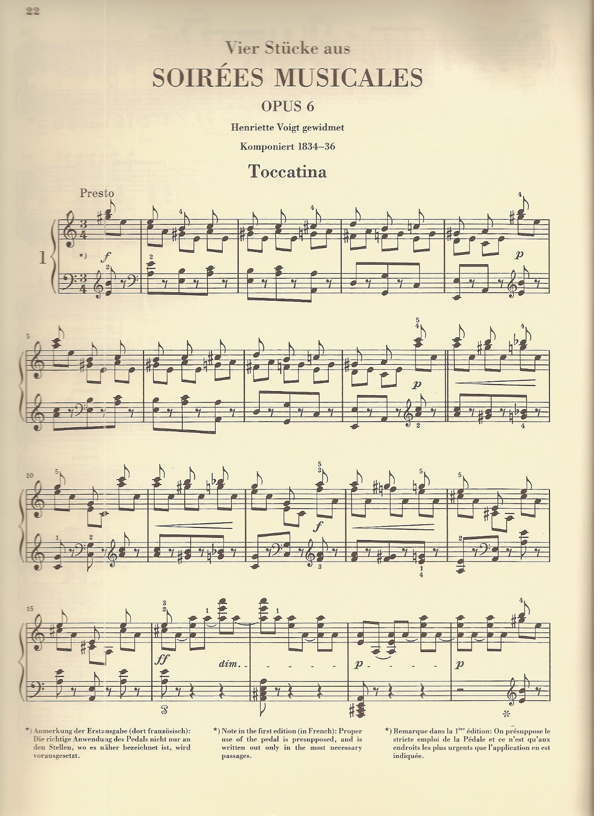
For the broken-chord pattern, it is most helpful to divide the passage into groups that are surprisingly comfortable. The divisions in Example 5 - 2 show that, after the initial anacrusis and downbeat, there are two sections where there are no large leaps.
Example 5 - 2. Soirées musicales, Op. 6, No. 1, mm. 1–4.
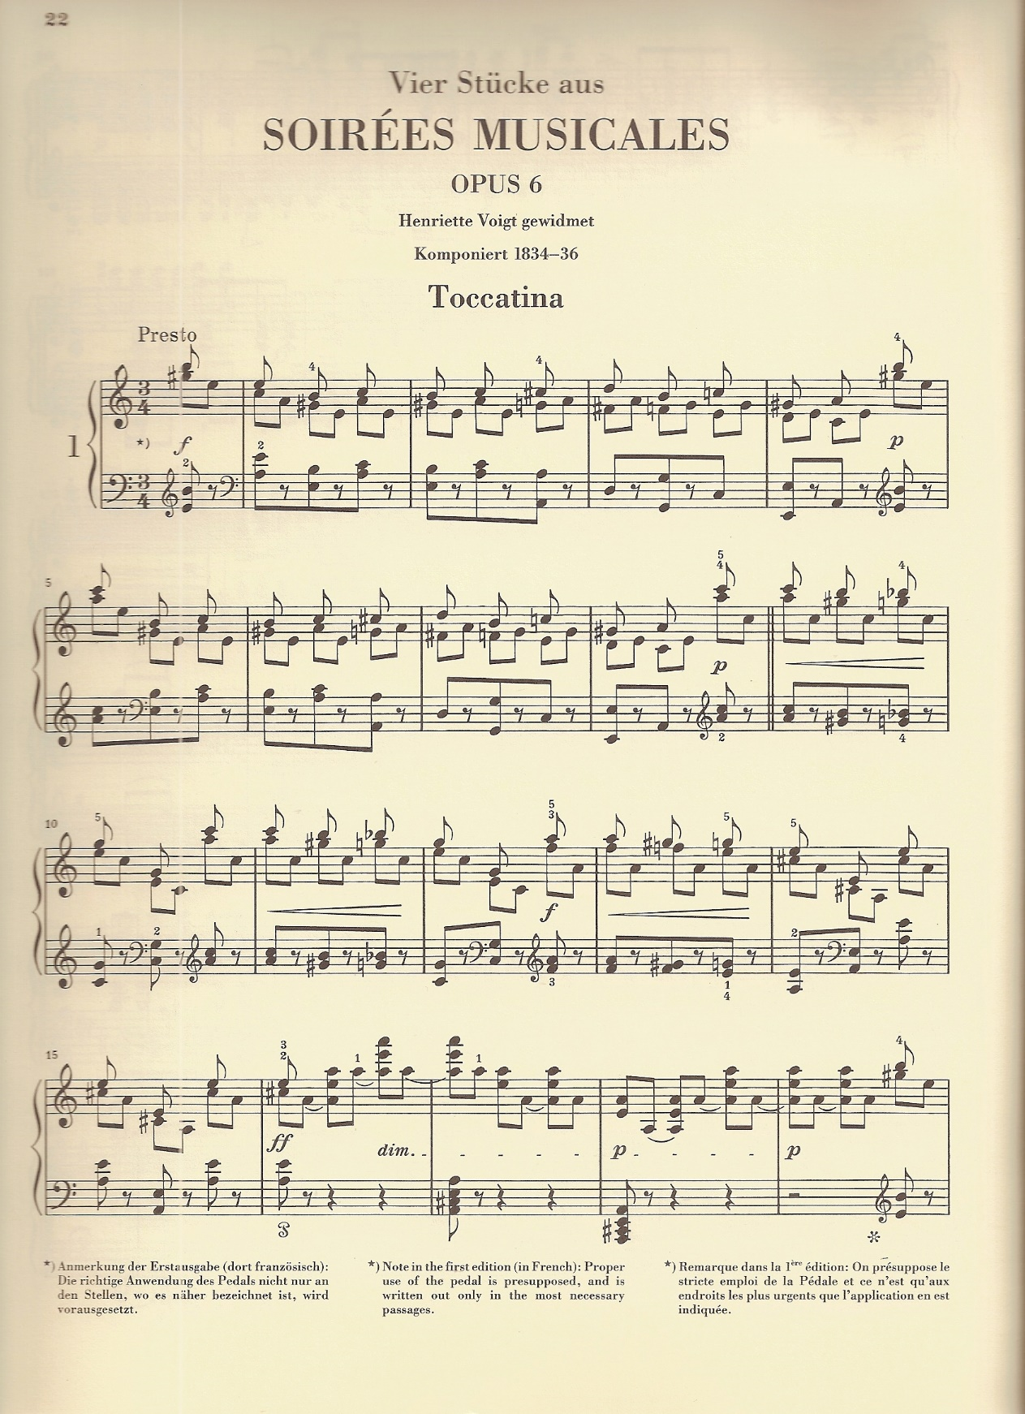
These divisions are not based on phrasing but technical groupings. Practicing each section and feeling the ease of motion permits simply gluing the sections together with quick shifts between groupings.
Blocking the right-hand chords allows one to prepare for each new position. After practicing each beat as a blocked chord, it is not difficult to simply break apart the chord and play the second eighth note as written. The same practice strategy can be used in the more widely-spaced answering phrase which begins with the anacrusis to m. 9 below.
Example 5 - 3. Soirées musicales, Op. 6, No. 1, mm. 8–12.
8
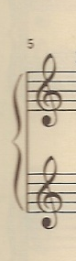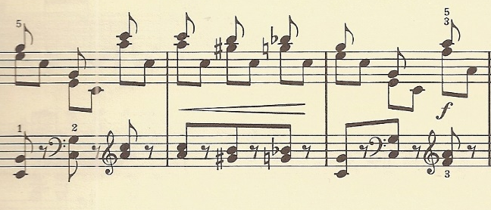
If bringing out the melody is difficult, initially leaving out the bottom note of each dyad promotes easier voicing of the top line.
Clara distinguishes the melody with separately-stemmed eighth notes, which indicate that the top melody is most important. Despite the detached style, each phrase can be shaped musically. Interestingly, Clara changes the direction of the phrases in the second half of the A section by using contrasting hairpin markings. For example, in the second theme, she indicates that m. 9 leads into the downbeat of m. 10 with an “open” hairpin. (See Example 5 - 3.) When the same phrase returns, the emphasis is shifted to the downbeat of m. 28 and followed by a “closed” hairpin, with three of the left-hand dyads slurred.

Example 5 - 4. Soirées musicales, Op. 6, No. 1, mm. 27–29.
27
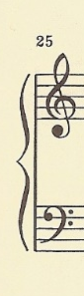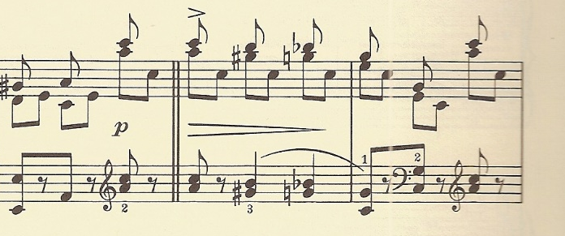
Similarly, the diminuendo in mm. 16–19 becomes a crescendo when the phrase returns in mm. 35–38. In this way, the phrases in the A section are structured in a type of arch form.
Although Clara uses nearly the same themes repeatedly, the projection of subtle differences can create a more compelling performance. The dynamics are constantly changing, and there are harmonic surprises like the progression in m. 42, where the harmony veers off to a perfect-authentic cadence in the Neapolitan before returning to the tonic.
Example 5 - 5. Soirées musicales, Op. 6, No. 1, mm. 42–43.
42
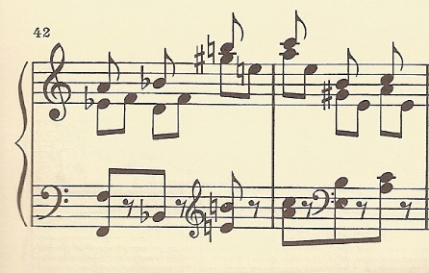
The economic use of thematic material allows for quick memorizing by identifying each similar passage and the differences between the repetitions. The following table may be helpful as a reference of the variances between passages.

Table 5 - 1. Structural overview of Soirées musicales, Op. 6, No. 1.
Measure | Phrase | Changes
1 | a | Opening phrase, forte
5 | a’ | Piano, change in register of downbeat
9 | b | Answering phrase, piano,
12 | b’ | Forte, , 3-measure extension with dimin.
20 | a’ | Piano, , crescendo
24 | a’ | Fortissimo
28 | b | , adds accents and slurred left hand
31 | b' | then crescendo
39 | a | Cadences on Neapolitan
43 | a’ | Final chord elides with B section,
48 | c | Opening material of B section
64 | d | More intense phrase group, same texture
76 | d | Altered ending on A major
92 | e | Long phrase group
132 | a’ | Extended anacrusis, , ends on Neapolitan
136 | a’ | Forte,
140 | b
143 | b' | , crescendo
151 | a’ | Fortissimo, , cadences on F major
155 | a’ | Pianissimo, , measure of rest, fortissimo end

The material in mm. 14–19 and then mm. 33–38 (indicated in Table 5 - 1 as part of b’) provides the only contrasting texture in the A section. The passage grows out of the “b” theme but ends with a harmonic fermata on A major lasting three measures.
Example 5 - 6. Soirées musicales, Op. 6, No. 1, mm. 15–19.
15
This passage is easier to play than to read as the right hand simply plays the same pattern in different octaves. The ties emphasize the sustained quality but need not be played legato.
In m. 46, the expected V–I cadence in A minor is replaced with a transition into the B section.
Example 5 - 7. Soirées musicales, Op. 6, No. 1, mm. 44–47.
44
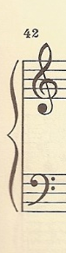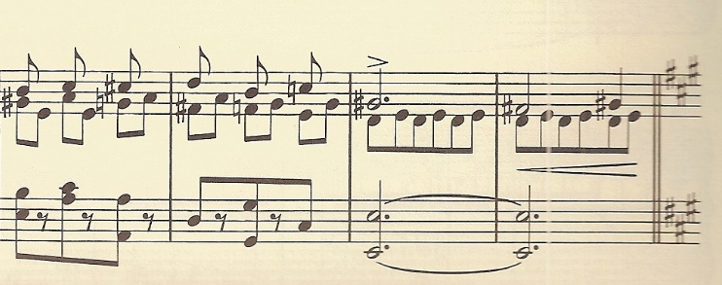
The chord used for the transition, shown in m. 46 of Example 5 - 7, is the same chord used in the preceding cadences in similar passages. In this way, mm. 46–47 form an elision from A to B. The harmony is not surprising; rather, the transition is interesting because the material finally moves in a new direction. The two-measure elision also transitions in touch—the light touch needed in the A section quickly changes to the legato style required by the B section. The open hairpin in m. 47 implies a broadening transition to the tranquillo of the B section.
The B section presents new challenges, with a melodic soprano line, smooth bass chords, and a moving alto accompaniment between the two. The right hand is responsible for both upper parts, as seen in the following example.

Example 5 - 8. Soirées musicales, Op. 6, No. 1, mm. 48–53.
48
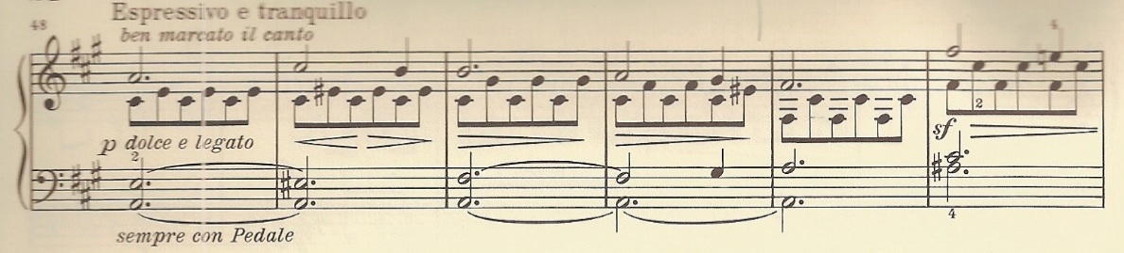
This section can develop the pianist’s ability to coordinate a typical pattern of two lines in one hand, often used by Beethoven and later composers.
At first, practicing the top voice with a natural, single-line legato fingering allows one to hear the ideal melodic line. However, this soprano line may be connected by the pedal and need not always be played with a meticulous physical legato. Although the quoted edition suggests using substitutions, this could be an excellent time to work with a student on playing a legato fifth-finger melody, such as mm. 65-67 in the example below.
Example 5 - 9. Soirées musicales, Op. 6, No. 1, mm. 61–67.
61
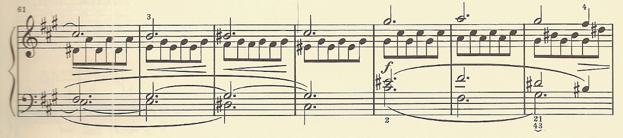
Connecting where comfortable and following the sempre con pedale marking can produce a legato effect in these passages. Practicing the downbeat chords with pedal may also be a helpful exercise in listening for a smooth melodic line as well as clean pedal changes.
The balance of the texture is another challenge. “Ghosting” the inner notes by touching the keys without making sound is one practice technique for controlling the alto accompaniment line, which needs to be performed softly. Practicing hands together without the melody also helps one hear how this inner accompaniment is interesting in itself and contributes to the shape of the entire passage.
Where dyads appear in the middle part, omitting the lower note at first may be helpful. For instance, the passage below could be practiced by leaving out each B in m. 106 and 108 and each A-sharp in m. 107 and 109.
Example 5 - 10. Soirées musicales, Op. 6, No. 1, mm. 105–110.
105
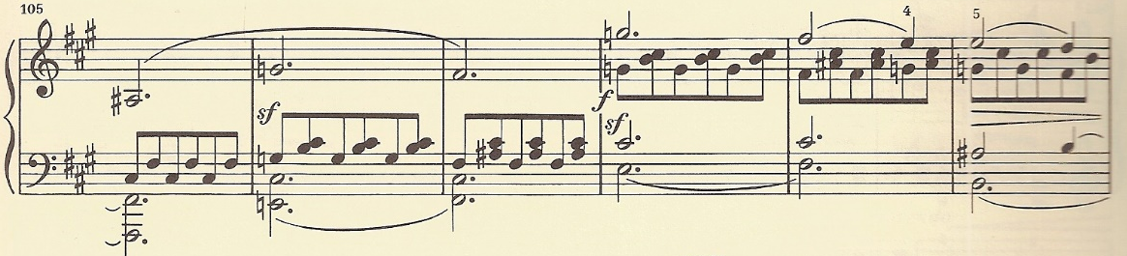
Becoming accustomed to the motion in this way will decrease tension, even when the notes are added back. Again, it is certainly permissible to release the melody notes to maintain ease and control.
Widely-spaced chords in the left hand that span an interval of a tenth or more may be played broken, as in m. 77 below.
Example 5 - 11. Soirées musicales, Op. 6, No. 1, mm. 74–80.
74
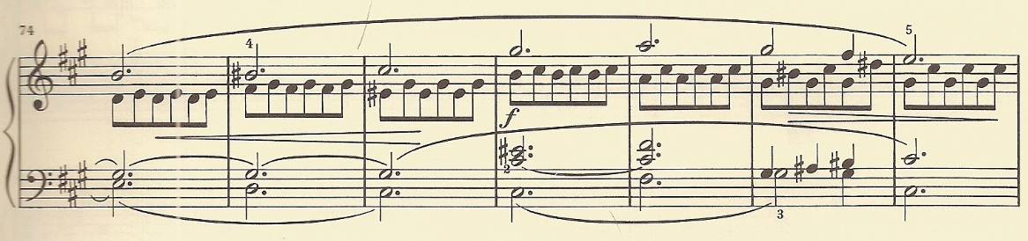
The C-sharp in m. 77, played as a grace note, could easily be caught in the pedal before the upper part of the chord arrives on the downbeat. A pedal change was probably not intended here since the harmony is retained from the previous measure—only a seventh has been added. In fact, keeping sonority in the pedal supports the direction of the hairpin marking which builds to m. 77. Both right-hand and left-hand slurs imply that these measures may be joined technically and musically.
In several passages, breaking apart a left-hand chord gives an added emphasis to the downbeat. In m. 77 (Example 5 - 11), it contributes to Clara’s forte dynamic. She writes large chords in similar climaxes in m. 117:
Example 5 - 12. Soirées musicales, Op. 6, No. 1, mm. 117–118.
117
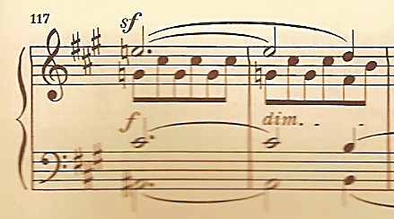
Unlike the transition to the B section, which is marked with an open hairpin, the retransition in mm. 130–131 seamlessly relaxes into the return of A. The closed hairpin and diminuendo in m. 130 indicate a subtle return of the opening material rather than an intense build.

Example 5 - 13. Soirées musicales, Op. 6, No. 1, mm. 129–133.
129
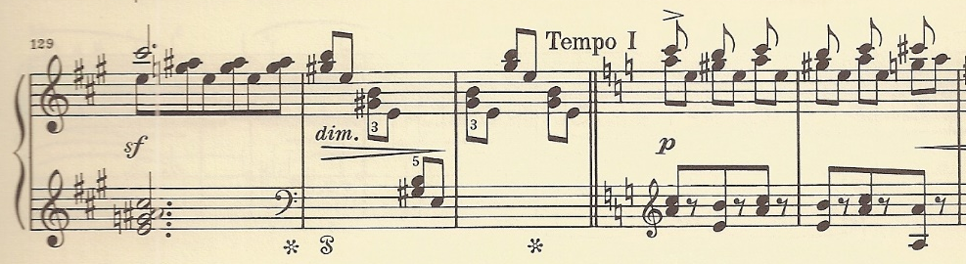
This lead-in passage is an expansion to two measures of the original eighth-note anacrusis, so very slight, if any, extra time should be taken. The hands alternate according to the directions of the stems, giving the right hand a full beat to prepare at the end of m. 131.

Performance Considerations
In performance, emphasizing the unexpected creates surprise and anticipation for the audience. The repetitious material may seem tiresome if the subtle dynamic and harmonic changes are not clearly brought out, but Clara suggests many opportunities for interesting interpretations. One example is the surprise of the penultimate measure of rest, where she dramatizes the ending by stopping suddenly before the final two chords.
Example 5 - 14. Soirées musicales, Op. 6, No. 1, mm. 153–159.
153
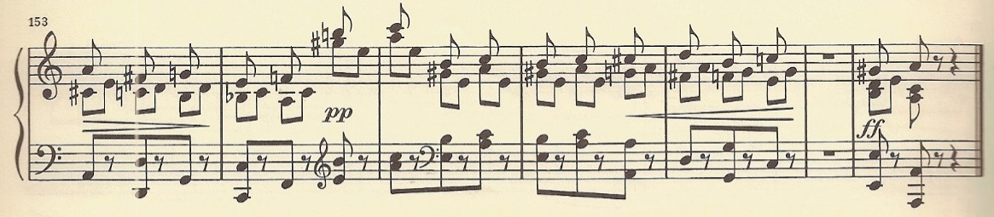
The individual style of each section is essential, as the charm of the B section provides welcome relief from the perpetual motion of the A section. The opening is full of life and should be played lightly, in the style of a dance. The middle section calls for the pianist to sink into the keys more and take extra time to produce a full sound. A strong contrast between a strict tempo and sentimental rubato will create a memorable performance.

Chapter 6: Quatre Pièces Fugitives (Op. 15)

Clara composed Quatre Pièces Fugitives, Op. 15, from 1841-1844 in Leipzig and dedicated them to her sister, Marie Wieck. These four short piano pieces were conceived after she married Robert and during the time when her own piano practice was limited. She tended to focus on Lieder during the early 1840s, making these pieces an exception. Some elements of her earlier grandiose writing are present, particularly in the second piece, but the set generally stresses lyrical, Romantic ideals. In their marriage diaries, Robert wrote, “Clara has written a group of smaller pieces that are more tenderly and musically conceived than any she has succeeded in doing before.” The set is also more varied in mood than others, with each piece vividly contrasting its neighbors.
Op. 15 consists of “Larghetto,” “Un poco agitato,” “Andante espressivo,” and “Scherzo.” Each piece is significantly shorter than Clara’s other character pieces; the first is only 47 measures. “Scherzo” was originally intended to be a movement of the Piano Sonata in G minor but instead became the final piece of Op. 15 with minimal changes.
All musical excerpts in this chapter are taken from the Dover edition, a reprint of the 1879 Breitkopf & Härtel score. This edition does not include any fingerings and is true to Clara’s original manuscripts. However, the author of this study has included a few select fingerings, marked above and below examples, which should prove helpful to pianists and teachers.

No. 1, “Larghetto”

Pedagogical Observations
In many ways, “Larghetto” is one of Clara’s most appealing character pieces and could be used as an introduction to her piano works. Its brevity and level-nine technical difficulty make it an approachable piece for many pianists. The long, singing lines may be its most prominent feature. Jane Magrath suggests it will be “attractive to the sensitive performer.” In fact, sensitive listening to the melodic lines is one of the important skills required by this piece. Other challenges include two-against-three rhythms, syncopated rhythms, large chords, and balancing of the hands.
As part of a piano curriculum, “Larghetto” may work well following some of Robert Schumann’s Kinderszenen, Op. 15, and similar Romantic works. It also prepares students for more difficult lyrical selections from the piano repertoire, such as some of Chopin’s preludes and Grieg’s Lyric Pieces.

Practice Strategies
“Larghetto” has less internal contrast than the other Op. 15 pieces, as the middle section of this ternary form develops themes from the opening rather than presenting new ideas. A concise structural chart is included below.
Section | Location
A | m. 1, opening
B | m. 16, “&” of beat 2
A | m. 31, elides with end of B section
Table 6a - 1. Structural overview of Quatre Pièces Fugitives, Op. 15, No. 1.

Evident from the first measure, the eighth-note accompanimental figures require the pianist to ease into the phrases.
Example 6a - 1. Quatre Pièces Fugitives, Op. 15, No. 1, mm. 1–4.
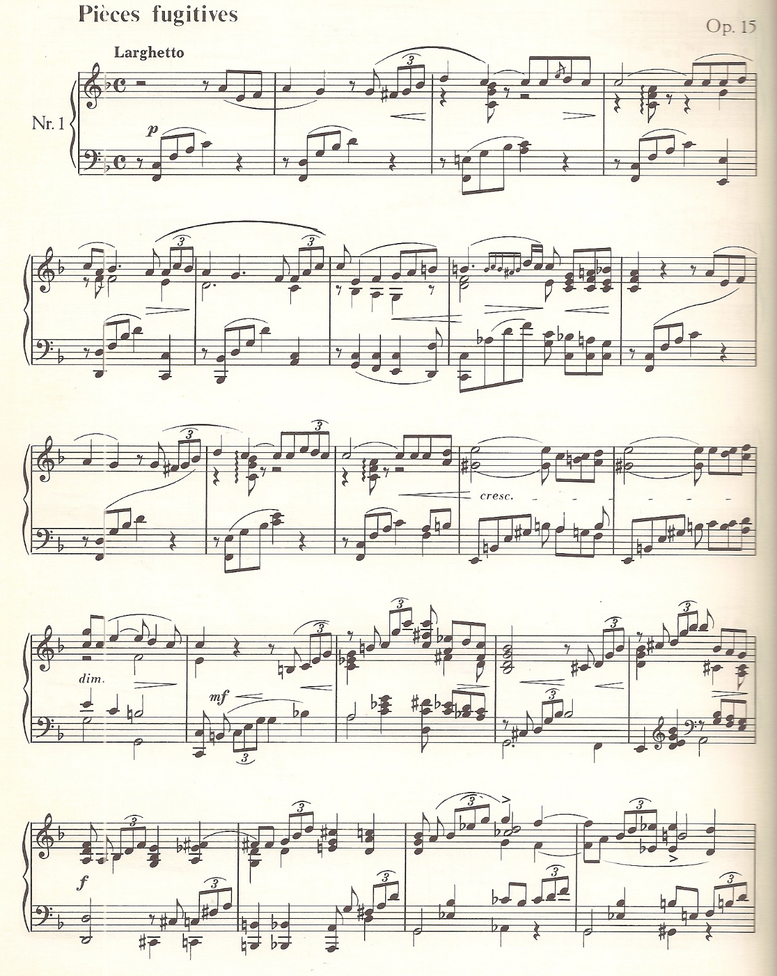
Listening for long phrases across bar lines and allowing the melody to float in over the left-hand accompaniment both help to establish a tranquil mood.
Balance of the hands is particularly important. The thicker texture and low register of each left-hand entrance could create too much sound and overtake the right hand. In fact, the most important didactic purpose of this piece may be teaching how the hands work together. The left hand moves directly into the right-hand phrases in each measure. Each hand needs to be prepared for its entrance, taking over from the other hand. Hands-separate practice is useful for listening to the shape of each part but not at the expense of feeling the inter-connected gestures between the hands. The melody needs to sing while the left hand provides a rich but gentle foundation.
Added syncopation in certain measures creates rhythmic tension. For example, the off-beat chords in m. 7 lead to an even stronger cadential resolution in m. 8.
Example 6a - 2. Quatre Pièces Fugitives, Op. 15, No. 1, mm. 7–9.
7
Alternation between duple and triple beats increase the expressiveness, beginning in the second phrase.
Example 6a - 3. Quatre Pièces Fugitives, Op. 15, No. 1, mm. 10–12.
10
In m. 11, the grace note from m. 3 becomes a triplet—a simple yet sensitive modification. These rhythmic changes are not difficult in themselves, but they require a sense of drama and sometimes urgency.
Triplets become more prominent in the brief but poignant B section (m. 16), which develops the ascending triplet motive from m. 2 of the A section.
Example 6a - 4. Quatre Pièces Fugitives, Op. 15, No. 1, mm. 16–19.
16
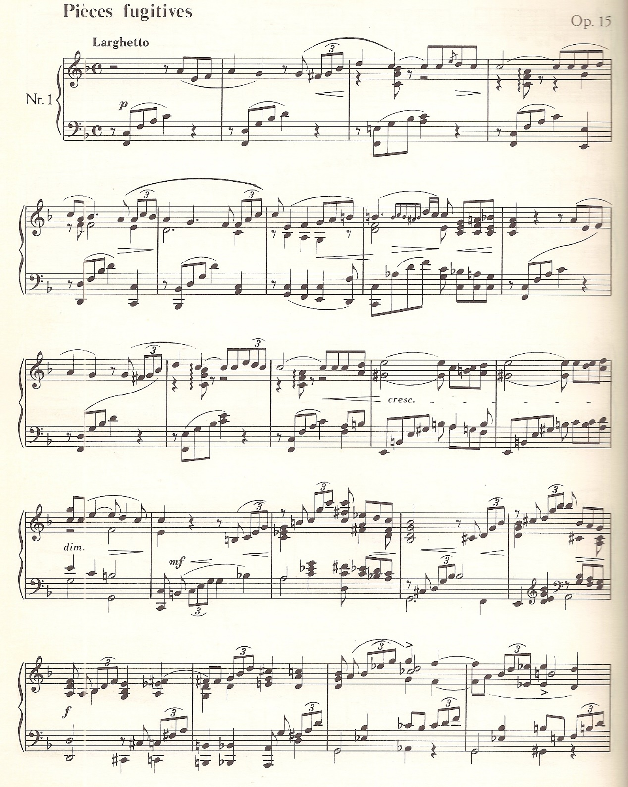
This motive quickly modulates sequentially through a variety of keys in three developmental phrases followed by a chordal retransition to the final A section. The following table outlines the progression of keys and ideas.
Table 6a - 2. Keys and developmental ideas of Op. 15, No. 1, B section.
Measure | Key | Content
16 | C Major | Ascending triplet motive in quick imitations
18 | G Minor | same
20 | D Minor | Contrapuntal development
22 | G Minor | same
24 | A Major | Triplet scales and arpeggios
29 | (trans.) | Chordal retransition

“Larghetto” helps to develop the important skill of shaping a complex melodic texture. In addition to its wide leaps, the melody passes between the hands quickly, particularly in the B section, and can easily become uneven. For example, in mm. 16–19 (Example 6a - 4), there are upward sweeps spanning more than three octaves. Although the hairpin crescendos suggest bringing out the piling up of the small motives, an overall crescendo to the top is still important. It is helpful to visually trace the melodic line in the score and practice it separately, and then listen in practice so that all of the elements effectively contribute to the larger phrase.
In mm. 20–23, the B section becomes imitative, with the ascending triplet motives in constant dialog between the hands.

Example 6a - 5. Quatre Pièces Fugitives, Op. 15, No. 1, mm. 20–23.
20
Stressing each motivic entrance will provide clarity and make this passage cohesive and exciting.
In the last developmental phrase (m. 24), a triplet melodic line is suspended above a mostly duple accompaniment.
Example 6a - 6. Quatre Pièces Fugitives, Op. 15, No. 1, mm. 24–26.
24
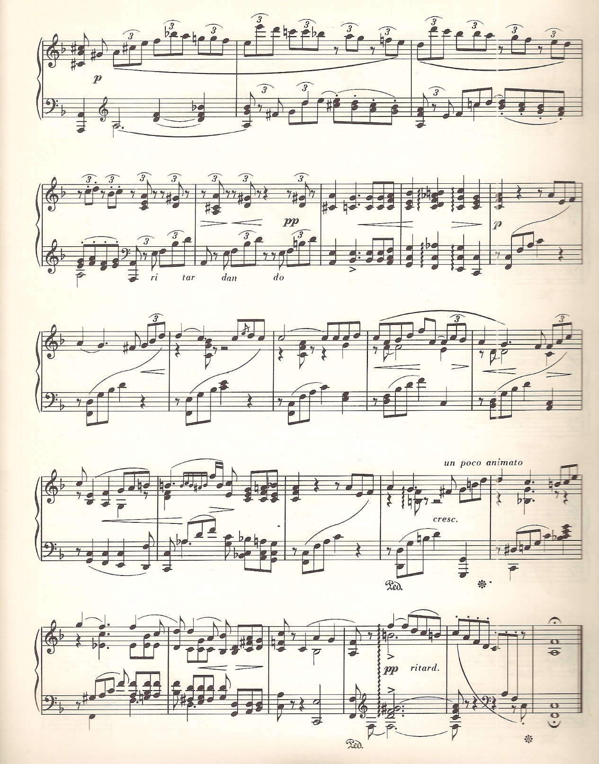
While the right hand may contain the soprano melody, the left-hand countermelody provides essential harmonic and rhythmic support. It also fills out the otherwise bare texture in the upper register of the piano. Due to rests on the beats, the two-against-three rhythms might be a significant challenge. In addition to practicing hands separately, one could get a feel for the rhythmic placement by actually playing appropriate notes in place of the rests.
The transitional chordal passage in mm. 29–30 (Example 6a - 7) requires clarity and should be voiced to the top.

Example 6a - 7. Quatre Pièces Fugitives, Op. 15, No. 1, mm. 27–31.
27

The ritardando starting in m. 27 should be extended to the diminuendo on the third beat of m. 30, carrying the intensity all the way to the cadence (and the return of A). Broadening the tempo with the rolled chords also makes this passage easier. While each beat may be pedaled, the large reach of the left hand in m. 30 necessitates its use.
The return of the A section is similar to the original statement, particularly in its first eight measures. Here, a slight modification is found in m. 35 when the phrase moves higher in the right hand.
Example 6a - 8. Quatre Pièces Fugitives, Op. 15, No. 1, mm. 32–36.
32
Although a small change, bringing attention to this new melodic reach expresses an increased sense of longing.
The last eight-measure phrase starts with the original theme once more, but Clara alters the ending with a final cadence in whispered dynamics that die away. The accents on inside notes in m. 45 (Example 6a - 9) for both hands represent the final tension and resolution of this piece.
Example 6a - 9. Quatre Pièces Fugitives, Op. 15, No. 1, mm. 44–47.
44
The right-hand accent is likely intended for the alto B that balances with the accented G-sharp in the left hand. Both notes resolve to A, creating an interesting treatment of the texture that requires balance of each note in the chords. The performer may take extra time to hear the resolution on the downbeat of m. 46. If done sensitively, one can appreciate Clara’s desire for a long pedal to carry the sonority to the very last chord of the piece. The quicker fading of the tone on Clara’s piano may have allowed for the long pedal in the score containing two harmonies, but the modern piano can create the same effect with a slight half-pedal change at m. 46.
All of the left-hand chords in this piece that span more than an octave can be broken or rolled, such as the tenths in both mm. 15 and 17.
Example 6a - 10. Quatre Pièces Fugitives, Op. 15, No. 1, mm. 15–17.
15
The bottom note may be played first and caught in the pedal. In mm. 41 and 42, both right and left hands require a large reach and may be rolled elegantly with use of pedal.

Example 6a - 11. Quatre Pièces Fugitives, Op. 15, No. 1, m. 42.
42

Performance Considerations

Freedom of rubato is needed in this piece and even encouraged by the composer. Clara includes some tempo indications, and the piece needs a sense of stretching of time in important moments, such as the transitions between sections. Its lyrical lines are evocative of a singer. Taking time with some of the large reaches stresses the sentimental quality while making the technical difficulties more accessible.
The layers of texture provide several opportunities for creative voicing. Perhaps when repeating sections, the performer can use imagination to bring the audience’s attention to a different voice besides the melody in the highest register. For example, see the triplet motive in Example 6a - 4.
With its improvisatory style and monothematic nature, “Larghetto” functions as a prelude to Op. 15. In light of the entire set, it does not need an overly dramatic interpretation with strong dynamic changes. Perhaps it is Clara’s simple way of preparing the audience for other musical moments to come.

No. 2, “Un poco agitato”

Pedagogical Observations
The second piece of Op. 15, “Un poco agitato,” is vividly different from “Larghetto,” with a vibrant opening motive that permeates the ABA form. In this level-ten work, the bright tempo and dramatic climax make it an effective solo on its own. While the spirit of the main motive is present in the entire piece, the B section contrasts in touch, mood, and motivic ideas. The extended material in the B section (m. 28) makes this piece more substantial in length and thematic ideas than Op. 15, No. 1.
Like “Toccatina” from Op. 6, “Un poco agitato” is an excellent study in quick, staccato passagework and repeated notes. Several fast, chordal passages are interspersed throughout the piece, and attention to fingering is important. Large leaps in the middles of phrases require graceful releases and jumps to maintain a convincing line. With its motivic development and contrapuntal elements, this piece requires a clear projection of the theme in each hand. Listening to balance between the hands is challenging since the theme jumps between parts often, particularly in the B section.

Practice Strategies
The opening contains two of the main technical challenges that occur throughout the section—staccato scalar passages and quick, successive chords.

Example 6b - 1. Quatre Pièces Fugitives, Op. 15, No. 2, mm. 1–3.
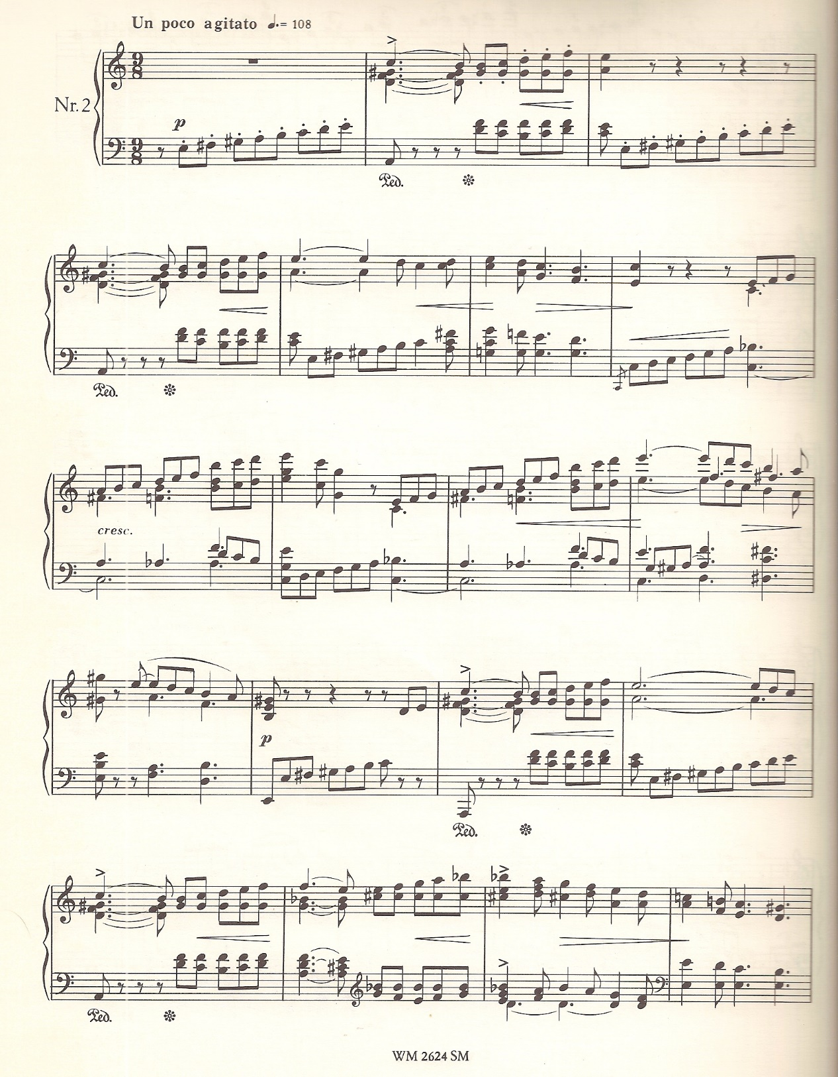
5 4 3 2 1
1 2 3
Both of these elements may create some degree of physical tension. A light touch with the fingers close to the keys is important here. Also, allowing the arm to relax when the phrase pauses, such as on the first beat of m. 2, makes playing easier. While the phrases are only 2-4 measures in length, it is helpful to find other places where the arm can relax. As a suggestion, the first measure could be shared between the hands, as indicated in Example 6b - 1. Taking the last three notes with the right hand allows the left hand time to jump to the low A in m. 2. Similar fingerings can be used in other related passages. Like many composers since the Classical era, Clara does not mark articulations in similar passages throughout the piece. Unless a slur is specifically indicated, staccato touch is implied.
Some pianists may not be able to reach the most widely-spaced chords, such as the left-hand downbeats of mm. 9 and 11.
Example 6b - 2. Quatre Pièces Fugitives, Op. 15, No. 2, m. 9–11.
9
1
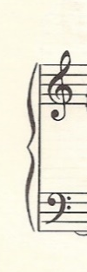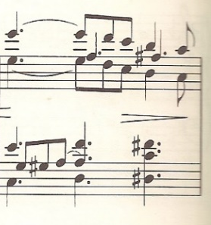
2 2 2
5

Here and elsewhere, one should feel free to take adequate time to roll the left-hand chords expressively and use pedal for longer notes. In m. 11, the moving parts may be played with the indicated fingering. Repeating the second finger in the moving part is more comfortable and easily achieved with use of pedal. Also, the F in the soprano of m. 11, beat 2 may be played by sliding the thumb.
The few rests in this piece provide relief from the constant eighth notes and should be carefully observed. For example, in m. 12, there is a short eighth-note rest in each hand, which adds to the drama:
Example 6b - 3. Quatre Pièces Fugitives, Op. 15, No. 2, m. 12.
12
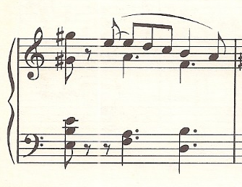
The dramatic pause in m. 43 especially allows the pianist to enjoy the leap to a new register in the right hand.
Example 6b - 4. Quatre Pièces Fugitives, Op. 15, No. 2, mm. 42–43.
42
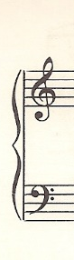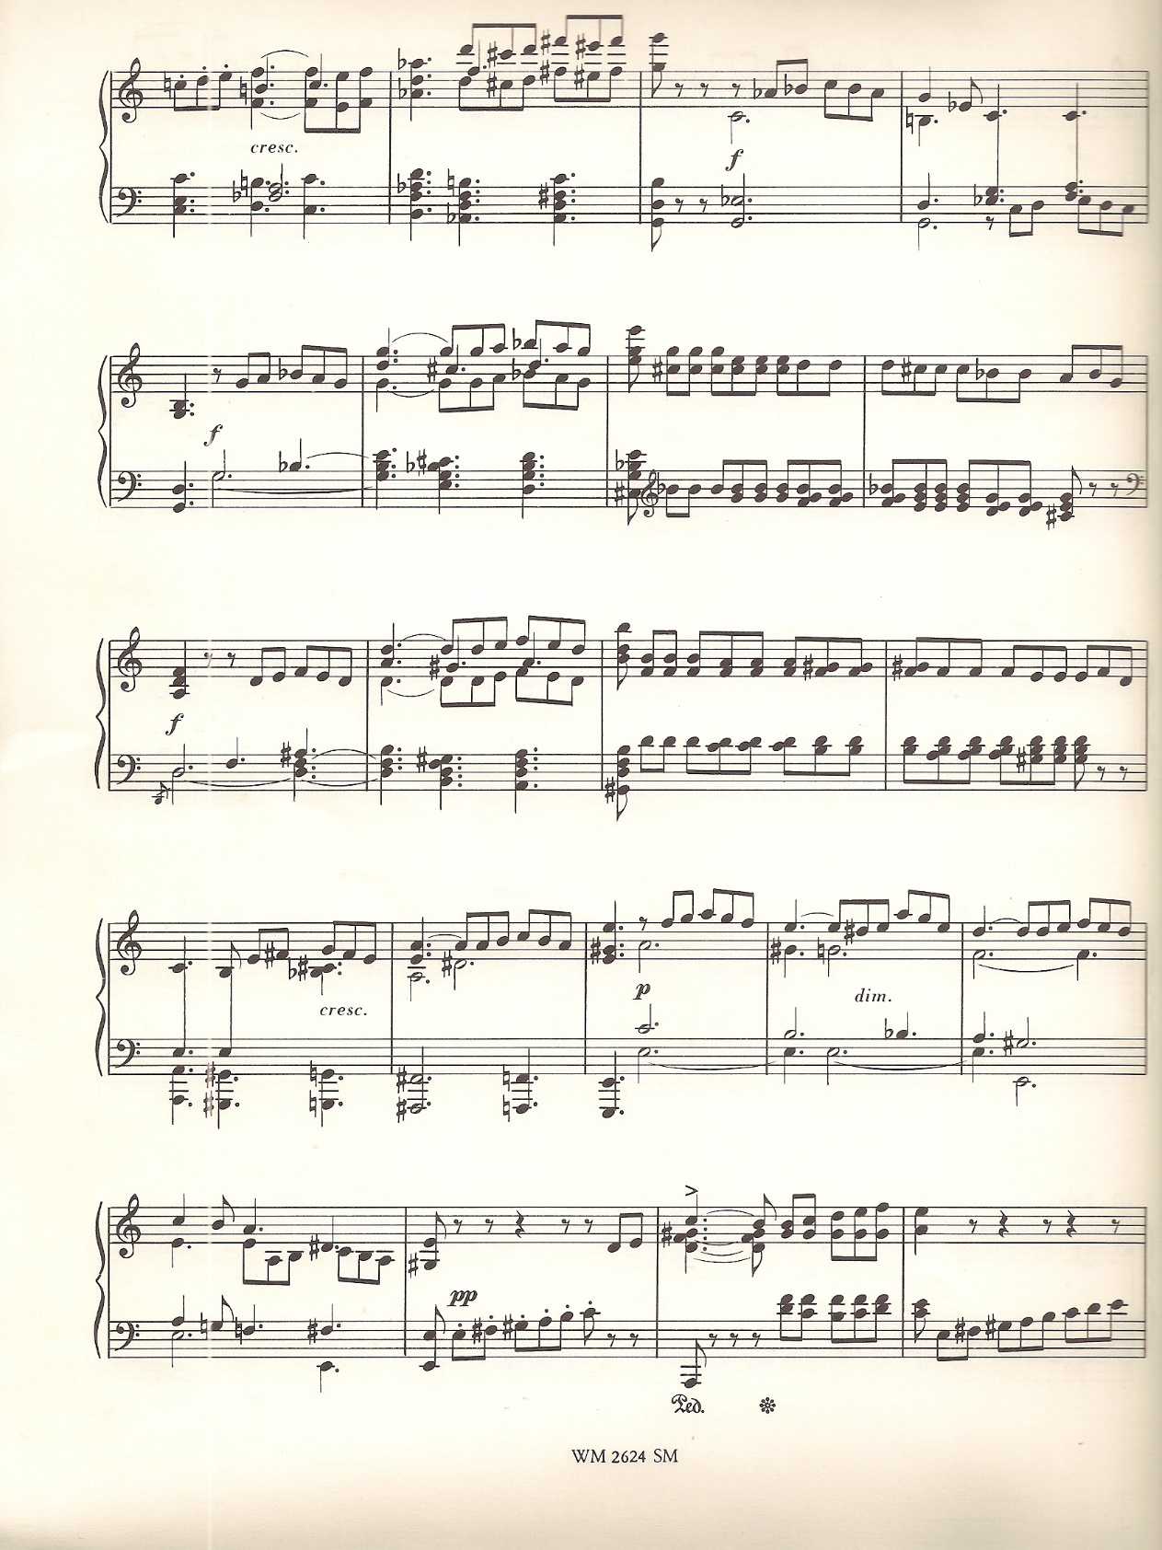
To end the A section (m. 24 in Example 6b - 5), Clara employs a new legato motive, which decorates the long chords.

Example 6b - 5. Quatre Pièces Fugitives, Op. 15, No. 2, mm. 24–27.
24
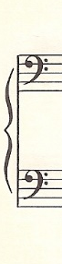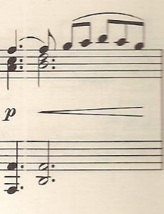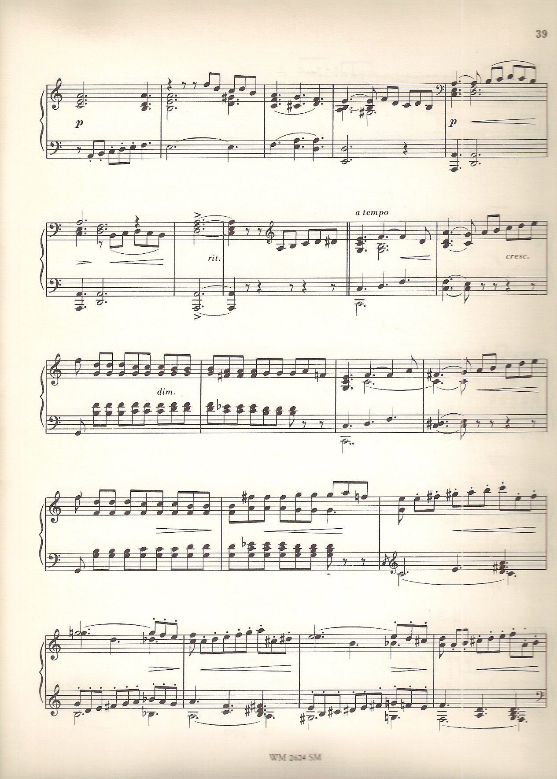
This slurred motive becomes more significant later in the piece.
Both the shift to the relative major key and the slow harmonic rhythm of the B section (m. 29) suggest a more relaxed style at the beginning of the section. Fingering suggestions for this passage are included below.
Example 6b - 6. Quatre Pièces Fugitives, Op. 15, No. 2, mm. 28–30.
2 3 4
28
1 2 3
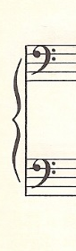
2 1
3 2
This passage provides a temporary reprieve from the continual scales of the A section, but those elements ultimately return. In fact, they eventually become more intense in various ways. For example, the repeated chords return and now span multiple measures.
Example 6b - 7. Quatre Pièces Fugitives, Op. 15, No. 2, mm. 30–32.
30
To decrease tension, this passage could first be practiced by playing each new chord and leaving out the repetitions. Then, the chords may be grouped in different ways, and the pianist can rest and prepare between each group.
The staccato, scalar idea returns in m. 36 but is now continually passed back and forth between the hands.
Example 6b - 8. Quatre Pièces Fugitives, Op. 15, No. 2, mm. 37–40.
37
This motive is expanded in the middle of this section and becomes the climax of the entire piece:
Example 6b - 9. Quatre Pièces Fugitives, Op. 15, No. 2, mm. 40–42.
40
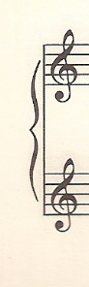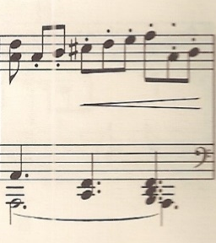
At this point, the piece reaches its widest range and thickest texture thus far. It is not surprising, then, that this is also one of the most difficult passages. In particular, the left hand of mm. 41–42 is challenging. The added dotted half note in m. 41 creates a thick texture and requires holding the notes through the measure. It should be noted that the F-flat indicated in m. 41 is most likely a misprint since there is an F-natural in the right hand. It was probably intended as an A-flat on the line above. The following fingering in Example 6b - 10 allows for a smooth transition.
Example 6b - 10. Quatre Pièces Fugitives, Op. 15, No. 2, mm. 41–42.
41
5
3
1
5
2
1
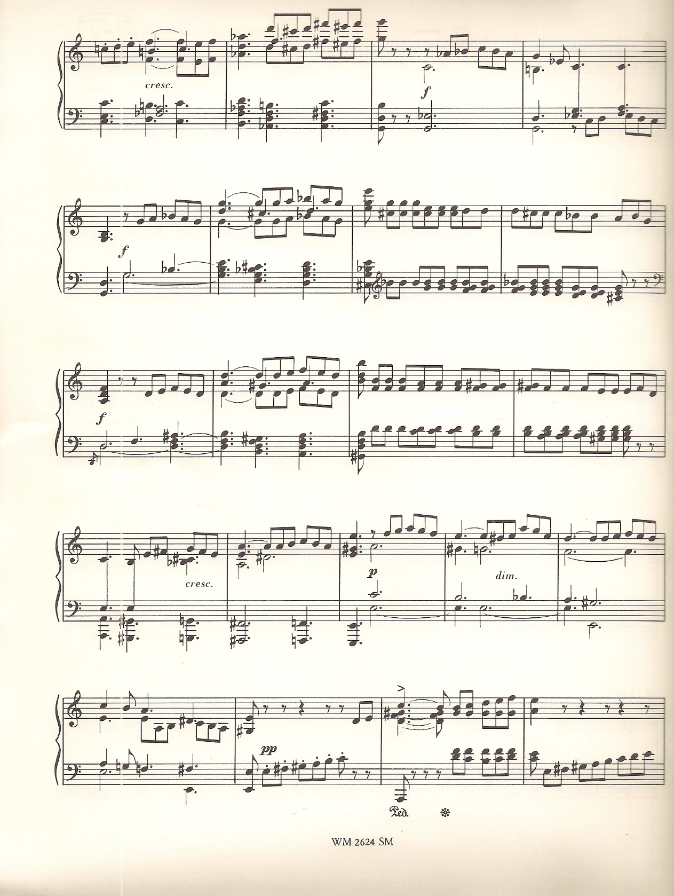
1
3
5
1
2
3
5

The left-hand chords in the next measure (m. 42) may be rolled, and the pianist may take extra time, especially with the French augmented-sixth chord on the last beat.
In m. 43, the slurred motive from the close of the A section (m. 24) is developed. Although not marked with a slur this time, it should be played legato, in sharp contrast of the repeated chords.
Example 6b - 11. Quatre Pièces Fugitives, Op. 15, No. 2, mm. 43–44.
43
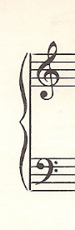
Clara places it in various registers and keys, nestles it amid different textures, and even expands it to octaves over the course of seventeen measures, as seen in the following example.

Example 6b - 12. Quatre Pièces Fugitives, Op. 15, No. 2, mm. 45–52.
45
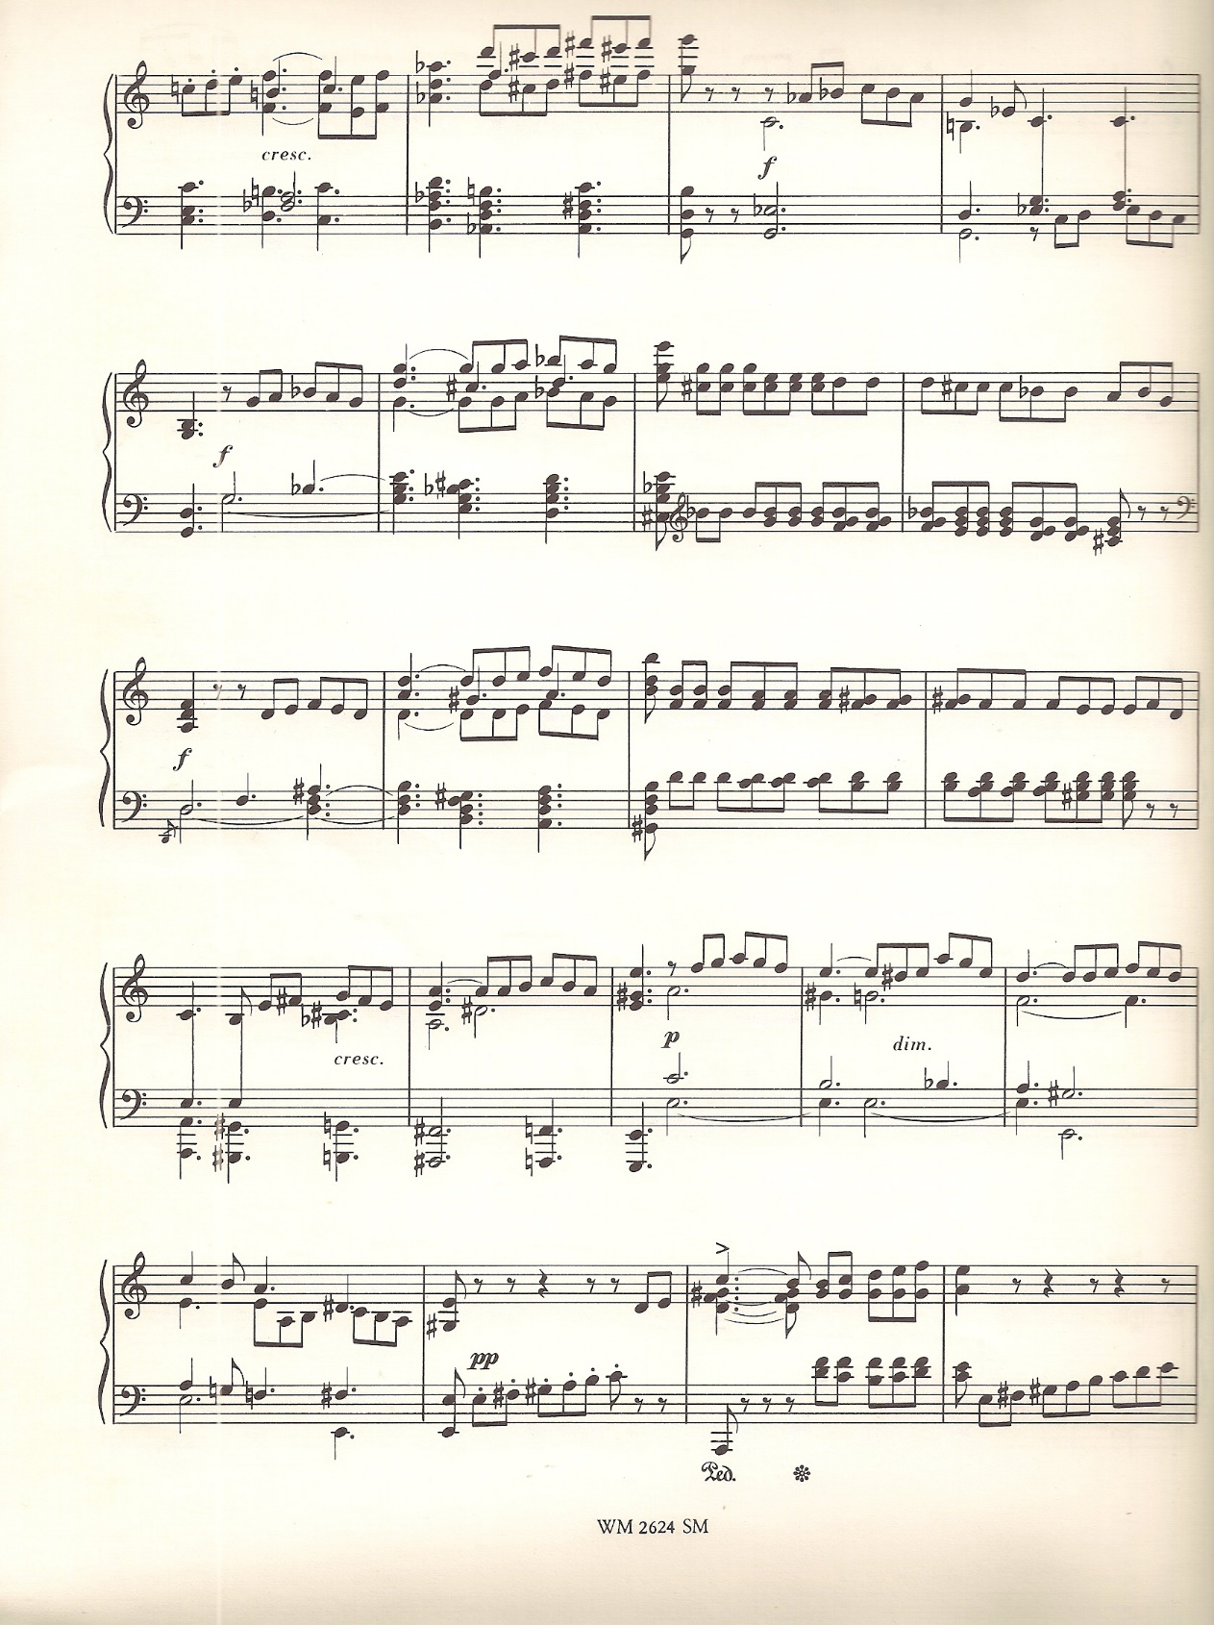
Finally, the motive functions as a retransition into the A section. Following a forte section, a sudden piano and diminuendo (mm. 55–56) effectively set up the quiet return of the A section. (m. 59)
Example 6b - 13. Quatre Pièces Fugitives, Op. 15, No. 2, mm. 53–57.
53
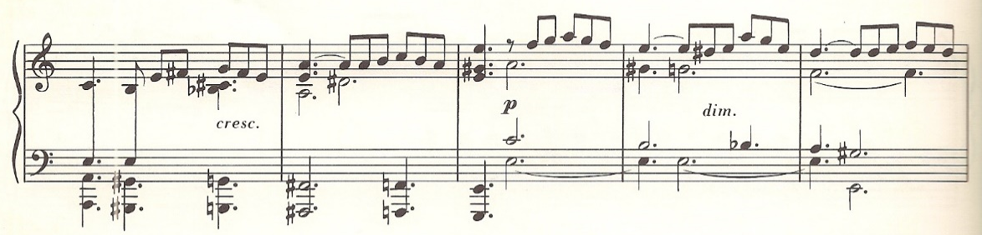
The return of the A section is nearly identical to the opening, with only a few slight changes in dynamics. Clara alters the ending, beginning at m. 81, which corresponds to m. 24 of the opening. Fittingly, she closes with a long, staccato scale that ends meekly on a pianissimo rolled chord.

Example 6b - 14. Quatre Pièces Fugitives, Op. 15, No. 2, mm. 81–85.
81
1 3
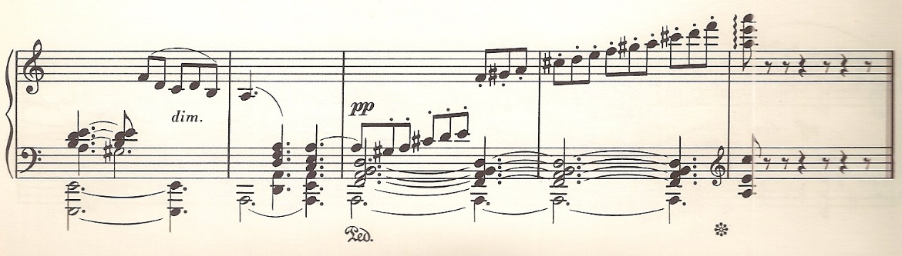
1 2
3 2 1
3 2 1
3 2 1
1 2 3
3
The long pedal with a gentle but precise lift creates a wistful effect if the scale is played lightly. Splitting the scale between the hands adds to the effect and makes the passage easier to play. (See suggested fingering in Example 6b - 14.)
Many large chords throughout the piece may be broken or rolled. Widely-spaced chords before a fast jump, such as the downbeat of m. 51, need not be played in a hurry.
Example 6b - 15. Quatre Pièces Fugitives, Op. 15, No. 2, m. 51.
15
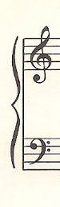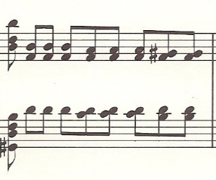
In reality, the chord on the second eighth is close and easy to reach. Playing just the chords on the beats is helpful practice, and then the leap can be tucked in easily.
Redistribution may help in other trouble spots. For instance, in mm. 20–22 (Example 6b - 16), taking one of the lower notes with the left hand gives the right hand more freedom in m. 21.

Example 6b - 16. Quatre Pièces Fugitives, Op. 15, No. 2, mm. 20–22.
5
2
1

2
4

2
1
3
5
20
1

5
One may also use touches of pedal here to help with long held notes. In mm. 24–25, already mentioned, a similar passage can be improved with use of pedal. On the second beat, the pianist can simply use pedal and lift the right hand—another example where pedal permits the use of natural fingering.
Example 6b - 17. Quatre Pièces Fugitives, Op. 15, No. 2, mm. 24–25.
5
3
1
5
2
1
5
2
1
24

2

4
2
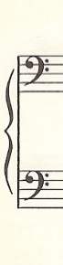
Finally, in certain passages, a gentle release and quick move of the hand allows a jump without accents. For instance, m. 44 requires the hand to leap after the first beat. The most natural fingering is to move the right hand to the fifth finger for the E-flat.
Example 6b - 18. Quatre Pièces Fugitives, Op. 15, No. 2, m. 44.
44
5
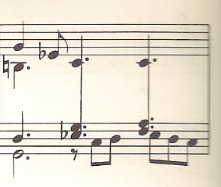
A similar passage is found in m. 54. Here, the pianist can play the first two chords with the right hand, then use pedal and lightly jump to the eighth-note motive.
Example 6b - 19. Quatre Pièces Fugitives, Op. 15, No. 2, m. 54.
54

Using a soft touch in leaps such as these allows the pianist to move easily instead of attempting to awkwardly connect the notes with the fingers.

Performance Considerations

As this piece is in 9/8 compound meter, it is important to note in the early stages of practice that each measure should feel like three large beats, rather than nine small beats. Clara indicates the metronome marking per each dotted quarter note, and the overall feeling of the piece is an energetic dance in three. In fact, counting one to each measure instead of counting beats is even more effective.
As part of the Op. 15 set, the contrast of this second piece should be apparent from the opening phrase. Whereas the previous piece allowed more freedom and rubato, the tempo of “Un poco agitato” should essentially be stricter, although with freedom for extra time at climactic moments.

No. 4, “Scherzo”

Pedagogical Observations
As one of the more approachable selections from Clara Schumann’s output, “Scherzo,” Op. 15, No. 4 serves as an ideal introduction to her neoclassical works. The piece evokes a sense of eighteenth-century structure even as Clara conveys her own pianistic flair. Although the B section is labeled Un poco più tranquillo instead of trio, the contrast in material and the repeat of the opening section at the end is reminiscent of a minuet and trio form. Harmonically, this level-nine work is mostly diatonic, so reading it is less intimidating in the initial stages of practice. Teachers will also find this piece agreeable for small hands; the texture is thin, and chordal passages are much less demanding than the wide hand span required of other pieces discussed in this study. The range is confined to an octave at a time in each hand with only a few exceptions.
One of the main challenges of the piece lies in the fast-paced changes in articulation, sometimes even between the hands. In addition to alternating between legato and staccato touches, two-note slurs appear frequently in the trio section and require small arm gestures and releases. Voicing of legato chords at the same time as two-note slurs adds another difficulty. In the scherzo section, Clara also writes several passages of arpeggios immediately followed by leaps, requiring sensible fingering and precise finger control.

Practice Strategies
Although in 3/4, this scherzo should feel like a dance in one as much as possible. A light touch, particularly on beats two and three, allows the piece to flow.
Example 6c - 1. Quatre Pièces Fugitives, Op. 15, No. 4, mm. 1–8.
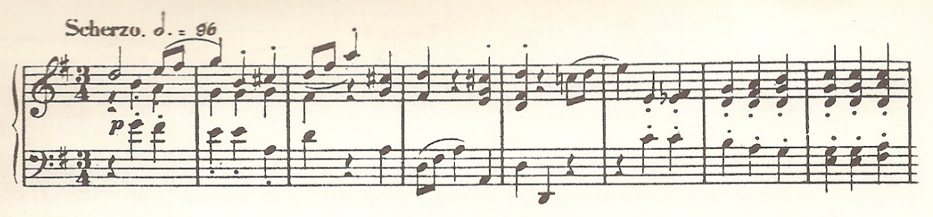
Clara’s tempo indication of 96 beats per measure is impossible considering the running eighth notes that begin in m. 13 and continue throughout most of the A section. Few pianists will be able to play it cleanly at that tempo, and the piece would sound hectic. A marking of about 70 is more reasonable yet maintains the bright spirit of the scherzo.
Example 6c - 2. Quatre Pièces Fugitives, Op. 15, No. 4, mm. 24–29.
24
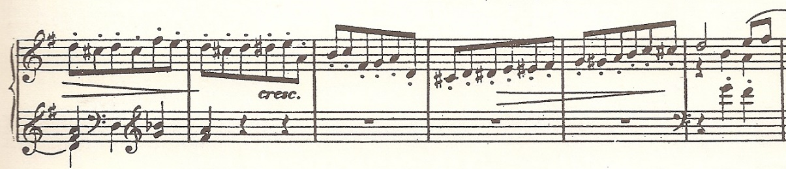
The melodic shapes in mm. 24–28 do not align with the measures. One should enjoy the varied groupings that propel these four measures to the return of the opening, thus making the passage easier to play and less like to rush. (See divisions indicated in Example 6c - 2.)
Several leaps follow arpeggiated eighth-note passages, requiring a precise but gentle touch. In mm. 14 and 16, a descending arpeggio quickly leaps back up with no rhythmic break. Here, one can either cross over with the second finger or simply take the last note of the measure in the left hand, as indicated in the example below.
Example 6c - 3. Quatre Pièces Fugitives, Op. 15, No. 4, mm. 13–19.
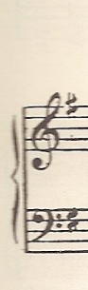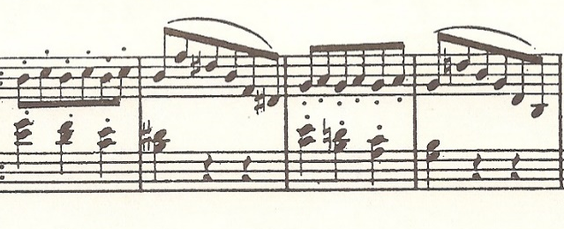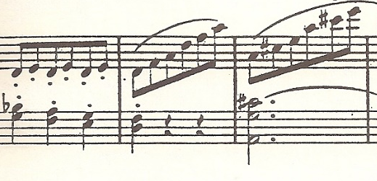
1 2 1 1 2 1
2
2
13
The transition from mm. 18–19 includes another leap that requires a gentle touch and a conscious effort not to accent the thumb on the downbeat of m. 19.
Challenges in articulation are evident from the opening (see Example 6c - 1) when a partially slurred melody floats above a staccato accompaniment. The articulations move back and forth between the hands often throughout the piece, similar to mm. 3–5. Texturally, the articulation differences indicate some secondary melodies and occasionally create polyphonic moments that further bring the baroque spirit to mind. For example, starting in m. 20, the left hand offers a distinct line in slow-moving quarter and half notes while the right-hand melody continues in staccato eighth notes.
Example 6c - 4. Quatre Pièces Fugitives, Op. 15, No. 4, mm. 20–25.
20
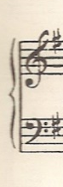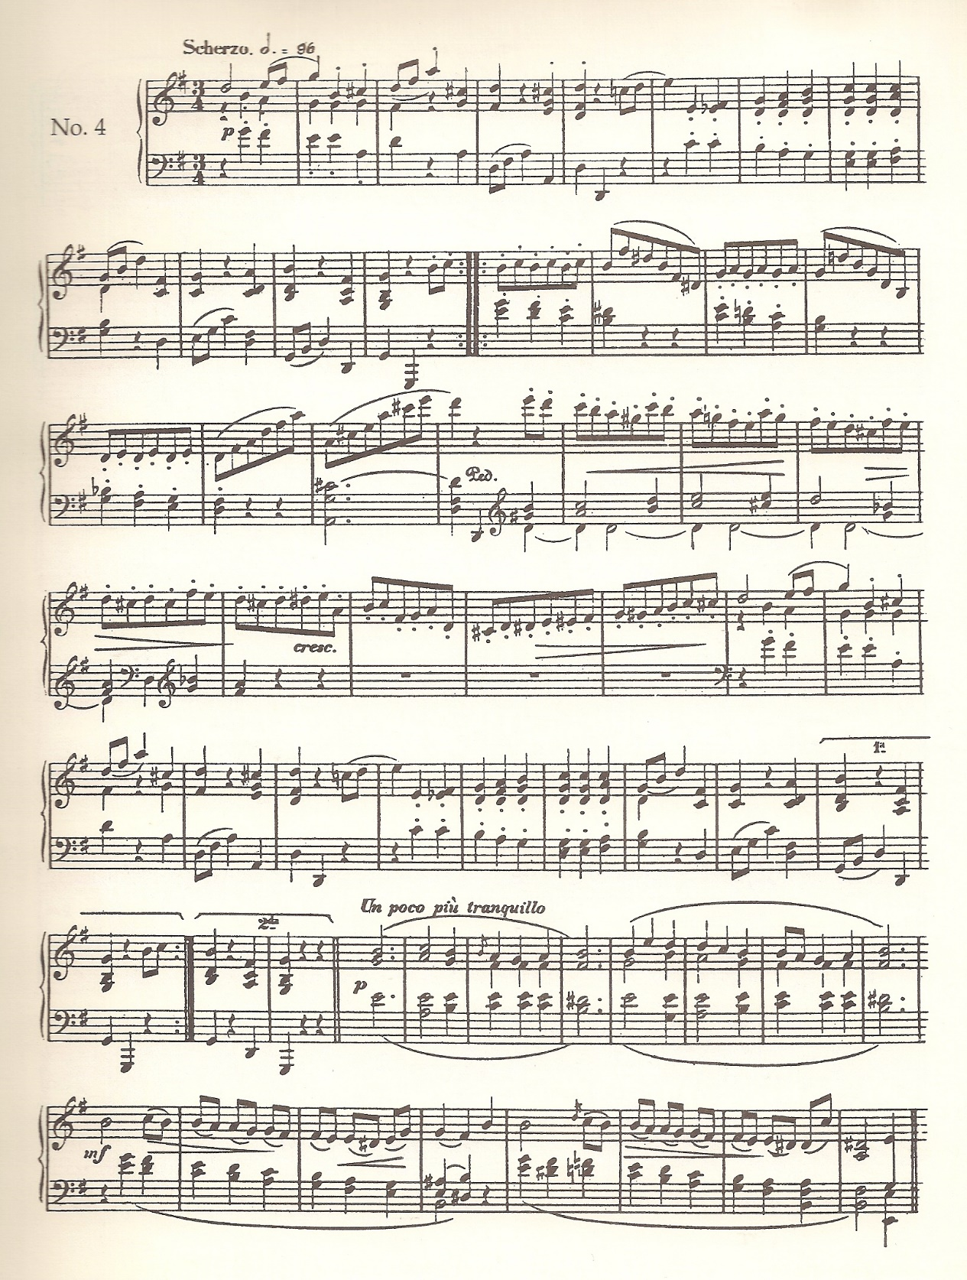
The left hand includes a repeated pedal point on the dominant that must be released to reach the upper notes, even though Clara writes them as longer note values. In fact, it is appropriate to use touches of pedal, and Clara includes a pedal marking within the staff to make this clear. The open pedal marking probably does not mean a long pedal; rather, she wanted to allow the use of pedal, even with the staccato eighths in the right hand. The staccato notes can be played lightly to maintain their character, even when the pedal is used.
At the B section (m. 41), a sudden shift to the relative minor and a new tempo (Un poco più tranquillo) indicate a change in mood, and the overall articulation is more smooth than in the A section. Legato voicing of the chords in both hands can be connected with slight touches of pedal.
Example 6c - 5. Quatre Pièces Fugitives, Op. 15, No. 4, mm. 41–48.
41
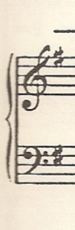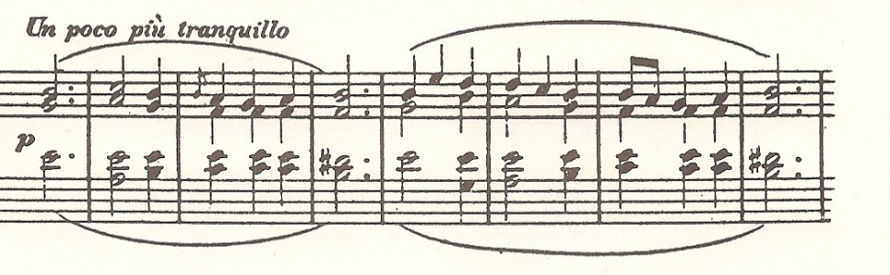
Throughout this middle section, the juxtaposition of two-note slurs against a legato line can be challenging. Making a smooth line in the left hand of mm. 49–56 is particularly difficult. Using a [3-2] fingering in the right hand naturally brings out the two-note slurs, while pedal can be used to smooth out any left-hand shifts.
Example 6c - 6. Quatre Pièces Fugitives, Op. 15, No. 4, mm. 49–56.
49
2 3 2 3
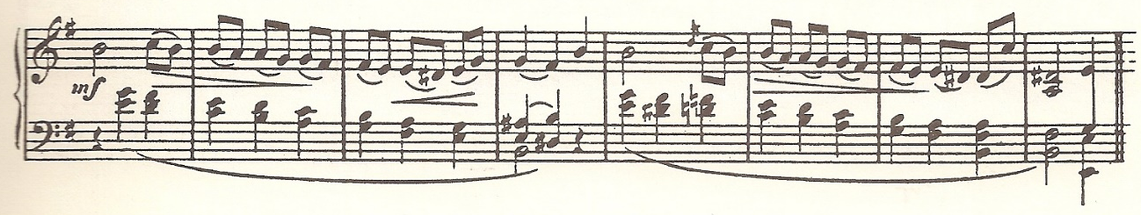
1 2 1 2 3
3 4 3 4 5
The off-beat accents in mm. 64–68 blur the meter and provide a break from the preceding legato passages. Here, bringing out the moving notes, rather than simply the tops of chords, is effective. In practice, one could leave out the held notes to better hear the moving voices.
Example 6c - 7. Quatre Pièces Fugitives, Op. 15, No. 4, mm. 64–68.
64
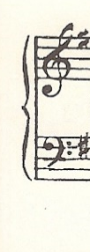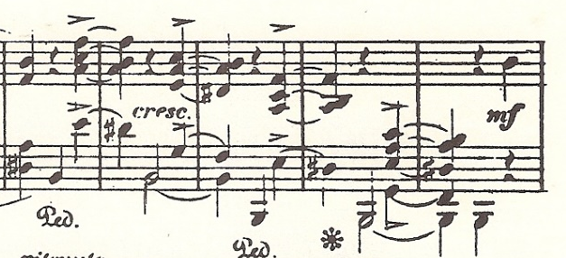

Since it is impossible to physically connect all the slurred notes with fingers, a more specific pedaling suggestion is included underneath Example 6c - 7, in addition to Clara’s own indications.
Particularly in the B section, some phrases end abruptly, often with a cadence on the third beat of a measure (the transition between mm. 56 and 57 in Example 6c - 8) before the next phrase begins on the following downbeat.
Example 6c - 8. Quatre Pièces Fugitives, Op. 15, No. 4, mm. 55–60.
55
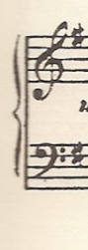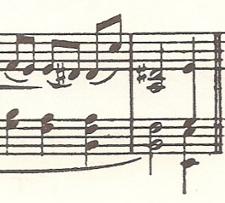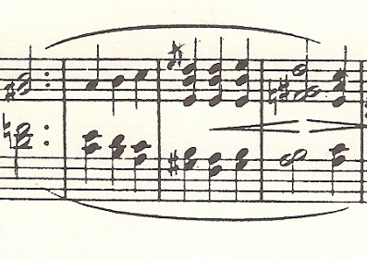
The vocal quality of the section surely allows for a natural lift between these phrases. The same situation occurs at the retransition back to the A section (mm. 85–86). Here, a slight rubato is also needed.
Example 6c - 9. Quatre Pièces Fugitives, Op. 15, No. 4, mm. 78–88.
78
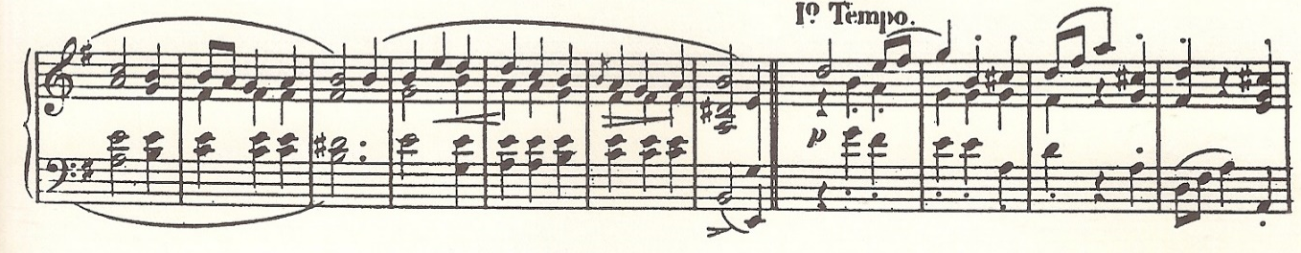

Performance Considerations
While “Scherzo” may be one of the more accessible of Clara’s character pieces due to its brevity, hand span, and easier reading level, it is by no means unsophisticated. The basic elements of dance form are the over-arching structure, and within that framework lie well-developed melodies, phrases, and textures.
Although at first glance the return of the A section in this piece looks identical to the original, a few important details should be noticed. For example, Clara leaves out an earlier crescendo and now includes a diminuendo in m. 111 when the scalar passage is repeated. Compare the following to Example 6c - 4.
Example 6c - 10. Quatre Pièces Fugitives, Op. 15, No. 4, mm. 106–113.
106
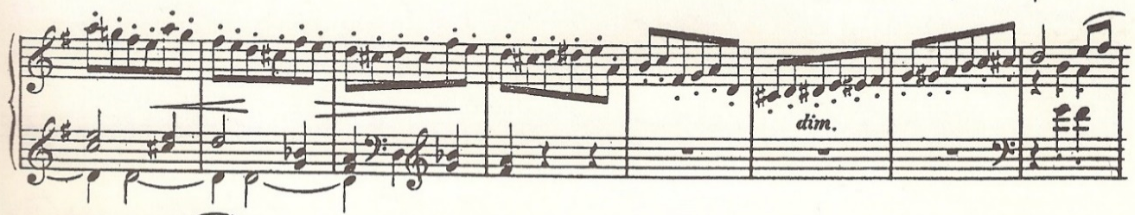
Bringing out these details not only respects the composer’s wishes but also brings new life to an otherwise exact repeat.
As the last movement of this set, “Scherzo” is perplexing. One might assume a scherzo and trio would fit better as a third piece within the given “four-movement” scheme, particularly with the knowledge that Clara originally conceived this piece as the third movement of another work. However, it is clear that Clara makes no attempt to simulate a four-movement sonata cycle; instead, she simply includes an effective piece to serve as a great ending. Indeed, the fast-paced tempo and strong closing make it effective as a stand-alone selection or as a final movement if the performer chooses to play all four pieces as a set.

Chapter 7: Romanze in A Minor (without Opus)

Although Clara continued to be burdened by Robert’s poor heath in Düsseldorf, the move to a more spacious home in the fall of 1852 finally afforded her the chance to write more of her own music. It was in this house that she composed several of her last works, some of which became her most often-performed pieces. In June of 1853, only a month after writing the Variations on a Theme of Robert Schumann (Op. 20), she composed one of her last sets of piano character pieces—a group of three contrasting Romanzen.
These pieces remained unpublished for almost two years, while Robert’s health deteriorated even more. He was finally admitted into an asylum in 1854, and according to Clara’s diaries, Brahms became her “prop” as she grew more discouraged about Robert’s illness. In April of 1855, while Brahms visited Robert in the asylum in Endenich, Clara wrote another piece and used it as a replacement for Romanze No. 1. However, the original Romanze, which is the focus of this study, was preserved and published without opus number in the magazine The Girl’s Own Paper in 1891; it was dedicated to Rosalie Leser, a neighbor and friend from Düsseldorf. Historically, this stand-alone piece reflects a turbulent and unsettled period in Clara’s life, and its mournful mood could be related to Robert’s illness.
Pedagogical Observations
For pianists who wish to study Clara’s compositions from later in her career, this ternary-form Romanze is a suitable starting point. It contains many features associated with her later works, including its expressive nature and less use of purely virtuosic elements, a noticeable change from her early years. Compared to some of her other character pieces, this Romanze requires a lesser hand span. In fact, the largest span in the A section of this piece is only a ninth (m. 24); most of her other works contain numerous tenths or larger in each section. The textures are generally thinner and thus easier to voice and balance.
The modest technical difficulties of Romanze allow the pianist to concentrate on essential musical skills such as phrasing and pedaling—the true focus of this piece. Rich harmonies abound and require slight emphasis on select moments of dissonance, always within the larger phrase. Also, one must voice and shape the melodic line, even when the accompaniment becomes quite busy. Clara’s short slurs often indicate small gestures, but the pianist must actively consider how these fit into the shape of longer phrases.
Romanze is also a study in legato pedaling. Where Clara’s slurred passages are not easy to connect with the fingers, sometimes generous touches of pedal can create a sense of legato and allow the pianist to play with comfort and ease.
The excerpts for this chapter are taken from the Henle Urtext edition, which relies on the earliest manuscript Clara wrote out for her friend, Rosalie. However, fingerings were added by Hans-Martin Theopold, who was born in 1904, eight years after Clara’s death. Some fingerings suggest uncomfortable crossings and finger substitutions in order to maintain a true legato as much as possible. Unfortunately, they create unnecessary complications that interrupt the musical flow. It is the recommendation of this author to simply play with ease, using pedal to connect and focusing on shaping the beautiful melody. A few specific passages will be mentioned in the next section.
Although a level-ten work that contains some difficulties, this original Romanze is more approachable and much shorter in length than the later Op. 21 replacement, while maintaining many of the beautiful moments. Its inclusion in this study therefore serves as a suggestion to learn this particular Romanze before progressing to some of the others.

Practice Strategies
Clara did not indicate a tempo marking for Romanze. However, an Andante tempo of about 76 beats per quarter note brings out the mournful temperament and allows the melody to flow smoothly.
The opening theme of this Romanze is an excellent example of legato playing with the pedal, where the pianist may simply connect the notes that are natural for the hand to connect, staying close to the keys and letting the constant pedal create the legato effect. Theopold’s fingering in Example 7 - 1 suggests connecting by stretching the hand and using finger substitutions. However, comfortable fingering actually makes control of the subtleties of each phrase much easier and more successful. Here, an alternate fingering is included above Theopold’s suggestions:
Example 7 - 1. Romanze in A Minor, without Opus (1853), mm. 1–5.
5
3 5 3 3
1 3 1 1 1 5 3 5 3

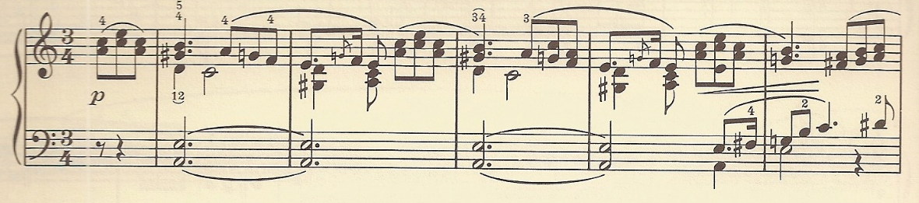
The short slur markings in the example above simply show the physical groupings. It is important not to break up the overarching phrases, which are actually two measures or more in length.
Romanze is an excellent study in phrasing and requires clear shaping of harmonic dissonance and resolution throughout the piece. Clara includes many surprising non-harmonic tones and rich harmonies that the pianist may enjoy by stretching the time in select passages. Subtle lifts in the moments of release are necessary. For example, the double suspension on the downbeat of m. 9 and the triple suspension on the downbeat of m. 10 require a slight emphasis to bring out the lush harmonies, even though the phrase must also move to its climax in m. 12.
Example 7 - 2. Romanze in A Minor, without Opus (1853), mm. 8–12.
8
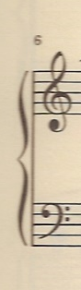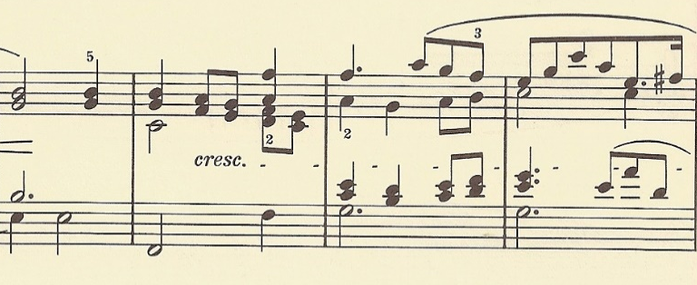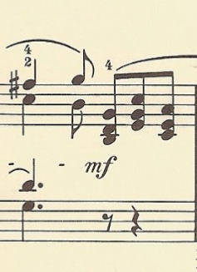
See also the dissonant clash of a minor second in m. 15, the suspension on the downbeat of m. 21, the double suspension on the fermata in m. 26, and the ritardando in mm. 38–39.
For many of these harmonies, a down-up (and thus “more-less”) arm gesture will shape the dissonance and resolution. These passages may be isolated and practiced on their own. In m. 26, the B and A in the right hand can be taken together with the thumb. (See added bracket in Example 7 - 3.) Because of the configuration, to achieve the down-up gesture, the hand must move in toward the fallboard slightly for the second chord.
Example 7 - 3. Romanze in A Minor, without Opus (1853), mm. 25–26.
25
2 3 5 3 5 2
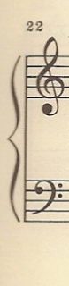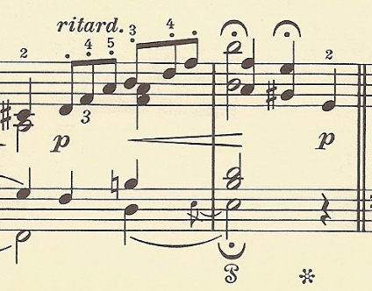
The editor’s fingering in m. 25 is another instance of unnecessary legato fingering. However, Clara herself marks the notes to be detached, and the suggested fingering in Example 7 - 3 would better prepare for the wide chord on the downbeat of m. 26.
The pedal marking in m. 26 (Example 7 - 3) must indicate to hold the pedal through the resolution. This interesting sonority may be quite effective, but only if the affected chords are played very softly.
Stretching the time can also assist with some wide reaches, such as the right hand of m. 28 at the opening of the middle section. A slight rubato gives the pianist enough time to reach this first tenth of the piece and also fits the wide spacing and expressive dissonance of the harmony. Using the fourth finger on the top of the preceding chord sets the hand up for an easy stretch to the E.
Example 7 - 4. Romanze in A Minor, without Opus (1853), mm. 27–29.
27
4
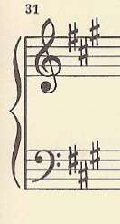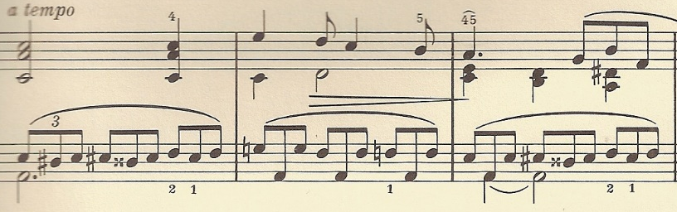
In this middle section, written in the parallel key of A major, the challenge in phrasing is to avoid interrupting the melodic line. Accompanimental triplets in the left hand create a busyness that can easily distract from the soprano line above. Also, the triplets form a two-against-three rhythm that pervades most of this section, further complicating the texture, as in m. 28. (See Example 7 - 4.) The pianist must make certain the melody is voiced and shaped for the long phrase that does not resolve until m. 30, particularly with the longer note values that may die away. Practicing this section hands separately allows one to hear and shape each of the individual parts, and ghosting the left hand accompaniment while playing out the right hand will help achieve balance between the hands.
A secondary bass line begins to appear in the left-hand accompaniment, starting in m. 29 but becoming more prominent in m. 38.
Example 7 - 5. Romanze in A Minor, without Opus (1853), mm. 38–41.
38
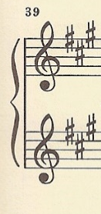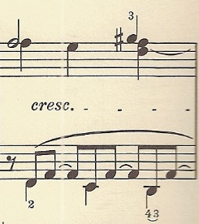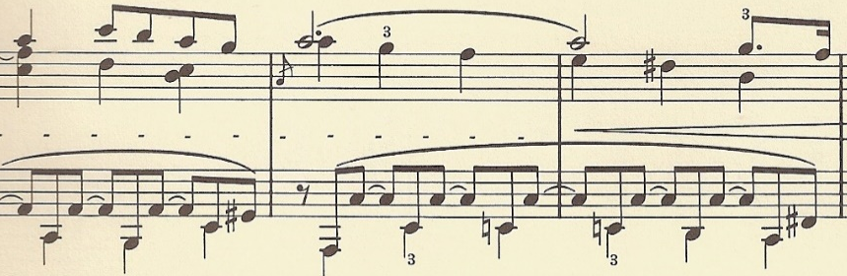
simile

Pedaling with the off-beat bass line, which is delayed until just after the right-hand melody notes, gives some natural emphasis to the bass while allowing the focus to remain on the melody.
In the retransition back to the A section in mm. 49–52, Clara indicates by downward stems to play the bottom two notes of each chord with the left hand, suggesting that she wants the melody as legato as possible here.
Example 7 - 6. Romanze in A Minor, without Opus (1853), mm. 49–52.
49
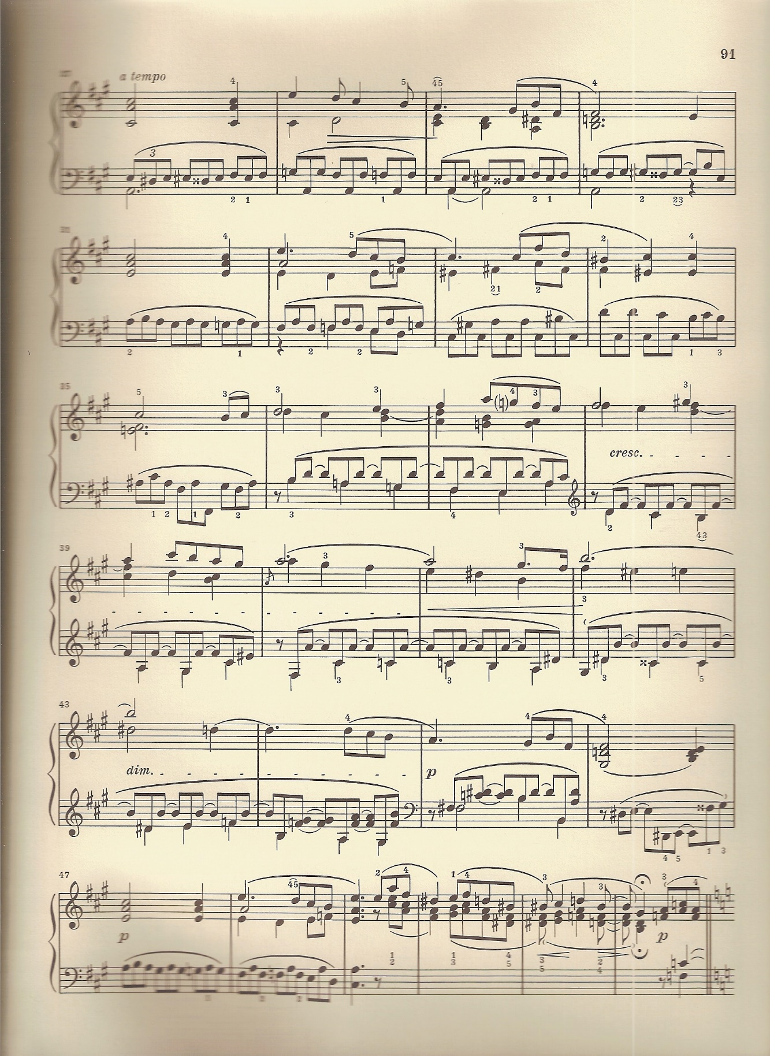
As before, one should interpret the slurs as gestures but project the larger four-measure phrase in Example 7 - 6.

Performance Considerations
The striking harmonies and soaring melodies throughout this piece are its outstanding features. Pianists should feel free to take time to accentuate the expressive nature of these characteristics. Clara also provides some harmonic surprises, such as the return of the A section in F major, which eventually resolves into A minor. Emphasizing the new tenor line in mm. 52–54 (Example 7 - 7) can beautifully underline this tonal transition.

Example 7 - 7. Romanze in A Minor, without Opus (1853), mm. 51–55.
51
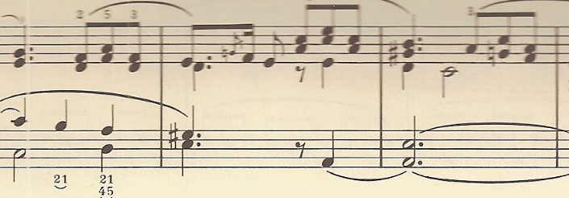
Although the Romanze is written in 3/4, Clara creates a remarkable feeling of floating by slurring across strong beats. For example, the slurs in Example 7 - 8 all begin on weak beats, dispelling the feeling of three.
Example 7 - 8. Romanze in A Minor, without Opus (1853), mm. 12–18.
12
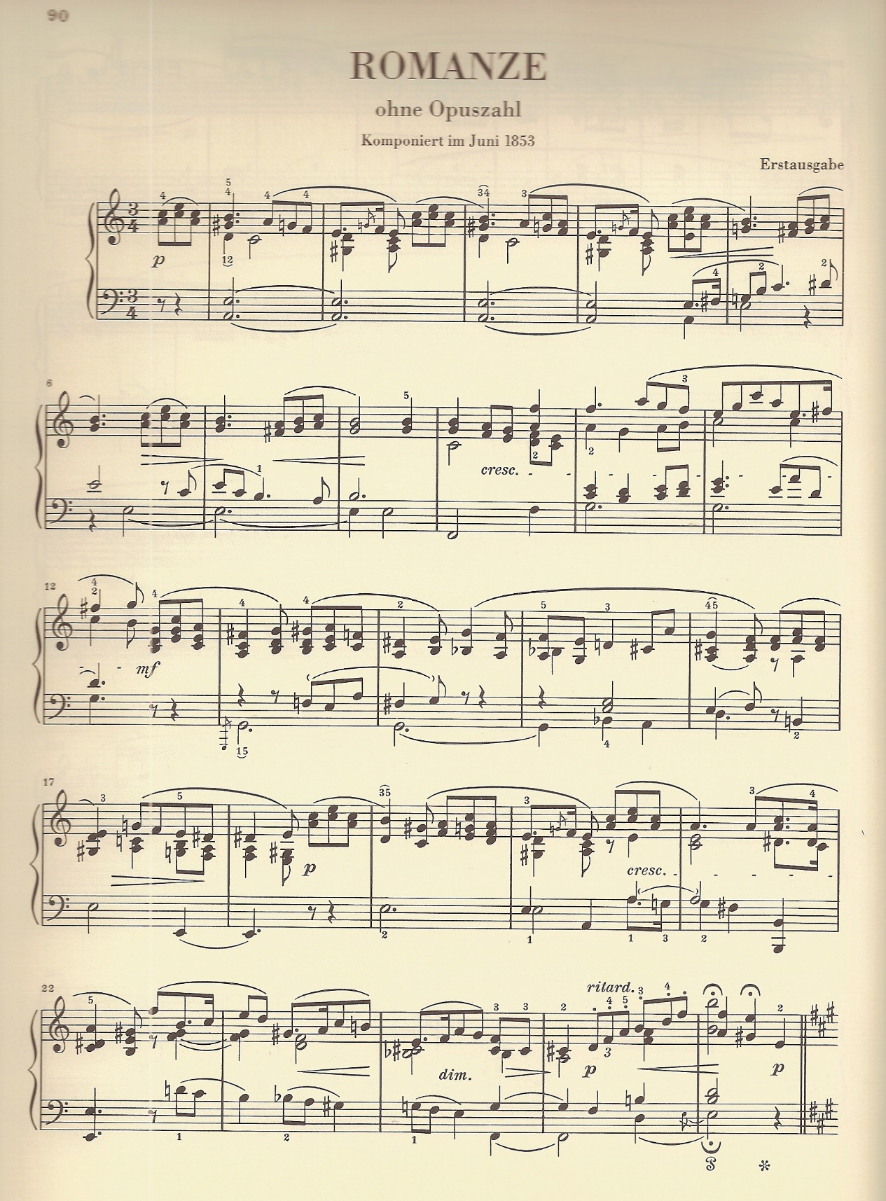
This floating effect alternates with strong instances of 3/4 throughout the piece. The changes in the sense of meter provide an unsettled feeling that increases the underlying expressiveness of the piece. Even at the end (Example 7 - 9), Clara emphasizes the 3/4 meter in a stringendo in m. 76 before ending the piece without any emphasis on the triple meter.

Example 7 - 9. Romanze in A Minor, without Opus (1853), mm. 74–78.
74
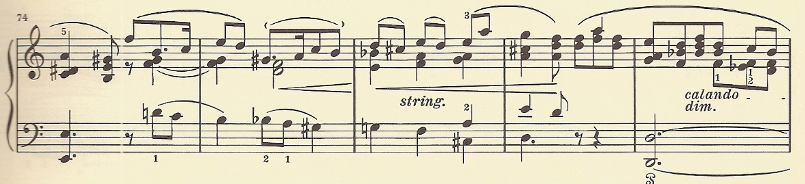
If one is not careful, it is easy to get lost in the changes in metric accents. However, the point is not to overemphasize the strong beats in order to keep control; instead, the pianist can allow the long phrases to flow freely, without interruption, effortlessly creating the dramatic, expressive mood.

Chapter 8: Summary

Clara Wieck Schumann’s performance accomplishments alone are worthy of discussion, but it is her compositions that have not been fully recognized in scholarly literature. Her life story resonates with many people, so it is no surprise that her biography is often retold by music teachers. Young pianists are customarily first introduced to a portion of her biography when playing Album for the Young, Kinderszenen, or another set of short, intermediate works by her husband. Unfortunately, many then miss out on studying Clara’s own music.
At first glance, it might appear that Clara’s compositions are only appropriate for advanced pianists. After all, many of the pieces were written to display her own phenomenal talents in concert. In reality, several of her pieces provide an avenue for aspiring young pianists and advanced pianists alike to enjoy her musical genius on a small scale. The character pieces included in this survey, ranging from level nine to early advanced, are some of the most accessible of her piano works and are meant to serve as a starting point for all those pianists who want to begin a journey with Clara Schumann.
Each of the five pieces includes important technical and musical challenges, but some pedagogical observations are common to all of them. Wide-reaching chords, such as tenths or larger, occur in every piece to some extent. Perhaps this is evidence of a large hand span of the composer, but breaking or rolling these chords never seems to impair the musical flow and can often be used for heightened expression. Pianists should feel free to use tasteful rubato in these passages.
Each piece also requires careful consideration of markings in the score that deal with phrasing and touch. Whether hairpins, dynamics, or slurs, it is up to the pianist to perceive the meaning of the markings in terms of the music. One is also required to use a variety of touches, including quick staccato chords and scales, two-note slurs that appear in sequence, arpeggios that sweep between the hands, multiple voices in a single hand, and legato thirds and chords.
Pedaling may be used to create a sense of legato when appropriate. Most passages fit the hand very naturally when pedaled, which was likely Clara’s intention. Awkward stretches and finger substitutions actually detract from subtle control of the phrases. For pianists who need practice with legato pedaling, some of these pieces will serve as excellent studies.
Executing the polyrhythms and other unique rhythmic devices require pianists to have a strong sense of the flow of pulses before attempting these works. In addition to competing rhythms between the hands, Clara uses accents and phrasing marks over downbeats to create rhythmic contrast and metric subtleties.
A concise order of levels is included in Appendix C. “Larghetto” (Op. 15, No. 1) and “Scherzo” (Op. 15, No. 4) are both approximately level nine. These are the shortest works of the five, include the fewest wide reaches, and focus on a limited number of challenges. “Larghetto” is the optimal piece with which to begin study, as it suggests a slower tempo and is more representative of Clara’s lyrical style. It is excellent for teaching how the hands works together with arpeggios divided between the hands. “Scherzo” includes fast scalar and chordal passages throughout, often with leaps and staccato articulation, but the texture is much thinner than in other works.
The Romanze in A Minor (without Opus) and “Un poco agitato” (Op. 15, No. 2) are both level-ten works. Even with its rhythmic, voicing, and phrasing challenges, the Romanze is slightly easier than “Un poco agitato,” which includes quick scale passages and rapid, thick chord changes. “Toccatina” (Op. 6, No. 1) is the most difficult and longest of these five pieces and requires strong facility and a light touch for the presto A section as well as solid finger independence and legato touch in the B section. “Toccatina” would be appropriate for early-advanced pianists or later.
It is notable that each set in this study (Op. 6, Op. 15, and Romanze) was influenced by a different time in Clara’s life, thus providing an introduction to each of her stylistic periods. “Toccatina,” Op. 6, No. 1, dates from 1836 when Clara was a performing teenager. Her father often programed improvisations or original compositions for her concerts, and pieces full of technical virtuosity appealed to the audiences. While on a smaller scale and part of a larger set, “Toccatina” is typical of works Clara might perform in that day—fast tempo, sectional, and displaying impressive technical feats.
The Op. 15 set, from 1841-1844, is perfectly situated in the years just after Clara’s marriage. Clara and Robert both experimented with vocal works during this time, and that lyrical element extended into her other genres. Clara’s piano works in these years were not so much intended for technical display in concerts. The first piece, “Larghetto,” reflects this new introspective quality the most, with a simple form and long, lyrical lines unobstructed by complicated passagework. “Un poco agitato” may be the most flashy from this set, but it still has overlying Romantic idioms and employs advanced motivic development, especially in the transformation of the closing theme of the A section. “Scherzo” was originally intended to be part of a sonata, but even this piece shows a restrained style with sophisticated phrase development.
Romanze in A Minor is from an altogether different point in Clara’s life. She was disheartened with Robert’s health, and the despairing mood in many of these pieces cannot be coincidence. Even beyond the mood, this piece shows a mature rhythmic treatment in the subtle way Clara avoids any strong sense of triple meter at times. She also uses competing rhythms between the hands. Perhaps these features were a mirror of the uncertainty in her life at this point.
What becomes evident when observing these five representative pieces is the impossibility of separating any of Clara’s music from the events that took place in her life. One has to wonder if she would have achieved as much had her situation been more bearable; her father exploited her talents and gave her no share in the profits, and her later married life ended in the deaths of her husband and several children many years before her own. Clara’s strength in spite of her circumstances may have factored into the expressive qualities that attract many of us to her works. Truly, she was able to draw from a wide range of emotion—from exuberant happiness to grief-stricken sadness. The character pieces are exceptional examples of her music and provide us all with fresh teaching and performance literature.

Bibliography

Books

Bomberger, E. “The Nineteenth Century.” In Convent to Concert Hall: A Guide to Women Composers, edited by Sylvia Glickman and Martha Furman Schleifer, 153-215. Westport, Connecticut: Greenwood Press, 2003.

Bowers, Jane and Judith Tick. Women Making Music: The Western Art Tradition, 1150-1950. Chicago: University of Illinois Press, 1986.

Burk, John N. Clara Schumann: A Romantic Biography. New York: Random House, 1940.

Burton, Anna M. “A Psychoanalyst’s View of Clara Schumann.” In Psychoanalytic Explorations in Music, edited by Stuart Feder, Richard L. Karmel, George H. Pollock, 97-114. Madison, Connecticut: International Universities Press, 1990.

———. “Robert Schumann and Clara Wieck: A Creative Partnership.” In Psychoanalytic Explorations in Music, edited by Stuart Feder, Richard L Karmel, George H. Pollock, 441-464. Madison, Connecticut: International Universities Press, 1990.

Chissell, Joan. Clara Schumann: A Dedicated Spirit. A Study of Her Life and Work. New York: Taplinger Publishing Company, 1983.

Goertzen, Valerie Wooding. “Setting the Stage: Clara Schumann’s Preludes.” From In the Course of Performance: Studies in the World of Musical Improvisation, edited by Bruno Nettl with Melinda Russell, 237-260. Chicago: The University of Chicago Press, 1998.

———. “Clara Wieck Schumann’s Improvisations and Her ‘Mosaics’ of Small Forms.” In Beyond Notes: Improvisation in Western Music of the Eighteenth and Nineteenth Centuries, edited by Rudolf Rasch, 153-162. Turnhout, Belgium: Brepols, 2011.

Hinson, Maurice. Guide to the Pianist’s Repertoire. 3rd ed. Bloomington: Indiana University Press, 2000.

Jezic, Diane. Women Composers: The Lost Tradition Found. New York: Feminist Press at the City University of New York, 1988.

Kennedy, Michael and Joyce Bourne Kennedy, eds. The Oxford Dictionary of Music. 2nd ed. Oxford: Oxford University Press, 1994.

Kimber, Marian Wilson. “From the Concert Hall to the Salon: The Piano Music of Clara Wieck Schumann and Fanny Mendelssohn Hensel.” In Nineteenth-Century Piano Music, edited by R. Larry Todd, 2nd ed., 316-355. New York: Routledge, 2004.

Litzmann, Berthold. Clara Schumann: An Artist’s Life, Based on Material Found in Diaries and Letters. Translated and abridged by Grace E. Hadow. 3 vols. London: Macmillan, 1913. Reprint, New York: Da Capo, 1979.

———, ed. Letters of Clara Schumann and Johannes Brahms 1853-1896. Westport Connecticut: Hyperion Press, 1972.

Magrath, Jane. The Pianist’s Guide to Standard Teaching and Performance Literature: An Invaluable Resource of Piano Literature from Baroque through Contemporary Periods for Teachers, Students and Performers. Van Nuys, California: Alfred Publishing, 1995.

Nauhaus, Gerd, ed. The Marriage Diaries of Robert & Clara Schumann: From Their Wedding Day through the Russia Trip. Translated by Peter Ostwald. Boston: Northeastern University Press, 1987.

Randel, Don Michael, ed. The Harvard Biographical Dictionary of Music. Cambridge, Massachusetts: Belknap Press of Harvard University, 1996.

Reich, Nancy B. Clara Schumann: The Artist and the Woman. Rev. ed. Ithaca, New York: Cornell University Press, 2001.

———. “Clara Schumann.” In Women Making Music: The Western Art Tradition, 1150-1950, edited by Jane Bowers and Judith Tick, 249-281. Chicago: University of Illinois Press, 1986.

Schleifer, Martha Furman and Sylvia Glickman. Women Composers: Music through the Ages. New York: G.K. Hall, 1996.

Steegmann, Monica. Clara Schumann. London: Haus Publishing Limited, 2004.

Weissweiler, Eva, ed. The Complete Correspondence of Clara and Robert Schumann: Critical Edition. Translated by Hildegard Fritsch and Ronald L. Crawford. New York: Peter Lang, 1994.

Dissertations and Theses

Blanton, Carol Valerie. Outstanding Women Pianists of the Nineteenth and Twentieth Centuries. M.S. thesis, The Juilliard School of Music, 1939.

Fang, Sui-Wan Chair. “Clara Schumann as Teacher.” D.M.A. dissertation, University of Illinois, 1978.

Gates, Eugene Murray. “The Woman Composer Question: Four Cases from the Romantic Era.” Ed.D. thesis, University of Toronto, 1992.

Geske, Sarah B. “Clara Schumann: The Woman behind the Music.” D.M.A. dissertation, University of Kansas, 2006.

Gordy, Laura Ann. “Women Creating Music, 1750-1850: Marianne Martinez, Maria Theresia von Paradis, Fanny Mendelssohn Hensel, and Clara Wieck Schumann.” D.M.A. dissertation, University of Alabama, 1987.

Hicks, Hilarie M. “The Piano Music of Robert and Clara Schumann: A Marriage of Musical Minds.” Honors thesis, College of William and Mary, 1984.

Juang, Jyh-Hueih Grace. “Romance: Selected Piano Music of Robert and Clara Schumann.” D.M.A. dissertation, University of Maryland, 2012.

Klassen, Shelly Maureen. “A Study of Selected Compositions of Three Performing Women Composers: Clara Wieck Schumann (1819-1896), Cécil Chaminade (1857-1944), and Amy Cheney Beach (1867-1944).” M.M. thesis, University of Wisconsin—Eau Claire, 1991.

Lai, Li-chin. “Variations on a Theme by Robert Schumann Op. 20 by Clara Schumann: An Analytical and Interpretive Study.” D.M.A. dissertation, Temple University, 1992.

Lee, Sang-Mi. “Clara and Robert Schumann.” D.M.A thesis, Manhattan School of Music, 2000.

Lucciola, Iolando Maria. “The Character Pieces of Clara Wieck-Schumann and Fanny Mendelssohn-Hensel: A Stylistic Comparison of Gender Traits and Idios Proper to the Genre.” M.A. thesis, University of Ottawa, 2001.

Nemko, Deborah. “Clara Schumann as Innovator and Collaborator: The Piano Trio in G Minor, Op. 17.” D.M.A. dissertation, University of Arizona, 1997.

Sohnn, Hunju. “Six Major Women Pianists: Clara Schumann, Teresa Carreno, Myra Hess, Clara Haskili, Alicia de Larrocha, and Martha Argerich.” D.M.A. document, Rice University, 2001.

Susskind, Pamela Gertrude. “Clara Schumann as Pianist and Composer: A Study of Her Life and Works.” Ph.D. dissertation, University of California-Berkeley, 1977.

Tan, Siok Lian. “The Influence of the Nineteenth-Century Bach Revival Movement on the Piano Works of Felix Mendelssohn-Bartholdy, Robert Schumann, Clara Wieck-Schumann, and Johannes Brahms.” D.M.A. dissertation, University of Cincinnati, 1998.

Walker, Nancy Lucile. “A Stylistic Analysis of Selected Lieder by Fanny Mendelssohn Hensel and Clara Wieck Schumann.” D.M.A. document, Indiana University, 1988.

Yang, Yi-heng. “Performing Schumann’s Piano Music: Clues from the Clara Schumann School and Period Instruments.” D.M.A. dissertation, The Juilliard School, 2010.

Periodicals

Artesanti, Laura. “Beyond Clara Schumann: Integrating Women Composers and Performers into General Music Classes.” General Music Today 25, no. 3 (April 2012): 23-31. Accessed March 14, 2014. http://gmt.sagepub.com/content/25/3/23.

Caines, Jennifer. “Clara Schumann: The Man and Her Music, Gender Subversion in Nineteenth-Century Concert Reviews.” Fermata 4, no. 32 (January 2002): 32-45.

Cooper, Suzanne. “Clara Schumann, You Mean… Robert Schumnn’s Wife?”
Ich fahre in mein liebes Wien: Clara Schumann—Fakten, Bilder, Projektionen (January 1, 1996): 151-158. Accessed March 17, 2014. RILM Abstracts of Music Literature.

Cromley, Dorothy. “Clara Schumann: Role Model for Today’s Woman.” American Music Teacher 41, no. 3 (December/January, 1991/92): 16-19.

Ferris, David. “Public Performance and Private Understanding: Clara Wieck’s Concerts in Berlin.” Journal of the American Musicological Society 56, no. 2 (Summer 2003): 351-408. Accessed March 14, 2014. http://www.jstor.org/stable/10.1525/jams.2003.56.2.351.

Gates, Eugene. “Clara Schumann: A Composer’s Wife as Composer.” Alla Breve 36, no. 1 (December 2011): 9-17.

Holz, Jennifer. “From Consort to Composer: The Emergence of Clara Wieck Schumann in Music History Texts.” Women of Note Quarterly: The Magazine of Historical and Contemporary Women Composers 9, no. 1 (May 1993): 24-27.

Pedroza, Ludim R. “Music as communitas: Franz Liszt, Clara Schumann, and the Musical Work.” From Journal of Musicological Research 29, no. 4 (October-December 2010): 295-321.

Pettler, Pamela Susskind. “Clara Schumann’s Recitals, 1832-50.” 19^{th –}Century Music 4, no. 1 (Summer 1980): 70-76. Accessed March 14, 2014. http://www.jstor.org/discover/10.2307/3519814.

Reich, Nancy and Anna Burton. “Clara Schumann: Old Sources, New Readings.” The Music Quarterly 70, no. 3 (Summer 1984): 332-354. Accessed March 14, 2014. http://www.jstor.org/discover/10.2307/742042.

Sagrans, Jacob. “Virtuosity in Clara Schumann’s Piano Compositions.” Musicological Explorations 11 (Spring 2010): 45-90.

Seldon, Margery Stomne. “Clara Wieck Schumann: In the Shadow of Genius.” Piano Guild Notes 30, no.1 (July-August 1980), 13-15.

Stinson, Russell. “Clara Schumann’s Bach Book: A Neglected Document of the Bach Revival.” From BACH: Journal of the Riemenschneider Bach Institute 39, no. 1 (2008): 1-66. Accessed March 14, 2014. http://www.jstor.org/discover/10.2307/41640571.

Scores

Hinson, Maurice, ed. At the Piano with Women Composers. Alfred Publishing Company, 1995.

———, ed. At the Piano with Robert and Clara Schumann. Alfred Publishing Company, 1988.

Schumann, Clara. Piano Music: Selected and with an Introduction by Nancy Reich. New York: Dover Publications, 2001.

———. Romantic Piano Music. Edited by Franzpeter Goebels. Bärenreiter Kassel: Bärenreiter-Verlag, 1957.

———. Romantic Piano Music (1819-1896). Edited by Franzpeter Goebels. Heft II. Heidelberg: Willy Müller.

———. Selected Piano Music. Introduction by Pamela Susskind. New York: Da Capo Press, 1979.

Smith, Gail. Great Women Composers. Pacific, Missouri: Mel Bay Publications, 1996.

Wieck-Schumann, Clara. Ausgewählte Klavierwerke. Introduction by Janina Klassen. Fingerings by Hans-Martin Theopold. München: G. Henle Verlag, 1987.

Audio

Schumann, Clara. Complete Piano Works. Performed by Jozef de Beenhouwer. Recorded 1990-1991, 2000. CPO 999 758-2, 2001. 3 CDs.

Appendices

Appendix A: Chronology

1819 Clara is born in Leipzig.
1824 Mother leaves the household.
Clara begins taking formal piano lessons.
1828 Her first compositions published- Quatre Polonaises, Op. 1.
Robert arrives in Leipzig.
1830 Robert comes to live with the Wieck family.
Clara gives first full recital.
1831 First extended concert tour.
1837 Robert asks to marry Clara.
First tour of Vienna.
1838 Second tour of Vienna.
Appointed “Kammer Virtuosin” to Austrian court.
1836-1838 Clara composes many of her piano works.
1840 Robert and Clara marry.
1840-1843 Clara composes most of her Lieder.
1841 Birth of Marie, first child of eight.
1842 Clara begins long-term tours again.
1844 Schumann family moves to Dresden.
1850 Schumann family moves to first home in Düsseldorf.
1854 Robert’s mental collapse and exile to asylum.
1856 Robert dies.
1879 Clara becomes principal teacher at Hoch Conservatory, Frankfurt.
1891 Clara gives last public appearance but continues to teach in home.
1896 Clara dies from stroke.

Appendix B: Clara Schumann’s Works with Piano

Works with Opus Numbers

Op. 1 Quatre polonaises (1831)
Op. 2 Caprices en forme de valse (1832)
Op. 3 Romance variée (1833)
Op. 4 Valse romantiques (1835)
Op. 5 Quatre pièces caractéristiques (1836)
Op. 5a Hexentanz (1838)
Op. 6 Soirée musicales (1836)
Op. 7 Premier Concert pour le Piano-Forte avec Accompagnement d’Orchestre (ou de Quintour) (1837)
Op. 8 Variations de concert sur la cavatine du Pirate de Bellini (1837)
Op. 9 Souvenir de Vienne, impromptu pour le pianoforte (1838)
Op. 10 Scherzo pour le pianoforte (D minor, 1838)
Op. 11 Trois romances pour le piano (1840)
Op. 12 Zwölf Gedichte aus F. Rückert’s Liebesfrühling für Gesange und Pianoforte (1841)
Op. 13 Sechs Lieder mit Begleitung des Pianoforte (1844)
Op. 14 Deuxième scherzo pour le pianoforte (1845)
Op. 15 Quatre pièces fugitives (1845)
Op. 16 Drei Praueludien und Fugen für das Pianoforte (1845)
Op. 17 Trio für Pianoforte, Violine und Violoncello (1847)
Op. 20 Variationen für das Pianoforte über ein Thema von Robert Schumann (1854)
Op. 21 Drei Romanzen für Pianoforte (1855)
Op. 22 Drei Romanzen für Pianoforte und Violine (1856)
Op. 23 Sechs Lieder aus Jucunde für eine Singstimme mit Begleitung des Pianoforte (1856)

Works without Opus Numbers*

Etude in A-Flat Major (written 1832, unpublished)
Sonate für Klavier, G Moll (written 1842, published 1991)
Impromptu in E Major (written before 1844, published 1885)
Three Fugues on Themes of J. S. Bach (written 1845, published 1999-2000)
Praeludium und Fuga in F# Moll (written 1845, published 1999-2000)
Praeludium in F Moll (written 1845, unpublished)
Konzertsatz für Klavier und Orchester in F Moll (incomplete 1847, completed by Josef de Beenhouewer 1994)
Romanze in A Minor (written 1853, published 1891)
Romanze in B Minor (written 1856, published 1967)
Marsch (E-Flat Major, Piano Four Hands, written 1879, published 1996)
Praeludien und Vorspiele (written 1895, published 1999)
Cadenzas for Beethoven’s Piano Concerto in E Major, Op. 58 (written 1846, published 1870)
Cadenzas for Beethoven’s Piano Concerto in C Minor, Op. 37 (written 1868, published 1870)
Cadenzas for Mozart’s Piano Concerto in D Minor, K. 466 (published 1891, composition date unknown)

*This list does not include individual vocal works without opus numbers and miscellaneous transcriptions of instrumental and vocal works.

Appendix C: Progressive Levels of Selected Character Pieces

Level 9 Op. 15, No. 1, “Larghetto”

Level 9 Op. 15, No. 4, “Scherzo”

Level 10 Romanze in A Minor, without Opus

Level 10 Op. 15, No. 2, “Un poco agitato”

Early-advanced Op. 6, No. 1, “Toccatina”

Appendix D: Institutional Review Board Exemption

Appendix E: Publisher Permission

Mon 1/18/2016 3:18 AM
To: Ellis, Olivia D. <oellis@ou.edu>

Dear Ms Ellis,

I am happy to inform you that we do not charge any licensing fees for reprinting of individual measures and excerpts from our music books when the purpose is scholarly or educational which certainly applies to a doctoral thesis. Please feel free to use the excerpts you need from the respective Henle music book.

We wish you much success.

Sincerely,
Kristina Winter
Assistant to the C.E.O.
G. Henle Publishers
Forstenrieder Allee 122
81476 München
Germany
phone: +49-89-75982-21
fax: +49-89-75982-55
www.henle.com
*************************************
G. Henle Verlag e.K., München
Amtsgericht München, Handelsregister A Nr. 08 808

Jane Bowers and Judith Tick, Women Making Music: The Western Art Tradition, 1150-1950 (Chicago: University of Illinois Press, 1986), 10.
Nancy Reich, Clara Schumann: The Artist and the Woman, rev. ed. (Ithaca, New York: Cornell University Press, 2001), 211.
Ibid., 229.
Reich, Clara Schumann: The Artist and the Woman, 212.
This recording does not include the improvisational preludes that Clara transcribed for her daughters in her last years.
Reich, Clara Schumann: The Artist and the Woman, n.p.
Berthold Litzmann, Clara Schumann: An Artist’s Life, Based on Material Found in Diaries and Letters, trans. and abrid. Grace E. Hadow, 3 vols. (London: Macmillan, 1913. Reprint, New York: Da Capo, 1979), n.p.
Jane Magrath, The Pianist’s Guide to Standard Teaching and Performance Literature: An Invaluable Resource of Piano Literature from Baroque through Contemporary Periods for Teachers, Students and Performers (Van Nuys, California: Alfred Publishing, 1995), n.p.
Litzmann, n.p.
Pamela Gertrude Susskind, “Clara Schumann as Pianist and Composer: A Study of Her Life and Works” (Ph.D. diss., University of California—Berkeley, 1977), n.p.
Reich, Clara Schumann: The Artist and the Woman, n.p.
Marian Wilson Kimber, “From the Concert Hall to the Salon: The Piano Music of Clara Wieck Schumann and Fanny Mendelssohn Hensel” in Nineteenth-Century Piano Music, ed. R. Larry Todd, 2nd ed. (New York: Routledge, 2004), 316-355.
Susskind, n.p.
Ibid., n.p.
Sarah B Geske, “Clara Schumann: The Woman behind the Music” (D.M.A. diss., University of Kansas, 2006), n.p.
Shelly Maureen Klassen, “A Study of Selected Compositions of Three Performing Women Composers: Clara Wieck Schumann (1819-1896), Cécil Chaminade (1857-1944), and Amy Cheney Beach (1867-1944)” (M.M. thesis, University of Wisconsin—Eau Claire, 1991), n.p.
Michael Kennedy and Joyce Bourne Kennedy, eds, The Oxford Dictionary of Music, 2nd ed. (Oxford: Oxford University Press, 1994), n.p.
Don Michael Randel, ed., The Harvard Biographical Dictionary of Music (Cambridge, Massachesetts: Belknap Press of Harvard University, 1996), n.p.
John N. Burk, Clara Schumann: A Romantic Biography (New York: Random House, 1940), n.p.
Joan Chissell, Clara Schumann: A Dedicated Spirit, A Study of Her Life and Works (New York: Taplinger Publishing Company, 1983), n.p.
Litzmann, n.p.
Reich, Clara Schumann: The Artist and the Woman, n.p.
Diane Jezic, Women Composers: The Lost Tradition Found (New York: Feminist Press at the City University of New York, 1988), n.p.
E. Bomberger, “The Nineteenth Century” in Convent to Concert Hall: A Guide to Women Composers, ed. Sylvia Glickman and Martha Furman Schleifer (Westport, Connecticut: Greenwood Press, 2003), 153-215.
Hunju Sohnn, “Six Major Women Pianists: Clara Schumann, Teresa Carreno, Myra Hess, Clara Haskili, Alicia de Larrocha, and Martha Argerich” (D.M.A. doc., Rice University, 2001), n.p.
Ibid., 8, 15.
Sui-Wan Chair Fang, “Clara Schumann as Teacher” (D.M.A. diss., University of Illinois, 1978), n.p.
Maurice Hinson, Guide to the Pianist’s Repertoire, 3rd ed. (Bloomington: Indiana University Press, 2000), n.p.
Magrath, n.p.
Kimber, 316-355.
Siok Lian Tan, “The Influence of the Nineteenth-Century Bach Revival Movement on the Piano Works of Felix Mendelssohn-Bartholdy, Robert Schumann, Clara Wieck-Schumann, and Johannes Brahms” (D.M.A. diss., University of Cincinnati, 1998), 82.
Ionaldo Maria Lucciola, “The Character Pieces of Clara Wieck-Schumann and Fanny Mendelssohn-Hensel: A Stylistic Comparison of Gender Traits and Idioms Proper to the Genre” (M.A. thesis, University of Ottawa, 2001), n.p.
Lucciola, 51.
Ibid., 74.
Eugene Murray Gates, “The Woman Composer Question: Four Cases from the Romantic Era” (Ed.D. thesis, University of Toronto, 1992), n.p.
Laura Ann Gordy, “Women Creating Music, 1750-1850: Marianne Martinez, Maria Theresia von Paradis, Fanny Mendelssohn Hensel, and Clara Wieck Schumann” (D.M.A. diss., University of Alabama, 1987), n.p.
Ibid., 51.
Laura Artesanti, “Beyond Clara Schumann: Integrating Women Composers and Performers into General Music Classes,” General Music Today 25, no. 3 (April 2012): 23-31, accessed March 14, 2014, http://gmt.sagepub.com/content/25/3/23.
Jennifer Caines, “Clara Schumann: The Man and Her Music, Gender Subversion in Nineteenth-Century Concert Reviews,” Fermata 4, no. 32 (January 2002): 32-45.
Jennifer Holz, “From Consort to Composer: The Emergence of Clara Wieck Schumann in Music History Texts,” Women of Note Quarterly: The Magazine of Historical and Contemporary Women Composers 9, no. 1 (May 1993): 24-27.
Susskind, 12.
Burton, 101.
Reich, Clara Schumann: The Artist and the Woman, 15.
Susskind, 14.
Burton, 99.
Deborah Nemko, Clara Schumann as Innovator and Collaborator: The Piano Trio in G Minor, Op. 17 (D.M.A. diss., University of Arizona, 1997), 14.
Chissell, 4.
Goertzen, 239.
Chissell, 5.
Reich, Clara Schumann: The Artist and the Woman, 21.
Susskind, 17.
Susskind, 18-20.
Burton, 108.
Litzmann, vol. 1, 67.
Gates, 10.
Nemko, 12.
Gates, 13.
Gates, 10.
Nancy Reich, “Clara Schumann,” in Women Making Music: The Western Art Tradition, 1150-1950, ed. Jane Bowers and Judith Tick (Chicago: University of Illinois Press, 1986), 259.
Gates, 12.
Bomberger, 160.
Gates, 12.
Ibid., 12.
Susskind, 30.
Ibid., 29.
Ibid., 73.
Litzmann, vol. 1, 318.
Bomberger, 162.
Ibid., 161.
Reich, “Clara Schumann,” in Women Making Music: The Western Art Tradition, 263.
Ibid., 264.
Litzmann, vol. 1, 139-140.
The piano sonata was published in 1991; Impromptu was published in 1885.
Burton, 109.
Bomberger, 162.
Reich, “Clara Schumann,” in Women Making Music: The Western Art Tradition, 266.
Bomberger, 161.
Gates, 15.
Gates., 15.
Litzmann, vol. 2, 36.
Litzmann, vol. 2, 241-242.
Gates, 15.
Reich, “Clara Schumann,” in Women Making Music: The Western Art Tradition, 265.
Reich, Clara Schumann: The Artist and the Woman, 223.
Susskind, 30.
Reich, Clara Schumann: The Artist and the Woman, 229.
Susskind, 90.
Reich, Clara Schumann: The Artist and the Woman, 232.
Ibid., 233.
Ibid., 234.
Premier Concert pour le Piano-Forte avec Accompagnement d’Orchestre (ou de Quintour).
Reich, Clara Schumann: The Artist and the Woman, 227.
Susskind, 46.
Ibid., 227.
Reich, Clara Schumann: The Artist and the Woman, 298.
Reich, Clara Schumann: The Artist and the Woman, 221.
Ibid., 221.
Ibid., 221.
Ibid., 293.
Reich, Clara Schumann: The Artist and the Woman, 225.
Chissell, 44.
Reich, Clara Schumann: The Artist and the Woman, 229-230.
Susskind, 91.
Reich, Clara Schumann: The Artist and the Woman, 233.
Susskind, 90.
Reich, Clara Schumann: The Artist and the Woman, 229.
Reich, Clara Schumann: The Artist and the Woman, 235.
Tan, 81.
Ibid., 81-82.
Ibid., 81.
Sagrans, 74.
Kimber, 328.
Ibid., 328.
Reich, Clara Schumann: The Artist and the Woman, 231.
Sagrans, 75.
Reich, Clara Schumann: The Artist and the Woman, 235.
Sagrans, 69.
Reich, Clara Schumann: The Artist and the Woman, 237.
Ibid., 236.
Reich, Clara Schumann: The Artist and the Woman, 235.
Ibid., 235.
Reich, Clara Schumann: The Artist and the Woman, 226.
Susskind, 81.
Kimber, 322.
Clara Wieck-Schumann, Ausgewählte Klavierwerke, introduction by Janina Klassen, fingerings by Hans-Martin Theopold (München: G. Henle Verlag, 1987).
Robert Schumann indicates similar pedaling in his “Kleine Studie” from Album for the Young. For example, he joins mm. 7–8 and mm. 9–10 with two-measure pedal markings, even though he adds sevenths to the existing harmonies. 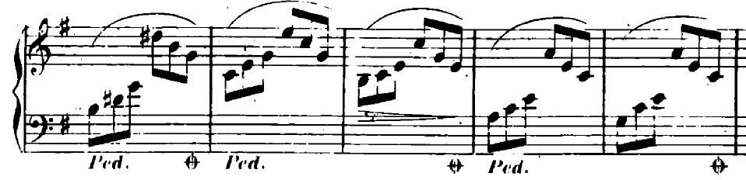
Reich, Clara Schumann: The Artist and the Woman, 309.
Ibid., 309.
The sonata was finally published in 1991 and included a third-movement scherzo that is nearly identical to the scherzo from Op. 15.
Clara Schumann, Piano Music: Selected and with an Introduction by Nancy Reich (New York: Dover Publications, 2001), n.p.
Magrath, 233.
Kimber, 324.
Similar passages include the left hand of m. 33 and the right hand of mm. 13, 49, and 59.
Romantic composers often included a pedal marking at the beginning of a piece to indicate the use of pedal as needed.
Susskind, 182.
Ibid., 195.
Reich, Clara Schumann: The Artist and the Women, 233.
The set with the later Romanze as the opening piece was eventually published as Op. 21. Clara dedicated the entire set to Brahms and presented it to him on his birthday in 1855. As a result, the second Romanze in A minor from 1855 is more well-known than this original version from 1853.
Reich, Clara Schumann: The Artist and the Women, 325-326.
Clara Wieck-Schumann, Ausgewählte Klavierwerke, introduction by Janina Klassen, fingerings by Hans-Martin Theopold (München: G. Henle Verlag, 1987).
Susskind, 7.
Since the works from the latest years of Clara’s life (many decades after Robert’s death) are few in number and of a different vein, they constitute an exception to these three periods of music.

