University of Oklahoma

Graduate College

characterization of rotary seals through identification of performance PARAMETERS

A thesis

submitted to the Graduate Faculty

in partial fulfillment of the requirements for the

Degree of

Master of Science

By

Anna masters
Norman, Oklahoma
2016

charActerization of rotary seals through identification of performance parameters

A thesis approved for the
School of Aerospace and Mechanical Engineering

By

______________________________
Dr. Zahed Siddique, Chair

______________________________
Dr. M. Cengiz Altan

______________________________
Dr. Yingtao Liu

______________________________
Dr. Raghu Madhavan

© Copyright by anna masters 2016
All Rights Reserved.

Acknowledgements
I would like to thank Dr. Zahed Siddique for his constant support through my college career in both my undergraduate studies and allowing me to do research with him in graduate school. I would also like to thank Raghu Madhavan and Chunnong Wang for supporting my research, and mentoring me for the last three years. Thank you to Dr. M. Cengiz Altan and Dr. Liu Yingtao for serving on my thesis committee.
I would like to acknowledge past capstone teams and James Kucinskas for developing the experimental test set-up used for this study. Additionally I would like to thank members in my research group: Nooshin Nassr, Colin Baker, and Jon Keegan. A special thanks to Madhumitha Ramachandran for helping with data analysis and data collection. I also wanted to thank Billy Mays, Greg Williams and all employees of the AME Machine Shop for their assistance with the development of my test set-up.
I wanted to especially thank Keith Hurdelbrink for being my best friend and all the help he has given me with my research and my college career. I would like to thank my family and friends for always loving and pushing me to do the best I can in everything that I do.

Table of Contents
Acknowledgements iv
List of Tables viii
List of Figures ix
Abstract xii
Chapter 1: Introduction 1
1.1 Oil and Gas Industry Overview 1
1.2 Rotary Equipment of Oil and Gas Technology 2
1.3 Rotary Seals and Current Understanding 5
1.4 Experimental Procedure and Design of Rotary Seals 7
1.5 Research Objectives and Questions 10
Chapter 2: Literature Review 12
2.1 Rotary Seals and Applications 12
2.2 Friction and Lubrication of Seals 17
2.3 Sealing Mechanism 19
2.4 Existing Models 21
2.1 Summary of Chapter 22

Chapter 3: Experimental Test set-up and Procedure for Determining Torque 24
3.1 Organization of Procedure 24
3.2 Experimental Set-up and Data Collection Equipment 25
3.3 Experimental Procedures for Steady-state Torque Test 31
3.4 Dwell Time Break-out Torque Experimental Procedure 33
3.5 Summary of Chapter 34
Chapter 4: Experimental Results and Analysis 36
4.1 Overview of Experimental Data 36
4.2 Break-Out Torque Analysis and Results 38
4.2.1 Break-Out Torque Size Comparison 38
4.2.2 Shaft Rotation Speed and Seal Material Effect on Break-out
Torque 40
4.2.3 Dwell Time Break-out Torque Test Results 45
4.3 Results for Steady-State Torque Test 46
4.3.1 Steady-State Torque Seal Size Comparison 46
4.3.2 Steady-state Torque RPM and Seal Type Material Comparison 48
4.4 Seal Torque Contribution 52
4.4.1 Analysis using the Theoretical Torque Equation and Thermal Expansion Factor 54
4.4.2 Evaluation of System Friction on Torque Measurements 55
4.4.3 Comparison of Theoretical and Experimental Seal Torque 57
4.5 Summary of Chapter 63
Chapter 5: Conclusion 64
5.1 Research Objectives and Questions 64
5.1.1 Research Question 1: What methods could be used to test and characterize rotary seals? 65
5.1.2 Research Question 2: How to isolate seal torque contribution from the rotary system? 66
5.1.3 Research Question 3: How does seal size, material, temperature, and rotational speed (RPM) effect both break out and steady state torque? 67
5.2 Research Limitations and Challenges 68
5.3 Further Recommendations 69
5.3.1 Short Term Recommendations 70
5.3.2 Long Term Recommendations 70
References 72
Appendix A: Nomenclature 74
Appendix B: Defining Terms 76

List of Tables
Table 3.1: Material Descriptions and Design of Experiment Matrix with 3 data sets for each material and size 26

List of Figures
Figure 1.1: Modern Day Oil Rig [5] 3
Figure 1.2: Example of complexity of the oil rig configuration [6] 4
Figure 1.3: Schematic shows the cross sectional area of the shaft and seal contact. 8
Figure 2.1: Schematic of four critical categories for seal analysis [8]. 13
Figure 2.2: An example of a seal configuration that has reverse pumping for lubrication, and also is a protection from the abrasive environment [19]. 16
Figure 3.1: Seal Cavity schematic of the seal cavity cross sectional view. 26
Figure 3.2: Schematic of the test set-up shows the flow fluid and pressure through the system. 27
Figure 3.3: Experimental test set-up with noted critical components. 28
Figure 3.4: Technical specifications of LVDT sensor provided by the manufacturer MTS [25] 29
Figure 3.5: LabVIEW user interphase for the experimental test set-up 30
Figure 3.6: Torque Cavity for seal size of 10 mm 34
Figure 4.1: First 5-seconds of typical test, break-out torque is observed. Blue line shows the transition into steady-state torque. 36
Figure 4.2: Break-out torque comparison for material type A material at (A) 100 RPM and (B) 300 RPM. Note: Bars indicate the experimental data range for each test. 38
Figure 4.3: Break-out torque comparison for Type B material at (A) 100 RPM and (B) 300 RPM. Note: Bars indicate the experimental data range for each test. 39
Figure 4.4: Comparison of material type A and material type B and shaft rotation speed for seal size of 10 mm. Note: Bars indicate the range in the sampling data. 41
Figure 4.5: Comparison of seal material type A and material type B and shaft rotation speed for seal size of 18 mm. Note: Bars indicate the range in the sampling data. 42
Figure 4.6: Comparison of seal material type A and material type B and shaft rotation speed for seal size of 21 mm. Note: Bars indicate the range in the sampling data. 43
Figure 4.7: Comparison of seal material type A and material type B and shaft rotation speed for seal size of 25 mm. Note: Bars indicate the range in the sampling data. 44
Figure 4.8: Effect of dwell time on break-out torque for four seal sizes and two seal material types. 45
Figure 4.9: Size comparison of material type A seal at a rotation speed of (A) 100 RPM and (B) 300 RPM. Bars indicate range of experimental data 46
Figure 4.10: Size comparison of material type B at a rotation speed of (A) 100 RPM and (B) 300 RPM. Bars indicate range of experimental data 47
Figure 4.11: Average steady-state torque for 10 mm sized seals. Bars represent range of the experimental data. 49
Figure 4.12: Average steady-state torque for 18 mm sized seals. Bars represent range of the experimental data. 50
Figure 4.13: Average steady-state torque for 21 mm sized seals. Bars represent range of the experimental data. 51
Figure 4.14: Average steady-state torque for 25 mm sized seals. Bars represent range of the experimental data. 52
Figure 4.15: Steady-state torque data for the experimental test set-up without rotary seals using shaft sizes of 18, 21, and 25 mm. 56
Figure 4.16: Average experimental steady-state torque for 10 mm diameter seals compared to the theoretical torque for rotational speeds of (A) 100 RPM and (B) 300 RPM. Bars indicate the range of experimental torque. 57
Figure 4.17: Average experimental steady-state torque for 18 mm diameter seals compared to the theoretical torque for rotational speeds of (A) 100 RPM and (B) 300 RPM. Bars indicate the range of experimental torque. 58
Figure 4.18: Average experimental steady-state torque for 21 mm diameter seals compared to the theoretical torque for rotational speeds of (A) 100 RPM and (B) 300 RPM. Bars indicate the range of experimental torque. 59
Figure 4.19: Average experimental steady-state torque for 25 mm diameter seals compared to the theoretical torque for rotational speeds of (A) 100 RPM and (B) 300 RPM. Bars indicate the range of experimental torque. 61

Abstract
The oil and gas industry is one of the largest industries in the world and is an industry that everyday lives rely on, especially in the United States (U.S.). The constant need for technological advances is more critical than ever in the oil and gas industry. Of the many sectors in the industry, one important sector is the service sector. Service companies develop and maintain a wide range of tools and equipment, such as compressors, valves, and various types of drilling machinery. This research study focuses specifically on rotary drilling equipment. These tools are frequently subjected to a very aggressive and dynamic environment that involves pressure and temperature changes. Harsh operating conditions may cause components within the rotary equipment to fail, which results in costly delays. Identifying and understanding each of the critical components within the rotary system can help prevent future problems. Rotary seals are one such component of rotary equipment that has proven to be susceptible to damage, and therefore will be the focus of this research.
The rotary seal is located directly on the rotating shaft of the equipment; its primary role within the drilling equipment is providing lubrication for the shaft and to protect the mechanical components from the aggressive environment. The aggressive dynamic conditions of downhole drilling can cause these seals to build up friction and eventually fail due to wear and extended dwell periods of sitting idle. The buildup of friction and wear can cause issues such as high torque in both the initial break out torque and during the operational steady state torque. An experimental test set-up was developed to measure rotary seal torque due to changes in operation conditions, such as temperature and rotational speed at constant pressure. The data collected from the experimental set-up was used to identify trends and compared to a theoretical model developed through an understanding of the seal and torque function. The research questions addressed in this Thesis are:
- RQ1: What methods could be used to test and characterize rotary seals?
- RQ2: How to isolate seal torque contribution from the rotary system?
- RQ3: How does seal size, material, temperature, and rotational speed (RPM) effect both break out and steady state torque?
Answering the research questions was accomplished by analyzing the experimental data results. Data analysis revealed an increase in torque as temperature and seal size increased. Higher shaft rotation speeds resulted in lower torque. From literature, a theoretical model from simulations was developed that evaluated contact pressure of the seals on the shaft surface. These calculations were converted to torque values and compared to the experimental steady-state torque data. Similar trends were observed as seal material and temperature changed. Overall the theoretical torque calculation was larger than the experimental steady-state data. This is most likely due to the theoretical model not considering the effect of lubrication.
Future studies will determine how lubrication affects the seal and shaft interaction, as well as examine the performance parameter of leak-rate. The experimental test set-up to address these studies is still being developed. Other studies will also focus on aging effects of seals on performance and the seal service life.
Proper characterization of rotary seals will greatly improve maintenance and serviceability of rotary equipment in the service industry. Through being able to predict the seal behavior, millions of dollars can be saved in repairs and preventing equipment failures. These technology improvements can make the drilling process more efficient, and ensure that energy can always be provided.

Chapter 1: Introduction

Oil and Gas Industry Overview
The oil and gas industry is one of the largest industries in the world. According to the American Petroleum Institute (API), the oil and gas industry employs or supports around 9.8 million U.S. jobs, and therefore accounts for approximately eight percent of the U.S. economy [1]. In addition to providing jobs, the oil and gas industry also provides important energy needs to transportation, homes, businesses, and other aspects of everyday life. From an international perspective, the world consumes around 30 billion barrels of oil per year, therefore making this industry the largest in developed nations [1].
In general, the oil and gas industry is broken up into different sections; including upstream, downstream, pipeline, offshore, service and supply [2]. Upstream production is primarily the exploration and physical production of either crude oil, natural gas, or other energy forms. Upstream production is located throughout the world, and is the initial step in the process of distributing oil and gas [2]. The downstream process includes refineries, and the actual distribution of petroleum products [2]. The goal of downstream is to develop and process the natural oil and gas into products that can be used by consumers. This could also include storage, transportation, and other processing techniques. Pipeline focuses on methods of transferring products or energy from one site to another; which primarily occurs through piping infrastructure [2]. Frequently this is included in the upstream or midstream process. Offshore is exploration that takes place in a body of water. According the American Oil and Gas Historical Society, there are at least 5,000 oil rigs located in the Gulf of Mexico alone; therefore offshore oil platforms have become very common across the world [3]. The service and supply structure is also a very important section of the oil and gas industry. This section provides the important equipment and people to make extraction possible [2]. Service and supply help to drive the technology growth. Without this section, it would hard to find new ways to extract oil and natural gas. The focus of this research study is on components within some rotary equipment used by the service and supply division of the oil and gas industry.

rotary equipment of oil and gas technology
The constant need for technology advances is more critical than ever in the oil and gas industry. Technology improvements will always be an important factor to the growth and success of the industry; whether it’s developing alternative energy resources or new ways of extracting oil. Through the years there have been many advances in both safety and effectiveness in extracting oil.
The Society of Petroleum Engineers (SPI) provides a historical timeline that accounts for the different technology development through the last century. The 1901 Texas oil boom was a major event that resulted in substantial growth in the oil and gas industry [4]. What allowed this oil boom to happen was the emerging technology that made oil extraction easier and more efficient [4]. The technology used at this time included fish tail bits, water-based drilling Mud, and steam driven rotary drills. The SPI indicates that it was not until 1929 that controlled directional drilling was first introduced [4]. Through the next decade, more effecting drill bits were developed to help aid maintenance and to increase the tools service life. Examples of the types of drill bits of this era include O-ring sealed, and advancements such as polycrystalline diamond compact drill bits [4]. SPI also includes the development of horizontal drilling; which was introduced as early as 1941, and continues to be popular to this present day [4]. By the 1980s, steerable drilling equipment was introduced to the industry. Improvements to this technology of this equipment and more are still in development [4]. Due to the continual improvement over time, drilling has become more accessible and robust; resulting in new locations for successful oil extraction. An image of a modern day oil rig is provided in Figure 1.1.
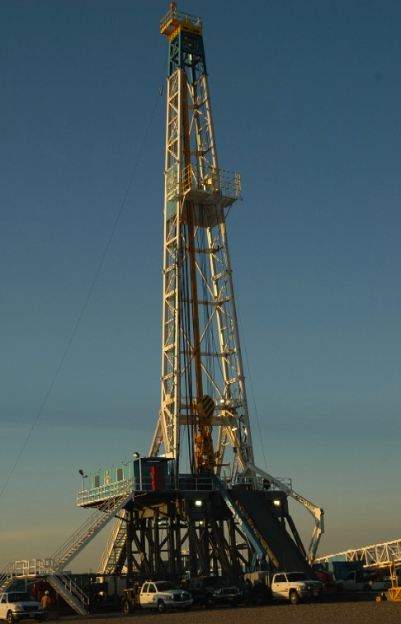
Figure 1.1: Modern Day Oil Rig [5]
As previously mentioned, the development of oil and gas extraction technology has been ongoing for the last 150 years. There is no limit on improvements made on this equipment. One of the main types of equipment used is classified as rotary drilling equipment; which is usually a part of a system made of hoisting and rotating equipment. There are several components that are designed into the system; therefore the system can be very complex and difficult to maintain. Some components located within this drilling equipment include: axial bearings, hydraulic pumps, O-rings, and rotary O-ring shaped seals, motors, and complex designed drill bits. Figure 1.2 is an example of all the components of the drilling rig, and how complex it can be.
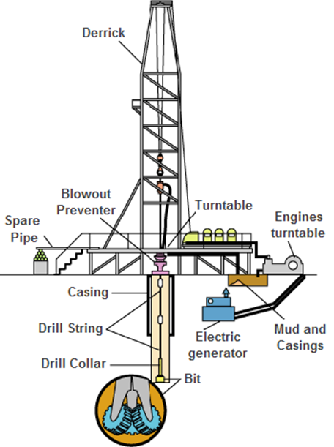
Figure 1.2: Example of complexity of the oil rig configuration [6]
Any failure in these critical components could lead to delays and large expenses. One common issue observed with drilling rigs is high break-out torque; which is the amount of torque required to start up the system. The system will stall if the break-out torque exceeds the amount of available motor torque. This can happen hundreds of feet into the ground. Service suppliers need to invest in understanding and characterizing how these tools work; which includes isolating each component of the system to understand their interaction with the overall system. The focus of this research will be the rotary seals located within the rotary drilling equipment.

Rotary Seals and Current Understanding
The primary role of rotary seals is providing lubrication for the shaft and to protect the mechanical components from the aggressive environment. These seals have direct contact with the rotating shaft that drives the rotary system. This direct contact can cause potential issues if the seal is not working as expected. Two of the main issues with rotary O-ring seals are excessive leak and high torque. The consequences of excessive leak could include lack of lubrication which can cause large amounts of friction and wear to both the seal and shaft. When the seal excessively leaks, it puts all the mechanical equipment at risk of failure. Torque of the system is very important as it can dictate how much power is required to operate the rotary system. The consequence of high torque is that it requires more power and therefore more energy to operate. The system torque can be divided into two categories; break-out torque and steady-state torque. Break-out torque is defined as the amount of torque required to start up the rotary system. Steady-state torque is the amount of dynamic torque on the system while the shaft is rotating. There are many factors that can affect both leak and torque. It is difficult to understand any effect that material properties have on the leak or torque of rotary O-ring seals due to a lack of available information pertaining to the materials of the polymer rotary O-ring seals. Therefore many assumptions have to be made as the rotary O-ring seals effects has on the system.
Based on manufacturing and industry knowledge, it is known that break-out torque is primarily effected by surface roughness of the shaft, contact pressure of the seal, viscosity of the lubrication, pressure condition, material hardness of seal, size of seal and shaft, geometry of seal, speed of rotation and dwell time without rotation [7]. Many researchers have concluded that there is an oil-film that contributes to lubrication and therefore directly affects torque. This oil film is located directly between the inner seal diameter and the outer dimeter of the shaft. Geometry of the seal has a large effect on the formation of that film. It has been studied and validated that the film thickness increases with rotational speed [8] Break-out torque is affected by static friction, so the longer the rotating shaft and seal assembly is idle without movement the larger the break-out will be [7, 9] . The operating environment, such as temperature and pressure, can also affect the friction and torque of the system as well. Both affect the seal’s contact with the shaft. Polymer material properties, such as stiffness, can change with temperature [7, 9]. The lubrication fluid is also an area of interest; as with increased temperature will also affect lubrication viscosity and torque as well [7].
Leak-rate of the seal is characterized by the physical sealing mechanism which is located at the meniscus of the seal. The meniscus of the seal is located the contact area between the seal face and shaft face [8]. This region is also known as the sealing zone , and the area is very much dictated by size, geometry, pressure, rotating and fluid viscosity [8]. Fluid contamination is another cause that may result in seal failure and excessive leakage. The contamination causes a breakage in the meniscus which then disables the leak mechanism of the seal [8, 10, 11].
Although the basic behavior of polymer rotary seals has been studied; there is still unknown information and behavior trends retaining to these types of seals specifically in the oil and gas industry. The primary problem has also been how to study and evaluate these types of seals, so that they properly represent their application and how they are used. Though there are many ASTM standards available for polymer seals, none specifically speak to the issues that are being investigated in this study. An effective and repeatable test procedure for rotary seals will provide a better understanding of the limitations or maintenance requirements of current systems as well as aid in the design process for future applications.

Experimental Procedure and Design of Rotary Seals
Due to a lack of ASTM standards for the development of a test set up and experimental procedure, the design of the experimental set-up had to be carefully laid out based on understanding of the application. The conditions that had to be satisfied included variable temperature, rotational speed, and pressure. The resulting measurable outputs of the system included leak-rate, break-out torque, and steady-state torque. Along with this a fluid lubrication would have to be implemented in the system to allow for lubrication and a measureable leak-rate.
The requirements of the test set up had to evaluate seals of various sizes. There were four sizes of varying inner diameters used with appropriately sized shaft. Two seals were placed inside the testing cavity. The seals held the pressure and lubrication fluid inside the cavity to simulate the pressure side of the seals in field application. Figure 1.3 shows the lay out of the inner cavity and where the fluid and pressure are located in relation to the seal.
Oil Lubrication and pressure enters the inner cavity
Rotary Seal
Spacer
Bearing
Rotating Shaft
Figure 1.3: Schematic shows the cross sectional area of the shaft and seal contact.
The shaft then connected to a torque meter to measure the torque of the shaft when in operation. The motor that powered the set-up was connected to the torque meter via a 5-1 gear reducer. This allowed the set-up to be operated at lower rotational speeds while not overheating the motor. The set-up has a temperature and speed control that was programmed through a custom LabVIEW code which also collected the measurable data of the overall system.
Due to the fluid and pressure in the system, hydraulic lines had to be implemented. These lines allowed for fluid to run throughout the whole system. A vacuum pump was used to fill the system with fluid and remove air from the system. If air was left in the system, it could cause false reading when detecting leak-rate.
In designing for experiments, three sets at each testing parameter was used to help minimize variance and to investigate data repeatability. Multiple tests were developed based on how the seals are used and what criteria needed to be measured. A torque test was developed to look at various torque measurements for varying temperatures and rotational speeds. The break-out and steady-state torque was evaluated at both 100 RPM and 300 RPM. These measurements were taking at temperature levels from room temperature (25 °C) up to the maximum seal operating temperature. A separate torque set-up was created to examine break-out torque of the seals exclusively. This was created to help negate any inertia effects that the different test set up components may cause. Due to leak-rate being a measurement over time, a separate test was developed to investigate this test. The leak-rate test consisted of a steady temperature and speed while evaluating the leak-rate for that specific rotary seal.
The goal of these experiments is to provide a better understanding of how these types of seals perform under different operation variables. With these tests, trends were identified and applied on a broader scale by the use of an existing models and results from the experimental results.

Research Objectives and Questions
As discussed in the previous sections, the subject of this work is the characterization and performance of rotary seals as a result of different operational parameters. The goal is to understand theoretical background and the parameters that effect seal performance in the areas of steady-state torque, break-out torque, and leak-rate. Therefore, the first research objective of this study is to identify the different parameters that affect the performance of rotary seals. This leads to the following research questions:
- RQ 1: What methods could be used to test and characterize rotary seals?
- RQ2: How to isolate seal torque contribution from the rotary system?
Additional research objectives were developed so as to address these research questions. The second research objective of this study is focused on the torque by developing test methods to achieve realistic controlled conditions to characterize the rotary seals. This leads to the following research question:
- RQ3: How does seal size, material, temperature, and rotational speed (RPM) effect both break out and steady state torque?
This question will drive the tests and experiments developed to find answers. Many of the test variables are used to represent the application of the rotary seal in downhole drilling. The remainder of this thesis will address the experimental set-up, data collection and analysis so as to answer these research questions.

Chapter 2: Literature Review
Chapter 2 will summarize publications related to the study of rotary seal understanding and potential theoretical models that exist. A comprehensive review of available studies will assist in achieving the research goals. The theoretical models will provide a validation measure of the developed test procedures and collected data for this research study.

Rotary Seals and Applications
Rotary Seals are used in applications where a seal is in contact with some form of a rotating shaft. The focus of this Thesis will be on O-ring shaped hydrodynamic seal. Hydrodynamic seals are used in a variety of industries, such as automotive or oil and gas, that involve rotating equipment. The application of the rotary seal in this research study is specifically used in downhole drilling applications of the oil and gas industry. It is important try to understand the fundamental performance behavior of rotary seals and how react to changing operating conditions. The process of studying rotary seals can be divided in to four basic categories which include: fluid mechanics, deformation, heat generation, and contact mechanics [8]. The main focus though of this thesis will be the contact mechanics, and trying understanding the contact between the seal and shaft. Figure 2.1 connects how the four categories relate.
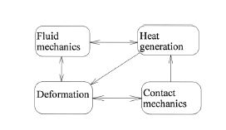
Figure 2.1: Schematic of four critical categories for seal analysis [8].
The different types of rotary seals include: fixed clearance seals, radial lip seals, mechanical face seals and rotary lip seals, hydrostatic seals, and hydrodynamic seals [8]. The rotary seal of this study is an O-ring geometry seal that falls between the categories of mechanical face seals and hydrodynamic seals. Mechanical face seals are designed with the main purpose of reducing and minimizing leak of fluid [8]. The working fluid of this research study is lubrication oil. Mechanical face seals primary characteristics are an ability to allow misalignment while maintaining very low to no leak [12]. So due to these characteristics, this makes mechanical face seals very good for low leakage application. An issue associated with mechanical face seals is wear, and if used too long can cause damage that leads to potential leaks [8]. Hydrostatic seals have an applied pressure that is the actual sealing mechanism rather than the rotating shaft [8]. Hydrostatic Seals can be either contact or noncontact seal types [8]. The rotary seals in this research study are the contact seal variety. They are designed to reverse pump which helps counteract a seal tendency to leak. They have grooves along the outer diameter that act as a pump to control the flow of the lubricant oil around the seal [8]. The rotary seal in this study is designed for low leak and to provide a lubrication function on the shaft. Therefore the rotary seals studied in this Thesis were a combination of hydrodynamic and hydrostatic seal [8]. With this information, understanding the parameters that affect these types of seals is critical in creating a theoretical model.
One study indicates that rotary seals become more effective as force increases at creating a fluid seal without any effect on friction [11]. Johnston examined the existence of an oil film between the seal and rotating shaft that protects the seal from damage and minimizes wear [13]. There is not significant evidence in literature of seal leaking as a result of hydrodynamic lubrication [14]. Due to the presence of an oil film, a popular topic in literature has been on the effect of seal surface texture on the lubrication and effectiveness of the oil film. Numerous optical studies were performed to observe the different textures of the elastomer seals. McClune and Tabor examined surface roughness effects on oil films in an optical interferometry model study [15]. Additional studies soon followed that examined thermal effects and roughness of the shafts on oil film formation [10]. The thermal effects focused on the temperature increase based on the friction between the shaft and seal. Gabelli and Poll used computational models to examine surface characteristics [10]. Conclusions from their studies showed increased torque for rougher surfaces. Understanding the shaft and how different surface roughness relates to the seal is important to consider. Although surface roughness generally is an important parameter to consider, the shafts used in this study were manufactured and coated by a standard procedure. Therefore varying surface roughness effects was not considered for the rotary seals in this study.
Another focal point in research has been on understanding how seals work and is commonly referred to as the sealing mechanism. Blitney states that seals will pump fluid inwards towards the oil side of the seal [14]. Therefore it was accepted that the meniscus of the seal was mostly responsible for the sealing [14]. However Muller conducted a study that concluded that asperities of the seal align with the axis of the rotating shaft and the oil film is pumped to the oil side of the seal [16].
Performance limitations have been attributed to temperature, speed, fluid and service life. An area that has been proposed to help mitigate the effect of temperature on seal performance has been using the material known as Polytetrafluoroethylene (PTFE) [14, 17]. This material is performs well in aggressive environments and in high temperatures. Some researchers have suggested a PTFE coated lip will reduce friction on the seal [14, 17]. The benefit of decreasing friction is that it would require less power to rotate and therefore would extend the service life of the seals. Through these studies show how important material can be in understanding seal performance.
Another area that is researched is the reverse pumping effect of seals. Reverse pumping creates a risk of outside contaminants coming into the seals which would lead to failure in bearings and other mechanical equipment [14]. This has led to researchers to propose an outward lip that would act as a barrier and prevent contaminates from entering the oil side [14]. A drawback of this design is that it can cause a large amount of friction and accelerate the pumping action [14]. Research also looked at how the shaft contributes to seal performance, more specifically on selecting different types of finishes and coatings for shafts [14, 18]. In general, a higher shaft surface roughness did contribute to lower seal friction [18]. The shafts used in this study are coated where the seals are located to reduce friction. Figure 2.2 shows an example of a rotary seal configuration that allows a reverse pumping and sealing mechanism.
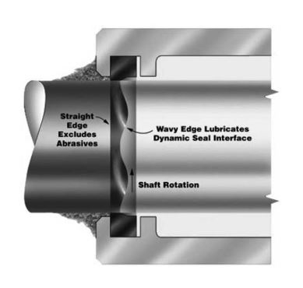
Figure 2.2: An example of a seal configuration that has reverse pumping for lubrication, and also is a protection from the abrasive environment [19].

Finally, the operating environment is a critical component to consider when examining the performance of rotary seals. Figure 2.2: An example of a seal configuration that has reverse pumping for lubrication, and also is a protection from the abrasive environment [19]. The application of the rotary seals being studied in this research is downhole drilling, which presents a very aggressive and dynamic environment. Flitney provides a detailed overview on rotary drilling specifically in downhole and oil field applications [19]. The rotary seals discussed in this Thesis are considered O-ring type shape. These O-ring type seals were developed to help lubrication of the shaft in extremely aggressive environments. The environment for downhole drilling commonly contains a blend of various oils, or water, which is commonly referred to as drilling mud. The mud environment and temperature changes can alter the chemical material of the seal and lead to damage or failure. The geometry of the seal has what is referred to as a hydrodynamic wave that allows for reverse pumping towards the sealing zone, which combats against high pressures or low viscosity fluids that could cause issues for the shaft and seal [19]. The current research on rotary seals can contribute to understanding the performance and limitations of these types of seals for downhole drilling applications, which could lead to more robust designs in the future.

Friction and Lubrication of Seals
Friction effects are an important aspect of this research study because it directly relates to torque. Generally, as static friction increases, the break-out torque will increase. Additionally, any increase in viscosity of the lubrication fluid can cause an increase in both steady-state torque and break-out torque [7, 9].
Jagger was one of the early researchers in the area of rotary seals research [11]. One of the main research focuses of Jagger was on the area of rotary seal friction, which he initially investigated using rubber synthetic seals in gearbox transmission applications [11]. This study involved a rotating shaft with seals that had geometry in the shape of the casing that was being sealed. The seals had rotating speeds of 2,000 to 10,000 RPM and were held at around atmospheric pressure conditions. An aerospace grade engine lubricating oil (DED 2472/ED) was used for seals lubrication [11]. A test apparatus was created to measure the contact load of the seal with the shaft, as well as any leaks. This study observed the presence of an oil film between the shaft and seal, and the main conclusions included reduced leakage as applied load increased and increased leakage as pressure increased [11]. Additionally the oil film helped decrease friction on the shaft. One key finding from this study described the process of how within hours of idle operation the seal becomes “bedded in”. It was concluded that due to sharp edges on some seal geometry along with high initial loads and absence of lubrication would cause bedding in of the seal [11]. This could indirectly relate to break-out torque and how it can vary over time. Jagger also concluded that after seal “bed in” had occurred, there is not a significant difference between short dwell times (1 or 2 hours) and long dwell times (1000+ hours) of service. Another study examined the effects of lubrication by performing a dry test (no lubrication oil) and measuring the coefficient of frictions. This studied concluded that lubrication is an effective method of significantly decreasing the friction and torque [13].
Another study performed by Jagger suggested that the actual surface of the seal which asperities affected the sealing zone along with the surface of the shaft [20]. This study also illustrated that with higher applied loads to the seal would result in an increase in the film thickness. Another study examined how the film thickness relates to rotational speed and load [21]. A predictive model was developed to look at rotational speed as a function of film thickness, which revealed an increase in of film thickness with increasing rotational speed, and experimental data was performed to validate model [10]. From those results, it was concluded that surface asperities of the seal were overshadowed by the hydrodynamic lubrication of the seal [10]. Thermal studies have been performed to examine changing temperature of the seal and shaft during rotation. Theoretical studies used Reynolds number and the energy equation to theorize the temperature distribution on the seal surface during rotation at high speeds [22]. This study concluded that temperature had little effect on friction, but it did affect the reverse pumping rate of the seals. There currently are no studies that examine the effect of temperature from the outside environment on the performance of rotary seals. The research of this Thesis will examine this gap in how temperature changes from the outside environment affect the torque behavior and degradation of the seals.

Sealing Mechanism
While research has investigated lubrication behavior on seals, another focal point is to understand how the physical sealing mechanism is achieved. An area of the seal that has been studied is the meniscus of the seals, which is the contact area between the seal face and shaft face and is also known as the sealing zone [8]. This is important to this research study because one of the performance parameters of interest is a measurable leak-rate. From literature and manufacturer information, the leak-rate is a function of the seal size, lubrication fluid viscosity, and speed of rotation [7].
Researchers have included this is the primary place where the sealing occurs [11] Early research looked at ways to cause leakage in the seal. One was added pressure because when pressure exceeds the seals capability it usually failed which believed because it broke down the sealing zone [11]. As talked about in the friction section of the chapter, the reverse pumping also plays a role in sealing. It helps to counteract the natural leakage in the seal [8]. Researchers have looked to try to model the reverse pumping to and model the meniscus. Conclusions have been these are very unique to seal geometry, speeds, and pressures that are seals are performing at [23].
Jagger found it difficult to cause a seal to leak, however he found that with an increase in pressure and adding particulates to the fluid would break down the seal and caused leakage [13]. Seals have a sealing region that is developed by a lubrication film, the size of the sealing region is dependent on the seal geometry, operation speed, and set-up configuration [8]. The leakage rate for hydrodynamic seals is inversely related to the viscosity of the lubrication fluid [8]. Deformation of the seal’s material has also been examined and how it relates to leakage and seal failure. Salant states that deformation from temperature and chemical reactants of the seals can cause issues on an order of microns [8]. This is on the same order of magnitude as typical film thicknesses, which is principal component of the sealing region, therefore this can cause failure of the seal [8].
The unique application of the rotary seals in this research study involves small diameters and low rotation speeds, therefore it may be challenging to measure large amounts of leaks. Testing methods was developed to examine the effect of the aggressive environment of rotary seals so as to deform the seals and observe any implications. The experimental test set-up will address both the thermal and chemical changes on the seals and how those changes affect leak-rate.

Existing Models
There are several key parameters that can affect torque and leak-rate of rotary seals. Friction and lubrication are two main parameters that can affect the torque, while lubrication viscosity and seal geometry can affect the rate of leakage.
There are thousands of different types of seals on the market which are all rather specialized for a given application; therefore it is difficult to develop generalized equations that would satisfy all rotary seals. Different manufactures publish models base on their design and testing.
Determining break-out torque and steady-state torque from a theoretical perspective requires understanding in both the static and dynamic conditions. The design of the equipment and manufacturing tolerances will affect the system torque. Contact area is a very important parameter involving seal characterization and developing a predictive model. Gawlskini examined a way to calculate contact pressure by considering the material and compression rate of the seal [9]. The equation developed by Gawlskini for determining average contact pressure (σ_{ai}) is shown in Equation 1 and will be used with the rotary seals in this research study to characterize performance [9].
$$\text{σ}\text{ai =} \frac{π}{6}∙E_{∞}(2∙ε+0.13)$$ | (1)
$$ε= \frac{∆d}{d}$$ | (2)
where E∞ is the modulus of elasticity, ε is the seal compression factor, Δd is the change in seal outer diameter, and d is the initial inner diameter of the cavity that the seal in placed into. This equation was derived by theoretical understanding of O-ring shaped seals and then verified through experiments [24]. The average contact pressure equation is then used to determine the operating contact pressure [9] by:
$$σ_{ao}=σ_{ai}+ .9p$$ | (3)

where p is the fluid or gas pressure. These equations provide a perspective on how to investigate seals and in characterizing the seals in relation to contact force. The contact force can then be used in developing a model to predict seal torque.
A torque calculation based on Equations 1-2 will determine seal torque for the rotary seals used in this research study. There are many different ways to test and characterize seals, which generally comes down to the application in which the seals are being used. The rotary seals in this research study have a very aggressive and dynamic environment, which will be discussed further in the Procedures Chapter.

Summary of Chapter
This chapter summarized a collection of literature that has been performed on rotary seals in various applications. Many industries experience similar issues associated with seals, those primarily being associated with excessive friction and the sealing mechanism. This has created extensive research focus in tribology of the seals and the sealing mechanism. Downhole environments create a high risk situation for the seals and facilitate unique challenges when testing these seal. Theoretical models have been developed through simulations and experimentation, which will aid in the development of developing a predictive model and validation using an experimental set-up of the rotary seals in this study.

Chapter 3: Experimental Test set-up and procedure For Determining Torque

Organization of Procedure
This section of the thesis explains the experimental procedures used to addresses the research objectives and questions relate to characterization of rotary seals. Pressure, rotational speed, seal size, temperature, and lubrication fluid are the parameters used to operate the set-up. These conditions were used based on the operating environment of downhole conditions that these seals are used in. The differential pressure observed for downhole rotary seals are about 100 psi and they are generally used at low rotation speeds of less than 300 RPM. The temperatures for downhole drilling can be as high as 150 °C to 175 °C [14]. Lubrication fluid is essential for the seal function and it aids in the long-term durability of the seals. The rotary seals in this study have different diameters but maintain the same scaled geometry and features. Therefore the effect of diameter size was investigated as well.
Several specific tests were developed to address the main objectives of characterizing seal performance. The first test developed was a torque test, which will be described further in the form of steady-state torque in Section 3.3. The steady-state torque test will compare two speeds of 100 RPM and 300 RPM, as well as the effect of increasing temperature.
The second test is a break-out torque test which examines initial torque of the seal without any inertia effects of the motor. The test was used specifically to examine size effect and dwell time on the seal torque performance. This test will be addressed in more detail in Chapter 3.4.

Experimental Set-up and Data Collection Equipment
An experimental test set-up was designed and manufactured in order to achieve the research goals and collect the necessary data. Multiple tests were performed to evaluate data on the test set-up. The two main measurements acquired from each test included torque (inch-pound) and leak-rate (milliliter/hour). The seals used in the experiment were O-ring shaped and are considered hydrodynamic seals due to their nature of pump lubrication for the shaft and seal contact. Two identically sized seals were placed in the testing cavity at opposite sides of the lubrication inlet. Four different seal which were defined by the shaft outer diameter (10, 18, 21, and 25.5 mm) were evaluated. The actual seal size would actually be smaller than the outer diameter of the shaft. When referring to the different size seals, the outer shaft parameter will be used to label that size seal. All seals were the same thickness in the z-direction. Two polymer based materials with different maximum temperatures were used and compared. The first polymer material (material type A) is primarily constructed from HNBR, Hydrogenated Nitrile Butadiene Rubber, polymer materials and has a maximum temperature of 150 °C. The second polymer material (material type B) is primarily constructed from FKM, a fluoroelastomer based material that has a maximum temperature of 175 °C. Due to supplier confidentiality, additional details pertaining to the material properties cannot be provided. Table 3.1 is a summary of the experimental matrix of the seal size and material.
Table 3.1: Material Descriptions and Design of Experiment Matrix with 3 data sets for each material and size
Material Type A:  Max temperature 150 °C  HNBR Polymer | Material Type B:  Max Temperature 175 ° C  FKM Polymer
10 mm Shaft | 10 mm Shaft
18 mm Shaft | 18 mm Shaft
21 mm Shaft | 21 mm Shaft
25.5 mm Shaft | 25.5 mm Shaft

The seals were assembled onto a rotating shaft with bearings and spacers and placed in a seal cavity and kept under pressure for the duration of a test. The bearings aided in the rotation of the shaft, and the spacers were designed to help keep the seal in place while being pressurized. Figure 3.1 is a cross-section view of the inner seal cavity assembly.
Figure 3.1: Schematic of the seal cavity cross sectional view.

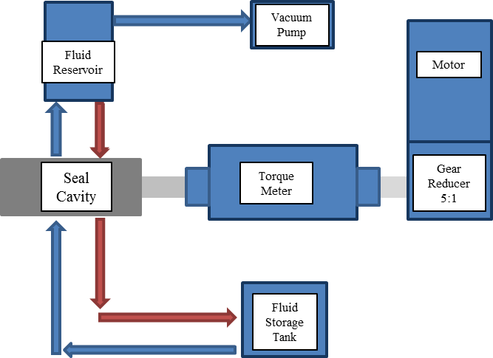
Figure 3.2: Schematic of the test set-up shows the flow fluid and pressure through the system.
Figure 3.2 is an overview of how the fluid and pressure flow through the system, and Figure 3.2 also includes the layout of each of the main components of the system. The blue arrows represent the movement of fluid when the system is being filled. The red arrow are the movement of fluid when the system is either leaking or being drained. The system was pressurized at 100 psi so as to replicate the differential pressure located underground. The shaft was then connected to the torque-meter via a coupling. The electronic motor was connected to the torque-meter via a coupling and 5-to-1 gear reducer. The gear reducer was used so that the low speeds required for this set-up could be achieved with a lower-cost motor that operates at higher speeds. The motor was controlled in real-time with a custom LabVIEW program with the torque–meter being monitored continuously. The selected lubrication oil used in the set up was Aero Shell Turbine Oil 560. The oil is in a storage container located below the set-up. To fill the system with the fluid from the storage tank, a vacuum pump is used to fill the set-up with fluid and ensure no air remains in the test system. Figure 3.3 is a picture of the experimental test set-up with labels.
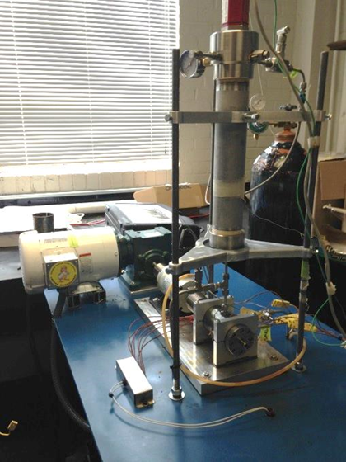
Nitrogen Tank
Fluid Reservoir
(LVDT Sensor Located inside)
Heating Rods Connections
Motor
Torque Meter
Seal Cavity
Figure 3.3: Experimental test set-up with noted critical components.
Leak is measured by a bobbin mounted on a LVDT sensor located in the fluid reservoir above in the seal cavity as seen in Figure 3.3. The sensor floats on top of the fluid and sends a voltage of where it is located vertically inside the fluid reservoir. This vertical voltage is considered the height of the fluid and can be used to calculate the volume of the fluid in the cylinder reservoir. Leak-rate is considered the change of volume for a given time period. Figure 3.4 list the technical specifications of the LVDT sensor produced by MTS. Though this has been implemented into the system, future measures need to be taken in order to measure leak. This will be discussed in Chapter 5.
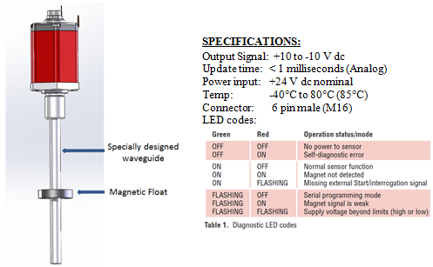
Figure 3.4: Technical specifications of LVDT sensor provided by the manufacturer MTS [25]
Torque measurements were divided into two forms; break-out torque and steady-state torque. Break-out torque is defined as the total torque required starting the test set-up. Steady-state torque is defined as the torque while the system maintains a constant speed. A National Instruments data acquisition unit was used to collect data at a sampling rate of 100 hertz. A high sampling rate was selected to ensure the maximum torque is recorded. The raw data files for each test can be evaluated using different data analysis software such as DIAdem, R-Studio, and Excel. The LabVIEW user interphase has controls for motor speed and temperature set-point and monitors for thermocouples, fluid reservoir level, torque-meter, and pressure. The real-time data provides a useful method of detecting and correcting and potential problems. Programmed safety stops will disable the motor and temperature function if any parameter exceeds specific thresholds. The LabVIEW user interface is shown in Figure 3.5.

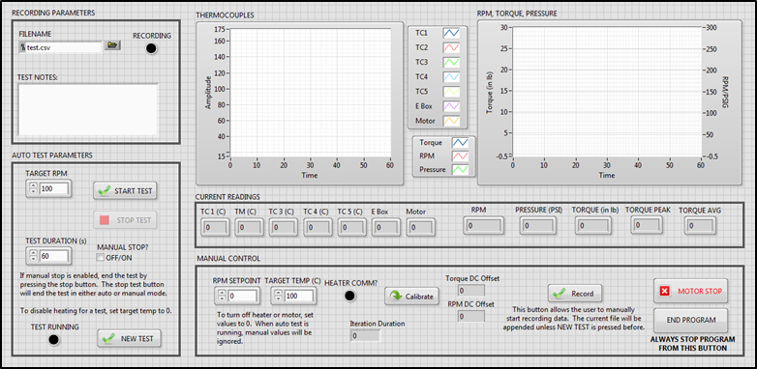
Figure 3.5: LabVIEW user interphase for the experimental test set-up
There is a process of priming the set-up to prepare for an experiment, which takes approximately 30 minutes to complete. The following steps describe the procedure to prepare the system for a test.
Preparing System Procedure:
- Assemble the seal cavity: The seal cavity assembly includes two seals, two roller bearings, the rotating shaft, two seal spacers, retaining clips, and secondary O-rings to retain fluid that leaks past the primary seals. The completed assembly is then inserted into the set up and retained by end-caps with four heating rods that run the full length of the seal cavity are located in the test cavity and as close as possible to the seals.
- Vacuum Pump and Bleeding of System: The vacuum pump was located outside of the system and connected at the top of the fluid reservoir. The vacuum line was connected at the top so that air could effectively be removed from the system as fluid is pulled from the storage tank located below the test set-up. It takes approximately five to ten minutes to add fluid and remove air from system.
- System Pressurization: The last step before starting up a test is pressurizing the system. The pressure is supplied by a nitrogen tank that is connected to the fluid reservoir. A regulator on the tank restricts the pressure to no more than 100 psi for all tests. Pressure is monitored with pressure transducers for each experiment to ensure the 100 psi operating pressure criteria is met.
These steps are required before running any tests with fluid and pressure.

Experimental Procedures for Steady-state Torque Test
This test was developed to address the research question of what parameters affect steady-state torque. The parameters manipulated were rotational speed, temperature, size and material. Each experimental test first examines the break-out torque followed by the steady-state torque for a given temperature and rotational speed. This experiment was design to look at a pair of seals for a single size in a low speed range of 100 RPM and 300 RPM. The steady-state torque test takes approximately two hours to complete. Data analysis was performed to identify basic trends in break-out torque and steady-state torque across different temperatures and shaft speeds. Three sets of data for each seal size and polymer seal material was collected to check repeatability in the data. Leak-rate was not evaluated during this test.
The steady-state torque test is performed at an operating pressure of 100 psi with a five-minute dwell time. Dwell time is defined as the period that the system is idle (0 RPM). Five minute dwell is standard for each seal size and material. By using a consistent dwell time at each measurement, this allowed to also take a break-out torque at the beginning of each step. It was decided to use five minute dwell due to reduce time. The basic procedure of each test begins with the test set-up at room temperature. The first rotational speed selected was 100 RPM and continues to operate for a period of five minutes. Steady-state torque tended to stabilize within minutes, so five minutes was considered expectable for running each speed. Two main results taken from this test was the initial break-out torque followed by the average steady-state torque for the five minute duration is recorded. The raw data was collected with LabVIEW and saved as a .dat file that can be evaluated using MS Excel, DIAdem or R studio. Chapter 4 will present in more detail the data analysis and development of a performance model. The following is a sequential step by step representation of the steady-state torque test.
Steady-state Torque Test Procedure:
- Each test consists of five temperature levels for seal material type A and six temperature levels for seal Type B which are room temperature (approximately 25 °C ), 75 °C, 100 °C, 125 °C, 150 °C , and 175 °C for seal Type B only
- Each temperature set point would start at 100 RPM rotational speed where break-out torque would be recorded, followed by a five minute operation period at 100 RPM to record steady-state torque.
- The set-up remains idle at 0 RPM for a dwell time of five minutes, followed by a motor speed selection of 300 RPM where break-out torque and steady-state torque is recorded again.
- After the 300 RPM test period, temperature is ramped up to next temperature set point. The system enters a five-minute dwell time once the temperature has stabilized at the new set point.
- Steps 2 through 4 are repeated for each new temperature set-point until the maximum operating temperature for each seal type is reached.

Dwell Time Break-out Torque Experimental Procedure
This test was developed to investigate the question if varying dwell time affects break-out torque. The dwell time seal cavity was designed to replicate the seal cavity in the actual set-up (Section 4.1) and remove any potential inertial effects from the motor, gear reducer, and torque meter. The dimensions and tolerances were replicated from the traditional set-up so as to maintain consistency between the two seal cavities. The dwell time seal cavity uses only the rotary seals and shaft. The seals were coated in lubrication oil described in Section 4.1 to simulate the regular test set-up. A digital torque screwdriver was used to collect different measurements for varying dwell times. The torque-meter attaches to the end of the shaft and measures the required torque to rotate the shaft. Figure 3.6 is an image of the cavity, seal, and shaft for the dwell time test.
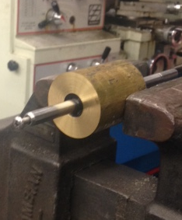
Seal
Shaft
Seal Cavity
Figure 3.6: Torque Cavity for seal size of 10 mm
Five measurements of each seal size and material was performed for each dummy torque set-up. The dwell times selected for these tests were initial torque, 5 minutes, 10 minutes, 30 minutes, and 1 hour.

Summary of Chapter
This chapter introduced the developed design of experiments that was formulated based on the critical parameters for the rotary seal application. The major parameters included: size of seal inner diameter and outer diameter of the shaft, pressure, temperature, rotational speed (RPM), seal material, aging, and fluid lubrication. These parameters all contribute to break-out torque, steady-state torque, and leak-rate. Three different tests were developed to address the operational parameters. The first test was a long torque test to measure steady-state torque at different temperature levels and rotation speeds. The second test was a break-out torque test that examined dwell time and rotation speed effects on torque performance.

Chapter 4: Experimental Results and Analysis

Overview of Experimental Data
The experimental set-up used for testing rotary seals was described in the Chapter 3. In addition to the test set-up, different test procedures were described to address rotary seal performance. The seal parameters will be used to address the research objectives of characterizing the rotary seals based on the break-out torque, and steady-state torque.
Filtering the experimental data is necessary before any conclusions about rotary seal performance can be made. Break-out torque occurs within the first few tenths of a second of each test, and then the torque quickly stabilizes into what is referred to as steady-state torque, which is calculated for a five minute test period.
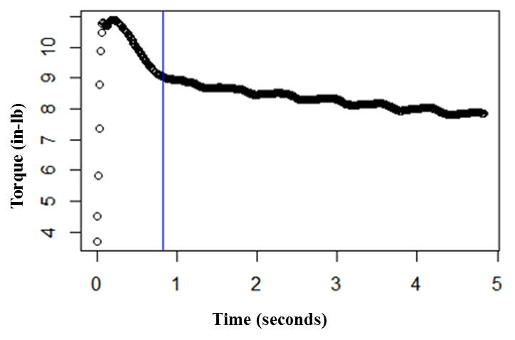
Figure 4.1: First 5-seconds of typical test, break-out torque is observed. Blue line shows the transition into steady-state torque.
Figure 1.1 is a representative sample of raw data at the beginning of a torque test. The data has to be filtered due to the sampling rate of 100 Hz and organized into the steady-state and break-out components of torque. Break-out torque typically occurs within the first 0.5 seconds of a test, and then stabilizes into steady-state torque in about 0.7 seconds. The average results with range bars were used in identifying trends from the data matrix described in the procedure section. The first test results discussed will focus on break-out torque. Multiple controlled variables were changed to examine their effect on torque. The control variables changing during the experiments included temperature, rotating speed, seal size, and seal material type. Results from these tests will be used to address the Research Question 1 through 3 related to determining effects of temperature, speed, material, and seal size on break-out torque. Results from this test will be presented in Section 4.2. The second test presented will be the steady-state torque tests. This test will also address Research Questions 1 through 3. The results of this test will be discussed in Section 4.3. Further analysis will discuss steady-state torque with comparisons of experimental results to a theoretical model from literature in Section 4.4. The comparison will help determine the seal’s contribution to the overall system.

Break-out Torque analysis and results

Break-Out Torque Size Comparison
Break-out torque was evaluated with a standard dwell time of five minutes to examine the effect of temperature and seal size on the torque value. The break-out torque data is a compilation of four seal sizes defined by shaft size (10, 18, 21, and 25 mm), two rotation speeds (100 and 300 RPM), and two seal material types (material type A and material type B). In this section we discuss rotational speed effects per material.
Figure 4.2: Break-out torque comparison for material type A material at (A) 100 RPM and (B) 300 RPM. Note: Bars indicate the experimental data range for each test.
Comparison of shaft rotation speed and temperature effects on the break-out torque for seal material type A is plotted in Figure 4.2. Generally the break-out torque decreased as temperature increased for all seal sizes. The smallest seal size (10 mm) was not affected by temperature changes as significantly as the larger seals. The two midrange seal sizes (18 mm and 21 mm) have similar values of torque. Torque increased as seal size increased from 10 to 25 mm, there was some overlap in the midrange seal sizes which may be due to measurement uncertainties. Behavior and trends for high rotation speeds (300 RPM) was similar to those observed with low rotation speeds (100 RPM). In most cases, the break-out torque is similar for both high and low shaft rotation speeds. The largest seal size (25 mm) had the largest variance in the data regardless of the shaft rotation speed, which is indicated by the larger range bars in Figure 4.2.
Figure 4.3: Break-out torque comparison for Type B material at (A) 100 RPM and (B) 300 RPM. Note: Bars indicate the experimental data range for each test.
Figure 4.3 is a comparison of shaft rotation speed and temperature effects on break-out torque for seal material B. A discernible trend in break-out torque as a function of temperature was not apparent with the Type B material. The smallest seal size (10 mm) had similar torque values regardless of temperature or shaft rotation speed. The midrange seal size (18 mm and 21 mm) had similar torque values. Both of the midrange size seal had the peak break-out torque value at about 125°C. The large seal size (25 mm) had the largest amount of torque and largest variation in sampling range. The peak break-out torque for the 25 mm size seal was at a temperature of around 125 °C for low shaft rotation speeds (100 RPM) and around 100 °C for high shaft rotation speeds (300 RPM). Similar torque values were observed for both high shaft rotation speeds and low shaft rotation speeds in most cases. Break-out torque generally increased as seal size increased.

Shaft Rotation Speed and Seal Material Effect on Break-out Torque
This section will investigate the effect of shaft rotation speed and seal material type on break-out torque data for specific seal sizes. Comparing these trends will help in answering the Research Question of if rotational speed and seal material have an effect on the break-out torque of rotary seals.

Figure 4.4: Comparison of material type A and material type B and shaft rotation speed for seal size of 10 mm. Note: Bars indicate the range in the sampling data.
Figure 4.4 provides a comparison of shaft rotation speed and seal material type for the 10 mm diameter seals. In most cases, seal material type A had larger torque values than seal material Type B. The lone exception was at a temperature set-point of 125 °C. All average torque values were within the range of 3.5 to 6 in-lbs, regardless of temperature, material type, or rotation speed.

Figure 4.5: Comparison of seal material type A and material type B and shaft rotation speed for seal size of 18 mm. Note: Bars indicate the range in the sampling data.
Figure 4.5 is a comparison of shaft rotation speed and seal material type for the 18 mm diameter seals. Torque values for this seal size were more inconclusive than the 10 mm size seal. Break-out torque was higher for seal material type A and lower for seal material type B at low shaft rotation speeds (100 RPM) when the operation temperature was less than 100 °C. High rotation speeds yielded lower torque values when temperature was 125 °C and greater.

Figure 4.6: Comparison of seal material type A and material type B and shaft rotation speed for seal size of 21 mm. Note: Bars indicate the range in the sampling data.
Figure 4.6 is a comparison of shaft rotation speed and seal material type for the 21 mm diameter seals. Torque values for this seal size were similar to the other midrange seal size (18 mm) in that conclusive trends were not immediately apparent. Break-out torque was higher for seal material type B than the seal material type A for nearly all temperatures and shaft rotation speeds. The lone exception was at 75 °C and shaft speed of 100 RPM. Sampling variation was typically higher for low shaft rotation speeds and seal material type A.

Figure 4.7: Comparison of seal material type A and material type B and shaft rotation speed for seal size of 25 mm. Note: Bars indicate the range in the sampling data.
Figure 4.7 is a comparison of shaft rotation speed and seal material type for the 25 mm diameter seals. Break-out torque was higher for seal material type B than the seal material type A when temperature was greater than 100 °C. Shaft rotation speed effects were not consistent per size or temperature. Generally, there were not consistent trends in break-out torque as temperature or seal material type changed. Overall no clear trends could be made, although certain temperatures and seal material types appeared to have substantially higher torque values. Additional tests need to be performed to further investigate the effect of temperature, seal material type, and shaft rotation speed on the break-out torque of rotary seals.

Dwell Time Break-out Torque Test Results
The effect of varying dwell time on break-out torque was studied and the results analyzed. This study included each seal size defined by shaft outer diameter (10, 18, 21, and 25 mm) and material type (type A and type B).
Figure 4.8: Effect of dwell time on break-out torque for four seal sizes and two seal material types.
Figure 4.8 is a comparison of seal material type and dwell time on break-out torque. The break-out torque value increased for both seal material types as dwell time increased. Additional tests need to be completed so as to ensure data repeatability with the dwell time study. Future results could help determine if dwell time is an important parameter in evaluating seal break-out torque.

Results for Steady-state Torque Test

Steady-state Torque Seal Size Comparison
Results for steady-state torque were the most consistent across each seal. As mentioned previously, steady-state torque is the torque while the shaft is rotating at a constant speed for a given time period. The time period that was used in all experiments was five minutes, with rotation speeds of 100 and 300 RPM. These two speeds were evaluated at different temperature set-points. Trends were established from the average results of three data sets for each seal material type and size.
Figure 4.9: Size comparison of material type A seal at a rotation speed of (A) 100 RPM and (B) 300 RPM. Bars indicate range of experimental data
Figure 4.9 is a comparison of the different size material type A at 100 RPM and 300 RPM. Regardless of rotation speed, the torque increases with temperature for all sizes. Steady-state torque was slightly lower at 300 RPM when compared to tests at 100 RPM. The two middle sizes of 18 mm and 21 mm had very similar torque readings where the largest seal (25 mm) is differentiated as having the highest torque values and the smaller seal (10 mm) as having the lowest torque. The smallest seal was not affected by temperature as significantly as the other sizes, which is indicated by the lower slope in Figure 4.9. Each size has the same overall trend that with temperature the steady-state torque increases. Torque readings had larger variations as seal diameter size increased, which is indicated by the larger range bars in Figure 4.9.
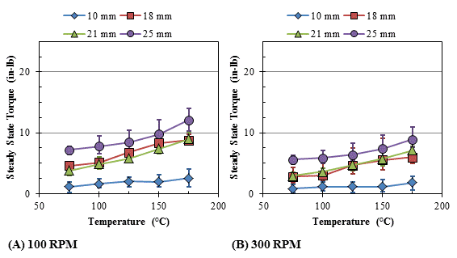
Figure 4.10: Size comparison of material type B at a rotation speed of (A) 100 RPM and (B) 300 RPM. Bars indicate range of experimental data
Figure 4.10 is a comparison of the different material type B seals at rotation speeds of 100 RPM and 300 RPM. Similar trends for material type B when compared to material type A was observed, specifically an increase in torque as temperature increases, and the small diameter seal (10 mm) being less affected by temperature than the other seal sizes. Again the two middle sizes (18 and 21 mm) are very close in torque measurement, while the 25 mm has the highest torque and the 10 mm has the lowest torque. Torque readings for high rotation speeds (300 RPM) were significantly lower than those for low rotational speeds. A comparison of material type A in Figure 4.9 and seal type B in Figure 4.10 indicates that material type B has much lower torque readings, regardless of seal size and temperature. This observation will be discussed in more detail in the next section.

Steady-state Torque RPM and Seal Type Material Comparison
The results were also analyzed to answer the research question of how does rotational speed (RPM) and material affect the steady-state torque. Due to inertia effects, the lower RPM tests should have higher torque when compared to the higher RPM tests. The figures in this section will compare both seal types (material type A and type B) seal for both rotation speeds of 100 RPM and 300 RPM. For both types of seals, the 100 RPM torque was larger than the 300 RPM, regardless of temperature set-point.

Figure 4.11: Average steady-state torque for 10 mm sized seals. Bars represent range of the experimental data.
Figure 4.11 is a comparison of 10 mm diameter seals of material type A and material type B for rotation speeds of 100 RPM and 300 RPM. For both types of seals, the 100 RPM was larger than the 300 RPM, regardless of the temperature. Material type A for 10 mm seals has significantly higher torque readings than the material type B seals. This trend is true for any temperature set-point. Therefore for this size seal, the material type B would be more desirable to use based on its smaller torque values.

Figure 4.12: Average steady-state torque for 18 mm sized seals. Bars represent range of the experimental data.
Figure 4.12 is a comparison of 18 mm seals of material type A and material type B for shaft rotational speeds of 100 RPM and 300 RPM. Similar to the 10 mm size seals, the 100 RPM torque is higher than the 300 RPM torque for all temperature set-points. The material type B consistently has lower torque values when compared to the material type A, however the variation between the two material types are not as significant as the smaller 10 mm diameter seals. The material type B is a more desirable material to use for 18 mm diameter seals due to the lower torque values.

Figure 4.13: Average steady-state torque for 21 mm sized seals. Bars represent range of the experimental data.
Figure 4.13 is a comparison of 21 mm seals of material type A and material type B for shaft rotation speeds of 100 RPM and 300 RPM. As with smaller diameter seals, the trend of 100 RPM tests have larger torque values than 300 RPM tests continues. This is consistent with both material types and all temperature set-points. Shaft rotation speed does not affect the torque values for 21 mm seals as significantly as that for smaller diameter seals. The torque values were more consistent for the material type B material, as indicated by the smaller range bars in Figure 4.13.

Figure 4.14: Average steady-state torque for 25 mm sized seals. Bars represent range of the experimental data.
Figure 4.14 is a comparison of 25 mm seals of material type A and material type B for rotational speeds of 100 RPM and 300 RPM. Shaft rotation speeds of 100 RPM are larger than 300 RPM for nearly all temperature levels. The lone exception is material type A at a temperature of 150 °C. Torque values for material type B are consistently lower than material type A for all temperature set-points. Therefore material type B is the more desirable at minimizing system torque.

Seal Torque Contribution
One of the objectives of this Thesis was to provide a theoretical background on how the polymer seal performs in very specific conditions that are similar to the down-hole environment. Before creating the theoretical model it’s important to understand the concept of torque and the proper way to derive it for this application. Torque’s basic definition involves a force and a distance. In the case of O-ring shaped seals, the radius of shaft, or inner diameter of the seal, would represent the distance where the contact force would determine the torque. The shaft is not static; therefore a moment of inertia would also contribute to the overall torque of the shaft. With this consideration, the theoretical torque is calculated by:
$$T_{seal}= I_{shaft}*α+ F_{seal contact}*r_{IDSeal }$$ | (5)
where α is the shaft rotational speed, I_{shaft} is the moment of inertia for the rotating shaft, F_{seal contact} is the contact force due to the seal, and r_{IDseal} is the inner radius of the seal. This equation does not consider temperature, lubrication or seal material thermal expansion, which has been discussed previously as being contributors to the system torque of rotary seals. Even with these limitations, this equation provides a simple representation of torque and the interactions of the shaft and seal on each other.
The contact pressure of a rotary seal was discussed in the Literature Review section [9] and is calculated by:
$$\text{σ}\text{ai =} \frac{π}{6}∙E_{∞}(2∙ε+0.13)$$ | (1)

where E∞ is the seal modulus of elasticity and ε is the compression of the seal. Solutions from Equations 5 and 1 can be used to determine the seal contact force (F_{seal contact}) by:
$$F_{seal contact}={ σ}_{ai}*A_{contact}$$ | (6)

Where σ_{ai} is the contact pressure determined from Equation 2 and A_{contact} is the contact area of the seal. The contact area is the inner circumference of the seal times the thickness of the seal. Seal contact force is used to develop a theoretical torque value, which can be compared to experimental data from the experimental test set-up. This equation does not consider thermal expansion of the seal. A correction factor was determined within this equation based on the manufacturer’s information seal modulus of elastic at 50%. The compression of the seal was determined by the seal’s outer diameter and the inner diameter of the seal cavity into which the seal in pressed into. The contact area of the seal was then determined based on the groove thickness and circumference of the seal. Due to the orientation of the seal the operating pressure of 100 PSI was disregarded because the inside diameter of the seal is not affected by the operating pressure.

Analysis using the Theoretical Torque Equation and Thermal Expansion Factor
A simple representation of torque considering the moment of inertia and the contact area of the seal was developed in the previous Section. Limitations of the theoretical model include temperature effects and material thermal expansion, which needs to be considered and applied. A thermal expansion coefficient was determined using the ASTM Standard E831 based on manufacturer information on the two material systems of HNBR (material type A) and FKM (material type B) [26]. Both materials had a linear rate of thermal expansion of 1.1E⁻⁴ in/in/°F. The thermal expansion was assumed to be applied to the seal thickness; therefore it would change the contact area between the seal and shaft and increase steady-state torque. This allows a theoretical torque to be calculated for each temperature level and analysis of the effect of temperature on the theoretical torque. As discussed in the Methods Chapter, the experimental test set-up has two rotary seals in testing cavity; therefore the seal contact area in the theoretical equation was doubled so as to represent the two seals.

Evaluation of System Friction on Torque Measurements
A test was performed with the experimental set-up without rotary seals so as to examine if the system components (bearings, couplings, gear reducer) are contributing significantly to the torque measurements by the torque-meter. This test was performed because the theoretical torque calculation only considers the seal; therefore this test will provide a more accurate representation of the seal torque on the system.
In the set-up an experiment was conducted to evaluate the contribution of bearings and other mechanical components that could cause an additional torque in the system. The test involved taking the seals out of the set-up and then running a test with just the bearings and the shaft.

Figure 4.15: Steady-state torque data for the experimental test set-up without rotary seals using shaft sizes of 18, 21, and 25 mm.
Figure 4.15 is the system steady-state torque results without rotary seals. The test revealed low torque values ranging from 0.08 to 0.15 in-lbs for all rotation speeds and seal sizes. These values are less than the experimental torque measurements by at least one order of magnitude, therefore it was concluded that a majority of the torque in the system is due to the seal contact with the shaft.

Comparison of Theoretical and Experimental Seal Torque
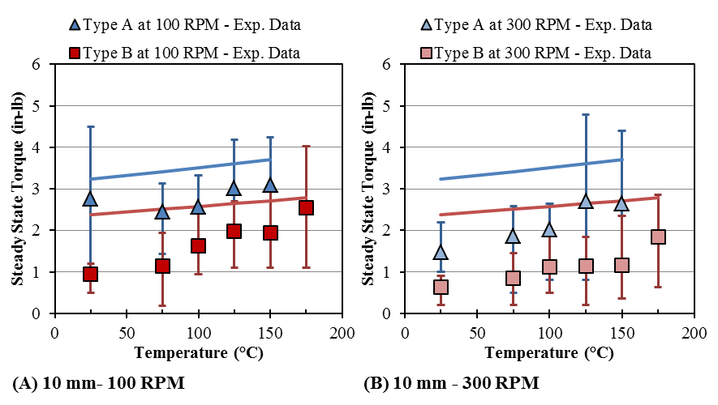
Figure 4.16: Average experimental steady-state torque for 10 mm diameter seals compared to the theoretical torque for rotational speeds of (A) 100 RPM and (B) 300 RPM. Bars indicate the range of experimental torque.
Figure 4.16 is a comparison of the theoretical and experimental steady-state torque for the 10 mm size rotary seal. Both the theoretical method and experimental results indicate the material type A has larger torque values than the material type B. The theoretical torque accuracy goes up with temperature for both materials. The material type A experimental torque is approximately 19 % less than the theoretical torque value at the maximum operation temperature of 150 °C. The Type B experimental torque value is approximately 10 % less than the theoretical torque data. The lower temperatures have larger variation between the experimental and theoretical torque values. Similar trends were observed for the 300 RPM torque values, however the variation between the theoretical and experimental torque values were larger. The material type A experimental torque was approximately 40% less than the theoretical model. The material type B experimental torque was approximately 51% less than the theoretical model.
Figure 4.17: Average experimental steady-state torque for 18 mm diameter seals compared to the theoretical torque for rotational speeds of (A) 100 RPM and (B) 300 RPM. Bars indicate the range of experimental torque.
Figure 4.17 is a comparison of the theoretical and experimental steady-state torque for the 18 mm size rotary seal. Both the theoretical method and experimental results indicate that the material type A material has larger torque values than the Type B material. For material type A material, the experimental torque value is approximately 28% less than the theoretical torque value at the maximum operating temperature of 150 °C. For the material type B, the experimental data is about 4% less than the theoretical torque value. The lower temperatures have higher discrepancies between the theoretical and experimental torque values. Similar trends for the 300 RPM torque values were observed for the 18 mm diameter seal, with larger variation between the theoretical and experimental torque values. The material type A experimental torque was approximately 86% less than the theoretical, and material type B experimental torque was approximately 46% less than the theoretical.
Figure 4.18: Average experimental steady-state torque for 21 mm diameter seals compared to the theoretical torque for rotational speeds of (A) 100 RPM and (B) 300 RPM. Bars indicate the range of experimental torque.
Figure 4.18 is a comparison of the theoretical and experimental steady-state torque for the 21 mm size rotary seal. Both the theoretical method and experimental results indicate that the material type A material has larger torque values than the material type B. For material type A, the experimental torque value is approximately 29% less than the theoretical torque value at the maximum operating temperature of 150 °C. For the material type B material, the experimental data is about 31% less than the theoretical torque value. The lower temperatures have higher discrepancies between the theoretical and experimental torque values. Similar trends for the 300 RPM torque values were observed for the 18 mm diameter seal, with larger variation between the theoretical and experimental torque values. The material type A experimental torque was approximately 37% less than the theoretical, and material type B experimental torque was approximately 64% less than the theoretical.

Figure 4.19: Average experimental steady-state torque for 25 mm diameter seals compared to the theoretical torque for rotational speeds of (A) 100 RPM and (B) 300 RPM. Bars indicate the range of experimental torque.
Figure 4.19 is a comparison of the theoretical and experimental steady-state torque for the 25 mm size rotary seal. Both the theoretical method and experimental results indicate that the material type A has larger torque values than the material type B. For material Type A, the experimental torque value is approximately 21% less than the theoretical torque value at the maximum operating temperature of 150 °C. For the material type B, the experimental data is about 18% less than the theoretical torque value. The lower temperatures have higher discrepancies between the theoretical and experimental torque values. Similar trends for the 300 RPM torque values were observed for the 18 mm diameter seal, with larger variation between the theoretical and experimental torque values. The material type A experimental torque was approximately 17% less than the theoretical, and material type B experimental torque was approximately 60% less than the theoretical.
The theoretical torque value was consistently higher than the experimental torque values for all rotation speeds, seal sizes, and temperature set-points. This is most likely due to the theoretical model not considering lubrication on the experimental system. The difference between the experimental and theoretical is lower with increasing temperature. At higher temperatures the experimental and theoretical have higher accuracy than the lower temperature. The 100 RPM accuracy tends to be higher than the 300 RPM. The set-up tends to show a larger inertia effect than the theoretical data.

Summary of Chapter
This chapter summarizes the experimental results on steady-state torque from rotary seals. The results were compared to what was expected based on different researchers and manufacturers that make similar products. Steady-state torque increased as temperature and seal size increased. Break-out torque increased as dwell time increased. Leak-rate is currently inconclusive, which is most likely due to the small shaft diameters (less than 25 mm) and low rotation speeds (less than 300 RPM).

Chapter 5: Conclusion

Research Objectives and Questions
The Oil and Gas industry is constantly improving technology so as to make operations more efficient. An important part of that technology is rotary drilling. Due to the aggressive operating environment, major issues in rotary drills and seals include high levels of torque or seal failures. Studying these rotary seals can help identify the causes and the parameters of the seal that affect the performance. Understanding these parameters can aid in design of equipment and save money in maintenance costs. Through this understanding, the following research questions were developed, which were proposed in Chapter 1:
- RQ1: What methods could be used to test and characterize rotary seals?
- RQ2: What torque performance parameters are necessary for a theoretical torque model?
Another research question focused on torque characteristics was developed so as to address the RQ1 and RQ2. The final research question pertains to developing tests methods to achieve realistic controlled conditions so as to characterize rotary seal performance.
- RQ3: How does seal size, material, temperature, and rotational speed (RPM) effect both break out and steady state torque?
These questions were addressed by analyzing experimental data and through a developed theoretical model. The rotary seals were characterized through a test set-up that examined break out torque, steady state torque, and leak rate. Results were discussed, and trends were identified. Break out torque proved difficult to identify consistent trends as temperature, rotation speed, or seal material changed. Dwell time test revealed an increase in torque as dwell time period increased. Steady state torque increased as seal size and temperature increased. Seal diameter sizes 18 mm and 21 mm had similar performance trends. Steady State torque showed consistent trends.

Research Question 1: What methods could be used to test and characterize rotary seals?
An experimental set-up was designed to simulate the application of the rotary seals. Due to the aggressive downhole environment, the experimental set-up had to satisfy the design requirements of varying temperature up to 175°C, low shaft rotational speeds, maintain constant pressure, and be able to accommodate different sized seals and lubrication fluid. The set-up had a digital torque meter to measure the torque at different operating conditions. An LVDT sensor was used to measure fluid levels and monitor any leaks. A National Instruments data acquisition system was used to monitor the set-up and collect the necessary data.
A detailed literature review helped identify important parameters to use in designing the experiments. This also led to a theoretical calculation that could be compared to the experimental results. The test that was designed addresses the three performance parameters that affect the seal, which includes steady state torque, break out torque, and leak rate of the seals. A test was designed specifically for steady state torque that examined the seals through different temperature levels, and rotational speeds. Break out torque was also evaluated during this test with a constant dwell time period. A separate break out torque test was developed to evaluate seal break out torque separated from the experimental set-up. This test focused specifically on the effect of dwell time on break out torque. With these experiments and set-up, the first research question was addressed on how to measure the performance of these seals. The performance parameters used to characterize the seal’s performance were steady state torque, break out torque, and leak rate. Multiple parameters were identified as a factor, including temperature, material, and seal size.

Research Question 2: How to isolate seal torque contribution from the rotary system?
A literature review was conducted to identify what other researchers have investigated for rotary seals through simulation and experiments. Seal manufacturers frequently identify contact force and thermal expansion as important parameters for seal performance. With these observations, a basic equation was used to account for the inertia of the rotating shaft; another equation was used to calculate the seal contact pressure. The contact pressure equation takes into account the seal material modulus of elasticity, and the compression of the seal in the cavity.
The theoretical model based on the literature findings were compared to the steady state torque experimental results. The percent difference of the two approaches was identified and discussed. The theoretical model over- predicted the experimental seal torque. The theoretical calculation was limited by having no factor for lubrication, which would reduce the system torque. Both methods converged to closer values when the seal was tested at the highest operating temperature. This suggests that further evaluation of temperature effects on seal torque performance would greatly improve the theoretical model, particularly at lower operating temperatures.
The second research question was addressed through the identification of critical parameters and development of a theoretical torque model. Limitations of the current model include no lubrication factor. It does indicate that it is possible to predict the torque of rotary seals. Some important parameters were identified that influence torque, including: seal compression, material hardness, material modulus of elasticity, lubrication viscosity, seal size, and thermal expansion of the seal material and shaft.

Research Question 3: How does seal size, material, temperature, and rotational speed (RPM) effect both break out and steady state torque?
Experiments were designed to address the effect of seal size on the steady state torque and break out torque. Literature suggests that as contact area increases for the same amount of contact pressure that the contact force also increases. Break out and steady state torque tests should confirm this observation.
The experimental test set-up was designed for interchangeability, so all seal sizes could be tested with the same equipment and experimental design. This allowed for a direct comparison of experimental data. The results revealed that steady state torque and break out torque increased as seal size increased. The two middle sizes (18 mm and 21 mm) performed similarly, while the 25 mm consistently had the largest torque, and the 10 mm seals had the lowest torque.
Seal material type had a large effect on seal performance. Material type A tended to have higher torque values than the material type B. This was also confirmed by the theoretical model due to the different modulus of elasticity of the materials.
Increasing temperature resulted in an overall increase in steady state torque. With break out torque, it was difficult to isolate a definite trend. Previous literature studies have concluded that the increase in steady state torque is most likely due to the thermal expansion of the seal material [7].
Isolating the inertia and rotational speed has proven to be difficult. The experimental data indicates a decrease in steady state torque as shaft rotation speed increased from 100 RPM to 300 RPM. A definitive trend for break out torque was not immediately apparent. This observation led to the additional study that isolates break out torque in a separate dummy test. Higher rotation speeds reduce steady state torque, however it may also cause high break out torques. Rotary equipment frequently has to be operated at lower speeds, therefore it is still important to characterize the torque at lower speeds.

Research Limitations and Challenges
Experimental research frequently has limitations that make it harder to conclude certain results. Some of the limitations of this research included time and money. Each seal torque test takes approximately two hours to complete on a brand new seal. Therefore it is difficult to collect large number of data points for each size and material type. This limited the amount of data points in the study. The cost of the rotary seals in this study is very expensive; therefore it was also important to use resources wisely and effectively.
Other limitations involved the controlled test set-up. The test served well to a seal with 100 psi differential pressure and lubrication oil. For downhole drilling, the seals are frequently exposed to harsh a fluid environment that is not as clean as this controlled experiment. The harsh operating conditions could not be simulated with this experimental set-up so as to not damage the components.

Further Recommendations
This research will continue to evolve with time. More extensive studies can be used so as to develop a more thorough understanding of rotary seal performance. The current model does not consider seal aging on the set-up, therefore one further recommendation is identifying an aging factor that can be applied to torque performance. Leak rate still needs to be refined as there is no detectable leak with the current set-up. This can be investigated by altering the experimental test set-up to accommodate higher rotation speeds. Further refinement and data collection can be made on the break out torque dummy set-up to provide more results.

Short Term Recommendations
Short Term recommendations include those that are capable of being completed in the near future. One of the main recommendations is investigating leak-rate. Currently the data is inconclusive, but literature does suggest there should be a measurable leak with higher shaft rotation speeds. This will involve rearranging the current set-up. The gear reducer would have to be removed and the motor will have to directly connect to the seal shaft. This may take some time to implement, but it will allow for leak rate investigations with shaft rotation speeds up to 1500 RPM.
Another short term recommendation is to continue with the aging process. This takes a bit of time, but aging effects are very important in leak and torque performance. Seal wear characteristics due to aging could be examined, a theoretical model could then be developed to account for a seal’s aging over a period of time.

Long Term Recommendations
Other long-term studies that could be done include lubrication studies, data driven model, and different seal geometries. All these subjects have not been studied yet, but would add to the overall understanding of rotary seal characterization. The data driven model would be a continuation of the model developed in this Thesis with the addition of leak rate and steady state torque. A lubrication study would be valuable to understand its relationship to torque. Based on our model, it’s apparent that the lubrication is a large factor in controlling torque. An ideal lubrication can be identified that can be used in this application and type of seal.
Another future study that can be investigated is examining the effect of different seal geometries on torque. The current study was limited to one seal geometry. Commercially available geometries would be preferable as the University does not have the required resources to manufacture different seal geometries in-house. All these suggestions for future studies could aid in the design of seals and identifying optimal operating conditions to reduce torque and leak rate of rotary seals.

References
1. American Petroleum Institute, 2016, cited 2016; Available from: http://www.api.org/Oil-and-Natural-Gas-Overview/Exploration-and-Production.
2. Vassiliou, M.S., in Historical Disctionary of Petroleum History 2009, Scarecrow Press.
3. American Oil and Gas Historical Society, 2016, cited 2016; Available from: http://aoghs.org/about-aoghs/.
4. Society of Petroleum Engineers History of Petroleum Technology 2015 [cited 2016.
5. 2014; Available from: http://aoghs.org/about-aoghs/.
6. Explore the World of Piping, Fossil Fuels- Oil and Extraction, cited 2016; Available from: http://www.wermac.org/others/oil_and_gas_well_drilling.html.
7. Dietle, L.L., Kalsi Seals Handbook. Document. 2137: p. 1992-2005.
8. Bhushan, B.a.R.F.S., Modern tribology handbook, two volume set, in Modern tribology handbook, two volume set. 2000, CRC press.
9. Gawliński, M., Friction and wear of elastomer seals. Archives of civil and mechanical engineering, 2007. 7(4): p. 57-67.
10. Gabelli, A. and G. Poll, Formation of lubricant film in rotary sealing contacts: part I—lubricant film modeling. Journal of tribology, 1992. 114(2): p. 280-287.
11. Jagger, E., Rotary shaft seals: the sealing mechanism of synthetic rubber seals running at atmospheric pressure. Proceedings of the Institution of Mechanical Engineers, 1957. 171(1): p. 597-616.
12. Bhushan, B., Modern tribology handbook, two volume set. 2000: CRC press.
13. Johnston, D. Using the frictional torque of rotary shaft seals to estimate the film parameters and the elastomer surface characteristics. in International Conference on Fluid Sealing, 8 th, Durham, England. 1978.
14. Flitney, B., Advances in understanding of polymer seals for rotating applications. Sealing Technology, 2010. 2010(11): p. 7-11.
15. McClune, C. and D. Tabor, An interferometric study of lubricated rotary face seals. Tribology International, 1978. 11(4): p. 219-227.
16. Müller, H. Concepts of sealing mechanism of rubber lip type rotary shaft seals. in Proceedings of the BHRA 11th International Conference on Fluid Sealing. 1987.
17. Bauer, F. and W. Hass. PTFE lip seals with spiral groove–the penetration behaviour, hydrodynamic flow and back pumping mechanisms”. in 18st International Conference on Fluid Sealing. 2005.
18. Kunstfeld, T. and W. Haas, Shaft surface manufacturing methods for rotary shaft lip seals. Sealing Technology, 2005. 2005(7): p. 5-9.
19. Flitney, B., Positive lubrication rotary seals for down-hole/abrasive applications. Sealing Technology, 2005. 2005(10): p. 8-11.
20. Jagger, E. and P.S. Walker, Second paper: Further studies of the lubrication of synthetic rubber rotary shaft seals. Proceedings of the Institution of Mechanical Engineers, 1966. 181(1): p. 191-204.
21. Salant, R., Soft elastohydrodynamic analysis of rotary lip seals. Proceedings of the Institution of Mechanical Engineers, Part C: Journal of Mechanical Engineering Science, 2010. 224(12): p. 2637-2647.
22. Salant, R., Theory of lubrication of elastomeric rotary shaft seals. Proceedings of the Institution of Mechanical Engineers, Part J: Journal of Engineering Tribology, 1999. 213(3): p. 189-201.
23. Salant, R., Elastohydrodynamic model of the rotary lip seal. Journal of tribology, 1996. 118(2): p. 292-296.
24. Karaszkiewicz, A., Geometry and contact pressure of an O-ring mounted in a seal groove. Industrial & engineering chemistry research, 1990. 29(10): p. 2134-2137.
25. Sensors, M. 2013; Available from: http://www.mtssensors.com/.
26. Corp, P.H. Coefficient of Thermal expansion, 2016, cited 2016; Available from: https://promo.parker.com/promotionsite/oring-ehandbook/us/en/ehome/Coefficient-of-Thermal-Expansion.

Appendix A: Nomenclature
$$\text{σ}\text{ai}$$ | Contact Pressure
$$E_{∞}$$ | Modulus of Elasticity
$$ε$$ | Compression
$$∆d$$ | Difference of inner seal diameter after compression
d | Inner Diameter of seal
$$σ_{ao}$$ | Operating Pressure
p | Pressure of System
$$Q$$ | Leak-rate
$$Y$$ | Viscosity Constant
S | Shaft Diameter
$$V_{RPM}$$ | Shaft Speed in RPM
psi | Pounds per square inch
LVDT | Linear Variable Differential Transformer
HNBR | Hydrogenated Nitrile Butadiene Rubber
FKM | Composition of Fluorinated Elastomers
RPM | Revolution per minute
$$T_{seal}$$ | Theoretical Seal Torque
$$I_{shaft}$$ | Moment of Inertia of Rotating shaft
$$α$$ | Angular acceleration of rotating shaft
$$F_{seal contact}$$ | Contact Force of Seal
$$r_{IDSeal }$$ | Seal Inner Radius
$$A_{contact}$$ | Contact Area

Appendix B: Defining Terms
Break-Out Torque: Initial torque needed to start rotation
Steady-State Torque: Constant Torque on the system during constant rotation
Leak-Rate: Amount of fluid volume loss through the seal per unit of time
Dwell Time: Time in which the system is not rotating

