UNIVERSITY OF OKLAHOMA
GRADUATE COLLEGE

SYMPHONY NO. I

A DOCUMENT
SUBMITTED TO THE GRADUATE FACULTY
in partial fulfillment of the requirements for the
Degree of
DOCTOR OF MUSICAL ARTS

By
CHELSEA GRACE WILLIAMSON
Norman, Oklahoma
2021
SYMPHONY NO. I

A DOCUMENT APPROVED FOR THE
SCHOOL OF MUSIC

BY THE COMMITTEE CONSISTING OF

Dr. Marvin Lamb, Chair

Dr. Roland Barrett, Co-Chair

Dr. Frank Riddick

Dr. Eugene Enrico

Dr. Ronald Schleifer

© Copyright by CHELSEA GRACE WILLIAMSON 2021
All Rights Reserved.

Acknowledgments

I would like to express my appreciation to Dr. Marvin Lamb and Dr. Roland Barrett for their guidance and advice during this process; to the members of my committee, Dr. Frank Riddick, Dr. Eugene Enrico, and Dr. Ronald Schleifer for their support throughout the DMA program; to my parents for their never-ending encouragement; and to Martin Majkut, for listening to the many incarnations of this work, offering suggestions and support, and for being a patient and loving partner.

Table of Contents
Acknowledgments iv
List of Tables vi
List of Figures vii
Abstract xi
Chapter I: Introduction 1
Chapter II: The Development of the Symphonic Band and Wind Ensemble Genres in the United States in the 19th and 20th Century 6
Chapter III: Martin Luther and the Chorale 25
Chapter IV: Symphony No. I 30
Chapter V: Conclusion 57
Bibliography 58
Appendix A: Instrumentation 60
Appendix B: Complete Score of Symphony No. I 62

List of Tables

Table 1: Commissioned works by Goldman, 1949-1956 11
Table 2: Selected compositions recorded by Fennell. 13
Table 3: Selected works from the 1957 & 1958 AWSO Seasons. 14
Table 4: Selected symphonies written for wind ensemble compiled from The Wind Repertory Project. 24

List of Figures

Figure 1: First four bars of the soprano and alto lines in Durch Adams Fall ist ganz verderbt. 31
Figure 2: Primary theme of Movement I. Fragment of the soprano line in measure 1 of Christ lag in Todesbanden. 31
Figure 3: First oboe countermelody. Soprano line in measures three and four of Durch Adams Fall ist ganz verderbt. 31
Figure 4: First two notes of the soprano line from Christ lag in Todesbanden being passed through the ensemble 32
Figure 5: Christ lag in Todesbanden tenor line, first two measures. 32
Figure 6: Representation of a moment of joy in piccolo and flutes. 33
Figure 7: bass trombone, measure 66, first three bars of soprano and alto lines in Christ lag in Todesbanden. 33
Figure 8: Piccolo playing a section of the flute solo from the beginning of the movement. 33
Figure 9: Bassoons 1 & 2 Christ lag in Todesbanden moving immediately into Durch Adams Fall ist ganz verderbt. 34
Figure 10: Measure 118, marimba, bassoons, contrabassoon leading into the return of the triplet motive in marimba, saxophones, clarinets. 34
Figure 11: Trombone 1, 2, and bass trombone playing fragments of the opening flute and oboe solo lines in augmentation. 34
Figure 12: First oboe solo, doubled briefly by the piccolo, playing the first two bars of the soprano line from Durch Adams Fall ist ganz verderbt. 35
Figure 13: First and second clarinet followed by the saxophone family. Durch Adams Fall is ganz verderbt interweaving with Christ lag in Todesbanden. 36
Figure 14: Bassoons, contrabassoon, and contrabass clarinet acting as accompaniment to the saxophone family in the beginning of Movement II. 37
Figure 15: The saxophone family playing Durch Adams Fall ist ganz verderbt, big band style. 37
Figure 16: Passage in the upper woodwinds in 5ths that succeeds the saxophone “chorale”. 37
Figure 17: Measure 18, sixteenth note line in the saxophone family (and clarinets and marimba) beginning with the first two notes of the soprano line from Christ lag in Todesbanden. 38
Figure 18: Measure 18, trombones and euphonium playing the first six notes of the soprano line from Christ lag in Todesbanden. 38
Figure 19: Climax at letter A built upon the soprano line in measures four and five of Christ lag in Todesbanden with some altered notes: F# and G# instead of F natural and G natural so that the sense of A major is strengthened. 39
Figure 20: Upper brass fanfare at measure 26. 39
Figure 21: Saxophone family playing the fanfare figure at measure 30. 39
Figure 22: Trombones, euphonium, marimba, and chimes playing the first six notes of the soprano line from Christ lag in Todesbanden. 40
Figure 23: Fanfare in the upper brass and the first five notes of the soprano line in the euphonium building to the climax the measure before letter C. 40
Figure 24: low reeds and saxophones at letter C. 41
Figure 25: triplets building to final climax of the movement until the finale. 41
Figure 26: Joyful melody returns at measure 50. 42
Figure 27: Christ lag in Todesbanden motive in trumpets and trombones. 42
Figure 28: Bassoons and contrabassoon with a similar playful figure to the beginning of the movement. 43
Figure 29: Clarinets, bass clarinet, and contrabass clarinet playing sustained chords above the playful bassoon line. 43
Figure 30: The soprano saxophone and alto saxophone playing fragments of the soprano and alto lines from Christ lag in Todesbanden. 43
Figure 31: Flugelhorn solo beginning three before letter J. 44
Figure 32: Playful figures in the woodwinds accompanying the flugelhorn solo and the low brass’ entrance. 44
Figure 33: Euphonium solo, measures 1 to 9. 45
Figure 34: Melody based on the soprano line from Christ lag in Todesbanden, letter A. 45
Figure 35: First flute solo, measures 25 to 30, beginning of the meditative section. 46
Figure 36: Fanfare section at letter C in trumpets. 46
Figure 37: Measure 55, brass playing fragment of Christ lag in Todesbanden. 46
Figure 38: Christ lag in Todesbanden sixteenth-note motive from Movement II. 47
Figure 39: Forte tutti section at Letter D. 47
Figure 40: Bassoons and soprano saxophone, measure 90-97, playing part of the euphonium solo from the beginning of the movement. 48
Figure 41: First bassoon sixteenth note figure at letter F. 48
Figure 42: Christ lag in Todesbanden based melody being passed through the woodwinds before ending with the first clarinet and contrabass clarinet. 49
Figure 43: Movement IV, A major chorale in low reeds, brass, and double bass. 50
Figure 44: Melodic material based upon the soprano line from Christ lag in Todesbanden with E major tonality. 50
Figure 45: Letter C, A major tonality, melodic material that will return throughout the movement; loosely based on the soprano line from Christ lag in Todesbanden. 50
Figure 46: Letter E, oboes and clarinets playing the Christ lag in Todesbanden sixteenth-note figure from Movement II. 51
Figure 47: Letter F, first bassoon and soprano saxophone motive based on the soprano line from Christ lag in Todesbanden. 51
Figure 48: Horn melody based on the soprano line from Christ lag in Todesbanden. 52
Figure 49: Letter I, trumpets, trombones, and double bass response to the horn melody. Based on the soprano line from Durch Adams Fall ist ganz verderbt. 52
Figure 50: Return of the horn melody with first bassoon and contrabassoon at letter J. 53
Figure 51: Letter L, woodwinds playing first full appearance of Christ lag in Todesbanden. 54
Figure 52: Measure 110 to 119, brass playing first full Durch Adams Fall ist ganz verderbt in response to the woodwinds. 54
Figure 53: Measure 147, woodwinds propelling the music to the end of the movement. 55
Figure 54: Return of the soprano line from Christ lag in Todesbanden. 55
Figure 55: final Christ lag in Todesbanden at letter U. 56

Abstract

This document contains the full score to Symphony No. I, a composition for wind ensemble comprised of four movements lasting approximately thirty minutes. On the macro level, this symphony is motivic, and is centered upon two chorales composed by Johann Sebastian Bach: Christ lag in Todesbanden and Durch Adams Fall ist ganz verdervt from the Kalmus edition of the 371 Four-Part Chorales. The two chorales form the fabric of the entire symphony. The piece is cyclical and on the micro level, the movements are constructed in such a way that thematic, rhythmic, and gestural elements return throughout the symphony creating a continuity between them through thematic development and restatement. The instrumentation is: piccolo, two flutes, three Bb clarinets, Bb bass clarinet, Bb contrabass clarinet, two bassoons, contrabassoon, soprano saxophone, alto saxophone, tenor saxophone, baritone saxophone, four horns in F, three Bb trumpets, two trombones, bass trombone, euphonium in bass clef, tuba, double bass, timpani, and five percussion. The score to Symphony No. I is supplemented with an analysis of the structure, key centers, harmonic materials, and motivic and melodic usage of the Bach chorales.

Chapter I: Introduction

In its simplest definition, a symphony is a piece of instrumental music that is of a significant length and often requires a sizeable force to perform it, often an orchestra, concert band, or wind ensemble. A symphony is most often made up of four movements: a fast movement (Allegro) that is often composed in sonata form, a slow movement (Andante, Adagio), a third movement that is often a Minuet or Scherzo and ending with another fast movement. Symphony No. I adheres broadly to some of this criteria. It is a work for wind ensemble that is approximately thirty minutes in duration. The instrumentation consists of: piccolo, two flutes, three Bb clarinets, Bb bass clarinet, Bb contrabass clarinet, two bassoons, contrabassoon, soprano saxophone, alto saxophone, tenor saxophone, baritone saxophone, four horns in F, three Bb trumpets, two trombones, bass trombone, euphonium in bass clef, tuba, double bass, timpani, and five percussionists playing marimba, vibraphone, suspended cymbal, chimes, bass drum, tam-tam, crotales, tom-toms, gongs, wind chimes, bongos, and slap stick. Since Symphony No. I does not have a programmatic title, in order to avoid confusion when discussing this work or discussing the genre, the work will be signified by capitalization or the inclusion of the work’s full title.
The thought of writing a symphony for wind ensemble as my dissertation piece would not have occurred had it not been for the mentorship and music of Dr. David Maslanka. I first heard David’s music while in high school, and that music completely reoriented my preconceptions of how a wind ensemble could sound. My next encounter with David’s work was during my own tenure as a student in the University of Central Oklahoma Wind Symphony. Our conductor, Dr. Brian Lamb, had programmed David’s Symphony No. 5 and assigned us the task of reaching out to one of the composers programmed and interview them about their music. I remembered my initial reaction to his work and jumped at the chance to communicate with him. Little did I know that this would change the course of my musical career and bring a mentor into my life who would have a profound impact on me for many years to come. David was exceptionally generous with his time and was kind enough to let me mail him drafts of pieces I was working on. Initially, he wrote multi-page letters with his critiques and encouragement, and then moved on to email exchanges (he complained that his handwriting was not what it used to be). These communications were at times quite profound while others were brief updates about what we were both working on at the time. David wrote nine symphonies and had begun composing a tenth when he passed away (Symphony No. 1 and No. 6 were composed for orchestra), so when I chose to write my first symphony for wind ensemble as my dissertation piece there was no question that it would be in homage to David Maslanka.
David had a unique approach for composition and often meditated on the Bach chorales before beginning his composing sessions. He possessed a fondness for them that transferred to his compositions, and the chorales can be found in many of his works for wind ensemble: Collected Chorale Settings (2005), Montana Music: Chorale Variations (1993), Symphony No. 4 (1993), Symphony No. 5 (2000), Symphony No. 7 (2005), and Symphony No. 9 (2011). As a byproduct of my respect for David and his work I began to delve into the chorales with the two that appear in this symphony, and they are Christ lag in Todesbanden and Durch Adams Fall ist ganz verdervt.
David offered new approaches to overcoming writing blocks, such as the method of going for long walks that has long been a tool of composers, along with introducing me to meditation as a way of allowing myself to become more open to the music and what it might become. He offered life advice when my family was facing a situation that caused me to feel as though my life were crumbling around me. He did so with complete openness and a willingness to listen and pass on what he learned from his similar struggles. He was the epitome of a mentor in both my personal and musical life.
His technique of orchestrating in such a way where the ensemble acts as one instrument drastically altered how I approached my own use of the wind ensemble. Dr. Maslanka’s work taught me how to weave thematic ideas subtly throughout a piece, so that the ear recognizes during a dramatic iteration that the idea has been there all along. I make use of this technique often throughout the four movements of Symphony No. 1. I also use of his method of treating the ensemble as one instrument as well, but I do so primarily at climactic moments in movements one and four. David Maslanka is a composer who changed the course of composition for wind ensembles, and also how audiences, ensembles, conductors, and composers conceive of how a wind ensemble could sound. On a personal level, David not only taught me compositional techniques, but those for navigating life as well. I am grateful for his generosity.
When I began to sketch ideas for Symphony No. 1, snippets of the two Bach chorales, Christ lag in Todesbanden and Durch Adams Fall ist ganz verdervt from the 371 Four-Part Chorales would consistently appear in my mind. I chose to make them the cornerstone for the four movements of the symphony. In doing so, I am paying homage to Dr. Maslanka and the effect he had on my musical life while also forging ahead with my own exploration of these well-known chorales. This decision was inspired by his incorporation of the same chorales in several of his works for wind ensemble. Out of all the chorales Bach composed, these two chorales hold a special place in my heart, because they were present at the most powerful and meaningful musical moments of my life.
In Symphony No. I, the chorales weave in and out of the musical tapestry, often quite altered from their original state, and only rarely appearing in their original form. I morph them by composing a new accompaniment for the melodic line, transposing, moving the bass line to the soprano and vice versa, rhythmic alterations, and other techniques that will be discussed later on in this document. The chorales, to me, were the perfect building blocks for creating a piece of music that is a journey through the joys and sorrows we experience throughout our lives. This is because of the arc of the melodic lines, the richness of the harmonic content, and the emotional attachment I mentioned earlier. I enjoy Bach’s use of chromatic passing tones that create interest and suspensions that infuse the chorales with a sense of tension followed by release. Bach’s counterpoint is also something I admire in the chorales, and I used them as a guide for my own contrapuntal writing throughout the Symphony (see examples in Chapter 3).
During the process of composing Symphony No.1 I found myself becoming increasingly interested in the history and development of the wind ensemble in the United States, the band as it evolved in the United States, the conflict between the two ensembles, the history of the chorales, and also in the history of the symphony as a genre of work being written for the ensemble. This document will explore these topics in depth.
There was another impetus for committing myself to writing this work: the underrepresentation of women and their compositions on the concert stage. Being the only female on a concert program is not something that is new to me, nor is it to the countless other women out there working tirelessly to have our voices heard. The Institute for Composer Diversity did an analysis of the 2019/2020 season for 120 orchestras with 4047 works performed. The percentage of women programmed for these seasons was only 8% with deceased women composers at 1.5%. The institute is also finalizing an analysis of collegiate band seasons using CBDNA reports from 2014-2019 that are showing that the percentage of women programmed for those seasons is averaging at about 5%. It is my hope that by creating this symphony and persevering to have it performed, that my work will assist in furthering the musical voices of female-identifying composers.

Chapter II: The Development of the Symphonic Band and Wind Ensemble Genres in the United States in the 19th and 20th Century

The band leaders, composers, conductors, and major events in the history of the wind band/ensemble discussed in this chapter paved the way for future composers, like myself, to write music that was viewed as more than light entertainment. They allowed us to explore what the wind band/ensemble could be capable of along with allowing us to compose works that grew in length and depth.
It is challenging to document the history of the wind band and its repertoire in the United States before 1800 but beginning in the early nineteenth century information becomes more available, and this allows us to have a clearer view of the trajectory of the wind band and its literature.
During the early nineteenth century, small bands were associated with local militia regiments, and their duties included performing at parades, drills, and ceremonies as they were needed. One of the most influential ensembles of this period was the Independent Band of New York, and it was the premiere professional ensemble of the time. Among the members of this ensemble were members of the Dodworth family who were composers, performers, publishers, and instrument importers. It was the Dodworth family’s influence that led to many of the bands transitioning into brass bands. These ensembles were instrumental in growing the popularity of band music, but they all were overshadowed by the appearance of Patrick S. Gilmore (1829-1892) and his Gilmore Band.
During his career he was the Boston Brass Band’s leader (1852-1855), led the Salem Brass Band (1855-1859), and became the leader of the Boston Brigade Band in 1859. According to Richard Franko Goldman, “this marked a new chapter in American band history.” In 1873 Gilmore became the leader of the 22nd Regiment Band of New York and thanks to his efforts wind bands continued to gain popularity. He and the ensemble toured Europe in 1878 where they received accolades from both critics and audiences, and this cemented the band as the “best America had produced.”
Patrick S. Gilmore’s efforts to increase the admiration of the wind band was sustained by John Philip Sousa (1854-1932). Sousa’s band leader career began with his appointment as conductor of the United States Marine Band in 1880. In 1892 Sousa resigned and formed his own band, and they were to become the most recognizable ensemble in the history of the wind band. Sousa’s contributions as a band leader and composer should not be underestimated, but it was his influence on high school and college bands that is his definitive legacy. Fennell states, “He is still the god of the American concert band world. His era of personal influence in the high school and college band movement has extended far beyond his death. In the closing years of his career he generously participated in the activities of these two spheres of musical influence, thus making it possible for hundreds of young men and women, in their years of vivid impression, to enjoy the experience of playing under his direction.”
As a contextually significant tangent, it is necessary to mention that the efforts of Lowell Mason (he introduced vocal music into the Boston public school system in 1832) led to the “firm establishment upon which later instrumental developments were to be based.” Edward Birge points out that these developments were centered around the orchestra, and it was shortly after the turn of the century that permanent school orchestras began to appear in high schools across the United States. As these orchestras became larger they began to perform more serious literature, and in 1920 orchestras thrived in schools across the nation. World War I was determined to be the cause of the decline of orchestras in schools and eventually led to the prevalence of bands. Charles Whitehill stated, “The immediate problems raised by the entrance of the United States into World War I in 1917 gave the first great impetus toward the acceptance of bands in the nation’s schools.” He continued by stating, “Before the war, orchestras were more wide-spread in schools than were bands. Yet, when one considers the patriotic role played by bands in the war effort, it follows that bands would tend to be emphasized while orchestras would tend to be de-emphasized.” The following characteristics were what made the band the more suitable wartime ensemble: it was portable, loud, and it possessed literature that was patriotic and militaristic (the marches and arrangements were playable both outdoors and indoors). Pitirim A. Sorokin stated, “In wartime there is a general decline, at least temporarily, in high artistic ideals and aesthetic sensitivity.” It was due to several factors that there was a decline in interest in art music: performers and composers could be called on to help in the war effort, the mood permeating the country is primarily pessimistic, and there is a feeling of guilt from the enjoyment of high art while others are dying in the war. Because the war created this pervasive mood it caused Americans to turn away from the high art of the orchestra. They exchanged it with an art form that was, at that time, considered less aesthetically lofty. During this time the middle class began to emerge in the country, and they had a strong influence on all aspects of life in America, including the school system. Whitehill said, “The new middle class now constitutes the majority of the school population. Schools are no longer for the elite but are mainly for the large middle class. As such, they propagate the tastes of mass culture. While the school orchestra may have appealed to the more elite student population around the turn of the century, the band is more truly a reflection of the culture of the public school system and as such has far exceeded the orchestra in number.” This led to a substantial rise in the number of bands in schools around the country. Another benefit the war gave to bands was that, thanks to the draft, there were hundreds of band leaders and musicians who were trained during their service, and this provided the country with an uptick in the amount of teachers and band supporters after the war. Despite being threatened by the Great Depression beginning in 1929, the growth that began during the war survived and continued to thrive when the United States entered World War II. Unlike the previous war, the band was in a position of prominence and Richard Franko Goldman had this to say about the continued growth, “1956 statistics of the United States Office of Education indicated a total of approximately 21,000 public high schools in the United States. We know that over 80% of the public high schools have bands and can arrive at a probable figure of somewhere between 16,000 and 18,000 bands in the public high schools alone. Add to this figure a large number of parochial schools, and a very small number in other private schools, and one can take roughly 20,000 as a safe working total.” According to Goldman, this is an indication that during the years 1940 to 1960, over 10,000,000 Americans have played in high school bands.
The majority of the literature performed by these bands until the 1950s was comprised primarily of transcriptions and marches. Because of this, there was an increase in the desire for original compositions for band during this time. This created an economic opportunity for composers and publishers that they had not enjoyed prior to this time, and their contributions had an immense impact on the literature available to ensembles. There were now pieces that were appropriate for the capabilities of ensembles on each ability level.
It is necessary to take a moment to discuss Edwin Franko Goldman because of his influence on the development of literature for the wind band during this period. It was his desire to create a new repertoire of original works for band, and this arose from a place of necessity as well as from a desire for works of high artistic merit. The band served as light entertainment, but also as the main means of bringing art music to the people. This is why transcriptions were a staple of their repertoire along with marches and other works that would be considered light fare.
With the growth of the middle class in the time following the first World War, the band’s role began to change noticeably. With the emergence of jazz, “the polka, schottische, waltz, and two-step became overshadowed by the fox-trot, Charleston, rag, and others.” This caused Goldman to realize that his band would have to adapt, and this meant his band would need to commission new works for the medium. This decision would have an immense impact during his time and for generations to come. Below is a table of works commissioned by Goldman from 1949 until his death in 1956, including the composers and year.
A Solemn Music | Virgil Thomson | 1949
Tunbridge Fair | Walter Piston | 1950
Canzona for Band | Peter Mennin | 1951
Mademoiselle, Ballet for Band | Robert Russell Bennett | 1952
Pageant | Vincent Persichetti | 1953
Chorale and Alleluia | Howard Hanson | 1954
Celebration | Paul Creston | 1955
Santa Fe Saga | Morton Gould | 1956
Table 1: Commissioned works by Goldman, 1949-1956

The Wind Ensemble concept was created in 1952 by Frederick Fennell (who had a profound and controversial impact on the wind band), and it signified a major turning point in the creation of new music for the wind band. This concept resulted from a winter concert at the Eastman School of Music in 1952. His thought process centered on these two points: 1) flexible instrumentation that would allow composers to write for any combination of wind instruments and 2) clarity of sound achieved through placing performers primarily one on a part, as in the wind section of a symphony orchestra. At the time, the wind ensemble was the object of immense criticism, and this can be attributed to the confusion over the term as well as the supposed threat to bands during this time. Charles Winkling explains it as follows: “A great many conductors of large college bands have viewed the wind ensemble as a serious threat to the positions of themselves and their groups. Dr. Fennell did not intend or foresee this development, but due in part to his influence and also due to the ambiguity of the term wind ensemble, the band world has since been in a state of upheaval more severe perhaps than that precipitated by any other controversy which it has faced…The lack of consistency in nomenclature has added fuel to the existent controversy of wind ensembles vs. bands and has resulted in a great deal of misunderstanding centered around Dr. Fennell and his counterparts in schools all over the nation.” Frank Battisti had this to say: “Traditional band directors feared that wind ensembles would destroy the nature of band programs. In their eyes, the band was a multi-functional uniformed musical organization in which the top indoor sit-down concert group (concert/symphonic band) performed repertoire using the full instrumentation of the ensemble. Important objectives of band activity were the development of discipline, pride and loyalty to the organization and/or school. The focus of wind ensemble activity was completely different. Here the goal was the artistic, aesthetic and technical development of each player. The flexible use of players in the Wind Ensemble made possible the study and performance of music from the entire spectrum of great wind literature composed in the last five centuries. Much of this literature was for ensembles with individual players on all parts.” It should be made clear that it was not Dr. Fennell’s intention to destroy the band culture of the period. He sought to create a “sound resource available to composers wishing to write music for the wind ensemble.” Fennell believed strongly that if he gave composers the opportunity to have an variety of instrumental colors at their disposal then they would be inspired to write new original works for wind band. In an effort to encourage this, Fennell penned letters to approximately four hundred composers in the summer of 1952. This spurred responses from composers including Vincent Persichetti, Percy Grainger, and Ralph Vaughan Williams, along with others, and brought about the creation of new literature for the ensemble. The Eastman Wind Ensemble released twenty-two recordings that focused on standard band literature as well as major repertoire not seen on traditional band programs (the Mercury Recording albums), and many band directors were inspired by the recording of original works by composers such as Hindemith (Symphony in B-flat), Schoenberg (Theme and Variations, op. 43a), Stravinsky (Symphonies of Wind Instruments), Holst (Suite No. 1 in E-flat and Suite No. 2 in F), and Persichetti (Divertimento for Band). This led to their works being performed by other ensembles now referring to themselves as “Wind Ensemble.” Below is a partial list of compositions recorded by Fennell during the latter half of the 1950s:
George Washington Bridge | William Schumann
Divertimento for Band | Vincent Persichetti
Canzona | Peter Mennin
Chorale and Alleluia | Howard Hanson
La Fiesta Mexicana | H. Owen Reed
West Point Symphony | Morton Gould
Symphonic Songs for Band | Robert Russell Bennett
Fanfare and Allegro | J. Clifton Williams
Table 2: Selected compositions recorded by Fennell.
The Eastman Wind Ensemble’s recordings increased awareness of the wind band, and caused more composers to be interested in writing their own original works for winds.
There is another important figure that must be discussed and that is Robert Boudreau and his American Wind Symphony. Boudreau began with the concept of multiples of woodwind, brass, and percussion instruments found in the traditional symphony orchestra. He created the American Wind Symphony in 1957 and his players came from universities and conservatories across the country. His idea was to create an orchestra of winds and percussion, commission composers around the world, and perform in concert halls all over the United States. Boudreau and his American Wind Symphony commissioned over four hundred works for wind band by 1999, and through an arrangement with C.F. Peters, over 150 of them were published in American Wind Symphony Orchestra Editions. The AWSO would later be known for performing on a specially constructed barge with the name Point and Counterpoint (this barge became the permanent home of the AWSO). Boudreau programmed existing literature along with works commissioned for the ensemble.
Jacques Castérède | Music for a Tale by Edgar Allen Poe
Hector Berlioz | Symphonie Funebre et Triomphale
Ingolf Dahl | Music for Brass Instruments
Antonin Dvorak | Serenade for Winds, Op. 44
Charles Gounod | Petite Symphonie
Ned Rorem | Sinfonia for 15 Wind Instruments
Table 3: Selected works from the 1957 & 1958 AWSO Seasons.
Robert Boudreau and the AWSO were influential in spurring the creation of new works as well as for aiding in cementing that ensembles comprised of winds and percussion have artistic legitimacy.
In 1958, William Revelli stated, “The band’s lack of artistic growth can be attributed to the fact that it has failed both to achieve a fixed instrumentation and to develop a repertoire that can be performed by bands throughout the world.” Fixed instrumentation was in opposition to the wind ensemble concept of Fennell and Boudreau’s double orchestral winds. Fennell’s wind ensemble concept encountered opposition from band directors who grew bands to monumental proportions during their careers. In calling for standardization, Revelli was able to challenge the wind ensemble concept without being in direct conflict with Fennell. The issues with the wind ensemble concept went beyond flexible instrumentation, because Revelli also wanted to standardize the size of the band. In 1950, the United Nations Educational, Scientific, and Cultural Organization approved the Comité Internationale pour la Musique Instrumentale that would “facilitate by all means in its power the printing, publication, distribution, and registration under all forms, present and future, of music works written according to the rules set by the association.” They asked Revelli to create a proposed international instrumentation for CIMI, and the instrumentation in his proposal added up to ninety musicians in total. Frank Battisti said, “the debate on standardized instrumentation reached an apex in 1960 at a special CBDNA Conference, called by President James Neilson in an attempt to reach a consensus regarding an ideal wind band instrumentation.” At the conference they agreed to a standard instrumentation that was significantly smaller than the proposal put forth by Revelli. Revelli, along with James Neilson and R. Bernard Fitzgerald attended the conference as representatives of CBDNA. Composers Paul Creston, Vincent Persichetti, Morton Gould, Philip Lang and Vittorio Giannini were the representatives of the composers, and Benjamin V. Grasso, Ralph Satz and Alfred Reed were the publishing industry’s representatives. Although they came to an agreement, Battisti said, “As it turned out, the advocacy for and adaption of a standardized instrumentation for band compositions was not very successful. Some publishers found it useful as a guideline for the publication of band works, but overall it had little effect. An attempt was made to revive the topic in the late 1960s, but it was met with no enthusiasm.” The standardized instrumentation debate was finished, the concept of the wind ensemble was gaining popularity, and the enormous concert band was losing its dominance.
Now, let us take a moment to discuss one of the earliest composers to choose the wind band as his primary medium, James Clifton Williams. Williams studied composition at the Eastman School of Music with Howard Hanson, and he was also a member of Fennell’s Symphonic Band. Williams received an MM degree in 1949 and following this he began a seventeen-year tenure at the University of Texas. In 1956, Williams was awarded the first Ostwald Composition Award for Fanfare and Allegro, followed in 1957 by the second Ostwald Award for Symphonic Suite. He became Chairman of the Theory and Composition Department at the University of Miami in 1967 and spent the rest of his life composing works for the wind band. He composed over fifty works for band and thirty-one of them are published. While he was at the University of Texas, his students included Francis McBeth, John Barnes Chance and Lawrence Weiner. Chance received an Ostwald Award for Variations on a Korean Folk Song in 1966 and Weiner received one for Daedalic Symphony in 1967 while McBeth composed over forty published works for the wind band during his career. Joe Daniel had this to say about Williams’ impact: “There is a general consensus that Williams opened the door to contemporary or post-1950 symphonic band music. He opened the door, gave everybody a look at the other side, and offered them a direction as to how to go. Before Clifton Williams’ Fanfare and Allegro there was not a great deal of really good symphonic band literature…Williams, in his own way, revolutionized band music…” James Clifton Williams is a prime example of a composer who paved the way for the next generation of composers.
There were many commissioning projects that influenced wind band literature in the latter part of the 1950s. One such project was the Ithaca High School project that was initiated by Frank Battisti in 1959. The project began with commissioning Warren Benson (Night Song) and continued for the next thirteen years. Battisti commissioned twenty-nine works from Vincent Persichetti, Gunther Schuller, Karel Husa, John Huggler, Alec Wilder, Leslie Bassett, Alan Hovhaness, Carlos Chávez and Samuel Adler. There were also many universities during this time that commissioned works that would become part of the standard repertoire. These pieces included: Persichetti’s Symphony No. 6, commissioned by Washington University, St. Louis in 1956, A Festival Prelude by Alfred Reed, commissioned by Phillips University in 1957, H. Owen Reed’s Che-Ban-Kun-Ah in 1957, and his Renascence commissioned by the University of Illinois and Lawrence Conservatory of Music in 1958. It was during the 1960s that colleges and universities began to commission more new works for the wind band, and in the 1970s new works began to emerge from young composers who were at the start of their careers. The late 1950s through the mid-1970s initiated the most exciting years in the history of the twentieth century for band. After the wind ensemble gained popularity, composers including Aaron Copland, Gunther Schuller, Warren Benson, Norman Dello Joio, Donald Erb, David Amram, Karel Husa, and Alan Hovhaness, began to create new sounds in their compositions for wind band and ensembles.
Three of the most prominent conductors of the time were H. Robert Reynolds, David Hunsberger, and Frank Battisti. Gunther Schuller, Karel Husa, Warren Benson, Leslie Bassett, and Michael Colgrass became influential composers during the 1970s and 1980s. They led the way for the writing of major works for winds using flexible instrumentation. The mid-70s through the 80s were a time where the literature for winds was enhanced by works including those by Pulitzer Prize winning composers: Consorts by Mario Davidovsky in 1981, Winds of Nagual by Michael Colgrass in 1985, Symphony No. 3 by Gunther Schuller, and …and the mountains rising nowhere by Joseph Schwantner in 1977.
In 1981, the National Public Radio created a broadcast named Windworks which was a series of thirteen, one-hour programs of wind band music. The broadcast was hosted by Fred Calland and produced by Evelyn Grimes. It covered original wind music from the 16th century through the 20th century with commentary by Frederick Fennell. This was the first national broadcast devoted exclusively to original wind music. Another major event in 1981 was the founding of The World Association for Symphonic Bands and Ensembles (WASBE), due to Frank Battisti. The two major goals of WASBE are to promote symphonic bands and wind ensembles as serious and distinctive mediums of musical expression and cultural heritage as well as encouraging the composition of music that reflects national heritage transcending international boundaries. In 1985, Frederick Fennell asked WASBE to encourage the composition of works for wind band that were of high quality and artistic standards: “Compositions for band must continue to address the undeniable factors of quality and artistic conscience. We conductors must remember that what we play can help listeners and players explore the marvelously intimate depths of the human psyche. Without some small percentage of the output of band music being ascribed to what reflects a deeper command of the experience of life, we shall remain child-like in our ways…” Fennell’s statement predicted a compositional trend that would emerge later in the twentieth-century. This came about as composers in the late 1980s and early 1990s began to create music in which physical, emotional and intellectual appeal were no longer separated. The early 1990s introduced several works by respected composers including: McBeth’s Of Sailors and Whales, Op. 78 (1990), Cindy McTee’s Circuits (1990), Michael Colgrass’ Arctic Dreams (1991), David Maslanka’s Symphony No. 3 (1991), Frank Ticheli’s Postcard (1991), Mark Camphouse’s A Movement for Rosa (1992), Donald Grantham’s Bum’s Rush (1993), and Steven Stucky’s Fanfares and Arias (1994). The commissioning of works during the 1990s was incredibly active. Due to the initiative of college and university ensembles commissioning new works, the quality and quantity of literature improved.
The first decade of the 21st century brought about an immense expansion of the literature for the wind band and ensemble. These works were commissioned by university, college, high schools, and national band associations. This allowed composers to find a community that was incredibly supportive of contemporary composers and their music. On June 29, 2003, the 11th Conference of the World Association of Symphonic Bands and Ensembles took place in Jonkoping, Sweden. The keynote speaker was Gary W. Hill, Director of Bands at Arizona State University and President of the CBDNA. He delivered this address to the participants about the future of the wind band field: “Our hope for a better tomorrow lies not in teaching the way that we were taught, in perpetuating worn-out paradigms of performance, or in preserving a second-rate body of literature, but in moving the wind band field from its present place on the cultural fringe, where it is a marginal player, to the cultural edge, where it can become the next big thing. It is only there that the fervent dream we have to see wind bands share center stage in both music education and art music-can someday be realized.” At the 2007 CBDNA conference at the University of Michigan, fifty-two works were performed over the span of nine concerts, and the increasing number of composers participating was affirmation of the Association’s commitment to composers and their work.
The following table was compiled from the Wind Repertory Project which, as stated on their website, is “an attempt at a comprehensive database of wind literature, expanded by contributions of band directors, conductors, students, and wind band enthusiasts worldwide. It is not intended to serve as a guide to rehearsal of the works contained, rather as a repository of information on the works selected, including but not limited to: publisher information and cost, duration, user-submitted program notes, discographies, instrumentation (including which percussion instruments are needed), known errata, and state difficulty ratings.” I wanted to highlight in this list prominent composers who have composed symphonies for wind ensemble as well as female-identifying composers.

Samuel Adler | Symphony No. 3, “Diptych” | 1961
Kimberly Archer | Symphony No. 3 | 2007
Armando Bayolo | Symphony: Savage Howls | 2011
Jodie Blackshaw | Symphony No. 1 | 2019
Carolyn Bremer | Symphony for Wind Band | 2002
John Corigliano | Symphony No. 3: Circus Maximus | 2004
Johan de Meij | Symphony No. 1 | 1987
David Dzubay | Symphony No. 2 | 2016
Donald Erb | Symphony for Winds | 1995
Nancy Galbraith | Wind Symphony No. 1 | 1996
Julie Giroux | Symphony No. 5, Elements | 2017
Adam Gorb | Symphony No. 1 in C | 2000
Morton Gould | Symphony No. 4 | 1952
Donald Grantham | Symphony for Winds and Percussion | 2009
Alan Hovhaness | Symphony No. 4 | 1958
Libby Larsen | A Short Symphony | 1995
Kathryn Louderback | Symphonies of Silence | 2018
John Mackey | Wine-Dark Sea: Symphony for Band | 2014
David Maslanka | Symphony No. 2, 3, 4, 5, 7, 8,9,10 | 1987, 1991/2007, 1993, 2000, 2004, 2008, 2011, 2018
Arthur Meulemans | Symphony No. 4 | 1934
Kirsten Milenko | Symphony d’aere | 2017/2019
Jonathan Newman | Symphony No. 1 “My Hands Are a City” | 2009
Carter Pann | My Brother’s Brain: A Symphony for Winds | 2011
Vincent Persichetti | Symphony for Band | 1956
David Rakowski | Ten of a Kind (Symphony No. 2): Concerto for Clarinet Section and Wind Ensemble | 2001
Alfred Reed | Symphony No. III | 1988
Alexa Rinn | Symphony for Wind Band | 2018
Adam Schoenberg | Symphony No. 2 | 2017
Philip Sparke | Earth, Water, Sun, Wind; Symphony No. 1 | 2000
Jack Stamp | Symphony No. 1 | 2006
James Stephenson | Symphony No. 2 | 2016
Igor Stravinsky | Symphonies of Wind Instruments | 1920, rev. 1947
Frank Ticheli | Symphony No. 2 | 2004
David Whitwell | Symphony No. 2 | 1988
Ellen Taaffe Zwilich | Ceremonies (Symphony for Winds) | 1991
Table 4: Selected symphonies written for wind ensemble compiled from The Wind Repertory Project.

Chapter III: Martin Luther and the Chorale

In the autumn of 1517, Martin Luther (1483-1546) prepared a list of ninety-five theological postulates that were intended for academic debate. This marked the beginning of the Protestant Reformation, and among the developments during this time were musical ones that had an immense impact on Western music, particularly sacred song. Martin Luther’s great love of singing and belief that music was a medium for evangelical proclamation brought about a new genre of church music: the chorale. Chorales foreshadowed the characteristics of the Baroque period and provided inspiration for generations of composers who wrote motets, cantatas, concertos, and other works based upon them.
The term “chorale” comes from the German word Choral, meaning Gregorian chant. It may also be derived from the Latin choraliter, a word related to the unison, unaccompanied manner in which chants were sung. The chorales were congregational hymns that were written in the vernacular language (German). They were intended to educate a mostly illiterate population on biblical content and theological concepts. Certain texts paraphrased and expanded on the ordinary of the Mass and could be used as congregational responses to or substitutions for the Latin chants. Other chorales were meant for specific liturgical seasons or feast days, like Christ lag in Todesbanden (“Christ Jesus Lay in Death’s Strong Bands”) at Easter. Others, such as Es ist das Heil uns kommen her (“Salvation Unto Us Has Come”), illuminated theological ideas of importance to the reformers. The tunes were actively rhythmic, several were original compositions, while others (the 16th century melodies) were adapted from or inspired by Gregorian chants, medieval Leisen, and cantiones. Tunes that were rooted in chant or Leisen were often through-composed, with smoother melodic shapes and only the intermittent skip greater than a third or fourth. Those that were original compositions often were more disjunct in character with leaps by fourth or fifth occurring more frequently. They were also more likely to be written in bar form.
The first Reformation-era hymnal was published in 1524 and within it were eight chorale texts and four monophonic tunes. During the same year, the Geistliche Gesangbüchlein was published in Wittenberg, Germany. It was comprised of forty-three polyphonic choral works by Johann Walter (1496-1570), and they were all written for three to five voices. Five of the works were written in Latin, the remaining in German, and most of those were settings of chorales.
In early choral settings of chorales, the melody was presented unembellished in one voice, usually the tenor, and was often presented in augmentation. The other voices moved contrapuntally around the melody, occasionally in polyphonic imitation dependent on the complexity of the chorale setting. Carl Schalk explains that, “a common practice was for the congregation, choir, and sometimes the organ to alternate in the singing of a chorale. The congregation sang its stanzas in unison, unaccompanied, while the stanzas sung by the choir and those by the organ were presented in any of the many polyphonic settings which were written for just this purpose.” This practice had a lengthy history in the church but was necessary for chorale singing. This was because several of the texts contained numerous stanzas, and it was not practical for the congregation to sing them all on their own.
As the chorale repertoire increased during the 16th century, so did the complexity and number of the settings. Cantors like Michael Praetorius (1571-1621) composed many settings of the same chorale tunes, in various heights of difficulty, for numbers ranging from two to eight or more voices.
In 1584, Hans Leo Hassler (1564-1612) became the first of several German composers to venture to Italy to enhance his musical study. As a student of Andrea Gabrieli, Hassler was exposed to the cori spezzati style, that made use of the architecture of the basilica and the particular placement of different choirs of voices and instruments to emphasize timbral and dynamic contrasts in Gabrieli’s compositions. When he returned to Germany he brought these and other Italian techniques with him. Musical contrast was a characteristic of the performance practice used for chorales, and the new techniques allowed the Lutheran composers to make use of additional tools for enhancing chorale singing in worship. The new Italian style quickly gained popularity and spread to such composers as Johann Staden (1587-1634), Johann Hermann Schein (1586-1630), Samuel Scheidt (1587-1654), and Heinrich Schütz (1585-1672) who often used polychoral writing, independent instrumental parts, and basso continuo in their sacred music.
There were additional developments that altered the chorale tunes: the movement toward major/minor and away from the Renaissance modal system. This meant a preference for harmonic structure over melody-driven polyphony. Gradually, the tunes were altered to accommodate increasingly complex harmonization. Rhythm was simplified, duration was normalized, and there was the addition of passing tones. Versions of these chorale tunes appear in the choral works of the latter part of the 17th century, including works by Dietrich Buxtehude (1637-1707) and Johann Pachelbel (1653-1706). When we reach the era of Johann Sebastian Bach (1685-1750), the isometric versions of the tunes had virtually replaced the original rhythmic forms. Bach inherited these chorales, creatively harmonized them, and made use of them frequently in his motets, cantatas, and passions. Their presence in these large-scale works signified a body of common knowledge: texts and tunes that were familiar to worshippers and contained liturgical, musical, and theological associations. Bach was able to freely quote, manipulate, and refer to the chorales even if he did not use them outright. The chorales augmented the interpretive genius of Bach’s music, especially the cantatas, who skillfully fulfilled the proclamatory function that Luther had imagined for German church music.
By the late 18th and 19th centuries, congregational singing was not as robust as it had been, and there was a growing preference for listening rather than singing in worship. The chorales continued to live on, though, through new choral works by composers including Felix Mendelssohn (1809-1847) and Johannes Brahms (1833-1897). Mendelssohn made use of chorales often, particularly in his oratorios and chorale cantatas that were inspired by Bach, whose St. Matthew Passion he famously revived. Brahms wrote chorale motets that revisited Renaissance and Baroque techniques and treated each stanza as an additional opportunity for text painting.
The Lutheran chorale tradition lives on in Germany and around the world today. Chorale tunes appear in hymnals across denominations and cultures with their texts translated into many languages. Composers continue to use the chorales as inspiration: from simple to complex, works intended for the concert hall to those meant for the church, continuing to enrich one another.
In the following chapter, Symphony No. 1 for wind ensemble will be discussed, and is a work that uses two such chorales as inspiration and the foundation for the work as a whole. The chorales are Christ lag in Todesbanden and Durch Adams Fall ist ganz verderbt. The reason I chose these chorales as the building blocks for this work is a sentimental one. Some of my most memorable and formative musical experiences during my time playing in wind ensembles involved these chorales in works written by David Maslanka. It seemed a fitting choice to have my first symphony for wind ensemble be centered on these chorales as well in memory of him and the profound impact he had on so many.

Chapter IV: Symphony No. I

The narrative of Symphony No. I is a journey through the joys and sorrows we experience throughout our lives and takes inspiration from and is built upon the two Bach chorales Durch Adams Fall ist ganz verderbt and Christ lag in Todesbanden. The first and third movements are similar in nature and portray sorrowful and brooding moods (both movements are primarily at slower tempos), while the second and fourth movements are playful, cheerful, and celebratory in nature (these are mostly at faster tempos). The first movement acts as an exposition to the overall work and introduces themes that will be reintroduced and developed in the following three movements. The movement is a musical reaction to the passing of David Maslanka, and the deep sense of loss that was felt at that time by me and those whose lives he and his music had an immense impact upon. The mood of the movement oscillates between melancholy and anger with the occasional, momentary glimpse of a joyful memory.
Movement one is through-composed and both Christ lag in Todesbanden and Durch Adams Fall ist ganz verderbt are present throughout the movement, although they are never presented in their entirety. The movement begins with the entrance of a C in the double bass, bassoon one and two, and the contrabass clarinet with a bass drum roll supporting them. Following the low reeds and bass drum, the marimba gives us our first appearance of a chorale tune (Durch Adams Fall ist ganz verderbt), but it is only playing the soprano and alto lines. The marimba is playing the first four bars of the chorale’s soprano and alto lines in augmentation. In the first draft of the movement, this chorale appearance was orchestrated differently and was written for harp instead of marimba. I opted for rewriting it for marimba so that ensembles without access to a harpist could still program the symphony.
Figure 1: First four bars of the soprano and alto lines in Durch Adams Fall ist ganz verderbt.

At measure twenty, the first snippet of the chorale Christ lag in Todesbanden appears in the primary theme of the movement in the first flute. It is disguised slightly by omitting the A that follows the G# (Ab in the flute line) in the soprano line. This theme is meant to represent remembering David and has a haunting and morose quality.

Figure 2: Primary theme of Movement I. Fragment of the soprano line in measure 1 of Christ lag in Todesbanden.

Immediately following, the first oboe enters (doubled by muted first trumpet) with the soprano line in measures three and four of Durch Adams Fall ist ganz verderbt. Fragments of the two chorales weave in and out of each other throughout this movement, and occasionally appear simultaneously with one acting as the counterpoint to the other.
Figure 3: First oboe countermelody. Soprano line in measures three and four of Durch Adams Fall ist ganz verderbt.

At letter B, the first two notes of the soprano line from Christ lag in Todesbanden appear first in the piccolo and are passed down through the ensemble to the double bass.
Figure 4: First two notes of the soprano line from Christ lag in Todesbanden being passed through the ensemble
.
Also, at letter B, in Bb clarinet one and two, is a continuous triplet line that is a nod to David and his work. In several of his pieces he wrote lines similar to this as accompaniment for his melodies, and in this section of Symphony No. 1 it also functions as a means of propelling the music forward. Another fragment from Christ lag in Todesbanden is presented at measure 45, and this is the first two measures of the tenor line in augmentation played by the flutes and percussion 2.
Figure 5: Christ lag in Todesbanden tenor line, first two measures.
In measures 54 to 63, the melody in the first oboe is taken from the first four measures of the soprano line in Durch Adams Fall ist ganz verderbt while the accompanying lines in the tuba, euphonium, trombones, and horns is the bass line pick up to the second to last measure. As mentioned at the start of this chapter, the overall mood of Movement I is one of melancholy and sorrow, but there are remembrances of joy that appear throughout the movement, often in the upper woodwinds. These lines are meant to represent those happy memories that present themselves to us during our struggle through our darkest times. Such a line is presented in the piccolo and flutes in measures 58 and 59.
Figure 6: Representation of a moment of joy in piccolo and flutes.
In the saxophone section, piccolo, and percussion 1 at measure 65 is a fragment of the flute solo from the beginning of the movement, and immediately following in measure 66 are the first three bars of the soprano and alto lines from Christ lag in Todesbanden augmented in the bass trombone until measure 68.

Figure 7: bass trombone, measure 66, first three bars of soprano and alto lines in Christ lag in Todesbanden.

Letter C presents a brief return of the solo from the beginning of the movement, this time in the piccolo.
Figure 8: Piccolo playing a section of the flute solo from the beginning of the movement.

This is followed by the first three measures of the soprano and alto lines from Christ lag in Todesbanden in the first oboe line, and that is succeeded by the same line in first bassoon with the second bassoon and contrabassoon playing measures two through four of the soprano and alto lines in retrograde. The longest iteration of the soprano line from Christ lag in Todesbanden at this point occurs in measures 85 to 101 which is immediately interrupted by the soprano line from beat four of measure two to the end of measure four from Durch Adams Fall ist ganz verderbt (measures 101 to 106).
Figure 9: Bassoons 1 & 2 Christ lag in Todesbanden moving immediately into Durch Adams Fall ist ganz verderbt.

Beginning at measure 118, the mood of the movement begins to shift slightly with the staccato eighth note entrance of the marimba, bassoons, and contrabassoon along with an accelerando into measure 121 where the triplet motive reappears.
Figure 10: Measure 118, marimba, bassoons, contrabassoon leading into the return of the triplet motive in marimba, saxophones, clarinets.

At letter H, there is a brief return of the flute and oboe solos from the beginning of the movement in augmentation and syncopated.
Figure 11: Trombone 1, 2, and bass trombone playing fragments of the opening flute and oboe solo lines in augmentation.

This leads to a momentary climactic entrance of the soprano line in bars 2-3 of Christ lag in Todesbanden before transitioning into first oboe doubled by piccolo (this time, the first two bars of the soprano line from Durch Adams Fall ist ganz verderbt) with percussion accompaniment (the triplet motive once again).
Figure 12: First oboe solo, doubled briefly by the piccolo, playing the first two bars of the soprano line from Durch Adams Fall ist ganz verderbt.

The mood transitions almost immediately from this sense of remembrance to anger and frustration at measure 170 with the entrance of first and second clarinets playing a variation on the soprano line from beat 4 of measure 2 to measure 4 from Durch Adams Fall ist ganz verderbt. They are playing the soprano line in diminution as sixteenth notes, repeated for five measures. Below this, in the low brass, is the soprano line from the pick-up to measure one to the fermata on beat three of measure two in Durch Adams Fall ist ganz verderbt which is then immediately succeeded by the saxophone family’s entrance with the soprano saxophone playing the soprano line from Christ lag in Todesbanden with the alto saxophone acting as the third of the chord and the tenor saxophone acting as the fifth of the chord (hinting at A minor before landing on D minor at measure 178).
Figure 13: First and second clarinet followed by the saxophone family. Durch Adams Fall is ganz verderbt interweaving with Christ lag in Todesbanden.
The following measures leading up to letter K are dominated by Durch Adams Fall is ganz verderbt with occasional interruptions by Christ lag in Todesbanden (the reoccurrence of the oboe solo in oboes, flutes, and piccolo) before concluding with the low reeds and brass playing an augmented first two bars of the soprano line from Durch Adams Fall ist ganz verderbt which feels to be drawn out further by the rallentando and fermata in the final measure.
Movement two of Symphony No. 1 has a drastically dissimilar mood than that of movement one in that it is playful, cheerful, and filled with the joy that was only hinted at during the previous movement. It begins with the bassoons, contrabassoon, and contrabass clarinet playing a line similar to one found in movement one and is followed by the saxophone family playing Durch Adams Fall ist ganz verderbt in what I imagined as a big band saxophone section with the low reeds acting as the rhythm section.

Figure 14: Bassoons, contrabassoon, and contrabass clarinet acting as accompaniment to the saxophone family in the beginning of Movement II.

Figure 15: The saxophone family playing Durch Adams Fall ist ganz verderbt, big band style.
The saxophone’s chorale is succeeded by the upper woodwinds playing a similar figure, but this iteration is built on perfect 5ths.
Figure 16: Passage in the upper woodwinds in 5ths that succeeds the saxophone “chorale”.
The following section beginning at measure 16 is focused around D minor, which would seem to hint at Durch Adams Fall ist ganz verderbt, but this is not the case. At measure 18, there is an important figure presented that will reappear later in the symphony. Clarinet one and soprano saxophone start the line that is then passed down to clarinet two, alto saxophone, tenor saxophone, baritone saxophone, and marimba. This sixteenth note line begins with the first two notes of the soprano line from Christ lag in Todesbanden. While this is happening, the first six notes of the soprano line are being played by the trombones and euphonium.
Figure 17: Measure 18, sixteenth note line in the saxophone family (and clarinets and marimba) beginning with the first two notes of the soprano line from Christ lag in Todesbanden.
Figure 18: Measure 18, trombones and euphonium playing the first six notes of the soprano line from Christ lag in Todesbanden.
At measure 19 another layer is added in the piccolo, flutes, and oboes where they are playing beats two, three, and four of the soprano line in the first full measure of Christ lag in Todesbanden. More instruments are added creating a textural crescendo (along with a written crescendo) that builds to the climax at letter A where we are very much in a major tonality (a strong feeling of A major) that is built upon the soprano line in measures four and five of Christ lag in Todesbanden with some altered notes: F# and G# instead of F natural and G natural so that the sense of A major is strengthened. The fifth measure of letter A also introduces a fanfare-like proclamation in the upper brass and percussion that is representative of the movement’s sense of joy which is in stark contrast to the overall tone of movement one.

Figure 19: Climax at letter A built upon the soprano line in measures four and five of Christ lag in Todesbanden with some altered notes: F# and G# instead of F natural and G natural so that the sense of A major is strengthened.
Figure 20: Upper brass fanfare at measure 26.
At measure 30, the saxophone family takes up the fanfare figure presented by the trumpets and horns while the trombones, euphonium, marimba, and chimes play the first six notes of the soprano line from Christ lag in Todesbanden.
Figure 21: Saxophone family playing the fanfare figure at measure 30.
Figure 22: Trombones, euphonium, marimba, and chimes playing the first six notes of the soprano line from Christ lag in Todesbanden.
The fanfare appears again in the trumpets, horns, and percussion at letter B while the euphonium and chimes play the first five notes of the soprano line, and the ensemble builds to a fortissimo A centered climax the measure before letter C.
Figure 23: Fanfare in the upper brass and the first five notes of the soprano line in the euphonium building to the climax the measure before letter C.
At letter C, the low woodwinds and saxophones have a line that is reminiscent of the opening big band figure that was presented by the saxophone family.

Figure 24: low reeds and saxophones at letter C.
This is followed by triplets in the low reeds, then the upper woodwinds, that brings us to our final climactic moment until the finale of the movement (with the A tonality lingering).
Figure 25: triplets building to final climax of the movement until the finale.
This triplet figure is another homage to David Maslanka and is similar to figures that he used in several of his compositions for wind ensemble. They often appear to be a tool to move the music forward or possibly as a way of transitioning from one tonality to the next. At measure 50, following the triplets, the joyful melody that was presented above the fanfare returns but with the motive built upon the first two notes of the soprano line from Christ lag in Todesbanden accompanying it instead of the fanfare (in the trumpets, trombones, and percussion).
Figure 26: Joyful melody returns at measure 50.
Figure 27: Christ lag in Todesbanden motive in trumpets and trombones.
Letter D is the last time the joyful melody appears in the movement and the music begins to fade away to piano and pianissimo as we approach letter E. At letter E the bass clarinet plays the first four notes of the soprano line, it is echoed by the chimes, and the music continues to fade away and slow down until all that is left is the timpani, bass drum, and tam-tam playing a sustained note. At letter F, the tempo increases, and the bassoons and contrabassoon are once again playing the playful eighth notes (syncopated and staccato) that started the movement, outlining A major (measures 74-77), A minor (measures 78-79), E major (measures 80-81), D major (measure 82), F major (measure 83), E minor (measure 84), D minor (measure 85), C major (measure 85) and B diminished (measure 86). There are sustained C major, E major, and D major chords being played above the bassoons in the clarinets, bass clarinet, and contrabass clarinet. The C, D, and E are taken from the tenor line’s second and third beat of the first measure in Christ lag in Todesbanden.
Figure 28: Bassoons and contrabassoon with a similar playful figure to the beginning of the movement.
Figure 29: Clarinets, bass clarinet, and contrabass clarinet playing sustained chords above the playful bassoon line.

At measure 86, the soprano saxophone and alto saxophone play fragments of the soprano and alto lines from Christ lag in Todesbanden: the soprano saxophone plays the first six notes of the soprano line while the alto saxophone plays the first eight notes of the alto line.
Figure 30: The soprano saxophone and alto saxophone playing fragments of the soprano and alto lines from Christ lag in Todesbanden.
Three measures before letter J, there is a brief flugelhorn solo that begins the transition to the finale of the movement, and it is reminiscent of the first oboe solo toward the end of movement one when there was a momentary remembrance of happiness. Accompanying this solo are playful sixteenth note and triplet figures that are passed throughout the woodwinds beginning four after letter J, and as the flugelhorn solo fades away at measure 117, the low brass play the first four notes of the soprano line from Christ lag in Todesbanden in augmentation with the playful figures still occurring, but also being taken up by the marimba as well.
Figure 31: Flugelhorn solo beginning three before letter J.
Figure 32: Playful figures in the woodwinds accompanying the flugelhorn solo and the low brass’ entrance.
There is a textural crescendo leading to measure 124 where we land on fortissimo C major chords with high woodwind flourishes (which are also outlining C major) floating above. The brief melodic line in the piccolo, flutes, oboes, clarinets, soprano saxophone, alto saxophone, horns, marimba, and chimes is comprised of notes taken from the alto line in measures five and six of Christ lag in Todesbanden. The movement ends on a fortissimo A minor chord that prepares us for the primary tonality of the third movement.
Movement three is meant to represent the process of moving through and beyond our grief. The movement begins with a solo in the euphonium that circles back to the first flute and first oboe solos in movement one. It is accompanied by wind chimes, crotales, bass drum, and gongs, bass clarinet and contrabass clarinet. The tonal center for the first thirteen measures is A minor with a non-chord tone added occasionally to create interest.
Figure 33: Euphonium solo, measures 1 to 9.
The tempo increases as we move to letter A where it is now marked quarter note equals 72, and there is also a tonal change from the minor tonality to moving between minor and major tonality. At letter A, we arrive on an E minor chord that then moves to a G major chord, and at measure 15 the first glimpse of a chorale melody is introduced. It is the soprano line from Christ lag in Todesbanden in both augmentation and diminution, and is presented in the piccolo, flutes, oboes, first clarinet, third clarinet, and soprano saxophone. This line is supported by a sustained F major chord in the low reeds and double bass, which works to further disguise the movement’s predominantly A centered tonality.
Figure 34: Melody based on the soprano line from Christ lag in Todesbanden, letter A.
Following letter B, the tempo slows briefly before returning to the tempo of letter A and the entrance of brief solo in the first flute. This section from measure 25 to letter C has a meditative and calm quality that is created through the use of static harmonies, sustained notes, dynamics that do not exceed mezzo piano, and the tempo. The section is based entirely upon the first flute solo in measures 25 to 30 and moves between the tonalities of A minor (measures 27-36), C major (measures 37-38), D minor (measures 39-40), and F major (measures 43-44) before concluding on a C major chord leading into letter C.
Figure 35: First flute solo, measures 25 to 30, beginning of the meditative section.
At letter C the trumpets, trombones, and first and second clarinet play a fanfare figure that propels the music into measure 55 where the horns, trumpets, bass trombone, and tuba play a chorale-like seven measures that hints at Christ lag in Todesbanden from measure 55 to measure 61.
Figure 36: Fanfare section at letter C in trumpets.
Figure 37: Measure 55, brass playing fragment of Christ lag in Todesbanden.

A triplet figure in the flutes, clarinets, and bassoons that is similar to those found in movements one and two transitions the music into the return of the Christ lag in Todesbanden sixteenth-note motive from movement two. It is passed down the ensemble from the piccolo, to the flutes and first and second clarinets, to the oboes and third clarinet, to the bassoons, and then finally the saxophone family whose entrance begins the transition into the forte tutti section at letter D. The saxophones dovetail into the marimba and vibraphone who are playing the triplet motive in A minor (measures 66-70).
Figure 38: Christ lag in Todesbanden sixteenth-note motive from Movement II.
Figure 39: Forte tutti section at Letter D.
This section at letter D is the first that is strongly in a major tonal center for this movement and is a dramatic emotional shift from what precedes it. This section is foreshadowing the joyful and celebratory nature of the final movement. Letter D moves from D major (measures 68-69), E major (measure 70), F major (measure 70), G major (measure 71), A major (measure 71), C major (measure 72), B major (measure 72), A major (measure 72), G major (measure 72), F major (measure 73), G major (measure 73), F major (measure 73), and finally F major (measure 74-75). In measures 75-80, the piccolo and clarinets play fragments of the solo in the euphonium at the beginning of the movement. At letter E, the tonality is centered around A major and is similar in style and mood to the meditative section at letter C (measures 81-97). At measure 90 the bassoons and soprano saxophone play part of the euphonium solo (measures 90-97) leading into letter F.
Figure 40: Bassoons and soprano saxophone, measure 90-97, playing part of the euphonium solo from the beginning of the movement.
Letter F is similar to the previous section but has more forward momentum with the sixteenth note line in the first bassoon and the quarter notes in the double bass. The piccolo, first clarinet, third clarinet, and contrabass clarinet take turns playing a fragment of the Christ lag in Todesbanden based melody from letter A. This section ends on an A tonality with the first clarinet and contrabass clarinet fading to pianissimo.
Figure 41: First bassoon sixteenth note figure at letter F.

Figure 42: Christ lag in Todesbanden based melody being passed through the woodwinds before ending with the first clarinet and contrabass clarinet.
Letter G is the final section of this movement and begins much in the same way as the movement began. The slow tempo of quarter note equals 54, gongs, bass drum, and crotales accompanying the euphonium solo with a pedal in the double bass. The euphonium solo is much the same as it was at the start of the movement but ends the movement with a sense of being in an E major tonality that prepares us for the A major tonal center of the fourth and final movement.
Movement four is celebratory in nature and is meant to represent finding renewed happiness and joy following a time of deepest sorrow. It is also the movement that has the most interactions between the two chorales. It begins with a chorale in the low reeds, brass, and double bass that is centered on A major and hints at the soprano line from Christ lag in Todesbanden but omits the G-sharp that is the second note of the line.
Figure 43: Movement IV, A major chorale in low reeds, brass, and double bass.
The chorale in the brass continues at letter B but is based upon the soprano line that occurs from beat four of measure two to measure four of Durch Adams Fall ist ganz verderbt. As this chorale ends, we move from A major to E major from measure 15 to measure 19 where the melodic material is based upon the soprano line from Christ lag in Todesbanden. At letter C the tonality shifts once again to A major with melodic material that will return throughout the movement.
Figure 44: Melodic material based upon the soprano line from Christ lag in Todesbanden with E major tonality.
Figure 45: Letter C, A major tonality, melodic material that will return throughout the movement; loosely based on the soprano line from Christ lag in Todesbanden.
This section builds until we reach letter D where the first fortissimo tutti section of the movement occurs. It is written at quarter note equals 120, is in C major, and is meant to represent a joyous celebration of life. At letter E the sixteenth-note motive from movement two reappears in the oboes and clarinets, and this along with the increasing tempo and sextuplet runs work to propel the music forward to letter F where the music changes mood once again. Letter F is once again in A major and the mood shifts to one of playfulness and humor. This is achieved through the piano dynamic, the tempo, a variety of short percussion motives in the bongos, crotales, marimba, and slapstick, as well as the bouncy staccato eighth note and quarter note lines in the low reeds, double bass, and timpani. Beginning in measure 45, the sixteenth note fragments in the first bassoon and soprano saxophone are based upon the soprano line from Christ lag in Todesbanden and they continue until measure 54.
Figure 46: Letter E, oboes and clarinets playing the Christ lag in Todesbanden sixteenth-note figure from Movement II.
Figure 47: Letter F, first bassoon and soprano saxophone motive based on the soprano line from Christ lag in Todesbanden.
From measure 62 to measure 66, the horns and baritone saxophone play a melodic line that is comprised of the first four notes of the soprano line from Christ lag in Todesbanden in augmentation and diminution. This is followed by a response in the trumpets, trombones, and double bass at letter I where their melodic material comes from beat four of measure two to measure four of the Durch Adams Fall ist ganz verderbt soprano line. The horn melody returns at letter J with the first bassoon and contrabassoon playing the melody as well.
Figure 48: Horn melody based on the soprano line from Christ lag in Todesbanden.
Figure 49: Letter I, trumpets, trombones, and double bass response to the horn melody. Based on the soprano line from Durch Adams Fall ist ganz verderbt.
Figure 50: Return of the horn melody with first bassoon and contrabassoon at letter J.
At letter L the piccolo, flutes, oboes, clarinets, bass clarinet, contrabass clarinet, bassoons, and contrabassoon introduce the full Christ lag in Todesbanden in augmentation. The chorale continues until measure 110 when the horns, trumpets, trombones, bass trombone, euphoniums, tuba, and double bass enter with the first full iteration of Durch Adams Fall ist ganz verderbt that lasts until measure 119. At letter O there is a brief entrance of the soprano line from Christ lag in Todesbanden in the first alto saxophone, tenor saxophone, and horns that is quickly taken over by the marimba, vibraphone, piccolo, flutes, oboes, clarinets, and soprano saxophone playing the soprano line from Durch Adams Fall ist ganz verderbt in diminution with support from a sustained A in the low reeds, timpani, and double bass. The Christ lag in Todesbanden figure returns in the alto saxophones, tenor saxophone, horns, and second trumpet before being overtaken again by Durch Adams Fall ist ganz verderbt. This culminates in the final push toward the end of the movement at letter S where the full ensemble is playing and the lines In the woodwinds propel us to measure 153 where the soprano line from Christ lag in Todesbanden returns in the thirty-second and sixteenth note lines in the piccolo, flutes, oboes, clarinets, soprano saxophone, alto saxophone, tenor saxophone, baritone saxophone, marimba, and vibraphone.
Figure 51: Letter L, woodwinds playing first full appearance of Christ lag in Todesbanden.
Figure 52: Measure 110 to 119, brass playing first full Durch Adams Fall ist ganz verderbt in response to the woodwinds.

Figure 53: Measure 147, woodwinds propelling the music to the end of the movement.
Figure 54: Return of the soprano line from Christ lag in Todesbanden.
At letter U we land on a strong A major tonality with the final entrance of Christ lag in Todesbanden in piccolo, flutes, oboes, clarinets, soprano saxophone, alto saxophone, trumpets, and chimes. The final measures of the movement move from A major, F major, A minor, E major, and finally A major.

Figure 55: final Christ lag in Todesbanden at letter U.

Chapter V: Conclusion

The band leaders, conductors, and composers from the 1800s forged a path for Frederick Fennell to envision and create his wind ensemble concept. This ensemble, with its controversial history, opened the door for composers such as James Clifton Williams, David Maslanka, Michael Colgrass, and others to write primarily for the wind ensemble, transform the sound of the ensemble, and compose original repertoire that is programmed across the globe. It is thanks to their efforts that I was able to compose my first symphony for wind ensemble.
Symphony No. I is a four-movement work that was composed in memory of Dr. David Maslanka, and is inspired by and centered around the two Bach chorales Christ lag in Todesbanden and Durch Adams Fall ist ganz verderbt. This work does not adhere strictly to the symphonic form in a traditional sense, but there are several elements of this symphony that reference the symphonic genre. It represents the joys and sorrows we experience throughout our lives and is a musical reaction to the passing of David Maslanka who had an immense impact on my musical and personal life. The piece is cyclical and on the micro level, the movements are constructed in such a way that thematic, rhythmic, and gestural elements return throughout the symphony creating a continuity between them through thematic development and restatement. The chorales that inspired this work, and the mentorship of Dr. David Maslanka, had a profound impact on my life and music. It is my hope that this symphony honors him well.

Bibliography

Battisti, Frank L. The Twentieth Century Wind Band/Ensemble: History, Development, and Literature. Fort Lauderdale, Florida: Meredith Music, 1995.

___ The Winds of Change. Galesville, MD: Meredith Publications, 2002.

___ Winds of Change II: The New Millennium, Galesville, MD: Meredith Publications, 2012.

Birge, Edward B. History of Public School Music in the United States. Washington, D.C.: Music Educators National Conference, 1966; original, 1928.

Bodiford, Kenneth G. “Evolution of Contemporary College Wind Band Repertoire and Programming in the United States: 1800-2010.” DMA diss., University of Alabama, Tuscaloosa, 2012. ProQuest Dissertations & Theses Global.

Campo, David W. “Original Music for Wind Band in the Latter Half of the 1950s: A Historical Perspective.” DMA diss., University of Oklahoma, Norman, 2007. ProQuest Dissertations & Theses Global.

Daniel, Joe Rayford. “The Band Works of James Clifton Williams.” PhD diss., University of Southern Mississippi, Hattiesburg, 1981. ProQuest Dissertations & Theses Global.

Fennell, Frederick. Time and the Winds. Kenosha, WI: LeBlanc, 1954.

___ “Band Music and the Composer: Old-Fashioned Pursuits in High-Tech Society.” Keynote Address for the Second International Congress Kortrijik, Belgium, July 15, 1985.

Goldman, Richard Franco. The Wind Band: Its Literature and Technique. Boston: Allyn, 1961.

Hansen, Richard. The American Wind Band: A Cultural History, Chicago: GIA Publications, Inc., 2005.

Highben, Zebulon M. "Reviving Sacred Song: 500 Years of the Lutheran Chorale in its Congregational and Choral Contexts." The Choral Journal 58, no. 1 (2017): 36-46. Accessed October 16, 2020. https://www.jstor.org/stable/26412814.

Hill, Gary W. “The Future of the Wind Band Field: Promise or Peril?” Journal of the World Association for Symphonic Bands and Ensembles 10 (2003).

Minelli, Charles. “Conference on the Band’s Repertoire, Instrumentation, and Nomenclature,” The College and University Band, 99 (1977).

“Orchestra Season Analysis,” Data Analysis of Orchestral Seasons 2019-2020, accessed July 1, 2020, http://www.composerdiversity.com/orchestra-seasons.

Revelli, William D. “Report on International Instrumentation,” The College and University Band, 85 (1977).

Schalk, Carl. Music in Early Lutheranism: Shaping the Tradition (1524-1672). St. Louis, MO: Concordia Publishing House, 2001.

Sorokin, Pitirim A. Man and Society in Calamity. New York: E.P. Dutton, 1942.

“The Wind Repertory Project,” Composers Category, accessed October 3, 2020, http://www.windrep.org/Category:Composers.

Westermeyer, Paul. Te Deum: The Church and Music. Minneapolis, MN: Fortress Press, 1998.

Whitehall, Charles D. “Sociological Conditions Which Contributed to the Growth of the School Band Movement in the United States,” Journal of Research in Music Education, 17 (Summer, 1969).

Winkling, Charles. “The Wind Ensemble in the Small College,” The Instrumentalist 20 (December 1965).

Appendix A: Instrumentation

Piccolo
2 Flutes
2 Oboes
3 Clarinets in B-Flat
Bass Clarinet in B-Flat
Contrabass Clarinet in B-Flat
2 Bassoons
Contrabassoon
Soprano Saxophone
Alto Saxophone
Tenor Saxophone
Baritone Saxophone
4 Horns in F
3 Trumpets in B-Flat
2 Trombones
Bass Trombone
Euphonium
Tuba
Double Bass
Timpani
Percussion 1 (Marimba, Wind Chimes)
Percussion 2 (Vibraphone, Chimes)
Percussion 3 (Chimes, Crotales, Tom-toms, Bongos, Slapstick)
Percussion 4 (Tam Tam, Suspended Cymbal, Gongs)
Percussion 5 (Bass Drum)

Appendix B: Complete Score of Symphony No. I

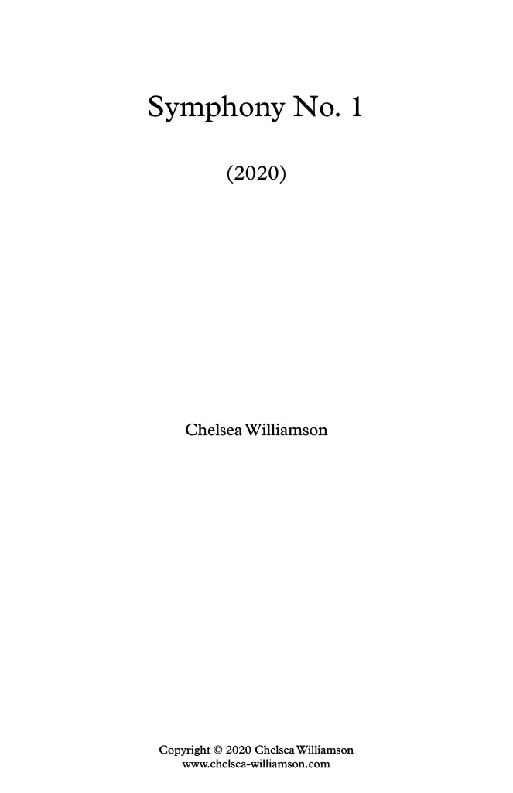
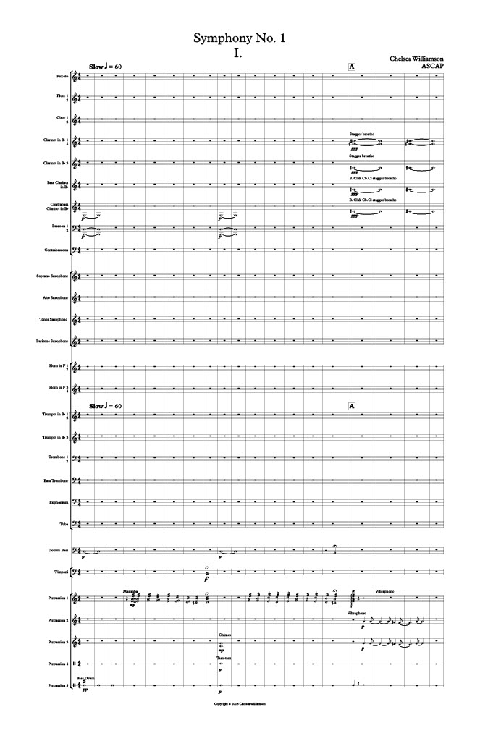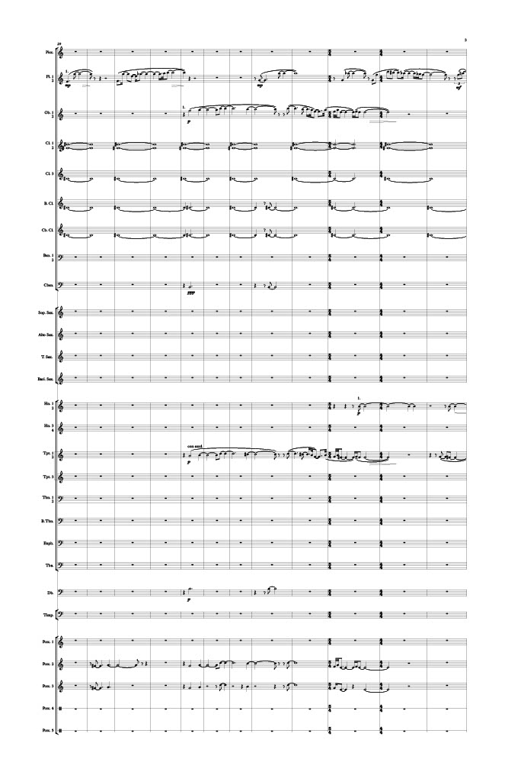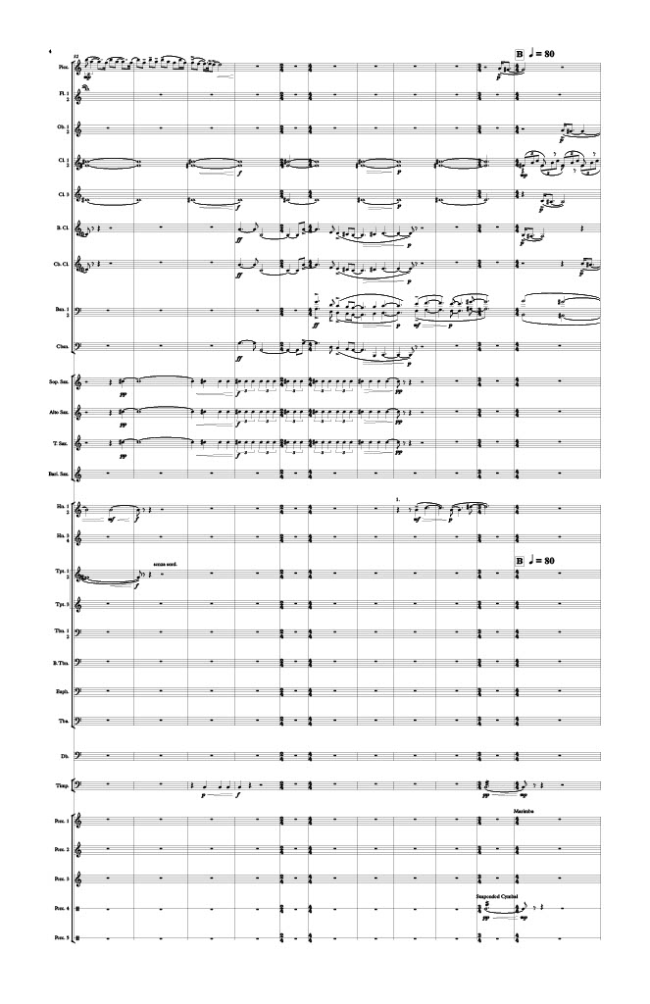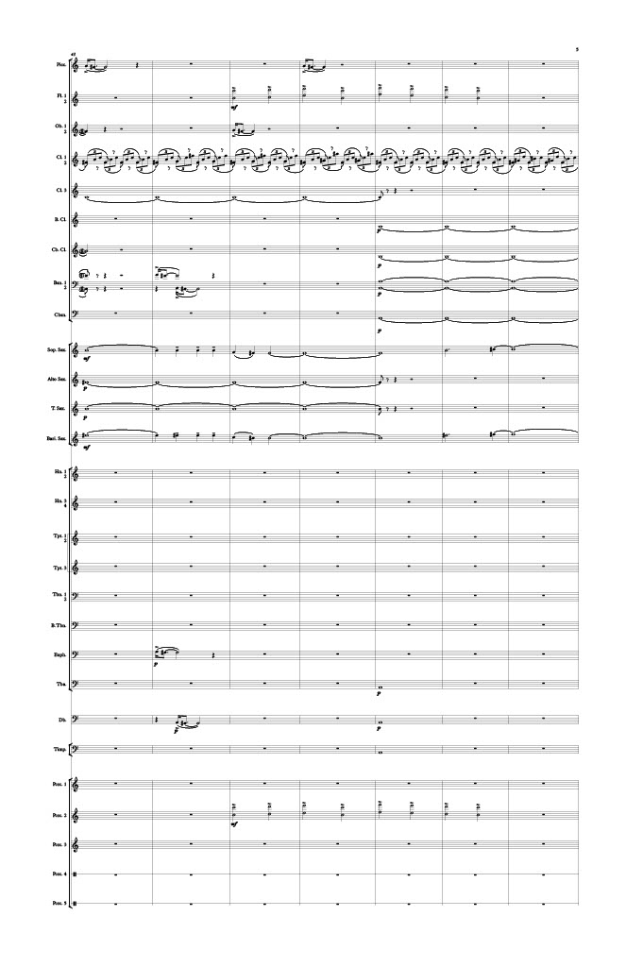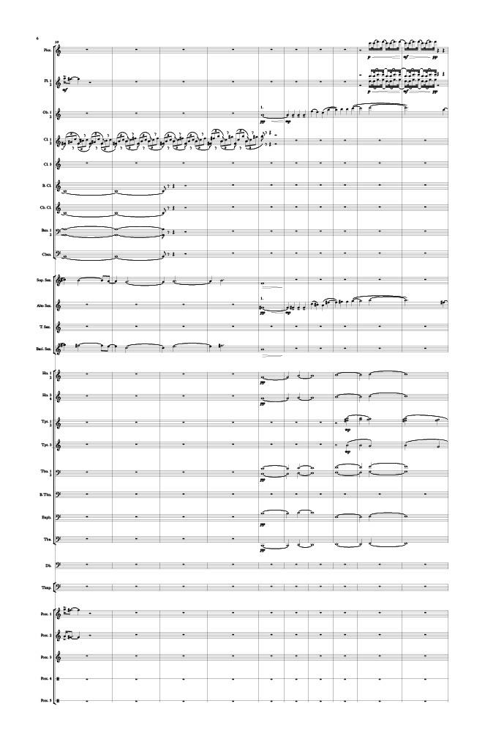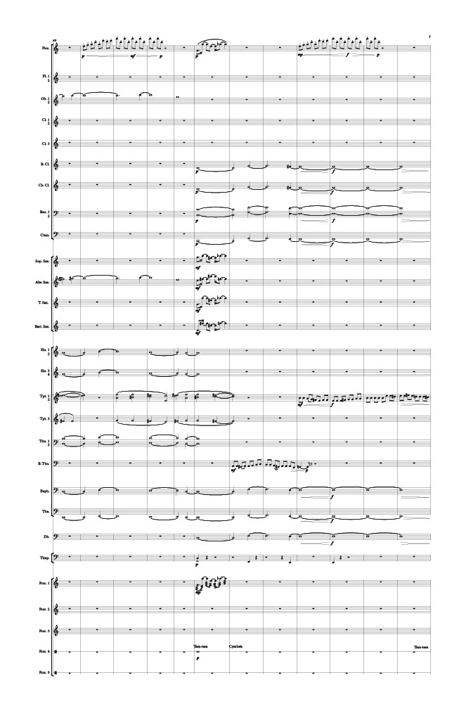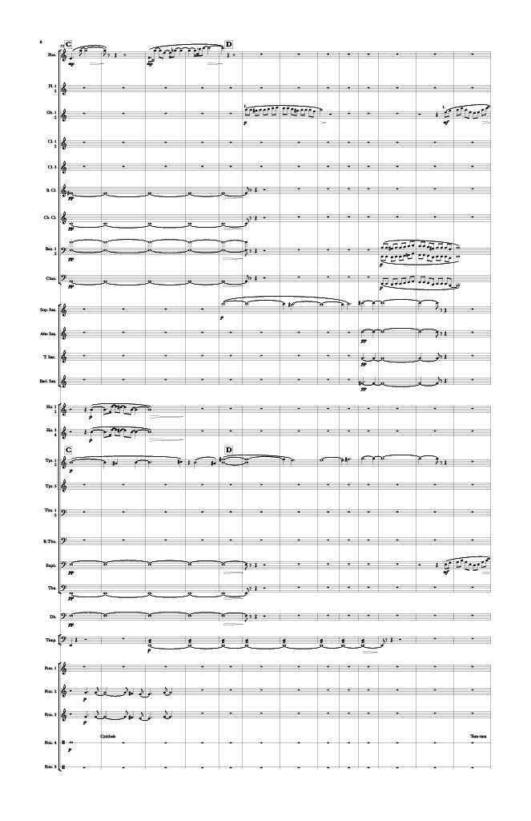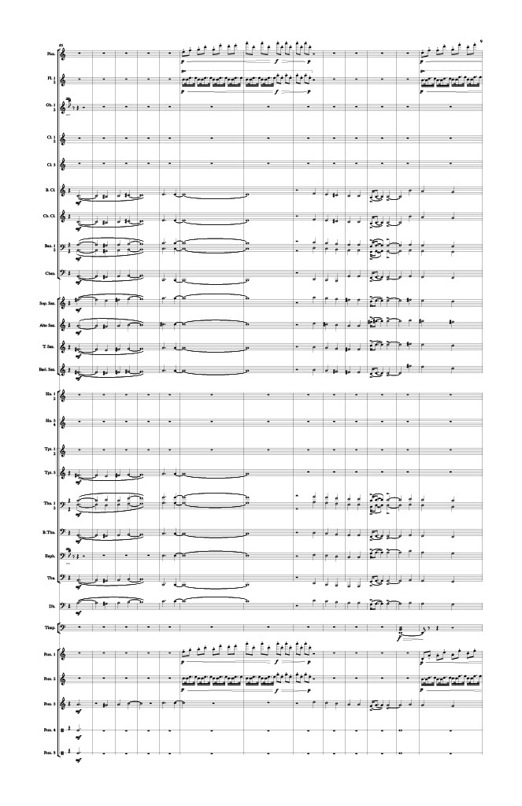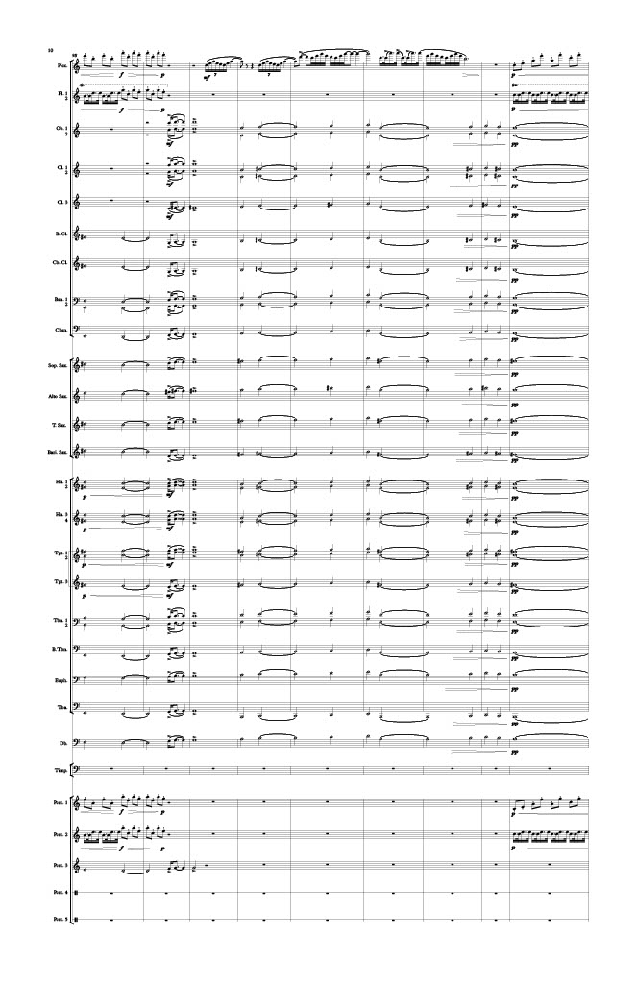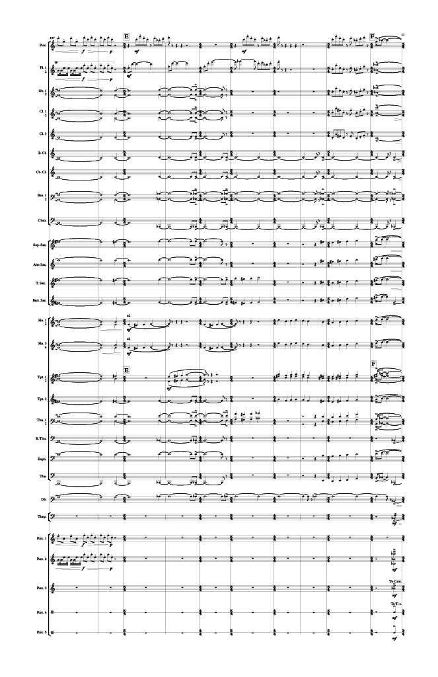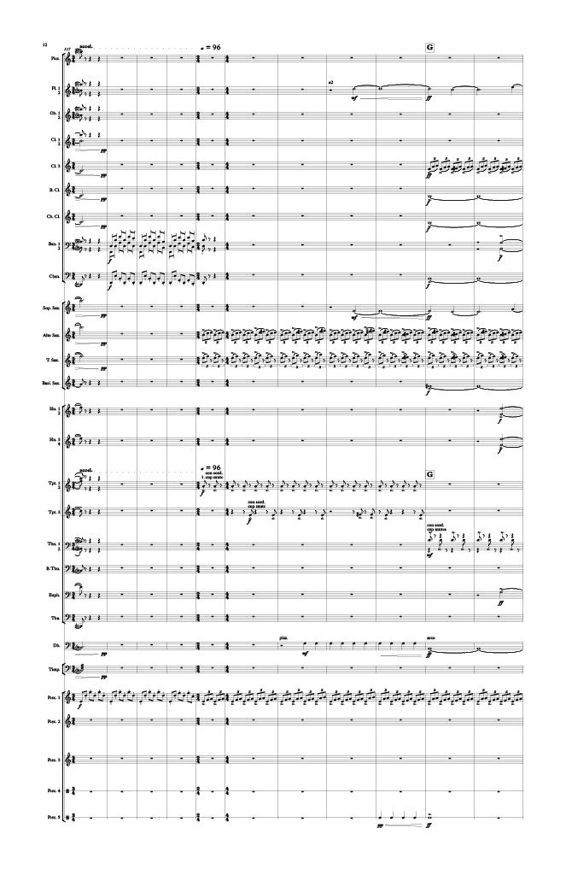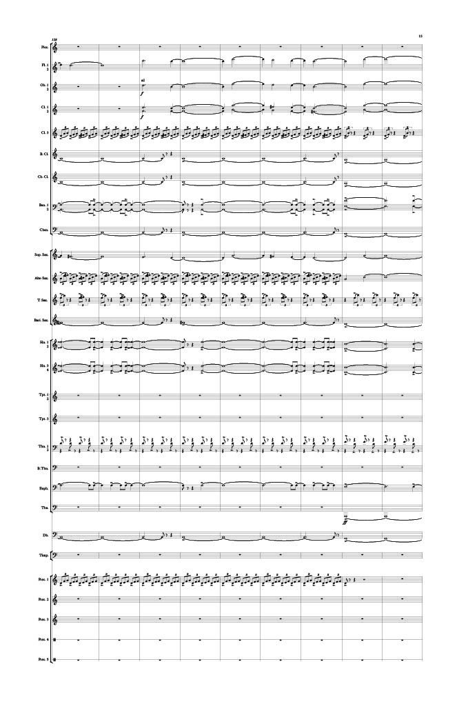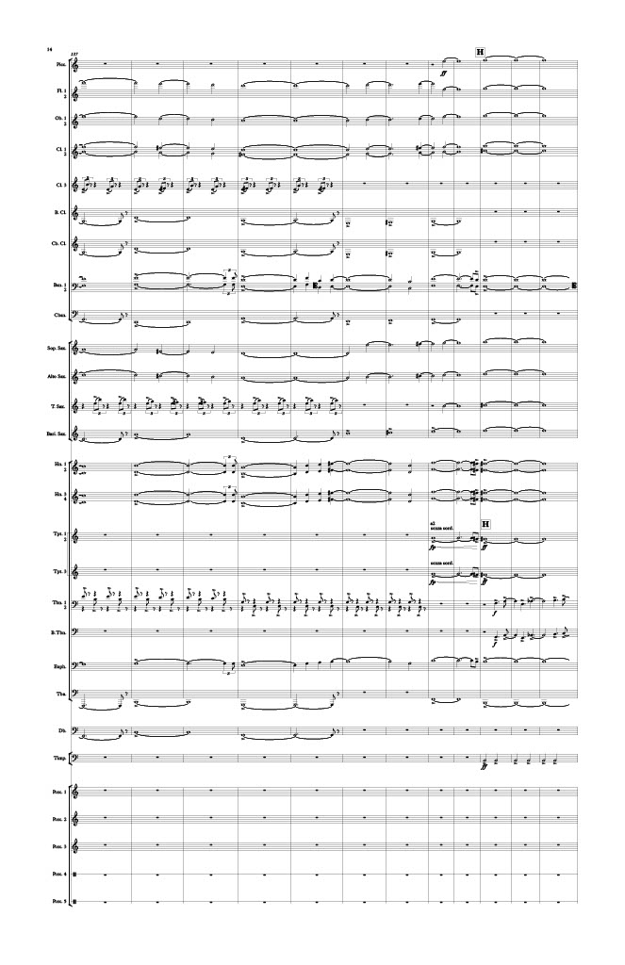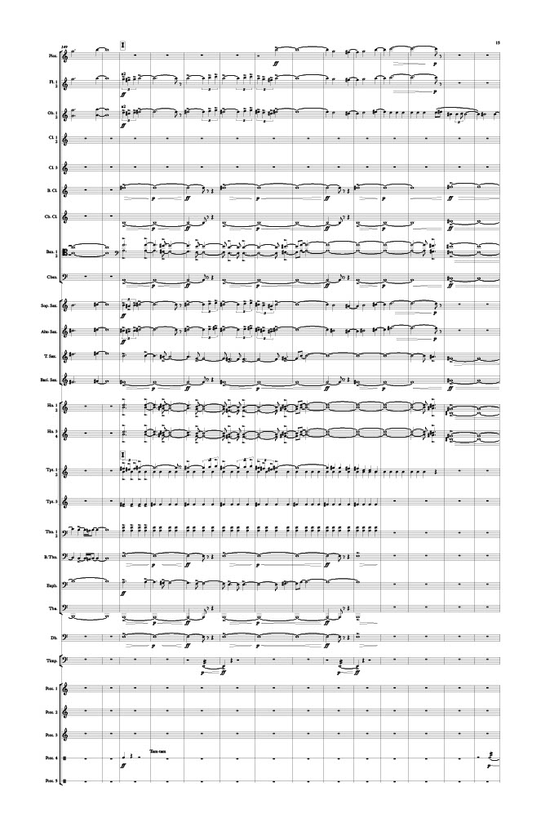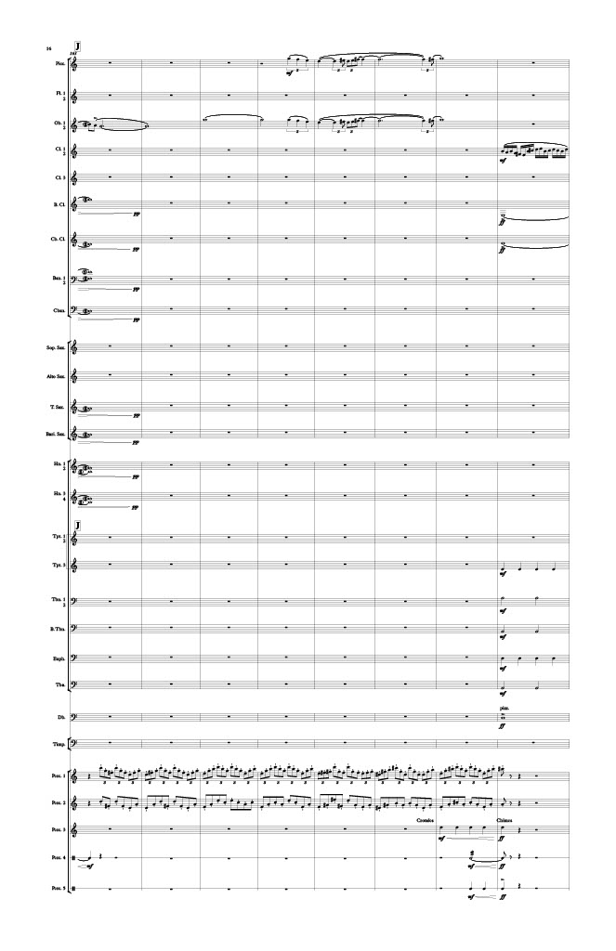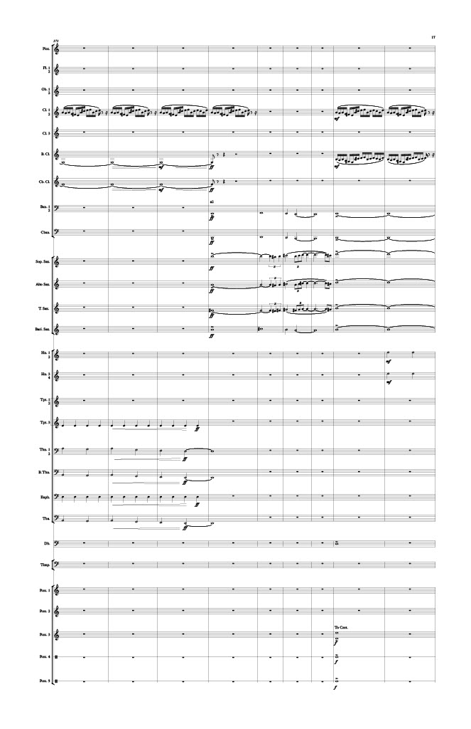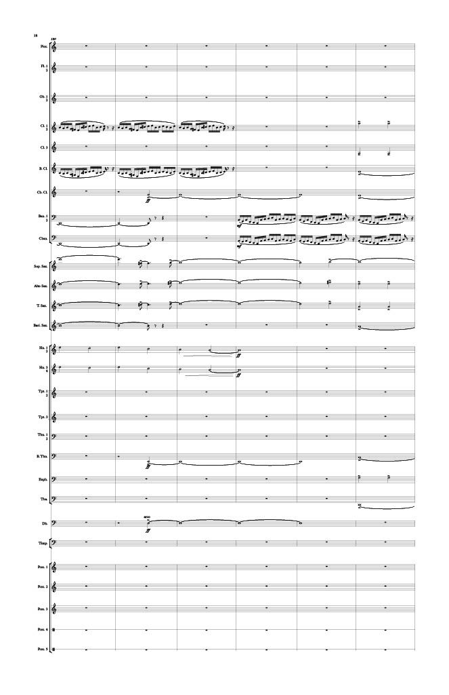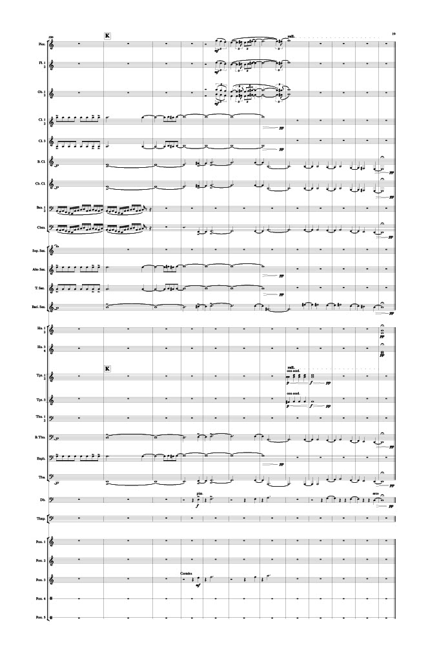
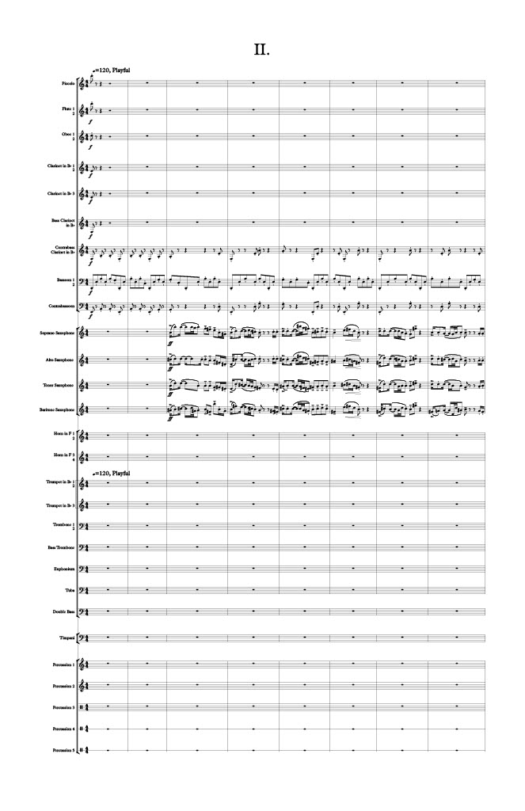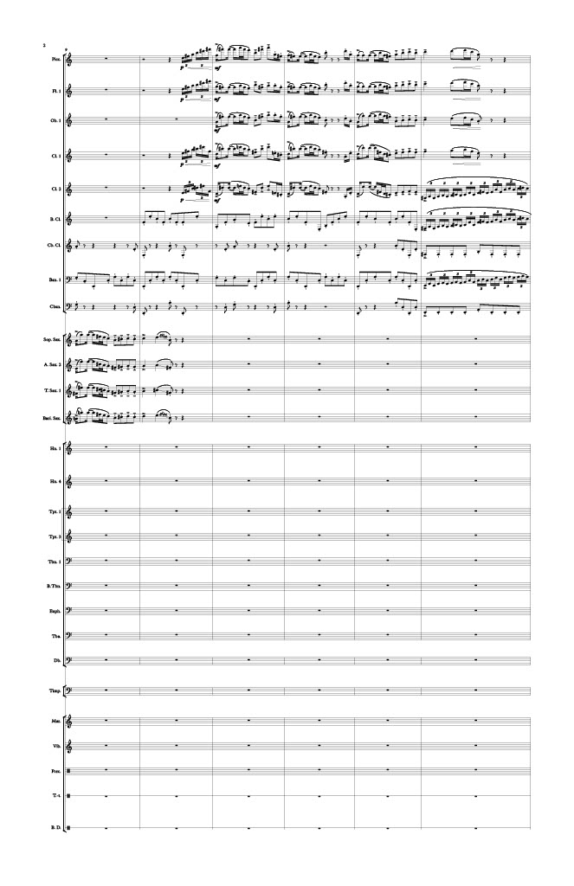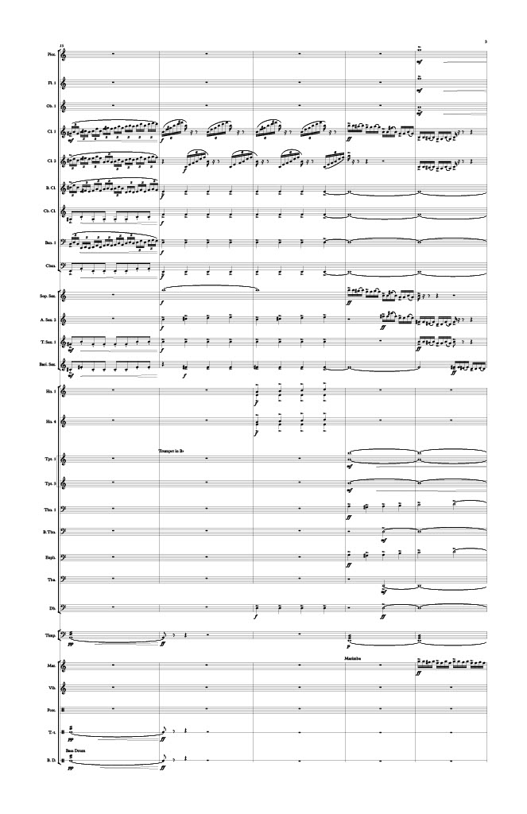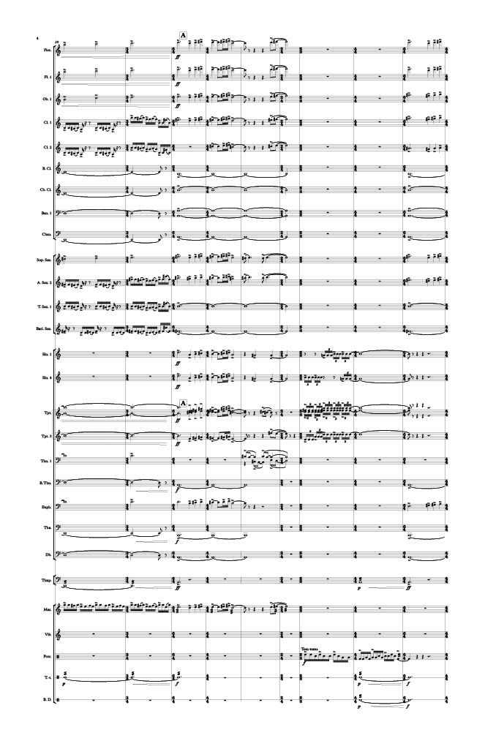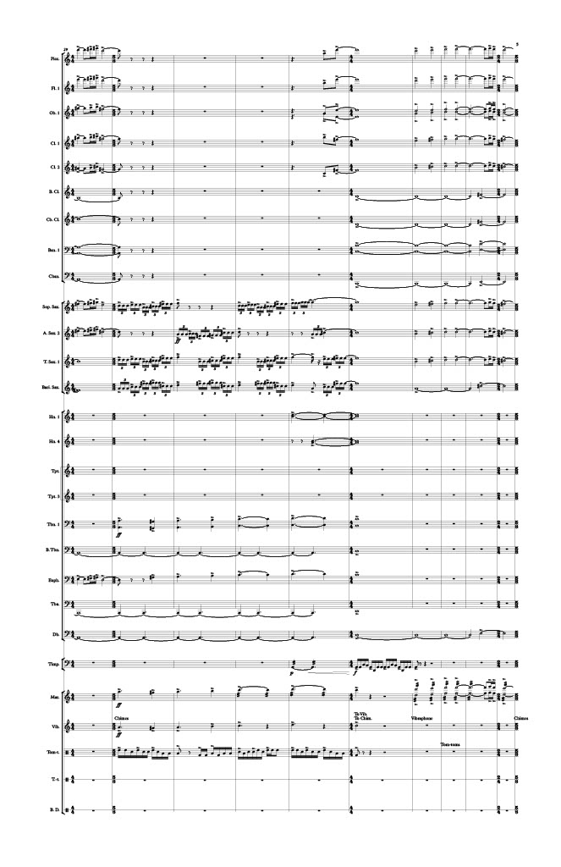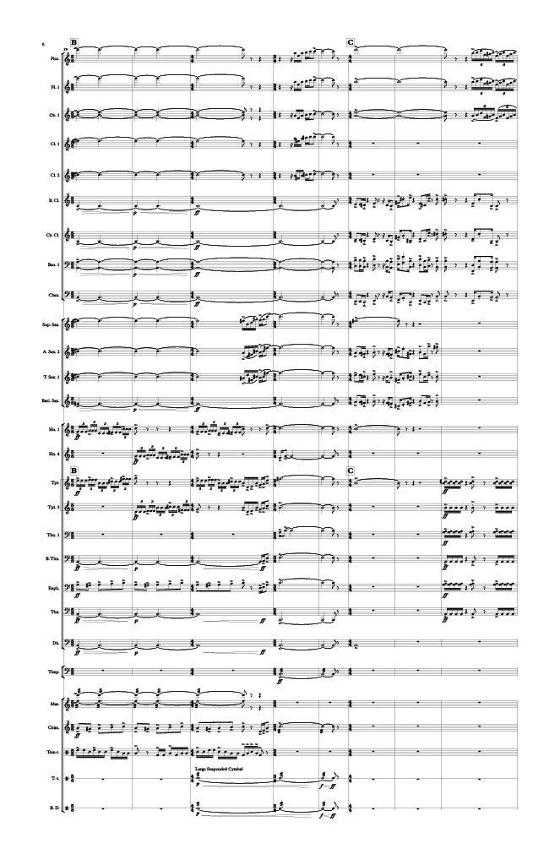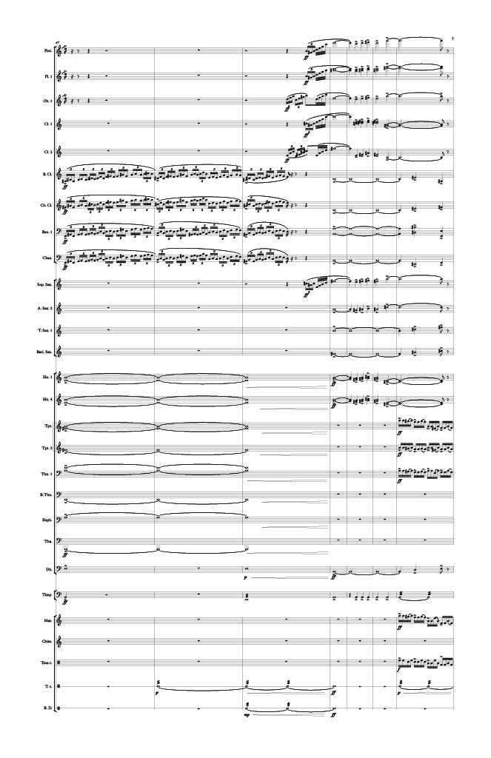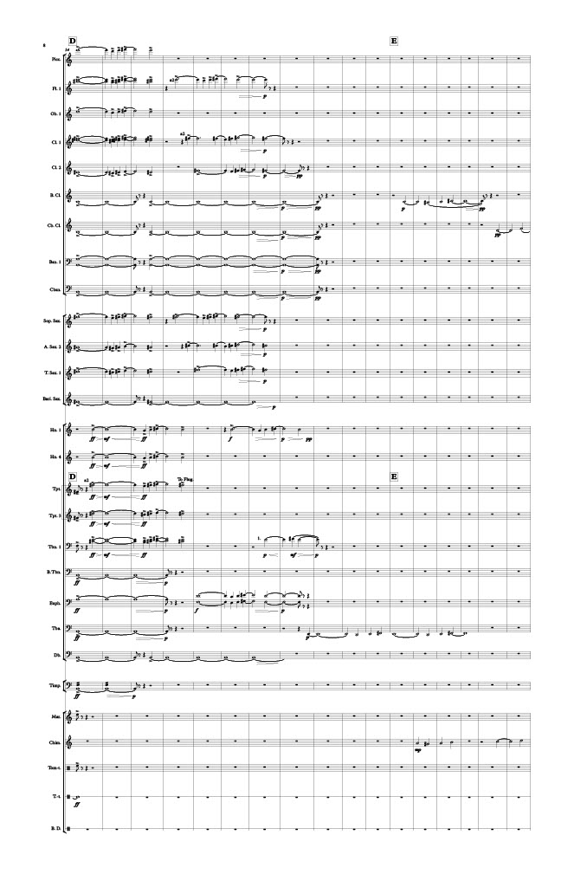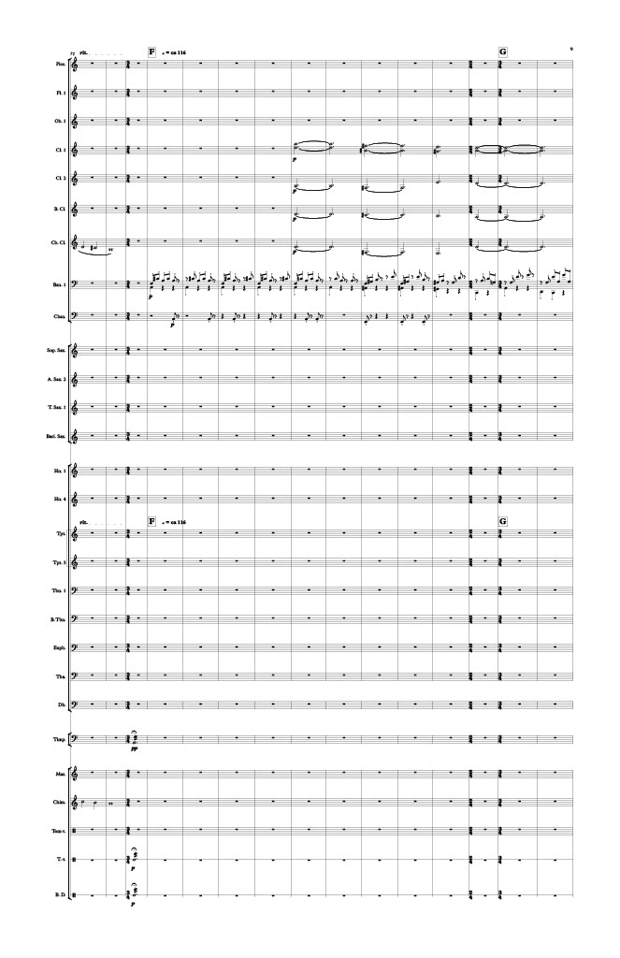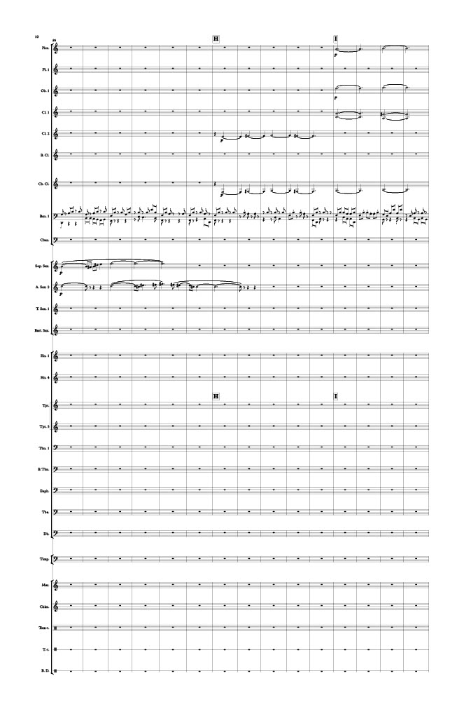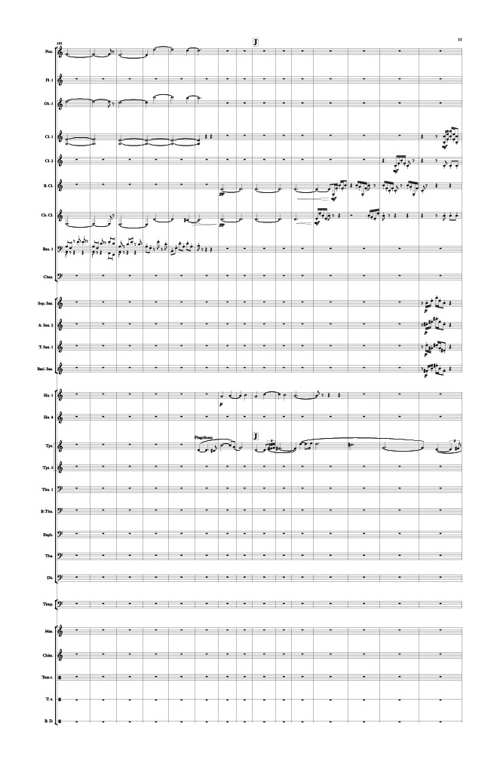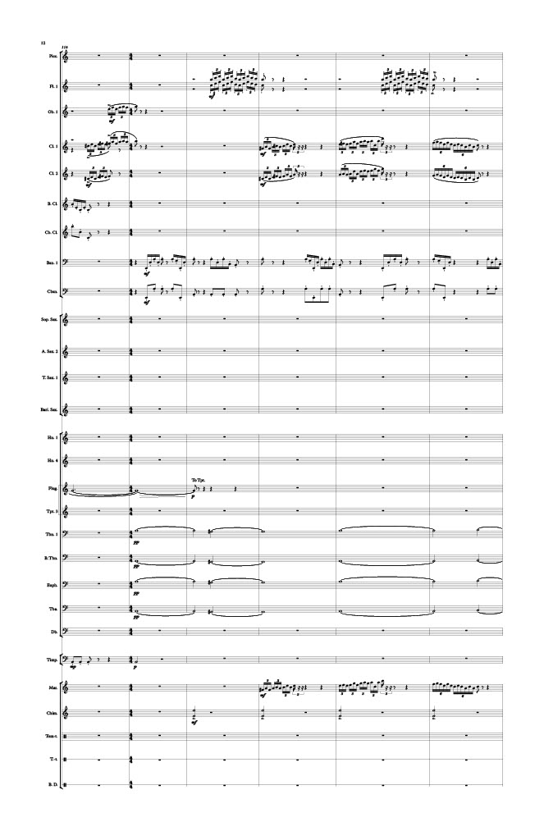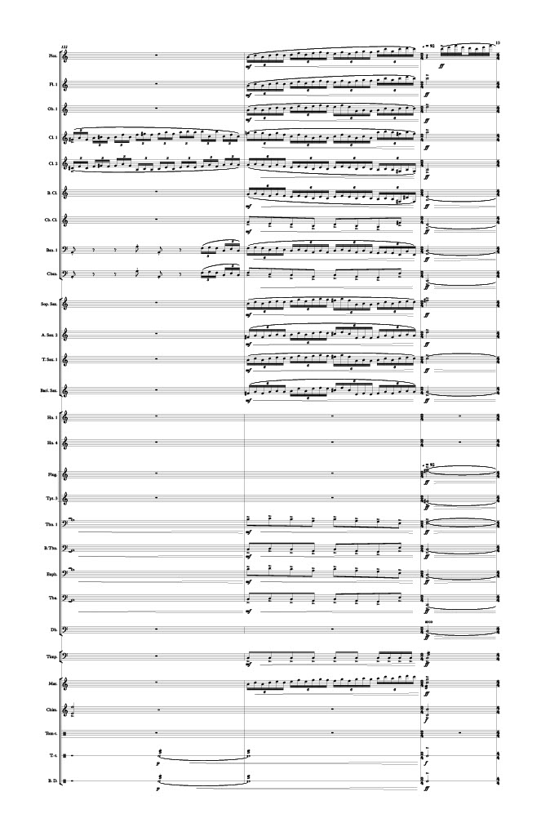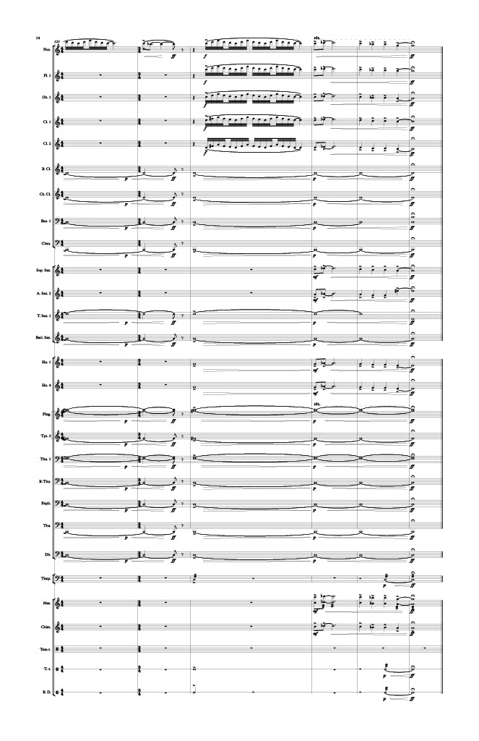
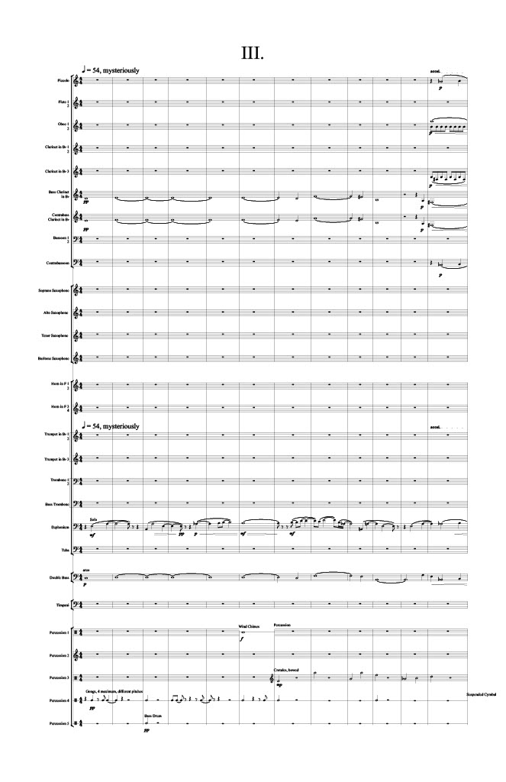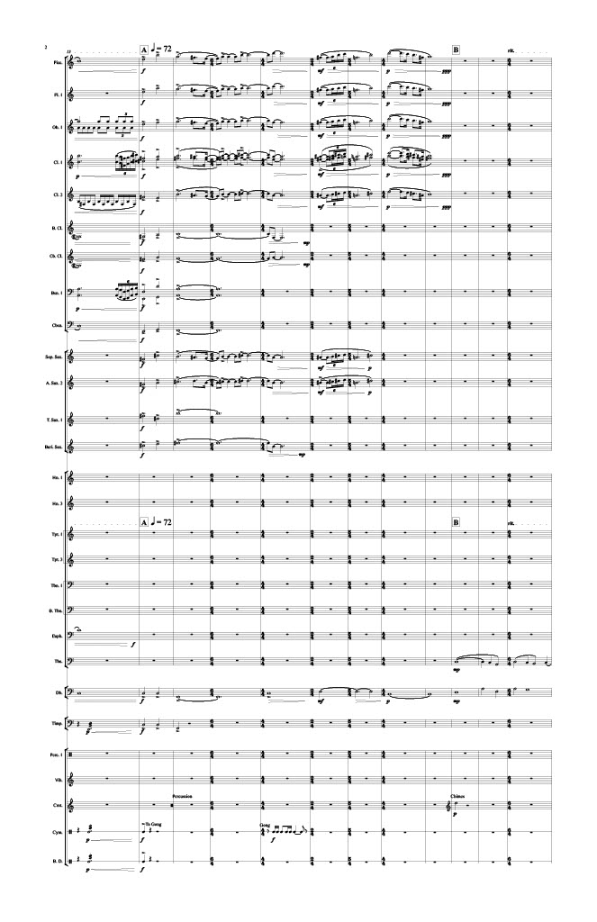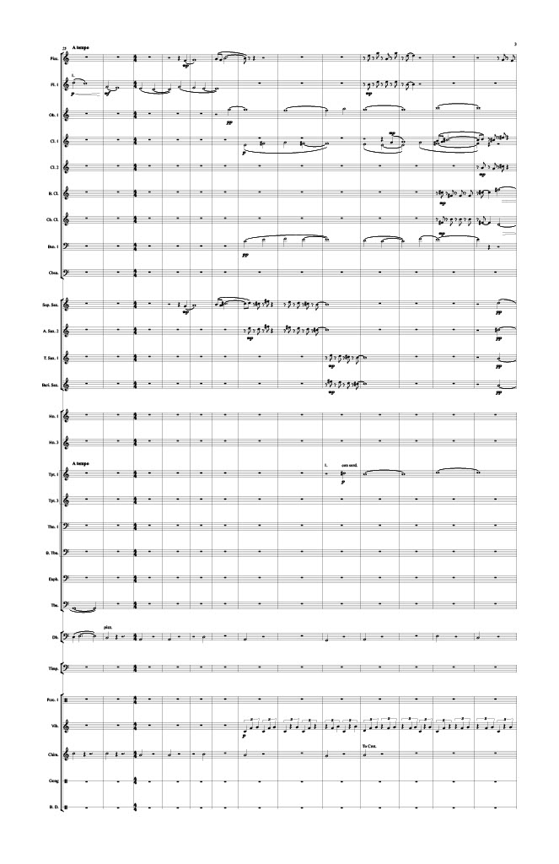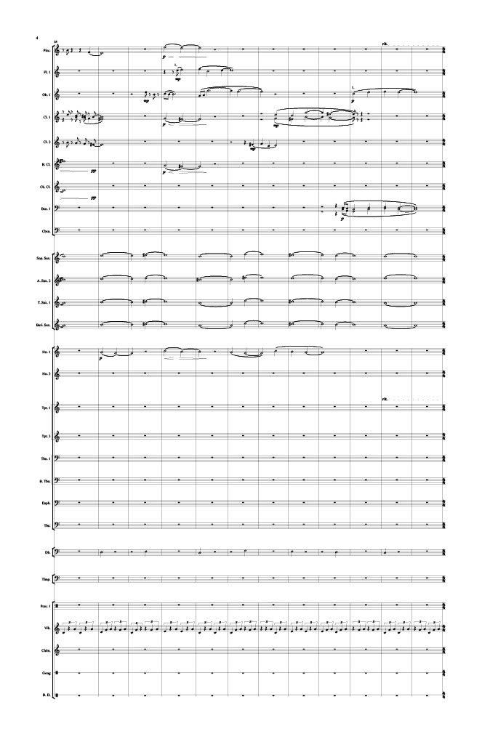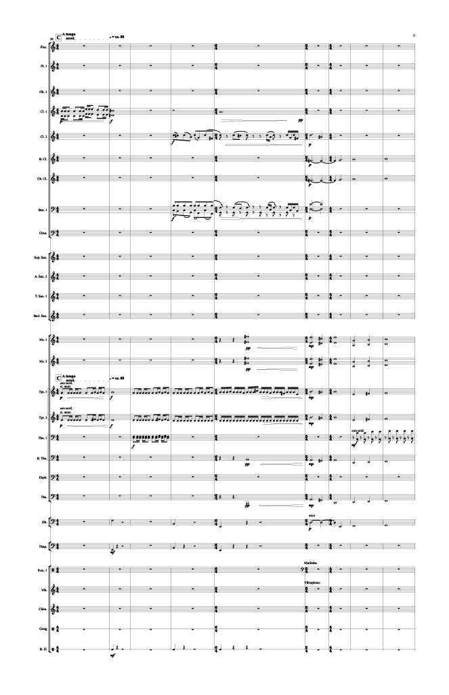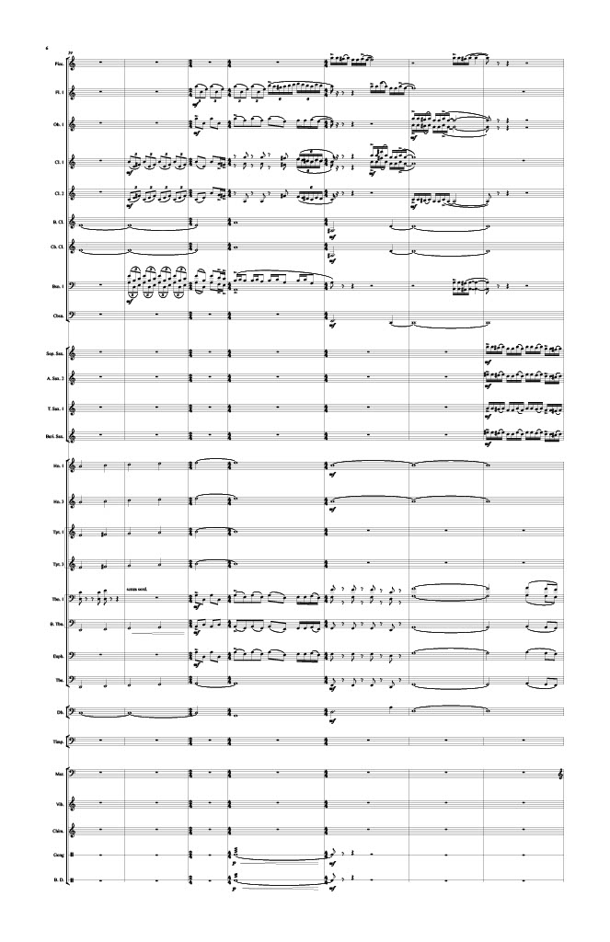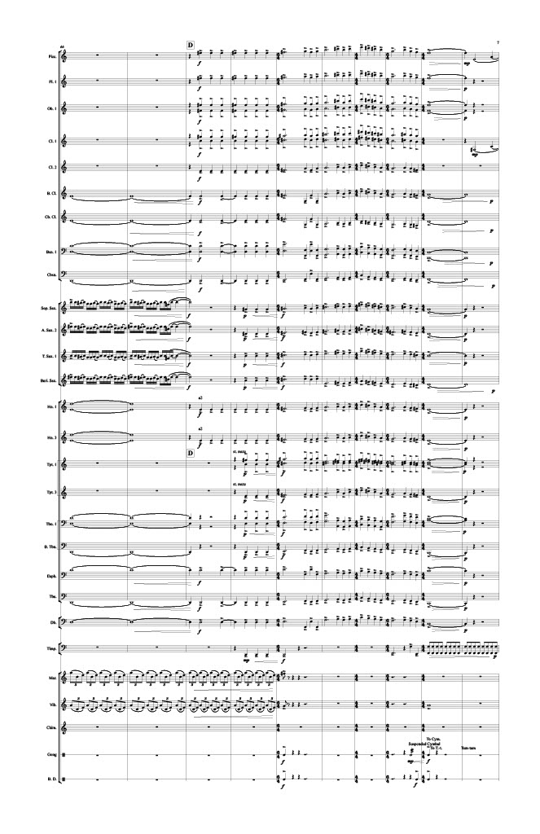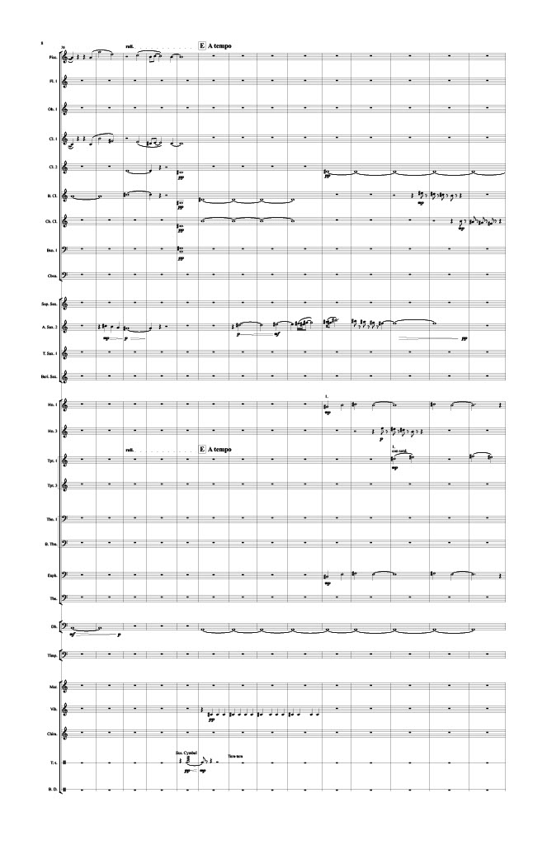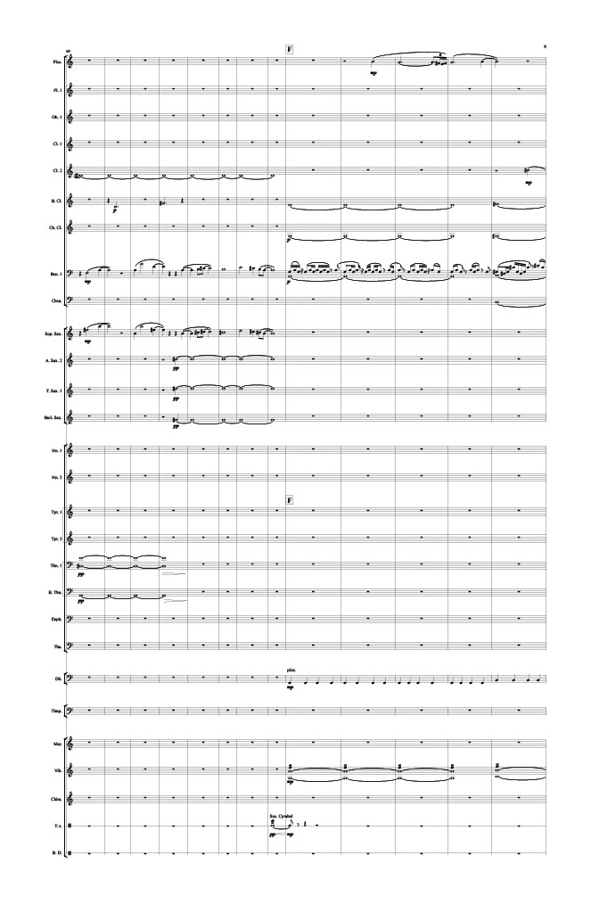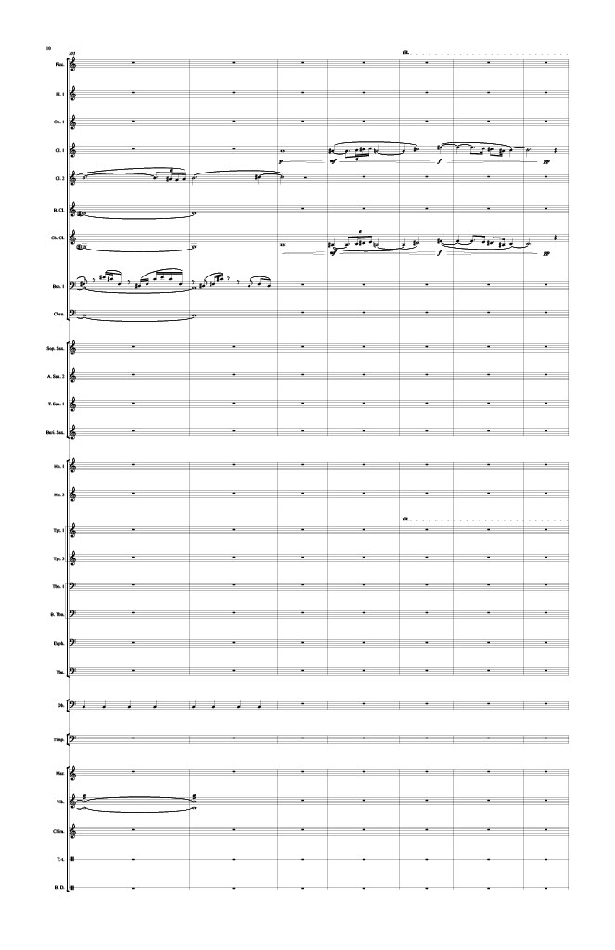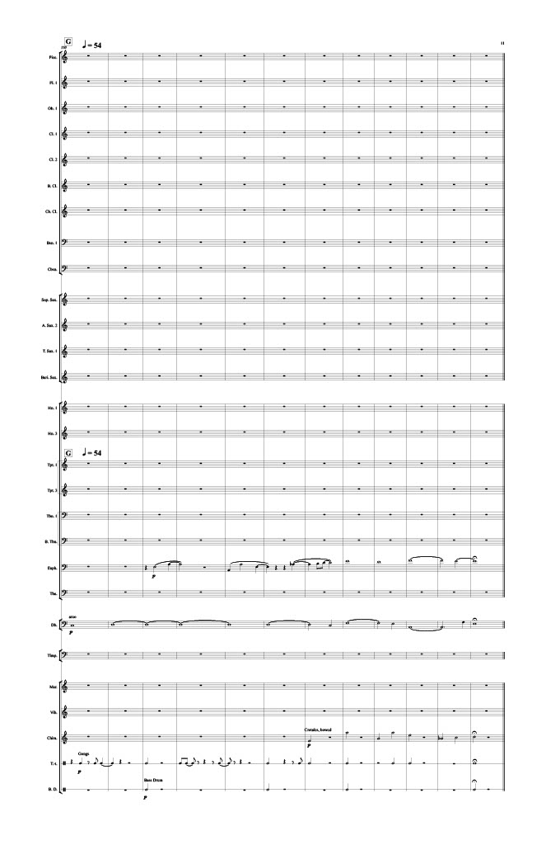
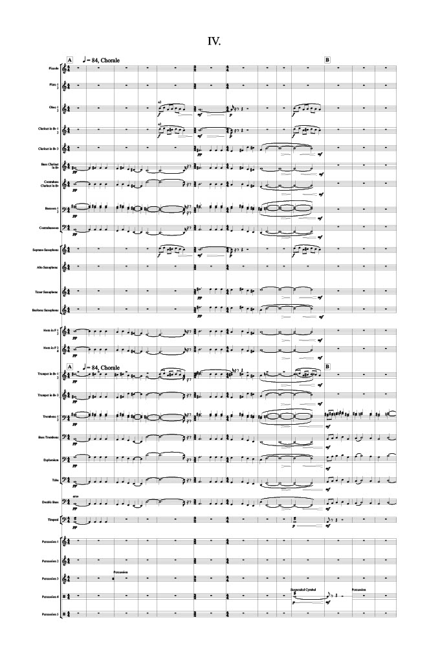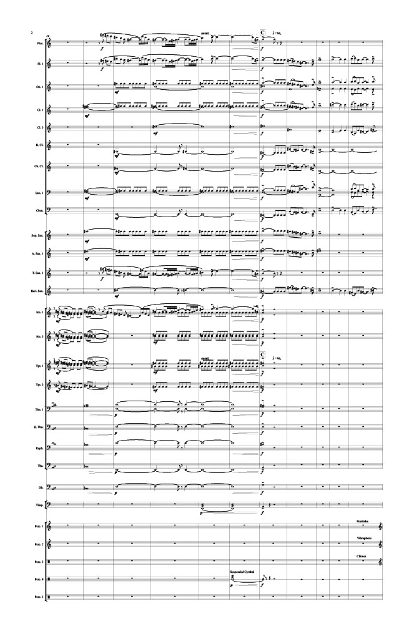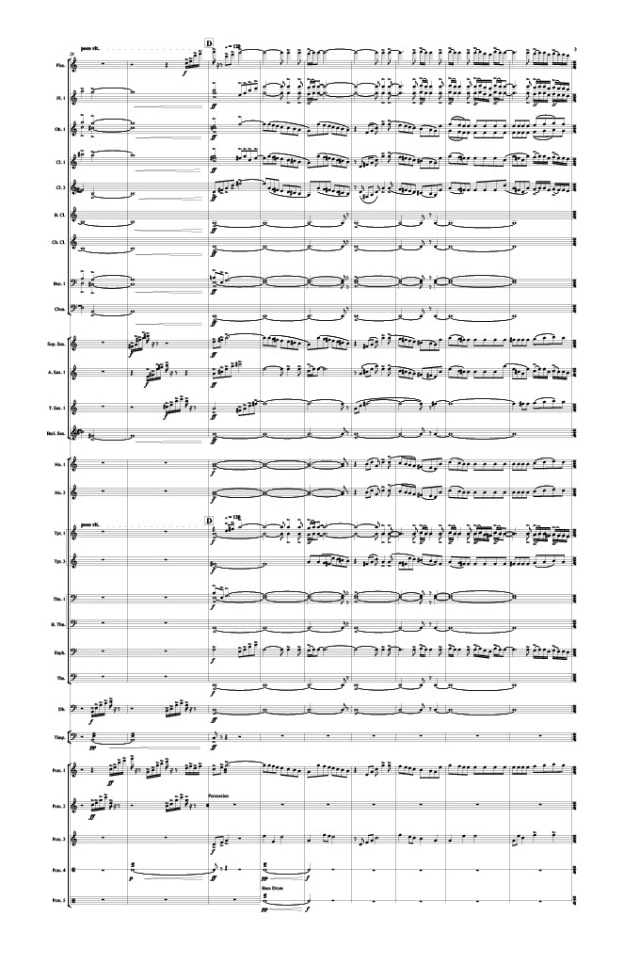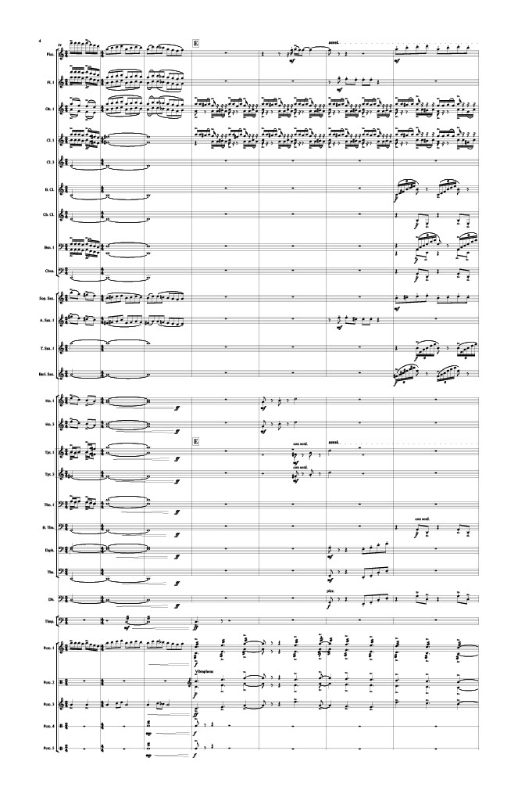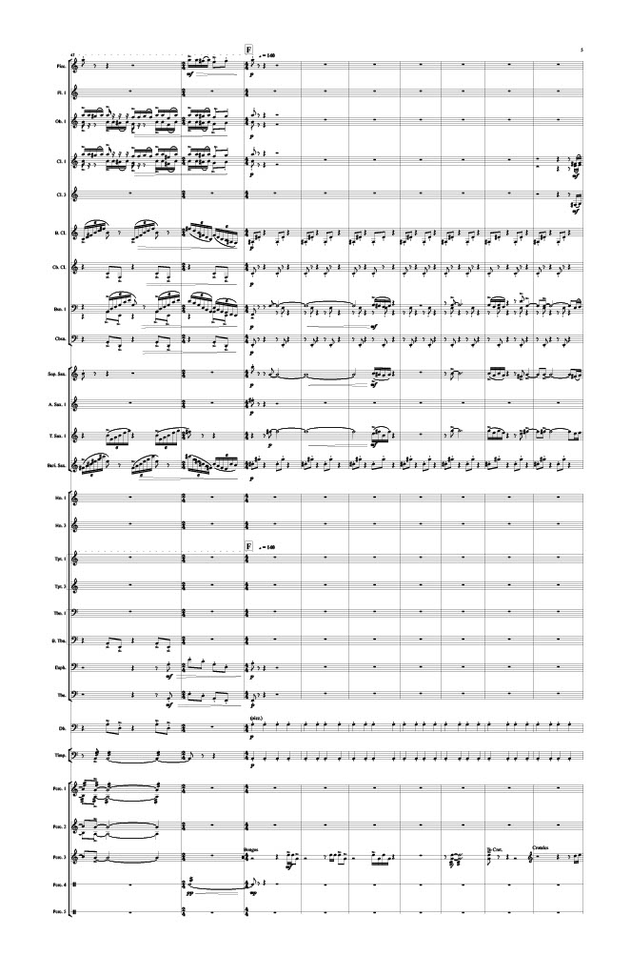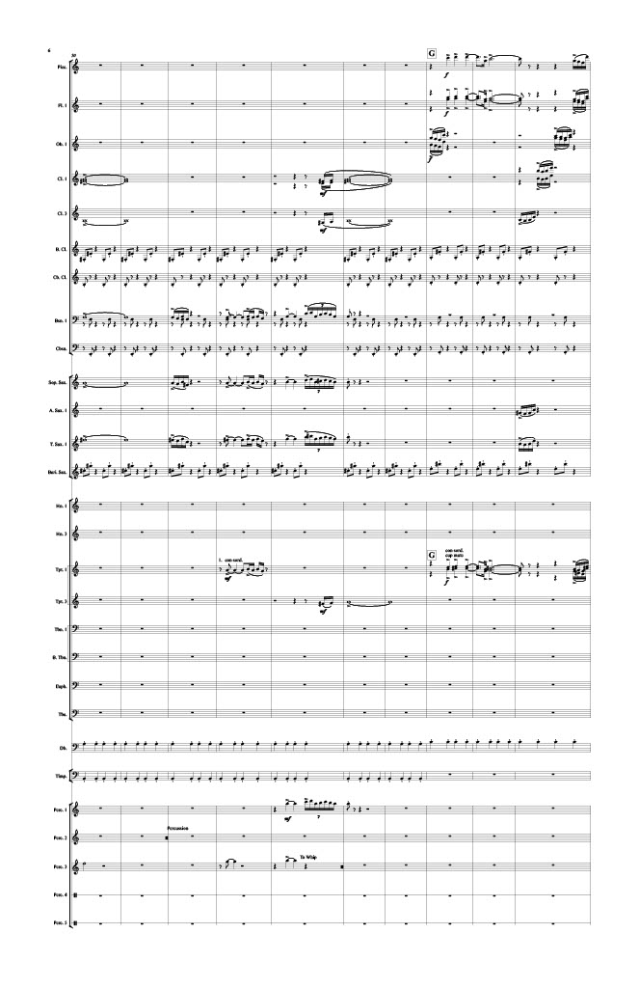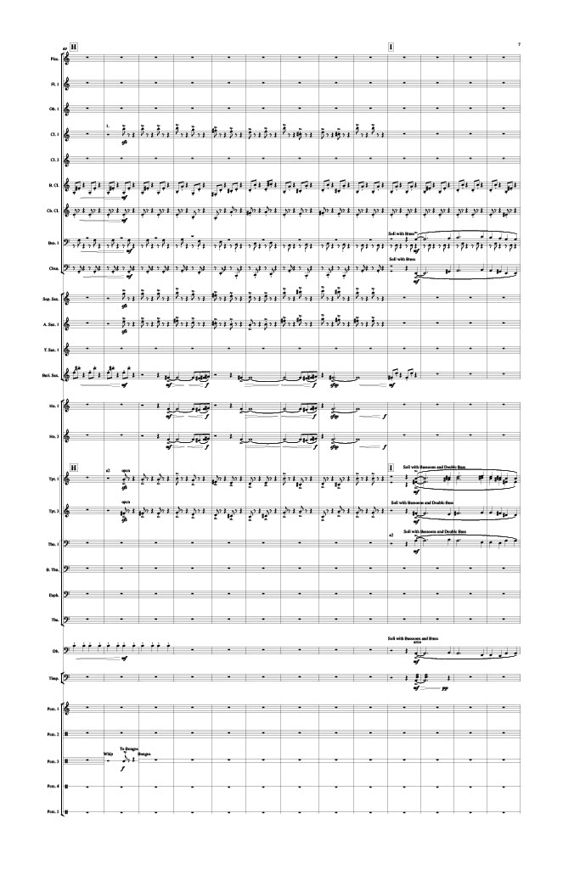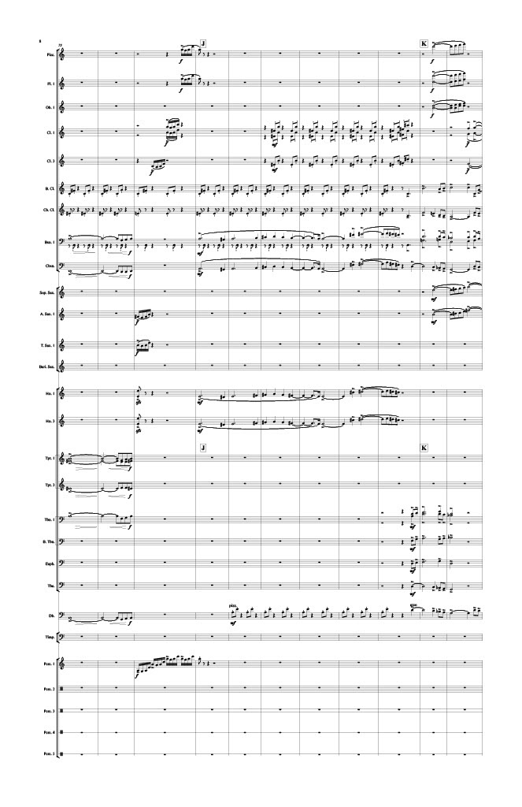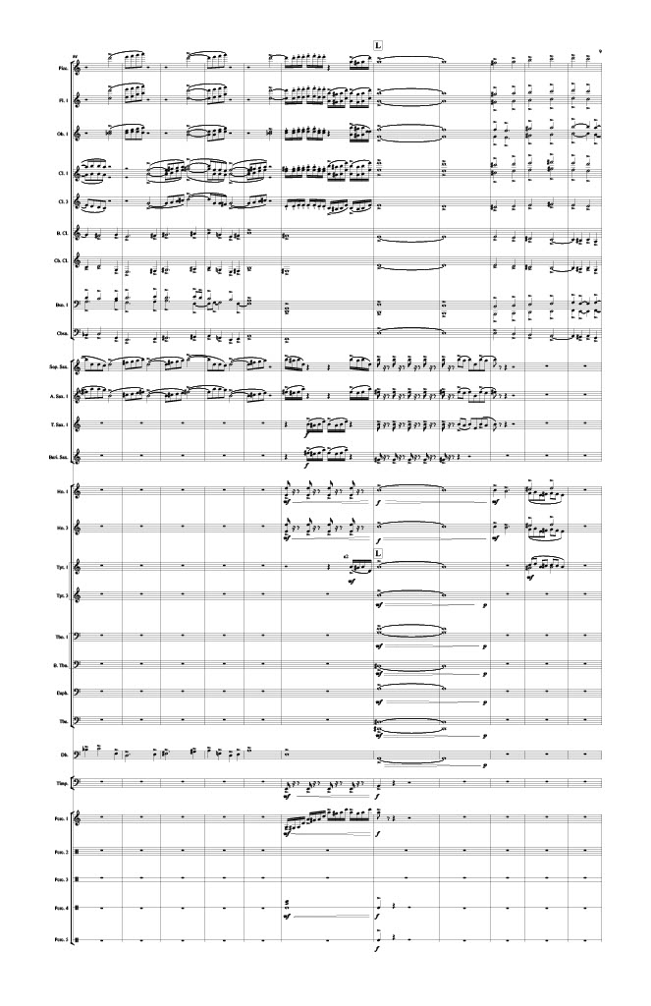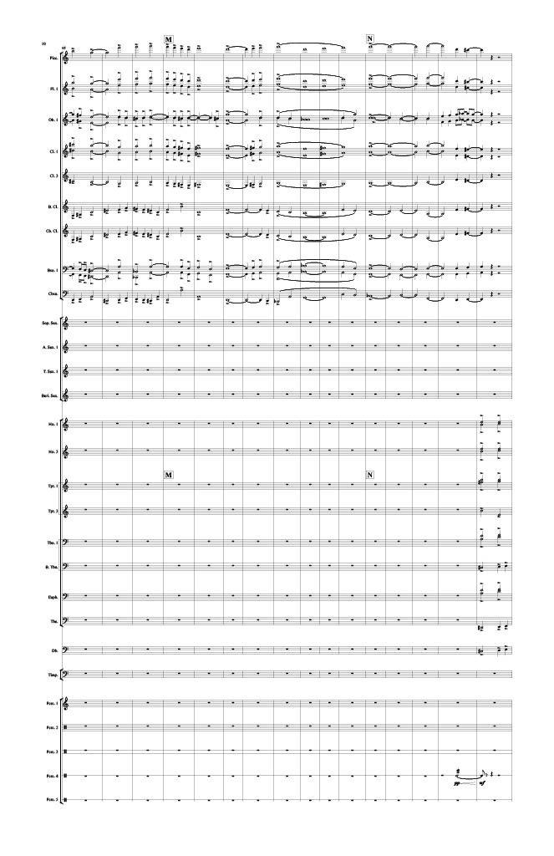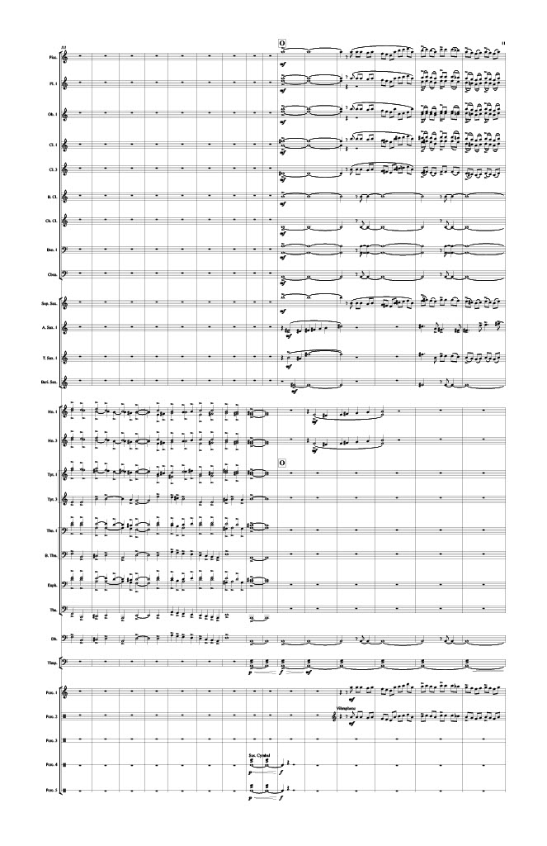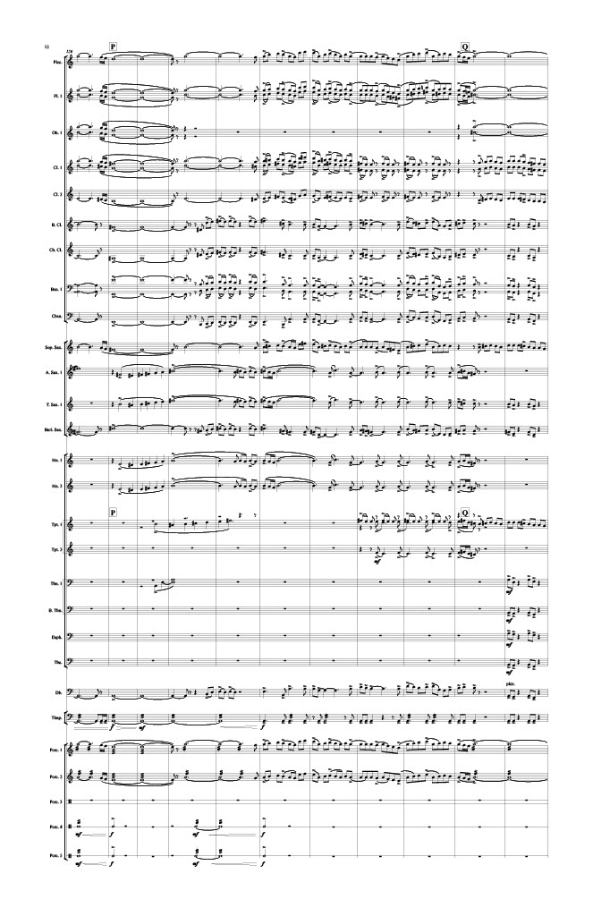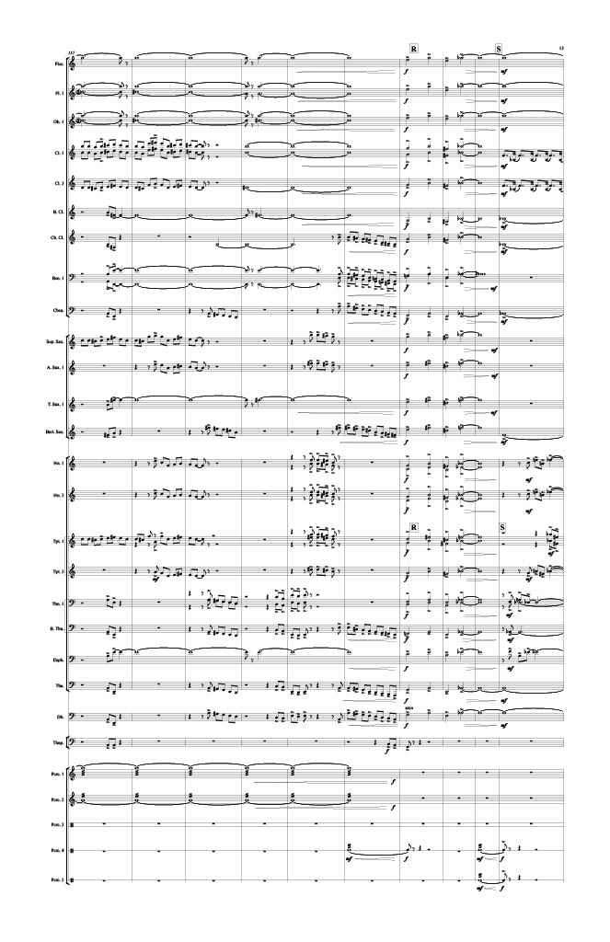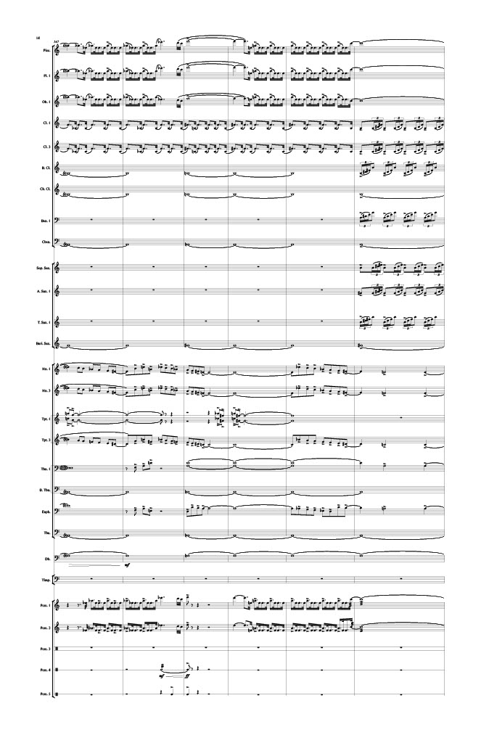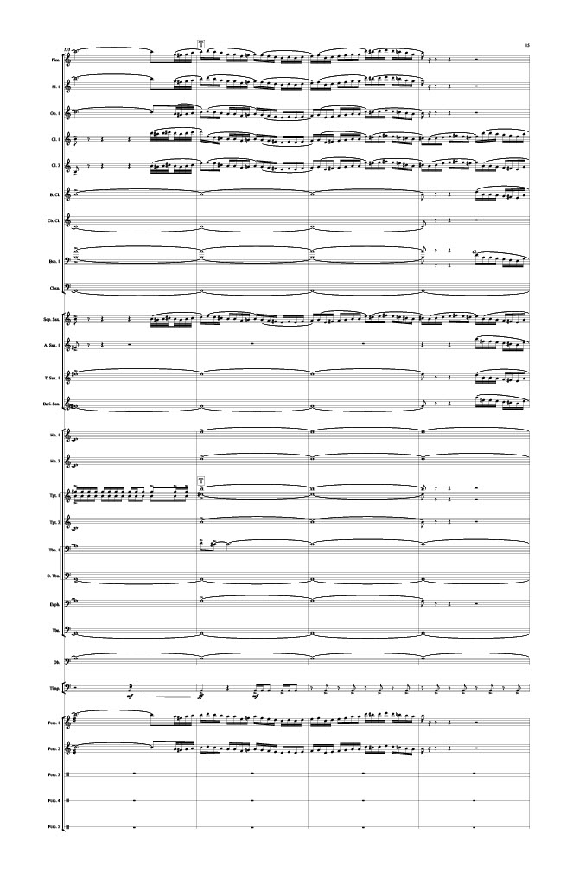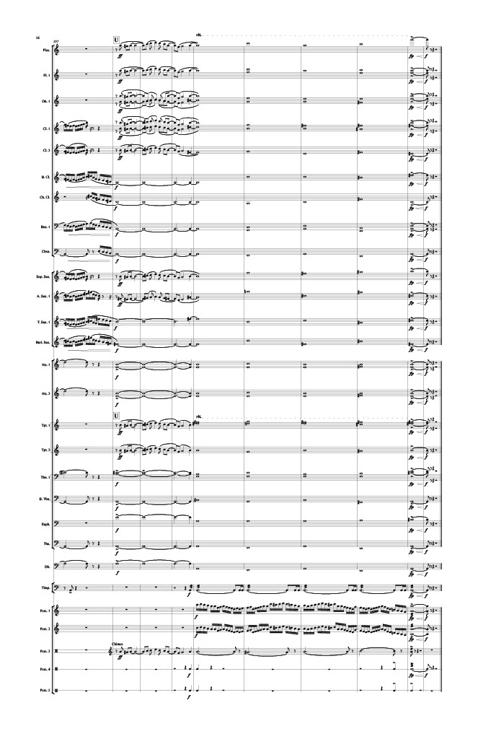

The University of Central Oklahoma Wind Symphony’s recording of Maslanka’s Traveler conducted by Dr. Brian Lamb.
“Data Analysis of Orchestral Seasons 2019-2020”, Institute for Composer Diversity, accessed September 2, 2020, https://www.composerdiversity.com/orchestra-seasons.
David W. Campo, “Original Music for Wind Band in the Latter Half of the 1950s: A Historical Perspective” (DMA diss., University of Oklahoma, Norman, 2007), 9. ProQuest Dissertations & Theses Global.
Ibid., 10.
Ibid., 10.
Ibid., 49.
Frederick Fennell, Time and the Winds (Kenosha, WI: LeBlanc, 1954), 38.
Campo, 12.
Fennell, 38.
Ibid., 41.
Edward B. Birge, History of Public School Music in the United States (Washington, D.C.: Music Educators National Conference, 1966; original, 1928), 175.
Charles D. Whitehall. “Sociological Conditions Which Contributed to the Growth of the School Band Movement in the United States,” Journal of Research in Music Education, 17 (Summer, 1969): 179-192.
Ibid., 180.
Ibid., 181.
Pitirim A. Sorokin. Man and Society in Calamity. (New York: E.P. Dutton, 1942), 28.
Campo, 14.
Whitehill, 184.
Ibid., 180.
Goldman, 121.
Ibid., 122.
Frank Battisti, The Twentieth Century American Wind Band/Ensemble-History, Development and Literature (Fort Lauderdale, FL: Meredith Music Publications, 1995), 3.
Fennell, 40.
Campo, 22.
Ibid., 28.
Charles Winkling, “The Wind Ensemble in the Small College,” The Instrumentalist 20 (December 1965): 48.
Frank Battisti, The Winds of Change (Galesville, MD: Meredith Music Publications, 2002), 67-68.
Ibid., 54.
Ibid., 58-59.
Ibid., 60.
Richard K. Hansen, The American Wind Band: A Cultural History (Chicago: GIA Publications, 2005), 166.
Campo, 33.
Revelli was regarded as one of the great music educators and band conductors of the century at the time of his death in 1994. He was director of bands at the University of Michigan for 37 years, and his influence is still felt there today. He was a Founder and Honorary Life President of the College Band Directors National Association, Past President of the National Band Association and the American Bandmasters Association and Honorary Life Member of the American Bandmasters Association.
William D. Revelli, “Report on International Instrumentation,” in The College and University Band, Whitwell and Ostling, eds. (Reston, VA, MENC, 1977): 85.
Campo, 37.
Revelli, 92.
Frank L. Battisti taught at the New England Conservatory, and during his time there he cemented his reputation as one of the most respected champions of music for winds in America. It was President Gunther Schuller’s goal to have Battisti create a wind ensemble program on the model of the work done by Frederick Fennell at Eastman. He is past president of the College Band Directors National Association, and his articles on the wind ensemble, music education, and literature have been published by several national and international journals. Battisti founded the World Association of Symphonic Bands and Ensembles.
CBDNA president from 1958-1960.
Battisti, 75.
R. Bernard Fitzgerald was a composer, educator, conductor and author of significance from the mid-20th century. He wrote many concert band and choral works, but is known by trumpet players because a number of his compositions and arrangements for trumpet have been included in the standard repertoire.
Associated Music Publishers.
G. Ricordi & Company
Charles Minelli, “Conference on the Band’s Repertoire, Instrumentation, and Nomenclature,” in The College and University Band, Whitwell and Ostling, eds. (Reston, VA, MENC, 1977): 99.
Battisti, 76.
The Ostwald family were band uniform manufacturers who became interested in band music in 1936, and they eventually came to dominate the band uniform market. In 1951, the company joined the American Bandmasters Association as an associate member and supplier. They established the ABA Ostwald Award that was given to the best band composition written in the preceding year. Since then, the award has grown in importance and prestige, attaining a position of national and international prominence. The Sousa Foundation joined together with the ABA Foundation to provide financial support the former ABA Ostwald Award, which is now known as the Sousa/ABA/Ostwald Award.
Campo, 48.
Joe Rayford Daniel, “The Band Works of James Clifton Williams.” (Ph.D. dissertation, University of Southern Mississippi, 1981), 41.
Campo, 56.
Battisti, 65.
Battisti, The Winds of Change, 69.
Kenneth G. Bodiford, “Evolution of Contemporary College Wind Band Repertoire and Programming in the United States: 1800-2010” (DMA diss., University of Alabama, Tuscaloosa, 2012), 44, ProQuest Dissertations & Theses Global.
Richard Hansen, The American Wind Band: A Cultural History, (Chicago: GIA Publications, Inc., 2005), 120.
Ibid., 121.
Frederick Fennell, “Band Music and the Composer: Old-Fashioned Pursuits in High-Tech Society” (keynote address for the Second International Congress Kortrijik, Belgium, July 15, 1985), 2-3.
Hansen, The American Wind Band, 123.
Bodiford, 48.
Ibid., 53.
Frank Battisti, Winds of Change II: The New Millennium (Galesville: Meredith Music Publication, 2012), 68.
Gary W. Hill, “The Future of the Wind Band Field: Promise or Peril? Journal of the World Association for Symphonic Bands and Ensembles 10 (2003), 47.
Battisti, Winds of Change II, 325.
www.windrep.org
Nikk Pilato, www.windrep.org
Highben, Zebulon M. "REVIVING SACRED SONG: 500 YEARS OF THE LUTHERAN CHORALE IN ITS CONGREGATIONAL AND CHORAL CONTEXTS." The Choral Journal 58, no. 1 (2017): 36-46. Accessed October 16, 2020. https://www.jstor.org/stable/26412814.
Ibid., 39.
Ibid., 39.
Ibid., 39.
Bar form is a three-part structure where two identical sections of a tune are succeeded by a contrasting third section (A-A-B), and it was prominent through the repertoire of the Minnesingers and Meistersingers of the Renaissance.
Highben, 40.
Carl Schalk, Music in Early Lutheranism: Shaping the Tradition (1524-1672) (St. Louis: Concordia Publishing House, 2001), 9.
Ibid., 31.
Ibid., 42.
Schalk, Music in Early Lutheranism, 22.
Ibid., 76.
Highben, 43.
Schalk, 15-28.
Westermeyer, 152-155.

