University of Oklahoma

Graduate College

THE HYDROLOGIC RESPONSES OF SEMIARID WATERSHEDS TO THE CULTIVATION OF SWITCHGRASS (PANICUM VIRGATUM L.)

A Dissertation

submitted to the graduate faculty

in partial fulfillment of the requirements for the

Degree of

Doctor of Philosophy

By

JUSTIN CHAMOY GOLDSTEIN
Norman, Oklahoma
2013

THE HYDROLOGIC RESPONSES OF SEMIARID WATERSHEDS TO THE CULTIVATION OF SWITCHGRASS (PANICUM VIRGATUM L.)

A Dissertation approved for the
Department of Geography and Environmental Sustainability

By

______________________________
Dr. Aondover Tarhule, Chair

______________________________
Dr. John Greene

______________________________
Dr. Bruce Hoagland

______________________________
Dr. Jason Julian

______________________________
Dr. Yang Hong

© Copyright by Justin chamoy goldstein 2013
All Rights Reserved.

Acknowledgements
I am grateful to G-d Almighty for providing the ability to research and to write a dissertation.
I thank many individuals whose academic knowledge and support allowed me to complete and defend this dissertation. I am grateful to my advisor, Aondover Tarhule, for his scholarly input, mentorship, and instruction for tackling the inevitable “crises” that emerge during one’s doctoral research. He always kept me calm, relaxed, and optimistic about the future of the research. Despite Dr. Tarhule’s extremely busy schedule, he always kept his door open for my frequent visits, a fact that is emblematic of true mentor-student relationship for which I am very grateful. I am also grateful to the other committee members, consisting of Professors John Greene, Bruce Hoagland, Jason Julian (OU Department of Geography and Environmental Sustainability) and Yang Hong (OU School of Civil Engineering and Environmental Science), for providing excellent scholarly input and feedback. I thank the faculty and staff of the University of Oklahoma Department of Geography and Environmental Sustainability for providing a caring atmosphere which maximized my research potential. I am also especially grateful to the department’s former IT administrator Chris Cook for accommodating my numerous computing needs which emerged during my research.
This dissertation would be incomplete without thanking Michael Kearney, my M.A. advisor at the University of Maryland, College Park, for introducing me to the vigors of self-directed research in the physical sciences and for encouraging my pursuit of the Ph.D. My exposure to hydrologic modeling began during my M.A. research which used MATLAB and GIS to investigate the impact of the theoretical removal of surface ice on the West Antarctic Ice Sheet to subglacial flow. During that research, I was lucky to be mentored by Robert Bindschadler (NASA Goddard Space Flight Center) and Patricia Vornberger (SAIC Corporation). This exposure to hydrologic modeling continued my first year at OU while enrolled in courses taught by Tohren Kibbey and Baxter Vieux in the OU School of Civil Engineering and Environmental Science. Everyone who has taught me hydrologic modeling has a share in this dissertation.
During my doctoral research, I was assisted by individuals too numerous to identify. However, I would like to single out four individuals outside OU to whom I am especially grateful for their assistance. First, Raghavan Srinivasan (Texas A&M University) taught me the intricacies of the SWAT hydrologic model, and provided invaluable advice regarding calibration techniques and the simulation of crop management in SWAT. In doing so, he went greatly exceeded the “call of duty” as the instructor for the SWAT workshops I attended. Dr. Srinivasan’s efforts were instrumental in allowing me to reach this point, and I will always be grateful for the tremendous amount of time he spent in answering the myriad of questions which arose during this research which I was unable to resolve. Second, David Brauer (Ogallala Aquifer Program, USDA-ARS) was instrumental in demonstrating the applicability of SWAT to the Great Plains region, a region that sometimes tests the assumptions on which the SWAT model is based. He also provided me with keen insights into agricultural practices in this region and their impact on hydrology. Because of his experience working in the Southern Great Plains from his office in Bushland, TX, he provided me site-specific values for simulation parameters which are not easily available in the literature. I would relish the opportunity to collaborate with Dr. Brauer on one or more of his projects, and we already have established a good working relationship. Third, Mr. Harold Crowley (Arkansas Red River Basin Forecast Center, National Weather Service) provided me the necessary xmrg rainfall data (Chapter 4) for my analysis. Even more importantly, he introduced me to the procedures for estimating precipitation from radar data. Finally, he demonstrated the prevalence of radar “holes” in the Great Plains, a complication which mandated my revising my initial research questions and watershed, and which served as the basis for the poster I presented at the Next Generation Climate Data Products Workshop in Boulder, CO in July 2013 (https://www2.image.ucar.edu/sites/default/files/event/workshop/files/Goldstein_IMAGe.pdf)! Last but definitely not least, I appreciate the assistance provided by my U.S Global Change Research Program colleague Chris Weaver (EPA). Chris assisted me with understanding and interpreting climate model outputs. He was all too happy to sit down with me to discuss my research, to answer questions about climate models, and to discuss results. I am proud to count Chris as a true friend and an outstanding colleague. I am also grateful to my colleagues at the National Coordination Office of the U.S. Global Change Research Program for their emotional support this past year.
I also could not have completed this research without the assistance of all the extremely kind and helpful individuals on the Swat-User and Arcswat-user google listserves. No question of mine was too difficult nor too dumb for the extremely enthusiastic individuals worldwide who assisted me with questions about the SWAT model. This dissertation was also truly an international effort. In an indication of the age in which we live, assistance for this project was provided by individuals residing in or visiting Burkina Faso, Nigeria, Switzerland, France, and Turkey.
With regards to data, I also acknowledge the modeling groups, the Program for Climate Model Diagnosis and Intercomparison (PCMDI) and the WCRP's Working Group on Coupled Modelling (WGCM) for their roles in making available the WCRP CMIP3 multi-model dataset. Support of this dataset is provided by the Office of Science, U.S. Department of Energy.
This “acknowledgements” section would not be complete without a mention of my family. I would not have reached this point without their emotional support and constant insistence that I finish this degree. This dissertation is a tribute to them.
Table of Contents

Acknowledgements iv
List of Tables xii
List of Figures xiv
Abstract xvii
Chapter 1: Research Overview and Introduction to the Dissertation 1
1.1: Overview of the Importance of Biofuels 1
1.2: Cellulosic Biofuels 2
1.3: Research Objectives and Contribution 6
1.4: Organization of the Dissertation 8
1.5: Description of the SWAT Hydrologic Model 10
1.6: Limitations to this Study 12
References 14
Chapter 2: Evolving Perspectives on Land Use in the US Great Plains 19
Abstract 20
2.1: The Great Plains As “The Great American Desert” 22
2.2: Land Use Change I: Settling the “Desert” 24
2.3: Land Use Change II: Adaptation to Drought 26
2.4: Land Use Change III: Impact of Water Resources and Land Use 28
2.5: Perspectives on the Future of the Great Plains 29
2.5.1: Perspectives I: The Prairies Shall Return 31
2.5.2: Perspectives II: The Great American Promise 34
2.5.3: Perspectives III: An Agricultural, Resource, Extraction, and Production Hub 35
2.5.4: Quantitative Analysis I: Population Projections 39
2.5.5: Quantitative Analysis II: Land Use Projections 42
2.5.6: Implications Of Climate Change Vis-à-vis Scenarios 44
2.6: Conclusions: The Great Plains: An Uncertain Future 45
Acknowledgements 46
References 46
Chapter 3: Simulating the hydrologic response of a semiarid watershed to switchgrass cultivation 54
Abstract 55
3.1: Introduction 56
3.2: Study Area 62
3.3: Model Description and Methods 65
3.4: Results 69
3.4.1: Calibration 69
3.4.2: Spring and summer discharge 75
3.4.3: Spring and summer eT 75
3.5: Conclusions 84
Acknowledgements 86
References 86
Chapter 4: Evaluating the Impacts of Climate Change and Switchgrass Production on a Semiarid Basin 92
Abstract 93
4.1: Introduction and Objective 94
4.2: Study Area 98
4.2.1: Overview 98
4.2.2: Geology 100
4.3: Data and Methods 102
4.3.1: Data and Model 102
4.3.2: Modeling Scenarios of Climate and Land Use Change 106
4.4: Results 111
4.4.1: Sensitivity Analysis and Calibration 111
4.4.2: Impacts of Projected Climate Change on the SCW 115
4.4.3: Response of the SCW to Climate Change and Switchgrass Cultivation 117
4.4.4: Determination of dominant mechanism affecting hydrology 119
4.5: Conclusions 120
Acknowledgements 124
References 125
Chapter 5: Conclusion 132
5.1: Objectives and Key Findings 132
5.2: Limitations to the SWAT Model 135
5.3: Avenues for Further Research 137
References 138
Appendix: Summary of Hydrologic Parameters, According to GCM, by Season (Pertains to Chapter 4) 139

List of Tables
Table 2.1: Table illustrating the various ICLUS scenarios. Source: Bierwagen et al. (2011). Adapted table used with permission. 40
Table 2.2: Number of GP Counties Projected to Lose Population, 2010-2010, according to the ICLUS Dataset. 40
Table 3.1: Data sources for items used in investigation 67
Table 3.2: Land use composition (%) of the MNCR post-land use threshold delineation 68
Table 3.3: Sensitivity index rankings for the MNCR 72
Table 3.4: CNs for crops in this investigation, by National Resources Conservation Hydrologic Soil Group 73
Table 3.5: Effectiveness of calibration during the calibration and simulation periods 74
Table 3.6: Average quantity of spring and summer water stress days, by scenario, 1995-2009 83
Table 3.7: The strength of the relationship between changes in eT (mm) and discharge (cms) in each scenario by season, as measured by R² and p-values 83
Table 4.1: Data Sources Inputted into SWAT 105
Table 4.2: GCMs used in this investigation. Table adapted from Reclamation (2013). Used with permission 110
Table 4.3: Most sensitive parameters from the Sensitivity Analysis for discharge at the (a) “Skeleton Creek at Enid, OK” USGS stream gage (upstream) and at the (b) “Skeleton Creek near Lovell, OK” USGS stream gage (downstream) 112
Table 4.4: Comparison of the median %Δr_{s} and %ΔeT values listed in Figures 6 and 7. Positive values indicate the switchgrass-based amplification of the hydrologic output. Negative values indicate a difference in the sign of the medians in the CCO and CCS scenarios, in which case there is no amplification. 119
Table 4.5: Contributions of climate change (“Clim”) and switchgrass cultivation (“Swch”) to %Δr_{s} in the 2040s under the CCS scenario, relative to the present, during the winter, spring, and summer seasons. Blank entries refer to situations where the sign of %ΔeT differs by situation. Dashes identify GCMs under which the % contribution of climate change relative to that under the CCS simulation exceeds 100%, meaning that the climate change contribution exceeds that of switchgrass. 123
Table 4.6: Contributions of climate change (“Clim”) and switchgrass cultivation (“Swch”) to %Δr_{s} in the 2040s under the CCS scenario, relative to the present, during the winter, spring, and summer seasons. Blank entries refer to situations where the sign of %ΔeT differs by situation. Dashes identify GCMs under which the % contribution of climate change relative to that under the CCS simulation exceeds 100%, meaning that the climate change contribution exceeds that of switchgrass. 124
Table A.1: Summary of Hydrologic Parameters, by GCM, for the winter season 140
Table A.2: Summary of Hydrologic Parameters, by GCM, for the spring season 141
Table A.3: Summary of Hydrologic Parameters, by GCM, for the summer season 142

List of Figures
Figure 1.1: Switchgrass (Panicum virgatum L.). a) Image source: Jeff McMillian, from the USDA-NRCS PLANTS Database. b) Image source: Bruce Hoagland. Both images used with permission. 3
Figure 2.1: The Great Plains, as defined in this paper, including settlements mentioned in this paper. Data source: The National Atlas of the United States of America. 21
Figure 2.2: Population change by US county, 2000-2010, with the GP emphasized. Adapted from Mackun and Wilson (2011), Figure 5. Image used with the permission of Steven Wilson. 30
Figure 2.3: Population growth in the micropolitan and metropolitan areas of the GP, 2000-2010. Adapted from Mackun and Wilson (2011), Figure 4. Image used with the permission of Steven Wilson. 31
Figure 2.4: Histograms illustrating the percentage of GP counties experiencing various ranges of population changes, 2000-2010, under all four ICLUS scenarios. Data source: EPA ICLUS Dataset. 41
Figure 2.5: Areas of agreement among the ICLUS scenarios vis-à-vis population increase or decline in GP counties by the Year 2100. Data source: EPA ICLUS dataset. 42
Figure 2.6: Extent of Impervious Surfaces (white) in the Year 2100, A2 Scenario. Data source: EPA ICLUS Dataset. 44
Figure 3.1: Location of the Middle North Canadian River Basin (MNCR), located within the U.S. State of Oklahoma. 63
Figure 3.2: Plot of simulated and observed monthly discharges at the watershed outlet during (a) the calibration period and (b) the simulation period 70
Figure 3.3: Calibration of seasonal discharges at the watershed outlet for (a) spring, and (b) summer 77
Figure 3.4: Comparison of observed and predicted discharges at the watershed outlet for (a) spring, and (b) summer during the simulation period 78
Figure 3.5: Differences in a) spring and summer discharge associated with switchgrass production relative to baseline in all scenarios during the simulation period, 1995-2009, and b) the percent change in spring and summer discharge relative to baseline in all scenarios during the simulation period, 1995-2009. The values of the medians (black lines) are provided. The dots comprise the observations; circles indicate outliers. The proportion of the watershed converted in each scenario is shown as a percentage in brackets underneath the x-axis label. 79
Figure 3.6: Relationship between change in spring discharge relative to baseline and precipitation, 1995-2009 in the a) nowwht, b) nornge, c) noag, and d) fert scenarios 80
Figure 3.7: Differences in in basin-wide a) spring and summer eT associated with switchgrass production relative to baseline in all scenarios during the simulation period, 1995-2009, and b) the percent change in spring and summer eT relative to baseline in all scenarios during the simulation period, 1995-2009. The boxplots are read in a manner identical to that of Figure 3.5. 81
Figure 3.8: Relationship between the change in seasonal eT in the four switchgrass scenarios relative to baseline, and the quantity of switchgrass biomass (in 100,000 metric tons) during the spring and summer. 82
Figure 4.1: The Skeleton Creek Watershed (SCW) 99
Figure 4.2: Monthly climograph for the SCW using data from the PRISM Climate Group, Oregon State University, http://prism.oregonstate.edu. The precipitation quantities are listed. 100
Figure 4.3: Land-use composition (%) of the SCW post-LU threshold delineation 106
Figure 4.4: Strength of calibration between simulated monthly discharges, 2002-2010, at the (a) “Skeleton Creek at Enid, OK” stream gage and at (b) the “Skeleton Creek near Lovell, OK” USGS stream gages. 113
Figure 4.5: Strength of calibration on simulated (a) winter, b) spring, and (c) summer discharges relative to observed, 2002-2010, at the watershed outlet: the “Skeleton Creek near Lovell, OK” USGS stream gage 114
Figure 4.6: The percent change in mean climate-change induced seasonal a) precipitation and b) temperature, relative to 2000-2010 conditions, as evaluated by sixteen GCMs. The median values (black lines) are provided. Circles indicate outlying values. 116
Figure 4.7: Comparison of percent change in (a) surface runoff and (b) evapotranspiration, by season, for the 2040s relative to baseline under the CCO and CCS scenarios as simulated based on 16 GCMs. The values of the medians are listed. Circles indicate outliers. 121

Abstract
Due in part to the very recent influx of federal and state policies promoting the development of ethanol as a gasoline additive, switchgrass (Panicum virgatum L.) has received much attention. Nevertheless, investigations of the hydrological responses to switchgrass production are few, with those existing largely interested in the Southern or Upper Midwestern regions of the United States. First, a contextualization of switchgrass as a potential biofuel crop vis-à-vis the history of land use change in the Great Plains region of the US is presented. Then, an investigation of the hydrologic responses of two Great Plains watersheds: a 1641 km² portion of the Middle North Canadian watershed and the 1061 km² Skeleton Creek Watershed to the cultivation of switchgrass using the semidistributed Soil and Water Assessment Tool (SWAT) hydrological model, specifically the hydrologic responses on total monthly and seasonal discharge, and evapotranspiration, are evaluated. Model results indicate that switchgrass cultivation is associated with decreased spring and summer seasonal runoff and increased spring and summer evapotranspiration relative to those under native land uses including native range grass and winter wheat. When the confounding impacts of changing precipitation and temperature patterns associated with climate change are considered, the impact of switchgrass cultivation on wintertime hydrology is a function of the particular General Circulation Model (GCM) utilized. With the addition of switchgrass, changes in surface runoff are amplified during the winter and summer and changes in evapotranspiration are amplified during all three seasons. Depending on the GCM utilized, either climate change or land use change (switchgrass cultivation) was the dominant driver of change in surface runoff while switchgrass cultivation was the major driver of changes in evapotranspiration. Therefore, any cultivation of switchgrass for biofuel production in the Great Plains region of the US must take into account hydrologic impacts and be accompanied by programs to ensure the sustainability of water supplies.
Keywords: Great Plains, Switchgrass, Climate Change, Land Use Change, Hydrology, Soil and Water Assessment Tool

Chapter 1: Research Overview and Introduction to the Dissertation

1.1: Overview of the Importance of Biofuels
Desire by the United States government to reduce its dependence on foreign oil combined with concerns about environmental sustainability, has caused the US to embrace biofuels as gasoline additives. Biofuels are “liquid fuels derived from biological materials” (e.g. Mitchell et al. 2010; Robertson et al. 2010). The Energy Policy Act of 2005 required 28 billion liters of ethanol to be blended into gasoline by 2012, a standard extended to 136 billion liters by 2022 as part of the Energy Independence and Security Act of 2007. The majority of Americans fill their cars with E10, a gasoline compound containing 10% ethanol, due to a combination of these federal regulations and state mandates (Renewable Fuels Association 2013). In 2010, the Environmental Protection Agency approved use of E15 for some vehicles model year 2001 and later. In the late 1990s, so-called Flex-Fuel vehicles, which run on E85 which is a blend of 85% ethanol and 15% gasoline, entered the market.
The effects of policies which promote the use of biofuels are visible on the American landscape. After remaining flat during the period 2000-2005, corn acreage, currently the only commercially-available ethanol source, increased by 13% or by 4 million hectares from 2006-2010 (EPA 2011).
Despite the dominance of corn in the ethanol market, corn-based ethanol is problematic for various reasons. First, various reports have linked ethanol production to increased food prices in much of the world due to increased demand for corn, although the picture is complex (e.g. FAPRI-MU 2008; Mitchell 2008; U.S. Congressional Budget Office 2009; Wescott 2012). Second, the necessity for fertilizer application associated with corn production has resulted in reduced water quality in many water bodies, most famously the Gulf of Mexico (e.g. Schilling et al. 2010, 2012; Secchi et al. 2011; Demissie et al. 2012; Forrestal et al. 2012). Third, there is much uncertainty in the quantity of CO₂ emissions resulting from the clearing of land to promote ethanol cultivation (e.g. Searchinger et al. 2008; Khosla 2008; Hertel et al. 2010; Plevin et al. 2010; Lambin and Meyfroidt 2011; Tonini et al. 2012).

1.2: Cellulosic Biofuels
Due to these concerns, much research has been conducted on so-called cellulosic biofuels, which refer to the utilization of crop-left overs like wood stalks or grasses as sources of ethanol production. Examples include wood chips and corn stover. One of the most frequently mentioned sources of cellulosic ethanol is switchgrass (Panicum virgatum L., Figure 1.1). This drought-tolerant warm-season grass is native to the tallgrass prairies of the eastern 2/3rds of the United States and can be planted on a range of soils (Parrish and Fike 2005). It has been subjected to extensive investigations by the United States Departments of Agriculture and the Department of Energy since the oil crisis of the 1970s. Early in the investigations, switchgrass was identified as the most-promising of the 37 feedstocks tested because of its generally high yields, low input requirements after the first year, and low economic and environmental costs (EPA 2011). It is also associated with improved environmental conditions over corn, most notably reduced erosion and improved water quality (e.g. Graham et al. 1996; Nelson et al. 2006; Schilling et al. 2008; Simpson et al. 2008).
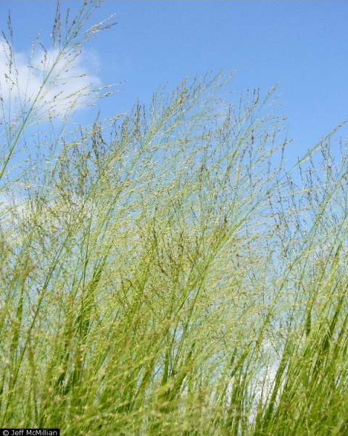 (a) 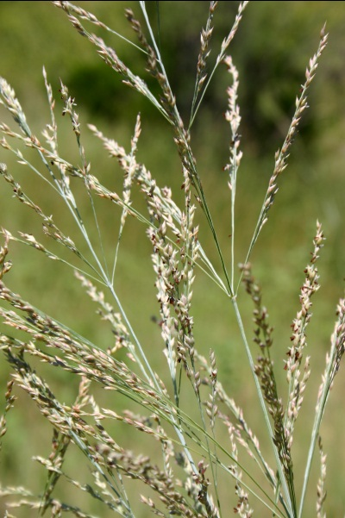 (b)
Figure 1.1: Switchgrass (Panicum virgatum L.). a) Image source: Jeff McMillian, from the USDA-NRCS PLANTS Database. b) Image source: Bruce Hoagland. Both images used with permission.

In nature, switchgrass has two different ecotypes: upland and lowland (Porter 1966). Upland switchgrass grows in mesic locations. Individuals of this ecotpe have been bred into the cultivars trailblazer, Blackwell, cave-in-rock, dacotah, pathfinder, sunburst, and caddo. Lowland ecotypes grow in hydric locations and are more sensitive to moisture deficits than other C₄ grasses (Porter 1966). Cultivars derived from lowland ecotypes include Alamo, Kanlow, and eg1101. In the southern tallgrass prairie of Kansas, Texas, and Oklahoma, the upland ecotype dominates while the lowland ecotype occupies the riverine portions (Brunken and Estes 1975). With respect to genetics, while upland switchgrass cultivars are either tetraploid, hexaploid, octoploid, or aneuploid, lowland cultivars are tetraploid (Porter 1966, Brunken and Estes 1975, Parrish and Fike 2005). Switchgrass may grow to heights of 3.0 meters and have rooting depths of 3.0 meters, although lowland types may grow larger (Parrish and Fike 2005). Lowland ecotypes also have thicker stems and more bluish-green leaves.
Despite the presence of two genetically distinct ecotypes, the most frequently reported quantity of switchgrass yields in the literature across both ecotypes is 10-14 Mg ha⁻¹ of biomass, although the quantity varies by climate and nitrogen application (Wullschleger et al. 2010). In general, yields increase with increasing temperature up to 15-20°C, then decrease. No correlation has been found between biomass yield and precipitation, although upland switchgrass yields have been shown to increase with increasing April-September precipitation up to 600 mm. No consensus exists as to the ideal quantity of nitrogen application for switchgrass given local variations in nutrient levels (Parrish and Fike 2005). Additionally, switchgrass has been successful in both acidic and basic soils (Porter 1966; Parrish and Fike 2005), although soil type is sometimes not as important for plant growth as moisture availability (Evers and Parsons 2003).
Switchgrass has been researched extensively in the Great Plains region, a predominantly semi-arid agricultural region situated between the 98th Meridian and the Rocky Mountains. Various management schemes have been specifically applied to switchgrass stands in Oklahoma (Porter 1966; Thomason et al. 2003; Foster et al. 2013). With the assistance of the government of the State of Oklahoma, the Samuel Roberts Noble Foundation (http://www.noble.org/), and Oklahoma State University, the Oklahoma Bioenergy Center (http://okbioenergycenter.org/) are actively engaged in biofuel crop research. In 2008, the Samuel Roberts Noble Foundation planted 403 hectares of switchgrass near Guymon, OK on 81 hectares near Maysville, OK as demonstration projects (John Blanton, Noble Energy Foundation, pers. com.). The demonstration plot at Guymon contains 231 hectares of the upland cultivars trailblazer and Blackwell, and 172 hectares of lowland cultivars alamo, kanlow, and eg1101. The switchgrass in this plot replaced a rotational planting system of wheat, corn, or soybeans (John Blanton, pers. Com.) Approximately sixty-five kilometers from Guymon in Hugoton, KS, Albengoa Bioenergy Corporation has commenced construction on a biorefinery designed to generate ethanol from this switchgrass.
Despite the interest in switchgrass, relatively little is known about the possible hydrologic response to switchgrass cultivation in the Great Plains region, a transition zone between the tallgrass prairies to which switchgrass is native and the shortgrasses associated with the Western US. To date, much of the investigations have been conducted in the American South and in the Midwest Corn Belt (e.g. Nyakatawa et al. 2006; Simpson et al. 2008; Chamberlain et al. 2011; Sarkar et al. 2011; Demissie et al. 2012). There is a need for similar investigation in the Great Plains because hydrologic response is often a function of local conditions. In 2008, the National Research Council labeled the hydrology of biofuel production as an emerging field of study due to the continued importance of biofuels in helping the US meet its energy needs.

1.3: Research Objectives and Contribution
This study utilizes the Soil and Water Assessment Tool (SWAT) to simulate the hydrologic response of two representative watersheds in the U.S. Great Plains to biofuel production, most notably Alamo switchgrass. The objectives of this research are as follows:
(i) To contextualize the cultivation of switchgrass for biofuel cultivation within the GP’s history of land use change and in the discussions regarding sustainability in this region (Chapter 2).
(ii) To assess and quantify the direction and magnitude of change in key hydrologic variables, including seasonal stream discharge and seasonal evapotranspiration, that would result from incrementally replacing the existing vegetation within the basin with switchgrass. Because switchgrass is likely to displace other existing land types, it is essential to determine how such a change in land use affects regional hydrology (Chapters 3, 4).
(iii) To investigate the hydrologic responses of such watersheds to switchgrass production under a climate change scenario, and to isolate the relative impacts of climate change and switchgrass production (Chapter 4).
(iv) To ascertain whether the cultivation of switchgrass in the U.S. Great Plains is advantageous or harmful from a water-supply perspective (Chapters 3, 4).
The research contributes to the scholarly discourse by adding to the growing body of literature on the possible environmental effects of biofuel production. Additionally, the study quantifies the magnitude of change in several hydrologic variables expected by the mid-21st century from various climate change scenarios.
The climate change component is particularly important, as this dimension has received too little discussion in the literature on biofuel production even though it is generally recognized that climate change may alter the amount and timing of precipitation. To the author’s knowledge, only two articles to date in the field of biofuel hydrology considers the impact of climate change. Brown et al. (2000) investigated the hydrologic response of a region spanning Minnesota to Southeastern Colorado to the planting of corn, sorghum, soybean, winter wheat, and switchgrass using two climate scenarios. However, they did not simulate combinations of the planting of such crops [i.e. they simulate the sole planting of switchgrass, the sole planting of sorghum, etc.], and their study is specific to the Upper Midwest and northern Great Plains. Recently, Kim et al. (2013) investigated the impact of climate change and the replacement of soybeans and corn with switchgrass and the grass Miscanthus (Miscanthus giganteus) for bioenergy purposes in the Upper Yazoo River Basin in the Southern US. They devised eight scenarios, two of which involved solely replacing such crops with switchgrass and miscanthus, respectively, without considering climate change, and six where climate change was considered. However, they only used the outputs from one GCM, the Goddard Fluid Dynamics-2.1 GCM; their climate change scenarios used this GCM’s outputs at different future periods with various combinations of land use change.

1.4: Organization of the Dissertation
The dissertation is organized as three chapters which are written as journal articles and therefore necessarily need to be self-sufficient or stand alone. That is, each article/chapter contains a statement of objectives, literature review, data sources and methods and is written as a mini independent study. Therefore, some repetition, especially related to problem statement, literature review, study area, and model description is unavoidable although efforts have been made to minimize it. Consequently, the format of each chapter’s in-text citations and bibliography varies according to the specification of the journal to which the chapter was sent.
The dissertation proceeds as follows. Following this introductory chapter (Chapter 1), Chapter 2 investigates the history of land use change in the Great Plains portion of the US. It describes how Federal government policies and railroad promotions fostered settlement in what many considered to be “the Great American Desert” from the 1860s-1880s. Drought caused a mass-exodus from portions of the Plains and caused those who stayed to alter their agricultural practices through planting drought-resistant wheat. To foster agricultural expansion, many farmers removed native range grasses (resulting in the Dust Bowl) and, after the 1930s, exploited the waters of the deep Ogallala Aquifer, creating a patchwork of irrigation circles throughout the Plains. The chapter then looks to the future to contextualize biofuel crop cultivation as the next chapter in agricultural land management in the Great Plains. This chapter has been submitted to the Geographical Review.
Chapter 3 evaluates the hydrologic response of a watershed in Western Oklahoma to a theoretical replacement of winter wheat and range grasses with switchgrass, using the semidistributed Soil and Water Assessment Tool (SWAT) hydrologic model. It found that replacing native land uses, namely winter wheat and range grasses, with switchgrass results in decreased discharges and increased evapotranspiration (eT) relative to current conditions, which is an important consideration in semi-arid areas. The definitive peer-reviewed and edited version of this chapter will be published in Hydrology Research 44(6) 2013, doi 10.2166/nh.2013.163 and is available at iwapublishing.com.
Chapter 4 evaluates the hydrologic response of a watershed at the eastern boundary of the Great Plains to both climate change and switchgrass cultivation using the SWAT model. Climate change is included in this analysis because it will likely combine with the impacts of switchgrass cultivation in determining the hydrologic regime of this region. The chapter found that switchgrass cultivation amplified the decreases in winter and summer runoff associated with climate change, as well as that in winter and eT. Switchgrass cultivation also reversed increases in spring runoff that occur under climate change and increases spring eT. Depending on the GCM utilized, either climate change or switchgrass cultivation was the dominant driver of changes in surface runoff while switchgrass cultivation was the major driver of changes in eT. These findings suggest that switchgrass cultivation will aggravate existing and projected water issues in the GP. This chapter has been submitted to Hydrological Processes for publication consideration.
Chapter 5, the conclusion chapter of the dissertation, summarizes the key findings and discusses avenues for future research.

1.5: Description of the SWAT Hydrologic Model
As Chapters 3 and 4 are SWAT-based hydrologic modeling studies, a short overview of this model is relevant. SWAT is a physics-based, semi-distributed hydrologic model developed by the US Department of Agriculture in Temple, Texas, and which has been employed in over six-hundred published studies worldwide (Gassman et al. 2007; Douglas-Mankin et al. 2010). The purpose of SWAT is to predict the impact of land management on the local hydrology and sediment budgets on large, ungaged basins (Arnold et al. 1998). It is frequently run as an extension in the ArcGIS program developed by ESRI. The user divides a watershed into smaller subbasins, and then into smaller hydrologic research units (HRUs) which are areas of homogeneous land use, soil, and slope. Required inputs to this model include a digital elevation model (DEM), land use grids, soil grids, information concerning land management, and weather. The water balance model employed by SWAT may be stated as follows. For day $i$, $given$soil water content $SW$, number of days $t$ in the simulation, precipitation $P,$ runoff $R$, evapotranspiration $ET$, seepage from the soil profile to the vadose zone $W_{seep}$, and return flow RF, then (Arnold et al. 1998):
${SW}_{t}=SW+\sum_{i=1}^{t}{(P_{i}-R_{i}-{ET}_{i}-W_{seep,i} — {RF}_{i})}$ (1.1)
All values are in millimeters. SWAT computes each of these factors at the outlet of every HRU on a daily timestep, and routes them from the individual HRU to the outlet of the larger subbasin. In equation (1.1) above, precipitation over each HRU is obtained from the closest weather station to each subbasin. Each subbasin is comprised of one main channel and one “tributary.” The user-selected subbasin outlets are placed on stream channels.
SWAT is an ideal model for this study because of its demonstrated efficacy in modeling the hydrologic impacts of watershed crop substitution (e.g. Schilling et al. 2008; Baskaran et al. 2010; Ng et al. 2010; Gramig et al. 2013; Kim et al. 2013). By design, SWAT is linked to various databases containing the data and information required for simulation, greatly simplifying model setup and operation. The crop database contains alterable biophysical information (e.g. extinction coefficient, leaf area index) for 108 crops, including many biofuels such as Alamo Switchgrass, corn, oil palm, sugarcane, grain sorghum, and soybeans. The availability of such information within the model permits the user to focus on hydrologic simulations rather than on developing a model to simulate crop production. SWAT uses the EPIC crop growth model when simulating plant growth, developed by Texas A&M Agrilife Research. The model is built to differentiate various agricultural patterns, as opposed to the grouping of all agricultural land into one category. Additionally, the land management database contains information concerning the properties of various fertilizers and harvesting schedules and tillage strategies, which are important considering that winter wheat and switchgrass are often fertilized.
The weather station database provides numerous monthly data for 1112 climate stations in the USA. These data include absolute location, minimum and maximum monthly temperatures (^{O}C), minimum, average, and maximum monthly rainfall totals (mm), average number of days with precipitation in each month, average monthly dew point (°C), wind speed (m/s), elevation (m), average monthly solar radiation (mJ m⁻²), and probability of a wet day following a dry day and that of a wet day following a wet day during a particular month. The availability of such weather data within the SWAT model not only obviates the need for a user to locate this information, but it also allows one to edit weather data when investigating climate change scenarios.

1.6: Limitations to this Study
As investigations are by definition finite in nature, this dissertation contains limitations. First, the results of any study are a function of its geographic extent. Likewise, the Great Plains, as with other regions, is not associated with any eastern boundary which is uniform across all investigations (see Lavin et al. 2011, pp. 11-13). Hudson (2011) recognized 50 different geographical extents for the Great Plains in the published literature. Some articles cited in Chapter 2 (e.g. Sohl et al. 2012) use the EPA Level-1 ecoregion which extends eastward into Southern Minnesota, Iowa and Northern Missouri (ftp://ftp.epa.gov/wed/ecoregions/cec_na/NA_LEVEL_I.pdf)). For instance, Popper and Popper (1987) relied fully on state boundaries. Gutmann et al. (2005) and Parton et al. (2007) restrict the eastern scope of their study to the eastern borders of North and South Dakota and the 98th meridian through Nebraska, Kansas, and Texas, but terminate their study area on the southern border of New Mexico. Due to the modifiable areal unit problem, the results from the literature cited in this chapter may not be directly intercomparable. This is an unavoidable problem but for the quantitative portion of Chapter 2, the Great Plains was defined as the area between the 98th meridian and the westward extent of the Great Plains ecoregion. The 98th meridian was selected as the eastern border for this study to be consistent with the pioneering work of the historian Walter Prescott Webb (1931).
Chapter 3 discusses the impacts of four scenarios involving switchgrass substitution on seasonal discharge and evapotranspiration. It does not investigate impacts on other facets of the water balance, including soil moisture and subsurface runoff, due to difficulties in getting SWAT to calibrate to baseflow, despite an overall excellent calibration. Likewise, Chapter 3 only deals with Alamo switchgrass, whereas other biofuel crops, such as miscanthus, may be worth examining. The investigation discussed in Chapter 4 may contain the most limitations of any study in the dissertation. A reliance on NEXRAD precipitation data due to the inability of weather gages to capture some high-rain events, combined with calibrating to a stream gage with discharge records going back only to 2000 resulted in the utilization of a short-calibration period. Due to the need to have as long of a calibration period as possible, a validation period was not used. Additionally, because of the short, nine-year calibration period, only a correspondingly short “climate change” period could be investigated. However, climate change studies require a longer analysis timeframe in order to minimize the impacts of interannual and interdecadal variability. Finally, only one decade, and one IPCC SRES emissions scenario, the A2, was used in order to minimize the scope of work required to complete a study which would otherwise have involved other modelers and scientists. While all these criticisms are legitimate, the nature of the research required some compromises. Large gaps in radar coverage exist over much of the Great Plains, including the western portion of the Oklahoma Panhandle and Southeastern Colorado through which large rivers such as the North Canadian flow (http://www.roc.noaa.gov/WSR88D/Maps.aspx). Watersheds in such areas therefore may not be calibrate-able without high-resolution precipitation data. The region suffers from intense groundwater mining which is not easily captured in SWAT and which results in near-zero discharges, to which calibration would be nearly impossible. Such challenges make the Great Plains a fascinating area in which to conduct hydrologic modeling, as well as an area which mandates one’s selection of less than ideal watersheds.

References
Arnold, J. G., R. Srinivasan, R. S. Muttiah, and J. R. Williams 1998 Large area hydrologic modeling and assessment - part 1: model development, J. Am. Water Resour. As., 34, 73-89.
Brown, R. A., N. J. Rosenberg, C. J. Hays, W. E. Easterling, and L. O. Mearns 2000 potential production and environmental effects of switchgrass and traditional crops under current and greenhouse-altered climate in the Central United States: a simulation study, Agr. Ecosyst. Environ., 78, 31-47.
Brunken, J. N., and J. R. Estes 1975 Cytological and morphological variation in Panicum virgatum L., Southwest. Nat., 19, 379-385.
Chamberlain, J.F., S. A. Miller, and J. R. Frederick 2011 Using DAYCENT to quantify on-farm GHG emissions and N dynamics of land use conversion to N- managed switchgrass in the Southern U.S., Agr. Ecosyst. Environ. 141, 332-341.
Demissie, Y., E. Yan, and M. Wu 2012 Assessing regional hydrology and water quality implications of large-scale biofuel feedstock production in the Upper Mississippi River Basin, Environ. Sci. Technol., 46, 9174-9182.

Douglas-Mankin K. R., R. Srinivasan, and J. G. Arnold 2010 Soil and Water Assessment Tool (SWAT) Model: current developments and applications, Trans. ASABE, 53, 1423-1431.

EPA 2011 Biofuels and the Environment: First Triennial Report to Congress, U.S. Environmental Protection Agency, Office of Research and Development.
FAPRI-MU 2008 Causes and Implications of the Food Price Surge. FAPRI-MU report #12-08. Available on-line at: http://www.fapri.missouri.edu/outreach/publications/2008/FAPRI_MU_Report_12_08.pdf Last accessed 12 June 2013.

Forrestal, P. J., R. J. Kratochvil, and J. J. Meisinger 2012 Late-season corn measurements to assess soil residual nitrate and nitrogen management, Agron. J., 104, 148-157.

Foster, J. L., J. Guretzky, C. Huo, M. K. Kering, and T. J. Butler 2013 Effects of row spacing, seeding rate, and planting date on establishment of switchgrass, Crop Sci., 53, 309–314.

Gassman, P. W., M. R. Reyes, C.H. Green, and J. G. Arnold 2007 The Soil And Water Assessment Tool: historical development, applications, and future research directions, Trans. ASABE, 50, 1211-1250.

Gramig, B. M., C. J. Reeling, R. Cibin, and I. Chaubey 2013 Environmental and economic trade-offs in a watershed when using corn stover for bioenergy, Environ. Sci. Technol., 47, 1784-1791.

Graham, R. L., M. Downing, and M. E. Walsh 1996 A Framework to assess regional environmental impacts of dedicated energy crop production, Environ. Manage., 20, 475-485.

Gutmann, M. P., W. J. Parton, G. Cunfer, and I. C. Burke 2005 Population and environment in the U.S. Great Plains. In Population, Land Use, and Environment: Research Directions, edited by B. Stern and P. C. Entwisle, 84- 105. National Academies Press, Washington, D.C..
Hertel, T.W., A. A. Golub, A. D. Jones, M. O’Hare, R. J. Plevin, and D. M. Kammen, 2010 Effects of US maize ethanol on global land use and greenhouse gas emissions: estimating market-mediated responses, Bioscience, 60, 223-231.

Hudson, J. 2011 Introduction. In: Lavin, S. J., F. M. Shelley, and J. C. Archer, Atlas of the Great Plains, University of Nebraska Press, Lincoln.

Khosla, V. 2008 Biofuels: Clarifying assumptions, Science, 322, 371-372.

Kim, H. K., P. B. Parajuli, and S. D. Filip To 2013 Assessing impacts of bioenergy crops and climate change on hydrometeorology in the Yazoo River Basin, Mississippi, Agr. Forest Meteorol., 169, 61-73.

Lambin, E. F., and P. Meyfroidt 2011 Global land use change, economic globalization, and the looming land scarcity, P. Natl. Acad. Sci. USA, 108, 3465-3472.

Lavin, S. J., F. M. Shelley, and J. C. Archer 2011 Atlas of the Great Plains, University of Nebraska Press, Lincoln.
Mitchell, D. 2008 A Note On Rising Food Prices. World Bank Development Prospects Group Policy Working Paper 4682. Policy research working paper 4682; Washington, D.C..

Mitchell, R., L. Wallace, W. Wilhelm, G. Varvel, and B. Wienold 2010 Grasslands, Rangelands, and Agricultural Systems. Ecological Society of America, Washington, D.C..

Nelson, R.G., J. C. Ascough, and M. R. Langemeier 2006 Environmental and economic analysis of switchgrass production for water quality improvement in Northeast Kansas, J. Environ. Manage. 79, 336-347.
Ng, T. L., J. W. Eheart, X. Cai, and F. Miguez 2010 Modeling miscanthus in the Soil and Water Assessment Tool, Environ. Sci. Technol., 44, 7138–7144.
Nyakatawa, E.Z., D. A. Mays, V. R. Tolbert, T. H. Green, and L. Bingham 2006 Runoff, sediment, nitrogen, and phosphorus losses from agricultural land converted to sweetgum and switchgrass bioenergy feedstock production in North Alabama, Biomass Bioenerg. 30, 655-664.
Parrish, D.J., and J. H. Fike 2005 The Biology and agronomy of switchgrass for biofuels, Crit. Rev. Plant Sci. 24, 423-459.
Parton, W. J., M. P. Gutmann, and D. Ojima 2007 Long-term trends in population, farm income, and crop production in the Great Plains, Bioscience, 57, 737-747.

Plevin, R. J., M. O’Hare, A. D. Jones, M. S. Torn, and H. K. Gibbs 2010 Greenhouse gas emissions from biofuels’ indirect land use change are uncertain but may be much greater than previously estimated, Environ. Sci. Technol., 44, 8015-8021.

Popper, D. E., and F. J. Popper 1987 Great Plains: From dust to dust, Planning 53, 12- 18.
Porter, C. 1966 An Analysis of variation between upland and lowland switchgrass, Ecology, 47, 980-992.

Renewable Fuels Association. 2013 Pocket Guide to Ethanol 2013. Available on-line at: http://ethanolrfa.3cdn.net/8fabfbf8fbcb08d399_xom6injp6.pdf. Last accessed 1 September 2013.

Robertson, G.P., S. K. Hamilton, S. J. Del Grosso, and W. J. Parton 2010 Growing Plants for Fuel: Predicting Effects on Water, Soil, and the Atmosphere. Biofuels and Sustainability Reports: Ecological Society of America, Washington, D.C..
Sarkar, S., S. A. Miller, J. R. Frederick, and J. F. Chamberlain 2011 Modeling nitrogen loss from switchgrass agricultural systems, Biomass Bioenerg. 35, 4381-4389.
Schilling, K.E., K.-S. Chan, H. Liu, and Y.-K. Zhang 2010 Quantifying the effect of land use land cover change on increasing discharge in the Upper Mississippi River, J. Hydrol. 387, 343-345.
Schilling, K.E., M. K. Jha, Y. K. Zhang, P. W. Gassman, and C. F. Wolter 2008 Impact of land use and land cover change on the water balance of a large agricultural watershed: historical effects and future directions, Water Resour. Res. 44, W00A09.
Schilling, K. E., C. S. Jones, A. Seeman, E. Bader, and J. Filipiak 2012 Nitrate- nitrogen patterns in engineered catchments in the Upper Mississippi River basin, Ecol. Eng., 42, 1-9.
Searchinger, T., R. Heimlich, R. A. Houghton, F. Dong, A. Elobeid, J. Fabiosa, S. Tokgoz, D. Hayes, and T.-H. Yu 2008 Use of US croplands for biofuels increases greenhouse gases through emissions from land-use change, Science, 319, 1238-1240.

Secchi, S., P. W. Gassman, M. Jha, L. Kurkalova, and C. L. Kling 2011 Potential water quality changes due to corn expansion in the Upper Mississippi River Basin, Ecol. Appl., 21, 1068-1084.

Simpson, T.W., A. N. Sharpley, R. W. Howarth, H. W. Paerl, and K. R. Mankin 2008 The New gold rush: fueling ethanol production while protecting water quality, J. Environ. Qual. 37, 318-324.

Sohl, T. L., B. M. Sleeter, K. L. Sayler, M. A. Bouchard, R. R. Reker, S. L. Bennett, R. R. Sleeter, R. L. Kanengieter, and Z. L. Zhu 2012 Spatially explicit land-use and land-cover scenarios for the Great Plains of the United States, Agr. Ecosyst. Environ., 153, 1-15.
Thomason, W. E., W. R. Raun, G. V. Johnson, C. M. Taliaferro, K. W. Freeman, K. J.
Wynn, and R. W. Mullen 2004 Switchgrass response to harvest frequency and
time and rate of applied nitrogen, J. Plant Nutr., 27, 1199-1226.

Tonini, D., L. Hamelin, H. Wenzel, and T. Astrup 2012 Bioenergy production from perennial energy crops: a consequential LCA of 12 bioenergy scenarios including land use changes, Environ. Sci. Technol., 46, 13521-13530.
U.S. Congressional Budget Office 2009 The Impact of Ethanol Use on Food Prices and Greenhouse-gas Emissions.

Webb, W. P. 1931 The Great Plains. Ginn and Company, Boston.
Wescott, P. 2012 USDA Agricultural Projections to 2021. Available on-line at: http://www.ers.usda.gov/publications/oce-usda-agricultural projections/oce121.aspx#.UbirHPm1FpU. Last accessed 12 June 2013.
Wullschleger, S. D., E. B. Davis, M. E. Borsuk, C. A. Gunderson, and L. R. Lynd 2010 Biomass production in switchgrass across the United States: database description and determinants of yield, Agron. J., 102, 1158-1168.
Zhang, X. S., and R. Srinivasan 2010 GIS-based spatial precipitation estimation using next generation radar and raingauge data, Environ. Modell. Softw., 25, 1781- 1788.

Chapter 2: Evolving Perspectives on Land Use in the US Great Plains
(Revised version in-consideration for publication in the Geographical Review)
Justin C. Goldstein¹* and Aondover Tarhule¹

* Corresponding Author. E-mail: Justin.C.Goldstein-1@ou.edu

¹Department of Geography and Environmental Sustainability
University of Oklahoma
100 E. Boyd Street SEC Suite 510
Norman, OK 73019 USA
+1(405) 325-5325 phone
+1(405) 325-6090 FAX

Abstract
I trace the role of land use as an important driver of social dynamics in the US Great Plains from the early nineteenth century to the present. Some early explorers believed this region to be a desert, while others saw an opportunity to create an agricultural economy. This dichotomy in perceptions continues today, as the relative dearth of built-up land is a driving factor in discussions about sustainability in this region. Whereas some perceive the region’s population dynamics as indicative of a dying region, others view it as an opportunity to foster economic development through an expanded agricultural and resource extraction base. Projections of future land use indicate that this region will remain predominantly agricultural and low-density but with a more urban character in the already emerging and developed regional and metropolitan centers.
Keywords: Agriculture, Biofuels, Great Plains, Rural Areas, Sustainability

Situated roughly on a north-south gradient between the 98th meridian and the Rocky Mountains is the Great Plains (GP) region of the United States of America (Figure 2.1). Within its US portion, the GP is home to 9.9 million people and covers approximately 1.4 million km² spread over nine states (Wilson 2009). The native vegetation of the region is largely grassland, with tallgrasses dominating the humid eastern portions, and shortgrasses and steppe dominating the drier western portions. Trees are restricted to riparian zones and settlements (Hudson 2011). The region contains thriving manufacturing and mining industries but agriculture remains the predominant economic activity.
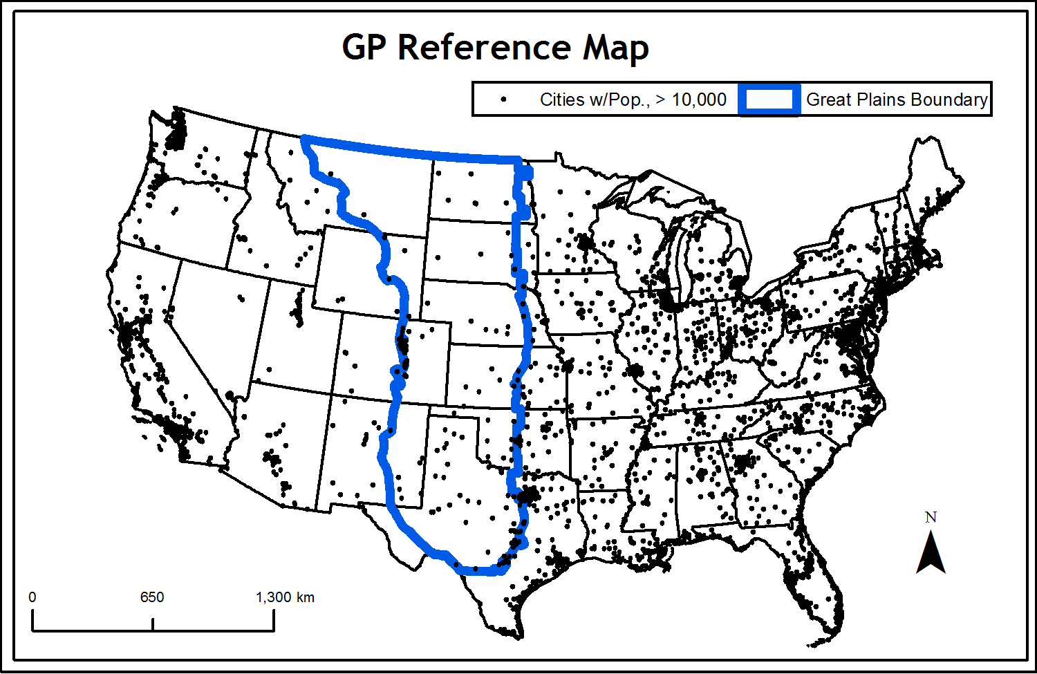
Figure 2.1: The Great Plains, as defined in this paper, including settlements mentioned in this paper. Data source: The National Atlas of the United States of America.

The dominance of agriculture coupled with the region’s large wheat-producing heritage has contributed to the legend of the GP as part of “America’s Breadbasket” (Garreau 1981), a title conjuring images of agricultural tradition and prosperity. Yet, perceptions of the GP have not always been so optimistic. This study of the GP is restricted to the US portion due to the importance of Federal policies in facilitating domestic migration which is highlighted below.

2.1: The Great Plains As “The Great American Desert”
The lack of precipitation and dearth of trees caused early 19th century explorers to describe this region as a wasteland and to paint a pessimistic picture of the future of non-Native American settlement in the GP. Following his exploration of the area between St. Louis, Missouri and the Rocky Mountains in 1806, Lieutenant Zebulon Pike described the region as desert, “these vast plains of the western hemisphere may become in time equally celebrated as the sandy deserts of Africa (Pike 1810, 8). Similarly, after his failed 1819 Yellowstone Expedition, Major Stephen Long characterized a 800-kilometer long region east of the Rocky Mountains as a “Great Desert” (James et al. 1823, 276) and noted, per expedition geographer Edwin James (1823, 236):
“I do not hesitate in giving the opinion, that it is almost wholly unfit for cultivation, and of course uninhabitable by a people depending upon agriculture for their subsistence… the scarcity of wood and water, almost uniformly prevalent, will prove an insuperable obstacle in the way of settling the country.”
Additionally, he wrote “This region, however, viewed as a frontier, may prove of infinite importance to the United States, in as much as it is calculated to serve as a barrier to prevent too great an extension of our population westward” (James et al. 1823, 237).
A number of scholars (e.g. Webb 1931, 152; Stegner 1954, 215) believe that the idea of the GP as the Great American Desert was fully engrained in the American consciousness in the first half of the nineteenth century. Additionally, Stegner (1954, 215) notes that practically every west-bound traveler in the early nineteenth century remarked upon the arid nature of the region (e.g. Greeley 1860, 36).
However, in the journals of those who traveled through the Great Plains between 1824 and 1869, New Englanders predominantly were inclined to refer to the region as a desert; travelers from other areas did so less frequently or not at all (Bowden, 1969) . For example, of the 143 members of the Church of Jesus Christ of Latter Day Saints (LDS) that journeyed in 1847 to what would become Salt Lake City, travelers remarked on the lack of moisture and grass and the prevalence of wind-blown dust in the western portions of the GP but only one wrote the word “desert” in his diary and none used the nomenclature “Great American Desert” (Jackson 1992). One traveler even called Nebraska “the most delightful country of undulating prairie and slopes crowned with richest kind of grass.” Bowden (1969) concludes that “the myth of the Great American Desert as the popular American image of the Western Interior before the Civil War is itself a myth.” Regardless of which analysis is correct, it can be concluded that most Americans did not consider migration to this region at the beginning of the 19th century.

2.2: Land Use Change I: Settling the “Desert”
Non-Native American settlements began to appear on the Great Plains by the middle of the 19th Century. Analyses of the geographic variations in the migrations to the Great Plains have been discussed elsewhere at length (see e.g. Hudson 1976, 1986; Shortridge 1988). Here, it suffices to note only that through initiatives like the Homestead Act (1862), Soldier and Sailors Act (1872), Timber Culture Act (1873), and the Desert Lands Act (1877), the Federal government offered inexpensive land to potential settlers in order to encourage westward expansion (e.g. Resiner 1993). Additionally, following the completion of the Transcontinental Railroad in 1869, the rail lines progressed rapidly, simultaneously spawning settlements related to the construction, supply, and maintenance of the railroads as well as facilitating the large-scale movement of people into the GP (e.g. White 2011, 455-493). Taking advantage of these developments, land speculators, including many who had acquired land inexpensively, aggressively promoted settlements in the West, including the GP.
One method of promoting migration to the Plains was the popularization of the theory that “rain follows the plow,” which claimed that soil cultivation for agriculture induces rainfall, a view supported by some scientists, politicians, and railroad magnates alike (e.g. Thomas 1873, 237; Wilber 1881, 70). Like all such claims this promotion was effective because it appeared at cursory glance to have some factual basis. Whereas 1845-1852 and 1856-1865 brought severe, sustained drought to portions of the GP (e.g. Woodhouse 2003), the period immediately following the American Civil War witnessed increased rainfall in the Great Plains. During this time, individuals in wagon trains to Oregon noted that the dry landscapes of Western Nebraska had turned green (Reisner 1993, 35).
The “rain follows the plow” rhetoric caused Stegner (1954) to state, “The Great American Desert was laughed away, washed away in the flow of [Colorado Governor and Presidential Aide William] Gilpin oratory, advertised away in the broadsides of land companies and railroad proselytizers” (p. 217). Such promotions were effective; Colonel Richard Irving Dodge (1877, 2) noted “What was then ‘unexplored’ is now almost thoroughly known. What was then regarded as a desert supports, in some portions, thriving populations. The blotch of thirty years ago is now known as ‘The Plains.’”
However, the period of good rainfall was transitory, above sentiments notwithstanding. A combination of drought and blizzard hit the Western Plains from 1885-1887 causing a mass starve-off of cattle (e.g. Shortridge 1988). The intensity of the 1893-1894 drought period in Central and Western Kansas led to farm failure and population declines of 27% in the twenty-four Kansas counties west of the 100th meridian from 1890-1900 (Libecap and Hansen 2002). Concurrently the population grew by 19% in drought-free Eastern Kansas (Libecap and Hansen 2002). The impacts of the drought extended into portions of neighboring Nebraska west of the 100th meridian, where 15,284 fewer people resided and 6,018 fewer farms existed in 1900 than in 1890 (Fite 1977). The drought also resulted in a decrease in new homesteads when wetter periods resumed and to a consolidation of existing ones (Libecap and Hansen 2002).

2.3: Land Use Change II: Adaptation to Drought
Not everyone abandoned the Plains; many endured drought by adapting their agricultural practices to the local climate. Cunfer (2005, 5) categorizes the period between 1870 and 1920 as one of “rapid land-use adaptation.” Many Central GP farmers replaced corn with more drought-tolerant wheat. In the twenty-four Kansas counties west of the 100th meridian, wheat acreage increased 391% from 35,230 ha to 172,928 ha between 1889 and 1896 (Fite 1977). Additionally, some Kansas and Nebraska farmers used lister drills to plant wheat in trenches at right angles relative to prevailing winds, resulting in increased yields (Bogue 1994, 229). From 1870-1920, GP farmers increased cropland acreage every year, at the expense of native rangeland (Cunfer 2005, 18). Some High Plains farmers produced sorghum (Bogue 1994, 229).
In the Dakota Territory, the period beginning with the 1873 bankruptcy of J.P Cooke and Company, a financier of the Northern Pacific railroad, is viewed as the onset of “bonanza farming” as company bondholders traded their worthless bonds for plots of land (NPS 1987). Bonanza farming was characterized by large farms utilizing mass production techniques. In 1855, the Cass-Cheney farm, west of Fargo, contained 13,000 hectares of wheat. The operation of such large farms was partially designed to increase confidence in the railroads, which were responsible for transporting this wheat, in the aftermath of the Panic of 1873. The success of the Cass-Cheney farm resulted in the establishment of other bonanza farms, including many which were not being established on former railroad land.
Agricultural activities in the GP during the late 1910s and early 1920s continued to reflect government policy and international markets. Demand for wheat, and consequently its market price, escalated during World War I when the Turkish Navy blocked the Dardanelles, cutting off a main artery for global wheat supply (Egan 2006, 42-43). In response, the US government encouraged GP farmers to plant more wheat, guaranteeing its price at $2/bushel through the end of the war. Consequently, a bushel of wheat in Northwestern Kansas which sold for $0.78 per bushel in 1913 sold for $2.18 in August 1918 (Cunfer 2005, 127). US wheat production increased from 18 to 30 million hectares between 1917 and 1919 (Egan 2006, 43). In 1920, tractors replaced horses, facilitating further land cultivation at reduced cost (Cunfer 2005, 46-47). In 1930, it required only 7.5 hours to plant and harvest one hectare of wheat in the Oklahoma Panhandle compared to 145 hours in the 1830s (Egan 2006, 46-47). The total amount of land cultivated throughout the GP increased from 7.7 million hectares in 1880 to 117 million hectares by 1930 (Gutmann et al. 2005). By the late 1930s, between 31% and 38% of the GP had been converted from grass to cropland, contributing, ultimately, to the Dust Bowl.
The causes, dynamics, and impacts of the Dust Bowl are well described in many sources (e.g. Worster 1979; Seager et al. 2005; Egan 2006). By exposing the environmental consequences of land mismanagement in a semi-arid environment, the Dust Bowl became a watershed event in environmental history and sustainability studies. Auspiciously, it induced changes to soil conservation and land management practices such that even with the return of severe drought during the 1950s and 1970s, the large clouds of dust failed to re-emerge (Hansen and Libecap 2004). Agricultural practices have actually improved since the Dust Bowl in many areas including the Texas Panhandle, where wind erosion has decreased since the beginning of a long-term study in 1961 (Stout and Lee 2003). Additionally, from 1938-1946, the Federal Government purchased 235,404 hectares in the Southern Great Plains (now “National Grasslands”), much of them in the former “Dust Bowl,” with the purpose of reducing soil erosion and restoring native vegetation cover (Hurt 1986).

2.4: Land Use Change III: Impact of Water Resources and Land Use
Following realization of the impracticality of large-scale dryland agriculture, irrigation began to increase in the former “core” Dust Bowl region. Extensive irrigation became possible during the 1930s due to the introduction of turbine pumps and internal combustion engines (Musick et al. 1988). By the 1960s, center-pivot sprinkler irrigation appeared (see Opie 1993), contributing to a still further increase in irrigation-based water use (e.g. Wahl and Tortorelli 1994; Colaizzi et al. 2009). From 1940-1980, irrigated acreage in the entire GP multiplied seven-fold from 800,000 ha to 5.7 million ha, with slightly more than half the irrigated acreage in 1980 situated in the Northern Great Plains (Weeks et al. 1988).
The proportion of the region consisting of cropland has remained relatively stable at 45% since 1950 (Gutmann et al. 2005). While significant rural depopulation has occurred (see below), owners who take over the farms of those who emigrate have tended to continue the same crop and land use patterns. Also, in much of the Central Great Plains, the net-impact of land use change is zero due to the balance between agricultural land retirement and extension. However, between 1950 and 2000, there have been episodic phases of intensified or diminished agricultural activity. For example, from 1973-2000, 8% of the region underwent land use/land cover change, with most of that land converted multiple times between grassland and cropland due to the Conservation Reserve Program (Drummond et al. 2012). Urbanization accounted for some of the change in land use over the region but is localized to metropolitan and micropolitan areas. The smallest change involved forest to agriculture, which was restricted to the eastern periphery of the Great Plains. The small population of counties in metropolitan areas and the small quantity of farmland within them minimizes the risk of widespread suburbanization in this area (Parton et al. 2007), with the exception of the urbanizing Colorado Front Range (Parton et al. 2003).

2.5: Perspectives on the Future of the Great Plains
In the above brief narrative, I demonstrated how a combination of socio-economic-political dynamics and climatic variability conspired first to populate the Great Plains and then to provide settlers with untold hardship. Today, it appears a different set of factors are creating new circumstances that in some important respects are analogous to the conditions that encouraged unbridled optimism during the early settlement of the GP.
One of these dynamics is the contemporary population shift from rural to urban areas. Numerous studies have analyzed declining population trends in some Great Plains counties since 1930 even as they acknowledge that population is rebounding in micropolitan and metropolitan areas (Figures 2.2 and 2.3) (e.g. Parton et al. 2007; Wilson 2009; Mackun and Wilson 2011; Kotkin 2012). These settlement patterns serve as the basis of many predictions regarding the future of the GP as discussed below.
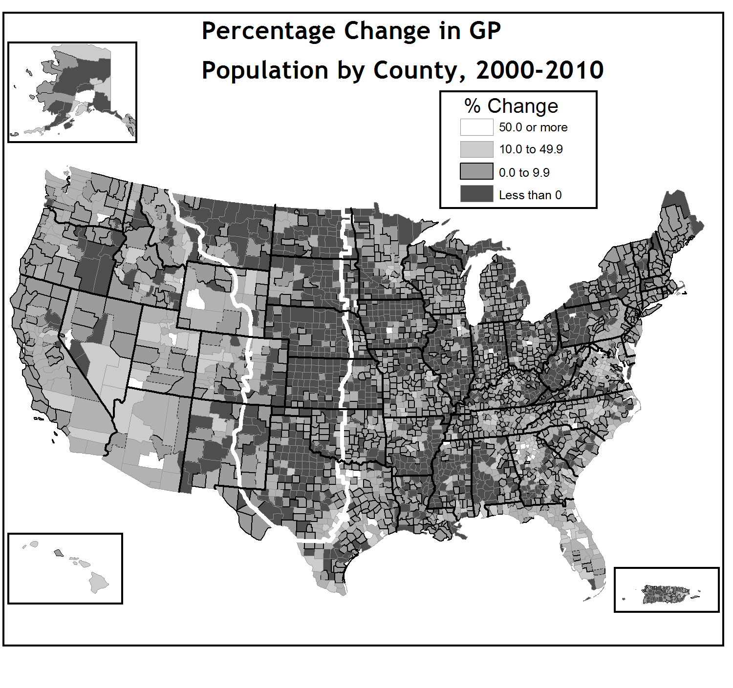
Figure 2.2: Population change by US county, 2000-2010, with the GP emphasized. Adapted from Mackun and Wilson (2011), Figure 5. Image used with the permission of Steven Wilson.

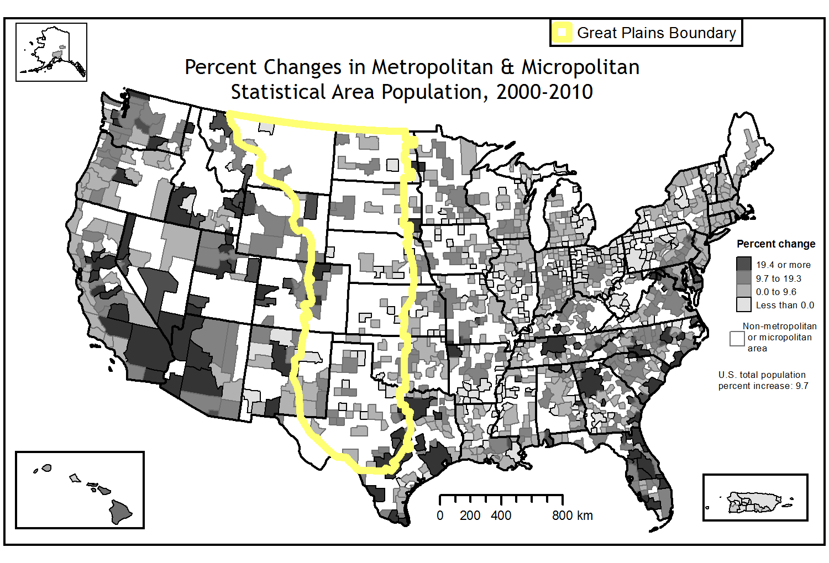
Figure 2.3: Population growth in the micropolitan and metropolitan areas of the GP, 2000-2010. Adapted from Mackun and Wilson (2011), Figure 4. Image used with the permission of Steven Wilson.

2.5.1: Perspectives I: The Prairies Shall Return
Wallach (1985) speculated that increasing volumes of crop surpluses in the United States could cause GP farmers to voluntarily cede land to the Federal Government in exchange for money as part of a large-scale prairie restoration plan. Similarly, citing the region’s troubled environmental history, climatic variability, the then unsustainable mining of the Ogallala Aquifer, large-scale depopulation, and bank failures Popper and Popper (1987) concluded that the depopulation of the region was “inevitable.” They therefore advocated that the US government create “the world’s largest historic preservation project,” a “buffalo commons” where “most of the Great Plains will become what all of the United States once was -- a vast land mass, largely empty and unexploited,” where its original inhabitants would freely roam. This position attracted such media attention and local notoriety that the authors needed police escort on their speaking tours through the Plains (e.g. Callenbach 1996; Matthews 2002; Popper and Popper 2006). Nevertheless, their article catapulted the issue of the sustainability of the GP to a level of discourse previously unseen, even though Popper and Popper (1999) later stated that the “buffalo commons” concept was meant as a metaphor for land management, not as advocacy for government seizure of property. In 1994, former Kansas governor Mike Hayden backed the concept following previous denunciations (Dreiling 2011). In 2011, due to the increase in buffalo production and increasing land easements owned by environmental organizations in the Plains, Frank Popper stated “…the Buffalo Commons has begun in clear ways to materialize” (Dreiling 2011).
Popper and Popper (1987) were not alone in their assessment of the possible end state of population shifts nor in advocating for the reintroduction of buffalo to the Great Plains. Based on consideration of declining small towns and their stagnant economies in Iowa (outside the Great Plains), Daniels and Lapping (1987) advocated that regional governments in the US embark on “a regional settlement policy” similar to that in the United Kingdom, by promoting the creation of regional centers of 2500-15000 people to take advantage of economies of scale for the provision of public services. “Small town triage” would be applied, in which growing towns would receive government aid at the expense of those showing less promise. Citing depopulation, Donlan et al. (2005; 2006) suggested that the GP could house an “ecological history park” housing endangered Pleistocene species, including Bactrian camels, feral horses, cheetahs, and kangaroos. Scott (1992) advocated the filling of 39,000 km² in Eastern Montana known as “the Big Open” (population 3000) with bison and making the area one large tourist destination. Today, Montana Big Open, Inc. is a tax-exempt charity run out of Hamilton, Montana which is devoted to restoring bison to some portions of the area (Northern Plains Conservation Network 2012). Indeed, it is important to note that today, bison numbers are increasing on the Great Plains, primarily due to the efforts of large land owners including the media mogul Ted Turner (Founder of Cable News Network, CNN), Native American groups, the US government, and non-governmental organizations, including the Nature Conservancy (Popper and Popper 2006; Wood 2008).
Commenting on depopulation in the GP, North Dakota Senator Byron Dorgan (2003) noted, “If we draw an egg shape from North Dakota down to Texas in the middle part of our country, we have the heartland of America being depopulated.” With Nebraska Senator Chuck Hagel and eleven co-sponsors, Senator Dorgan unsuccessfully introduced the New Homestead Economic Opportunity Act to provide Federal tax credits and investment incentives to counties experiencing out-migration.
In a content analysis featuring 600 articles in the popular media spanning 1997-2007, Dando (2009) found that the perspective of the GP as either a failed or a severely challenged region is also shared by the popular media in the popular media. She found that “depopulation” “drought,” “bison,” and “grasslands” collectively accounted for 190 articles (32%) as the most frequent topics explored vis-à-vis the Great Plains. Noting evidence to the contrary in the scholarly community, Dando (2009) accuses the media of “setting the stage for topocide/domicide.” These terms, introduced by the geographer J. Douglas Porteous (1989, xi), refer respectively to “the killing of place” and “the deliberate killing of home.”

2.5.2: Perspectives II: The Great American Promise
The notion that the GP may eventually entirely depopulate, whether voluntarily or involuntarily, is not universally shared although enthusiasm is tempered. While acknowledging that depopulation is indeed occurring, White (1994) demonstrated that the population in some areas, such as in Western Kansas, has become concentrated or stabilized around so-called “Ogallala Oases,” sustaining a livelihood by utilizing the High-Plains Aquifer. White (1994) concludes: “abandonment is a regional development policy that looks good only if you are a buffalo.” In a manner similar to the Homestead Act of 1862, various communities from North Dakota to Kansas have promoted “free land” to attract new residents (Shortridge 2004; Lu and Paull 2007), These communities promote themselves by emphasizing low crime rates, low traffic, good schools, inexpensive housing, and as community-oriented places suited to raising a family (Lu and Paull 2007). So far, these programs appear to be somewhat successful as they have attracted new residents and some towns have given away all their available lots. “If the initial success of these free land programs is any indication,” they conclude, “then the future of rural communities in the Great Plains may be more promising than the outlook has been in the past few decades” (Lu and Paull 2007). Shortridge (2004) indicates, however, that towns closer to major population centers have been more successful with these programs than those in more remote locations.
Contrary to present trends and fears about depopulation, Kotkin (2010, 2012), argued that the US “Heartland,” including the GP, will house a significantly growing American population by 2050. He argued that the rise in national and international demand for resources extracted in the GP, coupled with increased global demand for agriculture products grown in this region (corn, soybeans, cotton), and the recent increases in employment pertaining to primary economic activities in the GP bode well for the region’s future (Kotkin 2012). Additionally, he noted the ample space for development, and that many technological firms whose reliance on high speed communications technology obviated their locating near urban agglomerations have begun settling here (Kotkin 2010). Kotkin (2012, 108) concludes: “The Great Plains has already proved to be anything but ‘The Great American Desert.’ As we move into the 21st century, it [is] destined to once again take its role at the center stage of American inspiration, innovation, and progress.”

2.5.3: Perspectives III: An Agricultural, Resource, Extraction, and Production Hub
Often the clusters of population growth in the GP reflect the dominance of major industries. Since 1995, Southwestern Kansas has become a prime destination for the US dairy industry and houses one of the largest clusters of dairy operations in the Great Plains (Harrington et al. 2010). These activities take advantage of available land necessary for such large-scale operations, lower operating costs, tax incentives, and a physical climate amenable for large-scale dairy agriculture (e.g. lack of cold winters). As of 2011, Kansas ranks third of all US states in number of cattle slaughtered and in the number of cattle on farms with 6.1 million (National Agriculture Statistics Service 2012). The ubiquitous presence of beef in the region and its growing strength led Harrington et al. (2010, 540) to declare this part of Kansas as “real ‘cattle country!’”
Like agriculture, mineral extraction actively supports local economies. The GP is home to reserves of oil and gas; the Oklahoma Panhandle and Southwestern Kansas region overlay one of the largest natural gas producing areas in the world-the Hugoton Natural Gas Area (Lowitt 2006, 84-86). The national helium reserve is situated in the vicinity of this field, near Amarillo, Texas. The GP also contains the Powder River Basin in Wyoming which is a large coal-producing region, the extensive Palo Duro and Fort Worth oil Basins in West Texas, and the Willston Basin in North Dakota, South Dakota, and Montana. The vast majority (56%) of this production is due to extraction from the 500,000 km² Bakken Formation in Western North Dakota and far eastern Montana (North Dakota Industrial Commission Department of Mineral Resources 2010). This Formation overlies counties that have seen population increase by up to 50% between 2000 and 2010, prompting some reports to comment on the rise of “boom towns.” Counties overlying the Bakken Formation that have been losing population may see increases in population by 50% by 2025 because of the energy industry (North Dakota State University Center for Social Research 2012).
The United States’ pursuit of renewable energy will likewise involve the Great Plains, just as its reliance on oil has involved this region. For instance, wind power development comprises a nascent source for economic benefit. Each GP state has some of the highest on-shore wind power potential in the US with the highest potential capacities in the GP region being on the western portions of the GP in Montana, Southern Wyoming, and New Mexico (Brown et al. 2012). Three of the four states with the highest installed wind power capacity in 2012: Texas, Kansas, and Oklahoma, are in the Great Plains, as are five of the top 20 (Colorado, North Dakota) (DOE 2013). Texas, which tops the list, has more than twice the installed capacity of the next-highest state, California, and has more installed wind power capacity than all but five countries.
Wind power development in the GP results in an average aggregate increase in personal income of $11,000 per megawatt capacity and in the generation of 0.5 jobs per megawatt (Brown et al. 2012). Slattery et al. (2011) estimated using the National Renewable Energy Laboratory (NREL) Jobs and Economic Development Impacts (JEDI) model (http://www.nrel.gov/analysis/jedi/about_jedi_wind.html) that wind power projects in four west Texas counties supported the equivalent of 680 on-site construction jobs and 63 permanent on-site jobs, generating $3.6 million annually in earnings with an average annual salary of $58,000. An analysis with the JEDI model likewise indicated that the cumulative development of 1000 Megawatts of power in eastern Colorado generated 1700 full-time equivalent jobs during construction and supports 300 permanent jobs rural areas with a total payroll of $14.7 million, and annual local economic activity valued at $34.9 million (Reategui and Tegen 2008). A 2009 National Renewable Energy Laboratory report estimated that the development of 7,800 MW of wind power in Nebraska by 2030 will support 20,600 to 36,500 construction jobs, infusing $140 to $260 million into the state economy annually, and 2,200 to 4,000 operational jobs, infusing $250 million to $442 million into the state annually (Lantz 2009).
Likewise, biofuel production comprises a potential source of economic benefit. One biofuel-based crop that has received much attention is the warm-season grass Switchgrass (Panicum virgatum L, Parrish and Fike 2005) which is more drought-tolerant than other grasses and requires relatively few inputs for growth. Recently, the Samuel Roberts Noble Foundation planted 403 hectares of switchgrass near Guymon, Oklahoma and 81 hectare at another site near Maysville, Oklahoma as demonstration projects (Oklahoma Bioenergy Center 2008).
The production of corn-based ethanol is beginning to provide economic benefits to various towns in the Great Plains, such as Washburn, ND (population 1250) to which an ethanol plant brought 400 construction jobs and 40 permanent jobs, leading the mayor to announce “We’ve got the best future we’ve ever had” (Wood 2008, 171). To process ethanol, numerous refineries have established in the GP including Sterling Ethanol, LLC (http://www.sterlingethanol.com/), Yuma Ethanol (http://www.yumaethanol.com) and Bridgeport Ethanol (http://www.bridgeportethanol.com). Albengoa Bioenergy Corporation will open a $500 million switchgrass processing biorefinery in the Southwestern Kansas town of Hugoton by late 2013 or early 2014 (Albengoa Bioenergy 2011). This biorefinery will produce 87 million liters of ethanol annually, create 300 construction jobs, and employ 65 people (Hanks 2011; Bickel 2012). Albengoa also operates refineries in Portales, New Mexico and Colwich, Kansas both on the GP.
I have discussed the unfolding development of the biofuel industry on the GP to illustrate the fact that it represents a major land use change with implications on regional economy, regional sustainability, and environmental impacts. I now turn to the prospects for future land use changes in the GP. Given that land use change is often a function of population growth, I begin with analysis of future population scenarios in the GP.

2.5.4: Quantitative Analysis I: Population Projections
As noted above, the new energy security act is likely to affect land use change in the GP. Because land use change is often driven by demographics, the Integrated Climate and Land Use Scenarios (ICLUS) version 1.3 dataset developed by the US Environmental Protection Agency was utilized (Bierwagen et al. 2011) to investigate the percent change in the population of the 492 GP counties from 2000-2100. The ICLUS dataset contains county-level population data through 2100 under four demographic scenarios. These scenarios were designed in a manner similar, and labeled identically, to the carbon dioxide emission scenarios used by the Intergovernmental Panel on Climate Change (Nakicenovic 2000; Bierwagen et al. 2011, Table 2.1). In this analysis, 2010 population projections were used rather than 2010 census values because ICLUS version 1.3 was created prior to the census. In all four scenarios, the majority of the counties in the Great Plains, like those in the rest of the country, are expected to have lower populations in 2100 than in 2010 (Table 2.2). The A1 and A2 scenarios project the highest number of counties experiencing population declines; the B1 and B2 project the fewest. Consistent with the assumptions under which these scenarios were crafted, the A1 scenario projects the most severe declines in county population (due to urban migration) while the B2 projects the fewest quantity of population declines while predicting the highest number of counties experiencing population growth (Figure 2.4). Given the disparate assumptions behind the scenarios, it is not surprising that a consensus among the four scenarios is achieved in only 54.3% of the GP counties (Figure 2.5). They agree on population growth in 6.9% of the counties, notably those along the Denver-Colorado Front Range region and the Central Texas urbanized regions which have been growing for decades. The scenarios also agree on population declines in 47.4%, most notably in the Northern Great Plains and the periphery of the GP.

Table 2.1: Table illustrating the various ICLUS scenarios. Source: Bierwagen et al. (2011). Adapted table used with permission.
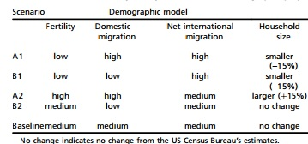

Table 2.2: Number of GP Counties Projected to Lose Population, 2010-2010, according to the ICLUS Dataset.
ICLUS Scenario | Number of Counties Losing Population | % of all GP Counties
A1 | 458 | 93.1%
A2 | 413 | 83.9%
B1 | 392 | 79.7%
B2 | 244 | 49.6%

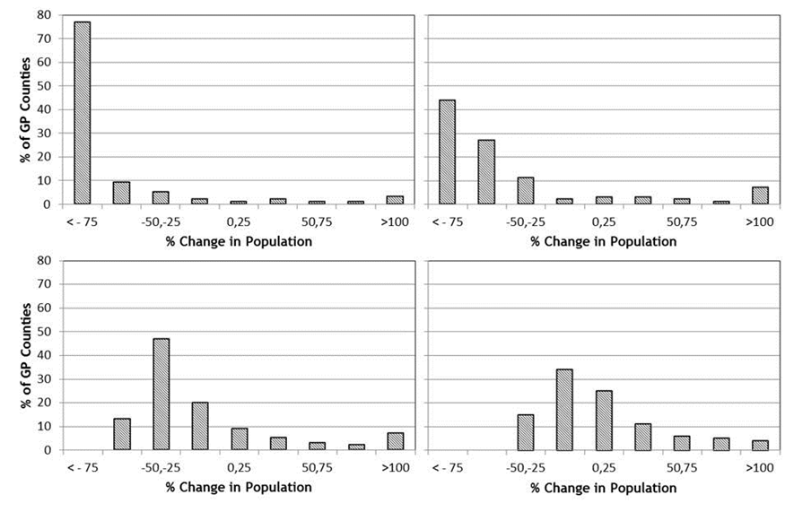
Figure 2.4: Histograms illustrating the percentage of GP counties experiencing various ranges of population changes, 2000-2010, under all four ICLUS scenarios. Data source: EPA ICLUS Dataset.

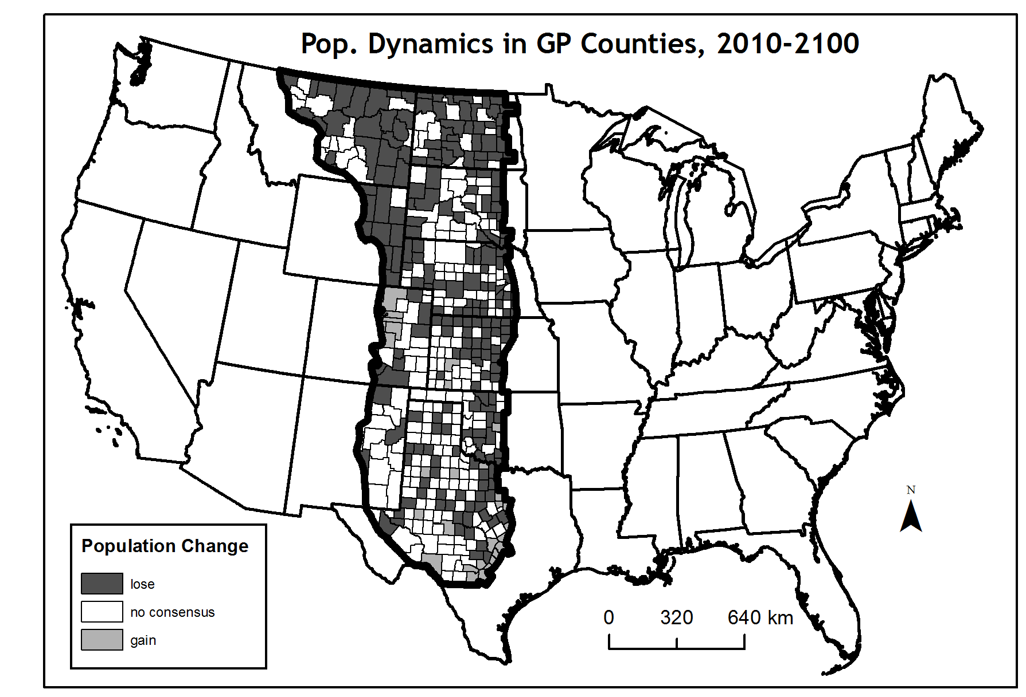
Figure 2.5: Areas of agreement among the ICLUS scenarios vis-à-vis population increase or decline in GP counties by the Year 2100. Data source: EPA ICLUS dataset.

2.5.5: Quantitative Analysis II: Land Use Projections
Next, possible future land use projections are discussed. Sohl et al. (2012) modeled changes in the land use composition of the GP in the Year 2100 using four scenarios designed in a manner similar to those used in the ICLUS dataset. However, they integrate agriculture into these scenarios, with higher demand for agricultural products, including biofuels, present in the A1B and A2 scenarios and heavier demand for sustainable land use practices, conservation, and the restoration of native land use types in the B1 and B2 scenarios. In their analysis, the former result in an increased proportion of anthropogenic land (defined as land that is urban, cultivated, hay/pasture, mechanically disturbed, or mined) in the GP from approximately 43% in 2006 to 65% in 2010 with that of the B1 increasing after 2040 to approximately 53% of the GP. The B2, however, predicts that following initial increase, anthropogenic signature in the GP decreases to 2006 levels by 2100. Accordingly, the proportion of “natural” land (forests, grass/shrublands, and wetlands) decreases from 56% (2003 value), with the A1B and A2 scenarios predicting the largest decrease – to approximately 35% by 2100. In all scenarios, the proportion of land that is hay/pasture (surrogate for biofuels) increases, with the largest expansions occurring in the A1B and A2 scenarios, where increase in the Northern and Southeastern GP comes at the expense of grass and shrubland. The aforementioned studies suggest that the major land use change in the GP will be the conversion of grassland to agriculture, even if population losses stabilize as suggested by the B2 scenario and micropolitan and metropolitan areas continue to grow.
Visual inspection of the map illustrating the extent of impervious land in the GP by 2100 using the ICLUS dataset described above reveals that the GP will continue to lag behind the rest of the Continental United States in the proportion of built-up land (Figure 2.6). This observation is consistent with population projections and with the findings of Sohl et al. (2012) that this region will remain predominantly low-density.
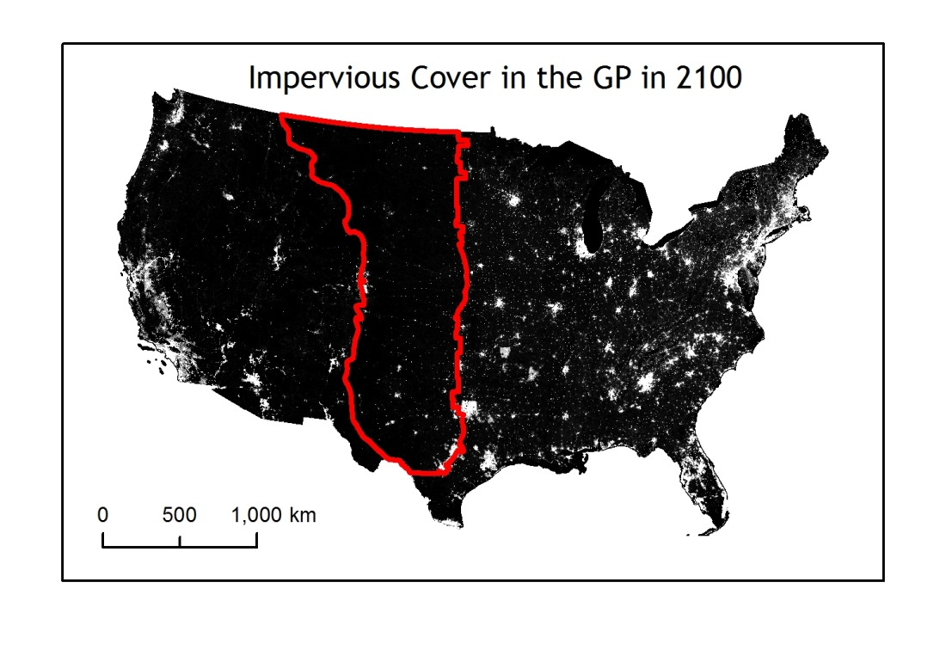
Figure 2.6: Extent of Impervious Surfaces (white) in the Year 2100, A2 Scenario. Data source: EPA ICLUS Dataset.

2.5.6: Implications Of Climate Change Vis-à-vis Scenarios
Under climate change, the Northern GP is expected to see increased moisture while the Southern GP is expected to become drier (U.S. Global Change Research Program 2009, 123-128). Concurrently, temperatures are expected to increase and more sustained droughts, which occur frequently on the Plains, are expected. Such conditions will tax a semi-arid region with a strong agricultural economic basis by reducing water supplies and pressuring agricultural economies (U.S. Global Change Research Program 2009). Continued drought may cause the long-term closures of biorefineries, for example.
Global climate change has the potential to amplify the impacts of both the “A” and “B” scenarios mentioned above. It has the potential of enhancing rural depopulation if water supplies dwindle, perhaps resulting in increased migration to urban centers similar to those projected in the “A” scenarios listed above. Or, it can foster the cultivation of crops and grasses that are more drought-tolerant, such as switchgrass. With regard to the “B” scenarios, the prevalence of groundwater conservation districts represents recognition that even in the most severe droughts, awareness of the sustainability of water supplies is necessary. Additionally, diversification of economic activities and the development of micropolitan/metropolitan centers can mitigate the direct impacts of climate change on agriculture and stem population loss.

2.6: Conclusions: The Great Plains: An Uncertain Future
The sustainability of the American Great Plains has been a matter of intense public discourse and speculation since the days of the region’s early exploration. On one hand, the discourse has had the effect of cementing iconic images of the Great Plains as a formidable desert and as a drought-prone dust bowl abyss. Others believe the region’s agricultural and mineral-based economy is a position of strength, especially if this region becomes a hearth for the cultivation of the nation’s supply of biofuel crops. Nevertheless, impacts of climate change need to be considered when evaluating the agricultural future of this region. The beginning of non-native settlement, land use change in the GP has been heavily influenced by government policies and market conditions.
If current projections of population dynamics and land use change hold, the vast majority of GP counties will continue to lose population, with the exception of those along the fringes of metropolitan and micropolitan areas. Thus, most of GP will remain agricultural favoring large expanses of land, the operation of small-scale industries, and perhaps some protected areas. Most land use change will involve either conversion of grasslands to agriculture or the retirement of agricultural land to grassland, depending on market prices, federal policies, and the demand for biofuel production. Although there may continue to be two de-facto GP regions: one agricultural and one built up, both will continue to play an integral role in US economic production, regardless of the extent of population changes.

Acknowledgements
I thank Steven Wilson (US Census Bureau) for providing the vector files used in Census Bureau publications which facilitated the cartographic process and to David Brauer (Agricultural Research Service, USDA) for providing insights into irrigation patterns in the Great Plains. I also thank the two anonymous reviewers for providing insights which improved the quality of this manuscript.

References
Albengoa Bioenergy. 2011. General Information. [http://www.abengoabioenergy.com/web/en/2g_hugoton_project]. Last accessed 06 August 2013.
Bickel, A. 2012. Ethanol plant is big business for area. The Hutchinson News. [http://hutchnews.com/todaystop/MON--abengoa-biomass]. Last accessed 2 February 2013.

Bierwagen, B. G., D. M. Theobald, C. R. Pyke, A. Choate, P. Groth, J. V. Thomas, and P. Morefield. 2010. National Housing and Impervious Surface Scenarios for Integrated Climate Impact Assessments. Proceedings of the National Academy of Sciences of the United States of America 107(49): 20887-20892.
Bogue, A. G. 1994. An Agricultural Empire. In The Oxford History of the American West, edited by C A. Milner II, C, A. O' Connor and M. A. Sandweiss, 275-313. New York: Oxford University Press.
Bowden, M. J. 1969. The Perception of the Western Interior of the United States, 1800-1870: A Problem in Historical Geosophy. Proceedings of the Association of American Geographers 1(1): 16-21.
Brown, J. P., J. Pender, R. Wiser, E. Lantz, and B. Hoen. 2012. Ex Post Analysis of Economic Impacts from Wind Power Development in U.S. counties. Energy Economics 34(6): 1743-1754.
Callenbach, E. 1996. Bring Back the Buffalo!: A Sustainable Future for America's Great Plains. Washington, D.C.: Island Press.
Colaizzi, P. D., P. H. Gowda, T. H. Marek, and D. O. Porter. 2009. Irrigation in the Texas High Plains: A Brief History and Potential Reductions in Demand. Irrigation and Drainage 58(3): 257-274.
Cunfer, G. 2005. On the Great Plains: Agriculture and Environment. College Station, Station, TX: Texas A & M University Press, 2005.
Dando, C. E. 2009. Deathscapes, Topocide, Domicide the Plains in Contemporary Print Media. Great Plains Quarterly 29(2): 95-119.
Daniels, T. L., and M. B. Lapping. 1987. Small Town Triage - a Rural Settlement Policy for the American Midwest. Journal of Rural Studies 3(3): 273-280.
Dodge, R. I. 1877. The Hunting Grounds of the Great West a Description of the Plains, Game, and Indians of the Great North American Desert. London: Chatto & Windus.
DOE. 2013. 2012 Wind Technologies Market Report. Available on-line at: wind.energy.gov/pdfs/2012_wind_technologies_market_report.pdf‎. Last accessed 1 September 2013.
Donlan, J., J. Berger, C. E. Bock, J. H. Bock, D. A. Burney, J. A. Estes, D. Foreman, P. S. Martin, G. W. Roemer, F. A. Smith, M. E. Soule, and H. W. Greene. 2005. Re-Wilding North America. Nature 436(7053): 913-914.
Donlan, C. J., J. Berger, C. E. Bock, J. H. Bock, D. A. Burney, J. A. Estes, D. Foreman, P. S. Martin, G. W. Roemer, F. A. Smith, M. E. Soule, and H. W. Greene. 2006. Pleistocene Rewilding: An Optimistic Agenda for Twenty-First Century Conservation. American Naturalist 168(5): 660-681.
Dorgan, B. 2003 (9 January). Homestead Economic Opportunity Act. In: the Congressional Record, 336.
Dreiling, L. 2011. Geographers revisit Buffalo Commons. High Plains/MidwestAg Journal, Jan. Available on-line at: http://www.hpj.com/archives/2011/jan11/jan10/0105KFUConferenceldsr.cfm. Last accessed 27 July 2013.
Drummond, M. A., R. F. Auch, K. A. Karstensen, K. L. Sayler, J. L. Taylor, and T. R. Loveland. 2012. Land Change Variability and Human-Environment Dynamics in the United States Great Plains. Land Use Policy 29(3): 710-723.
Egan, T. 2006. The Worst Hard Time: The Untold Story of Those Who Survived the Great American Dust Bowl. Boston: Houghton Mifflin Company.
Fite, G. C. 1977. Great Plains Farming: A Century of Change and Adjustment. Agricultural History 51(1): 244-256.
Garreau, J. 1981. The Nine Nations of North America. Boston: Houghton Mifflin.
Greeley, H. 1860. An Overland Journey from New York to San Francisco in the Summer of 1859. New York: C. M. Saxton, Barker & Company.
Gutmann, M. P., W. J. Parton, G. Cunfer, and I. C. Burke. 2005. Population and Environment in the U.S. Great Plains. In Population, Land Use, and Environment: Research Directions, edited by B. Stern and P. C. Entwisle, 84- 105. Washington, D.C.: National Academies Press.
Hanks, K. 2011. Hugoton is Literally Building a Future. The Hutchinson News. [http://www.hutchnews.com/Todaystop/sun--Hugoton-s-growth-spurt].
Hansen, Z. K, and G. D. Libecap. 2004. Small Farms, Externalities, and the Dust Bowl of the 1930s. The Journal of Political Economy 112(3): 665-694.
Harrington, L. M. B. 2009. The US Great Plains, Change, and Place Development. In The Next Rural Economies: Constructing Rural Place in Global Economies, edited by G. Markey, S. Bruce, and D. Halseth, 32-44. Wallingford: CABI.
Harrington, L. M. B., and M. Lu. 2002. Beef Feedlots in Southwestern Kansas: Local Change, Perceptions, and the Global Change Context. Global Environmental Change-Human and Policy Dimensions 12(4): 273-282.
Harrington, L. M. B., M. Lu, and J. Harrington. 2009. Fossil Water and Agriculture in Southwestern Kansas. In Sustainable Communities on a Sustainable Planet: The Human-Environment Regional Observatory Project, edited by B. Yarnal, C. Polsky and J. O’ Brien. Cambridge: Cambridge University Press.
Harrington, L. M. B., M. Lu, and D. E. Kromm. 2010. Milking the Plains: Movement of Large Dairy Operations into Southwestern Kansas. Geographical Review 100(4): 538-558.
Hudson, J. C. 1976. Migration to an American Frontier. Annals of the Association of American Geographers 66(2): 242-265.
Hudson, J. C. 1986. Who was ‘Forest Man?’ Sources of Migration to the Plains. Great Plains Quarterly 6(1): 69-83.
Hudson, J. C. 2011. Introduction. In Atlas of the Great Plains, edited by S. J. Lavin, F. M. Shelley, and J. C. Archer. Lincoln: University of Nebraska Press.
Hurt, R. D. 1986. Federal Land Reclamation in the Dust Bowl. Great Plains Quarterly 6(1): 94-106.
Jackson, R. H. 1992. The Mormon Experience: The Plains as Sinai, the Great Salt Lake as the Dead Sea, and the Great Basin as Desert-Cum-Promised Land. Journal of Historical Geography 18(1): 41-58.
James, E., S. H. Long, and T. Say. 1823. Account of an Expedition from Pittsburgh to the Rocky Mountains, Performed in the Years 1819 and ’20, by order of the Hon. J.C. Calhoun, Sec’y of War, Under the Command of Major Stephen H. Long, Vol. III. London: Longman, Hurst, Rees, Orme and Brown.
Kotkin, J. 2010. The Next Hundred Million: America in 2050. New York: Penguin Press.
Kotkin, J. 2012. The Rise of the Great Plains. Lubbock, TX: Texas Tech University.
Lantz, E. 2009. Economic Development Benefits from Wind Power in Nebraska: A Report for the Nebraska Energy Office. NREL Technical Report NREL/TP- 500-44344. Available on-line at: http://www.nrel.gov/docs/fy09osti/44344.pdf. Last accessed 1 September 2013.
Libecap, G. D., and Z. K. Hansen. 2002. ‘Rain Follows the Plow’ and Dryfarming Doctrine: The Climate Information Problem and Homestead Failure in the Upper Great Plains, 1890-1925. Journal of Economic History 62(1): 86-120.
Lowitt, R. 2006. American Outback: The Oklahoma Panhandle in the Twentieth Century. Lubbock, TX: Texas Tech University Press, 2006.
Lu, M., and D. A. Paull. 2007. Assessing the Free Land Programs for Reversing Rural Depopulation. Great Plains Research 17(1): 73-86.
Mackun, P., and S. Wilson. 2011. Population Distribution and Change: 2000 to 2010. Suitland: US Census Bureau.

Matthews, A. 2002. Where the Buffalo Roam: Restoring America's Great Plains. Chicago: University of Chicago Press.
Musick, J. T, F. B. Pringle, and J.D. Walker. 1988. Sprinkler and Furrow Irrigation Trends - Texas High Plains. Applied Engineering in Agriculture 4(1): 46-52.
Nakicenovic, N. 2000. Special Report on Emissions Scenarios: A Special Report of Working Group III of the Intergovernmental Panel on Climate Change. Cambridge: Cambridge University Press.
National Agriculture Statistics Service. 2012. Kansas Farm Facts. Available on- line at: http://www.nass.usda.gov/Statistics_by_State/Kansas/Publications/Annual _Statistical_Bulletin/ff2012.pdf. Last accessed 06 August 2013.
North Dakota Industrial Commission Department of Mineral Resources. 2010. 2010 North Dakota Gas Production by Formation. [https://www.dmr.nd.gov/oilgas/stats/2010gasprod.pdf]. Last accessed 2 February 2013.
North Dakota State University Center for Social Research. 2012. 2012 North Dakota Statewide Housing Needs Assessment. Component 1, Housing Forecast. Fargo: Center for Social Research, North Dakota State University.
Northern Plains Conservation Network. 2012. The Big Open Project. [http://www.npcn.net/index.php/pages/big-open/]. Last accessed 2 February 2013.
NPS, 1987. Bonanza Farming in North Dakota. [http://pdfhost.focus.nps.gov/docs/NRHP/Text/64500377.pdf]. Last accessed 25 July 2013.
Oklahoma Bioenergy Center. 2008. [http://okbioenergycenter.org/]. Last accessed 2 February 2013.
Parrish, D. J., and J. H. Fike. 2005. The Biology and Agronomy of Switchgrass for Biofuels, Critical Reviews in Plant Sciences 24(5-6), 423-459.
Parton, W. J., M. P. Gutmann, and W. R. Travis. 2003. Sustainability and Historical Land-Use Change in the Great Plains: The Case of Eastern Colorado. Great Plains Research 13(1): 97-125.
Parton, W. J., M. P. Gutmann, and D. Ojima. 2007. Long-Term Trends in Population, Farm Income, and Crop Production in the Great Plains. Bioscience 57(9): 737- 747.

Pike, Z. 1810. An Account of Expeditions to the Sources of the Mississippi, And Though The Western Parts of Louisiana, to the Sources of the Arkansaw, Kans, La Platte, and Pierre Jaun, Rivers; Performed By the Order of the Government of the United States During the Years 1805, 1806, and 1807. Philadelphia: C.A. Conrad & Company. Available on-line at: http://www.nebraskastudies.org/0400/media/0401_011005.pdf. Last accessed 25 July 2013.
Popper, D. E., and F. J. Popper. 1987. Great Plains: From Dust to Dust. Planning 53(12): 12-18.
Popper, D. E., and F. J. Popper. 1999. The Buffalo Commons: Metaphor as Method. Geographical Review 89(4): 491-510.
Popper, D. E., and F. J. Popper. 2006. The Onset of the Buffalo Commons. Journal of the West 48(4): 65-70.
Porteous, J. D. 1989. Planned to Death: The Annihilation of a Place Called Howdendyke. Manchester: Manchester University Press.
Reategui, S., and S. Tegen. 2008. Economic Development Impacts of Colorado’s First 1000 Megawatts of Wind Energy. WINDPOWER 2008 Conference Paper NREL/CP-500-43505. Available on-line at: http://www.nrel.gov/docs/fy08osti/43505.pdf. Last accessed 1 September 2013.

Reisner, M. 1993. Cadillac Desert: The American West and Its Disappearing Water. New York: Penguin Books.
Rosenberg, N. J., and S. J. Smith. 2009. A Sustainable Biomass Industry for the North American Great Plains. Current Opinion in Environmental Sustainability 1(2): 121-132.
Schubert, S. D., M. J. Suarez, P. J. Pegion, R. D. Koster, and J. T. Bacmeister. 2004. Causes of Long-Term Drought in the US Great Plains. Journal of Climate 17(3): 485-503.
Schubert, S. D., M. J. Suarez, P. J. Pegion, R. D. Koster, and J. T. Bacmeister. 2004. On the Cause of the 1930s Dust Bowl. Science 303(5665): 1855-1859.
Scott, R. 1992. The Big Open: A Plan for the Biggest Restoration Project Anywhere. Restoration and Management Notes 10(1): 51-52.
Seager, R., Y. Kushnir, C. Herweijer, N. Naik, and J. Velez. 2005. Modeling of Tropical Forcing of Persistent Droughts and Pluvials over Western North America: 1856-2000. Journal of Climate 18(19): 4065-88.
Shortridge, J. R. 1988. The Heart of the Prairie: Culture Areas in the Southern and Northern Great Plains. Great Plains Quarterly 8(1): 206-221.
Shortridge, J. R. 2004. A Cry For Help: Kansasfreeland.com. Geographical Review 94(4): 530-540.
Slattery, M. C., E. Lantz, and B. L. Johnson. 2011. State and Local Economic Impacts from Wind Energy Projects: Texas Case Study. Energy Policy 39(12): 7930- 7940.
Sohl, T. L., B. M. Sleeter, K. L. Sayler, M. A. Bouchard, R. R. Reker, S. L. Bennett, R. R. Sleeter, R. L. Kanengieter, and Z. L. Zhu. 2012. Spatially Explicit Land- Use and Land- Cover Scenarios for the Great Plains of the United States. Agriculture Ecosystems & Environment 153(1): 1-15.
Stegner, W. 1954. Beyond the Hundredth Meridian: John Wesley Powell and the Second Opening of the West. Boston: Houghton Mifflin.
Stout, J. E., and J. A. Lee. 2003. Indirect Evidence of Wind Erosion Trends on the Southern High Plains of North America. Journal of Arid Environments 55(1): 43-61.
Thomas, C. 1873. Agriculture of Colorado. In Geological and Geographical Survey of the Territories 6th Annual Report, edited by F. V. Hayden, 229-251. Washington: Government Printing Office.
U.S. Global Change Research Program. 2009. Global Change Impacts in the United States. New York: Cambridge University Press.
Wahl, K. L., R. L. Tortorelli. 1997. Changes in Flow in the Beaver-North Canadian River Basin Upstream from Canton Lake, Western Oklahoma, Water-Resources Investigations Report 96-4304. Oklahoma City: U.S. Geological Survey.
Wallach, B. 1985. The Return of the Prairie. Landscape 28(3): 1-5.
Webb, W. P. 1931. The Great Plains. Boston: Ginn and Company 1931.
White, R. 2011. Railroaded: the Transcontinentals and the Making of Modern America. New York: W. W. Norton & Company.
White, S. E. 1994. Ogallala Oases - Water-Use, Population Redistribution, and Policy Implications in the High-Plains of Western Kansas, 1980-1990. Annals of the Association of American Geographers 84(1): 29-45.
Wilber, C. D. 1881. The Great Valleys and Prairies of Nebraska and the Northwest. Omaha: Daily Republican Print.
Wilson, S. G. 2009. Population Dynamics of the Great Plains: 1950 to 2007. Suitland, MD: U.S. Census Bureau.
Wood, R. E. 2008. Survival of Rural America: Small Victories and Bitter Harvests. Lawrence, KS: University Press of Kansas.
Woodhouse, C. 2003. Droughts of the Past, Implications for the Future? In: The Future of the Southern Plains, edited by S. J. Smith, 95-113. Norman, OK: University of Oklahoma Press.
Worster, D. 1979. Dust Bowl: The Southern Plains in the 1930s. New York: Oxford.

Chapter 3: Simulating the hydrologic response of a semiarid watershed to switchgrass cultivation
(Reprinted from Hydrology Research, Volume 44, Issue 6, doi 10.2166/nh.2013.163, with permission from the copyright holders, IWA Publishing)
Justin C. Goldstein*, Aondover Tarhule¹, and David Brauer²

¹Department of Geography and Environmental Sustainability
University of Oklahoma
100 E. Boyd Street SEC Suite 510
Norman, OK 73019 USA
+1(405) 325-5325 phone
+1(405) 325-6090 FAX

²Ogallala Aquifer Program.
Conservation and Production Research Laboratory,
2300 Experiment Station Drive
P.O. Drawer 10
USDA Agricultural Research Service.
Bushland, TX 79012, USA
+1(806) 356-5769 phone
+1(806) 356-5750 FAX

Abstract
The conversion of land from existing uses to biofuel cultivation is expected to increase given concerns about the sustainability of fossil-fuel supplies. Nonetheless, research into the environmental impacts of biofuel crops, primarily the hydrological impacts of their cultivation, is in its infancy. To investigate such issues, the response of a 1649 km² semiarid basin to the incremental substitution of the widely-discussed biofuel candidate switchgrass (Panicum virgatum L.) for native land uses was modelled using the Soil and Water Assessment Tool (SWAT). Median discharges decreased 5.6% - 20.6% during the spring and 6.4 - 31.2% during the summer depending on the quantity of acreage converted. These were driven by an increased spring and summer evapotranspiration of 4.3% - 46% and 2.2% - 24%, respectively, depending on the quantity of switchgrass biomass produced. The substitution of switchgrass also resulted in larger quantities of water stress days than in baseline scenarios. I encourage the exploration of alternative biofuel crops in semiarid areas to mitigate such negative impacts.

Keywords: Biofuels, Great Plains, Land Use change, Soil and Water Assessment Tool, Semiarid regions, Switchgrass

3.1: Introduction
Land conversion from existing uses to biofuel crops cultivation is an important form of land use change in the 21st century. According to the Renewable Fuels Association (2012), between 2000 and 2010, annual U.S. corn ethanol production increased nearly nine-fold from 6 billion to 52 billion liters, while the number of ethanol plants quadrupled from 54 to 204. Driving this increase are a number of factors including increased oil prices, U.S. demand for greater energy independence, increased awareness and interest in renewable energy sources, as well as the policies and mandates of the United States Government. In his 2006 State of the Union address, U.S. President George W. Bush proposed the Advanced Energy Initiative, which called for energy from biofuels to replace greater than 75% of imported oil from the Middle East by 2025 (Bush 2006). It also called for increased Federal investment in the production of ethanol from sources other than corn, including wood chips and switchgrass, with the goal of making these alternative forms of ethanol (called cellulosic ethanol) competitive with corn-based ethanol by 2012. That call resulted ultimately in the Energy Independence and Security Act (EISA) of 2007. The goals of the EISA are to increase energy security in the U.S. and to increase the production of clean fossil fuels, among others, including the mandated production of 61 billion liters of cellulosic-based gasoline additives by 2022 (One-hundred Tenth Congress of the United States of America 2007).
The Ecological Society of America defines biofuels as “liquid fuels derived from biological materials” (e.g. Mitchell et al. 2010; Robertson et al. 2010). Common sources of biofuel crops include corn (Zea mays L.), switchgrass (Panicum virgatum L.), soybeans (Glycine max L.), sweetgum (Liquidamber styraciflua L.), rapeseed (Brassica napus L. rape), sugarcane (Saccharum officinarum L.), palm oil (Elaeis guineensis), and jatropha (Jatropha curcus). Resultant fuels include ethanol [the most common], methanol, propanol, butanol, methane, and biodiesel.
Native to the tallgrass prairies and a wide-range of mesic environments in the eastern two thirds of the United States, the warm season perennial switchgrass (Parrish & Fike 2005) has received much attention as a possible cellulosic biofuel source because of its perceived advantages over other biofuel crops. In their review paper, Simpson et al. (2008) concluded that compared to corn, switchgrass facilitates improved nutrient retention and carbon sequestration in soils, it has the ability to grow on marginal soils, and it needs replacement only once every twenty years. Also, it has been projected that switchgrass-based ethanol reduces the emission of greenhouse gases by 94% relative to those emitted by traditional gasoline (Schmer et al. 2008).
As with any other major land use modification, biofuel production is expected to have major, but not yet fully understood, impacts on regional hydrology. Acknowledging this point, the National Research Council (2008, p. vii) refers to the hydrology of biofuel production as an “emerging field” of scientific inquiry. Similarly, Georgescu and Lobell (2010, p. 33) noted, “changes to local hydrology caused by large-scale perennial systems may be complex, and thus require careful evaluation.” Two other factors related to climate change and sustainability also make such evaluation imperative. A number of authors (e.g. Sala et al. 2000; Vorosmarty et al. 2000; Foley et al. 2005; Turner II et al. 2007; Wagener et al. 2010) have noted that land use change dwarfs or is at least of comparable magnitude to the much more widely publicized topic of climate change, both as a driver and as an impact of future global environmental change. With specific respect to water resources, Ren et al. (2012) and Jiang et al. (2012) found that both climate change and anthropogenic activities including reservoir construction and irrigation are responsible for changes in streamflow in China’s Laohahae Basin during the late twentieth and early twenty-first century, although the relative contribution of each varies by decade. In their study of the Shaumalun Basin in China, Yang et al. (2012) found a decline in annual runoff post 1998 far in excess of what could be attributed to changes in basin precipitation. The authors concluded that the unexplained difference was likely due to land use changes including deforestation and urbanization. Ma et al. (2009) investigated the impacts of climate and land use change in the Kejie watershed in China from 1965-2005. They found that the hydrologic effects of climate change were offset by land use changes, and that while seasonal changes in streamflow were mostly a function of precipitation, mean annual changes in streamflow were largely influenced by land use change. Overall, they found that surface hydrology was more impacted by land use change than climate. Franczyk and Chang (2009) assessed the impacts of climate change and future urbanization on the hydrology of the Rock Creek Basin, Oregon USA, through the 2040s. They found that climate change and urbanization combine to amplify the magnitudes of the volumes of mean annual runoff and evapotranspiration relative to those in the absence of one of those factors. Du et al. (2012) found that the impacts of urbanization on mean annual runoff are a function of the magnitude of precipitation; in their investigation of the Qinhuai River Watershed in China, they found that annual runoff in dry years increases more than in wet years given a 10-fold increase in the area of impervious surfaces. Additionally, Raymond et al. (2008) and Schilling et al. (2010) attributed the increased in discharges in the Mississippi River Basin to agricultural production, and explicitly discounted the role of climate. With specific respect to regional hydrology, a number of studies have reported significant stream depletion due to groundwater mining associated with agricultural expansion (e.g. Reisner 1993; Glennon 2009; Kustu et al. 2010; McGuire 2011; Scanlon et al. 2012). These findings underscore a critical need to unbundle and quantify the relative contributions of specific land use changes, especially in semiarid areas such as the U.S. Great Plains where the issue of the sustainability of scarce water supplies is of paramount importance (see below). This study is a contribution toward that goal.
With regard to the sustainability of biofuel hydrology, the myriad of factors comprising the hydrologic impacts of biofuel production may be grouped into three broad categories namely, the water footprint (WF) defined as “the total annual volume of fresh water used to produce goods and services for consumption” (see e.g. Gerbens-Leenes et al. 2009 pp. 10219), water quality (e.g. Nyakatawa et al. 2006; Simpson et al. 2008; Chamberlain et al. 2011; Sarkar et al. 2011), and impacts on the local or regional water balance. This paper focuses on the third category. Specifically, the impact of switchgrass production on local scale changes in constituent components of the water balance, including runoff and evapotranspiration (eT), is investigated.
A number of studies have investigated the impact of the planting of different biofuel crops on local water balances (e.g. Schilling et al. 2008; Thomas et al. 2009). These studies suggest that increased biofuel crop cultivation can significantly alter local water balances through altering local evapotranspiration and discharge rates, although the results are mixed due to variations in crop management [i.e. till, no till, etc], climate, and topography. Generally, switchgrass and the biofuel-grass miscanthus (Miscanthus x giganteus) have been shown to increase soil moisture retention and to reduce the volumes of river discharge relative to other crops. For example, Schilling et al. (2008) simulated the impact of various land use scenarios involving combinations of biofuel crops in the Raccoon watershed in Iowa, USA, on the water balance using the Soil Water and Assessment Tool (SWAT). They devised nine scenarios, ranging from an expansion of corn acreage to cover solely United States Department of Agriculture (USDA) lands to those in which switchgrass became the dominant biofuel crop and, finally, those in which cool season biofuel crops (i.e. fescue) dominated. They found that the conversion of grassland to corn decreases mean annual evapotranspiration by 1% and increases mean annual runoff by nearly 8%, but the conversion of cropland to warm season biofuel crops (switchgrass) increases mean annual evapotranspiration by 2.6% and decreases mean annual runoff by 17%. On the other hand, Thomas et al. (2009) suggested that planting corn on an annual basis increases evapotranspiration. In an investigation using SWAT in a watershed in Eastern Kansas, United States, Nelson et al. (2006) modeled the percent reduction in surface runoff when the planting of switchgrass replaced the planting of traditional crop rotations, including corn-soybean, corn-soybean-wheat, grain sorghum-soybean, and grain sorghum-soybean-wheat. They found that the planting of switchgrass reduced surface runoff by 55% over a 24-year period relative to baseline. Graham et al. (1996) modeled the hydrologic impact of replacing plots of soybeans, wheat, and cotton with switchgrass in the vicinities of the cities of Nashville and Memphis (Tennessee, USA) using the Environmental Policy Integrated Climate (EPIC) model. They found that replacing such crops with switchgrass would result in lower runoff, erosion, evapotranspiration, and phosphorus loss. Specifically, replacing soybeans with switchgrass reduced evapotranspiration by 20% - 60% and phosphorus by 80% - 95%. Additionally, replacing corn with switchgrass reduced evapotranspiration by up to 10% - 50% and phosphorus loss by 80-95%. Finally, replacing wheat with switchgrass reduced evapotranspiration by 15% - 40% and phosphorus loss by approximately 90%. In another study, Vanlocke et al. (2010) investigated the hypothetical impact on regional water balance of planting increasing proportions (i.e. 10% of area, 25%, 50%, 75%, and 100%) of miscanthus in the Upper Midwest of the United States. By simulating the different land cover configurations using the Integrated Biosphere Simulator – Agricultural Version, the authors found that the planting of miscanthus significantly increased evapotranspiration and decreased discharge relative to its predecessor land cover type. In yet another experimental study, McIsaac et al. (2010), found that late-season soil moisture under switchgrass plots exceeded that of miscanthus and maize-soybean because of the higher transpiration levels of miscanthus and maize-soybean relative to switchgrass (due to higher leaf-area indices and biomass) throughout much of the growing season. Estimated evapotranspiration from miscanthus exceeded that of switchgrass by 140 mm and that of maize-soybean by 104 mm.
In addition to differences in management practices, impacts of biofuel cultivation have been shown to be region-specific as a result of differences in climatic conditions (e.g. Garoma et al. 2012). For example, soybeans and cotton require more water than corn when planted in the Pacific and Mountain regions of the U.S., but the opposite is true in the semiarid Great Plains (National Research Council 2008). These differences, and sometimes contradictory results, point to a need for more studies investigating the impacts of biofuel production generally in different regions and bioclimatic environments. This study contributes to that goal.

3.2: Study Area
The study area is part of the Middle North Canadian River (hereinafter, MNCR) Watershed located in Western Oklahoma, USA. It covers approximately 1649 km² within the U.S. Geological Survey (USGS) Hydrologic Unit Code 11100301 (Figure 3.1). The headwaters of the basin are located at (36°26'12" N, 99°16'41" W) and the watershed outlet is situated at (36°11'00" N, 98°55'15" W). Because of its predominantly agricultural character, the MNCR could be considered representative of other basins in the semiarid U.S. Great Plains. Largely rural, the largest settlements in the MNCR are Mooreland (population 1,190), Seiling (population 860), and Vici (population 699). Elevation varies from 762 meters at the headwaters to 512 meters at its outlet, a distance of approximately 53 km. For the period 1980-2010, average annual precipitation was 666 mm with precipitation peaking during May and June (PRISM Climate Group 2012). Average daily temperatures range from 1 ^{O}C during January to 27^{O}C during July and August. Like other portions of the Great Plains, the study area is drought prone and suffers from water shortages associated with evaporative losses (Zume & Tarhule 2006, 2011).
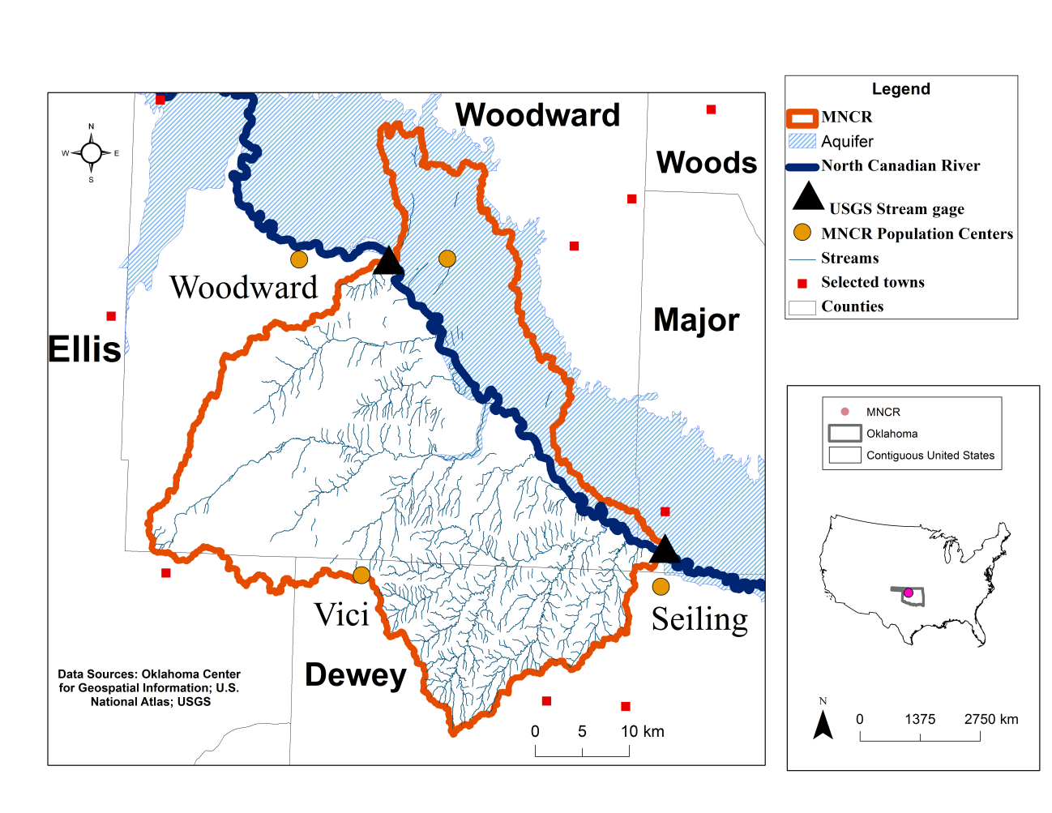
Figure 3.1: Location of the Middle North Canadian River Basin (MNCR), located within the U.S. State of Oklahoma.

The MNCR overlies two geological provinces: the Western Sand-Dune Belts and the Western Sandstone Hills (Goins & Anderson 2006). The sand dune belts, which were blown from Quaternary alluvium and terrace deposits, are found on the north side of the North Canadian River and are oriented southeast. These deposits create the Alluvium and Terrace aquifer (BNCR A&T) of the Beaver/North Canadian River, which originates upstream of the MNCR and ends at Lake Eufaula, 290 km downstream from the MNCR. This aquifer serves as an important water source for irrigation and public water supplies in this region. The Quaternary deposits vary in thickness; the alluvium deposits average 10 meters in thickness while the high terrace deposits average 21 meters in thickness. The terrace and alluvium deposits are the main water-bearing portions of the aquifer, and it is believed that these deposits are hydraulically continuous and comprise a single aquifer system. These deposits contain poorly-sorted sand and minor portions of gravel, silt, and clay (Davis & Christenson 1981). It is believed that the base of the aquifer coincides with the relatively impermeable Permian Red Beds Formation (Zume & Tarhule 2008).
The depth to bedrock at the BNCR A&T varies spatially up to a maximum of 100 meters, although it does outcrop at a few locations outside of the MNCR. Hydraulic conductivity values vary from 18-24 m/d per day (Davis & Christenson 1981; Adams et al. 1997), with specific yield around 0.28 (Zume & Tarhule 2008) and transmissivity values from 0 – 749 m²/d (Davis & Christenson 1981). Recharge is 1.39 * 10⁻⁴ m/d (Zume & Tarhule 2008), or approximately 7% of mean annual precipitation.
The vegetation of the watershed is dominated by non-irrigated native range grasses, and winter wheat, which is fertilized and irrigated. Grasses include buffalo grass, big and little bluestem, sideoats grama, and blue grama. Winter wheat is planted during the middle of September and is harvested in the middle of June of the following summer. Most of the irrigation originates from the BNCR A&T.
Heavy groundwater pumping for irrigation since 1970 in portions of the North Canadian River watershed upstream of the MNCR has contributed to decreases in the medians of the peak annual streamflow values of about 40% in the MNCR (see Wahl & Tortorelli 1997). The two largest uses of BNCR A&T water are irrigation and municipal use (Tortorelli 2009). More groundwater is used from BNCR A&T for municipal use than in any other aquifer in Oklahoma, and 50-89% of the total withdrawals in the study area counties are BNCR A&T water. The MNCR lacks large impoundments although several small reservoirs exist.

3.3: Model Description and Methods
The response of the MNCR to the substitution of native land uses with switchgrass was investigated using SWAT, a physics-based semi-distributed hydrologic model (Arnold et al. 1998). Developed by the U.S. Department of Agriculture in Temple, Texas, SWAT has been employed in over six-hundred published studies (Gassman et al. 2007; Douglas-Mankin et al. 2010), including many investigations of the impacts of crop substitution (e.g. Schilling et al. 2008; Baskaran et al. 2010; Ng et al. 2010). The model, along with associated documentation and related software, is available free of charge from the Texas A&M AgriLife Research Center (http://swatmodel.tamu.edu). It has been applied to a variety of water resource issues in a large range of locations and spatial scales – from 0.004 km² to 491,665 km² (Gassman et al. 2007; Douglas-Mankin et al. 2010). SWAT divides a watershed into smaller user-defined subbasins, and then into still smaller hydrologic research units (HRUs) which are areas of homogeneous land use, soil, and slope based on user-provided information. The model operates on a water-balance principle on a daily time step.
A key convenience of SWAT is that it is linked to various databases containing the data and information required for simulation, greatly simplifying model setup and operation. The crop database contains alterable biophysical information (e.g. extinction coefficient, leaf area index) for 108 crops, including many biofuels such as Alamo Switchgrass, corn, oil palm, sugarcane, grain sorghum, and soybeans. The sources for the input data used in this investigation are listed in Table 3.1.
The MNCR was delineated in SWAT using a 30-meter DEM, and by the subsequent “burning in” of the National Hydrography Dataset Plus dataset. Thirteen (13) subbasins were delineated. To reduce the quantity of HRUs to a manageable number without sacrificing model accuracy, a threshold of 3% land use, 10% soil, and 0% slope for each subbasin was used. In other words, land use types were retained if they covered greater than 3% of the subbasin, otherwise they were incorporated into other HRUs. This led to the retention of 529 HRUs. The land use composition of the watershed post-threshold delineation is displayed as Table 3.2.

Table 3.1: Data sources for items used in investigation
Data for Simulation | Source
Elevation: 30-meter DEM | USGS¹
Groundwater:  values for effective hydraulic conductivity | Zume & Tarhule (2008)
Land Use:  56-meter Crop Dataset Layer (CDL): 2006-2009 | National Agriculture Statistics Service¹
Management:  Planting, irrigation, and fertilization schedules | Agriculture extension agents
Soil: 1:15,000 scale Soil Survey Geographic  (SSURGO) dataset | Natural Resources Conservation Service (NRCS) ²
Weather:  Daily temperature and precipitation data | National Climatic Data Center
1 Available at the USDA NRCS Geospatial Data Gateway (http://datagateway.nrcs.usda.gov)
² Data imported into SWAT using the SWATioTools program (Sheshukov et al. 2009)

Table 3.2: Land use composition (%) of the MNCR post-land use threshold delineation
Land Use | % of Watershed
Native range grasses | 74.59%
Winter wheat | 12.30%
Low-density development | 5.90%
Evergreen forest | 4.03%
Shrubland | 3.18%

Driven primarily by the availability of streamflow data for calibration, SWAT was run for 1977-2009, with 1977-1979 as the initialization period, 1980-1994 as the calibration period, and 1995-2009 as the simulation period. These years coincided with a wet period in Oklahoma’s North Central Climate Climate Division (http://climate.ok.gov/index.php/climate/climate_trends/precipitation_history_annual_statewide/CD02/prcp/Annual). Following calibration, simulations of switchgrass replacement were conducted to quantify the response of the MNCR, specifically discharge (Q) and evapotranspiration (eT), to the cultivation of switchgrass during the spring and summer seasons which were the seasons with the best calibration results. The replacement scenarios are the following:
(1) “nowwht:” Replacement of winter wheat with nonfertilized Alamo switchgrass (12.3% of the MNCR).
(2) “nornge:” Replacement of range grasses with nonfertilized alamo switchgrass (74.5% of the MNCR).
(3) “noag:” Replacement of agricultural land uses (range grass and winter wheat), with
nonfertilized alamo switchgrass (86.8% of the MNCR) .
(4) “fert:” Similar to “noag,” except switchgrass is managed as follows:
a. April 15 fertilize (56 kg ha⁻¹ N)
b. Harvest May 15 (90% efficiency), July 15, November 1
c. Fertilize (56 kg ha⁻¹ N) May 17, July 17
Switchgrass production was simulated using the default biophysical settings for alamo switchgrass provided in the SWAT crop database with 1187 heat units for growth and with increased rooting depth from 2 to 3 meters (Baskaran et al. 2010).

3.4: Results

3.4.1: Calibration
The result of the calibration on total monthly discharge (in cubic meters per second or “cms”) at the watershed outlet is presented as Figure 3.2(a). The simulated model reproduces the observed discharges reasonably well without evidence of systematic under or over estimation. The Nash-Sutcliffe Efficiency (NSE, Nash & Sutcliffe 1970) estimate is 0.86, well above the 0.75 threshold generally regarded as indicative of a “very good” simulation (Moriasi et al. 2007). The calculated Percent Bias (PBIAS, Gupta et al. 1999) estimate is 3.87% (values less than 10% are considered “very good”). Finally, the calibration fit was evaluated using the RMSE-Observations Standard Deviation Ratio (RSR), a measure of the ratio of the normalized sum of squares to the standard deviation of the observed values (Singh et al. 2004). The RSR estimate is 0.38 (values below 0.5 are considered “very good,” Moriasi et al. 2007). Thus, the simulation performed satisfactorily on all three commonly used evaluation criteria.
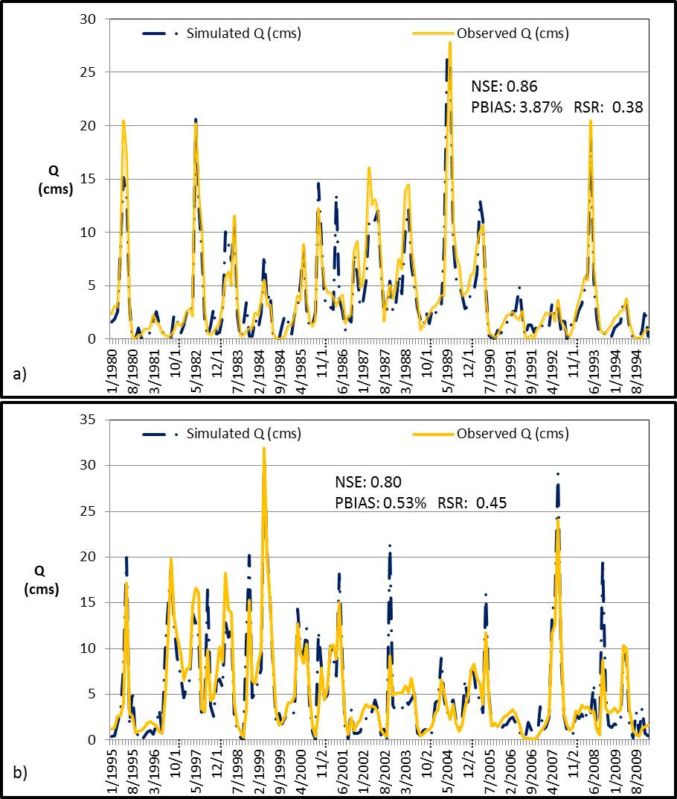
Figure 3.2: Plot of simulated and observed monthly discharges at the watershed outlet during (a) the calibration period and (b) the simulation period

Sensitivity analysis (van Griensven et al. 2006) was performed on 26 parameters, using observed data. The results showed that the curve number for soil moisture condition II (“average” moisture) was the most sensitive parameter, followed by maximum vegetation canopy storage, and Manning’s roughness coefficient (Table 3.3). A list of the curve numbers for the various land use classes in the calibration simulation is included as Table 3.4. However, further fine tuning was deemed unnecessary given the low values of the sensitivity indices as well as the excellent calibration agreement already achieved.
Accordingly, the model was used to simulate total monthly discharge for the simulation period of 1995 to 2009 (Figure. 2.2b). The results are likewise satisfactory with NSE of 0.80, PBIAS of 0.53, and RSR of 0.45.
Next, the model performance at seasonal time scale (i.e. winter - December, January, February, spring - March, April, May, summer - June, July, August, and fall - September, October, November) was evaluated for the calibration and simulation periods. The results appear in Table 3.5. The statistics for winter during the calibration and simulation periods were problematic due to relatively low NSE values and unsatisfactorily high PBIAS values (>25%, which is the threshold for satisfactorily monthly values per Moriasi et al. (2007)). Therefore, subsequent analysis was confined to the spring and summer seasons. Figures 3.3(a-b) and 3.4(a-b) present plots of the simulated and observed spring and summer discharges during the calibration and simulation periods, respectively.

Table 3.3: Sensitivity index rankings for the MNCR
Sensitivity  Ranking^{a, b} |  | Parameter |  | Description | Initial value | Range  tested^{c} | Sensitivity Index
1 | CN2 |  | $$Curve number for$$  $soil$ $condition II$ |  | Default | -10%, 10% ^{d} | 0.199
2 | Canmx |  | $$Maximum canopy storage$$  $$(mm H_{2}O)$$ |  | 0 | 0, 10 | 0.112
3 | Ch_N2 |  | $$Manning^{'}s \text{n }value for the$$  $$main channel$$ |  | Varies within range tested | 0.035, 0.11 | 0.0909
4 | Alpha_bf |  | $$Baseflow recession factor$$  $$(days)$$ |  | 0.75 | 0, 1 | 0.0816
5 | Blai |  | $$Maximum potential leaf$$  $$area index$$ |  | Default | 0, 1 | 0.0308
6 | Surlag |  | $$Surface runoff lag$$  $$coefficient (days)$$ |  | Default | 1, 24 | 0.0261
7 | Sol_Z |  | $$Depth from soil surface to bottom$$  $of soil$ $layer (mm)$ |  | Default | -4%, 4% ^{d} | 0.0205
8 | Esco |  | $$Soil evaporation$$  $$compensation factor$$ |  | 0.7 | 0.65, 0.80 | 0.0166
9 | Ch_K2e |  | $$Effective hydraulic conductivity$$  $in main$ $channel alluivum (\frac{mm}{hr})$ |  | 6.4-7 | 3, 20 | 0.0141
10 | Sol_Awc |  | $$Available water capacity of$$  $the$ $soil layer (mm)$ |  | Default | -4%, 4% ^{d} | 0.0113
ª Only 10 most sensitive parameters are shown
^{b} In order of decreasing sensitivity
^{c} Minimum and maximum values listed
^{d} Initial value multiplied by values in range
^{e} Only applied to subbasins with intermittent or ephemeral main channels. Values based on those reported by Zume and Tarhule (2008).

Table 3.4: CNs for crops in this investigation, by National Resources Conservation Hydrologic Soil Group

Crop | Soil Group Aª | Soil Group B | Soil Group C | Soil Group D ^{b}
Winter Wheat | 62 | 73 | 81 | 84
Native Range Grasses | 45 | 66 | 77 | 83
Shrubland | 39 | 61 | 74 | 80
Low-density development | 31 | 59 | 72 | 79
Alamo Switchgrass ^{c} | 31 | 59 | 72 | 79
Evergreen Forest | 25 | 55 | 70 | 77
_____________________________________________________________________
ª Lowest runoff potential

^{b} Highest runoff potential

^{c} Not included in calibration simulation

Source: SWAT crop database

Table 3.5: Effectiveness of calibration during the calibration and simulation periods
Criterion * | Winter | Spring | Summer | Fall
 | Calibration Period
NSE | 0.64 | 0.76 | 0.97 | 0.87
PBIAS (%) | 29.34 | -6.00 | -9.90 | -14.39
RSR | 0.60 | 0.49 | 0.18 | 0.36
 | Simulation Period
NSE | 0.61 | 0.93 | 0.88 | 0.69
PBIAS (%) | 25.17 | 6.75 | -8.23 | -29.63
RSR | 0.62 | 0.27 | 0.35 | 0.56
* Thresholds for satisfactory calibration on the monthly timescale for NSE, PBIAS, and RSR are 0.50, +/- 25%, and 0.75, respectively (Moriasi et al. 2007)

The changes in hydrology discussed below are driven solely by the impacts of land use change since climatic parameters were not adjusted during the simulations. The results of four switchgrass substitution simulation scenarios for the spring and summer appear in Figure 3.5(a-b). All four scenarios result in decreased discharges relative to baseline. Such decreases are consistent with the findings of Nelson et al. (2006) and Schilling et al. (2008), both of whom found decreased discharges when replacing pre-existing cropland with warm-season grasses. As may be expected, the magnitude of the decreased discharges is a function of the area converted to switchgrass, a finding which also echoes that of Schilling et al. (2008).

3.4.2: Spring and summer discharge
On one hand, the magnitude of the reduction in median spring discharge for all scenarios is directly proportional to seasonal precipitation in Oklahoma Climate Division 2, in which the majority of the MNCR is situated (Figures 3.6a-3.6d). All relationships are statistically significant (p<0.05). I hypothesize that higher rainfall results in greater switchgrass biomass accumulation which then results in higher evaporative losses and therefore less water for discharge. Notice that the relationship is relatively weak for the “nowwht” scenario. This may be explained by the fact that winter wheat relies more heavily on fertilizer applications, and less on precipitation, for growth. On the other hand, no statistically significant correlations exist between the magnitude of reduction in summer discharge and summer precipitation, implying that depletions in summer discharge are not a function of precipitation, explained below.

3.4.3: Spring and summer eT
The reductions in spring and summer discharge are driven by sizeable, statistically significant (p<0.05) increases in eT (Figures 3.7a-3.7b). Median increases during the spring vary from 4.3 mm (“nowwht” scenario) to 46.0 mm (“fert” scenario) and from 2.2 mm (“nowwht” scenario) to 24.0 mm (“fert” scenario) during the summer. These increases appear not to be functions of land area converted but of the quantity of switchgrass biomass produced (Figure 3.8). This is evident from the disparate eT values under the “noag” and “fert” scenarios despite these scenarios converting an identical acreage of switchgrass.
It is evident that summer eT is greatly limited by available moisture, as the increases in spring eT exceed those of the summer by a factor of 1.3 to 2.3 despite higher summer temperatures relative to spring (Figures 3.7a-3.7b). Higher water stress during the summer is evident in the higher ratio of summer eT to rainfall (0.632) relative to that during the spring (0.536). These results are consistent with those reported by Lakshmi et al. (2011) for an area situated just north of the MNCR. Additionally, the number of summer water stress days increases under all scenarios relative to baseline, resulting in an almost 300% increase under the “fert” scenario in which the most switchgrass biomass is produced (Table 3.6). Under the “fert” scenario, 48% of all summer days are water stressed. The increase in water stress days also explains the lack of a statistically significant relationship between precipitation and change in discharge (see above), as most of the MNCR’s summer moisture supply is exhausted by the high evaporative demands. Additionally, the statistical relationship between the change in eT (mm) and the change in discharge (cms) during the simulation years is stronger during spring months than in summer, which indicates a lack of requisite moisture during the latter period (Table 3.7). Simply stated, the increase in summer eT associated with switchgrass production increases the quantity of summer.

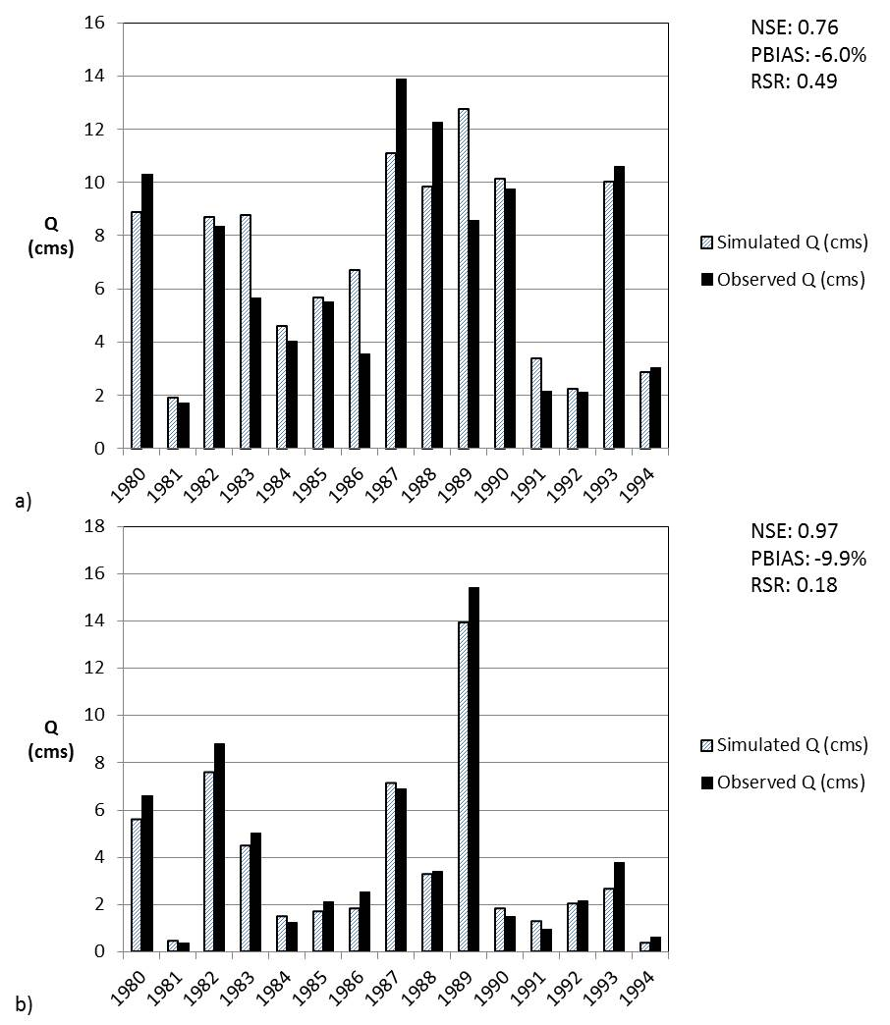
Figure 3.3: Calibration of seasonal discharges at the watershed outlet for (a) spring, and (b) summer

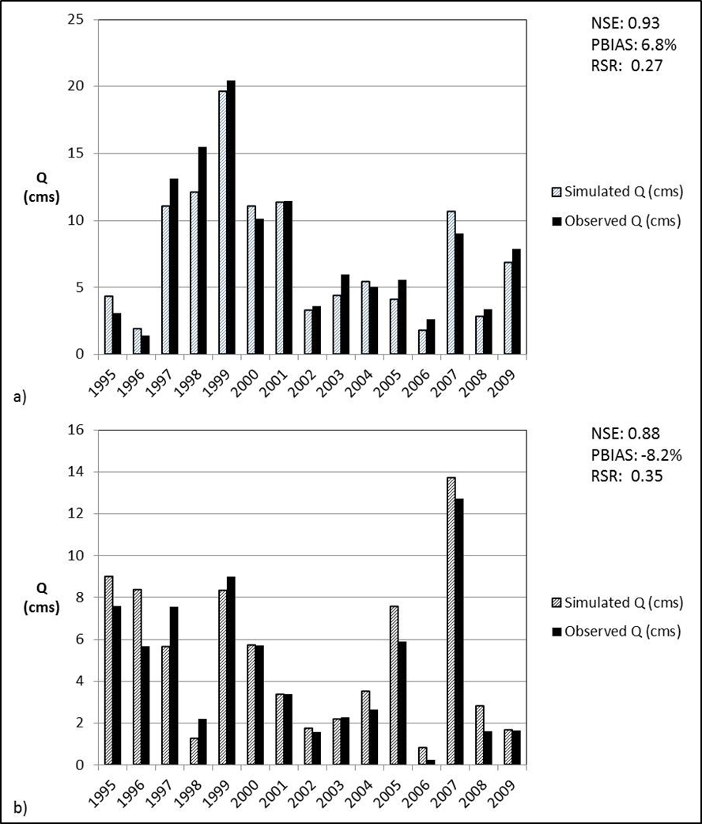
Figure 3.4: Comparison of observed and predicted discharges at the watershed outlet for (a) spring, and (b) summer during the simulation period

a)
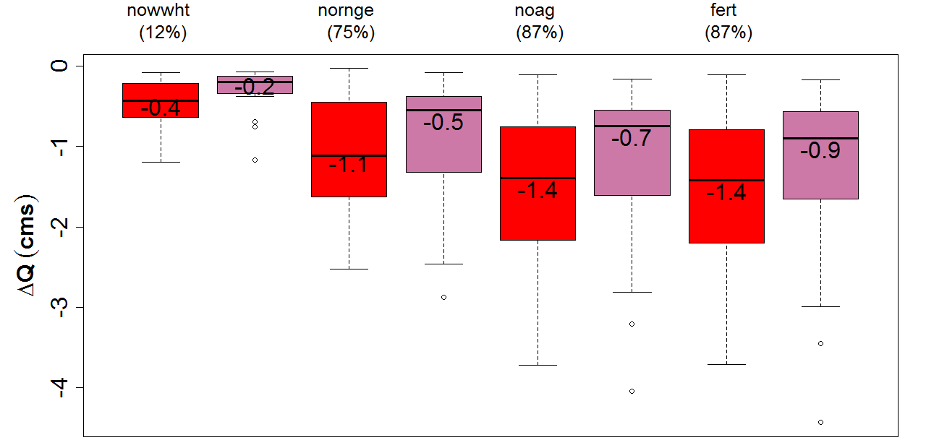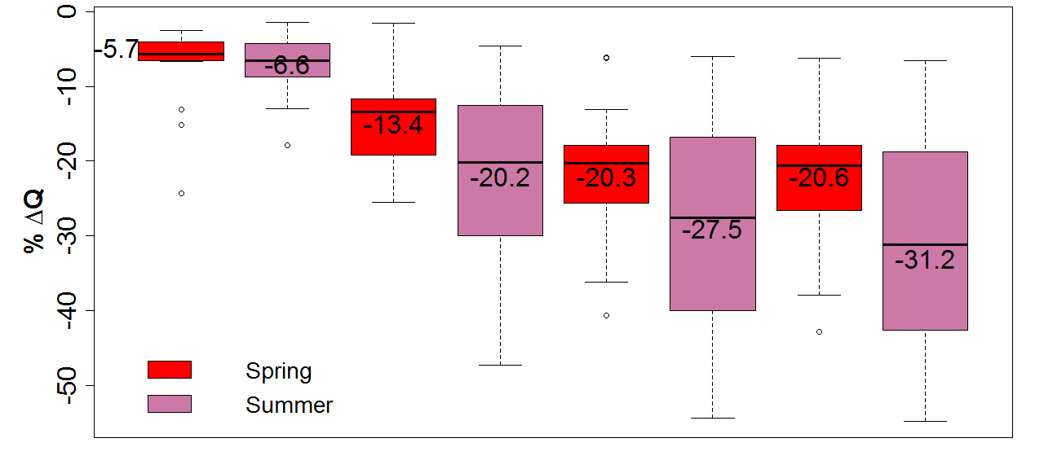Figure 3.5: Differences in a) spring and summer discharge associated with switchgrass production relative to baseline in all scenarios during the simulation period, 1995-2009, and b) the percent change in spring and summer discharge relative to baseline in all scenarios during the simulation period, 1995-2009. The values of the medians (black lines) are provided. The dots comprise the observations; circles indicate outliers. The proportion of the watershed converted in each scenario is shown as a percentage in brackets underneath the x-axis label.
b)

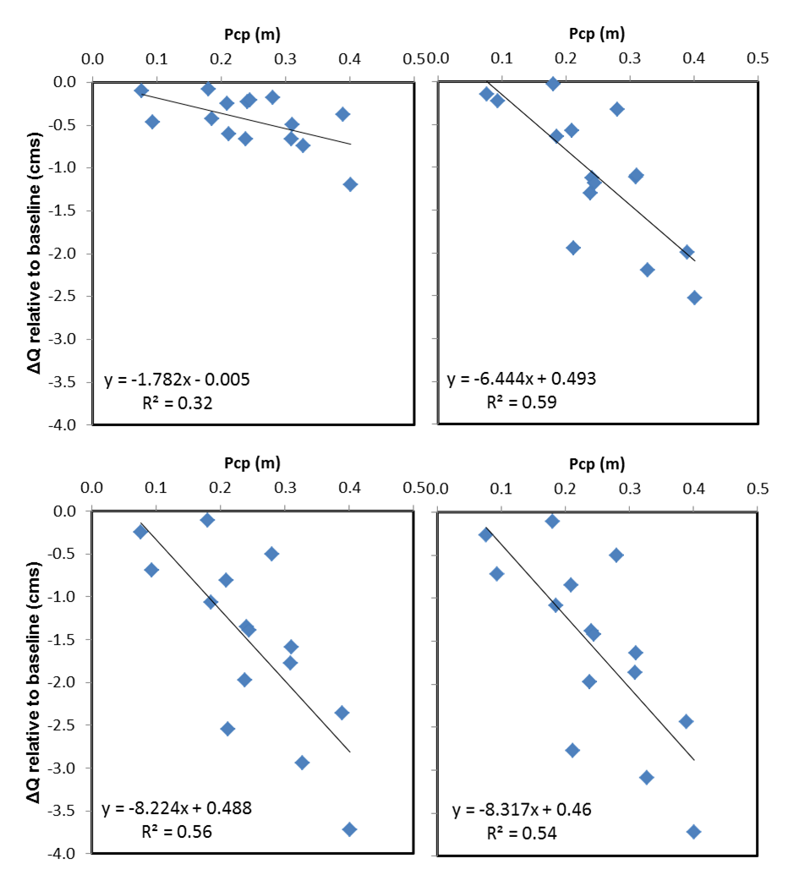
d)
b)
c)
a)
Figure 3.6: Relationship between change in spring discharge relative to baseline and precipitation, 1995-2009 in the a) nowwht, b) nornge, c) noag, and d) fert scenarios

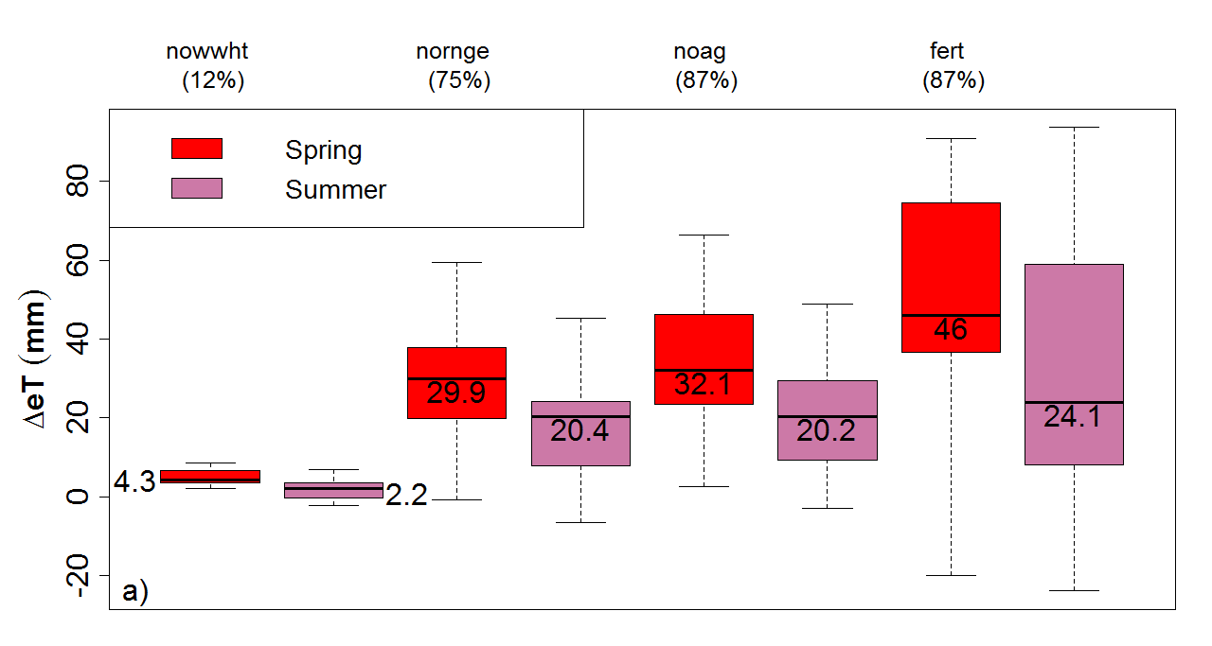
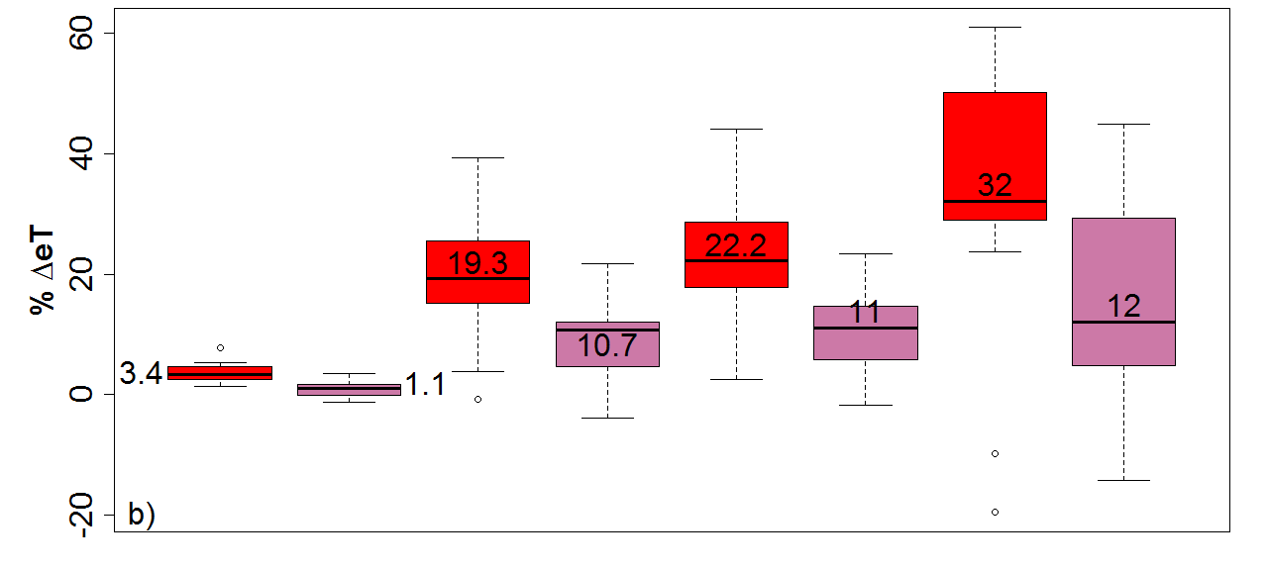
Figure 3.7: Differences in in basin-wide a) spring and summer eT associated with switchgrass production relative to baseline in all scenarios during the simulation period, 1995-2009, and b) the percent change in spring and summer eT relative to baseline in all scenarios during the simulation period, 1995-2009. The boxplots are read in a manner identical to that of Figure 3.5.

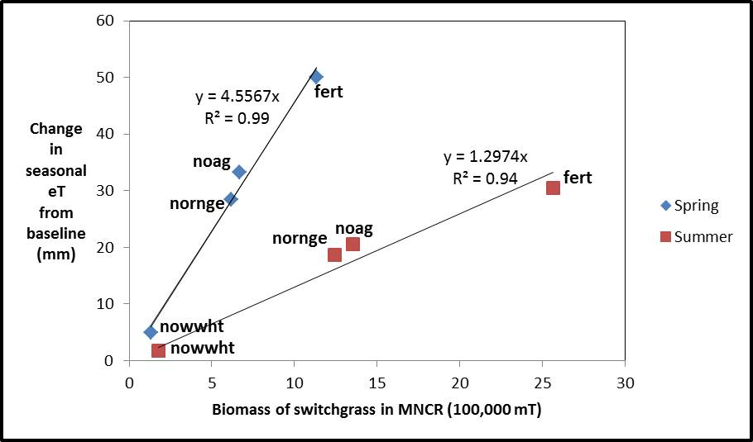
Figure 3.8: Relationship between the change in seasonal eT in the four switchgrass scenarios relative to baseline, and the quantity of switchgrass biomass (in 100,000 metric tons) during the spring and summer.

Table 3.7 indicates that moderately-strong, statistically-significant (p<0.05) relationships exist between changes in eT and changes in discharge during all seasons and scenarios except for “nowwht.” I conclude, therefore, that changes in discharge in the MNCR are driven by eT except in this scenario, which may be driven by the application of spring fertilizer with the subsequent increase in the growth of winter wheat. Ignoring the “nowwht” scenario, it is also noteworthy that the coefficient of determination for this relationship decreases with the volume of switchgrass production, which is further evidence of the occurrence of water stress mentioned above, as only so much moisture is available to be lost by eT.
Table 3.6: Average quantity of spring and summer water stress days, by scenario, 1995-2009
Scenario | Spring | Summer
baseline | $$5.74$$ | $$11.02$$
nowwht | $$5.57$$ | $13.23$*
nornge | $7.32$* | $16.05$*
noag | $7.15$* | $18.26$*
fert | $13.03$* | $43.33$*
* Quantities are statistically significant (p<0.05) relative to baseline

Table 3.7: The strength of the relationship between changes in eT (mm) and discharge (cms) in each scenario by season, as measured by R² and p-values
Scenario | R² | P-value
 | Spring
nowwht | 0.11 | 0.232
nornge | 0.81 | 5.2*10⁻⁶
noag | 0.64 | 0.003
fert | 0.59 | 0.0008
 | Summer
nowwht | 0.01 | 0.77
nornge | 0.50 | 3.36*10⁻³
noag | 0.47 | 0.0047
fert | 0.48 | 0.004

3.5: Conclusions
The current interest in biofuel crops is likely to lead to major land use changes in some watersheds with major impacts on regional hydrology. However, owing to the still evolving nature of the so-called biofuel hydrology, the dynamics and magnitudes of the possible hydrologic responses in different bioclimatic zones as well as management practices are not yet fully understood. Efforts toward achieving that understanding have tended to adopt a modeling approach because of the complexity and futuristic nature of the processes involved. Even though one of the largest experimental switchgrass plots is located in Guymon, Oklahoma, USA in the shortgrass prairies, few studies have investigated the hydrologic response to switchgrass cultivation in a semiarid environment. This study was carried out to help fill that gap and to contribute to the emerging literature on the possible environmental effects of biofuel production in various regions.
A SWAT model of the 1,649 km² MNCR watershed was developed. Model calibration resulted in excellent agreement between total simulated and observed discharges on three widely used model performance evaluation metrics (i.e. the NSE, PBIAS, and RSR). At a seasonal scale, the evaluation yielded satisfactory simulations for the spring and summer seasons only. Therefore, these seasons were used to explore the hydrologic impacts of replacing various current land use types with switchgrass under different management practices. The major findings of the study are the following:
(1) Replacing any land use type with switchgrass reduces stream discharge. The decreases ranged from 6 to 21% (spring) and 6 to 31% (summer). Overall, the reduction was greatest for the scenario in which native land uses were replaced by heavily-managed switchgrass. The degree of the reduction is a function of the amount of area replaced.
(2) Switchgrass substitution also leads to increased evapotranspiration relative to base period for all scenarios investigated. The increases ranged from 3% - 32% (spring) and 2% - 19% (summer). The scenario involving heavily-managed switchgrass produced the largest increase in eT. Since climactic inputs are identical in all scenarios, I hypothesize that increased eT is most likely the result of the quantity of switchgrass biomass generated.
(3) The summer-time impacts of managed switchgrass scenario are the most acute in the MNCR. This approach is responsible for a 31% decrease in discharge and 19% increase in evapotranspiration. Such impacts are significant in semiarid areas where evaporative losses are already high and discharges are relatively low (baseline discharges of 7.4 cms and 5.03 cms during the spring and summer, respectively, in the MNCR).
These results suggest that the hydrologic impacts of switchgrass cultivation may be non-trivial. The possible effects of such impacts on the sustainability of the water supplies in a groundwater-dependent region already facing the effects of groundwater depletion deserve careful consideration. I recognize that any decision about land use modification on the scale analyzed here will likely involve a cost-benefit analysis that includes many more variables than just the regional hydrology. These results can be an important component of such a decision matrix. The study highlights the need for further simulations that include a larger variety of biofuel crops, an analysis of all seasons, as well as investigations into the possible confounding effects of the impact of climate change.

Acknowledgements
Dr. Brauer receives financial support from the Ogallala Aquifer Program, a research and education consortium consisting of ARS-USDA, Kansas State University, Texas AgriLife/ TAMU, Texas Tech University and West Texas A&M University. Additionally, I express my gratitude to Dr. Raghavan Srinivasan (Texas A&M University) for his insights into the SWAT model. Finally, I thank the two anonymous reviewers for providing insightful comments which improved the quality of this manuscript.

References
Adams, G.P., Runkle, D.L. & Rea, A. 1997 Digital Data Sets That Describe Aquifer Characteristics of the Alluvial and Terrace Deposits Along the Beaver-North Canadian River from the Panhandle to Canton Lake in Northwestern Oklahoma. Open-File Report 96-446. U.S. Geological Survey, Oklahoma City, USA.
Arnold, J.G., Srinivasan, R., Muttiah, R.S. & Williams, J.R. 1998 Large area hydrologic modeling and assessment - part 1: model development. J. Am. Water Resour. As. 34, 73-89.
Baskaran, L., Jager, H.I., Schweizer, P.E. & Srinivasan, R. 2010 Progress towards evaluating the sustainability of switchgrass as a bioenergy crop using the SWAT model. T. ASABE 53, 1547-1556.
Bush, G. W. 2006. Address Before a Joint Session of the Congress on the State of the Union. Government Printing Office, Washington, D.C., USA.
Chamberlain, J.F., Miller, S.A. & Frederick. J.R. 2011 Using DAYCENT to quantify on-farm GHG emissions and N dynamics of land use conversion to N-managed switchgrass in the Southern U.S. Agr. Ecosyst. Environ. 141, 332-341.
Davis, R.E. & Christenson, S.C. 1981 Geohydrology and Numerical Simulation of the Alluvium and Terrace Aquifer along the Beaver-North Canadian River from the Panhandle to Canton Lake, Northwestern Oklahoma. Open-file Report 81-483. U.S. Geological Survey, Oklahoma City, USA.
Douglas-Mankin K.R., Srinivasan, R. & Arnold. J.G. 2010 Soil and water assessment tool (SWAT) model: current developments and applications. T. ASABE 53, 1423-1431.
Du, J., Qian, L., Rui, H., Zuo, T., Zheng, D., Xu, Y. & Xu, C.Y. 2012 Assessing the effects of urbanization on annual runoff and flood events using an integrated hydrological modeling system for Qinhuai River basin, China. J. Hydrol. 464, 127-139.
Foley, J.A., DeFries, R., Asner, G.P., Barford, C., Bonan, G., Carpenter, S.R., Chapin, F.S., Coe, M.T., Daily, G.C., Gibbs, H.K., Helkowski, J.H., Holloway, T., Howard, E.A., Kucharik, C.J., Monfreda, C., Patz, J.A., Prentice, I.C., Ramankutty, N. and Snyder, P.K. 2005 Global consequences of land use. Science 309, 570-574.
Franczyk, J. & Chang, H. 2009 The effects of climate change and urbanization on the runoff of the Rock Creek basin in the Portland metropolitan area, Oregon, USA. Hydrol. Process. 23, 805-815.
Garoma, T., Ben-Khaled, M. & Beyene, A. 2012 Comparative resource analyses for ethanol produced from corn and sugarcane in different climatic zones. Int. J. Energ. Res. 36, 1065-1076.
Gassman, P. W., M. R. Reyes, C.H. Green & Arnold, J.G. 2007 The Soil and Water Assessment Tool: historical development, applications, and future research directions. T. ASABE 50, 1211-1250.
Gerbens-Leenes, W., Hoekstra, A.Y. & van der Meer, T. H. 2009 The water footprint of bioenergy. P. Natl. Acad. Sci. USA 106, 10219-10223.
Glennon, R.J. 2009 Unquenchable: America's Water Crisis and What to Do About It. Island Press, Washington, D.C.
Georgescu, M. & Lobell D. B. 2010, Perennial questions of hydrology and climate. Science 330, 33.
Graham, R.L., Downing, M. & Walsh, M.E. 1996 A framework to assess regional environmental impacts of dedicated energy crop production. Environ. Manage. 20, 475-485.
Goins, C.R. & Anderson, J.H. 2006 Geomorphic provinces. In: Historical Atlas of Oklahoma 4th edition (C.R. Goins & D. Goble, eds.). University of Oklahoma Press, Norman, USA, pp. 5.
Gupta, H.V., Sorooshian, S. & Yapo, P.O. 1999 Status of automatic calibration for hydrologic models: comparison with multilevel expert calibration. J. Hydrol. Eng. 4, 135-143.
Jiang, S., Ren, L., Yong, B., Fu, C. & Yang, X. 2012 Analyzing the effects of climate variability and human activities on runoff from the Laohahe basin in northern China. Hydrol. Res. 43, 3-13.
Kustu, M. D., Fan, Y. & Robock, A. 2010 Large-scale water cycle perturbation due to irrigation pumping in the US High Plains: a synthesis of observed streamflow changes. J. Hydrol. 390, 222-244.
Lakshmi, V., Hong, S., Small, E.E. & Chen, F. 2011 The influence of the land surface on hydrometeorology and ecology: new advances from modeling and satellite remote sensing. Hydrol. Res. 42, 95-112.
Ma, X., Xu, J.C., Luo, Y., Aggarwal, S.P. & Li, J.T. 2009 Response of hydrological processes to land-cover and climate changes in Kejie watershed, south-west China. Hydrol. Process. 23, 1179-1191.
McGuire, V.L. 2011 Water-level Changes in the High Plains Aquifer, Predevelopment to 2009, 2007–08, and 2008–09, and Change in Water in Storage, Predevelopment to 2009: U.S. Geological Survey Scientific Investigations Report 2011–5089. U.S. Geological Survey, Reston, USA.
McIsaac, G.F., David, M.B. & Mitchell, C.A. 2010 Miscanthus and switchgrass production in central Illinois: impacts on hydrology and inorganic nitrogen leaching. J. Environ. Qual. 39, 1790-1799.
Mitchell, R., Wallace, L., Wilhelm, W., Varvel, G. & Wienold, B. 2010. Grasslands, Rangelands, and Agricultural Systems. Biofuels and Sustainability Reports: Ecological Society of America, Washington, D.C., USA.
Moriasi, D.N., Arnold. J.G., Van Liew, M.W., Bingner, R.L., Harmel, R.D. & Veith, T.L. 2007. Model evaluation guidelines for systematic quantification of accuracy in watershed simulations. T. ASABE 50, 885-900.
Nash, J.E. & Sutcliffe. J.V. 1970 River flow forecasting through conceptual models: part 1 – a discussion of principles. J. Hydrol. 10, 282-290.
National Research Council 2008 Water Implications of Biofuel Production in the United States. National Academy Press, Washington, D.C, USA.
Nelson, R.G., Ascough. J.C. & Langemeier, M.R. 2006 Environmental and economic analysis of switchgrass production for water quality improvement in Northeast Kansas. J. Environ. Manage. 79, 336-347.
Ng, T.L., Eheart, J.W., Cai, X. & Miguez, F. 2010 Modeling miscanthus in the soil and water assessment tool. Environ. Sci. Technol. 44, 7138–7144.
Nyakatawa, E.Z., Mays, D.A., Tolbert, V.R., Green, T.H. & Bingham, L. 2006 Runoff, sediment, nitrogen, and phosphorus losses from agricultural land converted to sweetgum and switchgrass bioenergy feedstock production in north Alabama. Biomass Bioenerg. 30, 655-664.
One-hundred Tenth Congress of the United States of America 2007 Energy Independence and Security Act. Government Printing Office, Washington, D.C., USA.
Parrish, D.J. & Fike. J.H. 2005 The biology and agronomy of switchgrass for biofuels. Crit. Rev. Plant Sci. 24, 423-459.
PRISM Climate Group, Oregon State University. Data available at: http://prism.oregonstate.edu. Retrieved 13 September 2012.
Raymond, P. A., Oh, N.-H., Turner, R. E. & Broussard, W. 2008 Anthropogenically enhanced fluxes of water and carbon from the Mississippi River. Nature 451, 449-452.
Reisner, M. 1993 Cadillac Desert: the American West and its Disappearing Water. Penguin Books, New York, USA.
Ren, L., Liu, X., Yuan, F., Xu, J. & Liu, W. 2012 Quantitative analysis of runoff reduction in the Laohahe basin. Hydrol. Res. 43, 38-47.
Renewable Fuels Association. Available from: http://www.ethanolrfa.org/. Retrieved 12 September 2012.
Robertson, G.P., Hamilton, S.K., Del Grosso, S.J. & Parton, W.J. 2010 Growing Plants for Fuel: Predicting Effects on Water, Soil, and the Atmosphere. Biofuels and Sustainability Reports: Ecological Society of America, Washington, D.C., USA.
Sala, O.E., Chapin, F.S., Armesto, J.J., Berlow, E., Bloomfield, J., Dirzo, R., Huber- Sanwald, E., Huenneke, L.F., Jackson, R.B., Kinzig, A., Leemans, R., Lodge, D.M., Mooney, H.A., Oesterheld, M., Poff, N.L., Sykes, M.T., Walker, B.H., Walker, M. & Wall, D.H. 2000 Global biodiversity scenarios for the year 2100. Science 287, 1770-1774.
Sarkar, S., Miller, S.A., Frederick, J.R. & Chamberlain, J.F. 2011 Modeling nitrogen loss from switchgrass agricultural systems. Biomass Bioenerg. 35, 4381-4389.
Scanlon, B.R., Faunt, C.C., Longuevergne, L., Reedy, R.C., Alley, W.M., McGuire, V.L. & McMahon, P.B. 2012. Groundwater depletion and sustainability of irrigation in the US High Plains and Central Valley. P. Natl. Acad. Sci. USA 109, 9320-9325.
Schilling, K.E., Jha, M.K., Zhang, Y.K., Gassman, P.W. & Wolter, C.F. 2008 Impact of land use and land cover change on the water balance of a large agricultural watershed: historical effects and future directions. Water Resour. Res. 44, W00A09.
-------------------, Chan, K.-S., Liu, H. & Zhang, Y.-K. 2010 Quantifying the effect of land use land cover change on increasing discharge in the Upper Mississippi River. J. Hydrol. 387, 343-345.
Schmer, M.R., Vogel, K.P., Mitchell, R.B. & Perrin, R.K. 2008 Net energy of cellulosic ethanol from switchgrass. P. Natl. Acad. Sci. USA 105, 464-469.
Sheshukov, A.Y., Daggupati P., Lee M.-C., & Douglas-Mankin, K. 2009 ArcMap Tool for Pre-processing SSURGO Soil Database for ArcSWAT. Proceedings of the 5th International SWAT Conference, Boulder, CO Aug 5-7, 2009.
Simpson, T.W., Sharpley, A.N., Howarth, R.W., Paerl, H.W. & Mankin, K.R. 2008 The new gold rush: fueling ethanol production while protecting water quality. J. Environ. Qual. 37, 318-324.
Singh. J., Knapp, H.V. and Demissie, M. 2004 Hydrologic Modeling of the Iroquois River Watershed Using HSPF and SWAT. CR 2004-08. Illinois State Water Survey, Champaign, IL, USA.
Thomas, M.A., Engel, B.A. & Chaubey, I. 2009 Water quality impacts of corn production to meet biofuel demands. J. Environ. Eng.-Asce 135, 1123-1135.

Tortorelli, R.L., 2009 Water Use in Oklahoma 1950-2005 Scientific Investigations Report 2009-5212. U.S. Geological Survey, Reston, USA.
Turner II, B.L., Lambin, E.F. & A. Reenberg 2007 The emergence of land change science for global environmental change and sustainability. P. Natl. Acad. Sci. USA 104, 20666-20671.
van Griensven, A., Meixner, T., Grunwald, S., Bishop, T., Diluzio, A. & Srinivasan, R. 2006 A global sensitivity analysis tool for the parameters of multi-variable catchment models. J. Hydrol. 324, 10-23.
Vanlocke, A., Bernacchi, C.J. & Twine, T.E. 2010 The impacts of Miscanthus x giganteus production on the midwest US hydrologic cycle. Glob. Change Biol. Bioenergy 2, 180-191.
Vorosmarty, C.J., Green, P., Salisbury, J. & Lammers, R.B. 2000 Global water resources: vulnerability from climate change and population growth. Science 289, 284-288.
Wagener, T., Sivapalan, M., Troch, P.A., McGlynn, B.L., Harman, C.J., Gupta, H.V., Kumar, P., Rao, P.S.C., Basu, N.B. & Wilson, J.S. 2010 The future of hydrology: an evolving science for a changing world. Water Resour. Res. 46, W05301.
Wahl, K.L. & Tortorelli, R.L. 1997 Changes in Flow in the Beaver-North Canadian River Basin Upstream From Canton Lake, Western Oklahoma. Water-Resources Investigations Report 96–4304. U.S. Geological Survey, Oklahoma City, USA.
Yang, X., Ren, L., Singh, V. P., Liu, X., Yuan, F., Jiang, S. & Yong, B. 2012 Impacts of land use and land cover changes on evapotranspiration and runoff at Shalamulun River watershed, China. Hydrol. Res., 43, 23-37.
Zume. J.T. & Tarhule, A. 2006 Precipitation and streamflow variability in Northwestern Oklahoma, 1894-2003. Phys. Geogr. 27, 1-17.
-------------------------------- 2008 Simulating the impacts of groundwater pumping on stream–aquifer dynamics in semiarid Northwestern Oklahoma, USA. Hydrogeol. J. 16, 797-810.
-------------------------------- 2011 Modelling the response of an alluvial aquifer to anthropogenic and recharge stresses in the United States Southern Great Plains. J. Earth Sys. Sci. 120, 557-572.

Chapter 4: Evaluating the Impacts of Climate Change and Switchgrass Production on a Semiarid Basin
(In-review with Hydrological Processes)

By:

Justin C. Goldstein^{1*} and Aondover Tarhule¹

* Corresponding Author. E-mail: Justin.C.Goldstein-1@ou.edu

¹Department of Geography and Environmental Sustainability
University of Oklahoma
100 E. Boyd Street SEC Suite 510
Norman, OK 73019 USA
+1(405) 325-5325 phone
+1(405) 325-6090 FAX

Abstract
Climate and land use change greatly modify hydrologic regimes. In this paper, the impacts of biofuel cultivation in the US Great Plains on a 1061 km² watershed was investigated using the SWAT hydrologic model. The model was calibrated to monthly discharges spanning 2002-2010 and for the winter, spring, and summer seasons. SWAT was then run for a climate change only scenario using downscaled precipitation and projected temperature projections for 16 GCM runs associated with the IPCC SRES A2 Scenario spanning 2040-2050. Then, SWAT was run for a climate change plus land use change scenario in which Alamo switchgrass (Panicum virgatum L.) replaced native range grasses, winter wheat, and rye (89% of the basin). For the climate change only scenario, the GCMs agreed on a monthly temperature increase of 1-2^{O}C by the 2042-2050 period, but they disagreed on the direction of change in precipitation. For this scenario, changes in surface runoff during all three seasons, and spring and summer evapotranspiration were driven predominantly by precipitation. Increased summer temperatures also significantly contributed to changes in eT. With the addition of switchgrass, changes in surface runoff are amplified during the winter and summer and changes in eT are amplified during all three seasons. Depending on the GCM utilized, either climate change or land use change (switchgrass cultivation) was the dominant driver of change in surface runoff while switchgrass cultivation was the major driver of changes in eT.
Keywords: Agriculture; Biofuels; Climate Change; Land Use change; Semi-arid regions; Soil and Water Assessment Tool (SWAT); Switchgrass

4.1: Introduction and Objective
The importance of climate and land use change to global hydrologic systems cannot be understated (Vorosmarty et al., 2000; Bronstert, 2004; Praskievicz and Chang, 2009). While the patterns of interactions and pathways of causal effects are broadly known (e.g. higher temperatures will lead to an intensification of the hydrologic cycle), knowledge remains inadequate and uneven regarding the dynamics, magnitudes, and timing of impacts at location- and site-specific contexts. Practical and theoretical considerations suggest an urgent need for improving such understanding. For example, non-stationarities introduced by climate and land use change changes may invalidate assumptions inherent in using past hydroclimatic behavior as a basis for future water resources analysis, planning, and management (see, Milly et al., 2008; Brown, 2010; Steinschneider and Brown, 2012).
Consequently, several studies have investigated hydrologic responses to the combined impacts of possible future climate and land use change. A common approach is to consider various combinations of the Intergovernmental Panel on Climate Change (IPCC) SRES scenarios (Intergovernmental Panel on Climate Change, 2000 p. 4) as well as a range of land use change scenarios. For example, Ma et al. (2010) investigated the impacts of climate change and future land use in the Kejie watershed in Southwest China using the A2 and B2 emission scenarios and four land use scenarios: grassland, cropland, increased forest, or urban areas. Using the Soil and Water Assessment Tool (SWAT) Hydrologic Model and a base period of 1965-2005, the authors found that from 2010 to 2069, the impacts of land use dominate streamflow response relative to the two climate change scenarios. From 2070-2099, however, climate change dominates. Viger et al. (2011) investigated the impacts of future climate change and urbanization on water availability in the Flint River Basin in the Southeastern United States through 2050 using the Precipitation-Runoff Modeling System hydrologic model. The inputs to the model were downscaled outputs from five GCMs and changes in urbanization extent predicted by the Forecasting Scenarios of Future Land-Cover Model. They found that increased surface runoff resulting from urbanization will offset the decreased runoff associated with climate change, resulting in a small gain in surface runoff. Additionally, the reduction in evapotranspiration resulting from a combination of urbanization is not as strong as that resulting solely from urbanization. Underscoring the significance of location and land use context, Franczyk and Chang (2009) used SWAT to assess the impacts of climate change and future urbanization on the hydrology of the Rock Creek Basin, Oregon USA, for the period 2039-2059. They used the results from the ECHAM5 GCM for the IPCC A1B scenario, and three land use scenarios ranging from increased low-density land use to high density development. While the combination of climate change and low-density development generated the largest change in mean annual runoff depth relative to the 1973-2002 reference period, the combination of climate change and high-density development netted the smallest change in mean annual runoff relative to observed period.
Whereas the above cited studies have generally found land use to be the dominant driver of hydrologic response, others have found the opposite (i.e. climate change as predominant over land use change). For example, Praskievicz and Chang (2011) investigated the relative impacts of climate and land use change in the Tualatin River Basin in the Northwestern United States using eight downscaled climate change scenarios and two land use scenarios during the 2040s and 2070s. The land use scenarios included (1) a market-oriented approach to urban development in which urbanization extends beyond current urban growth boundaries and (2) and a conservation-based approach in which population expands within current urban areas. They also considered four scenarios combining climate and land use change. The authors evaluated first the impact of climate change, assuming no change in land use, followed by the impacts of land use change, assuming no change in climate, and then, finally, the joint impacts of climate and land use change. The scenario in which climate change is combined with a market oriented approach resulted in a 71% increase in winter streamflow and a 48% decrease in summer flow. Because the results of the combined scenarios closely resemble those from the climate change scenarios, the authors concluded that climate change is more important than land use change in governing hydrologic response. Similarly, Montenegro and Ragab (2012) investigated the impacts of climate change on the hydrology of the Tapacura Basin in Northeast Brazil for three future time periods: 2010-2039, 2040-2069, and 2070-2099, relative to 2004-2007, using the A2 and B1 IPCC scenarios. A short baseline period was used because of a lack of rainfall data. Regarding climate change, they found increases in surface flow of 25.3%, 39.5%, and 22.0% respectively for each of the three periods under the A2 scenario but reductions of 4.89%, 14.28%, and 20.58% under the B1 scenario. In a separate exercise, the authors evaluated the impacts of land use change relative to the baseline period of 2004-2007. In this analysis, they concluded that reforesting 33.3% of the basin results in decreased streamflows of 2.7%, possibly as a result of enhanced evapotranspiration losses and groundwater recharge. On the other hand, replacing irrigation-dependent vegetable production with sugarcane cultivation in 54% of the watershed results in a 5% increase in streamflow.
A much-discussed form of land use change in the twenty-first century is land conversion for cultivation of biofuel crops (e.g. Searchinger et al., 2008; Hertel et al., 2010; Djomo and Ceulemans, 2012; Sohl et al., 2012). Several studies have concluded that biofuel crop production significantly changes water balances even in the absence of climate change. For example, Demissie et al. (2012) evaluated the impacts of potential biofuel production in the Upper Mississippi River Basin, USA for the year 2022, using SWAT. They found that biofuel production generated a 1 to 2% increase in evapotranspiration and a 5% decrease in streamflow relative to the baseline year (2006). Likewise, Schilling et al. (2008) used SWAT to simulate the impact of various land use management patterns involving biofuel production in the Raccoon watershed in Iowa, USA, a sub-basin of the Upper Mississippi River Basin. They created nine scenarios, ranging from an expansion of corn acreage solely on US Department of Agriculture lands to the emergence of switchgrass (Panicum virgatum L.) as the dominant biofuel crop in the basin. The results showed that converting grassland to corn decreased mean annual evapotranspiration from 610 mm to 603 mm (1.1%) and increased mean annual runoff from 84 mm to 91 mm (8.3%). In contrast, converting all cropland in the basin to switchgrass increased mean annual evapotranspiration from 610 mm to 668 mm (9.5%) and decreased mean annual runoff from 84 mm to 37 mm (-56.0%). Due to these opposite impacts based solely on the crop planted, the authors deduced that the type of biofuel crop planted will govern the responses of watersheds in the Upper Midwest of the United States. They concluded however that regardless of the type of biofuel crop planted, the water balance of such watersheds will be seriously impacted. Similarly, in an investigation of the impacts of switchgrass cultivation on the water balance of the Delaware River Basin in Eastern, Kansas USA, Nelson et al. (2006) found that planting switchgrass in-lieu of traditional corn-soybean rotations reduced runoff by 55.1-55.2% over a 24-year period, depending on the quantity of fertilizer applied to the switchgrass.
The above brief overview of the literature shows that the status of knowledge of the impacts of climate change and land use on watershed hydrology has not reached the point where broad generalizable conclusions can be drawn. Location- and context- specific analyses are needed to fill gaps in our understanding spatially, temporally, as well as in terms of the responses of specific hydrologic processes, such as evapotranspiration, runoff, infiltration, etc. (see National Research Council, 2008). This study is a contribution toward that goal. It investigates the joint impacts of climate change, notably precipitation and temperature, and biofuel cultivation on hydrologic dynamics in the semiarid Southern Great Plains (GP) of the United States.

4.2: Study Area

4.2.1: Overview
The study area is a 1061 km² portion of the Skeleton Creek Watershed (SCW), Oklahoma, USA (Figure 4.1). The basin is located within the Southern Great Plains of the United States, where projections of increased temperatures and prolonged, intense droughts have generated concern regarding the future sustainability of water resources (U.S. Global Change Research Program, 2009). As shown by Sohl et al. (2012), biofuel crop production is also likely to emerge as an important driver of land use, and therefore hydrologic dynamics, in this part of the United States (National Research Council, 2008).
Figure 4.1: The Skeleton Creek Watershed (SCW)

For the period 1970-2000, annual precipitation averaged 865 mm, with the largest amounts falling during the summer and fall and lowest amounts during the winter and spring (Figure 4.2). The elevation of the SCW varies from approximately 408 meters at the headwaters of the SCW to 288 meters at its outlet, a distance of about 56 km. The largest settlement in the SCW is the City of Enid (2010 population 49,379), a regional and national center for the production and storage of grain. Other settlements in the SCW are Waukomis (population 1,286), North Enid (population 860), Marshall (population 272), and Fairmont (population 134). Apart from these settlements, the SCW is dominated by range grasses and winter wheat production, making it representative of other Great Plains basins.
Figure 4.2: Monthly climograph for the SCW using data from the PRISM Climate Group, Oregon State University, http://prism.oregonstate.edu. The precipitation quantities are listed.

4.2.2: Geology
The headwaters of Skeleton Creek are fed by the 212 km² Enid Isolated Terrace Aquifer (EITA, Figure 4.1, Kent et al., 1982), which is the principal water source for the City of Enid. This unconfined aquifer is of Quaternary origin, and consists of terrace deposits composed of discontinuous layers of gravel, sand, sandy clay, and clay. The sands and gravels are generally not well-sorted except in the southeastern portion of the EITA. The deeper deposits are coarser grained than the shallower ones. The northwestern, western, and southwestern boundaries of the aquifer are delineated by the interface with the Permian-era Cedar Hills Sandstone Formation (part of the El Reno Group). This semipermeable Formation is situated on the Bison Formation and is fine-grained, well-sorted, calcitic sandstone. The eastern boundary of the EITA is located at the interface of the Permian-era Hennessey Group. Subsurface flow in the EITA is generally from northwest to southeast, and follows a very low gradient except at the aquifer boundary where seeps and springs may be located.
The maximum annual yield of the EITA is 23,000,000 m³ with the total quantity of water in the aquifer amounting to 580,000,000 m³ (Kent et al., 1982). The transmissivity of the EITA is 117 m²/d, and the average specific yield is 0.30. Hydraulic conductivity is 28.5 m/day over most of the EITA, except in the northwestern portion where it peaks at 40.84 m/d (Becker et al., 1997). Depth to the water table varies throughout the EITA from 0-17 meters. Recharge over the aquifer is 58 mm/yr, or approximately 7% of mean annual precipitation (Kent et al., 1982). The rest of this watershed is of Permian origin and belongs to the Central Red-Bed Plains geologic province which covers much of Central Oklahoma. This province is dominated by Permian sandstones and red shales which form broad, flat plains and rolling hills (Johnson, 2006).

4.3: Data and Methods

4.3.1: Data and Model
To investigate the impacts of climate change and switchgrass cultivation, the semi-distributed Soil and Water Assessment Tool hydrologic model (SWAT, Arnold et al., 1998), developed by the USDA Agricultural Research Service at the Grassland, Soil and Water Research Laboratory in Temple, Texas USA, was utilized. SWAT is designed to quantify the impacts of management patterns in complex watersheds. Running on a daily time-step, it permits the user to divide a watershed into subbasins and then into smaller “hydrologic research units” (HRUs), which are zones of uniform land use, soil, and slope characteristics. A useful characteristic of the model is that it is linked to various land management and crop databases, permitting a user lacking knowledge of crop management strategies or growth patterns to investigate the hydrologic impacts of such practices.
The datasets utilized in the modeling study are listed in Table 4.1. The SCW was delineated in SWAT using a 30-meter digital elevation model, and the superimposing of the NHDPlus stream dataset (http://www.horizon-systems.com/nhdplus/) in order to define the streamflow network. Twenty-five (25) subbasins were delineated. In theory, a nearly infinite number of HRUs can be derived from any watershed. To reduce the number of HRUs to a manageable level without compromising model accuracy, thresholds of land use, soil type, and slope were established. Within the SWAT interface, land use types comprising fewer than 5% of the land area of each subbasin were integrated into the more extensive land use classes within each subbasin in proportion to the percentage of each land use type. A threshold of 10% was used to accomplish the same task with soil type. Four thresholds of slope were defined i.e. 0-1%, 1-3%, 3-5%, and greater than 5%, and used to delineate sub categories of each subbasin. This resulted in the retention of 649 HRUs. The resulting land use configuration is presented as Figure 4.3.
As with any other hydrologic model, precipitation is a critical input into SWAT because its partitioning greatly impacts other output components (e.g. Zhang and Srinivasan, 2009). There is a need therefore to ensure that input precipitation values are as accurate as possible. While precipitation data from rain gauge networks are widely used, they often do not adequately capture the aerial distribution of precipitation across a watershed (e.g. Legates and DeLiberty, 1993; Groisman and Legates, 1994). This limitation can be especially acute in the Great Plains where most surface runoff results from a small number of intense storms (Jones et al., 1985; Fritsch et al., 1986). For these reasons, the U.S. National Weather Service’s XMRG precipitation products were utilized (http://www.nws.noaa.gov/oh/hr1/misc/XMRG.pdf, Crum et al., 1998). The XMRG products provide hourly precipitation estimates based on readings from approximately 160 Weather Surveillance Radar 1988 (WSR-88D) Doppler Radar Stations making up the Next-Generation Radar (NEXRAD) program. Installed during the mid-1990s, NEXRAD is the US’s first true digital radar network. The radar stations provide comprehensive coverage for 96% of the coterminous United States at a spatial resolution of 4 km * 4 km. Each radar is operated by the National Weather Service, Department of Defense, or the Department of Transportation. Within the SCW, the NEXRAD data originate from Vance Air Force Base station (station KVNX), located in Enid, Oklahoma, USA.
The NEXRAD-SWAT tool (Zhang and Srinivasan, 2010), available freely from http://xzhang.pbworks.com, provides an interactive framework for importing the radar readings into SWAT. This tool generates a daily precipitation radar-based time-series for the centroid of each subbasin. Results from previous studies have shown significantly improved calibration statistics relative to precipitation gages when NEXRAD data is used, especially when adjustments to the XMRG records are made including bias correction (e.g. Jayakrishnan et al., 2004; Sexton et al., 2010; Zhang and Srinivasan, 2010; Beeson et al., 2011; Gali et al., 2012). Consequently, the bias-corrected rainfall was used in this analysis. Potential evapotranspiration was simulated using the Hargreaves Method (Hargreaves et al., 1985; Neitsch et al. 2011). This equation may be written as follows: given extraterrestrial solar radiation ${RADEARTH}_{max}$ (MJ m⁻² d⁻¹), latent heat of vaporization $LHv$ (J g⁻¹) and daily maximum, average, and minimum temperatures (°C) $T_{max}$, $T$, and $T_{min}$ respectively, then the potential evapotranspiration ($PE$) is
$PE={(0.0022*{RADEARTH}_{max}*\left(T+17.8\right)\left(T_{max}- T_{min} \right)}^{0.6})/LHv$ (4.1)
The SWAT model of the SCW was calibrated to known monthly discharge from 2002-2010 (2000-2001 model initialization) at the two USGS gaging sites within the basin, as the downstream “Skeleton Creek near Lovell, OK” gage contains a complete data record beginning in 2001.

Table 4.1: Data Sources Inputted into SWAT
Data for Simulation | Source
Elevation: 30-meter DEM | USGS1
Groundwater: values for effective hydraulic conductivity | Kent et al. (1982)
Land Use:  56-meter Crop Dataset Layer: 2008-2010 | National Agriculture Statistics Service*
Management:  Planting, irrigation, and fertilization schedules | Agriculture extension agents mentioned in the “acknowledgements” section
Ponds:  Locations, areas, and volumes | U.S. Army Corp of Engineers National Inventory of Dams (2011)
Soil: 1:15,000 scale Soil Survey Geographic  (SSURGO) dataset | Natural Resources Conservation Service (NRCS) 1 ²
Water Use: | Water use reports filled with the Oklahoma Water Resources Board (OWRB)
Weather:  Hourly NEXRAD radar data from the Vance AFB radar station (KVNX): 2000-2010; Daily Maximum and Minimum Temperature Data (^{O}C) | Arkansas Red River Basin River Forecast Center; National Climatic Data Center (NCDC); Oklahoma Mesonet
1 Available from the USDA NRCS Geospatial Data Gateway (http://datagateway.nrcs.
usda.gov)
² Data imported into SWAT using the SWATioTools program (Sheshukov et al. 2009).
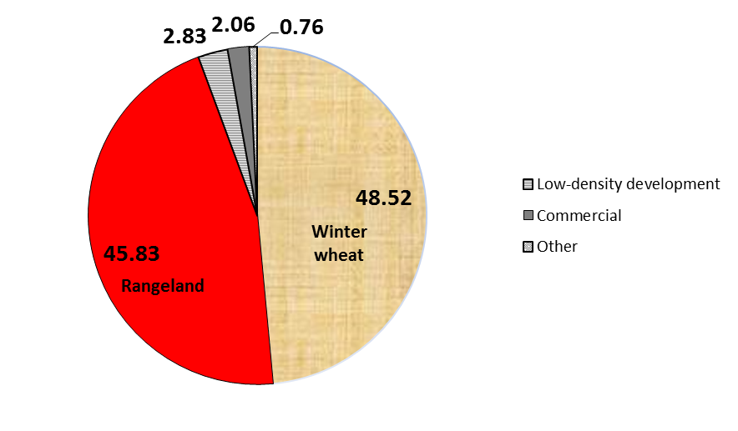
Figure 4.3: Land-use composition (%) of the SCW post-LU threshold delineation

4.3.2: Modeling Scenarios of Climate and Land Use Change
Bias corrected, statistically-downscaled (BCSD) monthly precipitation and temperature outputs at 1/8th degree resolution for sixteen General Circulation Models (GCMs) were downloaded from the World Climate Research Programme's Coupled Model Intercomparison Project phase 3 (CMIP3) multi-model dataset archive at http://gdo-dcp.ucllnl.org/downscaled_cmip3_projections/ (Wood et al., 2002, 2004; Maurer, 2007). The portal provides monthly climate outputs from 1950-2099 and daily climate outputs for 1961-2000, 2046-2065, and 2081-2100 for much of the western US. Table 4.2 lists the sixteen GCMs comprising the CMIP3 program. Only precipitation and temperature were downloaded due to the lack of downscaled solar radiation data at this portal. To facilitate comparison among the GCMs, the first member of the ensemble for each GCM in the BCSD archive was used. The A2 IPCC scenario was selected in order to highlight the most austere impacts of CO₂ emissions on climatic patterns by mid-century and because of computational limitations associated with running SWAT for additional scenarios. An approach similar to that used by Johnson et al. (2012) was used to process the precipitation and temperature data for the period from 2040-2050 for use in SWAT. This approach involved the computation of the projected percent change in monthly precipitation and raw change in monthly temperature for the 2040s relative to those predicted by the GCMs for the observed period-the 2000s. This approach is beneficial for our purpose not only because it makes use of observed climatic data which have undergone extensive quality analysis and control, but also because it captures intense, localized rainfall which downscaled GCM simulations of the SCW are unable to reproduce. The short simulation period was selected in order to correspond with the length of the short calibration period, which itself was necessitated by the short recent discharge record of the “Skeleton Creek near Lovell, OK” stream gage.
Before proceeding, acknowledgement of several limitations associated with the approach mentioned above is in order. First, I recognize the existence of a spatial mismatch in the climatic datasets, having used 4 km * 4 km NEXRAD rainfall data which were bias-corrected to point-based precipitation observations, point-based temperature observations, and 1/8th degree * 1/8th degree predictions of future precipitation and temperature. Such a mismatch can potentially produce large uncertainty in model results. Additionally, as a consequence of its small size, the SCW only overlaps few downscaled precipitation and temperature grid cells. Second, I recognize that the calibration and simulation time periods are not long enough to adequately capture interdecadal climate patterns and are at best a measure of short-term climatic variability. The period 2000-2010 mostly contained years of above-average rainfall in Oklahoma’s North Central Climate Division with the exception of 2001, 2003, and 2006 (http://climate.ok.gov/index.php/climate/climate_trends/precipitation_ history_annual_statewide/CD02/prcp/Annual). Unfortunately, the short length of record for the “Skeleton Creek at Enid” stream gage to which we calibrated did not permit analysis of a longer time period. Third, I recognize that an analysis using outputs solely from one IPCC SRES scenario can restrict the breath of this investigation. However, computational limitations hindered our ability to utilize outputs from other scenarios. To facilitate comparison between model runs, we chose to analyze the outputs from many GCM runs for a particular scenario rather than to use fewer GCMs from many scenarios. Finally, I acknowledge that the SCW does not overlap many 1/8th degree grid cells, which can potentially limit the breadth of the GCM outputs utilized.
To investigate the response of the SCW to both climate change and switchgrass cultivation, 32 SWAT simulations were run. The first sixteen simulations (one for each of the BCSD GCMs, as described above) were run under the “climate change only” (CCO) scenario, in which only the precipitation and temperature values were modified. In addition to the changed climate, the additional sixteen simulations were run under a regime in which pre-existing winter wheat, rye, and range grasses, which collectively account for 89% of the watershed, were converted to switchgrass. This is subsequently referred to as the “climate change + switchgrass” or CCS scenario. Switchgrass was managed according to the schedule reported by Goldstein et al. (2013):
a. Fertilize 56 kg ha⁻¹ N on April 15, May 17, and July 17 of each year.
b. Harvest (90% efficiency), on May 15, July 15, and November 1 of each year.
Per Baskaran et al. (2010), switchgrass cultivation was simulated as having 3-meter roots, an initial leaf area index of 0.5 and an initial quantity of 500 kg/ha dry-weight biomass. Switchgrass was assigned 1187 heat units for growth. As in the baseline run, the Hargreaves equation was used to simulate evapotranspiration.

Table 4.2: GCMs used in this investigation. Table adapted from Reclamation (2013). Used with permission
GCM | Developer | Primary Reference
BCCR_BCM_2.0 | Bjerknes Centre for Climate Research | Furevik et al. 2003
CGCM3.1 (T47) | Canadian Centre for Modeling and Analysis | Flato and Boer 2001
CNRM_CM3 | Meteo-France / Centre National de Recherches Meteorologiques, France | Salas-Melia et al. 2005
CSIRO_MK3_0 | CSIRO Atmospheric Research, Australia | Gordon et al. 2002
GFDL_CM_2_0 | NOAA Geophysical Fluid Dynamics Laboratory, USA | Delworth et al. 2006
GFDL_CM_2_1 | NOAA Geophysical Fluid Dynamics Laboratory, USA | Delworth et al. 2006
GISS_MODEL_E_R | NASA Goddard Institute for Space Studies, USA | Russell et al. 2000
INMCM3_0 | Institute for Numerical Mathematics, Russia | Diansky and Volodin 2002
IPSL_CM4 | Institut Pierre Simon Laplace, France | Marti et al. 2005
MIROC3.2 (MEDRES) | Center for Climate System Research (The University of Tokyo), National Institute for Environmental Studies, and Frontier Research Center for Global Change (JAMSTEC), Japan | Hasumi and Emori 2004
MIUB_ECHOG | Meteorological Institute of the University of Bonn, Meteorological Research Institute of KMA | Legutke and Voss 1999
ECHAM5/MPI-OM | Max Planck Institute for Meteorology, Germany | Jungclaus et al. 2005
MRI-CGCM2.3.2 | Meteorological Research Institute, Japan | Yukimoto et al. 2001
CCSM3 | National Center for Atmospheric Research, USA | Collins et al. 2006
PCM | National Center for Atmospheric Research, USA | Washington et al. 2000
UKMO-HADCM3 | Hadley Centre for Climate Prediction and Research Met Office, UK | Gordon et al. 2000

4.4: Results

4.4.1: Sensitivity Analysis and Calibration
Sensitivity analyses internal to the SWAT interface (van Griensven et al., 2006) were performed using observed monthly streamflow data at the two stream gages located in the watershed. Using a sensitivity index threshold of 1, implying a high sensitivity to input parameters, only one of twenty-six parameters, the “threshold depth of water in the shallow aquifer required for return flow to occur (mm H₂0)” parameter, was identified as sensitive at the upstream gage, and no parameters were sensitive at the downstream gage (Table 4.3a-b). Consequently, no further calibration was applied. Moriasi et al. (2007) provide criteria for evaluating the strength of model calibration as follows. A "very good” fit is characterized by a Nash-Sutcliffe Efficiency (NSE) > 0.75, Percent Bias (PBIAS) < ±10%, and RMSE-observations standard deviation ratio (RSR) ≤ 0.5. An “acceptable” match is one with NSE > 0.5, PBIAS < ±25%, and RSR < 0.7. On these criteria, a obtained a “very good” fit between simulated and observed monthly discharges (Q) at both stream gages was obtained (Figure 4.4). The fit between simulated and observed Q was also evaluated on a seasonal timescale defined as follows: winter (December-January-February), spring (March-April-May), summer (June-July-August), and fall (September-October-November). These fits were acceptable for all seasons except for fall (NSE < 0, Figure 4.5), which therefore was not utilized for further simulations.

Table 4.3: Most sensitive parameters from the Sensitivity Analysis for discharge at the (a) “Skeleton Creek at Enid, OK” USGS stream gage (upstream) and at the (b) “Skeleton Creek near Lovell, OK” USGS stream gage (downstream)

(a) Sensitivity Rankingª | Parameter | Description | Initial value |  |  | Range Tested |  | Sensitivity Index
1 | Gwqmn | Threshold depth of water in the shallow aquifer required for return flow to occur (mm) |  | 150 |  | -150, 4850 |  | 1.14
2 | Alpha_bf | Baseflow recession factor (days) |  | 0.01 |  | 0.01, 0.05 |  | 0.329
3 | Ch_K2 | Effective hydraulic conductivity in  main channel alluvium (mm/hr) |  | 10 |  | 1, 150 |  | 0.273
4 | Rchrg_dp | Deep Aquifer Percolation Function |  | 0 |  | 0, 1 |  | 0.243
5 | Cn2 | Initial Soil Conservation Service curve number for moisture condition II |  | Default |  | ±10%^{b} |  | 0.118
(b)
1 | Cn2 | Initial Soil Conservation Service curve  number for moisture condition II |  |  | Default |  | ±10%^{b} | 0.631
2 | Canmx | Maximum canopy storage (mm) |  |  | 0 |  | 0, 10 | 0.113
3 | Esco | Soil evaportation compensation factor |  |  | 0.72 |  | 0.6, 0.8 | 0.0789
4 | Sol_awc | Available water capacity of the soil  layer (mm H₂0/mm soil) |  |  | Default |  | -±4%^{b} | 0.0642
5 | Surlag | Surface runoff lag coefficient (days) |  |  | 24 |  | 1, 24 | 0.0598
ª in decreasing order of sensitivity ^{b} multiplied initial value by values in range.
Figure 4.4: Strength of calibration between simulated monthly discharges, 2002-2010, at the (a) “Skeleton Creek at Enid, OK” stream gage and at (b) the “Skeleton Creek near Lovell, OK” USGS stream gages.

Figure 4.5: Strength of calibration on simulated (a) winter, b) spring, and (c) summer discharges relative to observed, 2002-2010, at the watershed outlet: the “Skeleton Creek near Lovell, OK” USGS stream gage

4.4.2: Impacts of Projected Climate Change on the SCW
The impacts of climate change are mixed but not surprising; exactly half of the 192 GCM monthly precipitation series show increased precipitation while the other half shows decreased precipitation. Other studies (e.g. Tebaldi et al., 2011; Deser et al., 2012; Jin and Sridhar, 2012) found similar results for precipitation projections elsewhere. Considering each season separately, the projections show increases in winter months in 54% of cases, compared to 46% which show decreases. These percentages are almost exactly reversed in spring and fall. In summer, however, the models show relatively greater agreement, with increases projected in 40% of cases and decreases in 60%. Not surprisingly, the GCMs also disagree regarding the direction of change in seasonal precipitation (Figure 4.6a).
The changes in temperature are more decisive; 172 (90.0%) of the 192 GCM-months simulated (12 months * 16 GCM runs) project higher temperatures during 2042-2050 relative to the base period. Regarding the seasonal values (Figure 4.6b), the median temperature increases range from 1.0 °C (winter) to 1.2 °C (spring and summer). In addition, note that the 1st and 3rd quartiles and temperature ranges are also highest in the summer, and the variance among the GCM outputs exceeds those of the winter and spring by three-fold. These are noteworthy because they imply that the largest changes in temperature may coincide with the largest changes in precipitation.

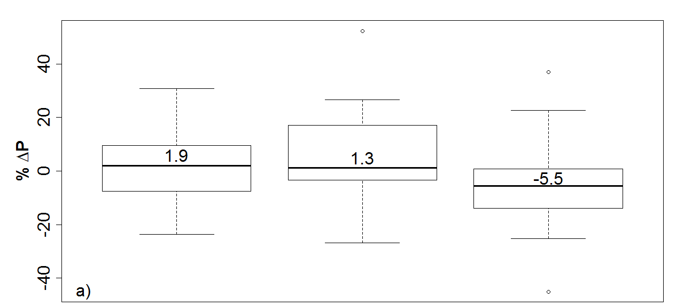
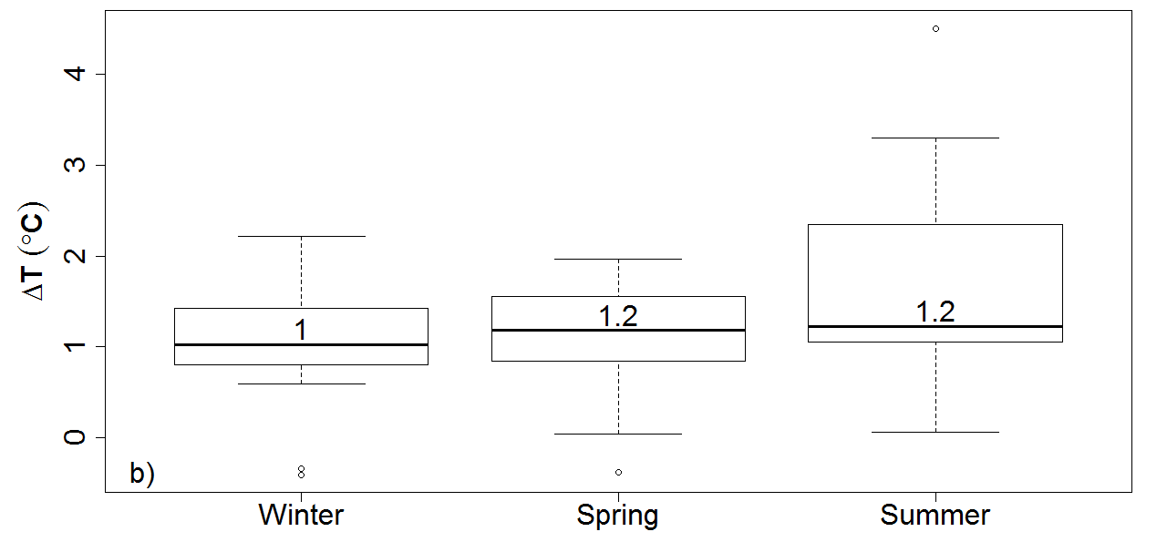
Figure 4.6: The percent change in mean climate-change induced seasonal a) precipitation and b) temperature, relative to 2000-2010 conditions, as evaluated by sixteen GCMs. The median values (black lines) are provided. Circles indicate outlying values.

4.4.3: Response of the SCW to Climate Change and Switchgrass Cultivation
Tables presenting the change in average seasonal precipitation (%ΔP), temperature (ΔT), surface runoff (%Δr_{s}), and evapotranspiration (%ΔeT) between the 2040s and the base period for the winter, spring, and summer seasons, respectively, by GCM are included in the Dissertation Appendix (Tables A.1-A.3). Boxplots illustrating the statistical summaries of %Δr_{s} and %ΔeT, according to season, are displayed as Figure 4.7, and a division of the medians (CCS/CCO), by season for the purpose of investigating the extent of the amplification of decreased winter and summer %Δr_{s} and amplification of increased winter and spring %ΔeT, is presented as Table 4.4. Regarding %Δr_{s}, note that the values of the 5-number summary under CCO always exceed those for CCS, and such values under CCS are always negative. The reduced variation in %Δr_{s} under the CCS scenario relative to the CCO scenario may result from prairie streams having increased baseflow, higher infiltration, and a lower contribution from direct runoff, relative to agricultural streams (e.g. Heimann 2009). The reduced contribution from direct runoff causes the prairie streams to possess a less “flashy” character than their agricultural counterparts.
For %ΔeT, the winter-season values of CCS are smaller than those under CCO, but those for spring and summer are larger. The replacement of winter wheat results in dormant switchgrass stubble during the winter, reducing eT. I speculate that reduced streamflow may be a function of a lack of available soil moisture due to switchgrass having exhausted the soil moisture during the late spring/early summer rainy season. With regard to the spring, while winter wheat and range grasses are not at full productivity, the impacts of the mid-April and mid-May fertilizer applications for switchgrass generated a nine-fold increase in %ΔeT under CCS relative to that under CCO, which is the largest amplification presented in Table 4.4. Consequently, the large amplification in spring %ΔeT results in a drastic reduction in %Δr_{s}. The 48% of the watershed associated with winter wheat cultivation, which is dormant under CCO during the summer, is replaced with large quantities of active switchgrass, likewise resulting in increased basin-wide eT. The decreased surface runoff and increased evapotranspiration associated with switchgrass management absent a change in climate during the spring and summer is consistent with previous findings (i.e. Goldstein et al. 2013).
Based on the results of multiple regression analysis (see also Vogel, 2006; Liu and Cui, 2011) in which precipitation and temperature were plotted against %Δr_{s} and separately against %ΔeT, %Δr_{s} is strongly associated with the change in precipitation, but not temperature, in all three seasons, with R² values of 0.74, 0.93, and 0.91, respectively (p<0.05 in all cases). Similarly, %ΔeT is also strongly associated with changes in precipitation for the spring and summer, with R² values of 0.71 and 0.87, respectively. The multiple regression also shows changes in summer eT to be the only parameter significantly associated with both changes in precipitation and temperature (p<0.05).

Table 4.4: Comparison of the median %Δr_{s} and %ΔeT values listed in Figures 6 and 7. Positive values indicate the switchgrass-based amplification of the hydrologic output. Negative values indicate a difference in the sign of the medians in the CCO and CCS scenarios, in which case there is no amplification.
 | %Δr_{s} | %ΔeT
Season | CCS/CCO | CCS/CCO
Winter | 3.31 | 2.92
Spring | -9.27 | 9.4
Summer | 4.47 | n/a⁺
⁺Division by zero.

4.4.4: Determination of dominant mechanism affecting hydrology
The individual contributions of climate change and land use change (switchgrass cultivation) to the percent change in average seasonal runoff and eT associated with the CCS scenario are analyzed by dividing the percent change resulting from the CCO only scenario by that in the CCS scenario. No dominant process can be identified where the signs of the changes in these drivers differ and where the hydrologic output under CCO exceeds that of CCS.
The dominant process in each season is identified in Tables 4.5 (for surface runoff) and 4.6 (for eT). The results are mixed. The dominant process is a function of the GCM employed. Regarding %Δr_{s}, the contribution of climate change exceeds that of switchgrass cultivation in five of the nine GCMs (56%) during the winter months, three of seven (43%) during the spring, and five of twelve (42%) during the summer. In contrast to the multifaceted picture of surface runoff-generating mechanisms, switchgrass is very clearly the dominant driver in the percent change in %ΔeT (Table 4.6). Climate dominates in four of the thirteen GCMs (31%) during the winter, in none during the spring, and in only one of nine (11%) during the summer. In Table 4.6, the plethora of blank spaces for spring %ΔeT represents that in 15 of the 16 GCMs, switchgrass cultivation is responsible for reversing the change in eT from positive under CCO to negative under CCS.

4.5: Conclusions
Various studies have investigated the relative impacts of climate and land use change on local hydrology. Often, these results are mixed and the contributions appear to be governed by spatial and temporal scale. A SWAT model of the 1061 km² Skeleton Creek Watershed (SCW) in the US Great Plains was created for the years 2000-2010. Simulated discharges were successfully calibrated to observed discharges on the monthly timescales and for winter, spring, and summer only. To investigate the impact of changing precipitation and temperature patterns on this watershed during the middle of the 21st century (2040-2050), SWAT was run by adding the projected anomalies in percent change in monthly precipitation and raw change in temperature relative to the observed period for each of sixteen GCMs to the observed precipitation and temperature data for 2000-2010. The climate change runs were subsequently rerun on top of a land use change scenario in which existing agricultural land (89% of the watershed) was converted to Alamo switchgrass. The main findings of this study are as follows:

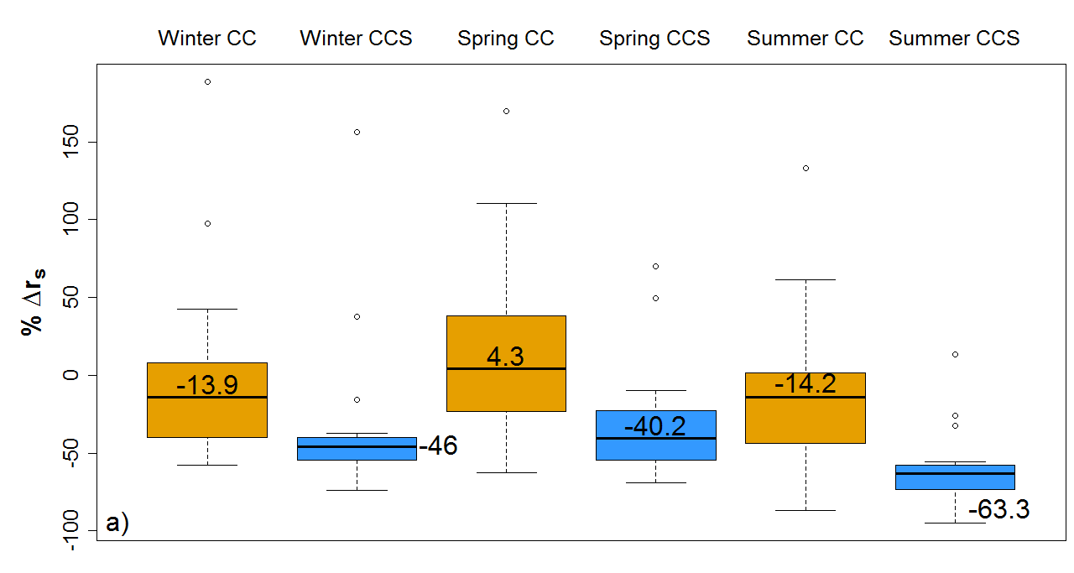
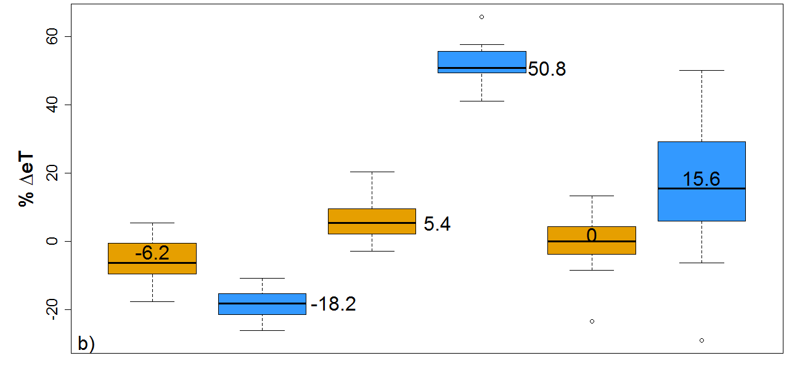
Figure 4.7: Comparison of percent change in (a) surface runoff and (b) evapotranspiration, by season, for the 2040s relative to baseline under the CCO and CCS scenarios as simulated based on 16 GCMs. The values of the medians are listed. Circles indicate outliers.

(a) The GCMs disagree on the direction of the change in precipitation during the 2040s, but they largely agree on a 1-2^{O} C increase in seasonal temperature.
(b) The direction of the percent changes in average surface runoff projected by SWAT during the three seasons varies by GCM, resulting in predictions of both increases and decreases. While precipitation was associated with changes in winter, spring, and summer surface runoff, in addition to spring and summer eT, changes in temperature only impacted changes in summer eT.
(c) During winter, spring, and summer, switchgrass cultivation results in decreased surface runoff relative to the CCO scenario. Switchgrass cultivation also results in decreased winter eT and increased spring and summer eT relative to the CCO scenario.
(d) Depending on the GCM employed and the season, either climate change or switchgrass cultivation can be identified as the dominant driver of changes in surface runoff. Under the vast majority of GCMs, switchgrass cultivation is the dominant driver of changes in eT.
Further investigation into the impacts of changing other climatic parameters and into the analysis of longer-time periods is warranted in order to more definitively investigate the impacts of climate change and switch grass cultivation on basin hydrology. Additionally, further research into biofuel crops other than switchgrass is necessary in order to gain a more coherent picture of the impacts of biofuel production.

Table 4.5: Contributions of climate change (“Clim”) and switchgrass cultivation (“Swch”) to %Δr_{s} in the 2040s under the CCS scenario, relative to the present, during the winter, spring, and summer seasons. Blank entries refer to situations where the sign of %ΔeT differs by situation. Dashes identify GCMs under which the % contribution of climate change relative to that under the CCS simulation exceeds 100%, meaning that the climate change contribution exceeds that of switchgrass.

GCM | Winter |  | Spring |  | Summer
 | Clim | Swch | Clim | Swch | Clim | Swch
BCCR_BCM_2.0 | 74.16 | 25.84 | - | - | 39.27 | 60.73
CCSM3 |  |  | 52.58 | 47.42
CGCM3.1 (T47) | - | - |  |  | 80.12 | 19.88
CNRM_CM3 | 28.66 | 71.34 |  |  | 70.58 | 29.42
CSIRO_MK3_0 | 28.72 | 71.28 | - | - | 14.94 | 85.06
ECHAM5/MPI-OM | - | - | 56.39 | 43.61 | - | -
GFDL_CM_2_0 | 66.95 | 33.05 |  |  | 91.48 | 8.52
GFDL_CM2_1 | 24.79 | 75.21 | 32.46 | 67.54 | 56.14 | 43.86
GISS_MODEL_E_R | 78.54 | 21.46 | 24.56 | 75.44 | 23.21 | 76.79
INMCM3_0 |  |  | 48.37 | 51.63 | 23.93 | 76.07
IPSL_CM4 | - | - | 75.01 | 24.99
MIROC3.2 (MEDRES) | 25.13 | 74.87 |  |  | 72.04 | 27.96
MIUB_ECHOG | 69.64 | 30.36 | 3.05 | 96.95 | 4.26 | 95.74
MRI-HADCM3 |  |  |  |  | 18.41 | 81.59
PCM
UKMO-HADCM3 | 81.38 | 18.62 |  |  | 19.63 | 80.37
Minimum | 24.79 | 18.62 | 3.05 | 24.99 | 4.26 | 8.52
1st Quartile | 28.66 | 25.84 | 28.51 | 45.52 | 19.33 | 29.06
Median | 66.95 | 33.05 | 48.37 | 51.63 | 31.6 | 68.4
3rd Quartile | 74.16 | 71.34 | 54.49 | 71.49 | 70.95 | 80.68
Maximum | 81.38 | 75.21 | 75.01 | 96.95 | 91.48 | 95.74

Table 4.6: Contributions of climate change (“Clim”) and switchgrass cultivation (“Swch”) to %Δr_{s} in the 2040s under the CCS scenario, relative to the present, during the winter, spring, and summer seasons. Blank entries refer to situations where the sign of %ΔeT differs by situation. Dashes identify GCMs under which the % contribution of climate change relative to that under the CCS simulation exceeds 100%, meaning that the climate change contribution exceeds that of switchgrass.

GCM | Winter |  | Spring |  | Summer
 | Clim | Swch | Clim | Swch | Clim | Swch
BCCR_BCM_2.0 | 6.32 | 93.68 |  |  | 5.59 | 94.41
CCSM3 | 87.47 | 12.53 |  |  | 29.03 | 70.97
CGCM3.1 (T47) | 13.05 | 86.95
CNRM_CM3 | 39.45 | 60.55
CSIRO_MK3_0 | 37.81 | 62.19 |  |  | 4.24 | 95.76
ECHAM5/MPI-OM |  |  |  |  | 19.58 | 80.42
GFDL_CM_2_0 | 97.02 | 2.98 |  |  | 80.7 | 19.3
GFDL_CM2_1 | 28.26 | 71.74
GISS_MODEL_E_R | 30.41 | 69.59
INMCM3_0 | 45.04 | 54.96 |  |  | 8.54 | 91.46
IPSL_CM4 | 1.59 | 98.41 |  |  | 24.07 | 75.93
MIROC3.2 (MEDRES) | 92.35 | 7.65 | 25.71 | 74.29 | - | -
MIUB_ECHOG | 53.04 | 46.96 |  |  | 21.36 | 78.64
MRI-HADCM3 | 19.22 | 80.78
PCM |  |  |  |  | 9.5 | 90.5
UKMO-HADCM3
Minimum | 1.59 | 2.98 |  |  | 4.24 | 19.3
1st Quartile | 19.22 | 46.96 |  |  | 8.54 | 75.93
Median | 37.81 | 62.19 | 25.71 | 74.29 | 19.58 | 80.42
3rd Quartile | 53.04 | 80.78 |  |  | 24.07 | 91.46
Maximum | 97.02 | 98.41 |  |  | 80.7 | 95.76

Acknowledgements
I am grateful to Raghavan Srinivasan (Texas A&M University), David Brauer (Ogallala Aquifer Program, USDA-ARS, Chris Weaver (US Environmental Protection Agency; U.S. Global Change Research Program), Harold Crowley (National Weather Service Arkansas-Red Basin River Forecast Center) Xuesong Zhang (Pacific Northwest National Laboratory), and Bob Sandbo (Oklahoma Water Resources Board). I also thank Oklahoma State University extension agents Keith Boevers, Jeff Bedwell, Roger Gribble, and Courtney Koats for providing crop management information for the SCW counties. With regards to climatic data, I also acknowledge the modeling groups, the Program for Climate Model Diagnosis and Intercomparison (PCMDI) and the WCRP's Working Group on Coupled Modelling (WGCM) for their roles in making available the WCRP CMIP3 multi-model dataset. Support of this dataset is provided by the Office of Science, U.S. Department of Energy.

References
Arnold, JG, Srinivasan R, Muttiah RS, Williams JR. 1998. Large area hydrologic modeling and assessment - part 1: model development. Journal of the American Water Resources Association 34: 73-89. DOI: 10.1111/j.1752- 1688.1998.tb05961.x.
Baskaran L, Jager HI, Schweizer PE, Srinivasan R. 2010. Progress towards evaluating the sustainability of switchgrass as a bioenergy crop using the SWAT model. Transactions of the ASABE 53: 1547-1556.
Beeson PC, Doraiswamy PC, Sadeghi AM, Di Luzio M, Tomer MD, Arnold JG, Daughtry CST. 2011. Treatments of precipitation inputs to hydrologic models. Transactions of the ASABE 54: 2011-2020.
Becker, CJ. Runkle D, Rea A. 1997. Digital Data Sets that Describe Aquifer Characteristics of the Enid Isolated Terrace Aquifer in Northwestern Oklahoma, U.S. Geological Survey Open-File Report 96-450. United States Geological Survey: Oklahoma City.
Bronstert A. 2004. Rainfall-runoff modelling for assessing impacts of climate and land- use change. Hydrological Processes 18: 567-570. DOI: 10.1002/0470848944.hsa139.
Brown C. 2010. The End of Reliability, Journal of Water Resources Planning and Management (ASCE) 36: 143-145. DOI: 10.1061/(ASCE)WR.1943-5452.65.
Collins WD, Bitz CM, Blackmon ML, Bonan GB, Bretherton CS, Carton JA, Chang P, Doney SC, Hack JJ, Henderson TB, Kiehl JT, Large WG., McKenna DS, Santer BD, Smith RD. 2006. The Community Climate System Model Version 3 (CCSM3). Journal of Climate 19: 2122-2143. DOI: 10.1175/JCLI3761.1
Crum TD, Saffle RE, Wilson JW. 1998. An Update on the NEXRAD program and future WSR-88D support to operations. Weather and Forecasting 13: 253-262. DOI: 10.1175/1520-0434(1998)013<0253:AUOTNP>2.0.CO;2.
Delworth TL., et al., 2006. GFDL's CM2 Global coupled climate models. part I: formulation and simulation characteristics. Journal of Climate 19: 643-674. DOI: 10.1175/JCLI3629.1.
Demissie Y, Yan E, Wu M. 2012. Assessing regional hydrology and water quality implications of large-scale biofuel feedstock production in the Upper Mississippi River Basin. Environmental Science & Technology 46: 9174-9182. DOI: 10.1021/es300769k.
Deser C, Knutti R, Solomon S, Phillips AS. 2012. Communication of the role of natural variability in future North American climate. Nature Climate Change 2: 775-779. DOI: 10.1038/nclimate1562.
Diansky, NA, Volodin EM. 2002. Simulation of present-day climate with a coupled atmosphere-ocean general circulation model. Izvestiya, Atmospheric and Oceanic Physics 38: 732-747.
Djomo SN, Ceulemans, R. 2012. A comparative analysis of the carbon intensity of biofuels caused by land use changes. Global Change Biology Bioenergy 4: 392- 407. DOI: 10.1111/j.1757-1707.2012.01176.x.
Flato, GM, Boer GJ. 2001. Warming asymmetry in climate change simulations, Geophysical Research Letters 28: 195-198. DOI: 10.1029/2000GL012121.
Franczyk J, Chang H. 2009. The Effects of climate change and urbanization on the runoff of the Rock Creek basin in the Portland metropolitan area, Oregon, USA. Hydrological Processes 23: 805-815. DOI: 10.1002/hyp.7176.
Fritsch JM, Kane RJ, Chelius CR. 1986. The Contribution of mesoscale convective weather systems to the warm-season precipitation in the United States, Journal of Climate and Applied Meteorology 25: 1333-1345. DOI: 10.1175/15200450(1986)025<1333:TCOMCW>2.0.CO;2.
Furevik T, Bentsen M, Drange H, Kindem IKT, Kvamsto NG, Sorteberg A. 2003. Description and evaluation of the Bergen climate model: ARPEGE coupled with MICOM. Climate Dynamics 21: 27-51. DOI: 10.1007/s00382-003-0317-5.

Gali R, Douglas-Mankin K, Li X, Xu T. 2012. Assessing NEXRAD P3 data effects on stream- flow simulation using SWAT model in an agricultural watershed. Journal of Hydrologic Engineering 17: 1245-1254. DOI: 10.1061/(ASCE)HE.1943-5584.0000618.
Goldstein JC, Tarhule A, Brauer D. 2013. Simulating the hydrologic response of a semiarid watershed to switchgrass cultivation. In-press with Hydrology Research. DOI: 10.2166/nh.2013.163.
Groisman PY, Legates DR. 1994. The Accuracy of United States precipitation data. Bulletin of the American Meteorological Society 75: 215-227. DOI: 10.1175/1520-0477(1994)075<0215:TAOUSP>2.0.CO;2.
Gordon C, Cooper C, Senior CA, Banks H, Gregory JM, Johns TC, Mitchell JFB, Wood RA. 2000. The simulation of SST, sea ice extents and ocean heat transports in a version of the Hadley Centre coupled model without flux adjustments. Climate Dynamics 16: 147-168. DOI: 10.1007/s003820050010.
Gordon HB, Rotstayn LD, McGregor JL, Dix MR, Kowalczyk EA, O’Farrell SP, Waterman LJ, Hirst AC, Wilson SG, Collier MA, Watterson IG, Elliott TI. 2002. The CSIRO Mk3 Climate System Model. CSIRO Australia: Melbourne; 130.
Hargreaves GL, Hargreaves GH, Riley J. 1985. Agricultural Benefits for Senegal River Basin. Journal of Irrigation and Drainage Engineering 111: 113-124. DOI: 10.1061/(ASCE)0733-9437(1985)111:2(113).
Hasumi H, Emori S. 2004. K-1 Coupled GCM (Miroc) Description. Center for Climate System Research, University of Tokyo: Tokyo; 34.
Heimann, DC. 2009. Comparison of Hydrologic and Water-quality Characteristics of Two Native Tallgrass Prairie Streams with Agricultural Streams in Missouri and Kansas, Scientific Investigations Report 2009–5213. United States Geological Survey: Reston.
Hertel, TW, Golub AA, Jones AD, O'Hare M, Plevin RJ, Kammen DM. 2010. Effects of US maize ethanol on global land use and greenhouse gas emissions: estimating market-mediated Responses. Bioscience 60: 223-231. DOI: 10.1525/bio.2010.60.3.8.
Intergovernmental Panel on Climate Change. 2000. IPCC Special Report, Emissions Scenarios: Summary for Policymakers. Available on-line at: http://www.ipcc.ch/pdf/special-reports/spm/sres-en.pdf, last accessed 7 May 2013.
Jayakrishnan R, Srinivasan R, Arnold JG. 2004. Comparison of raingage and WSR- 88D Stage III precipitation data over the Texas-Gulf Basin. Journal of Hydrology 292: 135-152. DOI: 10.1016/j.jhydrol.2003.12.027.
Jin X, Sridhar V. 2012. Impacts of climate change on hydrology and water resources in the Boise and Spokane River Basins. Journal of the American Water Resources Association 48: 197-220. DOI: 10.1111/j.1752-1688.2011.00605.x.
Johnson T, Butcher J, Parker A, Weaver C. 2012. Investigating the sensitivity of U.S. streamflow and water quality to climate change: U.S. EPA Global Change Research Program’s 20 Watersheds Project. Journal of Water Resources Planning and Management 138: 453-464. DOI: 10.1061/(ASCE)WR.1943- 5452.0000175.
Jones OR, Eck HV, Smith SJ, Coleman GA, Hauser VL. 1985. Runoff, soil, and nutrient losses from rangeland and dry-farmed cropland in the Southern High- Plains. Journal of Soil and Water Conservation 40: 161-164.
Jungclaus JH, Keenlyside N, Botzet M, Haak H, Luo JJ, Latif M, Marotzke J, Mikolajewicz U, Roeckner E. 2006. Ocean circulation and tropical variability in the coupled model ECHAM5/MPI-OM. Journal of Climate 19: 3952-3972. DOI: 10.1175/JCLI3827.1.
Kent DC, Beausoleil YJ, Witz FE. 1982. Evaluation of Aquifer Performance and Water Supply Capabilities of the Enid Isolated Terrace Aquifer in Garfield County, Oklahoma. Department of Geology, Oklahoma State University: Stillwater; 58.
Legates DR, DeLiberty TL. 1993. Precipitation measurement biases in the United States. JAWRA Journal of the American Water Resources Association 29: 855- 861. DOI: 10.1111/j.1752-1688.1993.tb03245.x.
Legutke S, Voss R. 1999. The Hamburg Atmosphere-Ocean Coupled Circulation Model ECHO-G. Hamburg: Modell Betreuungsgruppe DKRZ; 62.
Liu Q, Cui B. 2011. Impacts of climate change/variability on the streamflow in the Yellow River Basin, China. Ecological Modelling 222: 268-274. DOI: 10.1016/j.ecolmodel.2009.11.022.
Ma X, Xu JC, van Noordwijk M. 2010. Sensitivity of streamflow from a Himalayan catchment to plausible changes in land cover and climate. Hydrological Processes 24: 1379-1390. DOI: 10.1002/hyp.7602.
Marti O, et al., 2005. The New IPSL climate system model: IPSL-CM4. Note du Pôle de Modélisation, IPSL 26: 1-86.
Maurer, EP. 2007. Uncertainty in hydrologic impacts of climate change in the Sierra Nevada, California, under two emissions scenarios. Climatic Change 82: 309- 325. DOI: 10.1007/s10584-006-9180-9.
Milly, PCD, Betancourt J, Falkenmark M, Hirsch RM, Kundzewicz ZW, Lettenmaier DP, Stouffer RJ. 2008. Climate change - stationarity is dead: whither water management?. Science 319: 573-574. DOI: 10.1126/science.1151915.
Montenegro S, Ragab R. 2012. Impact of possible climate and land use changes in the semi arid regions: a case study from North Eastern Brazil, Journal of Hydrology, 434–435, 55-68. DOI: 10.1016/j.jhydrol.2012.02.036.
Moriasi DN, Arnold JG, Van Liew MW, Bingner RL, Harmel RD, Veith TL. 2007. Model evaluation guidelines for systematic quantification of accuracy in watershed simulations. Transactions of the ASABE, 50: 885-900.
National Research Council. 2008. Water Implications of Biofuels Production in the United States. National Academies Press: Washington, D.C.: National Academies Press; 76.
Neitsch SL, Arnold JG, Kiniry, JR, Williams JR. 2011. Soil and Water Assessment Tool Theoretical Documentation Version 2009: Texas Water Resources Institute Technical Report No. 406. Texas Water Resources Institute: College Station, TX; 618. Available on-line at: http://twri.tamu.edu/reports/2011/tr406.pdf. Last accessed 15 September 2013.
Praskievicz S, Chang H. 2009. A Review of hydrological modelling of basin-scale climate change and urban development impacts. Progress in Physical Geography 33: 650-671. DOI: 10.1177/0309133309348098.
Praskievicz S, Chang H. 2011. Impacts of climate change and urban development on water resources in the Tualatin River Basin, Oregon. Annals of the Association of American Geographers 101: 249-271. DOI: 10.1080/00045608.2010.544934.
Reclamation. 2013. Downscaled CMIP3 and CMIP5 Climate Projections: Release of Downscaled CMIP5 Climate Projections, Comparison with Preceding Information, and Summary of User Needs. U.S. Department of the Interior, Bureau of Reclamation, Technical Service Center: Denver; 116. Available on- line at: http://gdodcp.ucllnl.org/downscaled_cmip_projections/techmemo/downscaled_c
limate.pdf (last accessed 21 September 2013).

Russell GL, Miller JR, Rind D, Ruedy RA, Schmidt GA, Sheth S. 2000. Comparison of model and observed regional temperature changes during the past 40 years. Journal of Geophysical Research-Atmospheres 105: 14891-14898. DOI: 10.1029/2000JD900156.
Salas-Melia D, Chauvin F, Deque M, Douville H, Gueremy JF, Marquet P, Planton S, Royer JF, Tyteca S. 2005. Description and validation of the CNRM-CM3 global coupled model: CNRM Technical Report 103. Toulouse: CNRM. Available on-line at: http://www.cnrm.meteo.fr/scenario2004/paper_cm3.pdf. Last accessed 7 May 2013.
Searchinger T, Heimlich R, Houghton RA, Dong F, Elobeid A, Fabiosa J, Tokgoz S, Hayes D, Yu T-H. 2008. Use of US croplands for biofuels increases greenhouse gases through emissions from land-use change. Science 319: 1238- 1240. DOI: 10.1126/science.1151861.
Schilling KE, Jha MK, Zhang YK, Gassman PW, Wolter CF. 2008. Impact of land use and land cover change on the water balance of a large agricultural watershed: Historical effects and future directions. Water Resources Research 44: W00A09. DOI: 10.1029/2007WR006644.
Sexton AM, Sadeghi AM, Zhang X, Srinivasan R, Shirmohammadi A. 2010. Using NEXRAD and rain gauge precipitation data for hydrologic calibration of SWAT in a northeastern watershed. Transactions of the ASABE 53: 1501-1510.
Sheshukov, AY, Daggupati P, Lee M-C, Douglas-Mankin K. 2009. ArcMap Tool for Pre-processing SSURGO Soil Database for ArcSWAT. Proceedings of the 5th International SWAT Conference, Boulder, CO Aug 5-7, 2009.
Sohl TL, Sleeter BM, Sayler KL, Bouchard MA, Reker RR, Bennett SL, Sleeter RR, Kanengieter RL, Zhu ZL. 2012. Spatially explicit land-use and land-cover scenarios for the Great Plains of the United States. Agriculture, Ecosystems and Environment 153: 1-15. DOI: 10.1016/j.agee.2012.02.019.
Steinschneider S, Brown C. 2012. Dynamic reservoir management with real-option risk hedging as a robust adaptation to nonstationary climate. Water Resources Research 48: W05524. DOI: 10.1029/2011WR011540.
Tebaldi C, Arblaster JM, Knutti R. 2011. Mapping model agreement on future climate projections. Geophysical Research Letters 38: L23701. DOI: 10.1029/2011GL049863.
U.S. Global Change Research Program. 2009. Global climate change impacts in the United States. Cambridge University Press: New York; 188.
van Griensven A, Meixner T, Grunwald S, Bishop T, Diluzio A, Srinivasan R. 2006. A Global sensitivity analysis tool for the parameters of multi-variable catchment models. Journal of Hydrology 324: 10-23. DOI: 10.1016/j.jhydrol.2005.09.008.
Viger RJ, Hay LE, Markstrom SL, Jones JW, Buell GR. 2011. Hydrologic effects of urbanization and climate change on the Flint River Basin, Georgia. Earth Interactions 15: 1-25. DOI: 10.1175/2010EI369.1.
Vogel RM. 2006. Regional calibration of watershed models. In Watershed Models, Singh VP, Frevert DF (eds). CRC Press: Boca Raton; 47-71.
Vorosmarty, CJ, Green P, Salisbury J, Lammers RB. 2000. Global water resources: vulnerability from climate change and population growth, Science 289: 284- 288. DOI: 10.1126/science.289.5477.284.
Washington WM, Weatherly JW, Meehl GA, Semtner Jr AJ, Bettge TW, Craig AP, Strand Jr WG, Arblaster J, Wayland VB, James R, Zhang Y. 2000. Parallel climate model (PCM) control and transient simulations. Climate Dynamics 16: 755-774.
Wood AW, Maurer EP, Kumar A, Lettenmaier DP. 2002. Long-range experimental hydrologic forecasting for the eastern United States. Journal of Geophysical Research-Atmospheres 107: ACL 6-1-ACL-6-15. DOI: 10.1029/2001JD000659.
Wood AW, Leung LR, Sridhar V, Lettenmaier DP. 2004. Hydrologic implications of dynamical and statistical approaches to downscaling climate model outputs. Climatic Change 62:189-216. DOI: 10.1023/B:CLIM.0000013685.99609.9e.
Yukimoto S., Noda A, Kitoh A, Sugi M, Kitamura Y, Hosaka M, Shibata K, Maeda S, Uchiyama T. 2001. The New Meteorological Research Institute Coupled GCM (MRI-CGCM2): model climate and variability. Papers in Meteorology and Geophysics 41: 47-88.
Zhang X, Srinivasan R. 2009. GIS-based spatial precipitation estimation: a comparison of geostatistical approaches. JAWRA Journal of the American Water Resources Association 45: 894-906. DOI: 10.1111/j.1752-1688.2009.00335.x.
Zhang X, Srinivasan R. 2010. GIS-based spatial precipitation estimation using next generation radar and raingauge data. Environmental Modelling & Software 25: 1781-1788. DOI: 10.1016/j.envsoft.2010.05.012.

Chapter 5: Conclusion
The Great Plains Region of the United States of America (GP) has been at the center of discourse regarding the sustainability of agricultural regions in the US going back to the 19th century and continues to be so this day. Identified with monikers as “the Great American Desert,” “the Return of the Prairie” (Wallach 1985), and “the Buffalo Commons” (Popper and Popper 1987), it also has large agricultural and economic significance to the United States through its role as a hub for wheat production, livestock and dairy farming, and mineral extraction. A region characterized by population loss since 1930 likewise contains burgeoning and established micropolitan and metropolitan areas.
Recently, the prospect of the cultivation of biofuel crops, especially switchgrass, is causing some optimism regarding the future of the GP (e.g. Wood 2008; Kotkin 2012). However, biofuel cultivation, like any other land use change, is associated with changes in hydrology, which while always important, carry special significance in semiarid areas facing depleting water supplies, such as the GP. This dissertation explored this question through three investigations, each represented by a chapter. While Chapter 2 did not pertain to hydrologic modeling, Chapters 3 and 4 were exercises using the Soil and Water Assessment Tool (SWAT) hydrologic model (Arnold et al. 1998).

5.1: Objectives and Key Findings
There four objectives to this study, and associated key findings, are as follows:
(i) To contextualize the cultivation of switchgrass for biofuel cultivation within the GP’s history of land use change and in the discussions regarding sustainability in this region (Chapter 2).
Since the Civil War, the Great Plains has been predominantly an agricultural region with an economy based on the cultivation of wheat and sorghum, among other crops. Model results suggest that is expected to remain a largely agricultural region but will also continue to see continued growth along emerging and emerged micropolitan and metropolitan areas. Biofuel cultivation is a real possible land use change in agricultural portions of the Great Plains.
(ii) To assess and quantify the direction and magnitude of change in key hydrologic variables, including seasonal stream discharge and seasonal evapotranspiration, that would result from incrementally replacing the existing vegetation within the basin with switchgrass. Because switchgrass is likely to displace other existing land types, it is essential to determine how such a change in land use affects regional hydrology (Chapters 3, 4).
In a 1649 km² basin in Western Oklahoma, replacing either winter wheat or native range grasses with switchgrass reduces stream discharge from 6 to 21% (spring) and 6 to 31% (summer), and increases evapotranspiration from 3% - 32% (spring) and 2% - 19% (summer). The extents of the increases in evapotranspiration are functions of switchgrass biomass, with larger values corresponding to replacement of pre-existing land uses with managed switchgrass. Reductions in spring and summer discharge and increases in spring and summer evapotranspiration associated with switchgrass cultivation are also apparent in the 1061 km² Skeleton Creek Watershed (SCW) investigated in Chapter 4. Decreased winter surface runoff and evapotranspiration are associated with switchgrass cultivation (Chapter 4).
(iii) To investigate the hydrologic responses of such watersheds to switchgrass production under climate change scenarios, and to isolate the relative impacts of climate change and switchgrass production (Chapter 4).
The direction of the percent changes in average surface runoff projected by SWAT during winter, spring, and summer varies by General Circulation Model (GCM), resulting in predictions of both increases and decreases. During winter, spring, and summer, switchgrass cultivation results in decreased surface runoff relative to under scenarios where only temperature and precipitation were modified. Switchgrass cultivation also results in decreased winter eT and increased spring and summer eT relative to that under solely a modification of precipitation and temperature. Depending on the GCM employed and the season, either climate change or switchgrass cultivation can be identified as the dominant driver of changes in surface runoff. Under the vast majority of GCMs, switchgrass cultivation is the dominant driver of changes in eT during the spring and summer.
(iv) To ascertain whether the cultivation of switchgrass in the U.S. Great Plains is advantageous or harmful from a water-supply perspective (Chapters 3, 4).
The increased spring and summer evapotranspiration and reduced surface runoff associated with switchgrass cultivation is harmful from a water supply perspective. If switchgrass is fertilized, increases in evapotranspiration are amplified. In drought-prone, semi-arid regions, reductions in available moisture can be especially problematic. In Chapter 3 for example, an apparent small reduction in median summer discharge (0.9 cms) associated with switchgrass production is equivalent to a 31.2% decrease.
In answering these objectives, this study contributed to the scholarly record by investigating the hydrologic responses to switchgrass in the Great Plains region, and by combining the impacts of switchgrass cultivation with those emanating from changing precipitation and temperature patterns associated with climate change.

5.2: Limitations to the SWAT Model
Some limitations to the SWAT model are evident from the dissertation . Perhaps the most noteworthy is the problematic semidistributed nature of SWAT. By design, SWAT assigns the precipitation data to the subbasin closest to the corresponding weather station despite the variability in rainfall patterns (i.e. it does not perform geostatistical analysis on the rainfall). In order to capture the spatial variability in rainfall in a region experiencing highly localized precipitation like the US Great Plains, a large quantity of weather stations and subbasins is necessary. An increased number of subbasins results in increased numbers of HRUs, which results in longer processing time.
As mentioned above, the size of the subbasin matters considerably beyond its relevance to climatic data. Given the restriction of a subbasin to the one main channel and one tributary, the user must carefully decide which streams merit retention. As a general rule: the greater the number of streams that are retained, the more subbasins need to be created. As HRUs are then created for every subbasin, the quantity of HRUs increases, resulting in increased computation time. On a similar note, the user must carefully consider any important facets of the basin when delineating the watershed. If a user wishes to ensure that a particular land use or localized geological feature is preserved, s/he should ensure that these have their own subbasin. This may be particularly difficult in the absence of a neighboring stream network on which to place a subbasin outlet, such as in the case of the Alluvium and Terrace Aquifer of the North Canadian River (see Chapter 3 of the dissertation) where streams are lacking. The downside to these considerations is that they may result in SWAT not having subbasins of uniform size.
Another drawback to the model pertains to the characterization of a wetland, pond, pothole, and reservoirs as non-land uses but rather as external features with only one of each permitted per subbasin. Such structures are not assigned a specific location in the subbasin. A separate analysis not included here which involved assigning wetlands to the MNCR resulted in poor calibration.
Another limitation to SWAT involves its handling of “flash-flood” events. As SWAT is designed to evaluate the impacts of long-term land management practices, it is not designed to be used to investigate the impacts of isolated precipitation events (Arnold et al. 1998). This is yet another reason justifying a long calibration record in order to minimize the impacts of one intense storm. In a separate analysis not included here, SWAT performed poorly when trying to simulate the hydrologic impacts of a tropical storm.
Additionally, this research identified various considerations that emerge when using SWAT in the Great Plains. The lack of long-term high-resolution rainfall records, combined with ephemeral streams and minute discharges, greatly complicates hydrologic modeling in this region. Two other watersheds, the Wolf Creek Basin in the Texas Panhandle and Western Oklahoma (USGS Hydrologic Unit Codes 11100202 and 11100203) and the Palo Duro Basin in the Texas Panhandle (11100104), were initially considered for this research but were not included here due to problems with calibration arising from the problems listed above.

5.3: Avenues for Further Research
Several avenues for future research are manifest. Experimentation with different biofuel crop types will enrich our understanding of the impacts of biofuel cultivation on hydrology, as would a multi-species analysis. The grass Miscanthus (Miscanthus giganteus) has recently received much attention in the literature as a grass that is capable of producing large yields while using much less water than current crops. Chapter 4 may be enhanced through the performance of analyses dealing with other future decades and different IPCC scenarios. While the chapter investigates a “worst-case” scenario by investigating the A2 IPCC SRES scenario, it could benefit from an investigation of a “best-case” scenario by examining the impacts of the B1 IPCC scenario. Additionally, very recently projections from the CMIP5 program have been published and have been utilized along with CMIP3 outputs, which would likewise be a logical extension of this work.

References
Arnold, J. G., R. Srinivasan, R. S. Muttiah, and J. R. Williams 1998 Large area hydrologic modeling and assessment - part 1: model development, J. Am. Water Resour. As., 34, 73-89.
Kotkin, J. 2012 The Rise of the Great Plains. Texas Tech University Press, Lubbock, TX, USA.
Popper, D. E., and F. J. Popper 1987 Great Plains: From dust to dust, Planning 53, 12- 18.
Sohl, T. L., B. M. Sleeter, K. L. Sayler, M. A. Bouchard, R. R. Reker, S. L. Bennett, R. R. Sleeter, R. L. Kanengieter, and Z. L. Zhu 2012 Spatially explicit land-use and land-cover scenarios for the Great Plains of the United States, Agr. Ecosyst. Environ., 153, 1-15.
Wallach, B. 1985 The Return of the prairie, Landscape 28, 1-5.
Wood, R. E. 2008 Survival of Rural America: Small victories and Bitter Harvests. University Press of Kansas, Lawrence, KS, USA.

Appendix: Summary of Hydrologic Parameters, According to GCM, by Season (Pertains to Chapter 4)

Table A.1: Summary of Hydrologic Parameters, by GCM, for the winter season
 | P | (^{O}C) | r_{s} | eT
Avg Obs Value for Parameter (mm H₂0) | 65 | 3.19 | 3 | 70
 |  |  | Climate Change Only |  | Climate Change + Switchgrass
GCM | %ΔP | ΔT (^{O}C) | %Δr_{s} | %ΔeT | %Δr_{s} | %ΔeT
UKMO-HADCM3 | -23.68* | 2.22 | -56.12 | 0.16 | -68.96 | -15.58
GISS_MODEL_E_R | -14.18 | 1.47 | -57.91 | -6.34 | -73.73 | -20.85
MIUB_ECHOG | -10.2 | 1.75 | -32.84 | -13.89 | -47.16 | -26.19
CGCM3.1 (T47) | -8.59* | 0.93 | -47.16 | -2.62 | -42.09 | -20.07
PCM | -6.35 | 0.82 | 0.9 | 0.77 | -49.25 | -12.82
BCCR_BCM_2.0 | -6.3 | 1.37 | -32.54 | -1.01 | -43.88 | -15.99
GFDL_CM_2_0 | -2.6 | 1.15 | -47.76 | -17.59 | -71.34 | -18.13
CNRM_CM3 | 1.23 | 0.75 | -14.03 | -8.92 | -48.96 | -22.61
MIROC3.2 (MEDRES) | 2.66 | 1.32 | -13.73 | -10.02 | -54.63 | -10.85
CCSM3 | 4.46 | 1.06 | 6.27 | -12.99 | -44.78 | -14.85
CSIRO_MK3_0 | 6.39* | 0.84 | -15.52 | -8.98 | -54.03 | -23.75
GFDL_CM2_1 | 9.23* | -0.3 | -9.25 | -6.11 | -37.31 | -21.62
MRI-CGCM2.3.2 | 9.93 | 0.61 | 42.39 | -4.11 | -15.52 | -21.38
INMCM3_0 | 21.96* | 1.89 | 10.15 | -8.21 | -42.09 | -18.23
IPSL_CM4 | 28.3* | 0.99 | 97.61 | -0.18 | 37.91 | -11.33
ECHAM5/MPI-OM | 30.78* | -0.42 | 188.36 | 5.42 | 156.42 | -17.45
Minimum | -23.68 | -0.42 | -57.91 | -17.59 | -73.73 | -26.19
1st Quartile | -6.91 | 0.8 | -36.42 | -9.24 | -54.18 | -21.44
Median | 1.95 | 1.03 | -13.88 | -6.23 | -45.97 | -18.18
3rd Quartile | 9.41 | 1.4 | 7.24 | -0.8 | -40.9 | -15.4
Maximum | 30.78 | 2.22 | 188.36 | 5.42 | 156.42 | -10.85
* Denotes statistically significant change in precipitation (p<0.05). Only precipitation was tested for statistical significance.
Table A.2: Summary of Hydrologic Parameters, by GCM, for the spring season
 | P | (^{O}C) | r_{s} | eT
Avg Obs Value for Parameter (mm H₂0) | 242 | 15.31 | 37 | 166
 |  |  | Climate Change Only |  | Climate Change + Switchgrass
GCM | %ΔP | ΔT (^{O}C) | %Δr_{s} | %ΔeT | %Δr_{s} | %ΔeT
MIROC3.2 (MEDRES) | -26.77* | 1.53 | -62.67 | -2.79 | -54.63 | 41.06
IPSL_CM4 | -16.89* | 1.07 | -29.29 | 1.6 | -60.55 | 44.79
GFDL_CM_2_0 | -7.08* | 1.58 | -38.81 | 7.92 | -68.83 | 49.9
CGCM3.1 (T47) | -5.15* | 1.97 | -26.31 | 4.85 | -50.04 | 55.82
GISS_MODEL_E_R | -1.58 | 0.99 | -20.56 | 2.82 | -63.34 | 50.68
MRI-CGCM2.3.2 | -1.48 | 0.69 | -1.67 | 1.02 | -54.8 | 49.64
UKMO-HadCM3 | -1.35 | 1.85 | 5.75 | 5.97 | -32.3 | 65.74
INMCM3_0 | -0.36 | 1.36 | -12.6 | 6.74 | -51.3 | 49.01
BCCR_BCM_2.0 | 2.94 | 1.68 | 2.93 | 2 | -34.43 | 49.77
CNRM_CM3 | 9.26* | 1.09 | 11.74 | 9.65 | -38.83 | 55.52
MIUB_ECHOG | 10.26 | 1.31 | 23.78 | 4.57 | -41.63 | 52.78
CSIRO_MK3_0 | 16.52* | 1.06 | 28.57 | 10.5 | -32.81 | 57.65
PCM | 17.63* | 0.07 | 58.96 | 2.3 | -9.89 | 48.2
GFDL_CM2_1 | 19.56* | -0.37 | 47.92 | 13.62 | -13.33 | 53.31
ECHAM5/MPI-OM | 26.69* | 0.04 | 110.27 | 9.43 | 49.42 | 50.98
CCSM3 | 52.42* | 1.28 | 169.9 | 20.42 | 69.98 | 57.64
Minimum | -26.77 | -0.37 | -62.67 | -2.79 | -68.83 | 41.06
1st Quartile | -2.47 | 0.92 | -22 | 2.23 | -54.67 | 49.48
Median | 1.29 | 1.19 | 4.34 | 5.41 | -40.23 | 50.83
3rd Quartile | 16.8 | 1.54 | 33.41 | 9.49 | -27.56 | 55.6
Maximum | 52.42 | 1.97 | 169.9 | 20.42 | 69.98 | 65.74
* Denotes statistically significant change in precipitation (p<0.05). Only precipitation was tested for statistical significance).
Table A.3: Summary of Hydrologic Parameters, by GCM, for the summer season
 | P | (^{O}C) | r_{s} | eT
Avg Obs Value for Parameter (mm H₂0) | 308 | 27.03 | 31 | 243
 |  |  | Climate Change Only |  | Climate Change + Switchgrass
GCM | %ΔP | ΔT (^{O}C) | %Δr_{s} | %ΔeT | %Δr_{s} | %ΔeT
GFDL_CM_2_0 | -45.1* | 4.52 | -86.83 | -23.41 | -94.92 | -29.01
MIROC3.2 (MEDRES) | -25.34* | 3.12 | -65.3 | -8.4 | -90.65 | -6.28
GFDL_CM2_1 | -21.9* | 2.47 | -42.73 | -2.37 | -76.12 | 15.29
CNRM_CM3 | -16.65* | 1 | -55.82 | -3.79 | -79.09 | 8.68
GISS_MODEL_E_R | -11.33* | 1.3 | -14.5 | -4.19 | -62.48 | 9.69
BCCR_BCM_2.0 | -9.6* | 1.1 | -24.02 | 0.86 | -61.17 | 15.39
CGCM3.1 (T47) | -6.59* | 2.26 | -44.37 | -3.83 | -55.38 | 2.95
MRI-CGCM2.3.2* | -5.65* | 1.13 | -12.34 | -0.77 | -67.02 | 20.2
CSIRO_MK3_0 | -5.33* | 1.16 | -8.9 | 0.77 | -59.57 | 18.16
UKMO-HadCM3 | -2 | 3.3 | -13.83 | -2.21 | -70.46 | 3.4
INMCM3_0 | -1.4 | 1.3 | -15.95 | 1.35 | -66.65 | 15.8
MIUB_ECHOG | -0.04 | 1.4 | -2.65 | 5.47 | -62.19 | 25.61
PCM | 1.54 | 0.13 | 5.89 | 3.13 | -64.14 | 32.96
CCSM3* | 19.43* | 0.66 | 61.15 | 13.44 | -25.95 | 46.3
IPSL_CM4 | 22.59* | 1.14 | 59.26 | 8.29 | -32.52 | 34.44
ECHAM5/MPI-OM* | 36.98* | 0.06 | 133 | 9.82 | 13.46 | 50.15
Minimum | -45.1 | 0.06 | -86.83 | -23.41 | -94.92 | -29.01
1st Quartile | -12.66 | 1.08 | -43.14 | -3.8 | -71.88 | 7.36
Median | -5.49 | 1.23 | -13.83 | 0 | -62.19 | 15.6
3rd Quartile | 0.36 | 2.31 | -0.52 | 3.72 | -49.67 | 27.45
Maximum | 36.98 | 4.52 | 133 | 13.44 | 13.46 | 50.15
* Denotes statistically significant change in precipitation (p<0.05). Only precipitation was tested for statistical significance.

* Corresponding author. E-mail: Justin.C.Goldstein-1@ou.edu

