UNIVERSITY OF OKLAHOMA

GRADUATE COLLEGE

THE LAST LEAF:

A COMPOSITION FOR SATB CHOIR, VOCAL SOLOISTS, AND KEYBOARD PERCUSSION QUARTET

A DOCUMENT

SUBMITTED TO THE GRADUATE FACULTY

in partial fulfillment of the requirements for the

Degree of

DOCTOR OF MUSICAL ARTS

By

DUSTIN SCHULZE

Norman, Oklahoma

2023

THE LAST LEAF:

A COMPOSITION FOR SATB CHOIR, VOCAL SOLOISTS, AND KEYBOARD PERCUSSION QUARTET

A DOCUMENT APPROVED FOR THE

SCHOOL OF MUSIC

BY THE COMMITTEE CONSISTING OF

Chair Dr. Marvin Lamb,

Dr. Konstantinos Karathanasis,

Dr. Sanna Pederson,

Professor Christopher Sadler,

Dr. Jeffrey Swinkin

© Copyright by DUSTIN SCHULZE 2023
All Rights Reserved.
TABLE OF CONTENTS

ABSTRACT…………………………………………………………………………………………………………………………………..v

LIST OF MUSICAL EXAMPLES……………………………………………………………………………………………..………vi

LIST OF FIGURES……………………………………………………………………………………………………………………….vii

CHAPTER 1. Introduction……………………………………………………………………………………………………………1

CHAPTER 2. The Little Match Girl Passion……………………………………………………………………………..……4

CHAPTER 3. Orchestration………………………………………………………………………………………………….……19

CHAPTER 4. Text Setting……………………………………………………………………………………………………….….33

CHAPTER 5. Symmetry………………………………………………………………………………………………………….….44

BIBLIOGRAPHY…………………………………………………………………………………………………………………………60

APPENDIX. The Last Leaf (full score)…………………………………………………………………………………..…...62

ABSTRACT

The primary aim of this dissertation is to create a new piece of art music, specifically, an ensemble work consisting of SATB choir, soprano soloist, alto soloist, tenor soloist, and a keyboard percussion quartet, including four marimbas, crotales, and chimes. The piece, entitled The Last Leaf, is modeled on a work by the composer David Lang, entitled The Little Match Girl Passion. Lang’s piece utilizes a small chorus and four solo singers, who also play simple percussion parts, which act as an ornamental supplement to the vocal parts. My work, The Last Leaf, incorporates a quartet of keyboard percussionists that are equal contributors to the overall fabric of the piece.
In addition to providing the full score for The Last Leaf, this document elucidates the means by which my piece was constructed. I also detail the specific ways in which Lang’s work, The Little Match Girl Passion, was used a model, and as an aesthetic influence on The Last Leaf.
This document also explains the architectural and orchestrational components of my work, specifically its symmetrical designs. Furthermore, I will articulate how my libretto, which uses the text of a short story by O. Henry, also titled The Last Leaf, was paraphrased, broken up into constituent movements, and set to music.

LIST OF MUSICAL EXAMPLES
Musical Example 1- The press-and-pause (mvt. 2)…………………………………………….…………..………….6
Musical Example 2- Imitative layering (mvt. 11)………………………………………….…….…………………….10
Musical Example 3- Rhythmic dissonance (mvt. 6)………………………………………………..…………………13
Musical Example 4- Glockenspiel orchestration (mvt. 8)……………………..……………..……………………15
Musical Example 5- Percussion parts (mvt. 15)…………………………………….……..…………………………..17
Musical Example 6- Metallic keyboard entrance (mvt. 9)……………………………..……………..…………..20
Musical Example 7- Two-note gesture (mvt. 9)……………………………………………..…….………..…………21
Musical Example 8- Interlocking marimba layers (mvt. 3)………………………………..………………………23
Musical Example 9- Double vertical roll (mvt. 1)………………………………………………..…………………….25
Musical Example 10- Double lateral roll (mvt. 4)………………………………………………………………………25
Musical Example 11- Single alternating roll (mvt. 6)………………………………………..……………………….27
Musical Example 12- The marimba dead stroke (mvt. 8)………………………………..………………………..29
Musical Example 13- Metric dissonance (mvt. 9)…………………………………………………..…………………30
Musical Example 14- Metric dissonance in the marimbas (mvt. 9)……………….………..………………..31
Musical Example 15- Vocal scoring (mvt. 1)………………………………….…………………………….…………..38
Musical Example 16- Independent vocal polyphony (mvt. 9)……………………..………………….………..40
Musical Example 17- Soloist with choral interaction (mvt. 7)………………………….….…………….……..43
Musical Example 18- Symmetrical rhythms (mvt. 5)……………………………………….…..………..…………50
Musical Example 19- Quintuplets (mvt. 4)……………………………………………………….……..……………….51
Musical Example 20- Leading-tone transformation (mvt. 4)…………………………………….……….……..56
Musical Example 21- Slide transformation (mvt. 8)………………………………………….…………….………..58
LIST OF FIGURES

Figure 1- Movement lengths………………………………………………………………………………………………………8
Figure 2- The Last Leaf libretto………………………………………………………………………………….……………..34
Figure 3- Global form……………………………………………………………………………………………………………….45
Figure 4- Symmetrical rhythms………………………………………………………………………………………………. 47
Figure 5- Harmonic symmetry……………………………………………………………………………………..…………..52
Figure 6- Nested ternary progressions…………………………………………………………………………….……….53
Figure 7- Inter-movement harmonic links………………………………………………………………………..………53

CHAPTER 1
Introduction

To compose a piece of music is to confront the terror of the blank page. Creators have spoken about this terror for centuries, and it applies to me, still, even having composed dozens of musical works thus far. The behavioral scientist Baird Brightman quips that creators “stare into the abyss of the white page, the blank canvas, the unstarted blueprint, the unpopulated sheet music staves, the empty lab notebook. And the abyss stares back with a chilling challenge: Go ahead. Show me what you’ve GOT!”
Sometimes though, when coping with this abyss, we often look to others as a source of inspiration. My catalyst for confronting this terror of the blank page was David Lang’s musical composition, The Little Match Girl Passion. Often the music of another composer can serve as inspiration to actually begin a piece, which is often the most difficult part. And so it was with this piece, for I had stumbled upon a work that struck me as compelling and unique, and it quickly gave me the solution to the first problem at hand; deciding on an instrumentation. With inspiration in hand, I set out to compose a work for SATB choir, soprano soloist, alto soloist, tenor soloist, and a keyboard percussion quartet, including four marimbas, chimes, and crotales.
Lang’s seminal work, The Little Match Girl Passion, was composed in 2007 and utilizes four singers (SATB), each playing percussion instruments, including bass drum, brake drum, crotales, glockenspiel, sleighbell, and tubular bells. It was co-commissioned by the Carnegie Hall Corporation and The Perth Theatre and Concert Hall. It was premiered at Carnegie Hall by the Theatre of Voices in 2007, subsequently winning the Pulitzer Prize in 2008. Shortly after, he created a version of the piece for chamber choir, plus four voices (SATB) each playing simple percussion, which is the version I will be referring to throughout this document.
The work’s text amalgamates the short story of The Little Match Girl, by Hans Christian Anderson, and J.S. Bach’s St. Matthew Passion, “interspersing Anderson’s narrative with my versions of text of the crowd and character responses in the Bach. “ The text of Bach’s St. Matthew Passion is itself an amalgamation of Friedrich Henrici (Bach’s librettist) and the Gospel according to St. Matthew.
The aesthetic of Lang’s piece is austere and meditative, with a static presentness like many of Lang’s post-minimalist works exhibit. The quasi-repetitive nature of the music is what allows the text to drive the pace of the music. This aesthetic quality of stasis and contemplation is what initially drew me to the work. The somber vocal tapestry, ornamented by shimmering, effectively scored percussion sounds, maintains the tone of a suffering orphan girl selling matchsticks on a street corner in winter. Because of her chronic suffering, she manages to escape into her imagination, finding comfort and happiness in the warmth of her grandmother’s kitchen. Anderson’s stark juxtaposition of suffering and joy that Anderson creates is perhaps what most makes the story compelling and memorable, and Lang’s setting allows the story to unfold and comingle with the Passion story of Jesus, making it more universal.
Drawing upon the model of The Little Match Girl Passion, I sought to find the text of a short story rather than a poem to set to music. After months of scouring flash fiction and other short stories, I happened upon a gem by William Sidney Porter, pen name O. Henry. His story, The Last Leaf, has a darkness to it, but is suffused with a glimmer of hope and lightness, much like The Little Match Girl.
Instead of using ornamental percussion instruments played by the singers, I used an ensemble that incorporates a separate keyboard percussion quartet to partner with the singers. This piece’s contribution to the repertoire will add to the small niche of choir and percussion music, a medium that has much room for growth. At the time of writing, most of the published music for singers and percussion utilize the percussion parts as subsidiary embellishments. This work, The Last Leaf, named after the title of O. Henry’s short story, employs a keyboard percussion quartet that equals the skill level of the vocal parts. It is my hope that this work will allow more performance collaboration amongst the vocal and percussion mediums, while also creating an absorbing soundscape that enmeshes the contrasting timbres of voices and keyboard percussion instruments.
The next chapter will identify and illustrate some of its unique compositional features, including many of the features that I culled and used as a model for The Last Leaf.

CHAPTER 2
The Little Match Girl Passion

While composing The Last Leaf, I drew upon Lang’s piece as a sonic and architectural influence. However, The Last Leaf forges its own creative path, and I have not abandoned my own voice in this endeavor. This chapter will highlight some notable features of The Little Match Girl Passion, especially many of the compositional attributes that provided a model for my work.

Repetition

The musical surface of The Little Match Girl Passion features heavy doses of repetition and stasis. Much of Lang’s oeuvre is composed in a post-minimalist style, where repetitive rhythmic and harmonic structures are a key feature of the music’s aesthetic. A piece of music that is based on large quantities of repetitive phrases can have advantages and disadvantages. One potential is that such writing might cause boredom and the listeners might lose interest in the music. However, one potential is that the listener does not have concentrate their full attention on analyzing and predicting changes in the flow of music as it progresses. The listener, now free from attending to an ever-changing musical surface, can focus more deeply on the emotional aesthetic of the music. This type of listening can be different than, for example, attending to the musical narrative of a Beethoven piano sonata, which places ample demand on the listener to contextualize the incoming stream of music with the memory of the music before. The Little Match Girl Passion is constructed in a way that allows the listener to get comfortably settled into the ambience of sound, absorbing large spans of musical time. This may be why the term “meditative” is often used to describe highly repetitive music.
The repetitive structures in this piece are built on what I will refer to as Lang’s “press-and-pause” technique. This is a phrasing formula that Lang uses in many of his works, including This Was Written by Hand, “cheating, lying, stealing,” and Just (After Song of Songs), to name a few. This technique involves initiating a musical phrase with rhythmic momentum, then pressing towards a release of silence, or breath in the music. This phrase is often repeated either with subtle alterations or without any change. Some of these alterations can involve the pitch contour, harmony, text, or additive and subtractive rhythmic procedures. However, these changes do not interfere with or distract from the established repetition of the press-and-pause framework.
Lang’s press-and-pause technique can be heard throughout The Little Match Girl Passion. A typical example of this occurs at the beginning of the second movement (see Musical Example 1).

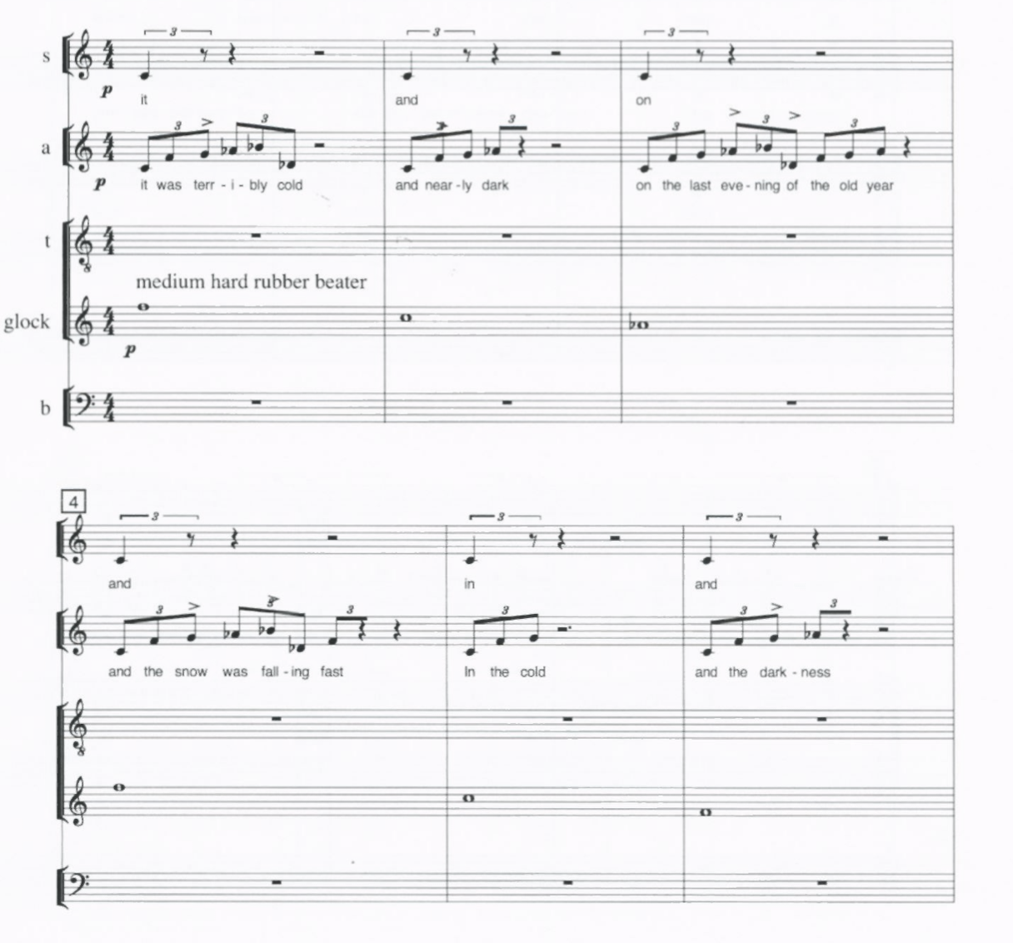
Musical Example 1 – The press-and-pause (mvt. 2)

Beginning in m.1, the alto voice initiates a pattern of consecutive eighth-note triplets that suddenly cease, only to be repeated at the beginning of the next measure, but with a slight alteration. Once Lang establishes this repetitive phrase structure it continues throughout the movement, generating a stasis that allows the listener to submerge into the music. This type of phrase repetition can also allow the listener to shift their attention to the words, following more closely the narrative of the text. Throughout movement 2, the text, texture, and exact rhythmic structure are varied, but the press-and-pause continues unabated, allowing the music to be fully absorbed.
With each movement Lang establishes different repetitive rhythmic motives to engage with the narrative of the text, sometimes even abandoning the pause altogether. Also, the relentlessness of the repetition makes the brevity of movement 2 feel adequate. Overall, Lang’s press-and-pause formula works especially well within the amply divided 15-movement structure of the whole piece.

Formal Divisions

Another notable feature of The Little Match Girl Passion is the short episodes in which it is separated. It is a 35-minute work divided into 15 movements, and as Lang states, is composed in the format of the Baroque Passion oratorio, St. Matthew Passion, by J.S. Bach. Lang’s piece integrates the narrative of The Little Match Girl with his versions of certain texts in St. Matthew Passion, similarly to how Bach’s Passion uses texts from multiple sources and stories, which are intermingled together to form a narrative. And although Lang’s work is considerably shorter than Bach’s, it is nevertheless divided into many brief movements, similar to how a Passion is partitioned.
The average length of a movement is about two minutes, with the shortest movement being just under a minute and the longest lasting almost five minutes (see Figure 1). Dividing up a piece of music into such small, quasi-independent episodes establishes a temporal flow that is different from that, for example, a symphonic work that is divided up into four movements.

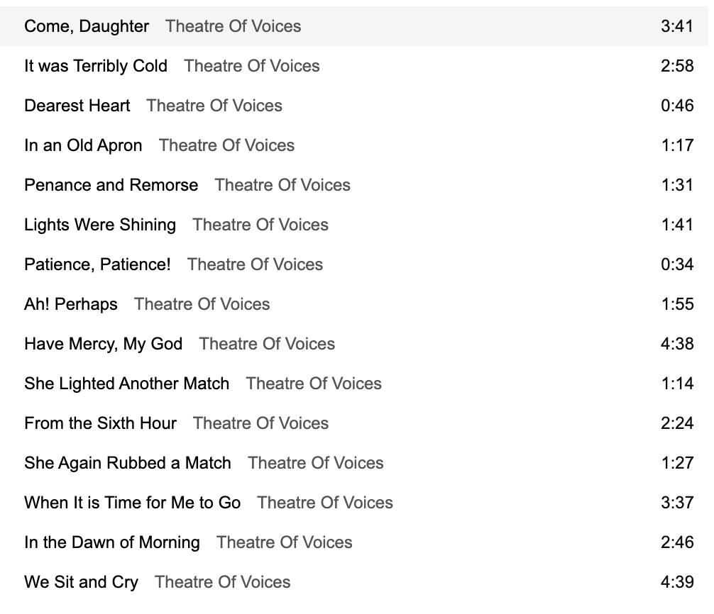
Figure 1 – Movement lengths

When a piece of music progresses through short episodes, the pace and structure of each movement needs to be approached differently than a piece in long-movement form. In subsequent chapters, I will detail how I approach the pace and division of my work, utilizing Lang’s model of episodic brevity.

Polyphony

Lang’s work utilizes various types of polyphonic writing throughout, from common imitative procedures such as canon at the unison, to more complex rhythmic dissonances and independent lines. In the beginning of Movement 11, Lang uses the procedure of direct imitation to assemble stacked layers of motion, somewhat akin to a triple canon. This creates a dense polyphonic fabric constructed out of simple individual units (see Musical Example 2).
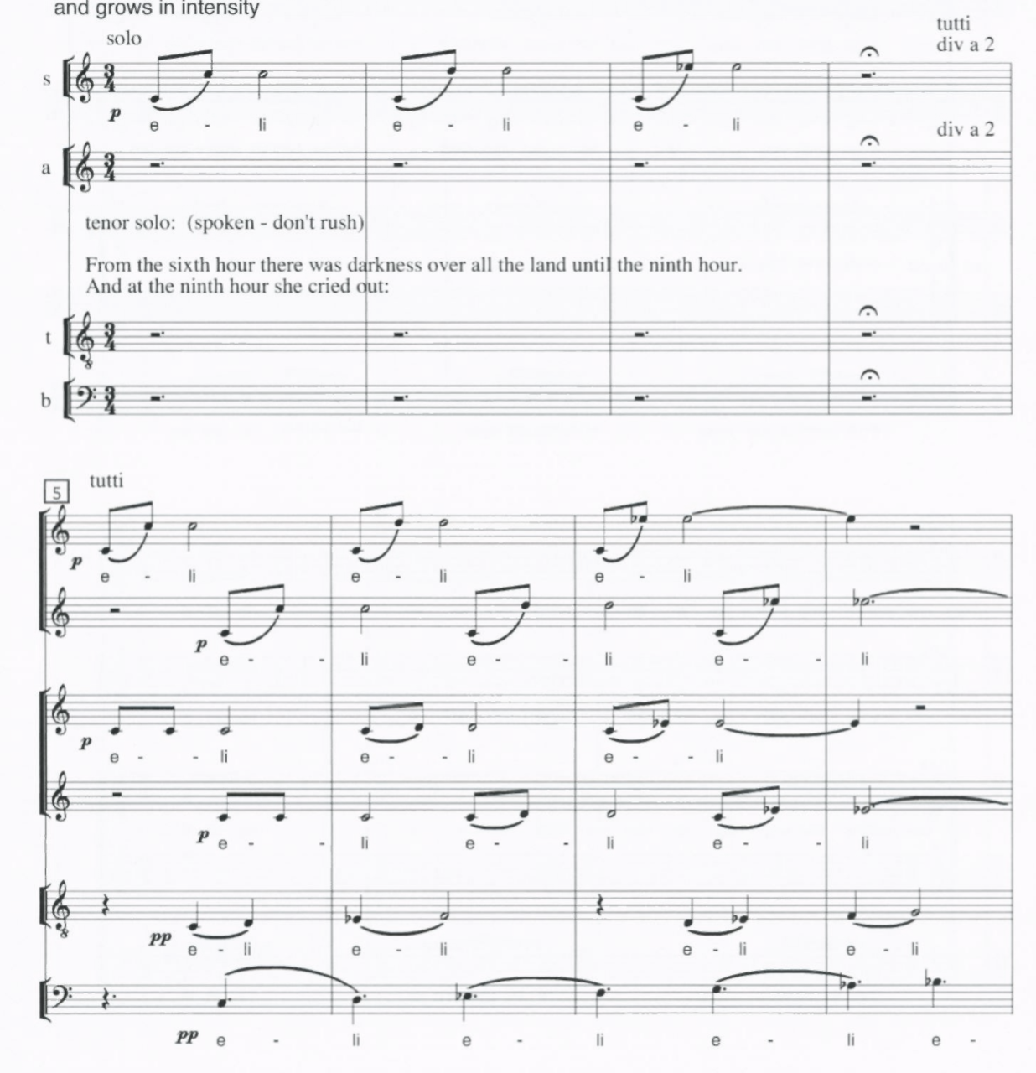
Musical Example 2– Imitative layering (mvt. 11)

Starting at m. 1, the soprano soloist initiates a phrase repeating the word “eli,” consisting of an eighth-note melisma and a half note. This simple figure is then split up in divisi by the soprano section, starting at m. 5, offset by a half note. Layered underneath is a similar imitative figure, sung by the alto section in divisi. But for the altos, instead of the melisma jumping up the octave, the pattern stays on the same note. Then, during the repetitions, the melisma moves up in pitch by sequence in both the soprano and alto voices.
Underneath that, Lang adds another layer of imitative procedures in the tenor and bass voice, but this time in augmentation.
In total, the composite fabric consists of overlapping layers of short musical figures, which create a synergistic effect. Lang takes a simple, yet effective musical procedure, then replicates it into six independent layers, while slightly altering some of the pitch contours and rhythmic durations of some of the figures. In this movement the polyphony is rich and dissonant yet generated with a minimum of material. One of the compositional feats of The Little Match Girl Passion is how such a limited number of musical materials are used in such economic and effective ways. This is a theme that will be reiterated throughout this document. It may not be depth of the individual musical ideas that make The Little Match Girl Passion compelling, but rather the way in which these basic musical materials are used and orchestrated to create the total experience of the music.

Metric Dissonance

Another compositional feature of this work is metric dissonance. Metric dissonance occurs when there are two or more rhythmically conflicting layers of music. For example, if eighth-note triplets were superimposed over eighth notes, the resulting rhythmic conflict would create a metric dissonance. This specific metric dissonance, three against two, can be referred to as a hemiolic grouping dissonance, as described by Krebs. Lang will often superimpose two or more incongruent rhythmic layers. These conflicting layers often cause a musical tension that befits the text. An example of this is the beginning of movement 6 (see Musical Example 3). Starting in m. 1, the soprano voice sings a fragment of text in consecutive triplet durations, followed by another fragment of text with a similar durational repetition. Below that, the alto voice has the same figure, but offset by an eighth note, and using eighth-note durations instead of triplets. This causes a hemiolic grouping dissonance that disturbs the otherwise smooth sonic surface. Furthermore, for the duration of Movement 6 the soprano and alto sing the text using imitative procedure that functions like an augmentation canon, which is like a regular canon, but instead of imitating a phrase exactly, it is done in proportionally augmented durational values. Below that in m. 1, the tenor and bass voices are scored in a way that is ubiquitous throughout the piece, which is to add emphasis to the beginnings of phrases. The tenor voice doubles the first two triplets of the soprano voice at the octave, then sustains “word” for the duration of the measure. This gives the tenor voice a drone-like function, but instead of droning on the tonic (F), it sustains the supertonic (G), forming a coarse harmonic dissonance. The bass voice anchors the downbeat of each measure by doubling first word and pitch class of the soprano part. Taken together, the soprano, tenor, and bass voices form a uniform musical line, while the tenor voice abrades the texture by interjecting a noncongruent rhythmic value in its imitative strand. This is another example of Lang taking a simple musical phrase and altering it slightly as he scores it across the ensemble. As a result, movement 6 treads a bristly landscape, composed by using a minimum of material.

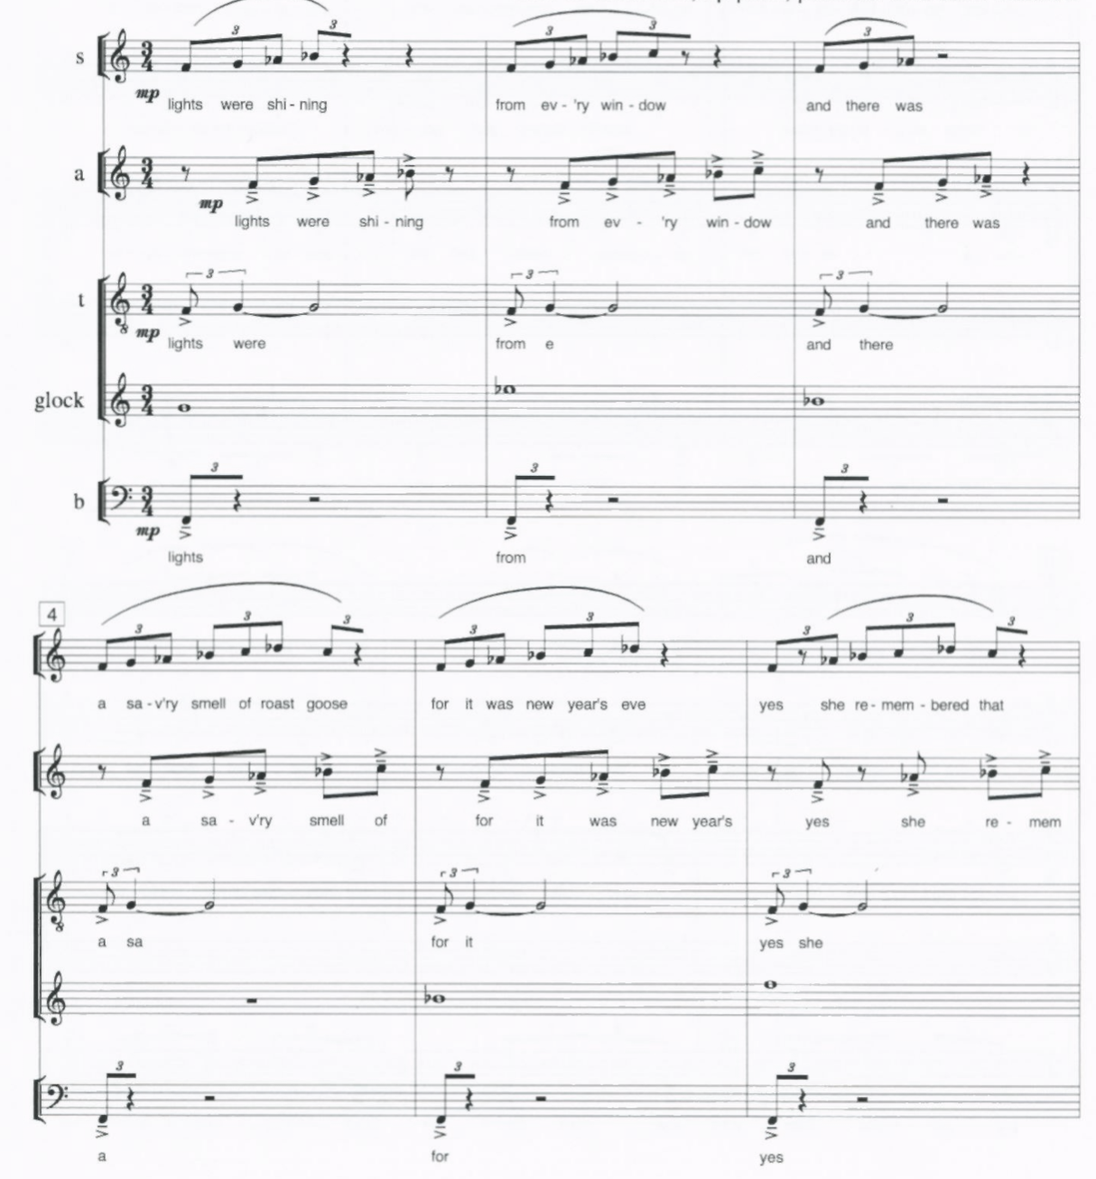
Musical Example 3– Metric dissonance (mvt. 6)

Percussion Scoring

There is one more compositional feature of The Little Match Girl Passion that influenced my orchestration of The Last Leaf. Lang’s use of what he calls “simple percussion” is done in a way that gives the work an atmosphere that I find captivating. There are countless choral pieces that have ornamental percussion accompaniment, but Lang utilizes the metallic percussion instruments in a tasteful and unique manner that is worthy of elaboration. It is unique because of its restraint, and it is tasteful because it does not interfere with the text, while adding another dimension and metallic sparkle to the music. But even though his percussion parts are spare, they achieve a maximum timbral and emotional impact using simple rhythmic material.
This work calls for brake drum, sleighbells, crotales, glockenspiel, bass drum, and tubular bells, but my focus will be on the keyboard percussion. The resonance of the glockenspiel, crotales, and tubular bells blend with the voices in a distinctive way. The combination of these timbres creates and maintains the metallic sparkle of the entire piece. A prototypical example of this spare, yet effective orchestration, can be seen in glockenspiel part in Movement 8 (see Musical Example 4).
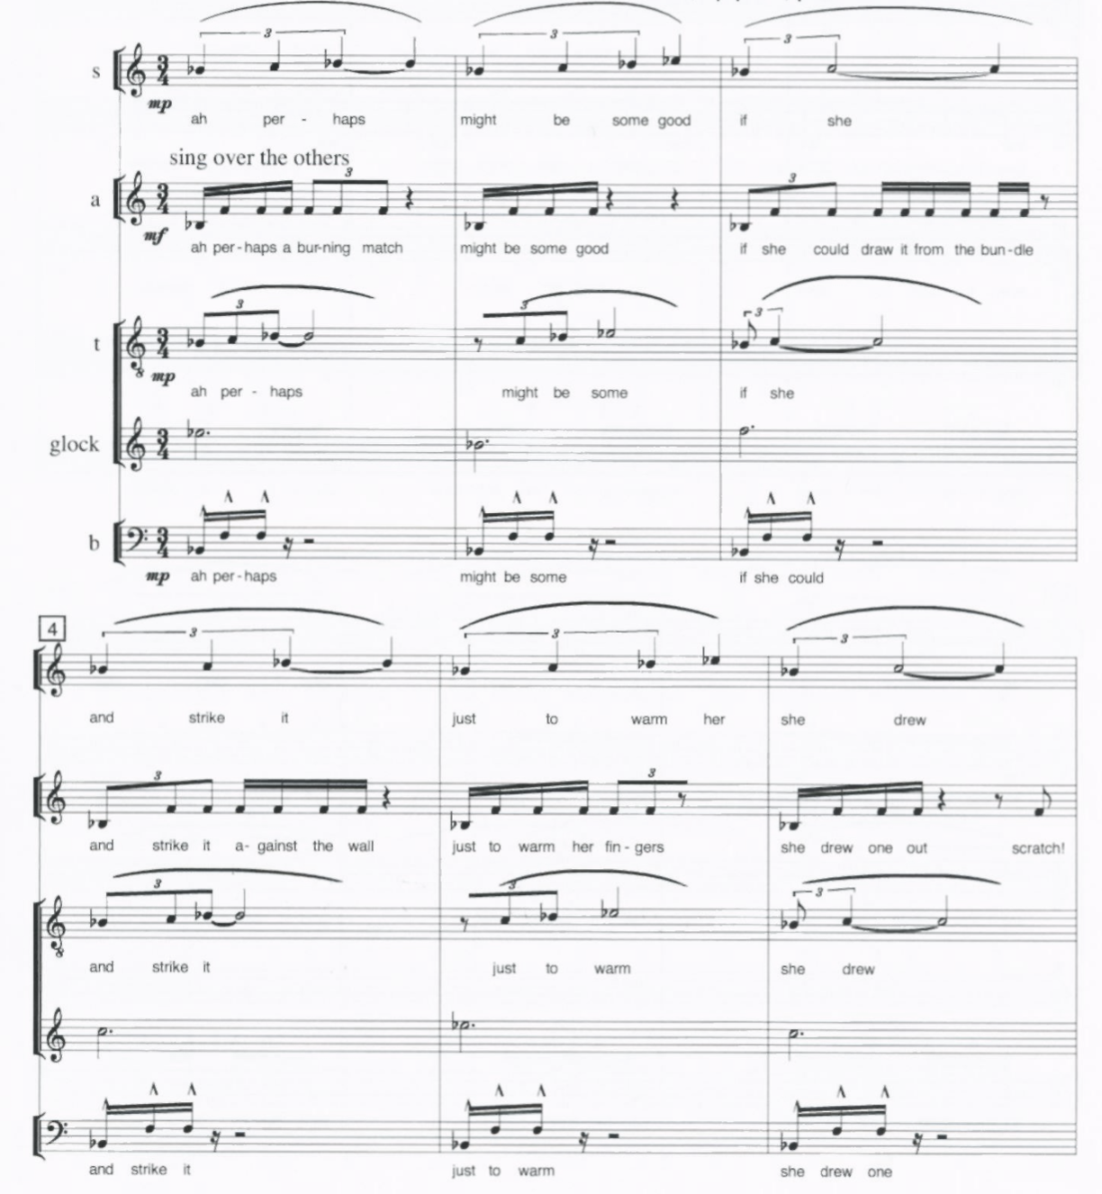
Musical Example 4- Glockenspiel orchestration (mvt. 8)

During this movement, the glockenspiel is performed by the tenor soloist and does nothing more than articulate the downbeats of each measure. During the first six measures, Lang establishes four noncongruent rhythmic layers, which create a harsh and dissonant tapestry. Starting at m.1, the competing layers of sixteenth notes, triplets, and quarter-note triplets are anchored by the shimmering glockenspiel on the downbeats, which act as a coalescing agent.
At the start of each measure, all voices begin their press, as each strand uncoils into a brief sustain, or pause. The disparate vocal layers all start their press simultaneously (except for the occasional upbeat entrance of the tenor voice), which makes the downbeat of each measure a point of recovery. The addition of the glockenspiel to every measure’s downbeat adds a flicker to the start of each press. And the slow decay of overtones made by the metal bars matches the decay of rhythmic energy as each measure fades away, only to begin again. This dance of metal and voice is timed so the decay of the glockenspiel aligns smoothly with the spinning out of rhythmic energy in the vocal parts.
The pitch content of the vocal parts centers around Bb minor, and most of the motion is anchored by the tonic and dominant. In fact, the vocal parts only use the first five notes of the Bb minor scale (Bb-C-Db-Eb-F), with the C’s and Eb’s being used mainly as passing tones. The glockenspiel accentuates every downbeat yet does not always articulate a note of a Bb minor triad. The very first glockenspiel note of the piece is an Eb, which is the only Eb being articulated by any of the parts, until the glockenspiel rearticulates it in m. 5. Also, the notes C, Eb, and Ab, are regularly sounded throughout the movement. These subtle dissonances create just enough harmonic rub to make the overall texture sound richer and more nuanced than if only the tonic and dominant were played.
For most of the piece, the percussion parts are played in the manner illustrated above; that is mainly long tones that accentuate and color the downbeats of measures. The final movement though, has more rhythmically active percussion parts, in that the crotales, which enter for the first time, play together with the glockenspiel (see Musical Example 5).
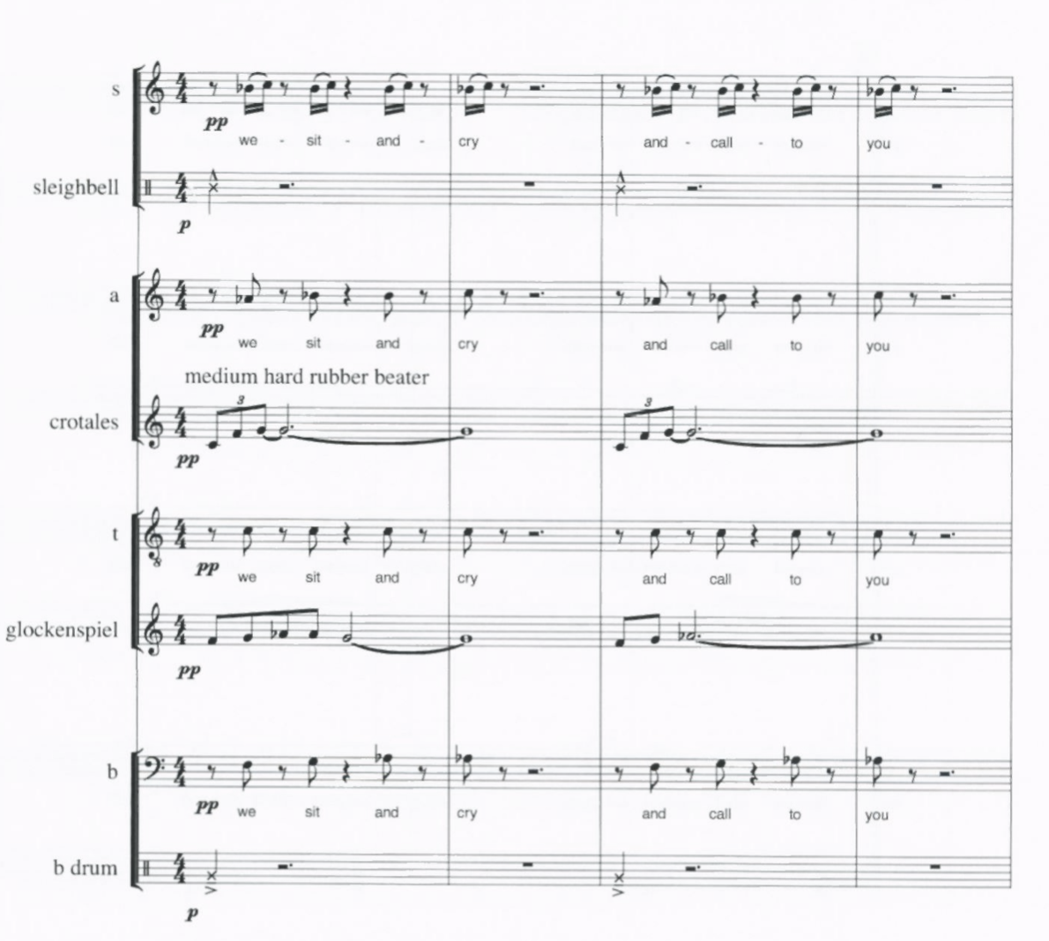
Musical Example 5- Percussion parts (mvt. 15)

The first four measures of Movement 15 illustrate the press-and-pause phrase construction, with the crotales and glockenspiel participating alongside the voices. Eighth-note triplet durations in the crotales are superimposed with eighth-note durations in the glockenspiel, which create rhythmically dissonant layers, similar to the previous examples. This movement also reintroduces the bass drum, as it has not been used since Movement 1, and the sleighbells are introduced for the first time. This makes the final movement the most percussively active, signifying the end of the piece with a wider bandwidth of sound.
In general, though, Lang uses the percussion parts with restraint and care as to not interfere with the text or austerity of the vocal orchestration. Using metallic percussion instruments as ornamental colors in a choir piece is not innovative or unique, but the way they augmented the tapestry of the music was of significant influence for me in the orchestration of The Last Leaf.
Now that some of the key compositional features of The Little Match Girl Passion have been addressed, the next chapter will be dedicated to articulating specific ways I incorporated some of those features in my work. I will also illustrate the ways that I integrated the percussion instruments in a more motoric manner, while still utilizing the shimmer of metallics that are at the heart of Lang’s orchestration.

CHAPTER 3
Orchestration

Percussion Scoring

The Last Leaf was written for SATB choir, soprano soloist, alto soloist, tenor soloist, and a keyboard quartet consisting of four marimbas, chimes, and crotales. Of the four marimbas, part 1 is written for a 5-octave range, and the other three are written for a 4.3-octave range. The 4.3-octave marimba is the most common, with most American universities and secondary schools having multiple on hand. The 5-octave marimba is becoming more common, yet many musical organizations only have one, if any. Some institutions are blessed with many 5-octave marimbas, but that is rare at the time of this piece’s creation. This is the reason I chose to only use one 5-octave marimba. The 5-octave marimba has the notes from C2 to C7, and the 4.3 octave marimba has the notes from A2 to C7. Therefore, the 5 octave adds nine extra notes below the range of 4.3 octave marimba.
The third and fourth marimba part also play crotales and chimes. The crotales, sometimes called antique cymbals, are scored for an octave set, C to C. The chimes, also referred to as the tubular bells, are scored for their normal range of C4 to F5. The third and fourth marimba parts are written so that the players must hold two marimba mallets in one hand and a chime or crotale mallet in the other, to facilitate playing the marimba and the chimes or crotales part in quick succession. The metallic keyboards are not introduced until the second half of the piece, starting at the end of movement 8. When those instruments enter, the treble staff of the grand marimba staves becomes the designated staff for the metallic keyboards (see Musical Example 6). The bass clef staves of the third and fourth player remain in use for the marimba parts.
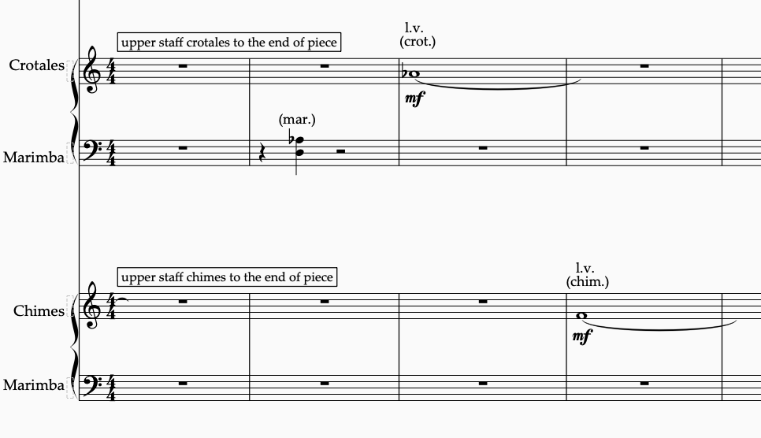
Musical Example 6 – Metallic keyboard entrance (mvt. 9)

Like The Little Match Girl Passion, the metallic keyboards are orchestrated in mostly long note values, allowing the slow decay of each sound to wash over the voices. The main rhythmic activity happens in the marimba writing, and the metals aim to color the downbeats and add a shimmer to the musical fabric. The pitch choices are usually allocated to the tonic or the dominant of the harmonic structure; sometimes however the third or seventh of a chord is articulated in the metals. In Musical Example 6, the Marimba 1 and 3 parts play a fully diminished seventh chord built on a B. The chimes play the fifth of the chord, while the crotales articulate the seventh of the chord.
There are very few instances of the metallic keyboards playing a non-chord tone, except as a passing tone gesture. A typical example of a passing tone gesture used occasionally is evident in m. 28 of Movement 9 (see Musical Example 7). The crotales play a two-note figure that ascends from C# to D. The tonality during this measure is a fully diminished seventh chord on B, like the previous example, as the two-note gesture moves from C# to D.

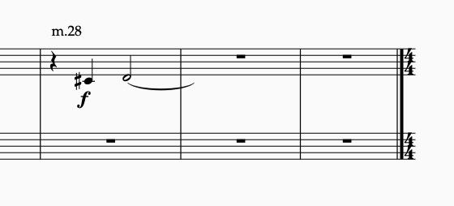
Musical Example 7- Two-note gesture (mvt. 9)

These two examples of scoring for the crotales and chimes are typical of the second half of The Last Leaf and follow the model of Lang. They are scored sparingly and are rhythmically simplistic, yet enrich the musical atmosphere and mood.

The marimba parts are where most of the rhythmic and harmonic activity are generated. I set out to utilize the marimbas as the center of rhythmic activity and the pulse motor. I chose the marimbas for this role because of the clarity of articulation that they can bring to complex and overlapping rhythmic ostinati, which might otherwise get lost within a large ensemble of singers, or within the saturation of overtones in the metallic keyboards. Also, utilizing the marimbas as the pulse center should make it easier for the entire ensemble to hear the pulse and maintain cohesive alignment.
The marimba parts require all four players to use four mallets, two in each hand. Some sections may not require an articulation of more than one or two notes at a time, but the music is often written in a way that is most easily executed using four mallets. When it comes to scoring for the marimba section, the players are often performing interlocking rhythmic figures that combine to create a larger composite rhythm. An example of this type of orchestration can be shown in mm. 12-15 of Movement 3 (see Musical Example 8). As you can see here, the macro rhythmic structure is divided between the marimbas, which creates a conglomerate surface that generates forward momentum throughout the movement. This example is typical of my usage of marimbas in this piece, and each of the first eight movements have unique rhythmic ostinati that generate the pulse.

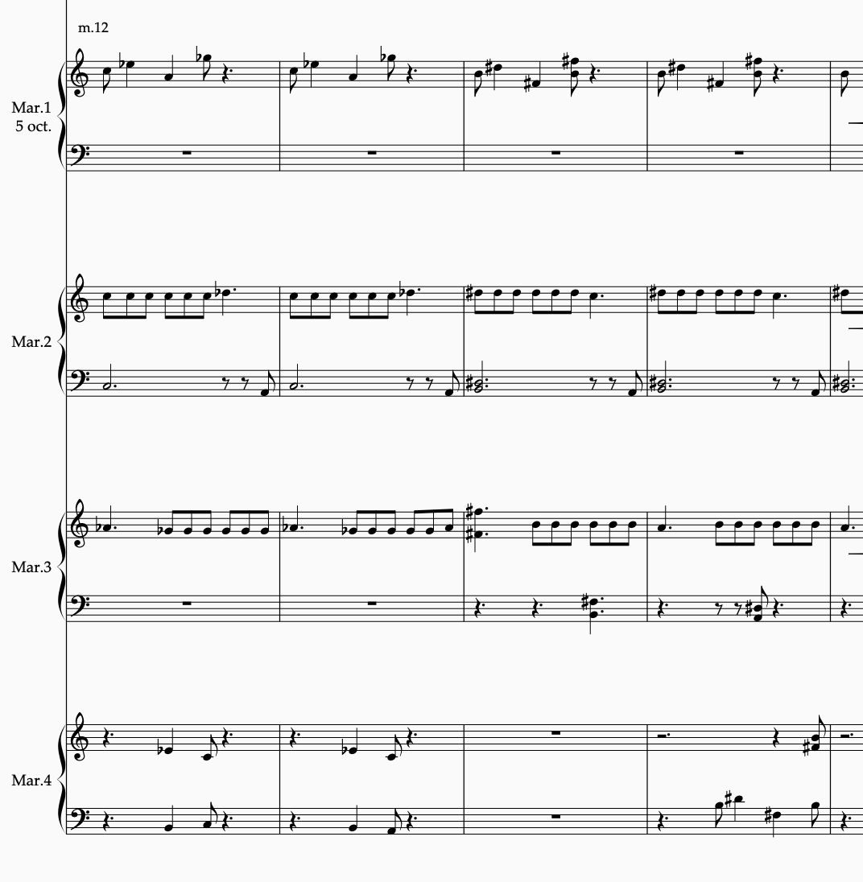
Musical Example 8- Interlocking marimba layers (mvt. 3)

Another important feature of the marimba scoring in The Last Leaf is the use of different roll types. Sustaining a note or chord on a marimba is not possible in the manner of a wind player or string player. The marimba player can, however, create the illusion of a sustain by executing an unmetered tremolo in various ways. A four-mallet roll, or tremolo, can be done in limited variety of ways, achieved by altering the sticking combinations. If one were to hold four mallets, the mallets would be labelled 1 through 4, going from left to right, or from the low-pitched end of the keyboard to the high-pitched end of the keyboard. The 1 and 2 mallets are held in the left hand and the 3 and 4 mallets are held in the right hand. The most common four-mallet roll type is called the double vertical roll, which is played by alternating hands, striking the 1 and 2 mallets simultaneously in the left hand and the 3 and 4 mallets simultaneously in the right hand. This means that two notes are always being struck at the same time, creating a different sound than the other rolls. The next roll-type I utilized is called the double lateral roll. Here, each mallet strikes the keyboard individually in a specified order, unlike the double vertical roll. The sticking I use in this piece for the double lateral roll is 1243, which means that the tremolo goes through that sticking order at a fast enough speed for the notes to blend, repeating the sticking for the duration of the roll’s note value. Finally, I also call for the single alternating roll, which is like the lateral roll, but with a different sticking combination. In this roll, each note is played individually using the sticking order of 1324, done in the same manner as the lateral roll.
Each of these roll types create a different texture, or create the illusion of sustain in a different way. I have incorporated all three roll types in The Last Leaf so I could vary the sound of the roll depending on the musical situation. For example, in the ending phrase of first movement I have specifically notated the Marimba 2 part to execute a double vertical roll (see Musical Example 9).

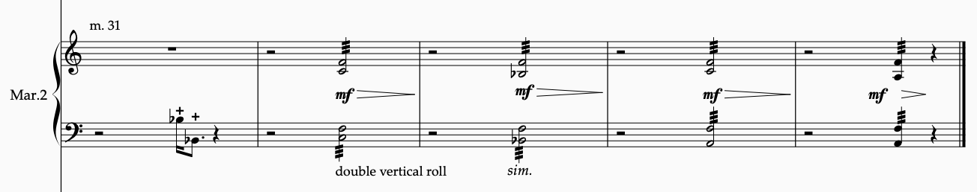
Musical Example 9- Double vertical roll (mvt. 1)

For this section, I wanted the roll to have a heavier quality with a more pointed attack. The double vertical roll has the weightiest sound because the tremolo is articulated as an unmetered alternation of the two notes of each hand striking simultaneously. This admittedly causes the sound to be a little choppy and separated, but this is the quality I desired for this section of music, for I wanted to foreshadow the heaviness the story will begin to entail.
When I desired a smoother and lighter sound, I called upon the double lateral roll, shown below, beginning at m. 12 of the fourth movement (see Musical Example 10).

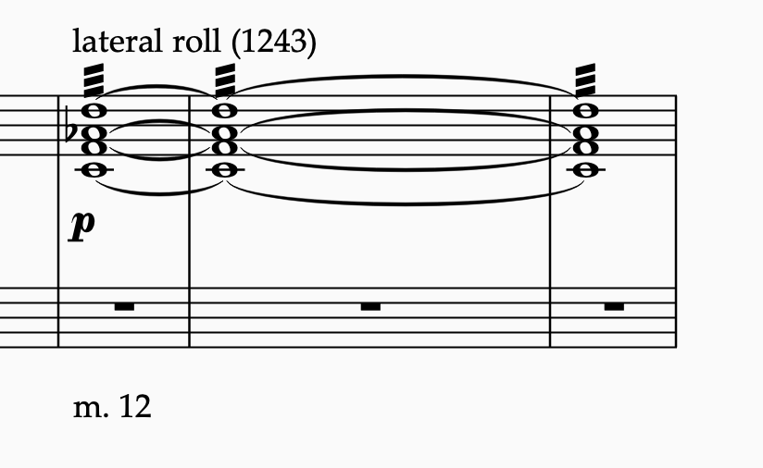
Musical Example 10- Double lateral roll (mvt. 4)
The double lateral has a lighter texture because it is a tremolo between each individual mallet, not each hand like the double vertical strokes. I wanted a lighter roll in this section, so it does not overpower the beginning of the tenor solo. Using a delicate, rippling chord as a backdrop for the tenor solo entrance will hopefully create a thinner atmosphere in this section of music.
And the final roll type discussed here, the single alternating roll, is called for at the end of Movement 6, in all four marimba parts, to create a thick, grainy texture (see Musical Example 11). This stroke-type calls for a mallet to be played in one hand, followed by the next note of the chord played by a mallet from the other hand. Unlike the double lateral or double vertical roll, the order of notes is widely spread across the chord. Looking at the roll in the Marimba 1 part, the order of notes to be played is G4-G5-C5-C6. This gives the texture a very open and full presence, without out the heaviness of the double vertical stroke.

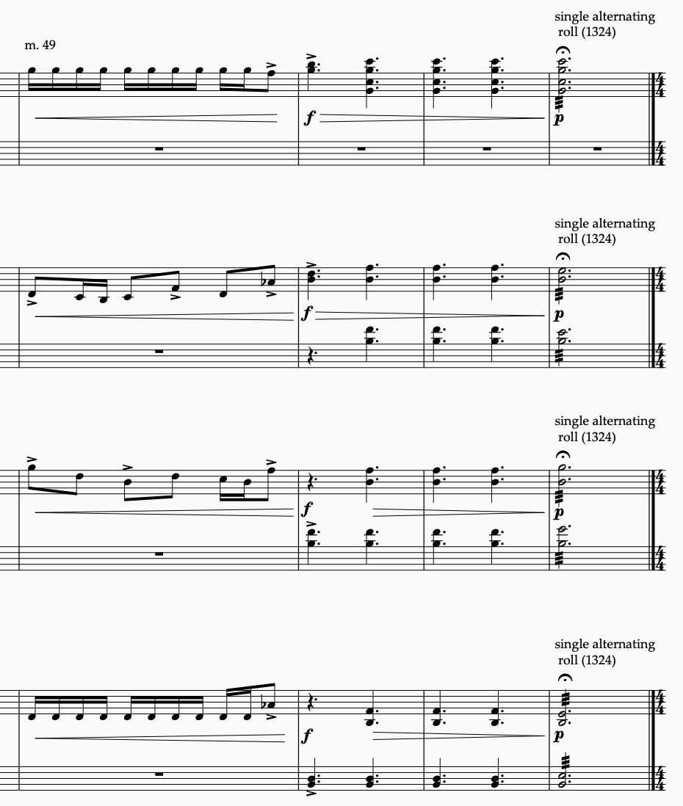
Musical Example 11- Single alternating roll (mvt. 6)

The final percussion orchestration technique that is featured in The Last Leaf is the “dead stroke.” This technique is unique to the marimba part because attempting to execute it on the chimes or crotales would result in an unwanted buzzing sound. In a normal marimba stroke, the yarn mallet strikes a key and immediately rebounds away from it, allowing the bar to vibrate freely without obstruction. The dead stroke is achieved by striking and pressing into the bar, without letting it vibrate. This chokes off the vibration of the bar and creates a shorter, more percussive sound. I have designated the notes to be played as a dead stroke with a “+” symbol above the notehead. This is a common way dead strokes are indicated in the percussion literature, yet it is not a codified rule like other instrumental articulations are. This demarcation is not yet specified in Elaine Gould’s book, Behind Bars: The Definitive Guide to Music Notation. However, the “+” symbol has been codified by Gould as the articulation for a closed hi hat sound.
An example of this stroke-type can be seen at the end of movement 8 in the Marimba 1 and 2 parts (see Musical Example 12). Here, the last note of the movement is articulated by dead strokes, signifying an abrupt cutoff, which also creates an abrupt timbral shift from the previous bars of idiomatic marimba playing. One will also notice that coupled with the short percussive marimba sounds is the articulation of a undampened chime note, which superimposes a contradictory articulation.
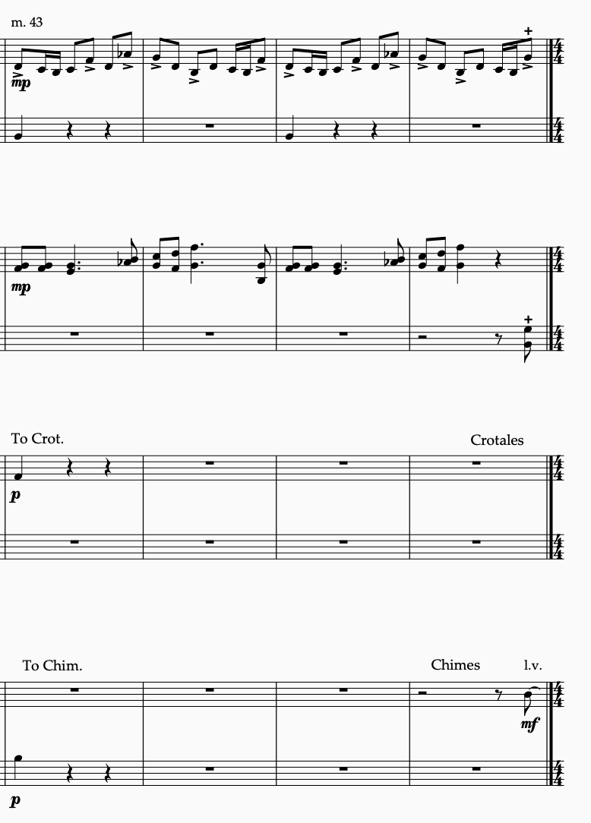
Musical Example 12- The marimba dead stroke (mvt. 8)

I specifically wanted to combine the contrasting tones of a muted marimba bar with a freely resonating chime sound. This is an instance of crafting a moment of textural ambiguity, a sonic admixture unlike any heard before in the piece. This composite sound should be as though the chime tone is weighted at its onset with a percussive accent coloration. This newly introduced sound combination also acts as a signifier of the return to repeated material of the piece.

Metric Dissonance
Like The Little Match Girl Passion, my work creates moments of metric dissonance, mostly of the hemiolic variety. An example of this occurring in the vocal parts can be clearly illustrated at the beginning of Movement 9 (see Musical Example 13).

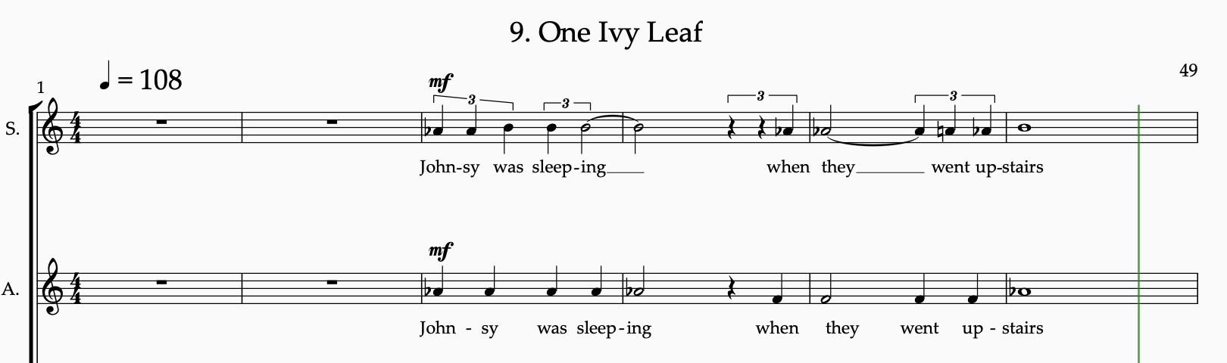
Musical Example 13- Metric dissonance (mvt. 9)

In this excerpt, both the soprano and alto voice sing the same text, but with differing durational values. The competing layers of music are not offset in imitation but are in direct competition for the listeners attention. This hemiolic grouping dissonance is a particular feature of Movement 9. For the most part, I tried not to obstruct the clarity of the text, although injecting some polyphonic perturbations hopefully provides freshness and contrast to the mostly homophonic text setting. This movement also features a metric dissonance in the keyboard parts as well. In m. 19, the marimba parts consist of quarter-note triplet layers overlaid with eighth-note layers (see Musical Example 14).

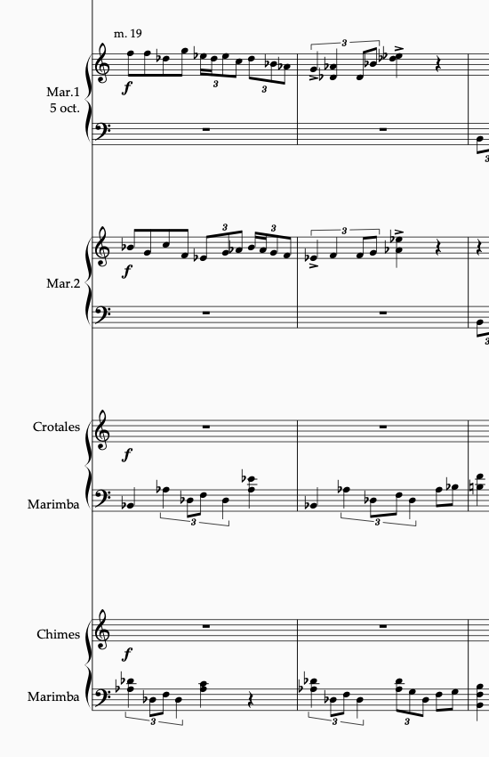
Musical Example 14- Metric dissonance in the marimbas (mvt. 9)
In m. 19, I wanted a temporal break in the text, so I created a virtuosic keyboard figure, superimposing fast rhythmic values and scalar motions on top of the persisting ostinati in the Marimba 4 and 5 parts. This also creates a dense passage of metric dissonance to contrast with more palatable material beforehand. I also wanted to draw attention away from the story for a brief period, creating the need for a mallet interlude. In fact, much of the metric dissonance in The Last Leaf is created to inject rhythmic tension into prolonged static moments of music. Any such prolonged states of metric dissonance were carefully avoided as to maintain the focus and pace of the text. The next chapter will deal with those aspects of the text, and text setting, including the vocal polyphony and formal divisions. I will expound upon the vocal solos in the following chapter as well.

CHAPTER 4
Text Setting

O. Henry’s The Last Leaf is a tale centered around subsisting through hardship and tragedy, similar to the arc of Anderson’s The Little Match Girl. The central themes of the story include hopelessness, sacrifice, and death, which are undoubtedly difficult topics to approach, but the story was so compelling to me that I undertook the challenge of setting it to music.
Before I discovered O. Henry’s work, I knew that I wanted to use a short story for my text rather than a poem. Poems are generally too short to break up into a multimovement work and tend to rely on heavy text repetition to create musical material. I searched for a text that had a high enough word count that could sustain a piece of music for over 15 minutes. The Last Leaf expends 2,360 words, which is much more than enough to cull a text for a 15 to 20-minute setting of music.
My goal for this piece was to tell the complete story of The Last Leaf, even while reducing it to a manageable size. My adaption, included below, is a paraphrase of the original text, which reduces the word count to approximately 350. After completing the reduction, I divided the text into thirteen segments, which would become the movements of the final piece. I carefully pruned the full text so that the listener could hear the entire story and receive ample context so they could fully grasp the surprise ending. The final libretto, seen below, is divided into 13 movements, which are further divided into stanzas. This further division corresponds to the harmonic progressions in which each stanza is set. This will be discussed further in the final chapter.
It should also be noted that I attempted to maintain O. Henry’s unique style of prose, which is full of rich and colorful language, including copious helpings of slang, alliteration, personification, and vernacular adages. I also hoped to encapsulate the overall emotion of the text, which is referred by Tu Long as the “tearful smile” style, which juxtaposes tragedy and humor.

Figure 2- The Last Leaf libretto

By O. Henry
Adapted by Dustin Schulze
- Greenwich Village

In a little district west of Washington square the streets have gone crazy and broken themselves into small strips called “places.”

These streets make strange angles and curves. So, to the quaint old Greenwich village the art people soon came prowling, hunting for north windows and eighteenth-century gables and Dutch attics and low rent.

At the top of a squatty, three-story brick Sue and Johnsy had their studio.

- Mr. Pneumonia

In November a cold unseen stranger, whom the doctors called Pneumonia, stalked about the colony,

touching one here and there with his icy fingers. Over on the east side this ravager strode boldly, smiting his victims by scores,

but his feet trod slowly through the maze of the narrow and moss-grown places.
- Johnsy He Smote

Mr. Pneumonia was not what you would call a chivalric old gentleman.

A mite of a little woman with blood thinned by California zephyrs was hardly fair game for the red-fisted, short-breathed old duffer.

But Johnsy he smote, and she lay scarcely moving on her painted iron bedstead.

- The Doctor

One morning the busy doctor invited Sue into the busy hallway with a shaggy, grey eyebrow.

“She has one chance in ten. And that chance is for her to want to live.”

“Your little lady has made up her mind that she’s not going to get well.”

- Japanese Napkin

After the doctor had gone, Sue went into the workroom and cried a Japanese napkin into a pulp.

Johnsy, lay, scarcely making a ripple under her bedclothes, with her face toward the window.

She was looking out the window and counting – counting backward.

- The Ivy Vine

Twelve, eleven, ten, nine, eight, seven.

Sue looked solicitously out of the window. What was there to count? An old ivy vine, gnarled and decayed at the roots, climbed halfway up the brick wall.

“They are falling faster now. Three days ago there were almost a hundred. There are only five left now. When the last one falls I must go too.”

- There Goes Another

“There goes another. That leaves just four.”

“I want to see the last one fall before it gets dark.“
“Then I’ll go too.”

- Old Behrman

Old Behrman was a painter who lived on the ground floor beneath them. He had been always about to paint a masterpiece, but had never yet begun it.

Sue found Behrman smelling strongly of juniper berries in his den below. She told him of Johnsy’s fancy, and how she feared she would

float away, when her slight hold upon the world grew weaker.

- One Ivy Leaf

Johnsy was sleeping when they went upstairs. They peered out the window fearfully at the ivy vine.

A persistent, cold rain was falling, mingled with snow.

After the beating rain and fierce gusts of wind, there stood against the brick wall one ivy leaf.

- The Rain Still Beat

The day wore away, and even through the twilight they could see the lone ivy leaf clinging to its stem against the wall.

And then, with the coming of the night the north wind was again loosed, while the rain still beat against the windows.

Next morning, the ivy leaf was still there.

- Some kind of Artist

“Something has made that last leaf stay there to show me how wicked I was. It is a sin to want to die. Someday I hope to paint the Bay of Naples.”

The doctor came in the afternoon.

“With good nursing you’ll win. And now I must see another case I have downstairs. Behrman, his name is- some kind of artist. Pneumonia, too. The attack is acute, there is no hope for him.”
- Green and Yellow

Sue came to the bed where Johnsy lay, contentedly knitting.

“I have something to tell you. Mr. Behrman died of Pneumonia today in the hospital. The janitor found him in the morning, helpless with pain. His shoes and clothing were wet through and icy cold.”

“And they found a lantern and a ladder that had been dragged from its place, and some scattered brushes, and a palette with green and yellow colors.”

- Old Behrman’s Masterpiece

“Look out the window, at the last ivy leaf on the wall. Didn’t you wonder why it never fluttered or moved when the wind blew?”

“Ah, darling it’s Behrman’s masterpiece-“

“he painted it there the night the last leaf fell.”

Figure 2- The Last Leaf libretto

Polyphony

With such a lengthy word count, I was unable to allow for significant text repetition like some of the movements in The Little Match Girl Passion. This lack of repetition motivated me to be cognizant of not excessively saturating the vocal parts with imitative polyphony. A rhythmically muddled delivery of this libretto could prevent the listener from understanding the words. The general principles that I adhered to while vocal scoring were twofold: First, I sought a rhythmic distribution of words in a way that was complementary to the natural phonetics of speech. Second, I wanted to disseminate the text in homorhythmic, one-to-one counterpoint.
I tried to make certain that the rhythmic setting of the text followed along with the natural agogic accents of the words. There were times though when this guideline was abandoned for the sake of musical expression. A typical example of text setting in The Last Leaf can be illustrated in the tenor and bass voice in the opening movement (see Musical Example 15).

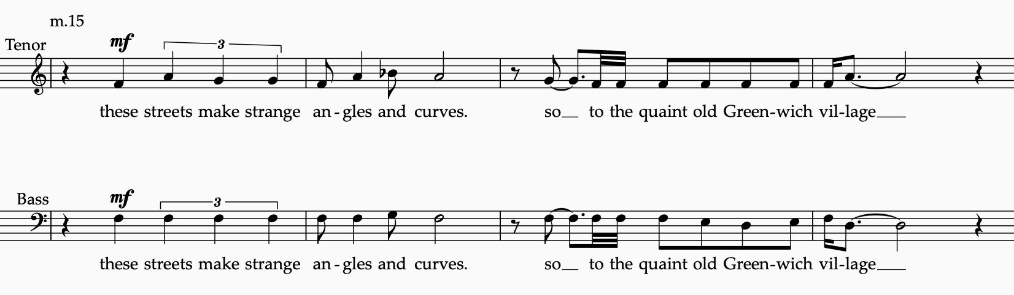
Musical Example 15- Vocal scoring (mvt. 1)

In this example, the rhythms of the text align closely with the natural scansion of the spoken words. Natural emphases of the appropriate syllables are placed upon metrically strong beats, allowing for a clear articulation of the text. This example also shows the use of the of the one-to-one, homorhythmic counterpoint. This technique was inspired by the early organum practice of the Middle Ages. In early European organum, melodies were often sung against a drone, binding them harmonically to a fixed tone, creating an aesthetic that I find captivating. However, instead of using a proper drone, I adjusted the technique to fit my homorhythmic approach.
In ex. 15, instead of having a sustained drone voice, I had both voices employ the same rhythm. Starting in m. 15, the bass and tenor voice execute the same rhythm, while the bass remains on a static pitch. This creates a similar effect to the medieval drone organum, yet both voices contribute to the articulation of the words, which hopefully adds textual clarity. Also, a melodic line that moves against a static line, in oblique motion, evokes an archaic and dark quality that is befitting of the story. This voice leading also forms pungent individual dissonances that become smoothed out when anchored to a static pitch.
Contrary and parallel motions occur as well, typically at the ends of phrases, acting as cadential markers. Looking at mm. 15-16 in ex. 15, the bass voice remains static until the end of the phrase, when it moves in parallel motion with the tenor voice. Then, in mm. 17-18, they alternate in carrying the drone, yet this time closing the phrase in contrary motion, ending on a perfect fifth. This phrasal tactic of establishing a drone, then moving to more independent contrapuntal motion, is typical of the vocal counterpoint throughout The Last Leaf.
There are also moments in the piece, however, where all voices are employed as independent lines. This is done to create contrast to the homorhythmic text declamation (see Musical Example 16).
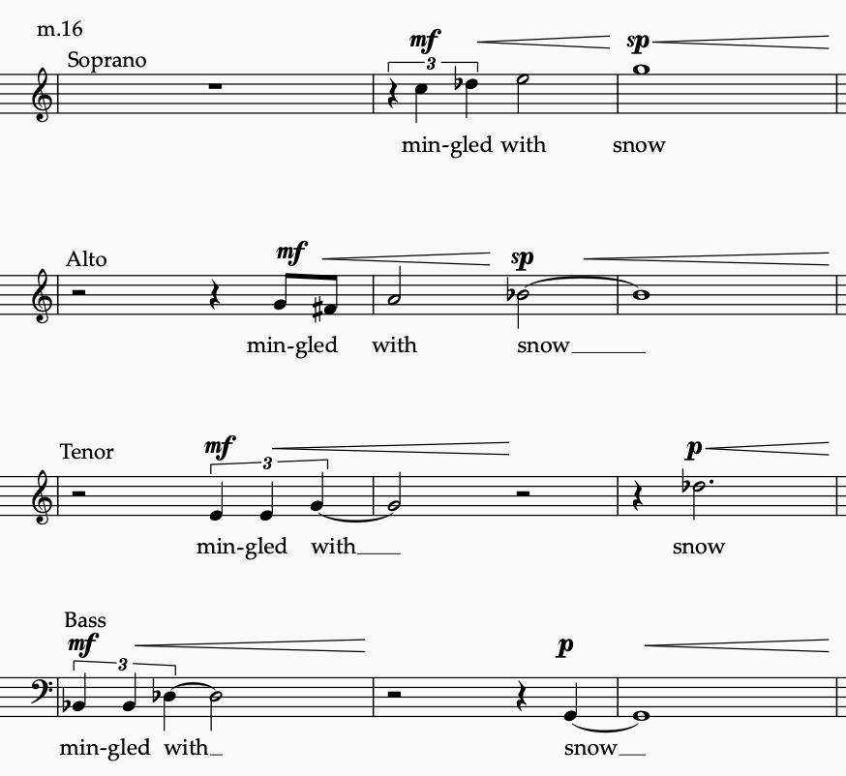
Musical Example 16- Independent vocal polyphony (mvt. 9)

Starting in m. 16 of movement 9, the voices stray from the text setting guidelines. For this specific part of the music, I sought to create a more disparate and rhythmically entangled text setting, as a way of painting the image of snow and rain beating against the window. The phrase “mingled with” is initiated by the bass voice and repeated at different points of imitation by the other voices, terracing up the pitch spectrum. This polyphonic device is complemented with a dynamic crescendo, followed by staggered entrances of the word “snow,” at subito piano, which then crescendo again to a climax. All four voices overlap and entangle to create an intricate burst of musical rhetoric. This is also a rare moment of text repetition. Lang’s libretto in The Little Match Girl Passion was short enough to afford the luxury of ample text repetition, but this libretto’s lengthy word count motivates one to keep vigorously moving through the text.

Soloists

The Last Leaf centers around four main characters:
- Sue
- Johnsy
- The Doctor
- Old Berhman

Most of the text is told by a third person narrator, but there are some lines of the story that are spoken by the characters. Some of these first-person lines needed to be in the libretto to tell the story properly, and needed to be differentiated enough so that the listener would know when a character is speaking. After initially conceiving of this piece without soloists, I soon realized that they were necessary to clarify the first and third person lines. Thus, this piece enlists a soprano soloist to play Sue, an alto soloist for Johnsy, and a tenor soloist for The Doctor. In O. Henry’s full text, Old Berhman does have some speaking lines, yet I was able to craft the libretto without his lines being necessary for the story.
The soloists sing as members of their respective section in the choir, then step out in front of the keyboard quartet to deliver their solos, then return the choir. This not only makes it clear to the audience when the libretto shifts to first-person narration, but also allows the soloists to be heard clearly over the keyboard percussion. For the most part, when a soloist is singing, the choir is not; however, there are some instances of ensemble vocal parts interacting with the soloists (see Musical Example 17).
In m. 18 of movement 2 the alto soloist (Johnsy), interacts with the soprano section in the manner of call-and-response imitation. This part of the music is preceded by the soloist singing without interruption for a significant portion of time. Utilizing the sopranos here is a way to stave off monotony and vary the textural bandwidth of the music. It also emphasizes Johnsy speaking on the imminence of her death after the last leaf falls. I also took this moment to create a stark and dissonant harmonic tension. In mm. 19 and 23, the soloist and soprano section create a minor second interval of Bb to B natural. These harmonic conflicts inject a dark and uncomfortable coloration in the music, mirroring Johnsy’s upsetting proclamation.
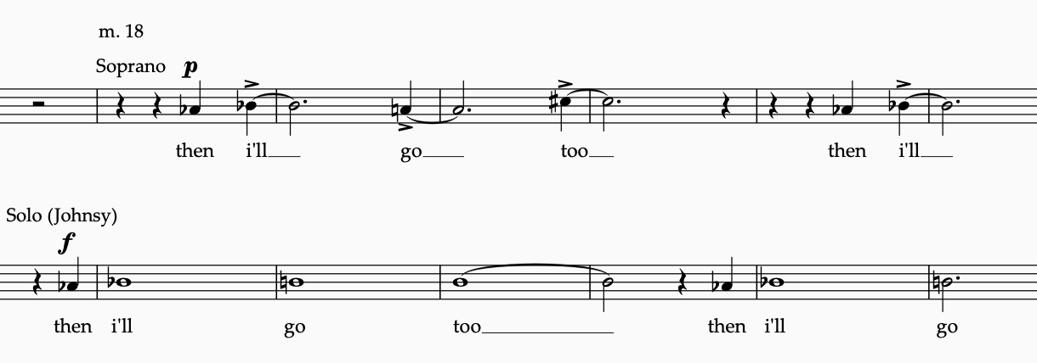
Musical Example 17- Soloist with choral interaction (mvt. 7)

As a general matter of solo orchestration, the characters are allowed to sing their lines without much interference from the choir or percussion section. Again, it was paramount to score the music in a way that did not overtly interfere with the clear foregrounding of the text. The repetitive structures within the keyboard help free up the listener to attend to the text, because her brain does not need to continually process new rhythms and pitches within this section. But this of course makes it more difficult to compose a compelling musical backdrop without stifling the text. My hope is that the keyboard percussion parts are creative and interesting enough to capture the listeners imagination, while at the same time not distracting from O. Henry’s narrative.

CHAPTER 5
Symmetry
For the most part, when composing a piece of music, I do not prefabricate the formal structure. I do not decide ahead of time what the form will be, whether it ends up in a ternary or through-composed form, for example. My approach to form is best summed up by Edgard Varèse, who said, “The misunderstanding has come from thinking of form as a departure, a pattern to be followed, a mold to be filled. Form is a result- the result of a process. Each of my works discovers its own form.”
Composing this way, I start with a small musical idea that slowly comes into to focus. I then begin to expand upon it. After I have expanded an idea or ideas into a large phrase, I can decide as to what might come after it, or in some cases before. After some time, the form of the piece will be suggested by the music composed thus far, as the global structure starts to reveal itself. As more music is written, the formal options become more limited, and the path starts to be chosen for me. When one does not designate a mold prior to writing the music, however, the terror of the blank page can seem more daunting.
With The Last Leaf, my approach was different than usual, because I decided that the form would be analogous to the structure of an ivy leaf, which is symmetrical in design. In fact, because the main symbol of the story is the leaf that keeps Johnsy alive, I decided to incorporate symmetry into the piece in several different ways. These symmetrical forms were prefabricated before I started composing any of the music. This broke with the process-driven philosophy that I had adhered to until this piece.
Global Symmetry

The Last Leaf consists of three nested levels of symmetry, from the global form, down to the individual harmonic progressions. After reducing O. Henry’s full text to a wieldy size, I divided it into thirteen movements, with the seventh movement becoming the center axis (see Figure 3).

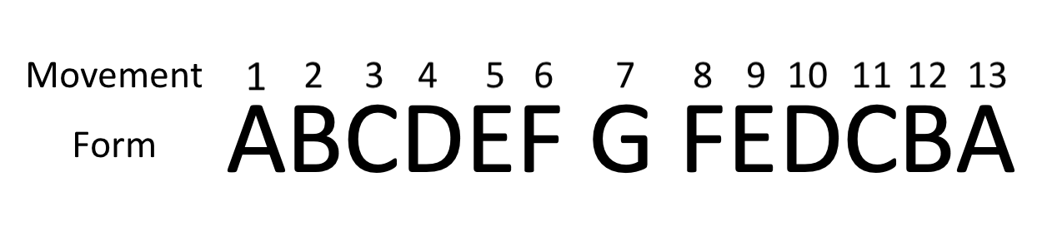
Figure 3- Global form

This palindromic formal plan provides the exoskeleton for the music and text to pass through. The text is asymmetrical, so the letter symmetry in Figure 3 depicts the musical material. Like basic ternary form, the arc of the piece has a sense of leaving and returning. Repetitive and symmetrical musical forms have been used throughout the history of music, perhaps because they are economically efficient, and give the listener a satisfying journey away from home, and comfortably back again. The symmetrical aspects of this piece are also aligned with the compositional approach of Lang’s piece- that is, getting the most out of minimal material, which a symmetrical form certainly does.
One of the challenges I encountered when applying a symmetrical scaffolding to an asymmetric text was having both the musical arc and the narrative arc work in support of each other. It is my hope that I allowed the story to be told convincingly, even as that story is enmeshed in formal symmetry.

Rhythmic Symmetry

Another prefabricated symmetrical aspect of The Last Leaf was the incorporation of symmetrical, or palindromic rhythmic motives. Oliver Messiaen refers to rhythms that are the same forward and backwards as “nonretrogradeable.” Symmetrical structures are common in Messiaen’s oeuvre, including at the pitch level, in which he uses what he calls “modes of limited transposition.” And before Messiaen, the composer Béla Bartók utilized symmetry in much of his output, including at the global level, and melodic level. Both composers have provided precedent for me and many others to build music on symmetrical edifices.
In The Last Leaf, I composed seven symmetrical rhythmic figures, which would be used as the keyboard ostinati that generate much of the motoric propulsion in the music (see Figure 4).

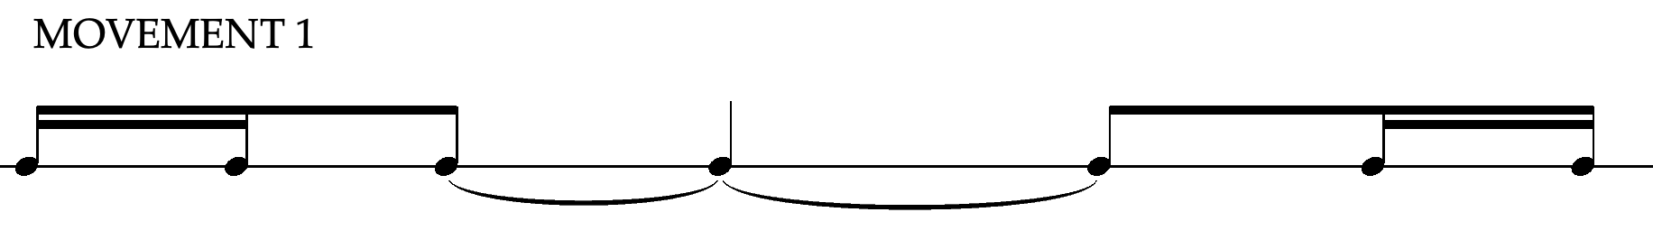
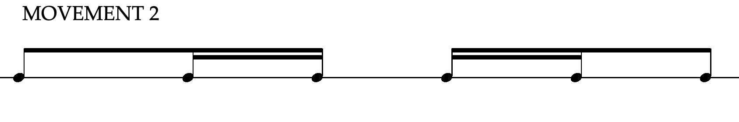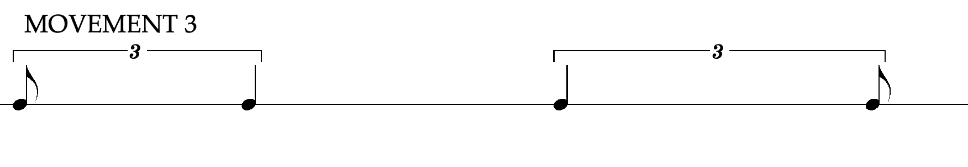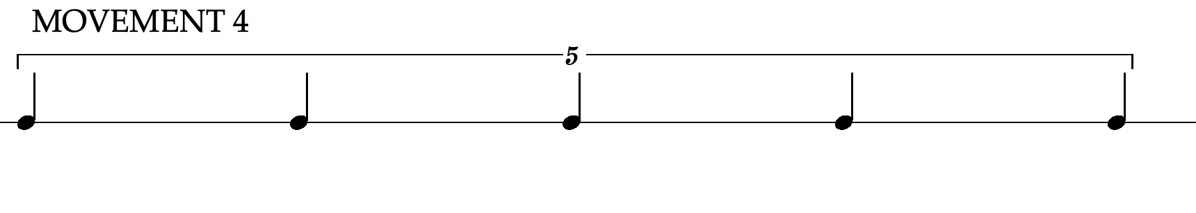
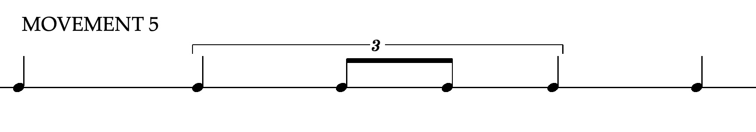
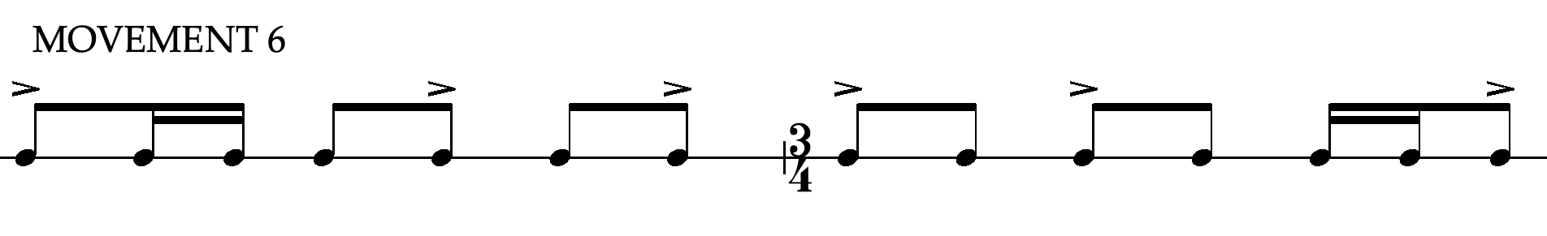

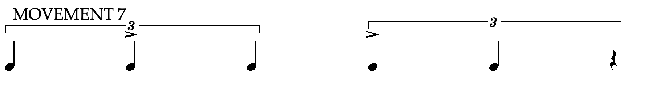
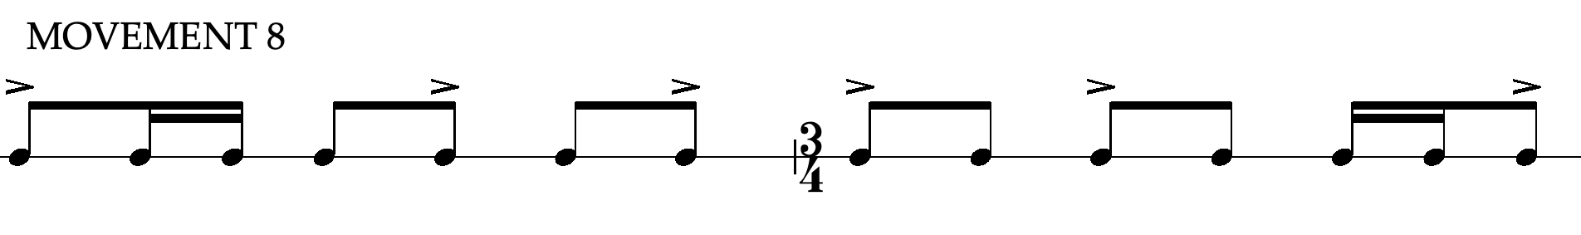
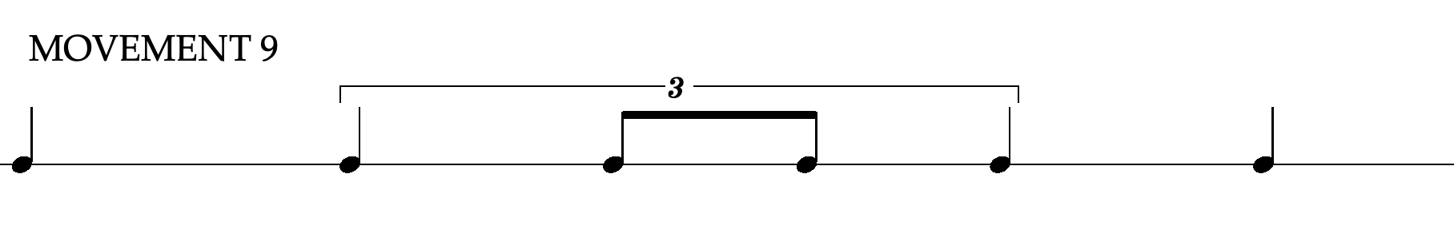
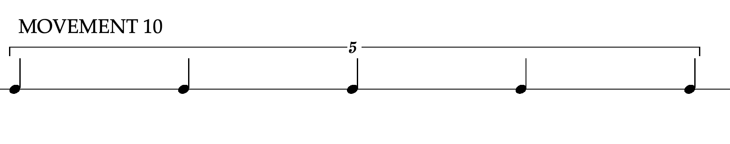
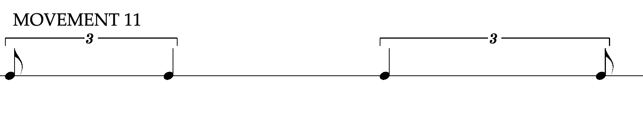
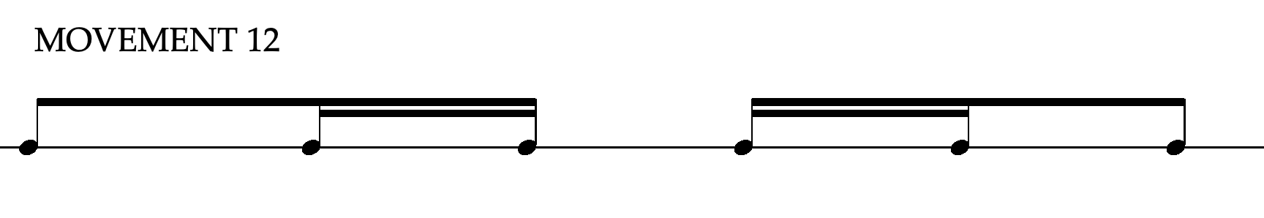
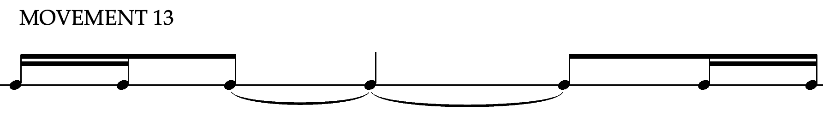
Figure 4- Symmetrical rhythms

These rhythmic structures are not only used in the percussion parts; they also make appearances in some of the vocal lines as well. One example of how these symmetrical rhythms are utilized as keyboard ostinati is illustrated below in the first six bars of movement 5 (see Musical Example 18). Here the Marimba 1 part initiates the symmetrical ostinato and repeats it almost exactly every measure, apart from the pitch changes on beat four. Marimba 2 comes in on m. 2 but begins the ostinato from a different point in its phrase, creating an overlapping of the two ostinati. This overlap creates a thicker and more complex fabric, which is also punctuated by displaced fragments of the ostinato in the other marimba parts. When Marimba 3 comes in, its fragment of the ostinato does not align with the other marimbas. And when Marimba 4 enters at m. 4, the rhythm is an altered version of the ostinato, thus creating some mild metric dissonance across all four marimba parts.

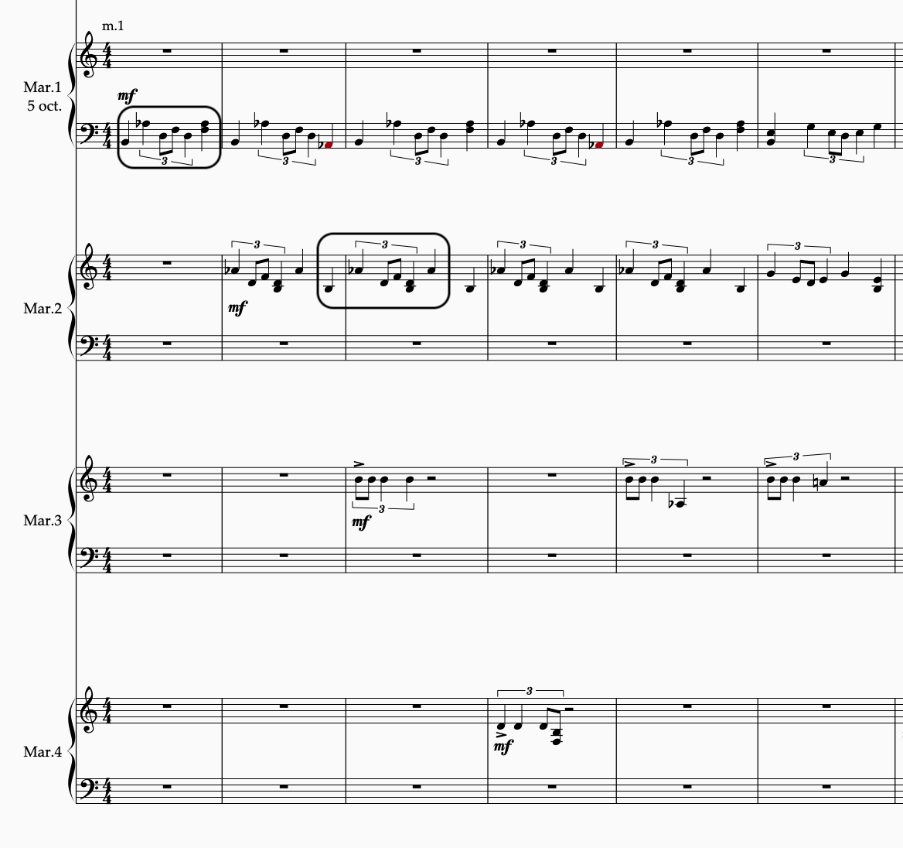
Musical Example 18- Symmetrical rhythms (mvt. 5)

Overlapping and offsetting these symmetrical rhythmic figures is a key feature throughout The Last Leaf, and it provides the motor and the rhythmic scaffolding for the harmonies. There are also instances of the symmetrical rhythms being used as melodic and non-motoric figures in the music. An example of this can be seen in Movement 4, as the quarter-note quintuplet figures are juxtaposed between the choir and Marimba 1 (see Musical Example 19).
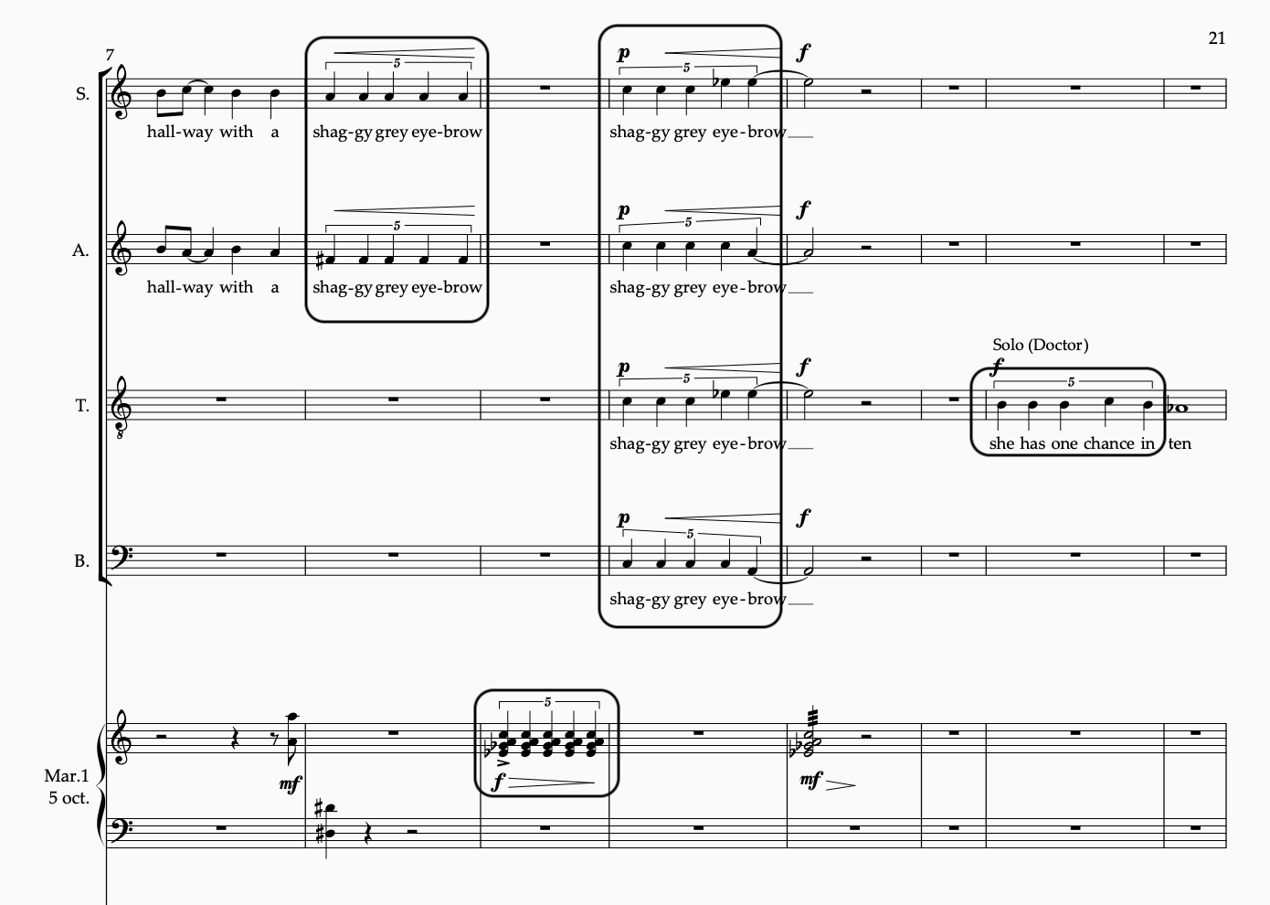
Musical Example 19- Quintuplets (mvt. 4)

Above, I use the rhythmic figure melodically in the voices and harmonically with Marimba 1. The soprano and alto voice first use it to convey the phrase “shaggy grey eyebrow,” followed by an interjection in the marimba, where it articulates the harmonic content of a fully diminished seventh chord on C in first inversion. Then the full choir utilizes the rhythmic figure to repeat the previous text, this time culminating in a dynamic climax of the section, setting the table for the tenor soloist, who begins with the same rhythmic figure.
Those are two examples of how I incorporated these prefabricated symmetrical rhythms within the piece. Taking a cue from Lang, I attempted to get the most utility out of these figures as I could, infusing them into the fabric of the music at every opportunity.

Harmonic Symmetry
The harmonic scheme of The Last Leaf is a series of ternary progressions nested inside a larger ternary harmonic framework, which is then nested inside the global symmetrical scheme, as Figure 5 illustrates.
- (d-Bb-d) (g-C-g) (d-Bb-d) A
- (g-C-g) (bb°-Db-bb°) (g-C-g) B
- (bb°-Db-bb°) (c°7-B7-c°7) (bb°-Db-bb°) C
- (c°7-B7-c°7) (b°7-e7-b°7) (c°7-B7-c°7) D
- (b°7-e7-b°7) (bb7-g°/7-bb7) (b°7-e7-b°7) E
- (bb7-g°/7-bb7) (eb7-A7-eb7) (bb7-g°/7-bb7) F
- (eb7-A7-eb7) (ab-G-ab) (eb7-A7-eb7) G
- (bb7-g°/7-bb7) (eb7-A7-eb7) (bb7-g°/7-bb7) F
- (b°7-e7-b°7) (bb7-g°/7-bb7) (b°7-e7-b°7) E
- (c°7-B7-c°7) (b°7-e7-b°7) (c°7-B7-c°7 D
- (bb°-Db-bb°) (c°7-B7-c°7) (bb°-Db-bb°) C
- (g-C-g) (bb°-Db-bb°) (g-C-g) B
- (d-Bb-d) (g-C-g) (d-Bb-d) A
Figure 5- Harmonic symmetry
Here one can see that each movement contains a series of ternary micro-progressions that are nested within a macro-progression. All the harmonies used to create these progressions are tertian in nature, although there are secundal and quartal simultaneities present throughout the surface level of the piece, and act as a further embellishment or coloration of the basic tertian structures. This symmetrical scheme can be further abstracted into letter names to represent a simpler rendering (Figure 6).

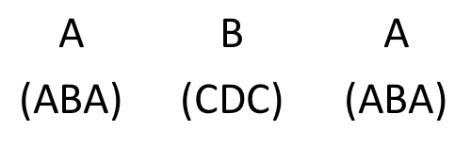
Figure 6- Nested ternary progressions

In figure 6, each letter within the parenthesis represents a single harmony. Furthermore, each movement is linearly connected to its adjacent movement by a harmonic link, shown in Figure 7.
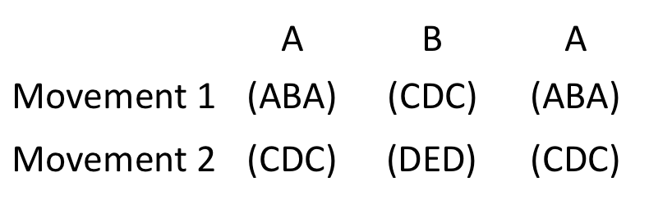
Figure 7- Inter-movement harmonic links

Using the connection of Movements 1 and 2 as an example, one can see how the interior harmonic progression of Movement 1 becomes the exterior harmonic progression of Movement 2. Then, the harmonic progression introduced in the B section of Movement 2 will be used as the exterior progression of Movement 3, and so on and so forth. This was done to create tonal connective tissue between the movements, and to continue the pursuit of maximizing the musical output with minimal means of production.
I created the individual harmonic progressions in The Last Leaf using two general criteria: First, I wanted the progression’s sonorous properties to evoke the mood of the text.
Second, I wanted to maintain common tone links when possible, for the sake of harmonic smoothness. I constructed the melodic and rhythmic content after I created the individual harmonies and the nested symmetrical matrix in which they are embedded. I chose the harmonic progressions though improvisation and trial and error, then selecting them based on their sonorous quality. They were then coupled together using the symmetrical nested framework discussed above.
When improvising chord progressions, I attempted to maintain one or two common tones between them, to create connection and coherence. It should be noted that the progressions are not based upon the common-practice principles of functional harmony, but on the chord-to-chord transformations. Therefore, these progressions can best be described in a Neo-Riemannian context. For example, the very first progression of The Last Leaf is a D minor triad, to a Bb major triad, then resolving back to the d minor triad (d-Bb-d). The d minor triad and the Bb major triad are one semitone away from each other and share two common tones, F and D. The fifth of the D minor triad, A, ascends a half step to the Bb, creating the Bb major triad. This simple leading-tone transformation toggles seamlessly between a minor triad and a major triad.
Another typical harmonic transformation in this work can be seen in movement 4. The progression in question is the opening C fully diminished seventh chord, to a B dominant seventh chord, and back again (c°7-B7-c°7). Going from one chord to the next requires a simple half step motion from C to B. Neo-Riemannian transformations only account for triadic progressions, but here I extend its applications to seventh chords. This leading-tone exchange transformation shifts the root of the chord from C to B, drastically altering the chord quality without changing more than one note. What was the Eb in the first chord becomes a D# in the second chord, which is the exact same pitch-class, but enharmonically spelled. The same thing occurs with the fifth and seventh of both chords, enharmonically transitioning from Gb to F#, and Bbb to A- same pitch-class, different spelling. This chord transformation is illustrated in the music starting at m. 5 (see Musical Example 20).
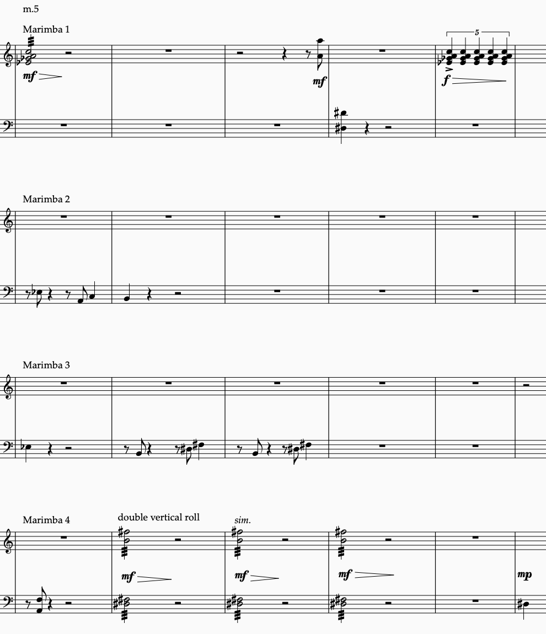
Musical Example 20- Leading-tone exchange transformation (mvt. 4)

In m. 5, notice the articulation of the c°7 in the marimba parts. The only note outside of that chord is played in the bottom staff of the marimba 4 part. The note F is added to this chord to act as a leading tone to the F# that occurs in the next measure. M. 6 moves to the B7 chord, with the B being exchanged for the C. The rest of the pitches are the same, but enharmonically spelled. Then, at m. 9, the harmony shifts back to c°7, as played in the roll of the Marimba 1 part.
I also used harmonic transformations that contain only one common tone between them. In movement 8, one of the progressions consist of an Ab minor triad to a G major triad. This transformation maintains the third of the Ab minor triad, while the root and the fifth slide down a half step. This Neo-Riemannian slide toggles from a major to a minor triad using a double-semitone descent, which allows for a placid transformation (See Musical Example 21). In ex. 21, the alto voice, Marimba 1, and Marimba 2 parts can be seen making the slide to a G major triad in m. 14. In the Marimba 1 bass clef staff, the third of the Ab minor chord changes its spelling from a Cb to a B natural. The alto part concludes its melisma on the word “fall” as it descends from Ab to G, thus anchoring the chord change. To further solidify the harmonic transformation, the Marimba 2 part executes a roll outlining the G major triad in first inversion. Even though only one common tone is maintained, this shift of tonality has a smoothness like the others, due to the proximity of the notes between the two chords.

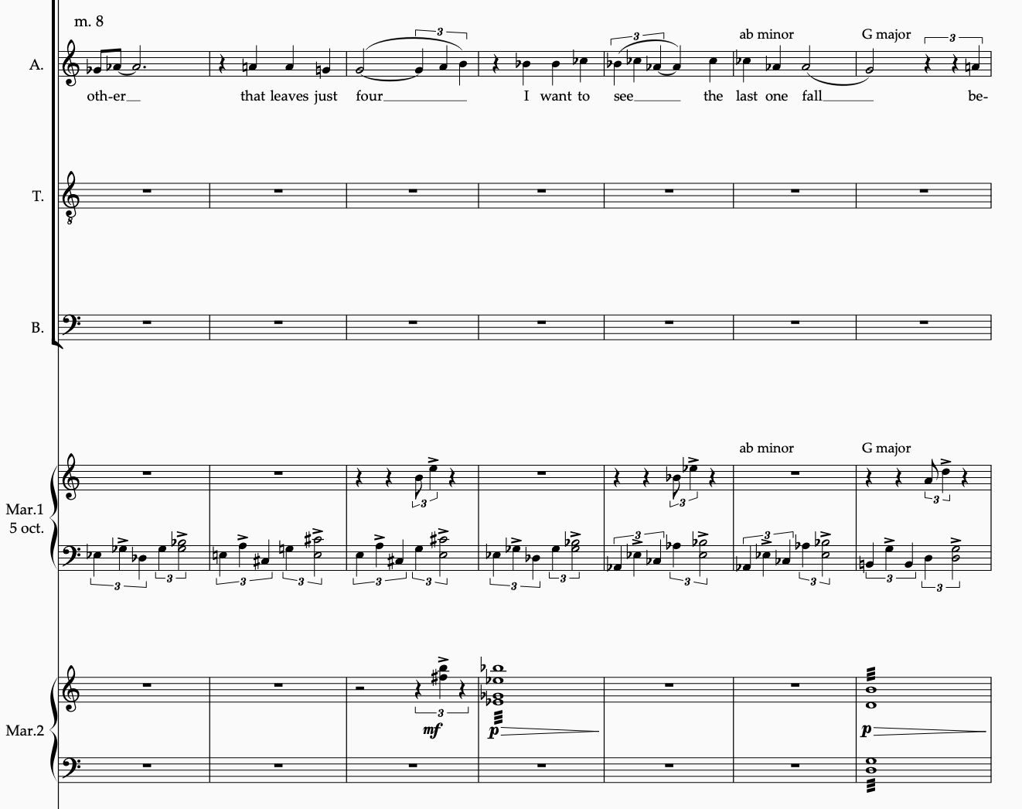
Musical Example 21- Slide transformation (mvt. 8)

The harmonic flow of the piece may best be described through these transformations, as opposed to the hierarchical governing of a specific scalar mode or pitch center. The individual ternary progressions (a-b-a) flow through common tone transformations, which are then linked hierarchically to the ternary macro progressions (A-B-A), which are then linked to the global symmetry of the movements. Through these nested symmetries, each symmetrical rhythmic motive is used in connection with its assigned movement, as a layered ostinato, or melodic scaffolding. From there, the text is overlayed onto the structure as the story of The Last Leaf is told using a variety of contrapuntal devices.

Conclusion

With The Last Leaf, I sought to create a piece of music with background structural features that do not impede upon the surface-level unfolding of the story. Scoring this text upon a symmetrical scaffolding made it more difficult to be sure, yet it created compositional opportunities that may not have been presented to me otherwise. One of these opportunities was to establish a synergy between the foreground and background levels, which would make the piece richer and more musically rewarding. Through solving compositional problems like these, my overall goal remained the same: I wanted to craft a piece of wholly original art music that is at once intellectually stimulating, sonically pleasing, and emotionally compelling.
I hope that this work contributes to the contemporary literature in a meaningful way and adds to the underutilized medium of choir and percussion ensemble. Lang’s The Little Match Girl Passion was a valuable model for me even though I composed The Last Leaf in my own voice and style. I also hope that this piece is a useful vehicle for sharing O. Henry’s moving story of hope and sacrifice. Combining music and narrative has always been a potent combination, and setting this text was a great opportunity to carry O. Henry’s work into the 21st century. The appendix of this document presents the full score of the piece, including the suggested setup chart and performance notes.

BIBLIOGRAPHY

Brightman, Baird. “The Courage to Create: Facing the terror of the blank page.” Medium. February 6, 2023. https://medium.com/@bairdbrightman/the-courage-to-create-d0b54caa4cc3.

Burkholder, J. Peter, Grout, Donald Jay, and Palisca, Claude V. A History of Western Music. 8th ed. New York: W. W. Norton & Company, 2010.

Cohn, Richard. "Introduction to Neo-Riemannian Theory: A Survey and a Historical Perspective." Journal of Music Theory 42, no. 2 (1998): 167-80.

Davison, Archibald T. The Technique of Choral Composition. Cambridge: Harvard University Press, 1963.

Gotham, Mark, Kyle Gullings, and Chelsey Hamm. Open Music Theory. Version 2 ed. Place of Publication Not Identified: Oklahoma State University.

Krebs, Harald. Fantasy Pieces: Metrical Dissonance in the Music of Robert Schumann. New York: Oxford University Press, 1999.

Long, Tu. “A Brief Analysis on the Typical Writing Styles of O. Henry.” Advances in Economics, Business and Management Research, Vol. 30 (2016): 207.

Messiaen, Olivier, and Satterfield, John. The Technique of My Musical Language Translated by John Satterfield. Bibliotheque-Leduc. Paris: A. Leduc, 1956.

Pinkney, Jerry. and H. C. Andersen. The Little Match Girl. New York, Puffin Books, 2002.

O. Henry. “The Last Leaf.” In The Trimmed Lamp and Other Stories of the Four Million. New York: 1907. https://www.gutenberg.org/ebooks/3707

Stevens, Leigh Howard. Method of Movement for Marimba. New Jersey: Charles Dumont & Sons, 2005.

Stein, Leon. Structure & Style: The Study and Analysis of Musical Forms. Florida: Summy-Birchard Inc., 1979.

Gould, Elaine. Behind Bars: The Definitive Guide to Music Notation. London: Faber Music Ltd, 2011.

Varèse, Edgard, and Chou Wen-chung. "The Liberation of Sound." Perspectives of New Music 5, no. 1 (1966): 11-19.

Wolf, Julia. Anthracite Fields. New York: G. Schirmer, Inc., 2014.

APPENDIX

The Last Leaf

Full Score

DUSTIN SCHULZE

THE LAST LEAF

FOR SATB CHOIR & KEYBOARD PERCUSSION QUARTET

Text by O. Henry: adapted by Dustin Schulze

SCORE
_________________________________________________________________________________________________________



INSTRUMENTATION

SATB Choir

Soprano Solo (Sue)

Alto Solo (Johnsy)

Tenor Solo (The Doctor)

Marimba 1
5 octave Marimba

Marimba 2
4.3 Octave Marimba

Marimba 3
4.3 Octave Marimba
Crotales (one octave set)

Marimba 4
4.3 Octave Marimba
Chimes

PERFORMANCE NOTES:

Approximately five to ten seconds should be taken in between movements, allowing enough time for the conductor to establish the next tempo. A longer break can be taken between the sets to allow for the broader tripartite division to be apparent.

The marimbas should be placed in the order suggested in the setup chart below, in front of their designated vocal parts, and in an arch that matches the arch of the choir risers.

All notes played on the crotales and chimes should be allowed to vibrate and decay freely, except for the notes marked with a staccato articulation. Those notes should be muted at the end of their rhythmic value, either by lifting the pedal of the chimes, or using the fingers to stop the vibration of the crotale disc(s).

SUGGESTED SETUP

Chimes
Marimba 4
Marimba 2
Marimba 1
Crotales
Marimba 3
Alto
Conductor
Soprano
Bass
Tenor

Soloists

Audience

Baird Brightman, “The Courage to Create: Facing the terror of the blank page,” Medium, February 6, 2023, https://medium.com/@bairdbrightman/the-courage-to-create-d0b54caa4cc3.
David Lang, “The Little Match Girl Passion” (Universal Music Corp., 2007) 1-5.
Ibid, 1-2.
David Lang, “The Little Match Girl Passion” (Universal Music Corp., 2007) 3.
David Lang, “The Little Match Girl Passion,” Accessed March 1, 2023, https://davidlangmusic.com/music/little-match-girl-passion/.
Harald Krebs, Fantasy Pieces: Metrical Dissonance in the Music of Robert Schumann (New York: Oxford University Press, 1999), 30-31.
Elaine Gould, Behind Bars: The Definitive Guide to Music Notation (London: Faber Music Ltd, 2011).
Lu Tong, “A Brief Analysis on the Typical Writing Styles of O. Henry,” Advances in Economics, Business and Management Research, Vol. 30 (2016): 207.
Edgard Varèse, “The Liberation of Sound,” Perspectives of New Music 5, no. 1 (1966): 16.
Oliver Messiaen, The Technique of My Musical Language (Paris: A. Leduc, 1956) 20-21.

