Supplementary Figure 1: Count Comparisons
Bland-Altman Plots

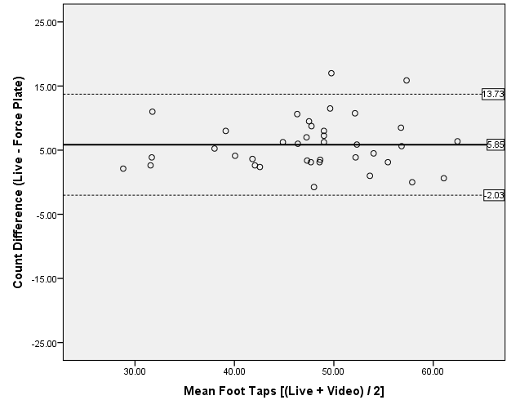
Sup. Figure 1.A: Live – Force Plate Count Comparison

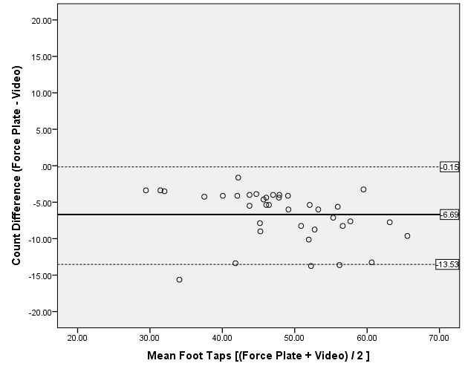
Sup .Figure 1.B: Force Plate – Video Count Comparison

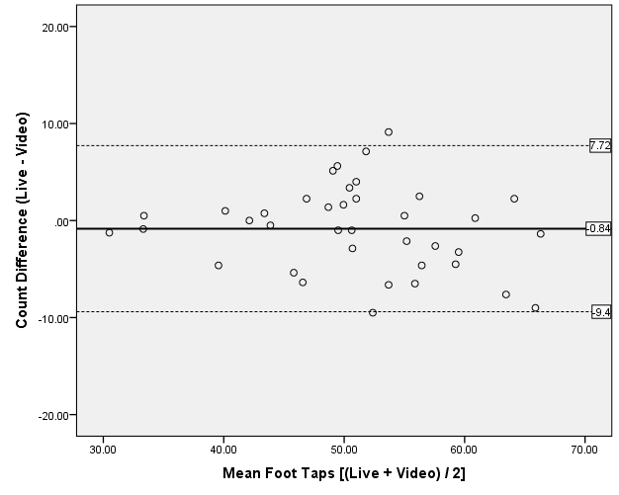
Sup. Figure 1.C: Live – Video Count Comparison

