University of Oklahoma

Graduate College

Consolidations in higher education: how collaborative structures and processes impact the outcomes of organizational change

A Dissertation

submitted to the Graduate Faculty

in partial fulfillment of the requirements for the

Degree of

Doctor of Philosophy

By

Paul robert valentine
Norman, Oklahoma
2018

Consolidations in higher education: how collaborative structures and processes impact the outcomes of organizational change

A Dissertation approved for the
Department of Political Science

By

______________________________
Dr. Alisa Hicklin Fryar, Chair

______________________________
Dr. Deven Carlson

______________________________
Dr. Scott Robinson

______________________________
Dr. Samuel Workman

______________________________
Dr. Derek Houston

© Copyright by paul robert valentine 2018
All Rights Reserved.

For my children.
May you all grow to be happier, healthier, smarter, wiser, and more successful than me.

Acknowledgements
I have been blessed beyond measure during my time in graduate school to have been surrounded by more supportive friends and family members than I could ever adequately put down to paper. Without this support community I would have never managed to make it to graduate school, let alone complete this research, so it is here that I will attempt to memorialize the efforts of everyone who has placed me on their shoulders for many years, however inadequate the gesture may be.
To my longest supporters, my father and mother, Kim and Erin Valentine, and my grandmother Ada Aitken, thank you for lifting me up all these years, supporting me spiritually, mentally, and financially whenever I was in need, and raising me to have the dedication and the drive to continue pursuing my education. I have often reflected on how privileged I am to have been given such a firm foundation straight from the beginning, and I owe anything I make of myself to that. Here’s looking at you, kids.
To my wife, Alana, thank you for following me on this journey, even though it meant leaving your job, your home, and your community to follow some crazy boy to Oklahoma City where he was planning on making very little money and spending most of his time writing on a laptop or reading books with big boring titles. I would have never had the drive or motivation to start this process or see it to the end without you by my side. You invested in me and our future together, and here’s to enjoying all the returns.
To my children, Wren and Ada, you’ll never know how much, even in your youth, you assisted me in this process (even though you often tried your best to keep me on my toes – future scholars, I don’t recommend welcoming your first child into the world a few weeks before taking comprehensive exams!) Whenever this work has been at its most difficult, you have given me endless motivation to continue onward, and reminded me of the all-important need for occasional dance party breaks.
To my friends, too many to list, and to all the great mates out there, thank you for the fun times, the nights off, and the shoulders to lean on over the years.
And, finally, to the network of academics here at OU who have helped me to develop as a teacher and a scholar, thank you for all of your support and encouragement along the way. In particular, I am in a great deal of gratitude to Alisa Hicklin Fryar, who was the first person in Norman to contact me after I had applied and has been helping me ever since. I couldn’t have asked for a better mentor and friend through this process, or anyone who could have better helped me navigate through this often confounding and overwhelming process.
To Sam Workman, thank you for trusting me early on in my time in Norman and giving me the opportunity to work with you; having that vote of confidence near the beginning of my doctoral work gave a much-needed boost of confidence to a graduate student often beset by imposter syndrome. And to Glen Krutz, thank you for helping me to greatly expand my range as a scholar and a participant in higher education over the past three years, and for trusting me to engage in such a wide number of important pursuits at OU. I am a better academic today because of it.
These past five years have, at times, been extremely challenging, but they have also been some of the most rewarding times of my life, and for that I am indebted to all of you. Thank you.

Table of Contents

Acknowledgements iv
List of Tables ix
List of Figures x
Abstract xi
Chapter 1: Introduction 1
Consolidations and Bureaucratic Reform 3
Motivations for Higher Education Consolidations 7
Organizational Change and Performance 12
Implications of this Research 15
Chapter Summaries 18
Chapter 2: Assessing the Short-Term Impact of Consolidations in Higher Education 21
Consolidations in the Literature 22
Similarities to K-12 Consolidation 28
How Similar are K-12 Consolidations and Higher Education Consolidations? 29
Size Matters 34
Similarities and Differences Between K-12 and Higher Education Consolidation 37
Data and Methodology 39
Propensity Score Matching 40
Results ……………………………………………………………………………...48
Consolidating Institutions See Increased State Funding, Decreased Federal Funding 49
Consolidated Institutions More Likely to Increase Spending than Reduce Costs 52
Consolidated Institutions Show Potential Growth in Academic Programs 54
Chapter Summary and Discussion 57
Chapter 3: Higher Education Accountability and Organizational Restructuring: Assessing Student Outcomes in Higher Education Consolidations 61
Performance and Accountability in Higher Education 62
Accountability, Benchmarks, and the Bottom Line 63
Reputational Accountability 66
First-Year Student Retention 68
Predicting Student Retention 69
Accountability, Student Retention, and Consolidation 73
Data and Methodology 75
Data ………………………………………………………………………….76
Methodology 78
Results ……………………………………………………………………………...86
Model Accuracy 86
Prediction Results 89
Discussion 93
Chapter 4: Collaboration and Profound Organizational Change: How Collaborative Processes and Structures Impact Change 100
Profound Organizational Change 102
Defining Change 102
Change and Organizational Performance 105
Organizational Change, Consolidations, and Outcomes 109
Collaboration Structures and Processes 112
Collaborative Structures and the Institutional Analysis and Development Framework 113
Collaboration and Organizational Performance 118
Collaboration and Organizational Change 122
Consolidations in the University System of Georgia 124
The USG Consolidation Process 125
The Four Consolidation Sites in This Study 126
Findings and Discussion 128
Persistent Factors 129
Particular Factors 133
Conclusion 143
Chapter 5: Conclusion 146
Summary of Findings 146
Implications for Theory: A Framework for Examining Organizational Change Within Collaborative Structures 149
Organizational Change 150
Collaborative Structures and Processes 151
Implications for Practitioners 155
Limitations and Future Directions 160
References 164

List of Tables

Table 2.1: Differences in Differences Estimators for Revenue Variables 49
Table 2.2: Differences in Differences Estimators for Expense Variables 52
Table 2.3: Differences in Differences Estimators for Academic Variables 54
Table 3.1: USG Consolidations Contained in This Study 76
Table 3.2: Variables Used in Gradient Boosted Models 79
Table 3.3: Performance Measurements for Model Training and Prediction 86

List of Figures

Figure 2.1: Covariate Balance for Propensity Score Matching 46
Figure 2.2: Effects Plots for Revenue Variable Models 50
Figure 2.3: Effects Plots for Expense Variable Models 53
Figure 2.4: Effects Plots for Student/Academic Variable Models 55
Figure 3.1: Hypothetical Decision Tree Modelling Student Retention 80
Figure 3.2: Iterative Decision Tree Development for Kennesaw State University Model 84
Figure 3.3: Marginal Impact of Model Variables on Prediction Algorithm 87
Figure 3.4: Percentage Difference Between Predicted First-Year Student Retention and Observed Retention in USG Consolidations 90
Figure 3.5: Observed First-Year Retention Rates Pre- and Post-Consolidation 94

Abstract
Over the past several decades, institutions of higher education have found themselves in a difficult environment. States have reduced funding, total enrollment has either fallen or flattened across several years, and technological advancements have placed institutions in direct competition with a larger number of colleges and universities. In response to this changing environment, policymakers and administrators have increasingly looked at consolidation to reorient systems of higher education in a way that makes them more suited to participate in this environment.
These consolidations have wide-ranging impacts on administrators, faculty, staff, students, and communities by determining the missions, goals, procedures, and outcomes of colleges and universities. Additionally, these efforts are highly relevant to longstanding discussions in public administration on bureaucratic reform, bureaucratic structures, performance measurement, the role of efficiency, and accountability. Despite this, there has been little development in the literature on the outcomes of consolidations in the U.S.
This dissertation contributes to our understanding of these consolidations within two main components. The first component is an exploration of the outcomes of consolidations which occurred in the U.S. over the past two decades. Chapter 2 uses a propensity score matching method to compare consolidated institutions with a control group of highly similar, non-consolidated institutions. This analysis produced evidence that while consolidations may increase their revenue in the short term, those gains are offset by increased expenses and the failure to reduce costs in expected areas. Chapter 3 utilizes student-level data from the University System of Georgia which has, since 2012, consolidated several colleges and universities. Using this data, a gradient boosted decision tree regression model develops a prediction algorithm from retention patterns pre-consolidation to predict post-consolidation retention based on the characteristics of enrolled students. These predictions are then compared to observed first-year retention. This comparison provides some evidence that consolidating institutions experience an opportunity cost where students expected to retain instead depart from the institution, especially for the cohorts which enrolled immediately after consolidation implementation.
In the second component, qualitative interviews from consolidating institutions are used to explore how the process of organizational change is impacted by the collaboration between the consolidating institution. Based on the Institutional Analysis and Development (IAD) framework’s development of the external environment, particular the rules-in-use which define participants’ behaviors, Chapter 4 proposes a framework for understanding how the collaboration between institutions impacts organizational change. This process is based on two sets of factors. The first, persistent factors, are factors which relate to the process of change and collaboration and will therefore be present any time an organization is undergoing change or collaboration. These factors generally determine the time and resource costs to employees, with higher costs being related to more negative outcomes for employees and organizations. The second set, particular factors, are based on the IAD framework’s external environment, where rules-in-place change the behavior of participants, and thus either promote or constrain certain decisions within the organizational change based on the specific external environment of the participating institutions.

Chapter 1: Introduction

In 2012, the University System of Georgia (USG) announced its intention to consolidate eight institutions into four. The endeavor was arguably the most significant structural reform of a higher education system through consolidation undertaken in the U.S. when you consider the size and variety of the institutions involved, even before the system would announce four additional consolidations in the following years which would ultimately reduce the system from 35 institutions to 26. The announcement was met with shock among administrators, faculty, and students at the involved institutions. At times, decisions during the implementation of the consolidations would become so contentious that students at one of the institutions staged a protest on campus.
The effort to consolidate was not new to the state of Georgia; the Technical College System of Georgia had previously consolidated fifteen institutions down to seven and reported annual savings of millions of dollars through reduced administrative overhead and workforce reductions. Internationally, consolidations are a common mode of reform within higher education systems, whether the effort moves top-down initiating from the system governing bodies or bottom-up with institutions seeking out opportunities to consolidate for growth. Outside of higher education in the U.S., public organizations have long used consolidation to pursue bureaucratic reform, including when counties merge service delivery organizations, healthcare systems consolidate hospitals, and, notably, when states consolidate their K-12 school districts. Consolidations are also popular within nonprofit organizations who use them both to pursue growth and to cede operations to other organizations which could potentially better serve their clientele. Despite the wide popularity of consolidation as a reform, even among higher education internationally, the history of consolidation between U.S. colleges and universities through most of the 20th century was a story of failed attempts. Due to a variety of reasons – the costs associated with consolidation implementation, state and local politics, uncertainty in the likelihood that consolidation goals would be achieved – many consolidations were proposed but status quo inertia proved to be difficult to overcome for most.
However, over the past several decades an increasingly more competitive and difficult environment for higher education institutions has led to a renewed drive for consolidation. Most states reduced their funding to higher education in the face of the recent recession, and even those states which have begun to increase spending as the economy has improved have mostly just returned to the level they were at pre-recession, meaning most state funds have been at best stagnant for many years. At the same time, the number of students enrolling in higher education has fallen recently while the number of institutions in many states has either remained the same or grown. Technological growth has assisted a rise in non-traditional higher education options including for-profit institutions, fully online degree programs, and increased access to international institutions. The result is that institutions with fewer resources are competing against a larger pool of organizations to recruit a smaller number of students.
This environment has moved the needle on consolidation as a means of reform and led to an increased number of institutions pulling the trigger on implementation. Since 2001, consolidations involving public higher education institutions have occurred in 20 states, and a number of additional states have had stakeholders in higher education at least float the idea publicly. These consolidations run the gamut of institutional arrangements. Some pair multiple two-year degree granting institutions to form a new four-year degree granting option, some involve a larger state school absorbing a smaller specialized program, some are between regional colleges of equal size and enrollment, and others involve more than two institutions being consolidated. The relatively sudden growth in consolidation in the U.S. provides a uniquely rich environment for academic study, but also places the practice of consolidation out in front of the scholarly work on their processes and outcomes.
This dissertation examines the recent wave of campus consolidations from a variety of different perspectives. Higher education in the U.S. serves a variety of lofty functions from producing new knowledge, to stimulating economic growth for students and their local communities, to promoting social justice within the culture, and to the establishment and development of human capital. The results of reform efforts such as consolidation, therefore, are not just important to understand because they are common, but also because of their large-scale impacts on many communities. In addition, the discussions held within the consolidation space tie into long standing areas of interest for public administration, especially for the consideration of bureaucratic reform.

Consolidations and Bureaucratic Reform
The central debates within the formation, structuring, and maintenance of bureaucratic systems have often been focused around questions of competing goals and norms. Whether management should be centralized or decentralized, how extensively principals should seek to control agents, to what extent public organizations should seek to be efficient with public funds versus how much they should maximize performance, how differently should public managers behave compared to their private counterparts; these questions are routinely debated both within the literature and amongst policymakers and managers.
The push and pull between these questions have also long been at the heart of large bureaucratic reform movements. Whether reformers are in the camps of New Public Management (NPM), Public Choice, electronic governance, democratic responsiveness, globalization, or some other large reform movement (or combination thereof), their efforts generally involve moving the response to one of the above questions in a certain direction. The implementation of these changes, then, often involve the reformation of bureaucratic organizations or systems in major ways to achieve these goals in a structural manner. These changes can impact a public organization along several dimensions, including its mission, membership, direct accountability structures, and constituents.
This dissertation adds to the discussion about these organizational changes by considering how the environment within which organizational change occurs affects the processes and outcomes targeted by these reforms. Specifically, it examines how the growing trend of organizations operating within collaborative systems impacts organizational change by studying how collaborative arrangements of power, entry, and norms of behavior between collaborating institutions impacts the day-to-day actions of employees and use of resources as well as how they shape decisions made within the organizational change. To do this, this dissertation looks at consolidations within higher education by first establishing a baseline of expectations for institutional and student outcomes, then exploring what factors relating to collaboration between the two consolidating institutions were important in shaping the implementation of organizational change.
Consolidations have been one large component of bureaucratic reform for decades. Most commonly, consolidations are considered in areas of public service provision, where advocates argue that economies of scale can be reached in procurement, management, and administration in ways that achieve economic efficiency in service delivery. For example, there is a wide body of literature on the consolidation of municipal services (Pachon and Lovrich 1977, Bunch and Strauss 1992, Maher 2015). These consolidations might be between many smaller, rural counties looking to combine delivery to eliminate duplication or within a larger, urban county looking to create new economies of scale through interlocal service provision. Another service which has consistently used consolidation as a mode of reform are hospitals, where often local systems are formed or the ownership of local medical services are transferred from public to private, or vice versa, through a consolidation process (Cuellar and Gertler 2003).
For all of these consolidations, reforms go through several processes. First, it must be determined that consolidation, rather than some other form of interorganizational cooperation, is the best mode of reform. The motivations for entering into a consolidation are discussed more thoroughly below, but in a broad sense consolidations are attractive as a reform option because the potential range of new outcomes is much larger than when using other forms of collaboration (Jennings and Ewalt 1998). Second, an implementation process for the consolidation must be decided upon, including a timeline, leadership, and an outlook for the post-consolidation organization. How change in an organization is managed has been broadly studied in the public administration literature (see Kuipers et al 2014), though less has been focused specifically on change through consolidation and much of this literature fails to link change management practices to post-change outcomes of the organization. Finally, once the consolidation has been implemented some evaluation of its performance can be attempted. The discussion of success or failure in consolidation reforms often comes down to the same fundamental questions mentioned above, weighing potential gains in economic efficiency against the quality of the services provided by the new look organization (Lyons and Lowery 1989).
Higher education has become a salient area for looking at organizational change, particularly through consolidation, over the past several decades. While consolidation has long been present within higher education in the U.S., and to a much larger extent, internationally, recent changes to the education environment have increased the attention policymakers are giving to consolidation. In the U.S., the funding of public higher education institutions has fallen in many states in recent years, coinciding with periods where enrollment has fallen or remained steady. At the same time, the number of total institutions has continued to grow, creating more pressure for institutions with fewer resources to attract a potentially shrinking pool of students. Additionally, while these shifts have occurred domestically the adoption of new technologies and the increased ability for travel in many countries has deepened the international market, placing many institutions in direct competition with international counterparts over students who would not have considered leaving the U.S. in the past, as well as providing new opportunities to attempt and attract international students to enroll. These trends have made consolidation appear a more attractive option for many system and institutional level stakeholders, and discussions of consolidations encompassing public higher education systems are currently being held within eight states, on top of consolidations of public colleges and universities within twenty states over the past two decades. This relatively recent and rapid rise in reform through consolidation in U.S. higher education has created a situation where there is growing action and interest on reforms that have very large implications on a number of stakeholders and constituents, but for which the field of literature is still nascent.

Motivations for Higher Education Consolidations
When public organizations consolidate, the reason most often cited is an increase in efficiency by reducing duplicated programs. Higher education consolidations are no different; state and institution level administrators often talk about how the consolidation of multiple institutions can capture economies of scale that reduces spending to reach a similar number of students (Tight 2013). However, some institutions also consolidate as part of an effort to diversify the total number of services offered (Lang 2003). By combining resources and expertise, multiple institutions can offer new and unique programs they otherwise would not be able to manage alone. This is seen by administrators as a way to position an institution more competitively as they market to future students and investors (Harman and Harman 2008).
Increasingly, financial efficiency is entering into discussions of accountability had by both state administrators and educators (Alexander 2000). Higher education institutions are pressured not just to produce positive results, but to serve as good stewards of the public resources available to them. The pressure to operate efficiently as well as effectively has come from external stakeholders both public and private (Lahey and Griffith 2002). Many states have reformed higher education funding to link budgets to specific programmatic outcomes such as student retention, graduation rates, job placement rates, or student scores on licensure exams (McLendon, Hearn, and Deaton 2006). This increased focus on both the resource inputs and performance outputs of higher education make efficiency a more noticeable priority.
Chambers (1987) identified three types of mergers that take place in higher education. The first two of these types, bankruptcy-bailout and mutual retrenchment of institutions with similar programming, deal directly with improving an institution’s financial situation. Financial incentives can range from an attempt to improve the performance of failing institutions to the elimination of waste by achieving economies of scale. Though literature on mergers and consolidation in higher education have been relatively sparse compared to their impact, especially in the U.S., many scholars involved in their study have long felt that financial concerns are the primary motivation for higher education consolidation (Millett 1976; Skodvin 1999). Those directly involved in the process also tend to see financial concerns placed front and center in the consolidation process (Azziz 2013). Primarily, the idea that consolidations can improve financial status is driven by the idea that consolidations eliminate waste within a system and free up resources to be used in more productive way.
Higher education is not unique within bureaucratic systems in embracing the idea that consolidation can increase organizations’ efficiency. The closest example is likely the consolidation of K-12 school districts, long seen as a way to more efficiently allocate state resources, especially in rural areas (see Dodson and Garrett 2002 as an example). Certainly, though, the restructuring of public systems and organizations through consolidation is not limited to education. City-county consolidation, where local city governance is merged into the county governance structure, is a popular reform effort generally promoted by the idea that linking together smaller local governments will result in a more efficient bureaucracy (Durning 1995). City-county consolidation reforms have been at the center of an ongoing debate between public administration scholars, who tend to be generally positive on the idea that consolidations help increase efficiency, and public choice theorists who are more concerned that consolidation creates monopolies of service provision which can become inefficient without competition (Campbell and Durning 2000). Interestingly, in spite of a long back and forth between the two sides, empirical evidence on the benefits of local consolidation is lacking, though some studies offer evidence that slight gains in efficiency are possible (Selden and Campbell 2000; Leland and Thurmaier 2000). On a smaller scale, many local governments use consolidation of public services as an attempt to save money. This was an especially popular strategy following the economic recession in 2008-2009 (Abernathy 2012). In the 1990’s the consolidation of hospitals, both public and private, was seen as a key reform to reduce costs and increase productivity, leading to a large increase in the restructuring of health care systems (Aiken, Clarke, and Sloane 2001).
In the aim for greater efficiency, these reforms all have at their core one main concept; by eliminating duplicated processes and pooling resources, organizations can achieve economies of scale which lower their total costs. When aiming for economies of scale, it is important to note that in education, like with any field, there is an upper limit to the gains that can be made by increasing scale (Lang 2003). However, previous studies on higher education have found that upper limit to be quite high (Schumacher 1983). This number has been pegged at somewhere around an enrollment of 20,000 (Patterson 1999; Toutkoushin 1999) after which increased enrollment does not result in greater efficiency. The idea that consolidating two large institutions would not help with efficiency is somewhat intuitive, and is borne out by the lack of consolidations between universities of this size. Instead, large universities may be more likely to work together through consortia or other collaborative means to achieve similar goals. Economies of scales are also limited by certain features of the institution. For example, increased enrollment of high quality students (measured by SAT scores) creates more efficiency than general increases in enrollment, and institutions with Ph.D. programs incur greater costs as enrollment grows (Koshal and Koshal 1999). The limits in gains on efficiency from an organization’s situation does not preclude further consolidation, though, because institutions may also consolidate in order to improve their offerings.
The final type of merger identified by Chambers (1987), the mutual growth of institutions with complementary offerings, speaks to second major motivation for consolidation: increased reputation, prestige, and marketability. While many institutional administrators and stakeholders may view the growth and development of the institution as the primary goal for undergoing consolidation, the pursuit of growth is often made possible by success in pursuing the financial goals; a more financially efficient organization is better able to invest in programmatic growth. By combining resources and eliminating duplicated programs, two or more organizations can free up resources to put towards the creation of new programs they would otherwise have been unable to start. This, in turn, helps them to increase their notoriety, attracting more students and, potentially, more streams of revenue.
One factor in pursuing consolidations has been the wide popularity among reformers to adopt approaches that stress the use of competition between organizations in order to promote growth and better outcomes (Drowley, Lewis, and Brooks 2013). From an economic perspective, consolidation reduces the total number of institutions operating in the market and, thus, reduces competition. However, reformers in higher education view consolidation as a means of creating institutions which are capable of expanding their reach and better competing against other institutions in their ecosystem. For example, two colleges which recruit primarily regionally within a state may view consolidation as a means of expanding their recruitment to other parts of the state or to neighboring states. In a similar fashion to smaller firms merging to improve their ability to compete with larger firms, consolidation is therefore used to alter the dynamics of competition the institution participates in. This has especially been the case as some organizations increase their pursuit of international students. In the global market, where students are less familiar with their options, things like university rankings become more important in signaling quality. Consolidations have been seen as one means of increasing in the collegiate rankings and becoming more competitive, especially globally (Valimaa, Aittola and Ursin 2014).
Increased efficiency has often been pursued as the primary goal in a top-down driven approach to bureaucratic reorganization. In higher education consolidations, large amounts of reorganization occurred from top-down efforts at restructuring national higher education systems in China (Cai 2007), England (Harman and Meek 2002), and Norway (Kyvik and Stensaker 2013). As a result, these top-down, efficiency driven mergers tend to involve underperforming institutions. However, Harman and Harman (2008) have found increased evidence for bottom-up, institution-initiated consolidations. These consolidations tend to focus more on the pursuit of institutional growth and, as a result, involve stronger, more prestigious institutions. Often, these consolidations occur with an implicit motive to move up in collegiate ranking systems.
Again, educational organizations are not alone in their use of consolidation to improve their marketability. Many small nonprofit organizations have used consolidation as a means of becoming more viable in a field where it’s increasingly competitive to find revenue, leadership and volunteers (Singer and Yankey 1991). Smaller nonprofits simply have a harder time attracting the same level of attention as larger ones. Like the top-down education consolidation, nonprofit mergers are often driven by “problem” organizations that face termination (Norris-Tirrell 2006). These organizations can attempt to acquire another organization or they can consolidate to form a larger nonprofit with an expanded range of services and direction.

Organizational Change and Performance
Regarding either motivation for consolidation, the literature has yet to provide strong empirical support that these goals will be met. While some evidence has been found in support of consolidations, other scholars have shown ways that consolidations can either fail outright or fall short of estimated gains. Kyvik and Stensaker (2013) classify three ways in which a higher education consolidation can fail: structural, cultural, and interest groups concerns. Structural explanations of failure have to do with things such as geographic distance between campuses, the number of institutions, and the size of institutions; cultural explanations have to do with organizational cultures and how well they combine; and interest group explanations involve the interaction between local stakeholders, administrators, and national power brokers. These three categories highlight the variety of factors that become crucial to a consolidation.
Generally, one big reason for the failure of consolidations is how disruptive the process is to day-to-day activities in involved organizations. Mergers and acquisitions are a trying time for many employees involved; individuals generally value stability, and a merger may cause anxiety by disrupting stability. This drastic organizational change can lead to anxiety for members in all involved organizations, even if the reorganization is the acquisition of one organization by another (Pritchett 1985). The process of the merger can disrupt daily activity in the organization and lead to shock, apathy, insecurity, and frustration in members (Kleppesto 1998). When you also consider that many organizations may be motivated to consolidate by a need to improve poor financial situation, it is not surprising that consolidations have a mixed record of success. One proposed explanation for the poor track record of consolidations is that decision makers often focus on the financial circumstances of the process and do not give adequate attention to the members involved (Fischer, Greitemeyer, Omay, and Frey 2007).
The disruptive effect of consolidations has been documented in a wide range of literature regarding public services (Andrews and Boyne 2012). Issues that create disruption include: goal displacement as leaders become distracted by managing the consolidation rather than the mission of the organization; leadership turnover as managers, unsure of their future in the organization, either choose early retirement or seek out a position in another organization; a lack of effective direction as strategic planning is put on hold until the new organization is full materialized, reductions in morale; and, in the case of local government consolidation, wasted resources as local bodies that are soon to be disbanded and merged into larger bodies seek to lock in long-term benefits for their constituents. The byproduct of all these issues is wasted resources and lowered productivity, which goes against the stated motivation for consolidation.
One consideration is whether the decrease in output caused by this disruption outweighs the future gains achieved in a consolidation. Little is currently known about whether new structures in reorganization realize benefits large enough to justify the costs (Pollitt 2009). Theories of structural change would suggest that even when gains are made from reorganization, it can take a considerable amount of time before these gains are reflected as a net positive (Hannan and Freeman 1984). It’s also possible that the deleterious impacts of reorganization can be compounded if structural changes are made before organizations have recovered from previous or concurrent changes (Pollitt 2007). Andrews and Boyne (2012) found that the negative impacts of reorganization can actually begin before the implementation of restructuring starts as members become aware that the process is imminent. This can widen the divide that future efficiency gains will need to fill to become a net positive.
Consolidations can also perform poorly when implementation is not handled well. Mulvey (1993) conducted 20 case studies ranging from 1964 to 1985 and found that the universities he examined developed very few strategies and generally handled implementation of the consolidation poorly. Lockey (2007) found that administrative costs ended up driving out most of the gained efficiency from consolidations. Administrators who were hired to manage the consolidation were ultimately retained in permanent capacities, and while one of the main reasons for consolidating is to eliminate duplicated programs, very few universities are willing to fire the faculty and staff necessary to truly eliminate duplication. This meant that institutions either never saw gains or actually performed worse post-consolidation by adding unnecessary duplication.
A final important issue in a consolidation is the power dynamic between members of the organizations. For example, in one study members were assigned into high, moderate, and low status groups; members of the low status group had the most negative opinions on the merger process and the new organization (Fischer et al 2007). In the case of an acquisition, members of the organization being acquired can suffer an especially large loss of status and, therefore, have severely negative reactions to the process (Pritchett 1985). In contrast, mergers where both organizations see each other as equals tend to form a stronger new organization because strict equality for both sides is enforced in the merger process (Zaheer, Schomaker, and Genc 2003).

Implications of this Research
Consolidations are a relatively recent trend in higher education in the U.S., but the issues therein relate to longstanding discussions in public administration about bureaucratic reform, performance measurement, structure, accountability in public organizations, and the role of efficiency. This dissertation will give consideration to some of the large questions in this space. How do you measure performance against competing types of accountability pressure? What weight should be placed on economic efficiency within public organizations, especially when they are tasked with missions that touch on lofty goals such as economic mobility, the construction of social capital, social justice, and the development of a democratic society? In what ways and to what extent is organizational change impacted by the structure of change and the decisions made by policymakers and stakeholders?
Higher education has several advantages when it comes to the consideration of these discussions. For one, there is a large amount of variety between institutions of higher education, allowing considerations to be made across differences in geography, resources, demographics, missions, political environments, and organizational structures. Tracing a phenomenon across this wide landscape of institutions can provide confidence that the results are not driven by extraneous circumstances. However, despite the variety across institutions, colleges and universities are largely all giving consideration to three major performance measurements – economic efficiency, their reputation, and student outcomes. In addition, federal reporting regulations and standards mean that higher education institutions maintain a set of data that is consistent across each institution and allows for the consideration of outcomes to be standardized to a certain extent.
This dissertation also aims to make a broader theoretical contribution to our understanding of how the well-studied phenomena of organizational change and collaboration can interact to shape the outcomes of public institutions and systems. I argue in this research that change within a collaborative environment is inherently shaped by collaborative processes in two ways. One, collaboration takes up both time and resources from an organization as employees must work on building mutual understanding and trust among collaborative partners, develop goals, assign responsibilities, establish membership rules, and create new work processes. Two, within collaboration, partners will develop dynamics of power and control over various issues, providing different organizations varying levels of influence over their partners. Within organizational change, collaborative power asymmetry can give one institution greater influence over steering the change process.
Consolidation provides an idealized environment in which to consider these two proposals. Because collaborative partners in a consolidation are making decisions and implementing the joining of their organizations, control of the collaboration provides direct influence over the organizational change. However, it is also easy to see ways that this dynamic could be present in issues outside of consolidation. Consider any public system where multiple institutions have policy overlap or provide services to the same geographic location; if one organization within this system undergoes a significant change, consideration must be given to the other institutions within the system, considerations which will ultimately be shaped by the collaborative space.
This research also has much utility for practitioners in higher education and policymakers within higher education systems and state legislatures. Within this dissertation, consolidations occurring between 2002 and 2015 from twenty states are incorporated in the analyses, representing a diverse field of institutions including HBCUs, public/private consolidations, regional institutions, and specialty focused institutions. In addition to these consolidations, future consolidations have either been passed, proposed, or discussed in Georgia, Louisiana, Pennsylvania, Alabama, New Mexico, Vermont, Idaho, and Michigan. It is clear that consolidation as a means of higher education reform is going to remain a relevant discussion for years to come.
Despite the increase in attention that higher education consolidations have been receiving in the United States, the literature on the process of consolidation and the expectations for outcomes remains sparse. This dissertation addresses both issues. First, it establishes a set of expectations for consolidations at the institutional level, looking at a wide variety of outcomes which are relevant to policymakers and institutional stakeholders. Second, it takes a deeper look at student outcomes, specifically student retention, and gives consideration to the potential opportunity costs for students and the institution while engaging in consolidation. Finally, this dissertation provides unique insight to the process of consolidation through qualitative work done within multiple public institutions within the state of Georgia which has undergone a number of major consolidations since 2011.

Chapter Summaries
Chapter II examines the outcomes from consolidations within their first five years from an institutional perspective, looking at a number of variables concerning revenues, expenses, and student/academic outcomes. It begins by looking at the existing literature on higher education consolidations, particularly internationally where there are a larger number of studies, as well as the literature on K-12 school district consolidations within the U.S., which have historically been more prevalent. It then uses a propensity score matching model to create a dataset using data available from the Department of Education’s Integrated Postsecondary Education Database (IPEDs) which pairs institutions formed through consolidation with a control group of institutions which are most similar across a range of identifying variables such as total enrollment, total budget, the number and types of degrees conferred, and geographic location, among others. A linear mixed-effects regression model is then used to examine the difference between consolidated institutions and non-consolidated institutions over the first five years after the consolidated institutions have been formed.
Expanding on this baseline of expectations, Chapter III uses student data provided by the University System of Georgia to assess the impact of consolidation on student outcomes among six different consolidations in Georgia. Specifically, this chapter looks at first-year student retention, which is one performance measurement that cuts across multiple accountability pressures that are applied to higher education institutions, which are discussed within the chapter. To do this, students at the pre-consolidation institutions are grouped together by consolidation to allow for an examination of retention in the pre-consolidation system. These students form a dataset which is utilized as training data for a gradient boosted decision tree regression model which is then used to predict retention post-consolidation based on a variety of variables including high school performance, collegiate performance, financial information, and demographic data. This methodology allows for a comparison of first-year retention in the pre-consolidation system to that of the post-consolidation system and is particularly robust in picking up on interaction effects between the predicting variables and small, esoteric differences between students. These advantages allow the methodology to both look at pre- and post-consolidation retention as well as look for an “opportunity cost” of students who were not retained but who would likely have been retained had consolidation not occurred.
After establishing these baseline expectations, Chapter IV is concerned with what factors of the consolidation implementation determine these outcomes or explain variation across consolidations. To do this, Chapter IV considers how the literature on organizational change potentially intersects with the literature on collaboration to understand how members of the organization operate on a day-to-day basis during implementation and what factors may affect decision making. Two proposals are formed; first, that organizations which undergo change while also participating in some level of collaboration will have more limited resources, and employees will experience more stress and negative job performance because organizational members must split time between both efforts. Second, that collaborative structures, especially the distribution of power between the collaborating institutions, will determine which collaborators have a greater influence over the organizational change.
Finally, Chapter V concludes with a discussion of the major findings and the relevant implications for both theory and practice. This dissertation seeks to contribute to these areas in two major ways. First, in the development of theory, it examines the often overlooked impact that the implementation of organizational change has on the final outcomes, especially in regards to how multiple changing organizations are structured with regard to one another. Second, for practitioners, this research provides information on the expected outcomes of higher education across a wide variety of variables, as well as gives consideration what factors within the collaborative environment should be considered to potentially mitigate harmful findings and boost the positive. The impacts found within this study are short-term in nature, but have long-term implications for the eventually success or failure of consolidations, especially in regard to their financial goals, as different early costs push the break-even point of consolidation to a higher dollar amount.

Chapter 2: Assessing the Short-Term Impact of Consolidations in Higher Education

When seeking to restructure bureaucratic systems in order to create more efficient organizations, consolidations have been a politically popular reform. Advocates argue that consolidations help limit the waste of resources, unlock economies of scale, and create more collaborative governments that can better serve the needs of constituents. Others argue that these sort of large reforms are costly and disruptive in the short-term and ultimately fail to achieve their goals because organizations cannot serve the same size of clientele for less money without it being detrimental to the quality of their service provision.
Within higher education, as institutions face an increasingly difficult environment from decreasing budgets, increased competition for students, and legislative constraints, many have turned to mergers and acquisitions as a means to strengthen their position. Some consolidations combine many smaller institutions together to form one larger, more competitive institution; others involve a larger institution acquiring a smaller one in order to diversify its academic offerings. In either case, despite the impact these mergers can have on students, faculty, employees, and communities, higher education consolidations occupy a relatively small space in scholarly research, particularly in the United States. Where scholarly work does exist, most of it is focused in two areas: the pre-consolidation period (where research has established the reasoning that most reformers give for pursuing consolidation efforts) and the actions of managers during consolidation implementation (specifically, how managers make decisions and how they select leadership styles). Lacking in both of those outlooks is an in-depth examination of the outcomes of consolidation.
This chapter seeks to first establish some baseline of what to expect from consolidations in higher education and add to the literature of education reform by focusing on outcomes rather than administrative decision making or the motivation to consolidate. Subsequent chapters will give deeper consideration to the process of consolidation implementation and how the implementation effort contributes to some of the outcomes found here.

Consolidations in the Literature
Consolidations, mergers, acquisitions, amalgamations, and other creative arrangements of institutions have been occurring in the United States for most of its history; the earliest recorded consolidations of higher education institutions I could find took place in Ohio and Maryland in the 1830s. However, through most of the 20th century these reforms tended to be relatively sparse. Consolidations, however, have seen an increase in popularity over the past several decades, dovetailing with the rise of New Public Management style reforms that stress efficiency and customer-oriented models, as discussed in Chapter I. Despite this increase in popularity, the outcomes of consolidations are not often the topic of study, with scholars instead focusing on the decision-making processes of managers and the process through which policymakers made the decision to consolidate. The studies which have been done generally take a case study approach which narrowly explores a single consolidation implementation.
Internationally, where consolidations have been more frequent than in the U.S. until recently, the literature is much more developed. The education systems in many of these countries are more tightly controlled by the central government, given reformers there an advantage over their U.S. counterparts when it comes to overcoming political forces maintaining the status quo. In China, Belgium, Finland, Great Britain, Australia, and Germany, among other countries, the central governments have mandated consolidations as a part of larger system reform efforts (Skodvin 1999, Mok 2005). In Finland, for example, the country established a new system of polytechnic colleges through consolidation, and institutions were given little autonomy throughout the implementation process. In the U.S., Canada, Sweden (as well as within some of the countries listed above which have hybrid governance model which gives both central and local governments control over education), the consolidation efforts generally starts at the state or provincial government level. In some of these countries public institutions have also voluntarily pursued consolidation opportunities which were later approved by their governing bodies.
Despite differences in the origin of consolidations, the motivations across the board generally fall into one of the two categories discussed in Chapter I: the pursuit of financial efficiency or the increase of institutional prestige and marketability. In some cases, these goals were pursued by the state as part of larger national goals. The Chinese government, for example, saw the increased globalization of the education market as a means to strengthen Chinese influence globally, and consolidated institutions in order to grow programs that would be more competitive among international students (Mok 2005).
Additionally, policymakers may view consolidation as the only way to purse both financial efficiency and programmatic growth simultaneously (Lang 2002). Educational systems are extremely dependent on history and path dependency, and as advancements in technology or cultural and demographic shifts occur systems may find that they have many institutions showing stagnant growth or experiencing a poor fit with their neighboring communities. Without the ability to reach new prospective students, programmatic growth is a potentially high-risk, low-reward scenario. However, closing an institution, even one with a poor financial outlook, produces extreme financial and cultural costs (Martin and Samels 2016). Given these realities, policymakers at the system level may view consolidation as a means of improving their ability to attract new students and creating an atmosphere where programmatic growth are possible.
At the institutional level, motivations also primarily fell into these two categories, with a discernable pattern showing based on the size of the institution (Lang 2002). Smaller institutions tend to be more focused on finances and may wish to take advantage of government funding rules which favor larger institutions, access resources of a larger institution, or have their accumulated debt absorbed into a larger institution in order to reduce its impact. Larger institutions, on the other hand, are less likely to see significant reforms like consolidation as necessary to pursue financial goals, and therefore tend to consider consolidations primarily as a driver of institutional development. One common means for larger colleges or universities to grow through consolidations is to merge with a small institution that specializes in one program; the larger school obtains a pre-existing progress through a process which ideally costs less than the spending it takes to develop a program from the ground up. International experience shows that government and system administrators tend to favor the financial motivations for consolidation (Ursin, Aittola, Henderson, and Valimaa 2010), so when institutions are not involved in the decision to consolidate it is perhaps likely that the structure of the consolidation will be more favorable to the desires of smaller institutions.
As stated above, how likely institutions are to achieve these goals is understudied in the literature. (The literature is more robust on the question of what makes a “successful consolidation” in the sense of what implementation techniques lead to the consolidation being finalized.) For the few studies which have been completed in the U.S., the results are mixed regarding financial returns. Fielden and Markhama (1997) found that most expected financial savings are intended to come from the elimination of teaching staff, upper administrators, various support staffs, and clerical staff. However, the necessity of most of these positions is tied directly to enrollment, so unless enrollment across the consolidating institutions drops it is unrealistic to make reductions in staff. In cases where duplicated roles become expendable, it is still not a given that the institution will be able to eliminate it, as many positions within higher education are legally protected from being fired except under specific circumstances (Skodvin 1999). In addition, institutions tended to underestimate the amount of additional training for staff that would be required for the consolidation implementation, tasks which often proved costly (Rowley 1997).
There is a more positive outlook on the academic development side. Skodvin (1999) identifies an ideal situation for academic growth, finding that institutions which vary in the size of their enrollments, are close together, and have diverse course offerings from each other tend to consolidate into positive environments for academic growth because the amount of conflict is minimized. Specifically, consolidated institutions generally provided a wider breadth of academic offerings than had existed between the pre-consolidated institutions (Rowley 1997, Skodvin 1999, Wan and Peterson 2006). However, these gains in academic programming can be hindered through poor consolidation implementation. This is especially true in the initial phase of considering consolidations – pairing institutions which are not complementary or giving institutional administrators confusing goals hamper future academic growth (Martin 1996). Again, policymakers in central or provincial governments tend to favor financial considerations for consolidation, which may lead to pairing institutions which are not ideal fits for programmatic growth; to make financial gains, it is more common to pair institutions with very similar academic offerings so that duplication within the higher education system can be eliminated.
Whether the introduction of new academic programs in turn leads to increased marketability is unclear, and scholarly work on this topic has consisted mostly of a few case studies. Aula and Tienari (2011) examined the consolidation of a university in Finland which openly touted the desire to be become a “word-class” institution as a driver to consolidate, but found that administrators were simply using an imaginary future state as a motivational tool and as a means to justify undergoing the consolidation. Once staff in the consolidating institutions began to perceive the “world-class” line as just empty rhetoric from administrators, it created substantial amounts of conflict. Another case study of the same university also found that the institution had difficulty adopting new branding in its attempt to improve its prestige, especially when the new branding was met with resistance from unsatisfied members of the university (Aspara, Aula, Tienari, Tikkanen 2010). A case study of a consolidated university in Sweden, on the other hand, found that the institution successfully created a new identity with large amounts of buy-in from staff, which successfully allowed them to rebrand the institution under its new direction, a move administrators credited for new growth in student applications (Geschwind, Melin, and Wedlin 2016). Success or failure in translating new programs into greater perceived prestige, then, may be reliant on the process of consolidation.
For any consolidation to successful pursue financial or institutional growth, it is also imperative that a full integration of the consolidating institutions occur. A successful melding of organizational culture, norms, practices, and the development of trust between all members has a number of benefits for the new institution, including maintaining the morale of employees, avoiding cultural conflicts, and allowing the pursuit of new to occur without being derailed by power struggles (Skodvin 1999, Hay and Fourie 2002, Harman 2002). For this successful integration to occur, two things are needed: strong managerial performance and time. Managers must be able to access a variety of managerial styles and be prepared to apply them to the various conflicts that arise during the process, being mindful of the preexisting culture at all institutions (Locke 2008). Imperative to this effort is understanding the various subcultures that develop within different sections of the institution and anticipating the concerns and desires of these groups. Managers must also pay careful attention to how loyalties develop between members of the new institution. One way to mitigate the issue of internal divisions is to unify the new institution under one layer of upper administration; for example, having one provost position instead of keeping a provost on the campus of each pre-consolidation institution (Harman 2002).
Even with expert management and leadership, however, conflict is bound to occur within a consolidation process. Higher education institutions lend themselves to the development of esoteric subcultures among departments and diverging loyalties as hierarchies are divided across campuses. Because it is unlikely that all of these subcultures will mesh well in the new institution, most scholars who have studied these consolidations have found that it will likely be somewhere around 10 years post-consolidation before integration can be finalized (Cannon 1983, Chambers 1987, Harman 2002). Research has indicated that this 10 year mark is when the majority of staff view themselves as members of a single institution, rather than members of two institutions still figuring out how to work together. It also allows time for new systems and norms to be established, and for the new institution to develop a reputation among external stakeholders (arguably most importantly, future students). However, while a long-term view of the consolidation effort is required, the short-term outlook is also important as costs accrued early make long-term gains harder to achieve, and conflict can harm academic delivery in the short-term in a way that is antithetical to the missions of higher education institutions.

Similarities to K-12 Consolidation
While the U.S. has less of a history in higher education consolidations than many other countries, there is a still a rich history of merge-based reforms in the education space: the consolidation of K-12 school districts. Both K-12 and advanced educators have similar missions, serve similar demographics, and have similar connections to culture and community. Taking a look at these K-12 consolidations, which have been much more frequent than in higher education to date, may provide some insight into what to expect from higher education consolidations.

How Similar are K-12 Consolidations and Higher Education Consolidations?
Perhaps more so than in higher education, consolidations of K-12 are driven by their history and development. As soon as the early 1800’s, when the introduction of state-funded public transportation in the U.S., invention of the automobile, and the paving of roads all contributed to a much more mobile populace, reformers began to push for the consolidation of school districts (Bard, Gardner, and Weiland 2006). They thought that larger schools would provide students with a better education, and these advances allowed them to transport students from small, rural communities to places where they could participate in a larger institution. As industrial centers grew in urban areas, education reformers also began to borrow ideas from industry and apply them to schools. It was believed that schools would be better if they were not just larger but also as similar to each other as possible (Kay 1982). As a result, the push for consolidating districts and having fewer but larger schools gained even more momentum as reformers sought to eliminate the diversity of methods across smaller districts. Over the next century, the number of school districts in the U.S. was reduced by nearly 90 percent (Duncombe, Yinger, and Zhang 2014).
Despite this massive reduction in districts, there are still many small school districts in the U.S. and still reformers pushing for their consolidation. The modern debate around consolidation in K-12 districts looks very similar to the financial and mission driven motivations that drive higher education reform. The basic foundation of the case for consolidation rests on the idea of achieving economies of scale (Duncombe and Yinger 2007). The idea is to allow schools to spread fixed costs (such as the maintenance of buildings, utilities, etc) over a larger group of students to operate more efficiently. Some of these cost savings can then be repurposed to help schools provide a better educational experience to students, have more flexibility in their operations, and allow teachers to take advantage of more professional development.
Proponents also argue that consolidating into large districts allows schools to expand their curriculum in a way that gives students more opportunities and choices, particularly at the secondary school level (Benton 1992). For instance, a larger school might be able to have band and choir offerings for which a smaller school would not have enough students to support. Monk and Haller (1993) found some evidence to support the assertion that larger schools tended to have more course offerings than smaller schools, although there are a lot of variables unique to each school which could explain varieties in offerings. A study of Arkansas school district consolidations looking at the variety of courses that students enrolled in post-consolidation found evidence that students participated in a wider range of courses after consolidation occurred, including advanced placement and vocational courses (Nitta, Holley, and Wrobel 2010).
Proponents of consolidation also say that growing the number of students allows schools to develop structural advantages over their smaller counterparts (Berry 2004). By increasing the student body, school districts, especially those in rural areas, are more likely to be able to group students by grade-level, unlike schools with student bodies small enough that it makes little economic sense to try and have staff working with grade levels individually. Additionally, by reducing the number of schools districts could both reduce the total number of administrators and streamline the efforts for larger governing bodies to manage districts. This led to a shift in power away from small, local school boards and towards the state government, where legislators pushed for more uniform professionalization standards for teachers and administrators (Spradlin, Carson, Hess, and Plucker 2010). In cases where consolidations have successfully improved financial outcomes, these structural advantages may be a significant driver in cost management (Durflinger and Haeffele 2011).
Investigation on how likely school districts are to improve their finances or better serve students through consolidation has produced mixed results. Some studies have found that students in consolidations have seen modest gains (Cox and Cox 2010) to more substantial gains (Gilliland 2008) in performance. A causal link between consolidation and student performance is often difficult to make because of the frequency of confounding external events, such as the passage of federal legislation like No Child Left Behind, which occur while longitudinal studies are being conducted (ibid). Other findings have been more negative, noting either no change post-consolidation or an actual decrease in student test scores, as well as drops in student attendance and graduation (Bard, Gardner, and Wieland 2006). Many of the studies showing a downward trend on student performance post-consolidation are related to the size of the new district, a topic discussed more thoroughly below.
The change in financial performance post-consolidation is equally determine. There is some evidence that consolidation may lead to cost savings for districts if the process does not create a need for the construction of additional facilities (Jacques, Brorson and Richter 2000). Other studies have found cost savings are possible if certain circumstances are granted. For example, the financial result of consolidation may depend on the size of the districts being consolidated – consolidating small districts generally had positive financial outcomes which began to decrease among consolidations of larger districts (Durflinger and Haeffele 2011). Another study found that the geographic location of districts determined post-consolidation cost savings; smaller districts in nonrural areas could be consolidated and achieve larger economies of scale than rural districts (Boser 2013). Gronberg et al (2015) found that the market concentration of school districts post-consolidation was a determinant in financial efficiency for the new district. They reported that school districts achieved significant economies of scale by consolidating, but by increasing in size they reduced competition which ultimately led to less efficient districts. This inefficiency negated some or all of the gains made through economies of scale in districts with higher post-consolidation market concentration. Duncombe, Yinger, and Zhang (2014) examined property values in consolidated districts as a measure of how popular the districts were for parents. They found an initial drop in property values that evened out after four years and then rose to higher rates than had been present pre-consolidation. Given the close tie between local school funding and property taxes (Figlio 1997), if consolidated districts increase property values this could lead to long-term savings not accounted for in current studies.
Other scholars have been more pessimistic about the opportunity for financial growth through consolidation. Howley, Johnson, and Petrie (2011) argue that most financial gains measured in consolidation occurred because the most obvious districts to consolidate were selected first. Now that most districts that needed to be consolidated already have been, they feel that future consolidation is more likely to have negative financial impacts. Cox and Cox (2010) found substantial increases in costs post-consolidation. Gilliland (2008) found an increase of per pupil expenditures of 503 dollars over four years, noting that most of the increase came from inadequately accounting for staffing increases. Many times, cost inefficiencies occur after consolidation because districts are required to bus students longer distances and hire more middle managers, which wipes out cost-savings that occur from reducing the total number of superintendents (Howley, Johnson, and Petrie 2011). The study of financial success and consolidation is also confounded by normative issues of measurement and how financial outcomes are defined. While some school districts find lower total costs, small districts tend to graduate students at a higher rate than larger ones. When this drop in graduation is accounted for, districts that saved money on per pupil spending still spent more money measured per graduation percentage, which some argue is a better measure of financial efficiency.
Opponents of school district consolidation also argue that some of the advantages listed above are not actually positives for students. For example, though students may attend schools with a greater number of extracurricular activities offered post-consolidation, Cotton (1996) found that the students who had been forced to switch schools actually participated in these activities at lower rates than they previously had, mostly due to the increased time and cost of travelling to practices and events (Cotton 1996; Bard, Gardner, and Wieland 2005). Although consolidation tends to increase the salary and professional development opportunities available to teachers, which in theory produces higher-performing teachers, studies have also found that this is negated when the process leads to increased stress, increases in the student-to-teacher ratio, higher rates of burnout, or when the difficulties in consolidation causes veteran teachers to retire early or switch districts (Nitta, Holley, and Wrobel 2008.)
Another argument frequently given by consolidation opponents is the impact that consolidation has on the community of schools that close. Lyson (2002) found that when consolidation resulted in a town losing its school, that town experienced losses in financial health and social capital. Schools are an important focal point for the arts, music, and other participatory activities in a community. Fanning (1995) argues that school district consolidation erodes the connection between community and education, an argument which has some support from Post and Stambach (1999) who found that after consolidation the participation from parents and local businesses in education fell. Residents in towns that lose a school with an athletic program may lose important events for building connectedness and social capital in the community (Peshkin 1978). When the two consolidating districts have populations with diverging predominant political ideologies, the choice to consolidate may also lead to growing amounts of resentment and political ostracization among the community that loses its school (Glasscock 1998).

Size Matters
Issues of size had a large impact in whether economies of scale were achieved and, especially, on student performance. Reformers feel that the optimum size of a school district changes over time, but there is some agreement that there is a point of enrollment beyond which consolidations experience diminishing returns (Bard, Gardner, and Wieland 2006). This level of enrollment is dependent on the type of school and what education offerings it has, with some schools being better suited for larger enrollment. Generally, too large of an enrollment harms the opportunity to achieve economies of scale by raising the need for administrative and support staff and increasing facility construction and maintenance costs (Bard, Gardner, and Wieland 2006; Howley, Johnson, and Petrie 2011). As outlined above, differences in size have been shown to have an impact on the ultimate financial efficiency of a consolidation.
Studies on how school district size impacts students have been much more numerous than studies on size and financial health. As school districts grow, they tend to become more bureaucratic, uniform, and impersonal (1995). Smaller school districts are correlated with a wide range of positive outcomes, including higher graduation rates, better perceptions of school, fewer behavioral problems, more frequent attendance, students with better interpersonal relationships and feelings of self-worth, lower dropout rates, and better success in college (Cotton 1996; Bard, Gardner, and Wieland 2006; Howley, Johnson, and Petrie 2011). Many other studies also indicate that smaller schools produce better educational outcomes for students (Howley and Bickel 2000; Cox 2002; Weiss, Carolan, and Baker-Smith 2009), often because smaller schools have lower student-to-teacher ratios. Howley, Strange, and Bickel (2000) suggests that after socioeconomic status, the size of the school is the most important determinant in student achievement.
Increasing the size of a school district can impact the level of connectedness students feel to their school. Connectedness is a buildup of social capital students get when they receive empathy, attention, and praise at school, and increasing connectedness can lead to positive improvements on confidence, feelings of self-worth and, ultimately, performance (Whitlock 2003, Blum et al 2004). Positive impacts derived from school connectedness can even be large enough that they can counteract negative effects derived from bad family environments (Loukas, Roalson, and Herrera 2010). Conversely, low school connectedness can increase the amount of behavioral problems for a student, as well as absenteeism (Monahan, Oesterle, and Hawkins 2010). There are many things that can build connectedness between school and student, but the primary drivers are the interpersonal relationships students develop and how schools manage their students, particularly how students transition into secondary education (Waters, Cross, and Shaw 2010). Smaller school districts tend to perform better in both of these areas when it comes to building connectedness; they create an environment where students have more frequent and meaningful interactions, especially because of increased participation in extracurricular activities (Gordon 2015). Larger districts also tend to have more polarization, where a small group of students are very actively involved in a variety of activities while a larger group of students participates in no extracurricular activities at all; in contrast, the percentage of students who participate in no extracurricular activities in small districts is much smaller (Durflinger and Haeffle 2011).
The impacts of larger districts are also disproportionately felt by students with low socioeconomic status (SES). Large achievement gaps exist between low-SES and high-SES students, but smaller districts tend to narrow this gap compared to their larger counterparts (Gordon 2015). These effects scale as you increase school district size, with some studies finding that the negative impact of low-SES on education is three times larger when school district size is increased (Johnson, Howley, and Howley 2002). The negative impacts of larger school districts are also more extensive to minority students (Cotton 1996), as, for example, minority students at larger schools may see increases in disciplinary involvement even absent higher rates of bad behavior (Peguero and Shekarkhar 2011).

Similarities and Differences Between K-12 and Higher Education Consolidation
There are some key differences between consolidations in K-12 districts and in higher education. First, the nature of the consolidations are generally different. Martin and Samels (2016) describe that consolidations in higher education usually consist of two institutions, often paired because of geographic proximity and in response to financial problems, and both locations tend to maintain a campus at their location. Even in larger consolidations, it is very rare for a campus to be entirely shut down. Rather, consolidated campuses tend to become a satellite campus and likely maintain a few unique programs. Contrast this to K-12 district consolidation, where many schools are involved and the ultimate goal is to permanently close some of them. Similarly, K-12 consolidations involve schools at different levels from primary to secondary education. Sometimes this allows districts to pursue creative consolidation structures; for example, some consolidations have had success by placing elementary and middle schools in one town and the high school in another (Lyson 2002). This allows the consolidation to disperse costs more widely and maintain the community advantages of having a school while still achieving economies of scale within each level of education. Higher education institutions are less able to approximate such an arrangement; it would be difficult, for instance, to run only graduate programs on one campus and undergraduate programs on another.
Second, K-12 consolidations are heavily influenced by a range of costs that are not applicable to higher education. Again, some of this is driven by the fact that higher education consolidations are far less likely to result in the closure of a campus, and because colleges and universities have different types of commitments to their students. Higher education institutions will not, for example, have to bus students long distances as a result of consolidation. This may allow higher education consolidations to achieve greater economies of scale before efficiency gains are depleted by the requirement of additional administrators and staff. Furthermore, higher education institutions are not locked into a student body based on school district zoning. Because of this, higher education institutions have more freedom to pursue the type and size of enrollment they desire.
Though these differences are not minor, the similarities between K-12 districts and higher education are strong enough that there are several lessons which higher education reformers might draw from. The focus on size post-consolidation is an especially important issue. The size of the new institution has an impact on how likely it is that economies of scale may be achieved, and also affects how student performance changes at the new institution. Additionally, issues of connectedness may grow if the consolidation makes opportunities for social interaction harder to access.
The importance of the institution in the community is also a crucial factor to take from K-12 consolidations. Even when both campuses are maintained, the institution may undergo significant changes in a way that harms its historical ties to the community. The importance of athletic events and teams to a community may be particularly meaningful in higher education consolidations. Further, colleges and universities often maintain close relationships to their alumni and it is unclear how the reshaping of names, traditions, and symbols through a consolidation will impact ties to alumni communities.
While the lessons taken from K-12 consolidations may be useful for policymakers and administrators as they design and implement similar reforms in higher education, it is unfortunately unclear how closely the outcomes of K-12 consolidation may be translated to higher education, given the differences between institutions at both levels. Generally speaking, K-12 school district consolidation in the U.S. seems more likely to help school districts increase financial efficiency than they are to increase student outcomes. In the literature for higher education consolidations outside of the U.S., the trend seems to be the exact opposite – consolidation is costly and administrators generally lack the ability or willpower to make the staff and program reductions necessary to meet financial goals, but institutions are capable of using consolidation to achieve programmatic growth in their academic offerings which may make them more marketable. In the following analysis, this chapter will consider whether the consolidations of higher education institutions in the U.S. fit either of these patterns or produce a different set of outcomes.

Data and Methodology
This study aims to clarify some of the impacts that higher education consolidations have on the two primary goals of pursuing consolidation – financial health and the growth of the institution, which is tied closely to student outcomes. In order to accomplish this, data from the U.S. Department of Education’s Integrated Postsecondary Education Data System (IPEDs) is examined. IPEDs has, from the year 2001 forward, an indication of whether an institution in the database has undergone a consolidation. Just over 170 schools from 2001 until 2015 (the most recent year of data available at the time of this analysis) have been formed through a consolidation. Generally, this variable is indicated in IPEDs for the year after a consolidation is finalized (i.e., the final year that all institutions involved continue to exist in the IPEDs database as separate entities is one year prior, although the consolidation generally occurs during this year). For this analysis, two- or four-year degree granting colleges that are public or private not-for-profit were considered. This resulted in a list of 42 institutions which had been formed through consolidation, with the earliest consolidation occurring in 2003 and the latest in 2015.
For this analysis, a dataset was created using data for all public and private not-for-profit, two- and four-year degree granting institutions from IPEDs. Propensity score matching was then used to create a control group of institutions which are most similar to the consolidated institutions in their first year of existence. A linear mixed effect model with random intercepts is then fitted to explore how consolidation impacts a variety of institutional variables, as well as how consolidated institutions interact with the time variable up to five years post-consolidation.

Propensity Score Matching
The purpose of this analysis is the create a subset of the IPEDs database for the time period being considered which consists of newly formed consolidated institutions and a set of similar institutions which have not been involved in a consolidation. This subset is developed through a propensity score matching analysis which is used to identify institutions that are quantitatively similar to the consolidated institutions.
Matching has become an increasingly popular methodology for measuring a treatment effect when the treatment is not randomized (Sekhon 2011). The matching process attempts to substitute for the ability to create an experimental control group by assuming that a set of potential comparison units can be selected based on a given set of variables. These units do not necessarily have to come from the same population as the treatment units, but a prerequisite is that data may be obtained for a common set of pre-treatment covariates (Dehejia and Wahba 2002). As all the institutions are required to meet federal guidelines for reporting data to IPEDs, in this case it is possible to obtain common covariates for both the consolidated group and the potential control group.
Multiple types of matching models have been developed, and propensity score matching, developed by Rosenbaum and Rubin (1983, 1985), had become one of the more popular variants. Propensity matching uses logistic regression to measure the odds of a unit being selected for a treatment (in this case, consolidation) based on a set of covariates. By measuring the probability of participation, a control group may then be created of units which were statistically likely to be selected for the treatment, but were not included in the treatment group. This allows the comparison to eliminate bias from the analysis if certain covariates increase the chance that a unit will receive the treatment. To put this in terms of consolidation; if institutions with an enrollment below 1000 students are more likely to consolidate, then the matching process will select control units of institutions with similar enrollment so that the effect of consolidation can be isolated from the impact of enrollment size.
A simple model of propensity score matching can be defined as:
$$p\left(x\right)≝\operatorname{Pr}\left(T=1 \right|X=x)$$
where the propensity score is the probability of $T$ treatment being selected based on $X$ background covariates. Thus, determining which covariates of $X$ to include in the propensity formulation is very important to the success of the matching algorithm. A general set of principles has been developed in the literature for covariate selection (Caliendo and Kopeinig 2005). First, variables which impact both the decision to participate in treatment as well as the outcome of the treatment should be included. For the consolidation dataset, this is easy to achieve as most input variables (revenues, expenses, types of funding, etc.) and outcomes (graduation rates, types of degrees offered, etc.) and are specifically cited by decision makers in deciding whether or not to consolidate. Second, only variables which are unaffected by the decision to participate in the treatment should be included. There are two methods to ensure this requirement is satisfied – covariates for the analysis should be fixed over time or measured before the treatment is applied.
To help ensure that this requirement is satisfied for the analysis in this chapter, a measurement period was selected to begin three years before the consolidations were listed in IPEDs. As stated above, the consolidation is generally noted in the database the first year that the institutions report together as a consolidated unit. Moving back three years provides one to two years’ worth of implementation time, as well as an additional year before the implementation begins. During this pre-implementation time, institutions may begin to make changes in anticipation of the consolidation, or the impending change may begin to impact the behavior of faculty and staff on campus (Chapter 4 contains a detailed description of how change affects employees of an organization). Thus, placing the propensity matching date three years prior gives some clearance to help ensure that the matching occurs prior to the consolidation beginning to impact the institutions. In order to carry out the process pre-consolidation, information for the consolidating institutions were combined into one unit for the matching process. For example, if Institution A and Institution B are consolidating into Institution C, then for the pre-consolidation years in IPEDs the data for A and B were combined to consider them as one unit.
After the time period for measurement was selected, a set of variables needed to be determined to include in the matching process. The issue of how many covariates to include in the propensity matching models has been debated in the literature. Bryson, Dorsett, and Purdon (2002) measured the inclusion of many extraneous covariates in the model and found it can make it harder for the formula to locate common overlap between the control and treatment population, as well as increase the variance in the estimates. Alternatively, Rubin and Thomas (1996) argue for a very broad inclusion of covariates in the model. They only recommend removing a covariate from the model if it is determined to have no relation to either participation or the outcome, or if it is believed that the measurement of the covariate is flawed. A number of methods have been developed to help determine the number of covariates to be included, however, many of them run the risk of reducing some of the overall effectiveness of the matching parameters (Caliendo and Kopeinig 2005). Alternatively, another method is to run a large number of iterations of the matching formula and compare the results of the matched datasets for each, selecting the model that reduces the total difference between the two sets the most.
This analysis employed the second approach for covariate selection. After running the matching formula across many configurations, the list of covariates which yielded the smallest total differences between the groups was: the federal information processing standards (FIPS) code for which state the institution is located in, the calendar year the measurement was taken within IPEDs, a factor indicating whether the institution is privately or publicly controlled, the size of the institution (measured by variables on the total number of staff and the total unduplicated 12-month enrollment), the institution’s financial position (measured by total assets and total liabilities), and institutional characteristics (measured by the 6-year graduation rate of the institution, the percentage of total students enrolled who are white, and the broad mission of the institution, defined by four variables on the number of associate, bachelors, masters, and doctoral degrees conferred in a given year).
After the selection of covariates and the measurement of propensity scores, a particular matching algorithm must be selected. As with the measurement of covariates, the literature has developed a wide variety of matching algorithms, each with their own benefits and downsides (Caliendo and Kopeinig 2005). For this analysis, the relevant parameters of the algorithm are that the nearest-neighbor method was employed, without allowing for replacement and with the selection of seven control units per treatment units. The nearest neighbor method is perhaps the simplest of the matching parameters; it seeks to reduce the total distance in propensity scores from the treatment to the control groups as much as possible. Replacement determines whether or not a control unit may be selected more than once; if replacement is allowed, then after a match a potential control unit is placed back in the pool. This can increase the overall success of the matching output by allowing all treatment units to find the closest possible match; however, it reduces the total number of control units selected. Not allowing replacement increases the number of unique control units, but can be susceptible to the order in which units are matched; i.e., the first treatment unit to be matched removes the closest control unit from the pool, even if this unit is technically closer to another treatment unit which will be matched down the line. In turn, this can increase the total difference in the propensity scores for the dataset. However, because the total number of potential control units in this dataset is taken from all selected institutions for every year within the timeframe in IPEDs, the total number of potential control units is quite large (over 40,000) which reduces the negative effects of not using replacement. Similarly, selecting more than one control unit for each treatment unit provides more information to be used in modeling the matched dataset, but risks decreasing the quality of subsequent matches. This problem is also reduced in this analysis because of the large number of potential control units.
There are some simple ways to look at the success of the matching process. The two measures of success that are of primary concern are whether the mean differences in the covariates were reduced in the matched sample, and whether all treatment variables were able to be matched. For this analysis, all consolidated institutions were successfully matched with multiple control units. Figure 1 shows the results of the matching process on the covariates in the formula.

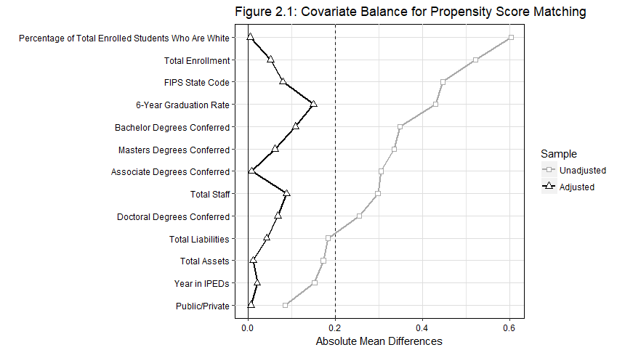
The darker line represents the absolute mean difference between the consolidated institutions and the control group, while the lighter line is the different between the consolidated institutions and the entire dataset. All covariates show a substantial decrease in their absolute mean difference, showing that the propensity matching process was successful in creating a control group that is similar to the consolidating institutions.
Once a list of matched institutions was generated, the final dataset used for the analysis was generated. To do this, the list of matched control groups was first parsed to remove duplicated control units. Even though replacement was not allowed, institutions were present in the dataset across multiple years, so it was possible for a single institution to be picked as a control unit in multiple years. The matched dataset contains a new variable indicating the total difference in propensity scores for the treatment and control unit, so for each duplicated control unit the one with the smallest difference in propensity scores was kept. This resulted in the removal of 16 control units from the matched dataset. For the remaining control units, the dataset was built out five years past the year for which it was matched.
For example, if Institution X in 2007 was matched to a consolidated institution, then it was placed into the dataset. A new variable of time was created, ranging from 1 to 5, which for Institution X would correspond to a range of calendar years from 2007 to 2011. If Institution Y is an institution which was consolidated in 2003, the time variable for it corresponds to a range of calendar years from 2003 to 2007. Thus, the newly formed dataset consists of all consolidated institutions for the first five years they existed, plus five years of data from a set of control institutions deemed through a propensity score analysis to be most similar to these institutions. The intent is then to measure if, all other things being as equal as possible, consolidated institutions differ from non-consolidated institutions in their first year, and whether any differences which are present are persistent in the short-term after consolidation.
After the final dataset was created, various institutional variables were run through two sets of analysis. The first analysis is a differences-in-differences model which compares the average change over time for the consolidated group to that of the control group over time to measure the impact of consolidation on each of the tested variables. The second analysis is a linear mixed effects regression model with random intercepts, which allows the consolidated group and the control group to be compared along each unit of time in the dataset. This model contains a dummy variable indicating whether the institution was consolidated or not, the newly created time variable, and a measurement of institution size (based on the experiences of K-12 consolidations and how the final size impacted their outcomes) defined here as total unduplicated 12-month enrollment. In addition to these variables, grouping factors based on the unique institutional IDs within IPEDs and the year the data was collected are included. The model is defined as
$$y_{ij}= β_{0}+ β_{1}{x1}_{ij}+β_{2}{x2}_{ij}+β_{3}{x3}_{ij}+ β_{4}\left({x1}_{ij}* {x2}_{ij}\right)+v_{i}+ v_{j}+ ε_{ij}$$
$$for \left(i=1,…,n\right) (j=1, …, m)$$
where:
- $y_{ij}$ is the observation of $y$ variable for institution $i$ in year $j$
- $β_{0}$ is the fixed intercept
- $β_{1} , β_{2} , and β_{3}$ are fixed slopes
- $x1$ is a factor of yes or no indicating whether the institution has been formed through consolidation
- $x2$ is a variable of time, ranging from 1 to 5, where 1 is either the first year post-consolidation for treatment units or the first year matched in the propensity process for control units, and each subsequent integer is one year
- $x3$ is the total unduplicated 12-month enrollment
- $(x1*x2)$ is the interaction between consolidation and time, which returns a fixed slope $β_{4}$ for consolidated institutions at each level of $x2$ - 1
- $v_{i} \begin{matrix}iid \\ \sim \end{matrix}N(0, σ_{v}^{2})$ is a random intercept for institution i
- $v_{j} \begin{matrix}iid \\ \sim \end{matrix}N(0, σ_{v}^{2})$ is a random intercept for year j
- and $ε_{ij}\begin{matrix}iid \\ \sim \end{matrix}N(0,σ_{e}^{2})$ is a Gaussian error term.

Results

For both the differences-in-differences and the linear mixed effect analyses, 20 models were run on variables relating to inputs or outputs for institutional performance. For this discussion, these variables will be divided into three categories: revenues, expenses, and student and academic outcomes.

Consolidating Institutions See Increased State Funding, Decreased Federal Funding
Table 2.1 contains the results of the differences-in-differences analysis on variables pertaining to institutional revenues.
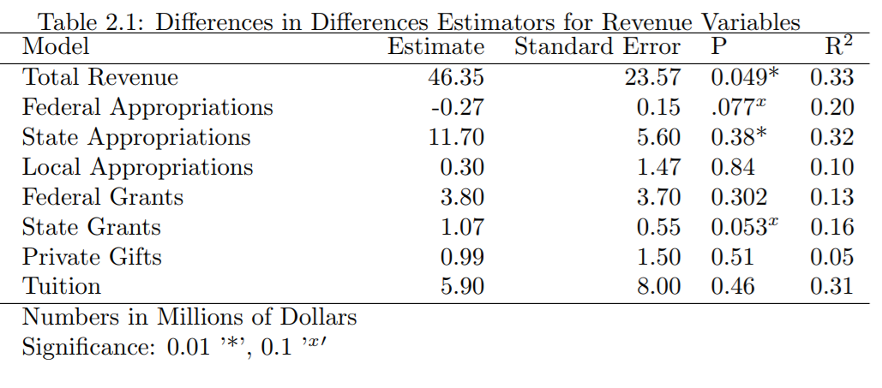

Consolidated institutions see a statistically significant increase in their total revenues (defined as total gross dollars collected during the year) after consolidation compared to the control group. This trend appears to be mainly driven by increases in funding from the states, a positive outcome for consolidations in the U.S. as governing bodies have not always financially supported consolidation in other areas. Gains in state funding are slightly offset by a decrease in federal appropriations, although the effect is much smaller compared to other increases.
The results of the linear mixed effect models for revenue, seen in Figure 2.2, are similar to the differences-in-differences analysis. The increases in revenue is steady across the time period but appears to really pick up one to two years post-consolidation.
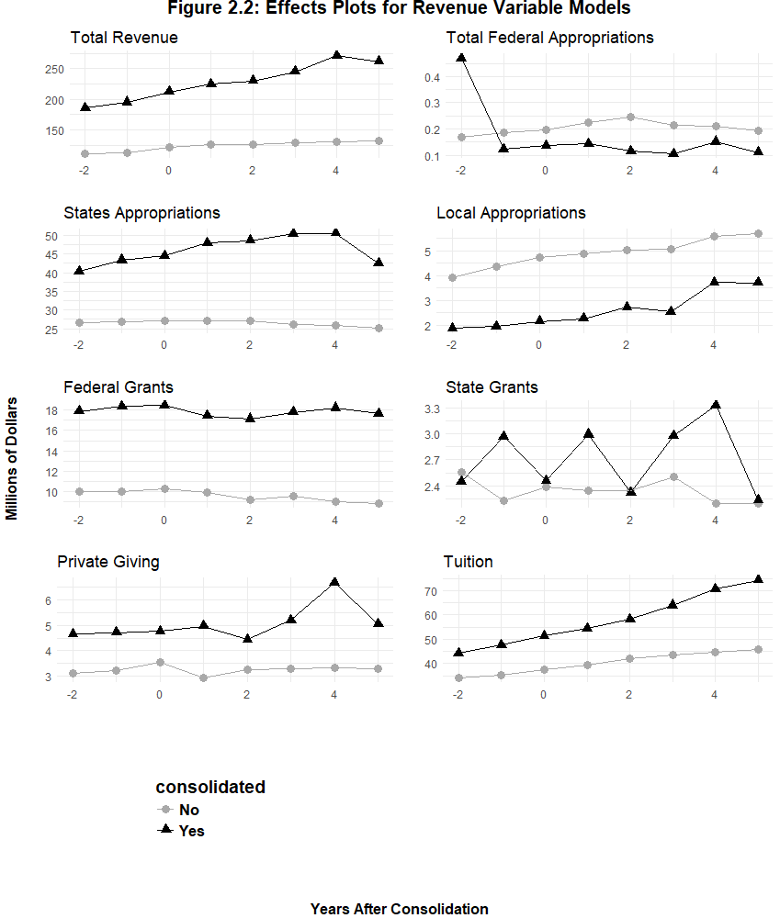
As noted in the previous analysis, the movement in state appropriations indicates that states are giving some financial support to the consolidation effort. There is a downturn at five years post-consolidation which may signal a new trend. Given that most consolidations, and especially state-level policymaker initiated consolidations, are driven by the pursuit of financial efficiency, it would be logical for state legislatures to look to decrease the amount of funding when it is assumed that the institution should be operating more efficiently. However, this analysis does not supply confirmation that the trend will continue after the five-year mark.
The decrease in federal funding appears to mainly occur in years two and three post-consolidation, although the gap between the consolidated group and the control group narrows again in year four.
Consolidated institutions also see an increase in tuition revenue by five years post-consolidation. This growth in tuition revenue starts in year two and continues through to year five. There are two potential explanations. The first is that as consolidated institutions identify themselves as more prestigious or more marketable, or as they perhaps transition away from a broader access mission, they might perceive a greater ability to raise tuition without impacting enrollment. The second explanation is that, as institutions are confronted with unexpected expenses from consolidation implementation and potentially decreased federal dollars, some of the costs are passed on to the students through higher tuition. Given the large costs associated with consolidation, it would not be surprising to see administrators seek out additional funding. University administrators generally view tuition as the most stable and dependable of their funding streams, making it an attractive way to control for financial instability that is not reliant on external stakeholders (Fryar and Carlson 2014).

Consolidated Institutions More Likely to Increase Spending than Reduce Costs
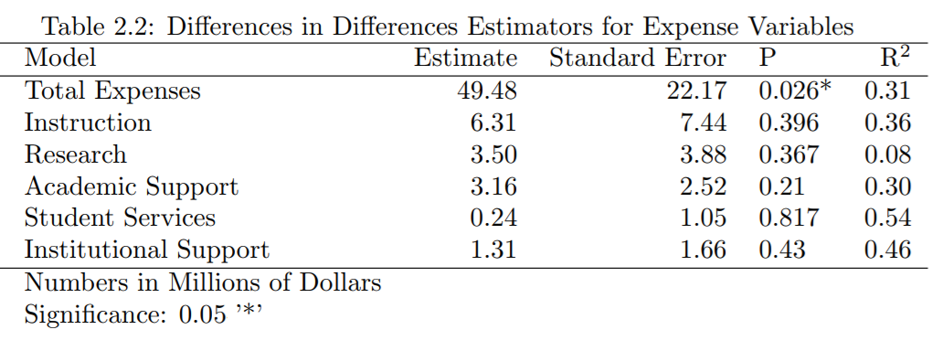
The consolidated group shows a large increase in total expenses within the differences-in-differences analysis, with just under $50 million more in expenses than the control group across time. The rest of the analysis is, perhaps, more interesting for what it doesn’t indicate; although there are no other statistically significant increases in spending for the consolidating groups, there area also no findings of savings in this analysis. An increase in spending with no reductions in cost for the institution may mean that any gains in revenue are offset by the costs of consolidation.
The linear mixed effect analysis, found in Figure 2.3, shows the increase in costs overtime for the consolidated group compared to the control group. It also appears to indicate that these costs are growing five years out from consolidation; spending on instruction, research, academic support, and institutional support are all trending upward five years after consolidation. As mentioned previously, scholars internationally have found that consolidated institutions can continue to see large changes in their goals, practices, and the development of organizational culture even up to the ten years post-consolidation.
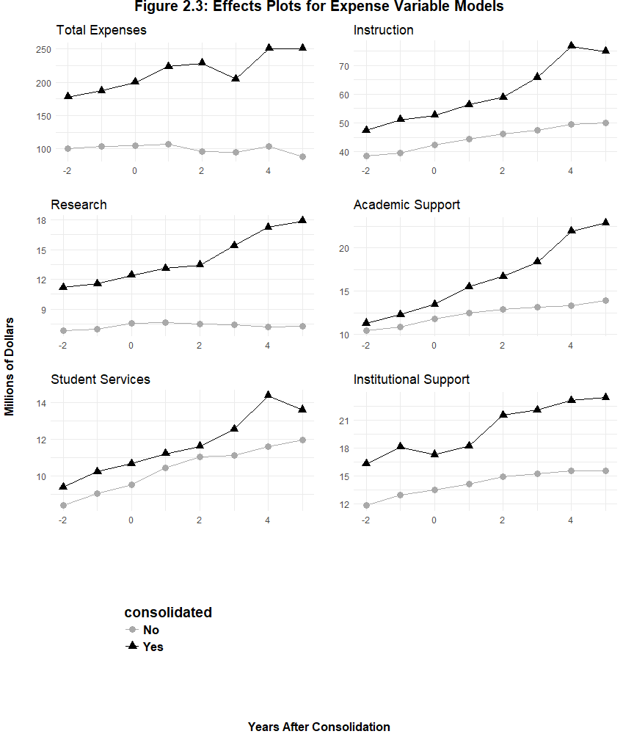
These upward trends could therefore be related to the ongoing process of dealing with change. It may also indicate that institutions are using the consolidation in order to grow programs; increasing research spending, for example, is often one way a consolidating institution attempts to improve its position with peers and in certain ranking systems. If institutions are increasing their spending in some areas because of the consolidation, there is no evidence in either model that they are achieving savings in the areas policymakers expect consolidations to find gains. Specifically, consolidations are designed to achieve economies of scale which theoretically let institutions reduce their spending on instructional spending and support services; however, it appears that spending at best remains unchanged and potentially begins to increase over time.

Consolidated Institutions Show Potential Growth in Academic Programs
Table 2.3, which has the differences-in-differences results for variables relating to students and academic programs, shows no statistically significant relationship between any of the variables and consolidation.
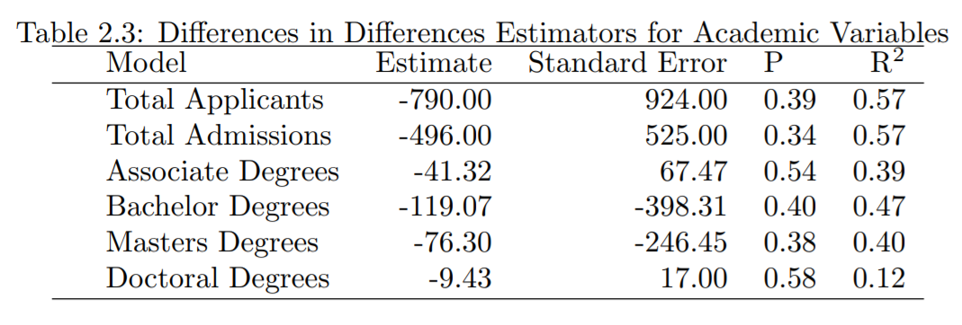
Again, this may be just as notable for what it doesn’t show as what it does. As the second primary goal of consolidation in programmatic growth in order to increase marketability, these institutions generally expect to be able to increase the number of students enrolled as well as the number of students who graduate from the institution. It is possible that this short-term analysis is simply not catching future gains that will be realized through consolidation; immediately following consolidation there is a low-information period where the institution establishes new practices and policies while prospective students must make enrollment decisions without full knowledge of what the institution will look like. Figure 2.4, which shows the results from the linear mixed effect models, indicates that these academic variables may be trending upward in a way that just wasn’t picked up by the differences-in-differences model for the short-term outlook.
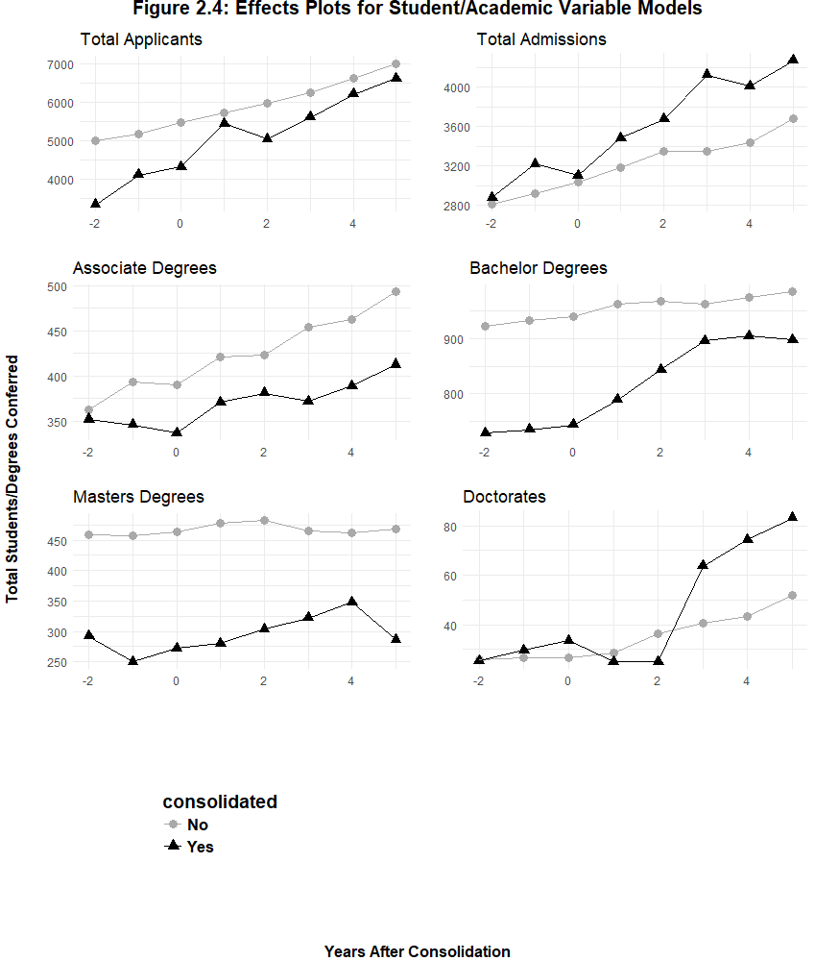
The number of applicants to consolidated institutions increases compared to the control group, especially in year one, which is the first year that the institutions would be soliciting applications in their new, consolidated form. Similarly, the consolidated groups increase their total enrollment compared to the control group; this trend appears to begin before the consolidation is implemented.
The early increase in enrollment, combined with the trends within the various types of degrees being conferred, lends more evidence towards some anticipatory increases in enrollment to some of the consolidating institutions academic programs. Compared to the control group, consolidating schools see increases in Bachelor’s, Master’s, and Doctoral degrees conferred beginning several years after consolidation. Although the timing of this increase would not align with cohorts enrolling after consolidation implementation graduating in higher numbers, it would be consistent with larger cohorts beginning before the consolidation and then finishing after. Especially for graduate programs, institutions may be anticipating future planned growth or additional resources from consolidation and admitting more students as a result. The one area where there is a decrease in the number conferred is for Associate’s degrees. One possible explanation for this is schools shifting their recruiting priorities post-consolidation. For example, if a primarily two-year degree granting institution consolidates with a primarily four-year degree granting institution, administrators may decide that the institution has more growth potential if they reduce the number of two-year degrees offered. This could represent broader mission shifts for consolidating institutions, which may align with policymakers and administrators goal of creating a more marketable institution, although it does raise questions of accountability regarding students enrolled in Associate’s programs. Some of these issues of accountability will be discussed further in Chapter 3.

Chapter Summary and Discussion
The propensity score matching used in this chapter allows for the comparison across consolidated and non-consolidated institutions by attempting to eliminate as many differences as possible between the two groups being considered. The process here was very successful, creating a control group that is reasonably similar to the consolidated institutions in size, resources, types of degrees conferred, location, control, and the calendar year. The range of post-consolidation years that may be considered is shorter because of the limitations on what years have data within IPEDs, but the process allows for a comparison of the consolidated group and the control group across the first five years that the new, consolidated institutions exist.
This short-term look still has large implications for the long-term prognosis of consolidation, as costs incurred within this stage increase the amount of efficiency that must be gained in order to begin to realize the advantages of consolidation.
In total, forty models examining different variables were considered. Broadly, these variables fall into the categories of revenues, expenses, and student/academic outcomes. Generally, a comparison of these variables between consolidated institutions and the control group indicates that consolidation, in the short term, allows institutions to increase their revenue, but these increases are offset through spending increases. Looking at the individual variables, it is possible this cost comes from a tradeoff between types of funding sources. Consolidating institutions appear to receive less support from the federal government post-consolidation, which is offset by (potentially temporary) support from the state government. There are several explanations for this. For one, it could primarily be related to shifts in the student body post-consolidation; federal aid includes the needs-based Pell Grant, so if the institution begins attracting generally wealthier students post-consolidation then this federal funding would shrink. It could also be that the previous, smaller institutions fell into other categories of funding from federal programs that they are no longer eligible for post-consolidation. For instance, to apply for Title III funding institutions must have a certain percentage of their students be on Pell Grants or otherwise demonstrate a financial need, and there are many federal grants given to institutions which serve high percentages of ethnic minorities. State funding is more positive for consolidating institutions; states appear to assist with the costly implementation effort with an initial increase in funding. This funding declines near the end of the five-year analysis, which is perhaps reasonably expected given that state-initiated consolidation reforms are generally intended to save the state money. The long-term trend for revenue after consolidation will depend greatly on whether increases in funding from the state is temporary or persists after the five-year mark.
Total expenses for the consolidating institutions begin to elevate before the consolidation implementation, and then rise more sharply after its completed. Again, looking at the individual variables creates a cynical picture of consolidation, where the new expenses are not merely related to the implementation. While the consolidation is expected to reduce costs through the elimination of duplicated programs and administrators, instead post-consolidation there are no observable savings in spending on instruction or support services, and spending potentially increases several years after consolidation. These results are similar to those found in the international literature, where legal, cultural, or organizational limitations often prevent consolidations from downsizing as much as need to in order to become cost efficient. The increased spending in research is more in line with an institution shifting some of its mission, likely in pursuit of the second goal of consolidation to become more prestigious and marketable.
Finally, the academic and student outcomes do indicate some potential growth for consolidated institutions for many types of academic programs. Applications to the consolidated group increase compared to the control group, and consolidating institutions also appear to enroll more students, beginning before the consolidation is implemented. In some cases, institutions may be increasing enrollment in some of their programs in anticipation of planned growth post-consolidation; the consolidating institutions see growth in the number of Bachelor’s, Master’s and Doctoral degrees conferred post-consolidation, although these increase occur too quickly to be driven by the student cohorts which enrolled during or prior to the consolidation implementation. This would be, however, consistent with some anticipatory increases in enrollment. The one area which sees a decrease are Associate’s degrees conferred; the two groups begin almost even pre-consolidation, but then average nearly a 100 degree difference by five-years post consolidation. Again, this would be consistent with institutions growing programs in a way that shifts their focus away from two-year degrees and towards four-year and graduate degrees. If this is the case, this could potentially have wide ranging implications outside of the consolidation. How some policymakers and stakeholders would view that trend will likely depend on if the decline in Associate’s degrees is driven by students enrolling in schools that haven’t consolidated, or students who would have previously enrolled at one of the pre-consolidation institutions instead deciding to forgo higher education.
Some of these trends are likely only short-term, but it is also possible that many could continue after the five years analyzed here. Even if savings are realized and expenses decrease after five years, these results will have long lasting impacts on the consolidation. The increase in expenses, coupled with no immediate savings in expected areas and the potential that revenue growth is only temporary, all increase the dollar amount future savings must accrue for a consolidation to break even, and thus the risk involved in undergoing a consolidation. The following chapter, which will further examine the short-term impacts of consolidation by looking at student enrollment and first-year retention, will also include a discussion of the various accountability pressures that higher education institutions fall under. These avenues of accountability can help contextualize these findings and determine whether the costs found here are worth the eventual promise of future efficiency and program growth.

Chapter 3: Higher Education Accountability and Organizational Restructuring: Assessing Student Outcomes in Higher Education Consolidations

The previous chapter examined some of the organizational level impacts of consolidation on institutions of higher education. This chapter shifts the focus from an organizational view to look more specifically at student level outcomes in consolidations within the University System of Georgia (USG) utilizing student-level data accessible through an individual agreement with the USG. By focusing on student outcomes, this chapter expands our understanding of how consolidations may impact both students and institutions. Specifically, this chapter examines first-year student retention during and after consolidation and finds evidence that institutions experience an opportunity cost during the consolidation process where observed retention is lower than predicted, based on the attributes of their students.
Institutions of higher education are complex organizations which exist within complex systems where various internal and external stakeholders apply accountability pressures from many different angles. In turn, institutions respond to these accountability pressures by prioritizing certain functions or pursuing outcomes that maximize their assessment by each stakeholder. These varied stakeholder interests can make overall performance assessment difficult as emphasis can be placed on a wide range of metrics such as graduation rates, admissions, or financial efficiency. Assessment is further complicated by a diverse landscape of educational institutions which serve different missions with different goals for students and faculty members. Before assessing the performance of specific institutions during consolidation, then, it is useful to give consideration to some of these issues of accountability.

Performance and Accountability in Higher Education
The nature of the U.S. federal system, which places the emphasis for higher education on the states, means that the federal government is limited in the influence that it can have over specific institutions. States then assume the role of arguably the most important external stakeholder to a public education institution, as states can exert both direct control over higher education institutions (through governance structures and funding decisions) as well as indirect (through political influence and other legislation). Since the1980s, states have increasingly sought to use this influence to exert more direct control over public institutions following long periods of self-governance in academia (Dunn 2003). The increased interests in higher education governance at the state level has often dovetailed with larger reform movements that have led states to focus on making their spending more efficient and their activities more focused on economic and market forces (Zavattaro and Garrett 2017). Over the past couple decades, the interest of states to address their budgets has coincided with an economic downturn that has forced even more dramatic responses. In this environment, many states have made the decision to tighten their control over their higher education systems in efforts to make them more accountable to financial concerns. Doyle and Zumeta (2014), for example, found states exhibit four general responses regarding higher education during periods of austerity, only one of which (bargaining greater autonomy for higher education institutions in exchange for reduced state appropriations) reduces direct involvement of the state government in higher education.

Accountability, Benchmarks, and the Bottom Line
One large movement to grow out of the states' interest in higher education was the adoption of performance-based funding accountability structures. These programs tie some portion of an institution’s appropriations either directly or indirectly to specific performance benchmarks. Institutions’ responses to performance based funding legislation have often been seen as perfunctory, with administrators and faculty members either directly opposing the measures or viewing them as simply more compliance steps that should be reported and then set aside (McClellan 2016), although there is evidence that even given the prevalence of opposition to these accountability structures, institutions have shifted some of their priorities in response to performance-based structures, especially at public research universities (Rabovsky 2012). Even if administrators less than enthusiastically embraces compliance to performance based funding programs, institutional behavior can shift in order to maximize the outcomes which are officially part of the funding formula, sometimes at the expense of other outcomes not tied to funding. This might also include shifts in behavior that would widely be considered negative, including finding ways to report only positive information, gaming some of the numbers (for example, by strictly limiting which students are measured within each year’s cohort to remove students less likely to meet performance requirements), or focusing on outputs that can be achieved with less effort or resource expenditure rather than ones which may be worth more in broader social or economic consideration (Bohte and Meier 2000; Hillman, Tandberg, and Fryar 2015; McClellan 2016). The effectiveness of performance-based accountability structures in directly impacting the desired outputs is a different matter, where most of the literature exploring this question has found no to very minimal impact for most institutions (see Conner and Rabovsky 2011 for a summary); however, the effectiveness of these accountability structures is immaterial to the discussion in this chapter. Rather, it is sufficient to note that states continue to apply accountability pressure on higher education institutions to remain economically efficient, as measured through generalizable benchmarks, and that institutions at various levels change behaviors to address this pressure.
Pressure to focus on generalizable benchmarks, especially graduation rates, is also applied to institutions from students and local communities. Over the past several decades, enrollment in higher education has trended upward in both the U.S. and abroad until the global recession led to enrollment reducing and then eventually flattening out (NCES 2018). That growth was part of a larger societal shift in how higher education was viewed, referred to by some scholars as “massification,” where the reach of higher education was expanded beyond the elite class (Hornsby and Osman 2014). One major reason for this expansion has been the growing belief in society that higher education is integral in promoting economic growth and reducing economic inequalities. In addition to taking on the role of economic driver, higher education is also increasingly seen as responsible for the promotion of social justice and the building of social and cultural capital (Altbach 1992, Gibbons 1998, Brennan and Naidoo 2008). As higher education has taken on more of these societal functions, the interest in institutional management and decision making has grown within external communities, especially after the 1980’s when public opinion became more skeptical of how tax dollars were being utilized (Zavattaro and Garrett 2017). This growth in public interest in how higher education institutions were being administered was also instrumental in allowing states to begin increasing the performance-based accountability pressure described above, as public opinion tended to lend support to these programs, especially in Republican controlled states (Alexander 2000, Dougherty et al 2013).
One of the central tenants of many modern reforms is to focus strongly on efficiency and improving the financial stability of organizations. This has been true for higher education, as the shift to performance measurement outlined above is a results-oriented approach that focuses on the bottom line. This shift in how states and local communities see higher education has also contributed to a shift in how many students look at these institutions. As students begin to see themselves as consumers of higher education primarily concerned with the economic and cultural development they receive while enrolled, they may begin to see themselves more as someone aiming to have a degree, rather than as an active learner who, as a consequence of these pursuits, happens to earn a degree (Molesworth and Nixon 2009; Weerts 2017). As a result, students now also view the worth of a degree in a different light, specifically being much more focused on the value their degree grants them in either pursuing further graduate level work or entering and advancing within the workforce, rather than the intellectual rigor represented in their completed program (Tomlinson 2008). In all, this means that at least some of goals students have in higher education align with reformers who seek to improve measurable outputs which impact the bottom line of an institution. Even in its role as an arbiter of social justice within the community, discussions tend to focus on these outcome-oriented measurements by looking at student enrollment numbers through affirmative action policies, diversity among faculty and staff, or graduation rates of at-risk populations. Institutions have responded to these pressures by looking to increase ways to account for student satisfaction, such as focusing on internal measurements that consider student satisfaction like simple course evaluations which are much more consumer-focused than academically focused (Blackmore 2009). Again, what a bottom-line approach to managing institutions means for higher education more generally is beyond the scope of this paper; it is sufficient to note that communities and students apply accountability pressures towards these results and that institutions are responsive.

Reputational Accountability
Finally, in a way that is unique from most other public organizations, higher education institutions are privy to reputational accountability pressure. All public institutions must balance some form of reputational accountability, and reputations have large impacts on how organizations formally and informally interact with external stakeholders (Busuioc and Lodge 2016). Along with shaping the relationships they pursue, institutions must also consider how their own reputation influences how others interact with them, leading organizations to weigh the potential reaction of external stakeholders or the general public before making decisions (Christensen and Lodge 2018, Christensen and Gornitzka 2018). Reputation also impacts internal perceptions of an institution, and members can either increase or reduce their attachment to the organization as new information shifts their opinions (Gilad, Bloom, and Assouline 2018).
While all public agencies deal with reputational accountability, higher education is unique in that measurements of reputation are formalized into publicly available rankings and scorecards that prospective students can use to make enrollment choices, grant programs consider in funding research, and potential employees can use to help decide whether to accept an offer. Placement in academic rankings impacts a range of activities for higher education institutions, including how much they are able to charge in tuition and fees, how likely they are to attract desired students and faculty, and how likely they are to attract competitive research grants (Fumasoli and Huisman 2013, Luca and Smith 2013, Wolf and Jenkins 2018). These rankings shape the reputation of institutions, particularly when new rankings become mainstream as initial perceptions of institutions can stick absent very large future movements in the rankings (Bowman and Bastedo 2010). Colleges and universities exist in an ever more competitive marketplace, where the addition of new institutions, increased ability of students to attend international institutions either in person or online, and the reduction of external funding sources place a higher order of importance on reputation.
As with performance based funding programs, faculty and administrators are often quick to point out the flaws of academic rankings. Rankings are path-dependent and difficult for institutions to make large moves in, placement is highly correlated to institutional endowment and student body size, new rankings are highly dependent on the methodology and variables selected by the researchers (who are often profit-seeking third parties), and the benefits provided by greater rankings are highly concentrated within a small group of elite institutions with measurable effects dropping quickly outside the top 25 (Saisana, d’Hombres, and Saltelli 2011; Fowles, Frederickson, and Koppell 2016; Trachtenberg 2016; Wolf and Jenkins 2018). Additionally, many types of institutions, like community colleges, aren’t included in the rankings systems. However, even given these concerns, academic rankings are entrenched in the practices of higher education, and their publication leads institutions to prioritize activities that are measured within the rankings and establish marketing practices to laud positive ranking results (Meijer 2006, Hemsley-Brown and Oplatka 2006, Trachtenberg 2016).

First-Year Student Retention
One measurement of institutional performance which impacts all these various layers of accountability is student retention. For stakeholders concerned with economic efficiency, student retention impacts the bottom line by helping to determine the total number of tuition paying/externally funded students on campus and moves students closer to their graduation. When the social justice or economic advancement components of higher education are emphasized, student retention can be examined by subgroups to see how at-risk populations are advancing through the education system. The satisfaction of students is intrinsically linked to retention, as once certain academic benchmarks are reached then institution fit and happiness become important indicators for the decision to return (Bean and Eaton 2001). And, finally, student retention is often expressly included into academic ranking and assessment programs. For example, the U.S. News and World Report specifically factors first-year retention into their algorithm for determining rankings, and the College Scorecard introduced by the Department of Education under the Obama Administration lists first year retention as one of three basic indicators when a user first pulls up information on an institution. Thus, as a performance indicator during organizational change such as consolidation, student retention satisfies the accountability pressure placed on higher education institutions from multiple directions.
In particular, first-year student retention has some advantages as a performance indicator. During students’ academic careers, the first year tends to be relatively more generalizable than later years when students take more major-specific and fewer general education courses. Additionally, for students to advance in many academic programs they may have to maintain certain GPA requirements or complete prerequisite courses during their first couple of years on campus. Thus, first to second year retention avoids some of the competing explanations for student departure that may arise the longer they’re on campus. Additionally, an outsized portion of the early literature on persistence and retention focused on first-year retention, so the contributing factors to student’s retention to their second year is more understood than persistence in later years (Tinto 2006). Identifying problems within the first year is also important as early intervention can shape greater student success in subsequent years (Lang 2007).

Predicting Student Retention
The higher education literature has extensively covered the topic of predicting student achievement and retention. Generally speaking, predictors for retention can be divided into two categories: academic and non-academic. The former primarily consists of pre-enrollment indicators including high school GPA and scores on standardized tests, usually the ACT or the SAT. The literature has been mixed on the effectiveness of these variables as predictors for retention. Some longitudinal studies have found these measurements of students’ academic ability to be the most important predictor for collegiate success, above other measurements like demographics or socio-economic status (SES) variables (Westrick et al 2015). These variables have also long held an important space in college admission decisions and remain near the top of the list; the National Association for College Admission Counseling’s (NACAC) 2017 report found that between 52% and 77% of institutions ranked high school GPA, standardized test scores, strength of the high school curriculum, and grades in college prep courses as having “considerable importance” to decision making (Clinedinst and Koranteng 2017). For comparison, the next highest scoring item for “considerable importance” was the application essay or writing sample at just under 19%.
Critics, however, argue that these measures are poor indicators of future success for students. One argument is that while these pre-enrollment academic characteristics are capable of explaining collegiate academic performance, they lack explanatory power in predicting retention, which is much more likely to be impacted by experiences that students have on campus (Hoffman and Lowitzki 2005). Other studies argue that these measurements are culturally biased towards middle- and upper-class white families as test scores in particular are less powerful at predicting minority students’ future success in college (Hoffman 2002), a result which may be driven by differences in SES among the students tested (Nettles, Millet, and Ready 2003). Another limiting factor in these measurements is age, as the predictive power of high school performance drops off after 30 (Moffat 1993).
Non-academic factors predicting retention can be further divided into pre-enrollment characteristics and on-campus activities and habits. Some of the pre-enrollment characteristics, such as demographic data, are easy to identify. Gender has been correlated with an effect on first-year academic achievement and retention, and in recent years males are more at-risk for lower grades and higher rates of attrition generally, with the exception of a few majors (DeBerard 2004). Similarly, ethnicity has been shown in several studies to be a strong predictor for retention. Generally, black, Hispanic, and Native American students are more likely to have higher rates of attrition than white or Asian students (Murtaugh, Burns, and Schuster 1999; Shapiro et al 2017), although this may be a product of environment, as, for example, black students have higher rates of retention when they attend HBCUs than other institutions (Fleming 2002). Family attributes, such as SES or the highest degree of education that a students’ parents achieved, have been found to be especially useful in explaining the variance across studies focused on the other variables discussed here (Hoffman and Lowitzki 2005, Tinto 2006, Fike and Fike 2008), and some scholars have found that controlling for SES eliminates most if not all of the predictive value of other variables.
Other pre-enrollment characteristics are somewhat harder to collect data on and analyze. Most of these variables focus on how ready students are to make the transition from high school to higher education. For example, many studies have explored the possibility of using scores on emotional intelligence tests to predict retention. These studies found evidence that students who score higher on emotional and societal measurements are more likely to experience collegiate success and persist in degree attainment (Parker et al 2004). Emotional intelligence may be an even greater predictor for success within academic programs that involve higher amounts of interpersonal interaction, such as nursing (Jones-Schenk and Harper 2014). Similarly, other psychological attributes of students, such as the coping strategies they have developed for dealing with stress and their general self-efficacy, have been found to be positively correlated with greater collegiate success (Chemers, Hu, and Garcia 2001; DeBerard 2004; Lotkowski, Robbins, and Noeth 2004). Other studies have looked at how students’ general worldviews impacts their transition to higher education; for example, students who believe they have greater control over the events in their lives tended to more successfully handle the transition (Gifford, Mianzo, and Briceño-Perriot 2006).
Once students are on campus, several other variables enter the retention picture. Importantly, these variables give institutions the opportunity to impact students’ likelihood to retain, whereas institutional involvement with pre-enrollment characteristics is limited mostly to admissions decisions. Financial aid has long been included in most studies of student achievement and retention, but more recently the literature has focused on how different types of aid changes the effect. For example, shifting students from receiving loans to receiving scholarship grants was found to have a positive impact on retention (DesJardins, Ahlburg, and McCall 2002), while the trend in some institutions to shift from need-based aid to unsubsidized and merit-based aid was found to make lower-income students less likely to retain (Singell 2004). The impact of financial aid is also likely to differ across diverse institutions, especially as students view opportunity costs differently. One study found that students in urban commuter settings are more likely to place an emphasis on the opportunity cost of lost wages, making certain types of aid like work-study programs more effective, while students at large state schools are less likely to be concerned with losing wages to attend school and are more responsive to grant based financial aid (Kerkvliet and Nowell 2005).
Student enrollment information, such as how many hours students are attempting, has been included in some studies of retention (Fike and Fike 2008), but in terms of campus activity the largest indicator towards positive retention is student engagement in campus activities and programs. Many studies have found that increased engagement is beneficial to students along a range of measurable outcomes (Kuh 2003; Braxton, Hirschy, and McClendon 2011; Kuh et al 2011). Kuh et al (2008) found that student engagement, when present, both supplanted many of the pre-enrollment characteristics in importance for predicting student success, and that increased engagement had a compensatory effect that made students more likely to retain even with lower academic success during their first year. One way higher education institutions have responded to these findings is to create first-year programs, such as a new student orientation course, which creates an avenue for student engagement with the institution. These programs have generally been viewed as having a positive impact on retention (Schnell and Doetkott 2003), although it is important to note that the effectiveness of these courses can vary depending on how they’re structured (Jamelske 2009) and that institutions must remain careful not to overestimate their importance due to volunteer bias.

Accountability, Student Retention, and Consolidation
Consolidation as a reform is tied to the three modes of accountability discussed here. Reformers seeking to restructure higher education systems through consolidation are often primarily concerned with the financial implications and the perceived opportunity for reducing expenses being their primary motivation. For higher education institutions to pursue their goals in economic and human capital development, it is imperative for them to keep students on campus and progressing towards graduation. And consolidation can potentially impact a number of issues that relates both directly and indirectly to reputational accountability. Directly, consolidation can shift numbers used in rankings systems like graduation rates, student-to-teacher ratio, retention rates, and other measures. Indirectly, to the extent that consolidation changes institutional behaviors or allows them to achieve programmatic growth it may alter the perception of the institution among stakeholders.
While the current literature on higher education accountability and on student retention is robust in its consideration of many of the involved variables, consolidation creates an environment which is unique from many of the environments these studies took place in. Consolidating institutions have high degrees of uncertainty during and immediately following consolidation; they must first make many decisions with wide ranging implications for the future of the institution, then must spend time adapting to new norms and practices while also attempting to build a new cohesive organizational culture. In this adjustment period for the institution, external stakeholders as well as current and prospective students will operate with relatively low information on what to expect. Even traditional forms of reputational accountability which may normally provide information on the institution may not be useful, as inclusion in any ranking system, for example, could only be based on the pre-consolidation institutions with no certainty on how their amalgamation will perform.
Consolidations raise many practical questions regarding how they may impact student retention. How do departments with different degree requirements handle course scheduling after consolidation? What impact does the departure of faculty members during the process have on current students? Are record systems adequately prepared to keep track of all enrolled students, especially if the consolidating institutions use different file programs? How are recruitment and admissions decisions made if institutions with different levels of academic rigor are consolidated? Does the consolidation cause the institution to expand its geographic reach beyond what the pre-consolidation institutions typically achieved?
This chapter expands the discussion of accountability in higher education by examining first-year student retention during and after consolidation. As discussed above, student retention is applicable to each of the accountability pressures in a variety of ways. By understanding when and if consolidation may impact accountability, this research can add to both the consolidation and accountability literature by considering how consolidations perform in regard to this accountability and by considering how profound organizational change impacts the environments that accountability research is conducted in.

Data and Methodology
Beginning in 2011, the University System of Georgia (USG) set out to aggressively restructure their institutions through a series of consolidations creating by far the most extensive consolidation project currently underway in the U.S. As of the end of 2017, the system has completed its fifth round of consolidations, with nine consolidation projects totaling 18 pre-consolidation institutions. These consolidations cover a variety of institution types and sizes in both urban and rural settings, including an HBCU, a medical research college, and an agricultural college. The venture, which is organized by a set of guiding principles agreed upon before the first round of consolidation, is, at its most basic level, driven by two stated goals – to improve the institution’s financial position and student outcomes. This chapter focuses on first-year student retention which, as described above, touches on both of these goals.

Data
In order to compare first-year retention, the USG provided me with data on all students who have matriculated through their system from 2008 through the 2016 academic year. This dataset contains a wide range of information including high school performance, academic performance at their institution, and financial aid amounts and types. Two of the consolidations (Abraham Baldwin Agricultural College/Bainbridge State College and Georgia Southern University/Armstrong State University) where completed in December of 2017 and another (Albany State University/Darton State College) was completed at the start of the 2016 academic year, placing them outside of the scope of this study since data for their first year post-consolidation is not available. The consolidations which are included in this study can be found in Table 3.1. 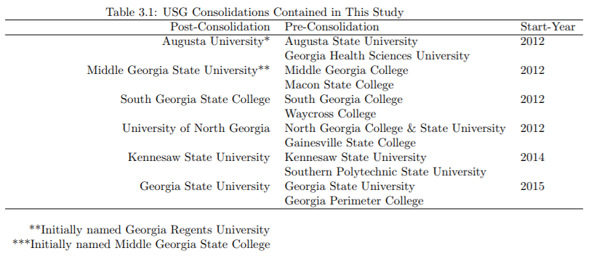
Typically, the consolidation process officially began one year prior to consolidation, so this study places the “start date” as the year prior to the consolidation being finalized (referred to as year 0 after consolidation in the following figures) to encompass both the consolidation implementation and the newly formed institution.
The student data was then parsed down in order to create a more generalizable cohort across each consolidated institution. First, graduate students were removed because not all institutions have graduate programs. For the remaining undergraduate students, all students who were tagged with an entering designation of “freshman” were included. This removed a number of students from the dataset, including students who entered with more than 30 transfer hours, non-degree seeking students, dual-enrollment or early college high school students, or enrollees auditing classes. This helps to make the students included in the analysis as uniform as possible across all institutions. Students with a high number of transfer hours could bias the cohort either because they were low performing (and are transferring because they were unsuccessful at their previous institutions) or because they are high performing (and are transferring because they were not a good fit at their previous institution). More hours also makes the student more likely to be enrolled in courses from within their major rather than general education, which potentially leads to greater divergence in their collegiate experience. Dual-enrollment and early enrollment students were also excluded because of the potential to bias the sample; these are generally high-performing students who selected into programs intended to provide a head start on higher education who are more likely to retain than their peers. Both part-time and full-time students are included in the sample, and many students entered with 30 or fewer transfer credits, which is accounted for as total transfer hours are a variable in the analyses. This expands the list of students beyond what institutions are legally required to report as their official cohort, but, as described below, the methodology used here is robust in its ability to differentiate between these different types of students. This expansion of the cohort helps to create a more accurate representation of student enrollment patters, as the federal government’s official cohort definitions are less applicable to many regional institutions.
To make a comparison of pre-consolidation to post-consolidation first-year retention, students were grouped together under the newly consolidated institution for both time periods. As an example, if Institution A and Institution B consolidate to form Institution C in 2012, I construct a hypothetical institution (Institution A + B) which consists of the students from both Institution A and Institution B for the years 2008-2011. Functionally speaking, the analysis then compares Institution A + B to Institution C. For the pre-consolidation period, this places students together from two institutions that generally served different student bodies and had different institutional goals. However, administrators within the USG maintain that the goal post-consolidation is for the institution to continue to serve the same range of students with a similar range of higher education goals as the two pre-consolidation institutions had, so the new institution should be expected under this standard to retain similar students as the combined pre-consolidation institutions.

Methodology
Once the data had been prepared, a comparison was made using a gradient boosted decision tree model to predict student retention for each of the post-consolidation years based on the set of predictor variables found in Table 3.2. These predictors contain most of the variables the higher education literature has found to be important for student retention, though they are lacking some measurement of student engagement.
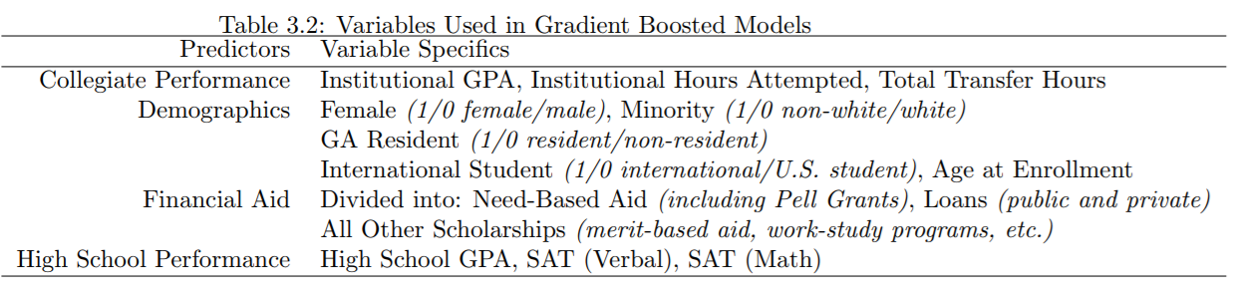
The past several decades have seen rapid growth in the performance of machine learning algorithms designed to predict and classify large amounts of data, particularly in fields such as biology or geography which require the classification of many samples (Elith, Leathwick, and Hastie 2008). Of the various machine learning algorithms, boosted decision trees contain a number of advantages for working with this type of student data; they can handle a number of different predictor types and missing data without requiring prior data transformation or the removal of outliers; they can fit complex, non-linear relationships as well as interaction effects between predictors; and they combine both powerful predictive capabilities with simple, lucid results. To do this, gradient boosted models first design a single decision which, by itself, has very poor predictive ability. It then builds thousands of more trees off of the first one and used the combined predictive capabilities to create a much stronger model. It is helpful to understand the model at both steps – the creation of the first tree, and then how it grows additional trees.
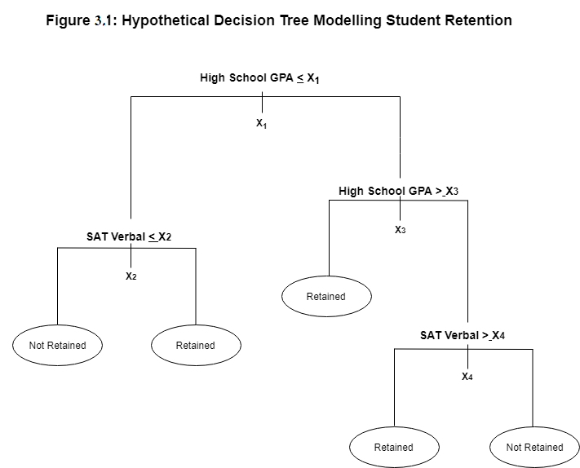
To create the first tree, the algorithm takes a set of training data – for this analysis, the combined students from the pre-consolidation institutions for all years available – and creates a decision tree around a set outcome. In this case the decision tree created is a classification tree as it is built around a discrete variable with only two outcomes – was the student retained into their second year of higher education or not. As the tree is grown, the leaves represent class labels and the branches represent some combination of predictor variables that lead to the predicted class. When making a single decision tree, the goal is to create the single best tree for predicting the classification of the outcome; usually, the process used for this is to continually apply a binary split until the output reaches some predetermined stopping point, then use cross-validation to trim the weakest branches (Elith, Leathwick, and Hastie 2008). Figure 3.1 shows an example of what a decision tree modelled on student retention might look like.

A single tree has some strong potential benefits that are hindered by generally poor predictive capabilities. The benefit to this output is that you can quickly trace the splits of a variable to a conclusion (in this case, whether a student is retained or not retained). In Figure 1, students with a lower GPA in high school and lower score on the verbal portion of their SAT exams as well as students with very robust GPAs and test scores are less likely to return for their second year. From this, you could extrapolate an explanation that low-performing students are underprepared for the rigor of college while high-performing students likely have more options to transfer if they decide that their initial institution is a poor fit. The downside to a single decision tree is that this outcome is highly contingent on chance. To model a decision tree, the algorithm has to make some decisions on which predictors to use and where to split them along the branches. Because the algorithm must make some random decisions during this process, if you were to generate single decision trees independently, each one would have different outcomes and be missing some valuable information. In Figure 1, for example, the tree might be leaving out that while students with high GPAs and test scores have more options if they decide to transfer, they are less likely to transfer at all if they are residents of the institution’s state. Because of this randomness, a single decision tree is generally, at best, only slightly better than a guess and is often worse.
Boosting models are capable of taking advantage of decision trees’ strengths while vastly improving their prediction abilities by combining many trees with weak predictors through an iterative process which builds one strong output. Other machine learning techniques apply the approach of building many outputs from some model and then averaging the output together, but boosting is unique in that it is a stagewise progression where each iteration of the model (the trees, in this case) are built off the results of the one before it (Freund and Schapire 1999). To achieve this, boosted models limit the number of splits in each tree to a small number of nodes, allowing the algorithm to quickly generate hundreds to thousands of trees that work together to form strong predictive power. For regression-based decision trees, the boosting is a form of “functional gradient descent” (Elith, Leathwick, and Hastie 2008, p. 77). That is, the algorithm calculates a loss function from a measure that represents the loss in predictive performance due to suboptimal specification. The first tree is generated based on whatever combination of variables and splits, given the limited number of branches specified for the trees, most reduces the loss function. A second tree is then fitted to the residuals of the first tree, potentially containing drastically different variables or, even if the same variables are chosen, different locations for the branches to split. The end model is better if each tree moves the overall model very slowly down the loss function, so typically new trees are trimmed at a learning rate less than 1 (in the analysis presented in this chapter, the learning rate was set to 0.01).
After the second tree has been generated, the overall model is updated to contain both trees and the combined residuals are calculated. As the process is stagewise, no previous tree is ever changed; only the fitted values for each observation are recalculated each time. After this process has been duplicated many times, the end result is a linear combination of many trees similar to a regression where each term is a decision tree.
While this process has many advantages, the biggest disadvantage to a boosted learning model is that the optimum algorithm specifications – such as how many times to allow each tree to split, how many trees to generate, what number of trees to generate, or what the learning rate for each subsequent tree should be – are not clear at the outset of the analysis and may require some trial and error. A first instinct may be to generate an extremely large amount of trees in order to capture as much information as possible; however, this often results in overfitting the model to the training data in a way that greatly reduces predictive power when the model is then applied to other datasets. The GBM package in R (Ridgeway 2007), which was utilized to create the boosted models in this study, has a number of ways to help prevent overfitting and analyze whether the end result of the model has good predictive power. GBMs are also stochastic, meaning that, rather than each tree being fitted to the entire training dataset, each additional tree is fitted to a randomly drawn sample without replacement. The introduction of randomness to the process both reduces the risk of overfitting and improves the predictive ability for use on future data (Friedman 2002).
The algorithm used in this analysis was also set to contain a five-fold cross-validation; this process breaks the training data into five groups, then runs the iterative process on four of the groups before using the fifth to check the accuracy of the results, then repeating the process so each group is used as the test group once. This adds additional randomness to the process and helps to detect if esoteric details of some subsets of the training data are skewing results. It does this by tracking the loss function for the model at each additional tree, which should continuously decrease the more trees are generated for the training data, then using the withheld group of data as an independently sampled test group with its own prediction loss function. The loss function for the test data should initially decrease then eventually begin increasing and diverging from the model’s progress as the model becomes overfitted to the training data. The algorithm then finds the “optimum” tree as the tree which maximally decreases the loss function before beginning to diverge from the test data. Because the existing trees are never altered when new trees are added, the training set can be retroactively held at the optimum tree when later used for prediction. This allows the algorithm to be set to run a very large number of trees (in this case 10,000) while avoiding the issue of overfitting.
Figure 3.2 shows the development of one of the predictors (total loans accepted) for the model specified for the Kennesaw State University consolidation.
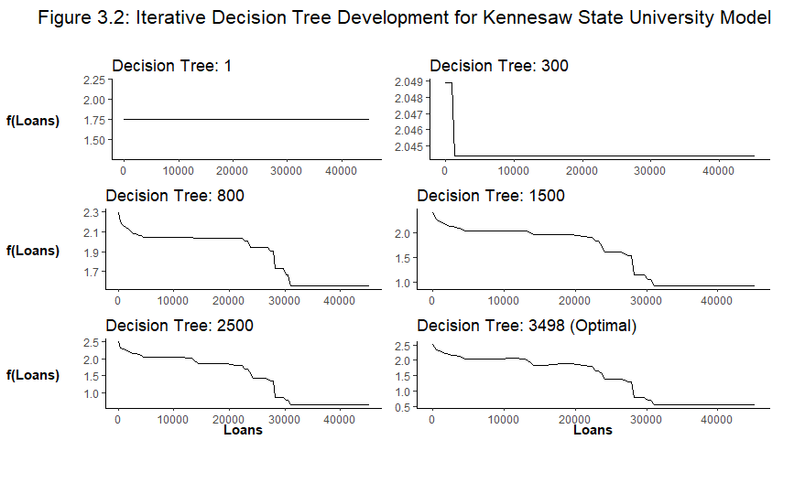
The graphs in Figure 3.2 show us what information we have on the relationship between the total dollar amount in loans a student has and the likelihood that they will retain to their second year based on the number of decision trees which have been grown by the model. In the upper left figure, only one decision tree has been generated. Recall that with a single decision tree, the model randomly selects variables and splits them. In this case, the model did not split the loan variable so there is no information available regarding how different amounts of loans changes the likelihood to retain. As more trees are developed, the model will include the loan variable in some of the tree and more information is gathered. The other graphs in Figure 2 represent the building of this information at different numbers of total trees generated. For Kennesaw State University the model fund that it had the best predictive power at a total of 3,498 trees generated. In other words, this is the point where we can most generalize the predictive ability of loans before it begins to become too specific to Kennesaw State to have predictive value at other institutions. From these results, we can conclude that having loans has a positive impact on retention, although the impact begins to drop as you increase the dollar amounts of the loans.
The other important downside to note with GBM and other, similar types of models is that they do not contain an element of uncertainty. The model is capable of producing confidence intervals for the overall accuracy of the model in predicting the outcome variable but does not produce prediction intervals for each student. This means that it is not possible to place the predicted retention into a confidence range when comparing it to the observed retention. Some methods for introducing uncertainty have been tested with random forest models (see Coulston 2016), but not applied to GBMs, which, although similar, have important differences from random forests. Although this limits some of the analysis, for the discussion in this chapter the GBM still provides useful information for the consideration of retention. Most notably, the model can pick up on trends in retention based on student enrollment, which is especially useful in identifying the impact of consolidation given that the institutions considered in this chapter consolidated in different calendar years.

Results

Model Accuracy
Table 3.3 shows the results of the model specification. The first column presents the accuracy of the algorithm when tested back against the training data; this is derived from the cross-validation validity check built into the model. Recall that to do this, the model is taking a random sample of 1/5 of the training data and reserving it while it builds the model. After the model is built, in then predicts retention for that random sample to check how accurate it is. The percentages reported are the percentage of students the model correctly predicted in this random sample. The lowest accuracy being a 78 percent for South Georgia State College and the highest at 88 percent for Kennesaw State University.
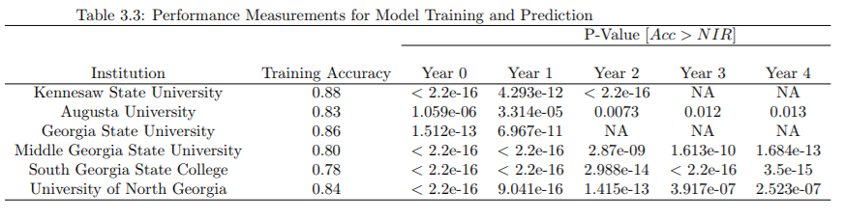
The remaining columns present a p-value for each of the post-consolidation years that the model then predicted. Computed p-values given for each of the models are derived from a one-sided test comparing the results of the prediction model to a prediction made using only the knowledge of class sizes, or the No Information Rate (NIR). The NIR is the accuracy rate you would get if you identified the largest class from the factor options and selected it every time. For example, Middle Georgia State University retained 65% of their students for Year 0, so since more students are retained than not to generate the NIR you would predict retention by simply selecting retain for every student. This would give you an NIR with 65% accuracy, and the test is measuring if the 80% accuracy rate generated for Middle Georgia State is significantly more accurate than the NIR. The null hypothesis is rejected at a value of p = .01 for almost all years, the only exceptions being the third and fourth year after consolidation for Augusta University, which were just barely outside the range.
The algorithm also allows for the examination of how the different model variables impacted the predictions for future years. Figure 3.3 contains a summary of variable impacts for each consolidation model.
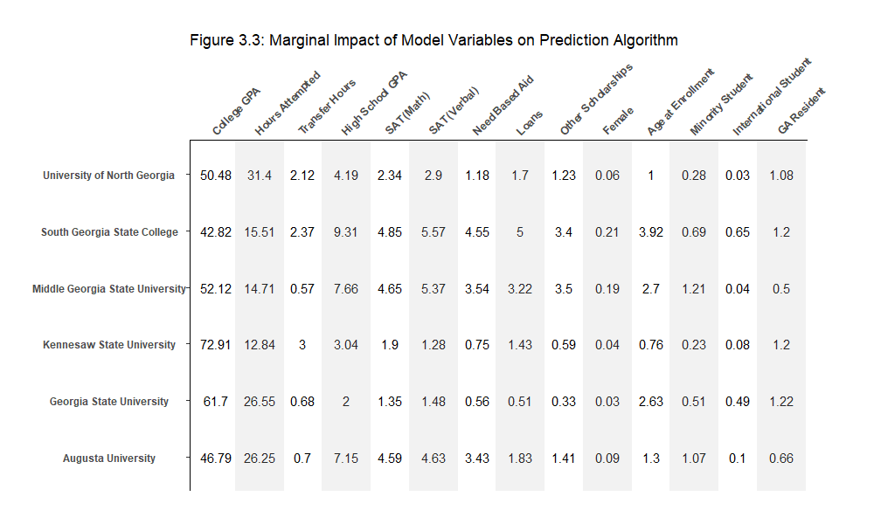
For each consolidation, the numbers for the variables represent how important, as a percentage, the variable was in building a predictive model for that institution. For instance, in the North Georgia consolidation just over 50% of the prediction was built on the students’ cumulative college GPA and adding this to the other numbers would equal close to 100% (accounting for rounding). Cumulative GPA for a student’s first year in college is the most important variable for predicting retention across all models. This effect is most clearly seen for the consolidations at Kennesaw State University and Georgia State University. These two are the youngest consolidations in the analysis, and also the only two consolidations in the Atlanta metro area, either of which may have some impact in shifting the prediction more towards collegiate GPA.
Following collegiate GPA, the next two most heavily weighted variables are the number of hours attempted and high school GPA. The importance of SAT score varies across consolidations, which can be logically accounted for with some basic knowledge of the institutions; the Kennesaw State consolidation, for example, contained Southern Polytechnic University which had a very large and robust engineering program, so it makes sense that the math SAT score is weighted more heavily for these students. Consolidations also differed on the impacts of various types of financial aid. Three consolidations (South Georgia State College, Middle Georgia State University, and Augusta University) saw larger impacts from financial aid in general, but the difference was highest across need-based financial aid. Somewhat surprisingly, the demographic data largely had little impact on the prediction algorithm, with the exception being age at enrollment. A higher impact for age at enrollment potentially signals that these institutions have a larger number of non-traditional students entering as freshmen. Kennesaw State and Georgia State, again, the two consolidations from within the Atlanta metro area, saw a slightly larger impact from their students’ residency status.

Prediction Results
The output from the prediction algorithm shows what retention these institutions are predicted to see given the characteristics of the students enrolled in each cohort and how these characteristics impacted retention in the training dataset. Figure 3.4 shows the comparison between the prediction results and the actual observed first-year student retention for each consolidation site. As stated above, “Year 0” on the x-axis is the year the consolidation is being implemented, and “Year 1” is the first year following the completion of the consolidation. So, students retaining from the Year 0 cohort began their collegiate career at one institution and re-enrolled at a new one, while students in the Year 1 cohort were the first new students to enroll in the consolidated institution. Once the predictions were made, I subtracted the percentage of students who were retained from the percentage of students who were predicted to retain; for almost all years, this produced a positive number, meaning observed retention was below the predicted value. Because the dataset used for the model does not have a measurement for how integrated a student is on campus (such as membership in student organizations, amount of times student services were utilized, etc) and because some students may decide to depart for reasons totally unrelated to their underlying metrics (such as homesickness, personal tragedy, the opportunity to join the workforce), the model likely overestimates the likelihood for some students to retain. To partially correct for these issues, before this calculation was made, the predicted retention percentage was reduced to account for some error in the models; after the training data was run for each model the algorithm supplies the percentage of false positives (students who were predicted to be retained in the training data but who departed) and false negatives, so the predicted percentages were reduced by the false positive rate minus the false negative rate to account for the observable error in the algorithm. Even if the model overestimates the odds for student retention, the output is still useful for examination because trends and large shifts in the prediction results can be established and compared to observable retention.
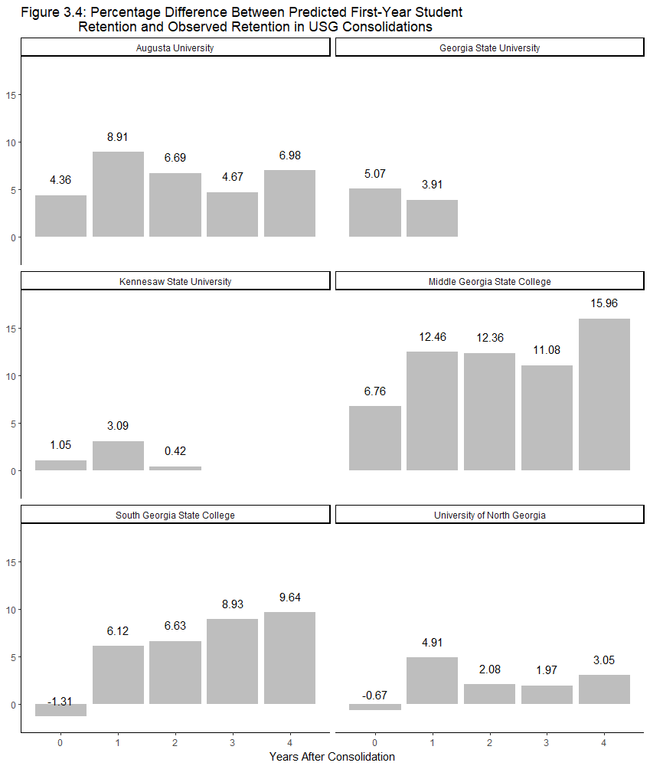
Again, Figure 3.4 represents the gap between the predicted retention and the observed retention. So a gap of 6% means that the model predicted a retention rate 6% higher than the observed rate for that year, and larger bars in Figure 4 represent larger gaps in performance compared to the prediction.
For all consolidations except Georgia State University, the gap in predicted retention and observed retention grows in Year 1, or the first year the consolidation has been made official. In two of these consolidations, Augusta University and Kennesaw State University, the gap returns to a similar level as Year 0 after three and two years, respectively, although the gap moves back up for Augusta in Year 4. In the remaining three consolidations the gap is elevated for all the years of data available. The differences are most dramatic at Middle Georgia State, where the gap between predicted and observed retention more than doubles from Year 0 to Year 4, and South Georgia State College, where observed retention outperformed the prediction model for Year 0 but lags behind it by just under ten percent by Year 4.
Year 0, being the year in which consolidation is implemented, may have been expected to be the most disruptive year for student retention. The implementation requires significant effort from administrators, faculty, and staff, and these students are retaining to a new institution which comes with a high degree of uncertainty. Instead, Year 0 is year in which four of the consolidations observed retention performance most closely matched the prediction model (and for one of the remaining two, Year 0 was less than one percent different from the closest year). Students enrolled at the institution in Year 0 may have some advantages over future students which could explain this. For one, by enrolling at one of the pre-consolidation institutions means they had the advantage of more known information prior to making their enrollment commitment, potentially allowing them to have better odds of determining their fit with the institution. Although the institution will be changing before their second year, they have still had a year to become familiar with campus, make connections, and progress towards graduation; if this year was more successful for them than in future cohorts because they had more information pre-enrollment, this could assist with their retention rates.
Another possibility is that during the implementation process, it may be easier for administrators to get buy-in for significant retention boosting efforts. As discussed previously, the retention effort requires a strong commitment from a significant portion of institution staff and faculty. If the implementation is seen as a threat against student retention, then perhaps these staff members will agree to extra hours of work, or seek out creative solutions to reach students on campus. After implementation, they may no longer perceive the consolidation as a looming threat to retention and reduce some of these efforts. However, the literature on higher education consolidations has found in many countries that the institution remains very unstable for many years following consolidation.
Finally, it could be that the threats to student retention post-consolidation are simply more impactful to students. While high levels of stress and insecurity may lead to poor staff performance and more people exiting the institution, this may affect organizational performance more than it does the students. Meanwhile, post-consolidation while the institution attempts to solidify as a new institution and determine its new norms of behavior, departments may make more frequent changes to their course offerings and requirements, student services may undergo more frequent redesigns, and students may have trouble consistently accessing academic support as these functions are all integrated together.

Discussion
It is important to clarify here the model results are not measuring the actual retention rates of these institutions, except as a comparison to the predicted rate. Figure 3.5 shows the observed retention rate for each consolidation site both pre- and post-consolidation; three institutions (Augusta, Kennesaw State, and North Georgia) show rapid to steady improvement in retention rates, South Georgia State has a drop in retention, Middle Georgia State experiences high amounts of volatility, and the Georgia State consolidation is not yet old enough to ascertain a trend. Instead, the methodology in this chapter more accurately determines the opportunity cost for undergoing a consolidation. In other words, based on the characteristics of the students who have enrolled at these institutions, the model predicted the institutions would have a higher first-year retention rate, in some cases by a much larger amount. For all but one consolidation, there is a large jump in the gap between predicted and observed retention beginning the first cohort following consolidation.
The observed retention rates in Figure 3.4 can be considered in conjunction with the model results to determine some trends for these institutions. Again, all institutions have a larger gap relating to the predicted retention in Year 1 after consolidation. North Georgia and Kennesaw both begin to increase their enrollment after Year 1, and this increase brings their total enrollment very close to the model results for each of the subsequent years.
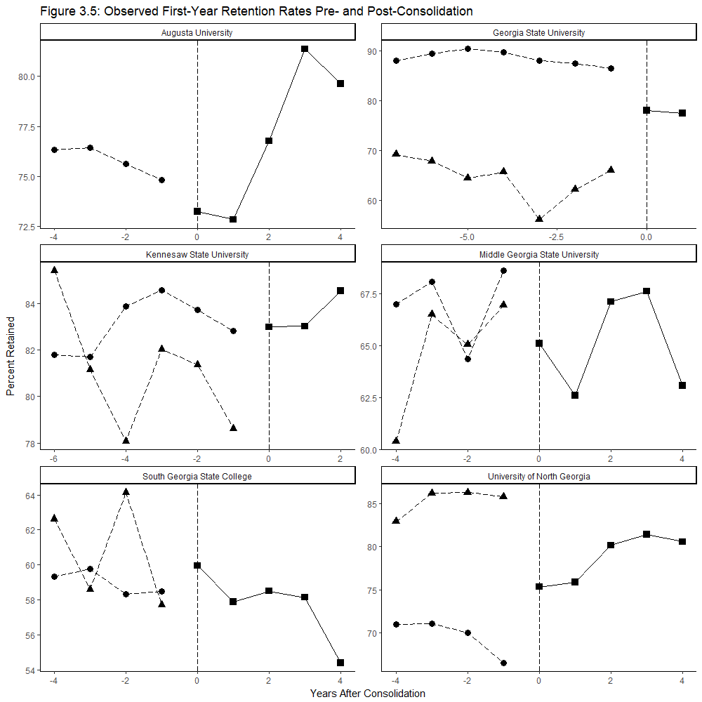

For South Georgia State and Middle Georgia State, the model predicted some slight gains in retention and then some stability, so when the institutions instead had years with drops in retention the predictive gap grew larger. At Augusta, retention initially drops lightly, then raises rapidly in Years 2 and 3 before finally dropping again in Year 4. The predictive gap declines in Years 2 and 3 then raises in Year 4, indicating the model expected Augusta to raise their retention slightly in Year 4, but instead Augusta saw a dip in retention performance. Augusta, as the only institution which had no undergraduate programs at one of the institutions, is the most direct comparison between the pre- and post-consolidation institutions as it contains all students from the same campus. That the Year 1 trend is present here lends strong support to the other model results.
Since the predictive gap is calculated by subtracting the observed results from the predicted results, it is unsurprising that the trends followed closely. However, the model output can still lend some useful information to the observed results. As mentioned above, the changing magnitudes of the gap can help determine years in which performance should be more closely examined. Additionally, the model results indicate that the drop in retention observed in Year 4 for many of the institutions should not be expected based on the characteristics of the students on campus. This potentially lends evidence to the literature which says that consolidated institutions continue to struggle with issues that can impact performance for years after consolidation is complete.
Efforts on campus to help students return from year-to-year are complicated and involve many moving pieces from multiple departments. For institutions with selective enrollment, it begins with the recruitment and admissions process, where staff must attempt to determine which applicants are likely to succeed at the institution and, often, which applicants should be given some sort of early intervention (like an adviser) at enrollment to help them make the transition. Once students are on campus, a number of groups need to work together to make sure information is communicated and acted upon. Information technology personnel handle student records and ensure that reporting systems are working properly; financial aid staffers conduct outreach to raise awareness of scholarship programs and keep track of students’ financial disbursements; advisers make sure students enroll in the courses they need and stay on track to continue in their chosen fields; residential managers assist students in the logistics of finding on-campus rooming and provide them with residential services (often especially important in the first year when many of the larger institutions require freshmen to live on campus); student support workers provide a wide range of assistance to help students’ mental and physical health, make sure they have the materials required for their courses, or connect students to on campus communities; and a number of other staff and faculty members interact with students daily in their courses or within other campus facilities. This list doesn’t include the staff members who work in jobs that rarely or never directly interact with the students, like facilities management, which nonetheless contribute to the retention rate.
Chapters I and IV contain some discussion of the amount of work that staff and faculty must put into the implementation process. On top of work directly involving implementation, many members of these institutions will find their daily work routine thrown off by the consolidation. This includes some changes that could have outsized impacts on attempting to retain a larger number of students; student record systems, for example, need to be overhauled to that both institutions input student data into the same system. Any disruption in the process of tracking student data as the systems are modified and joined could decrease the likelihood of identifying students who need an early intervention to increase their odds of returning the next academic year. Throughout the process in the USG, administrators were adamant that they wanted to implement the process in a way that would not negatively impact students on campus. Given the amount of work and instability just discussed, it is commendable that the Year 0 results in this analysis indicate that the Georgia institutions were largely successful in that goal.
However, the prediction model results indicate that the efforts taken to implement the consolidation, not just during the consolidation process but post-consolidation when the two institutions are continuing to meld their organizational processes and cultures, may come with an opportunity cost. The Year 1 cohort students, where the gap between predicted and observed retention first increases, are the first cohort of students admitted to the new consolidated institution. Staff overseeing admissions were likely extremely busy with tasks on campus during the implementation phase, and it is possible that this impacted the transition this cohort had arriving on campus. Other services with heavy influence on retention may actually experience greater instability after the consolidation process is complete as new services come on line, positions are eliminated or refigured in the new organization, or staff must learn how to accommodate students from the new campus who have different needs than the students they’ve traditionally assisted.
Aside from the work and changes impacting staff on campus, students considering enrolling or retaining at the consolidated institution are in a comparatively low-information environment. Pre-consolidation, students had years of history to go on before deciding to enroll. Post-consolidation, the new institution represents an unknown, where prospective students are unaware how institutional behaviors may change. To what extent the institution will change post-consolidation is likely unclear internally to administrators and staff as well during the process of transitioning to a fully integrated, multi-campus community. While consolidation may help these institutions experience programmatic growth and offer new opportunities to prospective and current students, students will have to weigh new opportunities against other, non-consolidating institutions with few unknowns.
The general pattern found in this analysis is that institutions may still be able to maintain or grow their observed retention rates post-consolidation, but that they likely incur the opportunity cost of losing some students who would have remained in the system absent consolidation. It is unclear whether stakeholders will view this as a net positive or negative in their assessment of the consolidation results. Regarding the previously discussed accountability pressures, this chapter and the previous one both seem to indicate that consolidations will perform poorly along several relevant measurements. The loss of students who would have potentially been retained without consolidation is an opportunity cost that is compounded by the likelihood that many of those students would have stayed for multiple years had they retained. Given that these opportunity costs occur during the same time period when consolidated institutions tend to experience increased costs with minimal increases in revenue, the break-even point to start realizing economic gains from consolidation is quite large. This makes it unlikely that consolidation will score well with internal or external stakeholders concerned with economic efficiency, at least in the short term.
The results in both of these chapters tell us very little about how consolidation impacts reputation and reputational accountability. Ranking systems are not well suited for assessing shifts in the short term and, as noted earlier, institutions rarely make large jumps between tiers in the common ranking systems. It’s possible that consolidation could propel two institutions from a lower tier to a slightly higher tier, but the stability of many of these rankings seem to indicate that this is unlikely. Localized views of reputation will more properly be assessed once the consolidations within the USG have been completed for longer periods of time, and the examination of student retention does not give us an early indicator of how the institution’s reputation may change within their region.
It should also be noted that these consolidations are still in their relative infancy. Several administrators I spoke with within the system indicated that they viewed 10 years out as the minimum timeline to begin making assessments of consolidation success, a timeline that is backed up by the experience of consolidation reforms abroad. It is possible some of these trends may reverse over time and many stakeholders may be completely satisfied with losses during a 5-10 year adjustment period if they believe larger gains will be made in turn. However, the analysis across these two chapters appears to indicate that consolidations are at a disadvantage in terms of achieving future financial success, given the large sunk and opportunity costs accrued early in the process. Additionally, the departure of a number of students who were likely to have retained pre-consolidation mean that consolidations may generate negative perceptions in the short term across multiple accountability pressures.

Chapter 4: Collaboration and Profound Organizational Change: How Collaborative Processes and Structures Impact Change

Public sector reform is an ongoing endeavor, leading to consistent periods of change that impact organizations and employees (Bhatti, Gørtz, and Pedersen 2015). Many of these reforms are tied to the restructuring of bureaucratic systems, including by either splitting or consolidating organizations (Van de Walle 2016). These reforms are driven by desires to downsize, reduce waste, increase efficiency, or realign bureaucracies to adhere to new priorities on policy issues, among other concerns. This is certainly true of structural reforms in higher education; as discussed in the previous chapters, higher education consolidation is primarily driven by the desire to increase efficiency or to facilitate the growth of new departments and programs in order to improve an institution’s marketability or reputation.
Organizational change has a substantial impact on employees throughout the process. This is particularly true for any reform which involves downsizing, which can lead to increases in stress, health issues, and voluntary departures among public employees (Shannon 2016). Deleterious consequences for employees can eventually have a cascading effect which leads to negative outcomes for organizational performance. Both high rates of departure (Lee 2017) and a decrease in the health of employees within the organization (Adler et al 2006) have been linked to lower job performance. Negative effects caused by downsizing or other organizational changes can be persistent even after the implementation of change has been completed, and if drops in performance endure it can compound the issue by making the organization less attractive to potential new employees who might be able to replace the human capital lost during change (Armstrong-Stassen and Cameron 2003).
The study of public sector reform, and specifically of organizational change, lends itself to two broad questions: what is the size, scope, and shape of the change, and how do employees of the organization cope with the impact? In addition to an extensive literature on organizational change, scholars have also over the past several decades explored the way in which public organizations operate within collaborative structures that impact a broad range of organizational behaviors, from administrative decision making to day-to-day employee actions (McGuire 2006). One area in the literature with the potential for much discovery is how the presence of these collaborative arrangements impacts both the nature of organizational change, and whether change within a collaborative environment has a different outlook for employees.
Higher education has always been a field which employs frequent collaboration – institutions collaborate in both formal and informal arrangements such as university systems, consortiums, transfer agreements, dual enrollment programs, and athletic conferences. As institutions attempt to adapt to shifts in the education market, interest in finding new, creative means of collaboration has grown over the past couple of decades (Martin and Samels 2016). Consolidations are on one far end of a spectrum of reform ideas in that they require extensive and obvious collaborative work as part of their implementation. For these reasons, higher education as a field and institutional consolidations as a specific reform present several advantages for considering issues of organizational change and collaboration. This chapter will examine four consolidations which incorporate a diverse set of public institutions from the state of Georgia. It will argue that collaborative processes and structures impact the process of organizational change in two main ways. First, collaborative processes require both resource and time commitments from employees, which when added to similar commitments made to organizational change create a negative environment for employee production and retention. Second, collaborative structures help to shape norms of behavior and levels of trust between organizations and are capable of creating asymmetrical power dynamics where one collaborator has greater formal or informal power over decisions. In these cases, a better positioned organization is more capable of moving organizational change towards the outcomes that they desire.

Profound Organizational Change
Organizational change may refer to a range of activities, including changes to an organization’s structure, culture, practices, or physical location (Robertson, Roberts, and Porras 1993). Because these changes can cover many policies and activities, several theories have been developed to help scholars and practitioners define different types and magnitudes of change (Fernandez and Rainey 2006). Thus, it is important to define what sort of organizational change is being discussed. In this work, the primary concern is large scale change that has significant impacts on organizational activities and on employees, sometimes referred to as “profound organizational change” (Bhatti, Gørtz, and Pedersen 2015).

Defining Change
The broader definition of organizational change can cover anything from large-scale activities such as restructurings, downsizing, and privatization to smaller changes like new computer software, managerial changes, or moving offices (Kiefer et al 2014). Organization scholars have spent considerable time distinguishing between the smaller and larger scale changes. Profound organizational change is differentiated in that it shifts the frame of an organization (Greenwood and Hinings 1996) in a process which disturbs the roles, identities, and interests of organizational subgroups that had been stable over extended periods of time (Huy, Corley, and Kraatz 2014). Conversely, smaller scale changes are more incremental, less disruptive for employees, and have a smaller impact on the broader goals of the organization.
The distinction between smaller change and profound change is important because of the difference in the intensity of impacts on employees. Profound change can lead to many different outcomes associated with decreasing performance, such as increased goal ambiguity (Jung and Rainey 2011), the disruption of daily activities and processes and a sense of lost independence (Bordia et al 2004), and the separation of positive work relationships (Giauque 2015). There are two particular areas which have significant impacts on employees: growing job insecurity and a shifting work environment.
Job security is any feature of an individual’s employment that leads to a sense of assurance in continued employment, whether at the same organization or somewhere in the same field or profession (Bhatti 2015). Job insecurity, then, is when an employee does not have this assurance and instead anticipates job loss. There are multiple types of loss ranging from permanent to temporary unemployment or a change in role within the organization, such as having titles or duties revoked. Loss of employment is the most disruptive type as the employee loses all benefits of organizational membership, but changing job roles can in extreme cases be nearly as disrupting if an employee loses control over their career trajectory, autonomy, status, and access to resources (Greenhalgh and Rosenblatt 1984). Job security is important to all employees but may be particularly important to public sector workers; job security correlates strongly with public service motivation (Chen and Hsieh 2015) which may explain why public employees tend to value job security more than their private sector counterparts (Lyons, Duxbury, and Higgins 2006).
The transformation of the work environment is influenced heavily by turnover and role change. Jobs within an organization are defined in several dimensions, including skill variety, task identity, task significance, autonomy, and feedback (Hackman and Oldham 1975). Changes along these dimensions can impact both individual job performance (Hackman and Oldham 1980) as well as overall commitment to the organization (Chen and Chen 2008). In a stable or only incrementally changing environment, small redesigns of roles can often lead to both short and long-term improvements in individual performance (Griffin 1991). However, during profound organizational change multiple elements can have a detrimental effect on performance. In the short term, undergoing change leads to high amounts of stress that can negate any positive value derived from change (Evangelista and Burke 2003). Additionally, significant turnover during profound change can lead to a more challenging work environment. High rates of turnover, especially when managers exit an organization, forces the remaining employees to complete tasks and assume roles that are unfamiliar with (Andrews and Boyne 2012). If these new tasks involve skills that are beyond their self-perceived abilities, it can lead to fear and stress (Chen and Chen 2008).

Change and Organizational Performance
The above section describes many of the ways that profound change negatively impacts employee performance. Increases in stress, uncertainty, and job insecurity can lead to poorer performance while on the job and either temporary or permanent exit from the organization. However, there are two other ways in which change can impact performance on an organizational level which should be given consideration: the loss of organizational learning and memory, and the deterioration of the organization’s internal reputation.
Organizational learning is a key element of success wherein members of the organization change their routines, behaviors, and strategies based on shared experiences and newly processed information (Mahler 1997). Learning can increase the efficiency of an organization, reduce the total number of errors committed, create innovation, and increase an organization’s total output (Rashman, Withers, and Hartley 2009). One important means of learning are patterns of personal relationships, accessibility, and communication between employees. These patterns are highly influential to employee behaviors; for example, in general, people are more likely to trust the advice of someone they have easy access to or a personal relationship with even over the advice of policy experts (Siciliano 2016).
To the extent that organizational change disrupts interpersonal patterns, then, learning may become more difficult for an organization. Even something as seemingly simple as changing technology through which employees communicate can alter the amount of information sharing that occurs (Kim and Lee 2006). As discussed above, change may also lead to an increase in exit from the organization. Exit impacts an organization in two ways. First, when employees leave permanently, they reduce organizational memory, or the storage of years of learning that could potentially be passed on the new employees (Rusaw 2005). Second, exit disrupts important social relationships and breaks chains of communication, an issue which can be compounded if a high-stress change environment makes employees less likely to pursue new relationships (ibid). Many factors determine the rate at which memory is lost when exit occurs, including how specialized job roles are, how communication occurs between employees, and to what extent employee practices have been formally codified (Fiedler and Welpe 2010).
Profound organizational change is particularly disruptive to learning structures. Along with the normal ways that change disrupts learning, profound change often promotes increased interest in the organization from external stakeholders; in public organizations, this often means more politicization as governing bodies begin to focus on them. Dekker and Hansen (2004) found that increased politicization of a public agency’s task harmed the learning processes because it created a massive influx of external information which disrupted normal learning routines. And while dynamic learning can be one way than an organization can successfully navigate instability and change, these circumstances create a difficult learning environment that requires skilled managers and policies for learning to continue (Wise 2002). Profound change, to the extent that it disrupts managers or causes exit, could therefore negate the positive impacts of learning in the short term while reducing the rate of learning in the long term.
Problems with organizational memory may be exacerbated for public sector employees in the current environment. Several trends, including the retirement of employees from the baby boomer generation and growing preferences among public reformers for downsizing led to decreases in total public-sector employment first in the early 2000s and then again around 2008, a trend which has currently not reversed (Lane, Wolf, and Woodward 2003; U.S. Bureau of Labor Statistics 2018). Federal and state government workforces have for much of their history been adequately insulated from a loss of organizational memory by having many long tenured works who remain in public service for lengthy periods of time (Lewis and Cho 2009), but the reduction of the workforce means many public organizations may be more susceptible to negative consequences if change causes disruption or exit.
Another threat to organizational performance brought about by change may be an increase in negative feelings about the organization and, in turn, the reduction of employee commitment. The relationship between change and employee commitment works in both directions; change can have a strong negative effect on job satisfaction and an employee’s level of commitment (Voet, Vermeeren 2016), and this effect occurs across different organizational contexts (Chordiya, Sabharwal, and Goodman 2017), but strong commitment to the organization before change can mitigate or even completely remove this negative impact (Yousef 2017). These effects can be seen shortly after a change is announced, even before the implementation of the change has started (Kiefer et al 2014). While commitment can be a factor in reducing the negative effects of change, it is likely not enough to counteract high amounts of stress. Stress is one of the main drivers of negative feelings during organizational change, and how employees cope with stress has a large impact on their ultimate opinions on change (Mikkelsen, Ogaard, and Lovrich 2000; Giauque 2015).
The second effect of change with broad organizational impacts is how change impacts the way in which employees perceive the organization. A more negative perception of the organization could potentially reduce employee commitment or increase their levels of stress. There are several variables which can help to determine whether organizational change has a positive or negative impact on perception. One highly important variable is the amount of trust between employees and their managers; trust works as a mediating force between a manager’s actions and attitude and an employee’s perception and response (Mone 1997). Although many studies have tended to focus on the relationship between employees and high-level administrators, some studies have found that trust in middle managers and direct supervisors is a larger contributing factor (Voet, Kuipers, and Groenveld 2015). Profound change can discompose these relationships either by causing a manager to exit or shifting roles so that employees have new managers. Similarly, interpersonal relationships between employees can help employees maintain a positive perception of the organization, but these relationships have the same risks during change as the manager-employee relationships (Giauque 2015). For public employees, high levels of public service motivation can help to lessen the negative impacts of change (Wright, Christensen, Isett 2011). Organizations can also structure change in a way that reduces negative opinions from employees. For example, framing a change as an innovation rather than a cutback (Kiefer et al 2014), making sure there are good lines of communication and that employees are involved in the decision making processes (Giauque 2015), and providing services to help employees deal with stress (Yu 2009) all ameliorate negative perceptions of the organization caused by change.

Organizational Change, Consolidations, and Outcomes
Profound organizational change, then, can have large impacts on the outcomes of organizations. It is unsurprising, then, that the literature on consolidations, a form of profound change, has identified several negative outcomes related to the process. Common types of consolidations such as mergers or acquisitions are a trying time for many employees involved; individuals generally value stability, and a merger disrupts stability. This drastic organizational change can lead to anxiety for members in all involved organizations, even for employees of a large organization acquiring a much smaller one (Pritchett 1985). The process of consolidation can disrupt daily activity in the organization and lead to shock, apathy, insecurity, and frustration in employees (Kleppesto 1998). Additionally, many of these organizations are motivated to consolidate because they are suffering from some financial or structural burden; it is therefore not surprising that consolidations have a mixed record of success. One proposed explanation for the poor track record of consolidations is that decision makers often focus on the financial circumstances of the process and do not give adequate attention to how the change process impacts employees (Fischer, Greitemeyer, Omay, and Frey 2007).
Scholars looking at public organizations have recorded several ways in which consolidation disrupts work and leads to poorer outcomes (Andrews and Boyne 2012). Administrators and managers sometimes become focused on the implementation of change in a way that displaces organizational goals and replaces them with implementation related goals. Leaders in public organizations also experience high rates of turnover during change as with other organizations, which leads to the effects described above. Some organizations began to lack direction as tasks like strategic planning were put on hold until after the consolidation was worked out. Employees of organizations experienced reductions in morale and increases in stress. Finally, certain types of public organizations, like county governments, which are involuntarily made to consolidate by larger governing bodies may rapidly burn through stockpiled resources on local projects rather than “losing” the resources to the other institutions they will consolidate with. The total result of these phenomena are that consolidations can lead to wasted resources and reductions in productivity, which are antithetical to the reasoning behind pursuing consolidation in the first place.
One major consideration for reformers is whether the decrease in output caused by these disruptions outweighs the future gains achieved in a consolidation. Little is currently known about whether new structures in reorganization realize benefits large enough to justify the costs (Pollitt 2009). Theories of structural change would suggest that even when gains are made from reorganization, it can take a considerable amount of time before these gains are reflected as a net positive (Hannan and Freeman 1984). It’s also possible that the negative impacts of reorganization can be compounded if more structural changes are made before organizations have recovered from previous or concurrent changes (Pollitt 2007). Andrews and Boyne (2012) found that the negative impacts of reorganization actually begin before the implementation begins as members become aware that the process is imminent. This can widen the divide that future efficiency gains will need to fill to become a net positive.
The implementation of the consolidation also has large implications for its eventual performance. Mulvey (1993) conducted 20 case studies of higher education consolidations ranging from 1964 to 1985 and found that the universities he examined developed very few strategies and generally handled implementation of the consolidation poorly. Lockey (2007), in a similar study, found that increased administrative costs counteracted most of the gains in efficiency. Administrators who were hired to manage the consolidation were ultimately retained in permanent capacities, and while one of the main reasons for consolidating is to eliminate duplicated programs, very few universities are willing to fire the faculty and staff necessary to truly eliminate duplication. So while consolidation is intended to reduce duplicated work within systems and save money by eliminating some administrative positions, some consolidations have actually led to increases in both.
One final important issue in consolidation is the power dynamic between members of the consolidating organizations and between employees. For example, in one study employees from two consolidation organizations were assigned into high, moderate, and low status groups; members of the low status group had the most negative opinions of the consolidation process and the new organization (Fischer et al 2007). In the case of an acquisition, members of the organization being acquired can suffer an especially large loss of status and, therefore, have severely negative reactions to the process (Pritchett 1985). In contrast, consolidations where both organizations see each other as equals tend to more quickly establish a cohesive organization because they were more likely to compromise and not attempt to override the other during the implementation process (Zaheer, Schomaker, and Genc 2003). These studies lend credence to the idea that the knowledge scholars have generated regarding collaborative structures and processes is useful for furthering our understanding of organizational change.

Collaboration Structures and Processes
Increasingly, public organizations are operating collaborative networks involving other public, nonprofit, or private organizations (or, at minimum, the literature has increasingly recognized the importance of these collaborative practices). Kettl (2006) describes collaboration as occurring along organizational boundaries which overlap with other organizations; for example, organizations which have similar goals, jurisdiction over similar policy areas, or share resources collaborate with one another on those issues. In many cases, instances where organizations undergoing a change which involve changes along these boundaries can be identified; for instance, consider a local public utility provider which collaborates with other organizations to develop the infrastructure required for their service. Restructuring the organization to change its service provision will require a consideration of those collaborative arrangements.
Consolidations represent the most extreme example of overlapping change and collaboration, since the organizations must eventually fully integrate to successfully complete the process. In higher education, the process of consolidation generally involves a period of close collaboration between the consolidating institutions where actors including upper level administrators, unit administrators, college and departmental leaders, and faculty work out details of the consolidation process and the post-consolidation institution (see Martin and Samels 2016 for a discussion of relevant case studies). Members of the organization first work in a highly collaborative environment, then enter into a situation that closely resembles collaboration while a cohesive identity for the organization is still being formed. How these collaborations are structured, and how they impact the variables of organizational change outlined above, are thus important to understanding the implementation and outcomes of consolidation.

Collaborative Structures and the Institutional Analysis and Development Framework
The outcomes of collaboration are, in one sense, simple: either collaboration creates synergy which helps organizations accomplish goals beyond their individual means, or it creates inertia which reduces their ability to complete tasks. However, delving into what leads to these diverging outcomes is a more difficult task. This is complicated by the fact that what exactly defines a collaboration is a difficult topic to reach consensus on (O’Leary and Vij 2012). It is useful to spend some time defining what collaboration looks like in order to understand how it may impact organizational change. Huxham (2010) theorizes that there are five common themes through which it is useful to consider collaboration: common aims, power, trust, membership structures, and leadership.
These themes are similar to elements of the Institutional Analysis and Development (IAD) framework developed by Elinor Ostrom which has been used to further the study of institutions (Ostrom 1990, 1991, 1996; Ostrom, Gardner, and Walker 1994) since its creation. The IAD framework is a broadly applicable tool designed to help synthesize and analyze complex behaviors and interactions between organizations and people (Polski and Ostrom 1999). The framework is a multi-level conceptual map from which scholars can focus on particular sections to identify key elements and outcomes from social interactions. Generally, the IAD framework is concerned with actors operating within action arenas. The actions that actors take in the arena shape the outcomes of institutional behavior, but what actions are available is limited by external factors broadly categorized as the physical environment, the community, and rules-in-use. The rules-in-use are those elements which can be tied closely back to Huxham’s (2010) collaborative themes. Thus, the IAD framework’s description of how rules affect the behavior of actors is useful for explaining how institutional arrangements impact the behavior of actors in collaboration and, thus, the organizational change effort.
Two categories of rules-in-use described by Ostrom (2009) are pay-off and scope. These rules cover the likely rewards or punishments for participating in the action arena and any requirements that exist for the final outcomes of interaction, respectively. Organizations looking to collaborate develop and apply these rules in the formation of collaboration when they align shared goals for the collaborative network. In order for collaborations to be successful, organizations must have their goals overlap on at least a minimal level. Generally, the impetus for beginning a collaboration is to pursue collaborative advantage – or the range of outcomes that can be achieved through collaboration that no individual organization could achieve alone (Huxham and Vangen 2013). Sometimes these arrangements are entered into voluntarily by both parties, other times it may be mandated by policymakers or administrators. Organizations may also “fail into” collaboration, meaning that successive failures to achieve performance benchmarks creates a situation where the organization has to collaborate to survive (Bryson and Crosby 2008). Discerning whether two organizations are capable of achieving collaborative advantages is a difficult task. The most common advice is simply for involved parties to enter in a period of discussion and negotiation, potentially over a long period of time, where they try to discover potential advantages (Huxham and Vangen 2013; Bryson, Ackermann, and Eden 2016). This is not a particularly attractive (or, sometimes, possible) method for organizations that enter into collaboration involuntarily or are addressing problems which require immediate action. Huxham and Vangen (2011) suggest a framework for assisting with this process. In the framework, organizations place goals from all collaborators into these categories: core goals, shared core goals, goals valued by the public that extend beyond core goals, negative-avoidance goals (goals which intend to limit risks involved with pursuing core goals), negative public value consequences (negative-avoidances for risks involved with non-core goals), and not-my-goals (goals for others within the collaboration that the organization does not wish to be held accountable for.) Collaborators can then use these categories to provide structure for the process of finding collaborative advantages between their various goals, and to help them rank which collaborative goals would have the most net benefit if pursued.
Two sets of rules in the IAD framework which deal with the range of actions available to actors are authority rules, which specify the types of actions an actor may take, and aggregation rules, which how decisions are made (Polski and Ostrom 1999). Generally, these rules for collaborators may be impacted by the relationship between collaborators; collaborations feature power dynamics that can lead to either cooperation or hostility between collaborators in ways that may affect authority or aggregation rules. How much power collaborators have is dependent on a number of factors including the history of collaborating organizations, resource dependency, or how legal authority is assigned (O’Leary and Vij 2012). Most, but not all, collaborations share some similarities regarding power: there is no authoritative power structure where one collaborator is in charge of all decisions (Huxham 1996), participants must come to a consensus and then are independently responsible for following the consensus (Gray 1989), and negotiation is performed with mutual respect, agreement, and information sharing with the goal of finding not the best solution, but one that all organizations can agree too (Thomson 2001). However, circumstances within collaborations can lead to deviation from these common themes. For example, if one collaborator has a monopoly on a resource required to pursue the goals of the collaboration, it can have a disproportionate say during any decision-making process (Agranoff 2006).
Additionally, the amount of trust developed in a collaborative effort could widen or narrow the scope of aggregation rules. Trust plays a critical role by allowing collaborators to build relationships which sustain the collaborative effort (Gray 1985, Huxham 1996). Often, trust is a function of familiarity and previous collaborations, where past interactions between two organizations which were successful builds confidence for continued success in the future (O’Leary and Vij 2012). Trust can still be built and maintained when collaborators do not have a common history, but this requires strong efforts from managers and good conflict resolution strategies for when problems arise (Milward and Provan 2006). Hibbert and Huxham (2010) also propose a theory of tradition to explain the development of trust between collaborators. In it, shared traditions – such as symbols, organizational processes, and views on authority – can help build trust. Collaborators may also create new traditions during collaboration that, if strong enough, can endure even if the collaboration ends. They argue that traditions are powerful enough forces that organizations should consider their individual histories just as carefully as they do their shared goals when considering collaboration.
Boundary rules, or entrance and exit requirements for actors, and position rules, which establish positions within the action arena as well as the number and type of actors who hold these positions (Ostrom 2009), are rules-in-use which help to examine official membership into collaboration. Membership structures are concerned with who is formally invited into the collaboration and what their level of interest is (Huxham and Vangen 2000.) A subset of this involves ensuring that all relevant stakeholders are included in the collaborative process. While conceptually simple, including relevant stakeholders becomes difficult when collaborations take place within complex environment and are aimed at addressing intractable problems (Gray 1985). Many recommend that collaborations be formalized with a clear list of members, and that all members have good knowledge about the traits and goals of their collaborators (Huxham and Vangen 2000). When collaborations are informal, or are started quickly to address an immediate problem, it is less likely that all collaborators will be familiar with one another (McGuire 2006). Organizations can also enter collaborations with different, sometimes competing goals, so rules which govern membership have the potential to create or avoid conflict between collaborators, as well as to determine the goals of the collaboration. Membership also has an impact on how information is shared between collaborators; organizational and jurisdictional boundaries can halt the flow of information, and differences in professional norms or ideology can make some collaborators unwilling to share with others (Dawes, Creswell, Pardo 2009).
Finally, it is important note that managers, while falling under the same categories of rules-in-use as all employees, also play important roles in developing rules for employees they supervise. Agranoff and McGuire (2001) describe four management behaviors in collaboration: activation, framing, mobilizing, and synthesizing. Activation is the selection and incorporation of the right members for collaboration. Framing is setting up a working structure for the collaborators and ensuring that there is a shared culture for members. Mobilizing is leading collaborators to take actions towards their decided upon goal, and synthesizing is assuring that collaborators work well together and avoid conflicts. This skill set is unique from skills required for other managerial tasks in non-collaborative environments (McGuire 2006), and stepping between the two roles can lead to a manager operating within two very different environments simultaneously (O’Leary and Vij 2012). For example, within their organization managers may have broad independence in making decisions, but when they work within the shared responsibilities of a collaboration they lose their autonomy. Even within the collaboration managers may have to alternate between being merely participative in tasks or assuming leadership of others depending on how specialized each of the collaborative organizations are. This requires managers to be both adept at working in all of these environments and capable of switching between roles effectively.

Collaboration and Organizational Performance
Collaborations may experience a range of success or failure, but measuring the outcomes is a complicated effort. Many studies of collaboration are built around an in-depth case study approach, which describe collaboration well but by nature preclude an analysis of what would have happed absent collaboration (Ulibarri 2015). For studies which do attempt to further isolate the impact of collaboration, there are many levels at which measurements may be made. For instance, some studies focus on the individual collaborators (Rogers and Weber 2010), while others take a broader system view (Kelman, Hong, and Turbitt 2013). Additionally, goal diversity between collaborators makes it difficult to create systems of performance measurement (McGuire and Agranoff 2011). This ambiguity may explain why there is such a wide variety in studies that look at the outcomes of collaboration.
Many scholars of collaborations have found them to be complex, slow moving, and not guaranteed to achieve collaborative advantage (Huxham and Vangen 2005; McGuire and Agranoff 2011; Bryson, Crosby and Stone 2015). Many of the problems that plague collaboration are related to the five elements outlined above. The paradoxes of managing within collaborating, in particular, has been found to be harmful to the ultimate success of a collaboration (Huxham and Vangen 2005, Keith and Kenis 2008, Vangen 2016). Power asymmetries may allow one collaborator to lead the process towards actions which do not maximize benefits (Agranoff and McGuire 2001). A lack of trust could lead to organizations losing commitment to the collaboration.
On top of issues relating to the collaborative structure, there are many process costs involved in collaboration (Huxham and Vangen 2005) which tend to lead to collaborative inertia. Collaborators must spend time to align their goals, work around jurisdictional boundaries, share information, and build trust, on top of the work within their own organization. Agranoff (2007) found that participants in collaboration spent a significant amount of time discussing the costs involved with the process, which cost them time towards completing organizational tasks. Changes in membership compounds the time spent building trust and relationships, and frequent membership changes can lead to partnership fatigue where organizations are less willing to spend time with new members (Huxham and Vangen 2005). Because the major form of decision making during collaboration is usually broad consensus building, and because collaborators are generally risk averse and respect that their partners are too, collaborations tend to involve a substantial amount of time in committees and meetings (McGuire and Agranoff 2011). This process not only has its own resource and time costs, it also usually leads to a narrowing of the scope of work which also reduces the total impact that the collaboration can achieve.
Collaborations must also contend with political issues. O’Toole and Meier (2004) argue that political implications in networks were not adequately considered in the early collaboration literature. They find that organizations within collaborations seek to bias the system’s efforts so that benefits are directed towards specific constituents. So even if a collaboration produces a collaborative advantage, it is possible that the increased gains in productivity will disproportionately benefit well-established and influential interests, rather than marginalized ones. O’Toole and Meier establish this trend over a seven-year period covering more than 500 school districts, and conclude that networks, rather than helping to minimize bias, may actually lead to an increase in bias.
While some of the above scholarly work highlights the structural and process related costs which work against collaborative advantage, others tend to views collaboration as a generally positive force (Berry, et al, 2004). Some argue that the more positive work on collaborations is based on the tautological assumption that since collaborations occur frequently they must have some inherent advantage that causes policymakers and organizations to pursue them (McGuire 2006). But proponents of collaboration point to a number of ways that collaborations can lead to positive outcomes. Government agencies can achieve economies of by collaborating with service providers with a larger reach (Provan and Lemaire 2012). For instance, many local municipalities may all contract with the same waste removal facility, which prevents each individual municipality from having to purchase and maintain the necessary equipment. On top of financial considerations, collaboration may also allow public organizations to improve the experience for their constituents (Goldsmith and Eggars 2004). By collaborating with other agencies, creating avenues of communication, and integrating information, agencies can streamline services and make sure they are provided efficiently and with minimal confusion or effort on the part of citizens. In general, scholars in favor of these collaborative processes argue networks allow government to work quickly, nimbly, and with an eye towards multiple problems (McGuire 2006); thus making them ideal for working with intractable issues (Kettl 2009).
Some empirical studies of networks have also shown their effectiveness. Provan and Milward (1995, 2001) extensively studied community mental health care services, looking at the amount of coordination among network members and how satisfied patients were with their treatment. They found that collaboration had positive impacts on patient satisfaction, especially when there were highly dense networks that were centralized so that one organization had a high degree of control over operations. Studying over 500 Texas schools districts, Meier and O’Toole (2003) found that higher frequencies of interaction between superintendents and other school members resulted in more positive outcomes for the districts. Agranoff and McGuire (2003) found comparable results in another study looking at the extent of local economic development policy in nearly 250 cities.

Collaboration and Organizational Change
Given the above, it is likely that organizational change which takes place within a collaborative environment will ultimately have different results than if the collaboration did not exist. This paper argues that, based on our understanding of organizational change in the literature as well as the dynamics of institutional interactions described in the IAD framework, collaboration will impact organizational change in two ways. First:
Proposition 1: Collaborators behavior will be impacted by the external environment, including the physical world, community, and rules-in-use, which in turn will shape the actions available to them during organizational change. The external environment will produce a set of particular factors which will differ in each collaboration and organizational change based on the external environment.
In profound organizational change and especially in consolidation, the new post-change organization will be very different in how it operates on a daily basis and, likely, will see a shift in the goals and potentially the broader mission of the organization. When collaboration is involved as part of this effort, it is possible that the process of making decisions for the post-change organization is determined by how the collaboration is structured. As the organization determines what its goals will be post change, it may consider how these goals impact other collaborators, or how it may change its responsibilities within the collaboration. Power balances between collaborators, especially in the case of asymmetrical power distribution, could lead to other collaborators having influence decisions regarding the change. Organizations will need to consider membership rules for collaborative networks as they pursue change, especially if the change may move them out of the collaboration (or give them the potential to join a new collaboration). And as managers switch between their organizational role and their collaborative role, their motivations may be affected in a way that alters their contribution to the change process.
While the external environment shapes the potential actions that collaborators can take, participation in both change and collaboration has several time and resource costs for employees. These costs, as outlined in the literature above, have many potentially negative effects for employees and, more broadly, organizational performance. thus:
Proposition 2: Being involved in collaboration has costs for employees which may increase the negative consequences of organizational change or affect their ability to participate in change. These costs can be identified as a set of persistent factors which, because they are tied to collaboration or change processes, will always be present in some extent when engaging in either activity.
Both organizational change and collaborative efforts are time and resource heavy activities which are potentially stressful for employees, so participation in both could potentially significantly amplify stress. To the extent that collaborative processes must be resolved before decisions can be made regarding change, collaboration may prolong periods of uncertainty or create greater uncertainty. If organizations are downsizing, the presence of other collaborative partners may increase feelings of job insecurity if employees feel that their responsibilities are being covered by a collaborator. Additionally, since employees’ views of the organization may shift during change and are potentially impacted by external information, being within a collaborative arrangement gives employees greater access to and communication with external stakeholders who could express their opinions on the change.
Consolidations offer the opportunity to examine these proposals in a context where many of these impacts will be even more direct because collaborators are making decisions which directly impact one another. To conduct this research, I visited six public institutions in the state of Georgia, three of which had been recently formed through consolidation and two of which were in the process of finalizing their consolidation. These institutions were diverse in their goals, missions, enrollment demographics, and histories and provided the opportunity to assess how the institutions collaborated with one another and how the interaction between the two institutions affected the outcomes of restructuring their organizations.

Consolidations in the University System of Georgia
I conducted interviews at four consolidation locations within the University System of Georgia (USG), which began a systematic reorganization in 2011 which now covers nine total consolidation sites, as discussed previously in Chapter III. A total of 25 interviews were conducted and included presidents, department heads, faculty, and administrators from student affairs, athletics, admissions, and finances. All interviewees were present at one of the existing institutions pre-consolidation, remain in the new consolidated institution, and were officially involved in one or more roles during the consolidation process. Interviews were loosely structured to allow for follow up questions and lasted approximately an hour.

The USG Consolidation Process
Sites within the USG were chosen at the system level with a heavy emphasis on institutions which were geographically close to each other and for which system administrators thought consolidation would bring greater economic efficiency to the system. System administrators, based on the recommendations given to them by institutions from other states that had undertaken consolidations, used a uniform process at each of the consolidations sites. All sites formed a Consolidation Implementation Committee (CIC) which was comprised of administrators, faculty, staff, community members, and students. CICs were the ultimate decision makers during consolidation and gave final approval to reports generated on specific tasks. Each CIC was brought to Atlanta at the start of the implementation process for an official kick-off event at the system offices.
Beneath the CICs were a number of Consolidation Working Groups (CWGs). Each CWG covered one topic, such as athletics, IT systems, housing, transportation, etc. Their membership is split evenly between the consolidating institutions, and there were official mandates stating that all members must be present for any meeting of a CWG, the groups must meet regularly, and they must alternate meeting locations between the consolidating institutions (except for the consolidation at the University of North Georgia which, because of the distance between the two institutions, teleconferenced a larger percentage of their meetings.) Because consolidations are complex and involve a considerable number of issues, each consolidation formed approximately 96 CWGs. This large number of groups meant that most participants served in multiple groups, some in up to five or six. Groups are given specific questions to answer by the CICs and generate reports (including the CWGs recommended action), which were then considered by the CIC before making final decisions.

The Four Consolidation Sites in This Study
The four consolidation sites visited for this study are what is now Albany State University, Augusta University, Kennesaw State University, and the University of North Georgia.
Albany State University
The new Albany State University was formed through the combination of Albany State University and Darton State College in 2016. The former Albany State was a four-year university while Darton State had a number of two-year programs, and a heavy transfer rate to Albany State. Although Darton State had a larger enrollment than Albany State at the time of consolidation (5,471 to 3,492), Albany was the larger financial institution with a fiscal year budget over $22 million larger than Darton State’s in the year prior to consolidation. Albany State also had (and continues to have) an official designation as an Historically Black College or University (HBCU), while Darton State had traditionally been a predominantly white institution. Darton State College became the western campus of Albany State University, but the newly formed college of nursing was named after Darton State because nursing had been Darton’s largest program.
Augusta University
Augusta University was formed by the consolidation of Augusta State University and Georgia Health Sciences University in 2011. Augusta State University was a four-year degree granting institution with an enrollment of just under 7,000, while Georgia Health Sciences University operated multiple public hospitals and ran several graduate programs in health related fields. Because of the hospitals and grants associated with their medical research, the financial discrepancy is large between the two institutions, with Augusta State’s budget of just under $70 million being significantly smaller than Georgia Health Science’s of over $632 million. Immediately after consolidation, the new institution was named Georgia Regents University. However, after backlash from the community it was decided to reincorporate the city name into the institution and it was changed to Augusta University. The USG envisioned these two institutions forming a new R1 university with similarities in structure and practice to Georgia Tech University.
Kennesaw State University
The new Kennesaw State Univesrity was formed through the consolidation of Kennesaw State University and Southern Polytechnic University in 2013. Kennesaw State, with an enrollment of around 24,500 and a budget just over $271 million is one of the larger institutions included in a Georgia consolidation so far. Southern Poly, on the other hand, was a much smaller institution with an enrollment of 6,500. Although smaller, Southern Poly predates Kennesaw State in the area by 15 years. Southern Poly has a core of well-regarded engineering programs, and students who failed to advance in these programs often transferred to Kennesaw State. For this study, Kennesaw State University was the only consolidation within the Atlanta metro area that was visited, although it is not the only metro consolidation to occur within the system.
University of North Georgia
The University of North Georgia was founded by the consolidation of North Georgia College & State University and Gainesville State College in 2011. Of the four sites visited in this study, this consolidation covered the largest geographic area with the two main campuses located in Dahlonega and Gainesville (twenty miles apart), with additional satellite campuses in Cumming and Watkinsville. The two universities are also the most similar in size (6,067 and 8,569 in enrollment, respectively) and had more extensive formal collaborative arrangements pre-consolidation than the other locations. Although enrollment was similar, their missions varied with Gainesville State having a broader access mission and while North Georgia College was more selective. North Georgia College was also one of six senior military schools in the country and the second oldest public education institution in Georgia, designations that were carried over to the University of North Georgia.

Findings and Discussion
The interviews revealed two sets of factors to consider during the process of consolidation in higher education. Based on the proposals outlined above, interviews were examined for the presence of two types of factors. The first, persistent factors, are the process related factors which potentially impact member performance. The second, particular factors, are shaped by the external environment of the action arena (in this case, the arena being the committees making consolidation decisions) and are expected to have greater deviation across consolidation sites.

Persistent Factors
Persistent factors tend to be related to the process of consolidation itself and tie closely to the issues of job insecurity and role changes found in profound organizational change. Most often, persistent factors create more stress for employees during consolidation. These factors, then, provide evidence in support of Proposition 2; the collaborative process amplified the negative externalities of organizational change for many members.
Uncertainty of the Organizational Chart
At all four sites, the merger process first began by handling high-level, mission related concepts such as developing a mission statement and value statements, then moved on to structural issues such as the arrangements of colleges, departments, and services. Producing a final organizational chart that finalized the institutional hierarchy and determined which positions would retained could not be completed until after these tasks. Almost all interviewees talked about the impossibility of making decisions on administrative positions without first knowing the structure of services that would be offered by the institution, which had to be agreed upon by both pre-consolidation institutions.
This process, however, created a large amount of uncertainty for members. Until the organizational chart was finalized, it was unclear what positions would be eliminated, what positions would be retained but were duplicated between the two institutions and thus required one of the counterparts to exit, and whether changes in department and program sizes would require downsizing. The stated goal from the system level was for these consolidations to achieve economic efficiency within the system while simultaneously expanding opportunities for students; for most interviewees this made it seem obvious that not all departments from involved institutions would be fully carried over to the post-consolidation institution, a feeling they stated was also common among their colleagues. However, until the two collaborating institutions could agree on the basic mission, goals, and structure of the post-consolidation institution the process of addressing individual academic units could not begin. Interviewees reported that the uncertainty and increased levels of job insecurity for them and their colleagues resulted in the early exit of many employees, including some upper level administrators. Associated with this increased job insecurity were higher levels of stress and anxiety, and some interviewees reported short-term health impacts for them or their colleagues including sleep deprivation and increased rates of illness.
The uncertainty of what positions would remain post-consolidation also meant that new hires could rarely be made when exit occurred. As a result, many of the interviewees were now in positions where multiple job duties and been merged into their title. Typically, this was the combination of two jobs within the institution, but the highest concentration of work was an interviewee whose official duties comprised of their previous role plus four other roles of colleagues who had exited early. The number of employees who exited seemed to be at least somewhat dependent on resources available at the institution. Darton State College, which had a smaller budget and experienced a short-term budget crunch when many students left after the consolidation announcement, experienced some of the highest rates of exit. Job overlap and distance also played a factor; Augusta University, which merged two institutions with the least amount of role overlap, experienced less exit than Kennesaw State or Albany State, and the University of North Georgia, which had the highest geographical separation, appears to have had the least amount of consolidation related turnover.
The Amount of Issues to Cover
In order to fully consolidate the institutions, decisions had to be made on a massive list of issues. Interviewees said they anticipated most of the major questions, but were surprised by the number of issues that ended up being important. The consolidations averaged 96 CWGs, which all met bi-weekly throughout the year that consolidation was implemented. Because most people served on several of these CWGs, often members had two or three meetings to attend weekly. On top of the actual meetings, CWG membership generally came with a lot of outside work. Each CWG generated multiple reports that were sent to the CIC for consideration and approval. Reports consisted of deep dives into the history of both institutions as well as examinations of relevant scholarly literature on the issue. These reports required research and writing on top of members’ normal job routines. For many interviewees, CWG work was a significant factor of stress.
As detailed above, one cause of collaborative inertia is the process of consensus building between collaborators. The CWGs had many formal rules designed to assist in consensus building but which similarly created inertia. By mandate, the CWGs had to have equal representation from both institutions and alternate their physical meeting location between the two campuses. All members of CWGs had to be present at each meeting in an attempt to try and stop one institution from making unilateral decisions. As a result, meetings were often moved to accommodate members’ schedules and the upkeep of tracking when and where meetings were being held was very time consuming. Several interviewees also reported that this arrangement created awkward situations where the CWG had to take risk-averse actions which prolonged the process of generating recommendations. For example, because the enrollment at Kennesaw State was so much larger than that of Southern Poly, most involved in the consolidation implementation agreed it was more practical to keep Kennesaw State’s student record systems and integrate Southern Poly into it. However, the CWG still had to devote time to studying Southern Poly’s system and incorporating it into the report.
Shared Sector Mission and Deadlines
These two factors interacted strongly with each other and were the only persistent factors that mitigated negative outcomes from organizational change. Although most consolidations were compromised of institutions that had differently targeted missions, they were all public colleges or universities that had a joint interest in the welfare of students. All interviewees, even those with an overall negative opinion of the decision to consolidate, agreed that their institutions were committed to using the process to achieve better outcomes for students. Along with this, the USG decided to set firm deadlines for when each of the consolidations would become official. Although this created a time element that was stressful for many of the interviewees, almost all of them agreed that the short timeline combined with a shared goal of promoting students’ welfare increased the amount of work each member was willing to do and helped them cope with some of the negative effects of stress. An attitude developed that “the train had left the station,” as one interviewee put it, and there was no choice other than to do what was necessary to make the consolidation a success, because otherwise the consequences would fall on students. Interviewees with a negative opinion of the decision to consolidate all agreed with the idea that this attitude at least somewhat increased their level of buy-in to the post-consolidation institution. Because they wanted positive outcomes for students, they were willing to look for positive growth in new programs even though they previously did not think these programs were worth the costs of consolidating.

Particular Factors
Particular factors can be further subdivided into two categories. The first is differences in resources between the two institutions, including budgets, salaries, staff sizes, and facilities. The second are differences in culture, which include governance structures, institution level missions, communities, and traditions. Finally, distance combined with geographic location was a particular factor that impacted several consolidation aspects. These factors lend support broadly towards Proposition 1, in that the behavior of participants in consolidation where impacted by the interaction between the two institutions.
Budgets
Differences in budgets led to tension in numerous ways. Interviewees, especially department heads, from larger institutions reported that their faculty felt money and resources that had been designated to their institution (especially research grants) would be shared with the smaller institution in a way that would harm their ability to do their job. This led to high amounts of stress for some individuals who weren’t actively involved in a CWG or CIC, although interviewees did not report large concerns with these issues themselves. Conversely, members of the organization with a smaller budget often set unrealistic expectations for how much of the budget would be transferred to their role and were later disappointed (again, interviewees did not report this for themselves but noticed it among colleagues who weren’t officially involved in the implementation). Large differences in budgets (and enrollment) also tended to lead to more “us vs. them” mentalities in some members. Interviewees from the smaller organizations often felt like the larger resources of one organization made the effort feel more like an acquisition than a consolidation, leading to more negative views of the decision to consolidate.
Salaries
Differences in salaries created very similar dynamics as differences in budgets. However, in this case the fears of the larger institutions were more warranted. Post-consolidation, institutions had to earmark certain percentages of their budgets to annual equity pay raises to gradually bring the salaries of employees with similar roles to an even level. Interviewees from smaller institutions that received these raises reported that this was a significant positive factor for their peers’ opinions of the consolidation. On the other hand, during the period of equitable pay raises employees from the larger institutions often experienced pay freezes. Interviewees said this created tension between members of each institutions. Additionally, interviewees from the larger institutions said this creates resentment among their peers which in some cases lead to decisions to exit from the organization post-consolidation.
Staff Size
Staff size was primarily important as it interacted with other factors. Because of the extensive number of items to consider, staff sizes greatly impacted the ability of an institution to absorb the workload of consolidation implementation. The impacts of this were exacerbated by the CWG process which required equal membership from all institutions. Interviewees from smaller institutions served on a higher number of CWGs than those from larger institutions and reported similar rates for their peers. In turn, members who were involved in several CWGs had less time to spend on the research and writing work outside of the meetings. Members from larger institutions, who were more likely to be participating in only one or two CWGs, then took over a higher proportion of this work. Interviewees from the smaller institutions felt like this exacerbated the power advantage that larger institutions had by giving them more control over the CWG reports. Conversely, interviewees from the University of North Georgia, which had institutions much closer in size, did not report experiencing this problem.
Facilities
Differences regarding facilities had two main impacts. Similarly to salary differences, interviewees from larger institutions said their peers feared that money for facilities management would be shifted more towards the smaller institutions at the expense of some of their resources. In some cases it was true that money from the institution with the higher budget was shifted to manage facilities and the other institution, but this had the positive result of increasing buy-in from faculty and staff at the institution which received the funding. This was seen most at Augusta University; while both institutions had similarly sized campuses, Georgia Health Sciences University had more funds available for building renovations because of hospital revenue. After the consolidation, and because the goal of the Augusta State consolidation was to grow programs more aggressively than at the other sites, renovations were started on buildings at the Augusta State campus. Department heads from Augusta State reported that this increased the positive image of consolidation for their faculty.
The other impact facilities had was related to the decision to have CWGs alternate between the campuses of the two institutions. Four interviewees reported that this created an awkward tension when one institution had multiple rooms with newer technology available while the other institution had older, smaller facilities. However, this effect was reported far less often than the interviewees who felt like the alternating meeting spots made the implementation feel more equitable.
Governance Structures
Consolidation, along with changing some of the broader goals and missions of the institutions, also required internal changes to how some faculty and staff were managed. One area in which this change was obvious were differences in faculty governance structures. Pre-consolidation, the two institutions tended to handle faculty governance difference, with the amount of direct involvement by faculty being dependent on the institution’s size. In the smaller institutions, the faculty senate involved meetings and input of the entire faculty, while the larger organizations used representative models. Logistically, the size of the institutions post-consolidation required that the new organization used the representative model. Interviewees of the smaller institution often felt like they were losing agency in the decision-making process. Their peers who had been at the institution for an extended period of time particularly felt like this change was negative.
Institution Level Missions
The institutions involved in these consolidations all had variations in their specific missions, but generally speaking throughout the USG consolidations one of the institutions has a broader access mission for local students, while the other institution in the consolidation was more focused on maintaining highly rigorous academic programs and pursuing higher graduations rates. The stated purpose of each of these consolidations was to maintain both missions within the new organization. This created a range of issues that had to be agreed upon within the collaborative arrangement, but the two biggest were discussions of academic rigor and how the tenure and promotion process would work.
Members of one institution were often worried that the consolidation with the other would impact the overall academic rigor of the institution and lower the value of the degrees they confer. This was an issue many CIC members said was raised frequently by alumni. They also felt that students would use the dual mission of the institution to “cheat” the system by gaining admission on a set of lower standards and then, once they were on campus, finding a way to enroll in programs that they would not have been accepted into pre-consolidation.
On the other hand, members of teaching and access focused institutions experienced stress over the tenure and promotion process. The new organization tended to have different standards for receiving tenure, including a higher research expectation. This was especially stressful for employees who were close to going up for tenure. There was also a large discrepancy in the number of members who had terminal degrees at each institution. In some cases, this caused a logistical problem with accreditation, which requires some institutions to have a certain percentage of faculty holding terminal degrees based on the programs offered. Members of the access-oriented institutions often reflected that it felt like they were now in a job totally unlike the one they had accepted.
Although Augusta University did not have the same tension between missions as the other consolidations, the decision by the USG to drive the institution towards becoming a substantial research producing institution created similar fears among members. Particularly, department heads at Augusta State reported significant faculty exit post-consolidation because they perceived their job had shifted dramatically from a teaching focused role to one with additional responsibilities. This was despite the fact that administrators attempted to assure faculty that roles were not expected to change and that the promotion and tenure decisions would be made based on the standards present when the faculty member was hired; worry about the change persisted even after the assurances.
Communities
Each institution, regardless of geographic distance, developed unique communities around them. Sometimes, differences in these two communities resulted in conflicts during the consolidation process. The most extreme example of this occurred at Albany State University which had to navigate the culturally challenging issue of consolidating an HBCU into an historically predominantly white institution. The CIC at Albany made the decision early that the new mission statement for the university should not include either of the core missions of the pre-consolidation institutions so it did not appear that one was more important than the other. Instead, both the HBCU and the access mission were listed in the institution’s value statements. However, when a mission state which did not mention the HBCU designation was released students and community staged a public protest over what they felt was the exclusion of the institution’s core identity.
The HBCU issue was arguably a bigger area of conflict at Darton State. Although the proportion of white students at Darton had dropped below 50% at the time of consolidation, it had generally been a predominantly white institution since its founding. Interviewees who had grown up in Albany said that it was generally understood in the community that Darton had been established primarily so that white parents who were uncomfortable with their children attending an HBCU could have another option in the community. Once the consolidation was announced, a large number of white students left Darton and transferred to other nearby institutions with predominantly white enrollment. These departures were high enough in number that it financially impacted Darton’s ability to implement the consolidation. One interviewee from Darton described a faculty member at a faculty senate meeting who began yelling racial slurs after the consolidation announcement was made. For most faculty members, these racial issues were an extreme source of stress.
On the other hand, embracing community differences was also a way to encourage positive responses to consolidation. Interviewees from Southern Poly described how the campus had openly embraced a “nerd” culture that most students and faculty were very proud of. Although initially fearful that this culture would be disrupted by the consolidation process, members of the CIC and the CWGs began to communicate to members that instead they would further embrace this culture on campus with events and clubs which would now have more resources and involvement from a larger number of students. This would also set their campus apart from the larger Kennesaw State campus by giving it a unique feel. Some interviewees said students reported this attitude towards the consolidation made the implementation and prospects of the new institution seem more fun.
Traditions
There were many concerns at each of the consolidation relating to traditions and symbols. One particularly important decision was what the name of the newly consolidated institution would be. In some cases, the decision was made at the system level while in others it was given to the CIC. Neither process seemed to please everyone, though when the system stepped in and made the decision it did eliminate one point of contention between the two institutions as their displeasure was directed externally. One interviewee from Augusta State University showed me a binder full of notes from the CWG tasked with choosing a name for the new institution; the section for names being considered contained over sixty pages of research breaking down elements of names of different universities, down to details such has how the number of article adjectives had effects on the institution’s reputation. This interviewee described the name process as one of the more work intensive and stressful tasks for the committee (and that the committee later felt jaded when the Georgia Regents University name was selected after the CIC conferred with system administrators even though that did not align with their recommendation). When consolidations kept the name of one of the previous institutions, it tended to foment more conflict when the institution losing its name began to feel more like it was being absorbed that it was an equal partner in consolidation.
A salient issue that is unique to education institutions is the number of traditions that build up around athletics. For consolidations which had athletic programs at both institutions, school colors, mascots, and slogans became a big deal and were the root of a lot of anger from alumni during the implementation. Even something as simple as the timing of traditions became difficult to manage; in the Kennesaw consolidation Kennesaw State, which has a football program, had traditionally held homecoming in the fall while Southern Polytechnic University, which did not, had held theirs in the spring. Athletics also created a logistical issue for completing the consolidations; one athletic director who was interviewed described the difficulty in combining athletic programs when there are NCAA limits on the number of athletes who can be on scholarship at one time while both institutions have multi-year commitments with players.
The debates over these traditions were partially determined by the level of trust between institutions. One of these debates described to me occurred in the selection of the new logo for the University of North Georgia. North Georgia College & State University had long used a symbol of a golden steeple which sits atop the oldest building on campus. Because the steeple is a physical structure on the Dahlonega campus, the CIC worried that continuing to use this logo would result in some resentment from the other institutions who already felt that North Georgia was the dominant collaborator in the process. In this case, though, the institution was able to mitigate these concerns by turning to external expertise; a marketing specialist was hired to provide a report on the logo and branding of the new institution, and the specialist heavily recommended they continue to use the golden steeple because it was unique to the university and the other options were more generic. Interviewees from the CIC reported that having this external recommendation eased negative feelings towards using a logo that was specific to one campus. Instead, regional elements (such as relating the gold in the steeple to a gold rush that had occurred in the area in the 1800s and adding a curved line under the steeple to represent the regions many mountains and rivers) were added to the logo to make it more inclusive. Several interviewees felt strongly that the use of an external arbiter headed off a potentially contentious topic.
Distance and Geographic Location
Finally, the distance between the two campuses played a role in impacting both persistent and particular factors. Perhaps counterintuitively, a larger distance between institutions lent itself to fewer negative impacts during and after consolidation (it was initially assumed that institutions closer to each other would be more similar in organizational culture and have less overlap). The greater distance between institutions at the University of North Georgia meant that fewer staff cutbacks were possible after the consolidation was complete. This reduced job insecurity, which was the largest stress factor at the other institutions. Additionally, because of the distance (along with the fact that North Georgia was in the first wave of consolidations) some of the mandates on CWG structures and arrangements were relaxed compared to other institutions. Because travel between the two campuses took longer, interactions between members of the two institutions did not occur as often or as closely and as a result there was less collaborative inertia. However, post-consolidation the distance between campuses creates some issues that may reduce the cost savings sought through consolidations. For example, some employees job duties require them to travel between campuses and, because of the longer distances, the university is legally required to compensate them for their travel
In addition, geographic location had an impact on some of the logistics of the institutional restructuring. The Kennesaw State University Consolidation saw the largest impact from location; although the two campuses are not very far apart, their location in the Atlanta metro area and in the morning and evenings there is very heavy traffic that significantly increases the travel time between campuses. CIC members from this consolidation said they spent a large amount of time discussing travel and carefully arranging departments and classes so they would minimize the amount of times a student would have to move between campuses. The idea was that a student could compete a degree entirely on one of the two campuses if desired, an outcome that required extra work that was not present at Augusta University or Albany State University. Post-consolidation, Kennesaw also had to increase the number of busses travelling between campuses which was a large expenditure that reduced consolidation cost savings.

Conclusion
The four consolidations included in this study provide some evidence in favor of both propositions. Collaboration between the two institutions shaped what the post-consolidation institution ultimately looked like, impacting missions, shaping the organizational culture, and changing many of the day-to-day activities that employees engaged in. Additionally, the process of collaboration amplified many of the negative impacts of organizational change by making more stress, using additional resources, leading to higher rates of exit, and creating higher levels of job insecurity.
The framework of considering persistent and particular factors in organizational change provides a way of classifying where collaboration may impact change and to what extent collaborative processes will affect employees during change. Returning to Kettl’s (2006) description of collaboration as taking place along the boundaries of the organization, particular factors can shape where the boundaries of organizations overlap and the degree to which this overlap may impact change. Specifically, when particular factors either lead to extensive overlap or create conflict between organizations, decisions or conflict resolution will need to flow through the collaborative structure, which impacts the ultimate outcomes in many of the way described above. For employees, the persistent factors allow for a determination of how impactful collaboration will be in increasing some of the negative experiences associated with change. As employees are involved more significantly in collaborative processes, these factors are areas which can lead to greater stress, job insecurity, and uncertainty.
The interplay of change and collaboration within consolidation appear to be linked. It could be argued, however, that consolidation is too unique of a scenario for this because collaborators are making joint decisions on their own futures regarding the change. Consolidations are common enough occurrences among public institutions that a framework which helps to understand the impacts of these reforms has its own utility. However, expansion of the framework outside of consolidation would expand its ability to describe the interaction of collaboration and organizational change. Future development of these ideas should explore whether these conclusions are present within organizational change that takes place in a collaborative environment but does not involve consolidation.

Chapter 5: Conclusion

This dissertation has presented issues of organizational change and collaboration within the space of higher education consolidations. These consolidations present a fertile environment for this study because of several coinciding circumstances. For one, institutional consolidation inherently necessitates both profound organizational change and a collaborative structure within which the organizations must be intimately involved. These collaborative structures can cover a diverse field of possibilities, differing on whether organizations had collaborated prior to consolidation, how formalized structures of authority overseeing the consolidation are, what goals the consolidating institutions share versus what goals are unique, and what mission, demographics, or other defining characteristics are present in the pre-consolidation institutions. In addition to creating a process where all the necessary phenomena are present, higher education consolidations provide a useful area of study because they are growing in popularity, are relevant to policymakers and stakeholders at multiple levels, and have a long history outside the U.S. for which comparisons can be made.

Summary of Findings
The results of this research cover two main components. The first component establishes some baseline expectations for what happens in the during and immediately after consolidation. It did this in two ways designed to maximize the value of existing higher education data. In Chapter 2, data from the Integrated Postsecondary Education Database (IPEDs) was put through a propensity score matching system to design a dataset of institutions formed through consolidation and a control group of similar, non-consolidated institutions. This allowed for a comparison of the institutions across a variety of variables focused on expenses, revenue, and student outcomes. Chapter 3 examined student level data from six consolidation sites within the University System of Georgia (USG) to compare first year student retention between the pre-consolidation scenario to the post-consolidation scenario. To do this, it used a gradient boosted stochastic decision tree model with a set of training data from the pre-consolidated scenario to predict retention post-consolidation based on a number of student demographic, academic, and financial factors. Predicted retention was then compared to the observed retention at each consolidation location.
For the two main goals of consolidation, gains in financial efficiency and creating a more prestigious and marketable institution, the results of this analysis are mixed. Financial variables indicated that consolidation likely raises expenses for institutions in the short term, and potentially longer. While consolidated institutions tended to offset expenses through increases in revenue compared to their non-consolidated counterparts, these gains are primarily related to increased state funding, of which there is some evidence that the increase may only be temporary. Meanwhile, consolidated institutions lost federal revenue compared to the control group and appear to have passed some of the costs off on students in the form of higher tuition. At the same time, this analysis did not find observable savings on instruction as expected, while institutions increased their spending on support services and research as compared to the control group.
The results of the student retention analysis similarly point to a possible opportunity cost for undergoing a consolidation. In almost all of the consolidation sites, the gap between predicted retention and observed retention grows steeply in the year immediately after the consolidation is implemented, meaning among students who were the first cohort to begin at the consolidated institution. In two of the consolidations this gap takes several years to return to the implementation year level, and in two others it continues to grow up to five years post-consolidation. This implies that some groups of students who, based on their observed qualities, would be expected to be retained at one of the pre-consolidated institutions were not retained here. This could be because immediately following consolidation there is a low-information period where the institution is working through changes and prospective students are less likely to be able to measure fit ahead of time, or it could be related to institution staff having to divert time and resources into the consolidation that would otherwise be spent on recruitment and retention efforts. Either way, the loss of prospective students out of the system has large financial implications as each student retained after their first year could potentially represent multiple years of tuition payments in the future.
The indicators are more optimistic when it comes to growing the institution in a way that could eventually lead to greater prestige and marketability. The first is that consolidated institutions appear to grow their enrollment compared to non-consolidated institutions. This growth in enrollment begins prior to the consolidation being implemented, perhaps in anticipation of approaching institutional changes. Consolidated institutions also begin to increase their number of applicants after the implementation.
The second positive sign for institutional growth comes in the form of graduate program degrees conferred. Beginning two years after consolidation for Master’s degrees and three and four years in for Doctoral degrees the consolidating institutions see larger amounts of growth than within their peer institutions. Although this timeframe is likely too short for a significant number of students to progress through programs that are created during the implementation process, this could signal that institutions either form new programs or recruit larger numbers of students leading into implementation in anticipation of having a new, expanded resources (or, at least, new approval from administrators to spend from existing resources on program growth). The growth of graduate programs are often cited by administrators as a goal of consolidation, and producing more graduate students provides assistance in growing an institution’s reputation from a number of angles.

Implications for Theory: A Framework for Examining Organizational Change Within Collaborative Structures
In the second component of the dissertation, the analysis examines what factors during consolidation implementation are instrumental in determining the range of outcomes discovered within the first component. Primarily, this work focused on the existing literature on profound organizational change and collaborative arrangements to propose that the latter had important impacts on the former. Collaboration has become the norm in public administration; or, at least, the literature has formalized collaborative relationships that have long existed (McGuire 2006). It is unlikely that a public organization undergoing a change is not also collaborating with various other stakeholders within their service or policy area. Certainly within consolidation the importance of collaboration on the process is obvious: two or more organizations are actively collaborating with one another in an attempt to combine. Consolidations have long been popular among public organizations even outside of education, especially within public service provision, and understanding the collaborative arrangements in these changes alone provides an important addition to the literature.
However, beyond consolidation it is not hard to see how collaborative structures and processes may impact the change effort in other scenarios. Kettl (2006) defines collaboration as organizations working together along several overlapping boundaries, including their mission, resources, accountability, capacity, and responsibility. To the extent that organizational change creates shifts along these boundaries, feedback between collaboration and change is possible. The study of how external environments impact the change plays an important role in the organizational change literature. Pettigrew (1990) and Pettigrew, Woodman, and Cameron (2001) challenged change scholars to give greater consideration of the broader contexts within which change occurs, a call which has been met by an expanded understanding of how environments matters in change (for example, Sydow, Schreyogg, and Koch 2009; Van der Voet 2014). The consideration of collaborative structures, then, is a continuance of this line of examination within the organizational change literature.

Organizational Change
There are large fields of literature studying how managers and employees act and are impacted both by organizational change and through collaboration. Fernandez and Rainey (2006) summarize some of the literature on the management of organizational change into several actions that managers must carry out during change. This includes providing a plan for change, building internal and external support, managing resources, institutionalizing the change, and ensuring that the change is comprehensive. What is required for managers to carry out any of these tasks differs based on the type of change, especially the magnitude; an incremental change requires a much different strategy than a profound change (Rusaw 2007).
The impact of organizational change on employees is discussed extensively in Chapter 4. The change environment, especially in the case of profound change, creates extensive stress for most employees, even occasionally among employees with high amounts of job security and connection to the organization. Profound change shifts what tasks employees perform, perhaps putting them in an uncomfortable situation, and increases the level of uncertainty regarding their job security. Change can also lead to members exiting the organization, either because they wish to avoid the change environment or by means outside of their control. This can disrupt established communication networks and cause organizational memory to be destroyed. As a result, the capacity for organizational learning can be harmed and outcomes and efficiency can be reduced.

Collaborative Structures and Processes
Management within collaboration has sometimes been referred to as the “black box,” where the exact details of collaborative actions are sometimes difficult to assess. Although many frameworks exist to consider collaborative management, most contain some consideration of the pre-collaboration environment (sometimes referred to as the antecedent), the actual process of collaboration, and then the measurement of collaborative outcomes (Thomson and Perry 2006). Within the process of collaboration, organizations are impacted by the governance structure and norms of trust and reciprocity within the collaborative arrangement, as well as the amount of autonomy they are given to pursue collaborative goals.
Bryson, Crosby, and Stone (2006) provided one of the more widely disseminated frameworks for understanding collaborative structures based on the existing collaboration literature, which they later updated in Bryson, Crosby, and Stone (2015). Their framework is similar to the antecedent-process-outcome structure in that it examines the collaborative process before, during, and after collaboration. In the pre-collaboration phase, organizations consider their past history with each other, what problem exists, and what sort of mandates each organization has in dealing with the problem. If the pre-collaboration environment moves into collaboration, then leaders from both organizations must manage both the process and structure of the collaboration. To do this, a number of important rules must be established: who and which organizations have decision power, what are the official designations for membership with the collaboration, and what formal roles will exist/who will fill them. Within the consideration of outcomes, participating organizations must be knowledgeable of the various formal and informal accountability pressures they face in order to establish goals, measure outputs, and create adaptive feedback systems to improve the collaboration.
In all steps, the establishment of norms and the building of trust between organizations is paramount. There are many conflicts which may potentially arise to disrupt the development of both. Power imbalances may be present which give one organization more control of the decision-making and reduce the commitment of the organization with lesser power. Decisions must be made on how inclusive to be in collaborative structures versus how much to consider efficiency, which could reduce the buy-in from certain members or alter the norms of behavior by decision makers. It must be decided how autonomous organizations will be within the collaborative arrangement, which could be potentially harmful to the development of trust if one is granted more autonomy than the others. Collaborators also must weigh the issue of whether to make the collaborative structure more flexible or more stable, which could have an impact on the norms of behavior for members.
The Persistent/Particular Framework
This dissertation seeks to leverage this literature on collaboration to better understand organizational change. It contributes to the change literature by providing a framework to achieve this goal. The framework is built around two sets of factors: persistent factors, which are present across all types of organizational change, and particular factors which may differ based on the organizations’ environments. The development of these factors is best understood within the Institutional Analysis and Development (IAD) framework which describes how the external environment, particularly rules-in-use, define and constrain participants’ behavior in specific action arenas (in this case, the work of collaboration and change). This work proposes that the arrangement of organizations in regard to these factors determine the areas within which and the extent that collaborative processes will impact the organizational change.
The persistent and particular factors impact organizational change in different ways. For persistent factors, the collaborative processes amplify the effects that change has on organization members. Because the collaborative process requires that members spend time establishing processes and building trust with another organization, they must then expend resources both on collaboration and change along with their normal job duties. Particular factors are more important in determining the outcomes and directions of change, as differences between organizations can have large impacts on the collaborative structures and, thus, the decisions (and authority to make decisions) that various organizational actors have. Large differences in resources, expertise, or cultural influences, for example, could create an asymmetrical power arrangement where one organization has a greater ability to steer the direction of change. Collaborative rules and norms for how the organizations interact can also impact how influential each organization is in resolving conflicts between different particular factors.
The persistent/particular framework is applicable to each stage of the collaborative process described by Thomson and Perry’s (2006) antecedent-process-outcome framework or Bryson, Crosby, and Stone’s (2006; 2015) more expanded framework. In the pre-collaboration phase, organizations establish how much they overlap across the boundaries described by Kettl (2006), which produce the areas within which collaboration will occur. The more overlap we see across these boundaries, the more of an impact we can expect to see from the persistent factors as more overlap means a more extensive collaboration. In the process phase, the identification of particular factors helps to determine where conflicts will arise during organizational change which will be either somewhat or largely resolved through the collaborative process. In the assessment of outcomes, both persistent and particular factors are relevant in determining how accountability pressures may differ across collaborating institutions, which could lead the different organizations to attempt to steer change in the direction of their preferred outcomes.
While the persistent/particular framework is applicable to a wide range of the existing literature on collaboration and organizational change, it also has the benefit of being parsimonious. The two types of factors are easy to understand and largely easy to identify; persistent factors should be present any time an organization undergoes change, and particular factors are identifiable by seeing where large differences or significant overlap occur between collaborating institutions. The framework’s parsimony is beneficial to its use in future theory development, and also in the translation of theory to results that are of interest to practitioners.

Implications for Practitioners
In addition to the above theoretical contribution, this dissertation provides much information that is of use to policymakers, administrators and faculty and staff within higher education. For policymakers, Chapters 2 and 3 may be of particular interest as they consider whether to pursue consolidation, particularly if they are considering consolidation because they need short-term financial help. The results of this analysis are discussed above.
Administrators, faculty, and staff at the institutional level will find useful information within Chapter 4. Because higher education consolidations in the U.S. are still relatively new in the literature, the discussions in Chapter 4 about the USG’s process for consolidation implementation and how implementation responsibilities were arranged can provide a starting point for discussions in other systems on how to conduct a consolidation. In addition, there are several takeaways from the interviews conducted that practitioners may consider.
First, there was substantial controversy surrounding symbolic features of the new organizations, primarily in the name, mission statement, and visual representations like logos. In naming the institution, two things seemed to be important: signaling an increase in prestige for the institution (usually either changing the name from “college” to “university,” or arranging the words in a way that research indicated people held in higher esteem) and maintaining a link to the geographic location of the institution. In preparing the mission statement, conflict was highest when the pre-consolidation institutions had very different missions, and different arrangements (e.g., listing both missions in the statement or listing neither and adding them to “vision” points beneath the mission statement) did not seem to make a difference across the consolidations. Consolidation implementers should, as much as possible, prepare for employees that will be unhappy about the final decisions made on these issues. The University of North Georgia, in deciding on the logo for the institution, employed a private, third-party marketing consultant to discuss options which seemed to assist in building buy-in for the final logo decision. In other consolidations, some of the symbolic decisions were made at the system level instead of left to the institution, which also helped take some pressure off institution decision makers. At minimum, having a third-party assist in controversial decisions gives organizational members someone to focus their anger on other than their administrators.
Second, position turnover and the loss of institutional memory were big deals at each of the consolidation sites. The process creates substantial amounts of uncertainty, especially for positions which are duplicated among the pre-consolidation institutions. This uncertainty is both unavoidable and unfortunately made worse because designing the organizational chart cannot be the first task completed during the process. All the consolidation implementation committees at the sites I visited placed a high priority at designing the new organizational chart, but before decisions can be made on who will fill certain positions more basic decisions like what departments will be retained, whether the departments will exist across multiple campuses, and other mission related specifics must be made. Because of this uncertainty, many members decided to leave early in the process for more stability at another institution. Administrators should prepare themselves for these sorts of exits and consider solidifying job roles and codifying as much information as possible before the process officially begins to attempt to mitigate the damage caused by exits at important positions.
Third, faculty and staff had concerns about the uncertainty of their job roles. This was particularly manifested among faculty worried about the promotion and tenure process within the new institution. Many faculty members were hired with the expectation that they would maintain a large teaching load with minimal research work, while the new institution (or the institution they were consolidating with) had higher research expectations. While the institutions had all decided that existing employees would retain the tenure and promotion guidelines present when they were hired, many feared that they would still be forced into a position that looked much different than the one they were initially hired for. These concerns were especially high among faculty members who were not officially involved in the implementation committees. For implementers, giving careful consideration to the lines of communication between whoever is officially involved in the implementation process and employees of the institution could help eliminate some of these concerns and potentially head off faculty exits.
Fourth, along with the more obvious symbolic decisions discussed here within the first point, there were a number of issues which took on importance to a degree that surprised many of the implementation committee members. These mostly involved campus traditions and history. Some were symbolic; the official colors of the university or the mascot of the athletic team. Others involved campus events such as the date on which homecoming would be held or festivities that were seen as promoting unique aspects of the institution’s culture. For implementers, it may be helpful to quickly develop a list of these types of issues early in the process and determine which ones will be harder to rectify during the consolidation.
Fifth, one of the more difficult issues for managers during the implementation were the perceptions that members from one institution held of the other. Although no members of the committee I talked to had very negative views of the other institution, there were often perceptions that the other institution did things differently in a way that would pose a significant risk to the status quo. Many of these concerns revolved around differences in resources; members from the institution with a larger amount of resources felt they would likely lose access to some of the budget or items they had traditionally been provided and, thus, would be limited in their ability to complete their jobs. In other cases, faculty who felt like their institution had more rigorous academic units were worried that the consolidation would lower the quality of students enrolled in their programs and harm the overall rigor of their departments. As some of the literature cited in Chapters 1 and 2 discusses, to successfully implement a consolidation managers must have a good understand of their employees, a good grasp of how they will respond to different managerial styles, and the ability to quickly change styles to adapt to new issues as they arise during the consolidation process.
Finally, the actual work of implementing the consolidation took much more time and resources than most committee members had assumed going into it. Because of the amount of decisions that had to be made as part of the process, there were somewhere around 100 working groups which supplied reports to the decision-making committee at each of the consolidation sites. Because of the large number of groups, most of the interviewees I spoke with were involved in more than one group. Stipulations set by the system required all members of a committee to be present any time a meeting was held, and groups had meetings either weekly or bi-weekly in some cases. Groups also had to alternate meeting spaces between the two campuses, which required a lot of logistical set up to accomplish. On top of this actual implementation work, members roles within their own institution became more difficult as employee exit occurred. Because it was often impractical to hire someone new to fill a position for a just year before the implementation was finalized, when someone would exit the institution their job duties were often folded into another position temporarily. Between the implementation committee, working groups, and covering more ground within the institution many people were working significant amounts of overtime for little to no reward.
One thing that was spoken positively of among several interviewees were social events that institutions held throughout the process. These events alleviated stress from the consolidation implementation. It also was an opportunity for members from both institutions to become more familiar with one another, helping with some of the other problems discussed here and in Chapter 4. Implementers could also consider some system to acknowledge and reward members of the working group for their efforts, even if only symbolic in nature, to help increase buy in to the process and work against burnout. The USG consolidations were mostly officially implemented over a year (discussions often began more than a year earlier, but it was a year between announcement and finishing the process), which could have contributed to the amount of exit and burnout experienced in these consolidations. The timeframe did have several advantages, though, such as reducing uncertainty for students on campus and helping to overcome inertia which might have otherwise built against change. Policymakers and implementers should give careful consideration to the timeline they would like to complete implementation in and what effects this timeline will have on the process.

Limitations and Future Directions
The analysis in this research was limited in two parts because of the way in which the data available was collected. First, the timeframe for analysis using the IPEDs data was limited to the short term (five years post-consolidation) because of the inability to collect enough data before and after many of the recent consolidations. Because the IPEDs data collection is driven by the Department of Education, occasionally the way in which certain variables are reported are changed from year to year, or were not added until more recently. So although it is possible to identify consolidations going back to 2001 within IPEDs, it is not until the mid-2000s that a full range of pre-consolidation data is available for many of the examples in the IPEDs universe. The timing of interest in consolidation has also placed many of them after 2010, and because the most recent years of data aren’t finalized this means that another group of consolidations within IPEDs do not yet have five, and a large group have no more than five, years’ worth of data available. Looking internationally, many scholars of consolidation peg 10 years post-consolidation as when the institutions are finally fully integrated, which could mean that many of the benefits of consolidation are not fully realized until even farther out.
In addition to the IPEDs limitation, the student data provided from the USG does not contain personally identifying information, which made it impossible to confidently identify if a student who departed an institution transferred to another USG institution in state, only whether they did or did not return within the same institution. Knowing whether a student stayed within the USG could be an important information in consideration of several of the layers of accountability pressure that higher education institutions face, particularly the student achievement oriented goals. From the system’s perspective on finances, it may be enough that the student’s tuition dollars remain within the system. However, it is important to note that the departure at the institutional level, even if the student remains within the system, still has implications for the future of the institution.
Another limitation placed on this research is that although higher education is a rich ground to analyze the broader issues discussed here, higher education institutions are still unique in many aspects from other public organizations. Most education institutions are granted a high degree of autonomy by their governing bodies which may leave them free to pursue implementation strategies that would not be possible in other organizations. Structurally, colleges and universities present different challenges from many other organizations as academic programs and departments on campus develop their own identities, cultures, norms, and practices in ways that are not replicated in smaller, more hierarchical organizations. Institutions of higher education also promote strong levels of identity formation between themselves and stakeholders in ways that may advantage them when promoting buy-in and seeking to prevent exit.
These limitations help to provide a blueprint for the future development of this research. In the long-term, the timeframe issue will solve itself. Within five years, the analysis of consolidated institutions could be expanded to 10 years post consolidation while simultaneously adding cases available within the dataset. Continuing to monitor these findings and updating them as more data is available will provide additional useful information to the short-term findings presented here.
An immediate step is to expand the more focused study of higher education consolidations outside the state of Georgia. The USG consolidations have received a lot of interest within the past three to five years simply because the amount of consolidations in one area is conducive to efficiently studying consolidation across multiple types of institutions. But a number of other consolidations have been recently completed or are in progress in a number of states, including both pairings similar to those in Georgia and unique consolidation scenarios. One next major step would be the design and dissemination of a survey among members of consolidating institutions across several states to test the relevance of the factors identified in the persistent/particular framework across a number of scenarios.
Of particular interest to practitioners, another immediate step to expand the information found within this dissertation is to give further consideration to how different types of students are impacted by consolidation, and how students already on campus are impacted. In Chapter II, some evidence that students pursuing an Associate’s degree are more likely to be negatively impacted by consolidation was found. Further examination of how the consolidation and collaborative processes move the outcomes for different students could help policymakers and administrators as they design consolidation implementation.
Finally, to fully develop the framework of using persistent and particular factors to leverage collaborative structures in the understanding of organizational change, the testing environment should be expanded beyond the field of higher education. Again, institutions of higher education are unique in a number of ways that may not make them immediately generalizable to other organizations. Testing the versatility of the persistent/particular framework in other environments would help solidify it as a useful tool for considering the impact of collaborative structures on organizational change. An immediate area that cold be useful for this is an examination of consolidation in municipal service delivery organizations. As consolidations, they are closely analogous to the work being done in higher education. Like higher education consolidations, it is also relatively easy to identify financial and output related measurements that could be generalized across multiple organizations. This would make municipal services a good next step before fully expanding the framework to an area not involving consolidation.

References

Adler, David A., Thomas J. McLaughlin, William H. Rogers, Hong Chang, Leueen Lapitsky, and Debra Lerner. "Job performance deficits due to depression." American Journal of Psychiatry 163, no. 9 (2006): 1569-1576.

Agranoff, Robert. "Inside collaborative networks: Ten lessons for public managers." Public administration review 66, no. s1 (2006): 56-65.

Alexander, F. King. "The changing face of accountability: Monitoring and assessing institutional performance in higher education." The Journal of Higher Education 71, no. 4 (2000): 411-431.

Altbach, Philip G. "Higher education, democracy, and development: implications for newly industrialized countries." Interchange 23, no. 1-2 (1992): 143-163.

Armstrong‐Stassen, Marjorie, and Sheila J. Cameron. "Nurses' Job Satisfaction and Turnover Intentions over a Six‐Year Period of Hospital Downsizing and Amalgamation." International Journal of Public Administration 26, no. 14 (2003): 1607-1620.

Aspara, Jaakko, Hanna-Mari Aula, Janne Tienari, and Henrikki Tikkanen. "Struggles in organizational attempts to adopt new branding logics: the case of a marketizing university." Consumption Markets & Culture 17, no. 6 (2014): 522-552.

Aula, Hanna-Mari, and Janne Tienari. "Becoming “world-class”? Reputation-building in a university merger." Critical perspectives on international business 7, no. 1 (2011): 7-29.

Bard, Joe, Clark Gardener, and Regi Wieland. "Rural School Consolidation: History, Research Summary, Conclusions, and Recommendations." Rural Educator 27, no. 2 (2006): 40-48.

Bean, John, and Shevawn Bogdan Eaton. "The psychology underlying successful retention practices." Journal of College Student Retention: Research, Theory & Practice 3, no. 1 (2001): 73-89.

Benton, Davis. "A Consolidation Success Story." (1992).

Bhatti, Yosef, Mette Gørtz, and Lene Holm Pedersen. "The Causal Effect of Profound Organizational Change When Job Insecurity Is Low—A Quasi-experiment Analyzing Municipal Mergers." Journal of Public Administration Research and Theory 25, no. 4 (2015): 1185-1220.

Blackmore, Jill. "Academic pedagogies, quality logics and performative universities: Evaluating teaching and what students want." Studies in Higher Education 34, no. 8 (2009): 857-872.

Blum, Robert Wm, Heather P. Libbey, John H. Bishop, and Matthew Bishop. "School connectedness–strengthening health and education outcomes for teenagers." Journal of School Health 74, no. 7 (2004): 231-235.

Bordia, Prashant, Elizabeth Hunt, Neil Paulsen, Dennis Tourish, and Nicholas DiFonzo. "Uncertainty during organizational change: Is it all about control?." European Journal of Work and Organizational Psychology 13, no. 3 (2004): 345-365.

Boser, Ulrich. "Size Matters: A Look at School-District Consolidation." Center for American Progress (2013).

Bosma, Hans, Richard Peter, Johannes Siegrist, and Michael Marmot. "Two alternative job stress models and the risk of coronary heart disease." American journal of public health 88, no. 1 (1998): 68-74.

Braxton, John M., Amy S. Hirschy, and Shederick A. McClendon. Understanding and reducing college student departure: ASHE-ERIC higher education report, volume 30, number 3. Vol. 16. John Wiley & Sons, 2011.

Brennan, John, and Rajani Naidoo. "Higher education and the achievement (and/or prevention) of equity and social justice." Higher Education 56, no. 3 (2008): 287-302.

Brinkerhoff, Derick W., and Jennifer M. Brinkerhoff. "Public sector management reform in developing countries: Perspectives beyond NPM orthodoxy." Public Administration and Development 35, no. 4 (2015): 222-237.
Bryson, John M., and Barbara C. Crosby. "Failing into cross-sector collaboration successfully." Big ideas in collaborative public management(2008): 55-78.

Bryson, John M., Barbara C. Crosby, and Melissa Middleton Stone. "The design and implementation of Cross‐Sector collaborations: Propositions from the literature." Public administration review 66 (2006): 44-55.

Bryson, John M., Barbara C. Crosby, and Melissa Middleton Stone. "Designing and implementing cross‐sector collaborations: Needed and challenging." Public Administration Review 75, no. 5 (2015): 647-663.

Bunch, Beverly S., and Robert P. Strauss. "Municipal consolidation: An analysis of the financial benefits for fiscally distressed small municipalities." Urban Affairs Quarterly 27, no. 4 (1992): 615-629.

Busuioc, Madalina, and Martin Lodge. "Reputation and accountability relationships: Managing accountability expectations through reputation." Public Administration Review 77, no. 1 (2017): 91-100.

Cannon, Joan B. "The Organizational and Human Implications of Merger." (1983).

Chemers, Martin M., Li-tze Hu, and Ben F. Garcia. "Academic self-efficacy and first year college student performance and adjustment." Journal of Educational psychology 93, no. 1 (2001): 55.

Chen, Chung-An, and Chih-Wei Hsieh. "Does pursuing external incentives compromise public service motivation? Comparing the effects of job security and high pay." Public Management Review 17, no. 8 (2015): 1190-1213.

Chordiya, Rashmi, Meghna Sabharwal, and Doug Goodman. “Affective Organizational Commitment and Job Satisfaction: A Cross-National Comparative Study.” Public Administration 95, no. 1 (2017): 178-195.

Christensen, Tom, and Åse Gornitzka. "Reputation Management in Public Agencies: The Relevance of Time, Sector, Audience, and Tasks." Administration & Society (2018): 0095399718771387.

Christensen, Tom, and Martin Lodge. "Reputation Management in Societal Security: A Comparative Study." The American Review of Public Administration 48, no. 2 (2018): 119-132.

Clinedinst, Melissa E. and Anna-Maria Koranteng. "State of College Admission." Washington, DC: National Association for College Admission Counseling (2017).

Cotton, Kathleen. "School size, school climate, and student performance." (1996).

Coulston, John W., Christine E. Blinn, Valerie A. Thomas, and Randolph H. Wynne. "Approximating prediction uncertainty for random forest regression models." Photogrammetric Engineering & Remote Sensing 82, no. 3 (2016): 189-197.

Cox, Betty, and Becky Cox. "A decade of results: a case for school district consolidation?." Education 131, no. 1 (2010): 83-93.

Cuellar, Alison Evans, and Paul J. Gertler. "Trends in hospital consolidation: the formation of local systems." Health Affairs22, no. 6 (2003): 77-87.

Dawes, Sharon S., Anthony M. Cresswell, and Theresa A. Pardo. "From “need to know” to “need to share”: Tangled problems, information boundaries, and the building of public sector knowledge networks." Public Administration Review 69, no. 3 (2009): 392-402.

DesJardins, Stephen L., Dennis A. Ahlburg, and Brian P. McCall. "Simulating the longitudinal effects of changes in financial aid on student departure from college." Journal of Human resources (2002): 653-679.

Dougherty, Kevin J., Rebecca S. Natow, Rachel Hare Bork, Sosanya M. Jones, and Blanca E. Vega. "Accounting for higher education accountability: Political origins of state performance funding for higher education." Teachers College Record 115, no. 1 (2013): n1.

Doyle, William, and William Zumeta. "State-level responses to the access and completion challenge in the new era of austerity." The ANNALS of the American Academy of Political and Social Science 655, no. 1 (2014): 79-98.

D'Souza, Rennie M., Lyndall Strazdins, Dorothy H. Broom, Bryan Rodgers, and Helen L. Berry. "Work demands, job insecurity and sickness absence from work. How productive is the new, flexible labour force?." Australian and New Zealand journal of public health 30, no. 3 (2006): 205-212.

Duncombe, William D., John Yinger, and Pengju Zhang. "How Does School District Consolidation Affect Property Values? A Case Study of New York." Public Finance Review 44, no. 1 (2016): 52-79.

Duncombe, William, and John Yinger. "Does school district consolidation cut costs?." Education 2, no. 4 (2007): 341-375.

Dunn, Delmer D. "Accountability, democratic theory, and higher education." Educational Policy 17, no. 1 (2003): 60-79.

Durflinger, Norm, and Lynne Haeffele. "Illinois Public School District Consolidation: A Tiered Approach." Center for the Study of Education Policy(2011).

Evangelista, A. S., and Lisa A. Burke. "Work redesign and performance management in times of downsizing." Business Horizons 46, no. 2 (2003): 71-76.

Fernandez, Sergio, and Hal G. Rainey. "Managing successful organizational change in the public sector." Public administration review 66, no. 2 (2006): 168-176.

Fernandez, Sergio, and Hal G. Rainey. "Managing successful organizational change in the public sector." Public administration review 66, no. 2 (2006): 168-176.

Fiedler, Marina, and Isabell Welpe. "How do organizations remember? The influence of organizational structure on organizational memory." Organization Studies 31, no. 4 (2010): 381-407.

Figlio, David N. "Did the “tax revolt” reduce school performance?." Journal of Public Economics 65, no. 3 (1997): 245-269.

Fike, David S., and Renea Fike. "Predictors of first-year student retention in the community college." Community college review 36, no. 2 (2008): 68-88.

Fleming, Jacqueline. "Who will succeed in college? When the SAT predicts Black students' performance." The Review of Higher Education 25, no. 3 (2002): 281-296.

Fowles, Jacob, H. George Frederickson, and Jonathan GS Koppell. "University rankings: Evidence and a conceptual framework." Public Administration Review 76, no. 5 (2016): 790-803.

Freund, Yoav, Robert Schapire, and Naoki Abe. "A short introduction to boosting." Journal-Japanese Society For Artificial Intelligence 14, no. 771-780 (1999): 1612.

Friedman, Jerome H. "Stochastic gradient boosting." Computational Statistics & Data Analysis 38, no. 4 (2002): 367-378.

Fryar, Alisa Hicklin, and Deven Carlson. "Putting Colleges on Notice." (2014).
Fumasoli, Tatiana, and Jeroen Huisman. "Strategic agency and system diversity: Conceptualizing institutional positioning in higher education." Minerva 51, no. 2 (2013): 155-169.

Geschwind, Lars, Göran Melin, and Linda Wedlin. "Mergers as Opportunities for Branding: The Making of the Linnaeus University." In Mergers in Higher Education, pp. 129-143. Springer, Cham, 2016.

Giauque, David. "Attitudes toward organizational change among public middle managers." Public Personnel Management 44, no. 1 (2015): 70-98.

Gibbons, Michael. "Higher Education Relevance in the 21st Century." (1998).

Gifford, Denise D., Juanita Briceno-Perriott, and Frank Mianzo. "Locus of Control: Academic Achievement and Retention in a Sample of University First-Year Students." Journal of College Admission 191 (2006): 18-25.

Gilad, Sharon, Pazit Ben-Nun Bloom, and Michaela Assouline. "Bureaucrats' processing of organizational reputation signals." Journal of Behavioral Public Administration 1, no. 1 (2018).

Girth, Amanda M. "Contracting, Civil Service Reform, and the Call to Reprofessionalize Public Service." Journal of Public Administration Research and Theory (2018): 295-297.

Glascock, Catherine H. "Rural Districts in Crisis: When a Community Is Divided." (1998).

Gordon, Matt R. "A Study of the Impact of School Consolidation on Student Achievement and District Financial Health." PhD diss., University of St. Francis, 2015.

Gray, Barbara. "Collaborating: Finding common ground for multiparty problems." (1989).

Greenwood, Royston, and Christopher R. Hinings. "Understanding radical organizational change: Bringing together the old and the new institutionalism." Academy of management review 21, no. 4 (1996): 1022-1054.

Griffin, Ricky W. "Effects of work redesign on employee perceptions, attitudes, and behaviors: A long-term investigation." Academy of management Journal 34, no. 2 (1991): 425-435.

Gronberg, Timothy J., Dennis W. Jansen, Mustafa U. Karakaplan, and Lori L. Taylor. "School district consolidation: Market concentration and the scale‐efficiency tradeoff." Southern Economic Journal 82, no. 2 (2015): 580-597.

Gualmini, Elisabetta. "Restructuring Weberian bureaucracy: Comparing managerial reforms in Europe and the United States." Public administration 86, no. 1 (2008): 75-94.

Hackman, J. Richard, and Greg R. Oldham. "Development of the job diagnostic survey." Journal of Applied psychology 60, no. 2 (1975): 159.

Hackman, J. Richard, and Greg R. Oldham. "Work redesign." (1980). Boston: Addison-Wesley.

Hay, Driekie, and Magda Fourie. "Preparing the way for mergers in South African higher and further education institutions: An investigation into staff perceptions." Higher Education 44, no. 1 (2002): 115-131.

Hibbert, Paul, and Chris Huxham. "The past in play: Tradition in the structures of collaboration." Organization Studies 31, no. 5 (2010): 525-554.

HigherEdJobs. “Higher Education Employment Report: First Quarter 2016.” (2016). http://bit.ly/2w5xMwn. Accessed 8/13/17.

Hillman, Nicholas W., David A. Tandberg, and Alisa H. Fryar. "Evaluating the impacts of “new” performance funding in higher education." Educational Evaluation and Policy Analysis 37, no. 4 (2015): 501-519.

Hoffman, John L. "The impact of student cocurricular involvement on student success: Racial and religious differences." Journal of College Student Development (2002).

Hoffman, John L., and Katie E. Lowitzki. "Predicting college success with high school grades and test scores: Limitations for minority students." The Review of Higher Education 28, no. 4 (2005): 455-474.

Hood, Christopher, and Guy Peters. "The middle aging of new public management: into the age of paradox?." Journal of public administration research and theory 14, no. 3 (2004): 267-282.

Hornsby, David J., and Ruksana Osman. "Massification in higher education: large classes and student learning." Higher Education 67, no. 6 (2014): 711-719.

Howley, Craig, and Robert Bickel. "Smaller districts: Closing the gap for poor kids." (2002).

Howley, Craig, Jerry Johnson, and Jennifer Petrie. "Consolidation of schools and districts: What the research says and what it means." (2011).

Howley, Craig, Marty Strange, and Robert Bickel. "Research about School Size and School Performance in Impoverished Communities. ERIC Digest." (2000).

Huxham , Chris. “Collaboration and Collaborative Advantage”. In Creating Collaborative Advantage, edited by Chris Huxham. (1999): 1 – 18 . Thousand Oaks, CA : Sage Publications .

Huxham, Chris. "Theorizing collaboration practice." Public management review 5, no. 3 (2003): 401-423.

Huxham, Chris, and Siv Vangen. "Ambiguity, complexity and dynamics in the membership of collaboration." Human relations 53, no. 6 (2000): 771-806.

Huxham, Chris, and Siv Vangen. Managing to collaborate: The theory and practice of collaborative advantage. Routledge, 2013.

Huy, Quy Nguyen, Kevin G. Corley, and Matthew S. Kraatz. "From support to mutiny: Shifting legitimacy judgments and emotional reactions impacting the implementation of radical change." Academy of Management Journal 57, no. 6 (2014): 1650-1680.

Jacques, Charles, B. Wade Brorsen, and Francisca GC Richter. "Consolidating rural school districts: Potential savings and effects on student achievement." Journal of Agricultural and Applied Economics 32, no. 3 (2000): 573-583.

Jamelske, Eric. "Measuring the impact of a university first-year experience program on student GPA and retention." Higher Education 57, no. 3 (2009): 373-391.

Jennings Jr, Edward T., and Jo Ann G. Ewalt. "Interorganizational coordination, administrative consolidation, and policy performance." Public Administration Review (1998): 417-428.

Johnson, Jerry D., Craig B. Howley, and Aimee A. Howley. "Size, Excellence, and Equity: A Report on Arkansas Schools and Districts." (2002).

Jones-Schenk, Jan, and Mary G. Harper. "Emotional intelligence: An admission criterion alternative to cumulative grade point averages for prelicensure students." Nurse education today 34, no. 3 (2014): 413-420.

Kay, Steve. "The Effect of School Consolidation on Fidelity to Traditional Value Systems." (1982).

Kelman, Steven. Unleashing change: A study of organizational renewal in government. Brookings Institution Press, 2005.

Kelman, Steven, Sounman Hong, and Irwin Turbitt. "Are there managerial practices associated with the outcomes of an interagency service delivery collaboration? Evidence from British crime and disorder reduction partnerships." Journal of Public Administration Research and Theory 23, no. 3 (2012): 609-630.

Kerkvliet, Joe, and Clifford Nowell. "Does one size fit all? University differences in the influence of wages, financial aid, and integration on student retention." Economics of Education Review 24, no. 1 (2005): 85-95.

Kettl, Donald F. "Managing boundaries in American administration: The collaboration imperative." Public Administration Review 66 (2006): 10-19.

Kiefer, Tina, Jean Hartley, Neil Conway, and Rob B. Briner. "Feeling the squeeze: Public employees’ experiences of cutback-and innovation-related organizational changes following a national announcement of budget reductions." Journal of Public Administration Research and Theory 25, no. 4 (2014): 1279-1305.

Kim, Tae Jun, and Olaf von dem Knesebeck. "Is an insecure job better for health than having no job at all? A systematic review of studies investigating the health-related risks of both job insecurity and unemployment." BMC public health 15, no. 1 (2015): 985.

Kuh, George D. "What we're learning about student engagement from NSSE: Benchmarks for effective educational practices." Change: The Magazine of Higher Learning 35, no. 2 (2003): 24-32.

Kuh, George D., Jillian Kinzie, Jennifer A. Buckley, Brian K. Bridges, and John C. Hayek. Piecing together the student success puzzle: Research, propositions, and recommendations: ASHE Higher Education Report. Vol. 116. John Wiley & Sons, 2011.

Kuh, George D., Ty M. Cruce, Rick Shoup, Jillian Kinzie, and Robert M. Gonyea. "Unmasking the effects of student engagement on first-year college grades and persistence." The journal of higher education 79, no. 5 (2008): 540-563.

Kuipers, Ben S., Malcolm Higgs, Walter Kickert, Lars Tummers, Jolien Grandia, and Joris Van der Voet. "The management of change in public organizations: A literature review." Public administration 92, no. 1 (2014): 1-20.

Lang, Daniel W. "There Are Mergers, and There Are Mergers." Higher Education Management and Policy 14, no. 1 (2002): 11-50.

Lang, David. "The impact of a first-year experience course on the academic performance, persistence, and graduation rates of first-semester college students at a public research university." Journal of the First-Year Experience & Students in Transition 19, no. 1 (2007): 9-25.

Lee, Shinwoo. "Employee Turnover and Organizational Performance in US Federal Agencies." The American Review of Public Administration (2017): 0275074017715322.

Locke, William. "Higher education mergers: Integrating organisational cultures and developing appropriate management styles." Higher Education Quarterly 61, no. 1 (2007): 83-102.

Lotkowski, Veronica A., Steven B. Robbins, and Richard J. Noeth. "The Role of Academic and Non-Academic Factors in Improving College Retention. ACT Policy Report." American College Testing ACT Inc (2004).

Loukas, Alexandra, Lori A. Roalson, and Denise E. Herrera. "School connectedness buffers the effects of negative family relations and poor effortful control on early adolescent conduct problems." Journal of Research on Adolescence 20, no. 1 (2010): 13-22.

Luca, Michael, and Jonathan Smith. "Salience in quality disclosure: evidence from the US News college rankings." Journal of Economics & Management Strategy 22, no. 1 (2013): 58-77.

Lundin, Martin. "Explaining cooperation: How resource interdependence, goal congruence, and trust affect joint actions in policy implementation." Journal of Public Administration Research and Theory 17, no. 4 (2007): 651-672.

Lyons, Sean T., Linda E. Duxbury, and Christopher A. Higgins. "A comparison of the values and commitment of private sector, public sector, and parapublic sector employees." Public administration review 66, no. 4 (2006): 605-618.

Lyons, William E., and David Lowery. "Governmental Fragmental Versus Consolidation: Five Public-Choice Myths About How to Create Informed, Involved, and Happy Citizens." Public administration review 49, no. 6 (1989): 533.

Lyson, Thomas A. "What Does a School Mean to a Community? Assessing the Social and Economic Benefits of Schools to Rural Villages in New York." (2002).

Maher, Craig S. "A longitudinal analysis of the effects of service consolidation on local government expenditures." Public Administration Quarterly (2015): 393-425.

Martin, Christopher D. "The involuntary push: University mergers and their effect on post-graduate management education in South Australia." Journal of Educational Administration 34, no. 3 (1996): 83-91.

Martin, James, and James E. Samels. Consolidating Colleges and Merging Universities: New Strategies for Higher Education Leaders. JHU Press, 2016.

McClellan, E. Fletcher. "What a long, strange trip it’s been: Three decades of outcomes Assessment in higher education." PS: Political Science & Politics 49, no. 1 (2016): 88-92.

McGuire, Michael, and Robert Agranoff. "The limitations of public management networks." Public Administration 89, no. 2 (2011): 265-284.

McGuire, Michael. "Collaborative public management: Assessing what we know and how we know it." Public administration review 66, no. s1 (2006): 33-43.

Meier, Kenneth J., and Laurence J. O'Toole. "Public management and educational performance: The impact of managerial networking." Public Administration Review 63, no. 6 (2003): 689-699.

Mikkelsen, Aslaug, Torvald Ogaard, and Nicholas Lovrich. "Modeling the effects of organizational setting and individual coping style on employees subjective health, job satisfaction and commitment." Public Administration Quarterly (2000): 371-397.

Milward, H. Brinton, and Keith G. Provan. A manager's guide to choosing and using collaborative networks. Vol. 8. Washington, DC: IBM Center for the Business of Government, 2006.

Moffatt, Gregory K. "The Validity of the SAT as a Predictor of Grade Point Average for Nontraditional College Students." (1993).

Mok, Ka-Ho. "Globalization and educational restructuring: University merging and changing governance in China." Higher education 50, no. 1 (2005): 57-88.

Molesworth, Mike, Elizabeth Nixon, and Richard Scullion. "Having, being and higher education: The marketisation of the university and the transformation of the student into consumer." Teaching in higher Education 14, no. 3 (2009): 277-287.

Monahan, Kathryn C., Sabrina Oesterle, and J. David Hawkins. "Predictors and consequences of school connectedness." The Prevention Researcher17, no. 3 (2010): 3-6.

Mone, Mark A. "How we got along after the downsizing: Post-downsizing trust as a double-edged sword." Public Administration Quarterly (1997): 309-336.

Monk, David H., and Emil J. Haller. "Predictors of high school academic course offerings: The role of school size." American Educational Research Journal 30, no. 1 (1993): 3-21.

Muenster, Eva, Heiko Rueger, Elke Ochsmann, Stephan Letzel, and André M. Toschke. "Association between overweight, obesity and self-perceived job insecurity in German employees." BMC public health 11, no. 1 (2011): 162.

Murtaugh, Paul A., Leslie D. Burns, and Jill Schuster. "Predicting the retention of university students." Research in higher education 40, no. 3 (1999): 355-371.

Nitta, Keith A., Marc J. Holley, and Sharon L. Wrobel. "A phenomenological study of rural school consolidation." Journal of Research in Rural Education (Online) 25, no. 2 (2010): 1.

O’Leary, Rosemary, and Nidhi Vij. "Collaborative public management: Where have we been and where are we going?." The American Review of Public Administration 42, no. 5 (2012): 507-522.

Ostrom, Elinor. "An agenda for the study of institutions." Public choice 48, no. 1 (1986): 3-25.

Ostrom, Elinor. Governing the Commons: the Evolution of Institutions for Collective Action. Cambridge, UK. Cambridge University Press. (1990)

Ostrom, Elinor. Understanding Institutional Diversity. Vol. 41. Princeton, NJ: Princeton University Press, 2005.

Ostrom, Elinor, Roy Gardner, James Walker, and Jimmy Walker. Rules, games, and common-pool resources. University of Michigan Press, 1994.

O'Toole, Laurence J., and Kenneth J. Meier. "Desperately Seeking Selznick: Cooptation and the Dark Side of Public Management in Networks." Public Administration Review 64, no. 6 (2004): 681-693.

Pachon, Harry P., and Nicholas P. Lovrich Jr. "The consolidation of urban public services: A focus on the police." Public Administration Review (1977): 38-47.

Parker, James DA, Laura J. Summerfeldt, Marjorie J. Hogan, and Sarah A. Majeski. "Emotional intelligence and academic success: Examining the transition from high school to university." Personality and individual differences 36, no. 1 (2004): 163-172.

Peguero, Anthony A., and Zahra Shekarkhar. "Latino/a student misbehavior and school punishment." Hispanic Journal of Behavioral Sciences 33, no. 1 (2011): 54-70.

Peshkin, Alan. "Growing Up American; Schooling and the Survival of Community." (1978).

Pettigrew, Andrew M., Richard W. Woodman, and Kim S. Cameron. "Studying organizational change and development: Challenges for future research." Academy of management journal 44, no. 4 (2001): 697-713.

Polski, Margaret M., and Elinor Ostrom. "An institutional framework for policy analysis and design." 1999 (1999).

Provan, Keith G., and H. Brinton Milward. "A Preliminary Theory of Interorganizational Network Effectiveness: A Comparative Study of Four Community Mental Health Systems." Administrative Science Quarterly (1995): 1-33.

Provan, Keith G., and H. Brinton Milward. "Do networks really work? A framework for evaluating public‐sector organizational networks." Public administration review 61, no. 4 (2001): 414-423.

Provan, Keith G., and Patrick Kenis. "Modes of network governance: Structure, management, and effectiveness." Journal of public administration research and theory 18, no. 2 (2008): 229-252.

Rabovsky, Thomas M. "Accountability in higher education: Exploring impacts on state budgets and institutional spending patterns." Journal of Public Administration Research and Theory 22, no. 4 (2012): 675-700.

Ridgeway, Greg. "Generalized Boosted Models: A guide to the gbm package." Update 1, no. 1 (2007): 2007.

Robertson, Peter J., Darryl R. Roberts, and Jerry I. Porras. "Dynamics of planned organizational change: Assessing empirical support for a theoretical model." Academy of Management Journal 36, no. 3 (1993): 619-634.

Rogers, Ellen, and Edward P. Weber. "Thinking harder about outcomes for collaborative governance arrangements." The American Review of Public Administration 40, no. 5 (2010): 546-567.

Rowley, Gillian. "Mergers in higher education: A strategic analysis." Higher Education Quarterly 51, no. 3 (1997): 251-263.

Saisana, Michaela, Béatrice d’Hombres, and Andrea Saltelli. "Rickety numbers: Volatility of university rankings and policy implications." Research policy 40, no. 1 (2011): 165-177.

Schnell, Carolyn A., and Curt D. Doetkott. "First year seminars produce long-term impact." Journal of College Student Retention: Research, Theory & Practice 4, no. 4 (2003): 377-391.

Shannon, Elizabeth Ann. "Beyond Public Sector Reform–The Persistence of Change." Australian Journal of Public Administration (2016).

Shapiro, Doug, Aftet Dunda, Faye Huie, Phoebe Khasiala Wakhungu, Xin Yuan, Angel Nathan, and Youngsik Hwang. "A National View of Student Attainment Rates by Race and Ethnicity--Fall 2010 Cohort (Signature Report No. 12b)." National Student Clearinghouse (2017).

Singell, Larry D. "Come and stay a while: does financial aid effect retention conditioned on enrollment at a large public university?." Economics of Education Review 23, no. 5 (2004): 459-471.

Skodvin, Ole‐Jacob. "Mergers in higher education‐success or failure?." Tertiary Education & Management 5, no. 1 (1999): 65-80.

Slopen, Natalie, Robert J. Glynn, Julie E. Buring, Tené T. Lewis, David R. Williams, and Michelle A. Albert. "Job strain, job insecurity, and incident cardiovascular disease in the Women’s Health Study: results from a 10-year prospective study." PLoS One 7, no. 7 (2012): e40512.

Spradlin, Terry E., Fatima R. Carson, Sara E. Hess, and Jonathan A. Plucker. "Revisiting School District Consolidation Issues. Education Policy Brief. Volume 8, Number 3, Summer 2010." Center for Evaluation and Education Policy, Indiana University (2010).

Thomson, Ann Marie, and James L. Perry. "Collaboration processes: Inside the black box." Public administration review66 (2006): 20-32.

Thomson, Ann Marie. "Collaboration: Meaning and measurement." Ph.D. Dissertation. Indiana University. (2003).

Tinto, Vincent. "Research and practice of student retention: What next?." Journal of College Student Retention: Research, Theory & Practice 8, no. 1 (2006): 1-19.

Tomlinson, Michael. "‘The degree is not enough’: students’ perceptions of the role of higher education credentials for graduate work and employability." British journal of sociology of education 29, no. 1 (2008): 49-61.

Trachtenberg, Stephen Joel. "Commentary: The Truth and Consequences of Academic Rankings." Public Administration Review 76, no. 5 (2016): 803-804.

Ulibarri, Nicola. "Collaboration in federal hydropower licensing: Impacts on process, outputs, and outcomes." Public Performance & Management Review 38, no. 4 (2015): 578-606.

Ursin, Jani, Helena Aittola, Charles Henderson, and Jussi Välimaa. "Is education getting lost in university mergers?." Tertiary education and management 16, no. 4 (2010): 327-340.

Vahtera, Jussi, Mika Kivimäki, Jaana Pentti, Anne Linna, Marianna Virtanen, Pekka Virtanen, and Jane E. Ferrie. "Organisational downsizing, sickness absence, and mortality: 10-town prospective cohort study." Bmj 328, no. 7439 (2004): 555.

Van de Walle, Steven, and Sandra Groeneveld, eds. Theory and Practice of Public Sector Reform. Vol. 27. Routledge, 2016.

Van der Voet, Joris, and Brenda Vermeeren. "Change management in hard times: can change management mitigate the negative relationship between cutbacks and the organizational commitment and work engagement of public sector employees?." The American Review of Public Administration 47, no. 2 (2017): 230-252.

Van der Voet, Joris, Ben S. Kuipers, and Sandra Groeneveld. "Implementing Change in Public Organizations: The relationship between leadership and affective commitment to change in a public sector context." Public Management Review 18, no. 6 (2016): 842-865.

Van Maele, Dimitri, and Mieke Van Houtte. "The quality of school life: Teacher-student trust relationships and the organizational school context." Social Indicators Research 100, no. 1 (2011): 85-100.

Wan, Yinmei, and Marvin W. Peterson. "A case study of a merger in Chinese higher education: The motives, processes, and outcomes." International Journal of educational development 27, no. 6 (2007): 683-696.

Waters, Stacey, Donna Cross, and Therese Shaw. "Does the nature of schools matter? An exploration of selected school ecology factors on adolescent perceptions of school connectedness." British Journal of Educational Psychology 80, no. 3 (2010): 381-402.

Weerts, David J. "From Covenant to Contract: Changing Conceptions of Public Research Universities in American Society." The Good Society 25, no. 2-3 (2017): 182-208.

Weick, Karl E., and Robert E. Quinn. "Organizational change and development." Annual review of psychology 50, no. 1 (1999): 361-386.

Weiss, Christopher C., Brian V. Carolan, and E. Christine Baker-Smith. "Big school, small school:(Re) testing assumptions about high school size, school engagement and mathematics achievement." Journal of Youth and Adolescence 39, no. 2 (2010): 163-176.

Westrick, Paul A., Huy Le, Steven B. Robbins, Justine MR Radunzel, and Frank L. Schmidt. "College performance and retention: A meta-analysis of the predictive validities of ACT® scores, high school grades, and SES." Educational Assessment 20, no. 1 (2015): 23-45.

Whitlock, Janis. "Fostering school connectedness: Research facts and findings." ACT for Youth, Upstate Centre of Excellence, Ithaca NY: Cornell University (2003).

Wolf, Alison, and Andrew Jenkins. "What's in a name? The impact of reputation and rankings on the teaching income of English universities." Higher Education Quarterly. (2018): 1-18

Wright, Bradley E., Robert K. Christensen, and Kimberley Roussin Isett. "Motivated to adapt? The role of public service motivation as employees face organizational change." Public Administration Review 73, no. 5 (2013): 738-747.

Yousef, Darwish Abdulrahman. "Organizational Commitment, Job Satisfaction and Attitudes toward Organizational Change: A Study in the Local Government." International Journal of Public Administration 40, no. 1 (2017): 77-88.

Yu, Ming-Chu. "Employees' perception of organizational change: The mediating effects of stress management strategies." Public Personnel Management 38, no. 1 (2009): 17-32.

Zavattaro, Staci M., and Terence M. Garrett. "“Reinventing” Higher Education: Symbolism, Sloganeering, and Subjectivity in the Lone Star State." Public Voices 13, no. 1 (2017): 100-119.

There are some exceptions caused by very specific circumstances. For example, as female-only colleges became less relevant in society many of them were consolidated into state schools.
Administrators from the USG graciously worked with me to provide the dataset used in this chapter’s analysis, and their work has greatly facilitated this research project. All analysis herein is my own and should not be considered an opinion held by the USG.
While the gradient boosted decision tree model was developed out of the practice of machine learning, boosted decision trees are now mainly classified as a form of regression (Friedman, Hastie & Tibshirani 2000)
Note that Augusta University only has one institution shown pre-consolidation because only Augusta State University had undergraduate programs pre-consolidation; Georgia Health Sciences University operated a public hospital and enrolled graduate medical students.
At the time of consolidation the student body at Darton State College was 48% white, but it retained a reputation in the community as a PWI.
Georgia Health Science University had also recently changed names, so some faculty and employees of that institution experienced up to four name changes over the span of around five years. One interviewee estimated that it cost the university around $1 million each time the name changed to update signage, letterhead and other stationary, and websites.

