UNIVERSITY OF OKLAHOMA

GRADUATE COLLEGE

KUSAMA’S POLKA DOTS AND KAWARA’S DATES: FINDING AMERICAN SUCCESS THROUGH DIFFERING USES OF IDENTITY, TEMPORALITY, AND ARTISTIC EXPRESSION

A THESIS

SUBMITTED TO THE GRADUATE FACULTY

in partial fulfillment of the requirements for the

Degree of

MASTER OF ARTS

By

MARIA M. KISSNER
Norman, Oklahoma
2023

KUSAMA’S POLKA DOTS AND KAWARA’S DATES: FINDING AMERICAN SUCCESS THROUGH DIFFERING USES OF IDENTITY, TEMPORALITY, AND ARTISTIC EXPRESSION

A THESIS APPROVED FOR THE SCHOOL OF VISUAL ARTS

BY THE COMMITTEE CONSISTING OF

Dr. Robert Bailey, Chair

Dr. Erin Duncan-O’Neill

Dr. Emily Warner

© Copyright by MARIA M. KISSNER 2023
All Rights Reserved.

ACKNOWLEDGEMENTS

The creation of this thesis would not have been possible without the support and aid of numerous individuals over the course of my study at the University of Oklahoma. Big thanks to Dr. Robert Bailey for encouraging and deciphering my ramblings regarding contemporary art and for helping me untangle my ideas for the proceeding thesis. I would also like to thank the additional members of my committee, Dr. Erin Duncan-O’Neil and Dr. Emily Warner, for showing enthusiasm in the project and offering additional resources and information to explore that helped in the writing process.
In addition to my academic support, I would also like to thank my friends and family that supported and aided in my completion of this project. To my friends at the Western History Collection who offered guidance and sanity, Grey Owl Coffee where I spent many hours writing, editing, and consuming copious amounts of caffeine, my Wyoming friends who made sure to check in along the way and to my cat, Raf, who offered support in his own way. Most thanks to my biggest support, Branden Blaylock, for putting up with my complaints over not getting enough sleep and my frustrations when writing was not working out. Your continuous support and encouragement, throughout not only the creation of this thesis but through everything, has helped me get through it all. To everyone that offered encouragement when doubt crept in. Love you all.

TABLE OF CONTENTS

ACKNOWLEDGEMENTS iv

TABLE OF CONTENTS v

LIST OF FIGURES vi

ABSTRACT vii

INTRODUCTION 1
LITERATURE REVIEW 3
JAPAN’S INFLUENCE ON AMERICAN SPACES 6
CULTURAL EXCHANGE BETWEEN EAST AND WEST 9
JAPANESE ART SPACES: POST WAR 12
SIMILARITIES IN WESTERN AND NON-WESTERN ART SPACES 14
JAPANESE CULTURAL IDENTITY 15
METHODOLOGIES 16

CHAPTER 1: KUSAMANIA: RECOGNITION THROUGH OBSESSION 18
IDENTITY FORMATION 18
ARTISTIC DRIVE 23
ACCEPTANCE 25
REGENERATION 28

CHAPTER 2: KAWARA: RECOGNITION THROUGH INDIFFERENCE 34
REJECTION OF IDENTITY 34
ARTISTIC SHIFT 40
ARTSTIC GOALS AND DRIVE 42
CONSISTENCY 44
UNHURRIED RECOGNITION 45
TEMPORALITY AND HUMANITY 47

CHAPTER 3: DUALITY IN SUCCESS 50
THE ARTISTS’ FOCUS AND MOTIVATION 50
THE VIEWER 54
PUBLIC RELATIONS AND CONNECTIONS 55
SOCIAL ENVIRONMENTS: SEEKING ACCEPTANCE AT THE MOST DESIRABLE TIME WITH THE “RIGHT” PEOPLE 58

CONCLUSION 60

BIBLIOGRAPHY 67

FIGURE APPENDIX 70

LIST OF FIGURES

Figure 1: Please Come In 70

Figure 2: Accumulation of the Corpses 71

Figure 3: White No. 28 72

Figure 4: Aggregation: One Thousand Boat Show 73

Figure 5: Grand Orgy to Awaken the Dead 74

Figure 6: Infinity Mirror Room — Love Forever 75

Figure 7: I Read 76

Figure 8: I Got Up 77

Figure 9: I Am Still Alive 78

Figure 10: I Met 79

Figure 11: The Bathroom Series 80

Figure 12: Stones Thrown 81

Figure 13: Title 82

Figure 14: MAY 20, 1981 83

Figure 15: Drink More 84

Figure 16: My Methods Inspired By Marilyn 85

Figure 17: Marilyn Monroe 86

Figure 18: THIS IS A BOOK 87

Figure 19: Phase — Mother Earth 88

Figure 20: Yayoi Kusama 89

ABSTRACT

American art spaces have been established as areas that allow for greater acceptance and recognition for artists thus drawing in artists from multitudes of cultural backgrounds. Due to social unrest and change during the mid-20th century, an influx of non-Western artists brought Japanese artists seeking artistic recognition and greater acceptance into American spaces. To effectively navigate cultural exchange in order to gain greater recognition, Japanese artists must learn to create, establish, and bring their art into Western spaces in manners that encourage American consumption. A process that is difficult and few succeed in, artists such as Yayoi Kusama and On Kawara, two widely successful Japanese artists in America, have learned how to bring about such success by incorporating their identity, temporality, and their own artistic interpretations into their art creation. Such accomplishments have allowed for greater Western recognition, changed how Japanese art is viewed in Western spaces, and solidified their places as revered artists in the United States. Although Western recognition is difficult to accomplish and does not follow a specific set of rules, it is apparent that both artists have navigated the American art world successfully.

INTRODUCTION
Acceptance and recognition within the American art world is not something that is often gained effortlessly and is a concept that rarely follows a linear path. A path that many attempt, and few succeed with, artists such as Yayoi Kusama and On Kawara are two Japanese artists who were able to effectively navigate Japanese and American cultural exchange by incorporating issues of identity and temporality into their work in ways that solidified their place in the United States. Their accomplishments lay the foundation for Japanese artists in Western spaces restructuring the post-World War II contemporary art world. The following research examines the work of Japanese artists Yayoi Kusama and On Kawara and their varied degrees of acceptance and recognition in the American art world during the mid-to-late 20th century, in order to establish a greater understanding of how Japanese identity and culture are included and excluded in Western artistic discourse and institutions. Kusama, an artist with extremely recognizable pieces, has grown to exist within popular culture becoming a fixture in the contemporary art world, her polka dot motif casually gracing Louis Vuitton bags. Kawara, although not existing within the exact same popular space that Kusama dwells in, has established his place with his humanistic artistic approaching, existing in large scale galleries and collections throughout the United States.
Additionally, to support such discourse, scholarly material surrounding how Western practices shape and influence Japanese artists in their individual artistic practices and styles will aid in establishing a greater understanding of American consumption of “Japaneseness”. The successful adaptation of Japanese artists to the established American structures and artistic expectations largely affects their potential growth within American recognition. It is important to understand such artistic adjustments to gain a greater understanding as to how Japanese artists are allowed to exist in American spaces. Aiding in establishing this argument is an analysis of the multiple timeframes that exist within Japanese and Western contexts, and the application of these concepts to the aforementioned artists.
The post-World War II art world of the 1950s through the 1970s saw greater acceptance in the amount of Japanese influence that was allowed to exist in Western spaces. I examine this period as well as recent events regarding the artists that exist due to the consequences of the past. This study analyzes how Japanese artists are absorbed into Western spaces, how they conform to or reject Western ideologies, and how this influences their art making. Lastly, this thesis incorporates a discussion of the success of contemporary Japanese artists following such parameters and why Western viewers are more comfortable with specific themes and depictions. Through the study of the established scholarship, the present narrative depicts the nuances of contemporary Japanese art in the Western sphere and how Western influences affect both the artist and their art practices. This narrative is lacking from the existing literature regarding contemporary Japanese art and is necessary to establish a greater comprehension of the importance of understanding cultural exchange between Western and non-Western spaces that do not share similar cultural ideologies. I establish a greater understanding of contemporary Japanese art practices and artistic exchange within an important period within the transition of Japanese art in contemporary Western and global spaces. A time of great globalization within the United States, post-World War II society opened a path for non-Western influence to have a greater opportunity to influence Western culture.

LITERATURE REVIEW
Scholarship on Japanese artists in both Japanese and Western contexts aids in establishing the general level at which artists operate and are absorbed into different artistic spaces. Scholars such as Joan Stanley-Baker in Japanese Art, write about the existence of contemporary Japanese art, noting that Japanese artists often do exist in Western spaces. Lacking in her discourse is a discussion as to how the artists continually endure in this space while being successful. The reader is led to believe that by a Japanese artist entering a Western space that they are then absorbed without hesitation. This discussion lacks the additional context of Japaneseness and that all artists are not going to be absorbed into Western culture equally. Continually, the lack of in-depth discourse on the nuances of cultural exchange demonstrates the lack of understanding regarding the artistic success of those originating from outside of the United States. Further, this exhibits the lack of established academic scholarship on the subject of Japanese contemporary art in Western spaces.
Although specific texts regarding general Japanese art history appear to be deficient in overall depth regarding the act of cultural exchange between Japanese contemporary artists and Western spaces, this lack of study exists in contrast to the wealth of information regarding Japanese artists and their interactions with French Impressionists of the late 19th and early 20th centuries. Several texts speak on the rise of Japanese influence and the cultural exchanges that took place during the Japonisme movement. Texts regarding this topic offer important context to 20th century transactions between Japanese and Western artists, resulting in Western spaces where Japanese art and influence were allowed to exist. These texts allow for historical comparison and a greater reading of the cultural exchange taking place between contemporary Japanese artists and their acceptance into Western spaces. Although the concept of Japonisme largely focuses on the influence that Japanese art had on Western, especially European artists, these materials allow for a greater understanding of how cultural exchange occurs between Japanese and Western cultures and the variables that exist in this process.
As I am using historical instances of cultural exchange between Japanese and Western cultures, it is important to establish a general context surrounding global art history and the environment that art exists in. Sources such as, A Transnational Critique of Japaneseness: Cultural Nationalism, Racism, and Multiculturalism in Japan by Yūko Kawai speak on the global and Japanese environment of art and the histories that exist throughout mid-20th century cultures. This source acts as a foundation for my analysis not only to create a larger context for the acceptance of Japanese art and artists in Western spaces but also in establishing how Japanese art operates on a global scale.
Texts that involves those who interact and critique Japanese artists in American are important in supplementing readings of Japanese art and art history. Texts such as Making a Home: Japanese Contemporary Artists in New York by Eric Shiner speak on the physical and cultural environment of New York, an area that many Japanese contemporary artists resided in during the mid-20th century. As both Kusama and Kawara resided in New York, this text provides a greater context for the specific environment such artists were acting in and adds to scholarship by establishing how artists lived during a turbulent era of art creation. Radicalism in the Wilderness: International Contemporaneity and 1960s Art in Japan by Reiko Tomii aids in establishing a greater context of Japanese artists and art during the 1960s. This is an important context to include within Japanese artistic discourse as Tomii makes connections throughout her writing between Japanese artists and the global art world. Additionally, Gutai: Decentering Modernism by Ming Tiampo provides conversation around transnational dimensions between Japan and the West. This text adds a dimension of context regarding Japanese artists and how they exist in increasingly contemporary spaces. Hiroko Ikegami’s work, The Great Migrator: Robert Rauschenberg and the Global Rise of American Art, looks at the global art world through the experiences of a Western artist who was active during the 1960s, traveling and collaborating in global art spaces. This perspective provides a deeper look into the art world environment and the cultural exchanges that were taking place while Kusama and Kawara were in the height of their art creation.
Discourse surrounding Japanese artists exists both in Japan and in American settings among current academic scholarship. Such information provides a foundation for additional research and the formation of a greater understanding as to how artists gain greater recognition in crowded Western art spaces. Lacking from the current discourse is a study of how the entirety of established information acts in conjunction with one another. Further understanding into the global contexts art exists in, differing cultural ideologies, and concepts of temporality aid in establishing the different ways in which recognition operates for Japanese artists.

JAPAN’S INFLUENCE ON AMERICAN SPACES
Time and identity are two concepts that have a complicated history in Japan. As a country largely influenced by neighboring countries, especially China, Japan has historically struggled to find its own identity, both culturally and artistically, having a tendency to show the world a mirror when it comes to its artistic and cultural depictions. Gaining substantial influence from China’s own artistic practices and Buddhist themes, Japan wished to create its own space in the art world and began establishing its own styles throughout the 7th and 8th centuries. Creating increasingly simplistic lines and forms within pieces and depicting themes that began to be considered culturally Japanese, Japan began to build general standards and rules that defined its art as its own. Through the closing of its borders to Western influence during the early 1600s to mid 1800s, and Western influence being largely restricted, Japan was able to quickly build upon its artistic practices. Relying on concepts that were often used, such as the worship of the imperfect and the natural, a mix of continental and indigenous artistic trends, and a yearning for the past (largely ancient Chinese aesthetics), Japan began to produce aesthetic trends that are now easily recognizable as Japanese. In conjunction with the established artistic trends, traditional Japanese standards of beauty, focusing on subjective ideology instead of inherent quality, the concept of realism in details instead of the piece’s composition, and the use of negative space solidified Japan’s overall artistic style and ideologies. These aesthetics become those that Western eyes begin to consume with the re-opening of Japan and continue to be popularized as Japanese nationalism aids in the growing acceptance among Japan that its “traditions are vital and valid.”
The opening of Japanese borders in 1859 brought about a rush of Western artists who were curious about the culturally specific styles that Japan had created, causing the establishment of the Japonisme phase of Western art, especially among French impressionists of the period. “The term ‘Japonisme’ was coined in 1872 by the French collector and art critic Phillippe Burty to define the taste for things Japanese, and it is most often associated with nineteenth-century European art, and French art in particular.” Western artists began to consume the Japanese practices, themes, and depictions, which soon became easily visible in Western art with artists creating pieces that showcased simpler lines and less depth than was previously used in Western artistic practices. Japanese influence, whether extremely apparent or subtle in European art creation, moved through a process of acceptance in Western spaces that ranged from curiosity to appropriation to full embracement of Japanese principles that allowed for such practices to move farther West to the United States. “Our understanding of cultural exchange today calls for a much more complex process, in which flirtation with the exotic aspects of ‘others’ arts and cultures remains an important aspect of all cultural exchange and serves, in fact, as a constant inspiration to artistic innovation and originality.” Although every use of Japanese art and its motifs may not have been in an altogether appropriate manner, the practice of incorporating Japan into Western artistic practices allowed for the growing of Japanese influence outside of Japan.
The rise of Japanese influence in America was not as immediate as that of European countries. “Curiously, during the 1860s, when both France and, to a lesser degree, England were experiencing the first phase of their passion for Japanese objects, America enjoyed only a brief initial period of ‘Japanese Fever.’” America in the 1860s was a time of societal change and upheaval with events such as the Civil War, the building of the transcontinental railroad, and the American Indian Wars putting a pause on the motivation to seek outside influence in arts, culture, and differing ideologies. With stabilization, America began to learn and incorporate the Japanese aesthetics that others had emulated, resulting in a secondhand account of Japanese influence, forgoing looking at Japan for influence in favor of how Europe had decided to imitate Japanese aesthetics. This indirect influence begins to shift to a more direct Japanese influence with events such as the 1862 International Exposition in London, the 1876 Philadelphia Centennial Exhibition, and the 1893 World’s Columbian Exposition in Chicago. The presence of Japanese and Japanese-inspired pieces allowed for reassurance among the American art world that such influence could be incorporated into Western art and be successfully received by the public.
By the end of the 19th century and into the early 20th century, there is a rise in a want and curiosity in Japanese culture with interest reaching new heights with the ability to travel to Japan, a rise in the spread of media, and an increase in artistic publications. Aiding Japanese popularity are art dealers such as Parisian art dealer Siegfried Bing who created the monthly publication Artistic Japan, running from 1888 through 1891, the Japanese art dealer Hayashi Tadamasa, who brought Japanese art into American spaces during the late 19th century, and Christopher Dresser, writer for publications such as the art periodical Art Amateur. This continued incorporation of Japanese themes, practices, and motifs steadily progresses through the end of the 19th century and becomes largely present in Western visual culture towards the end of the 20th century into the 21st, allowing for a platform for Japanese artists to be further incorporated into American spaces.

CULTURAL EXCHANGE BETWEEN EAST AND WEST
Through the continuation of cultural exchange, one sees Japanese influences that previously would not have been welcomed into Western spaces begin to be absorbed by Western artists. Viewers can see such Japanese influence in galleries and throughout the works of many Western artists, even if Japanese artists themselves are not accepted in such spaces. Whether this is considered appreciation, appropriation, or fetishization, or a combination of all terms, Japanese art and its influence is recognizably present in Western art even if the Japanese artist is excluded. This causes Western artists to create Japanese-inspired work that fills Western spaces that may benefit from being filled by a Japanese artist. Again, this reiterates that Japanese contemporary artists are required to fit within a certain “brand” of Japaneseness to be successful within a Western context. Artists may break this shell by either conforming to Western expectations or, if variables are favorable, create art that becomes gradually accepted in a Western space. Doing this while retaining one’s identity is difficult especially when one’s livelihood may depend on the support one receives for their art.
Western expectations create a precedent for cultural exchange, continuing to perpetuate the Westernized boundaries that Japanese contemporary art exists within. This seemingly thoughtless act causes the absorption of Japanese culture into a multitude of Western art spaces and for Western culture to be unknowingly shaped by Japanese influences. Additionally, this leads to Japanese visual culture and artistic practices to act as inspiration for Western art, interwoven without knowledge of doing so.
The intersection of timelines and the merging of art styles between Japanese and Western practices increases as there becomes greater ease in cultural exchange during the late 19st and into the early 20th century. Differing cultural timelines within a contemporary time frame creates a perplexing artistic environment where both Japanese and Western themes push to exert more authority. As the Western art world holds a larger and more influential space, artists must often cater to this space to have greater international success.
Japanese artists begin to encounter barriers as to what forms and depictions are accepted in a Western space. The West defines the line of what is accepted as Japanese. This invisible line affects the art creation of contemporary artists but can be difficult to define in a concrete manner. Often, pieces considered not acceptable or misunderstood are cut from Western spaces and instead replaced with artwork that may be more understandable or palatable. This causes a lack of Japanese contemporary artists who have the freedom to create art without considering what will and will not get their art shown, supported, and accepted within Western spaces. Such denial of artistic creation creates a space that is narrowed to specific artists, establishing required guidelines for artistic depictions, in turn leading to artists having to shift to fit into Western art spaces.
The United States consumes art of many different natures and formats. An absorption of different formats earlier in the 20th century may have allowed for greater reception of Japanese artists in the 1960s. The United States sees its first Japanese film in theaters with Akira Kurosawa’s Rashomon (1950). This film “introduced the director (and, to an extent, Japanese national cinema) to a global audience.” Rashomon brings Japanese cinema to the United States and slowly begins to integrate Japanese visual media to a more public audience. This continues to be followed by other Kurosawa films such as Seven Samurai (1954) and Yojimbo (1961) which are received favorably in the United States resulting later in American remakes of the films, The Magnificent Seven (1960) and A Fistful of Dollars (1964), respectfully. Kurosawa alone is able to greatly influence American perceptions of not only Japanese film but that of the public’s interpretation of Japanese artistic creations. His film Rashomon “quickly achieved critical acclaim as an artistic triumph. . . Over time it garnered the National Board of Review’s award for best foreign film [1951], an Oscar for best foreign film [1952], a Screen Director’s Guild Award [1953], and a nomination for a Film Critics’ Award.” Although this likely did not automatically raise Japanese art to something that was to be given greater distinction, it did, over time, allow for the films to be integrated into a niche area of interest within American viewers.
Japanese artistic formats receiving international or largely acclaimed awards effects many different forms of media and in turn American reception of Japanese works. Although a more niche form of artistic media, Japanese literature also aids in the American public having a greater willingness to consume Japanese art. Yasunari Kawabata becomes the first Japanese author to win the Nobel Prize for Literature in 1968. Noted as winning the Nobel Prize “for his narrative mastery, which with great sensibility expresses the essence of the Japanese mind,” Kawabata aids in bringing Japanese literature into a place of “high art” in Western spaces. The timing of this award comes with the rise in Japanese artists creating work in the United States. Although a small area of the artistic world, such distinctions may have allowed for a greater interest among the public to search out international art and literature. The slow rise in Japanese literature allowed for a continued want for translated work causing more modern authors such as Haruki Murakami, lauded Japanese novelist, to earn a place among Japanese translated literature in the United States. One of the more popular Japanese translated authors in the United States, Murakami’s book titled Hear the Wind Sing entered English translation in 1987 being originally published in 1979. Quickly gaining popularity, Murakami’s writing began to take less time to become translated for his American audience creating a market for Japanese fiction in the United States. This created additional space for Japanese art of multiple formats to exist in the United States mirroring early- 20th century America that required Japanese works to achieve greater worldly acclaim before there was greater American interest. Just as there is a need for translation of language in film and literature, there is a need for cultural translation for Americans to more willingly receive Japanese art.

JAPANESE ART SPACES: POST-WAR
Historically, a shifting in artistic styles is not limited to American spaces. Japan’s contemporary art spaces shifted in the way art was viewed, thought about, and received by the public and critics alike. This in turn affected not only Japanese artists in Japan but eventually those that entered Western spaces. The ending of World War II in 1945 was a large factor in the changing of Japanese art culture. A time of repression and hardship, groups such as the Gutai Art Association (Gutai Bijutsu Kyokai), established in 1954, appeared to navigate shifting spaces and the confusion and frustration that many had with society, political entities, and themselves. Ming Tiampo states, “Gutai emerged at a time when Japanese modernist artists were struggling to rediscover their voices in the wake of the state repression that took place in the years before and during the war.” Such rediscovery caused artists to look towards new ideas and new artistic concepts. Gutai, a perfect example of artistic experimentation, began to create art that stood in its own avant-garde category. Art that “faced perplexed and speechless critics, who for the most part ignored them.” Exhibitions, such as the Experimental Outdoor Exhibition of Modern Art to Challenge the Midsummer Sun at Ashiya Park in July of 1955 (figure 1), provided viewers with art in formats that were unusual or considered untraditional in nature. Not only was the public introduced to a transforming art space, but this allowed for other Japanese artists to feel more comfortable deviating from traditional Japanese artforms. Less traditional forms of art began to be more common as public thoughts around Japan’s traditionalism altered. “Most efforts to preserve, revive, or transform the traditional Japanese arts were seen as arch-conservative, reactionary, or even nationalistic. After years of isolation from international art movements, eagerness for contact and exchange with contemporary Euro-American culture also overwhelmed any significant interest in the national arts.” Although the understanding of avant-garde and contemporary arts was not necessarily understood immediately, these art movements began to be acknowledged as the new space that Japanese art existed in. Such artistic movement and globalization also caused Japanese artists to attempt to enter Western spaces, as these spaces were experiencing similar artistic shifts with greater success. Similar themes were becoming present in both Japanese and American art during the late 1950s into the 1960s. “A striking characteristic of vanguard Japanese culture of the 1960s is a grotesque and absurd imagination of the primal forces of sex, madness, and death.” These themes, born out of the chaos of post-war society, became engrained in artistic themes and messages, becoming familiar subjects in contemporary art spaces. Although facing similar sentiments, Japanese and American art featuring such messages were not fully accepted, although America had a greater environment for such ideologies to be recognized, causing Japanese artists to move west in hopes of a population that would more readily receive their messages.

SIMILARITIES IN WESTERN AND NON-WESTERN ART SPACES
Due to Japanese influence in Western spaces, one often observes similarities between the two art spheres. Both spheres exhibiting artistic themes and formats that appear comparable. This brings into consideration artists, such as Takashi Murakami, who largely meets expectations of Japaneseness through anime and manga references, and Yayoi Kusama both of whom have been widely successful in Western spaces. They are able to effectively mesh their art into palatable packages for Western audiences. Both artists exhibit art that is considered acceptable for Western eyes. Visual art that both artists create leads to extreme success in the Western context, going so far as to enter the world of pop culture and be familiar among those with limited art world knowledge. It is also worth noting widely recognizable artists such as Yoko Ono, who gained recognition in part due to her connections, in Yoko Ono’s case her husband, John Lennon and her work in the art experimental group, Fluxus. Her connections set her apart from artists such as Kusama causing the context she exists in to be of a different nature. This does not mean her circumstances do not make her rise in recognition unimportant but that they are not fully necessary in discussing as her rise in success is clearer in nature than artists such as Yayoi Kusama and On Kawara. Large-scale recognizability within the Western market leads to greater worldwide recognition thus allowing artists to have a greater opportunity to choose the art they desire to create. This concept is not one in which many Japanese contemporary artists may have the opportunity to experience.

JAPANESE CULTURAL IDENTITY
Japanese identity is viewed in a different manner than that of Western culture. An unfamiliar culture, or an unwilling viewer population, causes misconceptions as to the story, practice, or context that a Japanese artist is attempting to establish through their work. In a Japanese setting, with viewers familiar with Japanese history, practices, and culture, motifs, messages, and depictions may be increasingly easy to decipher. In a Western setting, where such knowledge is less likely to exist, viewers may view art based largely on aesthetic value. This is not necessarily an incorrect method of viewing an art piece, but it may cause the larger nuances intended by an artist to be overlooked. A viewer may unknowingly fail to notice the identity of the artist in a piece causing the fuller meaning of a piece to be understated.
The concept of time and temporality are also important in relation to Japanese identity and when discussing Japanese contemporary art in a western setting. The fluidity of time in Japanese culture does not necessarily match the linear structure of western time. While the West views time as something continuously moving forward, it is integral in Japanese culture to continue to look towards the past to know how to live their lives in the present moment. The act of reflection and slowing down becomes important, beyond everyday life, thus being visible through artistic practices, motifs, and how the general Japanese art world is viewed both by Japan and possibly by those looking in. The translation between a circular way of looking at time and a linear viewpoint causes misinterpretations in translation, causing Japanese art to be less understood by Western audiences.

METHODOLOGIES
How contemporary Japanese artists exist in the Western art world and the Western framework that allows them to exist is largely missing within art historical discourse, causing a void within the research of cultural exchange regarding non-Western art practices. This thesis works towards filling this void by discussing the nuances of Japanese artists in Western spaces and the processes they must employ to gain recognition. By contributing to this area of art historical research through two interrelated case studies, this discourse will contribute to a greater understanding of cultural exchange through highlighting the structures that one must navigate to be a recognized Japanese artist in America. Due to the nature of the proposed project, information is limited regarding artists and practices. This not only aids in my argument that there is a lack of academic scholarship originating from a Western setting regarding cultural exchange, specifically of Japanese contemporary artists, but helps establish that there is a greater need for such research within non-Western artistic practices and cultural exchange in general. Each artist also provides different opportunities as to the format of information that is available to aid in research. This not only effects the argument but, in some manner, showcases the varied drives the artists have and their public receptions. Additionally, while this project will be written from a Western perspective, from an American art historian, with potential cultural priorities and prejudices, I have remained attentive to such positionality.
Overall, this thesis tackles a long-neglected area of art historical study and provides a place in which, through writing of said thesis, others are able to contribute to the conversation. A framework that outlines the varying success of Japanese contemporary artists in a Western space, the reasons as to why this occurs, and how the act of cultural exchange effects what is accepted for Western consumption is established through the provided research.
Research was conducted through textual and visual analysis of the two artists chosen, as well as examples from additional artists to supplement the proposed argument. This was performed through primary and secondary sources both digital and print in format. Considered will be how cultural contexts and the physical location of the displayed art affects the viewing of Japanese art in America and the acceptance of its themes and depictions in Western spaces.

CHAPTER 1:

KUSAMANIA: RECOGNITION THROUGH OBSESSION

Among Japanese artists who have gained recognition within the American art world, Yayoi Kusama has gained an extraordinary level of success. Although an individualized artist who has created her own place within Western art spaces, Kusama is representative of the larger forces that shape the ways in which Japanese artists gain acclaim in America due to her widespread success and recognition. One who creates through play with self, and others, she brings others into her art creating a greater opportunity to exist among Western spaces. Kusama’s rise in success, even if not continually following an ideal progression, is one in which others can look to as an example of one who, though unlikely, was able to reach the pinnacles of American recognition.

IDENTITY FORMATION
Yayoi Kusama’s recognition and place in modern Western spaces is largely achieved through her success in the establishment of her own personal identity and through the identity that the media created both Western and Japanese. Born in 1929 in Matsumoto, Japan, Kusama was raised in a family who appreciated and owned a great deal of art. Although appreciative of art, her family engaged solely with traditional Japanese art pieces or Nihonga. A traditional Japanese style of painting using sumi ink and special pigments that largely focuses on motifs of natural scenery and people, Nihonga painting originally allowed for a distinct separation between Japanese and Western genres. The modern merging and consumption of both Western and Eastern formats has now, over time, caused for less distinction between the two styles. Allowing only traditional art formats and practices in the home, Kusama’s family was not necessarily appreciative of her childhood drawings which focused on abstract shapes and characters evolved from natural scenery and the hallucinations she often experienced.
Suffering from periods of severe neurosis from an early age, Kusama began to include the visual hallucinations she experienced in her work. Kusama’s art effectively became an outlet for her neurosis and a drive for her future career. Although her art creations were not appreciated, Kusama was allowed to begin Nihonga artistic training in 1942 and soon began to show skill in this art form. This led to her parents eventually allowing for her to apply to Kyoto City University of Arts, in 1948, to continue to study in the Nihonga style. Though Kusama had skill in this format, it was not the form of art that she wanted to create. This led to a departure from the Nihonga style painting to the use of oil paint as her painting medium. Kusama’s artistic transition in building her own unique style and theme of painting began with this deviation. One begins to see now familiar motifs and a greater sense of who Kusama is trying to become through her work such as in Accumulation of the Corpses (Prisoner Surrounded by the Curtain of Depersonalization), 1950 (figure 2) which began to show her use of repetitive lines and color while also displaying political themes which often occur throughout Kusama’s later projects. Her experiences with war time and post-war Japan, the rigidity of traditional Japanese culture, and lack of familial support produce a greater drive to create art that not only displays the hardships she experienced but also those of the world around her. This led to Kusama looking for access to the outside Western world.
Happening upon a book of Georgia O’Keeffe’s work, Kusama felt inspired to write to O’Keeffe to find a means in which she can leave Japan in anticipation of entering a Western space where she may have more freedom and acceptance with her art creations. This began Kusama’s efforts in reaching the United States. Through distant relations, personal connections, and O’Keeffe’s encouragement Kusama found passage to the United States in 1957 to begin her Western art career in Seattle. This path opened Kusama up to opportunities such as gallery exhibitions, other artist connections, and a greater understanding of what she wanted to create and accomplish.
Entering a foreign country, Kusama had the space to establish an identity that was all together separate from that of her upbringing. In conjunction with this mentality, Kusama does not necessarily fit into traditional Japanese frameworks, thus, there is an opportunity for Kusama to become a figure that represents her specific goals and aspirations. As with any person, this is hampered by the perception of her identity by those around her, specifically, her artistic peers, the public, and the media in both the United States, Japan, and worldwide. Although attempting to distance herself from her past, Kusama is met with her own Japaneseness and learns how to incorporate or further detach herself from such ideologies. Japaneseness, historically, has been a culmination of not only other cultures, ideologies, and practices but the creation of a whole new national identity. “Historically Japaneseness has been constructed by using the two significant discursive Others: Asia and the West.” This concept is one in which Kusama intertwines into her performance art but also in the way she presents herself to the media, a blending of multiple cultural identities. Gwendolyn Foster in Self-Stylization and Performativity in the Work of Yoko Ono, Yayoi Kusama and Mariko Mori argues that “Kusama’s seeming rejection of her own ethnic identity is perhaps quite understandable given the manner in which Asian subjects are often ‘Othered’ as part of a mythic Orient.” Kusama creates for herself an identity that is recognizable and expected to her viewers but also one in which sparks sufficient intrigue that allows her to hold an audience. She is shown to straddle both Eastern and Western identities by wearing a traditional kimono during many of her Happenings and exhibitions while the subject matter may deal with less traditionally-accepted subjects such as sex culture and other issues controversial during the time of her practice. Whether positive or negative media attention, Kusama builds an identity that is unique to her person without fully committing to a standard cultural or regional identity. Though establishing herself as an individualized artist, this does not prevent the media from creating an identity that they feel Kusama should evoke. Foster states that Kusama is “often described in diminutive terms, such as ‘tiny Japanese girl.’” This is furthered by Japanese media reporting in a manner that Kusama did not agree with. Kusama states, “My movement was distorted and misinterpreted by the Japanese media, who seemed interested only in exploiting me and whose reportage did nothing but sully my image.” This perception of Kusama in Japan causes an initial lack of positive reception in her home country but does cause her to continue to build up an artistic identity of one who is creating daring work without care of how others negatively or positively perceive her. This controversy, in itself, allows Kusama to fully embrace and establish her identity as one that does not necessarily have to fit within one space, being acknowledged without concerning about how this is done.
Kusama’s beginning years in the U.S. consist of a period where she is trying to find a foothold in the art world. Living in New York, Kusama embodied the stereotype of a starving artist, putting her meager earnings towards art supplies instead of food. Kusama states “My commitment to a revolution in art caused the blood to run hot in my veins and even made me forget my hunger.” This drive led Kusama to create art at a manic speed, attempting to create something both successful and accepted by those around her. Kusama began to create large works with motifs that are recognizable today, such as her Infinity Net pieces (figure 3). With continued exposure, Kusama began to see recognition not only from her artistic peers, emulating and purchasing her work, but also from others involved within larger art circles. This allows Kusama to push her art further and work in different mediums.
Kusama’s act of identity building can be largely seen in her creation of soft forms. These creations, first shown in a 1962 exhibit featuring an armchair (Accumulation #1) and sofa entirely covered with the phallic-like soft forms, creates a turning point in Kusama’s work. This leads to accompanying works such as Aggregation: One Thousand Boat Show (1963) (figure 4). This piece included a boat covered in phallic like soft forms in a room covered with prints of the piece. In a 1964 interview with Gordon Brown, Brown asks, “Miss Kusama, are the stuffed sacs with which you cover all those household objects really phallic symbols?” in which Kusama answers, “Everybody says so.”
She creates a new format of art making while infusing her own identity, ideologies, and thoughts into the process. The act of creating phallic-like soft forms connects Kusama to her fears of sex, relating to her childhood, while also allowing her to create conversation around relevant social issues that are important to her. She effectively fights her fears by creating pieces that can appear to dwell on such subjects. These soft forms are effective as the abstract nature allows for viewers to apply some amount of subjectivity to the pieces without Kusama specifically noting what the pieces are to represent. In itself, this continues to grow Kusama’s identity both with herself, as an art creator, a woman and the identity created by the media. She creates unique pieces and explore her own ideologies, fears, and the circumstances that shaped her life.

ARTISTIC DRIVE
Kusama’s reception in Western spaces largely rests on the drive she has in art making as she must create a space for herself. This is not only as an Asian woman in the United States, but one who is creating, to the public, flamboyant art that many do not agree with or understand. Such flamboyancy caused Kusama to continue to search for a community of people that are accepting of her work, motivated her to enter different global spaces in search of greater acceptance of her art. Her rise in recognition is not exactly linear and for some time is quite stagnant due to variables including spending more time on performance work and less on pieces that would directly involve her in the art world. When once again recognized by a few within the art world, her recognition begins to grow with the public and those on a general global scale during the late 20th century. Although again rising in recognition, Kusama is once more met with perceptions that attempt to put her in a certain category of artist. Those that do not know of her artistic goals in creating her pieces may see her pieces as pieces will little meaning outside of aesthetics. Pamela Wye speaking on the exhibition that brought Kusama back to the public eye, Love Forever: Yayoi Kusama, 1959-1968, shown at Los Angeles County Museum of Art (LACMA) in 1998, states that Kusama “hit hard, early, and on-target, but she disappeared before time could solidify her reputation in the United States, which, even under the best of circum- stances, would be tentative by virtue of her ‘exotic’ eccentricity-female, Japanese, and flirting with mental illness.” This indicates that during her years of art creation in the 1950s-1970s Kusama had not reached a space that allowed widespread recognition and acceptance of her identity. Wye’s statement firmly places Kusama in a purgatory-like state where although her art is available and lauded it also does not reach a place where viewers are comfortable and welcoming of her pieces.
Kusama’s original creation of the Infinity Net pieces become the base for many of her other works that are also driven by her struggles with neurosis and visual hallucinations. These works consist of “repeated small white arcs that she [Kusama] called ‘net’ or netto in Japanese. They are superimposed on a black foundation overlain with a wash of white.” These pieces, ranging in size, showcase Kusama’s repetitious form of art making and became a foundation for which her future pieces grew from. From this, Kusama built a distinct and recognizable form of art. Patterns, that the general public can recognize without knowing Kusama. Although the motif was painstakingly done by hand, there is little variation in the pattern with shapes appearing to be produced in a mechanical manner. Studying Kusama’s work closely reveals to the viewer that the pieces in fact lack perfection and are created without the use of a mechanicalistic tool. This close inspection displays her humanness, a humanness that can be easily missed if not looked for. Human acceptance, a variable that Kusama has always placed at the center of her pieces, allows for her pieces to take on a deeper meaning but is often easily missed by the greater public.
The process and general creation of the Infinity Net pieces demonstrates Kusama’s struggle with mental illness and her willingness to expose her innerworkings through her art. Kusama states, “I often suffered episodes of severe neurosis. I would cover a canvas with nets, then continue painting them on the table, on the floor, and finally on my own body. As I repeated this process over and over again, the nets began to expand to infinity.” Kusama’s struggles became her art and grew into an honest platform that allowed for her to present these ideas. Again, this exhibits that she is creating pieces with a deeper meaning that are often overlooked by the viewer. Instead of Kusama’s vulnerability becoming recognized, she is viewed as one creating daydream like art that exists as playful fodder for the viewer to consume.

ACCEPTANCE
Throughout Kusama’s journey of art creation, just as her pieces are made up of motifs of repetitive lines and shapes, she also repeatedly grapples with the concept of being accepted and rejected from those in the art world and the public. In 1966, Kusama attempted to show an exhibition at the Venice Biennale involving mirrored plastic balls arraigned on a green lawn while she stood among the exhibit. She states in her biography, “It is true that I was not officially invited, but I had spoken directly with the chairman of the committee and received his permission to go ahead with my installation.” She was asked to stop her exhibition when she began selling the mirrored spheres for two dollars as a comment on commercialism in the art world. This exclusion from a formal art space meant that Kusama had to go elsewhere to present her ideas. With a drive to create pieces, Kusama became obsessed with creating a large body of work while attempting to bring something new to Western art spaces. A constant struggle with being both an insider and an outsider, Kusama is constantly striving to break into a space where she is seen, not only for her art creation and innovation, but for the ideologies and identity that she possesses while still wanting to occupy a space that allows her to be an outsider. Kusama in a conversation with Akira Tatehata reveals that she knows she is an outsider and that she does not necessarily belong to one group of people: “I had no time to dwell on which school or group I belonged to. . . It feels good to be an outsider.” Apparent is the conflicting space that Kusama is trying to occupy, a place where Japaneseness matches that of American perceptions of cultural acceptance. A space that accepts her but also one in which she is free to create as she wills, which in turn grants her this outsider status.
Kusama’s art began to largely encompass three main motifs: infinity nets, polka dots, and soft forms. Kusama started to see success through exhibiting her art, interacting with other artists, and in the creation of art that is unique to New York in the 1960s. During Kusama’s last years in the U.S., she performs what she calls Happenings, various performance art pieces usually involving a group of participants, the painting of polka dots on their skin, and an interwoven message involving politics or societal issues. Kusama’s conflicting nature becomes visible in many of these staged Happenings, such as the Happening titled Grand Orgy to Awaken the Dead (1969) (figure 5). Through Kusama’s artistic displays there is an attempt to show viewers the concepts that she finds important. These ideas, such as sexual acceptance, artistic freedom, and empowerment of women, are easily visible in her work. It is arguable that although these messages are clearly shown to the public and engagement of such concepts is encouraged, Kusama is not seeking to change the minds of those around her but instead once more finds herself seeking a level of acceptance. Kusama, aware of the success of those within the avant-garde movement, writes in 1966 “to one of her gallerists in Europe, ‘I must. . . work very hard to be internationally active in an avant-garde manner.’” This statement, although indicating Kusama is within the avant-garde movement, demonstrates her separation from those within the movement showing her determination not to change the minds of her viewers but instead gain widespread recognition in a way that those of the avant-garde movement are often able to generate. It is worth noting that themes often explored by those within the avant-garde movement during the post World War II years, such as experimentation, innovation, and radicalism, were not those that were typically associated with Japaneseness but harkened more to American ideologies. Thus, it is understandable that Kusama would strive to be associated with this movement. It is arguable that, although being often grouped into the avant-garde movement, Kusama displays a different goal in creating her work. This being more focused on the art itself, the messages she is creating, and the widespread welcoming into spaces than by the acceptance of the individual viewer seeing her work. This is not to suggest that Kusama is not aware of her viewers but that they are not necessarily her priority. Creating something that portrays Kusama’s identity becomes a more important goal, and the viewer is made to understand that. Playing less to the viewer and more to her own inner working may have been a reason as to Kusama’s limited success during the height of her art creation. This possibly intentional othering of self causes Kusama to never fit exactly into one artistic movement. Kusama states that she does not care for artistic labeling which may have led to the temporary stagnation in her growth and caused a lack of support within the Western art community which favors distinction of style and artists who place their art in a category. When asked about artistic labels Kusama states, “I rely on my own interior imagination, I am not concerned with whatever they want to say about me.” Placing herself in this state, Kusama makes a choice to separate herself from any amount of artistic definition, leading to a continuing of growth with her Western following while Japanese society remains persistent in rejecting her unique portrayals for falling outside of traditional depictions of art and appropriate ways of displaying oneself.

REGENERATION
Kusama’s works in soft forms or repeating patterns, correlate to her own experiences and without background knowledge of this, viewers during the 1960s were less likely to understand her creations, especially as one who was creating art as a Japanese woman in a largely white male dominated space, time, and environment. This allowed for Kusama to be pushed from public acclaim as others, such as Andy Warhol and Claes Oldenburg quickly gaining recognition, begin to create pieces using similar motifs, mediums, and techniques. In 1962, Kusama, when viewing new work by Oldenburg at a gallery showing, states “it turned out to be numerically themed soft sculptures, his wife Pat, pulled me aside and said, ‘Yayoi, forgive us!” An environment that favored specific demographics, Kusama is not able to gain a stable foundation in the art world. Although discouraging, this does not cause Kusama to discontinue her art creation but become obsessed with creating a mass amount of work while seeking a new but familiar environment. She moves through a pattern of seeking acceptance, not receiving it, and moving to a new environment to try again.
Wanting to return her art to her home country, Kusama returns to Japan in 1970 where she struggles to find a foothold in both Japanese art circles and in public recognition. Any attempts to stage Happenings or be involved in the Japanese art world are met with little success and often Kusama is stopped by law enforcement officials. For example, her Ginza Midnight Happening Show involved participants dancing through the streets wearing only Kusama’s painted polka dots on the top half of their bodies. This was quickly stopped when police cited them for public indecency and began interrogated them after they were called in by a passerby. Kusama stated, “Finally, after a long and tiresome lecture, they let us go. Still, I could not help thinking what a truly hopeless case Japan was.” Kusama wanted to provide an “opportunity for a mass, nationwide people’s movement” and strived to create events that would be stopped my law enforcement in hopes that press coverage in Japan would spread worldwide. She again attempted to use any amount of coverage to further the acceptance of herself among others.
Unfortunately, her art is seen by the Japanese public as inappropriate and becomes unwelcome among the majority who view her art in Japan. Her Japanese following fails to grow as her Western following did during the 1960s causing Kusama to once more return to New York in 1972 to reestablish a place to work in a space that she believes is more accepting of her art. She then returns to Japan in 1973, entering a hospital to assist her in her mental health struggles where she now lives permanently. Continual global travel, in order to find a fully accepting community, may be a way in which Kusama rejected an established identity.
Although gaining general recognition from her artistic peers early on in her career, Kusama was delayed in receiving Western and global acceptance. This begins to shift as others begin to rediscover her, asking her to exhibit her work in several Western art spaces. This includes the 45th Venice Biennale in 1993, a space she was rejected from in 1966, various outdoor large-scale installations in several countries, and gallery shows in New York during the late 1980s through the 1990s. Her sudden rise or what Kusama has coined as “Kusamania” was accelerated with the opening of Love Forever: Yayoi Kusama 1958-1968 at the LACMA in 1998. This collaborative exhibition, organized by LACMA, the Museum of Modern Art, and the Japan Foundation, created a space where Kusama’s most notable works, ideas, and artistic voice would have their own space to speak. This exhibit brings Kusama back into popularity, not only in Western spaces, but also places Kusama in a context that she is satisfied with: being an artist that Japan is proud of. Her recognition with the Western public and art scene continues to grow thus influencing her worldwide fame, becoming an artist whose unique works are recognizable.
The regeneration period of the 1990s brings about recognition for many overlooked artists of the 1960s. A period that many feel to be at the height of cultural and societal change, the 1960s offered a look into the shifting of American ideology, social expectations, and greater freedom in artistic expression in another moment of social transition. This produced a desire to bring about concepts, artists, and motifs that people feel were overlooked or not given enough attention during their time of creation while also attempting to find artists, like Yayoi Kusama, who may have gone unrecognized due to the perpetual othering that often occurred/s with minority artists. This is what brings Kusama back into popular awareness, allowing her to receive the acclaim that her peers during the 1960s obtained that she was excluded from. Without the Love Forever: Yayoi Kusama 1958-1968 exhibition in 1998, it is likely that Kusama would not have reached the level of popular reception and celebration that her art holds within the United States. Kusama’s delayed artistic reception, although one can infer it was unfavorable for her as it was a period where she longed for recognition, later grants her additional importance in the art community. Recognized as one who was originally overlooked, it is recognized by art circles that this rejection was unfair and in some manner there appears to be a will by those within artistic authority to repair this wrong.
The space in which Kusama’s artistic works exist, especially within the United States, is one in which allows for both public praise and artistic acclaim. Although the pieces originated out of Kusama’s own trouble with mental illness and a difficult childhood, they often evoke a sense of novelty that allows for a viewer to enjoy a piece without needing to know Kusama’s initial message, inspiration, and drive. This allows for a wider viewer base, one in which is likely to produce greater engagement in the piece. Kusama’s Infinity Rooms, for example, are immersive experiences that may involve colored lights, darkness, polka dots, or soft forms (figure 6). These pieces continue to enjoy and gain success due to, social media, the rise of influencer culture, and a want for consumable digital content. The act of novelty that Kusama employs allows for a viewer to enter a room, be entertained, and take a photograph without having to know that Kusama is even behind the creation of such a room. There is a greater likelihood of a viewer recognizing the motifs that Kusama creates and not her as a person and/or artist. This allows for a greater spread of her work across social media platforms and through those marketing art to consumers.
Kusama throughout her career consistently struggled with the concept of acceptance not only in relation to her art creations but more importantly with herself. Although one cannot know if Kusama has reached a stage in which she now feels accepted or received in Western spaces, it is obvious that the world wants Kusama and the work she produces. This was not an instantaneous process, but one in which caused a great deal of variables to have to move in an advantageous manner. Not only did Kusama have to know the right people to enter the United States, such as those who aided in her first shows in Seattle and Georgia O’Keeffe’s encouragement, but she had to act quickly in a time period that was ready for new art creation. Through her drive to create work and new artistic processes, Kusama created recognizable motifs and an artistic style that is easily relatable to the public. During the height of her art creation, she is recognized by her artistic peers as being innovative causing others to emulate her processes. Yayoi states that after seeing her piece Thousand Boats Show that years later Andy Warhol creates a similar piece featuring “silkscreen posters of a cow’s face.” This recognition within the United States drops off as other artists with less controversy rise to take their spots. The reawakening of Kusama’s work in the 1990s allows for her recognition to grow among the public with works such as her Infinity Rooms becoming pieces that are valued on social media platforms and among a younger generation of art seekers. Once again, Kusama holds onto a familiar motif bringing soft forms, polka dots, and color to exhibitions. In doing so, Kusama stands in her own individual space in the Western art world. She effectively in some manner creates art largely free of culture, placing her art in a culture of its own. The dimension that Kusama exists in allows her artistic freedom and a continued growing of her worldwide support even if originally, she was met with controversy or lack of understanding from the public. There is not necessarily a way in which one can explain growth of recognition, but Kusama is one in which exists in a place that appears to allow for continual artistic progress. The acceptance, reception, and celebration that Kusama has achieved in the United States and subsequently the world, has allowed for Kusama to sit among those considered to be “successful” artists allowing for the continued spread of her work.

CHAPTER 2:

KAWARA: RECOGNITION THROUGH INDIFFERENCE

Creating in similar spaces as Yayoi Kusama, On Kawara finds his own unique version of recognition across American art spaces. Kawara’s emergence in the later 1960s mirrors the shifting art styles that the 1960s experience. Although producing in the same decade, Kusama exhibited work that exists in a space that is just beginning to acknowledge performance art, such as her Happenings, while Kawara existed in a space that has become increasingly conceptual and accepting of performance art formats. An artist who tended to keep to himself, Kawara created thematically consistent art that some may find to be poignantly relatable. Although his art style evolves, he evokes a deeply humanistic tone across the entirety of his artistic portfolio. Kawara is an important artist to identify as one who receives notable recognition among art spaces in the United States as he gained traction without loudness of identity, artistic depiction, or purposeful promotion of his work. This places Kawara in a unique setting that seems unlikely to result in artistic success.

REJECTION OF IDENTITY
On Kawara’s identity remains largely unknown due to his rejection of what would be considered traditional forms of acknowledgment of his work. Not interested in speaking on his work or providing a narrative for viewers, Kawara creates a space in which the focus of his art is purely his art and art intertwined with the limited identity that he allows to be created. By refusing to establish any aspect of identity, Kawara ironically establishes an identity but one in which the viewer fills in if needed or wanted. This allows for Kawara’s art to become the identity of the artist. This refusal to define his own identity allows for Kawara’s work to be effective at creating a space in which a universal viewer can apply their own identity to the piece. The concept of the individual is one in which the Western world celebrates allowing for Kawara’s art to fit within an already established framework.
Kawara’s rejection of identity allows him to become an artist who, although largely working in Western spaces, exists as someone who belongs to the world. “Kawara has completely transformed himself into a postnational artist by erasing all traces of his Japanese past from the abstract surfaces of his daily project, the Today series.” Working in formats that extend past cultural differences, Kawara effectively belongs to everyone in a manner that many artists choose not to employ. Interestingly, Kawara has a great deal of worldly experience even if this is often excluded from his work. Taking advantage of an opportunity to leave Japan in 1959 to join his father, an engineer, in Mexico City, Kawara took this time to attend the Universidad Nacional Autónoma de México while he developed his painting style. Kawara’s art began to transform in style from depictions of Japan’s social and political environment to recordings of dates and events. His general ideologies of self changed as he gained new experiences and viewpoints in traveling. In addition to Kawara’s period in Mexico, he traveled to New York in 1962 and lives there for an extended time, taking trips to other locations around the world, such as Paris and Spain. Such travels are also visible throughout Kawara’s “I” projects such as in I Got Up, I Am Still Alive, and I Met (figures 7-10), beginning in the mid 1960s through early 1970s, which actively record that he is traveling and interacting with people in different settings. Projects such as I Am Still Alive (1970-2000), and I Got Up (1968-1979) function in similar manners. While I Am Still Alive features the sending of a telegram to an acquaintance with the message “I Am Still Alive,” I Got Up includes a postcard with the time that Kawara woke up and the message “I Got Up.”
The “I Met” series (1968-1979) involved the daily creation of a handwritten then typewritten list of people that Kawara interacted with, exhibiting the bulk of Kawara’s human interaction. Without context, the pieces appear to be lists of random names. Although fluent in multiple languages, Kawara had trouble remembering Western names. Through the creation of this series, Kawara was able not only keep track of the people he spent time with but also, he felt, create a form of poetry through the writing down of others’ names.
Due to the amount of travel Kawara experienced, it is unlikely that he was struggling financially in a way that many rising artists may have been in New York during this period. In fact, a lifelong fan of games, it was known “that On Kawara financed his travels from his winnings in the game of mah-jong.” It is not entirely impossible that, due to the government job that Kawara’s father possessed, there was financial support, but it would be a mistake to fully assume that such monetary support existed. Instead of financial hardships, he may have been able to have more freedom to perfect his artistic ideas and gain additional inspiration through his traveling experiences.
Kawara’s own experiences with tragedy and the loss of identity that war creates may have caused a lack of deeper development and interest around his own culture. Born in 1932 in Kariya, Japan, Kawara was just thirteen when Hiroshima and Nagasaki were bombed. Beginning his art creation at nineteen years old, On Kawara’s upbringing in Japan’s turbulent post-war environment caused a need to express the disordered chaos of Japan’s social and political environments. Involved in both the Avant Garde Art Association and Artists’ Discussion Group, Kawara began to build a style that revolved around dire scenes of hopelessness in conjunction with other Japanese artists. The Avant Garde Art Association, established in 1947 by Maruki Iri and Kikuji Yamashita, was an artist group that associated itself “with left-wing opposition to manifestations of a new conservatism.” Artists within this group were creating art for the people, art that depicted the struggles of the common person, the tragedies that had happened during the war, and the cultural and social rebuilding that had to occur. In conjunction with such a group, Kawara’s involvement with the Artists’ Discussion Group (1955-56), a group of artists speaking and creating art with similar themes to that of the Avant Garde Art Association, he began to develop his art into a style that is recognizable to other artists within these groups. The art developed “a more surreal, elliptical style that constantly referred to unease and oppression, but without didacticism. Their dramatic images were more psychological – although often inspired by actual events – and deliberately obscure.”
One can see these stylistic choices in Kawara’s early work such as in The Bathroom series (1953-54) and Stones Thrown (1956) (figures 11 and 12). Both works showcase depictions that are troubling to look at with obvious themes within the pieces showcasing unease, violence, and repression. Confusion and anger at the state of Japan’s post-war society and culture largely encouraged Kawara’s involvement with other artists who needed a space in which they could release such emotions. These early art creations “immediately marked [him] as a leading figure of the new generation of artists who were determined to use social realism to confront the reality of Japan’s postwar society.” Such recognition was due in part to Kawara’s move to Tokyo, which provided him with opportunity to exhibit works at the Tokyo Metropolitan Art Museum, expanding his connections within Japan. The continued drive to understand humanity on a large scale may have driven Kawara to put less focus on that of his own culture, especially after leaving Japan, attempting to create a space for others who may have felt similar emotions during such a turbulent period of world history. In continuing this path throughout his artistic career, “he has obliterated all traces of his cultural, ethnic, and national origin, such as the Japanese language and the artist’s physical appearance, in his persistent pursuit of becoming a ‘citizen of the world.’” Without one being aware of Kawara’s name, it is not unlikely that a viewer unfamiliar with his work would even realize that he was Japanese. In some manner this may be looked at as a loss of Kawara’s own Japaneseness, but it is arguable that in Kawara’s suppression of his cultural identity this may have allowed him freedom, not only in learning about the identity of others through his travels and personal interactions but may have driven him to be more aware of his humanness and mortality.
Exclusion from identity itself allows for both Kawara and his art to hold greater agency. Kawara is released from most expectations, responsibilities, and roles that an artist would traditionally hold. This allowed for him to continue to create art that may not be considered traditional in nature. Instead of the production of art in expected formats, Kawara became an archivist of his and the world’s actions, creating a narrative of humanity itself. In some manner, this also allows for his repetitive style of art making to be more easily consumed and accepted by viewers. Each piece has its own complex identity attached to it, whether that is through the newspaper clipping attached to the interior of a date painting’s storage box or the picture on the front side of an “I Got Up” postcard. Each piece gains its own identity and humanity while also allowing for the viewer to be forced to attach their own understanding and experiences, allowing for a greater enrichment of the piece itself.
The mysterious state that Kawara holds may further the intrigue that viewers have of his artwork. This may push viewers to want to have a greater understanding of the artist to better understand his work. When searching for greater answers as to who Kawara is, a viewer will not be met with a wealth of information. To some this may garner a greater respect for the artist, as his lack of public identity further establishes that his artistic creations are the identity that he chooses to establish. To others, this may cause a lack of interest or understanding of Kawara’s work, a confusion at the repetitious actions that he employs. In either instance, whether confusion or connection, Kawara creates a space in which human interaction is employed.
Through Kawara’s work and accounts from other artists the viewer is able to gather a limited view into Kawara’s life and the interactions that may have influenced his artistic creations. One can surmise that although he was known to live a more closed life, he did interact with other artists who were present in New York during the 1960s. From sources such as Yayoi Kusama’s own account, she interacted with Kawara as he lived in the same apartment building that she resided in, and they often worked in the same studio space. This means that Kawara was also living within proximity to artists such as Claes Oldenburg and Donald Judd. Although such interactions and how they occurred are not fully known, it does not seem unlikely for one to infer that such interaction inspired Kawara in some manner.

ARTISTIC SHIFT
Kawara’s continuing shift to exclude himself from establishing an identity is mirrored in his shift in artistic styles. Leaving depictions of dire hopelessness, Kawara began during the early 1960s to create depictions that become increasingly minimal and conceptual in concept and style. His establishment in New York during the mid 1960s started a period where he produced some of his most well-known pieces and series. This began the development of his signature lettering style on a monochrome canvas. His pieces become more subjective and less objectively personal in nature, a style that gains popularity during the years of his art creation. Such change in themes is noticeable when viewing work Kawara created in Japan, often based thematically on a context of post-war Japan, versus his later works that often revolve around a physically one-dimensional, but conceptually multi-dimensional, depiction of a date. This shift also showcases an overthrowing of traditional art practices while also, in Kawara’s words, creating a “primordial” form of image making by directly communicating with others over a large period of time. Through this inspiration, Kawara establishes art that can be regarded as self-portraits without exclusively inserting himself into the depictions or direct messages of the pieces, a form of metaphysical art. This allows for one to view Kawara, simply, as someone creating art to better understand how humanity works apart from the categories we have established to divide ourselves.
One of the first pieces emerging in this minimal art style is Title (1965) (figure 13). A set of three red canvases painted with “ONE THING,” “1965,” and “VIET-NAM.” The creation of this piece “demonstrates its calculated reference to the political incidents of the year, particularly the war and trauma in Asia.” Title started Kawara’s journey into lettered canvases as the following year (1966) Kawara’s Today series began, arguably launching Kawara’s most well-known series (figure 14). This series of paintings ran from 1965 to 2014 with Kawara creating over 3000 pieces. Each piece features a date centralized on a painted canvas with slight differences being made when Kawara is in different countries. This results in the day, month, and year order to differ depending on a country’s date organization and for Kawara to mirror the language of his present country. Each painting was to be finished by midnight or was destroyed. Often the creation of a painting would “require over nine hours of manual labor, including mixing the paint, applying multiple layers to create the monochrome canvas, and finally lettering the dates with mechanical precision.” Each painting was then put in its own box with some paintings featuring a newspaper article from the day the piece was made. Kawara occasionally wrote a one-line journal entry that acted as a subtitle for the painting. Often the subtitles would have to do with world events but occasionally Kawara would provide a one-line sentence pertaining to himself as a person such as a statement relating to his health or an emotion he was feeling.

ARTISTIC GOALS AND DRIVE
Kawara’s concealment of artistic identity causes there to be room for a viewer to question his artistic motivations. Easily misconstrued as indifference, Kawara’s drive to create art exists in a different place than it does for most artists. Instead of seeking fame, recognition, or validation, it appears that Kawara’s larger goal is to aid a viewer in a greater understanding of humanity and the limited time that one is given. Interestingly, Kawara depicts the concept of time within his pieces in a Western manner. He creates expectations among viewers that his pieces will follow a linear path with one date following the one that came before. This demonstrates some amount of separation from his own Japaneseness where time may traditionally be represented in a more fluid manner.
Kawara’s establishment of linear time offers a relatable space for Western viewers allowing for some semblance of a collective memory. Through projects, such as the Today series, “The intent seems to be to assign these blocks to an expanded field of collective memory, defining them as once-contemporary things. Each box represents a duration of experience. Each is a subject of complex time.” Rejecting recognition and instead creating a community space, Kawara guides a viewer through their own ideology of self and in turn it is likely that through such art production Kawara was able to gain a greater sense of his own existence. Personal growth and establishment of self-ideologies may not be unusual goals for an artist, but the continued preservation of such artistic goals seems to be unusual especially with the growth in an artist’s recognition. What once was a goal of self-discovery can easily become distorted into one attempting to solely create art for a gain in public recognition. Although one cannot know Kawara’s thought processes exactly and the room for misrepresentation of Kawara is always possible, the consistency of his artistic processes show that such distortion does not enter his work but that, in some sense, he refuses to evolve his artistic identity keeping it within one place in time.
It is obvious within Kawara’s recording that he also has a drive to document and capture the concept of time. By recording dates, whether through the painstaking process of painting numbers or the use of a repeated message recorded daily by a telegram operator, Kawara continually tries to attain something that cannot necessarily be obtained. Kawara’s series are an “attempt to capture time, to expand what is temporary into a realm of permanence by a hyper-fidelity to that which is fleeting.” A very humanistic goal, Kawara is ever trying to capture an impossible dimension of human life. In this, it brings the reality of the fragility and temporality of humanity to the forefront of Kawara’s pieces. This dimension creates a drive within Kawara for something that can never be fully accomplished. This goal also in some way shows that he recognizes the impossible task of capturing time. “Kawara’s use of bureaucratic devices could be read both as an attempt to gain control over time, and as a comment on the impossibility of doing so.” This concept allows for Kawara to be seen not just as an artist but as a human, someone who is trying to complete an impossible task that every human in some way is trying to accomplish. Involving the viewer in a task that is familiar, that of thinking and experiencing of one’s own time, allows Kawara to bring viewers further into the reality of the fleeting human life.
Kawara also appears to be depicting only what is necessary in his pieces. This reflects itself in the minimalism, simplicity, and bluntness that he employs. He establishes that in the end, time is the only concept that is truly necessary. The journal-like art that Kawara creates “possess[es] a symbolic quality which Seigow Matsuoka relates to the ancient Japanese practice of watching the shifting phases of time in order to foresee the arrival of the god.” Kawara’s art takes on a meditative like quality through forcing the viewer to slow down. Through time we, as viewers, can better establish our own humanity and interact with the humanity, or lack thereof, that others employ. Kawara’s pieces appear to be driving his viewers towards such thought processes: time is limited, and it is important that one pays attention and is intentional with what they are given. If one does not make an effort to interact with time, they may miss a thought, action, or event that may hold importance. This thought inducing narrative is effective in bringing viewers into deeper contemplation of Kawara’s art without blatantly forcing a viewer to interact with the pieces in a specific manner, even if that in which is depicted is simply a concept of time.

CONSISTENCY
Kawara’s place in Western art spaces exists only in as much as he wants it to. He effectively creates a space for himself with greater control over how his art is received and displayed. As one who created his own identity, or more so, did not let any sense of public self be built, Kawara is able to exist in a space that is solely his own. This is established through his consistent style. In creating his own space, he also establishes his own form of culture, one in which does not consist of one culture or his own but that of everyone who interacts with his art. He creates a space for human interaction but then quietly exits the picture to allow for viewers to construct their own thoughts of the pieces in an unbiased space. This allows for the opportunity for Kawara to have a larger viewer base as less formalized meaning may make his pieces more accessible to a wider variety of viewers.
Kawara never deviates in style or theme. Lack of deviation suggests that Kawara did not look to others for direct influence although his pieces thematically fit into conceptual art styles of the 1960s. This also suggests that he does not let the opinions of viewers of his pieces alter his processes. A consistent process produces multiple series that indicate Kawara’s goal of recording the delicacies of time would still exist even without viewers or receivers of items such as the telegrams from the I Am Still Arrive series. Appearing as indifference, Kawara continued to create art without changing to cater to styles of the time or to themes and depictions that were being received more favorably. Working with the deep subject of humanity, it is possible that Kawara was solely in his head, attempting to create art that would allow for him to exit such a space or bring others into a greater understanding of the human existence that everyone must learn to navigate.

UNHURRIED RECOGNITION
As with many artists creating a great deal of work in the United States in the 1960s, Kawara is an artist that did not receive overnight recognition, but one in which received acknowledgement over many decades of work. Lack of recognition does not necessarily mean that Kawara did not receive respect from his artistic peers. Interacting with a great deal of others within the art world, such as those struggling for fame like Yayoi Kusama, or those working within the art field, such as curator Michel Claura who received some of Kawara’s first I Am Still Alive telegrams, Kawara was able to build a network of artistic types that understood the work Kawara was establishing. He effectively structured his artistic reception by creating what he found important while still interjecting known people within the art world into his pieces. This not only forced Kawara onto the radar of such people, but also allowed for Kawara to choose people who he feels will impact his reception in a favorable manner. An artist focusing on craft and not fame, it is likely that Kawara was creating out of a place of needing to create for himself and not for the need of others. “In place of ‘progress,’ he substitutes that which is given: an a priori system in which ‘advance’ is simply chronological.” The inevitable continuation of time means that Kawara’s art will continue to advance without needed outside resources and seemingly Kawara does not let anything pull him away from his processes.
Kawara’s slow growth may have been inevitable due to his limitations of speaking about his art or establishing any sort of narrative to the public. Without having a specific drive for “fame” or positive reception, Kawara deviates from art creation in attempts to gain supporters of his work. This is not to say that he was not able to establish supporters early on as he was included in spaces such as the Venice Biennale in 1976. His work speaks for itself but is not ostentatious enough to necessarily draw a viewer into his work without the viewer having to contribute some amount of work to understand Kawara’s goal of capturing and understanding time. It is arguable that instead of work that shows apparent playfulness it demonstrates a strangely emotional reading of innate humanness. This may have caused Kawara’s work to not hold as great of a space with the casual viewer as the pieces are not fanciful, immediately interesting, and demand effort from the viewer. A date painted on a canvas or a statement that is mundane in nature, such as “I Got Up” does not spark whimsey into a viewer but instead is one that may be easy to pass over.
The 1960s and 1970s were also producing a great deal of artists who were creating in similar repetitive manners. Artists creating in such styles created pieces that were very similar to each other with slight differences between pieces or series. Although there were different inspirations and reasons for doing so, it is not unlikely that artists were lost among the mix of repetitious creations. Artists such as Josef Albers and his Homage to the Square series which largely dealt with color theory, or Andy Warhol’s repetitive depictions of people and items from popular culture, were being created in the same space with different goals in mind. It is not unlikely that having the opportunity to choose between Warhol’s Campbell’s Soup Cans or Kawara’s date painting Oct. 31, 1978, a viewer is going to gravitate towards something that is more familiar and seems to have an already established message. This is not to automatically assume how a viewer is going to interact with Kawara’s works but establishes that such processes were/are not unlikely to occur causing Kawara’s quieter recognition within the Western art world.

TEMPORALITY AND HUMANITY
Kawara’s large focus on temporality both hinders and aids in his general recognition and the space that he holds in American art. Creating art before a wider use of media by the public, it is easy to theorize how Kawara’s work would blend into other art being created. It is also arguable though that a lack of social and widespread media may have aided in Kawara’s general messaging having a greater stage than the work itself. This lends itself to greater respect among American artists and those within artistic communities but not necessarily recognition from the public itself. In this case, the lack of social media during the late 20th century lends itself to Kawara’s goals. “Language, Kawara seems to be saying, stands alone.” The rise of social media and the ability for viewers to share photographs provides the opportunity for Kawara’s work to gain greater recognition within public viewership. As his pieces are not necessarily arresting visually, there has not been much expansion with Kawara’s own recognition within the public, but his general respect remains strong among those deeply involved within the artistic community.
Although Kawara’s pieces are literally dated, his art ironically exists in an ageless state always holding itself in a place of relevance. There will not likely be a time when humans are not trying to understand time and how one exists in an increasingly uncertain space. His pieces have the power to draw one back to a date or connect a date to something that one finds relevant, a specific event, or a personal experience. “His production of serial works could be seen as an effort that both beckons the infinite and concedes futility: nothing in art is equal to eternity.” Just as Kawara was able to create his pieces in any time or place, the pieces also traverse time and are able to remain in a modern space while showcasing that time is moving at an unwavering pace.
Although not receiving the acclaim that Kusama garners with the public, Kawara is respected in his own right, especially among those involved in the art community. His recognition quietly grew, not out of his drive to receive such attention but through the painstakingly tedious work that he put into his various series. The freedom from expectation from others and his own artistic drive may have allowed for the rigorous practice that his art creation became. This in turn created a space in which Kawara personally connects to the world. The viewer sees a representation of Kawara that displays that he is also a human, living one day at a time. One also sees that Kawara views the events that are occurring around the world and that in some manner he cares about the various events. This allows him to exist in the larger world context but also establishes himself as an individual who lives as fragile of a life as one viewing his work. The everyday process of creating a near identical painting or recording of a basic human task, although not necessarily allowing specific details into Kawara’s personality, does allow for a view into the everyday actions he performed and the mental processes that he employed, and in this, slowly establishes Kawara’s identity as an artist.
Working on subjects that are relatable with any human, Kawara showcases the fleetingness of time and makes one aware of their own life experiences by looking through his. Both the creation of Kawara’s Today paintings and the repetitive record keeping allow the viewer to glimpse a more personal view of Kawara without having Kawara’s own words. Through his work, he does not, “wish to be quoted nor to have his ideas and thoughts paraphrased: his project is not that of subjective autobiography but of a steady disciplined recording, in universally recognized and accepted objective terms, of experience and time that stretches from the year 1966 to today. Ours is the task of receiving and thinking about this singular life work.” His success also derives from his consistency, connection, even if distanced with others, and his highly recognizable artistic style. Though an artist who largely omits his identity from viewers, On Kawara exists in a worldly context showing viewers their own representation of self through his own identity of self, allowing for greater recognition in a Western context.

CHAPTER 3:

DUALITY IN SUCCESS

Success in many instances is a concept that is considered subjective. In the end, an artist’s own reaction of their reception may in many ways determine their measure of success. There is no exact formula for what is considered successful and no real conclusion as to the reason that artists reach different levels of recognition in American spaces although there are factors that may cause a greater likelihood as to such possibilities. Uncontrollable factors such as time, subjectivity, social and political movements, and geography, to some extent, are ones in which Yayoi Kusama and On Kawara had to navigate to bring their art into spaces where viewers have the opportunity to receive their art. Their use of personal identity, both of self and through the creation of their respective art, aid in establishing them as notable artists within American art spaces. This is supplemented by their use of temporality and how they managed, both using different methods, the changing art world of the 1960s.

THE ARTISTS’ FOCUS AND MOTIVATION
An infinite number of variables determine the reception and recognition of an artist, but the artist’s own focus, motivation, and drive in their art creation can greatly change the outcome of their place in an art setting. Yayoi Kusama’s own motivations for art creation were established before she began her career. They consisted largely of undertaking whatever movements were necessary to get her ideas into the minds of Americans and later those on a worldwide scale. Always feeling pressure to create original pieces, Kusama appeared to be in a constant state of panic, being very paranoid at others stealing her artistic ideas. This often led, especially during her early New York days, to periods of sickness that hospitalized her. In some manner, this drove her to create pieces in different mediums such as those involving soft forms and her Infinity Room spaces. Although to many this does not appear to necessarily be a healthy form of drive, it can be inferred that this did not matter to Kusama, as long as she continued to receive recognition in some format. Kusama’s manic art creation allowed for her art to be consistently in public view even if the public’s opinion was not necessarily positive. It is arguable that her success exists due to her continuing existence within the world’s mind, even if she is barely a tangible thought at some points during her career. Not giving the world time to breathe, Kusama was able to keep her art relevant thus driving her worldly recognition. Kusama, now existing in an extremely successful space, still appears to have such motivations to create art, although now well into her nineties, this has begun to slow to some extent. A lifelong drive to keep artistic production consistent while often surprising viewers with new but expected motifs, Kusama has been able to continue her success through the drive and motivation that she established at the start of her career.
On Kawara’s artistic brand of indifference establishes a different form of recognition from Kusama’s popularity. A drive that consisted of archiving daily happenings of one human being, Kawara’s art creation from the beginning was less focused on reception. Focused on social and political ideologies, just as Kusama is, Kawara creates art in a manner that establishes that he is aware of worldly ideologies and events but does less to push any one narrative upon a viewer. Beginning his career in Japan and forming artistic acclaim with his more political artistic depictions, Kawara does not find himself in American spaces without knowing the potential that his art creation has. Although shifting his overall artistic style to one that is more simplistic in nature, his motifs in some manner remain similar in how they function. Early works showcase repetitive shapes or motifs such as in Stones Thrown (1956) in which repeated patterns are the focus. Kawara continues his act of repetition, creating works that mirror the next day’s entry. His drive to create work that generated a steady narrative continued until he was not able to give his own time to the recording of time upon his death in 2014. Through the act of journaling his own time, Kawara establishes, in some regard, a respectable form of motivation behind his art creation. Without his own wish to document his daily acts, his art may have existed in an extremely different format or ceased to exist entirely. His continual creation and theme of work allows for a form of focus that drove him to continue to make art even without high praise or recognition of the public.
Artistic drive affected Kusama and Kawara in different manners. The artist’s reception of viewer’s opinions may have aided in the establishment of their artistic goals or cause one to change their artistic practices to allow for different viewer perceptions. Kusama’s absorption of the opinions of her viewers caused her to have determination to enter different artistic spaces. Looking for the acceptance of others largely drove her to bring her artwork back to Japan. Knowing that Japan’s level of acceptance had not shifted a great deal since she had left, due to negative feedback that she had already received through Japanese media, it seems significant that she decided to go back to Japan anyway. Kusama felt that she may hold some influence over art acceptance in Japan and is influenced by public perception. It is arguable that she had a need to have control over her established artistic narrative. It is admirable to some extent that Kusama worked so diligently to establish her own narrative even if she never was able to have complete control over such perceptions. The continued movement of Kusama allows for her influence to exist in many areas of the world, even if this influence in the Western world is not initially what she wished it to be. It is arguable that Kusama thrived on being hyper aware of the opinions of those around her even though she often worked to establish herself as an outsider or one outside of needing the opinions of others.
Kawara’s work often depends on the act of others receiving his art, he sits in a paradoxical space where in which he needs reception but also, due to the subject of his work often being his own humanness, does not necessarily need the opinion of viewers. For example, a viewer’s opinion is not going to change the time Kawara wakes up, the date, or the newspapers he reads all in which make up different recording projects that he produces. In fact, many people record things they read or the date in a journal, Kawara takes this daily task and raises it a level by sharing it publicly, showing that even one of his “status” performs the same actions as everyone else. Although Kawara appears to not necessarily want to have interactions with others, visible in his lack of speaking about himself or his art, he gradually creates a space where human interaction becomes more and more necessary to continue to document his life. It creates an almost poignant message: we cannot survive a life without the intervention of others, even when we feel that we would be better off without such influences. He is continually talking back to the viewer in order to bring greater justification to his own livelihood while also willfully exiling himself from public discourse. Unlike Kusama, Kawara does not appear to wish for his viewers to maintain a specific narrative around him or his art creation instead focusing on the creation of the art itself.
An artist’s motivation or level of attentiveness to their artistic reception is not considered superior over another artist’s but may change the degree in which their art disperses within an artistic space. This is turn may affect both the level of recognition and understanding that viewers have with one’s art as well as the speed in which one gains such acknowledgement. Such differences are made obvious through the differing receptions Kusama and Kawara receive creating artists who exist within different levels of viewer reception.

THE VIEWER
Success in drawing a viewer’s gaze is one in which Yayoi Kusama has been extremely successful in doing. Creating in an art style that employs depictions that inspire whimsy and playfulness, she effectively forces a viewer to look, and in some cases, interact with her art. Although viewers are different due to their own life circumstances and experiences, it is difficult to ignore a Kusama piece. Her established style has allowed for greater recognition among viewers even if her name is not always attached directly to the art. With a small amount of background knowledge about Kusama, one may also be drawn to the transparent nature of her art. Creating and being honest about her mental health through her artistic depictions may aid in drawing the viewer in. This is especially effective with the rise in transparency surrounding mental health. Having one who is open about their struggles may draw those who have similar experiences to want to view and experience such work as a way to better understand themself. In addition, viewers are draw by their own reflection and the entertainment at viewing oneself. Kusama’s Infinity Rooms, created with the aid of mirrors, allow viewers to view their own reflection for both entertainment and personal contemplation. Whether the viewer is drawn in for entertainment or more serious meditation, viewers are continually drawn to Kusama’s art thus allowing the fusing of her art into the minds of viewers.
Creating less visually striking pieces, On Kawara’s art may inspire greater depth of thought from his viewers than the more novelty-inducing art of Kusama. This may limit Kawara’s viewer base as to gain a greater understanding of his art there may be more time and contemplation required from the viewer. With visual media existing in formats that allow for near instant gratification, it is not improbable that Kawara’s art does not gain the same viewership as something that offers near instant entertainment. As Kawara’s goal in art creation is not to provide such entertainment, this aspect of the viewer’s gaze does not ultimately matter. As with his unbothered artistic drive, Kawara does not demand that anyone looks at his art but more so asks that it is recognized that he has created art at all. He longs to establish his worldly existence and wishes that in some manner the viewer can see their own existence in his art but at their own desire to. In a world that is extremely fast paced, viewers may not want to pause to contemplate such art making Kawara less of an interest to the public.
It is important to mention that although Kusama and Kawara’s art styles may attract different types of viewers, each viewer is going to look at a piece differently due to factors such as their own circumstances, experiences, and identity. This may mean that one finds more pleasure in looking at one artist’s work over the other, enjoys both artists, or finds both uninteresting to look at. There is no manner in which one can guess as to how a viewing population is going to receive work, but cultural, social, and economical factors should be taken into account when understanding a general populations acceptance of an artist and their work. A relevant example is Kusama finding it difficult to gain recognition in Japan with her Happenings in the 1970s. Although she found likeminded viewers in some American settings, it was extremely unlikely that during that period she was going to find similar groups of viewers in a Japanese setting. One must find groups of viewers that are drawn to one’s work and both Kusama and Kawara managed to find such viewership even with establishing vastly different work.

PUBLIC RELATIONS AND CONNECTIONS
Japanese artists need art world experts to view and recommend their work to gain greater traction in Western art world environments. To be considered “traditionally successful,” make a living wage, and feel satisfaction in reception, artists need to not only be able to exhibit their own brand but convince louder voices that hold more influence that they are worth noticing, a concept that is still relevant today. In the article “The Artist and the Brand” Jonathon Schroeder states, “Successful artists – those that manage to have their work widely exhibited, bought, and collected – may be seen as twin engines of branding knowledge, both as consummate image managers, and as managers of their own brand – the artist.” There is a need for an artist to have the resources to advance their brand across to different populations to allow for their art to find the right audience. This process can be slowed due to barriers within those higher up in the art world. Loizos Petrides and Alexandra Fernandes in “The Successful Visual Artist: The Building Blocks of Artistic Careers Model” state, “experts and gatekeepers, either as market or institutional agents, play a decisive role in the art market and the art world and therefore greatly influence artistic careers.” A Japanese artist in Japan can easily have a more difficult time in establishing these connections especially in a time prior to the wider spread that modern media and communication currently allow. Without this variable, this puts artists who are not physically in America or Western settings at a large disadvantage.
Involvement with others in the artistic community aided in the spread of Kusama and Kawara’s art although this differs in range of acceptance, notability, and reception. Kusama’s connection with others within the Western art field began early with her connection to Georgia O’Keeffe, an early type of connection that Kawara was not able to take advantage of. Although O’Keeffe was not able to necessarily help in physically getting Kusama into the United States, she became a friend to Kusama through exchanging letters and was able to put in a good word for Kusama. Being an established and successful artist by the time of her connection with Kusama, O’Keeffe’s word held weight within the art world, putting Kusama a measure above other Japanese artists who were looking for recognition in the United States during the 1960s. Once Kusama arrived in New York, she was able to reside in an area that many other promising artists were in the vicinity of. Not only did this allow for the option of competition but also provided the possibility of the exchanging of ideas and artistic opinions. Such early connections in Kusama’s career may have aided in the knowledge of Kusama’s existence within the art community, especially considering the memorable interactions that she often had with others.
Kawara’s art world connections began in Japan but specifically with Japanese based groups that did not necessarily have a grasp in the United States. Leaving this space, Kawara needed to establish connections within the Western art world to gain greater worldly recognition. Although Kawara for a period lived in the vicinity of Kusama, thus one can infer that he was around others involved in the art world, his quiet personality, meticulous art process, and want for a lack of public discourse around himself may have aided in artistic connections contributing less to his overall recognition. Later with his “I” projects, it is clear that he is sending postcards and telegrams to those within the art world, such as curators and other artists, but these connections appear to act more so as acquaintances or friends and less like associations that Kawara is using to gain greater acclaim. Once more, use of connections for personal gain can be related back to an artist’s general motivations. Although it seems unlikely that Kawara did not in some manner use his personal connections to advance his career, it was not to the same extent as that of Kusama. It is not impossible that with greater use of his connections, Kawara could have gained greater recognition if he had desired.

SOCIAL ENVIRONMENTS: SEEKING ACCEPTANCE AT THE MOST DESIRABLE TIME WITH THE “RIGHT” PEOPLE
Japanese artists working in Japan during the 1960s and 1970s were met with differing conditions than that of their counterparts working in America. An environment that had less space and acceptance for contemporary art, Japanese artists had to form their own niche in Japan to have their art recognized as legitimate. This is especially important to consider as there were fine lines to walk between the politicizing of art, the gaining of acceptance from the public, and avoiding governmental censorship. Reiko Tomii in “Radicalism in the Wilderness: International Contemporaneity and 1960s Art in Japan” states “Yet it is rather reductive to seek a one-to-one causal relationship between art and politics. Not that Japanese contemporary artists were apolitical.” Although politics were a context that Japanese art existed in, especially during the post-war period, there was also a wish to grow and establish Japaneseness through art practices. Post-war art was not something that necessarily gained traction quickly and it took some time for Japan to once again be in a space that would allow for art to be created and appreciated. It is not entirely impossible that Japan’s imbalanced and growing art space caused a period of stagnation right when America was experiencing a great deal of growth in art production and ideas. Japan’s tendency to combine aspects of both the old and the new differ from American linear ideas of advancement. Doryun Chong et al. in Tokyo 1955-1970: A New Avant-Garde states “Tokyo is not all about the gritty and the glittering. . . the contrast between the preserved-traditional and the modern-industrial-the old and the new.” While Japan looks to continue to advance its art, it also works to incorporate old traditions, themes, and depictions into its art in reimaged ways. This allows for Japan’s art to continue including traditional components but sets it apart from an American setting that continually strives for something that provides new entertainment. The success of both Yayoi Kusama and On Kawara is intertwined in such concepts. Although the political nature of the work both artists created shifted over their respective artistic careers, they find success in being able to talk about social and political ideas that they feel need greater attention. In Kusama’s situation this allows her to gain greater widespread attention with those who both agree and disagree with her messages. This achieves her goal of creating art that is recognized by more than her circle of followers. Kawara is successful with such messages in Japan, quickly becoming one in which is looked at when political art is mentioned. Due to his less provocative art creation in America, it does not appear that such messages are enacted as often. This is not to say that they do not exist, such as with his piece Title (1965), but that they are more serious and straightforward in tone.
Although Kusama and Kawara are creating art for different reasons and with contrasting drives, they find a way to gather large audiences of viewers. This reiterates that art is subjective in nature and that one way of art creation is not going to necessarily be successful over another. Motivations, public relations, viewership, and environment may shape an artist’s career, acknowledgement, and artistic success but there are countless variables that could also contribute to the formation of such success. Yayoi Kusama and On Kawara are of the few that were able to capitalize on such variables bringing about change in American art spaces through their art creation.

CONCLUSION

There are endless artists who are unable to break into Western spaces and go largely unknown with limited information around their art production ever being explored by Western audiences. An ideal example is artist Etsutomu Kashihara, an artist featuring a strong body of work that features anti-art ideologies that, although still active in art creation, was also active during the height of Kusama and Kawara’s own periods of art creation in America. Working mainly outside of critical commentary, Etsutomu works largely with ideas of theoretical reflection, focusing on the “why” and “how” of art creation and not necessarily the trends and depictions that formed the majority of Westernized popular art of the 1960s and 70s. The concepts revolving around the creation of the art became more important than the final creation itself. Etsutomu’s My Methods Inspired by Marilyn (1972-1975) (figure 15), an exception to contributing to popular depictions, form a series of work with Marilyn Monroe as the principal subject. This body of work is strikingly similar to Andy Warhol’s set of Marilyn Monroe screen prints (1967) (figure 16). Creating multiple pieces that build up to a final “complete” print, Etsutomu focuses on the process of art creation with what would be considered the final product lost among the other pieces. Although similar in depiction, it is arguable that showing the full process provides distinction between his and Warhol’s work.
Involved in several exhibitions overseas such as the Biennale de Paris (1975) and having pieces in the show “Global Conceptualism-points of Origin, 1950s-1980s,” exhibiting in Minneapolis (1999), New York (1999), Cambridge (2000) and Miami (2000), Etsutomu was not completely absent from Western spaces but does not see any amount of significant Western acclaim as his bursts of activity in Western settings do not gain traction. In conjunction with such shows, he is active in Japan with 11 exhibitions between 1989 and 2014. It stands to argue that Etsutomu is creating work that is similar in nature to other artists, even taking more linguistic approaches such as On Kawara. What differs is a difference in artistic goals, geographical location, and his recognition among other key players within the art field. An artist who creates for self instead of producing for viewers may have less of an initial reception in their art. Interestingly, there is extremely limited information that is available on Etsutomu Kashihara outside of his art itself with pieces such as THIS IS A BOOK (1970) (figure 17) being without any translation outside of the original Japanese. Although presumptuous to say that his work “needs” to be translated outside of Japanese, this may be a key factor in reasons as to the lack of international acclaim and recognition that Etsutomu holds. To begin this process, he would need to not only want for greater recognition in Japan and worldwide, but viewers both Japanese and otherwise would either need to have a want for the translation of such information or have the drive to better understand a language other than their own. This is a process that would involve a great deal of moving parts and time. As with the previously discussed artists, time is important in bringing an artist into greater recognition.
Etsutomu’s lack of Western recognition causes his recognizability to be largely limited to Japanese spaces. This lack of Western reception would cause many to theorize that because he does not exist within such spaces that his art is not as valuable as those of artists that are absorbed into American art spaces. Standardized and subjective Western ideologies cause for Western spaces to overlook art and artists existing outside of familiar or known spaces aiding in the lack of accurate information regarding diverse artists in Western spaces. Such ideologies discount Etsutomu’s art making and showcase that it is difficult for lesser-known artists to break into such spaces if they desire to.
Such themes are also visible through Japanese artists creating art around the idea of Americanness. Japanese artists began to look at American culture and art were beginning to analyze the ideologies among it. Ushio Shinohara, a Japanese artist who enacted such critiques, begins to create works best labeled as Imitation Art, creating pieces such as Drink More (1964) aptly demonstrating “the difference between ‘being American’ and ‘being Americanized’” (figure 18). Shinohara, an artist that eventually relocated to New York in 1969, went to greater lengths in discussing the art environment in America while also establishing the patterns of consumption that Japan itself enacted. In some manner, this works to establish that Japan is aware of its own consumption and that they understand that such consumption has allowed for the creation of their own unique cultural environment. It also establishes that, unconscious or not, there are structures in place surrounding what Western and non-Western influences, ideologies, and spaces allow for greater artistic recognition. Shinohara is an example of one who does not necessarily inhabit American art spaces but is aware of the difficulties in breaking into such a space.
Increased study regarding the consumption of non-Western artists and their work is needed to bring greater light to the differing hierarchies of recognition that exist within Western art spaces. Specifically, regarding Japanese art, there is a lack of study regarding the motives, reception, and general artistic practices of such artists. This has led for there to be a greater wealth of existing information regarding Westernized or accepted concepts of Japanese culture, such as Zen Buddhism or traditional block print art formats. Such information is not necessarily insignificant but does not grasp the full Japanese artistic landscape. Familiarized Japanese cultural aspects can be used as a foundation for further research, but it is up to the researcher to recognize the Americanization of many Japanese cultural ideologies and art forms. There is a need to research outside of Western spaces and gather information from Japanese source materials themselves. Due to a continuing drive to include further cultural diversity in social, political, and artistic spaces, it is distressing that there has not been a greater push for greater inquiry into such subjects. Recognition from researchers and those within influential art world positions have the opportunity to draw minority artists into Western art spaces. The lack of non-westernized culture is something that is not specific to Japanese culture in Western spaces but is one in which many cultures experience. A lack of understanding of non-Western cultures, including artists from geographical areas such as the Middle East, Asia, and Africa, create and exhibit art in different contexts, with different ideologies, and in differing formats that may not necessarily be familiar to Western viewers and critics. The unknown is a concept that takes time to gain a greater understanding of but is one that is needed especially to include differing cultural and artistic perspectives. Greater willingness to learn about others not only allows for a greater variety of perspectives in art spaces but allows for the opportunity for those within different cultures to learn and grow from each other.
Other Japanese artists and groups were operating in the same space as the discussed artists and are worth mentioning including artists such as the members of the Second Bikyoto Revolution Committee founded in 1974. Although they met varying degrees of success, Ikeda Shoichi, Yano Naokazu, Yamanaka Nobuo, Hori Kosai, Suzuki Kanji, and Hiosaka Naoyoshi, all fall short of the recognition that artists like Yayoi Kusama hold. Similarly, groups such as the Gutai Art Association are known as a whole but the individual artists are not necessarily known by name. Murakami Saburo is one such example. Known for his paper breaking performances his art is recognizable, but it is unlikely that one would be able to name the artist or connect him to Gutai unless one had prior knowledge of the group. Artists existing in a space that involved artistic formatting that may not have been as understandable to viewers were also met with less public acclaim. Sekine Nobuo, a member of the Mono-ha group, one Japanese group among many that focused on the concept of “non-making” such as Kashihara Etsutomu’s art making style, began creating installation pieces in Japanese and American spaces. Notably the piece Phase—Mother Earth (1968) (figure 19), focuses on the connections of natural and artistic ideologies but is largely unknown outside of those heavily involved with the art world. Even those who associated with Japanese artists who received greater success were left out of public attention. For example, photographer Shiegeo Anzai largely documented Japanese art and artists, photographing people such as Yayoi Kusama in one of her Infinity Rooms (figure 20). A form of documentational art in itself, Shiegeo Anzai is one in which sits in an interesting space where he is involved with artists who receive greater acclaim but he himself is less known among public discourse. Interestingly artists such as Kazuko Miyamoto, arriving in New York seven years after Kusama, also fall short of such artistic appreciation. Most known for her string art creations, she is recognized more than other Japanese artists of the 1960s but that may be due to the accessible nature of her art, being that she was based in New York. Being a Japanese woman creating in New York the same time as Kusama, it is a wonder that she did not succeed to the same degree that Kusama did, especially considering her artistic connections with artist Sol Lewitt, but, factors such as artistic drive and goals, artistic format, and happenstance may have affected her greater Western success.
Artists outside of Japan creating within the 1960s and 1970s are also of importance and a few are worth noting in relation to Japan. Nguyễn Tư Nghiêm, a Vietnamese oil painter, operated through the early to mid-20th century. Although widely unknown outside of Vietnam, he has had exhibits in Japan particularly at some of the locations that Etsutomu Kashihara has been involved with. Creating largely in the cubist style, Nguyễn Tư Nghiêm’s art style brings about images similar to those of Picasso. He is worth mentioning as Japan has found him an artist that deserves recognition. A modern Vietnamese artist that has also found acclaim in Japan is Danh Vo, a visual artist often creating in large scale sculptural formats. His unique formats and arresting visuals, in conjunction with the fact that he works in western countries, allows for greater public discussion and grants the possibility of greater future acclaim. Lastly, Kwak Duck-Jun, a Korean immigrant living his entire life in Japan, exists in an interesting space considering Japan and Korea’s turbulent history. Creating art with similar political and societal themes as Japanese artists of the 1960s, Kwak almost blend right into the Japanese art scene and created a space for himself within the Japanese art world but his involvement within the Western art world is largely non-existent.
As Western viewers, there are structures in place that cause blinders to exist regarding viewing and appreciating the art of others. This is not necessarily unexpected as there is a tendency and a desire to view what is comfortable and known. Unfortunately, this causes American viewers to miss artwork that may be gaining greater acclaim in outside countries. This is not specifically the fault of the viewer but may be due in part to barriers established by American systems, systems that create a perpetual lack of desire to seek out anything unfamiliar. A loss of diversity is created out of the specific interests, contexts, and guidelines that are considered acceptable to consume. This is not to say that there is a complete erasure of outside influences but that they are sanitized to a degree that makes them easier, or more acceptable, to absorb. In some manner, this is the system that both Kusama and Kawara had to learn to navigate. It is obvious through their reception that they were successful to some degree in doing this. They are able to fit into the landscape, but if looked at closely are never fully integrated into the American artistic setting. This is made clearer by Kusama’s constant voicing of her “otherness” and Kawara’s lack of desire to fully integrate into Western settings. It is possible that if they were more willing there would have been increased absorption, but it is unlikely that such consumption would be wanted by either artist, or even be possible. Saying such Western integration is needed is extremely Western-centric and unnecessary but unfortunately in terms of worldly success it becomes essential.
Although recognition may never follow a strict set of rules or guidelines, it is apparent that artists reach differing levels of acceptance in Western spaces. To better understand the concept of recognition of non-Western artists it is important that American scholars and those involved within art spaces take the initiative to bring such information into greater public ideology. This will allow for wider diversity within art spaces and may foster an increase in cultural understanding between different world spaces.

BIBLIOGRAPHY

Atkins, Katherine and Kelly Kivland, ed. Artists on On Kawara. New York: Dia Art Foundation, 2021.

Beke, Laszlo. Global Conceptualism: Points of Origin, 1950s-1980s. New York: Queens Museum of Art, 1999.

Chong, Doryun, Michio Hayashi, Mika Yoshitake, Miryam Sas, Mitsuda Yuri, and Nakajima Masatoshi. Tokyo 1955-1970: A New Avant Garde. New York: The Museum of Modern Art, 2012.

Foster, Gwendolyn A. “Self-Stylization and Performativity in the Work of Yoko Ono, Yayoi Kusama and Mariko Mori.” Quarterly Review of Film and Video 27, 4, (2010): 267-275. doi: 10.1080/10509200802350307.

“Haruki Murakami.” The Encyclopaedia Britannica. Last modified January 26, 2023. https://www.britannica.com/biography/Haruki-Murakami.

Hoptman, Laura, Akira Tatehata, and Udo Kultermann. Yayoi Kusama. London: Phaidon Press Limited, 2000.

Ikegami, Hiroko, and Robert Rauschenberg. The Great Migrator: Robert Rauschenberg and the Global Rise of American Art. Cambridge, Mass.: MIT Press, 2010.

Kawai, Yūko. A Transnational Critique of Japaneseness: Cultural Nationalism, Racism, and Multiculturalism in Japan / Yuko Kawai. Maryland: Lexington Books, 2020.

Koyano, Masako, Miho Yoneda, Rie Tojo, Mika Okawa, and Masako Saito. “Conservation Of Modern Nihonga (Traditional Japanese Paintings) On Paper.” Studies in Conservation, 47, no. 3 (2002): 114-117.

Kusama, Yayoi. Infinity Net: The Autobiography of Yayoi Kusama. Millbank, London: Tate Publishing, 2011.

Kusama, Yayoi, Sjarel Ex, Elizabeth Ann Macgregor, Paula Savage, Jaap Guldemond, Franck Gautherot, Seungduk Kim, Midori Yamamura, Diedrich Diedrichsen, and Lily van der Stokker. Mirrored Years. France: Les Presses Du Réel, 2009.

Martin, Daniel. "Subtitles and Audiences: The Translation and Global Circulation of the Films of Akira Kurosawa." Journal of Film and Video 69, no. 2 (2017): 20-33.

Meech, Julia, Gabriel P. Weisberg, and Jane Voorhees. Japonisme Comes to America: The Graphic Arts 1876-1925. New York: Abrams in Association with the Jane Voorhees Zimmerli Art Museum, 1990.

Mettler, Meghan Warner. “‘Godzilla versus Kurosawa: Presentation and Interpretation of Japanese Cinema in the Post World War II United States.’” The Journal of American-East Asian Relations 25, no. 4 (2018): 413–37. https://www.jstor.org/stable/26613850.

Munroe, Alexandra, Yokohama Bijutsukan, Solomon R. Guggenheim Museum, and San Francisco Museum of Modern Art. Japanese Art after 1945: Scream Against the Sky. New York: H.N. Abrams, 1994.

The Museum of Modern Art. “YAYOI KUSAMA'S DEFINING DECADE OF WORK--HER NEW YORK YEARS--EXAMINED IN MAJOR EXHIBITION AT THE MUSEUM OF MODERN ART.” Press release. 1998. https://www.moma.org/documents/moma_press-release_386979.pdf?_ga=2.60399469.1353288708.1674832524-1716891776.1669154977

Papastergiadis, Nikos. “Space/Time: Matter and Motion in On Kawara.” Afterall: A Journal of Art, Context and Enquiry 41, no. 1 (2016): 126-135.
https://www.jstor.org/stable/26558046.

Petrides, Loizos, and Alexandra Fernandes. "The Successful Visual Artist: The Building Blocks of Artistic Careers Model." The Journal of Arts Management, Law, and Society 50, no. 6, 2020.

Rhee, Jennifer. “Time Embodied: The Lived Body in On Kawara’s ‘Date Paintings.’” Thresholds, no. 31 (2006): 110–13. http://www.jstor.org/stable/43876281.

Schmetterling, Astrid. “Exhibitions: On Kawara.” Art Monthly, Issue 158, (1992): 16.

Schroeder, Jonathan E. "The Artist and the Brand." European Journal of Marketing 39, no. 11/12, 2005.

Shiner, Eric C., Reiko Tomii, and Japan Society. Making a Home: Japanese Contemporary Artists in New York. New York: Yale University Press, 2007.

Shuji, Takashina. Japanese Art in Perspective: East-West Encounters. Tokyo: Japan Publishing Industry Foundation for Culture, 2021.

Stanley-Baker, Joan. Japanese Art. Third ed. London: Thames & Hudson Ltd., 2014.

Tiampo, Ming. Gutai: Decentering Modernism. Chicago: University of Chicago Press, 2011.

Tomii, Reiko. Radicalism in the Wilderness: International Contemporaneity and 1960s Art in Japan. Cambridge: MIT Press, 2018.

Watkins, Jonathan, René Denizot and On Kawara. On Kawara / Jonathan Watkins, "Tribute." London; New York: Phaidon, 2002.

Weisberg, Gabriel P. The Orient Expressed: Japan’s Influence on western Art 1854 – 1918. Seattle: University of Washington Press, 2011.

Weiss, Jeffrey S., Anne Wheeler, Daniel Buren, Solomon R. Guggenheim Museum, and Museum of Non-Objective Painting. On Kawara -- Silence / Jeffrey Weiss with Anne Wheeler ; Essays by Daniel Buren ... [et Al.]. New York: Guggenheim Museum Publications: D.A.P./Artbook [distributor], 2015.

Woo, Jung-Ah. "On Kawara's Date Paintings: Series of Horror and Boredom." Art Journal 69, no. 3 (2010): 62-72.

Wye, Pamela, Lynn Zelevansky, Laura Hoptman, Akira Tatehata, and Alexandra Munroe. "Is She Famous Yet?" Art Journal 57, no. 4 (1998): 96-97.

Wylie, Charles., Ervin Laszlo, Takafumi Matsui, On Kawara, John R. Lane, and Dallas Museum of Art. On Kawara: 10 Tableaux and 16,952 Pages. New Haven: Dallas Museum of Art; Yale University Press, 2008.

“Yasunari Kawabata: Facts.” The Noble Prize. Accessed February 25, 2023. https://www.nobelprize.org/prizes/literature/1968/kawabata/facts/.

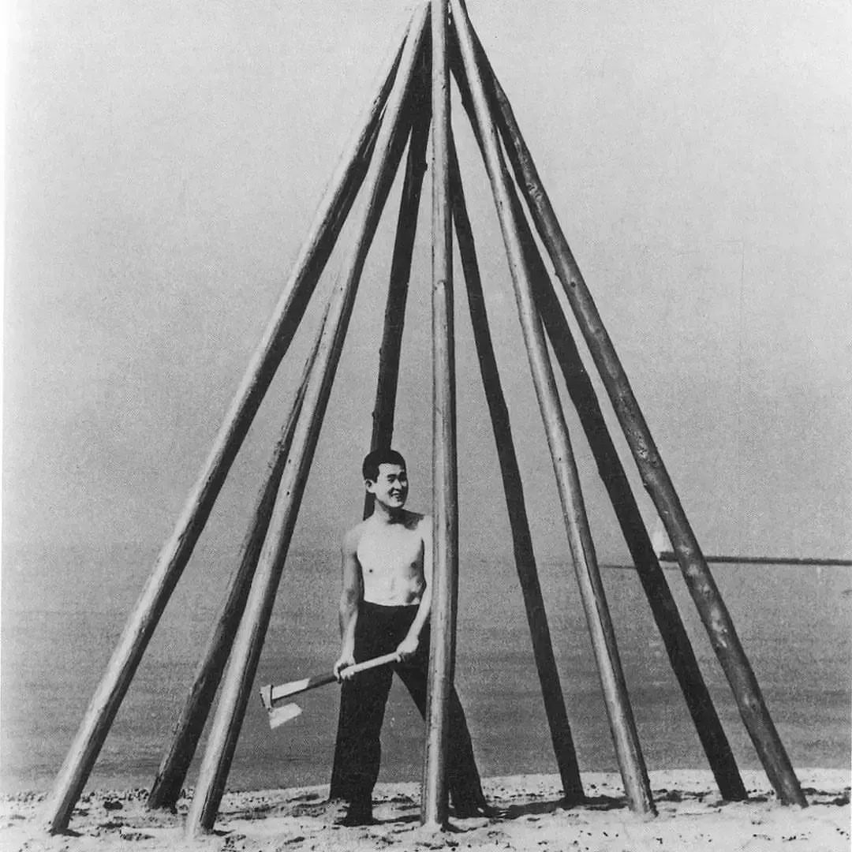
FIGURE APPENDIX

Figure 1

Kazuo Shiraga. Please Come In, 1955. Painted wood logs.

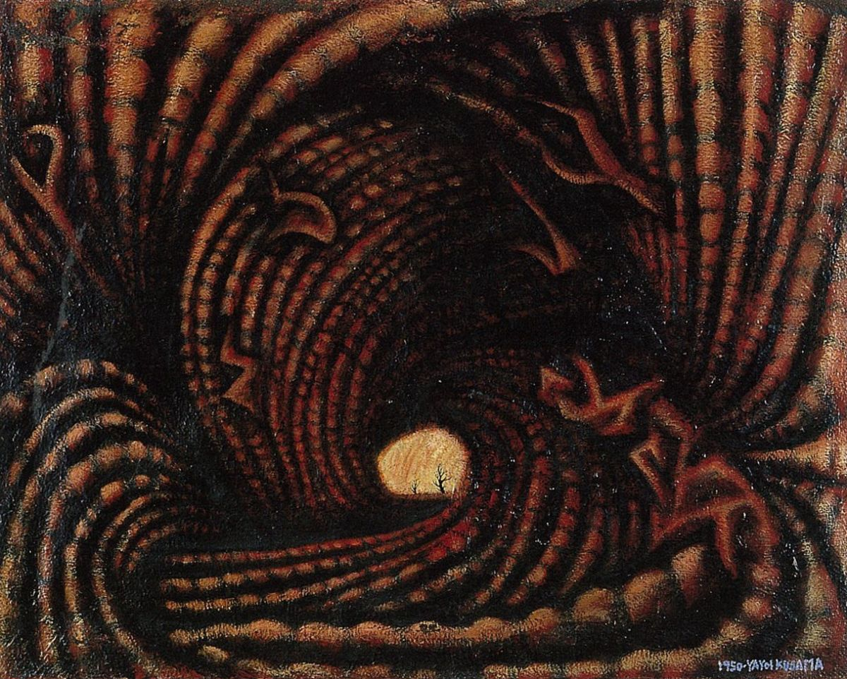

Figure 2

Yayoi Kusama. Accumulation of the Corpses (Prisoner Surrounded by the Curtain of Depersonalization), 1950. Oil and enamel on seed sack.

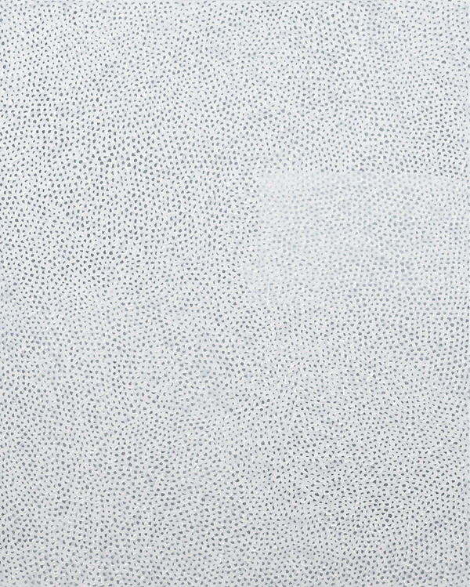

Figure 3

Yayoi Kusama. White No. 28, 1960. Oil on canvas.

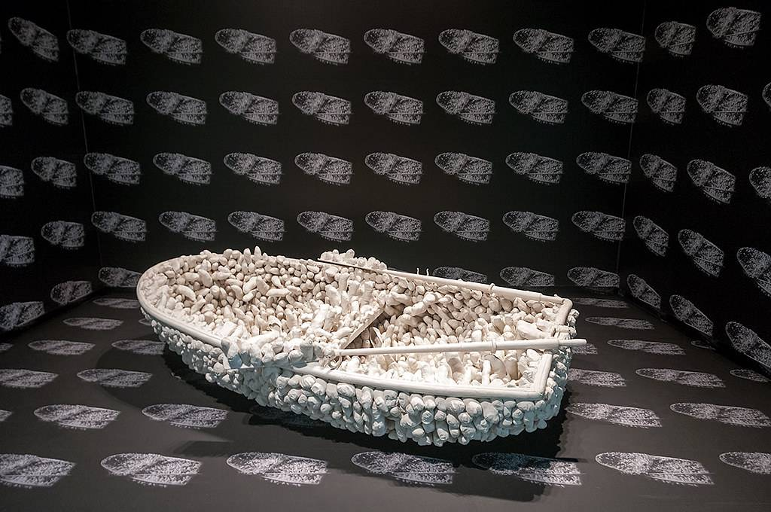

Figure 4

Yayoi Kusama. Aggregation: One Thousand Boat Show, 1963. Rowboat with oars, covered by plaster castings in white cotton, and a pair of lady’s shoes.

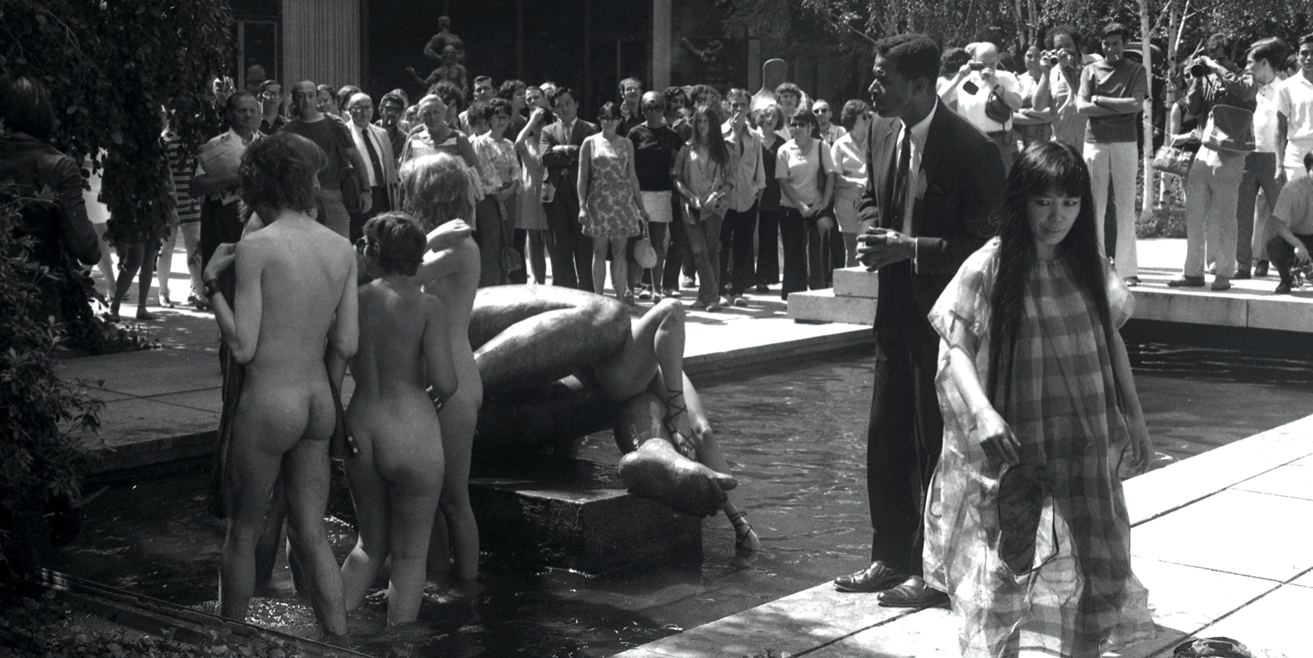
Figure 5

Yayoi Kusama. Grand Orgy to Awaken the Dead, August 25, 1969. Nude performers embracing each other while engaging with the sculptures around them.

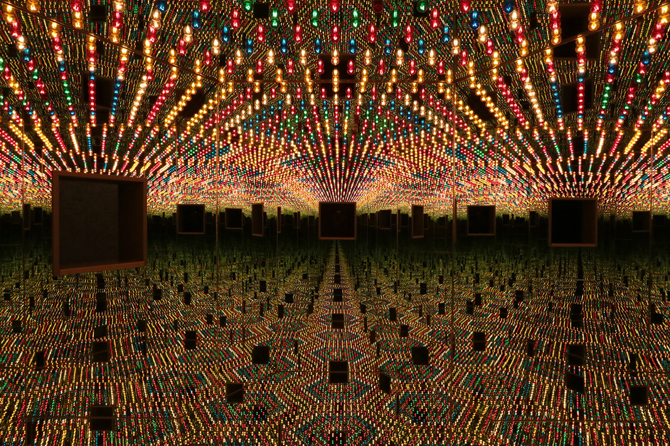
Figure 6

Yayoi Kusama. Infinity Mirror Room — Love Forever, 1966/94. Wood, mirrors, metal, and lightbulbs.

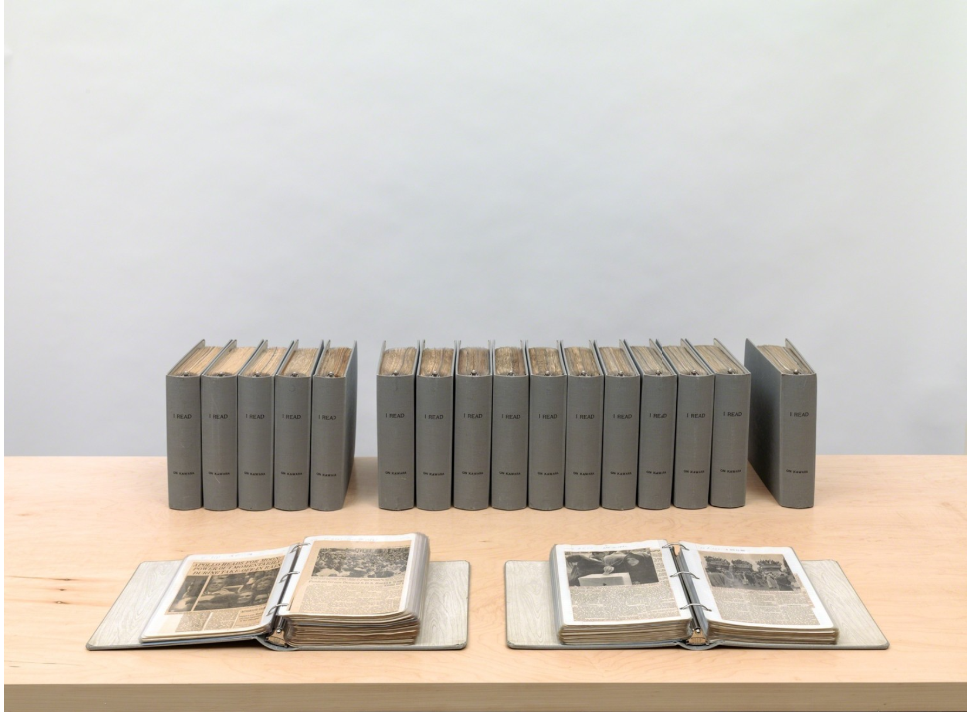
Figure 7

On Kawara. I Read, 1966-1995. Clothbound loose-leaf binders with plastic sleeves and inserted printed matter.

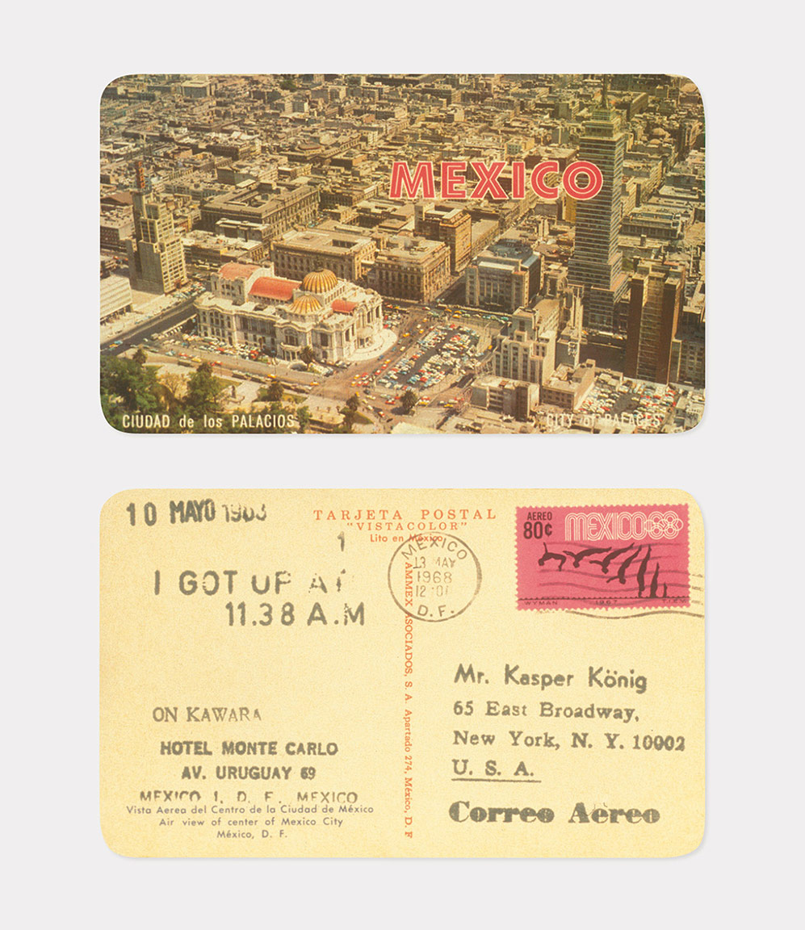

Figure 8

On Kawara. I Got Up, 1968. Stamped ink on postcard.

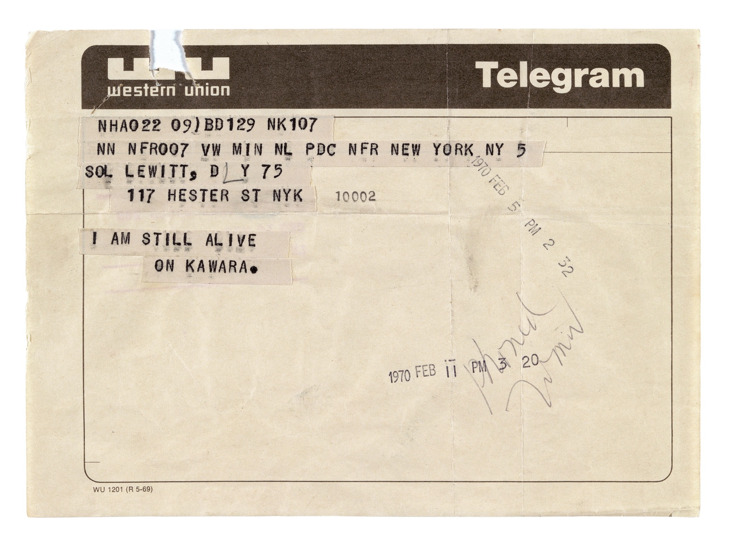

Figure 9

On Kawara. I Am Still Alive, February 5, 1970. Telegram.

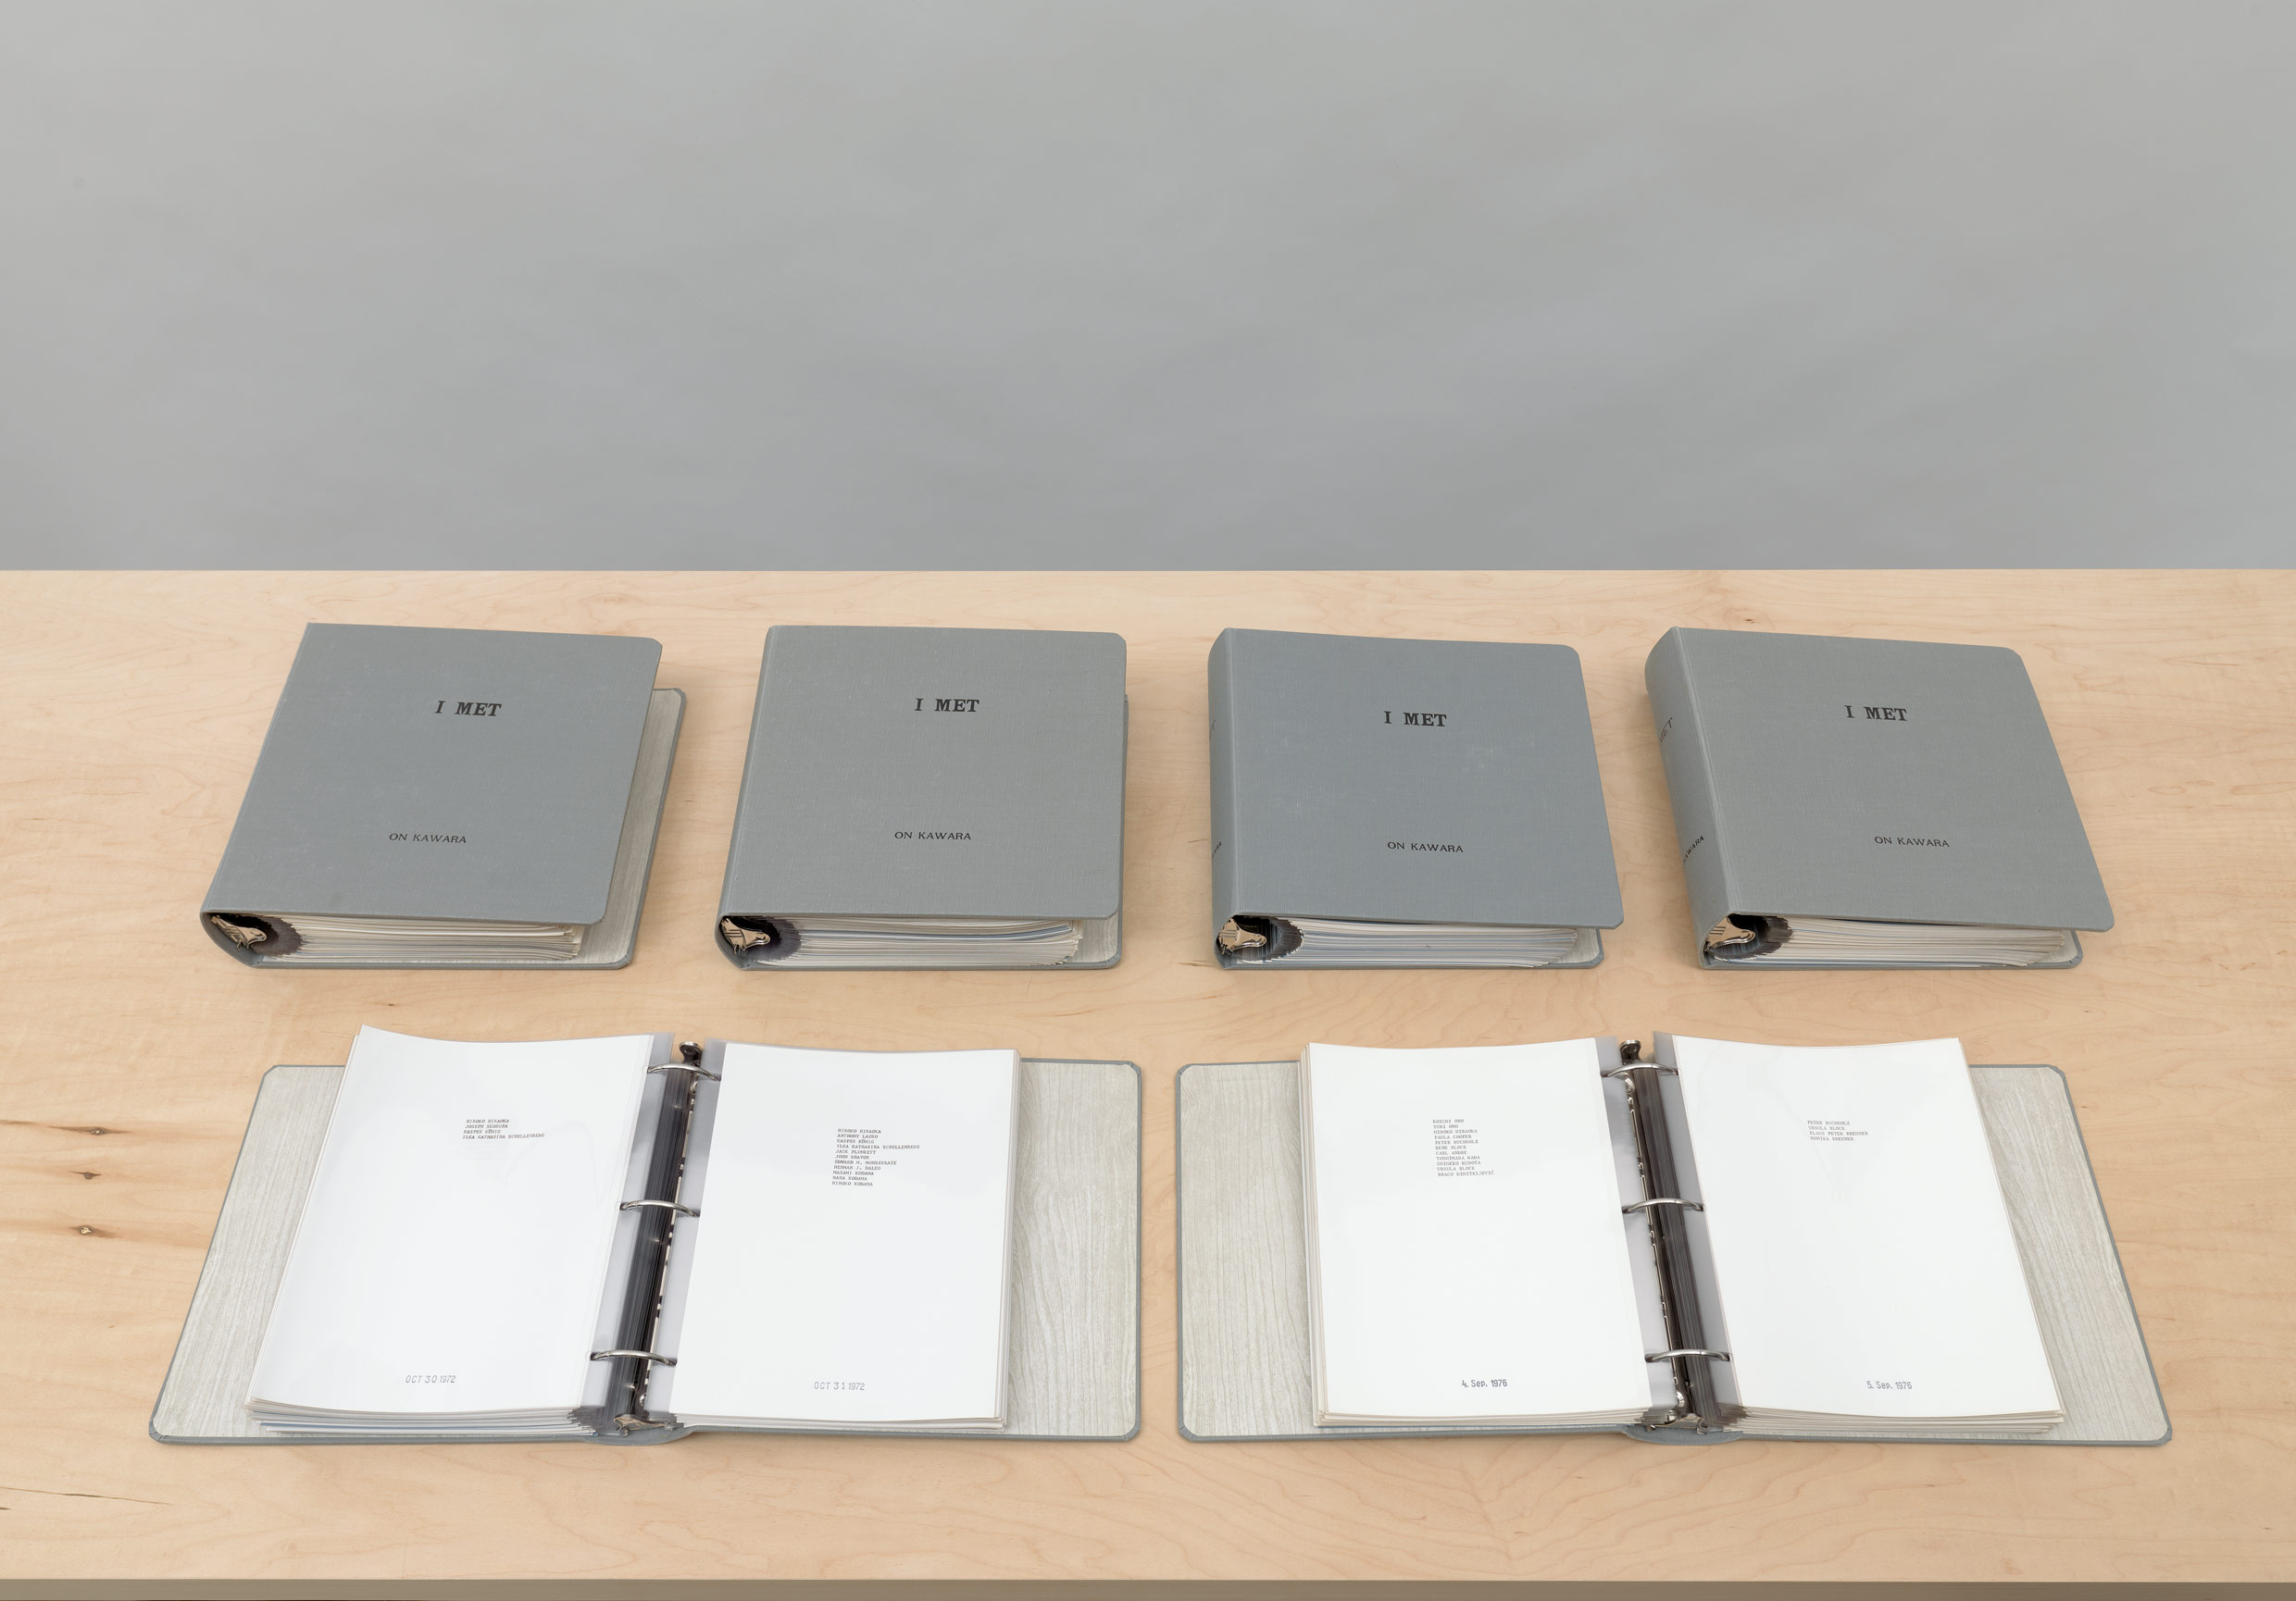
Figure 10

On Kawara. I Met, 1968-1979. Clothbound loose-leaf binders with plastic sleeves and inserted printed matter.

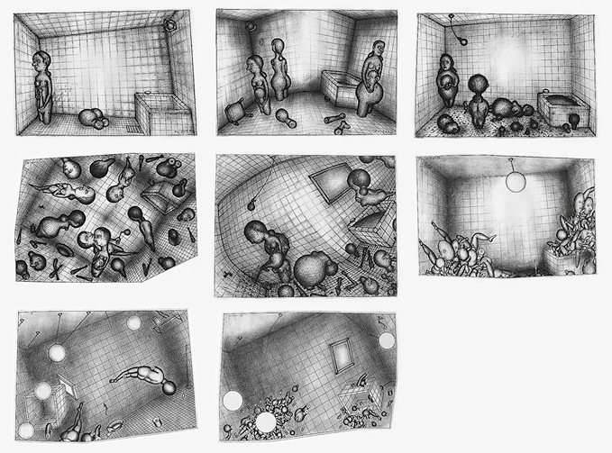

Figure 11

On Kawara. The Bathroom Series, 1953-1954. Graphite on paper.

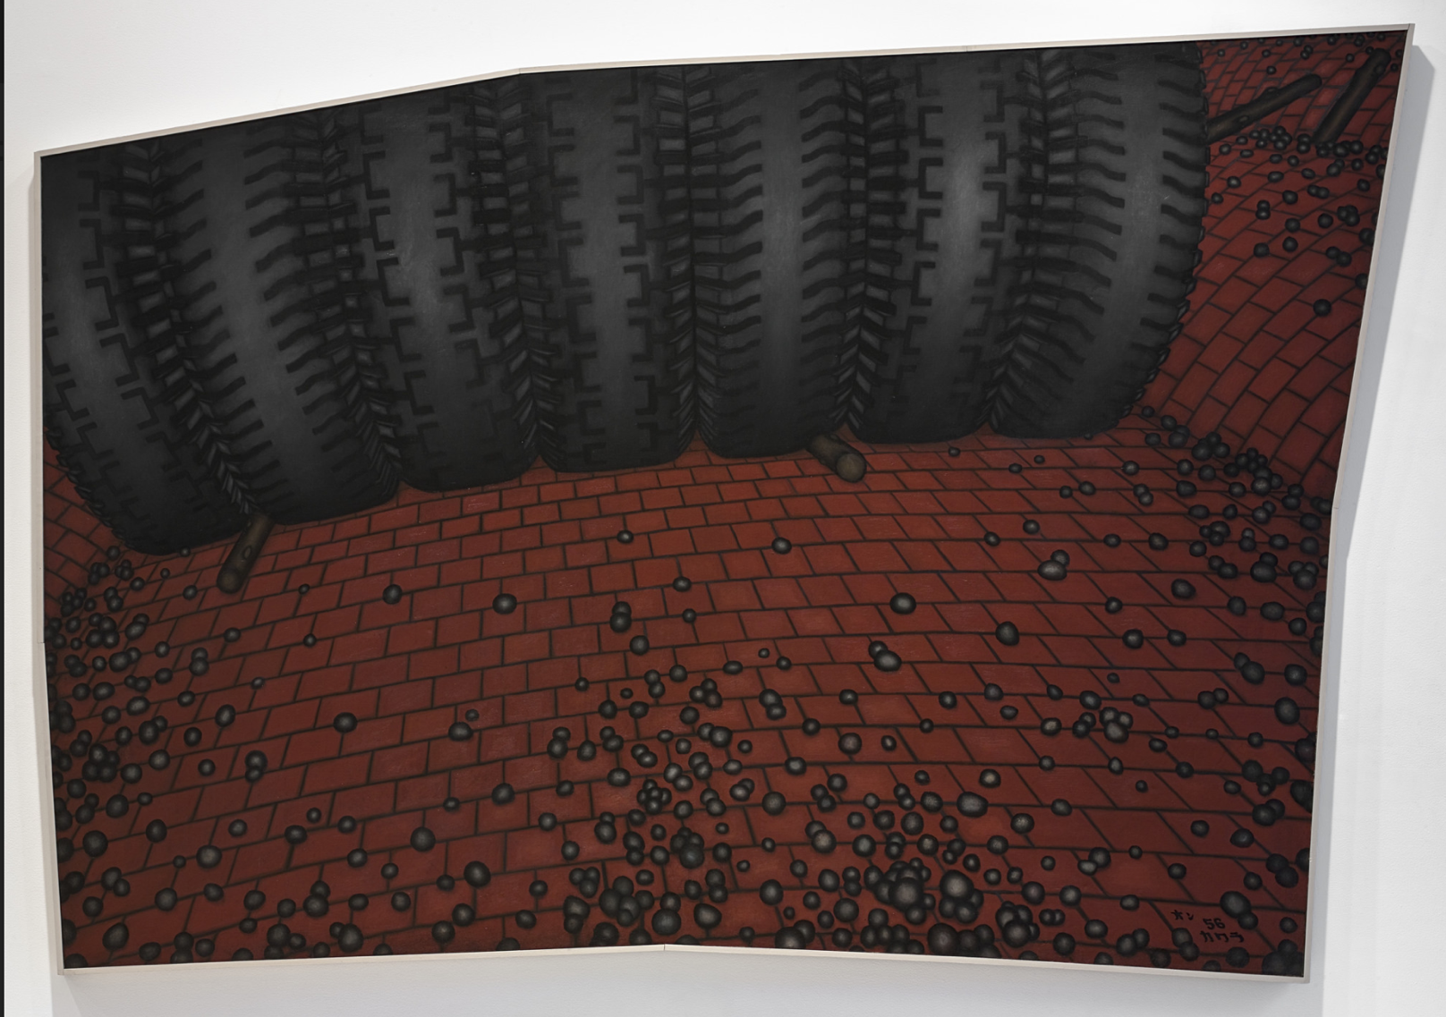
Figure 12

On Kawara. Stones Thrown, 1956. Oil on canvas.

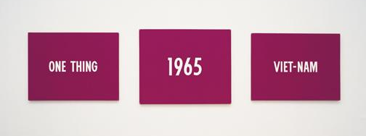

Figure 13

On Kawara. Title, 1965. Acrylic and collage on three separate canvases.

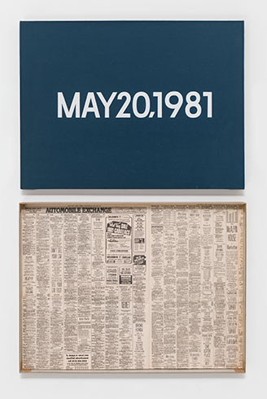

Figure 14:

On Kawara. MAY 20, 1981, 1981. Acrylic on canvas with artist made storage box lined with newspaper.

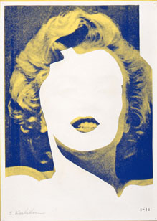

Figure 15:

Etsutomu Kashihara. My Methods Inspired By Marilyn [part], 1972-1975.
Screen-print.

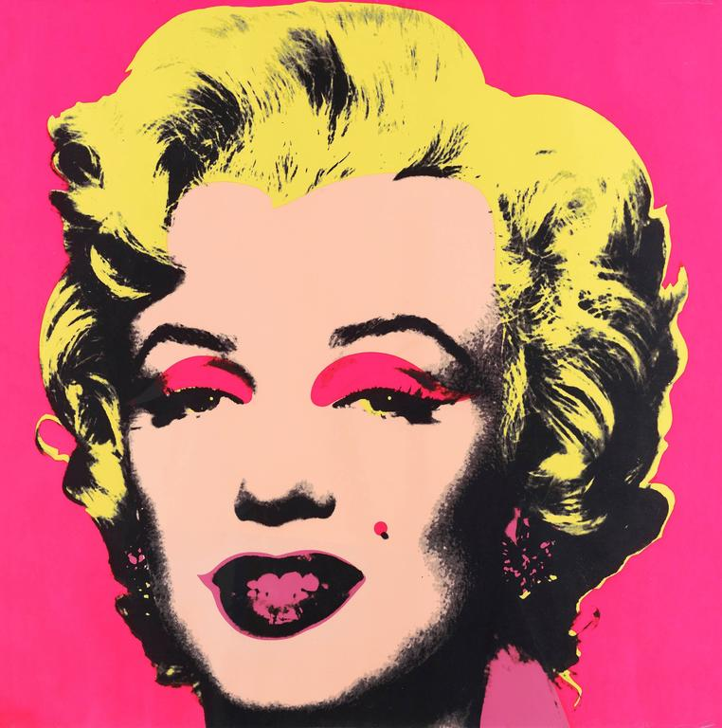

Figure 16

Andy Warhol. Marilyn Monroe, 1967. Screen-print.

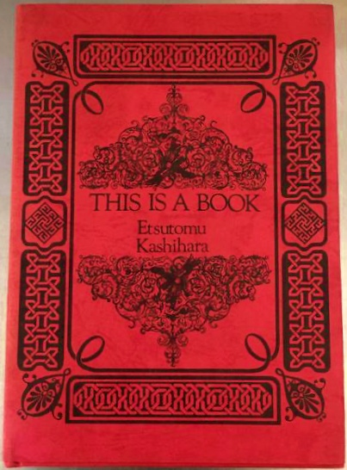

Figure 17

Etsutomu Kashihara. THIS IS A BOOK, 1970. Silkscreen on paper.

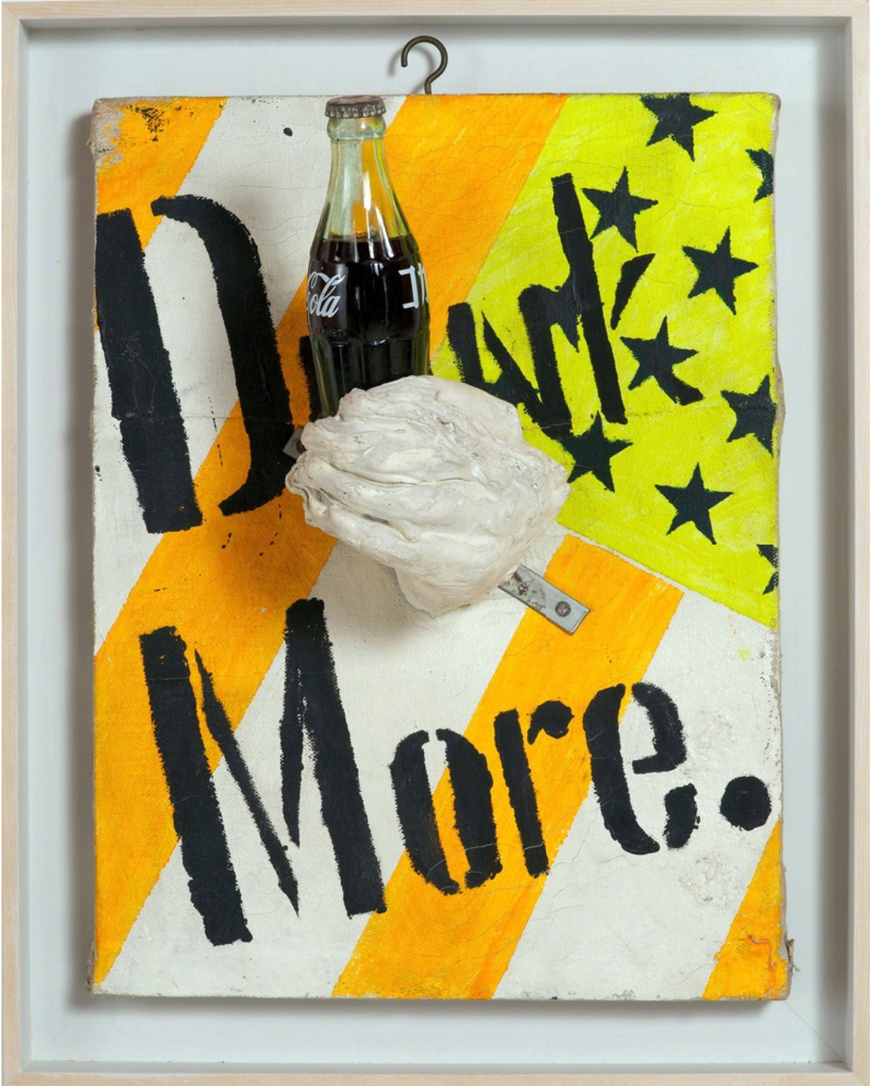
Figure 18

Ushio Shinohara. Drink More, 1964. Fluorescent paint, oil, plaster, and a Coca-Cola bottle.

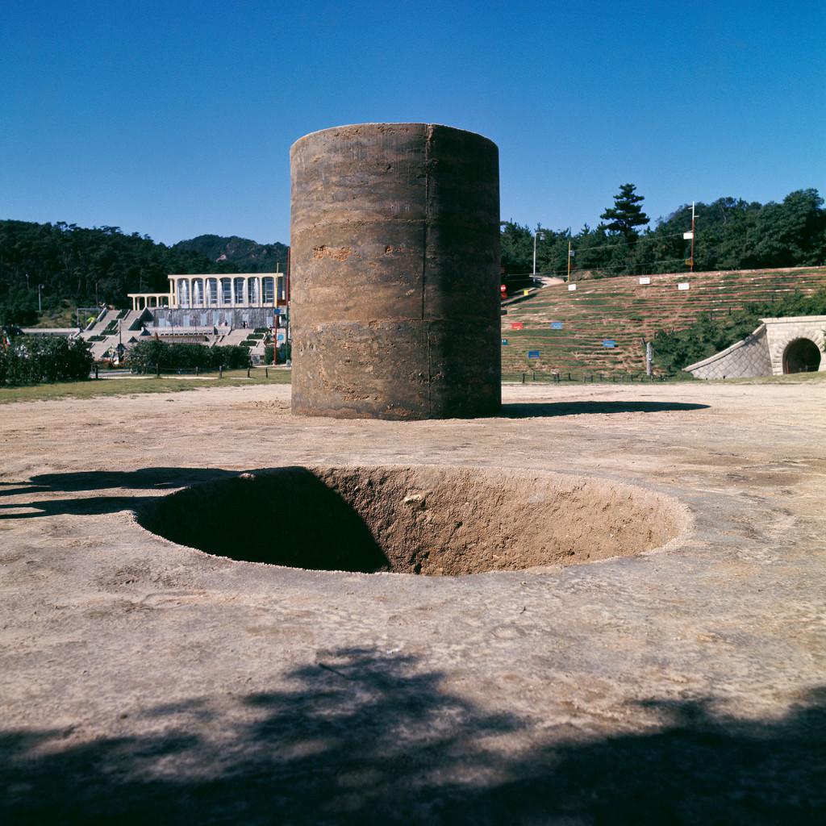

Figure 19:

Sekine Nobuo. Phase – Mother Earth, 1968. Earth and cement.

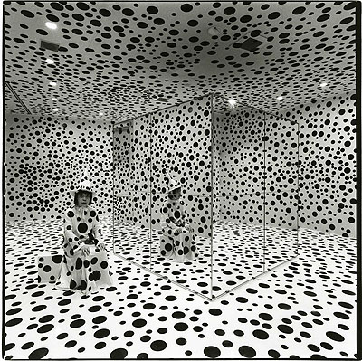

Figure 20

Shiegeo Anzai. Yayoi Kusama, Hara Museum Tokyo, 1992. Gelatin silver print.

Stanley-Baker, Joan, Japanese Art (London: Thames & Hudson Ltd., 2014).
Such texts include: 1) Takashina Shuji, Japanese Art in Perspective: East-West Encounter (Tokyo: Japan Publishing Industry Foundation for Culture, 2021); 2) Julia Meech, Gabriel P. Weisberg, and Jane Voorhees, Japonisme Comes to America: The Graphic Arts 1876-1925 (New York: Abrams in Association with the Jane Voorhees Zimmerli Art Museum, 1990); and, 3) Gabriel P. Weisberg The Orient Expressed: Japan’s Influence on western Art 1854 – 1918 (Seattle: University of Washington Press, 2011).
Yūko Kawai, A Transnational Critique of Japaneseness: Cultural Nationalism, Racism, and Multiculturalism in Japan (Maryland: Lexington Books, 2020).
Eric C. Shiner, Reiko Tomii, and Japan Society. Gallery, Making a Home : Japanese Contemporary Artists in New York, (New York: New Haven: Japan Society; Yale University Press, 2007).
Reiko Tomii, Radicalism in the Wilderness: International Contemporaneity and 1960s Art in Japan (Cambridge: MIT Press, 2018).
Hiroko Ikegami and Robert Rauschenberg, The Great Migrator: Robert Rauschenberg and the Global Rise of American Art (Cambridge, Mass.: MIT Press, 2010).
Stanley-Baker, Japanese Art, 8.
Ibid., 11, 51, and 172.
Takashina Shuji, Japanese Art in Perspective: East-West Encounters (Tokyo: Japan Publishing Industry Foundation for Culture, 2021), 12, 15, and 17.
Stanley-Baker, Japanese Art, 206.
Julia Meech, Gabriel P. Weisberg, and Jane Voorhees, Japonisme Comes to America: The Graphic Arts 1876-1925 (New York: Abrams in Association with the Jane Voorhees Zimmerli Art Museum, 1990), 7.
Gabriel P. Weisberg, The Orient Expressed: Japan’s Influence on Western Art 1854 – 1918 (Seattle: University of Washington Press, 2011), 103.
Meech, Weisberg, and Voorhees, Japonisme Comes to America, 16.
Ibid., 16.
Ibid., 17.
Daniel Martin, "Subtitles and Audiences: The Translation and Global Circulation of the Films of Akira Kurosawa," Journal of Film and Video 69, no. 2 (2017), 21.
Ibid.
Meghan Warner Mettler, “‘Godzilla versus Kurosawa: Presentation and Interpretation of Japanese Cinema in the Post World War II United States,’” The Journal of American-East Asian Relations 25, no. 4 (2018), 414.
“Yasunari Kawabata: Facts,” The Noble Prize, accessed February 25, 2023, https://www.nobelprize.org/prizes/literature/1968/kawabata/facts/.
“Haruki Murakami,” The Encyclopaedia Britannica, last modified January 26, 2023. https://www.britannica.com/biography/Haruki-Murakami.
Ming Tiampo, Gutai: Decentering Modernism (Chicago: University of Chicago Press, 2011), 21.
Ibid., 10.
Alexandra Munroe, Yokohama Bijutsukan, Solomon R. Guggenheim Museum, and San Francisco Museum of Modern Art, Japanese Art after 1945: Scream Against the Sky, (New York: H.N. Abrams, 1994), 127.
Munroe, Bijutsukan, Solomon R. Guggenheim Museum, and San Francisco Museum of Modern Art, Japanese Art after 1945, 189.
Masako Koyano, Miho Yoneda, Rie Tojo, Mika Okawa, and Masako Saito, “Conservation Of Modern Nihonga (Traditional Japanese Paintings) On Paper,” Studies in Conservation 47, no. 3 (2002): 114.
Yayoi Kusama, Infinity Net: The Autobiography of Yayoi Kusama (Millbank, London: Tate Publishing, 2011), 61-66.
Yayoi Kusama et al., Mirrored Years (France: Les Presses Du Réel, 2009), 65.
Kusama, Infinity Net, 12.
Ibid., 14-15.
Yūko Kawai, A Transnational Critique of Japaneseness: Cultural Nationalism, Racism, and Multiculturalism in Japan / Yuko Kawai (Maryland: Lexington Books, 2020), 27.
Gwendolyn A. Foster, “Self-Stylization and Performativity in the Work of Yoko Ono, Yayoi Kusama and Mariko Mori,” Quarterly Review of Film and Video 27, 4, (2010): 272.
Ibid., 267-268.
Ibid., 272.
Kusama, Infinity Net, 143.
Kusama, Infinity Net, 18.
Ibid., 39.
Laura Hoptman, Akira Tatehata, and Udo Kultermann, Yayoi Kusama (London: Phaidon Press Limited, 2000), 100.
Pamela Wye et al., "Is She Famous Yet?" Art Journal 57, no. 4 (1998), 96.
Kusama et al., Mirrored Years, 76.
Kusama, Infinity Net, 20.
Ibid., 54.
Hoptman, Tatehata, and Kultermann, Yayoi Kusama, 11.
Hoptman, Tatehata, and Kultermann, Yayoi Kusama, 34.
Hoptman, Tatehata, and Kultermann, Yayoi Kusama, 10.
Kusama, Infinity Net, 39.
Kusama et al., Mirrored Years, 52.
Kusama, Infinity Net, 151.
Ibid., 147.
Ibid., 224.
Kusama, Infinity Net, 221-223.
The Museum of Modern Art, “YAYOI KUSAMA'S DEFINING DECADE OF WORK--HER NEW YORK YEARS--EXAMINED IN MAJOR EXHIBITION AT THE MUSEUM OF MODERN ART,” press release, 1998, https://www.moma.org/documents/moma_press-release_386979.pdf?_ga=2.60399469.1353288708.1674832524-1716891776.1669154977
Kusama, Infinity Net, 42.
Jung-Ah Woo, "On Kawara's Date Paintings: Series of Horror and Boredom," Art Journal (New York. 1960) 69, no. 3 (2010): 63.
Ibid.
Ibid., 12.
Jeffrey S. Weiss, Wheeler, Anne, Buren, Daniel, Solomon R. Guggenheim Museum, and Museum of Non-Objective Painting, On Kawara – Silence, 129.
Nikos Papastergiadis, “Space/Time: Matter and Motion in On Kawara,” Afterall: A Journal of Art, Context and Enquiry 41, (2016): 131.
Jonathan Watkins, René Denizot, and On Kawara, On Kawara “Tribute," (London; New York: Phaidon, 2002), 48.
Ibid., 49.
Ibid.
Ibid.
Woo, "On Kawara's Date Paintings,” 63.
Katherine Atkins and Kelly Kivland, ed., Artists on On Kawara (New York: Dia Art Foundation, 2021), 10.
Woo, "On Kawara's Date Paintings," 65.
Hoptman, Tatehata, and Kultermann, Yayoi Kusama, 13.
Papastergiadis, “Space/Time,” 127.
Woo, "On Kawara's Date Paintings," 62.
Watkins, Denizot, and Kawara, On Kawara “Tribute," 78.
Woo, "On Kawara's Date Paintings," 65.
Scott Lyall, “Thinking with Today,” in Artists on On Kawara, ed. Katherine Atkins and Kelly Kivland (New York: Dia Art Foundation, 2021), 132.
Jennifer Rhee, “Time Embodied: The Lived Body in On Kawara’s ‘Date Paintings,’” Thresholds, no. 31 (2006): 112, http://www.jstor.org/stable/43876281.
Astrid Schmetterling, “Exhibitions: On Kawara,” Art Monthly, Issue 158, (1992): 16.
Schmetterling, “Exhibitions: On Kawara,” 16.
Weiss, Wheeler, Buren, Solomon R. Guggenheim Museum, and Museum of Non-Objective Painting, On Kawara – Silence, 34.
Rhee, “Time Embodied,” 113.
Papastergiadis, “Space/Time,” 135.
Charles Wylie, Ervin Laszlo, Takafumi Matsui, On Kawara, John R. Lane and Dallas Museum of Art., On Kawara: 10 Tableaux and 16,952 Pages / Texts, (New Haven: Dallas Museum of Art; Yale University Press, 2008), 34.
Jonathan E. Schroeder, "The Artist and the Brand," European Journal of Marketing 39, no. 11/12, 2005, 1293.
Loizos Petrides and Alexandra Fernandes. "The Successful Visual Artist: The Building Blocks of Artistic Careers Model," The Journal of Arts Management, Law, and Society 50, no. 6, 2020, 308.
Reiko Tomii, Radicalism in the Wilderness: International Contemporaneity and 1960s Art in Japan, (Cambridge: MIT Press, 2018), 32-33.
Doryun Chong, Michio Hayashi, Mika Yoshitake, Miryam Sas, Mitsuda Yuri, and Nakajima Masatoshi, Tokyo 1955-1970: A New Avant Garde, (New York: The Museum of Modern Art, 2012), 79.
Laszlo Beke, Global Conceptualism: Points of Origin, 1950s-1980s, (New York: Queens Museum of Art, 1999), 25.
Beke, Global Conceptualism, 197.

