UNIVERSITY OF OKLAHOMA
GRADUATE COLLEGE

THE ROLE OF BUILT ENVIRONMENT IN FOSTERING THE SAFETY OF CHILDREN WITH AUTISM IN PUBLIC PRIMARY SCHOOLS

A THESIS
SUBMITTED TO THE GRADUATE FACULTY
in partial fulfillment of the requirements for the
Degree of
MASTER OF SCIENCE
In Interior Design

By

RIHAM HAMED

Norman, Oklahoma
2023

THE ROLE OF BUILT ENVIRONMENT IN FOSTERING THE SAFETY OF CHILDREN WITH AUTISM IN PUBLIC PRIMARY SCHOOLS

A THESIS APPROVED FOR THE
CHRISTOPHER C. GIBBS COLLEGE OF ARCHITECTURE

BY THE COMMITTEE CONSISTING OF

Prof. Mia Kile, Chair
Associate Professor, College of Architecture
Dr. Dawn Loraas
Assistant Professor, College of Architecture
Dr. Emily Kuntz
Assistant Professor, College of Education

© Copyright by RIHAM HAMED 2023
All Rights Reserved.
Table of Contents
Dedication VIII
Acknowledgments IX
List of Figures X
List of Tables XV
Abstract XVI
Chapter I: Introduction 1
Background of Study 1
Research problem 2
Purpose of Study and Significance 3
Research Questions 4
Scope of Study 4
Hypothesis 5
Method 6
Limitations 7
Conclusion 8
Chapter II: Literature Review 9
Introduction 9
Literature Review 10
Autism and the Built Environment 10
Inclusive Education Opportunities and Obstacles 12
School Bullying vs. Perceptions of Safety 17
Towards Safer Schools’ Design 21
Conclusion 30
Chapter III: Methodology 31
Introduction 31
Case Studies Analysis 32
Selection Criteria 32
Survey 39
Survey Potential Participants 41
Sampling 41
Method of Contact 42
Conclusion 42
Chapter IV: Results 43
Introduction 43
Case Study (1): Egyptian Japanese School 44
School Zoning and Space Planning 44
Natural (Passive) Surveillance and Visibility 48
Space Organization & Wayfinding 53
Case Study (2): Browns Point Elementary School 59
School Zoning and Space Planning 59
Natural (Passive) Surveillance and Visibility 64
Space Organization & Wayfinding 68
Survey 75
Demographics 75
Teachers Identification of ASD Children’s Safety 78
Special Education or Integrated Classrooms 86
Bullying Potential Locations 87
Factors Threatening ASD Children’s Safety 88
The Separation of Restrooms and Cafeteria 89
Free Access to Outdoors 90
Walking Distance within School 91
Sensory Rooms Significance 91
Spaces of Close Proximity to Entrance and Main Hallways 92
General Teachers Recommendations 92
Conclusion 95
Chapter V: Discussion & Conclusion 96
Introduction 96
Architecture and Autism 96
Major Findings in Literature 96
ASD Children’s Challenges in Public Education 97
Major Findings in Literature 97
Survey Major Findings 98
School Design in Relation to ASD Children’s Safety 100
Major Findings in Literature 100
Case Studies’ Major Findings 101
Survey Major Findings 106
Unexpected Findings 109
Implications for Practitioners 111
Universal Design 114
Equitable Use 114
Flexibility of Use 114
Limitations 115
Future Research 117
Conclusion 117
References 119
Appendix A: IRB Approval Outcome Letter 130
Appendix B: Survey Questions 131
Appendix C: Browns Point School Photographs Usage Permissions 142
Permission from Eckert and Eckert Photography 142
Permission from LightCatcher Imagery 143

Dedication
My deepest gratitude goes to my mother, family, friends, and supportive husband for their unwavering support throughout my academic journey. I want to wholeheartedly thank them for believing in me and providing me with constant motivation and encouragement. Finally, I dedicate this thesis to all the children with autism worldwide, and I hope that it could be a beneficial contribution towards making our world more inclusive, accessible, and welcoming for everyone.

Acknowledgments
This thesis came to completion with the support of many phenomenal individuals. First, I would like to thank my chair and mentor professor. Mia Kile for being continuously supportive, providing me with successive opportunities, insightful feedback, and pushing me to think profoundly and progress past my limits. I would like to express my thankfulness and eminent gratitude to my committee members, professor. Dawn Loraas and professor. Emily Kuntz for their persistent encouragement to challenge myself, enthusiasm and extensive support that guided me throughout my journey. Additionally, I would like to thank my professor. Suchismita Bhattacharjee for being an outstanding graduate liaison and academic advisor who goes above and beyond to guide us without hesitation. I owe my deepest thanks to my professor. Elizabeth Pober, director of the Interior Design Department at OU, her confidence and dedication have always been inspiring and encouraging to me since my first day in the University of Oklahoma. Finally, I would like to thank the talented photographers, Pete Eckert (Eckert and Eckert Photography) and Andrew Storey (LightCatcher Imagery), for allowing me to use their photographs in my thesis. I highly value their remarkable contribution.

List of Figures
Figure 1. The Study Flowchart 7
Figure 2. The Symptoms of Autism, Risk factors for autism (El-Baz et al., 2011) 11
Figure 3. The continuum of alternative placements. (Miller, 2010) 14
Figure 4. The percentage of boys and girls reporting being bullied or not bullied at primary school (Collins, 2004) 18
Figure 5. The conceptualization and categorization of school climate (Wang & Degol, 2015) 19
Figure 6. School Layout Types (Pereira et al., 2018) 22
Figure 7. Classroom/Corridor Types Analysis (Pereira et al.,2018) 23
Figure 8. Plan of Jeremy Bentham's panopticon prison, drawn by Willey Reveley in 179. Retrieved from: https://en.wikipedia.org/wiki/Panopticon 25
Figure 9. Natural Surveillance in CPTED. 27
Figure 10. Transparency and visual connection between spaces creating visual interest and safety. Source: ABOTSFORD: Crime Prevention Through Environmental Design (CPTED) 29
Figure 11. The school types in Egypt and the current and future target of the Japanese Tokkatsu+ system (The Arab Republic of Egypt Detailed Study for Egypt Japan School (EJS) Dissemination Final Report, 2017) 33
Figure 12. Egyptian Japanese Schools' Location around Egypt (Map source: Google – Data source: https://www.youm7.com/story/2018/9/19/%D8%AA%D8. – Visualization by Author)’ 34
Figure 13. Egyptian Japanese School in October Gardens, Giza, Egypt (By: Author) 35
Figure 14. EJS main level floor plan (First Floor) – (Keshka, 2019) 36
Figure 15. EJS typical floor plan - (Second, third and fourth). (Keshka, 2019) Digitally drawn by author. 36
Figure 16. Browns Point Elementary School in Tacoma, WA (Source: Google) 37
Figure 17. Brown Point Elementary School main level floor plan (First Floor) – (Source: Browns Point Elementary School / TCF Architecture, (2022). Archdaily) 38
Figure 18. Brown Point Elementary School second floor plan – (Source: Browns Point Elementary School / TCF Architecture, (2022). Archdaily) 38
Figure 19. Egyptian Japanese School Zoning – 1st Floor (Digitally Drawn By: Author) 44
Figure 20. Egyptian Japanese School Zoning – 2nd Floor (Digitally Drawn By: Author) 45
Figure 21. EJS Exits (Digitally Drawn By: Author) 46
Figure 22. Exit leading to inner school court (By: Author) 46
Figure 23. EJS Restrooms location at the northern wing (Digitally Drawn By: Author) 47
Figure 24. EJS Restrooms location at the western wing (Digitally Drawn By: Author) 47
Figure 25. EJS 1st Floor Inter-visibility graph (By: Author) 48
Figure 26. EJS Typical Floor Inter-visibility graph (By: Author) 48
Figure 27. EJS vertical circulation stairs (By: Author) 49
Figure 28. EJS main circulation corridors (By: Author) 50
Figure 29. EJS Classrooms Corridor 51
Figure 30. EJS Classrooms windows overlooking main circulation corridors 51
Figure 31. EJS Simplified Site / Building Layout (By: Author) 52
Figure 32. EJS Typical Floor Integration Graph Analysis (By: Author) 53
Figure 33. EJS Typical Floor Integration Graph Analysis (By: Author) 54
Figure 34. Egyptian Japanese School Building Layout Graphical Representation – 1st Floor (By: Author) 55
Figure 35. EJS Justified Graph – 1st Floor. Relationships to main corridors from (a) corridor #1 (By: Author) 55
Figure 36. Egyptian Japanese School Building Layout Graphical Representation – Typical Floor (By: Author) 56
Figure 37. EJS Justified Graph – Typical Floor. Relationships to main corridors from (a) corridor #1 (By: Author) 56
Figure 38. EJS 1st Floor ISOVIST Graph Analysis (Digitally Drawn By: Author) 57
Figure 39. EJS Typical Floor ISOVIST Graph Analysis (Digitally Drawn By: Author) 58
Figure 40. Browns Point Elementary School Zoning – 1st Floor (Design Credit: TCF Architecture / Drawn By: Author) 59
Figure 41. Browns Point Elementary School Zoning – 2nd Floor (Design Credit: TCF Architecture / Drawn By: Author) 60
Figure 42. Browns Points Exits to the outdoors (Design Credit: TCF Architecture / Drawn By: Author) 61
Figure 43. Exit B towards the outdoor play area (Photo credit: Eckert and Eckert Photography©) 61
Figure 44. Restrooms locations (Design Credit: TCF Architecture / Drawn By: Author) 62
Figure 45. Observation points locations under the stairs’ flights (Design Credit: TCF Architecture / Drawn By: Author) 62
Figure 46. Observation Points under the Stairs Flights (Photo Credit: Eckert and Eckert Photography©) 63
Figure 47. Flexible Learning Areas (Photo credit: LightCatcher Imagery©) 63
Figure 48. BPS 1st Floor Visibility Graph Analysis (By: Author) 64
Figure 49. BPS 2nd Floor Visibility Graph Analysis (By: Author) 65
Figure 50. External faucets at the restrooms’ entrances (Photo credit: Eckert and Eckert Photography©) 65
Figure 51. Browns Point Elementary School Classrooms (Photo credit: Eckert and Eckert Photography©) 66
Figure 52. BPS Simplified Site / Building Layout (Source: Google / Visual Analysis by: Author) 67
Figure 53. BPS U-shaped Configuration Diagram ((Source: Browns Point Elementary School / TCF Architecture, (2022). Archdaily) 67
Figure 54. BPS 1st Floor Integration Graph Analysis (By: Author) 68
Figure 55. BPS 2nd Floor Integration Graph Analysis (By: Author) 69
Figure 56. Browns Point Elementary School Building Layout Graphical Representation – 1st Floor (By: Author) 70
Figure 57. BPS Justified Graph – 1st Floor. Relationships to main corridors from (a) corridor #1 (By: Author) 70
Figure 58. Browns Point Elementary School Building Layout Graphical Representation – 2nd Floor (By: Author) 71
Figure 59. BPS Justified Graph – 2nd Floor. Relationships to main corridors from (a) corridor #1 (By: Author) 71
Figure 60. BPS 1st Floor ISOVIST Graph Analysis (By: Author) 72
Figure 61. BPS 2nd Floor ISOVIST Graph Analysis (By: Author) 73
Figure 62. Color Coding and Routing of BPS (Source: Browns Point Elementary School / TCF Architecture, (2022). Archdaily 74
Figure 63. BPS Color Coding – Blue Zone (Photo Credit: Eckert and Eckert Photography©) 74
Figure 64. Figure 66 BPS Color Coding – Yellow Zone (Photo Credit: LightCatcher Imagery©) 74
Figure 65. Geographical region of participating teachers 75
Figure 66. Participating teachers' ages 76
Figure 67. Participating teachers’ years of professional experience 76
Figure 68. Teachers’ years of experience with ASD children 77
Figure 69. Age ranges of ASD students’ participation teachers worked with 78
Figure 70. Word cloud showing the most used words by teachers while describing Safety of ASD children in schools 78
Figure 71. Special Education Classrooms vs. Integrated Classrooms according to teachers’ perspectives 86
Figure 72. Types of Bullying with the highest prevalence rates according to Teachers 87
Figure 73. Bullying Locations in Public Schools 88
Figure 74. Factors that can threaten the safety of ASD children in Public Schools 88
Figure 75. Teachers' perspectives on having separate restrooms for ASD children 89
Figure 76. Teachers' perspectives on having separate Cafeteria/Lunchroom for ASD children 90
Figure 77. Teachers' perspectives on having a safe free access to outdoors for ASD children 90
Figure 78. Teachers’ perspectives on the relationship between the school's walking distance and the rate of bullying exposure 91
Figure 79. Spaces of higher priority to be placed near the school main hallways and main entrance 92

List of Tables
Table 1. Teachers Description of elements affecting Safety main Themes and Coding 79
Table 2. Mean and Standard Deviation on the measure of Significance of Sensory Rooms as a function that promotes the sense of Safety of ASD students. 92
Table 3. Teachers Recommendations to Architects and Designers to support ASD children’s Safety in Public Schools 93
Table 4. Cross Analysis between EJS and BPS Schools' Floor Plans Design 101
Table 5. Cross Analysis between Exits of EJS & BPS 103
Table 6. Cross Analysis between the Visibility Graph Analysis Results of EJS & BPS 105

Abstract
Background: A wide body of evidence shows that children with autism spectrum disorders encounter many struggles in public education system especially in the developing countries like Egypt, including exposure to problem behavior and limited resources. It can consequently be hypothesized that the school design and space planning can have a considerable impact on enhancing the physical and psychological safety of ASD students through logical school zoning, bullying suppression, and facilitated wayfinding.
Methods: This study utilized a mixed method approach to further understand how school design can foster the safety of ASD children. First, the spatial layout of two primary public schools, in Egypt and the United States were analyzed and compared to examine: (1) the schools’ zoning and space planning, (2) the natural surveillance provided by the schools’ buildings’ design through space syntax analysis using DepthmapX software, and (3) the space organization of the schools and how that affects the wayfinding. Second, a survey (n=312) was conducted to understand the perspectives of teachers, in Egypt and the US, regarding the safety of children with autism in public schools.
Results: The study findings showed that multiple design elements in the Egyptian school would result in suppressing the natural surveillance and wayfinding of children with autism like (1) concealed nooks, (2) corridors with limited widths, (3) multiple exits, (4) low-transparency classroom windows, and (5) dispersed classrooms zones and restrooms’ locations. Unlike the examined school in the US, the design helped foster natural surveillance and facilitated wayfinding in many ways which consequently would foster the safety of ASD students. Further, the teachers discussed multiple themes when asked to identify affect the safety of ASD children either positively or negatively. Among the identified themes: (1) Bullying, (2) Elopement, (3) Un-monitored Exits, (4) Sensory rooms, (5) Safe places, (6) Wayfinding, and (7) Un-educated teachers. Unexpected findings were also identified to affect the safety of ASD children in public schools according to the teachers’ responses including, (1) routine, (2) types of bullying, (3) Walking distance, (4) Exclusion, (5) communication boards, and (6) shortage of staff. In conclusion, major findings in literature and identified through the study analysis were utilized to suggest implications for practitioners toward designing safer schools for children with ASD.
Keywords: Built environment, autism spectrum disorders, inclusive education, physical safety, psychological safety, mental accessibility, bullying, public education, school design, space planning, visibility, natural surveillance, wayfinding.
Acronyms Used:
ADDM: The Autism and Developmental Disabilities Monitoring
ASD: Autism Spectrum Disorders
ID: Inclusive Education
LRE: Least Restrictive Environments
IDEA: Individuals with Disabilities Education Act
IEP: Individualized Education Plan
CPTED: Crime Prevention Through Environmental Design
SPED: Special Education
WWR: Window to Wall Ratio

Chapter I: Introduction

Background of Study
According to the statistics of the Egyptian ministry of social solidarity estimation in 2017, Egypt has around 800,000 people with autism (Al-Masry Al-Youm, 2017). While according to the statistics of Maenner et al. (2021), The overall autism spectrum disorders prevalence was 23.0 per 1,000, which means the ratio is one in 44 children aged eight years is diagnosed with autism. That same year, Abdel Meguid et al. (2021) concluded that the prevalence of autism spectrum disorder in Egypt had increased by 33 percent. This immense growth rate of the population with autism spectrum disorders, especially in Egypt, demands an extensive assessment of the facilities meant to serve them and whether they are sufficient to meet their special needs, especially their access to education as the base root of personality development.
Regarding ASD children’s access to education in Egypt, several studies pointed out that children with autism spectrum disorders in Egypt face the problem of poor education and even accessing it (Mansour & Gobrial, 2022; Gobrial et al., 2018). Egypt is a low- to medium-income developing country with a high count of ASD children (Abdel Meguid et al., 2021). One of the main challenges is children’s access to public education, as it is widespread in all the country regions and affordable to the majority of the Egyptian people, unlike the special education schools, which can be concentrated in limited areas and cost more than the average Egyptian family can bear. Ghoneim (2014) identified the shortage of special education schools in Egypt as an obstacle for children with special needs. Besides the limited availability and cost, inclusive education (ID) would highly benefit ASD children’s interaction and communication capabilities, unlike the special education schools that increase the gap between the children and their surrounding community. This positive effect of inclusive education was studied as Martin (2016) argued that the early childhood years in special education are pivotal in altering the whole educational experience of ASD children. Consequently, these early years spent during primary school need an adequate understanding of the children’s needs to provide them with all resources that can enhance their well-being, learning, and development.
Several studies connected the successful inclusion of children with ASD in public education with the development of social and communication skills and highlighted that the total inclusion of disabled children by only the physical allocation without further environmental considerations and interventions is not enough for successful socialization and development (Pfeiffer & Reddy, 2000; Wagner, 2001). Bernardi & Kowaltowski (2006) also supported the importance of the role of the built environment in providing safety and environmental comfort for ASD students as they described it to be the reason behind the students’ learning productivity. Therefore, the role of the built environment in inclusive education is essential and crucial, and its consequent effect on the safety of students with ASD is equally significant. Hence, making special amendments for these schools where that ASD students’ inclusion is intended must take into consideration their special needs. This should be the first step towards avoiding the duplication of the struggles that keep getting in the way of the children’s educational experience. Along these lines, this study investigates the pivotal role of the built environment in promoting and fostering ASD children’s safety within Egyptian public primary schools for a better educational experience for the children and lifting a heavy burden carried for years by their families.

Research problem
Numerous peer-reviewed studies recommended that more research is needed to investigate the contribution of the schools’ physical context on school safety and mitigating violence. (Ozer et al., 2017; Astor et al., 2010) Earlier, researchers focused primarily on classroom settings and how they can be compatible with ASD children’s needs; however, the rest of the building parts, including circulation and space planning, are not yet explored (Irish, 2022). Mostafa (2014) pointed out that studying the safety of children with autism in the learning environments they transition into was a point that was not yet overlooked in research. When it comes to inclusive education, Anderson & Boyle (2019) illustrated that, to date, very limited research has been done on inclusive education environments. The focus was either on special education for children with disabilities, or public education, which only serves typically developing children. Since the need for inclusive education is growing, an evidence-based design framework is needed to eliminate the social and psychological problems of bullying and enhance the safety measures before the school buildings are even constructed (Fram & Dickman, 2012). This identified gap in the literature triggered this study to delve into understanding the connection between perceived safety and the physical environment, specifically for children with autism.

Purpose of Study and Significance
This study focuses on determining the built environment’s attributes that can suppress bullying and influence ASD children’s physical and perceived psychological safety within public primary schools. As indicated by Pinto-Martin et al. (2005) in Developmental Stages of Developmental Screening, the earlier the interventions are, the more there is a chance to improve the subsequent lives of children with Autism; highlighted that early design interventions can have a strong role in improving ASD children’s lives. This paper aims to improve children with autism’s educational experience within the Egyptian Public Education system by determining the current challenges. Furthermore, proposing recommendations that can enhance the safety of ASD children and lift a heavy burden off their families’ shoulders.

Research Questions
- What is the relationship between the Built Environment and Autism Spectrum Disorders?
- What are the opportunities and challenges of inclusive education for ASD children in terms of safety?
- How can spatiality and school design promote the physical and psychological safety of children with autism?
- What are the perspectives of teachers and educators on the safety of children within the public schools’ context and how it can be fostered?

Scope of Study
Dependent Variable
The children with autism spectrum disorders’ psychological and physical safety and minimizing their exposure to bullying and problem behavior.
Independent Variable
The school’s physical environment features and space planning.
Targeted Population
The population for whom the study is designated are children with autism spectrum disorder according to their sensitivity towards the built environment.
Study Region
The study is focused regionally on developing ASD children’s educational experience in Egypt, a developing low to the medium-income country with limited resources. Since the struggle of ASD children to access education without being exposed to stereotyping and bullying is enormous (Mansour & Gobrial, 2022; Gobrial et al., 2018).
Study Setting
The public primary schools were chosen to be the context of the study for several reasons; (1) The availability and affordability of public schools to most Egyptians, (2) the schools are the buildings where the early developmental stages of children occur. Thus, early design interventions are sought to have a more significant effect. (Martin, 2016; Pinto-Martin, 2005)

Hypothesis
- Hypothesis (1): A relationship exists between the Egyptian public school’s architectural design and the significant percentage of school bullying.
- Hypothesis (2): The safety of children with autism has more complex dimensions related to the built environment that needs to be considered in the early design phases.
Study Objectives
This study was done to explore the extent of the challenge ASD children face upon their inclusion in Egyptian public schools that would affect their Safety through the following objectives:
- Objective (1): Examining the spatiality and the extent of safety provided by two case studies of public primary schools, one Egyptian and one American school.
- Objective (2): Examining the role of the built environment in fostering the Safety of children with autism in public primary schools according to the perspectives of teachers.

Method
This research adopted mixed methods, which utilize both qualitative and quantitative research methods (Ivankova & Creswell, 2009). This approach aims at understanding the relationship between the two variables of this study as follows:
- Method (1)
Use the “Space Syntax” method to analyze the spatiality of the two case studies chosen for this research. Turner (2004) defined Space Syntax as a methodology of examining and analyzing the spatial relationships and components of the space by visually representing the spatial components, producing a visual graph showing the analysis, and finally producing theoretical measures through a conventional numerical graph. The software that was used to study the space syntax is “DepthmapX” to examine the schools’ layouts and the visibility attribute, as well as the spatial organization of the schools. Turner (2004) furtherly defined Depthmap software as follows, “Depthmap is primarily a computer program to perform visibility analysis of architectural and urban systems. It takes input in the form of a plan of the system and is able to construct a map of ‘visually integrated’ locations within it.” (Turner. A, 2004)
- Method (2)
Collecting data through a Survey that targets teachers to understand their perspectives about the built environment features that can foster the safety of ASD children around their typically developing peers. Scheuren (2004) defined the survey as a method used to gather information and collect data from a sample of individuals, and the sample is the fraction of the population being studied. See Figure 1.
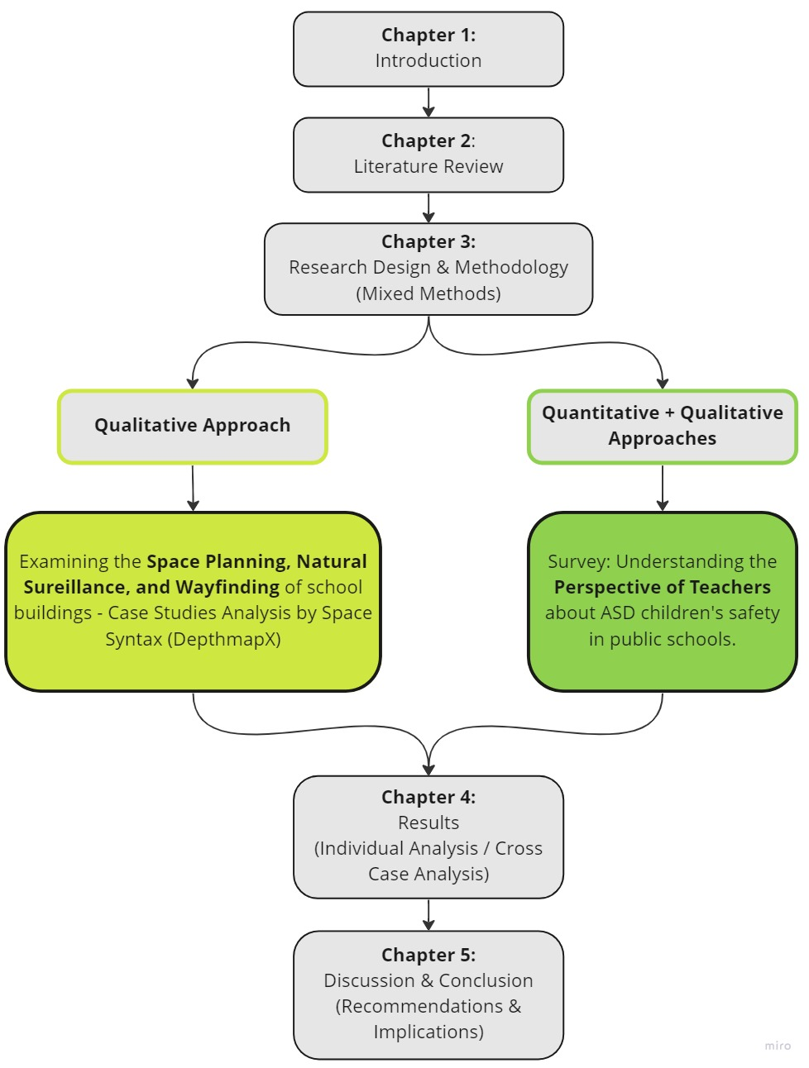
Figure 1. The Study Flowchart

Limitations
There may be some possible limitations in this study. This study is limited by the restricted access to take several photos of the public school in Egypt according to the school’s security considerations. Moreover, some studies that were directly connected to the topic were not peer-reviewed yet, which may affect the reliability aspect. The questionnaire survey is only focused on Egypt and the United States, which makes the research vulnerable to cultural bias and generalization as other regions and global perspectives were not covered in the study.

Conclusion
To sum up, this study focuses on the role of the built environment in passively enhancing the physical and perceived psychological safety attribute of public-school buildings dedicated to integrating ASD children with their typical peers by suppressing school bullying. Chapter two consequently looks at the published literature that is related to that topic and connects the dots toward understanding the definition of safety, ASD children’s challenges in accessing education, and the comprehensive information provided by precedent researchers to build off of their conclusions and approach new results that add up to the body of knowledge. Chapter three includes the methodology that investigates the validity of the research hypothesis in two stages. The first stage includes qualitative analysis of two school buildings’ case studies, one in Egypt and another in the US. The second stage consists of a quantitative survey that targets understanding the perspectives of teachers on the role of the built environment and space planning in enhancing the safety of ASD children. Chapter four includes the results concluded from the study’s previous methodology chapter. Finally, Chapter five houses the discussion and conclusion that overviews the results and proposes potential topics for future research.

Chapter II: Literature Review

Introduction
This literature review condenses the body of data by exploring the connection between Autism and the built environment and why people with autism can be of a higher sensitivity towards the surrounding contexts. The types of bullying within public schools and the attribute of children’s safety through the physical environment were highlighted. Sources were collected for analysis through the University of Oklahoma Library Database and Google Scholar. Hence, this study examines the attributes that affect ASD children’s safety, which can consequently enhance the children’s educational experience.
The literature review is divided into four sections as follows:
- Autism and the Built Environment
An overview of how the built environment affects the vulnerable population of autism spectrum disorders according to their condition and sensitivities towards external stimuli.
- Inclusive Education Opportunities and Obstacles
This section interrogates the definition of inclusive education. It touches on its benefits and positive aspects as well as the fears and misinterpretations adopted by ASD children’s parents. This section also overviews the challenges of inclusive education in Egypt despite the promising initiatives taken by the Egyptian government.
- School Bullying vs. Perceptions of Safety
At this stage in the literature review, school bullying is identified, and its types were investigated, as well as the peer harassment triggers and potential occurrence locations in schools. Safety is identified while going over the difference between the terms physical and psychological safety. Furthermore, the vulnerability of children with autism and how the core symptoms of their illness can make them the “Perfect Victims” in terms of exposure to bullying and harassment in public schools from their typically developing peers.
- Towards Safer Schools’ Design
In the last section of the literature review, the building spatiality features were explored in terms of how they relate to the sense of safety and mitigating the phenomenon of bullying and violence.
- First, the building’s space planning is explored in literature in terms of what recommendations were endorsed, what elements should be avoided, and an overview to understand the school layout types and the common spatial organizations.
- Second, delving into identifying the concept of natural surveillance and defensible space regarding how the school building design can promote the safety of ASD children.

Literature Review

Autism and the Built Environment
Autism Spectrum Disorders. The definition of autism spectrum disorders was stated, by Sharma et al. (2015), to be a set of neurodevelopmental disorders that affect the social interaction capabilities of individuals. These difficulties in interaction include verbal and non-verbal communication deficiencies, and they may also have restrictive and repetitive behaviors. As shown in Figure 2 by El-Baz et al. (2011), People with autism experience delayed speech as the most dominant condition with 72%, then playing alone, inattention to mothers, and loss of eye contact are other symptoms with very close percentages, 11%, 9% and 8% respectively.
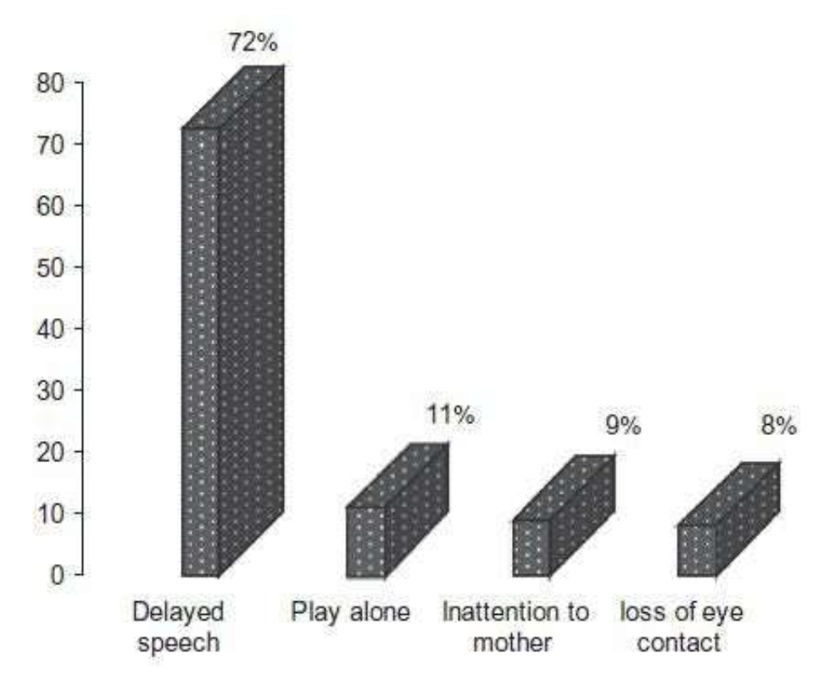
Figure 2. The Symptoms of Autism, Risk factors for autism
(El-Baz et al., 2011)
Hussein & Almanasef (2011) concluded that autistic symptoms begin to disclose by age three and persist throughout the individual’s life course. Salceanu (2020) further explained that children with autism experience anxiety and panic while corresponding to uncertain things in their surrounding environment. This surroundings’ unpredictability perception triggered this study to furtherly understand the connection between the built environment and children with autism and how physical settings with particular features can either negatively or positively affect the way ASD children behave and develop.
Architecture & Autism. Lawrence & Low (1990) explored the meaning of the built environment and identified it as an abstract concept describing the products of human activity ranging from hearths to cities. The effect of the built environment on ASD children is significant as, besides the core symptoms of their illness, they tend to be more sensitive toward their surrounding environment than typically developing children due to sensory processing issues, which later affect their behaviors and attitudes (Clouse et al., 2020). This concludes how the existing physical environments intended to host children with autism need a reassessment of whether they were suitable for them or not. In addition, it is a substantial responsibility for Architects and Designers to create new buildings capable of accommodating the acute condition of adults and children on the spectrum.
School Setting Significance. Among the first physical environments that individuals intensely experience are School buildings, as children and young adults spend on average 6.5 hours per day, five days a week, and 170 to 180 days per year, within their school for the whole duration of their education (Silva, 2007). Consequently, any design interventions taking place would have more chances to achieve promising results and effects (Perumean-Chaney & Sutton, 2013; Baeva et al., 2011; Martin, 2016; Pinto-Martin, 2005). Along these lines, due to the significant effect of schools, they should be prioritized by Architects, Interior designers, and researchers to guarantee their capability of accommodating the needs of all children. This includes considering the sensitivity of children with autism while designing schools meant to host this vulnerable population.

Inclusive Education Opportunities and Obstacles
ID Opportunities. Inclusive education is identified as the integration of children with autism and their typically developing peers in public and private education while granting everyone the opportunity to learn and belong to the community regardless of their abilities (Ghoneim, 2014, 195; Flavey et al., 1995; Ammar & Skaggs, 2016). Hayes & Bulat (2017) illustrated that among the misperceptions about inclusive education is that when the country has limited resources, typically developing children should be treated as a priority, and educating children with disabilities comes next. The author investigated and proved that this is untrue and that creating an education system that segregates children and provides unequal opportunities is unethical and contradicts the UN Sustainable Development Goals (SDGs). Parents of children with autism prefer inclusive education more than special education due to the formation of interpersonal relationships that can enhance their children’s personalities and skills (Salceanu, 2020, p. 18). Salceanu also investigated the percentage of success of children with ASD in public education against special education and found out public education is better by 76% (p. 19). The critical aspect here is that an inclusive educational environment can only achieve its intended goal by supporting the well-being of all marginalized individuals and accomplishing the principle of “Community psychology” Bonnell et al. (2022). Hence, inclusive education can be a very successful theoretical approach to giving children with disabilities access to education; however, the whole initiative relies on prioritizing, accepting, and accommodating their needs.
ID Obstacles. Despite the support that inclusive education received from the parents, they also adopted further misinterpretations and fears about it, including their children’s “Physical Safety” and how their peers and educational staff might treat them (Hanline & Halvorsen, 1989, 489). Another adopted fear was that the transition itself to a new environment could be challenging for children with Autism, affecting their mental health while fearing the new physical setting and anxiety about peer relations (Nuske et al., 2019, 308). Inconsistent implementation can also be a challenge that families would worry about, as a study in Australia figured out that the implementation framework of inclusive education is left to be the responsibility of each state to implement it the way they see appropriate (Anderson & Boyle, 2019). Thus, addressing the parents’ fears, understanding them, and the consistency of implementation after inaugurating the laws and regulations are essential steps of the process that can’t be skipped.
Least Restrictive Environment (LRE) in the US. According to Rozalski et al. (2010), The law in the United States, including the Individuals with Disabilities Education Act (IDEA, et al.), requires educating children with disabilities with their typically developing peers in general education setting “to the maximum extent appropriate.” The author illustrated the range of placement options the students have upon locally determining their disability falls within the interval shown in Figure 3. Along with this least restrictive environment, an Individualized Education Plan (IEP) is developed to guarantee the special needs of disabled students are met (Vaughnet et al., 2011). However, this guideline is broad and may result in a wide range of subjective interpretations and recommendations on determining what is appropriate for the students.
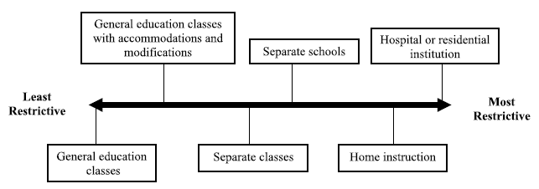
Figure 3. The continuum of alternative placements. (Miller, 2010)

Sacramento City Unified School District v. Rachel H. (1994) was a case of an 11-year-old girl, Rachel H., whose intellectual disabled was misjudged to be only compliant for special education according to Sacramento City United School team’s assessment. After this case the circuit court took four factors into consideration to determine whether the student was misjudged or correctly placed as follows: “(1) Comparing the educational benefits of a general education classrooms with all needed aids vs special education classroom; (2) The social interaction benefits of including disabled children with their typically developing peers (3) the effect of the disabled child presence on the teacher and their typically developing peers; and (4) the cost of the general (public) education”, this framework adopted by the circuit court was able to determine that the student, Rachel, was misplaced and should have had the opportunity to access general education (Alquraini, 2013). Yell & Drasgow (1999) concluded in their study that despite the availability of the supplementary aids and services in the general education classrooms to meet the need of disabled children, however the key factors are “individualization and appropriateness.”
A Promising ID Initiative in Egypt. Egypt is among the countries where laws and regulations state the right of children with disabilities to access education and is becoming more interested in including children with special needs in the public education system (Hayes & Bulat, 2017; Alhadi, 2021; Ghoneim, 2014). Among lived challenges of ASD children’s mothers are financial strains due to the high cost of speech therapies and special private education (Gobrial, 2018). Gobrial (2018) also identified the shortage in the availability of special schools and their exaggerated cost compared to public education as an obstacle that ASD children’s families constantly deal with. Consequently, opening the doors of public schools to students with Autism was a long-awaited step that was foreseen to solve the educational struggle the children and their families are suffering from. The Egyptian government recognized this problem and inaugurated a promising decision: the Inclusion Education Decree issued in 2015. This governmental decree deems that children with mild disabilities have the right to be included in Egyptian mainstream education between the age of 6-9 years (Ahram Al Youm, 2017). This decree was a glimpse of hope for the children and their families to finally access the Egyptian public education system. Because of that official legislation, the number of children with Autism in Egyptian public schools increased from 4,000 to 30,000 between 2014 and 2017 (Parnell, 2017). These high numbers of ASD children in public education resembled a fascinating growth. However, it also had several underlying downsides.
ID Challenges in Egypt. Gobrial (2018) and Gobrial et al. (2019) explored the obstacles children faced in Egyptian inclusive public education and concluded that the obstacles include: (1) Not receiving enough attention from public education teachers, (2) Bullying from typically developing peers, (3) The surrounding environment of public education can be confusing for the children, (4) Public education teachers don’t go through training on how to deal with children with special needs (p.196). The article furtherly recommended essential elements of the school’s physical environment that included rethinking the suitability of the school building for the children in terms of design, specifications, facilities, and providing the “resources room” (p.197). Math et al. (2016), in their review article about The Convention on the Rights of Persons with Disabilities (United Nations 2016), illustrated how it is very important to provide schools of inclusion with trained teachers with a good understanding level of behavior analysis and augmentative communication. With their high qualifications, these teachers can be a point of struggle in Egypt; since the unqualified teachers resemble a great concern in primary education (Loveluck, 2012). Besides the problem of unqualified teachers, the struggle of affording specialized shadow teachers to accompany ASD children in Egypt and guarantee their safety can be a source of financial strains for their families (Fathie, 2016). A study by El-Zouhairy (2016) concluded that the fear of bullying and marginalization in schools forms a huge concern to the families of children with autism in Egypt. The families worry about stereotyping their children’s disability which shall subject them to problem behavior from their peers. Hussein (2013) explored the phenomenon of school bullying in Egyptian primary schools and found that its prevalence rate is higher than the western regions. Verbal bullying, emotional violence, and physical bullying are common types of bullying in Egyptian public primary schools, leading to health and emotional struggles for the victimized children affecting their personalities and educational performance. (Radwan et al., 2021) With these high rates of bullying and problem behavior in Egyptian schools, the first question that comes to mind is, how to mitigate the struggles and support the smooth transition of this vulnerable population in the public mainstream education system.

School Bullying vs. Perceptions of Safety
Understanding School Bullying. Ttofi & Farrington (2009) identified bullying as a phenomenon that includes physical, verbal, or psychological attacks on the victim with the intention to cause harm or fear, which often happens due to the imbalance of powers between children by the presence of children of more power over the others. At the same time, Pepler & Craig (2000) identified bullying as an aggression pattern that happens according to the differences in powers among more powerful individuals (Bullies) and weaker ones (Victims). In an early study by Borg (1999), Bullying was revealed to be a critical problem in primary and secondary schools, and they further explored the bullying types that took place frequently or occasionally. The study results showed that name-calling, lies, and beating were among the highest bullying forms among boys and girls (p. 146). Rivers & Smith (1994) delved into the idea of bullying misconception as it has to be some sort of physical aggression and hitting; they stressed that it could be either direct or indirect. They added that it could also be in the form of silence and social exclusion.
The Perfect Victims. Collins (2004) expanded on bullying in primary schools to be more likely to happen to children who have fewer friends and suffer from frequent forms of bullying than students with more friends. According to Collins’s research results, 40% of pupils reported being exposed to some sort of bullying either occasionally or frequently, as shown in Figure 4.
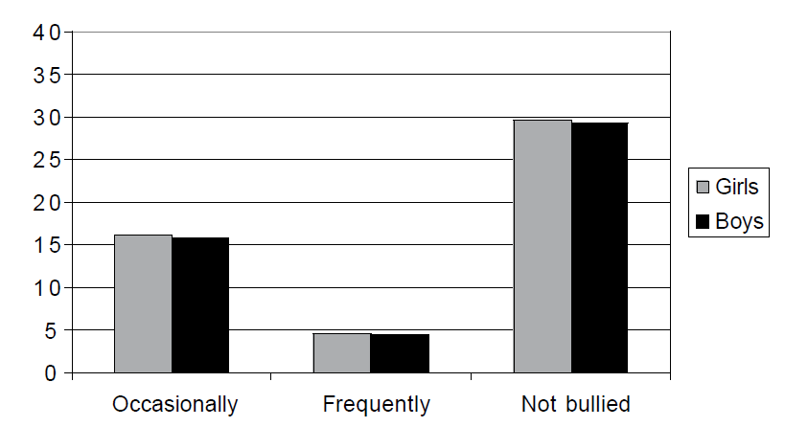
Figure 4. The percentage of boys and girls reporting being bullied or not bullied at primary school
(Collins, 2004)
Cappadocia et al. (2012) investigated the bullying experiences of children with autism spectrum disorders and found that ASD children are more likely to suffer from bullying than their typical peers according to their communication impairments. The study also found that the higher ASD children are exposed to victimization, the more they show symptoms of over-sensitivity and stereotypic behavior. That is why they were called “The Perfect Victims,” which drastically affects the children’s psychological and physical safety. Moreover, Children with autism suffer from the unpredictability and uncontrollability of the physical environments, including the unpredictable actions of the people with whom they may interact. (Kinnaer et al., 2015). Consequently, students suffer from emotion regulation problems and externalize problem behavior themselves (Baron-Cohen, 1988; Bauminger & Kasari, 2000; Howlin, 2004; Zablotsky et al., 2013). Copeland et al. (2007) examined the developmental consequences of being exposed to childhood traumatic events, resulting in the prevalence of anxiety and depression traits. This can be more alarming for children with autism as they already suffer from anxiety according to their illness’s core symptoms.
Being Safe vs. Feeling Safe. A safe school environment is described in the literature as a healthy context that is physically and psychologically safe and free from physical or emotional harm (Bernardi & Kowaltowski, 2006; Xaba, 2006). Loukas (2007) concluded that the student’s sense of belonging in their school could be intensely increased by enhancing school safety and preventing violence. The Safety attributes, including physical and psychological safety, were demonstrated by Wang & Degol (2015) in Figure 5, since the discipline and order portion relates more to the managerial aspect of the school.
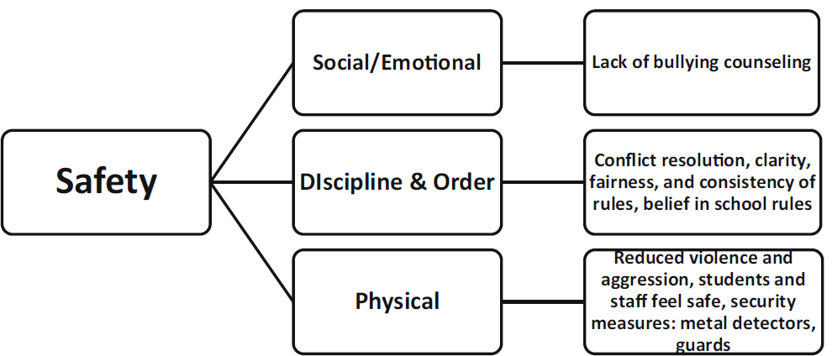
Figure 5. The conceptualization and categorization of school climate (Wang & Degol, 2015)
The physical safety of students means protecting them from any possible physical harm they may be exposed to in their school, including but not limited to physical fighting and bullying (Lamoreaux & Sulkowski, 2020; Bucher & Manning, 2005). In comparison, psychological safety in educational environments is identified as being mentally prepared to learn constructively and can only occur within contexts free of any sort of intellectual violence (Baeva & Bordovskaia, 2015; Lamoreaux & Sulkowski, 2020). The authors explained the importance of psychological safety for development in environmental contexts, while the threat which may affect psychological safety is Bullying and Psychological violence that may lead to “Psychotrauma,” which can result in low emotional comfort and confidence. The text also investigated the phenomena of well-being and ill-being, which evaluates the social state of an individual within a specific context (p. 89, 90, 91). Along these lines, Bullying is one form of traumatic events that would result in post-traumatic stress disorder (Cohen et al., 2010). Psychological safety was also identified as the feeling of security and well-being within physical learning, including schools. (Charteris et al., 2021) This phenomenon of psychological safety can be affected by indirect bullying, which can have more drastic effects than direct physical bullying (Rigby, 2007), Which makes it broader and more complex than physical safety. The physical and psychological safety of children with autism can be more challenging in inclusive education according to their helplessness and deficiencies in communication (Cappadocia et al., 2012). Hence, the designers of schools and learning environments should be more considerate than before about the psychological and physical safety considerations of children with autism upon their inclusion with their typically developing peers under the same building roof. However, further investigation is needed to understand in more depth the several dimensions of safety when it comes to ASD children.
Bullying Locations in Schools. The locations that encounter the most frequent number of bullying incidents in schools are playgrounds during break time, classrooms, corridors, bathrooms, and lunchrooms, as they were identified as the five most frequent bullying locations within schools; the studies that showed these results suggested that more supervision and surveillance by teachers and staff is needed to prevent these violence incidents (Francis et al., 2022; Borg, 1999; Fram & Dickman, 2012; Woolley, 2019). These results are findings of general studies for typically developing children. However, further investigation is needed when it comes to potential bullying and peer harassment locations of ASD children. Further study by Schiffbauer (2000) argued that to maintain a safe environment in school, more attention should be given to the school’s stairways, hallways, and the locations that the students use on their way from and to their classrooms.

Towards Safer Schools’ Design
Zoning & Space Planning. Crosland & Dunlap (2012) argued in their study that design interventions could be utilized to manipulate the built environment to make the problem and challenging behaviors less likely to occur. Researchers broke down the elements that compose the school climate into four pivotal domains: safety, community, academic, and institutional environment. The authors furtherly elaborated that these four features directly impact the pupils’ cognitive, behavioral, and psychological development as they stressed that the individual’s behaviors are consequently shaped by the physical quality of the building design and its structural organization (MacNiel et al., 2009; Kutsyuruba et al., 2015; Wang & Degol, 2015). To foster the mental accessibility of physical spaces for children with autism, the author recommended: (1) avoiding exaggeratedly big spaces and alcoves within larger spaces, (2) providing clearly seen exits, (3) functional and logical zoning of spaces to avoid ASD children’s confusion (Kinnaer et al., 2015; Mostafa, 2010; Vogel, 2008; Ahrentzen & Steele, 2009; Altenmüller-Lewis, 2017). Fernelius & Christensen (2017) emphasized the importance of play for children with autism and concluded that a circular playground layout is the best for children, naming that with the term “Circuit Structure.” They pointed out that preference is according to the clarity of movement within that structure. The authors also specified the importance of having observation points where children with autism safely observe other playing children without interruption (p. 89). Wu et al. (2022), through their study of the social behavior of children with autism and their play patterns, concluded that ASD children tend to need concealment as the last step among the four steps of their play patterns since they might feel tired or afraid of being overly participated in social interaction thus, they would need an enclosed space to rest and sense safety, security, and privacy (p. 2). Colwell et al. (2016) argued that providing areas of refuge can increase the perception of safety and control over the environment. However, these areas would be preferred by the children if they are located where they can be hidden from their peers but still seen and supervised by the teachers. By observing the school plan types according to the Foundation for Educational Development in Brazil, investigated by Pereira et al. (2018), the building layout can be responsible for either providing more surveillance and support for the students of obstructing the visual connection between spaces. Not a single configuration adopted the radial layout. See Figure 6.
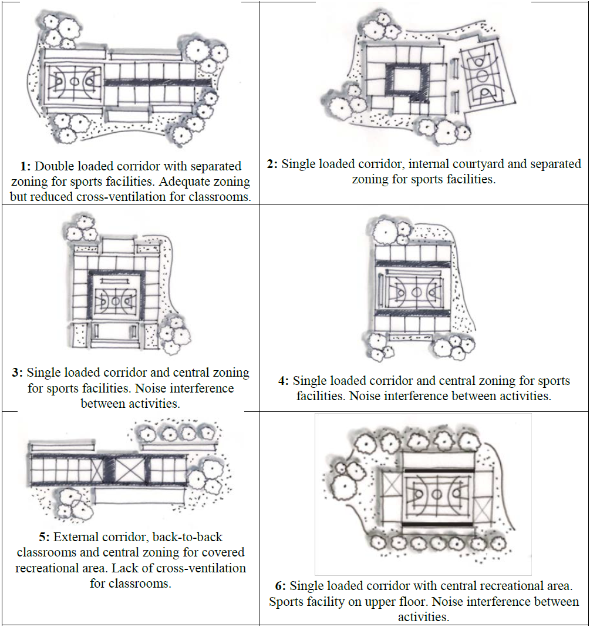
Figure 6. School Layout Types (Pereira et al., 2018)
Pereira et al. (2018) furtherly determined in their study results the possible classrooms’ clustering patterns and their pros and cons, as shown in Figure 7. The authors concluded that the tight width and long length double loaded corridors have poor lighting and ventilation. However, the shortness of the corridor length can provide more comfort levels. They also supported having the “School within School” concept by having flexible learning spaces in larger communal areas in front of the classrooms as shown in Figure 7(D).
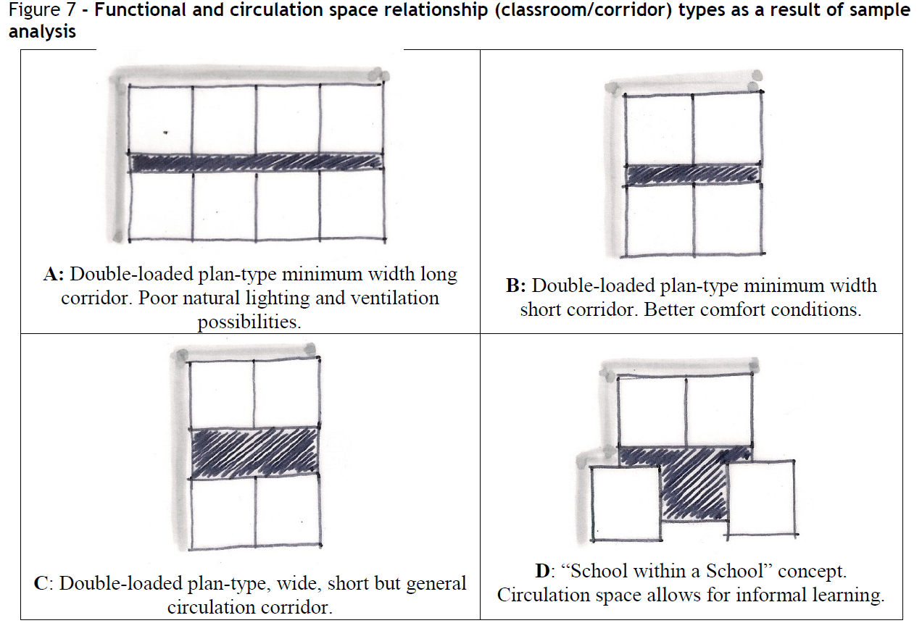
Figure 7. Classroom/Corridor Types Analysis (Pereira et al.,2018)
The school building is like the “Ant’s Nest”; it consists of interweaving layers of spaces. First, the official layer, which includes the rules and regulations; then the physical layer, the physical context of building features and spaces; and lastly, the informal layer of social interactions (Gordon, 1996). These spatial relations relate to the study’s focus since the official layers can resemble the spaces in control, which are the teachers’ offices and collaboration areas. The physical layer is the school building itself. The informal layer is the relationship between students, and this is where peer harassment and bullying might take place. Hence, the spatial relationship between these three layers is a vital factor in minimizing or increasing the problem behavior in school. Francis et al. (2022) argued that scattering the building with no accurate zoning can hinder monitoring and supervision while having a more compact building layout can enhance it. Hence, it can be hypothesized that having ASD children’s classrooms and their other dedicated facilities in close proximity to the rest of the school spaces, including teachers’ offices, would affect their sense of safety as teachers and staff would constantly be able to see and protect them. This would also decrease the travel time from and to their classes, decreasing their exposure to unwanted interactions and unpredicted behaviors by their peers. Further understanding of the perspectives of teachers is needed about the preferred space planning regarding what school areas should support the full inclusion of students with Autism and what area should rely on rationalizing that inclusion in public schools by having spaces dedicated only for ASD children within the bigger umbrella of inclusive education.
Visibility & Natural (Passive) Surveillance. Xaba (2014) identified surveillance in the school context as the ability to monitor and observe the whole building. Regarding the tools that can be utilized to prevent crime in urban areas, studies concluded that visibility provided through “Natural Surveillance” played an important successful role in deterring crime and violence rates by creating well-lit and well-monitored defensible spaces (Jacobs, 1961; Welsh et al., 2010). Xaba (2006) explored essential elements that should be provided to enhance the school’s safe environment, including having windows instead of solid walls to provide more surveillance and monitoring and ensure clear visibility towards important locations such as the building entrance. Tola et al. (2021) did an extensive scoping review on the design of the built environment for children with autism and concluded that the visual relation between spaces is significant as plenty of papers discussed the organization the spaces to support the maximum visual relation will allow teachers to constantly see the students and monitor if they need assistance or interference, and limiting the outdoor play areas which may not be supervised well (Tola et al., 2021; Ahrentzen & Steele, 2009; Deochand et al., 2015; Giofre, 2010; Humphreys, 2011; McAllister & Maguire, 2012). Jeremey Bentham in the 18th century proposed a concept to design a prison spatial layout that can allow a single security guard to watch all the prisoner at the same time while being concealed from the sight of the prisoners, and according to his theory, the prisoners will always presume they are observed and consequently will remain on their best behavior, even if they are not actually being watched by guards. (Bentham, 2011). See Figure 8.
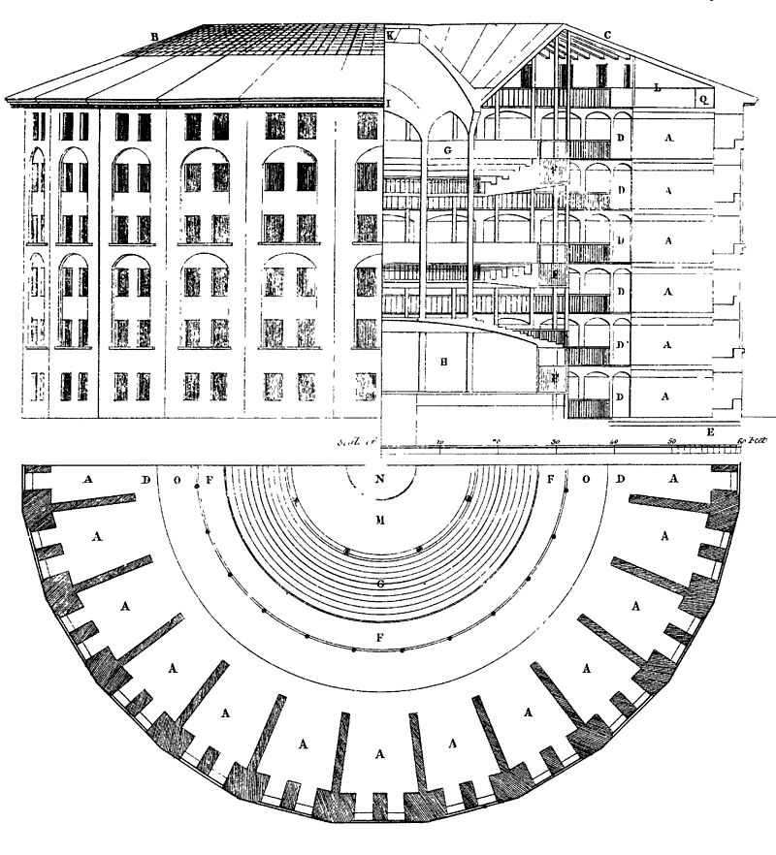
Figure 8. Plan of Jeremy Bentham's panopticon prison, drawn by Willey Reveley in 179. Retrieved from: https://en.wikipedia.org/wiki/Panopticon
Circling back to mitigating school bullying, Bentham’s concept in the panopticon can be utilized in eliminating violence and problem behavior through the idea of being constantly watched with no indication of an ideal time to harass peers. Cunningham et al. (2010) concluded that by restructuring the high-risk locations identified by the authors as areas away from teachers’ monitoring and increasing the constant supervision, the rates of violence could be effectively decreased. Horton et al. (2020) elaborated that problem behavior and peer harassment occur more frequently when teachers are not observed in close proximity and that it is hard for teachers to be everywhere. This enlightens the idea of how the visibility aspects of the vital circulation spines in school should be prioritized. Other studies also addressed the importance of monitoring and surveillance and discussed the significance of using security cameras (Astor, 2010; Cunningham et al., 2011; Chen & Chen, 2018; Wahab et al., 2018). However, relying on security cameras as the only means of monitoring the building can be tricky and dependent on several factors; among the limiting factors are that they can miss activities (Preston, 2022). On the contrary, utilizing the building as a semi-transparent shell will not require as much cost addition and maintenance requirements, and it won’t rely on specific personnel. All building occupants, including teachers, will have more control by constantly viewing all spaces and seeing vulnerable children with no unnecessary physical obstacles since bullying happens anywhere when teachers are not present (Gourneau, 2012). Drawing back on (Bentham, 2011), When the building structure and space planning provide more visibility, that would psychologically make bullies be more cautious before thinking about bullying their peers as they can be seen more easily instead of feeling aggressive and reckless when they are not seen, or no one is around.
To further understand the term “Natural Surveillance,” Xaba drew on Carter and Carter’s (2001) investigation of natural surveillance to be the concept of eliminating the hidden or hard-to-see places, which can be referred to as “Blind Spots,” In other words, it is the objective of enhancing the aspect of visibility throughout a particular building or setting by using the building and its features as the tool (p. 1585). Wahab et al. (2018) discussed crime prevention through environmental design (CPTED) and enhancing the sense of safety. The author’s theory was based on studying the relationship between the occupants and their environment while employing the physical environment features to muffle the crime rates and violent behaviors. It was also pointed out in Wahab and colleagues’ research that the concept of preventing crime through environmental design was not widely researched in school contexts like commercial and residential settings (p. 30). In their study, Lee et al. (2020) expanded on the use of natural surveillance as it is one of CPTED’s seven principles, the authors highlighted that low levels of lighting and high walls were sorts of visual obstructions which provided concealment for the offenders to practice the violent behavior and that open planes between buildings provided intervisibility and physical deterrence. Figure 9 illustrates the concept of natural surveillance through open planes and visual connectivity.
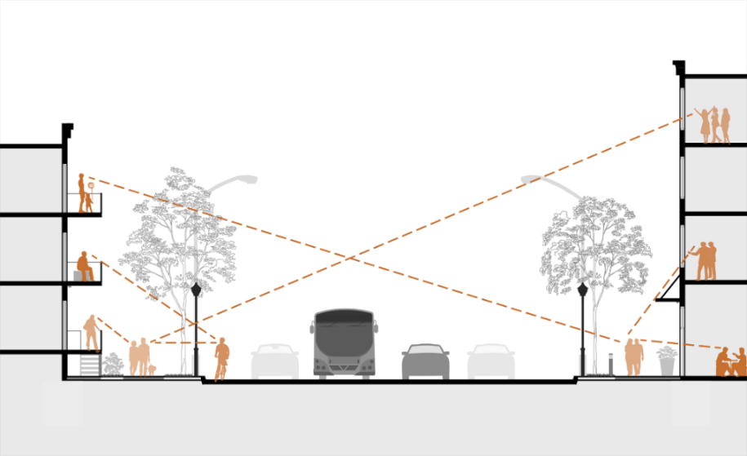
Figure 9. Natural Surveillance in CPTED. Retrieved from: https://minneapolis2040.com/policies/public-safety-through-environmental-design/
Natural Surveillance is linked in the literature to the term “Defensible Space.” The term defensible space was first introduced in 1972 to the body of knowledge by Oscar Newman (Newman, 1972). Newman identified it as “a form of correcting prevention,” in more detail, a defensible space is the role of the physical elements to provide more control of the building residents, consequently creating a sense of safety and promoting security (p. 63). The author further elaborated that defensible space is achieved when it allows the occupants of the building to easily monitor and control all tasks and activities performed within that space (p. 64). More recent papers utilized the concept of defensible spaces and built off of it. Welsh et al. (2010) expanded on implementing the concepts of defensible spaces to be at no potential costs, which included the redesign of existing elements or providing minor solutions, including redesigning walkways or windows installation (p. 315). These theoretical terms can be easily transformed into actual design interventions that benefit all building types, particularly school buildings. Speaking of having the building itself acting as a safe, transparent shell, Welsh illustrated examples of natural surveillance as having more windows to promote visibility to the building’s spaces as well as proper lighting. Schiffbauer (2000) & Fram and Dickmann’s (2012) supported that argument by concluding that the ideal school buildings can provide safety for the students and have more control over the environment by concluding that they must less isolated corridors and well-lit spaces. However, Schiffbauer’s study also added that fewer exits are recommended for a safer school environment; this relates to the phenomenon of running away that children with autism suffer from; however, would providing fewer exits improve the children’s psychological safety? That would be a question worth exploring. Isolating spaces can be concluded to be the opposite of what defensible spaces are trying to achieve, which is openness and visibility. Hence, the avoidance of isolating the corridors can accordingly enhance the monitoring of ASD students’ flow from and to their classrooms, un-harmed directly or indirectly. Schiffbauer also highlighted the importance of locating the administration offices near critical locations and avoiding overcrowding in the hallways (p. 73). This takes us back to space planning and figuring out where spaces should be placed according to their functions and ability to decrease school bullying.
Lamoreaux & Sulkowski (2020) furtherly explored the connection between bullying and students’ perceptions of physical and psychological safety and studied the principles of crime prevention through environmental design using natural surveillance, access control, and promoting territoriality and school maintenance. Their study findings also included that windows can be utilized to achieve natural surveillance and provide natural daylight, promoting visibility, which helps prevent bullying and enhance psychological comfort (p. 486). Transparency and opaque barriers providing visual interest and natural surveillance in urban spaces are illustrated in Figure 10.
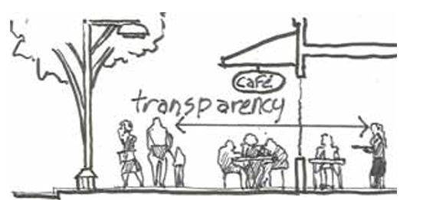
Figure 10. Transparency and visual connection between spaces creating visual interest and safety. Source: ABOTSFORD: Crime Prevention Through Environmental Design (CPTED)
Along these lines, providing adequate windows numbers and area in relation to the classroom size, for example, is a vital aspect of providing natural surveillance, supporting wayfinding, and creating defensible spaces free of bullying and problem behaviors.
Space Organization & Wayfinding. People with autism constantly found wayfinding a problem as they face difficulties in determining the motion direction (Pecora et al., 2021). Hunter (2010) argued that wayfinding has a considerable impact on psychological satisfaction, while the lack of wayfinding results in exclusion and decreasing the inclusiveness of the physical environments. Kopec (2012) investigated wayfinding in schools and concluded that with the absence of easy and clear wayfinding, students may feel more vulnerable and confused as they transition into a new space. Gains et al, (2014) argue that having clearly defined spaces help ASD children to understand where they are and the boundaries of their space. Gains and colleagues added that segmenting classrooms using furniture or colored duct tape can be useful in dividing larger spaces and making them more accessible for ASD students (p. 292). Speaking of the visual connectivity and its benefit to wayfinding, contended that the visual access between spaces, when provided by the building layout, can be more influential than signage in helping with wayfinding. Visual access provided by the building layout, or the visibility facilitates the wayfinding process (Carpman et al., 1985; Montello, 2005; Fewings, 2001). Abu-Ghazzeh (1996) concluded in their study that limiting visual access in campus buildings resulted in the occupants’ confusion as they couldn’t find their way. Pollet & Haskell (2003) argued that providing defined nodes where the main spines meet helps greatly with wayfinding. Furthermore, when visual access is associated with defined building zones and organization of spaces, wayfinding is eased (Fewings, 2001).

Conclusion
In conclusion, the review of the literature provided an extensive exploration and understanding of the study topic. The review included the analysis of inclusive education, its benefits, challenges, and implementation methods, and the problem of school bullying in public education. It also presented design patterns that prove promising results to enhance the physical and psychological safety of students with autism and mitigating the bullying from their typical peers. Further understanding of the term “Natural Surveillance” is explored to understand the role of the build environment in enhancing safety, security and creating “Defensible Spaces.” Through establishing these bases, the study looked into further understanding of the school spatiality performance on providing safety and the teachers perspectives on ASD children safety in inclusive education.

Chapter III: Methodology

Introduction
This section includes a method of approach to understand how to Egyptian public schools provide physical and psychological safety to children with autism who pass the inclusion requirements deemed by the Egyptian government. The study utilized mixed methods. First to examine the Egyptian schools a case study was selected to be evaluated and observed in comparison to a case study in the United States.
The schools were analyzed with reference to the elements identified in the literature review to be the best circumstances promoting the sense of safety of the ASD children. The examined elements were:
- School Zoning and Space Planning: (1) Zoning and Classrooms’ Clustering, (2) Exits / Access to Outdoors, (3) Restrooms, (4) Observation Points, (5) Corridors / Flexible Learning Spaces.
- Natural (Passive) Surveillance and Visibility: (1) Visual Connectivity, (2) Blind Spots, (3) Fenestration, (4) Layout Configuration.
- Space Organization & Wayfinding: (1) Spaces’ Integration, (2) Step Depth, (3) Permeability, (4) Color Coding.
The schools’ zoning, space planning and space organization were examined by using building layout observational analysis, while visibility and wayfinding were examined using DepthmapX software, which is utilized in space syntax studies. The space syntax analysis involved Visibility graph analysis, Connectivity graph analysis, Integration graph analysis, and ISOVIST graph analysis.
Secondly, a survey was adopted while targeting teachers who deal with children with autism spectrum disorders, to understand their perspectives on how sense of safety for children with autism can be enhanced in public education, and which elements would jeopardize it.

Case Studies Analysis
This study adopted case study analysis method for its first part. The case study is defined as an “empirical inquiry” to examine a phenomenon that occurs in real life setting (Yin, 2003). In this research two case studies were examined and analyzed to explore the performance of the physical environment design in promoting the sense of safety. Each of the two case studies was examined independently with respect to the study variables using space syntax tool by “DepthmapX” software, while providing individual preliminary observations per study. Personal investigation was only possible in one case study, the school in Egypt. Later in chapter V a cross-case analysis was completed to provide conclusion and discussion about the synergies and observations. A cross-case analysis is defined by Yin (1994), as a comparison between case studies to diagnose the similar and different observations to approach beneficial findings. The conclusion and observations resulting from the case studies were utilized to produce implications and recommendations for potential future study topics.

Selection Criteria
Case Study 1. The study’s assessment is focused on the children’s early developmental stages in public primary education. The case study chosen to represent the Egyptian public schools is one of the 48 Egyptian-Japanese collaboration schools that belong to an initiative between the Egyptian and Japanese governments for better public education in Egypt in terms of acceptance, collaboration and teamwork, and cleanliness of the school. (Youm 7, 2018). The schools adopt the “Tokkatsu activities” which is based on building the students characters by letting them do group activities together more the individualizing their activities (Youm 7, 2018). As shown in Figure 11, The Tokkatsu+ system is implemented in the Egyptian Japanese Schools (EJS) which public language and Arabic schools that serve the low-income Egyptian families, the new Japanese system is targeted to be implemented in 100 new schools, which includes the construction of a new building and 100 existing schools (The Arab Republic of Egypt Detailed Study for Egypt Japan School (EJS) Dissemination Final Report, 2017).
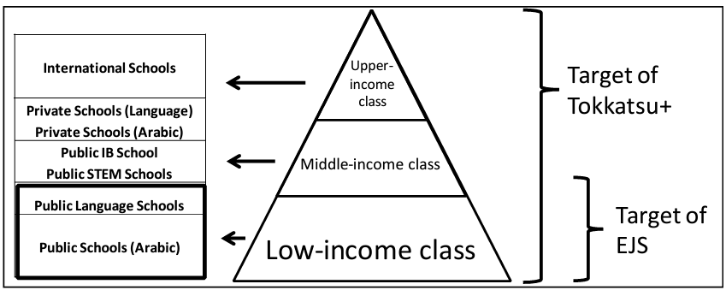
Figure 11. The school types in Egypt and the current and future target of the Japanese Tokkatsu+ system
(The Arab Republic of Egypt Detailed Study for Egypt Japan School (EJS) Dissemination Final Report, 2017)

Forty-eight Egyptian Japanese schools opened their doors in Egypt with around 30-40 students per class (Enterprise, 2022) The schools’ locations are shown in Figure 12. There are five Egyptian Japanese schools in Cairo governorate, which is the Egyptian capital and the densest city in terms of population, four EJS in Alexandria governorate, and three EJS in Giza governorate (Youm7, 2021).

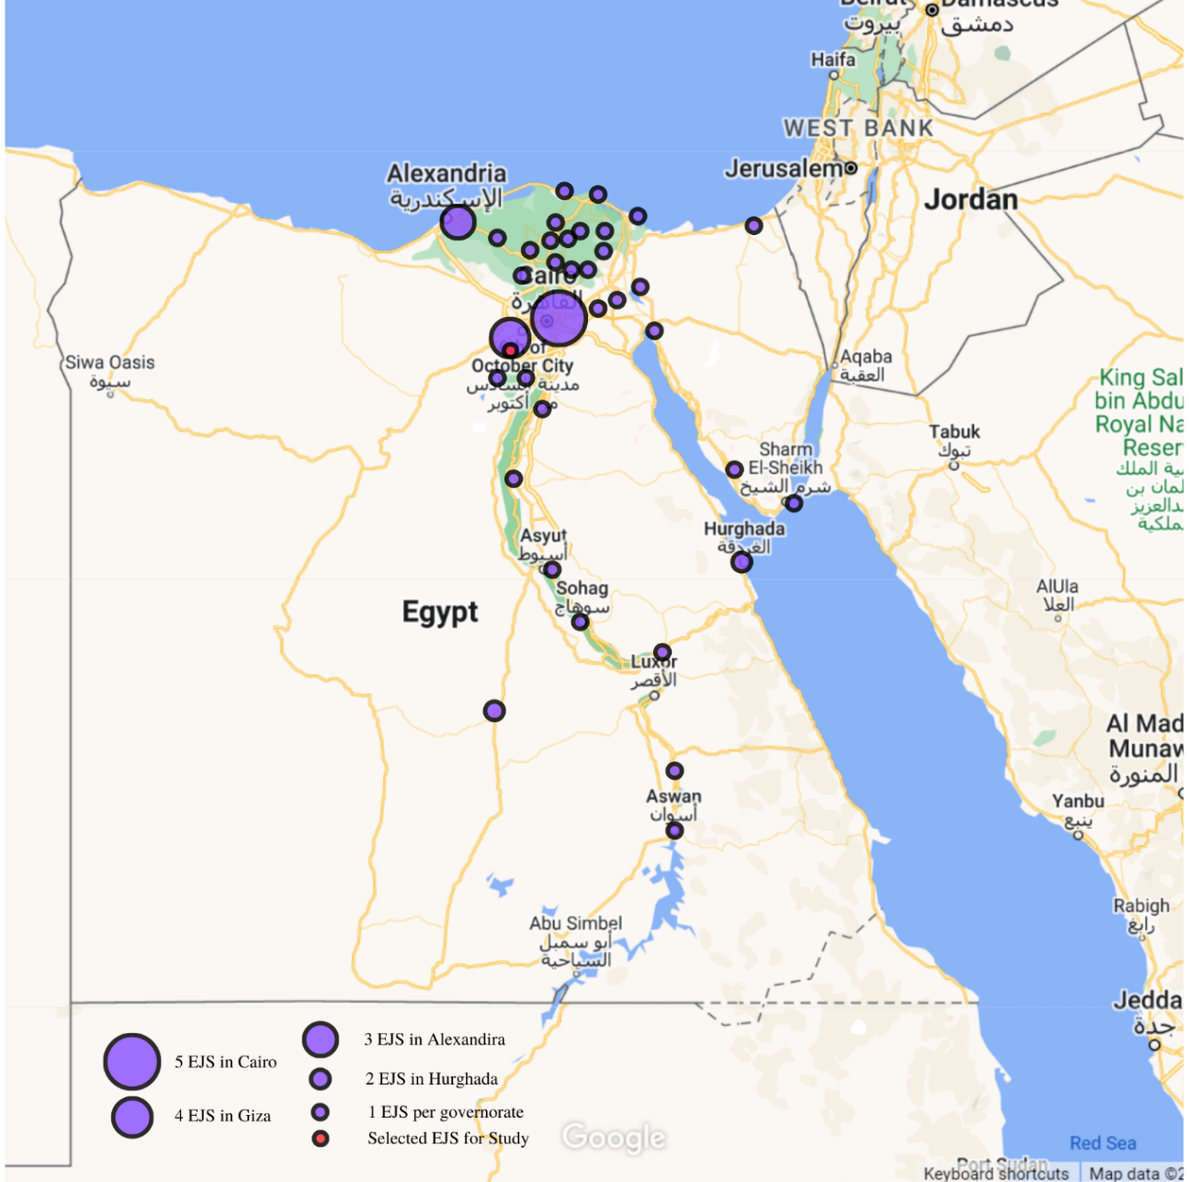
Figure 12. Egyptian Japanese Schools' Location around Egypt (Map source: Google – Data source: https://www.youm7.com/story/2018/9/19/%D8%AA%D8. – Visualization by Author)’

Selected School. A school from the forty-eight schools around Egypt is selected to be case study one. The selected school is Egyptian Japanese school in October Gardens in Giza, Egypt, as shown in Figure 13. It is one of the four Egyptian Japanese schools located in Giza Governorate.
The school built-up area is about 40,000 square feet. The main level is approximately 12,000 square feet and the typical floors are about 28,000 square feet. The main level (first floor) plan and the typical floor plan of the Egyptian Japanese school in October Garden, designed by “General Authority for Educational Building” (GAEB) which is an Egyptian organization that belongs to “Ministry of Education and Technical Education“ (MOETE) responsible for building schools (The Arab Republic of Egypt Detailed Study for Egypt Japan School (EJS) Dissemination Final Report, 2017), are shown in Figure 14 and Figure 15 respectively. The plans were digitally drawn by the author with reference to the floor plans shared only by Keshka (2019).

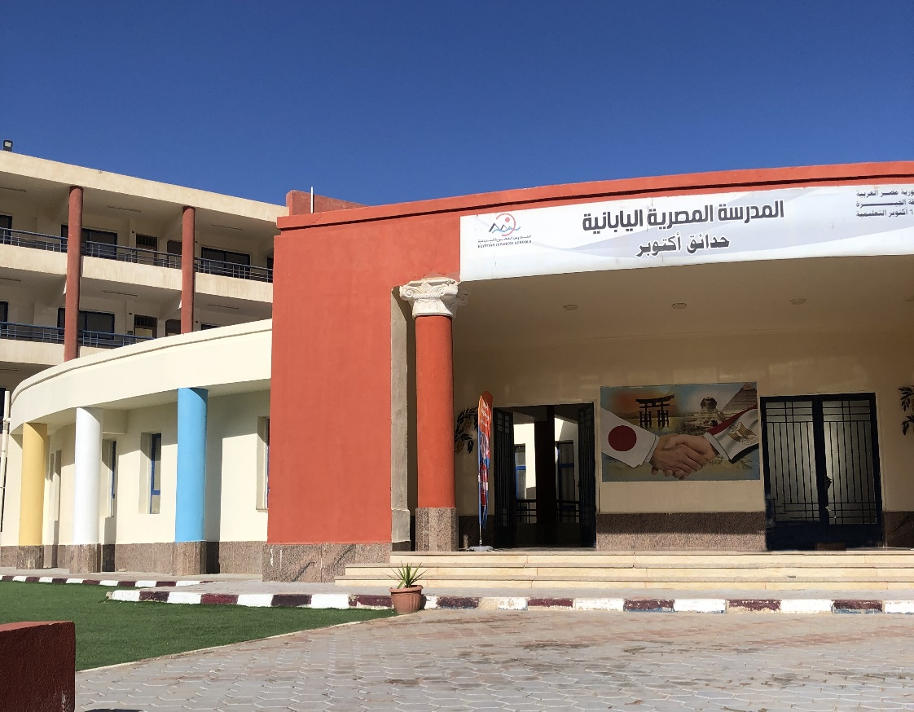
Figure 13. Egyptian Japanese School in October Gardens, Giza, Egypt (By: Author)
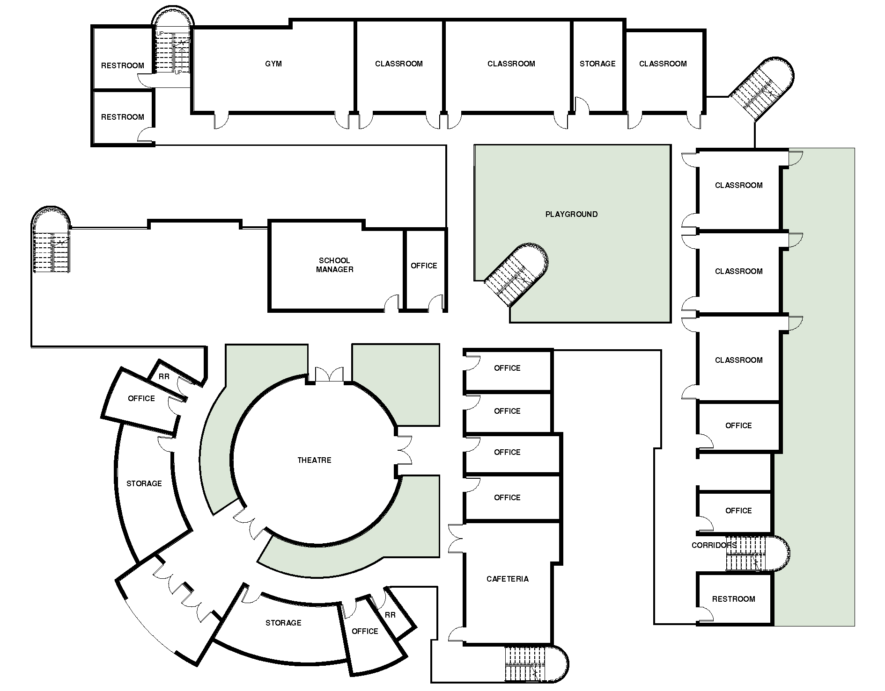
Figure 14. EJS main level floor plan (First Floor) – (Keshka, 2019) Digitally drawn by author.
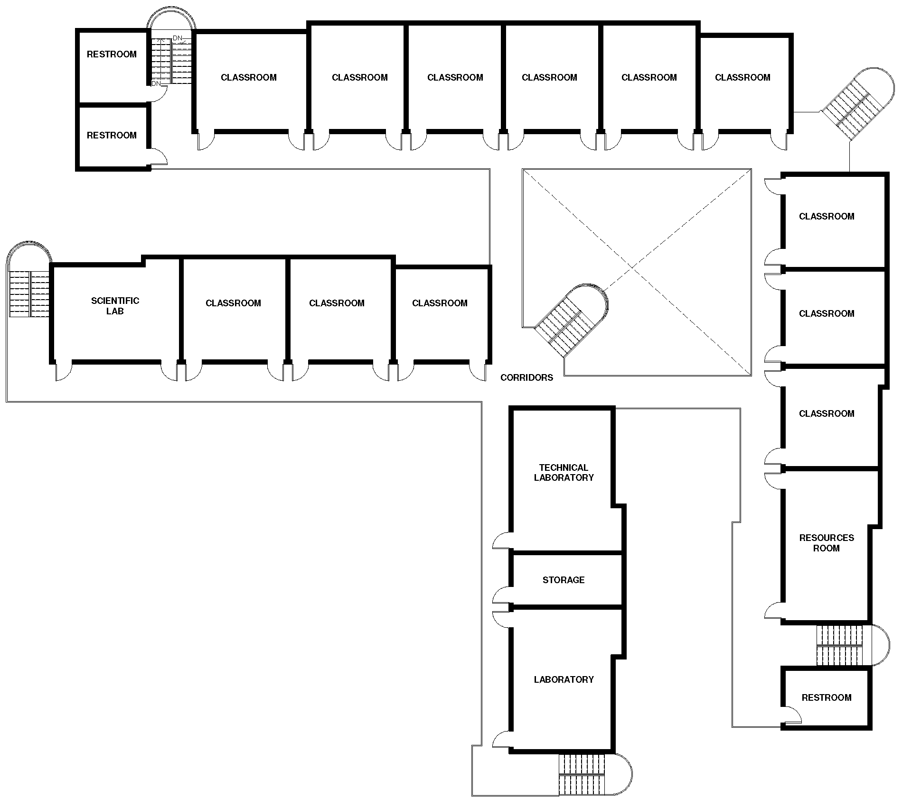
Figure 15. EJS typical floor plan - (Second, third and fourth). (Keshka, 2019) Digitally drawn by author.
Case Study 2. Case study two is a school in the United States to be compared to case study one (The Egyptian Japanese School). To select a school of suitable size and features for the comparison, exclusion criteria were adopted.
Exclusion Criteria. Schools of area less than 40,000 square feet and more than 60,000 square feet were excluded to have a reasonable school size for to compare with the chosen Egyptian Japanese school of approximate built-up area 40,000 sq. feet. Non-Public Schools and schools that have only one level were excluded. Middle and high schools were excluded. Building scope is limited to new constructions. Buildings which were completed before year 2015 were excluded. Schools with limited availability of published information were excluded.
Selected School. Hence, the American public elementary school that was selected for case study two is Browns Point Elementary School in Tacoma, WA as shown in Figure 16, which was completed in 2018. The school built-up area is about 56,430 square feet. Browns point school has 23 classroom teachers with total students number of 397, and the student/teacher ration is 17.19 (CCD Public school data 2021-2022 school year, 2022). The main level (first floor) plan and the second-floor plan of the Browns Point Elementary School, designed by TCF Architects, are shown in Figure 17 and Figure 18 respectively.
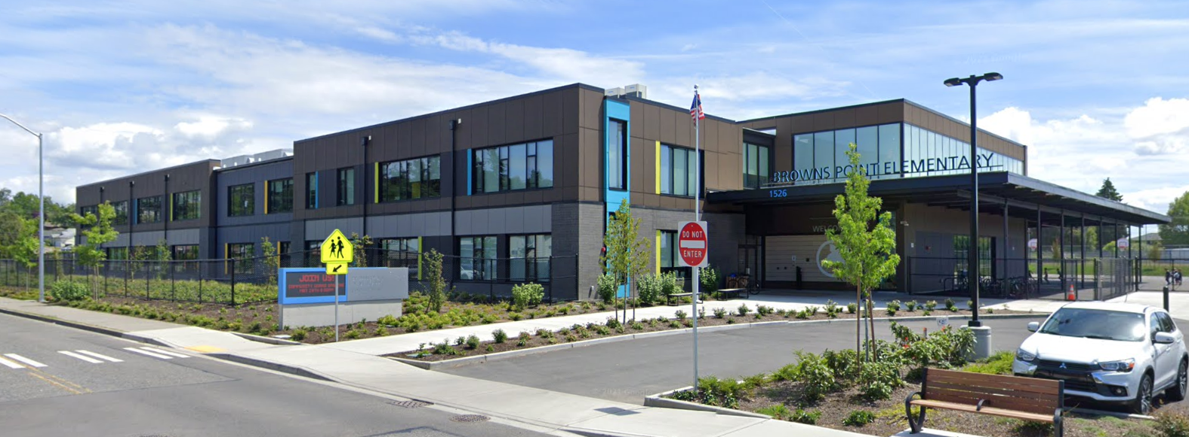
Figure 16. Browns Point Elementary School in Tacoma, WA (Source: Google)
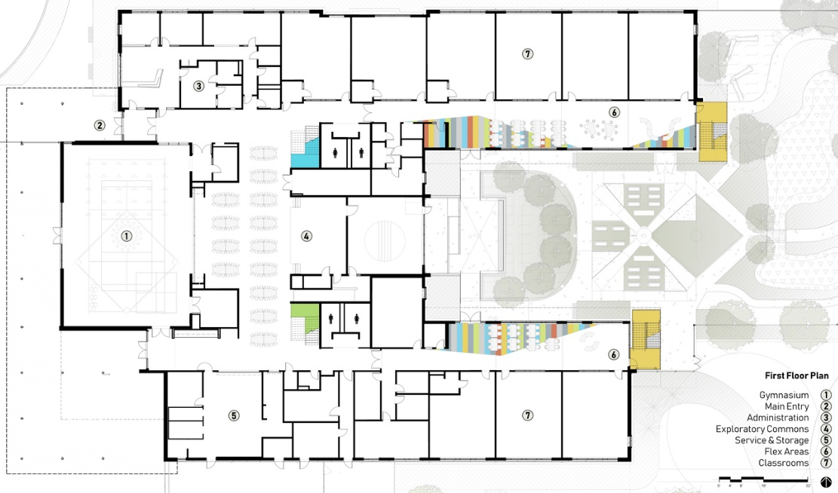
Figure 17. Brown Point Elementary School main level floor plan (First Floor) – (Source: Browns Point Elementary School / TCF Architecture, (2022). Archdaily)
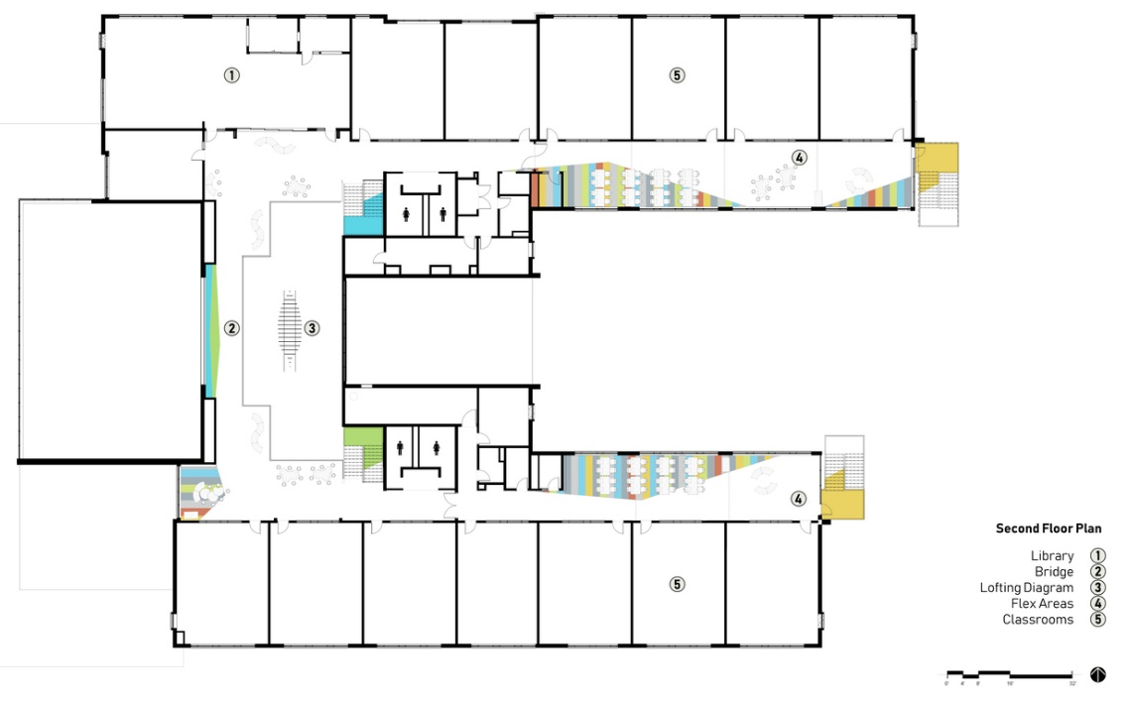
Figure 18. Brown Point Elementary School second floor plan – (Source: Browns Point Elementary School / TCF Architecture, (2022). Archdaily)

Survey
The survey questions were finalized in parallel to the literature review phase as the ideas being investigated start to unfold, and a good understanding base of the study variables is established. The survey was created using “Qualtrics” online survey creation and distribution tool. The survey was distributed online to be able to reach out to the largest number of participants possible. The survey was submitted to the Institutional Review Board “IRB” at the University of Oklahoma. The survey was comprised of 18 questions after the IRB informed consent form.
The first section of the survey comprised a consent form at its first welcoming page for the participants to either agree or disagree to participate in the study. The IRB approval outcome letter is included in Appendix A.
Once the participants agree to participate, a sequence of demographic questions follows, which is the second section of the survey. Within the demographic section, the respondents were asked about the following information:
- The geographical region from which the respondents were participating (Egypt or the United States).
- Age.
- Years of experience.
- The number of years they worked with children with autism.
- The age range of children with autism the teachers taught.
The third and core part of the survey, the teachers’ perspectives about the connection between the study variables; (1) the school building design (Built Environment) and (2) The children with autism sense of safety (Physical and Psychological Safety). This section aims to assess the teachers’ points of view about the following elements:
- Identifying the meaning of safety for children with autism in public schools
- The preference of teachers between special education classrooms and integrated classrooms in terms of what is more beneficial to children with autism.
- The types of bullying ASD children are mostly exposed to in public schools.
- The potential locations where ASD children may be bullied in the school building.
- Which factors can jeopardize ASD children’s sense of safety in public schools.
- Designating separate restrooms and cafeterias for ASD children.
- ASD children’s free secured access to an outdoor safe zone.
- The walking distance from and to classrooms where ASD children are located.
- The effect of including sensory rooms in public schools.
- The preferred proximity of the classrooms where ASD children are included to the school entrance and main hallways.
- Open-ended questions that target teachers’ general recommendations on the architectural design elements which need to be considered in terms of promoting ASD children’s sense of physical and psychological safety in public schools.
In the questions assessing the teachers likely to agree with a specific phenomenon, they were allowed to rate their agreement or disagreement on a five-point Likert scale ranging from (Strongly Agree or Extremely Likely or Definitely Yes) to (Strongly Disagree or Extremely Unlikely or Definitely Not) respectively. In the question where teachers were asked to rate the highest type of bullying that ASD children encounter; they were provided by a scale ranging from 1 (least) to 10 (most). The Survey remained open collecting responses for a full month starting from February 6, 2023, until March 6, 2023. The consent form and survey questions are included in Appendix B.

Survey Potential Participants
The study targeted surveying teachers from Egypt and the United States who have previous experience working with children with autism spectrum disorders. Teachers are the pillars of any educational system and the constant users of school buildings along with other managerial and maintenance staff members and students. Teachers are potential contributors in the success of including children with autism in public education (Loveluck, 2012). They stand for the cause and support that the most important factors of educational inclusion are the variety of assessment strategies, curriculum flexibility, and the individualization and customization of educational plans according to the distinctive needs of students (Salceanu, 2020). Teachers from the United States and Egypt were targeted to respond to the survey and share their perspectives on how the built environment design can facilitate and promote the sense of safety of ASD children in public schools.

Sampling
With reference to the Fowlers table of the required sample size, the survey targeted to have usable responses of 300 participants generating a 95% confidence interval with plus or minus 1.3% margin of error (Fowler, 2013).
Purposive sampling and snowball sampling were utilized to recruit teachers to participate in the study. Four potential categories of educators and teachers were selected as follows:
- Professors at the Faculty of Education at University of Oklahoma, US.
- Resource Teachers in Oklahoma, US.
- Special Education Teachers in Oklahoma, US.
- Special Education Teachers in Egypt.

Method of Contact
Once the study got the IRB approval, the survey distribution phase started. The author distributed the survey to the potential participants through sending out an IRB approved format of recruitment emails and web posting on social media. The email and web posting format reflected the same elements of the consent form to give the respondents full understanding about the study topic, the anonymity of their identity, that the participation in the study is completely options, and further contact information of the author and supervisor are provided in case further clarification is needed.

Conclusion
With reference to the data gathered from the literature review, the results and findings from the space syntax analysis and the survey responses were analyzed in chapter four. The results overview took into account the three physical environment dimensions that study is focused on: (1) School Zoning and Space Planning; (2) Natural (Passive) Surveillance (Visibility); (3) Space Organization & Wayfinding (Movement Patterns). After analyzing the results of each case study, the two case studies were compared to synthesize the findings for further understanding of the commons and differences. For the survey, the results were highlighted through figures, tables, and charts along with text to show the perspectives of teachers according to the responses received. Finally, preliminary recommendations and observations were displayed to prepare for the final chapter 6 of discussion and conclusion.

Chapter IV: Results

Introduction
The results in this chapter were approached through the mixed methods utilized by the study to understand the relationship between the built environment and the safety of children with autism in public schools. Case studies analysis results are overviewed in terms of (1) School Zoning and Space Planning; (2) Natural (Passive) Surveillance (Visibility); (3) Space Organization & Wayfinding (Movement). The case studies were analyzed in detail with respect to the following elements that correspond to the patterns overlooked throughout the literature review:
• School Zoning and Space Planning
1. Zoning and Classrooms’ Clustering
2. Exits / Access to Outdoors
3. Restrooms
4. Observation Points
5. Corridors / Flexible Learning Spaces
• Natural (Passive) Surveillance and Visibility
1. Visual Connectivity
1. Blind Spots
2. Fenestration
4. Layout Configuration
• Space Organization & Wayfinding
1. Spaces’ Integration
2. Step Depth
3. Permeability
4. Color Coding
In addition to the survey conducted to understand the teacher’s perspectives on the studied topic. All results are visually presented in visualized figures, charts, and tables in this chapter.

Case Study (1): Egyptian Japanese School

School Zoning and Space Planning
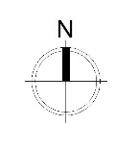
Zoning and Classrooms’ Clustering. The classrooms are grouped in a Linear L-Shaped layout. They are placed at the furthest wing from the school’s main entrance, while being partially segregated from the teachers’ offices and administration area, since two offices are added at a close proximity to the classrooms of the eastern wing. See Figure 19.

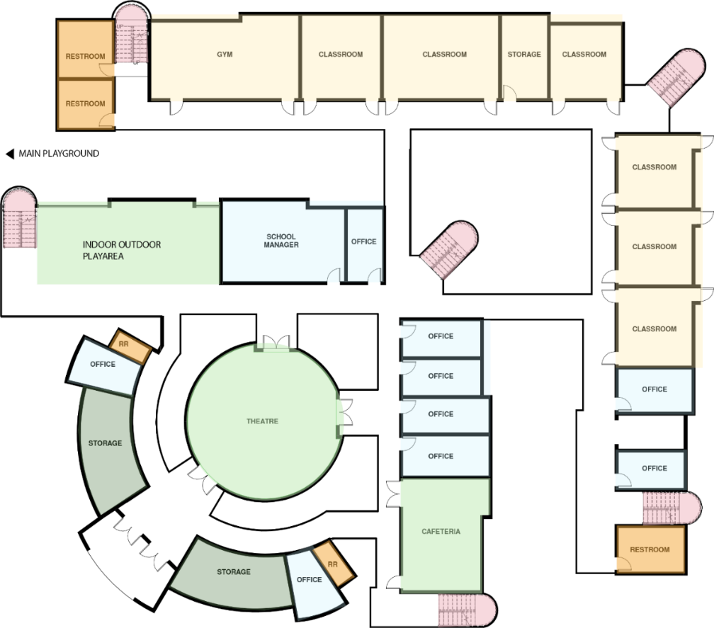
A
Gym
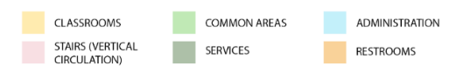
Figure 19. Egyptian Japanese School Zoning – 1st Floor (Digitally Drawn By: Author)

The offices, services and administration spaces are concentrated in the inner/smaller L-shape. The theatre is centralized near the school’s main entrance with easy access to visitors in case of having any events without having to deal with cross-circulation between the public and private zone of the classrooms. See Figure 19-A.
For the second floor, the classrooms clustering is repeated with the same Linear L-shape. However, the three classrooms are segregated and located at the inner L-shape instead of the outer wings. The school has 6 stairs as the only vertical circulation elements; however, it doesn’t include any elevators. See Figure 20. The resources room is located towards the end of the western wing corridor. See Figure 20- A.
A

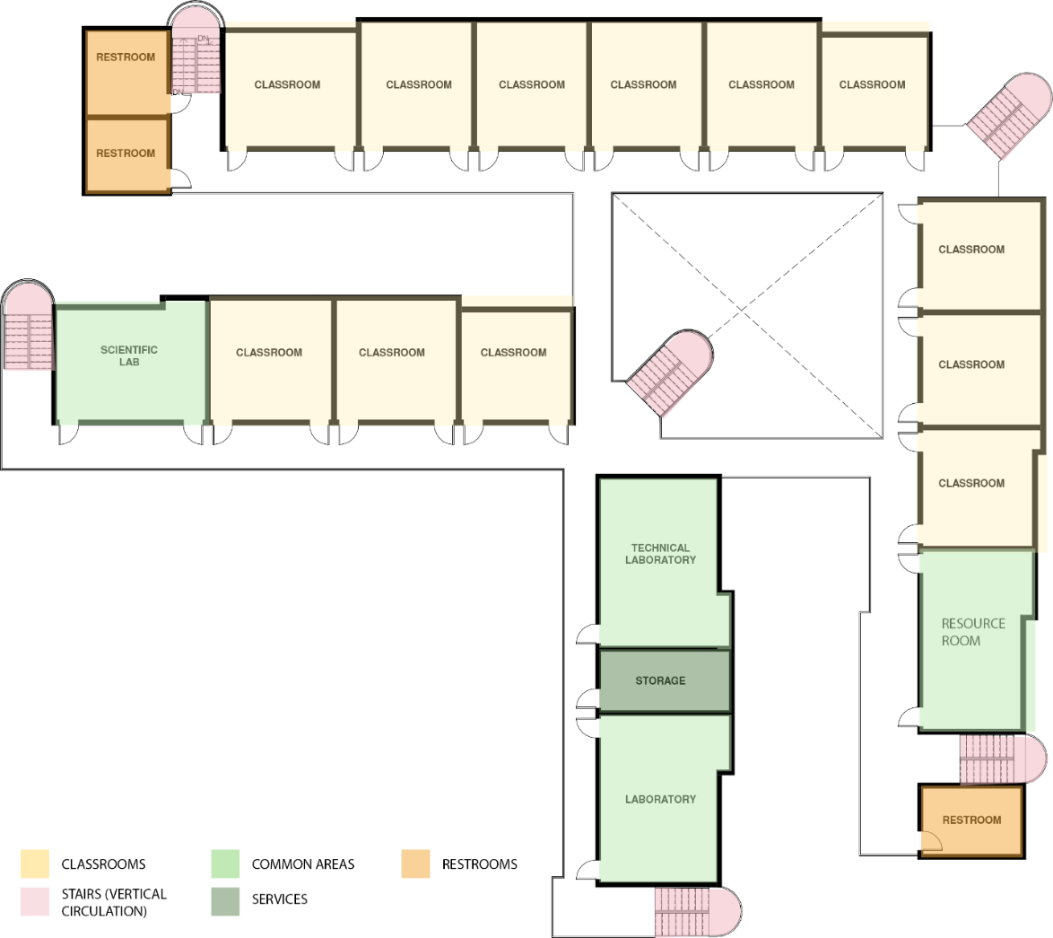
Figure 20. Egyptian Japanese School Zoning – 2nd Floor (Digitally Drawn By: Author)

Exits / Access to Outdoors. The Egyptian Japanese School had multiple exits that leads to either the bigger main playground or the smaller courts embedded within the school’s four main wings. Small stairs of 3 risers lead from the main level of the school into the outdoor street/playgrounds level. The total number of exits is 11 exits. 3 exits lead directly from the classrooms wings to the outdoor spaces, see Figures 21-A, 22, 3 exits included within the indoor-outdoor flex space, see Figure 21-B, 1 exit is located at the end of the corridor nearest to the main entrance, see Figure 21- C, and the main entrance/exit of the school, see Figure 21- D. Lastly, three classrooms at the 1st floor have direct access to a safe outdoor play area. See Figure 21-E.
PLAYGROUND
B
B
E
E
E
C
D
B
A
A
A
Figure 21. EJS Exits (Digitally Drawn By: Author)
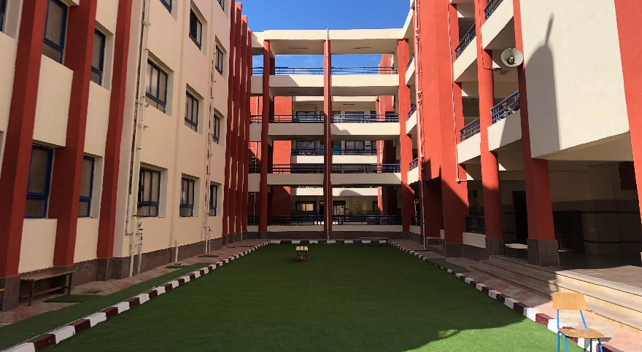
Figure 22. Exit leading to inner school court (By: Author)
Restrooms. The restrooms are located both on the first main level and the typical floors at the far end corners of the larger L-shape wings. See Figures 23, 24. The choice of that location for the restrooms can maximize the travel distance for some classrooms over the others. The restrooms at the northern wing are placed at the closest point to the playground to be at the closest distance for use during break times. See Figure 23-A.
A
A
Figure 23. EJS Restrooms location at the northern wing (Digitally Drawn By: Author)
Figure 24. EJS Restrooms location at the western wing (Digitally Drawn By: Author)

Corridors / Flexible Learning Spaces / Observation Points. EJS corridors are approximately 6 ft wide. This width provides room for smooth circulation from and to the classrooms. No flexible learning spaces were provided, which means all learning activities are conducted within the classrooms or in the outdoor areas. No observation points are designed on purpose for the ASD children to disconnect and observe the environment from them as a safe place.

Natural (Passive) Surveillance and Visibility
Visual Connectivity. The areas that have the highest visual connectivity values were the indoor-outdoor flex area and central corridors intersection points with values of approximately 2000 connection points. See Figures 25-A, 26-A.
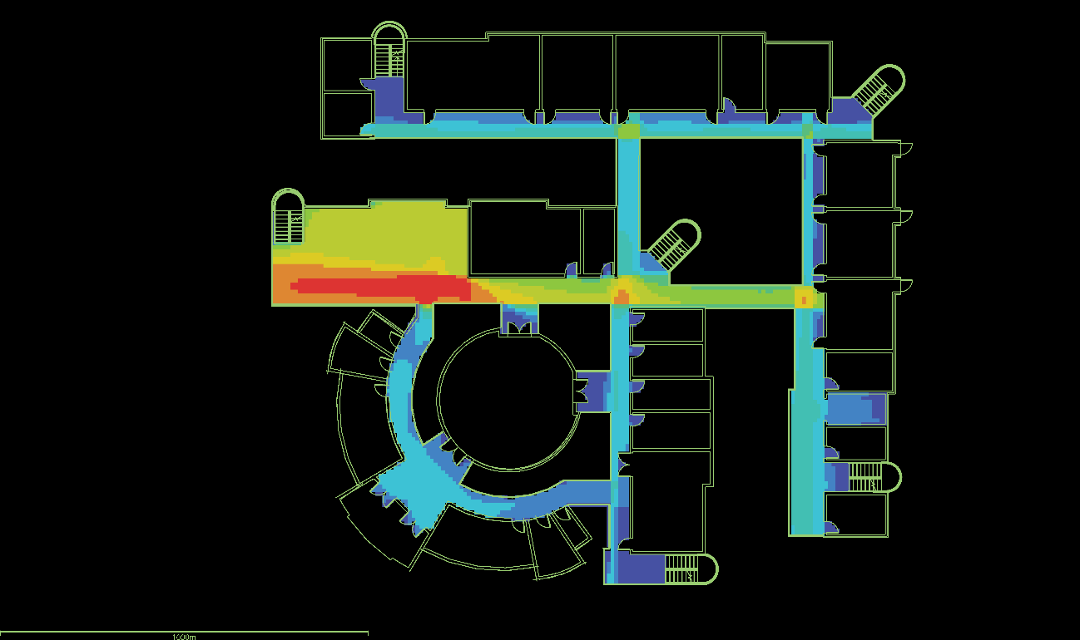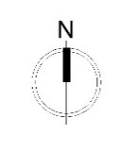
A
B
B
B
B
LOW  HIGH
Figure 25. EJS 1st Floor Inter-visibility graph (By: Author)
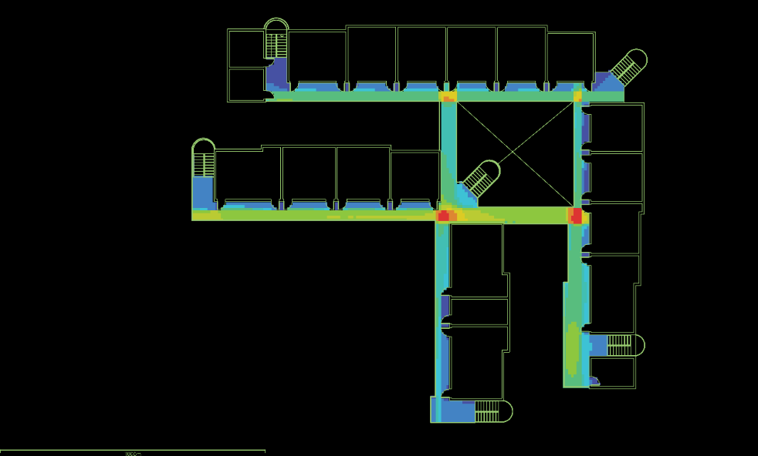
B
B
A
B
B
B
LOW HIGH
Figure 26. EJS Typical Floor Inter-visibility graph (By: Author)
Blind Spots. The locations with the lowest visual connectivity values were the stairs and restrooms at the building’s periphery that are located at the outer northern and western wings with values of approximately 150 connection points. See Figures 25-B, 26-B, 27.

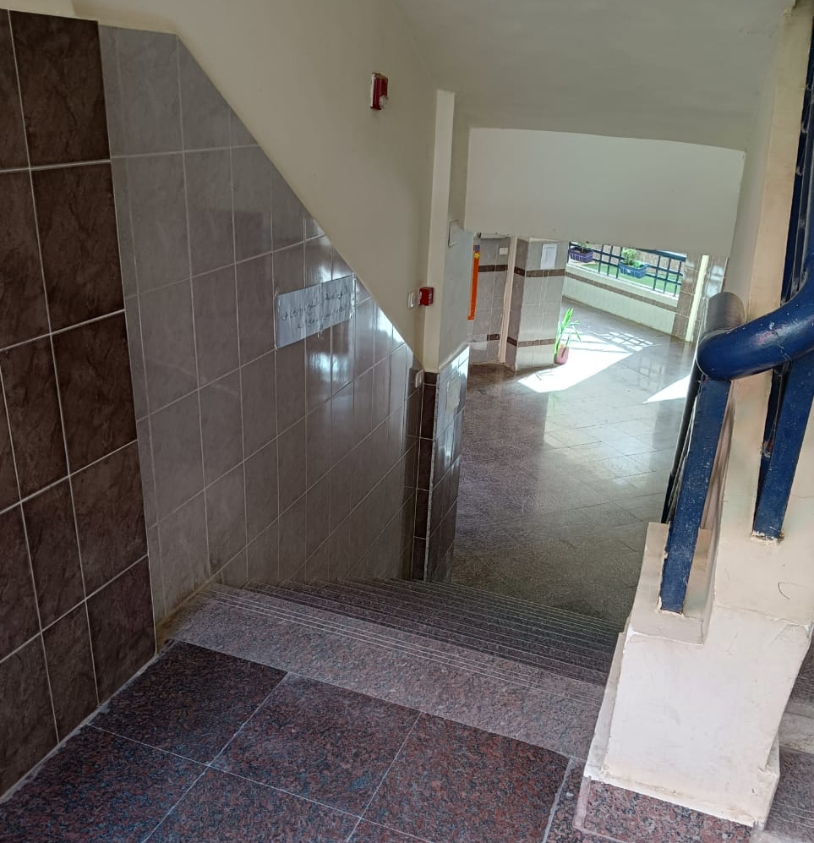
Figure 27. EJS vertical circulation stairs (By: Author)
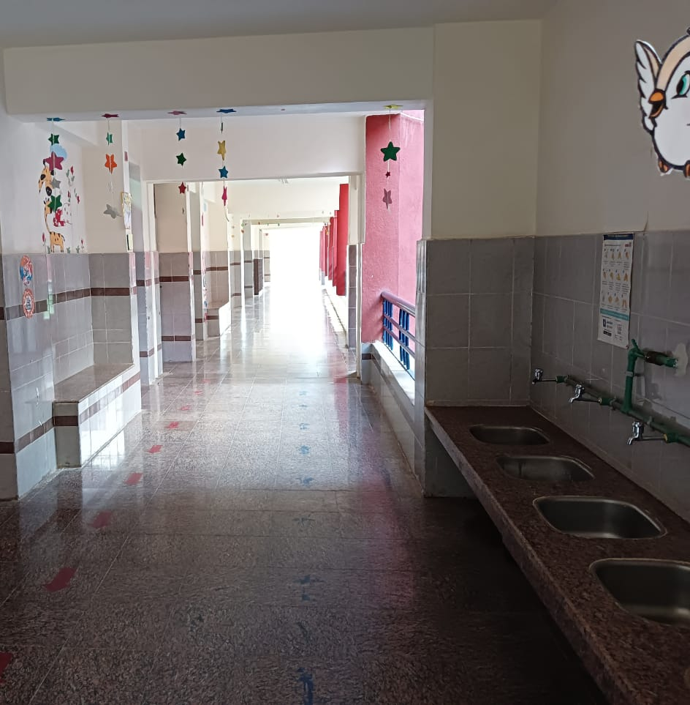
Figure 28. EJS main circulation corridors (By: Author)
However, on the other side, EJS school design include drinking fountains that are well seen from different angles in the school’s main corridors that are of a high connectivity and visibility ratios which consequently plays an important role in enhancing the natural surveillance. See Figure 28.
Fenestration. EJS corridors are all open to outdoors wither overlooking the inner courts or open to the bigger main playground. This brings a sufficient amount of daylight light to the corridor and supposedly the interior of the classroom. See Figures 29. However, the chosen material for the windows is a frosted plastic layer that was chosen for the safety of students in case of fracture. See Figure 30. Another aspect that was observed is the minimal window to wall ratio (WWR). The WWR in EJS ranges from 25% to 40%.
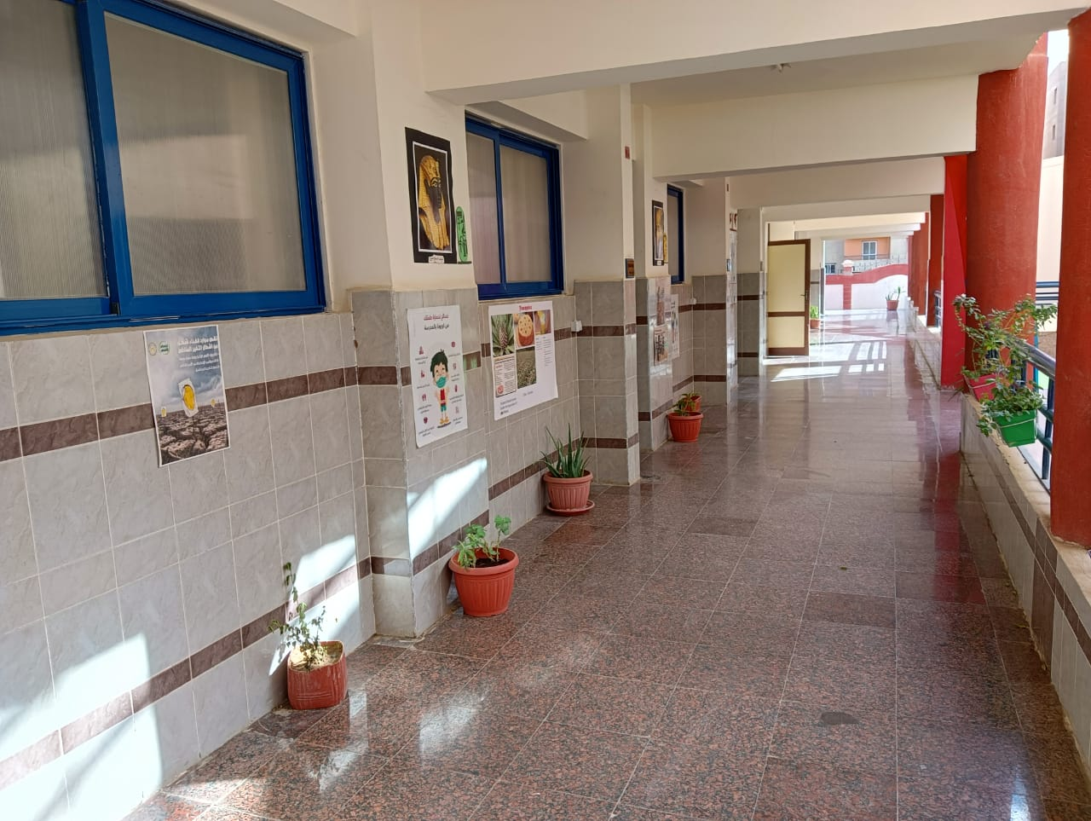
Figure 29. EJS Classrooms Corridor
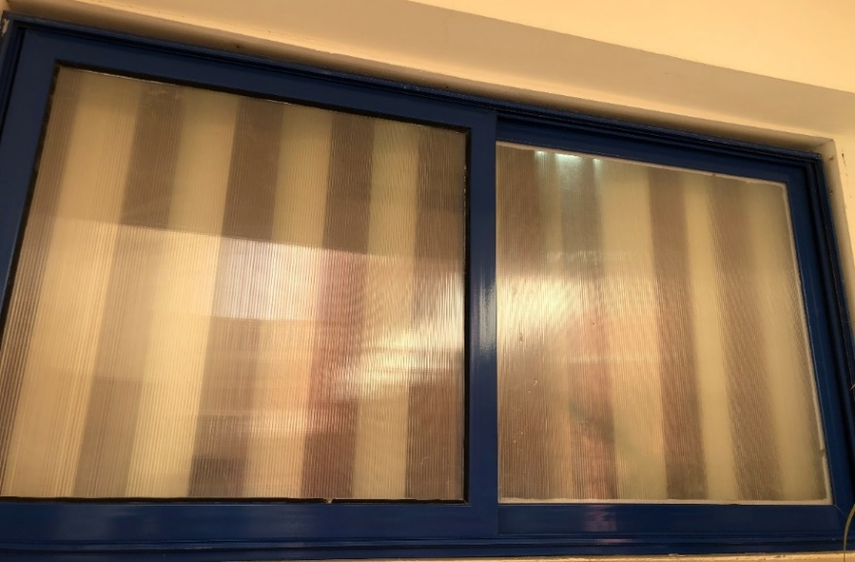
Figure 30. EJS Classrooms windows overlooking main circulation corridors
Layout Configuration. The Egyptian Japanese school layout is composed of two L-shaped wings with linear spaces’ organization and an attached zone for services, theatre, and administration with radian spaces’ organization. The layout configuration provides sufficient natural surveillance to the inner courts (A) surrounded by the L-shaped wings. However, the larger main playground (B) is only surrounded by the school building from one side which can affect the level of natural surveillance of students during their break times. The athletic field (C) is completely segregated from the school building and separated by the main playground in between. This makes it unaffected by the layout configuration of the building and not subject to any natural surveillance provided by proximity to the school building, where teachers are constantly present. The premises of the school is completely fenced. See Figure 31.
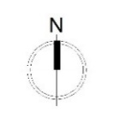
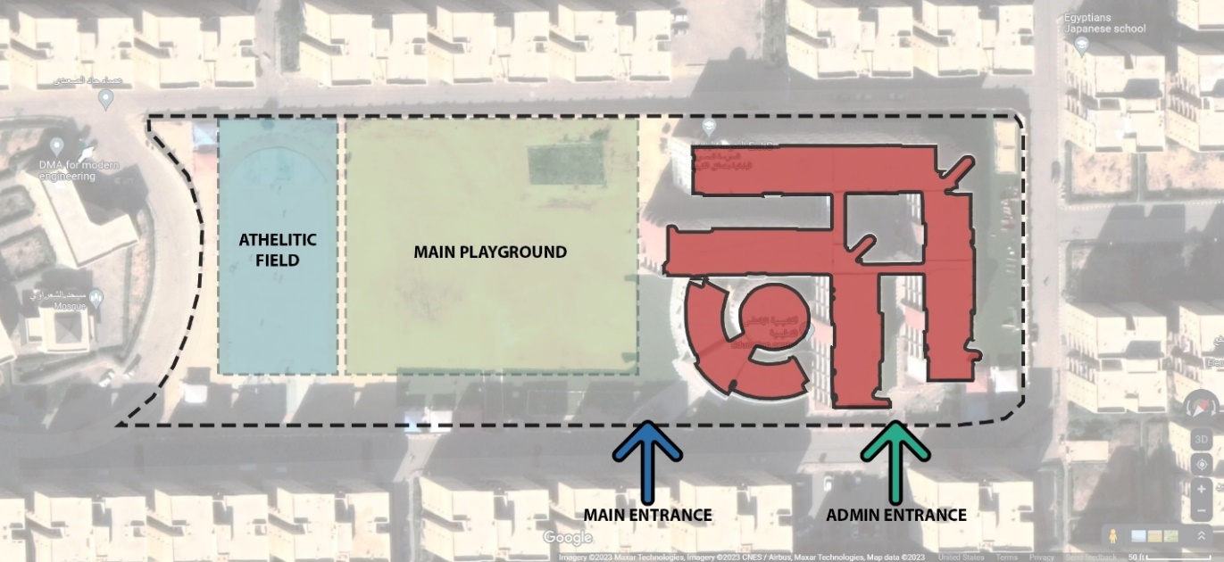
A
A
A
B
C
Figure 31. EJS Simplified Site / Building Layout (By: Author)

Space Organization & Wayfinding
Spaces’ Integration. DepthmapX was used to analyze the integration values of the spaces in the Egyptian Japanese School. The Integration Graph Analysis represents the shortness of distance of each space to get to the rest of spaces in the system. As shown in Figure 32, The Central corridor (A) has the highest integration value and can get to the rest of spaces through the shortest distances. However, the main entrance lobby (B) and the stairs’ cores (C) showed moderate integration values. No spaces resulted in low integration values.
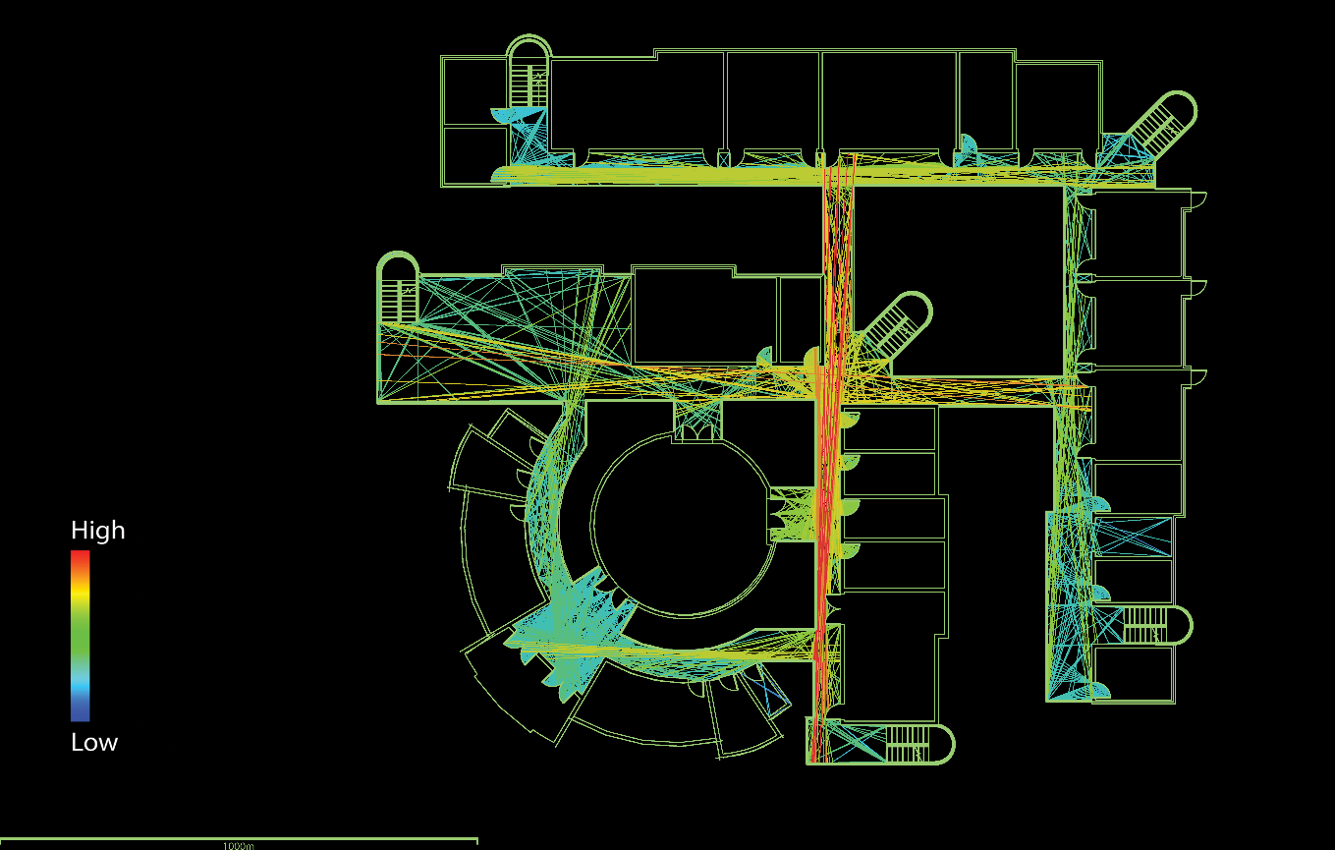
B
C
C
A
C
C
Figure 32. EJS Typical Floor Integration Graph Analysis (By: Author)

However, it was observed that the typical floors of the Egyptian Japanese school are to navigate due to the high integration values evenly throughout all the corridors. As shown in Figure 33, The central corridor has the highest integration values (A), followed by the eastern corridor (B). Yet, the stairs concealed pocket spaces (B) have the lowest relative integration values according to the analysis.

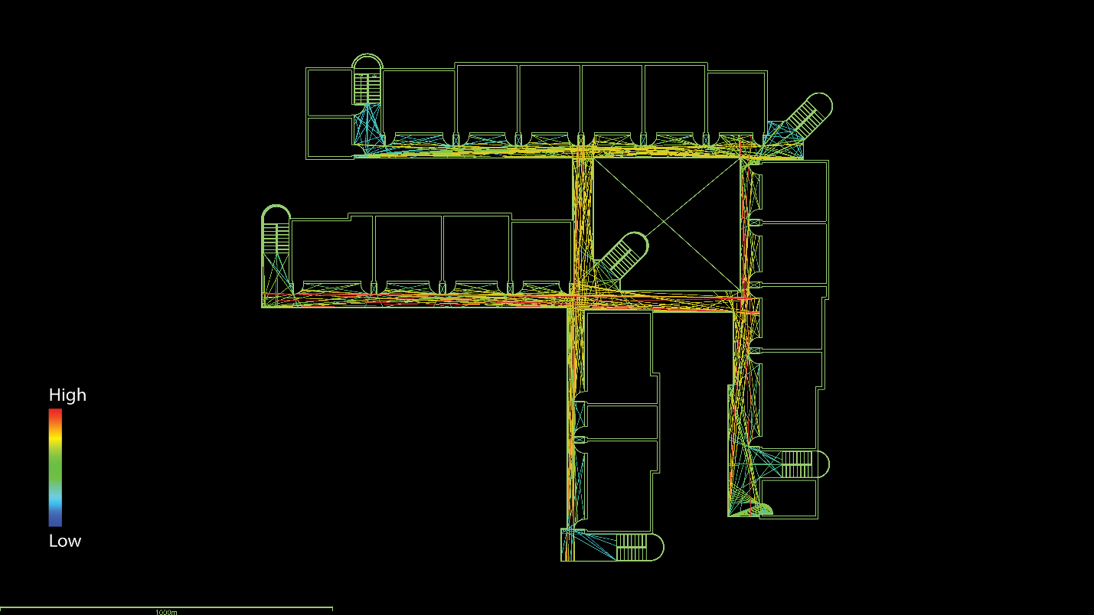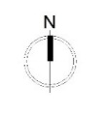
A
CB
A
C
B
C
B
C
Figure 33. EJS Typical Floor Integration Graph Analysis (By: Author)

Step Depth. To understand the step-depth within the layout of the Egyptian Japanese school graphical representation of the building layout for the first main floor and the typical floor were visualized, as shown in Figures 34 and 36, and the step-depth analysis was conducted on them. The analysis showed that all spaces within the school have a value of one step depth, as shown in Figures 35 and 37.

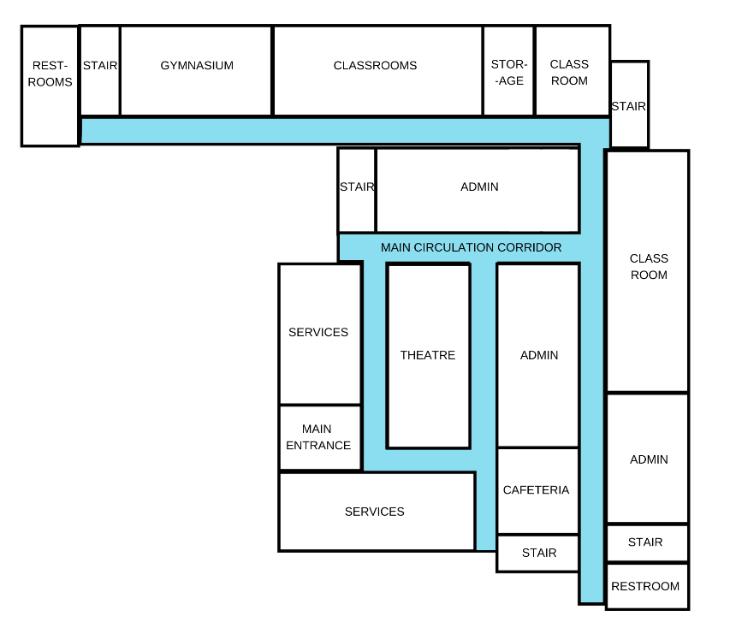
Figure 34. Egyptian Japanese School Building Layout Graphical Representation – 1st Floor (By: Author)

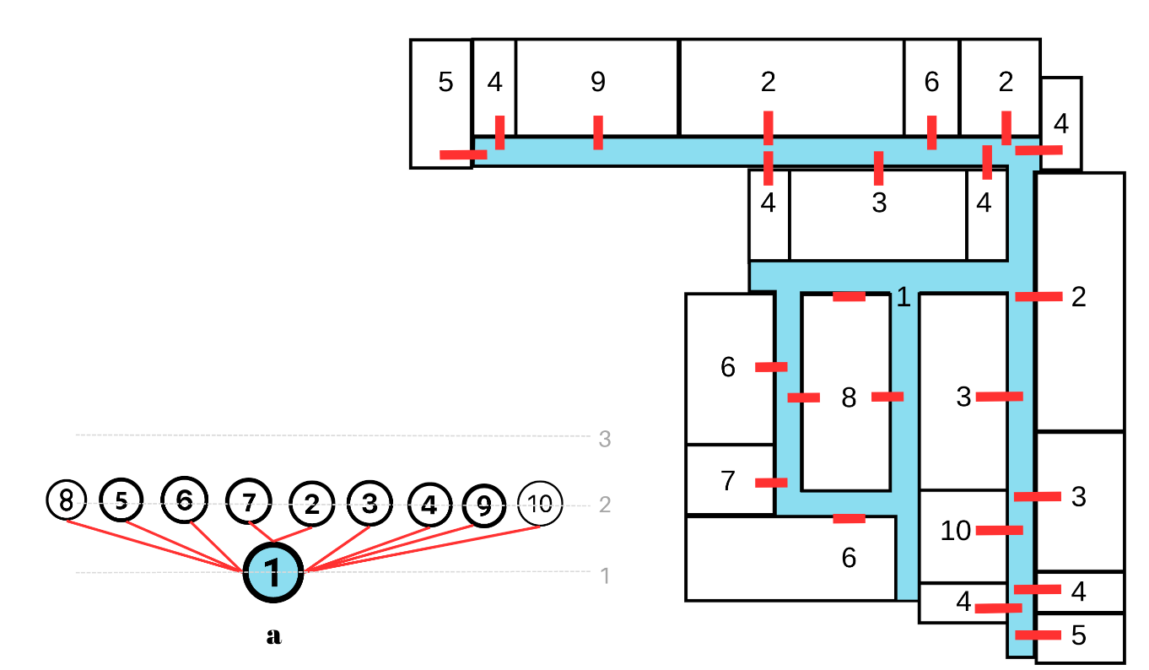
Figure 35. EJS Justified Graph – 1st Floor. Relationships to main corridors from (a) corridor #1 (By: Author)
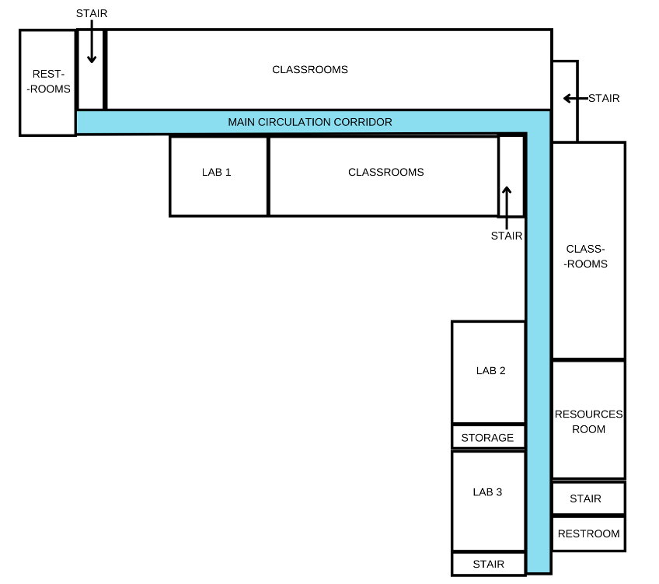
Figure 36. Egyptian Japanese School Building Layout Graphical Representation – Typical Floor (By: Author)

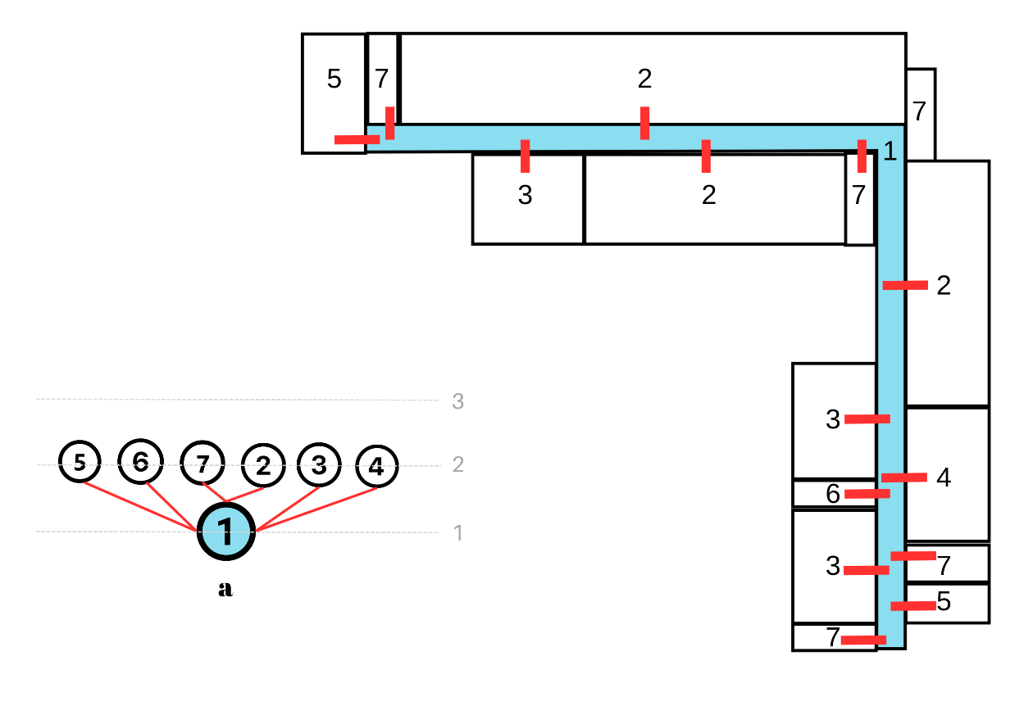
Figure 37. EJS Justified Graph – Typical Floor. Relationships to main corridors from (a) corridor #1 (By: Author)
Permeability. For the first-floor plan of EJS, four points were chosen to assess the visual access using DepthmapX’s ISOVIST graph analysis. Point (1) is located at the main entrance corridor, point (2) is located at the central intersection where the major corridors meet, point (3) is located at the far western end of the northern corridor, and point (4) is located at the far southern end of the eastern corridor. As shown in Figure 38, the permeability of point (1) is very minimal due to the curvilinear organization of spaces, which means it has minimal visual and physical access to the rest of the school spaces. However, the permeability of point (2) is higher and gets to observe more spaces from one standing point, which provides more sense of place, access, and information about the areas beyond. Points (3) & (4) have very close permeability values due to their similar linear configuration.
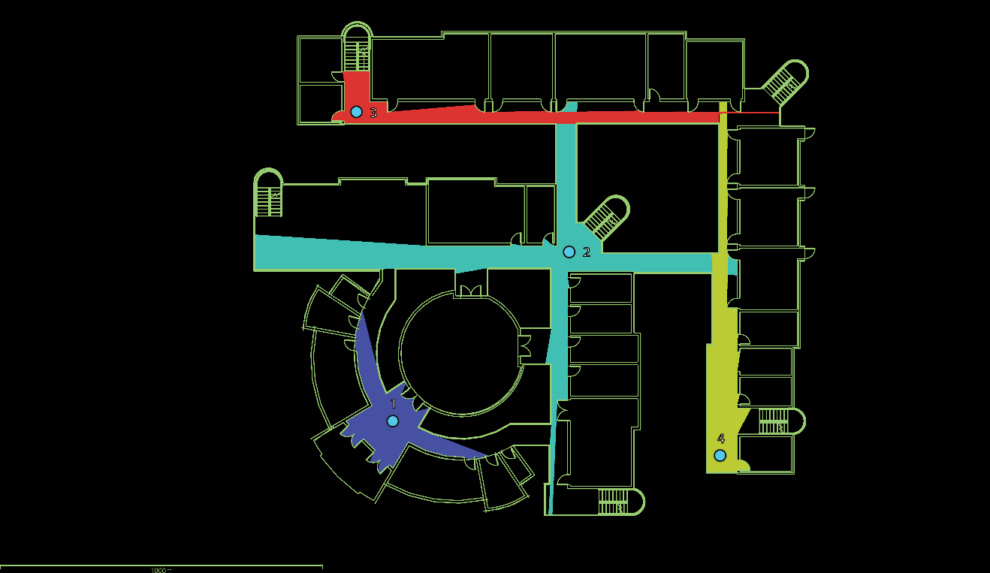
Figure 38. EJS 1st Floor ISOVIST Graph Analysis (Digitally Drawn By: Author)
For the typical floor plan of EJS, three points were chosen to conduct the ISOVIST graph analysis. Point (1) is at the central intersection, point (2) is at the far western end of the northern corridor, and point (3) is located at the far southern end of the eastern corridor. As shown in Figure 39, the permeability of the points is very similar to the analysis of the first floor. The linear configuration of the L-shaped wings provides high permeability values and accordingly an eased wayfinding within the building layout.
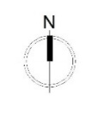
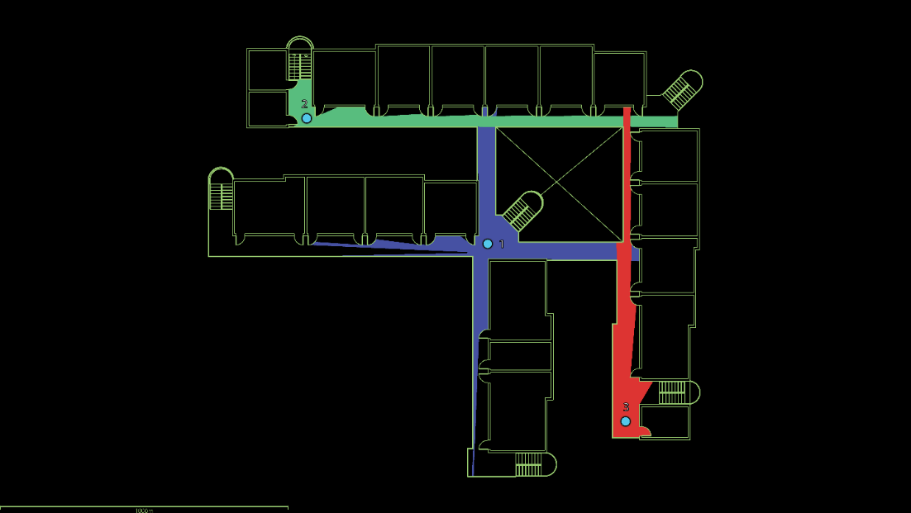
Figure 39. EJS Typical Floor ISOVIST Graph Analysis (Digitally Drawn By: Author)
The lengths of the circulation corridors are 65 feet and 78 feet for the inner L-shaped wing and for the outer L-shaped wing, the lengths are 95 feet and 112 feet long.
Color Coding. The Egyptian Japanese School doesn’t include any color-coding criteria in its design to differentiate between the distinct zones of the project.

Case Study (2): Browns Point Elementary School

School Zoning and Space Planning
Zoning and Classrooms’ Clustering. On the school’s first floor, the classrooms are clustered in a Linear configuration. Six classes are grouped at the northern leg and three of them are located at the southern. The administration has its own zone adjacent to the northern classes. The services are divided into a private part located south of the building and a public part in the central area to serve the classrooms. Two stairs are located at the center of the building and two are located outside at the far eastern ends of the northern and the southern corridors. The theatre and the common areas are located at the center of the building. Flex areas for a more flexible learning space are located in front of the classrooms. See Figure 40. The resources room, with a pocket restroom inside, is located at the southern leg as highlighted in Figure 40-A.
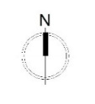
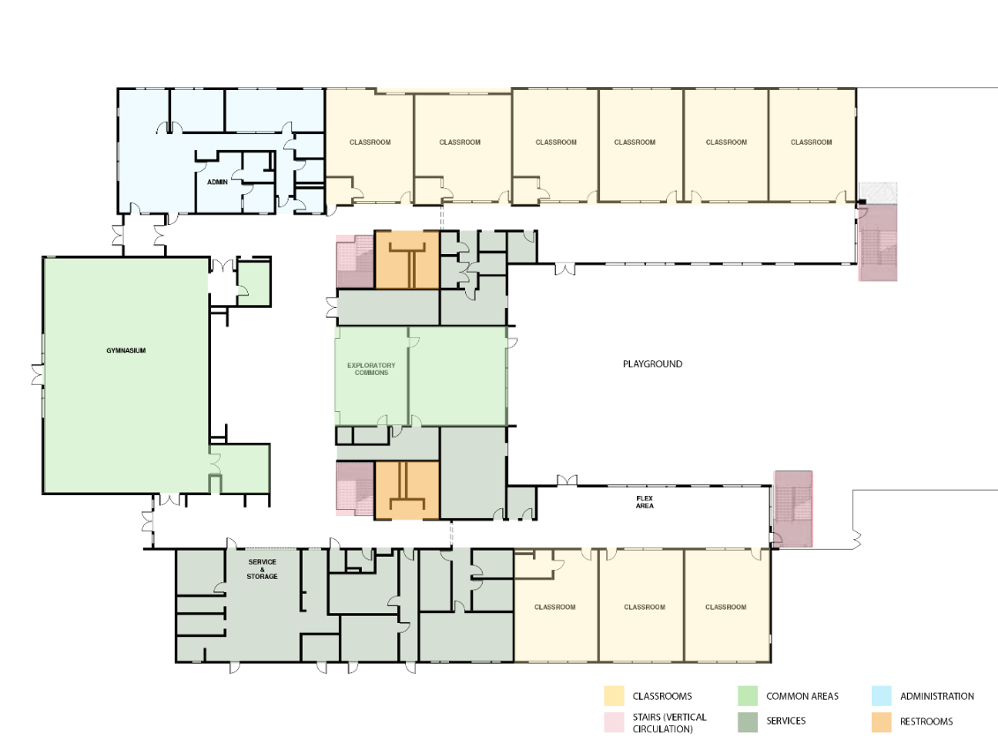
A
Figure 40. Browns Point Elementary School Zoning – 1st Floor (Design Credit: TCF Architecture / Drawn By: Author)
On the school’s second floor, the classrooms also populate the two northern and southern legs of the floor plan, however the lower leg has seven classrooms instead of the three on the first floor. The library substitutes the administration location on the second floor. While, the rest of spaces, including private and public services, and the stairs are located at the same locations as the first floor. Flex learning spaces are also located at the main corridors in front of the classrooms of the northern and southern wings of the building’s second floor. See Figure 41.
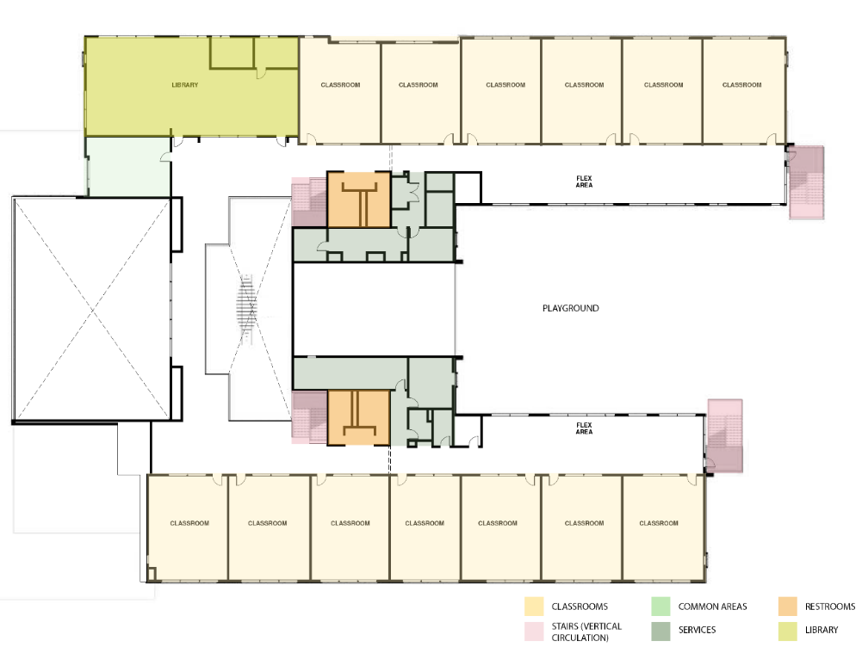
Figure 41. Browns Point Elementary School Zoning – 2nd Floor (Design Credit: TCF Architecture / Drawn By: Author)
Exits / Access to Outdoors. The school has four exits that lead to the outdoors. Exists (A) are at the main entrances of the building and exits (B) at the other end of the building leading to the outdoor the play area toward the east. See Figures 42, 43.
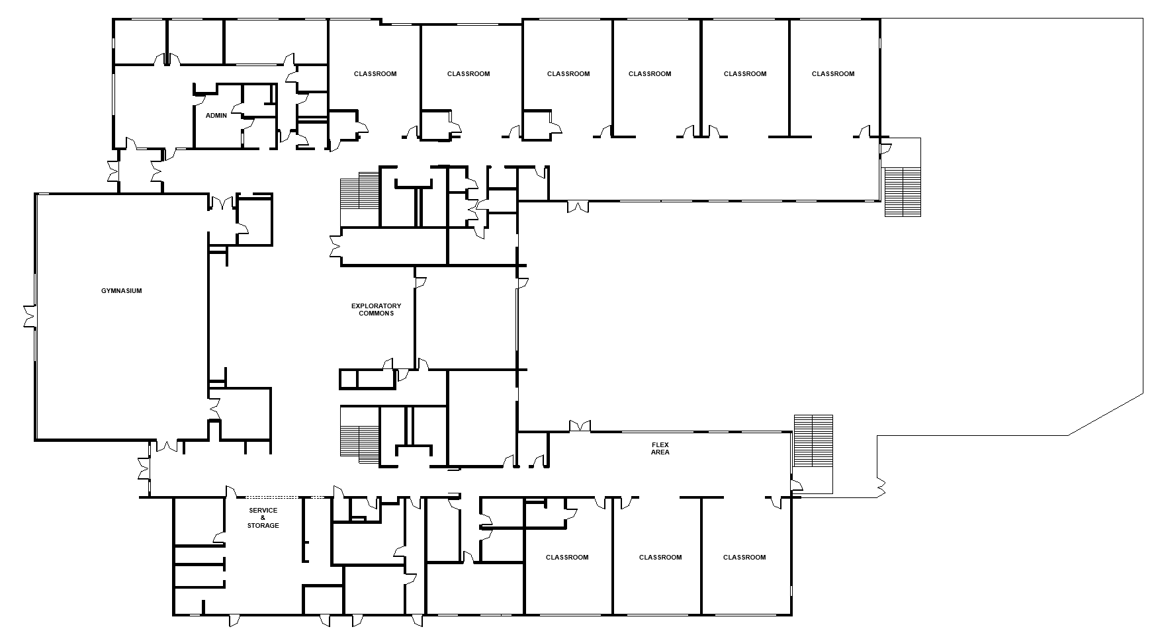
B
B
A
A
Figure 42. Browns Points Exits to the outdoors (Design Credit: TCF Architecture / Drawn By: Author)

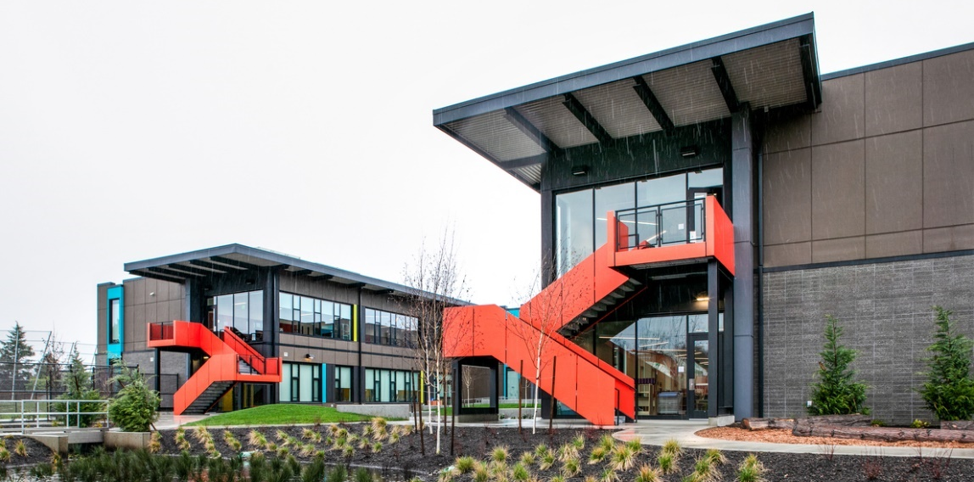
Figure 43. Exit B towards the outdoor play area (Photo credit: Eckert and Eckert Photography©)
Restrooms. The restrooms are centrally located at the core of the building both on the first and second floors. Two restrooms are provided, one closer to the northern leg and another located closer to the southern leg. See Figure 44-A. Faucets are attached to the restrooms however they are located next to their entrance while facing the corridors. See Figure 44-B.
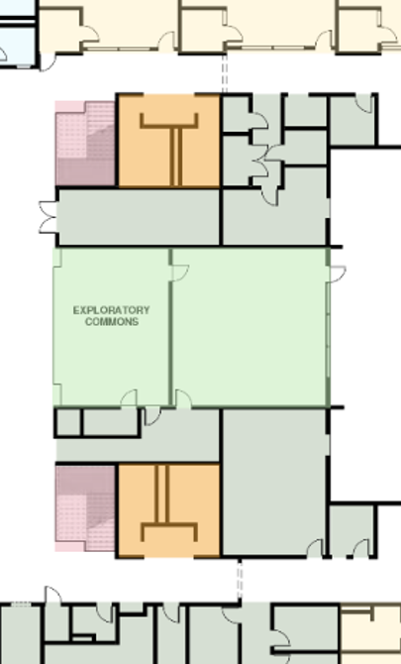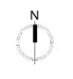
B
B
A
A
Figure 44. Restrooms’ locations (Design Credit: TCF Architecture / Drawn By: Author)
Observation Points. The school’s design utilizes the area beneath the central stair’s flights to create those enclosed spaces that are semi-detached from the core common area, yet they are still connected to it. See Figure 45 (A-B) & 46 (A-B).
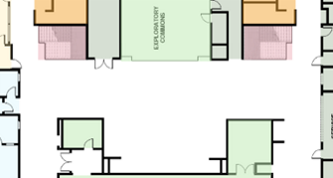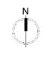
A
B
Figure 45. Observation points locations under the stairs’ flights (Design Credit: TCF Architecture / Drawn By: Author)
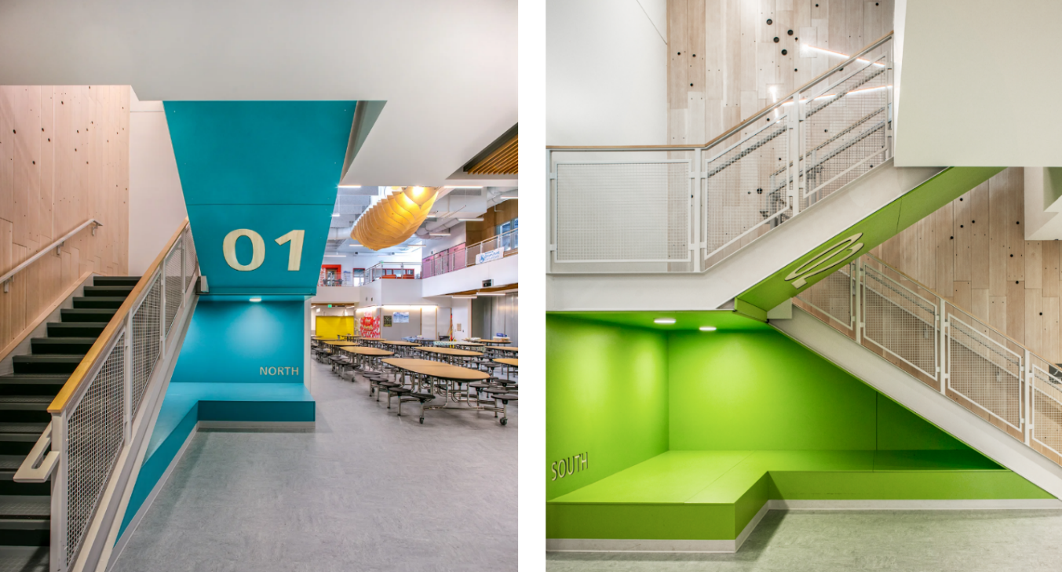
A
B
Figure 46. Observation Points under the Stairs Flights (Photo Credit: Eckert and Eckert Photography©)

Corridors / Flexible Learning Spaces. The corridors at BPS are wide, ranging from 7 feet at the narrowest areas to 17 feet at the widest locations. These wide widths provide plenty of space that is utilized as flexible learning spaces outside the classroom. Vibrant flooring colors are utilized to differentiate between the circulation and learning zones. See Figure 47-A.
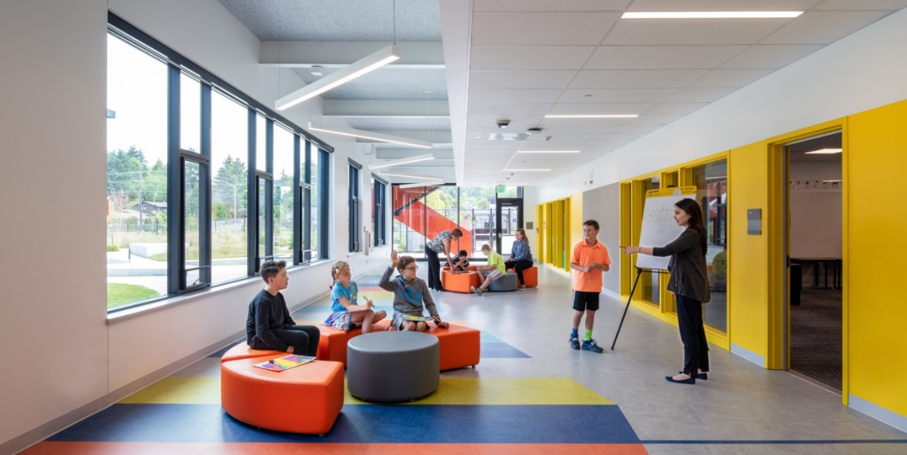
A
Figure 47. Flexible Learning Areas (Photo credit: LightCatcher Imagery©)

Natural (Passive) Surveillance and Visibility
Visual Connectivity. For the school’s first floor, the areas that have the highest visual connectivity values were the intersection of the northern and southern circulation corridors with the central common area (A), the common area itself (B), and the northern corridor (C). The connectivity values’ averages of these locations are 675, 547, and 527 respectively. See Figure 48.

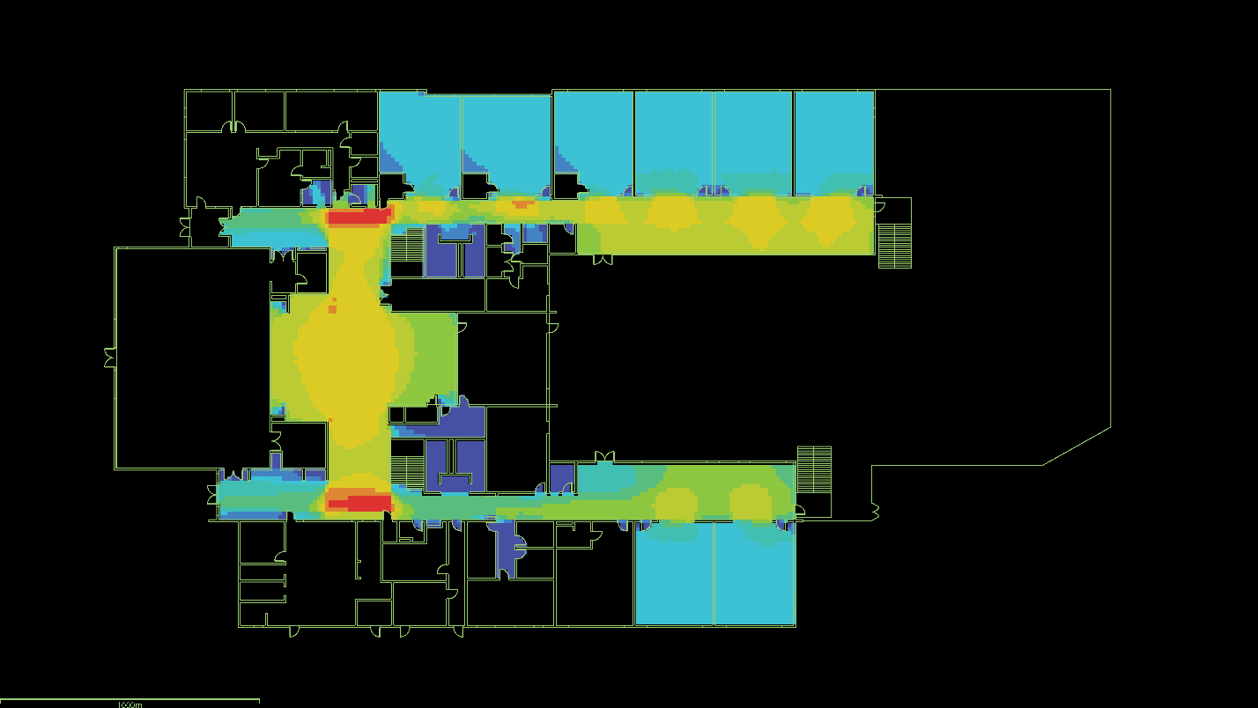
C
B
A
A
LOW HIGH
Figure 48. BPS 1st Floor Visibility Graph Analysis (By: Author)

However, for the second level the connectivity values duplicate. The Intersection of the main corridors with the central area remains the highest location of visual connectivity between spaces with an average value of 2550 (A), the central area follows to be the second highest with an average value of 1900 (B), and the northern corridor’s average visual connectivity value is 1000 (C). See Figure 49.
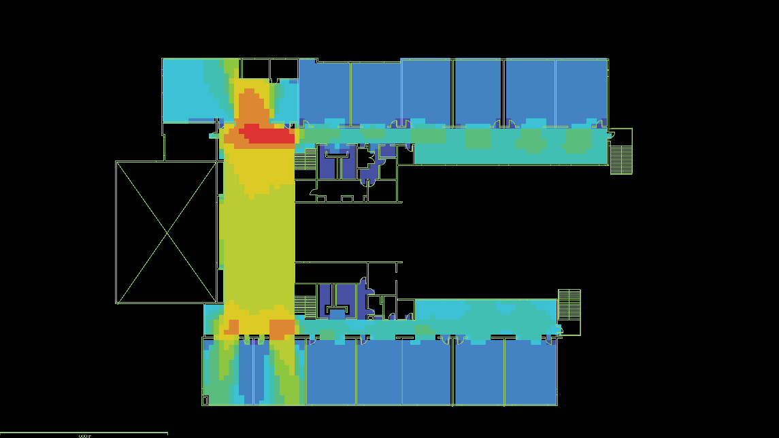
A
A
B
C
LOW HIGH
Figure 49. BPS 2nd Floor Visibility Graph Analysis (By: Author)
Blind Spots. According to deathcamps analysis, BPS has no blind spots that are constantly hard to be seen with very low visual connectivity values, The lowest visual connectivity values are in the restrooms as they are concealed spaces. The restrooms are designed to not have an actual door is completely capable of closing the space. See Figure 50-A. The faucets are also taken out and placed outside to minimize the need to go into the concealed boundary of the restrooms and maximize the visibility and monitoring of the students. See Figure 50-B.
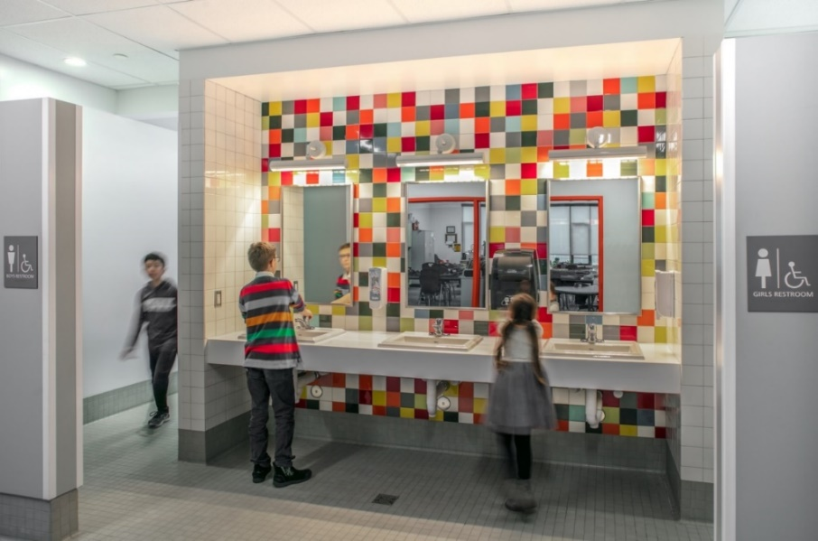
B
A
Figure 50. External faucets at the restrooms’ entrances (Photo credit: Eckert and Eckert Photography©)
The classrooms follow with a visual connectivity value average of 410, despite that this value is relatively low compared to the other spaces in the floor plan, it is still considered a high value of visual connectivity.
Fenestration. The classrooms have floor to ceiling windows with a window to wall ration that ranges from 65-80%. These huge windows supported the high visual connectivity values the space offers. See Figure 51-A. This high transparency of the space is also controllable by providing curtains that can be used to provide visual privacy whenever needed. See Figure 51-B. The visual connection between the outdoor flexible learning spaces that are included in the wide corridors and the interior of the classroom is also well established through the large windows. See Figure 51-C. The design was not only limited to incorporating large windows, but the door also had a large window panel that also maximizes the visual connectivity of the classrooms and the surrounding areas. See Figure 51-D.
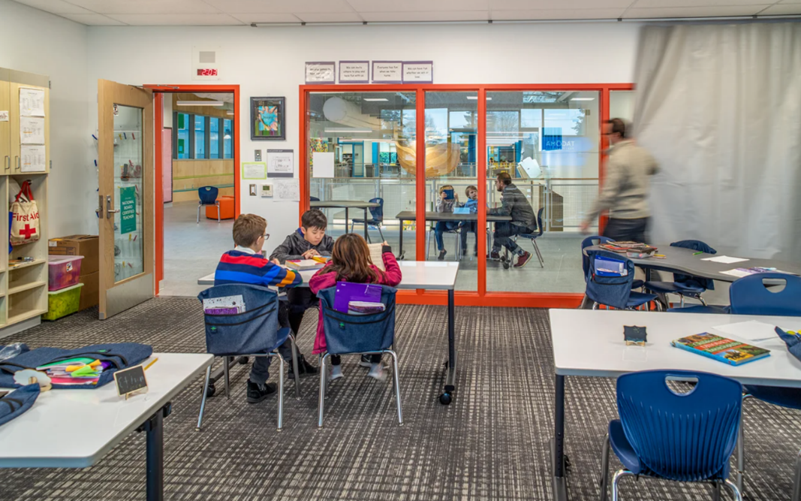
B
D
C
A
Figure 51. Browns Point Elementary School Classrooms (Photo credit: Eckert and Eckert Photography©)
Layout Configuration. The layout of Browns Point elementary school is U-shaped with linear organization of spaces. This layout configuration provides partially sufficient natural surveillance for the outer main playground since around 50% of playground premises is surrounded by the school building. See Figures 52-A, 53. The main playground of the school is completely fenced. The athletic field is segregated and doesn’t have a direct connection to the school building. See Figure 52-B.
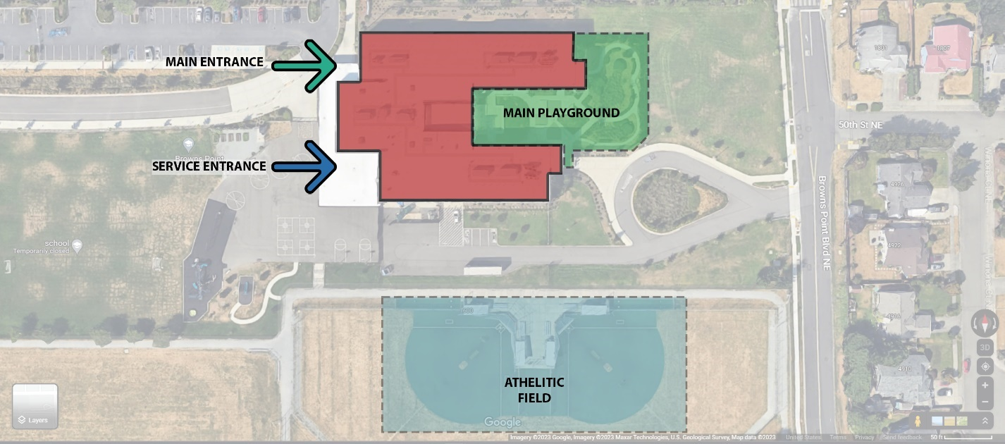
B
A
Figure 52. BPS Simplified Site / Building Layout (Source: Google / Visual Analysis by: Author)
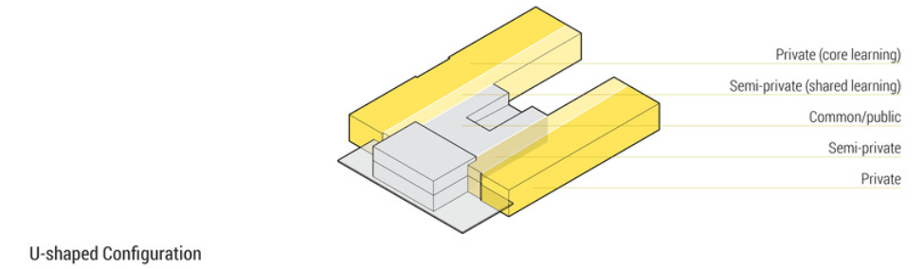
Figure 53. BPS U-shaped Configuration Diagram (Source: Browns Point Elementary School / TCF Architecture, (2022). Archdaily)

Space Organization & Wayfinding
Spaces’ Integration. On the first floor, the northern central common area has the highest integration value which means it can access several spaces in the system with minimal number of steps / through the shortest distance. See Figure 54-A. The northern corridor follows to have the sevond highest integration values. See Figure 54-B. Then the southern corridor has moderate integartion value, See Figure 54-C, followed by the classrooms. No spaces resulted in low integration values.
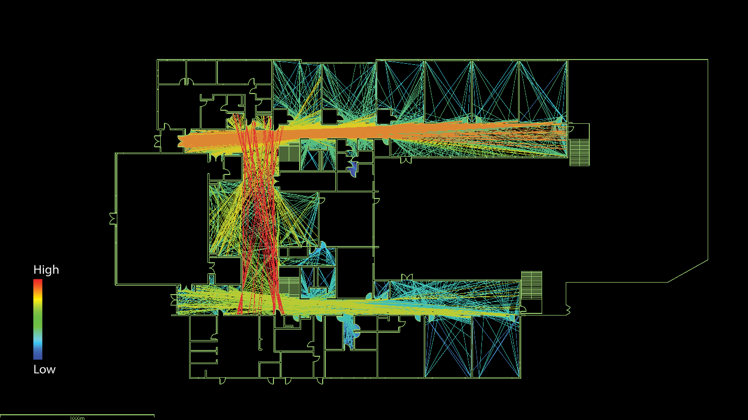
C
B
A
Figure 54. BPS 1st Floor Integration Graph Analysis (By: Author)
On the other hand, the integration values are considerably higher on the second floor. The central common area has the highest integration values. See Figure 55-A. The common area directly connects to the library at the northern wing (Figure 55-B), and the two classrooms at the southern wing (Figure 55-C). Hence, it easily connects to the northern and southern. The northern corridor follows as it highly connects the northern wing together (Figure 55-D), starting from the western end (The library), toward the eastern end (The egress stairs).
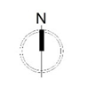
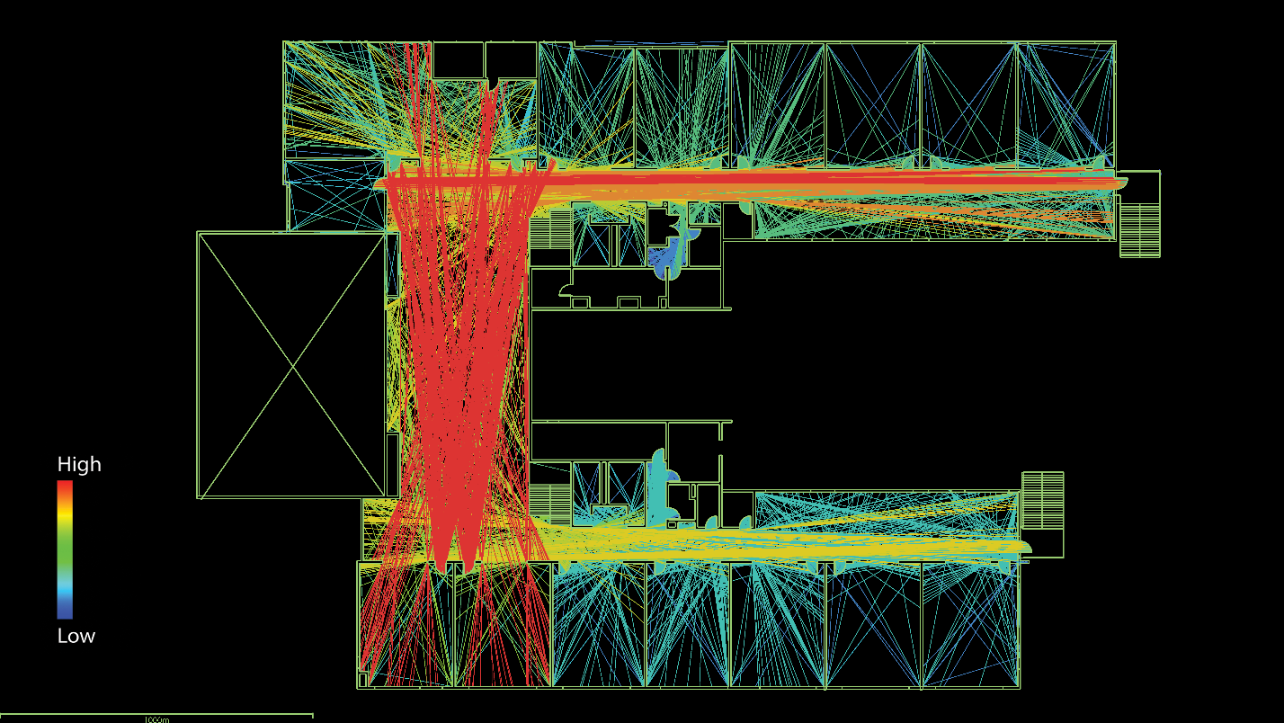
B
C
D
A
Figure 55. BPS 2nd Floor Integration Graph Analysis (By: Author)

Step Depth. To understand the step-depth within the layout of Browns Point Elementary School graphical representation of the building layout for the first main floor and the second floor were visualized, as shown in Figure 56 and 58, and the step-depth analysis was conducted on them. The analysis showed that for the first floor, five spaces have a value of one step depth, three spaces have a step depth value of two, and one space has a step depth value of three. See Figure 57. However, for the school’s second floor, the circulation is simpler as all spaces have a value of one step depth. See Figure 59.
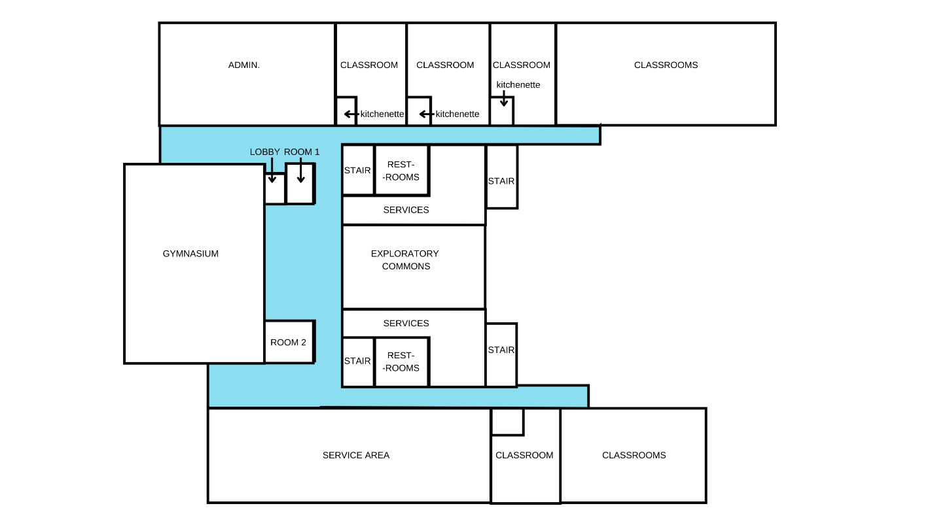
Figure 56. Browns Point Elementary School Building Layout Graphical Representation – 1st Floor (By: Author)

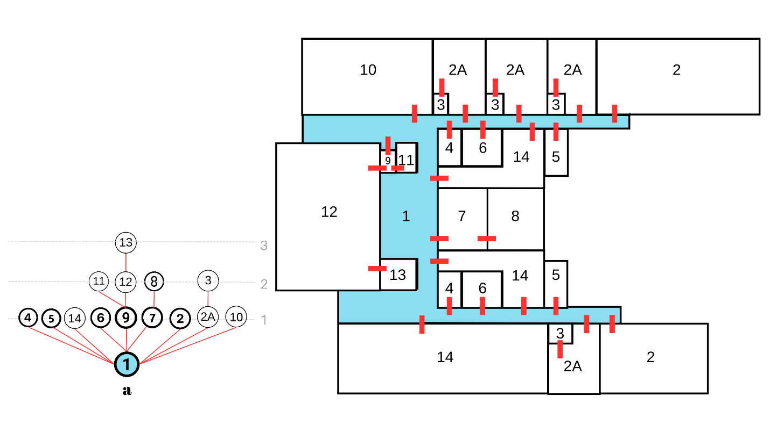
Figure 57. BPS Justified Graph – 1st Floor. Relationships to main corridors from (a) corridor #1 (By: Author)
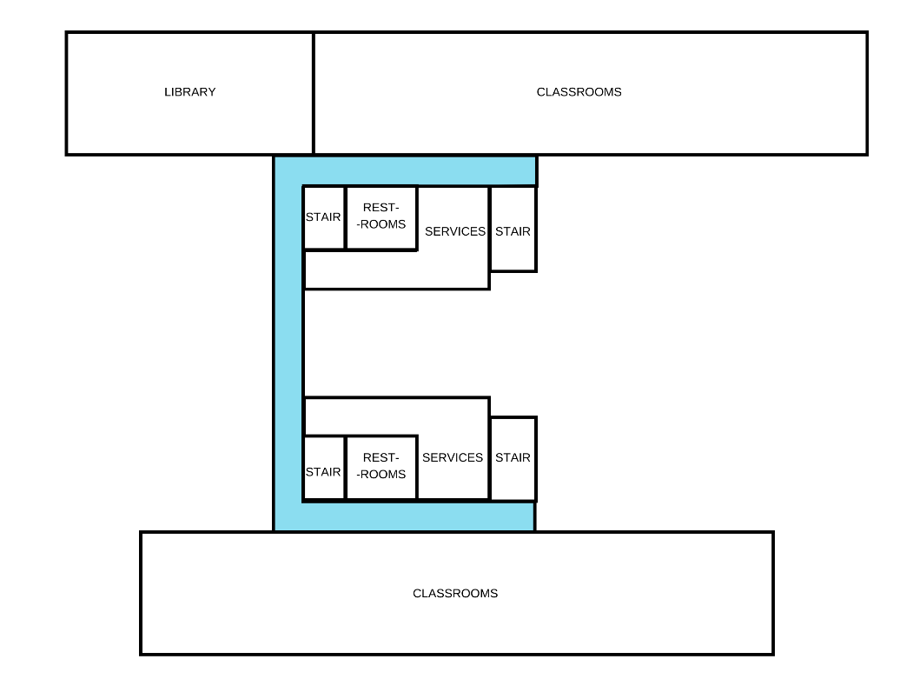
Figure 58. Browns Point Elementary School Building Layout Graphical Representation – 2nd Floor (By: Author)
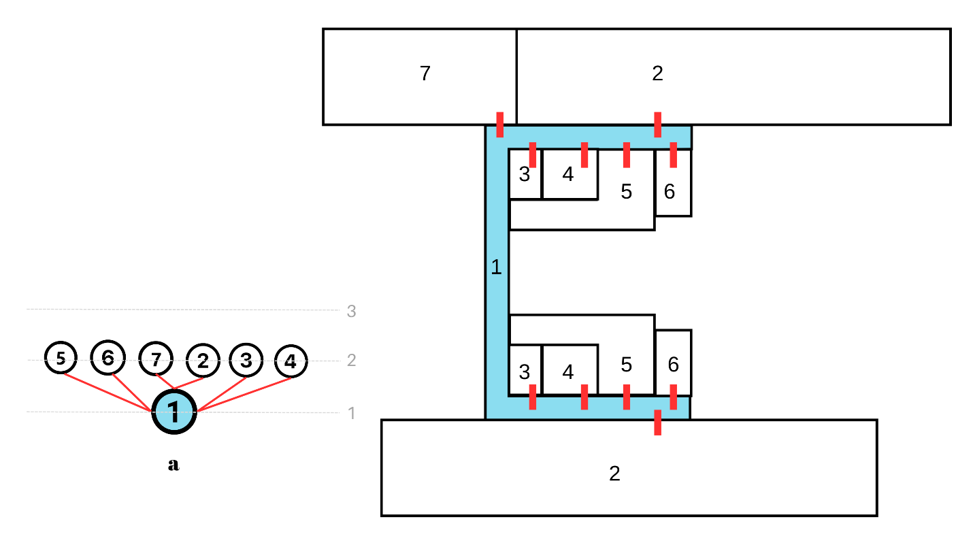
Figure 59. BPS Justified Graph – 2nd Floor. Relationships to main corridors from (a) corridor #1 (By: Author)
Permeability. For the first-floor plan of BPS, three points were chosen to assess the visual access using DepthmapX’s ISOVIST graph analysis. Point (1) is located at the center of the central common area. Point (2) is located at the school’s northern main entrance. Point (3) is located at the southern service’s entrance. As shown in Figure 60, the permeability of point (1) is high and connect to the nodes that resemble the start of the northern and southern circulation corridor. Point (2) and point (3) have high visual access of the whole length of the corridors according to the liner organization of spaces, which means the person navigating these spaces will be able to observe more spaces from that standing point which provides higher sense of place and easy wayfinding.
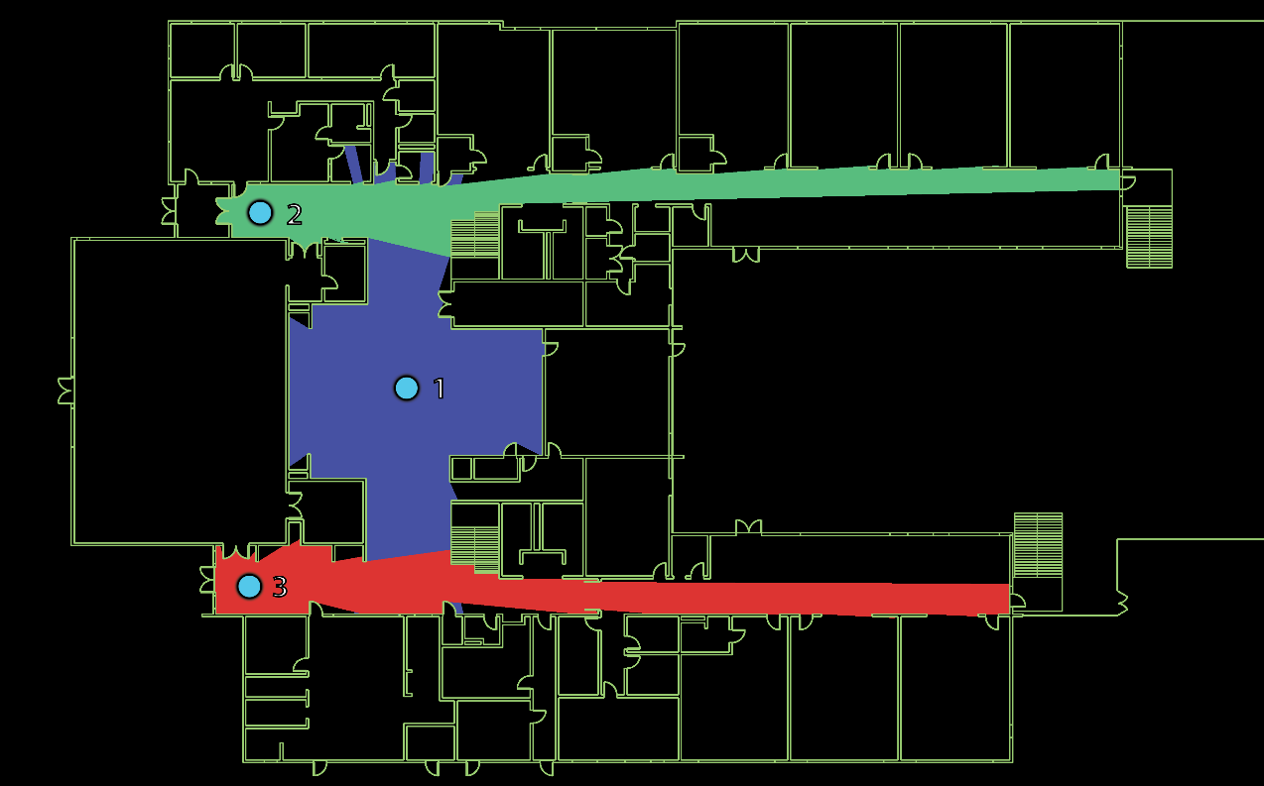

Figure 60. BPS 1st Floor ISOVIST Graph Analysis (By: Author)

For the second-floor plan of BPS, three points were chosen to conduct the ISOVIST graph analysis. Point (1) is the same as the first floor, at the central common area, point (2) is at the far eastern end of the northern corridor, and point (3) is located at the far eastern end of the southern corridor. As shown in Figure 61, the permeability value at point (1) was higher than the first floor as it gets to access more spaces as the library is more open than the private administration located at the first floor’s northern wing, and the classrooms are more open than the private services area located the first floor’s southern wing. Point (2) and point (3) have shown similar results to the first-floor results as both points get an open field of view letting the person standing at these points observe all spaces at their linear configuration without have any angularity or obstacles that blocks the physical access or visual view. This eases and facilitates the wayfinding within the school building.
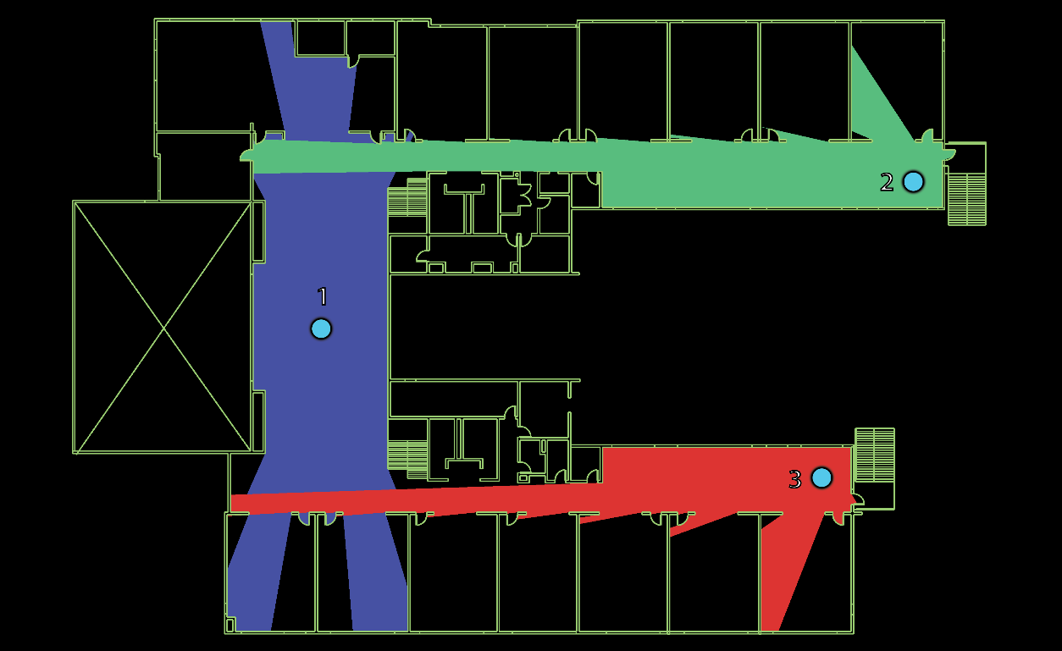
Figure 61. BPS 2nd Floor ISOVIST Graph Analysis (By: Author)
The lengths of the circulation corridors at the first floor are 206 feet (North corridor) and 184 feet (South corridor) and for the second floor, the lengths are 193 feet (North corridor) and 174 feet (South corridor).
Color Coding. The Browns Point Elementary School’s design utilizes color coding to differentiate between the school zones. The designers used green and blue for the north wings, and orange and yellow for the southern wing. See Figures 62, 63, 64.
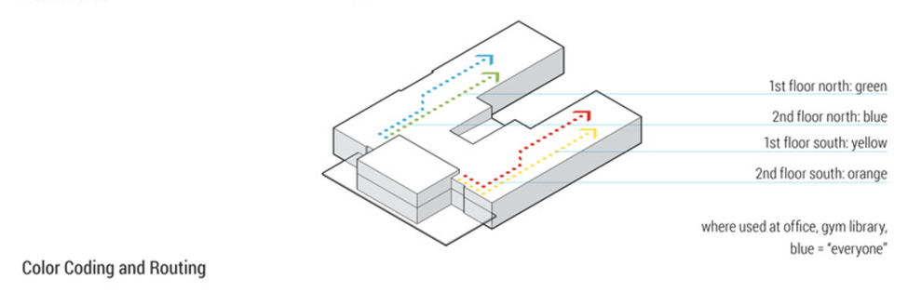
Figure 62. Color Coding and Routing of BPS (Source: Browns Point Elementary School / TCF Architecture, (2022). Archdaily

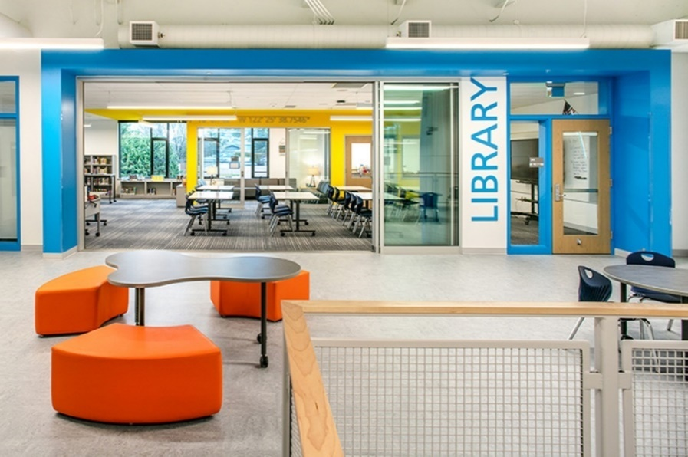
Figure 63. BPS Color Coding – Blue Zone (Photo Credit: Eckert and Eckert Photography©)
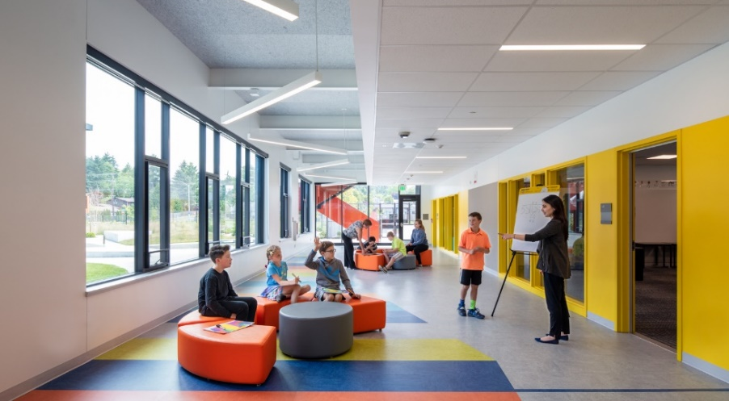
Figure 64. Figure 66 BPS Color Coding – Yellow Zone (Photo Credit: LightCatcher Imagery©)

Survey

Demographics
The survey had a completion rate of 91%. The total number of started surveys was 340, while the usable completed surveys were 312. The percentage of teachers’ participation from Oklahoma was 99% while the participation from Egypt was 1% as shown in Figure 65.

Figure 65. Geographical region of participating teachers
This low percentage of the Egyptian participation is assumed to be because of the limited availability of teachers and educators’ emails and contact information which resulted in the difficulty in getting them to participate in the study. More than 75.57% of the teachers who responded to the study were over 39 years old, 11.07% were between 25-31, 9.45% were between 32-38, and 3.91%, were between 18-24 as shown in Figure 66. Regarding the respondents’ years of experience, 65.12% of the respondents had more than ten years of professional experience, 17.94% had 5-10 years, 15.95% had 1-5 years, and 1% of the participating teachers had less than one year of experience as shown in Figure 67.

Figure 66. Participating teachers' ages

Figure 67. Participating teachers’ years of professional experience
More than half the respondents had above ten years of experience working with children with autism spectrum disorders which endorses the validity and reliability of their survey responses as they were based upon an extensive understanding of the children’s condition and specific needs. Specifically, 57.24% of the participating teachers had more than 10 years of experience, 23.03% had between 5 to 10 years of experience, 17.11% spent 1-5 years working with ASD children, and only 2.63% of the teachers has less than 1 year of experience with ASD children as shown in Figure 68.

Figure 68. Teachers’ years of experience with ASD children

The majority of the age range of students that the participating teachers worked with children of more than 12 years of age with percentage of 29.81%. 27.13% of the respondents worked with ASD children of 9-12 years of age, 23.97% worked with children who are 6-9 years old. While the percentage of teachers who worked with children of 3-6 years of age was 17.03. Only 2.05% of teachers worked with children with autism of less than 3 years of age as shown in Figure 69.

Figure 69. Age ranges of ASD students’ participation teachers worked with

Teachers Identification of ASD Children’s Safety
An open-ended question was added to understand what comes to the teachers’ minds regarding the safety of children with autism in public schools. A word cloud was visualized using Qualtrics to initially extract the words that were most repetitively used by teachers as shown in Figure 70. The word cloud was conducted using the limit of 50 words.
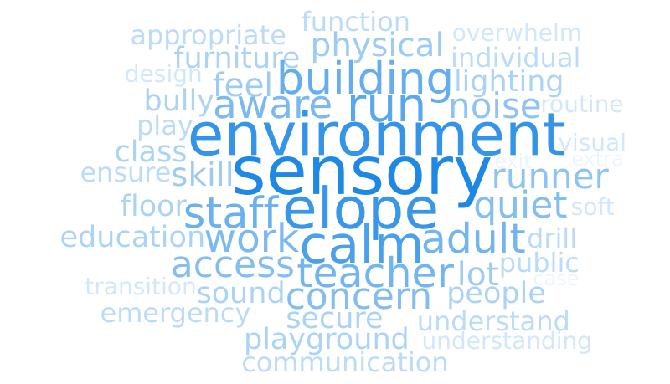
Figure 70. Word cloud showing the most used words by teachers while describing Safety of ASD children in schools
It was observed that the highest words that were frequently used by teachers in their answers were Sensory, Environment, Calm, Elope, and Building. These themes set a basic understanding of the responses themes that were later used for categorization by code. The teachers highlighted themes that either would foster the safety of ASD students or jeopardize it according to their understanding and experiences. The coding of the extracted themes was divided into three categories: (1) Phenomena. (2) Design Concerns, and (3) Managerial Concerns. Detailed overview of the main themes discussed by teachers is highlighted in Table 1.

Table 1. Teachers Description of elements affecting Safety main Themes and Coding
Quoted teachers’ responses | Theme | Code
“They need to be understood - triggers need to be communicated by parents so students are not at risk of hurting self and others.” | Bullying / Self-harm | Phenomena
“Safety for my students seems to be areas where they can quickly identify what to do, i.e. where to stand or sit with little guidance.” | Defined Spaces | Design Concerns
“Having a safe and quiet place to go with overstimulated, having space for sensory seeking opportunities.” | Safe Place / Area of Refuge | Design Concerns
“Emotional safety in terms of judging / bullying / helplessness.” | Bullying | Phenomena
“Have a teacher desk/area near each exit to stop eloping when needed. Have an area for calming with a rug and maybe a bean bag chair. A restroom nearby with a private stall for restroom needs.” | Monitored Exits / Safe Place / Close Restrooms | Design Concerns
“The building was not designed for children with ASD, we have children who run and having access to the street is not safe.” | Elopement / Monitored Exits | Design Concerns
“Music rooms for drawing, a puppet theater, surveillance cameras in every corner and yard, visual cues to guide children on the autism spectrum.” | Sensory Rooms / Surveillance / Wayfinding | Design Concerns
“Routine is always the first thing that comes to mind when I think of daily needs. I have seen students who have their daily schedule changed at the last minute and it causes unnecessary stress for them.” | Routine | Phenomena
“Doors that are hard to open for runners & Easy to move from one part of the building to another.” | Monitored Exits / Compact Zoning | Design Concerns
“They have a "fight or flight" response when they become upset at times. I worry about them leaving the classroom and possibly leaving the building where they would not be in a safe environment.” | Elopement | Phenomena
“Many schools do not have appropriate procedures in place to ensure the safety of ASD students. I have personally witnessed ASD students excluded from emergency drills to avoid behavior disruptions.” | Exclusion | Phenomena
“Availability of classroom space in order to give students with Autism a place to calm down.” | Safe Place / Area of Refuge | Design Concerns
“When I have students with boundary issues, I am afraid that another student will hit them or get int a fight with them. All students need to feel safe and so does the staff.” | Bullying | Phenomena
“When some students with ASD are non-verbal and are unable to communicate specific things that  are bothering them, this is challenging. We use communication boards, Board maker software and pictures to assist them to communicate things that may be bothering them in addressing their personal safety.” | Communication Boards | Design Concerns
“The narrowness of the hallways in my building is a concern.” | Hallways | Design Concerns
“Children living with ASD can become very overwhelmed with the amount of sensory input they receive in school. Most schools do not have an adequate place for students to go to calm down.” | Sensory Rooms / Safe Place | Design Concerns
“It is important that doors are secured, whether it be the classroom door or the doors to the exterior of the building for the physical aspect. Students should be supervised when traveling through the building as well.” | Monitored Exits / Surveillance / Compact Zoning | Design Concerns
“A lot of our students are runners and will look for any ‘opportunity to leave their room.” | Elopement | Phenomena
“Cabinets and drawers that can be secured so that children do not get into items that could be harmful like cleaners or scissors. A door that can be secured to keep students in the classroom but opened easily and quickly in case of emergency.” | Elopement / Self-harm | Phenomena
“Some will run, go outside a building and continue running without regard to where they are. (Lower functioning ASD)” | Elopement | Phenomena
“That school systems educate everyone and ensure they have a working understanding of autism and what that might mean to them.” | Educating teachers | Managerial concerns
“When I think of safety and children with ASD in public schools, I think of them running out of the classroom &/or school. Running from things they don't want to do.” | Elopement | Phenomena
“Elopement is the most pressing concern, especially for little children. And lack of equipment for swinging, jumping- etc.- that help children self-regulate. These things all but disappear as children with autism age.” | Elopement | Phenomena
“Children with Autism need a place where their academic and social/emotional needs can be met. Most need some kind of sensory space where they can go to destress from the classroom environment.” | Sensory Room | Design Concerns
“My classroom is located in an area that has an enclosed courtyard, so if a child were to run out of the classroom, he/she would not be able to make it onto the street.” | Elopement | Phenomena
“In larger areas: soothing lighting, quiet room acoustics, and flexible seating.” | Lighting / Acoustics / Flexibility | Design Concerns
“Care needs to be taken if the student has a tendency to run away or gets sensory overload.” | Sensory Overload / Elopement | Phenomena
“I have students who require constant supervision as they have no awareness of safety. These students are typically nonverbal or have limited speech / language / communication skills.” | Surveillance | Design Concerns
“When you've seen one student with autism, you've seen one student with autism. They are all so different, just like everyone. Basically though, for the very low students, they need a safer environment, i.e., no dangers within reach or sight and with perhaps, a one-on-one assistant.” | Variance of ASD conditions / One on one Assistance | Managerial concerns
“Preparing them to remain safe in small places where at any moment they could be triggered by loud sounds or yelling.” | Safe Place / Area of Refuge | Design Concerns
“There HAS TO BE a safe place for them to calm down.” | Safe Place / Area of Refuge | Design Concerns
“Behavior modification techniques to teach ASD students how to be safe and act appropriately.” | Educating children about safety | Managerial concerns
“Doors need to be able to secure magnetically for ASD students.” | Elopement | Phenomena
“Safety issues on the playground. Also, having locks/alarms on doors that keep students from eloping. Safe place to play inside.” | Elopement | Phenomena
“Many have dangerous behaviors that are not suited for the public school system as there is not enough staff to deal with all the issues that ASD kids bring.” | Shortness of staff | Managerial concerns
“Providing an environment with adequate fencing for safety for outdoor play areas.” | Elopement | Phenomena
“Bullying is one of the first things that comes to mind.” | Bullying | Phenomena
“Keeping an adult with them at all times.” | Surveillance
“There is not enough consideration of either. Expectations and protocols are not clear or created.” | Lack of Clarity | Managerial concerns
“Flexibility of the space, clearly defined pathways.” | Defined Spaces / Flexibility | Design Concerns
“Elopement from locations and access to exterior doors; having a designated safe space that is not a classroom, office, etc.” | Elopement | Phenomena
“Some of my students just need a safe place to come to when they become stressed in the regular classroom.” | Safe Place | Design Concerns
“Many children with ASD need breaks from the classroom. A safe space for them to go to such as a sensory room would be a great place where they can take a break from work demands and overstimulation of a noisy classroom.” | Safe Place / Sensory Room | Design Concerns
“Elopement is a huge concern, but spaces that have no windows and all doors have to be closed do not feel safe.” | Elopement / Surveillance | Phenomena / Design Concerns
“Those in charge not having the training they need to understand or provide services for Children with ASD.” | Educating Teachers | Managerial concerns
“having spaces that students can disengage from aversive environments and situations without moving into unsafe environments is really important.” | Safe Place / Sensory Room | Design Concerns
“They can become overwhelmed in crowds. Many ASD students like to sit at the back of the room, and closer to the door. These are high school students, who have acquired many coping skills through the grades.” | Safe Place | Design Concerns
“My students are higher functioning, but if they were unable to transition from one place to another within the building, cameras would be imperative.” | Surveillance | Design Concerns
“It is important to have secure areas, like playground areas. Having a fence that Children cannot get past and gain access to roads and streets is important.” | Monitored Exits / Fencing | Design Concerns
“The behaviors that are common in students with ASD are seen as intentional disobedience. I fear for the safety of these students' educations when there are individuals involved who have little to no training or idea on what it is like to teach/work with/help students with specialized, individual needs.” | Educating Teachers | Managerial concerns
“Visual signs for where things are located. Not just bathrooms and exits but other ways to know where the nurse, office, cafeteria, and other locations are.” | Wayfinding | Design Concerns
“Many need protection from bullies until they learn to appropriately stand up for themselves.” | Bullying | Phenomena
“There is no one-size-fits-all for students on the spectrum. But I would say that, generally speaking, they need the following: 1) safe, small, quiet places for privacy while they self-soothe, 2) spaces to interact with the gen ed population in ways that offer differing levels of sensory input (particularly noise and proximity) and 3) spaces to interact with other SPED students (including others on the spectrum) that are comfortable and calm, but minimally secluded/separated.” | Safe Place / Sensory Room | Design Concerns
“The safety of them not being understood and not being able to communicate properly what they want.” | Exclusion / Lack of Communication | Phenomena
“They are sometimes forced into inclusion in environments that do not offer them enough individual space.” | Safe Place / Areas of Refuge | Design Concerns
“In regard to safety and children with ASD in public schools, my mind first goes to exits and students eloping when overwhelmed, overstimulated, or angry.” | Elopement / Monitored Exits | Phenomena / Design Concerns
“My classroom has covers over all of the florescent lights. I like to keep the environment as calm as possible.” | Lighting | Design Concerns
“The school I was in provided inadequate educational and adaptive material for my student.” | Inadequate Materials | Managerial concerns
“Making sure students are aware of their surroundings because ASD students are not always aware of things going on around them.” | Wayfinding | Design Concerns
“My greatest fear is their naivety. They are very trusting of people and are not always aware of dangers around them.” | Bullying / Perfect Victims | Phenomena
“One of the areas my students struggle with is not only the physical space within a school, but the social space. I work with my students on a daily basis to understand the social aspects of 'personal space'. Their understanding of the concept of personal space and other social skills plays a large role in their long-term safety in both schools and community settings.” | Personal Space / Safe Place | Design Concerns
“Transitioning from class to class.” | Wayfinding / Transition Spaces | Design Concerns
“Teachers outside of Special Education don't have enough training when it comes to students with ASD.” | Educating Teachers | Managerial concerns
“Being watched at all times.” | Surveillance | Design Concerns
“Younger students may run and hide.” | Elopement / Surveillance | Phenomena / Design Concerns
“One of the biggest problems we have had is when we have drills (fire, tornado, intruder). Some of our students with ASD tend to not understand when the alarm goes off.” | Educating children about safety | Managerial concerns
“Bullying, being taken advantage of, being neglected.” | Bullying / Exclusion | Phenomena
“I do believe that there needs to be more training for staff to provide an enriched safe environment for students with ASD.” | Educating Teachers | Managerial concerns
“Appropriate environments where children can safely express themselves in a way that allows for inclusion.” | Self-expression / Inclusion | Managerial concerns
“I worry about the fact that some are runners and while we lock people out of the school it is hard to keep the children in the school and safe.” | Elopement | Design Concerns
“ASD students don't think or act like other students, and this can lead to being made fun of or bullied.” | Bullying | Phenomena
“I find their biggest need is having a safe place or a room where they can go when they are struggling with self-regulation.” | Safe Place / Sensory Room | Design Concerns
* Wider hallways may reduce the stress of traveling class to class,  * Acoustic panels to absorb sound to reduce overall noise level  * Color coded hallways to increase familiarity when traveling  * Hallways that follow a grid pattern; hallways and classrooms are clearly labeled and consistent (Hall A has classes A-1 through A-10, etc.)  * Security measures for elopement situations (fenced in campus, extensive security network, security language that can be announced to the school that only faculty understand and that alerts them to a specific area of need in the school)” | Wider Hallways / Color-coding / Acoustics / Monitored Exits / Fencing / Surveillance | Design Concerns
“Having rooms that are safe zones for them when they are upset, and sensory areas designed to meet sensory needs.” | Safe place / Area of Refuge / Sensory /Room | Design concerns
“Making sure that they have the appropriate level of supervision” | Surveillance | Design Concerns
“bullying/isolation, degree of inclusivity, support programs and clubs to promote belonging; level of functioning varies” | Bullying / Exclusion | Phenomena

The Results from the open-ended question helped highlight the main themes that teachers relate to in terms of the sense of safety of children with autism in public primary schools. Elopement and sensory overload were among the highest concerns of teachers as they described ASD children as “Runners.” Hence, teachers stressed on the significance of monitoring the school exits, fencing the playground, and including sensory rooms for the children to deescalate. They highlighted the problem of bullying and exclusion that ASD students face according to their communication impairments and endorsed the importance of their constant surveillance to protect them from peer-harassment and self-harm. Many responses mentioned that including Safe places and areas of refuge for students directly relate to their sense of safety. Teachers also highlighted the importance of wayfinding, color coding, and wide hallways. Some responses pointed out to the influence of educating teachers to be more capable of dealing with ASD children with their needs and educating ASD children about safety and familiarizing them with protocols, alarms, and emergency drills, as many students don’t understand that a drill is considered a sign of emergency.

Special Education or Integrated Classrooms
At this stage of the survey, the teachers’ preference of including children in special education (SPED) classrooms within the public school or an Integrated Classroom with other general Education students was examined. 35% of the teachers participating in the study found the special education classrooms to be the most optimum solution. However, 65% of the teachers preferred integrated classrooms that support the inclusion of ASD children within the same classroom as the typically developing students. See Figure 71.

Figure 71. Special Education Classrooms vs. Integrated Classrooms according to teachers’ perspectives

Types of Bullying ASD Children Face

The survey found that the highest type of bullying that ASD children face in public schools is Exclusion bullying with a percentage of 66.14%, the second highest type of bullying is Verbal bullying with a percentage of prevalence of 26.69%. However, gesture bullying and physical bullying were among the least types of bullying chosen by the teachers with percentages of 5.18% and 1.99%, respectively. See Figure 72.

Figure 72. Types of Bullying with the highest prevalence rates according to Teachers

Bullying Potential Locations
The phenomenon of bullying children with autism in public school and the potential location that it more frequently happens according to the teachers’ perspectives was further understood. Teachers highlighted that the location with the highest rate of bullying is playground with percentage of 24.17%, the second highest location of bullying was Restrooms (19.30%). Hallways were very close to restrooms with a percentage of 18.61%. Multiple settings or undifferentiated was the fourth highest choice of teachers (13.91%). Classrooms were selected by 13.04% of teachers. See Figure 73.
The teachers were given a choice to add their own responses in an open-ended answer option, which 10.96% of them used. There open-ended answers included: (1) Cafeteria/Lunchroom as the highest answer, (2) Waiting areas, (3) Anywhere unstructured, (4) Gymnasium, (5) School Buses, (6) Unsupervised areas, and (7) Locker rooms.

Figure 73. Bullying Locations in Public Schools

Factors Threatening ASD Children’s Safety
Teachers highlighted that the sensory overload is the highest factor that can jeopardize the sense of safety of children with autism in public schools. The sensory overload mean value was 8.04. While bullying, lack of self-reliance, and the feeling of exclusion had mean values of 5.89, 5.95, 5.88, respectively. See Figure 74.
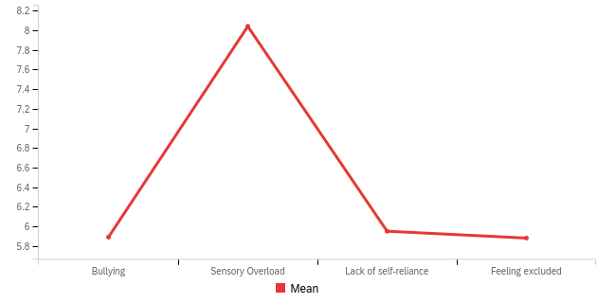
Figure 74. Factors that can threaten the safety of ASD children in Public Schools

The Separation of Restrooms and Cafeteria
Teachers’ responses on having separate restrooms for students with autism were highly competitive with very close percentages. 25.71% of teachers somewhat agreed on having separate restrooms, while 22.45% somewhat disagreed with it. 20.82% of the teachers didn’t find any preference regarding that and chose not to either agree or disagree. 16.73% of teachers strongly disagreed with detaching the restrooms of ASD children, while 14.29% of them strongly agreed with the importance of having separate restrooms for ASD children. See Figure 75.

Figure 75. Teachers' perspectives on having separate restrooms for ASD children

While for the separation of the Cafeteria/Lunchroom space, the survey results showed more skewed preference towards the unlikeliness of the separation effect. 23.77% and 25.82% found the separation extremely unlikely and somewhat unlikely to have a considerable effect on the children’s sense of safety, respectively. While 17.21% of teachers found that neither likely nor unlikely. 22.95% of teachers found the separation somewhat likely to have an influence on safety. Only 10.25% of teachers found that to be extremely likely to make a change in the safety perceptions of ASD students. See Figure 76.

Figure 76. Teachers' perspectives on having separate Cafeteria/Lunchroom for ASD children

Free Access to Outdoors
With reference to the phenomenon of Eloping, 52.65% of teachers supported having free access of ASD children to an outdoor safe zone to deal with the fact that children are “Runners” and tend to escape the building when they experience over stimulation. 25.71% of teachers, which is the second highest percentage, somewhat agreed with having that safe free access. However, 10.20% of teachers didn’t agree nor disagree. While 6.94% of teachers somewhat disagreed, and 4.49% strongly disagreed. See Figure 77.

Figure 77. Teachers' perspectives on having a safe free access to outdoors for ASD children

Walking Distance within School
Teachers who weren’t sure about the effect of walking distance within the school on ASD students’ exposure to bullying were around 42.21% of the total participants. While 25.82% of teachers found a potential probability of that relationship effectiveness. 15.98% of teachers answered, “Probably Not”, 12.30% of teachers answered, “Definitely Yes” and completely agreed with the question’s hypothesis. While 3.69% of teachers completely disagreed on having that relationship between the walking distance of students within their school and the rate of bullying, they might be exposed to. See Figure 78.

Figure 78. Teachers’ perspectives on the relationship between the school's walking distance and the rate of bullying exposure

Sensory Rooms Significance
The survey targeted understanding the perspectives of teachers on the importance of incorporating sensory rooms in the design of schools. The average responses that found the Sensory Rooms to be highly significant on promoting the sense of safety of ASD students was 8.61 (SD:1.85). See Table 2.

Table 2. Mean and Standard Deviation on the measure of Significance of Sensory Rooms as a function that promotes the sense of Safety of ASD students.
Field | Mean | SD | n
Scale | 8.61 | 1.85 | 240
Note. The maximum score is 10.
SD: Standard Deviation
n: Number of responses

Spaces of Close Proximity to Entrance and Main Hallways
Classrooms where ASD students are located had the highest percentage of responses regarding its prioritized placement near the main hallways and entrances (38%/n=81). The second prioritized spaces are Restrooms (20%/n=43), then comes Stairs (15%/n=32), followed by Cafeteria/Lunchroom (14%/n=30). The least prioritized spaces are the sensory rooms with a percentage of (13%/n=21). See Figure 79.
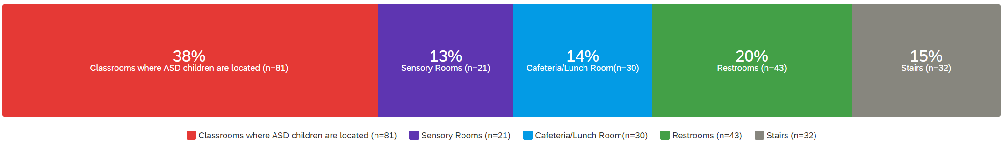
Figure 79. Spaces of higher priority to be placed near the school main hallways and main entrance

General Teachers Recommendations
For final design recommendation as a conclusion for the survey and to approach a compact guidance from teachers as they are the population who spends most of the time within the school building while being highly aware of the needs of children with Autism as well as children who are typically developing. The main paradigms discussed by teachers are highlighted in Table 3.

Table 3. Teachers Recommendations to Architects and Designers to support ASD children’s Safety in Public Schools
Quoted teachers’ design recommendations
“Classrooms be near a fenced in exit so for emergencies you don't need to worry about kids running out into the road. Need a restroom near the classroom if not in the classroom.”
“Keeping hidden areas to a minimum, such as nooks in hallways and under stairs. Using cameras in the common areas and hallways to help administration see if bullying occurs. Calm down or sensory rooms that can be accessed at any given time.”
“I believe emotionally disturbed student definitely need more room and sensory areas built into their classroom.”
“Limiting exits near sensory room and cafeteria.”
“Their classrooms should be larger than the average classroom to allow for movement and stemming while still learning.
“They need feel supported and included, but also their needs need to be considered. I would not put the ASD rooms or sensory rooms near exit or main doors due to children may run out the door.”
“Have everything close to classroom.”
“Sensory stations in the hall or calm down stations when there is an overload or adjusting their schedule to miss the crowd”
“I would put them further away from the loud spaces like the gym and cafeteria. I would also be mindful of building exits in relation to the classrooms.”
“Sound cancelling design, limit unnatural light exposure, create safe spaces within each room”
“Having single bathrooms or stalls that have dividers that go fully from the floor to ceiling are so helpful to give privacy and lessen sound.”
“Separate restrooms closer to classrooms; sensory room close to classrooms”
“Easy to navigate hallways. Clear signage in halls and on rooms. Signs in cafe to direct students.”
“Softer walls and floors for ASD students. Less pictures/shapes on the walls (paintings, murals, etc.). Curved walls instead of corners.”
“Natural light and windows whenever possible over walls.”
“Rounded corners, carpet sections and softer style walls.”
“It would also be good to have toilets that have delayed flushing so that students have time to move away from the sound.”
“Large spaces with flexible lighting”
“Restrooms and water fountains in the classroom. Wide hallways allowing for plenty of space for students to pass, safety mirrors placed so there aren't any "blind" areas where students may isolate others.”

“Stop designing separate spaces. Design the entire school to be a supportive environment for students with ASD. This will not just benefit students with ASD, but the whole school community. This is the basic principle behind universal design, which needs to be about more than adding a ramp here and there. We need to really think about having inclusive spaces from the beginning.”
“The room should not be cluttered. Areas should be clearly defined, (ex. work area, play area, quiet area etc..). NO fluorescent light. Avoid sensory overload A variety of sensory items. Limited patterns, textures, and colors.”
“I like the idea of a covered/fenced-in safe zone directly outside the building.”
“Students with ASD, generally speaking, need to be where there are the least distractions and noises.”
“Special Education classes should be close to an entrance. Some buildings have a separate entrance that are close their classroom. This works great!”
“Cameras or surveillance in all areas of school, teachers out in hallways and arranged classes to accommodate quick access and transport.”
“Having ASD students at the end of a hall and not next to stairways or other high traffic areas. Loud areas can cause them to become overwhelmed and safety becomes a concern.”
“Possibly soundproofing a few rooms - putting in some sound absorbing panels in the lunchroom.”
“Controllable fade lighting in all classrooms and window treatments.”
“I do love the idea of a sensory room. I think adding textured walls or flooring would be amazing for a sensory room. If it were possible, maybe including soundproof paneling so that noises from the outside environment would not distract or overwhelm them.”
“Location of relatable areas- don't put the sensory room next to the cafeteria or a science room appropriate lighting and adjustable lighting (not only dimming but maybe color and saturation as well)”
“I think that bathroom, especially in boy's bathrooms, should have more stalls where ASD students can feel safer and have more privacy.”
“Avoid enclaves in stairwells (and in general). Linear hallway design (for ease of directions/navigation)”
“Short distances between their classrooms and the cafeteria / restrooms.”
“Easily supervised entrance and exit. Railing, fences, and other natural boundaries.”
“Options to modify the environment - Classrooms with windows and curtains; lights with dimmers; Speakers with volume controls; accessibility at the forefront (co-morbidities are common).”
“Lighting, wall colors, windows, and which way they open.”
“Wide hallways, noise deafening, lighting.”
“Smaller buildings with easier access to the outside (provided that external space is secure).”
“School administration may need support in re-seeing these events through the experiences of student with ASD needs. Really, this is all about supporting the adults and educating them so that they are able to think more divergently about how the decisions they make, whether with regard to space or to other details, support and nurture children with ASD (and all children)”

Conclusion
All the analysis stages starting from the observational analysis, depthmapX space syntax analysis, and the survey results helped complete the picture and synthesizing the patterns being explored in the study to either foster or jeopardize the sense of safety for ASD students in public schools. The case studies’ observational and space syntax analysis helped provide a deep analysis of the Egyptian and American school’s floor plans and architectural elements that affected the depthmapX analytical results. The schools’ analysis highlighted the performance of the schools’ design in terms of School zoning as it provided an extensive insight about the classroom’s clustering, number of exits that lead to the outdoors, the location of the restrooms with respect to the whole floor plan, the presence of observation point, and whether the schools had room in their corridors for flexible learning spaces or not. The next layer of analysis investigated the natural surveillance values withing the schools. Visual connectivity was assessed for each school using depthmap’s visibility graph analysis, Blind spots were consequently highlighted, the fenestration and the windows locations in the classrooms were studied, and the layout configuration of the two schools. The third analytical layer addressed the space organization and wayfinding within the schools. Integration graph analysis, step depth analysis, and permeability analysis were conducted. Further, the presence of color coding in the design of the schools was assessed.
The survey results highlighted the perspectives of teachers by overviewing their concerns about school design, and other concerns related to the managerial aspects and utilized protocols within the school. The data gathered through this chapter complemented the patterns explored through the literature review and helped formulate a framework towards responding to the research questions and hypothesis. Further discussion and synthesis were produced in chapter five with an overall conclusions, implications, and recommendations for future studies potential topics.

Chapter V: Discussion & Conclusion

Introduction
Through this chapter, the major findings of all the previous research phases were overviewed, including the literature review, case studies analysis, and survey responses to answer the early questions that influenced the study. The findings were discussed and then used to produce design recommendations and implications for practitioners toward the design of safer schools for children with Autism. Further unexpected findings were also presented to trigger future research. Later in the chapter, the limitations of this study were discussed, proposing directions for potential future research topics.

Architecture and Autism
- What is the relationship between the Built Environment and Autism Spectrum Disorders?

Major Findings in Literature
Lawrence & Low (1990) explored the significant effect of the built environment on children with autism particularly and found out that they are very sensitive when it comes to sensory processing, and consequently, the surrounding environment substantially affects their behavior. The school setting in particular has a considerable effect due to the long periods spent within the school buildings either by teachers, students, or staff (Silva, 2007). Hence the school buildings should be prioritized by designers, and at the same time analyzing, the existing school that is intended to host children with autism regarding their capability of providing them with all their needs and protecting them from possible challenges that may occur. Any design interventions that take place in the schools would have very promising results in positively affecting the behavior of children during their early developmental stages, including children with autism (Perumean-Chaney & Sutton, 2013; Baeva et al., 2011; Martin, 2016; Pinto-Martin, 2005).

ASD Children’s Challenges in Public Education
- What are the opportunities and challenges of inclusive education to ASD children in terms of safety?

Major Findings in Literature
Opportunities. Inclusive Educations, or the Least Restrictive Environment (LRE) in the US, have many opportunities and obstacles. From the opportunities, it integrates children with autism with their typically developing peers, which enhances their sense of belonging in society regardless of their abilities (Ghoneim, 2014, 195; Flavey et al., 1995; Ammar & Skaggs, 2016). This resembles the principle of universal design of creating inclusive environments that welcome everybody unconditionally. Even the parents of children with autism find inclusive education more beneficial for their children (Salceanu, 2020).
Challenges. One of the major challenges of inclusive education or the least restrictive environment is the inconsistency in implementation and misplacement of children (Anderson & Boyle, 2019). Further key challenges which have wide prevalence in Egypt are:
- Bullying and marginalization affects the students and their families.
- Public education teachers who are untrained or unqualified to deal with ASD children.
- The confusing environment the children suddenly transfer into.
(Gobrial, 2018; Gobrial et al., 2019; Math et al., 2016; Loveluck, 2012; El-Zouhairy, 2016)
ASD children as Perfect Victims. Children with autism are considered the perfect victims for different types of bullying in public schools as they have communication impairments and very few friends, if any (Cappadocia et al., 2012). The locations with high percentages of bullying are classrooms, playgrounds during break time, corridors, bathrooms, and lunchrooms (Francis et al., 2022; Borg, 1999; Fram & Dickman, 2012; Woolley, 2019).

Survey Major Findings
Bullying. Several teachers brought up in their survey responses the problematic phenomena of bullying. Block quotations of answers from teachers when asked to identify safety in public schools are highlighted below:
Response 1:
“When I have students with boundary issues, I am afraid that another student will hit them or get int a fight with them. All students need to feel safe and so does the staff.”
Response 2:
“Many need protection from bullies until they learn to appropriately stand up for themselves.”
Response 3:
“My greatest fear is their naivety. They are very trusting of people and are not always aware of dangers around them.”
Response 4:
“ASD students don't think or act like other students, and this can lead to being made fun of or bullied.”
Response 5:
“bullying/isolation, degree of inclusivity, support programs and clubs to promote belonging; level of functioning varies.”
These responses from the teacher supported and emphasized how ASD children significantly face the problem of bullying in public schools as may have:
  - Boundary issues.
  - Minor capability of standing up for themselves.
  - Naivety and trusting people fast.
  - Acting differently from other typically developing peers.
  - Exclusion and Isolation.
Educating and Training Teachers. Several teachers brought up in their survey responses educating teachers and how it is essential to promote the students’ sense of safety in public schools. Some of the answers that addressed educating teachers are highlighted:
Response 1:

“That school systems educate everyone and ensure they have a working understanding of autism and what that might mean to them.”
Response 2:

“Those in charge not having the training they need to understand or provide services for Children with ASD.”
Response 3:

“The behaviors that are common in students with ASD are seen as intentional disobedience. I fear for the safety of these students' educations when there are individuals involved who have little to no training or idea on what it is like to teach/work with/help students with specialized, individual needs.”
Response 4:

“Teachers outside of Special Education don't have enough training when it comes to students with ASD.”
Response 5:

“I do believe that there needs to be more training for staff to provide an enriched safe environment for students with ASD.”
These responses from the teachers mainly highlighted making sure that teachers have a good understanding of autism and its symptoms, specifically those who have no experience in special education. The responses highlighted that children with autism might seem intentionally disobedient to the teachers’ orders. However, this is considered part of their illness's core symptoms, which should be clear to their teachers and contained by them.

School Design in Relation to ASD Children’s Safety
- How can the spatiality and school design promote physical and psychological safety of children with autism?

Major Findings in Literature
Through research in the literature about the elements in school design and its spatiality that can enhance the safety of ASD children among their typical peers, the below list of elements was primarily identified:
- Providing functional and logical zoning.
- Avoiding exaggeratedly large and unidentified spaces.
- Classrooms clustering and creating common flexible learning areas outside.
- The width of corridors should be generous to avoid overcrowding and make room for flexible learning areas.
- Providing clearly seen exits.
- Incorporating fewer exits to have more control over the students.
- Incorporating observation points and areas of refuge.
- Maximizing natural (Passive) Surveillance & minimizing blind spots.
- Incorporating Circular layout configuration/Well monitored playground.
- Clear wayfinding.
- Providing defined nodes.
- Color coding for identification and segmentation of school zones and spaces.
- Visual access and permeability between spaces.

Case Studies’ Major Findings
The case studies analysis of the Egyptian Japanese school and Browns Point Elementary School Buildings results are compared against the identified design elements in literature, and the major findings included the following points:
Egyptian Japanese School Compared to Browns Point Elementary School. According to the patterns identified in the literature, the schools’ designs were cross-analyzed, and the results showed some elements to have a positive effect on ASD children’s safety and others that need to be considered in future designs, as follows:
Zones, Classrooms’ Clustering, and Corridors Widths. For the EJS, the classrooms were divided into two zones on the first floor, three zones on the second floor, and four on the third and fourth, by substituting the laboratories, connected by circulation corridors of widths around 6 ft. Scattering the classrooms would increase the challenge of complicating the wayfinding, confusing the children, and demanding extra effort in providing extensive monitoring for the children. See Table 4-A. Additionally, the location of the Gym on the first floor is considered segregated from the core of the building, which would result in increasing the walking distance of children from and to the Gym without a defined necessity. The Gym’s location can also dramatically affect the acoustical performance of the adjacent classrooms. See Table 4-B. On the other side, scattering the teachers’ offices between the classrooms is considered a good move toward keeping teachers in constant proximity to the students. See Table 4-C. The school has a resource room. However, there are no designated pocket restrooms within. See Table 4-D.
On the other hand, for the BPS, the classrooms are divided into two zones only in the northern and southern wings. This makes the floor plan more concise, makes easier wayfinding, and facilitates monitoring of the students for the teachers. See Table 4-E. The corridors’ widths are generous, around 17 feet wide. This prevents overcrowding in the hallways and provides sufficient areas for flexible learning space. However, containing the administration area in a closed zone would limit and lessen the flow of teachers within the classrooms zone as their offices are distant. See Table 4-F.
Table 4. Cross Analysis between EJS and BPS Schools' Floor Plans Design
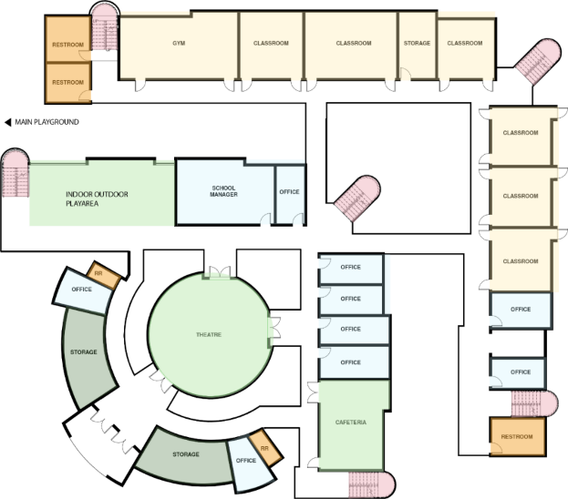  EJS – 1st Floor  C  A  B | 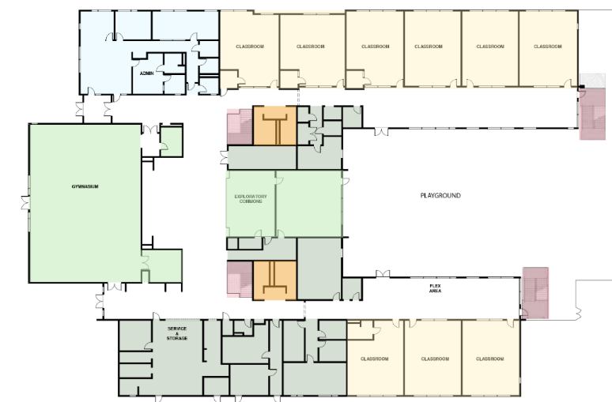  E  F  E  BPS – 1st Floor
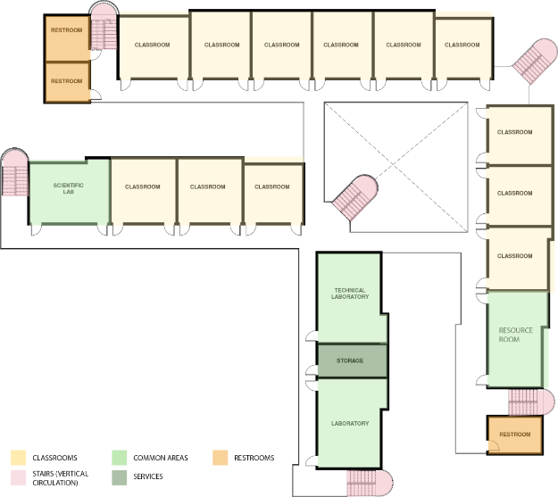  D  A  A  A  EJS – Typical Floor | 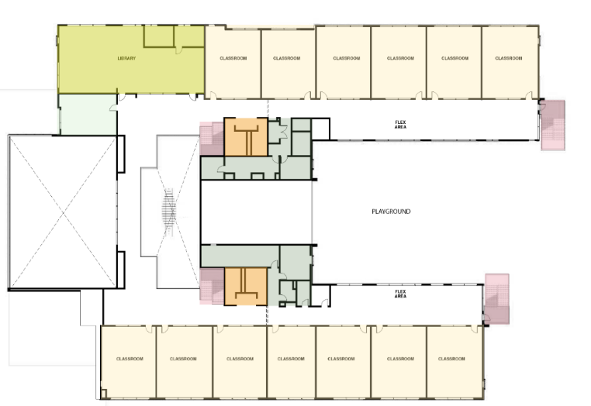  E  E  BPS – 2nd Floor
A
Exits. EJS incorporated a total number of 11 exits. This number can be very challenging for teachers to provide adequate control. In addition, most exits are open outdoors with no doors, which would duplicate the monitoring challenges in case of elopement. Nonetheless, the exits that are included within the three classrooms on the first-floor lead to a safe outdoor zone and would highly benefit ASD students by providing them with free access whenever needed. See Table 5-E. However, for BPS, all schools have a door, which makes controlling entering and exiting the school more controlled, even if they were freely opened to grant ASD students easy access to the safe zone of the playground. See Table 5.
Table 5. Cross Analysis between Exits of EJS & BPS
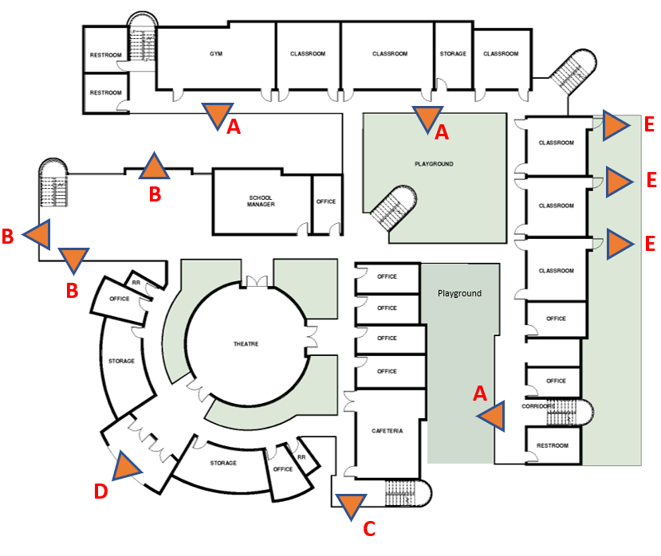 | 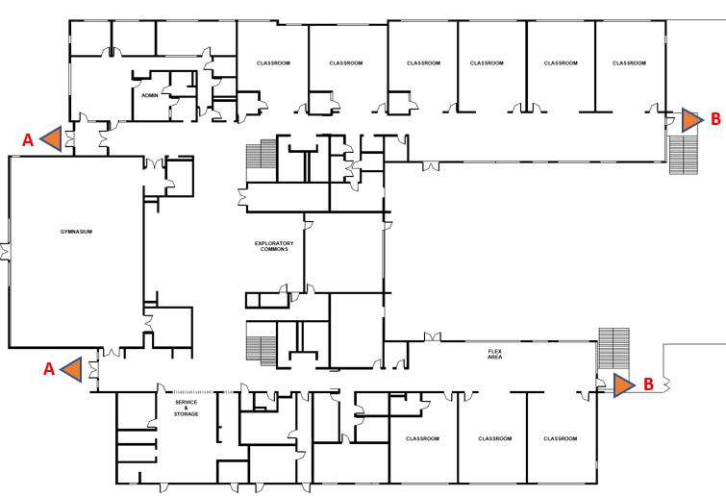  BPS 1st Floor  – 2nd
EJS – 1st Floor
Observation Points. EJS didn’t include any sort of pocket spaces that can be used by children with autism as observation points or areas of refuge whenever they encounter hypersensitivity or over-stimulation by their environment. However, BPS utilized spaces that could be considered waste areas in designing these semi-enclosed pockets that are considered areas of refuge or safe places for students who need them according to hyper-sensitivity without the need for complete segregation. These observation points would still allow the students to watch the activities happening in the common area without being involved in them physically or emotionally.
Natural Surveillance and Wayfinding. In EJS design, the restrooms segregation and the concealed areas of the stairs were proved to have very minimal visibility values, which would make them potential locations for bullying and problem behavior. See Table 6-A. However, for BPS, the restrooms are located at the core of the floor plan, which makes it desegregated and a well-monitored location by the teachers, staff, and the rest of the students. See Table 6-B.
Regarding the classrooms, unfortunately, the frosted plastic material used in the windows provides minimal visibility and transparency for the classrooms and minimizes the amount of natural light. The windows must remain open to provide sufficient visibility and surveillance, and that would dramatically affect the acoustical performance of the classroom. See Table 6-A1. For BPS, the classrooms have very large windows with clear glass, which performs between than EJS in providing sufficient visibility. See Table 6-A2.
The central area anchoring the whole school is pivotal in connecting spaces, providing natural surveillance, and facilitating wayfinding for EJS. There is no defined central zone incorporated in the design. See Table 6-C. On the other hand, for BPS, that huge central zone in the core of the building is well-designed, anchoring all spaces together, including corridors leading to the classrooms, administration, theatre, and services spaces. That central zone is also used as an open cafeteria, overlooking a small open theatre platform. See Table 6-D.
The layout of EJS is not circular; however, the design of the inner courts was successful and provided natural surveillance. See Table 6-E. Nonetheless, the large main playground was utterly segregated, making it a potential location for bullying since playgrounds are the number one location of bullying according to literature and survey results. See Table 6-F. On the other hand, the layout of BPS is U-shaped. It provides moderate natural surveillance of the playground, which enhances students' sense of safety and increases the chances of them being constantly monitored and watched. See Table 6-G. By comparing that observation to the recommendation in the literature to have a radial layout configuration, it was proved through the analysis that the U-shaped configuration provides sufficient surveillance while eliminating the problem of the wayfinding complexity that may be present in circular layouts. The circular playground would work, though. However, on a smaller design scale unaffecting the wayfinding.
Table 6. Cross Analysis between the Visibility Graph Analysis Results of EJS & BPS
A1: Photo credit: by Author  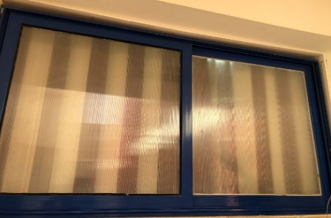 | A2: Photo credit: Eckert and Eckert Photography©  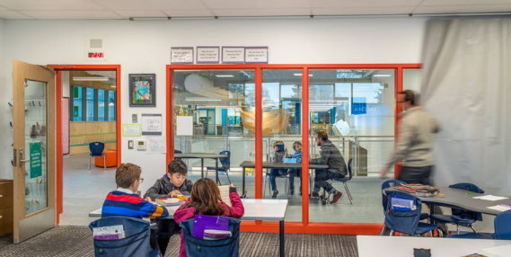
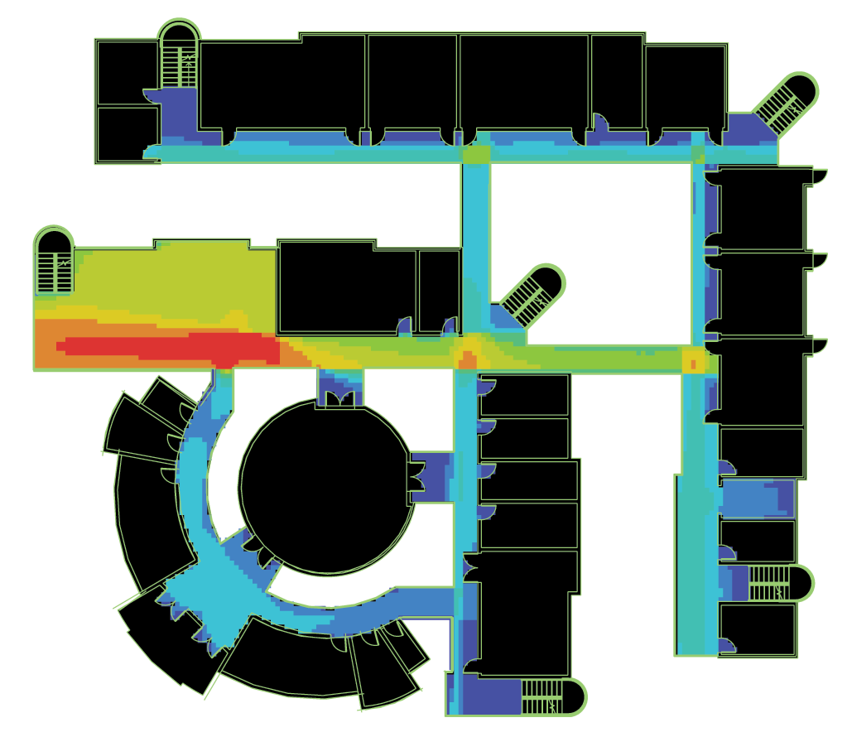  C  A  A  EJS – 1st Floor Visibility Graph Analysis | 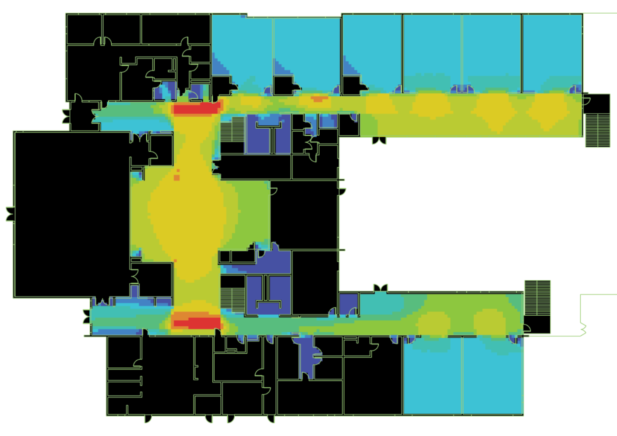  BPS – 1st Floor – Visibility Graph analysis  B  B  D
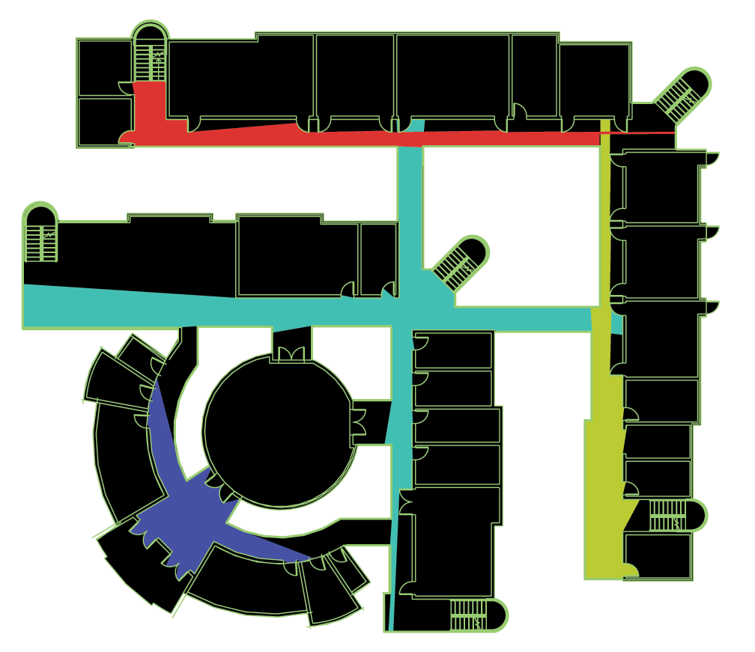  EJS – 1st Floor – ISOVIST Analysis  C | 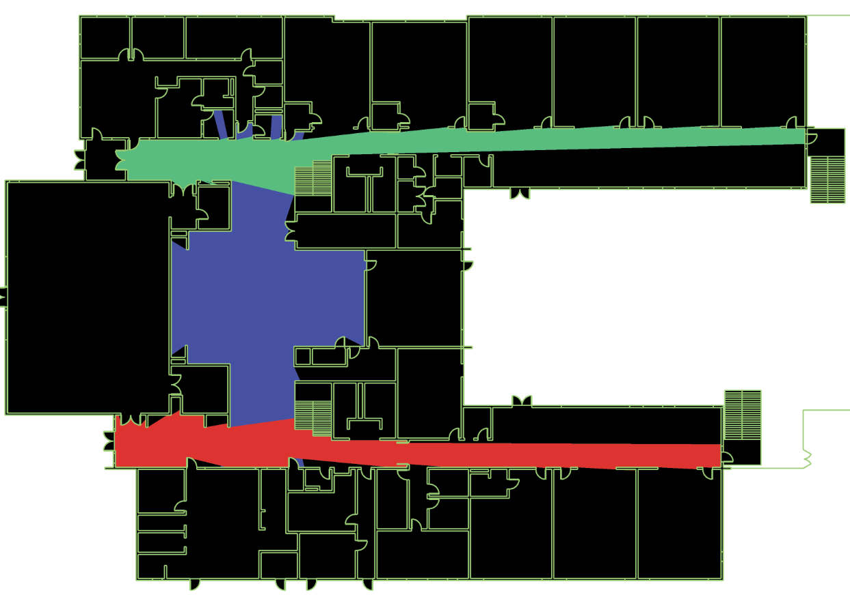  BPS – 1st Floor – ISOVIST Analysis  D
F  EJS – Layout Configuration  E  E  EV | G
Perspectives of Teachers About Promoting Safety in Public Schools
BPS - Layout Configuration

- What are the perspectives of teachers and educators on the safety of children within the public schools’ context and how it can be fostered?

Survey Major Findings
- Integrated Classrooms, Safe Places and Sensory Rooms. Teachers highly prefer integrated classrooms over segregated special education classrooms. However, sensory rooms are highly recommended to contain ASD children whenever they encounter sensory overload. Teachers identified sensory overload as the highest factor threatening the safety of ASD students in schools.
Some responses from teachers are included below:
Response 1:
“Children living with ASD can become very overwhelmed with the amount of sensory input they receive in school. Most schools do not have an adequate place for students to go to calm down.”
Response 2:
“Having spaces that students can disengage from aversive environments and situations without moving into unsafe environments is really important.”
Response 3:
“Preparing them to remain safe in small places where at any moment they could be triggered by loud sounds or yelling.”
Response 4:
“Some of my students just need a safe place to come to when they become stressed in the regular classroom.”
Response 5:

“They can become overwhelmed in crowds. Many ASD students like to sit at the back of the room, and closer to the door. These are high school students, who have acquired many coping skills through the grades.”
- Elopement/Monitored Exits. Elopement is considered a huge challenge faced by teachers when working on maintaining the safety of students with ASD within their schools. It was the most frequently mentioned element by teachers, as according to the teachers’ responses, ASD children are “runners” as they tend to leave the classrooms unexpectedly. Teachers expressed their worry that students may run into an unsafe place. They proposed having hard-to-open doors and a safe area outside the building to maintain the safety of children.
Some responses from teachers are included below:
Response 1:
“The building was not designed for children with ASD, we have children who run and having access to the street is not safe.”
Response 2:
“They have a "fight or flight" response when they become upset at times. I worry about them leaving the classroom and possibly leaving the building where they would not be in a safe environment.”
Response 3:
“It is important that doors are secured, whether it be the classroom door or the doors to the exterior of the building for the physical aspect. Students should be supervised when traveling through the building as well.”
Response 4:
“When I think of safety and children with ASD in public schools, I think of them running out of the classroom &/or school. Running from things they don't want to do.”
Response 5:
“My classroom is located in an area that has an enclosed courtyard, so if a child were to run out of the classroom, he/she would not be able to make it onto the street.”

Response 6:
“Elopement from locations and access to exterior doors; having a designated safe space that is not a classroom, office, etc.”
- Constant Surveillance. Teachers pointed out that the constant surveillance of the students is critical as ASD students have communication deficiency and would encounter difficulty navigating from one space to another.
Some responses from teachers are included below:
Response 1:
“I have students who require constant supervision as they have no awareness of safety. These students are typically nonverbal or have limited speech / language / communication skills.”
Response 2:
“Keeping an adult with them at all times.”
Response 3:
“My students are higher functioning, but if they were unable to transition from one place to another within the building, cameras would be imperative.”
Response 4:
“Making sure that they have the appropriate level of supervision.”

Unexpected Findings
The teachers’ responses also included some unexpected findings that addressed other elements that were not foreseen to have an effect on the physical and psychological safety of children with autism:
Types of Bullying. The type of bullying with the highest prevalence was exclusion bullying. While starting the study, verbal and gesture bullying were foreseen to have the highest prevalence rates among ASD children in public schools; however, the majority of teachers didn’t agree.
Walking Distance. The highest percentage of teachers didn't have any preference between shortening or increasing the walking distance within the school, which was also an unforeseen result as the study hypothesized that by decreasing the walking distance in the school, the exposure to bullying would decrease. The teachers' answers contradicted their responses to the question addressing the spaces that should be close to the entrance and hallways. The space that the highest percentage of teachers chose was the classrooms. This means they prefer that the classrooms should access the pivotal spaces through the shortest distance possible.
Routine. Some teachers mentioned that routine could be stressful and threatening to the psychological safety of ASD students because schedules can change at the last minute without any notifications.
Quotations from a teacher’s response is included below:
“Routine is always the first thing that comes to mind when I think of daily needs. I have seen students who have their daily schedule changed at the last minute and it causes unnecessary stress for them.”
Exclusion from emergency drills. Some responses addressed the exclusion of ASD students from the emergency drills that the schools conduct due to their possible unexpected responses, which affect the student’ awareness levels about safety and self-reliance.
Quotations from a teacher’s response is included below:
“Many schools do not have appropriate procedures in place to ensure the safety of ASD students. I have personally witnessed ASD students excluded from emergency drills to avoid behavior disruptions.”
Communication Boards. A teacher’s response addressed the importance of using communication boards to let the students express their feelings when it comes to personal safety. These boards are seen to have a positive effect on helping the students overcome the fact of being non-verbal.
Quotations from a teacher’s response is included below:
“When some students with ASD are non-verbal and are unable to communicate specific things that are bothering them, this is challenging. We use communication boards, Board maker software and pictures to assist them to communicate things that may be bothering them in addressing their personal safety.”
Shortness of Staff. Untrained teachers are not the only problem when it comes to teachers in public schools. A teacher’s response discussed the shortage of staff as an immense problem since the schools may need more staff to support the general needs, including the safety of ASD students physically and psychologically.
Quotations from a teacher’s response is included below:
“Many have dangerous behaviors that are not suited for the public school system as there is not enough staff to deal with all the issues that ASD kids bring.”

Implications for Practitioners
Implications were provided according to the study results to fill that gap between the teacher, the users that constantly occupy the school buildings and architects/designers who are responsible for designing the built environment. The recommendations of teachers were utilized to inform and reshape a framework for designers to consider creating safer schools that are evidence-based and designed through the eye and experiences of teachers.
The teachers’ design recommendations included the following elements:
- Creating a shaded and fenced area outside that school to allow the students to freely run into a safe, protected zone whenever they need to.
- Eliminating the hidden areas such as nooks within the corridors and increasing the width of corridors.
- Decreasing the number of exits.
- Designing “Sensory Stations” and observation points within larger spaces to act as gateway for the students to disconnect from the crowd and calm down.
- Incorporating noise canceling technologies.
- Locating the restrooms and sensory rooms close to the classrooms where ASD children are supposed to be integrated with their typical peers.
- Designing clear signage and linear hallways to facilitate navigation and wayfinding within the school building.
- Optimizing the graphics, pictures, and shapes on the walls as they might be distracting for ASD children.
- Designing curved walls instead of edgy and sharp corners.
- Maximizing daylight.
- Designing modifiable environments, like providing curtains to transfer a highly transparent wall of windows into a private space and providing controllable lighting, including color temperature controls and dimmable lighting. Teachers also recommended limiting the use of fluorescent light.
Quotations from a teacher’s response is included below:
“It would also be good to have toilets that have delayed flushing so that students have time to move away from the sound.”
- Providing floor-to-ceiling dividers (Full-length) between the restrooms' stalls to enhance students' privacy and increase the number of stalls, especially in the boys' restrooms.
Quotations from teachers’ responses are included below:
Response 1:
“Having single bathrooms or stalls that have dividers that go fully from the floor to ceiling are so helpful to give privacy and lessen sound.”
Response 2:
“I think that bathroom, especially in boy's bathrooms, should have more stalls where ASD students can feel safer and have more privacy.”
- Designing delayed flushing to protect the ASD students from the high disturbing flushing sound.
- Avoiding exaggeratedly large spaces and designing defined zones using color coding and different types of seating.
- Decreasing visual obstacles, improving natural surveillance by incorporating large classroom windows, and using surveillance cameras.
- Thinking extensively in terms of a successful and supportive school design as whole and not only successful separate spaces.
Quotations from a teacher’s response is included below:
“Stop designing separate spaces. Design the entire school to be a supportive environment for students with ASD. This will not just benefit students with ASD, but the whole school community. This is the basic principle behind universal design, which needs to be about more than adding a ramp here and there. We need to really think about having inclusive spaces from the beginning.”

Universal Design
This study aimed to create safer schools for ASD students upon their inclusion in the public education system. Throughout the research chapter and the approached results from teachers' perspectives, the defined design elements that can promote physical and psychological safety will promote the safety of all school occupants, including the typically developing students, teachers, staff, and even temporary visitors. This research followed the steps of previous studies that aimed to create safer and more inclusive environments for a marginalized group of people, and hopefully, more research will build on it toward a better tomorrow. The different principles of universal design related to the research topic are five out of seven principles.

Equitable Use
The study aimed at making the school environment more helpful to people with diverse abilities. The study targeted an inclusive atmosphere that respects the cognitive needs of ASD children.

Flexibility of Use
The study highlighted design recommendations that aimed at promoting flexibility within the schools' classrooms, including incorporating large windows and, simultaneously, curtains to have private space. The study also recommended having modifiable environments according to the teachers' recommendations to have flexible, controllable lighting when it comes to dimming and color temperature.

Simple and Intuitive Use
The study focused on facilitating the wayfinding within the school for ASD children by incorporating clear signage, linear hallways, having focal points and nodes. This allows all users to navigate within the school without the need for external help.
Tolerance of Error
The study recommended enhancing the safety of ASD students within the school and protecting them from any dangers that may occur due to Eloping. Among the recommendations were monitoring the school exits, providing a safe area outside the school building, and fencing the playgrounds. This does not only provide safety for the students but also psychological safety for the teachers as they will be mentally confident that the students will still be safe even if they exit the school building.
Appropriate Size and Space for Approach and Use
The study recommended avoiding exaggeratedly large spaces without internally dividing them into definite zones to avoid confusing children with autism and subjecting them to sensory overload. The study also endorsed using observation points that reflect the scale and proportion of the students, offering them a safe area of refuge without completely segregating them from the surrounding activities.

Limitations
Survey Participants from Egypt
The teachers participating from Egypt were minimal and didn’t exceed 1% of the total participants. This problem arose because no defined directory has all the emails of Egyptian teachers, even within Cairo or Giza, or one of the large Egyptian cities, to be able to contact them and get their input in research.
Conflicting Responses
For question number (14), teachers didn’t specify any preference when it comes to the walking distance between the classrooms, where the ASD children are integrated within their typical peers, and the rest of the school spaces and whether that affects the ASD children’s exposure to bullying either positively or negatively. However, in question (17), the majority of teachers specified that they prefer to have the ASD children’s classrooms located near the school’s entrance and main hallways. Therefore, it is assumed that question (14) wording was confusing for the teachers to understand its target and respond appropriately.
Egyptian School Accessibility
Accessing all the Egyptian Japanese school spaces and taking multiple photos was challenging, and the management only allowed taking a limited number of photos and accessing specific locations.
Study Regions and Urban Fabric
The case studies analyses, and survey were limited to Egypt and the United States of America, making the study subject to cultural bias, and affecting its generalization. Both studied schools in Egypt and the US are located in an urban-suburban context. Choosing other schools located at a denser or less dense urban fabric might have led to different results in some study analyses.

Future Research
According to the identified limitations, a minimal number of teachers from Egypt participated in the study’s survey, which would motivate future studies to utilize other recruitment methods like focus groups and interviews to be able to meet the teachers in the field and get more significant input from them. Another recommendation is to study the unexpected findings, including the school routine, shortage of staff, communication boards, and excluding ASD children from specific daily activities, and assess their relationship to the safety of children. Future research can focus on higher or lower levels of education or on different regions in the globe to determine how the ages of the students and the changes in the school design can affect the design recommendations in this study. Furthermore, the priorities of designers could be studied to understand how the subject of budget, projects time frame, and other project circumstances can affect the design quality and outcomes. Lastly, the conflict of responses when teachers answered questions about the walking distance preference within the school can be another potential point of future research. Researchers can furtherly test different questions, question-wording, or different methods and observe how the responses get affected and whether that preference has an actual influence on the physical and psychological safety of ASD students or not.

Conclusion
This study aimed to understand the reason behind the high prevalence of bullying in Egypt compared to the western regions and uncovered design elements adopted in an Egyptian school design that influenced that increase rate. These elements included minimal natural surveillance, confusing wayfinding, scattered zoning, multiple exits, lack of defined nodes, and narrow corridor widths. The study also aimed to understand through teachers’ perspectives the elements to be considered while designing schools to promote ASD children sense of safety and uncovered many elements and among them unexpected finding that are recommended to be considered by designers in the early design phases of the schools. The teachers’ recommendations included incorporating safe places and Sensory Rooms. monitored exits to limit elopement and maintaining constant surveillance for the students to avoid problem behavior. All these elements and recommendations uncovered through the case studies analysis alongside the survey results have potential to be embraced by architects and designers to make more inclusive and safe educational environments for ASD students and yet for their typically developing peers.

References
Ahrentzen, S., & Steele, K. (2009). Advancing full spectrum housing. Phoenix, USA: Arizona Board of Regents.
Al‐Masry Al‐Youm (2017). 800000‐egyptians‐estimated‐have‐autism‐social‐solidarity‐minister. Retrieved from https://www.egyptindependent.com/800000-egyptians-estimated-have autism-social-solidarity-minister/
Alquraini, T. A. (2013). An analysis of legal issues relating to the least restrictive environment standards. Journal of Research in Special Educational Needs, 13(2), 152-158.
Altenmüller-Lewis, U. (2017). Designing schools for students on the spectrum. The Design Journal, 20(sup1), S2215-S2229.
Ammar, A., & Skaggs, J. (2016). The influence of the diagnostic and statistical manual of mental disorders (DSM) on school discipline policy and classroom management in private international schools in Egypt. Also sponsored by Hosted and sponsored by, 7.
Anderson, J., & Boyle, C. (2019). Looking in the mirror: Reflecting on 25 years of inclusive education in Australia. International Journal of Inclusive Education, 23(7-8), 796-810.
Baeva, I. A., & Bordovskaia, N. V. (2015). The psychological safety of the educational environment and the psychological well-being of Russian secondary school pupils and teachers. Psychology in Russia: State of the Art, 8(1), 86-99.
Baeva, I. A., Volkova, E. N., & Laktionova, E. B. (2011). Psyhologicheskaya bezopastnost v obrazovatelnoi srede: Razvitiye lichnosti [The psychological safety of the educational environment: The development of personality](IA Baeva, Ed.). Moscow, St. Petersburg: Nestor-Istoriya.
Baron-Cohen, S. (1988). Social and pragmatic deficits in autism: Cognitive or affective?. Journal of autism and developmental disorders, 18(3), 379-402.
Bauminger, N., & Kasari, C. (2000). Loneliness and friendship in high‐functioning children with autism. Child development, 71(2), 447-456.
Bentham, J. (2011). The panopticon writings. Verso Books.
Bernardi, N., & Kowaltowski, D. C. (2006). Environmental comfort in school buildings: A case study of awareness and participation of users. Environment and behavior, 38(2), 155-172.
Bonnell, K., Mantooth, R., & Radtke, R. (2022). Activating Community Psychology Values to Promote Inclusive Academic Spaces for Diverse Populations. Participatory Practice in Space, Place, and Service Design: Questions of Access, Engagement and Creative Experience, 61.
Browns Point Elementary School / TCF Architecture" 09 Jul 2022. ArchDaily. Accessed 20 Feb 2023.<https://www.archdaily.com/984647/browns-point-elementary-school-tcf architecture> ISSN 0719-8884
Bucher, K. T., & Manning, M. L. (2005). Creating safe schools. The Clearing House: A Journal of Educational Strategies, Issues and Ideas, 79(1), 55-60.
Carter, S. P., & Carter, S. L. (2001). Planning Safer Schools. American School & University, 73(12), 168-70.
CCD Public school data 2021-2022 school year. (2022) https://nces.ed.gov/ccd/schoolsearch/school_detail.asp?Search=1&DistrictID=5308700 ID=530870001457.
Charteris, J., Anderson, J., & Page, A. (2021). Psychological safety in innovative learning environments: planning for inclusive spaces. International Journal of Inclusive Education, 1-17.
Clouse, J. R., Wood-Nartker, J., & Rice, F. A. (2020). Designing beyond the Americans with Disabilities Act (ADA): Creating an autism-friendly vocational center. HERD: Health Environments Research & Design Journal, 13(3), 215-229.
Collins, K., McAleavy, G., & Adamson, G. (2004). Bullying in schools: A Northern Ireland study. Educational research, 46(1), 55-72.
Colwell, M. J., Gaines, K., Pearson, M., Corson, K., Wright, H. D., & Logan, B. J. (2016). Space, place, and privacy: preschool children's secret hiding places. Family and Consumer Sciences Research Journal, 44(4), 412-421.
Copeland, W. E., Keeler, G., Angold, A., & Costello, E. J. (2007). Traumatic events and posttraumatic stress in childhood. Archives of general psychiatry, 64(5), 577-584.
Crosland, K., & Dunlap, G. (2012). Effective strategies for the inclusion of children with autism in general education classrooms. Behavior modification, 36(3), 251-269.
Cunningham, C. E., Cunningham, L. J., Ratcliffe, J., & Vaillancourt, T. (2010). A qualitative analysis of the bullying prevention and intervention recommendations of students in grades 5 to 8. Journal of School Violence, 9(4), 321-338.
Deochand, N., Conway, A. A., & Fuqua, R. W. (2015). Design Considerations for an Intensive Autism Treatment Centre. Support for Learning, 30(4), 327-340.
El-Baz, F., Ismael, N. A., & El-Din, S. M. N. (2011). Risk factors for autism: An Egyptian study. Egyptian Journal of Medical Human Genetics, 12(1).
Elhadi, A. (2021). Inclusion of Students with Disabilities in Egypt: Challenges and Recommendations. Journal of Education and E-Learning Research, 8(2), 173-178.
El-Zouhairy, N. (2016). Is inclusion the key to addressing the issue of marginalization of children with mental disabilities in Egypt?.
Falvey, M. A., Givner, C. C., & Kimm, C. (1995). What is an inclusive school. Creating an inclusive school, 1-12.
Farrington, D. P., & Ttofi, M. M. (2009). School‐based programs to reduce bullying and victimization. Campbell systematic reviews, 5(1), i-148.
Fathie, Y. (2016). Angels in our midst: Autism in Egypt. https://english.ahram.org.eg/NewsContentP/1/198530/Egypt/Angels-in-our-midst Autism-in-Egypt.aspx
Fewings, R. (2001). Wayfinding and airport terminal design. The journal of navigation, 54(2),177-184.
Fowler Jr, F. J. (2013). Survey research methods. Sage publications.
Fram, S. M., & Dickmann, E. M. (2012). How the school built environment exacerbates bullying and peer harassment. Children Youth and Environments, 22(1), 227-249.
Francis, J., Strobel, N., Trapp, G., Pearce, N., Vaz, S., Christian, H., ... & Cross, D. (2022). How does the school built environment impact students’ bullying behaviour? A scoping review. Social Science & Medicine, 115451.
Gaines, K. S., Curry, Z., Shroyer, J., Amor, C., & Lock, R. H. (2014). The perceived effects of visual design and features on students with autism spectrum disorder. Journal of architectural and planning research, 282-298.
Ghoneim, S. E. A. A. (2014). Requirements for inclusion of children with disabilities in public education in Egypt. Journal of Educational and Social Research, 4(4), 192.
Giofrè, F. (Ed.). (2010). Autismo: protezione sociale e architettura (Vol. 4). Alinea Editrice.
Gobrial, E. (2018). The lived experiences of mothers of children with the autism spectrum disorders in Egypt. Social sciences, 7(8), 133.
Gobrial, E., McAnelly, S., & Shannon, P. (2019). Education of children and young people with autistic spectrum disorders in Egypt. British Journal of Learning Disabilities, 47(1), 29- 34.
Gourneau, B. (2012). Students perspectives of bullying in schools. Contemporary Issues in Education Research (CIER), 5(2), 117-126.
Hanline, M. F., & Halvorsen, A. (1989). Parent perceptions of the integration transition process: Overcoming artificial barriers. Exceptional Children, 55(6), 487-492.
Hayes, A. M., & Bulat, J. (2017). Disabilities inclusive education systems and policies guide for low-and middle-income countries.
Howlin, P. (2004). Autism and Asperger syndrome: Preparing for adulthood. Routledge.
Humphrey, S. (2011). Architecture and Autism. Link Autism—Europe: Brussel, Belgium.
Hunter, S. (2010). Architectural wayfinding. Centre for Inclusive Design and Environmental Access. School of Architecture and Planning. University of Buffalo.
Hussein, H., Taha, G. R., & Almanasef, A. (2011). Characteristics of autism spectrum disorders in a sample of egyptian and saudi patients: transcultural cross sectional study. Child and adolescent psychiatry and mental health, 5(1), 1-12.
Hussein, M. H. (2010). The peer interaction in primary school questionnaire: Testing for measurement equivalence and latent mean differences in bullying between gender in Egypt, Saudi Arabia and the USA. Social Psychology of Education, 13, 57-76.
Irish, J. E. (2022). Ten years on: a post-occupancy evaluation of classrooms for pupils with severe autism. Facilities, (ahead-of-print).
Ivankova, N. V., & Creswell, J. W. (2009). Mixed methods. Qualitative research in applied linguistics: A practical introduction, 23, 135-161.
Jacobs, J. (1961) The Death and Life of Great American Cities. New York: Random House.
Keshka, M. (2019, January 2). مصاريف المدارس المصريه اليابانيه في مصر 2019.
Kinnaer, M., Baumers, S., & Heylighen, A. (2016). Autism-friendly architecture from the outside in and the inside out: An explorative study based on autobiographies of autistic people. Journal of Housing and the Built Environment, 31, 179-195.
Kopec, D. (2012). Environmental psychology for design. New York: Fairchild Books.
Kutsyuruba, B., Klinger, D. A., & Hussain, A. (2015). Relationships among school climate, school safety, and student achievement and well‐being: a review of the literature. Review of Education, 3(2), 103-135.
Lawrence, D. L., & Low, S. M. (1990). The built environment and spatial form. Annual review of anthropology, 19(1), 453-505.
Lee, J. J., Go, M. H., Kim, Y. K., Joo, M., Seo, J., Oh, H., ... & Lee, K. (2020). A Multi Component Analysis of CPTED in the Cyberspace Domain. Sensors, 20(14), 3968.
Loukas, A. (2007). What is school climate. Leadership compass, 5(1), 1-3.
Loveluck, L. (2012). Education in egypt: Key challenges. Universitäts-und Landesbibliothek Sachsen-Anhalt.
Maenner, M. J., Shaw, K. A., Bakian, A. V., Bilder, D. A., Durkin, M. S., Esler, A., ... & Cogswell, M. E. (2021). Prevalence and characteristics of autism spectrum disorder among children aged 8 years—autism and developmental disabilities monitoring network, 11 sites, United States, 2018. MMWR Surveillance Summaries, 70(11), 1.
Mansour, V. M. A., & Gobrial, E. S. (2022). Special Education Practices for Children with Autism Spectrum Disorders in the UK and Egypt. International Journal of research in Educational Sciences., 5(1), 63-90.
Martin, C. S. (2016). Exploring the impact of the design of the physical classroom environment on young children with autism spectrum disorders (ASD). Journal of Research in Special Educational Needs, 16(4), 280-298.
McAllister, K., & Maguire, B. (2012). Design considerations for the autism spectrum disorder friendly Key Stage 1 classroom. Support for learning, 27(3), 103-112.
Meguid, N. A., Nashaat, N. H., Elsaeid, A., Peana, M., Elnahry, A., & Bjørklund, G. (2021). Awareness and risk factors of autism spectrum disorder in an Egyptian population. Research in Autism Spectrum Disorders, 84, 101781.
Mostafa, M. (2010). Housing adaptation for adults with autistic spectrum disorder. Open house international, 35(1), 37-48.
Mostafa, M. (2014). Architecture for autism: Autism ASPECTSS™ in school design. International Journal of Architectural Research: ArchNet-IJAR, 8(1), 143-158.
Newman, O. (1972). Defensible space: Architectural design for crime prevention.
Nuske, H. J., McGhee Hassrick, E., Bronstein, B., Hauptman, L., Aponte, C., Levato, L., ... & Smith, T. (2019). Broken bridges—new school transitions for students with autism spectrum disorder: A systematic review on difficulties and strategies for success. Autism, 23(2), 306-325.
Ozer, E. J., Lavi, I., Douglas, L., & Wolf, J. P. (2017). Protective factors for youth exposed to violence in their communities: A review of family, school, and community moderators. Journal of Clinical Child & Adolescent Psychology, 46(3), 353-378.
Parnell, A. (2017). Building Implementation Capacity for Inclusive Education in Egypt. Unpublished PhD thesis]. The American University of Cairo.
Pecora, A. L., Attaianese, E., & Pagliano, A. (2021, June). A Human-Centered Approach for an Autism-Friendly Drawn Space. In Advances in Human Factors in Training, Education, and Learning Sciences: Proceedings of the AHFE 2021 Virtual Conference on Human Factors in Training, Education, and Learning Sciences, July 25-29, 2021, USA (pp. 71 77). Cham: Springer International Publishing.
Pepler, D. J., & Craig, W. (2000). Making a difference in bullying. LaMarsh report, 59, 1-41.
Pereira, P. R. P., Kowaltowski, D. C. C. K., & Deliberador, M. S. (2018). Analysis support for the design process of school buildings. Ambiente Construído, 18, 375-390.
Perumean-Chaney, S. E., & Sutton, L. M. (2013). Students and perceived school safety: The impact of school security measures. American Journal of Criminal Justice, 38, 570-588.
Pianta, R. C., & Hamre, B. K. (2009). Conceptualization, measurement, and improvement of classroom processes: Standardized observation can leverage capacity. Educational researcher, 38(2), 109-119.
Pinto-Martin, J. A., Dunkle, M., Earls, M., Fliedner, D., & Landes, C. (2005). Developmental stages of developmental screening: steps to implementation of a successful program. American Journal of Public Health, 95(11), 1928-1932.
Preston, T. (2022). No easy answers on safety. KAPPAN, 4.
Price, D. (2018, March 23). Laziness does not exist. Medium. https://humanparts.medium.com/laziness-does-not-exist-3af27e312d01
Project profile: How Japanese schools are part of Egypt’s educational reform program. (2022, February 28). Enterprise. Retrieved February 18, 2023 from: https://enterprise.press/stories/2022/02/28/project-profile-how-japanese-schools-are-part of-egypts-educational-reform-program-65944/
Radwan, N., Abd-Ellatif, E. E., & Abu-Elenin, M. (2021). Bullying and Associated Common Health Manifestations among Primary School Children in Tanta city, Egypt. The Egyptian Family Medicine Journal, 5(2), 4-19.
Rigby, K. (2007). Bullying in schools: And what to do about it. Aust Council for Ed Research.
Rivers, I., & Smith, P. K. (1994). Types of bullying behaviour and their correlates. Aggressive behavior, 20(5), 359-368.
Rozalski, M., Stewart, A., & Miller, J. (2010). How to determine the least restrictive environment for students with disabilities. Exceptionality, 18(3), 151-163.
Salceanu, C. (2020). Development and inclusion of autistic children in public schools. BRAIN. Broad Research in Artificial Intelligence and Neuroscience, 11(1), 14-31.
Scheuren, F. (2004). What is a Survey? Alexandria, VA. American Statistical Association. In Survey Research Methods Section.
Schiffbauer, P. (2000). A Checklist for Safe Schools. Educational Leadership, 57(6), 72-74.
Sharma, N., Mishra, R., & Mishra, D. (2015). The fifth edition of diagnostic and statistical manual of mental disorders (DSM-5): what is new for the pediatrician. Indian Pediatr, 52(2), 141 3.
Silva, E. (2007). On the clock: Rethinking the way schools use time. Washington, DC: Education Sector.
The Arab Republic of Egypt Detailed Study for Egypt Japan School (EJS) Dissemination Final Report (2017). Japan International Cooperation Agency INTEM Consulting, Inc.
Tola, G., Talu, V., Congiu, T., Bain, P., & Lindert, J. (2021). Built environment design and people with autism spectrum disorder (ASD): A scoping review. International journal of environmental research and public health, 18(6), 3203.
Turner, A. (2004). Depthmap 4: a researcher's handbook.
Vaughn, S., Bos, C., & Schumm, J. (2011). Teaching students who are exceptional, diverse, and at risk in the general education classroom. Upper Saddle River, NJ: Pearson Education.
Vogel, C. L. (2008). Classroom design for living and learning with autism. Autism Asperger’s Digest, 7(1), 30-39.
Wahab, A. A., Sakip, S. R. M., & Zainol, H. (2018). An assessment of CPTED principles in relation to bullying behaviour. Advances in Applied Sociology, 8(1), 25-48.
Wang, M. T., & Degol, J. L. (2016). School climate: A review of the construct, measurement, and impact on student outcomes. Educational psychology review, 28(2), 315-352.
Welsh, B. C., Mudge, M. E., & Farrington, D. P. (2010). Reconceptualizing public area surveillance and crime prevention: Security guards, place managers and defensible space. Security Journal, 23, 299-319.
Xaba, M. (2006). An investigation into the basic safety and security status of schools' physical environments. South African Journal of Education, 26(4), 565-580.
Xaba, M. I. (2014). A holistic approach to safety and security at schools in South Africa. Mediterranean Journal of Social Sciences, 5(20), 1580.
Yell, M. L., & Drasgow, E. (1999). A legal analysis of inclusion. Preventing School Failure: Alternative Education for Children and Youth, 43(3), 118-123.
Yin, R. K. (2003). Design and methods. Case study research, 3(9.2).
Yin, R.K. (1994). Case Study Research: Design and Methods, 2d ed. London: Sage Publications.
Zablotsky, B., Bradshaw, C. P., Anderson, C., & Law, P. A. (2013). The association between bullying and the psychological functioning of children with autism spectrum disorders. Journal of Developmental & Behavioral Pediatrics, 34(1), 1-8.
تعرف علي مشروع المدارس اليابانيه قبل بدء الدراسه. (2018, September 19). Youm7. February 18, 2023, from: https://www.youm7.com/story/2018/
عناوين المدارس المصرية اليابانية بالقاهرة والمحافظات بإجمالى 48 مدرسة. (2021, April 8). Youm7. Retrieved February 18, 2023, from: https://www.youm7.com/story/2021/

Appendix A: IRB Approval Outcome Letter

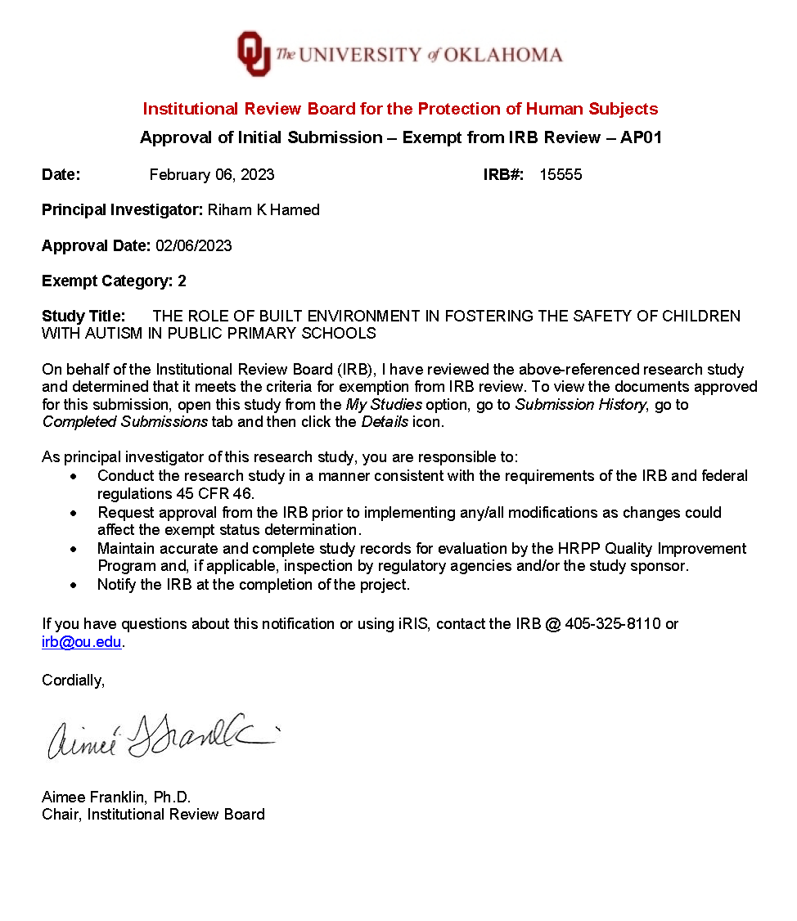

Appendix B: Survey Questions
Q0 Informed Consent
You are invited to participate in research about the role of the built environment (School space planning and design) in fostering the Safety (Psychological Safety) of children with autism spectrum disorders. The study focuses on inclusive education in public primary schools.
If you agree to be in this research, you will answer questions according to your experience in working with children with autism. Your participation will take roughly 7-10 minutes. About 200 people will participate in this study.
There are no risks and no benefits from being in this research. You will not be reimbursed for your time and participation in this research.
In research reports, there will be no information that will make it possible to identify you. Research records will be stored securely, and only approved researchers and the OU Institutional Review Board will have access to the records.
Data are collected via an online survey system that has its own privacy and security policies for keeping your information confidential. Please note that no assurance can be made as to the use of the data you provide for purposes other than this research.
After removing all identifiers, we might share your data with other researchers or use it in future research without obtaining additional consent from you.
If you do not participate, you will not be penalized or lose benefits or services unrelated to the research.
If you decide to participate, you don’t have to answer any questions and can stop participating at any time. If you have questions, concerns, or complaints about the research or have experienced a research-related injury, you can contact:

Riham Hamed
Graduate Student - Interior Design
College of Architecture
Email: rhamed@ou.edu
Cell Phone: (405) 546-8116

You can also contact my faculty advisor: Mia Kile @ mkile@ou.edu.

You can also contact the University of Oklahoma – Norman Campus Institutional Review Board (OU-NC IRB) at 405-325-8110 or irb@ou.edu if you have questions about your rights as a research participant, concerns, or complaints about the research and wish to talk to someone other than the researcher(s) or if you cannot reach the researcher(s). Please print this document for your records.
IRB # 15555 IRB Approval Date 2/6/2023
By providing information to the researcher(s), I am agreeing to participate in this research.
- I agree to participate (1)
- I do not want to participate (2)

Q1 of 18
Where are you participating from?
- The United States of America (1)
- Egypt (2)

Q2 of 18
Please, select your age.
- 18-24 (1)
- 25-31 (2)
- 32-38 (3)
- 39 and over (4)

Q3 of 18
How many years of experience do you have?
- Less than 1 year (1)
- 1-5 years (2)
- 5-10 years (3)
- More than 10 years (4)

Q4 of 18
For how many years have you been working with children with Autism?
- Less than 1 year (1)
- 1-5 years (2)
- 5-10 years (3)
- More than 10 years (4)

Q5 of 18
What age range/s of ASD students did you teach?
Please, select all that apply.
- Less than 3 years of age (1)
- 3-6 years (2)
- 6-9 years (3)
- 9-12 years (4)
- More than 12 years of age (5)

Q6 of 18
Describe what comes to mind regarding safety and children with ASD in public schools.
________________________________________________________________
________________________________________________________________
________________________________________________________________
________________________________________________________________
________________________________________________________________

Q7 of 18
In general, which type of classrooms do you think is more beneficial for ASD children in public schools, the special education classrooms or the integrated classroom (with their typical peers)?
autism spectrum disorder (ASD), i.e. is a set of neurodevelopmental disorders characterized by a lack of social interaction and verbal and nonverbal communication in the first three years of life.
- Special Education Classrooms (1)
- Integrated Classrooms (2)

Q8 of 18
Which type of bullying do you think ASD children are mostly exposed to in inclusive public schools?
Verbal Bullying. i.e., When the bully says hurtful things to the victim.
Physical Bullying. i.e., The type of bullying incorporates physical involvement like hair pulling, punching, or kicking.
Gesture Bullying. i.e., The type of bullying where the bully stares/looks at the victim in an intimidating way or shows threatening gestures.
Exclusion Bullying. i.e., The type of bullying where the bully leaves their victim out of things. For example: when someone is left all alone at lunchtime.
Bullying definitions source: Spunout. 6 different types of bullying. Spunout. Retrieved February 1, 2023, from https://spunout.ie/life/bullying/types-bullying
- Gesture bullying (1)
- Verbal bullying (2)
- Physical bullying (3)
- Exclusion bullying (4)

Q9 of 18
Based on your own experience, which area/s within the school building might ASD children face bullying from their peers the most?
Bullying Types. i.e., The types of bullying can be divided into five categories: gesture, verbal, physical, extortion, and exclusion bullying. (Tattum and Herbert, 1997)
Please, select all that apply.
- Hallways (1)
- Classrooms (2)
- Restrooms (3)
- Playgrounds (4)
- If OTHER, please describe: (5) __________________________________________________
- Multiple settings or Undifferentiated (6)

Q10 of 18
On a scale of 1 (least) to 10 (most), please rate the factors below regarding how much they may jeopardize ASD children's sense of safety in public schools.
Safety, i.e., It is the Psychological and Physical security of the children with autism around their typically developing peers, without encountering any types of bullying.
 | 0 | 1 | 2 | 3 | 4 | 5 | 6 | 7 | 8 | 9 | 10

Bullying () | 
Sensory Overload ()
Lack of self-reliance ()
Feeling excluded ()

Q11 of 18
To what extent do you agree that having separate Restrooms designated for ASD children only would promote ASD children's sense of Safety and suppress their exposure to bullying in public schools?
Safety, i.e., It is the Psychological and Physical security of the children with autism around their typically developing peers, without encountering any types of bullying.
- Strongly agree (1)
- Somewhat agree (2)
- Neither agree nor disagree (3)
- Somewhat disagree (4)
- Strongly disagree (5)

Q12 of 18
Do you think ASD children should be able to freely access a safe zone outside the building (e.g., a fenced outdoor playground) if they experience sensory overload?
- Strongly agree (1)
- Somewhat agree (2)
- Neither agree nor disagree (3)
- Somewhat disagree (4)
- Strongly disagree (5)

Q13 of 18
How likely do you think having a separate Cafeteria designated for ASD children only would promote ASD children's sense of Safety and suppress bullying?
- Extremely likely (1)
- Somewhat likely (2)
- Neither likely nor unlikely (3)
- Somewhat unlikely (4)
- Extremely unlikely (5)

Q14 of 18
Do you think the long indoor walking distance between ASD children's classrooms and the rest of the school spaces would affect their safety and exposure to bullying rates?
- Definitely yes (1)
- Probably yes (2)
- Might or might not (3)
- Probably not (4)
- Definitely not (5)

Q15 of 18
Based on your experience, what other elements should be considered in the schools' architectural design to promote ASD students' safety?
________________________________________________________________
________________________________________________________________
________________________________________________________________
________________________________________________________________
________________________________________________________________

Q16 of 18
On a scale of 1 (worst) to 10 (best), How positively do you rate the effect of having a "Sensory Room" for ASD children in public schools in terms of the children's sense of safety?
Safety, i.e., It is the Psychological and Physical security of the children with autism around their typically developing peers, without encountering any types of bullying.
 | 0 | 1 | 2 | 3 | 4 | 5 | 6 | 7 | 8 | 9 | 10

scale ()

Q17 of 18
Please, rearrange the following spaces based on how close you think they should be to the building entrance and main hallways.
______ Classrooms where ASD children are located (1)
______ Sensory Rooms (2)
______ Cafeteria (3)
______ Restrooms (4)
______ Stairs (5)

Q18 of 18
What recommendations would you suggest architects and designers consider to support ASD children's safety in public schools?
________________________________________________________________
________________________________________________________________
________________________________________________________________
________________________________________________________________
________________________________________________________________

End of Block: Default Question Block

Appendix C: Browns Point School Photographs Usage Permissions

Permission from Eckert and Eckert Photography
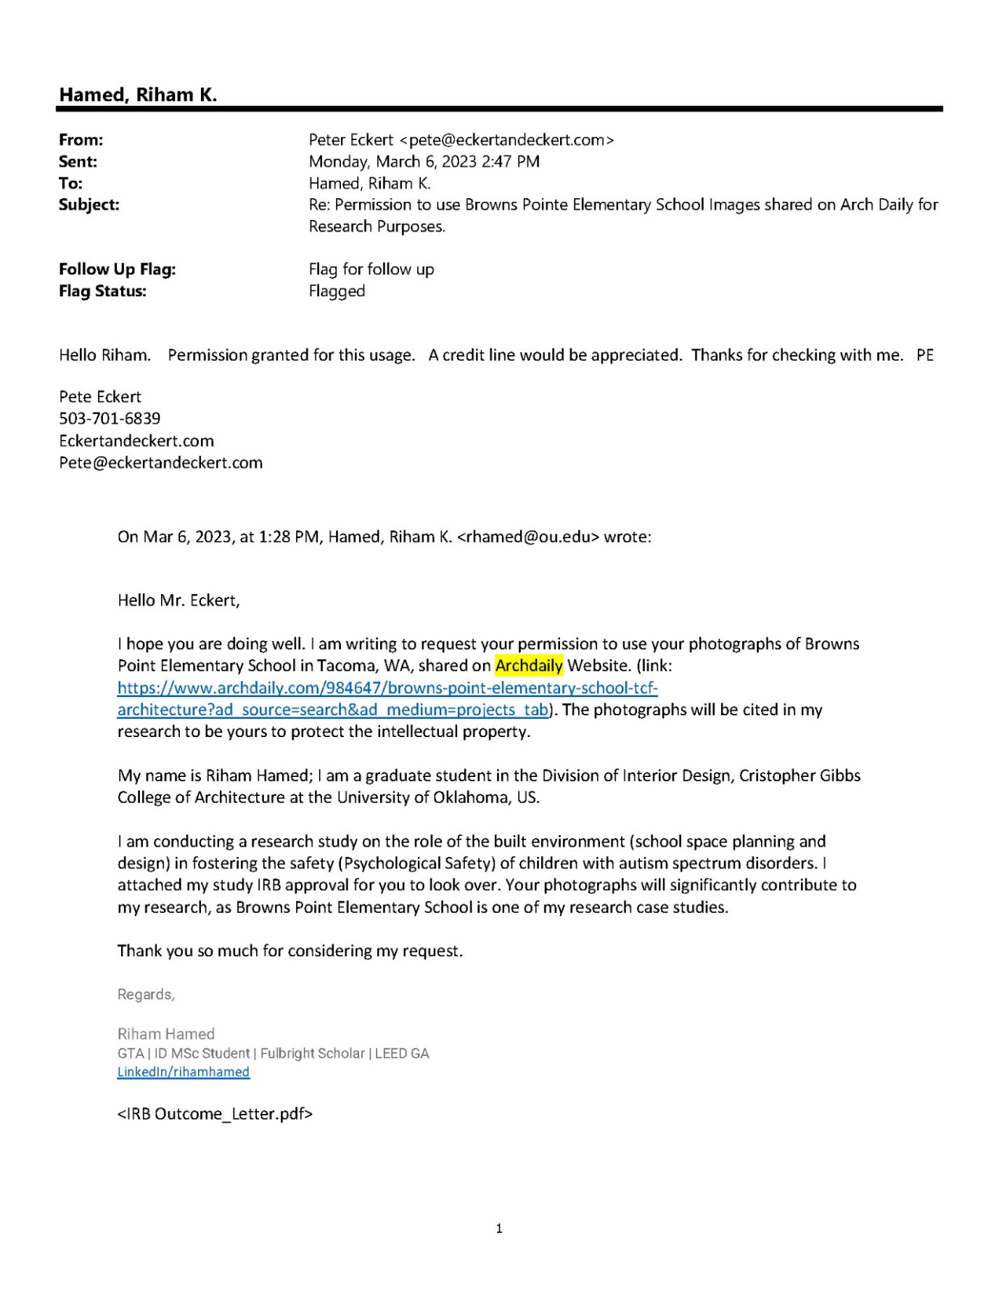

Permission from LightCatcher Imagery
