UNIVERSITY OF OKLAHOMA

GRADUATE COLLEGE

COMPONENT IMPORTANCE BALANCING OF MULTI-COMMODITY NETWORKS

A THESIS

SUBMITTED TO THE GRADUATE FACULTY

in partial fulfillment of the requirements for the

Degree of

MASTER OF SCIENCE

By

MICK BARLACH CHRISTENSEN
Norman, Oklahoma
2022

COMPONENT IMPORTANCE BALANCING OF MULTI-COMMODITY NETWORKS

A THESIS APPROVED FOR THE
SCHOOL OF INDUSTRIAL AND SYSTEMS ENGINEERING

BY THE COMMITTEE CONSISTING OF

Dr. Kash Barker, Chair

Dr. Andrés González

Dr. Rui Zhu

© Copyright by MICK BARLACH CHRISTENSEN 2022
All Rights Reserved.

Dedication

To everyone who lent me their patience, time, and love.

Acknowledgements
First and foremost, I thank Dr. Kash Barker for advising me on this thesis. Not only has he greatly improved the quality of work that would otherwise have been provided in this paper, he is also the main reason for me deciding to do a thesis at all. Had it not been for an email written at the end of my first semester of my accelerated degree, things would likely have looked much different for me. He is passionate about the College and ISE and it shows, and it inspires.

Second, I would like to thank Dr. Andrés González for the great help he provided in the thinking stages of the model development. His great knowledge is an immense gift to the School.

Third, a thank you to Dr. Rui Zhu for agreeing to join my committee, and to Dr. Jonas Johansson for collaborating and sharing the data used in this paper.

Finally, a big thank you to all the friends and educators I have met during my studies at OU and in Oklahoma. The past five years have been a mix of great and troubling times, but the Mick at this end of the experience is much stronger than the one first experiencing the sweltering heat and humidity back in August 2017.

Mick Christensen
Table of Contents
Dedication iv
Acknowledgements v
List of Tables viii
List of Figures ix
Abstract x
Chapter 1.0 Introduction and Motivation 1
1.1 Research Focus 3
Chapter 2.0 Proposed Methodology 5
2.1 Multi-Commodity Network Flow 5
2.2 Importance Measure Balancing 6
2.2.1 Multi-State System Balancing 6
2.2.2 Multi-Commodity Network Balancing 7
2.3 Multi-Objective Optimization 8
2.4 Initial Interdiction Optimization Model 10
2.4.1 Decision Variables and Objectives 10
2.4.2 Model Constraints 10
2.5 Balanced Optimization Model 12
2.5.1 Decision Variables and Objectives 12
2.5.2 Model Constraints 13
Chapter 3.0 Network Application 15
3.1 Swedish Railway Network Data 15
3.2 Data Selection Methodology 19
3.2.1 Instrumentation 19
3.2.2 Data Reduction 19
Chapter 4.0 Results and Analysis 21
4.1 Nature of the Data 21
4.2 Balanced Model Results 21
4.3 Network Balance Comparison 27
Chapter 5.0 Conclusion 30
References 31
Appendix A 34
Appendix B 35
Appendix C 38
Appendix D 39

List of Tables
Table 1. Total amount demanded of commodity type, k, and the baseline unmet demand, sorted by kTon. 16
Table 2. Source and sink nodes for each commodity in the aggregated network. 17
Table 3. Summary of the unmet demand across all interdiction scenarios per commodity. 20
Table 4. Summary of $U$ over 1132 interdicted links for all commodities. 22
Table 5. Maximum unmet demand vs. maximum and average $U$ for all commodities. 23
Table 6. Summary of the added capacity per commodity in the balanced network. 24
Table 7. Initial U values vs. balanced U values. 28

List of Figures
Figure 1. Network performance, $φ(t)$, over different network states. 2
Figure 2. Visual representation of the Swedish railway network. 18
Figure 3. Examples of baseline flow (in red) for Commodity 1: Agriculture, Forest, Fishing (left) and Commodity 2: Coal, Crude Oil, Natural Gas (right) for the Swedish railway network 18
Figure 4. Added capacity to links for commodities 1-8, excluding commodities 2 and 5. 25
Figure 5. Added capacity to links for commodities 9-14. 26
Figure 6. Added capacity to links for commodities 16-20, excluding commodity 17. 27

Abstract
Determining which network components to focus on in case of a disruption can be determined by the component with the greatest importance to the network. This study extends a balancing component added to a list of optimization targets in multi-state system to a multi-commodity network. A bi-objective optimization problem is developed in which one objective seeks to minimize the difference in a flow-based component importance measure across one-at-a-time interdiction scenarios by adding capacity to components, while the other minimizes unmet demand to encourage flow through the network. The optimization approach is applied to a multi-commodity Swedish railway network, where a set of link capacity increases per commodity are suggested based on the desire to balance the network.

Chapter 1.0 Introduction and Motivation
Understanding which critical infrastructure systems need more attention and resources is a growing and important research area. Prioritizing these resources can enhance national security and reduce risk in an increasingly interconnected and interdependent system [1, 2]. These critical infrastructures include transportation, energy, water, and communications and provide vital services to a nation. The severity of disruptions to these infrastructures is exemplified by the costs of downtime and recovery. Directly after Hurricane Harvey hit Texas in August 2017, 10% of the entire United States trucking industry was affected, with 25% of the regional trucking industry still affected a month later [3]. Along with this comes issues of decrease in supply and rising costs of transportation, eventually reaching the consumers. Threats to critical infrastructure, including physical and climate threats, are of growing interest for policy makers and researchers alike, with an interest to “safeguard and strengthen the systems” [4]. The resilience of transportation infrastructure is of particular importance to the successes of other infrastructures due to its role in the supply chain and is under increasing stress with rising requirements for maintenance and declining performance [5, 6].
There are several different definitions of resilience in various domains. For a transportation network, one way is as a metric for measuring a system’s performance in the event of a disruption, which can be represented graphically as seen in Figure 1 [7]. The figure is split in two after a disruptive event occurs: vulnerability and recoverability. Vulnerability is defined as the inability of the system to sustain its performance immediately after a disruption, while recoverability is defined as the ability of that disrupted system to recover in a timely manner [7-9].
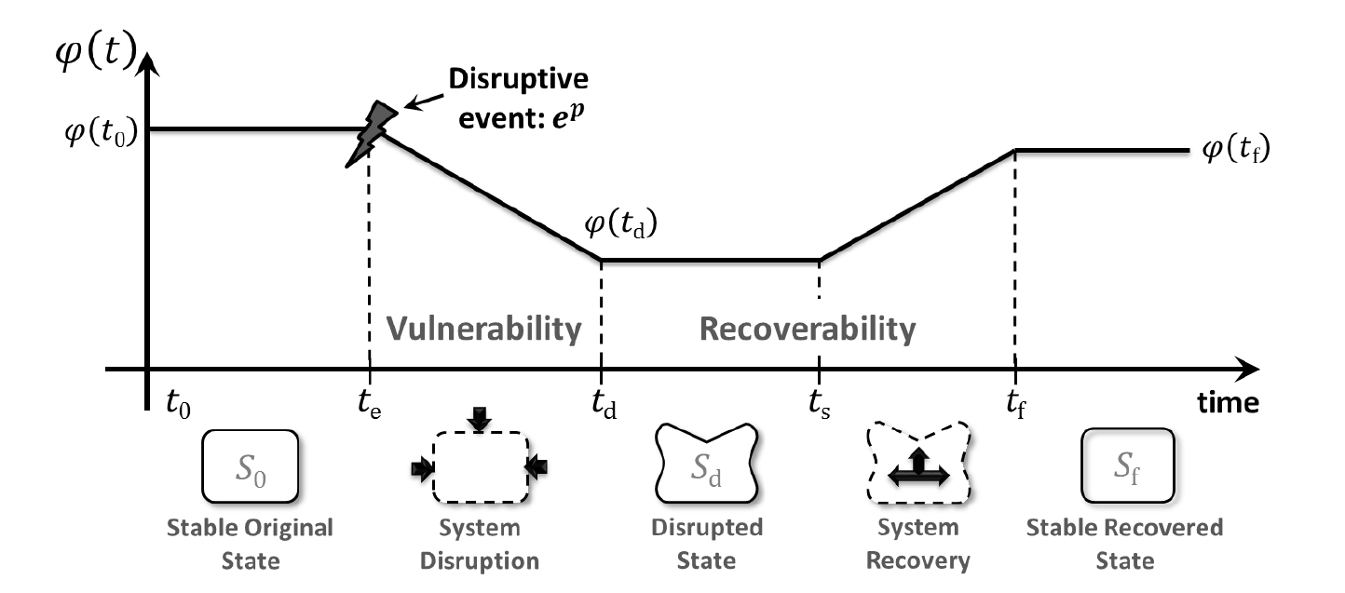
Figure 1. Network performance, $φ(t)$, over different network states.

The primary approaches for network vulnerability analysis have been broadly classified as scenario‐specific, strategy‐specific, simulation, and mathematical modeling methodologies [10]. Interdiction is a common theme for all the methodologies, where a network component is disrupted and its effect on the system is evaluated. Strategy-specific methodologies follow a hypothesized sequence of disruptions under the assumptions of weaker or more at-risk areas [11]. Simulation methodologies and mathematical modeling assessments are useful when little is known about the state of the network or when identifying the scenario with the greatest risk to the network [12, 13]. Scenario-specific methodologies will be utilized in this paper and measures the impact of removing one link at a time.
The performance of a network can be described using importance measures. Graph-theoretic measures, such as centrality-based measures, i.e., closeness, betweenness, straightness, and information centrality, have been developed to classify the performance of a network [14]. However, using flow-based network vulnerability measures is a newer research area that can quantify the impact of disruption to an individual component on the efficiency and connectivity of a network [15, 16]. Hence, flow-based measures may be more useful for decision making purposes, utilizing network efficiency measures such as the N-Q method for capturing the demands, flows, costs, and behavior of networks to assess the importance of network components, or quantifying multi-industry operability after a drop in commodity flow [17, 18].
When evaluating the network using importance measures, certain links may prove to be more important to the performance of the network. Under a disruptive scenario, these links would tend to have a greater impact on the network performance if sufficient redundancy is not available in the network. Therefore, it is a desirable property of a network system to avoid bottlenecks or overly high-performing components in addition to optimizing other stakeholder targets. Prior work has been done in designing systems such that each component has similar importance values throughout the system [19-21]. However, to the author’s knowledge, this approach has not been extended to multi-commodity networks utilizing flow-based importance measures.

1.1 Research Focus
Transportation networks contain multiple commodities that should be routed to the customer on time. Since multiple types of commodities need to be routed on each link and throughout the network, certain links may be more important in a network than others. This study considers the links throughout a network and seeks to spread out the importance of links to create a more resilient network.
Through the balancing of network components in a multi-commodity network, the model seeks to provide decision makers with information of which links require more attention in the event of a network disruption. An assumption of this approach is that each link has an equal chance of being disrupted; thus, networks without likely sequences of disruptions, such as in the case of strategy-specific interdiction, can be evaluated. The network vulnerability importance measure utilized in this section was developed in a prior study and involves the unmet demand throughout the network [22].
The remainder of this paper is arranged as follows. Section 2 provides definitions and notation for multi-commodity networks, the network component importance measure, an extension of the balanced system method, an initializing optimization model, and the balanced optimization model. Section 3 introduces a Swedish railway case study and demonstrates the proposed network reduction methodology. Section 4 offers the results of the model and the decision analysis, while Section 5 offers conclusions.

Chapter 2.0 Proposed Methodology
In this section, the methodology used to define multi-commodity network flow, balanced importance measures, multi-objective optimization, the initial optimization model, and the balancing optimization model are described.

2.1 Multi-Commodity Network Flow
This paper extends a model that adapted the traditional minimum-cost multi-commodity network flow problem in which the goal is to minimize the cost of transportation while meeting all demand. For the adapted model, the constraint that all demand must be met was slackened, while the cost minimizing objective was replaced by an unmet demand minimizing objective meant to measure the network’s ability to reroute commodities [18, 22].
Let a network be denoted by $G=\left(N,A\right)$, where $N$ is a set of $n$ nodes (or vertices) and $A$ is a set of links (or edges). Additionally, let there be $k=1,…,K$ commodities. Then, the capacity of link $\left(i,j\right)$ from node $i$ to node $j$ for commodity $k$ is represented by $c_{ij}^{k}$. Each commodity has a set of supply nodes in the set $S^{k}$ represented by $s_{i}^{k}$ with supply values of $λ_{i}^{k}$ and demand nodes $D^{k}$ represented by $d_{j}^{k}$ with demand values of $μ_{j}^{k}$. It is an assumption of the model that a node can be a supply node for a commodity and a demand node for another, but not both a supply and demand node for the same commodity.
Let the set of interdicted links, $L$, be a subset of all links, $A$. Then, if the link $\left(i,j\right)=l$ in interdiction scenario $l∈L$, $c_{ij}^{k}=0$ and $c_{ji}^{k}=0$ for all commodities $k∈K$. That is, no flow of commodities is allowed from node $i$ to node $j$ and vice versa for that interdiction scenario. Then, let $α_{ij}^{k}$ be the percent increase in capacity across link $\left(i,j\right)∈A$ used to reroute the flow of commodities that is blocked from the interdiction of link $l$.

2.2 Importance Measure Balancing
This section describes the balanced optimization component for a multi-state system and extends it to a multi-commodity network.

2.2.1 Multi-State System Balancing
In system design, it is a desirable property to avoid bottlenecks or overly high-performing components in addition to optimizing economic or safety goals. One way to achieve this is to design a system such that each component has similar importance values [19-21]. To achieve this, an importance measure balancing component $σ_{I}$ can be added to the optimization targets as in Eq. ( 1 ):
$$σ_{I}=\sqrt{\overline{I^{2}}-{\overline{I}}^{2}}$$ | ( 1 )

The balancing component, $σ_{I}$, is calculated by the difference in the average squared importance, $\overline{I^{2}}$, and the square of the average importance, ${\overline{I}}^{2}$, of component $j$ for generic importance measure $I$, $I_{j}$. The functions in Eqs. ( 3 )( 4 ) below show the calculation of $\overline{I^{2}}$ and $\overline{I}$, respectively:
$$\overline{I^{2}}=\frac{1}{n}\sum_{j=1}^{n}{I_{j}^{2}}$$ | ( 2 )

$$\overline{I}=\frac{1}{n}\sum_{j=1}^{n}{I_{j}}$$ | ( 3 )

Then, if $σ_{I}=0$, the importance of all $j=1,2,…,J$ system components are equal and the system is perfectly balanced with respect to the importance measure $I$, which meets the desired quality of the system.

2.2.2 Multi-Commodity Network Balancing
The multi-state system balancing method is extended to multiple commodities in an interdicted network. First, an importance measure $I_{l}^{k}$ is defined as the importance of interdicted link $l∈L$ to the network for commodity $k∈K$. The average importance across interdiction scenarios, $\overline{I^{k}}$, can then be defined by the sum of the importance of interdicted link $l$, $I_{l}^{k}$, for all interdicted links $l∈L$, divided by the number of interdicted links as in Eq. ( 4 ) below:
$$\overline{I^{k}}=\frac{1}{\left|L\right|}\sum_{l∈L}{I_{l}^{k}}$$ | ( 4 )

The balancing component in this case, then, is calculated by the difference between the importance of interdicted link $l$, $I_{l}^{k}$, and the average of all interdicted links’ importance, summed across all commodities $k∈K$ and interdicted links $l∈L$ as shown in Eq. ( 5 ) below:
$$\sum_{k∈K}{\sum_{l∈L}{\left|\overline{I^{k}}-I_{l}^{k}\right|}}$$ | ( 5 )

Thus, the balancing term in Eq. ( 5 ) will seek to balance the importance for all interdicted links and commodities.
The importance measure used in this model is the sum of the total unmet demand proportion for all commodities $k$ for all interdiction scenarios $l$ as shown in Eq. ( 6 ) below:
$$I_{l}^{k}=\sum_{j∈D^{k}}{\frac{μ_{j}^{k}-\left(\sum_{i:\left(i,j\right)∈A}{x_{ijl}^{k}}-\sum_{i:\left(i,j\right)∈A}{x_{jil}^{k}}\right)}{μ_{j}^{k}}}; ∀k∈K,l∈L$$ | ( 6 )
The proportion of unmet demand for commodity $k$ in interdiction scenario $l$, $I_{l}^{k}$, is calculated by the difference in demand of commodity $k$ at node $j$, $μ_{j}^{k}$, and the flow of commodity $k$ remaining in node $j$, standardized by $μ_{j}^{k}$. The flow of commodity $k$ remaining in demand node $j$ is calculated as the difference between the flow of commodity $k$ in and out of the node. This quantity is then summed and minimized across all demand nodes $j∈D^{k}$ for all commodities $k∈K$ and interdiction scenarios $l∈L$.

2.3 Multi-Objective Optimization
As the importance measure used for this study is minimizing unmet demand and subtracting it from the average as shown above, the simplest solution is for no flow to go through the network; hence, the difference in importance, $\overline{I^{k}}-I_{l}^{k}$, will be 0 for all interdicted links $l∈L$ and commodities $k∈K$. To encourage demand through the network, a second objective, minimizing total unmet demand for all interdiction scenarios $l$ and commodities $k$, defined in Section 2.4, will need to be put in place.
There are multiple ways to deal with multi-objective problems, such as the global criterion approach, goal programming, weighted sum method, or $ϵ$-constraint method [23, 24]. The global criterion approach is an a-priori method, which searches for a solution as close to a predetermined ideal vector as possible. Goal programming assigns some weight to objectives and applies deviational variables to get close to desired values without strictly enforcing constraints. The weighted sum method assigns a weight to each objective based on its importance relative to the other objectives. However, these weights are usually arbitrary, and a Pareto-frontier is often estimated by varying the weights of the objectives, which is then evaluated by decision-makers. The $ϵ$-constraint method deals with multi-objective optimization problems by writing all objectives but one as constraints [25, 26] and a variation of it will be utilized for this study.
For a multi-objective optimization problem with objectives $f_{1}\left(x\right), f_{2}\left(x\right),…,f_{M}(x)$, choose an objective to be the main objective, $f_{q}\left(x\right)$. This is usually the objective most important to the stakeholders. This objective is minimized as in Eq. ( 7 ) below:
$$minimize: f_{q}\left(x\right)$$ | ( 7 )
Then, let the optimization problem be subject to the following constraints in Eq. ( 8 ):
$$f_{i}≤ϵ_{i}; \left(i=1,2,q-1,q+1,…,M\right)$$ | ( 8 )
The $ϵ_{i}$ in Eq. ( 8 ) are limits to the values of the other objectives, i.e., objective $f_{i}$ cannot be less than a certain threshold $ϵ_{i}$. In the case of a bi-objective problem, such as the one utilized in this paper, this would be formulated as in Eqs. ( 9 )( 10 ):
$$minimize: f_{1}\left(x\right)$$ | ( 9 )

$$subject to f_{2}≤ϵ_{2}$$ | ( 10 )

2.4 Initial Interdiction Optimization Model
This section defines the decision variables, objectives, and constraints of the linear programming model that minimizes unmet demand for each interdiction scenario to gain baseline values.

2.4.1 Decision Variables and Objectives
The optimization model can be formulated as a linear programming model with a set of decision variables $x_{ijl}^{k}$, the flow of commodity $k∈K$ across link $\left(i,j\right)∈A$ in interdiction scenario $l∈L$.
After the variables are defined, the unmet demand minimizing function is added as an objective as shown below in Eq. ( 11 ):
$$minimize: \sum_{k∈K}{\sum_{j∈D^{k}}{\frac{μ_{j}^{k}-\left(\sum_{i:\left(i,j\right)∈A}{x_{ijl}^{k}}-\sum_{i:\left(i,j\right)∈A}{x_{jil}^{k}}\right)}{μ_{j}^{k}}}}; ∀l∈L$$ | ( 11 )

The objective is to minimize the sum of total unmet demand percentage for all commodities $k$ across all interdiction scenarios $l$. This is calculated in the same manner as the importance measure in Eq. ( 6 ), and is performed iteratively across all interdiction scenarios $l∈L$. The values of unmet demand at node $j∈D^{k}$ for all commodities $k$ in interdiction scenario $l$, seen in Eq. ( 12 ) below, are then stored as parameters to be used as minimum values constraints in the next optimization model.
$$ϵ_{l}=\sum_{k∈K}{\sum_{j∈D^{k}}{\frac{μ_{j}^{k}-\left(\sum_{i:\left(i,j\right)∈A}{x_{ijl}^{k}}-\sum_{i:\left(i,j\right)∈A}{x_{jil}^{k}}\right)}{μ_{j}^{k}}}}; ∀l∈L$$ | ( 12 )

2.4.2 Model Constraints
The flow of commodity $k$ across link $\left(i,j\right)$ for all interdiction scenarios $l$, $x_{ijl}^{k}$, is subject to the capacity constraint shown in Eq. ( 13 ) below:
$$x_{ijl}^{k}≤c_{ij}^{k}; ∀\left(i,j\right)∈A, k∈ K,l∈L$$ | ( 13 )

The constraint in Eq. says the flow, $x_{ijl}^{k}$, cannot exceed the capacity at that link, $c_{ij}^{k}$.
$$-\sum_{j:\left(i,j\right)∈A}{x_{ijl}^{k}}+\sum_{j:\left(j,i\right)∈A}{x_{jil}^{k}}≤μ_{i}^{k}; ∀i∈D^{k},k∈K,l∈L$$ | ( 14 )

$$\sum_{j:\left(i,j\right)∈A}{x_{ijl}^{k}}-\sum_{j:\left(j,i\right)∈A}{x_{jil}^{k}}≤λ_{i}^{k}; ∀i∈S^{k},k∈K,l∈L$$ | ( 15 )

$$\sum_{j:\left(i,j\right)∈A}{x_{ijl}^{k}}-\sum_{j:\left(j,i\right)∈A}{x_{jil}^{k}}=0; ∀i∈N\backslash \{D^{k},S^{k}\},k∈K,l∈L$$ | ( 16 )

The constraints in Eqs. ( 14 )( 15 )( 16 ) above balance the flow across the network. Eq. ( 14 ) sets the difference in flow in and out of demand node $j∈D^{k}$ for commodity $k$ to no more than the demand of commodity $k$ at node $j$, $μ_{j}^{k}$. Eq. ( 15 ) sets the difference in flow out and in of supply node $j∈S^{k}$ for commodity $k$ to no more than the supply of commodity $k$ at node $j$, $λ_{j}^{k}$. Eq. ( 16 ) ensures that the flow into node $i$ equals the flow out of node $i$ for all nodes $i$ in $N$, excluding all supply and demand nodes for commodity $k$.
$$x_{ijl}^{k}=0; \left(i,j\right)=l ∀l∈L,k ∈K$$ | ( 17 )

$$x_{jil}^{k}=0; \left(i,j\right)=l ∀l∈L,k ∈K$$ | ( 18 )

The constraints shown above in Eqs. ( 17 )( 18 ) prevent flow across interdicted link $\left(i,j\right)$ in interdiction scenario $l$ for all commodities $k$. This constraint is performed iteratively for each interdicted link $l∈L$.
Finally, all flow variables are nonnegative as shown in the constraint in Eq. ( 19 ) below:
$$x_{ijl}^{k}≥0; ∀\left(i,j\right)∈A,k∈K,l∈L$$ | ( 19 )

2.5 Balanced Optimization Model
This section defines the decision variables, objectives, and constraints of the importance balancing linear programming model.

2.5.1 Decision Variables and Objectives
The formulation for the flow decision variables, $x_{ijl}^{k}$, is the same as in section 2.4. However, a second set of variables representing the percentage increase in capacity for link $\left(i,j\right)∈A$ for commodity $k∈K$, $α_{ij}^{k}$ is added.
After the variables are defined, the importance measure balancing function is added as an objective as shown below in Eq. ( 20 ):
$$minimize: \sum_{k∈K}{\sum_{l∈L}{\left|\overline{I^{k}}-I_{l}^{k}\right|}}$$ | ( 20 )

Since this problem is to be formulated as a linear problem, however, the importance measure, $I_{l}^{k}$, and average importance measure across interdiction scenarios, $\overline{I^{k}}$, are replaced by a placeholder variable, $U_{l}^{k}$, as shown in Eq. ( 21 ). Two constraints are then added in Eqs. ( 22 )( 23 ) that constrain the value of $U_{l}^{k}$ to $\left|\overline{I^{k}}-I_{l}^{k}\right|$:
$$minimize: \sum_{k∈K}{\sum_{l∈L}{U_{l}^{k}}}$$ | ( 21 )

$$I_{ l}^{k}-\overline{I^{k}}≤U_{ l}^{k}; ∀l∈L,k∈K$$ | ( 22 )

$$-\left(I_{l}^{k}-\overline{I^{k}}\right)≤U_{l}^{k}; ∀l∈L,k∈K$$ | ( 23 )

The two constraints in Eqs. ( 22 )( 23 ), in combination with the objective function which seeks to minimize the differences in Eq. ( 21 ), ensure that:
- When $I_{l}^{k}-\overline{I^{k}}>0$, $U_{l}^{k}$ is minimized to $I_{l}^{k}-\overline{I^{k}}$.
- When $I_{l}^{k}-\overline{I^{k}}<0$, $U_{l}^{k}$ is minimized to $-\left(I_{l}^{k}-\overline{I^{k}} \right)$.
- When $I_{l}^{k}-\overline{I^{k}}=0$, $U_{l}^{k}$ is minimized to $0$.
$$minimize: \sum_{l∈L}{\sum_{k∈K}{\sum_{j∈D^{k}}{\frac{μ_{j}^{k}-\left(\sum_{i:\left(i,j\right)∈A}{x_{ijl}^{k}}-\sum_{i:\left(i,j\right)∈A}{x_{jil}^{k}}\right)}{μ_{j}^{k}}}}}$$ | ( 24 )

The second objective, minimizing the sum of total unmet demand percentage for all commodities $k$ and all interdiction scenarios $l$ as shown in Eq. ( 24 ), is then added as a constraint in the next section as an $ϵ$ constraint.

2.5.2 Model Constraints
The flow of commodity $k$ across link $\left(i,j\right)$ for all interdiction scenarios $l$, $x_{ijl}^{k}$, is subject to the capacity constraint shown in Eq. ( 25 ) below:
$$x_{ijl}^{k}≤\left(1+α_{ij}^{k}\right)×c_{ij}^{k}; ∀\left(i,j\right)∈A, k∈ K,l∈L$$ | ( 25 )

The constraint in Eq. ( 25 ) says the flow cannot exceed the sum of the original and added capacity. The added capacity on link $\left(i,j\right)$ for commodity $k$ can be limited by financial or physical constraint to the network and is subject to the constraints in Eqs. ( 26 )( 27 ):
$$α_{ij}^{k}≤p^{k}; ∀\left(i,j\right)∈A, k∈ K$$ | ( 26 )

$$\sum_{\left(i,j\right)∈A}{α_{ij}^{k}×c_{ij}^{k}}≤α_{max}^{k}; ∀ k∈ K$$ | ( 27 )

The constraint in Eq. ( 26 ) ensures the percent added capacity on link $\left(i,j\right)$ for commodity $k$, $α_{ij}^{k}$, does not exceed a maximum percentage increase of commodity $k$, $p^{k}$, for all links $\left(i,j\right)∈A$ and commodities $k∈K$. The constraint in Eq. ( 27 ) says the sum of all added capacity on link $\left(i,j\right)$ for commodity $k$ cannot exceed an allotted increase, $α_{max}^{k}$, for all commodities $k∈K$. The allotted increase, $α_{max}^{k}$, is defined as the total additional capacity available to the network for commodity $k$.
$$\sum_{k∈K}{\sum_{j∈D^{k}}{\frac{μ_{j}^{k}-\left(\sum_{i:\left(i,j\right)∈A}{x_{ijl}^{k}}-\sum_{i:\left(i,j\right)∈A}{x_{jil}^{k}}\right)}{μ_{j}^{k}}}}≤ϵ_{l}; ∀l∈L$$ | ( 28 )

The flow constraints for this optimization model are the same as those of the previous model in in Eqs. ( 14 )( 15 )( 16 ). Additionally, the unmet demand values achieved from the previous model, $ϵ_{l}$, are added as maximum values for the unmet demand at node for all nodes $j∈D^{k}$ and commodities $k$ for interdiction scenario $l$ as in Eq. ( 28 ) above.
The interdiction constraints and nonnegativity constraints provided in the previous model in Eqs. ( 17 )( 18 )( 19 ) are all applied to this model, and an additional nonnegativity constraint is added to the percent added capacity variable as in Eq. ( 29 ) below:
$$α_{ij}^{k}≥0; ∀\left(i,j\right)∈A,k∈K$$ | ( 29 )

Gurobi optimization software has been shown to efficiently find feasible and optimal solutions to linear problems, including multi-commodity network flow problems [27]. The Gurobi Optimizer found a solution using the dual simplex method and the python code for the initial and balancing model can be found in Appendix A and Appendix B, respectively.

Chapter 3.0 Network Application
In this section, the balanced network model is applied to the Swedish railway system. The system transported freight across 1363 stations (nodes) and 1438 bidirectional tracks (links), which was aggregated from public sources in 2012 [28]. The network has previously been studied in the context of vulnerability analysis [22, 29].

3.1 Swedish Railway Network Data
The freight moved in the system is summarized in Table 1 and consists of 20 commodities. As the data were compiled and aggregated to avoid disclosure of sensitive information, only aggregated cargo routes with origin and destination nodes are given, the number of which are summarized in Table 2. To overcome this and estimate link capacities and the supply/demand of nodes, a method developed in a previous study was utilized [22]. Supply and demand values for each commodity were distributed across the nodes utilized for each cargo route, proportional to the number of routes running through that node with that commodity. The commodity specific capacities of each link were estimated based on the freight movement in the network with adjustment factors to produce some slack.
Table 1. Total amount demanded of commodity type, k, and the baseline unmet demand, sorted by kTon.

Table 2. Source and sink nodes for each commodity in the aggregated network.
Commodity | Commodity Name | No. of Supply Nodes | No. of Demand Nodes
1 | Agriculture, forest, fishing | 228 | 284
2 | Coal, crude oil, natural gas | 27 | 19
3 | Ore | 210 | 262
4 | Food, beverage, tobacco | 281 | 366
5 | Textile, leather | 240 | 262
6 | Wood, cork, pulp, paper | 245 | 276
7 | Petroleum products | 198 | 217
8 | Chemicals, rubber, plastics | 186 | 187
9 | Other non-metallic mineral | 270 | 258
10 | Fabricated metal products | 216 | 193
11 | Machinery and equipment | 263 | 251
12 | Transport equipment | 240 | 269
13 | Furniture, other manufactured | 248 | 239
14 | Return materials and recycling | 256 | 380
15 | Post and packages | 0 | 0
16 | Equipment for transportation | 238 | 260
17 | Moving goods, vehicles for repair | 0 | 0
18 | Loader and grouped goods | 287 | 241
19 | Unidentifiable goods | 293 | 267
20 | Goods not in group of 1-19 | 227 | 195

The demand for the top three commodities exceeds 75%, where the top commodity, ore, represents around 46% of all demanded goods in kTon. The baseline case, i.e., the undisrupted network, has some unmet demand due to the cargo route aggregation and network estimation, shown in Table 1. Two commodities, 15 and 17, have no demand and no flow through the network. As such, the range of the number of supply and demand nodes for each commodity differs significantly among some of the commodities. This can be due to regionalization, such as in the case of commodity 2, which is centered in the northern region of the network. A visualization of the network is shown in Figure 2 and a comparison of network flow between commodities 1 and 2 are shown in Figure 3 on the next page [22, 28].
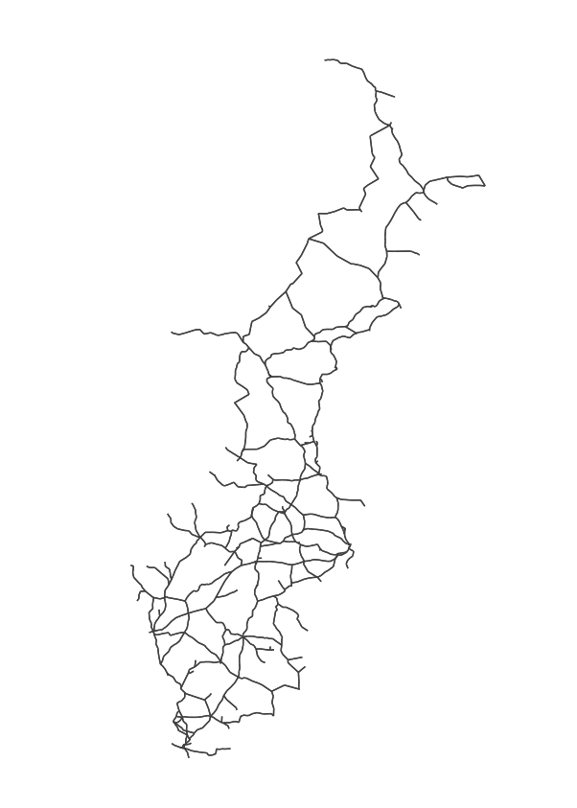
Figure 2. Visual representation of the Swedish railway network.
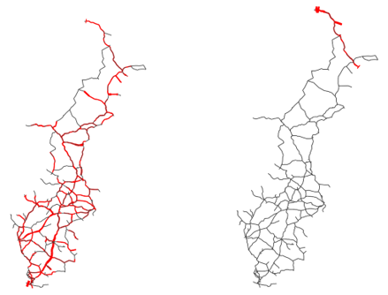
Figure 3. Examples of baseline flow (in red) for Commodity 1: Agriculture, Forest, Fishing (left) and Commodity 2: Coal, Crude Oil, Natural Gas (right) for the Swedish railway network

3.2 Data Selection Methodology

3.2.1 Instrumentation
The data were reduced and output to csv files. The problem was written in Python version 3.7 with the Gurobi Optimizer Python interface. All code was run on an 8-core 2.50 GHz processor with 32 gigabytes of memory.

3.2.2 Data Reduction
The full Swedish railway network dataset is large. If the full network is to be used, with 2878 links, 1439 interdicted links, and 20 commodities, the number of flow variables alone, not considering added capacity variables, will exceed 82,000,000. This is an exceedingly large problem for the instrumentation available. Therefore, the network has been reduced for this paper to allow for faster processing times while still achieving the goals of the model.
First, commodities 5, 15 and 17 are removed from the problem since they only provide 1, 0, and 0 kTon demand in the network, respectively. Second, since the optimization model adds a percentage of the current capacity of a link, any links with a capacity of 0 for all commodities would be unchanged and are, therefore, removed. Third, any of the nodes that are not included in the reduced list of links are removed. This reduces the number of links from 2878 to 2264, nodes from 1363 to 1085, and commodities to 17. When all 2264 bidirectional links are interdicted, the total number of flow variables is reduced to around 43,000,000.
The amount of additional capacity that can be added to the network will depend on the budget and importance the stakeholders put on each commodity. To approximate these numbers, it is assumed each link can only be increased by the average unmet demand percentage per commodity across all interdiction scenarios seen in Table 3 below. Additionally, the total network capacity can only be increased by half of the average unmet demand in kTons per commodity across all interdiction scenarios. The unmet demand for the 100 links with greatest impact on unmet demand after interdiction, summed across all commodities, can be found in Appendix C.
Table 3. Summary of the unmet demand across all interdiction scenarios per commodity.
Commodity | Commodity Group Name | Demand (kTons) | Max. Unmet Demand | Average Unmet Demand
1 | Agriculture, Forrest, Fishing | 8,463 | 5.88% | 3.56%
2 | Coal, Crude oil, Natural gas | 280 | 31.88% | 0.33%
3 | Ore | 29,427 | 5.82% | 0.13%
4 | Food, Beverage, Tobacco | 250 | 6.68% | 0.65%
5 | Textile, leather | 1 | 7.96% | 3.52%
6 | Wood, Cork, Pulp, Paper | 4,701 | 3.07% | 0.13%
7 | Petroleum products | 1,410 | 7.09% | 0.17%
8 | Chemicals, rubber, plastics | 1,257 | 8.29% | 0.11%
9 | Other non-metallic mineral | 449 | 7.50% | 1.31%
10 | Fabricated metal products | 4,017 | 2.97% | 0.12%
11 | Machinery and equipment | 95 | 3.85% | 0.20%
12 | Transport equipment | 894 | 3.17% | 0.87%
13 | Furniture, Other manufactured | 59 | 16.90% | 3.58%
14 | Return materials and recycling | 1,125 | 2.43% | 0.07%
16 | Equipment for transportation | 1,187 | 4.09% | 0.57%
18 | Loader and grouped goods | 39 | 2.82% | 0.13%
19 | Unidentifiable goods | 9,738 | 3.67% | 0.12%
20 | Goods not in group of 1-19 | 18 | 5.88% | 3.56%
T | Total | 63,410

Chapter 4.0 Results and Analysis
This section applies the optimization models defined in Section 2 to the Swedish railway network described in Section 3. The first subsection touches on the nature of the network, the next on the product of the balanced optimization model, followed by a comparison of the original network and the balanced network.

4.1 Nature of the Data
Since the capacity constraints were aggregated and estimated by dividing the number of trains on a link by the total number of trains on that link, the capacity values for the different links are very similar [22]. As such, the effect of interdicting a link is very similar for many of the links and may cause a similar effect on the network flow.

4.2 Balanced Model Results
A summary of the values of $U$, the difference between the average importance of all interdicted links for commodity $k$ and each individual link’s importance for commodity $k$, resulting from the balancing optimization model is seen in Table 4 below. The values of $U$ indicate the ability of the model to minimize the difference in importance across the network while meeting the unmet demand values found in the initial model. The average deviation from the average was below 1% for all commodities, even with some large maximum deviations, such as 32% for Commodity 2 as seen in Table 5 below. In this instance, as seen in Figure 3, Commodity 2 is centralized in the north, resulting in no change when unused links in the south are disrupted, lowering the average despite a large maximum value. The large maximum $U$ values correlate closely to the maximum observed unmet demand before capacity was added as seen it Table 5.
Table 4. Summary of $U$ over 1132 interdicted links for all commodities.
Table 5. Maximum unmet demand vs. maximum and average $U$ for all commodities.
Commodity | Commodity Group Name | Max. Unmet Demand | Max. U in % | Average U in %
1 | Agriculture, Forrest, Fishing | 5.88% | 2.25% | 0.18%
2 | Coal, Crude oil, Natural gas | 31.88% | 31.55% | 0.62%
3 | Ore | 5.82% | 5.69% | 0.21%
4 | Food, Beverage, Tobacco | 6.68% | 6.01% | 0.27%
6 | Wood, Cork, Pulp, Paper | 7.96% | 4.43% | 0.33%
7 | Petroleum products | 3.07% | 2.94% | 0.20%
8 | Chemicals, rubber, plastics | 7.09% | 6.91% | 0.28%
9 | Other non-metallic mineral | 8.29% | 8.18% | 0.19%
10 | Fabricated metal products | 7.50% | 6.18% | 0.16%
11 | Machinery and equipment | 2.97% | 2.84% | 0.19%
12 | Transport equipment | 3.85% | 3.65% | 0.31%
13 | Furniture, Other manufactured | 3.17% | 2.29% | 0.11%
14 | Return materials and recycling | 16.90% | 13.36% | 0.10%
16 | Equipment for transportation | 2.43% | 2.36% | 0.12%
18 | Loader and grouped goods | 4.09% | 3.52% | 0.13%
19 | Unidentifiable goods | 2.82% | 2.69% | 0.21%
20 | Goods not in group of 1-19 | 3.67% | 3.56% | 0.19%

The summary of the added commodity per commodity is presented in Table 6 below. In total, 780 capacity increases were implemented across all 17 commodities. The average capacity increase for each commodity was near the maximum allowable percentage capacity increase. All the link-commodity pairs with added capacity can be seen in Appendix D.

Table 6. Summary of the added capacity per commodity in the balanced network.
Commodity | No. of Links with Added Capacity | Average Added Capacity % | Max. Added Capacity %
1 | 46 | 3.55% | 3.56%
2 | 2 | 0.11% | 0.11%
3 | 54 | 0.13% | 0.13%
4 | 52 | 0.64% | 0.65%
6 | 51 | 3.47% | 3.52%
7 | 45 | 0.13% | 0.13%
8 | 53 | 0.17% | 0.17%
9 | 47 | 0.11% | 0.11%
10 | 55 | 1.05% | 1.31%
11 | 46 | 0.12% | 0.12%
12 | 46 | 0.20% | 0.20%
13 | 46 | 0.78% | 0.87%
14 | 49 | 3.11% | 3.58%
16 | 48 | 0.07% | 0.08%
18 | 45 | 0.57% | 0.57%
19 | 43 | 0.13% | 0.13%
20 | 52 | 0.12% | 0.12%
Total | 780

The links with increased capacity are shown in Figure 4, Figure 5, and Figure 6 below.

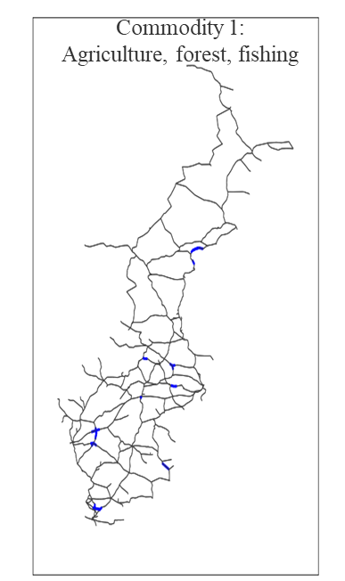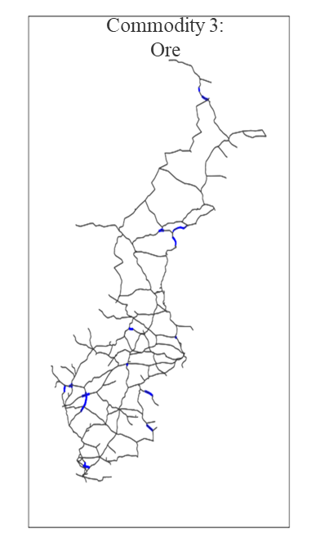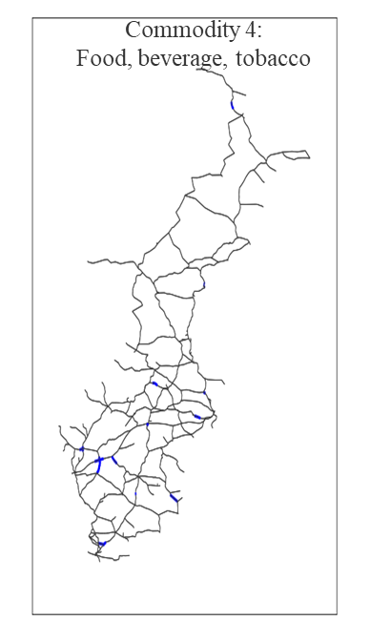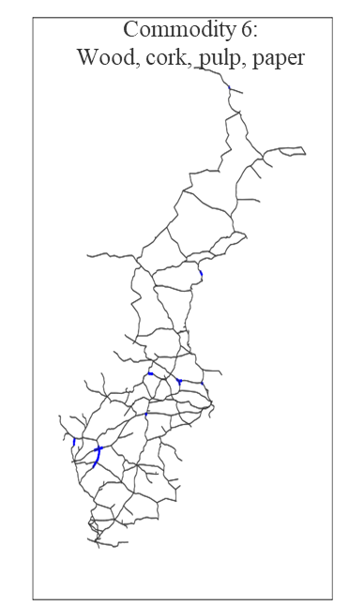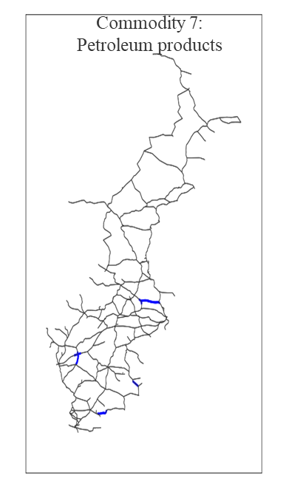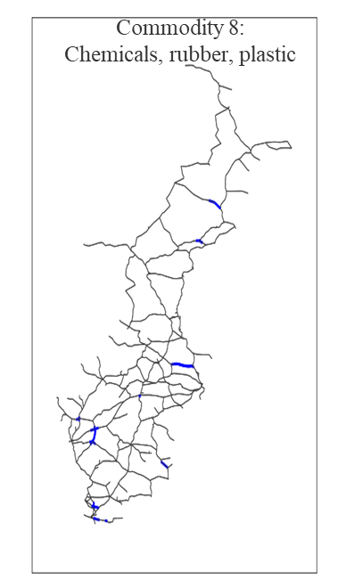
Figure 4. Added capacity to links for commodities 1-8, excluding commodities 2 and 5.
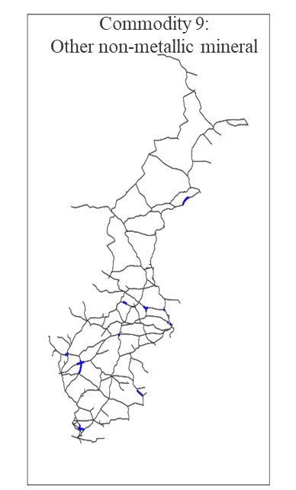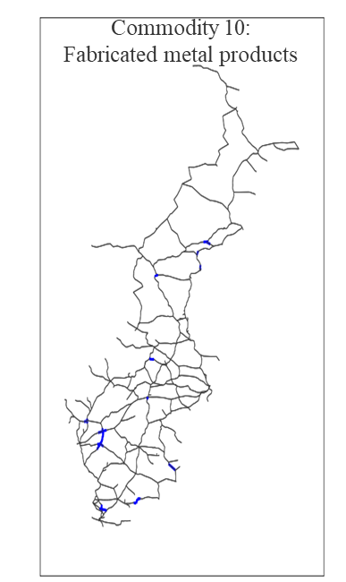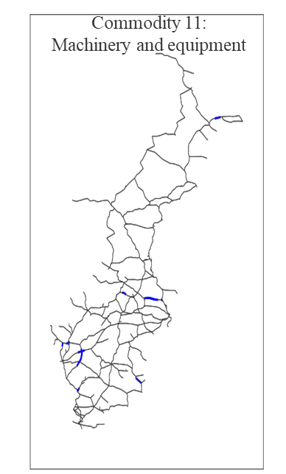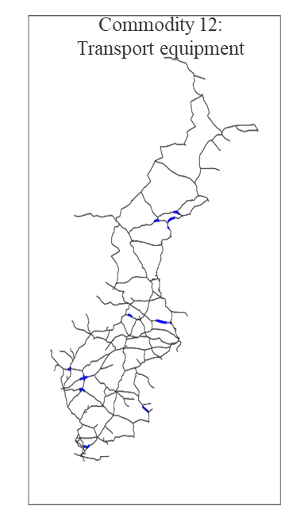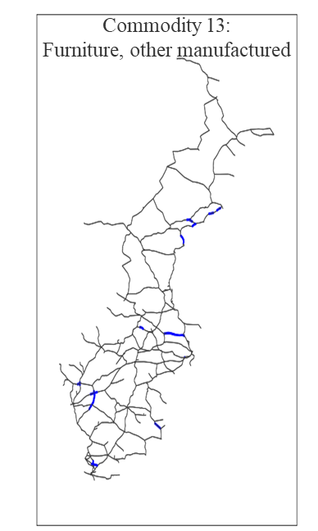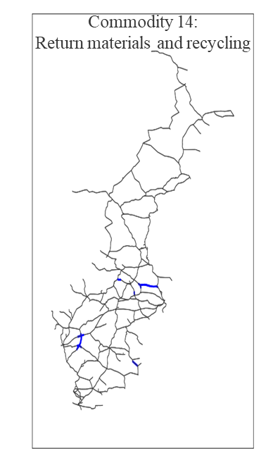
Figure 5. Added capacity to links for commodities 9-14.
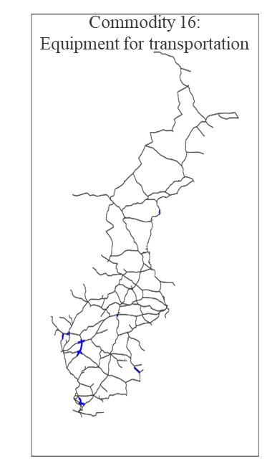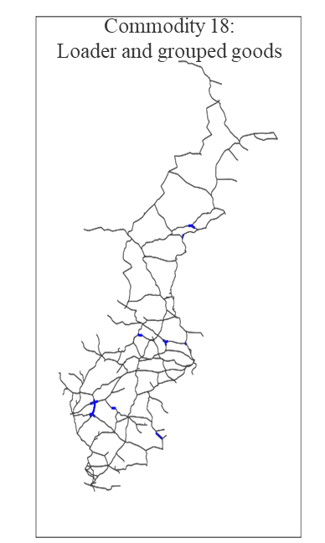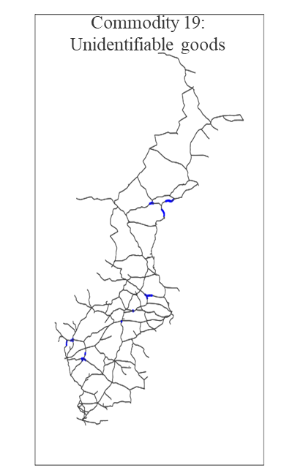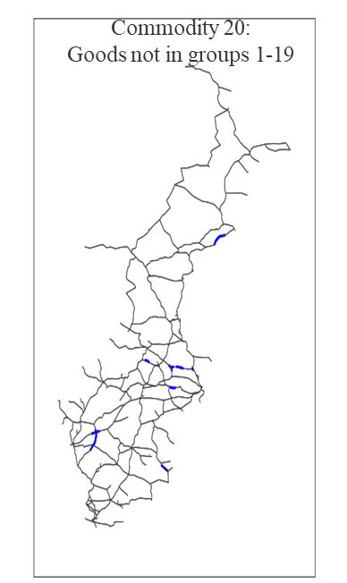
Figure 6. Added capacity to links for commodities 16-20, excluding commodity 17.

4.3 Network Balance Comparison
The $U$ values when applying the unmet demand minimizing model to the initial network and the balanced network are shown in Table 7 below. The values are much larger than those of the balanced model; therefore, they have been formatted in decimal form instead of in percentages.
Table 7. Initial U values vs. balanced U values.
As seen in Table 7, there is an improvement in the balance of the network after capacity has been added to the network. However, the difference for many of the commodities is negligible, and for those with higher $U$ values, an increase in capacity for links without current capacity may be considered for further improved performance. Nonetheless, a set of links have been identified as candidates for increased capacity under the current budget constraints placed on the network, and the commodities that may require a greater budget have been identified for further consideration.

Chapter 5.0 Conclusion
The work in this thesis aimed to improve network resilience reduce vulnerability by balancing a network using flow-based importance measures. In doing so, the components that would leave the network the most vulnerable if disrupted could be identified and allow stakeholders to focus on the selected components within a limited budget. The concept of a balancing component importance in a multi-state system was extended to a multi-commodity network utilizing flow-based measures, something that has not been done before to the author’s knowledge. To do this, an $ϵ$-constraint model was developed that optimized a bi-objective problem. First, unmet demand across all demand nodes and commodities for all interdiction scenarios was minimized in the network’s baseline form. Then, limited additional capacity was added to the network and the previous unmet demand values were applied as minimum values to encourage flow through the network. Finally, the difference in unmet demand across all interdiction scenarios was minimized, leaving the network optimally balanced within the limited budget. The components and their added capacities were reported and acted as recommendations for where to increase the capacity.
As a limitation for this work and an area for future study, the commodities could be ranked by their importance to the network or the industry/economy they are in. Additionally, different costs of adding capacity to the network could be compared to the cost of not meeting demand instead of only considering a maximum allowable capacity increase, making a recommendation even more robust. Finally, link criticality may differ for an n-at-a-time link interdiction analysis strategy compared to the one-at-a-time strategy used in this work, and could be considered for future work [30].

References
[1] S. M. Rinaldi, J. P. Peerenboom, and T. K. Kelly, "Identifying, understanding, and analyzing critical infrastructure interdependencies," IEEE, vol. 21, no. 6, pp. 11-25, December 2001 2001, doi: 10.1109/37.969131.
[2] (2019). A Guide to Critical Infrastructure Security and Resilience
[3] F. T. Intelligence, "Hurricane Harvey Disrupting Freight Transportation in Gulf Region," ed, 2017.
[4] (2021). A Proclamation on Critical Infrastructure Security and Resilience Month, 2021. [Online] Available: https://www.whitehouse.gov/briefing-room/presidential-actions/2021/10/29/a-proclamation-on-critical-infrastructure-security-and-resilience-month-2021/
[5] C. Wan, Z. Yang, D. Zhang, X. Yan, and S. Fan, "Resilience in transportation systems: a systematic review and future directions," Transport Reviews, vol. 38, no. 4, pp. 479-498, 2018, doi: https://doi.org/10.1080/01441647.2017.1383532.
[6] (2019). Freight Facts and Figures. [Online] Available: https://data.bts.gov/stories/s/Freight-Transportation-System-Condition-Performanc/vvk5-xjjp
[7] D. Henry and J. E. Ramirez-Marquez, "Generic metrics and quantitative approaches for system resilience as a function of time," Reliability Engineering and System Safety, vol. 99, pp. 114-122, 2012, doi: doi:10.1016/j.ress.2011.09.002.
[8] H. Baroud, K. Barker, J. E. Ramirez-Marquez, and C. M. Rocco, "Inherent Costs and Interdependent Impacts of Infrastructure Network Resilience," Risk Analysis, vol. 35, no. 4, pp. 642-662, 2015, doi: 10.1111/risa.12223.
[9] S. Hosseini, K. Barker, and J. E. Ramirez-Marquez, "A review of definitions and measures of system resilience," Reliability Engineering and System Safety, vol. 145, pp. 47-61, 2016, doi: http://dx.doi.org/10.1016/j.ress.2015.08.006.
[10] A. T. Murray, T. C. Matisziw, and T. H. Grubesic, "A methodological overview of network vulnerability analysis," Growth and Change, vol. 39, no. 4, pp. 573-592, 2008.
[11] R. Albert, H. Jeong, and A.-L. Barabási, "Error and attack tolerance of complex networks," nature, vol. 406, no. 6794, pp. 378-382, 2000.
[12] R. L. Church, M. P. Scaparra, and R. S. Middleton, "Identifying critical infrastructure: the median and covering facility interdiction problems," Annals of the Association of American Geographers, vol. 94, no. 3, pp. 491-502, 2004.
[13] T. C. Matisziw, A. T. Murray, and T. H. Grubesic, "Exploring the vulnerability of network infrastructure to disruption," The Annals of Regional Science, vol. 43, no. 2, pp. 307-321, 2009.
[14] P. Crucitti, V. Latora, and S. Porta, "Centrality measures in spatial networks of urban streets," Physical Review E, vol. 73, p. 036125, 2006, doi: https://doi.org/10.1103/PhysRevE.73.036125.
[15] Z. Xu, J. E. Ramirez-Marquez, Y. Liu, and T. Xiahou, "A new resilience-based component importance measure for multi-state networks," Reliability Engineering & System Safety, vol. 193, p. 106591, 2020.
[16] M. Ouyang, L. Hong, Z.-J. Mao, M.-H. Yu, and F. Qi, "A methodological approach to analyze vulnerability of interdependent infrastructures," Simulation Modelling Practice and Theory, vol. 17, 5, pp. 817-828, 2009.
[17] A. Nagurney and Q. Qiang, "A network efficiency measure with application to critical infrastructure networks," Journal of Global Optimization, vol. 40, no. 1, pp. 261-275, 2008.
[18] M. Darayi, K. Barker, and J. R. Santos, "Component Importance Measures for Multi-Industry Vulnerability of a Freight Transportation Network," Networks and spatial economics, vol. 17, no. 4, pp. 1111-1136, 2017.
[19] E. Zio and L. Podofillini, "The use of importance measures for the optimization of multi-state systems," Eksploatacja i Niezawodnosc–Maintenance and Reliability, vol. 2, pp. 33-36, 2006.
[20] E. Zio and L. Podofillini, "Importance measures and genetic algorithms for designing a risk-informed optimally balanced system," Reliability Engineering & System Safety, vol. 92, no. 10, pp. 1435-1447, 2007, doi: doi:10.1016/j.ress.2006.09.011.
[21] L. Podofillini and E. Zio, "Designing a risk-informed balanced system by genetic algorithms: Comparison of different balancing criteria," Reliability Engineering & System Safety, vol. 93, no. 12, pp. 1842-1852, 2008, doi: doi:10.1016/j.ress.2008.03.015.
[22] M. G. Whitman, K. Barker, J. Johansson, and M. Darayi, "Component importance for multi-commodity networks: Application in the Swedish railway," Computers & Industrial Engineering, vol. 112, pp. 274-288, 2017, doi: http://dx.doi.org/10.1016/j.cie.2017.08.004.
[23] L. Xiujuan and S. Zhongke, "Overview of multi-objective optimization methods," Journal of Systems Engineering and Electronics, vol. 15, no. 2, pp. 142-146, 2004.
[24] G. Chiandussi, M. Codegone, S. Ferrero, and F. E. Varesio, "Comparison of multi-objective optimization methodologies for engineering applications," Computers & Mathematics with Applications, vol. 63, no. 5, pp. 912-942, 2012.
[25] G. Mavrotas, "Effective implementation of the ε-constraint method in multi-objective mathematical programming problems," Applied mathematics and computation, vol. 213, no. 2, pp. 455-465, 2009.
[26] R. T. Marler and J. S. Arora, "The weighted sum method for multi-objective optimization: new insights," Structural and multidisciplinary optimization, vol. 41, no. 6, pp. 853-862, 2010.
[27] Gurobi Optimization Inc., "Gurobi Optimizer Reference Manual," 2022. [Online]. Available: https://www.gurobi.com/documentation/9.5/refman/index.html.
[28] J. Johansson. SwRailwayData_20141012.
[29] M. McCarter, K. Barker, J. Johansson, and J. E. Ramirez-Marquez, "A bi-objective formulation for robust defense strategies in multi-commodity networks," Reliability Engineering and System Safety, vol. 176, pp. 154-161, August 2018 2018, doi: https://doi.org/10.1016/j.ress.2018.04.011.
[30] D. L. Alderson, G. G. Brown, W. M. Carlyle, and L. A. Cox Jr, "Sometimes there is no" most-vital" arc: Assessing and improving the operational resilience of systems," Military Operations Research, vol. 18, no. 1, pp. 21-37, 2013.

Appendix A
Appendix A. Unmet Demand Minimizing Model Code.
- # Model the data:
- # Set of nodes, links, commodities, interdicted links,
- # supply/demand/transshipment node values, and capacity values.
- # Duplicate the sets as tuplelists/tupledicts for quicksum() function.

- import csv
- from gurobipy import *
- import pandas as pd

- def Min_Unmet_Demand(li_in,lj_in, k_in):
- # Create optimization model
- m = Model('bal_net_flow')

- # Decision variables - flow for each commodity
- x = m.addVars(A, name = "x") # flow variables
- mu_var = m.addVars(N, name = "mu_var") # demand variable for easier calculation

- m.update()

- # Constraint 3: Capacity constraint for link (i,j) for commodity k
- m.addConstrs(
- (x[i, j] <= c[i, j][k_in] for i, j in A), "cap")

- m.addConstrs(x[i,j] >= 0 for i,j in A)

- # Constraint 5: Flow balance constraint for link (i,j) for commodity k

- m.addConstrs(
- (quicksum(x[i1, j] for i1, j in tuple_A.select('*', j)) -
- quicksum(x[j, i2] for j, i2 in tuple_A.select(j, '*')) <=
- D[k_in] for j in D[k_in].keys())
- )

- m.addConstrs(
- (quicksum(x[i1, j] for i1, j in tuple_A.select('*', j)) -
- quicksum(x[j, i2] for j, i2 in tuple_A.select(j, '*')) >=
- 0 for j in D[k_in].keys())
- )

- m.addConstrs(
- (quicksum(x[i1, j] for i1, j in tuple_A.select('*', j)) -
- quicksum(x[j, i2] for j, i2 in tuple_A.select(j, '*')) ==
- mu_var[j] for j in D[k_in].keys())
- )

- m.addConstrs(
- (-quicksum(x[i1, j] for i1, j in tuple_A.select('*', j)) +
- quicksum(x[j, i2] for j, i2 in tuple_A.select(j, '*')) <=
- S[k_in] for j in S[k_in].keys())
- )

- m.addConstrs(
- (-quicksum(x[i1, j] for i1, j in tuple_A.select('*', j)) +
- quicksum(x[j, i2] for j, i2 in tuple_A.select(j, '*')) >=
- 0 for j in S[k_in].keys())
- )

- m.addConstrs(
- (quicksum(x[i1, j] for i1, j in tuple_A.select('*', j)) -
- quicksum(x[j, i2] for j, i2 in tuple_A.select(j, '*')) ==
- 0 for j in T[k_in].keys())
- )

- # Constraints 6 and 7: Interdiction constraints
- m.addConstr(
- (x[li_in, lj_in] == 0), "interdicted_1")

- m.addConstr(
- (x[lj_in, li_in] == 0), "interdicted_2")

- m.update()

- # Set minimized unmet demand objective
- Z = quicksum((D[k_in][j] - mu_var[j])/D[k_in][j] for j in D[k_in].keys())

- m.update()

- # Set objective
- m.setObjective(Z, GRB.MINIMIZE)

- m.update()
- # Solve the model
- m.optimize()

- return m.objVal

- # Store unmet demand values
- unmet_demand = {}
- for k in K:
- for li, lj in L:
- unmet_demand[li, lj, k] = Min_Unmet_Demand(li, lj, k)

Appendix B
Appendix B. Balancing Network Model Code.
- # Model the data:
- # Set of nodes, links, commodities, interdicted links,
- # supply/demand/transshipment node values, and capacity values.
- # Duplicate the sets as tuplelists/tupledicts for quicksum() function.
- # Add maximum added capacity parameters.
- # Import epsilon values/minimum unmet demand values.

- import csv
- from gurobipy import *
- import pandas as pd
- import time

- def Balance_Network(k_in):

- # Create optimization model
- m = Model('bal_net_flow')

- # Decision variables - flow and unmet demand for each commodity
- x = m.addVars(A, L, name = "x") # flow variables
- alpha = m.addVars(A, name = "alpha") # added capacity variables
- U = m.addVars(L, name = "U") # placeholder variable for objective linearization
- I_bar = m.addVar(vtype = GRB.CONTINUOUS, name = "I_bar") # Average importance measure

- m.update()

- # Equation 12: Capacity constraint for link (i,j) for commodity k
- m.addConstrs(
- ((1 + alpha[i, j]) * c[i, j][k_in] - x[i, j, li, lj] >= 0 for i, j in A for li, lj in L), "cap")

- # Equation 13: Added capacity constraint
- m.addConstrs(
- (alpha[i, j] <= p[k_in] for i, j in A), "p^k"
- )

- m.addConstr(
- (quicksum(alpha[i, j] * c[i, j][k_in] for i, j in tuple_A.select('*', '*')) <= alpha_max[k_in]), "max_alpha"
- )

- # Equations 15-17: Flow balance constraints for link (i,j) for commodity k
- m.addConstrs(
- (quicksum(x[i1, j, li, lj] for i1, j in tuple_A.select('*', j)) -
- quicksum(x[j, i2, li, lj] for j, i2 in tuple_A.select(j, '*')) <=
- D[k_in][j] for j in D[k_in].keys() for li, lj in L)
- )
- m.addConstrs(
- (quicksum(x[i1, j, li, lj] for i1, j in tuple_A.select('*', j)) -
- quicksum(x[j, i2, li, lj] for j, i2 in tuple_A.select(j, '*')) >=
- 0 for j in D[k_in].keys() for li, lj in L)
- )

- m.addConstrs(
- (-quicksum(x[i1, j, li, lj] for i1, j in tuple_A.select('*', j)) +
- quicksum(x[j, i2, li, lj] for j, i2 in tuple_A.select(j, '*')) <=
- S[k_in][j] for j in S[k_in].keys() for li, lj in L)
- )

- m.addConstrs(
- (-quicksum(x[i1, j, li, lj] for i1, j in tuple_A.select('*', j)) +
- quicksum(x[j, i2, li, lj] for j, i2 in tuple_A.select(j, '*')) >=
- 0 for j in S[k_in].keys() for li, lj in L)
- )

- m.addConstrs(
- (quicksum(x[i1, j, li, lj] for i1, j in tuple_A.select('*', j)) -
- quicksum(x[j, i2, li, lj] for j, i2 in tuple_A.select(j, '*')) ==
- 0 for j in T[k_in].keys() for li, lj in L)
- )

- # Equations 18-19: Interdiction constraints
- m.addConstrs(
- (x[li, lj, li, lj] == 0 for li, lj in L), "interdicted_1")

- m.addConstrs(
- (x[lj, li, li, lj] == 0 for li, lj in L), "interdicted_2")

- # Epsilon constraint
- m.addConstrs(
- (quicksum((D[k_in][j] - (quicksum(x[i1, j, li, lj] for i1, j in tuple_A.select('*', j)) -
- quicksum(x[j, i2, li, lj] for j, i2 in tuple_A.select(j, '*'))))/D[k_in][j] for j in D[k_in].keys()) <= unmet_demdf[(unmet_demdf['li']==li) & (unmet_demdf['lj']==lj) & (unmet_demdf['k']==k_in)]['unmet_demand'].values[0] for li, lj in L)
- )

- # Constraints for average importance values
- m.addConstr(
- (I_bar == 1/(len(L)) * quicksum((Dk[k_in] - quicksum(quicksum(x[i1, j, li, lj] for i1, j in tuple_A.select('*', j)) -
- quicksum(x[j, i2, li, lj] for j, i2 in tuple_A.select(j, '*')) for j in D[k_in].keys())) / Dk[k_in] for li, lj in L))
- )

- # Linearization constraints for objective function
- m.addConstrs(
- (((Dk[k_in] - quicksum(quicksum(x[i1, j, li, lj] for i1, j in tuple_A.select('*', j)) -
- quicksum(x[j, i2, li, lj] for j, i2 in tuple_A.select(j, '*')) for j in D[k_in].keys())) / Dk[k_in]) - I_bar <= U[li, lj] for li, lj in L)
- )

- m.addConstrs(
- (-(((Dk[k_in] - quicksum(quicksum(x[i1, j, li, lj] for i1, j in tuple_A.select('*', j)) -
- quicksum(x[j, i2, li, lj] for j, i2 in tuple_A.select(j, '*')) for j in D[k_in].keys())) / Dk[k_in]) - I_bar) <= U[li, lj] for li, lj in L)
- )

- m.update()

- # Equation 7: Objective function
- Z = quicksum(U[li, lj] for li, lj in L)

- # Set objective
- m.setObjective(Z, GRB.MINIMIZE)

- m.update()

- # Solve the model
- m.optimize()

- # Write file of added demand values
- name = 'added_demand_eps_com_{}.csv'.format(k_in)
- f = open(name,'w', newline='')
- header = ['i', 'j', 'k', 'added_demand']
- writer = csv.writer(f)
- writer.writerow(header)
- for i, j in A:
- line = [i,j, k_in, alpha[i, j].X]
- writer.writerow(line)
- f.close()

- # Write file of minimized importance values
- name = 'U_eps_com_{}.csv'.format(k_in)
- f = open(name,'w', newline='')
- header = ['li', 'lj', 'k', 'U']
- writer = csv.writer(f)
- writer.writerow(header)
- for li, lj in L:
- line = [li,lj, k_in, U[li, lj].X]
- writer.writerow(line)
- f.close()

- return m.objVal

- U_sum = {}
- for k in K:
- U_sum[k] = Balance_Network(k)

Appendix C
Appendix C. The top 100 interdicted links $\left(i,j\right)$ and their respective unmet demand
Node i | Node j | Unmet Demand |  | Node i | Node j | Unmet Demand
9 | 8 | 36.698% |  | 128 | 82 | 12.136%
10 | 9 | 30.135% |  | 30 | 19 | 12.101%
1002 | 1001 | 29.458% |  | 32 | 31 | 12.072%
1026 | 1002 | 25.135% |  | 85 | 84 | 11.984%
1001 | 1000 | 23.551% |  | 52 | 51 | 11.890%
11 | 10 | 22.911% |  | 46 | 45 | 11.783%
57 | 56 | 22.755% |  | 30 | 17 | 11.769%
56 | 55 | 21.672% |  | 62 | 58 | 11.760%
55 | 54 | 21.003% |  | 1036 | 1035 | 11.757%
3 | 2 | 20.273% |  | 65 | 64 | 11.649%
33 | 19 | 20.202% |  | 58 | 57 | 11.376%
16 | 2 | 20.064% |  | 45 | 44 | 11.141%
4 | 3 | 19.965% |  | 48 | 47 | 11.098%
5 | 4 | 19.940% |  | 87 | 86 | 11.054%
6 | 5 | 19.917% |  | 700 | 699 | 11.051%
54 | 53 | 19.592% |  | 1022 | 1021 | 11.009%
1084 | 1025 | 18.678% |  | 66 | 65 | 11.000%
61 | 36 | 18.621% |  | 15 | 14 | 10.919%
1038 | 1037 | 18.445% |  | 888 | 887 | 10.914%
12 | 11 | 18.442% |  | 460 | 459 | 10.909%
13 | 12 | 18.432% |  | 88 | 87 | 10.889%
34 | 33 | 18.201% |  | 461 | 460 | 10.751%
38 | 37 | 18.088% |  | 89 | 88 | 10.719%
14 | 13 | 17.943% |  | 31 | 20 | 10.612%
704 | 694 | 17.790% |  | 705 | 704 | 10.573%
1039 | 1038 | 17.587% |  | 21 | 20 | 10.546%
37 | 36 | 17.374% |  | 47 | 46 | 10.532%
1026 | 1025 | 17.006% |  | 90 | 89 | 10.501%
459 | 414 | 16.253% |  | 421 | 420 | 10.461%
130 | 129 | 16.142% |  | 90 | 64 | 10.406%
41 | 40 | 15.992% |  | 22 | 21 | 10.196%
39 | 38 | 15.752% |  | 51 | 50 | 10.190%
1000 | 999 | 15.725% |  | 414 | 354 | 10.119%
61 | 60 | 15.628% |  | 422 | 421 | 10.057%
18 | 16 | 14.878% |  | 67 | 66 | 10.057%
131 | 130 | 14.610% |  | 903 | 757 | 9.750%
40 | 39 | 14.253% |  | 49 | 48 | 9.418%
128 | 127 | 14.241% |  | 69 | 68 | 9.387%
1037 | 1036 | 13.937% |  | 86 | 85 | 9.332%
7 | 6 | 13.873% |  | 23 | 22 | 9.261%
50 | 49 | 13.862% |  | 24 | 23 | 9.190%
8 | 7 | 13.782% |  | 25 | 24 | 9.166%
43 | 42 | 13.542% |  | 762 | 761 | 9.163%
44 | 43 | 13.483% |  | 991 | 990 | 9.123%
52 | 31 | 13.424% |  | 761 | 760 | 8.992%
84 | 83 | 13.314% |  | 463 | 462 | 8.967%
83 | 82 | 12.841% |  | 113 | 112 | 8.965%
42 | 41 | 12.746% |  | 68 | 67 | 8.948%
60 | 53 | 12.257% |  | 996 | 995 | 8.890%
18 | 17 | 12.142% |  | 1023 | 1022 | 8.881%

Appendix D
Appendix D. Full list of link-commodity pairs with added demand.
Node $i$ | Node $j$ | Commodity | Added Capacity % |  | Node $i$ | Node $j$ | Commodity | Added Capacity %
33 | 43 | 1 | 3.56% |  | 1021 | 1022 | 10 | 1.31%
120 | 121 | 1 | 3.56% |  | 1022 | 1021 | 10 | 0.35%
173 | 130 | 1 | 3.56% |  | 1022 | 1023 | 10 | 1.31%
229 | 228 | 1 | 3.56% |  | 1023 | 1081 | 10 | 1.31%
241 | 242 | 1 | 3.56% |  | 1024 | 1025 | 10 | 1.31%
341 | 361 | 1 | 3.56% |  | 1077 | 1087 | 10 | 1.31%
341 | 342 | 1 | 3.56% |  | 1146 | 1147 | 10 | 1.31%
342 | 341 | 1 | 3.56% |  | 1158 | 1133 | 10 | 1.31%
342 | 343 | 1 | 3.56% |  | 1240 | 1243 | 10 | 1.31%
343 | 342 | 1 | 3.56% |  | 1289 | 1315 | 10 | 1.31%
343 | 344 | 1 | 3.56% |  | 1324 | 1325 | 10 | 1.31%
344 | 345 | 1 | 3.56% |  | 1325 | 1326 | 10 | 1.31%
344 | 343 | 1 | 3.56% |  | 1326 | 1327 | 10 | 1.31%
345 | 344 | 1 | 2.98% |  | 1328 | 1327 | 10 | 1.31%
345 | 346 | 1 | 3.56% |  | 120 | 121 | 11 | 0.12%
346 | 345 | 1 | 3.56% |  | 173 | 130 | 11 | 0.12%
361 | 360 | 1 | 3.56% |  | 223 | 224 | 11 | 0.12%
539 | 538 | 1 | 3.56% |  | 229 | 228 | 11 | 0.12%
563 | 556 | 1 | 3.56% |  | 346 | 345 | 11 | 0.12%
569 | 570 | 1 | 3.56% |  | 456 | 402 | 11 | 0.12%
600 | 599 | 1 | 3.56% |  | 504 | 510 | 11 | 0.12%
634 | 633 | 1 | 3.56% |  | 538 | 539 | 11 | 0.12%
669 | 825 | 1 | 3.56% |  | 555 | 548 | 11 | 0.12%
677 | 676 | 1 | 3.56% |  | 563 | 556 | 11 | 0.12%
686 | 685 | 1 | 3.56% |  | 664 | 642 | 11 | 0.12%
696 | 742 | 1 | 3.56% |  | 667 | 668 | 11 | 0.12%
769 | 768 | 1 | 3.56% |  | 678 | 679 | 11 | 0.12%
789 | 677 | 1 | 3.56% |  | 685 | 709 | 11 | 0.12%
800 | 809 | 1 | 3.56% |  | 691 | 686 | 11 | 0.12%
815 | 814 | 1 | 3.56% |  | 692 | 691 | 11 | 0.12%
912 | 913 | 1 | 3.56% |  | 692 | 693 | 11 | 0.12%
933 | 932 | 1 | 3.56% |  | 693 | 694 | 11 | 0.12%
944 | 1303 | 1 | 3.56% |  | 694 | 695 | 11 | 0.12%
970 | 1009 | 1 | 3.56% |  | 695 | 696 | 11 | 0.12%
1009 | 970 | 1 | 3.56% |  | 789 | 677 | 11 | 0.12%
1020 | 1019 | 1 | 3.56% |  | 800 | 809 | 11 | 0.12%
1021 | 1020 | 1 | 3.56% |  | 815 | 814 | 11 | 0.12%
1022 | 1021 | 1 | 3.56% |  | 873 | 879 | 11 | 0.11%
1023 | 1006 | 1 | 3.56% |  | 884 | 1015 | 11 | 0.12%
1023 | 1081 | 1 | 3.56% |  | 914 | 1008 | 11 | 0.12%
1077 | 1087 | 1 | 3.56% |  | 914 | 913 | 11 | 0.12%
1158 | 1133 | 1 | 3.56% |  | 933 | 932 | 11 | 0.12%
1240 | 1243 | 1 | 3.56% |  | 944 | 1303 | 11 | 0.12%
1243 | 1240 | 1 | 3.56% |  | 949 | 983 | 11 | 0.12%
1258 | 1289 | 1 | 3.56% |  | 1009 | 970 | 11 | 0.12%
1289 | 1315 | 1 | 3.56% |  | 1015 | 1016 | 11 | 0.12%
14 | 30 | 2 | 0.11% |  | 1016 | 1017 | 11 | 0.12%
33 | 43 | 3 | 0.13% |  | 1017 | 1018 | 11 | 0.12%
34 | 45 | 3 | 0.13% |  | 1018 | 1019 | 11 | 0.12%
38 | 39 | 3 | 0.01% |  | 1019 | 1020 | 11 | 0.12%
39 | 38 | 3 | 0.13% |  | 1020 | 1021 | 11 | 0.12%
173 | 130 | 3 | 0.13% |  | 1021 | 1022 | 11 | 0.12%
265 | 351 | 3 | 0.13% |  | 1022 | 1023 | 11 | 0.12%
345 | 346 | 3 | 0.13% |  | 1023 | 1006 | 11 | 0.12%
347 | 241 | 3 | 0.13% |  | 1024 | 1025 | 11 | 0.12%
456 | 402 | 3 | 0.13% |  | 1077 | 1087 | 11 | 0.12%
457 | 456 | 3 | 0.13% |  | 1158 | 1133 | 11 | 0.12%
538 | 539 | 3 | 0.13% |  | 1240 | 1243 | 11 | 0.12%
539 | 538 | 3 | 0.13% |  | 1243 | 1240 | 11 | 0.12%
669 | 825 | 3 | 0.13% |  | 1315 | 1289 | 11 | 0.12%
685 | 709 | 3 | 0.13% |  | 130 | 173 | 12 | 0.20%
686 | 691 | 3 | 0.13% |  | 173 | 130 | 12 | 0.20%
692 | 691 | 3 | 0.13% |  | 229 | 228 | 12 | 0.20%
696 | 742 | 3 | 0.13% |  | 239 | 171 | 12 | 0.20%
815 | 814 | 3 | 0.13% |  | 241 | 242 | 12 | 0.20%
884 | 1015 | 3 | 0.13% |  | 242 | 243 | 12 | 0.20%
912 | 913 | 3 | 0.13% |  | 243 | 244 | 12 | 0.20%
913 | 914 | 3 | 0.13% |  | 265 | 351 | 12 | 0.20%
914 | 1008 | 3 | 0.13% |  | 345 | 346 | 12 | 0.20%
919 | 912 | 3 | 0.13% |  | 347 | 241 | 12 | 0.20%
933 | 932 | 3 | 0.13% |  | 351 | 265 | 12 | 0.20%
944 | 1303 | 3 | 0.13% |  | 538 | 537 | 12 | 0.20%
949 | 983 | 3 | 0.13% |  | 538 | 539 | 12 | 0.20%
970 | 1009 | 3 | 0.13% |  | 569 | 570 | 12 | 0.20%
1009 | 970 | 3 | 0.13% |  | 623 | 633 | 12 | 0.20%
1015 | 1016 | 3 | 0.13% |  | 628 | 625 | 12 | 0.20%
1015 | 884 | 3 | 0.13% |  | 667 | 668 | 12 | 0.20%
1016 | 1017 | 3 | 0.13% |  | 685 | 709 | 12 | 0.20%
1016 | 1015 | 3 | 0.13% |  | 692 | 693 | 12 | 0.20%
1017 | 1016 | 3 | 0.13% |  | 693 | 694 | 12 | 0.20%
1017 | 1018 | 3 | 0.13% |  | 757 | 758 | 12 | 0.20%
1018 | 1017 | 3 | 0.13% |  | 800 | 809 | 12 | 0.20%
1018 | 1019 | 3 | 0.13% |  | 815 | 814 | 12 | 0.20%
1019 | 1018 | 3 | 0.13% |  | 837 | 838 | 12 | 0.20%
1019 | 1020 | 3 | 0.13% |  | 884 | 1015 | 12 | 0.20%
1020 | 1019 | 3 | 0.13% |  | 912 | 913 | 12 | 0.20%
1020 | 1021 | 3 | 0.13% |  | 914 | 913 | 12 | 0.20%
1021 | 1020 | 3 | 0.13% |  | 933 | 932 | 12 | 0.20%
1021 | 1022 | 3 | 0.13% |  | 944 | 1303 | 12 | 0.20%
1022 | 1021 | 3 | 0.13% |  | 949 | 983 | 12 | 0.20%
1022 | 1023 | 3 | 0.13% |  | 970 | 1009 | 12 | 0.20%
1023 | 1006 | 3 | 0.13% |  | 1009 | 970 | 12 | 0.20%
1024 | 1025 | 3 | 0.13% |  | 1019 | 1018 | 12 | 0.20%
1077 | 1087 | 3 | 0.13% |  | 1020 | 1019 | 12 | 0.20%
1146 | 1147 | 3 | 0.13% |  | 1021 | 1020 | 12 | 0.20%
1158 | 1133 | 3 | 0.13% |  | 1022 | 1021 | 12 | 0.20%
1240 | 1243 | 3 | 0.13% |  | 1023 | 1006 | 12 | 0.20%
1241 | 1198 | 3 | 0.13% |  | 1023 | 1081 | 12 | 0.20%
1243 | 1240 | 3 | 0.13% |  | 1077 | 1087 | 12 | 0.20%
1289 | 1315 | 3 | 0.13% |  | 1146 | 1147 | 12 | 0.20%
1315 | 1289 | 3 | 0.13% |  | 1159 | 1146 | 12 | 0.20%
37 | 38 | 4 | 0.17% |  | 1240 | 1243 | 12 | 0.20%
130 | 173 | 4 | 0.65% |  | 1243 | 1240 | 12 | 0.20%
229 | 228 | 4 | 0.65% |  | 1258 | 1289 | 12 | 0.20%
361 | 360 | 4 | 0.65% |  | 1274 | 1250 | 12 | 0.05%
473 | 476 | 4 | 0.65% |  | 1315 | 1289 | 12 | 0.20%
504 | 509 | 4 | 0.65% |  | 229 | 228 | 13 | 0.87%
514 | 513 | 4 | 0.56% |  | 246 | 245 | 13 | 0.87%
538 | 539 | 4 | 0.65% |  | 341 | 342 | 13 | 0.64%
667 | 668 | 4 | 0.65% |  | 342 | 343 | 13 | 0.64%
669 | 825 | 4 | 0.65% |  | 343 | 344 | 13 | 0.64%
677 | 676 | 4 | 0.65% |  | 344 | 345 | 13 | 0.64%
685 | 709 | 4 | 0.65% |  | 345 | 346 | 13 | 0.87%
686 | 685 | 4 | 0.65% |  | 351 | 265 | 13 | 0.87%
757 | 758 | 4 | 0.65% |  | 458 | 496 | 13 | 0.74%
789 | 677 | 4 | 0.65% |  | 538 | 537 | 13 | 0.87%
800 | 809 | 4 | 0.65% |  | 600 | 599 | 13 | 0.87%
815 | 814 | 4 | 0.65% |  | 642 | 664 | 13 | 0.87%
884 | 1015 | 4 | 0.65% |  | 685 | 709 | 13 | 0.87%
914 | 913 | 4 | 0.65% |  | 686 | 685 | 13 | 0.87%
933 | 932 | 4 | 0.65% |  | 686 | 691 | 13 | 0.12%
944 | 1303 | 4 | 0.65% |  | 691 | 692 | 13 | 0.12%
970 | 1009 | 4 | 0.65% |  | 692 | 693 | 13 | 0.12%
1008 | 914 | 4 | 0.65% |  | 693 | 694 | 13 | 0.87%
1009 | 970 | 4 | 0.65% |  | 694 | 695 | 13 | 0.87%
1015 | 1016 | 4 | 0.65% |  | 695 | 696 | 13 | 0.87%
1015 | 884 | 4 | 0.65% |  | 696 | 742 | 13 | 0.87%
1016 | 1017 | 4 | 0.65% |  | 815 | 814 | 13 | 0.87%
1016 | 1015 | 4 | 0.65% |  | 870 | 875 | 13 | 0.09%
1017 | 1016 | 4 | 0.65% |  | 914 | 913 | 13 | 0.87%
1017 | 1018 | 4 | 0.65% |  | 933 | 932 | 13 | 0.87%
1018 | 1017 | 4 | 0.65% |  | 944 | 1303 | 13 | 0.87%
1018 | 1019 | 4 | 0.65% |  | 970 | 1009 | 13 | 0.87%
1019 | 1018 | 4 | 0.65% |  | 1008 | 914 | 13 | 0.87%
1019 | 1020 | 4 | 0.65% |  | 1009 | 970 | 13 | 0.87%
1020 | 1019 | 4 | 0.65% |  | 1015 | 884 | 13 | 0.87%
1020 | 1021 | 4 | 0.65% |  | 1016 | 1015 | 13 | 0.87%
1021 | 1020 | 4 | 0.65% |  | 1017 | 1016 | 13 | 0.87%
1021 | 1022 | 4 | 0.65% |  | 1018 | 1017 | 13 | 0.87%
1022 | 1021 | 4 | 0.65% |  | 1019 | 1018 | 13 | 0.87%
1022 | 1023 | 4 | 0.65% |  | 1020 | 1019 | 13 | 0.87%
1023 | 1006 | 4 | 0.65% |  | 1021 | 1020 | 13 | 0.87%
1023 | 1081 | 4 | 0.65% |  | 1022 | 1021 | 13 | 0.87%
1024 | 1025 | 4 | 0.65% |  | 1023 | 1006 | 13 | 0.87%
1064 | 1065 | 4 | 0.65% |  | 1024 | 1025 | 13 | 0.87%
1077 | 1087 | 4 | 0.65% |  | 1077 | 1087 | 13 | 0.87%
1084 | 1085 | 4 | 0.65% |  | 1158 | 1133 | 13 | 0.87%
1146 | 1147 | 4 | 0.65% |  | 1240 | 1243 | 13 | 0.87%
1158 | 1133 | 4 | 0.65% |  | 1243 | 1240 | 13 | 0.87%
1240 | 1243 | 4 | 0.65% |  | 1289 | 1315 | 13 | 0.87%
1243 | 1240 | 4 | 0.65% |  | 1315 | 1289 | 13 | 0.87%
1258 | 1289 | 4 | 0.65% |  | 1328 | 1327 | 13 | 0.87%
1315 | 1289 | 4 | 0.65% |  | 120 | 121 | 14 | 3.58%
33 | 43 | 6 | 3.02% |  | 229 | 228 | 14 | 3.58%
173 | 130 | 6 | 3.52% |  | 539 | 538 | 14 | 3.58%
229 | 228 | 6 | 3.52% |  | 548 | 555 | 14 | 3.58%
246 | 223 | 6 | 3.52% |  | 563 | 556 | 14 | 3.58%
341 | 342 | 6 | 3.52% |  | 569 | 570 | 14 | 3.58%
342 | 343 | 6 | 2.92% |  | 677 | 676 | 14 | 3.58%
343 | 344 | 6 | 3.52% |  | 685 | 709 | 14 | 3.58%
344 | 345 | 6 | 2.73% |  | 686 | 691 | 14 | 0.48%
345 | 346 | 6 | 2.96% |  | 691 | 692 | 14 | 0.48%
539 | 538 | 6 | 3.52% |  | 692 | 693 | 14 | 0.48%
548 | 555 | 6 | 3.52% |  | 693 | 694 | 14 | 3.58%
556 | 563 | 6 | 3.52% |  | 694 | 693 | 14 | 3.58%
569 | 570 | 6 | 3.52% |  | 694 | 695 | 14 | 0.21%
585 | 579 | 6 | 3.52% |  | 695 | 696 | 14 | 1.96%
600 | 599 | 6 | 3.52% |  | 696 | 742 | 14 | 3.58%
669 | 825 | 6 | 3.52% |  | 722 | 723 | 14 | 0.45%
685 | 709 | 6 | 3.52% |  | 727 | 728 | 14 | 0.75%
696 | 742 | 6 | 3.52% |  | 728 | 727 | 14 | 0.95%
757 | 758 | 6 | 3.52% |  | 757 | 758 | 14 | 3.58%
800 | 809 | 6 | 3.52% |  | 815 | 814 | 14 | 3.58%
815 | 814 | 6 | 3.52% |  | 871 | 869 | 14 | 3.58%
884 | 1015 | 6 | 3.52% |  | 884 | 1015 | 14 | 3.58%
912 | 913 | 6 | 3.52% |  | 944 | 1303 | 14 | 3.58%
913 | 914 | 6 | 3.52% |  | 1009 | 970 | 14 | 3.58%
914 | 1008 | 6 | 3.52% |  | 1015 | 1016 | 14 | 3.58%
919 | 912 | 6 | 3.52% |  | 1015 | 884 | 14 | 3.58%
933 | 932 | 6 | 3.52% |  | 1016 | 1017 | 14 | 3.58%
944 | 1303 | 6 | 3.52% |  | 1016 | 1015 | 14 | 3.58%
1009 | 970 | 6 | 3.52% |  | 1017 | 1016 | 14 | 3.58%
1015 | 1016 | 6 | 3.52% |  | 1017 | 1018 | 14 | 3.58%
1015 | 884 | 6 | 3.52% |  | 1018 | 1017 | 14 | 3.58%
1016 | 1017 | 6 | 3.52% |  | 1018 | 1019 | 14 | 3.58%
1016 | 1015 | 6 | 3.52% |  | 1019 | 1018 | 14 | 3.58%
1017 | 1016 | 6 | 3.52% |  | 1019 | 1020 | 14 | 3.58%
1017 | 1018 | 6 | 3.52% |  | 1020 | 1019 | 14 | 3.58%
1018 | 1017 | 6 | 3.52% |  | 1020 | 1021 | 14 | 3.58%
1018 | 1019 | 6 | 3.52% |  | 1021 | 1020 | 14 | 3.58%
1019 | 1018 | 6 | 3.52% |  | 1021 | 1022 | 14 | 3.58%
1019 | 1020 | 6 | 3.52% |  | 1022 | 1021 | 14 | 3.58%
1020 | 1019 | 6 | 3.52% |  | 1022 | 1023 | 14 | 3.58%
1020 | 1021 | 6 | 3.52% |  | 1023 | 1081 | 14 | 3.58%
1021 | 1020 | 6 | 3.52% |  | 1024 | 1025 | 14 | 3.58%
1021 | 1022 | 6 | 3.52% |  | 1146 | 1147 | 14 | 3.58%
1022 | 1021 | 6 | 3.52% |  | 1158 | 1133 | 14 | 3.58%
1022 | 1023 | 6 | 3.52% |  | 1240 | 1243 | 14 | 3.58%
1023 | 1006 | 6 | 3.52% |  | 1243 | 1240 | 14 | 3.58%
1024 | 1025 | 6 | 3.52% |  | 1250 | 1249 | 14 | 3.58%
1077 | 1087 | 6 | 3.52% |  | 1315 | 1289 | 14 | 3.58%
1158 | 1133 | 6 | 3.52% |  | 14 | 15 | 16 | 0.05%
1243 | 1240 | 6 | 3.52% |  | 229 | 228 | 16 | 0.08%
1315 | 1289 | 6 | 3.52% |  | 341 | 361 | 16 | 0.08%
229 | 228 | 7 | 0.13% |  | 345 | 344 | 16 | 0.04%
685 | 709 | 7 | 0.13% |  | 361 | 360 | 16 | 0.08%
686 | 691 | 7 | 0.13% |  | 669 | 825 | 16 | 0.08%
691 | 692 | 7 | 0.13% |  | 800 | 809 | 16 | 0.08%
692 | 693 | 7 | 0.13% |  | 815 | 814 | 16 | 0.08%
693 | 694 | 7 | 0.13% |  | 884 | 1015 | 16 | 0.08%
694 | 695 | 7 | 0.13% |  | 912 | 913 | 16 | 0.08%
695 | 696 | 7 | 0.13% |  | 913 | 914 | 16 | 0.08%
696 | 742 | 7 | 0.13% |  | 914 | 1008 | 16 | 0.08%
815 | 814 | 7 | 0.13% |  | 914 | 913 | 16 | 0.08%
884 | 1015 | 7 | 0.13% |  | 919 | 912 | 16 | 0.08%
914 | 913 | 7 | 0.13% |  | 933 | 932 | 16 | 0.08%
933 | 932 | 7 | 0.13% |  | 944 | 1303 | 16 | 0.08%
1008 | 914 | 7 | 0.13% |  | 949 | 983 | 16 | 0.08%
1009 | 970 | 7 | 0.13% |  | 970 | 1009 | 16 | 0.08%
1015 | 1016 | 7 | 0.13% |  | 1008 | 914 | 16 | 0.08%
1015 | 884 | 7 | 0.13% |  | 1009 | 970 | 16 | 0.08%
1016 | 1017 | 7 | 0.13% |  | 1015 | 1016 | 16 | 0.08%
1016 | 1015 | 7 | 0.13% |  | 1015 | 884 | 16 | 0.08%
1017 | 1016 | 7 | 0.13% |  | 1016 | 1017 | 16 | 0.08%
1017 | 1018 | 7 | 0.13% |  | 1016 | 1015 | 16 | 0.08%
1018 | 1017 | 7 | 0.13% |  | 1017 | 1016 | 16 | 0.08%
1018 | 1019 | 7 | 0.13% |  | 1017 | 1018 | 16 | 0.08%
1019 | 1018 | 7 | 0.13% |  | 1018 | 1017 | 16 | 0.08%
1019 | 1020 | 7 | 0.13% |  | 1018 | 1019 | 16 | 0.08%
1020 | 1019 | 7 | 0.13% |  | 1019 | 1018 | 16 | 0.08%
1020 | 1021 | 7 | 0.13% |  | 1019 | 1020 | 16 | 0.08%
1021 | 1020 | 7 | 0.13% |  | 1020 | 1019 | 16 | 0.08%
1021 | 1022 | 7 | 0.13% |  | 1020 | 1021 | 16 | 0.08%
1022 | 1021 | 7 | 0.13% |  | 1021 | 1020 | 16 | 0.08%
1022 | 1023 | 7 | 0.13% |  | 1021 | 1022 | 16 | 0.08%
1023 | 1006 | 7 | 0.13% |  | 1022 | 1021 | 16 | 0.08%
1077 | 1087 | 7 | 0.13% |  | 1022 | 1023 | 16 | 0.08%
1158 | 1133 | 7 | 0.13% |  | 1023 | 1006 | 16 | 0.08%
1240 | 1243 | 7 | 0.13% |  | 1023 | 1081 | 16 | 0.08%
1243 | 1240 | 7 | 0.13% |  | 1024 | 1025 | 16 | 0.08%
1315 | 1289 | 7 | 0.13% |  | 1077 | 1087 | 16 | 0.08%
1320 | 1321 | 7 | 0.13% |  | 1146 | 1147 | 16 | 0.08%
1321 | 1320 | 7 | 0.13% |  | 1158 | 1133 | 16 | 0.08%
1322 | 1319 | 7 | 0.13% |  | 1240 | 1243 | 16 | 0.08%
1322 | 1323 | 7 | 0.13% |  | 1243 | 1240 | 16 | 0.08%
1323 | 1322 | 7 | 0.13% |  | 1252 | 1253 | 16 | 0.08%
1323 | 1324 | 7 | 0.13% |  | 1281 | 1282 | 16 | 0.08%
1324 | 1323 | 7 | 0.13% |  | 1282 | 1289 | 16 | 0.08%
1324 | 1325 | 7 | 0.13% |  | 1289 | 1315 | 16 | 0.08%
130 | 173 | 8 | 0.17% |  | 31 | 32 | 18 | 0.57%
176 | 177 | 8 | 0.17% |  | 130 | 173 | 18 | 0.57%
229 | 228 | 8 | 0.17% |  | 229 | 228 | 18 | 0.57%
265 | 351 | 8 | 0.17% |  | 241 | 347 | 18 | 0.57%
346 | 345 | 8 | 0.17% |  | 242 | 241 | 18 | 0.57%
456 | 402 | 8 | 0.17% |  | 345 | 346 | 18 | 0.57%
457 | 456 | 8 | 0.17% |  | 351 | 265 | 18 | 0.57%
569 | 570 | 8 | 0.17% |  | 361 | 360 | 18 | 0.57%
600 | 599 | 8 | 0.17% |  | 456 | 402 | 18 | 0.57%
669 | 825 | 8 | 0.17% |  | 502 | 503 | 18 | 0.57%
685 | 709 | 8 | 0.17% |  | 539 | 538 | 18 | 0.57%
686 | 691 | 8 | 0.17% |  | 669 | 825 | 18 | 0.57%
691 | 692 | 8 | 0.17% |  | 685 | 709 | 18 | 0.57%
692 | 693 | 8 | 0.17% |  | 686 | 685 | 18 | 0.57%
693 | 694 | 8 | 0.17% |  | 696 | 742 | 18 | 0.57%
694 | 695 | 8 | 0.17% |  | 800 | 809 | 18 | 0.57%
695 | 696 | 8 | 0.17% |  | 884 | 1015 | 18 | 0.57%
800 | 809 | 8 | 0.17% |  | 919 | 912 | 18 | 0.57%
815 | 814 | 8 | 0.17% |  | 933 | 932 | 18 | 0.57%
884 | 1015 | 8 | 0.17% |  | 944 | 1303 | 18 | 0.57%
912 | 913 | 8 | 0.17% |  | 949 | 983 | 18 | 0.57%
919 | 912 | 8 | 0.17% |  | 1008 | 914 | 18 | 0.57%
933 | 932 | 8 | 0.17% |  | 1009 | 970 | 18 | 0.57%
944 | 1303 | 8 | 0.17% |  | 1015 | 1016 | 18 | 0.57%
949 | 983 | 8 | 0.17% |  | 1015 | 884 | 18 | 0.57%
970 | 1009 | 8 | 0.17% |  | 1016 | 1017 | 18 | 0.57%
1009 | 970 | 8 | 0.17% |  | 1016 | 1015 | 18 | 0.57%
1015 | 1016 | 8 | 0.17% |  | 1017 | 1016 | 18 | 0.57%
1015 | 884 | 8 | 0.17% |  | 1017 | 1018 | 18 | 0.57%
1016 | 1017 | 8 | 0.17% |  | 1018 | 1017 | 18 | 0.57%
1016 | 1015 | 8 | 0.17% |  | 1018 | 1019 | 18 | 0.57%
1017 | 1016 | 8 | 0.17% |  | 1019 | 1018 | 18 | 0.57%
1017 | 1018 | 8 | 0.17% |  | 1019 | 1020 | 18 | 0.57%
1018 | 1017 | 8 | 0.17% |  | 1020 | 1019 | 18 | 0.57%
1018 | 1019 | 8 | 0.17% |  | 1020 | 1021 | 18 | 0.57%
1019 | 1018 | 8 | 0.17% |  | 1021 | 1020 | 18 | 0.57%
1019 | 1020 | 8 | 0.17% |  | 1021 | 1022 | 18 | 0.57%
1020 | 1019 | 8 | 0.17% |  | 1022 | 1021 | 18 | 0.57%
1020 | 1021 | 8 | 0.17% |  | 1022 | 1023 | 18 | 0.57%
1021 | 1020 | 8 | 0.17% |  | 1023 | 1006 | 18 | 0.57%
1021 | 1022 | 8 | 0.17% |  | 1073 | 1072 | 18 | 0.57%
1022 | 1021 | 8 | 0.17% |  | 1077 | 1087 | 18 | 0.57%
1022 | 1023 | 8 | 0.17% |  | 1158 | 1133 | 18 | 0.57%
1023 | 1006 | 8 | 0.17% |  | 1240 | 1243 | 18 | 0.57%
1023 | 1081 | 8 | 0.17% |  | 1243 | 1240 | 18 | 0.57%
1077 | 1087 | 8 | 0.17% |  | 120 | 121 | 19 | 0.13%
1158 | 1133 | 8 | 0.17% |  | 173 | 130 | 19 | 0.13%
1240 | 1243 | 8 | 0.17% |  | 239 | 171 | 19 | 0.13%
1243 | 1240 | 8 | 0.17% |  | 244 | 245 | 19 | 0.13%
1289 | 1315 | 8 | 0.17% |  | 245 | 246 | 19 | 0.13%
1343 | 1344 | 8 | 0.17% |  | 246 | 223 | 19 | 0.13%
1343 | 1342 | 8 | 0.17% |  | 265 | 351 | 19 | 0.13%
1344 | 1343 | 8 | 0.08% |  | 341 | 342 | 19 | 0.13%
17 | 16 | 9 | 0.11% |  | 342 | 343 | 19 | 0.13%
120 | 121 | 9 | 0.11% |  | 343 | 344 | 19 | 0.13%
130 | 173 | 9 | 0.11% |  | 344 | 345 | 19 | 0.13%
230 | 231 | 9 | 0.09% |  | 345 | 346 | 19 | 0.13%
231 | 232 | 9 | 0.09% |  | 346 | 345 | 19 | 0.13%
232 | 233 | 9 | 0.11% |  | 473 | 476 | 19 | 0.13%
233 | 234 | 9 | 0.11% |  | 538 | 539 | 19 | 0.13%
347 | 241 | 9 | 0.11% |  | 555 | 548 | 19 | 0.13%
538 | 539 | 9 | 0.11% |  | 569 | 570 | 19 | 0.13%
563 | 556 | 9 | 0.11% |  | 618 | 626 | 19 | 0.13%
600 | 599 | 9 | 0.11% |  | 623 | 633 | 19 | 0.13%
664 | 642 | 9 | 0.09% |  | 628 | 625 | 19 | 0.13%
669 | 825 | 9 | 0.11% |  | 669 | 825 | 19 | 0.13%
685 | 709 | 9 | 0.11% |  | 686 | 685 | 19 | 0.13%
696 | 742 | 9 | 0.11% |  | 694 | 695 | 19 | 0.13%
800 | 809 | 9 | 0.11% |  | 696 | 742 | 19 | 0.13%
884 | 1015 | 9 | 0.11% |  | 789 | 677 | 19 | 0.13%
914 | 913 | 9 | 0.11% |  | 800 | 809 | 19 | 0.13%
933 | 932 | 9 | 0.11% |  | 815 | 814 | 19 | 0.13%
944 | 1303 | 9 | 0.11% |  | 912 | 913 | 19 | 0.13%
949 | 983 | 9 | 0.11% |  | 913 | 914 | 19 | 0.13%
970 | 1009 | 9 | 0.11% |  | 933 | 932 | 19 | 0.13%
1008 | 914 | 9 | 0.11% |  | 970 | 1009 | 19 | 0.13%
1009 | 970 | 9 | 0.11% |  | 1009 | 970 | 19 | 0.13%
1015 | 1016 | 9 | 0.11% |  | 1017 | 1018 | 19 | 0.13%
1015 | 884 | 9 | 0.11% |  | 1018 | 1019 | 19 | 0.13%
1016 | 1017 | 9 | 0.11% |  | 1020 | 1019 | 19 | 0.13%
1016 | 1015 | 9 | 0.11% |  | 1023 | 1006 | 19 | 0.13%
1017 | 1016 | 9 | 0.11% |  | 1023 | 1081 | 19 | 0.13%
1017 | 1018 | 9 | 0.11% |  | 1077 | 1087 | 19 | 0.13%
1018 | 1017 | 9 | 0.11% |  | 1123 | 1122 | 19 | 0.03%
1018 | 1019 | 9 | 0.11% |  | 1146 | 1147 | 19 | 0.13%
1019 | 1018 | 9 | 0.11% |  | 1158 | 1133 | 19 | 0.13%
1019 | 1020 | 9 | 0.11% |  | 1243 | 1240 | 19 | 0.13%
1020 | 1019 | 9 | 0.11% |  | 1315 | 1289 | 19 | 0.13%
1020 | 1021 | 9 | 0.11% |  | 229 | 228 | 20 | 0.12%
1021 | 1020 | 9 | 0.11% |  | 230 | 231 | 20 | 0.12%
1021 | 1022 | 9 | 0.11% |  | 231 | 232 | 20 | 0.12%
1022 | 1021 | 9 | 0.11% |  | 232 | 233 | 20 | 0.12%
1022 | 1023 | 9 | 0.11% |  | 233 | 234 | 20 | 0.12%
1023 | 1006 | 9 | 0.11% |  | 234 | 235 | 20 | 0.12%
1024 | 1025 | 9 | 0.11% |  | 265 | 351 | 20 | 0.12%
1077 | 1087 | 9 | 0.11% |  | 346 | 345 | 20 | 0.12%
1158 | 1133 | 9 | 0.11% |  | 456 | 402 | 20 | 0.12%
1240 | 1243 | 9 | 0.11% |  | 457 | 456 | 20 | 0.12%
1243 | 1240 | 9 | 0.11% |  | 538 | 539 | 20 | 0.12%
1289 | 1315 | 9 | 0.11% |  | 540 | 541 | 20 | 0.09%
130 | 173 | 10 | 1.31% |  | 569 | 570 | 20 | 0.12%
229 | 228 | 10 | 1.31% |  | 669 | 825 | 20 | 0.12%
241 | 347 | 10 | 1.31% |  | 685 | 709 | 20 | 0.12%
242 | 241 | 10 | 1.31% |  | 686 | 685 | 20 | 0.12%
243 | 242 | 10 | 1.31% |  | 757 | 758 | 20 | 0.12%
244 | 243 | 10 | 1.31% |  | 769 | 768 | 20 | 0.12%
245 | 244 | 10 | 1.31% |  | 789 | 677 | 20 | 0.12%
276 | 275 | 10 | 1.31% |  | 815 | 814 | 20 | 0.12%
341 | 361 | 10 | 1.31% |  | 884 | 1015 | 20 | 0.12%
342 | 341 | 10 | 0.05% |  | 914 | 913 | 20 | 0.12%
343 | 342 | 10 | 0.05% |  | 933 | 932 | 20 | 0.12%
344 | 343 | 10 | 0.05% |  | 944 | 1303 | 20 | 0.12%
345 | 344 | 10 | 0.05% |  | 1008 | 914 | 20 | 0.12%
346 | 345 | 10 | 0.27% |  | 1009 | 970 | 20 | 0.12%
351 | 265 | 10 | 1.31% |  | 1015 | 1016 | 20 | 0.12%
361 | 360 | 10 | 1.31% |  | 1016 | 1017 | 20 | 0.12%
456 | 402 | 10 | 1.31% |  | 1017 | 1018 | 20 | 0.12%
473 | 476 | 10 | 1.31% |  | 1018 | 1019 | 20 | 0.12%
539 | 538 | 10 | 1.31% |  | 1019 | 1020 | 20 | 0.12%
600 | 599 | 10 | 1.31% |  | 1020 | 1021 | 20 | 0.12%
669 | 825 | 10 | 1.31% |  | 1021 | 1022 | 20 | 0.12%
800 | 809 | 10 | 1.13% |  | 1022 | 1023 | 20 | 0.12%
884 | 1015 | 10 | 1.31% |  | 1023 | 1006 | 20 | 0.12%
914 | 913 | 10 | 1.31% |  | 1024 | 1025 | 20 | 0.12%
944 | 1303 | 10 | 1.31% |  | 1077 | 1087 | 20 | 0.12%
970 | 1009 | 10 | 1.31% |  | 1158 | 1133 | 20 | 0.12%
1008 | 914 | 10 | 1.31% |  | 1194 | 1193 | 20 | 0.12%
1009 | 970 | 10 | 1.31% |  | 1240 | 1243 | 20 | 0.12%
1015 | 1016 | 10 | 1.31% |  | 1243 | 1240 | 20 | 0.12%
1015 | 884 | 10 | 0.35% |  | 1275 | 944 | 20 | 0.12%
1016 | 1017 | 10 | 1.31% |  | 1275 | 1276 | 20 | 0.12%
1016 | 1015 | 10 | 0.35% |  | 1276 | 1275 | 20 | 0.12%
1017 | 1016 | 10 | 0.35% |  | 1276 | 1277 | 20 | 0.12%
1017 | 1018 | 10 | 1.31% |  | 1277 | 1276 | 20 | 0.12%
1018 | 1017 | 10 | 0.35% |  | 1277 | 1278 | 20 | 0.12%
1018 | 1019 | 10 | 1.31% |  | 1315 | 1289 | 20 | 0.12%
1019 | 1018 | 10 | 0.35% |  | 1324 | 1325 | 20 | 0.12%
1019 | 1020 | 10 | 1.31% |  | 1325 | 1324 | 20 | 0.12%
1020 | 1019 | 10 | 0.35% |  | 1325 | 1326 | 20 | 0.12%
1020 | 1021 | 10 | 1.31% |  | 1327 | 1326 | 20 | 0.12%
1021 | 1020 | 10 | 0.35%

