UNIVERSITY OF OKLAHOMA

GRADUATE COLLEGE

INVESTIGATING MOUND ACTIVITIES AT MISSISSIPPIAN SITES IN THE SOUTHEAST:
A SPATIAL ANALYSIS OF LITHIC DEBITAGE AT THE PEVEY SITE (22LW510) IN MISSISSIPPI

A THESIS
SUBMITTED TO THE GRADUATE FACULTY
in partial fulfillment of the requirements for the
Degree of
MASTER OF ARTS

By
SARAH LUTHMAN
Norman, Oklahoma
2017

INVESTIGATING MOUND ACTIVITIES AT MISSISSIPPIAN MOUND SITES IN THE SOUTHEAST:
A SPATIAL ANALYSIS OF LITHIC DEBITAGE AT THE PEVEY SITE (22LW510) IN MISSISSIPPI

A THESIS APPROVED FOR THE
DEPARTMENT OF ANTHROPOLOGY

BY

_________________________________
Dr. Patrick Livingood, Chair

_________________________________
Dr. Asa Randall

_________________________________
Dr. Amanda Regnier

© Copyright by SARAH LUTHMAN 2017
All Rights Reserved.

Acknowledgements

I would be entirely remiss if I did not start by thanking my committee, whose ideas, constructive criticism, and support made this thesis possible. Drs. Patrick Livingood, Asa Randall, and Amanda Regnier have provided fantastic examples of positivity, and were available and responsive for whatever I needed. Dr. Randall’s classes on archaeological theory and southeastern archaeology greatly contributed to some of the ideas in this paper, especially the second chapter. Dr. Regnier helped most with my writing style, but also provided a smart reorganization of the first chapter. Dr. Livingood has led me through every step of the writing process, allowing me to work on the materials collected from his dissertation site, helping me formulate research questions, and providing comments on every page of this document. Without him, there would be no thesis.
I would also like to thank the Department of Anthropology at the University of Oklahoma, and all of the faculty who have showed me what opportunities are available in archaeology, and how history affects the lives of people today. They have worked together to create an environment that fosters friendly intellectual conversation, which has allowed me to take risks and ask questions. I would especially like to acknowledge Dr. Bonnie Pitblado, who introduced me to lithic analysis, and whose coding sheets helped me to organize what it was I wanted to know about the stone artifacts at the Pevey site. I also need to thank Dr. Paul Sandberg, who helped me to understand the basic statistics generated by this analysis, and who showed me how to discuss them.
I would also be remiss if I did not recognize the contributions of other archaeology graduate students to this paper. As an audience to their posters and papers, I have seen examples of how rigorous analysis can provide information about the past that really matters to other archaeologists. My cohort especially has been a lifeline of support and sanity during these trying times that we call graduate school.
Finally, I would like to thank Piers, who knew very little about the study of archaeology, but who listened attentively anyways when I talked of mounds and flakes. He has always been overly positive, and is very good at telling you you’re almost done (even when you’re not). His support during the last year is greatly appreciated, and his patience and understanding with my long absences while writing is admirable.

Table of Contents
Acknowledgements iv
List of Tables vii
List of Figures viii
Abstract…………. x
Ch. 1: The Pevey Site 1
Previous Research at Pevey 4
Mound Research along the Lower Mississippi and Black Warrior Rivers 12
Summary 15
Ch. 2: Mound Arrangements 17
Social Space Theory 19
Archaic Mounds 25
Look to the East: Mississippian Culture 29
Moundville: a Mississippian Mound Site 33
Plaquemine Cultures 41
Look to the West: Plaquemine and Coles Creek Mound Sites of the Lower Mississippi and Big Black Rivers 44
Summary 53
Ch. 3: Lithics Theory and Methods 56
Centralization, Stratification, and Craft Production 58
Choosing Proveniences for Analysis 66
Citronelle Gravels 70
Reduction Stages 73
Analysis of Unmodified Flakes 75
Types of Flakes 82
Typological Concepts for Tools 87
Modified Lithics 90
Summary 92
Ch. 4: Results 94
Assemblage Summary 97
Hypothesis 1 99
Multivariate Analysis 112
Hypothesis 2 118
Summary 128
Chapter 5: Conclusion 132
References 138
Appendix 1: Coding Flake Attributes 149
Appendix 2: Coding Tool Attributes 151
Appendix 3: Coding Hammerstone and Core Attributes 154
Appendix 4: Lithic Debitage Analysis 153
Appendix 5: Lithic Tools Analysis 228
Appendix 6: Hammerstones and Cores Analysis 235

List of Tables

Table 3.1: Analytical units from each unit, showing excavated lithics………….....68-69
Table 3.2: Description of width/thickness ratios for each biface stage………………..75
Table 4.1: Debitage and tools at each unit……………………………………………101
Table 4.2: Types of tools at Pevey……………………………………………………104
Table 4.3: Stone debitage, stone tool, and ceramic densities for each unit…………..105
Table 4.4: Eigenvectors for Principle Components 1, 2, and 3………………………112

List of Figures

Figure 1.1: Map of Pevey on the Pearl River…………………………………………4
Figure 1.2: Present heights of the mounds at Pevey………………………………….5
Figure 1.3: Map of Pevey’s mounds………………………………………………….6
Figure 1.4: Culture chronology chart for the Lower Mississippi River Valley………9
Figure 1.5: Map of contemporaneous sites in and near Mississippi………………...14
Figure 2.1: Idealized locations and sizes of mounds that may convey status……….23
Figure 2.2: Picture of St. Catherine’s Island shell rings…………………………….28
Figure 2.3: Model of MIIS influence………………………………………………..30
Figure 2.4: Graph of Moundville’s mound volumes………………………………..34
Figure 2.5: Map of Moundville’s activity areas……………………………………..36
Figure 2.6: Map of Moundville as a sociogram……………………………………..37
Figure 2.7: Diagram of a Chickasaw camp square………………………………….39
Figure 2.8: Map of the Anna site……………………………………………………45
Figure 2.9: Comparison of the Anna and Emerald sites…………………………….46
Figure 2.10: Map of the Lake George site…………………………………………..48
Figure 2.11: Comparison of the Lake George and Winterville sites………………..48
Figure 2.12: Map of the Greenhouse site……………………………………………50
Figure 2.13: Map of the Fatherland site……………………………………………..52
Figure 3.1: Map of Moundville’s activity areas……………………………………..64
Figure 3.2: Map of Citronelle gravel locations in Mississippi………………………71
Figure 3.3: Picture of Citronelle gravel colors………………………………………72
Figure 3.4: Picture of five stages of biface reduction from a flake………………….74
Figure 3.5: Diagram of four debitage categories……………………………………77
Figure 3.6: Picture of four types of terminations……………………………………81
Figure 3.7: Picture of biface thinning flakes………………………………………...83
Figure 3.8: Picture of bipolar cores and their flakes………………………………...86
Figure 3.9: Picture of evidence of bipolar flaking…………………………………..87
Figure 4.1: Map of the Pevey mounds………………………………………………94
Figure 4.2: Bar graph of tool counts and evidence for early stage reduction……...103
Figure 4.3: Proportion of serving/cooking vessels………………………………...107
Figure 4.4: Bar graph of cross-sections of flakes from each mound………………108
Figure 4.5: Map of types of platforms on flakes from each unit…………………..109
Figure 4.6: Map of bulbs of percussion on flakes from each unit…………………110
Figure 4.7: Box-and-whisker plot of debitage thicknesses………………………...111
Figure 4.8: Box-and-whisker plot of debitage weights……………………………111
Figure 4.9: Biplot of PC2 and PC3………………………………………………...115
Figure 4.10: Biplot of PC1and PC3………………………………………………..116
Figure 4.11: Scree plot of 3 clusters based on PC2 and PC3………………………119
Figure 4.12: Biplot of PC1 vs. PC2………………………………………………..120
Figure 4.13: Model of Pevey’s mounds showing differences between pairs of mounds……………………………………………………………………………..121
Figure 4.14: Bar graph of flake densities from each mound……………………….123
Figure 4.15: Bar graph of tool densities from each mound………………………..124
Figure 4.16: Bar graph of ceramic densities from each mound……………………124
Figure 4.17: Map of mound pairs and their lithic densities………………………..126
Figure 4.18: Model of Pevey’s mounds showing differences between rows of mounds……………………………………………………………………………..127

Abstract

The Pevey site on the Pearl River in Mississippi is a large, multi-mound site from the Mississippi Period (1200-1600 A.D.). Relatively unstudied compared to other large mound sites in the Southeast, Pevey’s distinctive U-shaped configuration of mounds of various sizes has led some to question whether its layout could have been a reflection of the social organization of the people who constructed and lived on these mounds. Previous ceramic analyses (Livingood 2006) have determined that there might be differences in the activities on each mound, and an additional lithic analysis here will further illuminate how these mounds might have been used during the Winstead Phase (approximately 1100-1350 A.D.).
Comparisons are made to previous research on mound use at other sites in the Southeast, including Moundville to the east and Plaquemine multi-mound sites to the west, to determine the significance of the U-shaped configuration, and how we might see a difference in lithic materials at the largest mounds which may have been used for elite activities. Upon examination, the lithic assemblage densities on the northern row of mounds were significantly less than the southern row densities. While this could be a factor of proximity to the Citronelle gravel cobbles in Mill Creek, it could also suggest the site was used by two corporate groups, each occupying its own row of mounds. Although there were also similarities between some of the smaller mounds, clusters do not suggest an alternative pattern of pairs across the open plaza. Finally, the largest mounds of the Pevey site do indeed show lithics that are slightly different than assemblages from other excavation units. These site asymmetries are similar to models created for Archaic shell mound sites in the Southeast, and could suggest that pre-contact people from many different time periods physically elevated their leaders in similar ways.

Ch. 1: The Pevey Site

Like the Chattahoochee, Tombigbee, and Black Warrior Rivers, the Pearl River is home to many Mississippian mound sites and homesteads. Located in Lawrence County, the nine mound Pevey site (22Lw510) is the largest mound site on the Pearl River from this time period (approximately 1100-1350 A.D.), and by number of mounds, ranks as a very large site in the Southeast (Livingood 2006:20). Despite its size, Pevey is actually not well known among professional archaeologists, and wasn’t recorded in detail until 1977 (Mann 1988:14).
This thesis builds off excavations completed in the 1990s, and Livingood’s (2006) dissertation, with the intent to use lithics to define differences in activity areas from one mound to another. An analysis of both chipped stone debitage and tools, often neglected in previous archaeological research of Mississippian sitesin this part of the Southeast (Carr 2008:201-202) will be integrated with Livingood’s previous discussion of the Pevey’s ceramics to examine whether special elite activities happened on the largest mounds at the center of this U-shaped mound site. This thesis will also examine mound sites from the Mississippi/Plaquemine and Archaic Periods where the artifacts and features have suggested that multiple groups were inhabiting whole rows of mounds or pairs of mounds. Comparisons will be made to mound use at Moundville to the east, and Plaquemine multi-mound sites to the west such as Anna, Lake George, and Winterville. Because social hierarchies and heterarchies are relationships that are practiced (Alt 2010), they may have been materialized in the site layouts at Plaquemine mound centers, many of which have not yet been well excavated and dated. Understanding the social dynamics of Plaquemine people and their Coles Creek predecessors may help us to determine the significance of the U-shaped configuration of mounds and investigate the variations in differences between elite and non-elite contexts across the Lower Mississippi River Valley and Gulf Coast.
Two hypotheses about Pevey will be tested. First, previous research about the significance of the largest mounds at the site (Mounds E and G) indicated some, but not all, of the ceramic evidence was consistent with special or elite activities (Livingood 2006). An examination of the lithics from these mounds may help to elucidate any special crafting, ritual, food production, or tool production activities on top of these mounds.
Second, Livingood (2006) noted some parallels between the arrangement of mounds at Pevey and at Moundville, and that the Moundville map has been interpreted as a corporate group map (Knight 2010). This comparison has yet to be examined in detail, and this paper will discuss the Moundville layout to hypothesize about how the lithic data from Pevey might also reveal groups. Searching for patterns by comparing Pevey’s lithic assemblages from one mound to the next will determine if there are discrepancies between rows or pairs of mounds, and if groups can be seen here as they have been described at Moundville.
An analysis of lithics such as this is uncommonly utilized in the Southeast, where the lithics sections of reports do not often discuss both the role of expedient tools and their associated debitage. This thesis can help archaeologists understand the role of chipped stone assemblages at Mississippi Period mound sites, beyond just using projectile point types to date a site. In addition, this paper will bring together Knight’s (2010) sociogram theory of Moundville’s layout with other authors’ analyses of Plaquemine and Archaic mound sites to present models for how Pevey may have functioned. The U-shaped mound layout has been discussed extensively in relation to Archaic shell mounds and later earthen mounds in the Southeast, and so Pevey could stand as an example of how people centuries apart share ideas about organizing different corporate groups, or elevating leaders above the rest of the community.
Chapter 1 provides a brief introduction to the area along the Pearl River and the Pevey site, and then will summarize excavations and the analysis of ceramics from the 1993 and 1994 seasons. Chapter 2 summarizes theory on activity areas at Mississippian, Plaquemine, and Archaic mound sites in the Southeast, and will show how archaeologists have used behavior and psychology studies about social space, as well as ethnographies, to hypothesize about the layout of mound sites. Chapter 3 discusses the lithic theory that structured the methods for measuring and analyzing the debitage and tools in this paper. Chapter 4 presents the results of the lithics analysis and interpretations of activities on several of the mounds. Here, I will discuss evidence that may support our two main hypotheses: that the largest mound was the location of elite activities at the site, and that Pevey may have been occupied by more than one corporate group, with a mound layout that reflects the group’s internal social organization. The appendices list the raw data for the lithic measurements, as well as the coding sheets used during analysis.

Previous Research at Pevey

The Pevey site is located on the Pearl River in southern Mississippi (Figure 1.1). It was first named the Mill Creek site in 1961 because it was located next to the confluence of the Pearl River and Mill Creek (Livingood 2006:23). It was also referred to as the Pearl Mounds in Baxter Mann’s (1988) Master’s Thesis to avoid confusion with other sites located on other Mill Creeks. It has since been changed to the Pevey Mounds in Patrick Livingood’s (2006) dissertation to avoid confusion, as there are several mound sites already known along the Pearl River.
Figure 1.1: The location of Pevey on the Pearl River, in Mississippi.

At the Pevey site, nine mounds are aligned in two parallel rows running approximately east-west on the edge of a floodplain terrace (Figure 1.2). Mounds B, C, D, and E comprise the northern row and grow in height moving from west to east. Paralleling Mounds B-E on the southern row are Mounds J, K, I, H, and G from west to east, again increasing in size (Livingood 2006:27).
Figure 1.2: Present heights of the mounds at Pevey

This lithic analysis will include artifacts from test units on top of Mounds B, C, E, K, I, H, and G, as well as three off-mound areas near the large Mound E. Archaeologists (Grøn 1991; Livingood 2006; Russo 2004; Sanger 2015; Sassaman 2010) have postulated that the size of mounds may sometimes be related to the status of the people living on them, and one of the two hypotheses in this thesis predicts that lithics on the largest mounds will be very different than assemblages from other mounds.

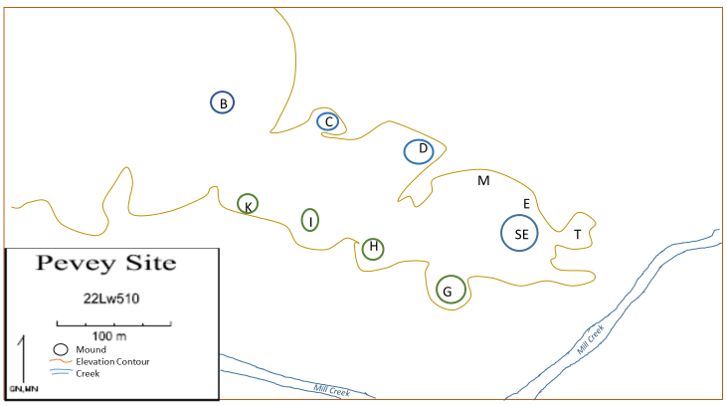
Figure 1.3: Simplified map of Pevey, showing northern mounds in blue, southern mounds in green, excavation unit names, and the proximity to Mill Creek.

Other, smaller mounds may have also existed to the east based on artifacts found at the surface (Mann 1988:6). Shovel testing to the north indicates there may have also been settlements on the terrace edge that have eroded away over time (Patrick Livingood, personal communication 2017). The 13.5-hectare site seems to be bounded on its southern side by Mill Creek, a tributary of the Pearl River (Livingood 2006:28), but the exact limits of occupation cannot be estimated at this time because much of the surrounding land has not been surveyed (Patrick Livingood, personal communication 2017). The flat floodplain continues to the west before disappearing into small, rolling hills typical of the Gulf Coastal Plain, and the soils in this area would have been very good for farming (Livingood 2006:28; Mann 1988:9).
Extensive information about sites along the Pearl River was collected by a CRM company commissioned by the US Army Corps of Engineers in 1982. The surveyed area stretched just over 100 miles from the Gulf of Mexico to the Ross Barnett Reservoir. Moore (1987) summarized the environmental and cultural resources. A region of Temperate Deciduous Forest parallels the river, with oak and maple trees and plentiful deer. Hickory trees are also present in Lawrence County, with a Magnolia-Maritime region to the south. There are many willows, cottonwoods, American elm, basswood, and swamp chestnut oak in the area, with an understory of sassafras, eastern redbud, and flowering dogwood. Wetland areas will have bald cypress, tupelo gum, black willow, and buttonbush plants (Moore 1987).
In this region, invertebrates such as mollusks, mussels, and gastropods could have been gathered by residents at the Pevey site, which is situated on the second terrace of the west bank of the river. Fishes include gars, bowfins, eels, herring, pickerels, minnows, suckers, catfishes, perches, basses, silversides, sunfishes, and drums. Many species of amphibians and reptiles are also present, and several species of snakes. Both migratory and permanent birds are present; mostly smaller species are listed, but also herons and ducks which would have been easy to hunt. Passenger pigeons and turkeys were probably also a good source of food. Mammals present include opossums, raccoons, fox, rabbits, squirrels, beavers, coypu, dogs, wolves, bobcats, weasel, minks, bears, skunks, and deer (Moore 1987). A full list of species (with their Latin names) can be found in Moore’s report (1987).
The Pevey site was first officially recorded as a large Plaquemine/Mississippian village center in 1977 by R. Wilson. When the site was visited by staff from the Mississippi Department of Archives and History (USACE 1982), it had already showed evidence of looting activities. Now on the National Register of Historic Places, agricultural clearing has been halted and several analyses have been done (Livingood 2006:24). Luckily, the largest mounds are located in forested areas and have not been severely affected by agricultural modifications, although there has been some looting on Mound I (Mann 1988:15).
Mann’s research sought to refine a ceramic chronology for the site, comparing the sherds with those found at other Mississippian mound sites to the east and west to determine any possible social interactions (1988:29). He also analyzed the materials at Pevey to examine the hypothesis that there should be a shift in artifact types from the late Coles Creek Phase to the Plaquemine Period, which is generally associated with increasing social complexity, possibly through diffusion with Mississippian societies north of the Natchez Bluffs (Mann 1988:39). This transition will be discussed at a greater length in Chapter 2.
Excavations in the early 1990s at both the Lowe-Steen and Pevey sites by Tim Mooney to test the Choctaw Ethnogenesis Hypothesis resulted in evidence that the sites had been abandoned long before the formation of the Choctaw tribe in the 18th century (Livingood 2006:275). While the ceramics were quickly recognized as belonging to Coles Creek, Plaquemine, and Mississippi Periods in early surveys, earlier reports indicated that the lithic projectile points appeared to consist of types associate with earlier Archaic use of the area (Mann 1988:15; McGahey 2000).
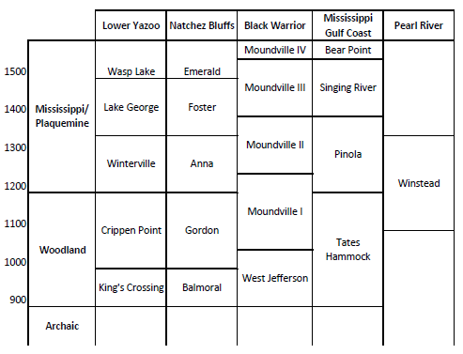
The chart below shows how the phases discussed below fit within the larger history of the Lower Mississippi Valley and other river valleys nearby that contain well-known multi-mound sites (Livingood 2006:275). The Winstead Phase along the Pearl River roughly corresponds with the end of the Gordon Phase and the entire Anna Phase in the Lower Mississippi River Valley, and it overlaps most of the Moundville I and II Phases in Alabama.
Figure 1.4: Chronological chart depicting the Winstead Phase’s placement among other phases for nearby river valleys (from Livingood 2006:275 and Rees 2010:12).

The ceramic styles at Pevey seemed to correspond with Ford’s typologies created for the Lower Mississippi Valley, and Mann wrote that many originated during the Anna Phase (approximately 1200-1300 A.D.) of the nearby Natchez Bluffs area, but a few (less than 5%) were reminiscent of the earlier Coles Creek period and the Gordon Phase. There is also evidence for some use of Mound E after the Anna Phase, with ceramics from the Foster and Emerald phase also identified in the units on top of and next to Mound E, but these were mixed with many more sherds that were still indicative of the Winstead Phase (Livingood 2006:190-191). Thus, for the purposes of this paper, we will treat all Analytical Units and all artifacts from this site as being produced during the Winstead Phase. Exceptions will be made for the layers that were clearly determined to be mound fill and were full of Archaic projectile point types; these lithic artifacts were not analyzed as part of this study.
During the summers of 1993 and 1994, when the Pevey site was excavated under the direction of Mooney and Steponaitis, the intent was to sample each of the nine mounds, areas of interest near the mounds, and the area where Mound A may once have stood. Archaeologists intended to excavate each 2x2m unit in two stages: first, a 1x2m unit would be removed in arbitrary 20 cm levels, then the second half would be excavated according to natural and cultural stratigraphy (Livingood 2006:33). These two groups of levels were matched later to create Analytical Units, the meaningful layers of mound-building, occupation floors, and midden. All soil was screened through ¼ inch mesh, and flotation and water screen samples were collected from most levels (Livingood 2006:33).
Excavations at Unit A revealed no evidence of a mound, recovering only a few sherds and no man-made features (Livingood 2006:34). Unit J also attempted to find evidence of a missing mound, but was placed incorrectly and revealed no man-made stratigraphy. Unit SJ, later excavated nearby, encountered the remains of Mound J (Livingood 2006:76). The midden uncovered at Unit K indicated a remnant mound at that location (Livingood 2006:74). Units B, C, G, H, and I were placed on the summits or flanks of the mounds of the same name, and SE was placed on the summit of Mound E. Unit E was placed at the base of its mound in a flank midden, and Units M and T were on a bluff edge and terrace wall near Mound E (Livingood 2006).
While all artifact types were examined in later analysis, the ceramics collected were most informative as to what kinds of activities were taking place at each location. The units on or near the largest mound, Mound E, had traits associated with feasting and elite groups, such as the large numbers of plates in Units M and E (Livingood 2006:232). Mound H, the second largest mound in the southern row, also had many plates, signifying that this might also have been a location for feasting or serving (Livingood 2006:100 and 232). On Mound G, the greatest quantities of imported ceramics were found, probably related to high-status individuals or activities. An interesting sherd of Moundville Incised, var. Moundville looks a great deal like it could have been made at Moundville, but sourcing results are unable to confirm (Livingood 2006:282). Finally, the only piece of copper found at the site, a fragment of a copper ornament in the shape of a bilobed arrow, was found at Unit M, near Mound E.
The smaller mounds to the west tended to have assemblages with more undecorated ceramics used for cooking. Mound I also had the highest amount of maize compared to the other mounds, and so the location of that unit could have been an area of maize processing (Livingood 2006:235). Lithics from this unit were unusual in many ways, compared to the assemblages from other mounds, and will be discussed at length in Chapter 4. The paleobotanical results show that Pevey is typically reliant on maize. The ratio of cupules to kernels, however, show that primary processing was taking place there, unlike at Moundville where it seems that the corn is processed elsewhere and then consumed at the mounds (Brewer 1995:35-36). Also, like other sites, the botanical assemblage included small quantities of amaranth, knotweed, chenopod, and sunflower (Livingood 2006:239).
Similar to what Mann had noticed about the ceramics in 1988, shell temper was found in abundance at the Pevey site during the 1993-1994 investigations. Livingood used a microscopic analysis of thin-section images to identify temper, and found that the grog-tempered vessels were used mostly for plates, bowls, and other serving vessels, while shell temper was most common in storage and cooking vessels (2006:232).
Structures were identified often in multiple Analytical Units of the larger mounds. Livingood (2006:263) described three types found at Mississippian sites: elite houses, temples, and charnel houses. Because of the lack of mortuary remains discovered at the site, it is unlikely that many could have been charnel houses, but information about ceramic forms and lithic tools could help to differentiate between residences and civic buildings. In every excavation unit at Pevey, the investigators uncovered large amounts of burned clay and fire-cracked rock (Livingood 2006:259), possibly potential hearths or structures, but no unusually large hearths have been found, indicating that the structures discovered were more likely residences than temples (Livingood 2006:263).

Mound Research along the Lower Mississippi and Black Warrior Rivers

Before examining areas of activity at Pevey, it is helpful to review the regional context of mound constructions in the Southeast, focusing on the Lower Mississippi River Valley and the Big Black River to the west, as well as the Tombigbee and Black Warrior Rivers to the east. By reviewing settlement patterns from the lesser-known Plaquemine sites to the west and the large amount of information on the major center of Moundville to the east in Chapter 2, an appreciation for the scale of the mounds and the deep history of their construction in this part of the world may help us understand why Pevey was constructed in the layout above, and how different areas might have been used for different lithic activities. A brief overview will be presented here, with specifics on mound layouts given in Chapter 2.
Archaeologists have long acknowledged that mounds in the Lower Mississippi Valley had been built for centuries before the mounds examined in this thesis, starting vigorously with the Watson Brake mounds during the Archaic Period (Gibson 1980; Gibson 1994; Kidder 2004; Kidder and Sherwood 2016; Livingood 2006; Ortmann et al 2003; Sassaman 2010; Sassaman and Randall 2012; Wright 2014). Mounds become more commonly associated with hierarchical, ranked societies in the Lower Mississippi Valley during the Coles Creek Period around 700 A.D. and continued to be built until contact with Europeans (Kidder 2004; LaDu 2016; Livingood 2006). Many of these sites were visited by early excavators of the Southeast, including Thomas and Moore in the late 1800s and early 1900s (Mann 1988:25). The inter-assemblage variation in the ceramics found in this region formed the basis for Ford’s early ceramic definitions of cultural units in the 1930s. Ford’s work in founding the Lower Mississippi Survey led to the discovery in 1949 of the Lake George and Winterville sites in the Yazoo Basin (Mann 1988:21-22). Excavations carried out at Lake George in the late 1950s gave archaeologists information about the use of mound sites (Williams and Brain 1983), but many other sites are known only through survey work (Livingood 2006:287).
Figure 1.5: Map of contemporaneous sites in and near Mississippi, discussed in Ch. 2.
Pevey

Because we have identified many of the populations who occupied these mound sites as middle-range societies (Anderson and Sassaman 2004; Blitz 2009; Welch 1991) research has been undertaken to understand how leaders participated in the planning of the mound construction, and if the construction can show us how they interacted with the rest of the community. Reinterpreting the rise of the platform mound on the Mississippian landscape has led archaeologists to see new traditions of ritual or political power. This power may have been distributed among the community, or vested in one person or family (Cobb 2003). Archaeologists have also moved beyond directly correlating the size of the mounds to the political power of its leaders, and now see each mound as having its own particular history, where it may have been used for several different purposes throughout the centuries (Blitz 1993; Knight 2001). In addition, as each layer of earth was added, it may have involved different degrees of inclusive or exclusive practices, especially if the movement of soil was carried out by a large community, but managed and overseen by just one leader (Dowd 2012:277).
Contemporaneous multi-mound polities in the Lower Mississippi Valley include Winterville, Lake George, Emerald, and Anna to the west (Livingood 2006:287). To the east, the well-known mound and plaza center of Moundville on the Black Warrior River serves as a reference for other Mississippian mound sites, and designs on ceramics found here are often recovered at sites hundreds of miles away. It is important to discuss sites from both east and west of Pevey because the excavations mentioned above uncovered a large percentage of cooking sherds that look like types from sites to the east and a large percentage of decorated wares that seem to come from sites to the west (Livingood 2006). Several of these site arrangements, as well as the layout of the earlier Greenhouse site and later Fatherland site, will be discussed in Chapter 2 to understand how people in the Southeast may have expressed their relations to each other by constructing their communities in certain ways.

Summary

The large, multi-mound Pevey site has a very short history of archaeological investigations, compared to other large sites in the Southeast. During the Mississippi Period, Pevey was one of many multi-mound sites incorporating open plazas and platform mounds into architectural patterns that may indicate the social organization of the inhabitants. Previous research at Pevey has established a culture chronology based on ceramics, and has identified areas of possible elite residency, feasting, and storage on and near Mounds E and G. A lithics analysis of the debris and tools found in all of the excavation units could help uncover activity areas of special tool production or use. In the following chapter, I compare arrangements of mounds from other sites in the Southeast and how some archaeologists believe that they were manifestations of social hierarchies or heterarchies. This will better help us understand why Pevey was designed in the U-shaped layout that we see today, and what that can tell us about leadership and community organization in the past.

Ch. 2: Mound Arrangements

Looking to other sites in the Southeast may help us understand why the mounds at Pevey are constructed in this particular configuration, and whether this arrangement signifies the division of the site into areas controlled by elites or several different corporate groups. This chapter explores social space theory published in psychology and behavior journals to understand why mounds might have been arranged as they were, and how people might have used the distances between them for separation, control, or cooperation. Then, I consider how ethnography has been used to shape our interpretations of the layout of Moundville, which is roughly contemporaneous with the Pevey site. Examples from earthen mound sites of the Coles Creek, Mississippi, and Protohistoric Periods, as well as shell mounds of the Archaic Period, will be analyzed for their shape and symmetry in an attempt to understand how archaeologists interpret circular and U-shaped mound formations, especially those in which some mounds are significantly larger than others.
Although not all habits regarding social space are cross-cultural, many generalizations about cooperation, hierarchy, and leadership manifest themselves in similar ways as people position themselves in different cooperative or competitive situations. Levi-Strauss (1963:139) has pointed out that allusions of balance, symmetry, or dualism can be construction features that disguise the complexity of actual life in a community, but some archaeologists accept the principle that formal spatial patterns probably reflect some reality or ideal of the social organization (Grøn 1991). It makes sense to examine the landscapes of other contemporaneous mound sites in the Southeast to identify which social orders, hierarchies, or distinctions were monumentalized in the form of earthen mounds. After reviewing several sites with similar layouts, it seems logical that these permanent fixtures on the horizon, with their planning and geometry, must have meant something to those who designed them, whether they were cosmograms or sociograms, designed for defense or to enhance prestige. It’s possible that people who were related to each other, or who were close enough to be in regular contact with each other, might have shared similar ideas of how residences, political centers, and monuments should be arranged, and so a critical use of ethnographic sources can provide hypotheses as to how hierarchies and heterarchies may have manifested themselves on Pevey’s mound design.
Examples below will inform about how Archaic groups in the past may have used subtle asymmetries to elevate some people in circular shell rings to transcend egalitarians ethos. Research into the modern use of social space will predict how people in U-shaped and circular layouts aligned themselves based on their leadership levels and desire to cooperate or compete with other groups. As Pevey certainly seems to fit a U-shaped model with much larger mounds at the center, Russo’s (2004) work connecting this social space theory to Archaic shell mound sites in similar configurations will be reviewed.
One Mississippian example will use an ethnography of a historic tribe’s settlement layout to propose that some social groups may have built pairs of mounds in different sectors of Moundville to separate themselves from the other groups. If Pevey was constructed like Knight’s Moundville diagram, with corporate groups inhabiting pairs of mounds, it could be that these pairs are directly across from each other, and thus E-G, D-H, C-I, and B-K would constitute the pairs. If we find that one of the pairs has significantly different lithics than the other pairs, we might make the argument that the corporate groups are ranked and used or created stone tools in different ways, perhaps producing their own special items so that they weren’t always competing directly for the same natural resources to make the same kinds of products.
These models will be compared to other Plaquemine sites along the Lower Mississippi Valley in order to show that not every mound site was necessarily a sociogram of separate corporate groups. At some of these sites, the large mounds seem to be shared by everyone in one unified community, but the mounds may represent different platforms for various kinds of structures, such as residences, storage facilities, or temples. It seems clear that the Pevey site, with its two largest mounds directly adjacent at the end of the U-shape formation, may have different functions for each of these mounds, but does not follow a prescribed model to which all Plaquemine sites adhere.
These models will be tested in Chapter 4 with the results of the lithics analysis at Pevey to help suggest if there are differences in lithic activities on each mound, and how these might be the result of the social organization of different groups at Pevey. The lithic analysis, combined with previous ceramic research, will also enable us to get a better idea of whether the material culture on or near the two largest mounds characterizes areas of elite habitation, formal presentation, feasting, or storage.

Social Space Theory

Behavior and psychology articles that discuss seating arrangements among modern workers as they are asked to solve a problem could be related to how the people positioned themselves as they were building these mound sites, assuming each mound or group of mounds could possibly represent a small group of people. Although culture determines to some degree the distance that people need for comfort in their personal space, it seems that people who gather in small groups to communicate and work together usually form circles and ovals, facing the center to be able to talk most effectively (Grøn 1991; Sommer 1961). In small circular groups, when several different work tasks are assigned, the group members tend to split themselves into smaller circles (Hare and Bales 1963; Steinzor 1950). This formation may be seen at some of the shell rings sites in Florida, when smaller shell circles seem to be attached to or near larger rings (Russo 2004:57-59). Also, these smaller circles of workers tend to place themselves across from other circles with contrasting ideas, possibly so that certain members of one circle can communicate visually with the competition and exchange opposing ideas (Russo 2004:37). Central to these interpretations is the belief that the rules regulating the spatial layout of individuals also regulates the placement of dwellings (Grøn 1991:105).
Applying these rules to Pevey, we would have to assume that each mound or pair of mounds represents a family or larger kin-based group. If two different groups occupied the two rows of mounds, one might hypothesize that the U-shape encouraged people to communicate with each other across the plaza, as each mound pair is only about 75-100 m apart. For example, even if a family living on Mound D and an unrelated family living on Mound H came from different backgrounds, constructing the mounds in this configuration would allow them to visually keep tabs on each other’s activities. Without excavations in the plaza-area, though, we have no way of knowing if it was kept open, or occupied by other structures, so it is unclear how helpful this arrangement is for communication between north and south mounds.
People who either think of themselves as leaders, or who are perceived to be the leaders by other members of this group, will seat themselves more distant from the rest (Sommer 1961). This place could be the center of a circle (like Mound A at Moundville) or at the end of an oval table (which would be more like Mound B at Moundville). By seating themselves apart from the rest of the workers, these dominant people are more visually in control of the conversation. In a U-shaped formation, the table will seat dominant people at the center of the U, facing the door (Hare and Bales 1963). At Pevey, this location would be on Mounds E and G, facing towards the west. If the plaza was not a common, open gathering place, people living on Mounds E and G may have been the nexus of information and communication between northern and southern groups.
The rest of the group members, when working together, will tend to seat themselves equally-spaced from one another (Sommer 1961). Interestingly, when regular, nondominant workers are placed at that position at the head of the table, they tend to take on more leadership roles than if they were to choose their own spot amongst the arms of the U-shape (Howells and Becker 1962). Grøn (1991:103) has shown that these traits are conservative forces that maintain existing structures, and so the location of a leader on a mound that references past leaders may be an effort to impress others with a traditional spot of power.
Ethnographic analogies of how small groups of modern hunter-gatherers arrange their living spaces and place themselves in certain spots according to their social standing can also provide hypotheses for how mound construction was planned to serve the social needs of its inhabitants. In small dwellings, the family that eats and sleeps there faces the center of the house, much like the workers mentioned above. The dominating individual usually sits directly opposite the entrance, either to be further from the natural elements or to have the best view of the traffic coming through the doorway. Everyone else in the house sits around the periphery, with the least dominant individuals in places nearer the doorway (Grøn 1991:103-104). At a mound site, this could appear in the form of dominant families at the end of the U-shape with the best view, while other families occupy other mounds. This would place the most distant relatives at the very ends of the U.
Related individuals and families typically place their houses next to each other, ethnographically, to increase interaction within families and separate themselves as a subgroup from other groups (Grøn 1991:101-102). Sometimes, these related households will also place less related households more on the periphery, and they will position themselves across from rival groups (Parkington and Mills 1991). Thus, U-shaped villages tend to mimic the seating arrangements of modern workers, with the most visually-dominant head at the center of the U, and less influential members on the ends. These kinds of formations with single focal points generally suggest a group with an extremely stratified hierarchy and a single clear leader (Grøn 1991:108).
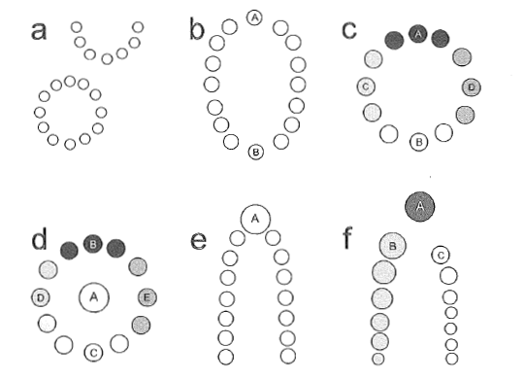
Figure 2.1: Idealized locations and sizes of mounds that convey status positions. Shade intensities show relatedness, and size of circles here denotes status (from Russo 2004:39).

At a U-shaped mound site where there is a significantly greater amount of shell in the middle, archaeologists might interpret this as a location that navigates between two opposing factions. A leader on a central, larger mound could act as a middle man, controlling information and communication, and this could be one of the sources of their power (Russo 2004:39). This could also be true for a circular site with an elevated household, or with a mound right in the middle of the circle (Grøn 1991:105-106), like Mounds A or B at Moundville. The distance that a large mound is from the rest of the mounds may also tell us about its use. The larger a household is, the more self-sufficient, and thus the less likely it is to be in contact with other households, but sometimes leaders also put space between themselves and more ordinary people to maintain visual dominance (Grøn 1991:106). Although the largest mounds at Pevey, E and G, are not further from the rest, they are definitely the highest. If there were indeed two factions of some sort living on the two rows of mounds, people living on Mounds E and G could have had the ability to negotiate between both groups if disagreements arose. Hypothetically, if Mound E was the central location of the leaders of the northern group, and Mound G was the residence of the leaders from the southern group, their proximity to the middle of the site and each other could have facilitated open communication between the two groups.
Considering the rest of the mounds, one might assume that all of the other mounds are places for the rest of the group, considered equals to each other, like in Model E of Figure 2.1. On the other hand, in a ranked community, it’s likely that people closest to the leader also gain some power or prestige by their proximity, and so mounds closest to the center might be slightly larger than those farthest from the center, like in Model F (Russo 2004:39). It’s possible that these households are more closely related to the leader at the center, or they could be the two most powerful households that each represent one of the arms of the U, with the rest of their extended families living further down the lines. This geometric figure would be beneficial for dealing the population expansion, as closed circles provide no extra room for new households, but U-shapes can just add another two mounds on the end if both moieties increase in number over time (Russo 2004:52). Thus, if it were shown that the smaller mounds at the end of Pevey were constructed later, an argument could be made that this open-ended shaped was perfect for adding on more mounds when there was in increase in people at the site. It might also suggest that those on larger mounds nearest the middle (like Mounds D and H) had more influence over decisions than people on the smaller western mounds (such as Mounds B, K, and I).

Archaic Mounds

Other possible interpretations of the arrangement of mounds at Pevey can be seen by looking to mound constructions in the Southeast that date to earlier periods. Although archaeologists have traditionally viewed societies from the Woodland and Archaic Periods as significantly less complex and less likely to organize large groups of people to create monuments, recent research has shown that earth and shell mounds have been built for thousands of years in interesting patterns (Gibson 1980; Gibson 1994; Kidder 2004; Kidder and Sherwood 2016; Livingood 2006; Ortmann et al 2003; Sassaman 2010; Sassaman and Randall 2012; Wright 2014), which might tell us something about the social structure of the people who made them. These discussions move far beyond the suggestion that mound sites created in a ring are a sign of egalitarianism (Blitz 2009; Cobb and Nassaney 2002; Kidder and Sherwood 2016; Ortmann et al 2003; Russo 2004), and stride towards identifying kin groups, their possible ranked space, and areas reserved for leaders.
Shell rings from Florida’s Archaic Period are among the earliest examples of large-scale architecture in the Southeast, possibly monuments intentionally built for some kind of ceremonial purpose, or as a place for people to gather (Russo 2004:26; Sassaman and Randall 2012). A focus on the geometric regularities and symmetries of a circular site can lead to conclusions about the planned nature of the constructions, which has been a measure of social complexity and possible sedentism (Service 1971). The evidence at these sites, though, suggests that there are significant irregularities in the geometry of the shell rings that may reclassify the social structures as more transegalitarian than a simple circle (Russo 2004:26-27; Sanger 2015:106). Shell rings in Florida, as well as several in Georgia and South Carolina, are not perfectly symmetrical, and Russo (2004:35) believed that these asymmetries are not mistakes, but the product of purposeful decisions made by a group that used this social space for particular tasks that required more shell be deposited at some areas than others.
In considering the function of the U-shaped shell ring at Silver Glen Run, Sassaman (2010) posited that the two parallel ends of the U might contain two different moieties. Some mounds in the middle of the U-shape have more shell and are higher than the rest. This could be a purposeful construction that shows some social stratification at that site. In addition, he looks at the types of pottery to differentiate which groups of people were living in each area. On the coast, there is a distinction between shell ring sites with incised pottery and non-ring sites with plain pottery (Saunders 2004:61-62). At Silver Glen Run, though, the opposite arms of the U-shaped shell mound site have either plain or incised pottery, but not both, suggesting a symmetrical duality occupied by two different groups. It’s important to note, though, that this could also be a chronological difference between the construction of the two arms (Sassaman 2010:77).
At Horr’s Island, materials recovered from a U-shaped shell monument showed hundreds of years of shell deposition, with mounds and causeways suggesting that this was more than just village midden. Russo’s (2004) interpretation that this was a village site for a small number of families that then hosted large feasts for other off-mound residents suggested that there could have been a hierarchy involved. He also interpreted the uneven shell deposition in certain areas as being a manifestation of inequality (Russo 2004:39), perhaps a way of providing elites with a better location on the landscape.
In Late Archaic shell rings on Saint Catherine’s Island in Georgia, pottery production and use showed that each ring was occupied by different communities, and excavations in the middle of each ring suggested that each community took part in similar ritual acts there on an anthropogenic surface (Sanger 2015:166). These sites are interpreted as a reflection of hunter-gatherer traditions that were increasingly formalizing divisions in sub-regional populations as the coast line became more crowded (Sanger 2015:2). The formation of these rings could have been a way for newly-sedentary people to deal with living in proximity to so many non-kin neighbors for the first time (Sanger 2015:31). This could be an example of a fission-fusion cycle (Blitz 1999) in which tensions within a large group arise, and villages can no longer be held together by kinship, alliances, or the rule of one authoritative leader. At the two shell rings excavated by Sanger, the majority of the shell was mounded on the northern edge of the circle, and there was evidence of trampling along the minor deposits at the southern edge, suggesting an entrance there (2015:171). This would fit with research on small group cooperation, which stated that leaders tend to position themselves directly across from the entrance.
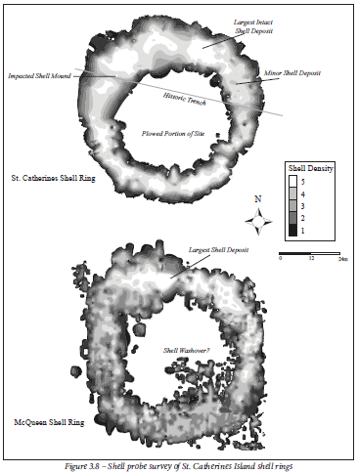
Figure 2.2: Survey of St. Catherine’s Island shell rings (from Sanger 2015:150).
Although the sites mentioned here are from much earlier time periods than Pevey, they show asymmetrical patterns that may have promoted some individuals or groups over others, even though archaeologists usually argue that social complexity during the Archaic was relatively less than during the Mississippi/Plaquemine Period. The asymmetries here suggest areas of increased mound height that might have been the location of leaders, often directly across from an opening that functioned as an entrance to U-shaped and circular shell formations.

Look to the East: Mississippian Culture

Evidence for some aspects of Mississippian culture first appeared far to the north of Pevey around 900 A.D., and later spread from Cahokia, perhaps south to the Lower Mississippi River Valley and Caddo areas with a focus on Spiro, and east to the Tennessee and Cumberland drainages with activity centered on sites like Moundville (Blitz 1993; Jenkins and Krause 1986:86; Pauketat 2005:196; Rees 2010:180-181). Following trends that began even before the Woodland Period in the Southeast, this time was characterized by an increase in population densities, sedentary communities, reliance on agriculture (especially maize), trade in exotic prestige goods, platform mound construction, and complex societies led by chiefs (Blitz 1993:5-6; Jenkins and Krause 1986:86; Rees 2010:180-181; Welch 1991:19). In the regions surrounding Pevey, some of these trends seem to be indigenously-generated, while others may have arisen from contact with people associated with Cahokia (as described below in the section on Plaquemine cultures). Mississippian leadership has been described as ascribed and hierarchical in some locations (Blitz 1993:6; Welch 1991:2), and many of these chiefs may have been able to organize large populations to construct palisades, temples, platform mounds, burial mounds, or elite residences.
A rapid Mississippianization process, recently defined as “an uneven historical process in which people politicized maize-based agricultural landscapes and cosmologies in ways contingent on their pasts and on each other” (Pauketat 2007:85), had been seen by earlier archaeologists as a set of independent responses to similar environmental challenges, like a set of subsistence strategies, or a stage of complexity in the evolution of society (Blitz and Lorenz 2006:123). Others stress that it is important to understand that Mississippian people may have also negotiated their own identities and alliances by selectively adopting certain Mississippian traits, but not others (Pauketat 2005). The Pevey site is contemporaneous with several other Mississippi Period mound sites in Louisiana, Mississippi, and Alabama, and so looking at what archaeologists have hypothesized about the mound layouts of these other sites may help elucidate how the mounds at Pevey were used.
The spread of Mississippian iconography can be seen radiating from Cahokia to other large multi-mound sites in the Southeast, and possibly from these sites to many of the smaller mound sites and farmsteads (Jenkins and Krause 1986; Knight 2001; Pauketat 2005). The existence of the Mississippian Ideological Interaction Sphere (MIIS), which dispersed exotic goods decorated with stylized images of mythical heroes and events (Blitz 2009:12-13; Knight 2001; Livingood 2008:11-12), illustrates the likelihood that people from distant sites were sharing their cosmology as they traded or copied decorated objects.
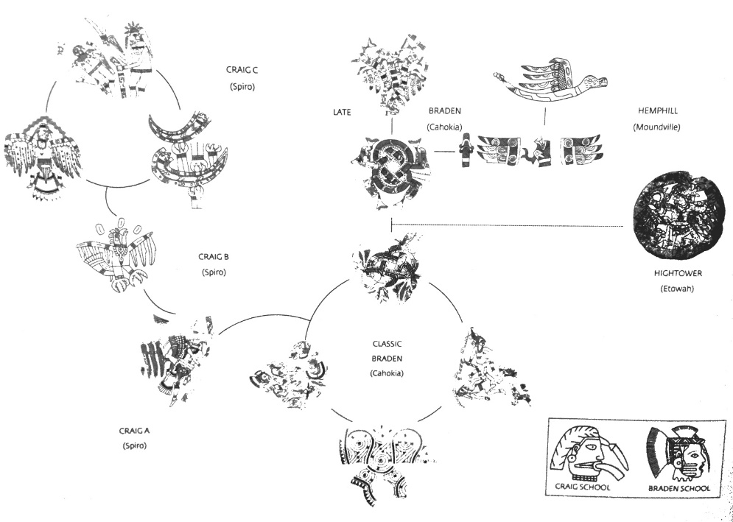
Figure 2.3: Model of MIIS influence for the Craig, Braden, Hemphill and Hightower styles at Spiro, Cahokia, Moundville, and Etowah (from Brown 2004:108).

Of course, the spread of this bundle of iconographic designs on artifacts like ceramics and shell varied regionally (Cobb 2005:566; others). Archaeologists have argued for a large amount of cultural diffusion from Cahokia to certain other large mound sites like Moundville, late in its history as it consolidated ritual power (Blitz 1993:118), but the routes by which the products traveled from one site to the other may have been very indirect. Others have argued for a more selective integration of certain iconographic elements at sites in the Lower Mississippi Valley, like at Old Hoover, a site with a large platform mound, but very little social status differentiation (Lorenz 1996).
A few hypothesized an introduction of Mississippian themes by means of intrusive groups setting up residence in other places, such as at Rood’s Landing and Singer-Moye on the Chattahoochee River (Blitz and Lorenz 2006:68), at the Petit Anse salt mines on the Gulf Coast (Rees 2010:192) or at later mound sites along the Alabama River (Regnier 2006). This adoption of ritual and tradition from one site to another during the Mississippi Period in the American Bottom and parts of the Southeast may have also been a way for some leaders to use a shared symbolism of chiefly/warrior myths or ancestor cults to legitimate their power or build ties to other communities (Pauketat 2005:205).
A shared architectural grammar of plazas and mounds could also be an indication of the spread of Mississppian culture in the Southeast during this period (Blitz 2009; Lewis and Stout 1998). As mentioned above, Levi-Strauss (1963:139) has pointed out that allusions of balance, symmetry, or dualism can be construction features that disguise the complexity of actual life in a community, but formal spatial patterns probably reflect some reality or ideal of the social organization (Grøn 1991). Large groups may have been needed for the rapid construction of some of the larger mounds, such as Mound A at Poverty Point (Ortmann et al 2013). It is also likely that many mounds were also constructed over centuries and would have required only a few people at a time to add each layer, such as Mound A at Shiloh (Kidder and Sherwood 2016:13-18). While the creation of these mounds was not a new invention by any stretch of the imagination (Blitz 1993:70; Jeffries 2004; Kidder 2004; Kidder 2010; Kidder and Sherwood 2016; Ortmann et al 2013; Pluckhahn 2003; Rees 2010:180; Russo 2004; Sassaman 2010; Saunders 2010:66; Wallis 2007; Wright 2014), it reached new proportions in the Southeast during the Mississippi Period with larger complexes of platform mounds and plazas ( Blitz 1993; Blitz 2009; Lewis and Stout 1998; Livingood 2008; Pauketat 2005; Rees 2010:180). Although conical burial mounds continued to be built, there is an increase in the construction and use of platform mounds that could have provided an area for elite homes, a location of restricted attendance for special activities, or a spot from which leaders could project their messages to large groups (Blitz 1993:70-71; Lewis and Stout 1998:17). Mounds became more commonly associated with hierarchical, ranked societies during the Coles Creek Period around 750 A.D., and continued to be built until contact with Europeans (Kidder 2004; Livingood 2006).
Platform mounds functioned as symbols, sometimes inclusive through the integration of communal labor, but sometimes exclusive by allowing in only those leaders with claims over resources or authority (Porth 2014:1). Blitz (1993:73) proposed that if mound tops were used to redistribute food, we would find ecofacts and features suggesting storage or feasting. If they were constructed for ritual activities, we should uncover temple layouts with nonutilitarian items. If mound platforms were locations of civic activities institutionalized over time, archaeologists should see patterned and repetitive architectural patterns that span several generations. It is possible that large mound sites exhibited some kind of ritual authority over single mound sites, which in turn may have been more socially important than the dispersed farmsteads within a region (King 2003; Welch 1991), though there is some evidence that small nonmound sites tended to aggregate near good farmland and not larger mound centers in some regions (Knight 2010:2).
The remainder of this chapter will examine the landscapes of other contemporaneous mound sites in an effort to identify which social orders, hierarchies, or distinctions were monumentalized in the form of earthen mounds. Moundville was a permanent fixture near Pevey, and similarities between the two site layouts may suggest some kind of shared social order.

Moundville: a Mississippian Mound Site

The Tombigbee and Black Warrior Rivers in western Alabama are home to a regional variant of Mississippian culture at Moundville. This site is of interest in this thesis because, like Pevey, it seems to have an orderly arrangement of Mississippi Period mounds on a terrace overlooking a major river. Covering 75 ha, Moundville consists of a central plaza surrounded by 29 remaining mounds that may be grouped in pairs of smaller burial mounds and larger residential mounds lacking burials (Knight 2010:1-6; Knight and Steponaitis 1998:4 and 49; Wesson 1998:101; Wilson 2008:1). All of the mounds seem to have supported pole-frame structures at one time, including the mounds with burials (Knight 2010:3). The presence of Moundville I pottery sherds recovered from excavations of nearly every mound suggests a quick construction from 1200 to 1300 A.D. and significant planning involving symmetry and ranked social spaces (Knight and Steponaitis 1998:14-15).
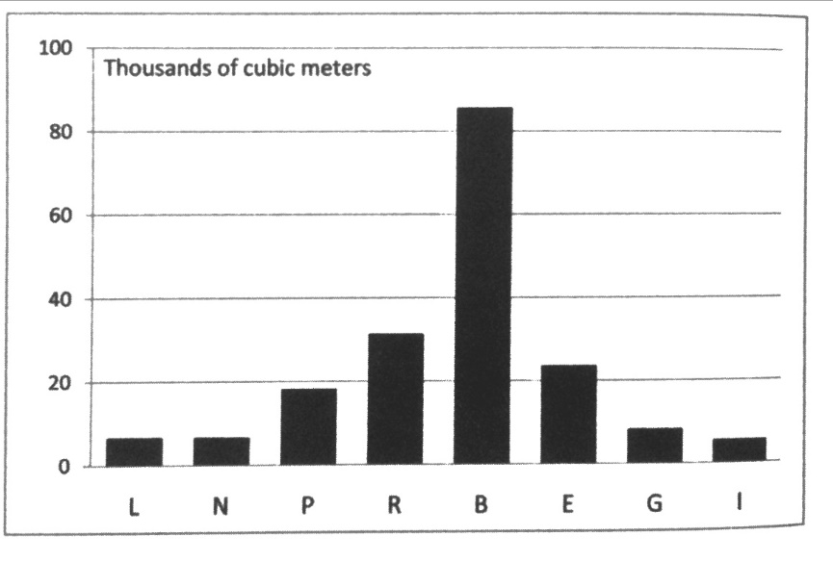
Like Pevey, the largest mounds are all located in the same area, and become steadily smaller as you move towards the opposite end of the site (Knight 2010:6).
Figure 2.4: Moundville’s periphery mound volumes, showing a decrease in both directions from Mound B at the center (from Knight 2010:6).

Unlike Pevey, over a century of mapping and excavations has produced much information about the possible uses of the mounds, the status of residents on the outskirts of Moundville, and the site’s relationship to other mound sites and farmsteads along the river. Excavations just outside of the mounds surrounding the plaza have revealed clusters of houses, often superimposed with cemeteries (Knight 2010:3).
In addition to the construction of mounds, the significant evidence of long-distance trade and differential access to exotic materials at Moundville suggest the presence of a structure of leadership that could inspire large groups of people. Although 90% of the ceramics excavated are undecorated (Jenkins and Krause 1986:93), there are several types of decorated wares, including a few that also appear at the Pevey site (Livingood 2006), indicating some sort of relationship, communication, or trade between the regions. There are fewer corn cupules here than at rural sites, indicating that perhaps food is being brought into this paramount center. The high percentage of burnished serving dishes and storage pots in these elite middens might provide supporting evidence that food was transported here for storage and then feasts (Knight and Steponaitis 1998:16; Welch 1991:180-183; Welch and Scarry 1995:405-408).
Zooming in and examining the artifacts found in each area of Moundville has allowed archaeologists to speculate on how open space and mounds may have been segmented. Excavations on Mound Q produced tools such as sandstone saws, Fort Payne chert microblades, pottery trowels, and greenstone adzes. Mound Q is located near some of the largest mounds, shell deposits, a greenstone manufacturing area, and raw materials such as galena and pigments, suggesting a special purpose for this particular location (Scarry 1998:94). Northeast of Mound Q, and just north of Mound R, there is also a large amount of nonlocal chert and burnished serving ceramics compared to most other excavated areas at the site (Scarry 1998:97-99). Thus, it seems that the northern edge of the site was generally an area of higher status, based on the larger size of the mounds, the elite burials on Mounds C and D (Knight and Steponaitis 1998:5), and the distribution of the exotic high-status goods near these large mounds (Scarry 1998:96). Additionally, during the transition to the Moundville II Phase, when the site became less of a town and more of a necropolis, it was the smaller mounds to the south that were abandoned first (Knight and Steponaitis 1998:18-19).
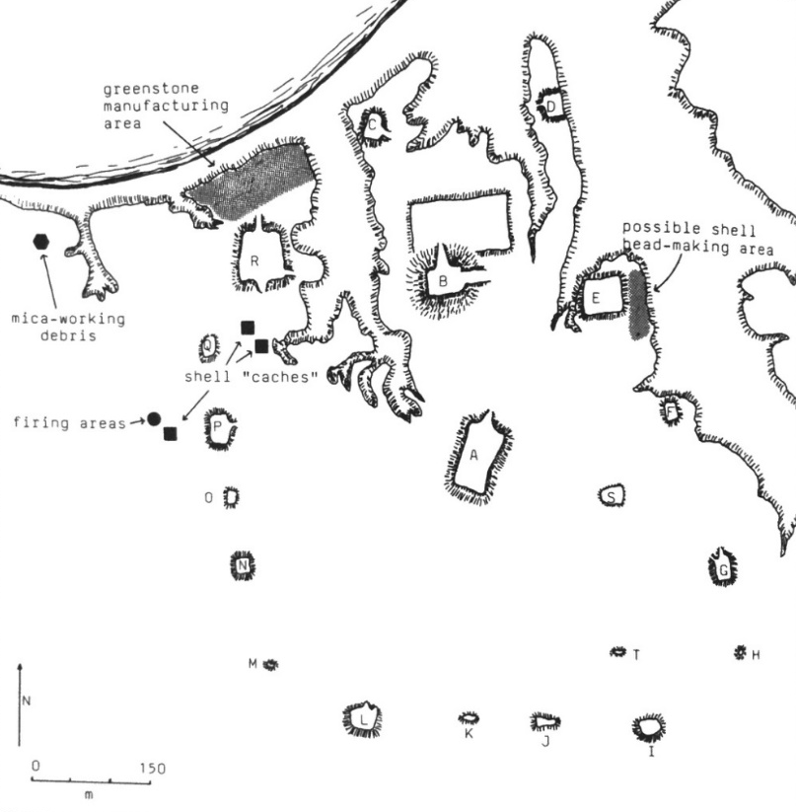
Figure 2.5: Moundville’s activity areas, with some mounds labeled (Welch 1991:146).

One interpretation of the social significance of this spatial arrangement is that each pair of mounds belonged to a different corporate group, which established a precinct in its area. Knight used the ethnographic analogy of Chickasaw kin groups engaging in a corporate ceremonial context to help understand how the Moundville site may have functioned as a diagrammatic ceremonial center (Knight 1998:44-46). He acknowledged that the construction of this diagram could have been a way to provide “intergenerational stability of a particular, arbitrary vision of social reality” (1998:46). The abandonment of the site shortly thereafter could also have been a way that people resisted these kinds of restrictive spaces (Knight 1998:17). Mound A in the center of the plaza is clearly the focus of many viewsheds, and sits opposite the impressive Mound B, which has in turn been interpreted as an elite residential mound (Knight 1998:49; Knight 2010:302 and 313). Figure 2.5 shows one possible interpretation of how the space was segmented and ranked.
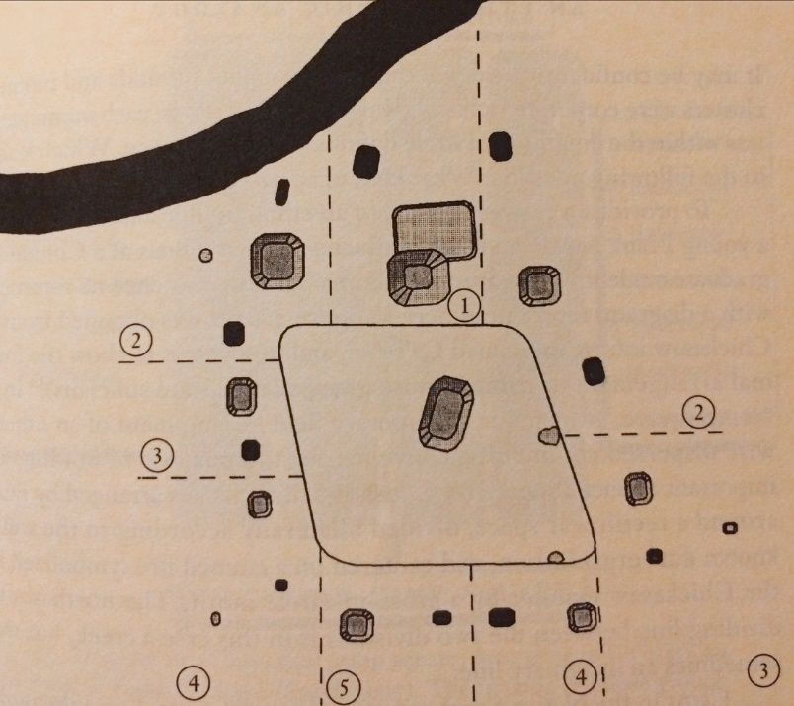
Figure 2.6: Moundville could have been separated into precincts, centered on pairs of mounds. Here, the precincts are ranked from 1 to 5, with Mound B presiding to the north (from Knight 1998:Figure 3.4).

The inspiration for this diagram came partly from a diagram of a Chickasaw camp square, recorded by a student of Franz Boas, based on a Native American informant’s description of a formal bilateral divide around a north-south axis. Like Moundville, this plan has a rectangular plaza, bilateral symmetry, a center reference point, and an arrangement of community segments by rank moving around the periphery (Knight 1998:54). This Chickasaw diagram seems to match the Pevey site in that the highest-ranking groups are located at one end of the diagram, and something similar could be mirrored in Pevey’s largest Mounds E and G. If Pevey followed this diagram, the smaller Mounds D and H would be home to the next highest ranked clans, and then Mounds C and I would be ranked next, with people on B and K ranked last. In this diagram, the mounds would not be paired, but would reflect two moieties that chose to place each house in a position that exemplifies its status compared to other houses with its subgroup, across a plaza from a house of another group that has achieved a similar status. This model looks a bit like Russo’s Model F configuration, shown in Figure 2.1 above.
With a possible Chickasaw heartland in western Mississippi, this plan could be similar to sites in Alabama and Mississippi, like Moundville and Pevey, even if these two Mississippian sites were created over 500 years earlier. Unfortunately, this diagram was created in the early 1900s after Removal to Oklahoma Territory, and may represent more of a gradation between traditional Chickasaw camps and Plains camp circles practiced in that area (Knight 1998:56-57).

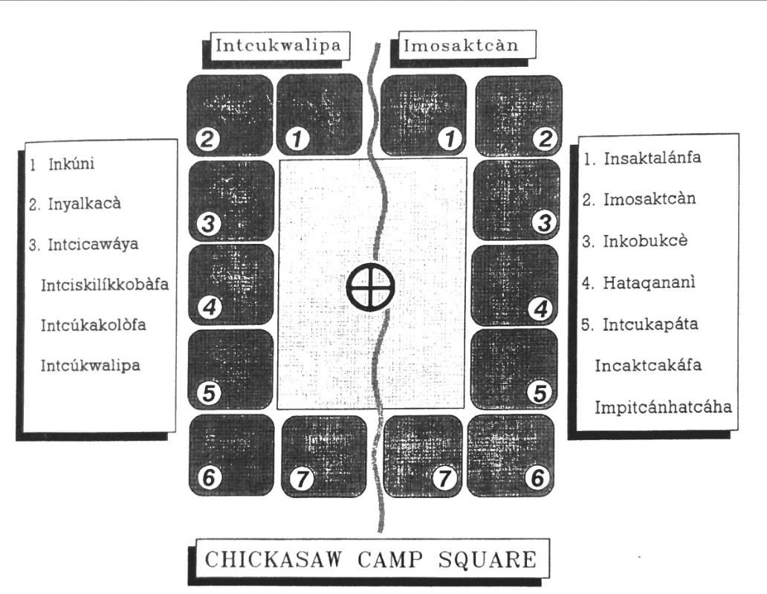

Figure 2.7: Diagram created by Frank Speck, based on an informant’s ranking of subgroups and where they resided around a council fire (Speck 1907, from Knight 1998:Figure 3.5).

Other models of Moundville’s layout of large central mounds and smaller mounds on the periphery have been considered, and most rejected. Knight (2016:26-27) has considered a hypothesis that a paramount chief occupied the largest mounds to the north, and subgroups on the smaller mounds were ranked by genealogical proximity, with more distant relatives on the mounds to the south. The idea of a temporary paramount chief has also been explored (Knight 2016:28-29), as this could be a demonstration of Blitz’s (1999) fission-fusion process in action as factional leaders come together to resolve conflicts and prevent fissioning. Both hypotheses have been rejected, though, because there doesn’t seem to be evidence of centralized political control on the larger mounds, even during Moundville’s most populace period.
A very different idea of Moundville as a gathering place for multiple sodalities, run by a cult council of some sort, has also been recently posited (Knight 2016:32), but what he has excavated from the tops of the mounds (skilled crafts and nonmortuary bone-handling) does not look like what he would expect to find in temples. Lankford (2016) has examined the possibility that this was a meeting place for sodalities of shamans that built medicine lodges and perhaps “Ghost Lodges” as has been recorded ethnographic accounts of tribes to the north, but is also not convinced that these kinds of groups were constructing the same kinds of temples or using the same kinds of owl effigies as the accounts detailed.
Finally, care has been taken to truly explore if Moundville should even be considered a town, and how permanent the residences may have been. The transition from two-mound typical town to mound-and-plaza ceremonial center to near-abandoned necropolis can be juxtaposed against the single-mound hinterland towns, which showed surprising intergenerational stability over the centuries (Scarry and Steponaitis 2016: 257-261). Moundville, on the other hand, may have been a regular but occasional gathering of clans who created a completely new type of settlement that was qualitatively different from the single-mound towns (Scarry and Steponaitis 2016:259-263). In the same way, Pevey could also be nothing like a town, but a regular place for groups to meet for some kind of political or religious purpose. If they organized themselves into clans upon their arrival, we may be able to see evidence of this in lithics assemblages that indicate that diverse but complementary activities were happening on top of each mound.
Because of the plentiful excavations at Moundville, archaeologists have a good picture of where some of the activity areas were located. While the Pevey site has significantly less exotic goods like greenstone, mica, and shell, an analysis of the chipped stone artifacts could still help us to see patterns in tool production. If a sufficient number of tools are found on each mound, we could microscopically analyze the use-wear to determine if certain perishable goods were being produced on each mound, even if these goods were later removed from the mound, or did not survive until the present. Details on the lithics excavated from Moundville will be presented in Chapter 3.

Plaquemine Cultures

Although Moundville provides a potentially unique example for how some mound sites may have been organized during the Mississippi Period, it is just one model of how kinship may have been a determining factor when constructing one of the largest sites near Pevey. At Moundville, though, there are certain kinds of artifacts and features found at the site that were not usually uncovered in excavations on the other side of the Mississippi River. Communities just to the west of Pevey, on the periphery of what archaeologists might call the Mississippian World but not participating in all aspects of that culture, are sometimes designated as Plaquemine. Especially farther south, these archaeological cultures acquired fewer nonlocal items and examples of MIIS representational art, and it’s possible that Plaquemine cultures shared a completely different worldview and cosmology than their Mississippian neighbors (LaDu 2016:42; Livingood 2010:17).
The Plaquemine culture chronologically follows the Coles Creek culture (Late Woodland, 750-1200 A.D.) in parts of Mississippi, Louisiana, and Arkansas, and is characterized by greater evidence of extensive labor in planned mound communities, social hierarchy, prestige items, and maize agriculture (Kidder 1992:147; Kidder and Fritz 1993; Rees 2010:187; Roe et al 2010:160). Many archaeologists believe that this early Coles Creek tradition of 2-4 mounds around an open plaza is somehow related to the earlier Archaic mounds at Watson Brake and Poverty Point, and is the precursor to temple mounds built at larger Plaquemine sites during the later Mississippi Period (Kidder 1998:130; LaDu 2016:31). It is also questionable as to whether these earlier Coles Creek centers were vacant ceremonial areas or residential communities like many later Plaquemine mound sites (Brown 1985:5-6; LaDu 2016:40).
These Plaquemine groups were geographically bordered to the west by Caddo sites and to the north and east by sites that seemed to be more Mississippianized (Rees and Livingood 2007:3-4). Several definitions of Plaquemine exist, often describing cultures by what they lack compared to Mississippian sites to the north (like a significant percentage of shell-tempered pottery or exotic non-local items), but research in the last seventy years on sites like Medora, Anna, Winterville, Lake George, and Greenhouse have further refined what Plaquemine means (Rees 2010:188; Rees and Livingood 2007). The larger sites have several truncated pyramidal mounds (Rees and Livingood 2007:5), and many surround one or two open plazas, reminiscent of Mississippian sites further north.
Many Plaquemine and Coles Creek site reports were written several decades ago, some do not include much detail because of limited excavations, and generally they do not address mound layout in as much detail as Knight did at Moundville. A comparison of several maps that show the layouts of mounds built during Coles Creek and Plaquemine times, though, will show if sites near Pevey are conforming to what we understand about how small groups of people arrange themselves. Like Moundville and Pevey, many of these mounds show evidence of structures on the summits, some with individually-placed posts and others supported by wall trenches (Rees 2010:176).
Some archaeologists have postulated that sites in the northern Plaquemine culture area tend to look more Mississippian than sites in the south (Brown 1985:253; LaDu 2016:40; Rees and Livingood 2007:7-8), and sites like Winterville and Lake George showed an increase over time in Mississippian traits, like wall-trench house construction, shell-tempered pottery, and Mississippian jars (Williams and Brain 1983:410-414). A transition from Coles Creek to Plaquemine occurred around 1200 A.D., but archaeologists still struggle over defining certain phases like Crippen Point or Bayou Petre as either Mississippian or Plaquemine (Rees and Livingood 2007:9). A few (Hally 1982; Kidder 1998) have suggested that we are placing too much emphasis on shell-tempered pottery as a flag for Mississippian culture, and petrographic studies of Plaquemine ceramics along the Pearl River have proven that there are many combinations of temper types (not just shell versus non-shell) (Livingood 2007: 124). There is a relatively small number of lithic tools and decorated pottery at most Coles Creek and Plaquemine sites, but many assemblages show a good deal of continuity between the material culture of the Coles Creek and Plaquemine Periods, especially further to the south (LaDu 2016:30-31; Rees 2010:175-180).
One way of viewing the lack of Mississippian practices in some parts of the Lower Mississippi Valley could be a sort of resistance to the political and ideological systems of other Mississippian people (LaDu 2016:528; Rees 2010:190). It’s also possible that a lack of regional alliances and/or marriages were responsible for not perpetuating the mythology and trade routes that flourished to the north (Rees 2010:190). Finally, some have argued that a lack of reliance on maize agriculture, possibly due to an abundance of wild resources along the Mississippi River, could have restrained the development of Mississippian hierarchies in some areas (Mitchem 2012). Thus, Plaquemine and Coles Creek sites’ architectural grammar should be examined as alternatives to the models proposed for Moundville, which may have been atypical of Mississippi Period mound sites.

Look to the West: Plaquemine and Coles Creek Mound Sites of the Lower Mississippi and Big Black Rivers

Several large multi-mound Plaquemine (1200-1650 A.D.) and Coles Creek (750-1200 A.D.) sites exist along the Mississippi and Big Black Rivers, and an analysis of their mound layouts and activity areas may help to inform what is going on at the Pevey site. Although some of these sites’ initial construction stages date to times just before Pevey, continued site enlargement through the Mississippi Period could show how the purpose of these mound sites changed over time.
Investigations at Anna, a large Plaquemine mound site in the Natchez Bluffs of southwestern Mississippi, have determined that there were at least eight mounds. A 1940 map by Jennings and Wagner provided detailed elevations, but agriculture and deforestation have accelerated an erosion of the loess bluffs (Beasley 2007:131-132). The Anna Phase of 1200-1350 A.D. represents the first local expression of Mississippian culture with an increase in agriculture and mound-building. It has been hypothesized that the Anna site represents the top of the hierarchy in a complex chiefdom, and was a predecessor to the historic Natchez, whom many people assume were also organized like a complex chiefdom (Beasley 2007:135-136).
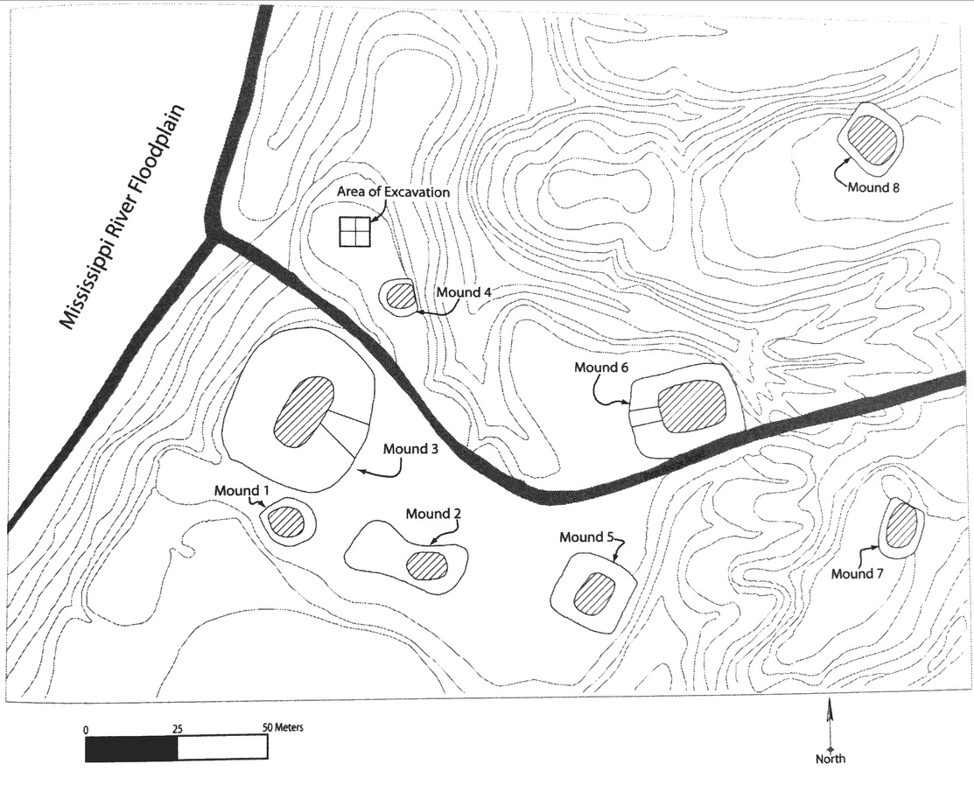
Figure 2.8: the Anna site, with area of excavation noted (from Beasley 2007:131).
The area of excavation north of Mound 4 revealed a specialized activity area at a very small mound that had not been previously acknowledged. Here, concentrations of ceramics and bone, as well as post holes from a temporary structure, indicate an area of feasting away from the central plaza and possibly atop a small mound that has since disappeared from erosion (Beasley 2007:136-141). These signatures are consistent with ethnohistoric accounts of Natchez feasts (Beasley 2007:142), but what is of interest here is the location of the feasting area. It is situated near Mound 4, but is not far from the imposing Mound 3. This array of feasting artifacts behind the largest mound is similar to the materials uncovered in Pevey’s Units T and M, which are located on the far side of Mound E; these areas are peripheral to the plaza and near enough to the largest mound that could suggest preferential access during times of celebration.
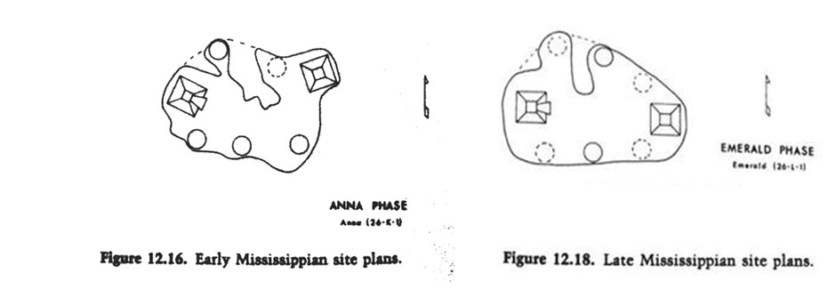
Figure 2.9: Comparison of Anna and Emerald sites during the Mississippi Period (from Williams and Brain 1983:412 and 415).
Although our understanding of the chronology at the Anna site is a little bit uncertain, an examination of the site plans from the Anna and the Emerald sites shows remarkable similarities in their layouts (Figure 2.8). Both sites have two dominating platform mounds on the east and west edges, with an open plaza area between them and smaller mounds completing the circular form. Both of these sites look as though they were circular Mississippian mound-and-plaza arrangements fit neatly into a landscape with a higher ridge cutting separating the northern-most mounds. If the planners of the Pevey site were using the landforms in the same way, it might be that a circular site was stretched to fit into the existing topography, creating a U-shape with a long and narrow plaza. Of course, the Anna and Emerald sites are very different than Pevey because their largest mounds seem to be directly across from each other. It is possible that this layout represents some sort of site heterarchy, whereby one kind of special activity is conducted on the west platform mound, and a completely different activity takes place on the east platform mound. For example, one mound could be a residence that hosts celebratory feasts, while another could be reserved for more somber mortuary activities.
Turning to another site model, the Lake George site is located just under 100 miles from Pevey, on the shore of Lake George and near the Mississippi River. At one time, it may have had 30 mounds, but 25 can now be discerned. Williams and Brain (1983) show that this site has a long history of occupation, starting from the Baytown Period, through Coles Creek, and into the Late Mississippi Period. The site plan shows a few large platform mounds, some of which used to have ramps, and several smaller mounds. The general layout seems to be two plazas swept clean of debris, one on either side of the enormous Mound A (Williams and Brain 1983:1-3). This mound in the middle of multiple plazas, at the visual center of everything, seems to be reminiscent of Mound A at Moundville. Few lithic artifacts were recovered from this mound (Williams and Brain 1983:246-249). The plazas were on slightly higher ground, than the areas at the base of the mounds, possibly due to depressions caused by the construction of the mounds (Williams and Brain 1983:4). The western plaza was created first, and the eastern, smaller plaza was both constructed later and abandoned the earliest (Williams and Brain 1983:74). Like Moundville’s last occupation being focused only on the largest mounds, and evidence for Pevey’s final occupation taking place on Mound E, Lake George’s last pre-contact people seemed to prefer the larger plaza to the smaller one.
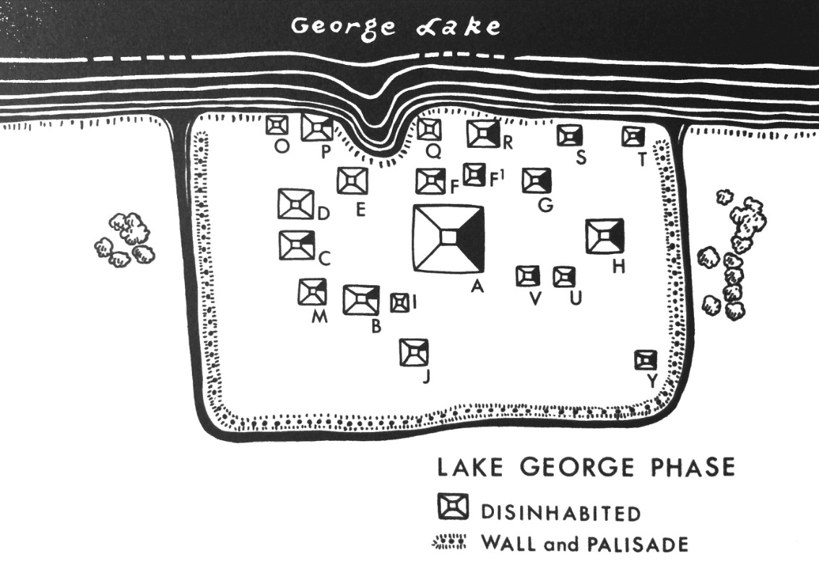
Figure 2.10: Towards the end of its occupation, several of Lake George’s mounds were unused, but Mound A still dominated both plaza areas (from Williams and Brain 1983).

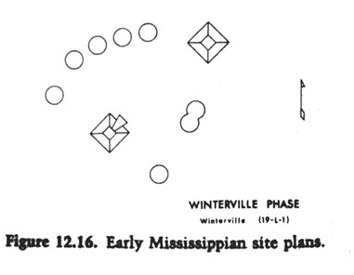
A comparison of Plaquemine sites in this area show more complex arrangements from the Coles Creek to the Mississippi Period, as many mounds are added, but some are also abandoned (Williams and Brain 1983:329-420).
Figure 2.11: Winterville site plan during the Mississippian Period (from Williams and Brain 1983:412).

During the Coles Creek Period, the Lake George and Winterville sites both have multiple large mounds surrounding a circular plaza, not just one large mound that is clearly dominating the rest. Williams and Brain (1983:407) suggest that a new class of elites circulated plans for similar site arrangements during the Coles Creek Period, resulting in layouts with mounds that were repeatedly used by generations of leaders for mortuary purposes and highly visible residences. It may also be of interest to note that both sites also exhibited certain Powell ceramics from the American Bottom during the late Coles Creek phase, and may be evidence of interaction between these two sites and Misssissippian cultures to the north (Williams and Brain 1983:83). By the Mississippi Period, though, the mounds at Lake George no longer look like a circular plaza. Like the Anna and Emerald sites, the largest platform mounds often seem opposed to each other across the plazas. This may be a holdover from earlier Coles Creek times, as seen in the Greenhouse site plans below.
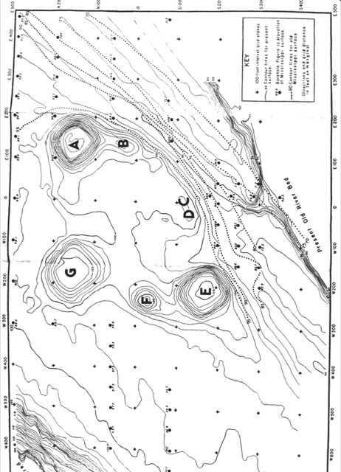
At this slightly earlier site, which is often considered the type site for the Coles Creek culture (LaDu 2016:92), the Greenhouse mounds are arranged around an open plaza, in somewhat of a circle, but there seem to be three large mounds dominating the landscape. Mounds A, E, and G seem to triangulate the majority of the plaza, with two tiny mounds along the southern border, near the old river bed. Mound B seems to be an outgrowth of the large Mound A, and Mound F, forming the west border, actually dates from the Plaquemine Period (Ford 1951:85). The circular arrangement of settlements here is similar to circle created by Archaic shell mounds, and research into Coles Creek differences in status and wealth has suggested that these earlier Coles Creek sites may have used ritual practices (including feasting, burials, and the actual process of mound-building) to reinforce the idea of a collective and inclusive identity (Kassabaum 2014: 341-351; Roe et al 2010:2).

Figure 2.12: Layout of Greenhouse mound site (from Ford 1951).
Three mounds also seem to dominate at the later Fatherland site in western Mississippi, thought to be the main village of the Natchez tribe during post-Columbian exploration of the Southeast. It can be seen as a bridge from archaeological evidence to historical accounts because the French visited it several times before its abandonment in the eighteenth century, and took note of its layout when many other groups of Native Americans had abandoned the Mississippian use of platform mounds as stages for architecture (Brown 1990:2). Neitzel’s excavations of the two largest mounds in the 1960s uncovered features that identified Mound C as the location of the historical temple, and Mound B as the mound on which the chief lived, though he seems to have had issues with reconciling historical accounts of the temple structure with what he found in the ground (Brown 1990:3-8). Mound C’s temple door may have opened to the northeast, facing the chief’s house on Mound B, which seems to be more centrally-located (Neitzel 1965:73). This site’s layout, with three large mounds in line with each other, allowed people at the chief’s house on Mound B to see what was going on inside the temple on Mound C (Brown 1990:8), and it’s possible that the chief’s house could also see activities on Mound A further to the northeast.
This configuration is an example of two large mounds that don’t represent different moieties or subgroups, but fulfill two different purposes for the same group of people. Similarly, Pevey may have been occupied by one unified community; perhaps a few mounds were used for houses, a few for food storage and preparation, and a few for feasting or special ceremonies. It’s also important to note that the Fatherland’s three mounds may not have all been used simultaneously by the people living there, and this reminds us that some of Pevey’s mounds may have been unused at times as well.
Figure 2.13: Mounds A, B, and C at the Fatherland site (from Neitzel 1965:Figure 2).

Like Anna, Emerald, Winterville, and Lake George, Fatherland has large mounds that sit opposite each other across a plaza. In these circular arrangements, there is no clear leadership position occupied by one mound directly across from some sort of entrance. If we presume that mounds represent different corporate groups, then Winterville, Anna, and Emerald, could be seen as two major platform mounds directly across from each, creating an axis running east-west that divides the smaller mounds into two moieties. This would create a theoretical model similar to the Pevey site, at which there are two rows of smaller mounds running east-west. Sometimes, though, these major mounds on opposite sides of an axis could represent meeting places for the one unified community that needed two separate places for two distinct activities, such as chiefly residences and temples. The polarity seen in these Plaquemine sites is a little different than what we see at Pevey and Moundville, where all of the big mounds are grouped together on one side of the plaza. With Pevey being the closest major multi-mound Plaquemine site to Moundville, perhaps its planning was influenced by people from the east. Of course, this is just a hypothetical situation that would require a detailed analysis of the material culture excavated from these mounds, which is far beyond the scope of this thesis.

Summary

The research into the social arrangement of modern workers in small groups predicted that people would sit across from each other at circular tables when working on separate projects, and would place their leader at the head of the table, opposite the entrance. Ethnographies of families that live together in one-room houses also predicted that the head of the household would sit across from the entryway, at the optimal location. These theories have been applied to Archaic Period shell rings in Florida and Georgia to understand the social stratification of sites and the likelihood that there was purposeful mounding of some locations to make them higher than others. This research helps to refine our first hypothesis: that Pevey’s largest mounds at the center of the U-shape housed elite homes or events. If the largest mound or pair of mounds has significantly different lithic assemblages than all of the rest of the mounds, we might be able to construct a hypothesis about leadership at those larger mounds (E and G). Combining the lithic analysis with previous ceramic research will enable us to better understand whether the material culture on and near these mounds characterizes areas of elite habitation, formal presentation, feasting, or storage.
These theories have also been applied to the Mississippian site of Moundville to hypothesize where elites may have lived, worked, and feasted. Ethnographies have been used to ascertain how the corporate groups may have arranged themselves on the landscapes, potentially by establishing precincts with paired mounds circumscribing the plaza. When this model is compared to Plaquemine sites along the Lower Mississippi River Valley, though, this does not seem to be a layout that gets copied everywhere in the Southeast. These Plaquemine sites tend to have two or three large platform mounds sitting directly opposite each other, often on an east-west axis, with smaller mounds completing the circular layout. At some of these sites, the large mounds seem to represent two different platforms for different kinds of structures used by one unified people, and it might not be a sociogram for several groups like Moundville seems to have been. More research would need to be done on the dating of mounds, the material culture found within them, and the structures that once stood on them to truly understand how people were using each mound. It does seem clear, though, that the Pevey site, with its two largest mounds directly adjacent at the end of the U-shape formation, does not follow a prescribed model to which all Mississippian or Plaquemine sites adhere, and lithics will also help us to understand if the mounds are a reflection of how corporate groups could have segregated or integrated their daily activities. It is also possible that Pevey was occupied by just one group that considered themselves a cohesive community. They may have used some mounds for houses and daily chores, others for storage, and a few for special celebrations or feasts, and we should also see differences in lithic types and densities in this case.
During the lithics analysis in Chapter 4, several patterns will be examined. If the Pevey site is arranged in two parallel rows of mounds that represent two distinct moieties, we may find differences in lithic types or densities on the three northern mounds (B, C, and E) versus the four southern mounds (G, H, I, and K). If Pevey was constructed like Knight’s Moundville diagram, with corporate groups inhabiting pairs of mounds, it could be that these pairs are directly across from each other, and thus E-G, D-H, C-I, and B-K would constitute the pairs. Alternatively, mounds adjacent to each other could form pairs, such as B-C, D-E, G-H, and I-K.
If we find that one of the pairs has significantly different lithics than the other pairs, we might make the argument that the corporate groups are ranked and used or created stone tools in different ways. Like Knight’s (2010) argument that various groups at Moundville may have engaged in different, complementary craft activities at their mound pairs, we may find sets of lithic tools that suggest Pevey had groups that also performed different kinds of daily tasks or produced special items.

Ch. 3: Lithics Theory and Methods

Although ceramics tend to have a shorter use-life and exhibit a faster rate of stylistic change than lithics in the Southeast, they are not the only artifacts that can provide clues to the ways that domestic and political economies were organized. Lithics have generally been used for two purposes in archaeology: to act as markers of cultural phases, or to identify the behaviors of individuals or groups within these cultures (Andrefsky 2005:62). One of the advantages to looking at lithic materials from the past is their ability to withstand the crumbling and decay that plague other categories of materials, such as basketry, cloth, and ceramics. One disadvantage, though, is that these other technologies are additive and provide more room for decoration and elaboration during the production process.
While we desire to know everything about the lives of people who once occupied a site, we must make do with the samples that we collect, often full of broken tools and tiny flakes, and try to recreate a piece of a puzzle that illuminates lifeways that have no written records. In conjunction with other lines of evidence, studying lithics can help archaeologists see restricted access to raw materials, elite control over household production, trade routes run by elites, attached specialist workshops, differential use of tools, or differential use of exotic artifacts in stratified burials (Cooper 2012; Roe 2010; Shafer 1973). At Pevey, I will attempt to use analytical techniques to find differences in lithic activities on each mound to identify the kinds of tools that people were making and the techniques that they were using. This kind of description will complement previous intensive ceramics analyses conducted at the site (Livingood 2010), and will help us to understand whether Pevey’s largest mounds were areas of elite activities, and whether we can see more than one group conducting different kinds of activities that show a distinction between rows or pairs of mounds.
This chapter will present a literature review of how lithics experts have used many attributes of unmodified flakes, modified flakes, and cores to understand the social organization of past societies. It will also describe why and how I coded and measured these attributes as I analyzed each chipped stone lithic from the Pevey site. These artifacts will shape our interpretations of how past people organized their lithic activities at the site, and will test hypotheses of how Pevey may have been organized like other large mound sites mentioned in Chapter 2.
The first hypothesis has previously been presented by Livingood (2006), that some kind of elite activities were conducted on top of the largest mounds, E (Unit SE) and G. If this was the case, and feasting was the special activity, the lithics from these units might show more evidence of food consumption and less of food and tool production. Alternatively, if there were elites living on these mounds, they could have employed attached specialists or may have themselves created lithic tools and then used these tools to produce other crafts. In which case, we would expect perforators or drills to indicate a possible area of clothing or lapidary production, or a collection of scrapers that might indicate food or hide preparation. Finally, in preparation for certain events, we might see the tops of these largest mounds swept clean of debris, which could possibly have been dumped in middens nearby. We might also expect Unit E to look like Units T and M when we really look at the flakes, hammerstones, cores, and tools found there. These three off-mound units were selectively placed by excavators to uncover middens with many ceramics. Their access is restricted by the natural topography and the placement of the largest mounds, and so they may have been reserved for certain people or occupations.
A second hypothesis concerning the organization of the two rows of mounds would test the possibility that different mounds hosted different kinds of lithic activities, and that patterns in lithic types and densities could suggest that rows or pairs of mounds were controlled by multiple corporate groups. We might see two or more sets of crafts, such as hunters and hide-workers occupying the northern mounds and groundstone tools being made and used on the southern mounds. On the other hand, if the people of Pevey considered themselves one unified community of families of equal status, and each mound hosted the living quarters of these various families, then expecting all of the assemblages to look approximately the same assumes that families are all performing the same daily chores and creating the same kinds of tools.
Considering the lithic densities and the possible stages of reduction that people performed at each mound could help to determine if certain mounds were used more often for certain types of work. Evaluating the prevalence of hard hammer or soft hammer percussion could also give clues as to what stages of reduction were being undertaken in each area, but it could also hint if certain groups of people had personal preferences about how often they ought to use hammerstones or bone and antler tines.

Centralization, Stratification, and Craft Production

Archaeologists have used lithic flake and tool attributes and the context in which assemblages were found to make inferences about the centralization of authority or the degree of social stratification present at the site. More recent excavations and analyses have been less concerned with figuring out when people became sedentary, and more concerned with the effects of a sedentary lifestyle on the specialization of lithic production and the ability of people to access the raw materials and tools that they needed. Archaeologists have examined who was creating stone tools and who was using them, hypothesizing that more complex societies will have less people producing more standardized tools, sometimes as attached specialists where production was dictated and sponsored by elites. Archaeologists considered a spectrum of craft specialization for both the production of stone tools and the production of other crafts that require these tools. We can incorporate some of the factors examined by Lewis (1995:33) to discuss this spectrum, including full-time versus part-time work, attached versus independent control, wealth versus utilitarian goods, and nucleated versus dispersed concentrations of workers.
In the Mississippi Delta, the limited availability of good chipped stone materials could make the study of lithics more interesting, but lithic analysis has not always been a major part of archaeology in the area (Carr 2008:201-202). Studies that are common in other parts of the country are often absent from site reports in the Southeast, and even within the region, lithic analysis in Mississippi is behind the times (Carr 2008:209). There are many reasons why lithic analysis is conducted in the Southeast, but mainly it seems that archaeologists uncritically use outdated methods, provide only the most basic data, do not explain how they classified the artifacts, or fail to discuss both flakes and tools (Bradbury and Carr 2000; Carr 2008:205-207). An organization-of-technology approach, which models how the environment affects social and economic strategies, which themselves affect tool design, tool distribution, flake attributes, and flake distribution, is recommended for sites that present both a decent number of tools and flakes (Carr 2008:212). While Pevey presented few tools, the effect that the environment had on the flake density distribution will be discussed in Chapter 4. The examples below will show that other areas of the world have used the archaeology of stone flakes and tools as a line of evidence about the types of tools being created, the ways that people used them, and the kind of people who typically made them.
Much evidence of workshops and specialized flintknappers occurs in Mesoamerica. In Northeastern Peten, Lewis (1995) examined different areas of lithic activity from the Late Classic Period to determine if status played a part in the production of agricultural lithic tools. He found that every courtyard had biface production, but it seemed to be concentrated in just one housemound at each (Lewis 1995:133). While most ratios of tool fragments to production debris suggested part-time intensity, some households were estimated to have produced a surplus (Lewis 1995:191). During the Late Classic Period at Mayan sites, some households ceased to produce their own tools, especially those with the most high-status ceramics, implying the existence of full-time specialists and greater social stratification (Cuddy 2000:213). Lewis (1995) and Cuddy (2000) found that all households in the Maya lowlands contained common agricultural hoes throughout several time periods, and thus were probably engaged in at least a little bit of household gardening, showing that even the elites of the neighborhood still contributed to subsistence. These findings are similar to Knight’s understanding that elites on Moundville’s northern mounds were creating their own crafts as the southern mounds were being abandoned (2010:352-360).
If we could determine that certain mounds seem to be producing more tools than would be needed for the number of people living in a few structures on and around that mound, we might be able to make arguments that a certain group at Pevey was creating tools full-time, possibly for distribution to others who focused on the manufacture of other products. Since so little of the mounds and off-mound areas have been excavated, though, it will be difficult to estimate population for each mound, mound pair, or row of mounds.
In the Southeast, Cobb (2000) used Mill Creek chert hoes from the uplands of Southern Illinois to evaluate the degree to which the quarry sites were centralized and controlled by elites, determining that there was equal access to the best chert and no segregation of certain biface production stages at certain sites. Comparing this information with burial goods, results from nearby fieldwork, house size similarities, and an analysis of ceramic decoration, show that the knappers were creating a small number of hoes each year, most of which were traded to other sites (Cobb 2000). If our analysis shows a cache of mass-produced, similar-looking stone tools (such as hoes or projectile points or drills) on a single mound, then we can also attempt to see if people there were trading these tools for raw materials or goods produced by people on other mounds or at other sites nearby.
At the Elk Fork site in Eastern Kentucky, the distribution of various types of chert in Late Archaic and Fort Ancient contexts determined which lithic materials were being traded, hoarded, gifted, or shared equally (Cooper 2012). Archaeologists found evidence that the Fort Ancient long-term settlement had a greater variety of raw materials present, and people were producing, maintaining, and discarding tools of nonlocal chert at this site (Cooper 2012). With no evidence of elites controlling access, trade, or production, egalitarian social systems seemed to still be in place with little evidence for social stratification or political centralization. If we found areas of the Pevey site that had many more pieces of nonlocal chert than other areas, we could hypothesize about elite access to trade, or possibly the presence of different groups with different long-distance social groups.
Often, archaeologists have used burials to identify social structure, and then used lithics to supplement information about that society. Shafer’s examination of the Davis site sought differences between Caddo and Coles Creek by first separating lithic artifacts by raw material, finding that rare non-local pieces were much more likely to be found in certain burials, indicating a group of high status individuals (1973:345). Similarly, by separating all lithic artifacts first into the two types of chert at the Lee Creek ceremonial site, and then examining flakes for cortex amount and ratio of flakes to tools in each provenience, Pluckhahn (2010:85) determined that the tools were produced on site, but the low densities of scatter suggested that few people lived at the site permanently. He suggested this site probably housed a small number of ceremonial care-takers and was then visited periodically by other groups who may have stayed there short-term, knapping nearby to produce just a few tools during this time (Pluckhahn 2010:86). Low densities found at Pevey could indicate a similar arrangement of care-takers.
Roe et al (2010) looked at the possibility of residences on flat-topped mounds as an indication of elite habitations at Coles Creek. These mounds could have been constructed by elites manipulating the labor of others to create lasting memories of social inequality, or by less-stratified groups in an effort to bring everyone together for ceremonial purposes. As a regional variant of early Mississippian culture, some sites yielded evidence of increasing sedentism and population expansion, but not necessarily centralization and similar subsistence strategies (Roe et al 2010:8). Excavations searched for tool production and use on top of the mound as evidence of habitation, or at least rare or non-utilitarian lithics that could indicate tribute that had been paid in the form of status symbols (Roe et al 2010:167). The analysis of morphological attributes determined that both expedient and formal tools were produced in Mound B, but there were only small quantities, and no other evidence that people were living on top of that mound (Roe et al 2010). There were also no ceremonial items in their lithic assemblage, and no reason to believe that elites were accessing better raw materials or receiving tribute from other sites (Roe et al 2010:174).
People at Moundville were knapping chert projectile points, but were also using a large variety of groundstone, bone, and shell implements that could indicate areas devoted to specific craft activities. Cold-hammered copper artifacts were uncovered (Jenkins and Krause 1986:94), and there is a distinct accumulation of mica scraps in a pit above a house floor to the northwest that may indicate craft activities (Scarry 1998:66 and 94). While many middens are present near the mounds and in the habitation areas along the terrace, few cultural artifacts were found in the center of the plaza (Steponaitis et al 1994). Excavations that uncovered sandstone saws, chert microblades, pottery trowels, greenstone adzes, pigments, and scraps of mica and galena indicated areas on the northern edge of the site were likely reserved for specific occupations (Scarry 1998:94-99). It seems that the northern edge was generally an area of higher status, based on the larger size of the mounds, the elite burials on Mounds C and D (Knight and Steponaitis 1998:5), and the distribution of the exotic high-status goods near these large mounds (Scarry 1998:96). Interestingly, even though lithics at Mound Q did contain a large percentage of non-local stone, they also were more expedient in form than lithics found at some of the other hinterland sites (Barry 2004:21). Clearly, we should not necessarily associate elite contexts or craft production areas with formal tools during the Mississippian Period.
Figure 3.1: Moundville’s activity areas, with some mounds labeled (Welch 1991:146).

This is interesting because exotic materials are pervasive at Moundville, but nonlocal artifacts are rarely found at other sites along the Black Warrior River that date from the same time (Scarry 1998:96), reinforcing the idea of hierarchies of sites within a proscribed area. Also, there are other sites along in the Black Warrior Basin that date to Late Woodland Moundville predecessors (West Jefferson Phase) that show areas of local production of crafts and maize. Microlithic tools are common at these settlements, and the tools often show use wear identical to tools that have been used to drill shell. It has been suggested that people at these other settlements were creating shell beads even before the construction of Moundville’s mounds, and they were using these beads as a sign of wealth (Knight and Steponaitis 1998; Pope 1989). It might be expected that other mound centers with earlier habitation areas might show similar shell production areas with microlithic tools.
At the White site, a single-mound Mississippian site about 25 miles south of Moundville, all stages of the lithic reduction sequence were present for locally-available stone materials, from which most tools were made (Welch 1991:154). There was almost a complete lack of lithic cores, but debitage indicated that there was a prevalence of bipolar reduction at the site (Welch 1991:155). The majority of this debitage was determined to have been produced during the early and middle stages of reduction, with very few flakes from the final stages of biface production or retouching (Welch 1991:157). The data from the nonlocal materials, though, showed that most of these flakes were produced during the final stages. This information, compared with data from Moundville, suggests that the White site received exotic stone in the form of finished or partially-finished tools, but only at Moundville was there a large influx of unworked exotic stone (Welch 1991:157-159). Although nonlocal stone is rare at Pevey, finding an area with more than one nonlocal lithic could tell us something about whether it was being brought to the site in the form of a core, flake, or finished tool.
Thus, lithics can elucidate the extent of controlled, centralized production of tools, and if found in the same context with other artifacts, it could point to an accumulation of lithic tools that were needed to create a particular product, such as shell beads or deer hides. The widespread presence of artifacts indicating food or tool production at several sites can also advocate for societies where different groups of people (including elites) are all responsible for provisioning themselves. Densities can suggest how populated an area was, and all of these factors can aid archaeologists in understanding how a mound site may have been occupied by hierarchical or heterarchical societies.
Unfortunately, sometimes the tools needed for the crafting and the other raw materials that are needed to create the finished product are not always found in the same context. At Cahokia, large numbers of microdrills showing microwear of drilling exclusively into shells were often found at a distance from the actual shells (Yerkes 1989). An abundance of one type of tool could also indicate the knapper’s intention supply his neighbors or use these tools to trade for other items. Spatial analyses of caches in relation to the placement of mounds, houses, public architecture, or burials can provide hypotheses about the relationships between people and how egalitarian a society was with its natural resources and finished goods.

Choosing Proveniences for Analysis

All lithic materials had been previously analyzed by undergraduate volunteers following the 2000 field season. This second analysis has been performed on a slightly smaller subsection of lithics, but has measured more variables in an attempt to see differences between the debris found on each mound. Lithics were ignored if they were retrieved from layers that seemed likely to be mound fill transported from another location. These layers were full of artifacts that seemed to come from earlier time periods, and may not have been indicative of the people that built and used these mounds during the Winstead Phase (the local equivalent of the Anna Phase) (Livingood 2006:190). Ignoring these lithics only subtracted a small percentage from the total count of 2,860 lithics. In addition, some units were entirely eliminated from the study: Units A, J, and SJ were excluded because they were not from mounds. In the end, 2007 flakes, 28 hammerstones/cores, 106 nondiagnostic tools, and 10 diagnostic projectile points were included in this study. These 2,151 lithic artifacts represented 75% of the collection.

Table 3.1: Analytical units from each unit, showing which lithics were excavated.
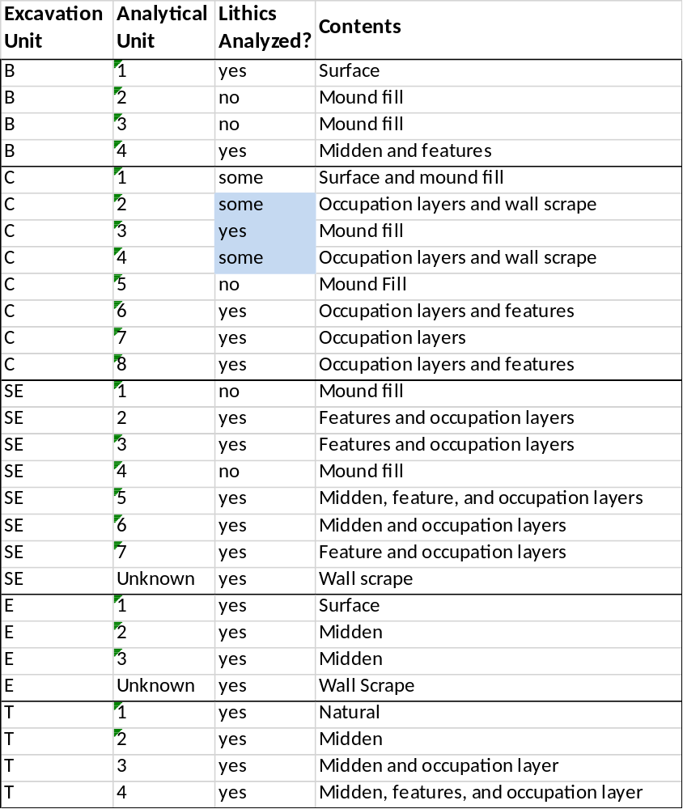

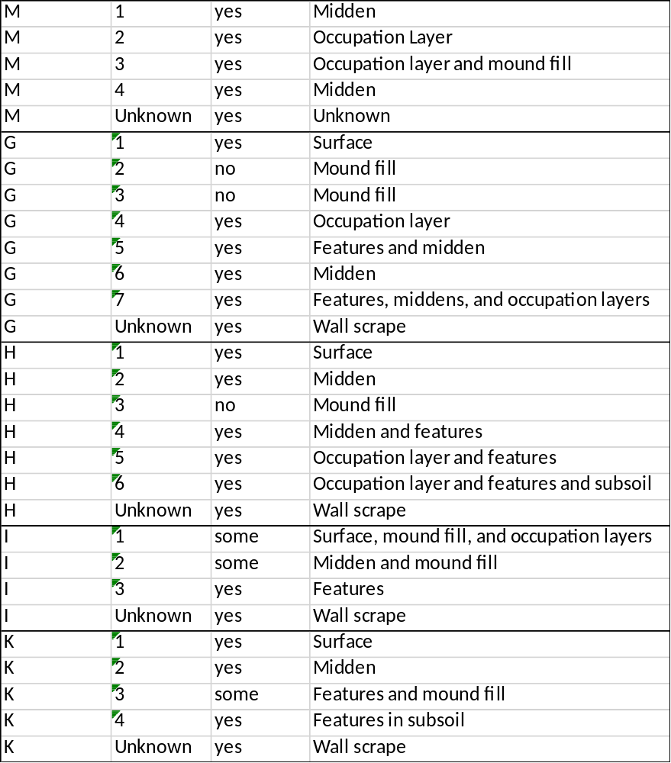
Each piece of chipped stone lithic was analyzed as either an unmodified flake, modified flake tool, hammerstone/core, or finished biface. Many classifications were based on analysis standards created by Dr. Bonnie Pitblado for her 2015 lithic analysis class, and were modified by the author. The coding sheets are reproduced in the Appendix. All measurements were obtained using a Carbon Fiber Composites Digital Caliper, with lengths accurate to the nearest tenth of a millimeter. Weights were obtained using a Spirit digital scale, accurate to the nearest tenth of a gram.

Citronelle Gravels

Variation in lithic tools and their debitage comes from several different factors. First, raw materials flake differently and are suited to the creation of different kinds of tools. Second, the knowledge and ability of the creators vary greatly, and the flakes left behind can distinguish different people or groups of people. Third, the function of the stone tool will have an effect on its final shape. Fourth, knappers use different styles to generate the same final product, often based on how they learned, and not a factor of material type, ability, or function (Whittaker 2012:270).
Concerning the first source of variation, it is important to note that nearly all chipped stone flakes and tools at Pevey were created from Citronelle gravel cherts, described by Matson (1916). These gravel cobles are typical of many sites in the area, except those dating to Late Archaic and Poverty Point Periods, when nonlocal materials are much more prevalent (Carr 2008:215). This gravel is readily found in the Loess Bluffs and across southern Mississippi, often in streams and gravel quarries alongside cobbles of quartzite and sandstone (Stallings 1989:38).
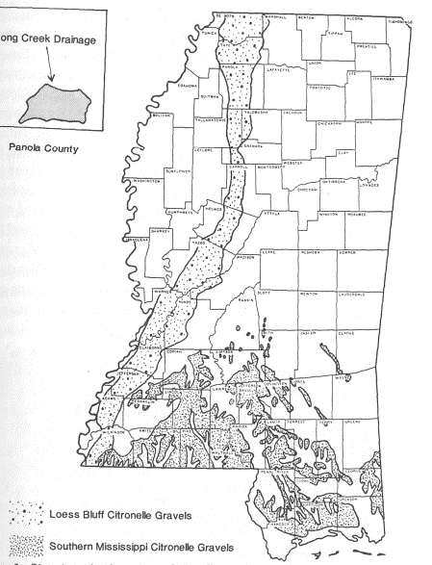
Figure 3.2: Location of Citronelle gravels in Mississippi (from Stallings 1989:37).

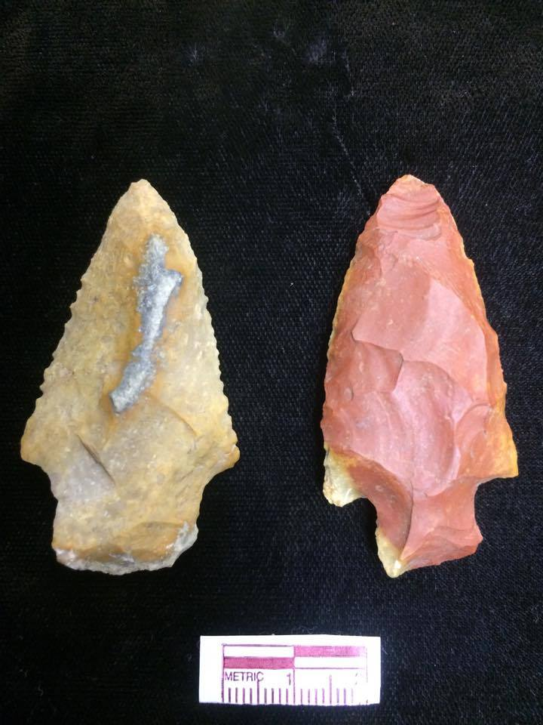
These gravels are often found as smaller subangular cobbles with a cortex cover (Stallings 1989:40-41), but can also rarely be seen in the form of large boulders that may be the result of Pleistocene glacial outwash (Stallings 1989:39). The most common interior colors are tans, butterscotches, reds, and grays in raw chert, with reds, purples, and pinks showing up more often in heat-treated chert. Because each lithic flake can show many different colors on both the cortical exterior and the smooth interior (Stallings 1989:45), determining whether this material has been heat-treated is often a subjective exercise and did not actually tell us very much about the collection as a whole or the differences between proveniences.
Figure 3.3: Citronelle gravels vary in color, with many showing mixtures of butterscotch, gray, and red.

Thus, qualities such as pot-lidding on the exterior and a waxy appearance on the interior were used to classify the lithics as heat-treated, but those that were red/pink/purple without these other qualities were listed as “possibly heat-treated”. Lithics that looked sooted or crazed were categorized as “burnt”. Bleed and Meier (1980) have shown that heat-treated chert produced more flakes that were longer with fewer hinge terminations, so it’s possibly that people at Pevey heat-treated their cores or large flakes as one step in the tool-making process. In other circumstances, coding by color could also help with refitting when examining the excavated cores, but this is much more challenging with Citronelle gravel because the coloring, even within individual cobbles, can show so much variation.

Reduction Stages

In the late 1800s, as scientists were trying to associate projectile point types with different groups of people and understand the great time depth of North America, W. H. Holmes recognized some of the crude bifaces were just earlier stages of refining a tool (Whittaker 2012:199). Several archaeologists over the last few decades have engaged in debates over whether or not stages actually exist in the manufacture of stone tools (Callahan 1979; Collins 1975; Flenniken, Patterson, and Hayden 1979; Whittaker 1984). Whether there are or are not clear stages in the process, there are definitely changes in the tools and techniques that are used as a knapper’s goals change. Callahan’s (1979) biface stages were numbered 1-5 and showed the progression from flake blank, to preliminary edging, then initial biface thinning, followed by secondary thinning, and concluding with the final shaping of the biface. Whittaker’s stages are numbered 0-4, but describe basically the same process with minor differences at the end: flake blank, edged blank, preform, refined biface, and finished biface. Some stages have been proposed that differ in descriptions of the earlier stages to describe how bifaces are produced from cortical cores instead (Andrefsky 2005:189).
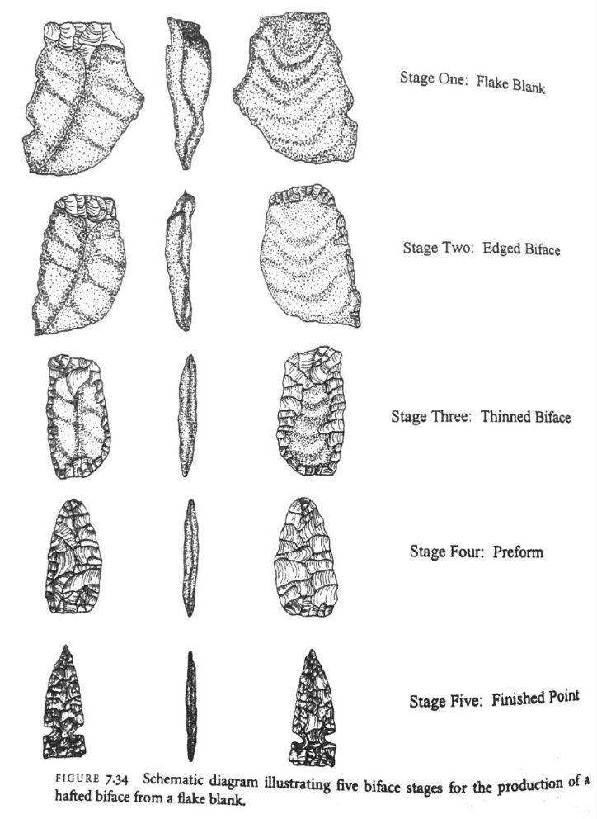
Figure 3.4: Five stages of biface reduction from a flake blank (from Andrefsky 2005:190).

Because many archaeologists seem to agree that bifaces get much thinner as they progress in stage, but ideally only lose a little bit of their width, using these measurements on whole preforms can help us to determine how far along a knapper was in the creation of a particular biface. Callahan (1979) has also shown that dividing the width by the thickness illustrates thinning through the stages, with indices for each stage in the chart below. If many of the worked flakes and cores from Pevey were bifacially flaked, this index could help us to determine to what degree each was finished. Unfortunately, because most flakes were only slightly modified, and only a small proportion of them had been flaked bifacially, I did not attempt to determine a stage classification for each item.
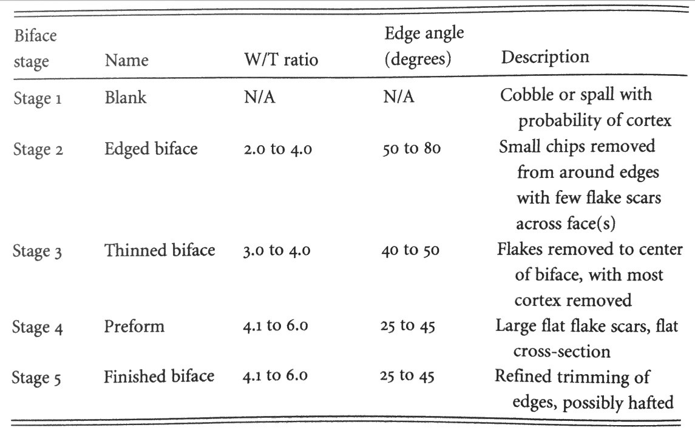
Table 0.1: Description of Width/Thickness Ratio for each biface stage (from Andrefsky 2005:188).
Table 3.2: Description of Width:Thickness Ratios for each biface stage (from Andrefsky 2005:188).

The sizes of the flakes removed change as well, and these flake changes may look like stages. Lithicists also examine the flakes’ dorsal scars and cortex to determine how far along the knappers were in the reduction process, and these measurements are described in the section below.

Analysis of Unmodified Flakes

Unmodified flakes made up the majority of the chipped stone artifacts from the Pevey site. When archaeologists are trying to decide if flakes were removed during certain stages, they consistently look at two variables: number of dorsal flake scars and amount of dorsal cortex. Generally, flake scars are discussed in terms of size and number. A dorsal surface with many small flake scars is often a sign of later stage reduction, while a flake with few, larger dorsal scars indicates early stage reduction. There are problems with this theory, though, as Schott (1994:80) pointed out. Mainly, less scars on a flake can also be caused by the flake’s small size or incomplete nature (Andrefsky 2005:108). Andrefsky says that we should ideally classify the number of dorsal scars as 0, 1, 2, or 3+ to help determine the stage of reduction (2005:107). Because there were so many flakes, though, that had large numbers of dorsal scars, I coded them 1-10.
Each lithic piece was examined for cortex on the dorsal surface, from 0-100%. Although Andrefsky (2005:107) believed that less cortex categories were better, and used a scale of 0-3 to code cortex coverage, I used a scale of 1-6 based on Pitblado’s teaching: 1 = no cortex, 2 = 0-25%, 3 = 25-50%, 4 = 50-75%, 5 = 75-100%, 6 = 100%. Andrefsky (2005:116-118) also showed that flakes with medium amounts of dorsal cortex often fell anywhere along the reduction spectrum, but flakes coded in the extremes, with very little or very much cortex, consistently fell in the beginning or end stages, and were a good indication of where the knapper was in the process of his work. We know that knappers’ first few flakes in core reduction are likely to have a lot of cortex on them, and their last few flakes when they are finishing a tool from a flake blank are going to have a lot less. We can also keep in mind our raw material at the Pevey site and assume that making a tool directly from a little river cobble is going to create a lot of cortical flakes, rather than creating a tool from a biface preform. If we do find that flakes from certain mounds have significantly more or less cortex or dorsal scars, we might be able to make inferences about the kinds or quantities of tools and flake blanks being produced there.
In an effort to avoid the downfalls of the stage vs. continuum debate and encourage an interpretation-free means of classifying debris, Sullivan and Rozen (1985) created mutually-exclusive categories for non-tool lithics that could help to categorize an assemblage. Replacing subjective names such as “biface thinning flake” and “tertiary flake”, they designed an attribute chart (shown below) that divided lithics into debris, flake fragments, broken flakes, and complete flakes. “Debris” are unorientable, with no single interior surface. Those pieces that do have this single interior surface are called “fragments” if their platforms are missing, “broken” if the platforms are present but missing margins or the distal end, and “complete” when they are intact (Sullivan and Rozen 1985:758-760). In addition, I used the category of “split flake” to define a flake that has been split in two from platform to termination.
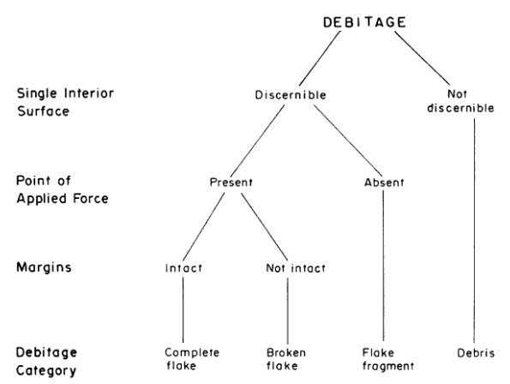
Figure 3.5: Defining the four debitage categories (from Sullivan and Rozen 1985:759).

Complete flakes included both a platform and a termination and thus could be measured for every variable. In comparing complete flakes as a percentage of a provenience, we know that they are often produced more during tool production than core reduction (Andrefsky 2005:129). Flakes that were coded as split were often just missing one of the margins, or half of the platform, and could usually be examined for most of the variables as well.
If the flakes had a platform present, the platform type was listed as either cortical, plain, dihedral (two facets), faceted (multiple facets), crushed, or single line. Although there are significant limitations with using flake cortex to determine the reduction stage of tools, as described above, we do know that flakes with a large amount of cortex on their platforms are more likely to be from early stage reduction, even if they also have some dorsal scars (Andrefsky 2005:95). Plain platforms are usually not removed from bifacial tools, and are more likely from unidirectional cores or from work on flake blanks (Andrefsky 2005). When viewing a platform with two or more facets, we should define these facets as not including the tiny flake scars that might have resulted from grinding the edges (Andrefsky 2005:92). When we see this type of abrading on smaller flakes, we might imagine knappers were trying to do one of a few things: they might be pressure-flaking and trying to remove a feathered edge so that the pressure flaker doesn’t slip, (Andrefsky 2005:98; Whittaker 2012:136), or they might have been preparing for soft hammer work (Whittaker 2012:192). Abrasion on platforms is not necessarily an indicator of core reduction, though (Andrefsky 2005:90). Any crushed platforms might suggest that knappers were using a lot of hard hammer percussion at that provenience (Andrefsky 2005:119).
If we do see definite flake scars, we know that the flakes more likely came from biface reduction than core reduction, and are more likely to be a product of later stages of reduction (Andrefsky 2005:90). When the whole platform is present, we can also take width and depth measurements. Odell (1989:185) has shown that smaller platform widths generally are part of smaller flakes which came from later stages, and Whittaker (2012:96) says that smaller platform depths correspond with smaller flakes as well. Thus, platform sizes can sometimes help us estimate the sizes of a collection of flakes, even if some of those flakes are incomplete.
The platforms were also checked for bulbs of percussion, lipping, and eraillures. Although nearly every complete or nearly-complete flake looked like it had a bulb of percussion, some were more diffused while others were very pronounced. Andrefsky (2005:119) explained that pronounced bulbs mostly result from the energy expended in hard hammer percussion, though they can occur with soft hammers as well. Diffused bulbs are usually caused by the impact of soft hammers (Crabtree 1972), and these kinds of bulbs tend to appear in flakes that have been taken off a core as the core is reduced (Andrefsky 2005:120). Crabtree (1972) believed that soft hammers also tended to produce pronounced lips on the edges of the platforms, but Patterson and Solberger (1978) disagreed that this alone was a good indicator. Whittaker (2012:188-189) believed that the elasticity of the soft hammer compresses to contact a larger area of the platform, sometimes bending the material until it breaks, in what he terms a “bending fracture”, which can cause the diffused bulbs and lipping on the platform.
The longitudinal cross-section was classified as either curved or flat for complete or mostly-complete flakes. Whittaker (2012:113) determined that curved flakes sometimes occur because they are taken from a core that is rounded and smooth, and the flake has followed the curve of that core, often because the core was moved slightly when struck. Sometimes this happens because the flake has been removed during an early stage of reduction (Andrefsky 2005:109). Both soft hammers and hard hammers can cause this kind of curve, but the most extremely curved pieces are likely caused by soft hammer percussion (Andrefsky 2005).
Terminations were examined for each flake that had one, and most were found to have nice feather terminations. A few, though, were hinged, which is often caused by a 90-degree platform angle or a 90-degree angle of blow with a hard hammer (Whittaker 2012:92-96). This could also be caused by no fault of the knappers, but by a flake that ran into a preexisting lump or another hinge scar while breaking away (Whittaker 2012:96). Step fractures can also be caused by angles that knappers use, when the outward force of blow is much greater than the downward force of the hammer (Whittaker 2012:107). On the other hand, overshoot terminations are caused by the opposite problem: when there is just too much downward force when using soft hammer percussion (Whittaker 2012:193), shown in the picture below.

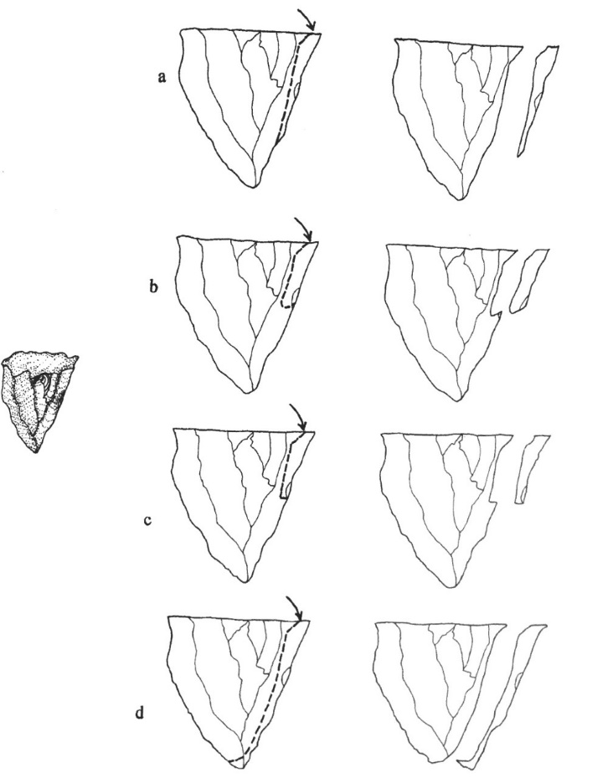

Figure 3.6: Feather, hinge, step, and overshoot terminations (from Andrefsky 2005:21).

Size is one of the factors that I looked at when trying to assign a reduction stage to debris, or when I wanted to know what kind of tools or techniques someone was using. It would seem natural to assume that the largest flakes are always removed before the smallest flakes, but sometimes knappers remove tiny flakes when they need to set up their platforms for removing the larger ones (Andrefsky 2005:98), so these flakes shouldn’t be individually placed in a stage with any kind of certainty. Flintknappers do know that it takes some skill to produce a lot of long flakes from a single core, especially when the raw material is not easy to work with. When using a hard hammer, the longer flakes are produced with a combination of forceful blows, the perfect platform depth (not too close to or far from the edge of the core), and larger exterior platform angles (up to 90 degrees) (Whittaker 2012:91). Experienced knappers also know that most of the complete flakes that fit into the very smallest size grades are a product of biface reduction or retouch, rather than core reduction (Andrefsky 2005:136-137). A length/thickness ratio and weight can, however, help to determine whether knappers were using unidirectional or multidirectional cores when examining whole collections, but looking at weight measurements by themselves show no difference in types of cores (Andrefsky 2005:129-131). All complete flakes were measured for their technical lengths, widths, and thicknesses to the nearest tenth of a millimeter. All of the lithics were measured for their maximum lengths and thicknesses, as well as their weights to the nearest tenth of a gram. Each flake was placed onto a diagram of concentric rings labeled 1-6 for general size as well.

Types of Flakes

Some authors name certain soft-hammer flakes “Biface Thinning Flakes” if they believe that they were removed from a biface preform, and these flakes tend to have certain characteristics. They have lips and diffused bulbs, with some cortex on the back but also previous flake scars. They are usually flat but occasionally curved, and often very thin. They have small platforms that are often abraded, but then expand in width from the platform (Whittaker 2012:185-187). If Biface Thinning Flakes could be identified, we could look at the percentages of these flakes compared to others to get an idea of what kinds of tools were being made, and a decrease in bifacial technology over time can show groups that became more sedentary (Parry and Kelly 1987). At Pevey, perhaps because these flakes tend to be smaller and weren’t recovered, or because these knappers just were not thinning bifaces near the excavation units, it was difficult to determine which flakes should be considered Biface Thinning Flakes.
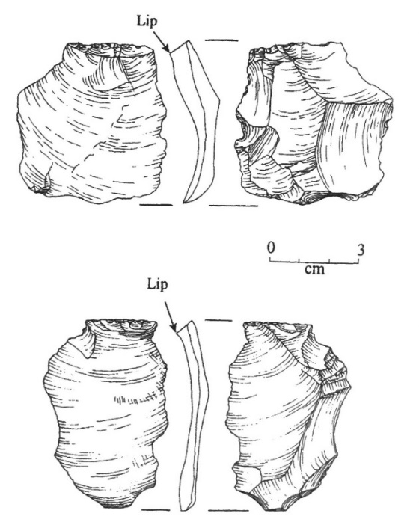
Another type of flake that recurs in much of the literature is the pressure flake, caused by a knapper pressing a small pressure flaker into the edge of the material instead of hitting it with hard hammer or soft hammer percussion. Although some experienced knappers believe these flakes are generally smaller, thinner, and lighter, Andrefsky has shown they are very hard to distinguish from other flakes (2005:118). Again, possibly because they are hard to separate from smaller biface thinning flakes, but perhaps also because they were not recovered in ¼” screens, it was difficult to determine whether each tiny flake was a pressure flake.
Figure 3.7: Biface thinning flakes with faceted platforms and noticeable lips (from Andrefsky 2005:124).

Sedentary groups in Mississippi who had access mainly to small Citronelle gravels probably also used a technology called bipolar reduction. When confronted with an exhausted core or small rounded river cobble with no good platforms, it is possible people used a hard hammer to crack open a core that was resting on a stone anvil; this method of percussion often allows knappers to obtain a large number of flakes from smaller cores (Andrefsky 2005:26-28 and 153; Knudsen 1978). Bipolar techniques have been seen from the earliest periods of prehistory up until historic times (Hiscock 2015: 347; Pargeter and Duke 2015:313; de la Peña 2015:317), and can be used both by knappers with few skills and by professionals to make more precise tools (Hiscock 2015:342). Bipolar reduction can occur as just one stage in the manipulation of cores, or can be applied continuously to the core until exhaustion (Hiscock 2015:344). In observations in Australia, Hiscock found that knappers often started using regular freehand percussion to knock flakes off of cores, and then switched to bipolar percussion when the cores became too small to hold immobile under the force of the pressure needed to continue to create more flakes (2015:345).
Bipolar flaking can be understood in a historical context of decreasing mobility in the Southeast over several centuries. Parry and Kelly (1987) described how less mobile people no longer needed to spend time creating bifaces, but instead started using a more expedient tool kit of unmodified or slightly-modified flakes to deal with problems encountered close to home. These people used unprepared cores and bipolar technology to quickly create many sharp edges that were not necessarily hafted or even retouched later (Parry and Kelly 1987). The authors described how sites during this time should show less biface-thinning flakes, less prepared cores, and less tools with retouch, in favor of small arrowheads and expediently-used flakes (Parry and Kelly 1987). Andrefsky (1994:30) has shown the relationship between quality and abundance of raw materials, and hypothesized that sites like Pevey with lower qualities by higher abundances would contain primarily informal tools. Kuhn (1991:84) has also demonstrated a greater percentage of retouched tools at Italian sites of shorter duration (66.9% retouched) than at sites where people stayed for a long time (only 33.6% retouched). A study based on a proto-historic group (Jeske 1992) concluded that the shift to sedentism reorganized priorities in how well-made the scrapers were, and resulted in a significant number of humpbacked scrapers with many hinge fractures and a complete lack of symmetry.
If people were living for a long time at Pevey, we would expect to find many flake tools that were not retouched, many asymmetrical scrapers if people were spending less time on perfecting their lithic tool kits, and expedient flakes made from bipolar percussion. We might assume that the Citronelle gravels of Mississippi would lead knappers to want to use bipolar, because the round, small nature of the raw material is harder to knap with the freehand technique of percussion. On the other hand, because the gravels are plentiful, we might also assume that bipolar was not always necessary because people did not need to maximize flakes from every cobble. Finally, bipolar reduction can be used to quickly split open a cobble to determine the quality of the stone, so we could expect to see this technique being used on cobbles that were immediately taken from the nearby creek and tested for further use.
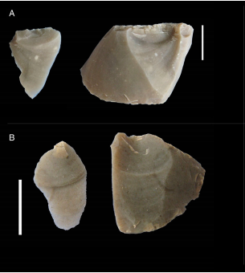
Johnson (1993:47) has pointed out that expedient tools and their debitage have long been overlooked by lithic experts because they are “technologically uninteresting and almost invisible”. Unfortunately, this bipolar technique creates some debris that looks very similar to “regular” flakes mentioned above, but also creates distinctive flakes with a few tell-tale characteristics. First, because the raw material is being hit with a hammer on the top, and also contacts the anvil on the bottom, there are two simultaneous cones that appear. This means that some of the flakes will show two crushed ends (de la Peña 2015:319) and two bulbs of percussion. The bulbs may also be a bit hinged, which can be seen in both the core and the flakes produced (de la Peña 2015:321).
Figure 3.8: Bipolar cores and their flakes show hinge bulbs of percussion (from de la Peña 2015:321).

Second, the way that the energy travels through the material from top to bottom often causes it to “split up into sections like an orange” (Whittaker 2012:115). Third, the scars that result are often step and hinge terminations, often with deep ripples (de la Peña 2015:319-320).
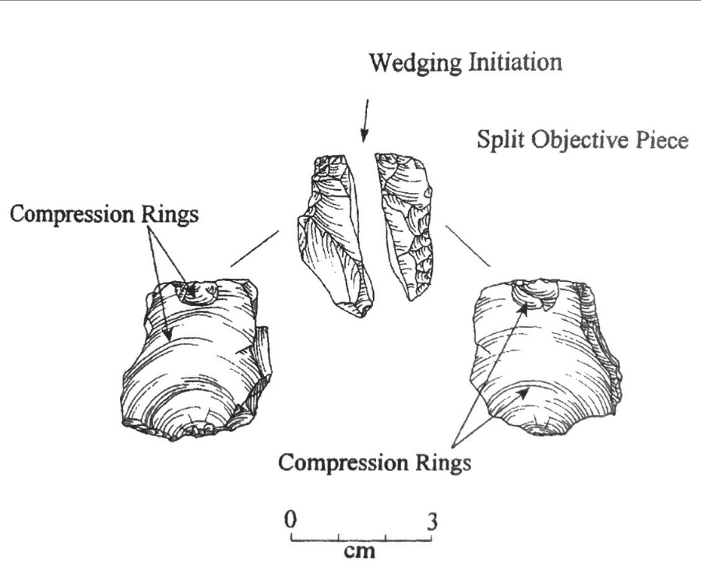
Thus, just after analysis had begun on the unmodified flakes, I decided to add in notes about our bipolar coding, and list these attributes in the data to show where double bulbs (B), crushed ends (C), orange-slice wedge shape (W), and twisting (T) occurred.

Figure 3.9: Bipolar flaking, showing wedging, crushed ends, and double bulbs (from Andrefsky 2005:125).

Typological Concepts for Tools

Parry and Kelly (1987) used numbers of bifaces to indicate mobility, with a high ratio of bifaces to cores at sites where more mobile people had lived. For hunter-gatherers, as the percentage of time spent mobile and distance travelled decreased, the artifact diversity increased. It’s possible that this is because people with low mobility complete many different kinds of tasks at each location, requiring many different kinds of tools during their stay (Andrefsky 2005:218). More mobile people needed to carry around one formal biface that could be used for many different hunting tasks and could be repeatedly resharpened or used as a source of raw material, but sedentary people could take their time to create new flakes and discard them at will (Andrefsky 2005:226-227).
Historically, a major shift in lithic technology occurred in the Southeast at different times during the Woodland Period. Nassaney (1999) used quantitative data on projectile points from the Woodland Period in Arkansas to see if there was a gradual decrease in size from “dart points” to “arrow points” over time, but found that there was actually a clear bimodal distribution, indicating that projectile points did not gradually get smaller over time until they became arrow points. In fact, there were contexts in which both types of points occurred until at least 1000 A.D. (Nassaney 1999:247), and there is evidence that completely different reduction techniques are used to make them (Nassaney 1999:250-253). The bow and arrow was definitely imported by the Coles Creek Period in the Lower Mississippi River Valley, even though lithic artifacts generally are not very common at sites just precededing Plaquemine sites (Kidder 1992:147). The addition of stealth and accuracy was probably a game-changer for raiding strategy (Nassaney 1999:259). Also, this could have transformed how people hunted, as darts are better for social bison drives, but arrows are more suitable to lone hunting, enabling individuals to obtain game on their own (Nassaney 1999:259). Finally, it’s possible that the stealthy and accurate arrows enabled people to collect more food and hides for tribute to rising chiefdoms that seem to appear during the Plaquemine Period (Nassaney 1999:260). Unfortunately, very few finished projectile points were found at Pevey, and those excavated tended to be larger Archaic dart points, not smaller arrow points. This indicated that many proveniences were mixed with mound fill deposits taken from earlier sites.
A classification system that uses a common vocabulary to put artifacts into categories can be helpful for summarizing the kinds of styles and shapes that archaeologists see when examining a large collection, especially concerning bifacial tools. Reducing variability into agreed-upon classes helps us to understand what is being left behind at the big-picture level. Being able to distinguish between flakes and cores and dart points is necessary when trying to understand what people were doing at a particular location, but very specific typologies usually aim to do much more than this. Many archaeologists would like for lithic types to be universal, and show large scale, long-term changes over space and time.
Others have argued that types created by archaeologists are probably random separations that do not match how the creators of these tools would have describe their tools. From ethnographies, we have learned that some modern aboriginal flintknappers do not consider their stone tools as types, but only concern themselves with whether the morphology of that flake can get the job done (Andrefsky 2005:209). In addition, many tools of a similar shape can be used for different kinds of activities, probably depending on raw material availability, mobility, and individual preferences (Andrefsky 2005:210).
When considering hafted bifaces, Andrefsky’s (2005:185) reading of Ahler (1971) has illustrated that some people have said that seven or eight attributes are necessary to identify each type, while others insisted on nearly twenty. The mixing and disturbance in the stratigraphy can sometimes account for overlaps in types from different levels, but if certain points are always associated with certain dates or depths in a region, they can be satisfactory indicators of a group of people. Because there were very few completed bifaces in this assemblage at Pevey, and because most seem to be Archaic types associated with layers of mound fill, the analysis of whole projectile points will include a type designation, but will also record quantitative attributes. I measured maximum length, maximum width, maximum thickness, blade length, stem width, stem length, and weight. All type designations were derived from McGahey’s (2000) book of Mississippi projectile points to see if there were significant differences in the types of points found on each mound.

Modified Lithics

When considering the modified lithics, all tools were examined for some of these same features used to describe debitage, including color, material, heat-treatment, cortex amount, number of dorsal scars, platform type, platform width, platform thickness, maximum length, maximum width, maximum thickness, and weight. If the tools were made from complete flakes, they were also measured for their technical lengths, technical widths, and technical thicknesses. In addition to these measurements, modified lithics were also classified by the condition of the tool (such as “complete”, “distal”, “lateral”, etc…) and its blank form (“flake”, “uniface”, “biface”, etc…). Then, each used or modified edge was examined and described individually based on the kind of retouch visible to the naked eye. Each edge modification was also measured linearly, as recommended by Andrefsky (2005:172-173).
Although most of the modified lithics were informally retouched or used flakes and fragments, a few were bifacially flaked. For these tools, various retouch indices could be used to evaluate the degree to which the edge or entire tool had been modified. Unfortunately, some indices do not differentiate between bifacially worked flake tools and unmodified edges first used as a tool and then retouched and resharpened (Andrefsky 2005:177). Clarkson’s method of segmenting each bifacially-worked flake into 16 regions, and then evaluating how invasively each region was retouched, creates a score of 0-1 for each tool. We could also divide this index or the tool’s width by the thickness to get a general idea of how much thinning has already taken place, as the goal for many knappers is to create projectile points and knives that sacrifice only a little width while trying to be as thin as possible. The few bifaces analyzed, but not listed as formal tools, were examined to determine the width divided by the thickness.
Cores and hammerstones were present in smaller amounts, and were also analyzed with categories from Pitblado’s coding guides. Material, heat treatment, and cortex amount were examined with the same codes used for modified lithics and unmodified flakes. The type of hammerstone or core was coded based on the distribution and direction of the platforms (such as “tested/casual”, “biface”, “single platform”, “centripetal”, or “hammerstone”), and its condition was also described. The types of cores left in the archaeological record can help to determine what kinds of tools people were trying to make, or whether they were attempting to maximize their raw material. For example, centripetal cores, also called multidirectional, maximize the length of the flakes, while parallel cores, or unidirectional, are flaked from one platform to maximize the number of flakes, up to three times as many (Andrefsky 2005:155). It has been difficult to determine formal definitions for types of cores and procedures for how archaeologists have measured them over time. Andrefsky (2005:145) suggests that we use the maximum length multiplied by the weight to estimate the general size of each core, so the maximum length, width, and thickness were recorded, as well as the weight of each item.
On the cores, scars were counted, and the technical length of the three longest scars was recorded, though there turned out to be not enough time to attempt any refitting. This would be made especially difficult because many kinds of cores can produce similar-looking flakes if knappers use slightly different techniques (Andrefsky 2005:163). Cores were examined for use as tools, and to distinguish between bifacial preforms and bifacially-flaked cores, Andrefsky says that archaeologists can divide the length by width, and graph the results against the thickness, to differentiate between them (2005:181-182). Possible knapping problems (such as “exhausted core”, “too many hinge/step fractures”, etc…) were coded.

Summary

Understanding how archaeologists have defined elite areas may help to designate Pevey’s largest mounds (Units SE and G) as such. Reviewing literature on debitage from different stages of lithic production could also aid archaeologists in determining if the middens near Mound E (Units E, T, and M) included remnants of the production of certain tools. Comparing the flake attributes, such as size, bulb of percussion, amount of cortex, and number of dorsal scars, for each mound can also help us to understand if people inhabiting different mounds were using different reduction techniques either because they had different goals to complete certain kinds of tools, or because they were performing different stages of the reduction process at various locations throughout the site. This may tell us more about how this society could have been socially stratified or divided into a few kin-based corporate groups.
Thus, after recording data in Microsoft Excel spreadsheets and ignoring non-contemporary artifacts clearly carried in with mound fill, the distribution of each lithic measurement was examined by comparing each mound assemblage to the rest. Pairs of mounds were compared to each other. The northern row was compared to the southern row. The larger mounds were compared to the smaller mounds. Chapter 4 will show how the lithic densities and flake attributes suggested that certain mounds may have been reserved for certain kinds of lithic activities based on differences in reduction stages and type of percussion (hard hammer versus soft).

Ch. 4: Results

The nine mounds at Pevey are arranged in two parallel rows with the largest mounds to the east of the configuration and the smallest to the west. Three of the excavation units from the 1990s (Units E, T, and M) were placed to uncover middens associated with Mound E, while the other 7 units (B, C, SE, G, H, I, and K) were placed on the summit or flank of a mound.
Figure 4.1: Simplified map of Pevey, showing northern mounds in blue, southern mounds in green, excavation unit names, and the proximity to Mill Creek.

The two hypotheses that I will test concern different parts of the Pevey site. First, I compare the lithics on Mounds E and G to the lithics from other mounds, expecting to see evidence of elite activities on the largest mounds. At many multiple-mound sites from the Mississippi Period, the largest mounds have been postulated to have a different function than the rest. We have seen examples of this in the literature concerning the Moundville and Fatherland sites, and the modern behavior and psychology research supports similar interpretations of Archaic shell mound sites elsewhere in the Southeast. Several kinds of elite activities could have taken place on and around Mounds E and G, and so there are several ways that the lithics from these mounds might differ from the rest, which will be discussed and evaluated in the next section.
As the analysis below will indicate, there at first seems to be nothing remarkable about the lithics from the second largest mound (Mound G) except that the quantity is very high. A multivariate analysis, though, shows similarities between the flake and tool attributes from Mounds E and G. The results suggest that something special may have been taking place on and around the largest Mound E; this could be because certain people had preferential access to the mound, or because that mound summit was reserved for special occasions. The counts and densities for the lithics from the top of Mound E were lower than most of the other mounds (except Mound B). The flake attributes showed the units near Mound E (Units, E, T, and M) also contained lithics distinctive from other contexts. The lithics near Mound E tended to be larger and show more signs of hard hammer percussion. It is likely different kinds of tools were being made there, or knappers who preferred hammerstones to antler or bone percussors chose to use these areas as their main flintknapping spaces.
The second hypothesis that I will examine predicts Pevey might have been inhabited by more than one corporate group, and this site’s mound arrangements reflected ways that multiple groups divided up space. On the one hand, it is possible that Pevey’s people considered themselves one unified community, and they may have established a shared use of the mounds and plaza area. Alternatively, Pevey’s U-shaped plan could have been a way for two or more groups to organize themselves by segregating space. Examining whether the lithic assemblages vary between mounds, between pairs of mounds, or between rows of mounds, can help suggest the presence of multiple corporate groups. I hypothesize that Pevey was organized into four pairs of groups, each controlling pairs of mounds, with one mound on each side of the plaza. This second section will examine how archaeologists might imagine the many ways that mound use could change based on how people arrange themselves in different groups.
The analysis below will show that, when examining many of the flake attributes, the small Mounds C and I, paired across the plaza, seemed to be different than the rest. Livingood (2006:261) suggested that Mound I could have been a locus of food processing for people living at or near the site. If the mounds were indeed paired across the open plaza, Mounds C and I might also have been occupied by the same group of people with different strategies of lithic production and use needs compared to people living and working on other mound pairs. This finding could support the model Knight (2010) proposed for Moundville, and will be treated in depth below. Because some of these analyses also suggest Mound K has a few similar attributes in its lithic assemblages, we might assume that people on Mound K were using similar techniques to the people on Mounds C and I, though this does not support a hypothesis of paired mounds.
Alternatively, these two mounds could be similar because two different peoples inhabited the two rows of mounds, but performed parallel activities on the mounds that mirrored each other. For example, the largest mounds could have been reserved for feasting and celebration, with the medium-sized mounds for living quarters and the smallest mounds for food preparation and storage. This interpretation of two rows of mounds for two groups of people is supported by density indices, and showed that there are significantly more lithic and ceramic artifacts from the analyzed levels in the southern mounds than there are in the northern mounds. On the other hand, this trend could support the interpretation that people in the community just chose to use the southern mounds more often, or simply left more of their daily debris to accumulate there. This density data also encourages us, though, to examine micro-sourcing analyses for Citronelle gravels to determine if the nearness to Mill Creek can account for the abundance of lithic debris on the summits of the southern mounds.
This chapter will compare artifact and tool counts from each unit to identity an area of elite activity on and around Mound E. It will show evidence of a disparity in artifact densities between the two site halves. The individual flake attributes will hypothesize what kinds of tool production, rejuvenation, and use were taking place on clusters of mounds to see if we can model an arrangement of mounds that might reflect the social realities of the people who lived and worked at Pevey.

Assemblage Summary

The analyzed lithics at Pevey (not including those excavated from layers of mound fill), consist almost entirely of flakes of Citronelle gravel. There were very few tools, and those identified were mostly flakes with one edge slightly modified. Although some of the edges were bifacially retouched, these expedient tools were not labeled as “bifaces” but as “modified flakes”. The entire assemblage of informal tools included 66 modified flakes, 24 informal bifaces (a few of which may be considered preforms), and 14 “other” tools. Some of these “other” lithics seemed to have two edges used for different purposes, such as one shaped as a scraper and another pointed like a graver. A few bifaces seemed on their way to becoming knives, but had huge chunks of cortex in the middle that perhaps could not be removed. Several modified flakes looked like they were intended to be scrapers, but no drills were identified. The ten formal projectile points were mostly Archaic types.
These tools were also accompanied by nineteen cores and nine hammerstones. The cores were mostly casually-tested, generally with fewer than ten flake scars.
The assemblage of 2007 unmodified flakes analyzed for this project included about 36% complete flakes, 24% broken flakes, 20% flake fragments, 6% split down the middle, and 14% unorientable debris. They followed a relatively normal distribution of sizes, with 15% falling into the smallest two categories, 72% in the middle two categories, and 13% in the largest two categories. Most flakes had feather terminations and cortical or plain platforms. Of the complete flakes, nearly all had a prominent bulb of percussion, about half had a platform lip, and only a few showed eraillures. When examining the overall shape of each complete flake, there were more flat than curved cross-sections. The average length of each piece of debitage was 23.2mm long, and the average weight was about 2.3g.
Because of difficulties with identifying heat-treatment, many of the flakes were coded as “likely heat-treated”, but this factor was not used to compare mounds. Similarly with the identification of bipolar percussion, because I was not always confident in my ability to determine if certain pieces of debitage showed definite signs of bipolar percussion, this variable was not compared from one mound to the next. Only after re-analyzing the first sets of flakes would I feel more assured that bipolar percussion is a strategy that might be seen to vary from one mound to another.

Hypothesis 1

Pevey’s Mounds E and G are the largest at the site, and are located at the center of the U-shaped arrangement of mounds. The sheer size of these mounds piques the curiosity of archaeologists and may cause us to wonder why some mounds were created larger than the rest. With Mound E being significantly larger than any other mound at the site, and surrounded by middens full of ceramics, it is natural to wonder if it was reserved for special activities or people during the Winstead Phase. It also contained a few pieces of ceramics that dated later than the rest of the site (Livingood 2006:42), and it possibly was occupied by people after they had abandoned the rest of the mound summits. Though Mound G is not nearly as large, it is also located at a pivotal spot in the U-shape, and provided many more ceramics and lithics during excavations. In addition, the unit on Mound G also contained several Moundville Incised sherds, including the only pieces of a Moundville Incised, var. Moundville jar, suggesting some kind of connection with other Mississippian cultures. Finally, the ceramics on Mound G had a larger proportion of decorated shallow plates and bowls associated with elite serving activities (Livingood 2006:61). For these reasons, both of these mounds should be examined for evidence of elite habitation and activities.
The data collected during lithic analysis in some ways supports our hypothesis that special activities may have been happening on these summits, but these “special activities” could be many and could manifest themselves in different ways in the archaeological record. First, if we are looking for a location reserved for serving large groups of people, we should address the ratios of serving to storage containers in the ceramics data, as was done in an earlier publication (Livingood 2006). An area of feasting should provide sherds of serving dishes, but possibly fewer lithic tools and even fewer pieces of debitage (especially cortical flakes). Also, if people invited large groups of people to a feast, they may have swept the floor clean of debris and deposited it elsewhere. We would expect middens nearby; these might be full of sherds and faunal bones from post-feast cleaning, but could also include lithics removed in preparation for guests.
A second way that we could define elite activities is to identify areas of performance, ritual, and ceremony. We might expect leaders of these kinds of performance to make use of pigments or hypertrophic stone artifacts. Because it would be so difficult to make extra-large bifaces from the Citronelle gravels nearby, these kinds of artifacts would likely be made from exotic stone, which is very rare at Pevey. We could hypothesize the presence of other kinds of adornments, like shell bead necklaces. Certain ceremonies might require special architecture, and people might also prepare for special events by sweeping the area clean.
Luckily, no human remains were encountered during excavations, but it is not entirely clear if charnel houses might have been present among some of the delineated patterns of post molds and trenches (Livingood 2006). If we had found evidence of bones or certain stone tools that might have been used for preparing bodies, then we could also examine whether these burials had any kind of elite status attached to them after death. Fortunately, this is not a hypothesis that needs to be addressed at this time.
Evidence of elite activities is probably most easily determined by confirming the existence of a living area that may have housed a community leader. In the Mississippi Period, we might imagine that this house was bigger than others, and placed in a prime location, such as on top of the largest mounds. The literature review in Chapter 3 provided evidence that elites at other sites probably still created and used their own tools, so a domestic structure should still have some bits of debris lying around. It might be possible these elites were provisioned with exotic stone and the best cherts available. They may have also used or been adorned with hypertrophic lithics to display symbols of status.
Finally, elites may be identified by the presence of specialized craft activities. Chapter 3 has already determined that some elites produced stone tools themselves, while others may have employed attached specialists working full-time or part-time to mass produce these tools. The largest mounds might also include evidence of stone tools used to mass produce other kinds of items, such as clothing, beads, food, or basketry. We would expect this situation to produce middens with a lot of debris on or near the largest mounds, and the tools and debitage might look very standardized. In addition, future use-wear analysis could determine how these standardized tools were used, but this kind of examination will not be a part of this paper.
Turning to the results of our analysis, a simple examination of the counts of certain types of lithic artifacts uncovered some noticeable differences between the larger mounds and the rest of the units. Unit SE, on the summit of the largest mound, has a decent number of flakes, but only one tool from the proveniences analyzed, and so it has the largest ratio of debitage:tools. Mound G resulted in an average ratio of debitage:tools, but clearly has the most debitage and the second highest number of tools (Table 4.1).

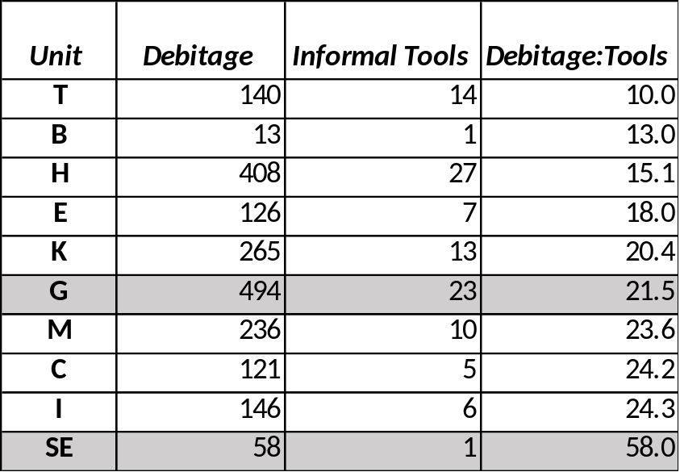
Table 4. 1: Debitage and tools at each unit.

The units near the largest mound (Units E, T, and M) on the other hand, have more tools compared to their modest numbers of flakes. Thus, some aspects of the lithic production or rejuvenation taking place on Mound E were not being copied nearby. One or more of these three off-mound areas could also have functioned as refuse dumps for people living on or near Mound E. In fact, Unit E was purposefully located to excavate what is likely a flank midden made up of discarded material from the Mound E summit.
Figure 4.2: Tool count and evidence for early stage reduction at each mound. Unpredictably, the flakes with a lot of cortex are not found in the same locations as the hammerstones and cores at Pevey. Interestingly, the paired Mounds C and I look similar, and the summit of Mound E (Unit SE) looks remarkably like the midden at its base (Unit E).

Returning to the top of Mound E, the large number of flakes, few tools, and no cores could indicate that minor retouch happened frequently at that location, but probably not much early flake reduction (Figure 4.2). Unit E, which is postulated to be part of a midden near the base, has a very low ratio of 18 pieces of debitage for each tool, and all of the tools were flakes or debris with one utilized or informally-modified edge. There were even fewer heavy-cortex pieces in this unit, and again no hammerstones or cores, so the debris here is slightly different from the top of the mound, and may represent some kind of refuse area for rejected flakes and expedient flake tools.
Unit T, one of the storage areas near Mound E, has the lowest ratio of all, with just 10 flakes for every tool. Both Units T and M, near Mound E, had a few hammerstones and cores, but then very few cortex-heavy flakes. With many tools at Unit T, it is possible people were making flakes and tools at these two locations, left the hammerstones and spent cores there for later use, swept up the flakes to dump elsewhere, and then used most of those tools in some kind of activity at Unit T. There does not seem to be an obvious explanation for the trend in Figure 4.2, which shows that the cortex-heavy flakes (often the first to be removed during core reduction and biface production) are not found at locations yielding hammerstones and cores.
It's also worth noting that Figure 4.2 indicates the Mound G assemblage is very unlike the summit of Mound E (Unit SE), but has nearly the same number of cortical flakes and hammerstones/cores as found in Unit T. Although the location of Unit T does seem to be closer to Mound E, it is only about 100 m from Mound G, and could have been somehow associated with people living on both mounds. The lithics at Mound G do not look much like those from Mound E when we consider the kinds of tools recovered from their excavations. Unit SE’s single tool was a modified flake (every unit had at least one of these), but Mound G had the greatest number of informal bifaces, biface preforms, and formal projectile points (Figure 4.3). Thus, tool creation, use, and discard on Mound G seems to happen more often than on Mound E.
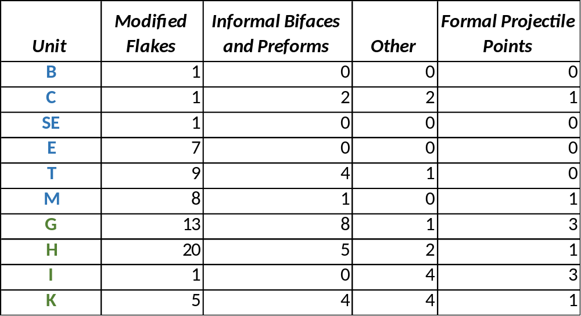
Table 4.2: Types of tools at Pevey. Most units had few tools, and most were informal unifacially-modified flakes.
I decided to examine lithic densities because the sheer number of lithic artifacts excavated from Units G and H created a sample size issue, and because units varied in size and extent. It does seem as though Units G and H returned more tools and cores compared to other units, but they returned more lithics in general, so these counts may not be notable. In fact, if we look at artifact densities and compare the amount of lithics found to the amount of dirt excavated from each unit, we can see that Mound G has the highest density, with about 156 flakes per cubic meter and a tool density of about 7 per cubic meter (Table 4.2). It is important to remember that these densities only included the Analytical Units from which the lithics were examined in this study, and this excluded most mound fill.

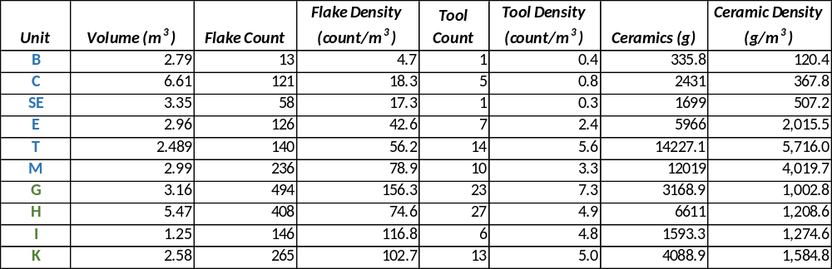
Table 4.3: Stone debitage, stone tool, and ceramic densities for each unit.
Mound E’s summit has very few artifacts in general, compared to the other mounds. There are especially high densities of ceramics found in the units near this mound (Units E, T, and M), but this should not be surprising when considering excavators chose these three areas because earlier surveying with augers showed them likely to hold more artifacts than other potential locations.
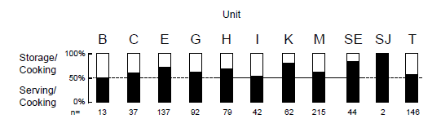
To summarize: Unit E had many ceramic sherds that seemed to be parts of serving vessels (Figure 4.3), possibly deposited from activities on the summit of Mound E. Unit T had a large density of lithic tools, and the densities of undecorated ceramic sherds and large quantities of mussel shell near burned surfaces have led excavators to suggest that this area could have been used for either feasting or storage (Livingood 2006:56). It’s possible these tools were brought to this exclusive area behind the largest mound to prepare, store, and serve food to large groups. Unit M, another possible storage area nearby, had a very high density of lithic debitage and ceramics by weight. Like the Unit E midden, these counts and weights point to a hypothesis that an elite area on the top of Mound E could have been an area used to serve people elaborate meals, and was swept clean of both lithic and ceramic debris by throwing it into areas near the mound.
Figure 4.3: The summits of Mounds E, J, and K contained the greatest proportion of serving/cooking vessels (from Livingood 2006:198). Mound J artifacts were not analyzed in the present study.

When comparing assemblages from each mound, it is worth considering some of the flake (and debitage in general) attributes that were collected in this study. The curvature of the longitudinal cross-sections, size, platform type, presence of platform lipping, and number of dorsal scars can also provide clues to what kind of percussion was used (hard hammer or soft hammer) and what stages of the reduction process were taking place at each unit. Because each provenience provided very few or no tiny flakes, pressure flaking will not be discussed here.
These attributes show an interesting trend with three of the units on and around Mound E, as the flakes are similarly sized and show the most evidence of hard hammer percussion. This might support the interpretation that the largest, centrally-located mound and the off-mound proveniences of E and T are somehow tied into an activity area where perhaps a different kind of tool was being made, or a certain group of knappers were using slightly different techniques that knappers on other mounds.
To address the difference in hard and soft hammer percussion, the curvature and bulb of percussion of each flake were examined. As mentioned in Chapter 3, extremely curved flakes with diffused bulbs of percussion are usually produced by soft hammers, and prominent bulbs of percussion are an indicator of hard hammer percussion. All four units on or near Mound E (SE, E, T, and M) had few curved flakes compared to the debitage from other mounds (Figure 4.4), and an abundance of flat flakes can indicate a reliance on hard hammer percussion.
Figure 4.4: The units on and near Mound E (in red) have the fewest curved cross-sections.

Three of these units produced flakes with many cortical facets and very few faceted platforms as well, suggesting many of these flakes were removed in the early stages of the core or biface reduction process (Figure 4.5). The summit of Mound E (Unit SE) flakes were also very thick, suggesting initial stages of reduction were taking place here, and knappers in this area were removing these big, cortical flakes with a hammerstone.
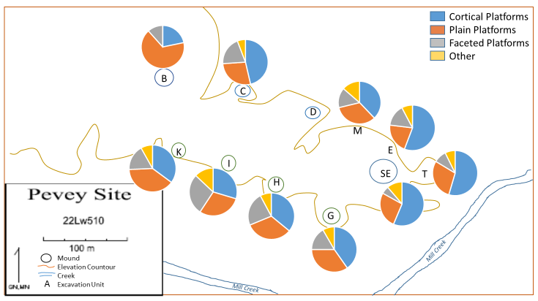
Figure 4.5: The summit of Mound E contained the most cortical platforms, and two of its three off-mound units showed the same. Mound I, on the other hand, had the most faceted platforms.

The top of the largest mound (Unit SE) also provided the highest percentage of flakes with prominent bulbs of percussion (72.4%), which are more easily produced with hard hammer percussion. The units near Mound E also had rather high percentages of flakes with prominent bulbs (Figure 4.6), which makes sense if some of this debris has been deposited here from the summit of Mound E, or if the same group of people was using the same kinds of tools (hammerstones) to start their lithic reduction.

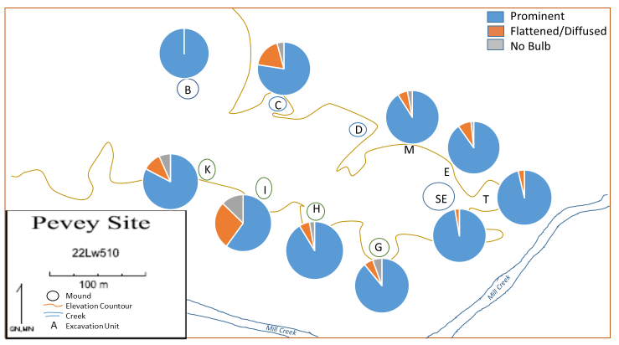
Figure 4.6: Units on and near Mound E have very many bulbs of percussion, indicating the use of hammerstones.

There are some flake attributes Units E and T share with the summit of Mound E, but are not seen in Unit M. The 133 lithics in the midden at Unit E also tended to be thick, flat flakes (Figure 4.7), but only 11% of the debris had more than half of the dorsal face covered with cortex. These flakes may still have been created by hard hammer percussion, but seem to be large pieces that were removed later in the core reduction process. Unit T, an area of possible storage and/or feasting on a wall edge near Mound E (Livingood 2006:261), also produced thick, flat flakes (Figure 4.7). These flakes exhibited few platform facets, similar to the other units associated with Mound E (Figure 4.5). Again, this is often a sign of flakes produced in the early stages of the reduction process. Also, these 140 lithics were much heavier than the average for the site (Figure 4.8).

Figure 4.7: Thickness of all debitage from mounds. Lithics from most of the units near Mound E were generally thicker, and Mound I lithics were much thinner.
Figure 4.8: Weights of all debitage. Unit T, near Mound E, contained many heavy flakes.

Unexpectedly, there was no evidence for the production of standardized tools on the mounds. In fact, there were very few finished tools at all, besides the occasional expediently modified flake (Table 4.2). Although a few tools looked like knives, only two lithics from Mounds K and I were shaped in such a way to potentially be used as drills or gravers. Therefore, the excavation units in this paper do not seem to have been placed in areas where specialized lithic tools were used to manufacture crafts, as has been documented at Moundville.

Multivariate Analysis
As another line of evidence, a Principal Component Analysis and a Cluster Analysis were run on several of the variables to determine whether Mounds E and G had similar lithic assemblages, and whether they were different from the other units. While some of the clusters will be discussed during the review of Hypothesis 2, it is worth noting these graphs and dendrograms produced by combining variables into components do consistently separate out Units E, T, and M, as similar to each other and distinct from the other units. Also, it is noteworthy that the two largest mounds, E and G, do not cluster together, indicating a different lithic composition.
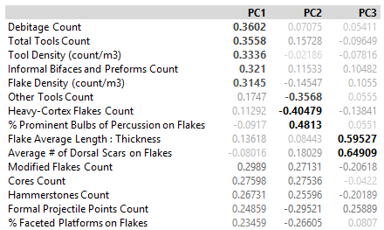
For this analysis, the variables in Table 4.4 were included in a Principal Components Analysis. The primary output of this is to combine the original variables into fewer synthetic variables that are the most efficient at capturing the variation in the original data. In this case, the first three components alone accounted for 81% of the original variation, and were the variables retained. Table 4.4 delineates the eigenvectors for PC1, PC2, and PC3. High positive values under PC1 indicate the units with high PC1 values also have high values in those original variables. High negative values indicate that units with high PC1 scores will have low values in those variables. PC1 values with low absolute values indicate that variable is not strongly associated with PC1.
Table 4.4:Eigenvectors for Principle Components 1, 2, and 3.

Based on these eigenvectors, PC1 is mostly a measure of counts and densities for each unit, and accounts for about 46% of the total variation. It loads moderately on flake counts, informal biface counts, total tool counts, flake densities, and tool densities. As described above, Unit SE, the summit of Mound E, provided very few artifacts, and so it scores very low on PC1. PC2 is strongly associated with prominent bulbs of percussion, but is negatively associated with cortical flakes, formal tool counts, and other tool counts. This component accounts for about 26% of the total variation. Units that score high on PC2 (all units except C, I, and K) have lots of evidence for hard hammer percussion, but few tools or cortical flakes. PC3 is highly associated with flake length:thickness ratios and the number of dorsal scars on the flakes, but also moderately associated with the counts of formal projectile points. This accounts for only 9% of the variation, but the units with high PC3 values (including Units SE, G, H, and B) have evidence for later stages of reduction and tool maintenance.
In an attempt to separate out the influence of counts and densities on the clusters, we can plot PC2 against PC3. This biplot looks only at the types of lithics being produced, and ignores counts. This forms three clusters, as shown in Figure 4.9. What is important in Hypothesis 1 is that PC3 can be used to separate Units B, G, and SE from H, M, E, and T, showing that the two largest mounds and the smallest show more evidence of tool use and maintenance, while the units near the largest mound (Units E, T, and M) cluster with Mound H because they have less evidence of tool use and maintenance.
If we ask whether Mounds E and G are similar to each other, we can ignore PC2 because they have similar scores. But, if we evaluate counts (PC1) vs PC3, where there is significant differentiation, we get Figure 4.10, which includes a consideration of counts of lithics. Specifically, it highlights that although G has similar types of lithics to B and SE, it is very different in raw counts. It also highlights that the three off-mound units (E, T, and M) have similar counts as well as similar tool types.
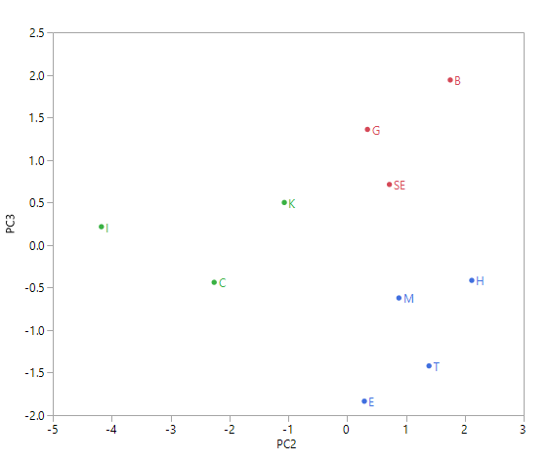
Figure 4.9: Plotting PC2 and PC3. Coloring based on the clusters identified using PC2 and PC3.

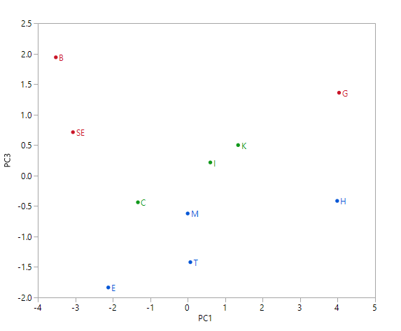
Figure 4.10: Plot of PC1 vs. PC3. Coloring based on the clusters identified using PC2 and PC3.

Hypothesis 1 had predicted Mounds E and G would have lithic assemblages similar to each other, but different from the rest of the mounds. While Unit G did produce many more stone artifacts, its flake attributes and tools did not seem that different from those on the smaller mounds. When examining PC2 and PC3, though, Unit G’s assemblage also looked very similar to the lithics on Mound E (Unit SE), because the east side of the site shows more evidence of hard hammer percussion. Because there were so many lithics on Mound G, it does not seem to have been swept clean in the same way as Mound E may have been. Although there were a few tools on Mound G, they were not standardized, and they mostly consisted of lightly-modified flakes and informal bifaces. These tools did not seem to be geared toward the manufacture of one specific product, like the summits of the mounds at Moundville. Because there were a few hammerstones and cores found in this unit, some initial reduction may have taken place, but the number of cortical flakes was also not remarkable.
Unit SE contained many flat flakes, often with unfaceted platforms and prominent bulbs of percussion, and a few cortical flakes suggesting hard hammer percussion and a bit of early stage reduction. Unfortunately, no hammerstones or cores were found in this unit. A few were found in the units nearby, where similar kinds of flakes were also found. Units E, T, and M clustered together on many variables, and are very much like the flakes on top of Mound E because they also were likely produced by more hard hammer production. It’s possible people working on Mound E were also flintknapping in these exclusive areas behind the mound, where it has been proposed feasting, storage, and elite houses may have been (Livingood 2006). Mound E may have been kept clean for some kind of gathering, such as a feast, dance, or ceremony, with only a few flakes on the mound that may have been the result of tool rejuvenation. The areas near the mound may have provided space for making tools and using them for food preparation and serving.
An unfortunate reality of this analysis is that we have virtually no evidence of exotic stone at Pevey. If there were high proportions of material originating from elsewhere, we could make an argument that elites had access to long-distance trade, or were provisioned with the most knappable cherts, but that case simply can’t be made here. Also, because so few tools, especially projectile points, were recovered from Pevey, we can’t use the presence of hypertrophic tools to justify Mound E or Mound G as locations of leadership. The lack of stone at Mound E, on the other hand, allows us to rule out the likelihood that attached specialists, or the elites themselves, were creating a massive number of standardized tools to provision the rest of the site, or for trade to people at other sites. In conclusion, Mound E could be an elite residence, an area reserved for performances, or a location for feasting, but it certainly doesn’t seem to be an area of specialized craft production requiring the creation of many stone tools.

Hypothesis 2

Many Mississippi Period mound centers may have hosted more than one kin-based corporate group at a time, and it is possible that the arrangement of mounds could be a reflection of the social realities constructed by its inhabitants. Both the Chickasaw ethnographic example and the Moundville sociogram theory proposed by Knight (2010) are underlain by the notion that groups living together at a single site were somehow ranked. The spaces groups carved out for themselves provide clues about their perception of their place within the larger society.
A null hypothesis that all mounds hosted the same types and frequencies of lithic activities predicts that the tools and flakes from each mound should look about the same. Any differences that we see between mounds could tell us something about where tools were used and made, and this in turn might suggest that different groups of people might have been engaged in the manufacture of different products at Pevey.
We have already determined there is a difference in lithics found atop Mound E, and there may be a clustering of similar activities happening at the three off-mound locations nearby (Units, E, T, and M). Several hypotheses about the control of mounds by corporate groups, and the particular ways in which tasks may have been divided between different mounds, can be further tested by comparing individual mounds, pairs of mounds, and rows of mounds to each other.
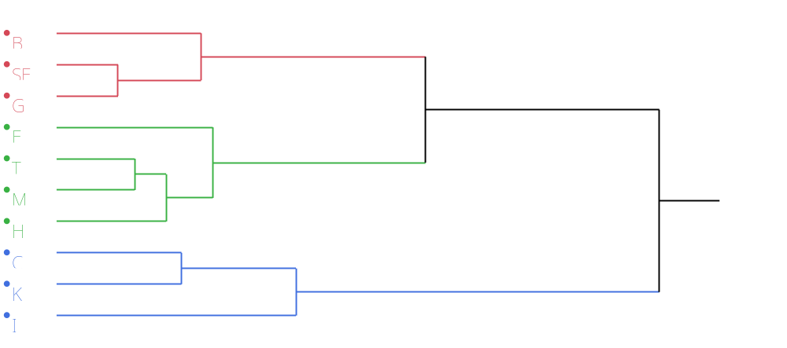
The Principal Component Analysis mentioned above has already hinted at clusters of mounds at Pevey. Other than similarities between the three off-mound units, there also seem to be similarities between Mounds I, C, and K. Plotting PC2 and PC3 in Figure 4.9 showed a cluster of Units I, C, and K, and Figure 4.11 below shows the dendrogram that illustrates just how deeply rooted this cluster is, separating it from the rest of the site.
Figure 4.11: The scree plot suggests that 3 clusters provide the best solution when clustering only on PC2 and PC3, the components which largely ignore counts and densities.

These units are separated from the rest because they have very few prominent bulbs of percussion (Figure 4.6) and more curved flakes (Figure 4.4). Mound I also had many more platform facets (Figure 4.5), and provided flakes much smaller than those from any other unit (Figures 4.7 and 4.8). These factors suggest more soft hammer percussion and later stage core or tool reduction.

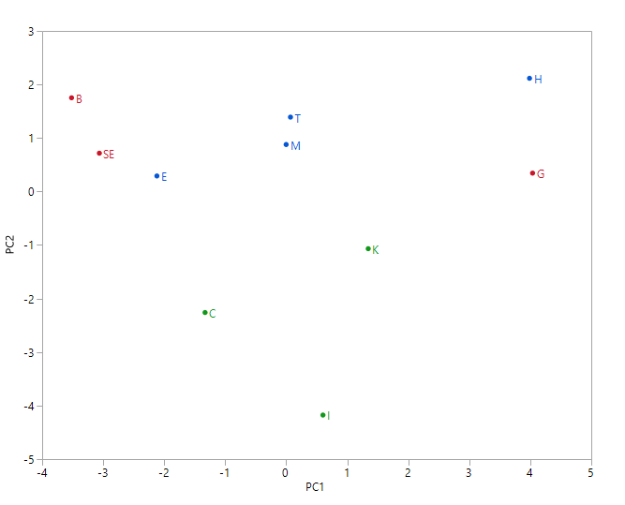
Figure 4.12: A biplot of PC1 vs. PC2.

When we factored PC1 back into our evaluation, densities and counts played a large role in clustering the units. Notably, Mounds C and I and K stayed together as a cluster. A return to the first few figures in this chapter (Tables 4.1, 4.2, and 4.3) will remind us that the lithic densities also produced a pattern of activity at Pevey that divided the north and south mounds. Units G, H, I, and K fall to the right of the PC1 continuum in Figure 4.12, but the northern units fall to the left.
The similarity of Mounds I and C also brings up the possibility that mounds across the plaza from each other could have been used for similar kinds of lithic reduction. One way we could model this pairing is by assuming that four groups were controlling four pairs of mounds, each with one from the southern row and one from the northern row. If each group was producing complementary types of goods, like Knight (2010) has suggested for the corporate groups at Moundville, then we would expect Mounds C and I to have debris and lithics different than the other mound pairs because the people were crafting a product other groups were not (Figure 4.13). Unfortunately, we do not see similarities in the other mound pairs that convince us mounds are paired across the plaza in this way.
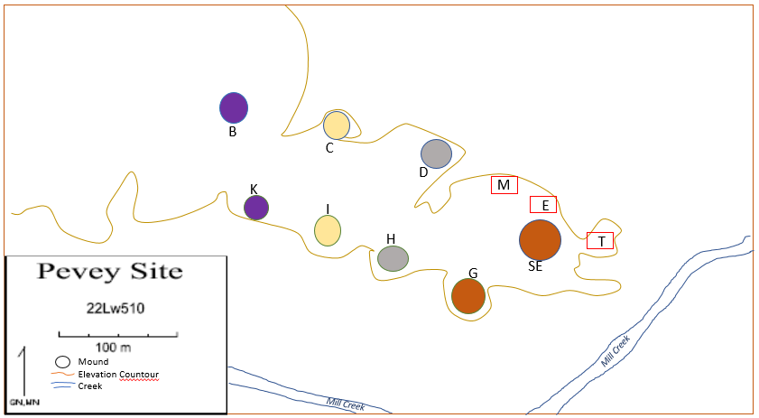
Figure 4.13: Model of Pevey mounds as they might conform to the Moundville Corporate Group Hypothesis: in this case, four groups living on paired mounds across the plaza, possibly ranked by size with the most powerful groups on Mounds E and G, should show similarity within each pair, but differences between each pair.

Alternatively, we could also model this result by hypothesizing two groups inhabited Pevey, one on the northern mounds and one on the southern mounds. These groups could have conducted parallel activities on their mounds, using the largest mounds for one kind of occupation, Mounds D and H for a different purpose, Mounds C and I for something else, and Mounds B and K for a fourth kind of activity. This model would also predict similarity in the assemblages of mounds that lie directly across the plaza from each other (Figure 4.13). Either model could explain the similarity of Mounds C and I, but not why Mound K lithics are also similar to these assemblages. Closely investigating the tools and flakes for mound pairs and rows of mounds at Pevey could provide more evidence of social organization.
When considering the mounds together in two rows, there is almost no difference in the debitage:tool ratios. The southern mounds G, H, I, and K produced 69 informal tools and 1313 pieces of debris total, resulting in a ratio of 19 pieces of debitage for each tool. The units in the northern row, B, C, SE, E, T, and M, produced only 38 informal tools, but also only 694 pieces of debitage, creating a similar ratio of 18.3 pieces of debris per tool.
Figure 4.2 suggested that most of the cores and hammerstones were in the southern units. There was also a notable trend in the low numbers of tools of all types from the northern mounds (Table 4.2). These patterns pique our interest, but could also be explained away by pointing out that lithics of all types were more present in the southern mounds. Thus, density should be re-examined to determine if it is a major factor in understanding the site layout.
When only accounting for the layers not considered mound fill (because these layers were often incidentally filled with Archaic Period points that are not indicative of the people who constructed the mounds), the flake densities in Figure 4.14 actually show that all 4 mounds to the south (in green) have many flakes, the three northern mound summits (B, C, and SE) have very few, and the off-mound excavations (Units E, T, and M) have a medium number of flakes. A study of flake density does reveal a difference in lithic activities occurring at this site, with northern mounds providing fewer flakes than the storage areas near Mound E, and far fewer than the southern mounds.
A graph of tool densities for each unit (Figure 4.15) also shows a large number of tools in the dirt from the southern mounds and areas near Mound E (Units E, T, and M), and far fewer tools on the summits of the northern mounds (Units B, C, and SE). Examining ceramic densities tells a very different story, though. The southern mounds in Figure 4.16 have a very average density of ceramics on each of the four summits, areas near Mound E have by far the most ceramics, and the northern mound summits have very few ceramics. The high densities at Units E, T, and M are not surprising as excavators chose these three areas because earlier surveying with augers showed they were likely to produce many ceramic artifacts.

Figure 4.14: Flake densities for each unit show a large number on the southern mounds (in green).

Figure 4.15: Tool densities for each unit also show a large number on the southern mound (G, H, I, and K), and significantly less from the northern mounds (B, C, and SE).

Figure 4.16: Ceramic densities for each unit.

The weight of sherds found in the areas near Mound E far outweigh what was found on the summits of the mounds. In addition, the mounds to the north had fewer ceramics than the mounds to the south.
Of course, this trend with high densities of lithic flakes and tools in the southern mounds could be a reflection of the availability of the Citronelle gravel cobbles from Mill Creek, which runs close to the southern mounds. It is possible that people gathering cobbles from the creek did a large proportion of initial reduction and tool shaping at these mounds because it was easier than walking across the site to the northern mounds. As most of the hammerstones and cores were found along the southern row, but most of the heavy-cortex flakes were excavated from the northern mounds, it’s hard to determine exactly where people were removing the first flakes from these cobbles.
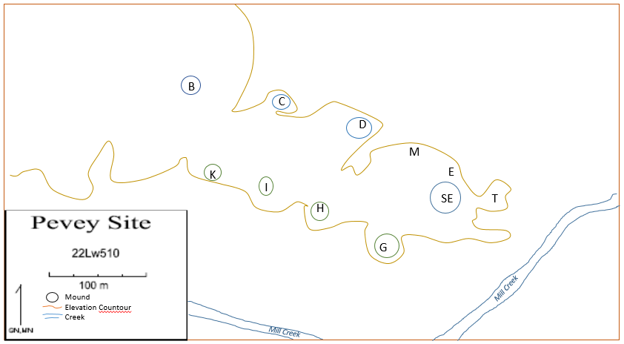
In examining the hypothesis that mounds are paired across the plaza, it certainly seems there is a difference in lithic densities at each mound pair. The smallest mounds, B and K, have together a very average density, because B’s density is so low and K’s density is so high. The largest mounds have the highest densities by far, and Mound C and I in the middle have very low densities together. If people at Pevey were using all of the southern mounds (near the source of the Citronelle gravel cobbles) for lithic reduction, and were not using the northern mounds as much, we would expect to see each pair together return similar densities, but it is clear the amount of lithics at each area is not solely determined by proximity to the source of the cobbles.
Figure 4.17: Mound pairs and their lithic densities.
To summarize, the examination of Hypothesis 2 has created several different kinds of clustering. We had already determined a cluster of units near Mound E during the review of Hypothesis 1, but the PCA reports also delineated a cluster of assemblages in Mounds I, C, and K. The lithics from Mounds I and C showed many diffused bulbs of percussion, curved flake cross-sections, and faceted platforms, which suggest soft hammer percussion and late stage reduction. The small size of lithics from Mound I would also argue that tool rejuvenation or late stage core reduction was taking place here. Although it is interesting to note the similarities between these three assemblages, a cluster of three mounds does not seem to support hypotheses concerning mounds paired across the plaza. We can say, though, that this side of the site (Mounds C, K, and I) was being used for slightly different lithic tool production than the eastern side, where the largest mounds are located.
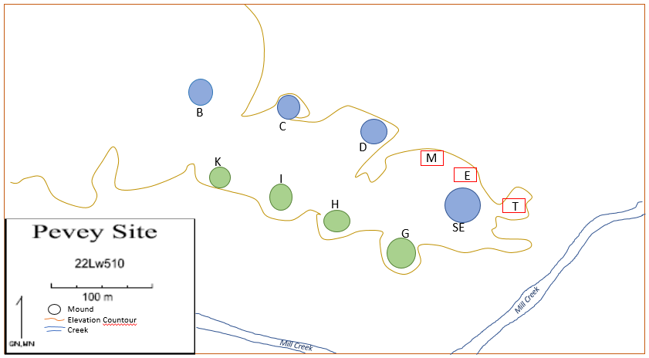
The analysis of densities grouped the mounds into their two rows (north vs. south), with significantly more lithic artifacts showing up in the southern units. This could be an effect of their proximity to Mill Creek, and the desire for flintknappers to reduce the distance to carry gravels from the creek to an area good for cobble-testing, initial removal of big, cortical flakes, and eventually tool production (Figure 4.18). One could also view it as evidence that people at Pevey left fewer ceramic and lithic artifacts on the tops of the northern mounds because these were being reserved for a different purpose and needed to be kept clear of debris.
Figure 4.18: Densities suggest that more lithic activities in general were occurring on the southern mounds, possibly as a factor of their proximity to Mill Creek.

Summary

Testing of Hypothesis 1 showed the lithics on and near Mound E seem to be a bit different than the rest. This could support the hypothesis that some kind of leader was living on top of this mound, or special elite activities took place there on occasion. The off-mound units look similar to the Mound E summit when we look at flake attributes and compare the assemblages’ flake sizes, platform types, presence of bulbs of percussion, and longitudinal cross-section shapes. The assemblages of lithic debitage recovered from Mound E, in a midden next to Mound E, and at the Unit T storage/feasting area near the mound had many characteristics in common. On average, these flakes were thicker, heavier, and had more cortical than faceted platforms. These characteristics are found more often on flakes created by hard hammer percussion, and less when they are produced by soft hammers. Though there were few tools to examine at this site, these assemblage characteristics could suggest different tools were being made on and near Mound E than on other mounds, and so this mound was a setting for some kind of special activity. While Mound G does not look like it was swept clean in the same manner as Mound E, some flake attributes from atop both of the large mounds suggest similarity between them (Figures 4.9 and 4.10).
In investigating Hypothesis 2, it was determined that the chipped stone and ceramic densities from the northern mounds are definitely greater than those on the southern mounds. While this could be an effect of two different groups occupying two rows of mounds, it could also be a product of micro-sourcing, as Mill Creek is located much closer to the southern mounds than the northern mounds. Flake attributes do not distinguish the northern row from the southern.
A story could be constructed about the clustered nature of the lithics from Mounds I and C. Although these units showed different artifact densities, they had nearly identical ratios of debitage to tools, and very few hammerstones and cores. The flakes on Mound I are much smaller than average, and the flakes on both mounds are frequently faceted. Both assemblages rarely show obvious bulbs of percussion, and so were likely produced by some soft hammer percussion. Both units produced similar ratios of ceramic sherds that looked like they had been parts of serving vessels. Along with evidence for maize at Mound I, interpreting Mound I as being used for maize processing, food preparation and storage, and incidental tool rejuvenation may help explain what was going on here. Further excavations would be needed to extend this interpretation to Mound C, but for now we can say some aspects of their lithics are in agreement, supporting the hypothesis that they could be a pair.
This finding could support a similar model to Knight’s (2010) proposed Moundville model, in which different corporate groups inhabited pairs of mounds, with artifacts on the largest pairs showing evidence of higher rank than the artifacts from the smaller pairs of mounds. This would be true if, as Knight suggested, segmentary groups compete socially in some ways (feasting, recruitment, or mound building), but participated in producing complementary goods. In his example, one group might produce beads, while another sponsored a group of skilled potters, or a third processed most of the corn (Knight 2010:358). If each group at Pevey controlled a pair of mounds and produced completely different goods than other groups, we might expect their lithic tools and reduction techniques to differ across mounds. To complicate matters, though, the similarity of Mound K’s assemblage to that found on Mounds I and C makes a hypothesis about paired mounds across a plaza less likely, assuming that Mounds I and C were supposed to be similar to each other and different from other pairs. Also, if Pevey conformed to this model of paired mounds, we would expect to see greater similarities between Mounds B and K, and the data simply does not support this pairing.
Alternatively, Mounds I and C could be similar because two different people inhabited each row of mounds, but performed parallel activities on the mounds that mirrored each other. For example, the largest mounds could have been reserved for feasting and celebration, with the medium-sized mounds for living quarters and the smallest mounds for food preparation and storage. This interpretation of two rows of mounds for two groups of people could be supported by density indices, and the pairing of Mounds I and C, but is again complicated by the fact the Mound K is so similar to these two, but not to Mound B.
The take-away is that there may be some elite activities occurring on the summit of Mound E, and the lithics in off-mound areas look similar to Mound E’s summit, but different from the rest of the site. In some ways, Mound G clusters with Mound E, but the sheer number of lithics suggests that it might not have been cleared in the same way. Most of the smaller mounds, on the other hand, showed more evidence of soft hammer percussion and smaller flake sizes.
There are definitely more lithics to the south, and research should be conducted into the proximity of Mill Creek and the availability of Citronelle gravels. Finally, if there were pairs of mounds controlled by different groups, we should imagine that each pair consisted of mounds across from each other, not next to each other. Mounds I and C are the most clearly related of the pairs, but the similarity of Mound K to this pair complicates matters and does not support the model suggested in Figure 4.13.

Chapter 5: Conclusion

The Pevey site in Mississippi is one of the largest mound sites in the Southeast, but is relatively unknown to archaeologists who study the Mississippi/Plaquemine Period. Throughout the region, archaeologists have often encountered mound sites whose layouts look relatively similar to each other, especially if they are contemporaneous, but the shape of the nine mounds at Pevey seems different from several examples that have been reviewed here.
Pevey’s U-shaped layout looks a little like a few Archaic shell mound sites from Florida and Georgia, which social scientists have used to examine analogies about the way individuals seat themselves during work and home activities, and how leaders project themselves spatially. Pevey’s U-shape does not look much like the nearby major Mississippian site of Moundville, where pairs of mounds form a ring around an empty plaza and may be a diagram for the way in which corporate groups subdivided the space. Pevey’s layout also does not look like a few of the Plaquemine sites that seem to center on double plazas surrounded by mounds, nor does it have two large mounds facing each other from directly across the plaza. This makes it hard to understand why pre-contact people built the mounds in the way that they did, and so artifact and feature analysis should elucidate the ways in which people used these mounds.
A general analysis had already been performed on several categories of artifacts from Pevey’s 1990 excavations, but the most in-depth research focused on the ceramics uncovered at the site. Lithics is another lens through which Mississippian sites can be understood, as they have previously been used to see trade networks for exotic stone, which people had access to the best materials, which areas were reserved for specialized tool production, how stone tools were used to make other products, and how different groups of people may have been exempt from making and using tools. Being able to identify different qualities of flakes can lead archaeologists to suggest that different assemblages may have been the result of different kinds of tools being produced, different knapping techniques, or simply different stages in the reduction process. The analyses of both tools and debitage is not often married in lithic reports from sites in the Southeast, and so it is important to experiment with the results of both to try to understand how a large site like Pevey may have been used.
The lithics discussed in this paper came from contexts on, inside, and around the mounds of Pevey, but only those flakes that seemed to result from living surfaces and middens (not mound fill full of Archaic projectile points) were analyzed. Chapter 4 suggested clusters of activity areas on and near Mound E, the largest mound at the center of the U-shape. This mound returned very few lithics, but a plethora were found in the middens and storage/feasting areas nearby, which may have only been accessible to people living and working on this large mound. These lithics tend to be thicker and heavier, and had more cortical than faceted platforms, compared to debitage at other mounds, suggesting a reliance on hard hammer percussion. Perhaps different kinds of tools were being made there, or perhaps a different group of people who simply preferred hammerstones to antler or bone billets were flintknapping there.
The multivariate analysis suggested a connection between the largest mounds at Pevey. Although there were many more lithics on Mound G, some of the flake attributes were similar to the flakes from the top of Mound E, and so it is possible that people knapping on and near Mound E were also working on Mound G. The size of Mound G and its large number of imported ceramics set it apart as being a potential location of elite residence or elite activities, and the clustering with Mound E when considering PC2 and PC3 suggests that they were both locations for more hard hammer percussion and late-stage reduction than other units.
We also see a possible cluster of attributes on the smaller mounds. Assemblages from Mounds C and I, directly across the plaza from each other, and to some extent from neighboring Mound K, had nearly identical ratios of debitage to tools, and very few hammerstones and cores as well. The flakes on Mound I were much smaller than average, and the flakes on both Mounds C and I were frequently faceted. Both assemblages rarely showed obvious bulbs of percussion, and so were likely produced by some soft hammer percussion. As mentioned above in Chapter 4, some kind of interpretation about Mound I being used for maize processing and storage, and incidental tool rejuvenation, may help to explain what was going on here. These similarities might support our hypothesis that mounds at Pevey may have been paired, with each pair controlled by a different corporate group performing activities different from what the other pairs were focusing on. The similarity of Mound K to Mounds I and C, though, does not support this model, but suggests a cluster of three.
Another exciting pattern was revealed when it became apparent that the northern mounds had much smaller lithic densities than mounds in the south. These units had fewer tools and flakes, and at first hinted at the possibility that different corporate groups at Pevey were using the mounds in different ways, like the mounds at Moundville. On further reflection, though, we might consider that this could be the result of proximity to Mill Creek in the south, an obvious source of lithics in the form of cobbles. It is likely that people living and working at these mounds obtained their raw materials in or near the creek, and then chose to complete much of their initial reduction on or near the mounds that happened to be closest to the creek. Although the data does not suggest that the largest, most cortex-heavy flakes with fewest dorsal scars were found in these southern mounds, and so we cannot say for sure that all of the initial reduction took place here, it’s possible that many stages of reduction took place here, and that is why we find the greatest density of all types of flakes in these units. Further research will need to be done into areas of micro-sourcing in the Southeast, to determine how people living very close to a chert gravel source structure the locations of their knapping activities.
Further excavations near the creek may also help us to understand whether the people at Pevey often used bipolar percussion to test cobbles directly at the source, and if they were doing much of the expedient knapping before they even returned to the mound areas. It may also be helpful to further explore how other activities at the site would benefit by being closer to the creek, and whether its proximity affects the densities of other artifact types.
Sedentary people in the more recent past were likely not following some of the same lithic reduction trajectories as their more mobile ancestors, and so the production of expedient tools from locally-available cherts might not produce the same proportions of big, cortical flakes from the beginning and small, faceted flakes at the end. More research needs to be done to understand how expedient knappers are choosing flakes from Citronelle gravels, and how much modification is desirable in the creation of the most common tool types, such as scrapers, knives, and projectile points. It would also make sense to consider how the people building Pevey during the Mississippi Period might have been picking up older Archaic tools and flakes at the site, and reworking them. If this happened often, then we should be noting the presence or absence of patination, especially on the projectile points that look like Archaic types.
Future excavations or surveys could also examine the areas between the U-shape mounds, often referred to as the plaza. At Mississippian sites, these plazas are often swept clean of debris, but Pevey’s has not yet been sampled, and so it could be that several more tools and a few more assemblages of flakes could tell a completely different story about how lithic activities were segregated around the site. Additionally, lithics excavated from Mounds J and D could be analyzed in a similar fashion to see if the densities continue to be higher in the southern half of the site.
In the future, the flakes that have been categorized as modified or used could be analyzed for any microwear by a specialist with experience looking at Citronelle gravels under a microscope. Perhaps patterns could be seen if certain used flakes and tools from certain mounds show similar signs of tool edge damage or polish, and this would allow us to make further hypotheses concerning how the tools were used to make other products at Pevey. Finally, with permission from landowners in the future, other areas outside of the recorded nine mounds could be surveyed or excavated, and the addition of more mounds could radically change the map of Pevey. It’s possible that this site was never intended to create a U-shape, and the archaeological questions could significantly change with the addition of more mounds to the map.
Pevey has great potential to help expand our knowledge of middle-range societies in the Southeast during the Mississippi Period, and lithics has been underutilized in this region in the past. By looking at more artifacts from more excavation units, and by analyzing them in different ways, we may be able to sketch a clearer picture of how the people at Pevey lived, and whether the mound configuration reflects their social organization.

References

Ahler, S. A.
1971 Projectile Point Form and Function at Rodgers Shelter, Missouri.

Alt, S. M.
2010 Ancient Complexities: New Perspectives in Precolumbian North America. University of Utah Press.

Anderson, D. G. and K. E. Sassaman
2004 Late Holocene Period, 3750 to 650 BC, Southeast Volume, Smithsonian Handbook of North American Indians:101-114.

Andrefsky Jr, W.
1994 Raw-Material Availability and the Organization of Technology. American Antiquity:21-34.

2005 Lithics: Macroscopic Approaches to Analysis. Cambridge University Press.

Barry, S. E.
2004 Lithic Raw Material and Chipped Stone Tools: A Comparison of Two Sites in the Moundville Chiefdom. Master’s Thesis, University of Alabama.

Beasley III, V. R.
2007 Feasting on the Bluffs: Anna Site Excavations in the Natchez Bluffs of Mississippi. Plaquemine Archaeology, edited by Rees, M. A. and P. C. Livingood, pp.127-144. University of Alabama Press, Tuscaloosa.

Bleed, P. and M. Meier
1980 An Objective Test of the Effects of Heat Treatment of Flakeable Stone. American Antiquity:502-507.

Blitz, J. H.
1993 Ancient Chiefdoms of the Tombigbee. University of Alabama Press, Tuscaloosa.

1999 Mississippian Chiefdoms and the Fission-Fusion Process. American Antiquity 64(4):577-592.

2010 New Perspectives in Mississippian Archaeology. Journal of Archaeological Research 18(1):1-39.

Blitz, J. H. and K. G. Lorenz
2006 The Chattahoochee Chiefdoms. University of Alabama Press, Tuscaloosa.

Carr, P. J., and A. P. Bradbury.
2000 Contemporary Lithic Analysis and Southeastern Archaeology. Southeastern Archaeology: 120-134.

Brewer, E. M.
1995 Subsistence Patterns in Central Mississippi and Alabama: The Pearl Mounds Site (22Lw510) Lawrence Co., Mississippi.

Brown, I. W.
1985 Plaquemine Architectural Patterns in the Natchez Bluffs and Surrounding Regions of the Lower Mississippi Valley. Midcontinental Journal of Archaeology:251-305.

Brown, J. A.
1990 Archaeology Confronts History at the Natchez Temple. Southeastern Archaeology 9(1):1-10.

Carr, P. J.
2008 Through the Lens of the Lithic Analyst. In Time’s River, edited by Rafferty, J. and E. Peacock, pp. 201-222. University of Alabama Press, Tuscaloosa.

Cobb, C. R.
2000 From Quarry to Cornfield: The Political Economy of Mississippian Hoe Production. University of Alabama Press, Tuscaloosa.

2003 Mississippian Chiefdoms: How Complex? Annual Review of Anthropology 32:63-84.

2005 Archaeology and the “Savage Slot”: Displacement and Emplacement in the Premodern World. American Anthropologist 107(4):563-574.

Cobb, C. R. and M. S. Nassaney
2002 Domesticating Self and Society. In The Woodland Southeast, edited by Anderson, D. G. and R. C. Mainfort, pp. 525-539. University of Alabama Press, Tuscaloosa.

Cooper, D. R.
2012 Shifting Strategies in Chert Use from the Late Archaic to the Early Fort Ancient at Elk Fork in Eastern Kentucky. In Contemporary Lithic Analysis in the Southeast: Problems, Solutions, and Interpretations, edited by Carr, P. J., A. P. Bradbury, and S. E. Price, pp. 146-164. University of Alabama Press, Tuscaloosa.

Cuddy, T.
2000 Socioeconomic Integration of the Classic Maya state: Political and Domestic Economies in a Residential Neighborhood, Columbia University.

de la Peña, P.
2015 A Qualitative Guide to Recognize Bipolar Knapping for Flint and Quartz. Lithic Technology 40(4):316-331.

Dowd, E. L.
2012 Alternative Conceptions of Complexity: Sociopolitical Dynamics of the Mountain Fork Caddo. Ph.D. Dissertation, University of Oklahoma.

Ford, J. A.
1951 Greenhouse: A Troyville-Coles Creek Period Site in Avoyelles Parish, Louisiana, Anthropological Papers of the American Museum of Natural History 44, Part I.

Gamble, C. and W. A. Boismier
1991 Ethnoarchaeological Approaches to Mobile Campsites: Hunter Gatherer and Pastoralist Case Studies. International Monographs in Prehistory.

Gibson, J. L.
1980 Speculations on the Origin and Development of Poverty Point Culture. Louisiana. Archaeology 6:321-348.

1994 Before Their Time? Early Mounds in the Lower Mississippi Valley. Southeastern Archaeology 13(2):162-186.

Gibson, J. L. and P. J. Carr
2004 Signs of Power: The Rise of Cultural Complexity in the Southeast. University of Alabama Press, Tuscaloosa.

Grøn, O.
1991 A Method for Reconstruction of Social Structure in Prehistoric Societies and Examples of Practical Application. In Social Space: Human Spatial Behaviour in Dwellings and Settlements, edited by Grøn, O., E. Engelstand, and I. Lindblom, pp. 100-117. Odense University Press.

Hally, D. J. and J. B. Langford
1987 Mississippi Period Archaeology of the Georgia Valley and Ridge Province.

Hare, A. P. and R. F. Bales
1963 Seating Position and Small Group Interaction. Sociometry:480-486.

Hiscock, P.
2015 Dynamics of Knapping with Bipolar Techniques: Modeling Transitions and the Implications of Variability. Lithic Technology 40(4):342-348.

Howells, L. T. and S. W. Becker
1962 Seating Arrangement and Leadership Emergence. The Journal of Abnormal and Social Psychology 64(2):148.

Jefferies, R. W.
2004 Regional Cultures, 700 BC–AD 1000. Handbook of North American Indians 14:115-127.

Jenkins, N. J. and R. A. Krause
1986 The Tombigbee Watershed in Southeastern Prehistory. University Alabama Press, Tuscaloosa.

Jeske, R. J.
1992 Energetic Efficiency and Lithic Technology: An Upper Mississippian Example. American Antiquity:467-481.

Johnson, J. K.
1993 The Development of Southeastern Archaeology. University of Alabama Press, Tuscaloosa.

Kidder, T. R.
1992 Coles Creek Period Social Organization and Evolution in Northeast Louisiana. Archeological Papers of the American Anthropological Association 3(1):145-162.

1998 Mississippi Period Mound Groups and Communities in the Lower Mississippi Valley. In Mississippian Towns and Sacred Spaces: Searching for an Architectural Grammar, edited by B. R. Lewis and C. Stout, pp. 123-150. University of Alabama Press.

2004 Plazas as Architecture: An Example from the Raffman site, Northeast Louisiana. American Antiquity:514-532.

2010 Trend, Tradition, and Transition at the End of the Archaic. Trend, Tradition, and Turmoil: What Happened to the Southeastern Archaic:23-32.

Kidder, T. R. and G. J. Fritz
1993 Subsistence and Social Change in the Lower Mississippi Valley: The Reno Brake and Osceola Sites, Louisiana. Journal of Field Archaeology 20(3):281-297.

Kidder, T. R. and S. C. Sherwood
2016 Look to the Earth: The Search for Ritual in the Context of Mound Construction. Archaeological and Anthropological Sciences:1-23.

King, E. M.
2000 The Organization of Late Classic Lithic Production at the Prehistoric Maya Site of Colha, Belize: A Study in Complexity and Heterarchy.

King, A.
2003 Etowah: The Political History of a Chiefdom Capital. University of Alabama Press, Tuscaloosa.

Knight, V. J.
1998 Moundville as a Diagrammatic Ceremonial Center. In Archaeology of the Moundville Chiefdom, edited by Knight, V. J. and V. P. Steponaitis, pp. 44-62. Smithsonian Institution Press, Washington.

2016 Social Archaeology of Monumental Spaces at Moundville. In Rethinking Moundville and its Hinterland, edited by Steponaitis, V. P. and C. M. Scarry, pp.24-40. University Press of Florida.

Knight Jr, V. J., J. A. Brown and G. E. Lankford
2001 On the Subject Matter of Southeastern Ceremonial Complex Art. Southeastern Archaeology:129-141.

Knight, V. J., H. E. Jackson and S. L. Scott
2010 Mound Excavations at Moundville: Architecture, Elites and Social Order. University of Alabama Press, Tuscaloosa.

Knight, V. J. and V. P. Steponaitis
1998 A New History of Moundville. In Archaeology of the Moundville Chiefdom, edited by Knight, V. J. and V. P. Steponaitis, pp. 1-25. Smithsonian Institution Press, Washington.

Kuhn, S. L.
1991 “Unpacking” Reduction: Lithic Raw Material Economy in the Mousterian of West-Central Italy. Journal of Anthropological Archaeology 10(1):76-106.

LaDu, D. A.
2016 The View from Mazique (22Ad502): The Coles Creek/Plaquemine Cultural Transition from the Perspective of the Natchez Bluffs Region of the Lower Mississippi Valley. The University of Alabama, Tuscaloosa.

Lankford, G. E.
2016 Was There a Moundville Medicine Society? In Rethinking Moundville and its Hinterland, edited by Steponaitis, V. P. and C. M. Scarry, pp.75-98. University Press of Florida.

Lévi-Strauss, C.
1963 Structural Anthropology 1. Basic Books.

Lewis, B. S.
1995 The Role of Specialized Production in the Development of Sociopolitical Complexity: A Test Case from the Late Classic Maya.

Lewis, R. B. and C. Stout
1998 Mississippian Towns and Sacred Spaces: Searching for an Architectural Grammar. University of Alabama Press, Tuscaloosa.

Livingood, P. C.
2006 The Geographic Limit of Inter-Polity Interaction during the Mississippian: A View from the Pevey and Lowe-Steen Sites on the Middle Pearl River, Mississippi. Dissertation, University of Michigan.

2007 Plaquemine Recipes: Using Computer-Assisted Petrographic Analysis to Investigate Plaquemine Ceramic Recipes. In Plaquemine Archaeology, edited by Rees, M. A. and P.C. Livingood, pp. 108-126. University of Alabama Press, Tuscaloosa.

2008 Recent Discussions in Late Prehistoric Southern Archaeology. Native South 1(1):1-26.

Lorenz, K. G.
1996 Small-Scale Mississippian Community Organization in the Big Black River Valley of Mississippi. Southeastern Archaeology 15:145-171.

Mann, C. B.
1988 Archaeological Classification of Ceramics from the Pearl River Mounds (22Lw510) Lawrence County, Mississippi. Master’s Thesis, University of Southern Mississippi.

Matson, G. C.
1916 Shorter Contributions to General Geology. United States Geological Survey, Washington D. C.

McGahey, S. O.
2000 Mississippi Projectile Point Guide. Mississippi Department of Archives and History.

Mitchem, J. M.
2012 Safety Harbor: Mississippian Influence in the Circum-Tampa Bay Region. In Late Prehistoric Florida: Archaeology at the Edge of the Mississippian World, edited by Ashley, K. H. and N. M. White, pp. 172-185. University Press of Florida.

Moore, B.
1984 Prehistory of the Pearl River, Louisiana and Mississippi: Report on a Literature Search. Louisiana Archaeology 11:191-227.

Nassaney, M. S. and K. Pyle
1999 The Adoption of the Bow and Arrow in Eastern North America: A View from Central Arkansas. American Antiquity:243-263.

Neitzel, R. S.
1965 Archeology of the Fatherland Site: The Grand Village of the Natchez. Anthropological Papers of the American Museum of Natural History 51, part 1.

1983 The Grand Village of the Natchez Revisited. Excavations at the Fatherland Site, Adams County, Mississippi, 1972. Archaeological Report No. 12, Mississippi Department of Archives and History, Jackson, Mississippi.

Novelli, D., J. Drury and S. Reicher
2010 Come Together: Two studies Concerning the Impact of Group Relations on Personal Space. British Journal of Social Psychology 49(2):223-236.

Ortmann, A. L. and T. R. Kidder
2013 Building Mound A at Poverty Point, Louisiana: Monumental Public Architecture, Ritual Practice, and Implications for Hunter‐Gatherer Complexity. Geoarchaeology 28(1):66-86.

Pargeter, J. and H. Duke
2015 Evolutionary Perspectives on Bipolar Technology. Taylor & Francis.

Parkington, J. and G. Mills
1991 From Space to Place: The Architecture and Social Organization of Southern African Mobile Communities. Ethnoarchaeological Approaches to Mobile Campsites: Hunter/gatherer and Pastoralist Case Studies:355-370.

Parry, W. and R. L. Kelly
1987 Expedient Core Technology and Sedentism. In The Organization of Core Technology, edited by Johnson, J. K. and C. A. Morrow. Westview Press, Boulder, Colorado.

Patterson, L. W. and J. B. Sollberger
1978 Replication and Classification of Small Size Lithic Debitage. The Plains Anthropologist:103-112.

Pauketat, T. R.
2005 The Forgotten History of the Mississippians. North American Archaeology, Blackwell, Oxford:187-211.

Pluckhahn, T. J.
2003 Kolomoki: Settlement, Ceremony, and Status in the Deep South, AD 350 to 750. University of Alabama Press, Tuscaloosa.

Pluckhahn, T. J. and M. T. Bonhage-Freund
2010 Archaeological Investigations in Spiro’s Hinterlands: Testing of the Lee Creek Ceremonial Site (34SQ12), Sequoyah County, Oklahoma.

Rees, M. A.
2010 Plaquemine and Mississippian. Archaeology of Louisiana:172-194.

Rees, M. A. and P. C. Livingood
2007 Plaquemine Archaeology. University of Alabama Press, Tuscaloosa.

Roe, L. M., T. M. Schilling, and M. A. Rees
2010 Coles Creek. Archaeology of Louisiana 157.

Russo, M.
2004 Measuring Shell Rings for Social Inequality. In Signs of Power: The Rise of Cultural Complexity in the Southeast, edited by Gibson J. L. and P. J. Carr, pp. 26-70. The University of Alabama Press, Tuscaloosa.

Sanger, M. C.
2015 Life in the Round: Shell Rings of the Georgia Bight. Dissertation.

Sassaman, K. E.
2010 The Eastern Archaic, Historicized. Rowman Altamira.

Sassaman, K. E. and A. R. Randall
2012 Shell Mounds of the Middle St. Johns Basin, Northeast Florida. Early New World Monumentality:53-72.

Saunders, J. W. and M. A. Rees
2010 Middle Archaic and Watson Brake. Archaeology of Louisiana:63-76.

Scarry, J. F.
1998 Domestic Life on the Northwest Riverbank. In Archaeology of the Moundville Chiefdom, edited by Knight, V. J. and V. P. Steponaitis, pp. Smithsonian Institution Press, Washington.

Scarry, C. M. and V. P. Steponaitis
2016 Moundville as a Ceremonial Ground. In Rethinking Moundville and its Hinterland, edited by Steponaitis, V. P. and C. M. Scarry, pp.255-268. University Press of Florida.

Service, E. R.
1971 Primitive Social Organization: An Evolutionary Perspective. 2nd ed. Random House, New York.

Shafer, H. J.
1973 Lithic Technology at the George C. Davis Site, Cherokee County, Texas. The University of Texas at Austin.

Sommer, R.
1969 Personal Space. The Behavioral Basis of Design.

1971 Spatial Parameters in Naturalistic Social Research. Environment and Behavior: 281-290. Springer.

Sommer, R. and F. D. Becker
1971 Room Density and User Satisfaction. Environment and Behavior. 3(4):412-417.

Stallings, R.
1989 Factors in Interpreting the Prehistoric Use of the Citronelle Gravels in Mississippi. Mississippi Archaeology 24:35-58.

Steinzor, B.
1950 The Spatial Factor in Face to Face Discussion Groups. The Journal of Abnormal and Social Psychology 45(3):552.

Steponaitis, V. P., R. P. S. Davis, Jr., and H. T. Ward
1994 Field Evaluation of Two Subsurface Augering Methods at Moundville. Report submitted to the Alabama Museum of Natural History, Tuscaloosa.

Sullivan III, A. P. and K. C. Rozen
1985 Debitage Analysis and Archaeological Interpretation. American Antiquity:755-779.

Trinkley, M. B.
1985 The Form and Function of South Carolina’s Early Woodland Shell Rings. Structure and Process in Southeastern Archaeology, edited by Dickens, R. S. Jr. and H. T. Ward, pp. 102-118. University of Alabama Press, Tuscaloosa.

Wallis, N. J.
2007 Defining Swift Creek Interactions: Earthenware Variability at Ring Middens and Burial Mounds. Southeastern Archaeology:212-231.

Welch, P. D.
1991 Moundville's Economy. University of Alabama Press, Tuscaloosa.

Welch, P. D. and C. M. Scarry
1995 Status-related Variation in Foodways in the Moundville Chiefdom. American Antiquity 60(3):397-419.

Wesson, C. B.
1998 Mississippian Sacred Landscapes. In Mississippian Towns and Sacred Spaces, edited by Barry, L. R. and C. Stout, pp. 93-122. University of Alabama Press, Tuscaloosa.

Whittaker, J. C.
1984 Arrowheads and Artisans: Stone Tool Manufacture and Individual Variation at Grasshopper Pueblo.

2012 Flintknapping: Making and Understanding Stone Tools. University of Texas Press.

Wilson, G. D.
2008 The Archaeology of Everyday Life at Early Moundville. University of Alabama Press, Tuscaloosa.

Wright, A.
2014 History, Monumentality, and Interaction in the Appalachian Summit Middle Woodland. American Antiquity 79(2):277-294.

Yerkes, R. W.
1989 Mississippian Craft Specialization on the American Bottom. Southeastern Archaeology:93-106.

Zweigenhaft, R. L.
1976 Personal Space in the Faculty Office: Desk Placement and the Student-faculty Interaction. Journal of Applied Psychology 61(4):529.

Appendix 1: Coding Flake Attributes
- Excavation Unit
- Provenience Number
- Color
  - 1 = Tan
  - 2 = Gray
  - 3 = Red/Maroon
  - 4 = White
  - 5 = Butterscotch
  - 6 = Black
  - 7 = Mottled
  - 8 = Pinkish/Purple
  - 9 = Dark Brown
  - 10 = Orange
- Heat Treatment
  - 1 = Unburnt
  - 2 = Burnt
  - 3 = Heat-treated
  - 4 = Possibly heat-treated (equivocal)
- Cortex Amount
  - 1 = 0%
  - 2 = 1-25%
  - 3 = 26-50%
  - 4 = 51-75%
  - 5 = 76-99%
  - 6 = 100%
- Lithic Type
  - 1 = Complete flake
  - 2 = Broken flake (platform present)
  - 3 = Flake fragment (no platform)
  - 4 = Split flake (broken along striking axis)
  - 5 = Debris
- Bipolar
  - 1 = no attributes present
  - 2 = at least one attribute present
  - T = twisting
  - B = 2 bulbs of percussion
  - C = crushed tips
  - W = wedge shape
- Size
  - Concentric circles labeled 1-5
- Termination Type
  - 1 = Feather
  - 2 = Step
  - 3 = Hinge
  - 4 = Overshot/plunging
  - 5 = No termination
- Platform Type
  - 1 = Cortical
  - 2 = Plain (single facet)
  - 3 = Dihedral (two facets)
  - 4 = Faceted (multiple facets)
  - 5 = Crushed
  - 6 = Single point or line
  - 7 = Missing
- Platform Width (mm)
- Platform Depth (mm)
- Lip
  - 1 = Present
  - 2 = Absent
  - 3 = No platform
- Bulb
  - 1 = Present
  - 2 = Semi-prominent/flattened
  - 3 = Flat
  - 4 = Flake is too fragmented to tell
- Longitudinal Cross-Section
  - 1 = Curved
  - 2 = Flat
  - 3 = Indeterminate
- # of Dorsal Scars
- Technical Length (mm)
- Technical Width (mm)
- Technical Thickness (mm)
- Maximum Length (mm)
- Maximum Thickness (mm)
- Weight (g)

Appendix 2: Coding Tool Attributes
- Excavation Unit
- Provenience Number
- Color
  - 1 = Tan
  - 2 = Gray
  - 3 = Red/Maroon
  - 4 = White
  - 5 = Butterscotch
  - 6 = Black
  - 7 = Mottled
  - 8 = Pinkish/Purple
  - 9 = Dark Brown
  - 10 = Orange
- Heat Treatment
  - 1 = Unburnt
  - 2 = Burnt
  - 3 = Heat-treated
  - 4 = Possibly heat-treated (equivocal)
- Condition
  - 1 = Proximal or base
  - 2 = Medial segment
  - 3 = Distal or tip
  - 4 = Complete
  - 5 = Lateral segment
  - 6 = Indeterminate small fragment
  - 7 = Broken, but greater than 80% present
  - 8 = Biface base/tip (can’t designate one or the other)
- Form
  - 1 = Flake
  - 2 = Uniface
  - 3 = Blade (twice as long as it is wide)
  - 4 = Biface/core
- Cortex Amount
  - 1 = 0%
  - 2 = 1-25%
  - 3 = 26-50%
  - 4 = 51-75%
  - 5 = 76-99%
  - 6 = 100%
- Lithic Type
  - 1 = Complete flake
  - 2 = Broken flake (platform present)
  - 3 = Flake fragment (no platform)
  - 4 = Split flake (broken along striking axis)
  - 5 = Debris
- Bipolar
  - 1 = no attributes present
  - 2 = at least one attribute present
  - T = twisting
  - B = 2 bulbs of percussion
  - C = crushed tips
  - W = wedge shape
- Size
  - Concentric circles labeled 1-5
- Termination Type
  - 1 = Feather
  - 2 = Step
  - 3 = Hinge
  - 4 = Overshot/plunging
  - 5 = No termination
- Platform Type
  - 1 = Cortical
  - 2 = Plain (single facet)
  - 3 = Dihedral (two facets)
  - 4 = Faceted (multiple facets)
  - 5 = Crushed
  - 6 = Single point or line
  - 7 = Missing
- Platform Width (mm)
- Platform Depth (mm)
- # of Dorsal Scars
- Technical Length (mm)
- Technical Width (mm)
- Technical Thickness (mm)
- Maximum Length (mm)
- Maximum Thickness (mm)
- Weight (g)
- # of Edges Worked/Used
  - Tool Type
    - 1 = Informally retouched edge
    - 2 = Biface/preform
    - 3 = Scraper
    - 4 = Drill
    - 5 = Graver
    - 6 = Chopper
    - 7 = Notch
    - 8 = Burin
    - 9 = Cody knife
    - 10 = Utilized edge
  - Type of Retouch
    - 1 = Continuous nibbling
    - 2 = Utilization damage only
    - 3 = Flat
    - 4 = Steep
    - 5 = Stepped/undercut
    - 6 = Notched
    - 7 = Burin blow
    - 8 = Combination flat-steep, single edge
    - 9 = None
  - Location of Retouched edge
    - 1 = Lateral, entire edge
    - 2 = Lateral, proximal only
    - 3 = Lateral, medial only
    - 4 = Lateral, distal only
    - 5 = Distal end (tip)
    - 6 = Distal, both sides of a point
    - 7 = Lateral, both sides of a point
    - 8 = Proximal/platform end
    - 9 = Circumference of tool
    - 10 = Unorientable
    - 11 = Lateral, unknown how much
    - 12 = Back, dorsal surface
    - 13 = Combination of 1-5
  - Length of Edge Unit (mm)
- Comments

Appendix 3: Coding Hammerstone and Core Attributes

- Excavation Unit
- Provenience Number
- Heat Treatment
  - 1 = Unburnt
  - 2 = Burnt
  - 3 = Heat-treated
  - 4 = Possibly heat-treated (equivocal)
- Condition
  - 1 = Fragmentary
  - 2 = Complete
  - 3 = Indeterminate
- Cortex Amount
  - 1 = 0%
  - 2 = 1-25%
  - 3 = 26-50%
  - 4 = 51-75%
  - 5 = 76-99%
  - 6 = 100%
- Core Type
  - 1 = Tested/casual (1-3 scars)
  - 2 = Proto-biface
  - 3 = Biface
  - 4 = Globular
  - 5 = Single platform
  - 6 = Opposed platforms
  - 7 = Biconical/centripetal
  - 8 = Hammerstone Spall
  - 9 = Protocentripetal
  - 10 = Indeterminate fragment
  - 11 = Flake core
  - 12 = Hammerstone (no flake removal)
- Knapping Problems
  - 1 = Repeated hinges or step terminations
  - 2 = Inherent fault in material
  - 3 = Exhausted or nearly so
  - 4 = Platform unrenewable (rounded)
  - 5 = Central mesa
  - 6 = Outrepasse
  - 7 = Crazing due to heating or freezing
  - 8 = Spalled off of a hammerstone
  - 9 = Two problems, one of which is exhausted core
  - 10 = Two problems, one of which is not an exhausted core
  - 11 = Three problems, one of which is exhausted core
  - 12 = Three problems, one of which is not an exhausted core
  - 13 = Four problems
  - None
- # of Scars
- Use as a tool
  - 1 = Retouched along one or more edges
  - 2 = Hammerstone
  - 3 = Unused
  - 4 = Edge-damaged along one or more edges
  - 5 = Retouched and utilized
- Maximum Length (mm)
- Maximum Width (mm)
- Maximum Thickness (mm)
- Length of 3 longest scars (mm)
- Weight (g)
- Comments

Appendix 4: Lithic Debitage Analysis
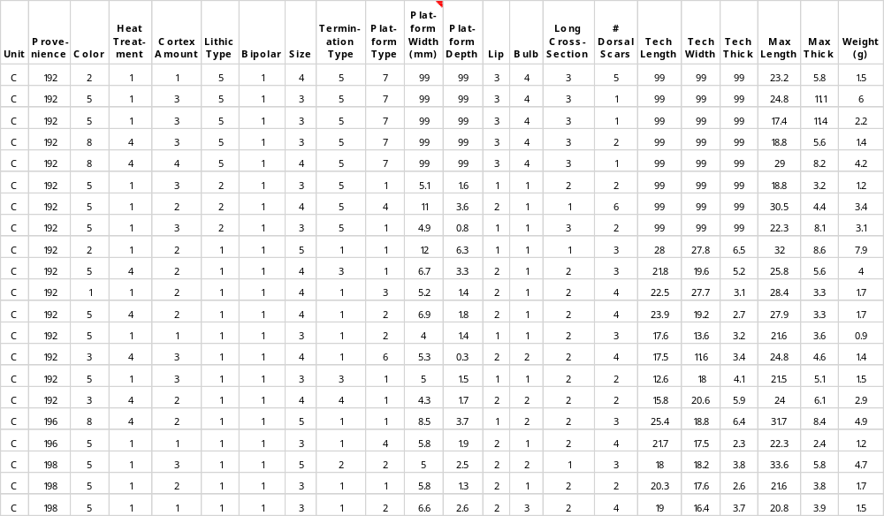

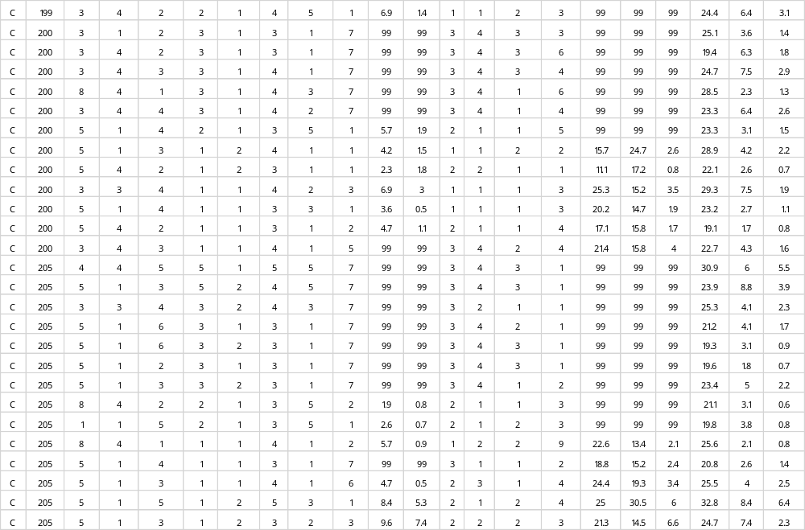
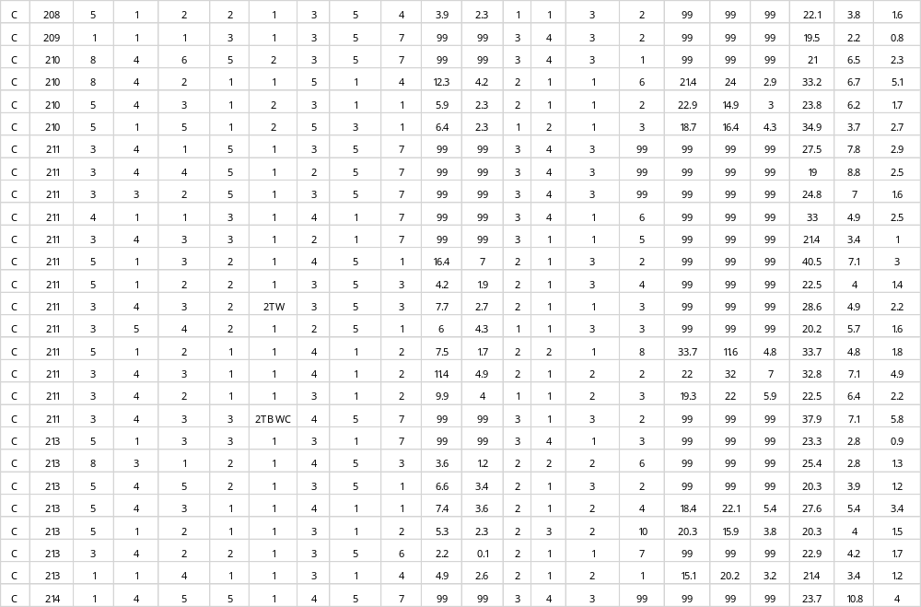
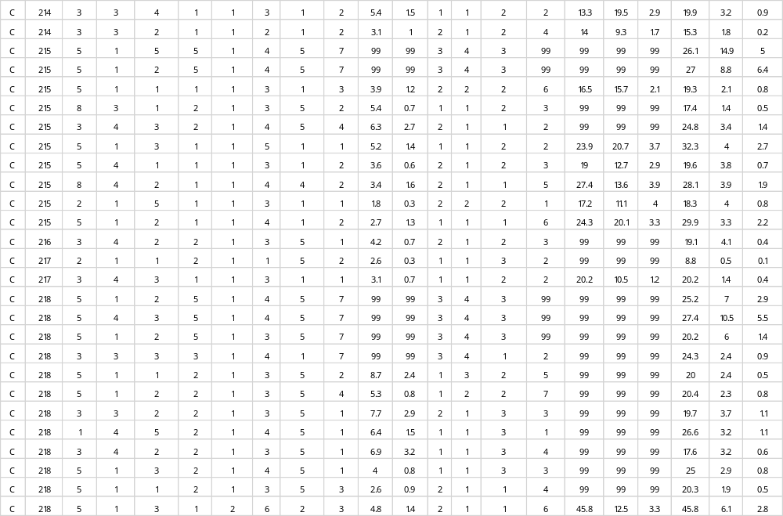
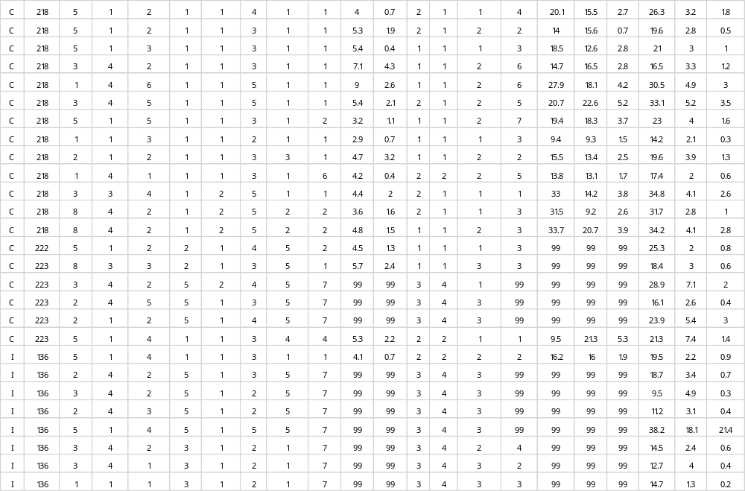
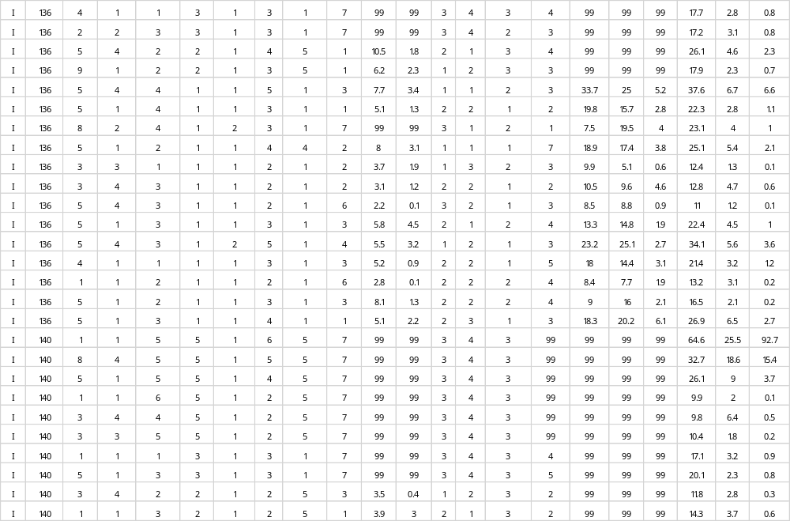
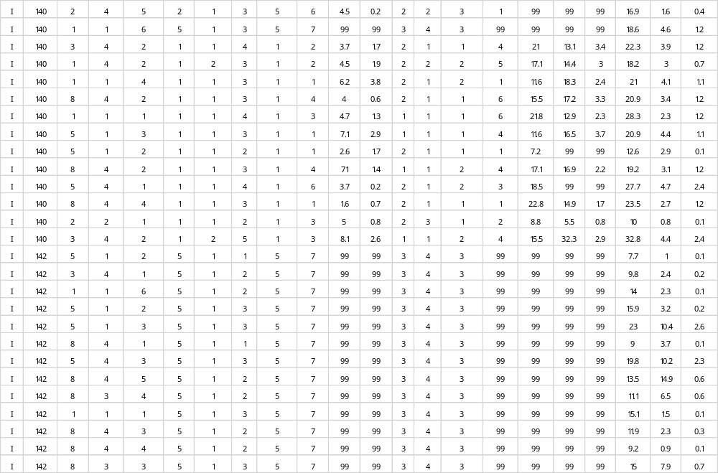

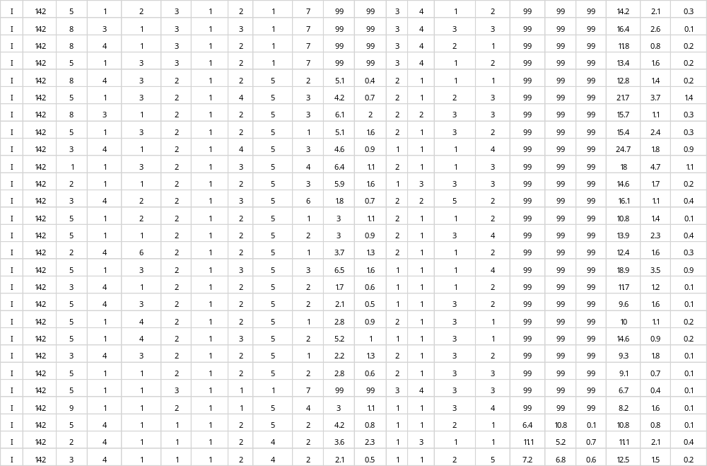
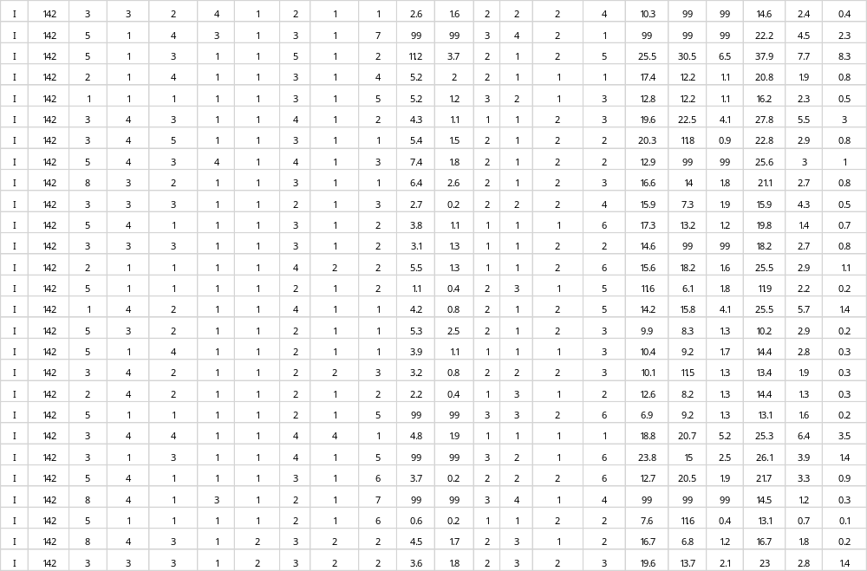
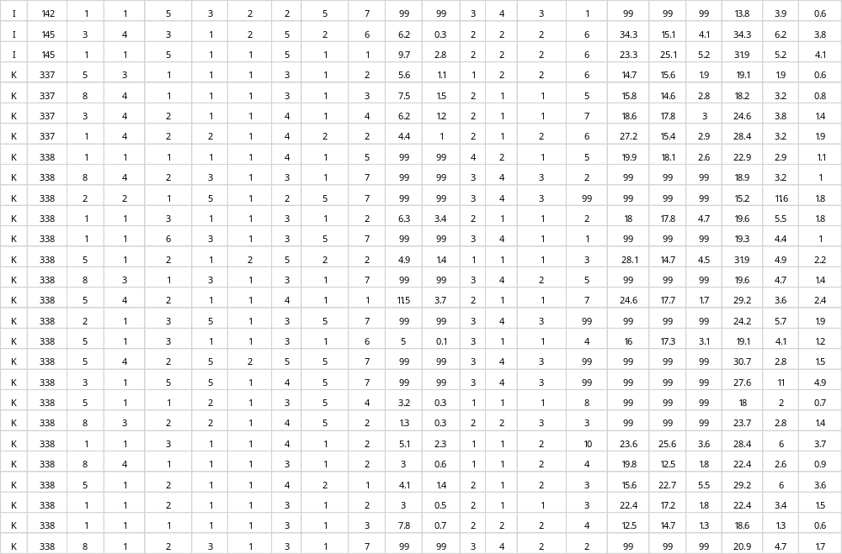
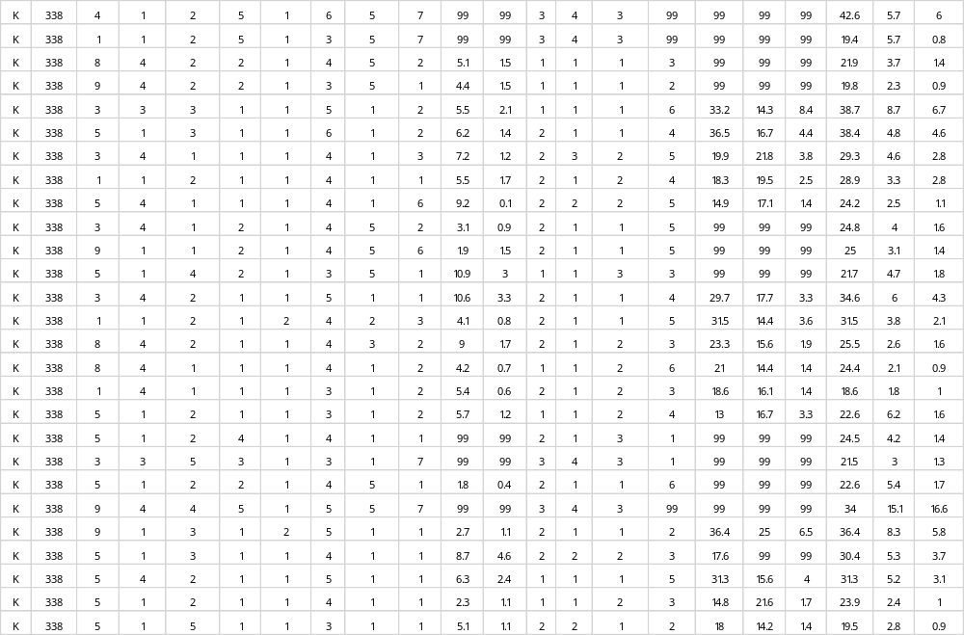

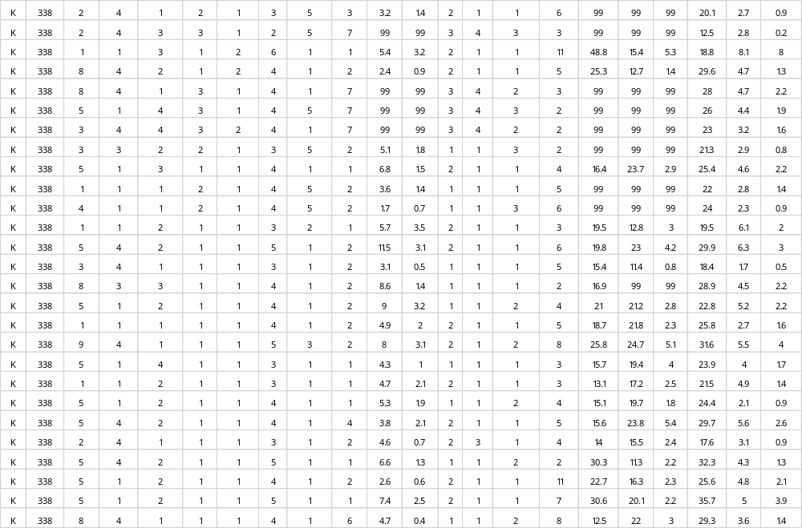
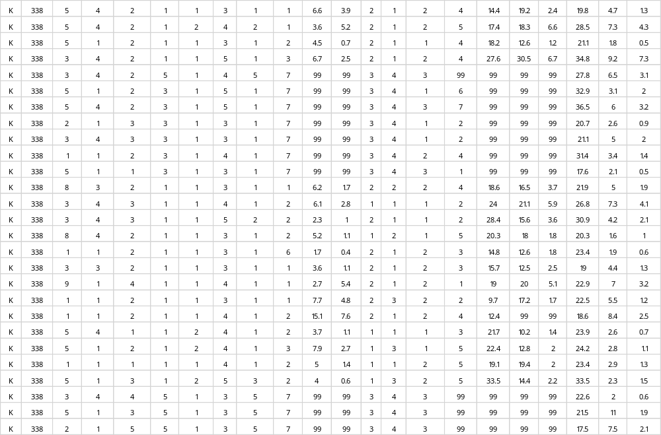
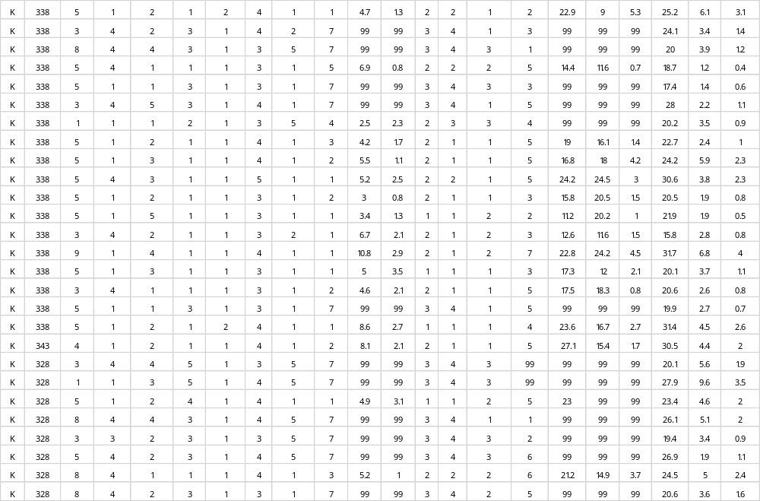
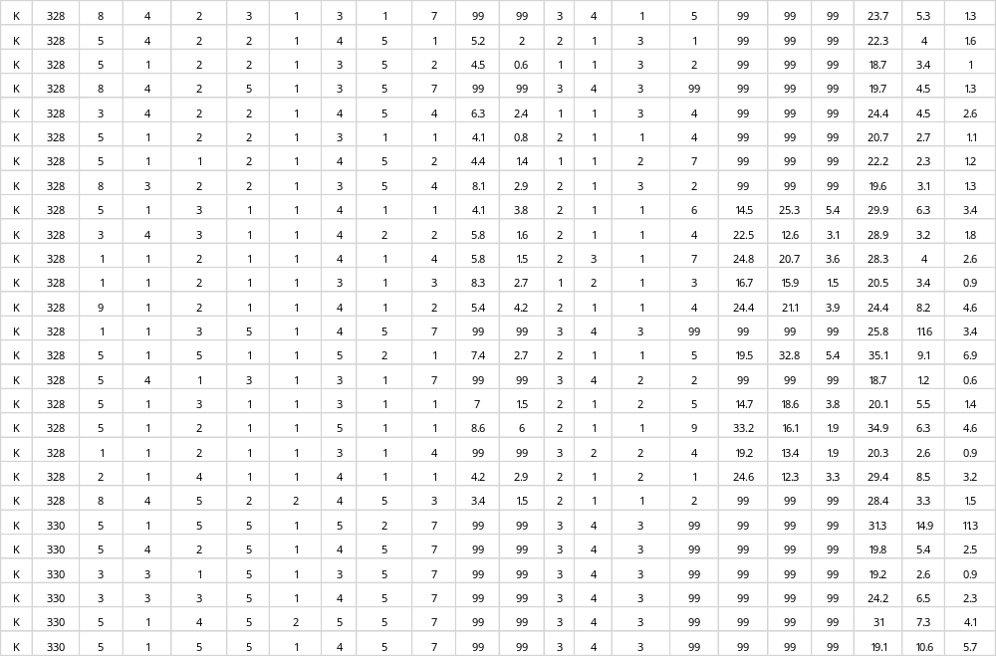
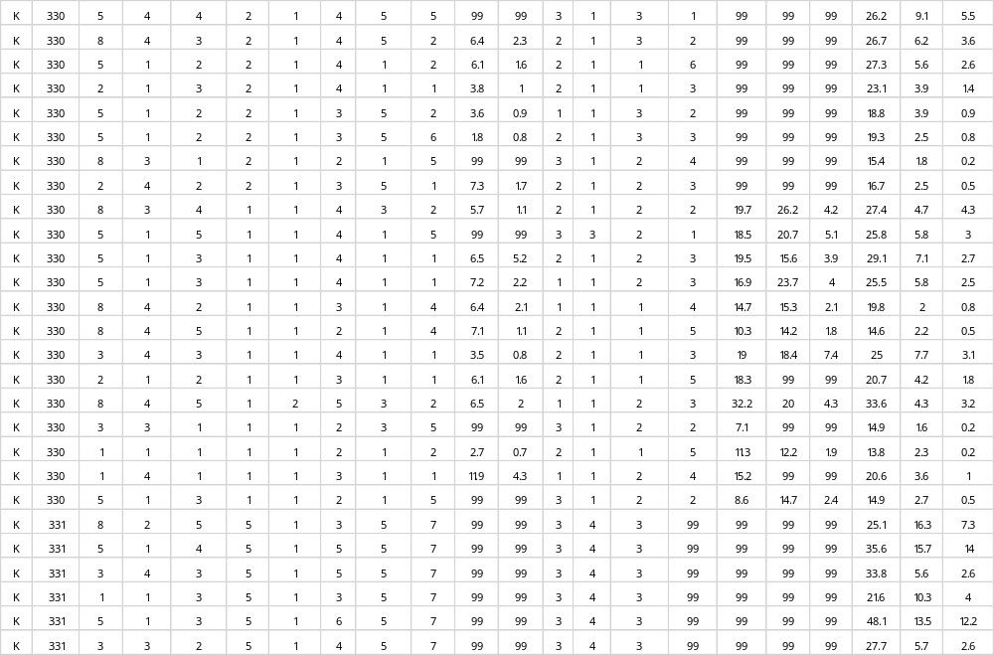
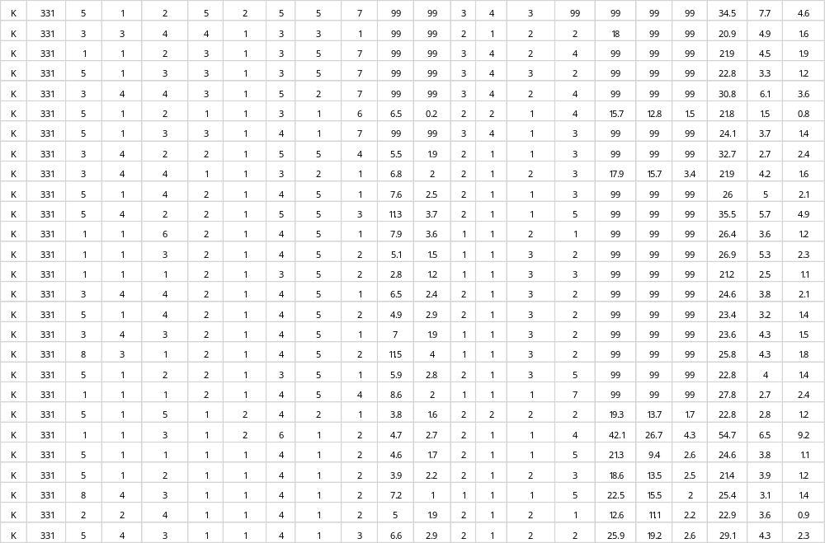
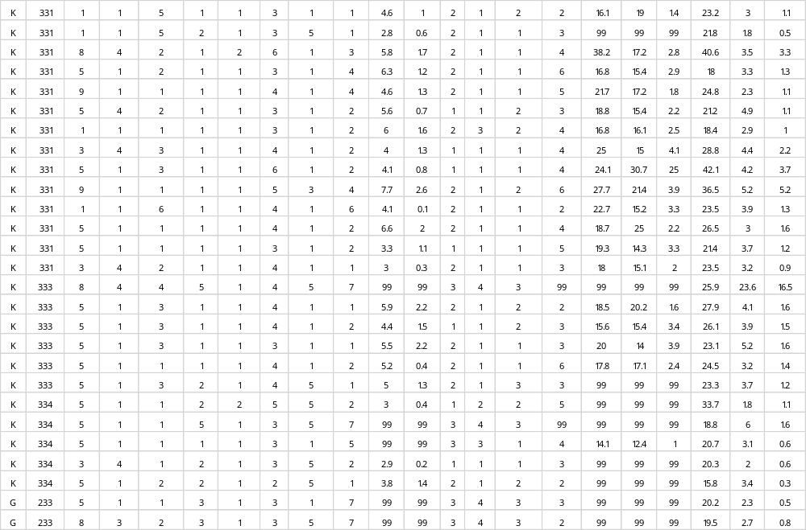
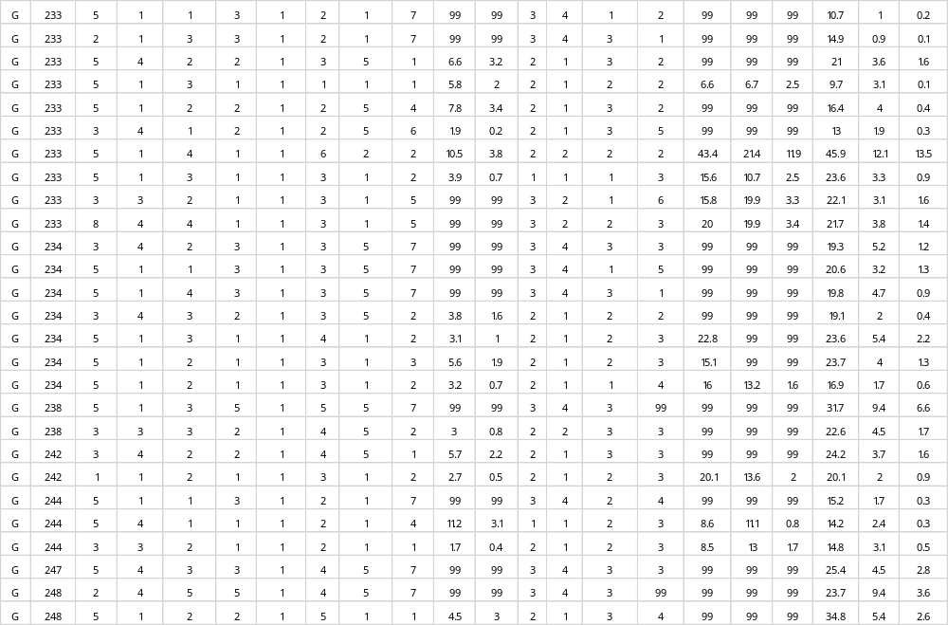
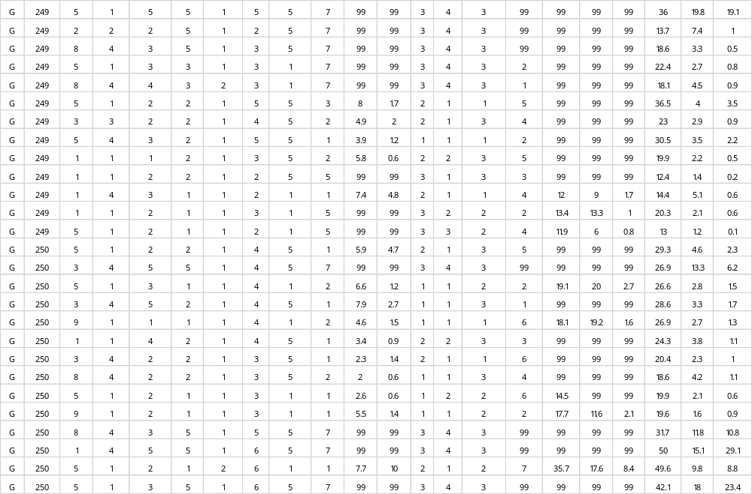
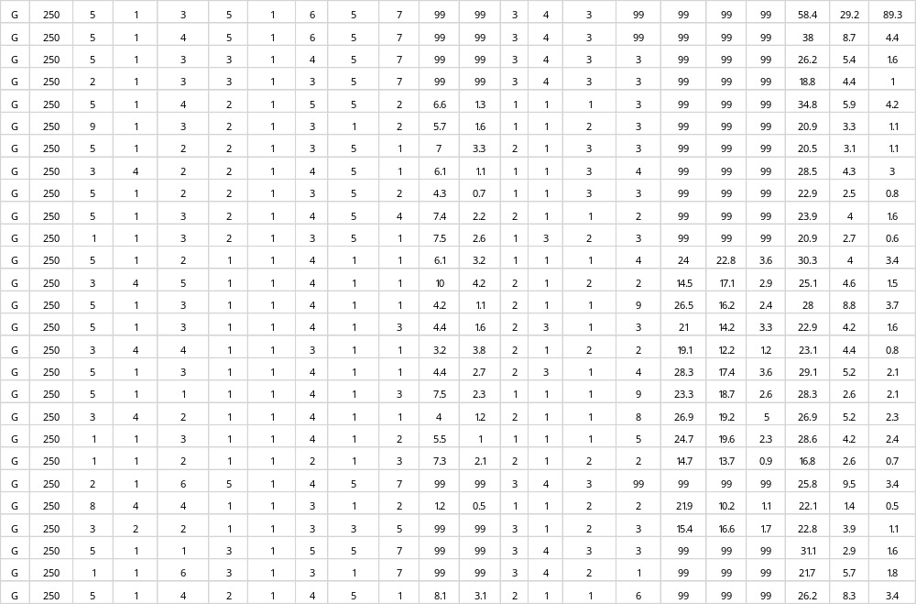
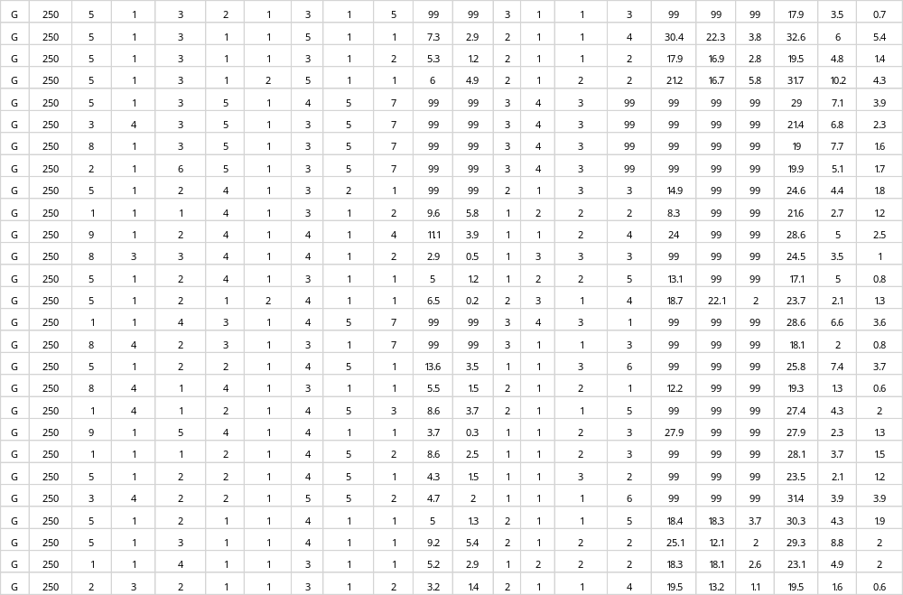
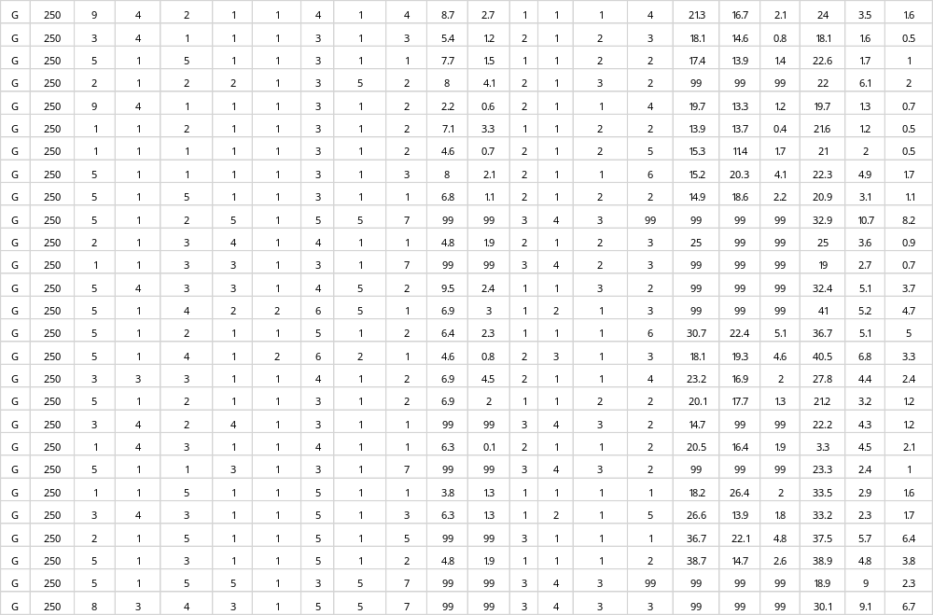
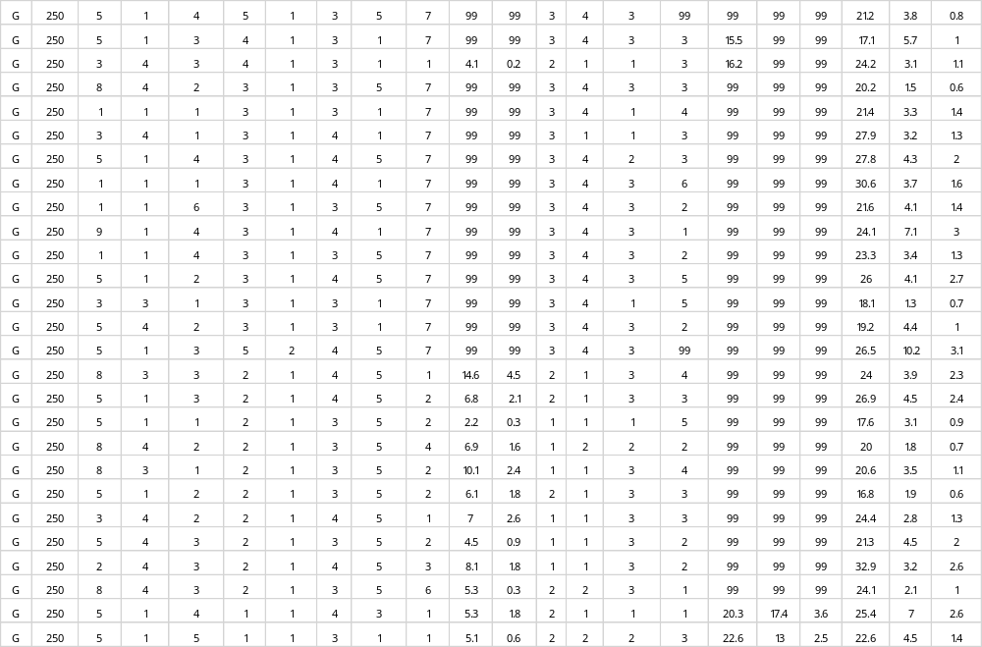
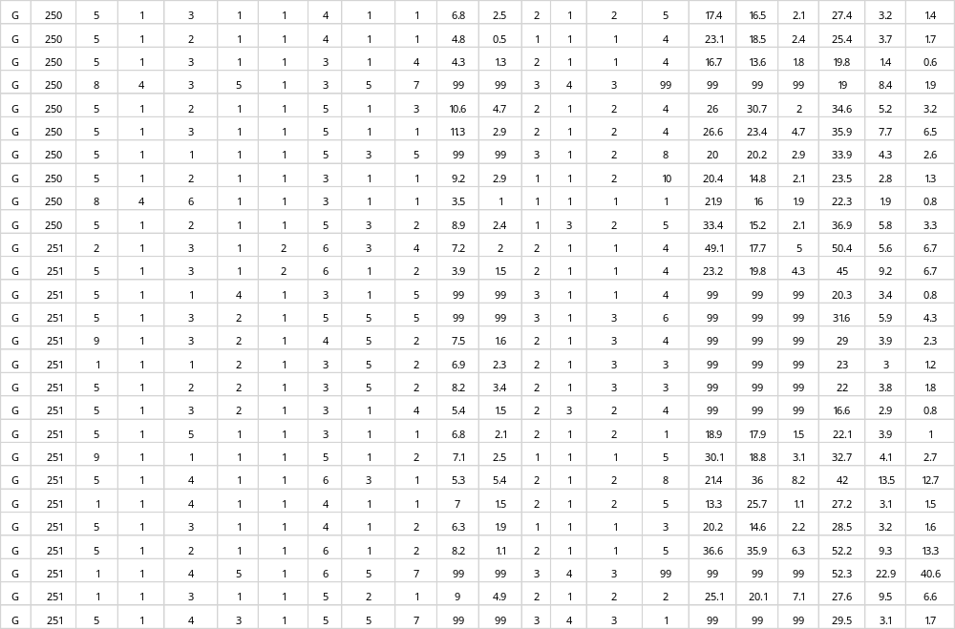
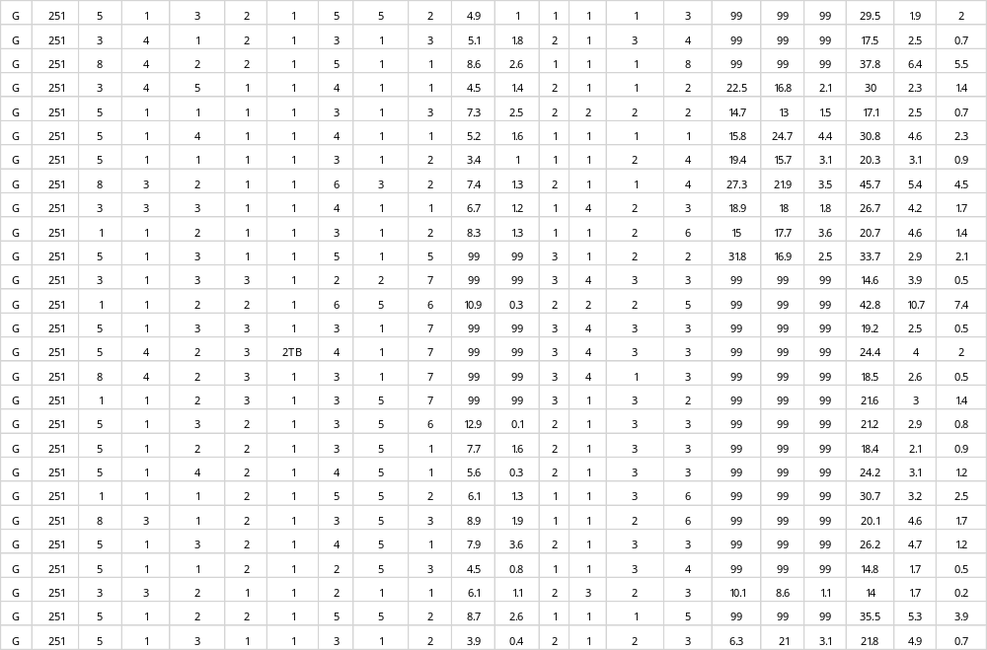
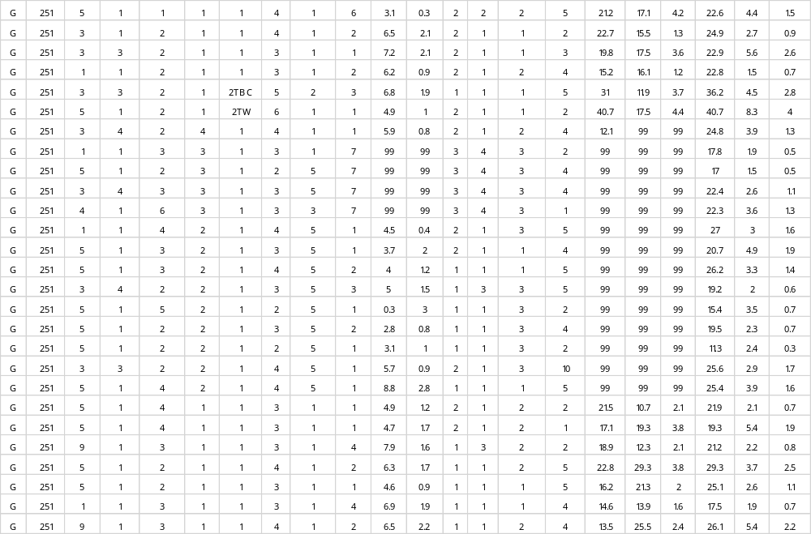
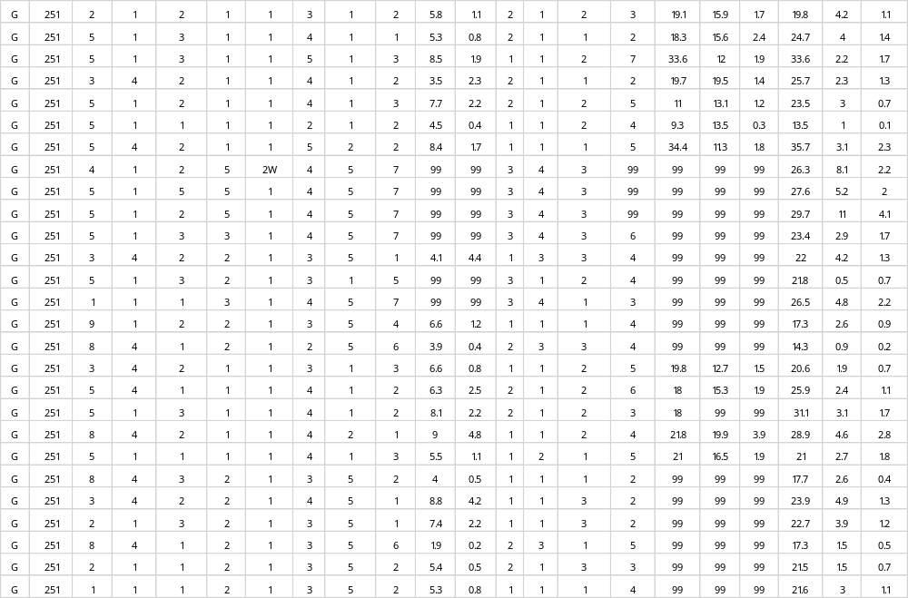
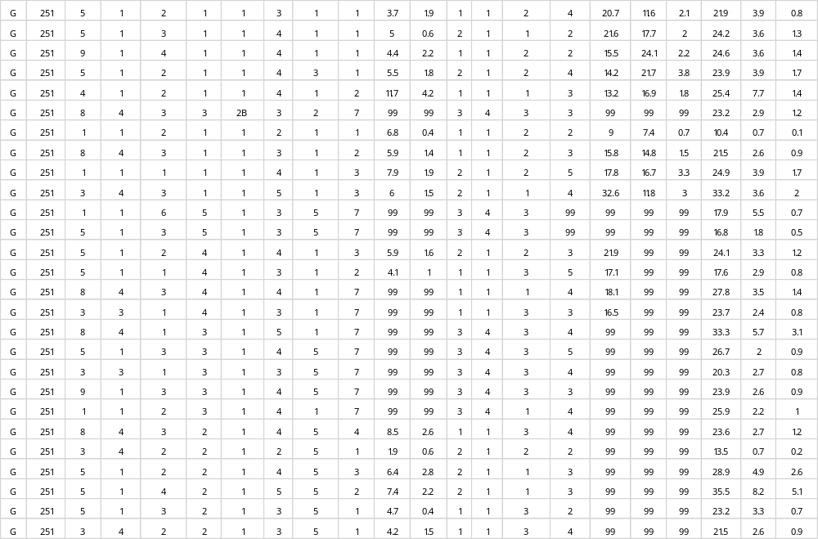
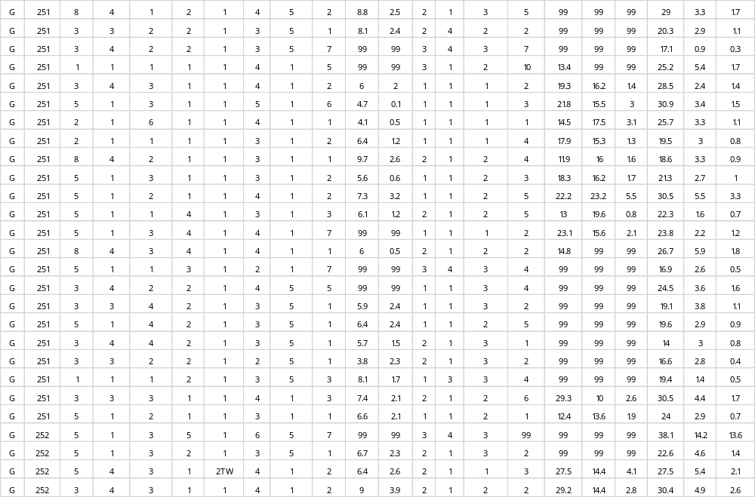
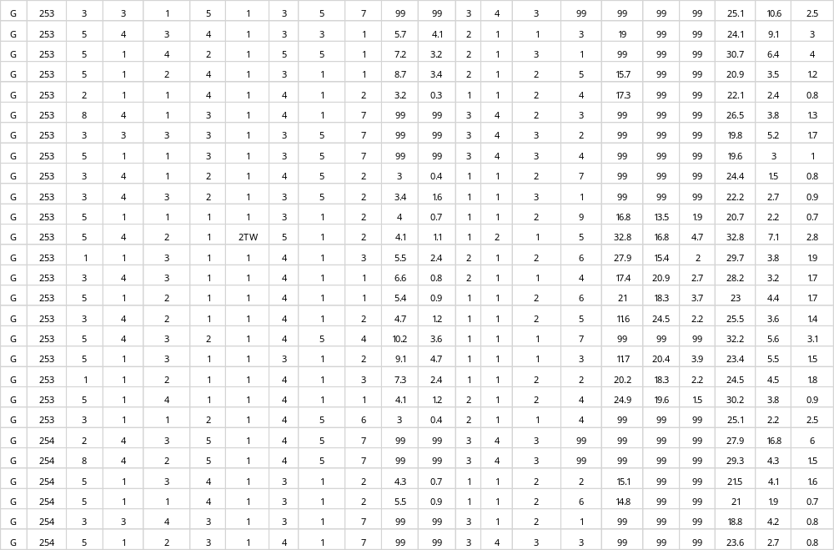
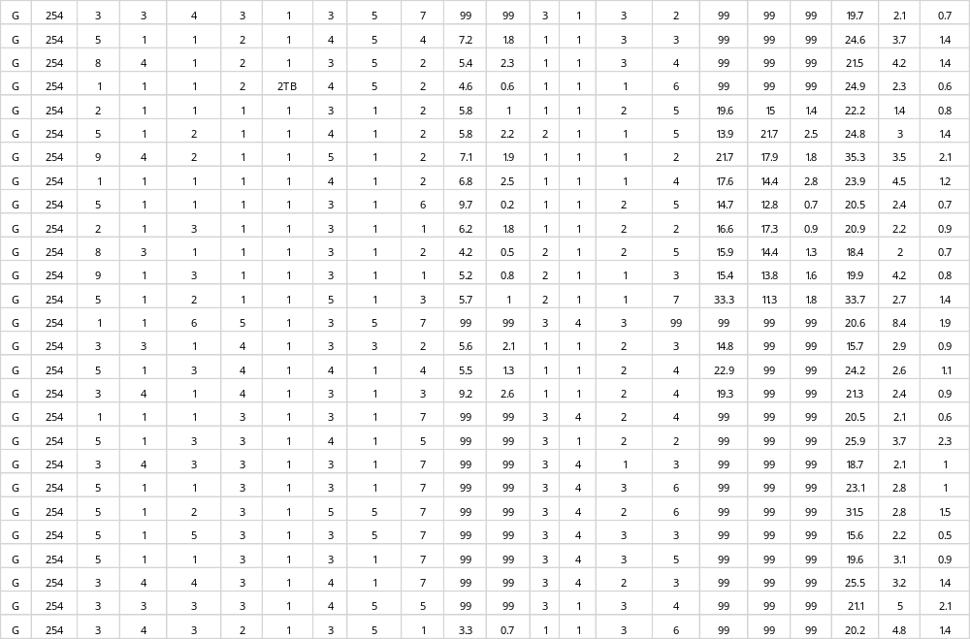
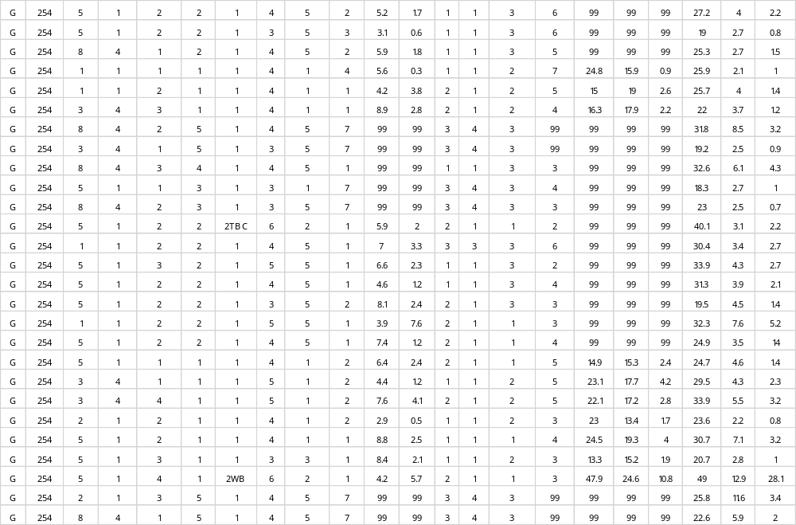
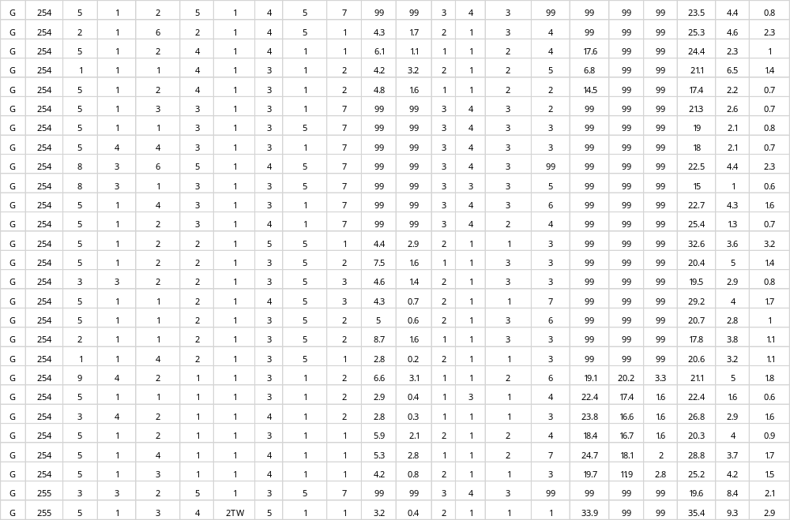
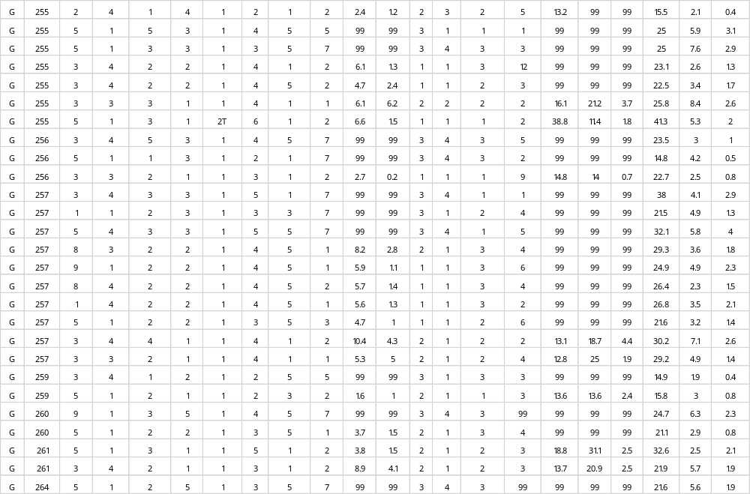
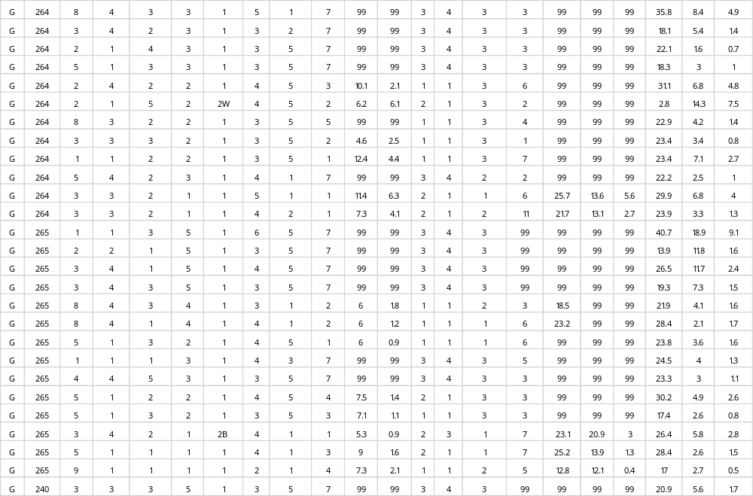
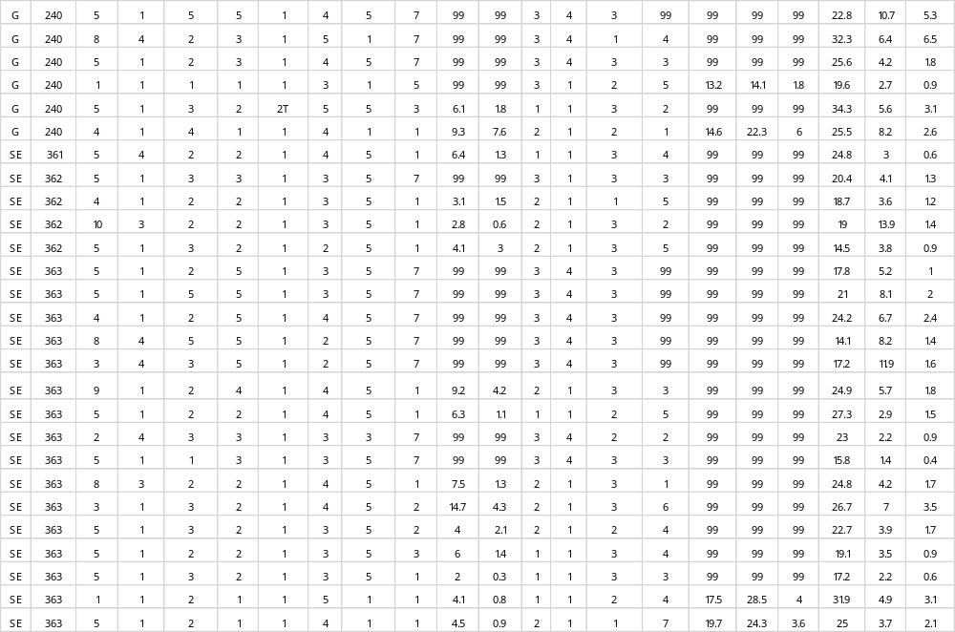
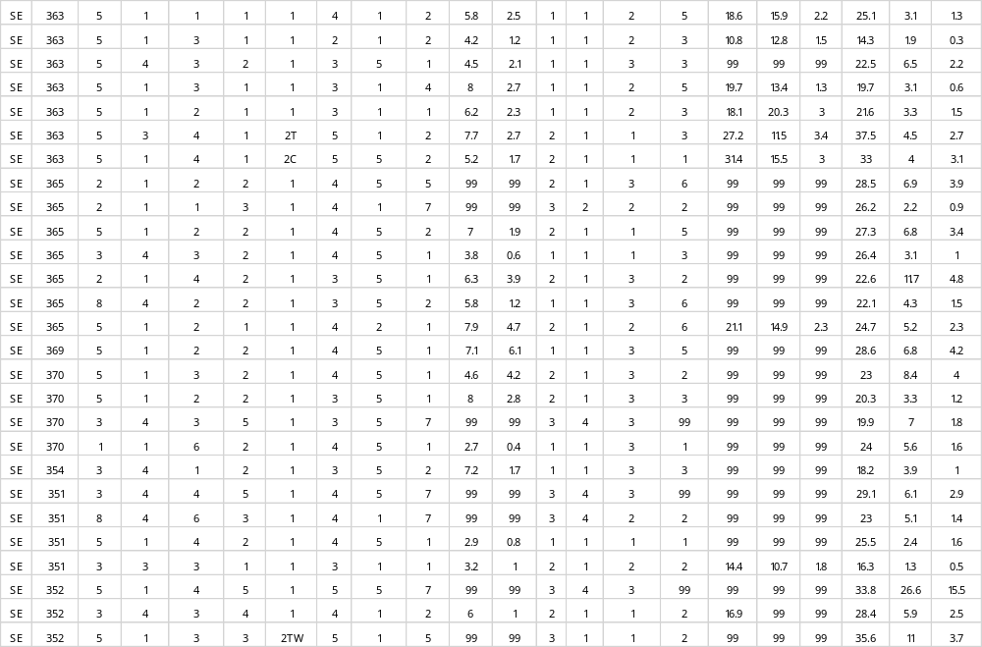
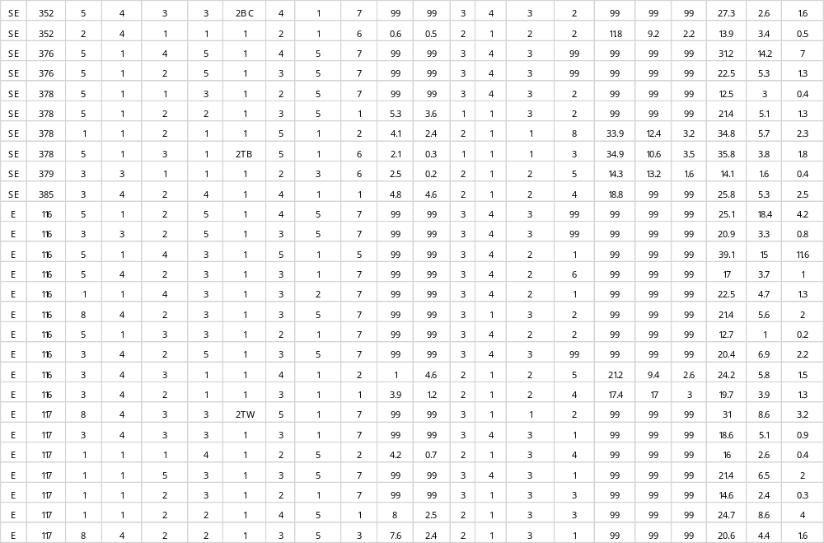

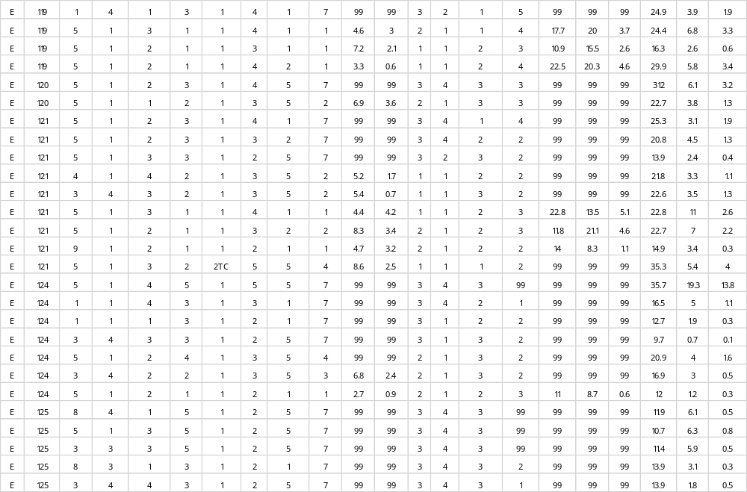
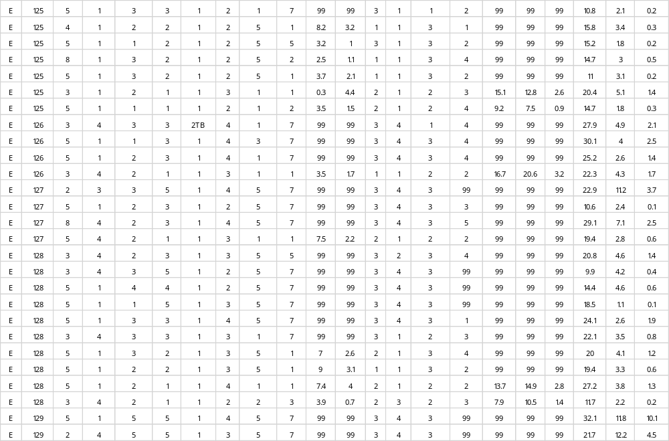
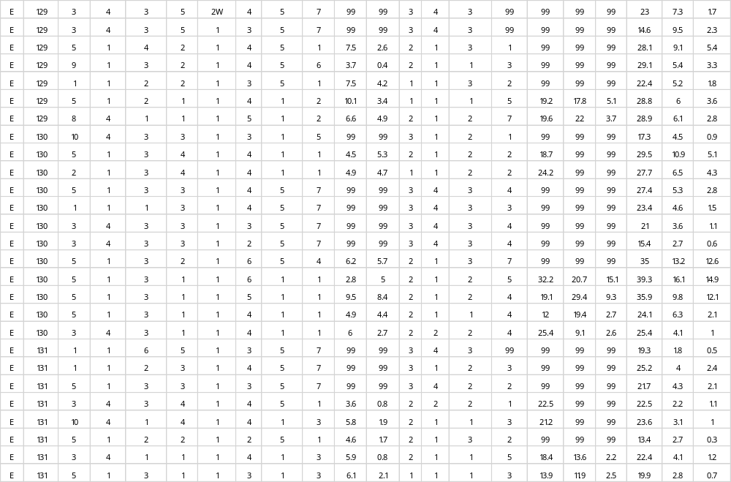

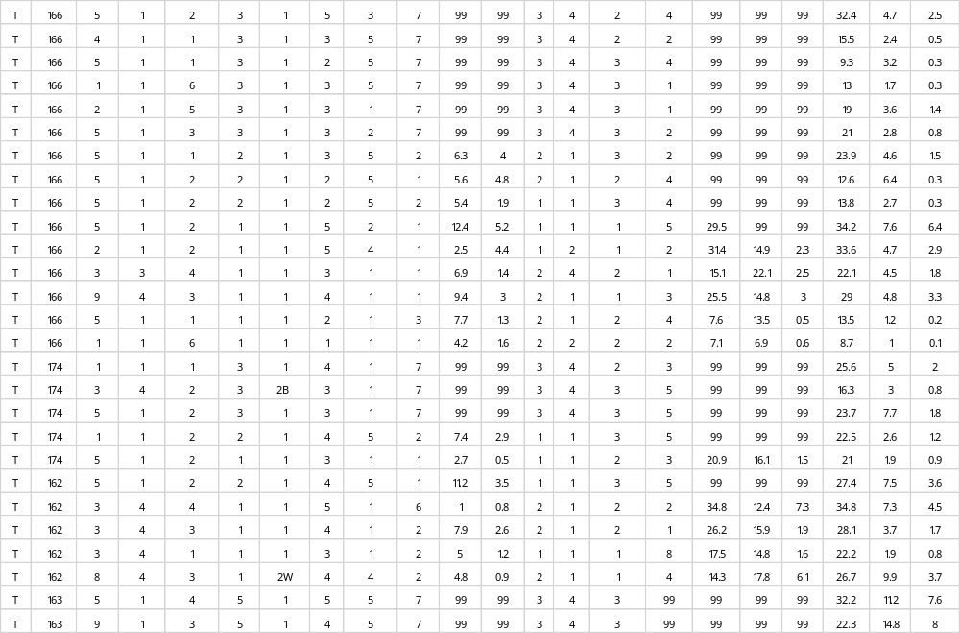
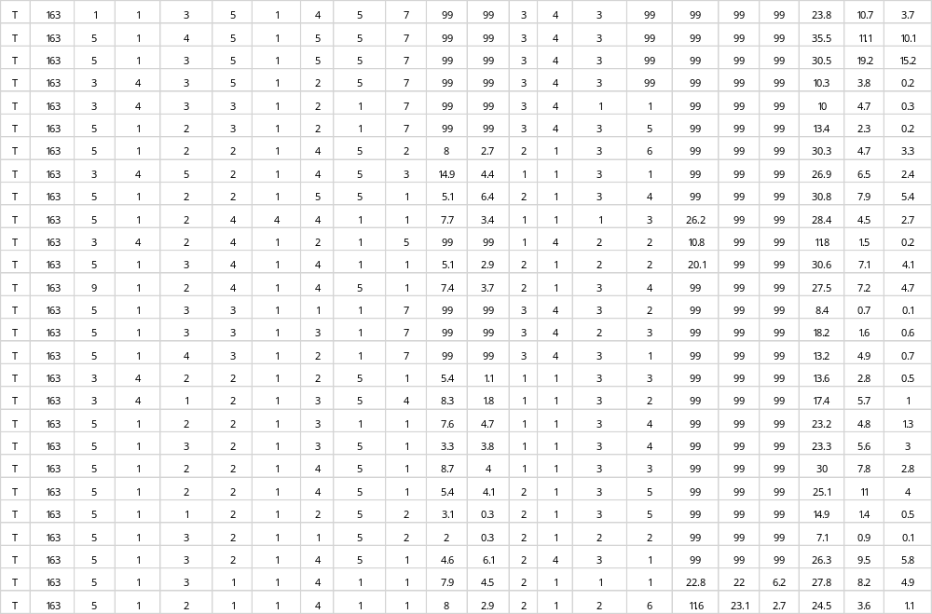
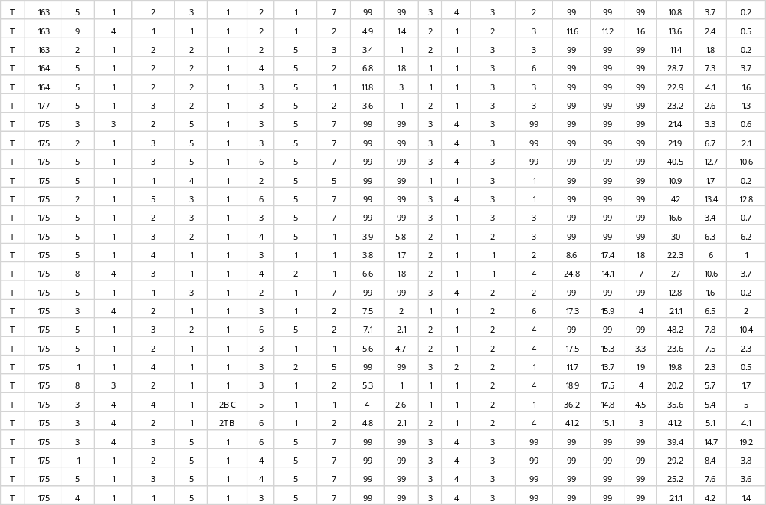
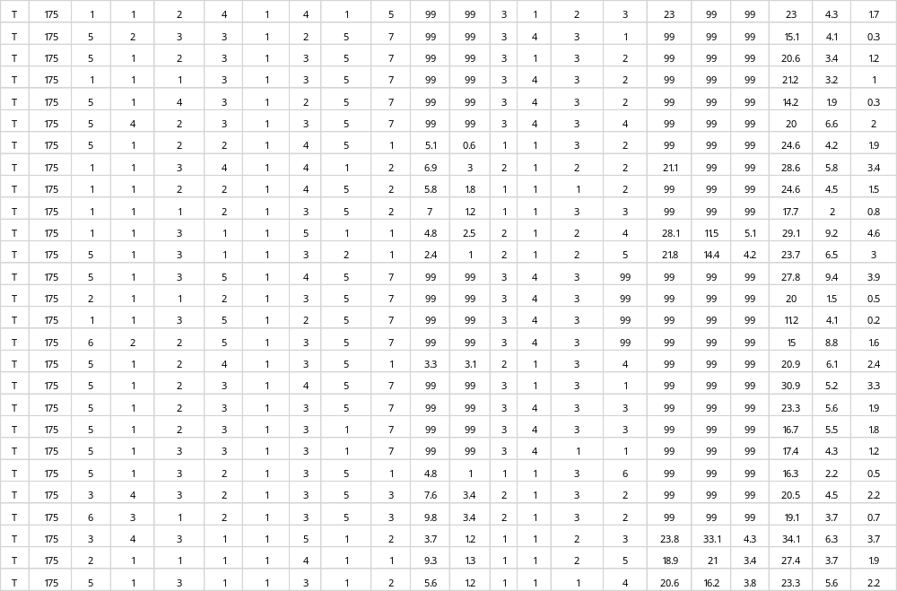
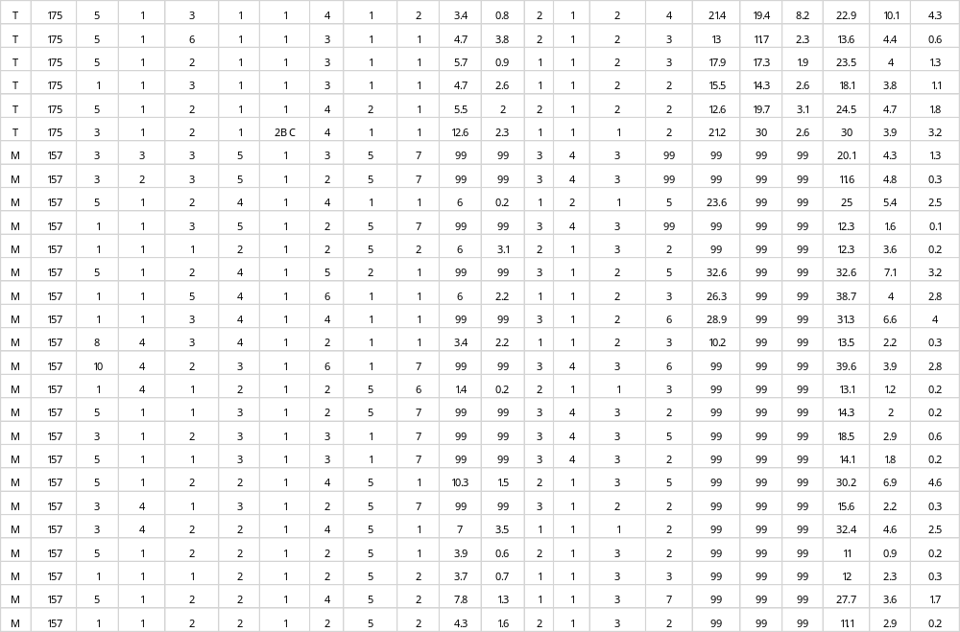
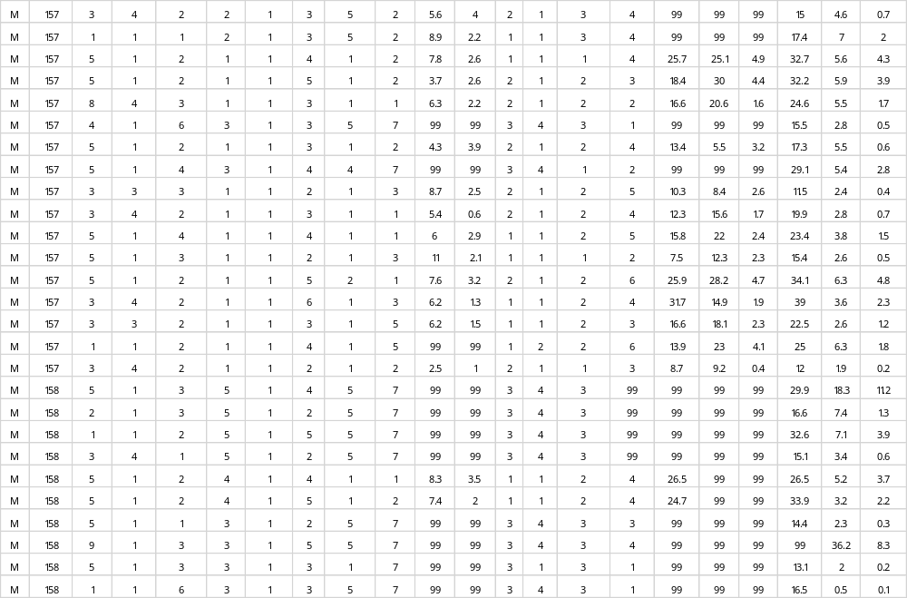
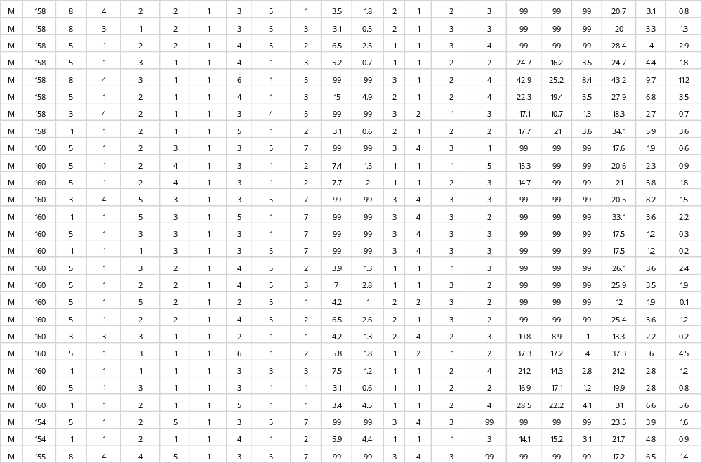
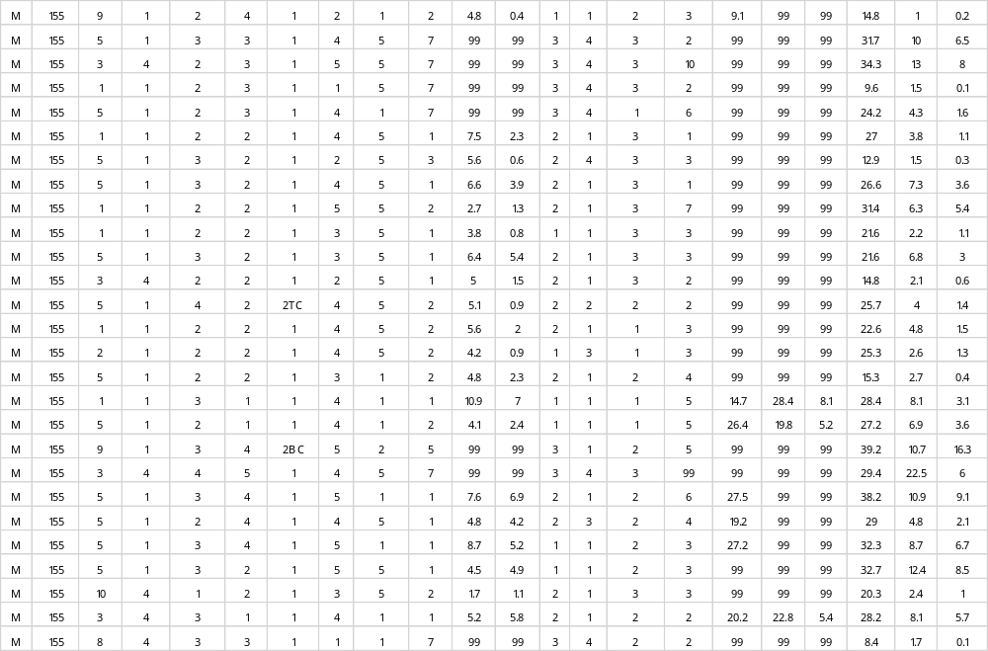
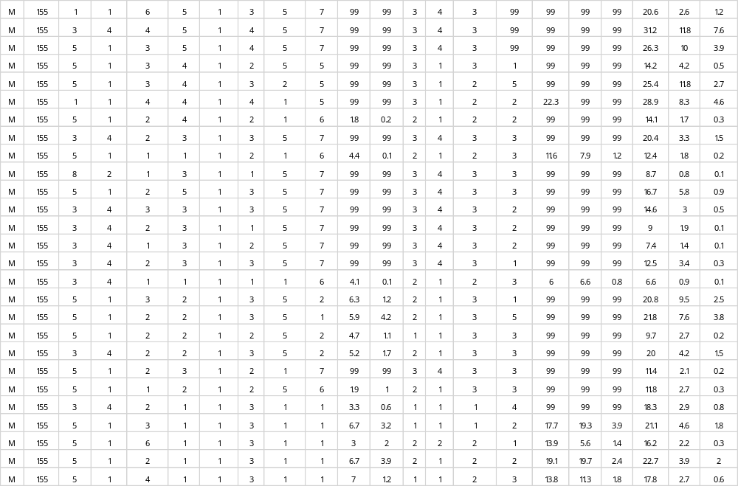
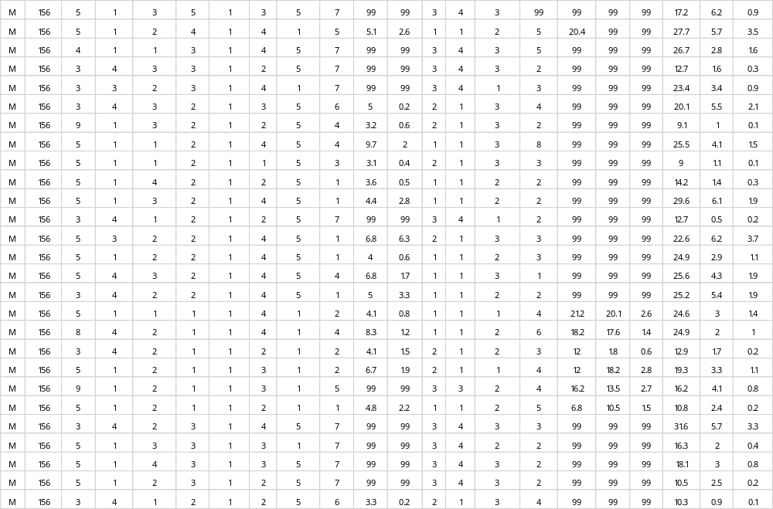
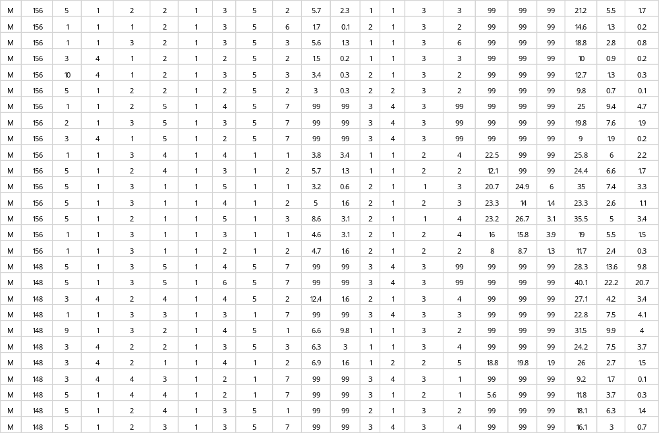
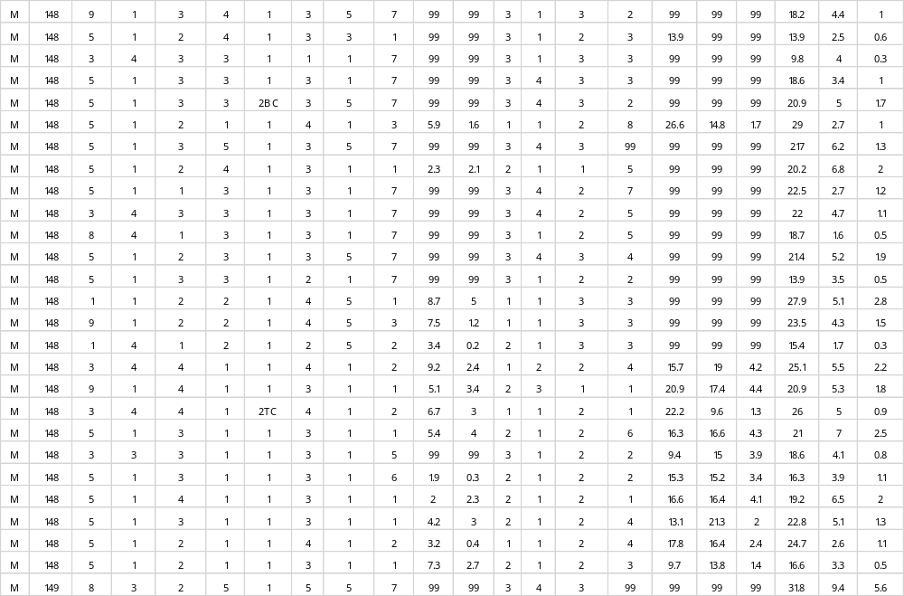
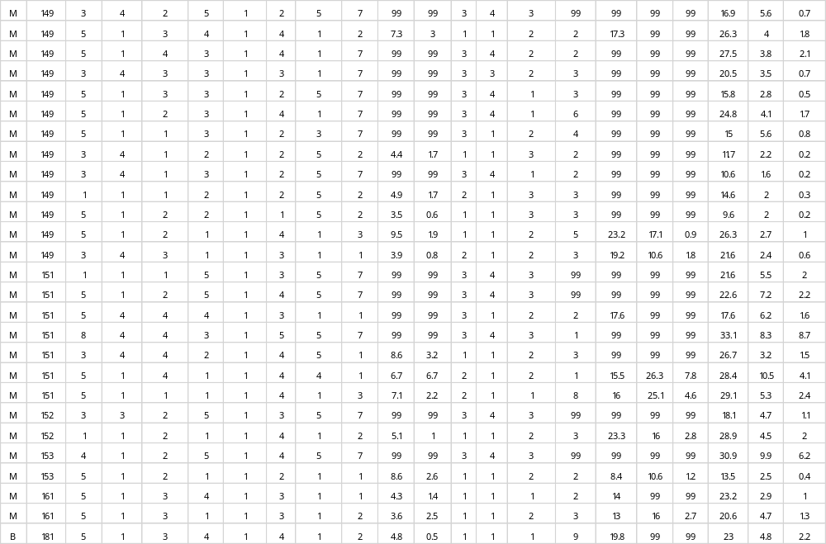
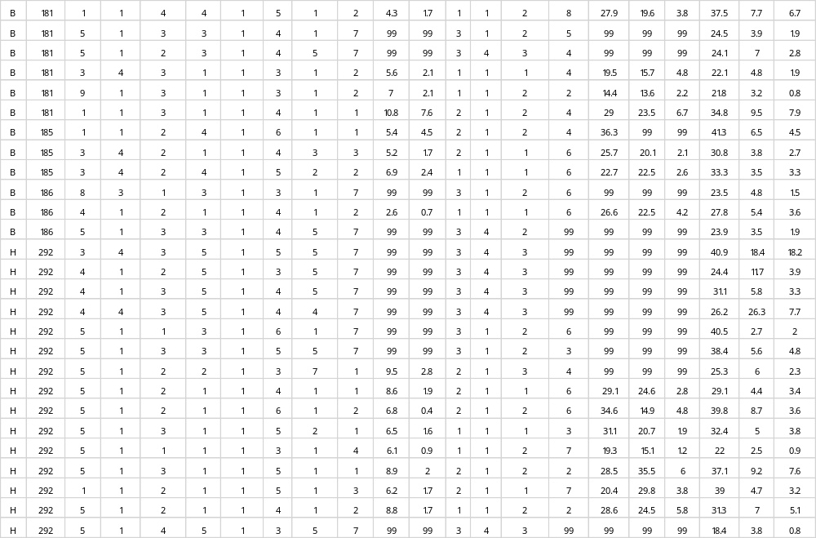
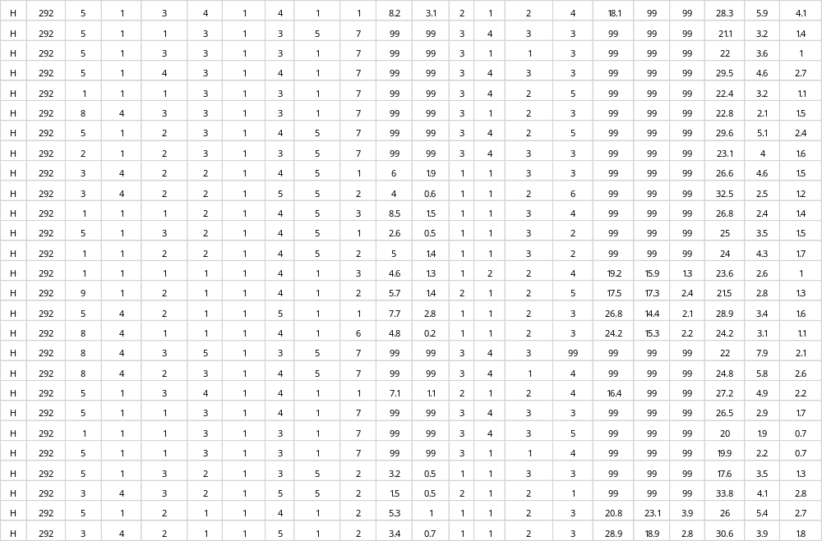
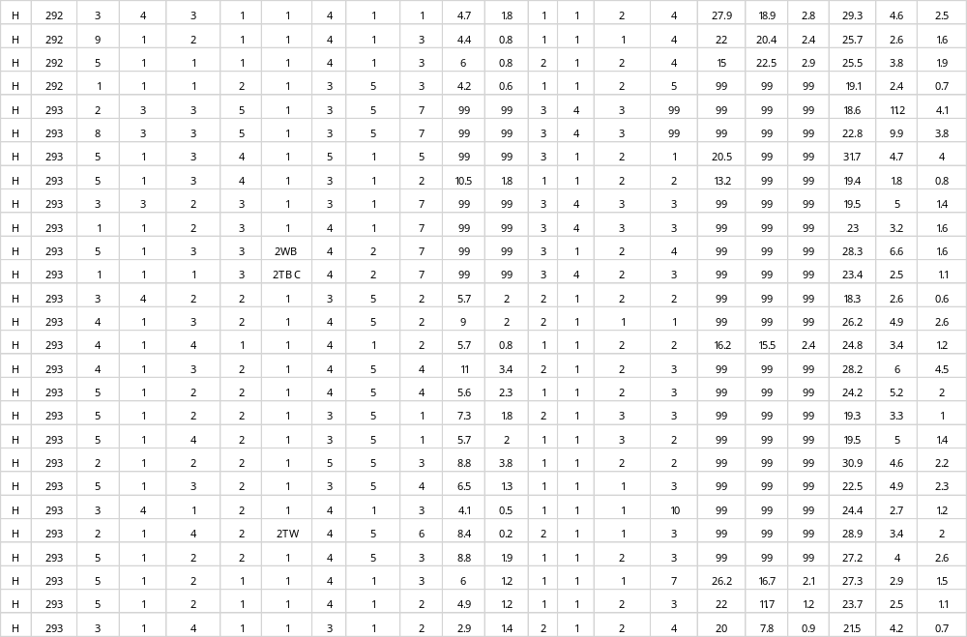
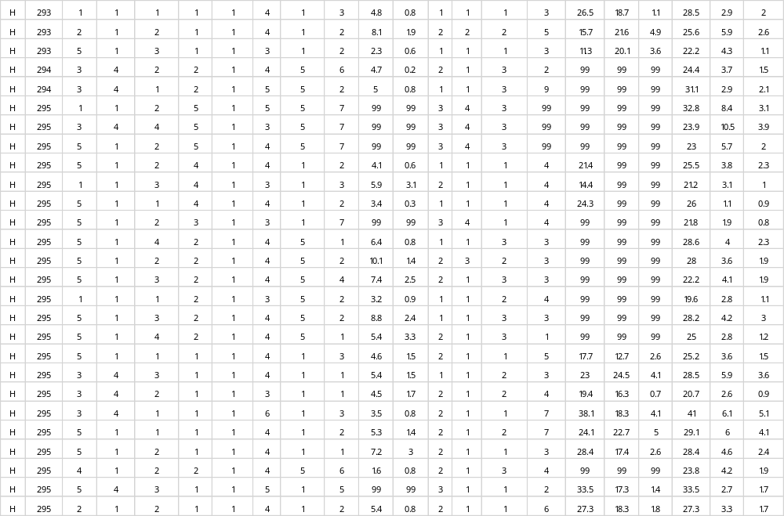
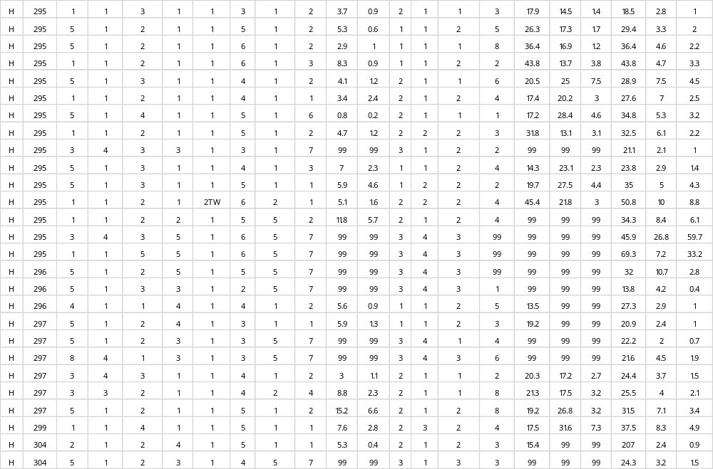
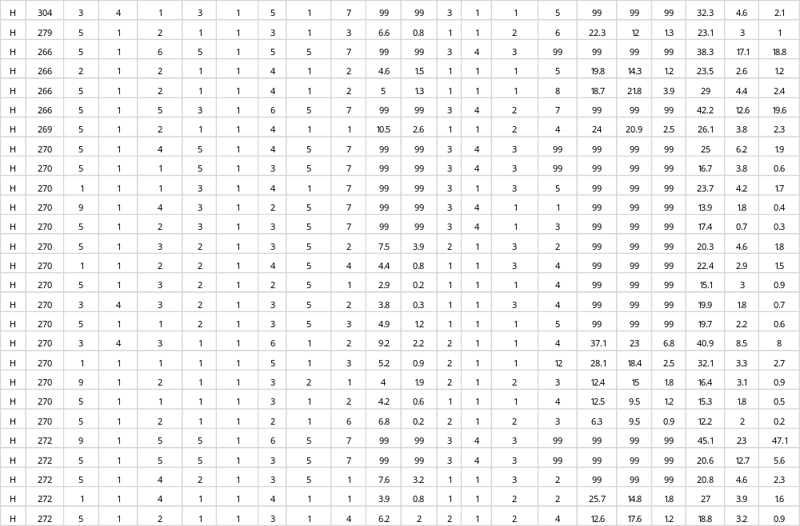
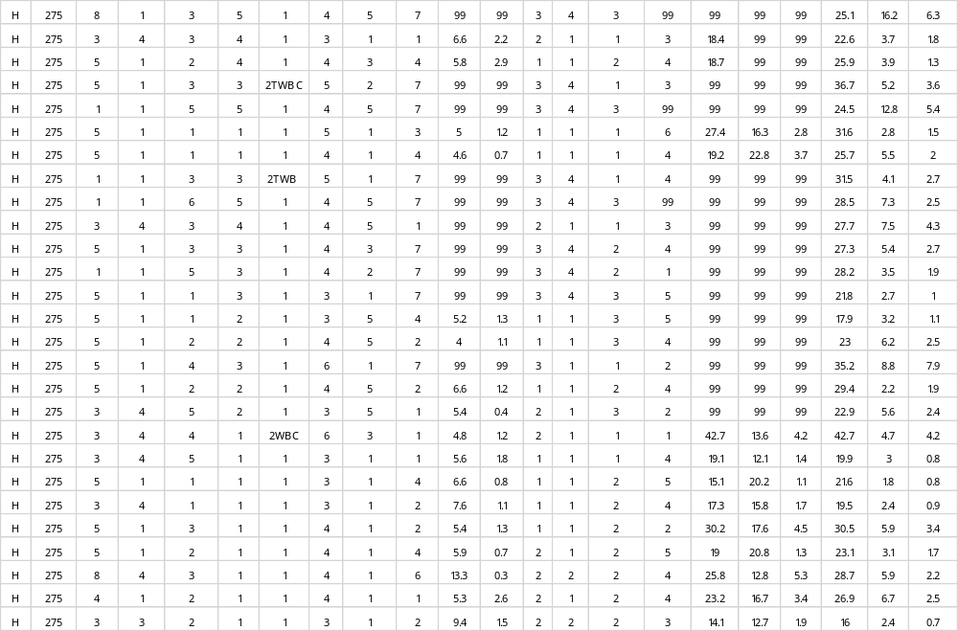
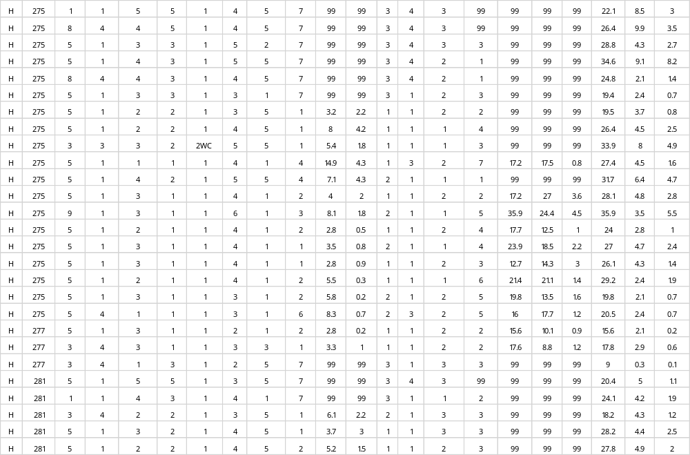
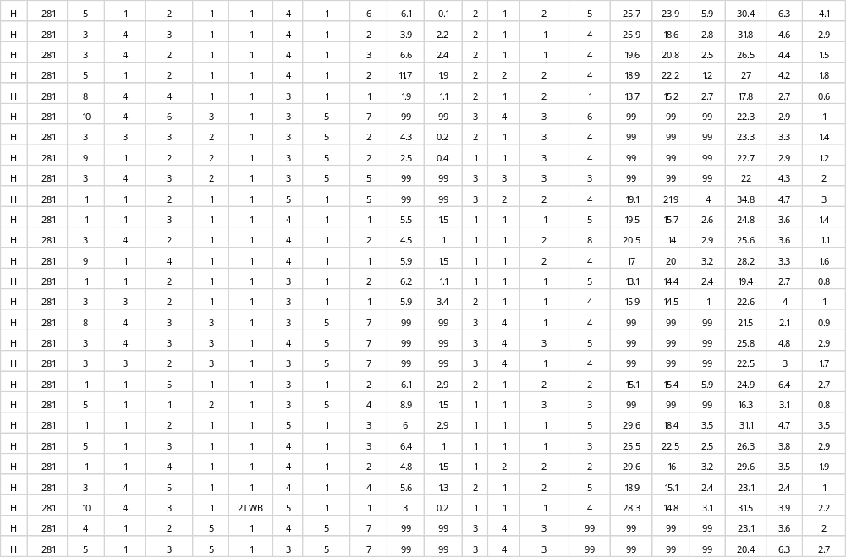
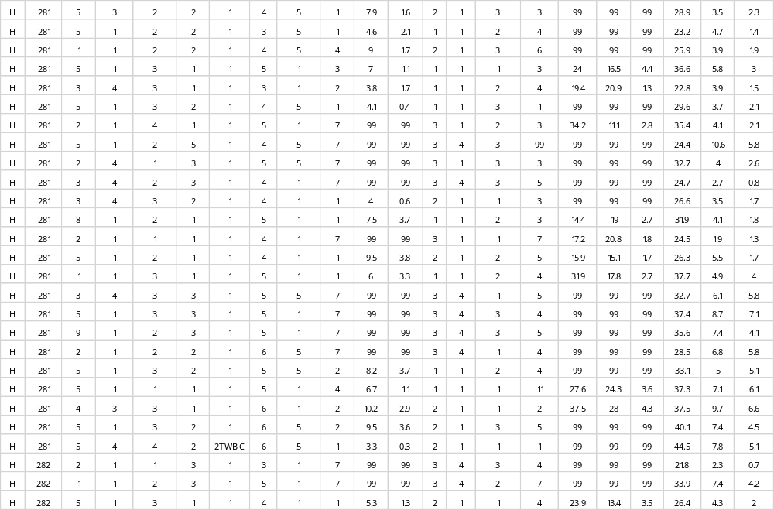

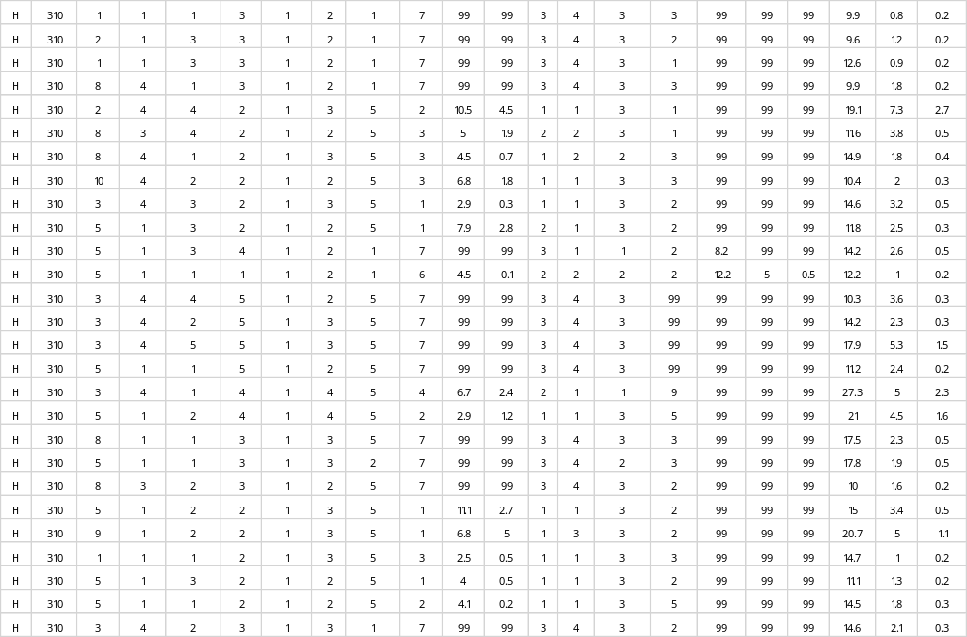
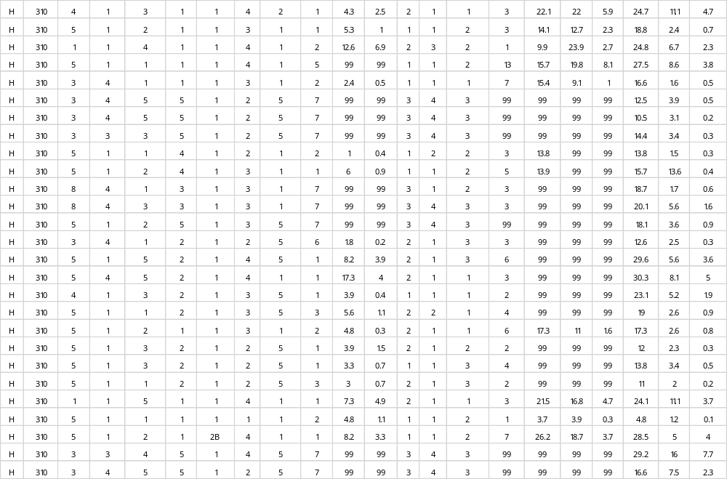
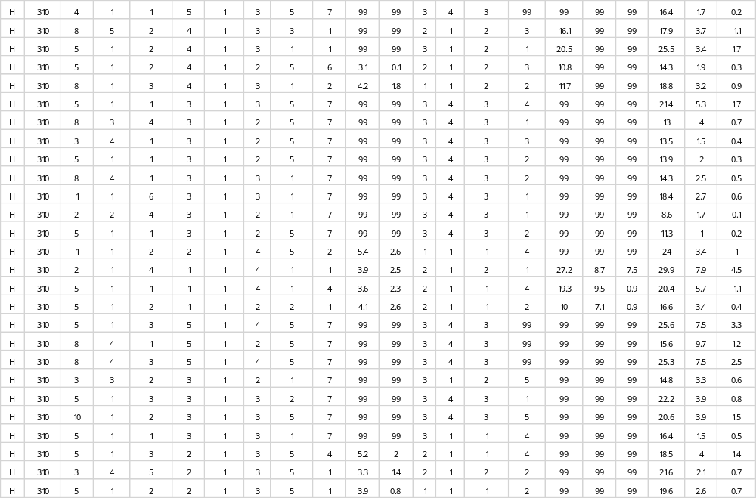
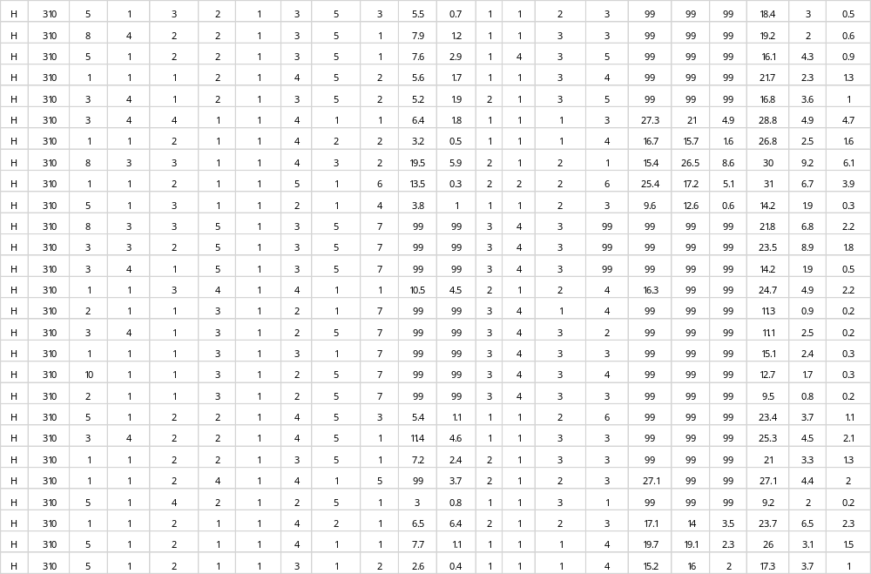
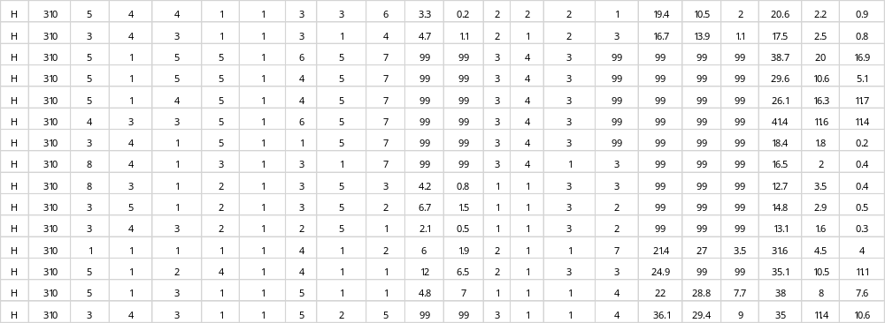

Appendix 5: Lithic Tools Analysis
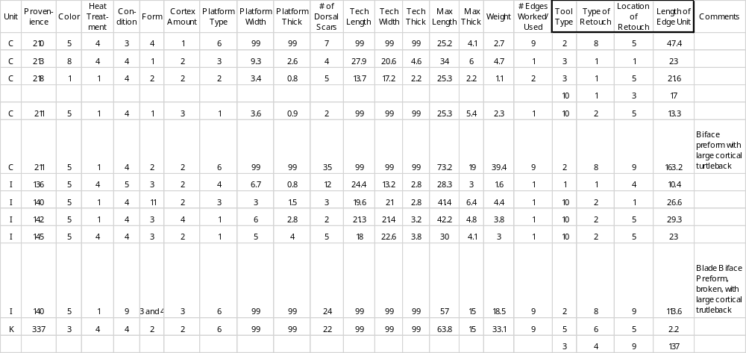

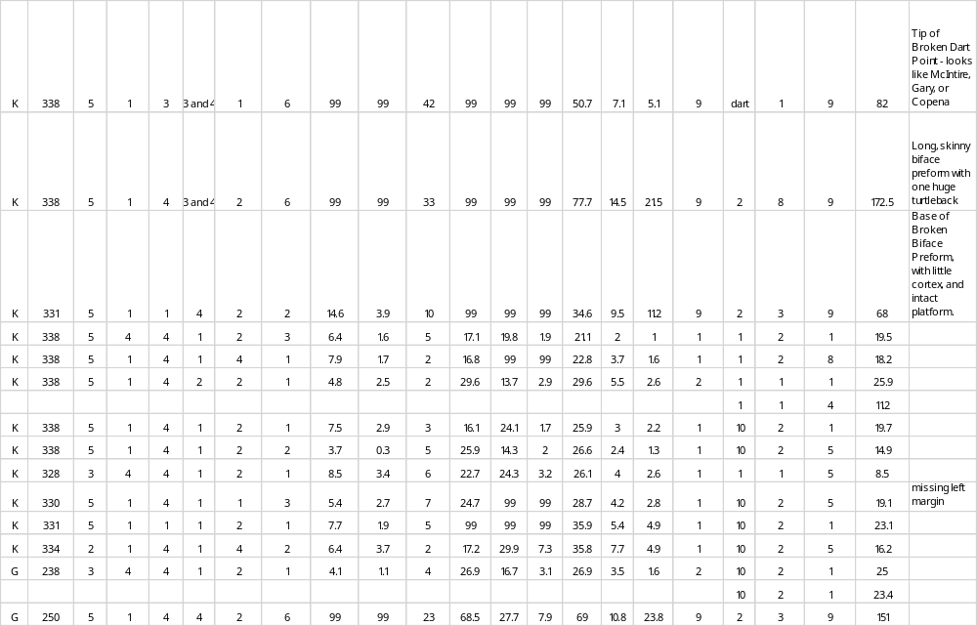
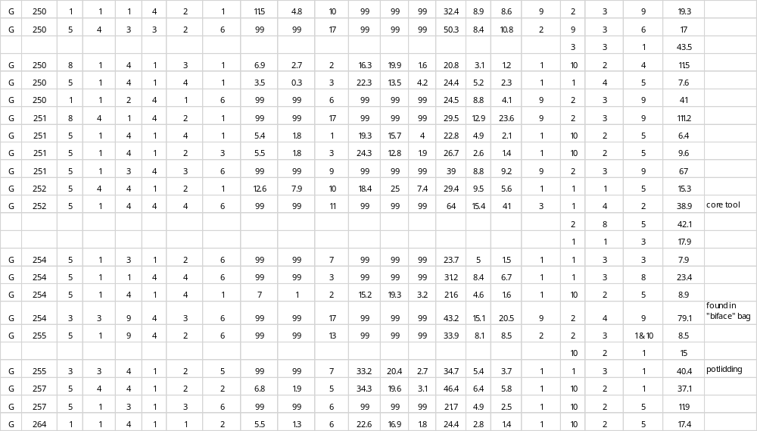

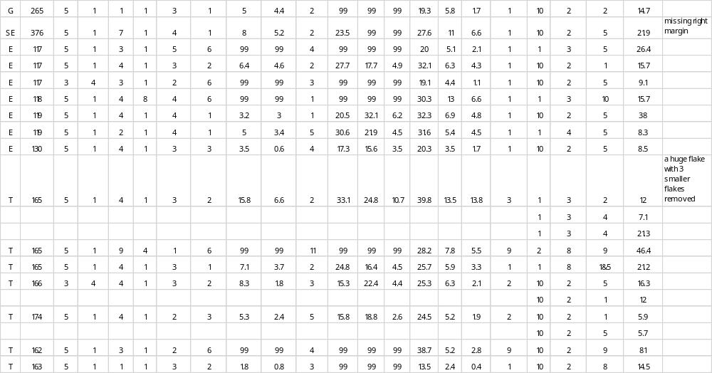

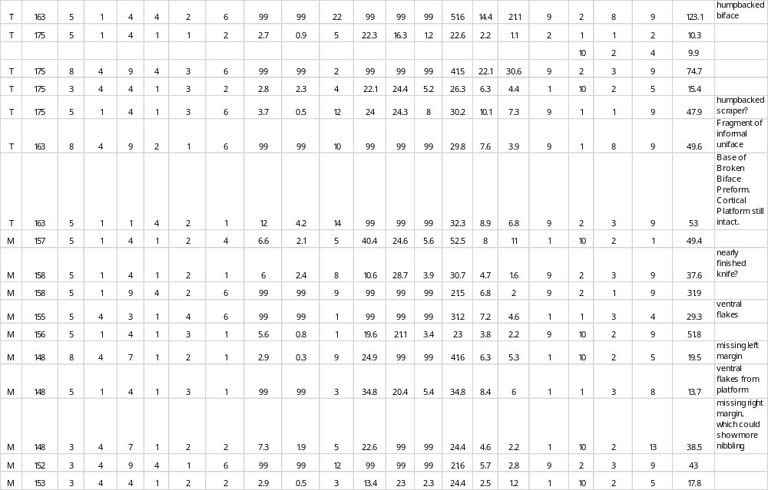
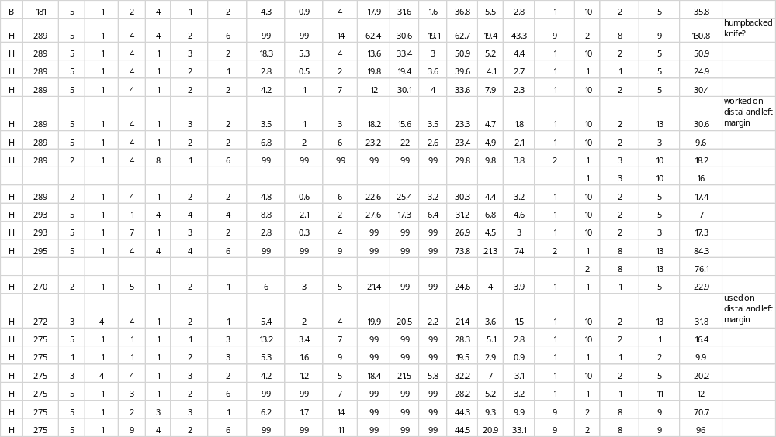

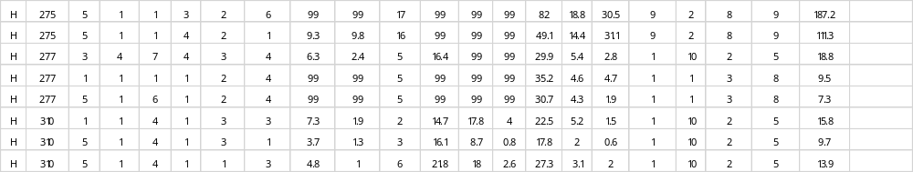

Appendix 6: Hammerstones and Cores Analysis
