University of Oklahoma

Graduate College

Charismatic, Ideological, and Pragmatic Leaders’

Impact on Creative Performance:

Person-Supervisor, Supervisor-Goal, and Person-Goal Fit

A Dissertation

submitted to the Graduate Faculty

in partial fulfillment of the requirements for the

Degree of

Doctor of Philosophy

By

Paul JAcob partlow
Norman, Oklahoma
2016

Charismatic, Ideological, and Pragmatic Leaders’
Impact on Creative Performance:
Person-Supervisor, Supervisor-Goal, and Person-Goal Fit

A Dissertation approved for the
Department of Psychology

By

______________________________
Dr. Michael Mumford, Chair

______________________________
Dr. Michael Buckley

______________________________
Dr. Shane Connelly

______________________________
Dr. Jorge Mendoza

______________________________
Dr. Jeffrey Schmidt

© Copyright by Paul jacob partlow 2016
All Rights Reserved.

Dedicated to my mother. Without her, none of this would have been possible.

Acknowledgements

I would like to thank my advisor, Dr. Michael D. Mumford, for his insight and support as well as my committee members, Dr.’s Michael R. Buckley, Shane Connelly, Jorge Mendoza, and Jeffrey Schmidt, for their valuable feedback. I am forever indebted to my phenomenal research assistants, Daniela Flores, Jason Nance, Sonal Patel, Shanna Rolfs, and Emily Rounds, who were all able to adequately cope with the quirky behaviors of their boss. I am also grateful to Kelsey Medeiros and the rest of my lab members for helping me complete this achievement.

Table of Contents
Acknowledgements iv
List of Tables vii
List of Figures viii
Abstract ix
Introduction 1
CIP Leadership 2
Charismatic Leaders 2
Ideological Leaders 3
Pragmatic Leaders 4
CIP Leadership and Crises 5
Leadership style effects 5
Crisis situation effects 6
Research on CIP leader-situation effects 7
Person-Supervisor Fit 10
Supervisor-Goal Fit 12
Person-Goal Fit 14
Method 16
Sample 16
General Procedures 16
Covariates 18
Intelligence 18
Divergent thinking 19
Expertise 19
Planning Skill 20
Motivation 20
Personality 21
Goal Commitment 21
Experimental Task 22
Manipulations and Follower Style 23
Leader Style 24
Project Goal 25
Crisis Situation 25
Follower Style 26
Dependent Variables 27
Analyses 30
Results 30
Quality 30
Originality 31
Elegance 32
Affective Reaction 33
Specificity 34
Discussion 36
References 45
Appendix A: Tables 56
Appendix B: Figures 61

List of Tables
Table 1. Differences among charismatic, ideological, and pragmatic leaders’ prescriptive mental models 57
Table 2. Means, standard deviations, and intercorrelations of study variables 58
Table 3. Effects of leader style, goals, crisis, and follower style on solution quality, originality, and elegance 59

List of Figures
Figure 1. Leadership style conditions 62
Figure 2. Quality, originality, and elegance rating scales 63
Figure 3. Affective reaction and specificity rating scales 65

Abstract
Research examining the compatibility between people and their work environment has been prevalent in the work behavior literature. Despite its rich history, questions remain as to the factors influencing, and the outcomes of, the fit between subordinates, supervisors, and goals. In the present effort, undergraduates completed a creative problem-solving task with the resulting plans being appraised for quality, originality, elegance, affective reaction, and specificity. Three manipulations were used: 1) task instructions framed in the style of a charismatic, ideological, or pragmatic (CIP) leader, 2) presentation of a creativity or performance goal, and 3) description of a crisis or non-crisis situation. Moreover, participants’ CIP leadership style preference was measured. It was found that certain pairings of leadership style, followers’ leader preference, goal type and crisis situation influenced creative problem-solving performance. The implications of these observations for understanding CIP leadership as well as person-supervisor, supervisor-goal, and person-goal fit are discussed.

Introduction
There is no question as to the profound impact that leaders have on organizations and society as a whole. When one thinks of outstanding leadership, one considers the vast influence that individuals, such as Winston Churchill and Franklin D. Roosevelt, have had on our lives (Mumford, 2006). To date, the majority of research involving outstanding leadership has focused primarily on charismatic leadership (e.g. Conger & Kanungo, 1988, 1998; House, 1977) and transformational leadership (e.g. Bass & Avolio, 1990). The findings from these studies have shown that the future-oriented vision articulated by charismatic and transformational leaders often have a substantial impact on leader and follower performance (de Hoogh, den Hartog, & Koopman, 2004; Hunt, 1999; Lowe, Kroeck, & Sivasubramaniam, 1996). Despite these compelling results, the question arises as to whether there are other leadership styles that are just as effective.
Indeed, other leadership scholars have suggested that alternative pathways to outstanding leadership exist. In a study of business leaders, Collins (2001) found most hold more pragmatic, problem-solving styles as opposed to charismatic styles. Moreover, Hunt and Ropo (1995) found that leader success was largely attributable to skill at identifying and structuring solutions to complex problems. Along similar lines, a few scholars have suggested that the positive impact charismatic and transformational leaders have evidenced do not hold across all situations (Hunt, Boal, & Dodge, 1999; Khurana, 2002; Pasternack & O’Toole, 2002).
Mumford and colleagues (Mumford, 2006; Mumford & Van Doorn, 2001; Strange & Mumford, 2002) have argued that, in addition to charismatic leadership, at least two other pathways to outstanding leadership exist – ideological and pragmatic leadership. Central to Mumford’s (2006) charismatic, ideological, and pragmatic (CIP) model of leadership is the contention that these leaders differ in the nature, content, and structure of the prescriptive mental models they apply during sensemaking (Mumford, Scott, & Hunter, 2006). The central purpose of the present effort was to build on the empirical evidence of these three distinct pathways to outstanding leadership by examining how the fit between these leadership styles, followers, and goals impact creative performance.

CIP Leadership
Building on Weber’s (1924) management authority theory, Mumford, Scott, and Hunter (2006) argued that the differences between charismatic, ideological, and pragmatic leadership styles are most pronounced during times of crises where they must engage in complex thinking. In other words, leaders must engage in sensemaking (Weick, 1995) to address the ambiguous, high stakes nature of crisis events by creating a cognitive framework to direct problem-solving activities. This is accomplished by building a prescriptive mental model that represents an idealized image of how a social system could be (Mumford, 2006). The CIP model of leadership states that these three leadership styles are distinguishable based on seven features of their prescriptive mental models. Table 1 illustrates these differences, which are discussed in more detail below.

Charismatic Leaders
Similar to Conger & Kanungo’s (1988) theory of charismatic leadership, charismatic leaders in the CIP model also stress a vision for the future. This future time frame will induce greater flexibility, however, this will result in prescriptive mental models that lack clarity. The experiences that charismatic leaders use to articulate their visions are most often positive. By using positive experiences, charismatic leaders will apply causes, as opposed to goals, when formulating their prescriptive mental models which allows them to operate as change agents (Strange & Mumford, 2002). With regard to the nature and number of outcomes sought, charismatic leaders will use multiple positive goals. This provides the ability to shift and propose goals that are likely to have a broad appeal. Furthermore, by constructing models based on external demands, charismatic leaders are well positioned to deal with broad social crises. When addressing such crises, charismatic leaders, due to their use of positive models, are likely to stress the importance of people as central causal entities and thus are focused on motivating followers. Finally, by seeing people as the locus of causation, charismatic leaders will tend to view the causes of the situation under his or her control.

Ideological Leaders
In contrast to charismatic leaders, ideological leaders stress a vision oriented towards an idealized past (Strange & Mumford, 2002). This past orientation limits flexibility characterizing ideological leaders as rigid in their beliefs and values. Ideological leaders will use this idealized past to demonstrate failures in the present system. In other words, they will often use negative experiences when constructing their prescriptive mental models. Through their use of negative experiences, ideological leaders will use a limited number of transcendent goals – goals aimed at resolving the failures of the current system. The use of a limited number of transcendent goals produces an influential image of a leader who is consistent and full of integrity given how little they will depart from their goals. Moreover, this focus on a small number of transcendent goals leads ideological leaders to be internally focused with regard to their model construction and evaluated against their deeply held beliefs and values (Bedell-Avers, Hunter, Angie, & Vert, 2006). Although this inwardly focused model will unlikely have broad appeal, it may prove especially powerful for those who do find it attractive by imposing personal meaning on events and providing a sense of identity. Unlike charismatic leaders, ideological leaders are likely to see situations as key causal forces. Given their belief that causes are under the control of external forces, ideological leaders will not view causes as within their control.

Pragmatic Leaders
Rather than focus on the future or past, pragmatic leaders focus on the known elements of the present to guide their sensemaking (Mumford & Van Doorn, 2001). This allows for flexibility in model construction while providing a much clearer model than charismatic leaders. By being focused on solving the present problem, pragmatic leaders will use both negative and positive experiences allowing them to promptly, and effectively, cut to the matter at hand. Similarly, pragmatic leaders will view the nature and number of goals sought as malleable and variable, being determined by the demands of the situation. As with charismatic leaders, pragmatic leaders will construct their prescriptive mental models based on external pressures making them well positioned to deal with crises arising from broad social forces. In regard to their locus of causation, pragmatic leaders, due to their synergistic style of addressing problems, will focus on how the situation effects people and their behavior (Mumford & Van Doorn, 2001). This synergistic style also extends to how they view the controllability of causation. Pragmatic leaders will view causes as varying based on their potential for control. By virtue of identifying and selecting a limited number of key causes viewed to be controllable, and their focus on solving the problem at hand, pragmatic leaders are capable of effectively inducing change. However, compared to charismatic and ideological leaders, pragmatic leaders are at a relative disadvantage with regard to motivating followers.

CIP Leadership and Crises
As stated above, charismatic, ideological, and pragmatic leaders are held to emerge during times of crisis. In addition to the differences in their prescriptive mental models, Mumford’s (2006) CIP model of leadership holds that charismatic, ideological, and pragmatic leaders differ in a number of other ways during crisis situations. These differences in how CIP leaders emerge, interact, and perform during times of crises suggest a complex set of interactions between leadership style and the situation.
In fact, using a framework proposed by Hunter, Cushenbery, Thoroughgood, Johnson, and Ligon (2011), Mumford, Partlow, and Medeiros (2013) described these leader-situation interactions between CIP leaders and crises. They argued that leader stylistic effects (e.g. outcomes sought, targets of influence, locus of causation) and crisis specific effects (e.g. resolution time frame, contagion, disruption by crisis) contributed to differences in CIP leaders’ approach to, and performance during, crisis situations. These differences between leadership style and crisis specific effects are highlighted below.

Leadership style effects
Based on Mumford’s (2006) CIP model, charismatic leaders are held to emerge and perform well under situations characterized by order and complex structure where crisis events unfold over time. If the vision made by the charismatic leader is inconsistent with the demands made by the crisis situation, the inflexibility on the part of charismatic leaders will lead to poor performance. Ideological leaders, on the other hand, are held to emerge and perform well under crisis conditions marked by chaos – where the path to crisis resolution is uncertain and the past provides an effective framework for handling the crisis. Therefore, if the causes of the crisis cannot be removed vis-à-vis a return to a past ideal, an ideological leader’s vision will prove to be ineffective. Conversely, pragmatic leaders are held to emerge and perform well under stable, localized conditions where the crisis can be resolved through technical expertise. If, however, the crisis cannot be resolved through technical analysis, or if followers and elites disagree about desirable outcomes, a pragmatic leader is likely to be ineffective (Mumford & Van Doorn, 2001). Additionally, it is important to emphasize that not all leaders seek the same outcomes in crisis situations. Charismatics seek to exploit crises to achieve their vision, ideologues seek to use crises to educate followers on the failures of the current social system, and pragmatics seek to resolve crises (Mumford, Partlow, & Medeiros, 2013). Thus, it is clear that the stylistic differences between CIP leaders affects how they emerge, perform, and respond to crises.

Crisis situation effects
In addition to the leadership style effects, it is also important to note the demands placed on leaders by the crises themselves. For example, crises are highly disruptive to organizational functioning (Weick, 1995) and can significantly influence leader behavior (Bligh, Kohles, & Meindl, 2004), follower confidence in the leader (Hunt, Boal, & Dodge, 1999), organizational commitment (Halverson, Holladay, Kazma, & Quinones, 2004), organizational performance (Tushman & O’Reilly, 1996), and the leader’s impact on group performance (Mumford, Friedrich, Caughron, & Byrne, 2007). These observations suggest that CIP leaders will behave differently based on certain features of crisis situations.
Accordingly, Mumford, Partlow, and Medeiros (2013) argued that a number of crisis specific elements will inhibit effective performance by CIP leaders. Charismatic leaders will prove unsuccessful when their vision is unsuited to the demands of the crisis situation. Poor performance on the part of ideological leaders will occur when their vision of a past ideal is incompatible for addressing the present crisis. Conversely, pragmatic leaders will prove ineffective when there is elite disengagement. Taken together, these observations suggest both leadership style and crisis specific elements impact the emergence and performance of CIP leaders.

Research on CIP leader-situation effects
Although much of the research cited thus far on Mumford’s (2006) CIP model of leadership has been based on the examination of outstanding leaders, other research has also investigated these effects with more “typical” leaders. Using a sample of undergraduate students, Bedell-Avers, Hunter, and Mumford (2008) investigated the differences in problem-solving approaches. After completing a measure categorizing each participant as a charismatic, ideological, or pragmatic leader, participants were presented with four leadership problems drawn from either a school or social domain along with two different contexts. Consistent with Mumford’s (2006) CIP model, Bedell-Avers et al. (2008) found that the three leadership types did not differ with regard to overall performance as measured by solution quality and originality. Specific conditions, however, were found to differentially influence leader performance. Charismatic leaders performed best under conditions allowing for more flexibility in their approach, ideological leaders succeeded when designated leader, and pragmatics were found to be adaptable problem solvers performing consistently across all conditions.
In another study using undergraduates, Hunter, Bedell-Avers, and Mumford (2009) investigated how complexity and problem framing influenced performance. Results showed that charismatic leaders, although performing well in several conditions, had difficulty in a highly complex context where a future-orientation was not an effective means of problem-solving. Conversely, ideological leaders succeeded in complex situations where their beliefs and values were relevant for addressing the crisis but had difficulty in situations that conflicted with the same beliefs and values. Replicating the findings of Bedell-Avers et al. (2008), pragmatics were found to be relatively consistent across all conditions.
More recently, Lovelace and Hunter (2013) investigated the impact that CIP leaders have on subordinates’ creativity. Undergraduate students completed three creativity tasks each representing a different stage of the creative process – early-, middle-, and late-stage. Results showed that charismatic leaders performed better than ideological and pragmatic leaders on a middle-stage task requiring idea generation and idea evaluation. Additionally, higher levels of stress negatively affected solution quality, but not originality. Moreover, pragmatic leaders were the least affected by stress.
Taken together, these experimental studies provide further support for Mumford’s (2006) CIP model of leadership. More questions, however, still remain. Specifically, what factors might be causing the performance differences observed in previous studies?
One possible explanation is that crisis situations affect the amount of detail, or specificity, leaders apply to solve problems. In fact, under conditions of threat, peoples’ range of information processing tends to narrow (Jackson & Dutton, 1988). This suggests that, by narrowing the range of focus to a limited number of elements, the level of detail people use to respond to threats may increase. Given the performance differences observed between CIP leaders, it is likely that the crisis situation is having a different effect on each leaders’ range of processing, and thus amount of specificity they apply to a given problem.
The observed decreases in charismatic leader performance occurring in stressful (Lovelace & Hunter, 2013) and ambiguous (Pasternick & O’Toole, 2002) situations may be due to the incompatibility between charismatic leaders’ thinking preference and the effects of the situation. That is, during a high crisis situation, the narrowing of information processing forces charismatic leaders to be specific, which goes against their penchant for thinking broadly into the future (Conger & Kunungo, 1988; Mumford, 2006), thus negatively affecting their performance. Conversely, ideological leaders, given their rigid thinking and unwillingness to compromise (Bedell-Avers et al., 2006), are likely to be less affected than charismatic leaders with regard to the amount of detail they use in the face of a crisis. Similarly, given their focus on solving the problem at hand (Mumford & Van Doorn, 2001) and consistency across stressful situations (Bedell-Avers, Hunter, & Mumford, 2008; Hunter, Bedell-Avers, & Mumford, 2009; Lovelace & Hunter, 2013), pragmatic leaders are likely to maintain a high level of detail regardless of the situation. These observations lead to our first hypothesis:

Hypothesis 1: Charismatic leaders will produce plans of greater specificity but lower quality, originality, elegance, and affective reaction under conditions of high crisis than low crisis while ideological and pragmatic leaders will maintain their level of quality, originality, elegance, affective reaction and specificity across crisis conditions.

Person-Supervisor Fit
Another potential explanation for the observed performance differences between charismatic, ideological, and pragmatic leaders in times of crisis is in regard to how well the followers fit the leadership style. One of the four demarcations for assessing how fit with various aspects of the work environment influences attitudes and behaviors is person-supervisor fit (Kristof-Brown, Zimmerman, & Johnson, 2005). Person-supervisor fit has been depicted as leader-follower value congruence (Kim & Kim, 2013; Krishnan, 2002), leader-follower personality congruence (Schaubroeck & Lam, 2002), and leader-follower mental model congruence (McIntosh, Mulhearn, & Mumford, in press). In a meta-analysis, Kristof-Brown et al. (2005) found person-supervisor fit to be positively related to employee job satisfaction, supervisor satisfaction, and the quality of the relationship with the leader. These outcomes, under the right conditions, can lead to improved performance (Gerstner & Day, 1997; Judge, Thoresen, Bono, & Patton, 2001). Moreover, perceptions of person-supervisor fit have been found to positively relate to organizational commitment (Van Vianen, Shen, & Chuang, 2011) and supervisor ratings of subordinate performance (Turban & Jones, 1988). Additionally, McIntosh, Mulhearn, and Mumford (in press) found that the presentation of alternative mental models negatively impacted performance suggesting followers will perform best when their mental models are similar to their leaders’.
These studies point to an additional area worth investigating with regard to Mumford’s (2006) CIP leadership model. Specifically, when followers are matched with a leader who has a similar leadership style to their own, the result is likely to be a shared understanding and value of the causes and goals leading to improved performance. On the other hand, low performance may occur when the styles between leaders and followers are dissimilar thus disrupting complex cognition (Friedrich & Mumford, 2009). Taken together, these observations of person-supervisor fit and the CIP leadership model lead to our second hypothesis:

Hypothesis 2: Matched leadership styles between leaders and followers will result in plans evidencing higher quality, originality, and elegance along with greater affective reaction and specificity as opposed to when the leadership styles do not match.

Supervisor-Goal Fit
When faced with crises, followers will look to the leader to guide the group’s response to the crisis (Klein, 1976), which often results in leaders becoming more directive and goal-oriented (Mulder, Ritsema van Eck, & de Jong, 1970). Moreover, goals have been found to influence performance through four mechanisms: 1) focusing attention, 2) increasing effort, 3) creating persistence, and 4) leading individuals to develop task-relevant cognitive strategies (Locke & Latham, 2002). Thus, goals may be an especially effective tool for leaders to use in guiding followers through crises by mitigating the anxiety-producing effects of crisis situations.
As described in the prior sections, CIP leaders differ with regard to the outcomes, or goals, that they seek to attain in times of crises. Charismatic leaders seek multiple positive goals, ideological leaders seek a limited number of transcendent goals, while pragmatic leaders will see goals as malleable and dictated by the demands of the situation. Less is understood, however, about how the content of the goals articulated by these leaders affect follower performance. In fact, on a broader level, less is known about the general relationship between leadership style and goals (Piccolo & Buengeler, 2013).
One area that has begun to receive more attention in the goal setting literature is how goals impact creative performance (Shalley & Koseoglu, 2013). Creative efforts, in turn, are commonly laden with crisis events (Drazin, Glynn, & Kazanjian, 1999) and an organization’s ability to respond to crises is in part attributable to its support for creativity (Tushman & O’Reilly, 1996). Moreover, given the complex and ambiguous nature of crisis situations, creativity is a necessary cognitive resource for effective leadership (Mumford & Friedrich, 2008). Therefore, examining how performance is impacted by creativity goals set by different leader styles in times of crisis is invaluable.
Studies of how goals impact creative performance have often investigated differences between a creativity goal – individual’s output should be novel and appropriate – or a productivity goal – individual’s output should be efficient (Carson & Carson, 1993; Madjar & Shalley, 2008; Shalley, 1991). Generally, these studies found that creative performance improves when participants were provided a creativity goal and declines when provided a productivity goal while efficiency improved when participants were provided a productivity goal and declined when provided a creativity goal.
This broaches the question as to whether creativity or performance goals are best articulated by charismatic, ideological, or pragmatic leaders and in what situations. Because these leadership styles differ with regard to the visions they articulate (Mumford, 2006), it would seem plausible that follower performance will be best under conditions where their individual task goal is in congruence to the leader’s articulated vision. In fact, performance appears to improve when there is goal congruence, or a lack of goal conflict, between an individual and the organization (Young & Smith, 2013). Given the broad focus, search for multiple outcomes, and relative vagueness of their visions, charismatic leaders are likely to yield better follower performance when they set a creativity goal due to the ill-defined nature of creative problems which can be solved in multiple ways (Mumford & Gustafson, 2007). On the other hand, by virtue of their inflexible and deeply held values embedded within their visions, ideological leaders are likely to yield better follower performance when they set a performance goal by allowing followers to apply an idealized past to a known standard. Similarly, due to their emphasis of focusing on the problem at hand, pragmatic leaders are likely to yield better follower performance when providing a performance goal. The nature of creativity goals is likely to encourage open-ended thinking (De Dreu, Baas, & Nijstad, 2012) which would run counter to a pragmatic leader’s emphasis of focusing on the present problem. These observations lead to our third hypothesis:

Hypothesis 3: Charismatic leaders who set a creativity goal as opposed to a performance goal, while ideological and pragmatic leaders who set a performance goal as opposed to a creativity goal, will result in follower plans evidencing higher quality, originality, and elegance along with greater affective reaction and specificity.

Person-Goal Fit
Examining the person-supervisor and supervisor-goal fit prompts a third area to investigate how fit impacts performance. Specifically, the fit between a follower’s leadership style preference and the goal they are given – person-goal fit. Earlier, it was hypothesized that charismatic leaders articulating a creativity goal, while ideological and pragmatic leaders articulating a performance goal, would lead to better follower performance. Although it would seem straightforward to extend this hypothesis to the relationship between a follower’s style and goal, the present study will make a different prediction.
It would be inappropriate to assume that setting a goal for followers is the same thing as receiving a goal from a leader. Both involve distinct activities including the expectation that followers are to attain the goal given to them by their leader while leaders are not often expected to attain the goal they provided to followers (e.g. Fleishman, 1953; House, 1971; Kirkpatrick & Locke, 1996). The likelihood of a follower attaining a given goal is influenced by four moderators and four mediators (Latham & Arshoff, 2015; Locke & Latham, 1990, 2013). The four moderators are ability, resources, feedback, and goal commitment while the four mediators are goal specificity, effort, persistence, and planning. Given the differences described thus far between CIP leadership styles, it would seem plausible for followers who differ based on their preferred CIP leadership style to be differentially affected by the goals they received due to these mediators and moderators.
More specifically, followers who prefer charismatic leaders, charismatic followers, may benefit from the more detailed, structured focus that a performance goal would provide given their broad focus on the future and desire for multiple outcomes. On the other hand, the performance of followers who prefer ideological leaders, ideological followers, may decrease when given a creativity goal by requiring them to think about deviating from their idealized past which would go against their uncompromising nature. Finally, followers who prefer pragmatic leaders, pragmatic followers, are already focused on solving the problem at hand thus providing them with a creativity goal may influence them to think about alternative solutions providing a richer technical analysis of the present problem. Thus, our fourth and final hypothesis:

Hypothesis 4: Charismatic and ideological followers who receive a performance goal as opposed to a creativity goal, while pragmatic followers who receive a creativity goal as opposed to a performance goal, will result in plans evidencing higher quality, originality, and elegance along with greater affective reaction and specificity.

Method

Sample
The sample that was used to test these hypotheses were 246 undergraduates attending a large southwestern university. The 97 males and 148 females, and one unidentified person, who participated in this study were recruited from undergraduate psychology classes providing course credit, or extra credit, for their participation. Those seeking credit reviewed a departmental website providing brief descriptions of available studies and chose in which studies they wished to participate. The average age of those who agreed to participate was 19 years old. Their scores on college entrance tests (e.g. SAT, ACT) were a quarter of a standard deviation above the national averages for freshman entering four-year colleges. These demographic characteristics are typical of the undergraduate population at this university.

General Procedures
Participants were recruited to take part in what was claimed to be a study examining the strategies people use in developing sophisticated plans of action. During the first half hour of this two-hour study, participants were asked to complete a set of timed covariate control measures assessing intelligence and divergent thinking. Next, participants were allotted 45 minutes to complete a creative problem-solving task adapted from Hester et al. (2012). During the last 45 minutes of the study, participants were asked to complete a demographic form as well as a set of untimed covariate control measures.
In this creative problem-solving task, participants were asked to assume the role of marketing director for an advertising firm, Kramer Marketing Agency, while under the leadership of the firm’s president, William Kramer. Participants were then told that their main task was to create a new marketing campaign for ABC Inc.’s new root beer and provided a description of ABC Inc. and its history. Subsequently, they were presented with further information surrounding the marketing campaign they were to create. Specifically, this information stated that ABC Inc.’s drinks were viewed as “grandpa’s favorite soda” and that the company had been losing market share. As a result, ABC Inc. was developing new products. One of these new products was a highly caffeinated root beer called Big Impact. Thus, participants were told that they were responsible for developing a successful marketing campaign for Big Impact. After reading through this material, participants were presented with information in the format of an “email” indicating that their firm was selected by ABC Inc. given Kramer Marketing Agency’s experience and reputation. Next, participants were asked to formulate a marketing plan for ABC Inc.’s new product – Big Impact root beer.
The marketing plans to be produced for Big Impact root beer were to be two to three handwritten pages. The descriptions of the marketing plans produced by participants were to be assessed for a number of variables. Specifically, judges were asked to evaluate the plans for creativity – quality, originality, and elegance – based on the findings of Besemer and O’Quin (1998) and Christiaans (2002). Judges were also asked to evaluate the plans for how emotionally evocative the plans were, termed affective reaction, based on the findings obtained by Shipman, Byrne, and Mumford (2010). Furthermore, judges appraised the plans for how detailed they were, termed specificity. These appraisals of the marketing plans’ quality, originality, elegance, affective reaction, and specificity served as the central dependent variables in the present effort.
Before working on their marketing plans, but after the introductory material describing ABC Inc. and the problem they face, participants were presented with a series of emails. These emails provided the means for embedding the manipulations. The first email presented participants with instructions from Kramer Marketing Agency’s president, William Kramer, in the style of a charismatic, ideological, or pragmatic leader. These instructions were adapted from Hunter, Bedell, and Mumford (2009) and varied based on the seven theoretical mental-model differences between CIP leaders (Mumford, 2006). The second email presented one of two project goals from Mr. Kramer – a creativity goal or a performance goal. The final manipulation varied the severity of the situation by presenting half of the participants with a third email describing a crisis while the other half received no additional email.

Covariates

Intelligence
Prior research has shown that intelligence, divergent thinking, and expertise are critical elements in creative problem solving (Vincent, Decker, & Mumford, 2002). Thus, to assess intelligence, participants were asked to complete the Employee Aptitude Survey (EAS). The 30 items included in this test presented four or five factual statements. Using these statements, people reason whether a conclusion is true, false, or unknowable and have five minutes to complete all 30 items. This measure produces test-retest reliability coefficients above .80. Evidence for the construct and predictive validity of this measure has been provided by Grimsley, Ruch, Warren, and Ford (1985) and Ruch and Ruch (1980).

Divergent thinking
To assess divergent thinking, Merrifield, Guildford, Christensen, and Frick’s (1962) Consequences Test was used. On this measure, people are presented with five improbable situations (e.g. what would happen if human life continued without death? What would happen if everyone lost the ability to use their arms and legs?). For each situation, people are asked to generate as many consequences that they can think of in two minutes. When scored for fluency, the number of consequences generated per question, and flexibility, the average number of categorical shifts per question, this measure produces internal consistency coefficients in the .70s. Guilford (1966), Merrifield, Guilford, Christensen, and Frick (1962) and Mumford, Marks, Connelly, Zaccaro, and Johnson (1998) have provided evidence pertaining to the construct validity of this measure.

Expertise
Expertise was measured using a background data, or life history, measure of marketing expertise (Mumford, Barrett, & Hester, 2012). Originally developed by Lonergan, Scott, and Mumford (2004), this measure presents people with questions regarding their interest or involvement with marketing issues. The six questions include “How often do you think about current advertisement and marketing trends?” and “How confident are you that you know the issues and concepts used by advertisers and marketers?” This measure produces internal consistency coefficients above .80. Hester et al. (2012) and Lonergan, Scott, and Mumford (2004) have provided evidence pertaining to the construct validity of this measure.

Planning Skill
Since the creative problem-solving task used in the present effort required the formation of a plan, participants were asked to complete Marta, Leritz, and Mumford’s (2005) measure of planning skills. This measure presents a series of half page business cases. After reading through these cases, participants are asked five planning questions based on the information presented (e.g. what are the future implications of the company’s decisions? What outside factors must the company consider when trying to establish a course of action?). After each question is a list of six to twelve response options of which people are asked to select three or four of the best answers. These responses are scored for effective execution of planning skills. This measure produces split-half reliability coefficients above .70. Marta, Leritz, and Mumford (2005) have provided evidence bearing on the construct validity of this scale.

Motivation
Participants were also asked to complete a measure of motivation for completing complex cognitive tasks such as the one administered in the present effort. This measure, Cacioppo and Petty’s (1982) Need for Cognition scale, is an 18 item self-report inventory that presents a series of behavioral statements asking people to indicate, on a five-point scale, their engagement with cognitively demanding tasks. Example items include “I would prefer complex to simple problems” and “I find satisfaction in deliberating hard and for long hours.” The resulting scale produces internal consistency coefficients above .80. Cacioppo and Petty (1982) provide evidence bearing on the construct validity for this measure.

Personality
To provide a general assessment of personality, participants were asked to complete Goldberg’s (1972) Adjective Checklist. This measure produces scales measuring extraversion, agreeableness, conscientiousness, neuroticism, and openness. These five constructs are measured by presenting people with 100 adjectives (e.g. irritable, organized, talkative) where they indicate on a nine-point scale how accurate each of adjectives are in describing them on a general basis and compared to others of a similar age and gender. Each of the resulting scales for measuring these five constructs of personality produce internal consistency coefficients above .80. Goldberg (1972) has provided evidence bearing on the construct validity for these scales of personality traits.

Goal Commitment
Lastly, because the present effort gave participants a goal, the final task participants were asked to complete was Hollenbeck, Klein, O’Leary, and Wright’s (1988) self-report measure of goal commitment. This measure presents people with four questions asking them to indicate, on a five-point scale, how much they agree with a statement in regard to the goal they received. Example items include “It was hard to take this goal seriously” and “Quite frankly, I didn’t care if I achieved this goal or not.” These questions yielded internal consistency coefficients above .70. Hollenbeck, Klein, O’Leary, and Wright (1988) have provided evidence bearing on the construct validity of this measure.

Experimental Task
The central task participants were asked to complete was creating a marketing campaign for a high-energy root beer. Before beginning work on this task, participants were presented with a summary of the client’s, ABC Inc., history. This summary stated that ABC Inc. was founded in St. Louis, Missouri in 1919 to create a substitute beverage during the era of Prohibition. The firm’s trademark was purchased by Eastern Bottling Company at the end of Prohibition. Then in the late 1930s it was sold to the Lexington Bottling Company where the popular soda received continued success for twenty years. After World War II, however, its popularity and distribution decreased. In 1980, the trademark was sold to the Palmer Company which later merged with Thirsty Beverages resulting in increased popularity and eventually distribution throughout the United States. Ultimately, Thirsty/Palmer Beverages Incorporated was acquired by the Clayworth-Hollingberry Beverage Company of London, England.
Following this history summary, the current situation was described. It was noted that ABC Inc. root beer had maintained its original, old fashioned taste. However, ABC Inc. has again been facing hard times due to the fiercely competitive soda market. Recent market polling revealed that a) ABC Inc. was viewed as “grandpa’s favorite soda,” b) most people rarely bought root beer and usually only to make root beer floats, and c) most people stated that they are not particular about which brand of root beer they purchase to make floats. Therefore, Derek Grey, the Vice President of Sales at Clayworth-Hollingberry Beverage Company, has contacted your advertising agency for help with marketing a new product.
Participants were told they were working for Kramer Marketing Agency as Director of Marketing, reporting to William Kramer – the firm’s president. William Kramer stated that Derek Grey had requested the firm’s assistance in developing a marketing plan for a highly caffeinated root beer called “Big Impact.” They were selected because of their substantial experience and reputation for outstanding work in the field of marketing. William Kramer has asked you to formulate a two to three-page handwritten plan in which you describe your marketing strategy for the Clayworth-Hollingberry Beverage Company’s new product – Big Impact root beer. Additionally, participants were asked to include a number of elements including target market, medium (magazines, TV, billboards, etc.), and advertisement content. Lastly, participants were asked to be detailed and reflect on the prior emails they received to guide their planning.

Manipulations and Follower Style
The present study employed a fully crossed, between-subjects design where participants were randomly assigned to experimental conditions. The first three manipulations occurred through a series of emails sent by Kramer Marketing Agency’s president, William Kramer, before participants began work on creating their marketing plan. The fourth independent variable, follower style, grouped participants based on their scores of a preferred leadership style measure completed following the main task.

Leader Style
The first manipulation, adapted from Hunter, Bedell-Avers, and Mumford (2009), presented participants with instructions from William Kramer regarding how they are to approach this marketing problem. Although all participants were given the task of producing an effective marketing campaign, the mental model framework for the three different leadership styles varied by condition. More specifically, these variations were modeled after the seven differences among charismatic, ideological, and pragmatic leaders in their prescriptive mental models (Mumford, 2006). For example, one difference between these leaders’ prescriptive mental models is in regard to the types of experiences used. Charismatic leaders use positive experiences thus, in the charismatic leader style condition, William Kramer stated, “I believe that by drawing on your previous successes…” Conversely, ideological leaders use negative experiences thus, in the ideological leader style condition, William Kramer stated, “I believe that by examining and considering previous failed attempts…” Pragmatic leaders, on the other hand, will use both positive and negative experiences thus, in the pragmatic leader style condition, William Kramer stated, “…draw on your previous experiences, both good and bad…” Figure 1 illustrates the three leader style conditions.
After reading their assigned leader style condition email, participants were asked to provide written responses to three questions: 1) is there a general trend that you can identify with Mr. Kramer’s direction, 2) which features do you find to be particularly important with regard to Mr. Kramer’s direction, and 3) what are the key strengths and weaknesses of Mr. Kramer’s direction. The participants’ written answers to these three questions were intended to insure active processing of the leadership style presented.

Project Goal
In the second email from William Kramer, participants received either a creativity goal or a performance goal from William Kramer. In both conditions, William Kramer begins by stating, “It is imperative that we hold a competitive advantage over our rival advertising companies.” In the creativity goal condition, William Kramer continues by stating, “Therefore, your primary goal for this project is to create a marketing plan that will improve Kramer Marketing Agency’s reputation for creativity and innovation thus improving our competitive advantage.” Conversely, in the performance goal condition, William Kramer states, “Therefore, your primary goal for this project is to create a marketing plan that will increase the profitability of Kramer Marketing Agency thus improving our competitive advantage.”
After reading through their assigned goal condition email, participants were again asked to provide written responses to three questions: 1) what is your project goal that Mr. Kramer assigned to you, 2) what are the key strengths and weaknesses of following such a goal, and 3) how well does Mr. Kramer’s project goal align with your personal goal for the present task. The participants’ written answers to these three questions were, again, intended to insure active processing of the presented goal.

Crisis Situation
The third variable that was manipulated varied the severity and stressfulness of the situation. In the high crisis condition, participants received an email from William Kramer saying that he has spoken with Derek Grey who informed him that ABC Inc. has been dissatisfied with the last two marketing proposals. Derek Grey is giving the agency one last opportunity. If this latest plan does not meet ABC Inc.’s approval, then they will take their business elsewhere — to a competing ad agency. William Kramer finishes this email by stating, “Therefore, it is of the extreme importance that they approve your next campaign proposal so our agency does not lose our highest profile client and, in doing so, tarnish your reputation as a marketing director.” Conversely, in the low crisis condition, participants were provided no such information regarding this being their last opportunity to provide an approvable marketing plan for ABC Inc.
After those in the high crisis condition read this email, or after those in the low crisis condition completed the three project goal questions, all participants were once again asked to provide handwritten responses. The three questions participants were asked this time were: 1) would you say the “stakes are high” for your present role as Marketing Director – why or why not, 2) What are the potential outcomes if you are able to produce an acceptable marketing campaign, and 3) What are the potential outcomes if you are unable to produce an acceptable marketing campaign. These questions were intended to insure active processing of the relative crisis that participants faced.

Follower Style
Following the presentation of the above three manipulations, and immediately following the completion of their handwritten marketing plans, participants completed a measure to assess their leadership style. This measure, developed by Bedall-Avers, Hunter, and Mumford (2008), evaluates people’s preferred leadership style with the assumption that people are most like those leaders that are similar to themselves (LeBreton, Barksdale, Robin, & James, 2007; Mumford, Connelly, Helton, & Osburn, 2002). More specifically, each person receives three scores indicating the degree to which they exhibit charismatic, ideological, and pragmatic leadership styles (Mumford, 2006). On this measure, people are presented with three paragraphs per question where each paragraph describes the behavior of a charismatic, ideological, and pragmatic leader drawn from historical sources. For each of the ipsative measure’s twelve questions, people read through the three paragraphs and select the leader description that is most like them. When scored, the resulting scales for this measure produces internal consistency coefficients in the .70s. Bedell-Avers, Hunter, and Mumford (2008) have provided evidence bearing on the construct validity of this measure of preferred leadership styles.
Thus, the follower style variable was defined based on the scores of Bedall-Avers, Hunter, and Mumford’s (2008) measure of leadership style. Specifically, those who most frequently preferred the charismatic leader were categorized as a charismatic follower, those who most frequently preferred the ideological leader were categorized as an ideological follower, and those who most frequently preferred the pragmatic leader were categorized as a pragmatic follower. If, however, participants’ scores indicated an equal preference between two or three of the leader types, they were categorized as undifferentiated.

Dependent Variables
Five dependent variables were measured to evaluate the effects of leader style, project goal, crisis situation, and follower style. Three of the dependent variables were used to assess the creative performance of the participant’s marketing plans – quality, originality, and elegance (Besemer & O’Quinn, 1999; Christiaans, 2002). In keeping with the observations of prior studies (e.g. Scott, Lonergan, & Mumford, 2005; Vessey, Barrett, & Mumford, 2012), quality was defined as a complete, coherent, and useful plan, originality as an unexpected and clever plan, and elegance as being a refined plan where the parts flow together seamlessly. Plans were also appraised with regard to affective reaction – the extent to which observers of the marketing plan would find it emotionally evocative and attractive (Strange and Mumford, 2005). Additionally, plans were appraised for specificity defined as the extent to which the participant provided detailed descriptions of their plan that can be clearly visualized.
All five of the dependent variables were evaluated using benchmark rating scales. Benchmark rating scales were used to evaluate these elements of the participants’ marketing plans based on the findings of Redmond, Teach, and Mumford (1993). They found that referencing exemplar solutions to appraise complex products evidenced higher reliability and validity. To develop these ratings scales, a sample of 40 marketing plans were randomly selected. Three judges were asked to rate each participant’s marketing plan for each of the five dependent variables, using the operational definitions described above, on a five-point scale. The marketing plans that produced mean ratings with low standard deviations, across the three judges, near the high, medium, and low points were selected to form scale anchors. Figure 2 illustrates the quality, originality, and elegance scale anchors while Figure 3 illustrates the affective reaction, and specificity scale anchors.
Before applying these scale anchors in evaluating the dependent variables, judges, undergraduate students who had worked in a leadership and creativity research lab for at least two semesters, completed a 10-hour training program. In this training program, judges were familiarized with the rating scales, the operational definitions underlying the scale’s construction, and how the qualities might be presented in the plans provided. Next, judges were asked to apply these ratings scales to a sample of marketing plans. As a means of creating a shared mental model of the rating scales, judges met to discuss the similarities and discrepancies in their ratings across this sample of marketing plans. These meetings continued with new samples until the judges reached a consensus concerning the central attributes surrounding each of the dependent variables. Following this training, the interrater agreement coefficients obtained for quality, originality, and elegance were .78, .74, and .72, respectively. For affective reaction and specificity, the interrater agreement coefficients were .71 and .77, respectively. These estimates meet the standards for acceptable agreement (Kline, 1999).
Table 2 presents the correlations among these rating scales producing evidence for the construct validity of these appraisals. Analogous to the findings of other studies (e.g. Scott, Lonergan, & Mumford, 2005; Medeiros, Partlow, & Mumford, 2014), quality and originality were strongly positively related (r = .70), quality and elegance were strongly related (r = .79), and originality and elegance were less strongly related (r = .61). In accordance to the findings of Partlow, Medeiros, and Mumford (2015), affective reaction was found to have weaker relationships with quality (r = .53), originality (r = .59), and elegance (r = .52). As may be expected, specificity, the amount of plan detail, was found to be related to quality (r = .76), originality (r = .77), and elegance (r = .71), but less related to affective reaction (r = .60). Furthermore, inspection of the correlations of these rating scales with the covariate controls provided more evidence of their construct validity. Flexibility was found to be the most strongly related to originality (r = .25) and least with affective reaction (r = .20). Also, goal commitment was found to be positively related to quality (r = .16), originality (r = .20), elegance (r = .17), affective reaction (r = .19) and specificity (r = .19).

Analyses
An analysis of covariance (ANCOVA) was used to assess the effects of the leader style, project goal, crisis situation, and follower style conditions on the quality, originality, elegance, affective reaction, and specificity in the solutions to the marketing problem. For all analyses, a covariate control was retained only if it was significant at the .05 level. Separate analyses were conducted for each of the five dependent variables.

Results

Quality
The results obtained in the ANCOVA for quality of the marketing plans can be found in Table 3. As can be seen, flexibility (F(1, 245) = 8.76, p ≤ .01), planning skills (F(1, 245) = 4.48, p ≤ .05), and need for cognition (F(1, 245) = 11.53, p ≤ .01) were found to be statistically significant covariates. As may be expected, flexibility, planning skills, and need for cognition were positively related to the production of high quality marketing plans. More centrally, a marginally significant interaction (F(2, 245) = 2.57, p = .08) between leader style and project goal was found. Inspection of the cell means indicate that higher quality plans were produced when a charismatic leader gave a creativity goal (M = 2.96, SE = .12) as opposed to a performance goal (M = 2.64, SE = .12), and when a pragmatic leader gave a performance goal (M = 3.11, SE = .10) as opposed to a creativity goal (M = 2.89, SE = .13). Thus, providing initial support for Hypothesis 3. Somewhat contradicting Hypothesis 3, ideological leaders produced follower plans of slightly higher quality when giving a creativity goal (M = 3.01, SE = .10) than a performance goal (M = 2.98, SE = .12). Interpretation of this finding, however, should be made cautiously given the small difference as well as the findings obtained for other dependent variables.
A significant interaction (F(3, 245) = 4.35, p ≤ .05) was also found between project goal and follower style. The cell means showed charismatic and ideological followers produced plans evidencing higher quality when given a performance goal (M = 3.00, SE = .14; M = 3.07, SE = .11) than when given a creativity goal (M = 2.98, SE = .16; M = 2.63, SE = .12). Conversely, pragmatic followers produced higher quality plans when given a creativity goal (M = 3.07, SE = .10) as opposed to a performance goal (M =2.89, SE = .09). Thus providing support for Hypotheses 4.

Originality
Table 3 presents the ANCOVA results obtained for the originality of marketing plans. Flexibility (F(1, 245) = 12.15, p ≤ .01), leader positions held (F(1, 245) = 3.89, p ≤.05), planning skills (F(1, 245) = 4.27, p ≤ .05), and goal commitment (F(1, 245) = 7.34, p ≤ .01) proved to be positively related to the production of more original plans. More centrally, a marginally significant interaction (F(6, 245) = 1.96, p = .07) between leader style and follower style was found. Inspection of the cell means showed that charismatic followers produced their most original plans when paired with an ideological leader (M = 3.32, SE = .19) than when paired with a charismatic (M = 2.94, SE = .24) or pragmatic (M = 2.89, SE = .19) leader. Ideological followers also produced their most original plans when led by an ideological leader (M = 3.11, SE = .15) than when paired with a charismatic (M = 2.78, SE = .14) or pragmatic (M = 2.69, SE = .18) leader. Conversely, pragmatic followers produced their most original plans when led by a pragmatic leader (M = 3.09, SE = .13) than when led by a charismatic (M = 2.97, SE = .13) or ideological (M = 2.78, SE = .15) leader. With the exception of charismatic followers, these findings provide partial support for Hypothesis 2.
Additionally, a significant interaction (F(3, 245) = 3.56, p ≤ .05) was found between project goal and follower style. Examination of the cell means indicate that charismatic and ideological followers produce more original plans when given a performance goal (M = 3.27, SE = .16; M = 2.96, SE = .12) than when given a creativity goal (M = 2.82, SE = .18; M = 2.76, SE = .14). On the other hand, pragmatic followers produce more original plans when given a creativity goal (M = 3.07, SE = .11) than when given a performance goal (M = 2.82, SE = .19). These findings provide support for Hypothesis 4.

Elegance
The ANCOVA results for the elegance of marketing plans is presented in Table 3. Flexibility (F(1, 245) = 4.61, p ≤ .05) and need for cognition (F(1, 245) = 9.74, p ≤ .01) both proved to be positively and significantly related to elegance. Of particular interest, a marginally significant interaction (F(2, 245) = 2.83, p = .06) was found between leader style and project goal. In support of Hypothesis 3, the most elegant plans where produced when a charismatic leader set a creativity goal (M = 2.88, SE = .11) as opposed to a performance goal (M = 2.62, SE = .11) and when a pragmatic leader set a performance goal (M = 2.92, SE = .09) as opposed to a creativity goal (M = 2.66, SE = .12). The plans produced from those with an ideological leader were slightly more elegant when given a performance goal (M = 2.80, SE = .12) than when given a creativity goal (M = 2.76, SE = .09).
Moreover, a significant interaction (F(3, 245) = 2.96, p ≤ .05) was found between project goal and follower style. Specifically, charismatic and ideological followers produced more elegant plans when provided a performance goal (M = 3.01, SE = .15; M = 3.00, SE = .12) than when provided a creativity goal (M = 2.79, SE = .1; M = 2.65, SE = .13). Conversely, pragmatic followers produced more elegant plans when given a creativity goal (M = 3.01, SE = .11) than when given a performance goal (M = 2.86, SE = .10). These results provide further support for Hypothesis 4.

Affective Reaction
Table 4 presents the ANCOVA results for the affective reaction of the participants’ marketing plans. Flexibility (F(1, 245) = 10.24, p ≤ .01) and goal commitment (F(1, 245) = 8.50, p ≤ .01) were found to be significant covariates positively related to the production of plans evidencing high affective reaction. More centrally, a significant interaction (F(2, 245) = 4.12, p ≤ .05) was found between leader style and goal. It was found that plans of greater affective reaction were produced when a charismatic leader set a creativity goal (M = 2.66, SE = .13) as opposed to a performance goal (M = 2.32, SE = .11). On the other hand, ideological and pragmatic leaders who set a performance goal (M = 2.61, SE = .13; M = 2.61, SE = .11) produced plans evidencing greater affection reaction than when setting a creativity goal (M = 2.37, SE = .11; M = 2.31, SE = .14). These results provide support for Hypothesis 3.
Moreover, a marginally significant three-way interaction (F(6, 245) = 1.88, p = .09) was obtained between leader style, goal, and follower leader style. It was found that charismatic followers produced plans with greater affective reaction when led by a charismatic leader who gave a creativity goal (M = 2.88, SE = .36) and produced plans with their least affective reaction when led by a pragmatic leader who gave a creativity goal (M = 2.19, SE = .28). Ideological followers were found to produce plans with greater affective reaction when led by a pragmatic leader who gave a performance goal (M = 2.73, SE = .15), however, produced plans with the least affective reaction when led by a pragmatic leader who gave a creativity goal (M = 1.78, SE = .27). Pragmatic followers, on the other hand, produced plans evidencing greater affective reaction when given a creativity goal by a pragmatic leader (M = 2.73, SE = .15) and produced plans of their least affective reaction when given a creativity goal by an ideological leader (M = 2.23, SE = .20). These mixed results indicate that it is unclear whether it is better to have person-supervisor, supervisor-goal, or person-goal fit especially in light of there being no other significant three-way interaction across all dependent variables.

Specificity
Table 4 presents the results obtained in the ANCOVA investigating the effects of the conditions on plan specificity. It was found that flexibility (F(1, 245) = 9.32, p ≤ .01), goal commitment (F(1, 245) = 6.04, p ≤ .01), and planning skills (F(1, 245) = 9.54, p ≤ .01), were all significant covariates. Flexibility, goal commitment, and planning skills were all positively related to the production of marketing plans evidencing greater specificity.
Five significant interactions were obtained with regard to plan specificity. First, a significant interaction (F(2, 245) = 3.63, p ≤ .05) between leader style and project goal was found. More specific plans were produced when a charismatic leader provided a creativity goal (M = 3.05, SE = .13) as opposed to a performance goal (M = 2.66, SE = .13). Conversely, when a pragmatic leader provided a performance goal (M = 3.07, SE = .11) as opposed to a creativity goal (M = 2.77, SE = .15) more specific plans were produced. These results lend support for Hypothesis 3.
Second, a significant interaction (F(6, 245) = 3.08, p ≤ .05) was obtained between leader style and follower style. Charismatic followers were most specific under a charismatic leader (M = 3.08, SE = .24) but least specific under a pragmatic leader (M = 2.60, SE = .18), ideological followers were most specific under an ideological leader (M = 3.16, SE = .15) but least specific under a pragmatic leader (M = 2.60, SE = .17), and pragmatic followers were most specific under a pragmatic leader (M = 3.20, SE = .12) but least specific under an ideological leader (M = 2.78, SE = .14). Thus providing support for Hypothesis 2.
Thirdly, a marginally significant interaction (F(1, 245) = 3.05, p = .08) was found between project goal and crisis. When given a creativity goal, participant plans were found to be more specific under conditions of a high crisis (M = 3.05, SE = .11) than low crisis (M = 2.79, SE = .10), however, when given a performance goal, participant plans were found to be more specific under conditions of a low crisis (M = 2.95, SE = .11) than a high crisis (M = 2.84, SE = .10). Fourth, a significant interaction (F(3, 245) = 3.32, p ≤ .05) was found between project goal and follower style. In support of Hypothesis 4, charismatic and ideological followers produced more specific plans when given a performance goal (M = 3.01, SE = .15; M = 3.00, SE = .12) than when given a creativity goal (M = 2.79, SE = .18; M = 2.65, SE = .13) while pragmatic followers were more specific when given a creativity goal (M = 3.01, SE = .11) than when given a performance goal (M = 2.86, SE = .10).
Most importantly, a significant interaction (F(3, 245) = 2.58, p ≤ .05) was found between crisis and follower style. Charismatic and pragmatic followers were found to be more specific during times of high crisis (M = 3.16, SE = .18; M = 3.04, SE = .10) than in times of low crisis (M = 2.64, SE = .16; M = 2.83, SE = .11). Ideological followers, on the other hand, were found to maintain their level of specificity across low crisis (M = 2.85, SE = .12) and high crisis (M = 2.81, SE = .13) situations. With the exception of pragmatic followers being more specific in times of high crisis, these results provide some support for Hypothesis 1. It is important to note, however, that no other significant interaction was found between follower style and crisis condition indicating that, for quality, originality, elegance, and affective reaction, CIP leaders perform similarly across situations when completing this study’s marketing task.

Discussion
Before turning to the broader implications of the present study, some limitations should be noted. First, this study was based on a classic experimental paradigm using undergraduate students in a laboratory setting. Even though expertise was controlled for, this broaches the question as to whether these findings can be generalized to experienced leaders with high levels of expertise (Ericsson & Moxley, 2012). Although the marketing task administered in the present study was reasonably realistic, the problems presented to those actually working in advertising are most likely to be much more complex and difficult.
Second, this study focused solely on creative problem-solving in the business domain of marketing. This raises the question as to whether similar effects would have been observed in other domains such as politics or education (Baer, 2012). Given the nature of the task, however, it was not possible to examine these effects across various domains. Doing so would have placed undue demands on participants.
Third, the present study examined the effects of only three leadership styles. Although charismatic, ideological, and pragmatic leaders are encountered in real world settings (Mumford, 2006), a number of other leadership styles also exist. These include the charismatic leadership from a different paradigm (Conger & Kanungo, 1998), transformational and transactional leadership (Bass & Avolio, 1990), autocratic, democratic, and laissez faire leadership (Lewin, Lippitt, & White, 1938), and servant leadership (Greenleaf, 1977). Thus, other leadership styles, such as the ones indicated above, might elicit different effects with regard to performance on a marketing task. Similarly, participants received one goal – either a broad creativity goal or a broad performance goal. Varying the goal specificity and difficulty (Locke & Latham, 1990), number of goals received (Madjar & Shalley, 2008), including a learning goal (Winters & Latham, 1996), or incorporating a timeframe (Latham & Seijts, 1999) might exert different effects on creative problem-solving.
Fourth, the leadership style manipulation also has some shortcomings. Because the manipulations were presented via text, certain aspects of the CIP leadership styles may not have been fully experienced by the participants. For example, charismatic and ideological leaders’ use of emotional appeals may be more apparent when articulated in person than when written in an email. Moreover, Mumford’s (2006) CIP model of leadership states that pragmatic leaders gain influence by building up their reputation as effective problem-solvers over time. The emails presented in this study did not explicitly establish the pragmatic leaders as being reputable problem-solvers suggesting that this element of pragmatic leadership was not involved in the present effort (Lovelace & Hunter, 2013). Even despite this limitation specific to certain elements of the CIP theory, participants demonstrated that they were able to distinguish between the attributes of the three leadership styles via text.
Finally, echoing the words of Hunter, Bedell-Avers, and Mumford (2009), a caveat should be noted with regard to the CIP leadership style measure employed in this study. The ipsative nature of this measure made it appropriate to only categorize participants into preferred leadership types (Baron, 1996) meaning that continuous scores of the three leadership styles could not be obtained. Thus, it is possible that a non-ipsative, normative measure would produce stronger results by providing a greater indication of a participant’s preferred leadership style. That withstanding, this measure has demonstrated adequate validity (Bedell-Avers, Hunter, & Mumford, 2008) and to date remains to be the only practical measure of CIP leadership.
Even bearing these limitations in mind, we believe the findings emerging from the present effort have some noteworthy implications. Our first hypothesis predicted that when faced with a crisis condition, charismatic leaders will be more specific but perform worse than when not faced with a crisis condition while ideological and pragmatic will maintain their performance across situations. The results found some support for this hypothesis. Charismatic leaders were found to produce more specific plans when faced with a crisis suggesting a potential cause for the performance differences observed across certain situations (Bedell-Avers, Hunter, & Mumford, 2008; Hunter, Bedell-Avers, & Mumford, 2009; Lovelace & Hunter, 2013). Because charismatic leaders are capable of opportunistically adapting their strategy for vision attainment (Fiol, Harris, & House, 1999), the demands placed on them by the crisis situation compels them to change their thinking pattern from unconstrained (Mumford, 2006) to specific. As expected, ideological leaders’ plan specificity was found to be stable across situations. Their inflexibility (Strange & Mumford, 2002), even in the face of a crisis, holds true with regard to the amount of specificity they apply when formulating plans. Conversely, and contradicting our hypothesis, pragmatic leaders were found to be more specific in times of crisis. One possible explanation is that their strength of being able to adapt to the situation (Mumford, Scott, & Hunter, 2006) allows for pragmatic leaders to be impacted by the situation (i.e. more specific) and still maintain their level of performance.
Furthermore, even though the interactional effect of the crisis situation and CIP leadership style influenced specificity, it did not impact any other dependent variable. This is consistent with the CIP leadership model’s fundamental principle of there being multiple pathways to effective leadership (Mumford, 2006). Whether specificity is by itself a desired outcome remains to be determined. Rather than causing performance differences in crisis situations, specificity may actually be another crisis-specific effect on CIP leaders explaining how the different leadership style deal with the crisis situation (Mumford, Partlow, & Medeiros, 2013).
Although neither leader style nor follower style were found to impact performance by themselves, each were found to interact with other variables, including with one another. Our second hypothesis held that matching followers and leaders based on leadership style would yield better performance than when the styles were dissimilar. Some support was found for this hypothesis. Matching followers to leaders with similar leadership styles resulted in more specific plans. Moreover, plans of greater originality were produced when ideological and pragmatic followers were matched to leaders with their same leadership style. Thus, these findings suggest that leaders must stay within their preferred leadership style when problem-solving to avoid cognitive load (McIntosh, Mulhearn, & Mumford, in press). Contradicting this pattern, however, charismatic followers were more original when matched with an ideological leader. One reason for this contradiction may be that ideological leaders act as a necessary constraint to charismatic followers’ broad thinking leading to more focused, and original, problem-solving solutions (Medeiros, Partlow, & Mumford, 2014). Conversely, the problem framing of ideological and pragmatic leaders may already impose the requisite amount of constraints for followers of the same leadership style.
These findings, however, appear to contradict those made by Hunter, Bedell-Avers, and Mumford (2009) who found no performance-fit relationship between CIP leadership style and CIP-framed situations (e.g. a charismatic leader in a charismatic framed situation). In fact, they found that performance was most optimal under conditions where there was a mismatch between CIP leadership style and CIP-framed situation. With a few exceptions (e.g. Theodore Roosevelt an ideological leader), Mumford (2006) found that certain leader types emerged from certain domains. Specifically, charismatic leaders tend to emerge in politics, ideological leaders tend to emerge in social justice domains, and pragmatics tend to emerge in business settings.
Moreover, Bedell-Avers et al. (2008) found that CIP leaders performed differently across school and social domains where the relative benefit of the leadership style was heightened when they were working in domains appropriate for the model being applied. Rather than using a school or social domain, the present effort employed a marketing task from the business domain. Thus, having a fit between leader and follower styles may be more critical when working in a business domain than a school or social domain. Furthermore, complementarity as opposed to similarity between leaders and followers may be more desirable for certain outcomes, tasks, domains, or traits (Kristof-Brown, Barrick, & Stevens, 2005). Taken together, these observations, including those of the present effort, suggests that further research is needed examining how the task and domain impacts the CIP person-supervisor fit and performance relationship.
In keeping with the investigation of the performance-fit relationship, our third hypothesis held that this would extend to goals – supervisor-goal fit. More specifically, it was hypothesized that performance would be best when charismatic leaders provided creativity goals while ideological and pragmatic leaders provided performance goals. Compelling support for this hypothesis emerged from this study. When the hypothesized pairings of CIP leader style and goals occurred, plans were found to evidence higher elegance, affective reaction, and specificity as well as higher quality for charismatic and pragmatic leader-goal pairings. Thus, it appears critical for leaders to set goals that are in congruence with their articulated vision.
Similarly, our fourth and final hypothesis held that there would be a performance-fit relationship between CIP followers and goals – person-goal fit. Strong support was also found for this hypothesis. Providing charismatic and ideological followers with a performance goal, and pragmatic followers with a creativity goal, produced plans evidencing higher quality, originality, elegance, and specificity. Thus, it appears that one’s preferred leadership style, or one’s problem solving approach, has a strong influence as to the effect that goals can have on performance. This suggests that leaders should adapt goals to fit the problem-solving styles of their subordinates in order to maximize the goal’s effectiveness. Furthermore, it suggests that the improved performance observed when matching the styles of leaders and followers may be in part due to a shared understanding, commitment, and approach to the problem at hand.
The supervisor-goal and person-goal fit findings have some noteworthy implications. Leaders and organizations should provide goals that work in conjunction with the vision or mission they articulate. However, leaders and organizations should not expect the same goals to work at lower levels without intermediary leaders translating the higher level goals to fit the styles of their subordinates. Furthermore, goal setting should not be the sole focus of leaders, as was the case in the present study, rather they should also ensure that employees are committed to attaining goals (Porter & Latham, 2013). Additionally, the role of middle managers is primarily to supplement structure and develop ways to implement the goals established at higher levels (Katz & Kahn, 1978) and when implementing goals, leaders must clarify and remove obstacles that prevent goal attainment for subordinates (House, 1971). The findings stemming from the present effort suggests that one way to clarify goals and remove obstacles to goal attainment is to ensure the proper fit between the person’s problem-solving style and goal type. Moreover, these findings lend support to the notion that leaders should allow followers to participate in setting their own goals (Erez & Canfer, 1983; Heslin & Caprar, 2013; Scully, Kirkpatrick, & Locke, 1995; Sue-Chan & Ong, 2002). Further research is needed to investigate how supervisor-goal and person-goal fit affects the relationship between goals and performance, including its impact on the moderators (e.g. goal commitment) and mediators (e.g. effort) of goal effectiveness (Locke & Latham, 1990, 2013).
Another noteworthy finding stemming from the present study was the lack of a main effect found for project goal across all dependent variables. Prior studies would suggest that those given a creativity goal would be more creative than those given a performance goal (Carson & Carson, 1993; Shalley, 1991). Oldham and Baer (2012), however, contend that the results coming from the few studies on the relationship between goals and individual creative performance are actually mixed (Carson & Carson, 1993; Madjar & Shalley, 2008; Shalley, 1991, 1995). Oldham and Baer (2012) suggest that the results may depend on how involved the individual is in creating the goal (Erez & Kanfer, 1983) and other individual differences including learning goal orientation (VandeWalle, 1997). An additional explanation may be that the leaders in the present study provided no guidance for how to attain the goal. Had the leaders in the present effort provided strategies (Kane, Zaccaro, Tremble, & Masuda, 2001; Mumford & Norris, 1999), or a plan (Latham & Arshoff, 2015), to attain a creativity goal, it is likely that greater creative performance would have been observed compared to the plans produced from a performance goal. Thus, future research should examine how the use of planning and strategies influences the relationship between creativity goals and creative performance.
The findings coming out of the present effort point to a number of other areas for future research not yet mentioned. The present study only provided one goal to participants, however, Mumford’s (2006) CIP model of leadership contends that charismatic leaders use multiple positive goals, ideological leaders use a limited number of transcendent goals, and pragmatic leaders view goals as malleable. Although studies of multiple goals exist (Madjar & Shalley, 2008; Sun & Frese, 2013), research on CIP leadership has yet to experimentally test this component of the model. Goal commitment within the CIP model of leadership would also serve as a worthwhile area of research. Transformational leaders are able to foster job performance through their ability to encourage commitment to organizational goals (Piccolo & Colquitt, 2006). The effect that ideological and pragmatic leaders have on goal commitment, however, remains to be determined. Finally, future research should take a closer look at specificity within the CIP leader-performance framework, including as a potential mediating variable given its strong correlation with other dependent variables. We hope that the present study provides an impetus for further research along these lines.

References
Baer, J. (2012). Why teachers should assume creativity is very domain specific. International Journal of Creativity and Problem Solving, 21, 57–61.
Baron, H. (1996). Strengths and limitations of ipsative measurement. Journal of Occupational and Organizational Psychology, 69, 49–56.
Bass, B. M., & Avolio, B. J. (1990). The implications of transactional and transformational leadership for individual, team, and organizational development. In W. Pasmore & R. W. Woodman (Eds.), Research in organizational change and development (pp. 231-272). Greenwich, Connecticut: JAI Press.
Bedell-Avers, K.E., Hunter, S.T., Angie, A.D., & Vert, A. (2006). A historiometric examination of Machiavellianism and a new taxonomy of leadership. Journal of Leadership and Organizational Studies, 12, 50–72.
Bedell-Avers, K. E., Hunter, S. T., & Mumford, M. D. (2008). Conditions of problem-solving and the performance of charismatic, ideological, and pragmatic leaders: A comparative experimental study. The Leadership Quarterly, 19, 89-106.
Besemer, S.P., & O’Quin, K. (1999). Confirming the three-factor creative product analysis matrix model in an American sample. Creativity Research Journal, 12, 287-296.
Bligh, M. C., Kohles, J. C., & Meindl, J. R. (2004). Charisma under crisis: Presidential leadership, rhetoric, and media responses before and after the September 11th terrorist attacks. The Leadership Quarterly, 15, 211−239.

Bono, J. E., & Illies, R. (2006). Charisma, positive emotions and mood contagion. Leadership Quarterly, 20, 299-315.

Cacioppo, J. T., & Petty, R. E. (1982). The need for cognition. Journal of Personality and Social Psychology, 42, 116-131.

Carson, P. P., & Carson, K. D. (1993). Managing creativity enhancement through goal setting and feedback. Journal of Creative Behavior, 2, 36 – 45.

Christiaans, H.H.C.M. (2002). Creativity as a design criterion. Creativity Research Journal, 14, 41-54.
Collins, J. (2001). Good to great: Why some companies make the leap and others don't. New York, NY: HarperBusiness.
Conger, J. A., & Kanungo, R. N. (1988). Behavioral dimensions of charismatic leadership. In J. A. Conger & R. N. Kanungo (Eds.), Charismatic leadership: The elusive factor in organizational effectiveness (pp. 78−97). San Francisco: Jossey-Bass.
Conger, J. A., & Kanungo, R. N. (1998). Charismatic leadership in organizations. Thousand Oaks, CA: Sage.
De Dreu, C. K. W., Baas, M., & Nijstad, B. A. (2012). The emotive roots of creativity: Basic and applied issues on affect and motivation. In M. D. Mumford (Ed.), Handbook of Organizational Creativity (pp. 217–240). San Diego, CA: Elsevier.
de Hoogh, A. H. B., den Hartog, D. N., & Koopman, P. L. (2004). Charismatic leadership, environmental dynamism, and performance. European Journal of Work and Organizational Psychology, 13, 447–471.
Drazin, R., Glynn, M. A., & Kazanjian, R. K. (1999). Multi-level theorizing about creativity in organizations: A sense-making perspective. Academy of Management Review, 24, 286–307.
Erez, M., & Kanfer, F. H. (1983). The role of goal acceptance in goal setting and task performance. Academy of Management Review, 8, 454–463.
Ericsson, K. A., & Moxley, J. H. (2012). The expert performance approach and deliberate practice: Some potential implications for studying creative performance in organizations. In M. D. Mumford (Ed.), Handbook of Organizational Creativity (pp. 141–167). San Diego, CA: Elsevier.
Fiol, C. M., Harris, D., & House, R. J. (1999). Charismatic leadership: Strategies for effecting social change. The Leadership Quarterly, 10, 449-482.
Friedrich, T. L., & Mumford, M. D. (2009). The effects of conflicting information on creative thought: A source of performance improvements or decrements? Creativity Research Journal, 12, 265-281.
Gerstner, C. R., & Day, D. V. 1997. Meta-analysis review of leader-member exchange theory: Correlation and construct issues. Journal of Applied Psychology, 82, 827– 844.
Goldberg, L. R. (1972). Parameters of personality inventory construction and utilization: A comparison of prediction strategies and tactics. Multivariate Behavior Monograph, 7, 1–59.
Greenleaf, R. K. (1977). Servant leadership: A journey into the nature of legitimate power and greatness. New York: Paulist Press.
Grimsley, G. L., Ruch, F. L., Warren, N. D., & Ford, J. S. (1985). Manual for the employee attitude survey, test of verbal reasoning. Glendale, CA: Psychological Services.
Guilford, J. P. (1966). Measurement and creativity. Theory into Practice, 5, 186-202.
Habermas, T., & Bluck, S. (2000). Getting a life: The emergence of the life story in adolescence. Psychological Bulletin, 126, 748−769.
Fleishman, E. A. (1953). The description of supervisory behavior. Journal of Applied Psychology, 37, 1 – 6.
Halverson, S. E., Holladay, C. C., Kazma, S. M., & Quinones, M. A. (2004). Self-sacrificial behavior in crisis situations: The competing roles of behavioral and situational factors. The Leadership Quarterly, 15, 211−240.
Heslin, P. A., & Caprar, D. V. (2013). Goals and self-efficacy as mediators. In E. A. Locke & G. P. Latham (Eds.) New Developments in Goal Setting and Task Performance (pp. 213 – 230). New York: Routledge.
Hester, K. S., Robledo, I. C., Barrett, J. D., Peterson, D. R., Hougen, D. P., Day, E. A., & Mumford, M. D. (2012). Causal analysis to enhance creative problem solving: Performance and effects on mental models. Creativity Research Journal, 24, 115–133.
Hollenbeck, J. R., Klein, H. J., O’Leary, A. M., & Wright, P. M. (1988). Investigation of the construct validity of a self-report measure of goal commitment. Journal of Applied Psychology, 74, 951-956.
House, R. J. (1971). A path goal theory of leader effectiveness. Administrative Science Quarterly, 16, 321 – 339.
House, R. J. (1977). A 1976 theory of charismatic leadership. In J. G. Hunt & L.L. Larson (Eds.), Leadership: the cutting edge (pp. 189−207). Carbondale, IL: Southern Illinois University Press.
Hunt, J. G. (1999). Transformation/charismatic leadership's transformation of the field: An historical essay. Leadership Quarterly, 10, 129−144.
Hunt, J. G., Boal, K. B., & Dodge, G. E. (1999). The effects of visionary and crisis responsive charisma on followers: An experimental examination of two kinds of charismatic leadership. Leadership Quarterly, 10, 423-448.
Hunt, J. G., & Ropo, A. (1995). Multi-level leadership: Grounded theory and mainstream theory applied to the case of General Motors. Leadership Quarterly, 6, 379-412.
Hunter, S. T., Bedell-Avers, K., & Mumford, M. D. (2009). Impact of situational framing and complexity on charismatic, ideological, and pragmatic leaders: Investigation using a computer simulation. The Leadership Quarterly, 20, 383-404.
Hunter, S. T., Cushenbery, L., Thoroughgood, C., Johnson, J. E., & Ligon, G. S. (2011). First and ten leadership: A historiometric investigation of the CIP leadership model. The Leadership Quarterly, 22, 70-91.

Jackson, S. E., & Dutton, J. E. (1988). Discerning threats and opportunities. Administrative Science Quarterly, 33, 370−387.

Judge, T. A., Thoresen, C. J., Bono, J. E., & Patton, G. K. (2001). The job satisfaction–job performance relationship: A qualitative and quantitative review. Psychological bulletin, 127, 376-407.

Kane, T. D., Zaccaro, S. J., Tremble, T. R., & Masuda, A. D. (2002). An examination of the leader’s regulation of groups. Small Group Research, 33, 65-120.

Katz, D., & Kahn, R. L. (1978). The social psychology of organizations, 2nd ed. New York: John Wiley.

Khurana, R. (2002). The curse of the superstar CEO. Harvard Business Review, 80, 60–66.
Kim, T. Y., & Kim, M. (2013). Leaders’ moral competence and employee outcomes: The effects of psychological empowerment and person–supervisor fit. Journal of business ethics, 112, 155-166.

Kirkpatrick, S. A., & Locke, E. A. (1996). Direct and indirect effects of three core charismatic leadership components on performance and attitudes. Journal of Applied Psychology, 81, 36 – 51.

Klein, A. L. (1976). Changes in leadership appraisal as a function of the stress of a simulated panic situation. Journal of Personality and Social Psychology, 34, 1143 – 1154.

Kline, P. (1999). The handbook of psychological testing (2nd ed.). London: Routledge.
Krishnan, V. R. (2002). Transformational leadership and value system congruence. Journal of Value-Based Management, 15, 19–33.

Kristof‐Brown, A., Barrick, M. R., & Kay Stevens, C. (2005). When opposites attract: a multi‐sample demonstration of complementary person‐team fit on extraversion. Journal of Personality, 73, 935-958.

Kristof-Brown, A. L., Zimmerman, R. D., & Johnson, E. C. (2005). Consequences of individuals’ fit at work: A meta-analysis of person-job, person-organization, person-group, and person-leader fit. Personnel Psychology, 58, 281–342.

Latham, G. P., & Arshoff, A. S. (2015). Planning: A mediator in goal setting theory. In M. Frese and M. D. Mumford (Eds.) Organization Planning: The Psychology of Performance. New York: Routledge.

Latham, G. P., & Seijts, G. H. (1999). The effects of proximal and distal goals on performance on a moderately complex task. Journal of Organizational Behavior, 20, 421–429.

LeBreton, J. M., Barksdale, C. D., Robin, J., & James, L. J. (2007). Measurement issues associated with conditional reasoning tests: Indirect measurement and test faking. Journal of Applied Psychology, 92, 1–16.

Lewin, K., Lippitt, R., & White, R. K. (1939). Patterns of aggressive behavior in experimentally created “social climates”. The Journal of Social Psychology, 10, 269-299.

Locke, E. A., & Latham, G. P. (1990). A theory of goal setting and task performance. Englewood Cliffs, NJ: Prentice Hall.

Locke, E. A., & Latham, G. P. (2002). Building a practically useful theory of goal setting and task motivation: A 35-year odyssey. American Psychologist, 57, 705-717.

Lonergan, D. C., Scott, G. M., & Mumford, M. D. (2004). Evaluative aspects of creative thoughts: Effects of idea appraisal and revision standards. Creativity Research Journal, 16, 231–246.

Lovelace, J. B., & Hunter, S. T. (2013). Charismatic, ideological, and pragmatic leaders' influence on subordinate creative performance across the creative process. Creativity Research Journal, 25, 59-74.

Lowe, K. B., Kroeck, K. G., & Sivasubramaniam, N. (1996). Effectiveness correlates of transformational and transactional leadership: A meta-analytic review of the MLQ literature. The Leadership Quarterly, 7, 385−425.

Madjar, N., & Shalley, C. E. (2008). Multiple tasks’ and multiple goals’ effect on creativity: forced incubation or just a distraction? Journal of Management, 34, 786 – 805.

Marcy, R.A. & Mumford, M.D. (2010). Leader cognition: Improving leader performance through causal analysis. The Leadership Quarterly, 21, 1-19.

Marta S., Leritz, L.E., & Mumford, M. D. (2005). Leadership skills and group performance: Situational demands, behavioral requirements, and planning. Leadership Quarterly, 16, 97-120.

McIntosh, T., Mulhearn, T., & Mumford, M. D. (in press). Leaders’ use of alternative mental models: Deliberate but don’t implement. The Leadership Quarterly.

Medeiros, K. E., Partlow, P. J., & Mumford, M. D. (2014). Not too much, not too little: The influence of constraints on creative problem solving. Psychology of Aesthetics, Creativity, and the Arts, 8, 198-210.

Merrifield, P. R., Guilford, J. P., Christensen, P. R., & Frick, J. W. (1962). The role of intellectual factors in problem solving. Psychological Monographs, 76, 1-21.
Meyer, J. P., & Allen, N. J. (1997). Commitment in the workplace: Theory, research, and application. Thousand Oaks, CA: Sage.

Mulder, M., Ritsema van Eck, J. R., & de Jong, R. D. (1970). An organization in crisis and non-crisis conditions. Human Relations, 24, 19–41.

Mumford, M. D. (2006). Pathways to Outstanding Leadership: A Comparative Analysis of Charismatic, Ideological, and Pragmatic Leadership. Mahwah, NJ: Erlbaum.

Mumford, M. D., Barrett, J. D., & Hester, K. S. (2012). Background data: Use of experiential knowledge in personnel selection. In N. Schmitt (Ed.), The Oxford handbook of personnel assessment and selection (pp.353–382). New York, New York.

Mumford M. D., Bedell-Avers, K. E., Hunter, S. T., Espejo, J., Eubanks, D., & Connelly, M. S. (2008). Violence in ideological and non-ideological groups: A quantitative analysis of qualitative data. Journal of Applied Social Psychology, 38, 1521-1561.

Mumford, M. D., Connelly, M. S., Helton, W. B., & Osburn, H. K. (2002). Alternative approaches for measuring values: Direct and indirect assessments in performance prediction. Journal of Vocational Behavior, 61, 348–373.

Mumford, M.D., Espejo, J., Hunter, S.T., Bedell-Avers, K.E., Eubanks, D.L., & Connelly, M.S. (2007). The sources of leader violence: A multi-level comparison of ideological and non-ideological leaders. The Leadership Quarterly, 18, 217-235.

Mumford, M. D., Friedrich, T. L., Caughron, J. J., & Byrne, C. L. (2007). Leader cognition in real-world settings: How do leaders think about crises?. The Leadership Quarterly, 18(6), 515-543.

Mumford, M. D., & Gustafson, S. B. (2007). Creative thought: Cognition and problem solving in a dynamic system. In M. A. Runco (Ed.), Creativity research handbook: Volume II (pp. 33–77). Cresskill, NJ: Hampton.

Mumford, M. D., Marks, M. A., Connelly, M., Zaccaro, S. J., & Johnson, J. F. (1998). Domain-based scoring in divergent-thinking tests: Validation evidence in an occupational sample. Creativity Research Journal, 11, 151-163.

Mumford, M. D., & Norris, D. G. (1999). Heuristics. In M. A. Runco & S. Pritzker (Eds.), Encyclopedia of creativity (Vol. 2, pp. 139–146). San Diego, CA: Academic Press.

Mumford, M. D., Partlow, P. J., & Medeiros, K. E. (2013). Charismatic leadership in crises: Its origins and effects on performance. In A.J. DuBrin (Ed.) Handbook of Research on Crisis Leadership in Organizations (pp. 67-91). Northampton, MA: Edward Elgar Publishing, Inc.

Mumford, M. D., Scott, G., & Hunter, S. T. (2006). Theory – Charismatic, ideological, and pragmatic leaders: How do they lead, why do they lead, and who do they lead?. In M. D. Mumford (Ed.), Pathways to outstanding leadership: A comparative analysis of charismatic, ideological, and pragmatic leadership. Mahwah, NJ: Erlbaum Press.

Mumford, M. D., & Strange, J. M. (2002). Vision and mental models: The case of charismatic and ideological leadership. In B. J. Avolio & F. J. Yammarino (Eds.), Charismatic and Transformational Leadership: The Road Ahead (pp. 109-142). Oxford, England: Elsevier.

Mumford, M. D., & Van Doorn, J. R. (2001). The leadership of pragmatism: Reconsidering Franklin in the age of charisma. Leadership Quarterly, 12, 279−309.

Nemanich, L. A., & Keller, R.T. (2007). Transformational leadership in an acquisition: A field study of employees. The Leadership Quarterly, 18, 49-68.

Oldham, G. R., & Baer, M. (2012). Creativity and the work context. In M. D. Mumford (Ed.), Handbook of Organizational Creativity (pp. 387–420). San Diego, CA: Elsevier.
Partlow, P. J., Medeiros, K. E., & Mumford, M. D. (2015). Leader cognition in vision formation: Simplicity and negativity. The Leadership Quarterly, 26, 448-469.

Pasternack, B. A., & O'Toole, J. (2002). Yellow-light leadership: How the world's best companies manage uncertainty. Strategy and Business, 27, 1–10.
Piccolo, R. E., & Buengeler (2013). Leadership and goal setting. In E. A. Locke & G. P. Latham (Eds.) New Developments in Goal Setting and Task Performance (pp. 357 – 374). New York: Routledge.
Piccolo, R. F., & Colquitt, J. A. (2006). Transformational leadership and job behaviors: The mediating role of core job characteristics. Academy of Management Journal, 49, 327 – 340.
Redmond, M.R., Mumford, M.D., & Teach, R. (1993). Putting creativity to work: Effects of leader behavior on subordinate creativity. Organizational Behavior and Human Decision Processes, 51, 120-151.
Ruch, F. L., & Ruch, W. W. (1980). Employee aptitude survey. Los Angeles, CA: Psychological Services.
Scott, G. M., Lonergan, D. C., & Mumford, M. D. (2005). Conceptual combination: Alternative knowledge structures, alternative heuristics. Creativity Research Journal, 17, 79-98.
Schaubroeck, J., & Lam, S. S. K. (2002). Dispositional similarity, group homogeneity and organizational advancement in different cultures. Academy of Management Journal, 45, 1120–1136.
Scully, J. A., Kirkpatrick, S. A., & Locke, E. A. (1995). Locus of knowledge as a determinant of the effects of participation on performance, affect and perceptions. Organizational Behavior and Human Decision Processes, 61, 276 – 288.
Shalley, C. E. 1991. Effects of productivity goals, creativity goals, and personal discretion on individual creativity. Journal of Applied Psychology, 76, 179–185.
Shalley, C. E. (1995). Effects of coaction, expected evaluation, and goal setting on creativity and productivity. Academy of Management Journal, 38, 483–503.
Shalley, C. E., & Koseoglu, G. (2013). Goals and creativity. In E. A. Locke & G. P. Latham (Eds.) New Developments in Goal Setting and Task Performance (pp. 343 – 356). New York: Routledge.
Strange, J. M., & Mumford, M. D. (2002). The origins of vision: Charismatic versus ideological leadership. The Leadership Quarterly, 13, 343−377.
Sue-Chan, C., & Ong, M. (2002). Goal assignment and performance: Assessing the mediating roles of goal commitment and self-efficacy and the moderating role of power distance. Organizational Behavior & Human Decision Processes, 89, 1140 – 1161.
Sun, S. H., & Frese, M. (2013). Multiple goal pursuit. In E. A. Locke & G. P. Latham (Eds.) New Developments in Goal Setting and Task Performance (pp. 177 – 194). New York: Routledge.
Turban, D. B., & Jones, A. P. (1988). Supervisor-subordinate similarity: Types, effects, and mechanisms. Journal of Applied Psychology, 73, 228-234.
Tushman, M. L., & O'Reilly, C. A. (1996). Ambidextrous organizations: Managing evolutionary and revolutionary change. Management Review, 38, 8−30.
VandeWalle, D. (1997). Development and validation of a work domain goal orientation instrument. Educational and Psychological Measurement, 57, 995–1015.
Van Vianen, A. E., Shen, C. T., & Chuang, A. (2011). Person–organization and person–supervisor fits: Employee commitments in a Chinese context. Journal of Organizational Behavior, 32, 906-926.

Vessey, W. B., Barrett, J., & Mumford, M. D. (2011). Leader cognition under threat: “Just the facts”. The Leadership Quarterly, 22, 710-728.

Vincent, A. S., Decker, B. P., & Mumford, M. D. (2002). Divergent thinking, intelligence, and expertise: A test of alternative models. Creativity Research Journal, 14, 163–178.
Weber, M. (1924). The theory of social and economic organizations. New York: Free Press.
Weick, K. (1995). Sensemaking in organizations. Thousand Oaks, CA: Sage.
Winters, D., & Latham, G. P. (1996). The effect of learning versus outcome goals on a simple versus a complex task. Group and Organization Management, 2, 235 – 250.
Young, G., & Smith, K. G. (2013). Units, divisions, and organizations: Macro-level goal setting. In E. A. Locke & G. P. Latham (Eds.) New Developments in Goal Setting and Task Performance (pp. 343 – 356). New York: Routledge.

Appendix A: Tables

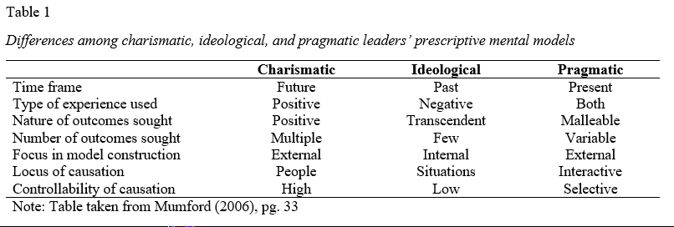
Table 1. Differences among charismatic, ideological, and pragmatic leaders’ prescriptive mental models
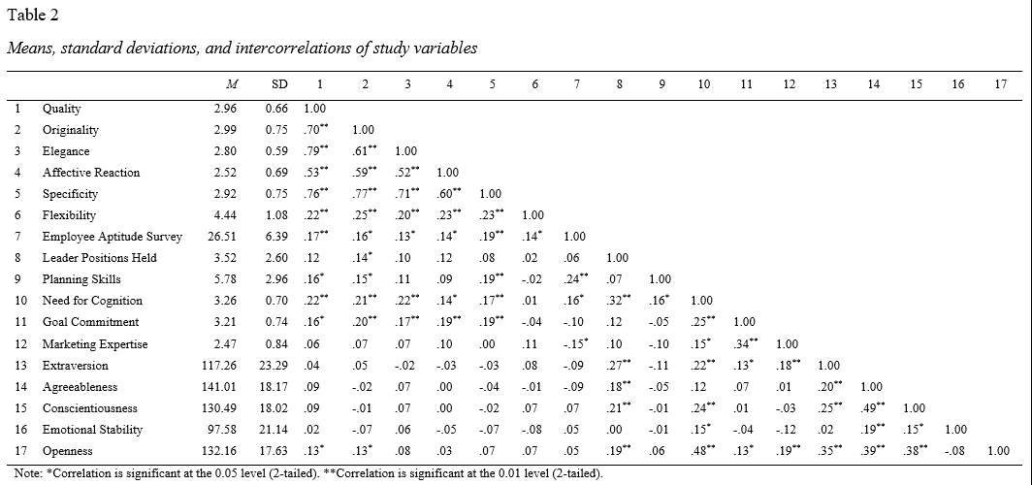
Table 2. Means, standard deviations, and intercorrelations of study variables

Table 3. Effects of leader style, goals, crisis, and follower style on solution quality, originality, and elegance
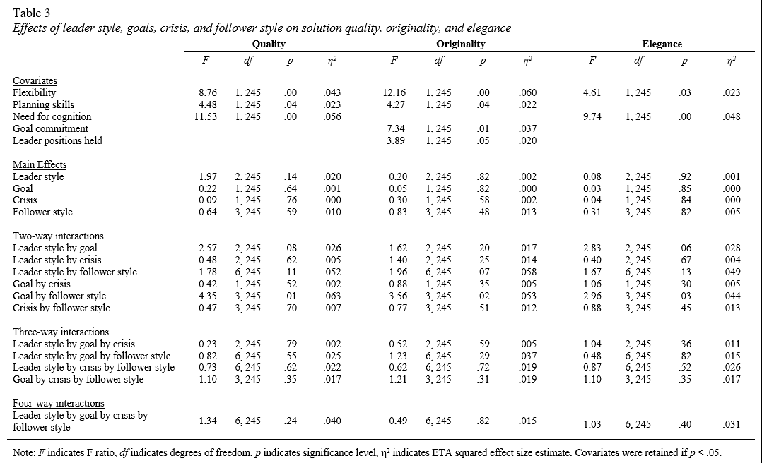
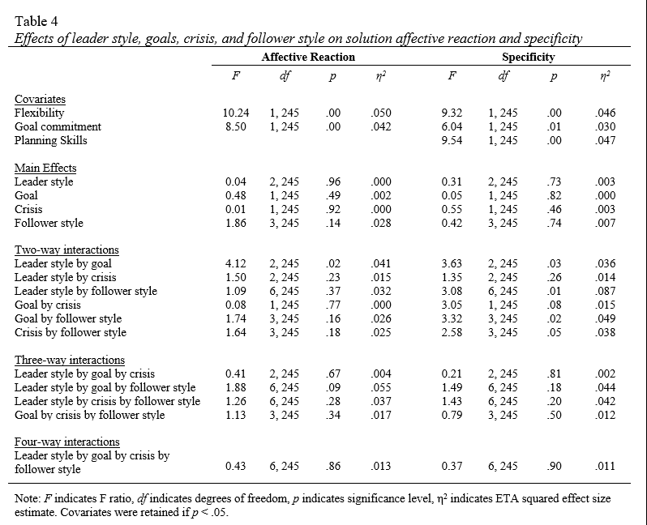

Appendix B: Figures

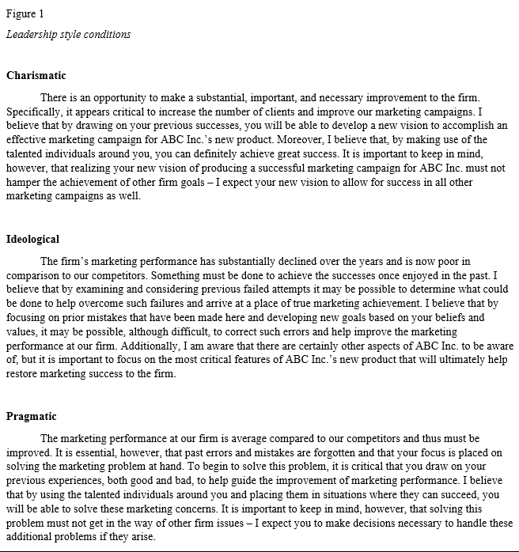
Figure 1. Leadership style conditions

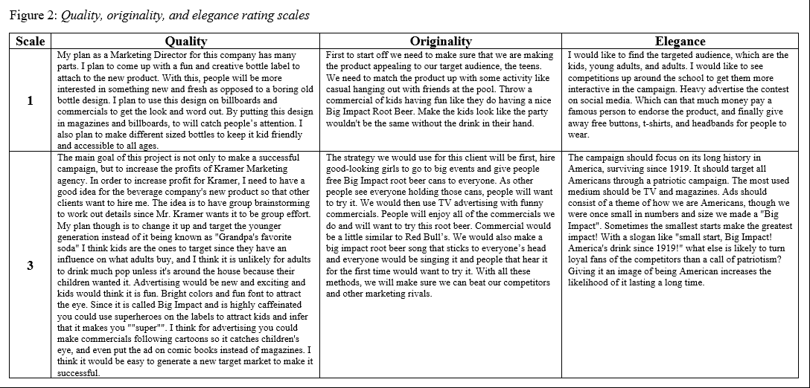
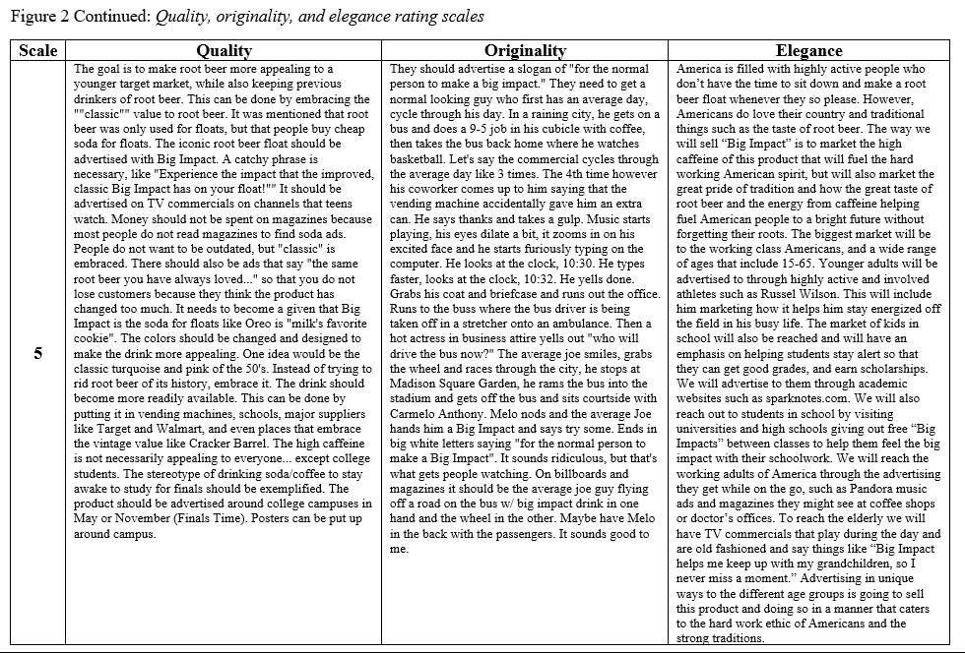
Figure 2. Quality, originality, and elegance rating scales

Figure 3. Affective reaction and specificity rating scales


