University of Oklahoma

Graduate College

Comparison of Interval Valued Pareto-Optimal Alternatives

A thesis

submitted to the Graduate Faculty

in partial fulfillment of the requirements for the

Degree of

Master of Science

By

Andrew Stewart
Norman, Oklahoma
2016

Comparison of Interval Valued pareto-Optimal Alternatives

A thesis approved for the
School of Industrial and Systems Engineering

By

______________________________
Dr. Kash Barker, Chair

______________________________
Dr. Charles Nicholson

______________________________
Dr. Shivakumar Raman

© Copyright by Andrew Stewart 2016
All Rights Reserved.

Acknowledgements
Thank you to all who made this possible.

Table of Contents

Acknowledgements iv
List of Tables vii
List of Figures ix
Abstract x
Chapter 1: Introduction 1
1.1 Past Work 2
1.2 Contribution 3
1.3 Thesis Structure 3
Chapter 2: Supporting Literature 5
2.1 Shortest Path Networks 5
2.2 Pareto-Optimality 6
2.3 Interval Arithmetic 8
2.4 Interval Comparisons 9
2.5 Multi-criteria decision analysis 9
2.6 TOPSIS 10
Chapter 3: Methodology 13
Chapter 4: Experimental Methodology 14
4.1 Examining the Network 14
4.2 Visually Plotting Interval Alternatives 17
4.3 TOPSIS 23
Chapter 5: Analysis and Discussion 33
5.1 Visual Comparative Analysis 33
5.2 TOPSIS 35
Chapter 6: Conclusions and Future Work 38
6.1 Conclusions 38
6.2 Application 39
6.3 Future Work 39
References 41
Appendix A – TOPSIS Data 43

List of Tables
Table 1: Possible Paths through the Network 16
Table 2: Combined Time and Cost Values across Alternatives 17
Table 3: TOPSIS Criteria Weight 23
Table 4: Ranking Matrix 24
Table 5: Criteria Scores 25
Table 6: Attribute Weights 25
Table 7: Normalized Decision Matrix 26
Table 8: Weighted Normalized Decision Matrix 26
Table 9: Max Value Across Criteria 27
Table 10: Min Value Across Critiera 27
Table 11: Distance from Positive Ideal 28
Table 12: Distance from Negative Ideal Solution 28
Table 13: Positive and Negative Ideal Values 29
Table 14: Distance Value and Index Value by Path through the Network 29
Table 15: Emphasis on Minimum Completion Time 30
Table 16: Rankings - Min Time Emphasis 30
Table 17: Criteria Weights - Max Time Emphasis 30
Table 18: Rankings - Max Time Emphasis 31
Table 19: Rankings - Min Cost Emphasis 31
Table 20: Rankings - Max Cost Emphasis 32
Table 21: Rankings – Emphasized Criteria 32
Table 22: Data with TOPSIS Rankings 35
Table 23: Rankings - Emphasized Criteria 36

List of Figures
Figure 1: Network - Path Times Between Nodes 15
Figure 2: Network: Path Cost Between Nodes 16
Figure 3: Plot of Path 1 18
Figure 4: Plot of Path 2 19
Figure 5: Plot of Path 3 19
Figure 6: Plot of Path 4 20
Figure 7: Plot of Path 5 20
Figure 8: Plot of Path 6 21
Figure 9: Plot of Path 7 21
Figure 10: Plot of Path 8 22
Figure 11: Plot of All Paths Combined 22

Abstract
Everyday tradeoff decisions are made where criteria must be compared, evaluated, and decided upon. In real world applications, variables have an inherent amount of uncertainty that must be regarded when making a decision, especially when considering interval data alternatives. There exists a need to incorporate uncertainty into the decision-making process but there are few straightforward approaches to directly compare interval valued variables. In this thesis, an approach to compare non-dominated interval valued alternatives is conducted using TOPSIS in order to determine the shortest path from source to sink in a construction network.

Key Terms: Shortest Path, Multi-Criteria Decision Making, TOPSIS, Interval, Non-dominated

Chapter 1: Introduction
Projects consist of three fundamental criteria: it must be completed on time or ahead of schedule, must be completed within or under budget, and must meet the requirements established by contract between the customer and contractor (Lester, 2007). To measure the aforementioned criteria, decision makers look at variables such as overall time to complete the project, cost of materials, project risk, and labor costs, to reference a few.
In industry, trade-offs between variables occur on a daily basis and often involve balancing the cost and benefits of multiple criteria when making a decision. Rarely is it possible to find relationships where reducing a variable, like cost, will also reduce other variables, like overall completion time. This results in alternatives that are inherently conflicting. The complex relationship between variables like cost and completion time significantly increases uncertainty that is within the system. In system planning and operation, uncertainty is often perceived as something purely negative, and considerable efforts and resources are spent to reduce uncertainties. In most situations, the underlying motivation is a desire to avoid unpleasant surprises, but the quest for certainty also has an intuitive appeal (Flage & Aven, 2009).
Because of the complex nature of managing decisions concerning multiple criteria in conjunction with the complex motivations that drive decision to be made, numerous techniques have been developed to aid in the process of making an informed decision on how to move forward.

A source to sink shortest path network will be used to demonstrate a tangible comparison between multiobjective Pareto optimal interval valued alternatives with the end purpose of determining a preferred path though the network.
Optimal trade-offs can be found by projecting the points onto an objective space defined by the involved variables. When considering two projected variables on an objective space, a line that is known as the Pareto front is formed. The Pareto front is the optimal solution where there can be no improvement towards minimizing one objective without undesirably affecting the other. It is important to note that the points above the Pareto front can improve both objectives by moving toward the frontier. Pareto optimal points have primarily been examined as discrete points, leaving a gap in research concerning interval valued alternative comparisons. Additionally, there are very few approaches in which to compare interval data in a useful way. Currently, interval valued comparison approaches under emphasize the best- and worst-case scenarios, which could become important is such scenarios are the basis of which decisions are being made (Barker and Rocco S, 2011). The usefulness of interval values in addressing uncertainty lowers whenever a comparison between the two ranges must be made as it is very difficult to do so in a clear, simple way, thus, leaving a gap in research for a straightforward comparison approach.

Past Work
Research that has been done in the area of Pareto-optimality analysis does not consider the Pareto frontier as more than discrete points on a line. Directly addressing uncertainty when the distribution of the data is not known means that we can overemphasize the mean value of the distribution and ignore what is happening in the tails. Therefore, “forcing” a distribution to fit the situation may do more harm than good in the decision making process (Huber 2010). There is a substantial gap in research concerning comparing interval value Pareto-optimal alternatives, especially in the multicriteria arena. Additionally, common decision making guidelines, such as Laplace, min regret, and similar approaches are rarely utilized when considering interval valued data due to the complex nature of dealing with uncertainty when making an important data driven decision.

Contribution
The proposed case study in this thesis aims to aid current research concerning interval comparisons of Pareto optimal alternatives. The incorporation of uncertainty in the multiobjective shortest path problem in conjunction with a ranking algorithm aims to decide which path through the network the decision maker should choose. Nondominated solutions are plotted so as to visually compare alternatives in a direct easy way. Furthermore, TOPSIS is utilized to demonstrate the preferred path through the construction network.

Thesis Structure
Chapter 2 explains the past work done in relevant areas of research as well as gives support to the methods that were used in the development and testing of the case scenarios. Chapter 3 describes the methodology that was followed throughout the proposed comparisons. Chapter 4 explains the usage of the techniques that are being used to compare the data and describes the results of the case study. Chapter 5 demonstrates an analysis of the data as well as discusses the associated alternatives in relation to the decision criteria. Chapter 6 discusses conclusions, possible areas of application, and suggested future work in the research area.

Chapter 2: Supporting Literature

2.1 Shortest Path Networks
Shortest path problems have been studied intensively in literature with single-objective shortest path problem being the most widely studied; however, it is often not sufficient to restrict oneself to only one objective when considering a real-world situation. Applications often indicate the necessity of taking two or more objectives into account, resulting in biobjective or multiple objective shortest path problems (Raith & Ehrgott, 2008). There are two main approaches to solving biobjective shortest path problems (BSP): enumerative approaches such as label correcting and label setting, or ranking methods.
Per Raith & Ehrgott (2008): in biobjective shortest path problems a node can have several labels, which do not dominate one another. The set of efficient solutions of the biobjective shortest path problems correspond to all labels at the target node after a labelling algorithm finishes. In label correcting and label setting methods, either one label at a certain node is extended by all arcs out of that node (label-selection) or all labels at a node are extended simultaneously (node-selection) (Cherkassky, Goldberg, & Radzik, 1996). Ranking methods are single-objective k-shortest path methods. Starting with the optimal value for one objective, the second-best solution, the third-best solution, etc. is obtained until the k-best solution is reached. For BSP, the process continues until it is guaranteed that all non-dominated points have been found (Raith & Ehrgott, 2008). In this case study, a decision maker will use a multiobjective ranking algorithm on the shortest path through the construction network given: four criteria, their weights, and eight nondominated interval valued alternatives.

2.2 Pareto-Optimality
When examining relationship between variables like time, cost, quality, and profit, there exists many inverse relationships where it is not possible to increase one variable without decreasing another. Generally, real life situation has more than one objective to be minimized or maximized. In cases where all of the objective functions either increase or decrease, there exist no optimum; however, in regions where these same objective functions are competing or conflicting with each other, meaning that a small change un the independent variables will result not only in an increase of one objective, but also a decrease in others, an optimum can exist (Paláncz & Awange, 2013). Such regions are called feasible regions for optimal solutions. A solution in this region is said to be a Pareto optimal solution if it is not dominated by any other solution in that region (Paláncz & Awange, 2013). A solution is Pareto dominated if some other value can be increased without decreasing any other values in the solution space. For example, in the case of two criteria X and Y, we consider a point a to be superior to point b when the following are satisfied (Lewi, Van Hoof, & Boey, 1992):
X_{a} > X_{b} and Y_{a} > Y_{b} or
X_{a} > X_{b} and Y_{a} = Y_{b} or
X_{a} = X_{b} and Y_{a} > Y_{b}
When plotted in objective space, the nondominated vectors are collectively known as the Pareto front. In order to view the different solutions, it is necessary to plot these alternatives in a design space that satisfies two objectives on a xy-plane. The plotted points that exist within the boundaries but not including the boundary points are called the Pareto Set. The set of solutions that make up the boundary of the plotted alternatives are called the Pareto Frontier (Blasco, 2008; Van Veldhuizen, 2000). It is important to note that the Pareto front does not realistically represent real-world problems as it is defined by an infinite number of points and has not yet incorporated uncertainty into the characterization of the situation. The search for all the solutions in the optimal Pareto set is so computationally and methodologically difficult that many methods frequently obtain the front by the use of approximation. Non-dominated solutions are identified during the process and approximated fronts are successively obtained (Pérez, Quintanilla, Lino, & Valls, 2014). Discrete approximations are usually compared in decision making situations due to the complex nature of continuous data and a lack of straightforward way to compare it consistently.
There are several ways that a Pareto Set can be viewed, but they are most commonly shown as scatter diagrams, parallel coordinates, or noninferior solution spaces. Scatter diagrams are arranged in the form of an n x n matrix with dimensions of the data set represented by a single row and column. Parallel coordinates plot a multidimensional point in a two-dimensional graph with each dimension of the original data translated to an x-coordinate in the two dimensional plot (Blasco et al., 2008). In this case study, a plot of noninferior solutions will be graphed in order to allow the decision maker an easier way to characterize each alternative.
The Pareto front will be shown in a graphical representation of the eight path alternatives using two variables, time and cost. The interval value data will be depicted as rectangles to accurately show the variable value ranges with each corner of the shape corresponding to its axes’ respective minimum and maximum. The graphical representation will allow the decision maker to visually see the difference in both cost and time for each alternative, thus allowing for an informed data driven decision. Additionally, because the rectangle shows the relationship between time and cost, it is possible to associate a risk with each alternative when using the mindset of a larger area of a rectangle directly correlating with a high-risk value and vice versa for the case of a smaller shape area correlating with a lower risk value. Though the concept of risk will not be quantifiably compared, it is important to note the different range of values across both the variables and alternative paths.

2.3 Interval Arithmetic
Interval estimates (uncertainty intervals) are specified for unknown parameters and it is assumed that each parameter can take on any value from the corresponding uncertainty interval regardless of the values taken on by other parameters (Averbakh, 2005).
Interval arithmetic was originally devised to obtain upper and lower bounds to rounding errors in mathematical computations (Moore, 1966). It has also been useful in representing uncertainty when dealing with exact parameters. To define an interval number, there exists an ordered pair of real numbers, [a, b] with a ≤ b in addition to a set of real numbers x such that a ≤ x ≤ b (Moore, 1966). For interval numbers M = [a, b] and N = [c, d], comprised of real numbers a, b, c, and d, then the following algebraic properties hold (Moore, 1966):
$M+N=\left[a,b\right]+\left[c,d\right]=\left[a+c,b+d\right]$,
$M-N=\left[a,b\right]-\left[c,d\right]=\left[a-d,b-c\right]$,
$$M∙N=\left[a,b\right]∙\left[c,d\right]=\left[\min\left(a∙c,a∙d,b∙c,b∙d\right),\max\left(a∙c,a∙d,b∙c,b∙d\right)\right],$$
$M/N=\left[a,b\right]/\left[c,d\right]=\left[\min\left(a/c,a/d,b/c,b/d\right), max⁡(a/c,a/d,b/c,b/d)\right]$,
$$where 0 ∌[c,d]$$
$z∙M=z∙\left[a,b\right]=[z∙a,z∙b]$ for real constant z ≥ 0
The listed properties will be useful to reference when considering computations in subsequent chapters of this thesis, specifically the use of interval addition.

2.4 Interval Comparisons
When examined on a fundamental level, there exists two types of intervals, intervals that intersect and those that do not. Narrow intervals occur when measurements of generic real-value quantities are sufficiently precise that the corresponding intervals avoid intersecting each other (Experimental uncertainty page 23). It is difficult to compare intervals, but rules exist that describe when two intervals are equal. For two intervals, A = [a₁, a₂] and B = [b₁, b₂] are called equal, A =B, if a₁ = b₁ and a₂ = b₂.
If the two intervals do not have the same values, then several other ways to approach the interval comparisons have been proposed, however, this case study does not aim to use interval comparisons to make a decision but utilize the multicriteria decision making tool, TOPSIS, to calculate a preferred path through the construction network. It is important to note that interval uncertainty is present in the system. Therefore, solving the extreme case of pure intervals is a first step before considering more elaborate representations of uncertainty where both probability and intervals are combined (Fortin, Zieliski, Dubois, & Fargier, 2010).

2.5 Multi-criteria decision analysis
Multiple-criteria decision analysis (MCDA), otherwise referred to as multiple-criteria decision making is a sub-discipline and full-grown branch of operations research that is concerned with designing mathematical and computational tools to support the subjective evaluation of a finite number of decision alternatives under a finite number of performance criteria set by a single decision maker or group (Lootsma, 1999). Multi-criteria decision analysis (MCDA) provides a systematic methodology to combine inputs with cost/benefit information and stakeholder views to rank project alternatives. MCDA is used to discover and quantify decision maker and stakeholder considerations about various (mostly) non-monetary factors in order to compare alternative courses of action (Huang, Keisler, & Linkov, 2011). There are numerous approaches that all fall under the umbrella of MCDA, each involving different protocols for eliciting inputs, structures to represent them, algorithms to combine them, and processes to interpret and use formal results in actual advising or decision making context. In this case study TOPSIS will be utilized to demonstrate the shortest path through the network.

2.6 TOPSIS
The Technique for Order Preference by Similarity to an Ideal Solution (TOPSIS), is a distance based multicriteria decision making method that is used for determining alternatives (Cheng-Shiung, 2010). TOPSIS is based on positive-ideal and negative-ideal solutions that are determined by calculating the distance of each scenario from the global best performing alternative and the global worst performing alternative (Hwang and Yoon, 1981).
In the existing evaluation schemes based on the weighted sum of objectives technique, the fitness function of a solution is calculated regardless of the fitness of other members in the current population, while in evaluation based TOPSIS, the fitness function of each solution is calculated based on the worst and the best values of each objective among all the members of the current population. Although, TOPSIS is dependent on the weight values given by the decision maker, its ability in distinguishing between solutions and ranking them is indisputable (Nourmohammadi and Zandieh, 2011). The basic principle is that the chosen alternative should have the shortest distance from the positive ideal solution and the farthest distance from the negative ideal solution. The procedure of TOPSIS can be expressed in the following series of steps (Yurdakul & Bankasi 2005):
- Calculate the normalized decision matrix. The normalized value n_{ij} is calculated as n_{ij =} $\frac{x_{ij}}{\sum_{i=1}^{m}{x_{ij}^{2}}}$ for i = 1,..., m and j = 1,..., n.
- Calculate the weighted normalized decision matrix. The weighted normalized value v_{ij} is calculated as v_{ij} = w_{i}n_{ij} for i = 1,..., m and j = 1,..., n where w_{i} is the weight of the ith attribute or criterion, and $\sum_{i=1}^{n}{w_{i}=1}$. These weights can be introduced by the decision maker.
- Determine the positive-ideal and negative-ideal solution
A⁺ = {(v₁⁺ ,v₂⁺ ,...,v_{n}⁺ )} = {(max v_{ij} |i ∈ O),(min v_{ij} |i ∈ I)}
A⁻ = {(v₁⁻ ,v₂⁻ ,...,v_{n}⁻ )} = {(min v_{ij} |i ∈ O),(max v_{ij} |i ∈ I)}
where O is associated with benefit criteria, and I is associated with cost criteria, if applicable.
- Calculate the separation measures, using the n-dimensional Euclidean distance. The separation of each alternative from the ideal solution is given as
$$d_{j}^{+}=\sum_{k=0}^{n}{{(v_{ij}-v_{i}^{+}) }^{1/2}}∀j.$$
Similarly, the separation from the negative-ideal solution is given as
$$d_{j}^{-}=\sum_{k=0}^{n}{{(v_{ij}-v_{i}^{-}) }^{1/2}}∀j.$$
- Calculate the relative closeness to the ideal solution. The relative closeness of the alternative A_{j} with respect to A⁺ is defined as $R_{j}= \frac{d_{j}^{-}}{{d_{j}^{+}+d}_{j}^{-}}$ for j =1, …, m. Since $d_{j}^{-}≥0$ and $d_{j}^{+}≥0$, then clearly $R_{j}$ ∈ [0, 1].
- Rank the preference order. For ranking alternatives using this index, the alternatives are ranked in decreasing order. The basic principle of the TOPSIS method is that the chosen alternative should have the ‘‘shortest distance’’ from the ideal solution and the ‘‘farthest distance’’ from the negative-ideal solution.

Chapter 3: Methodology
Below is the process describing each step that will be needed to conduct the comparison of the interval data:
- List all time and cost values for each possible path through the network
- Using interval arithmetic, calculate the [min, max] intervals for both time and cost corresponding to each alternative
- Plot interval valued time and cost to visually inspect path data to ensure each is a non-dominated solution
- Apply a weighted multi criteria decision ranking technique (TOPSIS) to the data to determine the preferred path through the construction network

Chapter 4: Experimental Methodology
This chapter will describe how the technique in chapter 3 was applied to the construction network in order to directly compare nondominated the interval alternatives. First, the network that will serve as the foundation of the case study will be examined. Next the path alternatives will be plotted to allow for visual inspection. Finally, TOPSIS will be used to rank the paths to determine the preferred nondominated path.

4.1 Examining the Network
When considering the construction network there are many variables that can be considered, the cost of the overall project, the quality of the product, the time associated with project length, risk associated with the project, as well as many others. In this case study, time and cost are being examined in the form of interval data with the following form: x = [x₁, x₂], with x₁ having the value of the lowest possible time to complete the project and x₂ representing the longest possible completion time. The costs associated with each length of time is represented by the interval y = [y₁, y₂], with y₁ representing the cost associated with the shortest possible time and y₂ representing the longer time. In the following figure, the time associated with the path between the nodes are shown as [x₁, x₂]. The starting point (source) for all possibilities will always be node 1. Similarly, the endpoint (sink) for all possibilities will be node 7.
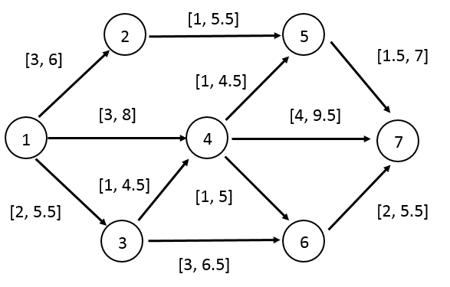
Figure 1: Network - Path Times Between Nodes
As seen in the figure, there are multiple paths through the network, each of which has an associated [min time, max time]. The source of all paths is node 1 and the sink of all possible ways through the network is node 7. There are several assumptions that will be used that concern the various paths: the values associated with the paths between nodes are constant, it is not possible to go backwards in the network, allocating extra resources to an activity node will not decrease the completion time, and no activity nodes or linkages may be added to the existing network. Figure 2 shows the costs between nodes associated with the network’s time values depicted in Figure 1.

Figure 2: Network: Path Cost Between Nodes
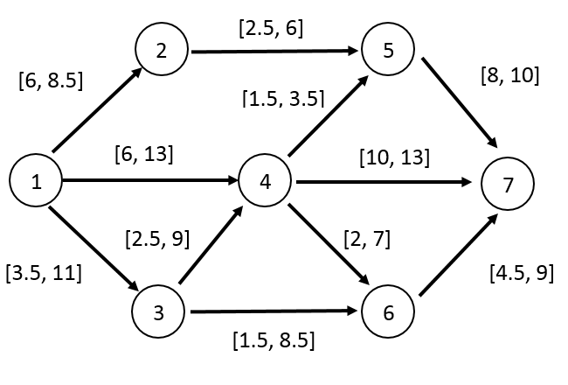
As shown in Figure 1 and Figure 2, there are eight possible paths through the network, each of which has been assigned a number ranging from one to eight. Table 1 shows the possible node paths through the network.

Table 1: Possible Paths through the Network
Path | Nodes
1 | 1, 4, 7
2 | 1, 2, 5, 7
3 | 1, 3, 4, 7
4 | 1, 3, 4, 5, 7
5 | 1, 3, 6, 7
6 | 1, 4, 5, 7
7 | 1, 4, 6, 7
8 | 1, 3, 4, 6, 7
Using interval addition, the minimum and maximum values of both time and cost for each alternative are listed in Table 2. This data will serve as the foundation of the interval valued alternative comparison. To calculate the minimum and maximum values for the two variables, it was necessary to apply the interval addition method that was discussed in section 2.3 Interval Arithmetic.
Table 2: Combined Time and Cost Values across Alternatives

Construction Network
Name | Possible Paths | Min Time | Max Time | Min Cost | Max Cost
1 | 1, 4, 7 | 7.0 | 17.5 | 16.00 | 26.00
2 | 1, 2, 5, 7 | 5.5 | 18.5 | 16.50 | 24.50
3 | 1, 3, 4, 7 | 7.0 | 19.5 | 16.00 | 33.00
4 | 1, 3, 4, 5, 7 | 5.5 | 21.5 | 15.50 | 33.50
5 | 1, 3, 6, 7 | 7.0 | 17.5 | 9.50 | 28.00
6 | 1, 4, 5, 7 | 5.5 | 19.5 | 15.50 | 26.50
7 | 1, 4, 6, 7 | 6.0 | 18.5 | 12.50 | 29.00
8 | 1, 3, 4, 6, 7 | 6.0 | 20.5 | 12.50 | 36.00

The data shown in Table 2 will be used to find the shortest path through the construction network. When inspecting the data in the table, it is difficult to directly see the differences between the paths. Section 4.2 will depict each alternative visually as to better compare the different node combinations.

4.2 Visually Plotting Interval Alternatives
In order to visually inspect the Pareto-front, two variables were considered for a construction network, time to complete the project, and overall cost. Time will be plotted on the x-axis and the cost of the project will be plotted on the y-axis. Plots of the various scenarios show the variables as a rectangle with each corner representing the min or max time and cost values, as seen in the example Figure 1.

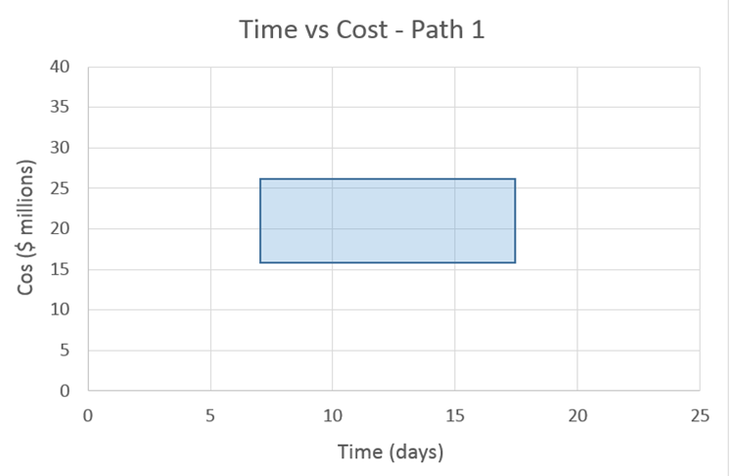
Figure 3: Plot of Path 1
In path one, the minimum time to complete the path is shown by the lower left corner with an associated value of 7 days and a maximum value shown as the lower right corner of the rectangle with a value of 17.5 days. Similarly, the minimum cost value is associated with lower left corner with a value of $16 million and the upper left corner represents the maximum cost value associated with the scenario ($26 million). Each of the eight alternatives are similarly shown in the following plots. After each scenario is plotted on a xy plane, the alternatives are plotted together on an additional xy plane with the purpose of allowing for visual inspection of both time and cost values across the alternatives.

Figure 4: Plot of Path 2

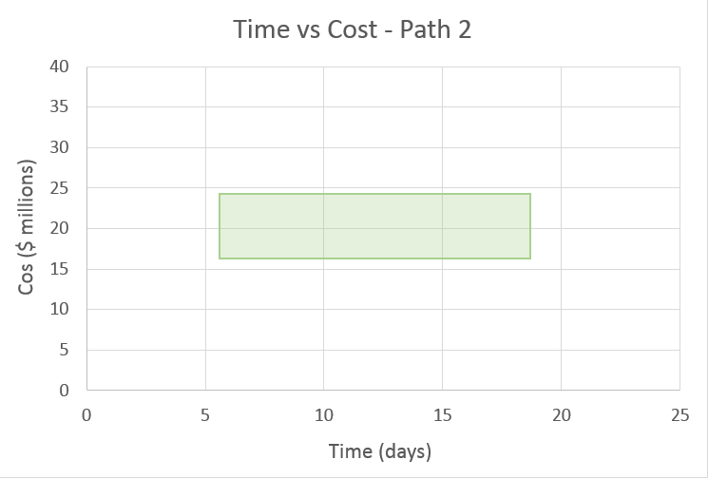
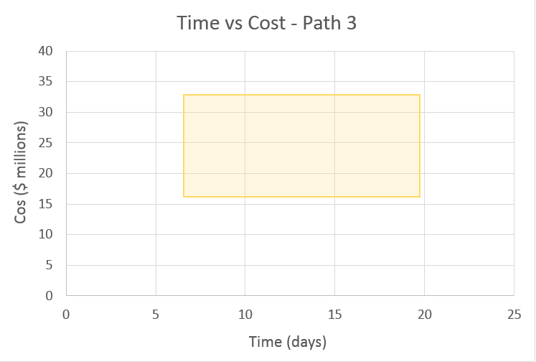
Figure 5: Plot of Path 3
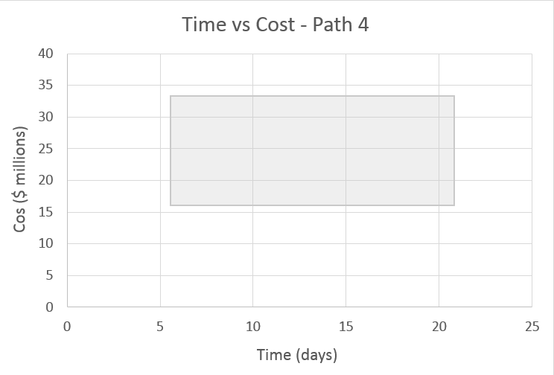
Figure 6: Plot of Path 4
Figure 7: Plot of Path 5

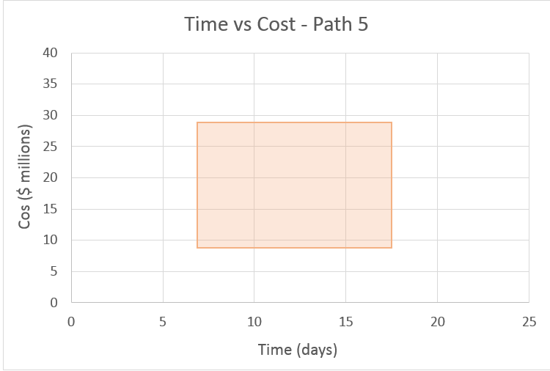
Figure 8: Plot of Path 6
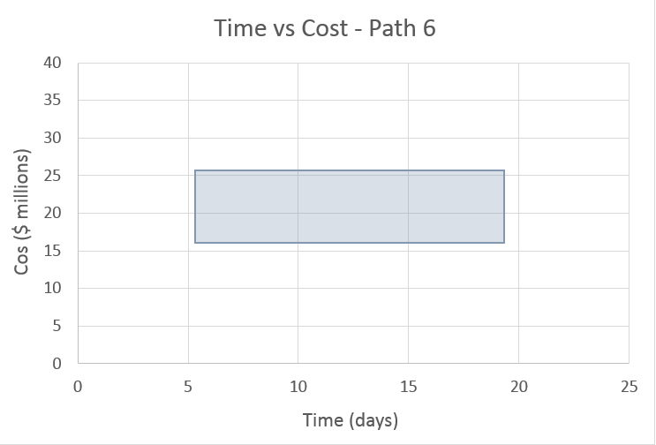

Figure 9: Plot of Path 7
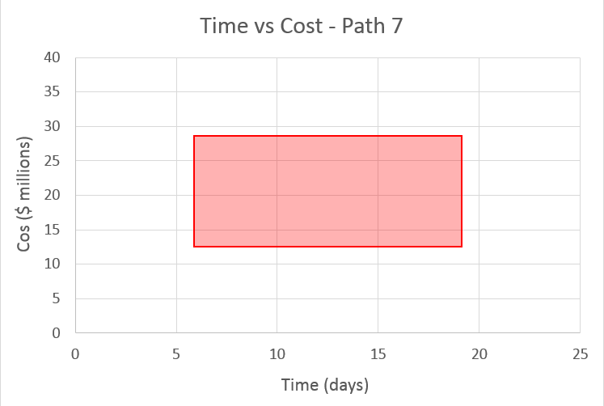
Figure 10: Plot of Path 8
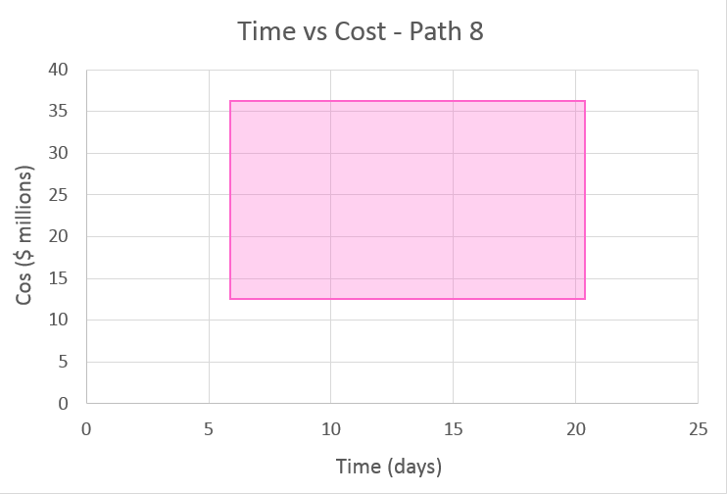
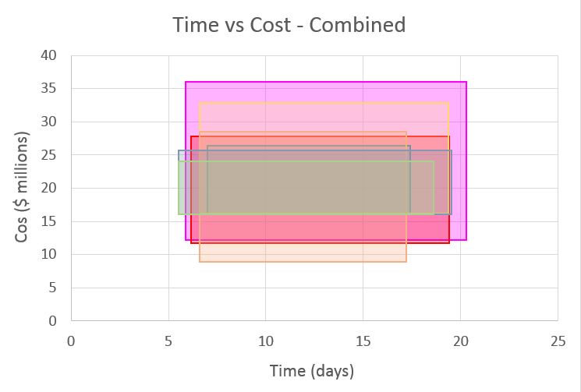
Figure 11: Plot of All Paths Combined
When the eight alternatives are plotted, and compared to each other, there is no way to visually discern which option has the lowest risk (analogous to the smallest area). There are several possibilities that show a higher risk than others but it is not possible to make a decision on which alternatives outperform any others through pure visual inspection. The non-dominated solutions thus must be quantifiably compared in order to determine the preferred path through the network.

4.3 TOPSIS
Before TOPSIS can be applied the criteria that will be used to rank the path alternatives must first be defined. For this case study, the criteria have been defined as the minimum completion time, minimum overall cost, maximum completion time, and maximum cost. The criteria weights have been assigned as shown in Table 3.
Table 3: TOPSIS Criteria Weight
Criteria | Weight
Min Completion Time | 0.25
Min Cost | 0.25
Max Time | 0.25
Max Cost | 0.25

Before TOPSIS can rank the alternatives, the paths must be given a score based on the four criteria listed in Table 3. Scores were attributed to each path alternative based on where it fell in the ranking table shown in Table 4.

Table 4: Ranking Matrix
Time |  |  |  | Cost
Min | Value | Max | Value | Min | Value | Max | Value
0 | 10 | 15 | 10 | 8 | 10 | 24 | 10
0.99 | 10 | 15.99 | 10 | 8.99 | 10 | 25.25 | 10
1 | 9 | 16 | 9 | 9 | 9 | 25.26 | 9
1.99 | 9 | 16.99 | 9 | 9.99 | 9 | 26.51 | 9
2 | 8 | 17 | 8 | 10 | 8 | 26.52 | 8
2.99 | 8 | 17.99 | 8 | 10.99 | 8 | 27.77 | 8
3 | 7 | 18 | 7 | 11 | 7 | 27.78 | 7
3.99 | 7 | 18.99 | 7 | 11.99 | 7 | 29.03 | 7
4 | 6 | 19 | 6 | 12 | 6 | 29.04 | 6
4.99 | 6 | 19.99 | 6 | 12.99 | 6 | 30.29 | 6
5 | 5 | 20 | 5 | 13 | 5 | 30.3 | 5
5.99 | 5 | 20.99 | 5 | 13.99 | 5 | 31.55 | 5
6 | 4 | 21 | 4 | 14 | 4 | 31.56 | 4
6.99 | 4 | 21.99 | 4 | 14.99 | 4 | 32.81 | 4
7 | 3 | 22 | 3 | 15 | 3 | 32.82 | 3
7.99 | 3 | 22.99 | 3 | 15.99 | 3 | 34.07 | 3
8 | 2 | 23 | 2 | 16 | 2 | 34.08 | 2
8.99 | 2 | 23.99 | 2 | 16.99 | 2 | 35.33 | 2
9 | 1 | 24 | 1 | 17 | 1 | 35.34 | 1
100 | 1 | 100 | 1 | 100 | 1 | 100 | 1

For this case study, the maximum value is the preferred, for this table that would be a value of 10. For example purposes, if a value for an alternative fell between a minimum time values of 4.5, it would be scored as a 6. An example of a completely scored alternative is shown in Table 5 below.

Table 5: Criteria Scores
Name | Possible Path | Min Time | Max Time | Min Cost | Max Cost
1 | 1, 4, 7 | 3 | 8 | 2 | 9
2 | 1, 2, 5, 7 | 5 | 7 | 2 | 10
3 | 1, 3, 4, 7 | 3 | 6 | 2 | 3
4 | 1, 3, 4, 5, 7 | 5 | 4 | 3 | 3
5 | 1, 3, 6, 7 | 3 | 8 | 9 | 7
6 | 1, 4, 5, 7 | 5 | 6 | 3 | 9
7 | 1, 4, 6, 7 | 4 | 7 | 6 | 7
8 | 1, 3, 4, 6, 7 | 4 | 5 | 6 | 1

Once an alternative was given a score, it was necessary to determine the attribute weight for each path. The attribute weight is calculated by summing the scores, for example Path 1 (node 1, 4, 7), across all alternatives and dividing the total by the number of scenarios as shown by the example below:
$$Attribute Weight\left(Path 1\right)=\frac{3+8+2+9}{4}=12.56980509$$
Table 6 shows an example of a table with both path scores and calculated attribute weights.
Table 6: Attribute Weights
Name | Possible Paths | Min Time | Max Time | Min Cost | Max Cost | Attribute Weights
1 | 1, 4, 7 | 3 | 8 | 2 | 9 | 12.56980509
2 | 1, 2, 5, 7 | 5 | 7 | 2 | 10 | 13.34166406
3 | 1, 3, 4, 7 | 3 | 6 | 2 | 3 | 7.615773106
4 | 1, 3, 4, 5, 7 | 5 | 4 | 3 | 3 | 7.681145748
5 | 1, 3, 6, 7 | 3 | 8 | 9 | 7 | 14.24780685
6 | 1, 4, 5, 7 | 5 | 6 | 3 | 9 | 12.28820573
7 | 1, 4, 6, 7 | 4 | 7 | 6 | 7 | 12.24744871
8 | 1, 3, 4, 6, 7 | 4 | 5 | 6 | 1 | 8.831760866

Once the attribute weights have been calculated for all alternatives, the attribute weights for each node were used to finalize the Normalized Decision Matrix. Table 7 shows an example of each criteria score divided by the calculated weights in Table 6.
Table 7: Normalized Decision Matrix
Name | Possible Paths | Min Time | Max Time | Min Cost | Max Cost
1 | 1, 4, 7 | 0.238667185 | 0.636445827 | 0.159111457 | 0.716001556
2 | 1, 2, 5, 7 | 0.374765844 | 0.524672182 | 0.149906338 | 0.749531689
3 | 1, 3, 4, 7 | 0.393919299 | 0.787838597 | 0.262612866 | 0.393919299
4 | 1, 3, 4, 5, 7 | 0.650944555 | 0.520755644 | 0.390566733 | 0.390566733
5 | 1, 3, 6, 7 | 0.210558722 | 0.561489925 | 0.631676166 | 0.491303684
6 | 1, 4, 5, 7 | 0.406894229 | 0.488273075 | 0.244136538 | 0.732409613
7 | 1, 4, 6, 7 | 0.326598632 | 0.571547607 | 0.489897949 | 0.571547607
8 | 1, 3, 4, 6, 7 | 0.452910814 | 0.566138517 | 0.67936622 | 0.113227703

After the Normalized Decision Matrix was established, TOPSIS requires each criteria weight to be multiplied to each path alternative. For example, in the case of Path 1, the value shown in Table 7 for Min Time (0.238667185) is multiplied by the criteria weight established in Table 3 (0.25) to show the result of 0.059667. Similar calculations were conducted across the other paths and criteria weights, as shown by Table 8.
Table 8: Weighted Normalized Decision Matrix
Name | Possible Paths | Min Time | Max Time | Min Cost | Max Cost
1 | 1, 4, 7 | 0.059667 | 0.159111 | 0.03978 | 0.179
2 | 1, 2, 5, 7 | 0.093691 | 0.131168 | 0.03748 | 0.187383
3 | 1, 3, 4, 7 | 0.09848 | 0.19696 | 0.06565 | 0.09848
4 | 1, 3, 4, 5, 7 | 0.162736 | 0.130189 | 0.09764 | 0.097642
5 | 1, 3, 6, 7 | 0.05264 | 0.140372 | 0.15792 | 0.122826
6 | 1, 4, 5, 7 | 0.101724 | 0.122068 | 0.06103 | 0.183102
7 | 1, 4, 6, 7 | 0.08165 | 0.142887 | 0.12247 | 0.142887
8 | 1, 3, 4, 6, 7 | 0.113228 | 0.141535 | 0.16984 | 0.028307

Once the Weighted Normalized Decision Matrix has been established, it is necessary to find the maximum values for each path. The maximum values will be used to find the distance from the positive ideal value (I_{p}) as shown by Table 11. Table 9 below shows the maximum value across the criteria for each path. Likewise, Table 10 depicts the minimum values for each possible path across the four criteria.
Table 9: Max Value Across Criteria
Name | Possible Path | Min Time | Max Time | Min Cost | Max Cost | Maximum
1 | 1, 4, 7 | 0.05967 | 0.15911 | 0.03978 | 0.17900 | 0.17900
2 | 1, 2, 5, 7 | 0.09369 | 0.13117 | 0.03748 | 0.18738 | 0.18738
3 | 1, 3, 4, 7 | 0.09848 | 0.19696 | 0.06565 | 0.09848 | 0.19696
4 | 1, 3, 4, 5, 7 | 0.16274 | 0.13019 | 0.09764 | 0.09764 | 0.16274
5 | 1, 3, 6, 7 | 0.05264 | 0.14037 | 0.15792 | 0.12283 | 0.15792
6 | 1, 4, 5, 7 | 0.10172 | 0.12207 | 0.06103 | 0.18310 | 0.18310
7 | 1, 4, 6, 7 | 0.08165 | 0.14289 | 0.12247 | 0.14289 | 0.14289
8 | 1, 3, 4, 6, 7 | 0.11323 | 0.14153 | 0.16984 | 0.02831 | 0.16984

Table 10: Min Value Across Critiera
Name | Possible Paths | Min Time | Max Time | Min Cost | Max Cost | Min
1 | 1, 4, 7 | 0.05967 | 0.15911 | 0.03978 | 0.17900 | 0.03978
2 | 1, 2, 5, 7 | 0.09369 | 0.13117 | 0.03748 | 0.18738 | 0.03748
3 | 1, 3, 4, 7 | 0.09848 | 0.19696 | 0.06565 | 0.09848 | 0.06565
4 | 1, 3, 4, 5, 7 | 0.16274 | 0.13019 | 0.09764 | 0.09764 | 0.09764
5 | 1, 3, 6, 7 | 0.05264 | 0.14037 | 0.15792 | 0.12283 | 0.05264
6 | 1, 4, 5, 7 | 0.10172 | 0.12207 | 0.06103 | 0.18310 | 0.06103
7 | 1, 4, 6, 7 | 0.08165 | 0.14289 | 0.12247 | 0.14289 | 0.08165
8 | 1, 3, 4, 6, 7 | 0.11323 | 0.14153 | 0.16984 | 0.02831 | 0.02831

After establishing the maximum values, it is necessary to find the distance from the Positive Ideal Solution (I_{p}). The equation below demonstrates the how the distance from the ideal solution was calculated (Yurdakul and Bankasi 2005).
$d_{j}^{+}=\sum_{k=0}^{n}{{(v_{ij}-v_{i}^{+}) }^{1/2}} ∀j.$
Table 11 shows the calculated values of the distance from the Positive Ideal Solution (I_{p}).
Table 11: Distance from Positive Ideal
Name | Possible Path | Min Time | Max Time | Min Cost | Max Cost | Dist from I_{p}
1 | 1, 4, 7 | 0.01424 | 0.00040 | 0.01938 | 0.00000 | 0.18444
2 | 1, 2, 5, 7 | 0.00878 | 0.00316 | 0.02247 | 0.00000 | 0.18550
3 | 1, 3, 4, 7 | 0.00970 | 0.00000 | 0.01724 | 0.00970 | 0.19141
4 | 1, 3, 4, 5, 7 | 0.00000 | 0.00106 | 0.00424 | 0.00424 | 0.09764
5 | 1, 3, 6, 7 | 0.01108 | 0.00031 | 0.00000 | 0.00123 | 0.11235
6 | 1, 4, 5, 7 | 0.00662 | 0.00373 | 0.01490 | 0.00000 | 0.15890
7 | 1, 4, 6, 7 | 0.00375 | 0.00000 | 0.00042 | 0.00000 | 0.06455
8 | 1, 3, 4, 6, 7 | 0.00321 | 0.00080 | 0.00000 | 0.02003 | 0.15504

Similarly, distances from the Negative Ideal Solution (I_{n}) were calculated using the following equation:
$$d_{j}^{-}=\sum_{k=0}^{n}{{(v_{ij}-v_{i}^{-}) }^{1/2}} ∀j.$$
Table 12 demonstrates the calculated distance from the Negative Ideal Solution (I_{n}).
Table 12: Distance from Negative Ideal Solution
Name | Possible Paths | Min Time | Max Time | Min Cost | Max Cost | Dist from I_{n}
1 | 1, 4, 7 | 0.00040 | 0.01424 | 0.00000 | 0.01938 | 0.18444
2 | 1, 2, 5, 7 | 0.00316 | 0.00878 | 0.00000 | 0.02247 | 0.18550
3 | 1, 3, 4, 7 | 0.00108 | 0.01724 | 0.00000 | 0.00108 | 0.13927
4 | 1, 3, 4, 5, 7 | 0.00424 | 0.00106 | 0.00000 | 0.00000 | 0.07278
5 | 1, 3, 6, 7 | 0.00000 | 0.00770 | 0.01108 | 0.00493 | 0.15397
6 | 1, 4, 5, 7 | 0.00166 | 0.00373 | 0.00000 | 0.01490 | 0.14241
7 | 1, 4, 6, 7 | 0.00000 | 0.00375 | 0.00167 | 0.00375 | 0.09574
8 | 1, 3, 4, 6, 7 | 0.00721 | 0.01282 | 0.02003 | 0.00000 | 0.20016

Table 13: Positive and Negative Ideal Values
Name | Distance from I_{p} | Distance from I_{n}
1 | 0.18444 | 0.18444
2 | 0.18549 | 0.18549
3 | 0.19141 | 0.13927
4 | 0.09764 | 0.07277
5 | 0.11235 | 0.15397
6 | 0.15889 | 0.14241
7 | 0.06454 | 0.09574
8 | 0.15504 | 0.20016

Using the distances from the Positive and Negative Ideal Solutions, it is possible to calculate the final rankings of the eight path alternatives. Table 14 shows calculated values as well as the final rankings for the path alternatives based on the criteria weights listed in Table 3.

Table 14: Distance Value and Index Value by Path through the Network
Name | Distance from I_{p} | Distance from I_{n} | I_{p} + I_{n} | I_{n} / I_{p} + I_{n} | Rank
1 | 0.184442369 | 0.184442369 | 0.368884737 | 0.5 | 4
2 | 0.185499629 | 0.185499629 | 0.370999258 | 0.5 | 4
3 | 0.191410373 | 0.139271504 | 0.330681877 | 0.42116461 | 8
4 | 0.097641683 | 0.072777814 | 0.170419497 | 0.427050983 | 7
5 | 0.112352805 | 0.153970441 | 0.266323245 | 0.57813369 | 2
6 | 0.158897276 | 0.14241298 | 0.301310256 | 0.472645644 | 6
7 | 0.064549722 | 0.095742711 | 0.160292433 | 0.597300252 | 1
8 | 0.155043418 | 0.200160192 | 0.35520361 | 0.563508327 | 3

Now that the preferred path through the shortest path problem has been examined, other criteria weights should be looked at to see if the result holds true. Table 15 shows a change in criteria weights from all equal to 0.25 to an emphasis on the minimum completion time which now has a weight equal to 0.4, resulting in a weight of 0.1 on the maximum completion time. The remaining two criteria, min cost and max cost, correspond to the original weights of 0.25.
Table 15: Emphasis on Minimum Completion Time
Min Time | Max Time | Min Cost | Max Cost
0.4 | 0.1 | 0.25 | 0.25

Table 16 shows the updated rankings that correspond to the new criteria weights listed in Table 15.
Table 16: Rankings - Min Time Emphasis
Dist from I_{p} | Dist from I_{n} | I_{p} + I_{n} | I_{n} / I_{p} + I_{n} | New Rank | Original Rank
0.199167571 | 0.15183 | 0.35100 | 0.43257 | 6 | 4
0.205130816 | 0.18798 | 0.39311 | 0.47819 | 5 | 4
0.134709137 | 0.09848 | 0.23319 | 0.42232 | 7 | 8
0.310412519 | 0.21804 | 0.52845 | 0.41260 | 8 | 7
0.130459589 | 0.12486 | 0.25532 | 0.48904 | 4 | 2
0.182604411 | 0.17652 | 0.35912 | 0.49153 | 3 | 6
0.088975652 | 0.13045 | 0.21942 | 0.59450 | 1 | 1
0.197500406 | 0.21023 | 0.40774 | 0.51562 | 2 | 3

Another crucial example of how critical criteria weights change the final rankings is when the criteria weights reflect an emphasis on maximum completion time. Table 17 shows the updated criteria weights that will be used in the TOPSIS calculations.
Table 17: Criteria Weights - Max Time Emphasis
Min Time | Max Time | Min Cost | Max Cost
0.1 | 0.4 | 0.25 | 0.25

Table 18 clearly shows the difference in rankings when the New Rank and Old Rank columns are examined.

Table 18: Rankings - Max Time Emphasis
Dist from I_{p} | Dist from I_{n} | I_{p} + I_{n} | I_{n} / I_{p} + I_{n} | New Rank | Original Rank
0.32416 | 0.27847 | 0.60263 | 0.46209 | 6 | 4
0.24483 | 0.22845 | 0.47329 | 0.48269 | 4 | 4
0.43037 | 0.28322 | 0.71359 | 0.39690 | 8 | 8
0.21213 | 0.15042 | 0.36256 | 0.41490 | 7 | 7
0.23713 | 0.26555 | 0.50268 | 0.52827 | 1 | 2
0.20515 | 0.21119 | 0.41634 | 0.50726 | 2 | 6
0.23878 | 0.24211 | 0.48089 | 0.50346 | 3 | 1
0.27439 | 0.24410 | 0.51848 | 0.47079 | 5 | 3

For comparison purposes, an emphasis will be put on both the remaining criteria in Tables 19 and 20. Table 19 corresponds to a higher weight associated with the minimum cost and Table 20 depicts the change of weight to the maximum cost criteria.
Table 19: Rankings - Min Cost Emphasis
Dist from I_{p} | Dist from I_{n} | I_{p} + I_{n} | I_{n} / I_{p} + I_{n} | New Rank | Original Rank
0.16328 | 0.10024 | 0.26352 | 0.38038 | 8 | 4
0.09816 | 0.08020 | 0.17836 | 0.44967 | 6 | 4
0.20730 | 0.18064 | 0.38794 | 0.46563 | 5 | 8
0.12806 | 0.19321 | 0.32127 | 0.60140 | 1 | 7
0.30668 | 0.22308 | 0.52976 | 0.42110 | 7 | 2
0.05826 | 0.06157 | 0.11983 | 0.51384 | 2 | 6
0.18748 | 0.16497 | 0.35246 | 0.46807 | 4 | 1
0.33152 | 0.30848 | 0.64000 | 0.48200 | 3 | 3

Table 20: Rankings - Max Cost Emphasis
Dist from I_{p} | Dist from I_{n} | I_{p} + I_{n} | I_{n} / I_{p} + I_{n} | New Rank | Original Rank
0.37520 | 0.30917 | 0.68437 | 0.45176 | 6 | 4
0.38994 | 0.31751 | 0.70745 | 0.44881 | 7 | 4
0.20097 | 0.22714 | 0.42811 | 0.53057 | 2 | 8
0.12806 | 0.19321 | 0.32127 | 0.60140 | 1 | 7
0.20405 | 0.16885 | 0.37290 | 0.45280 | 5 | 2
0.37135 | 0.29603 | 0.66737 | 0.44357 | 8 | 6
0.24742 | 0.20530 | 0.45272 | 0.45349 | 4 | 1
0.12442 | 0.11996 | 0.24438 | 0.49088 | 3 | 3

Table 21 shows a direct comparison of the ranking of the preferred paths across the changes heavier weight criteria scenarios. The column of Rank – All Equal represents the path ranking when the criteria are all 0.25. Min Time represents when it has a higher priority than Max Time with the criteria weights corresponding to 0.4 and 0.1 with the cost criteria both remaining equal to 0.25. The following columns depict the rankings when each subsequent criterion contains a higher weight value.
Table 21: Rankings – Emphasized Criteria
Rank - All Equal | Rank - Min Time | Rank - Max Time | Rank - Min Cost | Rank - Max Cost
4 | 6 | 6 | 8 | 6
4 | 5 | 4 | 6 | 7
8 | 7 | 8 | 5 | 2
7 | 8 | 7 | 1 | 1
2 | 4 | 1 | 7 | 5
6 | 3 | 2 | 2 | 8
1 | 1 | 3 | 4 | 4
3 | 2 | 5 | 3 | 3

Chapter 5: Analysis and Discussion
Chapter 5 presents and discusses the results of the experimental testing that was previously outlined in Chapter 4.
The first step in the analysis was to collect the interval values of maximum and minimum totals together in order to compare the alternatives. Figures 3 – 10 show the ranges of both the time to complete the project and cost associated with each time as well as the congregation of all alternative on one xy-plane. Figure 11 shows the combination of all the alternatives congregated on one plot. The differences between the alternatives is not as clear as one might expected when directly compared visually, thus the data is shown to be nondominated. Path data with higher differences will have larger areas, for example, path 1 contains a larger interval on both time and cost than Path 2, which can be seen when examining the difference in size on the plot. Alternatives with large differences in their time intervals will have wider shapes to demonstrate the characteristic, while paths with wide interval values when considering costs will have tall shapes associated on the xy-plane. The primary objective of the visual inspection attempts to demonstrate a need for more analysis before choosing an alternative.

5.1 Visual Comparative Analysis
When directly comparing the plots of the interval data, there is no solution that looks to be better than any other. There are either tradeoffs in the range of data or there is an extreme value contained within the path’s interval data. The decision on which path to select looks to depend upon the decision maker’s criteria. The decision maker has to weigh whether or not it is acceptable for the criteria to take on any of the possibilities within the interval as each possibility has a likelihood to occur (Zieliński, 2004).
One interesting example where the decision maker might decide to pursue a high-risk path would be path 8, which has the widest values for both completion time and overall cost of [18,75] and [24, 81] respectively. If the decision maker is prone to risk, he might choose to work with an option that contains both the lowest and highest possibilities within the data set. A more conservative decision maker would consider alternatives with values closer together, which would represent an alternative that would minimize the possibility of deviation from the original decision.
The listed scenarios each contain some degree of risk, either in the completion time, the cost, or both. For example, path 1 offers the possibility of completing the construction project in 53 days for $22 million dollar, which seems like an attractive option until the decision maker sees that this alternative could potentially last as long as 75 days and cost up to $86 million. The interval values associated across the path alternatives reinforce the notion that the decision maker would need to weigh the options carefully before deciding, especially when dealing with values that range from 58.5 days to nearly 69.5 and costs from $38 million to $70 million. Another interesting example is path 5, whose main risk is primarily located in the range of potential completion time values. The wide possibilities associated with time range from 36.75 to 62.25, but the cost of this alternative has a rather narrow range of $47 million to $59 million. Making the decision on path 5 is less concerned with cost and more about the time values, however, the low difference in cost may make the risk worth it to the decision maker.

5.2 TOPSIS
Technique for order preference by similarity to ideal solution (TOPSIS) was utilized in the case study to determine the preferred path through the construction network based on the decision maker’s criteria weight inputs. In this case study, TOPSIS allows for a quantitative method for ranking weighted criteria when considering a high quantity of data. It is important to note that the criteria weights that were initially utilized were equal across the four criteria for the base case scenario but subsequent weight changes are both discussed in the results section and available for reference in Appendix A. After examining the impact of changes to the criteria weights, it is necessary to use multiple runs to make a better-informed decision.
When looking at the original network data with each path’s corresponding TOPSIS ranking, it is interesting to note that both paths 1 and 2 have the same rank, however, Path 7 was ranked as the preferred path through the network from source to sink. When examining its inherent data, it does not have the lowest minimum time nor minimum cost but the interval maximum and minimum ranges are not the largest, corresponding to a range of 12.5 days and only $16.5 million.
Table 22: Data with TOPSIS Rankings
Name | Possible Path. | Min Time | Max Time | Min Cost | Max Cost | Rank
1 | 1, 4, 7 | 7 | 17.5 | 16.00 | 26.00 | 4
2 | 1, 2, 5, 7 | 5.5 | 18.5 | 16.50 | 24.50 | 4
3 | 1, 3, 4, 7 | 7 | 19.5 | 16.00 | 33.00 | 8
4 | 1, 3, 4, 5, 7 | 5.5 | 21.5 | 15.50 | 33.50 | 7
5 | 1, 3, 6, 7 | 7 | 17.5 | 9.50 | 28.00 | 2
6 | 1, 4, 5, 7 | 5.5 | 19.5 | 15.50 | 26.50 | 6
7 | 1, 4, 6, 7 | 6 | 18.5 | 12.50 | 29.00 | 1
8 | 1, 3, 4, 6, 7 | 6 | 20.5 | 12.50 | 36.00 | 3

It is important to note that had the weighted criteria been applied differently, the outcome would have reflected a different ranking outcome. Table 23 shows the possible outcomes had the decision maker applied a heavier weight to one criteria over another. In this case study, the criteria weight all sum to 1 with the original TOPSIS weights corresponding to each criterion having values of 0.25. Table 23 depicts the ranking changes had the minimum or maximum of each type of data, time and cost, been heavier weighted. For calculation purposes, the change in weights correspond to a higher weight of 0.40 for an emphasized criterion and 0.1 for its associated data. The remaining criteria remained unchanged for this comparison.
Table 23: Rankings - Emphasized Criteria
Name | Path | Rank - All Equal | Rank - Min Time |  | Rank - Max Time |  | Rank - Min Cost |  | Rank - Max Cost
1 | 1, 4, 7 | 4 | 6 | 6 |  | 8 |  | 6
2 | 1, 2, 5, 7 | 4 | 5 | 4 |  | 6 |  | 7
3 | 1, 3, 4, 7 | 8 | 7 | 8 |  | 5 |  | 2
4 | 1, 3, 4, 5, 7 | 7 | 8 | 7 |  | 1 |  | 1
5 | 1, 3, 6, 7 | 2 | 4 | 1 |  | 7 |  | 5
6 | 1, 4, 5, 7 | 6 | 3 | 2 |  | 2 |  | 8
7 | 1, 4, 6, 7 | 1 | 1 | 3 |  | 4 |  | 4
8 | 1, 3, 4, 6, 7 | 3 | 2 | 5 |  | 3 |  | 3

It is interesting to note the paths 1, 2 and 8 are never ranked as the preferred path through the network but correspond to rankings as high as 2 and as low as 8. Additionally, path 4, while ranked 1 for both Min Cost and Max Cost, ranked 7 and 8 when considering time.
The results from TOPSIS allows the decision maker to determine the preferred path through the network, a critical comparison that would have been difficult to determine through visual inspection alone when considering the volatility of the rankings across the emphasized criteria. The previously mentioned ranking differences demonstrate the critical importance of incorporating multiple objective data when making a decision; thusly proving the need for more robust multi-objective comparison tools in industry.

Chapter 6: Conclusions and Future Work

6.1 Conclusions
The result and analyses in chapter 5 prove that the usage of Pareto optimal alternatives with a ranking algorithm can successfully be applied in a discrete multi-criteria decision making situation even when interval data is present. Also, it was noted that the decision maker’s emphasized criteria drastically affected the TOPSIS rankings and had the potential to change the preferred path through the construction network. The extreme changes in values across the criteria weights in the final comparison demonstrates that multiple scenarios should be considered when making a multicriteria decision. Specifically, when using TOPSIS, the implemented criteria weights need to be carefully examined and defined prior to using the algorithm to rank alternatives.
After looking at final data, there were several assumptions that need to be reexamined in order to create a more robust data decision tool, specifically the notion that the values between the nodes are held constant. In a real-world situation, the time between nodes would not be held constant but would rather evolve as the completion times finish. The assumption that the overall completion time would not change would not hold true as project can finish ahead of schedule and behind schedule, but rarely exactly as initially planned. In order to create a more useful version of the decision tool, a more robust problem needs to be examined. It might be interesting to recalculate the rakings of TOPSIS after a node completes its activity. The addition of actual completion time could have an effect on the path rankings. Additionally, the assumption that allocating extra resources to an activity node would not reduce the completion time needs revisiting. Depending on the decision maker’s more heavily weighted criteria, whether it be time or cost, there are existing strategies that could be utilized to speed up or reduce overall completion time and cost. The notion of project crashing could be added to this comparison to demonstrate a more interesting case study.

6.2 Application
The primary object of the case study is to compare interval valued Pareto optimal alternatives that are measured using more than one objective in the context of determining the preferred path through a source to sink construction network. The use of interval data permits for the incorporation of uncertainty in decision making situations, allowing for improved mathematical models and a better representation of real world problems in a research setting. This case study demonstrates the many considerations that need to be made when examining tradeoff relationships including criteria weights and their associated impacts on the multiobjective ranking algorithm. The described approach of interval valued nondominated alternatives allows the decision maker to direct compare traditionally undistinguishable alternatives.

6.3 Future Work
A need to find ways to incorporate uncertainty in the decision making process will always exist, especially when multicriteria decisions need to be made. Proposed is a case study on an application of TOPSIS using non-dominated interval data. This case study can be expanded to include more than two variables to make models more robust and therefore more useful to the decision maker. Additionally, there exist opportunities to expand the field of study concerning Pareto optimal data comparisons that consider more elaborate representations of uncertainty where both stochastic and deterministic models and data are included. Conclusively, a case study involving project crashing as well as an investigation of recalculating rankings as the project moves through the network remains to be evaluated.

References
Averbakh, I. (2005). Computing and minimizing the relative regret in combinatorial optimization with interval data. Discrete Optimization, 2(4), 273-287.

Blasco, X., Herrero, J. M., Sanchis, J., & Martínez, M. (2008). A new graphical visualization of n-dimensional Pareto front for decision-making in multiobjective optimization. Information Sciences, 178(20), 3908-3924.

Barker, K., & Wilson, K. (2012). Decision Trees with Single and Multiple Interval-Valued Objectives. Decision Analysis. 4 (1), 348 – 358.

Cheng-Shiung, Wu, Chin-Tsai, Lin., Chuan, Lee. (2010). Optimal Marketing Strategy: A decision-making with ANP and TOPSIS. International Journal of Production Economics. 127 (1), 190 – 196.

Cherkassky, B.V., Goldberg, A.V. & Radzik, T. (1996). Shortest path algorithms: Theory and experimental evaluation. Mathematical Programming. 73, 129 - 174.

Flage, R., & Aven, T. (2009). On treatment of uncertainty in system planning. Reliability Engineering & System Safety, 94(4), 884-890.

Fortin, J., Zieliski, P., Dubois, D., & Fargier, H. (2010). Criticality analysis of activity networks under interval uncertainty. Journal of Scheduling, 13(6), 609-627.

Huang, I. B., Keisler, J., & Linkov, I. (2011). Multi-criteria decision analysis in environmental sciences: Ten years of applications and trends. Science of The Total Environment, 409(19), 3578-3594.

Hwang CL, Yoon K. 1981. Multiple Attribute Decision Making: Methods and Applications. Springer: Berlin, Heidelberg.

Lewi, P. J., Van Hoof, J., & Boey, P. (1992). Multicriteria decision making using Pareto optimality and PROMETHEE preference ranking. Chemometrics and Intelligent Laboratory Systems, 16(2), 139-144.

Lootsma, F. A. (1999). Multi-Criteria Decision Analysis via Ratio and Difference Judgement. Applied Optimization, 29, XII, 286.

Moore, R. E. (1966). Interval analysis. Englewood Cliffs, N.J.: Prentice-Hall.

Nourmohammadi, A. & M. Zandieh (2011) Assembly line balancing by a new multi-objective differential evolution algorithm based on TOPSIS, International Journal of Production Research, 49:10, 2833-2855.

Paláncz, B., & Awange, J. L. (2013). Pareto optimality solution of the multi-objective photogrammetric resection-intersection problem. Earth Science Informatics, 6(1), 1-20.

Pérez, Á., Quintanilla, S., Lino, P., & Valls, V. (2014). A multi-objective approach for a project scheduling problem with due dates and temporal constraints infeasibilities. International Journal of Production Research, 52(13), 3950-3965.

Raith, A., & Ehrgott M. (2008). A comparison of solution strategies for biobjective shortest path problems. Computers & Operations Research, 36, 1299 – 1331.

Van Veldhuizen, D. A., & Lamont, G. B. (2000). Multiobjective Evolutionary Algorithms: Analyzing the State-of-the-Art. Evolutionary Computation, 8(2), 125-147.

Yurdakul, M., & T. C. Ziraat Bankasi. (2005). Development of a performance measurement model for manufacturing companies using AHP and TOPSIS approaches. International Journal of Production Research. 43(21), 4609 – 4641.

Zieliński, P. (2004). The computational complexity of the relative robust shortest path problem with interval data. European Journal of Operational Research, 158(3), 570-576.

Appendix A – TOPSIS Data
Name | Possible Path. | Min Time | Max Time | Min Cost | Max Cost
1 | 1, 4, 7 | 7 | 17.5 | 16.00 | 26.00
2 | 1, 2, 5, 7 | 5.5 | 18.5 | 16.50 | 24.50
3 | 1, 3, 4, 7 | 7 | 19.5 | 16.00 | 33.00
4 | 1, 3, 4, 5, 7 | 5.5 | 21.5 | 15.50 | 33.50
5 | 1, 3, 6, 7 | 7 | 17.5 | 9.50 | 28.00
6 | 1, 4, 5, 7 | 5.5 | 19.5 | 15.50 | 26.50
7 | 1, 4, 6, 7 | 6 | 18.5 | 12.50 | 29.00
8 | 1, 3, 4, 6, 7 | 6 | 20.5 | 12.50 | 36.00

Normalized Decision Matrix - Step 1
Name | Possible Path | Min Time | Max Time | Min Cost | Max Cost | Attribute Weights
1 | 1, 4, 7 | 3 | 8 | 2 | 9 | 12.56980
2 | 1, 2, 5, 7 | 5 | 7 | 2 | 10 | 13.34166
3 | 1, 3, 4, 7 | 3 | 6 | 2 | 3 | 7.615773
4 | 1, 3, 4, 5, 7 | 5 | 4 | 3 | 3 | 7.681145
5 | 1, 3, 6, 7 | 3 | 8 | 9 | 7 | 14.24780
6 | 1, 4, 5, 7 | 5 | 6 | 3 | 9 | 12.28820
7 | 1, 4, 6, 7 | 4 | 7 | 6 | 7 | 12.24744
8 | 1, 3, 4, 6, 7 | 4 | 5 | 6 | 1 | 8.831760

Normalized Decision Matrix - Step 2
Name | Possible Path | Min Time | Max Time | Min Cost | Max Cost
1 | 1, 4, 7 | 0.238667185 | 0.636445827 | 0.159111457 | 0.716001556
2 | 1, 2, 5, 7 | 0.374765844 | 0.524672182 | 0.149906338 | 0.749531689
3 | 1, 3, 4, 7 | 0.393919299 | 0.787838597 | 0.262612866 | 0.393919299
4 | 1, 3, 4, 5, 7 | 0.650944555 | 0.520755644 | 0.390566733 | 0.390566733
5 | 1, 3, 6, 7 | 0.210558722 | 0.561489925 | 0.631676166 | 0.491303684
6 | 1, 4, 5, 7 | 0.406894229 | 0.488273075 | 0.244136538 | 0.732409613
7 | 1, 4, 6, 7 | 0.326598632 | 0.571547607 | 0.489897949 | 0.571547607
8 | 1, 3, 4, 6, 7 | 0.452910814 | 0.566138517 | 0.67936622 | 0.113227703

Weighted Decision Matrix
Name | Possible Path | Min Time | Max Time | Min Cost | Max Cost
1 | 1, 4, 7 | 0.059667 | 0.159111 | 0.03978 | 0.179
2 | 1, 2, 5, 7 | 0.093691 | 0.131168 | 0.03748 | 0.187383
3 | 1, 3, 4, 7 | 0.09848 | 0.19696 | 0.06565 | 0.09848
4 | 1, 3, 4, 5, 7 | 0.162736 | 0.130189 | 0.09764 | 0.097642
5 | 1, 3, 6, 7 | 0.05264 | 0.140372 | 0.15792 | 0.122826
6 | 1, 4, 5, 7 | 0.101724 | 0.122068 | 0.06103 | 0.183102
7 | 1, 4, 6, 7 | 0.08165 | 0.142887 | 0.12247 | 0.142887
8 | 1, 3, 4, 6, 7 | 0.113228 | 0.141535 | 0.16984 | 0.028307

Weighted Standardized Decision Matrix – 0.25 All - Max
Name | Possible Path | Min Time | Max Time | Min Cost | Max Cost | Max
1 | 1, 4, 7 | 0.05967 | 0.15911 | 0.03978 | 0.17900 | 0.17900
2 | 1, 2, 5, 7 | 0.09369 | 0.13117 | 0.03748 | 0.18738 | 0.18738
3 | 1, 3, 4, 7 | 0.09848 | 0.19696 | 0.06565 | 0.09848 | 0.19696
4 | 1, 3, 4, 5, 7 | 0.16274 | 0.13019 | 0.09764 | 0.09764 | 0.16274
5 | 1, 3, 6, 7 | 0.05264 | 0.14037 | 0.15792 | 0.12283 | 0.15792
6 | 1, 4, 5, 7 | 0.10172 | 0.12207 | 0.06103 | 0.18310 | 0.18310
7 | 1, 4, 6, 7 | 0.08165 | 0.14289 | 0.12247 | 0.14289 | 0.14289
8 | 1, 3, 4, 6, 7 | 0.11323 | 0.14153 | 0.16984 | 0.02831 | 0.16984

Weighted Standardized Decision Matrix - 0.25 All - Min
Name | Possible Paths | Min Time | Max Time | Min Cost | Max Cost | Min
1 | 1, 4, 7 | 0.05967 | 0.15911 | 0.03978 | 0.17900 | 0.03978
2 | 1, 2, 5, 7 | 0.09369 | 0.13117 | 0.03748 | 0.18738 | 0.03748
3 | 1, 3, 4, 7 | 0.09848 | 0.19696 | 0.06565 | 0.09848 | 0.06565
4 | 1, 3, 4, 5, 7 | 0.16274 | 0.13019 | 0.09764 | 0.09764 | 0.09764
5 | 1, 3, 6, 7 | 0.05264 | 0.14037 | 0.15792 | 0.12283 | 0.05264
6 | 1, 4, 5, 7 | 0.10172 | 0.12207 | 0.06103 | 0.18310 | 0.06103
7 | 1, 4, 6, 7 | 0.08165 | 0.14289 | 0.12247 | 0.14289 | 0.08165
8 | 1, 3, 4, 6, 7 | 0.11323 | 0.14153 | 0.16984 | 0.02831 | 0.02831

Positive and Negative Ideal Values – 0.25 All
Name | Possible Path | Max | Min
1 | 1, 4, 7 | 0.179000389 | 0.039777864
2 | 1, 2, 5, 7 | 0.187382922 | 0.037476584
3 | 1, 3, 4, 7 | 0.196959649 | 0.065653216
4 | 1, 3, 4, 5, 7 | 0.162736139 | 0.097641683
5 | 1, 3, 6, 7 | 0.157919041 | 0.05263968
6 | 1, 4, 5, 7 | 0.183102403 | 0.061034134
7 | 1, 4, 6, 7 | 0.142886902 | 0.081649658
8 | 1, 3, 4, 6, 7 | 0.169841555 | 0.028306926

TOPSIS Rankings - 0.25 All
Distance from I_{p} | Distance from I_{n} | I_{p} + I_{n} | I_{n} / I_{p} + I_{n} | Rank
0.18444 | 0.18444 | 0.36888 | 0.50000 | 4
0.18550 | 0.18550 | 0.37100 | 0.50000 | 4
0.19141 | 0.13927 | 0.33068 | 0.42116 | 8
0.09764 | 0.07278 | 0.17042 | 0.42705 | 7
0.11235 | 0.15397 | 0.26632 | 0.57813 | 2
0.15890 | 0.14241 | 0.30131 | 0.47265 | 6
0.06455 | 0.09574 | 0.16029 | 0.59730 | 1
0.15504 | 0.20016 | 0.35520 | 0.56351 | 3

Weighted Decision Matrix - Min Time Emphasized
Name | Possible Path | Min Time | Max Time | Min Cost | Max Cost
1 | 1, 4, 7 | 0.095467 | 0.063645 | 0.03978 | 0.179
2 | 1, 2, 5, 7 | 0.149906 | 0.052467 | 0.03748 | 0.187383
3 | 1, 3, 4, 7 | 0.157568 | 0.078784 | 0.06565 | 0.09848
4 | 1, 3, 4, 5, 7 | 0.260378 | 0.052076 | 0.09764 | 0.097642
5 | 1, 3, 6, 7 | 0.084223 | 0.056149 | 0.15792 | 0.122826
6 | 1, 4, 5, 7 | 0.162758 | 0.048827 | 0.06103 | 0.183102
7 | 1, 4, 6, 7 | 0.130639 | 0.057155 | 0.12247 | 0.142887
8 | 1, 3, 4, 6, 7 | 0.181164 | 0.056614 | 0.16984 | 0.028307

Weighted Standardized Decision Matrix
Name | Possible Path | Min Time | Max Time | Min Cost | Max Cost | Max
1 | 1, 4, 7 | 0.09547 | 0.06364 | 0.03978 | 0.17900 | 0.17900
2 | 1, 2, 5, 7 | 0.14991 | 0.05247 | 0.03748 | 0.18738 | 0.18738
3 | 1, 3, 4, 7 | 0.15757 | 0.07878 | 0.06565 | 0.09848 | 0.15757
4 | 1, 3, 4, 5, 7 | 0.26038 | 0.05208 | 0.09764 | 0.09764 | 0.26038
5 | 1, 3, 6, 7 | 0.08422 | 0.05615 | 0.15792 | 0.12283 | 0.15792
6 | 1, 4, 5, 7 | 0.16276 | 0.04883 | 0.06103 | 0.18310 | 0.18310
7 | 1, 4, 6, 7 | 0.13064 | 0.05715 | 0.12247 | 0.14289 | 0.14289
8 | 1, 3, 4, 6, 7 | 0.18116 | 0.05661 | 0.16984 | 0.02831 | 0.18116

Distance from Positive Ideal Value
Name | Possible Path | Min Time | Max Time | Min Cost | Max Cost | Distance from I_{p}
1 | 1, 4, 7 | 0.00698 | 0.01331 | 0.01938 | 0.00000 | 0.19917
2 | 1, 2, 5, 7 | 0.00140 | 0.01820 | 0.02247 | 0.00000 | 0.20513
3 | 1, 3, 4, 7 | 0.00000 | 0.00621 | 0.00845 | 0.00349 | 0.13471
4 | 1, 3, 4, 5, 7 | 0.00000 | 0.04339 | 0.02648 | 0.02648 | 0.31041
5 | 1, 3, 6, 7 | 0.00543 | 0.01036 | 0.00000 | 0.00123 | 0.13046
6 | 1, 4, 5, 7 | 0.00041 | 0.01803 | 0.01490 | 0.00000 | 0.18260
7 | 1, 4, 6, 7 | 0.00015 | 0.00735 | 0.00042 | 0.00000 | 0.08898
8 | 1, 3, 4, 6, 7 | 0.00000 | 0.01551 | 0.00013 | 0.02337 | 0.19750

Distance from Negative Ideal Values
Name | Possible Paths | Min Time | Max Time | Min Cost | Max Cost | Distance from I_{n}
1 | 1, 4, 7 | 0.00310 | 0.00057 | 0.00000 | 0.01938 | 0.15183
2 | 1, 2, 5, 7 | 0.01264 | 0.00022 | 0.00000 | 0.02247 | 0.18798
3 | 1, 3, 4, 7 | 0.00845 | 0.00017 | 0.00000 | 0.00108 | 0.09848
4 | 1, 3, 4, 5, 7 | 0.04339 | 0.00000 | 0.00208 | 0.00208 | 0.21804
5 | 1, 3, 6, 7 | 0.00079 | 0.00000 | 0.01036 | 0.00445 | 0.12486
6 | 1, 4, 5, 7 | 0.01298 | 0.00000 | 0.00015 | 0.01803 | 0.17652
7 | 1, 4, 6, 7 | 0.00540 | 0.00000 | 0.00427 | 0.00735 | 0.13045
8 | 1, 3, 4, 6, 7 | 0.02337 | 0.00080 | 0.02003 | 0.00000 | 0.21023

TOPSIS Rankings - Min Time Emphasized
Name | Distance from I_{p} | Distance from I_{n} | I_{p} + I_{n} | I_{n} / I_{p} + I_{n} | Rank
1 | 0.19917 | 0.15183 | 0.35100 | 0.43257 | 6
2 | 0.20513 | 0.18798 | 0.39311 | 0.47819 | 5
3 | 0.13471 | 0.09848 | 0.23319 | 0.42232 | 7
4 | 0.31041 | 0.21804 | 0.52845 | 0.41260 | 8
5 | 0.13046 | 0.12486 | 0.25532 | 0.48904 | 4
6 | 0.18260 | 0.17652 | 0.35912 | 0.49153 | 3
7 | 0.08898 | 0.13045 | 0.21942 | 0.59450 | 1
8 | 0.19750 | 0.21023 | 0.40774 | 0.51562 | 2

Distance from Positive Ideal Value – Max Time Emphasized
Name | Possible Path | Min Time | Max Time | Min Cost | Max Cost | Distance from I_{p}
1 | 1, 4, 7 | 0.05323 | 0.00000 | 0.04614 | 0.00571 | 0.32416
2 | 1, 2, 5, 7 | 0.02972 | 0.00000 | 0.02972 | 0.00051 | 0.24483
3 | 1, 3, 4, 7 | 0.07603 | 0.00000 | 0.06224 | 0.04694 | 0.43037
4 | 1, 3, 4, 5, 7 | 0.02051 | 0.00000 | 0.01225 | 0.01225 | 0.21213
5 | 1, 3, 6, 7 | 0.04143 | 0.00000 | 0.00445 | 0.01036 | 0.23713
6 | 1, 4, 5, 7 | 0.02391 | 0.00000 | 0.01803 | 0.00015 | 0.20515
7 | 1, 4, 6, 7 | 0.03840 | 0.00000 | 0.01127 | 0.00735 | 0.23878
8 | 1, 3, 4, 6, 7 | 0.03282 | 0.00000 | 0.00321 | 0.03926 | 0.27439

Distance from Negative Ideal Values – Max Time Emphasized
Name | Possible Paths | Min Time | Max Time | Min Cost | Max Cost | Distance from I_{n}
1 | 1, 4, 7 | 0.00000 | 0.05323 | 0.00025 | 0.02407 | 0.27847
2 | 1, 2, 5, 7 | 0.00000 | 0.02972 | 0.00000 | 0.02247 | 0.22845
3 | 1, 3, 4, 7 | 0.00000 | 0.07603 | 0.00069 | 0.00349 | 0.28322
4 | 1, 3, 4, 5, 7 | 0.00000 | 0.02051 | 0.00106 | 0.00106 | 0.15042
5 | 1, 3, 6, 7 | 0.00000 | 0.04143 | 0.01873 | 0.01036 | 0.26555
6 | 1, 4, 5, 7 | 0.00000 | 0.02391 | 0.00041 | 0.02028 | 0.21119
7 | 1, 4, 6, 7 | 0.00000 | 0.03840 | 0.00807 | 0.01215 | 0.24211
8 | 1, 3, 4, 6, 7 | 0.00029 | 0.03926 | 0.02003 | 0.00000 | 0.24410

TOPSIS Rankings - Max Time Emphasized
Name | Distance from I_{p} | Distance from I_{n} | I_{p} + I_{n} | I_{n} / I_{p} + I_{n} | Rank
1 | 0.32416 | 0.27847 | 0.60263 | 0.46209 | 6
2 | 0.24483 | 0.22845 | 0.47329 | 0.48269 | 4
3 | 0.43037 | 0.28322 | 0.71359 | 0.39690 | 8
4 | 0.21213 | 0.15042 | 0.36256 | 0.41490 | 7
5 | 0.23713 | 0.26555 | 0.50268 | 0.52827 | 1
6 | 0.20515 | 0.21119 | 0.41634 | 0.50726 | 2
7 | 0.23878 | 0.24211 | 0.48089 | 0.50346 | 3
8 | 0.27439 | 0.24410 | 0.51848 | 0.47079 | 5

Distance from Positive Ideal Value - Min Cost Emphasized
Name | Possible Path | Min Time | Max Time | Min Cost | Max Cost | Distance from I_{p}
1 | 1, 4, 7 | 0.00989 | 0.00000 | 0.00911 | 0.00766 | 0.16328
2 | 1, 2, 5, 7 | 0.00140 | 0.00000 | 0.00507 | 0.00316 | 0.09816
3 | 1, 3, 4, 7 | 0.00970 | 0.00000 | 0.00845 | 0.02483 | 0.20730
4 | 1, 3, 4, 5, 7 | 0.00000 | 0.00106 | 0.00004 | 0.01530 | 0.12806
5 | 1, 3, 6, 7 | 0.04001 | 0.01261 | 0.00000 | 0.04143 | 0.30668
6 | 1, 4, 5, 7 | 0.00041 | 0.00000 | 0.00060 | 0.00238 | 0.05826
7 | 1, 4, 6, 7 | 0.01307 | 0.00282 | 0.00000 | 0.01927 | 0.18748
8 | 1, 3, 4, 6, 7 | 0.02513 | 0.01696 | 0.00000 | 0.06782 | 0.33152

Distance from Negative Ideal Values - Min Cost Emphasized
Name | Possible Paths | Min Time | Max Time | Min Cost | Max Cost | Distance from I_{n}
1 | 1, 4, 7 | 0.00000 | 0.00989 | 0.00002 | 0.00014 | 0.10024
2 | 1, 2, 5, 7 | 0.00114 | 0.00507 | 0.00000 | 0.00022 | 0.08020
3 | 1, 3, 4, 7 | 0.00349 | 0.02483 | 0.00431 | 0.00000 | 0.18064
4 | 1, 3, 4, 5, 7 | 0.01530 | 0.00831 | 0.01373 | 0.00000 | 0.19321
5 | 1, 3, 6, 7 | 0.00001 | 0.00833 | 0.04143 | 0.00000 | 0.22308
6 | 1, 4, 5, 7 | 0.00081 | 0.00238 | 0.00060 | 0.00000 | 0.06157
7 | 1, 4, 6, 7 | 0.00060 | 0.00735 | 0.01927 | 0.00000 | 0.16497
8 | 1, 3, 4, 6, 7 | 0.01038 | 0.01696 | 0.06782 | 0.00000 | 0.30848

TOPSIS Rankings - Min Cost Emphasized
Name | Distance from I_{p} | Distance from I_{n} | I_{p} + I_{n} | I_{n} / I_{p} + I_{n} | Rank
1 | 0.16328 | 0.10024 | 0.26352 | 0.38038 | 8
2 | 0.09816 | 0.08020 | 0.17836 | 0.44967 | 6
3 | 0.20730 | 0.18064 | 0.38794 | 0.46563 | 5
4 | 0.12806 | 0.19321 | 0.32127 | 0.60140 | 1
5 | 0.30668 | 0.22308 | 0.52976 | 0.42110 | 7
6 | 0.05826 | 0.06157 | 0.11983 | 0.51384 | 2
7 | 0.18748 | 0.16497 | 0.35246 | 0.46807 | 4
8 | 0.33152 | 0.30848 | 0.64000 | 0.48200 | 3

Distance from Positive Ideal Value - Max Cost Emphasized
Name | Possible Path | Min Time | Max Time | Min Cost | Max Cost | Distance from I_{p}
1 | 1, 4, 7 | 0.05141 | 0.01620 | 0.07316 | 0.00000 | 0.37520
2 | 1, 2, 5, 7 | 0.04249 | 0.02844 | 0.08112 | 0.00000 | 0.38994
3 | 1, 3, 4, 7 | 0.00970 | 0.00000 | 0.02914 | 0.00155 | 0.20097
4 | 1, 3, 4, 5, 7 | 0.00000 | 0.00106 | 0.01530 | 0.00004 | 0.12806
5 | 1, 3, 6, 7 | 0.02070 | 0.00315 | 0.01778 | 0.00000 | 0.20405
6 | 1, 4, 5, 7 | 0.03657 | 0.02921 | 0.07212 | 0.00000 | 0.37135
7 | 1, 4, 6, 7 | 0.02160 | 0.00735 | 0.03227 | 0.00000 | 0.24742
8 | 1, 3, 4, 6, 7 | 0.00080 | 0.00000 | 0.00542 | 0.00926 | 0.12442

Distance from Negative Ideal Values - Max Cost Emphasized
Name | Possible Paths | Min Time | Max Time | Min Cost | Max Cost | Distance from I_{n}
1 | 1, 4, 7 | 0.00191 | 0.02051 | 0.00000 | 0.07316 | 0.30917
2 | 1, 2, 5, 7 | 0.00619 | 0.01350 | 0.00000 | 0.08112 | 0.31751
3 | 1, 3, 4, 7 | 0.00522 | 0.02914 | 0.00000 | 0.01724 | 0.22714
4 | 1, 3, 4, 5, 7 | 0.01530 | 0.00831 | 0.00000 | 0.01373 | 0.19321
5 | 1, 3, 6, 7 | 0.00000 | 0.00770 | 0.00011 | 0.02070 | 0.16885
6 | 1, 4, 5, 7 | 0.00598 | 0.00954 | 0.00000 | 0.07212 | 0.29603
7 | 1, 4, 6, 7 | 0.00107 | 0.00882 | 0.00000 | 0.03227 | 0.20530
8 | 1, 3, 4, 6, 7 | 0.00462 | 0.00926 | 0.00051 | 0.00000 | 0.11996

TOPSIS Rankings - Max Cost Emphasized
Name | Distance from I_{p} | Distance from I_{n} | I_{p} + I_{n} | I_{n} / I_{p} + I_{n} | Rank
1 | 0.37520 | 0.30917 | 0.68437 | 0.45176 | 6
2 | 0.38994 | 0.31751 | 0.70745 | 0.44881 | 7
3 | 0.20097 | 0.22714 | 0.42811 | 0.53057 | 2
4 | 0.12806 | 0.19321 | 0.32127 | 0.60140 | 1
5 | 0.20405 | 0.16885 | 0.37290 | 0.45280 | 5
6 | 0.37135 | 0.29603 | 0.66737 | 0.44357 | 8
7 | 0.24742 | 0.20530 | 0.45272 | 0.45349 | 4
8 | 0.12442 | 0.11996 | 0.24438 | 0.49088 | 3

