UNIVERSITY OF OKLAHOMA
GRADUATE COLLEGE

AUTHENTIC LEADERSHIP MEASURES

A DISSERTATION
SUBMITTED TO THE GRADUATE FACULTY
in partial fulfillment of the requirements for the
Degree of
DOCTOR OF PHILOSOPHY

By
MITCH A. BUTTERWORTH
Norman, Oklahoma
2020

AUTHENTIC LEADERSHIP MEASURES

A DISSERTATION APPROVED FOR THE
GRADUATE COLLEGE

BY THE COMMITTEE CONSISTING OF

Dr. Robert Terry, Chair
Dr. Allen Hertzke
Dr. Keith Gaddie
Dr. Eric Day
Dr. Trent Gabert

© Copyright by MITCH A. BUTTERWORTH 2020
All Rights Reserved.

TABLE OF CONTENTS
TABLE OF CONTENTS iv
LIST OF TABLES vi
LIST OF FIGURES vii
ABSTRACT viii
Introduction 1
Background 1
Problem Statement 1
Purpose Statement………………………………………………………………………………………..4
Review of the Literature 6
Authenticity and Leadership 6
Authentic Leadership 7
Emotional Intelligence 10
Authentic Leadership Measures 12
The Authentic Leadership Questionnaire (ALQ) 12
The Authentic Leadership Inventory (ALI) 15
The Authentic Leadership-Integrated Questionnaire (AL-IQ) 17
Factor Structure 19
Confirmatory Factor Analysis (CFA). 19
Exploratory Structural Equation Modeling (ESEM). 19
Bi-factor Analytic Modeling (BAM). 20
Purpose Statement and Research Questions 20
Methodology 22
Sample and Procedures 22
Measures 24
Authentic Leadership. 24
Emotional Intelligence 25
Data Analyses 25
Results 27
The ALQ 27
The ALI 30
The AL-IQ 35
The AES 41
Discussion 43
Overview 43
Theoretical Implications 43
Practical Implications 44
Limitations 45
Future Research 46
Conclusion 46
References 49
Appendix A: The Authentic Leadership Questionnaire 59
Appendix B: The Authentic Leadership Inventory 60
Appendix C: The Authentic Leadership-Integrated Questionnaire 61
Appendix D: The Modified, Assessing Emotions Scale 62
Appendix E: MPlus Code 64

LIST OF TABLES
Table 1. Demographic Information 23
Table 2. Scale Scores 26
Table 3. 30-item combined ALQ and ALI 34
Table 4. AL-IQ, Standard Parameter Estimates 39
Table 5. Model Comparison 40
Table 6. Zero Order Pearson Correlations, Modified Assessing Emotions Scale and Authentic Leadership Measures 42

LIST OF FIGURES
Figure 1. ALQ, Correlated Factors 28
Figure 2. ALQ, Second-Order Model 29
Figure 3. ALI, Correlated Factors 31
Figure 4. ALI, Second-Order Model 32
Figure 5. ALI, Bi-factor Model 33
Figure 6. AL-IQ, Correlated Factors 37
Figure 7. AL-IQ, Second-Order Model 38

ABSTRACT
The purpose of this study was to explore the structural validity and the structural reliability of the three measures for authentic leadership (Authentic Leadership Questionnaire, Authentic Leadership Inventory, Authentic Leadership-Integrated Questionnaire) by extending and replicating the analytic methods from Levesque-Cote et al. (2018) to an English-speaking sample. For establishing convergent validity, the study employed confirmatory factor analysis (CFA), experimental structural equation modeling (ESEM), and bi-factor analytic modeling (BAM) on the three measures of authentic leadership. To establish discriminant validity, the study examined the correlations between the three measures of authentic leadership and emotional intelligence. The main contribution of this study is the extension and replication of the Levesque-Cote et al. (2018) study to an English-speaking sample. The study also established the convergent validity of the Authentic Leadership-Integrated Questionnaire (AL-IQ), using a four-factor ESEM model, which was superior to the CFA and BAM. Finally, the study failed to establish discriminant validity between authentic leadership and emotional intelligence, as there were strong correlations among the two constructs.

AUTHENTIC LEADERSHIP MEASURES

Introduction

Background
Over the last twenty years, the topic of authenticity and leadership has garnered the attention of leadership practitioners and scholars (Miao et al., 2018). The recent attention on authenticity and leadership was, in part, the result of corporate ethical scandals and societal changes in the United States (Avolio & Gardner, 2005; Walumbwa et al., 2008). Attention to authenticity and leadership often surfaces when leaders face conflicting social pressure and grapple with complex ethical issues. Novicevic et al. (2006) noted:
In such turbulent times, leader authenticity becomes salient because the continuity of organizations as social systems is threatened by multiple discrepancies among leader responsibilities toward the self, toward the followers, and toward the other stakeholders (p. 65).
George was one of the first authors to introduce authentic leadership (AL) to the public at large (George, 2003). George called for a new approach to leadership focusing upon leadership consistent with one’s personality and character. The development of a theory for authentic leadership originated with Luthans and Avolio (2003). The researchers called for a new leadership style with a strong moral component, being authentic to one’s true self, and leader role modeling impacting followers in positive ways.

Problem Statement
The development of a theory for authentic leadership is not without controversy. The controversy centers around the measures developed for authentic leadership. The measures include, the Authentic Leadership Questionnaire (ALQ) developed by Walumbwa et al. (2008)
and the Authentic Leadership Inventory (ALI) developed by Neider and Schriesheim (2011). The ALQ and ALI were designed to capture the multidimensional nature of authentic leadership with four factors, self-awareness, relational transparency, balanced processing, and internalized moral perspective. However, empirical evidence establishing the multidimensional nature of the construct is not supported in the current literature (Banks et al., 2016; Levesque-Cote et al., 2018). One possible reason for poor empirical support is weak discriminant validity. Discriminant validity ensures a construct measure is empirically unique from other constructs of interest (Hair et al., 2010). For example, Levesque-Cote et al. (2018) highlights a specific question from the ALQ: “My leader seeks feedback to improve interactions with others” was designed to measure self-awareness. However, the use of “interactions with others” may tap into relational transparency. Further, the use of “seeks feedback” may also tap into balanced processing. A second possible reason for poor empirical support is weak construct validity. Construct validity is the extent to which a measure captures the underlying construct of interest (Bagozzi & Edwards, 1998). Weak construct validity occurs when a construct is too broad, incorporating aspects of other distinct constructs (Messick, 1994). For example, there are significant correlations between transformational leadership and authentic leadership, especially when measuring with the ALQ (Banks et al., 2016). The construct of authentic leadership also shows strong correlations with ethical leadership, servant leadership, and leader-member exchange theory (Wang et al., 2014; Hoch et al., 2018). Banks et al. (2016) noted:
The issue of distinctiveness between these theories, both theoretically and empirically, is important since a lack of distinctiveness between AL and other positive leadership theories could suggest that AL theory may be ‘old wine in new bottles’. Hence, determining whether AL represents a case of construct redundancy and if AL accounts for unique variance in key outcomes will help to assess the value that AL adds to the leadership literature (p. 635).
A third possible reason for poor empirical support is that the majority of investigations into the factor structure of the ALQ and ALI relied upon only confirmatory factor analysis (CFA). This criticism was directed at the researchers who developed the ALQ by Crede and Harms (2015). The primary drawback of using CFA, is the restrictive nature of factor loadings, hindering any association with other related dimensions (Marsh et al., 2014). A fourth reason for poor empirical support is the choice to frame authentic leadership as a multidimensional construct. This choice by researchers, creates a unique set of reliability, validity, and criterion related measurement issues (Edwards, 2001). For example, Edwards (2001) suggested that the use of structural equation modeling addresses unique reliability issues with multidimensional constructs. Levesque-Cote et al., (2018) employed structural equation modeling to examine the ALQ and ALI. From this study, the authors developed a third measure for authentic leadership (the Authentic Leadership-Integrated Questionnaire) to address short comings with the ALQ and ALI.
The controversy over measures for authentic leadership reached a high point with three article redactions associated with the ALQ. In the Walumbwa et al. (2010, 2014) article, the redaction was the result of misreported findings with model fit statistics. In the Peterson et al., (2012, 2014) article, the redaction was the result of misreported findings on the substantive and alternative models. In the Walumbwa et al. (2011, 2014) article, the redaction was the result of incorrectly calculating fit statics supporting the hypothesized model.
The general problem this study addresses is the ongoing “boom and bust” cycle with leadership research and measurement (Schriesheim et al., 2008). The boom portion of the cycle is characterized by great interest in the development of new leadership theories, including the development of multiple measures. The bust portion of the cycle is characterized by the realization that the new measures of leadership were never psychometrically sound. The specific problem this study addresses is questions with the current measures for authentic leadership. Questions with the ALQ and the ALI, concern construct and discriminant validity. Questions with the new AL-IQ relate to extending the analytic methods and replicating the study with an English-speaking sample. The Levesque-Cote et al. (2018) study used a French-Canadian speaking population with the authentic leadership measures translated into French. Finally, the study will address the discriminant validity of all three authentic leadership measures by examining any predictive relationship between authentic leadership and emotional intelligence.

Purpose Statement
According to Neider and Schriesheim (2011), the greatest challenge facing leadership researchers today is the development of psychometrically sound measures. As Walumbwa et al. (2008) noted:
Simply expecting leaders to be more authentic and to demonstrate integrity will be ineffective if tools for measuring these aspects of leadership are lacking. Indeed, in lieu of sound means of measuring these constructs, it is very difficult to fairly hold leaders ethically accountable (p. 90).
The purpose of this study is to explore the structural validity and the structural reliability of the three authentic leadership measures found in the current literature (Authentic Leadership Questionnaire; Authentic Leadership Inventory; Authentic Leadership-Integrated Questionnaire) by extending and replicating the analytic methods from the Levesque-Cote et al. (2018) study to an English-speaking sample. To establish convergent validity with the three measures of authentic leadership, this study will employ confirmatory factor analysis (CFA), experimental structural equation modeling (ESEM) and bi-factor analytic modeling (BAM). To establish discriminant validity, the study will explore the relationship between the three measures of authentic leadership and a commonly used measure of emotional intelligence.

Review of the Literature

Authenticity and Leadership
Authenticity is a relationship construct with a focus on being true to self and being true to self in relationship with others (Yagil & Medler-Liraz, 2014). The idea of authenticity is rooted in Greek philosophy and expressed by the idea “to thine own self be true” (Avolio & Gardner, 2005). Authenticity is also rooted in philosophical constructs such as existentialism and phenomenology with references to Sartre and Heidegger (Gardner et al., 2011). The philosophical roots involve moral virtues and ethical choices between public and private interests (Novicevic et al., 2006). Authenticity also reflects the inclusion of humanistic psychology with references to Carl Rogers and Abraham Maslow (Avolio & Gardner, 2005; Novicevic et al., 2006). Humanistic psychology posits authenticity is a basic need, motivating individuals to develop and maintain a true sense of self (Yagil & Medler-Liraz, 2013). However, the psychological construct of authenticity developed by Kernis and Goldman (2006) strongly influenced the development of authentic leadership (Diddams & Chang, 2012). Kernis and Goldman (2006) defined authenticity as:
A wide range of mental and behavioral processes explaining how people discover and construct, and maintain a core sense of self, and how this core sense of self is maintained across situations and time (p. 293).
The study of authenticity and leadership goes back to the 1930’s with the work of Chester Barnard (Novicevic et al., 2006). The critical issue for Barnard was moral creativity (Barnard, 1938). Barnard suggested that moral tension often exists between personal and organizational responsibilities. When faced with this moral tension, individual’s respond by employing either fragile self-esteem or secure self-esteem (Novicevic et al., 2006). Fragile self-esteem involves moral disengagement as a method to resolve the moral tension. Secure self-esteem involves taking responsibility by applying personal values to resolve the moral tension (Kernis, 2003; Novicevic et al., 2006). Decisions based on secure self-esteem also involve the use of moral creativity. Moral creativity is the process of substituting an action which satisfies the immediate desire or dictates of one’s code, yet conforms to all other codes (Barnard, 1938). The application of moral creativity is critical for authentic leaders. Novicevic et al. (2006) stressed the importance of moral creativity:
Authentic executives, having a genuine sense of the self, are adaptive to situational and organizational demands, but do not sacrifice their personal moral code. Even when critical events occur, they retain self-confidence and the stability of their self-esteem (p. 72).
The study of authenticity and leadership continued to develop in the United States. In the 1960’s, authenticity and leadership was placed in an organizational context. As such, an organization’s level of authenticity reflected the senior executive’s level of authenticity (Gardner et al., 2011; Novicevic, et al., 2006). In the 1980’s, efforts focused on defining and operationalizing leader authenticity. Henderson and Hoy (1983) noted that leader authenticity encompassed three components, the acceptance of personal and organizational responsibility, not manipulating subordinates, and not promoting self over role requirements. In the 1990’s, interest emerged again within the public and private school setting. Begley (2001) suggested that leader authenticity involved hopeful, open ended, visionary, and creative responses to circumstances. In the 2000’s, the study of authenticity and leadership converged into a theory of authentic leadership (Avolio & Gardner, 2005).

Authentic Leadership
The initial concept of authentic leadership included elements from various leadership domains, traits, states, behaviors, contexts, and attributes (Cooper et al., 2005). Caza et al. (2010) suggested that authentic leadership is an individual attribute which is semi-permanent in nature and stable across time. According to Avolio and Gardner (2005), authentic leadership is the root construct of all forms of positive leadership. As such, authentic leadership incorporates transformational, servant, spiritual, and ethical leadership. This reference to a root construct continues to raise concerns with conceptual redundancy (Banks et al., 2016). This reference also creates confusion in the field of leadership research with overlapping terms like authentically transformational leadership (Bass & Steidlmeier, 1999).
The generally accepted definition of authentic leadership comes from Walumbwa et al. (2008). The authors defined authentic leadership as:
A pattern of leader behavior that draws upon and promotes both positive psychological capacities and positive ethical climate, to foster greater self-awareness, an internalized moral perspective, balanced processing of information, and relational transparency on the part of leaders working with followers, fostering positive self-development (p. 94).
Walumbwa et al. (2008) suggested that this definition reflects several assumptions. One assumption is that the core components of self-awareness and self-regulatory behaviors drive relational transparency, balanced processing, and internalized moral perspective. Self-awareness is the process of understanding one’s values, and one’s strengths and weaknesses. Self-regulation is the process of aligning values and actions (Avolio & Gardner, 2005). Self-regulation involves a leader setting internal standards, assessing discrepancies with internal standards, and reconciling any discrepancies. The second assumption is that authentic leadership reflects a relationship between the leader and follower. Yukl (2010) stressed:
The core values for authentic leaders motivate them to do what is right and fair for followers, and to create a special type of relationship with them which includes high mutual trust, transparency (open and honest communication), guidance towards worthy shard objectives, and emphasis on follower welfare and development (p. 424).
Leader role modeling plays an important role in authentic leadership. Avolio and Gardner (2005) described a process of personal and social identification whereby leaders provide positive role modeling, impacting followers’ self-awareness, self-regulatory processes, positive psychological states, and moral perspectives. A third assumption is that authentic leadership stresses the development of both leaders and followers (Avolio et al., 2004; Cooper et al., 2005). A final assumption is that positive ethical climate and positive psychological capacities are not inherent to the construct, thus requiring the development of these capacities (Avolio et al., 2004; Cooper et al., 2005).
The four factors of authentic leadership are: self-awareness (SA), relationship transparency (RT), balanced processing (BP), and internalized moral perspective (IMP) (Walumbwa et al., 2008). Self-awareness involves understanding one’s strengths and weaknesses, core values, identity, motives, and goals. Self-awareness also involves understanding how one’s strengths, weaknesses, values, identity, motives, and goals, impact followers (Northouse, 2010). Relational transparency is the process of openly sharing information and the true expressions of one’s thoughts and feelings (Peterson et al., 2012). Balanced processing refers to objectively analyzing all relevant information before making a decision. Balanced processing allows others to openly challenge deeply held ideas or beliefs within the organization (Diddams & Chang, 2012). Internalized moral perspective refers to an individual’s behavior and actions being guided by clear set of moral standards, not by others or organizational pressure (Peterson et al., 2012). Avolio and Gardner (2005) suggested that internalized moral perspective refers to an ethical and transparent decision-making process, whereby leaders draw upon moral capacity, moral efficacy, moral courage, and moral resiliency, to address ethical issues.
Research outcomes for authentic leadership involve attitudinal and behavior outcomes (Banks et al., 2016; Gardner et al., 2011). High correlations occur with perceptions of authentic leadership and follower job satisfaction (Azanza et al., 2013; Jensen & Luthans, 2006; Levesque-Cote et al., 2018), follower satisfaction with supervisor (Banks et al., 2016; Walumbwa et al., 2008), group and organizational performance (Banks et al., 2016; Wang et al., 2014), task performance (Leroy et al., 2012; Levesque-Cote et al., 2018), trust in leadership (Clapp-Smith et al., 2009), organizational commitment (Jensen & Luthans, 2006; Walumbwa et al., 2008), and organizational citizenship behaviors (Walumbwa et al., 2008). Banks et al. (2016) suggested that these research outcomes indicate elevated levels of group and organizational performance. This stands in contrast to transformational leadership, which focuses upon individual performance. An area of weakness with authentic leadership research is identifying antecedents for developing authentic leadership (Banks, et al., 2016). Peus et al. (2012) found self-knowledge and self-consistency as antecedents for authentic leadership but more work is needed in this area. There is also a considerable gap in the literature with developing the moral component of authentic leadership (Banks et al., 2016; May et al., 2003).

Emotional Intelligence
The theory of emotional intelligence originated with the work of Salovey and Mayer (1990). The authors viewed emotional intelligence as a subset of social intelligence involving the ability to monitor one’s and others’ feelings and emotions, to discriminate among them, and to use this information to guide one’s thinking and actions. A method for organizing the various approaches to emotional intelligence is through types. One type of emotional intelligence is the intelligence type. The intelligence type focuses on a general level of individual intelligence. The primary measurement for the intelligence type is the Mayer-Salovey-Caruso Emotional Intelligence Test Version 2.0 (MSCEIT V 2.0) (Mayer et al., 2008). A second type of emotional intelligence is the mixed type. The mixed type focuses an individual’s latent abilities assessed through performance of tasks. The primary measurement for the mixed type is the Bar-On Emotional Quotient Inventory (EQ-i) (Bar-On, 2006). A similar mixed type model frequently used by organizations is Goleman’s model of emotional intelligence (Goleman, 1998). Goleman’s model focuses on developing emotions in an organizational setting to enhance performance. A third type of emotional intelligence is the personality-trait type. The personality-trait type focuses on the emotional aspects of the individual. Schutte et al. (2009) suggested emotional intelligence reflects trait personality assessed through self-refection of emotional functioning. The primary measurement for the personality-trait type is the Schutte Self Report Emotional Intelligence Test (SSREI), also called the Assessing Emotions Scale (Schutte et al., 2009; Schutte et al., 1998).
General outcomes associated with emotional intelligence and leadership include a link to all three types of emotional intelligence. All three types of emotional intelligence showed a positive relationship with effective leadership and effective leadership style (Miao et al., 2016). All three types of emotional intelligence also link to organizational outcomes, including subordinate job satisfaction, task performance, and organizational citizenship behaviors (Miao et al., 2016). In relation to transformational leadership, a meta-analysis of transformational leadership and emotional intelligence showed only a moderate relationship between the two constructs. However, trait measures of emotional intelligence showed a strong relationship with transformational leadership (Duncan et al., 2017; Saher et al., 2013).
A meta-analysis of authentic leadership and emotional intelligence showed positive correlations between the two constructs (Miao et al., 2018). The meta-analysis showed that the type of emotional intelligence previously discussed, moderates the relationship between emotional intelligence and authentic leadership. Specifically, self-report and mixed type emotional intelligence showed a positive relationship. The authors suggested that one moderator is the strong conceptual linkage between the four factors of emotional intelligence (self-awareness, self-management, social awareness, and social relationship) and the four factors of authentic leadership (self-awareness, relational transparency, balanced processing, and internalized moral perspective). Individual-level outcomes include a strong relationship between the self-awareness aspect of emotional intelligence and authentic leadership (Kotze & Petrus, 2017). Other moderators of the relationship between authentic leadership and emotional intelligence include empathy, social skills (conflict management, managing negative emotions) and, self-awareness and self-regulation (Gardner et al., 2009; Kotze & Petrus, 2015; Kotze & Petrus, 2017). Organizational-level outcomes with authentic leadership and emotional intelligence include the following. Authentic leadership and emotional intelligence predicted organizational identity (Adiguzel & Kuloglu, 2019), the expression of positive emotions by employees (Yagil & Medler-Liraz, 2014), employee job performance, and organizational citizenship behaviors (Saher et al., 2013).

Authentic Leadership Measures
The Authentic Leadership Questionnaire (ALQ)
Walumbwa et al. (2008) developed the ALQ using an inductive and deductive reasoning process. The first step in the process included a review of the current literature on authentic leadership. The second step included a review of dissertations on authentic leadership. A third step included seeking feedback from university faculty and graduate students on authentic leadership. As a result of these steps, five factors for authentic leadership were identified, including self-awareness, relational transparency, balanced information processing, internalized regulation, and positive moral perspective. The next step included asking a group of doctoral students with considerable work-related experience to describe an authentic leader. As a result of this step, the internalized regulation and moral perspective factors were combined. Next, the researchers reviewed the literature to determine if the four factors overlapped with ethical and transformational leadership. As a result of these steps, the authors developed 16 questions making up the ALQ.
The next step in the validation process was model testing with CFA. The model fit statistics for the ALQ demonstrated that the second order model best fit the data, allowing the 16 items to load on each other. The factor loadings ranged from .66 -.93. The second order model was the best fit for the data from the United States and the People’s Republic of China. The Cronbach’s alpha coefficients for the Walumbwa et al. (2008) study in the U.S. ranged from .76 to .92, demonstrating scale reliability. The Cronbach’s alpha coefficients in the Chinese study ranged from .73 to .76, demonstrating scale reliability. Convergent validity was established, showing a positive relationship between perceptions of authentic leadership and follower job satisfaction and individual job performance, with a separate sample of workers from Kenya. Walumbwa et al. (2008) stressed the importance of generalizability with the ALQ across cultural and organizational settings, including China and Kenya. Generalizability is important for capturing the extent of factor patterns, error variance, variance, and covariance of factors across different contexts (Bagozzi & Edwards, 1998). Several other studies support generalizability of the ALQ to other cultures, including New Zealand (Caza et al., 2010) Portugal (Rego et al., 2013) and, Germany (Peus et al., 2012). The Caza et al. (2010) study also supported measurement with the ALQ across gender.
The Walumbwa et al. (2008) study also examined the relationship between authentic leadership, ethical leadership, and transformational leadership. The results from this study identified positive correlations among the four components of authentic leadership and ethical and transformational leadership. However, the positive correlations were not strong enough to indicate concept redundancy (Walumbwa et al., 2008).
The Walumbwa et al. (2008) article on ALQ development is not without controversy. Crede and Harms (2015) criticized incorrect analysis and not comparing model fit with other alternative models, such as bi-factor analytic modeling. In a follow-up article entitled “Revisiting the Development and Validation of the Authentic Leadership Questionnaire: Analytical Clarifications”, the authors acknowledge problems with the 2008 article and the ALQ. Avolio et al. (2018) noted:
Revisiting the analyses that were reported in the Walumbwa et al. (2008) article to examine the construct validity of the authentic leadership, it is important to explicitly state that we did not report the use of modification indices in the structural equation analyses to covary the error variance of some of the indicators of fit statistics, a procedure described in many structural equation modeling (SEM) textbooks (p. 400).
However, despite problems with the 2008 article, the authors defended the ALQ on several fronts. First, the authors suggested that the analysis of the ALQ by Neider and Schriesheim (2011) produced a component model identical to the ALQ, using the eight-question survey. Second, the authors suggested the Caza et al. (2010) study using the ALQ supported a second order model as the best fit for the data. Third, the authors suggested that both Neider and Schriesheim (2011) and Levesque-Cote et al., (2018) advanced the idea that modeling authentic leadership as either a four factor or higher-order model depends on the situation or context under study (Avolio et al., 2018). Fourth, using CFA guidelines established by Crede and Harms (2015), including the addition of bi-factor modeling, the authors reexamined the 2008 data set (Walumbwa et al., 2008). The results showed that the higher-order model best explained the covariation among manifest variables, lower order factors, and variation in lower order factors and manifest variables. The authors noted:
Thus, consistent with our original 2008 study and with subsequent research by various authors, the trajectory of evidence to date collectively provides support for the theory of authentic leadership and its construct components, as well as motivation for further work to determine the leadership and measurement conditions where a higher-order model general model of ALT is more versus less justified (p. 406).
The Authentic Leadership Inventory (ALI)
Neider and Schriesheim (2011) developed the ALI, in response to concerns over the ALQ. The authors identified numerous problems with the ALQ. One problem was the small number of doctoral students and subject matter experts involved in the content validation process. A second problem was conceptual ambiguity over differences between authentic leadership and transformational leadership. A third problem was that the full version of the ALQ, with 16 questions, is restricted to those who purchase the measure. An eight-item ALQ, is available for use by the general public; however, establishing a psychometrically sound measure is difficult with widespread use by the general public. A fourth problem is that the authors questioned the employment of confirmatory factor analysis with the use of “garbage parameters” inflating model fits.
The authors conducted content validity assessment on the ALQ and ALI using the 2008 presidential election with McCain and Obama. The authors employed the eight-item version of the ALQ for their analysis. The results supported seven out of the eight items with the ALQ, with a question on relational transparency not supported. The authors highlighted the need to further establish content validity and, possibly, refinement of the ALQ. The results for the ALI showed a theoretical distinction among the four factors of authentic leadership. The Cronbach’s alpha coefficients for the ALI ranged from .74 - .85 demonstrating scale reliability. Convergent validity was established, showing a positive relationship between perceptions of authentic leadership and followers’ satisfaction with supervisors, organizational commitment, and job satisfaction. These correlations indicate support for outcomes with attitudinal and behavior outcomes with authentic leadership (Banks et al., 2016; Gardner et al., 2011). In two combined studies using the ALI, Steffens et al. (2016) reported support for the higher-order model of authentic leadership. However, the authors noted evidence of model misspecification with the studies, representing a weak function of one component factor with the ALI.
In relation to transformational leadership and authentic leadership, the authors used the 2008 presidential election to study the factor structure of the ALQ. The focus of the factor study was determining if authentic leadership contained four different, yet distinct, factors with correlated latent variables (Neider & Schriesheim, 2011). The authors noted that results from CFA failed to indicate measuring transformational and authentic leadership as global or aggregate concepts. The authors noted that the findings support the discriminant validity of the ALI and the transformational leadership inventory.
Levesque-Cote et al. (2018) highlighted several problems with the ALI, including the factor structure and differences regarding who is described in the study, either McCain or Obama. Another problem with ALI was high factor correlations ranging from .59 -.89, raising questions about discriminate validity.
The Authentic Leadership-Integrated Questionnaire (AL-IQ)
Levesque-Cote et al. (2018) developed the AL-IQ. The authors employed CFA and ESEM to examine the construct validity of the ALQ and ALI. The results showed that the four factor ESEM model was superior to the CFA, providing a better fit to the data and reducing estimates of factor correlations. The ESEM showed excessive overlap for the ALQ and ALI, highlighting a failure to capture the distinctiveness among the four components of authentic leadership. The specific results for the ALQ showed that the ESEM model provided a better fit to the data. The CFA data revealed that all four factors were strongly defined by prior items, but high correlations indicate weak discriminant validity. The results showed that seven of the sixteen items loaded on other factors versus the prior factor with large cross loadings. Taken as a whole, the results for the ALQ showed significant overlap among the factors of authentic leadership or an improper representation of prior items (Levesque-Cote et al., 2018). The specific results for the ALI included superiority of the ESEM model, but high correlations among the four factors of authentic leadership when using CFA. Finally, six of fourteen items did not load on the prior factor with many large cross loadings.
The authors then used ESEM to estimate a new four factor model using thirty items from ALQ and ALI. The authors combined the ALQ and ALI for the purpose of identifying a subset of questions to develop a representation of the four factors of the construct. To identify those factors, the authors used the highest loading on prior factors, factors with no large or unexplained cross loading, and items maintaining the content convergence of factors based on the review of two independent judges. This model, according to the authors, provided a satisfactory fit to the data. As a result, the authors developed a fourteen-item questionnaire, the AL-IQ. The authors then used the AL-IQ on two samples of five hundred and thirty-eight French Canadian speaking workers in both public and private sectors. The results again supported the four-factor model with ESEM as superior, with no differences between first and second order CFA models (Levesque-Cote et al., 2018). Convergent validity was established, showing a positive relationship between perceptions of authentic leadership and the second order model. The second order model predicted higher levels of job satisfaction, work performance, and lower levels of psychological stress.
The results from this study contribute to an ongoing process of establishing construct validity for authentic leadership. One contribution is the versatile nature of the the authentic leadership construct. In this study, the AL-IQ can represent a higher-order factor or a first-order factor structure. This finding supports context as a consideration with leadership research (Avolio et al., 2018; Crede & Harms, 2015; Marsh et al., 2014; Sass & Schmitt, 2011). A second contribution is using ESEM for investigating multidimensional constructs like authentic leadership. This study supports a growing body of empirical evidence related to ESEM, including established leadership constructs, such as transformational and ethical leadership (Boamah & Tremblay, 2018; Langlosis et al., 2014). A third contribution is the inability of the ALQ and the ALI to capture any distinction between the four factors of authentic leadership. This raises concerns with outcomes tied to authentic leadership, conceptual overlap, and correspondence between the prior subscales (Levesque-Cote et al., 2018). A fourth contribution is this study supports generalizability of the theory across genders, contexts, and sectors. As previously discussed, generalizability is important for capturing the extent of factor patterns, error variance, variance, and covariance of factors across different contexts (Bagozzi & Edwards, 1998).

Factor Structure

Confirmatory Factor Analysis (CFA)
The use of CFA to examine multidimensional constructs has dominated, organizational and leadership research over the last thirty years (Crede & Harms, 2015; Crede & Harms, 2019). The purpose of CFA is to assess the hypothesized item or construct relationship and the hypothesized distinction among latent constructs reflected in the data (Crede & Harms, 2019). The primary weaknesses with the CFA are the use of independent cluster models (ICM), constraining an item to correspond only to a single factor, while also constraining cross loadings to zero. In relation to measures for authentic leadership, several examples of problems exist with using ICM. One example was the development of the ALQ by Walumbwa et al. (2008). Specifically, the observation of residual associations among items not explained by prior items resulted in the inclusion of two post hoc correlations into the model of interest (Levesque-Cote et al., 2018). A second example was the ALI. In developing the ALI, Neider and Schriesheim (2011) excluded two items from the inventory in light of potential cross loadings.
Exploratory Structural Equation Modeling (ESEM)

In contrast to CFA, ESEM ensures simultaneous cross loading into a single step, allowing the identified factors to influence each other (Levesque-Cote et al., 2018). ESEM incorporates EFA and CFA, ensuring that all models are fitted without the restrictive limitations of CFA. As previously discussed, a growing body of empirical research supports the ESEM model as a better fit to the data with multidimensional constructs. Boamah and Tremblay (2018) found that ESEM had a superior fit to CFA in measuring correlations with the Multifactor Leadership Questionnaire 5X (MLQ-5X) and transformational leadership. Langlosis et al. (2014) found that the ESME had a superior fit when measuring with the Ethical Leadership Questionnaire (ELQ) and ethical leadership. In regard to measures for authentic leadership, only the Cote et al. (2018) study used ESEM to examine the factor structure of AL measures.

Bi-factor Analytic Modeling (BAM)
Bi-factor analytic modeling facilitates hypothesizing relationships between each specific dimension, along with relationships between a global factor and covariates. A bi-factor model is mathematically equivalent to a second-order model when using constraints from the Schmid-Lieman transformation (Chen et al., 2006). In fact, the second-order model is nested into the bi-factor model through factor loadings. This nesting allows the for the comparison of second-order models with bi-factor modeling. However, the bi-factor model provides distinct advantages over the second-order model. The most significant advantage is with test measurement invariance among the domain factors (Chen et al., 2006). Murray and Johnson (2013) reported empirical evidence supporting the superior fit of the bi-factor model compared to the second-order model. However, the authors urged caution as the preferred model depends on the purpose of the measurement model. In regard to measures for authentic leadership, only Avolio et al. (2018) used the Bi-factor modeling to examine the factor structure of the ALQ. The results showed a good data fit using Chi Square Two, the Tucker-Lewis Index, the Comparative Fit Index, the Standard Root Mean Square Residual, and the Root Mean Square of Approximation.

Purpose Statement and Research Questions
The purpose of this study is to explore the structural validity and structural reliability of the three measures of authentic leadership (Authentic Leadership Questionnaire, Authentic Leadership Inventory and the Authentic Leadership-Integrated Questionnaire) by extending the analytic methods from the Levesque-Cote et al. (2018) study to an English speaking sample. To establish convergent validity, this study will employ CFA, ESEM, and BAM on the three measures of authentic leadership. To establish discriminant validity, the study will examine the correlations between the three measures of authentic leadership and a commonly used measure of emotional intelligence.
Research Question One: What is the structural validity and reliability of the three authentic leadership measures currently found in the literature (ALQ, ALI, and AL-IQ)?
Research Question Two: Does the Bi-factor Analytic Model better explain the three authentic leadership measures than existing first- and second-order models?
Research Question Three: Does the AL-IQ replicate in an English sample using the same analytic analysis?
Research Question Four: What is the relationship between the three authentic leadership measures and a commonly used measure of emotional intelligence found in the current literature?

Methodology

Sample and Procedures
The participants in this study were recruited through Amazon’s Mechanical Turk. Mechanical Turk participants tend to better resemble the general population than undergraduate or Internet samples (Arditte et al., 2016; Buhrmester et al., 2011). A total of 410 participants completed the surveys in exchange for $4.00. A total of 24 cases were discarded for taking too little time (less than two minutes) or selecting the same response for all items. The final sample consisted of N = 386. The sample was 44.6% female, with a mean age of 39.36 (SD = 10.68). The sample was primarily white (84.7%), Asian (6.2%), Black (4.9%), Hispanic or Latino/a (3.1%), Pacific Islander (0.5%), and American Indian (0.3%). The educational levels included a four-year degree or higher (56.9%) and an Associate’s degree, certification, or some college classes (26.8%). Sectors of work employment included the private sector (66.5%), the public sector (27.0%), and non-profit organizations (6.5%). Demographic information appears in Table 1.
Procedures for this study included the use of global fit indices. There is widespread general agreement on the use of the Tucker-Lewis Index (TLI), the Comparative Fit Index (CFI), the Standard Root Mean Square Residual (SRMR), and the Root Mean Square Error of Approximation (RMSEA) (Crede & Harms, (2015); Browne & Cudeck, (1993). In this study, the cut off scores for global fit indices are: Tucker-Lewis Index .90; Comparative Fit Index .90; and Root Mean Square Residual (RMSEA) .08 (Browne & Cudeck, 1993; Hennessey et al., 2017).

Table 1
Demographic Information
Job function | N | %
Which of the following does your current job function most closely fit?
Retail/customer service | 89 | 23.1
Manufacturing/industry | 64 | 16.6
Business | 120 | 31.2
Health/social services | 53 | 13.8
Operations | 59 | 15.3
Current employer
How long have you been with your current employer?
Six months of less | 12 | 3.1
One year | 15 | 3.9
Two years | 33 | 8.6
2-5 years | 125 | 32.5
5+ years | 200 | 51.9
Current supervisor
How long have you had your current supervisor/boss?
Six months of less | 28 | 7.3
One year | 37 | 9.6
Two years | 59 | 15.3
2-5 years | 137 | 35.6
5+ years | 124 | 32.2

The Cronbach’s coefficient alpha internal consistency rating are generally viewed as α ≥ .9 = excellent, .89–.8 = good, .79–.7 = acceptable, .69–.6 = questionable, .59–.5 = poor, and .49 and below = unacceptable (Hennessey et al., 2017). All participants completed an online consent form, demographic information, and the four questionnaires.

Measures
Participants in the study completed the following surveys in order: (1) the Authentic Leadership Questionnaire, (2) the Authentic Leadership Inventory, (3) the Authentic Leadership-Integrated Questionnaire, and (4) the Modified, Assessing Emotions Scale. The means, standard deviations, internal consistency reliabilities (alpha), and zero-order Pearson correlations appear in Table 2, with the 95% confidence intervals in brackets. Scores for all four measures were negatively skewed. Corrections for normality included square root transformations for correlational analyses. Confidence intervals were obtained using bias-corrected and accelerated bootstrapping (N = 5,000).

Authentic Leadership
The Authentic Leadership Questionnaire (ALQ), is a 16-item questionnaire (α = .95) asking participants to measure how each statement fits their current or last supervisor on a five-point scale ranging from, Not at all; Once in a while; Sometimes; Fairly Often; Frequently if not always. The ALQ contains four questions on self-awareness, five on relational transparency, three on balanced processing, and four on internalized moral perspective. The ALQ appears in Appendix A of this study.
The Authentic Leadership Inventory (ALI) is a 16-item questionnaire (α = .95) asking participants to measure how each statement fits their current or last supervisor on a five-point scale ranging from, Disagree Strongly; Disagree; Neither agree nor disagree; Agree; Agree strongly. The ALI contains four questions on self-awareness, four on relational transparency, four on balanced processing, and four on internalized moral perspective. The ALI appears in Appendix B of this study.
The Authentic Leadership-Integrated Questionnaire (AL-IQ) is a 14-item questionnaire (α = .95) asking participants to rate how each statement fits their current or last supervisor on a five-point scale ranging from Never; Seldom; Sometimes; Often; Always. The AL-IQ contains three questions on self-awareness, three on relational transparency, four on balanced processing, and four on internalized moral perspective. The AL-IQ appears in Appendix C of this study.
Emotional Intelligence

The Modified, Assessing Emotions Scale (AES), is a 33-item inventory (α = .96). A modified version of the Assessing Emotions Scale was used in this study. The scale asked participants to measure how each statement fits their current or last supervisor on a five-point scale ranging from, Disagree; Strongly disagree; Neither agree nor disagree; Agree; Agree strongly. The AES contains ten questions on perceptions of emotions, nine on managing one’s emotions, eight on managing others’ emotions, and six on the utilization of emotions. The Modified AES appears in Appendix D of this study.

Data Analyses
Data cleaning and preliminary analyses were performed using SPSS version 24. CFA and ESEM (ML, target rotation) were performed using MPlus 7. The MPlus code appears in Appendix E. Following Levesque-Cote et al. (2018), first and second order confirmatory factor analyses (ICM assumptions) and Exploratory Structural Equation Modelling (ESEM) were performed on the ALQ, ALI, and the AL-IQ. To compare subscales across the three scales, factor scores were extracted from ESEM and correlated with AES scores. Factor scores for all subscales but the ALQ-BP and ALIQ-SA were negatively skewed. The ALI-RT, ALIMP, ALQ-SA, ALQ-RT, ALQ-MP, ALIQ-BP, LIQ-RT were corrected to normality with reflected square root transformations. The ALIQ-MP and ALI-BP required logarithmic transformation.

Table 2
Scale Scores
 | α | M | SD | ALQ | ALI | AL-IQ
AES | .963 | 3.58 | 0.71 | .836 [.802, .867] | .878 [.850, .902] | .871 [.844, .894]
ALQ | .953 | 3.61 | 0.86 |  | .928 [.911, .943] | .913 [.891, .931]
ALI | .950 | 3.72 | 0.84 |  |  | .959 [.949, .967]
AL-IQ | .950 | 3.71 | 0.83
Note. All four variables were negatively skewed; reflected square root transformations corrected them to normality prior to correlational analyses. Confidence intervals obtained with bias-corrected and accelerated bootstrapping (N = 5,000).

Results
Preliminary Results

The ALQ
Table 5 presents the results for the ALQ fitted factor models. The results for the ALQ are consistent with the Levesque-Cote et al. (2018) study, with the ESEM four factor model providing the best fit to the data by all global fit indices. The ESEM four factor model was superior with the established cut off scores for TLI (.95), CFI (.97), and RMSEA (.07). The first order and second order models with CFA did not meet the established cut off scores for model fit in this study (See Figures 1 and 2 for graphical representations of these models). Examination of the residuals from these models suggested a high number of correlated error terms at the item level, thus decreasing the overall fit of the model. The ESEM model counteracts this effect by not constraining the cross-loadings across factors and, hence, improving the overall fit. Finally, the BFA model resulted in a non-positive-definite theta matrix and thus failed to converge with the ALQ. Typically, this result is indicative of an overfitted model. Kline (2015) suggested possible steps to mitigate an overfitted model. However, these steps run the risk of upward bias with fit indices. The above results answer research question 3, in that the BAM did not explain the ALQ, better than first or second order models or the ESEM. The above results also answer research question 1, in that the ESEM, four factor model was the best fit to the data with the ALQ.

Figure 1
ALQ, Correlated Factors
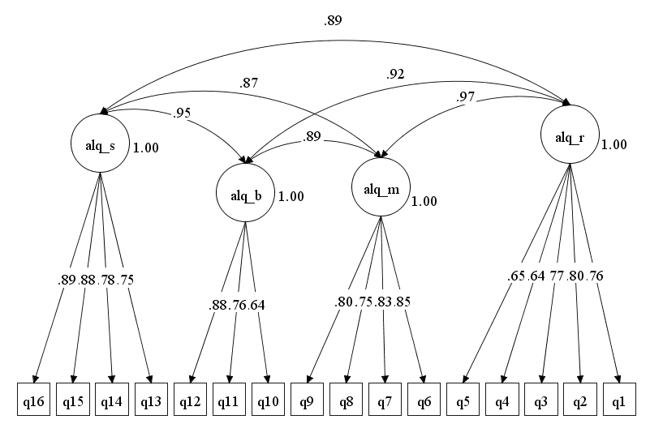
Figure 2
ALQ, Second-Order Model
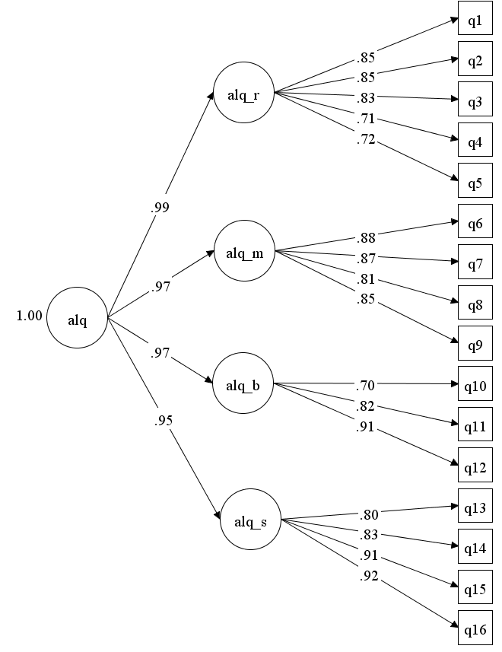

The ALI
Table 5 presents the results for the ALI fitted factor models. The results for the ALI are also consistent with the Levesque-Cote et al., (2018) study, with the ESEM four factor model providing the best fit to the data by all global fit indices. The ESEM four-factor model was superior with the established cut off scores for TLI (.96), CFI (.98), and RMSEA (.07). The first order and second-order models with CFA did meet the established cut off scores for model fit except for the RMSEA (see Figures 3 and 4 for graphical representations of these models). Examination of the residuals from these models again suggests a high number of correlated error terms at the item level, thus decreasing the overall fit of the model. The ESEM model, as before, counteracts this effect by not constraining the cross-loadings across factors and, hence improving the overall fit.
The data results for the BAM model also resulted in an acceptable fit on all but the RMSEA index (.087). Although the BAM model is the conceptually clearest of all the models (see Figure 5), the results for the ESEM four factor model appears to better fit to the data on all critical indices. These results answer research questions 1 and 2, in that the ESEM model was the best-fitting model for the ALI, and that the BAM model did not show better fit than the ESEM model.

Figure 3
ALI, Correlated Factors
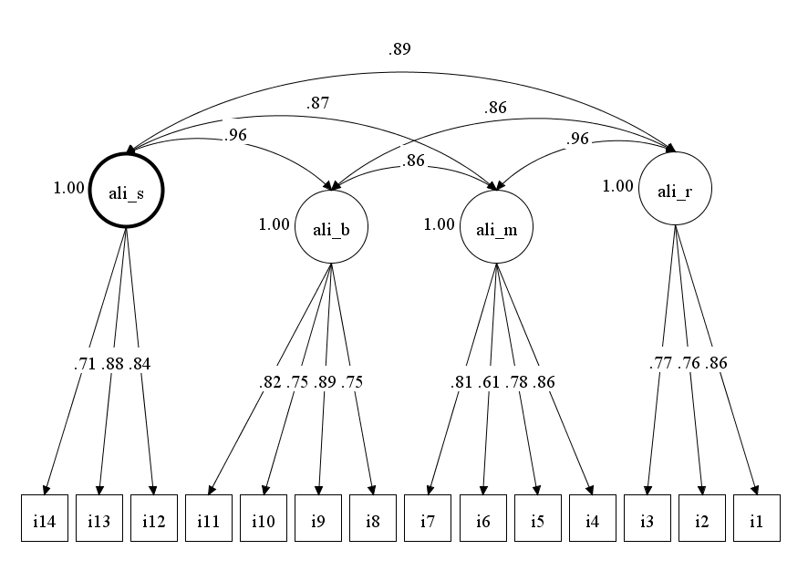

Figure 4
ALI, Second-Order Model
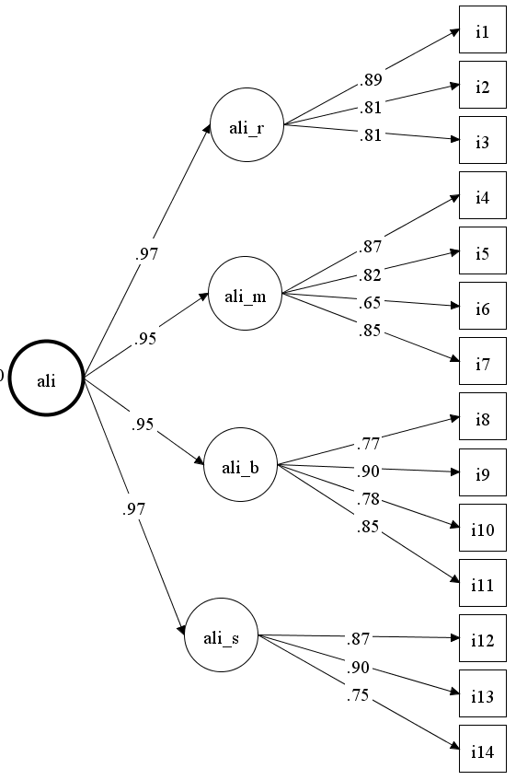
Figure 5
ALI, Bi-factor Model
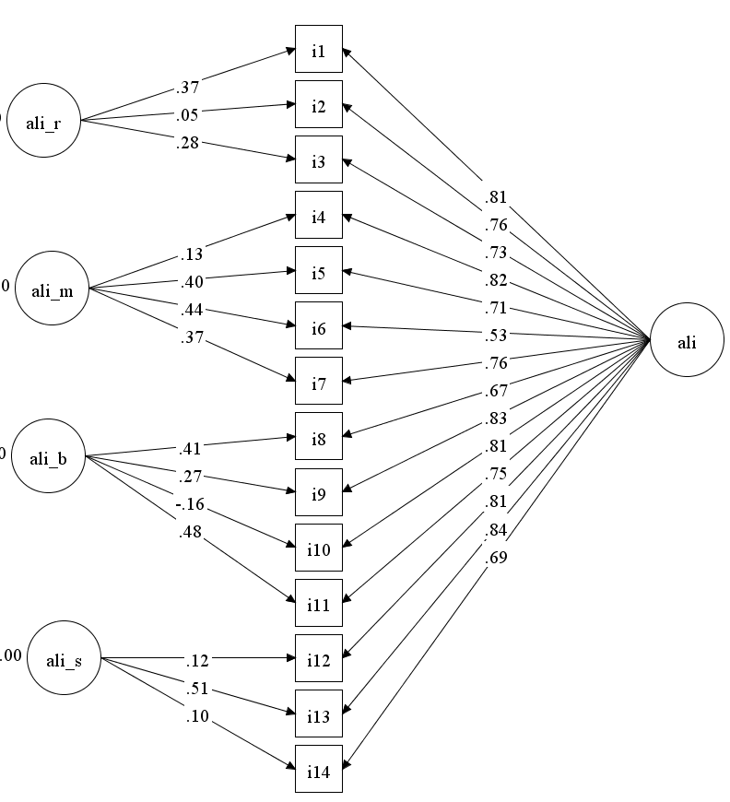

Table 3
30-item Combined ALQ and ALI
Note. 30-item combined ALI and ALQ four factor model is best. χ²(df = 321) = 888.09, p < .001. RMSEA =.068 90% CI [.062, .073], SRMSR = .024, CFI = .944, TLI = 0.92; (Using rotation = target as per Levesque-Cote, J., Fernet, C., Austin, S., & Morin, A. (2018). New wine in a new bottle: refining the assessment of authentic leadership using exploratory structural equation modeling (ESEM). Journal of Business Psychology, 33, 611-628)

The AL-IQ
Initially, following the Levesque-Cote analysis strategy, we fit the 4-factor ESEM model with all 30 items from the combined ALQ and ALI scales (see Table 3 for results). As shown in Table 3, the 4-factor model fit the data well (TLI = .92; CFI = .94, RMSEA = .068). However, when examining the factor loading after a targeted rotation in which all undesirable cross-loadings were targeted to zero, we see a number of cross-contamination of loadings across the different factors (identified in yellow in Table 3). The desirable factor loadings in Table 3 (identified in green) indicate the scales which should load highly on each factor. Because this solution would make the resulting factor scores nearly interpretable, we followed the Levesque-Cote paper and reduced the number of items from 30 to 16. The results for this reduced item AL-IQ are also consistent with the Levesque-Cote et al. (2018) study, with the ESEM four-factor model providing the overall best fit to the data in this study. Table 5 contains these results. Again, only the ESEM four-factor model fits the data well across all three global indices (TI = .97; CFI = .988; RMSEA = .057). The fit of the first- and second-order CFA models mostly failed on the RMSEA criterion (see Figures 6 and 7 for graphical depictions of these models as fitted). Finally, the results for the BFA model again displayed either non-positive-definite theta matrices or failed to converge in this study.
The above results answer research questions 1 and 2, in that, for the AL-IQ 14-item scale, the ESEM four factor model was the best fit to the data compared to first and second order models and BAM. The above results answer research question 3, in that the AL-IQ did replicate to an English speaking sample, consistent with Levesque-Cote et al. (2018) study.

To examine discriminant validity, the final version of the AL-IQ was used with the AES. Table 4 presents the factor loadings and factor correlations for examination and comparison purposes. The table shows that the number of large cross-loadings dramatically reduced from the original 30-item combined measure. Using this ESEM model, factor scores were calculated and used to assess the degree of overlap with thee emotional intelligence measure (AES). Finally, for the purposes of the next analysis, the alpha coefficient was calculated for each of the four AL-IQ subscales using the factor scores as the data. These values were as follows: SA: r_{α} = .828, BP: r_{α} = .865, RT: r_{α}= .856, IMP: r_{α} = .820, which is acceptable for further analysis.

Figure 6
AL-IQ, Correlated Factors
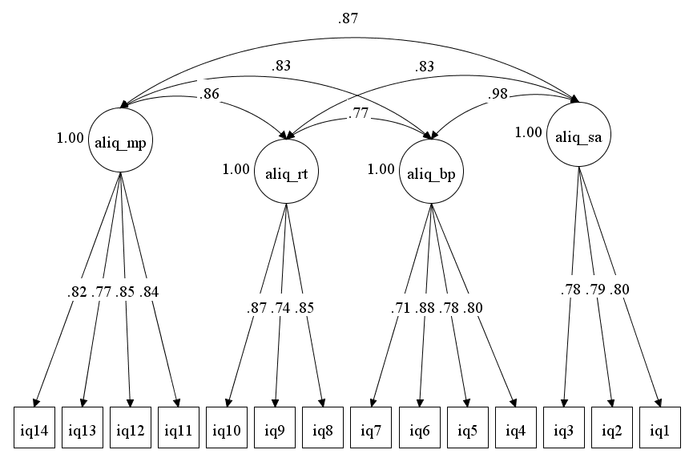

Figure 7
AL-IQ, Second-Order Model

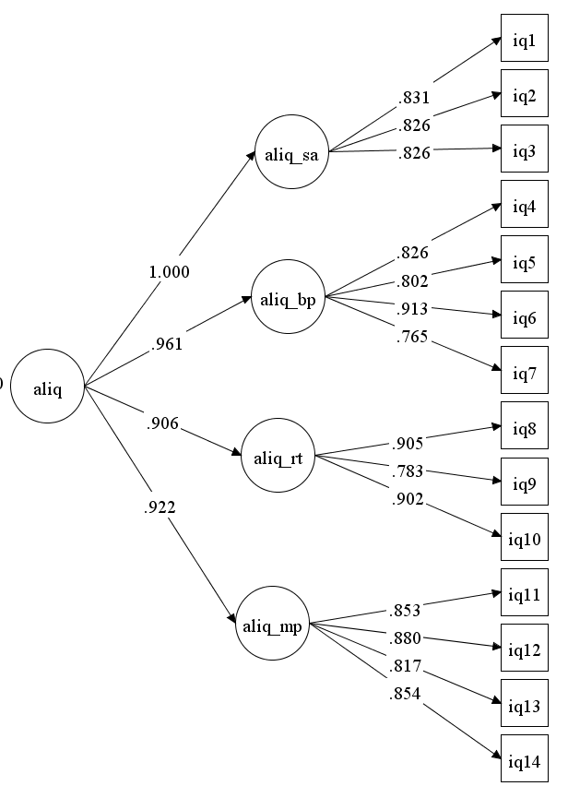
Table 4
AL-IQ, Standard Parameter Estimates

Table 5
Model Comparison

Discriminate Validity and The AES
The overall results for the zero-order Pearson correlations between the AES and the factor scores for the ALQ, ALI, and AL-IQ appear in Table 6. The zero-order Pearson correlations between the AES and the ALQ, show a strong positive relationship between three factors of SA, RT, and MP, all with scores above .70. However, the BP factor showed a negative relationship with the AES (-.015) and with the factors of SA (.091), RT (-.038), and IMP (-.119). For the ALI and the AES, the correlations also showed a strong relationship (r > .70) with RT, MP, and BP, with the relationship with SA more moderate (r > .6). Finally, for the AL-IQ and the AES, the relationship among the four factors and the AES was also strong (r > .70) with the exception of AES and SA (r > .60).
The above results answer research question 4, in that the relationship between the measures of authentic leadership and a measure of emotional intelligence did not show a high degree of divergence. Specifically, the AES scale shows high correlations with the four proposed factors of authentic leadership, suggesting a fairly high degree of overlap between the two constructs as measured and thus less discriminant validity than desirable. Three potential reasons for this follow in the discussion section.

Table 6
Zero Order Pearson Correlations, Modified Assessing Emotions Scale and Authentic Leadership Measures

Discussion

Overview
The purpose of this study was to explore the structural validity and the structural reliability of the three measures for authentic leadership by extending and replicating the analytic methods from the Levesque-Cote et al. (2018) study, to an English-speaking sample. To establish convergent validity, the study employed confirmatory factor analysis (CFA), exploratory structural equation modeling (ESEM), and bi-factor analytic modeling (BAM) on the three measures of authentic leadership. To establish discriminant validity, the study examined the correlations between the three measures of authentic leadership and the four subscales with emotional intelligence using the AES. The primary results from this study include the extension and replication of the Levesque-Cote et al. (2018) study to an English-speaking sample. The results also established the convergent validity of the AL-IQ using the four factor ESEM model, which was superior to the CFA and BAM. Finally, the study failed to establish discriminant validity between authentic leadership and emotional intelligence, as there were strong correlations between the two constructs.

Theoretical Implications
In regard to theoretical contributions, the major contributions of this study include the following. First, this study replicated and extended the Levesque-Cote et al. (2018) study to an English-speaking sample. The results of this study establish what Levesque-Cote et al. (2018) call “linguistic validity” with an English-speaking sample. Second, consistent with the Levesque-Cote et al. (2018) study, this study found that the four-factor ESEM model, provided the best overall fit of the data with the AL-IQ. The ESEM was superior to both the CFA and BAM for assessing and capturing the multidimensional structure of authentic leadership. ESEM remains a critical tool for assessing multidimensional constructs and remains unbiased in the presence or absence of cross loadings (Edwards, 2001; Langlosis et al., 2014; Levesque-Cote et al., 2018). Third, is the idea of factor versatility. Several researchers argue the multidimensional nature of authentic leadership allows for factor versatility in that cross-contamination of loadings is likely to be expected and should be modeled as part of the measure. Factor versatility is based on either the objectives of the study or the context (Avolio et al., 2018; Neider & Schriesheim, 2011). Levesque-Cote et al. (2018) also acknowledge factor versatility in their study. However, the researchers stressed caution as most of the rating outcomes with the AL-IQ occurred with the second-order model. A final contribution is the study failed to establish discriminant validity between the constructs of authentic leadership and emotional intelligence. The correlations between the AL measures and the AES were all above .60/.70, suggesting at least three different conceptual possibilities. First, it raises the possibility that the AL-IQ and the AES are measuring the same items, although the correlations are not high enough to indicate this as the most probable explanation. Second, it may suggest that high levels of emotional intelligence are potentially a direct cause and/or antecedent of a leader exhibiting authentic leadership. Finally, it may also the case that there is a strong mono-method effect which contaminates all items on the survey, although the finding of a better-fitting four factor model compared to both a single-factor model or a bifactor model argues against this as the sole reason for the lack of discriminant validity.

Practical Implications
In regard to practical implications, one implication is the AL-IO, provides a psychometrically sound measure for authentic leadership. This allows leadership practitioners to tailor training interventions or coaching strategies using questions from the AL-IQ. A second implication is the strong correlations in this study between authentic leadership and emotional intelligence, contributes to the developing literature on training interventions for authentic leadership (Avolio et al., 2004; Cooper et al., 2005). The strong correlations also address a gap in the literature on the identified antecedents for developing authentic leadership. A third implication is application of authentic leadership to small groups or teams. Banks et al. (2016) suggested that research outcomes for authentic leadership indicate elevated levels of group and organizational performance. Authentic leadership provides managers of groups or teams with tools to facilitate group function and performance.

Limitations
In regard to limitations, the most potent limitation in this study is the mono-method used to collect the survey items. The high correlations among the measures in this study may suggest a similar response pattern by participants. It is possible the use of Mechanical Turk contributed to the similar response pattern. Cheung et al. (2017) discussed literature results pertaining to mono-method bias and suggested that the best way to control for this bias is to secure multiple sources of data (e.g., multiple raters). However, the authors stressed that Mechanical Turk makes matching responses from multiple raters extremely difficult and, thus, it may be necessary to collect additional data outside of the Mechanical Turk environment. However, as suggested before, it is also important to point out the presence of a pure mono-method bias would most likely result in either the bi-factor model or the single factor model to emerge as the best fitting model. As this was not the case, we cannot attribute all the high correlations to a pure mono-method effect due to Mechanical Turk. In this regard, one positive use of Mechanical Turk is in providing a low cost platform with a broad sample of participants tending to better resemble the general population than undergraduate or Internet samples (Arditte et al., 2016; Buhrmester et al., 2011), while also providing a quick return on data depending on the nature of a study. Another limitation of this study was the use of self-reported data collected at one time-point. Multiple data points and the inclusion of leader feedback on followers will help to establish the validity of the AL-IQ. A final limitation with this study is the idea of group performance. Banks et al. (2016) suggested empirical research outcomes for AL groups around elevated levels of group and organizational performance. This study failed to address any group or organizational performance outcomes for authentic leadership and the AL-IQ.

Future Research
In regard to future research, as previously discussed, the inclusion of multiple data points, leader feedback, and the addition of test-retest reliability, will continue the process of establishing the validity of the AL-IQ. Another area for future research is expanding the AL-IQ to other cultures, work sectors, and contexts. In this study, 66.5% of participants worked in the private sector. Expanding to other sectors including the military, the medical sector with the recent emergence of a worldwide pandemic, and disaster response holds great potential for organizational outcomes. Future research should also examine what aspects of emotional intelligence facilitate the development of authentic leadership. As previously discussed, starting points include empathy, social skills (conflict management, managing negative emotions) and, self-awareness and self-regulation (Gardner et al., 2009; Kotze & Petrus, 2015; Kotze & Petrus, 2017).

Conclusion
This research study confirms authentic leadership is a measurable leadership construct. The study also confirms emotional intelligence as a possible antecedent to authentic leadership. As a result of this research study, the author recommends a training intervention designed to develop authentic leadership. The training intervention breaks into two broad ideas, understanding one’s emotions and understanding others’ emotions.
The two constructs of authentic leadership and emotional intelligence drive the training. Training for authentic leadership includes exercises and skill building to apply the four factors of authentic leadership (self-awareness, relational transparency, balanced processing, and internalized moral perspective). The training would also include exercises and skill building to reinforce questions from the Authentic Leadership-Integrated Questionnaire (AL-IQ). Training for emotional intelligence would include exercises and skill building to apply the four factors of the modified, Assessing Emotions Scale (perceptions of emotions, managing one’s emotions, managing others’ emotions, and the utilization of emotions).
Understanding One’s Emotions: Understanding one’s emotions consists of four subtasks. The first subtask involves training to develop self-awareness (taps into both AL and EI). Training for self-awareness entails identifying the strengths and weaknesses for each leader. Training also includes understanding the link between leader strengths and weaknesses as it relates to impacting followers (taps into AL). Finally, training for self-awareness includes understanding the influence of trigger events and personal histories on leadership (taps into AL). The second subtask is training on self-regulation (taps into both AL and EI). Training for self-regulation is designed to ensure a leader aligns their intentions (words) with their actions. Training also includes identifying one’s values and ensuring the alignment of those values. Finally, training for self-regulation involves the leader controlling the use of negative emotions. The third subtask is training on feedback, openness, and transparency (taps into AL and EI). The training for openness includes the leader receiving feedback and evaluating information from followers. Transparency involves the open sharing of emotions, feelings, and sharing the relationship dynamics and tensions impacting the organization. The final subtask is training on leader role modeling (taps into AL). The result of understanding one’s emotions is trust in the leader, consistent with research outcome on authentic leadership.
Understanding Others’ Emotions: Understanding others’ emotions consists of three subtasks. The first subtask is training to develop empathy (taps into AL and EI). Training for empathy centers on being aware of other’s feelings, needs, and concerns. The training for empathy also involves the importance of communicating and learning to read non-verbal behaviors. The second subtask is training to develop conflict resolution skills (taps into EI). Training for conflict resolution includes handling conflict with tact and diplomacy along with the importance of building consensus with groups. The third subtask is the process of the leader developing followers (taps into AL). Developing followers involves a combination of role modeling, training, and feedback or coaching. The broad topics include self-awareness, self-regulation, positive emotions, feedback, openness and transparency, and leader role modeling. Additional topics communications skills, understanding and applying values and the open and honest sharing of the relationship dynamics and tensions impacting the organization. The result of understanding others’ emotions is heightened levels of group and organizational performance consistent with research outcomes on authentic leadership and emotional intelligence.

References
Adiguzel, Z., & Kuloglu, E. (2019). Examination of the effects of emotional intelligence and authentic leadership on employees in the organizations. International Journal of Organizational Leadership, 8, 13-30. http://dx.doi.org/10.33844/ijol.2019.60412
Arditte, K., Cek, D., Shaw, A., & Timpano, K. (2016). The importance of assessing clinical phenomena in mechanical turk research. Psychological Assessment, 28(6), 684-691. https://doi.org/10.1037/pas0000217
Avolio, B., Gardner, W., Walumbwa, F., Luthans, F., & May, D. (2004). Unlocking the mask: a look at the process by which authentic leaders impact follower attitudes and behaviors. The Leadership Quarterly, 15(6), 801-823. https://doi.org/10.1016/j.leaqua.2004.09.003
Avolio, B. J., & Gardner, W. L. (2005). Authentic leadership development: getting to the root of positive forms of leadership. The Leadership Quarterly, 16, 315-338. https://doi.org/10.1016/j.leaqua.2005.03.001
Avolio, B. J., Wernsing, T., & Gardner, W. L. (2018). Revisiting the development and validation of the authentic leadership questionnaire: analytical clarifications. Journal of Management, 44, 399-411. https://doi.org/10.1016/j.leaqua.2005.03.001
Azanza, G., Moriano, J., & Molero, F. (2013). Authentic leadership and organizational culture as drivers of employees’ job satisfaction. Journal of Work and Organizational Psychology, 29, 45-50. https://doi.org/10.5093/tr2013a7
Bagozzi, R., & Edwards, J. (1998). A general approach to representing constructs in organizational research. Organizational Research Methods, 1, 48-87. https://doi.org/10.1177%2F109442819800100104
Banks, G. C., McCauley, K. D., Gardner, W. L., & Guler, C. E. (2016). A meta-analytic review of authentic and transformational leadership: a test for redundancy. The Leadership Quarterly, 27, 634-652. https://doi.org/10.1016/j.leaqua.2016.02.006
Bar-On, R. (2006). The Bar-On model of emotional-social intelligence. Psicothema, 18, 13-25.
Barnard, C. (1938). The functions of the executive. Cambridge: Harvard University.
Bass, B., & Steidlmeier, P. (1999). Ethics, character, and authentic transformational leadership behavior. The Leadership Quarterly, 10(2), 181-217. https://doi.org/10.1016/S1048-9843(99)00016-8
Begley, P. (2001). In pursuit of authentic school leadership practices. Journal of Leadership in Education, 4, 353-365. https://link.springer.com/bookseries/6543
Boamah, S., & Tremblay, P. (2018). Examining the factor structure of the MLQ transactional and transformational leadership dimensions in a nursing context. Western Journal of Nursing Research, 41(5), 743-761. https://doi.org/10.1177%2F0193945918778833
Browne, M., & Cudeck, R. (1993). Alternative ways of assessing model fit. In K. Bollen, & S. Long (Eds.), Testing structural equation models (pp. 136-162). Newberry Park, CA: Sage.
Buhrmester, N., Kwang, T., & Gosling, S. (2011). Amazon’s mechanical turk: a new source of inexpensive, yet high-quality data? Perspectives on Psychological Science, 6, 3-5. https://doi.org/10.1177/1745691610393980
Caza, A., Bagozzi, R., Woolley, L., Levy, L., & Brianna, C. (2010). Psychological capital and authentic leadership: measurement, gender, and cultural extension. Asia Pacific Journal of Business Administration, 2(1), 53-70. https://doi.org/10.1108/17574321011028972
Chen, F., West, S., & Sousa, K. (2006). A comparison of bifactor and second-order model of quality of life. Multivariate Behavioral Research, 41(2), 189-225. https://doi.org/10.1207/s15327906mbr4102_5
Cheung, J., Burns, D., Sinclair, R., & Sliter, M. (2017). Amazon mechanical turk in organizational psychology: an evaluation and practical recommendations. Journal of Business and Psychology, 32 (4), 347-361. https://doi.org/10.1007/s10869-016-9458-5
Clapp-Smith, R., Vogelgesang, G., & Avery, J. (2009). Authentic leadership and positive psychological capital: the mediating role of trust at the group level of analysis. Journal of Leadership & Organizational Studies, 15, 227-240. https://doi.org/10.1177%2F1548051808326596
Cooper, C., Scandura, T., & Schriesheim, C. (2005). Looking forward but learning from our past: potential challenges to developing authentic leadership theory and practice. The Leadership Quarterly, 16, 475-495. https://doi.org/10.1016/j.leaqua.2005.03.008
Crede, M., & Harms, P. (2015). 25 years of higher-order confirmatory factor analysis in the organizational sciences: a critical review and development of reporting recommendations. Journal of Organizational Behavior, 36(6), 845-872. https://doi.org/10.1002/job.2008
Crede, M., & Harms, P. (2019). Questionable research practices when using confirmatory factor analysis. Journal of Managerial Psychology, 35(1), 18-30. https://doi.org/10.1108/JMP-06-2018-0272
Diddams, M., & Chang, G. (2012). Only human: exploring the nature of weakness in authentic leadership. The Leadership Quarterly, 23, 593-603. https://doi.org/10.1016/j.leaqua.2011.12.010
Duncan, P., Green, M., Gergen, E., & Ecung, W. (2017). Authentic leadership-it is more than emotional intelligence. Administrative Issues Journal, 7(2), 11-22. https://doi.org/10.5929/2017.7.2.2
Edwards, J. (2001). Multidimensional constructs in organizational behavior research: an integrative analytical framework. Organizational Research Methods, 4, (2), 144-192. https://doi.org/10.1177%2F109442810142004
Gardner, W., Cogliser, C., Davis, K., & Dickens, M. (2011). Authentic leadership: a review of the literature and research agenda. The Leadership Quarterly, 22, 1120-1145. https://doi.org/10.1016/j.leaqua.2011.09.007
Gardner, W., Fischer, D., & Hunt, J. (2009). Emotional labor and leadership: a threat to authenticity. The Leadership Quarterly, 20, 466-482. https://doi.org/10.1016/j.leaqua.2009.03.011
George, B. (2003). Authentic leadership: rediscovering the secrets to creating lasting value. San Francisco: Jossey-Bass.
Goleman, D. (1998). Working with emotional intelligence. New York: Bantam.
Hair, J, Black W, Babin B, & Anderson, R. (2010). Multivariate data analysis (7th Ed). Englewood Cliffs: Prentice Hall.
Henderson, J., & Hoy, W. (1983). Leader authenticity: the development and test of an operational measure. Educational and Psychological Research, 3(2), 63-75.
Hennessey, M., Terry, R., Martin, J., McConnell, A., & Willis, D. (2017). Factor structure and basic psychometric properties of the transition assessment and goal generator. Hamilton Institute of Disabilities, 1-12. http://dx.doi.org/10.1177/2165143417691021
Hoch, J., Bommer, W., Dulebohn, J., & Wu, D. (2018). Do ethical, authentic, and servant leadership explain variance above and beyond transformational leadership? A meta-analysis. Journal of Management, 44(2), 501-529. https://doi.org/10.1177%2F0149206316665461
Jensen, S., & Luthans, F. (2006). Entrepreneurs as authentic leaders: impact on employees’ attitudes. Leadership and Organizational Development Journal, 27, 646-666. https://doi.org/10.1108/01437730610709273
Kernis, M. (2003). Toward a conceptualization of optimal self-esteem. Psychological Inquiry, 14, 1-26. https://www.jstor.org/publisher/taylorfrancis?refreqid=excelsior%3A8a68045af76320b6d4d7512ea4807abc
Kernis, M., & Goldman, B. (2006). A multicomponent conceptualization of authenticity. Advances in Experimental Psychology, 38, 283-357. https://doi.org/10.1016/S0065-2601(06)38006-9
Kline, R. (2015). Principles and practice of structural equation modeling (4th Ed). New York: Guildford.
Kotze, M., & Petrus, N. (2017). Personal factor effects on authentic leadership. Journal of Psychology in Africa, 27(1), 47-53. https://doi.org/10.1080/14330237.2016.1268291
Kotze, M., & Petrus, N. (2015). The influence of trait-emotional intelligence on authentic leadership. SA Journal of Human Resource Management, 13(1), 1-9. https://doi.org/10.4102/sajhrm.v13i1.716
Langlosis, L., Lapointe, C., Valois, P., & Leeuw, A. (2014). Development and validity of the ethical leadership questionnaire. Journal of Educational Administration, 52(3), 310-331. https://doi.org/10.1108/JEA-10-2012-0110
Leroy, H., Anseel, F., Gardner, W., & Sels, L. (2012). Authentic leadership, authentic followership, basic need satisfaction, and work role performance. Journal of Management, 41(6), 1677-1697. https://doi.org/10.1177%2F0149206312457822
Levesque-Cote, J., Fernet, C., Austin, S., & Morin, A. (2018). New wine in a new bottle: refining the assessment of authentic leadership using exploratory structural equation modeling (ESEM). Journal of Business Psychology, 33, 611-628. https://link.springer.com/article/10.1007/s10869-017-9512-y#citeas
Luthans, F., & Avolio, B. (2003). Authentic leadership: a positive developmental approach. In K. Cameron, J. Dutton, & R. Quinn (Eds.), Positive organizational scholarship: foundations of a new discipline (pp. 241-261). San Francisco: Barrett-Koehler.
Marsh, H., Morin, A., Parker, P., & Kaur, G. (2014). Exploratory structural equation modeling: an integration of the best features of exploratory and confirmatory factor analysis. Annual Review of Clinical Psychology, 10, 85-110. https://doi.org/10.1146/annurev-clinpsy-032813-153700
May, D., Chan, A., Hodges, T., & Avolio, B. (2003). Developing the moral component of authentic leadership. Organizational Dynamics, 32, 247-260. https://psycnet.apa.org/doi/10.1016/S0090-2616(03)00032-9
Mayer, J., Roberts, R., & Barsade, S. (2008). Human ability: emotional intelligence. Annual Review of Psychology, 59, 507-536. https://doi.org/10.1146/annurev.psych.59.103006.093646
Mayer, M., Salovey, P., & Caruso, D. (2004). A further consideration of the issues of emotional intelligence. Psychological Inquiry, 15(3), 249-255. http://ei.yale.edu/publication/consideration-issues-emotional-intelligence/
Messick, S. (1994). Validity of psychological assessment: validation of inferences from persons’ responses and performances as scientific inquiry into score meaning. Princeton, NJ: Educational Testing Service.
Miao, C., Humphrey, R., & Qian, S. (2016). Leader emotional intelligence and subordinate job satisfaction: a meta-analysis of main, mediator, and moderator effects. Personality and Individual Differences, 102, 13-24. https://doi.org/10.1016/j.paid.2016.06.056
Miao, C., Humphrey, R., & Qian, S. (2018). Emotional intelligence and authentic leadership: a meta-analysis. Leadership & Organizational Development Journal, 39, 679-690. https://doi.org/10.1108/LODJ-02-2018-0066
Murray, A., & Johnson, W. (2013). The limitations of model fit in comparing bi-factor versus higher-order models of human cognitive ability structure. Intelligence, 41, 407-422. https://doi.org/10.1016/j.intell.2013.06.004
Neider, L. L., & Schriesheim, C. A. (2011). The authentic leadership inventory (ALI): development and empirical tests. The Leadership Quarterly, 22, 1146-1164. https://doi.org/10.1016/j.leaqua.2011.09.008
Northouse, P. (2010). Leadership: theory and practice (5th ed.). Thousand Oaks: CA: Sage.
Novicevic, M., Harvey, M., Radford, R., & Brown-Radford, F. (2006). Authentic leadership: a historical perspective. Journal of Leadership and Organizational Studies, 13, 64-76. https://doi.org/10.1177%2F10717919070130010901
Peterson, S., Walumbwa, F., Avolio, B., & Hannah, S. (2012). The relationship between authentic leadership and follower job performance: the mediating role of follower positivity in extreme contexts. The Leadership Quarterly, 1-15. https://doi.org/10.1016/j.leaqua.2011.12.004
Peterson, S., Walumbwa, F., Avolio, B., & Hannah, S. (2014). Retraction notice to the relationship between authentic leadership and follower job performance: the mediating role of follower positivity in extreme contexts . The Leadership Quarterly , 25, 1183-1184. https://doi.org/10.1016/j.leaqua.2011.12.004
Peus, C., Sarah, J., Streicher, B., Braun, S., & Frey, D. (2012). Authentic leadership: an empirical test of its antecedents, consequences, and mediating mechanisms. Journal of Business Ethics, 107, 331-348. https://doi.org/10.1007/s10551-011-1042-3
Rego, A., Vitoria, A., Magalhaes, A., Ribeiro, R., & Cunha, M. (2013). Are authentic leaders associated with more virtuous, committed and potent teams? The Leadership Quarterly, 24, 61-79. https://doi.org/10.1016/j.leaqua.2012.08.002
Saher, N., Saleem, S., & Iqbal, M. (2013). Emotional intelligence (EI) and employee outcomes: the mediating effect of authentic leadership style. Interdisciplinary Journal of Contemporary Research in Business, 5(1), 394-405. https://doi.org/10.1177%2F2278533715605426
Salovey, P., & Mayer, J. (1990). Emotional intelligence. Imagination, Cognition and Personality, 9, 185-211. https://doi.org/10.2190%2FDUGG-P24E-52WK-6CDG
Sass, D., & Schmitt, T. (2011). Introduction to the special issue: moving beyond traditional psychometric approaches. Journal of Psychoeducational Assessment, 29(4), 299-303.
Schriesheim, C., Alonso, S., & Neider, L. (2008, 29 October-01 November). A quantitative examination of the content validity and theoretical dimensionality of the transformational leadership inventory. Paper presented at the Southern Management Association, St. Petersburg Beach. FL.
Schutte, N., Malouff, J., & Bhullar, N. (2009). The assessing emotions scale. In C. Stough, D. Saklofske, & J. Parker (Eds.), The assessment of emotional intelligence (pp. 119-135). New York: Springer.
Schutte, N., Malouff, J., Hall, L., Haggerty, D., Cooper, J., Golden, C., & Dornheim, L. (1998). Development and validation of a measure of emotional intelligence. Personality and Individual Differences, 25, 167-177. https://doi.org/10.1016/S0191-8869(98)00001-4
Steffens, N., Mols, F., Haslam, A., & Okimoto, T. (2016). True to what we stand for: championing collective interests as a path to authentic leadership. The Leadership Quarterly, 27, 726-744. https://doi.org/10.1016/j.leaqua.2016.04.004
Walumbwa, F. O., Alovio, B. J., Gardner, W. L., Wernsing, T. S., & Peterson, S. J. (2008). Authentic leadership: development and validation of theory-based measure. Journal of Management, 34(1), 89-126. https://doi.org/10.1177%2F0149206307308913
Walumbwa, F. O., Luthans, F., Avey, J. B., & Oke, A. (2011). Authentically leading groups: the mediating role of collective psychological capital and trust. Journal of Organizational Behavior, 32, 4-24. https://doi.org/10.1002/job.653
Walumbwa, F. O., Luthans, F., Avey, J. B., & Oke, A. (2014). Retraction, Authentically leading groups: the mediating role of collective psychological capital and trust. Journal of Organizational Behavior, 32(1), 89-126. https://doi.org/10.1002/job.653
Walumbwa, F., Wang, P., Wang, H., Schaubroeck, J., & Avolio, B. (2010). Psychological processes linking authentic leadership to follower’s behavior. The Leadership Quarterly, 21, 901-914.
Walumbwa, F., Wang, P., Wang, H., Schaubroeck, J., & Avolio, B. (2014). Retraction notice to psychological processes linking authentic leadership to follower’s behaviors. The Leadership Quarterly, 1071-1072. https://doi.org/10.1016/j.leaqua.2010.07.015
Wang, H., Sui, Y., Luthans, F., Wang, D., & Wu, Y. (2014). Impact of authentic leadership on performance: role of followers’ positive psychological capital and relational processes. Journal of Organizational Behavior, 35, 5-21. https://doi.org/10.1002/job.1850
Yagil, D., & Medler-Liraz, H. (2013). Moments of truth: examining transient authenticity and identity in service encounters. Academy of Management Journal, 56 (2), 473-497. https://doi.org/10.5465/amj.2011.0252
Yagil, D., & Medler-Liraz, H. (2014). Feel free, be yourself: authentic leadership, emotional expression, and employee authenticity. Journal of Leadership and Organizational Studies, 21 (1), 59-70. https://doi.org/10.1177%2F1548051813483833
Yukl, G. (2010). Leadership in organizations. Upper Saddle River, NJ: Pearson Education.

Appendix A: The Authentic Leadership Questionnaire

The authors of the ALQ and Mind garden do not allow for the publication of the copyrighted
ALQ for dissertations or articles.

Appendix B: The Authentic Leadership Inventory
1. My leader clearly states what he/she means.
2. My leader shows consistency between his/her beliefs and actions.
3. My leader asks for ideas that challenge his/her core beliefs.
4. My leader describes accurately the way that others view his/her abilities.
5. My leader uses his/her core beliefs to make decisions.
6. My leader carefully listens to alternative perspectives before reaching a conclusion.
7. My leader shows that he/she understands his/her strengths and weaknesses.
8. My leader openly shares information with others.
9. My leader resists pressures on him/her to do things contrary to his/her beliefs.
10. My leader objectively analyzes relevant data before making a decision.
11. My leader is clearly aware of the impact he/she has on others.
12. My leader expresses his/her ideas and thoughts clearly to others.
13. My leader is guided in his/her actions by internal moral standards.
14. My leader encourages others to voice opposing points of view.

Appendix C: The Authentic Leadership-Integrated Questionnaire
My Leader:
1. Encourages others to voice opposing points of view.
2. Solicits comments to improve his/her way of interacting with others.
3. Clearly states what he/she means.
4. Acts in accordance with his/her stated beliefs.
5. Asks for ideas that challenge his/her core beliefs.
6. Describes precisely how others views his/her abilities.
7. Openly express his/her thoughts.
8. Bases his/her decisions on its fundamental values.
9. Indicates that he/she understands how certain actions can influence other people.
10. Expresses his/her ideas and thoughts clearly to others.
11. Encourages me to make decisions that are consistent with my fundamental values.
12. Carefully listens to alternative perspectives before reaching a conclusion.
13. Makes decisions based on a rigorous ethical code.
14. Objectively analyzes relevant data before making a decision.

Appendix D: The Modified, Assessing Emotions Scale
1. My leader knows when to speak about my personal problems with others.
2. When faced with obstacles, my leader remembers times when they faced similar
obstacles and overcame them.
3. My leader expects that they will do well on most things they try.
4. My leader finds it easy to confide in others.
5. My leader finds it hard to understand the non-verbal messages of other people.
6. Some major life events have led my leader to re-evaluate what is important and not
important.
7. When my leader’s mood changes, they see new possibilities.
8. My leader believes emotions are one of the things that make life worth living.
9. My leader is aware of their emotions as they experience them.
10. My leader expects good things to happen.
11. My leader likes to share emotions with others.
12. When my leader experiences a positive emotion, they know how to make it last.
13. My leader arranges events others enjoy.
14. My leader seeks out activities that makes them happy.
15. My leader is aware of the non-verbal messages they send to others.
16. My leader presents themself in a way that makes a good impression on others.
17. When my leader is in a positive mood, solving problems is easy for them.
18. By looking at their facial expressions, my leader recognizes the emotions people are
experiencing.
19. My leader knows when their emotions change.
20. When in a positive mood, my leader is able to come up with new ideas.
21. My leader has control over their emotions.
22. My leader easily recognizes their emotions as experienced.
23. My leader self-motivates by imagining good outcomes with the tasks I take on.
24. My leader compliments others when they have done something well.
25. My leader is aware of the non-verbal messages other people send.
26. When another person tells my leader about an important event in their life, I almost feel
as though I experienced this event myself.
27. When my leader feels a change in emotions, they tend to come up with new ideas.
28. When faced with a challenge, my leader gives up because they believe they will fail.
29. My leader knows what other people are feeling just by looking at them.
30. My leader helps other people feel better when they are down.
31. My leader uses good moods to help others keep trying in the face of obstacles.
32. My leader can tell how other people are feeling by listening to the tone of their voice.
33. It is difficult for my leader to understand why people feel the way they do.

Appendix E: MPlus Code
SA by IQ1 IQ2 IQ3
IQ4~0 IQ5~0 IQ6~0 IQ7~0
IQ8~0 IQ9~0 IQ10~0
IQ11~0 IQ12~0 IQ13~0 IQ14~0 (*1).
RT by IQ8 IQ9 IQ10
IQ1~0 IQ2~0 IQ3~0
IQ4~0 IQ5~0 IQ6~0 IQ7~0
IQ11~0 IQ12~0 IQ13~0 IQ14~0 (*1).
MP by IQ11 IQ12 IQ13 IQ14
IQ8~0 IQ9~0 IQ10~0
IQ1~0 IQ2~0 IQ3~0
IQ4~0 IQ5~0 IQ6~0 IQ7~0 (*1);
BP BY IQ4 IQ5 IQ6 IQ7
IQ1~0 IQ2~0 IQ3~0
IQ8~0 IQ9~0 IQ10~0
IQ11~0 IQ12~0 IQ13~0 IQ14~0 (*1);

