University of Oklahoma

Graduate College

THE EMERGENCE OF Green MATERIALS AND TECHNOLOGIES IN HISTORIC BUILDING Adaptation
CASE STUDY: TABRIZ HISTORIC BAZAAR COMPLEX

A thesis

submitted to the graduate faculty

in partial fulfillment of the requirements for the

Degree of

Master of Science in Interior Design

By

ATEFE HEJRI
Norman, Oklahoma
2017

THE EMERGENCE OF Green MATERIALS AND TECHNOLOGIES IN HISTORIC BUILDING Adaptation
CASE STUDY: TABRIZ HISTORIC BAZAAR COMPLEX

A thesis approved for the
College of Architecture

By

______________________________
Ms. Mia Kile, Chair

______________________________
Mr. Ronald H. Frantz

______________________________
Ms. Hillary Fulton

© Copyright by ATEFE HEJRI 2017
All Rights Reserved.

Acknowledgments
I would first like to thank my dearest thesis advisor Prof. Mia Kile at the University of Oklahoma. The door to Prof. Kile office was always open whenever I had a question about my research or writing. She consistently encouraged me to conduct my work but guided me towards the right direction whenever she thought I needed it.
I would like to thank the experts who were involved in the validation of this research proposal: Ms. Hillary Fulton and Mr. Ronald H. Frantz. Without their input and valuable comments, the validation of thesis could not have been successfully achieved.
Finally, I must express my sincere gratitude and gratefulness to my dear Sattar, my mom and dad, and to my dear Ehsan and Mina for providing me with continuous encouragement throughout my years of work and study.

Table of Contents
Acknowledgments iv
List of Tables vii
List of Figures viii
Abstract ix
Introduction 1
Chapter 1 7
Review of World Literature 7
1.1 The Concept of Cultural Heritage 7
1.2 Value of Historic Preservation 8
1.3 The Climate Change Impacts on Cultural Heritage Conservation 8
1.4 Adaptation of Historic Buildings: Effective Strategy 12
1.5 Climate Change Impacts on Tabriz Historic Bazaar Complex 15
Chapter 2 17
Water Efficiency 17
2.1 Existing Issues in THBC 17
2.2 Review of Case Studies 17
2.3 Potentials for Improvements in Muzaffarieh carpet market 19
Chapter 3 22
Indoor Air Quality 22
3.1 Existing Issues in THBC 22
3.2 Review of Case Studies 23
3.3 Potentials for Improvements in Muzaffarieh carpet market 24
Chapter 4 27
Education 27
4.1 Review of Case Studies 27
4.2 Potentials for Improvements in Muzaffarieh carpet market 28
Summary and Conclusion 30
Reference 33
Appendix A 38
Color-coded Plan of THBC 38
Appendix B 39
Location of Professional Guilds in THBC 39
Physical Elements of THBC 39
Appendix C 40
Structural Analysis of Muzaffarieh Carpet Market 40
Appendix D 41
Typical Sources of Harmful Indoor Pollutant 41
Appendix E 42
List of Acronyms and Abbreviations 42

List of Tables
Table 0.1: THBC Spatial Elements (See Appendix C [2]) 2
Table 2.1: Example List of Efficient Water Devices [44]. 21
Table 3.1: List of Existing Materials [2] 25

List of Figures
Figure 0.1: Muzaffarieh Carpet Market [2]. 1
Figure 0.2: Muzaffarieh Carpet Market [3]. 1
Figure 0.3: Plan - Muzaffarieh Carpet Market [2]. 1
Figure 2.1: Graywater System for Indoor Reuse 18
Figure 2.2: Rainwater Harvesting System Channels [1]. 19
Figure 3.1: Inside the Stores [5]. 24
Figure 3.2: Air Conditioners are Attached to Walls in Both Sides [4]. 25

Abstract
The adverse environmental condition of the 21st century can impede sustainable settlement in buildings for future use. However, historic buildings as an example of vernacular architecture have potential to provide a healthy indoor that resists the 21st-century climate change. With proper adaptation and improvements, not only such buildings provide a healthy indoor environment but also, they can control the new adverse climatic conditions. Muzaffarieh carpet market located in Tabriz Historic Bazaar Complex (THBC), as a practical example of vernacular architecture in Tabriz city, has the potential to withstand the adverse environmental conditions of the 21st century. However, lack of local action plans and guidelines is a limit in the adaptation of this market to climate change.
Through a comprehensive theoretical framework, the presented study reviews the sustainable strategies for adaptation of Muzaffarieh carpet market. Data and information are collected from recent reports and articles for this location; though, to find substantial evidence of the conditions need further investigation. The aim is to supply indoor spaces with solutions concerning healthy air and water efficiency and to come up with an educational approach for informing shopkeepers. Here, the adaptation plan for the indoor environment is suggested through studying a number of historic buildings in the U.S. that are certified as green buildings with similar climates like Tabriz. The presented suggestions can ensure the sustainable presence of users in THBC for a longer time.

Introduction
Tabriz Historic Bazaar Complex (THBC) as a brick building has an area of 27 hectares with 3.5 miles of lanes [7]. This historical marketplace which is located in Tabriz, Iran has domed or vaulted structures which demonstrate different techniques of laying bricks [7]. Bazaar in Persian literature offers broad meanings. The name has been used for a crowded covered or semi-covered space. Bazaar is recognized as a place in which commercial activities are conducted. Therefore, it is a place for running a business which has evolved architectural characters of its own over time. Accordingly, THBC is the embodiment of this covered market typology [7].
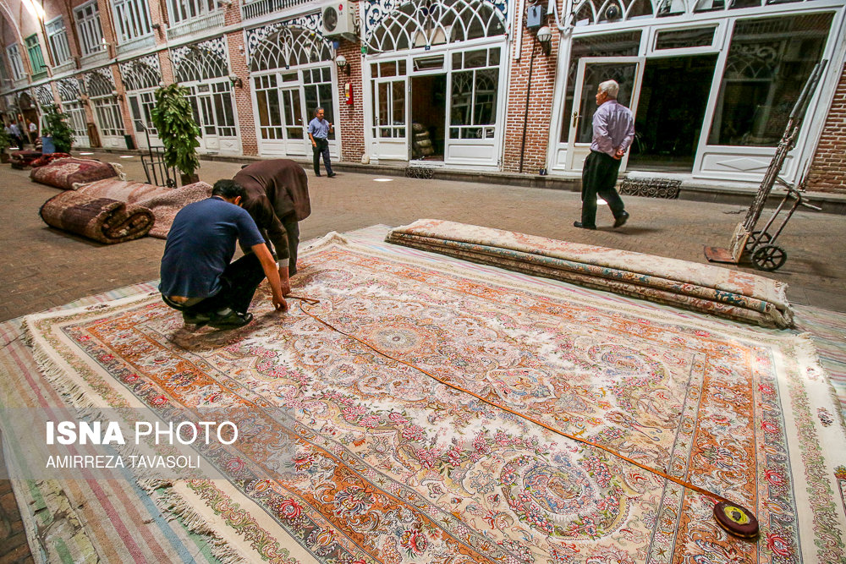
Figure 0.1: Muzaffarieh Carpet Market [3].
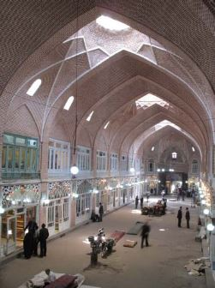
Figure 0.2: Muzaffarieh Carpet Market [4].
Figure 0.3: Plan - Muzaffarieh Carpet Market [3].
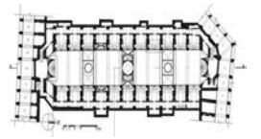
The whole THBC has been completely rebuilt several times, and most comprehensively in 1780 [8]. As shown in table 0.1, the complex consists of different spatial elements (See Appendix A and B [3, 9]). These functional spaces join the spine of THBC and create a multifunctional complex (See Appendix C [3]). THBC consists of 5500 stores with 40 professional guilds; 35 Sara (inn); 20 Rasteh (lane); 25 Timcheh (trading and storage centers); 11 Dalan (corridors) along with 20 mosques with nine traditional schools [7]. All of the functional spaces work together to build a social, economic and cultural structure.
Here, among different functional spaces in THBC, Timcheh is selected for studying adaptation purpose to climate change. In general, Timcheh is a trading and storage center, and it is a model of vernacular architecture (See Appendix C). These types of functional spaces are carrying out the economic activities in large scales [10]. The location of Timcheh is for selling and supplying particular expensive goods. Sometimes, they may also provide a place for social or cultural events.
Table 0.1: THBC Spatial Elements (See Appendix C [3])
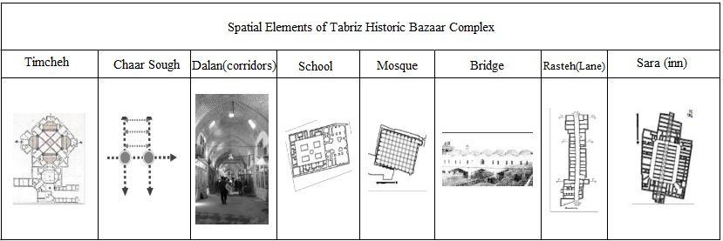
In THBC, as mentioned earlier, there are 25 locations called Timcheh. Each of them is popular for selling one specific product. Among them, Muzaffarieh carpet market is a Timcheh which had been used actively since 1880. Here is a significant section within THBC with the social, cultural, and economic stance. This location as an example of vernacular architecture can provide a useful and efficient model showcasing how this type of structure can resist potential adverse environmental conditions of the 21st century; although, as long as these types of buildings continue to become adapted to the changing environment [11]. As mentioned by Roaf (2009) the current challenge is to incorporate the emerging low-impact technologies “in a truly twenty-first century vernacular of locally appropriate buildings and cities” [11].
In the middle of the 1990s, under the auspices of Iran Cultural Heritage, Handcraft, and Tourism Organization (ICHTO) with the direct involvement of the traders and shopkeepers, THBC has undergone historic rehabilitation. THBC has been under protection and rehabilitation processes regulated by United Nations Educational, Scientific and Cultural Organization (UNESCO) and ICHTO for years [7]. Sustainable urban and cultural factors have been addressed as part of the THBC recent rehabilitation project. Throughout the project, the sustainability of THBC regarding its physical stability and longevity have been taken care of with maintenance works and manufacturing of local materials, along with the education of master builders. However, there is lack of prevention and adaptation strategies of THBC in the face of climate change. Adaptation is an approach to extending the useful life of buildings by a combination of improvements and conversions. It is considered to be an effective strategy to improve the sustainable use of historic buildings [12]. Few numbers of researchers have been working on the adaptation of historic buildings to climate change in Iran; while the adaptation of historic buildings can ensure the sustainable presence of users in them in the future and preserve the building from deterioration. As discussed further by Lowe and Steemers, by implementing minor or major works, such historic buildings can be adapted to new conditions caused by future climate change [13, 14].
The ever-changing environment imposes new guidelines, standards, and organizations for planning adaptation to the altering climate; while the country is yet to develop an official national climate change action plan [15]. Up until 2015, Iran has envisioned climate change within the broader objective of achieving sustainable development [15]. This vision was incorporated into the 2025 Vision of Iran, the Fifth Five-Year National Development Plan, as well as in other macro policies and sectoral plans [15].
The preservation of THBC historic characters imposes various restrictions and burden on this process. According to an onsite review report written by Radoine (2013), at this complex, even the replacement of the old materials with new ones is discouraged, and in the significant sections of THBC, the material selection is based on respect for the historical material use. However, rising environmental issues alarm and remind designers and stakeholders to provide plans to equip buildings with proper solutions in the face of climate change [11].The limit on the implementation of major works due to adaptation in THBC may impede sustainable settlement in the face of climate change. While the preservation of historic places as existing buildings is a viable solution to lower the environmental impacts; currently, their adaptation is being also considered to save these valuable pieces in the face of climate change. Hence, the conservation of historic places, such as THBC should be a vital strategy for building a sustainable environment, which addresses human needs in the 21st century.
Muzaffarieh carpet market should be adapted to the use of green indoor materials and technologies as part of the integrated design. To achieve a high-performance building, integrated design process (IDP) are vital to sustainable interior design [16]. According to a guide published by Advisory Council on Historic Preservation (ACHP) in 2011, a result of a comprehensive post-occupancy evaluation of 12 sustainably designed buildings reveals the positive influence of IDP on sustainable design. The evaluations, includes two rehabilitated historic buildings certified for Leadership in Energy and Environmental Design (LEED), addresses improvement of buildings’ performance due to utilizing IDP [17].
For analyzing the best choices in green materials and technologies within Muzaffarieh carpet market, here IDP looks at all the parameters of building related to water efficiency and indoor air. IDP is an approach to find the best decisions according to the relationships within and among different buildings systems and between the building, the occupants, and the indoor and outdoor environment [18]. According to the environmental protection agency (EPA) guideline for the healthy indoor environment, site location and climate, life-cycle analysis, and finding the maximum balance between healthy indoor and outdoor of buildings, and comfort need to be studied throughout IDP [19].
Indoor air and water efficiency as two major indoor issues have been discussed as part of the adaptation of Muzaffarieh carpet market. The presented technologies and improvements are mentioned through IDP approach. The suggested improvements in these two categories are minimum required changes according to current climatic issues in Tabriz city. These alterations along with proper education can ensure the sustainable presence of users in Muzaffarieh carpet market in THBC. The adaptation of Muzaffarieh carpet market promotes positive strategies not only for the improvement of THBC building but also it mainly aims at a broader popular audience in the region for their education. Through different case studies, the value and influences of educational approaches are reviewed in sustainable preservation of historic buildings. Also, given the case studies selected in similar climatic situations with THBC, materials, and technologies are discussed in the fields of indoor air and water efficiency. The following list of questions expand this topic further:
- What is an effective strategy for adaptation of Muzaffarieh carpet market to climate change?
- How does change of outdoor environment impact indoor air and water efficiency in Muzaffarieh carpet market (Timcheh) in THBC?
- How does education influence the effectiveness of materials and technologies selected?
- How do different case studies respond to the same issues of indoor air and water efficiency?
- What are comparable case studies using green education to inform audiences?

Review of World Literature

The Concept of Cultural Heritage
Within the twentieth century, historic preservation treated buildings as subjects frozen in time. Sohmer and Lang (1998) describe the practice of historic preservation during the twentieth century as a movement which began to save significant endangered buildings. However, “preservationists have tended to create sites frozen in time, museums of the past” [20]. Later on, in the late twentieth century, the concept has been altering to “context-sensitive historic preservation that accommodates the needs of individual neighborhoods” [20]. Donovan Rypkema (2005) confirmed this perception and stated that buildings “will neither be frozen in time nor look like they were built yesterday” [21]. He believes that they should become “a vehicle for achieving broader ends” [21].
Historic buildings were in the path to evolve in the past. If the active and functional historic buildings are in a shifting environment, they will probably alter in some degree. Historic environments are environmentally sustainable; although, it would be unsound to use this fact to oppose possible changes [22]. The historic buildings must involve with the process of adaptation to climate change in which the entire world is undergoing; otherwise there is a real high risk that historic places become redundant, and consequently, the cost of such environmental demolition in the future will be irreparable [22].

Value of Historic Preservation
Historic buildings may have a significant story about the past, serve as a tangible connection to the history, or they play a role as an economic engine within its community [23]. However, at the same time, different studies indicate how significantly the building rehabilitation impacts the environmental savings (in forms of greenhouse gas emissions reduction) [24]. In a report by Preservation Green Lab at the National Trust for Historic Preservation, retrofitting and reusing existing buildings has environmental values which may weigh in favor of building conservation. According to the report (2011), reuse and rehabilitation of existing buildings within 75 years lifespan offers immediate opportunities to address climate change impacts. As one of the key findings of this report, building reuse almost all the time yields fewer environmental impacts than new construction when comparing buildings of similar size and functionality. Different other studies also admit less ecological footprint of rehabilitation versus new building on the same plot [25, 26].

The Climate Change Impacts on Cultural Heritage Conservation
Concern over climate change has dominated thinking about the global environment in recent decades [27]. Nevertheless, the impact of greenhouse warming on cultural heritage conservation both indoors and outdoors appear less remarkable than the impact on issues such as agriculture and health [27]. It has not been a critical part of assessments from the Intergovernmental Panel on Climate Change (IPCC); although some projects have contributed to this area and examined the potential for damage to cultural heritage and materials [27].
In the U.S., some agencies did not consider climate change as a considerable issue, while some other mentioned that they have a Climate Change Adaption Plan and they are concerned with the sustainability of their facilities in susceptible locations [28]. Among them, National Park Service (NPS) reported one of the most comprehensive planning efforts about protecting historic properties from the impacts of climate change [28]. Also, NPS provides leadership within the community of historic preservation toward preparing for the effects of climate change [28]. The Union of Concerned Scientists (UCS), a nonprofit organization that has worked on climate change science and policies for decades, had not previously addressed the issues of heritage preservation [29]. But in 2014, UCS released a series of case studies detailing how climate change is already affecting some of the U.S. cultural heritage [29].

Challenges ahead of Historic Building Conservation
Adaptation of buildings mainly is reactive, which means that past events initiate it or current events. Also, the adaptation is also anticipatory because it is based on an assessment of conditions in the future [14, 30]. In practice, there is significant uncertainty regarding the impacts of an adaptation plan. In some cases, the impact may be evident and immediate, and subsequently, previous experiences are such a useful guide [14, 30]. Societies have adapted their behavior to past climatic changes, and many are now contemplating adjusting to future climatic conditions [11, 14, 30]. These conditions may be an increased threat to historic interiors and collections, but in most cases, knowledge of the range of interior environments around the world means it is likely there is already experience in managing them [27]. In other cases, for example, where the action is innovative, the consequences of adaptation may not be known.
There is a number of anticipatory challenges ahead of a conditioned historic building concerning indoor air. For instance, if HVAC system equips the building. Actions taken to reduce emissions of greenhouse gases (GHG) such as energy conservation may result in increased concentrations of indoor air contaminants in such buildings [31]. In a way that for reducing energy consumption due to HVAC systems, the buildings need to become airtight. However, at the same time, it will lower the overall ventilation and increase the indoor contaminant.
Another issue can be resulted because of adding modern materials. Vernacular architecture for a long time employed natural local materials and techniques; however, the problem occurs only when a built cultural heritage is conserved by reconstruction and use of modern methods and materials [32]. Since, buildings are altered for their current functional use, and not for their reuse or deconstruction; thus building elements selection is not optimal from the beginning [32]. In this case, by using the principle of life cycle assessment, these consequences can be eliminated.
Following less precipitation, historic buildings should be equipped with fixtures which allow them to utilize or even conserve water efficiently. Also, according to the local codes and regulations, they may only employ particular strategies to manage water utilization. However, as mentioned earlier, these strategies are following the local code. For instance, harvesting rainwater for consumption is prohibited by law in some states in U.S. Hence, depends on the location the suggested water conservation strategies might be different. Though, the use of efficient water fixtures among different strategies is widely commonplace.

Framework for Selection of Case Studies
According to U.S. National Park Service (NPS), there are some in-danger historic buildings which have been adapted according to future climate condition in the country. There is few number of these cases, and all the buildings are located in the prone flooded area [29]. Hence, the climatic situations of these cases are different from THBC location, and as a result, the buildings are not equipped with the proper advancements that are compatible with THBC indoor. Hence, the priority in selection of technologies within case studies is based on how they correspond to future climatic issues of Tabriz city. The attention was given to find solutions based on the fields of indoor air, water efficiency and education within LEED certified historic buildings,
In general, according to the U.S. Secretary of the Interior’s standards, four approaches for the treatment of historic properties are used: preservation, rehabilitation, restoration, and reconstruction. Among them, rehabilitation provides more possible alterations in historic places, and it is the probable treatment when a building needs major repair, replacements, modifications, or additions [33]. In this case, NPS recommends that preservation might be “appropriate if distinctive materials, features, and spaces are essentially intact and convey the building’s historical significance” [16]. NPS, also, recommends that the evaluation should be based on the building’s importance in history, physical condition, proposed use, and mandated code requirements [16].
The following evaluation criteria that are suggested by NPS will be used to further discussion about the case studies:
1. Importance of history:
Is the building a “nationally significant resource”?
Was the site of an important event?
2. Physical condition:
What was the last condition of the building before rehabilitation?
Has the original form survival mostly intact or has it been altered over time?
Are the alterations and changes an essential part of the building’s history?
3. Proposed use:
Is the building going to continue its use as originally intended or is the project going to be adapted to a new use?
4. Mandated code requirement:
What are the primary codes?
Accordingly, in the evaluation of case studies number of these question will be addressed.

Adaptation of Historic Buildings: Effective Strategy
Adaptation demonstrates rehabilitation, renovation or restoration works that do not necessarily impose the change of use. Rehabilitation is incorporating restoration and new construction through recycling of buildings [12]. The main difference is that restoration simulates a building to the previous condition it was initially constructed, whereas renovation alters a building so that it meets current standards and codes [12]. Also, renovation extends the useful life of a building [12]. It can, therefore, be argued that adaptation is an approach for extending the useful life of a building, and hence, their sustainability through a combination of improvements and alteration [12].
Adaptations can create short-term or long-term effects [14, 30]. They may amplify the impacts of climate change through unsustainable anticipatory action, for instance, a series of hot summers increase in the UK in recent years due to the rising demand for air conditioning in cars and homes [14, 30]. The effectiveness of meeting short-term objectives in defining a successful adaptation is inefficient. The success of adjustments depends on the sequence and interaction of changes over time [14, 30]. Hence, adding measures to increase resilience in adaptations are less likely to have an environmental impact; if they also focus on achieving long-term objectives with broader sustainability considerations [14, 30]. In this case, extensive studies need to be done about resilience in adaptations in interior design field [34].
Overall, in the face of climate change, historic interior environments will be preserved efficiently by utilizing preventative adaptations with long-term objective as well as considering environmentally responsible actions. As Winchip further discussed in her book Sustainable Design for Interior Environments “to protect the health and well-being of people, designers must incorporate sustainable strategies for indoor environmental quality, adhere to the regulations and best professional practice” [16]. In this respect, the LEED certification can be used as a valuable checklist for maximizing the sustainable qualities of historic buildings and adaptation [35].
Rating systems such as LEED offer various directions in the adaptation of old indoor spaces for climate change. However, through certification, LEED emphasizes more on climate change impacts by the reduction of greenhouse gas (GHG) emissions. For instance, the climate change impact category in LEED v4 only is an indicator of GHG emissions reduction for each credit [18]. But, other tools such as Climate Resilience Screening for LEED or pilot credits have been developed to show future sensitivities of sustainable projects to climate alterations.
Adaptation of historic buildings also requires prediction of climatic conditions. The risks and hazards of most significant predicted climate parameters need to be assessed [22, 27, 30]. It is typical to use these predictions as a starting point in estimating future indoor conditions. For instance, Koppen-Geiger climate classification maps indicate observed and projected climate shifts from 1901 to 2100. Within the maps, most noticeable changes may be found in the Northern hemispheric, where arid climate, warm temperate climate, snow climate and polar climates successively shift to the north [36]. The map has been used in Climate Resilience Screening Tool for LEED V4 Projects to show climate adaptation sensitivity or opportunity for each credit.
Educating people about the feasibility of the actions is also a part of an effective adaptation of historic buildings [2]. An educational plan incorporates environmental awareness into daily lifestyle of users [2]. The change and adaptation of significant historic buildings is an opportunity for public tours in which inform the users about the significance of such adaptation plan. Universities and schools have admitted how a knowledgeable user group can lower the operational cost of a building [2].

Climate Change Impacts on Tabriz Historic Bazaar Complex
THBC, same as many historic buildings, has various qualities which make the complex an excellent example of sustainable architecture. But, the ever-changing environment imposes new adaptation of THBC to the altering climate. While Iran is still developing an official national climate change action plan [15]; up until 2015, the country has considered climate change within the broader objective of achieving sustainable development [15]. This vision was involved in the 2025 Vision of Iran, the Fifth Five-Year National Development Plan, and in other macro policies and sectoral plans [15].

Sensitivity of Tabriz Historic Bazaar Complex
The average temperature of Tabriz city is predicted to increase by approximately 3 °C by the middle of this century, and subsequently, the city would have less rain and hotter summers [37]. Zarghami, Abdi, Babaeian, Yousef and Kanani (2011) developed a research on the seasonal patterns of the precipitation and temperature in Tabriz and other cities in the vicinity during this century. According to the result, the rainfall and temperature are anticipated to change substantially within every year, and these changes will probably become even more severe in the period from 2080 to 2099 [37].
The temperature indoors is likely to increase in the future in the absence of active climate control [27]. As it is expected, the indoor temperature will increase in cities like Tabriz due to the rise of outdoor temperature [38]. The higher temperature is likely to impact the historic indoors in different ways [27]:
- Increase the sensitivity of organic materials to thermal decay.
- Higher outgassing of pollutants from the objects themselves (formic acid and acetic acid or lead).
Also, in Tabriz, higher temperatures are expected to lead to lower relative humidity in the outdoor environment [39]. However, no direct relation between temperature increase and relative humidity have been found for indoor environments in Tabriz. According to Brimblecombe and Brimblecombe (2016), there is a possibility that humidity cycles indoors could have an increased amplitude and thus impose more stress on wooden objects and other organic materials. Humidity cycles have the potential to enhance salt weathering in porous stone [27]. Also, the potential for the increased presence of insects, which most typically damage wood and fabrics, might be realized if food and habitats remain available to them. The interior climate, especially increasing warmth, offers the potential for higher insect growth and survivability [40].

Water Efficiency

Existing Issues in THBC
Based on Zarghami et al. (2011), the results of their study can advise the designers to take suitable actions in securing the water supply in Tabriz. As the less rainfall is likely in this city, the use of appropriate fixtures or systems for water efficiency is becoming a vital strategy for better management of water usage. Subsequently, buildings such as THBC need to look for approaches for water efficiency and control.

Review of Case Studies
Different cases which currently experiences the issue of lower annual rainfall have been addressed using technologies and systems for water efficiency. The locations are selected based on the similarity with climatic problems of Tabriz city. For instance, the states such as Arizona, California, Colorado, Nevada, New Mexico, and Utah now are experiencing less precipitation than usual [41, 42]. Accordingly, case studies are selected within these locations.

Low-flow Fixtures and Use of Graywater
Public places with a large number of visitors can have an efficient control over water consumption with the use of water-efficient plumbing fixtures. These fixtures are commonplace now, and as part of the green building, they can reduce water usage by 75 percent [2]. For instance, Boulder Associates Sacramento Offices. This building which located in Boulder, CO was built in 1906. The firm occupies two floors of the Citizens National Bank building which then were renovated and certified under LEED for commercial interiors at the gold level in 2005 [2]. The building was a home for different businesses before the renovation [2]. With many new low-flow plumbing fixtures being introduced to the market, the designers chose to install two types of toilets including dual-flush and low-flow. They also opted waterless urinals, micro-hydro-powered faucets, and low-flow showerheads to experience their performance capabilities first hand [43]. According to the USGBC report, installation of these efficient fixtures in this building could reduce water usage by 43 percent [2, 44].
These fixtures can relate to water reuse strategies to decrease the water consumption by a substantial amount. According to Whole Building Design Guide (WBDG), greywater usage can significantly reduce the amount of potable water needed for plant irrigation, toilet flushing, and other non-drinking water uses.
Figure 2.1: Graywater System for Indoor Reuse [1].
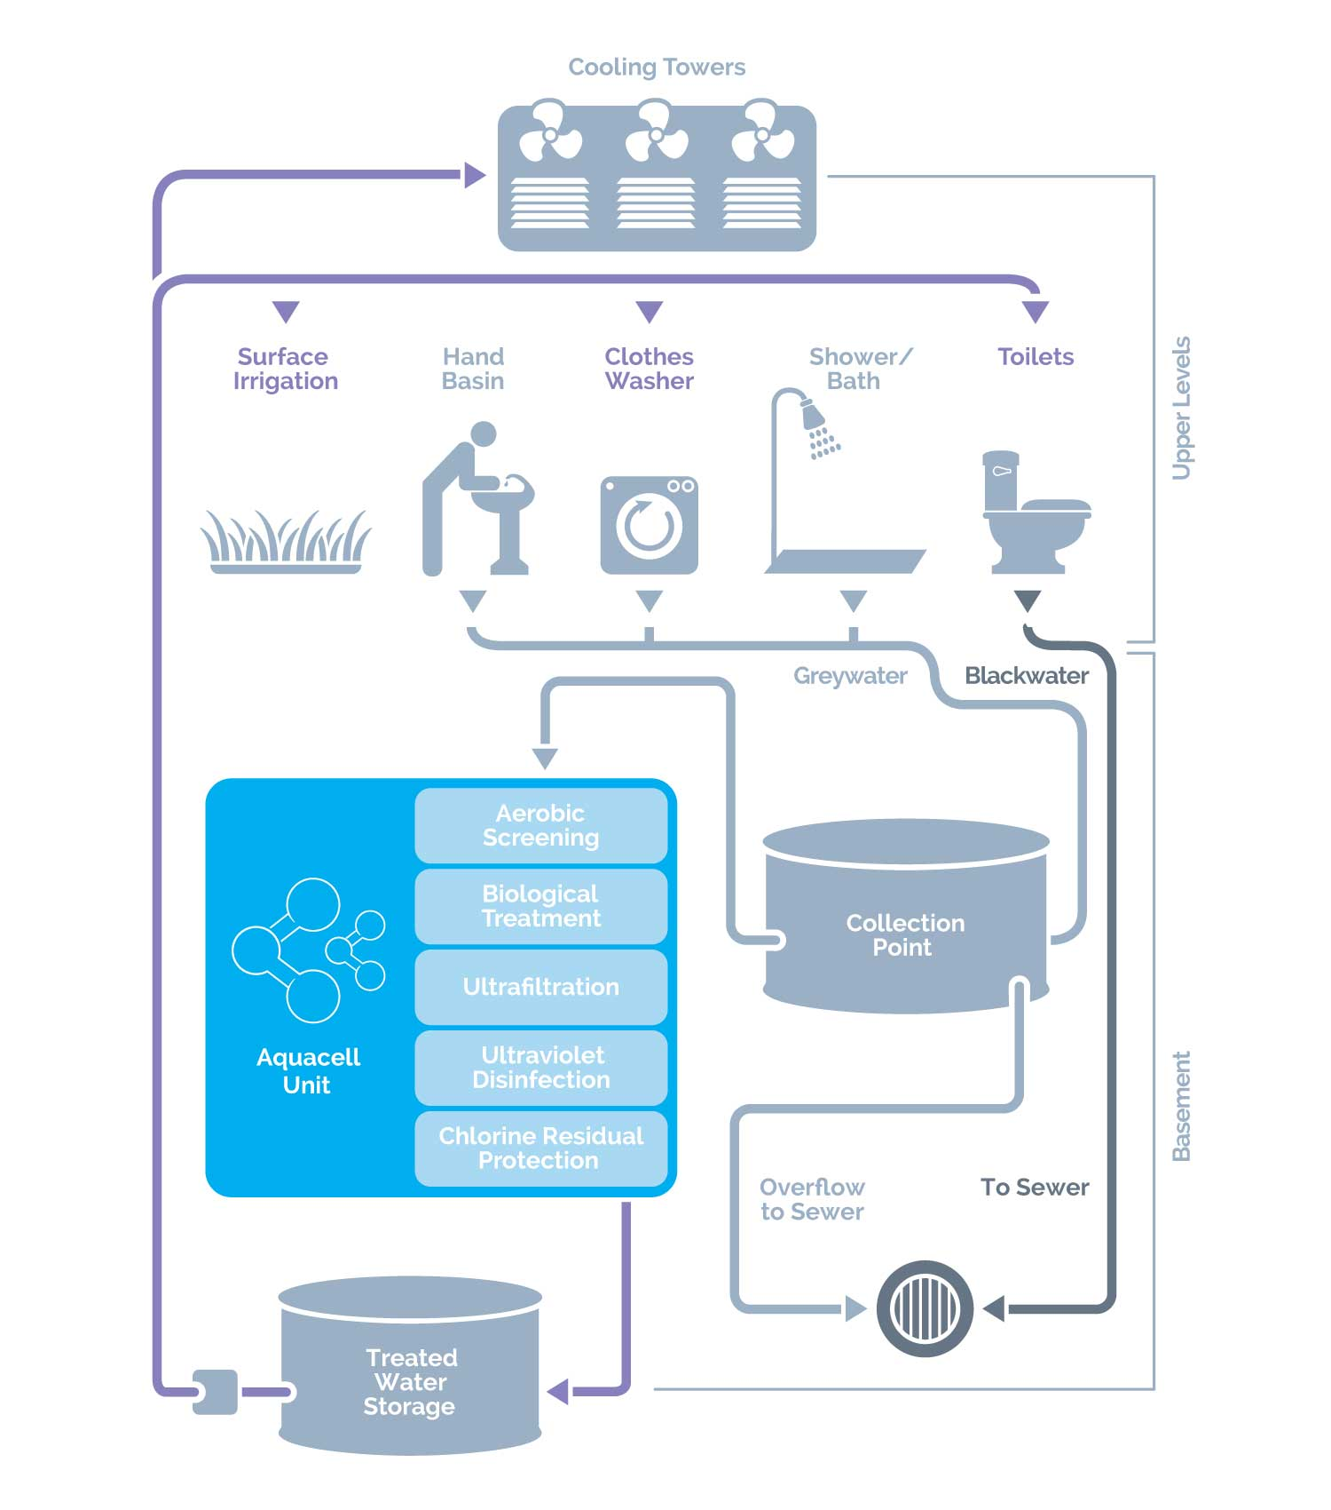

Rainwater Collection
Capturing the rainwater is a part of various green buildings. As explained earlier, the rain falling over Muzaffarieh carpet market along with the whole THBC is collected to prevent the roof degradation. However, this collected water can be reused or recycled for indoor spaces such as Muzaffarieh. As shown in figure 2, the rainwater can be collected from what falls from the building, inflow of the yard drain or biofilter. This water which is collected in a bulk tank then is filtered and sent to the toilet or urinal flushing.
Figure 2.2: Rainwater Harvesting System Channels [2].
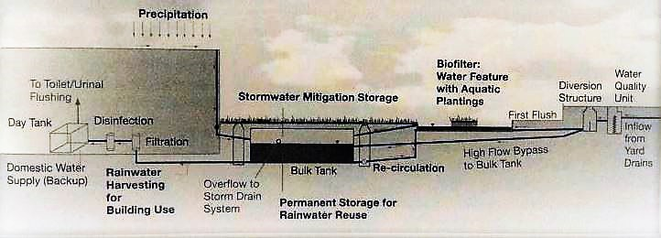

Potentials for Improvements in Muzaffarieh carpet market
As discussed by Carroon (2010), five approaches should address water issues in a building [2]:
- Rectify- to find out leaks
- Review- to find out if the water usage is necessary or cost-effective
- Reduce- to find out if the water can be used more efficiently
- Reuse- to find out if the water can be reused or filtered
- Recycle- to find out if the water can be recycled to be used elsewhere
These approaches need to be evaluated for feasibility of water efficiency. In general, there are four types of water throughout THBC area that need to be controlled including rain, river, sewer, and potable [7]. Muzaffarieh carpet market as one of the public spaces in THBC can provide potable water for customers and shopkeepers. Recently, many of the stores can also connect to the system to bring potable water into their places. Recently, the rainwater drainage and collection are well developed in recent rehabilitation. While the rainwater previously was the primary element deteriorating the structure at the roof level and drainage canal. In the new rehabilitation project, a system of collection for rainwater was established separately to prevent the water leakage into the building. Here, there is a potential to use the system further for reusing or recycling water for the indoor environment.
Besides, the water usage can be controlled by use of different types of low-flow fixtures. By using the list of efficient water devices, water usage can be significantly controlled. For instance, if 52 stores in Muzaffarieh carpet market use high-efficiency faucet and they work six days a week they can save almost 59,000 gals in one year. Below is a list of general commercial equipment including high-efficiency faucet, flush valve toilet, and dual flush toilet.

Device | Flow Rating | Device Life (years)¹ | Demand Reduction (L/conn/d) ²
High Efficiency Faucet in each Store | 6 L/min | 15-20 | 15
High Efficiency Flush Valve Toilet | 5 L/flush | 20+ | 800³
Dual Flush Toilet | 6/3 L/flush | 20+ | 100³
Table 2.1: Example List of Efficient Water Devices [45].

¹ Where applicable.
² Demand reduction is given in units liter per connection per day (Liter/conn/day). Assumed 2.5 persons per connection.
³ Per device.

Indoor Air Quality

Existing Issues in THBC
THBC has the potential to improve into a healthily sustainable interior if any newly proposed rehabilitation considers the impacts of the climate change. For instance, conditioned spaces such as Muzaffarieh carpet market will no longer be able to provide a healthy environment for its users in case that the outdoor is getting warmer due to climate change. As explained earlier, by increasing the outdoor temperature to 3˚ C, hot seasons will possibly impact the indoor temperature significantly. So even the adobe structures will not be able to diminish or moderate the extreme changes in temperature. The organic and fast recycled materials will decay or outgas faster. Even, by keeping the building airtight and then use of HVAC the air quality of the space can diminish. Currently, a number of domes in Muzaffarieh carpet market have oculus and lateral windows for natural air flow and ventilation. By adding HVAC, chemical emissions and off gassing cannot be well discharged to the outside. Hence, the chance of rising sick building syndrome will become higher. Thereupon, the success in the selection of new materials closely connected with the choice of the ventilation system. Without this consideration, the process of greening this historic structure will end up having a short-term life.
Overall, greening the materials in renovation or adaptation of Muzaffarieh carpet market can resolve health-related issues. Introducing materials with lower volatile organic compounds (VOC) and chemical emissions can diminish the indoor pollutants. Here, a list of typical sources of harmful indoor pollutant is introduced (See Appendix D [46]). Muzaffarieh carpet market has long been renovated with use of local organic materials similar to various historic buildings around the world. However, it is this current trend in designing each store by shopkeepers which add up increasingly modern materials with harmful chemical emissions in this section [7].

Review of Case Studies
Use of non-toxic materials with low-VOC has been addressed in the renovation of different historic buildings.

Low-VOC Local Materials
Alliance Center located in Denver, CO was built in 1908. During the early occupation of the building, it was initially used as a warehouse in downtown Denver, and over time it had been modified as office spaces [2]. The building did not require a gut rehabilitation [2]. Several improvements required replacement of interior systems and elements under LEED certification. Recently, it is recertified under LEED V4 for Existing Building Operation and Maintenance (EBOM). It was also awarded an Energy Star rating by the Environmental Protection Agency (EPA). Being the first building with LEED Gold certification in Colorado, up to now, the center is using LEED Dynamic Plaque to navigate and improve the building’s systems and parameters consistently [47]. The project team developed the indoor air quality through using of low-VOC materials fabricated by local green companies. By having the existing HVAC system, the team determined a need to increase the ventilation level and identified an opportunity to install economizers [48]. This method has allowed the building operators to continue to fine‐tune the heating and cooling requirements in this historic structure [48].
Another case is Denver Dry Building, CO (1888), located in Denver’s historic downtown; the building is listed on the National Register of Historic Places, and its revitalization brought back more than 2000 residents to the area [2]. The renovation was held through a public-private partnership [2]. The phases of the repair were completed between 1993 to 1997. Hence, the project is reflected as a vanguard of historical greening buildings. This project consists of two mixed-used blocks including retail, offices, and housing. Here, the indoor air quality (IAQ) improved by removal of toxic chemicals and use of low-VOC finishes. The building equipped with operable windows which allow natural air flow within spaces. Also, the building was rehabilitated by adding new central chillers.

Potentials for Improvements in Muzaffarieh carpet market
As discussed earlier, the higher temperature is likely to increase the sensitivity of organic materials to thermal decay and higher outgassing of pollutants from the objects themselves. Hence, a healthy IAQ needs a careful selection of materials with low emission of harmful compounds and with higher resistance to thermal decay. In the case of not adding HVAC system, the longevity of the materials and their emissions should be based on resistance to higher indoor temperature. VOCs and other chemical emissions will increase at higher ambient temperatures [24]. In Muzaffarieh carpet market sources of VOC can be explicitly found in carpets, paints, and furniture coatings. Inside some of the
Figure 3.1: Inside the Stores [6].
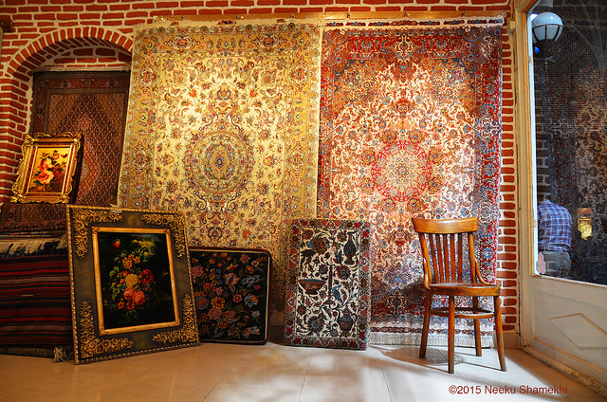

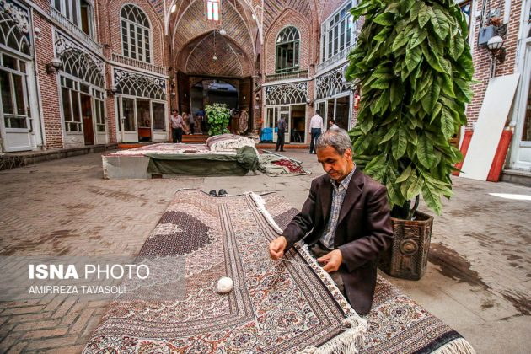
Figure 3.2: Air Conditioners are Attached to Walls in Both Sides [5].
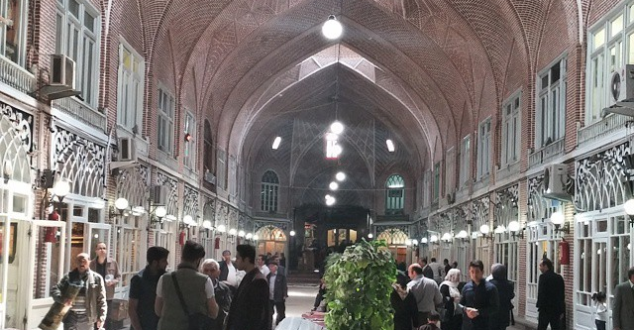

Figure 3.3: The Middle Space between Stores [4]
stores are equipped with split air conditioner, but the middle space between stores is conditioned with outside natural air flow. Hence, the middles space is more prone to the impacts of the higher temperature.
Table 3.1 shows major types of architectural materials. Though, more investigation is required to list all the indoor materials that are used in this market.
Elements | Floor | Arch, Vault, Dome | Doors | Windows
Material | Brick & Stone | Brick | Wood | Wood
Table 3.1: List of Existing Materials [3]

As explained earlier there is a possibility that the humidity cycles indoors could have an increased amplitude. Thus, the higher humidity imposes more stress on wooden objects such as door or window frames.
Materials, also, should be procured from the nearest available resources unless they are selected for deconstruction and reuse. Since the materials soon will end up going to waste field such an investment and transportation does not seem an optimal way. As earlier mentioned in the case studies, it is recommended that the procurement of green materials should be from locally available resources. By using local materials, the production of greenhouse gases due to the transportation of the materials will reduce; while procurement of them from farther reliable resources can increase GHG emissions.

Education
A city like Tabriz which is currently experiencing less rainfall and higher average temperature as signs of climate change showing the need for strategic actions concerning public education and awareness. Historic places like Muzaffarieh carpet market which attract many visitors and customers can work as a turning point in this regard. For instance, the change of any types of wall covering or indoor materials can provide valuable insight for presentation and education of the users, shopkeepers, or professionals regarding tracking lower VOC and use of non-toxic materials within the Muzaffarieh carpet market. Such strategies for the education of users can ensure boosting a healthy lifestyle in this space.

Review of Case Studies
Many historic buildings utilized this approach to inform the users and visitors about the positive impacts of sustainable historic preservation.

Use of Signage and Group Presentation
The restoration of 130 years old Whitaker Street Building showed the compatibility between LEED and historic rehabilitation. The building located in Savannah, GA is included in National Register of Historic Places. This commercial office building contains different signage showing key features of the efficient design. The Project team, also, have provided presentations on the building to many key leaders in local building industry demonstrating environmental efficiency have a prudent way to renovate buildings.
Another example is Alliance Center for Sustainable Colorado. As explained earlier, the building is 100 years old warehouse structure that has been adapted for office use several times. Throughout the building, different educational signage and touch screens demonstrate the green strategy used in the center. Also, a digital control system displays real-time energy systems to visitors. Within the lobby, a complete series of the document explains the history of the building.

Potentials for Improvements in Muzaffarieh carpet market
The adaptation of Muzaffarieh carpet market can demonstrate the effectiveness of environmentally responsible alterations and the challenge of adaptation for public awareness. The project has the potential to inform wide ranges of the audience from the public to professionals in different industrial sectors. For instance, it can provide an opportunity to inform carpet industry to track VOC through reliable guidelines and standards. Moreover, a wide range of public visitors or customers can have access to get informed about the result of the change and experience it.
Social and cultural gathering has been part of this market for a long time. The new culture of living can be expressed from a place with such a vital social importance. Muzaffarieh carpet market, as a result, can become a forum for exchanging ideas on the effects of future adaptation to climate change. Through showing a comprehensive set of information along with different separate group presentation for professionals or public visitors, different aspects of the project are targeted for the various audiences.
Besides, use of signage and touchscreens can be used to inform visitors, occupants, and professionals. In a way that the new project communicates with them throughout the days and months. For instance, a system for tracking water saving daily inform the occupants from the impacts of their decision regarding the carpet market adaptation. Day to day monitoring systems will aim at displaying these small changes and their overall significant effects on a larger scale. In a condition that Tabriz city is confronting with climatic changes, the new way of lifestyle needs to be addressed in every part of built environments. Such projects are only one solution to a major problem. However, by adding up each small solution subsequently, the big impacts will appear in a comprehensive confrontation against the climate change.

Summary and Conclusion
In the past, within different historical eras the climate has been changed dramatically and buildings, as a result, has been adapted based on the new conditions. However, this time, the change is due to human intervention. Hence, the new adaptation plan should be based on sustainable adaptation which not only reverses the harmful human impacts on the environment but also evolves the current indoor to adapt to the new climatic condition. As a result, use of new technologies or improvements can benefit THBC in long-term if they do not either compromise a healthy indoor environment nor the control of new climatic conditions. Although, there is considerable uncertainty regarding the intensity of the climate change in different literature; predicted climatic features are well described concerning Tabriz city. The presented alterations and improvements are minimum requirements that can ensure the sustainable presence of users in Muzaffarieh carpet market.
Within conditioned historic buildings, climate change impacts the adaptation strategies of the historic indoor environment. Through the study, the connection of climate, life cycle, and indoor air quality have been pointed out. The association of these elements can result in high-performance adaptation which aims at diminishing major climate change impacts on Muzaffarieh carpet market. By looking at different historic buildings, a similar common ground has been studied among buildings with related climatic issues. The study then identifies three major concepts that need further improvements in Muzaffarieh carpet market to advance a green design. Water efficiency, indoor air quality along with providing education for shopkeepers assist in developing a healthy environment.
The study identifies the dominant outdoor adverse climatic condition of Tabriz city through the literature. The suggested new technologies are then compatible with possible changes of indoor environment in Muzaffarieh carpet market due to outdoor changes. These pieces of data have been extracted from the literature based on the major threats facing the conditioned cultural heritage in the face of climate change. Due to the significance of THBC in Tabriz city, focus on adaptation of its indoor environments will draw public attention who aim at finding a best compatible selection of material and technologies.
For sustainable adaptation of the historic building and for getting high-performance design IDP approach has been utilized. With the help of this process, a thorough explanation of a balanced indoor and outdoor have been discussed to find the compatible solution for indoor air and water efficiency in Muzaffarieh carpet market within THBC. This outlook helped in finding the relationships between healthy indoor environment, site location and climate, life-cycle analysis, and seeing the maximum balance between healthy indoor and outdoor environment.
According to the evaluation of different case studies, a number of strategies have been reviewed for Muzaffarieh carpet market. The use of low flow fixtures with ultra-efficiency as part of water management in this area benefit the users in long-run. The codes can also require this solution as a common approach. Besides, Muzaffarieh carpet market has an opportunity to bring back the used potable water for reuse or recycle in the toilet as well as plant irrigation. The rainwater collection system has implemented within the building previously, and there is potential to enhance this system to reuse the collected rainwater in Muzaffarieh carpet market for indoor use.
Use of non-toxic materials with low-VOC has been addressed in the renovation of different historic buildings. This approach also has been used widely among ventilated historic buildings. In Muzaffarieh carpet market also it is recommended to implement this type of materials even if they are procured from the farther location as long as their reuse or deconstruction is considered. Otherwise, identifying the potentials and finding manufacturing information which is located near Tabriz will be an advisable approach.
Finally, due to the social and cultural significance of Muzaffarieh carpet market in THBC, the adaptation can invite and inform users and visitors from broad sectors. It will help to acquaint the public why the alterations are needed, how do these changes affect the indoor, and what the positive outcome of these changes for users’ health and well-being is. These pieces of information will not only aim at promoting the indoor environmental quality of the building but also, they aim at reminding the users that THBC has been altered and developed periodically for near 1000 years.

Reference
1. PHOENIX Water Recycling - Greywater Systems. aqua cell water recycling.
2. Carroon, J., Sustainable preservation: Greening Existing Buildings. 2011: John Wiley & Sons.
3. Iranian Cultural Heritage Handicrafts and Tourism Organization (ICHTO), Executive Summary: Tabriz Historical Bazaar Complex 2009: Tehran.
4. Amirreza Tavasoli, Historic Bazaar of Tabriz in Northwestern Iran. 2016.
5. Saeed Jeddi, Translation: Grand Bazaar of Tabriz. 2015.
6. Nikolaou, T., et al., Managing Indoor Environments and Energy in Buildings with Integrated Intelligent Systems. First edition 2015. ed. Green energy and technology,. 2015, Cham: Springer International Publishing : Imprint: Springer. XII, 261 pages 137 illustrations.
7. Compiled by the Aga Khan Award for Architecture, Rehabilitation of Tabriz Bazaar Project Brief. 2013: Geneva: Aga Khan Award for Architecture.
8. International Council on Monuments and Sites (ICOMOS), Evaluations of cultural properties. 2010.
9. Günther Schweizer, Bazar von Tabriz Branchenverteilung 1969 = Distribution of branches., in Erdkunde, . 1972, American Geographical Society Library Digital Map Collection.
10. Kalan, A. and E. Oliveira, A sustainable architecture approach to the economic and social aspects of the bazaar of Tabriz. 2014.
11. Roaf, S., D. Crichton, and F. Nicol, Adapting buildings and cities for climate change: a 21st century survival guide. 2009: Routledge.
12. Mofidi, S., A.M. Moradi, and M. Akhtarkavan. Assessing sustainable adaptation of historical buildings to climate changes of Iran. in 3rd IASME/WSEAS International Conference on Energy & Environment. 2008.
13. Steemers, K., Towards a research agenda for adapting to climate change. Building Research & Information, 2003. 31(3-4): p. 291-301.
14. W. Neil Adgera, N.W.A., Emma L. Tompkinsa, Successful adaptation to climate change across scales. Global Environmental Change, 2004. 15(2): p. 77-86.
15. Nachmany, M., et al., Climate Change Legislation in Iran in The 2015 Global Climate Legislation Study: A Review of Climate Change Legislation in 99 Countries. 2015.
16. Winchip, S.M., Sustainable design for interior environments. 2. ed. 2011, New York: Fairchild Books. xvii, 327 s.
17. ACHP, Sustainability and Historic Federal Buildings: Integrating the Requirements of the National Historic Preservation Act with the Requirements of Executive Order 13514: Federal leadership in Environmental, Energy, and Economic Performance. 2011.
18. American Society of Heating Refrigerating and Air-Conditioning Engineers. and Books24x7 Inc., ASHRAE greenguide design, construction, and operation of sustainable buildings, fourth edition. 2013, ASHRAE,: Atlanta, Ga.
19. Environmental Protection Agency (EPA), Healthy Buildings, Helthy People: A vision for 21st Century. 2010.
20. Sohmer, R. and R.E. Lang, Beyond this old house: Historic preservation in community development. 1998.
21. Rypkema, D.D., Globalization, urban heritage, and the 21st century economy. Global Urban Development, 2005. 1(1): p. 1-8.
22. Cassar, M., Sustainable Heritage: Challenges and Strategies for the Twenty-First Century, APT Bulletin. Journal of Preservation Technology, 2009. 40(1): p. 3-11.
23. National Trust for Historic Preservation (NTHP), The Greenest Building: Quantifying the Environmental Value of Building Reuse. 2011.
24. Schenck, P., et al., Climate change, indoor air quality and health. US Environmental Protection Agency, 2010.
25. Desirée Alba-Rodrígueza, A.M.-R., Patricia González-Vallejoa, Antonio Ferreira-Sáncheza, Madelyn Marreroa, Building rehabilitation versus demolition and new construction: Economic and environmental assessment. Environmental Impact Assessment Review, 2017. Volume 66: p. 115-126.
26. Ulisses Munarim, E.G., Environmental feasibility of heritage buildings rehabilitation. Renewable and Sustainable Energy Reviews, 2016. Volume 58: p. 235-249.
27. Peter Brimblecombe, C.B., Climate Change and Non-mechanically Ventilated Historic Interiors. APT Bulletin: The Journal of Preservation Technology, 2016. 47: p. 31-38.
28. United States. Advisory Council on Historic Preservation., In a spirit of stewardship : a report on federal historic property management. 2015, Advisory Council on Historic Preservation: Washington, DC. p. v.
29. Veerkamp, A., Preservation in a Changing Climate: Time to Pick Up the Tab. ForumJournal, 2015. VOL. 29 NO. 4(SUMMER 2015).
30. Horowitz, A.D., CLIMATE CHANGE AND CULTURAL HERITAGE CONSERVATION A LITERATURE REVIEW, M.F. Lopez, Editor. 2016, APT Technical Committee on Sustainable Preservation.
31. Brennan, T., Indoor Environmental Quality and Climate Change. 2010, U.S. Environmental Protection Agency: Washington DC.
32. L. Cazacova, Sustainable built cultural heritage conservation with Cradle to Cradle. Intenational Journal of Energy and Environment, , 2016. 10.
33. Anne E. Grimmer, J.E.H., Liz Petrella & Audrey T. Tepper, The Secretary of The Interior’s Sandards for RehabIlitation&Illustrated Guidelines on Sustainability for rehabIlitating historic buildings. 2011, National Park Service: Washington DC.
34. Barth, B.J., Designing for Disaster—The Next Frontier. ASID Icon, 2016. 18(4).
35. WBDG Historic Preservation Subcommittee, Sustainable Historic Preservation, in WBDG Whole Building Design Guide 2017, National Institute of Building Sciences.
36. RUBEL, F. and M. KOTTEK, Observed and projected climate shifts 1901–2100 depicted by worldmaps of the Koppen-Geiger climate classification. Meteorologische Zeitschrift, 2009. 19(2): p. 135-141.
37. Zarghami, M., et al., Impacts of climate change on runoffs in East Azerbaijan, Iran. Global and Planetary Change, 2011. 78(3): p. 137-146.
38. Roshan, G., A. Ghanghermeh, and J.A. Orosa, Thermal comfort and forecast of energy consumption in Northwest Iran. Arabian Journal of Geosciences, 2014. 7(9): p. 3657-3674.
39. Valipour, M., M.A.G. Sefidkouhi, and M. Raeini, Selecting the best model to estimate potential evapotranspiration with respect to climate change and magnitudes of extreme events. Agricultural Water Management, 2017. 180: p. 50-60.
40. Brimblecombe, P. and P. Lankester, Long-term changes in climate and insect damage in historic houses. Studies in Conservation, 2013. 58(1): p. 13-22.
41. Environmental Protection Agency (EPA), Climate change indicators in the United States 2016. 2016.
42. Climate Change Science Program (U.S.), The impacts of climate change on human health in the United States : a scientific assessment. 2016, U.S Global Change Research Program,: Washington, D.C. p. 1 online resource (xvi, 312 pages).
43. U.S. Green Building Council (USGBC). LEED ID+C: Commercial Interiors v2 - LEED 2.0, Boulder Associates Offices,. 2005; Available from: https://www.usgbc.org/projects/boulder-associates-offices?view=overview.
44. U.S. Green Building Council (USGBC). Boulder Associates, Inc. Office, . Project Profile 2006; Available from: https://www.usgbc.org/Docs/Archive/General/Docs2056.pdf.
45. Maddaus, L., W. Maddaus, and M. Maddaus, Preparing Urban Water Use Efficiency Plans. 2013: Iwa Publishing.
46. Environmental Protection Agency (EPA). Controlling Pollutants and Sources: Indoor Air Quality Design Tools for Schools. [cited 2017 Dec. 4th]; Available from: https://www.epa.gov/iaq-schools/controlling-pollutants-and-sources-indoor-air-quality-design-tools-schools.
47. Kunal Gulati. LEED Dynamic Plaque Diaries: The Alliance Center. LEED Dynamic Plaque Diaries: 2016 [cited 2017; Available from: https://www.usgbc.org/articles/leed-dynamic-plaque-diaries-alliance-center.
48. New Buildings Institute (NBI), A Case for Deep Savings, in 11 Case Studies of Deep Energy Retrofits in support of NEEA’s Existing Building Renewal Initiative and NBI’s Getting to 50 work. 2011, New Buildings Institute (NBI).

Appendix A

Color-coded Plan of THBC
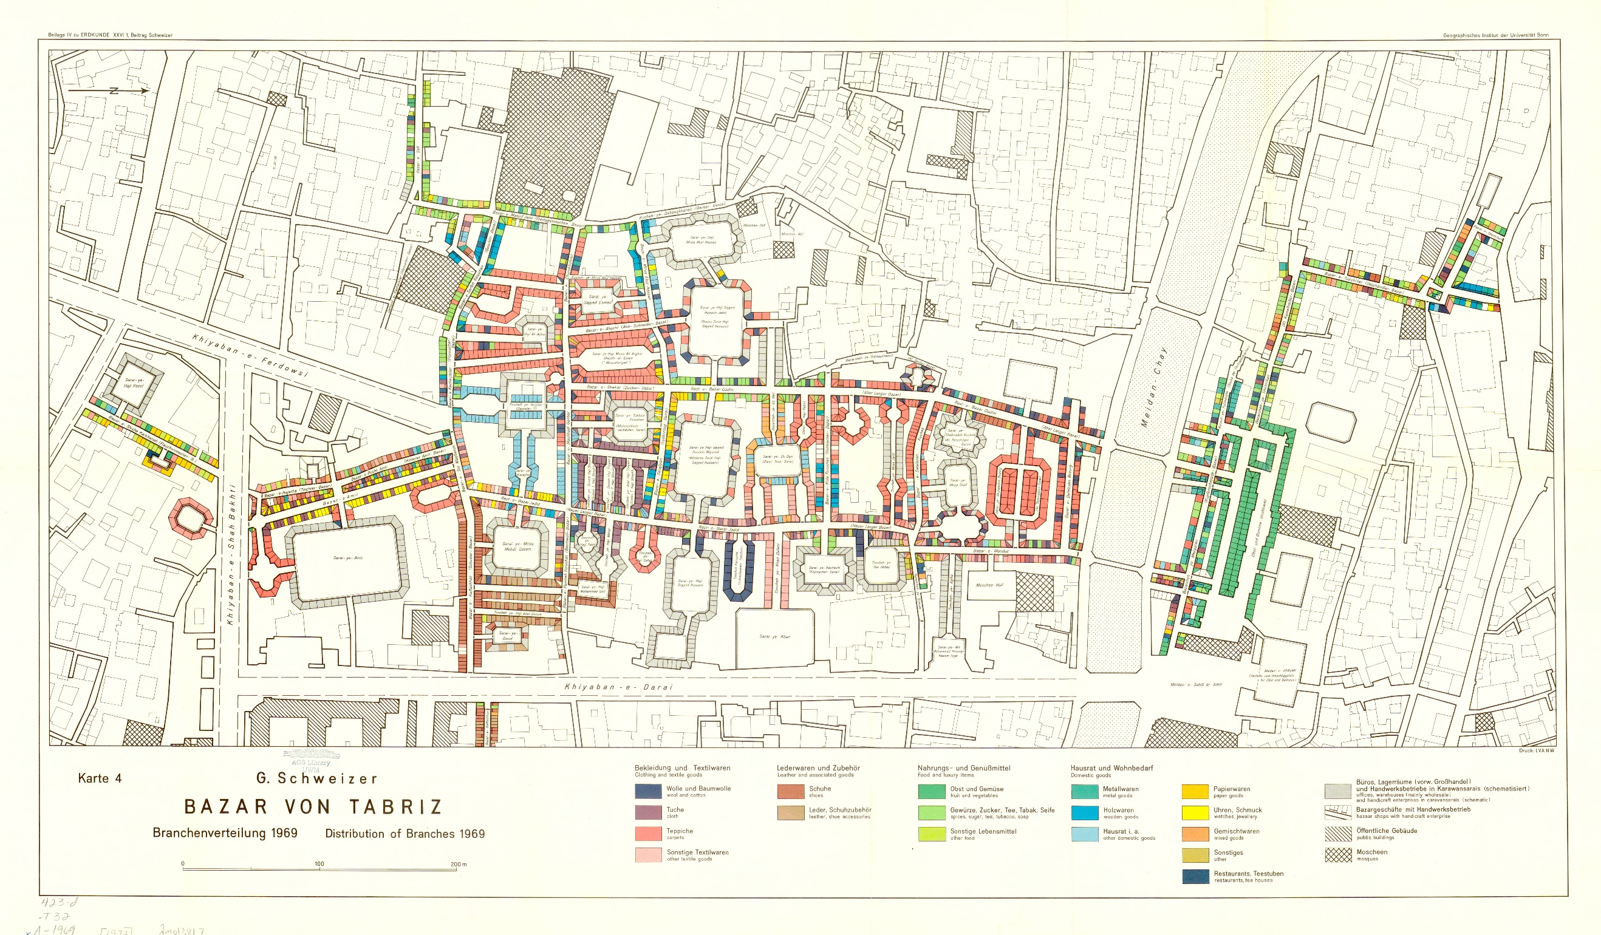

Appendix B

Location of Professional Guilds in THBC
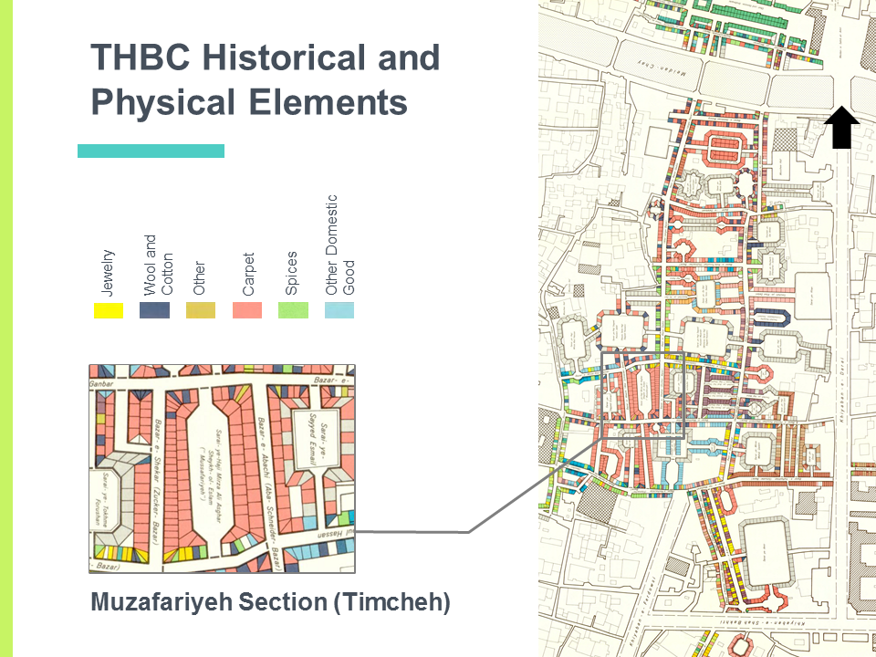

Physical Elements of THBC
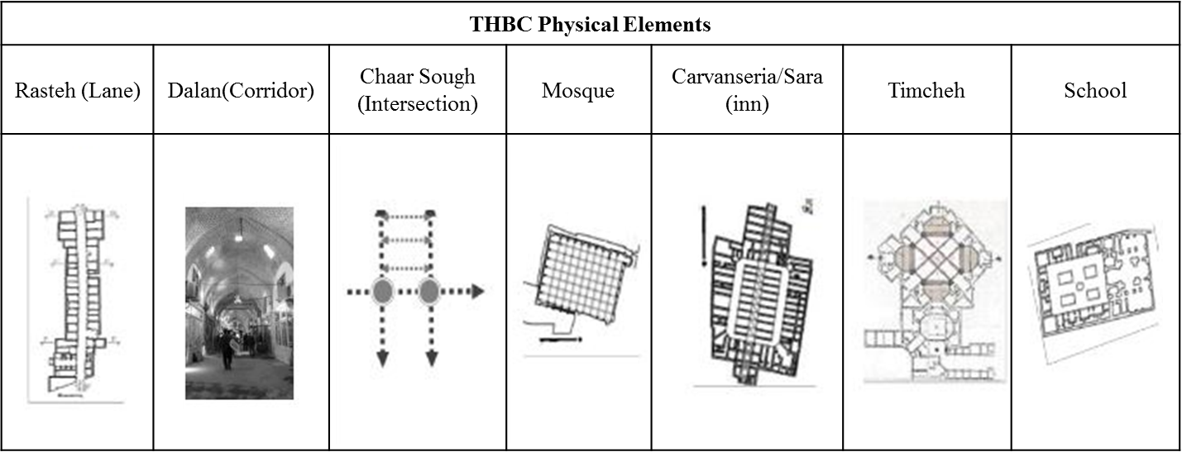

Appendix C

Structural Analysis of Muzaffarieh Carpet Market

Appendix D

Typical Sources of Harmful Indoor Pollutant
Outdoor Source | Building Equipment | Components/ Furnishings | Other Potential Indoor Sources
Polluted Outdoor Air  - Pollen, dust, mold spores  - Industrial emissions  - Vehicle and non-road engine  (cars, buses, truck, lawn, and garden equipment)  Nearby Sources  - Loading docks  - Odors from dumpsters  - Unsanitary debris or building exhausts near outdoor air intakes  Underground Sources  - Radon  - Pesticides  - Leakage from underground  Storage tanks | HVAC Equipment  - Mold growth in drip pans, ductwork, coils, and humidifiers  - Improper venting of combustion products  - Dust or debris in ductwork  Non-HVAC Equipment  - Emissions from office equipment  (volatile organic compounds (VOCs), ozone)  - Emissions from shop, lab, and cleaning equipment | Components  - Mold growth on or in soiled or water damaged materials  - Dry drain traps that allow the passage of sewer gas  - Materials containing VOCs, inorganic compounds, or damaged asbestos  - Materials that produce particles (dust)  Furnishings  - Emissions from new furnishings and floorings  - Mold growth on or in soiled or water-damaged furnishings | - Science laboratory supplies  - Copy print areas  - Food prep areas  - Smocking lounges  - Cleaning materials  - Emissions from trash  - Pesticides  - Odors and VOCs from paint, chalk, adhesives  - Occupants with communicable diseases  - Dry-erase markers and similar pens  - Insects and other pests  - Personal care products  - Stored gasoline and lawn and garden equipment

Appendix E

List of Acronyms and Abbreviations
ACHP Advisory Council on Historic Preservation
EBOM Existing Buildings Operation and Maintenance
EPA Environmental Protection Agency
GHG Greenhouse Gas
IAQ Indoor Air Quality
ICHTO Iran Cultural Heritage, Handicraft, and tourism organization
IDP Integrated Design Process
IPCC Intergovernmental Panel on Climate Change
LEED Leadership in Energy and Environmental Design
NPS National Park Service
THBC Tabriz Historic Bazaar Complex
UCS Union of Concerned Scientist
UNESCO United Nations Educational scientific and Cultural Organization
VOC Volatile Organic Compounds

