UNIVERSITY OF OKLAHOMA
GRADUATE COLLEGE

AVIAN BEHAVIOR IN A CHANGING WORLD: HOW HUMAN EFFECTS CHANGE BEHAVIORAL EXPRESSION AT THE INDIVIDUAL, POPULATION, AND COMMUNITY LEVEL

A DISSERTATION
SUBMITTED TO THE GRADUATE FACULTY
in partial fulfillment of the requirements for the
Degree of
DOCTOR OF PHILOSOPHY

By
MEELYN M. PANDIT
Norman, Oklahoma
2023

AVIAN BEHAVIOR IN A CHANGING WORLD: HOW HUMAN EFFECTS CHANGE BEHAVIORAL EXPRESSION AT THE INDIVIDUAL, POPULATION, AND COMMUNITY LEVEL

A DISSERTATION APPROVED FOR
THE DEPARTMENT OF BIOLOGY

BY THE COMMITTEE CONSISTING OF

Dr. Eli S. Bridge, Co-Chair

Dr. Jeremy Ross, Co-Chair

Dr. Jeffrey Kelly

Dr. Laura Stein

Dr. Jessica Ruyle

© Copyright by MEELYN MAYANK PANDIT 2023
All Rights Reserved.

I dedicate this dissertation to my late dad, my mom, my sister, and my brother-in-law, who never gave up on me, even when I did.

ACKNOWLEDGEMENTS
This dissertation is the culmination of multiple people’s efforts and support. I first and foremost would like to thank my advisers Dr. Eli S. Bridge and Dr. Jeremy D. Ross for their guidance and assistance throughout my PhD, as well as my committee members Dr. Jeff Kelly, Dr. Jessica Ruyle, and Dr. Laura Stein for their help with the dissertation process. These people let me explore different disciplines, such as biology, computer programming, and electrical engineering, which helped me grow as a biologist and as a person. I would like to thank the faculty and staff at the Oklahoma Biological Survey (OBS), specifically Dr. Laura Souza, Ranell Madding, and Trina L. Steil. They made the OBS a second home and were always there to help with any questions regarding research or travel.
I would like to thank numerous funding agencies such as the Sutton Ornithological Society, the Biogeography of Behavior research group, the OU Biological Station, the American Ornithologist’s Society, the North American Bluebird Society, and the National Science Foundation-National Research Traineeship for their financial support. I would also like to thank the many collaborators on these projects such as Dr. Darren Proppe, Sandy Sanders land manager Rob Smith, Cross Bar Management Area land manager Adrian Escobar, and field technician Lucas Castro. I would like to thank my friends and colleagues who I consulted with in developing research ideas and methods. Finally, I would like to thank my family, Pallavi Pandit, Caaminee Pandit Vecchio, and Alex Vecchio for their unlimited love and support throughout my PhD career.

TABLE OF CONTENTS
ACKNOWLEDGEMENTS v
TABLE OF CONTENTS vi
LIST OF TABLES ix
LIST OF FIGURES xii
ABSTRACT xv
CHAPTER 1: ANTHROPOGENIC NOISE ALTERS PARENTAL BEHAVIOR AND NESTLING DEVELOPMENTAL PATTERNS, BUT NOT FLEDGING CONDITION 1
1.1 INTRODUCTION 1
1.2 METHODS 4
1.2.1 Study sites and box setup 4
1.2.2 Adult capture and monitoring box visitation 5
1.2.3 Noise Treatments 7
1.2.4 Nesting physiology and body condition 8
1.2.5 Blood sample processing 8
1.2.6 Return Rate 9
1.2.7 Statistical analyses. 10
1.3 RESULTS 11
1.3.1 Parental care behavior and adult physiology. 11
1.3.2 Nestling condition and physiology 12
1.3.3 Returning Nestlings. 12
1.4 DISCUSSION 12
1.5 TABLES 18
1.6 FIGURES 21
CHAPTER 2: ENVIRONMENTAL CONDITIONS LEAD TO SHIFTS IN INDIVIDUAL COMMUNICATION, WHICH CAN CAUSE CASCADING EFFECTS ON SOUNDSCAPE COMPOSITION 24
2.1 INTRODUCTION 24
2.2 METHODS 28
2.2.1 Model design. 28
2.2.2 Experimental Design. 29
2.2.3 Individual contact percentages. 31
2.2.4 Population contact percentages. 32
2.2.5 Statistical Analysis. 33
2.3 RESULTS 34
2.3.1 Individual effects. 34
2.3.2 Population effects - Weather conditions. 35
2.3.3 Population effects - Frequency. 36
2.3.4 Population effects - Evaporative Water Loss. 37
2.3.5 Population effects - Territory Size. 37
2.4 DISCUSSION 38
2.5 TABLES 48
2.6 FIGURES 51
CHAPTER 3: IT’S NOT THE HEAT, IT’S THE ARIDITY: AVIAN SONG ACTIVITY AND SPECIES DIVERSITY AT THE COMMUNITY LEVEL HAVE CONSISTENT, NEGATIVE RESPONSES TO INCREASING ARIDITY 56
3.1 INTRODUCTION 56
3.2 METHODS 60
3.2.1 Study sites. 60
3.2.2 Supplemental water stations. 61
3.2.3 Local weather data. 62
3.2.4 Broad acoustic analyses. 64
3.2.5 Vocalization number and species diversity. 65
3.2.6 Statistical analysis. 65
3.3 RESULTS 67
3.3.1 Aridity gradient – pooled across sites. 67
3.3.2 Aridity gradient – full dataset. 68
3.3.3 Aridity gradient – ECE. 71
3.3.4 Water Supplementation – Full dataset. 71
3.3.5 Water supplementation – ECE. 72
3.4 DISCUSSION 72
3.5 TABLES 84
3.6 FIGURES 89
3.7 SUPPLEMENTAL INFORMATION 96
3.7.1 TABLES 96
3.7.2 FIGURES 103
REFERENCES 105

LIST OF TABLES
Table 1.1. Linear mixed model (LMM) with random effects, parameters, Beta estimates, standard errors, degrees of freedom (df), t-values, and p-values that best predict how noise treatment, nestling age, treatment time, Julian hatch date, and brood size affected the natural log of female visitation rates. Bolden values represent significant p-values (alpha = 0.05). 18
Table 1.2. Linear model (LM) with parameters, Beta estimates, standard errors, degrees of freedom (df), t-values, and p-values that demonstrate the effects of the noise treatment and Julian date on adult baseline corticosterone levels (n = 12). Bolden values represent significant p-values (alpha = 0.05). 19
Table 1.3. Linear mixed models (LMMs) with random effects, parameters, Beta estimates, standard errors, degrees of freedom (df), t-values, and p-values that best predict how nestling body conditions (n = 282 nestlings, from 19 different nest boxes), nestling baseline corticosterone (n = 47 nestlings from 19 different nest boxes), and nestling telomere lengths (n = 46 nestlings from 19 different nest boxes). We included both the nestling measure day (i.e. days 5, 11, and 14 post-hatch in which we measured the nestlings) and the log(measurement day) to demonstrate that nestling body condition initially until ~11 days post-hatch and decreased after that day. 20
Table 2.1. Model testing parameters. We tested multiple combinations of weather conditions, territory sizes, and mean song frequencies with our model. The mean contemporary weather conditions were an average of the 2010-2019 ERIC Mesonet weather data, the contemporary drought weather conditions were a subset of the contemporary weather data set, specifically the year 2011, in which a severe drought occurred in Oklahoma. The mean climate change conditions were the predicted weather conditions in 2070, and to obtain these values we took the mean contemporary conditions and added 7.5°C to the air temperature (TAIR) and subtracted 6% from the relative humidity (RELH) values. The drought climate change conditions were the predicted extreme weather conditions in 2070 and to obtain these values we took the mean climate change conditions and added 7.5°C to the air temperature (TAIR) and subtracted 6% from the relative humidity (RELH) values. In all of these conditions we tested three mean song frequencies (4, 8, and 12 kHz) to determine if frequency would affect neighbor contact rate. For these conditions we set the territory size to 1 km diameter. For the Medium, Bad, and Worst conditions, we used the climate change drought conditions, kept the mean song frequency to 8 kHz, while varying the territory size diameter to 1 km for the Medium conditions, 1.5 km for the Bad conditions, and 3 km for the Worst conditions. 48
Table 2.2. Model completion percentages. These percentages represent the percent of individuals that contacted all 6 neighbors by the end of the 6-hr model duration. 50
Table 3.1. Principal components (PCs) of the acoustic response variables. 84
Table 3.2. Aridity gradient experiment estimates across the morning acoustic period (predawn, early, mid, and late) and aridity for PC1 (acoustic diversity), PC2 (avian abundance), and PC3 (acoustic complexity). Estimates represent the slopes between the PC score and evaporation rate (mL/cm2/day). If the confidence interval did not include 0, then the estimate was significant. 85
Table 3.3. Aridity gradient contrasts across time periods, within sites. The estimate represents the difference of the slopes between the contrasts, d.f. represents the degrees of freedom, t-ratio represents the t-value, and p value represents the p-value. The sig. column represents the degree of significance. 86
Table 3.4. Mean PC1, PC2, and PC3 differences for the water supplementation experiment at SSWMA. The contrast column represents the post-hoc test conducted on the multiple combinations of water site, access to water, and evaporation rate. The estimate represents the difference of the slopes between the contrasts, d.f. represents the degrees of freedom, t-ratio represents the t-value, and p value represents the p-value. The sig. column represents the degree of significance. 87
Table 3.5. The mean PC1, PC2, and PC3 differences for the water supplementation experiment at CBMA. The contrast column represents the post-hoc test conducted on the multiple combinations of water site, access to water, and evaporation rate. The estimate represents the difference of the slopes between the contrasts, d.f. represents the degrees of freedom, t-ratio represents the t-value, and p value represents the p-value. The sig. column represents the degree of significance. 88

SUPPLEMENTAL TABLES
Table S 3.1. Aridity gradient contrasts across sites, within morning acoustic periods. 96
Table S 3.2. PC1 (Acoustic Diversity), PC2 (Avian Abundance), and PC3 (Acoustic Complexity) scores varying across sound attenuation at 4 kHz. 97
Table S 3.3. PC1 (Acoustic Diversity), PC2 (Avian Abundance), and PC3 (Acoustic Complexity) scores varying across sound attenuation at 8 kHz. 98
Table S 3.4. PC1 (Acoustic Diversity), PC2 (Avian Abundance), and PC3 (Acoustic Complexity) scores varying across sound attenuation at 12 kHz. 99
Table S 3.5. Extreme Climate Event (ECE) aridity gradient results for the three principal components that we analyzed (PC1 – Acoustic Diversity, PC2 – Avian Abundance, PC3 – Acoustic Complexity). We analyzed the extreme within-site normalized aridity values based on the climate definition (top 5% of the within-site normalized aridity values) and the impact definition (within-site normalized aridity value in which non-linearity is observed). There was no impact ECE analysis for PC3 because there was no threshold in which non-linearity was observed. 100
Table S 3.6. SSWMA ECE tables. Mean PC1, PC2, and PC3 estimate differences for the water supplementation experiment at SSWMA at extreme aridity levels. The results for the climate definition of extreme climate event (ECE) are displayed. The contrast column represents the post-hoc test conducted on the multiple combinations of water site and access to water. The estimate represents the difference of the slopes between the contrasts, d.f. represents the degrees of freedom, t-ratio represents the t-value, and p value represents the p-value. The sig. column represents the degree of significance. None of the PCs had a relationship that display non-linearity at extreme aridity and therefore we did not conduct an impact ECE analysis on them. 101
Table S 3.7. CBMA extreme climate event (ECE) results. Mean PC1, PC2, and PC3 estimate differences for the water supplementation experiment at CBMA at extreme aridity levels. The results for the climate definition of ECE are displayed. The contrast column represents the post-hoc test conducted on the multiple combinations of water site and access to water. The estimate represents the difference of the slopes between the contrasts, d.f. represents the degrees of freedom, t-ratio represents the t-value, and p value represents the p-value. The sig. column represents the degree of significance. Only PC2 had a relationship that display non-linearity at extreme aridity and therefore PC2 was the only PC used in the impact ECE analysis. 102

LIST OF FIGURES
Figure 1.1. Radio frequency identification (RFID) reader and external speaker setup. The RFID readers were retrofitted onto existing nest boxes by placing the readers in plastic containers and placing the containers on a wooden shelf. RFID antennas were held in place using entrance guards. 21
Figure 1.2. Adult female visitation rates within brood cycles. Adult visitation rates under the noise treatment were initially higher earlier within the brood cycle, but significantly decreased after 11 days post-hatch. Error bars represent standard error. 22
Figure 1.3. Nestling body conditions across the natural log of the day of the brood cycle. Nestling body morphometric measurements were taken on 5, 11, 14 days post-hatch. Nestlings in the noise treatment group initially had higher body conditions but this difference was no longer seen at the end of the brood cycle. Error bars represent standard error. 23
Figure 2.1. Pictogram of questions, hypotheses, and predictions for the ABM. The questions, variables, and values outlined in the orange box represent the FAB1 hypothesis, while the blue box represents the FAB2 hypothesis. 51
Figure 2.2. Virtual environment for a population of virtual birds. Each hexagon represents a bird’s territory in which the bird moves around. Each bird has 6 adjacent neighbors, except for the hexagons on the grid edge, which were not included in the final calculations since they could not contact all six neighbors. A bird will either sing, move, or rest until all neighbors were contacted. Birds that have contacted all six neighbors will turn gray and that bird will stop exhibiting behavior for the rest of the day. 52
Figure 2.3. Heatmaps of frequencies affected by extreme temperatures across different territory sizes. We applied the ABM to multiple territory sizes ranging from 25m radius territories to 1500m radius territories across the audible bird song frequencies for the differences in drought vs. contemporary weather data (A) and the differences in climate change drought vs. climate change weather data (B). Cooler colors represent frequencies and territory sizes that would lead to fewer birds successfully contacting all neighbors under extreme conditions in both the extreme and climate change drought data, suggesting that selection may drive bird populations towards smaller territory sizes and higher frequency songs. 53
Figure 2.4. Population contact rates across four different environment conditions: (A) Mean contemporary, an average of air temperature (TAIR), relative humidity (RELH), and air pressure (PRES) from the ERIC Mesonet station from 2010-2019. (B) Contemporary Drought, the weather data from 2011 drought from the ERIC Mesonet station. (C) Mean Climate Change, 7.5C TAIR increase and 6% RELH decrease to the Mean Contemporary data. (D) Climate Change Drought 7.5C TAIR increase and 6% RELH decrease to the Mean Climate Change data. Three frequencies that span the songbird frequency bandwidth were tested (4kHz: orange, 8kHz: blue, 12kHz: gray). Models without (solid) and with (dotted) the evaporative water loss (EWL) equation are included. 54
Figure 2.5. Total contacts decrease as territory size increases under extreme climate change conditions for 8 kHz. Total number of contacts is represented on the y-axis and time (min) is represented on the x-axis. 55
Figure 3.1. A) Aridity gradient study sites. The most humid site was the Lexington Wildlife Management Area (LWMA), and each site became more arid as longitude increased, so Sandy Sanders Wildlife Management Area (SSWMA) was more arid than LWMA, the Cross Bar Management Area (CBMA) was more arid than SSWMA, and the Kiowa National Grasslands (KIOWA) was the most arid out of all the sites. B) Mean evaporation rate (kg/h) of each site at each time period (predawn, early, mid, and late). 90
Figure 3.2. A) Supplemental water station at the Sandy Sanders Wildlife Management Area (SSWMA). A five gallon plastic bucket was raised ~1.5 m off of the ground by three 2.1 m t-posts and a wooden platform. A solar-powered pump would pump water from the bucket to a clay dish on the top to provide birds water. B) Wildlife guzzler installed at the CrossBar Management Area (CBMA) to provide supplemental water to the local wildlife. Rainwater is collected by a slanted roof and deposited in a fiberglass container buried underground. 91
Figure 3.3. HEXEAR case with AudioMoth automated recording unit. To reduce wind noise, we wrapped each HEXEAR in gauze as a windscreen. Each HEXEAR was placed on top of a 1.27 cm diameter conduit pole to increase the recording coverage. 92
Figure 3.4. PC1 (Avian Diversity) scores plotted against mean evaporation rate (mL/cm²/day) for each site (LWMA, SSWMA, CBMA, and KIOWA) across the morning acoustic periods (predawn, early, mid, and late). Solid lines represent the mean estimate and gray shading represents the standard error. 93
Figure 3.5. PC2 (Avian Abundance) scores plotted against mean evaporation rate (mL/cm²/day) for each site (LWMA, SSWMA, CBMA, and KIOWA) across the morning acoustic periods (predawn, early, mid, and late). Solid lines represent the mean estimate and gray shading represents the standard error. 94
Figure 3.6. PC3 (Acoustic Complexity) scores plotted against mean evaporation rate for (mL/cm²/day) each site (LWMA, SSWMA, CBMA, and KIOWA) across the morning acoustic periods (predawn, early, mid, and late). Solid lines represent the mean estimate and gray shading represents the standard error. 95

SUPPLEMENTAL FIGURES
Figure S 3.1. HEXEAR mechanical audio amplification case. A) 3D HEXEAR model. Audio enters the HEXEAR through any of the 6 amplification chambers and is focused in the center (focal point). B) Lateral view of the HEXEAR showing the amplification chamber and the top reflection panel. Audio entering the amplification chamber will reflect off of the top reflection panel and reach the focal point at the same time as unreflected, compounding the sound waves and leading to higher sound wave amplitudes. 103
Figure S 3.2. AudioMoth pure tone frequency amplitudes recorded in a bare AudioMoth (amoth_naked), AudioMoth in official case (amoth_ocase), the HEXEAR with no (hexear_nows), and the HEXEAR with the gauze windscreen (hexear_wind), across multiple pure tone frequencies. The numbers on the plot (0, 90, 180, and 270) represent the direction the AudioMoth microphone was facing while the pure tone frequency was playing. The AudioMoths in the bare and official case groups were positioned so that the microphone was facing the audio source, but when the AudioMoth was placed in the HEXEAR the microphone was facing down because the sound entered the amplification chambers rather than entering the microphone directly. 104

ABSTRACT
Human induced rapid environmental change (HIREC) is one of the largest threats to avian biodiversity and abundance (Rosenberg et al. 2019; Sih, Ferrari, and Harris 2011). Since selection acts on individual behavioral variation first, understanding which behavioral phenotypes are favored under these new selection pressures is necessary to understand how HIREC will eventually affect populations and communities (Alley et al. 2003; Bergstrom et al. 2015). With climate change acting so quickly, organisms have little time to respond and adapt to the novel conditions they face (Radchuk et al. 2019; Sih 2013). Under these altered conditions, selection may favor behavioral phenotypes that are maladaptive, such as individuals favoring a resource that lowers fitness, i.e. an ecological trap (Dwernychuk and Boag 1972; Robertson, Rehage, and Sih 2013). Understanding how maladaptive behaviors are selected from a spectrum of available behavioral phenotypes can help us reduce trap susceptibility and potentially even prevent ecological traps from occurring.
Behavioral plasticity is necessary for an individual adjust to HIREC to avoid fitness loss and death. Understanding how phenotypic plasticity responds to a changing environment can aid us in understanding how these individuals will persist in HIREC. However, we do not know the limits of behavioral flexibility under these extremely altered conditions. While activational behavioral plasticity (i.e. behavioral flexibility) can help individuals respond to immediate extreme events, developmental plasticity (i.e. plasticity) can limit the types or number of responses an individual can produce (Buchholz et al. 2019; Both et al. 2004). Understanding these behavioral flexibility and plasticity limits can help us understand how individuals can mitigate the negative consequences of HIREC and give us an idea of future trait selection.
This dissertation focused on how HIREC will affect avian behavioral responses, at the individual, population, community level in birds. My first chapter focuses on the effects of elevated noise levels on avian parental care and nestling development in eastern bluebirds (Sialia sialis). Anthropogenic noise is a ubiquitous feature of the American landscape, and is a known stressor for many bird species, leading to negative effects in behavior, physiology, reproduction, and ultimately fitness. While many studies examined how anthropogenic noise affects avian fitness, few also examined how noise impacts the relationship between parental care behavior and nestling fitness. We conducted Brownian noise playbacks for six hours a day during the nesting cycle on Eastern Bluebird (Sialia sialis) nest boxes to investigate if experimentally elevated noise affected parental care behavior, nestling body conditions, and nestling stress indices. We documented nest attendance by adult females using radio frequency identification (RFID), and we assessed nestling stress by measuring baseline corticosterone levels and telomere lengths. Adult bluebirds exposed to noise had significantly higher feeding rates earlier in the brood cycle than adults in the control group, but reduced feeding rates later in the cycle. Nestlings exposed to noise had higher body conditions than the control nestlings at eleven days of age, but conditions equalized between treatments by day fourteen. We found no differences in nestling baseline corticosterone levels or nestling telomere lengths between the two treatment groups. Our results revealed that noise altered adult behavior, which corresponded with altered nestling body condition. However, the absence of indicators of longer-term effects of noise on offspring suggests adult behavior may have been a short-term response.
My second chapter focused on simulating how current and future climate conditions alter avian soundscapes using agent-based models, and how individual vocalizing behavior can impact the entire population. Climate change is increasing aridity in grassland and desert habitats across the southwestern United States, reducing available resources and drastically changing the breeding habitat of many bird species. Increases in aridity will reduce sound propagation distances, potentially impacting habitat soundscapes, and leading to a breakdown of the avian soundscapes, which could lead to the loss of vocal culture, reduced mating opportunities, and local population extinctions. We developed an agent-based model to examine how changes in aridity will affect both sound propagation and the ability of territorial birds to audibly contact their neighbors. We simulated vocal signal attenuation under a variety of environmental scenarios for the south central semi-arid prairies of the United States, ranging from contemporary weather conditions to predicted extremes under climate change. We also simulated how changes in physiological conditions, mainly evaporative water loss (EWL) would affect singing behavior. Under extreme climate change conditions, we found significantly fewer individuals successfully contacted all adjacent neighbors than did individuals in either the contemporary or mean climate change conditions. We also found that at higher sound frequencies and higher EWL, fewer individuals were able to successfully contact all of their neighbors, particularly in the extreme and extreme climate change conditions. These results indicate that climate change-mediated aridification may disrupt the avian soundscape, such that vocal communication no longer effectively functions for mate attraction or territorial defense. As climate change progresses increased aridity in current grasslands may favor shifts toward low frequency songs, colonial resource use, and altered songbird community compositions.
My third and final chapter tested the conclusions outlined in chapter 2 on how avian singing activity and species composition vary across local climate conditions and access to water resources. Climate change is increasing aridity across multiple habitats throughout the world, which is likely reducing critical resources for songbirds in environments that are already resource limited. In addition to reducing food and water availability, increased aridity can reduce sound transmission distances and impose stress in the form of evaporative water loss on singing birds. To determine how aridity and water access affect avian vocal activity and detectability, we used automated recording units (ARUs) to sample soundscapes in shrub- and grassland ecosystems across an aridity gradient in Oklahoma, Texas, and New Mexico. We also examined the effect of water availability experimentally by providing supplemental water in two of the study sites. Avian vocal behavior decreased with increasing aridity across sites but was consistent across the morning acoustic period. Supplemental water did lead to increased detectable vocal behavior during arid conditions but only in one of the supplemental water experiments. During extremely arid conditions, only the most arid sites demonstrated significant negative responses, indicating these communities have some resilience to increasing aridity. Reduced vocal communication due to high aridity could be a warning sign of at-risk avian communities in some arid environments. Future studies should focus on how community composition and vocal characteristics change under increasing aridity.

ANTHROPOGENIC NOISE ALTERS PARENTAL BEHAVIOR AND NESTLING DEVELOPMENTAL PATTERNS, BUT NOT FLEDGING CONDITION

INTRODUCTION
Anthropogenic noise is a common feature of modern landscapes due to increasing human development (Brumm 2013; Mennitt, Sherrill, and Fristrup 2014). Under elevated noise levels, birds often face novel selection pressures that can lead to increased stress and reduced reproductive success (Kleist et al. 2018; Shannon et al. 2016; Yoo and Koper 2017). This noise can negatively impact birds at both the community (Slabbekoorn and Halfwerk 2009), population (McClure et al. 2017), and individual level (Injaian, Taff, and Patricelli 2018; Kight, Saha, and Swaddle 2012). Studies demonstrate that some bird species exposed to high levels of anthropogenic noise decrease in population size and that noise can alter population demographics in others (Alquezar et al. 2020; Benitez-Lopez, Alkemade, and Verweij 2010; Kociolek et al. 2011; Rien Reijnen and Foppen 1995; Slabbekoorn and Ripmeester 2008). At the individual level, anthropogenic noise can negatively affect avian acoustic communication (Kociolek et al. 2011; Slabbekoorn and Peet 2003), physiology (Ondi L. Crino et al. 2013; Injaian et al. 2018, 2019; Kight and Swaddle 2011; Kleist et al. 2018), telomere length (Dorado-Correa et al. 2018; Meillère et al. 2015), neural development (Potvin et al. 2016), and fitness (Schroeder et al. 2012).
Anthropogenic noise can directly affect adults and nestlings in a variety of ways, which can ultimately impact fitness and population composition (McClure et al. 2017; Reijnen and Foppen 2006; Ware et al. 2015). For example, elevated noise was associated with fewer eggs and a reduced likelihood of fledging in Great Tits (Parus major; Halfwerk et al. 2016). Eastern Bluebird (Sialia sialis) brood size and productivity (i.e. number of fledglings produced) was lower near sources of anthropogenic noise, such as roads, compared to bluebird nests in low noise habitats (Kight, Saha, and Swaddle 2012). However, other studies found that anthropogenic noise did not affect reproductive success (e.g., Great Tits; Halfwerk, Both, and Slabbekoorn 2016). Nevertheless, noise impacts on fitness may be present even when the number of young being produced is not altered. Multiple studies have demonstrated that elevated noise levels can lead to increased nestling stress, which likely affects long-term fitness. For example, one study on Tree Swallows (Tachycineta bicolor) found that elevated noise playbacks led to higher oxidative stress and lower mass in nestlings compared to control trials, even though fledging success between the treatment groups did not differ (Injaian, Taff, and Patricelli 2018). Noise can lead to food scarcity, due to insects moving away from noisy habitats (Ware et al. 2015), being less detectable by the adults due to the noise (Montgomerie and Weatherhead 1997), or from natural variation in insect abundance in urban environments (Kutschbach-Brohl et al. 2010), which could negatively affect a parent’s ability to effectively feed their nestlings. Noise can lead to higher corticosterone levels, which leads to reduced resource allocation for other physiological processes such as reproduction or maintenance (Crino et al. 2013; Mulholland et al. 2018; Ng, Des Brisay, and Koper 2019). Long-term elevated corticosterone levels can also lead to shorter life-spans (Kleist et al. 2018). In addition, house sparrows and great tits raised in noisy conditions have shorter telomeres (Meillère et al. 2015; P. Salmón et al. 2016; Pablo Salmón et al. 2017), another indicator of shorter life-spans (Angelier et al. 2013).
One species with a well-documented pattern of parental care behavior (Belser 1981) and a history of being exposed to noise is the Eastern Bluebird. Due to invasive species like the House Sparrow (Passer domesticus) and the European Starling (Sturnus vulgaris) out-competing bluebirds for natural cavities in the 1940’s, Eastern Bluebirds were listed as endangered, but with the implementation of artificial nest boxes, bluebird populations made a full recovery (Gowaty and Plissner 2020). However, nest boxes are often placed near sources of anthropogenic noise (i.e. roads) which could create an ecological trap for these birds since they are exposed to a stressor known to be detrimental in other species (Barber, Crooks, and Fristrup 2010; Benitez-Lopez, Alkemade, and Verweij 2010; Wong and Candolin 2015). In two previous studies in Eastern Bluebirds, anthropogenic noise led to both lower brood sizes and productivity as well as higher frequency, louder songs (Kight, Saha, and Swaddle 2012; Kight and Swaddle 2015), although these studies used ambient noise as their metric of anthropogenic noise. Another study on Western Bluebirds (Sialia mexicana) used experimental traffic noise in nest boxes and found no effect on clutch size, brood size, number of fledglings, or nestling success (Mulholland et al. 2018), indicating that noise may not affect overall breeding success.
To quantify both behavioral and fitness effects of anthropogenic noise simultaneously in Eastern Bluebirds, we presented a standardized noise treatment at 9 nest boxes within four spatially distinct study populations, and monitored box visitation, nestling progression, and nestling fitness. The same variables were monitored in 11 control boxes also within our study sites that did not receive elevated noise playbacks. We hypothesized that noise would negatively impact bluebird behavior and fitness, or more specifically that adult bluebirds exposed to elevated noise levels would visit less, and that nestlings would exhibit lower body condition, higher corticosterone levels, and shorter telomere lengths than control birds. Further, we predicted that control nestlings would be more likely than noise-exposed nestlings to return to breed at their natal sites.

METHODS

Study sites and box setup
Study bluebird boxes were located at the Goodwillie Environmental School (42.998086 N, 85.461985 W, n = 30), Boulder Creek golf course (43.067277 N, 85.567631 W, n = 47), Egypt Valley golf course (43.0108721 N, 85.493340 W, n = 82), and Flat Iron Lake Preserve (43.1235915 N, 85.384015 W, n = 20) in Kent County, Michigan. We banded bluebirds in all locations except the Flat Iron Lake Preserve for three or more years, with 100+ young being banded each year. Box activity was tracked each week by designated volunteer community scientists and the information was relayed to our research team. All sites also included smaller, but active, Tree Swallow and House Wren (Troglodytes aedon) populations. All boxes located on golf courses were exposed to regular, brief mowing events, but were otherwise largely non-impacted by anthropogenic noise. Boxes utilized within the study were >100 meters from medium to high use roads. We monitored and conducted noise manipulation on Eastern Bluebird broods between May 15 to July 23, 2018. This level of human activity has not negatively impacted bluebird nest success in previous field seasons (Burtka and Grindstaff 2015).

Adult capture and monitoring box visitation
Once a volunteer community scientist reported that a box had a complete nest, we monitored the nest box every 1-2 days until the eggs hatched to obtain the hatch date. Between 0-3 days post-hatch, we caught the adult female of the focal nest box using a Van Ert Universal Sparrow box trap (Van Ert Enterprises). We banded each female bluebird with a USFWS aluminum band and a pink passive integrated transponder (PIT) tag designed to quantify box visitation using a custom-built radio frequency identification (RFID) system (Bridge et al. 2019). We also collected a blood sample (between 50-100 µL) within 3 min of capture from the left brachial vein with a 22 gauge needle and heparinized capillary tube for hormone and telomere length assays (Romero and Reed 2005). Blood samples were kept on ice and separated into plasma and red blood cells within 5 hours of capture. Adult blood samples were collected before the experiment began and therefore do not reflect baseline corticosterone level changes in response to noise, but we wanted to ensure that adult baseline corticosterone levels did not affect nestling baseline corticosterone levels, as seen in other bird species (Hayward and Wingfield 2004; Saino et al. 2005).
We attached the RFID readers to the nest box 0-3 days post-hatch by placing the reader in a plastic container and attaching it directly to the box with L-brackets and duct tape or underneath the box on a wooden shelf. Antennas were attached to the box entrance with duct tape or with a 3D printed antenna holder, depending on the nest box (e.g., slot or round opening) that was used (Figure 1.1). To ensure that the antenna did not impede box entrance after RFID installation, we visually confirmed from a distance > 30m from the nest box that all adults returned to the nest box within 20 minutes. Nests were assigned to either the control group, which only received the RFID reader setup, or the noise treatment group, which received the RFID reader setup and noise playbacks during the brood cycle.
We measured parental care behavior from hatch through 16 days post-hatch using RFID to determine whether the noise treatments affected visitation rate to the nest box. The RFID system recorded all box visits by a female bluebird banded with a PIT tag (n=17). Since the reader was positioned at the box entrance, and adults regularly perched on the box entrance, we reduced repeated detections separated by ≤ 1 s into a single detection. We quantified visitation rate as the number of individual visits per hour for the entire monitoring period. Since the RFID reader could not determine directionality, we divided the total number of visits by two to account for the notion that each visit includes a bird entering and exiting the nest box. Due to the high-power consumption (~400 mAh per hour), batteries were drained around every two days. Although efforts were made to facilitate continual operation, occasional gaps in RFID reader activity occurred - although there was no significant bias between treatment groups. Nest visitation rates were calculated only for periods when the RFID readers were active (0500-2100 EDT) to remove periods when the female bluebird brooded the nestlings.
Bluebirds typically produce two broods per season (Peakall 1970) and two broods were included from 3 adult pairs. One female bluebird received the control treatment during the first brood and noise treatment during the second brood, while the other two female bluebirds received the opposite pattern. This reversal of treatment groups was to maximize data from all RFID banded females. Only a single nest was included in the study for the remaining 14 females. Since many of the single brood females were caught later in the breeding season, we were unable to determine if the remaining 14 females were on their first brood or second brood. We balanced the noise treatments across nest box trail sites, with the same number of control and noise treatments within each site.

Noise Treatments
We presented Brownian noise at experimental noise boxes to expose adult and nestling bluebirds to elevated noise levels similar in frequency to anthropogenic noise. We chose Brownian noise because the lower frequencies of Brownian noise have higher energy, similar to anthropogenic noise having more energy within the 1-2 kHz frequency range (Patange et al. 2011). We started the noise treatment immediately after capture of the female bluebird, which was within 0-3 days post-hatch. Noise was played continuously for six hours daily from 0530-1130 hours because this was the peak parental visitation period within a day (McCarty 2002), the time period coincided with high levels of anthropogenic noise due to rush hour traffic (Robbins 1981), and we were limited by our power supply. Daily noise playback continued until the day the nestlings fledged.
We used a 1 min WAV file of synthetically produced (Audacity 2.3.3) Brownian noise played on repeat and broadcasted from a speaker disguised as a rock placed on the ground three meters in front of the box opening (Frequency Response: 28Hz–20 kHz; Acoustic Audio RS6). The speaker was driven by a motorcycle audio amplifier (HS-9004 Cheng Sheng, China) and powered by a lead acid battery (18Ah 12V) connected to a 50 W solar panel (RNG 50-P, Renogy, Ontario, Canada) and an MPPT charge controller (GV-5, Genasun, Cambridge, MA; Proppe et al. 2020; Schepers and Proppe 2017). The speaker, battery, and solar panel had no apparent effect on willingness to enter the box during post-setup observation periods. Playback amplitude was standardized at 65 ± 2 dB at the box entrance. Noise level was assessed for 1 min at the beginning of the noise playback experiment for each nest box (A weighting CEL-633 type 1 sound level meter, Casella CEL, NY).

Nesting physiology and body condition
To assess individual nestling body condition, we marked individual nestlings on day 5 post-hatch by painting the nestling digits with different colored nail polish. Nail polish remains visible on the nestling digits until >11 days post-hatch. At 11 days post-hatch, we banded nestlings with a USFWS aluminum band. On 14 days post-hatch we banded the nestlings with a green PIT tag to differentiate them from the adult bluebirds with PIT tags, which received pink PIT tags. We measured nestling body conditions during development by obtaining wing length (mm) and body mass (g) on days 5, 11, and 14 post-hatch. We ran a linear regression of wing length against body mass and used the residuals to obtain body condition measurements (Gabriel and Black 2010). To evaluate baseline corticosterone in nestling bluebirds, we collected up to 75 µl of blood at 14 days post-hatch from the brachial vein. Only samples that were acquired under 3 min after being caught were used in the analyses to obtain baseline corticosterone levels before handling-induced corticosterone began circulating in the blood (Johnstone, Reina, and Lill 2012; Owen 2011).

Blood sample processing
Blood samples were immediately stored on ice in the field and processed within 5 hours of collection. In the lab, we separated plasma from red blood cells by centrifuging the sample for 7 min at 5000 rpm. We used an enzyme linked immunosorbent assay (ELISA; Enzo Life Sciences, ADI-900-097) that has been optimized for Eastern Bluebird hormones to determine the baseline corticosterone levels (ng/mL). To determine if noise treatments had any potential long-term effect, we measured telomere lengths on 46 nestlings from 19 different nest boxes. We used a DNeasy Blood and Tissue Kit (Qiagen) to extract DNA from frozen red blood cells and we conducted a quantitative polymerase chain reaction (qPCR) with glyceraldehyde-3-phosphae dehydrogenase (GAPDH) as the single control gene to amplify the number of telomeric (TTAGGG) sequences using specific oligonucleotide primers (5’-3’ forward: TGACCACTGTCCATGCCATCAC, reverse: TCCAGACGGCAGGTCAGGTC) described in previous studies (Criscuolo et al. 2009; Dorado-Correa et al. 2018; Meillère et al. 2015; Quirici et al. 2016; Scholten et al. 2020). We ran the 20 ng DNA samples from each individual in triplicate, and we averaged Ct values and quantified based on a plate-specific standard curve and a pooled sample to serve as a reference sample to account for interplate variability. We used a Southern blot analysis to determine the differences in telomere terminal restriction fragment (TRF) lengths of individuals among the treatment groups.

Return Rate
During the following spring (2019), we identified returning second year (SY) individuals that were exposed to either the control or noise treatment group by visually identifying individuals with green PIT tags with binoculars and recording their visits to nest boxes with the RFID readers. Relocation was done through regular surveys and using band information provided by volunteer community scientists.

Statistical analyses.
We used the feedR package in R to calculate the RFID visitation rates as visits/hr; (LaZerte et al. 2017). The “feedR” package was originally designed for total visits to a bird feeder; to adapt it to our study we divided the total number of visits by two to obtain the assumed number of entries and exits to the nest box. We created linear mixed models (LMMs) with the “lme4” package in R version 3.5.2 to determine if treatment group affected 1) adult visitation rates, 2) nestling body conditions, 3) nestling baseline corticosterone levels, and 4) nestling telomere lengths (Kuznetsova, Brockhoff, and Christensen 2014). In addition, we used a linear model (LM) to examine if there was a difference in adult female bluebird baseline corticosterone levels between the control and noise treatment. We assessed the distribution of residuals for all dependent variables for normality and tested for overdispersion by examining q-q plots. We used the natural log transformation of these values to achieve normality where needed. In addition to treatment, visitation models included nestling age (i.e. days post-hatch), treatment time (our RFID time window divided into the noise broadcast time (0530-1130) and silent time (1130-2100), and brood size as fixed terms. Band number (ID) was also included as a random effect. To account for potential variance due to brood number, and the presence of double broods for the three adult bluebird females, we included the Julian hatch date as a fixed effect. This term (which was quantifiable) accounts for variance across the season, which correlates with brood number (which would have to be assumed in many cases). Julian date and brood size were also included as fixed terms in models for adult and nestling baseline corticosterone level, nestling body condition, and nestling telomere length because these variables can affect each of these parameters (Bowers et al., 2014; Ilmonen et al., 2003; Quirici et al., 2016). Body condition models also included a fixed term for day since hatch (specifically day 5, 11, and 14). Nestling corticosterone models also included sex, since male and female nestlings were included. Band number (ID) and box number (brood) were included as random terms for the nestling body condition model. Since each bird had only one data point in corticosteroid and telomere models, box number was the only random term.

RESULTS

Parental care behavior and adult physiology.
A total of 25 nest boxes were used for this study. Eleven nest boxes were used for the control while nine were used for the noise treatment. For some broods, females could not be captured for RFID purposes, but noise/control playback was initiated anyway to increase nestling condition sample sizes. With RFID readers, we collected nest box visitation data for 17 female bluebirds, 14 females with only one brood and 3 females with two broods. Visitation rate significantly varied for the interaction between treatment groups and nestling age (Table 1.1). Specifically, when we examined within brood cycle visitation rates, we found that adults in the noise treatment group had higher visitation rates earlier in the brood cycle, but significantly lower visitation rates later in the brood cycle (Figure 1.2. Adult female visitation rates within brood cycles. Adult visitation rates under the noise treatment were initially higher earlier within the brood cycle, but significantly decreased after 11 days post-hatch. Error bars represent standard error.). Visitation rates did not significantly differ between the noise broadcast time and the silent time across treatment groups (Table 1.1). Finally, adult baseline corticosterone levels at the beginning of each treatment did not differ between the treatment groups (Table 1.2).

Nestling condition and physiology
The interaction between treatment and log of the measuring day (Table 1.3) indicates that nestlings in the noise treatment group had higher body conditions at 11 days post-hatch than nestlings in the control group (Figure 3), but both groups had similar body condition on days 5 and 14 post-hatch. No differences were found between control and noise treatment baseline corticosterone levels nor telomere lengths were observed for nestlings (Table 1.3). Finally, no nestling died before fledging in either treatment group.

Returning Nestlings.
Four nestlings from the control group and four nestlings from the noise treatment group returned as SY adults in the 2019 breeding season. Small sample sizes prevented statistical analysis of return rates, but the even distribution between groups suggest that no trend was evident.

DISCUSSION
Our results indicated that elevated noise levels at the nest box altered parental behavior and nestling growth, but at different stages during the nesting cycle. We found adult female bluebirds exposed to noise playback had a higher visitation rate than adults at control boxes earlier in the brood cycle, which was associated with a more rapid increase in nestling mass. However, after 11 days post-hatch, adult visitation rates in the noise treatment decreased more quickly than at control boxes, and nestling mass equalized between groups. Songbird parental visitation rate naturally increases from day 1-11 post-hatch and decreases between day 11-14 post-hatch (Conrad and Robertson 1993). This pattern was evident in both treatment groups, but more extreme in the noise-exposed group. The distinct change in nest box visitation rate after 11 days post-hatch in the noise treatment group could be due to the cumulative impacts of elevated noise and the increasing energetic cost of parental care as the nestlings get older (Injaian, Taff, and Patricelli 2018; Williams 2018). Alternatively, early investment might lead to provisioning later in the cycle to achieve optimal nestling fledging mass.
It is notable that RFID tracking detected a noise-associated change in adult behavior over the breeding cycle that corresponded with fledgling body condition, but that nestlings ultimately fledged in similar condition, (Bowers et al. 2016; Breuner, Patterson, and Hahn 2008; Crossin et al. 2013; Guindre-Parker and Rubenstein 2018). When conditions are subpar or variable, adult birds often adjust their parental behavior accordingly (Schroeder et al. 2012; Varpe 2017). If nestling survival is feasible, adult birds may increase parental care to raise the chance of offspring survival (Hall et al. 2020). Songbirds often increase their own mass as insurance when food sources are less dependable (Macleod, Clark, and Cresswell 2008), and nestlings will also accelerate growth under stressful conditions (Farrell et al. 2015; Metcalfe and Monaghan 2001).
Thus, it is plausible that the initial increase in parental visitation behavior could represent increased investment in offspring under a soundscape the adults interpreted as subpar. This interpretation is not unwarranted since insects often move away from noisy habitats (Ware et al. 2015) and become more difficult to locate (Calhim and Montgomerie 2015). Early investment might drop off later in the breeding cycle to achieve ideal fledgling weight. Alternatively, bluebirds in our study may have recognized the small radius of our noise exposure and responded with more ‘normal’ visitation levels. Testing this alternative hypothesis would require experimentation in areas with noise exposure on a larger spatial scale. A third scenario is that adult bluebirds are simply not able to sustain the higher rates of provisioning for the duration of the breeding cycle. While we cannot conclusively explain the observed behavioral patterns, the equal condition of fledglings in noise and control conditions suggest that parental behavior was altered to counter the potential negative effects of noise on their offspring.
Adult female bluebirds in our study have similar baseline corticosteroid levels prior to study initiation. Knowing this is necessary since adults with higher baseline corticosterone levels will invest more in parental care and offspring development (Bowers et al. 2016; Guindre-Parker and Rubenstein 2018). However, baseline corticosterone levels also increase with parental care investment and can negatively affect individual state (Breuner, Patterson, and Hahn 2008; Crossin et al. 2013). Since we did not collect post exposure data in adults, we cannot determine whether noise impacted adult stress level directly. But we can state that the differences in parental visitation behavior between treatments, and any differences in nestling corticosterone levels, were unlikely to be due to adult condition.
Nestlings in the noise treatment did not have significantly higher baseline corticosterone levels when we controlled for brood size or Julian date (Table 1.3). While previous studies demonstrate that noise can negatively affect nestling physiology ( Crino et al. 2013; Injaian et al. 2019; Kleist et al. 2018; Zollinger et al. 2019), the increased provisioning by the noise-exposed adult bluebirds could offset any negative effect from the noise. While noise masking can reduce parental perception and response to begging calls (Lucass, Eens, and Müller 2016), noise can also mask nestling vocalizations that are used as cues by predators. This can reduce the need for nest box guarding by parental birds and leave more time and energy for provisioning nestlings, leading to increases in nestling mass (Crino et al. 2011).
Results from the literature documenting the impacts of external stressors on corticosteroids are somewhat diffuse. One previous study found that zebra finch (Taeniopygia guttata) nestlings administered exogenous corticosterone had altered begging acoustic spectra, leading to increased parental provisioning (Perez et al. 2016). However, another study on the same species demonstrated that experimentally elevated levels of baseline corticosterone increased begging rates in nestlings, decreased nestling mass, caused weaker nestling immune responses, and led to less parental provisioning than nestlings that did not receive the experimental corticosterone (Loiseau et al. 2008; Perez et al. 2016). There is evidence that noise altered nestling mass and stress measurements (i.e. baseline corticosterone, heterophil/lymphocyte (H/L) ratios) are altered simultaneously in some species (Injaian, Taff, and Patricelli 2018; Walthers and Barber 2019; Zollinger et al. 2019). Clearly, additional work is needed to understand the mechanisms underlying observed noise-induced changes to parental behavior and nestling condition.
In other bird species, the immediate impacts of noise are also associated with longer term physiological changes. House Sparrow nestlings raised under high levels of anthropogenic noise often have shorter telomeres, potentially indicating a shorter expected lifespan (Chatelain, Drobniak, and Szulkin 2020; Meillère et al. 2015). In our study, however, nestling telomere lengths did not differ between control and noise-exposed groups. Again, altered adult behavior and nestling response may have mitigated the longer-term effects of noise. While the data is sparse, the equal return rate of control and noise-exposed nestlings to our field sites the following year suggests support for this hypothesis.
While our observed impacts of noise on bluebird nestlings were short-term, increased noise levels could eventually lead to decreased overall fitness in birds. Bluebirds are conspicuous species that regularly occur alongside human habitation. They may be prone to continue using noisy environments due to the presence of vital resources (i.e., nesting cavities). But higher noise levels are likely to impact prey insect populations since many species communicate through acoustic signals (Morley, Jones, and Radford 2014). Nonetheless, Eastern bluebirds may truly mitigate the negative effects of noise on offspring by altering their parental care behavior. If this is the case, then this species may be an excellent example of a successful noise adapter, and greater examination of its behavioral modifications may be warranted. However, given the negative impacts of productivity shown previously by (Kight et al., 2012), future studies should also focus on whether noise affects long-term survival, fitness, and population recruitment.
In summary, we report that Eastern Bluebird adults increase their nest box visitation rates early during the nestling stage under exposure to anthropogenic noise but reduce visitation rates in comparison to control birds later in the nestling stage. Although we identified corresponding differences in nestling mass, neither corticosteroid levels nor telomere lengths, a longer-term physiological response to stress, differed between control and noise-exposed nestlings. Alterations to the bluebird breeding cycle could still confer long-term challenges for populations breeding in noisy areas, but it is also plausible that plastic adult behavior is able to mitigate the impacts of noise on the next generation. More work is needed to understand the mechanisms underlying altered box visitation rates under noise exposure, but it is clear that even species regularly found alongside noise and human habitation are unable to completely escape the impacts of anthropogenic noise.

TABLES
Table 1.1. Linear mixed model (LMM) with random effects, parameters, Beta estimates, standard errors, degrees of freedom (df), t-values, and p-values that best predict how noise treatment, nestling age, treatment time, Julian hatch date, and brood size affected the natural log of female visitation rates. Bolden values represent significant p-values (alpha = 0.05).
Response Variable | Random Effect | Parameter | Beta Estimate | Std. Error | df | t value | p value
Log(Visits/hr) | Band Number | Intercept | -5.766 | 0.676 | 140.7 | -8.536 | <0.001
Log(Visits/hr) | Band Number | Noise | 0.600 | 1.842 | 2166 | 8.140 | <0.001
Log(Visits/hr) | Band Number | Nestling Age | 0.071 | 0.003 | 3898 | 21.698 | <0.001
Log(Visits/hr) | Band Number | Treatment Time | 0.063 | 0.029 | 3892 | 2.162 | 0.031
Log(Visits/hr) | Band Number | Julian Hatch Date | 0.018 | 0.002 | 34.15 | 6.783 | <0.001
Log(Visits/hr) | Band Number | Brood Size | 1.051 | 0.01 | 19.82 | 10.732 | <0.001
Log(Visits/hr) | Band Number | Noise * Nestling Age | -0.043 | 0.005 | 3914 | -7.872 | <0.001
Log(Visits/hr) | Band Number | Noise * Treatment Time | -0.027 | 0.047 | 3895 | -0.569 | 0.570

Table 1.2. Linear model (LM) with parameters, Beta estimates, standard errors, degrees of freedom (df), t-values, and p-values that demonstrate the effects of the noise treatment and Julian date on adult baseline corticosterone levels (n = 12). Bolden values represent significant p-values (alpha = 0.05).
Response Variable | Parameter | Beta Estimate | Std. Error | df | t value | p value
Log(Adult Cort) | Intercept | 7.958 | 10.352 | 1 | 0.769 | 0.471
Log(Adult Cort) | Treatment | -6.618 | 15.208 | 1 | -0.435 | 0.679
Log(Adult Cort) | Julian Date | -0.032 | 0.049 | 1 | -0.662 | 0.533
Log(Adult Cort) | Brood Size | -0.405 | 0.959 | 1 | -0.423 | 0.687
Log(Adult Cort) | Treatment * Julian Date | 0.007 | 0.072 | 1 | 0.092 | 0.930
Log(Adult Cort) | Treatment * Brood Size | 1.444 | 1.453 | 6 | 0.994 | 0.359

Table 1.3. Linear mixed models (LMMs) with random effects, parameters, Beta estimates, standard errors, degrees of freedom (df), t-values, and p-values that best predict how nestling body conditions (n = 282 nestlings, from 19 different nest boxes), nestling baseline corticosterone (n = 47 nestlings from 19 different nest boxes), and nestling telomere lengths (n = 46 nestlings from 19 different nest boxes). We included both the nestling measure day (i.e. days 5, 11, and 14 post-hatch in which we measured the nestlings) and the log(measurement day) to demonstrate that nestling body condition initially until ~11 days post-hatch and decreased after that day.
Response Variable | Random Effects | Parameter | Beta Estimate | Std. Error | df | t value | p value
Log(Nestling Body Conditions) | Band Number + Nest Box ID | Intercept | -24.283 | 4.821 | 187.082 | -5.037 | <0.001
Log(Nestling Body Conditions) | Band Number + Nest Box ID | Noise | -12.331 | 5.705 | 185.865 | -2.161 | 0.032
Log(Nestling Body Conditions) | Band Number + Nest Box ID | Measure Day | -3.001 | 0.462 | 183.999 | -6.489 | <0.001
Log(Nestling Body Conditions) | Band Number + Nest Box ID | Log (Measurement Day) | 58.227 | 9.061 | 183.999 | 6.426 | <0.001
Log(Nestling Body Conditions) | Band Number + Nest Box ID | Julian Date | -0.006 | 0.009 | 55.025 | -0.669 | 0.506
Log(Nestling Body Conditions) | Band Number + Nest Box ID | Brood Size | -0.237 | 0.311 | 23.304 | -0.763 | 0.453
Log(Nestling Body Conditions) | Band Number + Nest Box ID | Noise * Measure Day | -1.329 | 0.634 | 183.999 | -2.097 | 0.037
Log(Nestling Body Conditions) | Band Number + Nest Box ID | Noise * Log (Measure Day) | 27.087 | 12.424 | 183.999 | 2.18 | 0.031
Log (Nestling Cort) | Nest Box ID | Intercept | 2.17 | 1.8 | 20.385 | 1.205 | 0.242
Log (Nestling Cort) | Nest Box ID | Noise | 1.61 | 3.363 | 28.458 | 0.479 | 0.636
Log (Nestling Cort) | Nest Box ID | Julian Date | -0.01 | 0.009 | 23.528 | -1.175 | 0.252
Log (Nestling Cort) | Nest Box ID | Brood Size | 0.187 | 0.212 | 20.475 | 0.885 | 0.386
Log (Nestling Cort) | Nest Box ID | Sex (Females) | -0.196 | 0.771 | 39.249 | -0.255 | 0.800
Log (Nestling Cort) | Nest Box ID | Sex (Males) | -0.397 | 0.235 | 46.949 | -1.685 | 0.099
Log (Nestling Cort) | Nest Box ID | Noise * Julian Date | -0.006 | 0.015 | 27.776 | -0.390 | 0.700
Log (Nestling Cort) | Nest Box ID | Noise * Brood Size | 0.02 | 0.332 | 26.041 | 0.060 | 0.952
Log (Nestling Telomere Lengths) | Nest Box ID | Intercept | 0.203 | 0.333 | 46 | 0.609 | 0.545
Log (Nestling Telomere Lengths) | Nest Box ID | Noise | -0.292 | 0.412 | 46 | -0.709 | 0.482
Log (Nestling Telomere Lengths) | Nest Box ID | Julian Date | -0.001 | 0.002 | 46 | -0.495 | 0.623
Log (Nestling Telomere Lengths) | Nest Box ID | Brood Size | 0.015 | 0.02 | 46 | 0.751 | 0.457
Log (Nestling Telomere Lengths) | Nest Box ID | Noise * Julian Date | 0.002 | 0.002 | 46 | 0.714 | 0.479

FIGURES
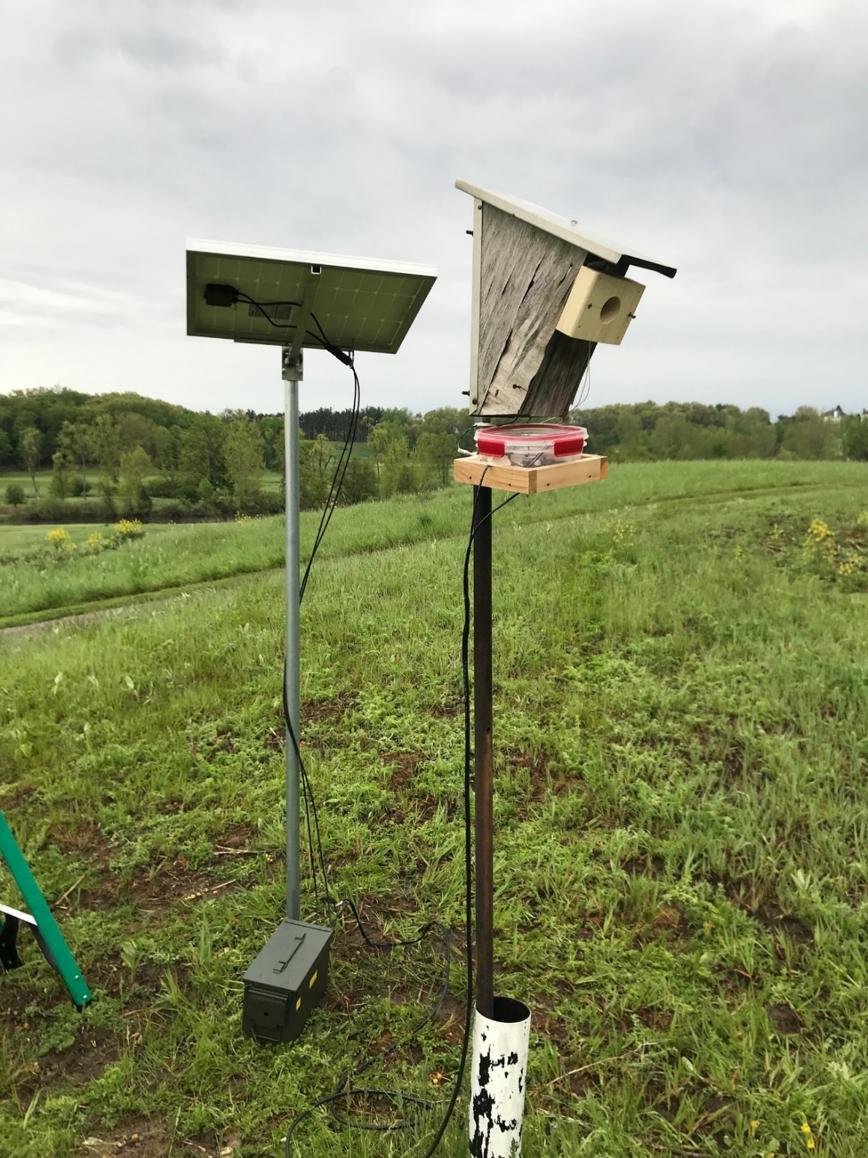
Figure 1.1. Radio frequency identification (RFID) reader and external speaker setup. The RFID readers were retrofitted onto existing nest boxes by placing the readers in plastic containers and placing the containers on a wooden shelf. RFID antennas were held in place using entrance guards.
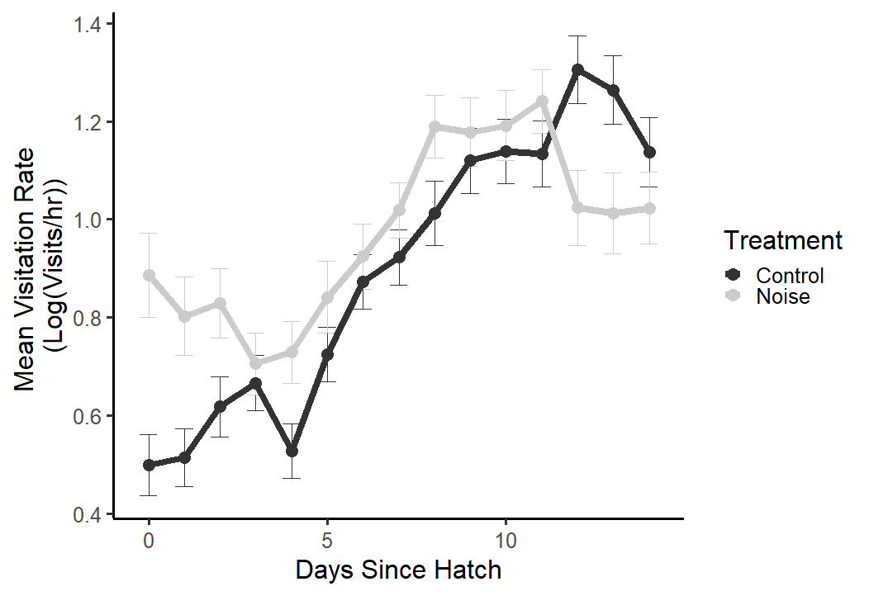
Figure 1.2. Adult female visitation rates within brood cycles. Adult visitation rates under the noise treatment were initially higher earlier within the brood cycle, but significantly decreased after 11 days post-hatch. Error bars represent standard error.

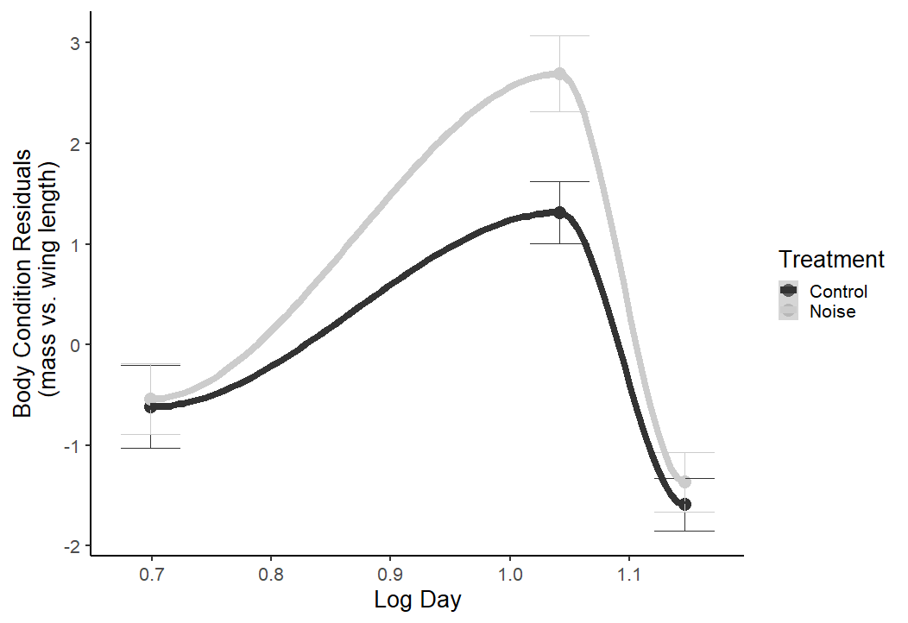
Figure 1.3. Nestling body conditions across the natural log of the day of the brood cycle. Nestling body morphometric measurements were taken on 5, 11, 14 days post-hatch. Nestlings in the noise treatment group initially had higher body conditions but this difference was no longer seen at the end of the brood cycle. Error bars represent standard error.

ENVIRONMENTAL CONDITIONS LEAD TO SHIFTS IN INDIVIDUAL COMMUNICATION, WHICH CAN CAUSE CASCADING EFFECTS ON SOUNDSCAPE COMPOSITION

INTRODUCTION
Semi-arid ecosystems are especially sensitive to climate change due to their relatively high temperatures, low precipitation, infertile soil, sparse vegetation cover, and low abundance of resources such as food and freshwater (Reynolds et al. 2007; Huang and Ullrich 2017; Wei et al. 2019). As global warming intensifies, desertification and land degradation in dryland habitats is also predicted to increase (J. Huang et al. 2015). In the Mojave Desert, increases in temperature and aridity coupled with a decrease in water resources have led to the collapse of desert avian communities (Iknayan and Beissinger 2018). While increases in temperature can lead to adaptations in heat dissipation (Song and Beissinger 2020), with increasing aridity birds will also suffer from increased evaporative water loss. Understanding how increased desertification affects avian behavior may provide insight into community collapse and resiliency under new environmental conditions (Buchholz et al. 2019). In response to warmer temperatures, some birds advanced the onset of reproductive and singing behaviors to earlier dates in the breeding season (Dunn, Winkler, and Møller 2010; Rubolini, Saino, and Møller 2010; Dunn and Møller 2014), as well as shift the onset of singing to earlier in the day due to higher overnight temperatures (Garson and Hunter 2008; Bruni, Mennill, and Foote 2014). Predicting how aridity changes birds’ energy and water demand and how these changes may affect their communication behavior will be useful for understanding how other factors, such as reproduction, physiology, and even population recruitment, will be impacted by future weather conditions (du Plessis et al. 2012; Van de Ven et al. 2016; Sharpe, Cale, and Gardner 2019).
Acoustic signals are used for intra- and interspecific communication among multiple animal species. Rapid changes in these signals can indicate that a population is adapting to environmental change associated with climate or other factors (Sueur and Farina 2015). Since dry air is a poor sound conductor relative to moist air, we can expect increased aridity to degrade sound transmission fidelity. Various signal frequencies (1.5, 3, 6 kHz) were tested in different environments at different times during the day. Broadcast coverage decreased dramatically across all signal frequencies when played in a desert environment in the afternoon compared to when played in a desert environment in the morning or compared to when played in a rainforest environment in the morning (Henwood and Fabrick 1979). This effect is most pronounced for high-frequency sounds, such as the songs of North American wood warblers, for which high frequency songs experienced high atmospheric attenuation (Snell-Rood 2012). For many bird species, the dawn chorus is a period of high singing activity during the breeding season (Catchpole and Slater 2008; Gil and Llusia 2020; Staicer, Spector, and Horn 2020). This period is usually characterized by low temperatures and moderate to high humidity, which generally corresponds to most optimal conditions for sound transmission (Henwood and Fabrick 1979). Therefore, the dawn chorus may represent a behavioral adaptation that exploits the optimal sound transmission properties of early morning. Yet, climate models predict disproportionate nighttime temperature increases, suggesting that early-morning conditions may become less optimal for vocal communication, potentially reducing the efficacy of the dawn chorus for adjacent neighbors to communicate (Mutiibwa et al. 2015). Birds may shift their pre-dawn and dawn chorus start times earlier to sing during low-light level periods, when foraging profitability is low due to low arthropod activity and constrained vision (Avery and Krebs 1984; Kacelnik 1979).
Increasing aridity will lead to reduced resources such as food and water (Reynolds et al. 2007; Reynolds et al. 2011), hence changing territory quality. To maintain suitable body condition for survival and reproduction, individuals need to expand territory sizes to access enough resources (Khoury and Boulad 2010). For example, in the Central Monte Desert in Argentina, rufous-collared sparrows (Zonotrichia capensis) maintain larger breeding territories compared to their temperate or tropical counterparts during the breeding season due to the lower habitat quality of this arid region (Cecilia Sagario and Cueto 2014).
Birds singing under increasingly arid conditions will not only simultaneously face poorer song transmission and territorial resource qualities, but the cost of singing itself will also increase, as the individual must shift allocations of time and energy resources away from singing (Reid 1987; Zollinger and Brumm 2015) and toward thermoregulatory and foraging behavior (Gil and Gahr 2002; du Plessis et al. 2012; Funghi et al. 2019). Furthermore, aridity likely increases the water costs for singing birds due to accelerated evaporative water loss; singing exposes the high moisture gradient between the bird’s respiratory tract and surrounding dry air, causing water loss to the environment (Ward, Speakman, and Slater 2003; Ward and Slater 2005; O’Connor et al. 2018). To avoid dehydration, birds will need to exhibit behavioral flexibility to sing at low dehydration conditions (Ducatez et al. 2020) or increase their rate of drinking (Czenze et al. 2020).
Agent-based models (ABMs) are a powerful tool to analyze individual behaviors and their population-level effects (Axelrod 1997). ABMs are built around a set number of agents, defined behaviors, and rules; each agent’s behavior is dependent on external stimuli fed into the model and the agent displays a behavior based on these stimuli and pre-defined rules (Reynolds 1987; Marceau 2008) . These models are useful in providing information on how behaviors can respond to future scenarios, such as increased temperature and aridity due to climate change, and on how the simulated system dynamics are affected. Studies used ABMs to predict migration start dates and routes for Painted Buntings (Passerina ciris) (Bridge et al. 2015) and stopover duration and movement distances in North American dabbling ducks under changing weather conditions (Beatty et al. 2017). ABMs are a valuable tool in predicting how climate change will affect the behavior of individuals, and how those altered behaviors can affect the population (Patt and Siebenhüner 2005). To our knowledge, ABMs have yet to map out how climate change will affect avian singing and territorial movement, and how these changes will affect the avian soundscape.
We examined how aridity would lead to a disrupted soundscape, and how this disrupted soundscape would affect avian singing, movement, and resting behavior. We developed two hypotheses to test how avian singing behavior changes under a disrupted soundscape: the facultative activity budget (FAB1) hypothesis, which states that singing activity is mainly dependent on individual condition, and the fixed activity budget (FAB2) hypothesis which states that singing activity is fixed, and species-specific traits are driving heterogeneity in vocal activity, regardless of individual condition. To evaluate these two hypotheses, we used an agent-based model to simulate a population of individuals each with their own territories and their singing, movement, and resting behavior across contemporary and climate change induced weather conditions. We varied territory size and mean song frequency to determine which bird species would be most at-risk to increased aridification (Figure 2.1).
We chose to simulate these disruptions under breeding conditions, both because alterations to breeding behavior would be more noticeable in an applied scenario, and because the consequences of disruptions to breeding behavior have tangible consequences for recruitment and persistence. We predicted that individual contact rate would decrease with increasing frequency and territory size, and that a population of singing individuals would not be able to maintain vocal contact with their immediate neighbors due to sound attenuation and reduced singing activity due to physiological constraints. We tested this hypothesis by using an ABM to model individual territorial vocalizations, within-territory movement, and resting behavior across current and predicted climate conditions.

METHODS

Model design.
We created an ABM in the program R v4.04 (R Core Team 2021) that simulated the singing and movement behavior of individual “virtual birds” (from now on referred to as birds) within their respective territories. The model advanced at 1 min time steps, and at each time step every bird could perform one of three behaviors: sing, move within the territory, and rest. Decisions regarding which action was performed were determined by probabilities assigned to each action. At the first time-step, the probability of each behavior was the same (0.33). The behavior probabilities only changed after a singing behavior was displayed or if the EWL equation was included in the model. When a singing behavior was initiated, a song radius was calculated based on the expected attenuation of the song. We set the threshold between audible and inaudible songs at 30 Db as the minimum amplitude that can be detected by the birds, because it is the ambient sound amplitude (Yost 2001). If a bird’s song radius overlapped with the position of any of its neighbors, then a successful instance of communication was recorded for all individuals involved and the neighbors within the song radius were induced to sing during that time step. If a bird’s song radius did not overlap with its neighbor, the focal bird would either move or rest in the following time-step, thereby changing the behavior probability to 0 for singing, 0.50 for moving, and 0.50 for resting. If a movement behavior was initiated the bird would relocate to a random position within its territory, and if a rest behavior was initiated, the bird would take no action during the time step.

Experimental Design.
We ran the model using weather data from an Oklahoma Mesonet station in western Oklahoma (ERIC) and we used this data to simulate future conditions caused by climate change (McPherson et al. 2007; Brock et al. 1995). We chose the ERIC Mesonet station because it has recorded some of the driest temperatures within the state of Oklahoma. We used weather data from May and June, a period that roughly corresponds to peak singing activity. Each modeled day used weather data from sunrise until 6 hours after sunrise which corresponded to peak singing activity. We averaged corresponding values from measurements at five-minute intervals for air temperature (TAIR), relative humidity (RELH), and air pressure (PRES) from 2010 to 2019. These average values were labeled as our contemporary weather data set (Table 2.1). These variables were used to calculate acoustic atmospheric attenuation (Rossing, 2007).
$α=f^{2}\left[\left(\frac{1.84×{10}^{-11}}{{\left(\frac{T_{0}}{T}\right)}^{\frac{1}{2}}×\frac{p_{s}}{p_{0}}}\right)+{\left(\frac{T_{0}}{T}\right)}^{2.5}×\left(\frac{{0.10680e}^{-3352/T}×f_{r,N}}{f^{2}+f_{r,N}^{2}}+\frac{{0.01278e}^{\frac{-2239.1}{T}}×f_{r,O}}{f^{2}+f_{r,O}^{2}}\right)×\frac{Np}{m×atm}\right]$ Eq 1.
With α as the attenuation coefficient, f is the sound frequency, T is the absolute temperature of the atmosphere in degrees Kelvin, T0 is 293.15K or 20C, ps is the local atmospheric pressure and p0 is the reference atmospheric pressure (1 atm = 1.01325 x 10⁵ Pa); f_{r,N} is the nitrogen relaxation frequency, f_{r,O} is the oxygen relaxation frequency and are calculated by the equations below:
$f_{r,N}= \frac{p_{s}}{p_{s0}}{\left(\frac{T_{0}}{T}\right)}^{\frac{1}{2}}×\left(9+280{He}^{-4.17\left[{\left(\frac{T_{0}}{T}\right)}^{\frac{1}{3}}-1\right]}\right)$ Eq. 2
$f_{r,O}=\frac{p_{s}}{p_{sO}}\left(24.0+4.04×{10}^{4}H\frac{0.02+H}{0.391+H}\right)$ Eq. 3
H being the percentage molar concentration of water vapor in the atmosphere or absolute humidity, and is calculated by:
$H=\frac{ρ_{sat}r_{h}p_{0}}{p_{s}}$ Eq. 4
With $ρ_{sat}={10}^{C_{sat}}$ and $C_{sat}=-6.8346{\left(\frac{T_{0}}{T}\right)}^{1.261}+4.6151$.
To simulate contemporary drought conditions, we used a subset of the baseline weather data from the year 2011, when there was a severe drought that affected most of Oklahoma and many neighboring states (Tadesse et al. 2015; Khand et al. 2017). We simulated extreme drought conditions to determine if vocal activity and if the vocal community would change in response to extreme aridity. To simulate the predicted climate change conditions in 2070 in which aridity is expected to increase in shrub- and grassland habitats, we took the mean weather condition values (TAIR, RELH, and PRES) from 2010-2019 ERIC Mesonet station and added 7.5°C to the TAIR and subtracted 6% from the RELH of the mean values (Table 2.1). These values are based on the predicted climate trends in the North American Southwest for the year 2070 (Huang and Ullrich 2017). To simulate drought conditions in 2070, we added 7.5°C to the TAIR and subtracted 6% from the RELH from the 2011 ERIC Mesonet weather data (Table 2.1).

Individual contact percentages.
We first ran a simplified version of the model with two individuals and their respective territories to test the effects of multiple song frequencies across multiple territory sizes. We tested 12 frequencies (1-12 kHz) and 60 territory size radii (25-1500m by 25m increments) to demonstrate how the different climate conditions listed above would affect the contact rate between two individuals with adjacent territories. We ran this model on the 06/01 date for the contemporary, extreme, climate change, and extreme climate change weather data because it was one of the hottest and driest days (based on 2011 TAIR and RELH, respectively) in our weather dataset. We ran this model over 5 iterations to add variability for the statistical analysis. To determine which frequency and territory radii would be affected by extreme weather, we subtracted the extreme and extreme climate change results from the contemporary and projected climate change results, respectively.

Population contact percentages.
This version of the model contained an array of 110 contiguous territories, represented as a hexagonal grid, such that 72 birds (those not on an edge of the array) had six neighbors (Figure 2.2). We increased the number of birds and territories in a population to determine if the changes in individual contact rates would influence the population-level communication system. Once a bird contacted all six of its neighbors it would stop singing because it has met the intrasexual condition of defending its territory against its adjacent neighbors. We also tested three different mean song frequencies (4, 8, and 12 kHz), which represented individual bird species to determine if contact rates varied as a function of frequency because these frequencies cover the majority of the avian song frequency bandwidth and 8 kHz is the expected hearing range of most birds (Dooling, 2004). We also ran the model with and without the evaporative water loss (EWL) equation included to determine if water budgets, our measure of individual condition, affected contact rates. In the first time-step, the probability of a bird singing, moving, or resting was equal (i.e. 0.33). However, to test if individual condition affected the probability of these behaviors, these probabilities were subject to change as the model progressed based on how much water had been lost due to thermoregulation. To account for this physiological change, we derived EWL equation from (Albright et al. 2017) for the House Finch (Haemorhous mexicanus), our model system for singing parameters. Once any bird lost 15% of its body mass due to total EWL (TEWL), it would no longer sing or move and would only rest until the next day because 15% TEWL is considered lethal to the bird (Albright et al. 2017). At the beginning of the next day, the TEWL resets back to zero under the assumption that the birds would recover their water reserves. Both the singing and moving behavior probabilities decreased by half of the TEWL divided by half of 15% of the body mass for each time step.
Each model run consisted of 61 virtual days each of which contained 6 virtual hours or 360 time steps. The six-hour period represented the dawn chorus and morning singing period, and we disregarded the rest of the day because the morning singing period is usually the highest singing period of the day (Gasc et al. 2017). We evaluated the effectiveness of vocal communication based on the percentage of birds that had successfully contacted all six neighbors at the end of each day. We then averaged these values across all days to generate an overall contact rate for each of the 360 time steps (i.e. the completion rate). Birds/territories that were on the edge of the hexagon array were not used to calculate contact rates as they had fewer than six neighbors. Hence, completion rates were calculated based on the 72 inner territories (Figure 2.2).

Statistical Analysis.
To analyze how different environmental conditions, frequencies, and territory sizes would affect individual contact rates, we developed a linear model (LM) using the lme4 package in the R statistical software (Bates et al. 2015). This model included the weather conditions, mean song frequency, and the inclusion or absence of the EWL equation on bird contact percentage. We conducted regression diagnostic tests and the residuals were somewhat normally distributed for this model. We also conducted an LM on the population-level, completion contact rate after conducting regression diagnostic tests and finding somewhat normally distributed residuals for both the population contact percentages. We averaged the total number of birds that contacted a neighbor for each time step across the 62 days within each iteration, which gave us the mean completion percentage across our model duration. We analyzed the interactions among weather conditions, frequency and the inclusion or absence of the EWL equation on the territory completion percentages. For both the individual and population-level contact analysis, we conducted a three-way ANOVA and a Tukey post-hoc test on the three-way interactions using the “car” and “multcomp” packages, respectively (Hothorn, Bretz, and Westfall 2008; Fox and Weisberg 2018) to determine which combinations of variables were significantly different from each other. All statistical analyses were done in R v4.0.4 (R Core Team 2021).

RESULTS

Individual effects.
According to the results of the LM, increasing frequency and territory size led to decreases in the mean contact percentages between then contemporary drought conditions and the mean contemporary conditions (B = -8.81e07 $±$ 24.05e-07 s.e., t = 2.175, p = 0.030) and between the mean climate change conditions and mean contemporary conditions, although this trend was not significant (B = -7.22e-07 $±$ 4.05e-07 s.e., t = -1.782, p = 0.075), indicating fewer contacts between neighbors as song frequency and territory size increased. These effect sizes were very small, which suggest that territory size and frequency may not be the most important factors in determining vocal contact between neighbors. The nature of these simulations would produce significant results because of the way the simulation was designed. The ANOVA demonstrated that there were significant differences between the weather conditions after considering variation from frequency and territory size (F = 4.084, df = 3, p = 0.007). The Tukey post-hoc test on weather conditions demonstrated that compared to the mean contemporary conditions, contact percentages significantly decreased in the mean contemporary drought conditions by ~17% (B = -17.356 $±$ 2.615 s.e., t = -6.638, p = 0.001) and in the mean climate change drought conditions by ~16% (B = -16.469 $±$ 2.615 s.e., t = -6.299, p < 0.001). The mean climate change conditions had higher contact percentages than the mean contemporary conditions by ~6% but this trend was not significant (B = 6.059 $±$ 2.615 s.e., t = 2.317, p = 0.094). To determine which frequencies would be affected by the extreme arid conditions, we subtracted the results of the simple model under the mean contemporary conditions from the drought conditions results (Figure 2.3A) and the mean climate change conditions from the climate change drought conditions results (Figure 2.3B) to demonstrate how extreme conditions affect mean song frequencies under different territory sizes. Smaller territory sizes with higher frequencies had higher contact rates compared to larger territories with lower frequencies.

Population effects - Weather conditions.
The ANOVA demonstrated that there were significant effects of weather conditions, frequency, and inclusion/absence of the EWL equation on completion percentages (F = 13146, df = 23, p <0.001). Based on the Tukey post-hoc tests, mean completion percentages between the contemporary drought conditions and mean contemporary conditions (Figure 2.4A) decreased for 4 kHz and 8 kHz by ~7% and ~16 , respectively (Figure 2.4B, 4kHz: B = -7.209 $±$ 0.494 s.e., t = -14.584, p = <0.001; 8Khz: B = -16.438 $±$ 0.494, t = -33.253 s.e., p <0.001). The climate change drought conditions also had lower completion probabilities for 4 kHz and 8 kHz by ~3% and ~4% , respectively (Figure 2.4D, 4kHz: B = -3.423 $±$ 0.494 s.e., t = -6.924, p <0.001; 8kHz: B = -4.093 $±$ 0.494 s.e., t = -8.28, p <0.001).The completion rates for the mean climate change conditions were higher than the mean contemporary conditions for all frequencies by ~13%, ~26%, and ~3% , respectively Figure 2.4C, 4kHz: B = 3.091 $±$ 0.494 s.e., t = 6.252, p <0.001; 8kHz: B = 26.361 $±$ 0.494 s.e., t = 53.327, p <0.001; 12kHz: B = 3.445 $±$ 0.494 s.e., t = 6.970, p<0.001). Completion rates for 12kHz were also significantly lower between the climate change drought and mean climate change conditions by ~ 2% (12kHz: B = -1.948$±$ 0.494 s.e., t = -3.942, p <0.018).

Population effects - Frequency.
Completion percentages decreased with increasing frequency for mean contemporary by ~60% when increasing from 4 kHz to 8 kHz and ~95%, when increasing from 4 kHz to 12 kHz (8kHz: B = -59.901 $±$ 0.494 s.e., t = -121.178, p <0.001; 12kHz: B = -95.014 $±$ 0.494 s.e., t = -192.209, p <0.001). Contemporary drought completion percentages decreased with increasing frequency by ~69% when increasing from 4 kHz to 8 kHz and ~7% when increasing from 4 kHz to 12 kHz (8kHz: B = -69.30 $±$ 0.494 s.e., t = -139.846, p <0.001; 12kHz: B = -86.945 $±$ 0.494 s.e., t = -175.886, p <0.001). Mean climate change completion percentages decreased with increasing frequency by ~37% when increasing from 4 kHz to 8 kHz and ~95%, when increasing from 4 kHz to 12 kHz (8kHz: B = -36.631 $±$ 0.494 s.e., t = –74.103, p <0.001; 12kHz: B = -94.659 $±$ 0.494 s.e., t = -191.491, p <0.001). Completion percentages decreased with increasing frequency in the climate change drought conditions by ~61% when increasing from 4 kHz to 8 kHz and ~90%, when increasing from 4 kHz to 12 kHz (8kHz: B = -60.572 $±$ 0.494 s.e., t = –122.534, p <0.001; 12kHz: B = -90.094 $±$ 0.494 s.e., t = -182.256, p <0.001).

Population effects - Evaporative Water Loss.
When we included the EWL equation in the model, EWL significantly reduced completion rates at 8kHz for contemporary conditions by ~3% (8kHz: B = -2.829 $±$ 0.494 s.e., t = –5.724, p <0.001), the contemporary drought conditions by ~3% (8kHz: B = -2.959 $±$ 0.494 s.e., t = –5.987, p <0.001), mean climate change conditions by ~5% (8kHz: B = -5.138 $±$ 0.494 s.e., t = –10.395, p <0.001), and climate change drought conditions by 9% (8kHz: B = -9.733 $±$ 0.494 s.e., t = –19.689, p <0.001). EWL also significantly reduced contact rates for 12kHz for the mean climate change conditions by ~3% (12kHz: B = -2.970 $±$ 0.494 s.e., t = –6.007, p <0.001).

Population effects - Territory Size.
Since the 8 kHz frequency demonstrated the most significant effects, we tested this frequency at various territory size diameters (1.0, 1.5, 3.0 km) under the climate change drought (Figure 2.5). The ANOVA demonstrated that the interaction between territory size and inclusion/absence of the EWL equation had significant effects on completion percentages (F = 4019.6, df = 5, p <0.001). Completion percentages decreased significantly as territory size increased from 1.0 km to 1.5 km by ~21% (B = -21.328 $±$ 0.283 s.e., t = –75.311, p <0.001), increased from 1.0 to 3.0 km by ~31% (B = -30.944 $±$ 0.283 s.e., t = –109.266, p <0.001), and increased from 1.5 to 3.0km by ~10% (B = -9.629 $±$ 0.283 s.e., z = –34.000, p <0.001). When EWL was included, completion percentages decreased significantly as territory size increased from 1.0 km to 1.5 km by ~18% (B = -17.608 $±$ 0.283 s.e., t = –62.174, p <0.001), increased from 1.0 to 3.0 km by ~ 22% (B = -21.953 $±$ 0.283 s.e., t = –77.517, p <0.001), and increased from 1.5 to 3.0km by 4% (B = -4.346 $±$ 0.283 s.e., t = –15.345 p <0.001).

DISCUSSION
Based on the ABM results, we concluded extreme arid conditions would lead to reduced contact rates and an altered avian soundscape for birds with mid to high mean song frequencies. While we found support for the FAB1 hypothesis, wherein reduced physiological condition (i.e. high TEWL) led to lower the completion rates for the 8 kHz mean song frequency under contemporary drought and climate change drought conditions, the majority of our results supported the FAB2 hypothesis, indicating that species’ specific soundscapes are dependent on fixed, species’ specific traits (i.e. mean song frequency and territory size). This trait-dependence means that with increasing aridity, certain species will be excluded due to reduced efficacy of the vocal communication system. This species loss will change the community composition of singing songbirds, which can be an indicator of community health (O’Connell, Jackson, and Brooks 2000). Our model demonstrates that under high aridity levels, the soundscape is no longer functional for certain species. Therefore, the population cannot maintain acoustic contact with each other, which could lead to changes in territorial boundaries and potential mating opportunities. These individual consequences could lead to population level effects such as a decline in population size, which could alter the community soundscape. Alternatively, species that can adjust their singing behavior to accommodate for these extreme conditions by producing signals with optimal transmission distance or by having a more gregarious social system, however not all species would be able to display behavioral flexibility or developmental plasticity accordingly.
We found from the population-level analysis, species-specific traits such as mean song frequency was the main determinant in maintaining contact with their adjacent neighbors, specifically species with low mean song frequencies were still able to contact all neighbors across all the different weather conditions tested (Figure 2.4). Low frequency acoustic signals still transmitted in desert environments later in the day, while high frequency acoustic signals attenuated at a much higher rate under the same conditions (Henwood and Fabrick 1979). Species with fixed vocalization frequencies, such as suboscines which have innate vocalizations, will be more likely affected by the increasing arid conditions because they cannot adjust their vocalization frequency for higher transmission distance (Ríos-Chelén et al. 2012). Suboscine species with high frequency vocalizations would have difficulty maintaining vocal contact with neighbors, as seen in a study on Vermillion Flycatchers (Pyrocephalus obscurus), which did not shift their song frequencies in response to high levels of anthropogenic noise (Ríos-Chelén et al. 2018). Bird species with more plastic singing behavior may be able to adjust their song frequency to increase transmission in nature. White-throated Sparrows (Zonotrichia albicolis) adjust song characteristics such as song duration, higher minimum frequencies, and narrower frequency bandwidths under high periods of noise (Lenske and La 2014). Male black-capped chickadees, (Poecile atricapillus) can shift their song frequencies up when masking noise is played (Goodwin and Podos 2013). While we found limited evidence for the FAB1 hypothesis as seen in reduced contact percentages with the inclusion of the EWL equation for mid to high mean song frequencies (Figure 4), other studies demonstrated that avian physiology can reduce singing behavior, especially under high temperatures (Coomes and Derryberry 2021; McGrann and Furnas 2016). Another study demonstrated that Willow Warblers (Phylloscopus trochilus) increased metabolic rate and thermoregulation costs while singing (Ward and Slater 2005), so one could assume that increased thermoregulatory needs and high TEWL could lead to decreased vocalization behavior.
Species whose singing and movement behaviors are fixed are more vulnerable to soundscape degradation associated with increased aridity. As song transmission distance decreases, maintaining contact rates will require some combination of lowering mean song frequency, increasing song volume, and altering the timing and intensity of singing to correspond with favorable conditions. For species that are flexible in their singing behavior, they will need to create new song types to sing in an arid environment (which supports the acoustic adaptation hypothesis), or change their peak singing time to periods of low aridity (which supports the acoustic niche hypothesis; (Morton 1975; Krause 1993). Selection for more transmissible songs in degraded environments has been noted in multiple species. North American warblers (Parulidae) decrease their signal frequency bandwidth (max frequency span within a note) and increase the signal length under high atmospheric attenuation (Snell-Rood 2012). Southern House Wrens (Troglodytes musculus) had lower song amplitude at high atmospheric attenuation conditions (Sementili-Cardoso and Donatelli 2021). In many bat species, which vocalize in ultrasonic frequencies, warmer climates have led to higher frequency calls that attenuate due to high temperatures and low humidity (Luo et al. 2014), which could lead to selection of lower frequency vocalizations and longer vocalizations to transmit information to the intended receivers. This selection for certain song syllables and song types could lead to the selection of low frequency, long songs, which would lead to the decrease of song type diversity in the avian soundscape. Species with higher frequency songs may relocate to habitats that have more favorable acoustic properties or reduce singing under hotter periods of the day (McGrann and Furnas 2016; Diepstraten and Willie 2021). Alternatively, selection can favor increased behavioral plasticity for birds to continue to sing in arid environments. Species that are not able to adjust their singing behavior can no longer maintain a vocal communication system in arid environments and will need to move to more suitable habitat.
While our model did not account for behavioral plasticity or intraspecific variation for individual species, this exclusion does not necessarily negate support for the FAB2 hypothesis. Completion rates did shift under the different climate scenarios, but frequency was the deciding factor in difference in completion rates (Figure 2.4). While plastic behavior is shown in many species, plasticity itself can be fixed, unless selection acts on it to increase (Crispo 2007). It has been documented that certain species’ singing behavior is flexible in disturbed habitats, particularly in habitats with high anthropogenic noise. Many urban birds such as Oregon Juncos (Junco hyemalis oreganus; Reichard et al. 2019), Great Tits (Slabbekoorn and den Boer-Visser 2006) , and White-crowned Sparrows (Derryberry, Danner, and Danner 2016) shifted their minimum song frequency to transmit signals above the low-frequency anthropogenic noise. Other species, like the Vermillion Flycatcher sing longer songs during noisy habitats (Ríos-Chelén et al. 2013) and Serins (Serinus serinus) increase vocal activity during noisy periods (Díaz, Parra, and Gallardo 2011). Birds in arid environments may also adjust vocal behavior by singing during the morning periods when sound transmission is the highest. Altitudinal migrants and resident bird species reduced singing activity when temperatures were high, but Neotropical migrants retained their singing activity even though the risk of heat-stress was high (McGrann and Furnas 2016). With behavioral plasticity included, the FAB2 still retains support because the limits of plasticity can be limited by species-specific interactions.
If territorial songs are unable to propagate and reach their intended receivers, then the efficiency of the song decreases and the cost of singing increases (Wiley 1998). This reduced efficacy could result in individuals not able to find mates due to incomplete information reaching the receiver, or potential mates preferring non-degraded songs. In many songbird species, females prefer certain song types over others. In habitats with high levels of anthropogenic noise, an example of a disturbed soundscape, Ovenbirds (Seiurus aurocapilla) suffered lower rates of pairing than quieter habitats (Habib, Bayne, and Boutin 2006). Wild male Zebra Finches (Taeniopygia castanotis) that sing longer, higher pitched songs predicted hatching success and the number of genetic offspring surviving (Woodgate et al. 2012). Preference can also play a factor in reduced population recruitment; female Lincoln’s Sparrows (Melospiza lincolnii) have a higher preference for male songs sung in colder temperatures vs. warmer temperatures (Beaulieu and Sockman 2012). On the opposite spectrum, male Pied Flycatchers (Ficedula hypoleuca) singing in cold temperatures are preferred less by female pied flycatchers than males singing in warmer temperatures (Slagsvold and Dale 1994). Warmer temperatures could also lead to potential mates preferring heterospecific songs over conspecific songs (Coomes, Danner, and Derryberry 2019), which could lead to missed mating opportunities and ultimately reduced population recruitment.
In addition to reduced preference for certain song types, as aridity increases, resources like food and water will decrease in abundance, and birds will need to expand their territories to have the necessary resources to survive and reproduce (Dean, Barnard, and Anderson 2009; Khoury and Boulad 2010). This increase in territory size will lead to increased energetic demand for patrolling territories, especially if the vocal signals used to maintain territory boundaries no longer reach their intended receivers. If vocal activity decreases, then individuals will need to increase territorial movement behavior to actively defend their territories from intruders. Increasing resource needs when resources are already low would push individuals past their breaking point (McKechnie, Hockey, and Wolf 2012), and while behavioral flexibility (short-term behavioral plasticity) would provide quick relief, the increased allostatic load would be too much for some species to adapt and develop non-reversible plasticity (i.e. developmental plasticity) to deal with increasingly extreme conditions (Wingfield et al. 2017). Outside of mating and reproduction, for social species the reduced soundscape under arid conditions could lead to reduced flock foraging behavior (Safriel 1990) as calls may not reach conspecifics. The reduced transmission of predator alarm class could have community level effects, such as elevated depredation events, due to multiple species listening to heterospecific alarm calls (Grade and Sieving 2016). Pair-bonded individuals will not be able to coordinate parental provisioning or produce effective alarm calls to warn of predators (Rose et al. 2020) if the vocal signals are degraded. Territorial behaviors may decrease if degraded signals reach neighbors because birds rely on ranging or auditory cues to evaluate the distance of a conspecific. If a trespassing neighbor’s song is degraded by high atmospheric attenuation, then the focal individual may not respond aggressively enough to the trespassing neighbor because the focal individual thinks the trespasser is farther away than it really is (Fotheringham, Martin, and Ratcliffe 1997; Farina 2014). Alternatively, aggressive territorial behaviors may increase due to competition over decreasing resources (Samplonius and Both 2019). Many avian species use vocalizations to defend territories against rival mates and prevent extra-pair paternity (Mace 1987). Males that move more could suffer from extra-pair fertilizations occurring on their territory. If the male is unable to defend the territory, territoriality behavior could become ineffective. Alternatively, individuals that are unable to defend a territory or no longer have access to a territory could become helpers on an existing territory of a more dominant/successful individual. With the degraded soundscape leading to fewer mating opportunities and increasing aridity leading to limited resources unable to support multiple breeding individuals, cooperative helpers may assist with dominant individuals to patrol territories and help with nestling provisioning (Koenig and Dickinson 2004). A direct effect of reduced resources leading to larger territories is smaller population densities, which coupled with attenuated song types/syllables could lead to the loss of vocal culture or reduced vocal repertoires. An example of this reduced vocal culture was found in Regent Honeyeaters (Anthochaera phrygia). Male Regent Honeyeater songs in 2011 were shorter and contained fewer syllables than songs in 1968 due to habitat fragmentation (Valderrama, Molles, and Waas 2013). This decrease in vocal culture led to reduced female pairing (Crates et al. 2021). Song type diversity may also decrease due to cultural selection in tandem with natural selection if certain signals are not learned by the next generation (Searcy and Nowicki 2005). Oscines or birds that learn song types from a tutor would only be exposed to low frequency, long syllable song types in an arid, degraded soundscape and once they mature their offspring will learn those song types as well. One study demonstrated that young Carolina Wrens (Thryothorus ludovicianus) prefer to learn undegraded songs than degraded songs (Morton, Gish, and Van Der Voort 1986), and under the predicted extreme aridity conditions, there may be fewer degraded song types to choose from. To reduce degradation, birds may position themselves higher in tree canopies (Mathevon, Dabelsteen, and Blumenrath 2005), which may expose birds to new ecological niches. Our results demonstrated that higher mean song frequencies would be less likely to transmit to adjacent neighbors, indicating that high frequency signals could be lost in arid songbird communities because they will not be heard by young birds. Alternatively, singing activity could potentially increase due to geophonies (i.e. sounds from the natural environment) decreasing due to dry riverbeds (B. Krause and Farina 2016). Regardless, species living in variable conditions and unpredictable environments will need to learn and invent new syllables and song types in order to communicate to their intended receivers (Laiolo and Tella 2006; Laiolo 2008; Botero et al. 2009), which could lead to an increase in syllable and song type diversity.
Changing song characteristics and song diversity would be an example of adaptation or a plastic response. Increasing phenotypic plasticity can help species continue to function in extreme environments, and these extreme environments can therefore select more plastic traits that reduce trait costs (Chevin and Lande 2010; Hoffmann and Parsons 1993). If the extreme environments continue to persist, organisms may develop non-reversible plasticity, which could lead to trait adaptation (Wingfield et al. 2017). While selection may favor plastic traits, plasticity is dependent on other traits (e.g. behavioral syndromes) that may limit behavioral expression, which could prevent species from expressing the optimal trait in a given context (Lande 2009). Plastic responses can be adaptive if those plastic responses in mild conditions are genetically correlated with responses in the extreme conditions (Chevin and Hoffmann 2017). Species with these correlated, plastic responses may have built-in climate resilience, which would lead to better chances of survival under increasingly extreme environments (Chevin, Lande, and Mace 2010).
Increasing aridity may completely alter soundscapes which can have individual, population, and community level impacts. The acoustic niche hypothesis states that species will occupy individual niches to avoid frequency or temporal overlap (Krause 1993). With increased aridity changing the optimal times to sing, increased temporal overlap may occur between species that before did not compete for the same frequency range (Krause 2012). Highest acoustic activity occurs during the dawn choruses, and while multiple factors like physiology (Thomas and Cuthill 2002; Thomas et al. 2002), light intensity (Berg, Brumfield, and Apanius 2006), and social factors (Krebs and Kacelnik 1983) affect the dawn chorus activity, if aridity negatively impacts the sound propagation characteristics during the day, then multiple species will compete for the same temporal space during the dawn chorus (Krause 1987). With selection favoring lower frequency songs and with a smaller optimal window to produce high frequency songs in arid environments, species that are unable to shift their song frequencies or cannot produce new songs will need to relocate to more suitable habitats. This relocation could lead to interspecific conflict between native species and the relocating species that use the same acoustic niche (Farina, Pieretti, and Morganti 2013), and potentially divergence of species as the colonizing species begins to adapt to the new acoustic environment (Cardoso and Price 2010). This change in community composition could lead to an avian soundscape dominated by functional diversity (i.e. low frequency songs in large territories or medium frequency songs in small territories) rather than phylogenetic diversity (Gasc et al. 2013).
Soundscapes can represent the health of an environment if acoustical niches correlate with ecological niches of vocal animals (Farina et al. 2011; Kasten et al. 2012; Gage and Axel 2014; Fuller et al. 2015). Soundscapes can be used to detect early signs of bird stress or disturbance related to habitat or climate changes (Sueur and Farina 2015; Doser et al. 2020). Since the 1990s, the avian community soundscape has become more homogeneous, acoustic diversity has decreased, and soundscape intensity has declined in northern and eastern North America (Morrison et al. 2021). Degrading soundscapes could lead to reduced perceived ecosystem value for many habitats (Ferraro et al. 2020). Humans have increased perceived ecosystem value if a habitat sounds more “natural” (Francis et al. 2017). Ecosystem services can be enhanced by making a habitat sound more natural, which in turn could lead to an increase in conservation support (Levenhagen et al. 2021). Protecting a soundscape is vital for adding ecosystem value to a habitat so we can advocate for ecosystems for the public’s benefit.
Our model demonstrated how changes in individual singing and movement behaviors due to extreme aridity can lead to an altered avian soundscape at the population level. This lack of communication could lead to an altered avian community soundscape, with certain species being able to adapt and continue to sing during these increasingly arid conditions. Identifying which species would suffer from this altered communication system can potentially be helpful in creating mitigation strategies such as adding supplemental water resources or creating artificial shade refugia, to help reduce the impact of increasing aridity on avian populations. Further analyses across multiple species are needed to determine how an entire avian community will be affected by increasing aridity.

TABLES
Table 2.1. Model testing parameters. We tested multiple combinations of weather conditions, territory sizes, and mean song frequencies with our model. The mean contemporary weather conditions were an average of the 2010-2019 ERIC Mesonet weather data, the contemporary drought weather conditions were a subset of the contemporary weather data set, specifically the year 2011, in which a severe drought occurred in Oklahoma. The mean climate change conditions were the predicted weather conditions in 2070, and to obtain these values we took the mean contemporary conditions and added 7.5°C to the air temperature (TAIR) and subtracted 6% from the relative humidity (RELH) values. The drought climate change conditions were the predicted extreme weather conditions in 2070 and to obtain these values we took the mean climate change conditions and added 7.5°C to the air temperature (TAIR) and subtracted 6% from the relative humidity (RELH) values. In all of these conditions we tested three mean song frequencies (4, 8, and 12 kHz) to determine if frequency would affect neighbor contact rate. For these conditions we set the territory size to 1 km diameter. For the Medium, Bad, and Worst conditions, we used the climate change drought conditions, kept the mean song frequency to 8 kHz, while varying the territory size diameter to 1 km for the Medium conditions, 1.5 km for the Bad conditions, and 3 km for the Worst conditions.
Weather Conditions | Data | Territory Size  Diameter (km) | Song Frequencies (kHz)
Contemporary | Average of 2010-2019 ERIC Mesonet Data | 1 | 4, 8, 12
Contemporary Drought | 2011 ERIC Mesonet Data | 1 | 4, 8, 12
Climate Change | Average of 2010-2019 ERIC Mesonet Data (+ 7.5C, -6%) | 1 | 4, 8, 12
Climate Change Drought | 2011 ERIC Mesonet Data (+7.5C, -6%) | 1 | 4, 8, 12
Medium (Climate Change Drought) | 2011 ERIC Mesonet Data (+7.5C, -6%) | 1 | 8
Bad (Climate Change Drought) | 2011 ERIC Mesonet Data (+7.5C, -6%) | 1.5 | 8
Worst (Climate Change Drought) | 2011 ERIC Mesonet Data (+7.5C, -6%) | 3 | 8

Table 2.2. Model completion percentages. These percentages represent the percent of individuals that contacted all 6 neighbors by the end of the 6-hr model duration.
Condition | Frequency (kHz) | EWL Inclusion/Absence | N | Percent | SE
Mean Contemporary | 4 | No EWL | 5 | 100.000 | 0.000
Mean Contemporary | 4 | EWL | 5 | 100.000 | 0.000
Mean Contemporary | 8 | No EWL | 5 | 71.867 | 0.418
Mean Contemporary | 8 | EWL | 5 | 63.948 | 0.191
Mean Contemporary | 12 | No EWL | 5 | 0.838 | 0.049
Mean Contemporary | 12 | EWL | 5 | 0.301 | 0.026
Contemporary Drought | 4 | No EWL | 5 | 99.832 | 0.020
Contemporary Drought | 4 | EWL | 5 | 99.417 | 0.060
Contemporary Drought | 8 | No EWL | 5 | 40.278 | 0.367
Contemporary Drought | 8 | EWL | 5 | 30.032 | 0.095
Contemporary Drought | 12 | No EWL | 5 | 3.374 | 0.093
Contemporary Drought | 12 | EWL | 5 | 2.928 | 0.152
Mean Climate Change | 4 | No EWL | 5 | 100.000 | 0.000
Mean Climate Change | 4 | EWL | 5 | 100.000 | 0.000
Mean Climate Change | 8 | No EWL | 5 | 91.448 | 0.262
Mean Climate Change | 8 | EWL | 5 | 79.781 | 0.360
Mean Climate Change | 12 | No EWL | 5 | 12.350 | 0.349
Mean Climate Change | 12 | EWL | 5 | 1.198 | 0.028
Climate Change Drought | 4 | No EWL | 5 | 99.736 | 0.042
Climate Change Drought | 4 | EWL | 5 | 97.910 | 0.138
Climate Change Drought | 8 | No EWL | 5 | 50.328 | 0.222
Climate Change Drought | 8 | EWL | 5 | 29.763 | 0.294
Climate Change Drought | 12 | No EWL | 5 | 5.433 | 0.166
Climate Change Drought | 12 | EWL | 5 | 0.779 | 0.091
Medium | 8 | No EWL | 5 | 49.754 | 0.291
Medium | 8 | EWL | 5 | 30.233 | 0.268
Bad | 8 | No EWL | 5 | 21.034 | 0.164
Bad | 8 | EWL | 5 | 6.913 | 0.266
Worst | 8 | No EWL | 5 | 0.077 | 0.015
Worst | 8 | EWL | 5 | 0.014 | 0.006

FIGURES
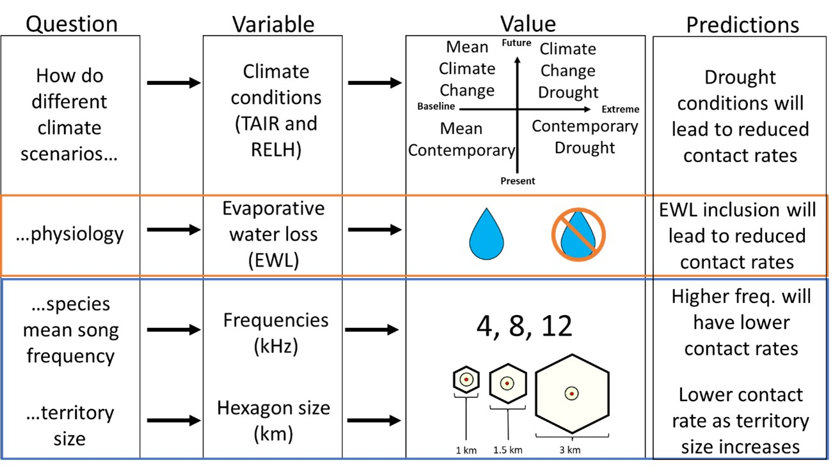
Figure 2.1. Pictogram of questions, hypotheses, and predictions for the ABM. The questions, variables, and values outlined in the orange box represent the FAB1 hypothesis, while the blue box represents the FAB2 hypothesis.
Figure 2.2. Virtual environment for a population of virtual birds. Each hexagon represents a bird’s territory in which the bird moves around. Each bird has 6 adjacent neighbors, except for the hexagons on the grid edge, which were not included in the final calculations since they could not contact all six neighbors. A bird will either sing, move, or rest until all neighbors were contacted. Birds that have contacted all six neighbors will turn gray and that bird will stop exhibiting behavior for the rest of the day.
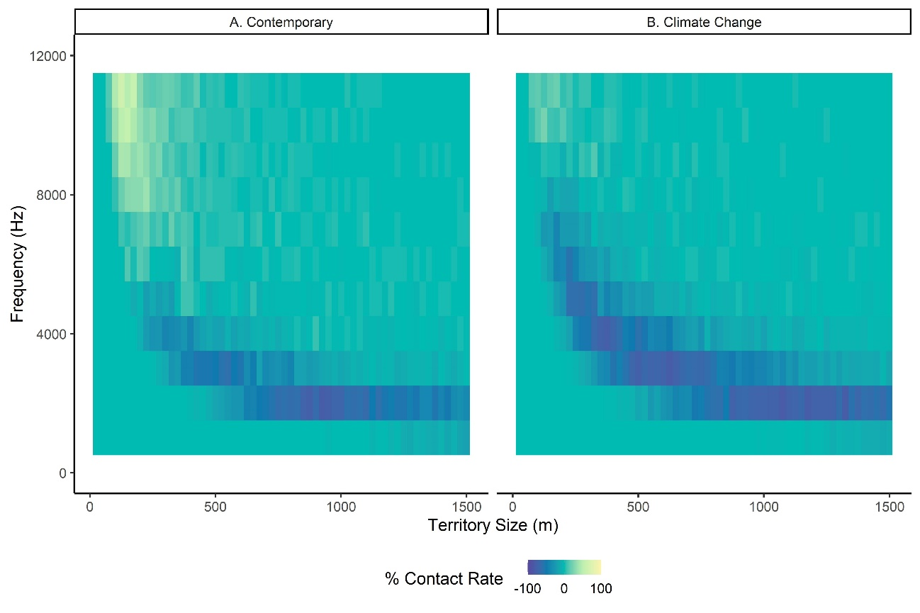
Figure 2.3. Heatmaps of frequencies affected by extreme temperatures across different territory sizes. We applied the ABM to multiple territory sizes ranging from 25m radius territories to 1500m radius territories across the audible bird song frequencies for the differences in drought vs. contemporary weather data (A) and the differences in climate change drought vs. climate change weather data (B). Cooler colors represent frequencies and territory sizes that would lead to fewer birds successfully contacting all neighbors under extreme conditions in both the extreme and climate change drought data, suggesting that selection may drive bird populations towards smaller territory sizes and higher frequency songs.
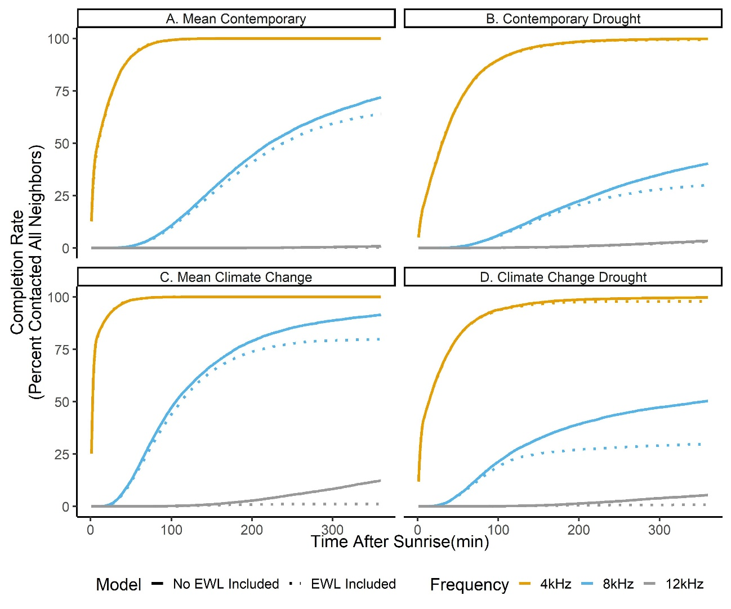
Figure 2.4. Population contact rates across four different environment conditions: (A) Mean contemporary, an average of air temperature (TAIR), relative humidity (RELH), and air pressure (PRES) from the ERIC Mesonet station from 2010-2019. (B) Contemporary Drought, the weather data from 2011 drought from the ERIC Mesonet station. (C) Mean Climate Change, 7.5C TAIR increase and 6% RELH decrease to the Mean Contemporary data. (D) Climate Change Drought 7.5C TAIR increase and 6% RELH decrease to the Mean Climate Change data. Three frequencies that span the songbird frequency bandwidth were tested (4kHz: orange, 8kHz: blue, 12kHz: gray). Models without (solid) and with (dotted) the evaporative water loss (EWL) equation are included.

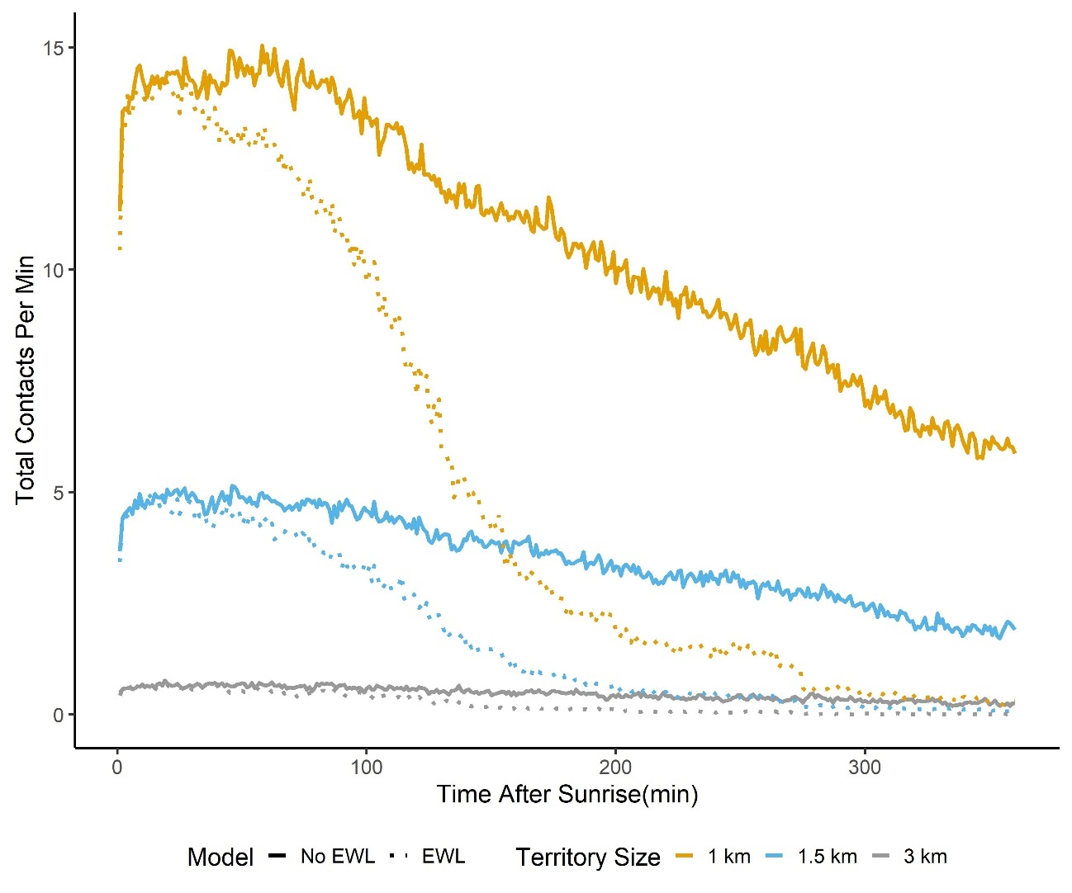
Figure 2.5. Total contacts decrease as territory size increases under extreme climate change conditions for 8 kHz. Total number of contacts is represented on the y-axis and time (min) is represented on the x-axis.

IT’S NOT THE HEAT, IT’S THE ARIDITY: AVIAN SONG ACTIVITY AND SPECIES DIVERSITY AT THE COMMUNITY LEVEL HAVE CONSISTENT, NEGATIVE RESPONSES TO INCREASING ARIDITY

INTRODUCTION
Arid environments such as shrub- and grasslands are sensitive to climate change and desertification (Huang and Ullrich 2017). As aridity increases in these habitats, resources associated with vegetation, soil fertility, and water availability will decline (Berdugo et al. 2020), which can alter the animal community composition of the environment (Puig-Gironès, Brotons, and Pons 2017). This alteration can degrade communities to the point of collapse, as seen with the Mojave Desert avian community (Iknayan and Beissinger 2018).
Increased aridity in grassland and shrublands presents several challenges to bird populations in these habitats. Among these challenges is increasing thermoregulatory demands due to the metabolic costs of heat dissipation. Smaller species are particularly vulnerable to thermal stress and may be unable to maintain necessary behaviors when burdened with additional thermoregulatory demands (Song and Beissinger 2020; McKechnie, Gerson, and Wolf 2021). Increased aridity can also reduce availability of resources, which may require territorial songbirds to establish larger territories and, in turn, require more energetic resources to defend these larger territories. A related challenge is that aridity increases evaporative water loss. As birds sing, they expose their respiratory tract to the environment, which is where most of the evaporative water loss occurs in songbirds (Wolf and Walsberg 1996). As air becomes drier, the evaporative gradient increases, leading to more water loss than under more humid conditions (McKechnie et al. 2016). Another challenge is increased instances of extreme climate events (ECEs) which can drastically impact fitness and selection of behavioral phenotypes (van de Pol et al. 2017). Finally, an often-overlooked side-effect of global warming is the altered acoustic transmission properties of the environment. Hotter, drier air generally reduces sound propagation (Brenowitz 1982; Henwood and Fabrick 1979; Larom et al. 1997), which means that songbirds would be less likely to vocally communicate with rivals and potential mates. Hence reduced sound propagation would likely exacerbate the challenges related above regarding territory defense and evaporative water loss.
Increased sound attenuation in arid environments could significantly alter soundscapes because the hotter, drier air generally reduces sound propagation, especially for higher frequencies, which can affect the life-histories of animals that use acoustic signals to communicate (Henwood and Fabrick 1979; Sueur, Krause, and Farina 2019). Attenuated acoustic signals may not reach the intended receivers (i.e. potential mates or territorial conspecifics) or may not effectively transmit all the information within that acoustic signal (Forrest 1994). This loss in signal information may lead to selection pressures on acoustic signals or on other behaviors to retain signal integrity and detectability. This outcome is a tenant of the acoustic adaptation hypothesis, which predicts that signalers should produce signals that optimize transmission in a given environment (Morton 1975). For example, singing activity by birds typically occurs in the early morning when acoustic signal transmission is at its highest and signal degradation is the lowest (Brown and Handford 2002). While not tested directly, studies demonstrated that arid conditions affect singing activity, with birds singing less on hot days and singing earlier in hotter habitats (Gordo, Sanz, and Lobo 2008). However, with climate change increasing aridity levels, periods of high sound propagation are shortening. Due to this narrower period, there will be selection for different vocal signals and behaviors (Irwin, Bensch, and Price 2001) and species that can adapt to these new conditions, which will alter the arid-land soundscape community.
Increased aridity not only reduces the efficacy of singing, but also increases evaporative water loss in animals that produce vocal acoustic signals. Vocalizing birds, frogs, and toads expose their respiratory tract to the environment, which is where most of the water is lost. As air becomes drier, the evaporative gradient increases, leading to more water lost than under more humid conditions (McKechnie et al. 2016). A study demonstrated that higher air temperatures led to higher rates of evaporative water loss in desert songbirds, which face higher dehydration risk than bird species in other habitats (Albright et al. 2017). This increase in evaporative water loss could lead to higher avian mortality and even collapse of avian communities (Iknayan and Beissinger 2018). To prevent evaporative water loss and dehydration, birds may reduce singing activity to conserve water, which would lead to an altered avian soundscape. To compensate for the reduced territorial signals, birds may increase territorial movement to patrol territorial boundaries and find mates. Yet, this increase in movement could also potentially increase dehydration risk in birds (Khoury and Boulad 2010). Some have suggested that supplemental water may alleviate the high evaporative water loss at more arid conditions (Smit et al. 2019), which could offset the increased cost of singing.
To examine links between aridity and singing behavior and to determine if supplemental water mitigates responses to arid conditions, we conducted two comparative studies in shrub- and grassland habitats. The first study examined the singing behavior responses to natural environmental conditions across an aridity gradient ranging from temperate to arid across Oklahoma, Texas, and New Mexico. The second study entailed experimental manipulation of the water availability at two study sites to test whether singing behavior is affected by water supplementation. We hypothesized that birds must balance the costs of vocalizing (e.g. water loss and energy expenditure), against the need to exclude competitors from territories and attract mates. We previously used an agent-based model to demonstrate that high aridity, evaporative water loss, and large territory sizes due to reduced resources can disrupt an avian population’s vocal communication system by reducing the detectability of vocalizing individuals (Pandit, Bridge, and Ross 2022). To resolve this tradeoff between individual condition and territoriality, birds may evaluate local conditions and reduce singing behavior when high aridity increases water loss and causes a high degree of sound attenuation. Hence, we predicted that as aridity increases, there will be decreases in general arid-land biophony (i.e. the sum of biological acoustic sounds due to birds, mammals, amphibians, and insects) intensity as well as changes in biophony phenology, as measured by multiple acoustic metrics. More specifically, birds would be less detectable during high aridity conditions, which would lead to reduced predawn chorus, dawn chorus, and general morning vocal activity. When supplemental water is present, we predicted that biophony activity would increase, and that water supplementation would prolong the biophony activity periods into the parts of the day when aridity conditions were high. Alternatively, when supplemental water is present it may only mitigate the negative effects of extreme aridity conditions (i.e. extreme water loss while vocalizing) and not necessarily increase the biophony activity period.

METHODS

3.2.1 Study sites.

To determine how avian vocal activity varied across an aridity gradient, we recorded avian community soundscapes at multiple sites across Oklahoma, Texas, and New Mexico, specifically, Lexington Wildlife Management Area (LWMA; 35.05, -97.21, Cleveland County, OK; Sandy Sanders Wildlife Management Area (SSWMA; 35.07, -99.83), Beckham County, OK; Cross Bar Management Area (CBMA; 35.41, -101.95), Potter County, TX; and Kiowa National Grassland (KIOWA; 36.07, -104.34), Colfax County, NM (Figure 3.1A). We chose these sites because they varied in aridity levels across time (Figure 3.1B). For each site we installed a 1 km transect of audio recording units (ARUs) every 100 m across relatively homogeneous grassland habitat. We positioned the transects strategically such that no recording unit was within 1 km of any surface water. The ARUs were AudioMoths (Hill et al. 2018) which were programmed to record for 2 min at 10 min intervals from predawn (~125 min before sunrise) to ~380 min after sunrise to obtain the peak singing activity within a day. ARUs recorded audio data from 2021/05/19-2021/08/15. We housed the ARUs in custom-built housing called HEXEARs (Figure S 3.1, Figure S 3.2), which turned the unidirectional AudioMoth microphone into an omnidirectional recording device by creating a boundary microphone system that not only increased recording coverage but also increased audio amplitude by reflecting sound within 6 collection funnels (Figure S 3.2). We installed the ARUs on 1.5m poles strapped to t-posts so the ARUs were ~ 2.6 m above ground level. Initially the ARUs were powered by 12V, 5Ah sealed lead acid (SLA) motorcycle batteries (Sigma-Tek SP12-5). While the AudioMoth 1.1 can be powered by these batteries, we found that the extreme heat at the study sites could cause the units to overheat and shutdown, resulting in the on-board clock to reset and therefore not keep track of time. To solve this issue, we either altered the power cords to include a buck converter that down regulated the voltage to 5V or switched the power source to three rechargeable AA batteries.

3.2.2 Supplemental water stations.
To determine whether supplemental water could mitigate the impacts of arid conditions on singing behaviors, we installed water supplementation stations at SSWMA in two of three separate study areas (i.e. water sites) with a minimum 1km buffer zone separating them. In the two water sites we provided an array of five elevated water stations separated by at least 500 meters. Water stations consisted of a 5-gallon (19 liter) bucket elevated approximately 1. 5 meters above the ground on top of three fence posts and equipped with a small solar-powered fountain to pump water to a dish at the top of the bucket (Figure 3.2A). We used this set up at the SSWMA site because SSWMA allows cattle grazing and this set-up prevented cattle from emptying the water station before we could refill them. We alternated water availability between the two water sites. The first site had water available for 14 days starting on 2021/05/17. On 2021/05/30 we drained the water from the first site and transferred it to buckets in the second treatment site. We repeated this cycle on 2021/06/13 and on 2021/07/02. The third water site was an unmanipulated control. At each of the watering stations, we installed one AudioMoth housed in a HEXEAR on a t-post and metal pole ~2.6 m from the ground to record the surrounding soundscape. The ARUs recorded audio data for 2 min every 10 minutes from predawn (~125 min before sunrise) to ~380 min after sunrise to obtain the peak singing activity within a day.
The second water supplementation experiment was at the CBMA, Potter County, TX. At this site, the wildlife managers installed 5 wildlife guzzlers (Figure 3.2B) in 2011 to collect and store rainwater to supplement local wildlife. The birds in this site were exposed to supplemental water for a long time-period and had time to habituate to the supplemental water. We divided the wildlife guzzlers into two water sites. At water site 1, we used wooden boards to block and unblocked water access to the guzzlers on a two-week cycle. The guzzlers had open water access at the beginning of the study period (i.e., 2021/05/15). We then restricted water access by blocking the guzzlers with wooden boards on 2021/06/04, and this cycle was repeated roughly every two weeks. Water site 2 had open water access throughout the study (2021/05/15-2021/08/15).

3.2.3 Local weather data.
We downloaded weather data from the nearest Mesonet/airport weather stations. We used the Washington, OK; Erick, OK; KBGD Airport, TX, and the Mills Canyon, NM weather stations for LWMA, SSWMA, CBMA, and KIOWA sites, respectively. While most of the weather data was in 5-min increments, some of the weather data was divided into 10-min or 1-hour bins. To approximate the missing weather data within each of these bins, we used the “zoo” package to interpolate 5-min weather data (Zeileis and Grothendieck 2005). We calculated the minutes after sunrise (MAS) metric at each site using the “suncalc” package (Thieurmel and Elmarhraoui 2019), with sunrise defined as the time the top edge of the sun appears on the horizon. We then created 5-min bins for the MAS variable so that the MAS variable would fit with the weather datasets. We then grouped the MAS variable into 4 factors (predawn, early, mid, and late) to determine how different time periods affected acoustic activity.
For each 5-min interval, we calculated an aridity metric based on air temperature, relative humidity, air pressure, and wind speed at 2 m at each site. This metric may be regarded as the aerodynamic evaporation rate (E_{a}) in (mm/day), and it was calculated as:
$E_{a} = B\left(e_{as}-e_{a}\right)⋅\left(1000⋅86400\right)$ Eq.1
In which e_{as} (Pa) is the saturation vapor pressure at the ambient temperature, e_{a} (Pa) is the actual vapor pressure estimated by multiplying es by the relative humidity, B is the vapor transfer coefficient (m/Pa/s) and is defined as:
$B = \frac{\left(0.622k^{2}ρ_{a}u_{2}\right)}{\left(pρ_{w}{\left[\ln\left(\frac{z_{2}}{z_{0}}\right)\right]}^{2}\right)}$ Eq. 2
In which k is the Von Karman constant (0.4), u2 is the wind velocity (m/s) measured at height z2 (cm) which in this study is 200 cm; z0 is the roughness height of a natural surface, here set to 0.03, ρ_{a} is the density of moist air (kg/m3), ρ_{w} is the density of water (kg/m3), and p is the atmospheric pressure (Pa) (Singh 2016; Lim et al. 2012). We then converted the evaporation rate from mm/day to mL/cm2/day by multiplying the evaporation by 0.1 (FAO 2023). We also calculated the attenuation coefficient (α) to determine if sound attenuation at 4, 8, and 12kHz affected acoustic activity (Rossing, 2007).

3.2.4 Broad acoustic analyses.
To obtain broad acoustic metrics from the recordings, we calculated the acoustic diversity index (ADI), acoustic complexity index (ACI), acoustic diversity index (ADI), acoustic evenness index (AEI), and the bioacoustic index (BIO) using the “sound ecology” package in R (Villanueva-Rivera et al. 2022). We calculated the ACI by taking the absolute difference between two values of intensity within a single frequency bin and within a single temporal time frame. We calculated ADI by dividing the spectrogram into 1 kHz bins and taking the proportion of signals in each bin above a –50 dBFS (decibels relative to full scale) threshold and is the result of the Shannon Index applied to the bins (Villanueva-Rivera et al. 2011). AEI was also calculated by dividing the spectrogram into 1 kHz bins and applying the Gini Index to the bins (Villanueva-Rivera et al. 2011). ADI and AEI are inversely correlated, with high ADI indicating low AEI, and vice-versa. We calculated the BIO by taking the area under the curve of all frequencies above an amplitude threshold, which was set at -50 dBFS (Boelman et al. 2007). While these metrics do not identify individual species, they do provide a broad metric of the biophony at each site (Pijanowski et al. 2011). To filter out anthropogenic and insect noise, we bandpass filtered the recordings below 1 kHz and above 8 kHz, respectively. Although the filter removed most of the insect noise, there were still some insect acoustic signals in the recording. We separately calculated these metrics for both the aridity gradient and the water supplementation experiments.

3.2.5 Vocalization number and species diversity.
Individual bird species’ songs were identified using the machine learning algorithm BirdNET-Analyzer from the Cornell Lab of Ornithology (Kahl et al. 2021). This algorithm was trained on millions of bird vocalizations from eBird, xeno-canto.org, and the Macaulay Library (“EBird” 2020; Xeno-canto 2020; Macaulay 2020). We set the confidence threshold to 0.3 because this was the threshold with the highest f0.5 score, which considers precision (number of true positives identified by the model divided by the sum of the true positives and false positives) and recall (number of true positives divided by the sum of the true positives and false negatives) but adds more weight to the precision. Higher f0.5 scores mean more precision at the expense of recall.
$F0.5=(1.25)×\frac{Precision×Recall}{\left(0.25×Precision\right)+Recall}$ Eq 3.
$Precision=\frac{\#true positives}{\#true positives+\#false positives}$ Eq 4.
$Recall= \frac{\#true positives}{\#true positives+\#false negatives}$ Eq 5.

3.2.6 Statistical analysis.
The data were summarized by normalized date values and by the minutes after sunrise (MAS) values that were binned into four morning acoustic periods, predawn (360 – 5 minutes before sunrise), early (0 – 125 MAS), mid (130 – 255 MAS), and late (260 – 400 MAS). We used these morning acoustic periods and the normalized date to determine how acoustic behavior changed with time of day and across the breeding season. To reduce the number of response variables and to understand trends among the acoustic variables, we performed a principal component analysis (PCA) using the “stats” package in R (R Core Team 2021). The PCA groups the response variables into principal components (PCs) that have linear combinations of the original response variables. The acoustic metric variables (ACI, ADI, AEI, BIO, vocalization number, and species diversity) were scaled and centered. The PCA produced three principal components (Table 3.1).
We first analyzed the aridity gradient data pooled across sites using linear mixed models (LMMs) with site as the random effect, the interaction between morning acoustic period and evaporation rate; and normalized date as fixed effects. We then analyzed how aridity affected the 3 PCs by creating linear models (LMs) that included the interaction among aridity within-site aridity factor, the morning acoustic periods, and site, as well as the normalized date to account for acoustic activity variation due to the breeding season progressing. We then conducted an ANOVA to determine if the interaction among mean within-site aridity factor, the morning acoustic periods, and site significantly affected the mean PCs. We then conducted a post-hoc Tukey test using the “emmeans” package to determine if the different combinations of sites and within-site aridity factors were different from each other within each morning acoustic period (Lenth 2021). Results are presented as effect sizes ± standard error, degrees of freedom (df), and 95% confidence interval (CI). Comparisons between sites or between morning acoustic periods are presented as effect sizes ± standard error, degrees of freedom (df), t-ratios, and p-values.
For the water supplementation experiment, we created within-site aridity and morning acoustic periods like the factors above, but the LMs we ran included the interaction among water site, water availability (open (1) or closed (0) access to water), and the within-site aridity factor, with normalized date and MAS bin factor included as well. We analyzed the SSWMA and CBMA sites separately due to the different water supplementation experiments at each site (i.e. providing supplemented water at SSWMA and restricting water access at established wildlife guzzlers at CBMA). For both sites, we conducted an ANOVA to determine if the interaction among water site, water access, and mean within-site aridity factor significantly affected the mean PCs. We then conducted a post-hoc Tukey test using the “emmeans” package to determine if the different combinations of water sites, water access, and within-site aridity factors were significantly different (Lenth 2021). We conducted these analyses for the last week of each of the water supplementation periods to account for habituation behavior and to determine if the water had any effect on acoustic activity.
To determine if extreme aridity affected any of the acoustic PCs, we sub-setted the full dataset based on the climate definition of an extreme climate event (top 5% of the within-site aridity data (NAS 2016; IPCC 2012); and the impact definition (threshold of where we see a non-linearity response in the biological reaction; Smith 2011); by fitting a generalized additive model (GAM) to determine the number of knots and determining the approximate knot value using the “mgcv” package (Wood 2017). Any value above this threshold value were defined as extreme (van de Pol et al. 2017).

RESULTS

Aridity gradient – pooled across sites.
In the linear mixed model that compared evaporation rate and PC1 scores (i.e. acoustic diversity), significant negative effect sizes indicated lower acoustic diversity in association with increasing evaporation rate. These values were negative across all morning acoustic periods (predawn: est. = -0.790±0.0426, df = 53947, CI = -0.873 to –0.706; early: est. = -0.936±0.039, df = 53947, CI = -1.012 to -0.861; mid: est. = -0.904±0.028, df = 53947, CI = -0.959 to CI = -0.850; and late: est. = -1.089±0.0284, df = 53947, CI = -1.145 to -1.034). PC2 scores (i.e. avian abundance ) significantly increased as evaporation rate increased across the predawn (est. = 0.327±0.043, df = 53949, CI = 0.243 to 0.411), early (est. = 0.286±0.039, df = 53950, CI = 0.210 to 0.361), mid (est. = 0.207±0.028, df = 53950, CI = 0.153 to 0.262) morning periods, but not for the late period (est. = -0.024±0.028, df = 53950, CI = -0.0794 to 0.032). PC3 (i.e. acoustic complexity) scores significantly decreased as evaporation rate increased in the early (est. = -0.2102±0.0348, df = 53948, CI = -0.278 to -0.142), mid (est. = -0.160±0.0251, df = 53948, CI = -0.209 to -0.111), and late morning acoustic periods, but not for the predawn period (est. = -0.070±0.038, df = 53949, CI = -0.145 to 0.006).

Aridity gradient – full dataset.
When looking at individual sites there are complex interactions between the morning acoustic periods and site. In the SSWMA and CBMA sites, PC1 scores significantly decreased as evaporation rate increased across all mourning acoustic periods, while PC1 scores in LWMA significantly decreased for the early, mid, and late periods; and PC1 scores in KIOWA only significantly decreased in the mid and late periods Table 3.2; Figure 3.4). Across sites, PC1 scores were significantly higher in the western sites as evaporation rate increased during the predawn and early periods compared to SSWMA but not LWMA (Table S 3.1). No significant differences were found in the mid or late periods across sites (Table S 3.1). Across the morning acoustic periods, only SSWMA had significant differences in PC1 between the mid and early periods (est. = 1.701±0.503, df = 1377, t = 3.378, p = 0.004; Table 3.3) and between the late and early periods (est. = 2.042±0.482, df = 1377, t = 4.233, p < 0.001; Table 3.3).
PC2 scores significantly increased in CBMA across all the morning acoustic periods as evaporation rate increased, while PC2 in LWMA significantly decreased as evaporation rate increased during the early period, SSWMA PC2 scores significantly increased in the early period, and KIOWA significantly increased in the predawn period and significantly decreased in the late period (Table 3.2; Figure 3.5). Within the early and late period, PC2 scores in the western sites were significantly higher as evaporation rate increased compared to the eastern sites (Table S 3.1). However, CBMA had significantly higher PC2 scores as evaporation rate increased compared to KIOWA in the mid and late periods (Table S 3.1). Across the morning acoustic periods, all sites had consistent estimates (Table 3.3), except KIOWA, which had significantly lower estimates between the late and predawn period (est. = -1.130±0.270, t = -4.177, p < 0.001; Table 3.3) and the late and early period (est. = -0.800±0.269, t = -2.976, p = 0.018; Table 3.3).
PC3 (acoustic complexity) significantly decreased as evaporation rate increased in LWMA for the mid and late periods; in SSWMA for the early, mid and late periods; and KIOWA for the late period (Table 3.2; Figure 3.6). In CBMA, PC3 significantly increased during the predawn and early periods (Table 3.2). During the predawn period, PC3 increased at a higher rate in CBMA than SSWMA (CBMA-SSWMA: est. 1.329±0.364, t = 3.655, p = 0.002; Table S 3.1) and PC3 decreased at a higher rate in KIOWA than CBMA (KIOWA-CBMA: est. -0.863±0.265, t = -3.263, p = 0.007; Table S 3.1). During the early and mid periods, PC3 scores were generally higher in the western sites compared to the eastern sites (Table S 3.1). For example, PC3 scores in CBMA increased at high evaporation rates compared to SSWMA (est. = 1.480±0.365, t = 4.060, p < 0.001; Table S 3.1), and there was a similar relationship between KIOWA and SSWMA (est. 0.897±0.338, t = 2.651, p = 0.049; Table S 3.1). Across the acoustic morning periods, the only significant result was in site CBMA between the late and predawn period (est. = -0.852± 0.233, t = -3.656, p = 0.002; Table 3.3).
Relationships between PCs and the sound attenuation coefficients at different frequencies (4, 8, 12 kHz) were consistent across the frequencies (Table S 3.2, Table S 3.3, Table S 3.4). PC1 significantly decreased as sound attenuation increased in SSWMA in the predawn and early periods, and in CBMA in the predawn and late periods. PC2 significantly increased as sound attenuation increased in the predawn period across all sites. PC2 significantly increased during the early and late periods in LWMA as sound attenuation increased. In CBMA, PC2 scores significantly decreased as sound attenuation increased in the late period. In KIOWA, PC2 significantly decreased in the mid and late periods as sound attenuation increased. PC3 saw significant decreases in the late period across all sites, except CBMA, which saw significant increases. PC3 significantly decreased as sound attenuation increased in the predawn and mid periods in LWMA. PC3 significantly decreased as sound attenuation increased in the early and mid periods in SSWMA. CBMA had significantly higher PC3 scores as sound attenuation increased in the predawn period.

Aridity gradient – ECE.
The only significant relationship we found between extreme evaporation rate under the impact ECE definition and PC2 was in KIOWA (est. = -0.557±0.250, df = 168, CI = -1.049 to -0.064). While all sites were represented in the climate ECE definition for all PC LMs, only CBMA and KIOWA were represented in the PC1 LM for the impact ECE definition. All sites were represented in PC2 LM for the impact ECE definition. PC3 was not included in the impact ECE analysis because there was no threshold in which non-linearity was observed (Table S 3.5).

Water Supplementation – Full dataset.
For the SSWMA water supplementation experiment, we found no significant differences in PC1 (acoustic diversity) scores between the control and supplemental water groups (Table 3.4). For PC2 (avian abundance), scores water site 1 with open water access were significantly lower than water site 2 with closed water access during the late period (est. = -5.137±1.577, t = -3.258, p = 0.005). PC3 (acoustic complexity) saw increases as aridity with water present at water site 1 compared to water site 3 with no water access during the late period (est. = 2.934±0.798, t = 3.678, p = 0.001; Table 3.4).
At CBMA, there was no evidence that water supplementation increased PC1 (i.e. acoustic diversity). For the majority of the morning acoustic periods, there was no significant effect of restricting water access at the wildlife guzzlers. The only significant effect was increased PC1 during the late period when water was restricted (est. = 1.735±0.591, df = 416, t = 2.934, p = 0.007; Table 5), which was contrary to expectations. With regard to avian abundance, there was limited evidence that supplemental water increased PC2 scores. When we restricted water access during the late period we saw decreased PC2 scores (est. = 1.212±0.506, df = 416, t = 2.395, p = 0.034; Table 3.5), and there were significantly lower PC2 scores between water site 1 with closed water access and water site 2 with open water access during the predawn period (est. = -1.257±0.471, df = 416, t = -2.668, p = 0.016; Table 3.5) and late period (est. = -1.231±0.447, df = 416, t = -2.756, p = 0.012; Table 3.5). PC3 (acoustic complexity) scores significantly increased at water site 2 with open water access compared to water site 1 with closed water access (est. = 1.426±0.464, df = 416, t = 3.075, p = 0.004; Table 3.5).

Water supplementation – ECE.
We found no significant differences for either ECE definition between water treatment groups and control groups for either the SSWMA (Table S 3.6) or CBMA (Table S 3.7) water supplementation experiments. Only CBMA exhibited a relationship between extreme aridity and PC2 scores that demonstrated non-linearity, but the water treatment groups had no significant effect on PC2 scores (Table S 3.7).

DISCUSSION
We initially hypothesized that if aridity levels deviated from the norm, avian vocalizing behavior would be less detectable as sound attenuation and water loss increased. We found that across our biophony metrics (acoustic diversity, avian abundance, and acoustic complexity), aridity had different impacts. Acoustic diversity decreased consistently within-sites but not across morning acoustic periods as aridity increased. Avian abundance had site-specific effects, with eastern sites having lower avian abundance earlier in the morning, while western sites had lower avian abundance during the later part of the morning. Acoustic complexity decreased as aridity increased across sites, except for CBMA which had higher acoustic complexity under high aridity. These results indicate that overall avian vocalizing behavior at the community level decreases when aridity deviates from the norm, but communities in arid habitats do have habitat-specific adaptations to continue to sing under high aridity and may mitigate consequences of vocalizing during high aridity by having high vocal activity earlier in the day. We also found that even under high sound attenuation during the predawn period, avian abundance increased during this time and decreased over the other periods. Based on these results, we concluded aridity does lead to decreased vocal detectability, and that these responses are a fixed behavior with limited flexibility.
We found limited evidence that supplemental water can affect soundscape activity. At SSWMA there was little evidence that additional water resources led to elevated vocal detectability, while at CBMA there was higher vocal detectability at the long-term water supplemental control compared to when the experimental group had closed water access. We therefore concluded that long-term water supplementation may alleviate the cost of vocalizing under arid conditions, although more evidence is needed to determine the effects of short-term water supplementation.
Under extreme aridity, we did not find the same relationships as when we analyzed all the aridity values; however, the avian communities at the most arid site, KIOWA, had significantly decreasing avian abundance under the impact ECE definition, which may indicate that these populations are adapted to extreme aridity and adjust their vocal behavior accordingly. Water supplementation did not lead to increased acoustic activity under extreme aridity either, indicating that evaporative water loss may not be an important factor in vocal activity under extreme aridity, or that additional water resources were not enough to alleviate the cost of vocalizing under extremely arid conditions.
Water supplementation did lead to increases in acoustic complexity at SSWMA, which could mean that additional water led species to sing more complex vocalizations, or the additional water allowed water-dependent species to contribute more to the soundscape, thus increasing complexity. Alternatively, higher ACI could be due to more insect acoustic activity in response to supplemental water. Trail cameras set up at water supplementation sites documented apparent use of supplemental water by insects. Insect acoustic signaling increases as time and temperature increases (Stanley et al. 2016), which we verified by listening to the recordings, so the soundscape may be biased towards insect acoustic signals. These increases in insect acoustic activity could explain why there were high ADI and ACI values at KIOWA and CBMA, respectively, during extremely arid conditions. An alternative explanation could be due to more arid-adapted species singing during these periods or avian community factors unrelated to aridity, such as vegetation structure (Farina et al. 2015) or territorial defense (Bircher et al. 2020).
Changes in climate extremes are caused by changes in the mean climate, so it is expected that responses to both the mean and extreme climates are correlated (Ummenhofer and Meehl 2017). While selection under ECEs would initially be weak due to the high selection pressure for survival under extreme conditions, the behavioral syndrome, or correlated behavior, across the mean and extreme environments indicate that the response to the normal environment should be correlated to the response under the extreme environment, indicating adaptive behavioral plasticity for ECEs (Chevin and Hoffmann 2017). While there were multiple significant relationships between aridity and the acoustic metrics, these relationships were not found when focusing only on extreme aridity. KIOWA was the only site that still had a significant positive relationship between aridity and avian abundance under the impact ECE definition, which could indicate that avian communities at these sites are more resilient to extreme aridity and can respond to it accordingly, while the less arid sites may be less exposed to these extreme aridity values and therefore do not have the activational plasticity to allow for continued singing. Activational behavioral plasticity can mitigate the effects of ECEs, but only to an extent. ECE’s that exceed tolerance levels of some individuals can serve as selection events that promote new and more resilient phenotypes (Wingfield et al. 2017). These individual responses to ECEs can cascade into the population and community levels, as seen in two Australian wren species, Fairy-Wrens (Malurus elegans) and scrubwrens (Sericornis frontalis), which suffered lower survival over time with hotter summers and hotter winters (Gardner et al. 2017). Drought, heat waves, and heat bursts can qualify as ECEs as they can increase aridity to extreme levels (McPherson et al. 2011; Puig-Gironès, Brotons, and Pons 2017; Stillman 2019), which could affect behavioral expression and potentially fitness (Safriel 1990; Sharpe, Cale, and Gardner 2019; Xie, Turrell, and McWhorter 2017; Mitchell et al. 2006). Understanding birds’ behavioral responses to ECEs can give us insight on how they will respond to even more arid conditions predicted under climate change scenarios (Chevin and Hoffmann 2017). Moreover, these behavioral responses can tell us which behavioral phenotypes would be adaptive, and by extension which species/populations are of most or least concern with regard to increasingly arid habitats.
There are several mechanisms through which increasing aridity can lead to higher vocal costs, thereby reducing vocal activity. We focused on the roles of increased sound attenuation (Henwood and Fabrick 1979) and increased evaporative water loss (Gerson et al. 2014; Song and Beissinger 2020). Although there is conflicting research on whether song production is costly or not (Zollinger and Brumm 2015), the increased cost of singing in arid environments can lead to an altered soundscape in a variety of ways. Species that exhibit plastic singing behavior may adjust their singing activity by only singing during periods of low aridity, similar to birds that shift their singing periods during low noise periods (Dominoni et al. 2016), however this may lead to conflict with other species that sing during that temporal space (Krause 1993). Species with flexible singing behavior could also sing songs with more transmissible syllables (i.e. low frequency, repeated syllables) to increase signal efficacy and redundancy (Luther and Danner 2016).
Vegetation structure can also affect arid-land soundscape activity. Grasslands and savannahs are increasingly converted to shrub-lands due to woody plant encroachment (WPE; Anser et al. 2004). This conversion is mainly due to increasing rainfall variability (i.e. the increasing time between rainfall events; Knapp et al. 2002); elevated CO2 levels (Bond and Midgley 2000), reduced frequency of wildfires, soil erosion, nutrient redistribution (D’Odorico, Okin, and Bestelmeyer 2012), and over-grazing from livestock (Archer 1994; Archer et al. 2017). As a result, these converted habitats can experience xerification (i.e. increases in bare soil areas and patchiness between vegetation) or thicketization (i.e. large areas of interconnected shrubs; Wilcox et al. 2022). Increases in WPE resulted in changing bird distributions, with grassland specialist species’ distributions shrinking, and more generalist bird species’ distributions increasing (Andersen and Steidl 2019). Habitats with larger shrub cover and higher shrub subcanopy height had larger insect and bird biodiversity than habitats with lower shrub cover and lower subcanopy height (Scarpelli et al. 2023). These findings demonstrate that increasing conversion from grassland habitat to shrub-land habitat will lead to changes in avian soundscape composition, mainly from one composed of grassland specialists to more generalist species. Changing vegetation structures would affect the available food resources (i.e. seeds, fruit, insects, etc.), which could indirectly affect vocal activity, as seen in lowland rain forests in Mount Cameroon, which saw increased avian vocal activity at peak food availability (Vokurkova et al. 2018). Further research is needed to determine if changing vegetation structures directly affect soundscape community composition by directly affecting which species are found in specific habitats or if changing vegetation structures indirectly affect soundscape community composition by altering food source diversity.
Under high aridity conditions, the avian soundscape could be composed of larger birds and/or large-beaked species because they are able to thermoregulate more efficiently than small birds or small-beaked species (Song and Beissinger 2020). Larger birds could thermoregulate excessive heat with evaporative water loss without becoming dehydrated, and larger-beaked birds are able to dissipate heat through the blood vascularization (Tattersall, Andrade, and Abe 2009; Greenberg et al. 2012; Tattersall, Chaves, and Danner 2018). Larger species are less likely to produce high frequency songs and large-beaked species are less likely to produce complex modulations (Derryberry et al. 2018), leading to the avian soundscape dominated by larger, louder species with relatively lower frequency vocalizations. Increasing aridity could mean that only birds with large bills could sing because large beaks are better at heat dissipation. While this study focuses on EWL from the respiratory tract, birds can lose water through cutaneous avenues due to the permeability of the skin (CTP 2003) and through the cloaca at extreme temperatures (Hoffman, Walsberg, and DeNardo 2007). Additional research is needed to determine how morphological traits could affect avian vocalizing behavior under arid conditions.
Birds can physiologically regulate evaporative water loss from the respiratory tract and skin due to changes in skin lipids (Muñoz-Garcia and Williams 2008; Munoz-Garcia, Cox, and Williams 2008) and modification of expired air temperature (Schmidt-Nielsen, Hainsworth, and Murrish 1970; Geist 2000) over small time periods (Eto et al. 2017) to weeks or months (Williams and Tieleman 2000; McKechnie and Wolf 2004). A study on budgerigars (Melopsittacus undulatus) demonstrated that individual birds maintain a consistent EWL across a range of relative humidities (15%, 40%, 60%, and 80%) and three ambient temperatures (Marder and Ben-Asher 1983; Withers 2001; Cooper and Withers 2004) demonstrating that there are regulatory mechanisms to reduce EWL at extreme aridity (Eto et al. 2017). Another study found a similar result in parrots in arid habitats, EWL rates did not have a linear relationship with aridity as measured by vapor pressure deficit (Cooper et al. 2020). These results suggest that arid-adapted species could reduce EWL and conserve water during arid conditions, which could potentially allow them to continue to vocalize under arid conditions. This EWL regulation could explain why CBMA had higher avian abundance and acoustic complexity regardless of aridity or time of day. These results also suggest that generalist species, species that did not evolve under arid conditions may not be able to regulate EWL during extreme aridity and therefore were the ones to reduce vocal activity under arid conditions. Future studies should focus on differentiating which species are reducing their vocal behavior during high aridity and if these species can regulate their EWL.
We anticipated that increased aridity would be associated with reduced complexity in the soundscape. However, ACI increased as sites became more arid, with CBMA having the highest acoustic complexity. This trend could be due to increases in insect acoustic activity and the insect signals were mistakenly classified as bird signals by the ACI and BIO metric (Retamosa Izaguirre and Ramírez-Alán 2018). We visually inspected the audio recording spectrograms and found that insect noise increased during the later parts of the morning acoustic period. Increases in acoustic complexity during high aridity could be due to larger repertoire sizes and repeated elements in signaling behavior (Searcy and Nowicki 2005). Under high aridity and signal attenuation, increasing the number of unique elements during this period could increase signal detectability for the intended receiver (Wiley 2000). However, this is highly unlikely because in high temperatures birds sing less complex, and shorter songs while devoting more energy to heat dissipation behaviors (Coomes and Derryberry 2021) Hence, vocal complexity should decrease under high aridity conditions. When birds are stressed due to high temperatures, they are more likely to respond to heterospecific songs rather than songs of their own species (Coomes, Danner, and Derryberry 2019), making singing costlier under arid conditions due to potential species mismatches.
The differential effects of water supplementation across SSWMA and CBMA could be due to the frequency of cattle grazing. At SSWMA we installed the water stations at the edge of mesquite forests across the different water sites, which had frequent cattle grazing. Cattle grazing can lead to higher avian abundance for certain grassland species like the Grasshopper Sparrow (Ammodramus savannarum), Boblink (Dolichonyx oryzivorus), and Upland Sandpiper (Bartramia longicauda) (Ahlering and Merkord 2016), which would lead to higher acoustic diversity, but we did not see that at SSWMA. The CBMA: Water Site 1 wildlife guzzlers were installed away from cattle ranches and in a recently converted mesquite to grassland area, while CBMA:Water Site 2 wildlife guzzlers were on older grassland habitats, and adjacent to land where cattle grazing was present. The increasing diversity at CBMA:Water Site 1 could be due to either the increased presence of water-drinking species or to increased presence of insects that attracted both water- and non-water drinking species. Further research is needed to determine if there was a difference in water vs. non-water drinking species at these water sites.
Current mitigation strategies may help with increasingly extreme aridity. CBMA contains short-grass prairie habitat which is adapted to wildfires for seed dispersal. However, fire suppression throughout much of the 20th century has given rise to extensive encroachment by easter red cedars (Juniperus virginiana) and other opportunistic tree and shrub species such as mesquite (genus Prosopis). Since 2004, the Bureau of Land Management (BLM) used control burns and herbicide to reduce mesquite and juniper tree encroachment and restore the native prairie grass species. Restoring the habitat to native prairie could lead to increased native insect abundance, which could eventually lead to increased avian abundance at the CBMA site (Trlica and Schuster 1969; Johnson and Sherry 2001), even though burned sites did not have significantly higher insect abundance than control sites at CBMA (Newton, Kazmaier, and David Sissom 2016). A study conducted in the Santa Rosa National Park (SRNP) in Costa Rica, which contains tropical wet and dry tropical forests, demonstrated that younger, dry forests (lower canopy cover and mor patchy) had higher ACI and bird abundance than older, dry forests (higher canopy cover and less patchy (Retamosa Izaguirre and Ramírez-Alán 2018). Hence, the recently converted prairie habitat could support a higher number of individual birds of the same species, while not necessarily supporting higher bird diversity.
There were hardware issues that occurred during this project. The water stations at SSWMA also did not work for the entire duration of the project due to malfunctions in the solar-powered water pump. These malfunctions could have led to the negative relationships seen at water sites with open water access due to water not regularly being pumped. There were also many ARUs that failed during the experiment due to overheating or water damage, therefore there were stretches of time in which there were no audio recordings which could have affected the results. We lost 17.4% of the LWMA data, 8.2% of the SSWMA data, 4.1 % of the CBMA data, and 5.2% of the KIOWA data, therefore not enough data was lost to bias the conclusions.
While aridity can be a driving factor for vocal activity during the dawn chorus for some songbird communities, multiple factors affect the timing and activity of the dawn chorus (Gil and Llusia 2020). The handicap hypothesis states that singing during the dawn period could be costlier than other periods of the day due to temperature, predation risk, or sleep deprivation (Ward and Slater 2005; Cirelli and Tononi 2008; Schmidt and Belinsky 2013). Benefits from dawn singing include access to supplemental food (Shimmura, Ohashi, and Yoshimura 2015) and a higher proportion of extra-pair fertilizations (Steinmeyer et al. 2010). Birds sing earlier when the moon is ¾ full or more and sing later under morning cloud cover and precipitation (Bruni, Mennill, and Foote 2014). Male birds also increase dawn singing activity when females are fertile presumably to deter extra-pair copulations and to increase female receptivity to the singing male (Mace 1987). Fertility is positively related to dawn singing duration or advances in dawn singing timing in multiple species (Møller 1988; Pärt 1991; Vabishchevich 2011; Bruni and Foote 2014; Dolan et al. 2007; Cuthill and Macdonald 1990; Forstmeier and Balsby 2002; Pinxten and Eens 1998), and this relationship is seen before and after the female fertility period, indicating that the singing males may use the dawn chorus to obtain extra-pair copulations.
Integrating biogeography into behavioral ecology, as proposed by Marske et al. (Marske et al. 2023), will be a useful framework to understand how increasing aridity levels limit species and community distributions, and if behavioral plasticity is enough for some species to resist local extinction. This integrated framework is also necessary to examine if species shift their range to find a more favorable vocal soundscape due to increasing aridity, and if these potential range shifts lead to vocal conflicts with established species.
This study demonstrates that aridity can negatively impact avian vocal activity at the community level, and that supplemental water access can lead to increases in vocal activity under the most arid conditions of the breeding season. As climate change increases aridity in shrub- and grassland habitats, the community soundscape will continue to change, potentially leading to local extirpation or new adaptations to the arid conditions. Understanding how the community composition of vocalizing birds will change, as well as species-specific behavior can give us a picture of how bird populations will either cope with increasingly arid conditions or suffer the consequences of a compromised soundscape.

TABLES
Table 3.1. Principal components (PCs) of the acoustic response variables.
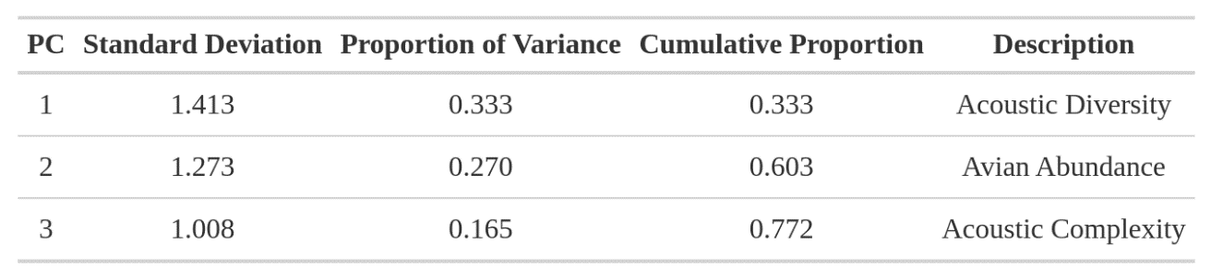

Table 3.2. Aridity gradient experiment estimates across the morning acoustic period (predawn, early, mid, and late) and aridity for PC1 (acoustic diversity), PC2 (avian abundance), and PC3 (acoustic complexity). Estimates represent the slopes between the PC score and evaporation rate (mL/cm2/day). If the confidence interval did not include 0, then the estimate was significant.
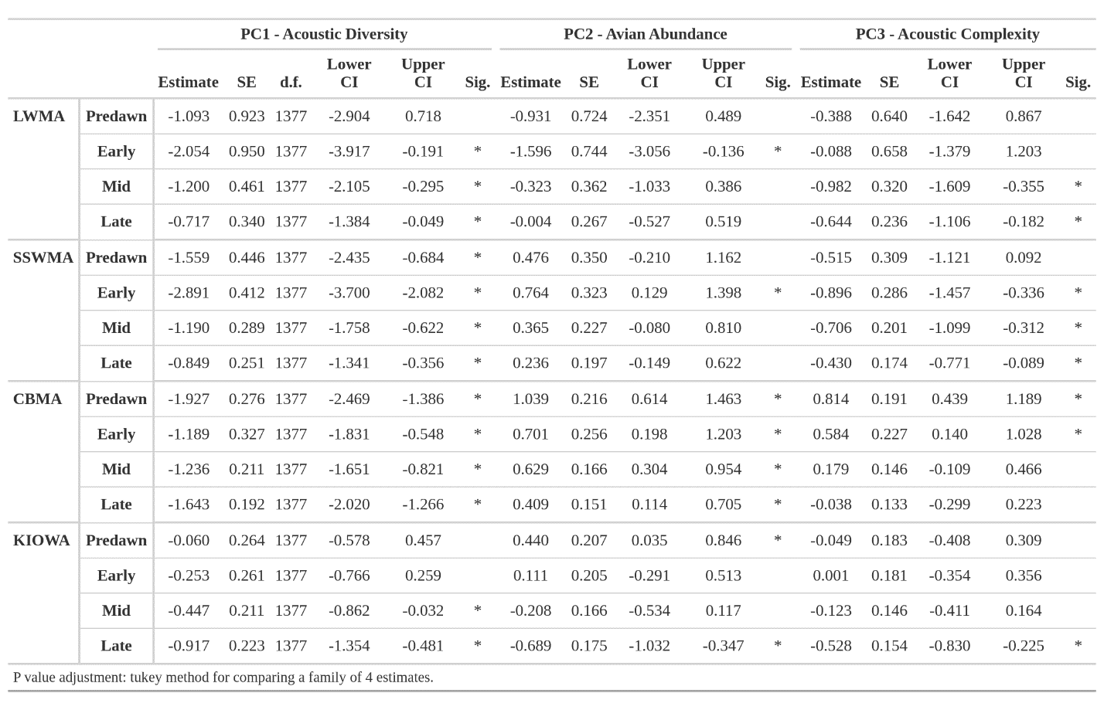

Table 3.3. Aridity gradient contrasts across time periods, within sites. The estimate represents the difference of the slopes between the contrasts, d.f. represents the degrees of freedom, t-ratio represents the t-value, and p value represents the p-value. The sig. column represents the degree of significance.
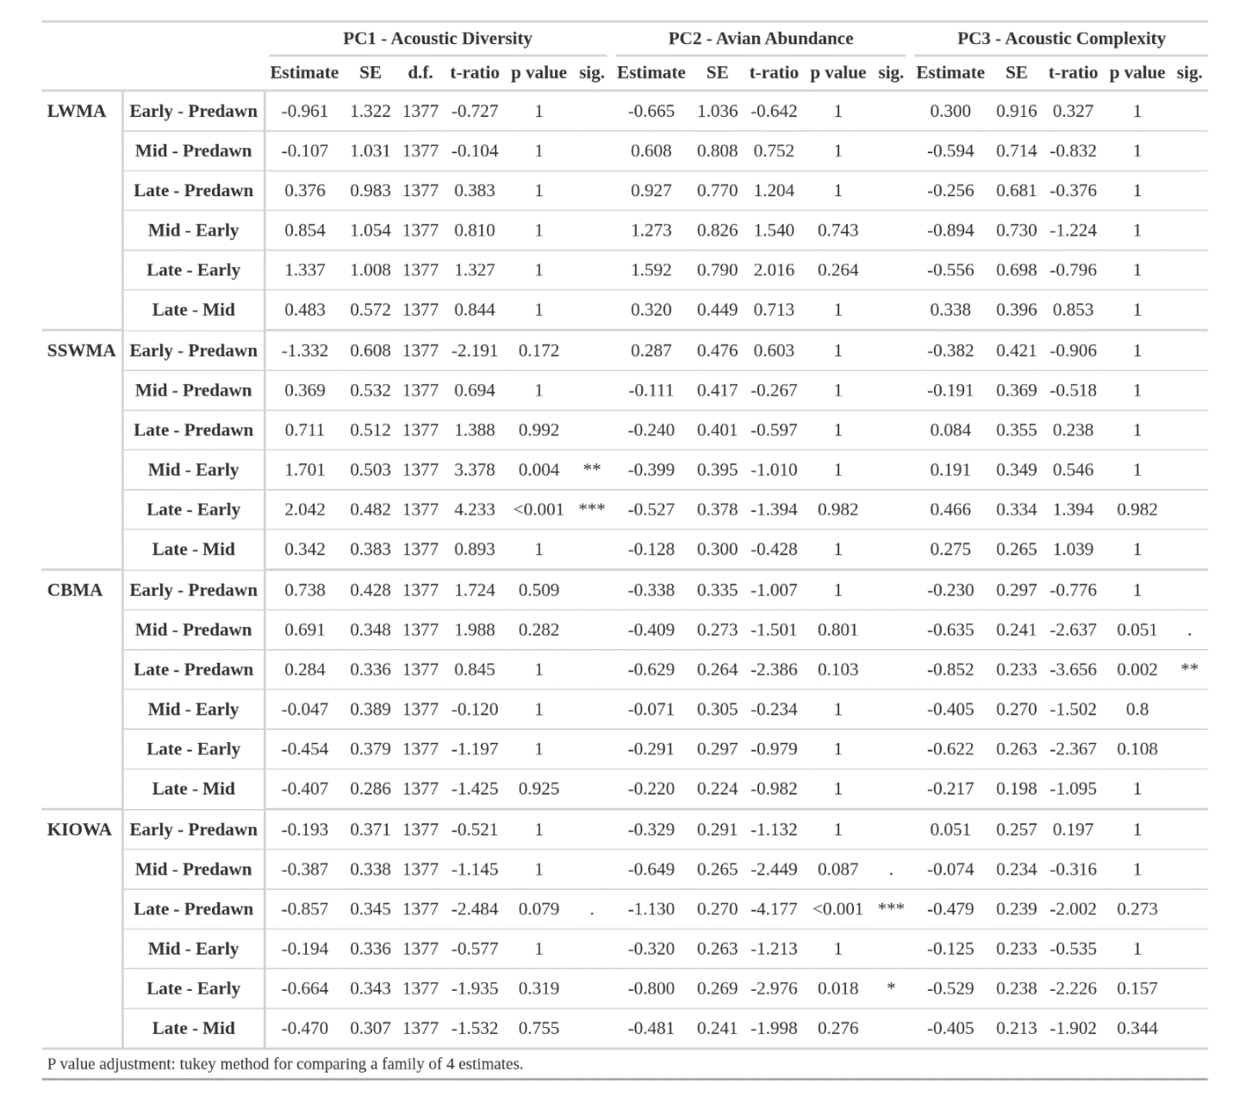

Table 3.4. Mean PC1, PC2, and PC3 differences for the water supplementation experiment at SSWMA. The contrast column represents the post-hoc test conducted on the multiple combinations of water site, access to water, and evaporation rate. The estimate represents the difference of the slopes between the contrasts, d.f. represents the degrees of freedom, t-ratio represents the t-value, and p value represents the p-value. The sig. column represents the degree of significance.
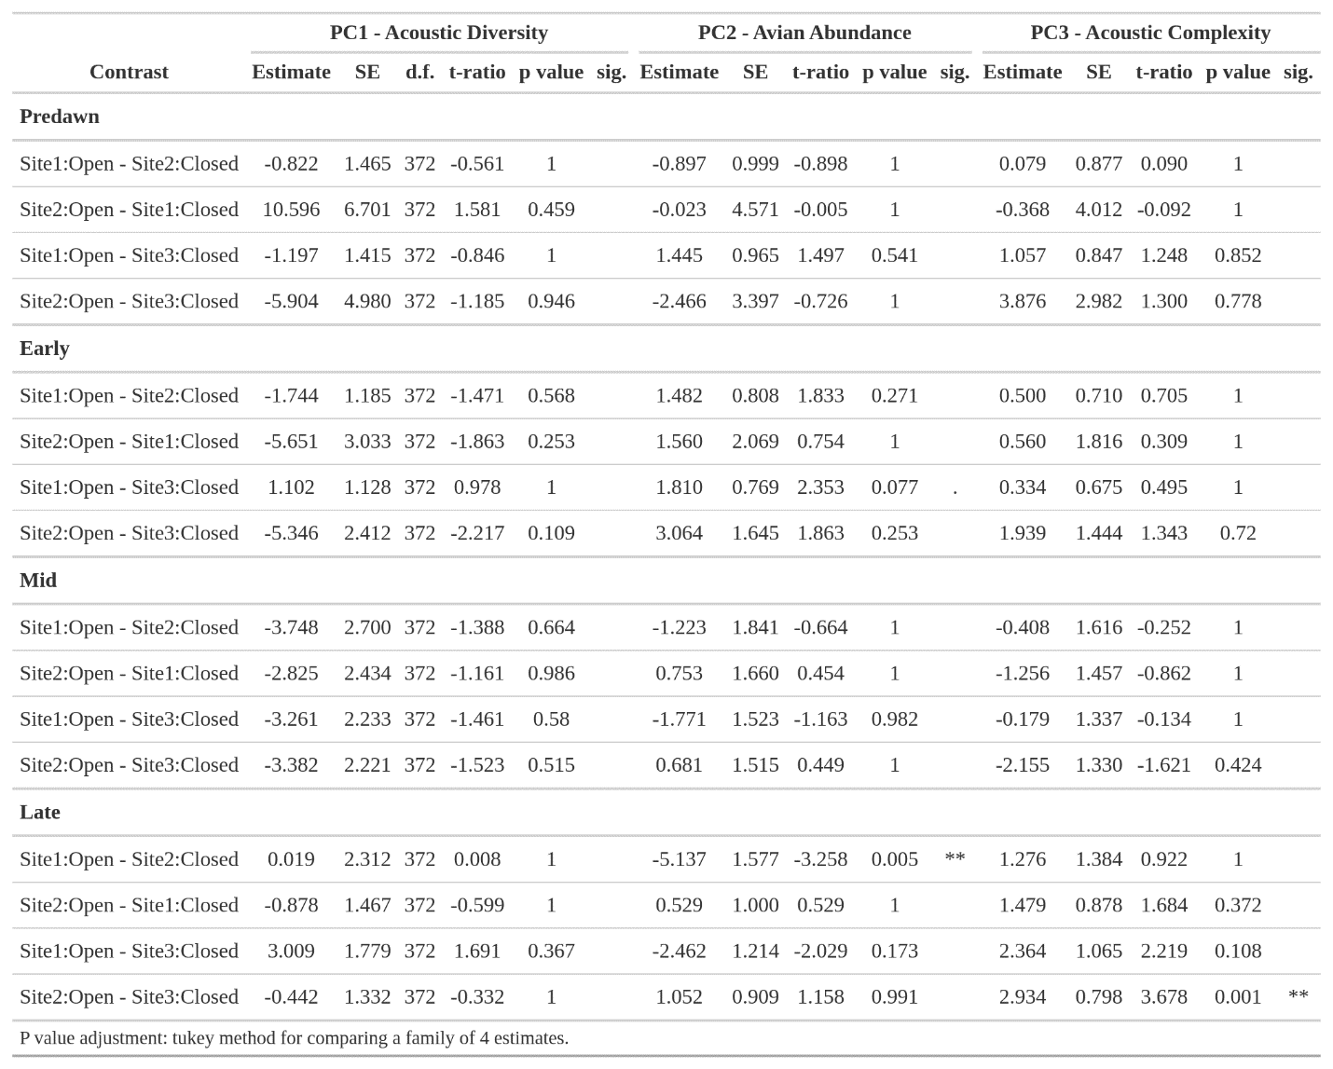
Table 3.5. The mean PC1, PC2, and PC3 differences for the water supplementation experiment at CBMA. The contrast column represents the post-hoc test conducted on the multiple combinations of water site, access to water, and evaporation rate. The estimate represents the difference of the slopes between the contrasts, d.f. represents the degrees of freedom, t-ratio represents the t-value, and p value represents the p-value. The sig. column represents the degree of significance.
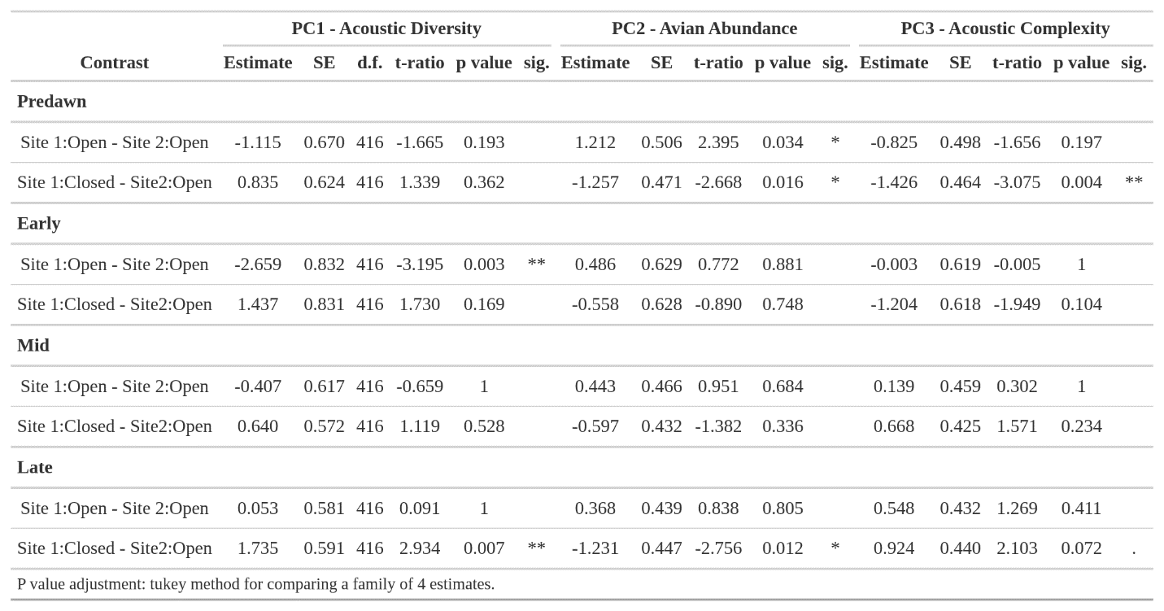

FIGURES
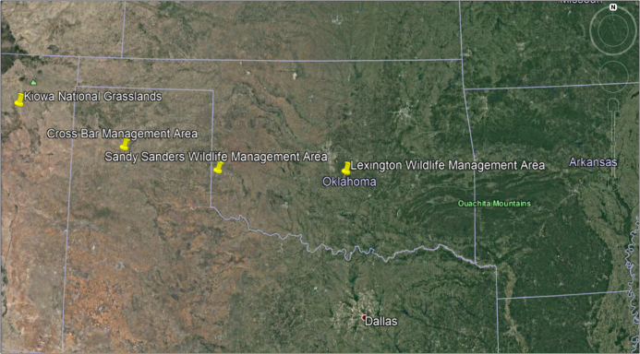
1A.
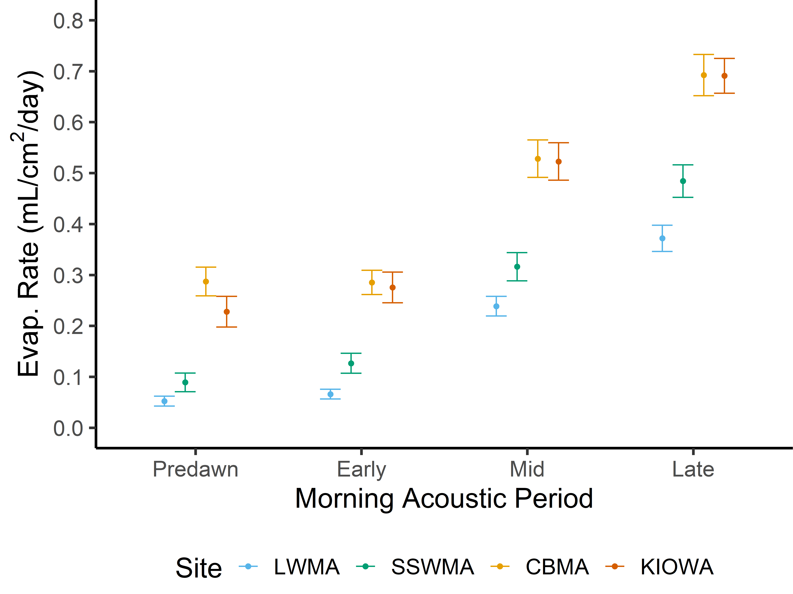
1B.
Figure 3.1. A) Aridity gradient study sites. The most humid site was the Lexington Wildlife Management Area (LWMA), and each site became more arid as longitude increased, so Sandy Sanders Wildlife Management Area (SSWMA) was more arid than LWMA, the Cross Bar Management Area (CBMA) was more arid than SSWMA, and the Kiowa National Grasslands (KIOWA) was the most arid out of all the sites. B) Mean evaporation rate (kg/h) of each site at each time period (predawn, early, mid, and late).

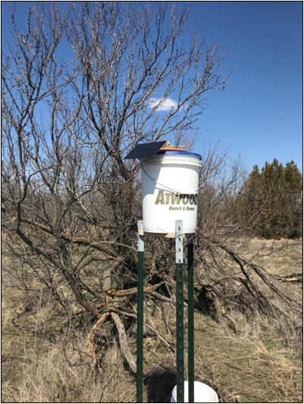
A.
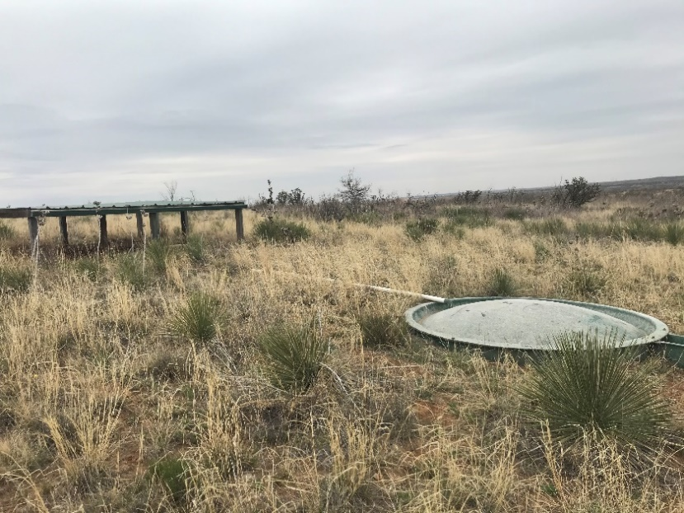
B.
Figure 3.2. A) Supplemental water station at the Sandy Sanders Wildlife Management Area (SSWMA). A five gallon plastic bucket was raised ~1.5 m off of the ground by three 2.1 m t-posts and a wooden platform. A solar-powered pump would pump water from the bucket to a clay dish on the top to provide birds water. B) Wildlife guzzler installed at the CrossBar Management Area (CBMA) to provide supplemental water to the local wildlife. Rainwater is collected by a slanted roof and deposited in a fiberglass container buried underground.

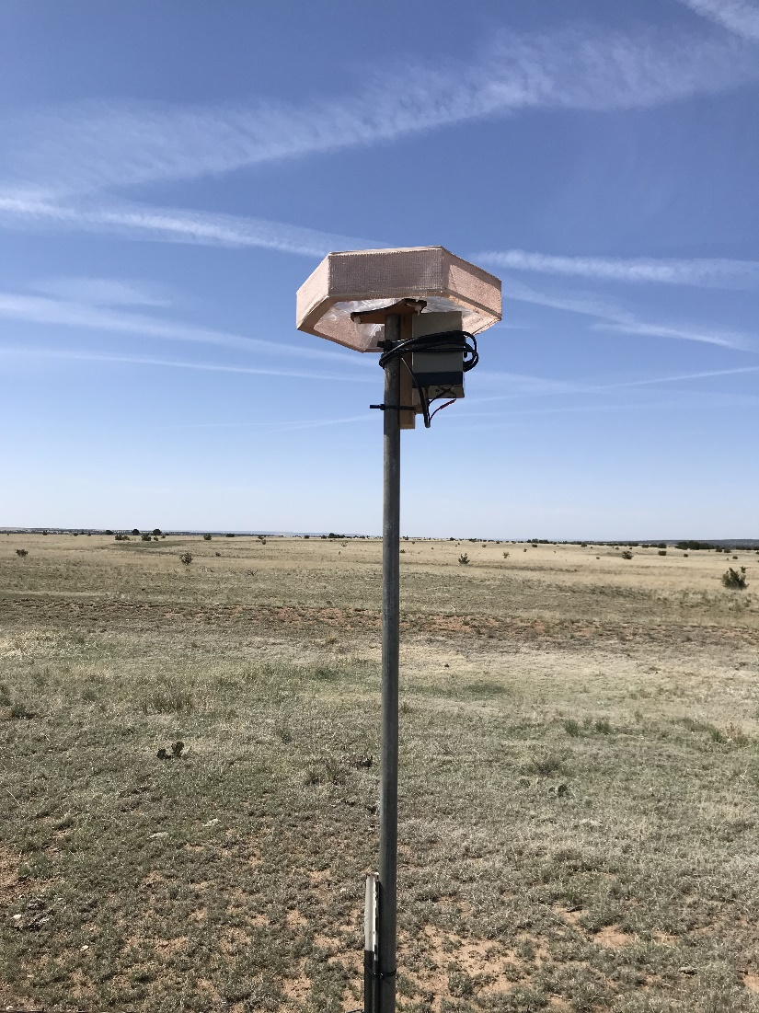
Figure 3.3. HEXEAR case with AudioMoth automated recording unit. To reduce wind noise, we wrapped each HEXEAR in gauze as a windscreen. Each HEXEAR was placed on top of a 1.27 cm diameter conduit pole to increase the recording coverage.

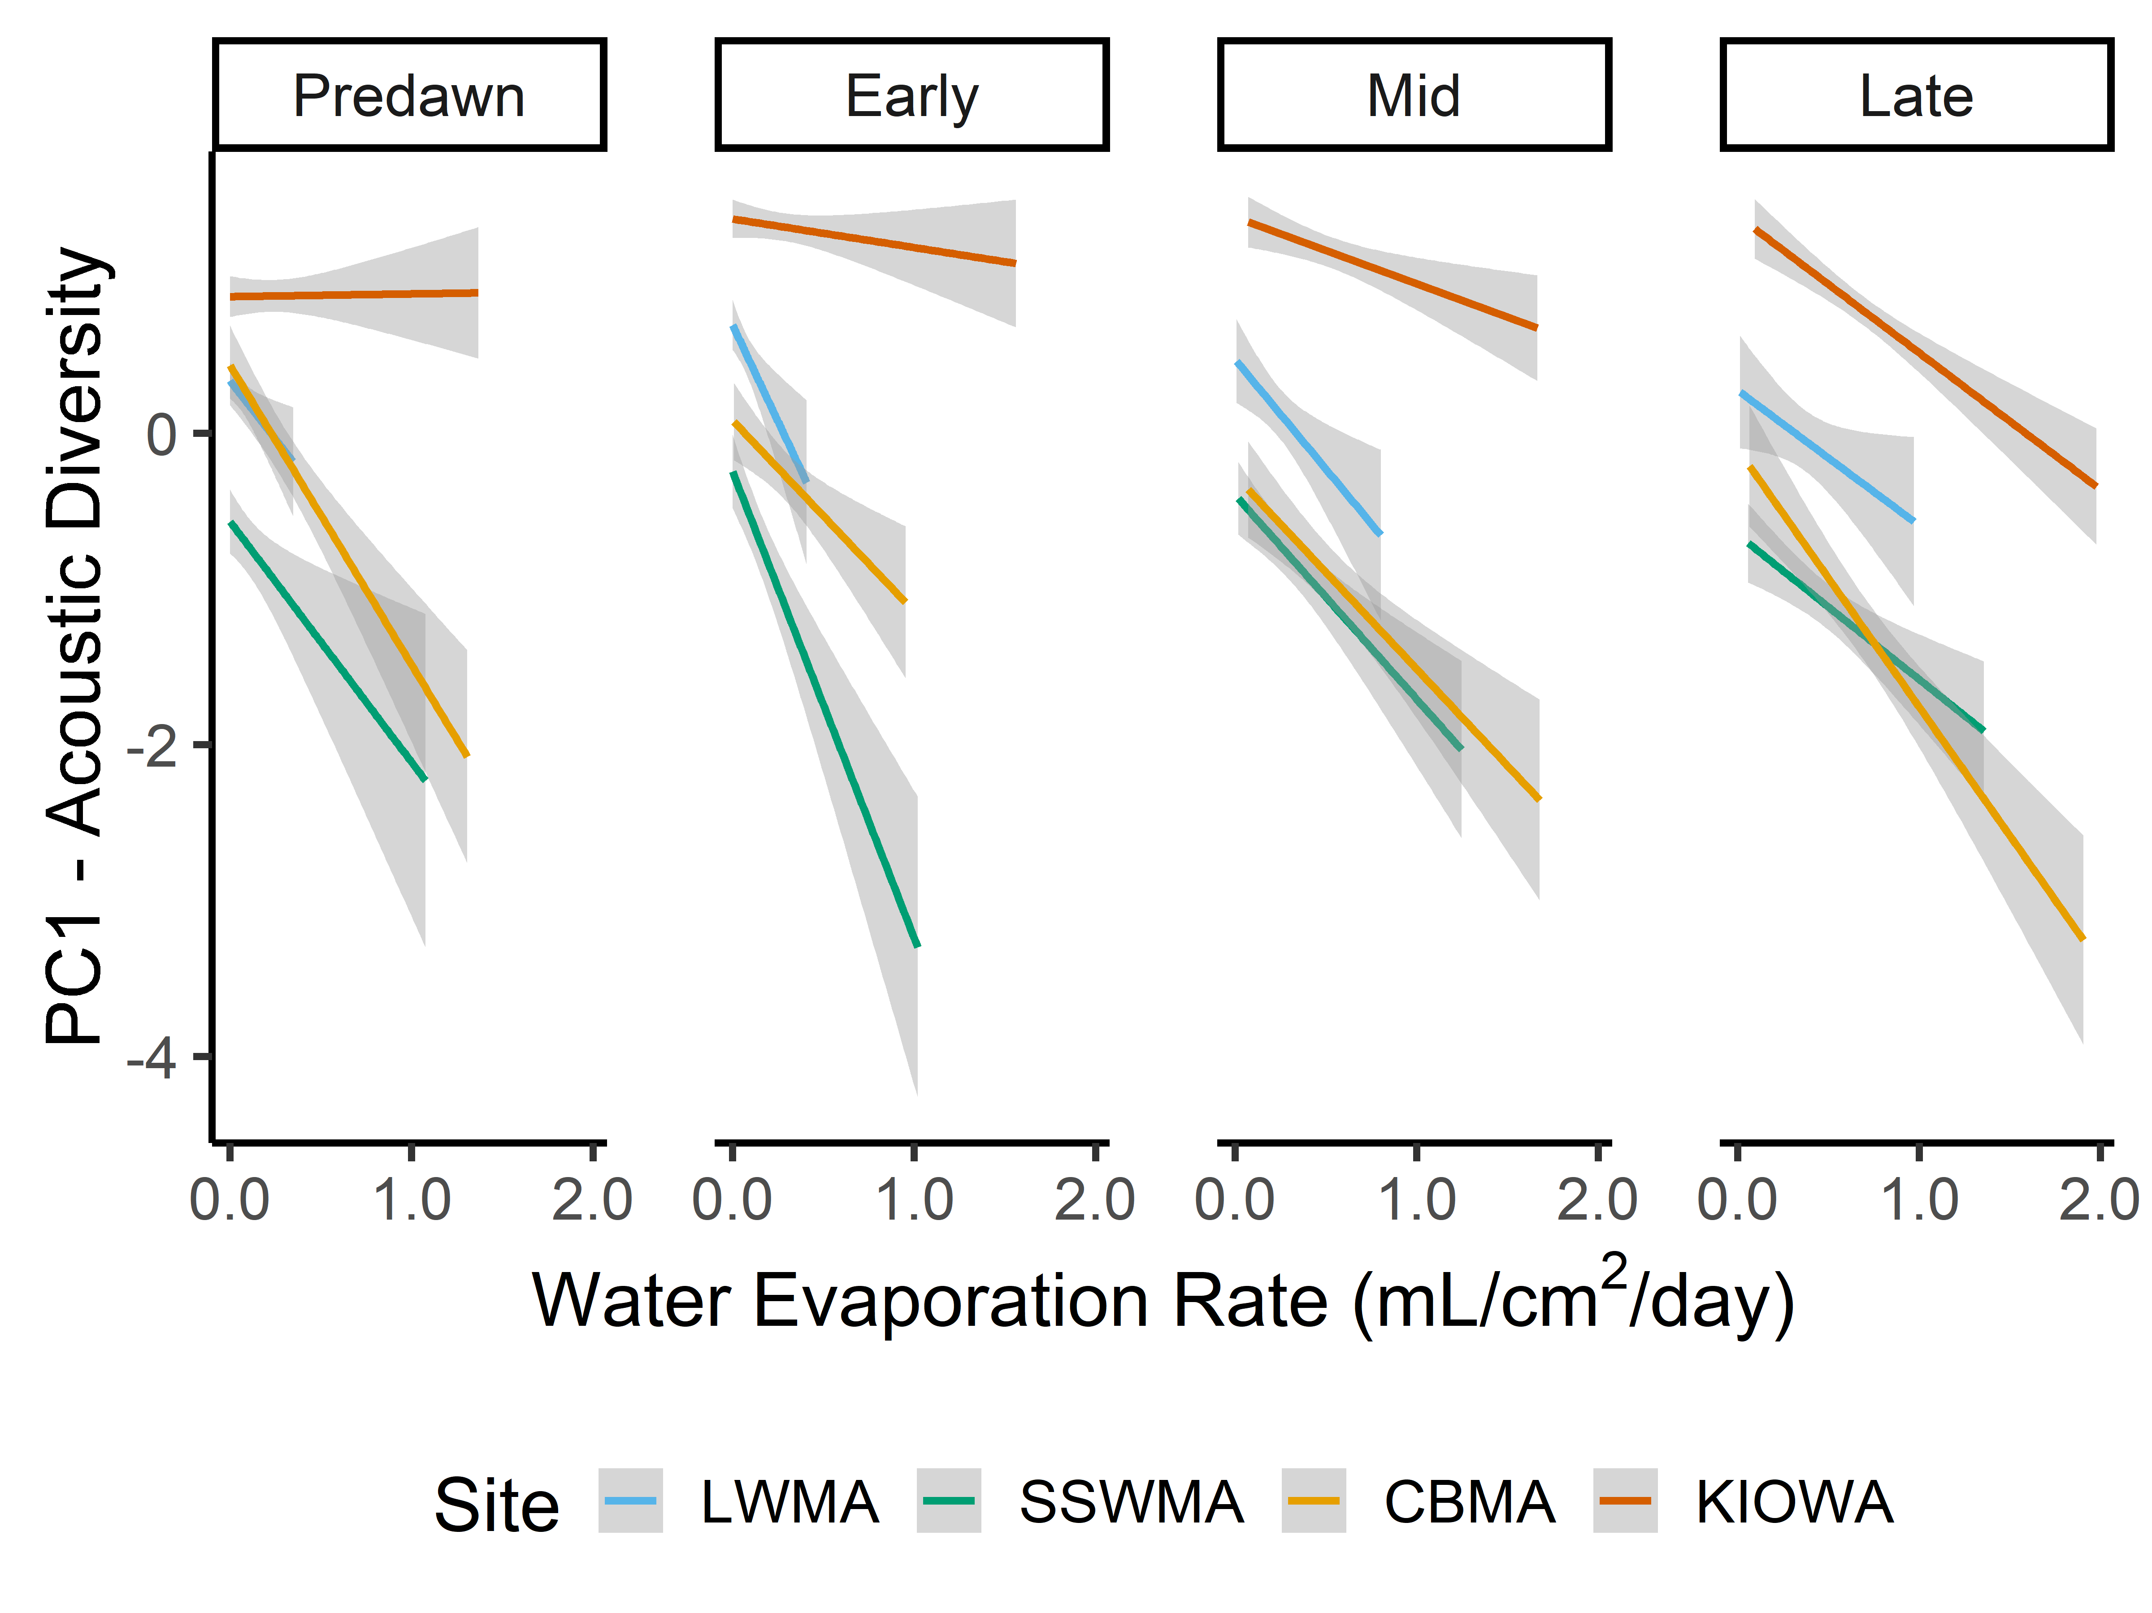
Figure 3.4. PC1 (Avian Diversity) scores plotted against mean evaporation rate (mL/cm²/day) for each site (LWMA, SSWMA, CBMA, and KIOWA) across the morning acoustic periods (predawn, early, mid, and late). Solid lines represent the mean estimate and gray shading represents the standard error.

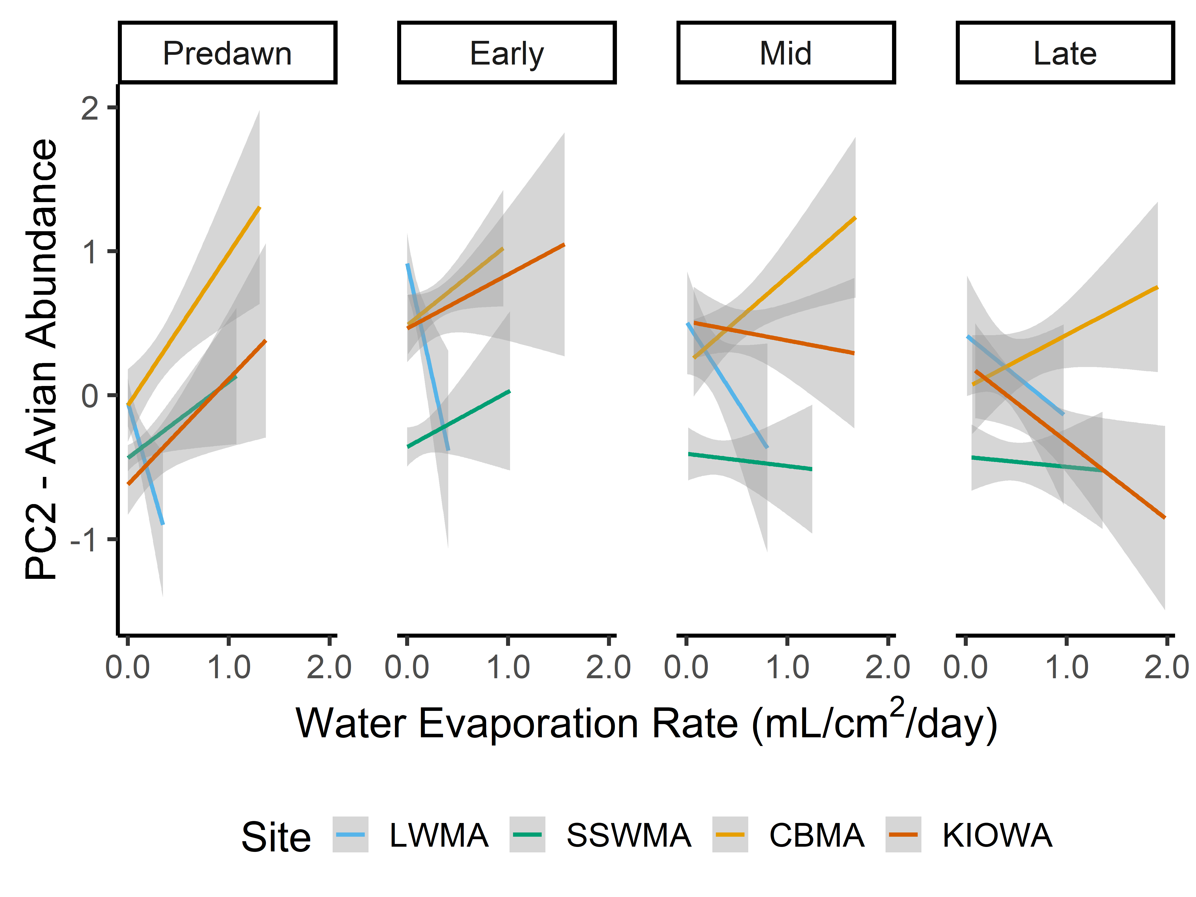
Figure 3.5. PC2 (Avian Abundance) scores plotted against mean evaporation rate (mL/cm²/day) for each site (LWMA, SSWMA, CBMA, and KIOWA) across the morning acoustic periods (predawn, early, mid, and late). Solid lines represent the mean estimate and gray shading represents the standard error.

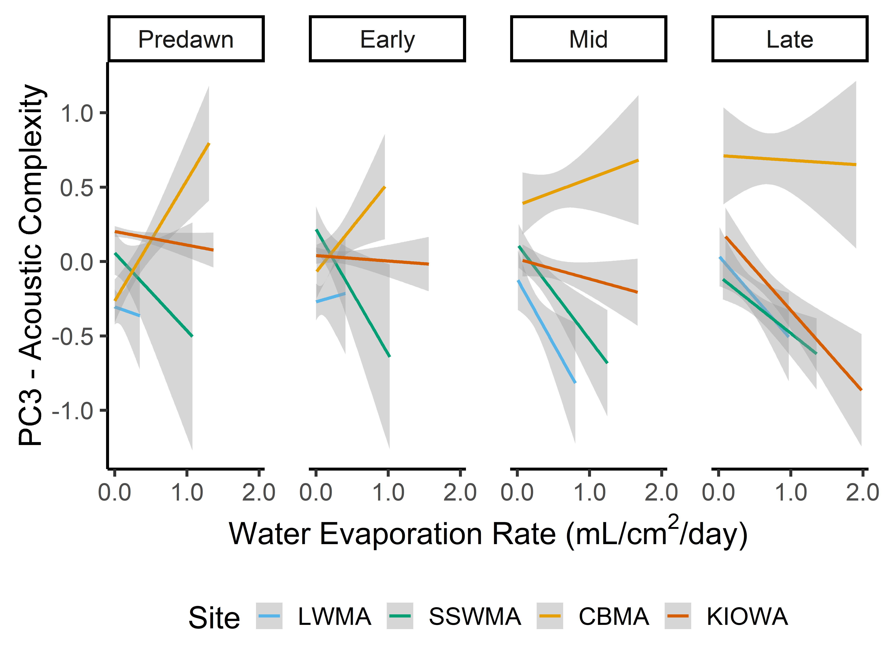
Figure 3.6. PC3 (Acoustic Complexity) scores plotted against mean evaporation rate for (mL/cm²/day) each site (LWMA, SSWMA, CBMA, and KIOWA) across the morning acoustic periods (predawn, early, mid, and late). Solid lines represent the mean estimate and gray shading represents the standard error.

SUPPLEMENTAL INFORMATION

TABLES
Table S 3.1. Aridity gradient contrasts across sites, within morning acoustic periods.
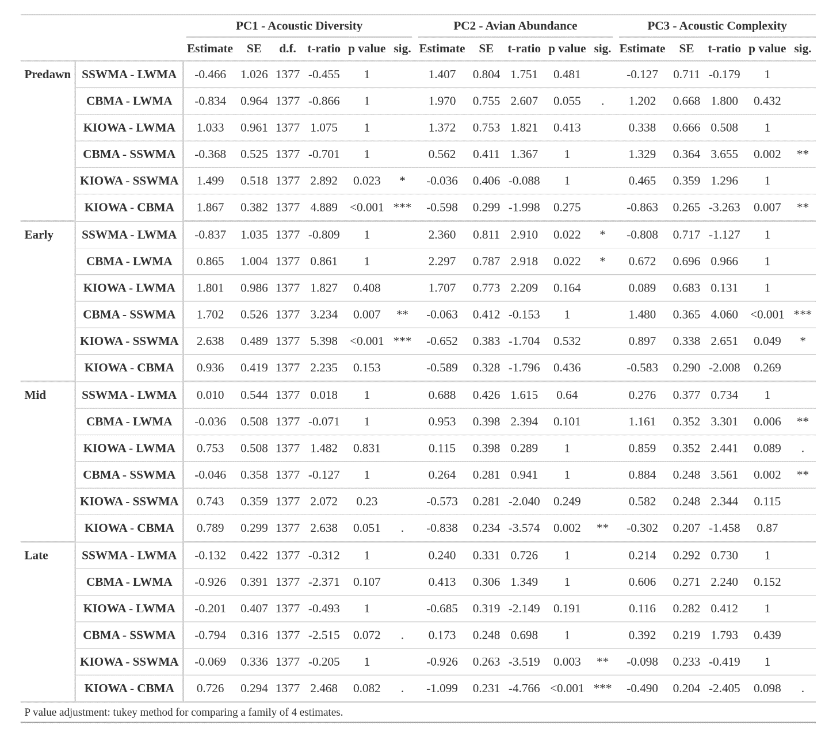

Table S 3.2. PC1 (Acoustic Diversity), PC2 (Avian Abundance), and PC3 (Acoustic Complexity) scores varying across sound attenuation at 4 kHz.
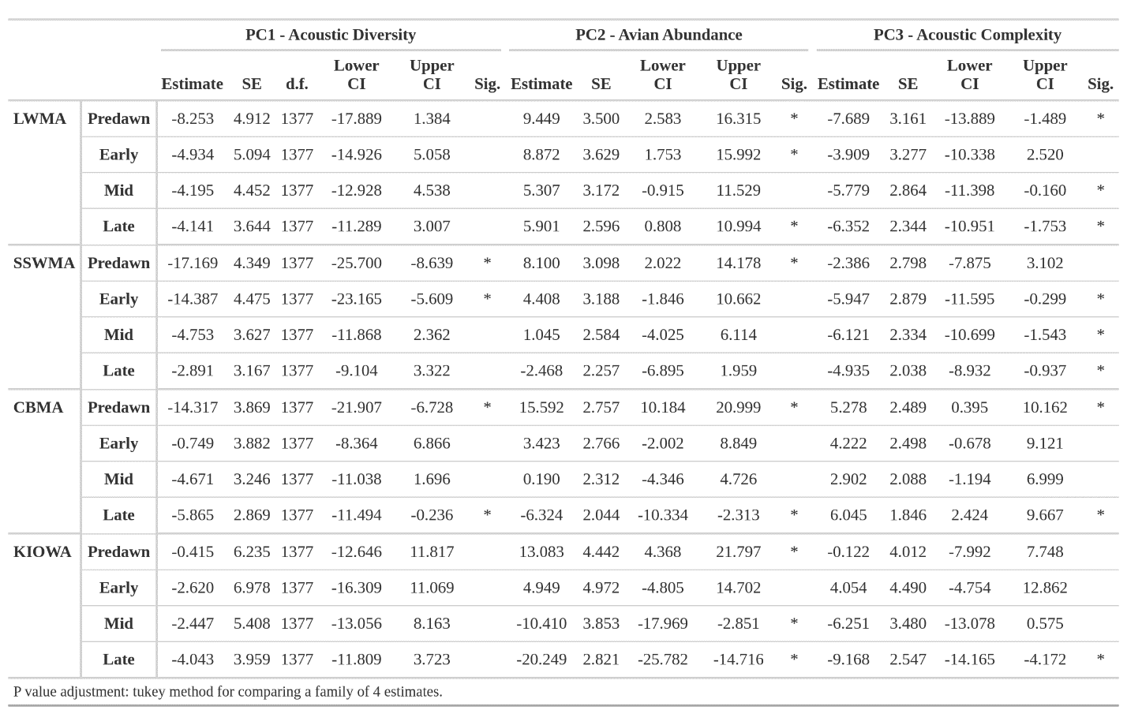

Table S 3.3. PC1 (Acoustic Diversity), PC2 (Avian Abundance), and PC3 (Acoustic Complexity) scores varying across sound attenuation at 8 kHz.
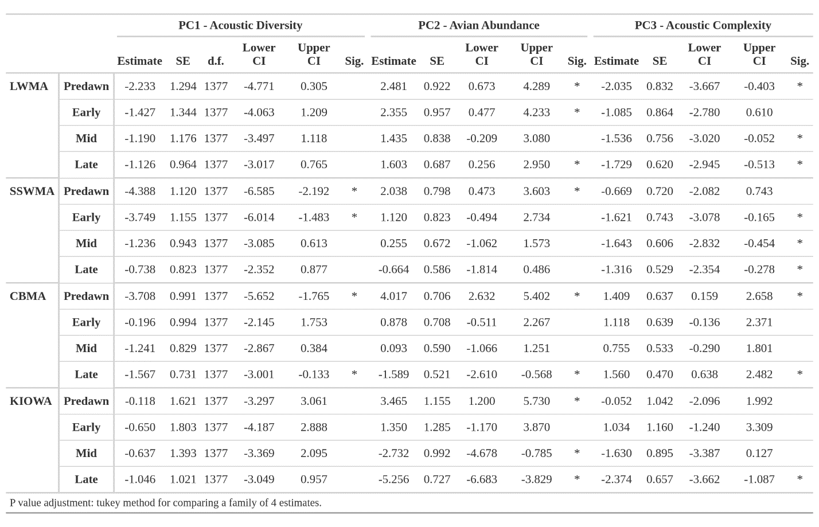

Table S 3.4. PC1 (Acoustic Diversity), PC2 (Avian Abundance), and PC3 (Acoustic Complexity) scores varying across sound attenuation at 12 kHz.
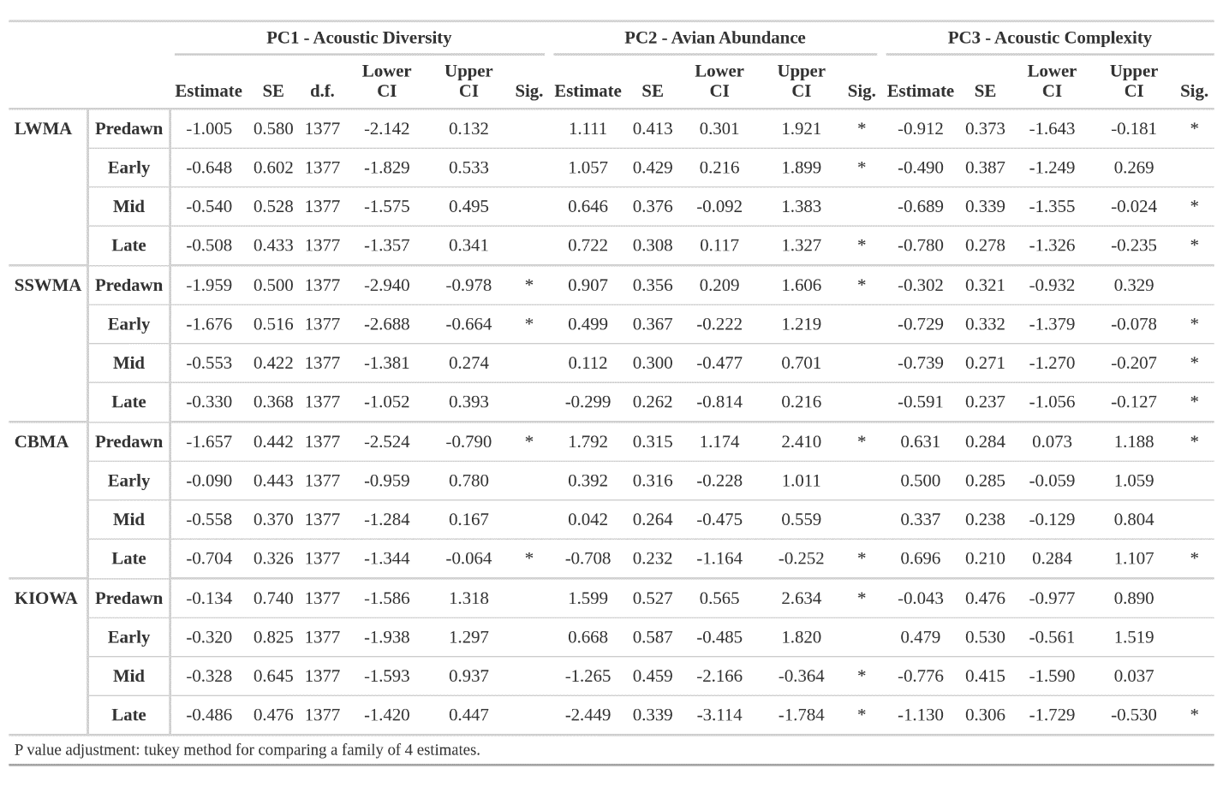

Table S 3.5. Extreme Climate Event (ECE) aridity gradient results for the three principal components that we analyzed (PC1 – Acoustic Diversity, PC2 – Avian Abundance, PC3 – Acoustic Complexity). We analyzed the extreme within-site normalized aridity values based on the climate definition (top 5% of the within-site normalized aridity values) and the impact definition (within-site normalized aridity value in which non-linearity is observed). There was no impact ECE analysis for PC3 because there was no threshold in which non-linearity was observed.
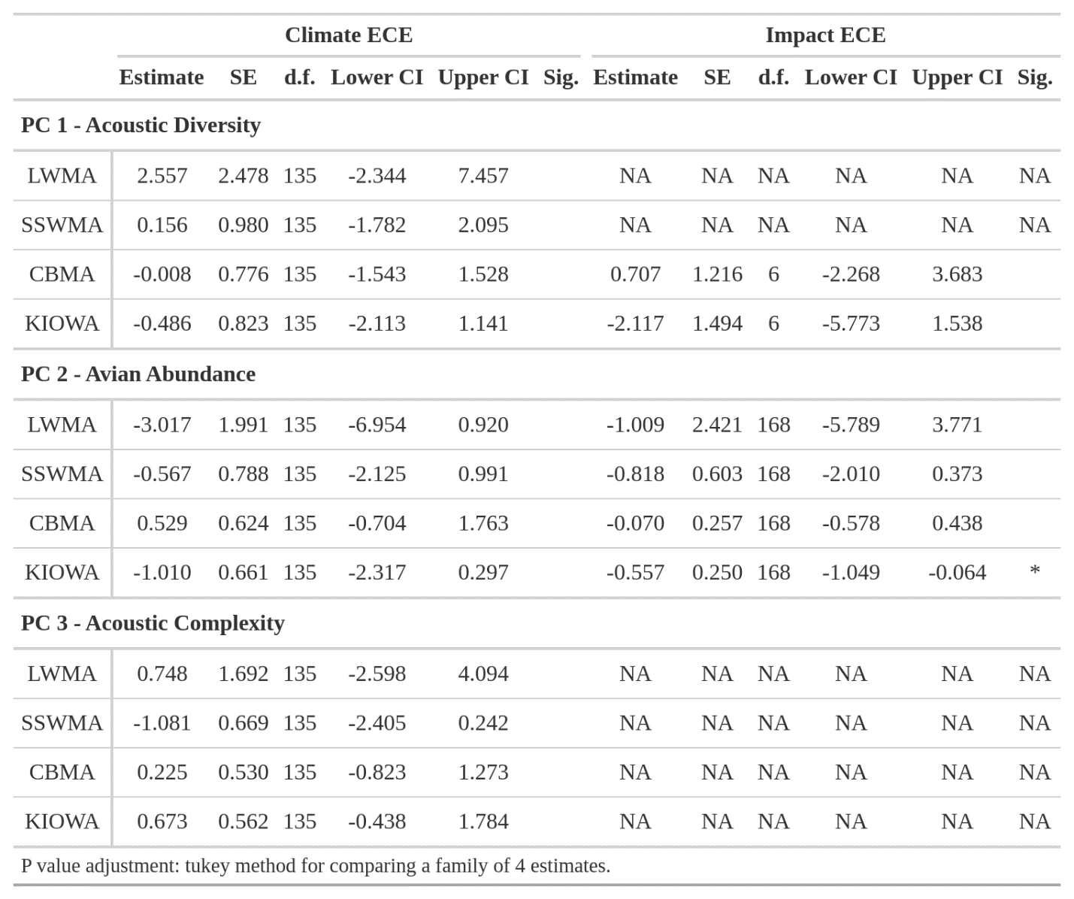

Table S 3.6. SSWMA ECE tables. Mean PC1, PC2, and PC3 estimate differences for the water supplementation experiment at SSWMA at extreme aridity levels. The results for the climate definition of extreme climate event (ECE) are displayed. The contrast column represents the post-hoc test conducted on the multiple combinations of water site and access to water. The estimate represents the difference of the slopes between the contrasts, d.f. represents the degrees of freedom, t-ratio represents the t-value, and p value represents the p-value. The sig. column represents the degree of significance. None of the PCs had a relationship that display non-linearity at extreme aridity and therefore we did not conduct an impact ECE analysis on them.
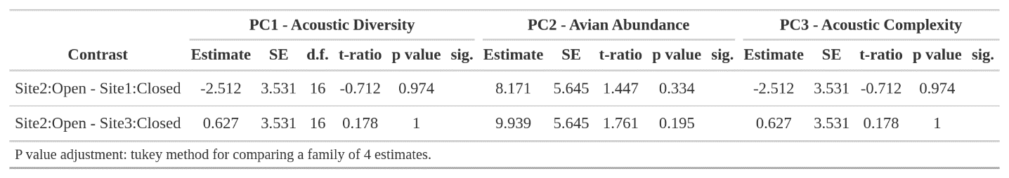

Table S 3.7. CBMA extreme climate event (ECE) results. Mean PC1, PC2, and PC3 estimate differences for the water supplementation experiment at CBMA at extreme aridity levels. The results for the climate definition of ECE are displayed. The contrast column represents the post-hoc test conducted on the multiple combinations of water site and access to water. The estimate represents the difference of the slopes between the contrasts, d.f. represents the degrees of freedom, t-ratio represents the t-value, and p value represents the p-value. The sig. column represents the degree of significance. Only PC2 had a relationship that display non-linearity at extreme aridity and therefore PC2 was the only PC used in the impact ECE analysis.
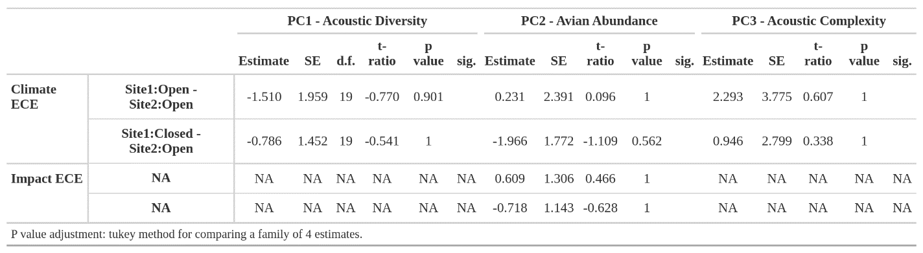

FIGURES

A.

B.
Figure S 3.1. HEXEAR mechanical audio amplification case. A) 3D HEXEAR model. Audio enters the HEXEAR through any of the 6 amplification chambers and is focused in the center (focal point). B) Lateral view of the HEXEAR showing the amplification chamber and the top reflection panel. Audio entering the amplification chamber will reflect off the top reflection panel and reach the focal point at the same time as non-reflected, compounding the sound waves and leading to higher sound wave amplitudes.

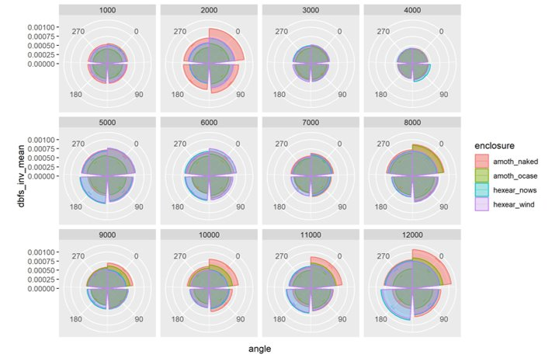
Figure S 3.2. AudioMoth pure tone frequency amplitudes recorded in a bare AudioMoth (amoth_naked), AudioMoth in official case (amoth_ocase), the HEXEAR with no (hexear_nows), and the HEXEAR with the gauze windscreen (hexear_wind), across multiple pure tone frequencies. The numbers on the plot (0, 90, 180, and 270) represent the direction the AudioMoth microphone was facing while the pure tone frequency was playing. The AudioMoths in the bare and official case groups were positioned so that the microphone was facing the audio source, but when the AudioMoth was placed in the HEXEAR the microphone was facing down because the sound entered the amplification chambers rather than entering the microphone directly.

REFERENCES

Ahlering, Marissa A., and Christopher L. Merkord. 2016. “Cattle Grazing and Grassland Birds in the Northern Tallgrass Prairie.” The Journal of Wildlife Management 80 (4): 643–54.
Albright, Thomas P., Denis Mutiibwa, Alexander R. Gerson, Eric Krabbe Smith, William A. Talbot, Jacqueline J. O’Neill, Andrew E. McKechnie, and Blair O. Wolf. 2017. “Mapping Evaporative Water Loss in Desert Passerines Reveals an Expanding Threat of Lethal Dehydration.” Proceedings of the National Academy of Sciences of the United States of America 114 (9): 2283–88.
Alley, R. B., J. Marotzke, W. D. Nordhaus, J. T. Overpeck, D. M. Peteet, R. A. Pielke Jr, R. T. Pierrehumbert, et al. 2003. “Abrupt Climate Change.” Science 299 (5615): 2005–10.
Alquezar, Renata D., Graziela Tolesano-Pascoli, Diego Gil, and Regina H. Macedo. 2020. “Avian Biotic Homogenization Driven by Airport-Affected Environments.” Urban Ecosystems, 1–11.
Andersen, Erik M., and Robert J. Steidl. 2019. “Woody Plant Encroachment Restructures Bird Communities in Semiarid Grasslands.” Biological Conservation 240 (December): 108276.
Angelier, Frédéric, Carol M. Vleck, Rebecca L. Holberton, and Peter P. Marra. 2013. “Telomere Length, Non‐breeding Habitat and Return Rate in MaleAmerican Redstarts.” Functional Ecology 27 (2): 342–50.
Archer, Steven. 1994. “Woody Plant Encroachment into Southwestern Grasslands and Savannas: Rates, Patterns and Proximate Causes.” In Ecological Implications of Livestock Herbivory in the West, edited by Vavra Laycock WA Pieper RD, 13–68. Society for Range Management.
Archer, Steven R., Erik M. Andersen, Katharine I. Predick, Susanne Schwinning, Robert J. Steidl, and Steven R. Woods. 2017. “Woody Plant Encroachment: Causes and Consequences.” Rangeland Systems: Processes, Management and Challenges, 25–84.
Avery, Mark I., and John R. Krebs. 1984. “Temperature and Foraging Success of Great Tits Parus Major Hunting for Spiders.” The Ibis 126 (1): 33–38.
Axelrod, Robert. 1997. “The Complexity of Cooperation: Agent-Based Models of Competition and Collaboration.” https://doi.org/10.1515/9781400822300.
Barber, Jesse R., Kevin R. Crooks, and Kurt M. Fristrup. 2010. “The Costs of Chronic Noise Exposure for Terrestrial Organisms.” Trends in Ecology & Evolution 25 (3): 180–89.
Bates, Douglas, Martin Mächler, Ben Bolker, and Steve Walker. 2015. “Fitting Linear Mixed-Effects Models Using Lme4.” J. Stat. Softw. 67 (1). https://doi.org/10.18637/jss.v067.i01.
Beatty, William S., Dylan C. Kesler, Elisabeth B. Webb, Luke W. Naylor, Andrew H. Raedeke, Dale D. Humburg, John M. Coluccy, and Gregory J. Soulliere. 2017. “How Will Predicted Land-Use Change Affect Waterfowl Spring Stopover Ecology? Inferences from an Individual-Based Model.” The Journal of Applied Ecology 54 (3): 926–34.
Beaulieu, Michaël, and Keith W. Sockman. 2012. “Song in the Cold Is ‘Hot’: Memory of and Preference for Sexual Signals Perceived under Thermal Challenge.” Biology Letters 8 (5): 751–53.
Belser, Carroll Gale. 1981. “Seasonal Ethograms of the Eastern Bluebird, Sialia Sialis, Near Clemson, South Carolina.” Clemson University. https://tigerprints.clemson.edu/arv_theses/5111/.
Benitez-Lopez, Ana, Rob Alkemade, and Pita A. Verweij. 2010. “The Impacts of Roads and Other Infrastructure on Mammal and Bird Populations: A Meta-Analysis.” Biological Conservation 143 (6): 1307–16.
Berdugo, Miguel, Manuel Delgado-Baquerizo, Santiago Soliveres, Rocío Hernández-Clemente, Yanchuang Zhao, Juan J. Gaitán, Nicolas Gross, et al. 2020. “Global Ecosystem Thresholds Driven by Aridity.” Science (New York, N.Y.) 367 (6479): 787–90.
Berg, Karl S., Robb T. Brumfield, and Victor Apanius. 2006. “Phylogenetic and Ecological Determinants of the Neotropical Dawn Chorus.” Proceedings. Biological Sciences / The Royal Society 273 (1589): 999–1005.
Bergstrom, Dana M., Phillippa K. Bricher, Ben Raymond, Aleks Terauds, David Doley, Melodie A. McGeoch, Jennie Whinam, et al. 2015. “Rapid Collapse of a Sub-Antarctic Alpine Ecosystem: The Role of Climate and Pathogens.” The Journal of Applied Ecology 52 (3): 774–83.
Bircher, Nina, Kees van Oers, Camilla A. Hinde, and Marc Naguib. 2020. “Extraterritorial Forays by Great Tits Are Associated with Dawn Song in Unexpected Ways.” Behavioral Ecology: Official Journal of the International Society for Behavioral Ecology 31 (4): 873–83.
Boelman, Natalie T., Gregory P. Asner, Patrick J. Hart, and Roberta E. Martin. 2007. “Multi-Trophic Invasion Resistance in Hawaii: Bioacoustics, Field Surveys, and Airborne Remote Sensing.” Ecological Applications: A Publication of the Ecological Society of America 17 (8): 2137–44.
Bond, William J., and Guy F. Midgley. 2000. “A Proposed CO2 -Controlled Mechanism of Woody Plant Invasion in Grasslands and Savannas.” Global Change Biology 6 (8): 865–69.
Botero, Carlos A., Neeltje J. Boogert, Sandra L. Vehrencamp, and Irby J. Lovette. 2009. “Climatic Patterns Predict the Elaboration of Song Displays in Mockingbirds.” Current Biology: CB 19 (13): 1151–55.
Both, Christiaan, Aleksandr V. Artemyev, Bert Blaauw, Richard J. Cowie, Aarnoud J. Dekhuijzen, Tapio Eeva, Anders Enemar, et al. 2004. “Large-Scale Geographical Variation Confirms That Climate Change Causes Birds to Lay Earlier.” Proceedings. Biological Sciences / The Royal Society 271 (1549): 1657–62.
Bowers, E. Keith, Rachel M. Bowden, Charles F. Thompson, and Scott K. Sakaluk. 2016. “Elevated Corticosterone during Egg Production Elicits Increased Maternal Investment and Promotes Nestling Growth in a Wild Songbird.” Hormones and Behavior 83 (July): 6–13.
Brenowitz, Eliot A. 1982. “The Active Space of Red-Winged Blackbird Song.” Journal of Comparative Physiology. A, Neuroethology, Sensory, Neural, and Behavioral Physiology 147 (4): 511–22.
Breuner, Creagh W., Stephen H. Patterson, and Thomas P. Hahn. 2008. “In Search of Relationships between the Acute Adrenocortical Response and Fitness.” General and Comparative Endocrinology 157 (3): 288–95.
Bridge, Eli S., Jeremy D. Ross, Andrea J. Contina, and Jeffrey F. Kelly. 2015. “Do Molt-Migrant Songbirds Optimize Migration Routes Based on Primary Productivity?” Behavioral Ecology: Official Journal of the International Society for Behavioral Ecology 27 (3): 784–92.
Bridge, Eli S., Jay Wilhelm, Meelyn M. Pandit, Alexander Moreno, Claire M. Curry, Tyler D. Pearson, Darren S. Proppe, et al. 2019. “An Arduino-Based RFID Platform for Animal Research.” Frontiers in Ecology and Evolution 7 (July). https://doi.org/10.3389/fevo.2019.00257.
Brock, Fred V., Kenneth C. Crawford, Ronald L. Elliott, Gerrit W. Cuperus, Steven J. Stadler, Howard L. Johnson, and Michael D. Eilts. 1995. “The Oklahoma Mesonet: A Technical Overview.” Journal of Atmospheric and Oceanic Technology 12 (1): 5–19.
Brown, Timothy J., and Paul Handford. 2002. “Why Birds Sing at Dawn: The Role of Consistent Song Transmission.” The Ibis 145 (1): 120–29.
Brumm, Henrik, ed. 2013. Animal Communication and Noise. Animal Signals and Communication.
Bruni, Adrianna, and Jennifer R. Foote. 2014. “Dawn Singing of Eastern Phoebes Varies with Breeding Stage and Brood Number.” The Wilson Journal of Ornithology 126 (3): 500–507.
Bruni, Adrianna, Daniel J. Mennill, and Jennifer R. Foote. 2014. “Dawn Chorus Start Time Variation in a Temperate Bird Community: Relationships with Seasonality, Weather, and Ambient Light.” Journal of Ornithology / DO-G 155 (4): 877–90.
Buchholz, Richard, John D. Banusiewicz, Stephanie Burgess, Sarah Crocker-Buta, Lauren Eveland, and Lauren Fuller. 2019. “Behavioural Research Priorities for the Study of Animal Response to Climate Change.” Animal Behaviour 150 (April): 127–37.
Burtka, Jennifer L., and Jennifer L. Grindstaff. 2015. “Similar Nest Defence Strategies within Pairs Increase Reproductive Success in the Eastern Bluebird, Sialia Sialis.” Animal Behaviour 100 (February): 174–82.
Calhim, Sara, and Robert Montgomerie. 2015. “Testis Asymmetry in Birds: The Influences of Sexual and Natural Selection.” Journal of Avian Biology 46 (2): 175–85.
Cardoso, Gonçalo C., and Trevor D. Price. 2010. “Community Convergence in Bird Song.” Evolutionary Ecology 24 (2): 447–61.
Catchpole, C. K., and P. J. Slater. 2008. Bird Song: Biological Themes and Variations. New York, NY: Cambridge University Press.
Cecilia Sagario, M., and Víctor R. Cueto. 2014. “Seasonal Space Use and Territory Size of Resident Sparrows in the Central Monte Desert, Argentina.” Ardeola 61 (1): 153–59.
Chatelain, Marion, Szymon M. Drobniak, and Marta Szulkin. 2020. “The Association between Stressors and Telomeres in Non‐human Vertebrates: A Meta‐analysis.” Edited by Julien Cote. Ecology Letters 23 (2): 381–98.
Chevin, Luis-Miguel, and Ary A. Hoffmann. 2017. “Evolution of Phenotypic Plasticity in Extreme Environments.” Philosophical Transactions of the Royal Society of London. Series B, Biological Sciences 372 (1723). https://doi.org/10.1098/rstb.2016.0138.
Chevin, Luis-Miguel, and Russell Lande. 2010. “When Do Adaptive Plasticity and Genetic Evolution Prevent Extinction of a Density-Regulated Population?” Evolution; International Journal of Organic Evolution 64 (4): 1143–50.
Chevin, Luis-Miguel, Russell Lande, and Georgina M. Mace. 2010. “Adaptation, Plasticity, and Extinction in a Changing Environment: Towards a Predictive Theory.” PLoS Biology 8 (4): e1000357.
Cirelli, Chiara, and Giulio Tononi. 2008. “Is Sleep Essential?” PLoS Biology 6 (8): e216.
Conrad, Kelvin F., and Raleigh J. Robertson. 1993. “Patterns of Parental Provisioning by Eastern Phoebes.” The Condor 95 (1): 57–62.
Coomes, C. M., and E. P. Derryberry. 2021. “High Temperatures Reduce Song Production and Alter Signal Salience in Songbirds.” Animal Behaviour 180 (October): 13–22.
Coomes, Casey M., Raymond M. Danner, and Elizabeth P. Derryberry. 2019. “Elevated Temperatures Reduce Discrimination between Conspecific and Heterospecific Sexual Signals.” Animal Behaviour 147 (January): 9–15.
Cooper, C. E., and P. C. Withers. 2004. “Ventilatory Physiology of the Numbat (Myrmecobius Fasciatus).” Journal of Comparative Physiology. B, Biochemical, Systemic, and Environmental Physiology 174 (2): 107–11.
Cooper, Christine Elizabeth, Philip Carew Withers, Gerhard Körtner, and Fritz Geiser. 2020. “Does Control of Insensible Evaporative Water Loss by Two Species of Mesic Parrot Have a Thermoregulatory Role?” The Journal of Experimental Biology 223 (Pt 19). https://doi.org/10.1242/jeb.229930.
Crates, Ross, Naomi Langmore, Louis Ranjard, Dejan Stojanovic, Laura Rayner, Dean Ingwersen, and Robert Heinsohn. 2021. “Loss of Vocal Culture and Fitness Costs in a Critically Endangered Songbird.” Proceedings. Biological Sciences / The Royal Society 288 (1947): 20210225.
Crino, O. L., B. Klaassen Van Oorschot, E. E. Johnson, J. L. Malisch, and C. W. Breuner. 2011. “Proximity to a High Traffic Road: Glucocorticoid and Life History Consequences for Nestling White-Crowned Sparrows.” General and Comparative Endocrinology 173 (2): 323–32.
Crino, Ondi L., Erin E. Johnson, Jessica L. Blickley, Gail L. Patricelli, and Creagh W. Breuner. 2013. “Effects of Experimentally Elevated Traffic Noise on Nestling White-Crowned Sparrow Stress Physiology, Immune Function and Life History.” The Journal of Experimental Biology 216 (Pt 11): 2055–62.
Criscuolo, François, Pierre Bize, Lubna Nasir, Neil B. Metcalfe, Chris G. Foote, Kate Griffiths, Elizabeth A. Gault, and Pat Monaghan. 2009. “Real-Time Quantitative PCR Assay for Measurement of Avian Telomeres.” Journal of Avian Biology. https://doi.org/10.1111/j.1600-048x.2008.04623.x.
Crispo, Erika. 2007. “The Baldwin Effect and Genetic Assimilation: Revisiting Two Mechanisms of Evolutionary Change Mediated by Phenotypic Plasticity.” Evolution; International Journal of Organic Evolution 61 (11): 2469–79.
Crossin, Glenn T., Richard A. Phillips, Christine R. Lattin, L. Michael Romero, and Tony D. Williams. 2013. “Corticosterone Mediated Costs of Reproduction Link Current to Future Breeding.” General and Comparative Endocrinology 193 (November): 112–20.
CTP. 2003. “Glossary of Terms for Thermal Physiology.” Journal of Thermal Biology 28 (1): 75–106.
Cuthill, Innesc, and Williama Macdonald. 1990. “Experimental Manipulation of the Dawn and Dusk Chorus in the Blackbird Turdus Merula.” Behavioral Ecology and Sociobiology 26 (3). https://doi.org/10.1007/bf00172088.
Czenze, Zenon J., Ryno Kemp, Barry Jaarsveld, Marc T. Freeman, Ben Smit, Blair O. Wolf, and Andrew E. McKechnie. 2020. “Regularly Drinking Desert Birds Have Greater Evaporative Cooling Capacity and Higher Heat Tolerance Limits than Non‐drinking Species.” Functional Ecology 34 (8): 1589–1600.
Dean, W. R. J., P. Barnard, and M. D. Anderson. 2009. “When to Stay, When to Go: Trade-Offs for Southern African Arid-Zone Birds in Times of Drought.” South African Journal of Science 105 (1/2). https://doi.org/10.1590/s0038-23532009000100016.
Derryberry, E. P., R. M. Danner, and J. E. Danner. 2016. “Patterns of Song across Natural and Anthropogenic Soundscapes Suggest That White-Crowned Sparrows Minimize Acoustic Masking and Maximize Signal ….” PLoS. https://journals.plos.org/plosone/article?id=10.1371/journal.pone.0154456.
Derryberry, Elizabeth Perrault, Nathalie Seddon, Graham Earnest Derryberry, Santiago Claramunt, Glenn Fairbanks Seeholzer, Robb Thomas Brumfield, and Joseph Andrew Tobias. 2018. “Ecological Drivers of Song Evolution in Birds: Disentangling the Effects of Habitat and Morphology.” Ecology and Evolution 8 (3): 1890–1905.
Díaz, Mario, Antonio Parra, and Clemente Gallardo. 2011. “Serins Respond to Anthropogenic Noise by Increasing Vocal Activity.” Behavioral Ecology: Official Journal of the International Society for Behavioral Ecology 22 (2): 332–36.
Diepstraten, Johan, and Jacob Willie. 2021. “Assessing the Structure and Drivers of Biological Sounds along a Disturbance Gradient.” Global Ecology and Conservation 31 (November): e01819.
D’Odorico, Paolo, Gregory S. Okin, and Brandon T. Bestelmeyer. 2012. “A Synthetic Review of Feedbacks and Drivers of Shrub Encroachment in Arid Grasslands.” Ecohydrology 5 (5): 520–30.
Dolan, Amy, Karen Sexton, Lucas Redmond, and Michael Murphy. 2007. “Dawn Song of Eastern Kingbirds: Intrapopulation Variability and Sociobiological Correlates.” Behaviour 144 (10): 1273–95.
Dominoni, Davide M., Stefan Greif, Erwin Nemeth, and Henrik Brumm. 2016. “Airport Noise Predicts Song Timing of European Birds.” Ecology and Evolution. https://doi.org/10.1002/ece3.2357.
Dorado-Correa, A. M., S. A. Zollinger, B. Heidinger, and H. Brumm. 2018. “Timing Matters: Traffic Noise Accelerates Telomere Loss Rate Differently across Developmental Stages.” Frontiers in Zoology 15 (August): 29.
Doser, Jeffrey W., Andrew O. Finley, Eric P. Kasten, and Stuart H. Gage. 2020. “Assessing Soundscape Disturbance through Hierarchical Models and Acoustic Indices: A Case Study on a Shelterwood Logged Northern Michigan Forest.” Ecological Indicators 113 (June): 106244.
Ducatez, Simon, Daniel Sol, Ferran Sayol, and Louis Lefebvre. 2020. “Behavioural Plasticity Is Associated with Reduced Extinction Risk in Birds.” Nature Ecology & Evolution 4 (6): 788–93.
Dunn, Peter O., and Anders P. Møller. 2014. “Changes in Breeding Phenology and Population Size of Birds.” The Journal of Animal Ecology 83 (3): 729–39.
Dunn, Peter O., David W. Winkler, and A. P. Møller. 2010. “Effects of Climate Change on Timing of Breeding and Reproductive Success in Birds.” Effects of Climate Change on Birds 11. https://books.google.com/books?hl=en&lr=&id=EhVwombWTpcC&oi=fnd&pg=PA113&dq=Effects+of+climate+change+on+timing+of+breeding+and+reproductive+success+in+birds&ots=NuPLZc_GPt&sig=3LM7AA3hV8PDzWuYAjtWiR6mzt0.
Dwernychuk, L. W., and D. A. Boag. 1972. “Ducks Nesting in Association with Gulls—an Ecological Trap?” Canadian Journal of Zoology 50 (5): 559–63.
“EBird.” 2020. https://doi.org/10.2173/ebird.
FAO. 2023. “Chapter 1 - Introduction to Evapotranspiration.” Food and Agriculture Organization of the United Nations. 2023. https://www.fao.org/3/x0490e/x0490e04.htm.
Farina, Almo. 2014. “Soundscape and Landscape Ecology.” In Soundscape Ecology: Principles, Patterns, Methods and Applications, edited by Almo Farina, 1–28. Dordrecht: Springer Netherlands.
Farina, Almo, Maria Ceraulo, Christopher Bobryk, Nadia Pieretti, Enza Quinci, and Emanuele Lattanzi. 2015. “Spatial and Temporal Variation of Bird Dawn Chorus and Successive Acoustic Morning Activity in a Mediterranean Landscape.” Bioacoustics-The International Journal of Animal Sound and Its Recording 24 (3): 269–88.
Farina, Almo, Emanuele Lattanzi, Rachele Malavasi, Nadia Pieretti, and Luigi Piccioli. 2011. “Avian Soundscapes and Cognitive Landscapes: Theory, Application and Ecological Perspectives.” Landscape Ecology 26 (9): 1257–67.
Farina, Almo, Nadia Pieretti, and Niki Morganti. 2013. “Acoustic Patterns of an Invasive Species: The Red-Billed Leiothrix (Leiothrix Lutea Scopoli 1786) in a Mediterranean Shrubland.” Bioacoustics 22 (3): 175–94.
Farrell, Tara M., Amanda Morgan, Yanina Sarquis-Adamson, and Scott A. MacDougall-Shackleton. 2015. “Effects of Early-Developmental Stress on Growth Rates, Body Composition and Developmental Plasticity of the HPG-Axis.” General and Comparative Endocrinology 222 (October): 134–43.
Ferraro, Danielle M., Zachary D. Miller, Lauren A. Ferguson, B. Derrick Taff, Jesse R. Barber, Peter Newman, and Clinton D. Francis. 2020. “The Phantom Chorus: Birdsong Boosts Human Well-Being in Protected Areas.” Proceedings. Biological Sciences / The Royal Society 287 (1941): 20201811.
Forrest, T. G. 1994. “From Sender to Receiver: Propagation and Environmental Effects on Acoustic Signals.” Integrative and Comparative Biology 34 (6): 644–54.
Forstmeier, Wolfgang, and Thorsten Balsby. 2002. “WHY MATED DUSKY WARBLERS SING SO MUCH: TERRITORY GUARDING AND MALE QUALITY ANNOUNCEMENT.” Behaviour 139 (1): 89–111.
Fotheringham, J. R., P. R. Martin, and L. Ratcliffe. 1997. “Song Transmission and Auditory Perception of Distance in Wood Warblers (Parulinae).” Animal Behaviour 53 (6): 1271–85.
Fox, John, and Sanford Weisberg. 2018. An R Companion to Applied Regression. SAGE Publications.
Francis, Clinton D., Peter Newman, B. Derrick Taff, Crow White, Christopher A. Monz, Mitchell Levenhagen, Alissa R. Petrelli, et al. 2017. “Acoustic Environments Matter: Synergistic Benefits to Humans and Ecological Communities.” Journal of Environmental Management 203 (Pt 1): 245–54.
Fuller, Susan, Anne C. Axel, David Tucker, and Stuart H. Gage. 2015. “Connecting Soundscape to Landscape: Which Acoustic Index Best Describes Landscape Configuration?” Ecological Indicators 58 (November): 207–15.
Funghi, Caterina, Luke S. C. McCowan, Wiebke Schuett, and Simon C. Griffith. 2019. “High Air Temperatures Induce Temporal, Spatial and Social Changes in the Foraging Behaviour of Wild Zebra Finches.” Animal Behaviour 149 (March): 33–43.
Gabriel, P. O., and J. M. Black. 2010. “Behavioural Syndromes in Steller’s Jays: The Role of Time Frames in the Assessment of Behavioural Traits.” Animal Behaviour. http://www.sciencedirect.com/science/article/pii/S0003347210002721.
Gage, Stuart H., and Anne C. Axel. 2014. “Visualization of Temporal Change in Soundscape Power of a Michigan Lake Habitat over a 4-Year Period.” Ecological Informatics 21 (May): 100–109.
Gardner, Janet L., Eleanor Rowley, Perry de Rebeira, Alma de Rebeira, and Lyanne Brouwer. 2017. “Effects of Extreme Weather on Two Sympatric Australian Passerine Bird Species.” Philosophical Transactions of the Royal Society of London. Series B, Biological Sciences 372 (1723). https://doi.org/10.1098/rstb.2016.0148.
Garson, Peter J., and Malcolm L. Hunter Jr. 2008. “Effects of Temperature and Time of Year on the Singing Behaviour of Wrens Troglodytes Troglodytes and Great Tits Parus Major.” The Ibis 121 (4): 481–87.
Gasc, A., J. Sueur, F. Jiguet, V. Devictor, P. Grandcolas, C. Burrow, M. Depraetere, and S. Pavoine. 2013. “Assessing Biodiversity with Sound: Do Acoustic Diversity Indices Reflect Phylogenetic and Functional Diversities of Bird Communities?” Ecological Indicators 25 (February): 279–87.
Gasc, Amandine, Dante Francomano, John B. Dunning, and Bryan C. Pijanowski. 2017. “Future Directions for Soundscape Ecology: The Importance of Ornithological Contributions.” The Auk 134 (1): 215–28.
Geist, N. R. 2000. “Nasal Respiratory Turbinate Function in Birds.” Physiological and Biochemical Zoology: PBZ 73 (5): 581–89.
Gerson, Alexander R., Eric Krabbe Smith, Ben Smit, Andrew E. McKechnie, and Blair O. Wolf. 2014. “The Impact of Humidity on Evaporative Cooling in Small Desert Birds Exposed to High Air Temperatures.” Physiological and Biochemical Zoology: PBZ 87 (6): 782–95.
Gil, Diego, and Manfred Gahr. 2002. “The Honesty of Bird Song: Multiple Constraints for Multiple Traits.” Trends in Ecology & Evolution 17 (3): 133–41.
Gil, Diego, and Diego Llusia. 2020. “The Bird Dawn Chorus Revisited.” In Coding Strategies in Vertebrate Acoustic Communication, edited by Thierry Aubin and Nicolas Mathevon, 45–90. Cham: Springer International Publishing.
Goodwin, Sarah E., and Jeffrey Podos. 2013. “Shift of Song Frequencies in Response to Masking Tones.” Animal Behaviour 85 (2): 435–40.
Gordo, Oscar, Juan José Sanz, and Jorge M. Lobo. 2008. “Geographic Variation in Onset of Singing among Populations of Two Migratory Birds.” Acta Oecologica 34 (1): 50–64.
Gowaty, Patricia A., and Jonathan H. Plissner. 2020. “Eastern Bluebird (Sialia Sialis).” In Birds of the World, edited by A. F. Poole. Cornell Laboratory of Ornithology.
Grade, Aaron M., and Kathryn E. Sieving. 2016. “When the Birds Go Unheard: Highway Noise Disrupts Information Transfer between Bird Species.” Biology Letters 12 (4). https://doi.org/10.1098/rsbl.2016.0113.
Greenberg, Russell, Viviana Cadena, Raymond M. Danner, and Glenn J. Tattersall. 2012. “Heat Loss May Explain Bill Size Differences between Birds Occupying Different Habitats.” PloS One 7 (7): e40933.
Guindre-Parker, Sarah, and Dustin R. Rubenstein. 2018. “No Short-Term Physiological Costs of Offspring Care in a Cooperatively Breeding Bird.” The Journal of Experimental Biology 221 (Pt 21). https://doi.org/10.1242/jeb.186569.
Habib, Lucas, Erin M. Bayne, and Stan Boutin. 2006. “Chronic Industrial Noise Affects Pairing Success and Age Structure of Ovenbirds Seiurus Aurocapilla: Chronic Noise and Ovenbird Pairing Success.” The Journal of Applied Ecology 44 (1): 176–84.
Halfwerk, W., C. Dingle, D. M. Brinkhuizen, J. W. Poelstra, J. Komdeur, and H. Slabbekoorn. 2016. “Sharp Acoustic Boundaries across an Altitudinal Avian Hybrid Zone despite Asymmetric Introgression.” Journal of Evolutionary Biology 29 (7): 1356–67.
Halfwerk, Wouter, Christiaan Both, and Hans Slabbekoorn. 2016. “Noise Affects Nest-Box Choice of 2 Competing Songbird Species, but Not Their Reproduction.” Behavioral Ecology: Official Journal of the International Society for Behavioral Ecology 27 (6): 1592–1600.
Hall, Joshua M., Timothy S. Mitchell, Christopher J. Thawley, James T. Stroud, and Daniel A. Warner. 2020. “Adaptive Seasonal Shift towards Investment in Fewer, Larger Offspring: Evidence from Field and Laboratory Studies.” Journal of Animal Ecology. https://doi.org/10.1111/1365-2656.13182.
Hayward, Lisa S., and John C. Wingfield. 2004. “Maternal Corticosterone Is Transferred to Avian Yolk and May Alter Offspring Growth and Adult Phenotype.” General and Comparative Endocrinology 135 (3): 365–71.
Henwood, Kenneth, and Allan Fabrick. 1979. “A Quantitative Analysis of the Dawn Chorus: Temporal Selection for Communicatory Optimization.” The American Naturalist 114 (2): 260–74.
Hill, Andrew P., Peter Prince, Evelyn Piña Covarrubias, C. Patrick Doncaster, Jake L. Snaddon, and Alex Rogers. 2018. “AudioMoth: Evaluation of a Smart Open Acoustic Device for Monitoring Biodiversity and the Environment.” Edited by Nick Isaac. Methods in Ecology and Evolution / British Ecological Society 9 (5): 1199–1211.
Hoffman, Ty C. M., Glenn E. Walsberg, and Dale F. DeNardo. 2007. “Cloacal Evaporation: An Important and Previously Undescribed Mechanism for Avian Thermoregulation.” The Journal of Experimental Biology 210 (Pt 5): 741–49.
Hoffmann, Ary A., and Peter Angas Parsons. 1993. Evolutionary Genetics and Environmental Stress. London, England: Oxford University Press.
Hothorn, Torsten, Frank Bretz, and Peter Westfall. 2008. “Simultaneous Inference in General Parametric Models.” Biometrical Journal. https://doi.org/10.1002/bimj.200810425.
Huang, Jianping, Haipeng Yu, Xiaodan Guan, Guoyin Wang, and Ruixia Guo. 2015. “Accelerated Dryland Expansion under Climate Change.” Nature Climate Change 6 (October): 166.
Huang, Xingying, and Paul A. Ullrich. 2017. “The Changing Character of Twenty-First-Century Precipitation over the Western United States in the Variable-Resolution CESM.” Journal of Climate 30 (18): 7555–75.
Iknayan, Kelly J., and Steven R. Beissinger. 2018. “Collapse of a Desert Bird Community over the Past Century Driven by Climate Change.” Proceedings of the National Academy of Sciences of the United States of America 115 (34): 8597–8602.
Injaian, Allison S., Paulina L. Gonzalez-Gomez, Conor C. Taff, Alicia K. Bird, Alexis D. Ziur, Gail L. Patricelli, Mark F. Haussmann, and John C. Wingfield. 2019. “Traffic Noise Exposure Alters Nestling Physiology and Telomere Attrition through Direct, but Not Maternal, Effects in a Free-Living Bird.” General and Comparative Endocrinology 276 (May): 14–21.
Injaian, Allison S., Conor C. Taff, and Gail L. Patricelli. 2018. “Experimental Anthropogenic Noise Impacts Avian Parental Behaviour, Nestling Growth and Nestling Oxidative Stress.” Animal Behaviour 136 (February): 31–39.
Injaian, Allison S., Conor C. Taff, Kira L. Pearson, Michelle M. Y. Gin, Gail L. Patricelli, and Maren N. Vitousek. 2018. “Effects of Experimental Chronic Traffic Noise Exposure on Adult and Nestling Corticosterone Levels, and Nestling Body Condition in a Free-Living Bird.” Hormones and Behavior 106 (November): 19–27.
IPCC. 2012. Managing the Risks of Extreme Events and Disasters to Advance Climate Change Adaptation. A Special Report of Working Groups I and II of the Intergovernmental Panel on Climate Change.
Irwin, D. E., S. Bensch, and T. D. Price. 2001. “Speciation in a Ring.” Nature 409 (6818): 333–37.
Johnson, and T. W. Sherry. 2001. “Effects of Food Availability on the Distribution of Migratory Warblers among Habitats in Jamaica.” The Journal of Animal Ecology 70 (4): 546–60.
Johnstone, Christopher P., Richard D. Reina, and Alan Lill. 2012. “Interpreting Indices of Physiological Stress in Free-Living Vertebrates.” Journal of Comparative Physiology. B, Biochemical, Systemic, and Environmental Physiology 182 (7): 861–79.
Kacelnik, Alejandro. 1979. “The Foraging Efficiency of Great Tits (Parus Major L.) in Relation to Light Intensity.” Animal Behaviour 27 (February): 237–41.
Kahl, Stefan, Connor M. Wood, Maximilian Eibl, and Holger Klinck. 2021. “BirdNET: A Deep Learning Solution for Avian Diversity Monitoring.” Ecological Informatics 61 (101236): 101236.
Kasten, Eric P., Stuart H. Gage, Jordan Fox, and Wooyeong Joo. 2012. “The Remote Environmental Assessment Laboratory’s Acoustic Library: An Archive for Studying Soundscape Ecology.” Ecological Informatics 12 (November): 50–67.
Khand, Kul, Saleh Taghvaeian, Ali Ajaz, and Others. 2017. “Drought and Its Impact on Agricultural Water Resources in Oklahoma.” https://shareok.org/bitstream/handle/11244/317087/oksd_bae_1533_2017-05.pdf?sequence=1.
Khoury, F., and N. Boulad. 2010. “Territory Size of the Mourning Wheatear Oenanthe Lugens along an Aridity Gradient.” Journal of Arid Environments 74 (11): 1413–17.
Kight, Caitlin R., Margaret S. Saha, and John P. Swaddle. 2012. “Anthropogenic Noise Is Associated with Reductions in the Productivity of Breeding Eastern Bluebirds (Sialia Sialis).” Ecological Applications: A Publication of the Ecological Society of America 22 (7): 1989–96.
Kight, Caitlin R., and John P. Swaddle. 2011. “How and Why Environmental Noise Impacts Animals: An Integrative, Mechanistic Review.” Ecology Letters 14 (10): 1052–61.
———. 2015. “Eastern Bluebirds Alter Their Song in Response to Anthropogenic Changes in the Acoustic Environment.” Integrative and Comparative Biology 55 (3): 418–31.
Kleist, Nathan J., Robert P. Guralnick, Alexander Cruz, Christopher A. Lowry, and Clinton D. Francis. 2018. “Chronic Anthropogenic Noise Disrupts Glucocorticoid Signaling and Has Multiple Effects on Fitness in an Avian Community.” Proceedings of the National Academy of Sciences of the United States of America 115 (4): E648–57.
Knapp, Alan K., Philip A. Fay, John M. Blair, Scott L. Collins, Melinda D. Smith, Jonathan D. Carlisle, Christopher W. Harper, Brett T. Danner, Michelle S. Lett, and James K. McCarron. 2002. “Rainfall Variability, Carbon Cycling, and Plant Species Diversity in a Mesic Grassland.” Science 298 (5601): 2202–5.
Kociolek, A. V., A. P. Clevenger, C. C. St Clair, and D. S. Proppe. 2011. “Effects of Road Networks on Bird Populations.” Conservation Biology: The Journal of the Society for Conservation Biology 25 (2): 241–49.
Koenig, Walter D., and Janis L. Dickinson. 2004. Ecology and Evolution of Cooperative Breeding in Birds. Cambridge University Press.
Krause. 1987. “Bioacoustics, Habitat Ambience in Ecological Balance.” Whole Earth Review 57 (Winter).
Krause, Bernard L. 1993. “The Niche Hypothesis: A Virtual Symphony of Animal Sounds, the Origins of Musical Expression and the Health of Habitats.” The Soundscape Newsletter 6: 6–10.
Krause, Bernie. 2012. The Great Animal Orchestra: Finding the Origins of Music in the World’s Wild Places. Little, Brown.
Krause, Bernie, and Almo Farina. 2016. “Using Ecoacoustic Methods to Survey the Impacts of Climate Change on Biodiversity.” Biological Conservation 195 (March): 245–54.
Krebs, John R., and Alejandro Kacelnik. 1983. “The Dawn Chorus in the Great Tit (Parus Major): Proximate and Ultimate Causes.” Behaviour 83 (3–4): 287–308.
Kutschbach-Brohl, Lisa, Brian E. Washburn, Glen E. Bernhardt, Richard B. Chipman, and Laura C. Francoeur. 2010. “Arthropods of a Semi-Natural Grassland in an Urban Environment: The John F. Kennedy International Airport, New York.” Journal of Insect Conservation 14 (4): 347–58.
Kuznetsova, Alexandra, P. Bruun Brockhoff, and R. Haubo Bojesen Christensen. 2014. “LmerTest: Tests for Random and Fixed Effects for Linear Mixed Effect Models (Lmer Objects of Lme4 Package). R Package Version 2.0-6.” Vienna, Austria: R Foundation for Statistical Computing Http://Www. inside-r. Org/Packages/Cran/LmerTest.
Laiolo, Paola. 2008. “Characterizing the Spatial Structure of Songbird Cultures.” Ecological Applications: A Publication of the Ecological Society of America 18 (7): 1774–80.
Laiolo, Paola, and José L. Tella. 2006. “Landscape Bioacoustics Allow Detection of the Effects of Habitat Patchiness on Population Structure.” Ecology 87 (5): 1203–14.
Lande, Russell. 2009. “Adaptation to an Extraordinary Environment by Evolution of Phenotypic Plasticity and Genetic Assimilation.” Journal of Evolutionary Biology 22 (7): 1435–46.
Larom, D., M. Garstang, K. Payne, R. Raspet, and M. Lindeque. 1997. “The Influence of Surface Atmospheric Conditions on the Range and Area Reached by Animal Vocalizations.” The Journal of Experimental Biology 200 (Pt 3): 421–31.
LaZerte, Stefanie E., Matthew W. Reudink, Ken A. Otter, Jackson Kusack, Jacob M. Bailey, Austin Woolverton, Mark Paetkau, Adriaan de Jong, and David J. Hill. 2017. “Feedr and Animalnexus. ca: A Paired R Package and User-Friendly Web Application for Transforming and Visualizing Animal Movement Data from Static Stations.” Ecology and Evolution 7 (19): 7884–96.
Lenske, Ariel K., and Van T. La. 2014. “White-Throated Sparrows Alter Songs Differentially in Response to Chorusing Anurans and Other Background Noise.” Behavioural Processes 105 (June): 28–35.
Lenth, Russell V. 2021. “Emmeans: Estimated Marginal Means, Aka Least-Squares Means.” https://CRAN.R-project.org/package=emmeans.
Levenhagen, Mitchell J., Zachary D. Miller, Alissa R. Petrelli, Lauren A. Ferguson, Yau‐huo (jimmy) Shr, Dylan G. E. Gomes, Brendan D. Taff, et al. 2021. “Ecosystem Services Enhanced through Soundscape Management Link People and Wildlife.” People and Nature 3 (1): 176–89.
Lim, Wee Ho, Michael L. Roderick, Michael T. Hobbins, Suan Chin Wong, Peter J. Groeneveld, Fubao Sun, and Graham D. Farquhar. 2012. “The Aerodynamics of Pan Evaporation.” Agricultural and Forest Meteorology 152 (January): 31–43.
Loiseau, Claire, Gabriele Sorci, Stéphanie Dano, and Olivier Chastel. 2008. “Effects of Experimental Increase of Corticosterone Levels on Begging Behavior, Immunity and Parental Provisioning Rate in House Sparrows.” General and Comparative Endocrinology 155 (1): 101–8.
Lucass, Carsten, Marcel Eens, and Wendt Müller. 2016. “When Ambient Noise Impairs Parent-Offspring Communication.” Environmental Pollution 212 (May): 592–97.
Luo, Jinhong, Klemen Koselj, Sándor Zsebok, Björn M. Siemers, and Holger R. Goerlitz. 2014. “Global Warming Alters Sound Transmission: Differential Impact on the Prey Detection Ability of Echolocating Bats.” Journal of the Royal Society, Interface / the Royal Society 11 (91): 20130961.
Luther, David, and Ray Danner. 2016. “Males with Larger Bills Sing at Higher Rates in a Hot and Dry Environment.” The Auk 133 (4): 770–78.
Macaulay. 2020. “The World’s Premier Scientific Archive of Natural History Audio, Video, and Photographs.” Macaulay Library. 2020. https://www.macaulaylibrary.org/about/history/.
Mace, Ruth. 1987. “The Dawn Chorus in the Great Tit Paras Major Is Directly Related to Female Fertility.” Nature 330 (6150): 745–46.
Macleod, Ross, Jacquie Clark, and Will Cresswell. 2008. “The Starvation--Predation Risk Trade-off, Body Mass and Population Status in the Common Starling Sturnus Vulgaris.” The Ibis 150: 199–208.
Marceau, Danielle J. 2008. “What Can Be Learned from Multi-Agent System Modeling?” In Monitoring, Simulation, and Management of Visitor Landscapes, edited by Howard Randal Gimblett and Hans Skov-Peterson, 411–25. University of Arizona Press.
Marder, J., and J. Ben-Asher. 1983. “Cutaneous Water Evaporation--I. Its Significance in Heat-Stressed Birds.” Comparative Biochemistry and Physiology. A, Comparative Physiology 75 (3): 425–31.
Marske, Katharine A., Hayley C. Lanier, Cameron D. Siler, Ashlee H. Rowe, and Laura R. Stein. 2023. “Integrating Biogeography and Behavioral Ecology to Rapidly Address Biodiversity Loss.” Proceedings of the National Academy of Sciences of the United States of America 120 (15): e2110866120.
Mathevon, Nicolas, Torben Dabelsteen, and Sandra H. Blumenrath. 2005. “Are High Perches in the Blackcap Sylvia Atricapilla Song or Listening Posts? A Sound Transmission Study.” The Journal of the Acoustical Society of America 117 (1): 442–49.
McCarty, J. P. 2002. “The Number of Visits to the Nest by Parents Is an Accurate Measure of Food Delivered to Nestlings in Tree Swallows (El Número de Visitas al Nido Por Los Padres Es Una ….” Journal of Field Ornithology. https://www.jstor.org/stable/4131060?casa_token=PXMeNcKb1q4AAAAA:y1D6k-iNHtb5EzpaGcGcgTXrRkS2H3pz51Bi9LBiFotKnhyy_Rs6odPswRv7KBfTQz0BgD1mO4wYQFdCTHqR6EeJGnH3Q7sIucHg6Gtb-gMv95nm05I.
McClure, C. J. W., H. E. Ware, J. D. Carlisle, and J. R. Barber. 2017. “Noise from a Phantom Road Experiment Alters the Age Structure of a Community of Migrating Birds.” Animal Conservation 20 (2): 164–72.
McGrann, Michael C., and Brett J. Furnas. 2016. “Divergent Species Richness and Vocal Behavior in Avian Migratory Guilds along an Elevational Gradient.” Ecosphere 7 (8). https://doi.org/10.1002/ecs2.1419.
McKechnie, Andrew E., Alexander R. Gerson, and Blair O. Wolf. 2021. “Thermoregulation in Desert Birds: Scaling and Phylogenetic Variation in Heat Tolerance and Evaporative Cooling.” Journal of Experimental Biology. https://doi.org/10.1242/jeb.229211.
McKechnie, Andrew E., Philip A. R. Hockey, and Blair O. Wolf. 2012. “Feeling the Heat: Australian Landbirds and Climate Change.” Emu-Austral Ornithology 112 (2): I–VII.
McKechnie, Andrew E., Maxine C. Whitfield, Ben Smit, Alexander R. Gerson, Eric Krabbe Smith, William A. Talbot, Todd J. McWhorter, and Blair O. Wolf. 2016. “Avian Thermoregulation in the Heat: Efficient Evaporative Cooling Allows for Extreme Heat Tolerance in Four Southern Hemisphere Columbids.” The Journal of Experimental Biology 219 (Pt 14): 2145–55.
McKechnie, Andrew E., and Blair O. Wolf. 2004. “Partitioning of Evaporative Water Loss in White-Winged Doves: Plasticity in Response to Short-Term Thermal Acclimation.” The Journal of Experimental Biology 207 (Pt 2): 203–10.
McPherson, Renee A., Christopher A. Fiebrich, Kenneth C. Crawford, James R. Kilby, David L. Grimsley, Janet E. Martinez, Jeffrey B. Basara, et al. 2007. “Statewide Monitoring of the Mesoscale Environment: A Technical Update on the Oklahoma Mesonet.” Journal of Atmospheric and Oceanic Technology 24 (3): 301–21.
McPherson, Renee A., Justin D. Lane, Kenneth C. Crawford, and William G. McPherson Jr. 2011. “A Climatological Analysis of Heatbursts in Oklahoma (1994-2009).” International Journal of Climatology 31 (4): 531–44.
Meillère, Alizée, François Brischoux, Cécile Ribout, and Frédéric Angelier. 2015. “Traffic Noise Exposure Affects Telomere Length in Nestling House Sparrows.” Biology Letters 11 (9): 20150559.
Mennitt, Daniel, Kirk Sherrill, and Kurt Fristrup. 2014. “A Geospatial Model of Ambient Sound Pressure Levels in the Contiguous United States.” The Journal of the Acoustical Society of America. https://doi.org/10.1121/1.4870481.
Metcalfe, N. B., and P. Monaghan. 2001. “Compensation for a Bad Start: Grow Now, Pay Later?” Trends in Ecology & Evolution 16 (5): 254–60.
Mitchell, John F. B., Jason Lowe, Richard A. Wood, and Michael Vellinga. 2006. “Extreme Events Due to Human-Induced Climate Change.” Philosophical Transactions. Series A, Mathematical, Physical, and Engineering Sciences 364 (1845): 2117–33.
Møller, Anders Pape. 1988. “Spatial and Temporal Distribution of Song in the Yellowhammer Emberiza Citrinella.” Ethology: Formerly Zeitschrift Fur Tierpsychologie 78 (4): 321–31.
Montgomerie, R., and P. J. Weatherhead. 1997. “How Robins Find Worms.” Animal Behaviour 54 (1): 143–51.
Morley, Erica L., Gareth Jones, and Andrew N. Radford. 2014. “The Importance of Invertebrates When Considering the Impacts of Anthropogenic Noise.” Proceedings. Biological Sciences / The Royal Society 281 (1776): 20132683.
Morrison, C. A., A. Auniņš, Z. Benkő, L. Brotons, T. Chodkiewicz, P. Chylarecki, V. Escandell, et al. 2021. “Bird Population Declines and Species Turnover Are Changing the Acoustic Properties of Spring Soundscapes.” Nature Communications 12 (1): 6217.
Morton, Eugene S. 1975. “Ecological Sources of Selection on Avian Sounds.” The American Naturalist 109 (965): 17–34.
Morton, Eugene S., Sheri L. Gish, and Martha Van Der Voort. 1986. “On the Learning of Degraded and Undegraded Songs in the Carolina Wren.” Animal Behaviour 34 (3): 815–20.
Mulholland, Tracy I., Danielle M. Ferraro, Kelley C. Boland, Kathleen N. Ivey, My-Lan Le, Carl A. LaRiccia, John M. Vigianelli, and Clinton D. Francis. 2018. “Effects of Experimental Anthropogenic Noise Exposure on the Reproductive Success of Secondary Cavity Nesting Birds.” Integrative and Comparative Biology 58 (5): 967–76.
Munoz-Garcia, Agusti, Robert M. Cox, and Joseph B. Williams. 2008. “Phenotypic Flexibility in Cutaneous Water Loss and Lipids of the Stratum Corneum in House Sparrows (Passer Domesticus) Following Acclimation to High and Low Humidity.” Physiological and Biochemical Zoology: PBZ 81 (1): 87–96.
Muñoz-Garcia, Agustí, and Joseph B. Williams. 2008. “Developmental Plasticity of Cutaneous Water Loss and Lipid Composition in Stratum Corneum of Desert and Mesic Nestling House Sparrows.” Proceedings of the National Academy of Sciences of the United States of America 105 (40): 15611–16.
Mutiibwa, Denis, Steven J. Vavrus, Stephanie A. McAfee, and Thomas P. Albright. 2015. “Recent Spatiotemporal Patterns in Temperature Extremes across Conterminous United States: CONUS TEMPERATURE EXTREMES.” Journal of Geophysical Research, D: Atmospheres 120 (15): 7378–92.
NAS. 2016. Attribution of Extreme Weather Events in the Context of Climate Change. Edited by Committee on Extreme Weather Events and Climate Change Attribution, Board on Atmospheric Sciences and Climate, Division on Earth and Life Studies & National Academies of Sciences, Engineering, and Medicine. National Academies Press.
Newton, Joy Lynn, Richard T. Kazmaier, and W. David Sissom. 2016. “Effects of Varying Fire-Return Interval on Terrestrial Macro-Arthropods in a Mesquite-Encroached Shortgrass Prairie: Abundance, Diversity, and Biomass.” Southwestern Entomologist 41 (4): 945–62.
Ng, Christoph S., Paulson G. Des Brisay, and Nicola Koper. 2019. “Chestnut-Collared Longspurs Reduce Parental Care in the Presence of Conventional Oil and Gas Development and Roads.” Animal Behaviour 148 (February): 71–80.
O’Connell, T. J., L. E. Jackson, and R. P. Brooks. 2000. “Bird Guilds as Indicators of Ecological Condition in the Central Appalachians.” Ecological Applications: A Publication of the Ecological Society of America 10 (6): 1706–21.
O’Connor, Ryan S., Ben Smit, William A. Talbot, Alexander R. Gerson, Mark Brigham, Blair O. Wolf, and Andrew E. McKechnie. 2018. “Avian Thermoregulation in the Heat: Is Evaporative Cooling More Economical in Nocturnal Birds?” BioRxiv 221 ((Pt 17)): jeb181420.
Owen, Jennifer C. 2011. “Collecting, Processing, and Storing Avian Blood: A Review.” Journal of Field Ornithology 82 (4): 339–54.
Pandit, Meelyn M., Eli S. Bridge, and Jeremy D. Ross. 2022. “Environmental Conditions Lead to Shifts in Individual Communication, Which Can Cause Cascading Effects on Soundscape Composition.” Ecology and Evolution 12 (10): e9359.
Pärt, Tomas. 1991. “Is Dawn Singing Related to Paternity Insurance? The Case of the Collared Flycatcher.” Animal Behaviour 41 (3): 451–56.
Patange, K. B., A. R. Khan, S. H. Behere, and Y. H. Shaikh. 2011. “Traffic Noise: 1/f Characteristics.” International Journal of Artificial Life Research (IJALR) 2 (4): 1–11.
Patt, Anthony, and Bernd Siebenhüner. 2005. “Agent Based Modeling and Adaptation to Climate Change.” Vierteljahrshefte Zur Wirtschaftsforschung 74 (2): 310–20.
Peakall, D. B. 1970. “The Eastern Bluebird: Its Breeding Season, Clutch Size, and Nesting Success.” Living Bird.
Perez, Emilie C., Mylene M. Mariette, Précillia Cochard, Christophe O. Soulage, Simon C. Griffith, and Clémentine Vignal. 2016. “Corticosterone Triggers High-Pitched Nestlings’ Begging Calls and Affects Parental Behavior in the Wild Zebra Finch.” Behavioral Ecology: Official Journal of the International Society for Behavioral Ecology, arw069.
Pijanowski, Bryan C., Almo Farina, Stuart H. Gage, Sarah L. Dumyahn, and Bernie L. Krause. 2011. “What Is Soundscape Ecology? An Introduction and Overview of an Emerging New Science.” Landscape Ecology 26 (9): 1213–32.
Pinxten, Rianne, and Marcel Eens. 1998. “Male Starlings Sing Most in the Late Morning, Following Egg-Laying: A Strategy to Protect Their Paternity?” Behaviour 135 (8): 1197–1211.
Plessis, Katherine L. du, Rowan O. Martin, Philip A. R. Hockey, Susan J. Cunningham, and Amanda R. Ridley. 2012. “The Costs of Keeping Cool in a Warming World: Implications of High Temperatures for Foraging, Thermoregulation and Body Condition of an Arid-Zone Bird.” Global Change Biology 18 (10): 3063–70.
Pol, Martijn van de, Stéphanie Jenouvrier, Johannes H. C. Cornelissen, and Marcel E. Visser. 2017. “Behavioural, Ecological and Evolutionary Responses to Extreme Climatic Events: Challenges and Directions.” Philosophical Transactions of the Royal Society of London. Series B, Biological Sciences 372 (1723). https://doi.org/10.1098/rstb.2016.0134.
Potvin, Dominique A., Michael T. Curcio, John P. Swaddle, and Scott A. MacDougall-Shackleton. 2016. “Experimental Exposure to Urban and Pink Noise Affects Brain Development and Song Learning in Zebra Finches (Taenopygia Guttata).” PeerJ 4 (August): e2287.
Proppe, Darren S., Meelyn M. Pandit, Eli S. Bridge, Philip Jasperse, and Charles Holwerda. 2020. “Semi‐portable Solar Power to Facilitate Continuous Operation of Technology in the Field.” Methods in Ecology and Evolution / British Ecological Society 11 (11): 1388–94.
Puig-Gironès, Roger, Lluís Brotons, and Pere Pons. 2017. “Aridity Influences the Recovery of Vegetation and Shrubland Birds after Wildfire.” PloS One 12 (3): e0173599.
Quirici, Verónica, Claudia Jimena Guerrero, Jesse S. Krause, John C. Wingfield, and Rodrigo A. Vásquez. 2016. “The Relationship of Telomere Length to Baseline Corticosterone Levels in Nestlings of an Altricial Passerine Bird in Natural Populations.” Frontiers in Zoology 13 (January): 1.
R Core Team. 2021. “R: A Language and Environment for Statistical Computing.” Vienna, Austria: R Foundation for Statistical Computing. https://www.R-project.org/.
Radchuk, Viktoriia, Thomas Reed, Céline Teplitsky, Martijn van de Pol, Anne Charmantier, Christopher Hassall, Peter Adamík, et al. 2019. “Adaptive Responses of Animals to Climate Change Are Most Likely Insufficient.” Nature Communications 10 (1): 3109.
Reichard, Dustin G., Jonathan W. Atwell, Meelyn M. Pandit, Gonçalo Cardoso, and Ellen Ketterson. 2019. “Urban Birdsongs: Higher Minimum Song Frequency of an Urban Colonist Persists in a Common Garden Experiment,” September. https://doi.org/10.1101/761734.
Reid, Mary L. 1987. “Costliness and Reliability in the Singing Vigour of Ipswich Sparrows.” Animal Behaviour 35 (6): 1735–43.
Reijnen, R., and R. Foppen. 2006. “Impact of Road Traffic on Breeding Bird Populations.” In The Ecology of Transportation: Managing Mobility for the Environment, edited by John Davenport and Julia L. Davenport, 255–74. Dordrecht: Springer Netherlands.
Reijnen, Rien, and Ruud Foppen. 1995. “The Effects of Car Traffic on Breeding Bird Populations in Woodland. IV. Influence of Population Size on the Reduction of Density Close to a Highway.” The Journal of Applied Ecology 32 (3): 481–91.
Retamosa Izaguirre, Mónica I., and Oscar Ramírez-Alán. 2018. “Acoustic Indices Applied to Biodiversity Monitoring in a Costa Rica Dry Tropical Forest.” Journal of Ecoacoustics 2 (1): 1–1.
Reynolds, Craig W. 1987. “Flocks, Herds and Schools: A Distributed Behavioral Model.” In Proceedings of the 14th Annual Conference on Computer Graphics and Interactive Techniques, 25–34. SIGGRAPH ’87. New York, NY, USA: Association for Computing Machinery.
Reynolds, J. F., A. Grainger, D. M. Stafford Smith, G. Bastin, L. Garcia-Barrios, R. J. Fernández, M. A. Janssen, et al. 2011. “Scientific Concepts for an Integrated Analysis of Desertification.” Land Degradation & Development. https://doi.org/10.1002/ldr.1104.
Reynolds, James F., D. Mark Stafford Smith, Eric F. Lambin, B. L. Turner 2nd, Michael Mortimore, Simon P. J. Batterbury, Thomas E. Downing, et al. 2007. “Global Desertification: Building a Science for Dryland Development.” Science 316 (5826): 847–51.
Ríos-Chelén, Alejandro Ariel, Cecilia Cuatianquiz-Lima, Amando Bautista, and Margarita Martínez-Gómez. 2018. “No Reliable Evidence for Immediate Noise-Induced Song Flexibility in a Suboscine.” Urban Ecosystems 21 (1): 15–25.
Ríos-Chelén, Alejandro Ariel, Esmeralda Quirós-Guerrero, Diego Gil, and Constantino Macías Garcia. 2013. “Dealing with Urban Noise: Vermilion Flycatchers Sing Longer Songs in Noisier Territories.” Behavioral Ecology and Sociobiology 67 (1): 145–52.
Ríos-Chelén, Alejandro Ariel, C. Salaberria, I. Barbosa, C. Macías Garcia, and D. Gil. 2012. “The Learning Advantage: Bird Species That Learn Their Song Show a Tighter Adjustment of Song to Noisy Environments than Those That Do Not Learn.” Journal of Evolutionary Biology 25 (11): 2171–80.
Robbins, Chandler S. 1981. “Effect of Time of Day on Bird Activity.” 1981. https://sora.unm.edu/sites/default/files/SAB_006_1981_P275-286%20Part%206%20Effect%20of%20Time%20of%20Day%20on%20Bird%20Activity%20Chandler%20S.%20Robbins.pdf.
Robertson, Bruce A., Jennifer S. Rehage, and Andrew Sih. 2013. “Ecological Novelty and the Emergence of Evolutionary Traps.” Trends in Ecology & Evolution 28 (9): 552–60.
Romero, L. Michael, and J. Michael Reed. 2005. “Collecting Baseline Corticosterone Samples in the Field: Is under 3 Min Good Enough?” Comparative Biochemistry and Physiology. Part A, Molecular & Integrative Physiology 140 (1): 73–79.
Rose, Evangeline M., Derek A. Coss, Casey D. Haines, Sheridan A. Danquah, Rebecca Hill, Bernard Lohr, and Kevin E. Omland. 2020. “Female Song in Eastern Bluebirds Varies in Acoustic Structure According to Social Context.” Behavioral Ecology and Sociobiology 74 (4). https://doi.org/10.1007/s00265-020-2824-3.
Rosenberg, Kenneth V., Adriaan M. Dokter, Peter J. Blancher, John R. Sauer, Adam C. Smith, Paul A. Smith, Jessica C. Stanton, et al. 2019. “Decline of the North American Avifauna.” Science 366 (6461): 120–24.
Rubolini, D., N. Saino, and A. P. Møller. 2010. “Migratory Behaviour Constrains the Phenological Response of Birds to Climate Change.” Climate Research 42 (1): 45–55.
Safriel, U. N. 1990. “WINTER FORAGING BEHAVIOR OF THE DUNE LARK IN THE NAMIB DESERT, AND THE EFFECT OF PROLONGED DROUGHT ON BEHAVIOR AND POPULATION-SIZE.” The Ostrich 61 (1–2): 77–80.
Saino, Nicola, Maria Romano, Raffaella Paola Ferrari, Roberta Martinelli, and Anders Pape Møller. 2005. “Stressed Mothers Lay Eggs with High Corticosterone Levels Which Produce Low-Quality Offspring.” Journal of Experimental Zoology Part A: Comparative Experimental Biology. https://doi.org/10.1002/jez.a.224.
Salmón, P., J. F. Nilsson, A. Nord, S. Bensch, and C. Isaksson. 2016. “Urban Environment Shortens Telomere Length in Nestling Great Tits, Parus Major.” Biology Letters 12 (6). https://doi.org/10.1098/rsbl.2016.0155.
Salmón, Pablo, Johan F. Nilsson, Hannah Watson, Staffan Bensch, and Caroline Isaksson. 2017. “Selective Disappearance of Great Tits with Short Telomeres in Urban Areas.” Proceedings. Biological Sciences / The Royal Society 284 (1862). https://doi.org/10.1098/rspb.2017.1349.
Samplonius, Jelmer M., and Christiaan Both. 2019. “Climate Change May Affect Fatal Competition between Two Bird Species.” Current Biology: CB 29 (2): 327-331.e2.
Scarpelli, M. D. A., D. Tucker, B. Doohan, P. Roe, and S. Fuller. 2023. “Spatial Dynamics of Soundscapes and Biodiversity in a Semi-Arid Landscape.” Landscape Ecology 38: 463–78.
Schepers, Matthew J., and Darren S. Proppe. 2017. “Song Playback Increases Songbird Density near Low to Moderate Use Roads.” Behavioral Ecology: Official Journal of the International Society for Behavioral Ecology 28 (1): 123–30.
Schmidt, Kenneth A., and Kara Loeb Belinsky. 2013. “Voices in the Dark: Predation Risk by Owls Influences Dusk Singing in a Diurnal Passerine.” Behavioral Ecology and Sociobiology 67 (11): 1837–43.
Schmidt-Nielsen, K., F. R. Hainsworth, and D. E. Murrish. 1970. “Counter-Current Heat Exchange in the Respiratory Passages: Effect on Water and Heat Balance.” Respiration Physiology 9 (2): 263–76.
Scholten, Bradley D., Abigail R. Beard, Hyeryeong Choi, Dena M. Baker, Margaret E. Caulfield, and Darren S. Proppe. 2020. “Short-Term Exposure to Unmanned Aerial Vehicles Does Not Alter Stress Responses in Breeding Tree Swallows.” Conservation Physiology 8 (1): coaa080.
Schroeder, Julia, Shinichi Nakagawa, Ian R. Cleasby, and Terry Burke. 2012. “Passerine Birds Breeding under Chronic Noise Experience Reduced Fitness.” PloS One 7 (7): e39200.
Searcy, William A., and Stephen Nowicki. 2005. The Evolution of Animal Communication: Reliability and Deception in Signaling Systems. Princeton University Press.
Sementili-Cardoso, Guilherme, and Reginaldo José Donatelli. 2021. “Anthropogenic Noise and Atmospheric Absorption of Sound Induce Amplitude Shifts in the Songs of Southern House Wren (Troglodytes Aedon Musculus).” Urban Ecosystems 24 (5): 1001–9.
Shannon, Graeme, Megan F. McKenna, Lisa M. Angeloni, Kevin R. Crooks, Kurt M. Fristrup, Emma Brown, Katy A. Warner, et al. 2016. “A Synthesis of Two Decades of Research Documenting the Effects of Noise on Wildlife.” Biological Reviews of the Cambridge Philosophical Society 91 (4): 982–1005.
Sharpe, Lynda, Belinda Cale, and Janet L. Gardner. 2019. “Weighing the Cost: The Impact of Serial Heatwaves on Body Mass in a Small Australian Passerine.” Journal of Avian Biology 50 (11). https://doi.org/10.1111/jav.02355.
Shimmura, Tsuyoshi, Shosei Ohashi, and Takashi Yoshimura. 2015. “The Highest-Ranking Rooster Has Priority to Announce the Break of Dawn.” Scientific Reports 5 (July): 11683.
Sih, Andrew. 2013. “Understanding Variation in Behavioural Responses to Human-Induced Rapid Environmental Change: A Conceptual Overview.” Animal Behaviour 85 (5): 1077–88.
Sih, Andrew, Maud C. O. Ferrari, and David J. Harris. 2011. “Evolution and Behavioural Responses to Human-Induced Rapid Environmental Change.” Evolutionary Applications 4 (2): 367–87.
Singh, Vijay P. 2016. Handbook of Applied Hydrology, Second Edition. McGraw Hill Professional.
Slabbekoorn, Hans, and Ardie den Boer-Visser. 2006. “Cities Change the Songs of Birds.” Current Biology: CB 16 (23): 2326–31.
Slabbekoorn, Hans, and Wouter Halfwerk. 2009. “Behavioural Ecology: Noise Annoys at Community Level.” Current Biology: CB.
Slabbekoorn, Hans, and Margriet Peet. 2003. “Ecology: Birds Sing at a Higher Pitch in Urban Noise.” Nature 424 (6946): 267.
Slabbekoorn, Hans, and Erwin A. P. Ripmeester. 2008. “Birdsong and Anthropogenic Noise: Implications and Applications for Conservation.” Molecular Ecology 17 (1): 72–83.
Slagsvold, Tore, and Svein Dale. 1994. “Why Do Female Pied Flycatchers Mate with Already Mated Males: Deception or Restricted Mate Sampling?” Behavioral Ecology and Sociobiology 34 (4): 239–50.
Smit, Ben, Stephan Woodborne, Blair O. Wolf, and Andrew E. McKechnie. 2019. “Differences in the Use of Surface Water Resources by Desert Birds Are Revealed Using Isotopic Tracers.” The Auk 136 (1). https://doi.org/10.1093/auk/uky005.
Smith, Melinda D. 2011. “An Ecological Perspective on Extreme Climatic Events: A Synthetic Definition and Framework to Guide Future Research.” The Journal of Ecology 99 (3): 656–63.
Snell-Rood, Emilie C. 2012. “The Effect of Climate on Acoustic Signals: Does Atmospheric Sound Absorption Matter for Bird Song and Bat Echolocation?” The Journal of the Acoustical Society of America 131 (2): 1650–58.
Song, Soorim, and Steven R. Beissinger. 2020. “Environmental Determinants of Total Evaporative Water Loss in Birds at Multiple Temperatures.” The Auk 137 (1). https://doi.org/10.1093/auk/ukz069.
Staicer, Cynthia A., David A. Spector, and Andrew G. Horn. 2020. “24. The Dawn Chorus and Other Diel Patterns in Acoustic Signaling.” Ecology and Evolution of Acoustic Communication in Birds. https://doi.org/10.7591/9781501736957-033.
Stanley, Calandra Q., Michael H. Walter, Madhvi X. Venkatraman, and Gerald S. Wilkinson. 2016. “Insect Noise Avoidance in the Dawn Chorus of Neotropical Birds.” Animal Behaviour 112 (February): 255–65.
Steinmeyer, Corinna, Holger Schielzeth, Jakob C. Mueller, and Bart Kempenaers. 2010. “Variation in Sleep Behaviour in Free-Living Blue Tits, Cyanistes Caeruleus: Effects of Sex, Age and Environment.” Animal Behaviour 80 (5): 853–64.
Stillman, Jonathon H. 2019. “Heat Waves, the New Normal: Summertime Temperature Extremes Will Impact Animals, Ecosystems, and Human Communities.” Physiology 34 (2): 86–100.
Sueur, Jérôme, and Almo Farina. 2015. “Ecoacoustics: The Ecological Investigation and Interpretation of Environmental Sound.” Biosemiotics 8 (3): 493–502.
Sueur, Jérôme, Bernie Krause, and Almo Farina. 2019. “Climate Change Is Breaking Earth’s Beat.” Trends in Ecology & Evolution, August. https://doi.org/10.1016/j.tree.2019.07.014.
Tadesse, Tsegaye, Brian D. Wardlow, Jesslyn F. Brown, Mark D. Svoboda, Michael J. Hayes, Brian Fuchs, and Denise Gutzmer. 2015. “Assessing the Vegetation Condition Impacts of the 2011 Drought across the US Southern Great Plains Using the Vegetation Drought Response Index (VegDRI).” Journal of Applied Meteorology and Climatology 54 (1): 153–69.
Tattersall, Glenn J., Denis V. Andrade, and Augusto S. Abe. 2009. “Heat Exchange from the Toucan Bill Reveals a Controllable Vascular Thermal Radiator.” Science 325 (5939): 468–70.
Tattersall, Glenn J., Jaime A. Chaves, and Raymond M. Danner. 2018. “Thermoregulatory Windows in Darwin’s Finches.” Edited by Johannes Overgaard. Functional Ecology 32 (2): 358–68.
Thieurmel, Benoit, and Achraf Elmarhraoui. 2019. “Suncalc: Compute Sun Position, Sunlight Phases, Moon Position and Lunar Phase.” https://CRAN.R-project.org/package=suncalc.
Thomas, Robert J., and Innes C. Cuthill. 2002. “Body Mass Regulation and the Daily Singing Routines of European Robins.” Animal Behaviour 63 (2): 285–95.
Thomas, Robert J., Tamás Székely, Innes C. Cuthill, David G. C. Harper, Stuart E. Newson, Tim D. Frayling, and Paul D. Wallis. 2002. “Eye Size in Birds and the Timing of Song at Dawn.” Proceedings. Biological Sciences / The Royal Society 269 (1493): 831–37.
Trlica, M. J., join(' ’, and J. L. Schuster. 1969. “Effects of Fire on Grasses of the Texas High Plains.” Journal of Range Management 22 (5): 329.
Ummenhofer, Caroline C., and Gerald A. Meehl. 2017. “Extreme Weather and Climate Events with Ecological Relevance: A Review.” Philosophical Transactions of the Royal Society of London. Series B, Biological Sciences 372 (1723). https://doi.org/10.1098/rstb.2016.0135.
Vabishchevich, Anastasia P. 2011. “Dawn Singing in Pied Flycatchers: Mated Males Sing Highly Versatile Songs in the Early Morning.” Annales Zoologici Fennici 48 (6): 376–80.
Valderrama, Sandra V., Laura E. Molles, and Joseph R. Waas. 2013. “Effects of Population Size on Singing Behavior of a Rare Duetting Songbird.” Conservation Biology: The Journal of the Society for Conservation Biology 27 (1): 210–18.
Van de Ven, Tmfn, R. O. Martin, T. J. F. Vink, Andrew E. McKechnie, and S. J. Cunningham. 2016. “Regulation of Heat Exchange across the Hornbill Beak: Functional Similarities with Toucans?” PloS One 11 (5): e0154768.
Varpe, Øystein. 2017. “Life History Adaptations to Seasonality.” Integrative and Comparative Biology 57 (5): 943–60.
Villanueva-Rivera, Luis J., Bryan C. Pijanowski, Jarrod Doucette, and Burak Pekin. 2011. “A Primer of Acoustic Analysis for Landscape Ecologists.” Landscape Ecology 26 (9): 1233.
Villanueva-Rivera, Luis J., Bryan C. Pijanowski, Maintainer Luis, and J. Villanueva-Rivera. 2022. “Package ‘Soundecology.’” 2022. http://mirrors.nic.cz/R/web/packages/soundecology/soundecology.pdf.
Vokurkova, Jana, Francis N. Motombi, Michal Ferenc, David Horak, and Ondrej Sedlacek. 2018. “Seasonality of Vocal Activity of a Bird Community in an Afrotropical Lowland Rain Forest.” Journal of Tropical Ecology 34 (January): 53–64.
Walthers, Alyssa R., and Colleen A. Barber. 2019. “Traffic Noise as a Potential Stressor to Offspring of an Urban Bird, the European Starling.” Journal of Ornithology / DO-G, 1–9.
Ward, Sally, and Peter J. B. Slater. 2005. “Raised Thermoregulatory Costs at Exposed Song Posts Increase the Energetic Cost of Singing for Willow Warblers Phylloscopus Trochilus.” Journal of Avian Biology 36 (4): 280–86.
Ward, Sally, John R. Speakman, and Peter J. B. Slater. 2003. “The Energy Cost of Song in the Canary, Serinus Canaria.” Animal Behaviour 66 (5): 893–902.
Ware, Heidi E., Christopher J. W. McClure, Jay D. Carlisle, and Jesse R. Barber. 2015. “A Phantom Road Experiment Reveals Traffic Noise Is an Invisible Source of Habitat Degradation.” Proceedings of the National Academy of Sciences of the United States of America 112 (39): 12105–9.
Wei, Yun, Haipeng Yu, Jianping Huang, Tianjun Zhou, Meng Zhang, and Yu Ren. 2019. “Drylands Climate Response to Transient and Stabilized 2 °C and 1.5 °C Global Warming Targets.” Climate Dynamics 53 (3–4): 2375–89.
Wilcox, B. P., S. Basant, H. Olariu, and P. A. M. Leite. 2022. “Ecohydrological Connectivity: A Unifying Framework for Understanding How Woody Plant Encroachment Alters the Water Cycle in Drylands.” Frontiers of Environmental Science & Engineering in China 10. https://doi.org/10.3389/fenvs.2022.934535.
Wiley. 2000. “Sexual Selection and Mate Choice: Trade-Offs for Males and Females.” Vertebrate Mating Systems: Proceedings of the 14th. https://books.google.com/books?hl=en&lr=&id=SciJV_mbpMIC&oi=fnd&pg=PA8&dq=sexual+selection+and+mating+systems+trade-offs+for+males+and+females&ots=3YfG3VW2ui&sig=Mn_-OWP0hwX2PjMvq5Eh58n_cWQ.
Wiley, R. Haven. 1998. “Ranging Reconsidered.” Behavioral Ecology and Sociobiology 42 (2): 143–46.
Williams, J. B., and B. I. Tieleman. 2000. “Flexibility in Basal Metabolic Rate and Evaporative Water Loss among Hoopoe Larks Exposed to Different Environmental Temperatures.” The Journal of Experimental Biology 203 (Pt 20): 3153–59.
Williams, Tony D. 2018. “Physiology, Activity and Costs of Parental Care in Birds.” The Journal of Experimental Biology 221 (Pt 17). https://doi.org/10.1242/jeb.169433.
Wingfield, John C., Jonathan H. Pérez, Jesse S. Krause, Karen R. Word, Paulina L. González-Gómez, Simeon Lisovski, and Helen E. Chmura. 2017. “How Birds Cope Physiologically and Behaviourally with Extreme Climatic Events.” Philosophical Transactions of the Royal Society of London. Series B, Biological Sciences 372 (1723). https://doi.org/10.1098/rstb.2016.0140.
Withers, P. C. 2001. “Design, Calibration and Calculation for Flow-through Respirometry Systems.” Australian Journal of Zoology 49 (4): 445.
Wolf, B., and G. Walsberg. 1996. “Respiratory and Cutaneous Evaporative Water Loss at High Environmental Temperatures in a Small Bird.” The Journal of Experimental Biology 199 (Pt 2): 451–57.
Wong, Bob B. M., and Ulrika Candolin. 2015. “Behavioral Responses to Changing Environments.” Behavioral Ecology: Official Journal of the International Society for Behavioral Ecology 26 (3): 665–73.
Wood, S. N. “GAMs in Practice: Mgcv.” In Generalized Additive Models, 325–403. Chapman and Hall/CRC.

Woodgate, Joseph L., Mylene M. Mariette, Andrew T. D. Bennett, Simon C. Griffith, and Katherine L. Buchanan. 2012. “Male Song Structure Predicts Reproductive Success in a Wild Zebra Finch Population.” Animal Behaviour 83 (3): 773–81.
Xeno-canto. 2020. “Sharing Bird Sounds from Around the World.” Xeno-canto.org. 2020. https://www.xeno -canto.org/about/xeno-canto.
Xie, Shangzhe, Erin J. Turrell, and Todd J. McWhorter. 2017. “Behavioural Responses to Heat in Captive Native Australian Birds.” The Emu 117 (1): 51–67.
Yoo, Jenny, and Nicola Koper. 2017. “Effects of Shallow Natural Gas Well Structures and Associated Roads on Grassland Songbird Reproductive Success in Alberta, Canada.” PloS One 12 (3): e0174243.
Yost, William A. 2001. “Fundamentals of Hearing: An Introduction (4th Edition).” The Journal of the Acoustical Society of America 110 (4): 1713–14.
Zeileis, Achim, and Gabor Grothendieck. 2005. “Zoo:S3Infrastructure for Regular and Irregular Time Series.” Journal of Statistical Software 14 (6). https://doi.org/10.18637/jss.v014.i06.
Zollinger, Sue Anne, and Henrik Brumm. 2015. “Why Birds Sing Loud Songs and Why They Sometimes Don’t.” Animal Behaviour 105 (July): 289–95.
Zollinger, Sue Anne, Adriana Dorado-Correa, Wolfgang Goymann, Wolfgang Forstmeier, Ulrich Knief, Ana María Bastidas Urrutia, and Henrik Brumm. 2019. “Traffic Noise Exposure Depresses Plasma Corticosterone and Delays Offspring Growth in Breeding Zebra Finches.” Conservation Physiology 7 (1): coz056.

