University of Oklahoma

Graduate College

NETWORKS OF MEANING: IDENTITY PRODUCTIONS ACROSS DIGITAL AND PRINT MEDIA

A Dissertation

submitted to the Graduate Faculty

in partial fulfillment of the requirements for the

Degree of

Doctor of Philosophy

By

amber young
Norman, Oklahoma
2015

NETWORKS OF MEANING: IDENTITY PRODUCTIONS ACROSS DIGITAL AND PRINT MEDIA

A Dissertation approved for the
Michael F. Price College of Business

By

______________________________
Dr. Shaila Miranda, Chair

______________________________
Dr. Brian Dunn

______________________________
Dr. Alexandra Durcikova

______________________________
Dr. Daniel Swan

______________________________
Dr. Robert W. Zmud

© Copyright by AMBER YOUNG 2015
All Rights Reserved.
I would like to dedicate this dissertation to my beloved family.
First, I would like to thank my husband, Eugene, who encouraged me to dream big and step out of my comfort zone.
I would like to thank my children, Amy Joy and Mya Love, for their unconditional love and the joy and balance they bring to my life.
I am also deeply grateful for my parents’ help caring for our children and encouraging me to keep perspective on life.
Finally, thank you to Hope, James, and Victoria for always cheering me on.
I love you all very much!

Acknowledgements
I would like to express my deepest appreciation to Shaila Miranda, my committee chairperson, for encouraging, inspiring, and guiding me throughout this process. Her openness and creativity make research fun. I look forward to many more adventurous projects together. I would also like to thank my committee members: Brian Dunn, Alex Durcikova, Daniel Swan, and Bob Zmud, for being open-minded and supportive as I adopted a novel approach for my dissertation. Their wisdom and insights are much appreciated. Finally, I would like to thank Jama Summers for her friendship and emotional support throughout this journey.

Table of Contents
Acknowledgements iv
List of Tables vii
List of Figures viii
Abstract ix
Chapter 1: Introduction 1
Objectives 3
Study Approach 5
Chapter 2: Literature Review 7
Media Differences 7
Website Design 9
Organizational Identity 11
Schemas and Organizational Identity as Schema 13
Constituent Concepts in Organizational Identity 14
Organizational Values 15
Stakeholder Theory 17
Knowledge Domains 18
Chapter 3: Methods 19
Sampling 20
Period of Analysis 24
Data and Coding 24
Development of Timelines 34
Chapter 4: Findings 36
Timelines 36
Organizations’ Identity Self-Schema or Networks of Meaning 44
Anaysis of Identity Relative to Critical Events 49
Chapter 5: Discussion 56
Chevron 56
The Chickasaw Nation 57
The Salvation Army 58
Patterns across Organization, Media, and Publication Type 59
Chapter 6: Research Contributions 65
Theortical Contributions 65
Methodological Contributions 68
Pratical Implications 69
Chapter 7: Conclusion 72
References 13
Appendix A: Comprehensive List of Stakeholder and Knowledge Domain Groups 875
Appendix B: Network and Cluster Densities and Names 877
Appendix C: Network Descriptions 100

List of Tables
Table 1. Sampling Criteria and Sample Description 2
Table 2. Depiction of the Data 25
Table 3. Examples of Values Codes 29
Table 4. Examples of Stakeholder Codes 31
Table 5. Examples of Knowledge Domain Codes 32
Table 6. Chevron Networks 44
Table 7. Chickasaw Nation Networks 46
Table 8. Salvation Army Networks 47

List of Figures
Figure 1. Timeline of Critical Events Challenging Chevron’s Identity 38
Figure 2. Timeline of Critical Events Challenging the Chickasaw Nation’s Identity 40
Figure 3. Timeline of Critical Events Challenging the Salvation Army’s Identity 43
Figure 4. Chevron Timeline - 5 Most Central Concepts in Dominant Theme 51
Figure 5. Chickasaw Nation Timeline - 5 Most Central Concepts in Dominant Theme 52
Figure 6. Salvation Army Timeline - 5 Most Central Concepts in Dominant Theme 55
Figure 7. Number of Concepts and Themes across Each Organization 60

Abstract
Managing organizational identity evolution is critical for identity coherence and consequent legitimacy. The complexity of identity evolution management has increased with the widespread adoption of digital media. In this information age, isomorphic pressures dictate that organizations publish an unprecedented breadth and detail of information, through a variety of media. Though media differences have been explored in contexts of interpersonal and dyadic communication, there is a dearth of research relating to differences in how media shape mass communication, and social constructions facilitated by mass communication, such as organizational identity. The purpose of this research is to understand how different types of organizations use digital and print media differently in forging and evolving their identities. Using an inductive case study approach toward theory development, I conceptualize identity as schema and demonstrate a novel way to think about and measure identity and underlying themes, which structure identity schemas. This research synthesizes concepts from identity and schema theory, contributing to the literature on organizational identity. This research also contributes to development of IS theories explaining media affordances for mass communication. By demonstrating how website archives and network analysis can lead to understanding of organizational identity evolution through examination of changes in the salience of and relationships between concepts in identity schemas over time, this research makes a methodological contribution as well.

Chapter 1: Introduction

In this information age, isomorphism dictates that organizations publish an unprecedented breadth and detail of information, through a variety of media including press releases and annual reports, and digital media such as websites and blogs. In addition to providing required disclosures, such communication is highly symbolic. In fact, a primary function of discursive action is to shape meanings audiences attribute to organizations, specifically meanings about organizational identity, i.e., “who” the organization is and is becoming (Gioia et al., 2000).

In communications across different media, organizations construct for themselves “iron cages” as communications constrain organizations’ future actions (DiMaggio and Powell, 1983). Not only do these “iron cages” constrain what organizations can say about themselves in the future, but also the strategies that they can enact. However, the nature and strength of constraint of organizations’ past statements on their future discourse and enactments may depend on the type of media, type of organization, and type of statement. The type of media used for mass communication has been shown to affect a variety of social construction processes, e.g., issue framing during a social movement (Yetgin et al., 2012). Different types of organizations have been found to emphasize different concerns, e.g., family businesses tend to hire based on nepotism rather than merit (Poza, 2013). Finally, organizations have been shown to customize communications to different audiences by producing different types of statements, i.e., general versus niche statements, e.g., NGOs may produce different statements, representing environmental efforts differently, for funders and founders (Livesey, 1999).

Given the diverse needs and expectations of groups of stakeholders, organizations often portray disparate identities to accommodate the disparate expectations of diverse stakeholder groups and manage these disparate identity displays through compartmentalization, e.g., projection of segregated identities through different media targeting different audiences (Pratt and Foreman, 2000). Organizations also evolve their identities over time as stakeholders’ needs and expectations change (Clark et al., 2010). Evolving organizational identity through traditional media is costly and has limited audience reach. In contrast, digital media permits organizations to evolve their identity narratives and reach a multitude of stakeholders.

Nonetheless, the digital era poses some unique challenges to organizations’ efforts to manage their identity. Whereas niche publications representing specific aspects of organizational identity target subsets of stakeholders, ubiquitous availability of digital information curtails specific identity management strategies such as maintaining pluralistic identities, each of which address segregated audiences with conflicting interests (Pratt and Foreman, 2000). Analysts are likely to read press releases, customers often engage through social media, and shareholders learn about organizations through annual reports. However, websites are accessible to all such stakeholder groups, making discrepancies in identity representations addressed to disparate stakeholders visible. By virtue of Internet archives such as the WayBack Machine and private actors’ – e.g., activists’ – archives, identity discontinuities over time also can be visible.

The MIS literature has considered the instrumental aspects of website design quite extensively, considering, for example, ways in which e-commerce sites can be made more useful or user-friendly (e.g., Kumar and Benbasat 2006; Tan et al., 2013). However, symbolic aspects of website design, e.g., the characteristics stakeholders attribute to the organization based on the website design, are addressed less frequently (e.g., Cyr et al., 2009; Zahedi and Bansal, 2011; Winter et al. 2003). While social media is attracting considerable research attention, Kane (2014) suggested that social media is simply the natural evolution of a technology – i.e., websites – that was always social. Website design, in fact, is far less complex an undertaking than firms’ design of their social media presence since organizations have complete control over site design and content. A more comprehensive understanding of website design choices therefore can inform our understanding the nature and consequences of firms’ social media design choices.

Objectives

The purpose of this study is to understand how different types of organizations use digital and print media differently in forging and evolving their identities. Specifically, the following research questions are addressed:

1. What are the differences in how organizations represent their identities on print versus digital media ?

2. How do different media afford organizations the ability to evolve their identities over time ?

3. How do different types of organizations – those operating primarily in the economic versus social sphere – manage their identity displays and evolution differently through different types of statements?

In addressing these research questions, I focused on the texts of organizations’ digital and print publications.

Organizational identity is reflected in who and what the organization knows and cares about (Clegg et al., 2007). Organizational identity theorists view organizational identity as the set of values and beliefs espoused by an organization (e.g., Corley et al., 2000). Social identification theory suggests that when an organization chooses to promote values with which groups of stakeholders identify, stakeholders will feel “psychologically intertwined” with the fate of the organization (Ashforth and Mael, 1989: 21). Thus, when organizational values relate to stakeholders’ values, i.e., “their own sense of who they are and what they stand for”, stakeholders will better identify with the organization (Dutton and Penner, 1993: 108). Therefore, the first identity signal attended to in this study is organizations’ references to values.

Organizational theories characterize organizations by their relationships with groups of stakeholders, i.e., “any group or individual who can affect or is affected by the achievement of the organization’s objectives” (Freeman, 1984: 46). Organizations manage these stakeholder relationships through strategic positioning of the organization (Herman, 1981) brought about when organizational agents make choices about “who” the organization is, and who it is becoming (Dutton and Penner, 1993). Thus, White (1992) viewed organizations as a nexus of stakeholder relationships. Identity theorists also view identities as forged by one’s membership in different groups (e.g., Tajfel and Turner 1986). Thus, another identity signal attended to is organizations’ references to stakeholders.

Third, organizational identity is reflected in what organizations know. Organizational identities are “rooted in institutional fields” or industry sector (Glynn and Abzug, 2002: 267). Organizational identity is solidified as emerging knowledge structures are shared amongst key stakeholders and used as a set of dimensions against which organizations can define themselves (Clegg et al., 2007). Organizations commonly summarize identity by referencing knowledge domains in slogans, e.g., American International Group’s slogan, “We know money,” or the name of the organization, e.g., the Internet company, WeKnowMemes. Thus, the third dimension of identity attended to in this study is knowledge domains.

Study Approach

By referencing values, stakeholders, and knowledge domains, organizations declare their identities through texts across digital and print media. To understand these identity displays and their evolution, I depict and discuss networks of meaning crafted from organizations’ references to different values, stakeholders, and knowledge domains across media, over time, in the face of identity challenging threats and opportunities. The objective of this research is to understand how types of organizations use types of media to address challenges in forging and evolving their organizational identities over time.

Because the state of knowledge about the symbolic content of website design, in particular design choices that represent an organization’s identity, is limited, the best approach for this study is generational, i.e., oriented toward theory-development, rather than verificational, i.e., oriented toward theory-testing. Focusing specifically on communication texts, I used an inductive case study approach to investigate the identity displays of three organizations, ranging from the primarily corporately-oriented Chevron to the primarily socially-oriented Salvation Army and including the hybrid corporate/social Chickasaw Nation. I then compared organizations’ identity displays on public websites to identity displays in a traditional medium, i.e., annual reports. The period of study is a ten-year window from January 1, 2005 to December 31, 2014. Comparable amounts of text were analyzed across websites and annual reports. In the course of this investigation, I identified key identity-related signals – or identity concepts – within each organizations’ digital and print document over time and charted the organizations’ “networks of meaning”, i.e., the inter-relationships among the concepts, which I term themes, and inter-relationships among the themes. The networks of meaning so constructed reveal the structure of the organizations’ self-identities or self-schemas.

This research has important theoretical contributions to the literature on media differences, as well as organizational identity theories. In addition to demonstrating a novel way of conceptualizing identity, this research makes a methodological contribution by representing identity as a network of concepts. Practical implications for those designing organizational publications are discussed in chapter 5.

Chapter 2: Literature Review
In what follows, I present a brief overview of the literatures germane to this study. Included in this chapter is research on media differences, website design, organizational identity, schemas and identity as schema, stakeholder theory, competing values frameworks, and knowledge domains.
Media Differences
MIS research has contrasted the effects of digital versus traditional media on interpersonal communication for over three decades. This research contributed to rich theories explaining the effects of media features and capabilities on interpersonal communication over time. In particular, Media Richness Theory proposed that media be classified along a spectrum of richness based on the levels of social presence evoked (Daft and Lengel, 1986). Rich media, those with greater language variety, multiplicity of cues, greater personalization, and rapid feedback, were suggested to enable negotiation and shape understandings. Lean media, those with less language variety, few cues, less personalization, and laggard feedback, were suggested to reduce information uncertainty around facts. As such, media richness theory argues that rich media are best suited for equivocal tasks involving potential for multiple interpretations of task-related information; lean media are best suited for uncertainty tasks, which require information specificity (Daft and Lengel 1986).
While promising, media richness theory was not consistently supported by research findings; therefore, media synchronicity theory was proposed as an alternative (Dennis and Valacich 1999). Media Synchronicity Theory characterized media using a spectrum of synchronicity based on five capabilities that affect interpersonal communication (Dennis et al., 2008). These capabilities are symbol set variety, rehearsability, parallelism, transmission velocity, and reprocessability. Reprocessability refers to the degree to which media accommodate decoding of a message followed by reexamination and reprocessing of that message over time, facilitated by an externally recorded memory. Transmission velocity refers to the level of interaction accommodated by the speed of message delivery. High transmission velocity interactions allow for speedy message delivery and timely interaction among actors; lower levels of transmission velocity force corresponding actors to communicate in turn. Parallelism refers to the degree to which media accommodate sending a message to multiple actors simultaneously. Rehearsability refers to degree to which media accommodate review and careful wording of a message before the message is transmitted. Finally, symbol set variety refers to the breadth of nonverbal social cues accommodated by media.
Most research building of Media Synchronicity Theory looks at individual level phenomenon (Young 2012). Recently, advances in digital media have led to a call for MIS research applied on a examining differential effects of media used for mass communication (Lucas et al., 2013). Media Synchronicity Theory was developed to address dyadic and group communication contexts, but may be useful for describing mass media as well. In particular, websites tend to be high in rehearsability, and reprocessability, and accommodate moderate varieties of symbol sets . Print media tend to be high in rehearsability and reprocessability, but low-to-moderate in symbol set variety. Transmission velocity and parallelism are less germane in unidirectional communication contexts. Media Synchronicity Theory predicts different interpersonal communication outcomes based on combinations of capabilities (Dennis et al., 2008); thus, it should expected that different combinations of media capabilities elicit disparate outcomes for mass communication as well.
Though Media Synchronicity Theory provides insight into outcomes when communication is bi-directional, it does not claim to explain uni-directional communication (Dennis et al., 2008). Audiences cognitively process bi-directional communication differently than uni-directional communication, sometimes referred to as broadcast communication (Bandura, 2001). Uni-directional communication can be conceptualized as “persuasion flowing from a source to a recipient” (Bandura, 2001: 291). A key difference in uni- and bi- directional communication is that while audiences may interact with other individuals to socially construct the meaning of a uni-directional message (Coleman et al., 1966; Rogers and Kincaid, 1981), the audience does not directly influence the broadcaster’s (in this case the organization) interpretations of meaning through a negotiation and dialogue (Bandura, 2001). Thus, mass communication media such as websites and annual reports may be understood better through older theories, such as the aforementioned Media Richness Theory, and there is clear opportunity for more nuanced theory development in this area.
Website Design
The field of Management Information Systems (MIS) has developed an extensive body of research on website design. This research explains the effects of design on various aspects of user experience and behavior (Abbasi et al., 2010; Cyr, et al., 2009; Deng and Poole, 2010; Garrett, 2010; Gefen and Straub, 2003; Hassanein and Head, 2007; Luo et al., 2012; Wells, et al., 2011; Yoo and Alavi, 2001). In particular, Benbasat and colleagues have worked throughout the last decade to understand website design in an e-commerce context, i.e., effects of website design on consumers’ perceived usefulness of websites (Kumar and Benbasat 2006), consumers’ understanding of products (Jiang and Benbasat 2007a), their attitudes toward the products offered by the website, and their intention to purchase from the website (Cenfetelli et al., 2008; Jiang and Benbasat, 2007b; Kim and Benbasat, 2006). Others have examined website design in an e-government context (Carter and Belanger, 2005; Tan et al., 2013; Wattal et al., 2010).
Prior MIS research has also studied the effects of website design on organizational identity projection; Winter, Saunders, and Hart (2003) suggested, “Websites should be considered ‘electronic storefronts’ or public work areas providing frames of symbolic representations that create impressions of their sponsoring firms.” When stakeholders view websites, they interpret embedded symbols and attribute socially constructed meanings to them. In the absence of perfect information, stakeholders will construct meaning by filling in gaps in understanding by activating existing mental models. For example, “when customers have incomplete information about product quality (i.e., a lack of intrinsic cues), they make inferences about product quality based on extrinsic cues that are readily available and easily evaluated” such as those found on organizations’ websites (Wells, et al., 2011).
In a material setting, large, comfortable office chairs are easily evaluated cues, potentially symbolizing “professionalism”; brightly colored, patterned carpet may symbolize a “playful” or “child-friendly” atmosphere. Just as furniture and décor project meaning in the material world, digital design elements (e.g., color-scheme, graphics, navigability) project meaning in the digital world (Wells et al., 2011). When well-managed, organizational websites provide opportunities for outreach and cooperation (Navis and Glynn, 2011); however, websites also present a threat of tainted identity if managed poorly (Goffman, 1963).
Upon diffusion of the Internet, organizational researchers began to note challenges in identity management through digital media that organizations had not faced when identity management relied primarily on traditional media. These challenges include increased exposure to criticism, ubiquitous access to organizational data, increased networking between stakeholders with competing values, and greater interactivity between organizations and stakeholders such that organizational boundaries are blurred (Hatch and Schultz, 2002). While little research exists on how organizations use symbols on websites to promote desired identities, researchers have discovered that websites are used by activist organizations to challenge corporations’ organizational identity (Devers et al., 2009).
Organizational Identity
Organizational identity is the answer to the question, “Who are we as an organization?” (Clark et al., 2010: 397) as answered by organizational stakeholders (Scott and Lane, 2000). The comprising dimensions of organizational identity are, “central character, distinctiveness, and temporal continuity” (Albert and Whetten, 1985: 265). Central character refers to deep-rooted attributions about the beliefs and values that make up the “soul” of an organization (Corely et al., 2000; Corley et al., 2006: 91). Predicated on comparison, distinctiveness references attributions of similarity and differences across analogous entities (Corley, et al., 2006: 92). Attributions of temporal continuity, based on contrasts between current identity displays and identity displays of the past, shape perceptions of identity coherence (Gioia et al., 2000; Whetten and Mackey, 2002). Construction and maintenance of organizational identity are essential to gaining and sustaining legitimacy, and consequent access to essential resources (Meyer and Rowan, 1977). Organizations therefore strive to manage identity displays over time and across a variety of diverse stakeholders (Gioia, 1986).
Organizational identity is a social construction, comprised of “meanings bestowed by man” and retained in routines and institutions (Berger and Luckmann, 1991: 71). As part of the construction process, organizational identity is represented within and outside the organization through symbols representing who and what the organization knows and cares about (Clegg et al., 2007; Olins, 1989). Symbols representing organizations’ values and knowledge domains are interpreted and used by stakeholders in the ongoing process of organizational identity construction (Hatch and Schultz, 1997: 358). Despite some core aspects, organizational identity is dynamic (Hatch and Schultz, 2002). Organizational identity evolution can occur organically over time or in response to an identity challenge. Organic evolution of identity may occur very slowly as social norms and values change. Identity evolution in response to identity challenges may occur more quickly when an identity challenge presents (Clark et al., 2010; Ravasi and Schultz, 2006). Identity challenges need not be negative events. Example of identity challenges include concrete events such as mergers and acquisitions, which may be a positive step for an organization, but necessitate profound reevaluation of values (Clark et al., 2010; Ravasi and Schultz, 2006).
Diffusion of the Internet has complicated identity evolution management as organizations now face unprecedented - and increasing - exposure to critical voices (Cheney and Christensen, 2001; Deephouse, 2000). As the public takes more interest in the “private lives” of organizations, actions incongruent with organizational identity are more likely to bring scrutiny (Hatch and Schultz, 2002). Moreover, as organizations expand their boundaries by inviting stakeholders to engage with them online, both stakeholder identities and organizational identities necessarily change as their values begin to align (Hatch and Schultz, 2002).
The dynamic nature of organizational identity construction, as well as divergent values espoused by groups of stakeholders, present a challenge for organizations seeking to manage organizational identity in a coherent way (Gioia, 1986).
Schemas and Organizational Identity as Schema
The literature on organizational identity builds upon a richer, more extensive body of knowledge investigating individuals’ identity and self-conceptions. Research on the identity of individuals has found the concept of schema particularly to be useful in conceptualizing identity (e.g., Markus 1977). A schema is “a cognitive structure that represents organized knowledge about a given concept or type of stimulus” (Fiske and Taylor 1984: 140). The schema consists not only of component concepts, but of relationships among those concepts (Strauss and Quinn 1997). In other words, an identity schema may be conceptualized as a network of meaning an actor holds about him/herself and/or attempts to project. At the individual-level, identity is believed to contain and synthesize concepts such as individuals’ race (e.g., Averhart and Bigler 1997), gender (Bem 1981), and morality (Aquino and Reed 2002). Such a schema-theoretic perspective would be useful to studies of organization identity, which is similarly comprised of a range of organization self-concepts.
As a nexus of concepts, i.e., values, stakeholders, and knowledge domains, wherein some concepts are more or less salient than others are and relationships exist between concepts, organizational identity can be understood using Schema Theory, e.g., Fisk and Taylor (1984). Conceptualizing organizational identity as schema entails viewing identity as schema comprised of sub-schemas, often referred to as themes. These themes are comprised of concepts. For example, the socially constructed organizational identity for the Michael F. Price College of Business at the University of Oklahoma, relates to every facet of the Price College. Themes within the Price College identity schema might include teaching, research, and service. Each of these themes, then, is comprised of concepts. For example, the concept faculty (a stakeholder concept) would be embedded in each theme. A central concept in the teaching theme would likely be CIVIC (a value concept, which focuses on concerns such as education). A central concept in the research theme would likely be INSPIRATION (a value concept, which focuses on innovation). A central concept in the service theme would likely be DOMESTIC (a value concept, which focuses on issues such as governance). Each theme is comprised of one or more concept(s), and each schema is comprised of one or more theme(s).
Constituent Concepts in Organizational Identity
Organizational identity is reflected in who and what an organization knows and cares about (Clegg et al., 2007). Organizational values reflect what the organization cares about. Knowledge domains represent what the organization knows. Those whom the organization knows and cares about are stakeholders. Together, concepts of values, stakeholders, and knowledge domains, and the relationships among these concepts, form the organizational identity schema. In what follows, I discuss each of these identity-comprising concepts.
Organizational Values
In any organization, there exists tension and conflict, necessitating organizational leaders to take a stand on equivocal issues. Choices about what to stand for reflect organizational values (Denison and Spreitzer, 1991). Organizational theorists have long acknowledged the existence of competing values within organizations (Cyert and March, 1963), noting, “emphasizing some values may hamper pursuit of other” (Buenger et al., 1996).
Values are “immutable, being the root of human perception, thought, and action;” thus, the ordering of values differs across individuals, groups, and organizations (Buenger et al., 1996: 560). The effort to categorize value sets began with Quinn and Rohrbaugh’s (1983) study of organizational effectiveness, which produced the competing values model. This model identified three value dimensions (i.e., control and flexibility, internal and external focus, and means and ends orientation) underlying four value sets (i.e., internal process value, rational goal value, human relations value, and open systems value).
More recently, Voss and colleagues (2006) developed a list of organizational value dimensions comprising organizational identity: artistic value, prosocial value, market value, achievement value, and financial value. Around the same time, Boltanski and Thévenot (2006) developed the “values of worth” framework, a more comprehensive representation of values used in organizations for justification of order and change. The ‘values of worth’ framework involves six values: inspiration, domestic, renown, civic, market, and industry. INSPIRATION relates to creativity and artistic expression (Jagd, 2011). DOMESTIC values tout status and relate to personal dependencies, in-group membership, culture and tradition (Jagd, 2011). RENOWN relates to public perception and promotes visibility and fame (Jagd, 2011). CIVIC values relate to the desire for collective good and self-sacrificial citizenship (Boltanski and Thévenot 1999). MARKET values relate to self-interest and opportunism such that wealth determines status (Boltanski and Thévenot 1999). INDUSTRIAL values relate, “the efficiency of beings, their performance, their productivity, and their capacity to ensure normal operations and to respond usefully to needs” (Boltanski and Thévenot 2006: 204, italics in original). The Boltanski and Thévenot framework maps to the list developed by Voss and colleagues with the addition of domestic values.
While organizations may espouse a dominant value, multiple values may be used in conjunction or across time. For example, a corporate organizations’ domestic value of providing insurance to part-time employees may conflict with the market value of minimizing overhead costs; a Native American organizations’ civic value of land preservation may conflict with the market value of gaining economic self-sufficiency from the U.S. government when oil is drilled on reservation lands. When dominant values conflict, organizations can manage this conflict in four ways: (1) by accepting divergent views for what they are and learning to live with them; (2) by separating them spatially, applying one view in one ‘space’ and the other in another; (3) by separating them temporally, applying one view in a given timeframe and the other in another; (4) by synthesizing them, which is potentially achievable by introducing new terms (Jagd, 2011: 352).
Stakeholder Theory
Stakeholders are individuals or groups with a legitimate interest in some substantive aspect(s) of an organization’s activities (Donaldson and Preston, 1995). Stakeholder theory is “a genre of stories about how we could live” (Freeman, 1994: 413) and how organizations “ought to be governed” and managers “ought to act” (Jensen and Sandstrom, 2011: 474). Normatively, stakeholder theory suggests that interests of all stakeholder groups are of intrinsic value and merit consideration beyond that of how they can further interests of other, potentially more powerful stakeholder groups such as shareholders (Donaldson and Preston, 1995).
The salience of stakeholder interests can be determined through investigation of “who and what really counts” to the organization (Freeman, 1994; Mitchell et al., 1997: 853). This salience is based on the following attributes: (1) the stakeholder’s power or influence on the organization, (2) the legitimacy of the stakeholder’s relationship with the organization, and (3) the urgency and legitimacy of the stakeholder’s claims (Mitchell et al., 1997: 47). These attributes are variable, social constructs (Mitchell et al., 1997).
Consideration of stakeholder’s interests is the job of organizational leaders, who may choose symbols to represent the organization to stakeholders for strategic reasons (Scott and Lane, 2000) or without strategic intent (Mitchell et al. 1997). Which stakeholders an organization lends consideration is reflective of the organization’s core values and identity. Over time, stakeholders are thought to espouse values and emphasize knowledge domains similar to those valued by their organizations due to social learning and self-selection (Jones, 1995).
Knowledge Domains
What an organization knows shapes organizational identity. In fact, as an organization emphasizes knowledge domains, and gains a reputation around those domains, the organization will begin to develop core competencies in the domain area, which will reinforce the association between that knowledge domain and the organization’s identity (Glynn, 2000). At the individual level, functional background (Randel and Jaussi, 2003), industry (Ashforth and Kreiner, 1999), and profession (Pratt et al., 2006) have been shown to affect identity and identification. Organizational studies research, too, has demonstrated a link between industry and identity, e.g., Glynn and Abzug (2002).
Organizational knowledge structures shared by members of an organization are used as scaffolding for the social construction of organizational identity (Clegg at al. 2007). The utility of emphasizing knowledge domains in organizational identity narratives seems apparent to practitioners who often use the phrase “we know” in name of their business, e.g., We Know Macs, a computer repair shop, or in slogans, “We know money”, American International Group’s slogan.

Chapter 3: Methods
The objective of this research is to understand how types of organizations use media differently to address challenges in forging and evolving their organizational identities over time. In pursuit of this objective, I address the following research questions: What are the differences in how organizations represent their identities on print versus digital media? How do different media afford organizations the ability to evolve their identities over time? How do different types of organizations – those operating primarily in the economic versus social sphere – manage their identity displays and evolution differently through different types of statements?
In pursuing these research questions, I employed an inductive case study approach to theory development. Case study is a research strategy wherein the researcher focuses on understanding the dynamics of single settings (Eisenhardt, 1989). Case study is well suited to the objectives of this research because case study allows investigation of a contemporary phenomenon in a real-life context (Yin, 1984), which will facilitate understanding of complex concepts through a mixed-methods approach (Venkatesh et al., 2013). In the evolving tradition of coupling the case study method for sampling and data analysis with grounded theory methods to formalize inductive processes (e.g., Racherla and Mandivalla 2013), I applied grounded theory concepts of theoretical sampling in choosing the research sites and open and axial coding to elicit novel insights from the data (Strauss and Corbin 2007). Since identity was the focal outcome of interest, selective coding processes prescribed by grounded theory methodologists were less applicable here, but I describe the process through which I elected to focus on some identity-related concepts and exclude other candidate concepts.
Sampling
Theoretical sampling is a critical component of case study research when the goal is theory development (Eisenhardt, 1989). To support the objective of understanding how types of organizations use media differently to address challenges in forging and evolving their identities, I studied different types of organizations on a spectrum from primarily corporate values to primarily social values: Chevron (primarily corporate), Chickasaw Nation (hybrid), and Salvation Army (primarily social).
These organizations were chosen for their large organizational size to promote generalizability and to ensure adequate information about the organizations’ desired identity would be publically available. These organizations were also chosen for the extensiveness and availability of their website archives, as well as the availability of printed annual reports.
The 2014 Fortune 500 list was used to select a large corporate organization and the 2013 Forbes 50 largest US charities list was used to select a large social organization. Hybrid organizations considered included corporations owned by churches or religious organizations, Native American tribes, and civic organizations. Initially, some hybrid organizations were excluded. Reasons for exclusion included: the organization did not publish an annual report (e.g., the Blackfeet Nation), the organization did not have a robust corporate and social Web presence (e.g., Hobby Lobby), the organization was geographically dispersed and comprised of multiple sub-organizations with potentially different identities (e.g., the Cherokee Nation).
During the sampling process, two corporate organizations were eliminated due to the lack of availability of website archives. This lack of data resulted from software used by the organizations to prevent web crawlers, like those used by Internet Archive, from crawling their websites on certain pages and/or at certain periods of time. This missing data was discovered during the data collection process. When it was discovered that there was missing data, I met with my advisor and we engaged in theoretical sampling again to find a replacement for the organization with missing data. While this process was tedious, resulted in several changes to the sample, and left me with a great deal of unused data, the process culminated in a sample for which I have a complete set of data for each organization. The data collection phase of this research took three people three months. Organizations dropped due to a lack of archived website data include Walmart (first on the 2014 Fortune 500 list), Exxon Mobile (second on the 2014 Fortune 500 list), and the United Way (first on the 2014 Forbes 50 largest US charities list).
To control for isomorphism effects in website design as websites matured, I chose three organizations with comparable digital presences, whose websites were first published around the same time, with publically available archives. Finally, these organizations all faced some potentially identity-challenging events in the last decade. For example, the Chickasaw Nation undertook a series of corporate acquisitions across a range of industries and a legal battle with the state of Oklahoma over water rights. Research has found organizations to undertake identity transformations following acquisitions (e.g., Empson 2004) and found lawsuits to be identity challenging (James and Wooten 2006). The Salvation Army faced a scandal involving children abused in an Australian children’s home and threats to their Christmas ministries when large retail outlets began banning Salvationists from collecting money outside of storefronts. Chevron has dealt with environmental and human rights scandals, including an Ecuadorian lawsuit involving trials where Chevron accused judges of taking bribes from governments. Such stigmatizing events also have been found to be followed by identity rework (e.g., Sutton and Callahan 1987). See Table 1 for a summary of the selection criteria and a sample description.
Chevron
Chevron is an American corporation with operations spanning the globe and engaging the energy sector through exploration, production, refinement, marketing, transporting, manufacturing, and selling of oil, natural gas, and geothermal products. Consistently ranked in the top five Fortune 500 companies, Chevron is one of the largest energy companies in the world. Chevron’s vision is “to be the global energy company most admired for its people, partnership and performance”.
The Chickasaw Nation
The Chickasaw Nation is a federally recognized Native American nation. Like most governments, the Chickasaw Nation provides a variety of services to citizens. While most governments generate revenue through taxation, the Chickasaw Nation engages in entrepreneurial activities and runs corporations to generate revenue. As a sovereign nation, the Chickasaw Nation has some discretion over laws on tribal lands, which can be used to create advantages in niche markets, such as gaming and healthcare. In addition to political and corporate concerns, the Chickasaw Nation engages in extensive efforts to preserve the culture and traditions of the Chickasaw people.
Table 1: Sampling Criteria and Sample Description
Criteria | Chevron | Chickasaw Nation | Salvation Army
Type | - Primarily corporate | - Hybrid | - Primarily social
Operations | - Headquartered in California, USA; operations are global | - Headquartered in Oklahoma, USA; operations are regional | - Headquartered in London, UK; operations are global
Size | - Consistent Fortune 500 rank in last 10 years  - 64,500 employees | - One of the largest, wealthiest U.S. tribes  - 20,631 members  - 16,000 employees | - Consistent Forbes largest US charities rank in last 10 years  - 26,269 ministers  - 1.5 million members
Economics | - $2.34 billion revenue in 2013 | - $2.4 billion economic impact in 2013 | - $4.32 billion revenue in 2013
Primary industries | - Energy | - Cultural preservation  - Entrepreneurship  - Government | - Christian ministry
First website archive | - 2/2/1997 | - Social: 4/12/1997  - Corporate: 4/1/1997 | - 11/14/1996
Focal print artifact | - Annual Report | - Annual Progress Report | - Annual Report
Identity challenges | - Environmental lawsuits  - Human rights violation allegations | - Corporate acquisitions  - Water rights conflict | - Bell ringer ban  - Child abuse scandal

The Salvation Army
The Salvation Army is a Christian ministry dedicated to meeting the physical and spiritual needs of the poor. Aptly named, the Salvation Army is organized in a quasi-military fashion, where employees are ranked, e.g., soldier or officer, and expected to engage in spiritual warfare, fighting for the souls nonbelievers. Among the Salvation Army’s ministries are homeless shelters, family counseling, food pantries and soup kitchens, and humanitarian aid in developing countries, and emergency response to natural disasters.
Period of Analysis
Though more than eighteen years of website productions are archived for each organization, this study is limited to the ten years from January 1, 2005 to December 31, 2014. This ten-year period of analysis excludes the initial years where the websites were still immature, decreasing the likelihood of non-deliberate displays. Yet, given the identity challenges faced during this period, ten years is sufficient to enable the observation of evolution in identity productions.
Data and Coding
The media of interest in this study are websites and annual reports. There is precedence for using websites (e.g., Winter et al., 2003) and annual reports (e.g., Zachary et al., 2011) to study organizational identity. While there are other digital and print media I could have studied, e.g., press releases and social media posts, those publications tend to focus on immediate events, rather than identity projection, and lack organizations’ complete control over authorship. While websites and annual reports address isolated incidents to some extent, one of the primary functions of websites and annual reports is to address organizational identity and enduring aspects of the organization.
My data were chosen with awareness that identity evolution constraint may be affected by the type of media, type of organization, and type of statement. See Table 2 for a depiction of the data.

Table 2: Depiction of the Data
 | Type of Statement
 | General |  | Niche
 | Type of Media
Type of Organization | Digital | Print | Digital | Print
Primarily Corporate | Chevron Website | - | - | Chevron Annual Report
Hybrid | Chickasaw Nation Social website | Chickasaw Nation Annual Report | Chickasaw Nation Corporate Website | -
Primarily Social | Salvation Army Website | Salvation Army Annual Report | - | -

The website data used in this study was archives of the organizations’ websites obtained from the Internet Archive’s WayBack Machine. The Internet Archive is a non-profit, digital library with archives of many digital and print publications. One unique feature of the Internet Archive is the WayBack Machine. The WayBack Machine allows users to type a url for a website and then visit archives of the url throughout history. These archives allow users select the page and date they would like to see. Then, users are able to click on page links and see archives of linked pages around the same period. Archived data is collected by bots that crawl the Web and record what they “see”. Websites that are linked to from other websites and websites with greater traffic tend to have the most comprehensive archives, with the exception of websites where bots have been blocked. Though there are many archives of digital and print artifacts, the Internet Archive is the largest, housing around 9 petabytes of data. One shortcoming of the WayBack Machine is the frequency of missing images and videos; however, this was not an issue for this study, since I was analyzing text data only.
Only the organizations’ primary, official websites were analyzed: Chevron.com (primarily corporate), SalvationArmy.org (primarily social), Chickasaw.com (primarily corporate), and Chickasaw.net (primarily social). Primarily transactional sites (e.g., Riverwind.com, the website for the Chickasaw Nation’s casino) and peripheral sites (e.g., SalvationArmyUSA.org, the website for the United States branch of the Salvation Army) were outside the scope of this study.
Along with two research assistants, I collected data from “Home” pages of websites, all pages one link down from the “Home” page, “About” pages, and all pages one link down from the “About” page. The selection of “Home” and “About” pages is consistent with other work on identity (Winter et al., 2003). This data was collected at two points in time for each of the ten years from January 1, 2005 to December 31, 2014. First, data was collected from the earliest archive in each year; second, data was collected from the first archive following July 1st of each year.
While some websites and annual reports were relatively sparse, others were very dense. Thus, I worked with my advisor to identify portions of websites and annual reports that best reflect organizational identity. For all websites, the “Home” and “About” pages were analyzed. Pages linking from the “About” pages were analyzed one level down for all websites and pages linking from the “Home” pages were analyzed one level down for less dense websites such as the Chevron website and the Chickasaw Nation Industries website. For the annual reports, all sections of the reports deemed not to be primarily financial in nature were coded, e.g., the letters to shareholders, history timelines, and descriptions of events. Only website data from the earliest data point in each year is presented in this manuscript.
Once I, along with two research assistants, archived and organized all of the data in files, I imported those files into Atlas.ti, a popular research software for qualitative coding. I then selected a subset of data to be used for development of coding categories. This subset included data from each year, organization, and media, and contained about two thirds of all the data collected. Borrowing from grounded theory methods (Strauss and Corbin 2007), I used open and axial coding methods to code the text data for identity concepts. Open coding is the process of identifying and labeling central concepts into subcategories, and axial coding involves grouping subcategories into higher-order categories (e.g., Miles and Huberman, 1994; Strauss and Corbin, 1998).
After taking two passes through the subset of data at the sentence level, I worked with my advisor to develop categories based on hierarchical relationships observed across concepts. Following an iterative selection process involving triangulation with my advisor’s observations and comparison with existing frameworks in the literatures on values, stakeholders, and knowledge domains, I finalized a set of codes. Some codes were determined not to be integral to organizational identity, and were therefore disregarded. For example, I initially coded geographic locations mentioned in identity narratives, e.g., Oklahoma, but did not use these location codes in my analysis as my advisor and I determined the locations not to be core to identity. The finalized set of codes determined to be core to organizational identity were used to re-code the initial subset of data and to code the remaining data.
The websites studied featured many pages. For example, data for the 2005 Chickasaw Nation social website was downloaded to five Word documents containing 6,121 kilobytes of data. Even after I narrowed down which pages would be studied, there were more websites pages in the sample than annual report pages. Because websites featured many pages with little text on each page, websites were coded at the page level. Annual reports, on the other hand, had few pages featuring much text on each page. Therefore, annual reports were coded at the paragraph level. Paragraphs from annual reports averaged around 6 codes, i.e., concepts, per paragraphs, compared to an average of just over 9 codes per webpage.
Due to the inductive nature of this investigation and the iterative nature of the coding process, I completed all of the concept coding myself. Having a single coder promotes comparability and consistency across codes. Further, as this is a qualitative study, it was important for me to personally engage with all of the texts in order to draw out qualitative insights related to which concepts were most pertinent to identity as well as how to interpret networks of meaning generated using these codes. Though efforts were made to triangulate my observations with those of my advisor to decrease bias, inductive work is typically less concerned with bias than positivist work. Rather, inductive research is concerned with novel insights, even if these insights contain subjectivity (Sarker et al., 2013).
The coding phase of this research took almost six months. In what follows, I describe each of the three types of concepts of identity, i.e., values, stakeholders, and knowledge domains, for which I coded the websites and annual reports text.
Values
While values frameworks existed prior to this study, researchers have called for openness to new categories, which could extend these frameworks. Thus, I began by open coding for values. The initial codes I develop were lower-order, e.g., turtle eco-system preservation, pollution reduction, and global warming research. I then grouped these lower-order codes into higher-order codes, e.g., CIVIC. After iterative refining of higher-order codes with input from my advisor, I develop a framework with eight values. However, after carefully comparing these eight values I surfaced to existing values frameworks, my advisor and I determined these values to correspond with those surfaced by Boltanski and Thevenot (2006) when two categories were merged into others. Thereafter, I used the verbiage Boltanski and Thevenot (2006) of to describe the six core values, i.e., CIVIC, DOMESTIC, INDUSTRIAL, INSPIRATION, MARKET, and RENOWN, written in all caps to distinguish them as value concepts. See Table 3 for definitions and an example of a quote that was coded with each value. Note that quotes may contain many identity concepts and may pertain to multiple values, stakeholders, and/or knowledge domains. The associated value code listed with each quote in Table3 does not reflect the exhaustive list of codes applied to each quote. For emphasis, to demonstrate which piece of each quote garnered the value code, I added italics in Table 3.
Table 3: Examples of Values Codes
Value | Definition | Quote
CIVIC | CIVIC values relate to the desire for collective good and self-sacrificial citizenship | “Chevron and our partners are helping to put the world on the road to cleaner fuels.” – Chevron website 2009
DOMESTIC | DOMESTIC values tout status and relate to personal dependencies, in-group membership, culture and tradition | “The culture of the Chickasaw lies in their language which comes from the Muskhogean linguistic family.” – Chickasaw social website 2011
INDUSTRIAL | INDUSTRIAL values relate to utility, efficiency, performance, productivity, and the capacity of operations | “The High Council was originally established by William Booth in 1904 as a safeguard…” Salvation Army website 2009
INSPIRATION | INSPIRATION values relate to creativity and artistic expression | “Projects completed by Times staff include: Chickasaw princess pageant edition…” – Chickasaw annual report 2005
MARKET | MARKET values relate to self-interest and opportunism such that wealth determines status | “In fact, the Red Kettle donations reached a new record-high for the eighth year in a row - $148.7 million.” – Salvation Army annual report 2013
RENOWN | RENOWN values relate to public perception and promote visibility and fame | “Our exploration program, which is centered on high-impact prospects in key basins, had a highly successful year.” – Chevron annual report 2007

Stakeholders
Stakeholders commonly identified for corporate organizations include governments, investors, political groups, suppliers, customers, trade associations, employees, and communities (Donaldson and Preston, 1995). The application of stakeholder theory in a government context surfaced five categories of stakeholders: public interest groups, consumers, represented voters, clients, and citizens (Bingham et al., 2005). Though these categories provide a starting point, they are not comprehensive. Thus, throughout the coding process, I worked to identify and understand hierarchical relationships between stakeholder concepts and group them appropriately. Though I kept records of lower-level codes, I also worked with my advisor to group lower-level codes into higher-level codes, e.g., both “Petroleum Engineer” and “Receptionist” were grouped as “Employee”, in order to promote digestibility of the networks and ensure the recognition of prominent stakeholders with multiple titles. See Table 4 for examples of stakeholder concept codes and Appendix A for a comprehensive list of stakeholder groups.

Table 4: Examples of Stakeholders Codes
Stakeholder | Quote
Focal organization  Needy  Focal organization  Employee | “Raised to evangelise, the Army spontaneously embarked on schemes for the social betterment of the poor. Such concerns have since developed, wherever the Army operates, in practical, skilled and cost-effective ways. Evolving social services meet endemic needs and specific crises worldwide. Modern facilities and highly-trained staff are employed.” – Salvation Army website 2011
Knowledge Domains
Knowledge domains are areas or fields that an organization knows something about, or claims to know something about. Knowledge domains may relate to an organization’s industry, but do not always. For example, though Chevron is an energy organization, Chevron may discuss organizational identity in a way that includes knowledge of the environment, education, and safety practices as well. Thus, I used an open coding process to surface lower-order knowledge domain categories, and then grouped them as hierarchical relationships became apparent. Though I kept records of lower-level codes, I also worked with my advisor to group lower-level codes into higher-level codes, e.g., both “STEM education” and “early childhood education” were grouped as “Education Domain”, in order to promote digestibility of the networks and ensure the recognition of prominent knowledge domains. See Table 5 for examples of knowledge domain codes and Appendix A for a comprehensive list of knowledge domain groups. The word Domain is present in each knowledge domain code label to help readers distinguish between knowledge domain codes and value and stakeholder codes.

Table 5: Examples of Knowledge Domain Codes
Knowledge Domain | Quote
Energy Domain  Crisis relief Domain | “Hurricanes Katrina and Rita interrupted crude oil and natural gas production in the U.S. Gulf of Mexico and temporarily shut down one of our largest refineries. Chevron employees throughout the region responded to the storms with exceptional courage, compassion and commitment.” – Chevron annual report 2005
In addition to the identity data, data pertaining to identity challenges was collected and analyzed. After all of the website and annual report data coding was complete, I and two research assistants scoured ABInform articles and used Google searches to identify critical events impacting each organization during the ten year period, as well as historic events leading up to more modern events and circumstances. Triangulation across researchers assured major events were not overlooked.
Analytical Approach to Investigating Organizations’ Identity Schemas
Consistent with my conceptualization of organizational identity as a schema, I applied network analysis to surface the structure of meanings attached to identity concepts, i.e., values, stakeholders, and knowledge domains, surfaced through coding. Network analysis, which originated to investigate relationships among individuals, increasingly is being used to understand relationships among concepts and to surface schemas (Goldberg 2011; Miranda et al. 2015). I used NodeXL to perform the network analysis to construct “networks of meaning” reflective of organizations’ identities over time (Smith et al. 2010).
Researchers now advocate leveraging computational techniques such as network analyses in conjunction with qualitative analyses (e.g., Birks et al. 2013), particularly to discover patterns in complex data (e.g., Miranda et al. 2015). By adopting a mixed-methods approach, I maximized the potential for meta-inferences to be drawn from the case studies resulting in “development of a substantive theory” (Venkatesh et al., 2013: 49).
The networks generated depict three types of concepts of organizational identity as displayed in a text (website or annual report) at different points in time. First, the size of the node representing a particular concept is indicative of the prominence of that concept in the text – i.e., the frequency with which the concept appeared in the text. Second, color indicates the extent to which a concept is central to the organization’s identity as revealed in that text at that time. Concept centrality was determined using the eigenvector centrality metric. Concepts depicted in warmer colors are more central; those depicted in cooler colors are less central. Specifically, nodes with eigenvector centrality greater than one standard deviation above the mean are red. Nodes with eigenvector centrality greater than the mean, but less than one standard deviation above the mean, are orange. Nodes with eigenvector centrality less than the mean, but less than one standard deviation below the mean, are green. Nodes with eigenvector centrality less than one standard deviation below the mean are blue. Finally, boxes and different shapes depict aggregation of concepts into identity themes, or sub-schemas, within an organization’s identity schema. These themes were ascertained by clustering the identity networks using the betweenness-based Girvan-Newman algorithm (Newman and Givan 2003). Givan-Newman is the best algorithm to apply to this data due to the relatively small number of vertices involved and the high number of edges that would reduce modularity, hence rendering underlying network structures unobservable, without a modularity-enhancing algorithm such as the Girvan-Newman (Newman 2006).
As noted before, in the network diagrams to follow, I also use the following conventions. Labels in ALL CAPS depict values codes, e.g. INSPIRATION. Codes featuring the word Domain in the label reflect a knowledge domain, e.g., Entrepreneurship Domain. All other words reflect Stakeholder codes, e.g., Focal organization.
Development of Timelines
Interpretation of identity evolution requires understanding of the critical events faced by the focal organizations. In order to investigate how organizations’ identity narratives are influenced by exogenous events, I developed timelines of the critical events the organizations faced within the 10-year study window from January 1, 2005 to December 31, 2014. So as to ensure that my coding of the identity concepts was not biased by critical events observed, I developed these timelines only after I had completed coding the websites and annual reports for identity concepts displayed. I did so along with two research assistants. One research assistant developed a timeline for Chevron and the Salvation Army. The other developed a timeline for the Chickasaw Nation. The instructions given to the research assistants were to develop a timeline of any critical events facing the organization, whether internal or external. Examples of identity challenging events in the organizational studies literatures, e.g., mergers, acquisitions, scandals, and awards, were described to the research assistants. The research assistants were told, if in doubt about whether the event constituted an identity challenge, to include it on the timeline. The research assistants were also given instructions to verify each event on the timeline using at least two reputable sources. While the research assistants developed timelines for the organizations assigned to them, I developed timelines for each organization as well. Finally, I compared the timelines I had developed with the timelines developed by the research assistants and finalized timelines of critical events pertaining to each organization.

Chapter 4: Findings
In this chapter, I present the results of analyses of the content of the websites and annual reports. To situate these findings, I first provide timelines of the critical events pertinent to each of the three organizations for the 10-year period studied.
Timelines
Critical events are any event, whether positive, negative, or neutral, that presents an identity challenge to the organization. These challenges can be seen as opportunities for evolution. Timelines of critical events faced by each of the organizations are shown below in Figures 1-3. These timelines depict potentially identity-challenging events, not the identity schemas (or themes or concepts), but enlighten interpretation of the identity schema analysis by providing information about context. Some of these events were positive, others negative or neutral. Regardless of whether the organization perceives identity challenges are opportunities or threats, there is potential for identity evolution. In what follows, I briefly describe the critical events mentioned in the timelines.
Chevron’s Timeline
One of the most visible challenges Chevron faced during the period of analysis related to a lawsuit in Ecuador. In 2001, Chevron purchased rival Texaco and became ChevronTexaco. Shortly after the acquisition, Texaco’s operations in Ecuador came under scrutiny. Chevron dropped Texaco from the name in 2005. In February of 2011, an $18 billion judgment - later reduced to $9.5 billion - was rendered against Chevron by a court in Lago Agrio, Ecuador, for alleged contamination resulting from crude oil production by Texaco. Chevron maintained the organization was innocent of all wrongdoing. In 2014, a United States District Court ruled that the $9.5 billion judgement against Chevron, made by an Ecuadorian court, was the product of fraud and racketeering. Thus, the Ecuadorian ruling was deemed unenforceable in United States courts. This was a major victory for Chevron.
The Ecuador lawsuit was not Chevron’s only legal challenge. In 2006, Chevron was accused of working with Nigerian security forces known to have a reputation for excessive force. In 2007, a lawsuit related to Chevron’s relationship with Nigerian Security Forces, Botowo v. Chevron Corp., was filed. Environmentalist protesters alleged that Chevron Nigeria hired security forces to remove protesters, resulting in four shootings, one kidnapping, torture, and two deaths. Chevron was later exonerated, in 2008.

Environmental concerns consistently present to Chevron, challenging the organization’s identity. In 2008, Chevron was recognized by the Ceres Coalition for it environmental efforts and investments in alternative energy. However, in 2009, Crude, a documentary about the environmental contamination in Ecuador, was released. In 2010, public opinion of “Big Oil” took another hit when British Petroleum spilled more than 200 million gallons of crude oil into the Gulf of Mexico. In 2011, Chevron was responsible for a 3,600-barrel oil spill in the ocean northeast of Rio de Janeiro, Brazil.
Safety concerns were paramount to Chevron’s identity management as well. In 2008, there was a controversy surrounding a forest fire in Lawachara National Park, Bangladesh near where Chevron was operating. A few months after the 2011 Brazil oil spill, in 2012, a jackrig explosion in Nigeria resulted in the death of two workers onboard and a fire that burned for 46 days. Later that year, a refinery fire occurred in California. In 2013, the US Chemical Safety Board reported chronic failures in Chevron’s safety procedures. The next year, there was a fracking explosion in Pennsylvania. As reparation for putting residents in danger, Chevron gave free pizza coupons to nearby residents. This strategy did not play out well for Chevron in the media.
Figure 1: Timeline of Critical Events Challenging Chevron’s Identity
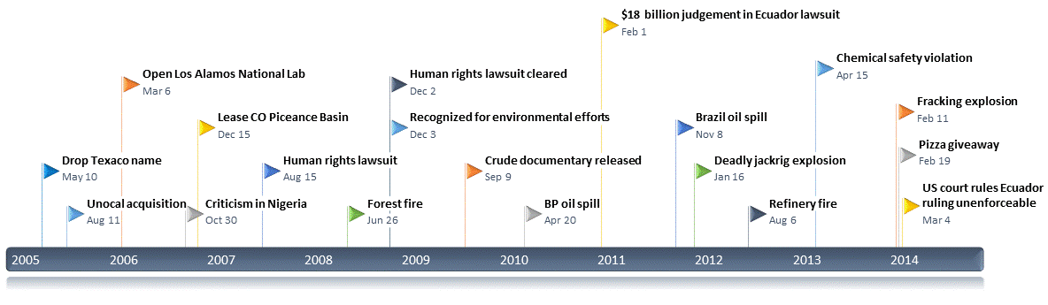

Chevron also experienced a number of acquisitions and mergers during this period. In 2005, Chevron acquired Unocal and expanded its operations in the Middle East. In 2006, Chevron opened a lab in Los Alamos and leased land in the Piceance Basin of Colorado to develop oil shale resources.
The Chickasaw Nation
The Chickasaw Nation experienced a variety of critical events, including a water dispute with the state of Oklahoma. In 2005, the state of Oklahoma was ordered to pay the U.S. Army Corps of Engineers $21.7 million for construction of Sardis Lake reservoir. At that time, local officials began making bids to acquire water rights for their cities. After much contention, a federal court upheld the 2005 ruling that Oklahoma must pay for Sardis Lake. Oklahoma City tried unsuccessfully to buy the lake water, as did many other parties. In 2009, the state of Oklahoma agreed to make payments on the Lake. While the Chickasaw Nation was aware of the Sardis Lake situation, the organization was not vocal about plans to seek water rights at this time.
Coinciding with a national effort where many Native American organizations were contesting water rights based on historical treaties that had been broken, the Choctaw and Chickasaw Nations of Oklahoma began asserting their rights to the Sardis Lake water in Eastern Oklahoma in 2010. The position of the Chickasaw and Choctaw Nations is that they have rights to the Sardis Lake water under the treaty of 1830. In 2011, the Chickasaw Nation entered into a lawsuit with the Choctaw Nation, suing the state of Oklahoma for Sardis Lake rights. Throughout the lawsuit, the Choctaw Nation has been the face of this campaign, while the Chickasaw Nation has worked behind the scenes and distanced the name of the organization from the controversy.
When drought in Oklahoma turned severe that summer, the Choctaw and Chickasaw Nations expanded their suit against the state to include Lake Atoka Reservoir also. Oklahoma threatened a counter-suit and the Nations subsequently amended their suit again, promising not to challenge existing permits and releasing a water plan. Not satisfied with this amendment, Oklahoma Governor Mary Fallin went to the media to plead Oklahoma’s case. Fallin asserted that the Chickasaw Nation voided their water rights in the treaty of 1866 after siding with the Confederacy in the Civil War. Chickasaw Governor Anoatubby affirmed the Chickasaw and Choctaw’s rights to the water for the media. As discord escalated, the judge assigned a federal mediator to work with all parties. Mediation continues to this day.

Figure 2: Timeline of Critical Events Challenging the Chickasaw Nation’s Identity
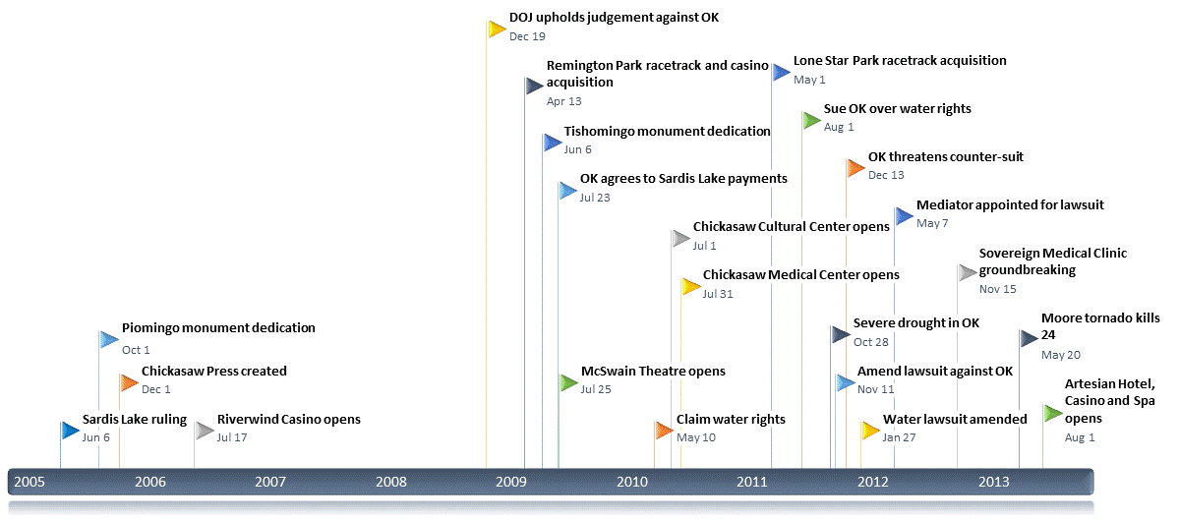

The Chickasaw Nation also experienced a variety of acquisitions and mergers. In 2006, the Chickasaw Press, a book publishing company opened. In 2007, the Chickasaw Nation opened the Riverwind Casino. In 2009, the Chickasaw Nation opened the McSwain Theatre and Remington Park Racetrack and Casino. The year of 2010 saw entry of the Chickasaw Nation into the medical arena as the Nation took advantage of niche market advantages brought about by the Affordable Care Act and opened the Chickasaw Medical Center. In 2011, the Chickasaw acquired the Lone Star Park racetrack. Expanding further into the medical arena, the Chickasaw Nation broke ground on the Sovereign Medical clinic in 2012. This endeavor required a steep investment by the Chickasaw Nation, but has given the Nation greater market advantage in the healthcare arena. The Chickasaw Nation opened the Artesian Casino and Spa in 2013.
Cultural events are also of importance, given the hybrid orientation of the Chickasaw Nation. In 2005, the Chickasaw Nation dedicated a monument to Chief Piomingo on Piomingo Day, a Chickasaw holiday celebrated the second Monday of October of each year. A monument was dedicated to Chief Tishomingo in 2009. Given the regional focus of the Chickasaw Nation, a large tornado in Moore, Oklahoma, which resulted in 24 fatalities, was also deemed identity challenging.
The Salvation Army
In 1891, the Salvation Army began taking donations in kettles displayed in public places to raise money to feed the poor a warm meal on Christmas day. Over the years, major retailers such as Walmart and Target agreed to let the Salvation Army set up a kettle outside their stores and ring a bell to encourage donations. In 2004, Target banned the Salvation Army from setting up outside their stores, citing the organization’s no solicitation policy. The ban provoked a major boycott of Target. In 2006, Target maintained its ban on bell ringers with kettles, but attempted to appease offended stakeholders by giving $1 million to the Salvation Army, donating profits from a Salvation Army Christmas tree ornament, and providing a link on the Target website for individuals to donate to the Salvation Army.
As a Christian ministry, the Salvation Army responds to critical events worldwide to help the needy. Thus, natural and manmade disasters play a critical in shaping the Salvation Army’s operations. In 2004, the Salvation Army responded in the aftermath of Indonesian earthquake and the subsequent Indian Ocean tsunami that devastated parts of Indonesia, Sri Lanka, India, and Thailand after over 230,000 people were killed and half a million were injured. In 2005, the Salvation Army responded after Hurricane Katrina overwhelmed the Gulf Coast of the United States and again after an earthquake shook the Kashmir region of Pakistan. On May 5, 2007, 84 tornados hit the Midwestern United States, killing 13 people in Kansas. The Salvation Army responded to those tornados as well as a slew of natural disasters in 2008 including Cyclone Nargis in Myanmar, the Sichuan Earthquake in China, and Atlantic Hurricanes Gustav and Ike.
In 2010, the Salvation Army responded to a 7.0 magnitude earthquake in Haiti. In 2011, the Salvation Army engaged in a variety of drought relief activities in Kenya, the Tōhoku earthquake and tsunami in Japan, a number of deadly tornados in the United States. In 2012, the Salvation Army responded to Hurricane Sandy and received over $36 million in donations. As donations poured in, the Salvation Army was criticized for not organizing more rapid dissemination of aid and funds to those in need. In 2013, the Salvation Army once again responded to tornados in the Midwestern United States, such as the May 20th tornado in Moore, Oklahoma.
In addition to natural disaster response, the Salvation Army, a Christian organization, has dealt with culture clashes with dominant society. These include the Salvation Army’s policy to ban Harry Potter toys from toy drives in 2010, due to references to sorcery in the Harry Potter books, and criticism voiced in 2010 about the Salvation Army’s prison outreach programs, which provide small Christmas gifts to inmates.

Figure 3: Timeline of Critical Events Challenging the Salvation Army’s Identity
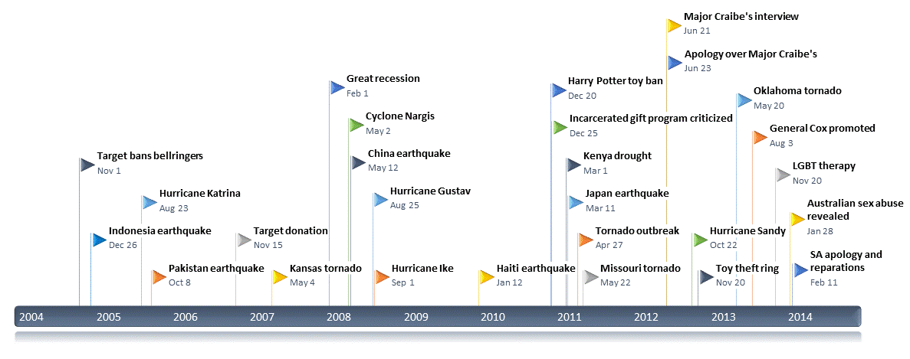

In 2013, the Salvation Army came under fire after publishing links to “reparative therapy” groups, i.e., groups that attempt to turn gay people straight through prayer, on its website. After being called out by Truth Wins Out, an activist organization, the Salvation Army removed the links and apologized for publishing the links, citing an accidental republishing of an archived page that does not reflect the Salvation Army’s current stance on LGBT issues. In 2013, Australian Salvation Army employee, Major Andrew Craibe, implied that people practicing homosexuality should be put to death while being interviewed on a radio show. Two days later, the Salvation Army issued an apology for Major Craibe’s remarks, saying Craibe’s comments reflected a misinterpretation of a scripture that referenced neither homosexuality nor physical death.
In 2012, a toy theft ring was discovered in Canada and an ex-executive of the Salvation Army was charged in connection with the theft of $2 million worth of toys. In 2014, allegations surfaced regarding sexual abuse in a children’s home in Australia where children were physically and sexually abused for years during the 1960s and 1970s. General Andre Cox, who was promoted to General just six months before this atrocity became known, told the media he was deeply disturbed by the horrors of the reported abuse and acted swiftly to review preventative measures worldwide and provide redress for victims. These disturbing revelations have significantly tainted the Salvation Army’s image worldwide (Kozaki, 2014).
Organizations’ Identity Self-Schemas or Network of Meaning
The networks generated in the network of meaning analyses are displayed in Tables 6-8. More complete descriptions of these networks can be found in Appendices B and C. These semantic networks reveal the evolution of organizational identity in terms of values espoused, stakeholders addressed, and knowledge domains emphasized over time.
Table 6: Chevron Networks
Legend: Size = concept salience (frequency); Color = concept centrality (eigenvector centrality); Shape/boxes = concept aggregation into themes (based on cluster analysis)
 | Website | Annual Report
2005 | 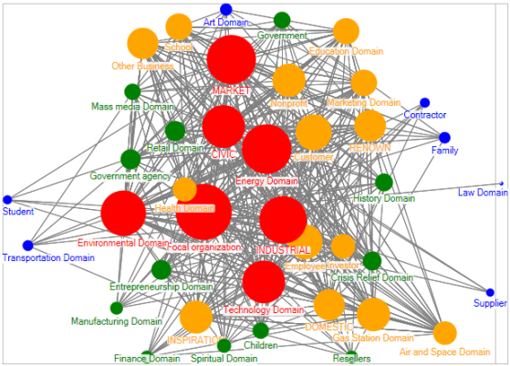 | 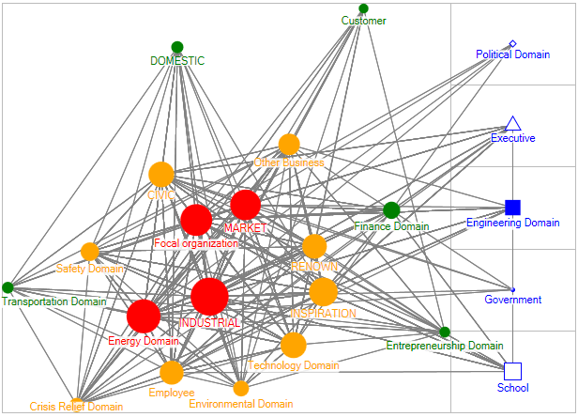
2005 | 40 concepts, 2 themes | 23 concepts, 6 themes
2007 | 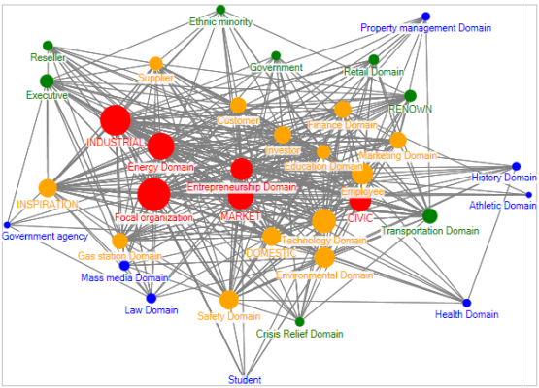 | 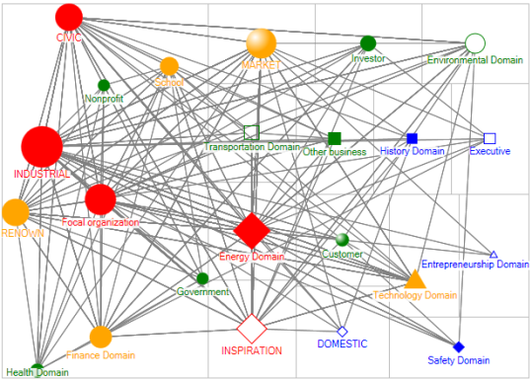
2007 | 35 concepts, 2 themes | 23 concepts, 15 themes
2009 | 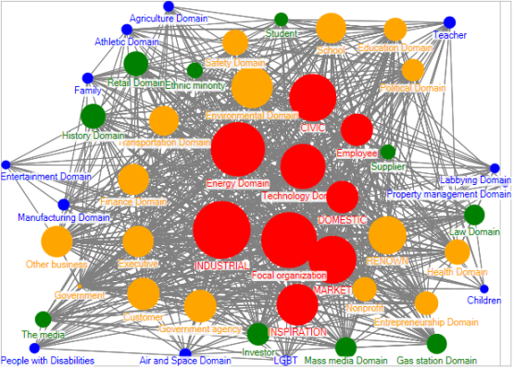 | 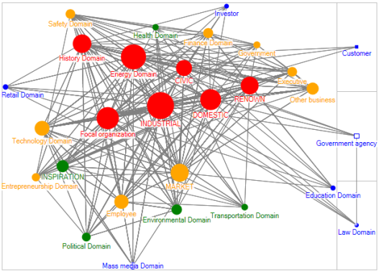
2009 | 47 concepts, 2 themes | 28 concepts, 4 themes
2011 | 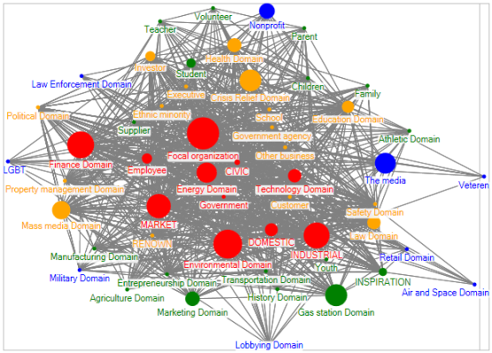 | 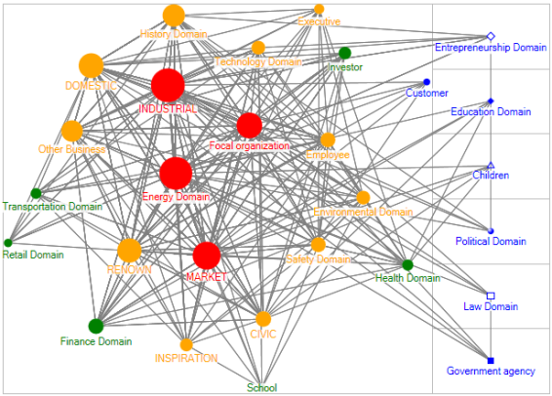
2011 | 53 concepts, 2 themes | 28 concepts, 7 themes
2013 | 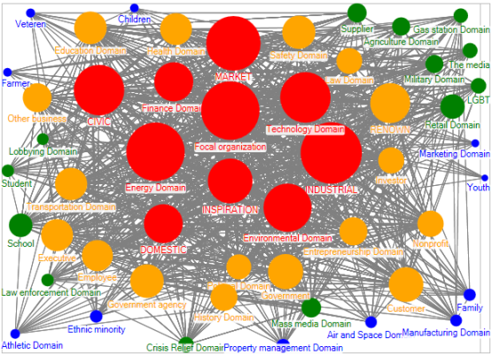 | 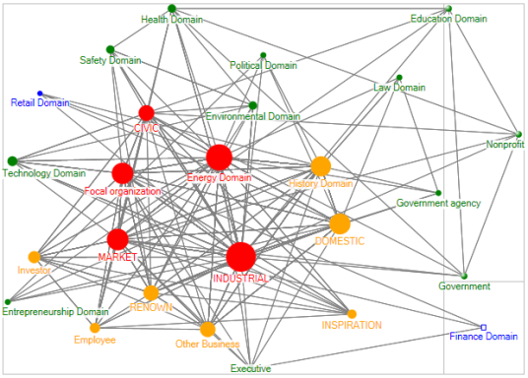
2013 | 51 concepts, 2 themes | 26 concepts, 3 themes

Though the Chevron websites tended to feature more concepts, the Chevron annual reports featured more themes, i.e., identity sub-schemas. Across media and over time, the concepts in the less dominant themes tended to be less central and occur with low frequency.
Table 7: Chickasaw Nation Networks
Legend: Size = concept salience (frequency); Color = concept centrality (eigenvector centrality); Shape/boxes = concept aggregation into themes (based on cluster analysis)
 | Corporate Website | Social Website | Annual Report
2005 | 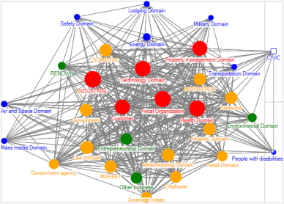 | 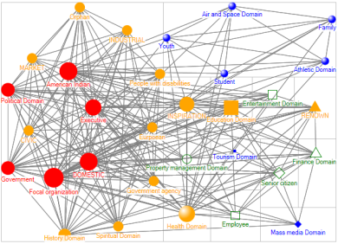 | 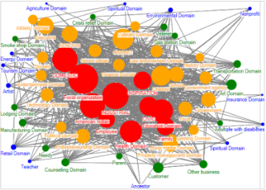
2005 | 31 concepts, 3 themes | 31 concepts, 13 themes | 59 concepts, 2 themes
2007 | 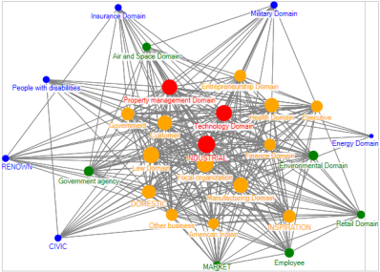 | 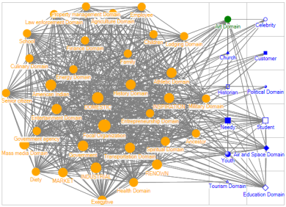 | 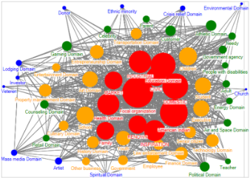
2007 | 28 concepts, 2 themes | 45 concepts, 13 themes | 56 concepts, 2 themes
2009 | 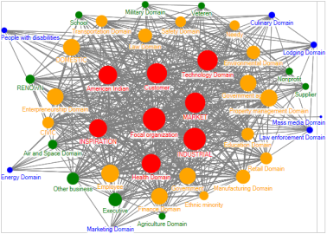 | 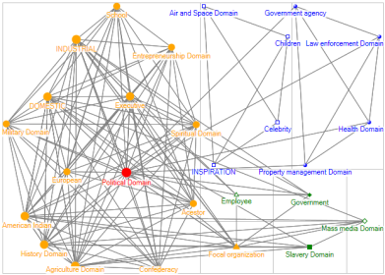 | 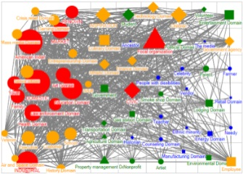
2009 | 42 concepts, 2 themes | 27 concepts, 8 themes | 62 concepts, 40 themes
2011 | 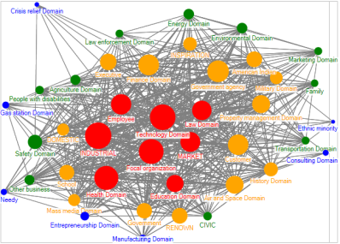 | 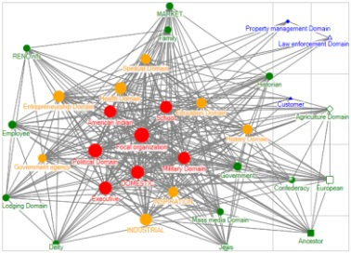 | 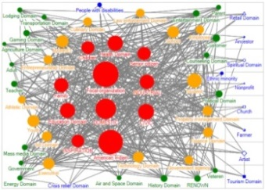
2011 | 41 concepts, 2 themes | 32 concepts, 8 themes | 55 concepts, 9 themes
2013 | 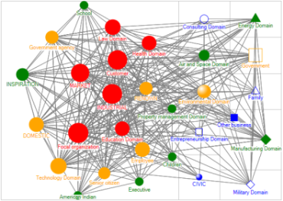 | 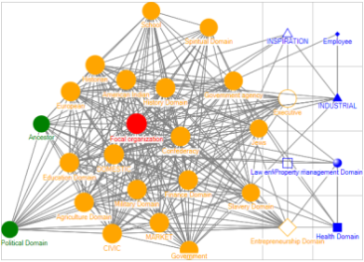 | 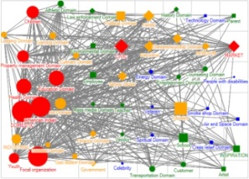
2013 | 30 concepts, 12 themes | 29 concepts, 9 themes | 51 concepts, 36 themes

While the Chickasaw Nation’s primarily corporate and primarily social websites both feature a similar number of concepts, the annual report features the most concepts. In general, the Chickasaw Nation’s annual report features the most themes, followed by the social website. In 2013, the Chickasaw Nation’s primarily corporate website featured 12 themes, compared to two or three in the other years sampled; notably, the concepts in the less dominant themes were somewhat central. While the concepts in less dominant themes on the websites were generally less central and occurred less frequently that the concepts in the dominant theme, on annual reports, some concepts in the less dominant themes were quite central and/or occurred frequently.

Table 8: Salvation Army Networks
Legend: Size = concept salience (frequency); Color = concept centrality (eigenvector centrality); Shape/boxes = concept aggregation into themes (based on cluster analysis)
 | Website | Annual Report
2005 | 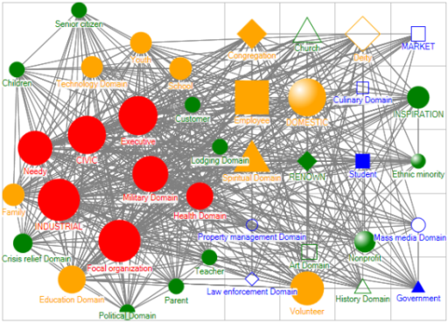 | 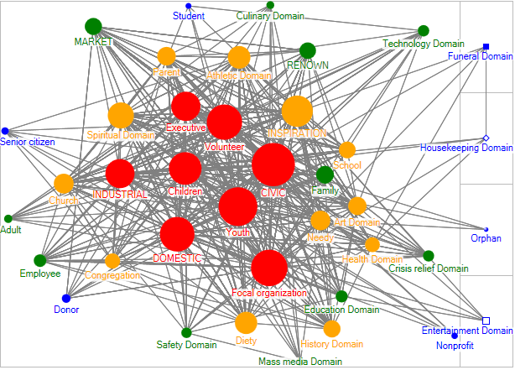
2005 | 40 concepts, 21 themes | 39 concepts, 5 themes
2007 | 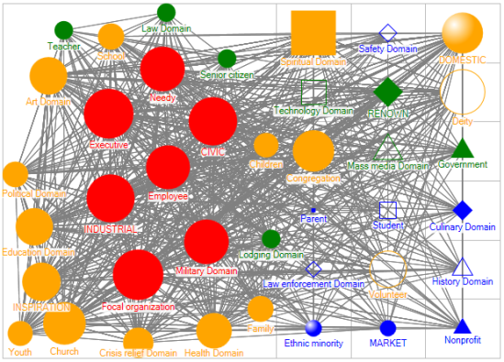 | 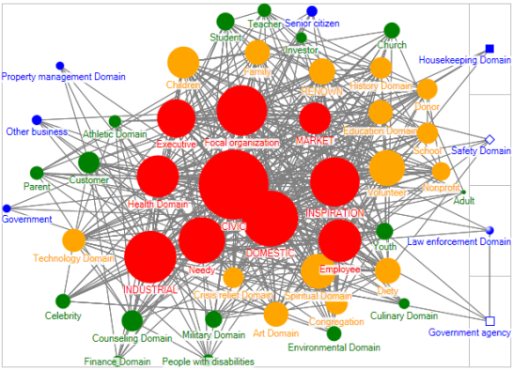
2007 | 40 concepts, 19 themes | 49 concepts, 5 themes
2009 | 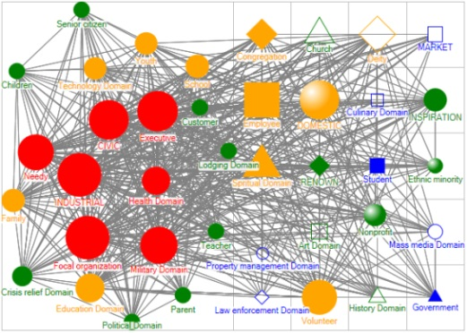 | 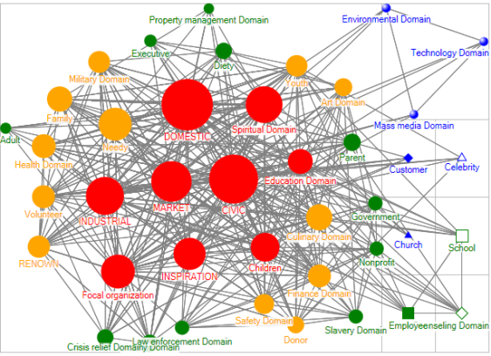
2009 | 40 concepts, 21 themes | 41 concepts, 8 themes
2011 | 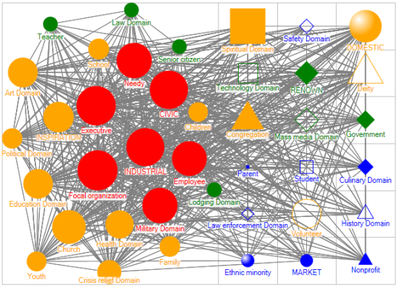 | 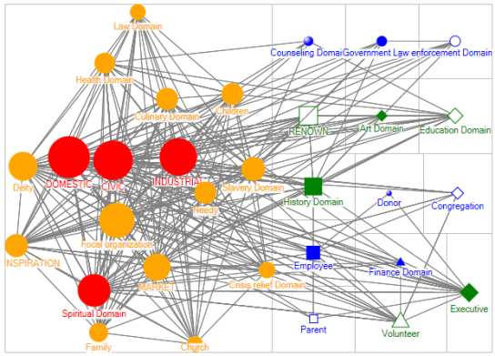
2011 | 40 concepts, 19 themes | 31 concepts, 15 themes
2013 | 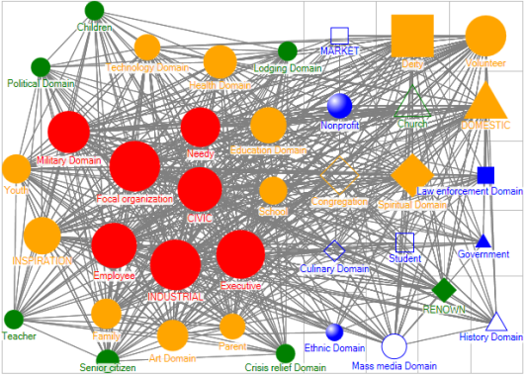 | 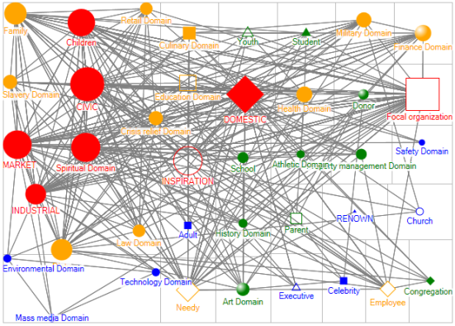
2013 | 38 concepts, 17 themes | 40 concepts, 28 themes

Both the digital and print publications of the Salvation Army featured many concepts and many themes. Notably, the concepts in the less dominant themes sometimes occurred frequently and were sometimes rather central.
Analysis of Identity Relative to Critical Events
Following the network of meaning analysis, I worked with two research assistants to develop timelines of critical events affecting each organization. The events on these timelines include internal events, such as workplace injuries and corporate mergers, and external events, such as earthquakes and legislation affecting the organization. The timelines are depicted below in Figures 4-6 with boxes depicting the top five most central concepts in the dominant themes of schemas for each organization, across media. These timelines provide a context for interpreting the networks of meaning.

Chevron
Many concepts in Chevron’s organizational identity were stable, such as Chevron (Focal organization), INDUSTRIAL, CIVIC, MARKET and Energy Domain. However, identity evolution did occur. As noted in the literature review, identity evolution is often provoked by identity challenges. Chevron faced a number of identity challenges during the period of analysis. In particular, several lawsuits threatened the firm. In 2006, Chevron began to receive criticism for environmentally unsound practices in Africa and protests ensued. Chevron was accused of working with Nigerian government security forces they knew had a history of using excessive force to stop protests. A human rights lawsuit was filed accusing Chevron of being complicit in the murder of Nigerian villagers in 2007. The 2007 annual report was the least coherent of Chevron’s annual reports, featuring 15 unique themes including one centered on the concept Safety Domain. The 2007 annual report was the only incidence of the Energy Domain concept not being a part of the dominant theme.
In 2008, a unanimous jury cleared Chevron of wrongdoing. Chevron’s 2009 annual report featured only four unique themes and for the first time, Law Domain and Government Agency concepts became a part of the organizational identity narrative in annual reports. These two new concepts were connected in a relationship in the 2009 annual report, and remained in 2011, still were connected in a relationship. By 2013, these two concepts, still connected in a relationship, had merged into the dominant theme, indicating that Chevron found a way to work discussions of lawsuits coherently into the organizational identity narrative.

Figure 4: Chevron Timeline with 5 Most Central Concepts in Dominant Theme
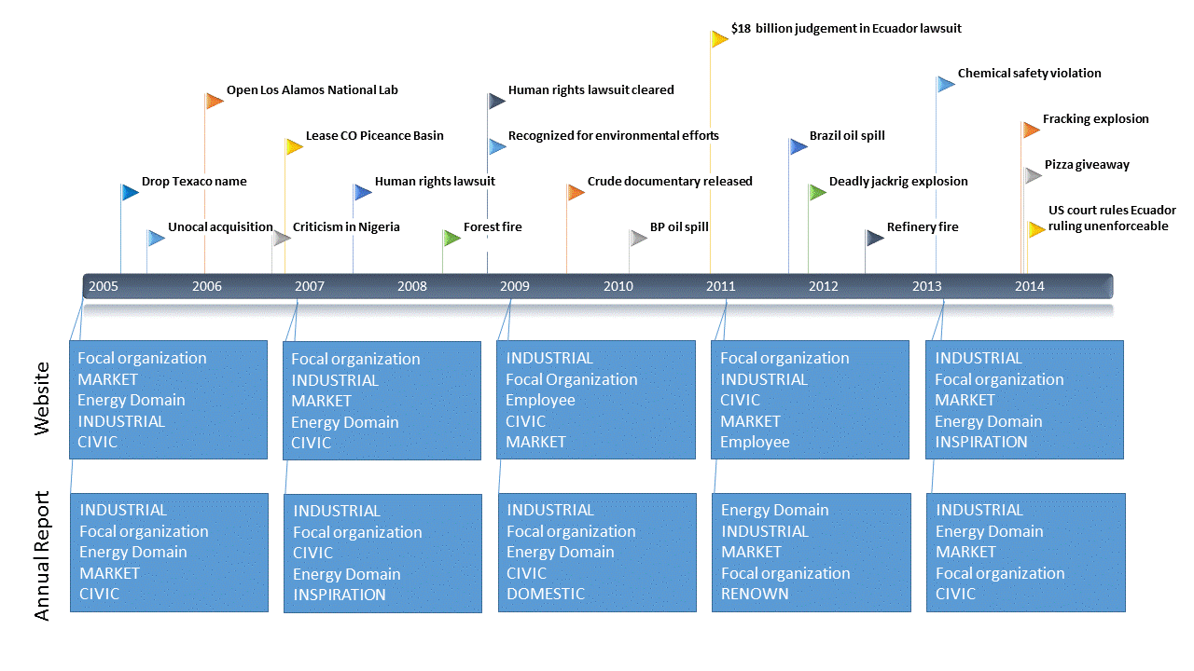

In 2003, prior to the period of analysis, a class action lawsuit was brought against Chevron for environmental damages. Chevron continued to fight well into the period of analysis. In 2011, a judge in Ecuador issued judgement against Chevron for environmental contamination in the amount of $8.6 billion, which was raised to $18 billion when Chevron refused to admit guilt or offer a public apology. Following this identity-tainting event, the value RENOWN was one of the most central concepts in the identity Chevron displayed in the 2011 annual report.
The Chickasaw Nation
Chickasaw Nation publications contained many concepts; Focal organization (the Chickasaw Nation), American Indian, INDUSTRIAL, and DOMESTIC were consistently prominent. The Chickasaw Nation, though a government, does not raise funds to provide services to citizens through taxation, but instead, funds government through the corporations it runs. One consistent concept in the Chickasaw Nation’s organizational identity that surfaced was the Entrepreneurship Domain concept. Though the entrepreneurial aspect of the Chickasaw Nation’s identity was consistently central, the area of entrepreneurial focus evolved over time and in light of circumstances, thus evolving the Chickasaw Nation’s identity.
Figure 5: Chickasaw Nation Timeline with 5 Most Central Concepts in Dominant Theme

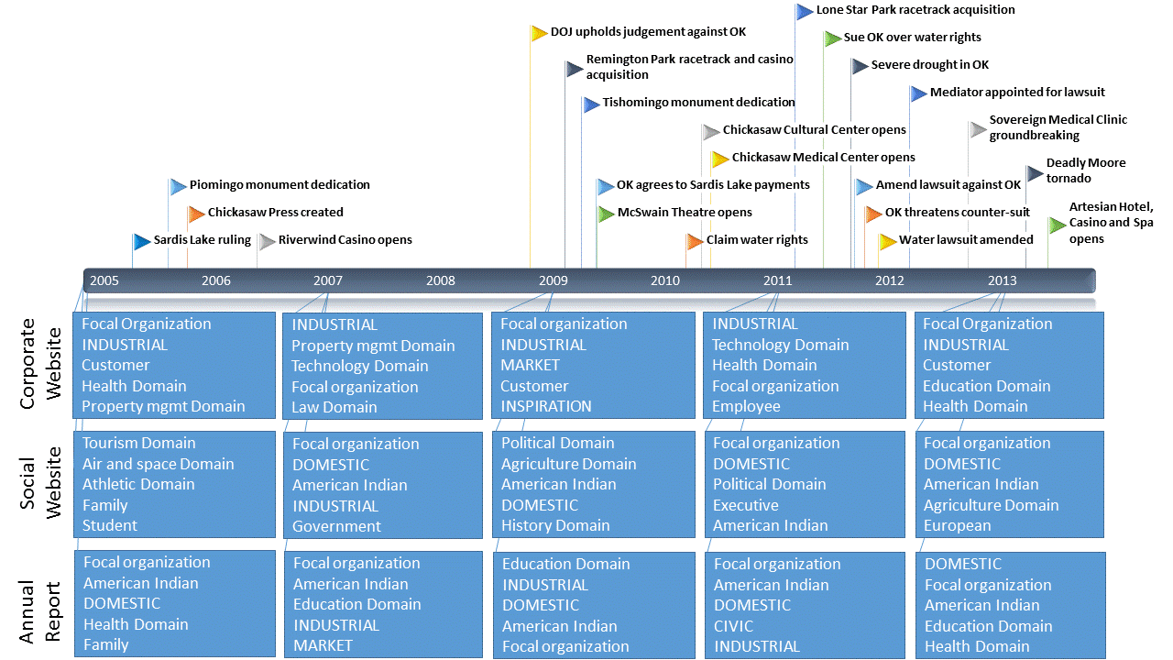

The period from 2008-2014 was marked with many new ventures and acquisitions for the Chickasaw Nation. Though the Chickasaw Nation is adept at balancing entrepreneurial activities in diverse arenas, this period marked unusually high levels of diversity and new ventures for the organization, leading to heightened levels of identity incoherence. This was especially evident on the annual report, which went from having an identity comprised of an average of two themes prior to 2008, to having an identity comprised of an average of over 29 themes after 2008. Decreased identity coherence was apparent on the Chickasaw social website also. In fact, the 2009 Chickasaw social website featured the only identity schema observed in this study comprised of more than two dominant themes, i.e., themes comprised of more than one dominant concept. Notably, the identity schema displayed on the corporate website in 2009 was largely consistent with previous years.
Though many identity challenges, e.g., medical center groundbreaking, were faced head-on by the Chickasaw Nation, others were omitted from identity displays. In particular, when the Chickasaw and Choctaw Nations teamed up to regain water rights from Sardis Lake in Oklahoma, the Choctaw Nation was the face of the water campaign, while the Chickasaw Nation supported the effort from a distance. Notably, the Chickasaw Nation did incorporate discussion of this lawsuit into identity productions.
While the Chickasaw Nation’s organizational identity certainly was influenced by external factors, such as U.S. legislation, internal strategic decisions about entrepreneurial activities were the main force behind identity evolution observed. Despite having separate outlets for expressing the corporate and social aspects of organizational identity, the dominant clusters for each of the identities expressed were similar, indicating a synthesized organizational identity overall. However, some segregated identities were found within the Chickasaw Nation social website, i.e., in 2005 and 2009 there were multiple, distinct themes. These secondary, dominant themes relate to programs and services offered to families, youth, and children. This indicates that some of the programs and services central to the Chickasaw Nation’s social identity are less synthesized than other aspects, such as history telling or entrepreneurship.
The Salvation Army
While the enduring theme of how the Salvation Army can work to help people came through consistently over time, the Salvation Army’s identity did evolve over time, in light of identity challenges. The Salvation Army was affected by internal identity challenges, but external challenges shaped the organization most. After all, as an organization devoted to helping people in need, the Salvation Army’s objectives change frequently as needs arise within the communities it serves. Thus, the knowledge domains surrounding the Salvation Army’s identity shifted whenever a major natural disaster occurred, but the presence of Crisis relief Domain as a concept endured.
Following most major natural disasters, the CIVIC value concept was a central concept in the dominant theme of the identity schema on the Salvation Army’s website, i.e., 2005, 2007, 2009, and 2011. However, following Hurricane Sandy in 2013, after which the Salvation Army was criticized for its response, the CIVC concept, while still central, was less central than INDUSTRIAL on the website. Notably, INDUSTRIAL was the second most central concept in the dominant theme on the website that year, and MARKET was a top five central concepts in the dominant theme on the annual report that year. Following Hurricane Sandy, donations poured in to the Salvation Army faster than the organization was able to organize processes to distribute the funds. Therefore, the organization made an effort to explain to audiences how and when those funds would be distributed. The “how and when” relates to an industrial value, while funds disbursement relate to market values.
The 2009 and 2013 annual reports featured two dominant themes. The first dominant theme was similar to the dominant themes observed other years, but the second dominant theme related to mass media coverage of natural disasters. In addition to using their identity narrative to tell audiences who the Salvation Army is, the Salvation Army used this space to communicate the devastation caused by natural disasters, thus demonstrating the role and importance of the Salvation Army. Given that this discussion broke out into a unique theme, it appears that this discussion is not integrated adequately in the Salvation Army’s identity narrative.
Figure 6: Salvation Army Timeline with 5 Most Central Concepts in Dominant Theme
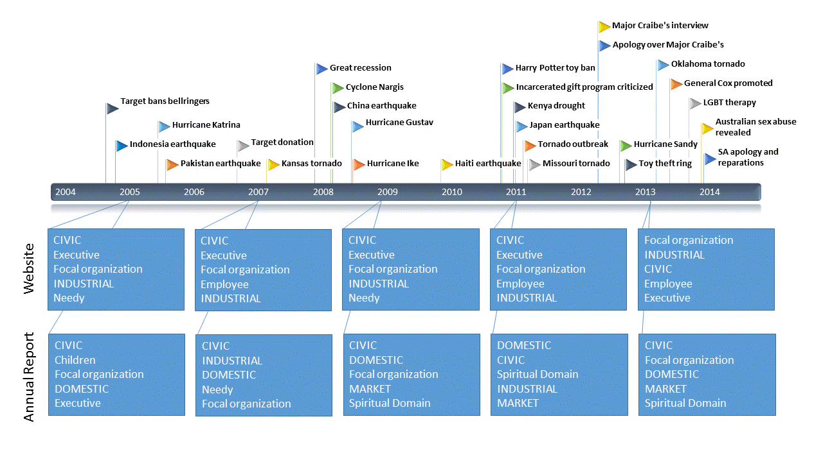

The networks of meaning generated for each organization reveal insights about the identity of each organization, specifically about their core concepts and about the underlying way in which those concepts are organized into themes comprising the organizations’ identity schemas. Interpreted in light of identity challenging critical events, these networks of meaning reveal how identity schemas, and identity-comprising themes, evolve over time. Discussion of the interpretation of these findings comprises the following chapter.

Chapter 5: Discussion
While the qualitative coding process did not extend the values of worth framework, it does confirm and validate the existing framework developed by Boltanski and Thévenot. The coding process revealed a final total of 45 higher-level groups of stakeholders and 42 higher-level groups of knowledge domains for this particular data set. Below is a summary of findings, organized by organization, followed by a synthesis of findings across media, i.e., digital or print, and publication type, e.g. primarily corporate or primarily social.
Chevron
Consistently central concepts in Chevron’s organizational identity include Chevron (Focal organization), INDUSTRIAL, CIVIC, MARKET and Energy Domain.
Chevron’s identity is also comprised of relationships with many stakeholders such as retailers, resellers, and suppliers. Chevron, the organization itself, is the most central stakeholder. Employee and Executive were somewhat central over the years as well. While somewhat peripheral, Investor appeared consistently, often in the dominant theme, indicating that while this stakeholder is not mentioned frequently, Chevron’s relationship with investors is a synthesized part of Chevron’s organizational identity schema.
While Chevron emphasized a variety of knowledge domains in organizational identity displays, the most central were Energy Domain, Mass media Domain, Finance Domain, Crisis relief Domain, and Environmental Domain. Over the years, one concept remained dominant in Chevron’s identity – Energy Domain. Energy Domain was well integrated and appeared in the dominant theme over the years across media, with the exception of the 2007 annual report. In this report, despite its frequency and centrality, Energy Domain was the vertex its own theme with the lowest density of any theme, indicating a disruption in Chevron’s organizational identity. Environmental Domain tended to be more central on Chevron’s digital than print media, and was even an outlier in the annual report of 2007. While Chevron incorporated a variety of knowledge domains into the Chevron identity, no knowledge domains besides Energy Domain were ever a top five most central concept over the years or across publications. This finding is evidence of identity coherence and continuity.
While Chevron’s organizational identity does appear to be influenced by external factors, Chevron’s identity displays were most consistent over time and across media. Over the years, across media, Chevron’s organizational identity schema featured more than one dominant theme only one time, in the 2013 annual report. The 2013 annual report featured a dominant theme similar to those seen on all media over time, but also featured a dominant theme with three vertices: Education Domain, Nonprofit, and Government. While these concepts were not central to the identity schema, they do comprise a unique theme in Chevron’s organizational identity. In 2013, Chevron used its annual report to display a segregated organizational identity where one theme in the identity schema depicts Chevron as an energy business, and the other discusses educational initiatives undertaken with nonprofit and government partners.
The Chickasaw Nation
Consistently central concepts in Chickasaw Nation’s identity include Focal organization (the Chickasaw Nation), American Indian, INDUSTRIAL, and DOMESTIC. The Chickasaw Nation, as the focal organization, was a core stakeholder in the Chickasaw Nation’s identity schema, as was American Indian. The other two consistently central concepts in the Chickasaw Nation identity schema were values, i.e., INDUSTRIAL and DOMESTIC. While INDUSTRIAL was most central on the Chickasaw Nation’s corporate website, and DOMESTIC was most central on the Chickasaw Nation’s social website, the Chickasaw Nation’s annual report featured INDUSTRIAL and DOMESTIC concepts centrally. This indicates that while the websites were targeting different audiences, the annual report was targeting all audiences. The audiences addressed by the Chickasaw Nation are diverse. The Chickasaw Nation defined itself in terms of more diverse set of knowledge domains than the other sampled organizations.
Salvation Army
CIVIC, Salvation Army (Focal organization), Executive, and INDUSTRIAL were consistently central concepts in the Salvation Army’s identity schema. Notably, while Salvation Army is a primarily social organization, the MARKET value concept was more central to the Salvation Army’s identity schema as it was to the identity schemas of the Chickasaw Nation, the hybrid organization sampled.
The Salvation Army’s identity revolves around values more than stakeholders, and stakeholders more than knowledge domains. While the Salvation Army identified many knowledge domains, these concepts were not well integrated in the dominant themes. Like the Chickasaw Nation’s social website and annual report, the Salvation Army’s identity schema lacked coherence, with an average of nearly 39 themes per website and more than 24 themes per annual report. The only knowledge domain consistently central to the Salvation Army’s identity schema over the years was Spiritual Domain, which was only a top five most central concept on the annual report, and only for 3 years.
The Salvation Army’s identity is comprised of relationships with many stakeholders including members of its congregation, people in need, and volunteers. The Salvation Army itself is the most central stakeholder concept in its identity schema, with Children, Church, Deity, Executive, and Family appearing as frequent, central concepts as well. A less dominant theme surrounding the stakeholder concept, Ethic minority, appeared every year for the Salvation Army website, but this concept was absent from the annual report. Which stakeholders were addressed was affected by the Salvation Army’s yearly theme. For instance, 2005 was the year of children and families, and Children was the second most central concept in the dominant theme in the 2005 annual report, and was not a top five most central theme at any other point during the period of analysis.
Patterns across Organization, Media, and Publication Type
Below, I discuss patterns across organizations, across media, and across publication type. These patterns include similarities and differences in the number of concepts and themes present in identity schemas, types of concepts present, identity coherence, and identity synergy.
Number of Concepts and Themes
My investigation revealed media differences across organizations. See Figure 7 for a depiction of the number of concepts and themes across publications for each type of organization.
Figure 7: Number of Concepts and Themes across Each Organization
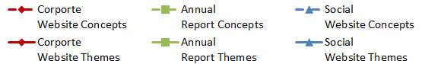
Chevron
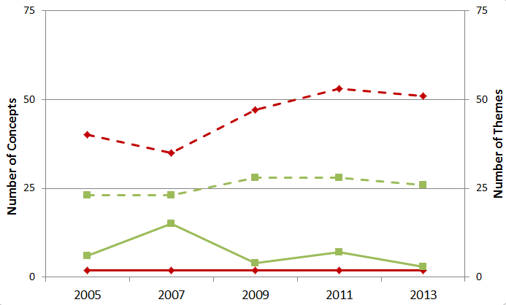
The Chickasaw Nation
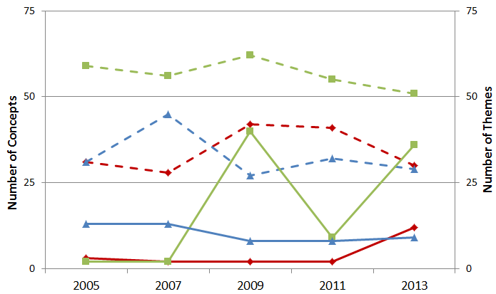
The Salvation Army
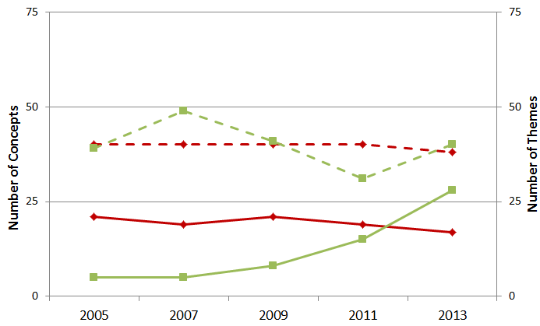

While Chevron’s website featured more concepts than Chevron’s annual report, the Chickasaw Nation’s annual report featured more concepts than the websites, and the Salvation Army’s identity schemas featured approximately the same number of concepts across media. This indicates that Chevron was very focused in the annual report, which is directed at a very specific stakeholder group, shareholders; in contrast, Chevron’s online presence, which addresses a wider audience, e.g., customers, environmentalism activists, and employees, evinced a more complex identity.
The Chickasaw Nation has two websites, one focusing on corporate issues and on focusing on social issues. Consequently, each website could be used to reveal different faces of the organization. The Chickasaw Nation annual report, in contrast, must address all stakeholders, and is therefore most complex, in terms of the number of concepts, number of themes, frequency of concepts in less dominant themes, and relationships among concepts in unique themes.
The Salvation Army, as a social organization, addresses the same group of stakeholders through all publications. Thus, differences in the complexity of identity displayed across media was less apparent for this organization.
Types of Concepts
The different organizations did not differ greatly in the number of concepts comprising identity, but the type of concepts did differ. Both the primarily corporate organization, i.e., Chevron, and the primarily social organization, i.e., the Salvation Army, emphasized value concepts most in identity displays. The hybrid organization, .i.e., the Chickasaw Nation, however, emphasized stakeholders most. Given the diversity of stakeholders the Chickasaw Nation must please, it is necessary for this hybrid organization to emphasize relationships across the spectrum of stakeholder groups in order to appeal to or appease all stakeholders. Thus, it is not surprising that the concepts most central and prominent in this hybrid organization’s identity schema were stakeholders.
Identity Coherence and Synergy
Identity coherence is the extent to which concepts and themes articulated are similar across media and over time (Miranda et al. 2015). Schema coherence, likewise, is defined in terms of similarity over time. Thus, analyzing similarities across identity schema reveals identity coherence. While identity coherence is a new theoretical concept (e.g., Miranda et al., 2015), there is a rich literature on identity synergy. Synergy is the extent to which concepts comprising identity schema are well-integrated (Pratt and Foreman, 2000). My findings revealed that Chevron’s identity schemas were most coherent across media and over time, the Salvation Army’s identity schemas were least coherent across media and over time. Notably, Chevron’s identity schemas were most synergized across media and over time, and the Salvation Army’s identity schemas were least synergized across media and over time. While low identity coherence is not theorized to align with lack of synergy, this finding indicates a possible relationship.
For all organizations, un-synergized identities, those featuring multiple dominant themes that were weakly inter-related, were common on annual reports, whereas this phenomenon occurred on websites only for the Salvation Army. This finding indicates that digital media may afford more synergized identity displays. Website texts are published in short blurbs where each blurb is meant to standalone and readers can navigate through the text in any order. Annual reports, on the other hand, assume a beginning-to-end reading pattern. Thus, while key points and phrases are emphasized repetitively on websites, writing norms pertaining to print documents, such as annual reports, eschew repetition. Despite an observed relationship between synergy and coherence across types of organizations, this did not bear out across media. That is, identity displays on print media were not more coherent over time than were digital media.
Identity Evolution
Identity evolution refers to the extent to which organizations’ identity schemas were transformed over time in anticipation of or response to critical events. Though some level of organizational identity evolution was observed for each organization, the degree of evolution differed across types of organizations. Chevron, the primarily corporate organization, experienced the most consistency and least identity evolution. The identity of the Chickasaw Nation, a hybrid organization, experienced moderate levels of evolution. The social organization, the Salvation Army, experienced the greatest degree of identity evolution and the least consistency over time and across media.

Chapter 6: Research Contributions
In this chapter, I discuss the contributions of this research. These include theoretical contributions, methodological contributions, and practical contributions.
Theoretical Contributions
Overall, my findings support the notions that 1.) Organizational identity evolution does occur and can be observed over time, 2.) Organizational identity management does differ across types of organizations, and 3.) Media does shape organizational identity representation in significant ways. This study contributes to current understanding in several important ways. In particular, by depicting organizational identity as a network of values espoused, stakeholders addressed, and knowledge domains emphasized, I refine and extend organizational identity theories and schema theory to explain that organizational identity is a schema, comprised of sub-schemas, or themes, which are comprised of concepts. By joining these distinct literature streams, I depict a novel way to conceptualize organization identity.
Regarding the first research question - What are differences in how organizations represent their identities on digital versus print media? – I found that organizations tend to represent their identities in a more fragmented, less synergized manner on print media. This finding contributes to the growing body of literature on media differences. Early MIS research examined questions about differential effects of media used in interpersonal communication (e.g., face-to-face, email, and video chat), culminating in core IS theories such as Media Richness Theory (Daft et al., 1987), Media Synchronicity Theory (Dennis, Fuller, and Valacich, 2008), and Channel Expansion Theory (Carlson and Zmud, 1999). Less understood is how media used for mass communication (e.g., television, websites, and social networking sites) differ.
Though MIS researchers have discovered disparate effects of traditional media versus social media on music sales (Dewan and Ramaprasad, 2014) and election results (Wattal et al., 2010), it is not yet known how other types of digital media, e.g., websites, are used differently or produce different outcomes than traditional media, e.g., print media. Recent research in this vein focuses on social media such as Facebook, YouTube, and Twitter; however, some researchers are beginning to view all digital media as social media:
“Social media is just the internet. Social media is exactly what the internet was always supposed to be and it has just evolved over time” (Kane, 2014).
As the form of “social media” over which organizations have complete content and design control, websites provide an ideal context for investigation into how organizations use design for symbolic representations, e.g., organizational identity projection. By examining websites and annual reports, I address a gap in the literature regarding symbolic design of websites versus print media and contribute to the development of IS theories explaining different uses and outcomes of media used for mass communication.
My second research question asks: How do different media afford organizations the ability to evolve their identities over time? Notably, identity evolution in annual reports was observed to be greater than on websites. This is likely because websites are not modified frequently and because readers returning to a page have an expectation of consistent information more so than readers examining a new document for the first time.
My third research question asks: How do different types of organizations – those operating primarily in the economic versus social sphere – manage their identity displays and evolution differently through types of statements? My findings suggest that primarily corporate organizations are most constrained in their identity evolution, given that the primarily corporate organization’s identity was the most consistent across media and over time, while the primarily social organization’s identity somewhat constrained across media and over time as well. This constraint may be attributable to the expectations of key stakeholders, which differ for each organization, and require organizations to make different types of statements, i.e. general versus niche statements. I expected to find that the hybrid organization maintained distinct identities on corporate and social publications, and found that to be the case. This finding has important implications for organizational studies theories relating to identity management of hybrid organizations e.g., family-owned businesses, minority-owned businesses, and Christian-owned businesses. Together, these findings align with organizational theories or inertia and rigidity developed based on studies of corporate organizations (e.g, Hannan and Freeman, 1984; Staw et al., 1981) and suggest a need for more refined theories of organizational rigidity and inertia for social and hybrid organizations.
Finally, by using open and axial coding processes to develop categories of organizational values, I was able to confirm the existing framework put forth by Boltanski and Thévenot (2006). Though researchers should remain open to surfacing new categories as culture evolves, the confirmation of the existing “values of worth” framework accomplished in this study lends credibility to current research building on this framework in a multiple of disciplines, e.g., MIS (Miranda et al. 2015), sociology (Jagd, 2011), and political science (Boltanski and Chiapello, 2005).
Methodological Contributions
The major contribution of this research is the methodological contribution of demonstrating how researchers interested in understanding identity projection on IT artifacts can represent amorphous notions of identity in a more concrete way. By depicting organizational identity as schema using network analysis as a tool for understanding the structure of underlying sub-schemas or themes, and the relationships between identity concepts, I provide researchers with a novel approach to forwarding organizational identity theories and for making sense of archival data readily found online.
While some research has examined identity evolution processes, this research tends to employ subjective data sources such as interviews or surveys (Clark et al., 2010; Ravasi and Schultz, 2006). This study serves as an example of how secondary data can be used to study identity evolution processes without suffering the ills of recall bias common in the identity literature. By providing an example of how longitudinal data from website archives can be used to understand organizations’ symbolic representations as indicators of organizational identity that are embedded in design, I make a methodological contribution to the field of MIS.

Practical Implications
This research promotes understanding of how MIS professionals can manage portrayal of identity across media catering to specific versus broad constituencies by comparing traditional versus digital productions. This research has practical relevance for organizational leaders and cultural entrepreneurs seeking to synthesize Internet-based identity portrayals to promote organizational identity coherence over time.
When organizational values conflict, organizations can manage ensuing tension through (a) acceptance, (b) spatial or temporal separation, or (c) synthesis (Jagd, 2011: 352). These value management strategies relate to Pratt and Foreman’s (2000) four strategies for managing plural organizational identities:
(1) Aggregation: “when an organization attempts to retain all of its identities while forging links between them” (Pratt and Foreman, 2000: 32);
(2) Compartmentalization: when multiple identities are maintained, but are physically, temporally, or spatially separated from each other”;
(3) Deletion: “when organizations strategically remove identities that are on their periphery, while retaining identities that are closer to their core” (Pratt and Foreman, 2000: 31);
(4) Integration: “when managers attempt to fuse multiple identities into a distinct new whole” such that the original identity no longer exists on its own (Pratt and Foreman, 2000: 30).
While organizational theories do not posit that one identity management strategy is intrinsically better than other strategies, the prevalence of digital archives is complicating each strategy.
This research revealed that organizational identity displays on print media tended to be more value-centric, while digital identity displays tended to be more utilitarian. This difference is likely due to the perceived materiality of each media. While the virtual nature of digital publications likely diminishes attributions of permanence, this perception is not reality. A recent Wired article cited William Faulkners’ aphorism, “The past is never dead. It’s not even past,” to explain that the increasing comprehensiveness of digital archives has made the past so accessible that it blurs with the present (Ford, 2014). The inability of organizations to delete archived versions of its websites, makes identity deletion and separation almost impossible. At the same time, online identity displays targeting one group of stakeholders are increasingly accessible to other groups online and accessible over time through archives. This makes identity compartmentalization strategies less and less manageable.
Thus, in this digital age, strategies that promote identity acceptance, identity aggregation, and/or identity synthesis and integration may be the most viable identity management options. With this in mind, organizations should consider all stakeholders when making choices about identity constitution and evolution and should consider the permanence of digital media, rather than just the utility of digital media, when designing identity displays.
Common thought on identity management is that identity displays should be made in a deliberate, rather than reactive, ways in order to promote identity coherence over time, and ultimately legitimacy. However, this assumption is based on theories built on studies of primarily corporate organizations. Given the more reactive nature of the Chickasaw Nation’s identity displays compared to Chevron’s and the Salvation Army’s, it may be that reactive organizational identity evolution is an appropriate identity management strategy depending on the type of organization and the demands of key stakeholders.

Chapter 7: Conclusion
With an increasing number of options available for identity projection, there is a need for theories describing the effects of mass media choice on identity projection. Organizations can use digital media to shape meanings audiences attribute to “who” the organization is and is becoming (Gioia et al., 2000). In so doing, organizations construct for themselves “iron cages” as statements made across media constrain what organization can reasonable say about the organization in the future (DiMaggio and Powell, 1983).
I used an inductive, generational approach to improve the state of knowledge about the symbolic content of website design related to organizational identity displays. In so doing, I uncovered insights related to how different types of organizations use digital and print media in forging and evolving their identities. By depicting organizational identity as a network of meaning representing who and what the organization knows and cares about, I demonstrate a novel way of conceptualizing identity, i.e, as schema, as well as a novel way of measuring organizational identity, i.e., network of meaning analysis.
References

Abbasi, A., Zhang, Z., Zimbra, D., Chen, H., & Nunamaker Jr, J. F. (2010). Detecting fake websites: the contribution of statistical learning theory. MIS Quarterly, 34(3), 435-461.

Albert, S., & Whetten, D. A. (1985). Organizational identity. Research in Organizational Behavior.

Aquino, K., & Reed II, A. (2002). The self-importance of moral identity. Journal of Personality and Social Psychology, 83(6), 1423.

Ashforth, B. E., & Mael, F. (1989). Social identity theory and the organization. Academy of Management Review, 14(1), 20-39.

Ashforth, B. E., & Kreiner, G. E. (1999). “How can you do it?”: Dirty work and the challenge of constructing a positive identity. Academy of Management Review, 24(3), 413-434.

Averhart, C. J., & Bigler, R. S. (1997). Shades of meaning: Skin tone, racial attitudes, and constructive memory in African American children. Journal of Experimental Child Psychology, 67(3), 363-388.

Bandura, A. (2001). Social cognitive theory of mass communication. Media psychology, 3(3), 265-299.

Bem, S. L. (1981). Gender schema theory: A cognitive account of sex typing. Psychological Review, 88(4), 354.

Berger, P. L., & Luckmann, T. (1991). The social construction of reality: A treatise in the sociology of knowledge (No. 10). Penguin UK.

Bingham, L. B., Nabatchi, T., & O'Leary, R. (2005). The new governance: Practices and processes for stakeholder and citizen participation in the work of government. Public Administration Review, 65(5), 547-558.

Birks, D.F., Fernandez, W., Levina, N., and Nasirin, S. (2013). Grounded Theory Method in Information Systems Research: Its Nature, Diversity and Opportunities. European Journal of Information Systems, (22:1), pp 1-8.

Boltanski, L., & Chiapello, E. (2005). The new spirit of capitalism. International Journal of Politics, Culture, and Society, 18(3-4), 161-188.

Boltanski, L., & Thévenot, L. (1999). The Sociology of Critical Capacity. European Journal of Social Theory, (2:3), pp 359-377.

Boltanski, L., & Thévenot, L. (2006). On Justification: Economies of Worth. Princeton, NJ: Princeton University Press.

Buenger, V., Daft, R. L., Conlon, E. J., & Austin, J. (1996). Competing values in organizations: Contextual influences and structural consequences. Organization Science, 7(5), 557-576.

Carlson, J. R., & Zmud, R. W. (1999). Channel expansion theory and the experiential nature of media richness perceptions. Academy of Management Journal, 42(2), 153-170.

Carter, L., & Bélanger, F. 2005. The Utilization of E‐Government Services: Citizen Trust, Innovation and Acceptance Factors. Information Systems Journal, (15:1), 5-25.

Cenfetelli, R.T., Benbasat, I., & Al-Natour, S. (2008). Addressing the What and How of Online Services: Positioning Supporting-Services Functionality and Service Quality for Business-to-Consumer Success. Information Systems Research, (19:2), 161-181.

Cheney, G. & Christensen, L.T. (2001). Organizational identity at issue: Linkages between ‘internal’ and ‘external’ organizational communication. In F.M. Jablin & L.L. Putnam (Eds), New handbook of organizational communication. Newbury Park, CA: Sage.

Clark, S. M., Gioia, D. A., Ketchen, D. J., & Thomas, J. B. (2010). Transitional identity as a facilitator of organizational identity change during a merger. Administrative Science Quarterly, 55(3), 397-438.

Clegg, S. R., Rhodes, C., & Kornberger, M. (2007). Desperately seeking legitimacy: Organizational identity and emerging industries. Organization Studies, 28(4), 495-513.

Coleman, J. S., Katz, E., & Menzel, H. (1966). Medical innovation: A diffusion study. New York: Bobbs-Merrill.

Corley, K. G., Harquail, C. V., Pratt, M. G., Glynn, M. A., Fiol, C. M., & Hatch, M. J. (2006). Guiding organizational identity through aged adolescence. Journal of Management Inquiry, 15(2), 85-99.

Gioia, D. A., Schultz, M., & Corley, K. G. (2000). Organizational identity, image, and adaptive instability. Academy of management Review, 25(1), 63-81.

Cyert, R. M., & March, J. G. (1963). A behavioral theory of the firm. Englewood Cliffs, NJ, 2.

Cyr, D., Head, M., Larios, H., & Pan, B. (2009). Exploring Human Images in Website Design: A Multi-Method Approach," MIS Quarterly, (33:3), 539.

Daft, R.L., Lengel, R.H., & Trevino, L.K. (1987). Message Equivocality, Media Selection, and Manager Performance: Implications for Information Systems. MIS Quarterly, (11:3), 355-366.

Deephouse, D.L. (2000). Media reputation as a strategic resource: An integration of mass communication and resource-based theories. Journal of Management, (26), 1091–112.

Deng, L., & Poole, M.S. (2010). Affect in Web Interfaces: A Study of the Impacts of Web Page Visual Complexity and Order. MIS Quarterly, (34:4), 711-730.

Dennis, A. R., Fuller, R. M., & Valacich, J. S. (2008). Media, tasks, and communication processes: A theory of media synchronicity. MIS Quarterly, 32(3), 575-600.

Dennis, A. R., & Valacich, J. S. (1999, January). Rethinking media richness: Towards a theory of media synchronicity. In Systems Sciences, 1999. HICSS-32. Proceedings of the 32nd Annual Hawaii International Conference on (pp. 10-pp). IEEE.

Devers, C. E., Dewett, T., Mishina, Y., & Belsito, C. A. (2009). A general theory of organizational stigma. Organization Science, 20(1), 154-171.

Dewan, S., & Ramaprasad, J. (2014). Social media, traditional media, and music sales. MIS Quarterly, 38(1), 101-121.

DiMaggio, P. J., & Powell, W. W. (1983). The iron cage revisited: Institutional isomorphism and collective rationality in organizational fields. American Sociological Review, 147-160.

Donaldson, T., & Preston, L. E. (1995). The stakeholder theory of the corporation: Concepts, evidence, and implications. Academy of Management Review, 20(1), 65-91.

Dutton, J. E. & Penner, W. J. (1993). The importance of organizational identity for strategic agenda building. Hendry, J., Johnson, G., and Newton, J., (eds) Strategic Thinking: Leadership and the Management of Change. John Wiley & Sons.

Eisenhardt, K. M. (1989). Building theories from case study research. Academy of Management Review, 14(4), 532-550.

Empson, L. 2004. "Organizational Identity Change: Managerial Regulation and Member Identification in an Accounting Firm Acquisition," Accounting, Organizations and Society (29:8), pp 759-781.

Fiske, S.T., & Taylor, S.E. 1984. Social Cognition: From Brains to Culture. Thousand Oaks, CA: Sage. Fiss, P.C. 2011

Ford. (2014). The end of the past? Present? Online it all runs together. Wired Magazine.

Freeman, R. E. (1984). Strategic management: A stakeholder approach. Boston: Pitman.

Freeman, R. E. (1994). The politics of stakeholder theory: Some future directions. Business Ethics Quarterly, 4 (4), 409–22.

Garrett, J. J. (2010). Elements of User Experience: The User-Centered Design for the Web and Beyond. Pearson Education.

Gefen, D., & Straub, D. W. (2003). Managing user trust in B2C e-services. E-service Journal, 2(2), 7-24.

Gioia, D. A. (1986). Conclusion: The state of the art in organizational social cognition: A personal view. The thinking organization: Dynamics of organizational social cognition, 336, 356.

Gioia, D. A., Schultz, M., & Corley, K. G. (2000). Organizational identity, image, and adaptive instability. Academy of Management Review, 25(1), 63-81.

Glynn, M. A. (2000). When cymbals become symbols: Conflict over organizational identity within a symphony orchestra. Organization Science, 11(3), 285-298.

Glynn, M. A., and Abzug, R. (2002). Institutionalizing identity: Symbolic isomorphism and organizational names. Academy of Management Journal, 45(1), 267-280.

Goffman, E. (1963). Stigma: Notes on a spoiled identity.

Goldberg, A. 2011. “Mapping Shared Understandings Using Relational Class Analysis: The Case of the Cultural Omnivore Reexamined,” American Journal of Sociology (116:5), pp. 1397-1436.

Hannan, M. T., & Freeman, J. (1984). Structural inertia and organizational change. American sociological review, 149-164.

Hassanein, K., & Head, M. (2007). Manipulating perceived social presence through the web interface and its impact on attitude towards online shopping. International Journal of Human-Computer Studies, 65(8), 689-708.

Hatch, M. J., & Schultz, M. (1997). Relations between organizational culture, identity and image. European Journal of Marketing, 31(5/6), 356-365.

Hatch, M. J., & Schultz, M. (2002). The dynamics of organizational identity. Human Relations, 55(8), 989-1018.

Herman. E. S. 1981. Corporate control, Corporate Power. Cambridge. England: Cambridge University Press, Chicago.

Jagd, S. (2011). Pragmatic sociology and competing orders of worth in organizations. European Journal of Social Theory, 14(3), 343-359.

James, E.H., and Wooten, L.P. 2006. "Diversity Crises: How Firms Manage Discrimination Lawsuits," Academy of Management Journal (49:6), pp 1103-1118.

Jensen, T., & Sandström, J. (2011). Stakeholder theory and globalization: the challenges of power and responsibility. Organization Studies, 32(4), 473-488.

Jiang, Z., & Benbasat, I. (2007a). The Effects of Presentation Formats and Task Complexity on Online Consumers' Product Understanding. MIS Quarterly, (31:3), 475-500.

Jiang, Z., & Benbasat, I. (2007b). Research Note: Investigating the Influence of the Functional Mechanisms of Online Product Presentations. Information Systems Research, (18:4), 454-470.

Jones, T. M. (1995). Instrumental stakeholder theory: A synthesis of ethics and economics. Academy of Management Review, 20(2), 404-437.

Kane, J. (2014, July 7). Social media… You haven’t seen anything yet. Retrieved from https://www.youtube.com/watch?v=KzcQzM8CgIc.

Kim, D., & Benbasat, I. (2006). The Effects of Trust-Assuring Arguments on Consumer Trust in Internet Stores: Application of Toulmin's Model of Argumentation. Information Systems Research, (17:3), 286-300.

Kozaki, D. 2015. “The Salvation Army’s reputation declines after child sex abuse inquiry hearings: research” ABC News. Retrieved from http://www.abc.net.au/news/2014-12-22/salvation-army-reputation-declines-after-child-sex-abuse-inquiry/5983508.

Kumar, N., & Benbasat, I. (2006). Research Note: The Influence of Recommendations and Consumer Reviews on Evaluations of Websites. Information Systems Research, (17:4), 425-439.

Lucas, H., Agarwal, R., Clemons, E.K., El Sawy, O.A., & Weber, B. (2013). Impactful Research on Transformational Information Technology: An Opportunity to Inform New Audiences. MIS Quarterly, (37:2), 371-382.

Luo, J., Ba, S., & Zhang, H. (2012). The Effectiveness of Online Shopping Characteristics and Well-Designed Websites on Satisfaction. MIS Quarterly, 36(4), 1131-1144.

Markus, H. (1977). Self-schemata and processing information about the self. Journal of Personality and Social Psychology, 35(2), 63.

Meyer, J. W., & Rowan, B. (1977). Institutionalized organizations: Formal structure as myth and ceremony. American Journal of Sociology, 340-363.

Miles, M. B.,& Huberman, A. M. (1994). Qualitative data analysis (2nd ed.). Thousand Oaks, CA: Sage.

Mitchell, R. K., Agle, B. R., & Wood, D. J. (1997). Toward a theory of stakeholder identification and salience: Defining the principle of who or what really counts. Academy of Management Review, 22 (4), 853–886.

Navis, C., & Glynn, M. A. (2011). Legitimate distinctiveness and the entrepreneurial identity: Influence on investor judgments of new venture plausibility. Academy of Management Review, 36(3), 479-499.

Newman M.E.J. (2006) Modularity and community structure in networks. Proceedings of the National Academy of Science USA 103: 8577–8582.

Newman, M. E., and Girvan, M. (2003). Mixing patterns and community structure in networks. In Statistical mechanics of complex networks. Springer Berlin Heidelberg (pp. 66-87).

Olins, W. (1989). Corporate identity. Thames & Hudson.

Poza, E. (2013). Family business. Cengage Learning.

Pratt, M. G., & Foreman, P. O. (2000). Classifying managerial responses to multiple organizational identities. Academy of Management Review, 25(1), 18-42.

Quinn, R. E., & Rohrbaugh, J. (1983). A spatial model of effectiveness criteria: Towards a competing values approach to organizational analysis. Management Science, 29(3), 363-377.

Racherla, P., & Mandviwalla, M. (2013). "Moving from Access to Use of the Information Infrastructure: A Multilevel Sociotechnical Framework," Information Systems Research (24:3), 709-730.

Randel, A. E., & Jaussi, K. S. (2003). Functional background identity, diversity, and individual performance in cross-functional teams. Academy of Management Journal, 46(6), 763-774.

Ravasi, D., & Schultz, M. (2006). Responding to organizational identity threats: Exploring the role of organizational culture. Academy of Management Journal, 49(3), 433-458.

Rogers, E. M., & Kincaid, D. L. (1981). Communication networks: Toward a new paradigm for research. New York: Free Press.

Sarker, S., Xiao, X., & Beaulieu, T. (2013). Guest editorial: Qualitative studies in information systems: A critical review and some guiding principles. MIS Quarterly, 37(4), iii-xviii.

Scott, S. G., & Lane, V. R. (2000). A stakeholder approach to organizational identity. Academy of Management Review, 25(1), 43-62.

Smith, M., Milic-Frayling, N., Shneiderman, B., Mendes Rodrigues, E., Leskovec, J., & Dunne, C. (2010). “NodeXL: A Free and Open Network Overview, Discovery and Exploration Add-In for Excel 2007/2010,” Social Media Research Foundation (http://nodexl.codeplex.com/).

Staw, B. M., Sandelands, L. E., & Dutton, J. E. (1981). Threat rigidity effects in organizational behavior: A multilevel analysis. Administrative science quarterly, 501-524.

Strauss, A., & Corbin, J. (1998). Basics of qualitative research: Techniques and procedures for developing grounded theory. Thousand Oaks, CA: Sage.

Strauss, A., & Corbin, J. (2007). Basics of Qualitative Research: Techniques and Procedures for Developing Grounded Theory. Thousand Oaks, CA: Sage Publications, Incorporated.

Strauss, C., & Quinn, N. (1997). A Cognitive Theory of Cultural Meaning. Cambridge, UK: Cambridge University Press.

Sutton, R.I., & Callahan, A.L. (1987). "The Stigma of Bankruptcy: Spoiled Organizational Image and Its Management," Academy of Management Journal (30:3), pp 405-436.

Tajfel, H. & Turner, JC (1986). The social identity theory of intergroup behavior. Psychology of intergroup relations, 7-24.

Tan, C. W., Benbasat, I., & Cenfetelli, R. T. (2013). IT-mediated customer service content and delivery in electronic governments: An empirical investigation of the antecedents of service quality. MIS Quarterly, 37(1), 77-109.

Venkatesh, V., Brown, S. A., & Bala, H. (2013). Bridging the qualitative-quantitative divide: Guidelines for conducting mixed methods research in information systems. MIS Quarterly, 37(1), 21-54.

Voss, Z. G., Cable, D. M., & Voss, G. B. (2006). Organizational identity and firm performance: what happens when leaders disagree about “who we are?”. Organization Science, 17(6), 741-755.

Voss, G. B., Cable, D. M., & Voss, Z. G. (2000). Linking organizational values to relationships with external constituents: A study of nonprofit professional theatres. Organization Science, 11(3), 330-347.

Wattal, S., Schuff, D., Mandviwalla, M., & Williams, C.B. (2010). Web 2.0 and Politics: The 2008 US Presidential Election and an E-Politics Research Agenda. MIS Quarterly, (34:4), 669-688.

Wells, J. D., Valacich, J. S., & Hess, T. J. (2011). What Signals Are You Sending? How Website Quality Influences Perceptions of Product Quality and Purchase Intentions. MIS Quarterly, 35(2), 373-396.

Whetten, D. A., & Mackey, A. (2002). A social actor conception of organizational identity and its implications for the study of organizational reputation. Business & Society, 41(4), 393-414.

White, H. C. (1992). Identity and control: A structural theory of social action. Princeton University Press.

Winter, S.J., Saunders, C., & Hart, P. (2003). Electronic Window Dressing: Impression Management with Websites. European Journal of Information Systems, (12:4), 309-322.

Yetgin, E., Young, A. G., & Miranda, S. M. (2012). Cultural Production of Protest Frames and Tactics: Cybermediaries and the SOPA Movement.

Yin, R. K. (1984). Case study research: Design and methods. Newbury Park, CA: Sage.

Yoo, Y., & Alavi, M. (2001). Media and group cohesion: Relative influences on social presence, task participation, and group consensus. MIS Quarterly, 371-390.

Young, A. (2012). Communicating Necessary Evils: The Role of Expressive and Diffusive Capabilities. Americas Conference on Information Systems (AMCIS).

Zachary, M. A., McKenny, A. F., Short, J. C., Davis, K. M., & Wu, D. (2011). Franchise branding: An organizational identity perspective. Journal of the Academy of Marketing Science, 39(4), 629-645.

Zahedi, F.M., & Bansal, G. 2011. "Cultural Signifiers of Web Site Images," Journal of Management Information Systems (28:1), pp 147-200.

Appendix A: Comprehensive List of Stakeholder and Knowledge Domain Groups
Stakeholder Groups | Knowledge Domain Groups
Adults  American Indians  Ancestors  Europeans  Artists  Attorneys  Celebrities  Children  Churches  Confederacy  Congregation  Contractors  Customers  Deity  Donors  Employees  Ethnic minorities  Executives  Families  Farmers  Focal organization  Governments  Government agencies  Historians  Investors  Needy  Nonprofits  Orphans  Other businesses  Parents  People with disabilities  People who are lesbian, gay, bisexual, and/or transgender  Resellers  Schools  Senior citizens  Students  Suppliers  Teachers  The media  Vendors  Veterans  Volunteers  Youth | Agriculture Domain  Air and space Domain  Art Domain  Athletics Domain  Construction Domain  Consulting Domain  Counseling Domain  Crisis relief Domain  Culinary Domain  Education Domain  Energy Domain  Engineering Domain  Entertainment Domain  Entrepreneurship Domain  Environmental Domain  Finance Domain  Funeral Domain  Gaming Domain  Gas station Domain  Health Domain  History Domain  Housekeeping Domain  Insurance Domain  Law Domain  Law enforcement Domain  Lobbying Domain  Lodging Domain  Manufacturing Domain  Marketing Domain  Mass media Domain  Military Domain  Political Domain  Property management Domain  Retail Domain  Safety Domain  Slavery Domain  Smoke shop Domain  Spiritual Domain  Technology Domain  Tourism Domain  Transportation Domain
Appendix B: Network and Cluster Densities and Names
Chevron Websites
 | Network Density | Clusters | Cluster Densities | Top 5 Vertices
2005 | 0.481 | 2 | 0.096 | Energy Domain  Focal Organization  Gas Station Domain  INDUSTRIAL  INSPIRATION
2005 | 0.481 | 2 | 0.001 | Law Domain
2007 | 0.550 | 2 | 1.090 | Energy Domain  Environmental Domain  Executive  Focal Organization  INDUSTRIAL
2007 | 0.550 | 2 | 0.008 | Athletic Domain
2009 | 0.617 | 2 | 1.226 | Energy Domain  Executive  Finance Domain  Focal Organization  Government Agency
2009 | 0.617 | 2 | 0.008 | Property Management Domain
2011 | 0.567 | 2 | 1.130 | Crisis Relief Domain  Education Domain  Employee  Energy Domain  Environmental Domain
2011 | 0.567 | 2 | 0.005 | Veteran
2013 | 0.588 | 2 | 1.171 | CIVIC  Crisis Relief Domain  Energy Domain  Executive  Finance Domain
2013 | 0.588 | 2 | 0.005 | Youth

Chevron Annual Reports
 | Network Density | Clusters | Cluster Densities | Top 5 Vertices
2005 | 0.628 | 6 | 1.119 | CIVIC  Crisis Relief Domain  DOMESTIC  Employee  Energy Domain
2005 | 0.628 | 6 | 0.020 | Government
2005 | 0.628 | 6 | 0.032 | School
2005 | 0.628 | 6 | 0.036 | Engineering Domain
2005 | 0.628 | 6 | 0.020 | Political Domain
2005 | 0.628 | 6 | 0.032 | Executive
2007 | 0.494 | 15 | 0.490 | CIVIC  Focal Organization  School  Finance Domain  RENOWN
2007 | 0.494 | 15 | 0.032 | Customer
2007 | 0.494 | 15 | 0.024 | Executive
2007 | 0.494 | 15 | 0.024 | History Domain
2007 | 0.494 | 15 | 0.024 | DOMESTIC
2007 | 0.494 | 15 | 0.020 | Safety Domain
2007 | 0.494 | 15 | 0.012 | Entrepreneurship Domain
2007 | 0.494 | 15 | 0.040 | Technology Domain
2007 | 0.494 | 15 | 0.040 | Environmental Domain
2007 | 0.494 | 15 | 0.032 | Investor
2007 | 0.494 | 15 | 0.060 | MARKET
2007 | 0.494 | 15 | 0.028 | Transportation Domain
2007 | 0.494 | 15 | 0.028 | Other Business
2007 | 0.494 | 15 | 0.063 | INSPIRATION
2007 | 0.494 | 15 | 0.075 | Energy Domain
2009 | 0.508 | 4 | 0.981 | CIVIC  Employee  Energy Domain  Focal Organization  INDUSTRIAL
2009 | 0.508 | 4 | 0.013 | Law Domain
2009 | 0.508 | 4 | 0.013 | Government Agency
2009 | 0.508 | 4 | 0.008 | Customer
2011 | 0.489 | 7 | 0.892 | Energy Domain  Finance Domain  Focal Organization  INDUSTRIAL  MARKET
2011 | 0.489 | 7 | 0.013 | Political Domain
2011 | 0.489 | 7 | 0.013 | Law Domain
2011 | 0.489 | 7 | 0.013 | Government Agency
2011 | 0.489 | 7 | 0.016 | Entrepreneurship Domain
2011 | 0.489 | 7 | 0.016 | Education Domain
2011 | 0.489 | 7 | 0.016 | Children
2013 | 0.391 | 3 | 0.717 | Energy Domain  INDUSTRIAL  CIVIC  Employee  Focal Organization
2013 | 0.391 | 3 | 0.055 | Education Domain  Government  Nonprofit
2013 | 0.391 | 3 | 0.009 | Finance Domain

Chickasaw Corporate Websites
 | Network Density | Clusters | Cluster Densities | Top 5 Vertices
2005 | 0.759 | 3 | 1.462 | DOMESTIC  Finance Domain  Entrepreneurship Domain  Focal Organization  INDUSTRIAL
2005 | 0.759 | 3 | 0.028 | People with Disabilities
2005 | 0.759 | 3 | 0.028 | CIVIC
2007 | 0.749 | 2 | 0.749 | Entrepreneurship Domain  DOMESTIC  Finance Domain  Focal Organization  INDUSTRIAL
2007 | 0.749 | 2 | 0.013 | Energy Domain
2009 | 0.628 | 2 | 1.256 | American Indian  CIVIC  DOMESTIC  Education Domain  Employee
2009 | 0.628 | 2 | 0.001 | Mass Media Domain
2011 | 0.661 | 2 | 1.321 | Air and space Domain  Customer  Focal Organization  Government  Health Domain
2011 | 0.661 | 2 | 0.006 | Ethnic Minority
2013 | 0.651 | 12 | 0.922 | Customer  DOMESTIC  Employee  Focal Organization  INSPIRATION
2013 | 0.651 | 12 | 0.018 | CIVIC
2013 | 0.651 | 12 | 0.021 | Entrepreneurship Domain
2013 | 0.651 | 12 | 0.023 | Other business
2013 | 0.651 | 12 | 0.030 | Military Domain
2013 | 0.651 | 12 | 0.041 | Manufacturing Domain
2013 | 0.651 | 12 | 0.030 | Family
2013 | 0.651 | 12 | 0.041 | Energy Domain
2013 | 0.651 | 12 | 0.030 | Consulting Domain
2013 | 0.651 | 12 | 0.041 | Air And Space Domain
2013 | 0.651 | 12 | 0.055 | Environmental Domain
2013 | 0.651 | 12 | 0.048 | Government

Chickasaw Social Websites
 | Network Density | Clusters | Cluster Densities | Top 5 Vertices
2005 | 1.467 | 13 | 0.594 | American Indian  DOMESTIC  Executive  Focal organization  Government
2005 | 1.467 | 13 | 0.086 | Air and space Domain  Athletic Domain  Family  Student  Youth
2005 | 1.467 | 13 | 0.022 | Employee
2005 | 1.467 | 13 | 0.002 | Tourism Domain
2005 | 1.467 | 13 | 0.026 | Senior citizen
2005 | 1.467 | 13 | 0.015 | Mass media Domain
2005 | 1.467 | 13 | 0.026 | Finance Domain
2005 | 1.467 | 13 | 0.030 | RENOWN
2005 | 1.467 | 13 | 0.024 | Property management Domain
2005 | 1.467 | 13 | 0.041 | INSPIRATION
2005 | 1.467 | 13 | 0.045 | Health Domain
2005 | 1.467 | 13 | 0.024 | Entertainment Domain
2005 | 1.467 | 13 | 0.034 | Education Domain
2007 | 0.645 | 13 | 1.160 | DOMESTIC  Executive  Focal organization  MARKET  Mass Media Domain
2007 | 0.645 | 13 | 0.016 | Youth
2007 | 0.645 | 13 | 0.016 | Student
2007 | 0.645 | 13 | 0.016 | Needy
2007 | 0.645 | 13 | 0.016 | Education Domain
2007 | 0.645 | 13 | 0.016 | Air and space Domain
2007 | 0.645 | 13 | 0.002 | Tourism Domain
2007 | 0.645 | 13 | 0.006 | Church
2007 | 0.645 | 13 | 0.006 | Celebrity
2007 | 0.645 | 13 | 0.020 | Art Domain
2007 | 0.645 | 13 | 0.004 | Political Domain
2007 | 0.645 | 13 | 0.006 | Historian
2007 | 0.645 | 13 | 0.006 | Customer
2009 | 0.382 | 8 | 0.595 | INDUSTRIAL  Political Domain  Executive  Agriculture Domain  American Indian
2009 | 0.382 | 8 | 0.050 | Government agency  Health Domain  Law enforcement Domain  Property management Domain
2009 | 0.382 | 8 | 0.034 | Air and space Domain  Celebrity  Children  INSPIRATION
2009 | 0.382 | 8 | 0.017 | Slavery Domain
2009 | 0.382 | 8 | 0.017 | Mass media Domain
2009 | 0.382 | 8 | 0.014 | Government
2009 | 0.382 | 8 | 0.014 | Employee
2009 | 0.382 | 8 | 0.031 | Focal organization
2011 | 0.637 | 8 | 1.131 | Entrepreneurship Domain  Focal organization  Health Domain  INDUSTRIAL  Political Domain
2011 | 0.637 | 8 | 0.028 | Confederacy
2011 | 0.637 | 8 | 0.028 | European
2011 | 0.637 | 8 | 0.028 | Ancestor
2011 | 0.637 | 8 | 0.028 | Agriculture Domain
2011 | 0.637 | 8 | 0.012 | Property management Domain
2011 | 0.637 | 8 | 0.012 | Law enforcement Domain
2011 | 0.637 | 8 | 0.010 | Customer
2013 | 0.638 | 9 | 1.103 | American Indian  DOMESTIC  Focal organization  Government  Agriculture Domain
2013 | 0.638 | 9 | 0.015 | Property management Domain
2013 | 0.638 | 9 | 0.015 | Law enforcement Domain
2013 | 0.638 | 9 | 0.015 | Health Domain
2013 | 0.638 | 9 | 0.049 | Entrepreneurship Domain
2013 | 0.638 | 9 | 0.005 | Employee
2013 | 0.638 | 9 | 0.015 | INSPIRATION
2013 | 0.638 | 9 | 0.017 | INDUSTRIAL
2013 | 0.638 | 9 | 0.047 | Executive

Chickasaw Annual Report
 | Network Density | Clusters | Cluster Densities | Top 5 Vertices
2005 | 0.447 | 2 | 0.893 | CIVIC  DOMESTIC  Entrepreneurship Domain  Focal organization  INDUSTRIAL
2005 | 0.447 | 2 | 0.001 | Insurance Domain
2007 | 0.487 | 2 | 0.972 | DOMESTIC  Focal organization  INSPIRATION  RENOWN  American Indian
2007 | 0.487 | 2 | 0.002 | Church
2009 | 0.413 | 40 | 0.459 | American Indian  DOMESTIC  Entrepreneurship Domain  Executive  Family
2009 | 0.413 | 40 | 0.009 | Smoke shop Domain
2009 | 0.413 | 40 | 0.004 | Farmer
2009 | 0.413 | 40 | 0.005 | Counseling Domain
2009 | 0.413 | 40 | 0.005 | Teacher
2009 | 0.413 | 40 | 0.008 | Parent
2009 | 0.413 | 40 | 0.006 | Nonprofit
2009 | 0.413 | 40 | 0.003 | Historian
2009 | 0.413 | 40 | 0.004 | Celebrity
2009 | 0.413 | 40 | 0.005 | People with disabilities
2009 | 0.413 | 40 | 0.006 | Artist
2009 | 0.413 | 40 | 0.004 | Needy
2009 | 0.413 | 40 | 0.005 | Energy Domain
2009 | 0.413 | 40 | 0.014 | Employee
2009 | 0.413 | 40 | 0.007 | Environmental Domain
2009 | 0.413 | 40 | 0.004 | Manufacturing Domain
2009 | 0.413 | 40 | 0.012 | Lodging Domain
2009 | 0.413 | 40 | 0.002 | Vendor
2009 | 0.413 | 40 | 0.002 | Ethnic minority
2009 | 0.413 | 40 | 0.002 | Retail Domain
2009 | 0.413 | 40 | 0.010 | Gas station Domain
2009 | 0.413 | 40 | 0.016 | Culinary Domain
2009 | 0.413 | 40 | 0.013 | Entertainment Domain
2009 | 0.413 | 40 | 0.011 | Government
2009 | 0.413 | 40 | 0.016 | Athletic Domain
2009 | 0.413 | 40 | 0.007 | Volunteer
2009 | 0.413 | 40 | 0.011 | Student
2009 | 0.413 | 40 | 0.019 | INSPIRATION
2009 | 0.413 | 40 | 0.019 | Children
2009 | 0.413 | 40 | 0.017 | Technology Domain
2009 | 0.413 | 40 | 0.008 | Transportation Domain
2009 | 0.413 | 40 | 0.017 | Government agency
2009 | 0.413 | 40 | 0.003 | The media
2009 | 0.413 | 40 | 0.023 | CIVIC
2009 | 0.413 | 40 | 0.015 | Finance Domain
2009 | 0.413 | 40 | 0.007 | Political Domain
2009 | 0.413 | 40 | 0.012 | Property management Domain
2009 | 0.413 | 40 | 0.006 | Agriculture Domain
2009 | 0.413 | 40 | 0.028 | Focal organization
2009 | 0.413 | 40 | 0.002 | Ancestor
2011 | 0.343 | 9 | 0.664 | Focal organization  DOMESTIC  INDUSTRIAL  American Indian  Entrepreneurship Domain
2011 | 0.343 | 9 | 0.003 | Farmer
2011 | 0.343 | 9 | 0.002 | Church
2011 | 0.343 | 9 | 0.003 | Tourism Domain
2011 | 0.343 | 9 | 0.005 | Artist
2011 | 0.343 | 9 | 0.002 | Ancestor
2011 | 0.343 | 9 | 0.003 | Retail Domain
2011 | 0.343 | 9 | 0.001 | Nonprofit
2011 | 0.343 | 9 | 0.003 | Spiritual Domain
2013 | 0.351 | 36 | 0.341 | Children  DOMESTIC  Education Domain  Focal organization  Health Domain
2013 | 0.351 | 36 | 0.002 | People with disabilities
2013 | 0.351 | 36 | 0.007 | Counseling Domain
2013 | 0.351 | 36 | 0.004 | Spiritual Domain
2013 | 0.351 | 36 | 0.003 | Veteran
2013 | 0.351 | 36 | 0.003 | Celebrity
2013 | 0.351 | 36 | 0.006 | Vendor
2013 | 0.351 | 36 | 0.007 | Entertainment Domain
2013 | 0.351 | 36 | 0.004 | Energy Domain
2013 | 0.351 | 36 | 0.009 | Transportation Domain
2013 | 0.351 | 36 | 0.005 | Crisis relief Domain
2013 | 0.351 | 36 | 0.011 | Customer
2013 | 0.351 | 36 | 0.007 | Artist
2013 | 0.351 | 36 | 0.012 | INSPIRATION
2013 | 0.351 | 36 | 0.004 | Smoke shop Domain
2013 | 0.351 | 36 | 0.019 | Student
2013 | 0.351 | 36 | 0.013 | School
2013 | 0.351 | 36 | 0.005 | Air and space Domain
2013 | 0.351 | 36 | 0.006 | Teacher
2013 | 0.351 | 36 | 0.006 | Parent
2013 | 0.351 | 36 | 0.004 | Technology Domain
2013 | 0.351 | 36 | 0.012 | Employee
2013 | 0.351 | 36 | 0.009 | Environmental Domain
2013 | 0.351 | 36 | 0.014 | Political Domain
2013 | 0.351 | 36 | 0.011 | Law enforcement Domain
2013 | 0.351 | 36 | 0.008 | History Domain
2013 | 0.351 | 36 | 0.017 | Family
2013 | 0.351 | 36 | 0.009 | Mass media Domain
2013 | 0.351 | 36 | 0.015 | RENOWN
2013 | 0.351 | 36 | 0.019 | Entrepreneurship Domain
2013 | 0.351 | 36 | 0.013 | Senior citizen
2013 | 0.351 | 36 | 0.020 | MARKET
2013 | 0.351 | 36 | 0.014 | Government
2013 | 0.351 | 36 | 0.016 | Finance Domain
2013 | 0.351 | 36 | 0.019 | Executive
2013 | 0.351 | 36 | 0.027 | CIVIC

Salvation Army Websites
 | Network Density | Clusters | Cluster Densities | Top 5 Vertices
2005 | 0.617 | 21 | 0.718 | CIVIC  Crisis Relief Domain  Executive  Focal organization  INDUSTRIAL
2005 | 0.617 | 21 | 0.022 | Ethnic minority
2005 | 0.617 | 21 | 0.022 | Art Domain
2005 | 0.617 | 21 | 0.018 | Student
2005 | 0.617 | 21 | 0.018 | Law enforcement Domain
2005 | 0.617 | 21 | 0.026 | RENOWN
2005 | 0.617 | 21 | 0.021 | History Domain
2005 | 0.617 | 21 | 0.019 | Government
2005 | 0.617 | 21 | 0.019 | Mass media Domain
2005 | 0.617 | 21 | 0.037 | Volunteer
2005 | 0.617 | 21 | 0.024 | Nonprofit
2005 | 0.617 | 21 | 0.019 | MARKET
2005 | 0.617 | 21 | 0.037 | Employee
2005 | 0.617 | 21 | 0.037 | Deity
2005 | 0.617 | 21 | 0.032 | Congregation
2005 | 0.617 | 21 | 0.027 | Church
2005 | 0.617 | 21 | 0.041 | Spiritual Domain
2005 | 0.617 | 21 | 0.013 | Property management Domain
2005 | 0.617 | 21 | 0.029 | INSPIRATION
2005 | 0.617 | 21 | 0.041 | DOMESTIC
2005 | 0.617 | 21 | 0.013 | Culinary Domain
2007 | 0.715 | 19 | 0.895 | Art Domain  Church  CIVIC  Crisis Relief Domain  Education Domain
2007 | 0.715 | 19 | 0.022 | Ethnic minority
2007 | 0.715 | 19 | 0.021 | Student
2007 | 0.715 | 19 | 0.019 | Parent
2007 | 0.715 | 19 | 0.019 | Law enforcement Domain
2007 | 0.715 | 19 | 0.024 | Culinary Domain
2007 | 0.715 | 19 | 0.024 | History Domain
2007 | 0.715 | 19 | 0.022 | Nonprofit
2007 | 0.715 | 19 | 0.036 | Volunteer
2007 | 0.715 | 19 | 0.021 | MARKET
2007 | 0.715 | 19 | 0.042 | DOMESTIC
2007 | 0.715 | 19 | 0.032 | Technology Domain
2007 | 0.715 | 19 | 0.045 | Spiritual Domain
2007 | 0.715 | 19 | 0.024 | Safety Domain
2007 | 0.715 | 19 | 0.035 | RENOWN
2007 | 0.715 | 19 | 0.033 | Mass media Domain
2007 | 0.715 | 19 | 0.029 | Government
2007 | 0.715 | 19 | 0.045 | Deity
2007 | 0.715 | 19 | 0.042 | Congregation
2009 | 0.617 | 21 | 0.718 | CIVIC  Crisis relief Domain  Executive  Focal organization  INDUSTRIAL
2009 | 0.617 | 21 | 0.022 | Ethnic minority
2009 | 0.617 | 21 | 0.022 | Art Domain
2009 | 0.617 | 21 | 0.018 | Student
2009 | 0.617 | 21 | 0.018 | Law enforcement Domain
2009 | 0.617 | 21 | 0.026 | RENOWN
2009 | 0.617 | 21 | 0.021 | History Domain
2009 | 0.617 | 21 | 0.019 | Government
2009 | 0.617 | 21 | 0.019 | Mass media Domain
2009 | 0.617 | 21 | 0.037 | Volunteer
2009 | 0.617 | 21 | 0.024 | Nonprofit
2009 | 0.617 | 21 | 0.019 | MARKET
2009 | 0.617 | 21 | 0.037 | Employee
2009 | 0.617 | 21 | 0.037 | Deity
2009 | 0.617 | 21 | 0.032 | Congregation
2009 | 0.617 | 21 | 0.027 | Church
2009 | 0.617 | 21 | 0.041 | Spiritual Domain
2009 | 0.617 | 21 | 0.013 | Property management Domain
2009 | 0.617 | 21 | 0.029 | INSPIRATION
2009 | 0.617 | 21 | 0.041 | DOMESTIC
2009 | 0.617 | 21 | 0.013 | Culinary Domain
2011 | 0.715 | 19 | 0.895 | Art Domain  Church  CIVIC  Crisis relief Domain  Education Domain
2011 | 0.715 | 19 | 0.022 | Ethnic minority
2011 | 0.715 | 19 | 0.021 | Student
2011 | 0.715 | 19 | 0.019 | Parent
2011 | 0.715 | 19 | 0.019 | Law enforcement Domain
2011 | 0.715 | 19 | 0.024 | Culinary Domain
2011 | 0.715 | 19 | 0.024 | History Domain
2011 | 0.715 | 19 | 0.022 | Nonprofit
2011 | 0.715 | 19 | 0.036 | Volunteer
2011 | 0.715 | 19 | 0.021 | MARKET
2011 | 0.715 | 19 | 0.042 | DOMESTIC
2011 | 0.715 | 19 | 0.032 | Technology Domain
2011 | 0.715 | 19 | 0.045 | Spiritual Domain
2011 | 0.715 | 19 | 0.024 | Safety Domain
2011 | 0.715 | 19 | 0.035 | RENOWN
2011 | 0.715 | 19 | 0.033 | Mass media Domain
2011 | 0.715 | 19 | 0.029 | Government
2011 | 0.715 | 19 | 0.045 | Deity
2011 | 0.715 | 19 | 0.042 | Congregation
2013 | 0.718 | 17 | 0.929 | Focal organization  INDUSTRIAL  Education Domain  Family  INSPIRATION
2013 | 0.718 | 17 | 0.024 | Ethnic minority
2013 | 0.718 | 17 | 0.023 | Student
2013 | 0.718 | 17 | 0.023 | Law enforcement Domain
2013 | 0.718 | 17 | 0.027 | Culinary Domain
2013 | 0.718 | 17 | 0.031 | RENOWN
2013 | 0.718 | 17 | 0.027 | History Domain
2013 | 0.718 | 17 | 0.021 | Government
2013 | 0.718 | 17 | 0.028 | Mass media Domain
2013 | 0.718 | 17 | 0.044 | Volunteer
2013 | 0.718 | 17 | 0.027 | Nonprofit
2013 | 0.718 | 17 | 0.021 | MARKET
2013 | 0.718 | 17 | 0.044 | Deity
2013 | 0.718 | 17 | 0.040 | Congregation
2013 | 0.718 | 17 | 0.046 | Spiritual Domain
2013 | 0.718 | 17 | 0.036 | Church
2013 | 0.718 | 17 | 0.046 | DOMESTIC

Salvation Army Annual Reports
 | Network Density | Clusters | Cluster Densities | Top 5 Vertices
2005 | 0.460 | 5 | 0.896 | Children  CIVIC  Congregation  Deity  DOMESTIC
2005 | 0.460 | 5 | 0.004 | Orphan
2005 | 0.460 | 5 | 0.007 | Entertainment Domain
2005 | 0.460 | 5 | 0.007 | Funeral Domain
2005 | 0.460 | 5 | 0.007 | Housekeeping Domain
2007 | 0.357 | 5 | 0.700 | CIVIC  Crisis relief Domain  Culinary Domain  DOMESTIC  Employee
2007 | 0.357 | 5 | 0.003 | Law enforcement Doman
2007 | 0.357 | 5 | 0.003 | Government agency
2007 | 0.357 | 5 | 0.003 | Housekeeping Domain
2007 | 0.357 | 5 | 0.004 | Safety Domain
2009 | 0.402 | 8 | 0.735 | Family  History Domain  INDUSTRIAL  MARKET  RENOWN
2009 | 0.402 | 8 | 0.018 | Environmental Domain  Mass media Domain  Technology Domain
2009 | 0.402 | 8 | 0.011 | School
2009 | 0.402 | 8 | 0.011 | Employee
2009 | 0.402 | 8 | 0.011 | Counseling Domain
2009 | 0.402 | 8 | 0.007 | Customer
2009 | 0.402 | 8 | 0.006 | Celebrity
2009 | 0.402 | 8 | 0.005 | Church
2011 | 0.503 | 15 | 0.746 | DOMESTIC  Focal organization  INDUSTRIAL  Spiritual Domain  Deity
2011 | 0.503 | 15 | 0.004 | Donor
2011 | 0.503 | 15 | 0.009 | Parent
2011 | 0.503 | 15 | 0.019 | Employee
2011 | 0.503 | 15 | 0.013 | Congregation
2011 | 0.503 | 15 | 0.026 | Executive
2011 | 0.503 | 15 | 0.024 | Volunteer
2011 | 0.503 | 15 | 0.013 | Finance Domain
2011 | 0.503 | 15 | 0.015 | Law enforcement Domain
2011 | 0.503 | 15 | 0.015 | Government agency
2011 | 0.503 | 15 | 0.013 | Counseling Domain
2011 | 0.503 | 15 | 0.030 | RENOWN
2011 | 0.503 | 15 | 0.032 | History Domain
2011 | 0.503 | 15 | 0.028 | Education Domain
2011 | 0.503 | 15 | 0.019 | Art Domain
2013 | 0.328 | 28 | 0.285 | CIVIC  Spiritual Domain  Children  INDUSTRIAL  MARKET
2013 | 0.328 | 28 | 0.019 | Environmental Domain  Mass media Domain  Technology Domain
2013 | 0.328 | 28 | 0.006 | Athletic Domain
2013 | 0.328 | 28 | 0.012 | Property management Domain
2013 | 0.328 | 28 | 0.004 | Safety Domain
2013 | 0.328 | 28 | 0.012 | School
2013 | 0.328 | 28 | 0.008 | History Domain
2013 | 0.328 | 28 | 0.014 | Art Domain
2013 | 0.328 | 28 | 0.010 | Parent
2013 | 0.328 | 28 | 0.005 | Celebrity
2013 | 0.328 | 28 | 0.015 | Employee
2013 | 0.328 | 28 | 0.008 | Congregation
2013 | 0.328 | 28 | 0.005 | Executive
2013 | 0.328 | 28 | 0.001 | RENOWN
2013 | 0.328 | 28 | 0.005 | Church
2013 | 0.328 | 28 | 0.017 | Military Domain
2013 | 0.328 | 28 | 0.017 | Finance Domain
2013 | 0.328 | 28 | 0.018 | Education Domain
2013 | 0.328 | 28 | 0.015 | Culinary Domain
2013 | 0.328 | 28 | 0.010 | Youth
2013 | 0.328 | 28 | 0.009 | Student
2013 | 0.328 | 28 | 0.028 | INSPIRATION
2013 | 0.328 | 28 | 0.017 | Health Domain
2013 | 0.328 | 28 | 0.009 | Donor
2013 | 0.328 | 28 | 0.038 | Focal organization
2013 | 0.328 | 28 | 0.005 | Adult
2013 | 0.328 | 28 | 0.027 | Needy
2013 | 0.328 | 28 | 0.037 | DOMESTIC

Appendix C: Network Descriptions

Chevron
 | Website | Annual Report
2005
  G1 | Energy Domain
  G1 | Focal Organization
  G1 | Gas Station Domain
  G1 | INDUSTRIAL
  G1 | INSPIRATION
  G1 | MARKET
  G1 | Technology Domain
  G1 | Air And Space Domain
  G1 | Environmental Domain
  G1 | Children
  G1 | Customer
  G1 | Entrepreneurship Domain
  G1 | Employee
  G1 | Marketing Domain
  G1 | Resellers
  G1 | DOMESTIC
  G1 | Education Domain
  G1 | History Domain
  G1 | RENOWN
  G1 | School
  G1 | CIVIC
  G1 | Nonprofit
  G1 | Finance Domain
  G1 | Investor
  G1 | Government Agency
  G1 | Mass Media Domain
  G1 | Transportation Domain
  G1 | Retail Domain
  G1 | Contractors
  G1 | Supplier
  G1 | Art Domain
  G1 | Health Domain
  G1 | Student
  G1 | Other Business
  G1 | Crisis Relief Domain
  G1 | Family
  G1 | Government
  G1 | Spiritual Domain
  G1 | Manufacturing Domain
  G2 | Law Domain
  G1 | CIVIC
  G1 | Crisis Relief Domain
  G1 | DOMESTIC
  G1 | Employee
  G1 | Energy Domain
  G1 | Focal Organization
  G1 | INDUSTRIAL
  G1 | MARKET
  G1 | Transportation Domain
  G1 | INSPIRATION
  G1 | Other Business
  G1 | Safety Domain
  G1 | RENOWN
  G1 | Finance Domain
  G1 | Technology Domain
  G1 | Environmental Domain
  G1 | Customer
  G1 | Entrepreneurship Domain
  G2 | Government
  G3 | School
  G4 | Engineering Domain
  G5 | Political Domain
  G6 | Executive
2007
  G1 | Energy Domain
  G1 | Environmental Domain
  G1 | Executive
  G1 | Focal Organization
  G1 | INDUSTRIAL
  G1 | INSPIRATION
  G1 | Law Domain
  G1 | MARKET
  G1 | Mass Media Domain
  G1 | CIVIC
  G1 | Employee
  G1 | Gas Station Domain
  G1 | Marketing Domain
  G1 | RENOWN
  G1 | Technology Domain
  G1 | DOMESTIC
  G1 | Entrepreneurship Domain
  G1 | Health Domain
  G1 | History Domain
  G1 | Safety Domain
  G1 | Student
  G1 | Finance Domain
  G1 | Customer
  G1 | Education Domain
  G1 | Reseller
  G1 | Supplier
  G1 | Crisis Relief Domain
  G1 | Government
  G1 | Investor
  G1 | Transportation Domain
  G1 | Retail Domain
  G1 | Ethnic Minority
  G1 | Government Agency
  G1 | Property Management Domain
  G2 | Athletic Domain
  G1 | CIVIC
  G1 | Focal Organization
  G1 | School
  G1 | Finance Domain
  G1 | RENOWN
  G1 | INDUSTRIAL
  G1 | Health Domain
  G1 | Government
  G1 | Nonprofit
  G2 | Customer
  G3 | Executive
  G4 | History Domain
  G5 | DOMESTIC
  G6 | Safety Domain
  G7 | Entrepreneurship Domain
  G8 | Technology Domain
  G9 | Environmental Domain
  G10 | Investor
  G11 | MARKET
  G12 | Transportation Domain
  G13 | Other Business
  G14 | INSPIRATION
  G15 | Energy Domain
2009
  G1 | Energy Domain
  G1 | Executive
  G1 | Finance Domain
  G1 | Focal Organization
  G1 | Government Agency
  G1 | INDUSTRIAL
  G1 | INSPIRATION
  G1 | Investor
  G1 | MARKET
  G1 | Mass Media Domain
  G1 | RENOWN
  G1 | The Media
  G1 | CIVIC
  G1 | Gas Station Domain
  G1 | Technology Domain
  G1 | DOMESTIC
  G1 | Environmental Domain
  G1 | Health Domain
  G1 | Safety Domain
  G1 | Government
  G1 | Other Business
  G1 | School
  G1 | Transportation Domain
  G1 | Political Domain
  G1 | Customer
  G1 | Agriculture Domain
  G1 | Nonprofit
  G1 | Education Domain
  G1 | Employee
  G1 | Entrepreneurship Domain
  G1 | Teacher
  G1 | Athletic Domain
  G1 | Family
  G1 | Student
  G1 | Children
  G1 | Law Domain
  G1 | Ethnic Minority
  G1 | LGBT
  G1 | People With Disabilities
  G1 | Supplier
  G1 | History Domain
  G1 | Manufacturing Domain
  G1 | Entertainment Domain
  G1 | Retail Domain
  G1 | Air And Space Domain
  G1 | Lobbying Domain
  G2 | Property Management Domain
  G1 | CIVIC
  G1 | Employee
  G1 | Energy Domain
  G1 | Focal Organization
  G1 | INDUSTRIAL
  G1 | INSPIRATION
  G1 | MARKET
  G1 | RENOWN
  G1 | Technology Domain
  G1 | Mass Media Domain
  G1 | DOMESTIC
  G1 | History Domain
  G1 | Investor
  G1 | Executive
  G1 | Environmental Domain
  G1 | Political Domain
  G1 | Safety Domain
  G1 | Education Domain
  G1 | Finance Domain
  G1 | Health Domain
  G1 | Entrepreneurship Domain
  G1 | Government
  G1 | Other Business
  G1 | Transportation Domain
  G1 | Retail Domain
  G2 | Law Domain
  G3 | Government Agency
  G4 | Customer
2011
  G1 | Crisis Relief Domain
  G1 | Education Domain
  G1 | Employee
  G1 | Energy Domain
  G1 | Environmental Domain
  G1 | Finance Domain
  G1 | Focal Organization
  G1 | INDUSTRIAL
  G1 | Investor
  G1 | Law Domain
  G1 | MARKET
  G1 | Mass Media Domain
  G1 | Nonprofit
  G1 | The Media
  G1 | Marketing Domain
  G1 | Gas Station Domain
  G1 | CIVIC
  G1 | Technology Domain
  G1 | DOMESTIC
  G1 | Health Domain
  G1 | Safety Domain
  G1 | INSPIRATION
  G1 | Student
  G1 | Entrepreneurship Domain
  G1 | RENOWN
  G1 | Family
  G1 | Government
  G1 | Other Business
  G1 | School
  G1 | Customer
  G1 | Executive
  G1 | Political Domain
  G1 | Supplier
  G1 | Government Agency
  G1 | Transportation Domain
  G1 | Athletic Domain
  G1 | Ethnic Minority
  G1 | History Domain
  G1 | Agriculture Domain
  G1 | Children
  G1 | Parent
  G1 | Property Management Domain
  G1 | Teacher
  G1 | Volunteer
  G1 | Youth
  G1 | Lobbying Domain
  G1 | Law Enforcement Domain
  G1 | Retail Domain
  G1 | Air And Space Domain
  G1 | Manufacturing Domain
  G1 | LGBT
  G1 | Military Domain
  G2 | Veteran
  G1 | Energy Domain
  G1 | Finance Domain
  G1 | Focal Organization
  G1 | INDUSTRIAL
  G1 | MARKET
  G1 | RENOWN
  G1 | INSPIRATION
  G1 | CIVIC
  G1 | DOMESTIC
  G1 | Employee
  G1 | Investor
  G1 | Other Business
  G1 | Technology Domain
  G1 | Environmental Domain
  G1 | Safety Domain
  G1 | School
  G1 | History Domain
  G1 | Health Domain
  G1 | Executive
  G1 | Transportation Domain
  G1 | Retail Domain
  G1 | Customer
  G2 | Political Domain
  G3 | Law Domain
  G4 | Government Agency
  G5 | Entrepreneurship Domain
  G6 | Education Domain
  G7 | Children
2013
  G1 | CIVIC
  G1 | Crisis Relief Domain
  G1 | Energy Domain
  G1 | Executive
  G1 | Finance Domain
  G1 | Focal Organization
  G1 | Government Agency
  G1 | INDUSTRIAL
  G1 | INSPIRATION
  G1 | Investor
  G1 | Law Domain
  G1 | Law Enforcement Domain
  G1 | MARKET
  G1 | Mass Media Domain
  G1 | Political Domain
  G1 | Technology Domain
  G1 | The Media
  G1 | Customer
  G1 | Supplier
  G1 | DOMESTIC
  G1 | Employee
  G1 | Retail Domain
  G1 | Safety Domain
  G1 | RENOWN
  G1 | Environmental Domain
  G1 | Health Domain
  G1 | History Domain
  G1 | Education Domain
  G1 | Military Domain
  G1 | Family
  G1 | Other Business
  G1 | School
  G1 | Transportation Domain
  G1 | Government
  G1 | Entrepreneurship Domain
  G1 | Agriculture Domain
  G1 | Farmer
  G1 | Nonprofit
  G1 | Ethnic Minority
  G1 | LGBT
  G1 | Lobbying Domain
  G1 | Student
  G1 | Athletic Domain
  G1 | Gas Station Domain
  G1 | Property Management Domain
  G1 | Air And Space Domain
  G1 | Veteran
  G1 | Marketing Domain
  G1 | Manufacturing Domain
  G1 | Children
  G2 | Youth
  G1 | Energy Domain
  G1 | INDUSTRIAL
  G1 | CIVIC
  G1 | Employee
  G1 | Focal Organization
  G1 | Investor
  G1 | MARKET
  G1 | Other Business
  G1 | Technology Domain
  G1 | RENOWN
  G1 | Environmental Domain
  G1 | Safety Domain
  G1 | Health Domain
  G1 | INSPIRATION
  G1 | Executive
  G1 | DOMESTIC
  G1 | History Domain
  G1 | Government Agency
  G1 | Law Domain
  G1 | Retail Domain
  G1 | Entrepreneurship Domain
  G1 | Political Domain
  G2 | Education Domain
  G2 | Government
  G2 | Nonprofit
  G3 | Finance Domain

Chickasaw Nation
 | Corporate Website | Social Website | Annual Report
2005
  G1 | DOMESTIC
  G1 | Finance Domain
  G1 | Entrepreneurship Domain
  G1 | Focal Organization
  G1 | INDUSTRIAL
  G1 | Law Domain
  G1 | MARKET
  G1 | American Indian
  G1 | Customer
  G1 | Employee
  G1 | Executive
  G1 | Government
  G1 | Health Domain
  G1 | INSPIRATION
  G1 | Manufacturing Domain
  G1 | Other Business
  G1 | Property Management Domain
  G1 | Retail Domain
  G1 | Technology Domain
  G1 | Air And Space Domain
  G1 | Government Agency
  G1 | Military Domain
  G1 | Energy Domain
  G1 | Environmental Domain
  G1 | RENOWN
  G1 | Lodging Domain
  G1 | Mass Media Domain
  G1 | Safety Domain
  G1 | Transportation Domain
  G2 | People With Disabilities
  G3 | CIVIC
  G1 | American Indian
  G1 | DOMESTIC
  G1 | Executive
  G1 | Focal  Organization
  G1 | Government
  G1 | Political Domain
  G1 | History Domain
  G1 | European
  G1 | CIVIC
  G1 | Government  agency
  G1 | INDUSTRIAL
  G1 | MARKET
  G1 | Orphan
  G1 | People With Disabilities
  G1 | Spiritual Domain
  G2 | Air And Space Domain
  G2 | Athletic Domain
  G2 | Family
  G2 | Student
  G2 | Youth
  G3 | Employee
  G4 | Tourism Domain
  G5 | Senior Citizen
  G6 | Mass Media  Domain
  G7 | Finance Domain
  G8 | RENOWN
  G9 | Property Management Domain
  G10 | INSPIRATION
  G11 | Health Domain
  G12 | Entertainment Domain
  G13 | Education  Domain
  G1 | CIVIC
  G1 | DOMESTIC
  G1 | Entrepreneurship Domain
  G1 | Focal Organization
  G1 | INDUSTRIAL
  G1 | Political Domain
  G1 | Education Domain
  G1 | Employee
  G1 | Health Domain
  G1 | MARKET
  G1 | Property Management Domain
  G1 | RENOWN
  G1 | American Indian
  G1 | Executive
  G1 | Government
  G1 | INSPIRATION
  G1 | Mass Media Domain
  G1 | Family
  G1 | Youth
  G1 | Culinary Domain
  G1 | Finance Domain
  G1 | Law Enforcement Domain
  G1 | Transportation Domain
  G1 | Customer
  G1 | Senior Citizen
  G1 | Technology Domain
  G1 | Art Domain
  G1 | Children
  G1 | History Domain
  G1 | School
  G1 | Veteran
  G1 | Entertainment Domain
  G1 | Counseling Domain
  G1 | Environmental Domain
  G1 | Gaming Domain
  G1 | Government Agency
  G1 | Crisis Relief Domain
  G1 | Ancestors
  G1 | Needy
  G1 | Other Business
  G1 | Athletic Domain
  G1 | Teacher
  G1 | Energy Domain
  G1 | Agricultural Domain
  G1 | Parent
  G1 | Spiritual Domain
  G1 | Student
  G1 | People With Disabilities
  G1 | Adult
  G1 | Artist
  G1 | Tourism Domain
  G1 | Gas Station Domain
  G1 | Lodging Domain
  G1 | Manufacturing Domain
  G1 | Smoke Shop Domain
  G1 | Retail Domain
  G1 | Nonprofit
  G2 | Insurance Domain
2007
  G1 | Entrepreneurship Domain
  G1 | DOMESTIC
  G1 | Finance Domain
  G1 | Focal  organization
  G1 | INDUSTRIAL
  G1 | Law Domain
  G1 | MARKET
  G1 | American Indian
  G1 | Customer
  G1 | Employee
  G1 | Executive
  G1 | Government
  G1 | Health Domain
  G1 | INSPIRATION
  G1 | Manufacturing Domain
  G1 | Other Business
  G1 | Property  management  Domain
  G1 | Retail Domain
  G1 | Technology Domain
  G1 | Air and  space Domain
  G1 | Government  agency
  G1 | Military Domain
  G1 | CIVIC
  G1 | Environmental Domain
  G1 | People  with disabilities
  G1 | Insurance  Domain
  G1 | RENOWN
  G2 | Energy Domain
  G1 | DOMESTIC
  G1 | Executive
  G1 | Focal  organization
  G1 | MARKET
  G1 | Mass Media  Domain
  G1 | American Indian
  G1 | INDUSTRIAL
  G1 | Spiritual Domain
  G1 | Government
  G1 | Health Domain
  G1 | Athletic Domain
  G1 | Entertainment Domain
  G1 | History Domain
  G1 | INSPIRATION
  G1 | RENOWN
  G1 | Transportation Domain
  G1 | Agriculture  Domain
  G1 | Ancestor
  G1 | Children
  G1 | Culinary Domain
  G1 | Deity
  G1 | Employee
  G1 | Energy Domain
  G1 | Entrepreneur Domain
  G1 | Family
  G1 | Finance Domain
  G1 | Government  agency
  G1 | Law  enforcement Domain
  G1 | Lodging Domain
  G1 | Military Domain
  G1 | Property Management Domain
  G1 | School
  G1 | Senior Citizen
  G2 | Youth
  G3 | Student
  G4 | Needy
  G5 | Education  Domain
  G6 | Air and  space Domain
  G7 | Tourism Domain
  G8 | Church
  G9 | Celebrity
  G10 | Art Domain
  G11 | Political Domain
  G12 | Historian
  G13 | Customer
  G1 | DOMESTIC
  G1 | Focal Organization
  G1 | INSPIRATION
  G1 | RENOWN
  G1 | American Indian
  G1 | Art Domain
  G1 | History Domain
  G1 | Air And  Space Domain
  G1 | MARKET
  G1 | School
  G1 | Student
  G1 | Youth
  G1 | Health Domain
  G1 | Senior Citizen
  G1 | Family
  G1 | INDUSTRIAL
  G1 | Entrepreneurship Domain
  G1 | Executive
  G1 | CIVIC
  G1 | Finance Domain
  G1 | Employee
  G1 | Law  enforcement Domain
  G1 | Political Domain
  G1 | Education Domain
  G1 | Entertainment Domain
  G1 | Customer
  G1 | Property Management Domain
  G1 | Transportation Domain
  G1 | Children
  G1 | Athletic Domain
  G1 | Celebrity
  G1 | Gaming Domain
  G1 | Parent
  G1 | Needy
  G1 | Teacher
  G1 | Adult
  G1 | Donor
  G1 | Technology Domain
  G1 | Other Business
  G1 | People  with Disabilities
  G1 | Artist
  G1 | Counseling  Domain
  G1 | Culinary Domain
  G1 | Retail Domain
  G1 | Spiritual Domain
  G1 | Government
  G1 | Crisis  relief Domain
  G1 | Government  agency
  G1 | Energy Domain
  G1 | Ethnic Minority
  G1 | Veteran
  G1 | Mass media  Domain
  G1 | Environmental Domain
  G1 | Lodging Domain
  G1 | Investor
  G2 | Church
2009
  G1 | American Indian
  G1 | CIVIC
  G1 | DOMESTIC
  G1 | Education  Domain
  G1 | Employee
  G1 | Entrepreneurship Domain
  G1 | Executive
  G1 | Finance Domain
  G1 | Focal  organization
  G1 | Government
  G1 | Government  agency
  G1 | Health Domain
  G1 | INDUSTRIAL
  G1 | INSPIRATION
  G1 | Manufacturing Domain
  G1 | MARKET
  G1 | Property  management  Domain
  G1 | Technology  Domain
  G1 | Customer
  G1 | Law Domain
  G1 | Other Business
  G1 | Retail Domain
  G1 | Energy Domain
  G1 | Environmental Domain
  G1 | Air and  space Domain
  G1 | Safety Domain
  G1 | Agriculture  Domain
  G1 | Military Domain
  G1 | Needy
  G1 | Supplier
  G1 | Veterans
  G1 | RENOWN
  G1 | Transportation Domain
  G1 | Culinary Domain
  G1 | Law  enforcement  Domain
  G1 | Lodging Domain
  G1 | People  with disabilities
  G1 | Ethnic minority
  G1 | Marketing  Domain
  G1 | Nonprofit
  G1 | School
  G2 | Mass media  Domain
  G1 | INDUSTRIAL
  G1 | Political Domain
  G1 | Executive
  G1 | Agriculture  Domain
  G1 | American Indian
  G1 | DOMESTIC
  G1 | History Domain
  G1 | Ancestor
  G1 | European
  G1 | Confederacy
  G1 | Entrepreneurship Domain
  G1 | Military Domain
  G1 | School
  G1 | Spiritual Domain
  G2 | Government  agency
  G2 | Health Domain
  G2 | Law  Enforcement  Domain
  G2 | Property Management Domain
  G3 | Air and  space Domain
  G3 | Celebrity
  G3 | Children
  G3 | INSPIRATION
  G4 | Slavery Domain
  G5 | Mass media  Domain
  G6 | Government
  G7 | Employee
  G8 | Focal Organization
  G1 | American Indian
  G1 | DOMESTIC
  G1 | Entrepreneurship Domain
  G1 | Executive
  G1 | Family
  G1 | Youth
  G1 | INDUSTRIAL
  G1 | Health Domain
  G1 | Senior Citizen
  G1 | Law  enforcement  Domain
  G1 | MARKET
  G1 | Mass media  Domain
  G1 | Art Domain
  G1 | Education  Domain
  G1 | History Domain
  G1 | Customer
  G1 | RENOWN
  G1 | School
  G1 | Gaming Domain
  G1 | Crisis relief  Domain
  G1 | Air and  space Domain
  G1 | Adult
  G1 | Veteran
  G2 | Smoke shop  Domain
  G3 | Farmer
  G4 | Counseling  Domain
  G5 | Teacher
  G6 | Parent
  G7 | Nonprofit
  G8 | Historian
  G9 | Celebrity
  G10 | People  with Disabilities
  G11 | Artist
  G12 | Needy
  G13 | Energy Domain
  G14 | Employee
  G15 | Environmental Domain
  G16 | Manufacturing Domain
  G17 | Lodging Domain
  G18 | Vendor
  G19 | Ethnic Minority
  G20 | Retail Domain
  G21 | Gas station  Domain
  G22 | Culinary Domain
  G23 | Entertainment Domain
  G24 | Government
  G25 | Athletic Domain
  G26 | Volunteer
  G27 | Student
  G28 | INSPIRATION
  G29 | Children
  G30 | Technology  Domain
  G31 | Transportation Domain
  G32 | Government  agency
  G33 | The Media
  G34 | CIVIC
  G35 | Finance Domain
  G36 | Political Domain
  G37 | Property Management  Domain
  G38 | Agriculture  Domain
  G39 | Focal  organization
  G40 | Ancestor
2011
  G1 | Air and space  Domain
  G1 | Customer
  G1 | Focal  organization
  G1 | Government
  G1 | Health Domain
  G1 | INDUSTRIAL
  G1 | Law Domain
  G1 | Manufacturing Domain
  G1 | Other Business
  G1 | Property  management  Domain
  G1 | Technology  Domain
  G1 | Executive
  G1 | Finance Domain
  G1 | Government  agency
  G1 | MARKET
  G1 | RENOWN
  G1 | Agricultural  Domain
  G1 | Education  Domain
  G1 | Employee
  G1 | Gas station  Domain
  G1 | Mass media  Domain
  G1 | Military Domain
  G1 | School
  G1 | American Indian
  G1 | Energy Domain
  G1 | Environmental Domain
  G1 | History Domain
  G1 | INSPIRATION
  G1 | Marketing  Domain
  G1 | Transportation Domain
  G1 | Safety Domain
  G1 | Crisis relief  Domain
  G1 | DOMESTIC
  G1 | Law  enforcement  Domain
  G1 | CIVIC
  G1 | Family
  G1 | People  with disabilities
  G1 | Entrepreneurship Domain
  G1 | Needy
  G1 | Consulting  Domain
  G2 | Ethnic Minority
  G1 | Entrepreneurship  Domain
  G1 | Focal  organization
  G1 | Health Domain
  G1 | INDUSTRIAL
  G1 | Political Domain
  G1 | Employee
  G1 | Executive
  G1 | Government
  G1 | American Indian
  G1 | DOMESTIC
  G1 | Education  Domain
  G1 | Government  Agency
  G1 | Historian
  G1 | History Domain
  G1 | INSPIRATION
  G1 | Jews
  G1 | MARKET
  G1 | Military Domain
  G1 | School
  G1 | Spiritual Domain
  G1 | Deity
  G1 | Family
  G1 | Lodging Domain
  G1 | Mass media  Domain
  G1 | RENOWN
  G2 | Confederacy
  G3 | European
  G4 | Ancestor
  G5 | Agriculture  Domain
  G6 | Property  management  Domain
  G7 | Law enforcement  Domain
  G8 | Customer
  G1 | Focal Organization
  G1 | DOMESTIC
  G1 | INDUSTRIAL
  G1 | American Indian
  G1 | Entrepreneurship Domain
  G1 | MARKET
  G1 | Executive
  G1 | INSPIRATION
  G1 | Art Domain
  G1 | Education Domain
  G1 | Entertainment  Domain
  G1 | Mass media  Domain
  G1 | Finance Domain
  G1 | Property  management  Domain
  G1 | History Domain
  G1 | Government  agency
  G1 | Law  enforcement  Domain
  G1 | Political Domain
  G1 | Senior Citizen
  G1 | Counseling  Domain
  G1 | Youth
  G1 | Family
  G1 | Health Domain
  G1 | Technology  Domain
  G1 | Children
  G1 | Student
  G1 | Athletic Domain
  G1 | CIVIC
  G1 | Employee
  G1 | Customer
  G1 | School
  G1 | Gaming Domain
  G1 | Lodging Domain
  G1 | Culinary Domain
  G1 | RENOWN
  G1 | Ethnic Minority
  G1 | Transportation Domain
  G1 | Crisis Relief  Domain
  G1 | Energy Domain
  G1 | Parent
  G1 | Teacher
  G1 | Government
  G1 | Adult
  G1 | People  with disabilities
  G1 | Air and space  Domain
  G1 | Veteran
  G1 | Agriculture  Domain
  G2 | Farmer
  G3 | Church
  G4 | Tourism Domain
  G5 | Artist
  G6 | Ancestor
  G7 | Retail Domain
  G8 | Nonprofit
  G9 | Spiritual Domain
2013
  G1 | Customer
  G1 | DOMESTIC
  G1 | Employee
  G1 | Focal  organization
  G1 | INSPIRATION
  G1 | MARKET
  G1 | American  Indian
  G1 | Children
  G1 | Education  Domain
  G1 | Executive
  G1 | Health Domain
  G1 | INDUSTRIAL
  G1 | Law Domain
  G1 | Property management  Domain
  G1 | Senior Citizen
  G1 | Technology  Domain
  G1 | Government  agency
  G1 | RENOWN
  G1 | School
  G2 | CIVIC
  G3 | Entrepreneur-  ship  Domain
  G4 | Other Business
  G5 | Military  Domain
  G6 | Manufacturing Domain
  G7 | Family
  G8 | Energy Domain
  G9 | Consulting  Domain
  G10 | Air and  space Domain
  G11 | Environmental Domain
  G12 | Government
  G1 | American Indian
  G1 | DOMESTIC
  G1 | Focal  organization
  G1 | Government
  G1 | Agriculture  Domain
  G1 | European
  G1 | CIVIC
  G1 | Confederacy
  G1 | Education  Domain
  G1 | Finance  Domain
  G1 | Government  agency
  G1 | Historian
  G1 | History Domain
  G1 | Jews
  G1 | MARKET
  G1 | Military Domain
  G1 | School
  G1 | Slavery Domain
  G1 | Spiritual Domain
  G1 | Ancestor
  G1 | Political Domain
  G2 | Property Management Domain
  G3 | Law Enforcement Domain
  G4 | Health Domain
  G5 | Entrepreneurship Domain
  G6 | Employee
  G7 | INSPIRATION
  G8 | INDUSTRIAL
  G9 | Executive
  G1 | Children
  G1 | DOMESTIC
  G1 | Education Domain
  G1 | Focal Organization
  G1 | Health Domain
  G1 | Property Management Domain
  G1 | Youth
  G1 | American Indian
  G1 | INDUST-RIAL
  G1 | Art Domain
  G1 | Athletic Domain
  G1 | Lodging Domain
  G1 | Gaming Domain
  G1 | Culinary Domain
  G1 | Gas station Domain
  G1 | Tourism Domain
  G2 | People with disabilities
  G3 | Counseling Domain
  G4 | Spiritual Domain
  G5 | Veteran
  G6 | Celebrity
  G7 | Vendor
  G8 | Entertainment Domain
  G9 | Energy Domain
  G10 | Transportation Domain
  G11 | Crisis relief Domain
  G12 | Customer
  G13 | Artist
  G14 | INSPIRATION
  G15 | Smoke shop Domain
  G16 | Student
  G17 | School
  G18 | Air and space Domain
  G19 | Teacher
  G20 | Parent
  G21 | Technology Domain
  G22 | Employee
  G23 | Environmental Domain
  G24 | Political Domain
  G25 | Law Enforcement Domain
  G26 | History Domain
  G27 | Family
  G28 | Mass Media Domain
  G29 | RENOWN
  G30 | Entrepreneurship Domain
  G31 | Senior Citizen
  G32 | MARKET
  G33 | Government
  G34 | Finance Domain
  G35 | Executive
  G36 | CIVIC

Salvation Army
 | Website | Annual Report
2005
  G1 | CIVIC
  G1 | Crisis Relief Domain
  G1 | Executive
  G1 | Focal Organization
  G1 | INDUSTRIAL
  G1 | Needy
  G1 | Education Domain
  G1 | Military Domain
  G1 | Family
  G1 | Health Domain
  G1 | School
  G1 | Children
  G1 | Customer
  G1 | Lodging Domain
  G1 | Parent
  G1 | Political Domain
  G1 | Senior Citizen
  G1 | Teacher
  G1 | Youth
  G1 | Technology Domain
  G2 | Ethnic Minority
  G3 | Art Domain
  G4 | Student
  G5 | Law Enforcement Domain
  G6 | RENOWN
  G7 | History Domain
  G8 | Government
  G9 | Mass Media Domain
  G10 | Volunteer
  G11 | Nonprofit
  G12 | MARKET
  G13 | Employee
  G14 | Deity
  G15 | Congregation
  G16 | Church
  G17 | Spiritual Domain
  G18 | Property Management  Domain
  G19 | INSPIRATION
  G20 | DOMESTIC
  G21 | Culinary Domain
  G1 | Children
  G1 | CIVIC
  G1 | Congregation
  G1 | Deity
  G1 | DOMESTIC
  G1 | Employee
  G1 | Focal Organization
  G1 | INDUSTRIAL
  G1 | Spiritual Domain
  G1 | Volunteer
  G1 | Youth
  G1 | Executive
  G1 | Family
  G1 | Health Domain
  G1 | History Domain
  G1 | INSPIRATION
  G1 | Culinary Domain
  G1 | Mass Media Domain
  G1 | Needy
  G1 | Parent
  G1 | Safety Domain
  G1 | Art Domain
  G1 | Athletic Domain
  G1 | Education Domain
  G1 | Church
  G1 | Technology Domain
  G1 | Donor
  G1 | MARKET
  G1 | School
  G1 | Crisis Relief Domain
  G1 | RENOWN
  G1 | Senior Citizen
  G1 | Adult
  G1 | Student
  G1 | Nonprofit
  G2 | Orphans
  G3 | Entertainment Domain
  G4 | Funeral Domain
  G5 | Housekeeping Domain
2007
  G1 | Art Domain
  G1 | Church
  G1 | CIVIC
  G1 | Crisis Relief Domain
  G1 | Education Domain
  G1 | Executive
  G1 | Focal Organization
  G1 | INDUSTRIAL
  G1 | INSPIRATION
  G1 | Military Domain
  G1 | Needy
  G1 | Political Domain
  G1 | Children
  G1 | Employee
  G1 | Family
  G1 | Health Domain
  G1 | School
  G1 | Lodging Domain
  G1 | Senior Citizen
  G1 | Teacher
  G1 | Youth
  G1 | Law Domain
  G2 | Ethnic Minority
  G3 | Student
  G4 | Parent
  G5 | Law Enforcement Domain
  G6 | Culinary Domain
  G7 | History Domain
  G8 | Nonprofit
  G9 | Volunteer
  G10 | MARKET
  G11 | DOMESTIC
  G12 | Technology Domain
  G13 | Spiritual Domain
  G14 | Safety Domain
  G15 | RENOWN
  G16 | Mass Media Domain
  G17 | Government
  G18 | Deity
  G19 | Congregation
  G1 | CIVIC
  G1 | Crisis Relief Domain
  G1 | Culinary Domain
  G1 | DOMESTIC
  G1 | Employee
  G1 | Focal Organization
  G1 | Needy
  G1 | Spiritual Domain
  G1 | Counseling Domain
  G1 | INDUSTRIAL
  G1 | INSPIRATION
  G1 | Parent
  G1 | Senior Citizen
  G1 | Youth
  G1 | Deity
  G1 | Congregation
  G1 | Executive
  G1 | Volunteer
  G1 | History Domain
  G1 | Investor
  G1 | Military Domain
  G1 | Education Domain
  G1 | MARKET
  G1 | Adult
  G1 | Children
  G1 | Church
  G1 | Health Domain
  G1 | RENOWN
  G1 | Donor
  G1 | Nonprofit
  G1 | Student
  G1 | Customer
  G1 | Government
  G1 | Technology Domain
  G1 | Environmental Domain
  G1 | Family
  G1 | Other Business
  G1 | Finance Domain
  G1 | Art Domain
  G1 | School
  G1 | Teacher
  G1 | Celebrity
  G1 | Property Management Domain
  G1 | Athletic Domain
  G1 | People With Disabilities
  G2 | Law Enforcement Domain
  G3 | Government Agency
  G4 | Housekeeping Domain
  G5 | Safety Domain
2009
  G1 | CIVIC
  G1 | Crisis Relief Domain
  G1 | Executive
  G1 | Focal Organization
  G1 | INDUSTRIAL
  G1 | Needy
  G1 | Education Domain
  G1 | Military Domain
  G1 | Family
  G1 | Health Domain
  G1 | School
  G1 | Children
  G1 | Customer
  G1 | Lodging Domain
  G1 | Parent
  G1 | Political Domain
  G1 | Senior Citizen
  G1 | Teacher
  G1 | Youth
  G1 | Technology Domain
  G2 | Ethnic Minority
  G3 | Art Domain
  G4 | Student
  G5 | Law Enforcement Domain
  G6 | RENOWN
  G7 | History Domain
  G8 | Government
  G9 | Mass Media Domain
  G10 | Volunteer
  G11 | Nonprofit
  G12 | MARKET
  G13 | Employee
  G14 | Deity
  G15 | Congregation
  G16 | Church
  G17 | Spiritual Domain
  G18 | Property Management  Domain
  G19 | INSPIRATION
  G20 | DOMESTIC
  G21 | Culinary Domain
  G1 | Family
  G1 | History Domain
  G1 | INDUSTRIAL
  G1 | MARKET
  G1 | RENOWN
  G1 | CIVIC
  G1 | Crisis Relief Domain
  G1 | Culinary Domain
  G1 | DOMESTIC
  G1 | Focal Organization
  G1 | Spiritual Domain
  G1 | Volunteer
  G1 | Needy
  G1 | Art Domain
  G1 | Children
  G1 | Donor
  G1 | Education Domain
  G1 | Finance Domain
  G1 | Government
  G1 | INSPIRATION
  G1 | Law Enforcement Domain
  G1 | Nonprofit
  G1 | Safety Domain
  G1 | Slavery Domain
  G1 | Military Domain
  G1 | Deity
  G1 | Health Domain
  G1 | Executive
  G1 | Youth
  G1 | Parent
  G1 | Property Management Domain
  G1 | Adult
  G2 | Environmental Domain
  G2 | Mass Media Domain
  G2 | Technology Domain
  G3 | School
  G4 | Employee
  G5 | Counseling Domain
  G6 | Customer
  G7 | Celebrity
  G8 | Church
2011
  G1 | Art Domain
  G1 | Church
  G1 | CIVIC
  G1 | Crisis Relief Domain
  G1 | Education Domain
  G1 | Executive
  G1 | Focal Organization
  G1 | INDUSTRIAL
  G1 | INSPIRATION
  G1 | Military Domain
  G1 | Needy
  G1 | Political Domain
  G1 | Children
  G1 | Employee
  G1 | Family
  G1 | Health Domain
  G1 | School
  G1 | Lodging Domain
  G1 | Senior Citizen
  G1 | Teacher
  G1 | Youth
  G1 | Law Domain
  G2 | Ethnic Minority
  G3 | Student
  G4 | Parent
  G5 | Law Enforcement Domain
  G6 | Culinary Domain
  G7 | History Domain
  G8 | Nonprofit
  G9 | Volunteer
  G10 | MARKET
  G11 | DOMESTIC
  G12 | Technology Domain
  G13 | Spiritual Domain
  G14 | Safety Domain
  G15 | RENOWN
  G16 | Mass Media Domain
  G17 | Government
  G18 | Deity
  G19 | Congregation
  G1 | DOMESTIC
  G1 | Focal Organization
  G1 | INDUSTRIAL
  G1 | Spiritual Domain
  G1 | Deity
  G1 | CIVIC
  G1 | Family
  G1 | MARKET
  G1 | INSPIRATION
  G1 | Slavery Domain
  G1 | Children
  G1 | Health Domain
  G1 | Culinary Domain
  G1 | Needy
  G1 | Crisis Relief Domain
  G1 | Church
  G1 | Law Domain
  G2 | Donor
  G3 | Parent
  G4 | Employee
  G5 | Congregation
  G6 | Executive
  G7 | Volunteer
  G8 | Finance Domain
  G9 | Law Enforcement Domain
  G10 | Government Agency
  G11 | Counseling Domain
  G12 | RENOWN
  G13 | History Domain
  G14 | Education Domain
  G15 | Art Domain
2013
  G1 | Focal Organization
  G1 | INDUSTRIAL
  G1 | Education Domain
  G1 | Family
  G1 | INSPIRATION
  G1 | Youth
  G1 | Senior Citizen
  G1 | CIVIC
  G1 | Employee
  G1 | Executive
  G1 | Needy
  G1 | Military Domain
  G1 | Health Domain
  G1 | School
  G1 | Parent
  G1 | Art Domain
  G1 | Children
  G1 | Crisis Relief Domain
  G1 | Lodging Domain
  G1 | Political Domain
  G1 | Teacher
  G1 | Technology Domain
  G2 | Ethnic Minority
  G3 | Student
  G4 | Law Enforcement Domain
  G5 | Culinary Domain
  G6 | RENOWN
  G7 | History Domain
  G8 | Government
  G9 | Mass Media Domain
  G10 | Volunteer
  G11 | Nonprofit
  G12 | MARKET
  G13 | Deity
  G14 | Congregation
  G15 | Spiritual Domain
  G16 | Church
  G17 | DOMESTIC
  G1 | CIVIC
  G1 | Spiritual Domain
  G1 | Children
  G1 | INDUSTRIAL
  G1 | MARKET
  G1 | Family
  G1 | Deity
  G1 | Crisis Relief Domain
  G1 | Slavery Domain
  G1 | Law Domain
  G1 | Retail Domain
  G2 | Environmental Domain
  G2 | Mass Media Domain
  G2 | Technology Domain
  G3 | Athletic Domain
  G4 | Property Management Domain
  G5 | Safety Domain
  G6 | School
  G7 | History Domain
  G8 | Art Domain
  G9 | Parent
  G10 | Celebrity
  G11 | Employee
  G12 | Congregation
  G13 | Executive
  G14 | RENOWN
  G15 | Church
  G16 | Military Domain
  G17 | Finance Domain
  G18 | Education Domain
  G19 | Culinary Domain
  G20 | Youth
  G21 | Student
  G22 | INSPIRATION
  G23 | Health Domain
  G24 | Donor
  G25 | Focal Organization
  G26 | Adult
  G27 | Needy
  G28 | DOMESTIC

The colors on the timeline are not symbolic.
Some reports suggest that the abuse dates back to the 1940s.
For Chevron and Salvation Army, ethnic minorities codes reflect mention of an ethnic or people group that is not Anglo, European, or White. For the Chickasaw Nation, ethnic minorities codes reflect mention of an ethnic or people group that is not American Indian nor Anglo, European, or White.
Focal organization concepts reflect the organization’s mention of its own name.

