UNIVERSITY OF OKLAHOMA
GRADUATE COLLEGE

DIFFERENTIAL EFFECTS OF INFORMING AND FRAMING ON BENEFICENCE IN DO-NOT-RESUSCITATE ORDERS (DNR)

A THESIS
SUBMITTED TO THE GRADUATE FACULTY
In partial fulfilment of the requirements for the
Degree of
MASTER OF SCIENCE

By
MUHAMMAD ASIF
Norman, Oklahoma
2023
DIFFERENTIAL EFFECTS OF INFORMING AND FRAMING ON BENEFICENCE IN DO-NOT-RESUSCITATE ORDERS (DNR)

A THESIS APPROVED FOR THE
DEPARTMENT OF PSYCHOLOGY

BY THE COMMITTEE CONSISTING OF

Dr. Adam Feltz, Chair
Dr. Edward Cokely
Dr. Scott Gronlund

© Copyright by MUHAMMAD ASIF 2023
All Rights Reserved.
Acknowledgements
I would like to express my sincerest gratitude to Dr. Adam Feltz for his consistent support, guidance, encouragement and involvement in this whole process. I would like to cordially thank Dr. Edward Cokely and Dr. Scott Gronlund for their support and constructive feedback. I extend my thanks to my family, my friends, and my colleagues in the Ethical Interaction Lab for their support and encouragement.
Table of Contents
Acknowledgements………………………………………………………………………………iv
Abstract…………………………………………………………………………………………..vi
Introduction……………………………………………………………………………………….1
Beneficence……………………………………………………………………………………….1
CPR and Do-not-resuscitate Orders (DNR)………………………………………………………5
Interventions Aimed at DNRs…………………………………………………………………....11
Beneficence and Rational and Non-Rational Persuasion……………………………………...…16
Experiment 1a………………………………………………………………………………...….21
Method…………………………………………………………………………………...…...22
Participants……………………………………………………………………………….22
Materials………………………………………………………………………………....23
Procedure………………………………………………………………………………...24
Results and Discussion……………………………………………………………………….24
CPR Understanding…………………………………………………………………...…24
Positive Valence……………………………………….…………………………………24
Experiment 1b……………………………………………….…………………………………...25
Method……………………………………………………………………….……………….26
Participants………………………………………………………………………………26
Materials…………………………………………………………………………………26
Procedure………………………………………………………………………………...27
Results and Discussion……………………………………………………………………….28
CPR Understanding……………………………………………………………………...28
Negative Valence………………………………………………………………...………28
DNR Preference………………………………………………………………………….28
Correlation Differences across Terminologies…………………………………………..29
Experiment 1c………………………………………………………………………………...….30
Method………………………………………………………………………………………..32
Participants……………………………………………………………………………….32
Materials……………………………………………………………………………...….33
Results and Discussion……………………………………………………………………….34
Experiment 2………………………………………………………………….………………….35
Method…………………………………………………………………………….………….36
Participants……………………………………………………………………………....37
Materials…………………………………………………………………………………37
Results and Discussion……………………………………………………………………….40
Correlation Differences across Interventions……………………………………………40
DNR Knowledge………………………………………………………………………...43
Attitudes toward DNR…………………………………………………………………...44
Attitudes toward CPR……………………………………………………………………45
General Discussion………………………………………………………………………………46
Reference………………………………………………………………………………………...52
Figures…………………………………………………………………………………………...71
Tables……………………………………………………………………………………………90

Abstract
Empirical comparisons based on ethical standards have been neglected in end-of-life decision making research. I have compared two persuasion techniques (i.e., informing and framing) on whether they protect or promote beneficence. Experiment 1a (N = 225) suggested that people understand and feel about different DNR terminologies (CPR, AND & DNR) differently. Experiment 1b (N = 281) showed similar results to Experiment 1a and further suggested people different terminologies also affect people’s DNR preference. Experiment 1c (N = 415) suggested that informing predicted higher DNR preference and lower CPR preference while positive frame predicted higher CPR preference. Experiment 2 (N = 381) showed that informing protected beneficence in both CPR and DNR preference decisions context while framing (both positive and negative frames) also protected beneficence in CPR preference decision. Overall, the findings of this thesis suggest that different decision aid interventions could be compared based on ethical standards and that both informing and framing can protect beneficence in end-of-life decision making context.
Keywords: beneficence, informing, message framing, end-of-life values, DNR preference, CPR preference.

Introduction
Consistent with Ethical Interaction Theory (Feltz & Cokely, submitted; Tanner, 2021; Tanner & Feltz, 2022), my goal is to compare two persuasion techniques, an educational intervention (i.e., informing; rational persuasion) and message framing nudge (i.e., non-rational persuasion), to determine which intervention better protects or promotes beneficence. Beneficence is a key value in contemporary medical decision making (along with autonomy) and a major aspirational principle of the American Psychological Association. I will compare these interventions in the context of an individual’s do-not-resuscitate orders (DNR) decision making.
To foreshadow, in two experiments I provide evidence that both informing and framing can change people’s preference to get CPR and write DNRs. However, informing has more consistent effects influencing choices to receive CPR or write a DNR. Secondly, I provide evidence that informing could protect (or promote) beneficence more as compared to framing nudges in DNR decision context, but framing could also protect (or promote) beneficence in CPR context along with informing. This research adds evidence to the suggestion by Tanner (2021) and Tanner and Feltz (2022), that policy makers should evaluate the practical and ethical cost associated with using different persuasion techniques in addition to some exogenously agreed upon outcomes (e.g., DNR prevalence). Overall, this research provides another ethical dimension on which interventions could, and perhaps should, be evaluated.
Beneficence
One of the central goals in contemporary medical decision making is beneficence. Beneficence can be generally defined as a combination of all the norms, dispositions, and actions with the aim of protecting (or promoting) the wellbeing of others (Beauchamp, 2008; Cullity, 2007). Wellbeing is a debated topic with no consensus about a definition (see Feltz & Cokely 2012, for a potential explanation), but wellbeing can generally be characterized as actualizing the (most deeply held) values of an individual (Bishop, 2015; S. Feltz & Feltz, 2016). According to value fulfillment theory, wellbeing can be characterized as the fulfilment of an individual’s fundamental values where those values are emotionally appropriate and deliberately realized and recognized by the individual to make their life go well (Tiberius, 2018 & 2014). On either of these conceptions of wellbeing, the connection between the individuals’ values and decisions are key. Beneficence as a principle of medical ethics can therefore be described as the obligation or duty to protect or promote the (deeply held) values of patients (i.e., wellbeing) (Bester, 2020; Kant, 1996; Mill, 1998).
Finding a completely satisfactory definition of ‘values’ that has wide-spread consensus is difficult to find (probably for similar reasons ‘well-being’ is a contested concept). Some theorists have adopted “thicker” notions of values in which values are the things towards which we have a synchronized pattern of motivations, emotions, and judgments and we take them significant to how our life goes (i.e., wellbeing) (Regan, 1987 & 2011). Most of the values are socially authorized, stable over time, and objective (i.e., can be evaluated whether they are achieved). Therefore, they can be considered as a standard for wellbeing assessment. Others hold that values are the standards of preferences (Williams, 1979). People behave in ways which express their values and attain the goals underlying those values (Bardi & Schwartz, 2003). Values can be taken as guiding principles, evaluation standards, virtues, and norms, in judgment and decision-making process. I will consider these values to be “thick” because they could involve a host of associated factors like social authorization, stability, objective, emotions, and rational preferences.
While there may be some value in these more substantive, “thick” views about values, any of the forgoing views about values will serve my purposes in this thesis. Partially for this reason, I adopt Chang’s (1997) conceptually undemanding and “thin” view that values are anything on which a meaningful comparison are made (this conception would be entailed by all the “thicker” views). If any of the thicker views about values end up being true, then the thinner view I adopt is true. Hence, nothing substantive changes in the conceptualization of my thesis if one of the thicker views of values ends up being true. On this thin conception of values, values are important because they core elements in decision making (Baron, 2008; Weirich, 2004) and factor into assessments of how our lives are going (Anderson, 1995; Bishop, 2015; Chang, 1997; Raibley, 2010; Tiberius, 2014). This general view about values’ role in decision making has a long and relatively uncontroversial history (Baron, 2008, Fritzsche, 1991, 1995; Weirich, 2004). Not surprisingly, there is plenty of empirical research that values play important roles in decisions (see Arieli et al., 2020; Sagiv et al., 2017; Sanderson & McQuikin, 2017; Skimina et al., 2019).
I have conceptualized beneficence along the lines with Bishop (2015), Kant (1996), S. Feltz and Feltz (2016), and Tiberius (2014) that beneficence can be at least partially understood as a relation between one’s values (e.g., avoiding pain) and one’s decision (e.g., writing a DNR). As the relationship between one’s values and one’s decision could be more or less strong, beneficence is also gradable, meaning that beneficence admits of degrees. So, one’s decision could be more or less tightly linked to one’s values, and the strength of that link would indicate greater or lesser beneficence (Chang 1997). For example, imagine that a person values a debt-free lifestyle. Imagine now a program is started that encourages this person pays off a credit card bill that carries a 7% interest rate. However, imagine that this same person also has a credit card that carries a 10% interest rate. While paying off the 7% interest rate card promotes a value of that person, paying off the 10% interest rate card would do so even more. Hence, in this example, beneficence was lower than it could have been with the program encouraging the choice to pay off the 10% credit card. That is, paying the 10% credit card would have involved greater beneficence than the 7% credit card.
On this understanding of beneficence, relative comparisons of beneficence can be made between interventions even if both interventions bring about some good (or reduce some harm). To illustrate, imagine two Interventions 1 and 2. Given those two interventions, the following two principles seem plausible:
Principle of Gradable Beneficence: If Intervention 1 produces a relation X between relevant values and choices, and Intervention 2 produces a relation Y between relevant values and choices, and X > Y, then Intervention 1 protects or promotes beneficence more than Intervention 2.
The Principle of Beneficence Comparison: Everything else being equal, any intervention that has higher beneficence is ethically better than any intervention that has lower beneficence.
Take the credit card example again. If Intervention A increases the chances that the person will pay off the 10% credit cared more than Intervention B (Principle of Gradable Beneficence), then Intervention A is better in terms of beneficence (Principle of Beneficence Comparison). Intervention A increases the strength of the link between the value of living a debt-free lifestyle and the decision to pay off a credit card.
In summary, beneficence represents the connection between one’s decisions and one’s deeply held relevant values. Among the thicker views of what values are, I have chosen a thinner view that values are anything based on which meaningful comparisons could be made. With respect to Principal of Beneficence Comparison, two interventions could be ethically compared based on how strongly the resulting behavior is associated with a person’s relevant values.
CPR and Do-not-resuscitate orders (DNR)
Cardiopulmonary resuscitation (CPR) was introduced around 1960 as a medical intervention to be performed on those who experienced cardiac arrest. CPR includes chest compressions, artificial ventilation, resuscitation drugs, and electric shocks (Rabkin, Gillerman & Rice, 1976). Partially because of the recognition of the benefits of CPR in terms of the probability of extending a person’s life, it became a default procedure (i.e., full code) (Larkin et al., 2010). Currently, in most of the Western world including the United States, many people receive CPR in the condition of cardiac arrest (i.e., when an individual’s heart stops beating) (e.g., Heart Disease and Stroke Statistics-2023 reported that laypeople tried bystander CPR in 40.2% of 356,000 cases (Tsao et al., 2023)), unless the person has a DNR order (and sometimes even if they do have a DNR (Anesi & Halpern, 2016)).
While CPR undoubtedly saves lives, the effectiveness of the intervention may seem to be underwhelming and surprising. Public perceptions of survival rates of CPR are usually overestimated (Halpern et al., 2013). Beginning in the 1980s, most of the studies showed that the average survival rates by the time of discharge for almost all patients getting CPR in the US hospitals were only 10-15% (Bedell et al., 1983; Moss, 1989). These survival rates have not significantly increased in the ensuring 35 years (Benjamin et al., 2019). The American Heart Association’s team recently conducted a meta-analysis on a cohort of 57,312 in-hospital cardiac arrest patients from 538 hospitals in the United States. The CPR survival rate of the patients was estimated 17.1%. When CPR was performed within the two-minutes after their heart stopped beating and defibrillation was performed subsequently within next two-minutes, 38.1% of patients survived (out of 8,713 patients reviewed) (Bircher et al., 2019). Another meta-analysis included 141 studies (4.6 million patients globally) to estimate the CPR survival rates among the out-of-hospital cardiac arrest patients and found that patients had a survival to hospital discharge rate of 8.8%. The survival rate to one-month period was estimated 10.7% (Yan et al., 2020). For the patients with terminal illness, for example cancer patients, these numbers can be as low as 5% (Hwang et al., 2010). Even if the patients survive CPR, some patients suffer adverse consequences associated directly with CPR, like fractured ribs and sternum, neurological defects, coma, intrathoracic haemorrhage, dependency for daily life activities, and post-traumatic stress disorder (PTSD) (Boland et al., 2015; Buschmann & Tsokos, 2009; McMeekin et al., 2017). Because of statistics such as these, health care professionals and policy makers have seen it as increasingly important that people not only have the right to make decision about CPR and DNR but they actually do so according to their own personal values (i.e., beneficence) (Bester et al., 2020).
In terms of CPR and DNR decision making, people have different values and preferences (Becker et al., 2019; Halpern et al., 2013; Kaldjian et al., 2009; Winter, 2013). These differences can include differential value that is put on pain tolerance, emotional and financial burden, religiosity, and longevity (Winter, 2013). Not only do people have diverse values about end-of-life decisions, sometimes these values are associated with differences in decision related to end-of-life care. For example, Winter (2013) found that people’s end-of-life values like strong religiosity, longevity, and respect for family wishes were positively associated with more life-prolonging interventions (i.e., CPR) while values like preferences for dignified death, pain management, avoiding burdening others’ values were negatively associated with life-prolonging interventions (i.e., CPR). She further reported that these correlations were independent of covariates like sociodemographic characteristics.
Similarly, Howard et al. (2017) examined the relationship between end-of-life values and patients’ treatment preferences. They used end-of-life values scale (Winter, 2008) to measure nine EOL values and categorized treatment preferences into three categories: 1) comfort care/allow natural death, 2) use full medical care excluding CPR, 3) all possible measures including CPR. They found a ceiling effect in patient’s ratings on three of the end-of-life values (i.e., having more time with family, being comfortable and suffering as little as possible, and death is not prolonged). The relationship of some values was weak or inconsistent with other values (e.g., correlation of ‘life should be preserved’ and ‘living as long as possible’ with ‘avoiding tubes and machines’ were r = -.03, p = .49 and r = .02, p = 52, respectively (both were expected to be strong negative)). Additionally, most values were weakly correlated with treatment preferences (e.g., correlation between ‘avoid hospitalization’ value and treatment preference was, r = -.12, p < .00 (was expected to be strongly negative)). This evidence may suggest that people are not able to discriminate between the end-of-life values with each other (e.g., avoid hospitalization vs. longevity) or may have difficulty associating their values with their treatment preferences (Howard et al., 2017).
Inconsistency and weaker association between end-of-life values and treatment preferences—e.g., in patients’ self-ratings, in surrogates’ and patients’ ratings—are frequent findings in end-of-life care literature (Abdul-Razzak et al., 2019; Auriemma et al., 2014; Heyland et al., 2020). There are many potential explanations for these patterns. For example, people may have trouble recognizing the trade-offs between different values which are involved when making end-of-life treatment choices. For example, when trade-offs are considered, there is expected to be a negative association between the importance rating on longevity and being as comfortable and suffering as little as possible. Likewise, there is expected to be a negative association between a treatment preference for all possible measure including CPR and the importance ratings on being as comfortable and suffering as little as possible. However, in many instances, these effects are not found or are weak (Elwyn et al., 2006; Howard et al., 2017)
Among the complexities of end-of-life decision making, concordance between patients’ and surrogates’ self-reported values and treatment preferences is another important aspect. Concordance means that strength to which one’s values are associated with decisions. Abdul-Razzak and colleagues (2019) studied the agreement between patients’ and family members’ ratings on their values and treatment preferences (1. Use of machines and other resources including CPR, 2. Use of machine and other resources excluding CPR, 3. Use of machines for short term to see the progress, no CPR, 4. Use medical care excluding CPR, 5. Use comfort care, no CPR). They found that the agreement between patients and family ratings for CPR treatment preference vs. all other options without CPR was high (91.3%, kappa = .60, 95% CI: .45 - .75). While when the agreement decreased significantly when treatment preferences were categorized as comfort care vs. all other options to prolong life (56%, kappa = .39, 95% CI: .31 - .47). Hence, in some instances, the concordance of a patients’ values may not be obtained when a surrogate makes a decision. Similarly, Heyland and colleagues (2016) studied the medical error: inconsistency between expressed treatment preferences (by patient and family members) and documented treatment preferences. They found that raw concordance between patients’ and family members expressed and documented treatment preferences was 35% and 33%, respectively. With respect to individual treatment options, 37% of patients made a medical error with respect to expressed and documented orders to get CPR. Among patients who expressed preference to not get CPR, 16% had documented orders to get CPR and 19% had no documented orders, who by default, would get CPR when their heart would stop beating. Hence, sometimes patient’s themselves will make a mistake about their own treatment preferences (i.e., either the documented or expressed preference has to be wrong).
Considering the misperceptions surrounding CPR, inconsistencies in judgments, and weaker association between end-of-life values and treatment preferences, policy makers (e.g., medical care takers, governments) and professionals have attempted to help patients to make better end-of-life decisions concerning DNRs. Over the years, multiple efforts have been made to develop decision aids to help people clarify their values and make better end-of-life decisions (Cardona-Morrell et al., 2017; Cox et al., 2019; Elwyn et al., 2006; Green & Levi, 2009; Oczkowski et al., 2016; Sudore et al., 2017). These interventions are diverse and often focus on different dimensions. To illustrate, some of the interventions are communication-based interventions (Oczkowski et al., 2016), interactive computer-based interventions (van der Smissen et al., 2020), educational video-based interventions (El-Jawari et al., 2016; Volandes et al., 2012).
These decision aid interventions can often have different goals or metrics to measure success such as completion rates of advance directives (e.g., Jezewski et al., 2007), value histories (Doukas & McCullough, 1991), detailed preferences (Emanuel & Emanuel, 1989), and disease-specific advance directives (e.g., Singer et al., 1997). For example, Heyland et al. (2020) tested the efficacy of a decision support intervention, called the Plan Well Guide, for medical directives completion (i.e., Goals of Care Designation) and positive decisional outcomes. The Plan Well Guide is a communication-based decision aid which doctors can use in end-of-life discussions with patients. They found a non-significant increase in completion rates of medical directives using the Plan Well Guide. However, significantly fewer patients in the experimental condition signed medical directives for intensive care unit (ICU) and CPR compared to patients in control condition. Similarly, patients in experimental condition had significantly lower decisional conflict (i.e., decision conflict related to patients’ preference for CPR, e.g., ‘clear what matters most’) scores as compared to control condition. Green and Levi (2008) developed an interactive web/computer-based decision aid (“Making Your Wishes Known: Planning Your Medical Future”) for end-of-life decision making. This decision aid guides patients the end-of-life planning steps, provides tailored educational interventions, value clarification tools, and a decision tool which transforms patients’ values and treatment preferences into a specific medical plan. They conducted a pilot study on cancer patients and found that patients were satisfied with the program and found it accurate in depicting their values and increased their perceived knowledge about end-of-life care options. El-Jawari et al. (2015) developed a video-based decision aid about CPR to help patients make their CPR related decisions. They found that after watching the video, patients’ intentions to get CPR significantly deceased and intentions to write DNR increased. There are number of similar video-based interventions which were found effective for increasing the advance directive completion rates (El-Jawari et al., 2016; Volandes et al., 2012).
Irrespective of the specific end-of-life decision outcomes in the literature, there is collective consensus on the notion that there should be a concordance between people’s end-of-life values and their treatment preferences so that people’s personal values could be respected (Fagerlin & Schneider, 2004; Green & Levi, 2009; Heyland et al., 2016; Heyland et al., 2020; Howard et al., 2017). Concordance as I understand the term means aligning a decision with a (more deeply held) value (see credit card example above). The goal of helping people in end-of-life decision making is not achieved (or is achieved to a lesser extent) if a decision aid intervention does not promote or protect the concordance between end-of-life values and treatment preferences. Considering this is a main goal of end-of-life decision making (i.e., achieving concordance that contributes to beneficence), none of the studies in the literature that I know of have tested the effectiveness of interventions based on the concordance between end-of-life values and CPR/DNR preferences, nor compared this concordance across different interventions. This is an important gap in the empirical literature on end-of-life decision making because it shows the lack of a technique or evidence for evaluating different interventions in terms of beneficence. In this thesis, I have tried to fill this gap in the literature and defined the concordance between end-of-life values and CPR/DNR preferences as beneficence.
Interventions Aimed at DNRs
There are several studies that have attempted to evaluate interventions to increase DNR uptake. I will focus on two general kinds of interventions. The first is what has been called “non-rational persuasion” interventions and the second has been called “rational persuasion” interventions. One way to understand the distinction between the two kinds of interventions is through the Dual System Model of cognition (Evans, 2008; Kahnman, 2003, 2011). According to the dual-system model, humans process the information through two systems, System I and System II, through which they make their decisions. System I is an automatic, passive, and fast system of information processing which requires little effort and produces intuitive reasoning to make judgments/decisions. System II requires more deliberation and effort to process the information and produces reflective reasoning for decision making. Irrational persuasion techniques—for example default nudge—work through System I by taking advantage of people’s cognitive biases (e.g., tendencies to stick with defaults perhaps). While rational persuasion techniques—for example, educational interventions—work through System II by utilizing deliberation and other cognitive resources (e.g., by providing information that a person consciously integrates in deliberation that results in an intention to act) (see Figure 1; Engelen, 2019; Kahnman, 2003; Schmidt & Engelen, 2020; Tanner & Feltz, 2022; Tverskey & Kahnman, 1986).
There have been several interventions that appear non-rationally to influence decisions concerning DNRs. Halpern and colleagues (2013) investigated the effect of defaults nudge on end-of-life care decisions in seriously ill patients. They divided people into three groups. Two groups were given advance directives with default options: for one group, comfort care option was checked, and for other group, life-extending care option was checked. The third group was provided with a standard advance directive form with a forced choice (i.e., pick either comfort care of life extending care). They found that 77% of people in default comfort care group retained the checked option, 43% people in default life-extending care group chose comfort care, and 61% people in the forced choice group selected the comfort care option. Studies on college students (Kressel & Chaoman, 2007) and older out-patients (Kressel, Chaoman & Leventhal, 2007) reported similar results that people were more likely to decline life-extending interventions while completing advance directives when these options were made defaults as compared to when they were asked to decline life-extending interventions. Theoretically, the default option should not change one’s preference. Hence, one explanation of these results is that they work through non-rational persuasion (e.g., the tendency to simply stick with default options).
Other than active use of defaults, the structure of options in advance directives have been used to perhaps non-rationally encourage some choices (Halpern, 2012; Halper et al., 2013). For example, in a frequently used document for advance directives “Five Wishes”, there are three options for different treatment choices at the end-of-life. “I want to have life support” is the first option in the list of those three clinical options. Evidence suggests that choices are affected by the order in which they are presented and that the first options often dominate. So, people would be more likely to select first treatment option (Bishop & Smith, 1997; Krosnick & Alwin, 1987). Again, the order of presentation is arguably a non-rational factor that, at least in some circumstances, should not influence one’s preference.
There is plenty of literature which shows the effectiveness of message framing in medical decision making. For example, Tversky and Kahneman (1981 & 1987) used a scenario with success rate of Program A and Program B to save people (out of 600) to study the framing effect. They found that 72% people chose Program A when they were presented with a positive frame (i.e., ‘people will be saved’) ‘If Program A is adopted, 200 people will be saved’ (i.e., risk-aversive option) as compared to 28% people whole selected Program B ‘If Program B is adopted, there is a 1/3 probability that 600 people will be saved, and a 2/3 probability that no people will be saved’. When they used a negative frame (i.e., ‘people will die’), 78% people chose Program B framed as ‘If Program B is adopted, there is a 1/3 probability that nobody will die, and a 2/3 probability that 600 people will die’, a risk-seeking option, as compared to 22% people who selected a Program A (i.e., a risk-aversive option) ‘If Program A is adopted, 400 people will die’. We can see that people’s preferences changed by 50% with different frames. Rothman et al. (1999) found that when people were given gain framed pamphlet about oral hygiene, people requested a free sample of prevention mouth rinse (i.e., risk aversive option) while when presented with a loss frame, more people requested a detection mouth rinse (i.e., risk-seeking option). Garcia-Retamero and Cokely (2011) found that more young adults were intended to use condoms (i.e., a risk aversive option) when presented with a grain/positive framed pamphlet (promoting condom use indorsing that condom use decreases the chance of both contracting STDs and of suffering several health conditions) as compared to a loss/negative frame (promoting condom use indorsing that not using condoms will increases the chance of both contracting STDs and of suffering several health conditions). While in terms of STDs screening behavior, young adults were more intendent to make an appointment with their doctor for STDs detection when presented with a loss/ negative frame as compared to a gain/positive frame. There are number of other studies reporting similar findings: cancer prevention and detection behaviors (Latimer et al., 2005), physical activity (Latimer et al., 2008), and skin cancer (Thomas et al., 2011).
Informing can be characterized as providing information about a given context (e.g., DNR/CPR decisions) which people can consciously use to help make decisions. The literature suggests that informing people about CPR and DNR can influence choices about writing a DNR or wanting CPR, mostly in the direction of wanting to have a DNR and reducing a desire for CPR (Becker et al., 2019; El-Jawari et al., 2016; El-Jawari et al., 2015; Volandes et al., 2012).
One way to understand the way in which information can help people consciously made decisions is with the Skilled Decision Theory (Cokely et al., 2018, see Figure 2). This theory suggests that transparent and effective educational interventions can increase the representative understanding of decisions makers and subsequently the decision quality. Representative understanding involves having a sufficiently rich understanding of a topic that one can make informed decisions. One way to understand how one might think of representative understanding is by analogy to statistical sampling. One has a sufficiently large and representative sample, any random addition to that sample is not likely to substantially influence that samples’ representativeness of the relevant population. Likewise, when one has a representative understanding, then any additional random bit of information is not likely to substantially change one’s understanding so that it is no longer representative of the kind of decision to be made. Representative understanding can be achieved by having enough relevant, and representative, factual information about the problem at hand which can inform and integrate with people’s values and preferences (Cokely et al., 2018; Garcia-Retamero & Cokely, 2013; Tanner & Feltz, 2022). Well informed people tend to have personally meaningful and representative understanding, which helps them to choose better options for themselves (Cho et al., 2021; Cokely et al., 2018; Feltz & Cokely, 2017). Informing thus can increase knowledge and help people more consistently connect their core values to choose options (Baron, 2008; Feltz et al., 2022; Tanner, 2021; Tanner & Feltz, 2022). Education also helps to have an appropriate level of decision confidence (Tanner & Feltz, 2022), which has been considered as an indicator of better decisions (Gronlund et al., 2015; Wixted et al., 2015; Ybarra et al., 2018). Effective informing, therefore, has the potential to at least protect if not promote beneficence for all individuals.
Beneficence and Rational and Non-Rational Persuasion
The use of non-rational persuasion techniques may have some ethical issues (e.g., Schmidt & Engelen, 2020). Non-rational persuasion techniques like framing (Bandsma, Rauws & De Roo, 2021; Tversky & Kahneman, 1981) often influence people on a single dimension (i.e., they tend to influence people to make only one exogenously decided choice (Thaler & Sunstein, 2008)). For example, defaults can only default people into one choice, and policy makers often make that default choice one that are “better” on some standard. Non-rational nudging, therefore, has the potential to encourage a choice that is (1) similar to an individual’s antecedent preferences or (2) different from an individual’s antecedent preferences (Sunstein, 2018). In the second case, the use of non-rational persuasion techniques (e.g., nudges) can be problematic in terms of beneficence because nudges can influence people to choose options different from their values. The risk of this problem is especially worrisome in domains where there is substantial value heterogeneity like end-of-life care. That is, when a single outcome of a choice is nudged with defaults, that nudged choice is more likely to be chosen regardless of the values of the individual. Sometimes, the choice will be contrary to the person’s values (Hertwig, 2012). In those cases, beneficence is not promoted or protected since the values of the person are not actualized.
Alternatively, informing (e.g., DNR knowledge interventions) could help people to align their value without necessarily promoting any specific outcome. For example, people might be able to review factual information and recognize the trade-offs of having CPR and DNR. Given their own values, they can use that factual evaluation to make a choice consistent with their values (Lichtenstein & Slovic, 2006). A well-designed educational tool could enhance patients’ ability to carefully align their values with their decisions/preferences in a transparent and reliable manner (Elwyn et al., 2006; Shiell, Hawe & Seymour, 1997). The DNR educational intervention in this case might be an appropriate intervention to align a person’s CPR and DNR decision with their end-of-life care values, so that the CPR or DNR decisions and end-of-life values are connected. In this case, beneficence is protected (and perhaps promoted) since the person has actualized their personal values regardless of what those values are.
I have chosen end-of-life decision making about DNRs because previous research has suggested that there is value heterogeneity about DNRs and CPR (Becker et al., 2019; Halpern et al., 2013; Winter, 2013). That is, some people want to have DNRs whereas others do not want to have DNRs. In terms of beneficence, both values are equally acceptable to have since there is no known “correct” exogenous choice about whether people should want to have CPR. In general, nudges tend to work best in terms of beneficence when there is value homogeneity because then that single value could be the target of the encouraged choice. In those cases, nudges may (but are not certain to) increase beneficence because it is likely that the single value can be targeted and promoted. Education tends to provide information that a person can integrate with values, whatever those values are. So, providing information about DNRs could help some people actualize their values to get or not get a DNR. For example, if John really values avoiding pain at the end of life, then he may decide to have a DNR. However, if Sally wants to live as long as she can, she may decide not to have a DNR. Both values, on their surface, seem acceptable to have. Nudging, at least as it is commonly construed, can only promote one of John or Sally’s values. However, theoretically, since education only provides factual information, that information could be used to help John or Sally make a decision more consistent with their core values (maybe John finds out that CPR tends to cause injury, and Sally finds out the CPR is often the best chance for survival). The factual information need not promote any specific choice unlike framing. Hence, DNR decisions provide a unique domain to test and contrast those two types of choice architecture (i.e., framing and informing) in terms of beneficence.
With this theoretical framework, we can test whether framing or informing help people make DNR decisions consistent with their end-of-life values. If the DNR decision is related to the relevant end-of-life values, then we can assume that beneficence has been promoted (or protected); and if their DNR decision is not related (or more weakly related) to relevant end-of-life values, then we can assume that beneficence has not been protected (or at least to a lesser extent). The link between values and decisions can be operationalized as a correlation. Correlation is the measurement of relationship among two variables (for example, Pearson-product-moment correlation (Rodgers & Nicewander, 1988)). If the DNR/CPR decision is strongly correlated with relevant end-of-life values in correct direction, that provides some evidence that DNR/CPR decisions are aligned with person’s end-of-life values. Consequently, in that case beneficence is promoted (or protected). Following this conceptualization and the Principle of Beneficence Comparison, if one intervention strengthens the correlation between DNR/CPR decision with relevant end-of-life values more than another intervention, that intervention promotes beneficence more as compared to the other. Again, all things being equal, if one strategy promotes beneficence more than another, then that strategy is ethically preferred.
One important criterion variable of this thesis is the decision to write DNR and get CPR. Given that the CPR and DNR terminologies are conceptual mirror images of each other (i.e., a desire to get CPR is the opposite of desiring a DNR), it was important to test whether people understand CPR and DNR differently (i.e., not perfectly negatively related). There is some suggestive evidence that people do in fact understand what DNRs and CPRs are differently (Bishop et al., 2010; Breault, 2011; O’Brien et al., 2016; Taha, Asfour & Attia, 2010). DNR terminology is usually considered to produce negative emotional reactions because it represents the notion of guaranteed death (Fritz et al., 2010; Koch, 2008). In the same vein, previous studies showed that people (i.e., both layman and health care workers) thought that DNR means the withholding of all life-support interventions, although DNR only means the withholding of CPR (Naghshbandi et al., 2019; O’Brien et al., 2016; Resnick, Cowart & Kubrin, 1998; Taha, Asfour & Attia, 2010). While CPR terminology is usually considered positive because CPR intervention is seen as a lifesaving intervention with higher survival rates (although based on misconceptions and lack of knowledge) (Halpern et al., 2013). Consequently, people can have differential understanding and preferences compared to CPR or other end-of-life terminologies (e.g., AND; Fan, Wang & Lin, 2018).
Along with CPR and DNR terminologies, a relatively new term has been introduced to describe DNR: intermediate support-Allow-Natural-Death (intermediate support-AND). AND has been most frequently compared term with DNR (Knox & Vereb, 2005; Venneman et al., 2008). Along with Meyer (2004), many others suggested that DNR term is more ambiguous, harsh, and insensitive than AND (e.g., Fritz et al., 2010; Sanders, Schepp & Baird, 2011; Sehgal & Wachter, 2007; Sokol, 2009; Venneman et al., 2006). Meyer (2010) suggested that AND is comparatively kinder and more accurate term which would increase DNR writing and allow terminally ill people to die with dignity. AND has been found more positive affect inducing and effective for DNR writing in health care providers (Jones et al., 2008; Knox & Vereb, 2005; Venneman et al., 2006), surrogates (Fairlie, 2018), and the general population (Fan, Wang & Lin, 2018). However, some researchers have suggested that AND does not depict the correct meaning of withholding resuscitation and can increase confusion about end-of-life care (Chen & Youngner, 2008).
To identify the potential differences in different DNR terminologies (i.e., CPR, AND, DNR), I conducted Experiment 1a and found that people have different understanding and positive feelings towards different DNR terminologies. Experiment 1b tested whether people have different understanding and negative feelings towards different DNR terminologies. An additional objective of Experiment 1b was to test the effect of different DNR terminologies on beneficence (i.e., correlation between EOL values and CPR/DNR preferences) and whether these terminologies differentiate in terms of preference to write DNRs. The findings indicated that people did not significantly differentiate in terms of understanding. In terms of emotional valence, people had significantly lower negative feelings toward CPR terminology. In terms of DNR preference decision, people preferred not to write a DNR order (i.e., preferred to get CPR) when they were presented with a DNR directive scenario with CPR terminology as compared to people in AND and DNR terminology conditions. Experiment 1c tested the interaction effect of informing and framing on preferences to get CPR and write DNRs. The findings indicated that informing predicted higher probabilities of DNR preference and lower probabilities of CPR preference while framing only predicted the higher probabilities of CPR preference. There was no effect of their interaction on CPR and DNR preferences. Experiment 2 tested whether informing and framing produced higher beneficence (i.e., correlation between EOL values and CPR/DNR preferences) and their effect on DNR knowledge, attitude towards CPR and DNR. Findings indicated that informing protected (or promoted) beneficence as compared to framing. People’s DNR knowledge and positive attitudes toward DNR significantly increased (only) after watching a DNR educational intervention. While positive attitude toward CPR decreased after watching educational intervention and responding on a positive framing scenario. Experiment 2 also suggested that DNR knowledge gain explained the positive effect of educational intervention on DNR preference and a negative effect on CPR preference.
Experiment 1a
Experiment 1a was designed to test whether people generally have different understanding of CPR, intermediate support-AND, and DNR terminologies. Identifying potential differences in understanding can then help inform when, and where, educational or framing interventions are likely to have the best chance of influencing choices (e.g., if people understand DNR poorly, then education has a good chance of alleviating that ignorance).
The criterion variable to measure understanding was a checklist consisted of ten medical interventions which apply (or do not) during CPR, intermediate support-AND, and DNR conditions. There were two main hypotheses of this experiment:
H1: People will have more understanding of intermediate support-AND terminology as compared to CPR and DNR terminologies.
H2: People will have more positive valence about intermediate support-AND as compared to CPR and DNR terminologies.
To test these two hypotheses, a three group between-subject design was used. The independent variable was terminology: (1) Cardiopulmonary Resuscitation, (2) intermediate support-Allow Natural Death, and (3) Do-not-Resuscitate Order. There were two dependent variables: understanding about CPR and positive emotional valence. The understanding about CPR was operationalized as scores on a 10-items understanding checklist about which interventions are withheld in CPR, intermediate-AND, and DNR. The positive emotional valence was operationalized as scores on a single item asking about how positive or negatively, they felt about CPR, intermediate-AND, and DNR (Lishner, Cooter & Zald, 2008).
Method
Participants. Participants were recruited from an online platform CloudResearch. CloudResearch as compared to other online data collection platforms (e.g., MTurk) is cost effective and provides high quality data (Douglas, Ewell & Brauer, 2023). The recruited sample size consisted of (N = 240), estimated through G*Power (Faul et al., 2009) with a medium effect size (d = .50), 80% power, and an (α = .05). 6 responses were discarded from the data because of the failure to correctly respond on attention check questions (e.g., A doctor works twenty-eight hours in a typical day), 4 responses were excluded because of the straight lining (i.e., participants respondent with identical responses on all items in a scale), and 5 responses were discarded because of the worry of computer bots (i.e., there were 0 number of clicks on a block of multiple items) (Andreadis & Kartsounidou, 2020; Buchanan & Scofield, 2018; DeSimone, Harms & DeSimone, 2015). After data-screening, the remaining 225 responses were used for the data analysis. With respect to gender, there were 158 (70%) female, 63 (28%) male, 2 (1%) non-binary, and 2 (1%) preferred not to mention the gender. The average age of the participants was 45.44 (SD = 13.36).
Materials. A 10-item understanding checklist was developed to assess the understanding of the term CPR, intermediate-AND, and DNR. The 10-items were potential medical interventions relevant to CPR. In CPR condition, none of the interventions are withheld. While 5 of the medical care interventions (2, 6, 7, 8, and 9 in the list below) are withheld in intermediate-AND and DNR (O’Brien et al., 2017; Taha, Asfour & Attia, 2010). Participants were given the following instructions and prompts:
Please select all the interventions which do not apply in [Cardiopulmonary Resuscitation (CPR)/ Do Not Resucitate Order (DNR)/ Allow Natural Death (AND)]. [Cardiopulmonary Resuscitation (CPR)/ Do Not Resucitate Order (DNR)/ Allow Natural Death (AND)] means the withholding of:
- Medical Treatment (respective to the illness) / (Chemotherapy / Radiotherapy / Dialysis / Surgery)
- Chest Compressions
- Tube feeding (fluids and nutrition)
- Pre-existent oxygen administration
- Provision of Care (for example, immunization, position changing, emotional support)
- Electric shocks to restore the heartbeat rhythm (fibrillation)
- Resuscitation Drugs
- Mouth to mouth or Mechanical Ventilation
- Artificial ventilation (artificial airway insertion / tracheal intubation)
- Pain Medications
The emotional valence was measured through a single item Empirical Valence Scale (Lishner, Cooter & Zald, 2008). The item asked how the participants felt about the term CPR, intermediate-AND, and DNR, as following:
- How do you feel about the term Cardiopulmonary Resuscitation/ intermediate-Allow Natural Death/Do-not-resuscitate Orders? (Most Unpleasant imaginable = 1, Most Pleasant Imaginable = 16)
Procedure. The experiment was developed and executed online through Qualtrics program. The participants were randomly assigned to one of the three groups: CPR, intermediate support-AND, and DNR. The participants were asked to select all the interventions which do not apply in CPR/AND/DNR from the 10-item checklist. A total number correct was used in analyses. After completing the checklist task, participants were asked to rate their emotional valence between most unpleasant imaginable and most pleasant imaginable.
Results and Discussion
CPR Understanding. For the understanding scores on CPR, AND, and DNR, a one-way ANOVA suggested marginally significant overall differences, F(2, 222) = 2.63, p = .074, η² = .02. Post-hoc analyses for paired-wise comparisons indicated the participants in AND group (M = 6.28, SD = 1.63) had significantly higher scores as compared to people in CPR (M = 5.61, SD = 2.13), and DNR groups (M = 5.63, SD = 2.17) (see Table 1, Figure 3).
Positive Valence. The ANOVA model for emotional valence across the three conditions was non-significant, F(2, 222) = 2.18, p = .115, η² = .02. Post-hoc analyses for paired-wise comparisons indicated the participants in AND group (M = 7.82, SD = 3.58) had significantly higher scores as compared to people in DNR groups (M = 6.66, SD = 3.70). Although, the valence scores in CPR (M = 7.36, SD = 3.05) were non-significantly different from valence scores in AND and DNR conditions (see Table 2, Figure 4).
H1 was supported by the results of this experiment. People had comparatively higher understanding of AND terminology as compared to CPR and DNR. No studies previously have objectively tested the difference of understanding of AND, CPR, and DNR terminologies. The findings of the second hypothesis (i.e., H2) of this experiment have been supported by previous studies as number of researchers have reported that people show more positive affect toward AND terminology (Fairlie, 2018; Fan, Wang & Lin, 2018; Knox & Vereb, 2005; Venneman et al., 2006).
Focusing on the main objective of Experiment 1a, I have found evidence that people understand CPR/AND/DNR terminologies differently and that people are more confused (i.e., have less understanding) about the term CPR and then DNR. This motivated the objectives of Experiment 1b to test whether these DNR terminologies differentiate in terms of beneficence and DNR preference.
Experiment 1b
Experiment 1a suggested that people understand CPR, AND, and DNR terminologies differently. This led to the main objective of Experiment 1b that whether CPR, AND, and DNR terminologies has an effect on beneficence and people’s preference to have DNRs. There were the following two hypotheses of this experiment:
H3: The correlations between end-of-life values and DNR decision will be in the correct direction and significantly different across CPR, intermediate support-AND, and DNR terminologies conditions.
H4: People in CPR condition will have lower DNR order preferences as compared to people in DNR and intermediate support-AND conditions.
Method
Participants. There were 300 total participants in the initial dataset, collected online from CloudResearch platform. Data was screened for data quality assurance (Andreadis & Kartsounidou, 2020; Buchanan & Scofield, 2018; DeSimone, Harms & DeSimone, 2015). After data screening, a total of 281 participants were used for the data analysis. With respect to gender, there were 162 (58%) female, 116 (41%) male, 2, (.7%) non-binary, and one participant (.3%) preferred not to mention the gender. The average age of the participants was 43.80 years (SD = 13.47).
Material. The understanding checklist was same as in Experiment 1A except an item ‘Mouth to mouth or Mechanical Ventilation’ was divided into two items, ‘Mouth to mouth Ventilation’ and ‘Mechanical Ventilation (in which doctors use ventilator)’. The emotional valence about terminologies was measured through a single item “Please indicate how negative you felt about the term Cardiopulmonary Resuscitation/intermediate support-Allow Natural Death/Do-not-resuscitate Orders” with a 5-Likert response pattern ranging from Not at all unpleasant = 1 to Extremely unpleasant = 5. I choose to use 5-Likert scale instead of 16-Likert (in Experiment 1a) because there is some evidence that Likert scales can lose fidelity with a large number of response options (see Garratt, Helgeland & Gulbrandsen, 2011; for systematic review, see Sitzia, 1999).
The end-of-life values scale (Winter, 2013) was used to measure EOL values. The scale was consisted of 8 items with a 5-Likert response pattern ranging from Not at all important = 1 to Extremely important = 5. The scale has two factors: life-oriented values (i.e., religiosity, family wishes, and longevity) and pain and dependence oriented values (i.e., dignified death, spared pain, burdening emotionally, burdening financially, dependence). The instructions and 8 items were following:
How important is/are:
- Your religious beliefs?
- Your wish to have a dignified death?
- Your wish to be spared pain?
- Your wish to avoid burdening family and friends emotionally?
- Your wish to avoid burdening others financially?
- Your wish to avoid being dependent on others?
- The wishes of other family members regarding your care?
- Your wish to live as long as possible?
In order to measure preference about getting cardiopulmonary resuscitation (CPR) / intermediate support-Allow Natural Death order (AND) / do-not-resuscitate order (DNR), following question was presented:
- If you were to get so sick that your heart stopped beating, would you want doctors to perform [cardiopulmonary resuscitation (CPR) / have intermediate support-Allow Natural Death order (AND) / have do-not-resuscitate order (DNR)] on you in this case? (Yes / No)
Procedure. The experiment was hosted online through Qualtrics program. The participants were randomly assigned to one of the three groups: CPR, intermediate support-AND, and DNR. The participants were asked to respond on EOL values scale for pre-test measurement so that manipulations could not have any effect on values ratings. The participants were then asked to select all the interventions which do not apply in CPR/AND/DNR (respective to their assigned condition) from the 11-item checklist. A total number of correct responses was used in the analyses. After completing the checklist task, participants were asked to respond to preference questions and rate the emotional valence.
Results and Discussion
CPR Understanding. For the understanding scores on CPR, AND, and DNR, a one-way ANOVA suggested non-significant overall differences, F(2, 278) = .99, p = .37, η² = .02. Consequently, the post-hoc analyses for paired-wise comparisons indicated the understanding score differences in AND group (M = 7.11, SD = 2.47), CPR group (M = 6.62, SD = 2.57), and DNR groups (M = 7.07, SD = 2.93) were non-significant (see Table 3, Figure 5). Although, the scores’ comparative magnitude of understanding scores was in the same order as in Experiment 1a: AND > DNR > CPR.
Negative Valence. The ANOVA model for negative valence across the three conditions (CPR, AND, DNR) was significant, F(2, 278) = 7.64, p < .001, η² = .05. The post-hoc analyses for paired-wise comparisons indicated the negative valence score scores in CPR group (M = 2.04, SD = 1.13) were significantly lower than AND group (M = 2.71, SD = 1.20) and DNR groups (M = 2.46, SD = 1.21). While the difference between AND and DNR were non-significant (see Table 4, Figure 6).
DNR Preference. A chi-square test was performed to evaluate whether the preference to write DNR was related to different terminologies (i.e., CPR, AND, DNR). Results indicated that DNR writing preferences are significantly related with different DNR terminologies, χ² (2) = 38.83, p < .001 (see Table 5). People in the CPR condition were less likely to write DNR as compared to people in DNR and AND conditions. Although, no previous studied in my knowledge have compared the effect of CPR terminologies with DNR and AND terminologies. But most of studies using CPR terminology in treatment preferences scenarios show that more people tend to prefer CPR as compared to no CPR option in control conditions (i.e., when using no intervention) (e.g., Halpern et al., 2013; El-Jawari et al., 2015; El-Jawari et al., 2016). This may suggest that people’s CPR preferences at least partially depend on the terminology.
Correlation Differences across Terminologies. The correlation between DNR preference and end-of-life values (life-oriented values, pain and dependence-oriented values) shows the concordance between one’s DNR decision and one’s end-of-life values (i.e., strength/magnitude of beneficence). The correlation DNR preference should be negative with life-oriented values (i.e., religiosity, family wishes, and longevity) and positive with pain and dependence-oriented values (i.e., dignified death, spared pain, burdening emotionally, burdening financially, dependence). In addition to the direction and magnitude of the zero-order correlations, we can also look and see if the terminology influenced the strength of the correlations. To do so, we can make pair-wise comparisons of correlations across groups (Paul, 1989). To make these pairwise comparisons, I used the INCOR statistical software (Silver et al., 2008) to compare the strength of correlations across four groups (positive frame, negative frame, educational video, irrelevant/control video).
The DNR decision (i.e., DNR writing preference) was negatively correlated with life-oriented values (i.e., religiosity, family wishes, and longevity) in all three conditions: AND, CPR, and DNR (see Table 6). The DNR decision was positively correlated with pain and dependence-oriented values (i.e., dignified death, spared pain, burdening emotionally, burdening financially, dependence) in AND and DNR conditions but was negatively correlated in CPR condition (see Table 7). In terms of correlation between DNR decision and life-oriented values, the pairwise correlation comparisons revealed that the correlation in DNR condition was in correct direction and significantly different from correlations in CPR and AND conditions, while correlations in CPR and AND conditions were non-significantly different from each other (see Figure 6). In terms of correlation between DNR decision and pain and dependence oriented values (i.e., dignified death, spared pain, burdening emotionally, burdening financially, dependence), the pairwise correlation comparisons revealed that the correlation in DNR condition was in correct direction and significantly different from correlation in CPR and marginally significant from correlation in intermediate support-AND conditions, while correlations in CPR and AND conditions were marginally significantly different from each other (see Figure 7).
Results of Experiment 1b suggested that different DNR terminologies can have different impacts on beneficence. We can see that people were better at making a DNR decision which was aligned with their relevant values when presented with DNR terminology scenario, as compared to people in other conditions. People’s values were not as strongly related to their decisions to write a DNR especially with respect to pain and dependence-oriented values (i.e., dignified death, spared pain, burdening emotionally, burdening financially, dependence) in the CPR condition. Similarly, people had lower level of negative valence toward CPR and people in CPR condition had the least number of DNR writing decision. One explanation is that people were emotionally charged with CPR terminology which in turn resulted in lower DNR writing decision as compared to DNR and intermediate support-AND conditions (future research should be conducted to test this assumption). These findings suggest that CPR could be a potential candidate for being selected for decision support because people were less able to align their values with the DNR decisions when presented with a situation containing CPR terminology.
Experiment 1c
The main objective of Experiment 1c was to test the effectiveness of framing and informing for the decision to write a DNR and get CPR. In order to investigate the ethical cost associated with the use of two persuasion techniques (i.e., framing and informing), it was important to first establish the effectiveness of both interventions for people’s decision about writing a DNR and getting CPR. The main goal here was to compare whether informing is more effective for DNR, and CPR decisions as compared to framing nudge. Here, I have defined informing as providing general information about DNRs i.e., information about the prevalence of CPR and DNRs, survival rates and outcomes of CPR, and procedural information about DNRs. Several researchers have used CPR educational videos to inform patients and the general population about CPR (Becker et al., 2019; El-Jawari et al., 2016; El-Jawari et al., 2015; Volandes et al., 2012). For framing nudge, two frames—positive/gain frame and negative/loss frame—were used in order to test their effect on DNR and CPR decision (Garcia-Retamero & Cokely, 2011; Tverskey & Kahneman, 1981). The main criterion variables here were the decision to write a DNR and get CPR, which were operationalized as a binary choice i.e., Yes and No. The three main hypotheses of experiment 1 were following:
H5: informing (i.e., DNR knowledge video) will increase the probability of decision to write a DNR and decrease the probability of decision to have CPR compared to a control condition.
H6: positive frame will decrease the probability of decision to write a DNR and increase the probability of decision to have CPR.
H7: negative frame will increase the probability of decision to write a DNR and decrease the probability of decision to have CPR.
Following the main objective of Experiment 1c (was to investigate the effectiveness of informing and framing on the decisions to get CPR and write a DNR), a 2x2 between subject factorial design was implemented. The main motivation behind using 2x2 factorial design was to test not only the main effects of informing and framing nudge, but also the effect of interaction between both interventions on decisions to get CPR and write a DNR. The interaction effect of informing and framing had not been hypothesized because there is no evidence that I know of that framing and education interact. Tanner (2021) (Tanner and Feltz (2022)) used a similar design by testing the interaction effect of informing and defaults nudge on the strength of acceptance for recycled water and found that the interaction effect was non-significant. It was important to test this interaction because of the planned series of studies, in particular the design of Experiment 2 (see below). Thus, the interaction effect in this experiment was exploratory.
Method
Participants. 441 undergraduate psychology students were recruited from a large public university. Participants were compensated for their participation with partial research credits. The experiment was hosted on Qualtrics. Similar data screening tools were used as in Experiment 1a, 1b, and 1c. 24 responses were excluded from the dataset because of the failure to correctly respond on attention check questions and 2 responses were excluded because of the straight lining (Andreadis & Kartsounidou, 2020; DeSimone, Harms & DeSimone, 2015). The remaining 415 responses were used for the data analysis. 81% were female (N = 335) in the sample. The average age of the participants was 18.69 (SD = 1.47). A sensitivity analysis for logistic regression with an interaction (Demidinko, 2007, 2008) was conducted. With respect to CPR preference, an alternate Odd Ration of 3.63 could be reliably detected with following parameters: with a sample size of 415; α of .05; a power of .80; a 50% probability of being selected in informing and framing with the Odd Ratio of 1.0 (selected based on random assignment of participants); an Odd Ratio of .22 for preferring CPR in informing and of 3.15 in framing conditions (selected based on experiment findings); and a 40% prevalence of CPR administration in population (see Heart Disease and Stroke Statistics-2023 report; Tsao et al., 2023). With respect to DNR preference, an alternate Odd Ration of 3.57 could be reliably detected with following parameters: with a sample size of 415; α of .05; a power of .80; 50% probability of being selected in informing and framing with the Odd Ratio of 1.0 (selected based on random assignment of participants); an Odd Ratio of 2.68 for preferring DNR in informing and of .65 in framing conditions (selected based on experiment findings); and a 23% prevalence of documented DNR orders in international population (reported prevalence range: 15%-31%; McNeill et al., 2012; Mills et al., 2017; Shanmuganathan et al., 2011).
Materials. There were two independent variables in this experiment: informing and framing. The first independent variable informing had two conditions: (1) a DNR information video and (2) non-DNR information video. The participants in the DNR information video condition watched a video consisting of DNR and CPR related information (https://youtu.be/7aBjwWbJBC0). The content of the video contained information about the prevalence of CPR and DNR, survival rates and outcomes of CPR, and general information about DNR. The participants in the non-DNR information video condition watched a video in which a professor was writing a mathematical problem on a black board (https://youtu.be/9NtSTlwb11A).
The second independent variable, message framing, also had two conditions: (1) negative frame and (2) positive frame. These messages prompts were presented after particpatns were exposed to either the educational or control video. In the negative frame, the participants were presented with the following statement:
- “Imagine that your heart has stopped beating. According to research, there is a 90% chance that you will not survive after receiving CPR treatment”.
In the positive frame, the participants were presented with following statement:
- “Imagine that your heart has stopped beating. According to research, there ia a 10% chance that you will survive after receiving CPR treatment”.
There were two dependent variables: decision to get CPR and write DNR. The CPR and DNR decisions were operationalized through taking people’s preference to get CPR and write DNR on a binary response pattern Yes or No.
Results and Discussion
For preference to write a DNR, the findings indicated no main effect of framing nudge (OR = .65, p = .379, 95% CI [.24, 1.65]) and no interaction effect of informing and framing nudge (OR = .79, p > .684, 95% CI [.25, 2.60]) on preference to write a DNR. The main effect of informing was significant (OR = 2.68, p = .006, 95% CI [1.34, 5.57]) (see Table 8, Figure 8). This means that people who watched DNR knowledge video were 268% more likely to write a DNR for as compared to the people who watched random video. The overall model explained 37% of the variance (McFadden R² = .37) in preference to write a DNR.
For preference to get CPR, the main effects of framing nudge (OR = 3.15, p = .03, 95% CI [1.20, 9.86]) and informing (OR = .22, p < .01, 95% CI [.11, .40]) were found statistically significant. For framing, these results suggest that people who were presented with a positive frame were 315% more likely to prefer to get CPR as compared to people who were presented with a negative frame. For informing, these results suggest that people who watched DNR knowledge video were 78% less likely to prefer to get CPR as compared to people who watched the random video. The interaction effect of informing and framing nudge (OR = .49, p = .224, 95% CI [.14, 1.48]) on preference to get CPR was not statistically significant (see Table 9, Figure 9). The overall model explained 12% of the variance (McFadden R² = .12) in preference to get CPR.
The results from experiment 1c data were consistent with the hypothesis that informing (i.e., DNR information video) increased the probability of decision to write a DNR and decreased the probability of decision to have CPR. The framing (i.e., positive frame) increased the probability of decision to have CPR but not DNR.
Experiment 2
The second objective, which is the key objective of this thesis, was to compare the effect of framing and informing on beneficence. Beneficence as criterion variable was operationally defined as the correlation between end-of-life values and DNR (and CPR) decision. The correlation between end-of-life values and treatment choices (CPR, DNR, comfort care) have been previously studied by a few researchers to investigate the concordance among different EOL values and the concordance between EOL values and treatment choices (Heyland et al., 2020; Howard et al., 2017). But none of these studies used the correlation as criterion to compare the interventions. The end-of-life values were operationally defined in accordance with Winter (2013). Winter (2013) defined and measured end-of-life values through eight values divided into two factors: Life oriented-values) religious beliefs, family wishes for one’s care, and length of life; Pain and dependence-oriented values) dignified death, decreased pain, avoid burdening family and friends emotionally, avoid burdening others financially, and avoid being dependent on others. Winter’s (2013) 8-end-of-life values have been considered as among key values important for end-of-life treatment care decision making and studied multiple times (Ejem et al., 2019; Frechman et al., 2020; Heyland et al., 2020; Howard et al., 2017; Modes et al., 2019). The main four hypotheses of experiment 2 were following:
H8: In the education condition, the correlation between end-of-life values and DNR decision will be in the correct direction, larger, and significantly different from the correlation between end-of-life values and DNR decision in control condition (i.e., no education), positive frame and negative frame.
H9: In the education condition, the correlation between end-of-life values and CPR decision will be in the correct direction, larger, and significantly different from the correlation between end-of-life values and CPR decision in control condition (i.e., no education), positive frame and negative frame.
H10: The correlation of end-of-life values with DNR decision will be larger in negative frame than the correlation in positive frame and significantly different from the correlation in control condition.
H11: The correlation of end-of-life values with CPR decision will be larger in positive frame than the correlation in negative frame and significantly different from the correlation in control condition.
Method
Participants. The participants of this study were recruited from an online platform Cloud Research (Douglas, Ewell & Brauer, 2023). The recruited sample size consisted of 400 participants. There are no simulation studies present for sensitivity or power analysis for executing correlation comparisons through INCOR (Silver et al., 2008). Considering the four independent conditions of the design, I recruited 100 participants per condition. After data-screening, the remaining 381 responses were used for the data analysis. With respect to gender, there were 152 (66%) female, 126 (33%) male, and 3 (1%) non-binary. The average age of the participants was 44.30 (SD = 14.06).
Material. There were four stimuli for the experimental manipulations: positive frame, negative frame, educational video, irrelevant/control video. Both positive frame and negative frame statements were same as in Experiment 1c. The DNR educational video was slightly revised as the video was not found effective in two pilot studies. Some irrelevant information and confusing wording were excluded (~ 30 seconds). Icon array for statistics about CPR survival rate and consequences were included in the video. Overall, the scope of the video was not changed (https://youtu.be/jQRnmhY-D5A). The irrelevant video was same as in Experiment 1c except that its length was reduced to 2 minutes and 45 seconds to make it equivalent to DNR knowledge video (https://youtu.be/4ghrWvs1Qgg). CPR and DNR preferences were measured through following questions:
- If you were to get so sick that your heart stopped beating, would you want doctors to perform cardiopulmonary resuscitation (CPR) on you in this case? (Yes / No)
- If you were to get so sick that your heart stopped beating, would you like to have do-not-resuscitate order (DNR) for you in this case? (Yes / No)
Along with CPR and DNR preference measures, there were four additional measures: End-of-life values scale (Winter, 2013), DNR knowledge scale (Asif et al, ms), attitude toward DNR scale, and attitude toward CPR scale. The end-of-life values scale (Winter, 2013) was used to measure 8 end-of-life values divided into two factors (life-oriented values, pain and dependence-oriented values).
DNR knowledge scale was developed and standardized through a number of pilot studies. The psychometric properties of the scale were found satisfactory (see Table 20, Figure 17-19). The scale consisted of 14 items with 7 true and 7 false items. The items of the scale were following:
- Do not resuscitate orders (DNR) are not official medical documents. (R) (Ture / False / I don’t know)
- Cardiopulmonary resuscitation (CPR) includes chest compression and artificial ventilation. (Ture / False / I don’t know)
- Do not resuscitate orders (DNR) sabotage individuals' right to exercise control over their medical care wishes. (R) (Ture / False / I don’t know)
- A do-not-resuscitate (DNR) order is an order not to apply cardiopulmonary resuscitation (CPR). (Ture / False / I don’t know)
- Individuals have the right to a doctor who is willing to administer cardiopulmonary resuscitation (CPR). (Ture / False / I don’t know)
- Individuals should not discuss their wishes about do-not-resuscitate (DNR) orders before they are sick. (R) (Ture / False / I don’t know)
- Unless there are good reasons not to, all patients receive cardiopulmonary resuscitation (CPR) if needed. (Ture / False / I don’t know)
- Individuals should discuss their wishes about do-not-resuscitate (DNR) orders with their decision making proxies. (Ture / False / I don’t know)
- Individuals can use an advance directive form as a do-not-resuscitate (DNR) order. (Ture / False / I don’t know)
- Do-not-resuscitate (DNR) orders can be written by a lawyer. (Ture / False / I don’t know)
- Do-not-resuscitate (DNR) orders cannot be changed. (R) (Ture / False / I don’t know)
- Cardiopulmonary resuscitation (CPR) cannot be performed on individuals with terminal illnesses. (R) (Ture / False / I don’t know)
- Cardiopulmonary resuscitation (CPR) cannot be performed on individuals of any age. (R) (Ture / False / I don’t know)
- Do-not-resuscitate (DNR) orders does not apply in all inside and outside of hospital settings. (R) (Ture / False / I don’t know)
The attitude towards CPR scale was developed and standardized through number of pilot studies. The psychometric properties of the scale were found satisfactory (see Table 21). The scale was consisted of 5 items. The items of the scale were following:
- You would like to get CPR if your heart stops beating. (Strongly disagree = 1, Strongly agree = 5)
- Even if the CPR provider is not medical professional, I would be willing to get CPR. (Strongly disagree = 1, Strongly agree = 5)
- I am willing get CPR, even with the potential consequences of CPR (e.g., broken ribs, internal bleeding). (Strongly disagree = 1, Strongly agree = 5)
- CPR is beneficial for the well-being of human beings. (Strongly disagree = 1, Strongly agree = 5)
- I recommend everyone should get CPR when needed. (Strongly disagree = 1, Strongly agree = 5)
The attitude towards DNR scale was developed and standardized through number of pilot studies. The psychometric properties of the scale were found satisfactory (see Table 22). The scale was consisted of 4 items. The items of the scale were following:
- I would not like to get CPR if my heart stops beating. (Strongly disagree = 1, Strongly agree = 5)
- I would like to have a DNR, even if I’m healthy. (Strongly disagree = 1, Strongly agree = 5)
- DNR ensures a peaceful death. (Strongly disagree = 1, Strongly agree = 5)
- I recommend everyone should have a DNR. (Strongly disagree = 1, Strongly agree = 5)
Results and Discussion
Correlation Differences across Interventions. The overall correlations between CPR decision and EOL values were stronger, especially of life-oriented values (i.e., religiosity, family wishes, and longevity) than correlations between DNR decision and pain and dependence-oriented values (i.e., dignified death, spared pain, burdening emotionally, burdening financially, dependence) (see Table 10). These findings were consistent with Winter’s (2013). She reported that religiosity, family wishes values, and longevity were more strongly correlated with preferences for life-prolonging treatment preferences (i.e., CPR decision) as compared to pain and dependence-oriented values (i.e., dignified death, spared pain, burdening emotionally, burdening financially, dependence). However, Experiment 2 results revealed that correlations between DNR decision and pain and dependence-oriented values were comparatively stronger than DNR decision and life-oriented values. This looks promising because the pain and dependence oriented values (i.e., dignified death, spared pain, burdening emotionally, burdening financially, dependence) are arguably more medically relevant (especially in chronic illnesses, e.g., spared pain is more medically relevant as compared to respecting family wishes about their treatment), DNR-decision oriented, and comparatively high-stake values (Coppola et al., 1999; Cousineau et al., 2003; Doukas, Antonucci & Gorenflo, 1992; Doukas & Gorenflo, 1993; McPherson, Wilson & Murray, 2007).
In the DNR preference question, education condition performed better for pain and dependence-oriented values (i.e., dignified death, spared pain, burdening emotionally, burdening financially, dependence). Correlations between pain and dependence-oriented values and DNR preference decision were positive in all four conditions, but the correlation in education condition was stronger than all three other conditions. The correlation in education condition was significantly different from correlation in control condition. The correlations in positive and negative frames were non-significantly different from correlations in control condition. The correlations between life-oriented values (i.e., religiosity, family wishes, and longevity) and DNR preference decision were negative in all four conditions but the correlation differences with each other were statistically non-significant. These correlation differences are depicted in Figure 10. These findings for DNR decision suggested that the decision aid interventions (i.e., education and framing) performed same as providing no decision aid (i.e., irrelevant video) in terms of promoting/protecting the life-oriented values (i.e., religiosity, family wishes, and longevity). While only the educational intervention performed significantly better than no decision aid in terms of promoting/protecting the pain and dependence-oriented values (i.e., dignified death, spared pain, burdening emotionally, burdening financially, dependence); positive and negative frame performed same as providing no decision aid.
In the CPR preference decision context, the correlations between life-oriented values (i.e., religiosity, family wishes, and longevity) and CPR decision in education condition were positive and stronger in magnitude as compared to all three other conditions but the correlation differences were statistically non-significant. The correlations (i.e., between pain and dependence-oriented values and CPR decision) in education, positive, and negative frame conditions were negative and significantly different from correlation in control condition (i.e., irrelevant video). The correlation differences were non-significant in education, positive, and negative frame conditions (with each other). These correlation differences are depicted in Figure 11. These findings suggested that the decision aid interventions (i.e., education and framing) performed same providing no decision aid (i.e., irrelevant video) in terms of promoting/protecting the life oriented values (i.e., same as in DNR decision context). While educational intervention along with positive and negative frame, performed better than providing no decision aid (i.e., irrelevant video) in terms of promoting/protecting the pain and dependence oriented values (i.e., dignified death, spared pain, burdening emotionally, burdening financially, dependence).
The findings of Experiment 2 supported the hypotheses 8 (especially for pain and dependence oriented values), that in the education condition, the correlation between end-of-life values and DNR decision were in the correct direction, larger, and significantly different from the correlation between end-of-life values and DNR decision in control condition (i.e., no DNR education. Similarly, results of Experiment 2 supported the hypothesis 9 (especially for pain and dependence oriented values), that in the education condition, the correlation between end-of-life values and CPR decision were in the correct direction, larger, and significantly different from the correlation between end-of-life values and CPR decision in control condition (i.e., no DNR education). The findings of Experiment 2 partially supported the hypothesis 10 as the correlation between DNR and EOL values (especially pain and dependence oriented values) was larger in negative frame than in the correlation in positive frame and control condition, but these correlations were non-significantly different from one another.
DNR Knowledge. To check to make sure the educational video increased objective knowledge about CPR and DNRs, we analyzed mean gain scores on the DNR Knowledge instrument. An ANOVA was conducted to test whether DNR knowledge varies before and after four groups/interventions and across groups/interventions (positive frame, negative frame, education, control). There was a significant main effect of pre-post DNR knowledge, F(1, 377) = 9.22, p < .01, η² = .002, which means that DNR knowledge scores significantly changed after the experimental conditions as a whole. The interaction effect of groups and pre-post DNR knowledge, F(3, 377) = 9.26, p < .01, η² = .01, which means that DNR knowledge scores significantly changed only because of one (or more than one) particular condition. The main effect of groups was found non-significant, F(3, 377) = 1.73, p > .05, η² = .01, which means that over scores of DNR knowledge were not different across groups. The descriptives are provided in Table 11. The post-hoc analysis for pre-post DNR knowledge revealed that knowledge scores significantly increased after the interventions (see Table 12). The post-hoc analysis for the interaction between groups and pre-post DNR knowledge revealed that the post DNR knowledge scores were significantly higher than pre DNR knowledge scores in educational video condition and both pre and post DNR knowledge scores in irrelevant video condition (see Table 13, Figure 12).
A mediation analysis was conducted to test the indirect effect of experimental groups on CPR preference (and DNR preference) through DNR knowledge gain after controlling the effects of attitude towards CPR and DNR, through Mediation package in R. The DNR knowledge gain scores were computed through subtracting pre DNR knowledge scores from post DNR scores. Attitudes toward CPR and DNR were controlled in this analysis because their scores were also significantly changed along with DNR knowledge as a result of manipulation (especially in result of education). Consequently, attitudes toward CPR and DNR also had significant impacts on CPR and DNR preferences (see Figure 13-14). Mixed model ANOVAs for attitudes toward CPR and DNR were conducted (discussed below) to test the change in their scores before and after the interventions. For DNR preference, the indirect effect of education was found significant (B = .25, SE = .12, 95% CI: .05 - .52) while all other indirect effects (negative affect, no education) were non-significant. The direct effect of education was found non-significant (β = .10, p > .05) including all other direct effects. This represented that the effect of education on DNR preference was fully mediated by DNR knowledge. The mediational model for DNR preference is presented in Figure 12. For CPR preference, the indirect effect of education was found significant (B = -.23, SE = .16, 95% CI: .58 - .04) while all other indirect effects (negative affect, no education) were non-significant. The direct effect of negative frame was found significant (β = -.40, p < .05) while all other direct effects were found non-significant. This represented that the effect of education on CPR preference was fully mediated by DNR knowledge. The mediational model for CPR preference is presented in Figure 13.
Attitude toward DNR. A mixed model ANOVA was conducted to test whether attitude toward DNR varied before and after four groups/interventions and across groups/interventions (positive frame, negative frame, education, control). This analysis was conducted because attitude toward DNR was a significant predictor of DNR preference and was controlled in mediational analyses (discussed above, see Figure 13-14). I wanted to test whether attitude toward DNR scores changed as a result of different interventions and which intervention had higher impact. There was a significant main effect of pre-post attitude towards DNR, F(1, 377) = 28.43, p < .001, = .01 and interaction effect of groups and pre-post attitude towards DNR, F(3, 377) = 4.84, p < .01, = .004. The descriptives are provided in Table 14. The post-hoc analysis for pre-post attitude towards DNR revealed that attitude toward DNR scores significantly increased after the interventions (see Table 15). The post-hoc analysis for the interaction between groups and pre-post attitude towards DNR revealed that attitude toward DNR scores significantly increased in positive frame and educational video condition. Although the magnitude of scores increased was higher in educational video condition (see Table 16, Figure 15).
Attitude toward CPR. A mixed model ANOVA was conducted to test whether attitude toward CPR varies before and after four groups/interventions and across groups/interventions (positive frame, negative frame, education, control). Similar to attitude toward DNR, attitude toward CPR was found as a significant predictor of CPR and DNR preference (discussed above, see Figure 13-14). Thus. I wanted to test whether attitude toward CPR changed before and after different interventions and which interventions had higher impact. There was a significant main effect of pre-post attitude towards CPR, F(1, 377) = 47.53, p < .001, = .01. The interaction effect of groups and pre-post attitude towards CPR was also found significant, F(3, 377) = 13.97, p < .001, = .01. The descriptives are provided in Table 17. The post-hoc analysis for pre-post attitude towards CPR revealed that attitude toward CPR scores significantly decreased after the interventions (see Table 18). The post-hoc analysis for the interaction between groups and pre-post attitude towards CPR revealed that the post scores of attitude toward CPR in educational video condition were significantly lower than both pre and post attitude scores in positive frame and negative frame conditions, and pre attitude scores in irrelevant video condition (see Table 29, Figure 16).
General Discussion
The overall findings of this thesis suggest that both “rational” and “non-rational” persuasion techniques could be used for increasing beneficence about DNR and CPR decisions (but see discussion below). Experiment 1c reported that education (as a rational persuasion technique) effectively persuaded people for writing DNRs and not getting CPR, while framing (i.e., positive frame) was not effective for persuading people to write DNRs but it effectively persuaded people for getting CPR. Experiment 1a and 1b revealed that people understand different terminologies for end-of-life treatment decisions (i.e., CPR, intermediate support-AND, DNR) differently. People were found more confused about the term CPR and less confused about AND. With respect to this thesis criterion variables terminologies, people potentially need more help in understanding CPR related decisions because people were more confused about CPR than DNR terminology. People’s DNR preferences were more strongly aligned with EOL values (both life oriented values and pain and dependence oriented values) when people were presented with an EOL decision scenario with DNR terminology, as compared to intermediate support-AND and CPR terminology. Further extending toward the key objective of this thesis, Experiment 2 results suggested that informing protects/promotes beneficence (i.e., concordance of end-of-life values with CPR/DNR related decisions) better than providing no decision aid (i.e., control) in both CPR and DNR related decisions. However, framing also protects/promotes beneficence along with informing in CPR related decisions. For a quick guide, a summary of the findings of all experiments is provided in Table 23.
The findings of Experiment 2 provide empirical evidence for the general approach of comparing the ethical cost of using two different interventions (i.e., Ethical Interactions theory; Feltz & Cokely, submitted). Experiment 2 findings suggested that informing resulted in concordance of end-of-life values with both DNR and CPR related decisions (i.e., beneficence) which was significantly different (i.e., better) than providing no decision aid (i.e., control condition). While framing (both positive and negative) also produced concordance in people’s end-of-life values and people’s CPR preference which was significantly better than providing no decision aid (i.e., control condition) but in terms of concordance end-of-life values with DNR preference, framing performed not significantly better than providing no decision aid. We can see that informing has consistent and positive effects on beneficence in both CPR and DNR related decisions, as predicted. But framing (both positive and negative frames) also has protected beneficence along with informing, at least in CPR related decision, which is interesting and puzzling because it was not predicted. Theoretical frameworks suggested that framing as a non-rational persuasion technique works through System I (i.e., passive, biased) for information processing (Evan, 2008; Kahneman, 2003 & 2011, see Figure 1). Empirical studies have reported that positive frame (i.e., gain frame) and negative frame (i.e., lose frame) have different (opposite) impacts on outcomes (Garcia-Retamero & Cokely, 2013; Tversky & Kahneman, 1981). Lose frame motivates people to choose riskier options while gain frame motivates people to choose less riskier options. Consistent with this understanding, it was hypothesized that positive frame would promote beneficence in CPR decision while negative frame would perform the opposite (or at least significantly weaker). Similarly, it was predicted that the negative frame would promote beneficence in DNR decision while positive frame would perform the opposite. But the results were inconsistent with what was predicted and showed that both positive and negative frame protected beneficence in CPR preference decision along with educational intervention.
One possible explanation of why both positive and negative frames protected beneficence in CPR preference decision could be that in both positive and negative frame scenarios, I have used factual information about CPR survival rate (i.e., according to research, there are 10% chance (/90% chance) that you will survive (/will not survive) after receiving CPR treatment). There is a possibility that this factual information increased (at least partially) the representative understanding of people and moved people toward making (to some extant) informed decision. Replication studies should be conducted to assess the reliability of framing effects for promoting beneficence. With this explanation, I could say that non-rational persuasion technique i.e., framing, may not have been a non-rational persuasion technique in these studies. Thus, framing might have informed people to make decisions which were aligned with their relevant end-of-life values. This pattern of results and the corresponding cognitive mechanisms should be further explored.
The findings of Experiment 1b, Experiment 1c, and Experiment 2 potentially support the framework of Skilled Decision Theory (Cokely et al., 2018) which suggests that a better representative understanding of decisions makers about the problem at hand can boost the decision quality. In the current context, the decision quality is quantified in terms of beneficence. My studies suggest that beneficence can be protected (and perhaps promoted) with a transparent and effective educational intervention. Experiment 1c and 2 especially provided the evidence which aligns with Skilled Decision Theory (see Figure 2). According to the theory, transparent educational intervention along with general cognitive abilities (e.g., statistical numeracy) impacts deliberation, calibration, and knowledge (i.e., comprehension) about the problem at hand which in turn can influence affective reaction (e.g., feeling and attitudes) and integrate with people’s relevant values and preferences (Cokely et al., 2018; Garcia-Retamero & Cokely, 2013; Tanner & Feltz, 2022). Experiment 1c and 2 results suggested that education significantly increased people’s knowledge about DNR and predicted their preferences to write DNRs and get CPR. The mediational models in Experiment 2 suggested that DNR knowledge gain fully mediated the relationship between educational intervention and preferences to write DNRs and get CPR. Along with mediational models, mixed model ANOVA results suggested that DNR knowledge significantly improved after watching educational intervention only, no other intervention performed significantly effective as educational intervention did. Consistent with the precision of affective reaction component of Skilled Decision Theory, positive attitude toward DNR significantly improved while positive attitude toward CPR significantly decreased after watching educational intervention. The positive frame scenario also improved the positive attitude toward DNR, but the improvement was comparatively higher in educational intervention condition. These findings suggested that DNR educational intervention not only improved people’s DNR knowledge but also informed their attitudes toward CPR and DNR (i.e., representative understanding), as reflected in positive impact on beneficence in Experiment 2. Skilled decision theory (Cokely et al., 2018) provides some insight about how the cognitive process works in generating beneficence. However, there is need for further research to objectively test the role of different cognitive factors (e.g., numeracy, deliberation, calibration) in generating beneficence in end-of-life decision making context.
These experiments also have some limitations. An important limitation is the measure of beneficence (i.e., correlation between EOL values and EOL decisions). We have used a set of eight EOL values (Winter, 2013) as a proxy measure of EOL values to compute the overall beneficence. There are number of different relevant EOL values in the literature (Doukas, Antonucci & Gorenflo, 1992; Doukas & Gorenflo, 1993; Downey et al., 2010; Steinhauser et al., 2002) which could be important for end-of-life decision making. The relations obtained using those other relevant values may be different than the relations observed in my studies. In addition to that, previous research literature (including experiments in this thesis) have reported a weak correlation between end-of-life values and treatment preferences, which could be problematic for beneficence measurement (in terms of magnitude of beneficence for comparison across interventions). However, this also might represent an opportunity because we may find some potential sources of the relative smallness of the correlation (e.g., terminology, lack of understanding, motivation, etc…) Future research should focus on measuring beneficence in a more refined manner which could contribute to evaluate the ethical cost associated with different interventions. Another limitation is the hypothetical scenarios in framing conditions with binary response options. These scenarios may have limited generalization in real decision-making environment. It is also important to consider that DNR related decisions could change over time depending on the physical and mental health status along with other possible factors (e.g., financial wellbeing status). Future research should consider these factors while establishing the concordance between EOL values and EOL treatment preferences. Similarly, future research should replicate these results in different populations (e.g., health condition-specific) to ensure their generalizability.
In summary, these studies stress on the use of decision aids which maximally allow people actualizing their values in making their life and death related decisions. Collective and consistent efforts by decision science researchers, health care worker, and medical policy making experts will help in establishing ways to figure out which decision support techniques, for whom, when, and in what circumstances could be beneficial.

Reference
Abdul-Razzak, A., Heyland, D. K., Simon, J., Ghosh, S., Day, A. G., & You, J. J. (2019). Patient-family agreement on values and preferences for life-sustaining treatment: results of a multicentre observational study. BMJ Supportive & Palliative Care, 9(1), e20-e20. https://doi.org/10.1136/bmjspcare-2016-001284
Anderson, E. (1995). Value in Ethics and Economics. Harvard University Press.
Andreadis, I., & Kartsounidou, E. (2020). The impact of splitting a long online questionnaire on data quality. Survey Research Methods, 13(1). 31-42.
Anesi, G. L., & Halpern, S. D. (2016). Choice architecture in code status discussions with terminally ill patients and their families. Intensive Care Medicine, 42(6), 1065-1067. https://doi.org/10.1007/s00134-016-4294-7
Arieli, S., Sagiv, L., & Roccas, S. (2020). Values at work: The impact of personal values in organisations. Applied Psychology, 69(2), 230-275. https://doi.org/10.1111/apps.12181
Auriemma, C. L., Nguyen, C. A., Bronheim, R., Kent, S., Nadiger, S., Pardo, D., & Halpern, S. D. (2014). Stability of end-of-life preferences: a systematic review of the evidence. JAMA Internal Medicine, 174(7), 1085-1092. https://doi.org/10.1001/jamainternmed.2014.1183
Bandsma, K., Rauws, W., & de Roo, G. (2021). Tailoring nudges to self-organising behavioural patterns in public space. In Handbook on Cities and Complexity (pp. 331-348). Edward Elgar Publishing. https://doi.org/10.4337/9781789900125.00028
Bardi, A., & Schwartz, S. H. (2003). Values and behavior: Strength and structure of relations. Personality and Social Psychology Bulletin, 29(10), 1207-1220. https://doi.org/10.1177/0146167203254602
Baron, J. (2008). Thinking and Deciding (4th ed.). Cambridge, England: Cambridge University Press.
Beauchamp, T. (2008). The principle of beneficence in applied ethics. The Stanford Encyclopedia of Philosophy (Spring 2019 Edition). Retrieved from: https://plato.stanford.edu/archives/spr2019/entries/principle-beneficence/
Becker, T. K., Gul, S. S., Cohen, S. A., Maciel, C. B., Baron-Lee, J., Murphy, T. W., ... & Alviar, C. L. (2019). Public perception towards bystander cardiopulmonary resuscitation. Emergency Medicine Journal, 36(11), 660-665. http://dx.doi.org/10.1136/emermed-2018-208234.
Bedell, S. E., Delbanco, T. L., Cook, E. F., & Epstein, F. H. (1983). Survival after cardiopulmonary resuscitation in the hospital. New England journal of medicine, 309(10), 569-576. https://doi.org/10.1056/NEJM198309083091001
Benjamin, E. J., Muntner, P., Alonso, A., Bittencourt, M. S., Callaway, C. W., Carson, A. P., ... & American Heart Association Council on Epidemiology and Prevention Statistics Committee and Stroke Statistics Subcommittee. (2019). Heart disease and stroke statistics—2019 update: a report from the American Heart Association. Circulation, 139(10), e56-e528. https://doi.org/10.1161/CIR.0000000000000659
Bester, J. C. (2020). Beneficence, interests, and wellbeing in medicine: what it means to provide benefit to patients. The American Journal of Bioethics, 20(3), 53-62. https://doi.org/10.1080/15265161.2020.1714793
Bircher, N. G., Chan, P. S., Xu, Y., & American Heart Association. (2019). Delays in cardiopulmonary resuscitation, defibrillation, and epinephrine administration all decrease survival in in-hospital cardiac arrest. Anesthesiology, 130(3), 414-422. https://doi.org/10.1097/ALN.0000000000002563
Bishop, G., & Smith, A. (1997). Response-order effects in public opinion surveys: The plausibility of rival hypotheses. In American Association for Public Opinion Research, Norfolk, VA.
Bishop, J. P., Brothers, K. B., Perry, J. E., & Ahmad, A. (2010). Reviving the conversation around CPR/DNR. The American Journal of Bioethics, 10(1), 61-67. https://doi.org/10.1080/15265160903469328
Bishop, M. A. (2015). The good life: Unifying the philosophy and psychology of well-being. Oxford University Press, USA. https://doi.org/10.1093/acprof:oso/9780199923113.001.0001
Boland, L. L., Satterlee, P. A., Hokanson, J. S., Strauss, C. E., & Yost, D. (2015). Chest compression injuries detected via routine post-arrest care in patients who survive to admission after out-of-hospital cardiac arrest. Prehospital Emergency Care, 19(1), 23-30. https://doi.org/10.3109/10903127.2014.936636
Breault, J. L. (2011). DNR, DNAR, or AND? Is language important?. Ochsner Journal, 11(4), 302-306.
Buchanan, E. M., & Scofield, J. E. (2018). Methods to detect low quality data and its implication for psychological research. Behavior Research Methods, 50, 2586-2596. https://doi.org/10.3758/s13428-018-1035-6
Buschmann, C. T., & Tsokos, M. (2009). Frequent and rare complications of resuscitation attempts. Intensive Care Medicine, 35(3), 397-404. https://doi.org/10.1007/s00134-008-1255-9
Cardona-Morrell, M., Benfatti-Olivato, G., Jansen, J., Turner, R. M., Fajardo-Pulido, D., & Hillman, K. (2017). A systematic review of effectiveness of decision aids to assist older patients at the end of life. Patient Education and Counseling, 100(3), 425-435. https://doi.org/10.1016/j.pec.2016.10.007
Chang, R. (1997). Introduction. In R. Change (Ed.), Incommensurability, Incomparability, and Practical Reason (pp. 1-34). Cambridge: Harvard University Press.
Chen, Y. Y., & Youngner, S. J. (2008). “Allow natural death” is not equivalent to “do not resuscitate”: a response. Journal of Medical Ethics, 34(12), 887-888. https://doi.org/10.1136/jme.2008.024570
Cho, J., Cokely, E., Ramasubramanian, M., Allan, J., Feltz, A., & Garcia-Retamero, R. (2021). Risk literacy promotes representative understanding: Numerate people are less biased, more knowledgeable, and more concerned about climate change. Research Square. https://doi.org/10.21203/rs.3.rs-420681/v1.
Cokely, E. T., Feltz, A., Ghazal, S., Allan, J. N., Petrova, D., & Garcia-Retamero, R. (2018). Skilled decision theory: From intelligence to numeracy and expertise. In K. A. Ericsson, R. R. Hoffman, A. Kozbelt, & A. M. Williams (Eds.), The Cambridge handbook of expertise and expert performance (2nd ed., pp. 476–505). Cambridge, England: Cambridge University Press. https://psycnet.apa.org/doi/10.1017/9781316480748.026
Coppola, M., Bookwala, J., Ditto, P. H., Lockhart, L. K., Danks, J. H., Smucker, K. (1999). Elderly adults' preferences for life-sustaining treatments: the role of impairment, prognosis, and pain. Death Studies, 23(7), 617-634. https://doi.org/10.1080/074811899200803
Cousineau, N., McDowell, I., Hotz, S., & Hébert, P. (2003). Measuring chronic patients' feelings of being a burden to their caregivers: development and preliminary validation of a scale. Medical Care, 110-118. https://doi.org/10.1097/00005650-200301000-00013
Cox, C. E., White, D. B., Hough, C. L., Jones, D. M., Kahn, J. M., Olsen, M. K., ... & Carson, S. S. (2019). Effects of a personalized web-based decision aid for surrogate decision makers of patients with prolonged mechanical ventilation: a randomized clinical trial. Annals of Internal Medicine, 170(5), 285-297. https://doi.org/10.7326/M18-2335
Cullity, G. (2007). Beneficence. In y R.E. Ashcroft, A. Dawson, H. Draper & J. R. McMillan (Eds.), Principles of health care ethics (2nd ed., pp. 19-26). John Wiley & Sons. https://doi.org/10.1002/9780470510544.ch3
Demidenko, E. (2007). Sample size determination for logistic regression revisited. Statistics in Medicine, 26(18), 3385-3397. https://doi.org/10.1002/sim.2771
Demidenko, E. (2008). Sample size and optimal design for logistic regression with binary interaction. Statistics in Medicine, 27(1), 36-46. https://doi.org/10.1002/sim.2980
DeSimone, J. A., Harms, P. D., & DeSimone, A. J. (2015). Best practice recommendations for data screening. Journal of Organizational Behavior, 36(2), 171-181. https://doi.org/10.1002/job.1962
Douglas, B. D., Ewell, P. J., & Brauer, M. (2023). Data quality in online human-subjects research: Comparisons between MTurk, Prolific, CloudResearch, Qualtrics, and SONA. Plos One, 18(3), e0279720. https://doi.org/10.1371/journal.pone.0279720
Doukas, D. J., & Gorenflo, D. W. (1993). Analyzing the values history: an evaluation of patient medical values and advance directives. The Journal of Clinical Ethics, 4(1), 41-45. https://doi.org/10.1086/JCE199304107
Doukas, D. J., & McCullough, L. B. (1991). The values history. Journal of Family Practice, 32(2), 145-153.
Doukas, D. J., Antonucci, T., & Gorenflo, D. W. (1992). A multigenerational study on the correlation of values and advance directives. Ethics & Behavior, 2(1), 51-59. https://doi.org/10.1207/s15327019eb0201_4
Downey, L., Curtis, J. R., Lafferty, W. E., Herting, J. R., & Engelberg, R. A. (2010). The Quality of Dying and Death Questionnaire (QODD): empirical domains and theoretical perspectives. Journal of Pain and Symptom Management, 39(1), 9-22. https://doi.org/10.1016/j.jpainsymman.2009.05.012
Ejem, D. B., Barrett, N., Rhodes, R. L., Olsen, M., Bakitas, M., Durant, R., ... & Johnson, K. (2019). Reducing disparities in the quality of palliative care for older African Americans through improved advance care planning: study design and protocol. Journal of Palliative Medicine, 22(S1), S-90. https://doi.org/10.1089/jpm.2019.0146
El-Jawahri, A., Paasche-Orlow, M. K., Matlock, D., Stevenson, L. W., Lewis, E. F., Stewart, G., ... & Volandes, A. E. (2016). Randomized, controlled trial of an advance care planning video decision support tool for patients with advanced heart failure. Circulation, 134(1), 52-60. https://doi.org/10.1161/CIRCULATIONAHA.116.021937.
El-Jawahri, A., Temel, J. S., Ramchandran, K., Jackson, V. A., Chang, Y., Walker-Corkery, E., ... & Volandes, A. E. (2015). A randomized controlled trial of a cardiopulmonary resuscitation (CPR) video decision support tool for seriously ill hospitalized patients with advanced cancer. Journal of Clinical Oncology, 33(29), 7. https://doi.org/10.1200/jco.2015.33.29_suppl.7.
Elwyn, G., O'Connor, A., Stacey, D., Volk, R., Edwards, A., Coulter, A., ... & Whelan, T. (2006). Developing a quality criteria framework for patient decision aids: online international Delphi consensus process. BMJ, 333(7565), 417. https://doi.org/10.1136/bmj.38926.629329.AE
Emanuel, L. L., & Emanuel, E. J. (1989). The medical directive: a new comprehensive advance care document. JAMA, 261(22), 3288-3293. https://doi.org/10.1001/jama.1989.03420220102036
Engelen, B. (2019). Ethical criteria for health-promoting nudges: a case-by-case analysis. The American Journal of Bioethics, 19(5), 48-59. https://doi.org/10.1080/15265161.2019.1588411
Evans, J. S. B. (2008). Dual-processing accounts of reasoning, judgment, and social cognition. Annu. Rev. Psychol., 59, 255-278. https://doi.org/10.1146/annurev.psych.59.103006.093629
Fagerlin, A., & Schneider, C. E. (2004). Enough: the failure of the living will. Hastings Center Report, 34(2), 30-42. https://doi.org/10.2307/3527683
Fairlie, D. E. (2018). Specific words and experience matter to surrogates when making end of life decisions. Health Communication, 33(5), 537-543. https://doi.org/10.1080/10410236.2017.1283560
Fan, S. Y., Wang, Y. W., & Lin, I. M. (2018). Allow natural death versus do-not-resuscitate: titles, information contents, outcomes, and the considerations related to do-not-resuscitate decision. BMC Palliative Care, 17, 1-7. https://doi.org/10.1186/s12904-018-0367-4
Faul, F., Erdfelder, E., Buchner, A., & Lang, A. G. (2009). Statistical power analyses using G* Power 3.1: Tests for correlation and regression analyses. Behavior Research Methods, 41(4), 1149-1160. https://doi.org/10.3758/BRM.41.4.1149
Feltz, A. & Cokely, E. (in prep). Ethical Decision Science.
Feltz, A. & Cokely, E. (submitted). Ethical Interaction Theory.
Feltz, A., & Cokely, E. T. (2012). The philosophical personality argument. Philosophical Studies, 161, 227-246. https://doi.org/10.1007/s11098-011-9731-4
Feltz, A., & Cokely, E. T. (2017). Informing ethical decision making. In K. Rommelfanger & L. S. Johnson (Eds.), Handbook of Neuroethics (pp. 314–327). Routledge. https://doi.org/10.4324/9781315708652-23.
Feltz, A., Caton, J. N., Cogely, Z., Engel, M., Feltz, S., Ilea, R., ... & Offer-Westort, T. (2022). Developing an objective measure of knowledge of factory farming. Philosophical Psychology, 1-26. https://doi.org/10.1080/09515089.2022.2056436
Feltz, S., & Feltz, A. (2016). The good life: Unifying the philosophy and psychology of well-being. Philosophical Psychology, 29(8), 1253-1255. https://doi.org/10.1080/09515089.2016.1224827
Frechman, E., Dietrich, M. S., Walden, R. L., & Maxwell, C. A. (2020). Exploring the uptake of advance care planning in older adults: an integrative review. Journal of Pain and Symptom Management, 60(6), 1208-1222. https://doi.org/10.1016/j.jpainsymman.2020.06.043
Fritz, Z., Fuld, J., Haydock, S., & Palmer, C. (2010). Interpretation and intent: a study of the (mis) understanding of DNAR orders in a teaching hospital. Resuscitation, 81(9), 1138-1141. https://doi.org/10.1016/j.resuscitation.2010.05.014
Garcia-Retamero, R., & Cokely, E. T. (2011). Effective communication of risks to young adults: using message framing and visual aids to increase condom use and STD screening. Journal of Experimental Psychology: Applied, 17(3), 270. https://doi.org/10.1037/a0023677.
Garcia‐Retamero, R., & Cokely, E. T. (2014). The influence of skills, message frame, and visual aids on prevention of sexually transmitted diseases. Journal of Behavioral Decision Making, 27(2), 179-189. https://doi.org/10.1002/bdm.1797.
Garcia-Retamero, R., & Cokely, E. T. (2015). Simple but powerful health messages for increasing condom use in young adults. The Journal of Sex Research, 52(1), 30-42. https://doi.org/10.1080/00224499.2013.806647.
Green, M. J., & Levi, B. H. (2009). Development of an interactive computer program for advance care planning. Health Expectations, 12(1), 60-69. https://doi.org/10.1111/j.1369-7625.2008.00517.x
Gronlund, S., Mickes, L., Wixted, J., & Clark, S. (2015). Conducting an Eyewitness Lineup: How the Research Got It Wrong. Psychology of Learning and Motivation - Advances in Research and Theory, 63, 1–43. https://doi.org/10.1016/bs.plm.2015.03.003
Haeri, M. H. (2018). The Ethics of Nudging in the Physician-Patient Relationship: Maximizing Autonomy When It Really Counts (Doctoral dissertation, Johns Hopkins University).
Halpern, S. D. (2012). Shaping end-of-life care: behavioral economics and advance directives. Seminars in Respiratory and Critical Care Medicine, 33(4). 393-400. Thieme Medical Publishers. https://doi.org/10.1055/s-0032-1322403
Halpern, S. D., Loewenstein, G., Volpp, K. G., Cooney, E., Vranas, K., Quill, C. M., ... & Bryce, C. (2013). Default options in advance directives influence how patients set goals for end-of-life care. Health Affairs, 32(2), 408-417. https://doi.org/10.1377/hlthaff.2012.0895
Hertwig, R. (2012). The psychology and rationality of decisions from experience. Synthese, 187(1), 269-292. https://doi.org/10.1007/s11229-011-0024-4
Heyland, D. K., Heyland, R., Bailey, A., & Howard, M. (2020). A novel decision aid to help plan for serious illness: a multisite randomized trial. Canadian Medical Association Open Access Journal, 8(2), E289-E296. https://doi.org/10.9778/cmajo.20190179
Heyland, D. K., Ilan, R., Jiang, X., You, J. J., & Dodek, P. (2016). The prevalence of medical error related to end-of-life communication in Canadian hospitals: results of a multicentre observational study. BMJ Quality & Safety, 25(9), 671-679. https://doi.org/10.1136/bmjqs-2015-004567
Howard, M., Bansback, N., Tan, A., Klein, D., Bernard, C., Barwich, D., ... & Heyland, D. K. (2017). Recognizing difficult trade-offs: values and treatment preferences for end-of-life care in a multi-site survey of adult patients in family practices. BMC Medical Informatics and Decision Making, 17(1), 1-9. https://doi.org/10.1186/s12911-017-0570-x
Jones, B. L., Parker‐Raley, J., Higgerson, R., Christie, L. M., Legett, S., & Greathouse, J. (2008). Finding the right words: using the terms allow natural death (AND) and do not resuscitate (DNR) in pediatric palliative care. Journal for Healthcare Quality, 30(5), 55-63. https://doi.org/10.1111/j.1945-1474.2008.tb01162.x
Kahneman, D. (2003). A perspective on judgment and choice: mapping bounded rationality. American Psychologist, 58(9), 697. https://doi.org/10.1037/0003-066X.58.9.697
Kahneman, D. (2011). Thinking, Fast and Slow. Macmillan.
Kaldjian, L. C., Erekson, Z. D., Haberle, T. H., Curtis, A. E., Shinkunas, L. A., Cannon, K. T., & Forman-Hoffman, V. L. (2009). Code status discussions and goals of care among hospitalised adults. Journal of Medical Ethics, 35(6), 338-342. https://doi.org/10.1136/jme.2008.027854
Kant, I. (1996). The Metaphysics of Morals. Cambridge University Press. https://doi.org/10.1017/CBO9780511809644
Knox, C., & Vereb, J. A. (2005). Allow natural death: a more humane approach to discussing end-of-life directives. Journal of Emergency Nursing, 31(6), 560-561. https://doi.org/10.1016/j.jen.2005.06.020
Koch, K. A. (2008). Allow natural death: “Do not resuscitate” orders. Northeast Florida Medicine Supplement, 59, 13–17.
Kressel, L. M., & Chapman, G. B. (2007). The default effect in end-of-life medical treatment preferences. Medical Decision Making, 27(3), 299-310. https://doi.org/10.1177/0272989X07300608
Kressel, L. M., Chapman, G. B., & Leventhal, E. (2007). The influence of default options on the expression of end-of-life treatment preferences in advance directives. Journal of General Internal Medicine, 22, 1007-1010. https://doi.org/10.1177/0272989X07300608
Krosnick, J. A., & Alwin, D. F. (1987). An evaluation of a cognitive theory of response-order effects in survey measurement. Public Opinion Quarterly, 51(2), 201-219. https://doi.org/10.1086/269029
Larkin, G. L., Copes, W. S., Nathanson, B. H., & Kaye, W. (2010). Pre-resuscitation factors associated with mortality in 49,130 cases of in-hospital cardiac arrest: a report from the National Registry for Cardiopulmonary Resuscitation. Resuscitation, 81(3), 302-311. https://doi.org/10.1016/j.resuscitation.2009.11.021
Latimer, A. E., Katulak, N. A., Mowad, L., & Salovey, P. (2005). Motivating cancer prevention and early detection behaviors using psychologically tailored messages. Journal of health communication, 10(S1), 137-155. https://doi.org/10.1080/10810730500263364.
Latimer, A. E., Rench, T. A., Rivers, S. E., Katulak, N. A., Materese, S. A., Cadmus, L., ... & Salovey, P. (2008). Promoting participation in physical activity using framed messages: An application of prospect theory. British Journal of Health Psychology, 13(4), 659-681. https://doi.org/10.1348/135910707X246186.
Lichtenstein, S., & Slovic, P. (Eds.). (2006). The Construction of Preference. Cambridge University Press. https://doi.org/10.1017/CBO9780511618031
Lishner, D. A., Cooter, A. B., & Zald, D. H. (2008). Addressing measurement limitations in affective rating scales: Development of an empirical valence scale. Cognition and Emotion, 22(1), 180-192. https://doi.org/10.1080/02699930701319139
McMeekin, D. E., Hickman Jr, R. L., Douglas, S. L., & Kelley, C. G. (2017). Stress and coping of critical care nurses after unsuccessful cardiopulmonary resuscitation. American Journal of Critical Care, 26(2), 128-135. https://doi.org/10.4037/ajcc2017916
McNeil, B. J., Pauker, S. G., Sox Jr, H. C., & Tversky, A. (1982). On the elicitation of preferences for alternative therapies. New England Journal of Medicine, 306(21), 1259-1262. https://doi.org/10.1056/NEJM198205273062103.
McPherson, C. J., Wilson, K. G., & Murray, M. A. (2007). Feeling like a burden: Exploring the perspectives of patients at the end of life. Social Science & Medicine, 64(2), 417-427. https://doi.org/10.1016/j.socscimed.2006.09.013
Meyer, C. (2010). A new designation for allowing natural death (AND). Hospice Patients Alliance. Retrieved from http://www.hospicepatients.org/and.html.
Mill, J. S. (1998). Utilitarianism. Oxford University Press.
Mills, B., Nurius, P., Matsueda, R., Rivara, F., & Rowhani-Rahbar, A. (2017). 41 Patterns of prior hospitalisation and arrest: a comparison of legal intervention firearm injuries to assault-related firearm injuries and motor vehicle injuries in Seattle. Injury Prevention, 23. A15-A16. https://doi.org/10.1136/injuryprev-2017-042560.41
Modes, M. E., Engelberg, R. A., Downey, L., Nielsen, E. L., Lee, R. Y., Curtis, J. R., & Kross, E. K. (2019). Toward understanding the relationship between prioritized values and preferences for cardiopulmonary resuscitation among seriously ill adults. Journal of Pain and Symptom Management, 58(4), 567-577. https://doi.org/10.1016/j.jpainsymman.2019.06.011
Moss, A. H. (1989). Informing the patient about cardiopulmonary resuscitation. Journal of General Internal Medicine, 4(4), 349-355. https://doi.org/10.1007/BF02597409
Naghshbandi, S., Salmasi, S., Parsian, Z., & Rahmani, F. (2019). Attitude of nurses in intensive care units towards Do Not Resuscitate order. Journal of Research in Clinical Medicine, 7(4), 122-128. https://doi.org/10.15171/jarcm.2019.023
O’Brien, H., Scarlett, S., Brady, A., Harkin, K., Kenny, R. A., & Moriarty, J. (2018). Do-not-attempt-resuscitation (DNAR) orders: understanding and interpretation of their use in the hospitalised patient in Ireland. A brief report. Journal of Medical Ethics, 44(3), 201-203. https://doi.org/10.1136/medethics-2016-103986
Oczkowski, S. J., Chung, H. O., Hanvey, L., Mbuagbaw, L., & You, J. J. (2016). Communication tools for end-of-life decision-making in ambulatory care settings: a systematic review and meta-analysis. PloS One, 11(4), e0150671. https://doi.org/10.1371/journal.pone.0150671
Paul, S. R. (1989). Test for the equality of several correlation coefficients. Canadian Journal of Statistics, 17(2), 217-227. https://doi.org/10.2307/3314850
Rabkin, M. T., Gillerman, G., & Rice, N. R. (1976). Orders not to resuscitate. New England Journal of Medicine, 295(7), 364-366. https://doi.org/10.1056/NEJM197608122950705
Raibley, J. (2010). Well-being and the priority of values. Social Theory and Practice, 36(4), 593-620. https://doi.org/10.5840/soctheorpract201036432
Regan, T. (1987). The case for animal rights. Advances in Animal Welfare Science 1986/87, 179-189.
Regan, T. (2011). The radical egalitarian case for animal rights. Food Ethics, 31.
Resnick, L., Cowart, M. E., & Kubrin, A. (1998). Perceptions of do-not-resuscitate orders. Social Work in Health Care, 26(4), 1-21. https://doi.org/10.1300/J010v26n04_01
Rodgers, J. L., & Nicewander, W. A. (1988). Thirteen ways to look at the correlation coefficient. American Statistician, 59-66. https://doi.org/10.2307/2685263
Rothman, A. J., Martino, S. C., Bedell, B. T., Detweiler, J. B., & Salovey, P. (1999). The systematic influence of gain-and loss-framed messages on interest in and use of different types of health behavior. Personality and Social Psychology Bulletin, 25(11), 1355-1369. https://doi.org/10.1177/0146167299259003
Sagiv, L., Roccas, S., Cieciuch, J., & Schwartz, S.H. (2017). Personal values in human life. Nature Human Behaviour, 1(9), 630–639. https://doi.org/10.1038/ s41562-017-0185-3.
Sanders, A., Schepp, M., & Baird, M. (2011). Partial do-not-resuscitate orders: a hazard to patient safety and clinical outcomes?. Critical Care Medicine, 39(1), 14-18. https://doi.org/10.1097/CCM.0b013e3181feb8f6
Sanderson, R., & McQuilkin, J. (2017). Many kinds of kindness: The relationship between values and pro-social behavior. In: S. Roccas & L. Sagiv (Eds.), Values and behavior: Taking a cross-cultural perspective (pp. 75–96). Cham: Springer. https://doi.org/10.1007/978-3-319-56352-7_4
Schmidt, A. T., & Engelen, B. (2020). The ethics of nudging: An overview. Philosophy Compass, 15(4), e12658. https://doi.org/10.1111/phc3.12658
Sehgal, N. L., & Wachter, R. M. (2007). Identification of inpatient DNR status: a safety hazard begging for standardization. Journal of Hospital Medicine: An Official Publication of the Society of Hospital Medicine, 2(6), 366-371. https://doi.org/10.1002/jhm.283
Shanmuganathan, N., Li, J. Y., Yong, T. Y., Hakendorf, P. H., Ben-Tovim, D. I., & Thompson, C. H. (2011). Resuscitation orders and their relevance to patients’ clinical status and outcomes. QJM: An International Journal of Medicine, 104(6), 485-488. https://doi.org/10.1093/qjmed/hcq241
Shiell, A., Hawe, P., & Seymour, J. (1997). Values and preferences are not necessarily the same. Health Economics, 6(5), 515-518. https://doi.org/10.1002/(SICI)1099-1050(199709)6:5%3C515::AID-HEC292%3E3.0.CO;2-N
Silveira, M. J., Kim, S. Y., & Langa, K. M. (2010). Advance directives and outcomes of surrogate decision making before death. New England Journal of Medicine, 362(13), 1211-1218. https://doi.org/10.1056/NEJMsa0907901
Silver, N. C., Zaikina, H., Hittner, J. B., & May, K. (2008). INCOR: A computer program for testing differences among independent correlations. Molecular Ecology Resources, 8(4), 763-764. https://doi.org/10.1111/j.1755-0998.2008.02107.x
Skimina, E., Cieciuch, J., Schwartz, S. H., Davidov, E., & Algesheimer, R. (2019). Behavioral signatures of values in everyday behavior in retrospective and real-time self-reports. Frontiers in Psychology, 10, 281. https://doi.org/10.3389/fpsyg.2019.00281
Sokol, D. K. (2009). The Death of DNR. BMJ, 338. https://doi.org/10.1136/bmj.b1723
Steinhauser, K. E., Bosworth, H. B., Clipp, E. C., McNeilly, M., Christakis, N. A., Parker, J., & Tulsky, J. A. (2002). Initial assessment of a new instrument to measure quality of life at the end of life. Journal of Palliative Medicine, 5(6), 829-841. https://doi.org/10.1089/10966210260499014
Sudore, R. L., Boscardin, J., Feuz, M. A., McMahan, R. D., Katen, M. T., & Barnes, D. E. (2017). Effect of the PREPARE website vs an easy-to-read advance directive on advance care planning documentation and engagement among veterans: a randomized clinical trial. JAMA Internal Medicine, 177(8), 1102-1109. https://doi.org/10.1001/jamainternmed.2017.1607
Sunstein, C. R. (2018). “Better off, as judged by themselves”: a comment on evaluating nudges. International Review of Economics, 65(1), 1-8. https://doi.org/10.1007/s12232-017-0280-9
Taha, S., Asfour, H., & Attia, A. (2010). Critical Care Nurses' Knowledge and Attitudes Regarding the. Journal of High Institute of Public Health, 40(3), 528-562. https://doi.org/10.21608/jhiph.2010.20619
Tanner, B. (2021). Cascading Effects of Nudging and Education on Common Goods: An Experimental Comparison of Potable Water Recycling Interventions. Unpublished Master’s Thesis. University of Oklahoma.
Tanner, B., & Feltz, A. (2022). Comparing effects of default nudges and informing on recycled water decisions. Journal of Experimental Psychology: Applied, 28(2), 399. https://doi.org/10.1037/xap0000406
Thaler, R. H., and Sunstein, C. R. (2008). Nudge: Improving decisions about health, wealth, and happiness. New Haven, CT: Yale University Press.
Thomas, K., Hevey, D., Pertl, M., Ní Chuinneagáin, S., Craig, A., & Maher, L. (2011). Appearance matters: The frame and focus of health messages influences beliefs about skin cancer. British Journal of Health Psychology, 16(2), 418-429. https://doi.org/10.1348/135910710X520088
Tiberius, V. (2014). How theories of well-being can help us help. Journal of Practical Ethics, 2(2).
Tiberius, V. (2018). Well-being as value fulfillment: How we can help each other to live well. Oxford University Press, USA. https://doi.org/10.1093/oso/9780198809494.001.0001
Tsao, C. W., Aday, A. W., Almarzooq, Z. I., Anderson, C. A., Arora, P., Avery, C. L., ... & American Heart Association Council on Epidemiology and Prevention Statistics Committee and Stroke Statistics Subcommittee. (2023). Heart disease and stroke statistics—2023 update: a report from the American Heart Association. Circulation, 147(8), e93-e621. https://doi.org/10.1161/CIR.0000000000001123
Tverskey, A. & Kahneman, D. (1981). The framing of decisions and the psychology of choice. Science, 211(4481), 453-458. https://doi.org/10.1126/science.7455683
Tverskey, A. & Kahneman, D. (1986). Rational choice and the framing of decisions. Journal of Business, 59, 251-278. https://doi.org/10.1086/296365
Tversky, A., & Kahneman, D. (1987). Rational Choice and the Framing of Decisions. In R. M. Hogarth and M. W. Reder (Eds.), Rational Choice. Chicago: University of Chicago Press. https://doi.org/10.1017/CBO9780511598951.011
van der Smissen, D., Overbeek, A., van Dulmen, S., van Gemert-Pijnen, L., van der Heide, A., Rietjens, J. A., & Korfage, I. J. (2020). The feasibility and effectiveness of web-based advance care planning programs: scoping review. Journal of Medical Internet Research, 22(3), e15578. https://doi.org/10.2196/15578
Venneman, S. S., Narnor-Harris, P., Perish, M., & Hamilton, M. (2008). “Allow natural death” versus “do not resuscitate”: three words that can change a life. Journal of Medical Ethics, 34(1), 2-6. https://doi.org/10.1136/jme.2006.018317
Volandes, A. E., Brandeis, G. H., Davis, A. D., Paasche-Orlow, M. K., Gillick, M. R., Chang, Y., ... & Mitchell, S. L. (2012). A randomized controlled trial of a goals-of-care video for elderly patients admitted to skilled nursing facilities. Journal of Palliative Medicine, 15(7), 805-811. https://doi.org/10.1089/jpm.2011.0505.
Weirich, P. (2004). Realistic decision theory: Rules for nonideal agents in nonideal circumstances. Oxford University Press. https://doi.org/10.1093/019517125X.001.0001
Williams Jr, R. M. (1979). Change and stability in values and value systems: A sociological perspective. Understanding Human Values, 15, 46.
Winter, L. (2013). Patient values and preferences for end-of-life treatments: are values better predictors than a living will?. Journal of Palliative Medicine, 16(4), 362-368. https://doi.org/10.1089/jpm.2012.0303
Wixted, J. T., Mickes, L., Clark, S. E., Gronlund, S. D., & Roediger III, H. L. (2015). Initial eyewitness confidence reliably predicts eyewitness identification accuracy. American Psychologist, 70(6), 515. https://psycnet.apa.org/doi/10.1037/a0039510
Yan, S., Gan, Y., Jiang, N., Wang, R., Chen, Y., Luo, Z., ... & Lv, C. (2020). The global survival rate among adult out-of-hospital cardiac arrest patients who received cardiopulmonary resuscitation: a systematic review and meta-analysis. Critical Care, 24(1), 1-13. https://doi.org/10.1186/s13054-020-2773-2
Ybarra, V., Allan, J., Garcia-Retamero, R., Feltz, A., & Cokely, E. (2018). Rethinking the bias blind spot: Numerate people are less biased, and they know it. Society for Judgment and Decision Making.

Figure 1
Theoretical Model of Framing Influencing Decision making Through Irrational Persuasion
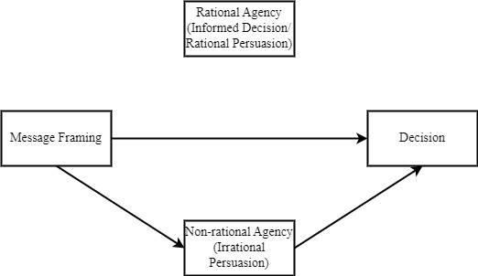

Figure 2
Process Model of Skilled Decision Theory
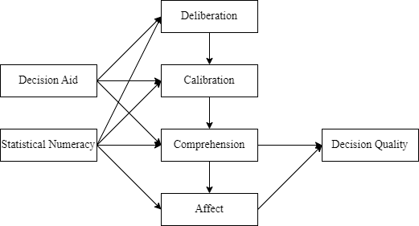
Figure 3
Understanding Score Differences about CPR, intermediate-AND, and DNR in Experiment 1a
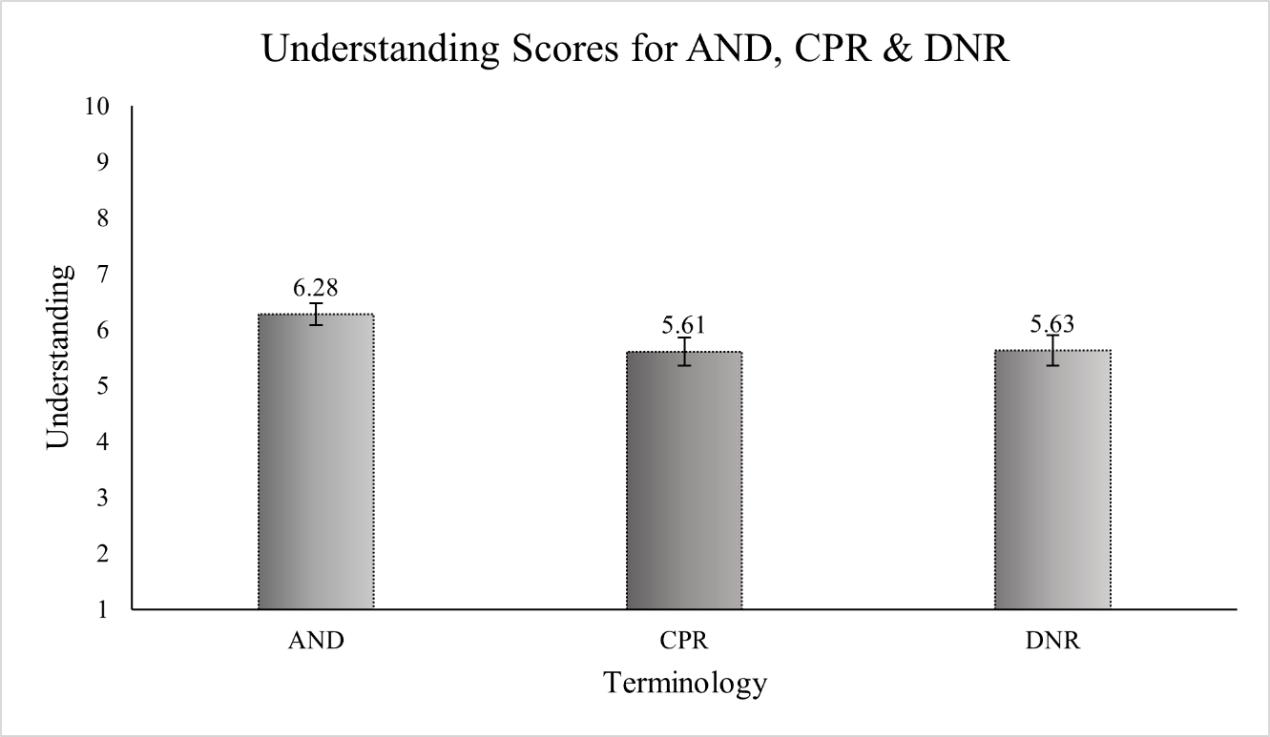
Note. Error bars are standard errors.

Figure 4
Positive Valence Score Differences about CPR, intermediate-AND, and DNR in Experiment 1a
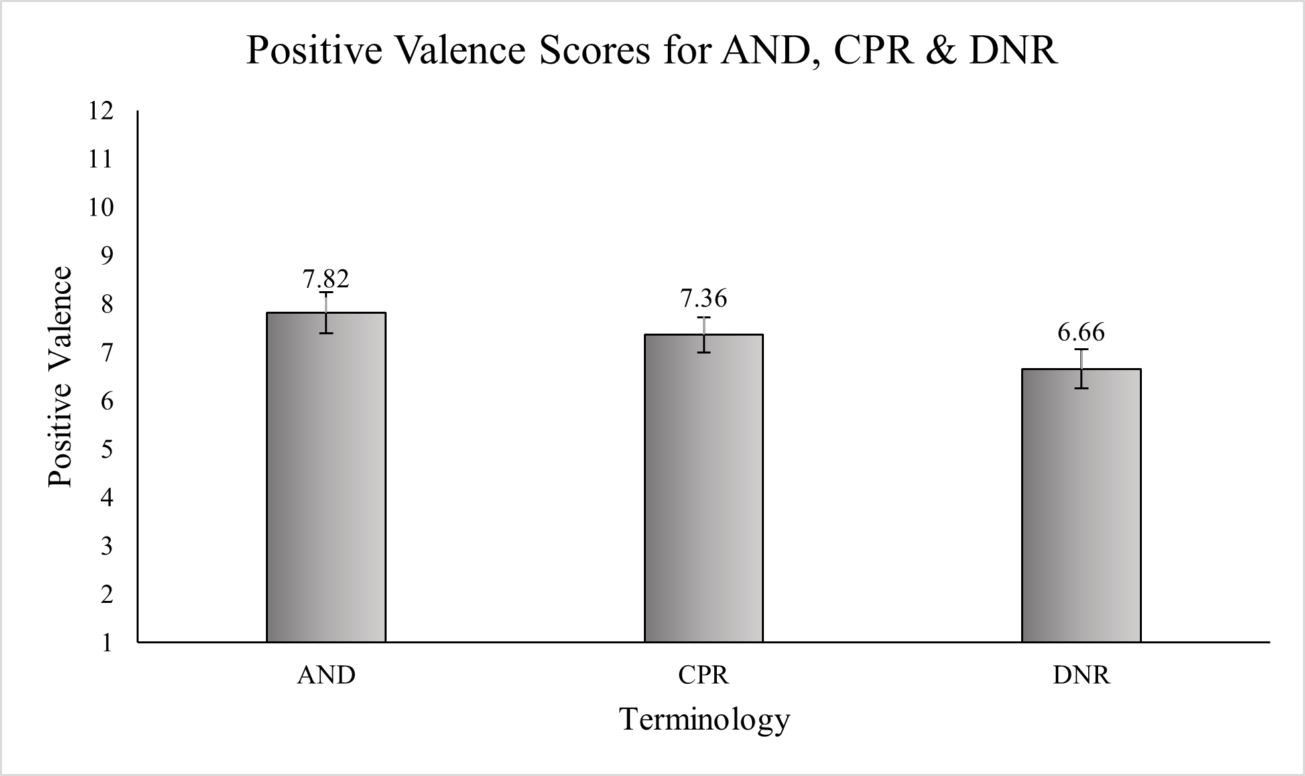
Note. Error bars are standard errors.

Figure 5
CPR Understanding Score Differences about CPR, intermediate-AND, and DNR in Experimen1b
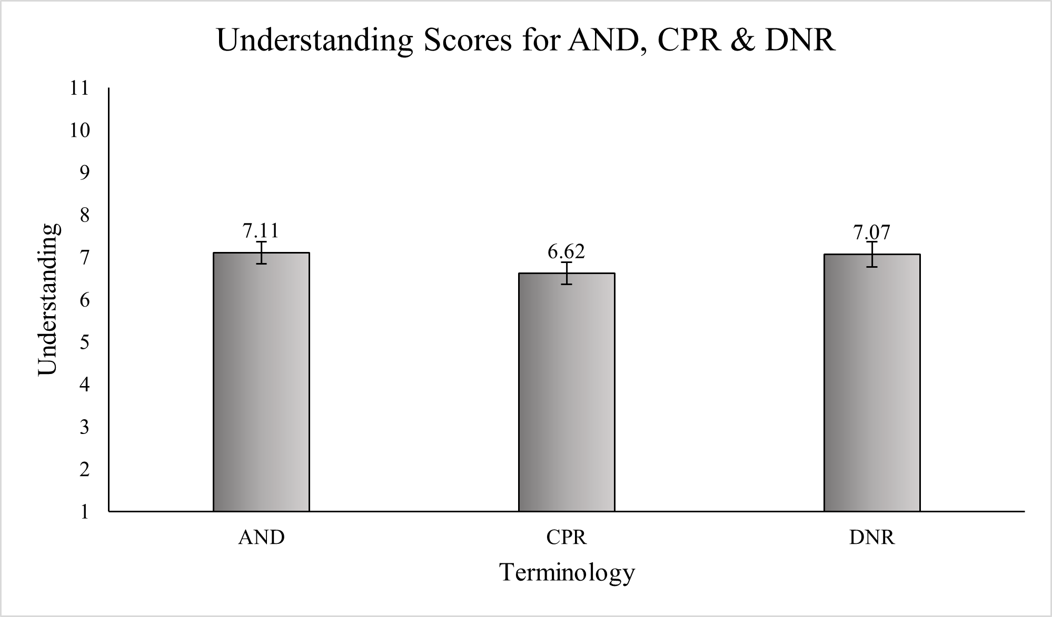
Note. Error bars are standard errors.

Figure 6
Positive Valence Score Differences about CPR, intermediate-AND, and DNR in Experimen1b
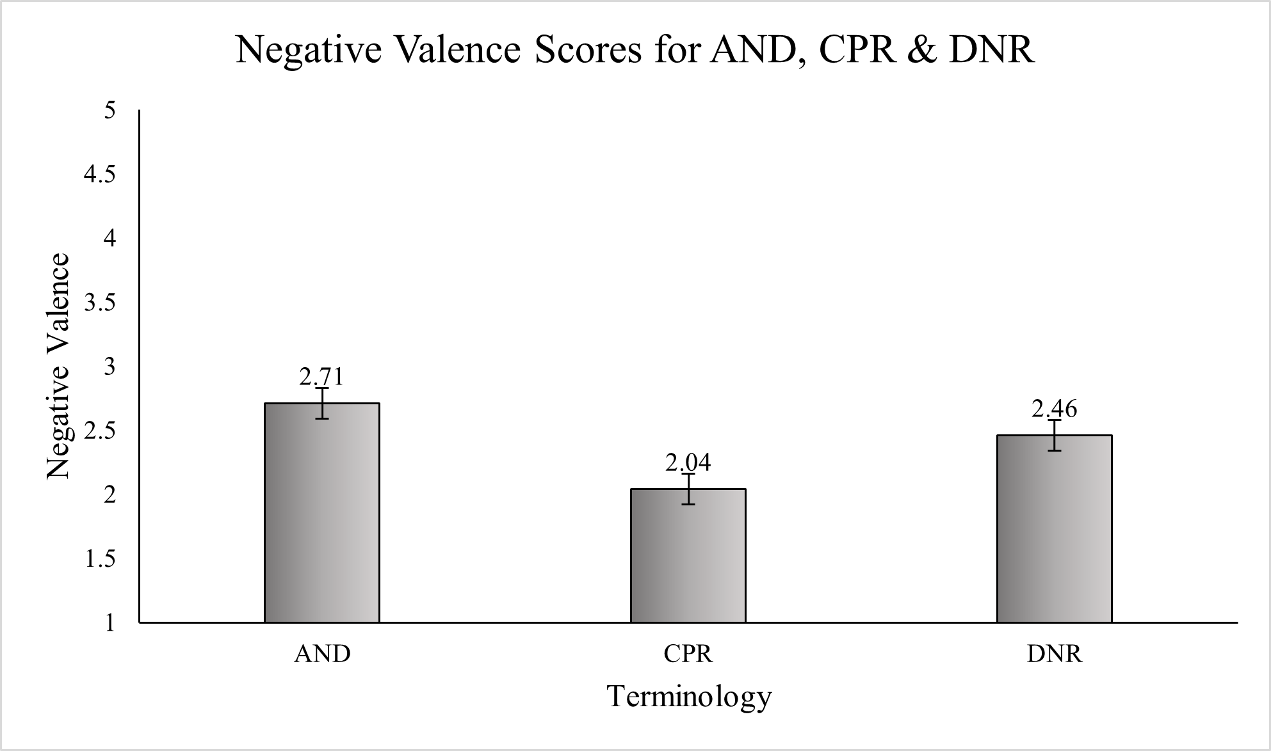
Note. Error bars are standard errors.

Figure 7
Comparison of Correlations between EOL Values and DNR Preference across Terminologies in Experiment 1b
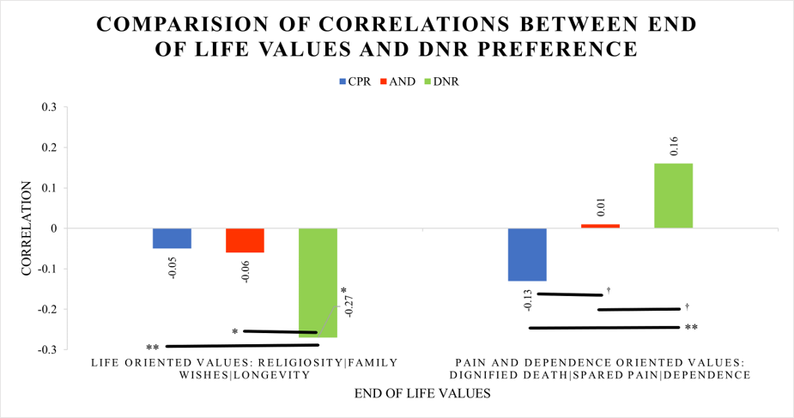
Note. †p < .10, *p < .05.

Figure 8
The Effects of Informing and Framing Nudge on the Probability to Write a DNR in Experiment 1c
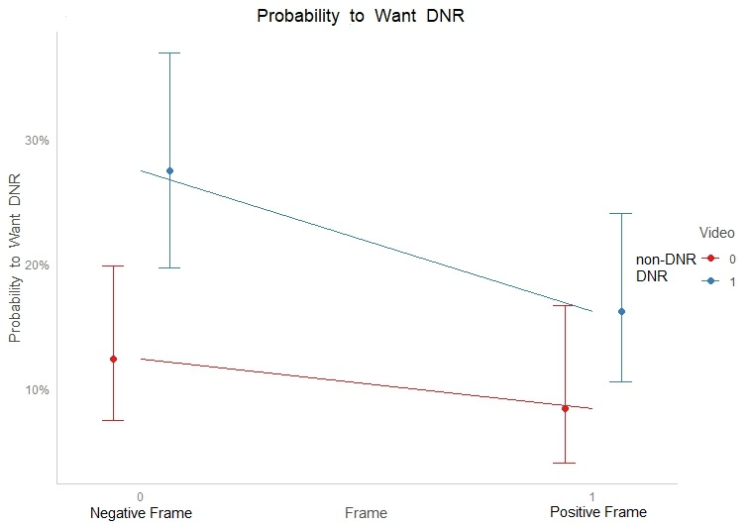

Figure 9
The Effects of Informing and Framing Nudge on the Probability to get CPR in Experiment 1c
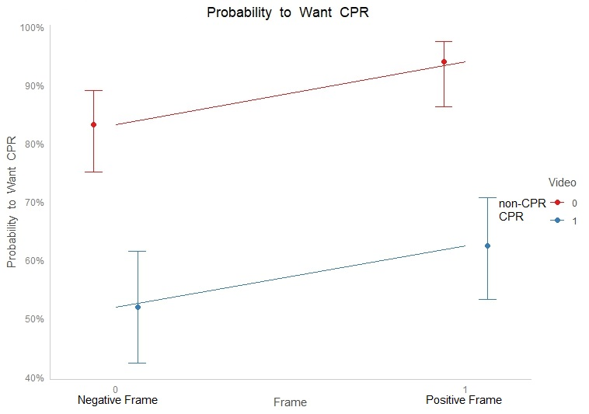

Figure 10
Comparison of Correlations between EOL Values and DNR Preference across Experimental Conditions in Experiment 2
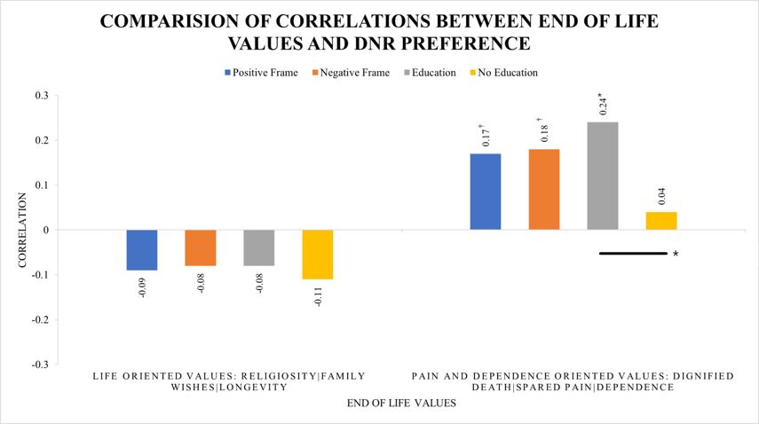
Note. †p < .10, *p < .05.

Figure 11
Comparison of Correlations between EOL Values and CPR Preference across Experimental Conditions in Experiment 2
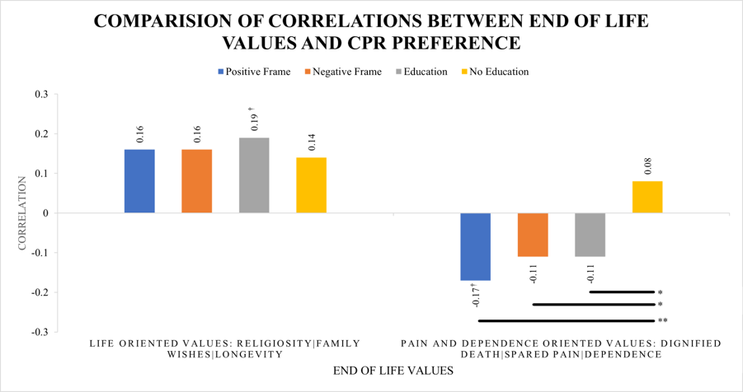
Note. †p < .10, *p < .05.

Figure 12
DNR Knowledge Before and After Across Interventions in Experiment 2
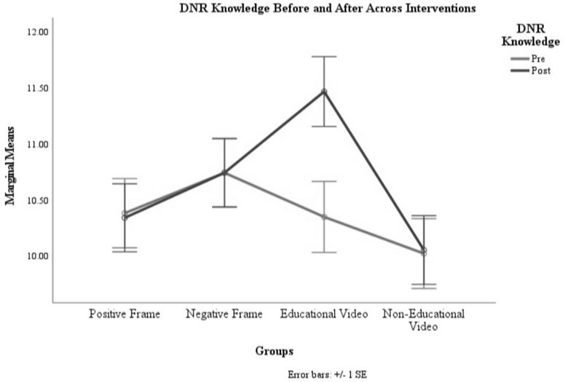

Figure 13
Mediational Model for DNR Preference in Experiment 2
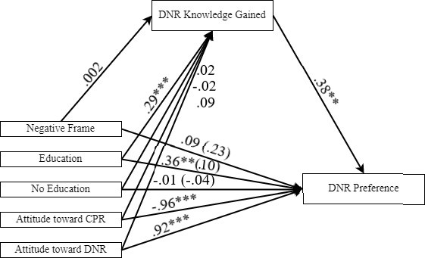
Note. ** p < .01, *** p < .001.

Figure 14
Mediational Model for CPR Preference in Experiment 2
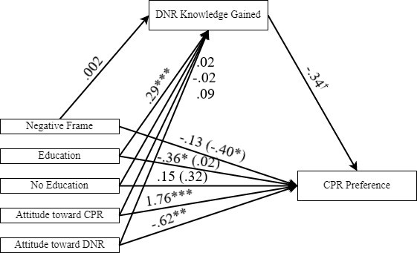
Note. †p < .10, * p < .05, ** p < .01, *** p < .001.

Figure 15
Attitude Toward DNR Before and After Across Interventions in Experiment 2
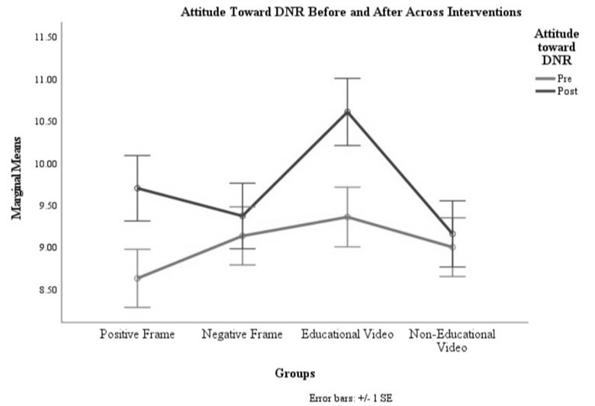
Figure 16
Attitude Toward CPR Before and After Across Interventions in Experiment 2
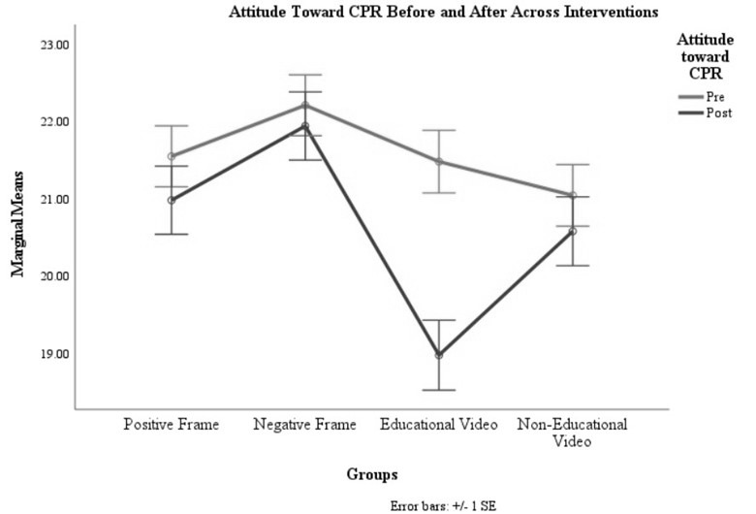
Figure 17
Item Characteristics Curve of DNR Knowledge Scale in Experiment 2
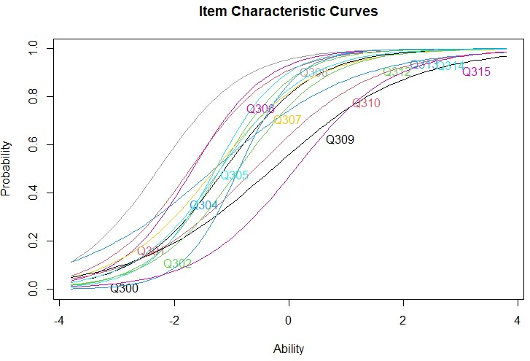

Figure 18
Item Information Curve of DNR Knowledge Scale in Experiment 2
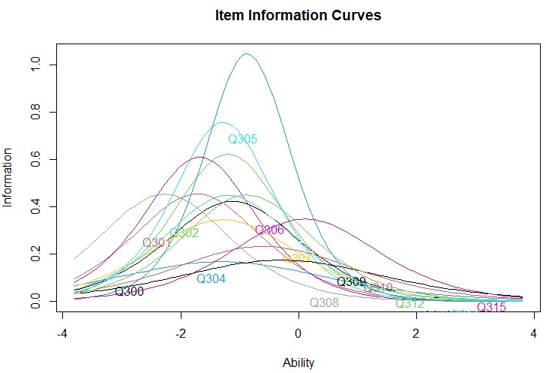

Figure 19
Test Information Function of DNR Knowledge Scale in Experiment 2
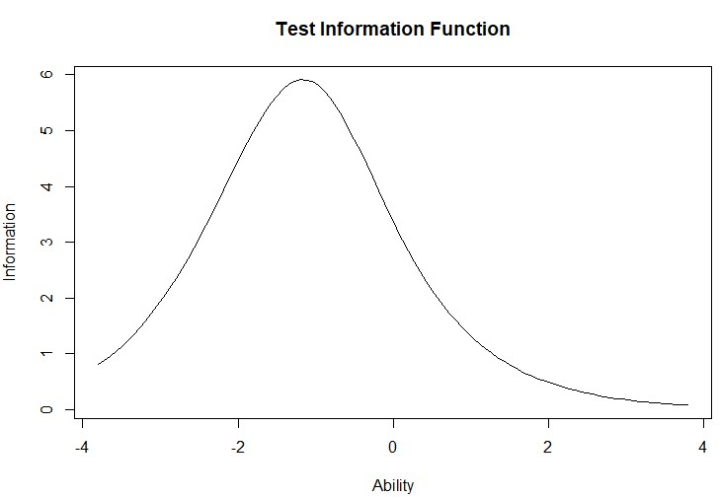

Table 1
LSD Post-Hoc Comparisons for CPR Understanding Across Terminologies in Experiment 1a
Groups |  | MD | SE | p
CPR | AND | -.67* | .33 | .046
 | DNR | -.02 | .32 | .943
AND | DNR | .65* | .33 | .047
Note. * p < .05.

Table 2
LSD Post-Hoc Comparisons for Positive Valence Across Terminologies in Experiment 1a
Groups |  | MD | SE | p
CPR | AND | -.46 | .58 | .432
 | DNR | .70 | .56 | .210
AND | DNR | 1.15* | .56 | .040
Note. * p < .05.

Table 3
LSD Post-Hoc Comparisons for CPR Understanding Across Terminologies in Experiment 1b
Groups |  | MD | SE | p
CPR | AND | -.49 | .39 | .210
 | DNR | -.46 | .39 | .240
AND | DNR | .04 | .39 | .925

Table 4
LSD Post-Hoc Comparisons for Negative Valence Across Terminologies in Experiment 1b
Groups |  | MD | SE | p
CPR | AND | -.67*** | .17 | .26
 | DNR | -.41* | .17 | .31
AND | DNR | .26 | .17 | .03
Note. * p < .05.

Table 5
Chi-Square Test for Groups and DNR Decision in Experiment 1b
Group | DNR Decision
Group | Yes | No
CPR | 12 | 82
AND | 44 | 47
DNR | 51 | 45
ꭓ² (2) = 38.83, p < .001

Table 6
Comparison of Correlations Between Life Oriented Values and DNR Preference Across Terminologies in Experiment 1b
Terminologies |  | Rstat | p | χ² | p
DNR (r = -.27**) | CPR (r = -.05) | 3.78** | .007 | 9.13* | .01
DNR (r = -.27**) | AND (r = -.06) | 3.62* | .011
CPR (r = -.05) | AND (r = -.06) | .17 | 1.00
Note. The correlation between Life Oriented values and DNR preference is provided in parentheses in respective condition. * p < .05, **p < .01.

Table 7
Comparison of Correlations Between Pain and Dependence Oriented Values and DNR Decision Across Terminologies in Experiment 1b
Terminologies |  | Rstat | p | χ² | p
DNR (r =.16) | CPR (r = -.13) | 4.87** | .001 | 11.82** | .003
DNR (r =.16) | AND (r =.01) | 2.52† | .074
CPR (r = -.13) | AND (r =.01) | 2.35† | .096
Note. The correlation between pain and dependence oriented values and DNR preference is provided in parentheses in respective condition. †p < .10, ** p < .01.

Table 8
The Effects of Informing and Framing Nudge on Preference to Write a DNR in Experiment 1c
Predictors | β | SE | OR | z | p(z)
Intercept | -1.96 | .28 | .14 | -6.85 | .000
Frame | -.42 | .49 | .65 | -.88 | .379
Video | .98 | .36 | 2.68 | 2.72 | .006
Frame*Video | -.24 | .68 | .79 | -.41 | .684
Note. β = standardized coefficient of prediction for logistic regression, SE = standard error, OR = Odd Ratios, z = Wald test statistic.

Table 9
The Effects of Informing and Framing Nudge on Preference to get CPR in Experiment 1c
Predictors | β | SE | OR | z | p(z)
Intercept | 1.60 | .25 | 4.95 | 6.36 | .000
Frame | 1.14 | .52 | 3.15 | 2.19 | .020
Video | -1.52 | .32 | .22 | -4.75 | .000
Frame*Video | -.72 | .59 | .49 | -1.21 | .220
Note. β = standardized coefficient of prediction for logistic regression, SE = standard error, OR = Odd Ratios, z = Wald test statistic.

Table 10
Correlations between EOL Values and Decisions in Experiment 2
CPR Preference and End of Life Values
 | Life Oriented Values | Pain and Dependence Oriented Values | Religiosity | Dignified Death | Spared Pain | Burdening Emotionally | Burdening Financially | Dependence | Family Wishes | Longevity
Positive Frame | .16 | -.17† | .06 | -.14 | -.18† | -.13 | -.17 | -.07 | .01 | .27**
Negative Frame | .16 | -.11 | .00 | -.13 | -.01 | -.07 | -.06 | -.18† | .07 | .30**
Education | .19† | -.11 | .02 | -.13 | .06 | -.12 | -.10 | -.10 | .10 | .32**
No Education | .14 | .08 | .10 | .14 | -.04 | .12 | .11 | -.03 | .01 | .16
DNR Preference and End of Life Values
Positive Frame | -.09 | .17† | .07 | .17† | .17 | .14 | .18 | .02 | -.01 | -.29**
Negative Frame | -.08 | .18† | -.02 | .18† | .03 | .11 | .11 | .28** | .04 | -.18†
Education | -.08 | .24* | -.03 | .17 | .12 | .20 | .21* | .17† | .02 | -.16
No Education | -.11 | .04 | -.10 | -.08 | .08 | .05 | .03 | .08 | .03 | -.13
Note. †p < .10, *p < .05, **p < .01. Life Oriented Values = Religiosity, Family Wishes, and Longevity; Pain and Dependence Oriented Values = Dignified Death, Spared Pain, Burdening Emotionally, Burdening Financially, Dependence.

Table 11
Descriptive Statistics of Pre-Post Knowledge, Groups, and their Interaction in Experiment 2
 | Pre-Post Knowledge | Marginal M | SE
 | Pre DNR Knowledge | 10.37 | .16
 | Post DNR Knowledge | 10.65 | .16
 | Groups | Marginal M | SE
 | Positive Frame | 10.36 | .29
 | Negative Frame | 10.74 | .29
 | Educational Video | 10.91 | .30
 | Irrelevant Video | 10.03 | .30
Pre-Post Knowledge | Groups | M | SD
Pre DNR Knowledge | Positive Frame | 10.35 | 3.17
 | Negative Frame | 10.74 | 2.79
 | Educational Video | 10.02 | 3.23
 | Irrelevant Video | 10.38 | 2.97
Post DNR Knowledge | Positive Frame | 11.47 | 2.64
 | Negative Frame | 10.74 | 2.92
 | Educational Video | 10.05 | 3.33
 | Irrelevant Video | 10.34 | 3.02

Table 12
Turkey Post-Hoc Comparison for Pre-Post DNR Knowledge in Experiment 2
Pre-Post DNR Knowledge |  | MD | SE | t | p
Pre DNR Knowledge | Post DNR Knowledge | -.28*** | .09 | -3.04 | .003
Note. **p < .01.

Table 13
Turkey Post-Hoc Comparisons for Groups*Pre-Post DNR Knowledge in Experiment 2
Groups * Pre-Post DNR Knowledge |  | MD | SE | t | p
Positive - Pre Knowledge | Negative - Pre Knowledge | -.36 | .43 | -.83 | 1.00
 | Education - Pre Knowledge | .03 | .44 | .08 | 1.00
 | Irrelevant – Pre Knowledge | .36 | .44 | .83 | 1.00
 | Positive – Post Knowledge | .04 | .18 | .23 | 1.00
 | Negative – Post Knowledge | -.36 | .43 | -.83 | 1.00
 | Education - Post Knowledge | -1.09 | .44 | -2.47 | .33
 | Irrelevant – Post Knowledge | .33 | .44 | .76 | 1.00
Negative-Pre Knowledge | Education - Pre Knowledge | .39 | .44 | .90 | 1.00
 | Irrelevant – Pre Knowledge | .72 | .44 | 1.66 | 1.00
 | Positive – Post Knowledge | .40 | .43 | .93 | 1.00
 | Negative – Post Knowledge | -.01 | .18 | -.01 | 1.00
 | Education - Post Knowledge | -.73 | .44 | -1.65 | 1.00
 | Irrelevant – Post Knowledge | .69 | .44 | 1.58 | 1.00
Education-Pre Knowledge | Irrelevant – Pre Knowledge | .33 | .44 | .74 | 1.00
 | Positive – Post Knowledge | .01 | .44 | .02 | 1.00
 | Negative – Post Knowledge | -.39 | .44 | -.90 | 1.00
 | Education - Post Knowledge | -1.12*** | .19 | -6.02 | .00
 | Irrelevant – Post Knowledge | .30 | .44 | .67 | 1.00
Irrelevant-Pre Knowledge | Positive – Post Knowledge | -.32 | .44 | -.73 | 1.00
 | Negative – Post Knowledge | -.72 | .44 | -1.66 | 1.00
 | Education - Post Knowledge | -1.45* | .44 | -3.28 | .03
 | Irrelevant – Post Knowledge | -.03 | .18 | -.17 | 1.00
Positive-Post Knowledge | Negative – Post Knowledge | -.40 | .43 | -.93 | 1.00
 | Education - Post Knowledge | -1.13 | .44 | -2.57 | .27
 | Irrelevant – Post Knowledge | .29 | .44 | .66 | 1.00
Negative-Post Knowledge | Education - Post Knowledge | -.73 | .44 | -1.65 | 1.00
 | Irrelevant – Post Knowledge | .69 | .44 | 1.58 | 1.00
Education-Post Knowledge | Irrelevant – Post Knowledge | 1.42* | .44 | 3.21 | .04
Note. *p < .05, ***p < .001.

Table 14
Descriptive Statistics of Pre-Post Attitude toward DNR, Groups, and their Interaction in Experiment 2
 | Pre-Post DNR Attitude | Marginal M | SE
 | Pre DNR Attitude | 9.02 | .19
 | Post DNR Attitude | 9.70 | .19
 | Groups | Marginal M | SE
 | Positive Frame | 9.16 | .35
 | Negative Frame | 9.25 | .35
 | Educational Video | 9.98 | .35
 | Irrelevant Video | 9.07 | .35
Pre-Post DNR Attitude | Groups | M | SD
Pre DNR Attitude | Positive Frame | 9.36 | 3.49
 | Negative Frame | 9.13 | 3.61
 | Educational Video | 9.00 | 3.38
 | Irrelevant Video | 8.63 | 3.11
Post CPR Attitude | Positive Frame | 10.61 | 3.95
 | Negative Frame | 9.37 | 3.89
 | Educational Video | 9.16 | 3.79
 | Irrelevant Video | 9.70 | 3.72

Table 15
Turkey Post-Hoc Comparison for Pre-Post Attitude toward DNR in Experiment 2
Pre-Post DNR Attitude |  | MD | SE | t | p
Pre DNR Attitude | Post DNR Attitude | -.68*** | .13 | -5.33 | .000
Note. ***p < .001.

Table 16
Turkey Post-Hoc Comparisons for Groups*Pre-Post DNR Attitude in Experiment 2
Groups * Pre-Post DNR Attitude |  | MD | SE | t | p
Positive - Pre DNR Attitude | Negative - Pre DNR Attitude | -.50 | .52 | -.97 | 1.00
 | Education - Pre DNR Attitude | -.73 | .52 | -1.38 | 1.00
 | Irrelevant – Pre DNR Attitude | -.37 | .52 | -.71 | 1.00
 | Positive – Post DNR Attitude | -1.07*** | .25 | -4.25 | .00
 | Negative – Post DNR Attitude | -.74 | .52 | -1.43 | 1.00
 | Education - Post DNR Attitude | -1.98** | .53 | -3.76 | .01
 | Irrelevant – Post DNR Attitude | -.53 | .52 | -1.01 | 1.00
Negative-Pre DNR Attitude | Education - Pre DNR Attitude | -.22 | .52 | -.42 | 1.00
 | Irrelevant – Pre DNR Attitude | .13 | .52 | .25 | 1.00
 | Positive – Post DNR Attitude | -.57 | .52 | -1.09 | 1.00
 | Negative – Post DNR Attitude | -.24 | .25 | -.94 | 1.00
 | Education - Post DNR Attitude | -1.48 | .53 | -2.80 | .13
 | Irrelevant – Post DNR Attitude | -.02 | .52 | -.05 | 1.00
Education-Pre DNR Attitude | Irrelevant – Pre DNR Attitude | .36 | .53 | .68 | 1.00
 | Positive – Post DNR Attitude | -.34 | .53 | -.65 | 1.00
 | Negative – Post DNR Attitude | -.01 | .53 | -.02 | 1.00
 | Education - Post DNR Attitude | -1.25*** | .26 | -4.82 | .00
 | Irrelevant – Post DNR Attitude | .20 | .52 | .38 | 1.00
Irrelevant-Pre DNR Attitude | Positive – Post DNR Attitude | -.70 | .52 | -1.34 | 1.00
 | Negative – Post DNR Attitude | -.37 | .52 | -.71 | 1.00
 | Education - Post DNR Attitude | -1.61 | .53 | -3.03 | .06
 | Irrelevant – Post DNR Attitude | -.16 | .25 | -.62 | 1.00
Positive-Post DNR Attitude | Negative – Post DNR Attitude | .33 | .53 | .63 | 1.00
 | Education - Post DNR Attitude | -.91 | .53 | -1.72 | 1.00
 | Irrelevant – Post DNR Attitude | .54 | .53 | 1.04 | 1.00
Negative-Post DNR Attitude | Education - Post DNR Attitude | -1.24 | .53 | -2.35 | .43
 | Irrelevant – Post DNR Attitude | .21 | .53 | .41 | 1.00
Education-Post DNR Attitude | Irrelevant – Post DNR Attitude | 1.45 | .53 | 2.74 | .15
Note. **p < .01, ***p < .001.

Table 17
Descriptive Statistics of Pre-Post Attitude toward CPR, Groups, and their Interaction in Experiment 2
 | Pre-Post CPR Attitude | Marginal M | SE
 | Pre CPR Attitude | 21.58 | .21
 | Post CPR Attitude | 20.63 | .21
 | Groups | Marginal M | SE
 | Positive Frame | 21.28 | .40
 | Negative Frame | 22.09 | .40
 | Educational Video | 20.24 | .40
 | Irrelevant Video | 20.81 | .40
Pre-Post CPR Attitude | Groups | M | SD
Pre CPR Attitude | Positive Frame | 21.48 | 3.66
 | Negative Frame | 22.21 | 3.71
 | Educational Video | 21.04 | 3.84
 | Irrelevant Video | 21.55 | 4.25
Post CPR Attitude | Positive Frame | 18.98 | 5.29
 | Negative Frame | 21.94 | 3.70
 | Educational Video | 20.58 | 4.00
 | Irrelevant Video | 20.98 | 4.24

Table 18
Turkey Post-Hoc Comparison for Pre-Post CPR Attitude in Experiment 2
Pre-Post CPR Attitude |  | MD | SE | t | p
Pre CPR Attitude | Post CPR Attitude | .95*** | .14 | 6.89 | .000
Note. ***p < .001.

Table 19
Turkey Post-Hoc Comparisons for Groups*Pre-Post CPR Attitude in Experiment 2
Groups * Pre-Post CPR Attitude |  | MD | SE | t | p
Positive - Pre CPR Attitude | Negative - Pre CPR Attitude | -.66 | .60 | -1.12 | 1.000
 | Education - Pre CPR Attitude | .07 | .60 | .11 | 1.000
 | Irrelevant – Pre CPR Attitude | .50 | .60 | .845 | 1.000
 | Positive – Post CPR Attitude | .57 | .27 | 2.08 | .728
 | Negative – Post CPR Attitude | -.39 | .60 | -.66 | 1.000
 | Education - Post CPR Attitude | 2.57*** | .60 | 4.29 | .000
 | Irrelevant – Post CPR Attitude | .97 | .60 | 1.63 | 1.000
Negative-Pre CPR Attitude | Education - Pre CPR Attitude | .73 | .60 | 1.22 | 1.000
 | Irrelevant – Pre CPR Attitude | 1.16 | .60 | 1.96 | .858
 | Positive – Post CPR Attitude | 1.23 | .60 | 2.08 | .728
 | Negative – Post CPR Attitude | .27 | .27 | .98 | 1.000
 | Education - Post CPR Attitude | 3.23*** | .60 | 5.39 | .000
 | Irrelevant – Post CPR Attitude | 1.63 | .60 | 2.74 | .140
Education-Pre CPR Attitude | Irrelevant – Pre CPR Attitude | .44 | .60 | .72 | 1.000
 | Positive – Post CPR Attitude | .50 | .60 | .83 | 1.000
 | Negative – Post CPR Attitude | -.46 | .60 | -.77 | 1.000
 | Education - Post CPR Attitude | 2.50*** | .28 | 8.92 | .000
 | Irrelevant – Post CPR Attitude | .90 | .60 | 1.50 | 1.000
Irrelevant-Pre CPR Attitude | Positive – Post CPR Attitude | .06 | .60 | .11 | 1.000
 | Negative – Post CPR Attitude | -.90 | .60 | -1.51 | 1.000
 | Education - Post CPR Attitude | 2.06* | .60 | 3.43 | .016
 | Irrelevant – Post CPR Attitude | .46 | .28 | 1.68 | 1.000
Positive-Post CPR Attitude | Negative – Post CPR Attitude | -.96 | .60 | -1.62 | 1.000
 | Education - Post CPR Attitude | 2.00* | .60 | 3.34 | .021
 | Irrelevant – Post CPR Attitude | .40 | .60 | .68 | 1.000
Negative-Post CPR Attitude | Education - Post CPR Attitude | 2.96*** | .60 | 4.94 | .000
 | Irrelevant – Post CPR Attitude | 1.36 | .60 | 2.29 | .450
Education-Post CPR Attitude | Irrelevant – Post CPR Attitude | -1.60 | .60 | -2.66 | .169
Note. *p < .05, ***p < .001

Table 20
IRT Properties of DNR Knowledge Scale in Experiment 2
 | Items | IRT Properties
 | Items | Difficulty Index | Discrimination Index | Probability
1 | Do not resuscitate orders (DNR) are not official medical documents. (R) | -1.11 | 1.30 | .81
2 | Cardiopulmonary resuscitation (CPR) includes chest compression and artificial ventilation. | -1.72 | 1.35 | .91
3 | Do not resuscitate orders (DNR) sabotage individuals’ right to exercise control over their medical care wishes. (R) | -1.19 | 1.58 | .87
4 | A do-not-resuscitate (DNR) order is an order not to apply cardiopulmonary resuscitation (CPR). | -1.30 | .82 | .74
5 | Individuals have the right to a doctor who is willing to administer cardiopulmonary resuscitation (CPR). | -1.28 | 1.74 | .90
6 | Individuals should not discuss their wishes about do-not-resuscitate (DNR) orders before they are sick. (R) | -1.68 | 1.56 | .93
7 | Unless there are good reasons not to, all patients receive cardiopulmonary resuscitation (CPR) if needed. | -1.28 | 1.18 | .82
8 | Individuals should discuss their wishes about do-not-resuscitate (DNR) orders with their decision making proxies. | -2.28 | 1.35 | .95
9 | Individuals can use an advance directive form as a do-not-resuscitate (DNR) order. | -.29 | .84 | .56
10 | Do-not-resuscitate (DNR) orders can be written by a lawyer. | -.59 | .97 | .64
11 | Do-not-resuscitate (DNR) orders cannot be changed. (R) | -.87 | 1.34 | .76
12 | Cardiopulmonary resuscitation (CPR) cannot be performed on individuals with terminal illnesses. (R) | -.87 | 2.05 | .85
13 | Cardiopulmonary resuscitation (CPR) cannot be performed on individuals of any age. (R) | -1.19 | 1.34 | .83
14 | Do-not-resuscitate (DNR) orders do not apply in all inside and outside of hospital settings. (R) | .11 | 1.18 | .47

Table 21
Exploratory Factor Analysis for Attitude toward CPR Scale in Experiment 2
Items | Factor 1
Items | λ | R²
You would like to get CPR if your heart stops beating? | .90 | .628
Even if the CPR provider is not medical professional, I would be willing to get CPR. | .87
I am willing get CPR, even with the potential consequences of CPR (e.g., broken ribs, internal bleeding). | .82
CPR is beneficial for the well-being of human beings. | .67
I recommend everyone should get CPR when needed. | .65

Table 22
Exploratory Factor Analysis for Attitude toward DNR Scale in Experiment 2
Items | Factor 1
Items | λ | R²
I would not like to get CPR if your heart stops beating? | .84 | .435
I would like to have a DNR, even if I’m healthy. | .76
DNR ensures a peaceful death. | .49
I recommend everyone should have a DNR. | .48

Table 23
Summary of Findings across Experiments
Experiments | Findings
Experiment 1a | - People have better understanding of AND terminology as compared to CPR and DNR.  - People feel more positive about AND terminology as compared to DNR.
Experiment 1b | - People do not understand AND, CPR and DNR terminologies differently.  - People feel least negative about CPR terminology as compared to AND and DNR.  - Beneficence was significantly high when DNR terminology was used as compared to when CPR and AND terminologies were used.
Experiment 1c | - Educational video predicted the higher probability of DNR preference and lower probability of CPR preference.  - Positive frame predicted only the higher probability of CPR preference.  - Interactions of informing and framing for CPR and DNR preferences were non-significant.
Experiment 2 | - Education performed better than control condition in protecting beneficence for both CPR and DNR decisions.  - Framing (both positive and negative frames) also performed better than control condition in protecting beneficence for CPR decision.  - DNR knowledge increased while attitude toward CPR scores decreased in educational video condition only.  - DNR knowledge gain fully mediated the positive effect of education on DNR preference after controlling for attitudes toward CPR and DNR.  - DNR knowledge gain fully mediated the negative effect of education on CPR preference after controlling for attitudes toward CPR and DNR.

