UNIVERSITY OF OKLAHOMA
GRAUDATE COLLEGE

TEACHING MUSIC THEORY THROUGH MUSICAL THEATRE REPERTOIRE

A THESIS
SUBMITTED TO THE GRADUATE FACULTY
in partial fulfillment of the requirements for the
Degree of
MASTER OF MUSIC

By
JAMISON TANNER HARROD
Norman, Oklahoma
2020

TEACHING MUSIC THEORY THROUGH MUSICAL THEATRE REPERTOIRE

A THESIS APPROVED FOR THE
SCHOOL OF MUSIC

BY THE COMMITTEE CONSISTING OF

Dr. Jeffrey Swinkin, Chair
Dr. Michael Lee
Mr. Jay Wilkinson

© Copyright by JAMISON TANNER HARROD 2020
All Rights Reserved.

Contents

Abstract v

Acknowledgements vi

Introduction 1

Chapter 1. Direct Modulation 17

Chapter 2. Form 31

Chapter 3. Counterpoint 60

Conclusion 86

Bibliography 89

ABSTRACT

This document uses musical theatre repertoire to both reinforce and extend music-theoretical concepts typically taught in undergraduate theory sequences. Three such concepts—modulation, form, and counterpoint—are examined first by analyzing select songs from the wide body of American musical theatre literature. While tools taught in the theory sequence are used to analyze said theatre songs, jazz theory and popular music analysis also factor into our understanding of this music, allowing for an expanded treatment of common-practice theoretical methods. The repertoire selected for analysis ranges from the Tin Pan Alley musicals of the 1930s to contemporary productions, and embeds various other styles, such as jazz, pop, rock, and hip hop. Consequently, when students learn theory via musical theatre, they see concepts deployed within a wide swath of stylistic settings. In addition to viewing each topic from a strict music-theoretical viewpoint, this document emphasizes the dramatic element, allowing students and instructors to explore the relationships between music, its structure, and the on-stage drama. Each chapter, after analyzing theatre songs, will take up pedagogical considerations, posing teaching scenarios involving theatre repertoire that readers might emulate.

ACKNOWLEDGEMENTS

I would like to thank my advisor, Dr. Jeffrey Swinkin, for his support and mentorship throughout my time at the University of Oklahoma. Thank you for your continued support of my educational goals and the countless amount of advice you’ve provided me the last two years.
I wish to show my gratitude to each of my students that I have had the pleasure of teaching during my time here at OU. It has been an honor to watch you all grow throughout the theory sequence. I look forward to seeing each and every one of you succeed in your careers and will continue to root for you once our time together is over.
I also extend my thanks to my fellow theory graduate assistants—Alexis Barton, Emily Gilbertson, David Lim, David Marvel, Katie Ostrosky, and Caleb Westby—for being the very best friends, colleagues, and coworkers I could ask for. Each one of you has been an inspiration to me as a teacher, and I am blessed to also consider you to be my dear friends. Thank you for all your encouragement and support, I would not have been able to complete this document without you.
To my parents, Carson and Tiffany Harrod, and my sister, Savannah, thank you for the love and support you have given me my entire life. You all have encouraged my pursuit of music my entire life, without which none of this work would have been possible.
Lastly, I wish to express my deepest gratitude to my fiancée, Mily Montanez. Thank you so much for the love you show me every day and for always being by my side. Thank you for encouraging me to pursue music theory in my graduate studies. Thank you for being my confidant and my best friend. I love you.

Introduction

I. Motivations Behind Study
Some instructors of freshman and sophomore music theory might agree that including popular music of any kind in the curriculum can be a fruitful endeavor, one that has the potential to enrich learning for the undergraduate student. Still, many of those instructors avoid popular music in favor of common-practice—Baroque, Classical, and Romantic—repertoire. The reasons for this might be multifaceted and vary from teacher to teacher. Perhaps the instructor or institution feels that there is simply not enough time in the (typically) four-semester theory sequence to include other styles of music. That is, extra time might be required to explain why certain “rules” now function differently—or appear to be broken altogether. Other instructors might deem themselves unqualified to teach popular music or other musical styles due to their own lack of immersion in it.
This document draws on musical theatre literature to demonstrate how including such repertoire—and, by extension, popular music more broadly—can both support and augment the teaching of common-practice-oriented music theory. In this vein, I will address three subjects—modulation (specifically, direct modulation), form, and counterpoint—using musical theatre; after discussing each topic, I will present pedagogical scenarios that employ such music.
My primary motivations are to redress the fairly scant use of musical theatre repertoire in music theory textbooks and classrooms and to advocate for greater inclusion the core theory curriculum. I advocate for its inclusion because such repertoire can reinforce standard concepts using a wider swath of styles which reflects and accommodates the diversity of musical tastes among students and prepares students to be at least somewhat fluent in a style they may have to perform or teach. Additionally, such repertoire can force one to venture beyond stand concepts—ones that were primarily engineered for composers such as Bach, Mozart, and Beethoven—to encourage analytic versatility and flexibility in general and to develop analytic tools adequate to the exigencies to theatre music in particular. In pursuit of these motivations I will address three different core-theory topics and consider how theatre-music analysis both affirms and extends their common-practice usage. I will also consider the specifically pedagogical side of each topic by considering where and how these topics might fit into a more standard curriculum and exhibiting concrete pedagogical scenarios, to show how these topics and songs might be deployed in actual classrooms.

II. Literature Review
Here it will be helpful to review some studies that take music-analytic approaches to theatre music as well as research that discusses or demonstrates its use in the theory classroom. As a precursor, I will first explore literature that provides insight to the current inclusion of popular music of any kind within the curriculum. The 2014 conference of the College Music Society featured a report from the Task Force on the Undergraduate Music Major, entitled “Transforming Music Study from its Foundations: A Manifesto for Progressive Change in the Undergraduate Preparation of Music Majors.” This report lays out three key areas that undergraduate music programs need to develop in order to “ensure the relevance, quality, and rigor of the undergraduate music curriculum.” These areas are creativity: the curricular synthesis of improvisation, composition, and the study and performance of existing music; diversity: students intellectually and performatively engaging with music from a wide variety of cultural backgrounds; and integration: to quote the taskforce, “the content of the undergraduate music curriculum must be integrated at deep levels and in ways that advance understanding, interpretive performance, and creativity as a holistic foundation of growth and maturation.” The Manifesto offers several possibilities for implementing these changes in the theory curriculum. Primarily, they encourage greater inclusion of music by black composers, especially jazz, as the TFUMM notes that “jazz…[intersects] with key European common practice structures, yet also [encompasses] a modal-tonal-post-tonal spectrum that connects with today’s musical world.” The Manifesto also emphasizes that common-practice music should not be replaced, but rather that all styles should have equal weight in the classroom. Additionally, the document calls for more integration between music theory, music history, and the and the music program as a whole. In publishing this report, the College Music Society endorses a change of music theory’s role within the undergraduate music curriculum that calls for more inclusion, integration, and diversity in both the study and performance of music.
Jennifer Sterling Snodgrass criticized the Manifesto for its lack of citations, dearth of hard data, and what she describes as a “one-size-fits-all” solution to the issues it presents.” Snodgrass provides the results of surveys she organized of members of both the Society of Music Theory and the College Music Society, which, despite relatively few participants, indicates that many of the solutions the Manifesto calls for are actually being implemented in many theory classrooms. She does not, however, posit any correlation between the Manifesto’s publication in 2014 and the results of her survey. Instead, she concludes, “Perhaps through the conversation that has begun due to the publication of the Manifesto we can continue this discussion, moving forward with a better understanding of what is truly happening in our classrooms around the country without unsupported claims and generalizations.”
In 2017, Barbara Murphy and Brendan McConville published an update to Richard Nelson’s 2000 survey of the music theory undergraduate core curriculum. In their survey of 259 programs, participants were asked about three topics in the area of popular and jazz music, and if they appeared in their core written theory sequence. 45.56% of programs covered what they labeled as “pop music analysis”, 22.01% of programs covered jazz theory, while only 3.86% of programs used the Nashville number system. Murphy and McConville view these statistics in a positive light: “Although the percentages of schools including popular music analysis and jazz theory could be considered low, these numbers might actually be encouraging. That these topics are included in the core sequence at all in 2017 is important since they were not even mentioned in the 2000 survey.” Survey questions concerning aural skills classes did not ask about what styles of music are used in the courses, so no information about this is available. When asked about making changes to the written-skills curriculum, 17 schools indicated a desire for “more of ‘other’ types of music,” while five schools indicated that they wanted more jazz in the curriculum. In regard to aural-skills programs, eight schools wanted to have more types of music in their curriculum (again, without knowing the kinds of music that programs are currently using, this small number doesn’t mean much). The next update of this survey is planned for 2022, and it will be interesting to see how these numbers evolve. At present, while pedagogues might feel that incorporating diverse styles of music is important to young musicians’ development, only a small number of institutions actually put that philosophy into practice.
Jazz music, or at least jazz-influenced music, has been studied in an academic context since the late twentieth century. Steven E. Gilbert takes a modified Schenkerian approach to several of Gershwin’s pieces. Although Schenker himself had no interest whatsoever in Gershwin’s music or anything similar to it, Gilbert uses this approach to highlight the contrapuntal complexity of the composer’s music. While Gilbert does find that the melodic and contrapuntal content of Gershwin’s music can be analyzed using a Schenkerian model, it is also important to note that Gilbert sees Schenkerian analysis as “a test of quality” and that “a good piece of music [such as those Gilbert analyzes] will be rich in the kind of organic, hierarchical relationships that were the focus of Schenker’s work.” The notion of utilizing a specific analytical tool as a way of determining quality of any music is beyond the scope of this document. However, using Schenkerian-based tools to study jazz-influenced music will be of interest when we discuss modulations in the theatre music of Frank Loesser.
Nicole Biamonte analyzes harmonic structure and syntax in rock music, reconciling it with the behavior of pitch and harmony in common-practice music. After a brief overview of how modal progressions can be understood in the same way tonal progressions are discussed, she devotes time to double-plagal progressions (i.e. bVII-IV-I) as well as progressions in the Aeolian mode. In both cases, Biamonte gives harmonic progressions functional labels: “neighboring,” “passing,” “circular,” “closed,” and “open.” These labels help us understand the repetitive aspects of chord progressions in pop and rock music. She also reconciles the use of pentatonic scales and pentatonic-based music with tonic-predominant-dominant functions. She ultimately argues that, while “the surface syntax of these modal and pentatonic systems stands in contrast to a historical … background of major-minor tonality … at a deeper level they express many of the [same] underlying principles….”
Several articles have been devoted to the intersection of music theory pedagogy and popular music. Timothy K. Chenette sets out to help music theory instructors use the music of popular styles to meet the changing musical landscape and provide students with intrinsic motivation by teaching theory using examples reflecting their musical interests. As Chenette states in his thesis, “… every degree of choice and creativity one allows to students—within the constraints of a course’s purpose, goals, and available resource—… invites students to greater success in any curriculum.” After discussing trends in and reasons for incorporating popular music in the theory classroom, Chenette provides several examples at varying instructional levels, spanning both the written and aural skills curricula, from the beginning of the fundamentals unit to upper-level undergraduate courses. Throughout the article and in his conclusion, he stresses the importance of bringing student’s musical experiences and interests into the classroom, making strong cases for the further incorporation of popular music in the theory classroom.
The inclusion of popular music does not have to be limited to Western popular music. Nigerian scholar Austin Emielu discusses the need for more analysis of what he calls “African pop” – a catch-all term for the popular music of the African continent, regardless of country of origin. Emielu describes African pop as “a macrocosm of musical expressions which seem to have distinctive strands, but yet have some centrally binding musical and extra-musical concepts.” While spending much of his article on Highlife music (music originating in West Africa that fuses traditional African music with Western jazz-influenced styles), Emielu emphasizes African pop’s cultural importance through social construction, deconstruction, and reconstruction. This article serves as a reminder for the music theory curriculum to be global in its choices of music, and African pop can help achieve this goal.
Stuart Folse describes the pedagogical applications of Shania Twain’s “You’re Still the One” and The Eagles’ “New Kid in Town.” Of the Twain, Folse takes time to point out its variety of tonic, predominant, and dominant functions. He does this in conjunction with a variation on the typical harmonic dictation exercise found in the aural skills classroom, by which he only has students write in the chord changes above a lyric sheet, as opposed to transcribing the soprano and bass pitches and then determining the harmonic content. He also uses this piece as an opportunity to discuss a common element of popular music – moving from V to IV. He shows his students that, in this context, “the IV chord delays the resolution of V through harmonic embellishment or possibly through a cadential extension.” In the Eagles’ New Kid in Town, Folse discusses on two major topics: non-dominant secondary function (such as IV/IV) as well the abundance of mediant relationships. The former Folse uses in Aural Skills II, the latter, in Musicianship III. Of both examples (or any use of popular music) Folse asserts that “by utilizing examples not associated with the ‘normal’ theory textbook, students are guided to encounter all music…as musicians, energetically participating in the process of understanding what they experience.” Folse strongly believes that including popular music in the curriculum enhances students’ overall musicianship.
Patricia Julien has documented several pedagogical tools used in her Advanced Jazz Composition and Arranging course, but these tools can also be used in the basic theory core curriculum. She begins by having students consider form, then key areas, followed by choosing the chords to fit into these larger structures, while having students look for opportunities to explore jazz harmonic language through chord substitutions and applied chords. Julien also gives instructors ideas for incorporating jazz composition into the theory classroom over multiple class sessions. Exercises such as Julien’s provide students an applied activity for classical, jazz, and popular harmonic progressions taught in class.
Nancy Rosenberg teaches harmonic progressions of both common-practice music and popular music at the same time by restructuring the curriculum into four categories: “Single-chord works and static harmony,” “Two- and three-chord progressions,” “Standard chord progressions of four or more chords,” and “Other progressions of four or more chords.” The first two she teaches in the first semester of the written-skills class, while the second two are taught in the second semester. Additionally, Rosenberg provides an appendix for each category with a list of examples instructors can use to teach it. While she does give a variety of examples and lessons to use in each of these units, Rosenberg does not explain how the first year of music theory progresses into the second year—especially as many of the chromatic aspects of tonal music are compressed into her Category IV which she teaches at the end of the first year. Rosenberg also claims that “jazz, musical theater, film music, and other genres are beyond this discussion’s scope,” yet, conceptually, these styles could be taught within her paradigm, as her goal is to teach both popular music and common-practice music at the same time.
Guy Capuzzo describes ways to teach riffs in the theory curriculum, which he claims receive far less attention than form, melody, and harmony. He primarily does this by identifying what he labels as scale-degree patterns (SDPs) very similar in concept to pitch-class sets used in the analysis of twentieth-century music. As this article primarily features the minor pentatonic scale, Capuzzo provides a variety of singing exercises using every combination of two-, three-, and four-note SDPs that make up the minor pentatonic scale. He then brings in a plethora of riffs from rock music that feature these SDPs. His goal in these exercises is to “offer a concise approach to the pitch language of minor pentatonic riffs.” Such activities could of course be applied to riffs using scales besides the minor pentatonic.
Homing in, now, on the genre of musical theatre, two recent textbooks have been written for the musical theatre student studying music theory. John Bell and Steven R. Chicurel’s 2008 book Music Theory for Musical Theatre can serve as a supplement to a musical theatre students’ other resources in music theory (or to a student interested in the musical theatre repertoire). The book itself does not actually contain enough theoretical content to be used as a primary text in a music theory classroom, even in a theory course exclusively for musical theatre majors. Part 1 of the book contains all “Rudiments of Music,” covering the construction of intervals through basic chords including the V⁷, all content typically taught in the first semester of music theory. This part of the book also provides a brief discussion of the form of musical theatre. Part 2 includes “Essays in Music Analysis” (all examples are of musical theatre music), while Part 3 is a workbook with which students can practice the material introduced in Part 1. While this book can be helpful for the first semester of music theory, especially in diversifying repertoire used in that class, other materials are needed to supplement this text; still, for instructors looking for more varied examples, this book is a valuable resource.
2015 saw the release of Music Theory Through Musical Theatre, a textbook by John Franceschina designed to give musical theatre majors a similar experience to what other music majors receive in the standard undergraduate music theory sequence. Franceschina finds that musical theatre majors who are required to take traditional theory courses tend to see them as not directly applicable to their studies. Franceschina is careful to include only what deems to be the most important topics for musical theatre students in the book, and the noticeable absence of other subject matter is often deemed crucial to music theory training for the traditional music major.
By and large, this textbook teaches harmony. The majority of the book deals with chords ranging from diatonic triads, applied chords, the Neapolitan and Augmented-Sixth chords, modulation and tonicization, all the way to extended tertian harmonies. It should be noted that it does not cover post-tonal concepts, as the vast majority of musical theatre is quite tonal. Although the book fixates on harmony, figured bass is mentioned only in passing, when discussing inversions. The book does use Roman numerals, but not figured bass symbols, instead labeling inversions in lead sheet notation. Another key component of harmony missing is voice leading, which is not mentioned at all in the book. Other aspects of music receive significantly less time than harmony. Counterpoint is the crux of two chapters, taught after diatonic harmony and before chromatic harmony. This includes first through fifth species counterpoint and a brief discussion of the fugue. In regard to Form, the book only touches on cadences, phrases, periods, and sentences, followed by a description of song forms. Common-practice instrumental forms are missing and would need to be included through supplemental materials. The emphasis on harmony and less attention on other components of music stem from Franceschina’s thesis, in that musical theatre scores do not have figured bass, so students do not need to spend time studying the concept.
While this textbook would be appropriate in a section consisting entirely of musical theatre majors, it could not be used as a primary text in a blended section with other music majors. It skimps on some core concepts of common-practice music; these, even where not directly applicable to musical theatre performance and literature, are helpful in developing well-rounded musicians. Theory teachers would be wise to select a more traditional theory text and use this as a supplement, especially as a resource from which to pull examples, bringing musical theatre into the classroom for all music students.

III. Broader Issues and a Layout of the Thesis
My reasoning for focusing on musical theatre specifically is twofold. First, musical theatre is extremely diverse stylistically: it ranges from big-band jazz à la Guys and Dolls to the modern rock stylings of Heathers to the hip-hop of Hamilton. Second, musical theatre is already studied on many college and university campuses. Several institutions offer degrees in musical-theatre performance, often requiring at least a semester or two of music theory. Musical theatre students should have the music they perform included within their theory curriculum while also being exposed to the common-practice music their music-major colleagues primarily study; and, conversely, music majors should be exposed to the repertoire their musical theatre counterparts focus on.
Moreover, musical theatre is often performed by musicians with some level of formal training. While pop and rock bands, for instance, might not consist of guitarists and vocalists with degrees in music, actors and pit musicians often go through years of schooling to work in professional theatre. The music education major might well end up as the director of a high school musical at some point in his or her career. As the way musicians earn their incomes continually changes, it becomes the responsibility of music teachers to expose their students to a plethora of musical styles to better prepare them for the realities of the profession. In short, including musical theatre (and all popular music styles) in the theory sequence can be both enriching and eminently pragmatic.
While familiarizing students with the musical theatre repertoire before they enter the workforce is a fine practical reason for its inclusion, there is a music-theoretical reason as well. As mentioned at the forefront, it is the goal of this document to show that not only can a knowledge of common-practice theory deepen our understanding of musical theatre music, but that very music can reinforce the common-practice concepts we already teach. Moreover, when musical theatre repertoire goes beyond our traditional understanding of common-practice theory, an opportunity presents itself to introduce students to the differences between common-practice and popular music theory. I recognize, of course, that some skeptics might feel that exposing students to these differences might cause some harm. Once we start showing examples that seem to “break the rules,” students might claim anything they don’t fully understand to be a similarly exceptional circumstance. Students might not engage with a particularly difficult assignment if they think it’s a trick question because one of their precious rules was not followed. I am certainly sympathetic to these concerns. My aim here, however, is to accommodate musical theatre repertoire with established, though occasionally modified, theoretical tools. Still, it is pedagogue’s responsibility to carefully demonstrate where it is stylistically appropriate to break from the traditional understandings of common-practice theory.
This document consists of three main chapters, each focused on a subject taught within the core theory sequence. Each chapter will analyze numerous selections of musical theatre literature using a variety of common-practice paradigms—and extensions thereof. Following these analyses, I will suggest ways to incorporate what we have studied into lesson plans for the undergraduate theory classroom. Scrips will provide a place to begin discussions on the subject matter between the teacher and their students.
The first chapter’s central topic is modulations, which are heavily taught in the classroom once the instructor has introduced chromatic harmony. Specifically, this chapter deals with direct modulations—moving abruptly from one key to another without the use of a pivot chord. This is a prototypical technique of the musical theatre composer, who often takes the last chorus of a song up a half or whole step to intensify the onstage drama. To complement the analysis of each modulation, we will investigate the songs in question for their dramatic content, to discuss why exactly the composer may have chosen to implement a given modulation at that specific point in the music.
Following our study of direct modulation, the second chapter is devoted to form in the musical theatre song. Following a summary of how the most common theory texts teach form, the chapter explores both micro and macro forms within the musical theatre song, as well as how the form of contemporary pop music has been integrated within the musical theatre repertory. A significant portion of the chapter is dedicated to the Rhythm Changes, which consists of both a specific form and harmonic progression. This allows for comparisons between the Rhythm Changes, a jazz form, and common-practice forms that also have form-defining harmonic events, such as the sonata.
Finally, the last chapter centers on counterpoint. After a review of the counterpoint typically taught within the theory sequence, I analyze the contrapuntal content of three stylistically distinct selections from the musical theatre repertoire. In doing so, I describe what I label as dramatic counterpoint—counterpoint that relies on dynamics, register, and other secondary parameters to amplify the drama of both the music and the plot. The notion of dramatic counterpoint is carried into the pedagogical example, which compares musical theatre counterpoint with a Bach invention to show how the added context of a story affects the composer’s use of counterpoint.
This document will ideally help ease those who may have trepidations when it comes to incorporating musical theatre into the music theory classroom. Skeptics who believe that their time is better spent focusing on common-practice music exclusively should have confidence that musical theatre can not only reinforce those traditionally taught concepts but expand students’ knowledge of said concepts through this form of popular music. The practical applications provided in each chapter should give the musical theatre or popular music novice a foundation to begin introducing these concepts to students who will also be learning how to understand popular music in this way for the first time as well. At the same time, the instructor should not feel the need to be able to be the expert all the time. When a student asks the instructor a question that he or she might not have the answer to, it provides the instructor an opportunity to seek out opinions from respected peers and colleagues for both the instructor’s edification and to answer the student’s question. The examples here allow for teachers and students alike to both better understand and better appreciate a cornerstone of American popular music.

Chapter 1
Direct Modulation

I. Introduction
One of the most often-used modulatory techniques in musical theatre is so-called direct modulation. Direct modulations occur when the key of the piece changes but is not established with the help of any sort of pivot chord, at least not one diatonic to both keys. This kind of modulation usually occur between distantly related keys. In musical theatre, as well as in other popular styles, one of the most common direct modulations is from the home key to one half or whole step higher.
Adam Ricci calls a direct modulation in pop music (or similar popular styles) a “pump-up.” In studying the Chicago songs “Hard Habit to Break” and “You’re the Inspiration,” Ricci identifies how a pump-up can arise and the significant role it plays within an overall tonal structure. Ricci affords these modulations considerable significance, in terms both of structure and of text, whose meaning the modulations underline.
In Ricci’s examples, and also in the musical theatre examples this chapter will explore, direct modulations play a crucial role in the strategy of directional tonality—these songs end in different keys than where they begin. These songs pose a challenge to monotonality and theories thereof, especially that of Heinrich Schenker, for whom any truly tonal piece would need to rest entirely in one key. Ricci notes that “in order for songs with pump-ups to be considered . . . tonally closed structures, the music after the pump-up must be unceremoniously lopped off, treated as outside the song proper.” Ricci demurs, regarding such keys as tonally integral, thus going against what he views as the logic of monotonality, where the material after the key change would necessarily be additive, essentially postscripts to a closed and monotonal structure.
Michael Buchler addresses direct modulations in musical theatre, citing examples from two of Frank Loesser’s most successful musicals, Guys and Dolls and How to Succeed in Business Without Really Trying. He notes that some songs utilize direct modulations simply to allow actors of different voice types to sing the same musical material; that is, one character will sing material in the original key, the music will modulate, and the next character will sing in the new key, one better suited to his or her range. Still, he continues, in many cases Loesser will use direct modulations to convey meaning and to amplify dramatic elements of the text. Studying four songs, Buchler notes that Loesser was skilled at conveying the meaning of the text through the music’s harmonies, a skill Buchler attributes to Loesser’s dual role as both composer and lyricist. Additionally, Buchler provides tools for analysts to parse these direct modulations without entirely jettisoning a more classical understanding of tonal orientation. In this approach, direct modulations and directional tonality do not necessarily disturb tonal unity.
Music theory curricula often teach the concept of modulation over the course of a whole semester, often the third in a four-semester sequence. The discussion of modulation gradually begins by examining applied chords and tonicization, then moving on to modulations to closely related keys (by way of pivot chords). As the semester progresses and more chromatic chords are added to the students’ harmonic vocabulary, modulations to distantly related keys become possible. It is at this juncture where the instructor might introduce direct modulations in theatre music in order to reinforce students’ understanding of similarly audacious modulations in classical repertoire.

II. Examples
In my analysis of direct modulations from the musical theatre literature, I am going to look at these modulations from less direct to more direct. To begin, I will study an example that is assisted by a V chord in the new key leading into the modulation. Following this I will introduce an example whose modulation occurs following a grand pause, which immediately shifts to the new key center without any preparation whatsoever. These different types of modulations carry different types of dramatic intensity, which will be discussed below.
Guys and Dolls, the first musical Buchler draws our attention to, centers on two couples in New York City. For our purposes, we will focus on only one couple—Nathan Detroit and Miss Adelaide. Nathan is the organizer of the “oldest established, permanent, floating,” and illegal crap game in New York. His fiancée of fourteen years, Adelaide, a showgirl at the Hot Box nightclub, wants nothing more than to marry Nathan, who has always put his gambling addiction over tying the knot with Adelaide.
The first example from the musical Buchler cites, “Adelaide’s Lament,” has similarities to common-practice pivot modulations that he doesn’t mention here, but does when addressing another song from the show, “Luck Be a Lady.”
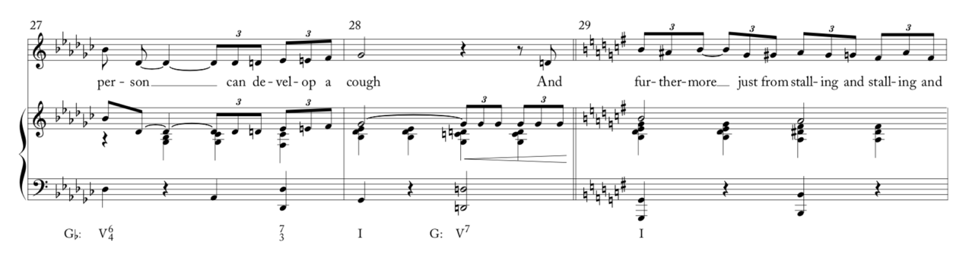
Figure 1.1 – Michael Buchler’s analysis of “Adelaide's Lament," mm. 27-29.

Note that here, in “Adelaide’s Lament” (Fig. 1.1) the modulation to G major is preceded by a D⁷ chord, V⁷ in the new key. D⁷, however, can be enharmonically respelled as Ebb-Gb-Bbb-C, the German augmented 6th chord in the previous key of Gb major. In this reading, the D⁷ chord actually acts as a pivot of sorts (enharmonically), such that this is technically not a direct modulation.
Perhaps a transformational approach might best demonstrate the modulation in question, if neither key prolongs the other. Figure 1.2 shows the progression Gb-D⁷-G through its various transformations. The mapping from Gb to its German augmented-sixth chord can be described as a parallel-Leittonwechselklang transformation, which has also undergone an inclusion-transformation (noted by the prime symbol) to create a dominant seventh chord. More globally, the movement from Gb to G major follows a Nebenverwandt-Leittonwechselklang mapping. In a reading such as this, both keys are given equal importance, as opposed to directional tonality (which would assume G major is auxiliary to Gb) as well as Schenker’s auxiliary cadence (where G major would indeed be the central key).
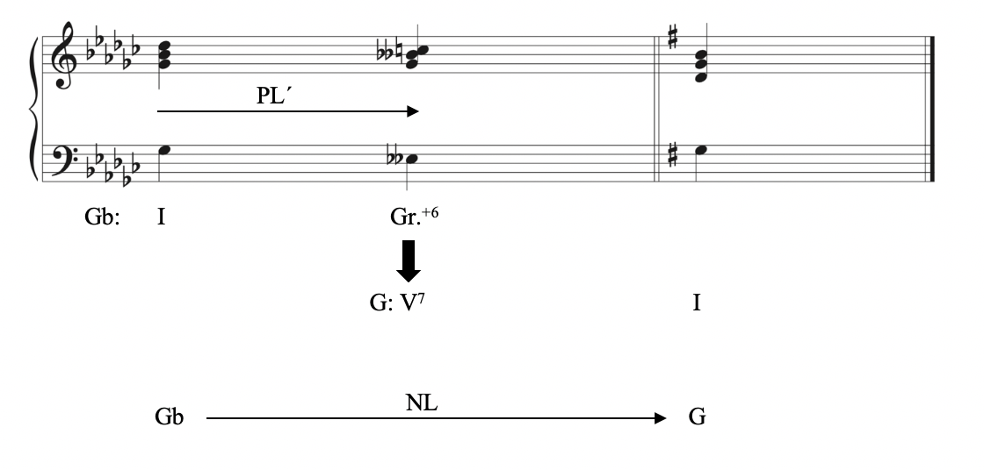
Figure 1.2 - A transformational graph of "Adelaide's Lament," mm. 28-29.
However, Buchler chooses not to invoke any sort of transformational theory in describing this moment, instead favoring a more monotonal approach using modified Schenkerian tools. Had Schenker himself studied this moment in “Adelaide’s Lament,” he likely would have labeled the material prior to m. 29 as an auxiliary cadence, in order to reconcile the modulation with his theory of monotonality. If interpreted as beginning with an auxiliary cadence, the piece would be in G major the whole time, with the material in Gb major functioning as foreground material leading up the start of the Urlinie at m. 29. Buchler, while not subscribing to the Schenkerian school of thought, does modify some of Schenker’s tools to help explain the modulation. (Fig. 1.3) In this instance, the Urlinie is present throughout the refrain, even in the Gb major portion prior to m. 29. Once the piece modulates Buchler modifies the Kopfton with a “↑” symbol, indicating a different “shade” of the Kopfton. Moreover, he notes that “Functionally, they are both [scale degree 3,] but one is a bit higher.” Buchler uses these modified Schenkerian tools to show his view of the Urlinie extending beyond Schenker’s view of monotonality, and thus laying the groundwork for an interpretation where both keys have importance.
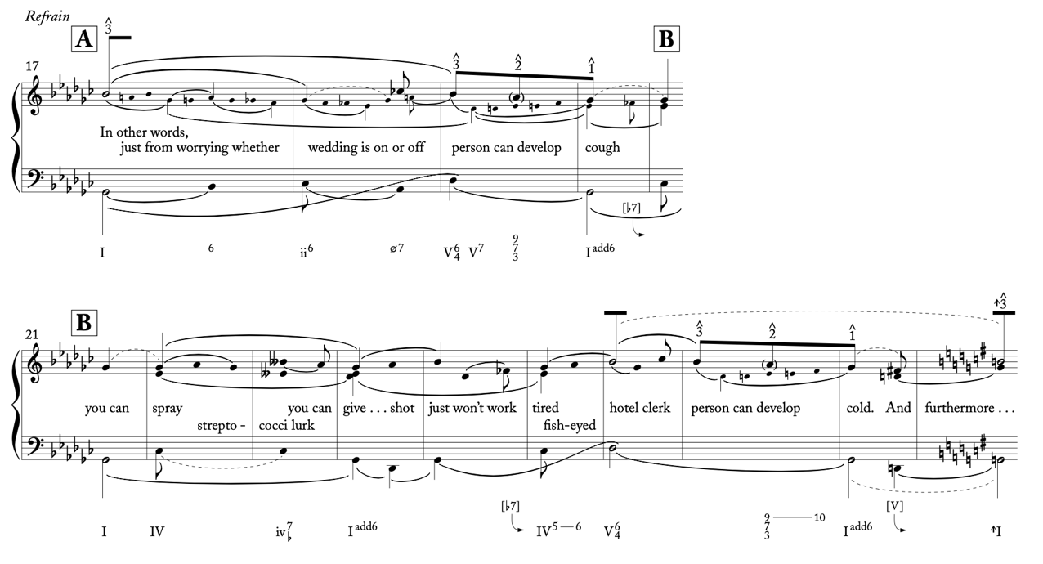
Figure 1.3 - Buchler's foreground sketch of "Adelaide's Lament," mm. 17-29.
Buchler does note that “the G♭ and G major tonics play the same role: . . . neither anticipates nor is anticipated by the other. When we abruptly move to G major, it simply substitutes for G♭.” The question then arises of why exactly Buchler did not acknowledge reading this modulation as a pivot modulation, especially when he does in his next example, “Luck Be a Lady.” It should be noted, first, that Buchler only mentions this reading in a footnote, describing it as a “liberal” reading of the analysis. One issue with this reading is the location of this phrase in the piece. The phrase has just landed on a perfect authentic cadence, and a new phrase has not even begun. To label this D⁷ as an augmented 6th chord would mean considering the chord to have a predominant function in the original key, which, coming after the end of the phrase, would not be entirely apt. (Fig. 1.4)
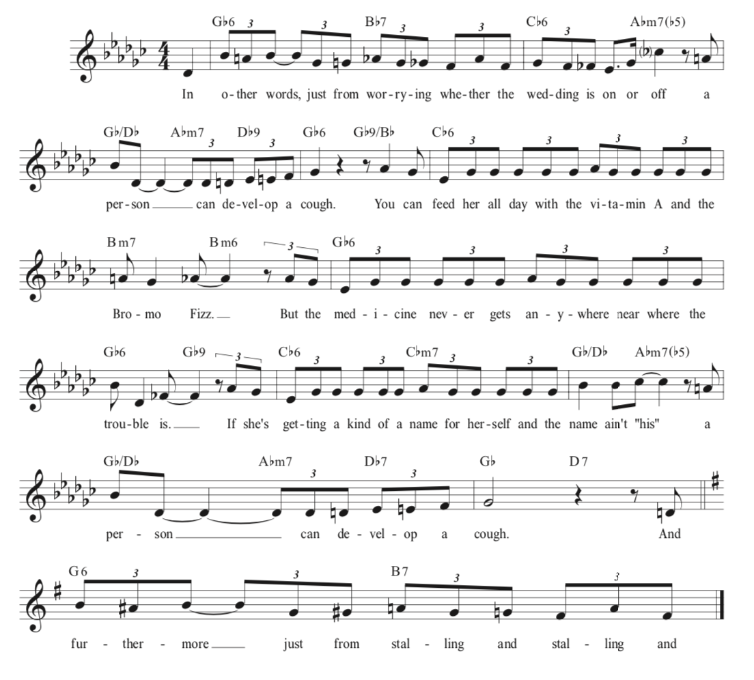
Figure 1.4 - Lead sheet of "Adelaide's Lament," 2nd Refrain.

Compare the so-called pivot’s placement to, for instance the common-chord modulation in the theme of the third movement of Mozart’s D major Sonata, K. 284 (Figure 1.5 below). In m. 5, the pivot chord functions as a predominant in both keys. In “Adelaide’s Lament,” by contrast, the D⁷ chord in question functions only as a dominant in G major, since the chord is placed precariously in between the end of one cadence and the beginning of the next cadence. Although we can literally label the chord as a Gr.⁺⁶ in Gb, the chord does not function the way an augmented sixth chord traditionally would. This would justify Buchler’s reading of a direct modulation.
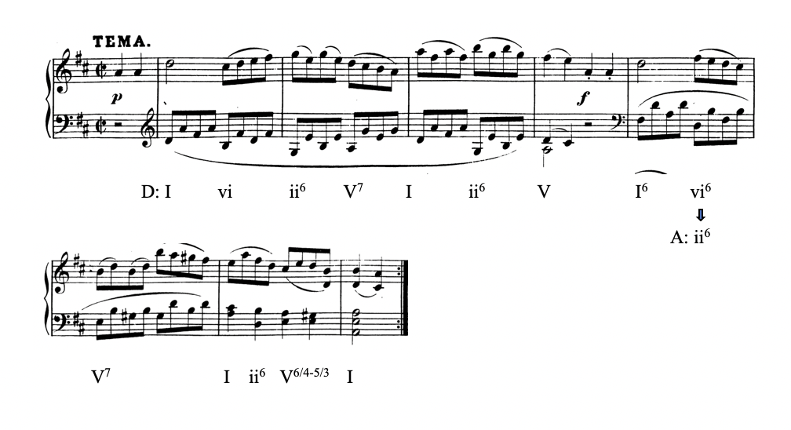
Figure 1.5 - Harmonic Analysis of Mozart's Sonata in D Major, K. 284, III.
It is also important to note Buchler’s comments on the dramatic elements of this modulation:
“The modulation . . . conveys Adelaide’s increased anxiety and, given her relatively low social status, it imbues the song with a certain unpolished authenticity. It also musically paints Loesser’s lyrics which (at that point) sound like an extemporized continuation: ‘And furthermore, just from stalling and stalling and stalling the wedding trip, A person . . . can develop La grippe.’ The lyrics and well-placed modulation effectively extend a short list of symptoms into something of a litany.

Adelaide is not resolving her issues in this song; it’s a soliloquy that gives the audience a glimpse of her psyche and is part of her character arc. Loesser musically focuses on her mental state home via the modulation and stays in that key for the remainder of the song. The text doesn’t call for the music to return to the home key, as by the end of the song she’s only irater over her present situation.
That direct modulations can highlight a character’s emotional state is also evident in more modern musicals. Take for example the modulation in “Waving Through a Window” from Dear Evan Hansen (Figure 1.6). For dramatic context—the song follows the protagonist Evan on the first day of his senior year of high school. Evan suffers from extreme social anxiety and worries that he will always be viewed by his peers as some sort of social outcast.
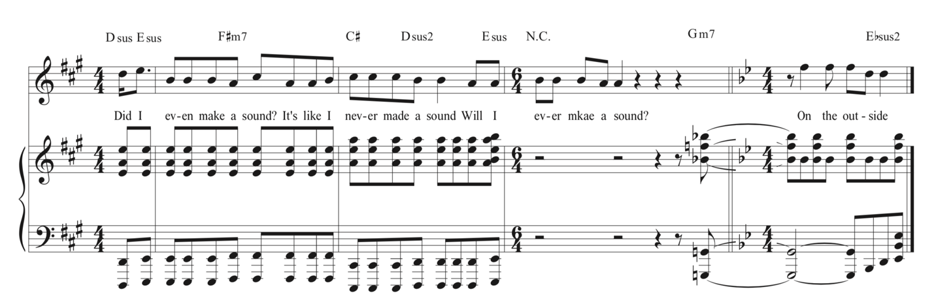
Figure 1.6 - Direct Modulation in "Waving Through a Window"

While the lyrics at the modulation are on the surface simply another repetition of the chorus (“On the outside always looking in will I ever be more than I’ve always been…”), the bridge it follows features a repeated line, “When you’re falling in the forest, and there’s nobody around, do you ever really crash or even make a sound . . .” At this point in the musical, Evan has a broken arm, and as the audience will learn at the climax of the show, he sustained that injury from falling out of a tree in a suicide attempt. The plea Evan makes in the chorus following the modulation, while still the same lyrics, carries a lot more weight following the bridge; the final refrain carries even greater weight retrospectively—once the audience learns more about his background and that suicide attempt. Evan sings this song after he’s already tried to kill himself. The song is about how Evan feels like an outsider and that all he wants is to feel noticed, even by just one person. Considering this is the only thing he wants out of the world following a suicide attempt, it’s a pretty powerful emotion; the overarching directional tonality helps to amplify his mental state.
Unlike “Adelaide’s Lament,” however, this direct modulation is even more direct, since no chord (or any transitional passage, for that matter) prepares the sudden shift to Bb major. From these examples, one can start to descry a spectrum of direct modulations, from those that are less direct (preparing the modulation with the new key’s dominant) to those that are more direct (as in “Waving Through a Window”). These are also reflected in the dramatic intensification of the texts: While Adelaide certainly has issues, she has not brought herself to make a significant change such as leaving her fiancé (who is the cause of her anxiety); Evan has survived a suicide attempt. These two examples point to the possibility that, although a less direct modulation can have some dramatic intensity, a more direct modulation has more power in this regard. Naturally, however, a much wider selection of the repertoire would need to be studied to corroborate prove this notion.

III. Pedagogical Applications
Let us now turn our attention to exploring these topics in the music theory classroom. As stated in the introduction to this document, in addition to studying this repertoire for its own sake (as graduates of our programs might work in this area of music in one form or another), this music can reinforce and even expand our current understandings of modulations by bringing in new repertoire that might need to be examined via several analytical methods. Students can add this kind of modulation to their bank of knowledge, to various degrees of specificity and by using various techniques. The remainder of this chapter will focus on using musical theatre repertoire to discuss modulation in the undergraduate theory classes.
The instructor might best choose to introduce these topics towards the end of the theory sequence, when students have developed their foundational theory skills and have familiarized themselves with common-practice modulations. Like most topics, direct modulations should be studied in both the written and aural skills classroom. That is, the modulations should be reinforced aurally in the written skills class and theoretically in the aural skills class A group analysis of any of these pieces discussed in this chapter during lecture time will prime students to detect and label direct modulations. When doing these analyses, it is paramount to highlight the differences between modulations in common-practice music and the musical theatre repertoire. In looking at, say, “Adelaide’s Lament,” students should be able to describe any of the modulations as much detail as possible. In the simplest and broadest terms we can label the key areas before and after the point of modulation. After the labeling of these keys we can say how the modulation occurred—should we label this as pivot chord modulation or a direct modulation? From here we can then determine what kind of pivot chord was used or, in the case of a direct modulation, how direct was said modulation. Finally, we would want to discuss any specific melodic or harmonic techniques used to execute the modulation. After some time working on these skills, students can start to focus on the relationship between the text and the modulations, which Buchler discusses in his article.
To begin working on these modulations in the aural skills classroom, one might provide students with a lyric sheet and have them mark when for sure the music is in a new key. As many of these direct modulations are prepared by V, students should mark the location of the new I chord, since this when the music is firmly in the new key. For example, in “Adelaide’s Lament,” students will ideally mark a new I on the word “Furthermore,” located in m. 31 in the actual score. After discussing this, work backwards, helping students hear that while the I chord appears in m. 31, it is preceded by a V chord in m. 30 (after “a person can develop a cough”). Once this is accomplished, have them note what harmonies precede the modulation— namely a perfect authentic cadence in the original key of G major. Students will then have isolated all the different components that comprise the modulation. One will not necessarily give a test on these materials but, with a curriculum focused primarily on common-practice music, it can be helpful for students to apply their learned listening skills to other styles of music.
Figure 1.6 below gives a sample lesson plan for introducing direct modulations and directional tonality in the theory classroom, by primarily using “Waving Through a Window.”

Sample Lesson Plan – Direct Modulations and Directional Tonality
Pre-Class | - Instructor will have “Waving Through a Window” playing on speaker systems a few minutes before the class period begins.
Introduction (5 min) | - Instructor asks class about the modulation (if necessary, he or she can play the example again), specifically, how the modulation is approached.  - Students should note that, after a period of silence, the music is automatically in the next key.  - Instructor might point out that the piece moves from A to Bb major, keys that are not closely related.  - Instructor defines the term direct modulation.
Compare to Common-Practice Music (10 min) | - Bring an example used in a previous lesson covering modulations (i.e. pivot chord modulation)  - Highlight key differences between the two examples (including, but not limited to):  - Distantly related keys (in “Waving Through a Window,” Bb is the original key’s Neapolitan)  - Lack of a pivot chord.  - In a pivot chord modulation, it is easier to talk about elements of functionality (tonic-predominant-dominant). Here, there is a clear start and stop to functionality, as one key area ends before the next begins.
Text and Music (20 min) | - For students not aware of the overarching plot elements of the musical, clue them in or allow a student familiar with the show to tell other students about the plot.  - Begin a discussion on how the modulation interacts with the text. Highlights may include:  - The text itself is just the chorus again.  - As such, the only changes are musical (the modulation as well as a denser orchestration).  - The higher-pitched new key helps to amplify the emotional state of the character
Directional Tonality (10 min) | - Point out that once the song shifts to Bb major and stays there.  - This is unlike common-practice music, where more often than not the piece will start and stop in the original key (cite previous lesson’s example).  - Define directional tonality.  - Give a summary of the theory of monotonality; this can be brief and not even necessarily name Schenker specifically.  - Discuss how Buchler might consider the post-modulation material as a “new shade” of the original key, as a way to try and reconcile the conflict between directional tonality and monotonality.
Questions (5 min) | - Allow time for students to ask questions.
For Next Class | - Point students towards examples such as “Adelaide’s Lament” that can be discussed in the next class (introducing the spectrum of direct modulations).
The skeptic might reasonably be concerned about whether the sophomore-level student is ready for any conversation regarding monotonality and its conflict with direct modulation, even if the conversation is broad in nature. One way to discuss monotonality is through sonata form, a topic sophomores will likely cover, even if at an introductory level. While a sonata maneuvers through several key areas, the ultimate goal is to reconcile all of the sonata’s thematic material with the piece’s home key, resulting in the recapitulation ending in the same key as the beginning of the exposition. We could then say that, at a deeply foundational level, the entire piece is in the home key, since what seems like a modulation to the dominant key, for instance, is actually an expansion of a scale-step within the home key. Unlike the sonata, however, these songs are not in one key the whole time. Neither “Adelaide” nor “Waving” ever return to that home key, and once we’ve shifted away, we’ve shifted away for good.
As modulations can be found in both common-practice, jazz, and popular styles, the students should have exposure in the classroom to how they are both treated. Musical theatre in particular can help students understand direct modulations due to the varied ways in which they are treated in such repertoire, and one can compare how these modulations are both similar and different to those found in common-practice music. This does not mean that musical theatre exclusively utilizes direct modulations, merely that the repertoire can provide a plethora of examples to teach the concept. Moreover, students can use the analysis of these musical techniques as a springboard to discussions about more advanced topics, such as the relationship between text and music.

Chapter 2
Form

I. Introduction
Current undergraduate theory curricula tend to favor harmony and counterpoint, thus undervaluing the crucial role form plays in the understanding and analysis of music. Often, form-related topics will be covered tangentially, dispersed across multiple semesters, beginning with small forms such as the phrase, sentence, and period, and gradually working up to large forms such as the sonata and rondo. Still, connections between, say, form and harmony are made quite often when discussing classical literature. Most forms, for example, move away from tonic and back to it by the end. By making these connections, instructors have a way of relating form to other theoretical topics, which can then segue into discussions and lectures on form for the sake of teaching form. After surveying various texts used to teach form to undergraduate students, this chapter will look a variety of forms found throughout the history of musical theatre and then explore ways of incorporating them into the undergraduate curriculum.

II. A Brief Survey on Form in Textbooks
Barbara Murphy and Brendan McConville’s “Music Theory Undergraduate Core Curriculum Survey” (most recently updated in 2017) lists the top five texts respondents used to teach topics related to form, which combined are used in 58.2% of classrooms (a small majority, but a majority nonetheless). These, in order from most- to least-often used, are Charles Burkhart, Anthology for Musical Analysis (whose new Seventh Edition is co-authored by William Rothstein); Stefan Kostka, Dorothy Payne, and Byron Almén, Tonal Harmony; Bruce Benward and Marilyn Saker, Music Theory and Practice; Steve Laitz, The Complete Musician; and Jane Piper Clendinning and Elizabeth West Marvin, The Musician’s Guide to Theory and Analysis. It is important to note that none of these books focus solely on form and analysis: the Burkhart is simply a music anthology, while the other four are general music theory texts used for the standard undergraduate sequence. In Richard Nelson’s original survey for the College Music Society in 2000, three of the top five texts were form-specific. The change to using general theory texts corresponds to the fact that as of 2017, form and analysis is covered in some level of detail in 64.29% of respondents’ theory sequences. Classes dedicated to form and analysis are still offered at many universities, though not as many as in 2000. The increased integration of form into the theory core does allow students to learn about the interaction of form with other musical elements, such as pitch, harmony, and rhythm. Additionally, considering how these books cover form can alert the teacher as to what additional materials he or she might need to supply in order to mitigate any deficiencies. Two general trends emerge from studying these texts. First, they spend much more time focusing on instrumental forms than on vocal forms. Second, they devote much more attention to common-practice classical music than they do to popular music. As both a popular and vocal style of music, music theatre gets scant attention across these five books, mostly thanks to the impact of George and Ira Gershwin’s “I Got Rhythm” from Girl Crazy (discussed later in the chapter).
Burkhart and Rothstein’s Anthology for Musical Analysis, the lone anthology on this list but the most frequently required book, relegates all examples of popular music to the first appendix. Even that, however, covers little beyond 12-bar blues and the Rhythm Changes. While this is certainly preferable to not including any popular forms, it is problematic to place them in an appendix, for it sends a message to instructors and students that these forms are less significant than, and auxiliary to, the content covered in the body of the book. Kostka, Payne, and Almén’s Tonal Harmony includes the 12-bar blues in its one chapter devoted to form, which covers all “Larger Forms” (anything larger than a phrase, period, or sentence, all of which are covered in an earlier chapter). Tonal Harmony still lacks information on vocal forms, as in the short amount of space dedicated to form, it only covers instrumental forms (though its example for 12-Bar Blues is a vocal tune). Benward and Saker dedicate more space to form (four whole chapters across two volumes). In their chapter, “Ternary Forms,” the authors even provide a musical-theatre example— “Memory,” from Cats. This is included in a discussion of “Common Popular Chorus Forms,” itself included within a brief history of ternary design. Besides “I Got Rhythm,” this is only musical theatre example used to illustrate form among these five books. Laitz’s text also primarily focuses on instrumental music, and exclusively common-practice music (though Laitz does discuss the Da Capo aria in his “Ternary Form” chapter).
Clendenning and Marvin spend the most amount of time focusing on topics generally relating to musical theatre. “Vocal Forms” are covered in their own dedicated chapter, immediately followed by a chapter on “Popular Music.” While the chapter exclusively focuses on common-practice repertoire, “Vocal Forms” gives the most detailed look at form in vocal music of all five books on this list, with discussions of arias, recitative, and strophic forms, as well as text painting and analysis of songs. “Popular Music” continues the discussion of vocal forms by looking at songs of both the twentieth and twenty-first centuries, ranging in time periods from “I Got Rhythm” (the only musical theatre example in the chapter) to Katy Perry’s 2013 hit “Roar.” Several other chapters are dedicated to instrumental forms, providing the broadest coverage of form among the five most commonly used textbooks.

II. 32-Bar Song Form and the Rhythm Changes
While Clendenning and Marvin transition into their discussion of “I Got Rhythm” by mentioning form, mostly they cover the harmonic content. However, in this song, form and harmony are inseparably linked. They purposefully spend more time on the refrain of the song. This is because the refrain of “I Got Rhythm” constitutes the basis of the so-called “Rhythm Changes,” a 32-measure chord progression that follows an AABA form. This link between harmony and form is not unique to the Rhythm Changes. The classical sonata, for instance, assigns certain key areas to certain sections. In the exposition, the tonic key will modulate to either the dominant (in a major-key sonata) or the relative major (in a minor-key sonata). In the Rhythm Changes, it is specific harmonies, not key areas, that play an important role in the form.
Prior to discussing the Rhythm Changes, however, I would like to take a moment to look at “I Got Rhythm” in its global form, as performed as a verse-refrain Tin Pan Alley song in the musical Girl Crazy. This verse-refrain form has similarities to the recitative-aria form of opera, itself an ancestor of the Tin Pan Alley musical. Similar to how a recitative will go through several harmonic events to arrive at the key of the subsequent aria, the verse of “I Got Rhythm” (Fig. 2.1) begins in G minor and eventually makes its way to Bb major to begin the refrain.
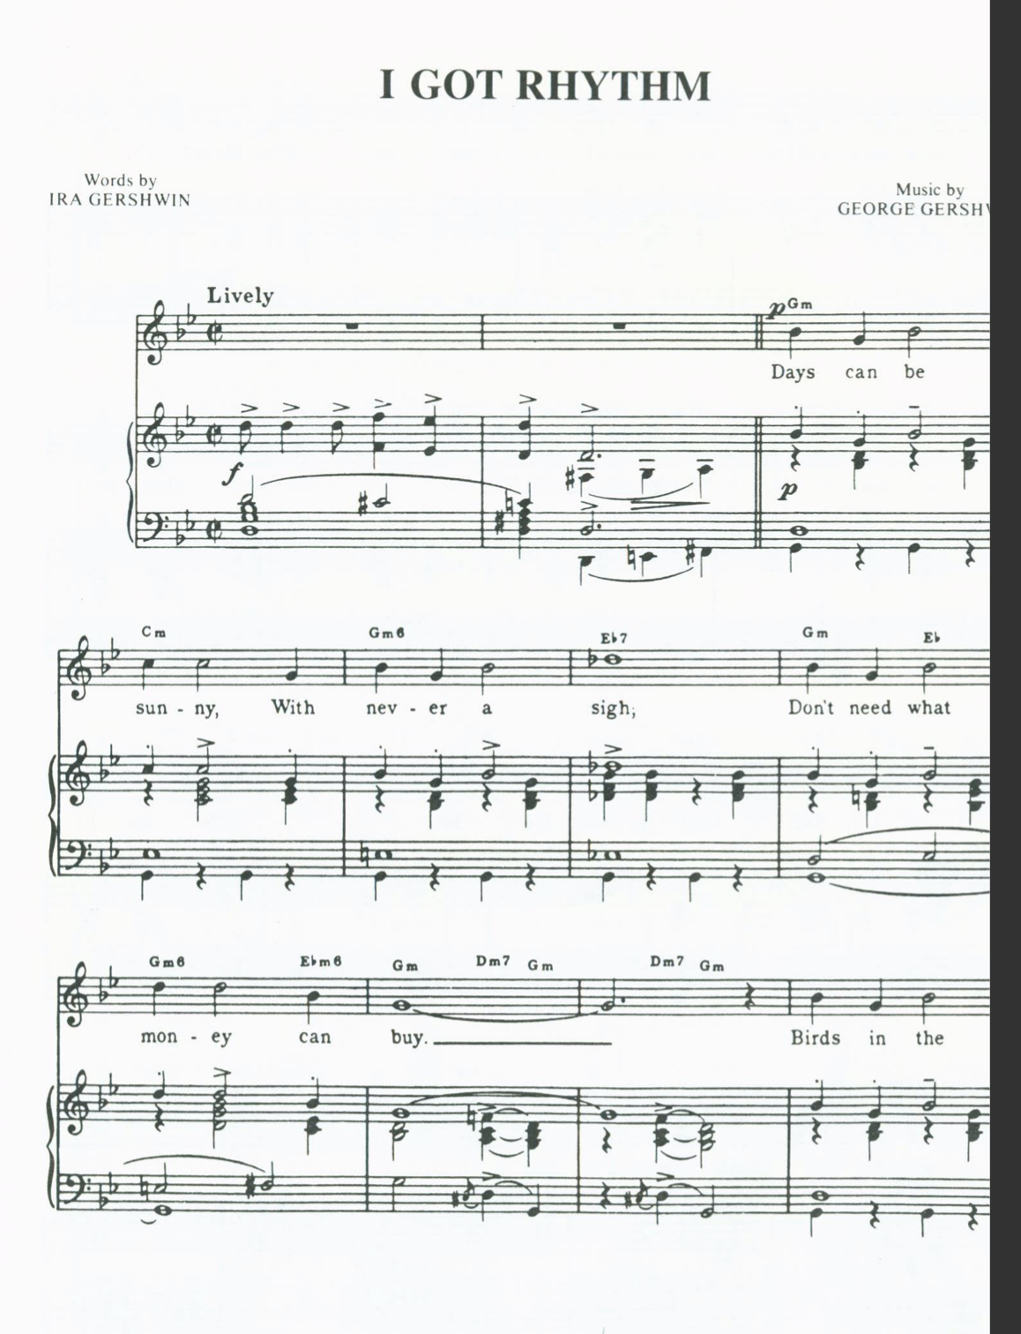
4
8
Figure 2.5 - Gershwin, "I Got Rhythm," verse. (cont. on next page)
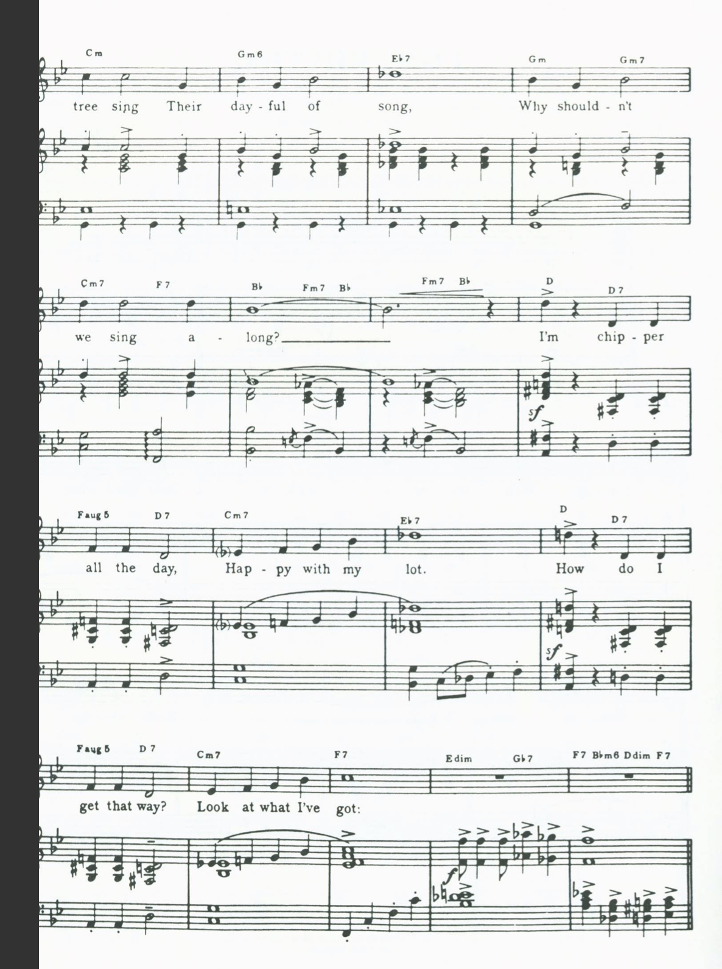
24
20
12
16
 | Intro | Verse |  | Refrain
Measures | 1 | 3 | 19 | 29 | 37 | 45 | 53
Sections |  | a | b | a | a | b | a
Key Areas | G minor |  |  | Bb Major
Figure 2.6 - Form of "I Got Rhythm"

Figure 2.2 above shows that, following a two-measure introduction that establishes the starting key area of G minor, the verse begins and only occurs once, as is typical of Tin Pan Alley songs. Harmonically, mm. 2-10 consist entirely of a tonic pedal and does not ever truly cadence in G minor. In mm. 11-18, however, we get an actual cadence in Bb major, which will end up serving as the home key of the refrain. Although the cadence of this period (mm. 2-18) is in the relative major, the preponderance of tonic pedal in both phrases helps to emphasize the home key of G minor. The second period of the verse is 10 measures long, consisting of a four-measure antecedent phrase (mm. 19-22) and a four-measure consequent phrase (mm. 23-26) with a two-measure transition into the refrain (mm. 27-28), which extends the phrase from 8 to 10 measures. Both phrases of this period begin by emphasizing D, the V of G minor. Measure 22, the end of the second period’s antecedent phrase, lands on an Eb⁷ chord. As the chord resolves to a D triad in the next measure, the Eb⁷ is best understood as a tritone substitution of A⁷, allowing this antecedent phrase to end on a disguised half cadence in D. In fact, the Db in the melody resolves up to D natural, almost as if it is an enharmonically respelled C#. Through the phase extension added on to the consequent phrase, we get an elided authentic cadence in Bb into the refrain (because of the continuing bass motion it would be unwise to label this moment as a half cadence). Although the beginnings of phrases establish G minor or its dominant, each period’s closing cadence is in Bb major, preparing the listener for the refrain’s home key.
The harmonic preparation of the refrain by the verse is not a new or unique technique to musical theatre. In the opera tradition, the recitative was employed to move the music towards the key of the following aria (as well as serving to advance the plot). In Mozart’s Don Giovanni, the recitative prior to Donna Anna’s aria, “Or sai, chi l’onore,” begins in Bb major, but needs to eventually move to D major, the home key of the aria. (Figure 2.3) Note that the recitative establishes D by ending with a root-position V, itself preceded by its own leading-tone fully diminished chord.
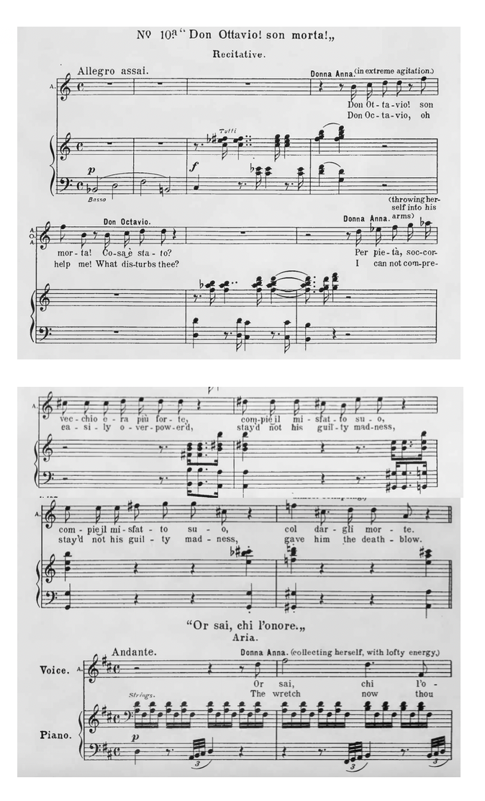
Figure 2.7 - Mozart, Don Giovanni, No. 10a - Recitative (mm. 1-7; 66-69) and Aria (mm. 1-2).
Both the Burkhart and Rothstein as well as the Clendinning and Marvin textbook focus on “I Got Rhythm’s” refrain (Figure 2.4)—the foundation for the Rhythm Changes. It is in AABA form, which Clendinning and Marvin refer to as quaternary or thirty-two bar song form. All of the A sections are identical, save for the endings of the second and third A sections having stronger perfect authentic cadences than the first A section, especially considering that the first cadence ends with a ii-V turnaround into the second A section. The B section is characterized by a circle of fifths progression: D⁷–G⁷–C⁷–F⁷, which then resolves to Bb at the beginning of the third A section.
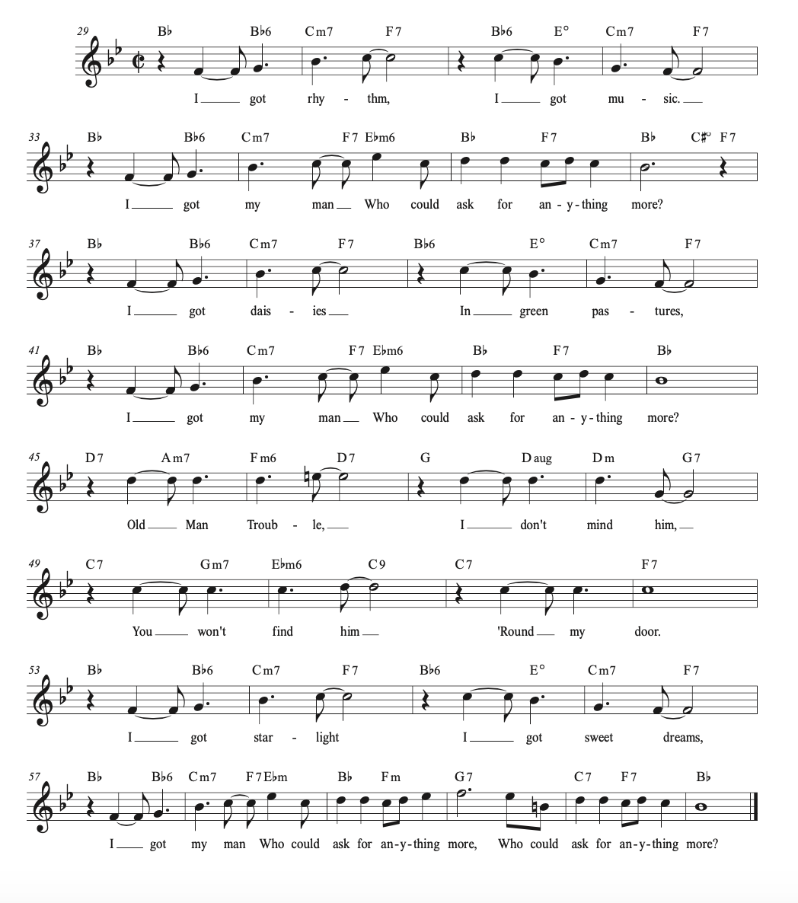
Figure 2.8 - Lead sheet of the "I Got Rhythm" refrain, often played by itself as a jazz standard.

What Burkhart and Rothstein only touch on, and what Clendinning and Marvin do not even mention, is the impact this show tune has had on jazz music. The Rhythm Changes have been used as a template for many pieces in the jazz literature, pieces that have since become standards. Examples include Cotton Tail by Duke Ellington and Anthropology by Charlie Parker. In the jazz idiom, a new melody written over a pre-existing chord progression is known as a contrafact. Often times, a Rhythm contrafact will not be a copy-and-paste of the exact chords Gershwin used in the original song; contrafacts of the Rhythm Changes often make minor adjustments to the notated harmonies. This reflects jazz performance practice more generally, by which musicians routinely add chord extensions and substitutions. Additionally, the Rhythm Changes has even extended beyond jazz to idioms such as television themes. Take for instance the iconic television theme, “(Meet) The Flintstones,” which occasionally is also performed as a big band arrangement (Figure 2.5):
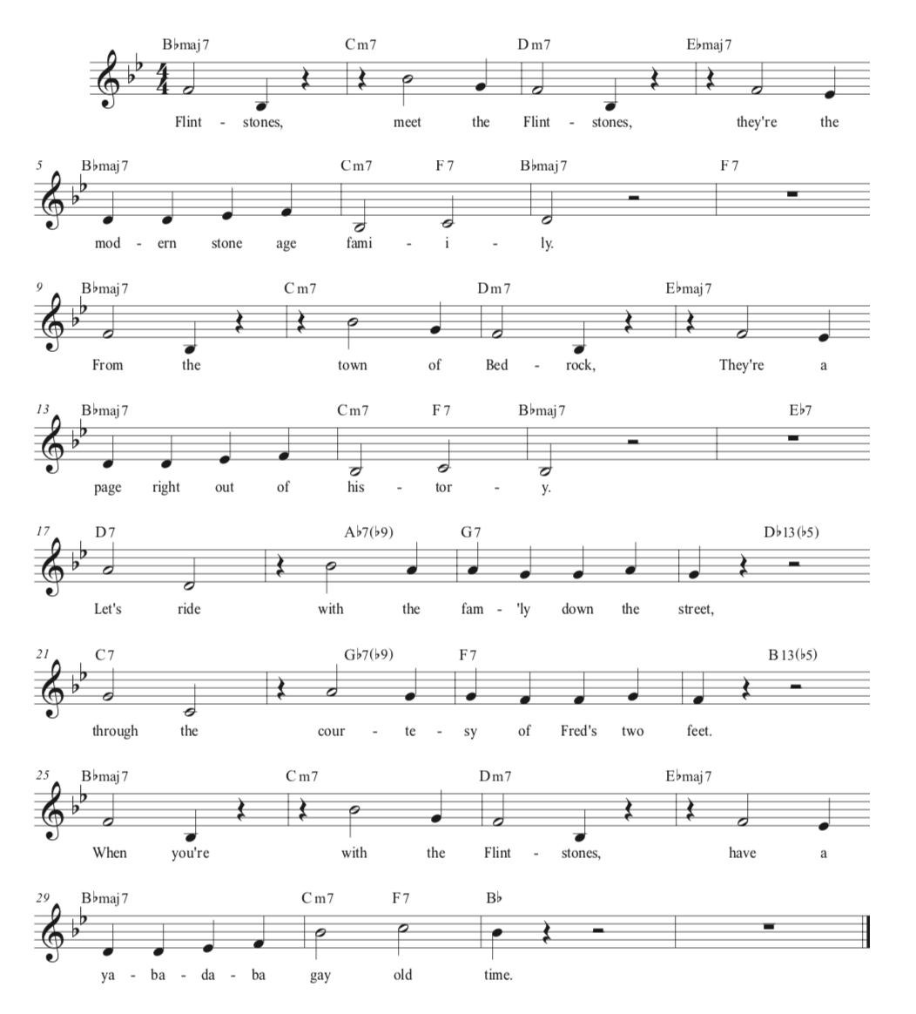
Figure 2.9 - Lead sheet of "(Meet) The Flintstones," transposed from F major to Bb major.

One of the first noticeable alterations is the reducing of chords: whereas in the A section of “I Got Rhythm” most bars had two chords, in “(Meet) The Flintstones” most bars have only one. For example, the Bb⁶ in m. 1 and F⁷ in m. 2 are elided. Some chord extensions are different as well: for instance, a I^{M7} replaces a I^{add6} in mm. 1, 5, and 7. Mm. 3 and 4 also feature chord substitutions at the mediant: the D⁻⁷ in m. 3 of “The Flintstones” substitutes for the Bb⁶ in “I Got Rhythm,” while in m. 4, “The Flintstones” Eb^{M7} substitutes for C⁻⁷. The result is a progression whose bass line is more linear than Gershwin’s: Bb–C–D–Eb. Comparing the B sections of both tunes, we can see that each of the chords on beat three of mm. 18, 20, 22, and 24 in “The Flintstones” are tritone substitutions of their comparable chords in “I Got Rhythm.” Still, the overall harmonic motion is the same—an A section in the home key, eventually ending on an authentic cadence, and a B section that moves through a circle-of-fifths progression that eventually leads back to the home key at the start of the concluding A section.
While plenty of jazz standards have utilized the Rhythm Changes, contrafacts of “I Got Rhythm” have also appeared in the musical-theatre repertoire. Take, for instance, the title song from 1992 musical Five Guys Named Moe, written by Larry Wynn and Jerry Bresler (Figure 2.6):
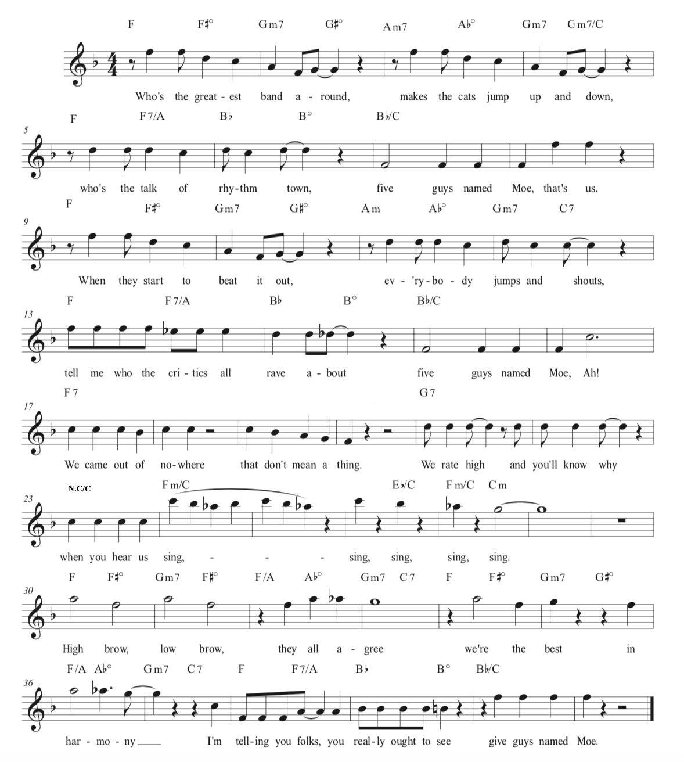
Figure 2.10 - Lead sheet of "Five Guys Named Moe."

Although this song, like “The Flintstones,” features some chord substitutions vis-à-vis “I Got Rhythm” throughout its entirety, the B section is the most altered passage, in terms of both harmonies themselves and harmonic duration/harmonic rhythm. We would traditionally expect the B section of a Rhythm Changes tune to traverse (in B-flat major) A⁷-D⁷-G⁷-C⁷. In “Five Guys Named Moe,” however, F⁷ takes the place of both the A⁷ and D⁷, which works because F is chromatic mediant relative to both A and D. , G⁷ is in its expected place, followed by seven harmonically nebulous measures of a C pedal. Mm. 23-24 line up with mm. 51-52 of “I Got Rhythm,” with the following five measures functioning as an addendum to the eight-measure phrase. While the chords change throughout mm. 23-29, the C pedal helps to establish the dominant before it resolves to tonic in m. 30.
In looking at “I Got Rhythm,” “(Meet) The Flintstones,” and “Five Guys Named Moe,” we can start more accurately to define what makes a song a Rhythm Changes contrafact. First, it needs to fit into the 32-bar song form (allowing for additional measures resulting from or motivating phrase expansion). Second, the song must follow a certain harmonic progression as defined above, which can also be subject to chord substitutions and/or alternate chord extensions. Figure 2.7 below shows a generic Rhythm Changes template.
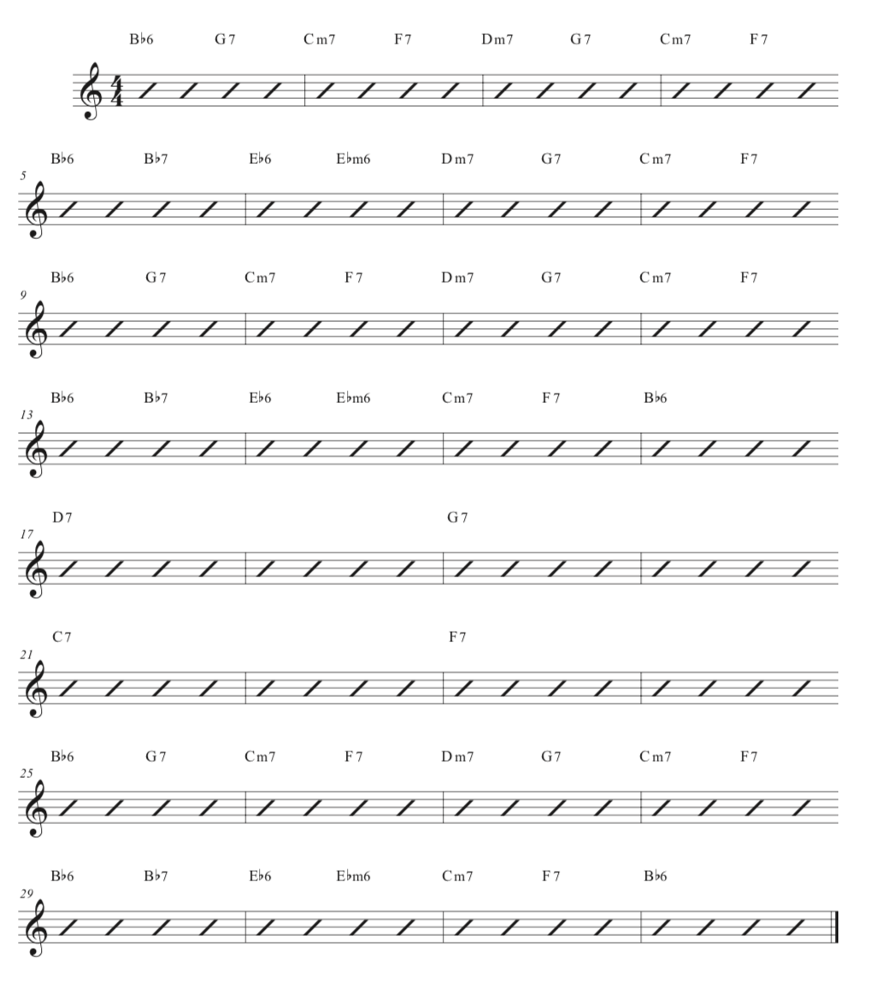
Figure 2.11 - Sample Rhythm Changes chord chart.

Critical to our understanding of the Rhythm Changes is the notion that form and harmony are inseparably linked. This relationship has parallels to other forms, both popular and classical, such as the twelve-bar blues (a form with origins in folk music which, similarly, follows a specific chord progression that is subject to slight alterations) or, as previously stated, even the sonata, which, while not subject to any specific harmonies, does have prototypical key areas and harmonic strategies, such as placing a half cadence in either the primary or secondary key at the medial caesura (Fig. 2.8 outlines the sonata form and its harmonic strategies in both major and minor). This connection between form and harmony in the Rhythm Changes is vital to our understanding and teaching of what is now considered a staple of the jazz repertoire.

Overview of Sonata Form
Exposition :|| Development Recapitulation :||
P trans. S codetta P trans. S codetta
major key: I ––– HC V –––––––– V⁷ i ––– HC I –––––––––––
minor key: i ––– HC III –––––––– V⁷ i ––– HC i or I –––––––

Legend:
P = primary theme/key
S = secondary theme/key
trans. = transition
HC = half cadence (in either primary key or secondary key)
Figure 2.8 – Overview of Sonata Form, courtesy of Jeffrey Swinkin.

III. Examples of Other Forms
Besides “I Got Rhythm,” other musical-theatre songs and their forms have been borrowed by jazz and popular musics. Conversely, idioms that began in jazz and popular music have also found their way into today’s new musicals. The next two examples will examine both theatre’s influence on popular music as well as the reverse: “My Favorite Things” from The Sound of Music has also received plenty of use as a jazz standard, while the form of “Bad Idea” from Waitress clearly betrays the influence of contemporary pop music.
Like “I Got Rhythm,” “My Favorite Things” from Roger and Hammerstein’s The Sound of Music follows a quaternary form; here, however, instead of aaba it is aaab (Figure 2.9).
 | Intro | a | a | a$´$ | b
Starting Measure | 1 | 5 | 19 | 37 | 53
Phrase Length | 4 | 16+2 | 16+2 | 16 | 16+2
Starting Lyric |  | “Raindrops on Roses…” | “Cream colored ponies…” | “Girls in white dresses…” | “When the dog bites…”
Figure 2.9 - Form chart of "My Favorite Things."

The third repetition of the A section receives a prime designation for two reasons: first, it does not carry the two-measure tag that the other two A sections have. Additionally, the melodic material in mm. 51 and 52 is slightly different than their comparable measures in the previous two A sections (mm. 17-18 and 35-36, respectively). Figure 2.10 below highlights the differences between the endings of the second and third A sections. Just as in “I Got Rhythm,” where the 32-bar song form was only the refrain of a broader song, this 72-measure segment is only one component of the larger song. After the character Maria sings this material in E minor, the entire 72-measure cycle starts over, this time in F minor and sung by the Mother Abbess (with the exact same lyrics). After her turn singing the song, the two characters together sing the B section material in G minor, acting as a coda to the song. Figure 2.11 shows the larger-scale form of the song.
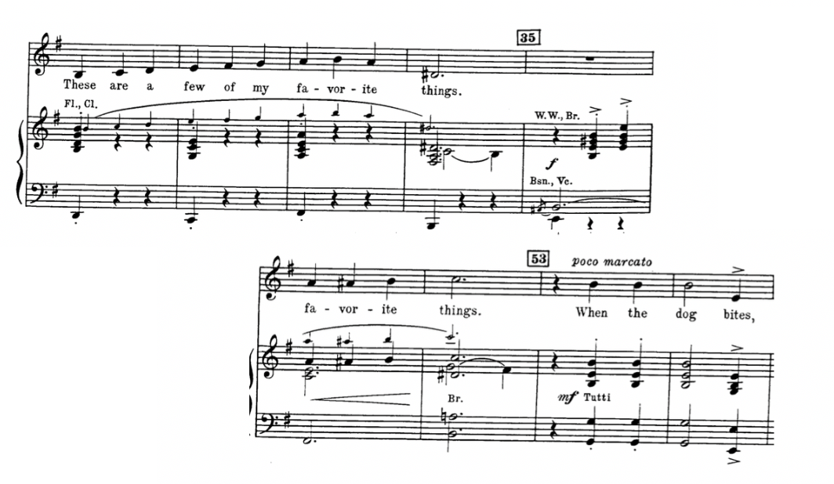
Figure 2.10 - "My Favorite Things," mm. 31-35 and 51-54.

 | A1 | A2 | Coda
Starting Measure No. | 1 | 73 | 149
smaller form | aaa$´$b | aaa$´$b | b
Character(s) | Maria | Mother Abbess | Maria and Mother Abbess
Figure 2.11 - Large scale form of "My Favorite Things."
In performances of “My Favorite Things” as a jazz standard, outside the context of the musical, the tune is based on the 68-bar form (excluding the four-measure introduction at the beginning), typically including a playing of the melody, followed by an undetermined number of solos, and finishing with another playing of the original melody (the “head” of the tune, in jazz parlance). As such, it is useful to look at the form of “My Favorite Things,” or similar musical theatre songs that have become jazz standards, on both local and global levels. The local level (the form of the song as a jazz standard), as described in figure 2.8, consists of a 68-measure aaab refrain with a 4-measure introduction. The global level, meanwhile, the form of the tune as used in productions of The Sound of Music, consists of two repetitions of the 72-measure song (the introduction happens both times), followed by a coda, a repetition of the small b section material. In both early musical theatre as well as songs from the “Golden Age,” such as those in The Sound of Music, it is crucial to distinguish between the form of the song and that of its arrangements.
This distinction might be less necessary in the “pop musicals” prevalent in the twenty-first century. Recent musicals such as Dear Evan Hansen, SpongeBob SquarePants, and Waitress all have heavily incorporated pop music, in terms of style, orchestration, and yes, form as well. The Act I Finale of Waitress, “Bad Idea,” reveals clear pop influences in its overarching form (Figure 2.12).

 | Intro | Verse 1 | Chorus | Verse 2 | Chorus | Bridge | Chorus
Starting Measure | 1 (repeated) | 2 | 18 | 28 | 18 (D.S. al Coda) | 38 | 58
Starting Lyric |  | “It’s a bad idea me and you…” | “Hearts keep racing…” | “It’s a bad idea me and you…” | “Hearts keep racing…” | “I know what’s right for me…” | “Hearts keep racing…”
Figure 2.12 - Form chart of "Bad Idea."

Note that the two verses, while starting with the same text, do not contain the same text all the way through, or even have the same number of measures. The first verse contains two eight-measure phrases, while the second verse contains only one eight-measure phrase, with the addition of a two-measure interruption at mm. 34-35 (Figure 2.13) The bridge can be further subdivided into two subsections: the first, as described in Fig. 2.9, starts at m. 38 with the phrase “I know what’s right for me,” while the second subsection begins at m. 52 with the lyrics “I need a bad idea.” Unlike the quaternary forms of “I Got Rhythm” and “My Favorite Things,” the form of “Bad Idea,” is indissoluble: outside the context of the musical, the refrain would not be performed alone; the performer would also sing the verses, which are more an integral part of the song, just as they are in most rock songs. That is partly because, in rock songs as well as in their musical theatre counterparts, the verse is not a one-off, as it is in Tin Pan Alley songs, but repeated (verse–refrain, verse–refrain, etc.).
As mentioned earlier, in the discussion of the most widely used books to teach form, only Clendenning/Marvin discusses popular-song form in their text. Additionally, with this book being the least-used of the five books, popular song form does not necessarily receive the same attention in the classroom that, say, the Rhythm Changes might. Due to the changing musical landscape, especially in musical theatre where more and more musicals are pop-music based, it behooves students to learn about popular forms when covering song form in the classroom. I address such pedagogical concerns in the next section.
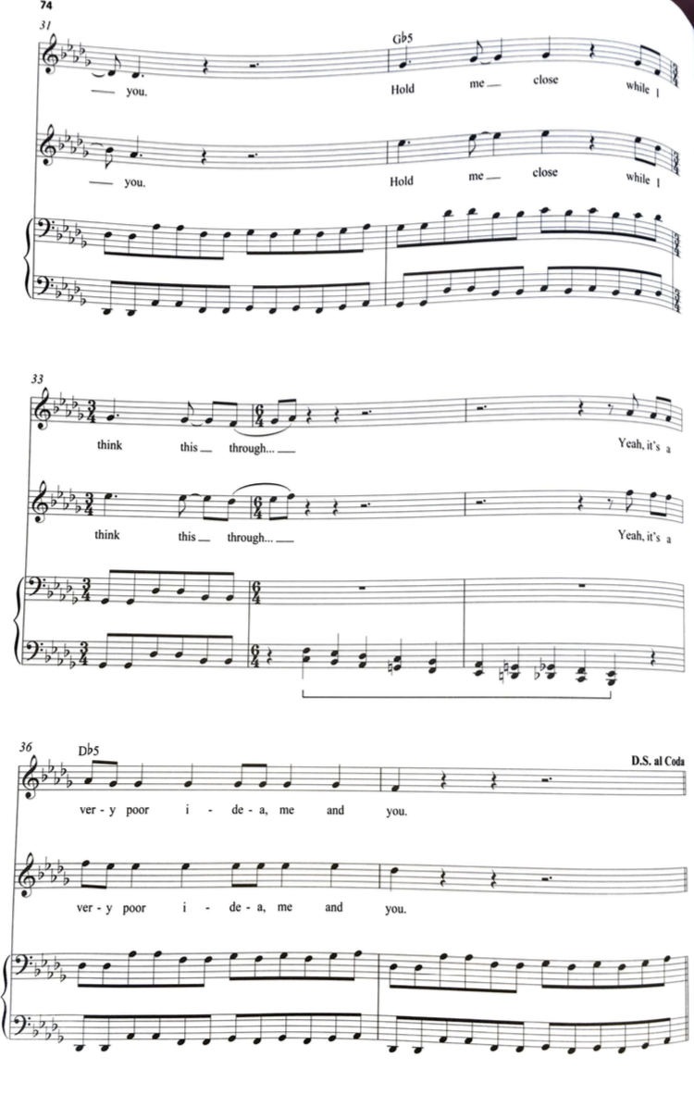
Figure 2.13 - Waitress, "Bad Idea," mm. 31-37. Mm. 34-35 interrupt Verse 2 and have no equivalent measures in Verse 1.

IV. Pedagogical Applications
As Murphy and McConville’s survey points out, there is a growing trend in curricular practices of including topics on form within the core theory sequence, with fewer programs relegating form to its own class. It should be noted that many programs still offer specific classes on forms and analysis, though less so than when Nelson conducted his original survey in 2000. In the core sequence, form is usually covered in the second year; as work on harmony starts to wrap up, instructors and students start discussing form and reconciling it with harmonic content. In regard to a textbook recommendation of the ones surveyed at the beginning of the chapter, the Clendinning/Marvin text stands out due to the sheer variety in forms they cover within a broader general music theory textbook (which still devotes plenty of time to harmony and counterpoint over the four-semester sequence). That said, the Clendinning/Marvin does not explicitly make clear that the Rhythm Changes consist of a particular chord progression within a specific form, thereby highlighting the inseparability of its form and harmony. In music theory, as with any subject, the instructor must use the textbook as just one of his or her many tools.
Pop forms, such as the song form of “Bad Idea,” can be used as an introduction to the analysis of musical forms, as students will probably already be familiar with terms such as “verse,” “chorus,” and “bridge,” and know where to place these labels in the music. The below script can be used to introduce this song, as well as concepts of form, to students:

As class begins, Teacher (T) passes out a lead sheet of the song “Bad Idea” from Waitress. After playing the song, T begins script:
T: Label on your sheet where the verses, choruses, and the bridge appear. After you hear the song, I might ask you to compare and contrast the verses to the choruses and bridge, or the verses with each other.
T plays “Bad Idea” for the class, giving Students (S) a few minutes after the song is over to wrap up, if necessary. T puts a copy of the lead sheet on the projector.
T: Now tell me, where exactly do these labels need to go?
(S identifies labels akin to Fig. 2.9. If S struggles, T and S have a discussion about why we put these labels in these locations.)
T: Very Good! Now, how does Verse 1 compare to Verse 2?
S: Verse 2 is roughly half the length of verse 1. Also, I notice that m. 33 is a lone 3/4 measure in the middle of a bunch of 6/4 measures, which doesn’t happen in Verse 1.
T: Oh, good eye! Look beyond to mm. 34-35, which also take a break from the typical verse form. For context, the pitches in the bass clef of mm. 34-35 are trying to emulate an electronic music effect, while dramatically the characters are momentarily pulled away from the music and are thrown into, well, a fit of passion.
S: It’s quite interesting to see how the form, music, and the text all interact with each other.
T: I agree.
An activity and dialogue such as this can help students begin thinking about form in a way they likely are already familiar with, and once this happens the teacher can begin to introduce terminology used in their textbooks and other materials. As students continue their studies in form, the instructor might feel inclined to discuss 32-bar song form and expose students to “I Got Rhythm” and its impact on jazz music. This gives the theory instructor a chance to incorporate music history into the lesson plan, especially by showing students a variety of tunes that utilize the Rhythm Changes.
Furthermore, the instructor can expand this lesson into a composition project, giving students a few smaller assignments that will culminate in a full contrafact on the Rhythm Changes:
- Create a melody to be used in the first A section. Remember, the specific chords can be extended or substituted slightly, which can give you more melodic options. See me if you have any questions about making appropriate substitutions.
- Revise the melody from Assignment 1 with the feedback I’ve given you, and also write out the other two A sections. Keep in mind that there’s a stronger cadence in these sections, as the other two A sections end on a I chord, while the first one ends with ii-V motion into the second A section.
- Revise Assignment 2 and provide a B section to complement your A section material.
- Revise Assignment 3 and submit your completed song! Be sure to add in dynamics and articulations.
Composition assignments can be a great final project in a course, as students can make progress over the course of a few weeks, while also learning new material that needs to be covered. It can even be fun to have a few students make a small jazz combo and play their tunes for the rest of the class. While the provided lesson and activity primarily focus on form, we have also shown how to both analyze and create melodies and harmonies that interact with the forms we’ve discussed.

Chapter Three
Counterpoint

I. Introduction
Theory teachers who teach counterpoint mostly teach the eighteenth-century idiom—mostly through exercises akin to those found in Fux’s Gradus ad Parnassum and also by analyzing the music of J. S. Bach and other Baroque composers. Textbooks such as L. Poundie Burstein and Joseph N. Straus’s Concise Introduction to Tonal Harmony include an introduction to species counterpoint as a precursor to diatonic harmony. Fig. 3.5 shows a prototypical cantus firmus, composed by Haydn, that would be used for student to practice species counterpoint. In addition to exposing students to a historically significant compositional technique and pedagogical tool, species counterpoint prepares students for voice leading and part-writing. Teaching students these principles in the form of two-voice exercises can make the compositional process more manageable; these exercises are a jumping-off point for composing with three and four voices.
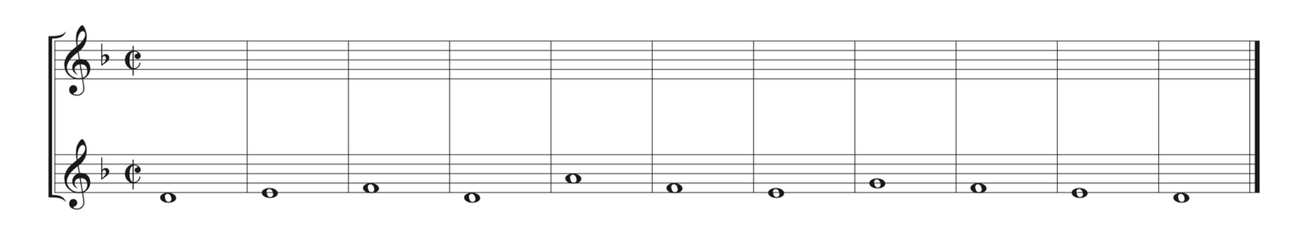
Figure 3.12 - Cantus Firmus by Haydn
The guidelines for first-species counterpoint are quite strict: only whole notes are allowed, and only consonant intervals may occur between the counterpoint and the cantus firmus. Additionally, one must approach perfect intervals through either contrary or oblique motion; one should move primarily by step, with the occasional (exclusively consonant) leap. Second-species counterpoint allows for half notes in the service of two-against-one counterpoint. With this change in the rhythmic requirement come the introduction of vertical dissonances, though only as passing or neighbor motion on metrically weak beats. Figure 3.2 gives an example of first and second-species counterpoint, using the same cantus firmus of Figure 3.1. Note that the rhythmic structure of the species is simple the better for the practitioner to attend to intervallic relationships between two melodic lines. The primary concern of Fuxian counterpoint is the treatment of consonant and dissonant intervals. Common-practice composers studied species counterpoint to hone their voice-leading skills, which helps pave the way for an understanding of Classical harmony.
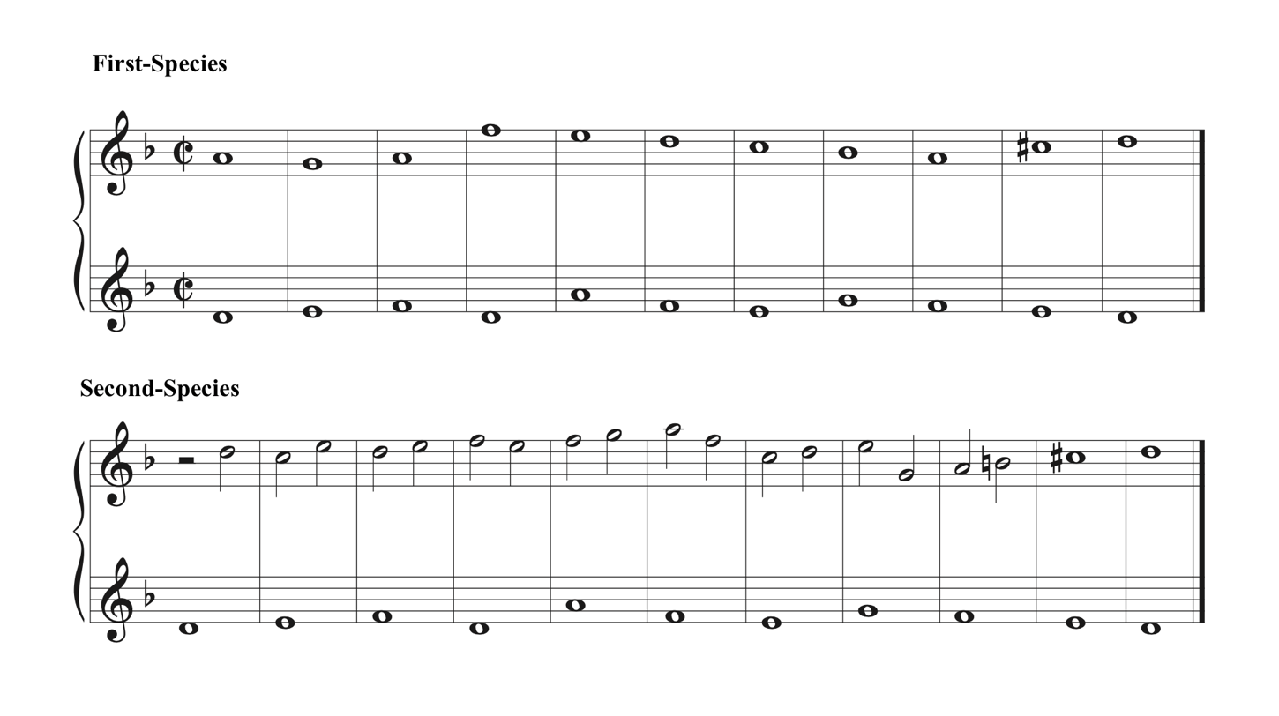
Figure 3.13 - First and second-species counterpoint on cantus firmus by Haydn. Counterpoint by L. Poundie Burstein and Joseph N. Straus.
Subsequent to lessons concerning two-voice counterpoint, the instructor can elect to give students three-voice counterpoint exercises (the same cantus firmus in Figure 3.1 can be used for such exercises), which can eventually lead into four-voice part writing that can then be a conduit into diatonic and chromatic harmony. Beyond this, it is common for further detailed instruction in counterpoint to be reserved for a counterpoint-specific course, which might explore counterpoint in the inventions and fugues of J.S. Bach and other Baroque composers. However, before leaving counterpoint behind as a specific topic in the general theory curriculum, it can be fruitful to show students how it is used in today’s music. The chapter will now turn its attention to counterpoint in musical theatre, before exploring their pedagogical applications.
In current counterpoint pedagogy, teachers use Fux’s method since its emphasis on pitch-oriented matters such as dissonance treatment is apropos of the Baroque and Classical repertoire being studied. What using that method fails to address, however, are aspects of counterpoint that exceed intervallic considerations. In theatre music, for instance, counterpoint can be primarily rhythmic in its construction and emphasis; it can also be dramatic, drawing in parameters such as dynamics or register that amplify the drama of both the music and plot. Expanding one’s contrapuntal purview no doubt requires additional time, effort, and resourcefulness on the teacher’s part, but the effort can be well worth it for the student. Not only can this broader vantage equip students to understand more contemporary usages of counterpoint, but it can also shed light on aspects of traditional usage that the species fail to consider.
This chapter will explore three instances of contrapuntal writing in musical theatre. Each example comes from a different composer, different decade, and different musical style. While these examples attempt to account for musical diversity under the musical theatre umbrella, all share a common element: the ability to amplify the drama, whether positive excitement or negative tension and conflict between characters.
Previous chapters have noted similarities and differences between the common-practice music typically taught in the theory curriculum and the musical theatre repertoire. This chapter instead uses theatre music to expand and continue the study of counterpoint after the students have grasped strict contrapuntal principles.

II. Counterpoint in Musical Theatre
Stephen Schwartz’s 2003 musical Wicked tells the story of The Wizard of Oz (first a children’s novel and then eventually the classic 1939 movie musical) from the perspectives of Glinda the Good Witch and the Wicked Witch of the West (named Elphaba in this adaptation). Schwartz’s musical provides backstory and lore to the land of Oz and the events leading into the original story. The Act I song, “One Short Day,” describes the two lead characters’ first experience in the famed Emerald City and features some alluring counterpoint between the main characters and the chorus. In this instance, Schwartz utilizes counterpoint to generate excitement on stage about the wonders of the setting where the characters have just arrived. Although counterpoint, as described by Fux, traditionally deals with the balance of consonant and dissonant intervals, Schwartz’s counterpoint is primarily based on rhythmic relationships between two melodies, though it can still be fruitful to study how Schwartz treats intervals.
Unlike the other examples studied in this chapter, Schwartz introduces two melodies separately, before layering them on top of one another to create counterpoint. The song opens with the material that Glinda and Elphaba will eventually sing together contrapuntally. (Fig. 3.3):
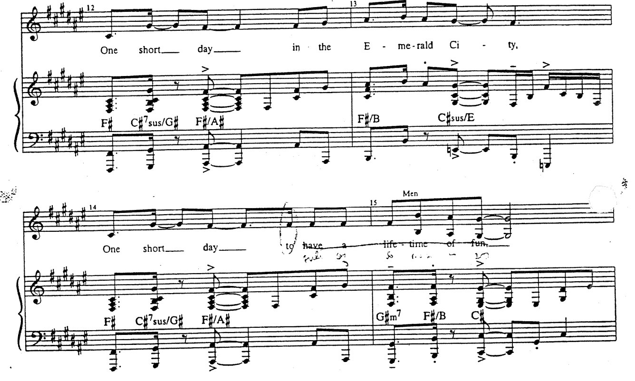
Figure 3.14 - Wicked, "One Short Day," mm. 12-15.
The melody, by and large, uses diatonic stepwise motion. Only two melodic skips occur, in mm. 12 and 15. Rhythmically speaking, this material is palpably energetic. Marked “Moderato” with a metronome marking of 120 beats per minute (four measures prior to Figure 3.3), the syncopated and eighth-note-driven music helps to convey the characters’ excitement about the adventure that lies ahead of them. The other melodic component of the counterpoint (sung by a “Show Chorus”) begins with similar syncopation (Figure 3.4):
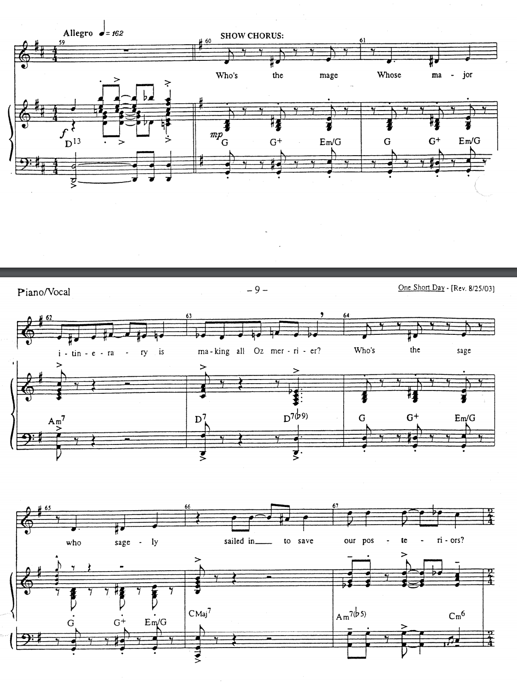
Figure 3.15 - Wicked, "One Short Day," mm. 60-67.
Subdividing the pulse of mm. 60 and 61 in eighth notes, we notice that the pitches occur on every third eighth note. In other words, this melodic fragment has an indirect grouping dissonance of G 4/3. This is repeated in mm. 64 and 65. When we look at the syncopation in mm. 12 and 14, we notice that the melodic figure for the lyrics “One short day” also has an inner-onset interval of three, though with its basic unit of sixteenth notes instead of eighth notes. While again primarily stepwise, this time the music is fairly chromatic, as opposed to the primarily diatonic design of mm. 12-15. Mm. 66 and 67 slightly break the pattern of mm. 60-65. The chromatic tones are much sparser in these two measures, with just one neighbor tone and one passing tone. The melodic material of mm. 12-15 and 60-67 are superimposed onto each other to create mm. 84-99 (Figure 3.5)
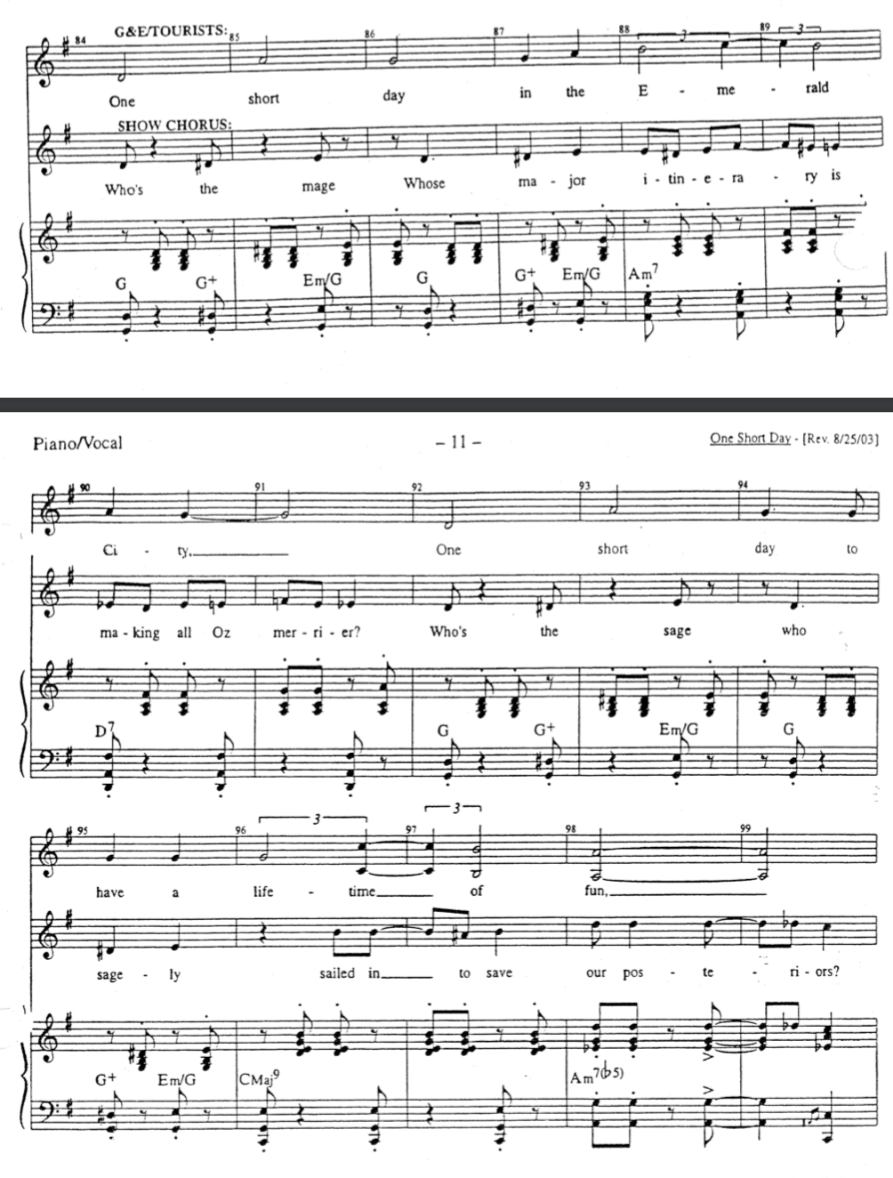
Figure 3.16 - Wicked, "One Short Day," mm. 84-99.
Although the previous material had been written in 4/4 time, in this section the material has been transcribed in 2/4. That in itself does not alter our aural perception. The Show Chorus melody is unchanged from its original presentation at m. 60. The accompaniment (shown here as a piano reduction of the orchestra), while harmonically the same as the phrase at m. 60, does have a slightly different rhythmic pattern. While the accompaniment at m. 60 primarily contains short hits that line up with the Show Chorus, its equivalent phrase at m. 84 is much more active, consisting of a near constant stream of eighth notes (mm. 98-99 deviate slightly.)
The most significant change happens in the music originally presented at m. 12, now sung by Glinda, Elphaba, and other Tourists (ensemble members) to the Emerald City. The rhythms have been augmented in such a way that what was dotted eighth notes in m. 12 is now half notes in mm. 90-92. Had the rhythms simply been doubled in length (where the dotted eighth notes becomes dotted quarters), they would have metrically lined up with the Show Chorus melody, creating one-against-one counterpoint. Likewise, had Schwartz kept the syncopation in the top voice, a couple of things might have happened. Practically speaking, Schwartz might have run out of lyrics too quickly, forcing him to incorporate text he might not have wanted to use at this given moment in the song. Rhythmically, perhaps too many active, fast-paced rhythmic events would take place in each measure. This in turn might transform the dramatic atmosphere from wondrous excitement to frantic energy, which would not as accurately portray the emotional state of Glinda and Elphaba. By adjusting the rhythms to create half notes, a more florid counterpoint emerges, creating a G4/3 hemiola between the two voices (Figure 3.6) The same hemiola also occurs in mm. 88-89 and 96-97, at half the rhythmic length. The pitch content remains unchanged, making it quite easy to reharmonize with the Show Chorus material.
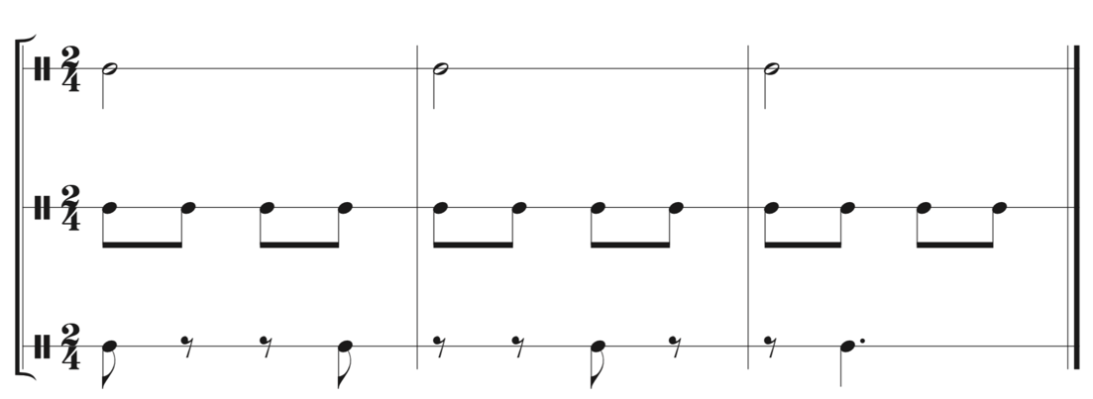
Figure 3.17 - Rhythmic Presentation of Hemiola in "One Short Day," mm. 90-92. Top staff represents Glinda, Elphaba, and Tourists. Middle Staff is the underlying eighth note pulse. Bottom staff represents the Show Chorus.
Dramatically speaking, this counterpoint builds the excitement that has been brewing up to this point in the song. Certainly this is not the only way Schartz could have engendered this euphoria, though the energy of different parts of the cast performing melodies that create rhythmic cohesion helps play to the emotions on stage. While the Show Chorus continues their routine praising of the Wizard (whom Elphaba and Glinda have come to the city to meet), the Tourists (including our two main characters) are still amazed at the awe-inspiring and fantastical Emerald City. The counterpoint does not create any sort of conflict between the two groups on stage; only positivity, excitement, and spectacle are present in this moment.
The next two examples further highlight the range of dramatic potential of counterpoint, as the music and characters are more confrontational and argumentative.
Although the 1980 sung-through musical Les Misérables (colloquially, Les Mis) features a variety of interweaving plots and a plethora of characters, the excerpt most relevant for our purposes involvoes only two characters: reformed convict Jean Valjean and the police inspector Javert. In this scene, the two men confront each other: Valjean has just sworn to protect the child of a recently desceased mother, while Javert desires to arrest Valjean for breaking his parole years ago.
While composer Claude-Michel Schönberg explores rhythmic relationships in this scene , known as “The Confrontation,” he also emphasizes secondary parameters, namely dynamics and register – parameters that are of secondary relevance to common-practice counterpoint (and of no concern to Fux at all). Schönberg focuses on these parameters primarily to create a dramatic counterpoint in concert with the musical counterpoint. The dramatic counterpoint presented here allows both the plot and music to further two central characters as individuals and also the antagonistic relationship between them.
Unlike in “One Short Day,” here the separate contrapuntal strands are not initially introduced separately; the characters immediately jump into the counterpoint after a brief introduction. “The Confrontation” does however share some similarities with an earlier segment of the Prologue, entitled “Work Song” (Figure 3.7). Both numbers are in F minor, have similar tempi, and the same accompanimental texture (straight quarter notes in the upper voices of the piano/orchestra with a more rhythmic bass line). Additionally, the recitative-like melodies sung by Convict 4 in “Work Song” and Valjean in “The Confrontation” both feature descending perfect intervals in sixteenth notes. The material Javert sings beginning at m. 76, however, is new—more melodic and song-like than Valjean’s recitative-adjacent material.
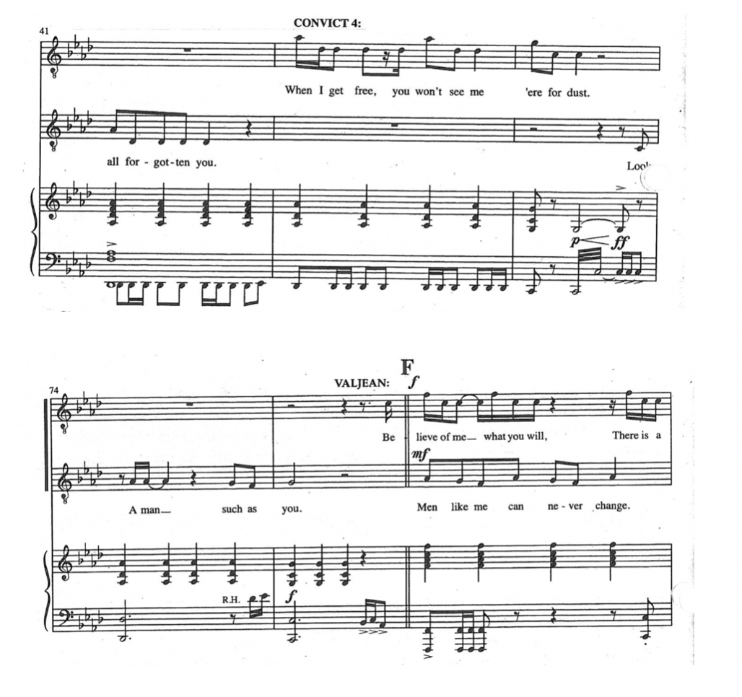
Figure 3.18 - Les Miserables, "Work Song," mm. 41-43 (top system), "The Confrontation," mm. 74-76 (bottom system).
As this scene features the two men constantly singing against the other, not giving one another time to be heard in their arguments, it can be difficult for performers musically to balance the two lines. Schönberg solves this primarily by dynamic level, secondarily by range. Dynamically, one character sings forte while the other sings mezzo-forte, with the two roles exchanging these dynamics. The following table compares the two characters’ text, with bold text indicating when a character sings forte.

Jean Valjean  Believe of me what you will,  There is a duty that I’m sworn to do.  You know nothing of my life.  All I did was steal some bread.  You know nothing of the world.  You would sooner see me dead.  But not before I see this justice done.  I am warning you Javert  I’m a stronger man by far.  There is power in me yet,  My race in not yet run.  I am warning you Javert,  There is nothing I won’t dare.  If I have to kill you here,  I’ll do what must be done. | Javert  Men like me can never change.  Men like you can never change.  No, 24601.  My duty’s to the law.  You have no rights,  Come with me, 24601.  Now the wheel has turned around.  Jean Valjean is nothing now.  Dare you talk to me of crime,  And the price you had to pay.  Every man is born in sin,  Every man must choose his way.  You know nothing of Javert,  I was born inside a jail.  I was born with scum like you,  I am from the gutter too.

Each line lasts approximately one measure, with Javert having slightly more time at a higher dynamic than Valjean. Accordingly, the audience better understands Javert’s motivations, since, by the end of the sequence, his backstory has been fleshed out more than Valjean’s. By this point, the audience has already sided with Valjean as the protagonist of the story and accepted him as a character who seeks redemption and to do good in Cosette’s life. On the other hand, the audience does not know much about Javert, other than that he is a man who strictly follows the law and relentlessly pursues a man who broke his parole. “The Confrontation” gives the audience insight into his background—his own mother was a criminal, but he has chosen for himself the path of the law. Since this sequence develops Javert more than it does Valjean, it makes sense to give Javert more time at the stronger dynamic level so that the audience can hear the imporant new information.
The range of the singers also helps slightly, though not as much as the dynamics do. Valjean is a tenor role, Javert a baritone one. However, Javert does spend most of mm. 79-83 singing higher than does Valjean (Figure 3.8 below) (recall that he also sings louder and has more jagged melodic leaps). Mm. 82 and 83 deviate slightly: in the first three beats of m. 82 Valjean sings higher than Javert and m. 83 sees Vajean finishing his previous line while Javert sings one extra line. Melodically the characters trade roles, as Javert begins singing the leaping material and Valjean takes the stepwise melody in mm. 79-81. Timbre also plays an important role here, as a baritone singing in that register will create a different color than a tenor singing the same notes. This again helps to ensure that one voice is always heard more clearly than the other.
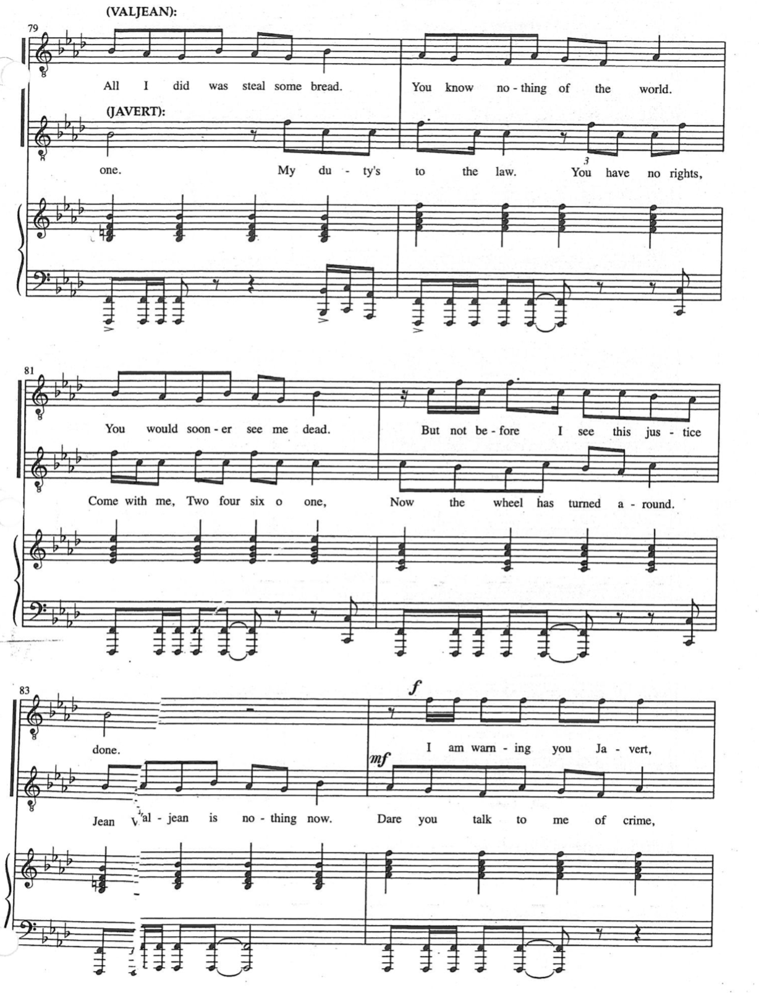
Figure 3.19 - Les Misérables, "The Confrontation," mm. 79-84.
It should be noted, however, that using dynamics to help one voice in the counterpoint project over another goes against traditional counterpoint teachings, which vaule an equal balance among voices. Said adjustments should be considered as a dramatic extension of classical counterpoint—that is, the action on stage demands that certain lines of text be brought out more than another. While a performer of music by Bach or any other composer more devoted to Fuxian practices might choose themselves to bring out one particular line over the other, this would not have been indicated in the score. In the case of “The Confrontation” both the notated music and drama requires one voice to be prominent at a given time.
Contrapuntally, although the music might appear to incorporate a variety of traditional species, instances such as the minor seventh interval between Valjean and Javert (m. 79, beat 3.5) demonstrate another moment of contrapuntal extension. Intervallic content, the primary factor of Fuxian counterpoint, has been put aside in favor of rhythmic and dramatic counterpoint. The two parts of the counterpoint are melodically different, with one voice utilizing primarily linear material (such as Javert in mm. 83 and 84), while the other voice, primarily Valjean sings the angular figure described earlier. Combined with the fairly straightforward accompaniment, the music is composed in a way that allows the text and dramatic tension to take center stage, advancing the plot and developing two central characters along the way.
In the 2015 hip-hop musical Hamilton, elegant rhythmic counterpoint graces an Act I song entitled “Farmer Refuted.” In this song, a debate occurs between a minor character, Samuel Seabury, and Alexander Hamilton during the Continental Congress, shortly before the scene changes to the beginnings of the American Revolution. The song’s form can help us understand the structure of the debate in the text, which, in turn, helps us understand the use and necessity of the counterpoint. Three refrains make up the core of the song, preceded by a four-measure introduction and followed by transitionary material into the next song, “You’ll Be Back.” Figure 3.9 outlines the song’s form.

 | Introduction | Refrain 1 | Refrain 2 | Refrain 3 | Coda/Transition
Starting Measure | 1 | 5 | 21 | 37 | 45
Character(s) | Seabury (dialogue only) | Seabury  Mulligan/Burr (background dialogue) | Seabury  Hamilton | Seabury  Hamilton  Burr | Company
Figure 3.20 - Form diagram of Hamilton, "Farmer Refuted."
In the first refrain, Seabury sings by himself, with two short asides from Lawrence Mulligan and Aaron Burr (Figure 3.10). Seabury’s musical material is completely sung through, in an operatic tone, accompanied mainly by harpsichord. The European musical style afforded this character is distinctly opposed to the American hip-hop and RnB styles afforded the other characters and Hamilton’s score generally; the classical-music allusion reflects Seabury’s anti-American and pro-British political views (Seabury was a British Loyalist). Such characters represented by two different musical styles on top of one another yields a certain stylisic counterpoint. This stylistic counterpoint is similar to Peter Dickson’s style-modulation, but instead of one style shifting into another the two are presented simultaneously. Once again, stylistic counterpoint is another example of the musical theatre literature creating an extension of Fuxian counterpoint, whose goal is to represent music of a uniquely Palestrinian style.
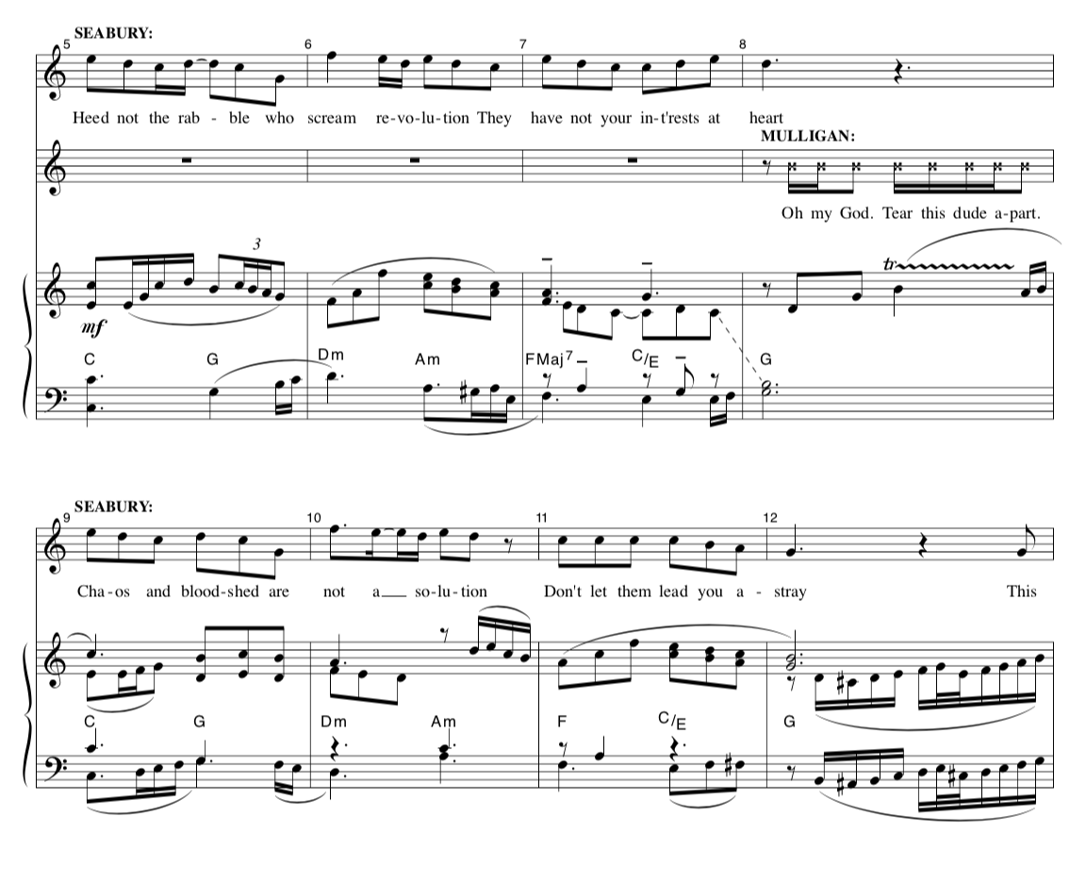
Figure 3.21 - Hamilton, "Farmer Refuted," mm. 5-12.
The second refrain contains most of the rhythmic counterpoint. Seabury repeats his verse verbatim—the music and text are both exactly the same. Hamilton, meanwhile, has joined in, bringing hip-hop back into the song by rapping his argument (Figure 3.11). Similarly to “The Confrontation” from Les Mis, most of the counterpoint happens in first or second species (from a purely rhythmic standpoint), with Hamilton rapping many more words than Seabury can sing in this 16-measure refrain (Seabury’s refrain contains 52 words while Hamilton’s rap contains 85). Mm. 30-33 feature the only time Hamilton actually sings in this number (Figure 3.12). The phrase comes off as Hamilton mocking Seabury’s posh attitude, by starting the singing on the word “eloquently” and, at least in the original cast recording, doing so sarcastically, as if mocking Seabury’s operatic tone. The third refrain begins to break down the debate of the second refrain, with Seabury only singing a few notes of his original melody, now having lost the argument against Hamilton (Figure 3.13).
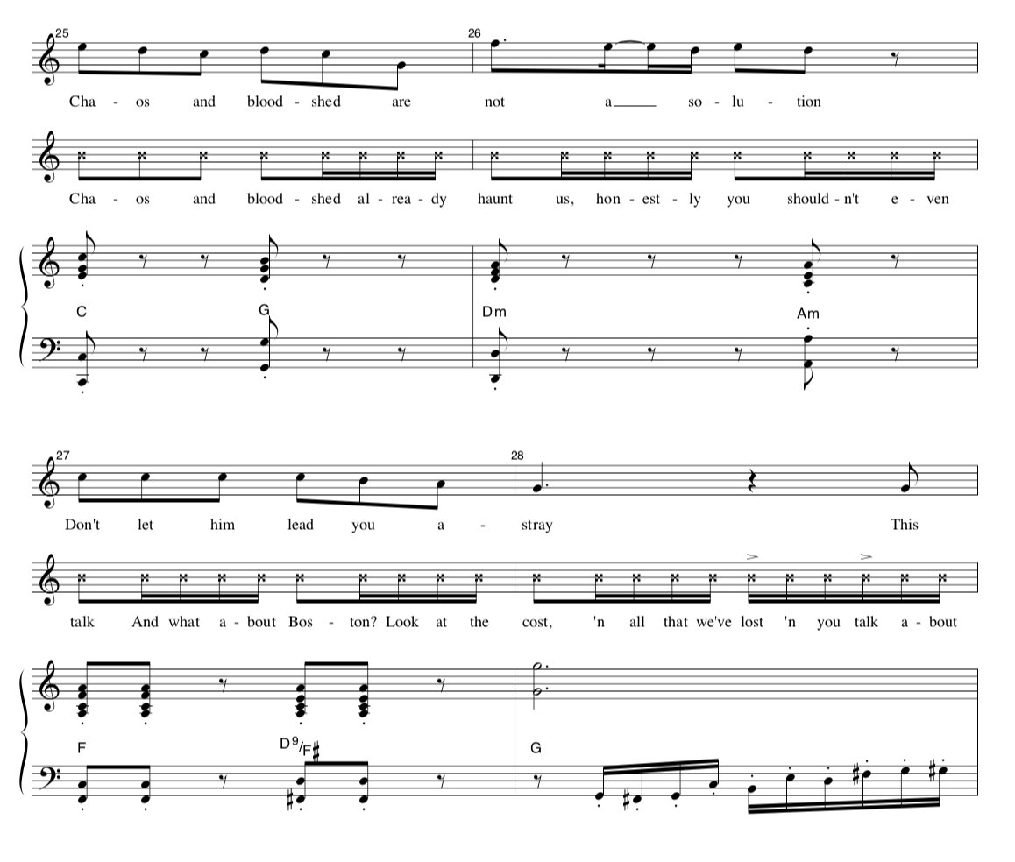
Figure 3.22 - Hamilton, "Farmer Refuted," mm. 25-28.
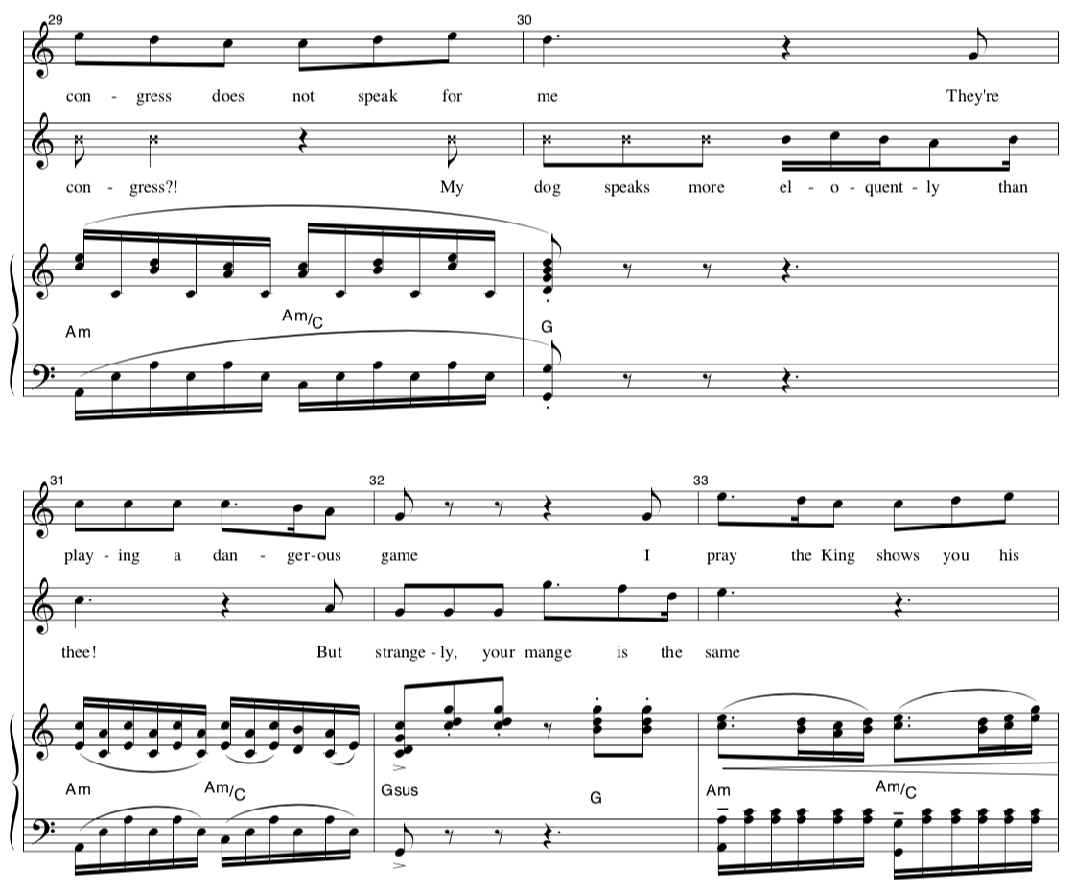
Figure 3.23 - Hamilton, "Farmer Refuted," mm. 29-33.
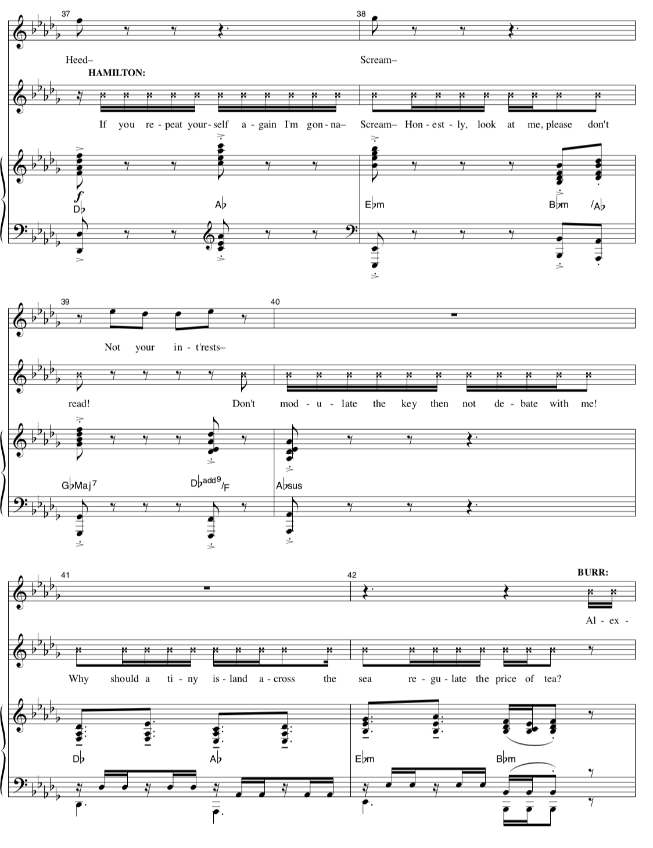
Figure 3.24 - Hamilton, "Farmer Refuted," mm. 37-42.
The song and the counterpoint in turn also represent the discourse of political dialogue today, especially in America. Seabury and Hamilton arguing and speaking over one another, especially in the second refrain, mirrors current politics where two sides or parties continue to fight and try to speak louder than the other, without giving the other room to have their side heard. The result is cacophony, not euphonious dialogue. Additionally, Seabury’s repeating of the same text refrain after refrain is also akin to politicians repeating their soundbytes every chance they get. Lin-Manuel Miranda, the composer and lyricist creates this political landscape in “Farmer Refuted” by utilizing two lines working contrapuntally to mimic the arguments heard in both eighteenth and twenty-first century politics.

III. Pedagogical Applications
Each of the above works is from a different decade; they collectively showcase the stylistic variety of musical theatre as a whole. Of the three, Wicked, and especially “One Short Day,” has the most similarities to the Golden Age musicals of the 1950s such as Loesser’s Guys and Dolls, but with a distinctly modern sound. Les Mis represents some of the best of the 1980’s “mega musicals,” with its huge orchestral sound and elegant staging, lighting and costuming, which results in both a large-scale work of art as well as a highly marketable product. Hamilton, meanwhile, is one of the most celebrated contemporary musicals, bringing hip-hop, RnB, and electronic sounds to the stage. Such stylistic diversity allows for greater variety in teaching contemporary usage of counterpoint and its dramatic potential.
The following script can be used as a guide in leading students in a discussion about the music, the drama, and the counterpoint. While this script uses Les Mis as its example, many other examples can certainly be used.
As class begins, Teacher (T) plays for Students (S) “The Confrontation” from Les Mis. Optionally, T could play the clip of this scene from the 2012 film, so S could watch the drama unfold before their eyes.
T: Notice that these two characters are singing over each other, creating two equally important melodies sounding at the same time. Do we have a name for this technique?
S: Counterpoint?
T: Excellent! This is a very contemporary use of the counterpoint techniques we’ve been studying thus far in the class, which we can now examine in more detail. Now, what can be said of what the counterpoint is doing for this scene right now?
(S need not have a thorough knowledge of the plot of Les Mis. A score excerpt of this section could be passed out so that students can follow along with this scene, which T might replay at this time.)
S: The characters seem to be fighting or arguing with each other and not wanting the other character to get a word in.
T: Absolutely! That’s the main idea of how the composer uses counterpoint to create dramatic tension. Now, let’s look at the specific technical elements of the counterpoint. Certainly, we can all agree that this is not in any one strict contrapuntal species, but elements of species counterpoint are certainly present. Can anybody name a specific moment in the song?
S: I see in m. 81 that there’s second-species counterpoint on the first beat before the music shifts to a one-against-one texture for the rest of the measure.
T: Great, we can work with that for sure. While both melodies right here are independent, how do we know exactly how to listen to this, or how would we perform and balance these two parts?
S: Well right here, the second staff is singing higher and at a louder dynamic than the first staff, so that might be the more important line at that point.
T: Very good indeed! I’d like to take some time to explore the way the composer uses dynamics further. Let’s compare this to an invention by Bach, which is also two-voice counterpoint.
T can either play a recording of Bach’s D minor Invention, BWV 775, or play it themselves. Either way, a score should be projected on the screen for S to follow.
T: Now, how does the use of dynamics compare between the Bach and Les Mis?
S: In the Bach, dynamics were definitely used to shape phrases, but one voice didn’t necessarily stick out over the other in the case of Les Mis.
T: Oh, that’s a fantastic point! In the Bach (as well as in the music of other common practice composers), the dynamics were a secondary parameter. Essentially, the dynamics come into play after the counterpoint has been composed. The counterpoint would still have all of the necessary components even if no dynamic were printed on the sheet. With Les Mis though, now that we’re also trying to convey a plot, how we balance the two lines at any given time because increasingly more important. We as an audience need to know if there’s a certain line, we should be gravitating towards more than another line. If we were to create a spectrum of the importance of dynamics in a given contrapuntal texture, we’d want to put “The Confrontation” on one end (very important) and the Bach on the opposite end (less important.)
T draws this continuum on the board.
Additionally, the instructor should point out that in “The Confrontation,” the two characters are not passing around similar material as happens in the Bach. They are singing two distinct melodies, another extension of traditional counterpoint. The goal with a lesson such as this is to highlight how a composer for a musical would utilize counterpoint in the context of a plot, not just as a piece in and of itself as in a Bach invention. During the course of a lesson, a discussion might occur on how secondary parameters can change in importance from the common practice period to contemporary compositional practices. An analysis of both a Bach invention and “The Confrontation,” perhaps as a homework assignment or as an in-class project, could look at further differences as well as similarities, such as how we might rhythmically see momentary uses of species counterpoint (though still, instructors and students must make clear where species counterpoint rules are followed and where they have been extended). In these lessons and assignments, the goal should not only be to find differences, but to show how musical theatre repertoire can augment and support our common practice understandings. From here the conversation can go in multiple directions. The instructor can choose to dive deeper into the plot of Les Mis and explain how pivotal this song is for character growth, or even move on to dissect other songs and shows described in the analysis portion of this chapter. A potential assignment might have students partner up and record themselves singing this counterpoint to solidify for themselves its dramatic elements (especially if musical theatre majors are in the classroom).
Further studies, both for the student in classroom as well as for the scholar in his or her own research, beyond the scope of this chapter could also be explored in the relationship between counterpoint and musical theatre. One possible activity for students in a counterpoint class, ones who are familiar with fugue techniques, would have them analyzing the “jazz fugue” from “Cool” in Bernstein’s West Side Story. Contrapuntal techniques occur often in the history of musical theatre and we have a variety of ways to incorporate this music into lectures on counterpoint in the theory classroom.

Conclusion
When incorporated into the music theory curricula, the wide body of musical theatre repertoire can enhance and extend the students’ knowledge and understanding of the core subject matter. Many of the topics discussed in this document are not unique to the musical theatre tradition, however. The diversity of musical styles within musical theatre can be attributed to the various popular music styles of the twentieth and twenty-first centuries. As such, this document does not only endorse the inclusion of musical theatre repertoire within the theory curriculum, but of any kind of popular music more broadly.
Theatre music does, however, provide a dramatic element that interacts with and enhances the music, allowing students to explore relationships between said dramatic elements and music theory. A direct modulation can highlight a character’s amplified emotional state. The intricate counterpoint of two characters singing over one another can be understood as a manifestation of the inherent conflict in their interaction. Students can begin to see how drama can be portrayed musically, which in turn can prepare students for more advanced studies concerning music and meaning.
Instructors who might shy away from incorporating musical theatre into the classroom due to their own perceived inexperience should find encouragement in the above analyses of musical theatre music as well as the various pedagogical applications of each explored topic. The lesson scripts and strategies in this document can be molded and adapted for each instructor and each classroom. Collaboration can often be a useful tool in the classroom. Those teachers who still might have some apprehensions of incorporating musical theatre (or any popular music) might seek out colleagues at their institution who might work with this music more often. These people might be those who direct the school’s musical, an applied instructor who frequently performs in local or professional theatre, or a scholar that has devoted more time to studying popular music. The amount of cooperation might manifest itself in simple meetings to discuss various pedagogical and analytical strategies, or perhaps lead to a guest speaker coming to speak to the class on their specialty. Fruitful collaborations between instructors of different musical and theatrical disciplines will ultimately yield a richer learning experience for the students.
The instructor steadfast in his or her methods might still maintain that there simply is not enough time in the course of a semester to devote time to musical theatre. It should be noted, however, that music in this document has not been studied with any novel analytical techniques. In this way, instructors can have a dialogue about musical theatre using established methods in the classroom. Thus, musical theatre can be used as a reinforcement tool in the teaching of music theory. When our analysis has yielded a typical result for musical theatre but an atypical result for classical music, we have framed these differences as extensions of common-practice theory. If viewed as extensions and not as a different music altogether, musical theatre can further enhance the present teaching of music theory, not detract from it.
Similar future studies on integrating musical theatre into the theory classroom might focus on other topics taught in the curriculum and the musical selections that can best embody said topics. Furthermore, in addition to the musical theatre repertory, related research might choose to incorporate other styles of popular music. Additional research would likely still primarily focus on undergraduate music theory, as at the graduate level musical theatre might receive its own dedicated seminar. It can however be interesting to discuss the pedagogy of teaching a graduate seminar such as this, while at the same time finding opportunities to discuss musical theatre in the more common graduate theory topics (such as Buchler’s modified Schenkerian approach to modulations, which might find its way into the end of a Schenkerian analysis course that covers extensions to that theory).
In an ever-changing musical world, more students graduating from institutions teaching classical music will have to interact with a diverse variety of musical styles, either as performers, educators, scholars, composers, or some mixture of these careers. By teaching music theory through musical theatre we not only demonstrate a reinforcement and extension of common-practice music, but also best prepare our students for their futures as musicians once they leave our institutions.

Bibliography
Bell, John, and Steven R. Chicurel. 2008. Music Theory for Musical Theatre. Lanham, MD: Scarecrow Press, Inc.
Benward, Bruce and Marilyn Saker. Music Theory and Practice. 9th ed. (New York: McGraw-Hill Education).
Biamonte, Nicole. "Triadic Modal and Pentatonic Patterns in Rock Music." Music Theory Spectrum 32, no. 2 (2010): 95-110.
Buchler, Michael. "Modulation as a Dramatic Agent in Frank Loesser's Broadway Songs." Music Theory Spectrum 30, no. 1 (2008): 35-60.
Burkhart, Charles and William Rothstien. 2012. Anthology for Musical Analysis, 7th ed., (Boston: Schirmer Cengage Learning).
Burstein, L. Poundie and Joseph N. Straus. 2016. Concise Introduction to Tonal Harmony. (New York: W.W. Norton and Company).
Campbell, Patricia Shehan, et al. 2014. Transforming Music Study from its Foundations: A Manifesto for Progressive Change in the Undergraduate Preparation of Music Majors, conference copy. Report of the Task Force on the Undergraduate Music Major, The College Music Society.
Capuzzo, Guy. “A Pedagogical Approach to Minor Pentatonic Riffs in Rock Music.” Journal of Music Theory Pedagogy 23 (2009): 39–55.
Chennette, Timothy K. "Incorporating Popular Music in Teaching: Ideas for the Non-Expert." Journal of Music Theory Pedagogy 31 (2017): 3-18.
Clendinning, Jane Piper and Elizabeth Marvin, The Musician’s Guide to Theory and Analysis. 3rd ed. (New York: W.W. Norton & Company).
de Clerque, Trevor. "The Nashville Number System: A Framework for Teaching Harmony in Popular Music." Journal of Music Theory Pedagogy 33 (2019): 3-28.
Dickinson, Peter. “Style-Modulation: An Approach to Stylistic Pluralism.” The Musical Times 130, no. 1754 (1989): 208–11.
Emielu, Austin. "Some Theoretical Perspectives on African Popular Music." Popular Music 30, no. 3 (2011): 371-88.
Folse, Stuart. “Popular Music as a Pedagogical Resource for Musicianship - Contextual Listening, Prolongations, Mediant Relationships, and Musical Form.” Journal of Music Theory Pedagogy 18 (2004): 65–79.
Franceschina, John Charles. 2015. Music Theory through Musical Theatre: Putting It Together. New York: Oxford University Press.
Gilbert, Steven E. "Gershwin's Art of Counterpoint." The Musical Quarterly 70, no. 4 (1984): 423-56.
Hook, Julian. “Cross-Type Transformations and the Path Consistency Condition.” Music Theory Spectrum 29 (2007): 1-40.
Julien, Patricia. “How to Write a Jazz Chord Progression.” Journal of Music Theory Pedagogy 26 (2012): 29–58.
Kostka, Stefan, Dorothy Payne, and Byron Almén. Tonal Harmony. 8th ed. (New York: McGraw-Hill Education).
Laitz, Steven G. The Complete Musician: An Integrated Approach to Theory, Analysis, and Listening. 4th ed. (New York: Oxford University Press).
Murphy, Barbara, and Brendan McConville. “Music Theory Undergraduate Core Curriculum Survey: a 2017 Update.” Journal of Music Theory Pedagogy 31 (2017): 177–277.
Ricci, Adam. "A "Hard Habit to Break": The Integration of Harmonic Cycles and Voice-Leading Structure in Two Songs by Chicago." Indiana Theory Review 21 (2000): 129-46.
Rosenberg, Nancy. “Bach, Beck, and Bjork Walk into a Bar - Reclassifying Harmonic Progressions to Accommodate Popular Music Repertoire in the Traditional Music Theory Class.” Journal of Music Theory Pedagogy 28 (2014).
Snodgrass, Jennifer Sterling. "Current Status of Music Theory Teaching." College Music Symposium 56 (2016).
Swinkin, Jefferey. “Notes on Sonata Form” (Handout received in Structures IV with Professor Jeffrey Swinkin, Norman, Oklahoma, Mar. 3, 2020).

Patricia Shehan Campbell, et al., “Transforming Music Study from its Foundations: A Manifesto for Progressive Change in the Undergraduate Preparation of Music Majors,” conference copy. Report of the Task Force on the Undergraduate Music Major, The College Music Society, 2014.
Campbell, et. al., “Manifesto,” 2.
Ibid., 3.
Ibid., 38.
Jennifer Sterling Snodgrass, "Current Status of Music Theory Teaching," College Music Symposium 56 (2016).
Snodgrass, “Current Status of Music Theory Teaching,” 9.
Barbara Murphy and Brendan McConville, “Music Theory Undergraduate Core Curriculum Survey: a 2017 Update,” Journal of Music Theory Pedagogy 31 (2017): 177–277.
The Nashville number system is a harmonic notation tool similar to the Roman numeral system used in traditional music theory, with a key difference being using Arabic numeral (so 5⁷ would symbolize a dominant seventh chord). For a more detailed description see Trevor de Clerque, "The Nashville Number System: A Framework for Teaching Harmony in Popular Music," Journal of Music Theory Pedagogy 33 (2019): 3-28.
Murphy and McConville, “Music Theory Survey,” 221.
Steven E. Gilbert, "Gershwin's Art of Counterpoint," The Musical Quarterly 70, no. 4 (1984): 423-56.
Gilbert, “Gershwin’s Art of Counterpoint,” 455.
Nicole Biamonte, "Triadic Modal and Pentatonic Patterns in Rock Music," Music Theory Spectrum 32, no. 2 (2010): 95-110.
Biamonte, “Triadic Rock Music,” 108.
Timothy K Chenette, "Incorporating Popular Music in Teaching: Ideas for the Non-Expert," Journal of Music Theory Pedagogy 31 (2017): 3-18.
Chenette, “Incorporating Popular Music,” 5.
Austin Emilu, "Some Theoretical Perspectives on African Popular Music," Popular Music 30, no. 3 (2011): 371-88. Considering that present national borders in Africa are a result of European colonization and not any actual cultural boundaries, country of origin can mean very little when discussing elements of African culture.
Stuart Folse, “Popular Music as a Pedagogical Resource for Musicianship - Contextual Listening, Prolongations, Mediant Relationships, and Musical Form,” Journal of Music Theory Pedagogy 18 (2004): 65–79.
Folse, “Popular Music as a Pedagogical Resource,” 79.
Patricia Julien, “How to Write a Jazz Composition’s Chord Progression,” Journal of Music Theory Pedagogy 26 (2012): 29–58.
Nancy Rosenberg, “Bach, Beck, and Bjork Walk into a Bar - Reclassifying Harmonic Progressions to Accommodate Popular Music Repertoire in the Traditional Music Theory Class,” Journal of Music Theory Pedagogy 28 (2014).
Rosenberg, “Reclassifying Harmonic Progressions,” 163.
Guy Capuzzo, “A Pedagogical Approach to Minor Pentatonic Riffs in Rock Music,” Journal of Music Theory Pedagogy 23 (2009): 39–55.
Capuzzo, “Minor Pentatonic Riffs,” 52.
John Bell and Steven R. Chicurel, Music Theory for Musical Theatre, Lanham, MD: Scarecrow Press, Inc., 2008.
John Charles Franceschina, Music Theory through Musical Theatre: Putting It Together, New York: Oxford University Press, 2015.
For example, a I⁶ in C major would be written as a C/E chord (C chord with an E in the bass). Lead sheet notation can be used in conjunction with Roman numerals and figured bass, as the lead sheet symbol describes what the chord is while figured bass describes how the chord functions.
Adam Ricci, “A ‘Hard Habit to Break’: The Integration of Harmonic Cycles and Voice-Leading Structure in Two Songs by Chicago,” Indiana Theory Review 21 (2000): 129–46.
Ricci, “Two Songs by Chicago,” 132.
Michael Buchler, “Modulation as a Dramatic Agent in Frank Loesser’s Broadway Songs,” Music Theory Spectrum 30, no. 1 (2008): 35–60
Buchler, “Modulation as a Dramatic Agent,” 39.
An inclusion-transformation “maps any major or minor triad to the unique dominant or half-diminished seventh chord that contains it.” (4) See Julian Hook, “Cross-Type Transformations and the Path Consistency Condition,” Music Theory Spectrum 29 (2007): 1-40.
Buchler, 39.
Ibid., 40.
Hook, “Cross-Type Transformations,” 43.
Buchler, 38-39.
Although this study has focused on the dramatic effect of modulation, these elements can also be applied in a similar manner to heighten comedic effect. Examples may include “I Am Not Dead Yet” and “The Song That Goes Like This,” from Monty Python’s Spamalot, which actively poke fun at the trope of shifting a song up a half step in the text, while modulating in this way themselves.
Buchler, 39.
Some programs include an entire course on form and analysis outside of the standard four-semester sequence.
Barbara Murphy and Brendan McConville, “Music Theory Undergraduate Core Curriculum Survey: a 2017 Update,” Journal of Music Theory Pedagogy 31 (2017): 177–277.
Ibid,. 205. Citations to follow.
Murphy and McConville: 204.
Charles Burkhart and William Rothstien, Anthology for Musical Analysis, 7th ed., (Boston: Schirmer Cengage Learning, 2012).
Stefan Kostka, Dorothy Payne, and Byron Almén, Tonal Harmony, 8th ed., (New York: McGraw-Hill Education).
Bruce Benward and Marilyn Saker, Music Theory and Practice, 9th ed., (New York: McGraw-Hill Education).
Steven G. Laitz, The Complete Musician: An Integrated Approach to Theory, Analysis, and Listening, 4th ed., (New York: Oxford University Press).
Jane Piper Clendinning and Elizabeth Marvin, The Musician’s Guide to Theory and Analysis, 3rd ed. (New York: W.W. Norton & Company).
Lead sheet for “I Got Rhythm” adapted from a Piano/Vocal book, Vocal Selections from “Girl Crazy,” published by Warner Bros. Publications in 1984.
Just as the verse-refrain form of Tin Pan Alley songs evolved from recitative-aria form, the jazz contrafact arguably evolved from the early music practice of contrafactum, in which new words are set to a pre-existing melody.
Lead sheet for “(Meet) the Flintstones” adapted from Piano/Vocal sheet music published by Barbara-Hanna Music.
Five Guys Named Moe primarily features music from mid-twentieth-century jazz composer Louis Jordan. The title song is one of several written by Wynn and Bressler to round out the musical numbers of the stage show.
Lead sheet for “Five Guys Named Moe” adapted from Piano/Vocal book Five Guys Named Moe: Vocal Selections, published in 1993.
Similar to the other contrafacts explored in this chapter, Figure 2.7 is not simply a copy/paste of the literal chords of “I Got Rhythm.” Among other slight variations, m. 1 uses the V/ii on b. 3, which is similar to the use of viiº/ii. in m. 2 of “Five Guys Named Moe.” Additionally, the B section has been simplified to purely a circle-of-fifths motion.
Jeffrey Swinkin, “Notes on Sonata Form” (Handout received in Structures IV with Professor Jeffrey Swinkin, Norman, Oklahoma, Mar. 3, 2020).
Sheet music for “My Favorite Things” taken from Piano/Vocal score to The Sound of Music. Piano Reduction by Trude Rittman.
For a quintessential recording of “My Favorite Things” as a jazz tune, see John Coltrane, My Favorite Things, Atlantic Records, 1960.
“Bad Idea” focuses on the immediate aftermath of Jenna Hunterson, a pregnant waitress trapped in an abusive marriage, kissing her OB/GYN, the equally married Dr. Jim Pomatter. During the course of the song they decide to begin an extramarital affair; the song and Act I conclude with the two characters having sex in Dr. Pomatter’s office.
Sheet music for “Bad Idea” from the Waitress Vocal Sections book, published by Hal Leonard in 2015.
This is not an endorsement of the book as a whole—my textbook review was entirely devoted to how each text teaches form.
Instructors can additionally choose to provide a sheet with several chord substitution possibilities, from which they can choose deliberately and/or randomly.
L. Poundie Burstein and Joseph N. Straus, Concise Introduction to Tonal Harmony (New York: W.W. Norton and Company, 2016), 93, 95.
Score excerpts for Wicked taken from a Piano/Vocal score, revised on 10/7/2003.
Additionally, Javert’s melodic material that leads into “The Confrontation” is a reprise of “Work Song.”
Score excerpts for Les Misérables taken from the Piano/Vocal score licensed by Music Theatre International, used in the 2010 UK Tour. Editing and Piano Reduction by Stephen Metcalfe & Peter Washtell.
Peter Dickinson, “Style-Modulation: An Approach to Stylistic Pluralism,” The Musical Times 130, no. 1754 (1989): 208–11.
Score excerpts for Hamilton are taken from a Piano/Vocal score, revised on 8/15/2015.
Said score may be an Ursatz edition which would feature little to no printed dynamics, or an edition that comes with dynamic markings. Students should know regardless that Bach did not often mark dynamics in his scores, but an edition with dynamics might help visually reinforce how dynamics in traditional counterpoint differ from the use of dynamics in Les Mis.

