University of Oklahoma

Graduate College

Factors relevant to Parallelism inspection

A thesis

submitted to the Graduate Faculty

in partial fulfillment of the requirements for the

Degree of

Master of Science

By

Nitya gupta
Norman, Oklahoma
2017

Factors relevant to Parallelism Inspection

A thesis approved for the
School of Industrial and Systems Engineering

By

______________________________
Dr. Shivakumar Raman, Chair

______________________________
Dr. Randa L. Shehab

______________________________
Dr. Theodore B. Trafalis

© Copyright by Nitya Gupta 2017
All Rights Reserved.

Acknowledgements
I would like to express my sincere gratitude to my thesis advisor and mentor Dr. Shivakumar Raman who was a constant source of motivation throughout my graduate studies. His support and guidance steered my work in the right direction at every step and gave me the chance to think and apply myself as an engineer. I wish to thank the members of my master’s thesis committee, Dr. Randa L. Shehab and Dr. Theodore B. Trafalis who were an invaluable source of wisdom throughout my research. I am gratefully indebted to my advisor and to each member my committee for their valuable feedback on my work.
I would like to express my sincere gratitude to Dr. Ziho Kang for his sincere effort and time that he spent to guide me through this entire study. I can’t thank him enough for his valuable time.
I would also like to acknowledge and thank the faculty and staff of the Department of Industrial and Systems Engineering, especially Cheryl Carney and Kristi Wilson for their constant support and assistance.
Last but foremost, I would like to express my love and appreciation for my beautiful family, my loving husband, and my doting mother who inspire me to be better at all that I do.

Table of Contents

Acknowledgements iv
List of Tables viii
List of Figures ix
Abstract xi
CHAPTER 1: INTRODUCTION 1
1.1 Research Overview 2
CHAPTER 2: BACKGROUND AND LITERATURE REVIEW 4
2.1 Terminology 4
2.2 Datum 5
2.2.1 Recent Studies on Datum Realization 7
2.3 Parallelism 10
2.3.1 Parallel Lines 10
2.3.2 Line parallel to a plane 12
2.3.3 Parallel Planes 12
2.3.4 Planes and associated angle 13
2.3.5 Equation of plane passing through a point and parallel to given plane 16
2.3.6 Distance between two parallel planes 16
2.3.7 Parallel Measurement 17
2.4 Coordinate Measuring Machine (CMM) 20
2.5 Sampling 23
2.5.1 Sampling Techniques 24
2.5.2 Sample size 27
2.5.3 Sampling in coordinate metrology 28
2.5.4 Search Algorithm 30
2.6 Regression Analysis 32
2.6.1 Method of Least Squares 34
2.6.2 Least squares fitting of planes 36
CHAPTER 3: EXPERIMENTAL SET- UP AND METHODS USED 37
3.1 Experimental Model 37
3.1.1 Sampling Strategy 37
3.1.3 Sample Sizes 39
3.1.4 Necessary Software 39
3.1.3 Necessary Equipment 40
CHAPTER 4: EXPERIMENTAL DESIGN 41
4.1 Inspection Samples 41
4.2 Sampling Design 41
4.1.2 Sampling Techniques 41
4.1.2 Selection of Sample Sizes 41
4.3 Experimental Response Parameter 42
4.4 Design of Experiment 43
4.5 Experiment Procedure 43
4.5.1 Suppositions 44
4.5.2 Sample Collection 45
4.5.3 Creation of Best fitting Planes 45
4.5.3 Creation of secondary reference planes 47
4.5.4 Calculating Parallelism Tolerance 47
CHAPTER 5: RESULTS AND ANALYSIS 49
5.1 Results and Data Representation 49
5.1.1 Parallelism Measurement 49
5.1.2 Sampling Method 58
5.1.3 Sample Size 59
5.2 Analysis of Results 60
CHAPTER 6: CONCLUSION AND FUTURE SCOPE 64
6.1 Conclusion 64
6.2 Application and Future Scope 65
6.3 Limitations 66
References 67
Appendix A: MATLAB CODE FOR ERROR DISTANCE 72
Appendix B: CODE FOR SAMPLING IN CMM 74

List of Tables

Table 1: Average discrepancy rate for accuracy of flatness (Source: Kim & Raman, 2000) 29
Table 2: Levels of Sampling 42
Table 3: Factors of Experimental Model 43
Table 4: Parallelism for 0°- Part 1 to 5 50
Table 5: Parallelism for 5°- Part 1 to 5 51
Table 6: Parallelism for 10°- Part 1 to 5 52
Table 7: Mean and Standard deviation of parallelism for inspected parts. 53
Table 8: Factor Table 61
Table 9: ANOVA Table 61
Table 10: Inspection Table 64

List of Figures

Figure 1: Deriving a datum plane from a datum feature (Source: Shakarji & Srinivasan, 2016) 6
Figure 2: Datum features and derived datum geometries (Source: Wu & Gu, 2016) 8
Figure 3: Datum combinations for multiple datum features (Source: Wu & Gu, 2016) 9
Figure 4: Datum system of planes according to ISO 5459 (Source: Ebermann et al. 2016) 10
Figure 5: Parallel Lines intersected by a transverse line (Parallel (geometry), 2016) 11
Figure 6: Parallel planes P, Q and R (Parallel and Perpendicular Planes, 2017) 13
Figure 7: Normal vector to a plane (Weisstein,"Plane.") 14
Figure 8: Angle between two Intersecting planes (Angle between Two Planes, 2017) 15
Figure 9: Feature Control Frame (Parallelism, GD&T Basics) 17
Figure 10: Dial Indicator system to measure parallelism (Source: Bewoor and Kulkami, 2009) 18
Figure 11: Three probe system to measure parallelism of ultra-precision guideways (Source: Hwang et al. 2007) 19
Figure 12: Coordinates of Sampling Methods: Hammersley, Halton-Zaremba, aligned systematic, aligned random respectively. (Source: Kim & Raman, 2000) 27
Figure 13: Region elimination algorithm - straightness estimation (Source: Badar et al., 2003) 31
Figure 14: Hybrid search algorithm for flatness inspection (Source: Badar et al., 2003) 32
Figure 15: Coordinates of Aligned Systematic Sampling 38
Figure 16: Inspection Design 44
Figure 17: Aligned vs. Random: Parallelism plot for inspected parts 57
Figure 18: Main Effects Plot for Analysis 62
Figure 19: Interaction Plot for Analysis 62

Abstract
Inspection of parallelism between two surfaces (planes) requires the establishment of a datum feature (surface), and determination of the envelope of points containing the inspected feature parallel to that datum feature. Verifying parallelism thus requires the establishment of the datum feature, and determining the separating distance between the two parallel planes. The parallelism determination can change with sampling (number of data points) and fitting of points. The datum feature establishment is very important to the inspection, and is also dependent on the number of points used to define it. In this thesis, the datum feature is least squares fit from the data collected using coordinate metrology. The inspected feature is then enveloped by minimum separation planes that contain the maximum deviation between the points. The separating distance between the enveloping planes is calculated, and termed the Parallelism Tolerance.

Three levels each, of two sets of data representing the datum feature and inspected feature are collected, for 15 aluminum plates (3 parallelism geometries, 5 replicates). The independent factors are analyzed against the calculated parallelism values. Experimental analysis shows significant effect of sample size on the parallelism computed. As would be expected, the best parallelism values were obtained at the combination of the highest levels of sampling points for datum feature establishment and inspected feature verification.

CHAPTER 1: INTRODUCTION
In recent years, the demand for more complex mechanical products has increased along with higher precision requirements. Therefore, the demand dictates production processes to be more accurate, and features to be better controlled. The inaccuracies in the surfaces can result in improper performance of mechanical assemblies. Sampling of parts and features plays an important role in the verification of manufactured features.
Geometric feature verification is a procedure essential to inspect tolerances of size, form, orientation, profile, runout and location. Orientation is considered a related feature tolerance that requires the establishment of a datum feature. Parallelism is a type of orientation tolerance, and hence always must be specified with a datum feature callout in engineering drawings.
In coordinate metrology, fixed sampling techniques are used to obtain discrete sampling points. These techniques include systematic, stratified, and random methods (Kim & Raman, 2000). The sampled points are often times fit using fitting algorithms that employ regression methods (Obeidat & Raman, 2011) or through minimum zone estimation. The envelope principle used in the latter determines the tolerance zone, and is usually done through optimization or computational geometry. The ANSI tolerance standards are better represented by the envelope principle rather than the least squares algorithms employed by Coordinate Measuring Machines. Often larger sample sizes are preferred in sampling, and yet good sampling schemes are required to collect the most representative points from surfaces. Although extremely large sample sizes, may not always be very effective in surface fitting (Dowling et al., 2005, 2007: Obeidat & Raman, 2011), it is also intuitive to use larger samples to better capture feature geometries during verification.
Studies suggest that the sampling techniques and sample sizes have a large effect on the efficacy of tolerance verification. Sampling also provides details for effective process control (Aguirre Cruz, et al., 2009). This thesis is focused on varying sample sizes and sampling methods and studying their effect on the establishment of the datum feature and on the determination of the zone of parallelism.

1.1 Research Overview
Traditional GD&T methods require the establishment of a datum feature in order to truly define parallelism of surfaces. This poses a challenge to designers and inspection engineers because defining a datum feature for a part with complex as well as many features can be quite tedious. Also, as proven is previous studies, sampling techniques and sample sizes in related feature determination can be quite difficult to develop, if a proper datum is not established

The datum feature establishment is very important to the inspection, and is also dependent on the number of points used to define it. In this thesis, the datum feature for a flat plate is least squares fit from the data collected using coordinate metrology. The inspected feature is then enveloped by minimum separation planes that contain the maximum deviation between the points. The separating distance between the enveloping planes is calculated, and termed the Parallelism Tolerance.

Three levels each, of two sets of data representing the datum feature and inspected feature are collected, for 15 aluminum plates (3 parallelism geometries, 5 replicates). The independent factors are analyzed against the calculated parallelism values. Experimental analysis shows significant effect of sample size on the parallelism computed. As would be expected, the best parallelism values were obtained at the combination of the highest levels of sampling points for datum feature establishment and inspected feature verification.

CHAPTER 2: BACKGROUND AND LITERATURE REVIEW
This chapter discusses datum planes, models to establish datum planes, parallelism and its verification, studies of coordinate metrology, sampling methods, and regression analysis.

2.1 Terminology
- Geometric Dimensioning & Tolerancing: Geometric Dimensioning & Tolerancing or GD&T is a system that outlines and communicates geometric tolerances. It utilizes various established symbols in order to define different geometric features. It specifies the theoretical geometry of a part and the allowable deviations from it. Various standards exist to understand the symbols and communicate the rules used in GD&T. (ASME, 2009)
- Metrology: The science of measurement.
- Tolerance: The allowable deviation from absolute or theoretical feature.
- Datum: It is a theoretical plane, line or a point used to reference geometric tolerances.
- Datum feature: It is an important functional feature of a part that is controlled during measurement.
- Datum Reference Frame (DRF): It is an orthogonal coordinate system that establishes the actual position of a feature in accordance to its geometric tolerance. It is an essential tool for verification, inspection and analysis of geometric tolerances (Wu & Gu, 2016)
- Parallelism: It is a property of two lines or planes that never intersect. Surface parallelism controls parallelism between two features.
- Coordinate Measuring Machine (CMM): It is a machine widely used to inspect geometric dimensions and tolerances with the help of a computer software.
- Sampling: It is the selection of a subset of units from within a statistical population to estimate characteristics of the whole population
- Regression Analysis: In statistical analysis regression analysis is a technique for estimating the relationships among variables.
- PC- DMIS: Coordinate measuring machine software used to acquire data from CMM’s.
- MATLAB: It is a computing platform that allows implementation of various mathematical and numerical applications.
- Normal Vector: It is a vector that is perpendicular to an object or a surface at a given point.

2.2 Datum
Datum is an integral part of GD&T for the determination of the location and orientation of tolerances. A widespread use in inspection of parts, the datum plane is substantiated by mating planes to imperfect datum features on the parts. The datum planes are used to establish distance and orientation on models that give information of the location and orientation of tolerance zones (Shakarji & Srinivasan, 2016).

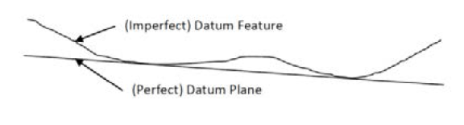
Figure 1: Deriving a datum plane from a datum feature (Source: Shakarji & Srinivasan, 2016)

The Datum reference plane (DRF) is an orthogonal coordinate system that establishes the actual position of a feature in accordance to its geometric tolerance. It is an essential tool for verification, inspection and analysis of geometric tolerances. It is essential to establish the composition fundamentals of DRF in order to automate feature verification (Wu & Gu, 2009).
Datum systems are the backbone for connected geometric features of a part which determines the orientation and location of tolerance zones (Ebermann et al. 2016). According to Ebermann et al. (2016), there has been an attempt to change from dimensional to geometric tolerancing that has made datum systems more important than ever. The current knowledge and research efforts still stand short in defining standardized measures for verification and also in realizing datum systems in a function oriented design process (Ebermann et al. 2016).
The theory of a datum plane is a non-standardized, yet global concept which is employed in almost all tolerance verification processes. Hence, it could be realized from a datum feature through multiple reasonable approaches. Currently, there is considerable research effort by International Organization for Standards (ISO) and American Society for Mechanical Engineers (ASME) to define default datum planes (Shakarji & Srinivasan, 2016).
The realization of a DRF using standards is done on a per case basis which makes it a tedious process to adhere to all conditions of validity (Wu & Gu, 2016). ASME Y14.5M established permissible datum features for planar, width, cylindrical, spherical geometries. ANSI Y14.5.1M has a list of 52 different DRF’s using various combinations of points, lines and planes.

2.2.1 Recent Studies on Datum Realization
In the recent past, there have been many research studies that have proposed models based on different approaches to determine the datum. Gou et al. (2000) proposed an approach based on Lie Algebra and homogenous space transformation to determine a DRF which describes the datum feature as an elementary geometry while complex geometries are eliminated. Mejbri et al. (2005) suggested generic rules validating datum reference systems based on part topology. Wu et al. (2003) proposed ways to assess and validate a datum for verification of tolerances. Ramaswamy et al. (2001) based their model to realize a datum on automatic dimensioning models. (Wu & Gu, 2016)
Ebermann et al. (2016) proposed an approach to determine a functional data system during design proceedings. This functional data system is based on the interaction of the indeterminate geometry of the part. Shakarji et al. (2015) proposed an algorithmic based on a constrained L1 norms to establish a default planar datum for tolerancing standards. Further, Shakarji et al. (2016) proposed an algorithmic based model to realize planar datum by employing constrained total least-squares.
Wu & Gu (2016) proposed rules to construct a datum reference plane. Their study was based on the decomposition of the DRF into a point, a line passing through the point and a plane containing the line. They constructed the DRF based on basic datum geometries of basic shapes that can be realized using a point, a line or a plane. Mapping relationships that exist between the datum features were used to directly obtain datum geometries from datum features.
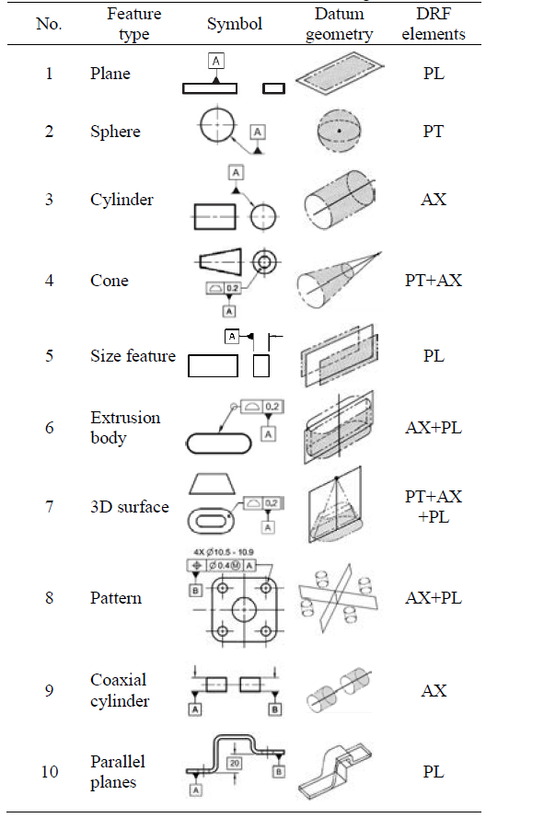
Figure 2: Datum features and derived datum geometries (Source: Wu & Gu, 2016)

Further, an approach was proposed for a datum geometry composed by multiple datum features in which two to three datum geometries are combined to form a new geometry. In this, out of all possible combinations, only 5 combination of point-point, line-line, plane-line, point-point-point and point-point-line follow the composition principle which adheres to generating a new geometry and increasing capability of constraining DOF.

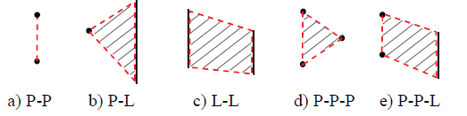
Figure 3: Datum combinations for multiple datum features (Source: Wu & Gu, 2016)

Utilizing the above stated methods, the authors established rules for automatic establishment algorithm for the DRF.
According to ISO 5459, the connection between two features of a part is validated using the location and orientation of the tolerance zone established by a nominal feature taken from the geometrical features of the actual surface as a datum. This datum system has been derived by combining two or three datums and forms a coordinate system for the part. Yet, ISO 5459 does not determine the extraction/ partition surfaces for datum calculation. There were mentions of these strategies in ISO 14406, which yet again does not have standardized rules to determine measuring points that supply information regarding the surface. (Ebermann et al., 2016).

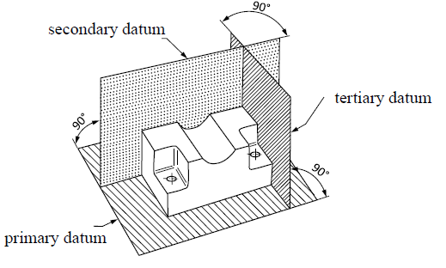
Figure 4: Datum system of planes according to ISO 5459 (Source: Ebermann et al. 2016)

The current studies and standards show that there is still a long way to go for standardized datum realization techniques. The proposed studies that we discussed in this section are unique, yet still require time and effort to establish valid datum systems.

2.3 Parallelism

2.3.1 Parallel Lines
“Two lines that never intersect each other at any point in a two dimensional space are said to be parallel.” (Parallel and Perpendicular Lines, 2017)
The lines do not meet at their given lengths and even when extended to infinity. This means theta the perpendicular distance between the lines should remain constant at every given point in space. In a three dimensional set-up, these lines can be parallel if they lie on the same plane. In a situation where these lines do not lie on the same plane, they are called skew lines. (Parallel and Perpendicular Lines, 2017)
Additionally, the two lines when intersected by a transverse line make interior angles which sum to 180°. If the sum is lesser or greater than 180°, the lines will intersect at some point if extended beyond their lengths.
For two lines to be parallel in a Euclidean space, the following conditions should be met:
- The lines have to be equidistant at every given point
- The two lines lie on the same plane and never intersect even on extending them to infinity.
- The two lines when intersected by a third line (transverse line) in the same plane, the corresponding angles are equal.
(Parallel (geometry), 2016)

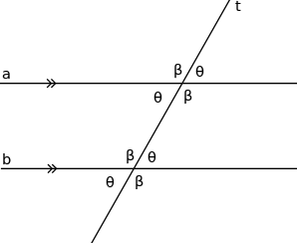
Figure 5: Parallel Lines intersected by a transverse line (Parallel (geometry), 2016)

Mathematically, two lines are parallel if they have equal slopes. For the equation,
$$y=mx+c$$
‘m’ is the slope of the line. Consider two lines with equations,
$f\left(x\right)=mx+b$ and $g\left(x\right)=nx+c$
The corresponding slopes of the lines ‘n’ and ‘m’ should be equal for them to be parallel. That is, $m=n$.

The perpendicular distance between the lines parallel lines, $f\left(x\right)$ and $g\left(x\right)$ is calculated as,
$$d=\frac{\left|b-c\right|}{\begin{aligned}\sqrt{(m^{2}}+1)\end{aligned}}$$
(Parallel and Perpendicular Lines, 2015)

2.3.2 Line parallel to a plane
Further, a line can also be parallel to a plane. Given that a line does not lie in a plane, the line is said to be parallel to the plane only if the line and the plane do not intersect at any given point. Also, they are parallel if and only if the distance from a point on line to the nearest point in plane is not dependent on the location of the point on the line. (Parallel (geometry), 2016)

2.3.3 Parallel Planes
Two planes are said to be parallel if the two planes never intersect each other in a three dimensional space. If the two planes are not parallel, they intersect each other in a line. Additionally, if two planes are parallel to the same plane, all three planes are parallel to each other. That is, consider planes $P, Q and R.$ If $P∥Q$ and $R∥Q$,
$$P∥Q∥R$$
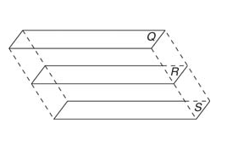
Figure 6: Parallel planes P, Q and R (Parallel and Perpendicular Planes, 2017)

Mathematically, If the two planes are parallel in Hessian normal form, if
$\left|{\hat{n}}_{1}∙{\hat{n}}_{2}\right|=1$ $or$
$${\hat{n}}_{1}×{\hat{n}}_{2}=0$$
Where, ${\hat{n}}_{1} and {\hat{n}}_{2}$ are corresponding normal vectors of the two planes (Gellert et al., 1989)

2.3.4 Planes and associated angle
If two planes are not parallel they always intersect in a line. In Hessian normal form, the line of intersection is perpendicular to normal vectors, ${\hat{n}}_{1} and {\hat{n}}_{2}$.
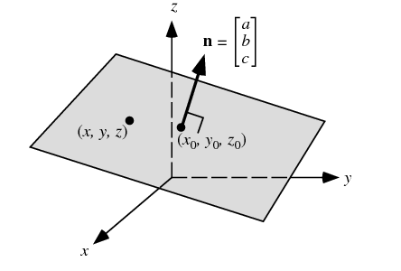
Figure 7: Normal vector to a plane (Weisstein,"Plane.")

The equation of a plane with normal vector $\hat{n}$ through the point $X_{o}=\left(x_{o}, y_{o},z_{o}\right)$ is
$$n ∙\left(X_{o}-X\right)=0$$
Where, $X=\left(x,y,z\right)$. Substituting the above values, the equation of the plane becomes
$$ax+by+cz+d=0$$
Where, the normal vector, $n=[a b c]$ (Weisstein,"Plane.")
The equation of a plane can also be determined using three points on the corresponding plane.

The angle between two intersecting planes is determined by the dot product of the two corresponding normal vectors of the concerned planes.
Mathematically, let us consider two planes and their equation,
$$a_{1}x+b_{1}y+c_{1}z+d_{1}=0 and$$
$$a_{2}x+b_{2}y+c_{2}z+d_{2}=0$$
Where, their corresponding normal vectors are,
$$n_{1}={(a}_{1}, b_{1},c_{1}) and n_{2}={(a}_{2}, b_{2},c_{2})$$
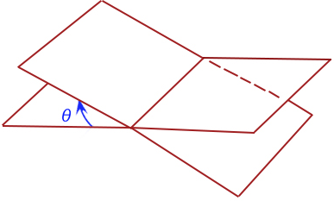
Figure 8: Angle between two Intersecting planes (Angle between Two Planes, 2017)

For the above, the angle between the two planes is given by,
$${cosθ=\hat{n}}_{1}∙{\hat{n}}_{2}$$
Or
$$cosθ=\frac{a_{1}a_{2+}b_{1}b_{2+}c_{1}c_{2}}{\sqrt{a_{1+}^{2}b_{1}^{2}+c_{1}^{2}}+\sqrt{a_{2}^{2}+b_{2}^{2}+c_{2}^{2}}}$$
The angle $'θ'$is called dihedral angle which is determined by,
$$Cosθ=\frac{n_{1}{∙n}_{2}}{{|n}_{1}{||n}_{2|}}$$
That makes,
$$θ=\cos^{-1}{\frac{n_{1}{∙n}_{2}}{{|n}_{1}{||n}_{2|}}}$$
For the associated planes to be parallel,
$$θ=0$$
If the two planes are parallel and never intersect each other, the normal vectors of the two planes are proportional to each other in the form that,
$$\frac{a_{1}}{a_{2}}=\frac{b_{1}}{b_{2}}=\frac{c_{1}}{c_{2}}$$
In GD&T, a plane is said to be parallel if it is equidistant from the datum plane at all given points on the plane.

2.3.5 Equation of plane passing through a point and parallel to given plane
The equation of a plane that passes through a point and parallel to a given plane is determined by,
$$\vec{r}∙\hat{n}=0$$
Where $\vec{r}$ is the point on the plane and $\hat{n}$ is the normal to the given plane.

2.3.6 Distance between two parallel planes
The distance between two parallel planes is derived from the method to find the distance between a point and a plane. Hence, it is obtained by selecting a point on either plane and then using the other plane's equation in the formula for the distance between a point and a plane.
Using the same equations for the planes illustrated in the previous section, this distance ‘D’ is calculated by the formula,
$$D=\frac{{|a}_{1}x_{2}{+b}_{1}y_{2}+c_{1}z_{2}+d_{1}|}{\sqrt{a_{1}^{2}+b_{1}^{2}+c_{1}^{2}}}$$
Where, $a_{1}b_{1}c_{1} and d_{1}$are taken from the equation of the first plane and $x_{2},y_{2,}z_{2}$ are coordinates of a point on the second plane.
The distance ‘D’ between these 2 planes remains the same throughout all points on both panes.

2.3.7 Parallel Measurement
Based on the feature in concern to be measured, parallelism is defined in two different ways in GD&T. The tolerance that controls parallelism between two surfaces or features is called ‘Surface Parallelism’ and is most common form of parallelism. This tolerance is controlled in similar ways as flatness (tolerance zone is determined using two parallel planes). Another form of parallelism is called ‘Axis Parallelism’ which controls the magnitude of parallelism between the central axis of specific parts and the datum. This feature is usually controlled by a cylinder outlining a theoretical parallel axis (Parallelism, GD&T Basics).
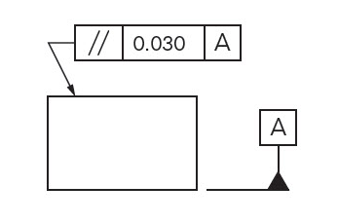
Figure 9: Feature Control Frame (Parallelism, GD&T Basics)

Parallelism describes the parallel orientation the concerned feature to the datum surface or line. For a three dimensional tolerance zone, Parallelism establishes the orientation of a plane parallel to the datum plane. Based on the datum, the tolerance establishes the 0° angle between the parts by controlling where the surface can be oriented.
To control parallelism, the concerned surface or the feature that needs to be measured and the datum need to be determined. (Parallelism, GD&T Basics)

According to Bewoor and Kulkami (2009), Parallelism between two planes is measured by employing a test mandrel and a dial indicator that act like a datum supported along one of the planes. The dial indicator takes measure along the surface of the other plane in concern. According to the authors, parallelism is established by the measure of the distance between the two planes. If the measured readings do not exceed or fall short of the specified limits, the surface is deemed to be parallel. The above stated method is used to determine parallelism between an axis and a plane. Parallelism between two cylindrical axes is determined by moving the dial indicator from the axis of the datum. (Bewoor and Kulkami, 2009)
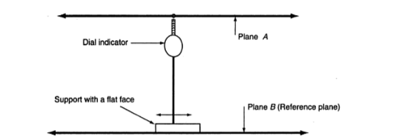
Figure 10: Dial Indicator system to measure parallelism (Source: Bewoor and Kulkami, 2009)

A study on parallelism measurement of optical micro units was proposed by Kerobyan et al. (2013). In this study, a laser beam is projected through a screen with a miniscule hole which illuminates a plate which is under inspection. To provide divergence, a lens (negative/positive) is kept before the screen. The result of the laser beam reflection between two surfaces creates circular, concentric fringes. If the center of the whole perfectly aligns with the center of the fringes, the plate is at absolute parallelism.
(Kerobyan et al. 2013)

Another system to measure parallelism proposed by Hwang et al. (2007), uses a three-probe system to measure parallelism of ultra-precision guideways (rails). This model uses three probes $P_{1}, P_{2} and P_{3}$ to simultaneously measure parallelism and straightness of the rails. Here, $P_{1} and P_{2}$ measure parallelism and $P_{3}$ measures straightness. In addition, a surface plate is used increase the accuracy of parallelism measurement (50 $μ$-inch accuracy). Two gauges that are in conjunction are directly placed one above the other at a given height. This whole measuring setup moves through the guiderails as in the model proposed earlier. (Hwang et al. 2007)
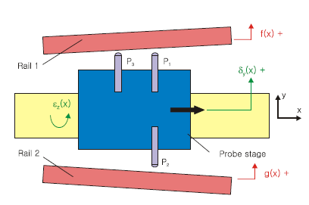
Figure 11: Three probe system to measure parallelism of ultra-precision guideways (Source: Hwang et al. 2007)

Taylor (2015) proposed a model for non-datum inspection of parallelism and perpendicularity. He used the least square method to fit the points of the surfaces to be inspected into trend lines and measured the distance between these lines to determine parallelism. This study applied to both continuous and discontinuous surfaces. However, this study had not factored in the result of sampling on inspection efficiency. Also, it does not say much about the surfaces being measured, merely compares trend lines after fitting a least squares line. (Taylor, 2015)

2.4 Coordinate Measuring Machine (CMM)
Coordinate measuring machines are widely used in verification and measurement of various geometric dimensions and tolerances in the world of manufacturing technology.
CMM’s are commonly accepted tools for tolerance inspection throughout the global industry. This can be owed to advances in the field of computer numerical control technology. (Wu & Gu, 2016)
CMM’s can measure discrete coordinate data of the actual surface that pertains to both the datum and the concerned feature. It establishes mathematical algorithms to determine the DRF while locating the tolerance zone that results in the analysis of comparison between the actual position of the feature and the tolerance zone. This technique of measurement employed by CMM’s help eliminate shortcoming associated with traditional methods of measurement and can be applied to automated inspection of larger number of parts in one go. (Wu & Gu, 2016)

The CMM uses a probe to collect data across the surface of the part. The control of the probe could be either manual or automated depending on the part under consideration, the application and the kind of machine. The probe is used to collect coordinate measurements as guided through the operator either manually or through computer control. The data establishes the features, location and dimensions of the part under control. These features include almost all GD&T features discussed in previous sections. A computer controlled CMM has advantages over manual CMM’s as the former is a more time efficient device which can inspect large number of parts in a shorter period of time.
A CMM comprises of three basic components, namely, the housing, the probe and the software. The housing consists the 3D measuring plane and the corresponding guiderails. The housing is made of aluminum alloys or similar and a ceramic annex is provided to obtain rigidity of z-axis. The bridge which connects to the probe is suspended on two legs. The bridge is guided through air bearings for its motion along the Y-Axis which brings down friction to zero.
The probe is used to collect data from the surface of the part. There are different kinds of probes available to use with CMM’s, namely, optical, laser and tactile (mechanical) and their use depends on the application and the kind of machine. Optical probes are non-contact probes that scan the image of the surface under inspection. The advantage associated with optical probes pertains to the fact that it can take larger number of data points and low chances of mechanical damage to the probe system. However, it cannot be used for 3D parts with low resolution. The laser probe captures high resolution 3D images of the surface and is a very effective and sophisticated of measuring. Depending on the operation and the kind of probes used to suit the, they can measure at angles between -90° to +90° vertically and can be rotated from -180° to +180°. In traditional CMM’s, the probe had to be guided physically to record data, but in recent times come equipped with driving motors that can be automated using a computer software. The contact diameter of the probe is much smaller than the feature under inspection (Woody & Bauza, 2007). There are also developments in micrometrology probes but aren’t being used as an established probe system due to issues with reliability and susceptibility to damage and environmental conditions. Also, smaller and lighter probes can cause false triggers and take longer to collect data (Weckenmann & Hoffmann, 2006).
The first CMM was built in the 1950’s that only took measurement in two dimensional coordinates. This was enhanced in the 1960’s where it began measuring in 3D. The most common kind of CMM is the 3D-Bridge CMM.

Since the 1970’s, the CMM’s come equipped with a computer control mechanism. These usually consist of a processing unit, a display monitor, a data collection software and a controller (jogbox). The jogbox or the computer program is used to direct the probe over the surface under inspection. The collected data is sent over to the software through various encoders and is available to the operator for use and analysis.
In most constructions of the CMM, sophisticated design features like low friction air bearings and reduced vibration installation mountings are incorporated to reduce error and increase accuracy and precision. (Schaffer, 1982)
The various modes to operate while working with CMM’s are manual control, manual computer-assisted, motorized computer-assisted and direct computer control.
The direct computer controlled or DCC mode is the most sophisticated and can handle intricate data processing and mathematical functions and high precision inspection functions by automated control. (Elmaraghy et al., 1990)
The disadvantages of using a CMM is the intricate technology which makes it a difficult equipment to learn and operate on. Further, CMM programming is an acquired skill and is not common knowledge.

2.5 Sampling
Sampling is the procedure that helps identify the way to choose units from the concerned population while keeping the objective in mind. This sample should be a representative of the population and should be able to estimate the population totals and averages. The efficiency of sampling is an important factor to consider while collecting samples. Hence, the selection method should be accurate, low cost and optimized. (Cochran, 1977)
Sampling errors are common during sampling which might occur due to the fact that the population being measured does not always involve the whole population and only a part of it. Sampling errors can be identified by the inconsistency between the population and sample estimates. These errors can be minimized by selection of larger sample sizes. (Cochran, 1977)
Selection of sample points is crucial to measure the feature of a part. The points should be selected in such a way that it represents the features of the surface, irrespective of the profile, complexity. An efficient sampling strategy must have optimal sample points and optimal sample size. A statistical approach to find the sample points would be better than the use of knowledge of manufacturing process, material properties etc., simply because it is not always possible to have the knowledge of the products in detail (Wu et al., 2000)
Aguirre Cruz (2007) used Hammersley distribution to sample points in his study on developing decision support for form verification of manufactured parts. The forms in his study included cone, sphere, cylinder, frustum and torus. He sampled these geometries using the Hammersley technique as it was found to be a more effective method of sampling in various studies and because the coordinates of this sequence are representative of points inspected by a CMM (Aguirre Cruz, 2007).
Various sampling methods have been established and can be employed depending on the need of the experiment. To name a few, we have simple random sampling, stratified sampling, systematic sampling, and cluster sampling.

2.5.1 Sampling Techniques
- Simple Random Sampling
According to Stuart (1976), “a simple random sampling is one selected by a process which gives every possible sample (of that size from that population) the same chance of selection”. Also, according to Cochran (1977) it is stated as a method of selecting n out of N units from a population such that every one of the ${}_{n}^{N}c$ distinct samples has an equal chance of being drawn. So, for selecting ‘n’ number of samples out of population ‘N’, each unit has an equal probability of getting selected at the first and each subsequent draw. The units of the population are arranged in an order starting from 1 extending to N. A sequence of random numbers between the arrangements is drawn for which the chance of selection of all these available units from the population is equal in the first draw. Therefore, all of the different ${}_{n}^{N}c$ samples have an equal chance of being selected. After selecting n samples in n draws, the probability of selection becomes $\frac{1}{{}_{n}^{N}c}$. (Sukhatme et al., 1970), (Cochran, 1977) & (Kim & Raman, 2000).

- Stratified Sampling
This sampling method employs stratification to improve the estimation precision. The accuracy of the sample estimate of the population mean is a function of the sample size and the variability of population. The estimate can be optimized by increasing the sample size and also by reducing variability of the population. (Ray, 1968)
According to Sukhatme et al. (1970), for this method, the population ‘N’ is divided into subpopulations ‘$N_{1}, N_{2}, ……N_{L}$’ which are called strata, where the subpopulations do not consist of repetitions and sum up to the population. A sample is drawn from each stratum. Stratified random sampling is when a simple random sample is taken from each stratum. (Kim & Raman, 2000)
$$N_{1}+N_{2}+.…….+ N_{L}=N$$

- Systematic Sampling
In this method of sampling, the first selection determines the selection of the rest of the sample. The first selection is made based on random selection and the subsequent selections are regulated by automatic selection. The units of the population are arranged in an order starting from 1 extending to N, a sample of n units is selected by considering a random number $i≤k$ for which $N=k×n$. Here, the selected number ‘i’ and every kth unit are considered to be the sample n. (Kim & Raman, 2000)
This method has more advantages over simple random sampling as it is easy to draw and execute samples. Uniform sampling is a part of systematic sampling. This can be represented in a ‘square grid’ pattern for one-dimensional sampling. (Cochran, 1977)
- Cluster Sampling
This method is similar to stratified sampling. The difference lies in the fact that cluster sampling does not represent all divided subpopulations. (Konijn, 1973). Hence, the population is divided into smaller units and are called elements of the population. Here, groups of elements are clusters. (Sukhatme et al., 1970) & (Kim & Raman, 2000).
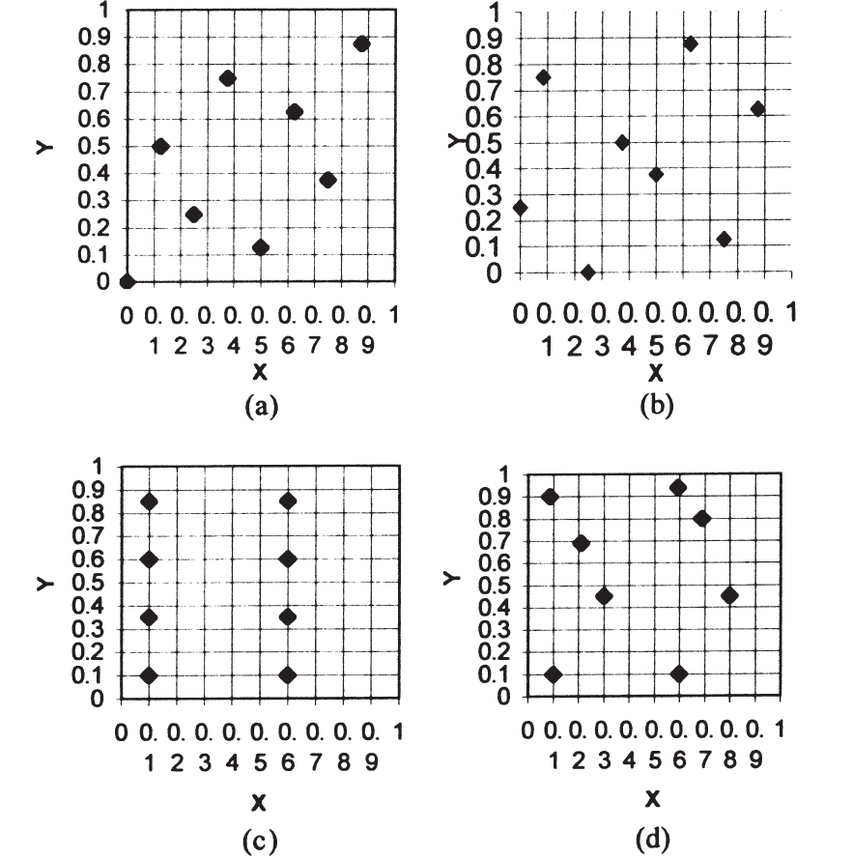
Figure 12: Coordinates of Sampling Methods: Hammersley, Halton-Zaremba, aligned systematic, aligned random respectively. (Source: Kim & Raman, 2000)

2.5.2 Sample size
The process of sampling using a CMM is a discrete method that presents much approximation. The larger the sample size, the lesser the error. If there are infinite points on a surface, the number of errors tend to zero whereas if there are finite points, we will have a non-zero value of the error. In a study by Kim & Raman (2000), 4, 8, 16, 32 and 64 points were chosen at random on a flat plate while measuring flatness.
In a study proposed by Rao (2006), the sample size varies according to shape and profile of the surface and it also depends upon the length to width ratio of that surface. Neural network and neuro-fuzzy techniques were employed to determine sample sizes in that study. Yet, the drawbacks of both studies included not factoring in the uncertainties that could arise in determination of the sample sizes of the surface. It is known that manufacturing process plays an important role in finding the sample size. But, since the type of manufacturing process may vary from product to product, it is essential that the surface roughness is considered for the sample size identification (Rao, 2006). Rao used samples that factored in varying surface roughness while inspecting the flatness of the surface, while Kim focused on sampling techniques to measure flatness of the surface.

2.5.3 Sampling in coordinate metrology
Lin and Chen (1997) established models to find the measuring point positions of surface composition features followed by estimating the positions of the measuring points on the surface (Obeidat & Raman, 2011). Studies show that larger sample sizes are needed for higher accuracy of results (Namboothiri and Shunmugam, 1999: Obeidat & Raman, 2011). In 1995, Woo et al. studied the flatness and the roughness of surfaces by using Uniform and Stratified sampling, Hammersley, Halton-Zaremba to collect sample data. This study showed that uniform, random and stratified method did not provide good estimations of the surface. Yet, the sample size was not factored in during this study.

Table 1: Average discrepancy rate for accuracy of flatness (Source: Kim & Raman, 2000)

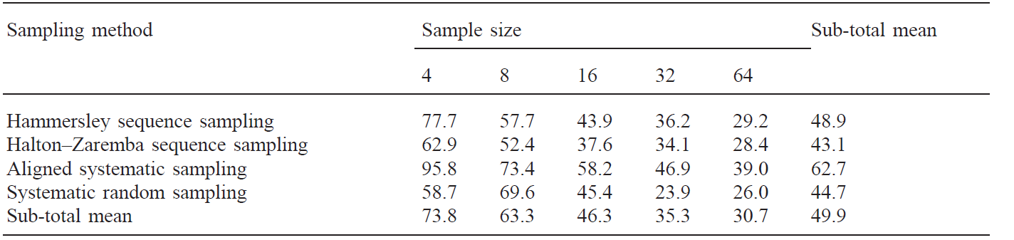
Uppliappan et al. (1997) proposed a study on the sampling process for cylinder inspection for which they employed equidistant sampling and spiral sampling techniques for data collection. The relation between form error and the sampling algorithm and the fitting algorithm used to fit the substitute geometry was studied in this research. Cho and Kim (1995) proposed a model for inspection of sculptured surfaces using a coordinate measuring machine (CMM) where the optimum measuring point locations were established based on the mean curvature analysis and a region selection ratio constant.
Various methods to determine the optimum probe path that minimizes the inspection time and the measuring errors was also determined in this study. Pahk et al. (1995) proposed an inspection system for manufacturing molds incorporating CAD. Uniform distribution sampling, and surface curvature were employed in that study. The points were sampled on the surface using an amalgamation of both the techniques. For their experiment they divided the surfaces into subintervals and the points were randomly distributed. Lee et al. (1997) combined the use of Hammersley sequence and a stratified sampling method and proposed a sampling strategy for geometric features on a surface. The efficiency of Hammersley, uniform sampling and random sampling were compared in this study. The number of sample points were reduced using quadratic systems by employing a strategy based on Hammersley and uniform sampling method which yielded the same level of accuracy.
Badar et al. (2005) established an adaptive sampling method to reduce the sample size. This study estimated the region of maximum error based on the error profile of the surface. They concluded that the accuracy of the procedure in which the initial points were estimated to determine other inspection points is similar to the method which considers the population measurement points. In another study of experimental analysis to determine the performance of adaptive sampling methods in straightness and flatness verification, Badar et al. studied the effects of different factors on the sample size and on the error. These factors included manufacturing process and step size of the search algorithm in straightness and flatness. In a recent study, Obeidat and Raman (2009) proposed three techniques to inspect free form surfaces as a function of their free form surfaces geometry. Based on the critical regions, this model reduced the number of sampling points.

2.5.4 Search Algorithm
In a study by Badar et al. (2003), Initial set of data points were obtained to evaluate form tolerances using the least squares (LS) technique and minimum zone (MZ) methods. The initial points are guided by geometry of the part and are also based on manufacturing conditions. For the initial sample, a fit feature and the corresponding deviation $e_{i}$ of each point was obtained using the linear least squares (LS) technique. Then a search method was used to intelligently pick the next points until an optimum $e_{max}$ was reached. The search was performed in both the positive and negative directions from the fit surface. For straightness, a region-elimination (RE) search was employed to choose additional data points. Three iterations were allowed with the intervals of, Δ/2, and Δ/4, where Δ=4*step size. The algorithm started from a point that had the maximum deviation among the initial data points in the negative or positive direction, depending on which direction a solution was being sought. For flatness, two pattern search methods, tabu search and hybrid search, were applied to sample data points outside the initial set. Hybrid search (HS) developed was a combination of coordinate search, Hooke-Jeeves pattern search and tabu search (TS). (Badar et al, 2005)
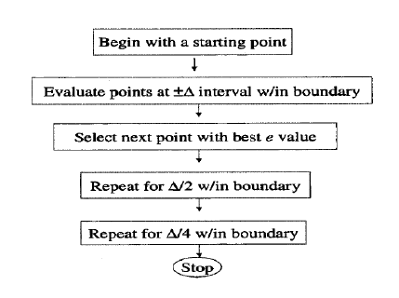
Figure 13: Region elimination algorithm - straightness estimation (Source: Badar et al., 2003)

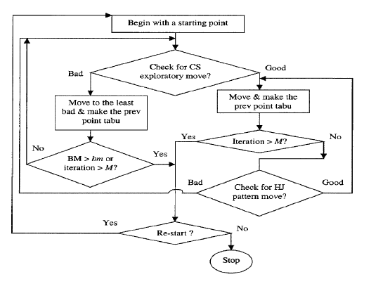
Figure 14: Hybrid search algorithm for flatness inspection (Source: Badar et al., 2003)

2.6 Regression Analysis
“Regression analysis is a statistical method that defines the relationship between variables. Many variables can be considered while the concentration is between a dependent variable (y) and one or more independent variables (x_{1,} …, x_{n}).” (Regression Analysis, 2017)
This investigates how the average value of the dependent variable is affected by the independent variable. A function of the independent variables (regression function) is established that best estimates the relationship. (Regression Analysis, 2017).
There are various methods of performing linear and nonlinear regression analysis, including the parametric Least Squares, as well as Nonparametric Regression, which has more flexibility in terms of variables and dimensions. The assumption made to simplify the ease of use of methods depends on how the data is collected. The validation of these regression methods can be done using R-squared and the F-test (Regression Analysis, 2017).
In parametric regression, unknown parameters are represented by β. So,
y ≈ f(x, β).
Where n is the number of x data points and k is number of β unknowns, n $>$ k for accurate results. The error ‘e’ assumes normal distribution, where (n – k) is called the “degrees of freedom”. Higher degrees of freedom may have more efficient results (Regression Analysis, 2017).
For Simple linear regression, n data points are considered with only one independent variable x and two parameters β₀ and β₁. The dependent variable follows,
y_{i} = β₁x_{i} + β₀ + e_{i} for i = {1,…,n}.
With a random sample supplied for this, y_{i} is estimated by ŷ_{i} where,
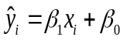.
the error e_{i} is the vertical difference between the actual value of the dependent variable and its estimated value for the independent variable or, mathematically,
e_{i} = y_{i} – ŷ_{i}.
This error is called “residual” (Regression Analysis, 2017).
Multiple linear regression, can be used to analyze two or more independent variables and three or more parameters. For a model with three independent variables, the independent variable will look like,
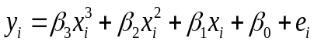
Where, i = {1,…,n}.
For p independent variables , we have (p + 1) parameters. The error estimation is similar to simple linear regression. (Regression Analysis, 2017).

2.6.1 Method of Least Squares
The least squares (LS) method was the primary form of regression analysis, developed in the early nineteenth century. This method minimizes the sum of squared errors (SSE), also known as residuals sum of squares (RSS). From simple linear regression,
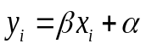,
The estimates for the parameters α and β are construed as,
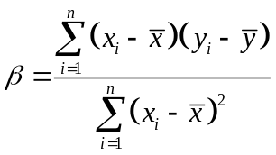
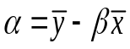,
where 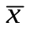 is the mean of the x values, 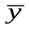 is the mean of the y values, and n is the number of data points. The error variance 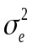 is then calculated using
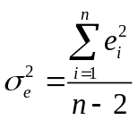,
Which is called the mean square error. The parametric errors are calculated by using their respective standard deviations σ_{β} and σ_{α},
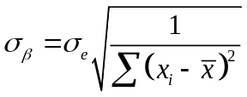
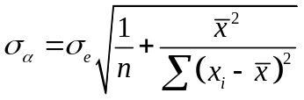.
Parametric errors, σ_{β} and σ_{α} are used to determine confidence intervals and hypothesis testing analysis (Regression Analysis, 2015).
Least squares are usually used in forecasting and fitting problems. In forecasting, it gives an estimate for future behavior of data when it the assumption is that the dependent variables are subject to the same types of residual observations like in the model creation. For true relationship fitting, the independent variable is believed to contain negligible or zero error. That is, only the dependent variables are estimated for errors (Gorard, 2004).
For Least squares, the sum of the errors from the mean always equals zero,
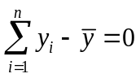.
And also, sum of the squares of errors from the mean is always less than the sum of the squares of the same vertical errors taken from any other y value. That is,
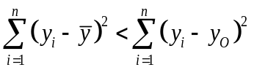,
Here, y_{O} is a y value not equal to the mean as least squares minimizes this error. Hence, error is estimated as the vertical distance between the value and the mean (Kenney, 1947).

2.6.2 Least squares fitting of planes
A best fitting plane to a set of points can be determined using the least squares regression method with an assumption that z is functionally dependent on the x and y. For a set of samples,
($x_{i}$ ,$y_{i}, z_{i}$) where i=1, 2, …. m
A, B, and C is determined so that the plane z = Ax + By + C best fits the samples and the sum of the squared errors between the $z_{i}$and the plane A$x_{i}$+B$y_{i}$+C is minimized. Here, that the error is measured only in the z-direction.
The error function for the least squares minimization is defined as,
$$E(A, B, C) = \sum_{i=1}^{m}{{[\left(Ax_{i}+By_{i} +C\right)-z_{i} ]}^{2}}$$
Where E is nonnegative and in the shape of hyperparaboloid whose vertex occurs when the gradient satisfies ∇E = (0, 0, 0) for which a system of three linear equations in A, B, and C is derived. Hence,
$$\left[\begin{matrix}\sum_{i=1}^{m}{x_{i}^{2}} & \sum_{i=1}^{m}{x_{i}y_{i}} & \sum_{i=1}^{m}{x_{i}} \\ \sum_{i=1}^{m}{x_{i}y_{i}} & \sum_{i=1}^{m}{y_{i}^{2}} & \sum_{i=1}^{m}{y_{i}} \\ \sum_{i=1}^{m}{x_{i}} & \sum_{i=1}^{m}{y_{i}} & \sum_{i=1}^{m}{1}\end{matrix}\right]\left[\begin{matrix}A \\ B \\ C\end{matrix}\right]=\left[\begin{matrix}\sum_{i=1}^{m}{x_{i}z_{i}} \\ \sum_{i=1}^{m}{z_{i}y_{i}} \\ \sum_{i=1}^{m}{z_{i}}\end{matrix}\right]$$
Which gives us, z = Ax + By + C. This can be an ill-conditioned linear system and hence, averages $\overline{x}=\frac{1}{m}\sum_{i=1}^{m}{x_{i}}$ , $\overline{y}=\frac{1}{m}\sum_{i=1}^{m}{y_{i}}$ and $\overline{z}=\frac{1}{m}\sum_{i=1}^{m}{z_{i}}$ are computed and subtracted from the data, and the fitted plane is $z-\overline{z}= A(x-\overline{x}) + B(y-\overline{y})$ where,
$\left[\begin{matrix}A \\ B\end{matrix}\right]={\left[\begin{matrix}\sum_{i=1}^{m}{{(x_{i}-\overline{x})}^{2}} & \sum_{i=1}^{m}{(x_{i}{-\overline{x})(y}_{i}-\overline{y})} \\ \sum_{i=1}^{m}{(x_{i}{-\overline{x})(y}_{i}-\overline{y})} & \sum_{i=1}^{m}{{(y_{i}-\overline{y})}^{2}}\end{matrix}\right]}^{-1}\left[\begin{matrix}\sum_{i=1}^{m}{(x_{i}{-\overline{x})(z}_{i}-\overline{z})} \\ \sum_{i=1}^{m}{(x_{i}{-\overline{x})(z}_{i}-\overline{z})}\end{matrix}\right]$
(Least Square fitting of data, 1999)

CHAPTER 3: EXPERIMENTAL SET- UP AND METHODS USED
In this chapter, we will discuss how the experiment was set-up and the modelling techniques used to design and validate our model.

3.1 Experimental Model
There are two objectives of this study are:
- To develop a simple method to inspect parallelism, and
- To investigate the effect of the sampling techniques and sample sizes used in the computation of the datum feature, and in the verification of the inspected (related) surface.

3.1.1 Sampling Strategy
There are many sampling methods which can be employed while working with a CMM. The sampling techniques used for this study are chosen from these commonly used methods of sampling in coordinate metrology. We have chosen to use the simple random sampling technique and the aligned systematic sampling technique. We compare these two techniques for evaluating their effectiveness in verifying parallelism using CMMs.
- Aligned Systematic Sampling
The aligned systematic sampling technique is a uniform model of sampling. The surface of the part being measured is divided into in to $n ×n$ rows and columns of equal length and width. The matrix grid for two-dimensional aligned systematic sampling is shown in figure 17.
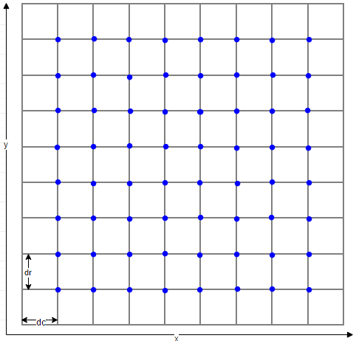
Figure 15: Coordinates of Aligned Systematic Sampling

- The measure of the width of each column and each row depends on the length and width of the part. These measures is represented as $d_{c} \& d_{r}$where, the former is the height of each column and the latter is the height of each row. The measure is given by, $d_{c}=\frac{b}{n} and d_{r}=\frac{l}{n}$ where b, l are the length and width of the part. The first sample is collected at the point $(d_{c}, { d}_{r})$ on the matrix grid. The rest of the samples are collected using a systematic incremental approach with the deviation from $d_{c} and { d}_{r}$ on the x and y coordinate axis accordingly. Incremental step value for consecutive points depend on sample size.
The approach uses the form, $(xd_{c}, yd_{r})$ to attain sample points throughout the grid where $x=1,2,……n-1 and y=1,2……n-1$ for maximum number of samples.
- Simple Random Sampling
This technique is achieved by collecting n sample points from a population of N points where each point has an equal chance of being selected. For this reason, we generated a set of random coordinates within the specified range for $x and y$ (which depends on the alignment and dimensions of the part) for each part. These coordinates were then fed to the CMM program to determine the exact location on the 3-D surface and to collect data accordingly.

3.1.3 Sample Sizes
According to Kim et al. (2000), a sample size beyond the size of 64 shows the most accurate inspection results while measuring flatness of a surface.
Samples were collected in order to show the effect of sample sizes on the inspection. Hence, three samples of 10, 33 and 100 samples were collected for each of the two surfaces of each part for each sampling technique.

3.1.4 Necessary Software
We employed four different computer programs in our study. The first software used was MS Excel which helped in random coordinate generation for random sampling, representation of collected data, and also representation of analyzed data and results.
CMM software program PC-DMIS by Hexagon Metrology was used to collect sample data for systematic aligned sampling and random sampling methods, using the PFx Microval 454 CMM system. This software aided in automated DCC collection of sample points for all parts inspected. The alignment of the parts under inspection was done manually as required by the program. After each alignment, the software recognized the surface and geometry of the part under inspection and was able to collect the data automatically by employing a coded program and manual alignment. The coded program is attached in Appendix C. This code was developed by Kim et al. (2000) and was modified to the current specifications.
This thesis also employed MATLAB version R2017a to analyze the samples and calculate the error value for the inspected parts. The mathematical approach to inspect parallelism was coded in MATLAB which provided the error function based on the samples collected. The coded program file for MATLAB is attached in Appendix B. Another statistical analysis software called Minitab was used for data analysis and hypothesis testing.

3.1.3 Necessary Equipment
The Brown & Sharpe®, MicroVal™ PFx 454 CMM was used to inspect parallelism of the sample parts. The MicroVal™ PFx 454 is a fixed bridge CMM which utilizes the PC-DMIS software for computer control. The parts were clamped and fixed on the worktable by clamping tools to ensure that the parts are rigidly fixed and do not move during sample collection. The dedicated remote jogbox was used to align samples.

CHAPTER 4: EXPERIMENTAL DESIGN

4.1 Inspection Samples
The samples used in this study are rectangular blocks of aluminum metal. A total of 15 sample blocks with varying top plane angles were fabricated and were used to inspect parallelism. The dimensions of each block was set at $2.5×2.5×0.5 inches^3.$ We had five replicates for each top plane angle. The top plane angles were set at 0°, 5° and 10°. The tolerance of the machined blocks was determined to be $±$0.010 inches.

4.2 Sampling Design

4.1.2 Sampling Techniques
We use two different approaches to collect samples: simple random sampling and systematic aligned sampling.

4.1.2 Selection of Sample Sizes
Samples were collected in order to study the effect of sample sizes on the inspection. Hence, three levels of sample sizes (10, 33 and 100 samples) were collected for each of two surfaces (datum feature, inspected feature) for each part, for each sampling technique. For this experiment, thus we have nine levels of sample size combinations which are achieved by the combination of three sample sizes for each of the two surfaces. The levels are as described in the table below
Table 2: Levels of Sampling
Level | Sample ($n_{1}\&n_{2})$  $n_{1}$- Sample size for datum feature  $n_{2}$- Sample size for inspected feature
Level 1 | 10 & 10
Level 2 | 10 & 33
Level 3 | 33 & 10
Level 4 | 33 & 33
Level 5 | 10 & 100
Level 6 | 100 & 10
Level 7 | 33 & 100
Level 8 | 100 & 33
Level 9 | 100 & 100

4.3 Experimental Response Parameter
We have selected our error function as our response parameter which will tell us about the effect of our factors on the parallelism inspection. This error function is the parallelism tolerance, and is measured by the distance between the minimum spacing planes that encompass the farthest deviations of the inspected (related) feature.

4.4 Design of Experiment
A design is considered with four factors of independent variables that affect the dependent variable. The four factors have levels and are identified as:
- Top Plane Angle (0, 5 and 10)
- Sampling Technique (Aligned and Random)
- Sample Size for Datum (10, 33 and 100)
- Sample Size for Top (10, 33 and 100)
The dependent variable is the Parallelism tolerance
Table 3: Factors of Experimental Model
Dependent Variable:  Parallelism Tolerance | Factor A | Factor B | Factor C | Factor D
Dependent Variable:  Parallelism Tolerance | Top Plane Angle | Sampling Technique | Sample Size for Datum | Sample Size for Top

The factors have levels. The first factor has 3 levels, second has 2, third and fourth both have 3 levels as mentioned above. This gives us a $3×2×3×3$ factorial design. We also have 5 similar parts for each top plane angle which gives us 5 replicates of each reading. We test the effect of each factor on our dependent variable.

4.5 Experiment Procedure
The datum surface is fit into a best fitting plane using the least squares method. The inspected feature is then enveloped by minimum separation planes that contain the maximum deviation between the points. The error is determined by measuring the distance between these separation planes. The effect of sampling size and technique is studied by collecting samples of different sizes for all sample blocks in an aligned and also random manner. This method is represented in the figure below:

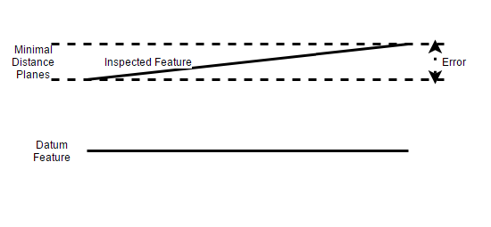
Figure 16: Inspection Design

4.5.1 Suppositions
We have made the following suppositions while designing our experiment. These suppositions pertain to both measurement and analysis stages of the model.
- One of the surfaces under inspection is considered as an assumed datum feature and the parallelism between the two surfaces (Datum feature and inspected surface) is measured using this supposition.
- The average value of error was assumed to be the estimated deviation of the inspected surface from its absolute theoretical value. This is called the parallelism tolerance.

4.5.2 Sample Collection
The first step of this experiment is to collect the samples using the Brown & Sharpe®, MicroVal™ PFx 454 CMM. The data is collected from each of the 15 blocks for both the datum feature and inspected feature for the mentioned sample sizes through the adopted sampling techniques. The two sides of dimensions$2.5×2.5$ were the sampling areas. For samples with 0° top plane angle, it is not necessary to determine the datum feature side of the two surfaces but while sampling for the 5° and 10° top plane angle we assume the tapered side as the inspected feature and the other surface as the datum feature. The data is collected in in three-dimensional form with $x,y,z$coordinates for each sample point. More than 2 surfaces can be measured to be parallel using our model but we have only considered two for this study and inspected for parallelism between the two surfaces.

4.5.3 Creation of Best fitting Planes
A best fitting plane is calculated for the datum feature by least square plane fitting using the sampling points for that surface. The planes are fit using the regression least squares fitting algorithm using a MATLAB code.
The best fitting plane to a set of collected sample points is determined using the least squares regression method with an assumption that z is functionally dependent on the x and y. For our given set of samples,
($x_{i}$ ,$y_{i}, z_{i}$) where i=1, 2, …. m
A, B, and C is determined so that the plane z = Ax + By + C best fits the samples and the sum of the squared errors between the $z_{i}$and the plane A$x_{i}$+B$y_{i}$+C is minimized. Here, that the error is measured only in the z-direction.
The error function for the least squares minimization is defined as,
$$E(A, B, C) = \sum_{i=1}^{m}{{[\left(Ax_{i}+By_{i} +C\right)-z_{i} ]}^{2}}$$
Where E is nonnegative and in the shape of hyperparaboloid whose vertex occurs when the gradient satisfies ∇E = (0, 0, 0) for which a system of three linear equations in A, B, and C is derived. Hence,
$$\left[\begin{matrix}\sum_{i=1}^{m}{x_{i}^{2}} & \sum_{i=1}^{m}{x_{i}y_{i}} & \sum_{i=1}^{m}{x_{i}} \\ \sum_{i=1}^{m}{x_{i}y_{i}} & \sum_{i=1}^{m}{y_{i}^{2}} & \sum_{i=1}^{m}{y_{i}} \\ \sum_{i=1}^{m}{x_{i}} & \sum_{i=1}^{m}{y_{i}} & \sum_{i=1}^{m}{1}\end{matrix}\right]\left[\begin{matrix}A \\ B \\ C\end{matrix}\right]=\left[\begin{matrix}\sum_{i=1}^{m}{x_{i}z_{i}} \\ \sum_{i=1}^{m}{z_{i}y_{i}} \\ \sum_{i=1}^{m}{z_{i}}\end{matrix}\right]$$
Which gives us, z = Ax + By + C. This can be an ill-conditioned linear system and hence, averages $\overline{x}=\frac{1}{m}\sum_{i=1}^{m}{x_{i}}$ , $\overline{y}=\frac{1}{m}\sum_{i=1}^{m}{y_{i}}$ and $\overline{z}=\frac{1}{m}\sum_{i=1}^{m}{z_{i}}$ are computed and subtracted from the data, and the fitted plane is $z-\overline{z}= A(x-\overline{x}) + B(y-\overline{y})$ where,
$\left[\begin{matrix}A \\ B\end{matrix}\right]={\left[\begin{matrix}\sum_{i=1}^{m}{{(x_{i}-\overline{x})}^{2}} & \sum_{i=1}^{m}{(x_{i}{-\overline{x})(y}_{i}-\overline{y})} \\ \sum_{i=1}^{m}{(x_{i}{-\overline{x})(y}_{i}-\overline{y})} & \sum_{i=1}^{m}{{(y_{i}-\overline{y})}^{2}}\end{matrix}\right]}^{-1}\left[\begin{matrix}\sum_{i=1}^{m}{(x_{i}{-\overline{x})(z}_{i}-\overline{z})} \\ \sum_{i=1}^{m}{(x_{i}{-\overline{x})(z}_{i}-\overline{z})}\end{matrix}\right]$
(Least Square fitting of data, 1999)
Here, $A, B and C$ define the normal vector ‘n’ to the plane,
$$n= \left[\begin{matrix}A & B & C\end{matrix}\right]$$
We find ‘n’ for both surfaces for each part, sample size and sampling technique by employing MATLAB. This step is repeated for all necessary factors.

4.5.3 Creation of secondary reference planes
After the creation of the best fitting plane for the datum feature, we find the lowest point and the highest point on the inspected feature w.r.t the datum plane.
The two minimum separation planes are drawn from the lowest and the highest point of the inspected feature which are parallel to the fitted datum feature. To find the equation of these planes, we use the normal vector of the best fitting datum feature and the points that we determined on the inspected feature. So, if n is the normal vector of the datum plane, and $(x_{l}, y_{l}, z_{l})$ and $(x_{h}, y_{h}, z_{h})$ are the coordinates of the lowest and highest points on the top plane, the equation of the minimum separation planes are derived from the following,
$n(x-x_{l}, y-y_{l}, z- z_{l}) =0$ and $n(x-x_{h}, y-y_{h}, z-z_{h}) =0$.
This is done using the MATLAB code to find the error distance (parallelism tolerance).

4.5.4 Calculating Parallelism Tolerance
The error distance is determined by calculating the distance between the two parallel minimum distance planes. Mathematically,
$$D=\frac{{|a}_{1}x_{2}{+b}_{1}y_{2}+c_{1}z_{2}+d_{1}|}{\sqrt{a_{1}^{2}+b_{1}^{2}+c_{1}^{2}}}$$
Where, $a_{1}b_{1}c_{1} and d_{1}$are taken from the equation of the first plane and $x_{2},y_{2,}z_{2}$ are coordinates of a point on the second plane.
The distance ‘D’ between these 2 planes remains the same throughout all points on both planes.
We repeat this process for calculating distance between planes created with the three sampling sizes that we have. So 3 planes are fit for this experiment for a single sampling technique on a single part. There are 3 planes for the datum feature which has one plane each fit from 10, 33 and 100 sample points which are compared with the 3 different envelopes of the inspected feature which again is generated by 3 different sample sizes of 10, 33 and 100. We compare all 3 planes fit for datum feature with the 3 envelopes for the inspected feature. This gives us 9 parallelism values depending on the sample size combinations. This entire process is repeated to calculate the parallelism tolerance for aligned and random measurements.

CHAPTER 5: RESULTS AND ANALYSIS
In this chapter we will discuss the results and analysis of our experimental study. We also visually represent the same to observe the results of our experiment.

5.1 Results and Data Representation

5.1.1 Parallelism Measurement
Parallelism was measured using a coordinate measuring machine for the 15 sample blocks of aluminum, 5 replicates of three geometries (varying top plane angle)
Table 4 to Table 6 show the calculated parallelism for the 15 parts measured using CMM with nine-levels of intricacy based on sample size and 2 levels of intricacy based on sampling technique. In the table, ‘top’ is used for the inspected feature and ‘datum’ is used for the datum feature. All units of experimental analysis are in mm.

Table 4: Parallelism for 0°- Part 1 to 5
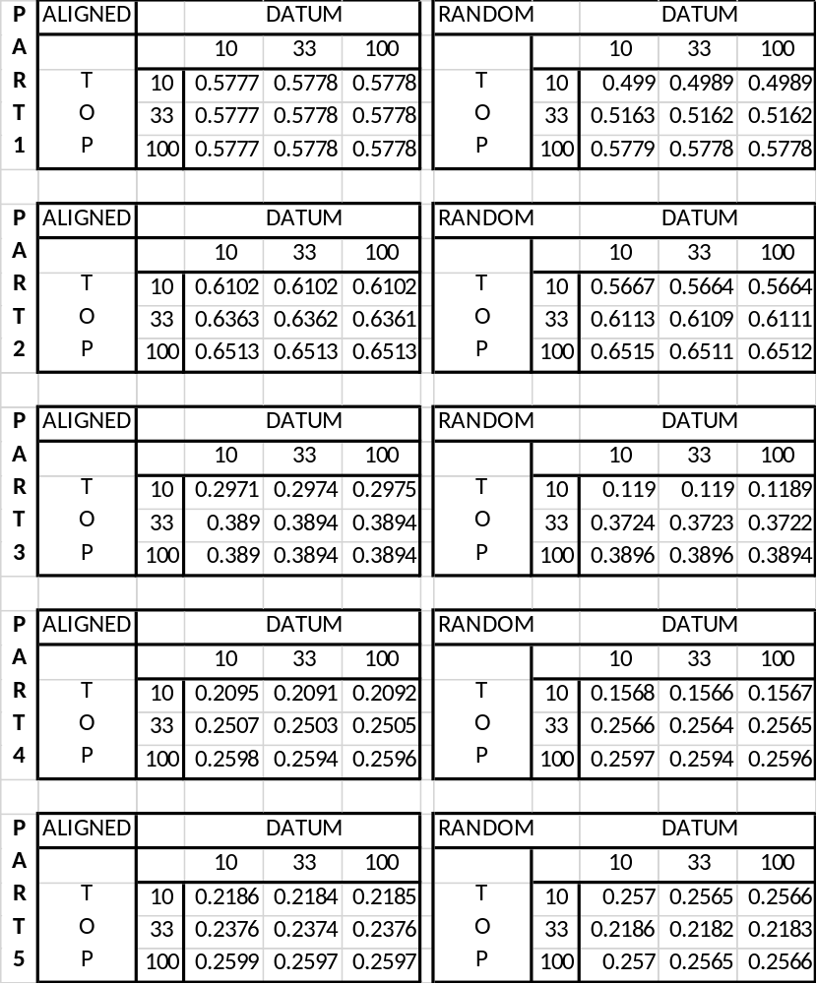
Units in mm

Table 5: Parallelism for 5°- Part 1 to 5
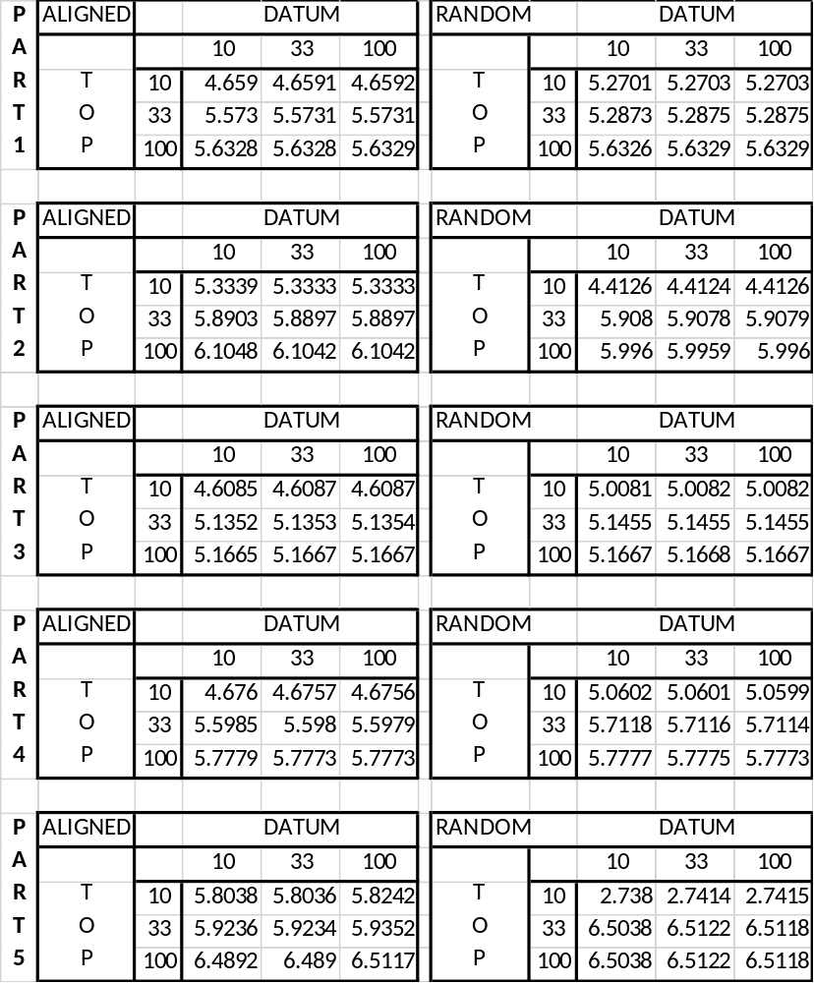
Units in mm

Table 6: Parallelism for 10°- Part 1 to 5
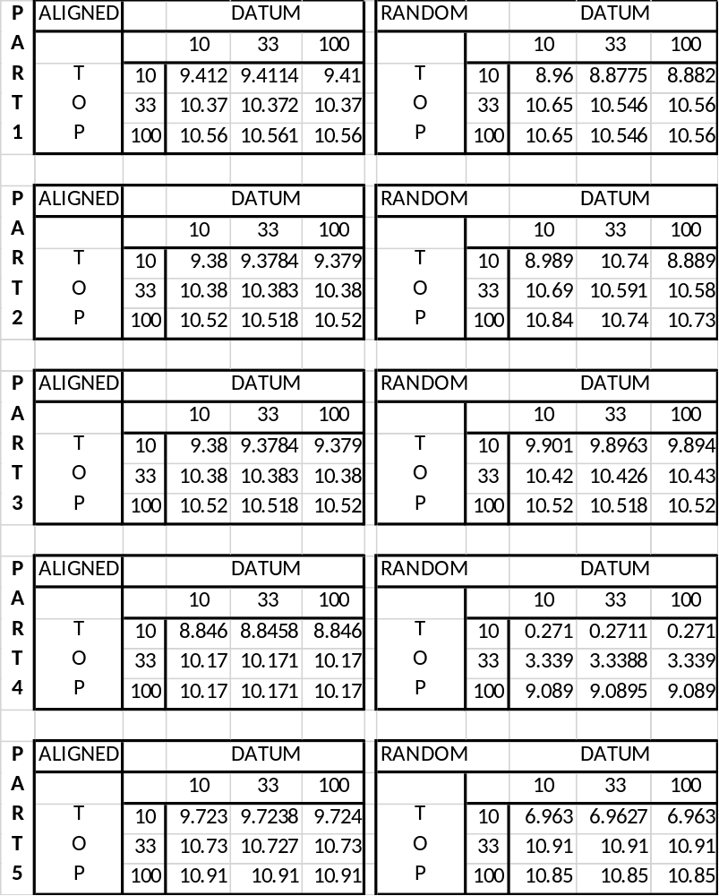
Units in mm

Table 7: Mean and Standard deviation of parallelism for inspected parts.
Sampling technique |  | Sample Parts Unit: mm
 |  | O Degrees |  |  |  |  | 5 Degrees |  |  |  |  | 10 degrees
 |  | P 1 | P 2 | P 3 | P 4 | P 5 | P 1 | P 2 | P 3 | P 4 | P 5 | P 1 | P 2 | P 3 | P 4 | P 5
Aligned Sytematic Sampling | Mean | 0.57777 | 0.63257 | 0.35862 | 0.23979 | 0.2386 | 5.28833 | 5.77593 | 4.97019 | 5.35047 | 6.07819 | 10.114 | 10.0937 | 10.0937 | 9.72944 | 10.4536
Aligned Sytematic Sampling | Std. D | 0.00005 | 0.018 | 0.04597 | 0.02323 | 0.01789 | 0.47263 | 0.34458 | 0.27151 | 0.51195 | 0.31803 | 0.53361 | 0.53911 | 0.53911 | 0.66278 | 0.55321
Random Sampling | Mean | 0.531 | 0.60962 | 0.2936 | 0.22426 | 0.24392 | 5.39682 | 5.4388 | 5.1068 | 5.51639 | 5.25294 | 10.0253 | 10.3108 | 10.2801 | 4.23303 | 9.57421
Random Sampling | Std. D | 0.03591 | 0.03672 | 0.13119 | 0.05068 | 0.01917 | 0.17714 | 0.77064 | 0.07454 | 0.34343 | 1.88449 | 0.84042 | 0.78211 | 0.28982 | 3.8769 | 1.95876

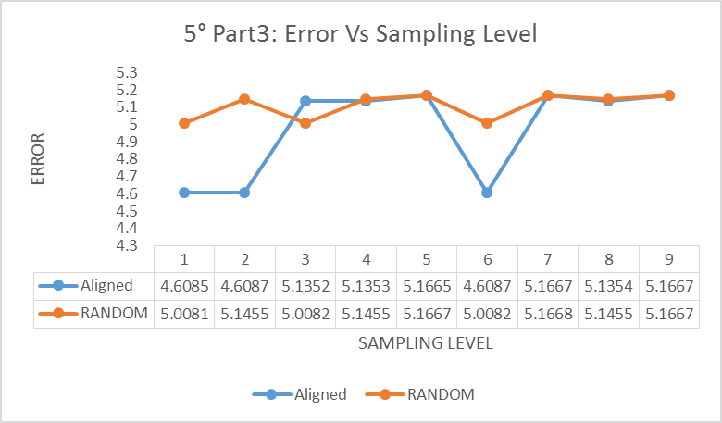
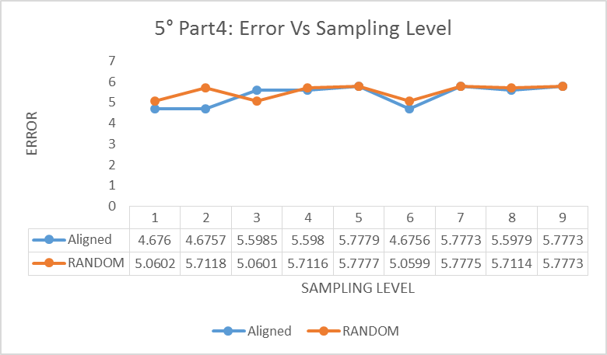
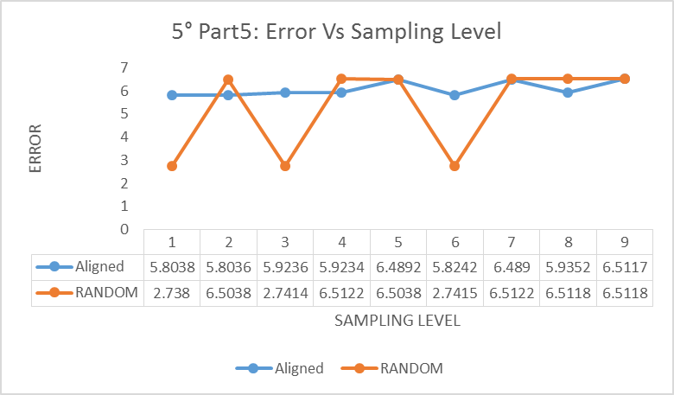
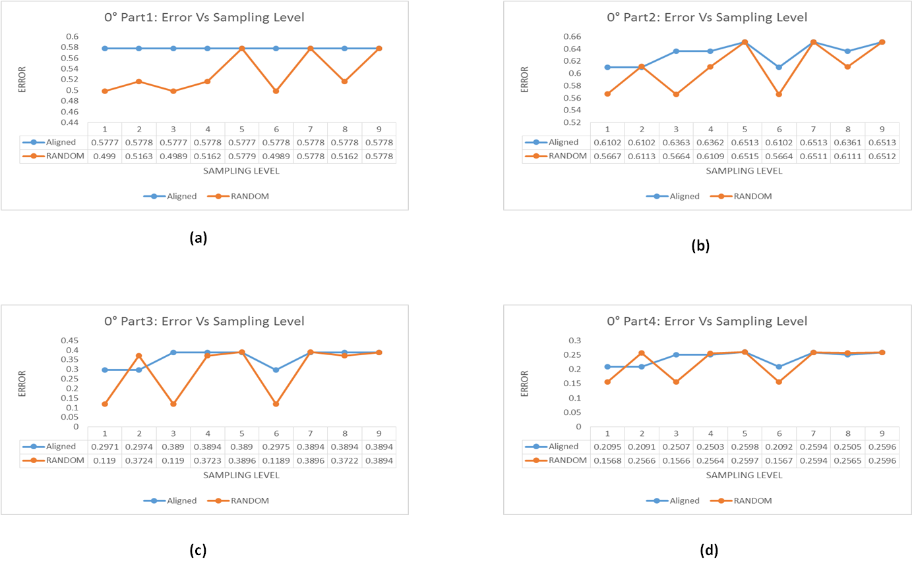
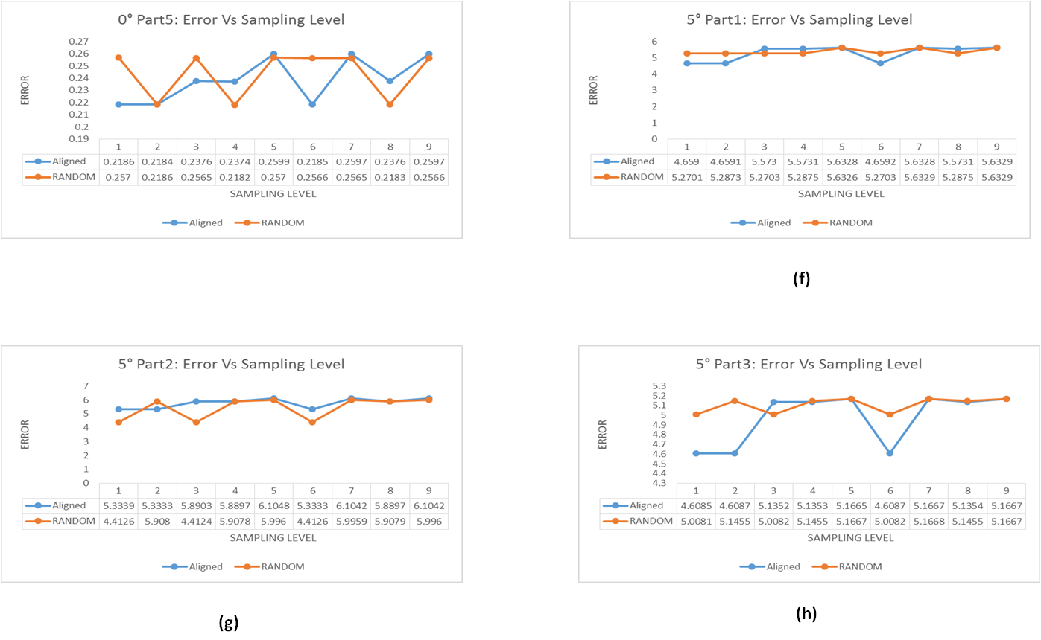
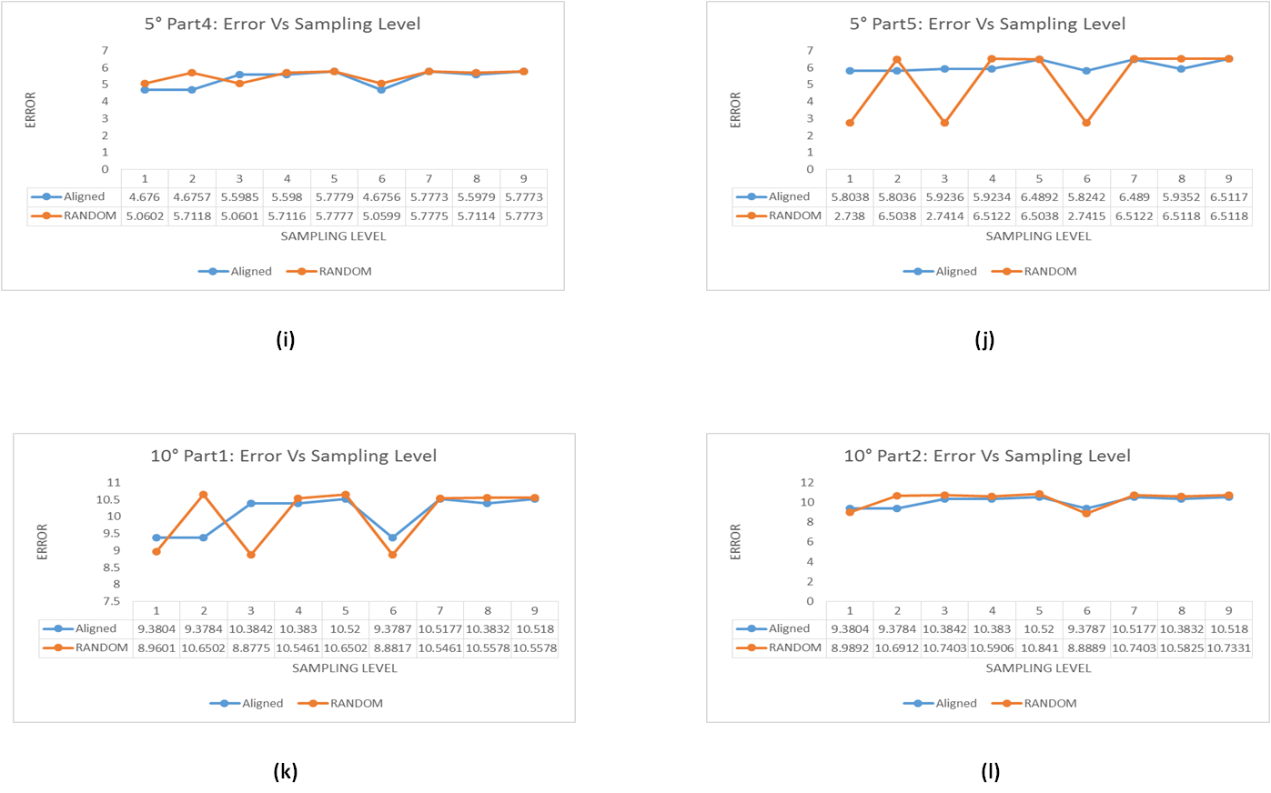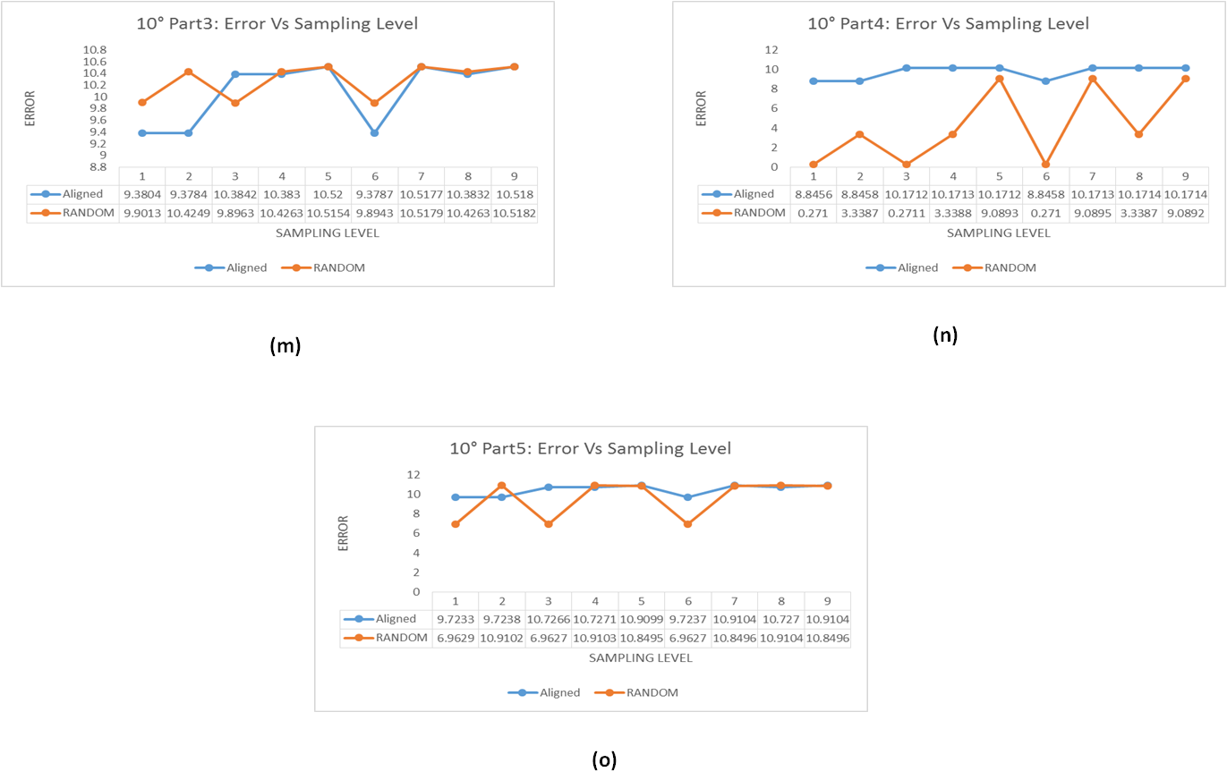
Figure 17: Aligned vs. Random: Parallelism plot for inspected parts
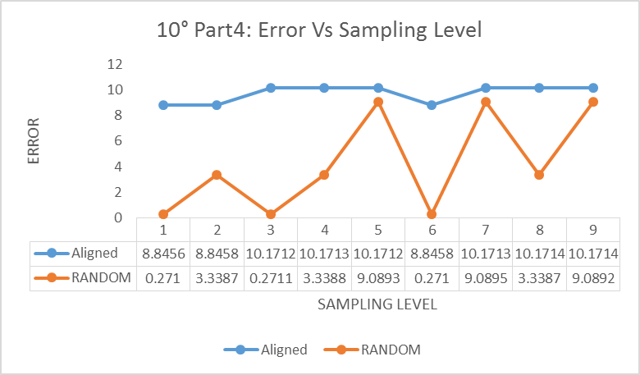
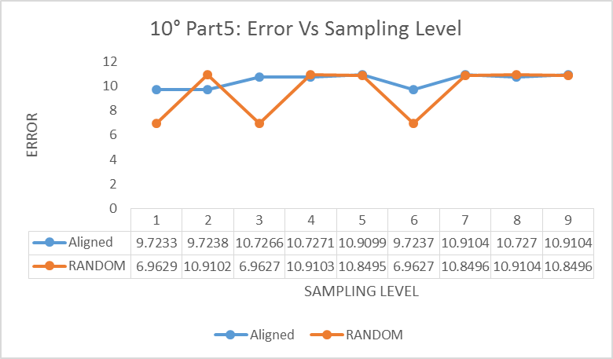
From the above tables and graphs, parallelism was measured in terms of ‘error’ which is the distance between the minimum distance planes. The theoretical value of the ‘error distance’ for two parallel surfaces should be zero. But for practical reasons, we have estimated the error value to be between 0.2 to 0.5 mm based on the tolerance limit. The following observations were made for the inspected parallelism:
- 3 out of the 5, 0° degree top plane angle sample blocks were found to be in spec with respect to the manufacturer’s specified tolerance level. On an average, the ‘error distance’ for the parallel parts ranged between 0.22 to 0.63 mm. That means, out of the 15 parts inspected, we found out that 3 parts were parallel with the specified tolerance.
- The 5° and the 10° degree top plane angle parts showed significant ‘error distance’ which was expected.

5.1.2 Sampling Method
From the tabulated results and plots of the experiment, the following was observed regarding the effect of sampling method on our inspection model:
- There is more variability in parallelism values in random sampling than that in aligned sampling.
- For smaller sample sizes, random sampling does not seem to be a good sampling technique. At lower sample point levels, the deviation within the technique, and especially when compared to the results of aligned sampling, is quite significant.
- For smaller sample sizes, aligned sampling provides a more accurate estimate of parallelism.
- For non-parallel parts, aligned sampling can detect the deviation even with smaller sample sizes.
- For larger sample sizes, the error value for random and aligned are very close. Hence, the deviation between these values is small when compared to other levels. This tells us that for larger samples, both random and aligned are likely to be both equally effective.
- On an average, the deviation of the distance error within levels for a single block is less in aligned sampling compared to random sampling.

5.1.3 Sample Size
- There is considerable variation between the error values among different levels within the same technique due to the sample size combinations used.
- The error value is the most consistent for the sample size of 100 for the inspected feature when compared to the rest of the levels and sizes.
- The least deviation in the error value is exhibited at 100-100 (Level 9) between both techniques.
- The error value is inconsistent at smaller sample size values, especially where sample size for the top surface is concerned.
- On an average, better and more consistent results are exhibited at higher sampling levels for both sampling techniques.
- For random sampling, larger sample size show more consistent error values. At smaller levels, the deviations are extreme in some cases.

5.2 Analysis of Results
We analyze a full factorial design with four factors ($3×2×3×3)$. These factors have mixed levels. The design is as explained in section 4.4.
Factors are identified as:
- Top Plane Angle (0, 5 and 10)
- Sampling Technique (Aligned and Random)
- Sample Size for Datum (10, 33 and 100)
- Sample Size for Top (10, 33 and 100)
For all experiments the confidence level is set to 95%, which gives us $α=0.05$. We also have 5 replicates of each reading.
Our Hypothesis for the test is as follows:
Factor A, $H_{o}:$ $μ_{0}{=μ}_{5}=μ_{10}$ and $H_{1}:$ $μ_{0}{≠μ}_{5}≠μ_{10}$
Factor B, $H_{o}:$ $β_{A}=β_{R}$ and $H_{1}:$ $β_{A}≠β_{R}$
Factor C, $H_{o}:$ $γ_{10}=γ_{33}=γ_{100}$ and $H_{1}:$ $γ_{10}≠γ_{33}≠γ_{100}$
Factor D, $H_{o}:$ $θ_{10}=θ_{33}=θ_{100}$ and $H_{1}:$ $θ_{10}≠θ_{33}≠θ_{100}$
Interactions:
AB, $H_{o}:$ ${(μβ)}_{ij}=0$ and $H_{1}:$ ${(μβ)}_{ij}≠0$
AC, $H_{o}:$ ${(μγ)}_{ik}=0$ and $H_{1}:$ ${(μγ)}_{ik}≠0$
BC, $H_{o}:$ ${(βγ)}_{jk}=0$ and $H_{1}:$ ${(βγ)}_{jk}≠0$
AD, $H_{o}:$ ${(μθ)}_{il}=0$ and $H_{1}:$ ${(μθ)}_{il}≠0$
BD, $H_{o}:$ ${(βθ)}_{jl}=0$ and $H_{1}:$ ${(βθ)}_{jl}≠0$
CD, $H_{o}:$ ${(γθ)}_{kl}=0$ and $H_{1}:$ ${(γθ)}_{kl}≠0$
BCD, $H_{o}:$ ${(βγθ)}_{ljk}=0$ and $H_{1}:$ ${(βγθ)}_{ljk}≠0$
ABD, $H_{o}:$ ${(μβθ)}_{ijl}=0$ and $H_{1}:$ ${(μβθ)}_{ijl}≠0$
ABC, $H_{o}:$ ${(μβγ)}_{ijk}=0$ and $H_{1}:$ ${(μβγ)}_{ijk}≠0$
ABCD, $H_{o}:$ ${(μβγθ)}_{ijkl}=0$ and $H_{1}:$ ${(μβγθ)}_{ijkl}≠0$
Where $μ, β , γ and θ$are means and $i, j , k and l$ are the levels of the corresponding factors $A, B , C and D$.

Table 8: Factor Table
Factor Information
Factor Levels Values
PARTS 3 0, 5, 10
TECHNIQUE 2 A, R
DATUM 3 10, 33, 100
TOP 3 10, 33, 100

Table 9: ANOVA Table
Analysis of Variance
Source DF Adj SS Adj MS F-Value P-Value
Model 53 3885.69 73.31 44.10 0.000
Linear 7 3812.12 544.59 327.56 0.000
PARTS 2 3736.30 1868.15 1123.67 0.000
TECHNIQUE 1 14.53 14.53 8.74 0.003
DATUM 2 0.02 0.01 0.01 0.994
TOP 2 61.26 30.63 18.42 0.000

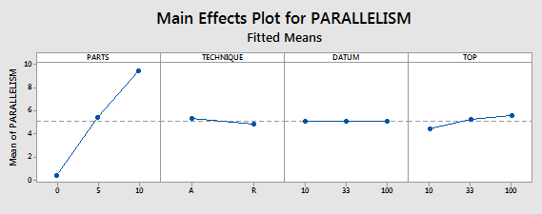
Figure 18: Main Effects Plot for Analysis

From the above analysis, we see no significant effect of the datum on our parallelism.

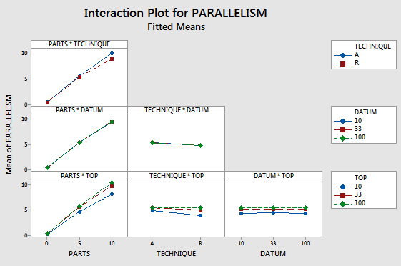
Figure 19: Interaction Plot for Analysis

The analysis results of the factorial design based on the ‘p’ value showed significant difference for top plane angle and sample size for top. Sampling techniques, sample size for datum and the interactions between the factors did not show any significant effects. Therefore, we fail to reject our null hypothesis for all but A and C.

CHAPTER 6: CONCLUSION AND FUTURE SCOPE

6.1 Conclusion
After the implementation of the model and the analysis, we find that only 3 out of the 15 parts measured exhibit parallel behavior between the inspected feature and datum feature. 10 out of the 15 parts were expected to fail the test due to the top plane angle of the parts. However, the two out of the five parts that were designed to exhibit parallelism also failed our test. This could be due to a variety of reasons. The reasons could be but are not limited to machining or sampling errors. The resulting table for the 15 parts inspected is listed below.
Table 10: Inspection Table
INSPECTION RESULT
0° | PART 1 | FAIL
0° | PART 2 | FAIL
0° | PART 3 | PASS
0° | PART 4 | PASS
0° | PART 5 | PASS
5° | PART 1 | FAIL
5° | PART 2 | FAIL
5° | PART 3 | FAIL
5° | PART 4 | FAIL
5° | PART 5 | FAIL
10° | PART 1 | FAIL
10° | PART 2 | FAIL
10° | PART 3 | FAIL
10° | PART 4 | FAIL
10° | PART 5 | FAIL

Out of the four factors that we considered, only two factors have an effect on the Parallelism tolerance.
- Factor 1-Sampling Size for Top: This factor has a significant impact on the error analysis. Larger sample sizes gave more consistent and efficient results when compared to samples of smaller size. The sampling level of 100-100, which had 100 samples for both the inspected and datum feature gave us the consistent value of the error. This value was repeated by both sampling techniques at this level. Statistical analysis using ANOVA also showed difference in the means across various sample sizes. The mean increases as we move from 10 to 100 sample size.
- Factor 2-Top Plane Angle: The result of the ANOVA shows that there is significant difference between the means across the levels of this factor. The mean value increases as we move from 0 to 10 which proves the validity of our inspection method.
There was no significant effect of sampling technique and sample size for datum on our parallelism value. By the findings of Kim et al. (2000) and our study, we can conclude that parallelism is best measured with larger sample sizes that have been selected randomly as aligned sampling might have systematic errors which might go undetected with larger samples. For smaller sample sizes, aligned sampling can find efficient results to show deviation from parallelism.

6.2 Application and Future Scope
The model that we have proposed could be implemented in many inspection techniques in manufacturing. It can be specified as reference models to measure parallelism, and reference units to manufacture other parts based on this method. This model can also be applied to inspect various orientation features in coordinate metrology inspection such as perpendicularity and angularity.
This experiment can also be extended by adding more levels to our factors. Hence, instead of 3 sample sizes for each surface, we could have 5 or more sample sizes with additional refinements based on manufacturing processes employed to make parts. We could also add more stratified sampling techniques, and investigate their comparative efficiency, in measuring parts using CMM sampling. Lastly, we can increase the number of sampling points, by increasing replication, and larger spreads of sampling surfaces.

6.3 Limitations
This model has a few limitations as the parts inspected were free from any projections, holes, and other artifacts and defects. It remains to be seen how this model will perform in an event that the parts under inspection have such complexities. Also, the surfaces under inspection have to be placed in a manner such that both the surfaces can be measured at the same time. If the datum surface is aligned on the bed of the CMM, an implicit datum gets created. Hence, the clamping position has to be such that both the surfaces can be easily accessed for measurement in one setting, without introducing positioning/orientation errors.
Also, the number of parts inspected for this study was much less than the specified statistical number (central limit theorem). This sample was further compromised due to the fact that 66.66% of our parts were deliberately designed to fail the parallelism test. So for each degree of taper, we only had 5 replicates.

References
- Kim W.-S. and Raman S. “On the selection of flatness measurement points in coordinate measuring machine inspection”, International Journal of Machine Tools and Manufacture, Vol. 40, No. 3, pp. 427–443, 2000.

- Obeidat, S. M., Raman, S. (2011). "Process Guided Coordinate Sampling of End Milled Flat Plates." International Journal of Advanced Manufacturing Technology, Vol. 50, No. 9-12, DOI: 10.1007/s00170-010-2885-y, pp. 979-991.

- Dowling M.M., Griffin P.M., Tsui K.-L., and Zhou C., “A comparison of the orthogonal least squares and minimum enclosing zone methods for form error estimation”, ASME Manufacturing Review, Vol. 8, No. 2, pp.120–138, 1995.

- Dowling M.M., Griffin P.M., Tsui K.-L., and Zhou C., “Statistical issues in geometric feature inspection using coordinate measuring machines”. Technometrics, Vol. 39, No. 1, pp. 3–17, 1997

- Gilbert, R. C., Raman, S., Trafalis, T.B., Obeidat, S., and Aguirre-Cruz, J.A., "Mathematical Foundations for Form Inspection and Adaptive Sampling." Journal of Manufacturing Science and Engineering 131.4, 2009.

- Wu, Yuguang, and Qiqi Gu. "The Composition Principle of the Datum Reference Frame." Procedia CIRP 43, 2016, pp. 226-31.

- Shakarji, C. M., & Srinivasan, V. “Theory and Algorithm for Planar Datum Establishment Using Constrained Total Least-squares”. Procedia CIRP 43, 2016, pp. 232-237.

- Weißgerber, Marco, Marko Ebermann, Sophie Gröger, and Erhard Leidich. "Requirements for Datum Systems in Computer Aided Tolerancing and the Verification Process." Procedia CIRP 43, 2016, pp. 238-43.

- ASME. Dimensioning and Tolerancing - Engineering Drawing and Related Documentation Practices. ASME Y14.5-2009.

- ANSI/ASME Y14.5.1M-2009 “Dimensioning and Tolerancing,” The American Society of Mechanical Engineers, New York.
- ANSI/ASME Y14.5.1M-1994 “Dimensioning and Tolerancing,” The American Society of Mechanical Engineers, New York

- Gou, J., et al. "A geometric method for computation of datum reference frames." IEEE Transactions on Robotics and Automation, vol. 16, no. 6, 2000, pp. 797-806.

- Mejbri, H., B. Anselmetti, and K. Mawussi. "Functional tolerancing of complex mechanisms: Identification and specification of key parts." Computers & Industrial Engineering 49.2 (2005): 241-65.

- Wu, Yanyan, et al. "Computer Modeling of Geometric Variations in Mechanical Parts and Assemblies." Journal of Computing and Information Science in Engineering, vol. 3, no. 1, 2003, p. 54-63.

- Ramaswamy, Sanjay, et al. “Computer Aided GD&T Advisor Based on Y14.5 Conformance & Good Practice.” — Arizona State University, Proceedings of DETC' 01. 2001.

- Shakarji, Craig M., and Vijay Srinivasan. "Datum Planes Based on a Constrained L1Norm." Journal of Computing and Information Science in Engineering. Vol. 15.4, 2015.

- ISO 5459:2011. Geometrical product specifications (GPS) - Geometrical Tolerancing - Datums and datum systems. Geneva: International Standards for Organization, 2011.

- ISO 14406:2010 - Geometrical product specifications (GPS). Geneva: International Standards for Organization, 2010.

- Parallel and Perpendicular Lines." 29 December 2014. Boundless Algebra. Boundless. 2017.

- "Parallel (geometry)." Wikipedia. Wikimedia Foundation, 02 Apr. 2017. Web. 01 May 2017.

- Gellert, W.; Gottwald, S.; Hellwich, M.; Kästner, H.; and Künstner, H. (Eds.). "Plane." In VNR Concise Encyclopedia of Mathematics, 2nd ed. New York: Van Nostrand Reinhold, pp. 539-543, 1989.

- Weisstein, Eric W. "Plane." From MathWorld--A Wolfram Web Resource. http://mathworld.wolfram.com/Plane.html.

- Parallel and Perpendicular Planes. N.p., n.d. Web. 01 May 2017.

- "Angle Between Two Planes." Math@TutorVista.com. N.p., n.d. Web. 01 May 2017.

- Gdandtbasics.com. N.p., n.d. Web. 01 May 2017

- Bewoor, Anand K and Vinay A Kulkarni. Metrology & Measurement. New Delhi: Tata McGraw-Hill Education, 2009.
- Kerobyan, Meruzhan, et al. "An Interference Method for Measuring Parallelism of Miniature Optical Components." Journal of Modern Optics, 2013. pp. 808-813.

- Hwang, Jooho, Chun-Hong Park, Wei Gao, and Seung-Woo Kim. "A three-probe system for measuring the parallelism and straightness of a pair of rails for ultra-precision guideways." International Journal of Machine Tools and Manufacture, Vol. 47.7-8, 2007, pp. 1053-058.

- Taylor, Derek. “Non-Datum Based Parallelism and Perpendicularity Metrology for Units Containing Continuous and Discontinuous Perimeters”. MS Thesis. University of Oklahoma, 2015.

- Woody, Shane C and Marcin B Bauza. "High Aspect Ratio Sensors with an Application to Microscale Metrology." NCSL International Workshop and Symposium 2007.

- Weckenmann, A, G Peggs and J Hoffmann. "Probing Systems for Dimensional Micro- and Nano-metrology." Measurement Science and Technology, 2006. pp. 504-509.

- Schaffer, G.H. “Taking the measure of CMM’s”. Special Report 749. American Machinist, October 1982. pp. 116-145.

- Elkott, Diaa F., Hoda A. Elmaraghy, and Waguih H. Elmaraghy. "Automatic sampling for CMM inspection planning of free-form surfaces." International Journal of Production Research 40.11, 2002. pp. 2653-676.

- Cochran, W. G. Sampling Techniques. New York: J. Wiley, 1977.

- Aguirre Cruz, J.A. “Decision support system for form verification of manufactured parts. Doctoral Dissertation. University of Oklahoma, Norman, Oklahoma, 2007.

- Stuart, A. Basic ideas of scientific sampling. Charles Griffin & Company Limited, London and High Wycombe, 1976. pp. 11-13.

- Sukhatme, P.V. and Sukhatme, B.V. Sampling Theory of Surveys with Applications. Iowa State University Press, Ames, Iowa, U.S.A, 1970.

- Konijn, H S. Statistical Theory of Sample Survey Design and Analysis. North-Holland, 1973.

- Ragunandan R, Rao Venkateshwara Selection of sampling points for accurate evaluation of flatness error using coordinate measuring machine. International Journal of Machine Tools and Manufacture 47, 2007. pp. 477– 482.
- Namboothiri V.N., and Shunmugam M.S., “On determination of sample size in form error evaluation using coordinate metrology”. International Journal of Production Research, Vol. 37, No. 4, pp.793–804, 1999.

- Woo T.C., Liang R., Hsieh C.-C., and Lee N.K., “Efficient sampling for surface measurements. Journal of Manufacturing Systems”, Vol. 14, No. 5, 1995. pp. 345-54.

- Uppliappan B., Raja J., Hocken R.J., and Chen K., “Sampling methods and substitute geometry algorithms for measuring cylinders in coordinate measuring machine”, Trans NAMRI/SME XXV:353–358, 1997.

- Cho M.W., and Kim K., “New inspection planning strategy for sculptured surfaces using coordinate measuring machine. International Journal of Production Research, Vol. 33, No. 2, pp. 427–44, 1995

- Pahk H.J., Jung M.Y., Hwang S.W., Kim Y.H., Hong Y.S., and Kim S.G., “Integrated precision inspection system for manufacturing of molds having CAD defined features. International Journal of Advanced Manufacturing Technology, Vol. 10, No. 3, pp.198–207, 1995.

- Lee G., Mou J., and Shen Y., “Sampling strategy design for dimensional measurement of geometric features using coordinate measuring machine”, International Journal Machine Tools and Manufacture Vol. 37, No. 7, pp. 917–934, 1997.

- Badar, A., Raman, S. and Pulat, S., “Intelligent Search-Based Selection of Sample Points for Straightness and Flatness Estimation,” Transactions of the ASME, Journal of Manufacturing Science and Engineering, Vol.125, Issue No.2, 2003, pp. 263-271.

- Badar M.A., Raman S., Pulat P.S., and Shehab R.L., “Experimental analysis of search-based selected of sample points for straightness and flatness estimation”, Journal of Manufacturing Science and Engineering, Transactions of the ASME, Vol. 127, No. 1, 2005. pp. 96-103.

- Badar, A., Raman, S. and Pulat, S., “Experimental verification of manufacturing error form pattern and its utilization in form tolerance sampling,” International Journal of Machine Tools and Manufacture, Vol. 45, No.1, 2005, pp. 63-73.

- “Regression Analysis.". Wikipedia: The Free Encyclopedia. Wikimedia Foundation, Inc. 2017

- Gorard, Stephen. "Revisiting a 90-year-old Debate: The Advantages of the Mean Deviation." British Educational Research Association Annual Conference. University of Manchester, 2004.
- Least Squares Fitting of Data David Eberly Geometric Tools, LLC http://www.geometrictools.com/ Copyright c 1998-2016. All Rights Reserved. Created: July 15, 1999 Last Modified: November 20, 2016

Appendix A: MATLAB CODE FOR ERROR DISTANCE

xyz=xlsread(FileName1.xlsx'); %%datum plane
x = xyz(:,1);
y = xyz(:,2);
z = xyz(:,3);
[a,b,c] = bilinreg(x, y, z) %%function call for lest square plane datum
n = [a,b,c] %% normal vector of datum
xyz1=xlsread(FileName2.xlsx') %%top plane
x1 = xyz1(:,1);
y1 = xyz1(:,2);
z1 = xyz1(:,3);
[a1,b1,c1] = bilinreg1(x1, y1, z1) %%function call for lest square plane top
minIdx1 = find(z1==min(z1)) %%index of row containing smallest z from top plane
maxIdx1 = find(z1==max(z1)) %%index of row containing largest z from top plane
minRow1 = xyz1(minIdx1,:) %%lowest point on top plane
maxRow1 = xyz1(maxIdx1,:) %%highest point on top plane
n1 = [a1,b1,c1] %%normal of top plane
d= dot(n, minRow1) %%to calculate value of d in equation of lower secondary plane
dis= dot(n,maxRow1)-d
num=abs(dis) %%finding distance between top higher and lower secondary plane
deno=norm(n)
D=num/deno

function [a,b,c]=bilinreg1(x,y,z) %% Least Square Plane fitting for Datum
mat=[ mean(x.^2) mean(x.*y) mean(x) ;
mean(x.*y) mean(y.^2) mean(y) ;
mean(x) mean(y) 1 ];
vec= [ mean(x.*z)
mean(y.*z)
mean(z) ];
res=(inv(mat)*vec);
a=res(1);
b=res(2);
c=res(3);
end
function [a1,b1,c1]=bilinreg(x1,y1,z1) %% Least Square Plane fitting for Top
mat1=[ mean(x1.^2) mean(x1.*y1) mean(x1) ;
mean(x1.*y1) mean(y1.^2) mean(y1) ;
mean(x1) mean(y1) 1 ];
vec= [ mean(x1.*z1)
mean(y1.*z1)
mean(z1) ];
res1=(inv(mat1)*vec);
a1=res1(1);
b1=res1(2);
c1=res1(3);

Appendix B: CODE FOR SAMPLING IN CMM
Code developed by Kim et al. (2000) and modified to fit sampling requirements.
% To create Aligned systematic sampling sequence.
file=input (‘Filename’ ,’s’)
fn=fopen (file, ‘at+’) ;
nump=1;
N=input (‘input the number of the total samples N=’) ;
xi=0; %initial value of coordinate of x-axis
x=1; %initial # of the sample points of y-axis
z=1; %initial # of the sample points of x-axis
r=.001;
y=.001;
while (x<=z) / (x*z<=N) % z is the number of the points of x-axis
z=ceil (N/x) ; % x is the number of the points of y-axis
if z- (N/x) > 0 & z~=1
z=z-1;
else
z=z;
end
w=x
x=x+1
end
if w*z~=N
z=z-1 ;
w=N/z ;
else
end
r=1/z ;
y=1/w ;
rannumx=1*0.2*r;
rannumy=2*0.2*y;
for k=1 : w
for h=1 : z
xi=rannumx+ (h-1) *r;
yi=rannumy+ (k-1) *y
point (nump, 1)=nump ;
point (nump, 2)=xi;
point (nump, 3)=yi;
fprint (fn, ‘ %d %7.4f %7.4f\n’ ,
point (nump,1) , point (nump,2) , point (nump,3) ) ;
nump=nump+1;
end
end
fclose (fn);

% Aligned systematic sampling method
nump=1;
file=input (‘outputfilename’, ‘s’ )
fn=fopen (file, ‘a+’ ) ;
file1=input (‘outputfilename’ ‘s’ )
ft=fopen (file1, ‘a+’ ) ;
N=input (‘Sample size=’ ) ;
hor1=input (‘Length of part =’ ) ;
ver1=input (‘Width of part? =’ ) ;
height=input (‘height of the probe =’ ) ;
entrance=input (‘maximum tolerance of the sample part =’ ) ;
clearance=input (‘between the CMM probe and the sample part =’ ) ;
seqno=input (what is the number of sequence =’ ) ;
nump=1 ;
xi=0; %initial value of coordinate of x-axis
x=1; %initial # of the sample points of y-axis
z=1; %initial # of the sample points of x-axis
r=.001;
y=.001;
while (x<=z)/ (x*z<=N) % z is the number of the points of x-axis
z=ceil (N/x) ;
if z- (N/x) > 0 & z~=1
z=z-1
else
z=z ;
end
w=x ;
x=x+1 ;
end
if w*z~=N
z=z-1 ;
w=N/z ;
else
end
r=1/z ;
y=1/w ;
rannumx=1*0.2*r;
rannumy=2*0.2*y;
for k=1:w
for h=1:z
xi=rannumx+ (h-1)*r;
yi=rannumy+ (k-1)*y;
point (nump, 1)=nump ;
point (nump, 2)=xi ;
point (nump, 3)=yi ;
if k==1 & h==1
fprintf (fn, ‘#path PT%d I\n’ ,seqno ) ;
inix=xi ;
iniy=yi ;
else
end
point (nump, 1 )=xi*hor1;
point (nump, 2 )=yi*ver1;
point (nump, 3 )=height;
fprintf (fn, ‘ p 1 1 %7.4f %7.4f %7.4f/n’ ,
point (nump, 1) , point (nump, 2) , point (nump, 3) ) ;
nump=nump+1 ;
point (nump, 1 )=xi*hor1;
point (nump, 2 )=yi*ver1;
point (nump, 3 )=height + clearance + entrance;
fprintf (fn, ‘ M 1 1 %7.4f %7.4f %7.4f/n’ ,
point (nump, 1) , point (nump, 2) , point (nump, 3) ) ;
nump=nump+1 ;
point (nump, 1 )=xi*hor1;
point (nump, 2 )=yi*ver1;
point (nump, 3 )=height;
fprintf (fn, ‘ p 1 1 %7.4f %7.4f %7.4f/n’ ,
point (nump, 1) , point (nump, 2) , point (nump, 3) ) ;
nump=nump+1 ;
end
end
point (nump, 1 )=inix*hor1 ; % apply the initial value when started at first
point (nump, 2 )=iniy*ver1 ;
point (nump, 3 )=height;
fprintf ( fn, ‘ P 1 1 %7.4f %7.4f %7.4f/n’ ,
point (nump, 1) , point (nump, 2) , point (nump, 3) ) ;
nump=nump+1 ;
fprintf (fn, ‘#endpath\n’ ) ;
fprintf (fn, ‘ MEMORY[%d]=” “ \n’, seqno ) ;
fprintf (fn, ‘ mpl (MEMORY[%d] , %d) path PT%d\n’, seqno, N , seqno ) ;
fprintf (ft, ‘ ! \n’ ) ;
fprintf (ft, ‘endstat\n’ ) ;
fprintf (ft, ‘end_program\n’ ) ;
fprintf (ft, ‘#include %s\n’, file) ;
fclose (‘all’ ) ;

