UNIVERSITY OF OKLAHOMA
GRADUATE COLLEGE

AN APPLIED EVALUATION OF
ECOSYSTEM SERVICES DECISION-SUPPORT TOOLS

A THESIS
SUBMITTED TO THE GRADUATE FACULTY
in partial fulfillment of the requirements for the
Degree of
MASTER OF ENVIRONMENTAL SCIENCE

By
ALISSA M. MEEK
Norman, Oklahoma
2024

AN APPLIED EVALUATION OF
ECOSYSTEM SERVICES DECISION-SUPPORT TOOLS

A THESIS APPROVED FOR THE
SCHOOL OF CIVIL ENGINEERING AND ENVIRONMENTAL SCIENCE

BY THE COMMITTEE CONSISTING OF

Dr. Robert W. Nairn, Chair
Dr. Robert C. Knox
Dr. Jayash Paudel

© Copyright by ALISSA MEEK 2024
All Rights Reserved.
Acknowledgements
I would like to express my deepest gratitude to the Center for Restoration of Ecosystems and Watersheds (CREW) and its members for their support and assistance during the course of this project. A special acknowledgment goes to the Lake Frances team, Hailey Seago and Cheyenne Morgan, whose contribution has greatly enriched me and this work.
I extend my sincere appreciation to my admired committee members, Dr. Jayash Paudel and Dr. Robert Knox, for their patient guidance and invaluable advice throughout this research journey. I would like to recognize the generous support and funding provided by the Grand River Dam Authority (GRDA), with a special mention of Ed Fite, whose profound knowledge of the Lake Frances site significantly contributed to the success of this research.
I extend my thanks to Steve Patterson of BioxDesign® for his continuous provision of expertise and guidance, which not only offered invaluable insights for this work but also served as a wellspring of inspiration for my future endeavors. Last but certainly not least, I want to express my heartfelt gratitude to my advisor, Dr. Robert Nairn, who provided unwavering support while helping me grow as a professional and scientist.

Table of Contents
Acknowledgements……………………………………………………………………………….iv
Table of Contents………………………………………………………………………………….v
List of Tables…………………………………………………………………………………....viii
List of Figures…………………………………………………………………………………….ix
List of Appendices…….……………………………………………………………………….…xi
Abstract………………………………………………………………………………………….xiii
1.0 Introduction……………………………………………………………………………………1
1.1 Problem Overview and Significance………………………………………………….1
2.0 Literature Review……………………………………………………………………………...3
2.1 Nature-Based Solutions (NBS): Wetlands for Benefit Optimization………………….3
2.2 Wetland Conservation Progress and Remaining Challenges………………………….7
2.3 Bridging the Site-Level Implementation Gap………………………………………....9
3.0 Research Hypothesis and Objectives………………………………………………………….9
4.0 Methods………………………………………………………………………………………10
4.1 Site Selection………………………………………………………………………...10
4.1.1 Lake Frances near the Illinois River……………………………………….10
4.1.2 Mayer Ranch and Southeast Commerce Passive Treatment Systems……..14
4.2 Tool Selection………………………………………………………………………..19
4.2.1 Descriptive Review for Tool Selection…………………………………….19
4.3 InVEST Tool Setup and Input Requirements…...…………………………………...21
4.3.1 InVEST Setup.,…………………………………………………………….21
4.3.2 InVEST Requirements: RouteDEM and DelineateIt..…………..………....22
4.3.3 InVEST Requirements: Sediment Delivery Ratio ….…………………......25
4.3.4 InVEST Requirements: Nutrient Delivery Ratio…….....……………….....30
4.3.5 InVEST Requirements: Annual Water Yield……….………………...…....32
4.3.6 InVEST Requirements: Carbon Storage and Sequestration……...…..…....37
4.3.7 InVEST Requirements: Habitat Quality……..…………………….....…....38
4.3.8 InVEST Requirements: Urban Stormwater Retention………...…......….....42
4.3.9 InVEST Requirements: Urban Flood Risk Mitigation………...…......…....43
4.3.10 ESII Setup……..…..…......…………………………………………….....45
4.3.11 ESII Requirements: Regional Inputs………...…...…………………….....46
4.3.12 ESII Requirements: Habitat Survey.……..…………………………….....48
4.3.13 ESII Requirements: Vegetation Survey………….....………………….....49
4.3.14 ESII Requirements: Surface Survey……….….……………………….....53
4.3.15 ESII Requirements: Screen Survey….……..…………………………......56
4.4 Tracking Wildlife at Lake Frances…..…………….…………………………………57
4.5 Data Analysis Methods……………...…………….…………………………………57
4.5.1 Qualitative Evaluation….....…………………………………………….....57
4.5.2 Educated Partner ES Analysis….…………...………………………….......58
5.0 Results………………...……………………………………………………………………...61
5.1 Vegetation and Soil Analyses………………………………………………………...61
5.1.1 Vegetation at Lake Frances.….…………………………………...….….....61
5.1.2 Soils at Lake Frances, MRPTS, and SECPTS.………………………….....62
5.2 ES-DST Results………..…………………………………………………………….64
5.2.1 InVEST Outputs Overview………....…......…………………………….....65
5.2.2 InVEST SDR Outputs: Erosion Control…..........……………………….....67
5.2.3 InVEST NDR Outputs: Nutrient Retention.…………...........…………......69
5.2.4 InVEST AWY Outputs: Water Provisioning.......……………...…….…......74
5.2.5 InVEST CSS Outputs: Carbon Stock…...……….………………….…......75
5.2.6 InVEST HQ Outputs: Habitat Degradation and Quality.……...…….…......78
5.2.7 InVEST USWR Outputs: Stormwater Retention..………….....…….…......81
5.2.8 InVEST UFRM Outputs: Flood Attenuation……....……..…...…….…......83
5.2.9 ESII Outputs Overview…………….….......…………………………….....87
5.2.10 ESII Outputs: Water Provisioning.....….....…………………………….....89
5.2.11 ESII Outputs: Air Quality Regulation (NO_{X} and PM₁₀ Removal)...….......90
5.2.12 ESII Outputs: Climate Regulation (Reduction Shade)…………....….......93
5.2.13 ESII Outputs: Water Quality Control (NO_{X} and TSS Removal).....….......94
5.2.14 ESII Outputs: Water Quantity Control (Runoff Retention)…….....….......97
5.3 Evaluative Criteria Results…………………………………………………………..98
5.4 Educated Partner Feedback Results………………………………………………...100
5.5 Camera Trapping Results…………………………………………………………...103
6.0 Conclusions…………………………………………………………………………………107
6.1 Quantifying Site-Level ES………………………………………………………….107
6.1.1 Lake Frances: BHFs Enhance ES for Water Security and Beyond..……...107
6.1.2 MRPTS and SECPTS: Restoring ES Beyond Water Quality in Mine-Impacted Habitats………………………………………………………………108
6.2 ES-DSTs, like InVEST and ESII, Offer Quantitative Approaches to ES Analysis…109
6.2.1 InVEST: Decoding Nature's Value to Empower Decision-Making…...….109
6.2.2 ESII: Integrating Sustainability into Business-As-Usual Approaches……110
6.3 Generating Unique, Site-Specific Measures to Improve ES Tracking……….….….111
6.3.1 Engaging Stakeholders to Drive Site-Specific ES Investigation ………...111
6.3.2 Incorporating Wildlife Cameras for Biodiversity Tracking…………..…..111
6.4 Future Directions: Refining and Valuing ES-DST Outputs………………….….….112
7.0 References…………………………………………………………………………………..115
8.0 Appendices………….………………………………………………………………………134
8.1 Appendix A: Supporting Data…………………………………………………...….134
8.2 Appendix B: ESII Survey Questions……..……………………………………...….143
8.3 Appendix C: Decision-Support Tool Outputs……..…..………………………...….148
8.4 Appendix D: Wildlife Camera Results………….....…..………………………...….153
8.5 Appendix E: Ecosystem Services Valuation...….....…..………………………...….230

List of Tables
Table 4-1. Input requirements for RouteDEM and DelineateIt……….………………..…………22
Table 4-2. Input requirements for the Sediment Delivery Ratio model…………………………...26
Table 4-3. Input requirements for the Nutrient Delivery Ratio model…………………………….31
Table 4-4. Input requirements for the Annual Water Yield model………….……………..………33
Table 4-5. Input requirements for the Carbon Storage and Sequestration model…………............37
Table 4-6. Input requirements for the Habitat Quality model………………...……..…...………..39
Table 4-7. Input requirements for the Urban Stormwater Retention model………….……..…......42
Table 4-8. Input requirements for the Urban Flood Risk Mitigation model…..……...……………44
Table 4-9. Regional requirements for Lake Frances and both passive treatment systems...............48
Table 4-10. Canopy condition assessment criteria….……….………………..……………...…..52
Table 4-11. Ground cover categories…………….………….………………..……………...…...53
Table 4-12. Evaluative criteria adapted from Bagstad et al. (2013).........................………...…….58
Table 4-13. Lake Frances ecosystem services for educated partner feedback…....................……60
Table 4-14. Mayer Ranch and Southeast Commerce ecosystem services for educated partner feedback…………………………………………………………………………………….........61
Table 5-1. ES-DST tool comparison relative to evaluative criteria…………….......…...…...……98
Table 5-2. Lake Frances: educated partner feedback cumulative scores……...…….......…...…..101
Table 5-3. Mayer Ranch and Southeast Commerce: educated partner feedback cumulative scores……....................................................................................................................................102
Table 5-4. Species richness snapshot and composition per deployment…………...…...…...…..106

List of Figures
Figure 2-1. Millennium Ecosystem Assessment (2005) Ecosystem Services classification…….....4
Figure 4-1. Pilot Study Watersheds: (1) Tar Creek Watershed and (2) Lake Frances/Illinois River Watershed within Oklahoma………………………………………………………………..……10
Figure 4-2. Lake Frances within the Illinois River Watershed………………………..…..………11
Figure 4-3. Focus area: southern floodplain of Lake Frances……………..……………………..12
Figure 4-4. Unnamed Tributary Watershed within the larger Tar Creek Watershed..…………....15
Figure 4-5. Mayer Ranch and Southeast Commerce passive treatment systems within the Unnamed Tributary Watershed.………...……………………………………………..……...……………..17
Figure 4-6. Mayer Ranch (bottom right) and Southeast Commerce (top left) sites….…......…....18
Figure 4-7. Ecosystem Services Decision Support Tools identified from screening processes.....20
Figure 4-8. Lake Frances (point i) locations for vegetation and soil sampling.………….....…....50
Figure 4-9. Soil sampling locations at Mayer Ranch.……………..…………………….......…...54
Figure 4-10. Soil sampling locations at Southeast Commerce.………...……………….......…....54
Figure 5-1. Soil bulk density: Lake Frances, Southeast Commerce, and Mayer Ranch…......……63
Figure 5-2. Soil moisture content: Lake Frances, Southeast Commerce, and Mayer Ranch.........64
Figure 5-3. Digital elevation model: (a) Illinois River Watershed and (b) Lake Frances..…........65
Figure 5-4. Digital elevation model: (a) Unnamed Tributary Watershed, (b) Mayer Ranch, and (c) Southeast Commerce…………………………………………………………………...…...........66
Figure 5-5. Watershed boundaries: (a) Illinois River Watershed and (b) Unnamed Tributary Watershed………………………………………………………………………………………...66
Figure 5-6. Sediment retention: (a) Illinois River Watershed and (b) Lake Frances...…...............68
Figure 5-7. Sediment retention: (a) Unnamed Tributary Watershed, (b) Mayer Ranch, and (c) Southeast Commerce……………………………………………………………………..............69
Figure 5-8. (1) Nitrogen retention and (2) phosphorus retention: (a) Illinois River Watershed and (b) Lake Frances…………………...…………………………………………...…………...........71
Figure 5-9. (1) Nitrogen retention and (2) phosphorus retention: (a) Unnamed Tributary Watershed, (b) Mayer Ranch, and (c) Southeast Commerce………………………...…….............................73
Figure 5-10. Water yield: (a) Illinois River Watershed and (b) Lake Frances……….....…...........74
Figure 5-11. Water yield: (a) Unnamed Tributary Watershed, (b) Mayer Ranch, and (c) Southeast Commerce………………………………………………………………………………..............75
Figure 5-12. Carbon stock: (a) Illinois River Watershed and (b) Lake Frances ……..………...….76
Figure 5-13. Carbon stock: (a) Unnamed Tributary Watershed, (b) Mayer Ranch, and (c) Southeast Commerce……...……………………………………………………………….………………..77
Figure 5-14. (1) Habitat degradation and (2) habitat quality: (a) Illinois River Watershed and (b) Lake Frances……………………………………………………………………………………..79
Figure 5-15. (1) Habitat degradation and (2) habitat quality: (a) Unnamed Tributary Watershed, (b) Mayer Ranch, and (c) Southeast Commerce…………………………….…………...…...............80
Figure 5-16. Stormwater retention: (a) Illinois River Watershed and (b) Lake Frances………......82
Figure 5-17. Retention value: (a) Illinois River Watershed and (b) Lake Frances...…….…...........83
Figure 5-18. Runoff retention for rain depths of (1) 16.8 mm and (2) 142 mm: (a) Illinois River Watershed and (b) Lake Frances…………….………………………………………..………......84
Figure 5-19. Runoff retention for rain depths of (1) 16.9 mm and (2) 146 mm: (a) Unnamed Tributary Watershed, (b) Mayer Ranch, and (c) Southeast Commerce……….……..………........86
Figure 5-20. ESII map units: Lake Frances………………………………….…….........…….......88
Figure 5-21. ESII map units: (a) Mayer Ranch and (b) Southeast Commerce………….................88
Figure 5-22. Water provisioning: Lake Frances…………………………………………..............89
Figure 5-23. Water provisioning: (a) Mayer Ranch and (b) Southeast Commerce..........................90
Figure 5-24. (1) Air nitrogen removal and (2) particulate matter removal: Lake Frances …….......91
Figure 5-25. (1) Air nitrogen removal and (2) particulate matter removal: (a) Mayer Ranch, and (b) Southeast Commerce………………………………………………………..……...………...92
Figure 5-26. Reduction shade: Lake Frances……………………………………………......…....93
Figure 5-27. Reduction shade: (a) Mayer Ranch and (b) Southeast Commerce……………..........94
Figure 5-28. (1) Nitrogen removal and (2) total suspended solids removal: Lake Frances…..........95
Figure 5-29. (1) Nitrogen removal and (2) total suspended solids removal: (a) Mayer Ranch and (b) Southeast Commerce…………………………………………………………………...…….96
Figure 5-30. Runoff retention: Lake Frances …………………….…………………………..…..97
Figure 5-31. Runoff retention: (a) Mayer Ranch and (b) Southeast Commerce.……………….....98
Figure 5-32. Map of wildlife camera deployments at Lake Frances…………………..……........104
Figure 5-33. Spatial distribution of notable events by percent of captures per location of a total of 291 occurrences………………………………………………………………………………....105

List of Appendices
Table A1. Illinois River Watershed: land use/land cover distribution (page 29)……..……..…..134
Table A2. Unnamed Tributary Watershed: land use/land cover distribution (page 29)….……....134
Table A3. Illinois River Watershed and Unnamed Tributary Watershed: Sediment Delivery Ratio model biophysical input table (page 30)…….…...………………………………………….......135
Table A4. Illinois River Watershed: Nutrient Delivery Ratio model biophysical input table (page 32)…….………………………………………………………………………………………...135
Table A5. Unnamed Tributary Watershed: Nutrient Delivery Ratio model biophysical input table (page 32)…………………………………………………………………………………….......136
Table A6. Calculated reference evapotranspiration for Westville and Miami, Oklahoma Mesonet Stations (page 33)…………………………………..……………………………………….......136
Table A7. Illinois River Watershed: Annual Water Yield biophysical input table (page 35)...…...137
Table A8. Unnamed Tributary Watershed: Annual Water Yield biophysical input table (page 35)………………………………………………………………………………………………137Table A9. Estimates of consumptive water use per county (page 36)...………………………....138
Table A10. Illinois River Watershed and Unnamed Tributary Watershed: Total consumptive water use (page 37)……………………………………………………………………………………138
Table A11. Illinois River Watershed and Unnamed Tributary Watershed: Carbon biomass pools (page 38)…………………………...……………………………………………………………138
Table A12. Literature references for carbon biomass pools (page 38)...…………………..…....139
Table A13. Illinois River Watershed: Habitat Quality threats input table (page 40)….…….........139
Table A14. Unnamed Tributary Watershed: Habitat Quality threats input table (see page 40)…..139
Table A15. Illinois River Watershed: Habitat Quality sensitivity table (page 41)….…….......….140
Table A16. Unnamed Tributary Watershed: Habitat Quality sensitivity table (page 42)….........140
Table A17. Illinois River Watershed: Urban Stormwater Retention runoff coefficients (page 43)………………………………………………………………………………………………141
Table A18. Illinois River Watershed: Urban Stormwater Retention curve numbers (page 44)…..141
Table A19. Lake Frances soil sample measurements.….…….......……………………………...142
Table A20. Mayer Ranch soil sample measurements.….…….......……………………………...142
Table A21. Southeast Commerce soil sample measurements. .….…….......……………..……...143
Table B1. ESII habitat survey questions (page 48)…………...….…….......……………..……...143
Table B2. ESII vegetation survey questions (page 49)…………...….…….......………………..144
Table B3. ESII surface survey (ground surface and slope) questions (page 53)………….……..145
Table B4. ESII surface survey (hydrologic regime) questions (page 56)………….…………….146
Table B5. ESII surface survey (percent coverage) questions (page 56)………….……………...147
Table B6. ESII screen survey questions (page 56)…………...….…….............………………..147
Table C1. Tool Outputs for Lake Frances: (a) Integrated Valuation of Ecosystem Services and Tradeoffs (InVEST) and (b) Ecosystem Services Identification and Inventory (ESII)………….148
Table C2. Tool Outputs for (1) Mayer Ranch and (2) Southeast Commerce: (a) Integrated Valuation of Ecosystem Services and Tradeoffs (InVEST) and (b) Ecosystem Services Identification and Inventory (ESII)…………...….…….............…………………………………………………..149
Table C3. Lake Frances: ESII percent performance outputs…………...……...………………..150
Table C4. Mayer Ranch: ESII percent performance outputs…………...……...………………..150
Table C5. Southeast Commerce: ESII percent performance outputs…………...……...………..151
Table C6. Lake Frances: ESII engineering outputs………..…………...……...………………..151
Table C7. Mayer Ranch: ESII engineering outputs...………..…………...……...………………152
Table C8. Southeast Commerce: ESII engineering outputs. ...………..…………...…….............152
Table D1. Species occurrence per deployment and percent of total 291 notable events………....153
Table D2. Notable events at Lake Frances categorized by each camera (LF0[X]) during the first and second deployment periods……………………………..…………...……...………………154
Table E1. Non-monetary ecosystem service valuation methods……………………..……….....230
Table E2. Monetary ecosystem service valuation methods…….……………………..………....231

Abstract
Nature's value as an asset is unmistakable, evident through the tangible benefits it provides, such as agricultural yields and tourist attractions. These services, known as ecosystem services (ES), are easy to appreciate due to their direct market connections. However, implicit ES, like climate regulation and flood control, are often overlooked until their absence becomes painfully evident, demonstrated by disasters such as Hurricane Katrina (Daily et al., 2009) and the 2012 Midwest flash drought event (Cui et al., 2019), as well as with large development projects, such as the channelization and subsequent re-meandering of the Kissimmee River (Wohl et al., 2015).
While wetlands are recognized to contribute to ecological integrity, human well-being, and national resilience (Mitsch et al., 2015), population growth and economic development have historically led to the transformation of these critical habitats (Reis et al., 2017). The rapid conversion of wetland habitat has largely degraded wetland ES, especially affecting inland wetlands (Mitsch et al., 2015). An apparent gap exists between wetland conservation policies and site-level decision-making (Gomez-Baggethun et al., 2010, Guerry et al., 2015), often stemming from inadequate documentation of wetland ES costs and benefits at the local and regional levels (Watkin et al., 2019; Ramsar Convention, 2015; Ruhl et al., 2021).
This research accepted the hypothesis that ES Decision Support Tools (ES-DSTs) are capable of quantifying site-specific freshwater wetland ES. Pilot studies were employed to highlight the potential of ES-DSTs to bridge the gap between high-level wetland conservation policies and on-the-ground implementation by improving ES accounting. These quantitative metrics lay the groundwork for ES valuation, a crucial preparatory phase to conducting a BCA.

1.0 Introduction
1.1 Problem Overview and Significance
Nature's value as an asset is unmistakable, evident through the tangible benefits it provides, such as agricultural yields and tourist attractions. These amenities are known as ecosystem services (ES). The stocks of biotic and abiotic resources stored in ecosystems’ soil, water, air, and plant and animal biomass are called natural capital. Natural capital sustains society in the form of ES, providing direct and indirect benefits to society through the production of various goods (e.g., food) and services (e.g., carbon sequestration) (Reid et al., 2005).
Although it is easy to grasp the importance of explicit ES with direct market connections, like agriculture and tourism, implicit ES, such as climate regulation and flood control, often go unnoticed until they are depleted. This is evident through historic natural disasters like Hurricane Katrina (Daily et al., 2009) and the 2012 Midwest flash drought event (Jin et al., 2019) or in major development projects like the Kissimmee River channelization and re-meandering (Wohl et al., 2015).
Wetlands, among Earth's most productive ecosystems, play a crucial role in maintaining ecological integrity, human well-being, and national resilience (Mitsch et al., 2015). Despite their significance, wetlands have been consistently transformed due to population growth and economic expansion (Reis et al., 2017). The fertile soils and freshwater resources offered by inland wetlands has made them especially vulnerable to human development, especially for agriculture (USGS, 1996). The decline of freshwater wetland habitats (75%) due to land use change between 1997 and 2011 resulted in wetland ES losses between $2.7 and $2.8 trillion per year in 2007 USD (Costanza et al., 2014). While nationwide efforts are underway to safeguard and rehabilitate coastal wetlands (Bridges et al., 2022), efforts to conserve freshwater wetlands receive comparatively fewer resources. This disparity requires immediate attention when considering the crucial role of freshwater wetland ES in combating the impacts of climate change.
Despite efforts to respond to this need (Salzman et al., 2006; Ramsar Convention, 2015; Ruhl et al., 2021), there remains a lack of standard principles and guidelines to assess, report, and track inland wetland status and trends. Consequently, inadequate communication of wetland ES costs and benefits to local and regional decision-makers hinders conservation efforts (Watkin et al., 2019). Effective communication and informed decision-making are pivotal to achieving wetland conservation goals. To promote wetland conservation, it is crucial to establish clear, unambiguous measures to document inland wetland status (Ruhl et al., 2021).
ES quantification is one means of emphasizing nature's importance within the framework of societal value. The rising interest in characterizing and valuing ES for landscape and watershed management has driven the development of tools termed by this research as ES Decision-Support Tools (ES-DSTs). These tools have the potential to bridge the gap between knowledge and application, providing technological solutions to guide decision-making (Guerry, et al., 2015).
This research employs case studies to demonstrate the effectiveness of ES-DSTs as ES quantification tools. It aims to validate the hypothesis that ES-DSTs can quantify both explicit and implicit site-specific wetland ecosystem services. These assessments, which provide numerical documentation of environmental and social factors, facilitate more comprehensive reporting on ES. This, in turn, will lead to a better representation of the true benefits of wetland ES in landscape-scale benefit-cost analyses (BCAs) for use in local and regional decision-making.
2.0 Literature Review
2.1 Nature-Based Solutions (NBS): Wetlands for Benefit Optimization
The extent of nature’s contributions to societal maintenance is not well-understood, which may account for the recalcitrance of human consumption patterns, even as the decline of ES on a global scale becomes increasingly discernable. ES sustain human life, provide food, water, shelter and support the human experience with various forms of recreation and entertainment (Costanza et al., 1998).
The Millennium Ecosystem Assessment (MA) categorized ES based on the type of product or service provided. Provisioning services are tangible products humans derive directly from ecosystems such as timber, food, drinking water, and natural gas. Regulating services refer to benefits provided to society through ecosystem processes like climate regulation, water purification, pollination, and decomposition. Cultural services are nonmaterial benefits such as aesthetic value, recreation and things which provide physical and mental health. Supporting services are indirect benefits to humans in that they support all other services such as soil formation, nutrient and water cycling, and photosynthesis (Figure 2-1) (Reid et al., 2005). Total exhaustion of ES and natural capital stocks would pose serious threats to human wellbeing and lead to missed opportunities for economic expansion (IPBES, 2019).
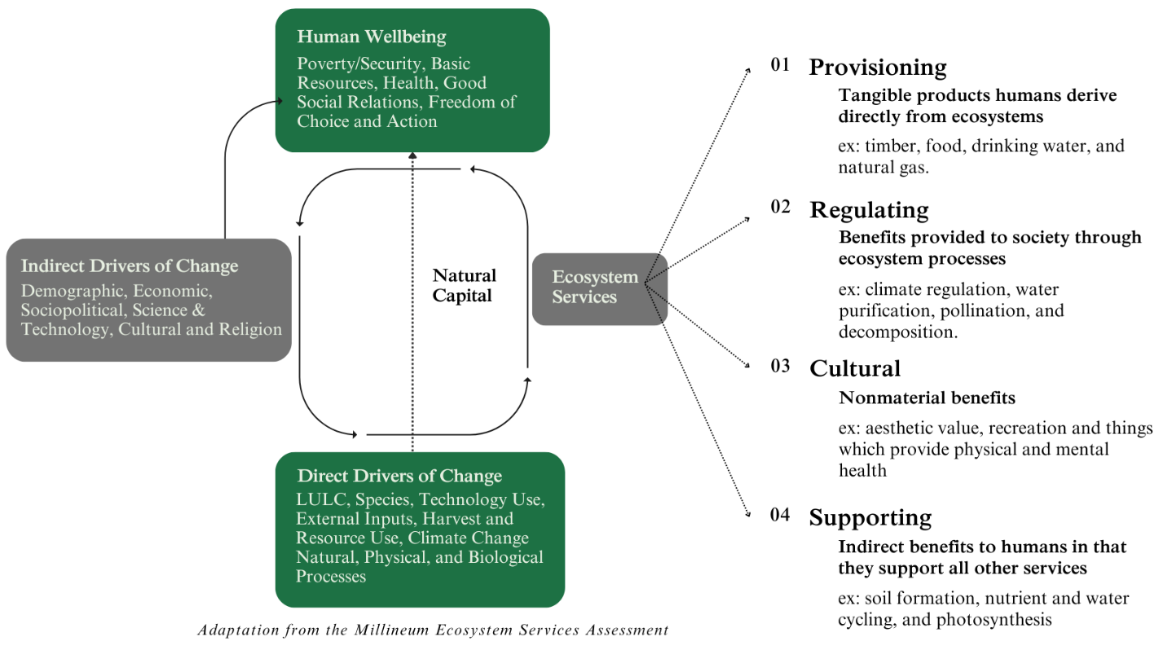
Figure 2-1. Millennium Ecosystem Assessment (2005) Ecosystem Services classification.
Nature-Based Solutions (NBS) has become a common umbrella term to enwrap a range of different approaches which apply the ES concept and is defined formally as, “actions to protect, sustainably manage, and restore natural and modified ecosystems that address societal challenges effectively and adaptively, simultaneously benefiting people and nature (Singh, 2023).” Wetlands are frequently considered NBS (Watkin et al., 2019), as they provide for cleaner water and cooler temperatures, help to control flooding extremes, promote greater biodiversity, support indigenous populations, and improve economic viability (Mitsch et al., 2015). Despite these facts, the average percentage of global wetland loss is somewhere between 54-57%, with up to 90% loss in the most degraded habitats (Reis et al., 2017). Whether natural, restored or created, wetlands are ecologically, socially, and economically valuable ecosystems (Mitsch et al., 2015).
Oklahoma is one of the most biodiverse states in the U.S., with claim to 12 U.S. Environmental Protection Agency (USEPA) Level III ecoregions, spanning from the High Plains to the Ozark Highlands (Woods et al., 2005). Most prevalent of all are habitats featuring tall-, mixed- and short-grass prairies, with a variety of wildflowers and sparse number of trees and shrubs interspersed, often found along riparian zones (USEPA, 2012). The area of interest for this research, northeastern Oklahoma, consists mostly of the Central Irregular Plains and the Ozark Highlands ecoregions.
Characterized by low, gently rolling hills and broad floodplains, the Central Irregular Plains ecoregion separates the Ozark Highlands from the Central Oklahoma/Texas Plains, where tallgrass prairies meet dryer upland forests (ODWC, 1996). Wetland habitats, such as in-channel wetlands and depressional areas, are dispersed throughout this region (Walters et al., 2010). However, what remains today is only a fraction of the original wetland area prior to conversion to support agricultural operations and urbanization (USGS, 2009).
Dominated by low mountains formed by the eroding Ozark Plateau, the Ozark Highlands support various tallgrass species as well as taller, oak-hickory forest communities, mingling to create ecologically rich bottomland hardwood forests along floodplains (ODWC, 1996). The unique hydrodynamics of this landscape create features like seasonal wetlands and oxbow lakes (OWRB, 2019). Similar to the Central Irregular Plains ecoregion, much of this native forest- and prairieland was logged and displaced during the early part of the 20th century, again, trading essential habitat for economic gain (ODWC, 1996).
Along the transition between terrestrial and deepwater aquatic habitats, in the zones known as ecotones, a unique set of ecological conditions often form, creating the perfect environment in terms of hydrology, vegetation, and substrate, to support a wetland habitat (Mitsch and Gosselink, 2015). Due to this interconnectivity, the degradation and fragmentation of terrestrial habitats directly affects the occurrence and quality of wetland habitats. Considering that nearly 76% of Oklahoma’s 18.2 million hectares of potential terrestrial habitat are presently under agricultural production (ODAFF, 2022), the extent and condition of aquatic ecosystems in the state is of concern. Between 1780 and 1980, agricultural expansion, along with intensified urbanization, contributed to the direct loss of an estimated 67% of wetlands in Oklahoma, amounting to a decrease in area from 1,150,000 to 384,000 hectares, with about 45% of that loss occurring between 1950 and 1980 (Dahl, 1990). The continued loss of wetland habitats and conversion of critical natural landscapes not only threatens fish and wildlife, but also human wellbeing, which relies heavily on the ES provided by these critical ecosystems.
Wetlands have the capacity to address numerous environmental and socio-economic challenges, especially related to water quality and supply (Agaton, 2023; Dahl, 1990). Considering global trends of explosive population growth, Central Great Plains’ communities would greatly benefit from increased wetland habitats. As an illustrative example, following expansion of the Dallas-Fort Worth Metropolitan area from 2010 to 2019 (King et al., 2021), the North Texas Municipal Water District (NTMWD) East Fork Water Reuse Project constructed wetlands to function as a large-scale water recycling facility, naturally filtering sediment, trace metals, nutrients, and other pollutants. The project cost was $280 million, offering an economical alternative to building a reservoir. In addition to the water supply and quality ES, the associated John Bunker Sands Wetlands Center offers educational and recreational opportunities (NTWMD, 2024). Offering an alternative perspective, the devastation caused by Hurricane Katrina is tied to the loss of wetland area in the New Orleans region, reducing the natural buffer which protected the city from storm surges. It is estimated that the displacement of over 500,000 hectares of wetland and associated ES in New Orleans since the 1930s would have prevented storm damages estimated to exceed $100 billion of the total $200 billion damages incurred (Batker et al., 2010). Faced with unique climatic extremes, increasing wetland habitat would lead to increased opportunities for ES like water storage and treatment, to address concerns over water insecurity, and flood attenuation, to reduce costs associated with disaster risk (Dahl, 1990).
2.2 Wetland Conservation Progress and Remaining Challenges
In 1998, Costanza et al. released the first global economic valuation of ES, stimulating a cascade of efforts around the topic of ES valuation. The study found that inland wetlands, namely swamps and floodplains, had the highest value per unit area than any other inland biome (e.g., forests, lakes/rivers, croplands, grasslands/rangelands), only outweighed by coastal estuaries (Costanza et al., 1998). Between 1997 and 2011, ES unit values for tidal marsh/mangroves increased from $13,786 to $193,843 (+180,057) per hectare per year (ha/yr) in 2007 USD, while ES values for inland swamps/floodplain decreased from $27,021 to $25,681 (-1,340) per ha/yr. This was attributed to the emergence of new studies focusing on coastal habitats, leading to enhanced understanding and subsequent valuation opportunities, while analogous attention was not given to inland habitats (Costanza et al., 2014).
The MA was a four-year study involving scientists in promoting conservation in policy at the national and global scales. This effort ultimately provided a framework to broadly characterize the benefits of nature in terms of the “services” they provide, with wide acceptance across varied societal backgrounds (Reid et al., 2005). Globally, the MA and Costanza’s efforts laid the groundwork for the establishment of initiatives like The Economics of Ecosystems and Biodiversity (TEEB) project in 2010, which served to bring the ES concept to mass media audiences (2010). The International Panel on Biodiversity and Ecosystem Services (IPBES) was established in 2013 to promote better informed decision-making by providing periodic reports on the status and trends of nature (Díaz et al., 2019) and supplementary summaries catered specifically for policymakers (IPBES, 2019). In 2015, the U.N. adopted the Sustainable Development Goals (SDGs), targeted at addressing growing pressures of urbanization, climate change, and water insecurity (King et al., 2021).
At a national level, the U.S. is working to make NBS a priority to help fulfill the UN SDGs. Federal entities such as the USEPA, U.S. Army Corps of Engineers (USACE) and U.S. Forest Service (USFS) adopted policies calling for consideration of ES in decision-making about forests, wetlands, and other ecosystems (Ruhl et al., 2021). The establishment of the USACE’s Engineering With Nature® (EWN®) initiative, in particular, is changing the way the U.S. approaches engineering and infrastructure challenges, seeking to identify ways to apply or supplement NBS to deliver economic, environmental, and social benefit (King et al., 2021). Most recently, the Biden administration announced the undertaking of the first ever National Nature Assessment in April of 2022, aimed specifically at taking inventory of the state of the nation’s lands, waters, and wildlife (Tallis et al., 2008).
Although there is growing evidence of progress for wetland ES conservation at the global and national levels, these advancements are not well reflected in site-scale resource decision-making (Guerry et al. 2015). Existing studies relating ES to a decision-context have focused on topics such as ES mapping, quantification, valuation, and stakeholder engagement, or on one of the various approaches to integrating ES into political decisions (Martinez-Harms et al., 2015). To effectively operationalize integration of the ES concept into site-level decision-making, practitioners must move beyond education campaigns about general ES importance and push toward developing practicable applications (National Research Council, 2005; Martinez-Harms et al., 2015; Guerry et al. 2015).

2.3 Bridging the Site-Level Implementation Gap
Addressing the gap between high-level policies and practical site-level ES documentation requires aligning nature investments with profitability (Daily et al., 2009). Traditional benefit-cost analyses (BCAs) are commonly used for wetland management decisions but tend to prioritize economic assets over natural ones (Windhoffer et al., 2022). To enhance wetland policy and management, it is crucial to incorporate both explicit and implicit wetland ES values into BCAs, with economic ES valuation offering a direct comparison method (Maler et al., 2008). The development of ES-DSTs provides technological solutions that can bridge the policy-to-application gap by aiding local decision-making (Gomez-Baggethun et al., 2010).
3.0 Research Hypothesis and Objectives
This thesis assesses the potential of ES-DSTs to bridge the gap in site-level wetland conservation policy implementation. It is hypothesized that ES-DSTs can effectively quantify explicit and implicit site-specific wetland ES values, providing numerical estimates for environmental and social aspects. These estimates will enhance landscape-level ES analyses, contributing to more comprehensive representation of wetland ES in large-scale BCAs commonly used in local and regional decision-making. The study objectives include (1) identifying the most suitable ES-DSTs for pilot application through descriptive review methods; (2) demonstrating practical application by deploying selected ES-DSTs in specific case study sites to quantify ES; (3) exploring ways to integrate site-specific biodiversity indicators into the ES evaluation process; and (4) assessing how well ES-DSTs align with stakeholder priorities by soliciting educated partner feedback.

4.0 Methods
4.1 Site Selection
Three wetland sites in northeastern Oklahoma were identified to develop two case studies, each of which emphasizes different elements of each ES-DST applied in this research. Focusing on areas in Oklahoma, as shown in Figure 4-1, these three sites are located within two 12-digit hydrologic unit code (HUC) watersheds. The Lake Frances site sits between Arkansas and Oklahoma, just near the border, within the Illinois River Watershed (IRW) also called the Lake Frances Illinois River watershed. The Southeast Commerce and Mayer Ranch passive treatment systems (SECPTS and MRPTS) are located within the larger Tar Creek Watershed, which extends from Kansas into northeastern Oklahoma (USGS, 2024).
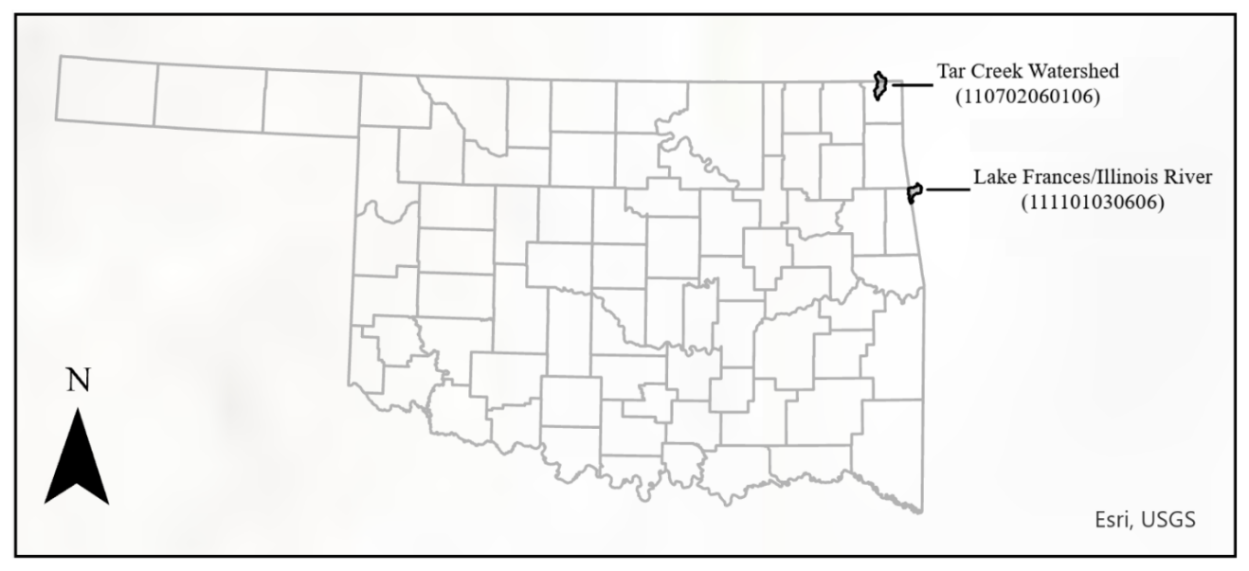
Figure 4-1. Pilot Study Watersheds: (1) Tar Creek Watershed and (2) Lake Frances/Illinois River Watershed within Oklahoma
4.1.1 Lake Frances near the Illinois River
The first case study application focused on assessing the ES provided by a recently established bottomland hardwood forest ecosystem, a site colloquially known as Lake Frances. This application serves as a prime example of how ES-DSTs can be employed to create comprehensive site-level summaries of ES value.
Located near Watts, Oklahoma, just southwest of Siloam Springs, Arkansas, Lake Frances (Figure 4-2) was formed after dam construction on the Illinois River in 1931 (Gade, 1990). In collaboration with the Grand River Dam Authority (GRDA), this research is concentrated on exploring the southern region of the Lake Frances area, with aspirations for future expansion.
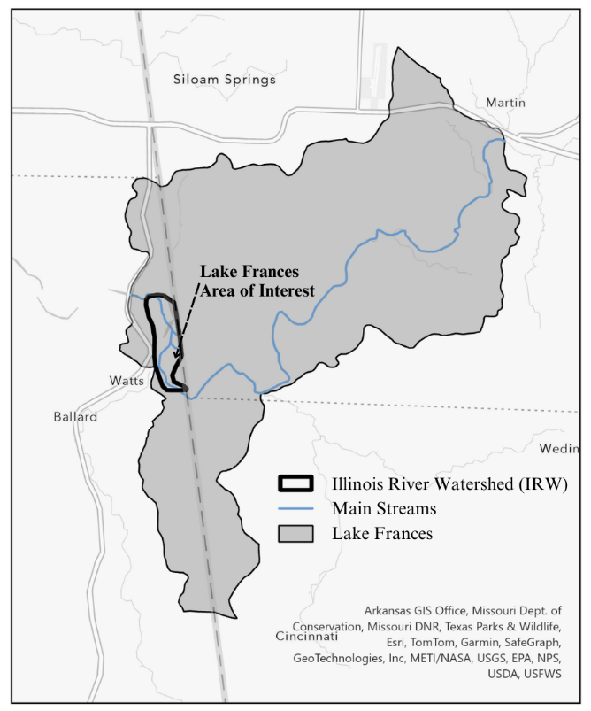
Figure 4-2. Lake Frances within the Illinois River Watershed.
Lake Frances was once a popular local reservoir until a final dam failure occurred in 1990, causing the lake to drain. This transformed the local reservoir, with significant implications for the surrounding ecosystems and the provision of ES at the site. The shift from a man-made reservoir to a channelized flow in the Illinois River resulted in the establishment of a newly grown bottomland hardwood forest (BHF) (Figure 4-3), marking a remarkable ecological transition (Gade, 1990).
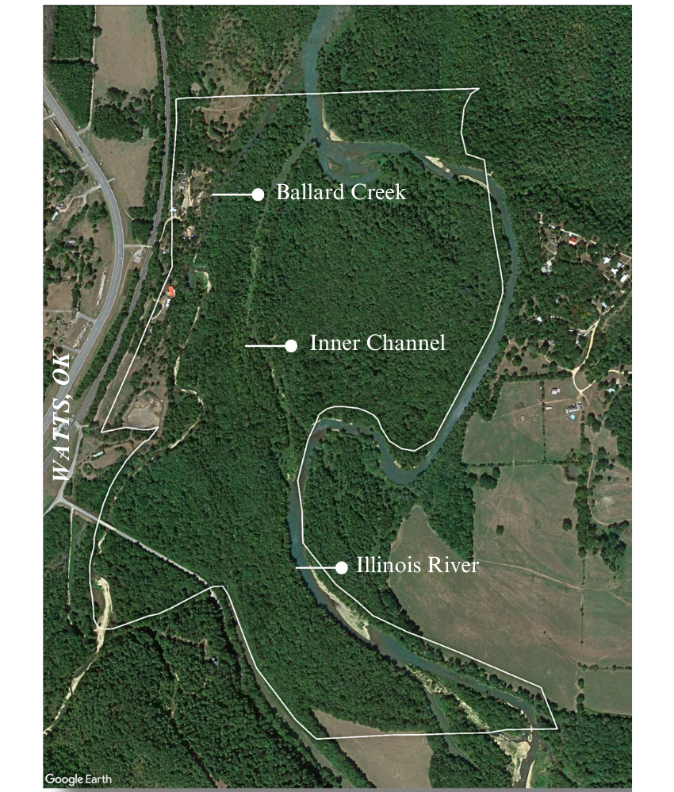
Figure 4-3. Focus area: southern floodplain of Lake Frances.
Lake Frances is connected to the greater IRW (HUC-12 111101030606), a water body well-known to face complex water quality challenges. Streams and rivers within the IRW often fail to meet water quality criteria, being listed under the 303(d) program for issues like low dissolved oxygen, and elevated chlorophyll-a, total phosphorus, enterococcus, and Escherichia coli concentrations (DEQ, 2022). These problems are due to upstream influences of non-point source discharges from stormwater and agricultural operations as well as point source discharges of municipal wastewater. Adding to these concerns is the expected population growth in northwest Arkansas to more than double in the next 20 years, putting even more pressure on the 1,513-hectare IRW (NWAMTP, 2021). The deteriorating water quality in the streams within the IRW is of paramount concern due to its significant impact on the provision of crucial ES.
The newly established BHF is likely to contribute to enhanced biodiversity and improved habitat (King and Allen, 1996). This, in turn, supports other critical ES such as pollination, pest control, and the maintenance of genetic diversity. Moreover, BHFs play a crucial role in water regulation and quality improvement. The uniquely adapted BHF trees help stabilize riverbanks, reduce erosion, and filter pollutants from runoff (Kellison and Young, 1997). These benefits are especially significant given the potential for downstream impacts on communities that rely on the IRW for drinking water and agricultural purposes.
BHFs are also highly effective carbon sinks, contributing significantly to local and global climate change mitigation efforts by capturing emissions and storing carbon within the soil and biomass (Streeter et al., 2023). Additionally, aesthetic and recreational values associated with a thriving BHF can positively impact the well-being of local communities, providing opportunities for outdoor recreation, including hiking, birdwatching, and nature appreciation. These recreational activities contribute to the mental and physical health of residents, fostering a sense of connection to nature and promoting environmental awareness (Gear et al., 2023).
The transition from a reservoir to a BHF and the provision of associated ES, such as biodiversity support, water regulation, carbon sequestration, and recreational opportunities, have far-reaching implications for ecosystems within the IRW and beyond. Understanding and appreciating these ES can inform conservation and management strategies to ensure the sustained health and resilience of the Lake Frances BHF and the broader IRW ecosystem.
4.1.2 Mayer Ranch and Southeast Commerce Passive Treatment Systems
In the second case study, the objective was to assess the potential of passive treatment systems (PTS) designed to tackle ecotoxic trace metals in mine drainage to offer ancillary ES, focusing on the Southeast Commerce PTS (SECPTS) and Mayer Ranch PTS (MRPTS). The application exemplifies the capacity for ES-DSTs to be used to document ecological success, or the lack of, in legacy pollution restoration projects.
Located in northeast Oklahoma within the Tri-State Lead-Zinc Mining District, the Tar Creek Watershed (HUC-12 110702060106) is a portion of a designated Superfund Site, as it is afflicted by contamination due to mine water discharge and runoff from mine tailings containing lead, zinc, cadmium, and other pollutants (Nairn et al., 2020). The contamination was of such magnitude that the site was classified as suffering from "irreversible man-made damage," a daunting designation when confronting the formidable challenge of Superfund or brownfield restoration (USEPA, 2000). Effectively addressing the issue with ecological engineering, the University of Oklahoma’s (OU) Center for Restoration of Ecosystems and Watersheds (CREW) operates two full-scale PTS near Commerce, Oklahoma, SECPTS and MRPTS (McCann and Nairn, 2022), located in close proximity within the same first-order 152-hectare study watershed, hereon called the Unnamed Tributary Watershed (UTW) (Figure 4-4).
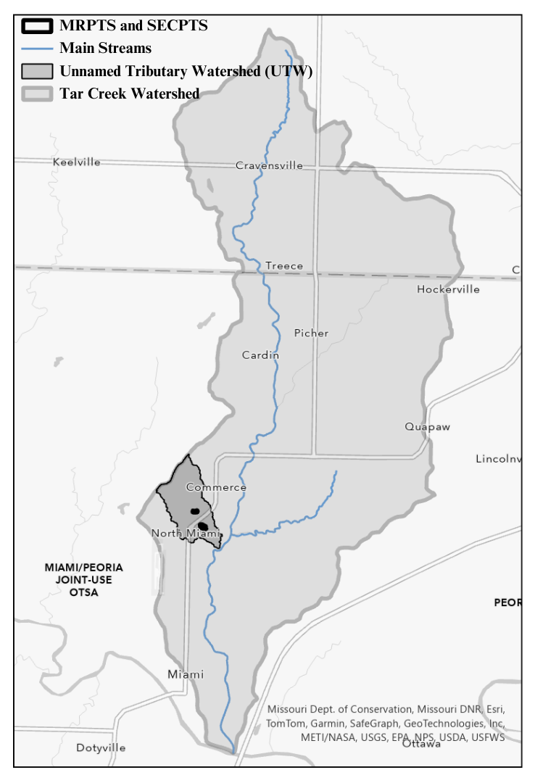
Figure 4-4. Unnamed Tributary Watershed within the larger Tar Creek Watershed.
When addressing environmental contamination at USEPA-designated brownfield and Superfund sites, the associated remediation costs can be prohibitively high (Nairn et al., 2011). Reports reveal that the USEPA allocates over $240 million annually for Superfund remediation efforts nationwide, a figure which only provides a partial overview of the total project cost (USGAO, 2011). Three decades ago, the USEPA estimated that up to 23,000 kilometers of freshwater streams are impacted by mine drainage, having devastating consequences on the aquatic ecology (USEPA, 1994a). This context sets the stage for understanding the importance of considering cost-effective alternatives in the form of well-designed and operated PTS for reclaiming ES within legacy mining watersheds.
Mine drainage is a costly environmental hazard, devastating local ecology, with repercussions that extend to society, especially affecting agricultural, municipal, and industrial operations. Among its detrimental effects is compromised water quality, characterized by low pH levels, increased sulfate concentrations, and elevated trace metal levels. Wetlands provide an array of ES that, when innovatively harnessed, can help restore functions of degraded watersheds and ecosystems (Porter and Nairn, 2008). PTSs are ecologically engineered wetlands tailored to mitigate ecotoxicity, offering a cost-effective, low-maintenance alternative to traditional treatment methods such as active chemical treatments (Brumley, 2014).
CREW PTS applications have demonstrated efficacy in mitigating the impacts of ecotoxic trace metals in mine drainage (Nairn et al., 2023), offering a cost-effective, nature-based method. To ensure a comprehensive evaluation of the ES closely linked with the positive outcomes of these systems, the first-order UTW is employed as the focus watershed for ES-DST application (Figure 4-5).
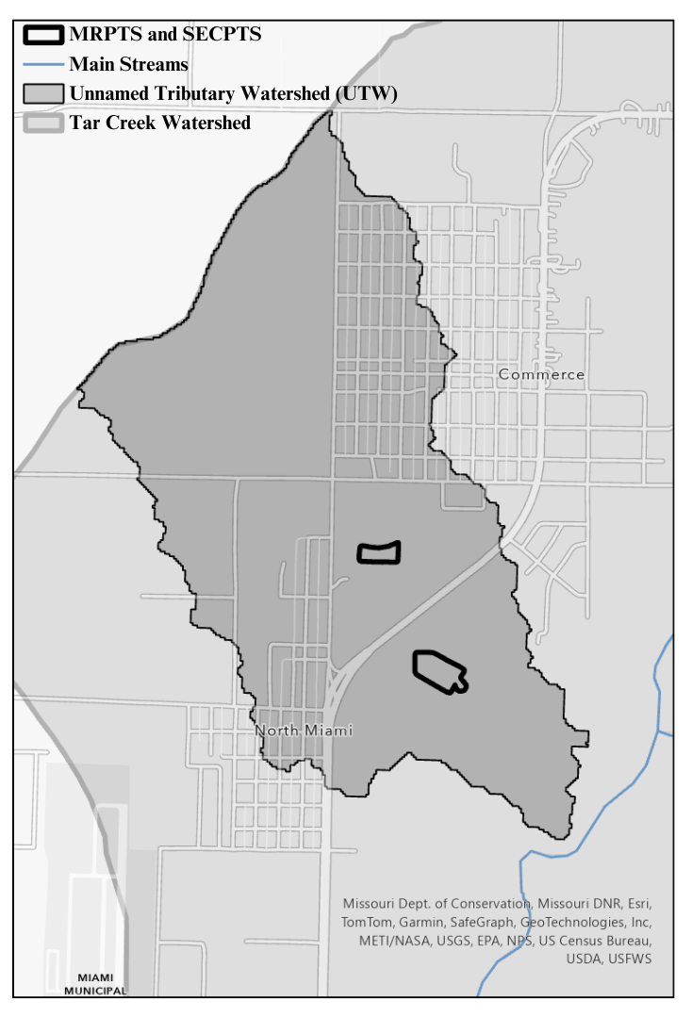
Figure 4-5. Mayer Ranch and Southeast Commerce passive treatment systems within the Unnamed Tributary Watershed.
The PTSs are strategically located to intercept mine water discharges, with MRPTS and SECPTS receiving drainage from three surface seeps. Operating continuously since 2008, MRPTS comprises ten process units: a single oxidation pond diverges into two treatment trains, incorporating surface flow wetlands, vertical flow bioreactors, re-aeration ponds, and horizontal flow limestone beds, ultimately reuniting in a single polishing pond (Nairn et al., 2020). Inspired by the success of MRPTS, the implementation of SECPTS in 2017 has expedited ecological progress in the area, featuring four process units: an oxidation pond, surface flow wetland, vertical flow bioreactor, and final polishing unit (McCann and Nairn, 2022) (Figure 4-6).
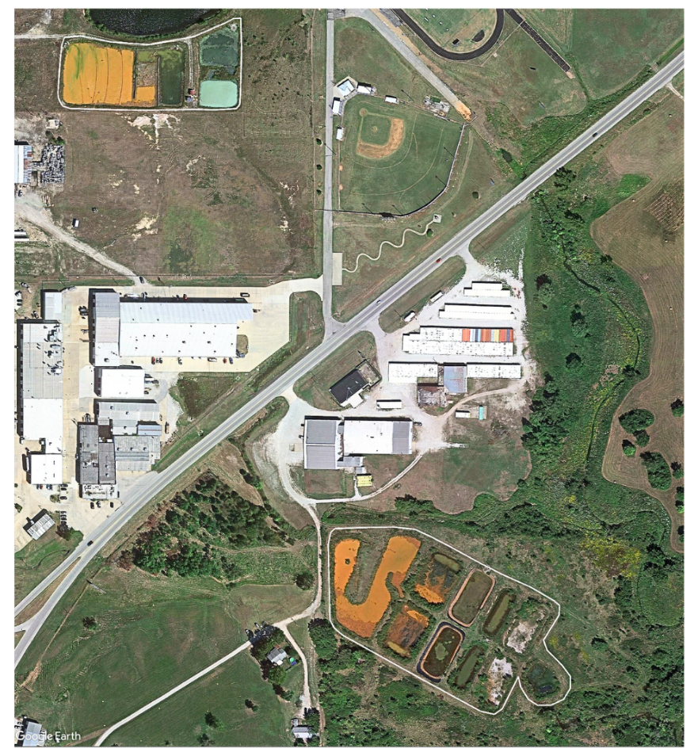
Figure 4-6. Mayer Ranch (bottom right) and Southeast Commerce (top left) passive treatment systems.
Water quality improvements of these systems are clear, as evidenced by the positive effects on in-stream water quality, leading to notable increases in the richness of fish species. This impact has been documented through consistent monitoring at MRPTS by CREW, even prompting the implementation of SECPTS (Nairn et al., 2023). Nevertheless, there persists a challenge in comprehensively documenting the subsidiary ecological improvements of PTS. The complex and unstructured nature of restoration outcomes makes it difficult to fully illustrate ancillary ES provided by this targeted NBS. A failure to effectively communicate the full suite of benefits provided by PTS, could potentially impede duplication and scaling of these, and similar, innovative NBS.
The case study within the UTW demonstrates how PTS can serve as a low-maintenance, natural infrastructure for restoring ES in legacy mining watersheds. The approach used for this research was to utilize ES-DSTs to quantify ES values at these PTS sites, shedding light on the adaptability and limitations of each tool. The aim of this application was to demonstrate ES quantification in order to provide an efficient and standardized method for potential widespread use.
4.2 Tool Selection
4.2.1 Descriptive Review for Tool Selection
A descriptive review was conducted to determine ES-DSTs most suited to the objectives for application of this study. In step one, review objectives were defined as (1) providing insights into the landscape of ES-DSTs and (2) identifying ES-DSTs suitable for inland wetland ES valuation. Step two involved searching various databases, mainly Google Scholar, Web of Science, and Scopus, to identify potential ES-DSTs and assessing their relevance to the review objectives by employing non-exhaustive search strategies using key terms such as "ecosystem service," "valuation/quantification," "decision support tools," and related variations (Templier and Paré, 2015).
In step three, screening criteria were established, which helped identify ES-DSTs potentially suitable for pilot study application (Figure 4-7). Articles were filtered to include literature that was (a) in English, (b) from credible journals, and (c) relevant to inland wetland ES valuation. Due to the wide-breadth of existing ES-DSTs, a secondary screening was employed to narrow the selection of ES-DSTs based on these additional criteria: (a) open-access availability, (b) capability to assess multiple ES, (c) readiness for application, and (d) suitability for site-scale decision-making (Templier and Paré, 2015).
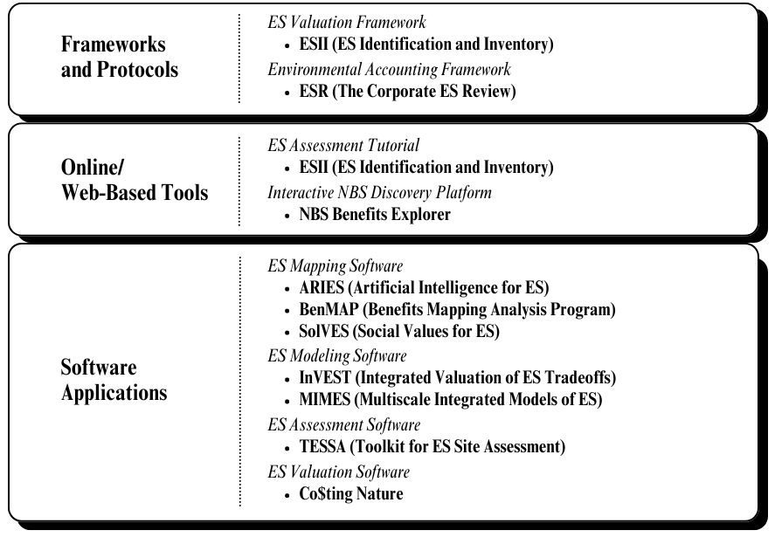
Figure 4-7. Ecosystem Services Decision Support Tools identified from screening processes.
Step four involved using quality assessment criteria, adapted from the Critical Appraisal Skills Programme's (CASP) checklist, to note potential biases in the selected ES-DSTs without formal quality assurance. These criteria employed the use of six quality assessment questions to evaluate elements such as the clarity of research objectives, appropriateness of research design, adequacy of data analysis methods, presentation of findings, achievement of study objectives, and identification of potential conflicts of interest (CASP, 2023). In Step five, the ES-DSTs which surpassed each screening step, were reviewed for their applicability to study purpose, location, data collection, and analysis methods. This step provided an additional basis from which to determine ES-DSTs likely suitable for the present research objectives (Thomas and Harden, 2008).
Following primary screening, secondary screening, and data quality assurance, two standout tools, the Integrated Valuation of Ecosystem Services and Tradeoffs (InVEST) and the Ecosystem Services Identification and Inventory (ESII) tool, emerged as meeting all six quality assessment criteria. InVEST stands out as a well-documented tool with an impressive track record, boasting over 12 peer-reviewed studies that pass each of the criteria (Sharp et al., 2018). Released in 2008, InVEST was developed by The Natural Capital project to fill a need for widely accessible ES tools with robust operational performance, demonstrated by studies like Gómez-Baggethun (2014).
ESII, though not be as extensively documented as InVEST, demonstrated promise where applied, with each observed peer-reviewed study successfully meeting all quality assessment criteria. Developed in 2011 by a collaboration between The Nature Conservancy (TNC), the Dow Chemical Company (Dow) and the EcoMetrix Solutions Group, ESII was uniquely designed to aid Dow and similar corporations in ES assessments; however, the tool is under refinement to fill broader needs of ES evaluation (TNC et al., 2016). The ESII tool was selected as the secondary ES-DST for application due to its consistent ability to meet diverse research objectives with simple methods, indicating promising potential for broad use.
4.3 Tool Setup and Requirements
4.3.1 InVEST Setup
InVEST, a widely used ES modeling tool, strongly emphasizes the importance of conducting analyses at the watershed level (Arcidiacono, 2015; Sharp et al, 2018). InVEST was tested for both the watershed and site-scale. Subsequently, the outputs generated by InVEST were interpreted to discern any discrepancies or variations between the two scales. This comprehensive approach allowed for a thorough examination of the tool's performance across varying spatial scales, shedding light on tool applicability and reliability for widespread use.
4.3.2 InVEST Requirements: RouteDEM and DelineateIt
The cornerstone input for all InVEST models is a reliable Digital Elevation Model (DEM). Recognizing the critical importance of accurate DEMs, InVEST offers standalone hydrological tools, such as RouteDEM and DelineateIt, which are instrumental for refining input DEMs. Although RouteDEM and DelineateIt serve similar functions, their combined application offers a comprehensive approach to inspecting the input DEM thoroughly. This proactive approach allows for the identification and rectification of any potential issues in the DEM, thus minimizing errors and enhancing the robustness of subsequent modeling analyses (Sharp et al., 2018).
The RouteDEM model was designed as a standalone tool to address deficiencies found in commonly used flow direction and flow accumulation algorithms. By leveraging advanced calculations of flow accumulation and direction, this tool effectively generates stream networks and delineates watersheds while addressing common issues such as hydrological sinks and errors stemming from plateaus. Among the various input requirements listed for RouteDEM (Table 4-1), the DEM raster stands out as the most critical component essential for ensuring the accuracy and reliability of the model (Sharp et al., 2018).
Table 4-1. Input requirements for RouteDEM and DelineateIt (Sharp et al., 2018).
RouteDEM Inputs | Input Type | Input Value |  | Source
RouteDEM Inputs | Input Type | IRW | UTW | Source
Digital Elevation Model (DEM) | Raster (meters) | 273-378 m | 235-258 m | USGS, 2019
Threshold Flow Accumulation | Number (unitless) | 1000 |  | Sharp et al., 2018

Tiled DEM datasets, obtained from the US Geological Survey’s (USGS) National Map viewer at a 10-meter (1/3 arc-second) resolution (USGS, 2019), were processed according to the InVEST User Guide using ArcGIS Pro Version 3.1. The raw DEM tiles were first reprojected to the Universal Traverse Mercator coordinate system (WGS 1984 UTM zone 15S) to ensure model compatibility before being merged into a single raster using the Mosaic to New Raster tool. Bilinear interpolation was used for resampling to prevent flow accumulation calculation errors. The DEM was then examined for missing data values and filled using the Focal Mean function within the Raster Calculator. Using the ArcGIS Hydrology Fill tool, any remaining gaps in the resulting DEM were filled (Sharp et al., 2018).
To ensure high-quality outputs from InVEST’s freshwater models, the input DEM must have continuous streams, requiring a Threshold Flow Accumulation (TFA) value to help calibrate the RouteDEM model. The TFA is a user-defined value which relates to the stream density and structure of outputs. Specifically, the TFA adjusts the grid size, changing the level of detail to fit various user needs. Functionally, it defines stream channels by establishing a minimum threshold of upslope pixels that contribute flow to a downslope pixel (Sharp et al., 2018).
Various TFA values were tested between 100 and 1,000, per the User Guide. The final TFA value was selected by comparing each of the outputs to a real-world stream map, then selecting the one which is most consistent with true conditions (Sharp et al., 2018). This research used the USGS StreamStats tool for reference; however, it was used with caution as the software is known to skew outputs at smaller scales (USGS, 2020b). To ensure the best fit is acquired, the watersheds were also assessed using Google Earth Pro, making a visual comparison of streams. This preparatory process using RouteDEM refined the DEM, ready for further processing by InVEST’s DelineateIt tool (Sharp et al., 2018).
The DelineateIt model is instrumental in the process, as it takes the filled DEM file generated by RouteDEM and produces watershed polygons, a fundamental requirement for many of InVEST's freshwater models. These watershed polygons serve as the foundational units for aggregating ES outputs. Much of the modeling within InVEST relies on these delineated watersheds to analyze and quantify various ecological processes and services. Similar to RouteDEM, the inputs for the DelineateIt tool predominantly revolve around the input DEM and the user-specified TFA value (Sharp et al., 2019), as was outlined in Table 4-1.
While the RouteDEM tool creates a filled stream network to test the DEM, DelineateIt utilizes the refined DEM data to generate well-defined watershed polygons. DelineateIt is an independent watershed modeling tool specifically designed for delineating watersheds for use throughout the InVEST application. This model starts by addressing hydrologic sinks to ensure accurate calculations throughout, after which it proceeds to compute flow direction and flow accumulation. PyGeoprocessing is used to route the DEM, in which the D8 algorithm is employed to trace the flow of water across the landscape, accounting for the topographic gradients between each pixel and its eight neighboring pixels (Sharp et al, 2018).
Similar to the calibration process for RouteDEM, the TFA value is crucial for fine-tuning the DelineateIt model (Sharp et al, 2018). Values between 100 and 1,000 were again tested against real-world watershed geometries, with reference to data from StreamStats and satellite imagery (USGS, 2020b). The accuracy of the resulting watershed layer was evaluated by cross-referencing the unique integer identifications ("ws_id") with actual streams, as detailed in the InVEST User Guide. Once the alignment of these identifications was confirmed and the TFA value that most accurately reflected the true network was selected, the DEM was deemed prepared for further manipulation (Sharp et al., 2018).
To tailor the DEM to the study sites, shapefiles of each HUC-12 watershed (Lake Frances/Illinois River Watershed and Tar Creek Watershed) were obtained from the USGS’ Science in Your Watershed tool (USGS, 2020a). Within the Tar Creek Watershed, the smaller UTW watershed was selected as the focal point for PTS evaluation, employing a delineated basin shapefile sourced from StreamStats (USGS, 2019). ArcGIS tools were used to generate a one-kilometer buffer around each watershed polygon and a 100-meter buffer around each study site. These buffers acted as a guideline for all subsequent clipping operations, ensuring that sufficient data were preserved along the edges of each polygon, as outlined in the User Guide (Sharp et al., 2018).
4.3.3 InVEST Requirements: Sediment Delivery Ratio
The Sediment Delivery Ratio (SDR) model is specifically engineered to evaluate sediment dynamics by quantifying the movement of sediment to streams through overland flow. This model gauges the retention capacity of vegetation, accounting for various input data such as land use and land cover (LULC) types, ground cover management, and various management practices (Table 4-2) (Sharp et al., 2018).

Table 4-2. Input requirements for the Sediment Delivery Ratio model (Sharp et al., 2018).
SDR Inputs | Input Type | Input Value |  | Source
SDR Inputs | Input Type | IRW | UTW | Source
Digital Elevation Model (DEM) | Raster (meters) | 273-378 m | 235-258 m | USGS, 2019
Land Use/Land Cover (LULC) | Raster | - |  | Dewitz, 2023
Erosivity (R) | Raster  MJ·mm/(ha·hr) | 1,448-5,792 | 1,422-5,687 | SSURGO, 2022
Soil Erodibility (K) | Raster ton·ha·hr/(ha·MJ·mm) | 0.00-0.64 | 0.00-0.50 | SSURGO, 2023
Cover Management Factor (usle_c) | Ratio | 0.00-0.29 |  | Woznicki et al, 2020
Conservation Practice Factor (usle_p) | Ratio | 0.5-1.0 |  | USDA-ARS, 1972
Borselli K Parameter | Number (unitless) | 2 |  | Sharp et al., 2018
Borselli Connectivity Parameter (IC₀) | Number (unitless) | 0.5 |  | Sharp et al., 2018
Maximum SDR (SDR_{MAX}) | Ratio | 0.8 |  | Sharp et al., 2018
Maximum L (L_{MAX}) | Number (meters) | 68 | 24 | -

ArcGIS Pro Raster Functions were applied to estimate input parameters according to the Revised Universal Soil Loss Equation (RUSLE), a widely utilized method for predicting water-driven erosion and average annual soil loss (Sharp et al., 2018). Average annual precipitation values were calculated from Oklahoma Mesonet weather stations spanning from 2008 to 2022, compiled by the Oklahoma Climatological Survey (OCS). Rasters were generated (as necessitated by subsequent models) utilizing data from the Miami and Westville monitoring stations, assuming consistent values across each study area (OCS, 2023).
The erosivity (R) factor, representing the intensity of rainfall contributing to erosion, was derived from the average annual precipitation data following the guidelines provided in the User Guide (Sharp et al., 2018). To compute the R factor, this research adopted the equation established by the US Department of Agriculture's (USDA) Agricultural Research Service (ARS), which accounts for regional geographical and climatic variations (Benavidez et al, 2018):
R = (-823.8) + 5.213P (1)
Where $R$ = erosivity (megajoule · millimeter hour⁻¹ hectare⁻¹ year⁻¹) and $P$ = annual precipitation (millimeter year⁻¹). To ensure the reliability of these estimations, global and national maps of rainfall erosivity were consulted. These maps revealed that the R values utilized in this study fall within a reasonable range of potential values (Panagos et al., 2017, McGehee et al., 2022).
As directed by the User Guide, USDA's Natural Resources Conservation Service (NRCS) Soil Survey Geographic Database (SSURGO) was used as a primary source of soils data for this study (Sharp et al., 2018). To obtain regional datasets, the SSURGO Bulk Downloader was employed, enabling data extraction at the county level for each of the study sites. The IRW analysis required data for Adair (OK001), Benton (AR007), and Washington (AR143) counties, while the UTW analysis necessitated data for Ottawa (OK115) county. The SSURGO Downloader outputs a variety of features, but this analysis specifically relied on the "soilmu_a_[county code]" polygons. These polygons were instrumental in assigning a unique "MUKEY" code to each soil type within the areas of interest, allowing for easy referencing and application of Web Soil Survey (WSS) data to create soil maps for each study site. Polygon features were merged, if required, and then extracted by mask to match the buffer extent of each watershed. Within the ArcGIS Portal, the USA Soil Map Units SSURGO feature was used to generate individual soil maps for each watershed based on the unique MUKEY identification code field (USDA-NRCS SSURGO, 2022).
The soil erodibility factor, K, is closely tied to soil texture, with clay-rich soils exhibiting lower erodibility compared to soils with higher proportions of sand and silt (Benavidez et al., 2018). Bearing this relationship in mind, the SSURGO erodibility raster was first re-projected and then extracted for the respective watersheds. These extracted maps were examined for data gaps and inconsistencies. Notably, substantial gaps were observed within the UTW map, with smaller gaps present throughout the IRW map. Consequently, additional processing steps were deemed necessary before the data were utilized in the model. To address these gaps, raster interpolation and union functions were applied, generating new erodibility rasters that encompassed the entirety of each watershed. The attribute tables of each map were reviewed to assess the accuracy of the interpolated data, ensuring that the gaps aligned with known soil properties, as indicated by the SSURGO estimates of clay content (USDA-NRCS SSURGO, 2022).
The Slope Length (LS) is a unitless gradient factor which encapsulates the combined influence of both slope length (L) and slope steepness (S) on erosion dynamics (Benavidez et al., 2018). LS was calculated from the refined watershed DEMs using the ArcGIS Raster Calculator. From the review of approaches detailed by Ansari and Tayfur (2022), the methodology developed by Moore and Burch (1986) was employed, which entails the application of a series of GIS functions to generate an LS raster. This approach was chosen for its simplicity, while still maintaining theoretical underpinnings consistent with more recent, sophisticated methodologies proposed by Zhang et al. (2017) and Desmet and Govers (1996). These equations leverage flow accumulation and slope rasters to calculate each factor individually before combining them through multiplication to generate the LS raster:
LS = L × S (2)
L = [(Flow Accumulation × Cell Size)/22.13]^{0.4} (3)
S = [(Sin(Slope°) × 0.01745)/0.0896]^{1.3} (4)
where L = slope length in meters and S = slope steepness in degrees (Ansari and Tayfur, 2022). Alternatively, a lumped parameter equation can be input into the Raster Calculator as follows:
LS = Power("Flow_Accumulation"*Cell Size/22.13,0.4)
*Power(0.01745*(Sin("Slope_Degrees"))/0.0896,1.3) (5)
Specific equations used in this research for the IRW and UTW comprise:
LS_IRW = Power("flow_accum_IRW"*9.319731266905947/22.13,0.4)
*Power(0.01745*(Sin("slope_degrees_IRW"))/0.0896,1.3) (6)
LS_UTW = Power("flow_accum_100_UTW_Copy"*9.319731266905901/22.13,0.4)
*Power(0.01745*(Sin("slope_degrees_UTW") (7)
From the resulting LS rasters, the maximum allowable value for the LS parameter (L_{MAX}) was determined to be 68 meters for IRW and 24 meters for UTW.
InVEST models commonly necessitate a biophysical input table. The SDR model requires a biophysical input table containing the following fields: (1) lucode (LULC code), (2) usle_c (cover management factor), and (3) usle_p (support practice factor) (Sharp et al., 2018).
To assess cover management and support practice factors accurately, comprehensive land use and land cover (LULC) maps for each watershed were derived using the latest data from the National Land Cover Database (NLCD) (Dewitz, 2023). The cell count for each class was then multiplied by the original cell size area of the LULC raster (90 square meters) to compute estimations of area on a square meter basis, later converted to hectares (Tables A1 and A2).
The cover management factor (C) is a key component of the RUSLE equation (Benavidez et al., 2018). Woznicki et al. (2020) delineated its categorization based on LULC class with values ranging from 0 to 1. The C-factor represents erosion potential, with 0 denoting no erosion susceptibility and 1 signifying high erosion susceptibility (Sharp et al., 2018). In tandem with the C factor, the P factor, delineating support practices for erosion control, similarly adopts a ratio scale ranging from 0 to 1. A P factor of 1 indicates high erosion potential due to a lack of support practices, while a value of 0 signifies less erosion potential as a result of more effective conservation measures (Benavidez et al., 2018). These values were derived by consulting USDA-ARS (1972), which assigns P-factors based on both LULC class and percent slope. To assess percentage slope, a raster was generated from SSURGO data, with its symbology reclassified to align with the USDA-ARS (1972) slope categories. Table A3 contains the final biophysical input table, denoting the land-cover management (usle_c) factors and conservation practice (usle_p) factors applicable to each LULC category.
Finally, the SDR model was calibrated utilizing the recommended default value of 0.8 for the maximum theoretical SDR (SDR_{MAX}) (Sharp et al., 2018). Another crucial parameter within the SDR model was the Borselli K parameter, which establishes the link between sediment inflow into the stream and the hydrologic connectivity index (IC₀). In accordance with InVEST guidelines, both K and IC₀ were set to their default values of 2 and 0.5, respectively (Sharp et al., 2018).
4.3.4 InVEST Requirements: Nutrient Delivery Ratio
The Nutrient Delivery Ratio (NDR) model tracks and maps the transport of nutrients to streams. The input parameters from Table 4-3 were used to model the ES of nutrient retention, quantified based on estimates of point sources, including industrial waste and wastewater effluent, as well as non-point sources stemming from agricultural fields and residential areas (Sharp et al., 2018).

Table 4-3. Input requirements for the Nutrient Delivery Ratio model (Sharp et al, 2018).
NDR Inputs | Input Type | Input Value |  | Source
NDR Inputs | Input Type | IRW | UTW | Source
Digital Elevation Model (DEM) | Raster (meters) | 273-378 m | 235-258 m | USGS, 2019
Land Use/Land Cover (LULC) | Raster | - |  | Dewitz, 2023
Nutrient Runoff Proxy (RP) | Raster (unitless) | 1,269 | 1,249 | OCS, 2023
Phosphorus Load (load_p) | Number (kg×(ha×yr)⁻¹) | 0.30 | 0.10-4.46 | Han et al., 2021, Yepez and Nairn, 2012
Maximum Phosphorus Retention Efficiency (eff_p) | Number (kg×(ha×yr)⁻¹) | 0.15-0.80 | 0.15-0.88 | Han et al., 2021, Yepez and Nairn, 2012
Phosphorus Critical Retention Length (crit_lens_p) | Number (meters) | 1.00-30.00 |  | Daigneault et al., 2018
Nitrogen Load (load_n) | Number (kg×(ha×yr)⁻¹) | 2.40 | 2.20-66.00 | Han et al., 2021, Yepez and Nairn, 2012
Maximum Nitrogen Retention Efficiency (eff_n) | Number (kg×(ha×yr)⁻¹) | 0.08-0.85 | 0.08-0.70 | Han et al., 2021, Yepez and Nairn, 2012
Nitrogen Critical Retention Length (crit_lens_n) | Number (meters) | 1.00-30.00 |  | Daigneault et al., 2018
Dissolved Nitrogen (prop_subsurface_n) | Ratio | 0.00-0.8 |  | Sharp et al., 2018
Borselli K Parameter | Number (unitless) | 2 |  | Sharp et al., 2018
Subsurface Critical Length (Nitrogen) | Number (meters) | 150 |  | Hooftman et al., 2023
Subsurface Maximum Retention Efficiency (Nitrogen) | Number (unitless) | 0.8 |  | Hooftman et al., 2023
The Nutrient Runoff Proxy (RP) raster, which signifies the potential for nutrient transport via runoff, was set equal to average annual precipitation to be normalized by the model (Sharp et al., 2018). Apart from obtaining the average annual precipitation estimate from Oklahoma Mesonet data (OCS, 2023), as discussed in the SDR model section, minimal manipulation was required on the part of the practitioner (Sharp et al., 2018).
The NDR biophysical input table requires a range of water quality parameters, sourced from the literature and assigned based on LULC class. These parameters include influent phosphorus and nitrogen loadings, percent retention efficiencies, critical distances for maximum retention efficiencies, and proportional dissolved subsurface retention for nitrogen only (Sharp et al., 2018).
Nutrient parameters for each study watershed were sourced from various relevant literature. Values for total phosphorus and nitrogen loads were obtained from Storm et al. (2000), which employs the Soil and Water Assessment Tool (SWAT) to estimate nonpoint source nutrient by 11-digit HUC watershed and LULC class for the state of Oklahoma. Average annual total nitrogen and phosphorus exports in kilograms per hectare per year used are listed in Tables 4-7 and 4-8. For open water classes, values for wetlands for each watershed were used.
Retention efficiencies (ret_eff) by LULC class for each watershed were derived from Han et al. (2021). Critical retention length (crit_len) estimates in meters were derived from Daigneault et al. (2018), a pertinent study conducted by The Nature Conservancy. Following InVEST recommendations, a value of 0.8 was assigned for subsurface dissolved nitrogen retention (DI) in vegetated LULC classes, while a value of 0 was assigned for unvegetated LULC classes. Subsurface critical length represents the distance at which soil retention reaches maximum capacity, and subsurface maximum retention efficiency is the peak efficiency for subsurface flow (Sharp et al., 2018). These parameters apply to nitrogen only and were obtained from Hooftman et al. (2023). Values for each watershed can be found in Tables A4 and A5.
4.3.5 InVEST Requirements: Annual Water Yield
The Annual Water Yield (AWY) model assesses the ES of freshwater provision by estimating the contributions to water yield from different LULC classes across a landscape. The output offers valuable insights into the impact of land use on water yield, considering factors such as soil-water characteristics, seasonal variations, and vegetative coverage (Table 4-4) (Sharp et al., 2018).
Table 4-4. Input requirements for the AWY model (Sharp et al., 2018).
AWY Inputs | Input Type | Input Value |  | Source
AWY Inputs | Input Type | IRW | UTW | Source
Digital Elevation Model (DEM) | Raster (meters) | 273-378 m | 235-258 m | USGS, 2019
Land Use/Land Cover (LULC) | Raster | - |  | Dewitz, 2023
Average Precipitation | Raster (mm×yr⁻¹) | 1,269 | 1,249 | OCS, 2023
Annual Evapotranspiration | Raster (mm) | 20.00 | 21 | OCS, 2023
Root Restricting Zone Depth | Raster (mm) | 180-1,500 | 1,140-1,500 | SSURGO, 2022
Plant Available Water Content | Raster (unitless) | 0.074-0.220 | 0.160-0.200 | SSURGO, 2022
Vegetation Indicator (lulc_veg) | Number (unitless) | 0-1 |  | Sharp et al., 2018
Maximum Root Depth (root_depth) | Number (mm) | 495-1,303 | 1,140-1,500 | SSURGO, 2022
Crop Coefficient (K_{c}) | Number (unitless) | 0.26-1.10 |  | FAO, 2017; Sharp et al., 2018
Seasonality (Z) Parameter | Number (unitless) | 12 |  | Yang et al., 2019; Hamel et al., 2015
The initial step for AWY involves generating the annual evapotranspiration raster. Utilizing the average annual precipitation raster derived from data collected at the Miami and Westville monitoring stations (OCS, 2023), a reference evapotranspiration (ET₀) raster was generated. As outlined in the User Guide, ET₀ can be computed using the modified Hargreaves' equation, as follows (Sharp et al., 2018):
ET₀ = 0.0005304 × RA × (T_{AVG} + 17) × (TD – 0.0123P)^{0.76} (8)
Where, RA = extraterrestrial radiation (Megajoule meters⁻² day⁻¹), T_{AVG} = average temperature per month (°C), TD = difference between mean daily maximum and mean daily minimum temperature per month (°C), and P = precipitation (millimeters day⁻¹). Parameters were derived from the Oklahoma Mesonet data for long-term averages (OCS, 2023). Table A6 presents the calculated values for each month spanning from 2008 to 2022 (OCS, 2023).
Rasters for root-restricting zone depth and plant-available water content were created using SSURGO soil maps. The UTW extent displayed several null values for mining land (Mp) map units. Considering that highly compacted mine soils, under worst-case conditions, typically offer less than two feet of effective rooting depth, a value of 98 was assigned to each Mp map unit (Sheoran et al., 2010). Additionally, within the IRW, various infrastructure features such as pits or dams also contained null values. In such cases, the lowest value within the IRW range was assigned. Furthermore, both the UTW and IRW soil maps had null values for water (W) map units, which were addressed by averaging the surrounding map units for each null data point. The root-restricting zone depth, initially provided in centimeters, was converted to millimeters to align with InVEST requirements (NRCS-USDA SSURGO, 2022).
The plant-available water content field was computed by dividing the Root Zone Available Water Storage, an estimate of volumetric plant-available water, by the soil depth to the root-restricting zone (NRCS-USDA SSURGO, 2022). Similar to the process for root-restricting zone depth, these data were examined for null or missing values. If necessary, such values were filled as described above. The final input maps were then prepared in raster format using the Polygon to Raster function.
The biophysical input table required by the AWY model requires the following fields: (1) lucode (LULC code), (2) lulc_veg (0 = no vegetation, 1 = some vegetation) (3) root_depth (maximum root depth), and (4) k_{c} (evapotranspiration coefficients). A code indicating the presence or absence of vegetation for each LULC class was required to determine actual evapotranspiration (AET). Presence was denoted by 1 and absence by 0, reflecting the dominant condition of each class. However, InVEST specifies that all wetlands and urban areas should be assigned a value of 0, as the model's calculations are optimized under this assumption (Sharp et al., 2018). Furthermore, the maximum root depth was acquired from the root depth raster, selecting maximum values which correlate to each LULC class.
The evapotranspiration coefficient (k_{c}) values, often called crop coefficients, were obtained to represent each of the LULC classes. In most cases, values were derived from the Food and Agriculture Organization (FAO), where the coefficients by growth stage (k_{cini}, k_{cmid}, k_{cend}) were converted to an annual average (FAO, 2017). The k_{c} calculator provided by InVEST was then used to calculate the values. For barren land cover, the k_{c} value was set to 0.5, as suggested by InVEST (Sharp et al., 2018). The k_{c} values for developed classes were determined using Equation 9:
Urban K_{C} = f × 0.1 + [(1 – f) × 0.6] (9)
where f is the percent of impervious cover for the focus urban land cover (Sharp et al., 2018).
The percentage of impervious surface within each developed class was derived from the standard NLCD classification. According to this classification, the imperviousness factor (f) falls within specific ranges: up to 20% for open space, 20-49% for low intensity, 50-79% for medium intensity, and 80% or more for high intensity (Dewitz, 2023). To assign values to f, comparisons were made between the LULC map and a map of percent impervious surfaces. The f values were 0.1 for open space, 0.3 for low intensity development, 0.7 for medium intensity development, and 0.9 for high intensity development. Tables A7 and A8 present the results of these calculations alongside other biophysical table components.
The seasonality parameter (Z) is an empirical constant ranging between 1 and 30, which captures the nuanced seasonal heterogeneity influencing hydrologic dynamics. The Z parameter was used to calibrate the model. Drawing from recommendations in the literature (Yang et al., 2019; Hamel et al., 2015), values of 7, 12, and 22 were chosen for comparison and evaluation.
The water demand table serves as an optional input crucial for allocating consumptive water use estimates across various LULC classes. This allocation is typically based on localized insights into water supply and demand dynamics. Numerous methodologies exist for estimating the volume of water extracted or reallocated by each LULC class (Sharp et al., 2018). Given the intricate expertise and extensive dedication required for an exhaustive water budget analysis of each study watershed, a simplified approach was adopted.
County-level statistics derived from the USGS’ 2015 national water use estimates were employed. This study only utilized estimates of agricultural and urban water use, in line with InVEST recommendations, which suggest estimating water use across agricultural, urban, and industrial sectors (Sharp et al., 2018). Although an attempt was made to investigate the water use of industrial sectors, the lack of sufficient data made inclusion of this aspect unfeasible.
In the case of urban classes, water use was assessed on a per-person basis and then multiplied by the population per raster cell to ascertain water consumption within the watershed area for each county. In estimating agricultural water use, the values assume that all allocated water, whether for agricultural crops or livestock, does not return to the watershed. These values were calculated on a per pixel basis, independent of population. Looking ahead, as records of reclaimed water resources become accessible, additional calculations can incorporate the impact of recycled water. Throughout these calculations, it was assumed that water use was evenly distributed across each relevant land use class and that population was consistent across each county area (Sharp et al., 2018).
As the values do not directly align with any singular LULC classification, certain assumptions were necessary for their allocation. As outlined in Table A9, for each county, agricultural water use estimates were assigned to the Hay/Pasture and Cultivated Crops LULC classes. Meanwhile, combined public and domestic supply were attributed to all urban classes, irrespective of the intensity of development. Table A10 offers an overview of total water usage by watershed.
4.3.6 InVEST Requirements: Carbon Storage and Sequestration
The Carbon Storage and Sequestration (CSS) model evaluates carbon stored or sequestered over time within terrestrial ecosystems by examining carbon density. This model simplifies carbon dynamics by assessing four primary carbon pools (aboveground biomass, belowground biomass, soil, and dead matter) for each LULC class (Sharp et al., 2018). Refer to Table 4-5 for input requirements and the values employed in this study.
Table 4-5. Input requirements for the CSS model (Sharp et al., 2018).
CSS Inputs | Input Type | Input Value |  | Source
CSS Inputs | Input Type | IRW | UTW | Source
Land Use/Land Cover (LULC) | Raster | - |  | Dewitz, 2023
Aboveground Carbon Density (c_above) | Number (Mg×ha⁻¹) | 0.00-49.28 |  | See Table 4-18
Belowground Carbon Density (c_below) | Number (Mg×ha⁻¹) | 0.00-14.66 |  | See Table 4-18
Soil Carbon Density (c_soil) | Number (Mg×ha⁻¹) | 0.00-99.91 |  | See Table 4-18
Dead Carbon Density (c_dead) | Number (Mg×ha⁻¹) | 0.00-20.5 |  | See Table 4-18
Carbon density, also known as biomass density, denotes the measure of carbon stock per unit area, typically expressed in metric tonnes (or megagrams) per hectare. The CSS biophysical input table requires values of average carbon storage per each LULC class, determining total carbon stored based on estimates from aboveground biomass (AGB), belowground biomass (BGB), soil, and dead matter. While data for aboveground and belowground soil carbon stocks are generally accessible, and soil organic carbon can be acquired from SSURGO data, information on dead carbon matter is not frequently included in carbon analyses (Sharp et al., 2018). Obtaining regional data is complicated by the fact that most available data are provided at the country to continent-level scale.
Although site-specific data on carbon storage to generate local field estimates for each carbon pool is preferred, this study used values derived from literature (Sharp et al., 2018). Scant information is available for soil carbon densities specific to each LULC class for either of the study sites. However, diverse data on carbon pools per LULC type are available for semi-arid, temperate climates. A variety of studies were consulted to establish baseline estimates for each watershed.
Baseline carbon stock ranges for the US were established using density data outlined by Tan et al. (2015). These ranges were developed by US agencies, providing a comprehensive carbon stock estimate per unit area for each LULC class that aligns with recommendations put out by the IPCC. Estimates for AGB, BGB, soil and dead carbon pools (Table A11) were derived from various literature sources (Table A12).
4.3.7 InVEST Requirements: Habitat Quality
The InVEST Habitat Quality (HQ) model assesses habitat quality by analyzing the spatial distribution of LULC alongside potential threats to local biodiversity. Although biodiversity itself is not classified as an ES, it plays a crucial role in ES production. The HQ model offers estimates of landscape degradation extent, offering crucial insights to guide conservation strategies and priorities. Detailed inputs for this model are outlined in Table 4-6 (Sharp et al., 2018).

Table 4-6. Input requirements for the HQ model (Sharp et al., 2018).
HQ Inputs | Input Type | Input Value |  | Source
HQ Inputs | Input Type | IRW | UTW | Source
Digital Elevation Model (DEM) | Raster (meters) | 273-378 m | 235-258 m | USGS, 2019
Land Use/Land Cover (LULC) | Raster | - |  | Dewitz, 2023
Name of Threats | Text | Roads, dairy, beef, poultry, swine, wastewater | Roads, mine discharges | Ma et al., 2022, USDA, 2017; EPA, 2023, OSMF, 2018
Maximum Distance of Threat Impact (max_dist) | Number (meters) | 10-100 | 10 | See Table 1-19
Weight of Threat Impact (weight) | Number (unitless) | 0.6-0.8 |  | See Table 1-19
Type of Threat Decay (decay) | Exponential/linear | Exponential |  | Sharp et al., 2018
Threats Map | Raster | - |  | Ma et al., 2022, USDA, 2017; EPA, 2023, OSMF, 2018
Habitat Suitability (habitat) | Ratio | 0.3-1.0 |  | Chen et al., 2023; Wang et al., 2023
Relative Sensitivity to Threat | Ratio | 0.2-0.8 |  | Ma et al., 2022, USDA, 2017; EPA, 2023
Half Saturation Constant (k) | Number (unitless) | 0.5 |  | Sharp et al., 2018
The central component of the HQ model is the threats table, detailing critical habitat threats, including the type of threat (threat), the distance over which the threat extends its impact (max_dist), and the relative importance or weight assigned to each threat impact (weight) (Sharp et al., 2018). In this study, site-specific threats were chosen based on local knowledge of the watershed areas. The selected threats for each site were mapped using various sources to inform estimations of threat weight and habitat sensitivity parameters, ultimately developing a threat distribution raster.
Paved roads are a common urban threat to biodiversity. As such, they were incorporated for both watersheds to establish a baseline for determining threat weights for each site-specific concern. Polygon features for roads were derived from Open Street Maps data for Oklahoma and Arkansas, and these features were clipped to the areas of interest (OSMF, 2018).
The IRW area confronts a multitude of habitat threats, most prominently, agricultural activities and wastewater facilities. Among agricultural threats, operations such as swine, cattle, and poultry farming stand out. To evaluate agricultural threats, comprehensive data on operations by county as of 2017, encompassing dairy and beef cattle, poultry, and swine lots, were procured from the USEPA’s EnviroAtlas (2022). Data on the size and distribution of wastewater facilities were obtained from the USEPA's facility registry system (2023). However, mapping revealed no facilities within the watershed area, posing a significant challenge in assessing potential threats.
In the UTW area, pollution stemming from mine water discharge emerges as the primary concern affecting local habitats. Using Google Earth, discharge points were pinpointed and mapped, with resulting data exported to ArcGIS to produce a threats raster specific to the UTW. The raster reveals the presence of six discharge points spanning the UTW region, with three located in SECPTS and three in MRPTS.
Threat weights were assigned based on their expected ecological impact compared to a baseline weight obtained for roads from Ma et al. (2022). For roads, a distance of ten kilometers was assigned. For the IRW, a distance of 100 kilometers was used to account for water quality impacts downstream. For the UTW, a 10-kilometer distance was used for all threats to capture the effects of mine pollution and urbanization across individual sites with minimal overlap. The decay function utilized for all threats followed an exponential pattern, effectively modulating the spatial influence of threats. This function accounts for diminishing effects as distance from the point of impact increases, reaching its maximum impact distance (Sharp et al., 2018). More detailed information regarding these site-specific threats can be found in Tables A13 and A14.
The HQ model necessitates an additional input table to define the suitability of each habitat for wildlife and the vulnerability of these habitats to specific threats. For each LULC class, habitat suitability was represented by a ratio ranging from 0 (unsuitable for species) to 1 (highly suitable for species) (Sharp et al., 2018). These values were derived from Chen et al. (2023). The sensitivity ratios also range from 0 to 1, estimating the impact of a threat on habitats per LULC class (Sharp et al., 2018). Sensitivity values for most LULC classes were derived from Ma et al. (2022), whereas wetland sensitivity values were sourced from Wang et al. (2023).
In the context of the IRW area, the relative sensitivity of habitats to specific agricultural threats was delineated using USDA data on swine, poultry, beef, and dairy cattle operations (USDA, 2017). The sensitivity weights were divided into three classes, each signifying varying levels of impact. The lowest class received a ratio of 0.4, the intermediate class was allotted a ratio of 0.6, and the highest class was assigned a ratio of 0.8. These ratios were then aligned with each LULC class through the overlay of ArcGIS rasters to estimate prevailing conditions (USDA, 2017).
Regarding wastewater discharge, sensitivity values were determined based on the USEPA's facility registry system for wastewater operations, factoring in facility distribution and size within each LULC class to assign relative values ranging from 0.4 to 0.8 (USEPA, 2023). Detailed indicators for habitat suitability and sensitivity specific to the IRW site are outlined in Table A15.
For mining discharges across all LULC classes throughout the UTW site, sensitivity estimates were established at 0.8, reflecting the significant ecological impact typically associated with such discharges. While a sensitivity value of 1 would be justified for areas directly impacted by mining activities due to their heightened potential for ecological harm, a ratio of 0.8 was employed to acknowledge the partial mitigation of sensitivity resulting from containment efforts provided by the PTSs. Detailed indicators delineating suitability and sensitivity at the PTS site can be referenced in Table A16.
Last of the HQ required inputs, the half-saturation (k) constant was an essential parameter for the decay function. Following InVEST recommendation, this was initially set at 0.05, however, adjustments were made during model calibration to optimize results (Sharp et al., 2018).
4.3.8 InVEST Requirements: Urban Stormwater Retention
The Urban Stormwater Retention (USWR) model employs a generalized urban water balance equation to estimate surface runoff, runoff retention, and retention values (Sharp et al., 2018). The model was exclusively used for the IRW extent, as stormwater retention was not relevant to the objectives of the PTS sites within the UTW. The requirements and IRW inputs for the USWR model are detailed in Table 4-7.
Table 4-7. Input requirements for the USWR model (Sharp et al., 2018).
USWR Inputs | Input Type | Input Value | Source
USWR Inputs | Input Type | IRW | Source
Land Use/Land Cover (LULC) | Raster | - | Dewitz, 2023
Soil Hydrologic Groups | Raster (A-D) | - | SSURGO, 2022
Runoff Coefficient for Soil Group A (rc_a) | Ratio | 0.00-0.88 | Meixler et al., 2010
Runoff Coefficient for Soil Group B (rc_b) | Ratio | 0.00-0.89 | Meixler et al., 2010
Runoff Coefficient for Soil Group C (rc_c) | Ratio | 0.00-0.89 | Meixler et al., 2010
Runoff Coefficient for Soil Group D (rc_d) | Ratio | 0.00-0.89 | Meixler et al., 2010
Road Centerlines | Shapefile | - | OSMF, 2018
Replacement Cost | $/m³ | 5.3 | OSMF, 2018
Average Precipitation | Raster (mm×yr⁻¹) | 1,269 | OCS, 2023
The USWR input table requires runoff coefficient ratios for each of the relevant soil groups, a parameter which is based on hydrologic soil groups. Hydrologic soil groups, labeled as A, B, C, and D in USDA SSURGO data, needed to be translated into numeric values for InVEST. This translation was done by exporting soil map data to an Excel table and using if/then equations to assign values (USDA-ARS, SSURGO, 2022). For areas with missing data in the IRW dataset, the predominant soil group "D" was assigned. A new field called "Hydro_Code" was added to the attribute table of the SSURGO map to store these assigned values and export raster data. Then, to assign stormwater runoff coefficients per LULC class, estimates were produced based on curve numbers per soil group. Values used (Table A17) were acquired from Meixler et al. (2010).
InVEST’s USWR model employs a replacement cost method to estimate the value of a natural feature's retention service based on the equivalent cost of stormwater retention devices. This value can be extracted from either best management practices (BMP) cost estimates or green infrastructure construction costs (Sharp et al., 2018). Focusing the analysis on the retention capacity of the Lake Frances floodplain within the IRW, construction costs for bioretention cells were derived from the USEPA's Costs and Benefits of Storm Water BMPs, providing a replacement value of approximately $5.30 per cubic meter of basin (USEPA, 1997).
4.3.9 InVEST Requirements: Urban Flood Risk Mitigation
The Urban Flood Risk Mitigation (UFRM) model, though similar to the USWR model, is distinct in its exclusive focus on runoff retention. It aims to emphasize the benefits of natural infrastructure, like floodplains or constructed wetlands, to effectively mitigate flood hazards. Implemented in both study sites, the UFRM model primarily evaluates the available space for water storage in floodplains or basins (Sharp et al., 2018). Detailed input requirements for the UFRM model can be referenced in Table 4-8.
Table 4-8. Input requirements for the UFRM model (Sharp et al., 2018).
UFRM Inputs | Input Type | Input Value |  | Source
UFRM Inputs | Input Type | IRW | UTW | Source
Land Use/Land Cover (LULC) | Raster | 273-378 m | 235-258 m | Dewitz, 2023
Soil Hydrologic Groups | Raster | - |  | SSURGO, 2022
Curve Number Group A (cn_a) | Ratio | 30-89 |  | USDA-NRCS, 2004
Curve Number Group B (cn_b) | Ratio | 55-92 |  | USDA-NRCS, 2004
Curve Number Group C (cn_c) | Ratio | 70-94 |  | USDA-NRCS, 2004
Curve Number Group D (cn_d) | Ratio | 77-95 |  | USDA-NRCS, 2004
Rainfall Depth (P) | Number (mm) | 16.8-142 | 16.9-146 | OCS, 2023
Rainfall data for flood risk events was sourced from the National Oceanic and Atmospheric Administration’s (NOAA) National Weather Station (NWS) Precipitation Frequency Data Server (PFDS) (NWS-NOAA, 2017). For both watershed locations, data were provided for a 10-year return period, covering two storm durations: 5-minute high-intensity storms and 24-hour moderate-intensity storms. For the Watts, Oklahoma station (ID: 34-9382), the 10-year return period yields 0.661 inches (16.79 mm) for 5-minute storms and 5.57 inches (141.48 mm) for 24-hour storms. Meanwhile, the Miami, Oklahoma station (ID: 86-0081) reports 0.665 inches (16.89 mm) for 5-minute storms and 5.73 inches (145.54 mm) for 24-hour storms in a 10-year return scenario (NWS-NOAA, 2017).
Curve numbers (CN) (Table A18) were determined based on hydrologic soil groups for each site. Assumptions reflect the dominant conditions for each LULC class. For developed areas, it was assumed that 85% of surfaces are impervious. To provide a conservative estimate, LULC classes such as hay/pasture, herbaceous, scrub-shrub, and woody were presumed to be in "Fair Condition." In recognition of the growing trend toward regenerative and sustainable agriculture, cultivated cropland and wetlands were categorized as being in "Good Condition." Barren land was depicted as bare soil, representing a worst-case scenario for this class (USDA-NRCS, 2004).
4.3.10 ESII Setup
The ESII tool has two workspaces, including a web interface and a mobile application (TNC et al., 2016). In this study, the web interface served as the primary platform for site preparation and data processing, while the mobile application played a crucial role in facilitating field data collection.
The desktop version of the application was employed to begin an analysis at the site-scale, with three sites designated for Lake Frances, MRPTS, and SECPTS. Site boundaries were preliminarily delineated to encompass the respective areas for analysis. Subsequently, within each site, a Data Collection Effort (DCE) was established by outlining boundaries around the specific focus area targeted for analysis. To further refine the analysis, map units were incorporated to denote even smaller units within a DCE, segmented based on areas featuring similar habitat features (TNC et al., 2016).
The DCE for the Lake Frances site was focused on the southern floodplain, due to limited site accessibility. For both MRPTS and SECPTS, site boundaries included a large extent of the surrounding terrestrial landscape, but each DCE focused only on the PTS. For MRPTS, ten map units were established, representing each of the individual process units. For SECPTS, boundaries for map units were drawn around each of the four process units. Map units at Lake Frances were developed in the field after establishing similar habitats, considering that aerial imagery would mistakenly assume a single habitat type across the entirety of the DCE. Lake Frances was initially divided into six total map units based on initial site reconnaissance; however, after collecting primary data, the inputs were normalized across three dominant habitat types, ultimately aligning with the site’s vegetative characteristics, hydrologic regimes and elevation profile.
4.3.11 ESII Requirements: Regional Inputs
Requirements for the ESII tool include a mixture of primary and secondary data. Although some of the secondary data inputs are based on inputs used for the InVEST tool, most are determined using ESII’s User Guide recommendations in order to assess user friendliness (TNC et al., 2016).
Once sites were set up, regional data, called Site Questions, were required, with a total of 13 inputs (TNC et al., 2016). Of these site questions, the majority were climatological data, with the exception of two questions that were related to air and water quality. The first three of these parameters required data on summer maximum high temperature (°F), annual average temperature (°F), and the annual average precipitation in inches. As recommended by ESII, data were obtained from the nearest NOAA weather stations, using the Miami and Westville, Oklahoma sites for reference (TNC et al., 2016; NWS-NOAA, 2017).
Average annual solar radiation, measured in kilowatts per meter per day, was obtained by zooming into each site using data from the National Solar Radiation Database (Sengupta et al., 2018). Additionally, average precipitation estimates for 24-hour durations corresponding to both 25- and 2-year storm events were sourced from NWS-NOAA’s Precipitation Frequency Data Server (PFDS) (TNC et al., 2016; NWS-NOAA, 2017). Further details regarding precipitation data can be found in the InVEST section.
To ascertain the suitable wind power class in meters per second, the regional wind speed was estimated utilizing a map of annual average wind speeds sourced from the National Renewable Energy Laboratory, as recommended by ESII guidelines (NREL, 2017; TNC et al., 2016). Based on this analysis, the average wind speed was found to be approximately between 5 to 5.9 meters per second. According to NREL's wind power classification system, this places all sites within wind class 4, indicating a "good" resource potential (NREL, 2009).
To determine the average number of days per growing season at each site, ESII suggests referencing a global raster of length of growing period (LGP) zones (TNC et al., 2016). Specifically, for Lake Frances, the LGP fell between 210 and 239 days, whereas for the PTS sites, it ranged between 180 and 209 days (Van Velthuizen et al., 2007). To derive the final input values, the average of these LGP ranges was computed.
Mean annual relative humidity percentages were sourced from NOAA’s National Centers for Environmental Information (NCEI) data tables on comparative climatological data, obtained from the nearest site to each location (NOAA-NCEI, 2018). Additionally, ESII necessitates maximum monthly values for average solar radiation, measured in British thermal units per square foot per day (BTU/ft²/d). These specific values were extracted from the NREL Solar Radiation Data Manual for Buildings (NREL, 1995).
Average nitrogen and particulate matter removal rates in pounds per acre per year (lbs/acre/yr) were the final two requirements for regional data. For these data, state-level estimates are provided by ESII and suggested for use (TNC et al., 2016). Table 4-27 lists the site questions and regional inputs used.

Table 4-9. Regional requirements for Lake Frances and both passive treatment systems (TNC et al., 2016).
Regional Inputs | Units | Input Value |  | Source
Regional Inputs | Units | LF | PTS | Source
Maximum Average Temperature (Summer) | °F | 88.6 | 89.8 | NWS-NOAA, 2017
Average Temperature (Summer) | °F | 77.6 | 78.7 | NWS-NOAA, 2017
Average Precipitation (Annual) | Inches | 45.43 | 44.00 | NWS-NOAA, 2017
Average Solar Radiation (Annual) | kWh/m/day | 4-4.5 | 4-5 | Sengupta et al., 2018
Average Precipitation Expected in 24 hrs for a 25-year Storm Event | Inches | 6.62 | 6.92 | NWS-NOAA, 2017
Average Precipitation Expected in 24 hrs for a 2-year Storm Event | Inches | 4.00 | 3.96 | NWS-NOAA, 2017
Wind Power Class | Class | 4 | 4 | NREL, 2017
Average Length of Growing Season | Days | 225 | 195 | Van Velthuizen et al., 2007
Latitude | Degrees | 70.5 | 68.5 | Google Earth
Average Relative Humidity (Annual) | Percent | 0.705 | 0.685 | NOAA-NCEI, 2018
Max. Average Incidental Solar Radiation Monthly Value | BTU/ft²/day | 2100 | 2110 | NREL, 1995
Average Particulate Matter (PM10) Removal Rate | lbs/ac/yr | 4.66 | 4.35 | TNC et al., 2016
Average Nitrogen Removal Rate | lbs/ac/yr | 26.1 | 25.5 | TNC et al., 2016
For more in-depth, site-specific analyses, survey questions were answered in the field per each map unit of each site. This included a total of 69 questions per map unit. The survey questions for the ESII tool are categorized within four dominant categories by type: (1) habitat, (2) vegetation, (3) surface, and (4) screen (TNC et al., 2016). Each of these categories and what inputs are required for each are described in greater detail below.
4.3.12 ESII Requirements: Habitat Survey
The habitat survey questions offer insights to help characterize each map unit per site based on prevailing habitat conditions (TNC et al., 2016). Each of the habitat survey questions and their corresponding responses are provided in Table B1.
Broadly, primary habitat type options include (1) undeveloped or agricultural, (2) developed or managed, and (3) aquatic. Within each category lie sub-categories, or secondary habitat types, allowing for more nuanced descriptions of each map unit habitat, such as mixed forest or man-made aquatic structures (TNC et al., 2016).
At Lake Frances, most map units belong to the category of undeveloped or agricultural land, with secondary habitat selections including both “Forest” and “Wet Areas.” Additionally, an inner channel runs between the main floodplain and higher elevation land, characterized as aquatic, with a secondary habitat selection of “Stream/River (Perennial).” For MRPTS and SECPTS, the primary category for all map units was aquatic. The most pertinent secondary habitat identified was “other aquatic habitat or man-made aquatic structures.”
4.3.13 ESII Requirements: Vegetation Survey Questions
The vegetation survey questions included a wide range of input requirements, mostly pertaining to the dominant types and conditions of vegetation per each map unit (TNC et al., 2016). The vegetation survey questions and corresponding inputs for Lake Frances and the PTSs are outlined in Table B2.
While visual estimates constituted the primary method for answering vegetation-related questions, certain inputs necessitated specific ranges of vegetation height. To ensure accurate characterization and prevent oversimplification of data for the selected sites, primary data collection was conducted to provide a more detailed understanding of terrestrial vegetation and soil characteristics. At the PTS sites, vegetative features were either directly measured or visually estimated in the field, following the ESII field guide (TNC et al., 2016). Conversely, the diverse and intricate habitats of the Lake Frances site demanded a more thorough vegetative analysis.
Expanding on the vegetation survey conducted at the Lake Frances site, habitat vegetation was characterized following protocols outlined by the USEPA for assessing wetland vegetation as a proxy for ecosystem condition (USEPA, 2002). The National Riparian Core Protocol (Merritt et al., 2017) was also integrated where applicable. In preparation for field sampling, sites were mapped, primarily using Google Earth and ArcGIS. Other GIS resources were also integrated as needed, including the National Wetlands Inventory Mapper (USFWS, 2019), the USDA NRCS Gateway (NRCS, 2023), and the USGS EarthExplorer (Water Resources Mission Area, 2022). Trendlines were then drawn to identify sampling transects, following the valley formation, channel orientation or other topographical features present at each site. Perpendicular lines were added across the trendline, creating transects from which sampling locations were roughly distributed across the site (Figure 4-8) (Merritt et al., 2017).
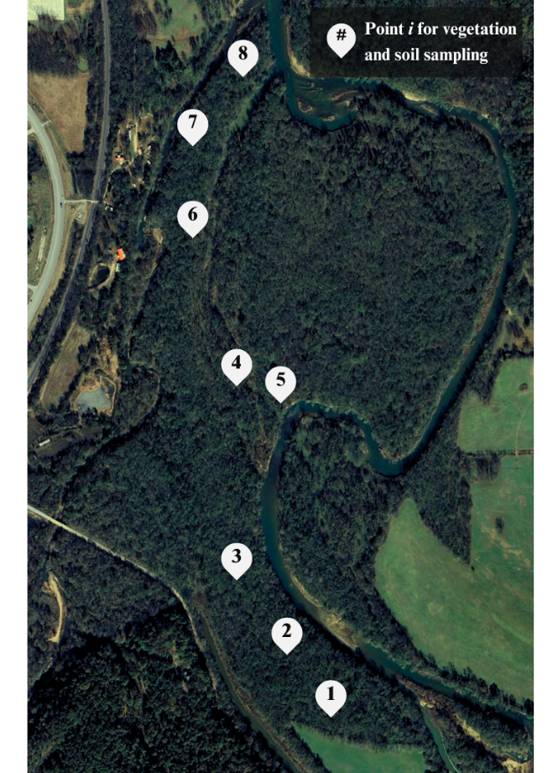
Figure 4-8. Lake Frances (point i) locations for vegetation and soil sampling.
The point-quarter method was employed to derive ground estimates of forest density at Lake Frances. Random points were selected along the transects, and at each point, the area was divided into 90° hemispheres, resulting in four quarters or areas for analysis. Within each hemisphere, the nearest tree was identified, and the distances between the center point and the nearest trees were recorded, resulting in a total of four distance measurements (USEPA, 2002). From these data, estimates of population density (Np), population density variance, and standard error were calculated. Specifically, the population density (Np), variance, and standard error calculations were based on the number of points (n) and the distances between point i and the nearest tree in hemisphere j (r2ij) (USEPA, 2002), where:
- N_{p} = [4 × (4n - 1)] / (π × Σr²ij)
- Variance N_{p} = N_{p}² / [4 × (4n - 1)]
- Standard Error N_{p} = (Variance N_{p} / 4n)^{1/2}
At each point, for each 90° quadrant, additional measurements were taken to characterize woody and herbaceous vegetation, applying the Riparian Core field sampling protocol (Merritt et al., 2017). For each nearest tree, measurements of tree diameter and stem diameter at breast height (about 1.37 meters) were recorded (USEPA, 2002; Merritt et al., 2017).
Further investigation was conducted to characterize representative strata of vegetation, including trees, shrubs, and grass-like species. Functional species groups were categorized by relative height, where grass-like species (hereon grasses) were characterized by low vegetation (< 1.5 meters), shrubs by mid-story vegetation (1.5-5 meters), and trees by canopy (> 5 meters) (Merritt et al., 2017). The size of quadrants ranged between 10-30 square meters, depending on whether cover was dominated by trees or grasses (USEPA, 2002). Standing within each quadrant, estimates of percent areal cover (canopy cover for trees) per functional group (trees, shrubs, grasses) were visually assessed and reported relative to quadrant area.
The average height of shrubs and grasses were measured using measuring tape, while average tree height was measured from the perspective of the point-quarter position, using a clinometer and basic trigonometry. The clinometer was pointed toward the highest point of the tree of interest, where the tangent angle (i.e., clinometer angle) was determined. Multiplying the tangent angle by the distance to the tree provides reliable estimates of tree height (Brohman and Bryant, 2004). Lastly, canopy condition criteria outlined in Table 4-10 were fitted to evaluate the general condition of each functional group and dominant ground cover categories were established from Table 4-11 (Merritt et al., 2017).
Table 4-10. Canopy condition assessment criteria (Merritt et al., 2017).
Condition | Description
(1) Critically Stressed | Major leaf death and/or branch die back (>50% of canopy volume affected)
(2) Significantly Stressed | Prominent leaf death or branch die back (21-50% of canopy volume affected)
(3) Stressed | Minimal leaf death or branch die back (11-20% of canopy volume affected)
(4) Mildly Stressed | Little or no sign of leaf water stress/no water stress related leaf death (5-10% of canopy volume affected)
(5) Vigorous | No sign of leaf water stress/very healthy-looking canopy (<5% of canopy volume affected)

Table 4-11. Ground cover categories (Merritt et al., 2017).
Code | Description
Physical
BARE1 | Bare soil - sand (>0.1 mm)
BARE2 | Bare soil - clay silt (0.1-2.0 mm)
GRAV | Gravel (>2.0-75 mm)
COBB | Cobble (75-250 mm)
BOUL | Boulder (>600 mm)
BEDR | Bedrock
WATE | Water
Organic
BAVE | Basal vegetation
CML | Bryophyte - cryptograms, mosses and lichens
WOOD | Wood
LITT | Litter; including dead plant material and animal droppings
4.3.14 ESII Requirements: Surface Survey
ESII’s surface survey encompassed the majority of inquiries, much of which covered topics concerning prevailing surface conditions, placing particular emphasis on topsoil attributes, hydrological dynamics, and the ramifications of disturbances (TNC et al., 2016). Due to the length of this section, the surface survey was split into three tables, the first of which encompasses survey questions related to ground surface and slope (Table B3).
To gain a comprehensive understanding of ground surface properties and their influence on site hydrology, soil color, moisture, and bulk density measurements were collected for each site. To represent each map unit across the three sites, three soil core samples were collected per map unit location between July and September of 2023, resulting in nine samples from Lake Frances, 18 from MRPTS, and 12 from SECPTS. Soil cores were collected by pushing a 2.54-centimeter diameter soil probe into the soil to a depth of approximately 25 centimeters. The topmost 15 centimeters of soil was carefully measured and cut before being extracted to exclude the discernable litter layer. Each 15-centimeter core was transferred into a low-density polyethylene (LDPE) bag, taped off, and labeled after removing the head space before being put on ice for laboratory analysis.
Due to sludge build-up (e.g., iron oxides) and exogenous material in the process units, the samples were taken from the berms at the PTS sites to focus on the site’s native soil properties. Sample locations for Lake Frances are identified as "point i" in the vegetative analysis (Figure 4-7), while sample locations for MRPTS and SECPTS are detailed in Figures 4-9 and 4-10.
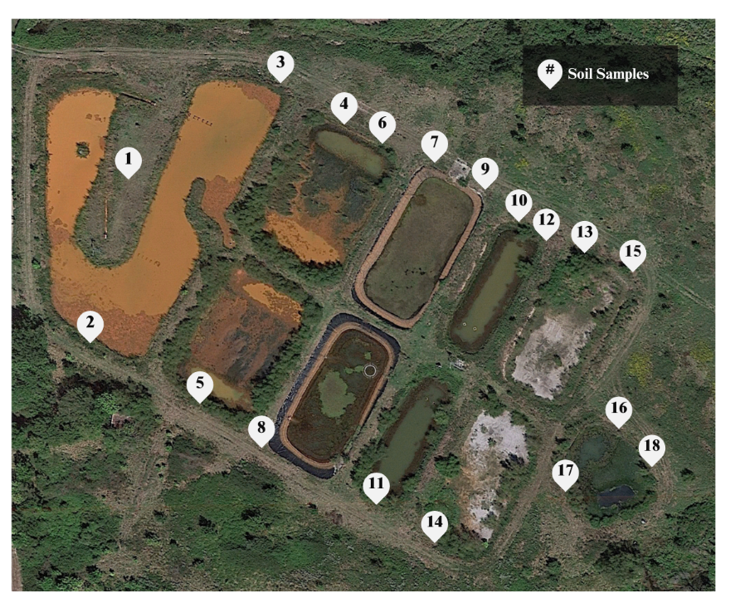
Figure 4-9. Soil sampling locations at Mayer Ranch.
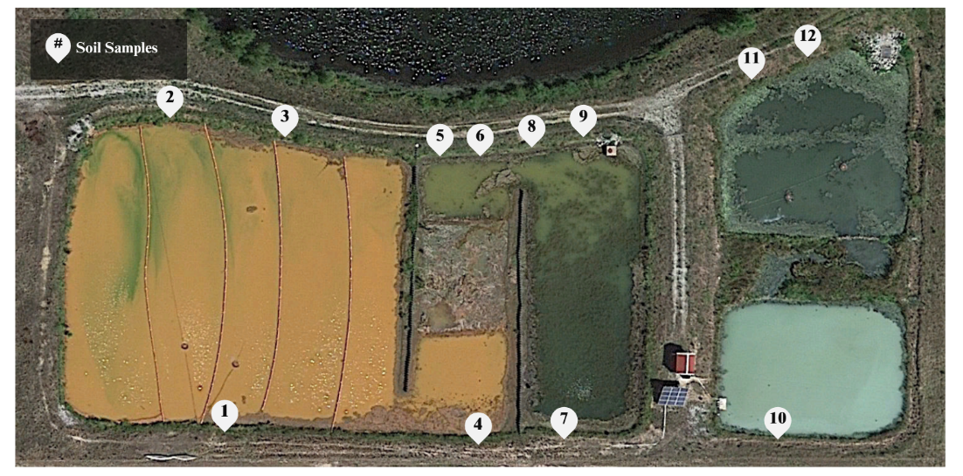
Figure 4-10. Soil sampling locations at Southeast Commerce.
Soil color evaluation followed the standard procedure, employing a Munsell color chart to classify soil based on hue, value, and chroma, thereby providing insights into both physical and chemical soil properties (Munsell, 2010). With the known volume of the core used for sampling, bulk density was determined. Aluminum tins of pre-determined weight were labeled, and the soil cores were carefully transferred onto them for weighing. The weight of each sample was recorded, after which they were placed in a drying oven set at 105°C for 24-48 hours. Following the drying period, the samples were removed from the oven and re-weighed to determine the loss of moisture (Carter, 2017). Bulk density was then calculated using equations 10 and 11:
Mass of Dry Soil (g) = Mass of Tin with Dry Soil – Mass of Empty Tin (10)
Bulk Density (g/cm³) = Mass of Dry Soil (g) / Volume of Core (cm³) (11)
Where the volume of the core used for data collection was 76 cubic centimeters. From the bulk density calculations, the percentage of sample moisture weight (i.e., soil moisture) was estimated using equations 12-14 (Carter, 2017).
Moisture Content (g) = Mass of Tin with Moist Soil -Mass of Tin with Dry Soil (12)
Mass of Moist Soil (g) = Mass of Tin with Moist Soil – Mass of Empty Tin (13)
Soil Moisture (%) = Moisture Content (g) / Mass of Moist Soil (g) × 100% (14)
For surface inquiries concerning the hydrologic regime of each map unit (Table B4), the majority of questions necessitated visual estimation and the utilization of GIS. For inquiries regarding map unit saturation, inundation, or its absence, both visual field assessments and comprehensive knowledge of each site were used. Similarly, queries pertaining to water flow, the presence of seeps/springs, and surface sheens were addressed based on thorough field observations. The sinuosity degree was specifically pertinent to the Lake Frances site and was approximated utilizing Google Earth Pro. Likewise, the average bankfull width and height, and Ordinary High Water (OHW) width and height for Lake Frances map units, were gauged using Google Earth elevation differentials. These measurements were subsequently verified in the field with a tape measure. The final set of surface survey questions pertains to percent coverage, solely necessitating visual estimation of surface characteristics and assessment of the extent of human-caused disturbances (Table B5) (TNC et al., 2016).
4.3.15 ESII Requirements: Screen Survey
ESII’s concluding survey category centers on screening features (Table B6), encompassing relative markers to denote the elevation of each map unit in comparison to its surroundings and the density of vegetation, which offers noise dampening effects.
The first question in this section entails evaluating the elevation of each map unit relative to neighboring ones. To gather this information, lines were created between map units using Google Earth, and the elevation profile was analyzed to determine whether a map unit was positioned “higher,” “lower,” or “higher and lower” compared to its surroundings. At Lake Frances, the prevalence of microtopography across the site often results in inputs categorized as “higher and lower.” At each PTS site, inputs indicate “higher” elevation for each oxidation pond, “higher and lower” for intermediary units, and “lower” for final polishing units.
The final input pertains to the degree of visual screening created by foliage density, which was visually estimated in the field. Inputs for map units at each PTS site were predominantly categorized as “bare,” indicating minimal vegetation obstruction across the site. In contrast, Lake Frances inputs include categories such as “moderate” and “dense,” reflecting varying levels of foliage density (TNC et al., 2016).

4.4 Tracking Wildlife at Lake Frances
Camera traps were incorporated as a sampling technique for tracking and monitoring wildlife. Camera traps are often used to assess terrestrial wildlife occupancy and species richness (Wearn and Glover-Kapfer, 2019). Wildlife cameras can be used for a variety of inventory purposes, however, techniques for standard analysis are not well-developed (Meek et al., 2014). For this reason, the present research took an exploratory approach to the use of camera trap studies to provide insight into habitat wildlife biodiversity using simple quantitative measures per deployment time. The deliberately biased placement method, outlined by Meek et al., (2014) was used to guide wildlife monitoring efforts, incorporating complementary strategies where necessary (Caravaggi et al., 2020).
Deployment locations were determined during on-site reconnaissance visits, set up in areas with evidence of animal activity, such as tracks, trails, and burrows (Meek et al., 2014). Because these data were incorporated to investigate the use of camera trap surveys as a supplemental wetland conservation monitoring method, a simple approach was taken in which notable events per deployment time per camera were recorded. Because a deliberately biased deployment method was adopted, final wildlife camera locations are provided in Figure 5-37 under the Results section.
4.5 Data Analysis Methods
4.5.1 Qualitative Evaluation
Results of ES-DSTs were qualitatively assessed relative to evaluative criteria to identify ES-DSTs most applicable for use in inland wetland habitats. Evaluative criteria (Table 4-12) were defined based on factors related to tool accessibility, flexibility, and practicality, outlining tool operation, unique features, limitations, opportunities, and recommendations for suitable applications (Bagstad et al., 2013).
Table 4-12. Evaluative criteria adapted from Bagstad et al. (2013).
Criterion | Description
(1) Level of Site-Specificity | ES-DSTs that require greater inputs of site-specific data are considered superior alternatives to those with less site-specific data-based tools.
(2) Services Evaluated | ES-DSTs which consider more types of services (provisioning, regulating, cultural and supporting) were regarded as more useful than those which consider less service types.
(3) Value Output | The value output was evaluated in terms of its ability to be incorporated into a BCA, favoring common metrics with specific values and ranges of values over classified ranking systems or metrics of biodiversity which are not easily comparable.
(4) Spatial Scalability | The ability to adapt ES-DSTs for use at the site-level decision-context makes them favorable for decision-making purposes and are further regarded as favorable in this study.
(5) Level of Difficulty | User-friendly ES-DSTs that support a wider range of applications were considered favorable, as they present less technical obstacles for general practitioners. The success of this study was dependent on its ability to identify ES-DSTs with interdisciplinary functionality.
(6) Time Requirement | Convenience is pivotal in terms of implementation. ES-DSTs with timely procedures are favorable for widespread use and were regarded as better in this analysis.
4.5.2 Educated Partner ES Analysis
Because the decision-making process was heavily reliant on public support, understanding of the varied uses and interactions with ES at each application site was vital (Ruhl et al., 2021). In this study, OU CREW partners were used as a proxy for stakeholders, casually engaged in-person and through email to help answer any questions and identify relative ES priorities at each site. Though not a traditional approach, this effort allowed for each ES-DST to be evaluated based on its capacity to reflect stakeholder interests, without diving into a timely stakeholder analysis requiring extensive preparation.
Hereon referred to as educated partners, interested individuals from relevant partner associations representing government agencies, educational institutions, environmental agencies, tribal nations, and nonprofits were engaged through email and in-person to provide feedback on relevant site ES. Two prompts were provided: “(1) According to personal knowledge and experiences associated with the site, rank the eight/ten provided ES in order of LEAST (1) to MOST (8/10) important. Keep in mind that the term ‘important,’ is intentionally nonspecific, as the word itself comes with personal biases based on individual knowledge and experiences. (2) Produce brief explanations/arguments for why the top three to five ES were selected as having higher importance. Feel free to provide explanations/arguments for the remaining ES.” Responses from each application were subsequently used to inform how well each ES-DST’s output reflects local priorities regarding ES using a casual rank-ordering methodology as a comparative basis.
Educated partners for the initial LF application were chosen based on their familiarity with the site. In no specific order, ES determined relevant to LF along with descriptions are provided in Table 4-13. Provided this list, responses were garnered from representatives of locally involved organizations such as the GRDA, the OCC, the Illinois River Watershed Partnership (IRWP), and Bio x Design® Ecological Restoration and Ecosystem Design Consulting.

Table 4-13. Lake Frances ecosystem services for educated partner feedback.
ES at Lake Frances near the Illinois River
1. Water Yield | The site's contribution to the supply of surface water downstream based on the quantity of runoff flowing to surrounding areas, helping to ensure a reliable source of water for various uses.
2. Carbon Storage and Sequestration | The site's capacity to capture, store, and remove carbon from the atmosphere and water over time, helping to mitigate climate change by reducing greenhouse gas levels.
3. Flood Risk Mitigation | The site's ability to naturally reduce the risk of flooding in by absorbing excess rainwater and slowing down flow, thereby minimizing flood hazards.
4. Stormwater Retention | The site's capability to capture and retain rainwater runoff, allowing it to infiltrate the ground and recharge aquifers, which helps manage stormwater pollutants and maintain groundwater levels.
5. Nutrient Retention | The site's capacity to capture and retain nutrients from water, preventing excessive nutrient runoff into water bodies and reducing the risk of water pollution and eutrophication.
6. Sediment Retention | The site's ability to capture and hold sediment, preventing it from entering water bodies and maintaining water quality by reducing turbidity and sediment-related issues.
7. Plant Pollination | The site's role in supporting pollinators, such as birds, bees, and butterflies, which are essential for the production of crops like fruits, vegetables, and other agricultural products.
8. Scenic Quality | The site's capacity to provide visually pleasing and aesthetically appealing natural landscapes or vistas, enhancing the overall beauty and attractiveness of the area.
9. Recreation and Tourism | The site's ability to support a variety of human recreational activities and tourism experiences, including kayaking, fishing, hiking, and more, which contribute to the site's value as a destination for visitors.
10. Habitat Quality | The site's suitability for sustaining diverse and healthy ecosystems, including its ability to provide suitable conditions and resources for various species, thereby supporting biodiversity and ecological balance.
For the subsequent application aimed at understanding ES at the PTSs in Commerce, Oklahoma, key personnel from CREW as well as primary agencies leading local cleanup endeavors were consulted. The ES associated with the PTSs are listed in Table 4-14, which yielded valuable insights from partners including the USEPA, the Department of Environmental Quality (DEQ), and the Quapaw Nation.

Table 4-14. Mayer Ranch and Southeast Commerce ecosystem services provided for educated partner feedback.
ES at Mayer Ranch and Southeast Commerce Passive Treatment Systems
1. Carbon Storage and Sequestration | The ability of wetlands and other vegetated areas in the site to sequester carbon dioxide from the atmosphere, helping to mitigate the effects of climate change by storing carbon in plant biomass and soil.
2. Contaminant Buffering | The site's capacity to buffer contaminants, such as trace metals, nutrients, organic substances and more from water, preventing excessive pollution runoff into water bodies.
3. Pollination | The site's role in supporting pollinators, such as birds, bees, and butterflies, which is essential for the growth and sustainment of various forms of vegetation.
4. Scenic Quality | The site's capacity to enhance the aesthetic quality of a location, creating natural landscapes which improve overall attractiveness of an area.
5. Habitat Quality | The site’s ability to create valuable habitats for a variety of wildlife, including mammals, birds, amphibians, insects, and aquatic species. This supports overall biodiversity and enhances the ecological value of the area.
6. Education and Research | The site's ability to support a variety of learning experiences, providing opportunities to explore various environmental topics, such as ecosystem dynamics, pollution removal mechanisms, and ecological engineering applications.
7. Economic Benefits | The site's ability to offer economic benefits to local communities, whether by avoiding costly wastewater treatment infrastructure or by improving downstream fish habitat with no need for in-stream interference.
8. Non-Potable Water Yield | The site's contribution to non-potable water supply, based on the quantity of effluent water helping to fill non-potable resource needs for uses like crop irrigation.
5.0 Results
5.1 Vegetation and Soil Analyses
5.1.1 Vegetation at Lake Frances
The results of the vegetation survey conducted at Lake Frances are summarized in Table 5-1. These findings served as a foundation for enhancing the map units of the Lake Frances site. The six map units at the Lake Frances site were classified into three primary habitat types, combined due to similarities in vegetation, topsoil characteristics, relative elevation profiles.
Table 5-1. Average vegetation measures for Lake Frances map units.
Category | Parameter | Averages per Map Unit (by sample location i)
Category | Parameter | Highland (1,2,3) | Midland (4,5) | Floodplain (6,7,8)
Tree Measurements | Distance, r (m) | 6.23 | 3.61 | 4.43
Tree Measurements | Trunk diameter (m) | 0.78 | 0.95 | 1.2
Areal Cover (% of 100%) | Low (<1.5m) | 54 | 39 | 49
Areal Cover (% of 100%) | Med. (1.5-5m) | 19 | 38 | 24
Areal Cover (% of 100%) | Canopy (>5m) | 27 | 24 | 27
Vegetation Height (m) | Grasses | 0.6 | 0.18 | 0.41
Vegetation Height (m) | Shrubs | 1.59 | 0.99 | 0.61
Vegetation Height (m) | Trees | 15.73 | 11.68 | 15.08
Vegetation Condition | Grasses | 3 | 3 | 3
Vegetation Condition | Shrubs | 3 | 4 | 3
Vegetation Condition | Trees | 4 | 3 | 3
Vegetation Condition | Dominant Ground Cover | BAVE | LITT | LITT
The population density of trees in Lake Frances was determined to be 0.16 trees per square meter, offering insight into the distribution of trees within the area. Additionally, the variance (0.00005) and standard error (0.0006) were low, indicating the precision of the density estimate. The low variability suggests consistent measurements across the site, although potential errors in field estimates cannot be ruled out.
5.1.2 Soils at Lake Frances, MRPTS, and SECPTS
This section highlights how the soils results were incorporated for ES-DST use, with detailed data on bulk density, moisture content, and soil color provided in Tables A19, A20, and A21 for reference. Soil parameters of soil color, bulk density and soil moisture content informed responses to ESII survey questions.
LF hue/value/chroma results showed a dominant soil condition that is yellow-red in color and moderately dark in hue, suggesting a moderately low saturation. For MRPTS and SECPTS soil color varied between yellow-red and yellow-green, from light to moderately dark hues, similarly indicating a moderately low saturation.
Bulk density measurements served multiple purposes, primarily as a surrogate indicator for soil disturbance (Campbell, 1994), where higher bulk densities correlate with increased soil disturbance due to higher compaction. Timlin et al. (2004) suggests that bulk density, when considered with soil moisture content, can also offer insights into soil characteristics such as saturation and permeability.
Soil saturation was gauged by assessing bulk density and soil moisture content, as bulk density relates to soil compaction and pore space, while soil moisture content reflects water volume. Permeability was assessed through its inverse relationship to bulk density, where high compaction suggests low infiltration rates and groundwater recharge rates (Timlin et al., 2004). The distribution of bulk density and soil moisture measurements across each site by sample number are presented in Figures 5-2 and 5-3.
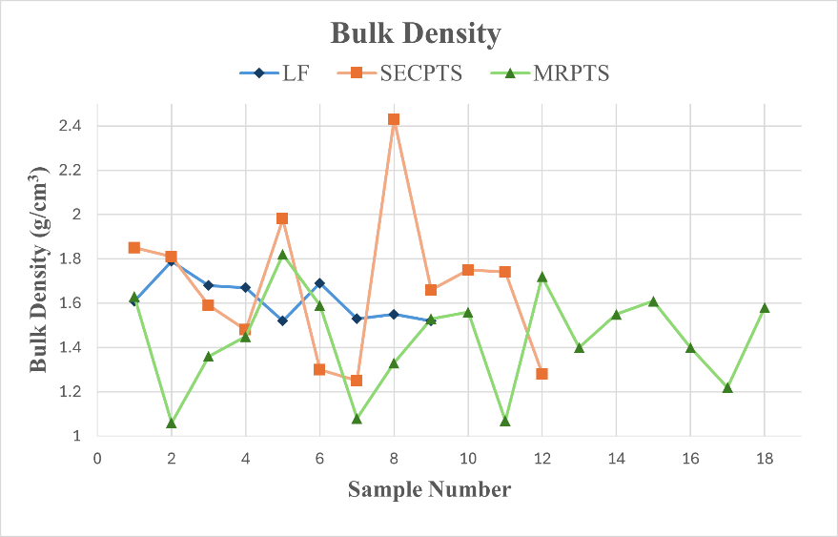
Figure 5-2. Soil bulk density: Lake Frances, Southeast Commerce, and Mayer Ranch.
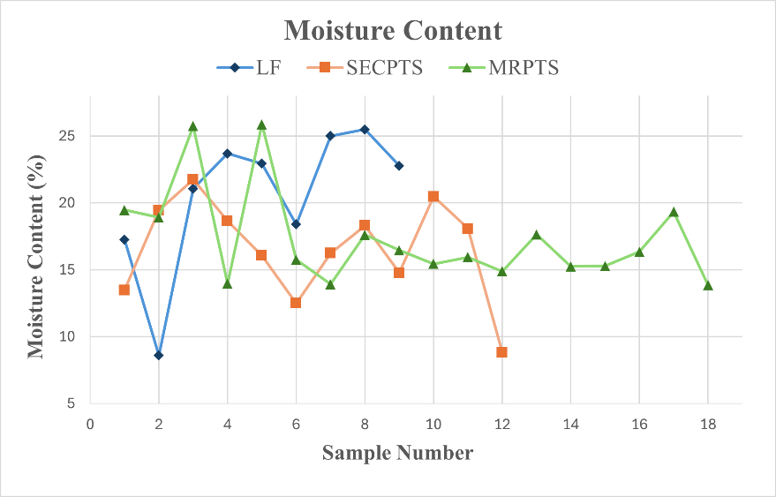
Figure 5-3. Soil moisture content: Lake Frances, Southeast Commerce, and Mayer Ranch.
Soils at LF had an average bulk density of 1.6 g/cm³, suggesting moderate to high levels of compaction. Bulk densities for MRPTS and SECPTS also exhibited a moderate level of compaction. MRPTS had the lowest average of all sites with a bulk density of 1.4 g/cm³, while SECPTS had the highest, with an average bulk density of 1.7 g/cm³.
While the dominant soil condition was moderately saturated at LF due to an average soil moisture of 21%, the 9% minimum suggests that some areas may be very dry. Average soil moisture at MRPTS and SECPTS was 17%, suggesting the prevailing condition of soils was moderately saturated.
5.2 ES-DST Results
To assess reliability, InVEST and ESII outputs were evaluated against relevant observed data and modeled values. Tables C1 and C2 provide site summaries of ES outputs as compared to reference ranges or values. Outputs were discussed using terminology such as "over-estimation" and "under-estimation" to offer a relative comparison to observed values. Since these data have not been validated and calibrated at the site-level, conclusions were based on inference and should therefore be interpreted with caution.
5.2.1 InVEST Outputs Overview
While InVEST provides diverse data for various applications, this research focused on analyzing its ES outputs. The results from the preparatory tools, RouteDEM and DelineateIt, are briefly outlined followed by descriptions of InVEST’s ES model outputs, employed to assess seven different ES.
The TFA input was used to calibrate RouteDEM, yielding a best match value of 1,000. Values ranging between 100 and 1,000 were tested. A TFA value below 1,000 led to the creation of non-existent streams compared to real-world data, while values greater than 1,000 oversimplified the stream networks.
The primary output of the RouteDEM tool was the filled DEM file for each watershed and each site. The elevation profile for the IRW ranged from 273 to 378 meters (m) above mean sea level (AMSL) and from 277 to 286 m for LF (Figure 5-3). UTW elevation ranged from 237 to 253 m, 240 to 242 m for MRPTS, and 242 and 243 m for SECPTS (Figure 5-4).
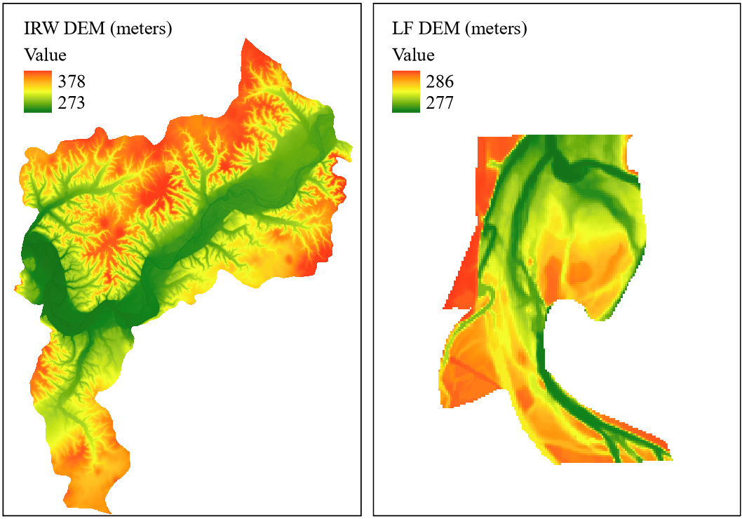
Figure 5-3. Digital elevation model: (a) Illinois River Watershed and (b) Lake Frances.
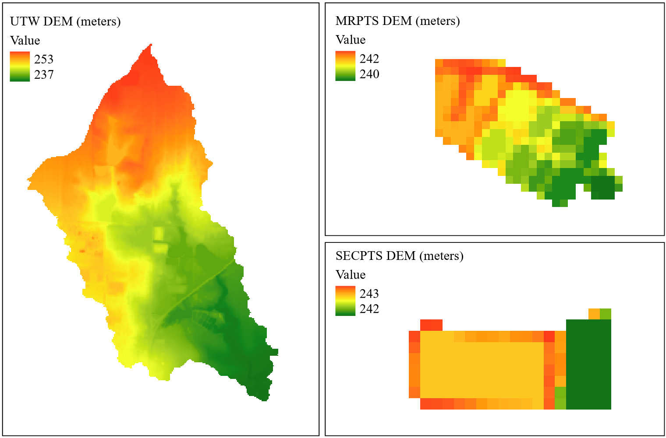
Figure 5-4. Digital elevation model: (a) Unnamed Tributary Watershed, (b) Mayer Ranch, and (c) Southeast Commerce.
The DelineateIt tool generated watershed boundaries utilizing the output derived from RouteDEM (Figure 5-5). These shapefiles served as storage areas for aggregating the results of ES models that require watershed-level estimation but were ultimately not relevant for site-scale analyses (TNC et al., 2016).
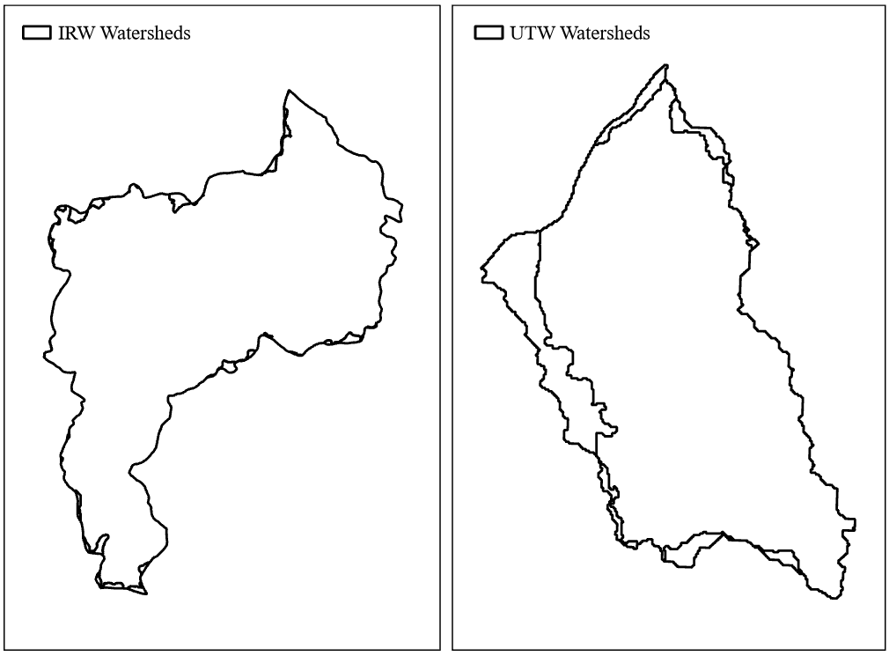
Figure 5-5. Watershed boundaries: (a) Illinois River Watershed and (b) Unnamed Tributary Watershed.

5.2.2 InVEST SDR Outputs: Erosion Control
The SDR model produced six rasters, encompassing various aspects of sediment dynamics, such as total potential soil loss, sediment yield, sediment deposition, avoided erosion and avoided export. Relevant to this research, the avoided export map was used to assess the ES of erosion control.
The amount of sediment reaching the stream served as a benchmark for comparing model outputs against observed data (Sharp et al., 2018). For the IRW, sediment export varied from 0 to 110 tonnes per hectare per year (t/ha/yr), whereas a range of 0 to 2.3 t/ha/yr estimated for LF. Monitoring at the Arkansas/Oklahoma state-line in 2005 reported an average sediment yield of 0.23 t/ha/yr for the IRW, suggesting outputs may be high and perhaps overestimated (Nelson et al., 2006).
Sediment export data for Ballard Creek was referenced to evaluate LF outputs, in which an average benchmark value of 0.17 t/ha/yr was reported (Nelson et al., 2006). Observations used to calibrate a hydrological model by Pai et al. (2011) reported an average export rate of 0.26 t/ha/yr. Considering these findings, the simulated sediment export for LF appears to be within reasonable range of observed data.
Sediment retention outputs for IRW and LF (Figure 5-6) were consistent with literature findings. For IRW, sediment retention peaked at 3,420 t/ha/yr, with an average of 30 t/ha/yr. When considering just LF, sediment retention peaked at 485 t/ha/yr, with an average of 10 t/ha/yr.
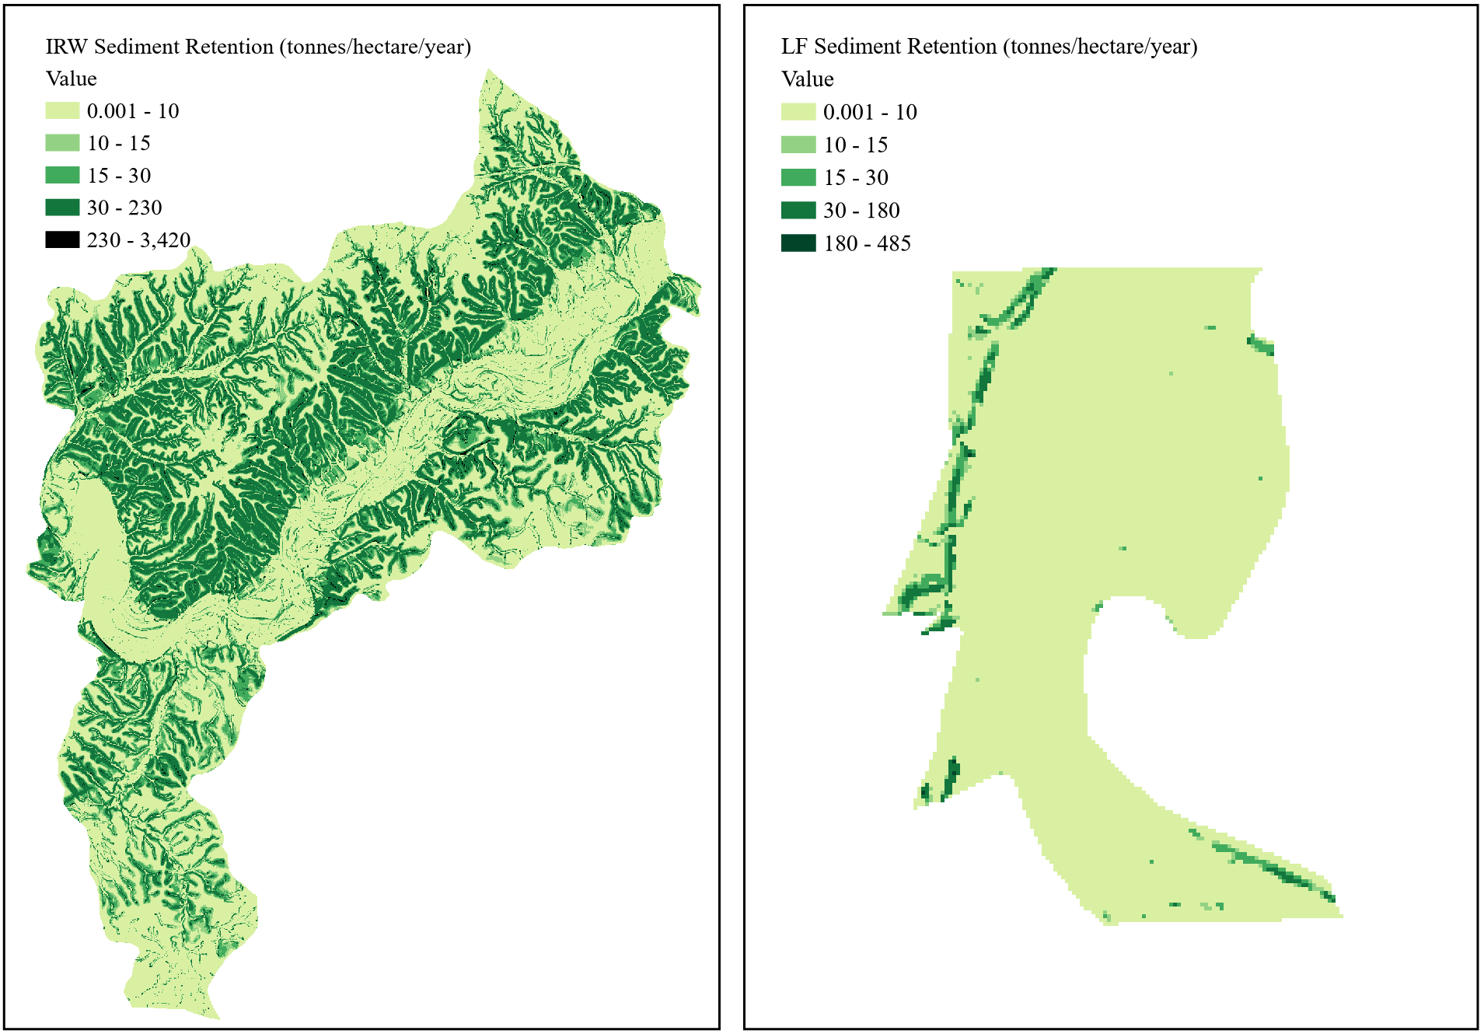
Figure 5-6. Sediment retention: (a) Illinois River Watershed and (b) Lake Frances.
Although data on sediment retention at the watershed level are relatively scarce, information on BHFs was accessible for assessing the reliability of site-level outputs for LF. Across the site, average retention was below 10 t/ha/yr, with a range from 0.001 to 485 t/ha/yr. The average value aligned well with existing literature on expected retention by Midwest BHF wetlands; Anderson and Mitsch (2006) reported an average of 8 t/ha/yr, while Kleiss (1995) reported a range between 0.1 and 13 t/ha/yr.
Maximum sediment retention for the UTW was 685 t/ha/yr, 145 t/ha/yr for MRPTS, and 20 t/ha/yr for SECPTS. The average retention for the UTW and MRPTS was less than 10 t/ha/yr, and below 5 t/ha/yr for SECPTS (Figure 5-7).
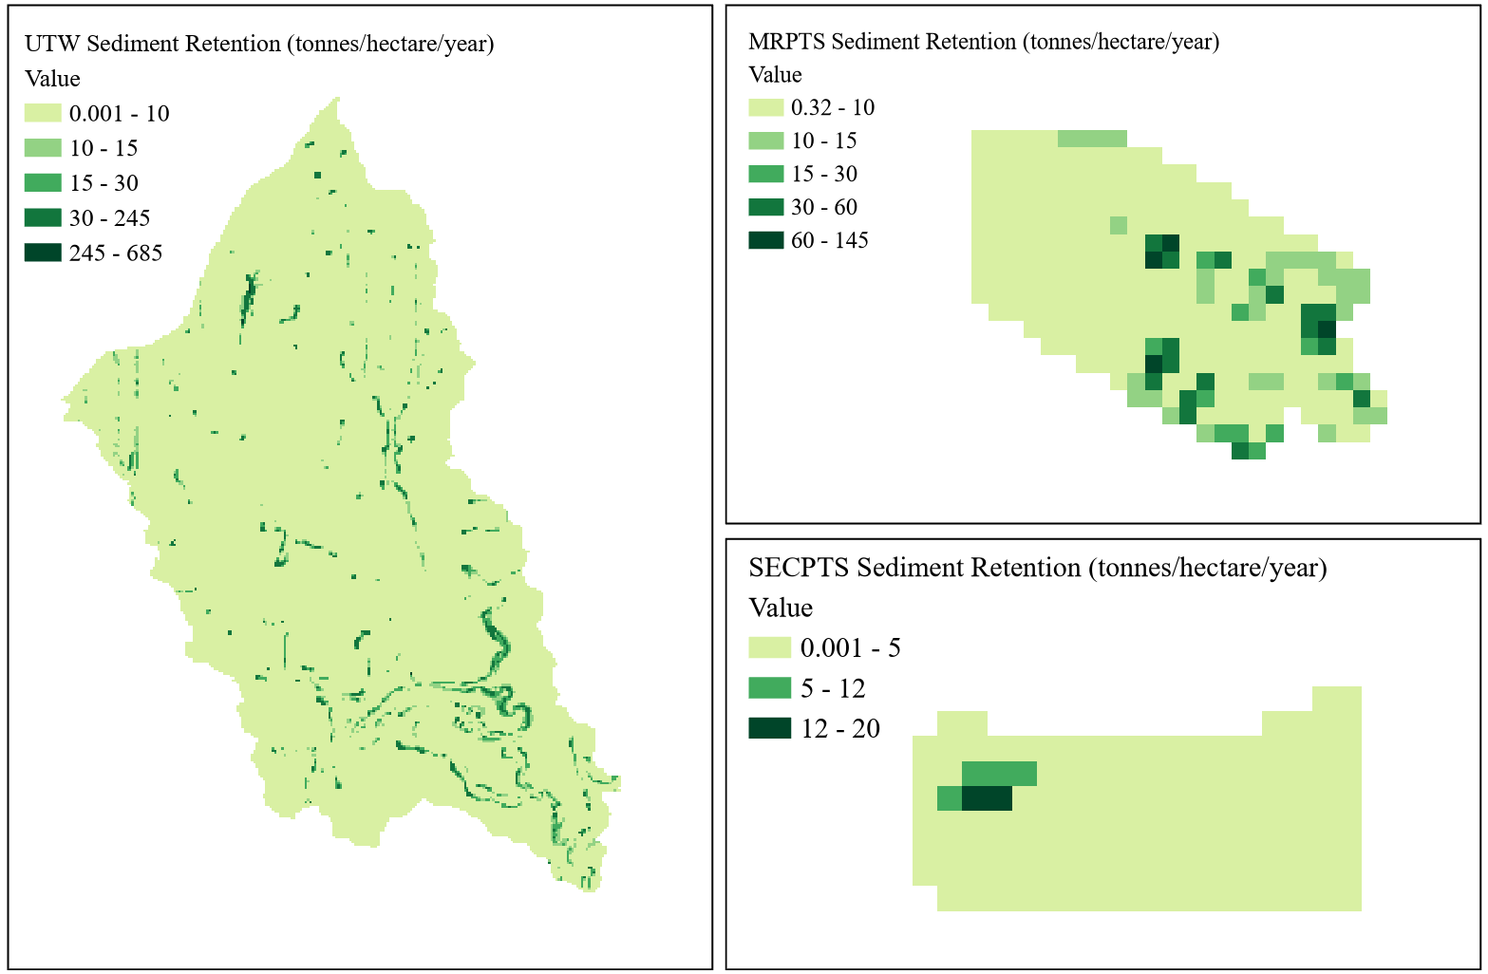
Figure 5-7. Sediment retention: (a) Unnamed Tributary Watershed, (b) Mayer Ranch, and (c) Southeast Commerce.
Sediment export for the UTW ranged from 0 to 6 t/ha/yr, a range similar to that reported by Douglas-Mankin et al. (2004) for the Spring River watershed, in which observations fell between 0.2 and 1.3 t/ha/yr. Sediment retention estimates were below 15 t/ha/yr for MRPTS and less than 5 t/ha/yr for SECPTS. In related systems at the Olentangy River Wetland Research Park, sediment retention reportedly ranged from 43 to 47 t/ha/yr (Anderson and Mitsch, 2006). Outputs for MRPTS and SECPTS fell below this range, suggesting they may have been underestimated. Regional disparities could explain this variation, as a riverine system further northeast would likely receive and consequently retain more sediment compared to Midwest systems. A study by Dunne et al. (2010) reported sediment removal rates ranging between 2.6 and 30 t/ha/yr for a large-scale constructed wetland, aligning with outputs for MRPTS and SECPTS.
5.2.3 InVEST NDR Outputs: Nutrient Retention
The NDR model generated four rasters, including maps of phosphorus and nitrogen surface export, nitrogen subsurface export, and total nitrogen export. Although the NDR model does not offer a direct quantification of nutrient retention services, the InVEST recommended method to estimate the retention service for each nutrient was applied, which involved subtracting the total nutrient export raster from the modified nutrient load raster (an intermediate output). The result was a quantitative estimate for both phosphorus and nitrogen retention (Sharp et al., 2018).
Employing a similar approach to the sediment analysis, nutrient export was used to evaluate the accuracy of NDR outputs. For the IRW, an the model estimated nitrogen loading to be less than 6 kilograms per hectare per year (kg/ha/yr), consistent with the 4.5 kg/ha/yr estimation outlined in the 2010 Watershed Based Plan for the IRW (Thralls, 2010). Phosphorus loading was estimated to range from 0.0003 to 1.6 kg/ha/yr for the IRW, aligning with findings reported by Thralls (2010), Storm et al. (2010), and Scott et al. (2011), which ranged from 0.03 to 1.06 kg/ha/yr.
At the site level, nutrient loads for both parameters at LF were lower than reported values. Literature sources indicated higher average nitrogen loads for Ballard Creek compared to the modeled load, with an expected load of approximately 12 kg/ha/yr (Pai et al., 2011; Nelson et al., 2006), while the simulated load ranged between 0.1 and 2 kg/ha/yr. Phosphorus loading at LF was between 0.0005 and 0.21 kg/ha/yr. Compared to the loading range between 1.5 and 1.6 kg/ha/yr reported in literature (Nelson et al., 2006; Pai et al., 2011), loading outputs were low, signaling that underestimation was possible.
Nitrogen retention for the IRW ranged from 0.07 to 21 kg/ha/yr, and from 0.08 to 4 kg/ha/yr for LF. Phosphorus retention varied between 0.006 and 3 kg/ha/yr for the IRW and between 0.007 and 0.76 kg/ha/yr for LF (Figure 5-8).
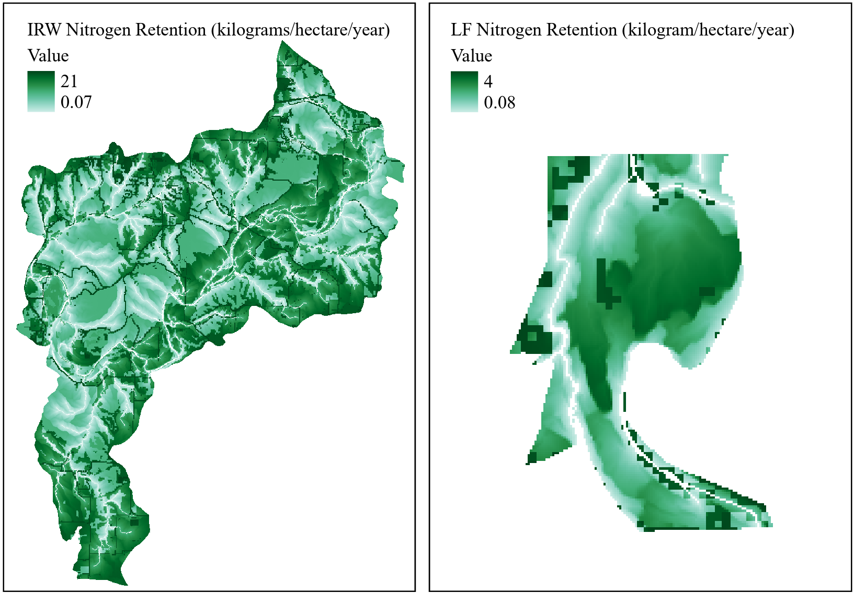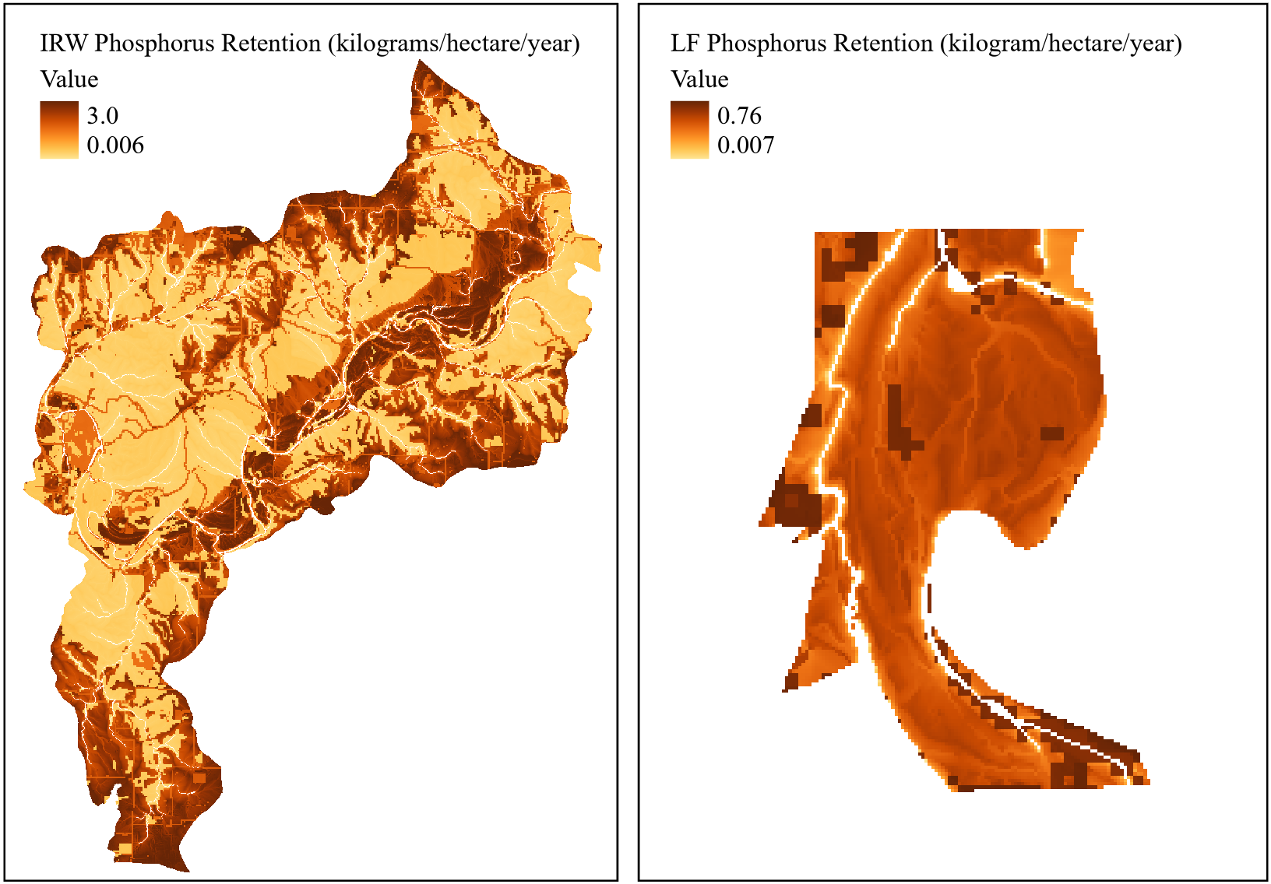
Figure 5-8. (1) Nitrogen retention and (2) phosphorus retention: (a) Illinois River Watershed and (b) Lake Frances.
Considering the disparity between modeled and observed export for LF, it was expected that resulting nutrient retention maps would also deviate from relevant literature. Confirming this, nitrogen retention reached an average of 0.7 kg/ha/yr and maximum of only 4 kg/ha/yr, a low value considering the range of 100 to 200 kg/ha/yr reported by Gordon et al. (2020), suggesting potential underestimation. Phosphorus retention for LF was 0.3 kg/ha/yr on average, which is within scope of the range reported for BHF wetlands between 1.7 and 5 kg/ha/yr (Gordon et al., 2020).
Outputs for nutrient export from the UTW deviated from expectations based on literature-derived loading measurements. Nitrogen export ranged from 0.03 to 5 kg/ha/yr, while phosphorus export ranged from 0.007 to 0.8 kg/ha/yr. These data align with average nutrient yield measurements of 4.9 N kg/ha/yr and 0.6 P kg/ha/yr from Robertson et al. (2019), but they fall below nutrient loading estimates, reported by Douglas-Mankin et al. (2004) to range between 8 and 15 N kg/ha/yr and 1 and 2 P kg/ha/yr. Nutrient retention outputs varied from observed data findings, with relatively low estimates suggesting outputs for the UTW, MRPTS and SECPTS could be underestimations (Figure 5-9).

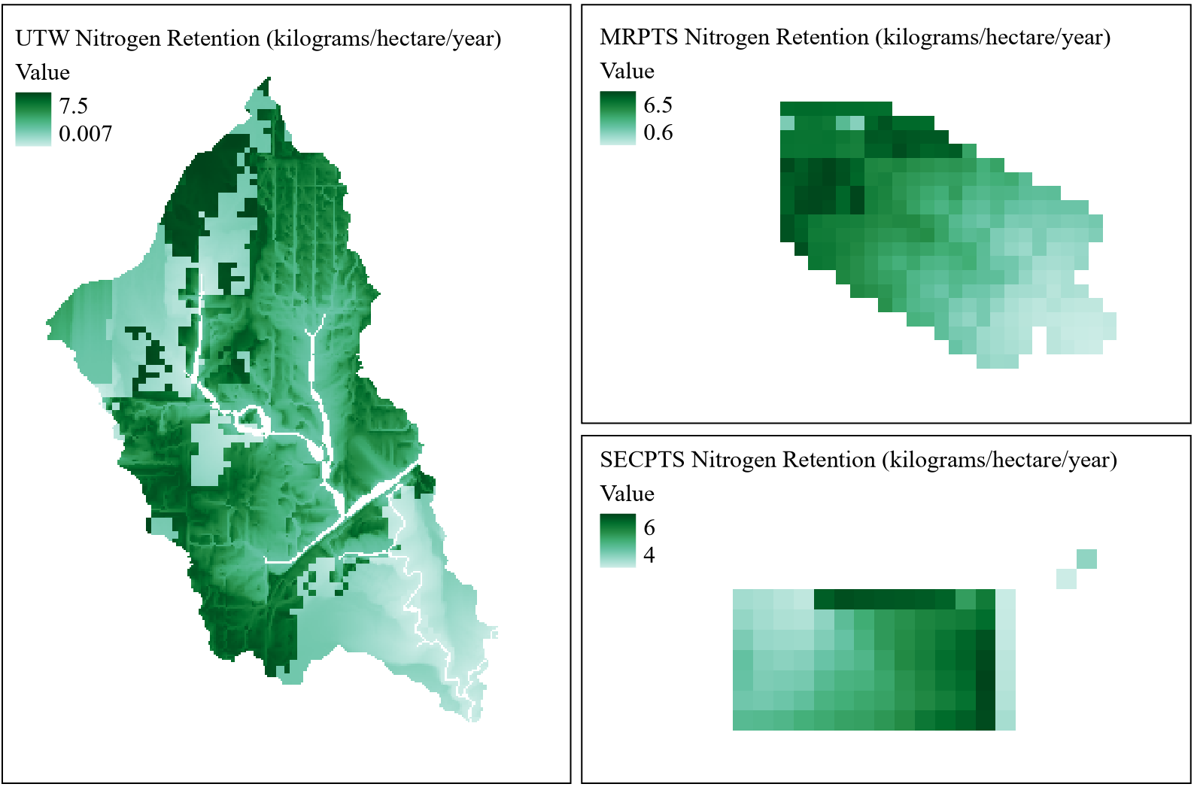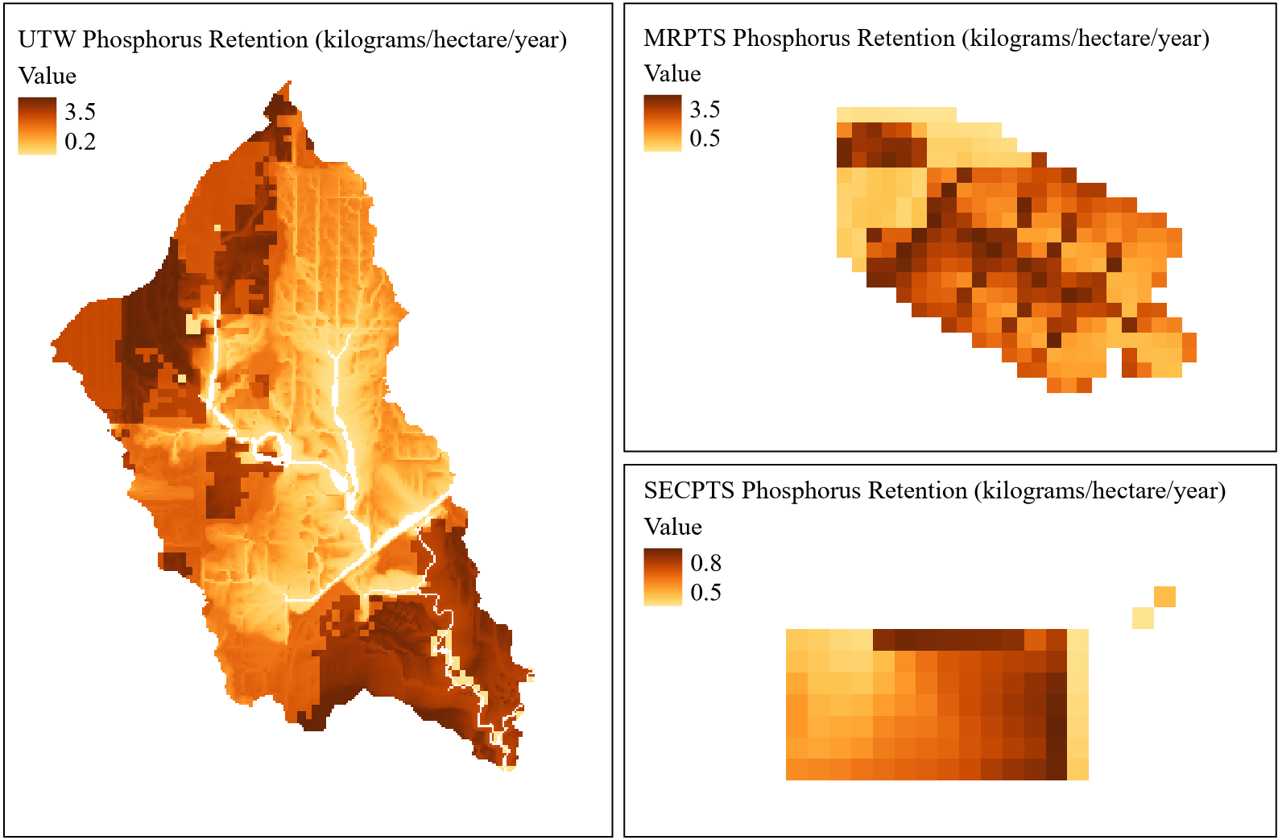
Figure 5-9. (1) Nitrogen retention and (2) phosphorus retention: (a) Unnamed Tributary Watershed, (b) Mayer Ranch, and (c) Southeast Commerce.
Nitrogen retention for the UTW, MRPTS, and SECPTS was 5 kg/ha/yr on average. For the UTW, retention peaked at 7.5 kg/ha/yr, 6.5 kg/ha/yr for MRPTS, and 6 kg/ha/yr for SECPTS, diverging from the 100 to 400 kg/ha/yr range reported by Mitsch et al. (2014). Phosphorus retention was 3.0 kg/ha/yr on average for the UTW and MRPTS, and 0.7 kg/ha/yr for SECPTS. These outputs were low compared to reported values for wetlands ranging from 5 to 50 kg/ha/yr, with values for constructed wetlands between 21 and 26 kg/ha/yr (Mitsch et al., 2014). This suggests potential underestimation.
5.2.4 InVEST AWY Outputs: Water Provisioning
The AWY model produced five outputs, comprising a parameter log, two raster files, and a shapefile accompanied by two CSV files. The key ES output generated by the AWY model was the estimated water yield raster - a proxy for the ES of potential water provisioning. Outputs for the IRW and LF ranged from 10 to 12 cubic meters per hectare per year (m³/ha/yr), with averages of 11 m³/ha/yr for the IRW and 10.5 m³/ha/yr for LF (Figure 5-10).
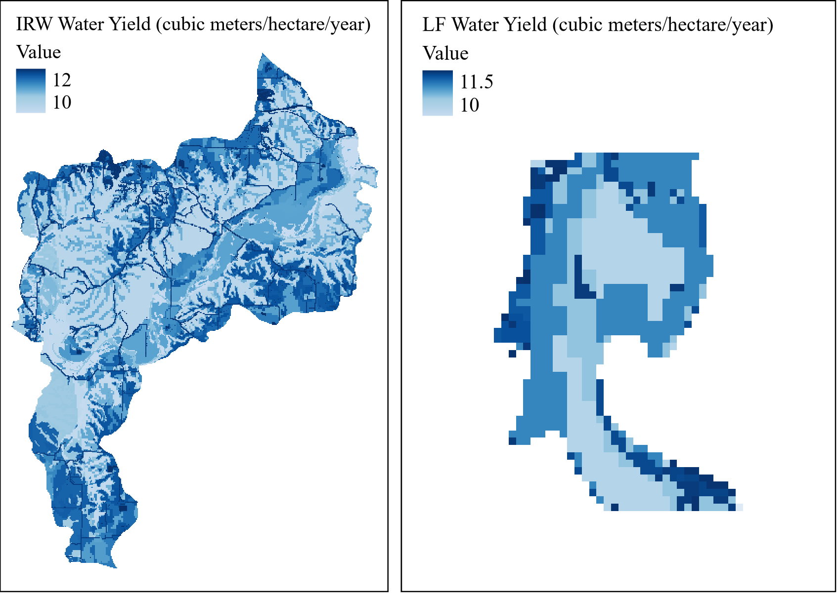
Figure 5-10. Water yield: (a) Illinois River Watershed and (b) Lake Frances.
Compared to runoff retention estimates between 247 and 357 m³/ha/yr reported by Salata et al. (2021), outputs for LF were low, potentially indicating underestimation compared to realistic measurements. Runoff volume for various watersheds throughout Oklahoma and Arkansas was reported to range from 50 to 5,615 m³/ha/yr, reaffirming that InVEST AWY outputs may low or even underestimated (Holmes et al., 2011).
For the UTW, MRPTS, and SECPTS, water yield outputs ranged from 10 to 12 m³/ha/yr (Figure 5-11). The average water yield was 10.8 m³/ha/yr for the UTW and 11.5 m³/ha/yr for both MRPTS and SECPTS.
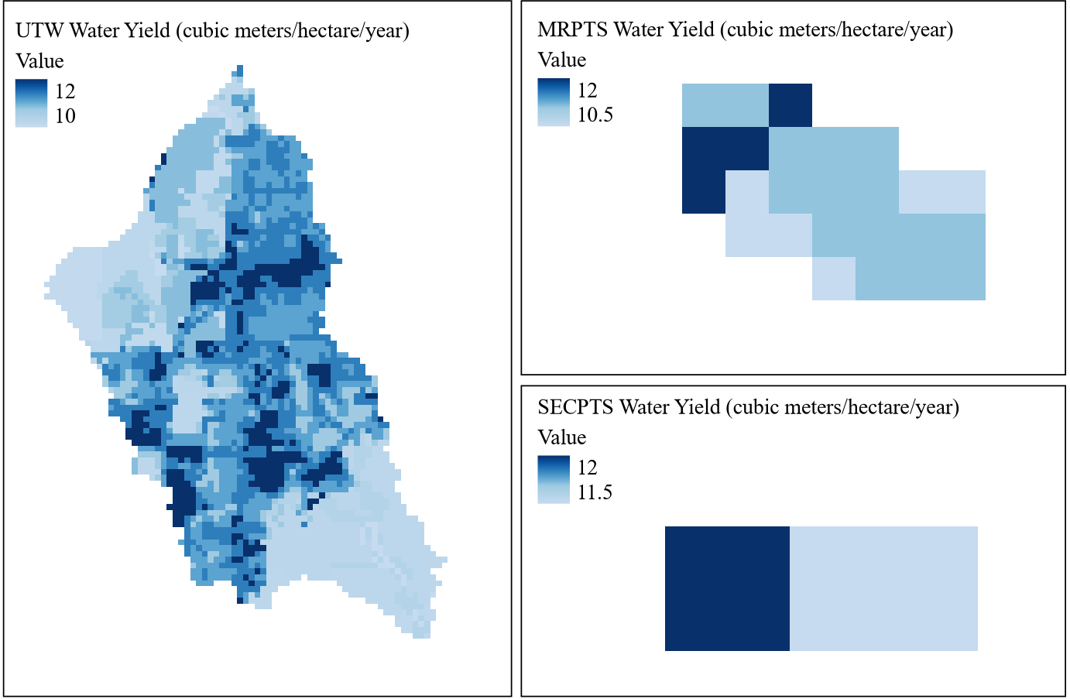
Figure 5-11. Water yield: (a) Unnamed Tributary Watershed, (b) Mayer Ranch, and (c) Southeast Commerce.
Compared to estimates of runoff retention aggregated by Salata et al. (2021), outputs for MRPTS and SECPTS were low, potentially suggesting underestimation. This is further supported when compared to a wider range of runoff volumes reported for Oklahoma/Arkansas between 50 and 5,615 m³/ha/yr (Holmes et al., 2011).
5.2.5 InVEST CSS Outputs: Carbon Stock
The CSS model yielded three outputs: a parameter log, a summary report of CSS data, and a carbon storage map. The carbon storage output estimates the cumulative carbon content contained within a given unit area, considering above- and below-ground carbon as well as soil and dead biomass (Sharp et al., 2018). While carbon storage alone is not classified as an ES, the carbon storage data can serve as a baseline for ongoing sequestration monitoring. Tracking storage annually, subsequent studies could leverage the CSS model to estimate carbon sequestration rates.
Results for the IRW and LF demonstrated strong alignment with regional observations and comparable studies on carbon stocks. Maximum carbon storage for the IRW and LF peaked at 182 metric tonnes per hectare (t/ha), with average values of 75 t/ha for the IRW and 100 t/ha for LF (Figure 5-12).
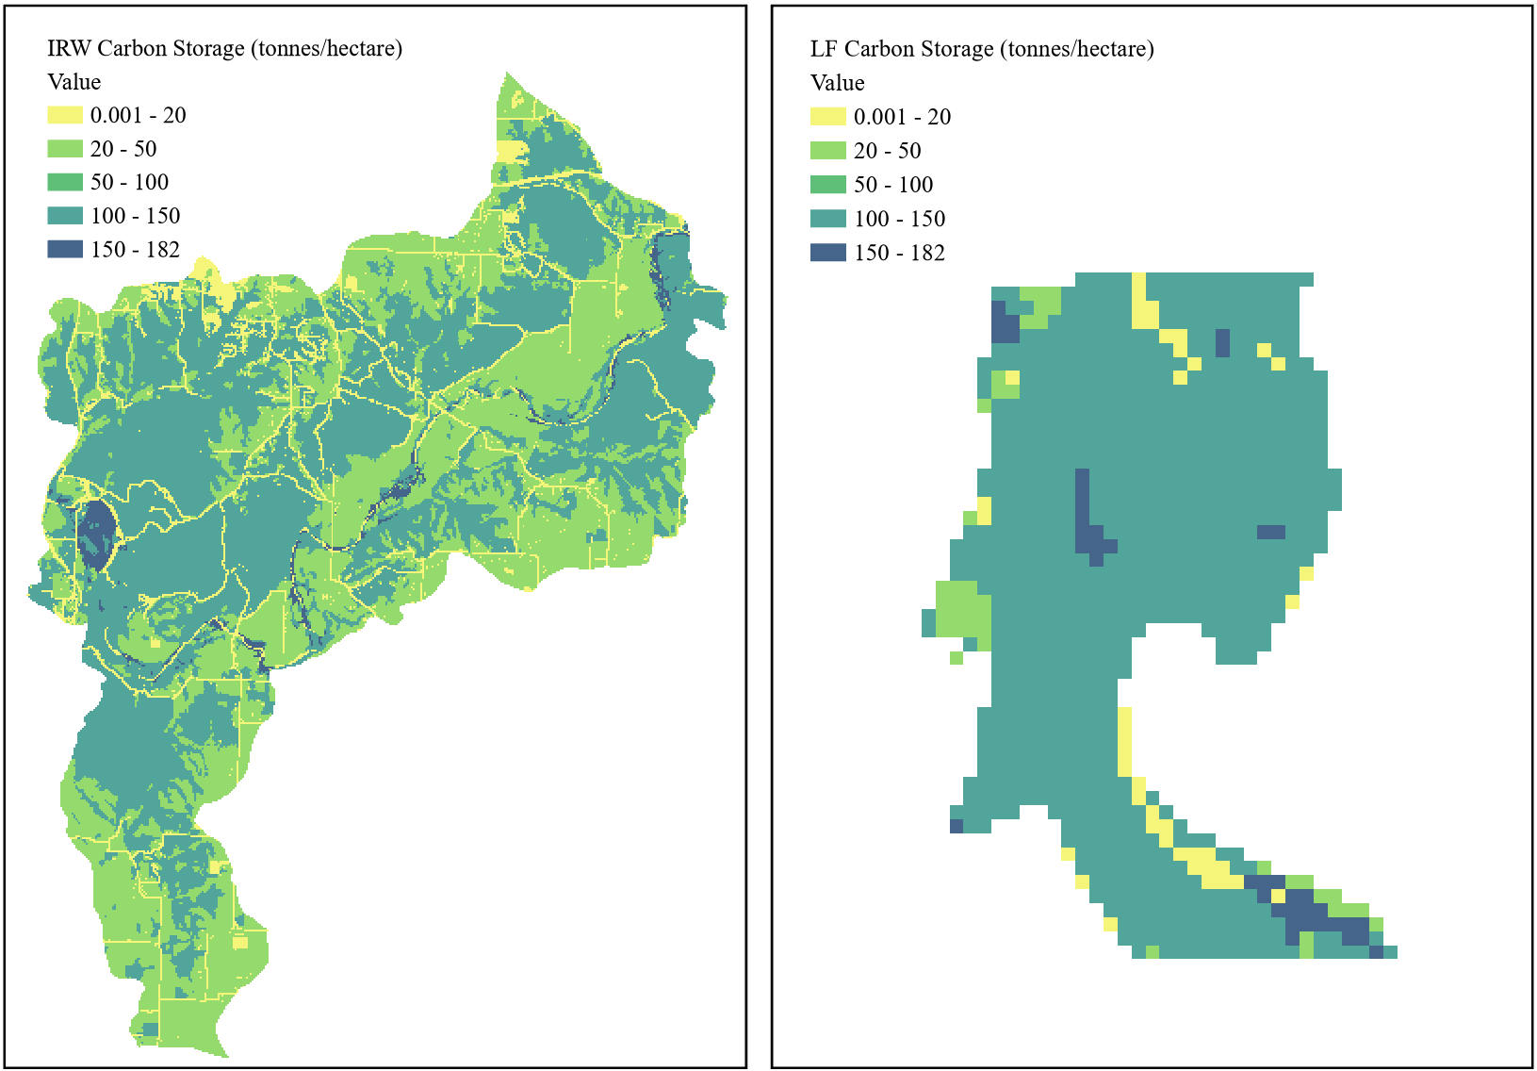
Figure 5-12. Carbon stock: (a) Illinois River Watershed and (b) Lake Frances.
Carbon storage outputs for the IRW and LF aligned with values from Sperow (2020), which reported a wide range of 50 to 100 t/ha for carbon storage within northeast Oklahoma based on 2019 IPCC guidelines. Modeled outputs for the Kiamichi River ranging from 0 to 9 t/ha were low compared to outputs from this study, suggesting possible overestimation (Castro et al., 2015). A similar InVEST study reported an average carbon storage capacity of 130 t/ha for the Midwest (Walston et al., 2021), reaffirming that IRW carbon storage outputs likely fell within an appropriate range of literature observations.
Rheinhardt et al. (2012) reported carbon storage ranging from 18 to 242 t/ha for riparian forested habitats, aligning with LF outputs. Additionally, an average carbon density of 200 t/ha for freshwater wetlands within the interior plains region was reported by Nahlik et al. (2016). Considering both sources, LF outputs were within practical bounds of real-world carbon storage measurements.
Maximum carbon storage at UTW reached 182 t/ha, with an average of 4 t/ha. For MRPTS, carbon storage ranged between 2.7 and 30 t/ha with an average of 18 t/ha. Carbon storage at SECPTS peaked at 3 t/ha, with an average value of 2 t/ha (Figure 5-13).
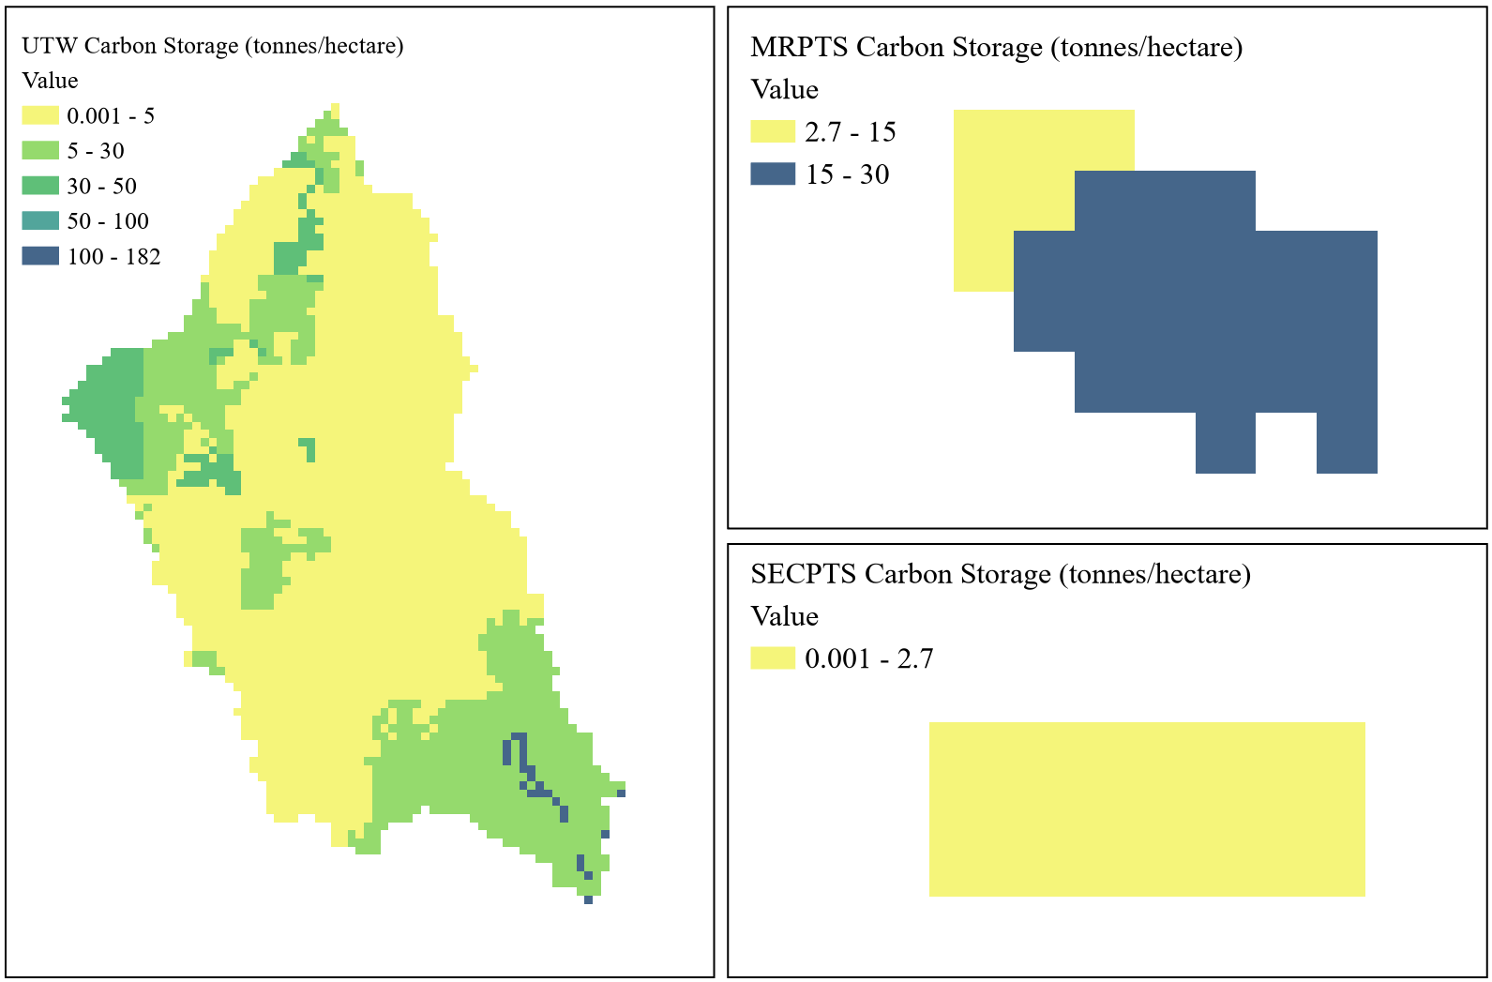
Figure 5-13. Carbon stock: (a) Unnamed Tributary Watershed, (b) Mayer Ranch, and (c) Southeast Commerce.
For the UTW, carbon storage diverged from values reported by Sperow (2020) between 50 and 100 t/ha. Outputs also fell below the average carbon storage capacity of 130 t/ha for the Midwest reported by Walston et al. (2021). UTW outputs were consistent with findings by Dhakal et al. (2023), which reported net ecosystem exchange (NEE) for northeast Oklahoma between 4.7 and 6.3 t/ha.
Similar to the UTW, outputs for MRPTS and SECPTS showed some inconsistencies with comparable data on carbon storage. Carbon storage at MRPTS and SECPTS aligned with Nowak (2021), which reported a range from 30 to 110 t/ha for carbon storage within constructed wetlands. Compared to carbon storage estimates for northeastern Oklahoma reported to range between 4.7 to 6.3 t/ha (Dhakal et al., 2023), SECPTS outputs were low and potentially underestimated, while outputs for MRPTS were high and possibly overestimated (Dhakal et al., 2023).
5.2.6 InVEST HQ Outputs: Habitat Degradation and Quality
The HQ model generated three key outputs, including a parameter log and two rasters. These rasters provide spatial representations of scores assigned to denote relative levels of habitat degradation and habitat quality. While these outputs do not offer quantitative biodiversity measures, they are indicators of potential habitat extent and quality, offering guidance to pinpoint areas suitable for conservation and protection (Sharp et al., 2018).
The habitat degradation raster provides a unitless measure to indicate relative landscape disturbance. Higher values indicate greater degrees of disturbance, whereas a value of zero suggests no degradation. Habitat quality, also unitless, indicates the quality of habitat provided relative to surrounding pixels. Values approaching 1 signify higher quality habitat, while a value of 0 reflects unfavorable conditions.
Habitat degradation scores for the IRW and LF ranged between 0 and 0.7, with an average of 0.4. Habitat quality for the IRW and LF followed an inverse pattern, ranging from 0 to 0.6 with an average of 0.5 (Figure 5-14).
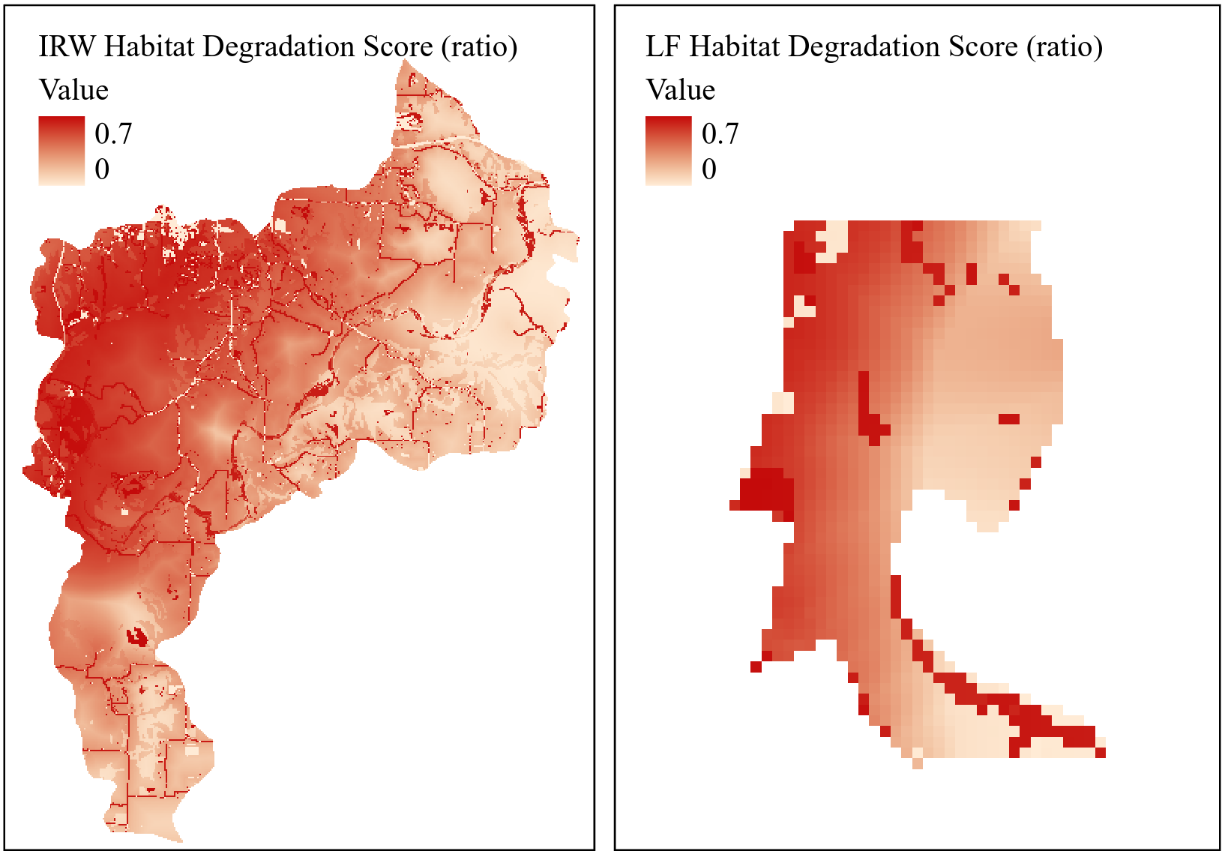
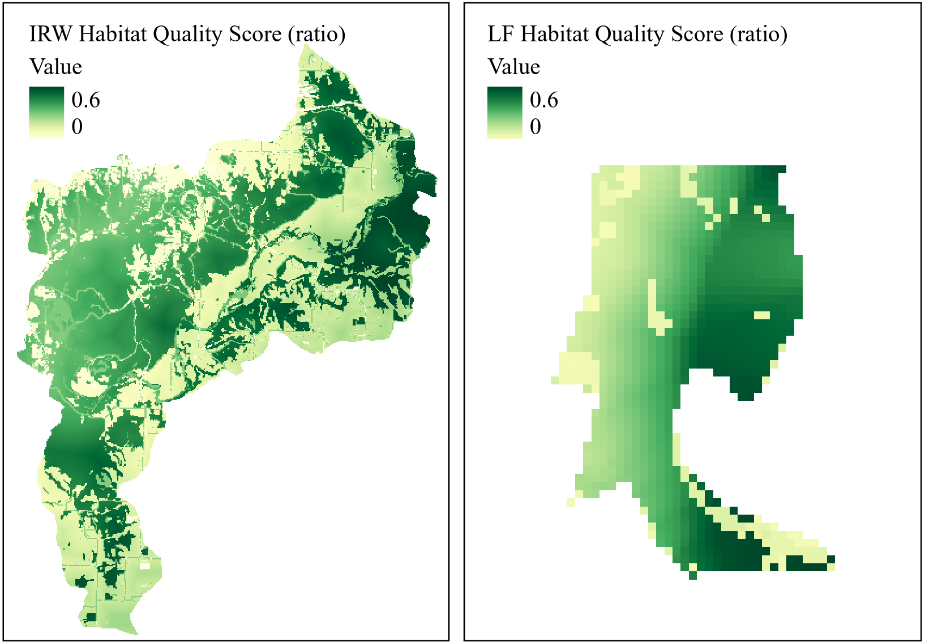
Figure 5-14. (1) Habitat degradation and (2) habitat quality: (a) Illinois River Watershed and (b) Lake Frances.
Habitat degradation and quality outputs for the IRW and LF demonstrated increased degradation and diminished quality nearest impervious areas (e.g. roads, railroads, urban areas). While habitat degradation was high for impervious surfaces at LF, it was highest for the Illinois River, indicating the riverine habitat experiences greater degradation compared to surrounding terrestrial habitats.
LF results were correlated with wildlife camera trapping data presented later in this thesis. The habitat quality outputs aligned with the spatial distribution of notable events (Figure 5-38), in which higher percentages of species captures corresponded with the lowest degradation scores and the highest habitat quality scores at LF.
For the UTW, habitat degradation scores ranged from 0 to 0.2, with an average score of 0.1. While MRPTS outputs indicated some degradation, estimated to peak at 0.1, SECPTS was given a score of 0, indicating no degradation. Habitat quality for the UTW peaked at a score of 1.0, while MRPTS capped at 0.6, and SECPTS scored 0 (Figure 5-15).
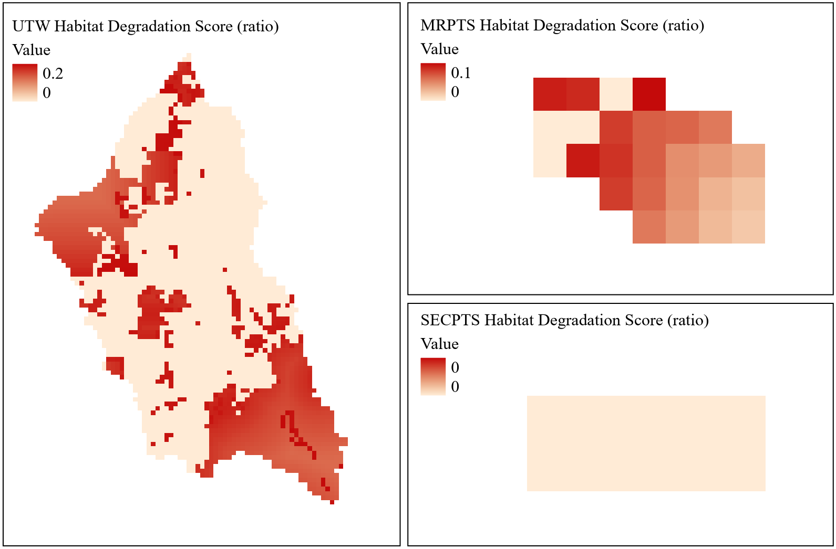
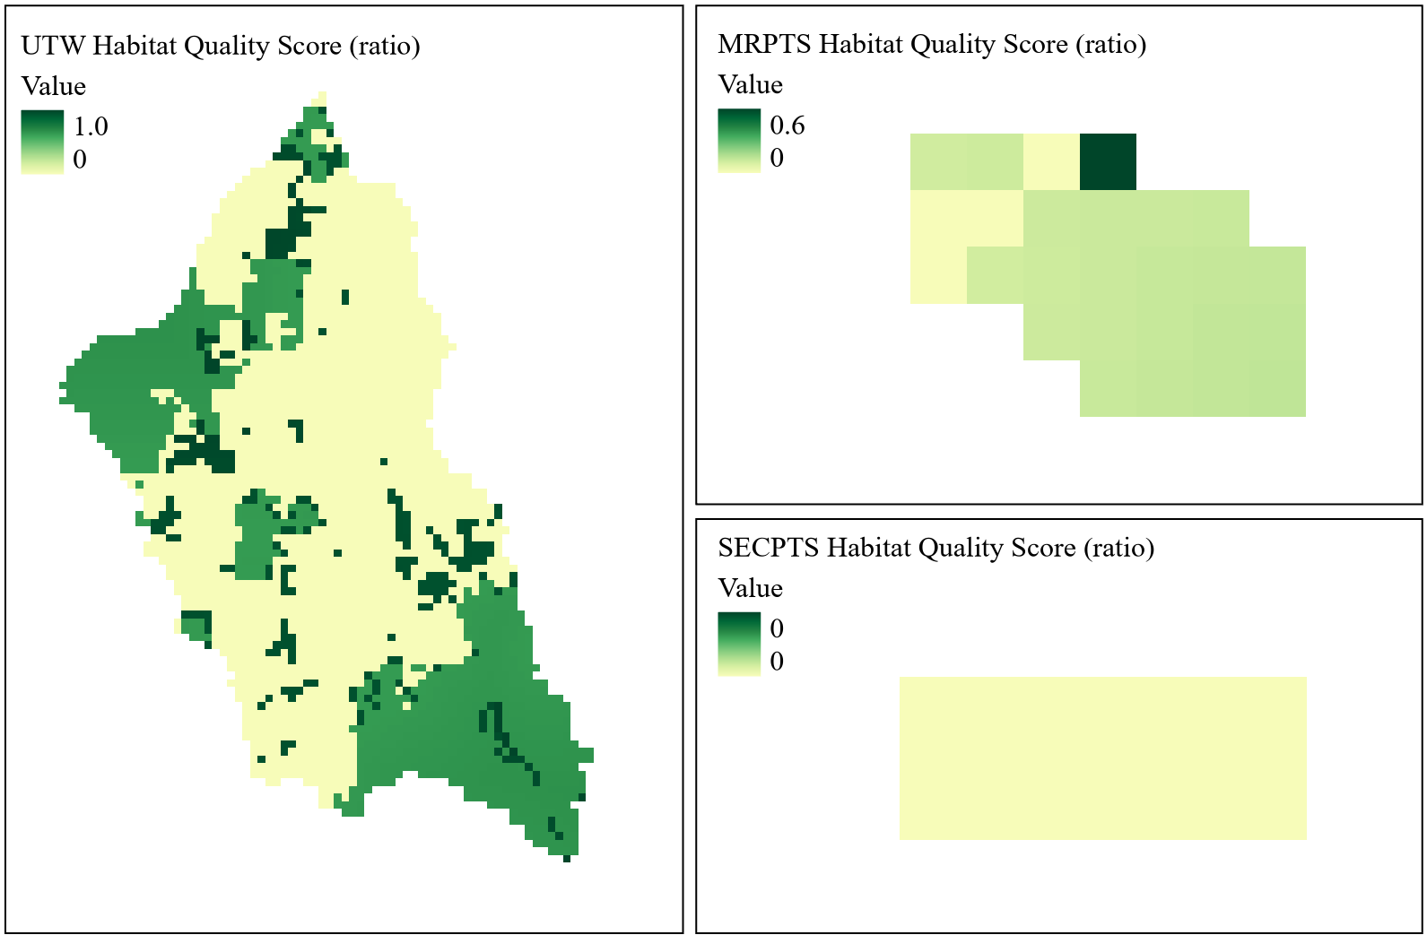
Figure 5-15. (1) Habitat degradation and (2) habitat quality: (a) Unnamed Tributary Watershed, (b) Mayer Ranch, and (c) Southeast Commerce.
Habitat degradation near the Tar Creek outflow had the highest score for the UTW, suggesting stream presence had a greater impact than mine water discharges or urban areas. Habitat quality declined in developed areas, mirroring the pattern seen in the IRW. There was a notable improvement in habitat quality near the MRPTS outflow into the UTW.
The influence throughout the process units was well reflected by the pattern of habitat degradation at MRPTS, however, the modest high degradation score of 0.1 suggests that the weight of the impact of mine water discharge was not well integrated into the model. Habitat quality for MRPTS showed little variability, only suggesting decreased habitat quality within the oxidation unit. Meanwhile, habitat degradation and quality at SECPTS scored 0 across the site, highlighting a possible limitation for site-scale applications.
5.2.7 InVEST USWR Outputs: Stormwater Retention
There were five raster outputs from the USWR model, including maps of retention and runoff volumes, stormwater retention, runoff ratios, and retention value. Relevant to the ES of stormwater retention are maps of retention volume in cubic meters per hectare per year (m³/ha/yr) and retention value in dollars per hectare per year ($/ha/yr).
Reported values on runoff volumes were consulted to evaluate output validity, assuming that retention volumes would be within the same order of magnitude. For the IRW, retention volumes ranged between 1,395 and 12,700 m³/ha/yr, with a narrower range of 7,100 and 12,700 m³/ha/yr for LF (Figure 5-16). Average retention volume for both the IRW and LF was 10,000 m³/ha/yr.
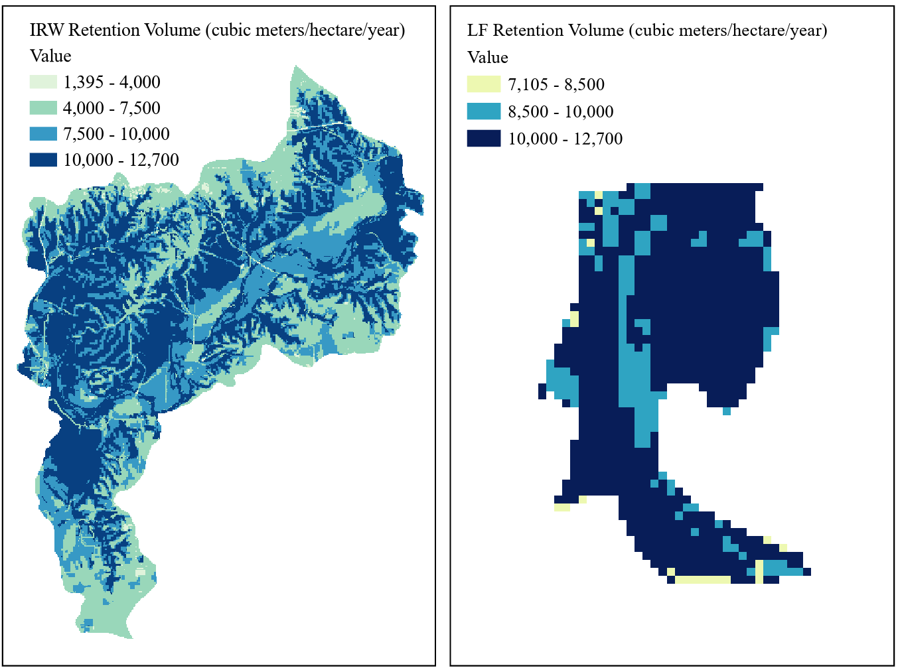
Figure 5-16. Stormwater retention: (a) Illinois River Watershed and (b) Lake Frances.
Laine (1959) reported an average runoff for the IRW of 35,400 m³/ha/yr, more than double the average of the IRW and LF outputs. Although the outputs were not within close range of this estimate, it should be expected that retention would be lower than runoff for any given water balance. Holmes et al. (2011) reported mean annual runoff for Arkansas and Oklahoma ranging between 50 and 5,615 m³/ha/yr, indicating retention volumes were within reasonable range of real-world values.
The retention value map shows the monetary value of stormwater retention, estimated based on the replacement costs associated with traditional grey infrastructure. For the IRW, retention values range from $7,400 to $68,000 per ha/yr, while for LF, values ranged from $37,650 to $68,000 per ha/yr (Figure 5-17).
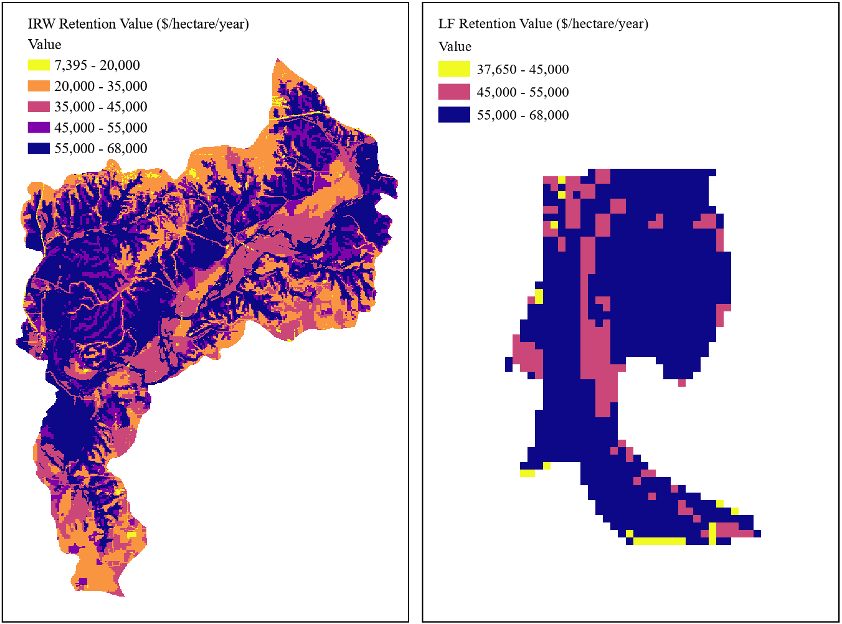
Figure 5-17. Stormwater retention value: (a) Illinois River Watershed and (b) Lake Frances.
A summary of proposed values for green infrastructure reported a replacement value of $305,700 per ha/yr for bioretention services (FEMA, 2022), indicating that outputs were low and may be underestimated. Hellman et al. (2018) reported a range from $100 to $1,532 per ha/yr, alternatively inferring that outputs were high and may be overestimated. Watson et al. (2016) reported avoided damage costs for flood attenuation provided by wetlands and floodplains ranging between $100 and $9,000 per ha/yr. Considering all sources together, the range from $100 to $306,000 per ha/yr points to the average value of $55,000 for bioretention at LF being a reasonable estimate, though it fell within the upper end of values.
5.2.8 InVEST Outputs: Flood Attenuation (UFRM)
The UFRM model generated five outputs, including a parameter log, three rasters, and a shapefile of watershed results. Output maps include average runoff retention index values, runoff retention volumes, and flood volume. The runoff retention outputs were used to assess the ES of flood attenuation at each site.
Results varied considerably between the 5-minute and 24-hour rainfall event duration intervals. For both LF and IRW, runoff retention volumes reached 168 cubic meters per hectare per year (m³/ha/yr) for a 16.8 mm rainfall depth and 1,420 m³/ha/yr for a 142 mm depth (Figure 5-18).
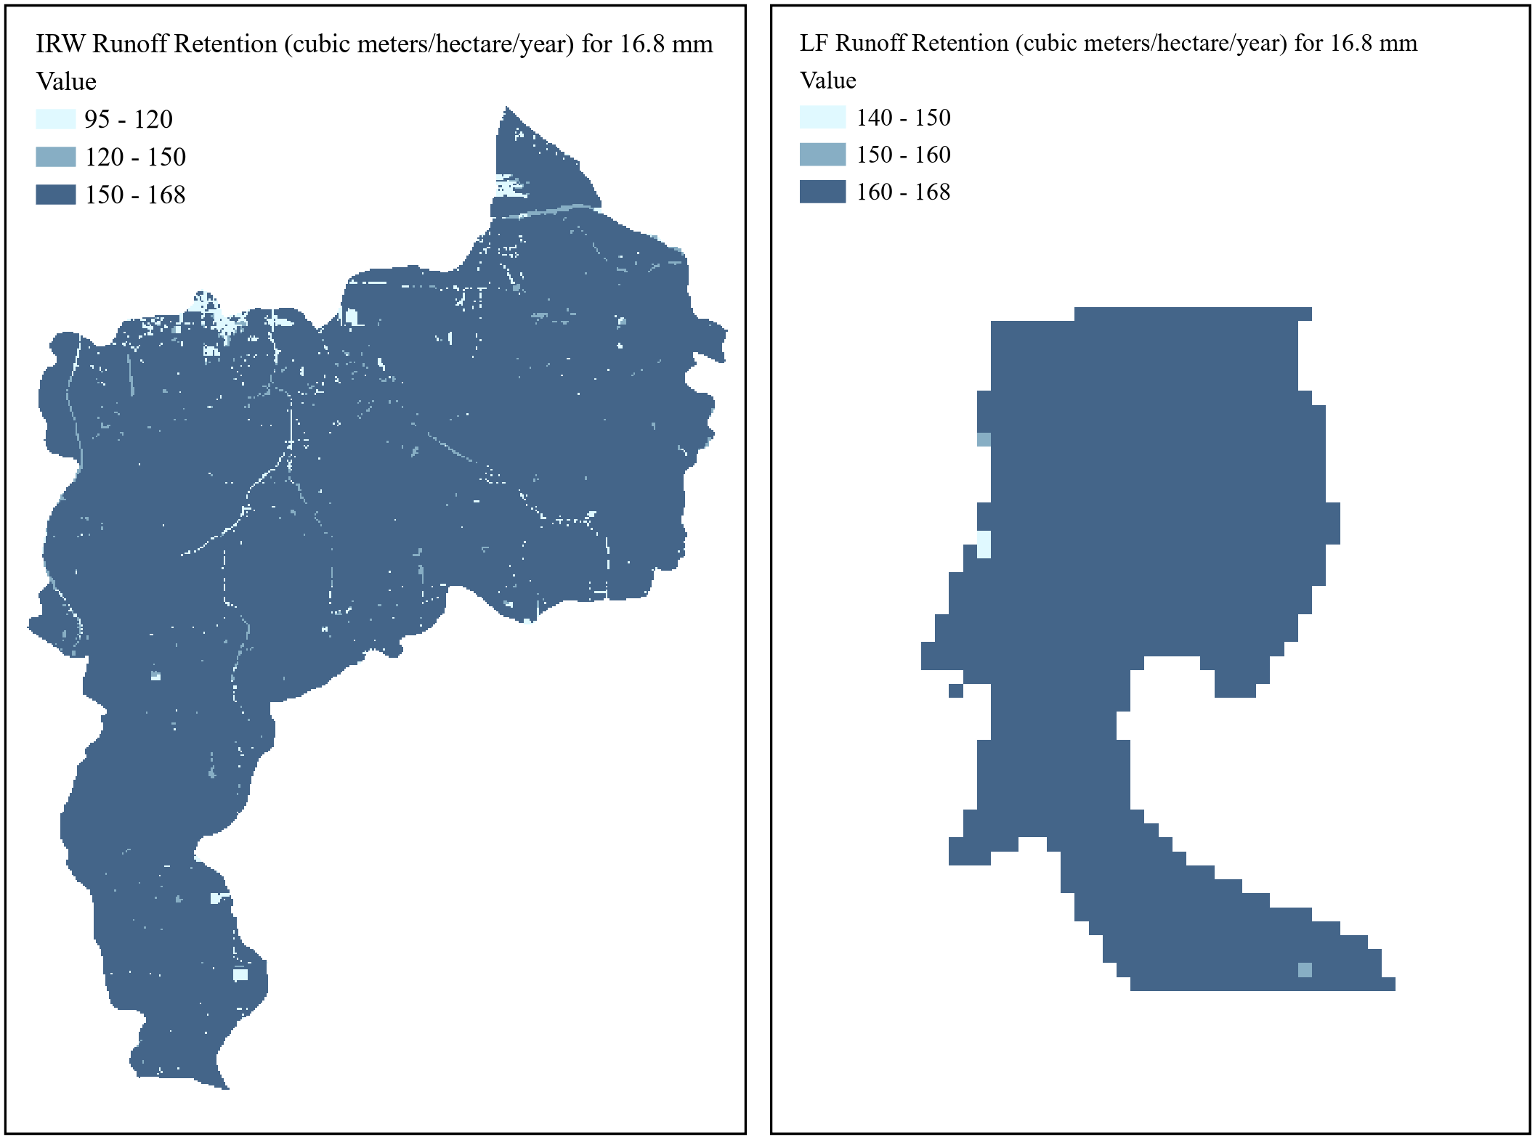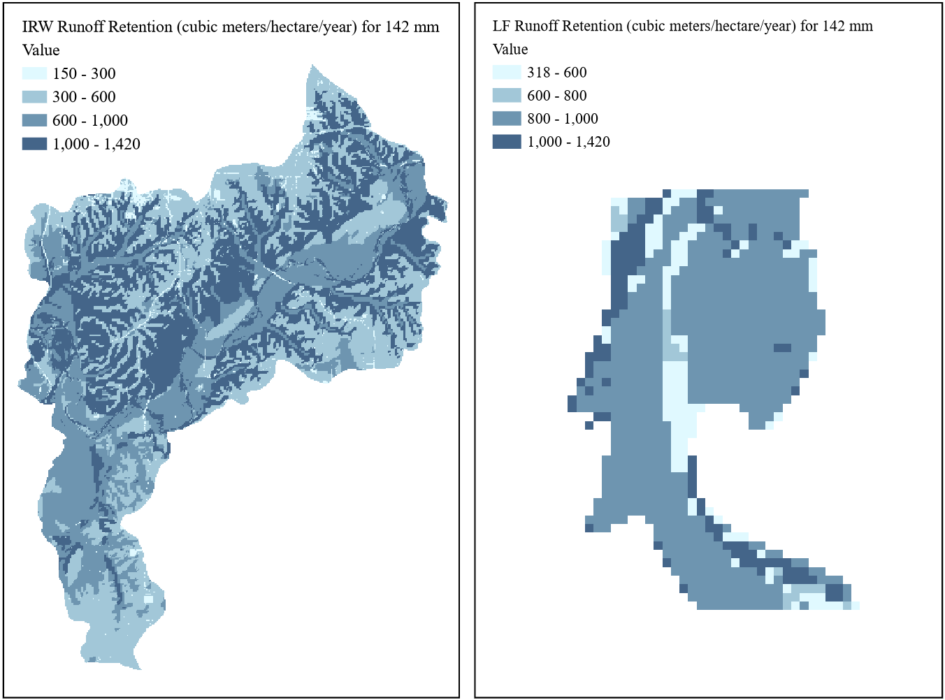
Figure 5-18. Runoff retention for rain depths of (1) 16.8 mm and (2) 142 mm: (a) Illinois River Watershed and (b) Lake Frances.
At a rainfall depth of 16.8 mm, the average runoff retention volume for the IRW and LF was 160 m³/ha/yr, whereas a depth of 142 mm yielded an average retention volume of 800 m³/ha/yr. Runoff retention reported by Salata et al. (2021) ranged between 247 and 357 m³/ha/yr, suggesting outputs were low for the 16.8 mm rainfall depth and possibly underestimated, while outputs were high or overestimated for the 142 mm depth. Compared to mean annual runoff for Arkansas and Oklahoma reported by Holmes et al. (2011), ranging from 50 to 5,615 m³/ha/yr, retention volumes were within reasonable range of observed runoff volumes.
For the UTW, retention volumes peaked at 170 m³/ha/yr for a rainfall depth of 16.9 mm and 1,460 m³/ha/yr for a depth of 146 mm. At MRPTS, peak retention volumes were 160 m³/ha/yr for a 16.9 mm depth and 450 m³/ha/yr for a 146 mm depth. SECPTS retention volumes were estimated to be 95 m³/ha/yr across the site for a 16.9 mm depth and 150 m³/ha/yr for a 146 mm depth (Figure 5-19).

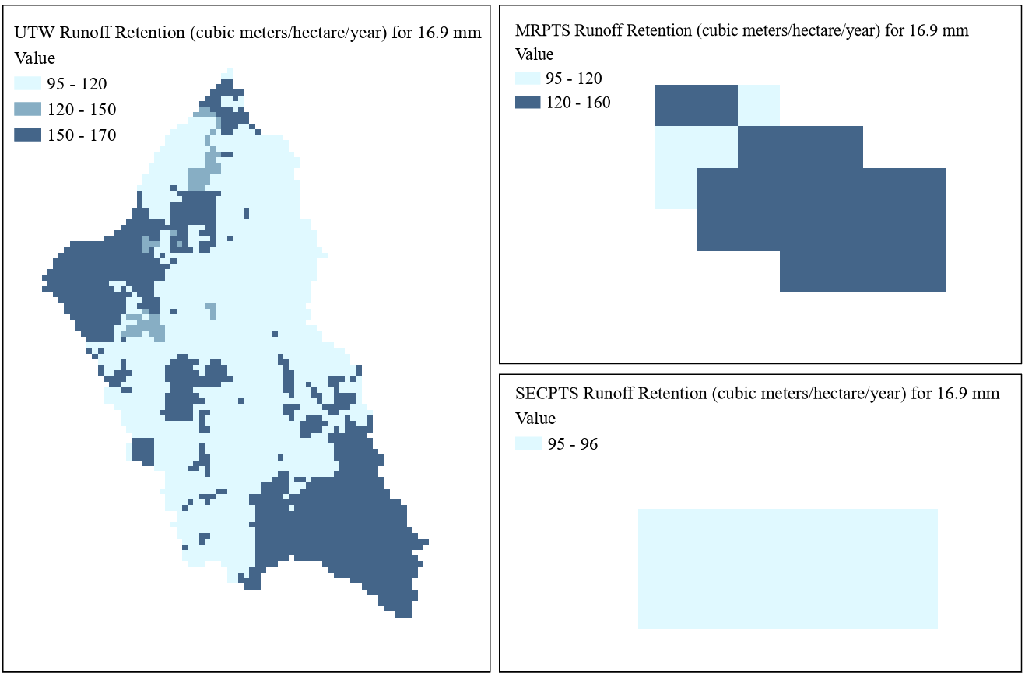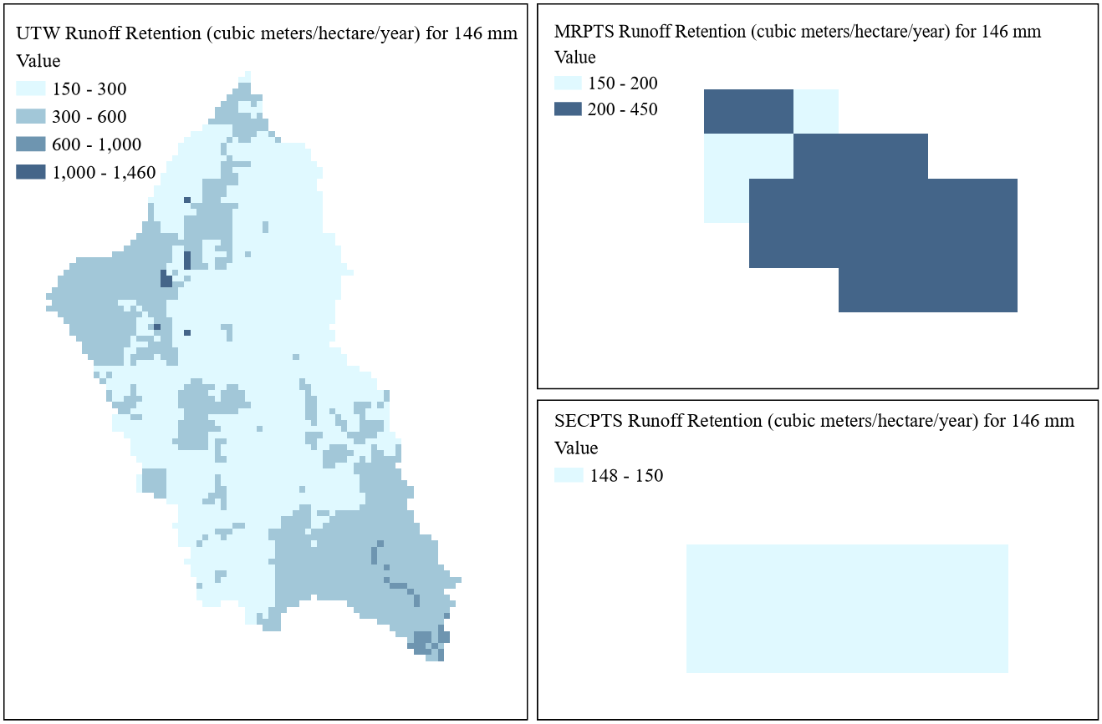
Figure 5-19. Runoff retention for rain depths of (1) 16.9 mm and (2) 146 mm: (a) Unnamed Tributary Watershed, (b) Mayer Ranch, and (c) Southeast Commerce.
For a rainfall depth of 16.9 mm, average runoff retention volume for the UTW and MRPTS was 130 m³/ha/yr, increasing to 280 m³/ha/yr for a depth of 146 mm. At SECPTS, retention volumes were 95 m³/ha/yr for a depth of 16.9 mm and 150 m³/ha/yr for a depth of 146 mm. Compared to runoff retention values reported by Salata et al. (2021) ranging between 247 and 357 m³/ha/yr, outputs were low or perhaps underestimated for the 16.9 mm rainfall event, but within range for the depth of 146 mm. Runoff volumes reported by Holmes et al. (2011) for Arkansas and Oklahoma ranging between 50 and 5,615 m³/ha/yr suggest that outputs for the UTW, MRPTS, and SECPTS fell within reasonable range of expectations for the region.
5.2.9 ESII Outputs Overview
ESII outputs come in two forms: (1) percent performance and (2) engineering units (TNC et al., 2016). While percent performance results offer unique, informative measures, this research focused on the latter. In total, ESII generated 13 model results describing the performance of six ES including climate regulation, water quality regulation, water provisioning, water quantity control, erosion regulation, and aesthetic quality (TNC et al., 2016).
Percent performance scores gauge the suitability of a habitat to support a specific ES, producing a percentage relative to the highest potential performance for that service and landscape type (Guertin et al., 2019). Percent performance metrics, though not the primary focus, provided unique and informative benchmarks to facilitate direct comparisons between ES within a site (TNC et al., 2016). Though only highlights of ES percent performance results are discussed for illustrative purposes, Tables C3, C4, and C5 outline results in detail.
At LF, the highest performing ES was air quality regulation as nitrogen removal (72%), followed by water quantity control (68%), and erosion regulation (63%). Compared to reference habitats, nitrogen removal had a high performance (>70%), while water quantity control, erosion regulation, noise attenuation, visual habitat quality, particulate matter removal, air and water temperature regulation, water filtration, nitrogen removal, and carbon uptake received medium performance scores (30-70%). Water provisioning and mass wasting fell within the low performance category (0-9%) (TNC et al., 2016).
At MRPTS and SECPTS, the highest performing ES was water quantity control (95%), followed by air quality control as particulate removal (56% and 57%) and erosion control (56% and 57%). Percent performance benchmarks indicated water quantity control was a high performance ES, while erosion control and air particulate matter removal were medium performing ES. Low performing ES at the PTSs included atmospheric nitrogen removal, mass wasting, noise attenuation, visual habitat quality, air and water temperature regulation, carbon uptake, and, surprisingly, water filtration. Given that the design purpose of the PTSs is to tackle contaminants, the outcome reveals a potential limitation of ESII in capturing the complex dynamics of a PTS (TNC et al., 2016).
Outputs in engineering units offered quantitative measures of ES performance across each site. Tables C6, C7 and C8 list the complete set of results. To understand ES at each site, results were discussed for the site as a whole and per map unit (Figures 5-20 and 5-21) (TNC et al., 2016).
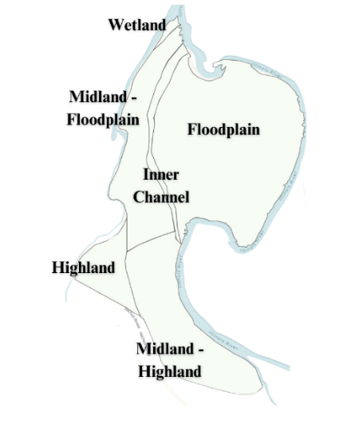
Figure 5-20. ESII map units: Lake Frances.
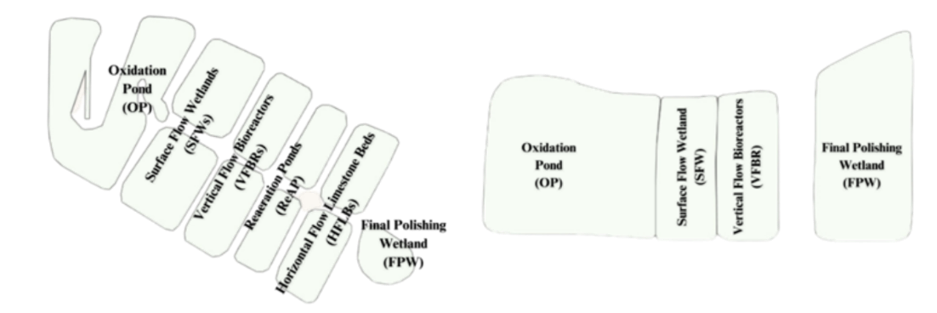
Figure 5-21. ESII map units: (a) Mayer Ranch and (b) Southeast Commerce.
5.2.10 ESII Outputs: Water Provisioning
ESII water provisioning outputs predict a habitat's capacity to provide water for essential use, reflecting the landscape's capability to capture, infiltrate, and store water. The ESII water provisioning outputs for LF (Figure 5-22) aligned reasonably well with the literature, reaching a maximum of 733 m³/ha/yr.
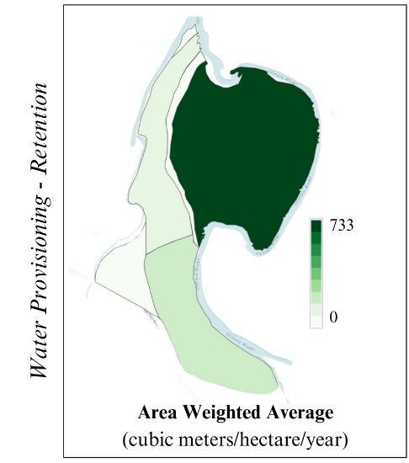
Figure 5-22. Water provisioning: Lake Frances.
Compared to the range of runoff retention outputs reported by Salata et al. (2021) between 247 and 357 m³/ha/yr, the LF water provisioning average of 300 m³/ha/yr appears to be within reasonable range. Holmes et al. (2011) reported a range of mean annual runoff values for Arkansas and Oklahoma between 52 and 5,615 m³/ha/yr, further supporting that output volumes were, at a minimum, realistic.
Water provisioning outputs for MRPTS and SECPTS were high compared to literature values, indicating potential overestimation. On average, MRPTS and SECPTS were estimated to retain approximately 7,800 m³/ha/yr (Figure 5-23).
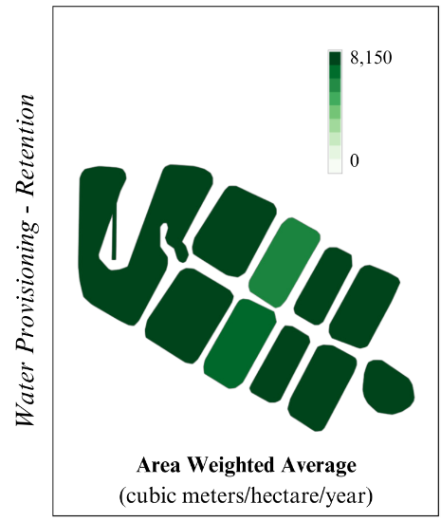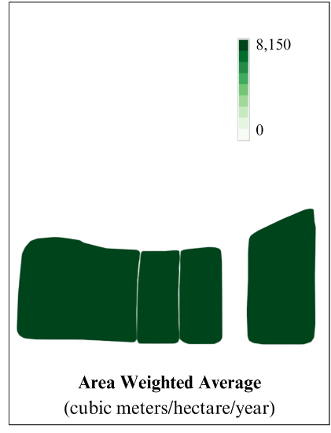
Figure 5-23. Water provisioning: (a) Mayer Ranch and (b) Southeast Commerce.
Estimates of runoff retention from Salata et al. (2021) and Holmes et al. (2011) suggest that outputs were likely overestimated for MRPTS and SECPTS. This discrepancy is likely due to inaccurate interpretation of input data, which accounts for the presence and influence of seeps at the site but does not request additional detail concerning seep type or discharge rate. Further, while habitat types include an option for man-made aquatic infrastructure, the selection does not specify infrastructure purpose, incorrectly operating under the assumption that the PTSs were retention ponds. The combination of these two factors can likely explain the overestimation, however, this highlights remaining limitations for ESII as a tool for PTS applications.
5.2.11 ESII Outputs: Air Quality Regulation (NO_{X} and PM₁₀ Removal)
Air quality regulation was modeled as removal rates of two air filtration parameters: atmospheric nitrogen (NO_{X}) and particulate matter (PM₁₀). NO_{X} removal amounted to 2.6 kilograms per hectare per year (kg/ha/yr) and 14 kg/ha/yr for PM₁₀ removal across LF (Figure 5-24).
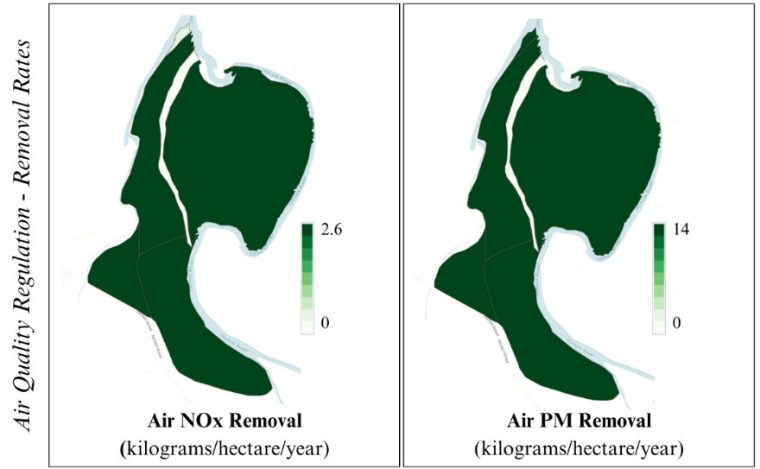
Figure 5-24. (1) Air nitrogen removal and (2) particulate matter removal: Lake Frances.
While LF outputs for NO_{X} removal exceed the 0.006 to 0.01 kg/ha/yr range reported by Mayer et al. (2007), with a maximum and average of 2.6 kg/ha/yr, which indicates possible overestimation. Gil-Alana et al. (2020) estimated an average PM₁₀ removal of 0.2 kg/ha/yr for Oklahoma, with values peaking at 0.86 kg/ha/yr. Comparatively, PM₁₀ removal at LF was high, with an average value of 14 kg/ha/yr, potentially suggesting overestimation.
For MRPTS and SECPTS, air quality removal rates for both parameters were nearly negligible, with a maximum NO_{X} removal of 0.004 kg/ha/yr for MRPTS and 0.005 kg/ha/yr for SECPTS. PM₁₀ removal peaked at 0.02 kg/ha/yr for MRPTS and 0.03 kg/ha/yr for SECPTS (Figure 5-25).
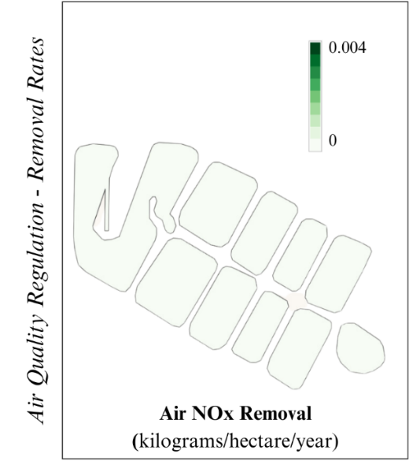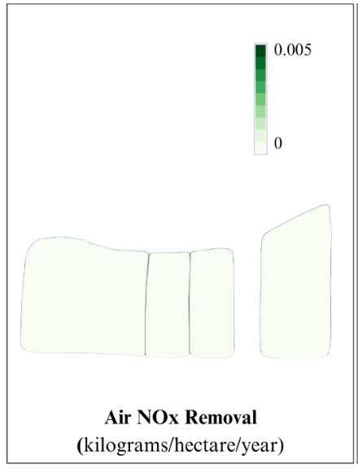
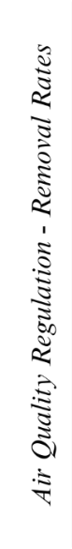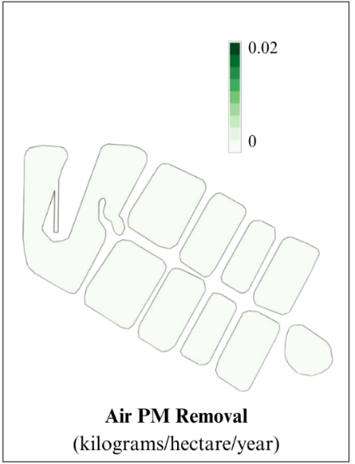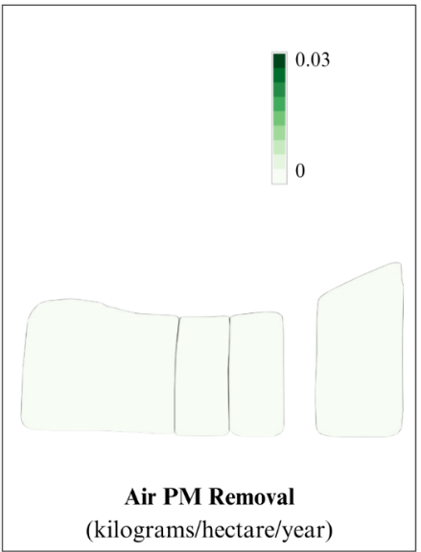
Figure 5-25. (1) Air nitrogen removal and (2) particulate matter removal: (a) Mayer Ranch, and (b) Southeast Commerce.
Compared to nitrogen removal rates ranging between 0.006 and 0.01 kg/ha/yr reported by Mayer et al. (2007), MRPTS and SECPTS values were low, possibly indicating overestimation. A study assessing constructed wetland denitrification observed an average NO_{X} removal of 938 kg/ha/yr (Mander et al., 2021), substantially exceeding the maximum estimated values of 0.004 kg/ha/yr for MRPTS and 0.005 kg/ha/yr for SECPTS. Removal rates in constructed wetlands were reported by Groh et al. (2015) to range from 152 to 1,013 kg/ha/yr, supporting the conjecture that outputs were low and perhaps underestimated.
PM₁₀ removal at MRPTS peaked at 0.02 kg/ha/yr, while SECPTS exhibited a slightly higher peak at 0.03 kg/ha/yr. Outputs were low compared to the average of 0.2 kg/ha/yr and maximum value of 0.9 kg/ha/yr reported by Gil-Alana et al. (2020), suggesting possible underestimation of PM₁₀ removal outputs.
5.2.12 ESII Outputs: Climate Regulation (Reduction Shade)
ESII generates reduction shade measures as a proxy for temperature control, a function which contributes to the ES of climate regulation. For LF outputs, reduction shade showed little variation across the site (Figure 5-26).
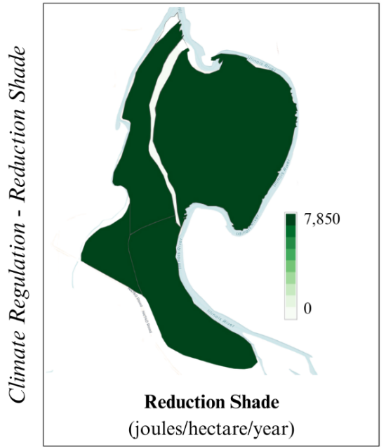
Figure 5-26. Reduction shade: Lake Frances.
For LF, reduction shade was 7, 850 Joules per hectare per year (J/ha/yr) except for within the inner channel, with sparser vegetative cover. This resulted in an average value of 7,500 J/ha/yr for LF. Guertin et al. (2019) reported a value of 115,000 J/ha/yr for an ecologically restored site, suggesting LF values were low and could be underestimated.
MRPTS and SECPTS outputs demonstrated variation between process units. In line with logical reasoning, reduction shade increased with vegetation density (Figure 5-27).
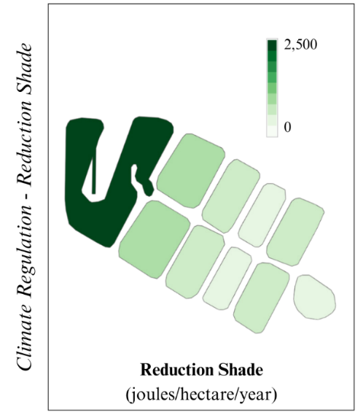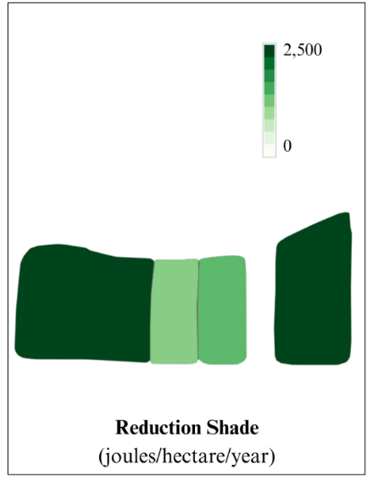
Figure 5-27. Reduction shade: (a) Mayer Ranch and (b) Southeast Commerce.
At MRPTS and SECPTS, reduction shade was greatest within the OPs, coinciding with the highest accumulation of iron sludge material. Denser vegetation correlated with higher reduction shade values. Guertin et al. (2019) reports an average of 70,000 J/ha/yr reduction shade for an unrestored site, suggesting MRPTS and SECPTS outputs were low and may be underestimates of real-world values.
5.2.13 ESII Outputs: Water Quality Control (NO_{X} and TSS Removal)
ESII’s water quality control model outputs maps of nitrogen (NO_{X}) and total suspended solids (TSS) removal in milligrams per liter per year (mg/l/yr). NO_{X} removal at LF peaked at 0.85 mg/l/yr, with an average of 0.22 mg/l/yr, while TSS removal reached 52 mg/l/yr, with an average of 13 mg/l/yr (Figure 5-28).
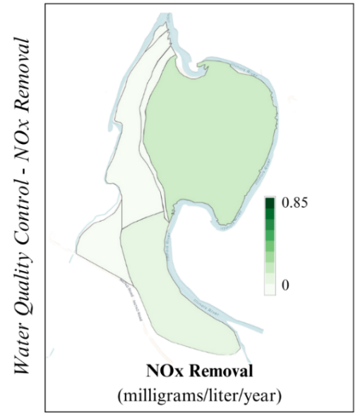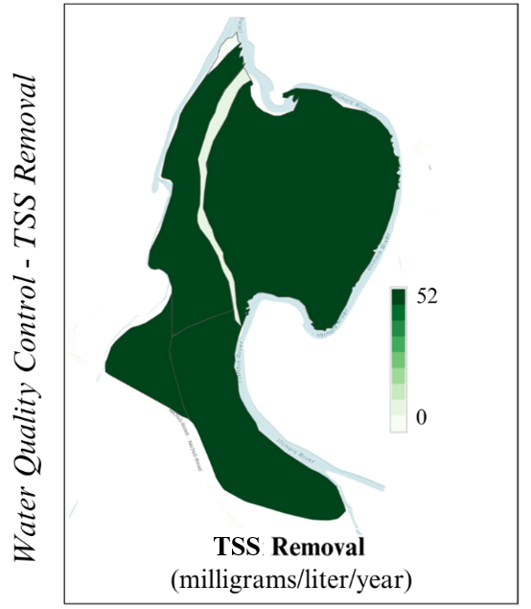
Figure 5-28. (1) Nitrogen removal and (2) total suspended solids removal: Lake Frances.
Hunter et al. (2009) reported nutrient removal of forested wetlands ranging from 2.3 mg/l/yr to as much as 68 mg/l/yr, suggesting that NO_{X} removal for LF was low or underestimated. The 1.6 mg/l/yr nitrogen reduction rate reported by Thralls (2010) further supports that LF outputs were low and may be underestimated. Thralls (2010) also reported mean TSS loads ranging from 40 to 165 mg/l/yr. While not a direct comparison for TSS removal, this suggests that removal estimates were within reasonable range of load rates.
For MRPTS and SECPTS, maximum NO_{X} removal reached 0.86 mg/l/yr, with an average removal of 0.18 mg/l/yr. TSS removal for MRPTS peaked at 26 mg/l/yr, with an average of 7.6 mg/l/yr. TSS at SECPTS reached 30 mg/l/yr, with an average removal rate of 8 mg/l/yr (Figure 5-29).
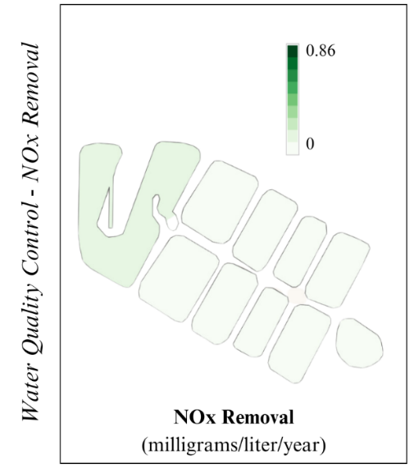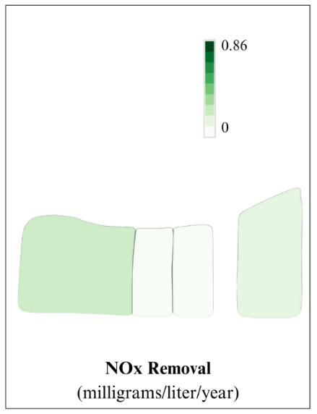
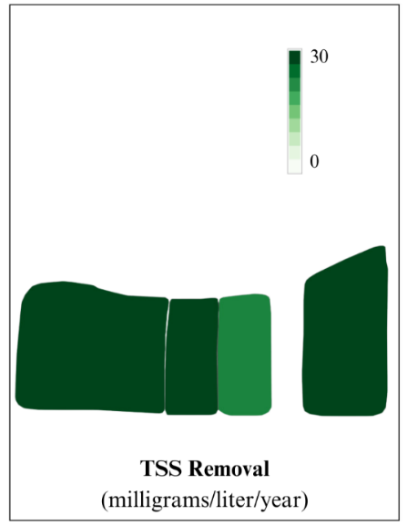
Figure 5-29. (1) Nitrogen removal and (2) total suspended solids removal: (a) Mayer Ranch and (b) Southeast Commerce.
Outputs of nitrogen removal for the PTSs were contrasted with passive nitrogen reduction systems' data reported by Anderson and Hirst (2015), ranging from 23 to 97 mg/l/yr. This may suggest underestimation of MRPTS and SECPTS outputs, further corroborated when compared against the average NO_{X} removal rate of 96 mg/l/yr reported by Dzakpasu et al. (2011).

5.2.14 ESII Outputs: Water Quantity Control (Runoff Retention)
ESII water quantity control outputs offer insight into a habitat’s capacity to absorb the surge of a 25-year storm event. For LF, water quantity control reached a maximum runoff retention volume of 24,700 m³/yr (Figure 5-30).
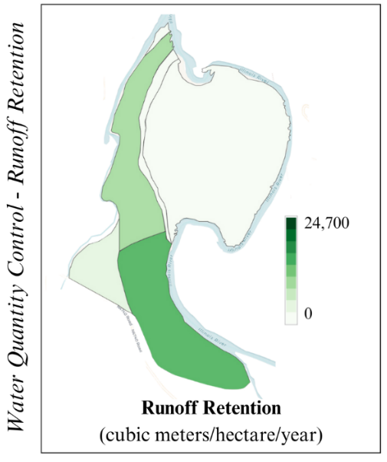
Figure 5-30. Runoff retention: Lake Frances.
Average runoff retention for LF was 235 m³/ha/yr, aligning with runoff retention data reported by Salata et al. (2021), with values ranging between 247 and 357 m³/ha/yr. Holmes et al. (2011) reported mean annual runoff volumes between 50 and 5,615 m³/ha/yr, further supporting that outputs were within reasonable range of observed values.
For MRPTS and SECPTS, there was no variation in runoff retention between process units. Overall, outputs were low, peaking at 2.18 for MRPTS and 1.15 m³/ha/yr for SECPTS (Figure 5-31).
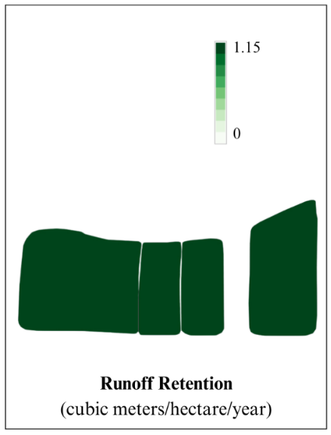
Figure 5-31. Runoff retention: (a) Mayer Ranch and (b) Southeast Commerce.
The average retention volume for MRPTS was 2.0 m³/ha/yr and 1.0 m³/ha/yr for SECPTS. Compared to retention estimates reported by Salata et al. (2021) and runoff volumes recorded by Holmes et al. (2011), runoff retention outputs were low, suggesting potential underestimation.
5.3 Evaluative Criteria Results
Results of ES-DSTs were qualitatively assessed relative to evaluative criteria to identify ES-DSTs most applicable for use in inland wetland habitats. The qualitative findings from the application of ES-DSTs were evaluated against predefined criteria, drawing conclusions based on personal experience with the application process. The evaluative criteria results were given either low, medium, or high performance scores (Table 5-1).
Table 5-1. ES-DST tool comparison relative to evaluative criteria.
Predefined Criteria | InVEST | ESII
(1) Level of Site-Specificity | Medium | High
(2) Services Evaluated | High | Medium
(3) Value Output | High | Medium
(4) Spatial Scalability | Medium | High
(5) Level of Difficulty | Medium | Low
(6) Time Requirement | Medium | Medium
The degree of site-specificity for each ES-DST was determined by assessing the extent of site-specific requirements, which include primary data and regionally derived secondary inputs. InVEST received a medium rating for site-specificity due to its emphasis on modeled inputs. ESII received a high rating for site-specificity because it mandated and provided instruction for field observations.
Versatility was assessed based on which types of services (provisioning, regulating, cultural, and supporting) were evaluated by each tool. InVEST was rated high because it can evaluate a total of 18 services spanning all four ES categories of ES. The ESII tool was also given a medium rating, addressing three out of the four ES categories in its outputs.
The suitability of output values from each tool for integration into a BCA focused on identifying metrics that can be commonly employed and easily compared, such as specific quantitative values and well-defined value ranges. InVEST outputs are deemed highly conducive for BCA incorporation, providing a diverse array of traditional engineering measurements that are useful for economic valuation. While most InVEST models do not explicitly provide economic valuation, the quantitative outputs still serve as a foundation for valuation. ESII was assigned a medium rating for its potential to be integrated into a BCA, given that its outputs primarily consist of engineering measurements. For any tool, data should be calibrated and validated before valuation is performed.
Spatial adaptability was regarded as favorable for ES-DSTs compared to those with limited or inflexible capabilities. InVEST was attributed a medium rating for spatial adaptability, as it allows for site-level analyses; however, its optimal effectiveness was observed at the watershed-scale, meaning conducting analyses at the site-level compromised the quality of resulting data. ESII received a high spatial adaptability rating due to its remarkable scalability, developed for user-defined sites and habitat units, with virtually no limits to its applicability.
Application difficulty was gauged by the level of user-friendliness it offered. InVEST was given a medium rating due to the prerequisite GIS proficiency requirement for data preparation. InVEST offers a comprehensive User Guide and various supplementary resources, including example data sets and an online user forum where expert guidance is readily available. The ESII tool was given a low difficulty rating due to its straightforward step-by-step approach. ESII also offers extensive support, including the ESII User’s Guide, which provides PDF documents and videos covering various topics of tool usage, from initial workspace preparation to result interpretation.
Time considerations were evaluated based on convenience, with an emphasis on timeliness for tool implementation and application. InVEST received a medium rating because running each of the models was quick, however, preparing input data can be time-consuming, especially for practitioners with limited GIS experience. ESII was given a medium time requirement rating, as the field surveys can be time-intensive, but executing the ESII models was simple and fast, contributing to a balanced overall time profile.
5.4 Educated Partner Feedback Results
Educated partners were provided ten ES determined to be relevant to the LF site. They were tasked with ranking these ES from most to least important, assigning a value of 10 to the most important ES and a value of 1 to the least important. These values were then added to develop a cumulative score for each ES. Analysis of educated partner feedback for LF (Table 5-2) generally aligned with outputs generated by the ES-DSTs. However, notable disparities emerged, highlighting the importance of selecting the appropriate analytical tool for comprehensive evaluation.
Table 5-2. Lake Frances: educated partner feedback cumulative scores.
Rank | Service | Score
1 | Nutrient Retention | 39
2 | Flood Risk Mitigation | 32
3 | Stormwater Retention | 31
4 | Sediment Retention | 29
5 | Habitat Quality | 22
6 | Water Yield | 20
7 | Carbon Storage | 19
8 | Recreation/Education | 12
9 | Plant Pollination | 9
10 | Scenic Quality | 7
Educated partner responses regarded nutrient retention as the most important ES at LF. Comparatively, ES-DST outputs underestimate the importance of nutrient retention. Both the InVEST and ESII tools suggested there was negligible retention occurring at LF, on the contrary, indicating that the site may even be contributing to nutrient loads. This discrepancy between educated partner assessments and modeling outputs highlights the need for careful interpretation and integration of diverse sources of information in ES assessments.
Per educated partner responses, stormwater retention emerges as the third most vital ES at LF. This ranking is consistent with the well-documented capacity of BHFs to effectively capture and store runoff (King and Allen, 1996). It is logical that educated partner possessing local knowledge of the site, and thus understanding the significant impact of stormwater runoff on water quality and flooding frequencies downstream of the site, would accord such high importance to stormwater retention.
When compared to tool outputs, the perceived value of stormwater retention at the site aligned well with InVEST’s interpretations. While ESII does not directly assess this service, insights into stormwater retention at the site can be inferred based water quantity control and water filtration outputs. ESII regards water quantity control as the second most important ES at LF, while water filtration was the least, diverging from educated partner perspectives. Considering this, InVEST may be a more appropriate tool selection for gathering ES data to inform decisions with an emphasis on stormwater retention.
For MRPTS and SECPTS, educated partners were presented with a list of eight ES deemed relevant to the sites (Table 5-13). They were tasked with ranking these ES from most (8) to least important (1). These values were summed to calculate a cumulative score for each ES. The educated partner feedback for the PTSs (Table 5-3) highlights the pivotal role of human perspectives in the decision-making process.
Table 5-3. Mayer Ranch and Southeast Commerce: educated partner feedback cumulative scores.
Rank | Service | Score
1 | Contaminant Buffering | 32
2 | Habitat Quality | 25
3 | Education and Research | 22
4 | Economic Benefits | 18
5 | Plant Pollination | 18
6 | Carbon Storage | 13
7 | Scenic Quality | 11
8 | Non-Potable Water Yield | 5
Educated partner responses revealed that contaminant buffering was considered the most critical ES at the PTSs. ES-DST outputs exhibited a diminished emphasis on water quality buffering, a discrepancy which was attributed to the limited flexibility of the tools in representing PTSs realistically. This underscores the need for enhanced flexibility and customization options within ES-DSTs to better reflect the complex dynamics of PTSs designed for pollutant buffering in mine-affected environments.
Habitat quality was regarded as the second most important ES for the PTS sites according to educated partner input. InVEST results demonstrated that habitat provided by MRPTS surpasses that of surrounding habitats within the UTW, aligning with anecdotal site observations. ESII outputs do not explicitly depict this aspect, suggesting that InVEST is better equipped to provide decision-makers with valuable information for prioritizing wildlife conservation efforts based on habitat quality indicators.
Collective educated partner feedback highlights the perceived value of cultural services at the PTS sites, with the ES of education and research ranked as the third most important. This highlights a significant gap in both InVEST and ESII—neither tool explicitly addresses cultural services beyond recreation and aesthetic quality. This limitation underscores the need for greater consideration and creative integration of cultural services into ES-DSTs.
5.5 Camera Trapping Results
In this study, a more refined approach to wildlife observation was adopted. Instead of calculating traditional detection rates over time, the focus was on capturing noteworthy events to provide insights into animal activity and habitat suitability. This adaptation was necessary due to the limitations of the detection rate approach, revealed during capture processing. When applied to a small sample size, the detection rate approach likely distorts accurate species estimates. To improve statistical power and accuracy, it is advisable to employ a larger sample size in future studies (Kolowski et al, 2021).
This research recorded notable events, including events that capture relatively rare species sightings, multiple consecutive occurrences, and species interactions. In twelve (Figure 5-32) deployments across distinct habitat locations at LF, a total of 291 notable captures were recorded, within which 12 different species were identified between late January to early December 2023.
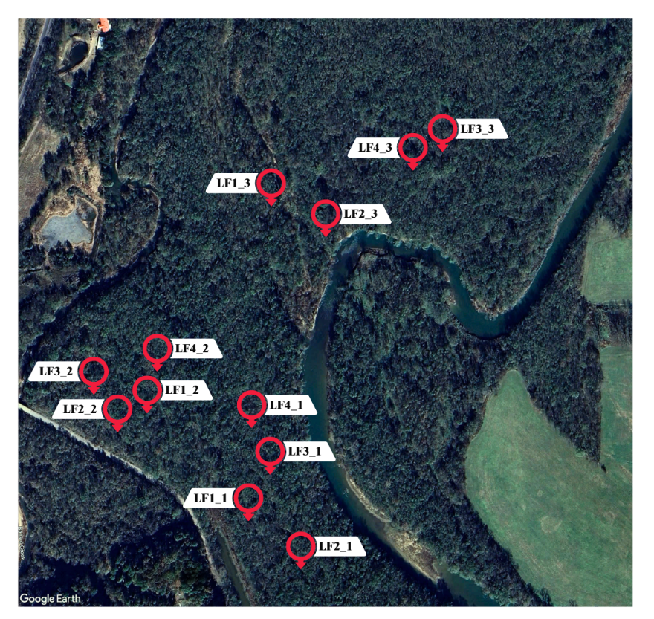
Figure 5-32. Map of wildlife camera deployments at Lake Frances.
Identified species include the nine-banded armadillo (Dasypus novemcinctus), Southeastern coyote (Canis latrans), white-tailed deer (Odocoileus virginianus), Great Pyrenees dog (Canis lupus familiaris), North American possum (Didelphis virginiana), woodchuck (Marmota monax), raccoon (Procyon lotor), North American river otter (Lutra canadensis), fox squirrel (Sciurus niger), an unknown snake species, Northern cardinal (Cardinalis cardinalis), and American crow (Corvus brachyrhynchos). A snapshot of species presence and individual species occurrence rates per camera deployment is provided in Table 5-14. More detailed information on notable captures and representative images for each camera during each deployment are presented in Table D1.
For each deployment, the percentage capture of total events was calculated to visually assess the spatial distribution of species across the site (Figure 5-33). An emerging trend indicates increasing species occurrence with distance from the developed road area. Furthermore, this trend appears to correlate with proximity to water bodies, demonstrated by higher species occurrence rates coinciding with the presence of inner channels within the floodplain. This relationship was illustrated through the findings from deployments LF1_3, LF2_1, and to a lesser extent, LF4_3.
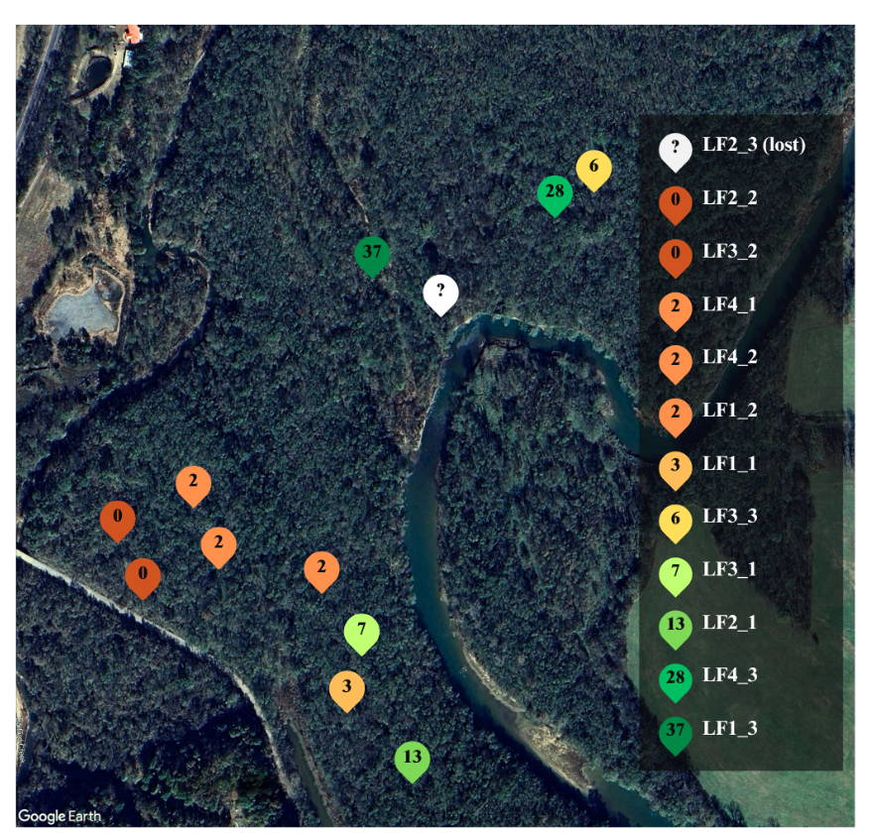
Figure 5-33. Spatial distribution of notable events by percent of captures per location of a total of 291 occurrences.
Species richness exhibits a similar pattern, with a greater number of species observed at locations farther from the roadway and in closer proximity to the river within the floodplain areas. For instance, deployment LF1_3 recorded a total of nine distinct species, while deployment LF2_1 documented four species. Conversely, deployments LF2_2 and LF3_2 recorded no wildlife species, indicating a stark contrast in species richness across the site. This observation underscores the influence of environmental factors such as proximity to water bodies and habitat quality on species diversity within the study area. Notable events are documented in Table D2, but Table 5-4 provides a snapshot of species’ richness and the composition of observed communities during each deployment.
Table 5-4. Species richness snapshot and composition per deployment.
Deployment | Richness | Species Composition | Date
LF1_1 | 3 | 80% Deer, 10% Coyote, 10% Raccoon | 1/23 - 3/29/2023
LF1_2 | 1 | 100% Deer | 7/25 - 9/2/2023
LF1_3 | 9 | 44% Armadillo, 20% Deer, 11% Raccoon, 8% Squirrel, 7% Possum, 6% River Otter, 2% Coyote, 1% Snake, 1% Woodchuck | 9/2 - 12/8/2023
LF2_1 | 4 | 44% Armadillo, 33% Deer, 13% Squirrel, 10% Possum | 1/23 - 3/29/2023
LF2_2 | 0 | - | 7/25 - 9/2/2023
LF2_3 | NA | NA | Stolen
LF3_1 | 3 | 74% Deer, 21% Squirrel, 5% Dog | 3/29 - 5/25/2023
LF3_2 | 0 | - | 7/25 - 9/2/2023
LF3_3 | 1 | 100% Deer | 9/2 - 12/8/2023
LF4_1 | 2 | 60% Deer, 40% Squirrel | 3/29 - 5/25/2023
LF4_2 | 4 | 57% Deer, 14% Squirrel, 14% Crow, 14% Cardinal | 7/25 - 9/2/2023
LF4_3 | 1 | 100% Deer | 9/2 - 12/8/2023
Wildlife occurrence and richness were not observed to be influenced by the date of deployment. However, it is pertinent to advocate for more extensive investigations into the seasonal variability of wildlife patterns. A comprehensive understanding of seasonal changes in wildlife dynamics is crucial for elucidating the underlying mechanisms driving ecological processes and for informing conservation and management strategies tailored to different times of the year.
Kolowski et al. (2021) emphasized the importance of using larger sample sizes in wildlife camera trapping studies to improve statistical power and accuracy. Their findings underscore the potential of this approach in obtaining reliable estimates of species occurrence and distribution, ultimately contributing to better-informed conservation decisions. Moreover, employing a larger sample size facilitates the detection of rare or elusive species that are often missed in smaller sample sizes. This is particularly important for conservation efforts, as accurate assessments of species presence and abundance are essential for effective management and conservation planning.
It is imperative for future studies to delve deeper into the temporal dynamics of wildlife at the LF site, employing a statistically robust design to attain a comprehensive understanding. Investigating seasonal variations and long-term temporal changes in wildlife communities is of utmost importance. By scrutinizing seasonal patterns more closely, future studies could unveil more nuanced shifts in species behavior, habitat utilization, and community dynamics that often elude detection in short-term analyses. For example, many studies use occupancy models to interpret how the spatial distribution of species is influenced across different seasons. This approach allows researchers to assess not only the presence or absence of species but also their habitat preferences and patterns of movement over time (Premathilake and Jackson, 2018). By incorporating such methodologies, future investigations can capture the intricate interplay between environmental factors and wildlife dynamics, thereby enhancing our understanding of ecosystem functioning and informing more effective conservation strategies.
6.0 Conclusions
6.1 Quantifying Site-Level ES
6.1.1 Lake Frances: BHFs Enhance ES for Water Security and Beyond
Drawing upon a comprehensive analysis of outputs from both InVEST and ESII, supplemented by educated partner consultations, key ES at LF included stormwater retention and flood attenuation. While educated partner responses underscored nutrient retention as a crucial ES at the site, the InVEST and ESII tools do not accord this ES with the same level of import, producing low, potentially underestimated, outputs for both nitrogen and phosphorus. This discrepancy stresses the importance of taking a multifaceted approach, integrating stakeholder insights alongside analytical tools to ensure a nuanced understanding of ecosystem dynamics according to local priorities.
The LF case study employed ES-DSTs to illustrate how BHFs serve as natural sinks to mitigate the consequences of excess runoff and water pollution. The results could inform the site’s capacity as natural infrastructure for stormwater management. Integration of wildlife camera traps served to demonstrate the site’s importance as a habitat corridor for local wildlife. Demonstrated by the educated partner responses, the ES-DST outputs, and the wildlife observations, LF appears to be a natural ES hotspot. These data could, at a minimum, provide supporting evidence for preserving LF as natural infrastructure.
6.1.2 MRPTS and SECPTS: Restoring ES Beyond Water Quality in Mine-Impacted Habitats
Considering InVEST and ESII outputs plus educated partner consultations, the priority and highest performing ES at the PTSs included contaminant buffering and habitat quality. While educated partner feedback emphasizes the importance of cultural services, ranking education/research as the third most important ES at the PTSs, neither tool explicitly addresses cultural services beyond recreation and aesthetic quality. Addressing this gap is crucial for ensuring a holistic understanding of ES to inform decisions about conservation and management strategies moving forward.
The PTS case study demonstrates how NBS and other nature-based restoration approaches can be leveraged to tackle complex water quality challenges, while simultaneously enhancing ancillary ES, thus increasing the overall value of the infrastructure. ES-DST outputs provided visual and numerical representation of the myriad benefits offered by this targeted ecologically engineered NBS, yet constraints were encountered. Foremost, educated partner responses shed light on the limitations of InVEST and ESII in capturing unique site-specific influences, such as those found in mine-impacted landscapes. Nonetheless, this PTS pilot study illustrated how nature-based technologies can be harnessed to document the restoration of primary and ancillary ES at similarly irreversibly damaged (USEPA, 2000) Superfund and brownfield sites (Nairn et al., 2001).
6.2 ES-DSTs, like InVEST and ESII, Offer Quantitative Approaches to ES Analysis
This research investigated the use of ES-DSTs for assessing both explicit and implicit freshwater wetland ES. A pilot study approach was adopted to illustrate the effectiveness of selected ES-DSTs for quantifying site-level ES. Subjective evaluation of the tool application process revealed various insights about the varying strengths and weaknesses between InVEST and ESII, suggesting that tool selection plays a pivotal role in ES assessments. While InVEST provides a broad array of models for generating comprehensive ES data, its capability to deliver accurate site-specific evaluations is limited. ESII, while designed to guide targeted site-level ES assessments, does include options to incorporate unique influences, such as mine water discharge. Depending on the objectives of an ES assessment, multiple ES-DSTs could be applied to integrate results for improved quantification of ES. Regardless of the tool or tools applied, site-level calibration is necessary prior to valuation for BCA integration.
6.2.1 InVEST: Decoding Nature's Value to Empower Decision-Making
Given the White House's endorsement of initiatives aimed at integrating ES into BCAs, there is a pressing call for proactive efforts to address data gaps that encompass the multifaceted benefits at the site-level (OMB, 2024). Quantitative documentation of ES presence and effectiveness empowers decision-makers to compare between outcomes of conventional and nature-based infrastructure scenarios. InVEST, using a simple framework to link ES production functions to beneficiaries, holds potential as a conduit for site-scale quantitative ES analyses.
Offering a medium degree of site-specificity, InVEST evaluated a versatile range of services across three of the four MA ES categories, producing outputs which were well-suited for integration into a valuation equation for BCA integration. InVEST received a medium rating for difficulty and time considerations because of the prerequisite of GIS knowledge and timely GIS preparation phase, although, comprehensive support and resources were provided.
InVEST outputs were readily applicable for use in landscape development projects, especially amenable to for use in engineering, construction or other infrastructure planning and design fields. Once data is validated and calibrated at the site level, InVEST outputs can be valued by plugging them into cost-based valuation equations and integrating regional economic data. The findings of this research indicate that InVEST, when compared to other ES-DSTs, stands out as one of the most effective options for evaluating site-specific ecosystem benefits and translating them into a BCA.
6.2.2 ESII: Integrating Sustainability into Business-As-Usual Approaches
The timelier the consideration of nature-based alternatives during the planning and design of infrastructure decisions, the greater the feasibility of their integration (Guertin et al., 2019). With both international and national sustainability objectives at the forefront of media attention, ESII presents a straightforward method for integrating nature into corporate development strategies. ESII is an effective instrument to help guide businesses looking to showcase corporate commitment to the SDGs through site-level ES assessments. Despite its primary focus on the corporate realm, ESII's adaptability makes it applicable across diverse fields and situations.
ESII stands out for its emphasis on site-specificity, tailoring analyses to user-defined site maps. It offers versatility by generating a wide array of outputs that aid in understanding decision trade-offs. Although ESII does not value ES overtly, the outputs were suitable to be input into standard cost-based valuation methods with regional economic data to facilitate integration into a BCA (Badamfirooz, 2021). Despite ESII’s lengthy list of input requirements, it boasts a relatively efficient and simple step-by-step process, suggesting the tool has potential for widespread application.
6.3 Generating Unique, Site-Specific Measures to Improve ES Tracking
6.3.1 Engaging Stakeholders to Drive Site-Specific ES Investigation
Incorporating stakeholder perspectives is paramount in conducting comprehensive ES investigations (NESP, 2016). By understanding the intricate interactions between a site and its stakeholders, researchers can gain insights into a local community's willingness to invest in, or pay (WTP) for, the protection and enhancement of ES. Through dialogue and collaboration with stakeholders, researchers can identify valuable context and firsthand knowledge to understand key ES priorities and concerns. Stakeholder involvement also fosters a sense of ownership and responsibility among local communities towards their surrounding environment. This participatory approach not only enriches ES investigations but also promotes the development of interdisciplinary strategies for preserving ecosystem health and resilience (NESP, 2016).
6.3.2 Incorporating Wildlife Cameras for Biodiversity Tracking
The exploratory wildlife study conducted at LF demonstrated the utility of camera traps for wildlife tracking and monitoring. While traditional quantitative biodiversity metric were not employed due to concerns about data accuracy given the small sample size, this study introduced the concept of notable captures: a practical quantitative approach for short-term wildlife observation studies. Long-term, the approach could be leveraged to track significant changes in wildlife populations, behaviors, interactions and more, serving as an indicator of habitat quality improvement.
For LF, the analysis of notable events revealed low biodiversity across the site, in which species richness and occurrence appears to be lowest near urbanized areas (i.e roads, railroads) and highest near freshwater resources, such as the inner channel and Illinois River. Given the simplified nature of this approach, it must be acknowledged that other factors likely influenced these patterns. The findings of this study merely highlight the need for further investigation.
6.4 Future Directions: Refining and Valuing ES-DST Outputs
While internal valuation processes are ideal for ES-DSTs, neither InVEST nor ESII provided explicit values for all ES outputs. Future research endeavors could consider employing external valuation methods. However, before proceeding with the valuation of ES-DST outputs, validation and uncertainty assessments are critical to ensuring the credibility and reliability of the results. To effectively assess and report uncertainty, three key steps should be followed:
- Sensitivity Analysis: Sensitivity analyses entail systematically adjusting input parameters to evaluate their impact on the model outcomes. This process helps identify which factors exert the most significant influence on the results, highlighting areas where further investigation or data refinement may be needed (Cariboni et al., 2007). While this study included a sensitivity analysis, a more comprehensive examination would be warranted prior to valuation.
- Ensemble Analysis: An ensemble analysis, similar to the approach taken for this research, combines the use of multiple ES-DSTs to produce a range of potential outcomes. By considering a spectrum of possible futures, ensemble analyses provide decision-makers with a nuanced understanding of the uncertainty inherent in the model predictions (Willcock et al., 2020).
- Scenario Comparisons: Scenario comparisons involve evaluating outputs across alternative scenarios that reflect different conditions, such as changes in land use, policy interventions, or socio-economic trends. By exploring various plausible situations, scenario comparisons help decision-makers anticipate and prepare for uncertainty, enabling them to make more adaptive decisions.
Numerous ES valuation methods are available which are potentially suitable for assessing site-level ES across the study sites analyzed in this research. Reid et al. (2005) offered a comprehensive overview of the diverse interpretations of ES "value," acknowledging its subjective nature. Depending on the valuation objectives, either monetary or non-monetary quantitative values can be calculated.
Non-monetary valuation, although beneficial for conservation purposes, often results in misunderstandings of ES values among non-specialists. Nevertheless, four non-monetary valuation methods were deemed potentially suitable for establishing quantitative values (Table E1) with emergy analysis standing out for its unique approach.
Emergy analysis assesses energy memory (hence the "m" in emergy), valuing an ES as the aggregate of all energy inputs contributing to a service or good, standardized to a common basis known as solar emergy (seJ) using a conversion factor called the Unit Emergy Value (UEV) (Nadalini et al., 2021). An emergy analysis previously conducted at the PTSs, for example, provided insight into the ecological value of water purification services by considering all energy inputs involved in system operation, including solar energy, embodied energy of materials, labor, and more (Winfrey et al., 2015).
Monetary valuation approaches offer broader applicability for ES accounting and reporting, as the dollar value is universal, transcending professional disciplines and socioeconomic statuses. This research identified thirteen monetary methods to help value ES at a site (Table E2).
Because market prices are ultimately determined by social perspectives of value, stated-preference approaches, especially contingent valuation (i.e. willingness to pay (WTP), willingness to accept (WTA), or willingness to sell (WTS)), could be supplemented into any valuation to act as a compass, akin to how educated partner responses were used in this research (Selivanov and Hlaváčková, 2021). Market-based and cost-based methods employ real economic data to estimate ES values. For instance, flood attenuation provided by natural infrastructure such as a BHF, could be valued as the expense of replacing ES benefits with built infrastructure according to the replacement cost method.
…
In conclusion, this research accepted the hypothesis that ES-DSTs are capable of quantitatively assessing site-specific freshwater wetland ES. The results of these pilot studies highlight the potential of ES-DSTs to bridge the gap between global and national wetland conservation policies and on-the-ground implementation by improving ES accounting. These quantitative metrics lay the groundwork for ES valuation, a crucial preparatory phase to conducting a BCA.

7.0 References
Adelisardou, F., Zhao, W., Chow, R., Mederly, P., Minkina, T., and Schou, J. “Spatiotemporal Change Detection of Carbon Storage and Sequestration in an Arid Ecosystem by Integrating Google Earth Engine and InVEST.” International Journal of Environmental Science and Technology, vol. 19, no. 10, pp. 5929-5944, 2022. Springer, https://doi.org/10.1007/s13762-021-03676-6.
Agaton, C. B., and Caparas Guila, P. M. “Ecosystem Services Valuation of Constructed Wetland as a Nature-Based Solution to Wastewater Treatment.” Earth, vol. 4, no. 1, pp. 78-92, 2023. Multidisciplinary Digital Publishing Institute, https://doi.org/10.3390/earth4010006.
Anderson, C. J. and Mitsch, W. J. “Sediment, Carbon, and Nutrient Accumulation at Two 10-Year-Old Created Riverine Marshes.” Wetlands, vol. 26, no. 3, pp. 779-792, 2006. Springer, https://doi.org/10.1672/0277-5212(2006)26[779:SCANAA]2.0.CO;2.
Anderson, D., and Hirst, J. “Performance Evaluation of In-Ground Passive Nitrogen Reduction System (PNRS).” Virginia Beach, VA: Proceedings of NOWRA/VOWRA/SORA/NAWT Onsite Wastewater Mega-Conference, 2015, www.nowra.org/2015proceedings.
Ansari, A., and Tayfur, G. “Comparative Analysis of Estimation of Slope-Length Gradient (LS) Factor for Entire Afghanistan.” Geomatics Natural Hazards and Risks, vol. 14, no. 1, 2023. Taylor & Francis Online, https://doi.org/10.1080/19475705.2023.2200890.
Arcidiacono, A., Ronchi, S., and Salata, S. "Ecosystem Services Assessment Using InVEST as a Tool to Support Decision Making Process: Critical Issues and Opportunities." Computational Science and Its Applications - ICCSA 2015, vol. 9158, pp. 35-49, 2015. Springer, https://doi.org/10.1007/978-3-319-21410-8_3.
Badamfirooz, J., Mousazadeh, R., and Sarkheil, H. "A Proposed Framework for Economic Valuation and Assessment of Damages Cost to National Wetlands Ecosystem Services Using the Benefit-Transfer Approach." Environmental Challenges, vol. 5, p. 100303, 2021. Science Direct, https://doi.org/10.1016/j.envc.2021.
Bagstad, K. J., Semmens, D. J., Waage, S., and Winthrop, R. "A Comparative Assessment of Decision-Support Tools for Ecosystem Services Quantification and Valuation." Ecosystem Services, vol. 5, pp. 27-39, 2013. ScienceDirect, https://doi.org/10.1016/j.ecoser.2013.07.004.
Batker, D., De Torre, I., Costanza, R., Swedeen, P., Day, J. W., Boumans, R., and Bagstad, K. “Gaining Ground: Wetlands, Hurricanes, and the Economy: The Value of Restoring the Mississippi River Delta.” Tacoma, WA: Earth Economics, 2010.
Benavidez, R., Jackson, B., Maxwell, D., and Norton, K. “A Review of the (Revised) Universal Soil Loss Equation (R/USLE) with a View to Increasing its Global Applicability and Improving Soil Loss Estimates.” European Geosciences Union: Hydrology and Earth System Sciences, vol. 22, pp. 6059-6086, 2018. Copernicus Publications, https://doi.org/10.5194/hess-22-6059-2018.
Brander, L.M., van Beukering P., Balzan, M., Broekx, S., Liekens, I., Marta-Pedroso, C., Szkop, Z., Vause, J., Maes, J., Santos-Martin F. and Potschin-Young M. “Report on Economic Mapping and Assessment Methods for Ecosystem Services.” Deliverable D3.2 EU Horizon 2020 ESMERALDA Project, Grant agreement No. 642007. Foundation for Sustainable Development, 2018.
Bridges, T. S., Smith, J. M., King, J. K., Simm, J. D., Dillard, M., DeVries, J., Reed, D., Piercy, C. D., Van Zanten, B., Arkema, K., Swannack, T., De Looff, H., Lodder, Q., Jeuken, C., Ponte, N., Gailani, J. Z., Whitfield, P., Murphy, E., Lowe, R. J., McLeod, E., Altman, S., Cairns, C., Suedel, B. C., and Naylor, L. A. “Coastal Natural and Nature-Based Features: International Guidelines for Flood Risk Management.” Frontiers in Built Environment, vol. 8, 2022. Frontiers, https://doi.org/10.3389/fbuil.2022.904483.
Brohman, R. J., and Bryant, L. D. “Existing Vegetation Classification and Mapping Technical Guide Version 1.0.” Washington, DC, WA: U.S. Department of Agriculture Forest Service, Ecosystem Management Coordination Staff, 2005.
Brumley, J. D. “Application of Ecosystem Energetic Indicators for the Valuation of Ecosystem Services and Health.” Norman, OK: Dissertation, University of Oklahoma, 2014.
Burkhard, B. and Maes, J. (eds). "Mapping Ecosystem Services." Pensoft, ch. 4, pp.104-114, 2017. Advanced Books, https://doi.org/10.3897/ab.e12837.
Campbell, D. J. “Chapter 6 - Determination and Use of Soil Bulk Density in Relation to Soil Compaction.” Developments in Agricultural Engineering, vol. 11, pp. 113-139, 1994. Elsevier, https://doi.org/10.1016/B978-0-444-88286-8.50014-3.
Caravaggi, A, Burton, A. C., Clark, D. A., Fisher, J. T., Grass, A., Green, S., Hobaiter, C., Hofmeester, T. R., Kalan, A. K., Rabaiotti, D., and Rivet, D. “A Review of Factors to Consider When Using Camera Traps to Study Animal Behavior to Inform Wildlife Ecology and Conservation.” Conservation Science and Practice, vol. 2, no. 8, p. 239, 2020. Wiley, https://doi.org/10.1111/csp2.239.
Cariboni, J., Gatelli, D., Liska, R., and Saltelli, A. “The Role of Sensitivity Analysis in Ecological Modeling.” Ecological Modeling, vol. 203, no. 1-2, pp. 167-182, 2007. Science Direct, https://doi.org/10.1016/j.ecolmodel.2005.10.045.
Carson, R. M. and Bergstrom, J. C. "A Review of Ecosystem Valuation Techniques." University of Georgia Department of Agricultural and Applied Economics, 2003, https://doi.org/10.22004/ag.econ.16651.
Carter, B. J. “DEQ/OSU Soil Classification Manual.” U.S. Environmental Protection Agency/Oklahoma Conservation Commission/Oklahoma State University, 2017.
“CASP Checklists - Qualitative Studies Checklist: 10 Questions to Help You Make Sense of Qualitative Research.” 2023. Critical Appraisal Skills Program (CASP), casp-uk.net/casp-tools-checklists/.
Castro, A. J., Vaughn, C. C., Julian, J. P., Llorente, M. G., and Bowman, K. N. “Chapter 7: Social Perception and Supply of Ecosystem Services — A Watershed Approach for Carbon Related Ecosystem Services.” Biodiversity in Ecosystems, 2015, https://doi.org/10.5772/59280.
Chen, C., Liu, J., and Bi, L. “Spatial and Temporal Changes of Habitat Quality and Its Influential Factors in China Based on the InVEST Model.” Forests, vol. 14, no. 2, p. 374, 2023. MDPI, https://doi.org/10.3390/f14020374.
Costanza, R., De Groot, R., Sutton, P., Van Der Ploeg, S., Anderson, S. J., Kubiszewski, I., Farber, S., and Turner, R. K. "Changes in the Global Value of Ecosystem Services." Global Environmental Change, vol. 26, pp. 152-158, 2014. Science Direct, https://doi.org/10.1016/j.gloenvcha.2014.04.002.
Costanza, R., De Groot, R., Braat, L., Kubiszewski, I., Fioramonti, L., Sutton, P., Farber, S., and Grasso, M. "Twenty Years of Ecosystem Services: How Far Have We Come and How Far Do We Still Need to Go?" Ecosystem Services, vol. 28, part A, pp. 1-16, 2017. ScienceDirect, https://doi.org/10.1016/j.ecoser.2017.09.008.
Costanza, R., D'Arge, R., De Groot, R., Farber, S., Grasso, M., Hannon, B., Limburg, K., Naeem, S., O’Neill, R. V., Paruelo, J., Raskin, R. G., Sutton, P., and Van Den Belt, M. "The Value of the World's Ecosystem Services and Natural Capital." Ecological Economics, vol. 25, no. 1, pp. 3-15, 1998. ScienceDirect, https://doi.org/10.1016/S0921-8009(98)00020-2.
Dahl, T. E. “Wetlands Losses in the United States: 1780’s to 1980’s.” Washington D.C., WA: U.S. Department of the Interior (DOI), Fish and Wildlife Service (FWS), 1990.
Daigneault, A., and Strong, A. L. “An Economic Case for the Sebago Watershed Water and Forest Conservation Fund.” The Nature Conservancy/Highstead, 2018.
Daily, G. C., Polasky, S., Goldstein, J., Kareiva, P. M., Mooney, H. A., Pejchar, L., Ricketts, T. H., Salzman, J., and Shallenberger, R. “Ecosystem Services in Decision Making: Time to Deliver.” Frontiers in Ecology and the Environment, vol. 7, no. 1, pp. 21-28, 2009. Ecological Society of America, https://doi.org/10.1890/080025.
Department of Environmental Quality (DEQ). “Water Quality in Oklahoma: 2022 Integrated Report.” DEQ, 2022, https://www.deq.ok.gov/wp-content/uploads/water-division/OK_2022-Integrated-Report_report-only-Final.pdf.
Desmet, P. J., and Govers, G. “A GIS Procedure for Automatically Calculating the USLE LS Factor on Topographically Complex Landscape Units.” Journal of Soil and Water Conservation, vol. 51, no. 5, pp. 427-433, 1996.
Dewitz, J. “National Land Cover Database (NLCD) 2021 Products.” U.S. Geological Survey, 2023. Science Base, https://doi.org/10.5066/P9JZ7AO3.
Díaz, S., Settele, J., Brondizio, E. S., Ngo, H. T., Guèze, M., Agard, J., Arneth, A., Balvanera, P., Brauman, K. A., Butchart, S. H. M., Chan, K. M. A., Garibaldi, L. A., Ichii, K., Liu, J., Subramanian, S. M., Midgley, G. F., Miloslavich, P., Molnár, Z., Obura, D., Pfaff, A., Polasky, S., Purvis, A., Rassaque, J., Reyers, B., Chowdhury, R., Shin, Y. J., Visseren-Hamakers, I. J., Willis, K. J., and Zayas, C. N. “Summary for Policymakers of the Global Assessment Report on Biodiversity and Ecosystem Services.” Bonn, Germany: Intergovernmental Science-Policy Platform on Biodiversity and Ecosystem Services (IPBES), 2019, https://doi.org/10.5281/zenodo.3831673.
Dionizio, E. A., Pimenta, F. M., Lima, L. B., and Costa, M. H. “Carbon Stocks and Dynamics of Different Land Uses on the Cerrado Agricultural Frontier.” PLoS ONE, vol. 15, no. 11, 2020. National Library of Medicine, https://doi.org/10.1371/journal.pone.0241637.
Douglas-Mankin, K. R. and Sheshukov, A. Y. “Kansas Watershed Restoration and Protection Strategy (WRAPS) Project: Neosho River Watershed Assessment.” Kansas State University Research and Extension, KDHE Project No. 2004-0029, 2004.
Dunne, E. J., Coveney, M. F., Marzolf, E. R., Hoge, V. R., Conrow, R., Naleway, R., Lowe, E. F., and Battoe, L. E. “Efficacy of a Large-Scale Constructed Wetland to Remove Phosphorus and Suspended Solids from Lake Apopka, Florida.” Ecological Engineering, vol. 42, pp. 90-100, 2012. Elsevier, https://doi.org/doi:10.1016/j.ecoleng.2012.01.019.
Dzakpasu, M., Hofmann, O., Scholz, M., Harrington, R., Jordan, S. N., and McCarthy. V. “Nitrogen Removal in an Integrated Constructed Wetland Treating Domestic Wastewater.” Journal of Environmental Science and Health: (Part A) Toxic/Hazardous Substances and Environmental Engineering, 2011, vol. 46, no. 7, pp. 742-50. National Library of Medicine, https://doi.org/10.1080/10934529.2011.571592.
Federal Emergency Management Agency (FEMA). “Economic Benefit Values for Green Infrastructure.” FEMA, 2022, www.fema.gov/sites/default/files/documents/fema_economic-benefit-values-green-infrastructure.pdf.
Gade, D. R. “Trend Analysis of Temporal Nutrient Concentrations in the Illinois River Basin in Oklahoma and Arkansas.” Oklahoma State University, 1990. SHAREOK: OSU Theses, https://hdl.handle.net/11244/13940.
Gardner, R., Barchiesi, S., Beltrame, C., Finlayson, M., Galewski, T., Harrison, I., Paganini, M., Perennou, C., DE, P., Rosenqvist, A., and Walpole, M. “State of the World's Wetlands and Their Services to People: A Compilation of Recent Analyses.” 2015. SSRN Electronic Journal, https://doi.org/10.2139/ssrn.2589447.
Gear, K., Carlin, C., and Flaherty, G. T. “Deep Roots: Realizing the Public Health Benefits of Exposure to Forest Environments.” Advances in Integrative Medicine, vol. 10, no. 2, pp. 86-88, 2023. Science Direct, https://doi.org/10.1016/j.aimed.2023.05.006.
Gil-Alana, L. A., Yaya, O. S., Awolaga, O. G., and Cristofaro, L. “Long Memory and Time Trends in Particulate Matter Pollution (PM2.5 and PM10) in the 50 U.S. States.” Journal of Applications of Meteorological Climatology, vol. 59, pp. 1351-1367, 2020. American Meteorological Society, https://doi.org/10.1175/JAMC-D-20-0040.1.
Gómez-Baggethun, E., Martín-López, B., Barton, D., Braat, L., Kelemen, E., Garcia-Lorene, M., Saarikoski, H., Van Den Bergh, J., Arias-Arévalo, P., Berry, P. M., Potschin, M., Dunford, R. W., Keene, H., Schröter-Schlaack, C., and Harrison, P. "State-of-the-Art Report on Integrated Valuation of Ecosystem Services." European Commission FP7, 2014.
Gordon, B. A., Dorothy, O., and Lenhart, C. F. “Nutrient Retention in Ecologically Functional Floodplains: A Review.” Water, vol. 12, no. 10, pp. 2762, 2020. Multidisciplinary Digital Publishing Institute, https://doi.org/10.3390/w12102762.
Groh, T. A., Lowell, E. G., and David, M. B. “Nitrogen Removal and Greenhouse Gas Emissions from Constructed Wetlands Receiving Tile Drainage Water.” Journal of Environmental Quality, vol. 44, no. 3, pp. 1001-1010, 2015. Wiley, https://doi.org/10.2134/jeq2014.10.0415.
Guerry, A. D., Polasky, S., Lubchenco, J., Chaplin-Kramer, R., Daily, G. C., Griffin, R., Ruckelshaus, M. H., Bateman, I. J., Duraiappah, A., Elmqvist, T., Feldman, M. W., Folke, C., Hoekstra, J., Kareiva, P. M., Keeler, B. L., Li, S., McKenzie, E., Ouyang, Z., Reyers, B., Ricketts, T. H., Rockström, J., Tallis, H., and Vira, B. “Natural Capital and Ecosystem Services Informing Decisions: From Promise to Practice.” Proceedings of the National Academy of Sciences, vol. 112, no. 24, pp. 7348–7355, 2015, https://doi.org/10.1073/pnas.1503751112.
Guertin, F., Halsey, K., Polzin, T., Rogers, M., and Witt, B. "From Ash Pond to Riverside Wetlands: Making the Business Case for Engineered Natural Technologies." Science of the Total Environment, vol. 651, no. 1, pp. 419-426, 2019. Science Direct, https://doi.org/10.1016/j.scitotenv.2018.09.035.
Han, B., Jin, X., Xiang, S., Rui, X., Zhang, X., Jin, Z., and Zhou, Y. “An Integrated Evaluation Framework for Land-Space Ecological Restoration Planning Strategy Making in Rapidly Developing Area.” Ecological Indicators, vol. 124, 2021.
Hamel, P. and Guswa, A. J. “Uncertainty Analysis of a Spatially-Explicit Annual Water-Balance Model: Case Study of the Cape Fear Catchment, North Carolina.” Hydrology and Earth System Sciences, vol. 19, no. 2, pp. 839-853, 2015. European Geosciences Union, https://doi.org/10.5194/hess-19-839-2015.
Hellman, K., Wagner, J., Lass, D., Korfmacher, K., and Hanna, B. G. “Estimating the Economic Impact of Stormwater Runoff in the Allen Creek Watershed.” Ecological Economics, vol. 145, pp. 420-429, 2018. ScienceDirect, https://doi.org/10.1016/j.ecolecon.2017.11.022.
Holmes, R.R., Jr., Wiche, G.J., Koenig, T.A., and Sando, S.K. “Peak Streamflows and Runoff Volumes for the Central United States: February through September.” U.S. Geological Survey, Professional Paper 1798–C, 2011, http://pubs.usgs.gov/pp/1798c/.
Hooftman, D. A., Bullock, J. M., Evans, P. M., Redhead, J. W., Ridding, L. E., Varma, V., Pywell, R. F. “A Model of Sediment Retention by Vegetation for Great Britain: New Methodologies and Validation.” BioRxiv, 2023, https://doi.org/10.1101/2023.08.17.553678.
Hu, J., Yan, D., and Wang, W. “Estimating Carbon Stock Change Caused by Multi-Scenario Land-Use Structure in Urban Agglomeration.” Sustainability, vol. 15, no. 6, p. 5503, 2023. Multidisciplinary Digital Publishing Institute, https://doi.org/10.3390/su15065503.
Hunter, R., Lane, R., Day, J., Lindsey, J., Day, J., and Hunter, M. “Nutrient Removal and Loading Rate Analysis of Louisiana Forested Wetlands Assimilating Treated Municipal Effluent.” Environmental Management, 2009. Springer, https://doi.org/ 10.1007/s00267-009-9348-y.
Jin, C., Luo, X., Xiao, X., Dong, J., Li, X., Yang, J., and Zhao, D. (2019). “The 2012 Flash Drought Threatened US Midwest Agroecosystems.” Chinese Geographical Science, vol. 29, pp. 768-783, 2019. Springer, https://doi.org/10.1007/s11769-019-1066-7.
Kellison, R. C., and Young, M. J. “The Bottomland Hardwood Forest of the Southern United States.” Forest Ecology and Management, vol. 90, no. 2-3, pp. 101-115, 1997. ScienceDirect, https://doi.org/10.1016/S0378-1127(96)03905-9.
King, D. M., Mazzotta, M. J., and Markowitz, K. J. “Ecosystem Valuation.” U.S. Department of Agriculture Natural Resources Conservation Service (USDA-NRCS) and National Oceanographic and Atmospheric Administration (NOAA), 2000, www.ecosystemvaluation.org/. Accessed 2024.
King, J., Holmes, R., Burkholder, S., Holzman, J. and Suedel, B. “Advancing Nature-Based Solutions by Leveraging Engineering With Nature® Strategies and Landscape Architectural Practices in Highly Collaborative Settings.” Integrated Environmental Assessment Management, vol. 18, no. 1, pp.108-114, 2021. National Library of Medicine, https://doi.org/10.1002/ieam.4473.
King, S., and Allen, J. “Plant Succession and Greentree Reservoir Management: Implications for Management and Restoration of Bottomland Hardwood Wetlands.” Wetlands, vol. 16, pp. 503-511, 1996. Springer, https://doi.org/10.1007/BF03161340.
Kleiss, B. A. “Sediment Retention in a Bottomland Hardwood Wetland in Eastern Arkansas.” Louisiana State University Historical Dissertations and Theses, 6025, 1995, https://repository.lsu.edu/gradschool_disstheses/6025.
Kolowski, J. M., Oley, J., McShea, W. “High-Density Camera Trap Grid Reveals Lack of Consistency in Detection and Capture Rates Across Space and Time.” Methods, Tools, And Technologies, vol. 12, no. 2, 2021. Ecological Society of America, https://doi.org/10.1002/ecs2.3350.
Laine, L. L. “Surface Waters of Illinois River Basin in Arkansas and Oklahoma.” USGS Publications Warehouse, 1959, https://doi.org/10.3133/ofr5976.
Liu, S., Costanza, R., Farber, S., and Troy, A. “Valuing Ecosystem Services: Theory, Practice, and the Need for a Transdisciplinary Synthesis.” Annals of the New York Academy of Sciences, vol. 1185, pp. 54-78, 2010. Wiley, https://doi.org/10.1111/j.1749-6632.2009.05167.x.
Ma, R., Lü, Y., Fu, B., Lü, D., Wu, X., Sun, S., Zhang, Y. “A Modified Habitat Quality Model to Incorporate the Effects of Ecological Restoration.” Environmental Research Letters, vol. 17, no. 10, 2022. IOP Publishing, https://doi.org/10.1088/1748-9326/ac9298.
Maler, K. G., Aniyar, S., and Jansson, A. “Accounting for Ecosystem Services as a Way to Understand the Requirements for Sustainable Development.” Biological Sciences, vol. 105, no. 28, pp. 9501-9506, 2008. Proceedings of the National Academy of Sciences, https://doi.org/10.1073/pnas.0708856105.
Mander, U., Tournebize, J., Espenberg, M., Chaumont, C., Torga, R., Garnier, J., Muhel, M., Maddison, M., Lebrun, J. D., Uher, E., Remm, K., Pärn, J., and Soosaar, K. “High Denitrification Potential but Low Nitrous Oxide Emission in a Constructed Wetland Treating Nitrate-Polluted Agricultural Runoff.” Science of the Total Environment, 2021, https://doi.org/10.1016/j.scitotenv.2021.146614.
Martin, S., Aspden, R. J., and Paterson, D. M. (eds). "Marine Biodiversity and Ecosystem Functioning: Frameworks, Methodologies, and Integration." Oxford University Press, ch. 15, pp. 215-234, 2013. Oxford Academic, https://doi.org/10.1093/acprof:oso/9780199642250.001.0001.
Martinez-Harms, M. J., Bryan, B. B., Balvanera, P., Law, E. A., Rhodes, J. R., Possingham, H. P., and Wilson, K. A. “Making Decisions for Managing Ecosystem Services.” Biological Conservation, vol. 184, pp. 229-238, 2015. ScienceDirect, https://doi.org/10.1016/j.biocon.2015.01.024.
Mayer, P., Reynolds, S. K., McCutchen, M. D., and Canfield, T. J. “Meta-Analysis of Nitrogen Removal in Riparian Buffers.” Journal of Environmental Quality, vol. 36, no. 4, pp. 1172-1180, 2007. National Library of Medicine, https://doi.org/ 10.2134/jeq2006.0462.
McCann, J. I., and Nairn, R. W. "Characterization of Residual Solids from Mine Water Passive Treatment Oxidation Ponds at the Tar Creek Superfund Site, Oklahoma, USA: Potential for Reuse or Disposal." Cleaner Waste Systems, vol. 3, 2022. ScienceDirect, https://doi.org/10.1016/j.clwas.2022.100031.
McGehee, R. P., Flanagan, D. C., Srivastava, P., Engel, B. A., Huang, C., and Nearing, M. A. “An Updated Isoerodent Map of the Conterminous United States.” International Soil and Water Conservation Research, vol. 10, no. 1, pp. 1-16, 2022. ScienceDirect, https://doi.org/10.1016/j.iswcr.2021.06.004.
Meek, P., Ballard, G., Claridge, A., Kays, R., Moseby, K., O'Brien, T., O’Connell, A., Sanderson, J., Swann, D., Tobler, M., and Townsend, S. “Recommended Guiding Principles for Reporting on Camera Trapping Research.” Biodiversity and Conservation, vol. 23, pp. 2321-2343, 2014. Springer, https://doi.org/10.1007/s10531-014-0712-8.
Meixler, M., Bain, M. B. “A Water Quality Model for Regional Stream Assessment and Conservation Strategy Development.” Environmental Management, vol. 45, pp. 868-880, 2010. Springer, https://doi.org/10.1007/s00267-010-9453-y.
Mendez-Estrella, R., Romo-Leon, J. R., and Castellanos, A. E. “Mapping Changes in Carbon Storage and Productivity Services Provided by Riparian Ecosystems of Semi-Arid Environments in Northwestern Mexico.” ISPRS International Journal of Geo-Information, vol. 6, no. 10, p. 298, 2017. Multidisciplinary Digital Publishing Institute, https://doi.org/10.3390/ijgi6100298.
Merritt, D. M., Manning, M. E. and Hough-Snee, N.W. “The National Riparian Core Protocol: A Riparian Vegetation Monitoring Protocol for Wadeable Streams of the Conterminous United States.” Fort Collins, CO: U.S. Department of Agriculture Forest Service, 2017.
Mitsch, W. J., Bernal, B., and Hernandez, M. E. “Ecosystem Services of Wetlands.” International Journal of Biodiversity Science Ecosystem Services and Management, vol. 11, no. 1, pp. 1-4, 2015. Taylor & Francis Online, https://doi.org/10.1080/21513732.2015.1006250.
Mitsch, W. J., and Gosselink, J. “Wetlands.” John Wiley & Sons, 5th ed., 2015.
Mitsch, W. J., Zhang, L., Wletzko, E., and Bernal, B. “Validation of the Ecosystem Services of Created Wetlands: Two Decades of Plant Succession, Nutrient Retention, and Carbon Sequestration in Experimental Riverine Marshes.” Ecological Engineering, vol. 72, pp. 11-24, 2014. ScienceDirect, https://doi.org/10.1016/j.ecoleng.2014.09.108.
Moore, I., and Burch, G. “Physical Basis of the Length-Slope Factor in the Universal Soil Loss Equation.” Soil Science Society of America Journal, vol. 50, no. 5, pp. 1294-1298, 1986. Wiley, https://doi.org/10.2136/sssaj1986.03615995005000050042x.
“Munsell Soil Color Charts (revised ed.).” Baltimore, MD: Munsell Color Co., Inc., 2010.
Nadalini, A. V., Kalid, R. A., and Torres, E. A. “Emergy as a Tool to Evaluate Ecosystem Services: A Systematic Review of the Literature.” Sustainability, vol. 13, no. 13, pp. 7102, 2021. Multidisciplinary Digital Publishing Institute, https://doi.org/10.3390/su13137102.
Nahlik, A. M. and Fennessy, M. S. “Carbon Storage in U.S. Wetlands.” Nature Communications, 2016, https://doi.org/10.1038/ncomms13835.
Nairn, R. W., LaBar, J. A., Oxenford, L. R., Shepherd, N. L., Holzbauer-Schweitzer, B. K., Arango, J. G., Tang, Z., Dorman, D. M., Folz, C. A., McCann, J., Stanfield, H. T., and Knox, R. C. "Toward Sustainability of Passive Treatment in Legacy Mining Watersheds: Operational Performance and System Maintenance." Christchurch, New Zealand: Proceedings of the Postponed 14th International Mine Water Association (IMWA) Congress (ISBN 978-3-00-067297-2), pp. 123-128, 2020.
Nairn, R. W., LaBar, J. A., Oxenford, L. R., and Strevett, K.A. "Passive Treatment Opportunities in a Drastically Disturbed Watershed: Reversing the Irreversible?" 28th Annual Meeting of the American Society of Mining and Reclamation, pp. 450-468, 2011, https://doi.org/ 10.21000/JASMR11010450.
Nairn, R. W., Griffin, B. C., Strong, J. D., and Hatley, E. L. "Remediation Challenges and Opportunities at the Tar Creek Superfund Site, Oklahoma." Proceedings of the American Society of Mining and Reclamation, pp. 579-584, 2001, https://doi.org/10.21000/JASMR01010579.
Nairn, R. W., Shepherd, N. L., Dorman, D. M., McCann, J. I., and Knox, R. C. “Stream Recovery through Managed Biogeochemical Redox Coupling in Ecologically Engineered Passive Treatment Systems: A Natural Infrastructure Approach.” Newport, Wales: Proceedings of the International Mine Water Association (IMWA) (ISBN 978-3-9825293-1-8), pp. 390-396, 2023.
National Research Council. “Valuing Ecosystem Services: Toward Better Environmental Decision-Making.” Washington, DC, WA: National Academies Press, ch. 7, pp. 239-260, 2005. National Academies of Sciences, Engineering, and Medicine, https://doi.org/10.17226/11139.
Natural Resources Conservation Service (NRCS). “Geospatial Data Gateway.” U.S. Department of Agriculture, 2023.
National Ecosystem Services Partnership (NESP). “Federal Resource Management and Ecosystem Services Guidebook 2nd ed.” Durham: National Ecosystem Services Partnership, 2016. Duke University, https://nespguidebook.com.
National Oceanic and Atmospheric Administration (NOAA) National Weather Service (NWS). “Precipitation Frequency Data Server (PFDS).” NOAA-NWS, 2017.
Nelson, M., Cash, L. W., Trost, K., Purtle, J., and Matlock, M. “2005 Nutrient and Sediment Monitoring Report Ballard Creek Near Arkansas/Oklahoma Line.” Fayetteville, AR: Arkansas Water Resources Center, no. MSC329, p. 12. Scholar Works, https://scholarworks.uark.edu/awrctr/48.
North Texas Municipal Water District (NTMWD). “East Fork Water Reuse Project.” NTMWD, 2024, www.ntmwd.com/east-fork-water-reuse-project/.
Nowak, K. “Carbon Storage in Free Water Surface Constructed Wetlands in Southern Sweden.” Halmstad University, 2021, www.diva-portal.org/smash/get/diva2:1094542/FULLTEXT02.
Office of Management and Budget (OMB). “Guidance for Assessing Changes in Environmental and Ecosystem Services in Benefit-Cost Analysis.” Office of Information and Regulatory Affairs, 2024, https://www.whitehouse.gov/wp-content/uploads/2024/02/ESGuidance.pdf.
Oklahoma Climatological Survey (OCS). “Mesonet Long-Term Climate Averages – Maps.” OCS Mesonet, 2023, https://www.mesonet.org/index.php/past_data/mesonet_averages_maps.
Oklahoma Department of Wildlife Conservation (ODWC). “Oklahoma Biodiversity Plan – Chapter 3: Oklahoma’s Biodiversity.” ODWC, 1996.
Oklahoma Department of Agriculture, Food and Forestry (ODAFF). “Oklahoma Studies: Oklahoma Agriculture in the Classroom.” ODAFF, 2022, https://oklahoma.agclassroom.org/lessons/other_okstudies/.
Oklahoma Water Resources Board (OWRB). “Riverine and Oxbow Wetland Hydrogeographic and Biogeochemical Study.” OWRB, 2019.
OpenStreetMap Foundation (OSMF), 2018, https://www.openstreetmap.org/.
Pai, N., Saraswat, D., and Daniels, M. B. “Identifying Priority Subwatersheds in the Illinois River Drainage Area in Arkansas Watershed Using a Distributed Modeling Approach.” American Society of Agricultural and Biological Engineers, vol. 54, no. 6, 2011, https://doi.org/10.13031/2013.40657.
Panagos, P., Borrelli, P., Meusburger, K., Yu, B., Klik, A., Lim, K. J., Yang, J. E., Ni, J., Miao, C., Chattopadhyay, N., Sadeghi, S. H., Hazbavi, Z., Zabihi, M., Larionov, G. A., Krasnov, S. F., Gorobets, A. V., Levi, Y., Erpul, G., Birkel, C., Hoyos, N., Naipal, V., Oliveira, P. S., Bonilla, C. A., Meddi, M., Nel, W., Dashti, H. A., Boni, M., Diodato, N., Oost, K. V., Nearing, and M., Ballabio, C. “Global Rainfall Erosivity Assessment Based on High-Temporal Resolution Rainfall Records.” Scientific Reports, vol. 7, no. 4175, 2017. Nature, https://doi.org/10.1038/s41598-017-04282-8.
Porter, C. M., and Nairn, R. W. “Ecosystem Functions within a Mine Drainage Passive Treatment System.” Ecological Engineering, vol. 32, no. 4, pp. 337-346, 2008. Science Direct, https://doi.org/10.1016/j.ecoleng.2007.12.013
Premathilake, D., and Jackson, V. “Integrating Camera Trap Data and Occupancy Modeling to Estimate Seasonal Variations in Occurrence, Detection, and Activity Patterns of Mesocarnivores in Southcentral Oklahoma.” 2018. SHAREOK, https://hdl.handle.net/11244/325063.
Reid, V. W., Mooney, A. H., Cropper, A., Capistrano, D. R., Carpenter, S., Chopra, K., Dasgupta, P., Dietz, T., Duraiappah, A. K., Hassan, R., Kasperson, R., Leemans, R., May, R. M., McMichael, T., Pingali, P., Samper, C., Scholes, R., Watson, R. T., Zakri, A. H., Shidong, Z., Ash, N. J., Bennett, E., Kumar, P., Lee, M. J., Raudsepp-Hearne, C., Simons, H., Thonell, J., and Zurek, M. B. “Ecosystems and Human Well-Being Synthesis.” Millennium Ecosystem Assessment (MA), 2005. Washington DC, WA: The Center for Resource Economics.
Reis, V., Hermoso, V., Hamilton, S. K., Ward, D., Fluet-Chouinard, E., Lehner, B., and Linke, S. “A Global Assessment of Inland Wetland Conservation Status.” BioScience, vol. 67, no. 6, pp. 523-533, 2017. Oxford Academic, https://doi.org/10.1093/biosci/bix045.
Rheinhardt, R. D., Brinson, M. M., Meye, G. F., and Miller, K. H. “Carbon Storage of Headwater Riparian Zones in an Agricultural Landscape.” Carbon Balance and Management, vol. 7, no. 4, 2012. Springer, https://doi.org/10.1186/1750-0680-7-4.
Robertson, D.M., and Saad, D.A. “Spatially Referenced Models of Streamflow and Nitrogen, Phosphorus, and Suspended-Sediment Loads in Streams of the Midwestern United States.” U.S. Geological Survey Scientific Investigations, Report 2019–5114, 2019, https://doi.org/10.3133/sir20195114.
Ruhl, J., Salzman, J., Arnold, C. A., Craig, R., Hirokawa, K., Olander, L., and Ricketts, T. H. “Connecting Ecosystem Services Science and Policy in the Field.” Frontiers in Ecology and the Environment, vol. 19, no. 9, pp. 519-525, 2021. Ecological Society of America, https://doi.org/10.1002/fee.2390.
Salata, S., Ronchi, S., Giamimo, C., and Arcidiacono, A. “Performance-Based Planning to Reduce Flooding Vulnerability Insights from the Case of Turin (North-West Italy).” Sustainability, vol. 13, no. 10, p. 5697, 2021. Multidisciplinary Digital Publishing Institute, https://doi.org/10.3390/su13105697.
Salzman, J. E., and Ruhl, J. B. “'No Net Loss' - Instrument Choice in Wetlands Protection.” Duke Science Technology and Innovation, Research Paper no. 1, 2006.
Sarvašová, Z., Kovalčík, M., Dobšinská, Z., Šálka, J., and Jarský, V. “Ecosystem Services – Examples of Their Valuation Methods in Czech Republic and Slovakia.” Change and Adaptation in Socio-Ecological Systems, vol. 1, no. 1, pp. 74-83, 2014. De Gruyter, https://doi.org/10.2478/cass-2014-0008.
Scott, E. E. and Haggard, B. E. “Constituent Loads and Trends in the Upper Illinois River Watershed and Upper White River Basin: 2015 October through 2018 September.” Arkansas Water Resources Center, 2019. University of Arkansas Scholar Works, Report MSC387, https://scholarworks.uark.edu/awrctr/321.
Scott, J. T., Haggard, B. E., Sharpley, A. N., and Romeis, J. J. “Change Point Analysis of Phosphorus Trends in the Illinois River (Oklahoma) Demonstrates the Effects of Watershed Management.” Journal of Environmental Quality, vol. 40, no. 4, pp, 1249-1256, 2011. PubMed, https://doi.org/10.2134/jeq2010.0476.
Selivanov, E. and Hlaváčková, P. “Methods for Monetary Valuation of Ecosystem Services: A Scoping Review.” Journal of Forest Science, vol. 67, no. 11, pp. 499-511, 2021. Czech Academy of Agricultural Sciences, https://doi.org/10.17221/96/2021-JFS.
Sengupta, M., Xie, Y., Habte, A., Buster, G., Maclaurin, G., Edwards, P., Sky, H., Bannister, M., and Rosenlieb, E. “National Solar Radiation Database (NSRDB).” National Renewable Energy Laboratory (NREL), 2018.
Sharp, R., Chaplin-Kramer, R., Wood, S. A., and Guerry, A. “InVEST User’s Guide.” Stanford University, University of Minnesota, Chinese Academy of Sciences, The Nature Conservancy, World Wildlife Fund, Stockholm Resilience Centre and the Royal Swedish Academy of Sciences, 2018, https://naturalcapitalproject.stanford.edu/software/invest.
Sheoran, V., Sheoran, A., and Poonia, P. “Soil Reclamation of Abandoned Mine Land by Revegetation: A Review.” International Journal of Soil, Sediment and Water, vol. 3, no. 2, 2010. Scholar Works, https://scholarworks.umass.edu/intljssw/vol3/iss2/13.
Singh, V. “Nature-Based Solutions.” International Union on the Conservation of Nature (IUCN), 2023, www.iucn.org/our-work/nature-based-solutions.
Sperow, M. “Updated Potential Soil Carbon Sequestration Rates on U.S. Agricultural Land Based on the 2019 IPCC Guidelines.” Soil and Tillage Research, vol. 204, no. 104719, 2020. ScienceDirect, https://doi.org/10.1016/j.still.2020.104719.
Storm, D. E., Busteed, P. R., Mittelstet, A. R., and White, M. J. “Hydrologic Modeling of the Oklahoma/Arkansas Illinois River Basin Using SWAT 2005.” Oklahoma Department of Environmental Quality, 2010.
Storm, D. E., Gade, D., Tejral, R., Smolen, M. D., Kenkel, P., and Gregory, M. S. “Estimating Watershed Level Nonpoint Source Load for the State of Oklahoma.” U.S. Environmental Protection Agency, Oklahoma Conservation Commission TASK #78 - FY 1996 319(h) TASK #210, 2000. Oklahoma State University Archives, Box: 14, Item: 6, https://archivesspace.library.okstate.edu/repositories/3/archival_objects/99553.
Streeter, J., Bhattacharjee, J., and Kandel, B. “Aboveground Carbon Stock in a Bottomland Hardwood Forest in the Southeastern United States.” Forests, vol. 14, no. 5, pp. 974, 2023. Multidisciplinary Digital Publishing Institute, https://doi.org/10.3390/f14050974.
Tallis, H., Kareiva P., Marvier M., and Chang, A. “An Ecosystem Services Framework to Support Both Practical Conservation and Economic Development.” Ecosystem Services, vol. 105, no. 28, pp. 9457–9464, 2008. Proceedings of the National Academy of Sciences, https://doi.org/10.1073/pnas.0705797105.
Tan, Z., Liu, S., Sohl, T., Wu, Y. “Ecosystem Carbon Stocks and Sequestration Potential of Federal Lands Across the Conterminous United States.” Ecology, vol. 112, no. 41, 2015. Proceedings of the National Academy of Sciences, https://doi.org/10.1073/pnas.151254211.
Templier, M. and Paré, G. “A Framework for Guiding and Evaluating Literature Reviews. Communications of the Association for Information Systems.” Communications of the Association for Information Systems, vol. 37, no. 6, pp. 112-137, 2015. Association for Information Systems, https://doi.org/10.17705/1CAIS.03706.
The Economics of Ecosystems and Biodiversity (TEEB). “The Economics of Ecosystems and Biodiversity: Mainstreaming the Economics of Nature: A Synthesis of the Approach, Conclusions and Recommendations of TEEB.” TEEB, 2010.
The Nature Conservancy (TNC), EcoMetrix Solutions Group, and Dow Chemical Company. “About ESII.” EcoMetrix Solutions Group, 2016.
Thomas, J., and Harden, A. “Methods for the Thematic Synthesis of Qualitative Research in Systematic Reviews.” BMC Medical Research Methodology, vol. 8, no. 45, 2008. Springer, https://doi.org/10.1186/1471-2288-8-45.
Thralls, M. “Watershed Based Plan for the Illinois River Watershed.” Oklahoma Conservation Commission (OCC), 2011, http://www.conservation.ok.gov.
Timlin, D. J., Williams, R. D., Ahuja, L. R., and Heathman, G. C. “Simple Parametric Methods to Estimate Soil Water Retention and Hydraulic Conductivity.” Developments in Soil Science, vol. 30, pp. 71-93, 2004. Elsevier, https://doi.org/10.1016/S0166-2481(04)30005-X.
Tomasso, L., and Leighton, M. “The Impact of Land Use Change for Greenhouse Gas Inventories and State-Level Climate Mediation Policy: A GIS Methodology Applied to Connecticut.” Journal of Environmental Protection, vol. 5, no. 17, pp. 1572-1587, 2014. Scientific Research, http://dx.doi.org/10.4236/jep.2014.517149.
Turner, K. G., Anderson, S., Gonzales-Chang, M., Costanza, R., Courville, S., Dalgaard, T., Dominati, E., Kubiszewski, I., Ogilvy, S., Porfirio, L., Ratna, N., Sandhu, H., Sutton, P. C., Svenning, J., Turner, G. M., Varennes, Y., Voinov, A., and Wratten, S. “A Review of Methods, Data, and Models to Assess Changes in the Value of Ecosystem Services from Land Degradation and Restoration.” Ecological Modeling, vol. 319, pp. 190-207, 2016. Science Direct, https://doi.org/10.1016/j.ecolmodel.2015.07.017.
U.S. Department of Agriculture (USDA), Natural Resources Conservation Service (NRCS). “Soil Survey Geographic (SSURGO) Database.” USDA-NRCS, 2022.
U.S. Department of Agriculture (USDA), Natural Resources Conservation Service (NRCS). “Hydrology National Engineering Handbook.” USDA-NRCS, 2004.
U.S. Department of Agriculture (USDA), Agricultural Research Service (ARS). “Guide for Selection of Practices for Soil and Water Conservation.” USDA-ARS, 1972.
U.S. Environmental Protection Agency (USEPA). “EPA Facility Registry Service (FRS): Wastewater Treatment Plants.” USEPA, 2023.
U.S. Environmental Protection Agency (USEPA). “EnviroAtlas – Number of Operations.” USEPA, 2023, https://www.epa.gov/enviroatlas.
U.S. Environmental Protection Agency (USEPA). “Methods for Evaluating Wetland Condition: Using Vegetation to Assess Environmental Conditions in Wetlands.” USEPA Office of Water, 2002.
U.S. Environmental Protection Agency (USEPA). “Five-Year Review: Tar Creek Superfund Site.” USEPA, 2000.
U.S. Environmental Protection Agency (USEPA). “Costs and Benefits of Storm Water BMPs.” USEPA, 1997.
U.S. Environmental Protection Agency (USEPA). “Acid mine drainage prediction.” Washington, DC, WA: USEPA Office of Solid Waste, 1994a.
U.S. Fish and Wildlife Service (USFWS). “National Wetlands Inventory.” U.S. Department of the Interior, 2019.
U.S. Geological Survey (USGS). “National Map Viewer.” U.S. Department of the Interior, 2024, https://water.usgs.gov/wsc/map_index.html.
U.S. Geological Survey (USGS). “3D Elevation Program 1-Meter Resolution Digital Elevation Model.” USGS, 2019.
U.S. Geological Survey (USGS). “National Water Information System: Water Use Data for Oklahoma.” USGS, 2015.
U.S. Geological Survey (USGS). “National Water Summary on Wetland Resources.” USGS, Water Supply Paper 2425, 1996.
U.S. Geological Survey (USGS). "Science in Your Watershed.” USGS, 2020a, https://water.usgs.gov/wsc/map_index.html.
U.S. Geological Survey (USGS). "StreamStats: A Web-Based Geographic Information System for Streamflow Characteristics." USGS, 2020b, https://streamstats.usgs.gov/.
U.S. Government Accountability Office (USGAO). “Environmental Justice: EPA Needs to Take Additional Actions to Help Ensure Effective Implementation.” USGAO, 2011.
Van Velthuizen, H. T., Huddleson, B., Fischer, G., Salvatore, M., Ataman, E., Nachtergaele, F. O., Zanetti, M., and Bloise, M. “Length of Growing Period (LGP) Zones of the World (FGGD).” Environment and Natural Resources Series, no. 11, 2007. Food and Agriculture Organization (FAO), http://www.fao.org/docrep/010/a1075e/a1075e00.htm.
Walston, L. J., Li, Y., Hartmann, H. M., Macknick, J., Hanson, A., Nootenboom, C., Lonsdorf, E., and Hellman, J. “Modeling the Ecosystem Services of Native Vegetation Management Practices at Solar Energy Facilities in the Midwestern United States.” Ecosystem Services, vol. 47, no. 101227, 2021. ScienceDirect, https://doi.org/10.1016/j.ecoser.2020.101227.
Walters, M., Davis, C., Bidwell, J., Dzialowski, A., and Dvorett, D. “Classification of Wetland Habitats in Oklahoma’s Eastern Ecoregions – FY 2010 104(b) Wetlands Grant Report.” Oklahoma Conservation Commission (OCC), 2010.
Wang, J., Wu, Y., and Gou, A. “Habitat Quality Evolution Characteristics and Multi-Scenario Prediction in Shenzhen Based on PLUS and InVEST Models.” Frontiers in Environmental Science, vol. 11, 2023. Frontiers, https://doi.org/10.3389/fenvs.2023.1146347.
Water Resources Mission Area. “PeakFQ Software User Notice.” U.S. Geological Survey (USGS), 2022.
Watkin, L. J., Ruangpan, L., Vojinovic, Z., Weesakul, S., and Torres, A. S. “A Framework for Assessing Benefits of Implemented Nature-Based Solutions.” Sustainability, vol. 11, no. 23, pp. 6788, 2019. Multidisciplinary Digital Publishing Institute, https://doi.org/10.3390/su11236788.
Wearn, O. R. and Glover-Kapfer, P. "Snap Happy: Camera Traps are an Effective Sampling Tool When Compared with Alternative Methods." The Royal Society Open Science Publishing, vol. 6, no. 3, pp. 579-584, 2019, https://doi.org/10.1098/rsos.181748.
Willcock, S., Hooftman, D., Blanchard, R., Dawson, T. P., Hickler, T., Lindeskog, M., Martinez-Lopez, J., Reyers, B., Watts, S. M., Eigenbrod, F., and Bullock, J. M. “Ensembles of Ecosystem Service Models Can Improve Accuracy and Indicate Uncertainty.” Science of the Total Environment, vol. 747, 2020. Science Direct, https://doi.org/10.1016/j.scitotenv.2020.141006.
Windhoffer, E., Hughes, S., Hughes, T., Grismore, A., Littman, A., Haertling, A., and Fischbach, J. R. “Enhancing Benefits Evaluation for Water Resources Projects: Towards a More Comprehensive Approach for Nature-Based Solutions.” The Water Institute of the Gulf/U.S. Army Corps of Engineers, 2022.
Winfrey, B. K., Nairn, R. W., Tilley, D. R., and Strosnider W. H. “Emergy and Carbon Footprint Analysis of the Construction of Passive and Active Treatment Systems for Net Alkaline Mine Drainage.” Mine Water and the Environment, vol. 34, pp. 31-41, 2015.
Woods, A. J., Omernik, J. M., Butler, D. R., Ford, J. G., Henley, J. E., Hoagland, B. W., Arndt, D. C., and Moran, B. C. “Ecoregions of Oklahoma.” U.S. Geological Survey (USGS), 2005.
Woznicki, A. S., Cada, P., Wickham, J., Schmidt, M., Baynes, J., Mehaffrey, M., and Neale, A. “Sediment Retention by Natural Landscapes in the Conterminous United States.” Science of the Total Environment, vol. 745, 2020. Science Direct, https://doi.org/10.1016/j.scitotenv.2020.140972.
Yang, D., Liu, W., Tang, L., Chen, L., Li, X., and Xu, X. “Estimation of Water Provision Service for Monsoon Catchments of South China: Applicability of the InVEST Model.” Landscape and Urban Planning, vol. 182, pp. 133-143, 2019. Science Direct, https://doi.org/10.1016/j.landurbplan.2018.10.011.
Yepez, S. A. and Nairn, R. W. “Nutrient and Sulfide Export from a Mine Drainage Passive Treatment System.” Environmental Science, vol. 2012, pp. 539-556, 2012. Journal of the American Society of Reclamation Sciences (ASRS), https://doi.org/10.21000/JASMR12010539.
Zhang, H., Wei, J., Yang, Q., Baartman, J., Gai, L., Yang, X., Li, S., Yu, J., Ritsema, C., and Geissan, V. “An Improved Method for Calculating Slope Length and the LS Parameters of the Revised Universal Soil Loss Equation for Large Watersheds.” Geoderma, vol. 308, pp. 36-45, 2017. Science Direct, https://doi.org/10.1016/j.geoderma.2017.08.006.

8.0 Appendices
8.1 Appendix A: Supporting Data
Table A1. Illinois River Watershed: land use/land cover distribution (page 29).
LULC Class | Code | Area (ha) | Coverage (%)
Open Water | 11 | 11.10 | 0.73
Developed, Open Space | 21 | 83.10 | 5.49
Developed, Low Intensity | 22 | 37.10 | 2.45
Developed, Medium Intensity | 23 | 28.10 | 1.86
Developed, High Intensity | 24 | 11.60 | 0.77
Barren Land | 31 | 1.30 | 0.09
Deciduous Forest | 41 | 590.00 | 39.0
Evergreen Forest | 42 | 8.94 | 0.59
Mixed Forest | 43 | 45.30 | 2.99
Shrub/Scrub | 52 | 7.93 | 0.52
Herbaceous | 71 | 9.40 | 0.62
Hay/Pasture | 81 | 658.00 | 43.50
Woody Wetlands | 90 | 18.80 | 1.24
Emergent Herbaceous Wetlands | 95 | 1.76 | 0.12
TOTAL IRW AREA: |  | 1513

Table A2. Unnamed Tributary Watershed: land use/land cover distribution (page 29).
LULC Class | Code | Area (ha) | Coverage (%)
Open Water | 11 | 0.86 | 0.57
Developed, Open Space | 21 | 10.20 | 6.71
Developed, Low Intensity | 22 | 21.20 | 13.90
Developed, Medium Intensity | 23 | 14.40 | 9.47
Developed, High Intensity | 24 | 6.30 | 4.14
Barren Land | 31 | 3.65 | 2.40
Deciduous Forest | 41 | 3.45 | 2.27
Mixed Forest | 43 | 0.24 | 0.16
Herbaceous | 71 | 1.13 | 0.74
Hay/Pasture | 81 | 51.20 | 33.70
Cultivated Crops | 82 | 34.10 | 22.40
Woody Wetlands | 90 | 5.27 | 3.47
Emergent Herbaceous Wetlands | 95 | 0.22 | 0.14
TOTAL UTW AREA: |  | 152

Table A3. Illinois River Watershed and Unnamed Tributary Watershed: Sediment Delivery Ratio model biophysical input table (page 30).
NLCD LULC Class | lucode | usle_c | usle_p
Open Water | 11 | 0.00 | 1.0
Developed, Open Space | 21 | 0.03 | 1.0
Developed, Low Intensity | 22 | 0.03 | 1.0
Developed, Medium Intensity | 23 | 0.03 | 1.0
Developed, High Intensity | 24 | 0.03 | 1.0
Barren Land | 31 | 0.29 | 1.0
Deciduous Forest | 41 | 0.002 | 1.0
Evergreen Forest | 42 | 0.002 | 1.0
Mixed Forest | 43 | 0.002 | 1.0
Shrub/Scrub | 52 | 0.04 | 1.0
Herbaceous | 71 | 0.01 | 1.0
Hay/Pasture | 81 | 0.07 | 0.5
Cultivated Crops | 82 | 0.17 | 0.6
Woody Wetlands | 90 | 0.001 | 1.0
Emergent Herbaceous Wetlands | 95 | 0.001 | 1.0

Table A4. Illinois River Watershed: Nutrient Delivery Ratio model biophysical input table (page 32).
LULC Class | Load (kg/(ha·yr)) |  | ret_eff (%) |  | crit_len (m) |  | DI (%)
LULC Class | P | N | P | N | P | N | N
Open Water | 0.4 | 1.1 | 0.69 | 0.1 | 1 | 1 | 0
Developed, Open Space | 0.7 | 4.2 | 0.24 | 0.3 | 10 | 10 | 0
Developed, Low Intensity | 0.7 | 4.2 | 0.24 | 0.2 | 5 | 10 | 0
Developed, Medium Intensity | 0.7 | 4.2 | 0.24 | 0.2 | 5 | 10 | 0
Developed, High Intensity | 0.7 | 4.2 | 0.24 | 0.08 | 5 | 10 | 0
Barren Land | 2.7 | 22 | 0.24 | 0.3 | 10 | 10 | 0
Deciduous Forest | 0.01 | 0.5 | 0.7 | 0.7 | 30 | 30 | 0.8
Evergreen Forest | 0.01 | 0.5 | 0.7 | 0.7 | 30 | 30 | 0.8
Mixed Forest | 0.01 | 0.5 | 0.7 | 0.7 | 30 | 30 | 0.8
Shrub/Scrub | 0.2 | 0.7 | 0.6 | 0.6 | 30 | 30 | 0.8
Herbaceous | 0.8 | 2.4 | 0.7 | 0.54 | 30 | 30 | 0.8
Hay/Pasture | 0.8 | 2.4 | 0.8 | 0.45 | 30 | 30 | 0.8
Woody Wetlands | 0.4 | 1.1 | 0.38 | 0.85 | 30 | 30 | 0.8
Emergent Herbaceous Wetlands | 0.4 | 1.1 | 0.35 | 0.72 | 30 | 30 | 0.8

Table A5. Unnamed Tributary Watershed: Nutrient Delivery Ratio model biophysical input table (page 32).
LULC Class | Load (kg/(ha·yr)) |  | ret_eff (%) |  | crit_len (m) |  | DI (%)
LULC Class | P | N | P | N | P | N | N
Open Water | 0.2 | 0.7 | 0.88 | 0.38 | 1 | 1 | 0
Developed, Open Space | 0.96 | 7.4 | 0.24 | 0.3 | 10 | 10 | 0
Developed, Low Intensity | 0.96 | 7.4 | 0.24 | 0.2 | 5 | 10 | 0
Developed, Medium Intensity | 0.96 | 7.4 | 0.24 | 0.2 | 5 | 10 | 0
Developed, High Intensity | 0.96 | 7.4 | 0.24 | 0.08 | 5 | 10 | 0
Barren Land | 1.1 | 8.2 | 0.24 | 0.3 | 10 | 10 | 0
Deciduous Forest | 0.6 | 0.04 | 0.7 | 0.7 | 30 | 30 | 0.8
Mixed Forest | 0.6 | 0.04 | 0.7 | 0.7 | 30 | 30 | 0.8
Herbaceous | 3.5 | 1.3 | 0.7 | 0.54 | 30 | 30 | 0.8
Hay/Pasture | 3.5 | 1.3 | 0.8 | 0.45 | 30 | 30 | 0.8
Cultivated Crops | 1.7 | 7.1 | 0.15 | 0.15 | 30 | 30 | 0.8
Woody Wetlands | 0.2 | 0.7 | 0.88 | 0.38 | 30 | 30 | 0.8
Emergent Herbaceous Wetlands | 0.2 | 0.7 | 0.88 | 0.38 | 30 | 30 | 0.8

Table A6. Calculated reference evapotranspiration for Westville and Miami, Oklahoma Mesonet Stations (page 33).
Weather Parameter | Westville (IRW) | Miami (UTW)
Annual Rainfall (mm) | 1269 | 1249
Average Temperature (°C) | 15 | 15
Average Temperature Difference (°C) | 11 | 12
Average Solar Radiation (MJ/m²·d) | 16 | 16
Annual Evapotranspiration (mm) | 240 | 252

Table A7. Illinois River Watershed: Annual Water Yield biophysical input table (page 35).
LULC Class | lucode | lulc_veg | root_depth | K_{c}
Open Water | 11 | 0 | 1500 | 0.87
Developed, Open Space | 21 | 0 | 1500 | 0.55
Developed, Low Intensity | 22 | 0 | 1500 | 0.45
Developed, Medium Intensity | 23 | 0 | 1500 | 0.25
Developed, High Intensity | 24 | 0 | 1500 | 0.15
Barren Land | 31 | 0 | 1480 | 0.5
Deciduous Forest | 41 | 1 | 1500 | 0.96
Evergreen Forest | 42 | 1 | 1500 | 0.96
Mixed Forest | 43 | 1 | 1500 | 0.96
Shrub/Scrub | 52 | 1 | 440 | 0.9
Herbaceous | 71 | 1 | 1480 | 0.9
Hay/Pasture | 81 | 1 | 1500 | 0.7
Woody Wetlands | 90 | 0 | 1500 | 0.8
Emergent Herbaceous Wetlands | 95 | 0 | 1500 | 0.8

Table A8. Unnamed Tributary Watershed: Annual Water Yield biophysical input table (page 35).
LULC Class | lucode | lulc_veg | root_depth | K_{c}
Open Water | 11 | 0 | 1500 | 0.87
Developed, Open Space | 21 | 0 | 1500 | 0.55
Developed, Low Intensity | 22 | 0 | 1500 | 0.45
Developed, Medium Intensity | 23 | 0 | 1500 | 0.25
Developed, High Intensity | 24 | 0 | 1500 | 0.15
Barren Land | 31 | 0 | 1500 | 0.5
Deciduous Forest | 41 | 1 | 1500 | 0.96
Mixed Forest | 43 | 1 | 1500 | 0.96
Herbaceous | 71 | 1 | 980 | 0.9
Hay/Pasture | 81 | 1 | 1500 | 0.7
Cultivated Crops | 82 | 1 | 1500 | 0.77
Woody Wetlands | 90 | 0 | 1500 | 0.8
Emergent Herbaceous Wetlands | 95 | 0 | 1500 | 0.8

Table A9. Estimates of consumptive water use per county (page 36).
Category | ADAIR COUNTY (001) | DELAWARE COUNTY (041) | BENTON COUNTY (007) | WASHINGTON COUNTY (143) | OTTAWA COUNTY (115)
Urban Water Use (m³/cell/year) | 12.4 | 32.4 | 59.9 | 10.4 | 8.8
Public Supply (m³/cell/year) | 9.4 | 28.6 | 35.4 | 0.10 | 3.70
Domestic Supply (m³/cell/year) | 3.00 | 3.90 | 24.4 | 10.3 | 5.1
Agricultural Water Use (m³/cell/year) | 1.20 | 1.10 | 1.50 | 1.10 | 0.80
Urban Cell Count (Developed, Open Space; Low, Medium, and High Intensity) | 2,880 | 226 | 13,600 | 1,030 | 5,780
Agricultural Cell Count (Hay/Pasture; Cultivated Crops) | 15,000 | 705 | 45,400 | 12,000 | 9,480
Total Urban Use (m³/year) | 35,700 | 7,300 | 816,000 | 10,700 | 51,000
Total Agricultural Use (m³/year) | 17,800 | 800 | 66,400 | 13,000 | 7,950
Table A10. Illinois River Watershed and Unnamed Tributary Watershed: Total consumptive water use (page 36).
 | Urban | Agricultural | Total
IRW (m³/year) | 869,677 | 97,917 | 967,594
UTW (m³/year) | 50,949 | 7,954 | 58,904

Table A11. Illinois River Watershed and Unnamed Tributary Watershed: Carbon biomass pools (page 38).
LULC Class | Carbon Biomass (Mg/ha)
LULC Class | AGB | BGB | SOIL | DEAD | TOTAL | CONUS Estimate
Open Water | 0 | 0 | 0 | 0 | 0 | 0
Developed | 0.4 | 0.59 | 1.73 | 0 | 2.72 | 4.6 +/- 2.9
Barren Land | 0.4 | 0.59 | 1.73 | 0 | 2.72 | 4.6 +/- 2.9
Forested | 30.55 | 14.66 | 82.29 | 13 | 140.5 | 142.25 +/- 19.5
Shrub/Scrub | 3.47 | 8.11 | 21.4 | 0.2 | 33.18 | 32.55 +/- 4.6
Herbaceous | 3.47 | 8.11 | 21.4 | 0.2 | 33.18 | 32.55 +/- 4.6
Hay/Pasture | 5.2 | 0.89 | 21.4 | 1.7 | 29.19 | 33.25 +/- 9.3
Cultivated Crops | 5.2 | 0.89 | 40.8 | 1.7 | 48.59 | 41.25 +/- 10.1
Woody Wetlands | 49.28 | 12.83 | 99.91 | 20.05 | 182.07 | 176.6 +/- 51.6
Emergent Herbaceous Wetlands | 35.24 | 9.18 | 99.91 | 0 | 144.33 | 176.6 +/- 51.6
Table A12. Literature references for carbon biomass pools (page 38).
LULC Class | Literature Sources
LULC Class | AG | BG | SOIL | DEAD
Open Water | Tomasso and Leighton, 2015 | Tomasso and Leighton, 2016 | Tomasso and Leighton, 2017 | Tomasso and Leighton, 2018
Developed | Adelisardou et al., 2022 | Tomasso and Leighton, 2015 | Adelisardou et al., 2022 | Tomasso and Leighton, 2015
Barren Land | Adelisardou et al., 2022 | Tomasso and Leighton, 2015 | Adelisardou et al., 2022 | Tomasso and Leighton, 2015
Forested | Hu et al., 2023 | Hu et al., 2023 | Hu et al., 2023 | Hu et al., 2023
Shrub/Scrub | Dionizio et al., 2020 | Dionizio et al., 2020 | Mendez-Estrella et al., 2017 | Tomasso and Leighton, 2015
Herbaceous | Dionizio et al., 2020 | Dionizio et al., 2020 | Mendez-Estrella et al., 2017 | Tomasso and Leighton, 2015
Hay/Pasture | Tomasso and Leighton, 2014 | Tomasso and Leighton, 2015 | Mendez-Estrella et al., 2017 | Tomasso and Leighton, 2015
Cultivated Crops | Tomasso and Leighton, 2014 | Tomasso and Leighton, 2015 | Mendez-Estrella et al., 2017 | Tomasso and Leighton, 2015
Woody Wetlands | Tomasso and Leighton, 2014 | Tomasso and Leighton, 2015 | Tomasso and Leighton, 2016 | Tomasso and Leighton, 2017
Emergent Herbaceous Wetlands | Tomasso and Leighton, 2014 | Tomasso and Leighton, 2015 | Tomasso and Leighton, 2016 | Tomasso and Leighton, 2017

Table A13. Illinois River Watershed: Habitat Quality threats input table (page 40).
Threat | Maximum Distance of Impact (km) | Impact Weight
ROADS | 10 | 0.6
DAIRY | 100 | 0.8
BEEF | 100 | 0.8
POULTRY | 100 | 0.8
SWINE | 100 | 0.8
WASTEWATER | 100 | 0.8

Table A14. Unnamed Tributary Watershed: Habitat Quality threats input table (see page 40).
Threat | Maximum Distance of Impact (km) | Impact Weight
ROADS | 10 | 0.6
DISCHARGES | 10 | 0.8

Table A15. Illinois River Watershed: Habitat Quality sensitivity table (page 41).
LULC Class | Habitat Suitability | Habitat Sensitivity
LULC Class | Habitat Suitability | ROADS | DAIRY | BEEF | POULTRY | SWINE
Open Water | 1 | 0.5 | 0.5 | 0.5 | 0.5 | 0.5
Developed, Open Space | 0.6 | 0.3 | 0.6 | 0.6 | 0.8 | 0.8
Barren Land | 1 | 0.4 | 0.8 | 0.4 | 0.4 | 0.4
Deciduous Forest | 1 | 0.4 | 0.8 | 0.4 | 0.4 | 0.4
Evergreen Forest | 1 | 0.4 | 0.8 | 0.4 | 0.4 | 0.4
Mixed Forest | 1 | 0.7 | 0.6 | 0.6 | 0.8 | 0.8
Shrub/Scrub | 1 | 0.6 | 0.4 | 0.8 | 0.6 | 0.6
Herbaceous | 0.3 | 0.2 | 0.4 | 0.8 | 0.4 | 0.6
Hay/Pasture | 0.3 | 0.2 | 0.4 | 0.8 | 0.4 | 0.6
Woody Wetlands | 1 | 0.7 | 0.6 | 0.6 | 0.4 | 0.6
Emergent Herbaceous Wetlands | 1 | 0.7 | 0.6 | 0.6 | 0.4 | 0.6

Table A16. Unnamed Tributary Watershed: Habitat Quality sensitivity table (page 42).
LULC Class | Habitat Suitability | Habitat Sensitivity
LULC Class | Habitat Suitability | ROADS | DISCHARGES
Open Water | 1 | 0.5 | 0.8
Developed, Open Space | 0.6 | 0.3 | 0.8
Barren Land | 1 | 0.4 | 0.8
Deciduous Forest | 1 | 0.4 | 0.8
Mixed Forest | 1 | 0.4 | 0.8
Shrub/Scrub | 1 | 0.7 | 0.8
Herbaceous | 1 | 0.6 | 0.8
Hay/Pasture | 0.3 | 0.2 | 0.8
Cultivated Crops | 0.3 | 0.2 | 0.8
Woody Wetlands | 1 | 0.7 | 0.8
Emergent Herbaceous Wetlands | 1 | 0.7 | 0.8

Table A17. Illinois River Watershed: Urban Stormwater Retention runoff coefficients (page 43).
LULC Class | Runoff Coefficients
LULC Class | A | B | C | D
Open Water | 0 | 0 | 0 | 0
Developed, Open Space | 0.4 | 0.44 | 0.49 | 0.54
Developed, Low Intensity | 0.4 | 0.44 | 0.49 | 0.54
Developed, Medium Intensity | 0.88 | 0.89 | 0.89 | 0.89
Developed, High Intensity | 0.88 | 0.89 | 0.89 | 0.89
Barren Land | 0.67 | 0.68 | 0.7 | 0.72
Deciduous Forest | 0.14 | 0.18 | 0.2 | 0.25
Evergreen Forest | 0.14 | 0.18 | 0.2 | 0.25
Mixed Forest | 0.14 | 0.18 | 0.2 | 0.25
Shrub/Scrub | 0.3 | 0.37 | 0.44 | 0.5
Grassland/ Herbaceous | 0.3 | 0.37 | 0.44 | 0.5
Hay/Pasture | 0.25 | 0.34 | 0.42 | 0.5
Cultivated Crops | 0.18 | 0.21 | 0.25 | 0.29
Woody Wetlands | 0.1 | 0.1 | 0.1 | 0.1
Emergent Herbaceous Wetlands | 0.1 | 0.1 | 0.1 | 0.1

Table A18. Illinois River Watershed: Urban Stormwater Retention curve numbers (page 44).
LULC Class | Curve Numbers
LULC Class | A | B | C | D
Open Water | NA | NA | NA | NA
Developed, Open Space | 49 | 69 | 79 | 84
Developed, Low Intensity | 89 | 92 | 94 | 95
Developed, Medium Intensity | 89 | 92 | 94 | 95
Developed, High Intensity | 89 | 92 | 94 | 95
Barren Land | 77 | 86 | 91 | 94
Deciduous Forest | 36 | 60 | 73 | 79
Evergreen Forest | 36 | 60 | 73 | 79
Mixed Forest | 36 | 60 | 73 | 79
Shrub/Scrub | 35 | 56 | 70 | 77
Grassland/ Herbaceous | 62 | 71 | 81 | 89
Hay/Pasture | 49 | 69 | 79 | 84
Cultivated Crops | 63 | 75 | 83 | 87
Woody Wetlands | 30 | 55 | 70 | 77
Emergent Herbaceous Wetlands | 30 | 55 | 70 | 77

Table A19. Lake Frances soil sample measurements.
ID | Date | Hue/Value/Chroma | Moisture Content (%) | Bulk Density (g/cm³)
1 | 7/25/2023 | 10YR/4/4 | 17.25 | 1.61
2 | 7/25/2023 | 10YR/3/4 | 8.6 | 1.79
3 | 7/25/2023 | 10YR/4/3 | 21.06 | 1.68
4 | 9/2/2023 | 2.5YR/3/2 | 23.7 | 1.67
5 | 9/2/2023 | 2.5YR/3/2 | 22.94 | 1.52
6 | 9/2/2023 | 2.5YR/3/2 | 18.39 | 1.69
7 | 8/7/2023 | 10YR/2/2 | 25.01 | 1.53
8 | 8/7/2023 | 10YR/3/2 | 25.49 | 1.55
9 | 8/7/2023 | 10YR/2/2 | 22.77 | 1.52

Table A20. Mayer Ranch soil sample measurements.
Nearest PTS Unit | ID | Date | Hue/Value/Chroma | Moisture Content (%) | Bulk Density (g/cm³)
Oxidation Pond (C1) | 1 (N) | 6/11/2023 | 10YR/3/3 | 19.48 | 1.63
Oxidation Pond (C1) | 2 (S) | 7/14/2023 | 10YR/2/1 | 18.91 | 1.06
Oxidation Pond (C1) | 3 (N) | 9/7/2023 | 10YR/3/4 | 25.74 | 1.36
Surface Flow Wetlands (C2) | 4 (N) | 6/11/2023 | 10YR/4/2 | 13.97 | 1.45
Surface Flow Wetlands (C2) | 5 (S) | 7/14/2023 | 10YR/2/2 | 25.88 | 1.82
Surface Flow Wetlands (C2) | 6 (N) | 9/7/2023 | 10YR/3/2 | 15.76 | 1.59
Vertical Flow Bioreactors (C3) | 7 (N) | 6/11/2023 | 2.5Y/4/3 | 13.93 | 1.08
Vertical Flow Bioreactors (C3) | 8 (S) | 7/14/2023 | 10YR/3/1 | 17.62 | 1.33
Vertical Flow Bioreactors (C3) | 9 (N) | 9/7/2023 | 10YR/3/3 | 16.46 | 1.53
Reaeration Ponds (C4) | 10 (N) | 6/11/2023 | 2.5Y/3/3 | 15.44 | 1.56
Reaeration Ponds (C4) | 11 (S) | 7/14/2023 | 10YR/3/1 | 15.94 | 1.07
Reaeration Ponds (C4) | 12 (N) | 9/7/2023 | 10YR/4/2 | 14.88 | 1.72
Horizontal Flow Limestone Beds (C5) | 13 (N) | 6/11/2023 | 10YR/3/4 | 17.65 | 1.4
Horizontal Flow Limestone Beds (C5) | 14 (S) | 7/14/2023 | 10YR/4/2 | 15.26 | 1.55
Horizontal Flow Limestone Beds (C5) | 15 (N) | 9/7/2023 | 10YR/3/3 | 15.28 | 1.61
Final Polishing Wetland (C6) | 16 (N) | 6/11/2023 | 10YR/2/1 | 16.34 | 1.4
Final Polishing Wetland (C6) | 17 (S) | 7/14/2023 | 10YR/2/1 | 19.34 | 1.22
Final Polishing Wetland (C6) | 18 (N) | 9/7/2023 | 10YR/3/6 | 13.86 | 1.58

Table A21. Southeast Commerce soil sample measurements.
Nearest PTS Unit | ID | Date | Hue/Value/Chroma | Moisture Content (%) | Bulk Density (g/cm³)
Oxidation Pond (C1) | 1 (S) | 6/12/2023 | 2.5Y/4/4 | 13.48 | 1.85
Oxidation Pond (C1) | 2 (N) | 7/14/2023 | 10YR/4/2 | 19.44 | 1.81
Oxidation Pond (C1) | 3 (N) | 9/8/2023 | 10YR/2/2 | 21.76 | 1.59
Surface Flow Wetland (C2) | 4 (S) | 6/12/2023 | 10YR/3/3 | 18.65 | 1.48
Surface Flow Wetland (C2) | 5 (N) | 7/14/2023 | 10YR/5/4 | 16.06 | 1.98
Surface Flow Wetland (C2) | 6 (N) | 9/8/2023 | 10YR/5/4 | 12.49 | 1.3
Vertical Flow Bioreactor (C3) | 7 (S) | 6/12/2023 | 10YR/3/3 | 16.24 | 1.25
Vertical Flow Bioreactor (C3) | 8 (N) | 7/14/2023 | 10YR/6/4 | 18.31 | 2.43
Vertical Flow Bioreactor (C3) | 9 (N) | 9/8/2023 | 10YR/5/4 | 14.77 | 1.66
Final Polishing Wetland (C6) | 10 (S) | 6/12/2023 | 10YR/3/3 | 20.48 | 1.75
Final Polishing Wetland (C6) | 11 (N) | 7/14/2023 | 10YR/5/4 | 18.09 | 1.74
Final Polishing Wetland (C6) | 12 (N) | 9/8/2023 | 10YR/6/4 | 8.82 | 1.28

8.2 Appendix B: ESII Survey Questions
Table B1. ESII habitat survey questions (page 48).
ESII Habitat Survey
Which of the following best describes the map unit habitat type? Select only one. (a) Undeveloped or Agriculture, (b) Developed or Managed, (c) Aquatic
From the provided additional secondary habitats, which best describes the map unit habitat type in further detail? (a) Bare Ground, (b) Pasture/Range, (c) Cultivated/Cropland, (d) Orchard/Tree Farm, (e) Grassland/Meadow, (f) Brush Scrub/Shrub, (g) Forest, (h) Mixed Forest/Grassland, (i) Wet Areas, (j) Other, (k) Building/Structure, (l) Impervious Area, (m) Pervious Area, (n) Landscaped Areas, (o) Athletic/Recreational Fields, (p) Bioswale/Green Roof/Detention Pond, (q) Low Density Residential (>1ac lot), (r) Medium Density Residential (1-1/4 ac lot), (s) High Density Residential (<1/4 ac lot), (t) Low Density Commercial/Business Complex (Office Park), (u) High Density Commercial/Business Complex (Urban), (v) Industrial Complex, (w) Berm/Levee, (x) Stabilized Bank, (y) Other developed or managed, (z) Stream/River (Perennial), (aa) Stream/River (Ephemeral/Intermittent), (bb) Pond, (cc) Lake, (dd) Beach/Bar/Bank, (ee) Drainage Ditch/Canal (Perennial), (ff) Drainage Ditch/Canal (Ephemeral/Intermittent), (gg) Culvert (Perennial), (hh) Culvert (Intermittent/ Ephemeral), (ii) Catchment/Impoundment/ Reservoir/Holding Pond, (jj) Other aquatic habitat or manmade aquatic structures

Table B2. ESII vegetation survey questions (page 49).
ESII Vegetation Survey
Which vegetation type is dominant within the map unit? Select one. (a) No vegetation present, (b) Only aquatic vegetation present, (c) Moss/lichen, (d) Non-woody, soft and green stemmed plants, (e) Low shrub (<1.8’), (f) Medium shrub (1.8’-6.5’), (g) Tall shrub(>6.5’), (h) Seedling(<1” dbh), (i) Sapling/pole (1”-9” dbh), (j) Small tree(10”-14”dbh), (k) Medium tree(15”-19” dbh), (l) Large tree(20”-29” dbh), (m) Large tree(30”-48” dbh); , (n) Large tree (>48” dbh)
What is the average height of the dominant vegetation? (a) 0-3.5’, (b) 3.5-7’, (c) 7-16’, (d) 16-33’, (e) 33-82’, (f) 82-164’, (g) >164’
What type of shrub or tree is dominant? (a) Deciduous (broad leaf), (b) Deciduous (needle), (c) Evergreen (broad leaf), (d) Evergreen (needle), (e) Mixed
What is the TOTAL area of the map unit occupied by standing stems and/or trunks of vegetation? (a) Negligible, (b) <5%, (c) 5-10%, (d) 10-30%, (e) 30-60%, (f) 60-90%, (g) >90%
What is the TOTAL aerial cover of each group within the map unit? (a) Negligible, (b) <5%, (c) 5-10%, (d) 10-30%, (e) 30-60%, (f) 60-90%, (g) >90%
Non—woody¸ soft and green stems group | Tree group
Shrub group
What is the total aerial cover along the map unit's edge? (a) Negligible, (b) <10%, (c) 10-30%, (d) 30-60%, (e) 60-90%, (f) >90%
Non—woody¸ soft and green stems group | Tree group Shrub Group
What is the total cover for all aquatic vegetation (emergent¸ submergent and floating mat) within the map unit? (a) Negligible, (b) <10%, (c) 10-30%, (d) 30-60%, (e) 60-90%, (f) >90%
Emergent | Floating mats Submergent

Table B3. ESII surface survey (ground surface and slope) questions (page 53).
ESII Surface Survey (ground surface and slope)
What is the dominant material exposed to the sun? (a) Grass, (b) Deciduous, (c) Coniferous, (d) Evergreen, (e) Light Soil, (f) Dark Soil, (g) Gravel, (h) Concrete, (i) Asphalt, (j) Water, (k) Not Exposed, (l) Other
What is the average density of the stems/branches? (a) Very sparse (<10%), (b) Sparse (10-30%), (c) Medium (30-60%), (d) Dense (60-90%), (e) Very dense (>90%)
What is the average thickness of the litter/duff layer? (a) <1”, (b) 1-2”, (c) 2-3”, (d) 3-4”, (e) 4-6”, (f) 6-8”, (g) >8”
Which type of natural or man-made material is dominant? Select bed material for aquatic. (a) Organic material, (b) Clay (<0.002” dia.), (c) Silt (0.002”-0.05” dia.), (d) Sand (0.05”-0.1” dia.), (e) Gravel (0.1”-4” dia.), (f) Cobble (4”-10” dia.), (g) Rocks (10”-24” dia.), (h) Boulders (>24” dia.), (i) Bedrock, (j) Man-made pervious/porous surface, (k) Man-made impervious, (l) Unknown
What is the predominant slope (gradient) of the map unit? (a) No slope (0°), (b) <3% (1-2°), (c) 3-5% (2-3°), (d) 5-10% (3-6°), (e) 10-15% (6-9°), (f) 15-20% (9-11°), (g) 20-40% (11-22°), (h) 40-60% (22-31°), (i) 60-80% (31-39°), (j) 80-100% (39-45°), (k) 100-150% (45-56°), (l) >150% (>56°)
If "<3% (1-2°)" is selected AND the map has flowing water (i.e. stream/river)¸ then select one of the following. If flowing water is NOT present¸ select 1-2% (1-1.5°). (a) <1% (<1°), (b) 1-2% (1-1.5°), (c) 2-3% (1.5-2°)
If there is a predominant slope¸ what is the longest length of the map unit along the fall-line? (a) 0-5’, (b) 5-10’, (c) 10-20’, (d) 20-30’, (e) 30-50’, (f) 50-100’, (g) 100-200’, (h) >200’
How permeable is the soil? (a) High (sand and gravel), (b) Moderate (sand with some clay or silt), (c) Low (clay or silt with some sand), (d) Very Low (mostly clay), (e) None of the above

Table B4. ESII surface survey (hydrologic regime) questions (page 56).
ESII Surface Survey (hydrologic regime)
Does the map unit become saturated/inundated during the course of a normal year? (a) No, (b) Saturated, (c) Inundated
If the map unit is saturated or inundated during the course of a normal year¸ is the saturation or inundation occasional¸ seasonal¸ or permanent? (a) Occasional, (b) Seasonal, (c) Permanent
If the map unit is saturated/inundated during a normal year¸ what is the salinity regime? (a) Fresh Water, (b) Brackish Water, (c) Sea Water, (d) Brine, (e) None, (f) Other
If saturated/inundated, what type of water motion is present? (a) Flowing, (b) Still
Is the map unit within a low¸ medium¸ or high sinuosity (degree of curve or bend) system? (a) Low Sinuosity, (b) Medium Sinuosity, (c) High Sinuosity
What is your level of certainty for the stream dimension measurements? (a) High (measured heights and widths), (b) Medium (estimated with fixed length device), (c) Low (estimated)
When water is present¸ what is the predominant depth? (a) Not present, (b) <1’, (c) 1-2’, (d) 2-4’, (e) 4-6’, (f) >6’
What area of the map unit is made up of¸ or affected by¸ a seep or spring? (a) No seep or spring present, (b) <1 ft², (c) 1-10 ft², (d) >10 ft²
Are surface sheens (iridescent or rainbow—like films) present? (a) No, (b) Yes
Are the surface sheens natural (from bacteria) or unknown? (a) Natural, (b) Unknown
Is the map unit adjacent to a developed area (industrial plant¸ road¸ ag. field)? (a) No, (b) Yes
Is the map unit adjacent to areas of permanent open water? (a) No, (b) Yes
What direction is the center of the map unit from the adjacent open water area? Select all that apply. (a) North, (b) East, (c) South, (d) West
What is the average bankfull width for the map unit? [open answer]
What is the average bankfull height for the map unit? [open answer]
What is the average Ordinary High Water (OHW) width for the map unit? [open answer]
What is the average height to Ordinary High Water (OHW) for the map unit? [open answer]

Table B5. ESII surface survey (percent coverage) questions (page 56).
ESII Surface Survey (percent coverage)
For each of the following questions, select from the following options: (a) Negligible, (b) <10%, (c) 10-30%, (d) 30-60%, (e) 60-90%, (f) >90%
What percent of the map unit's ground is covered by stems/branches less than 3 inches in diameter?
What percent of the map unit contains microtopography?
What percent of the map unit is made up of depressional areas (areas greater than 6 inches in depth)?
If the map unit is saturated or inundated during the course of a normal year¸ what percent of the map unit is affected by saturation or inundation (this may be based on local knowledge of the site)?
What percent of the map unit contains open water that is free of vegetation or other obstructions?
What percent of the map unit shows evidence of recent manmade VEGETATION disturbance?
What percent of the map unit shows evidence of manmade SOIL disturbance?
What percent of the soil disturbance is due to compaction (by construction¸ agriculture¸ etc.)?
What percent of the soil disturbance is due to tillage practices or comprised of overturned soil?
For each of the following questions, select from the following options: (a) Negligible, (b) <5%, (c) 5-10%, (d) 10-30%, (e) 30-60%, (f) 60-90%, (g) >90%
What percent of the map unit is covered by litter/duff?
What percent of the map unit's surface is exposed (not covered by living or dead vegetation)?
How much do each of the following contribute to the composition of the exposed surface? (Sum must be ≤100%)
Organic material; Clay (<0.002 dia.)" | Rocks (10 - 24 dia.)"
Silt (0.002 - 0.05 dia.)" | Boulders (>24 dia.)"
Sand (0.05 - 0.1 dia.)" | Man-made pervious surface
Gravel (0.1 - 4 dia.)" | Man-made impervious surface
Cobble (4 - 10 dia.)" | Unknown/Other
Table B6. ESII screen survey questions (page 56).
ESII Screen Survey (relative screening)
What is the relative elevation of the map unit? That is¸ is it higher or lower than surrounding map units? (a) Higher, (b) Lower, (c) Higher and Lower, (d) On same elevation)
On average¸ what is the height difference from surrounding map units (difference from ground level)? (a) <7 ft', (b) 7-16', (c) 16-33', (d) 33-82', (e) 82-164', (f) >164'
What is the degree of screening provided by foliage within the map unit? Assume that this is being estimated at a time when leaves are present? (a) Bare (surveyor not obscured regardless of distance), (b) Sparse (surveyor ceases to be visible at 30 yards away), (c) Moderate (surveyor ceases to be visible at 15 yards away), (d) Dense (surveyor ceases to be visible at 5 yards away)

8.3 Appendix C: Decision-Support Tool Outputs
Table C1. Tool Outputs for Lake Frances: (a) Integrated Valuation of Ecosystem Services and Tradeoffs (InVEST) and (b) Ecosystem Services Identification and Inventory (ESII)

Table C2. Tool Outputs for (1) Mayer Ranch and (2) Southeast Commerce: (a) Integrated Valuation of Ecosystem Services and Tradeoffs (InVEST) and (b) Ecosystem Services Identification and Inventory (ESII)

Table C3. Lake Frances: ESII percent performance outputs.
ES Category | Lake Frances ES | Score (%) | Relative Rank
Aesthetic Quality | Noise Attenuation | 50.9% | 6
Aesthetic Quality | Visual Quality | 56.5% | 5
Air Quality Regulation | Nitrogen Removal | 72.1% | 1
Air Quality Regulation | Particulate Removal | 61.4% | 4
Climate Regulation | Air Temperature Regulation | 39.4% | 9
Climate Regulation | Carbon Uptake | 41.0% | 8
Erosion Control | Erosion Regulation | 63.2% | 3
Erosion Control | Mass Wasting | 9.10% | 12
Water Provisioning | Water Retention | 0.40% | 13
Water Quality Control | Water Filtration | 35.4% | 10
Water Quality Control | Nitrogen Removal | 47.1% | 7
Water Quality Control | Water Temperature Regulation | 33.1% | 11
Flood Control | Water Quantity Control | 67.7% | 2
Table C4. Mayer Ranch: ESII percent performance outputs.
ES Category | Mayer Ranch ES | Score (%) | Relative Rank
Aesthetic Quality | Noise Attenuation | 10.2% | 10
Aesthetic Quality | Visual Quality | 10.7% | 9
Air Quality Regulation | Nitrogen Removal | 0.10% | 13
Air Quality Regulation | Particulate Removal | 56.2% | 2
Climate Regulation | Air Temperature Regulation | 13.0% | 8
Climate Regulation | Carbon Uptake | 5.7% | 12
Erosion Control | Erosion Regulation | 55.8% | 3
Erosion Control | Mass Wasting | 9.10% | 11
Water Provisioning | Water Retention | 38.9% | 5
Water Quality Control | Water Filtration | 17.2% | 7
Water Quality Control | Nitrogen Removal | 47.5% | 4
Water Quality Control | Water Temperature Regulation | 20.4% | 6
Flood Control | Water Quantity Control | 95.0% | 1

Table C5. Southeast Commerce: ESII percent performance outputs.
ES Category | Southeast Commerce ES | Score (%) | Relative Rank
Aesthetic Quality | Noise Attenuation | 10.0% | 10
Aesthetic Quality | Visual Quality | 12.1% | 9
Air Quality Regulation | Nitrogen Removal | 0.10% | 13
Air Quality Regulation | Particulate Removal | 57.1% | 3
Climate Regulation | Air Temperature Regulation | 13.7% | 8
Climate Regulation | Carbon Uptake | 5.68% | 12
Erosion Control | Erosion Regulation | 57.2% | 2
Erosion Control | Mass Wasting | 9.10% | 11
Water Provisioning | Water Retention | 55.4% | 4
Water Quality Control | Water Filtration | 20.1% | 6
Water Quality Control | Nitrogen Removal | 49.4% | 5
Water Quality Control | Water Temperature Regulation | 20.1% | 7
Flood Control | Water Quantity Control | 95.0% | 1
Table C6. Lake Frances: ESII engineering outputs.
ES Category | Parameter | LF Output | Units
Climate Control | Reduction Shade (Area Weighted Average) | 829,000 | joules/square meter/hour
Climate Control | Total Reduction Shade | 5.92E+11 | joules/site/hour
Air Quality Regulation | Total NOx Removal | 268 | kilograms/site/year
Air Quality Regulation | Total PM Removal | 1,500 | kilograms/site/year
Water Provisioning | Retention (Area Weighted Average) | 733 | cubic meters/hectare/year
Water Provisioning | Total Retention | 52,300 | cubic meters/site/year
Water Quality Control | NOx Removal (Area Weighted Average) | 0.22 | milligrams/liter/year
Water Quality Control | Maximum NOx Removal | 0.85 | milligrams/liter/year
Water Quality Control | TSS Removal (Area Weighted Average) | 13.0 | milligrams/liter/year
Water Quality Control | Maximum TSS Removal | 52.0 | milligrams/liter/year
Water Quantity Control | Quantity Runoff Across Site | 35.0 | millimeters/year
Water Quantity Control | Total Quantity Runoff | 24,700 | cubic meters/site/year

Table C7. Mayer Ranch: ESII engineering outputs.
ES Category | Parameter | MRPTS Output | Units
Climate Control | Reduction Shade (Area Weighted Average) | 468,000 | joules/square meter/hour
Climate Control | Total Reduction Shade | 8.05E+08 | joules/site/hour
Air Quality Regulation | Total NOx Removal | 0.009 | kilogram/site/year
Air Quality Regulation | Total PM Removal | 0.05 | kilogram/site/year
Water Provisioning | Retention (Area Weighted Average) | 8,150 | cubic meters/hectare/year
Water Provisioning | Total Retention | 13,700 | cubic meters/site/year
Water Quality Control | NOx Removal (Area Weighted Average) | 0.18 | milligrams/liter/year
Water Quality Control | Maximum NOx Removal | 0.86 | milligrams/liter/year
Water Quality Control | TSS Removal (Area Weighted Average) | 7.59 | milligrams/liter/year
Water Quality Control | Maximum TSS Removal | 26.0 | milligrams/liter/year
Water Quantity Control | Quantity Runoff Across Site | 0.25 | millimeters/year
Water Quantity Control | Total Quantity Runoff | 2.18 | cubic meters/site/year
Table C8. Southeast Commerce: ESII engineering outputs.
ES Category | Parameter | SECPTS Output | Units
Climate Control | Reduction Shade (Area Weighted Average) | 468,000 | joules/square meter/hour
Climate Control | Total Reduction Shade | 4.22E+08 | joules/site/hour
Air Quality Regulation | Total NOx Removal | 0.005 | kilogram/site/year
Air Quality Regulation | Total PM Removal | 0.03 | kilogram/site/year
Water Provisioning | Retention (Area Weighted Average) | 8,150 | cubic meters/hectare/year
Water Provisioning | Total Retention | 7,270 | cubic meters/site/year
Water Quality Control | NOx Removal (Area Weighted Average) | 0.19 | milligrams/liter/year
Water Quality Control | Maximum NOx Removal | 0.89 | milligrams/liter/year
Water Quality Control | TSS Removal (Area Weighted Average) | 8.11 | milligrams/liter/year
Water Quality Control | Maximum TSS Removal | 30.0 | milligrams/liter/year
Water Quantity Control | Quantity Runoff Across Site | 0.25 | millimeters/year
Water Quantity Control | Total Quantity Runoff | 1.15 | cubic meters/site/year

8.4 Appendix D: Wildlife Camera Outputs
Table D1. Species occurrence per deployment and percent of total 291 notable events.
Species per Deployment | LF1_1 | LF1_2 | LF1_3 | LF2_1 | LF2_2 | LF2_3 | LF3_1 | LF3_2 | LF3_3 | LF4_1 | LF4_2 | LF4_3
Armadillo | 0 | 0 | 47 | 17 | 0 | NA | 0 | 0 | 0 | 0 | 0 | 0
Coyote | 1 | 0 | 2 | 0 | 0 | NA | 0 | 0 | 0 | 0 | 0 | 0
Deer | 8 | 7 | 21 | 13 | 0 | NA | 14 | 0 | 16 | 3 | 4 | 81
Dog | 0 | 0 | 0 | 0 | 0 | NA | 1 | 0 | 0 | 0 | 0 | 0
Possum | 0 | 0 | 8 | 4 | 0 | NA | 0 | 0 | 0 | 0 | 0 | 0
Woodchuck | 0 | 0 | 1 | 0 | 0 | NA | 0 | 0 | 0 | 0 | 0 | 0
Raccoon | 1 | 0 | 12 | 0 | 0 | NA | 0 | 0 | 0 | 0 | 0 | 0
River Otter | 0 | 0 | 6 | 0 | 0 | NA | 0 | 0 | 0 | 0 | 0 | 0
Squirrel | 0 | 0 | 9 | 5 | 0 | NA | 4 | 0 | 0 | 2 | 1 | 0
Snake | 0 | 0 | 1 | 0 | 0 | NA | 0 | 0 | 0 | 0 | 0 | 0
Cardinal | 0 | 0 | 0 | 0 | 0 | NA | 0 | 0 | 0 | 0 | 1 | 0
Crow | 0 | 0 | 0 | 0 | 0 | NA | 0 | 0 | 0 | 0 | 1 | 0
Events: | 10 | 7 | 107 | 39 | 0 | NA | 19 | 0 | 16 | 5 | 7 | 81
Percent: | 3 | 2 | 37 | 13 | 0 | NA | 7 | 0 | 6 | 2 | 2 | 28

Table D2. Notable events at Lake Frances categorized by each camera (LF0[X]) during the first and second deployment periods.
Notable Events (Camera ID: LF01_1)
EVENT | PHOTO ID | COMMENTS
1 | 103 to 111 | Coyote hunting deer | 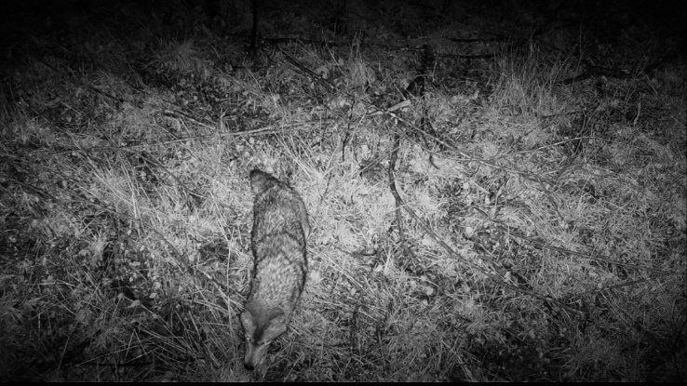  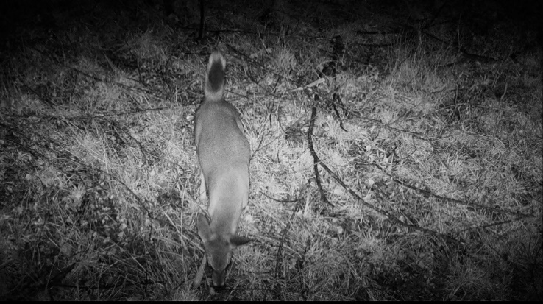
2 | 112 to 114 | Deer activity during nighttime | 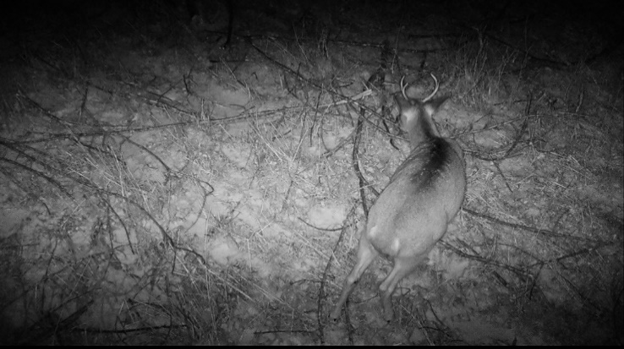
3 | 118 to 120 | Racoon hunting for insects in water-logged depressional area | 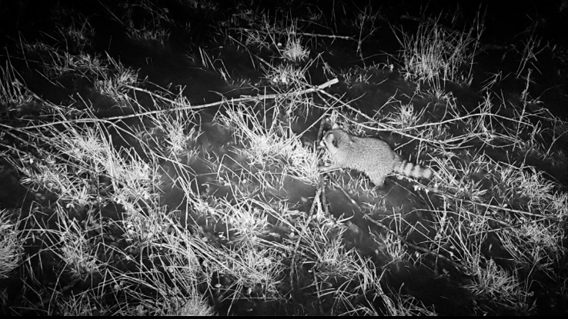
4 | 124 to 129 | Deer activity during nighttime | 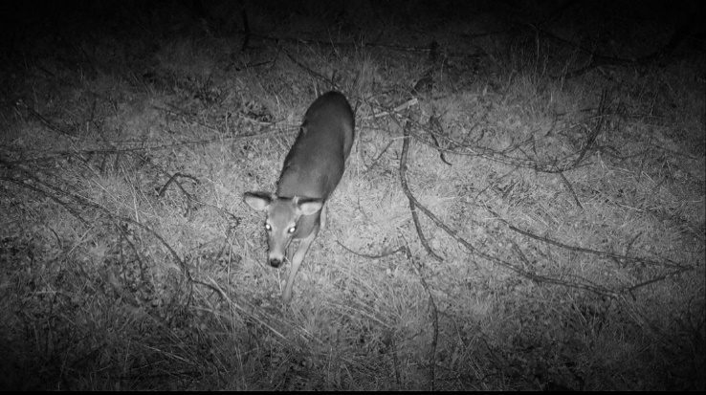
5 | 133 to 143 | Deer activity during nighttime | 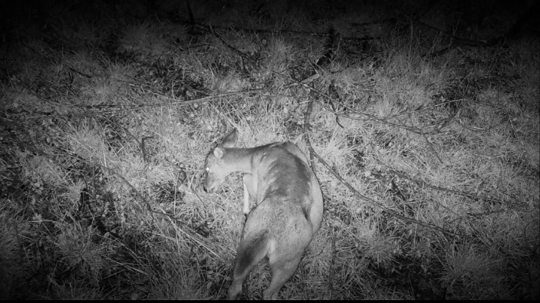
6 | 145 to 150 | Deer activity during nighttime (multiple) | 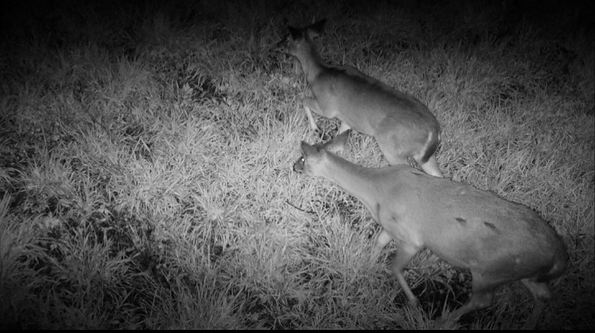
7 | 154 to 165 | Deer activity during nighttime (multiple) | 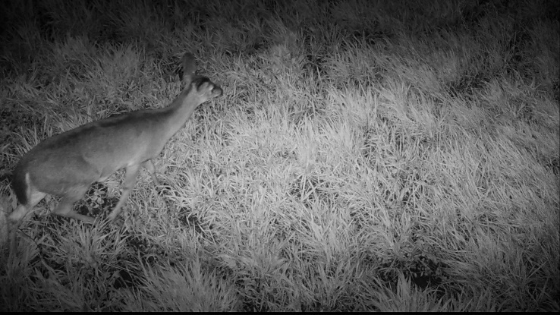
8 | 175 | Deer activity during nighttime | 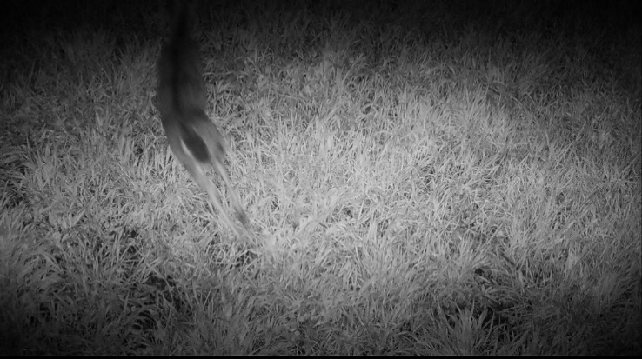
9 | 274 to 279 | Deer activity during nighttime | 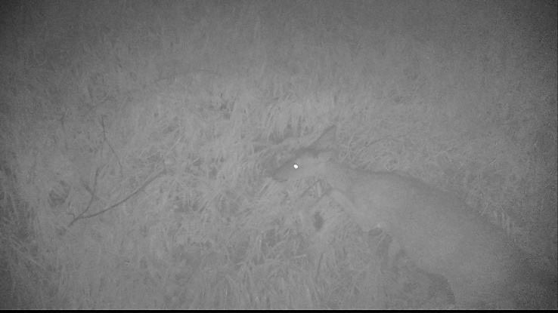
10 | 280 to 282 | Deer activity during nighttime | 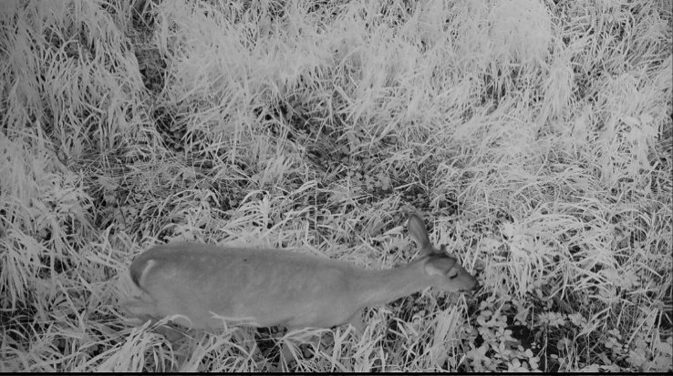

Notable Events (Camera ID: LF01_2)
EVENT | PHOTO ID | COMMENTS
11 | 25 to 27 | Deer activity during nighttime | 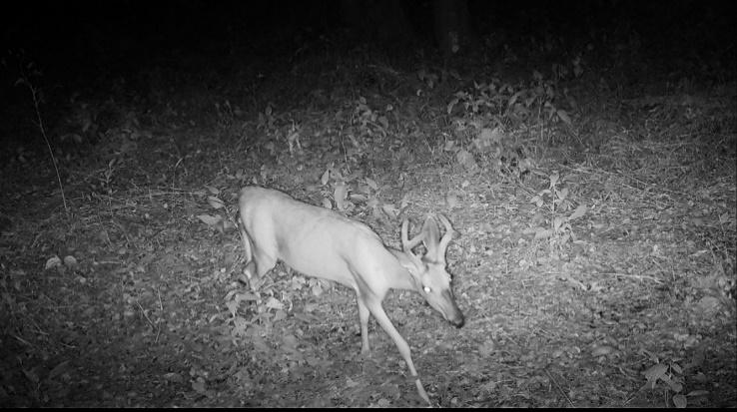
12 | 31 to 33 | Deer activity during nighttime (multiple) | 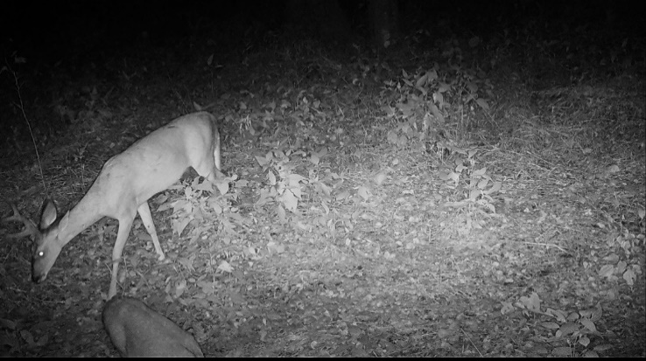
13 | 40 to 60 | Deer activity during nighttime (multiple) | 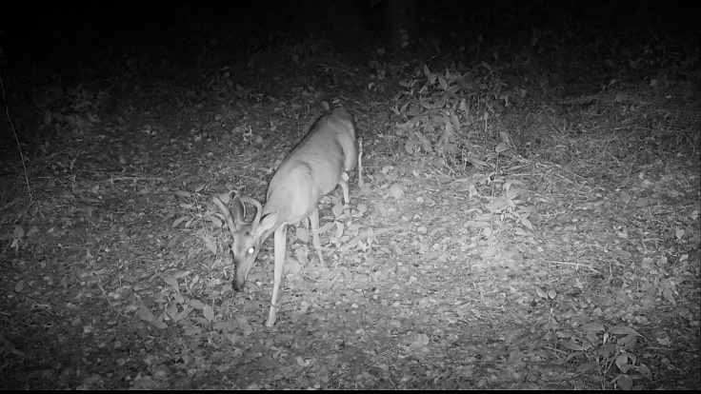
14 | 85 to 89 | Deer activity during daytime | 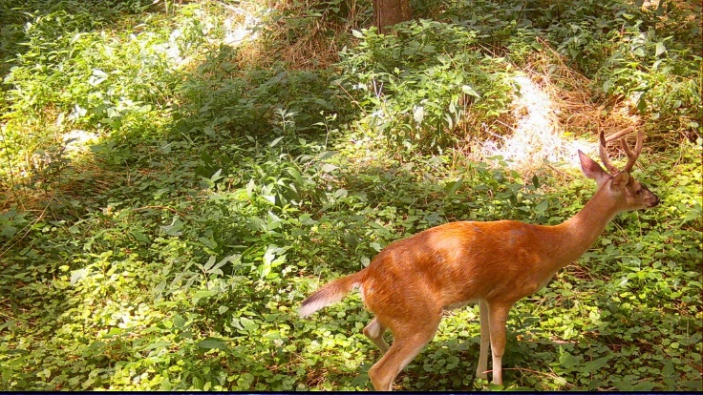
15 | 91 to 108 | Deer activity during nighttime (multiple) | 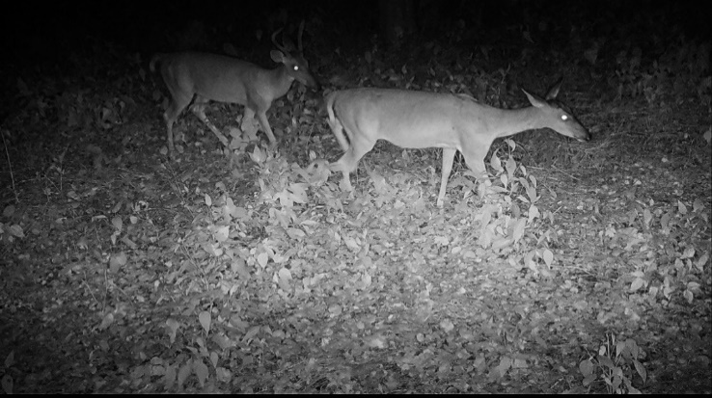
16 | 109 to 111 | Deer activity during daytime | 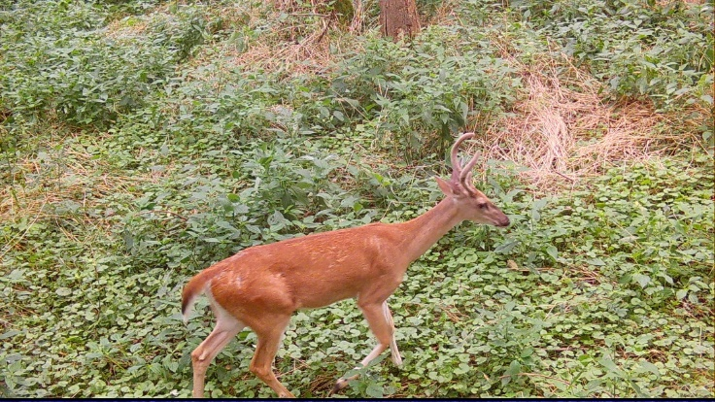
17 | 112 to 114 | Deer activity during daytime | 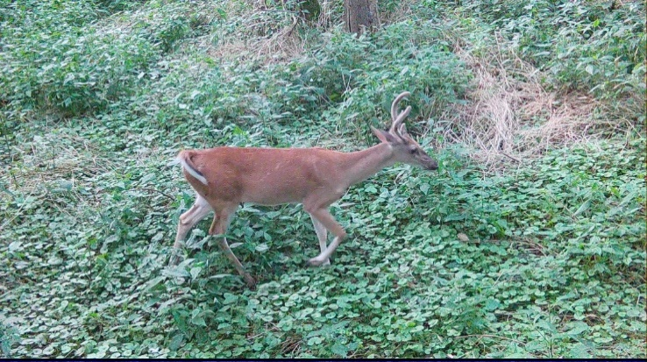

Notable Events (Camera ID: LF01_3)
EVENT | PHOTO ID | EVENT
18 | 577 to 578 | Possum activity during nighttime
  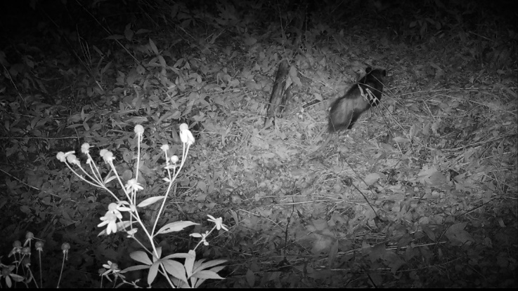
19 | 579 to 592 | Armadillo activity during nighttime | 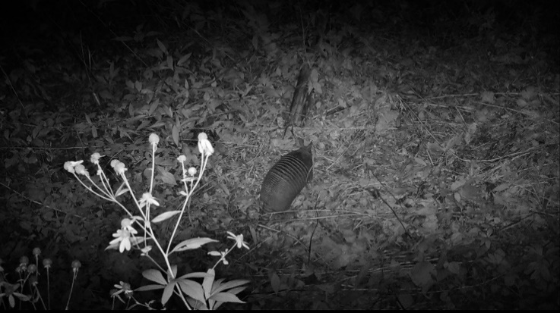
20 | 599 | Woodchuck activity during nighttime | 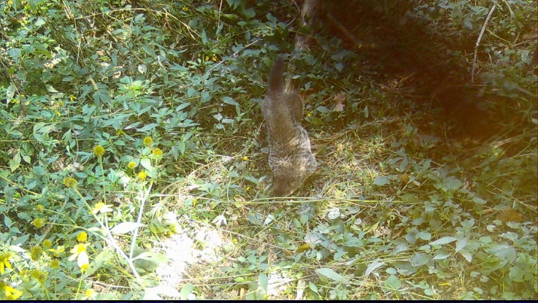
21 | 601 to 602 | Armadillo activity during nighttime | 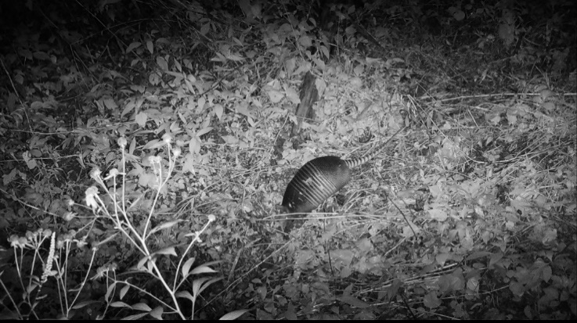
22 | 605 | Possum activity during nighttime | 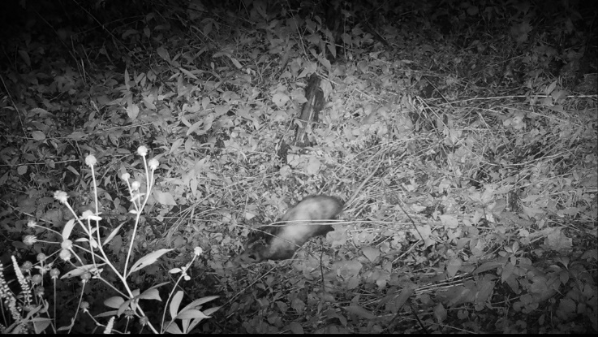
23 | 607 to 614 | Deer (buck) activity during nighttime | 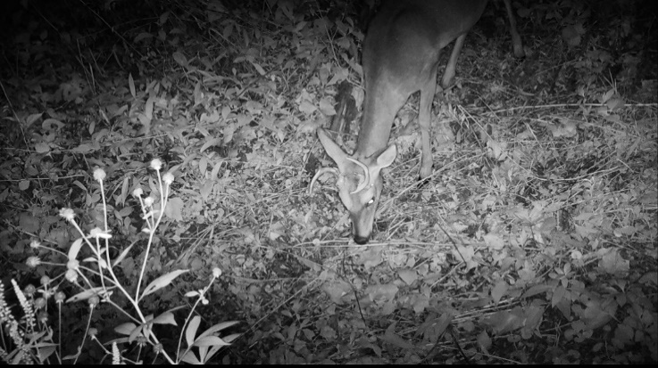
24 | 615 to 616 | Armadillo activity during nighttime | 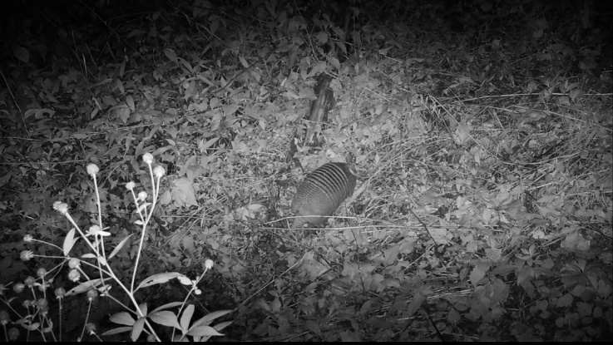
25 | 617 | Raccoon activity during nighttime | 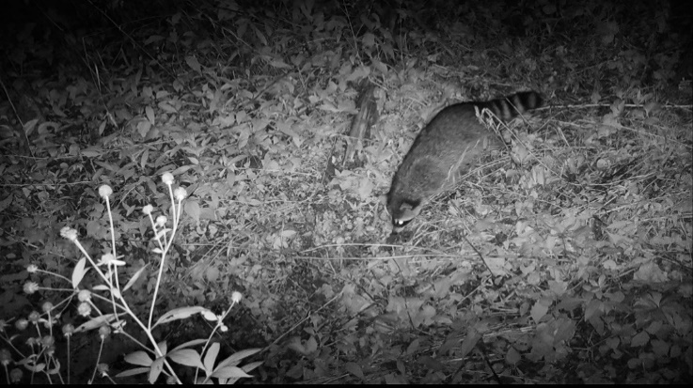
26 | 619 | Armadillo activity during nighttime | 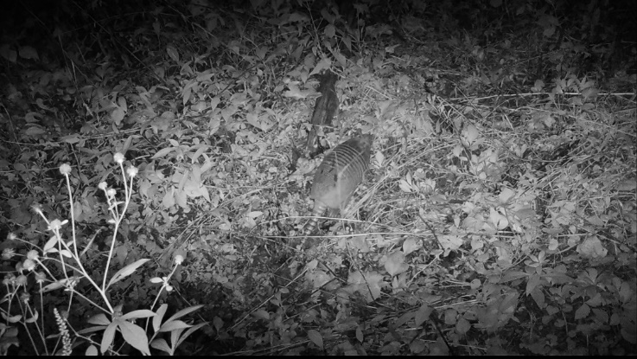
27 | 621 to 631 | Deer (multiple) activity during daytime | 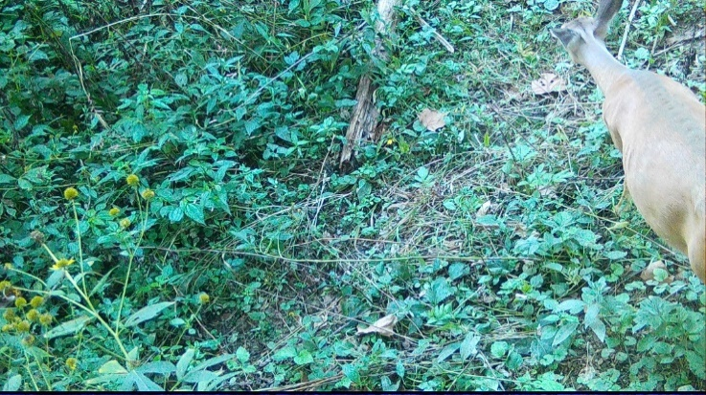
28 | 633 to 658 | Armadillo (multiple) activity during nighttime | 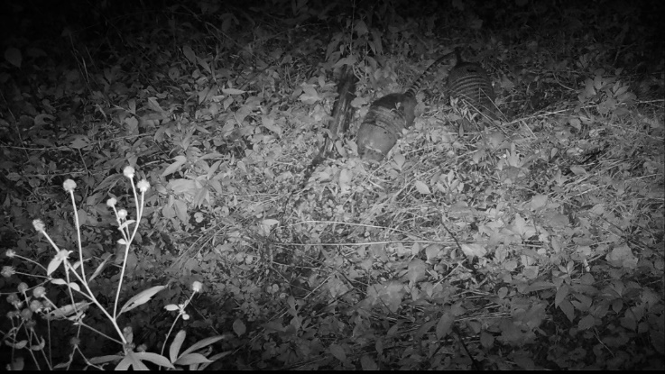
29 | 659 | Deer activity during daytime
  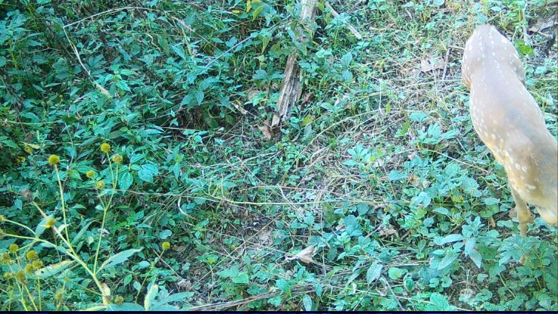
30 | 661 | Raccoon activity during nighttime | 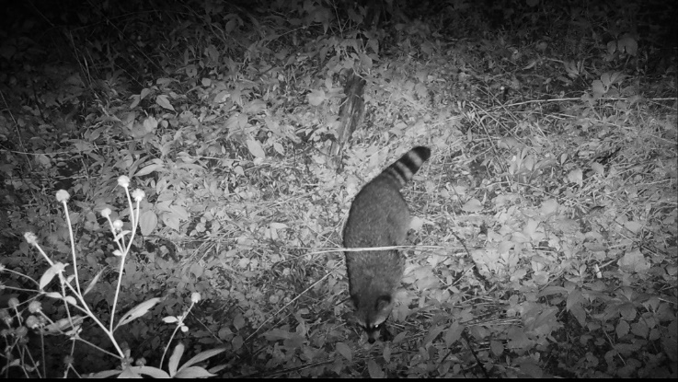
31 | 663 | Possum activity during nighttime | 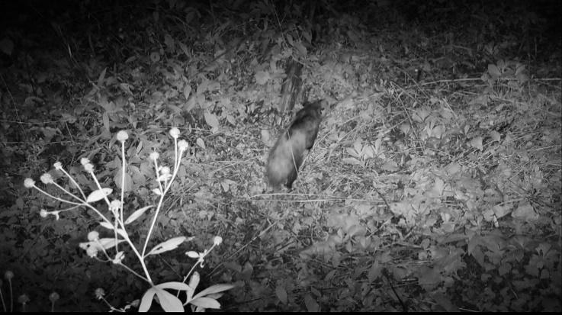
32 | 665 to 666 | Armadillo activity during nighttime | 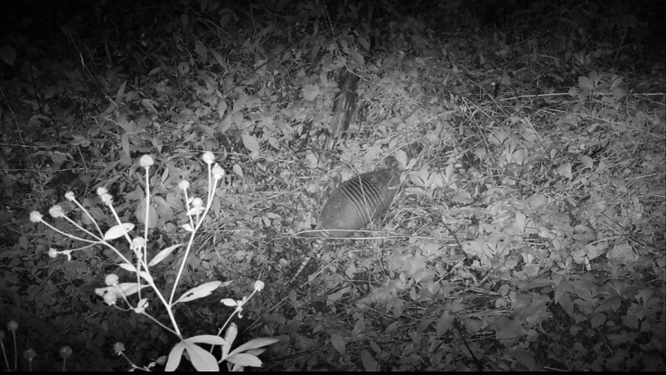
33 | 667 | Raccoon activity during nighttime | 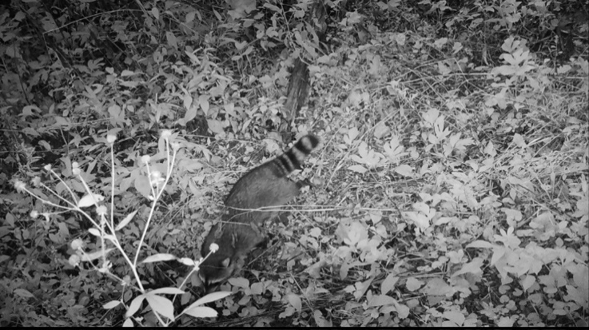
34 | 669 to 670 | Possum activity during nighttime | 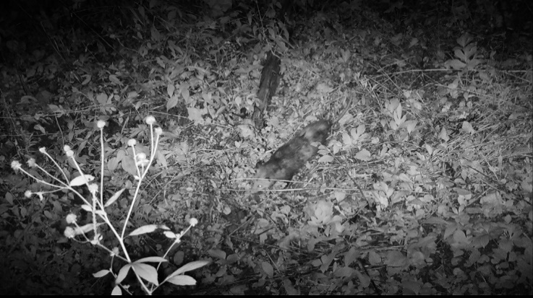
35 | 671 to 676 | Deer (buck) activity during daytime | 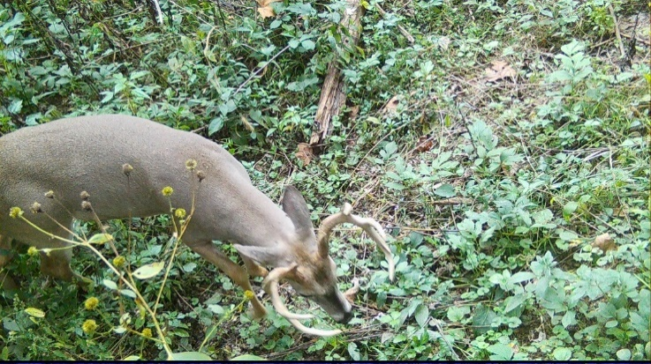
36 | 677 to 678 | Armadillo activity during nighttime | 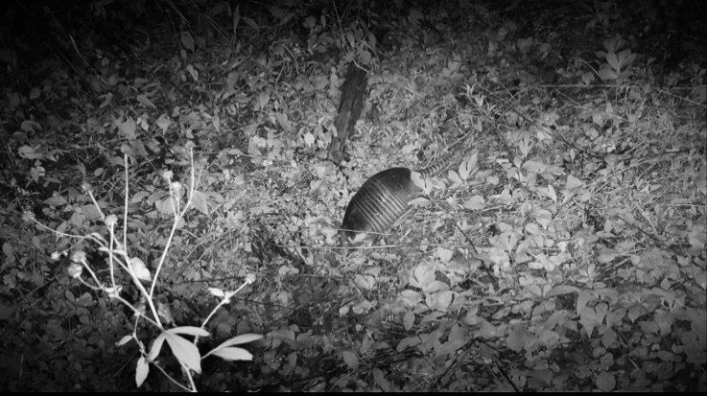
37 | 679 | Squirrel activity during daytime | 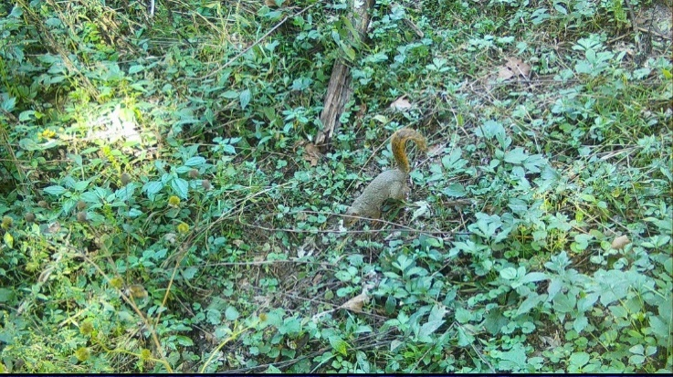
38 | 681 to 682 | Armadillo activity during nighttime | 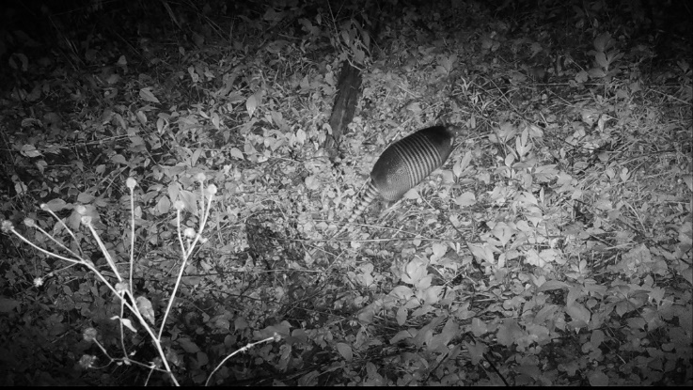
39 | 683 to 686 | Raccoon (multiple) foraging for grubs during nighttime | 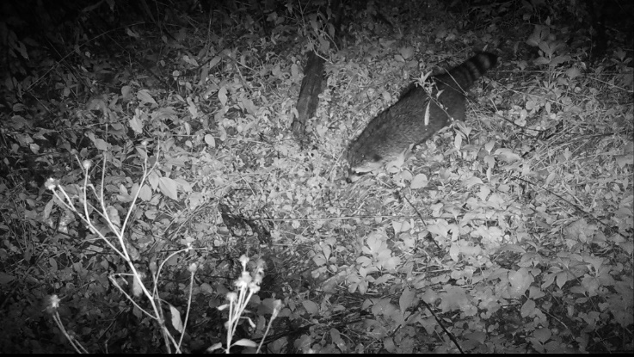
40 | 687 | River otter activity during nighttime | 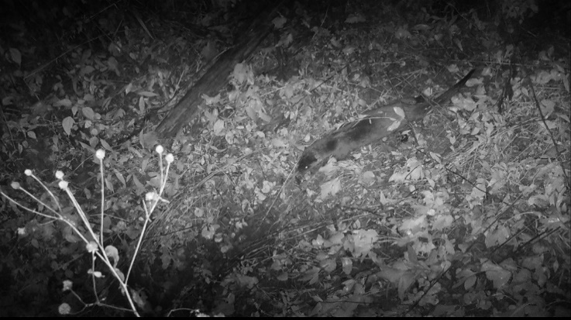
41 | 689 to 690 | Raccoon activity during nighttime | 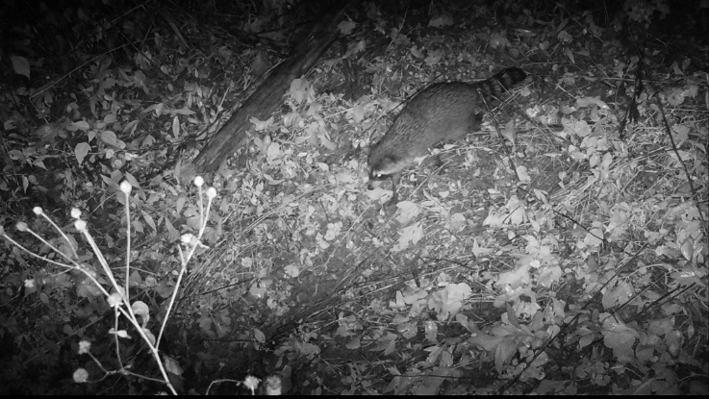
42 | 691 | River otter activity during nighttime | 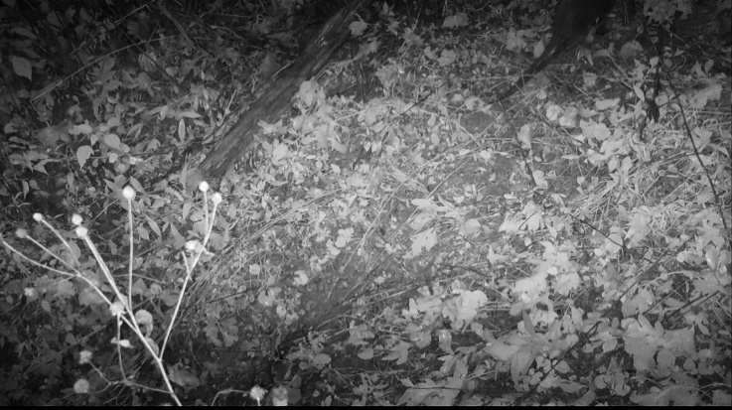
43 | 691 to 693 | River otter activity during daytime; apparent rainfall | 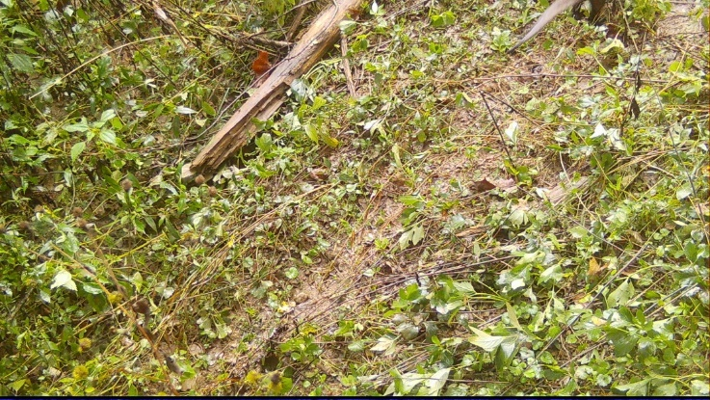
44 | 695 | Deer activity during nighttime | 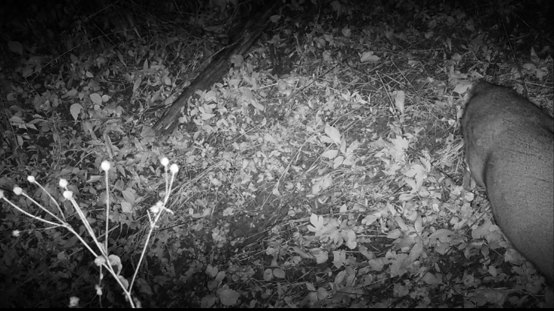
45 | 697 | Raccoon activity during nighttime | 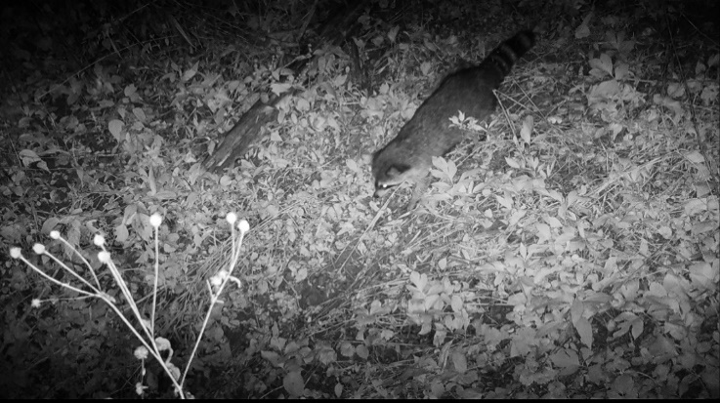
46 | 699 to 700 | Armadillo activity during nighttime | 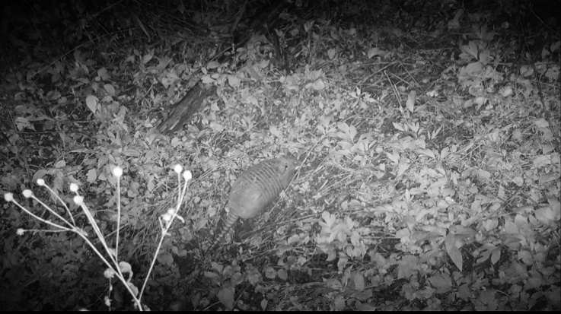
47 | 701 | Squirrel activity during daytime | 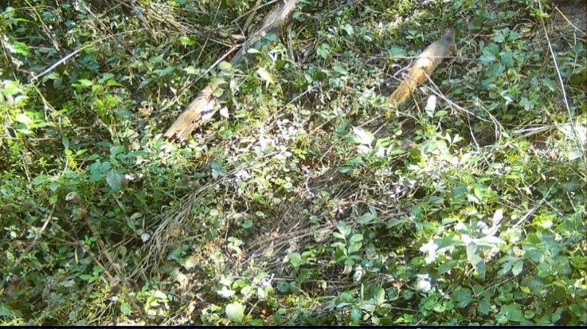
48 | 703 to 705 | Armadillo activity during nighttime | 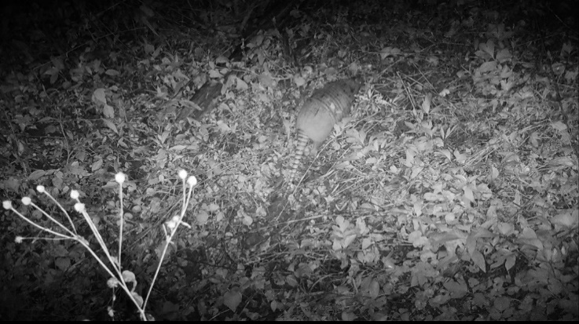
49 | 709 to 712 | Armadillo activity during nighttime | 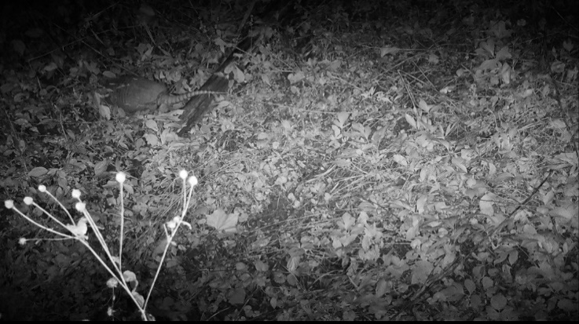
50 | 713 to 714 | Deer activity during nighttime | 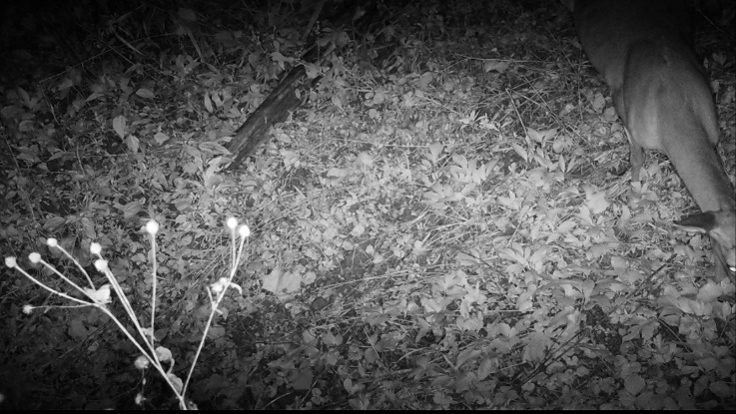
51 | 717 | Deer activity during nighttime | 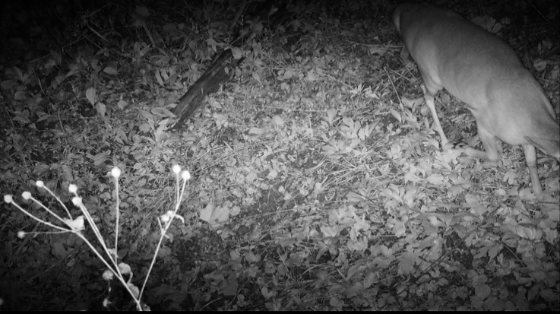
52 | 719 | Deer activity during nighttime | 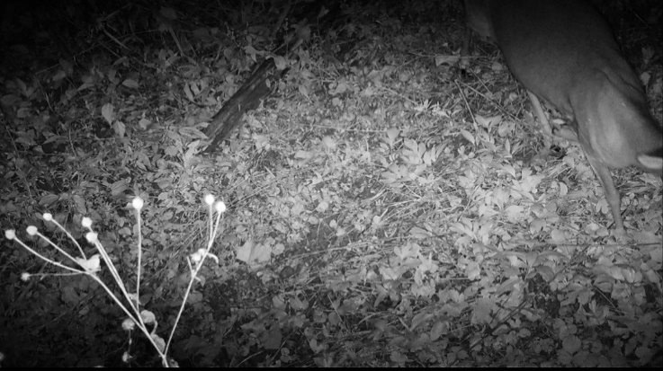
53 | 721 | Armadillo activity during nighttime | 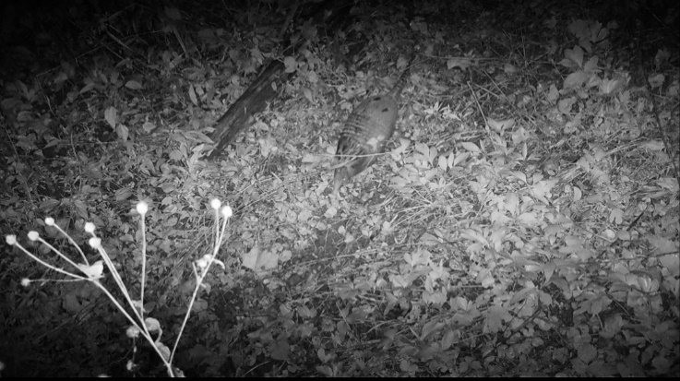
54 | 723 to 724 | Possum activity during nighttime | 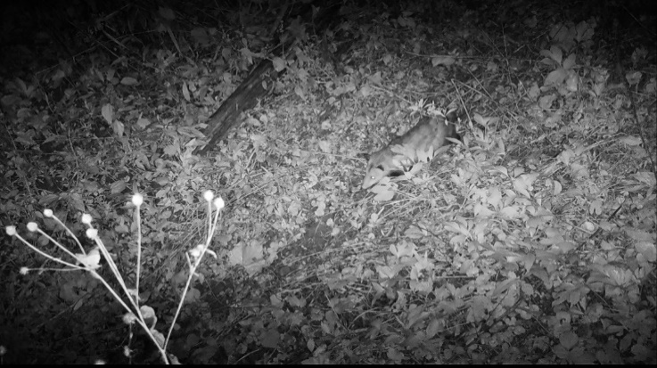
55 | 725 to 726 | Armadillo activity during nighttime | 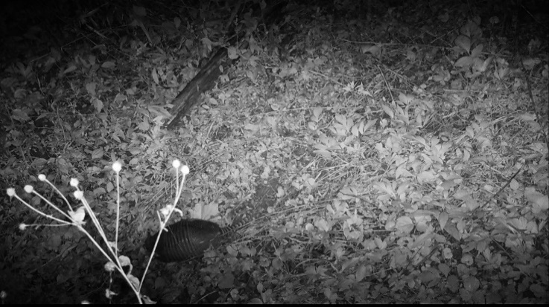
56 | 727 to 728 | Squirrel activity during daytime | 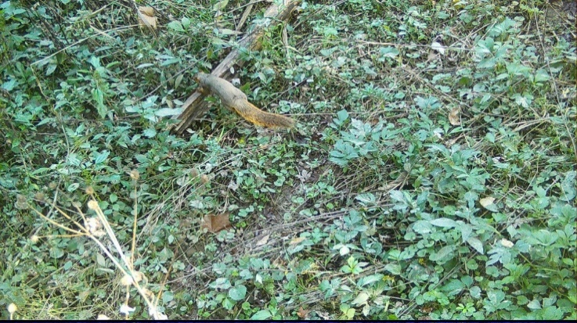
57 | 729 | Armadillo activity during nighttime | 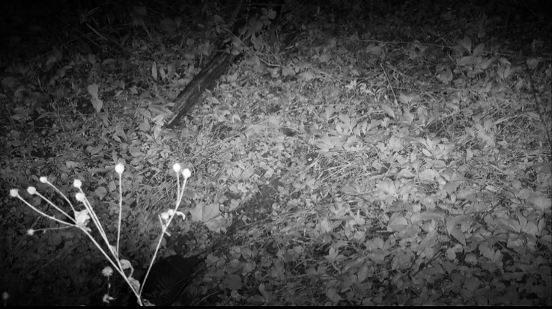
58 | 733 to 736 | River otter (multiple) activity during nighttime | 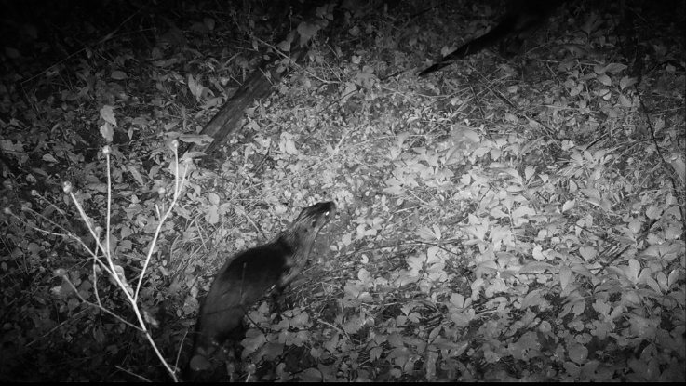
59 | 737 to 738 | Deer activity during daytime | 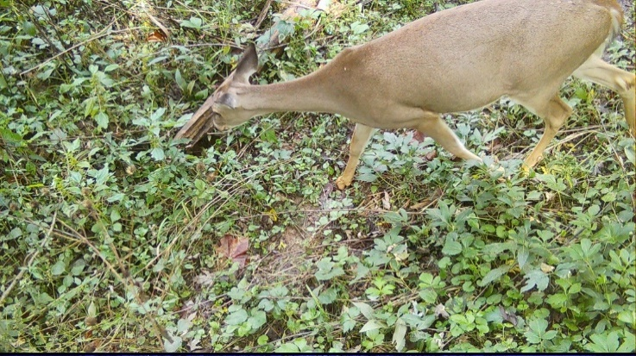
60 | 739 | River otter activity during daytime | 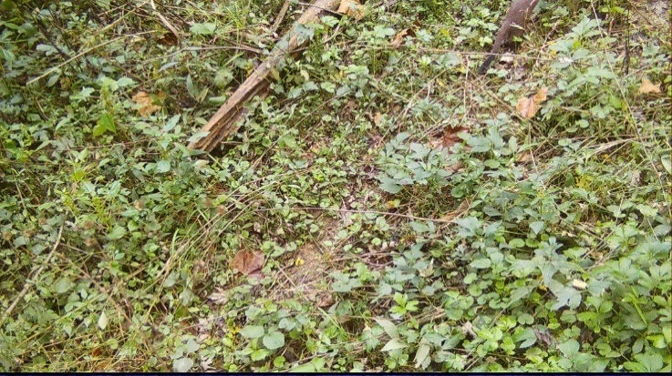
61 | 741 | Armadillo activity during nighttime | 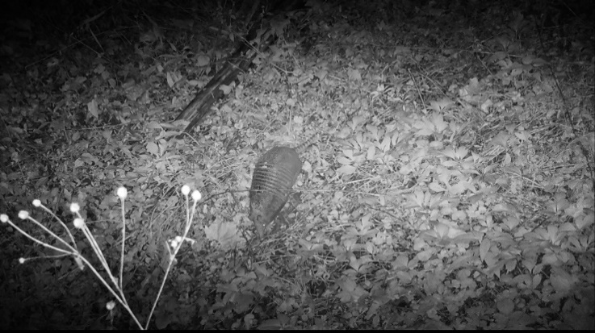
62 | 743 to 747 | Armadillo activity during nighttime | 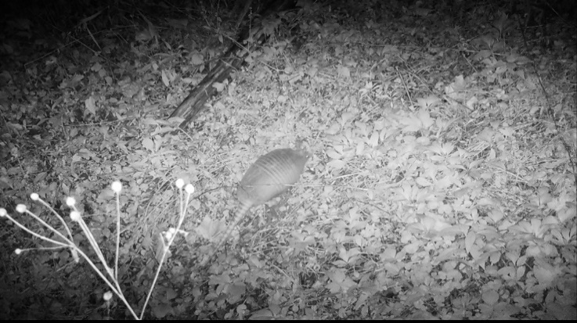
63 | 749 | Armadillo activity during nighttime | 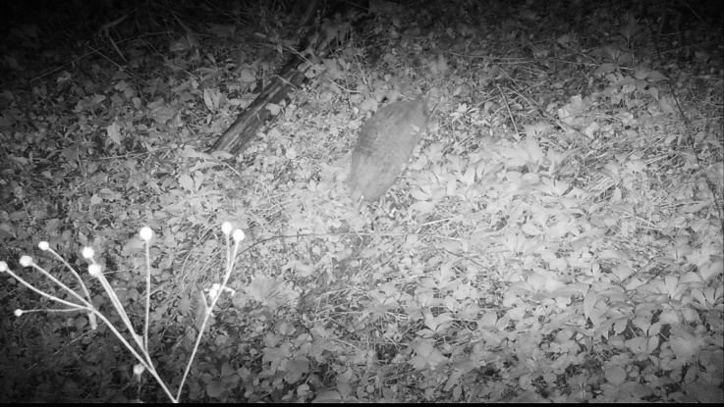
64 | 751 | Armadillo activity during nighttime | 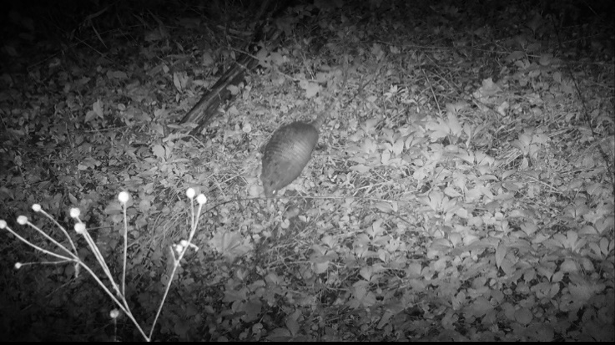
65 | 753 | Armadillo activity during nighttime | 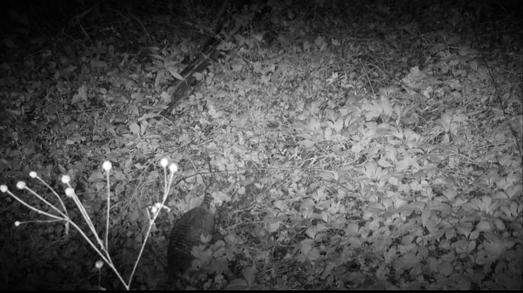
66 | 755 | Armadillo activity during nighttime | 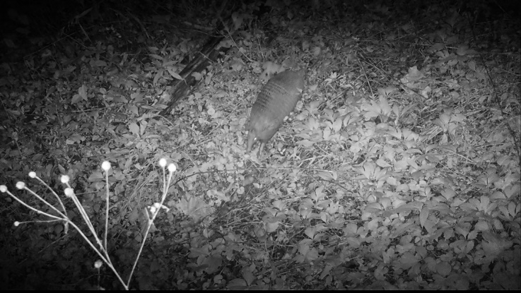
67 | 757 | Armadillo activity during nighttime | 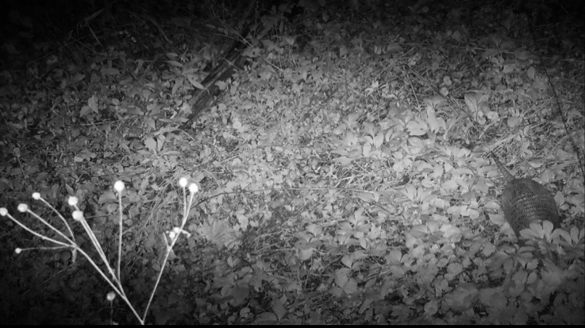
68 | 759 to 760 | Raccoon activity during nighttime | 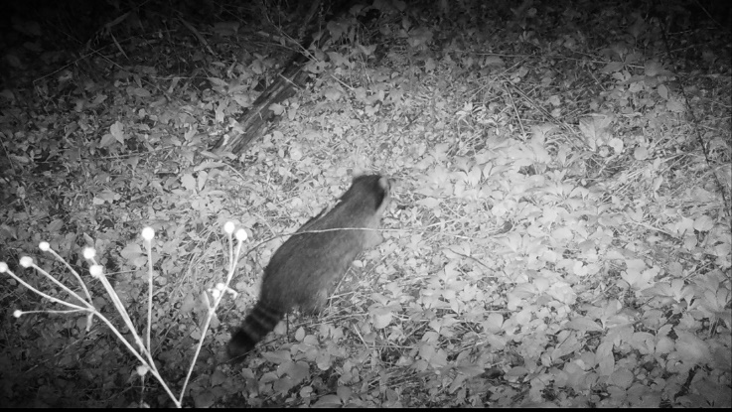
69 | 761 | Armadillo activity during nighttime | 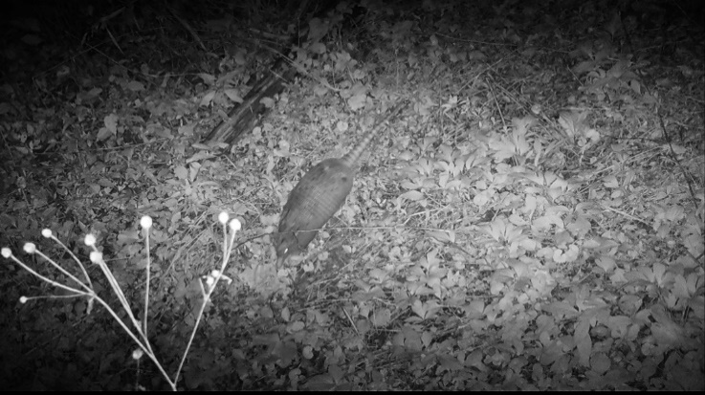
70 | 763 | Armadillo activity during nighttime | 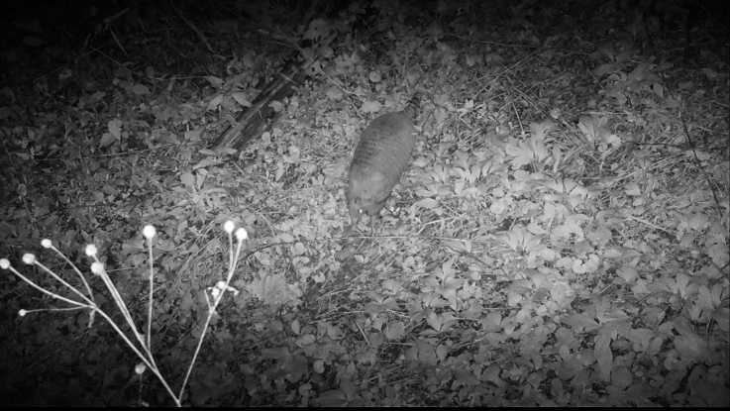
71 | 765 | Armadillo activity during nighttime | 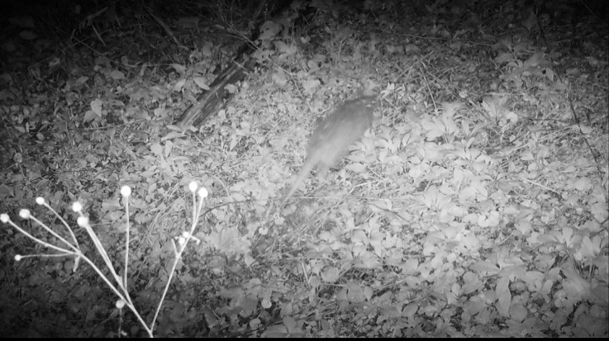
72 | 767 to 769 | Armadillo activity during nighttime | 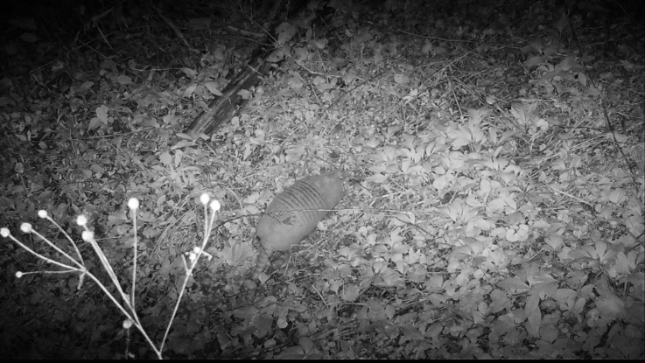
73 | 771 to 773 | Deer (doe and fawn) activity during daytime | 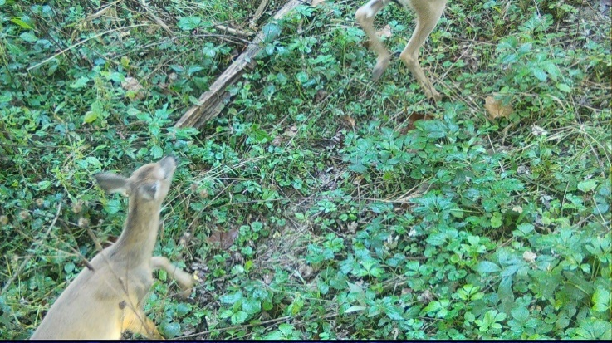
74 | 775 | Deer (fawn) activity during daytime | 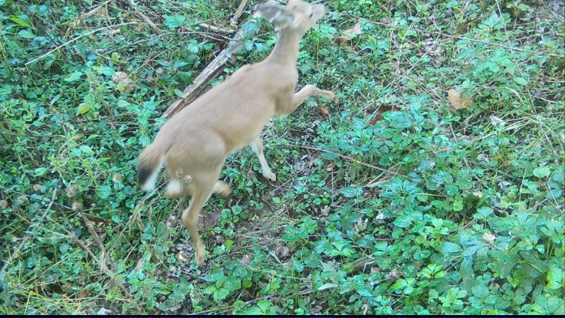
75 | 777 | Deer (doe) activity during daytime | 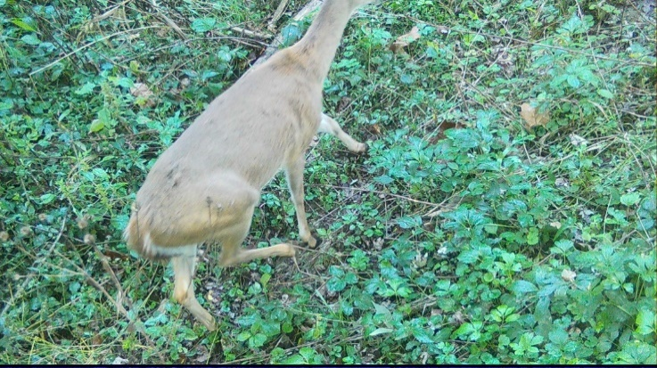
76 | 779 | Armadillo activity during nighttime | 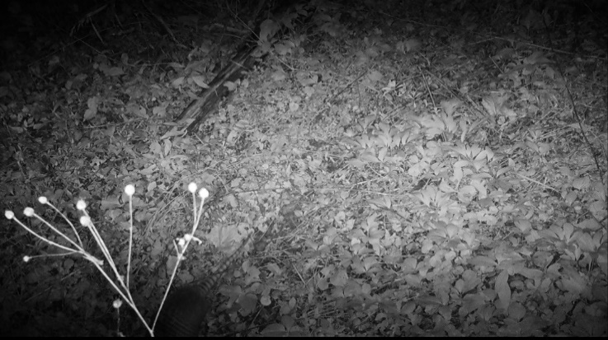
77 | 781 | Armadillo activity during nighttime | 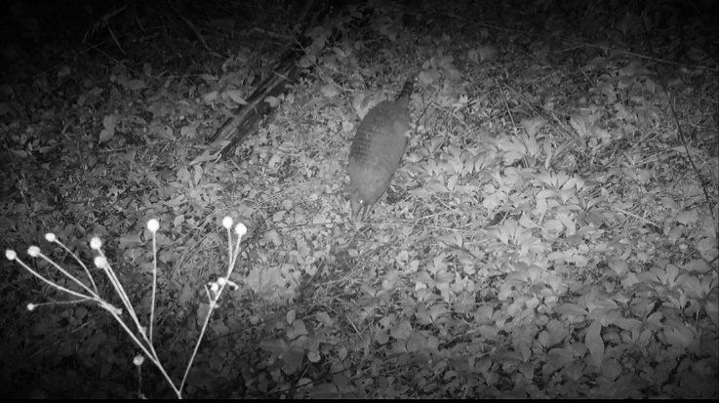
78 | 783 | Armadillo activity during nighttime
  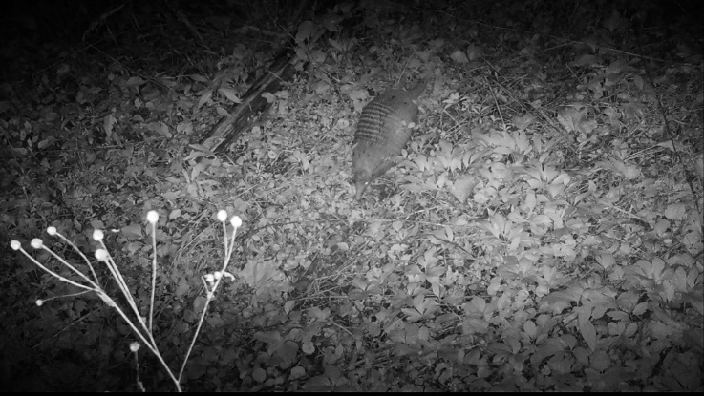
79 | 785 to 787 | Deer (fawn) activity during daytime | 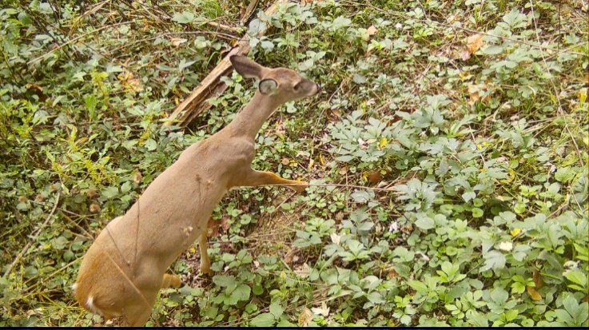
80 | 791 to 797 | Armadillo activity during nighttime | 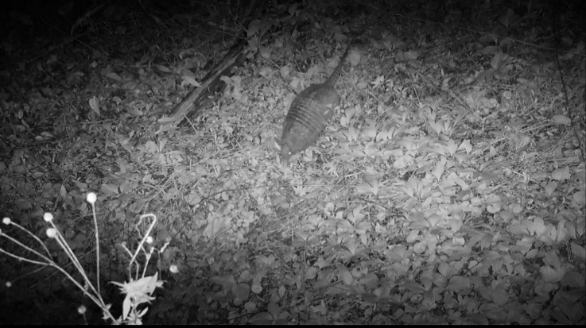
81 | 805 | Armadillo activity during nighttime | 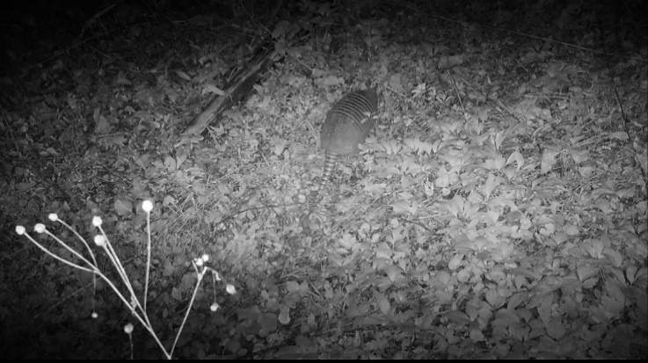
82 | 807 | Armadillo activity during nighttime | 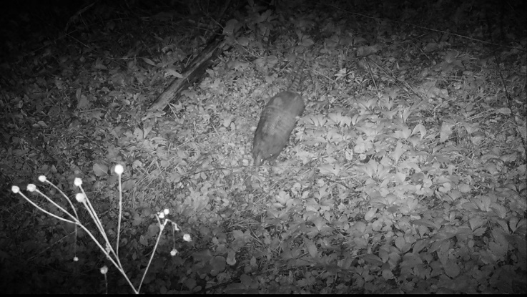
83 | 811 | Coyote activity during nighttime | 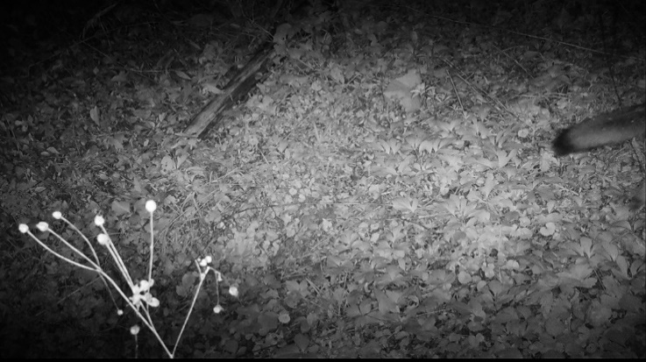
84 | 813 to 815 | Armadillo activity during nighttime | 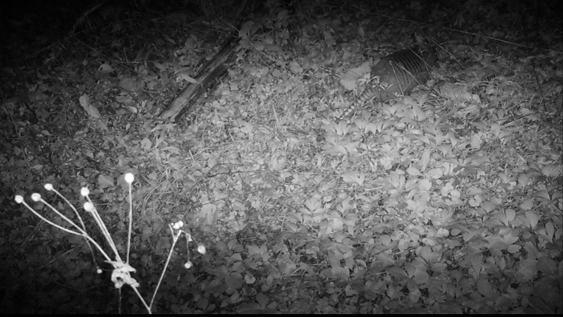
85 | 823 to 824 | Squirrel activity during daytime | 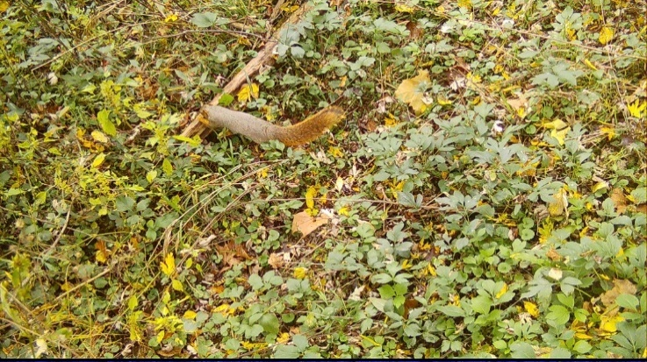
86 | 825 | Armadillo activity during nighttime | 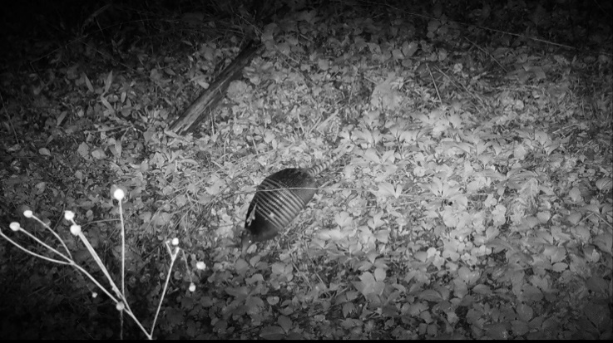
87 | 827 | Deer activity during daytime | 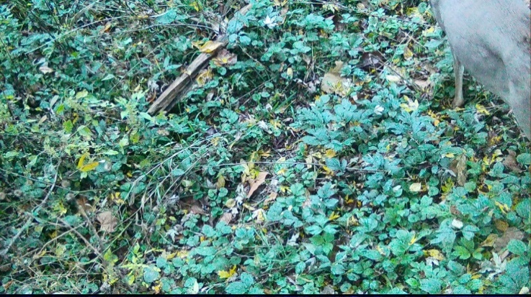
88 | 831 to 835 | Armadillo activity during nighttime | 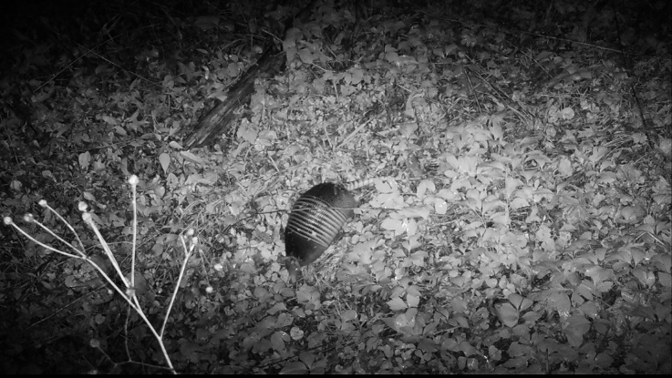
89 | 837 to 839 | Armadillo activity during nighttime | 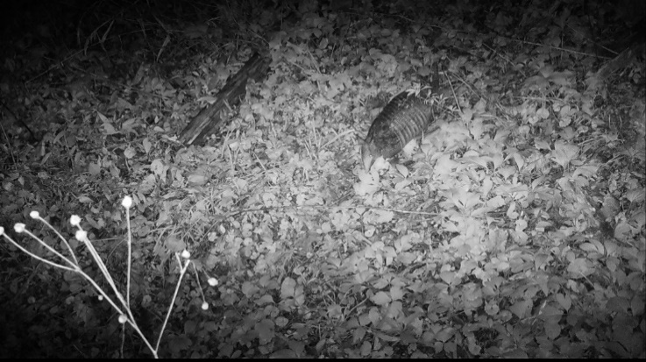
90 | 841 to 843 | Squirrel activity during daytime | 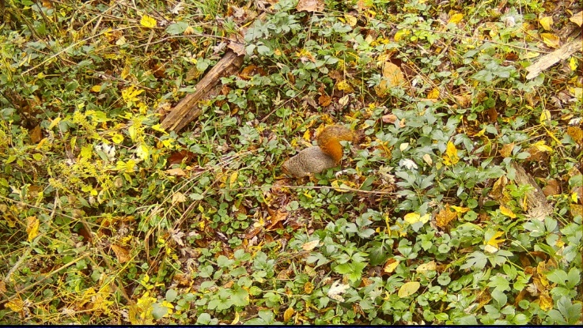
91 | 845 | Squirrel activity during daytime | 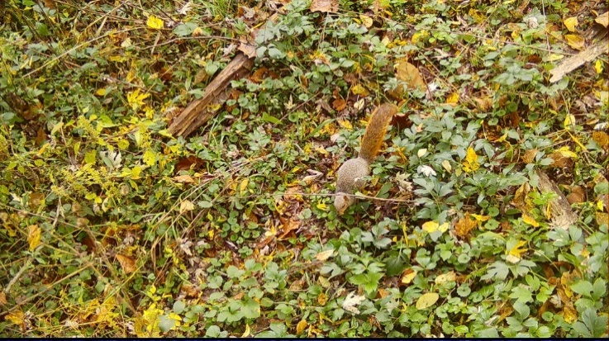
92 | 847 | Squirrel activity during daytime | 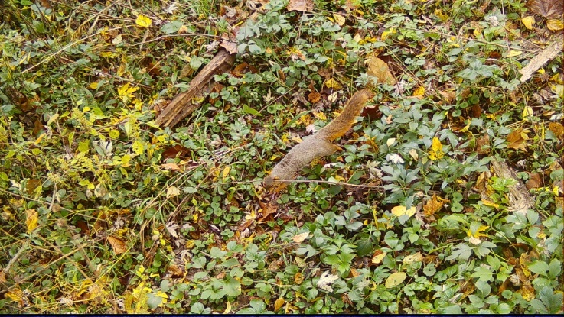
93 | 849 | Squirrel activity during daytime | 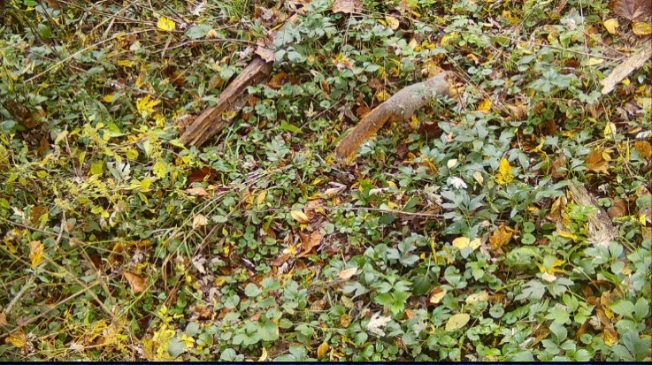
94 | 851 to 852 | River otter (multiple) activity during daytime | 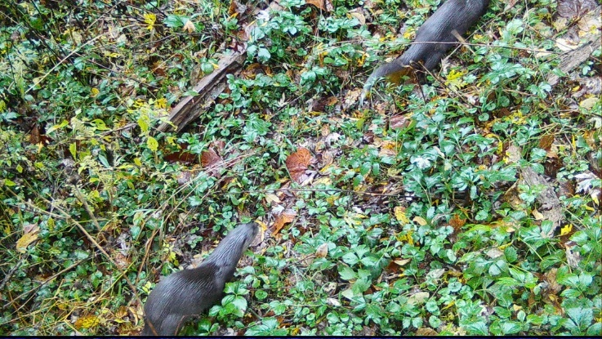
95 | 853 | Snake activity during nighttime | 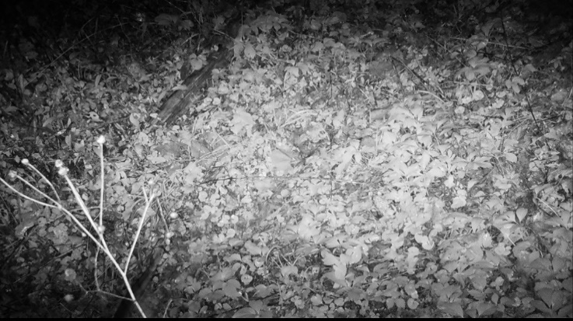
96 | 855 to 856 | Raccoon activity during nighttime | 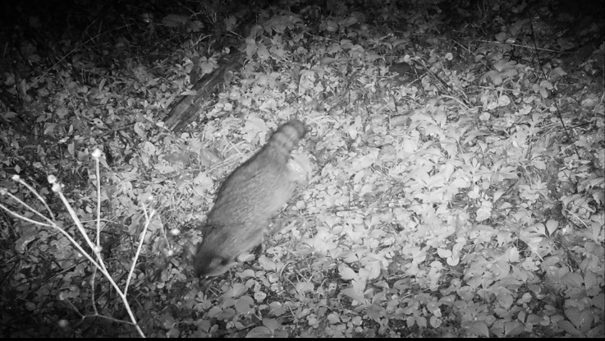
97 | 857 to 859 | Armadillo activity during nighttime | 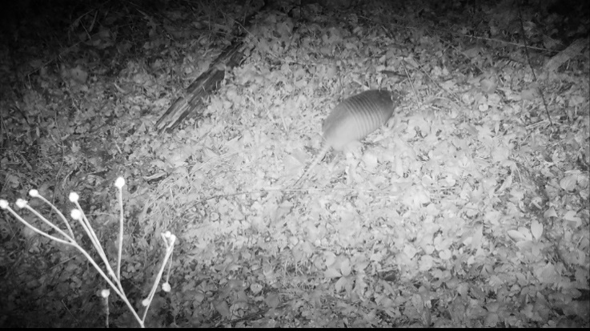
98 | 861 to 867 | Deer (doe and fawn) activity during daytime | 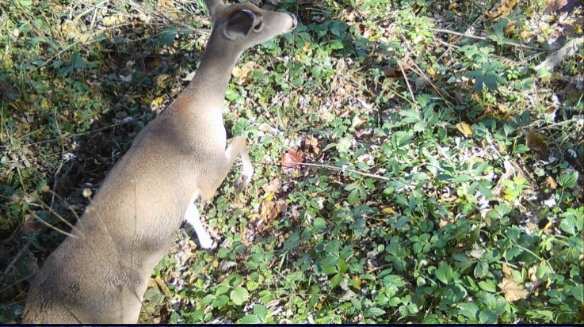  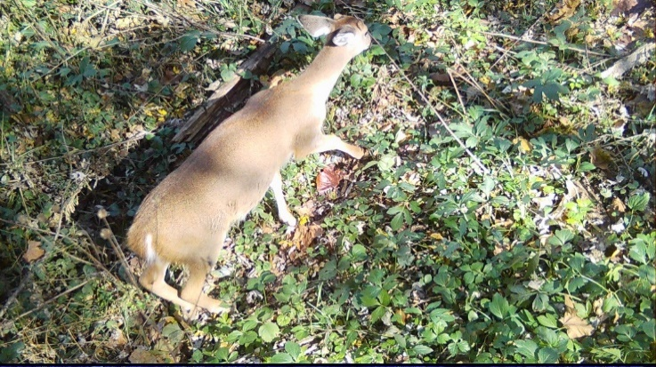
99 | 869 to 872 | Deer (doe and fawn) activity during daytime | 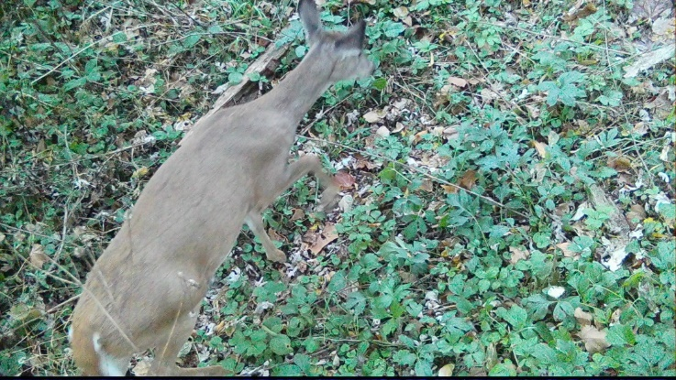
100 | 873 to 877 | Armadillo activity during nighttime | 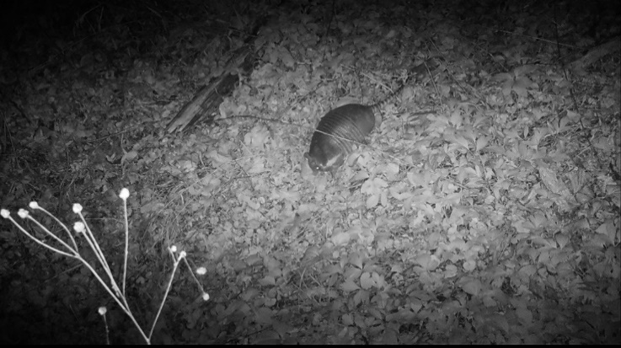
101 | 879 to 880 | Armadillo activity during nighttime | 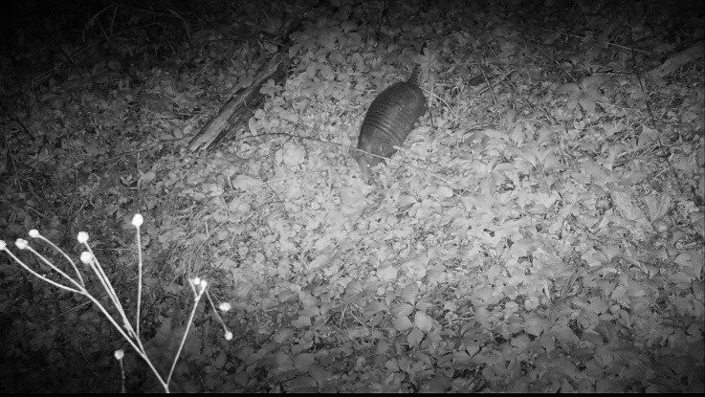
102 | 883 to 884 | Raccoon activity during nighttime | 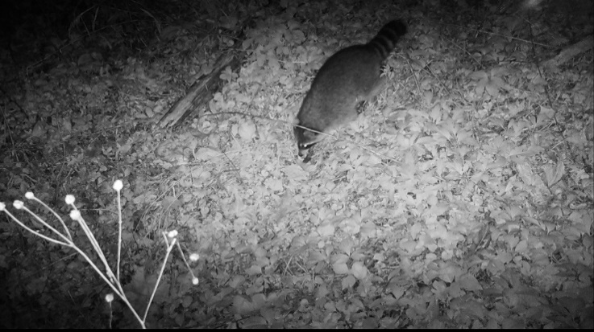
103 | 885 | Armadillo activity during nighttime | 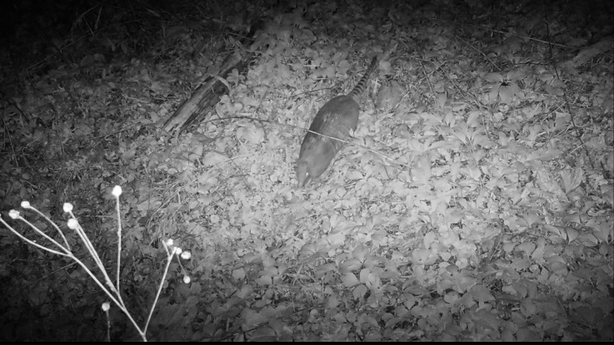
104 | 887 to 888 | Possum activity during nighttime | 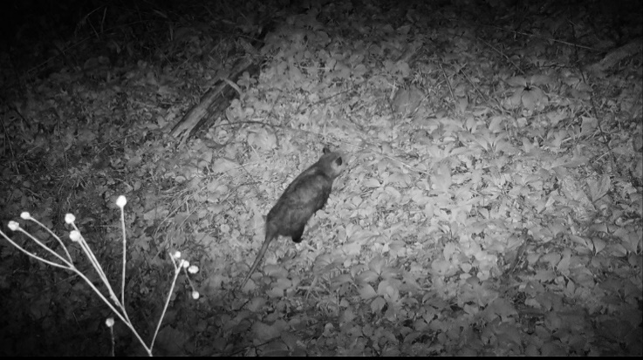
105 | 895 to 899 | Armadillo activity during nighttime | 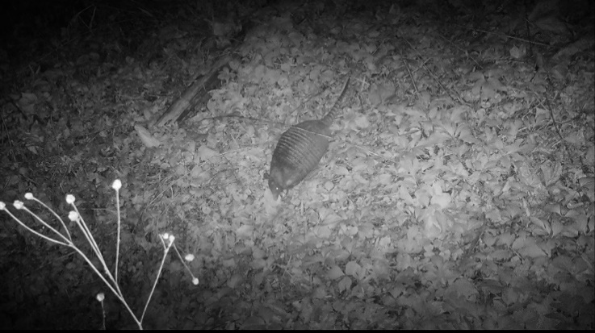
106 | 907 to 908 | Armadillo activity during nighttime | 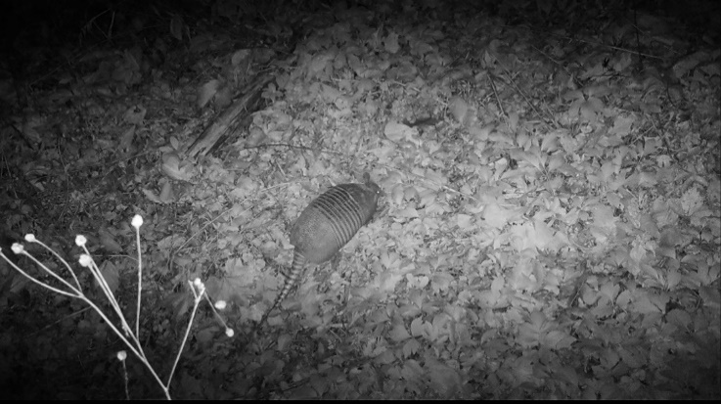
107 | 909 to 910 | Coyote activity during nighttime | 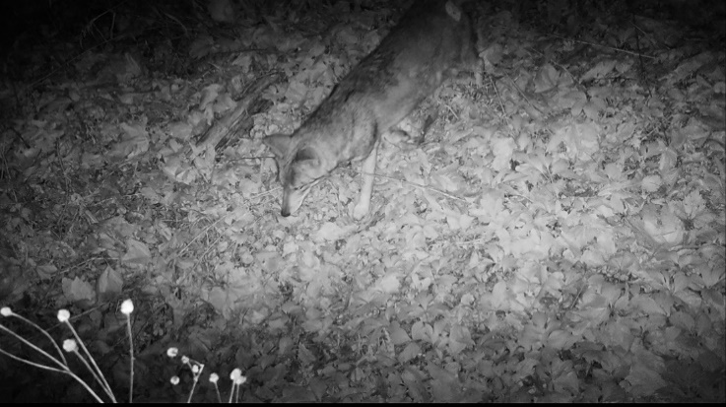
108 | 911 | Deer activity during nighttime | 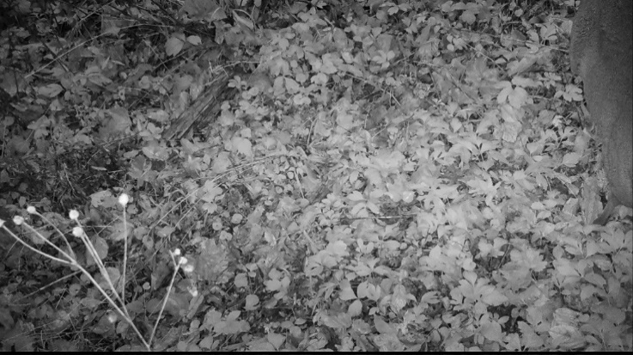
109 | 913 | Raccoon activity during nighttime | 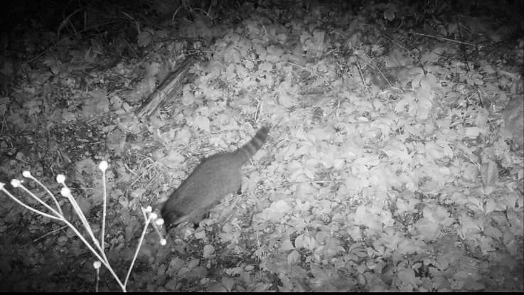
110 | 915 to 919 | Armadillo activity during nighttime | 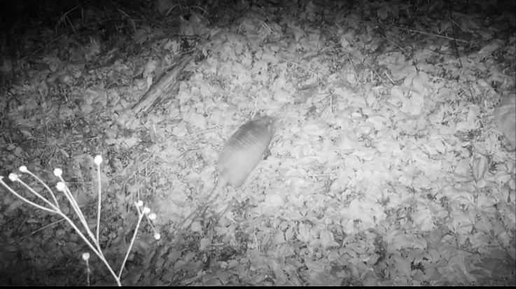
111 | 921 | Deer activity during nighttime | 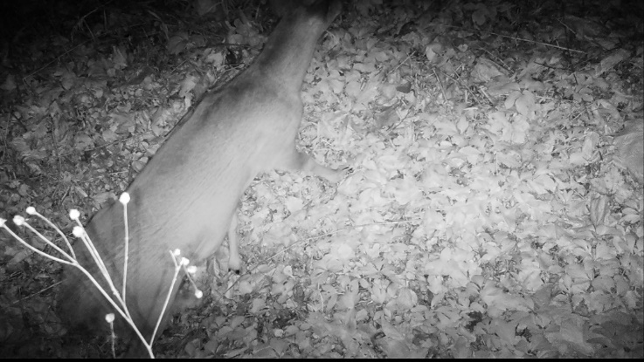
112 | 923 to 926 | Raccoon activity during nighttime | 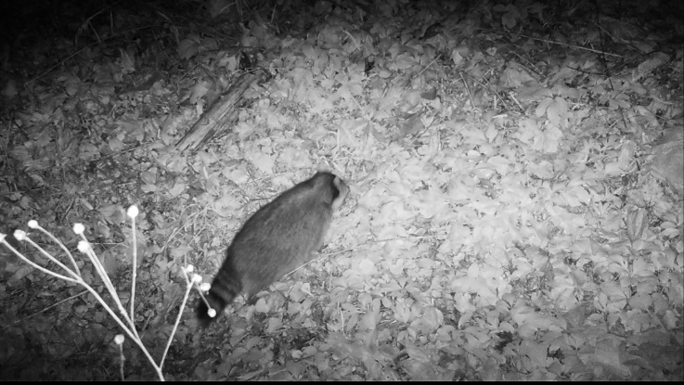
113 | 927 to 932 | Deer activity during nighttime | 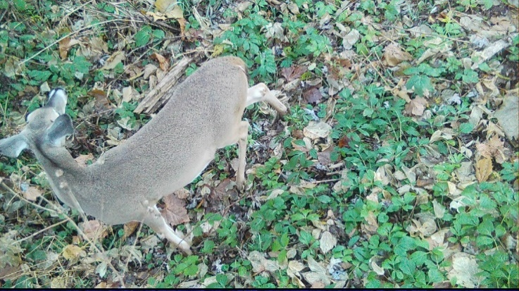
114 | 935 to 936 | Armadillo activity during nighttime | 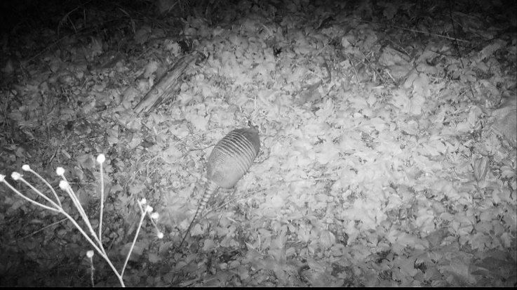
115 | 937 to 939 | Raccoon (mom and baby) activity during nighttime | 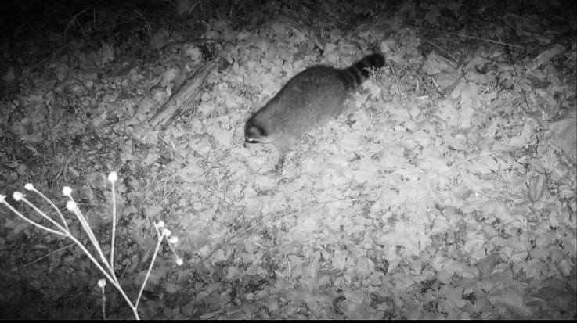  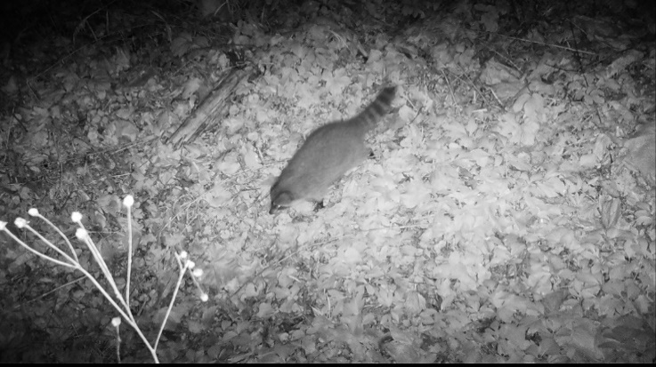
116 | 941 to 948 | Deer activity during daytime | 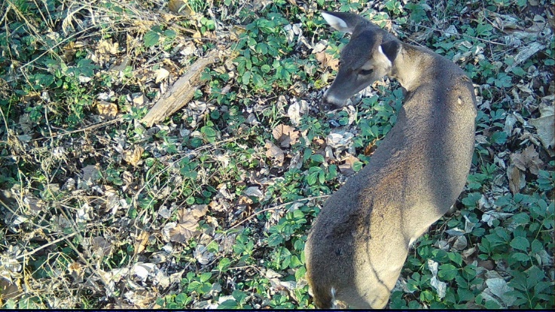
117 | 949 | Armadillo activity during nighttime | 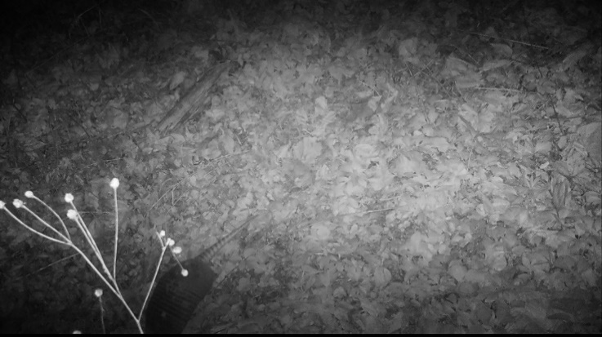
118 | 951 | Possum activity during nighttime
  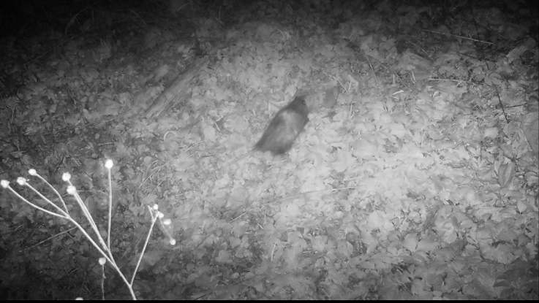
119 | 953 | Armadillo activity during daytime | 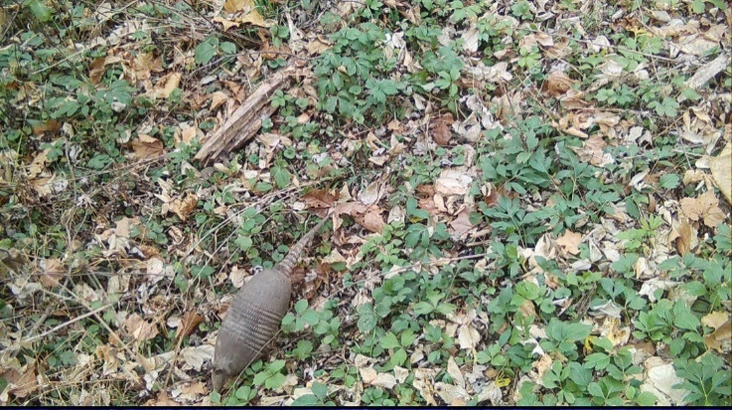
120 | 955 to 956 | Armadillo activity during daytime | 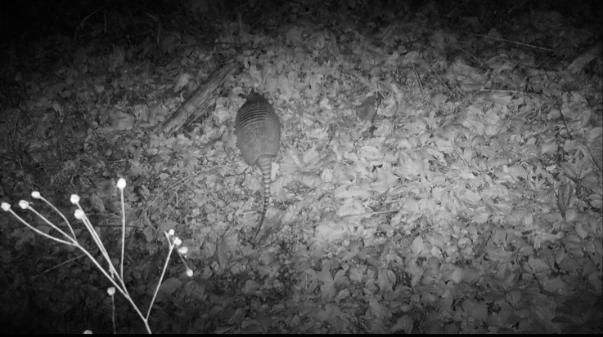
121 | 957 to 958 | Squirrel activity during daytime | 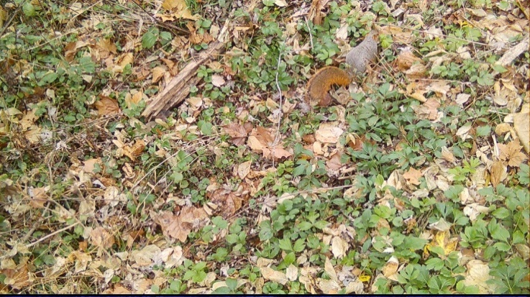
122 | 959 to 960 | Armadillo activity during daytime | 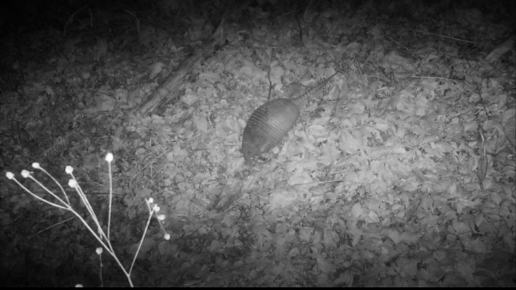
123 | 961 to 963 | Deer activity during nighttime | 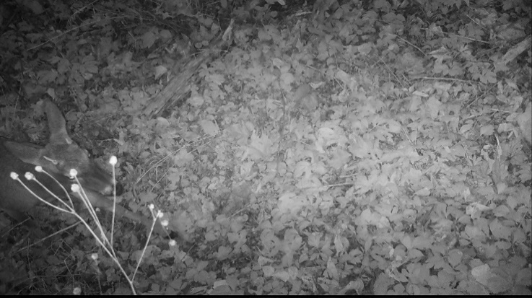
124 | 965 to 966 | Possum activity during nighttime | 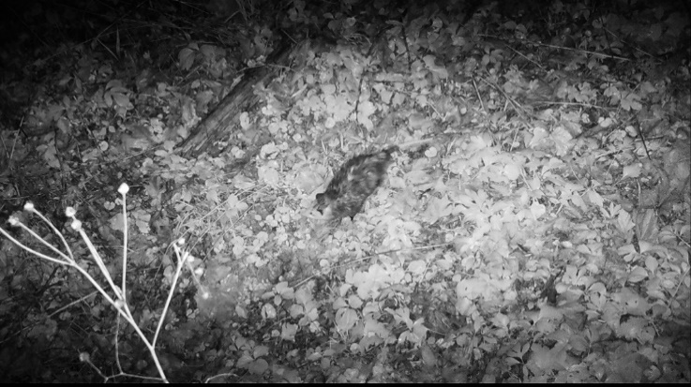

Notable Events (Camera ID: LF02_1)
EVENT | PHOTO ID | COMMENTS
125 | 49 to 54 | Armadillo activity near burrow during nighttime | 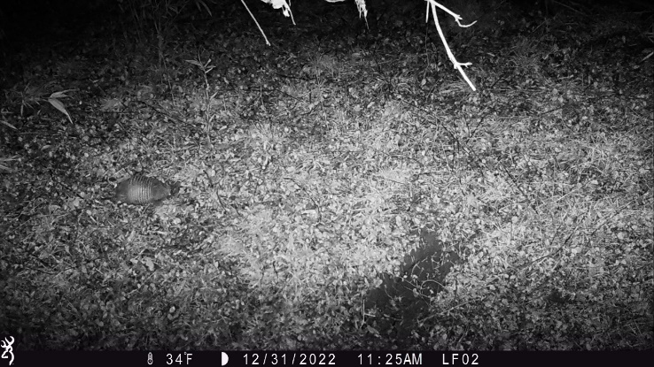
126 | 55 to 57 | Possum activity near armadillo burrow during nighttime | 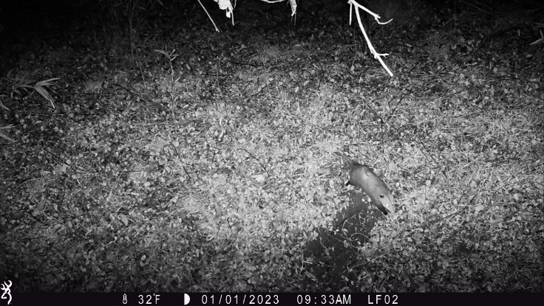
127 | 58 to 60 | Deer activity during nighttime; snowfall | 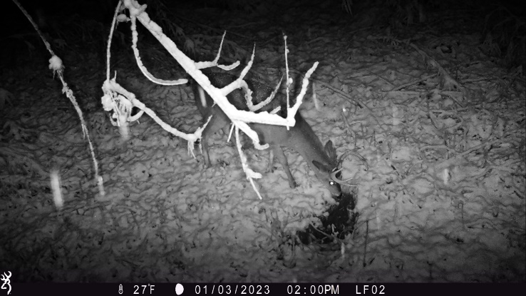
128 | 61 to 63 | Armadillo activity near burrow during nighttime | 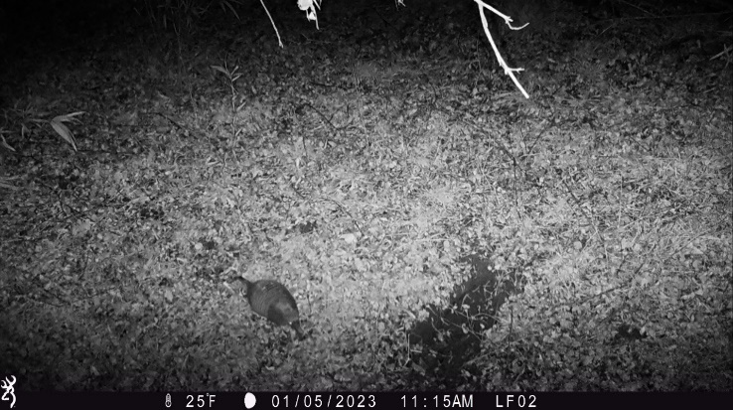
129 | 64 to 66 | Squirrel activity during daytime | 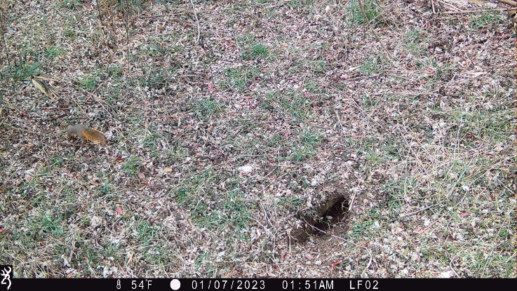
130 | 67 to 72 | Deer activity during nighttime | 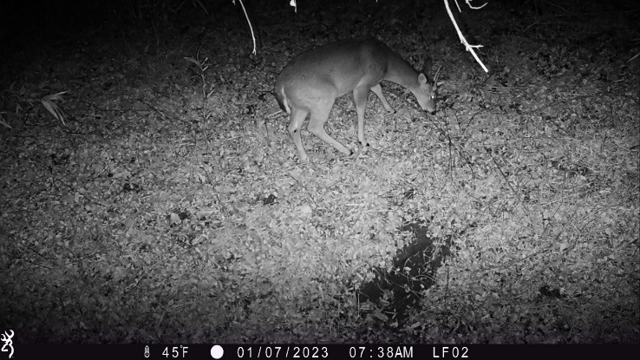
131 | 76 to 78 | Deer activity during nighttime | 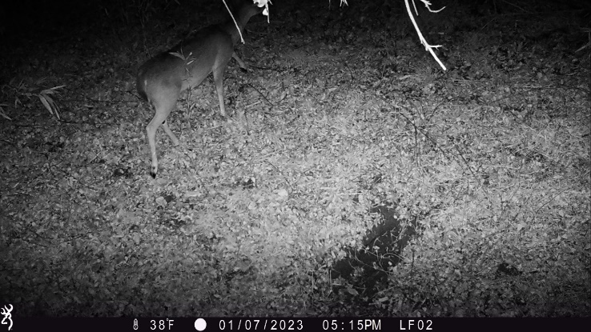
132 | 79 to 81 | Armadillo activity during nighttime | 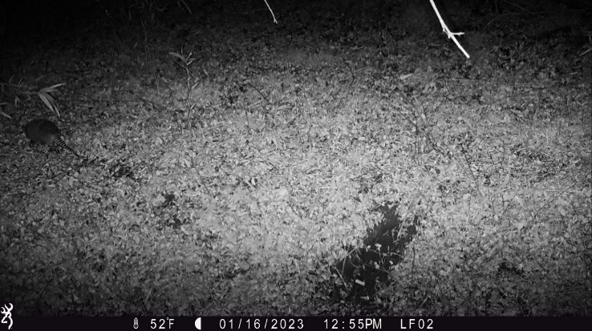
133 | 85 to 87 | Deer activity during nighttime | 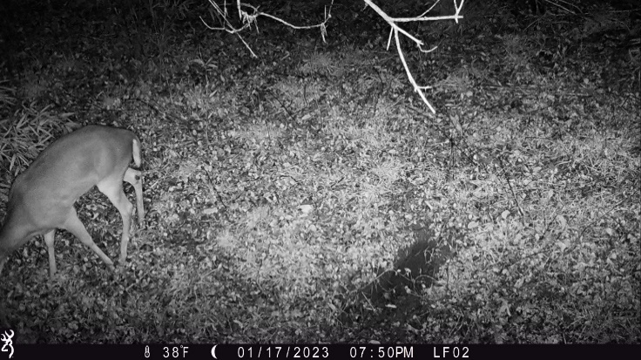
134 | 88 to 90 | Possum activity during nighttime | 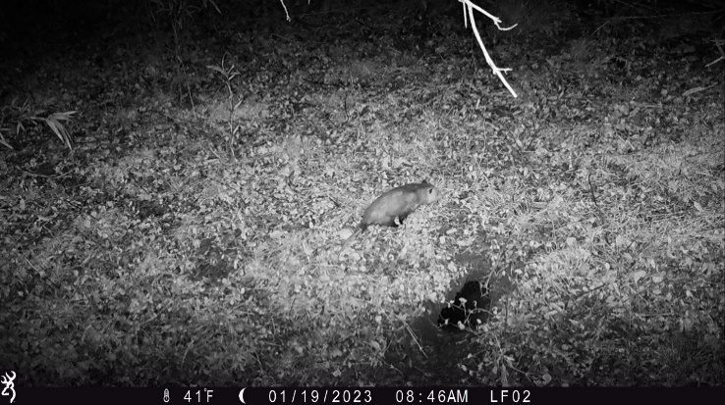
135 | 91 to 93 | Squirrel activity during daytime | 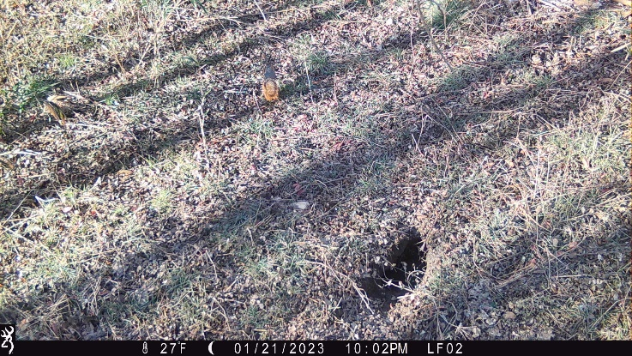
136 | 94 to 95 | Possum activity during nighttime | 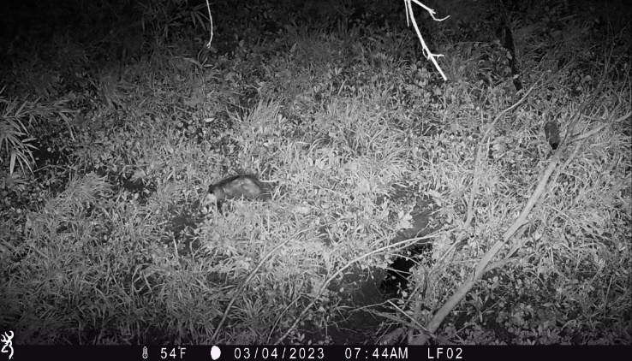
137 | 96 | Deer activity during nighttime | 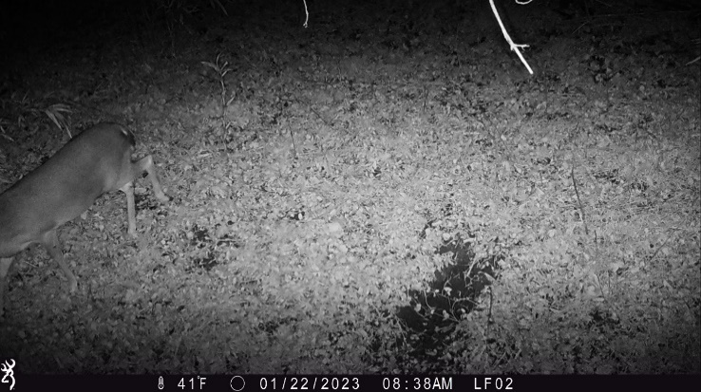
138 | 97 to 111 | Armadillo activity during nighttime | 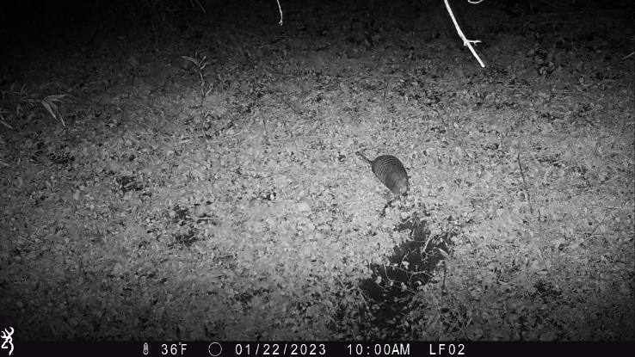
139 | 115 to 117 | Armadillo activity during nighttime; defensive behavior | 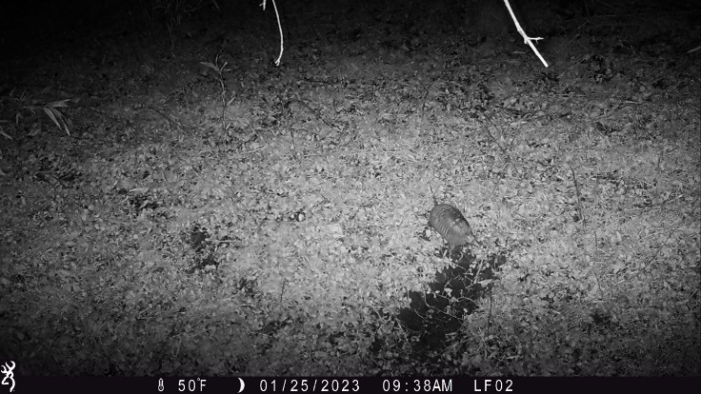
140 | 121 to 138 | Deer activity during nighttime | 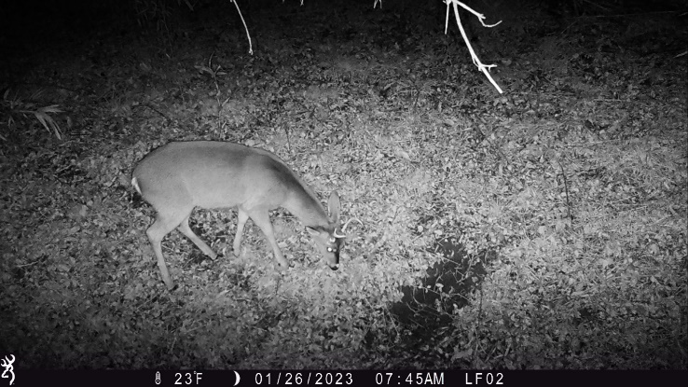
141 | 139 to 141 | Armadillo activity during nighttime | 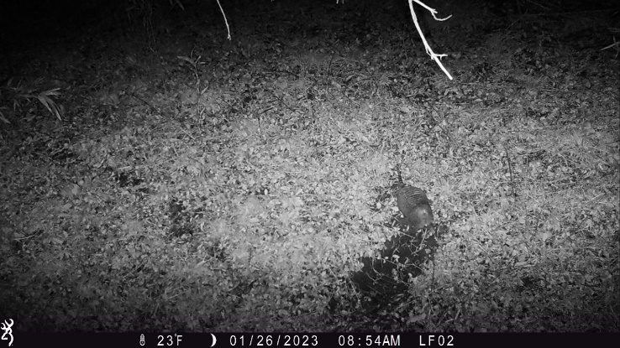
142 | 142 to 144 | Deer activity during nighttime | 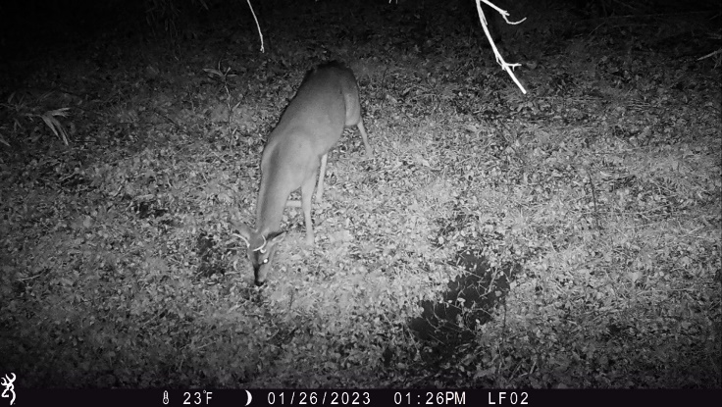
143 | 145 to 147 | Squirrel activity during daytime | 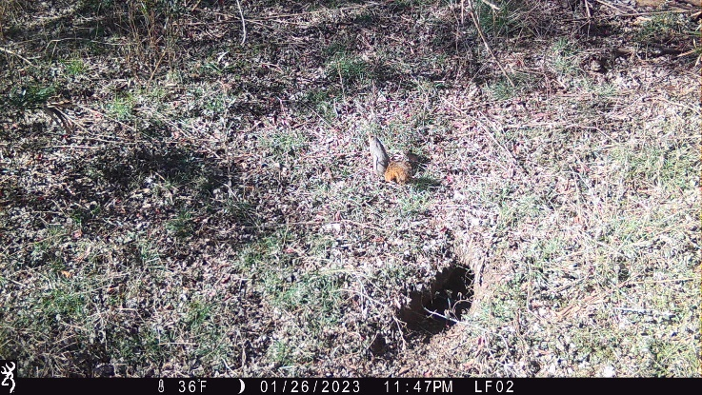
144 | 148 to 180 | Armadillo activity during nighttime | 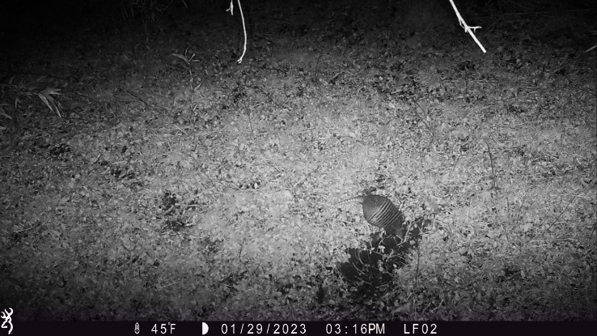
145 | 181 to 189 | Deer activity during nighttime | 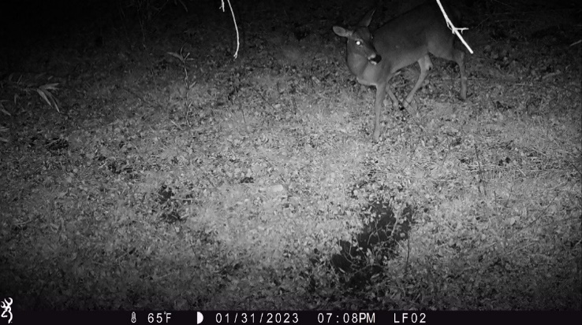
146 | 190 to 201 | Armadillo activity during nighttime | 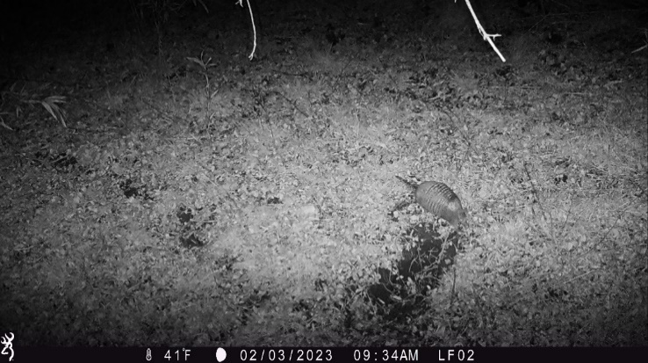
147 | 202 to 206 | Squirrel activity in armadillo burrow during daytime | 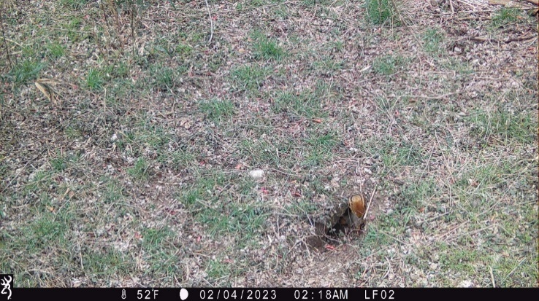
148 | 208 to 219 | Armadillo activity during nighttime | 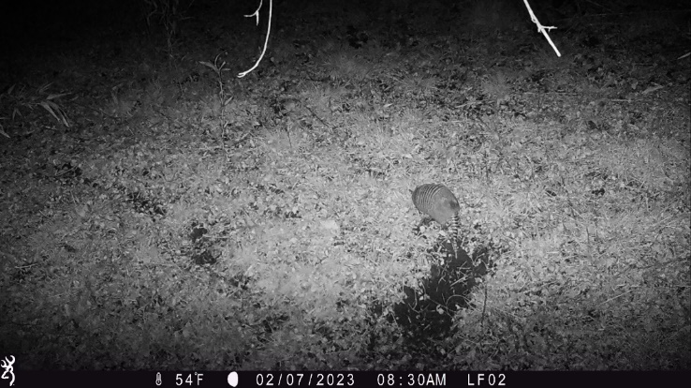
149 | 220 to 237 | Deer activity during nighttime | 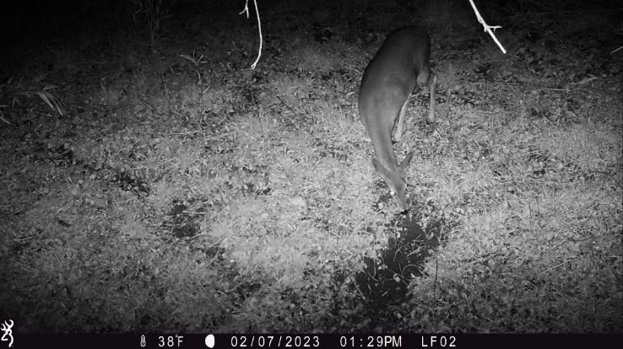
150 | 238 to 240 | Squirrel activity near armadillo burrow during daytime | 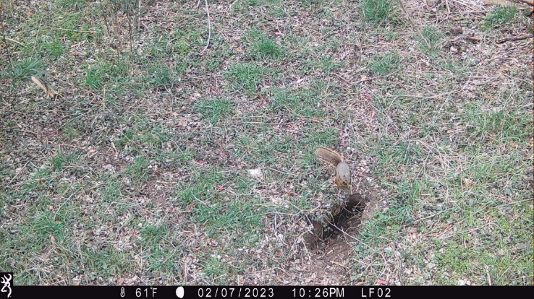
151 | 241 to 243 | Armadillo activity during nighttime | 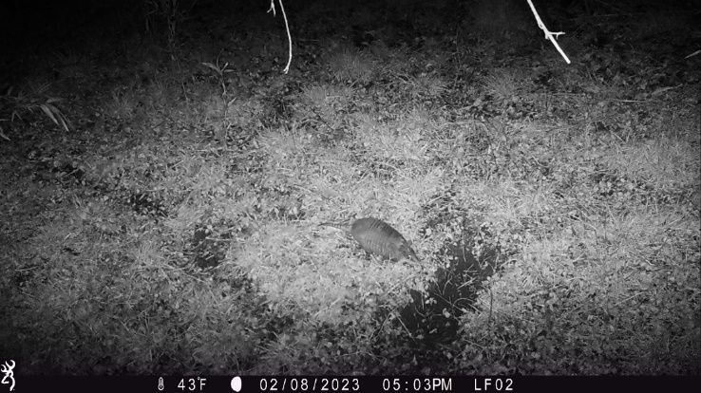
152 | 247 to 258 | Armadillo activity during nighttime | 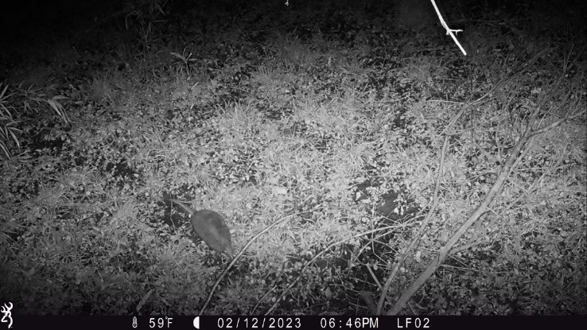
153 | 259 to 261 | Possum activity during nighttime | 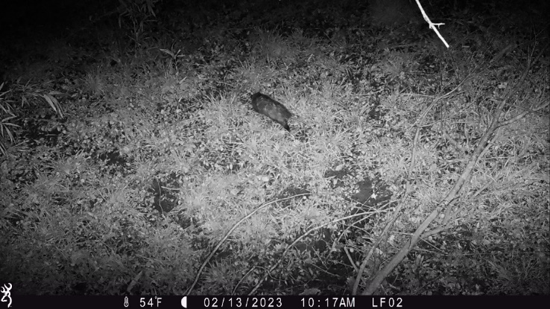
154 | 262 to 264 | Armadillo activity during nighttime | 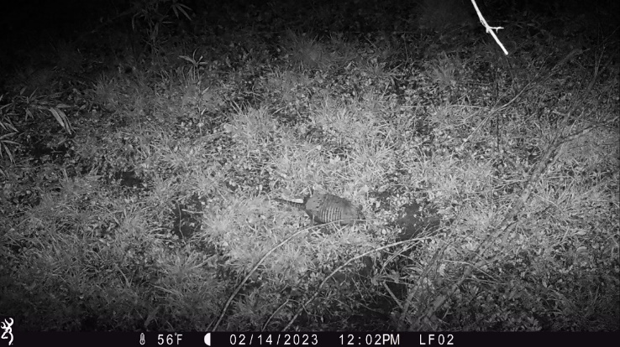
155 | 268 to 270 | Armadillo activity during nighttime | 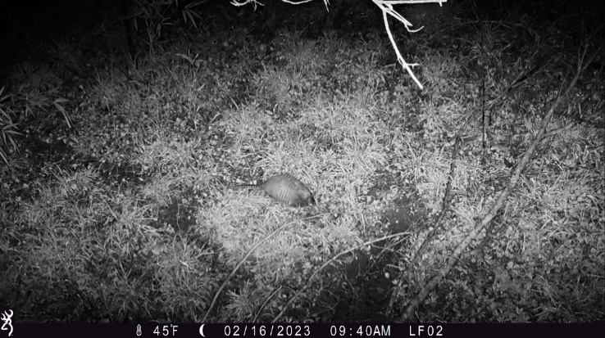
156 | 274 to 276 | Armadillo activity during nighttime | 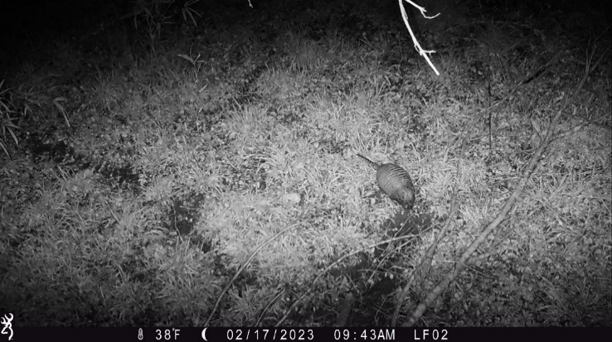
157 | 289 to 291 | Armadillo activity during nighttime | 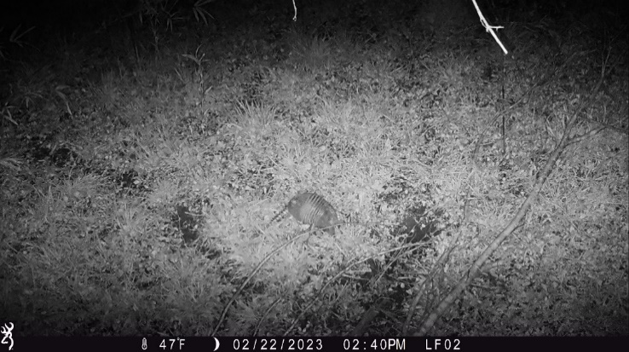
158 | 295 to 297 | Deer activity during nighttime | 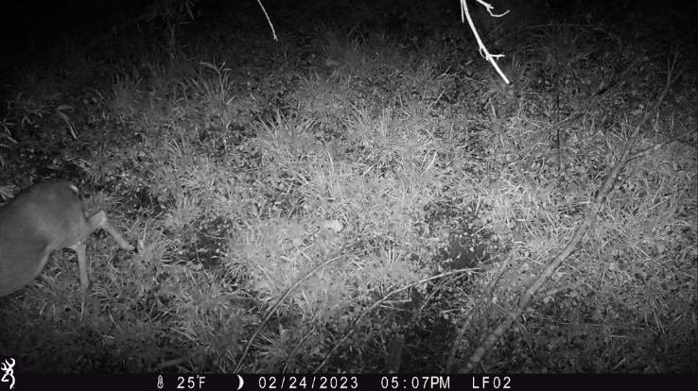
159 | 301 to 318 | Armadillo activity during nighttime | 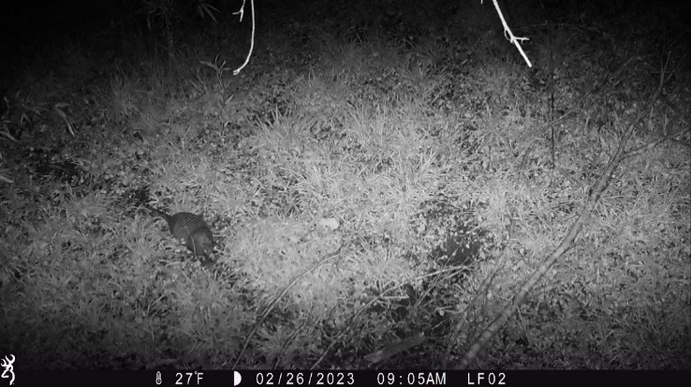
160 | 331 to 339 | Armadillo activity during nighttime | 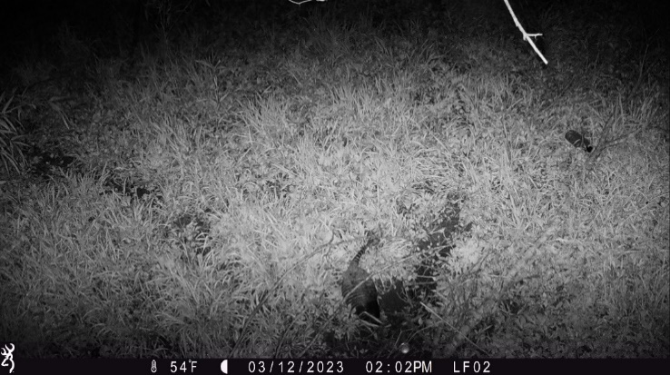
161 | 340 to 342 | Deer activity during nighttime (multiple) | 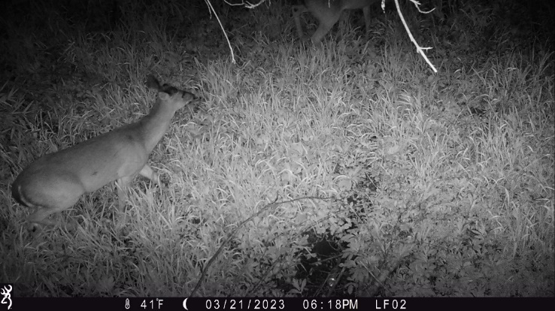
162 | 358 to 369 | Deer activity during daytime | 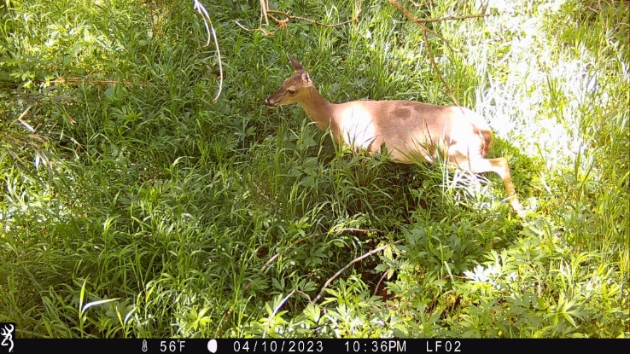
163 | 373 to 387 | Deer activity during nighttime | 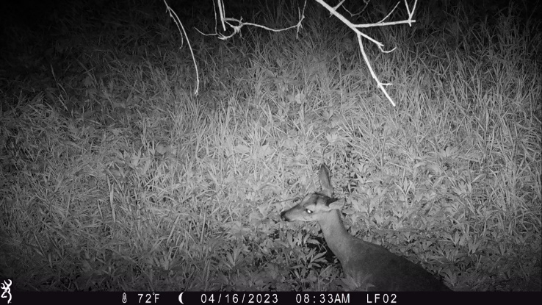

Notable Events (Camera ID: LF02_2)
EVENT | PHOTO ID | COMMENTS
- | NA | No notable wildlife

Notable Events (Camera ID: LF02_3)
EVENT | PHOTO ID | COMMENTS
- | NA | Camera stolen; unable to report wildlife findings

Notable Events (Camera ID: LF03_1)
EVENT | PHOTO ID | COMMENTS
164 | 4 to 6 | Deer activity during nighttime | 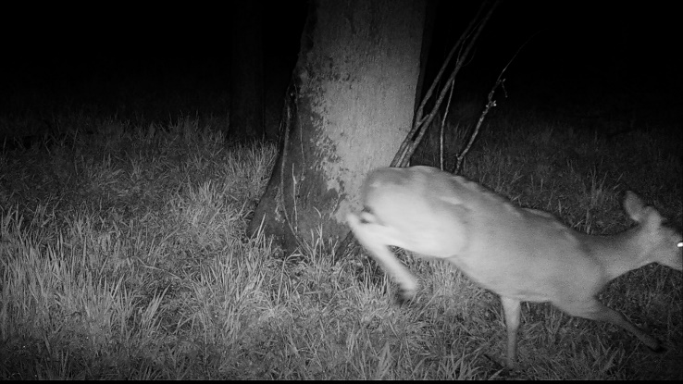
165 | 10 to 12 | Squirrel activity during daytime | 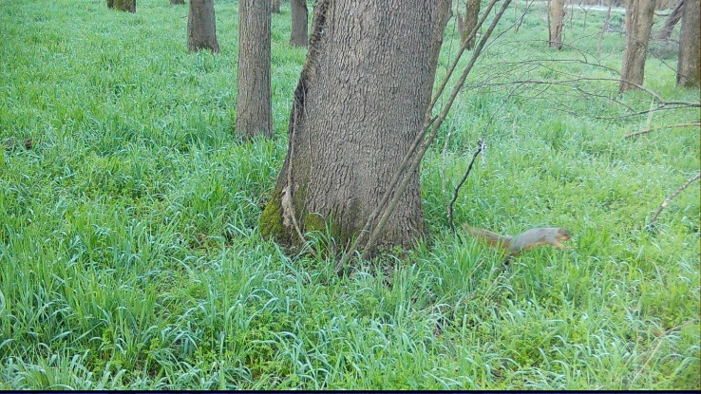
166 | 13 to 15 | Deer activity during daytime | 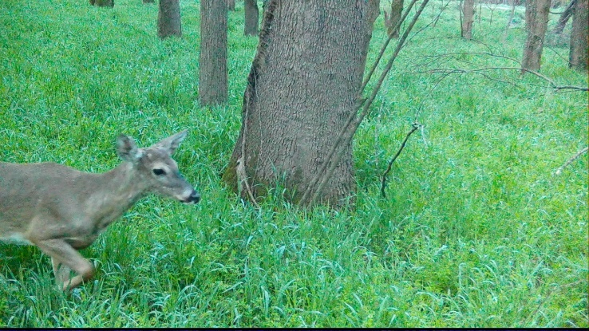
167 | 16 to 39 | Deer activity during nighttime (multiple) | 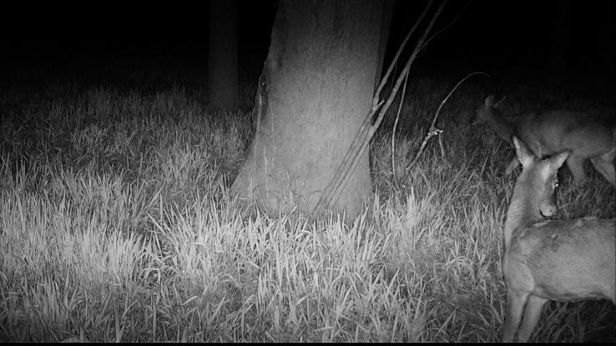
168 | 40 to 42 | Squirrel activity during daytime | 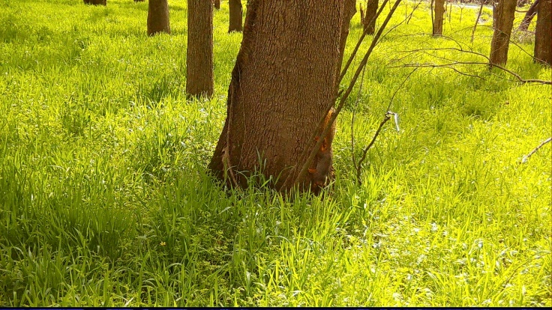
169 | 43 to 57 | Deer activity during nighttime | 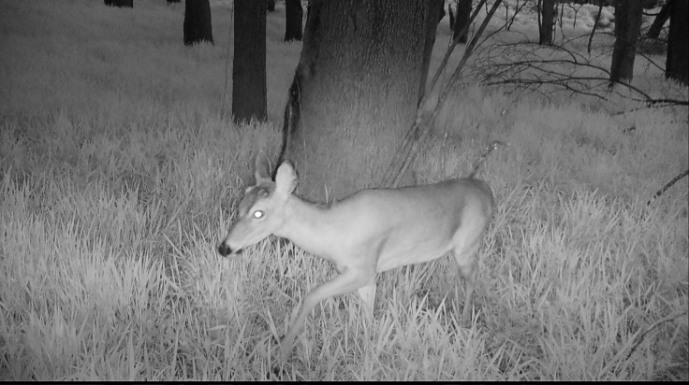
170 | 64 to 66 | Squirrel activity during daytime | 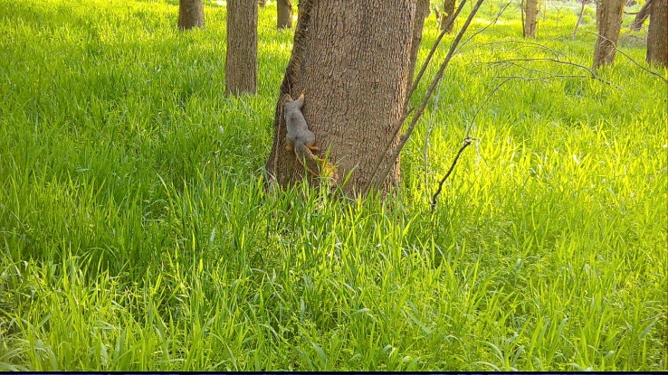
171 | 79 to 81 | Deer activity during nighttime | 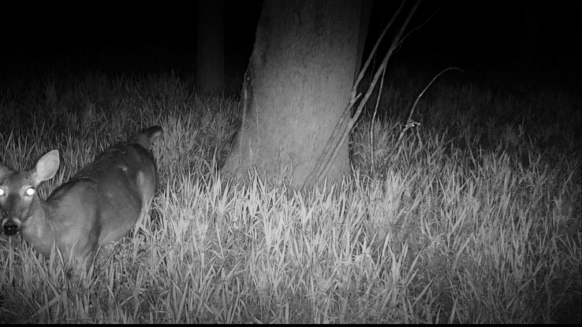
172 | 82 to 84 | Squirrel activity during daytime | 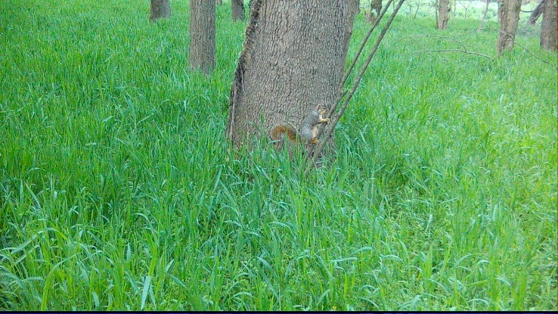
173 | 88 to 96 | Deer activity during nighttime; significant vegetative growth | 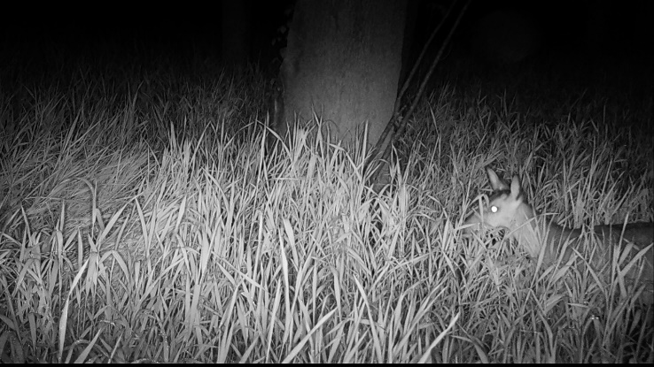
174 | 121 to 123 | Deer activity during nighttime; overflow effect on vegetation | 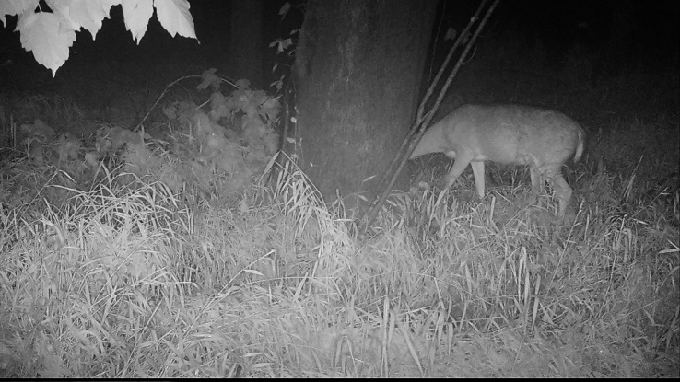
175 | 127 to 144 | Deer activity during nighttime | 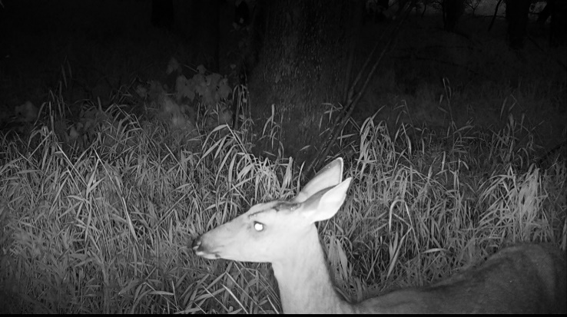
176 | 148 to 150 | Deer activity during daytime | 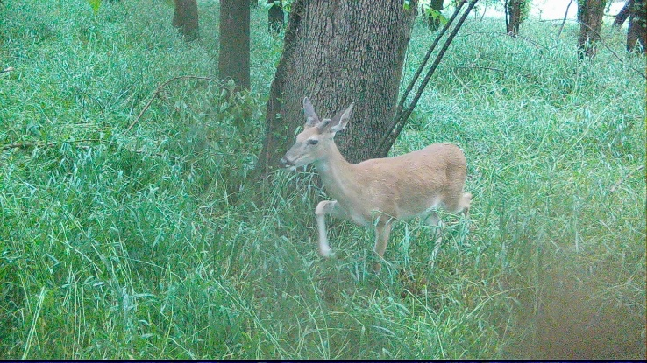
177 | 151 to 153 | Deer activity during nighttime | 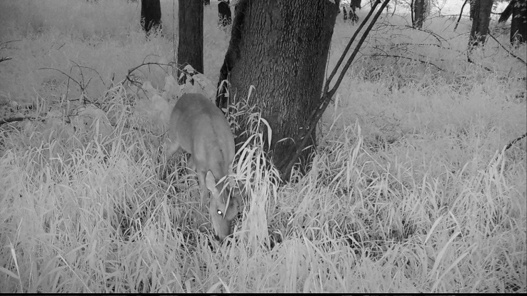
178 | 160 to 163 | Deer activity during nighttime | 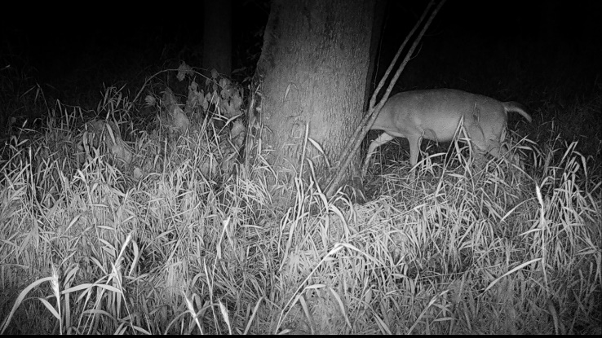
179 | 166 to 168 | Deer activity during daytime | 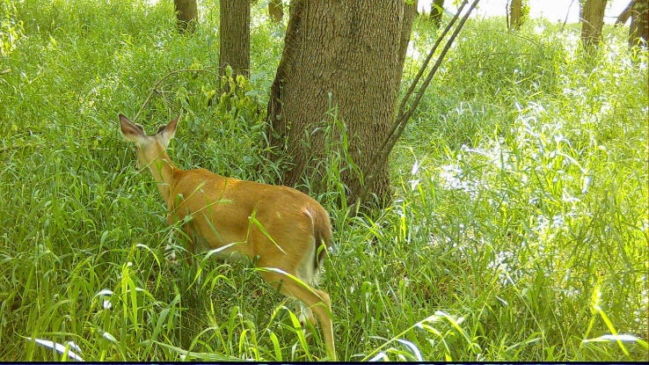
180 | 175 | Deer activity during daytime | 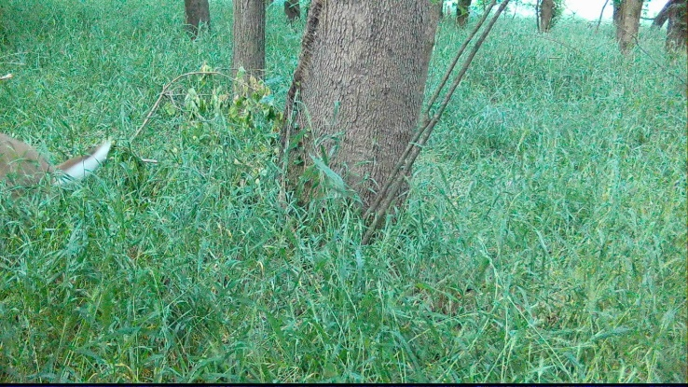
181 | 181 to 183 | Dog activity during daytime | 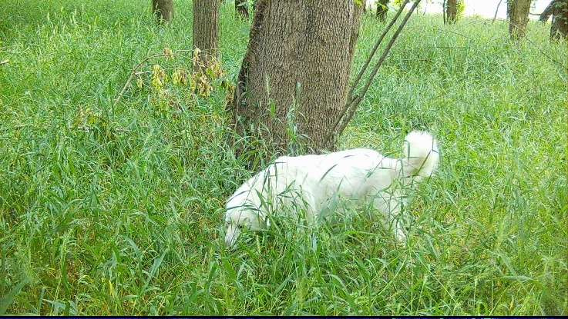
182 | 184 to 210 | Deer activity during daytime | 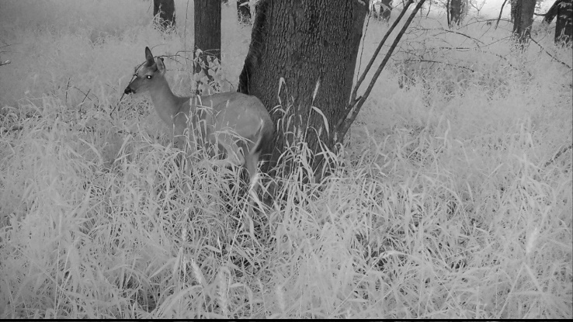

Notable Events (Camera ID: LF03_2)
EVENT | PHOTO ID | COMMENTS
- | NA | No notable wildlife

Notable Events (Camera ID: LF03_3)
EVENT | PHOTO ID | COMMENTS
183 | 152 to 153 | Deer activity during daytime | 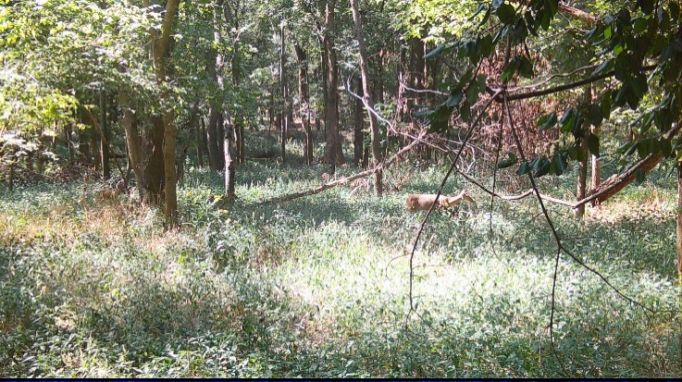
184 | 156 to 161 | Deer (multiple) activity during daytime | 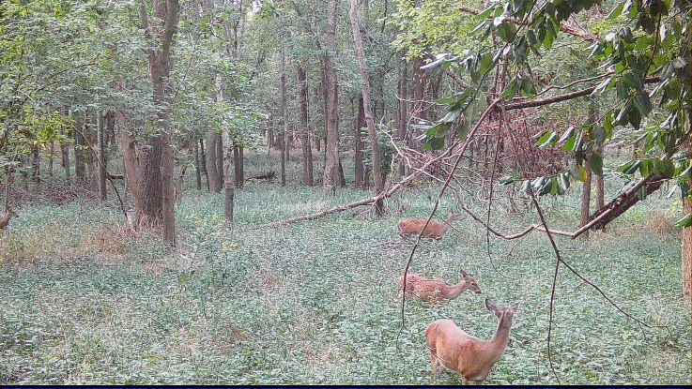
185 | 166 to 167 | Deer (multiple) activity during daytime | 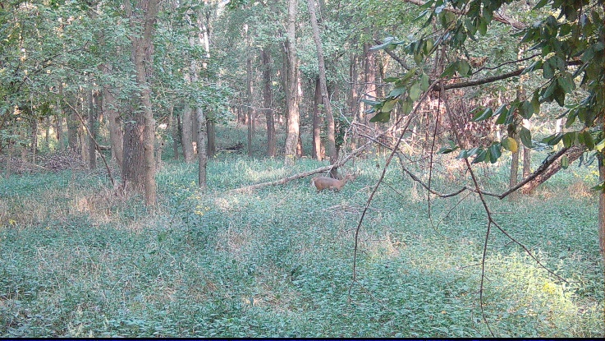
186 | 178 to 179 | Deer (buck) activity during daytime | 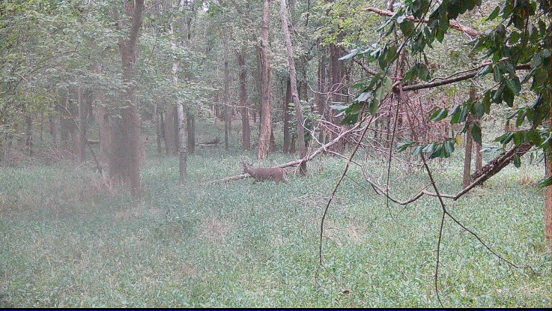
187 | 180 to 182 | Deer (multiple) activity during daytime | 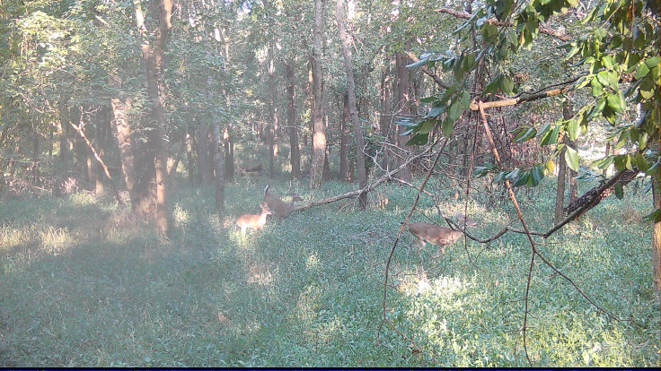
188 | 184 to 202 | Deer (multiple) activity during daytime | 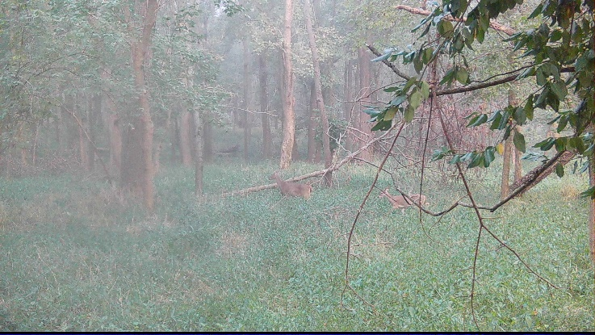
189 | 204 to 211 | Deer (multiple) activity during daytime | 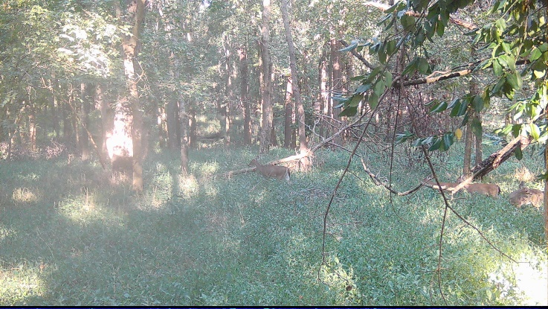
190 | 212 to 223 | Deer (multiple) activity during daytime | 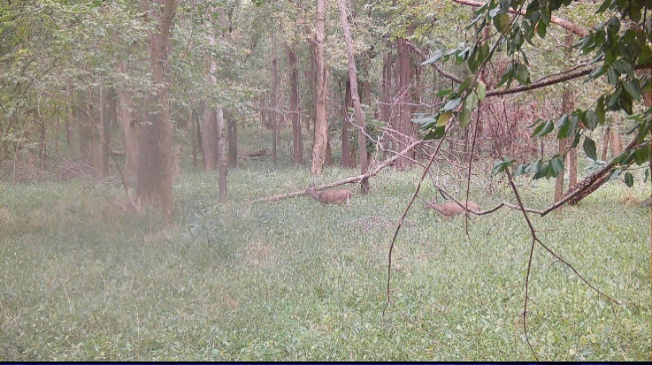
191 | 225 to 242 | Deer (multiple) activity during daytime | 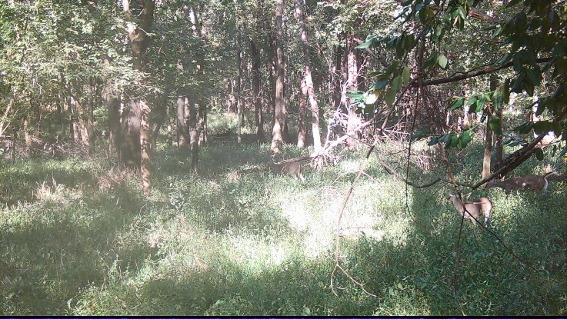
192 | 244 to 246 | Deer (multiple) activity during daytime | 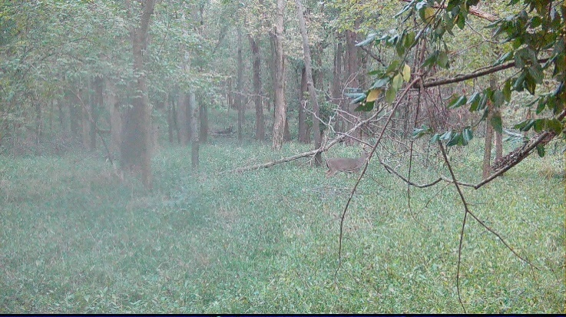
193 | 248 to 281 | Deer (multiple) activity during daytime | 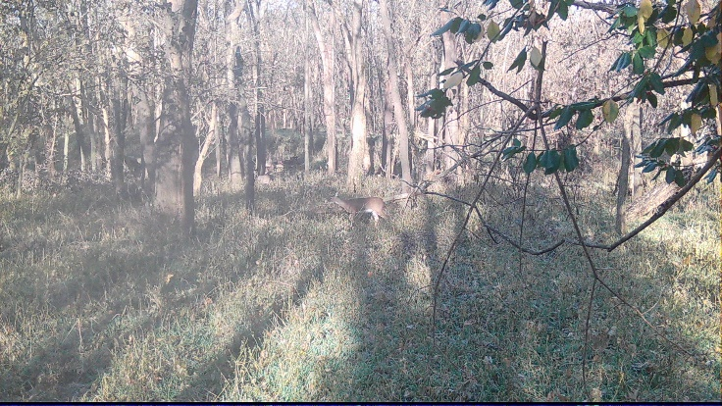
194 | 284 to 286 | Deer (multiple) activity during daytime | 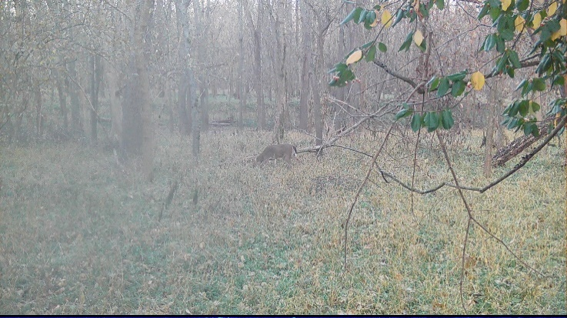
195 | 288 to 289 | Deer (multiple) activity during daytime | 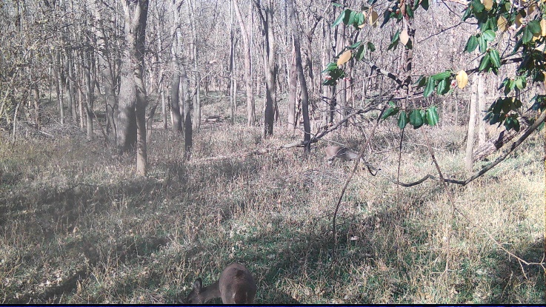
196 | 292 to 298 | Deer (multiple) activity during daytime | 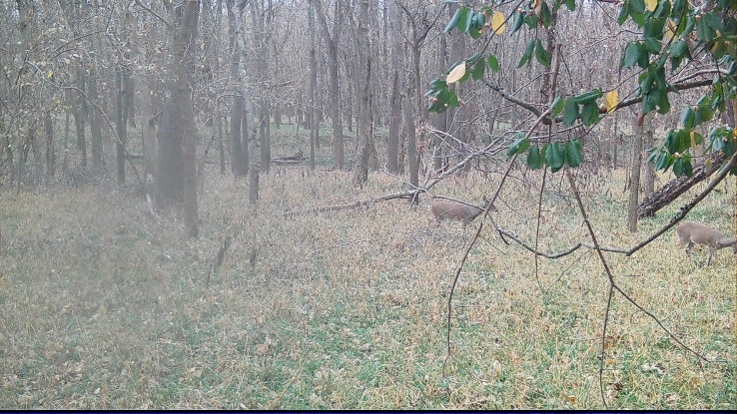
197 | 299 to 301 | Deer (multiple) activity during daytime | 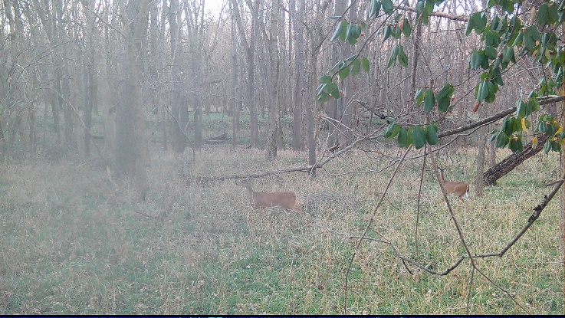
198 | 304 to 333 | Deer (multiple) activity during daytime | 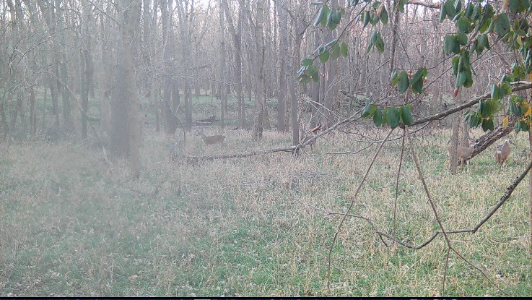

Notable Events (Camera ID: LF04_1)
EVENT | PHOTO ID | COMMENTS
199 | 1 to 15 | Deer activity during nighttime | 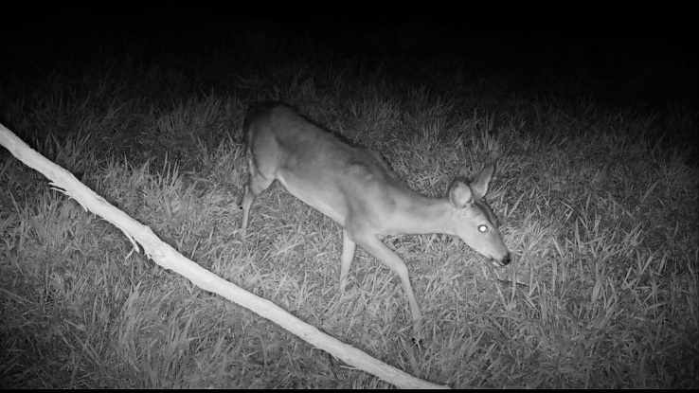
200 | 16 to 17 | Squirrel activity during daytime | 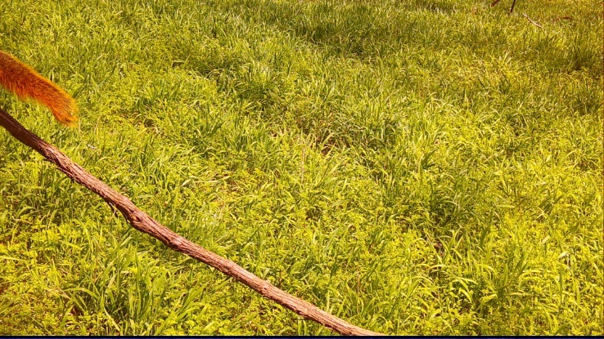
201 | 19 to 24 | Deer activity during nighttime | 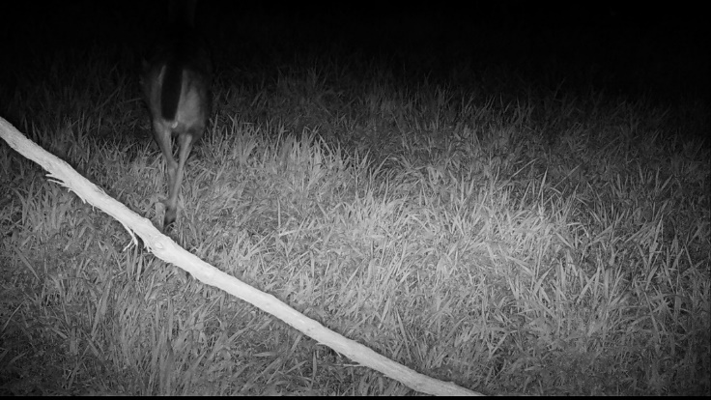
202 | 25 to 26 | Squirrel activity during daytime | 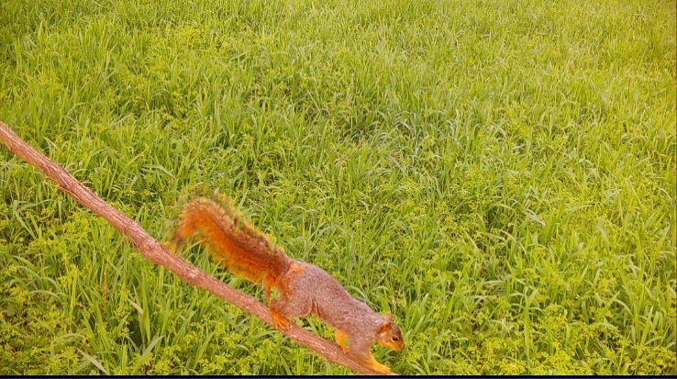
203 | 30 to 33 | Deer activity during nighttime | 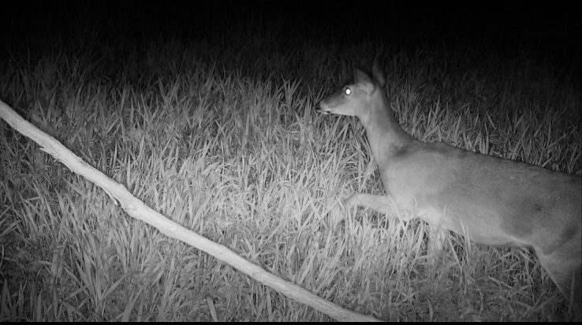

Notable Events (Camera ID: LF04_2)
EVENT | PHOTO ID | COMMENTS
204 | 754 to 768 | Deer activity during nighttime | 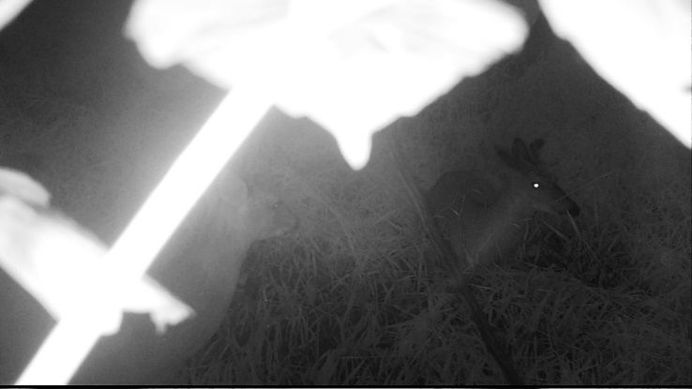
205 | 769 to 771 | Deer activity during daytime | 
206 | 793 to 801 | Deer activity during nighttime; possibly pregnant | 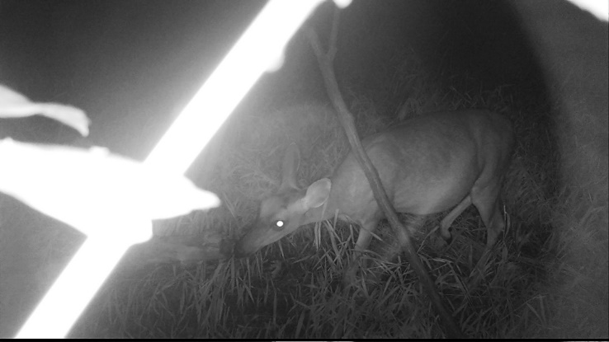
207 | 805 to 810 | Deer activity during nighttime | 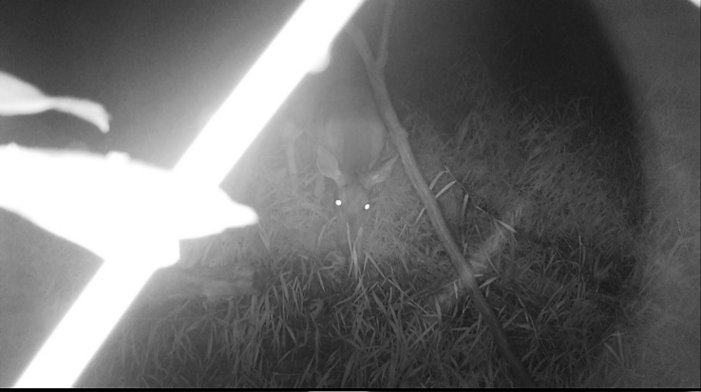
208 | 820 to 824 | Squirrel activity during daytime | 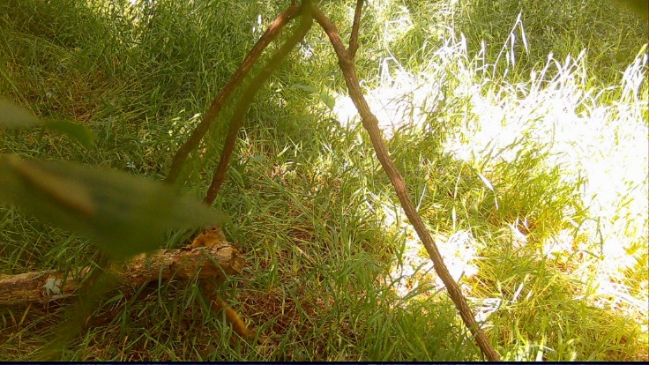
209 | 829 to 831 | Crow activity during daytime | 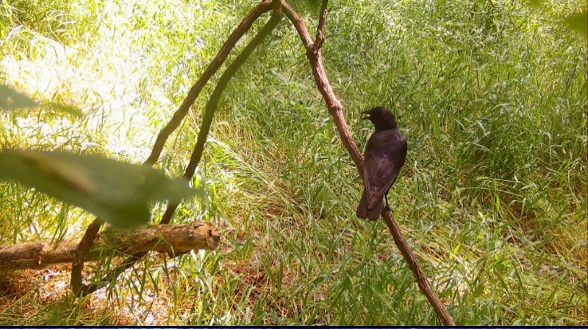
210 | 832 to 834 | Northern Cardinal activity during daytime | 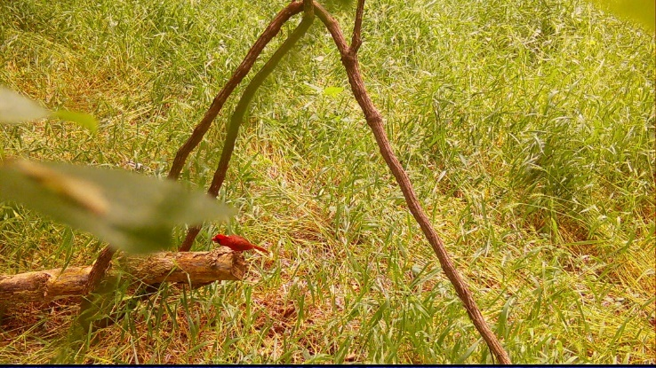

Notable Events (Camera ID: LF04_3)
EVENT | PHOTO ID | COMMENTS
211 | 71 to 73 | Deer activity during daytime | 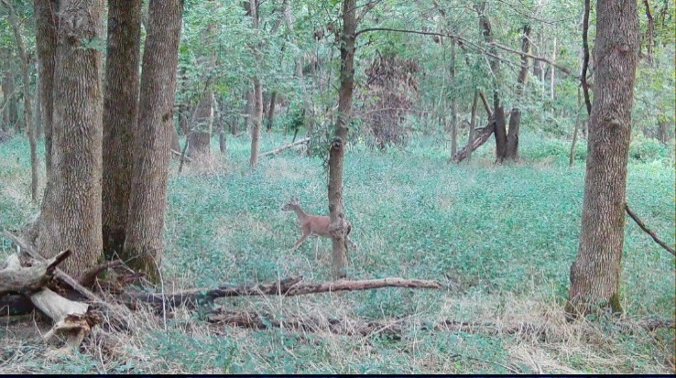
212 | 74 to 76 | Deer (multiple) activity during nighttime | 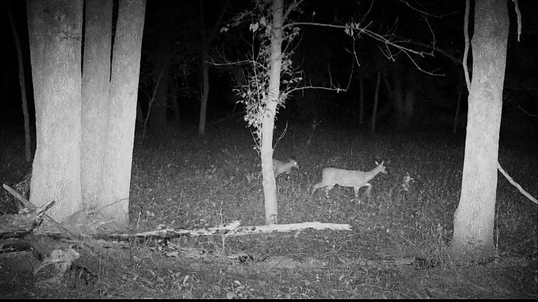
213 | 77 to 78 | Deer (multiple) activity during daytime | 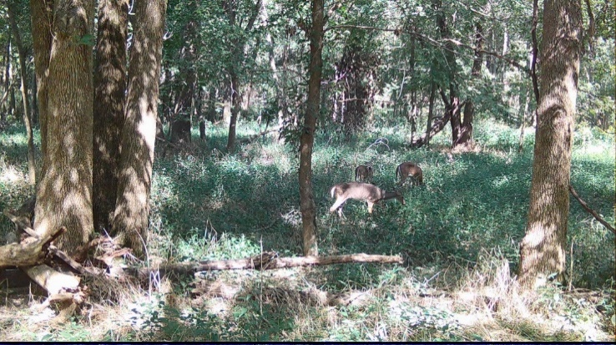
214 | 79 to 82 | Deer activity during daytime | 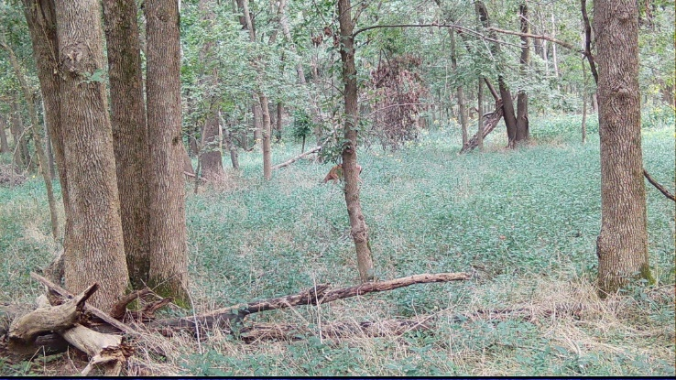
215 | 83 to 86 | Deer (multiple) activity during daytime | 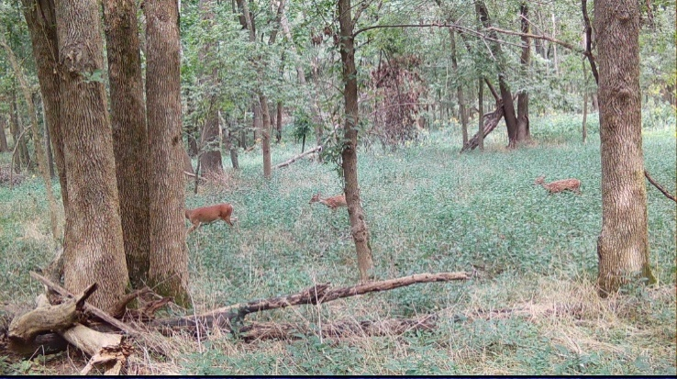
216 | 87 to 88 | Deer activity during daytime | 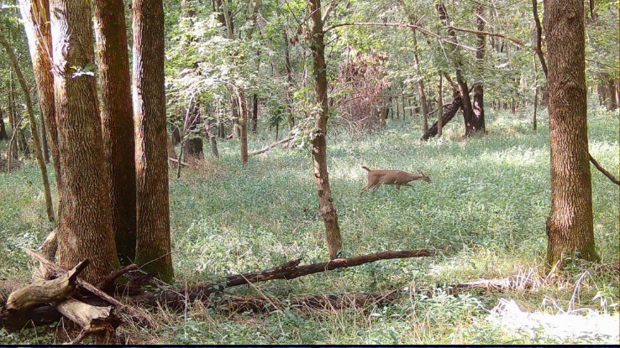
217 | 89 to 92 | Deer (multiple) activity during daytime | 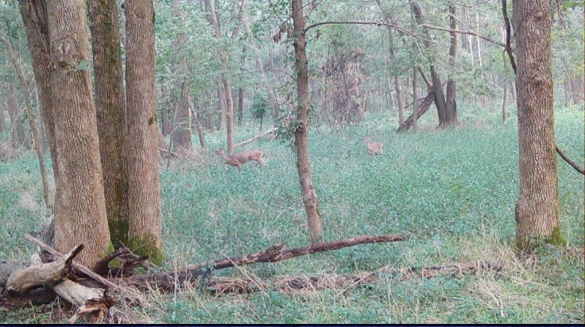
218 | 97 to 100 | Deer (multiple) activity during daytime | 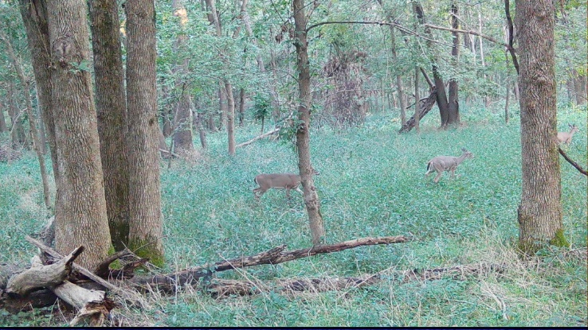
219 | 101 to 104 | Deer activity during daytime | 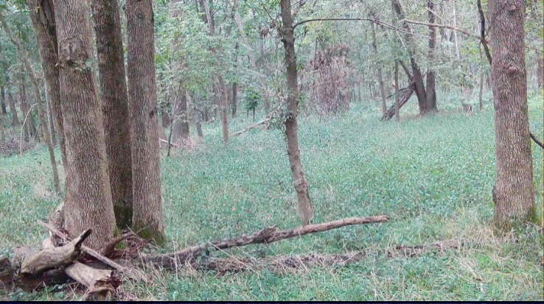
220 | 105 to 112 | Deer (multiple) activity during daytime | 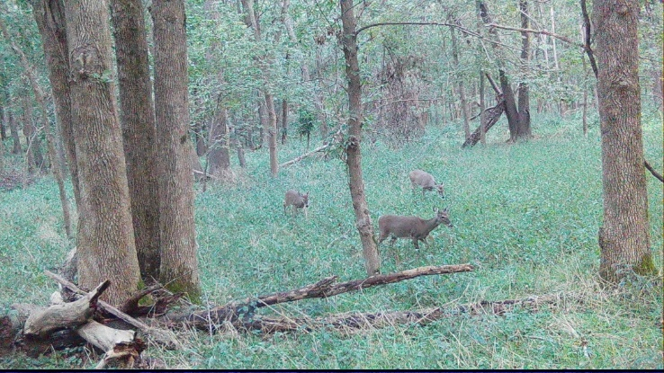
221 | 113 to 120 | Deer (multiple) activity during daytime | 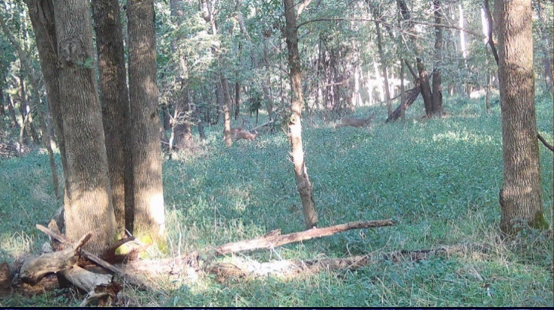
222 | 121 to 122 | Deer activity during daytime | 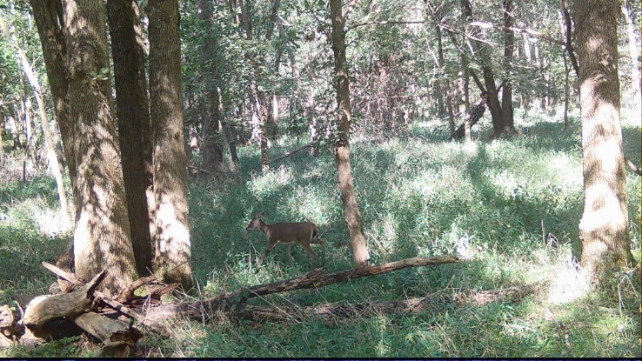
223 | 123 to 124 | Deer activity during daytime | 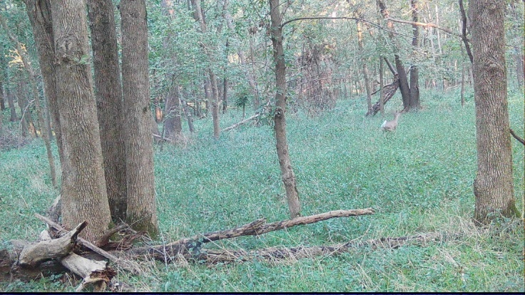
224 | 125 to 130 | Deer activity during daytime | 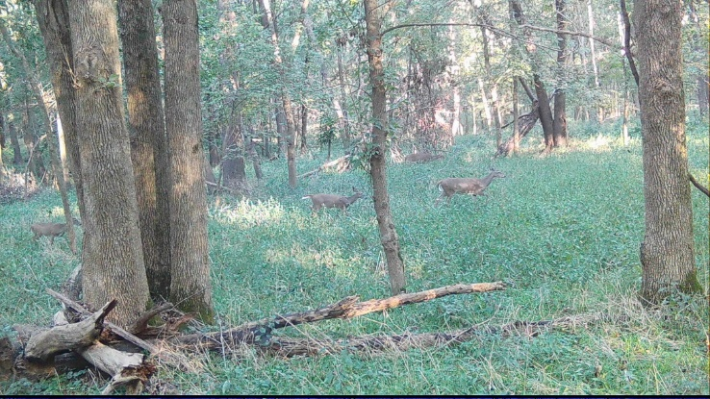
225 | 131 to 132 | Deer activity during daytime | 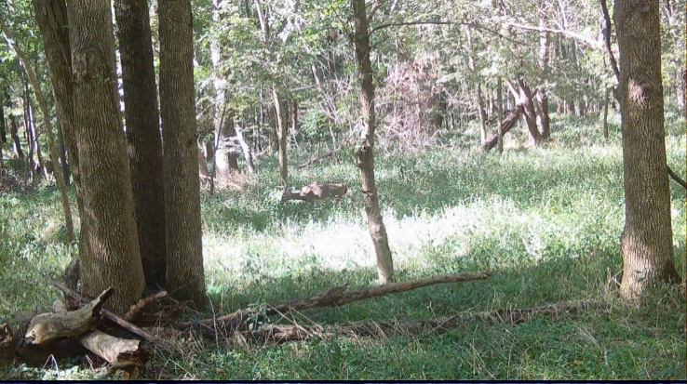
226 | 133 to 138 | Deer activity during daytime | 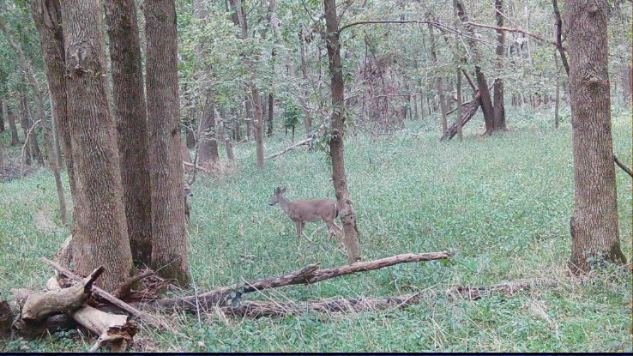
227 | 139 to 142 | Deer activity during daytime | 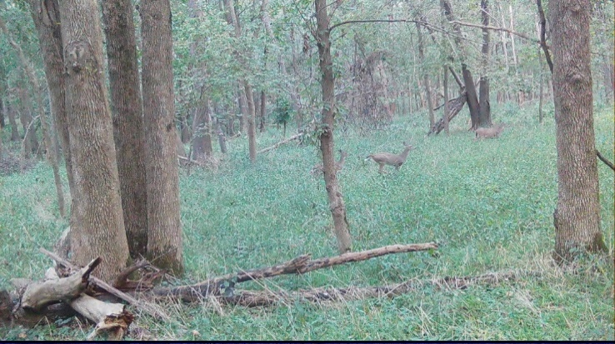
228 | 143 to 144 | Deer activity during daytime | 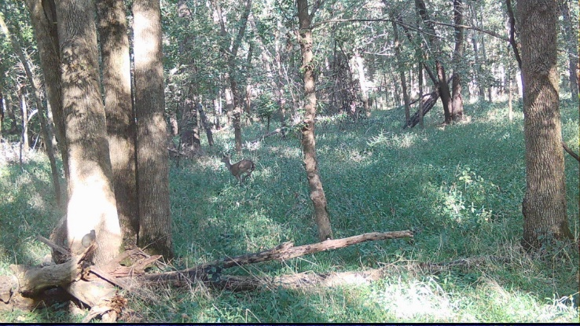
229 | 145 to 146 | Deer activity during daytime | 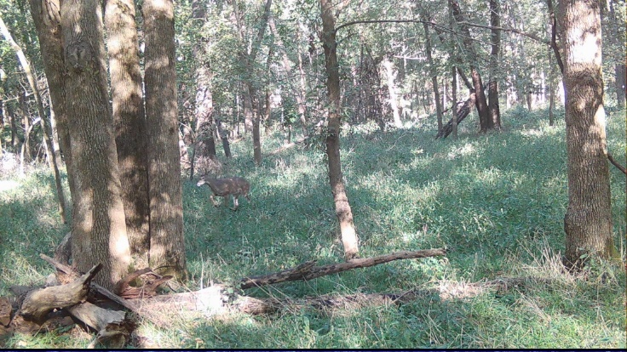
230 | 147 to 148 | Deer activity during daytime | 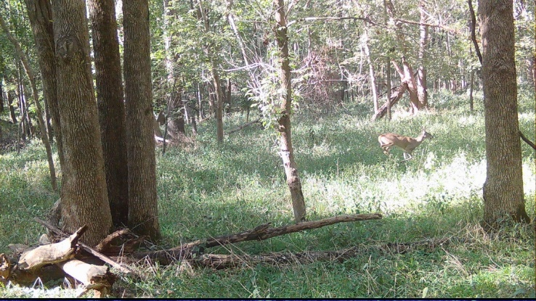
231 | 149 to 152 | Deer activity during daytime | 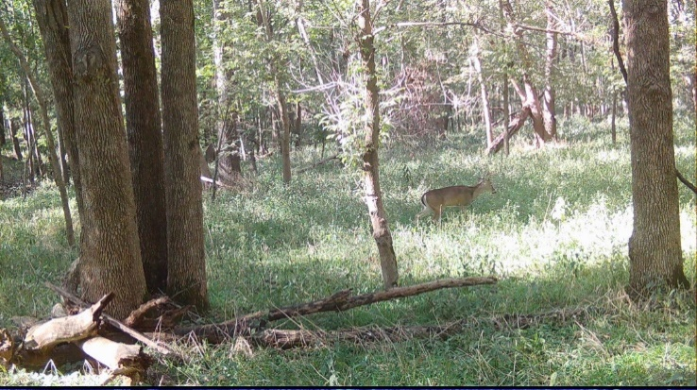
232 | 157 to 160 | Deer activity during daytime | 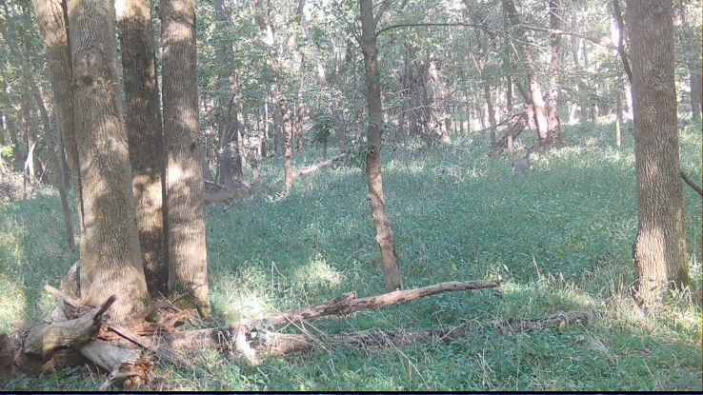
233 | 161 to 176 | Deer (multiple) activity during daytime | 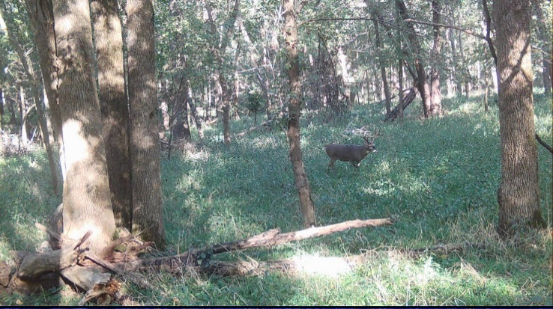  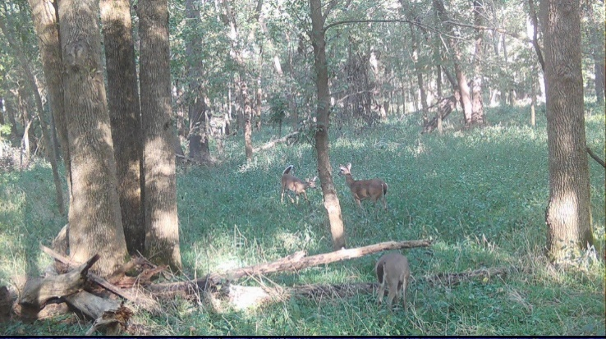
234 | 177 to 180 | Deer activity during daytime | 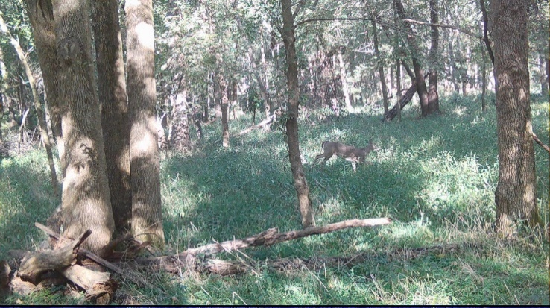
235 | 181 to 184 | Deer (multiple) activity during daytime | 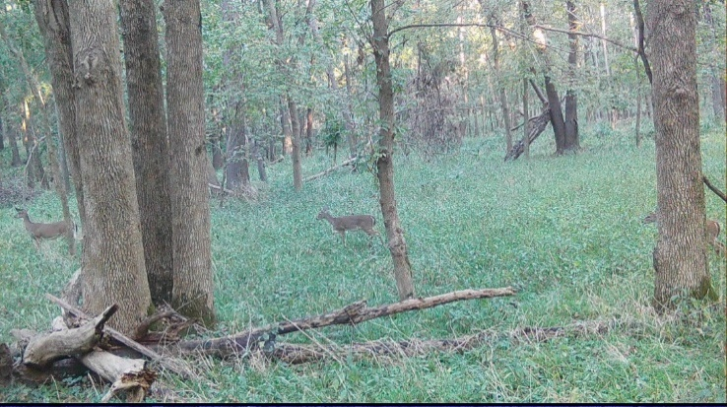
236 | 189 to 194 | Deer activity during nighttime | 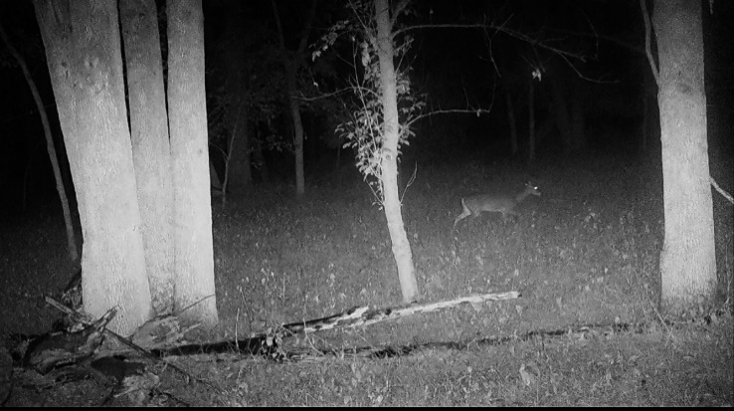
237 | 197 to 198 | Deer activity during daytime | 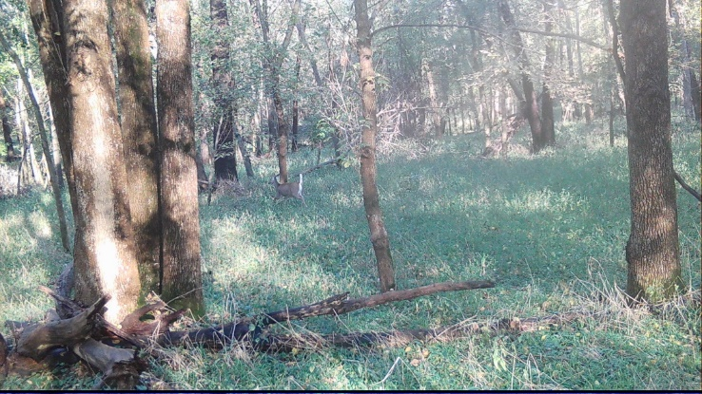
238 | 199 to 204 | Deer (multiple) activity during daytime | 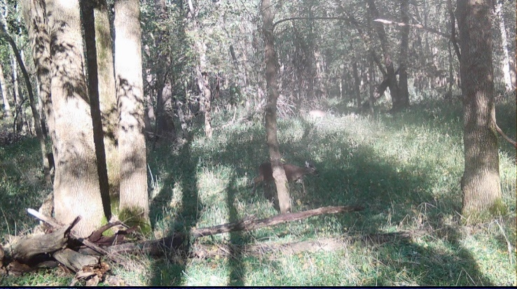
239 | 205 to 208 | Deer activity during nighttime | 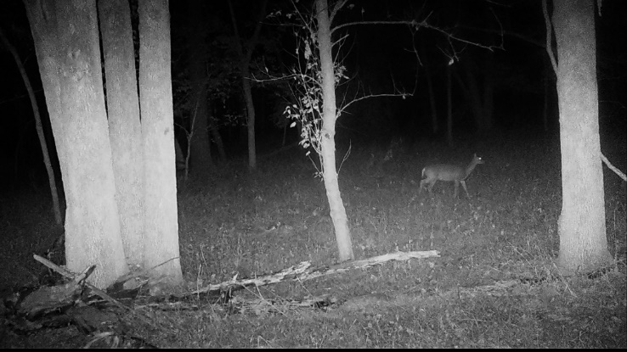
240 | 211 to 218 | Deer activity during daytime | 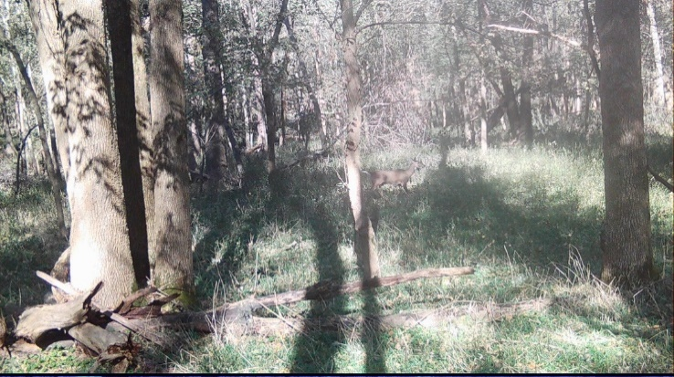
241 | 219 to 228 | Deer (multiple) activity during daytime | 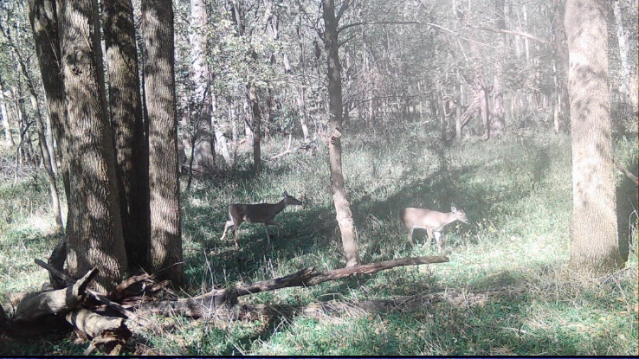
242 | 229 to 230 | Deer activity during nighttime | 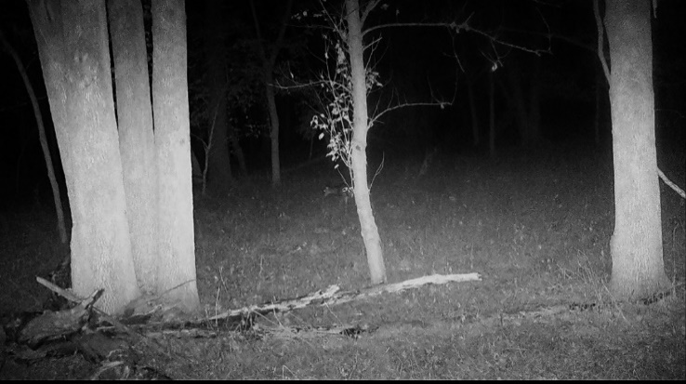
243 | 231 to 232 | Deer activity during nighttime | 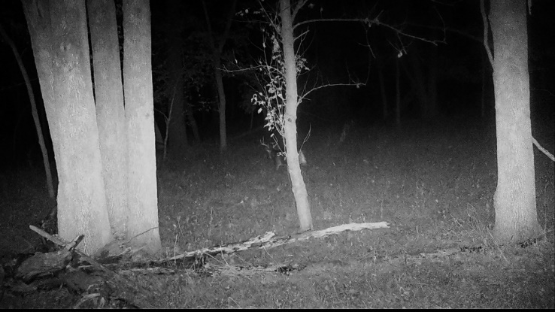
244 | 233 to 238 | Deer activity during daytime | 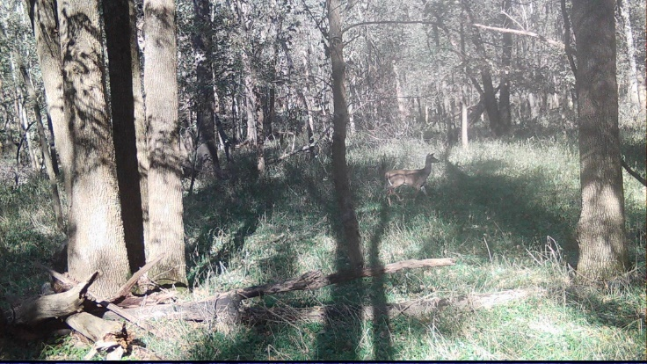
245 | 239 to 240 | Deer (multiple) activity during daytime | 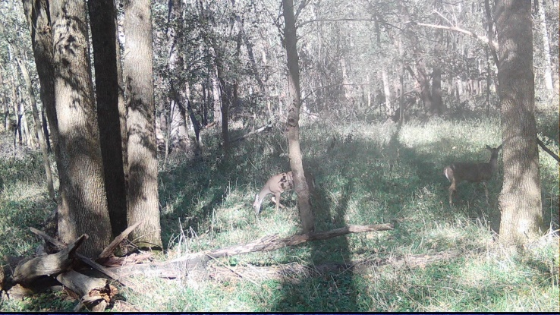
246 | 241 to 248 | Deer activity during nighttime | 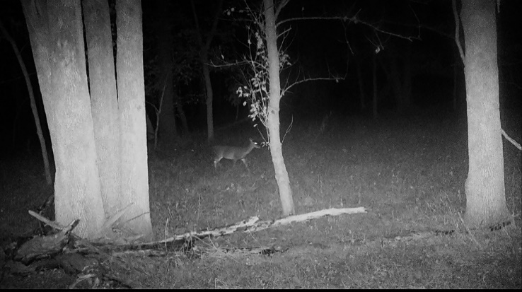
247 | 249 to 250 | Deer activity during daytime | 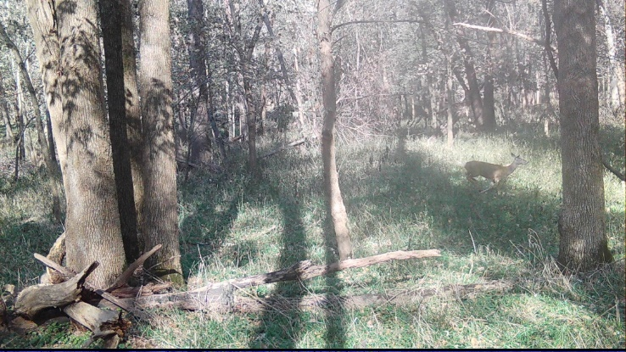
248 | 251 to 254 | Deer activity during daytime | 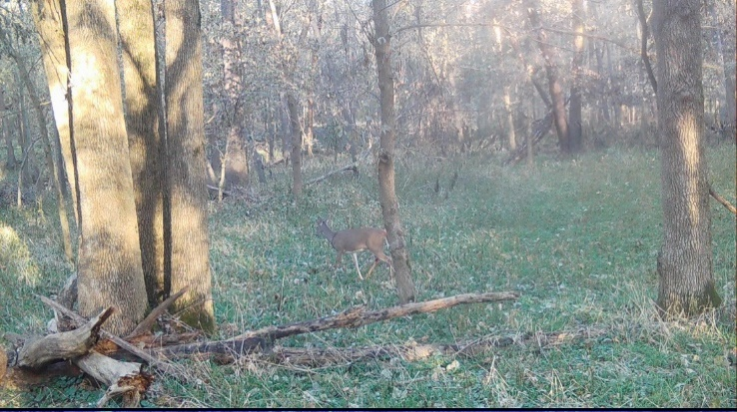
249 | 255 to 258 | Deer activity during daytime | 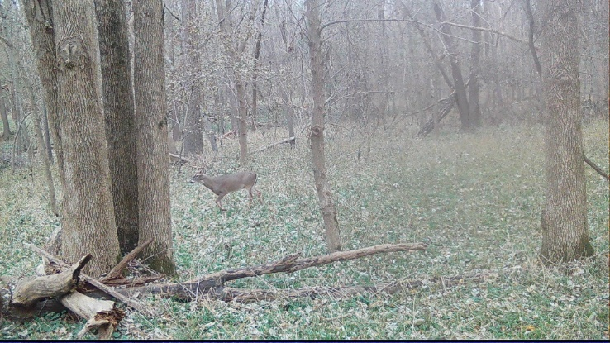
250 | 259 to 260 | Deer activity during daytime | 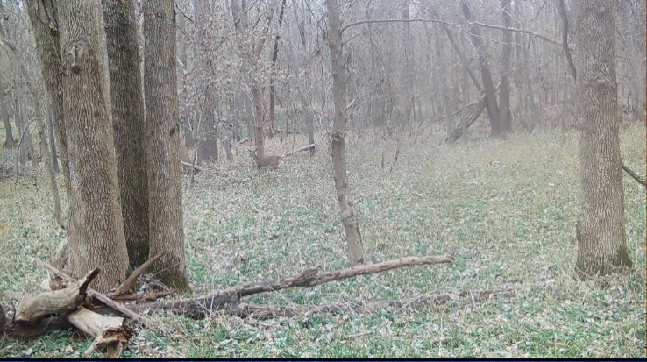
251 | 261 to 262 | Deer activity during daytime | 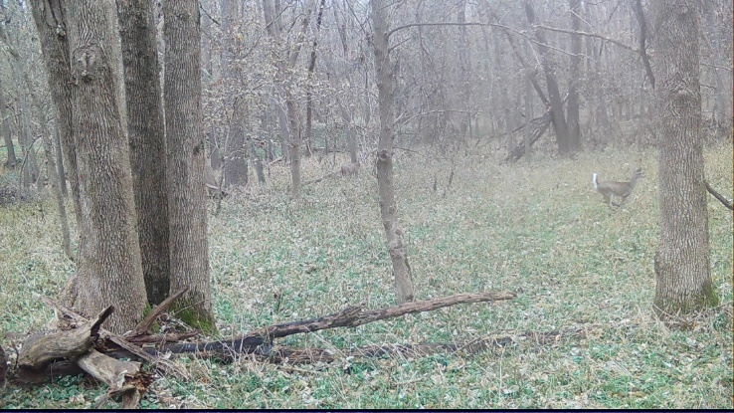
252 | 263 to 264 | Deer activity during daytime | 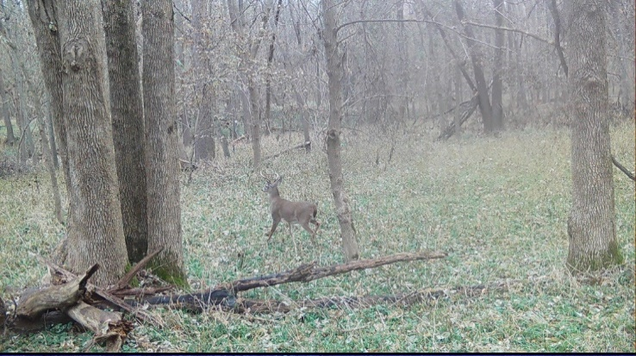
253 | 265 to 266 | Deer activity during daytime | 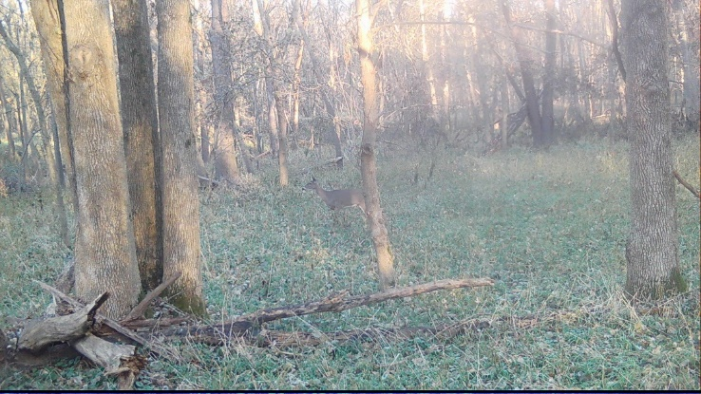
254 | 267 to 270 | Deer activity during daytime | 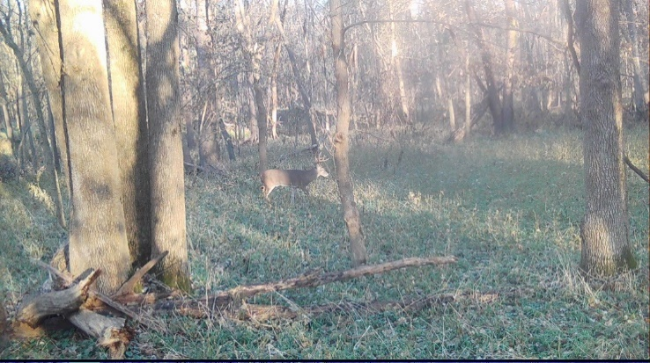
255 | 271 to 275 | Deer activity during daytime | 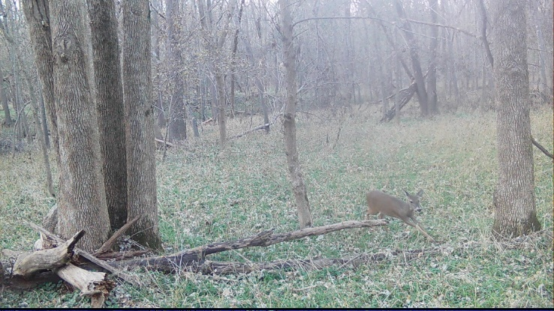
256 | 277 to 280 | Deer activity during daytime | 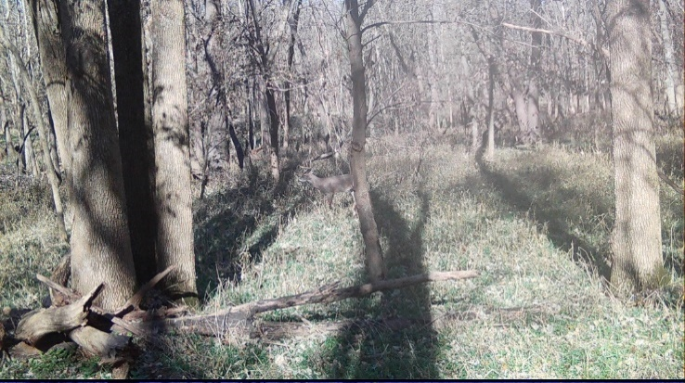
257 | 281 to 286 | Deer activity during daytime | 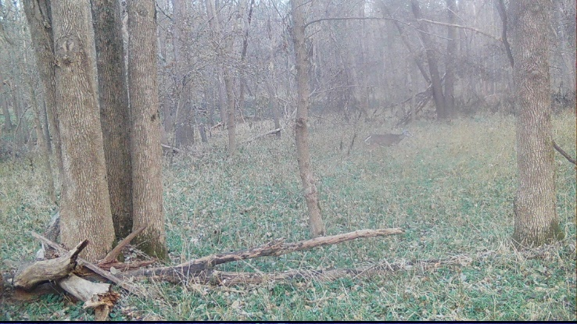
258 | 287 to 290 | Deer activity during daytime | 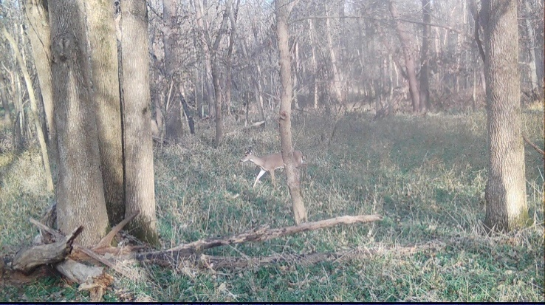
259 | 291 to 296 | Deer activity during daytime | 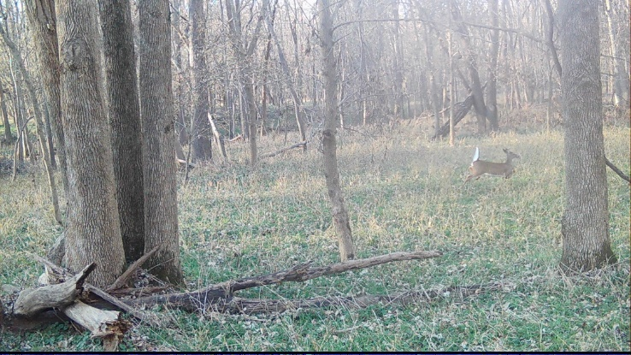
260 | 297 to 298 | Deer activity during daytime | 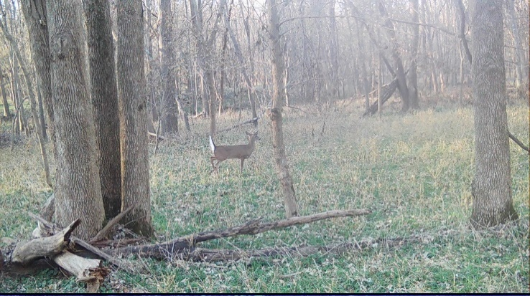
261 | 299 to 302 | Deer activity during daytime | 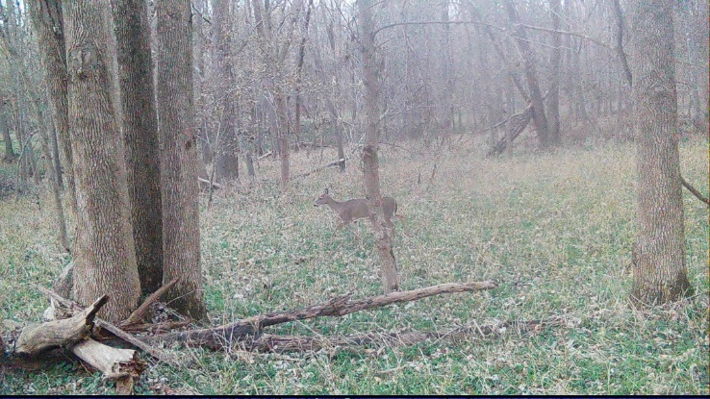
262 | 305 to 306 | Deer activity during daytime | 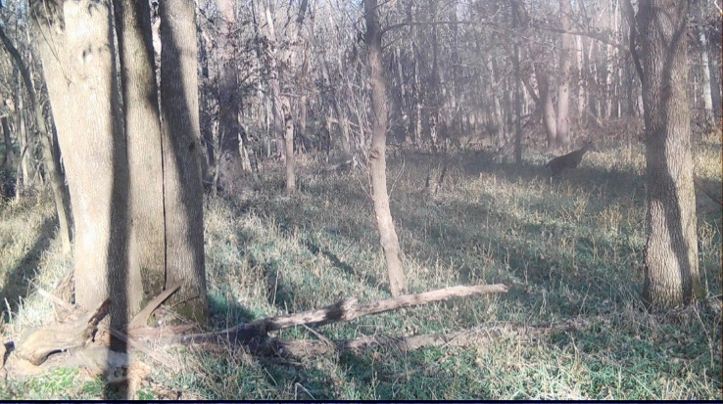
263 | 307 to 308 | Deer activity during daytime | 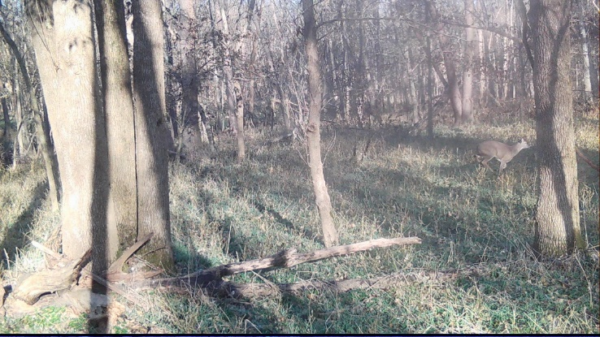
264 | 309 to 310 | Deer activity during daytime | 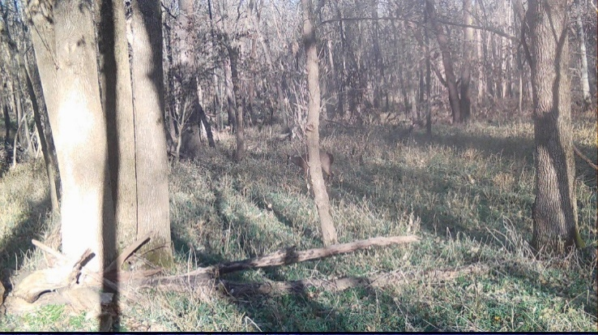
265 | 311 to 312 | Deer activity during daytime | 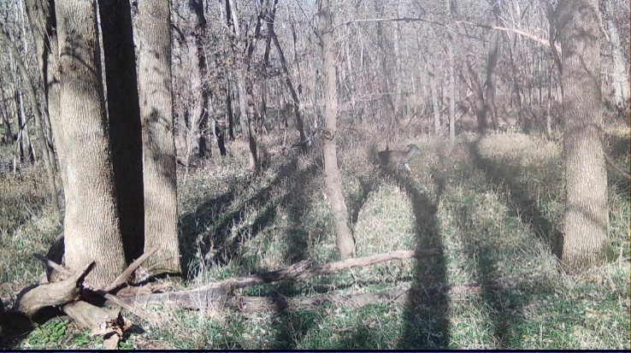
266 | 313 to 316 | Deer activity during daytime | 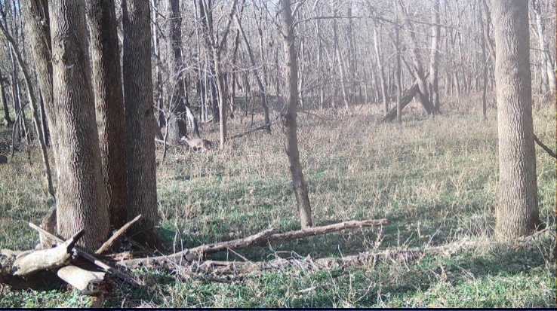
267 | 317 to 322 | Deer activity during nighttime | 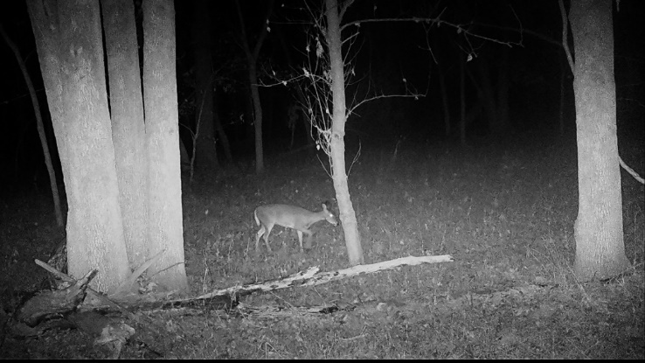
268 | 323 to 327 | Deer activity during daytime | 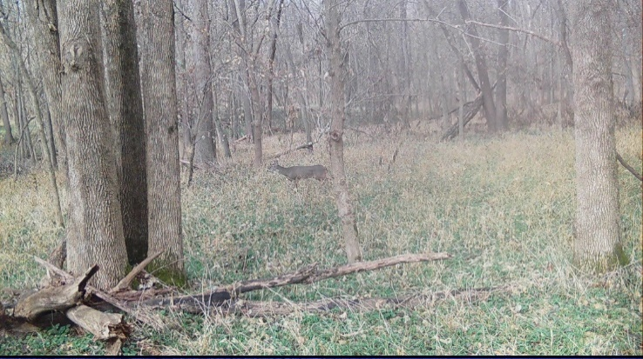
269 | 329 to 332 | Deer activity during daytime | 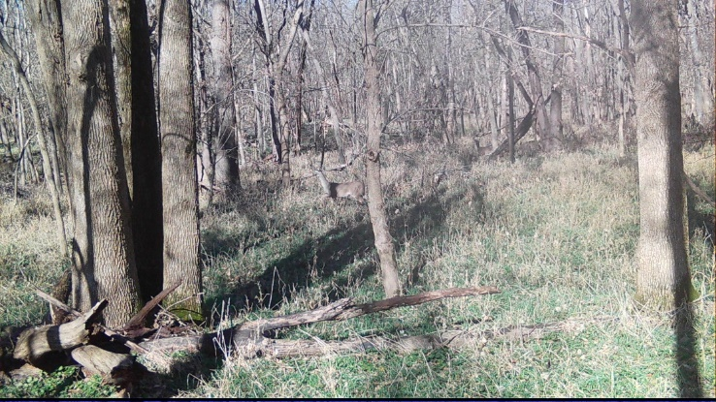
270 | 333 to 334 | Deer activity during daytime | 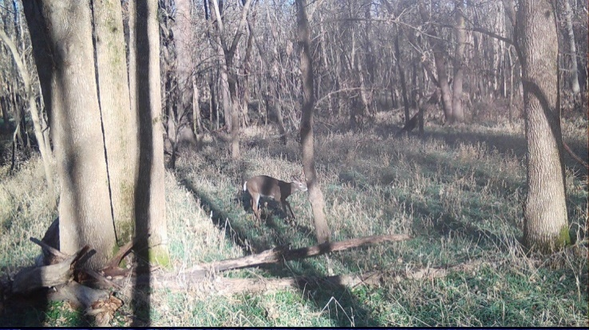
271 | 336 | Deer activity during daytime | 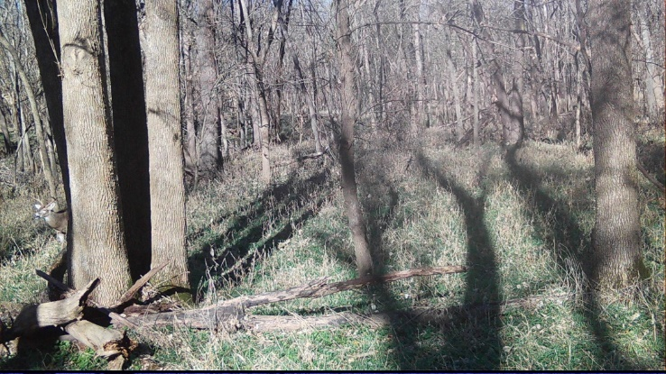
272 | 337 to 340 | Deer activity during nighttime | 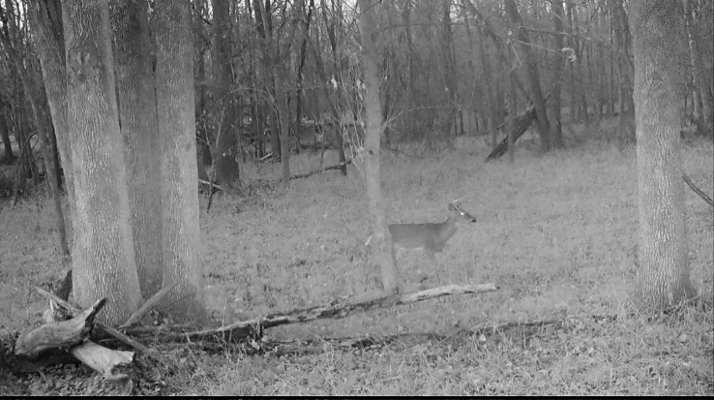
273 | 341 to 342 | Deer activity during daytime | 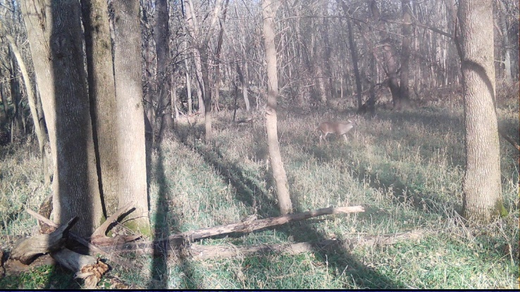
274 | 345 to 346 | Deer activity during daytime | 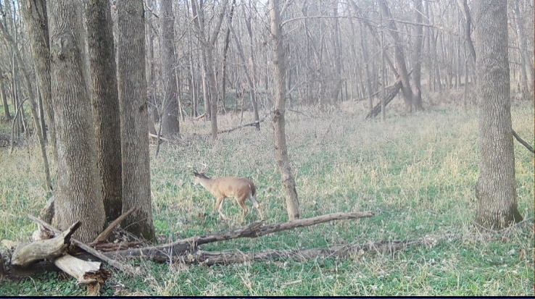
275 | 347 to 348 | Deer (multiple) activity during daytime | 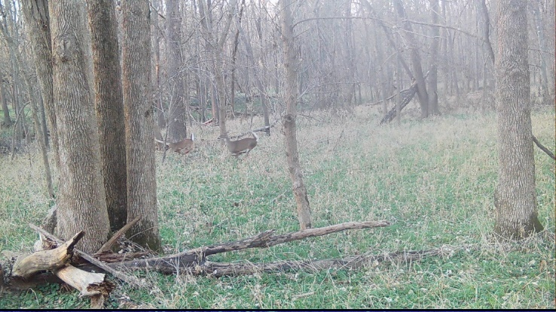
276 | 349 to 350 | Deer activity during daytime | 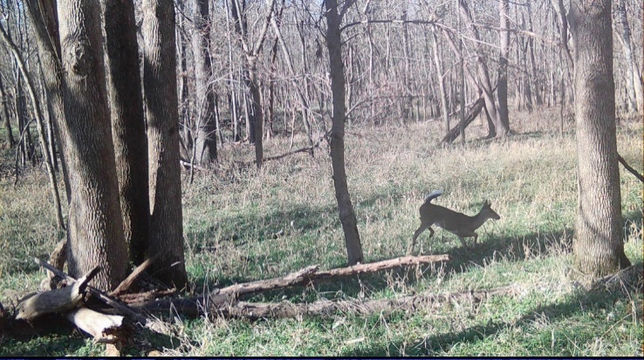
277 | 351 to 352 | Deer activity during daytime | 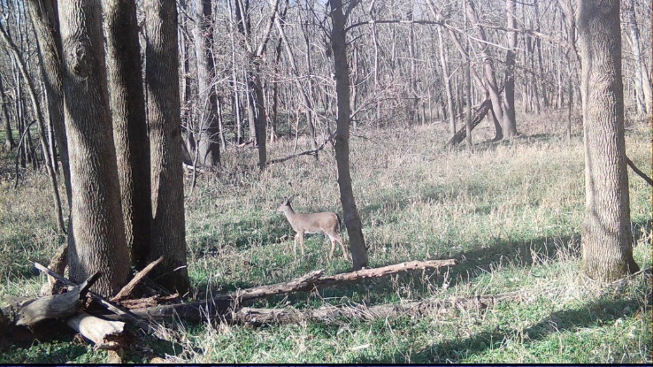
278 | 355 to 356 | Deer activity during nighttime | 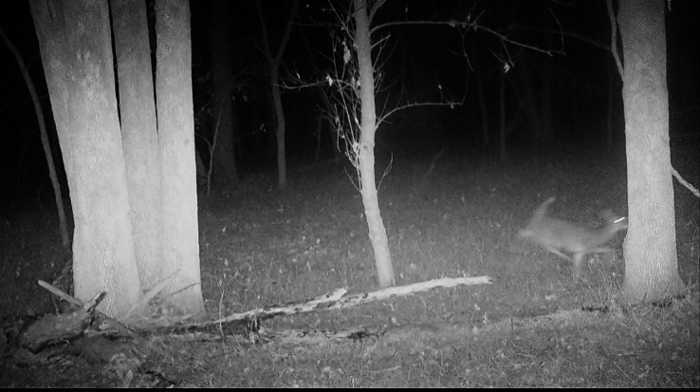
279 | 357 | Deer activity during daytime | 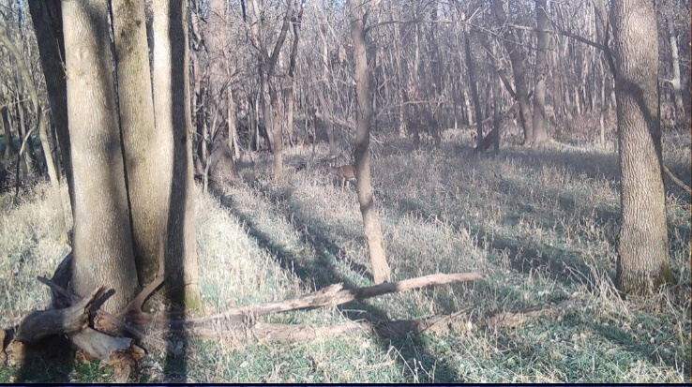
280 | 358 to 367 | Deer (multiple) activity during daytime | 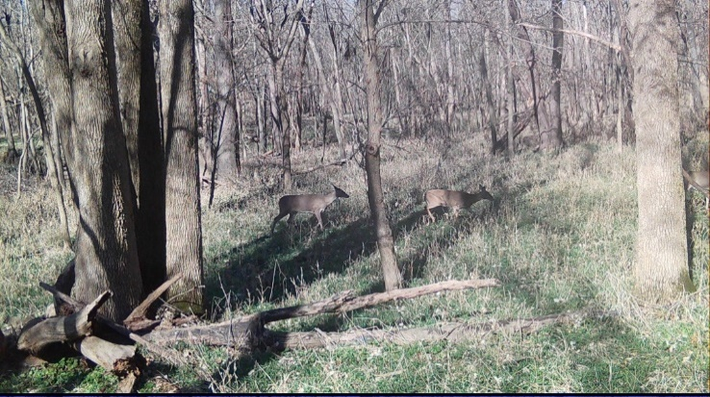
281 | 368 to 369 | Deer activity during daytime | 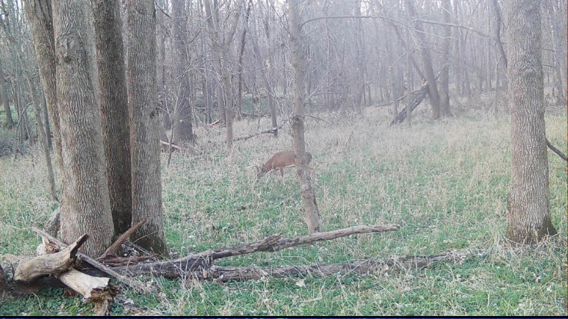
282 | 370 to 371 | Deer activity during nighttime | 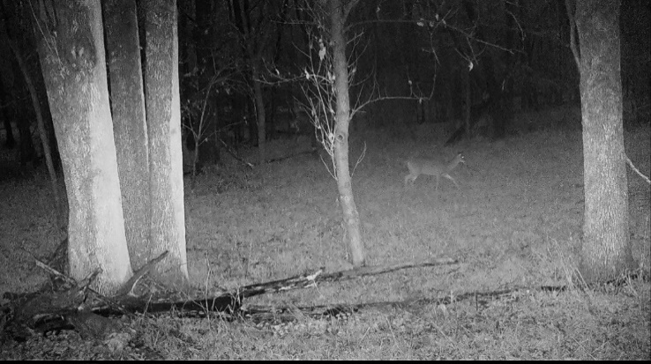
283 | 372 to 373 | Deer activity during daytime | 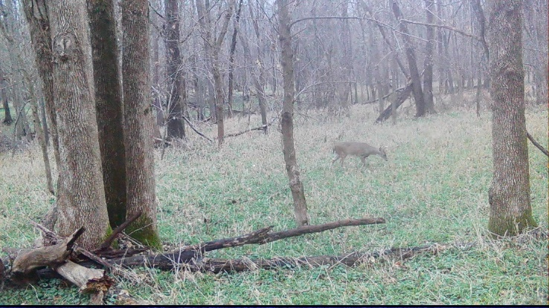
284 | 374 to 375 | Deer activity during daytime | 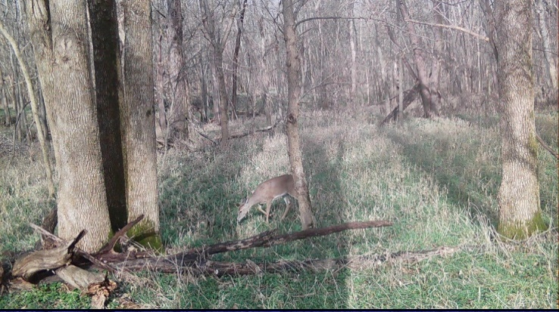
285 | 376 to 377 | Deer (multiple) activity during daytime | 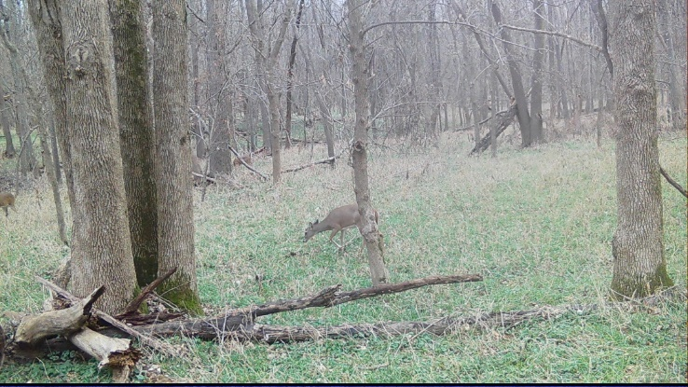
286 | 378 to 379 | Deer activity during nighttime | 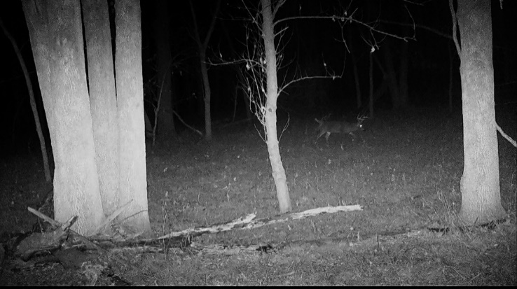
287 | 380 to 381 | Deer activity during nighttime | 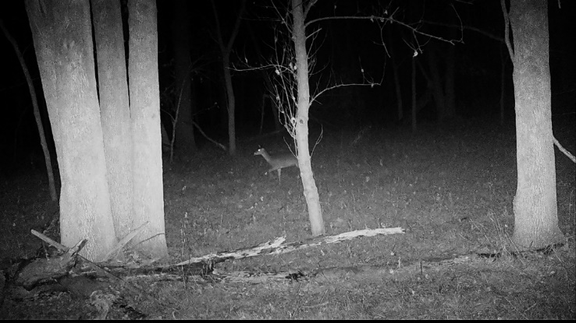
288 | 382 to 383 | Deer activity during nighttime | 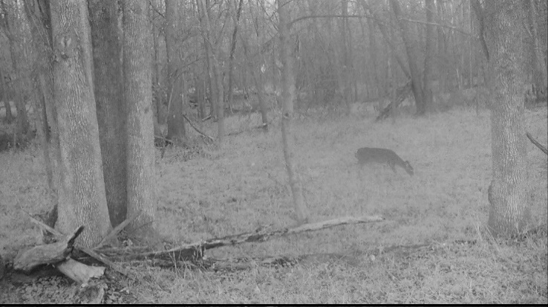
289 | 384 to 385 | Deer activity during nighttime | 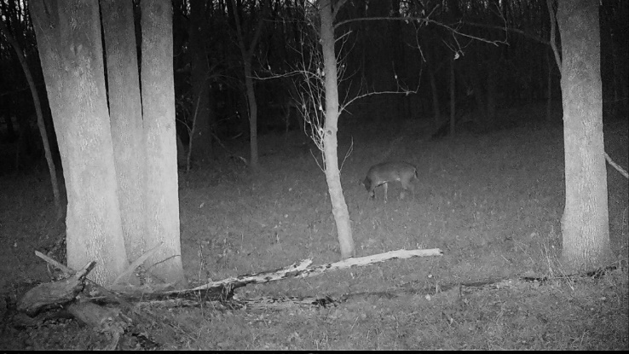
290 | 386 to 387 | Deer (multiple) activity during nighttime | 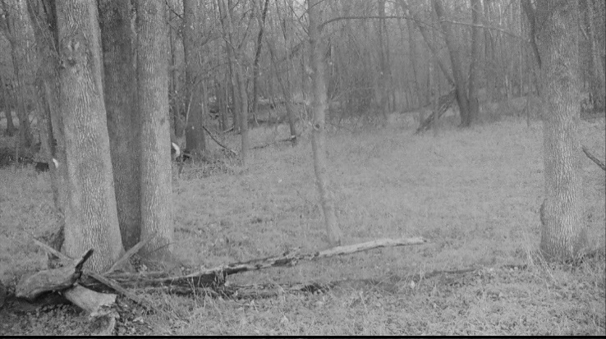
291 | 390 to 391 | Deer activity during nighttime | 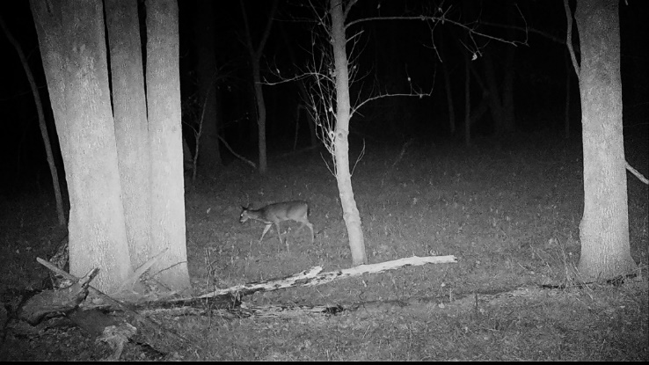

8.5 Appendix E: Ecosystem Services Valuation
Table E1. Non-monetary ecosystem service valuation methods.
Non-Monetary ES Valuation Methods |  | Applicable ES
→ Sociocultural Approaches assess stakeholder perspectives to elicit social ES values
1 | Measures of Preference  Uses survey techniques (e.g. rating, ranking) to escribe social values based on stakeholder ES perceptions (Sarvašová et al., 2014) | All
2 | Time Use  Asks questions to assess willingness to give up time (WTT) in exchange for higher value ES (Burkhard and Maes, 2017) | All
3 | Photo-Elicitation Survey  Asks questions about ES-related photos to gauge social ES preferences and willingness-to-pay (WTP) (Burkhard and Maes, 2017) | All
→ Other Non-Monetary Approaches which quantify ES
4 | Emergy Analysis  Values ES as the energy expended to produce an ES (Martin et al., 2013) | All

Table E2. Monetary ecosystem service valuation methods.
Monetary ES Valuation Methods |  | Applicable ES
→ Market-Based Approaches use actual market cost data for an ES or proxy service/good
1 | Market Price (i.e. Gross Revenue)  Uses real market prices of goods/services (Carson and Bergstrom, 2003) | Market-Driven ES
2 | Production Function  Values ES as its contribution to the production of a marketed good/service (National Research Council, 2005) | Market-Driven ES
→ Revealed Preference Approaches observe consumer market behavior to value ES
3 | Travel Cost  Values ES with data on travel costs and visitor rates (Liu et al., 2010) | Recreation/Tourism
4 | Hedonic Pricing  Links realestate fluctuations to ES value changes (Sarvašová et al., 2014) | Realestate-Related ES
→ Stated Preference Approaches elicit public responses to assess social ES value
5 | Contingent Valuation  Asks questions about hypothetical ES scenarios to assess willingness to pay (WTP), willingness to accept (WTA), or willingness to sell (WTS) (Selivanov and Hlaváčková, 2021) | All
6 | Choice Modeling ( i.e. Conjoint Analysis)  Asks questions about tradeoffs between ES and other goods/services to elicit willingness to pay (WTP) values (Sarvašová et al., 2014) | All
7 | Group Deliberation  Applies a stated-preference method to a group setting (Selivanov and Hlaváčková, 2021) | All
→ Cost-Based Approaches use costs of substituting ES function as its value
8 | Replacement Cost  Values ES as cost of replacing its function with human-made goods/services (Turner et al., 2016) | ES with Engineered Counterpart
9 | Restoration Cost  Values ES as cost of restoring a degraded habitat (Brander et al., 2018) | All
10 | Opportunity Cost  Values ES as the benefits foregone from alternative uses of the resources involved (Brander et al., 2018) | All
11 | Damage Cost Avoided  Values ES as cost of damages that would have occurred in ES absence (National Research Council, 2005) | Regulating ES
12 | Social Cost of Carbon (SCC)  Values cost/benefit of damages incurred/avoided due to the emission of one tonne of carbon dioxide in a given year (Brander et al., 2018) | Carbon Sequestration
13 | Value Transfer (i.e. Benefit Transfer)  Values non-marketed ES by transferring data from one location to a separate, but ecologically similar location (King et al., 2000) | All

