UNIVERSITY OF OKLAHOMA

GRADUATE COLLEGE

USING ACTION RESEARCH TO DETERMINE THE LEVEL OF SUPPORT NEEDED IN DEVELOPING INDEPENDENCE IN UNIVERSITY HOUSING FOR INDIVIDUALS WITH AN INTELLECTUAL DISABILITY

A DISSERTATION

SUBMITTED TO THE GRADUATE FACULTY

in partial fulfillment of the requirements for the

Degree of

DOCTOR OF PHILOSOPHY

By

MINDY E. LINGO
Norman, Oklahoma
2020

USING ACTION RESEARCH TO DETERMINE THE LEVEL OF SUPPORT NEEDED IN DEVELOPING INDEPENDENCE IN UNIVERSITY HOUSING FOR INDIVIDUALS WITH AN INTELLECTUAL DISABILITY

A DISSERTATION APPROVED FOR THE
DEPARTMENT OF EDUCATIONAL PSYCHOLOGY

BY THE COMMITTEE CONSISTING OF

Dr. Kendra Williams-Diehm, Chair

Dr. R. Nicolle Carr

Dr. John Jones

Dr. Corey Peltier

© Copyright by MINDY E. LINGO 2020
All Rights Reserved.
Dedication

To my husband and son who have supported me through this entire journey and my family, friends, and students.

Acknowledgements

This journey would not have been possible without the support of many important people. I would first like to thank my ever supportive Zarrow Center staff members, who pushed me to be a better student every step of the way. Heather, Joshua, Belkis, Malarie, Andrea, Tiffany, and Tracy you all are more than office mates, you have become friends and each of you mean the world to me. I would also like to extend my gratitude to Donna for being the glue which holds the Zarrow Center together through the endless support she provides us all as a professional and friend. I would be remiss if I did not mention the wonderful students of Sooner Works, who make going to work every day a true pleasure.
Thank you to my committee members. First, Dr. Jones for always providing encouraging words and a kind smile. Dr. Carr for being the most down to earth mentor, offering up the most “parsimonious” advice when my mind was going a million miles a minute, and Dr. Peltier who goes above and beyond to provide guidance and support. Then to my doctoral advisor, Dr. Williams-Diehm, you have been an integral part of this journey and provided mentorship both professionally and as a working mom trying to balance it all, thank you for supporting me in my passions. To you all, thank you for the encouragement when needed and pushing me beyond what I ever imagined possible for myself.
Thank you to my family, my words cannot do justice to how much I appreciate you. My mom who has been a role model in perseverance and kindness, because of her I am proud of the woman I have become today. My dad taught me through example what it means to work hard and be proud of the job you complete. My Aunt Gayla, step-mom, sisters, and brother, thank you for your support and encouragement every step of the way. To my Lingo family, thank you for your willingness to always lend a helping hand with childcare and meals, because of you my family continued to run smoothly during the days when work consumed my life. I must also thank my best friends Cortney and Tara, who are family in their own special way and have been my biggest cheerleaders and knew just when to offer a much needed reprieve from the craziness.
Finally, and most importantly to my husband and son, you two have been instrumental in my accomplishment. Without Jason none of this would have been possible, from his urging to pursue my doctorate to his constant belief in my abilities. Thank you for your “coach’ talks when needed and taking on many extra duties over the last four years. You are my rock and the glue which holds us together, I love you. To my world, Jax, you had to sacrifice so many things during the last four years and you always reassured me with a smile on your face that it was okay and it would not always be this way. Thank you for your understanding and the compassion you provided even on the days I did not feel like I deserved you, you are truly my best accomplishment.

Table of Contents

Dedication……...………………………………………………………………………………... iv
Acknowledgement……….….………………………………………………………..………...... v
List of Tables……… …………………………………………………………………………… xi
List of Figures………..………………………………………………………………………..... xii
Abstract……....………………………………………………………………….……………... xiii
Chapter 1: Introduction………………….………………….……………………………...…….. 1
Background of the Problem…………………………………………………………………… 1
Significance of the Study ……………………………………………………………………... 9
Problem Statement…………………………………………………………………………….. 9
Purpose of the Study…………………………………………………………………………. 10
Research Question…………………………………………………………………………… 10
Chapter 2: Review of Literature ……………………………………………………………….. 12
Transition Education ………………………………………………………………………… 12
Federal Legislation and Models………………………………………………………….... 13
IDEA…………………………………………………………………………………... 15
Transition Models……………………………………………………………………... 16
Transition in Practice………………………………………………………………….…... 20
Predictors Associated with Postschool Outcomes……………………………….……. 20
Evidence Based Practices……………………………………………………………………. 27
Transition Related Research for Individuals with an ID………………………………….. 28
Independent Living Skills……………………………………………………………………. 31
Self-Determination and Self-Monitoring…………………………………………………….. 32
Prompting…………………………………………………………………………………….. 34
Postsecondary Education Programming…………………………………………………..…. 35
Postsecondary Education Programming and Action Research……………………………. 38
Chapter 3: Methodology………………………………………………………………………... 40
Research Questions……………………………………………………………………….….. 40
Research Design……………………………………………………………………………… 42
Sampling Method and Participants…………………………………………………………... 44
Setting………….…………………………………………………………………………….. 47
Research Question One: Quantitative Approach………………………….…………………. 47
Dependent Variable and Measures………………………………………………………... 49
Independent Variables…………………………………………………..………………… 51
Implementation of the Intervention……………………………………………………….. 52
Research Question Two: Qualitative Approach……………………………………………... 57
Data Collection………………………………………………………………………….… 58
Data Analysis and Justification……………………………………………………………..... 58
Validity and Trustworthiness…………………………………………………………..…….. 60
Chapter 4: Results…………………………………………………………………………...….. 62
Interobserver Agreement………………………………………………………………..…… 62
Research Question One: Fading Response Prompts in Cleaning Dorm Room……………… 63
Baseline……………………………………………………………………………………. 67
Intervention………………………………………………………………………………... 67
Maintenance……………………………………………………………………………….. 69
Research Question Two: Social Validity…………………………………………………….. 69
Socially-Significant………………………………………………………………………... 71
Action Research…………………………………………………………………………… 73
Validity to the Study Design………………………………………………………………. 75
Summary of Data Analysis…………………………………………………………………... 75
Chapter 5: Discussion…………………………………………………………………………... 77
Findings………………………………………………………………………………………… 77
Research Question One………………………………………………………………………. 78
AB Design…………………………………………………………………………………. 78
Research Question Two……………………………………………………………………… 81
General Inductive Qualitative Design……………………………………………………... 81
Social Validity………………………………………………………………………… 82
Future Recommendations for the Program……………………………………………. 83
Implications for Future Programming……………………………………………………….. 86
Implications for Future Research…………………………………………………………….. 87
Strengths……………………………………………………………………………………... 88
Limitations…………………………………………………………………………………… 89
Conclusion……………………………………………………………………………………… 92
References………………………………………………………………………………………. 93
Appendix A……………………………………………………………………………………. 114
Appendix B……………………………………………………………………………………. 117
Appendix C……………………………………………………………………………………. 118
Appendix D……………………………………………………………………………………. 119
Appendix E……………………………………………………………………………………. 121
Appendix F…………………………………………………………………………………….. 122

List of Tables
Table 1: Evidence-Based Predictors with Operational Definitions…………………………….. 22
Table 2: NTACT Effective Practices…………………………………………………………… 28
Table 3: Intervention B – List of Most to Least Response Prompts by Phase………………….. 51
Table 4: Interobserver Agreement on Data Collection…………………………………………. 62
Table 5: Code Book………………………………………………………………………..…… 70
Table 6: Social Validity Categories and Participants’ Perceptions…………………………….. 72
Table 7: Action Research Categories and Participants’ Perspectives…………………………... 73figu

List of Figures
Figure 1: Madeline Will’s 1984 Bridges from School-to-Work Transition Model…………….. 17
Figure 2: Andrew Halpern’s 1985 Transition Model…………………………………………... 18
Figure 3: Kohler’s Transition Taxonomy………………………………………………………. 19
Figure 4: Taxonomy for Transition Programming 2.0…………………………………………. 19
Figure 5: Diagram of a Complex Mixed Methods Design……………………………………... 42
Figure 6: Clean Dorm Room Rubric Used as Dependent Measure and for IOA…………….… 50
Figure 7: Example and Non-Example of Clean Dorm Room…………………………………... 53
Figure 8: Daily Cleaning Task List……………………………………………………………... 55
Figure 9: Nathan’s AB Design Graph…………………………………………………………... 64
Figure 10: Jack’s AB Design Graph……………………………………………………………. 65
Figure 11: Hannah’s AB Design Graph…………………………………………………..…….. 66

Abstract
The passing of the Higher Education Act of 2008 changed the diversity landscape of universities across the country. The act specifically addressed the inclusion of individuals with an intellectual disability (ID) in college attendance and the creation of a national coordinating center devoted to the development and preservation of postsecondary education (PSE) programs. With these changes the growth of PSE programs across the country have seen an increase to over 270 programs in 2020. Since PSE programming is in its infancy, there is still much research needed to determine best practices to facilitate increased postsecondary outcomes for young adults with an ID. This action research based mixed methods study contributes to this endeavor, especially pertaining to increasing independent living skills and guiding future practices of PSE programming. Through a single-case AB design intervention, it was determined the use of prompt fading was beneficial in increasing the rate of completion in cleaning a dorm room for students with an ID participating in a postsecondary program. In addition, the intervention had social validity among the participants as measured by their responses using a general inductive qualitative approach through interviewing. While the intervention showed a relation with increased clean dorm rooms for the participants, within the guideline of action research it was determined less intrusive measures (e.g., video-chatting) to conduct dorm checks may prove to be more or equally beneficial and should be further evaluated as part of future PSE programming at the researcher’s university.
Keywords: postsecondary program, intellectual disability, university, independent living, prompt fading

Chapter 1
Introduction
Going to college is a dream for many students graduating from high school regardless of their background, ethnicity, or disability. In 2019, about 19.9 million individuals accomplished this goal by enrolling in some type of postsecondary school within four years of leaving high school (National Center for Education Statistics [NCES], 2019). Typically, this college experience consists of students attending courses, living on campus, participating in activities, and joining organizations on the college campus. In its entirety, college is a multifaceted experience which includes academics, social integration, and independence (Yazedjian et al., 2008). While college was once only an opportunity for high-status groups (Baker et al., 2018), in recent decades we have witnessed a shift in demographics in respect to race, ethnicity, gender, socio-economic status, and disability (NCES, 2019; Newman et al., 2011).
Background of Problem
With this increase in college attendance by diverse individuals, including those with disabilities, it seems even more promising that students with mild disabilities are falling just slightly below their peers without disabilities in postsecondary attendance, 60% versus 64% respectively (Newman et al., 2010, 2011). In contrast, postsecondary attendance is not as promising for students with an intellectual disability. Only about one-fourth of these individuals attend college (Newman et al., 2010). An intellectual disability (ID) is characterized by a significant impairment in intellectual functioning (reasoning, learning, and problem solving) and in adaptive behavior (social and practical skills), occurring prior to age 18 (American Association on Intellectual and Developmental Disabilities [AAIDD], 2018). While those individuals with an ID may not have postsecondary attendance rates comparable to those of their non-disabled counterparts, 93% do attend public schools (U.S. Department of Education, 2020). The increased enrollment in K-12 compared to higher education is directly linked to K-12 educational mandates (e.g., Education for All Handicapped Children Act of 1975, Individuals with Disabilities Act [IDEA] of 2004), which increased access to neighborhood schools and supported involvement in classes, clubs, and other activities (Bumble et al., 2019).
Not only did the mandates impact involvement in public education, they also addressed the need to prepare students with disabilities for transition from public schooling to postschool activities (IDEA, 2004). This transition planning involves providing coordinated activities, courses, and experiences aligned with the students’ postsecondary goals to promote the successful movement from school to post-school activities, including employment, training/education, and independent living (IDEA, 2004). While transition planning has become an integral part of the secondary individualized education program (IEP), this has not always been the case for individuals with a disability (Johnson, 2012; Yell et al., 1998).
Today, public education is considered a right for all Americans regardless of race, socioeconomic status, or disability, but this was not always afforded to all children (Yell et al., 1998). Students with disabilities were one of the last minority groups to be integrated into public education (Yell et al., 1998). Major court decisions like Brown vs. Board of Education (1954) paved the way for equal education by declaring state-required or state-sanctioned segregation based upon unalterable characteristics to be illegal. While Brown vs. Board of Education mainly focused on civil rights for African Americans, many considered it to be equally applicable to those with disabilities (Yell et al., 1998). This case triggered an onslaught of challenges to the educational practices for individuals with disabilities, which led to many legal proceedings and mandates, resulting in what we know as special education today (Shealey et al., 2005; Yell et al., 1998).
A common fallacy pertaining to special education is the misconception it is a setting for students with disabilities and not a service (Ferri et al., 2011). In actuality, special education provides specialized services, programs, supports, and environments to meet the educational needs of students with disabilities (IDEA, 2004). IDEA defines special education as “specially designed instruction, at no cost to parents, to meet the unique needs of a child with a disability" (IDEA, 2004, § 300.39). IDEA entitles “each eligible child with a disability to a free appropriate public education which emphasizes special education and related services designed to meet the child’s unique needs and prepares the child for further education, employment, and independent living” (U.S. Department of Education Office of Special Education Programs [OSEP], 2015, p. 1) These concepts were first established in Section 504 of the Rehabilitation Act of 1973 and the Education for All Handicapped Children Act (EAHCA) of 1975, also known as Public Law 94-142 and what would eventually evolve into IDEA of 2004 (Yell et al., 2017).
Prior to Section 504 and the EAHCA, students with disabilities were either excluded completely from public education, or if they did attend public school their educational needs were not being met (Yell et al., 2017). These exclusionary practices were specifically addressed in Section 504, which was enacted to protect the rights of all individuals with disabilities (including school-age children) by fully integrating them into American life. Section 504 was aimed at addressing the needs for all individuals with disabilities regardless of age; it was a civil rights law and not a special education law. The first law to expressly address special education was EAHCA of 1975 (Yell et al., 2017). It aligned with the individual rights protocols of Section 504 but was aimed solely at addressing public education and ensuring individuals with disabilities received educational services which were beneficial (Zigmond & Kloo, 2017). The EAHCA designated federal funds for states providing educational services for students with disabilities and brought forth the importance of planning for postschool life by loosely designating transition planning as a component of the IEP (Johnson, 2012). The EAHCA remained the guiding force for special education for almost 20 years, but due to lax interpretation of the guidelines by individual states, more explicit mandates were needed to ensure educational benefit for students with disabilities (Zigmond & Kloo, 2017).
The IDEA (1990) was the reauthorization of EAHCA (1975); it included updated terms to reflect people-first language and also required a transition plan for every student by age 16 (Yell et al., 1998). Then, in 1997, another reauthorization of IDEA came about which not only delineated individualized services for educational benefit, but went even further by also including compliance monitoring of those services to ensure procedural safeguards were met. In addition, IDEA (1997) stressed the importance of the least restrictive environment (LRE) for students with disabilities (Zigmond & Kloo, 2017). The LRE requires that students with disabilities receive their education alongside their peers without disabilities to the maximum extent possible (Yell et al., 2017). This concept of LRE within the constructs of a free appropriate public education was the focus of the 2004 amendments to IDEA. This reauthorization included more guidelines for state monitoring and the use of “scientifically-based research” in practices pertaining to programming and curricula. In addition, IDEA (2004) extended transition planning to address postsecondary education with more of a focus being placed on goal-oriented planning (Yell et al., 2017).
Around the same time IDEA (1990) was enacted, the American with Disabilities Act (ADA, 1990) was passed to provide equal access for individuals with disabilities to any entity receiving funds from federal, state, or privately-owned establishments (Johnson, 2012). The ADA prohibits the discrimination of individuals based upon their disability (Johnson, 2012). In 2008, the Higher Education Opportunity Act (HEOA) was enacted to address access to postsecondary education for individuals with an ID (Papay et al., 2018). The HEOA (2008) included ID as part of the federal definition associated with the population attending college and increased funding opportunities to make college more inclusive for individuals with an ID (Papay et al., 2018). These legislative initiatives paved the way in preparing individuals with disabilities, including those with an ID, for a postsecondary education.
The evolution of mandates plays a key role in improving transition services for students with disabilities as a means to improve postschool outcomes. These legislative efforts are not solely based upon case law; they are also impacted by research in the field (Johnson, 2012). Starting in the early 1980s, experts in the field of transition started producing conceptual models to provide best practice frameworks for practitioners (Halpern, 1985). As researched progressed, additional models emerged linked to scientifically-based practices and theories (Kohler et al., 2017). The transition models and theories can be tied back to predictors found to improve postschool outcomes for individuals with disabilities (Kohler et al., 2017). Predictors indicate a positive relation between an intervention and the measured outcomes (Shmueli, 2010). In an attempt to designate predictors associated with secondary transition, Test and colleagues (2009) conducted a systematic review to determine promising practices associated with improved postschool outcomes. The review yielded 16 predictors of in-school practices which were positively correlated with improved outcomes. These predictors have guided secondary transition programing for the last decade. However, the predictors are focused on all individuals with disabilities, not specifically those with an ID (Test et al., 2009). In an attempt to narrow down the research, several predictors for individuals with an ID have been identified (Baer et al., 2011; Carter et al., 2012; Grigal et al., 2011). Some of the key predictors associated with improved postschool outcomes for individuals with an ID are learning independent living and self-determination skills (Carter et al., 2012: Nota et al., 2007 Test et al., 2009).
Independent living skills include the skills one needs to successfully care for oneself regarding personal management, socialization, daily living, financial management, and health and wellness (Rowe et al., 2015). Despite independent living skills being a predictor of positive postschool outcomes, only 36.6% of individuals with an ID reported living independently at some point after graduating from high school (Newman et al., 2011). This low percentage can be increased by improving self-determination skills for individuals with an ID (Shogren et al., 2015).
Individuals with self-determination possess the ability to make choices, they can solve problems, set goals and take the initiative to reach those goals, evaluate options, and accept consequences for their actions (Rowe et al., 2015). The overall concept of self-determination includes subcomponents of choice and decision making, self-efficacy, goal setting, self-advocacy, self-knowledge, and self-management/regulation (Wehmeyer & Field, 2007). Self-determined people make choices and decisions based on their own preferences and interests, then monitor and regulate their own behaviors (Carter et al., 2012; Wehmeyer et al., 1998). Self-management, or regulation of these behaviors, consists of a person intentionally acting a certain way to change subsequent behaviors (Cooper et al., 2007). Specifically, self-management involves deliberate actions influencing one’s own behaviors as a means to influence desired outcomes (Browder & Shaprio, 1985). Self-management benefits individuals with disabilities (Lee et al., 2008), including those with an ID (Agran et al., 2005).
Self-management is beneficial to those with a disability, but it is a skill that must be learned (Zimmerman & Schunk, 2012). Using prompting has been successful for individuals with disabilities in learning self-management (Bereznak et al., 2012). In the most simplistic terms, prompting is providing a stimuli to elicit a correct response, which ideally leads to control over the behavior (Cooper et al., 2007). Prompting is used to increase the likelihood of a behavior. Under the umbrella of prompting is response prompting, which is a specific type of prompting involving systematic instruction (Collins et al., 2018). Response prompting entails an attentional cue, task direction (an instructional stimulus), a response, and a consequence. All of this is conducted in hopes of evoking a specific response. Then, within response prompting lies the implementation procedure of most-to-least prompts, which requires the systematic reduction of support in prompting the target behavior (Collins et al., 2018). The response prompting is faded through the various levels of support to avoid individuals’ dependency on these prompts, which then results in the eventual display of the targeted behavior without the prompt (Snell & Brown, 2011). Providing most-to-least response through prompt fading allows for the occasioning of the behavior to transfer from response prompting to a natural stimuli prompting the targeted behavior (Cooper et al., 2007). This prompt fading has evidence of being an effective method to teach independence to individuals with an intellectual disability (Cullen et al., 2017; Kelley et al., 2013). However, little research has been done to assess the effectiveness of response prompt fading with young adults participating in postsecondary programs for individuals with an intellectual disability.
Both transition services and response prompting are means to increase the skills needed in achieving independence for students with disabilities, including those with an ID (Ayers et al., 2013; Cihak & Grim, 2008). Often, one such outcome goal is postsecondary education; 50% of students with an ID envision attending college after high school graduation (Lipscomb et al., 2017). Fortunately, in recent years, postsecondary education (PSE) options for individuals with an ID have increased across the nation. For the purpose of this study, PSE is defined as educational programs for individuals with an ID found at 4-year colleges or universities and community colleges. This expansion of PSE options can be directly related to the passing of HEOA of 2008 (Papay et al., 2018). The HEOA (2008), the reauthorization of the Higher Education Act of 1965, included ID as part of the federal definition associated with the population attending college. It also established financial aid support for PSE programs and participants, and established a model demonstration program - Transition and Postsecondary Programs for Students with Intellectual Disabilities (TPSID). TPSID assists with the creation and funding of PSE programs across the country. In addition, HEOA created a national coordinating center for TPSID programs entitled Think College (Papay et al., 2018). Think College provides guidance, resources, and research pertaining to PSE development and preservation.
The main goals of PSE programs consist of providing academic opportunities, with career development and campus socialization activities, usually without participation in typical degree-seeking programming (Lynch & Getzel, 2013). While overall PSE programs have the same goals, each individual program varies in its course offerings, number of participants, requirements, and types of college enrollment (Think College, 2019). These programs provide participants the opportunity to attend college to gain social, academic, and employment skills as a means to improve independence (Griffin et al., 2010). Independence increases because PSE participation provides increased self-determination through time management, self-advocacy, choice making, and understanding consequences of those choices. All of these are daily experiences for college students (Grigal et al., 2013).
A typical PSE program can be described as follows (a) participants attend these programs on a college campus, (b) where they take inclusive courses with their college peers (students can audit or take for credit) and/or specialized courses for the program participants only which focus on instruction in life skills, social skills, and career preparation; (c) live in inclusive settings on campus; and (d) participate in campus organizations (Papay et al., 2018). Currently, there are about 275 PSE programs in 50 states for individuals with an ID or developmental disabilities, with new ones emerging every year (Think College, 2019).
Significance of the Study
Completion of these PSE programs improves an individual’s ability to gain meaningful employment (Grigal et al., 2013; Smith et al., 2018), which leads to enhanced self-esteem, financial independence, and beneficial social networks (Carter et al., 2012). Specifically, Smith et al. (2018) found PSE program participants receiving vocational rehabilitation services had higher paid integrated employment rates (65%) than those who only received vocational rehabilitation services (56%). In addition, PSE program participants made up to 51% higher weekly wages.
Problem Statement
With the rapid growth of PSE programs, the research is emerging in the field, but much more is needed to establish what higher education institutions should consider best practices (Graff et al., 2019). This can be accomplished through action research, which provides “a systematic approach to investigation that enables people to find effective solutions to problems they confront in their everyday lives” (Stringer, 2007, p. 1). Action research has five main characteristics, which include purposes and value choices, contextual focus, change-based data and sense making, and knowledge diffusion; essentially, it is providing “real life” solutions (Martella et al., 2013). With PSE programing still in its infancy and lacking a strong research base, practitioners and researchers need to produce evidence of what is working currently and what can be done to improve practices. While a few researchers have started this important endeavor, still more is needed to guide instruction, policy, and practices for PSE programming (Love & Mock, 2019; Rao et al., 2017; Schwantes & Rivera, 2017).
Purpose of the Study
To gain much needed research in the field of PSE programming regarding effective practices, the researcher used a mixed methods experimental design with an action research focus. This methodology consisted of a single-case AB design and a general inductive qualitative design as action research to investigate whether the use of fading response prompts was beneficial in gaining independent living skills associated with cleaning a dormitory room for participants in a postsecondary education (PSE) program. In addition, the researcher ascertained the social validity of the intervention as perceived by the study participants and measured how the intervention directly affected the programming practices at the researcher’s postsecondary program.
Research Questions
- Is there a relation between the use of fading response prompts and the level of completion in cleaning a dorm room for students with an intellectual disability participating in a postsecondary education program on a university campus? (single-case design during first phase of the study)
2. Do the postsecondary program’s participants value the use of fading prompts and find it beneficial? (qualitative design during the second phase of the study)
a. Did the fading prompts help the participants become more independent?
b. Were there one or more prompts the participants felt were the most beneficial?
c. Were there any prompts that they felt did not benefit them in completing their cleaning tasks?
d. How can the use of fading prompts be improved for the program’s participants in the future?
e. Will the participants continue to use any of the prompts for other tasks in the future and why?
f. Did the participants prefer the in-person or video-chat dorm checks and why?

Chapter 2
Review of Literature
Transition is an inevitable part of life. Whether it be from home to school, school to work, or work to retirement, this factor plays a significant recurring role throughout our lives. The transition from being a dependent child to an independent adult is one of the biggest and most challenging transitions in one’s life, but it is especially challenging for those with disabilities (Halpern, 1992). Often, this transition is not smooth for those with disabilities and results in their falling behind their peers without disabilities in attending postsecondary education, gaining competitive postschool employment, and living independently (Newman et al., 2010). While this problem has been around for decades, many researchers, educators, and parents have influenced policy change and educational practices as a means to improve the postschool outcomes for individuals with disabilities (Kochhar-Bryant, 2003; Johnson, 2012). The compilation of these factors has led to gradual improvements in postschool outcomes for those with disabilities in attending postsecondary education, obtaining competitive employment, and living independently (Johnson 2012; Test et al., 2009).
Transition Education
Today’s policies and practices in transition education and planning aim to improve postschool outcomes as compared to outcomes of prior generations (Blackorby & Wagner, 1996; Newman et al., 2011). Our current transition planning for students with disabilities entails “a results-oriented process…to facilitate the child’s movement from school to postschool activities” (§34 CFR 300.43(a)(1), IDEA, 2004). Most simply stated, transition services are a set of coordinated activities, courses, and experiences aligned with students’ postsecondary goals to facilitate the successful movement from school to post-school activities; activities include employment, training/education, and independent living (IDEA, 2004). Services must begin for all students with a disability on or before their 16th birthday but are encouraged to start even earlier when possible (Papay et al., 2015; Suk et al., 2020). Transition planning and the resulting services are critical in outlining future goals and preparing individuals with disabilities for postsecondary successes (Williams-Diehm & Lynch, 2007). While we now understand the importance of transition planning for individuals with disabilities, this has not always been the mindset. Fortunately, now, through federal educational mandates and research we are witnessing a positively changing climate in secondary education and active community participation for this population (Johnson, 2012; Kohler et al., 2017).
Federal Legislation and Models
Prior to the Individuals with Education Act (IDEA), loosely organized transition services had minimal policy requirements with the majority of decision-making regarding transition planning protocol falling to each individual state (Repetto et al., 2002; Repetto et al., 1990). Despite the national disconnectedness of transition services, there were some federal policies and legislation during this time which were noteworthy in laying the foundation for today’s mandatory transition services. The 1954 amendment to the Vocational Rehabilitation Act placed a focus on the importance of vocational rehabilitation programs by providing federal funds to state programs for vocational training (Johnson, 2012). Then, in 1968, another amendment provided students with disabilities access to vocational training programs. While this was promising, our nation was still facing educational inequality for individuals with disabilities (Johnson, 2012). This was most evident in 1970, when only one in five children with a disability was enrolled in public schooling and our nation’s residential institutions for those with significant disabilities were filled to capacity (U.S. Department of Education, 2010). In a means to improve these outcomes Section 504 of the Rehabilitation Act was enacted in 1973, which prohibited discrimination on the basis of disability for any entity receiving federal funding, including public sector jobs and public schools (Johnson, 2012). According to Zigmond and Kloo (2017), Section 504 specifically required individuals with disabilities get equivalent services or programs:
It called for structural alterations, redesign of equipment, reassignment to classes, assignment of aides, regular classroom intervention, and reasonable accommodations and modification of classroom methods, materials, and procedures to make them accessible and allow the student with a disability an equal opportunity to benefit from the education program being provided. (p. 251)
On the heels of Section 504 came the Education for all Handicapped Children Act (EAHCA) of 1975, which was specific to education and required states to provide a free and appropriate public education for children with disabilities from ages 3 to 21. The act was needed in that the equality provisions of Section 504 still left some students marginalized because they needed more services than their peers without disabilities needed for educational benefit (Zigmond & Kloo, 2017). Thus, EAHCA accomplished educational benefit by requiring each state to provide students with a disability through
non-discriminatory testing, evaluation and placement, the right to due process, education in the least restrictive environment, and free appropriate public education (FAPE), with its details spelled out in an IEP that included relevant goals and objectives, specification as to the length of the school year, determination of the most appropriate placement, and descriptions of the criteria to be used in the evaluation of student progress. (Zigmond & Kloo, 2017, p. 162)
This law also designated federal funds for states to provide educational services for students eligible to receive special education (EAHCA, 1975). The act had many notable components, including access to more inclusive settings, the creation of IEPs, full parental involvement in the development of the IEP, least restrictive environment, and due process safeguards (Johnson, 2012). In regard to transition related issues it specifically addressed access for students with disabilities to vocational education and career preparation and required the establishment of at least one career goal on students’ IEPs. In the subsequent amendments of EAHCA in the 1980s came the explicit definition of transition services and the allocation of grant funding to states, allowing for an increase in services (Johnson, 2012). Even though these important civil rights mandates increased employment opportunities and individualized education programs for those with disabilities, states’ interpretations still lacked uniformity in their implementation, and little attention was paid to postschool education access for those with disabilities (Johnson, 2012; Repetto et al., 2002).
IDEA. The 1990s brought forth major changes to policies and a new era of transition services (Kochhar-Bryant & Greene, 2009). These changes resulted from the early research in the field of transition education, which started linking transition planning to postschool outcomes. The originators of IDEA used this research to guide the new legislation in defining
transition services and connected these services directly to students’ IEPs (IDEA, 1990). The IEP allowed for planning postschool outcomes, including vocational training, independent living, and additional educational experiences. It also required transition services based on students’ needs and preferences, allowing for the concept of self-determination to play a role in transition planning. While IDEA 1990 started the endeavor of increasing self-determination through the processes associated with the IEP, there was still a gap between research and practice (IDEA, 1990; Kochhar-Bryant & Greene, 2009).
A reauthorization of IDEA in 1997 attempted to bridge this gap by increasing guidance and using more explicit definitions for transition planning (Kochhar-Bryant & Greene, 2009). The 1997 reauthorization emphasized individualizing the process for each student with disabilities receiving services on an IEP. This iteration of IDEA allowed for more access to the general education curriculum and provided different pathways to graduation depending on students’ specific needs, consisting of flexible combinations of academic, career-technical classes, and community-based work experiences (Kochhar-Bryant & Greene, 2009). In addition, it called for increasing students’ role in the process by requiring them to be more involved in their meetings and signing off on their IEPs at the age of 18 (Flexer et al., 2008). For the first time, the concept of postsecondary education was explicitly addressed as an adult outcome for individuals with a disability in IDEA (1997). As with the former iterations of IDEA, this reauthorization again attempted to increase students’ self-determination practices associated with the IEP and transition planning in adherence with best practices emerging from the research in the field (Kochhar-Bryant & Greene, 2009).
Prior to the IDEA 2004 reauthorization, IDEA’s focus remained on instructing local and state agencies on the processes to follow in educating students with disabilities (IDEA 1990, 1997). Once the reauthorization (renamed as the Individuals with Disabilities Education Improvement Act) passed, the focus moved beyond just following the designated processes and required measurement of students’ progress and achievement. Further, this legislation specifically addressed and expanded transition services for students with disabilities (IDEA, 2004). The new mandates expanded on previous IDEA policies and required the following (a) measurable postsecondary goals related to education/training, employment, and when appropriate, independent living skills, based on the results of age-appropriate transition assessments; (b) transition services, including a course of study; and (c) notification of transfer of rights one year prior to the student reaching the age of majority, which is 18 years of age (IDEA, 2004).
The evolution of mandates played a key role in improving transition services for students with disabilities, but it is important to recognize this legislation and these transition practices resulted from the guidance provided by various transition models emerging from evolving research (Johnson, 2012; Kohler et al., 2017). These models started surfacing in 1985 and have since influenced practitioners in transition planning (Halpern, 1985; Kohler, 1996; Kohler et al., 2016).
Transition Models. In the mid-1980s, researchers deemed as experts within the emerging field of transition started producing conceptual models to guide practitioners in best practices (Halpern, 1985). The models initially started off very simplistic, but as the research base grew, more complex models developed linked to scientifically-based practices and theories (Kohler, 1996; Kohler et al., 2016; Kohler et al., 2017). Four major models have emerged over the years for guiding the transition process. Initially, Madeline Will, director of the U.S. Office of Special Education and Rehabilitative Services (OSERS), developed a model in 1983 representing the importance of special education services as the foundation of transition planning (Will, 1983). The model had three levels of services conceptualized as bridges from secondary special education to adult employment (Halpern, 1985). The bridges in this model (see Figure 1) included transition without special services support (accessible for all individuals), time limited services (short-term services usually dedicated to individuals with disabilities), and transitions with ongoing services (supported employment). This model is referenced as both Will’s Bridges Model and OSERS Transition Model within the literature.
Figure 1
Madeline Will’s 1984 Bridges from School-to-Work Transition Model
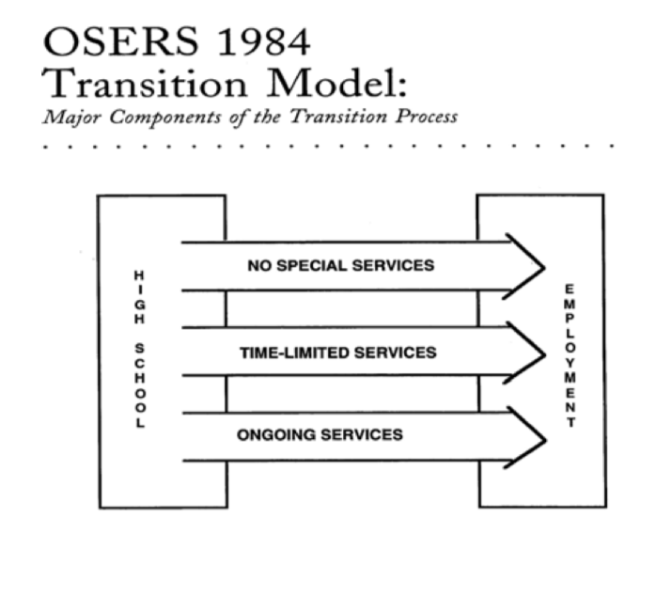
Note: Will’s Bridges Model is also known as the OSERS Model.
While Will’s Bridges Model was a beneficial guide, it was very basic in its conceptual framework. Andrew Halpern improved on the model by going beyond just the employment-related transition process to include other areas of community adjustment (Halpern, 1985). The Halpern Transition model (see Figure 2) had the three bridges from Will’s Bridges Model but these led to community adjustment, encompassing three pillars of residential environment (quality of home life with access to community services and recreational opportunities), employment (job searching, employment, and pay wages), and social and interpersonal networks (human relationships, communications, and self-esteem). This model was the cornerstone for transition planning for almost a decade.
Figure 2
Andrew Halpern’s 1985 Transition Model

Kohler (1996) linked the then-updated research to the current practices in the field of transition planning with the Taxonomy for Transition Programming (see Figure 3). This resource-based model was regarded as a seminal guide to link scientifically-based research to everyday transition programming practices; it provided more concrete guidelines than previous models and represented the cyclical process associated with transition planning (Kohler et al., 2017). The Transition Taxonomy focused on five areas: Family Involvement, Program Structure, Interagency Collaboration, Student Development, and Student-Focused Planning. Each of the five focus areas had several subcategories devoted to specific practices which facilitated transition planning. The taxonomy was a student-focused system which could be individualized, but overall its general strategies were applicable for all disability groups. During the era of the Transition Taxonomy, transition programming moved toward more of an outcome-focused approach from the disability-focused and deficit-driven concentration of the past (Kohler et al., 2017).
Figure 3
Kohler’s Transition Taxonomy
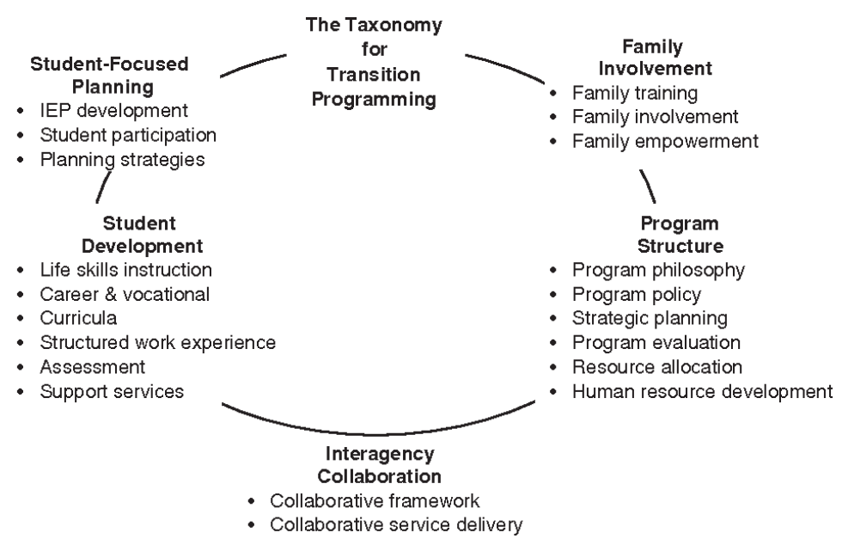

The Transition Taxonomy provided the standard for transition programming for 20 years, until Kohler and colleagues updated it to meet the field’s changing researched practices (Kohler et al., 2016). The Taxonomy for Transition Programming 2.0 (see Figure 4) version included the same five areas from the original taxonomy but with updated subcategories reflecting the most recent “…literature regarding predictors of post-school success, strategies to increase graduation and reduce dropout, school climate, and vocational rehabilitation services focused on fostering successful transition of youth with disabilities in college and careers” (Kohler at el., 2016, p. 2). The Taxonomy for Transition Programming 2.0 acts as the primary model for guiding transition planning today. Transition planning is the fundamental basis of education and the Taxonomy 2.0 provides concrete research-based practices regarding predictors of postschool success (Kohler et al., 2017).
Figure 4
Taxonomy for Transition Programming 2.0

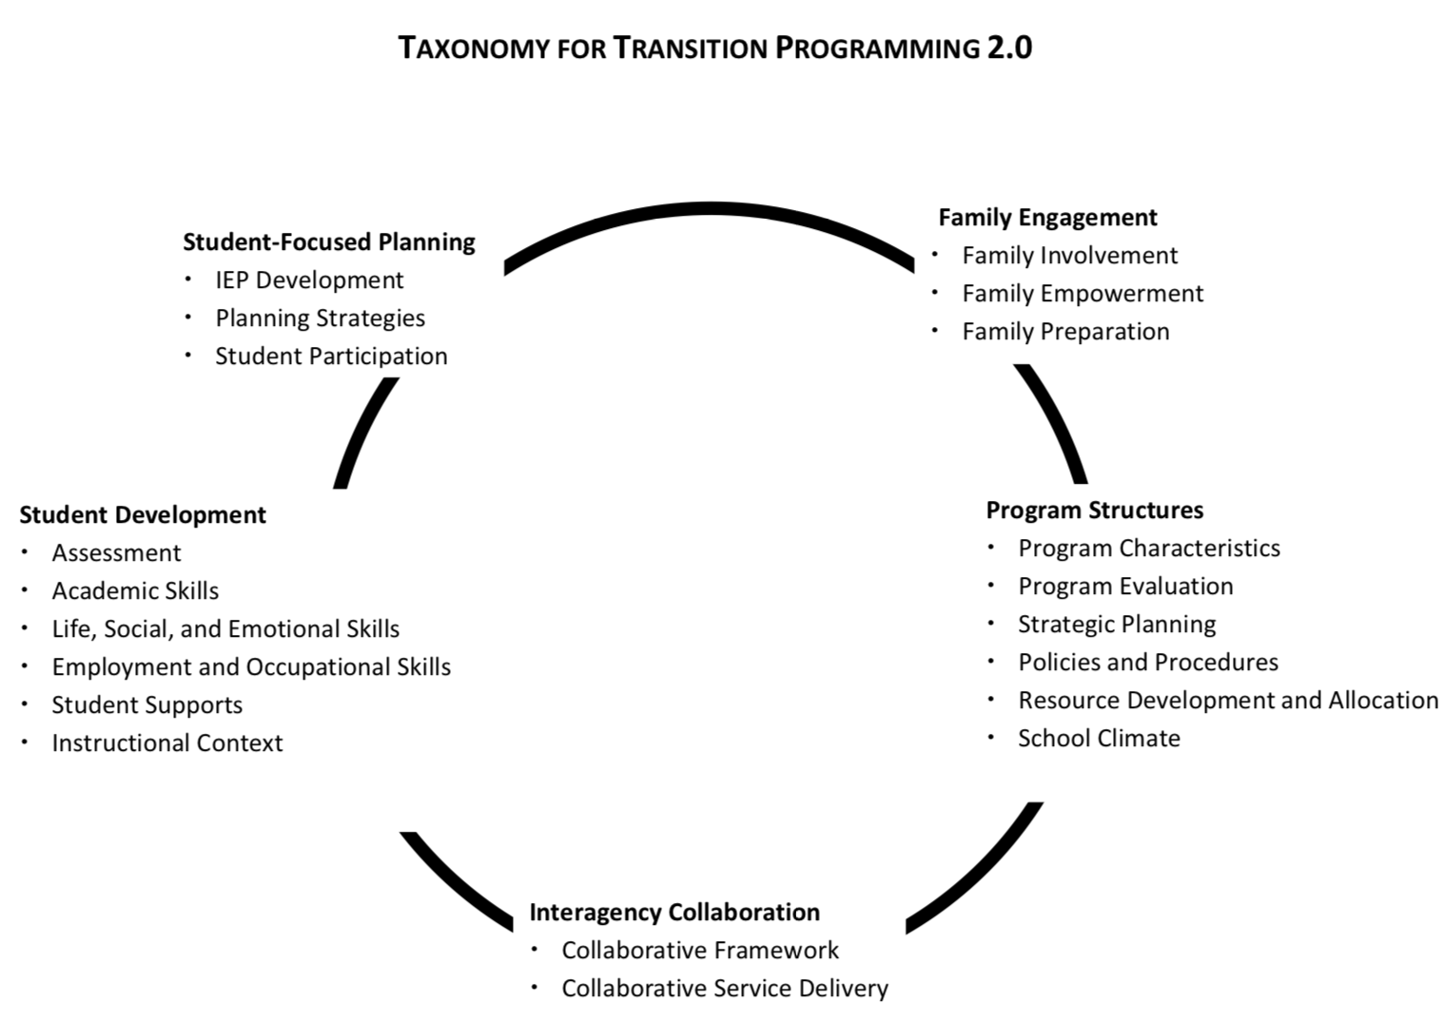
Transition in Practice
Special education as a field, including transition programming, has undergone many changes pertaining to what is considered best practices; research and legislation are responsible for this evolution (Odom et al., 2005). By using research to evaluate and disseminate practices within transition programming, we ensure our field is using the scientific method to guide practices. This use of well-conducted research allows practitioners to know programs, curricula, and practices have shown to be successful in meeting the educational needs of children by increased student performance (Cook & Odom, 2013).
Predictors and Evidence-Based Practices Associated with Postschool Outcomes. In alignment with IDEA’s regulations which require practitioners to use evidence-based practices, the field’s researchers have produced several evaluations related to predictors of postschool success (Mazzotti et al., 2016; Test et al., 2009). A predictor involves the process of applying statistical modeling to data to indicate a correlational relation between an independent variable and an outcome variable, while also controlling for extraneous variables (Shmueli, 2010). Predictors are also based upon theories already established within the field’s research. Correlational research allows researchers to determine most promising practices and to examine short-term targets for interventions related to later improved outcomes and conditions in which interventions are effective; however, it cannot rule out confounds such as maturational effects. This because some independent variable cannot be experimentally manipulated so correlations research helps identify variable which could be of interest in identifying practices. Identifying predictors is not rooted within rigorous experimental research but lays the groundwork for emerging research in a growing field which does not have a lot of experimental research (Harber et al., 2016; Test et al., 2009). Specifically, for the purpose of this literature review a predictor indicates educational practices that are correlated with positive postschool outcomes for individuals with a disability (Mazzotti et al., 2016; Rowe et al., 2015; Test et al., 2009).
In 2009, Test and colleagues conducted a systematic review of the literature in the field of transition planning to determine effective and common practices. The researchers initially had 162 articles meeting their research criteria, but through exclusion examination (must include correlational data), 63 potential studies emerged. Of those 63 studies, only 28 met the inclusion criteria (variables related to secondary transition programming or practices and student outcomes related to postschool education, employment, and independent living). These 28 studies were reviewed using a 13-item correlational research quality indicator check-list, resulting in 22 articles for their final review. After examining the articles using predetermined criteria (excluded stepwise analysis methods and must include effect size in findings) regarding statistical analysis and participant information, they determined 16 predictors (see Table 1) were linked to in-school practices and programs resulting in improved postschool outcomes. These predictors included career awareness, occupational courses, paid employment/work experiences, vocational education, work study, community experience, exit exams requirements/high school diploma status, inclusion in general education, program of study, self-determination/self-advocacy, self-care/independent living skills, social skills, interagency collaboration, parental involvement, student support, and transition program. Additionally, they determined the area(s) of transition outcomes the predictors impacted (education, employment, and/or independent living), the level of evidence relating to each predictor, and the effect size of each (Test et al., 2009). As a result of Test and colleagues’ work, a Delphi study (see Table 1) was conducted with experts in the field of transition education to operationally define these predictors to ensure the information was unified and more accessible for practitioners (Rowe et al., 2015).
Table 1
Evidence-Based Predictors with Operational Definitions
Evidence-Based Predictors with Operational Definitions
Predictors | Operational Definition | Outcome Areas
Career Awareness | Career awareness is learning about opportunities, education, and skills needed in various occupational pathways to choose a career that matches one’s strengths and interests. | Education  Employment
Occupational Courses | Occupational courses are individual courses that support career awareness, allow or enable students to explore various career pathways, develop occupational specific skills through instruction, and experiences focused on their desired employment goals. | Education  Employment
Paid Employment/Work Experiences | Work experience is any activity that places the student in an authentic workplace and could include work sampling, job shadowing, internship, apprenticeships, and paid employment. Paid employment can include existing standard jobs in a company or organization, or customized work assignments negotiated with the employer, but these activities always feature competitive pay (e.g., minimum wage) paid directly to the student by the employer. | Education  Employment  Independent Living
Vocational Education | Vocational education is a sequence of courses that prepares students for a specific job or career at various levels from trade or craft positions to technical, business, or professional careers. | Education  Employment
Work Study | A work study program is a specified sequence of work skills instruction and experiences designed to develop students’ work attitudes and general work behaviors by providing students with mutually supportive and integrated academic and vocational instruction. | Employment
Community Experiences | Community experiences are activities occurring outside the school setting, supported with in-class instruction, where students apply academic, social, and/or general work behaviors and skills. | Employment
Exit Exam Requirements/High School Diploma Status | Exit exams are standardized state tests, assessing single content area (e.g., algebra, English) or multiple skill areas, with specified levels of proficiency that students must pass to obtain a high school diploma. Diploma status is achieved by completing the requirements of the state awarding the diploma including the completion of necessary core curriculum credits. | Employment
Inclusion in General Education | Inclusion in general education requires students with disabilities to have access to general education curriculum and be engaged in regular education classes with peers without disabilities. | Education  Employment  Independent Living
Program of Study | A program of study is an individualized set of courses, experiences, and curriculum designed to develop students’ academic and functional achievement to support the attainment of students’ desired post-school goals. | Employment
Self-Determination/Self-Advocacy | Self-determination is the ability to make choices, solve problems, set goals, evaluate options, take initiative to reach one’s goals, and accept consequences of one’s actions. | Education  Employment
Self-Care/Independent Living Skills | Self-care/independent living skills are skills necessary for management of one’s personal self-care and daily independent living, including the personal management skills needed to interact with others, daily living skills, financial management skills, and the self-management of health care/wellness needs. | Education  Employment  Independent Living
Social Skills | Social skills are behaviors and attitudes that facilitate communication and cooperation (e.g., social conventions, social problem solving when engaged in a social interaction, body language, speaking, listening, responding, verbal, and written communication). | Education  Employment
Interagency Collaboration | Interagency collaboration is a clear, purposeful, and carefully designed process that promotes cross-agency, cross-program, and cross-disciplinary collaborative efforts leading to tangible transition outcomes for youth. | Education  Employment
Parental Involvement | Parent involvement means parents/families/guardians are active and knowledgeable participants in all aspects of transition planning (e.g., decision making, providing support, attending meetings, and advocating for their child). | Employment
Student Support | Student support is a network of people (e.g., family, friends, educators, and adult service providers) who provide services and resources in multiple environments to prepare students to obtain their annual transition and postsecondary goals aligned with their preferences, interests, and needs. | Education  Employment  Independent Living
Transition Program | A transition program prepares students to move from secondary settings (e.g., middle school/high school) to adult life, utilizing comprehensive transition planning and education that creates individualized opportunities, services, and supports to help students achieve their post-school goals in education/training, employment, and independent living | Education  Employment

Note: The above evidence-based predictors and outcome areas were originally determined through a systematic review of secondary transition correlational literature (Test et al., 2009). Rowe et al. (2015) then conducted a Delphi study to operationalize the definitions of those predictors by surveying 22 experts in the field of transition education (pp. 118-123).
To further support and extend Test and colleagues’ findings, Mazzotti et al. (2016) conducted a systematic review of articles published pertaining to transition practices since 2009. The researchers started with 54 articles and then narrowed down using exclusion and inclusion criteria similar to the original studies’ procedures. As a result, they included 11 articles in their review. The researchers found four additional predictor categories: parent expectations, youth autonomy/decision making, goal setting, and travel skills for students with disabilities (Mazzotti et al., 2016). Harber et al., (2016) simultaneously conducted a meta-analysis to verify Test’s findings and found a positive relation between predictors and outcomes with a meaningful magnitude. To date, there are 20 predictors and over 65 researched practices in the field of transition planning which demonstrate some level of results for students with disabilities (Kohler et al., 2017). While knowing the predictors allows us to know the concepts practitioners need to focus on during instruction, we also need to know the most effective methods for teaching those concepts.
Evidence-Based Practices
An effective practice is considered a “teaching method used to teach a specific skill that has been shown to be effective based on high-quality research” (Rowe et al., 2019, p. 2). The National Technical Assistance Center on Transition (NTACT) has been the leader in organizing and disseminating the evidence-based practices within special education’s specialized field of transition planning (NTACT, 2020). NTACT (2019) categorized transition practices into one of four tiers of effectiveness from highest to lowest: (a) evidence-based practices, (b) research-based practices, (c) promising practices, and (d) unestablished practices. Evidence-based practices demonstrate the use of rigorous designs, a strong record of improving outcomes, and research quality indicators set forth by the Council of Exceptional Children (CEC). Research-based practices use rigorous designs, show a sufficient record of improving outcomes, and meet CEC quality indicators. Promising practices may use rigorous designs, show some success for improving outcomes, and may adhere to CEC quality indicators. Finally, unestablished practices are based on minimal research with a demonstration of limited success of improving outcomes (NTACT, 2018). In transition planning, NTACT is the guiding force for practitioners and researchers on best practices for providing students with disabilities the needed curricula, services, and resources while in school to prepare them for their adult lives (Morningstar et al., 2018). NTACT allows practitioners to meet the transition planning guidelines detailed within IDEA (2004) mandates regarding the use of scientifically-based research. As of October 2019, NTACT established 69 effective practices (see Table 2) with 12 evidenced-based practices, 32 research-based practices, and 25 promising practices (Rowe et al., 2019). NTACT has provided the categories of students or parents the practices were proven effective with through the research.
Transition Related Research for Individuals with an ID
We know individuals with disabilities do not have comparable adult outcomes to their peers without disabilities (Newman et al., 2010); this is even more pronounced for those with an ID. These individuals have poorer outcomes than their peers with more mild disabilities (e.g., attention deficit disorders, specific learning disability, communication disorders) (Baer et al., 2011; Grigal et al., 2011; Newman et al., 2010). However, there are instructional practices specifically associated with individuals with ID to improve transition outcomes (Baer et al., 2011; Carter et al., 2012; Grigal et al., 2011). While inclusion in general education classes was the only established predictor for postschool involvement for individuals with an ID (Baer et al., 2011), NTACT standards have identified effective practices which benefit this population (Rowe et al., 2019). Through examining the research in the field of transition education, NTACT found that of their 69 effective practices, 46 pertained to individuals with an ID, as did 10 of the 12 evidence-based practices (see Table 2).
Table 2
NTACT Effective Practices
NTACT Effective Practices
Evidence-Based | Research-Based | Promising
Anchored Instruction* | Check and Connect | At Work Vocational Rehabilitation Program
Graphic Organizers* | Corrective Reading* | Backward Chaining*
Mastering Fractions | Direct Instruction of Main Idea | Beyond High School Model
Mnemonic* | Embedded Story Structure Routine | Community-Based Instruction*
Parent Training in Transition* | Envision IT Curriculum* | Computer Assisted Instruction*
Peer Assisted Instruction and Support* | Expressive Writing Level One Curriculum | Constant Time Delay*
Project SEARCH* | GO 4 IT…NOW Strategy* | Differential Reinforcement
REWARDS Program Curriculum | Graduated Sequence of Instruction* | FEAT Curriculum*
Schema-Based Instruction* | Internships | Forward Chaining*
Self-Advocacy Strategy* | Mentoring | Most to Least Prompting*
Self-Directed IEP* | Person Centered Planning | Multimodal Anxiety and Social Skills Intervention (MASSI)
Take Charge Curriculum* | RAP Paraphrasing Strategy* | One-More-Than Strategy*
 | Reading Comprehension Strategy | Peer Assisted Instruction/Support plus Simultaneous Prompting*
 | Reading Comprehension Strategies plus Attribution Retraining Concepts and Strategies | Peer Networking Intervention
 | Repeated Reading* | Progressive Time Delay*
 | Response Prompting* | Post-School Achievement Through Higher Learning Skills (PATHS) Curriculum
 | Self-Determined Learning Model of Instruction (SDLMI) * | Self-Monitoring Instruction
 | Self-Management Instruction* | Simultaneous Prompting*
 | Self-Regulated Strategy Development | Social Skills and Sports Program Curriculum*
 | Self-Regulated Strategy Development plus POW-TREE | System of Least Prompts*
 | Service Learning | Take Action: Making Goals Happen Curriculum*
 | Simulated Instruction* | Total Task Chaining*
 | SOLVE IT Curriculum | Total Task Chaining plus Prompting
 | Strategic Note Taking | TouchMath®*
 | Structured Inquiry* | Video Modeling plus Constant Time Delay*
 | Student Directed Transition Planning Lesson Package*
 | TRAVEL Mnemonic*
 | Video Modeling*
 | Visual Displays*
 | “Whose Future Is It Anyway?” Curriculum
 | Word Mapping Strategy
 | Working at Gaining Employment Skills (WAGES) Curriculum*

Note: Full table with operational definitions and student populations can be found at transitionta.org.
* Denotes practices with research pertaining to students with an ID.
The following research from various experts in the field of transition education who specialize in working with individuals with an ID can also be used to guide practitioners. First, students with a transition goal of attending a 2- or 4-year college had increased employment as adults, while working in a sheltered workshop had a negative impact on future employment (Grigal et al., 2011). Baer et al. (2011) also determined inclusion plays a pivotal role in increasing the likelihood students with an ID will go on to enroll in postsecondary programs. Specifically, students enrolled in general education classes more than 80% of their day were more likely to enroll in postsecondary education. Carter et al. (2012) examined the NTLS-2 data and found students with more involved disabilities, ID included, where more likely to attain employment if during their secondary education they held paid community-based employment. Additionally, independent self-care for males, higher social skills, increased household chores, and higher parental expectations resulted in improved postschool employment (Carter et al., 2012). Most recently, it was determined that graduating with a regular high school diploma improved postschool outcomes (Prince et al., 2018). In summary, in order to improve the postschool outcomes of students with an ID, we need to ensure they participate in community-based employment with competitive pay, are taught independent self-care and social skills, participate in household chores, have an in-school transition goal of attending a 2- or 4-year college, participate in general education classes more than 80% of their day, and have high expectations from their parents. All of these recommendations lead to improved self-determination, which has been correlated with positive postschool outcomes for individuals with an ID (Nota et al., 2007). It is apparent there are many predictors associated with adult outcomes for individuals with a disability, but for the purpose of this review the practices focusing on postsecondary educational outcomes will be delved into further, including independent living skills and self-determination.
Independent Living Skills
Independent living skills are positively correlated with increased adult independence for individuals with an ID (Carter et al., 2012). Independent living skills include the “skills necessary for management of one’s personal self-care and daily independent living, including the personal management skills needed to interact with others, daily living skills, financial management skills, and the self-management of health care/wellness needs.” (Rowe et al, 2015, p. 121). Despite independent living being considered an important milestone in the transition into our adult lives, only 36.6% of individuals with an ID reported living independently at some point after graduating from high school (Newman et al., 2011). Improving these skills associated with independent living, including the adaptive skills needed (i.e., practical skills an individual learns and performs in everyday life) can benefit postschool independence (Dell’Armo & Tassé, 2019). Practical skills include tasks needed for daily living, self-care, using transportation, and health and safety. When individuals with an ID received instruction in these practical skills, they reported positive postschool outcomes (Dell’Armo & Tassé, 2019). Increasing independent living skills will increase the students’ access to future environments where these skills are important for living on their own (Wehmeyer & Palmer, 2003). Overall, teaching any skill which facilitates independence to individuals with an ID increased their quality of life (Schalock et al., 2002). Deficits in daily living skills can have the opposite effect (Parmenter, 1994). Individuals with an ID are at risk of becoming dependent on others to complete these tasks for them (Giangreco & Broer, 2007). Despite IDEA transition planning mandates, there has been less focus on functional curriculum (e.g., independent living skills instruction) with more focus on academic achievement in inclusive settings (Bouck, 2007). Alwell and Cobb (2009) point out this focus has, in turn, limited research pertaining to independent living skills related to individuals with an ID. We need to conduct more research on educational practices and interventions directly impacting individual living skills for those with an ID. This increase in independent living has correlated with higher levels of self-determination for students with an ID (Wehmeyer & Palmer, 2003), but we need more research studies to aid in predicting what interventions are most effective in improving adult outcomes for individuals with an ID.
Self-Determination and Self-Monitoring
Teaching self-determination seeks to improve adult outcomes by giving individuals the tools to create acceptable and effective ways of exerting control over their opportunities (Dunlap et al., 2005). Self-determination has played a significant role in increasing future success for individuals with a disability (Wehmeyer et al., 2012). One with self-determination possesses the “ability to make choices, solve problems, set goals, evaluate options, take initiative to reach one’s goals, and accept consequences of one’s actions,” (Rowe et al., 2015, p. 121). Self-determination specifically includes subcomponents of choice and decision making, self-efficacy, goal setting, self-advocacy, self-knowledge and self-management/regulation (Wehmeyer & Field, 2007). Self-determined people make choices and decisions based on their own preferences and interests, then monitor and regulate their own behaviors (Carter et al., 2013; Wehmeyer et al.,1998). Self-determination instruction has proven effective across individuals with differing disabilities, including those with an ID (Shogren, 2013). Specifically pertaining to students with an ID, improved self-determination increased productivity, organization, and academic achievement (Erickson et al., 2015). In addition, elevated postsecondary education enrollment has been correlated with higher levels of self-determination (Shogren et al., 2018). Despite these positive implications associated with self-determination, these are skills students with disabilities do not attain similarly to their peers without disabilities, and we must make intentional effort to help them improve in this area (Campbell-Whately, 2008).
Encouraging and allowing students to make decisions regarding their futures through student-focused planning has increased self-determination (Kohler & Field, 2003; Warger & Burnette, 2000). To accomplish this, we must move away from a system where teachers maintain full control of the decision-making process and instead value students’ active participation and collaboration in these processes (Agran & Brown, 2015). Self-determination increased when practices were used to enhance students’ choices and decision-making skills (Karvonen et al., 2004). Teaching students with disabilities the skills associated with self-determination has allowed them to become the change agents of their own behavior (Agran & Brown, 2015).
Strategies related to self-determination were most effective when students received instruction pertaining to the specific skills needed to control their own behaviors (Wehmeyer, 2014). This focus on the behaviors related to self-determination has led the concept of self-determination to move beyond transition planning into the field of behavioral support (Agran & Brown, 2015).
Self-determination represents a potentially powerful intervention as it gives students opportunities to manipulate the setting events, antecedents, and consequences present in their environment and, in doing so, reduce their dependence on external change agents. Second, by giving students this advantage, it changes their role and allows them to, in fact, be their own change agents. (Agran & Brown, p. 406)
By teaching an individual the skills associated with self-determination (e.g., make choices, problem solve, set goals, evaluate options, attain goals, accept consequences) we are empowering them to be responsible for their behavior. This is especially true in the self-determination skill of self-management (Niesyn, 2009).
Self-management consists of a person intentionally acting a certain way to change subsequent behaviors (Cooper et al., 2007). In particular, self-management involves deliberate actions influencing one’s behaviors in order to influence self-selected outcomes (Browder & Shaprio, 1985). This includes using preferences to make choices to manage one’s own affairs (Wehmeyer & Abery, 2013), while allowing for one to use one’s own efforts, judgements, resources, and abilities in making these choices (Sandjojo et al., 2018). Self-management can be an effective intervention for broad application and is adaptable for differing goals, ability levels, and preferences for individuals with an ID (Sandjojo et al., 2018). It allows individuals to live a more efficient daily life, break bad habits, accomplish difficult tasks, and achieve personal lifestyle goals (Cooper et al., 2007). Additionally, it impacts behaviors not accessible to external changes and promotes the generalization and maintenance of behaviors. Self-management is also beneficial across environments and the end results can be rewarding for individuals (Cooper et al., 2007). Self-management's multitude of benefits across varying individuals with different needs allows for a wide array of implementations for individuals with disabilities and for the promotion of generalization and independence through shifting control of behavior from teacher to student (Hume et al., 2009; Newman et al., 2000). Learning to self-manage one’s behaviors is a skill which can be successfully taught to individuals with an ID (Mechling, 2007).
Prompting
Self-managing one’s behavior allows individuals to eventually become self-motivated through natural consequences (Hume & Odom, 2007), but it takes time to learn this skill (Zimmerman & Schunk, 2012). Using prompting to teach self-management has been an effective method for those with disabilities, including increased independence in daily living skills (Bereznak et al., 2012). Prompting is a behavior strategy which involves “supplementary antecedent stimulus use to occasion a correct response in the presence of a SD [discriminative stimulus-a type of stimulus which consistently is used to gain a specific response] that will eventually control the behavior” (Cooper et al., 2007, p. 401). Prompting is used to increase the likelihood of a behavior. While prompting is an overall concept of the strategy, response prompting is a specific type of prompting involving systematic instruction (Collins et al., 2018). It involves utilizing an attentional cue, task direction (an instructional stimulus), a response, and a consequence as a means to evoke a specific response (Collins et al., 2018). Response prompting can include verbal instructions, modeling, and physical guidance. With the many variations of response prompting there are even more implementation procedures for prompting. One such procedure, known as most-to-least prompts, is the systematic reduction of support in prompting the target behavior (Collins et al., 2018). Most-to-least prompts allow for the response prompt fading through the various levels of support to avoid individuals’ dependency on these prompts and with a final goal of demonstration of the targeted behavior without any prompting (Snell & Brown, 2011) or a natural stimuli prompting the targeted behavior (Cooper et al., 2007). Prompt fading is an effective method to teach independence to individuals with an intellectual disability (Cullen et al., 2017; Kelley et al., 2013). However, little research has been done to assess the effectiveness of response prompt fading with young adults participating in postsecondary programs for individuals with an intellectual disability.
The use of response prompting is a research-based practice listed by NTACT as positively impacting adult outcomes for individuals with disabilities, including those with an ID (Rowe et al., 2019); specifically, the transition-focused outcome of independent living benefits from response prompting. For example, prompting has proven as an effective means of teaching independence in postsecondary programming for individuals with an intellectual disability (Cullen et al., 2017; Kelley et al., 2013). In addition, fading prompts was also beneficial in gaining independence in daily living in postsecondary programs for individuals with an ID (Gilson & Carter, 2016; Sigafoos et al., 2006). Despite these promising findings, little research exists regarding effective practices at postsecondary programs for individuals with an ID.
Postsecondary Education Programming
All of these aforementioned transition services and interventions aim to increase the opportunities and skills for students with an ID to achieve their postschool outcomes. Many people assume individuals with an ID will stop pursuing educational services once they leave K-12 public schooling (Hart et al., 2010). Often, young adults with an ID are left out of the idea of the pursuit of the “American Dream” due to the notion they do not have the capabilities to pursue competitive employment, postsecondary education, or living independently in a similar fashion to their same-age peers without disabilities. Despite this notion, about half of the students with an ID envision attending college after high school graduation (Lipscomb et al., 2017). This goal of attending college was often seen as a pipe dream in the past, until the recent rise of PSE options for individuals with an ID across the nation (Think College, 2019).
The expansion of PSE programs for students with IDs can be directly related to social and legislative initiatives (Plotner & Marshall, 2015), including financial support through the Office of Postsecondary Education and the passing of the Higher Education Opportunity Act (HEOA) of 2008 (Papay et al., 2018). Past mandates like Section 504 and ADA led the way for individuals with disabilities to gain access to higher education institutions, but still very few individuals with an ID attended college. The passing of HEOA (2008), the reauthorization of the Higher Education Act of 1965, changed the disability diversity of colleges when it included ID as part of the federal definition associated with the population attending college (Papay et al., 2018). Additionally, it established financial aid support for PSE programs and participants through establishing their eligibility for student grants and work-study opportunities as well as the establishment of a model demonstration program—the Transition and Postsecondary Programs for Students with Intellectual Disabilities (TPSID; Grigal et al., 2013). TPSID allows for the creation and funding of PSE programs across the country. In addition, HEOA created a national coordinating center for TPSID programs entitled Think College (Papay et al., 2018). Think College provides guidance, resources, and research pertaining to PSE program development and preservation.
Under the guidance of Think College, the main goals of current PSE programs consist of providing academic and independent living opportunities, which include career development and campus socialization activities, usually without participating in typical degree-seeking programming (Lynch & Getzel, 2013). Since most PSE programs offer completion certifications, students are not held to the same academic standards for college admissions and are allowed alternative course options. While PSE program goals are unified in providing independent living, career preparation, and socialization training, programs vary depending on course offerings, number of participants, requirements, and types of college enrollment (Think College, 2019). Despite the internal dynamics of each PSE program, the main goal is to improve independence for their participants (Griffin et al., 2010). Independence increases because PSE programs provide participants increased self-determination through time management, self-advocacy, choice making, and understanding consequences of those choices, which are all daily experiences for college students (Grigal et al., 2013).
A typical PSE program experience can be described as the following: participants attend a program on a college campus, where they take inclusive courses with their college peers (students can audit or take for credit) and/or specialized courses for the programs participants only, which focuses on instruction in life skills, social skills, and career preparation; live in inclusive settings on campus; and participate in campus organizations (Papay et al., 2018). Currently, it is estimated by the coordinator of Think College about 6,640 individuals are attending PSE programs across 275 campuses in 49 states (M. Grigal, personal communication, September 25, 2019).
Attendance in a PSE program improves individuals’ ability to gain meaningful employment (Grigal et al., 2013; Smith et al., 2018), which leads to enhanced self-esteem, financial independence, and beneficial social networks (Carter et al., 2012). Smith et al. (2018) found after analyzing 19,050 individuals’ postschool outcomes, PSE program participants receiving vocational rehabilitation services had higher paid integrated employment rates (65%) than those who only received vocational rehabilitation services (56%); in addition, they made up to 51% higher weekly wages. PSE programming also increases independent living skills (Kirkendall et al., 2008). PSE residential living allows for a gradual transition to independent living environments (Eisenman & Mancini, 2010). However, teaching independence must be a component of PSE programming as part of the curriculum (Grigal & Hart, 2010). When participants are taught the skills associated with independent living it provides more opportunities for self-determination and decision making (Kelley & Westling, 2019; Wehmeyer & Abery, 2013). Living on campus is the perfect situation to allow students with an ID to exercise their self-determination and decision-making skills, while they are still provided support based upon their needs, and they have many opportunities for daily choices (Kelley & Westling, 2019). It should also be noted, while it is understood individuals with an ID attending PSE programs benefit from independent living skills training, it is crucial they learn these skills proficiently and in a timely manner. Due to perceptions regarding the ability levels of individuals attending PSE programs, sometimes there is not as much latitude in poor decision making as compared to their college peers without disabilities. This can relate back to the opinion these students do not have the ability to participate in a PSE setting, which makes it imperative they are provided the support to learn these skills. PSE program participants need guidance to become more self-determined regarding decision making and independent living to facilitate their future participation in their community (Kelley & Westling, 2019).
Postsecondary Education Programming and Action Research
With the recent rapid growth of PSE programs, research is emerging in the field, but much more is needed to establish what higher education institutions should consider best practices (Graff et al., 2019). This can be accomplished through action research, which provides “a systematic approach to investigation that enables people to find effective solutions to problems they confront in their everyday lives” (Stringer, 2007, p. 1). Action research is traditionally employed across disciplines where practitioners lead the research efforts, like in the fields of health and social sciences (de Zeeuw, 2003). This is because action research bridges the gap between academic research and the applications of day-to-day practices. Action research has five main characteristics, which include purposes and value choices, contextual focus, change-based data and sense making, and knowledge diffusion; essentially, it is providing “real life” solutions (Martella et al., 2013). Action research allows practitioners to be directly involved in scientifically evaluating their practices so they can understand the effect of what they are doing. Action research is conducted in a systematic fashion. It occurs in the real world and allows for the researcher to learn more about the participants, the setting, and the participants’ role in the process, and allows for the formation of practical solutions. Action research can be used within all the major research designs, including quantitative, qualitative, and single-case (Martella et al., 2013).
With PSE programing still in its infancy and lacking a strong research base, practitioners and researchers need to produce evidence of what is working currently and what can be done to improve practices. While a few have started this important endeavor, still more is needed to guide instruction, policy, and practices for PSE programming (Love & Mock, 2019; Rao et al., 2017; Schwantes & Rivera, 2017).

Chapter 3
Methodology
This chapter describes the mixed methods experimental design study employing a single-case AB design and a general inductive qualitative design as action research to investigate whether the use of fading response prompts is beneficial in gaining independent living skills associated with cleaning a dormitory room for participants in a postsecondary education (PSE) program. In addition, the researcher ascertained the social validity of the intervention as perceived by the study participants. The information gathered through this study contributes much needed research to the field of PSE programming for individuals with an intellectual disability regarding the most effective practices focusing on self-determination and independent living skills attainment. In addition, the study directly affects the programming practices at the researcher’s postsecondary program.
Research Questions
- Is there a relation between the use of fading response prompts and the level of completion in cleaning a dorm room for students with an intellectual disability participating in a postsecondary education program on a university campus? (single-case design during first phase of the study)
2. Do the postsecondary program’s participants value the use of fading prompts and find it beneficial? (qualitative design during the second phase of the study)
a. Did the fading prompts help the participants become more independent?
b. Were there one or more prompts the participants felt were the most beneficial?
c. Were there any prompts they felt did not benefit them in completing their cleaning tasks?
d. How can the use of fading prompts be improved for the program’s participants in the future?
e. Will the participants continue to use any of the prompts for other tasks in the future and why?
f. Did the participants prefer the in-person or the video-chat dorm checks and why?
The general purpose of the design was to determine if fading response prompts facilitated the organization and cleaning of college dormitory rooms for students with an ID participating in a PSE program in a manner consistent with action research to help guide their future practices. Within the mixed-method study design, the social validity of the interventions was also assessed to help address the comparison and the utility of both interventions. This chapter also describes my theoretical framework to allow readers to understand my philosophical foundations behind my research. The chapter will also address the trustworthiness, validity, strengths, and limitations associated with the design.
While mixed-methods research is considered relatively new, described by Teddlie and Tashakkori (2009) as being in its “adolescence phase,” it provides an approach to bridge the gap between quantitative and qualitative measures. Quantitative research roots lie within a positivist viewpoint of verifying theories through scientific research. In contrast, qualitative research uses the constructivist lens of gaining understanding of multiple means of experiences derived from historic and social events (Creswell & Plano Clark, 2018). Some have argued these two designs are opposite ends of the methodology spectrum and the two theories should not be mixed, but many are starting to adhere to the belief these methods can improve research by supporting one another (Johnson & Onwuegbuzie, 2004). This ideology falls in line with the pragmatic philosophy, where a problem is identified and viewed within its broad context as a means to better understand it and, ultimately, solve real-world problems.
Research Design
In an attempt to answer the research questions and guide future PSE programming practices, a mixed methods experimental design was utilized. A mixed methods design consists of “research in which the investigator collects and analyzes data, integrates the findings, and draws inferences using both quantitative and qualitative approaches” (Tashakkori & Creswell, 2007, p. 4). Specifically, this is considered a complex mixed methods design which entails using both quantitative (primary method) and qualitative (secondary method) data collection and analysis of each method independently. Then, the information is integrated within an experimental quantitative research design (See Figure 5 for a diagram of this approach). This design allowed for the researcher to first control the conditions, to implement the intervention, and to determine the outcome of the intervention. In the final phase, participants’ feedback regarding the treatment was analyzed in order to guide future practices (Creswell & Plano Clark, 2018).
Figure 5
Diagram of a Complex Mixed Methods Design
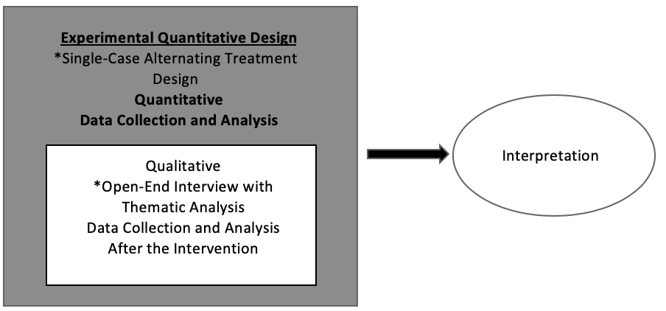
Note: This is a complex experimental quantitative design with a primary method of quantitative research and a secondary qualitative component.
The purpose of this study consisted of investigating behaviors associated with the independent living skills of organizing and cleaning a dormitory room for participants in a PSE program. In order to adequately assess these behaviors, they must be operationally defined. An operational definition describes what the behaviors look like in a way that is observable, measurable, and repeatable (Cooper et al., 2007). The behaviors associated with cleaning and organizing a dorm room have many different aspects which need to be examined and quantified. For the purpose of this study the targeted behaviors of a clean room constituted no build-up on hard surfaces (including mirrors and the floor) of trash, dirt, dust, or substances. Also, all trash should be placed in the trash can, which should not be full to the point of items falling out or emitting a foul odor. In regard to organization, the bed must be made and cleared of non-bedding items; all personal items (e.g., clothes, books, papers, food, drinks, back-pack, etc.) should be put in an appropriate area if not being used at the moment. Note: for the purpose of this study, cleaning will be limited to the dormitory room only and will not include the bathroom due to suitemates having an impact on the outcome variable. During the first phase, the researcher used a single-case AB design across three participants to determine if there was a relation between the use of fading response prompts and the level of completion in cleaning a dorm. Then, in the second phase, the participants’ interviews were embedded into the larger design for the purpose of assessing social validity. Social validity includes (a) the measure of the goals of the intervention, (b) determination of the appropriateness of the intervention procedures, (c) and the social importance of the intervention’s outcomes (Wolf, 1978). Addressing sustainability of the intervention is also an important component of social validity (Ledford et al., 2014). Sustainability allows for the determination of whether the intervention will likely increase the future probability in maintaining the desired behavior. The qualitative results pertaining to social validity were embedded with the quantitative outcome results to assess the overall benefit of fading response in learning independent living skills.
This combining of two research methods adheres to Bryman’s (2006) mixing rationales for determining the utility of the intervention. According to Bryman (2006), utility refers to the usefulness of findings and it is more prominent when there is an applied focus with the research and the combining the methodologies can be more useful to practitioners. Mixing both quantitative and qualitative methods within this mixed methods design allows for ascertaining the effectiveness of one intervention as compared to another intervention, while also providing the social validity, which is a key component of behavioral based research (Wolf, 1978).
Sampling Method and Participants
The nonprobabilist-opportunity sampling method (viz. volunteer sampling), which is similar to convenience sampling, was utilized to gain participants for the quantitative portion of the study (Martella et al., 2013). This type of sampling involves recruiting participants who are readily available and who meet the study criteria, as in convenience sampling, but goes further to include participants who are also willing to take part in the study. While this is not the preferred random sampling method for experimental designs (Creswell & Plano Clark, 2018), due to the nature of the participants’ characteristics, their limited availability, and the single-case design, a more randomized sampling method would not be appropriate. To be eligible for the study, participants were (a) PSE program students on the researcher’s campus, (b) at least 18 years of age, and (c) diagnosed with an ID. Race, gender, and socioeconomic status of participants varied depending on the make-up of the students participating in the PSE program. For the second phase of the study, the same participants were used, aligned with a sequential purposeful sampling method, where all the participants had experience with the key concept (intervention) being explored prior to this stage of the study (Creswell & Plano Clark, 2018). Due to the enrollment in the PSE program at the researcher’s university, a sample size of three participants was used for this study.
The three participants were all consenting adults who voluntarily participated in the study. They were given pseudonyms Nathan, Jack, and Hannah. They all were on IEPs while in high school due to an intellectual disability, and at the time of the study they participated in the PSE program the researcher was associated with.
Nathan was a 20-year-old male from a higher socioeconomic status background. Nathan was of Asian descent and was adopted from another country as an infant. Nathan’s family disclosed he had some traits associated with autism as well as a below average intelligence quotient (IQ). He had a driver’s license and attended a private high school where he was in all general education classes. Nathan held competitive employment in the food industry for several years. He was very driven to succeed in school and wanted to be seen as “typical” compared to his peers without disabilities. He preferred to not be associated publicly with the PSE program because he did not want others to know he was part of a program specially for individuals with a disability. He enjoyed attending the university but still liked to go home every weekend to spend time with his family who were located about 45 minutes from the university. Of the three participants Nathan had the highest functioning and academic levels but was the most easily stressed about new situations and meeting the demands of college life. Nathan attended a smaller state university but struggled academically before coming to the PSE program. This was the first time he lived away from his family home. Nathan came into the program academically prepared, with the beginning job skills to handle the demands of the program.
Jack was a 22-year-old white male from a higher middle-class socioeconomic background. Jack was diagnosed as having an ID and autism. Jack was very social and easy going and enjoyed being part of the PSE program. He did not always understand social situations but was willing to try new things. However, he expressed when he did not enjoy something. He had two jobs outside of the program (one during school breaks in a factory and the other one as a food server at a local sorority house) and had a very busy schedule. He thoroughly enjoyed his independence at college and chose to stay on campus on the weekends and during extended breaks. Jack strictly followed all rules and guidelines of the PSE program. Prior to coming to the PSE program, Jack participated in a highly structured program for learning digital media, which only served individuals with autism. This program was located in another state, about three hours from his hometown. While at this program he lived with his maternal grandparents. In addition, he participated in a 12+ program in his public school district where he took classes related to employment and did a half-day work-study at a hotel. Jack came into the program with many independent living and employment skills associated with these previous experiences.
The only female in the program, Hannah, was 20 years old and diagnosed with an ID. She needed the most support academically but was the most willing to venture out on campus independently. Hannah had never participated in competitive employment but did attend a one-year hospitality service program at her local technical school after her high school graduation. She almost always followed directions and did not express when she did not want to do something. Hannah seemed to enjoy everything about university life and only went to her family home, which was about an hour from campus, on school breaks. She preferred to stay on campus on the weekends and partake in the university’s campus activities. She was very active in social organizations on campus and enjoyed hanging out with peer mentors from the PSE program.
Setting
All aspects of the study took place on campus at a southwest university. The consent discussions and interviews were conducted in the main offices of the PSE program, while the dorm room checks happened in the participants’ dorm rooms, either in-person or via a live video-chat call between the participants and researcher(s).
Research Question One: Quantitative Approach
For research question #1 a quantitative single-case research design was used to answer, “Is there a relation between the use of fading response prompts and the level of completion in cleaning a dorm room for students with an intellectual disability participating in a postsecondary education program on a university campus?” This is an effect design according to What Works Clearinghouse (WWC), because it can provide an experimental evaluation of the effects of an intervention and a basis for the establishment of causal inference (Kratochwill et al., 2010). Single-case designs are identified by three core characteristics: (a) an individual subject (single participant or a cluster of participants) serves as the unit of intervention and data analysis, (b) the case serves as its own control for the purpose of comparison, and (c) the dependent variable (outcome) is measured repeatedly across and within conditions of the independent variable (intervention). In addition, the single-case design has many benefits for researchers. They are especially beneficial for applied settings because they allow detailed documentation of participants’ characteristics regarding effective cases, which is sometimes obscured in a group design (Kratochwill et al., 2010). Also, single-case designs are intentionally flexible and adaptive due to their focus on an effective intervention for a specific case (Kratochwill et al., 2010), and they control for threats to internal validity (Barlow et al., 2009).
Within the single-case designs there are several variations of methodology. This study utilizes an AB design, which entails repeated measurement of the targeted behavior(s) during baseline and a treatment condition to assess whether the intervention can be attributed to changes in the dependent variable (Barlow et al., 2009). This design is the most simplistic of single-case experimental strategies and is quasi-experimental because it does not contain randomization nor replication of the baseline and intervention phases (Kratochwill & Levin, 2014). The AB design adheres to baseline logic which enlists the repeated measure of the targeted behavior under at least two adjacent conditions (A-baseline; B-intervention), in which a measurable change in the behavior after the introduction of the intervention as compared to the baseline phase indicates probability that the intervention was responsible for that change (Gast & Baekey, 2014). While the AB design is not considered a rigorous experimental design and does not allow for the functional analysis of behavior, it can allow for correlational conclusions regarding the intervention’s impact on the targeted behavior and can be useful in documenting change when ethical and practical constraints do not allow for the use of repeated introductions and withdrawals of an intervention (Gast & Baekey, 2014). In addition, Martella and colleagues (2013) asserted the AB design can easily assess a program through action research and guide decision making. Cooper at el. (2007) established the AB design as sufficient to evaluate the effect of most self-management interventions. The AB design cannot be considered experimental due to threats of “internal validity (history, maturation, instability, testing, instrumentation, regression artifacts, selection, experimental mortality, and selection-maturation interaction) and external validity (interaction effects of testing, interaction of selection and experimental treatment, reactive effects of experimental arrangements, multiple-treatment interference, irrelevant responsiveness of measures, and irrelevant replicability of treatments)” (Barlow et al., 2009, p. 138). However, implementing a follow-up phase does increase the validity of the design. This design was more rigorous than pre- and post-assessment measures and allowed the researcher to demonstrate the behaviors were stable during baseline, then changed with the implementation of the treatment (Barlow et al., 2009).
Dependent Variable and Measures
The clean and organized dormitory room of the participants served as the dependent measure, the target behavior for the study. A clean and organized dormitory room in this study was defined as (a) bed made - all covers pulled up, pillows arranged in designated areas, and free of non-bedding items; (b) personal items placed in appropriate areas – items currently being used by students were excluded; (c) hard surfaces clean – included desk and dresser tops, shelves, mirrors, personal appliances and devices; no dust, trash, or other substances built-up on the surfaces; (d) laundry put away – not on floor, bed, chair, or piled in corner; clean laundry must also be put away; (e) trash can emptied when needed – trash not overflowing and not emitting a foul odor; (f) floor clean – clear of debris, dirt, trash, or spills (prior stains not applicable). The outcomes were gathered using a paper/pencil rubric (see Figure 6) by the researcher and an additional data collector for the purpose of interobserver agreement (IOA) on at least 25% of sessions in every phase of the study across all participants. The checklist served as data documentation and was used in the study analysis. The measurement of the dependent variable included graphing the outcomes using standard graphing protocols consistent with single-case designs as determined by What Works Clearinghouse (WWC; Kratochwill et al., 2010).
Figure 6
Clean Dorm Room Rubric Used as Dependent Measure and for IOA
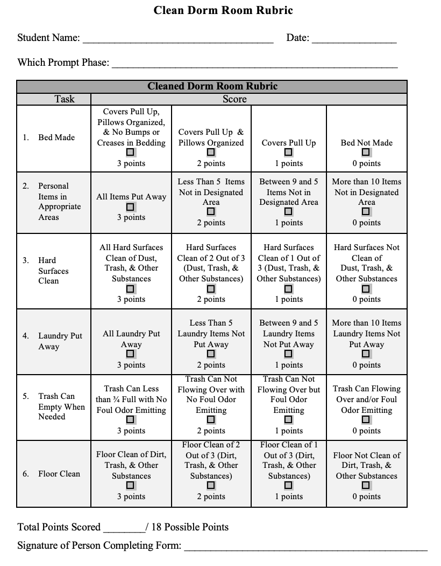
Independent Variables
The study began with a baseline—a non-intervention phase (A-baseline). This phase served as the control condition of the study where the targeted behavior was measured during the absence of the intervention (Cooper et al., 2007). After baseline was established, the independent variable (intervention) of fading response prompts in facilitating the cleaning and organization of the participants’ dorm rooms was implemented. The fading of response prompts (B- intervention) included five phases (see Table 3) within the intervention, starting with the most intrusive prompt and moving towards no prompt provided. The support levels within each prompt were determined by fading the stimulus prompt to provide less support in each phase building independence in cleaning the dorm for each participant.
Table 3
Intervention B – List of Most to Least Response Prompts by Phase
Phase | Description of Prompt
1 | Direct instruction with the support of the researcher, consisting of a demonstration by the researcher of tasks (I do), then the researcher and the participant doing in tandem (we do), and finally the participant doing independently (you do), with a task list of cleaning objectives posted in the dorm room on the door.
2 | Supervision by the researcher with verbal prompts when needed with a task list of cleaning objectives posted in the dorm room on the door.
3 | A text message stating “clean your room” and a task list of cleaning objectives posted in the dorm room on the door.
4 | No prompt provided with a task list of cleaning objectives posted in the dorm room on the door.
5 | No prompt and no task list posted in the dorm room.

The participants were instructed to not use any form of self-monitoring or checklist on the final phase of the intervention. While there is always the chance the participants did not follow the directions of the researcher, they signed an agreement stating they would follow study protocols and the researcher was confident in their adherence to the protocol. Interobserver agreement (IOA) was also analyzed on the dependent variable on at least 25% of the data collection permanent product records by the researcher and another graduate student familiar with data collection procedures associated with single-case design methodology. Total count IOA was utilized to measure the agreement between the researcher and observer on their individual data collection forms. IOA was expressed as percentage of agreement on occurrence of target behavior, which was found by dividing the smaller count by the larger count, then multiplied by 100.
Implementation of the Intervention
Prior to starting the study, the researcher informally observed the participants’ dorm rooms on three separate occasions to assess their overall ability to keep a dorm room clean. During a quick visual inspection, the rooms appeared somewhat clean but after a more thorough examination there were some concerns regarding the cleanliness of the rooms. All of the participants’ rooms had dust and dirt debris built up on surfaces, the floors needed cleaned, and several personal items were scattered throughout the rooms. There was dirty laundry on a chair in one of the participant’s rooms on every visit. On two of the visits, the trash cans in two participants’ rooms were full to the point of items falling on the floor or piled up over the rim. The researcher felt intervention was warranted due to the unsatisfactory level of cleanliness and organization of the dorm rooms. In addition to the dorm room checks, interobserver agreement training also occurred. The additional observer received training in a one-hour session from the researcher focused on reviewing the operational definitions of the target behaviors. During the training, the observer and researcher used the study Clean Dorm Room Rubric (see Figure 6) to assess their agreement on pictorial examples and non-examples (see Figure 7) of the targeted behavior until they reached 100% agreement on 10 pictorial examples and non-examples in a row. The examples were provided in a random order.
Figure 7
Example and Non-Example of Clean Dorm Room
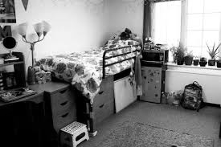
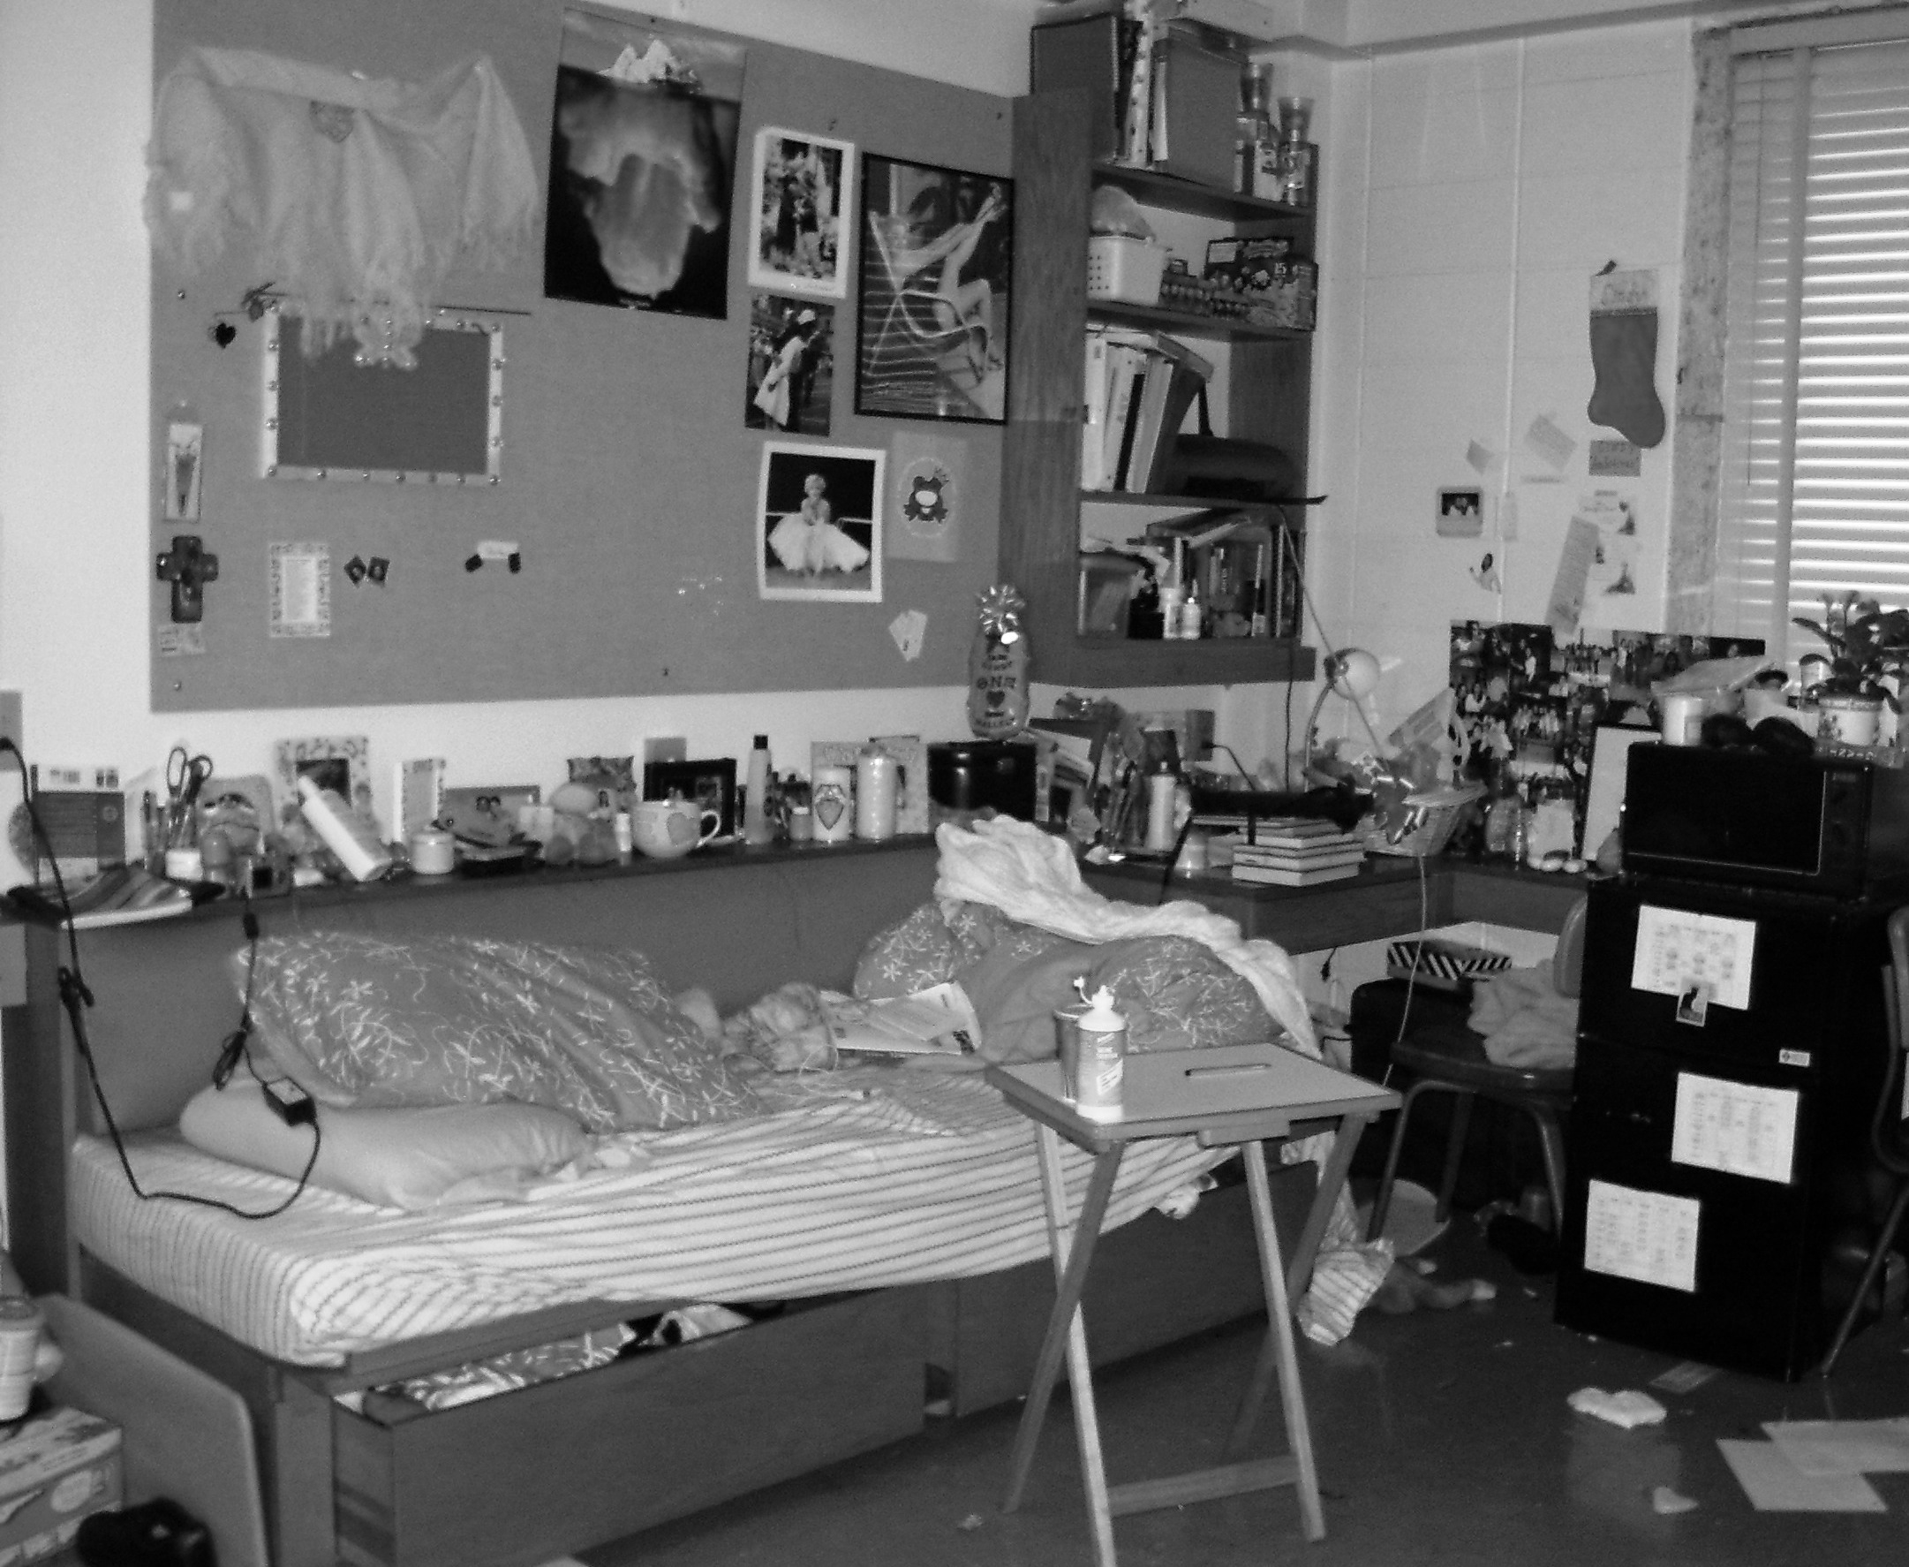
Note: The top picture is an example of a clean dormitory room (bed made, personal items put away, clean floor and surfaces, and no trash visible). The bottom picture is a non-example of a clean dormitory room (bed unmade, personal items not in designated places, dirty surfaces and floor, and trash is visible).
The actual implementation of the intervention followed a traditional single-case design baseline phase (Cooper et al., 2007). During baseline (A), the independent variable is not present, which allows for determination of whether the independent variable (intervention/treatment B) improved the target behavior during its implementation (Cooper et al., 2007). During baseline, the study participants’ dorm rooms were checked in-person daily using the Clean Dorm Room Rubric by both the researcher and at least 30% of the time with the additional observer trained in the protocol of the checklist for IOA. The researcher graphed baseline daily after observation as recommended by Cooper et al. (2007). Baseline lasted three sessions, meeting the WWC guidelines regarding three data points showing a stable and non-therapeutic trend for meeting standards with reservations (Kratochwill et al., 2010). Due to time constraints within the study, the researcher determined to meet the WWC standards with reservations instead of without reservations. This was deemed appropriate since the design was not a rigorous experimental design but was used instead for the purpose of action research.
Next, the researcher started the first phase of the intervention - direct instruction with the task list posted (see Figure 8). The intervention was implemented with the participants daily (Monday through Friday), starting with most supported response prompt until the students reached at least 90% completion as measured by the Clean Dorm Room Rubric on the dependent variable for three consecutive days (note: weekends were not included in the study due to the possibility of the students not being on campus). The researcher decided to start each participant on the same level of support for uniformity purposes of implementation. Additionally, 90% was determined as mastery due the high level of cleanliness the PSE program staff felt was appropriate for all participants to achieve in adherence with program guidelines. Once mastery was reached for each individual participant on each phase of the intervention (treatment B), the researcher faded the response prompt by introducing the next phase consisting of a less intrusive response (see Table 3). Each participant’s implementation of the intervention was independently assessed through their own personal data and was not impacted by other participants’ data. Initially, all dorm room checks were planned to be in-person visits, but due to situations beyond the researcher’s control (e.g., weather, travel, and sickness), a few of the data collection sessions and IOA sessions were conducted via live video-chat on mobile phones.
Figure 8
Daily Cleaning Task List
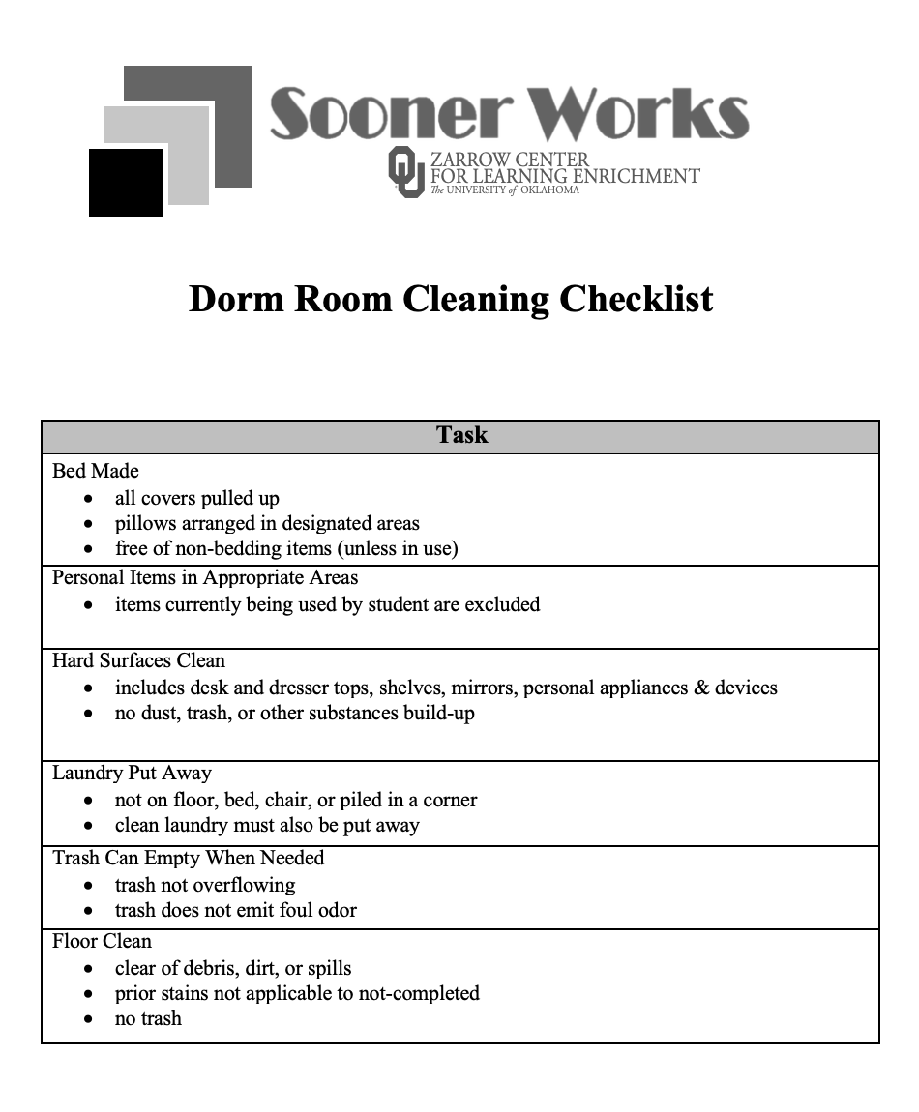
The data was graphed after each session for immediate access and ongoing visual analysis (Cooper et al., 2007). All of the data from observations were graphed on X and Y axes of a line graph; the X-axis represented the session number (daily) while the Y-axis represented the percentage of completed tasks from the researcher’s and additional observer’s checklists. The percentage of completion was found by taking the total point possibility of the session’s tasks divided by the participant’s individual score as measured by the clean dorm room checklist. This number was then converted to a percentage. Each participant’s information was graphed separately to allow for visual analysis across participants, which is explained in the following section. The additional observer also recorded participants’ percentage of completion on a separate form during IOA, which allowed for comparison to the researcher’s and IOA observer’s clean dorm room rubric and served as an additional source of fidelity within the study’s protocol. At the conclusion of the study, the researcher did a maintenance (follow-up) phase to ensure the targeted behavior was still being exhibited by the participants and to aid in increasing validity of the study. Three maintenance probes were conducted at 1, 2, and 3 weeks after the intervention phase of the study. All maintenance probes operated under the same conditions as the no prompting/no task analysis intervention phase, using the same data collection rubric used during baseline and intervention. IOA on the dependent measure was also conducted during this phase.
Research Question Two: Qualitative Approach
The qualitative design consisted of a general inductive qualitative design approach as a means to answer: “Do the postsecondary program’s participants value the use of fading prompts and find it beneficial?” This allows for the understanding of the participants’ perceptions of the intervention through semi-structured, in-person interviews with open-ended questions (Thomas, 2006). The inductive approach provided additional data to the quantitative findings, which enriched the experimental results by providing social validity of the intervention (Creswell & Plano Clark, 2018). The social validity ascertainment adheres to Wolf’s (1978) principals, including the evaluation of the treatment’s appropriateness, fairness, and reasonability for the client—in short, the social importance of the intervention to participants and stakeholders. An inductive qualitative approach was used to gauge the participants’ perspectives of the social validity of the intervention. This qualitative phase commenced after the conclusion of the quantitative data gathering phase.
A general inductive qualitative approach allows for (a) raw data to be condensed into a brief summary format, (b) establishment of clear links between the research objectives and findings from the data summary, and (c) development of a framework of the participants’ experiences (Thomas, 2006). While this inductive approach is not as in-depth as some other qualitative analytical approaches, it is a less complicated approach which provides a systematic procedure that provides reliable and valid findings (Thomas, 2006). For the sake of time efficiency, the inductive qualitative approach seemed the most prudent for this study.
Data Collection
In respect to a general inductive qualitative approach outlined by Creswell and Poth (2017), data collection was conducted through interviewing the participants. The data collection consisted of first identifying demographics and then conducting interviews (see Appendix G for interview protocol). The interviews were semi-structured and included open-ended questions; they were conducted one-on-one, in person. The interviews were audio recorded and then transcribed line by line. They ranged from about 8 to 10 minutes. In order to gain a true understanding of the perceptions of the participants, a subjective approach was used where the researcher’s own knowledge and presuppositions were bracketed to the best of her abilities in order not to taint the data (Crotty, 1998). Reference Appendix A for a detailed subjectivity statement regarding the researcher’s beliefs in conducting this study.
Data Analysis and Justification
Data analysis in the single-case design portion of the study relied on visual analysis. According to Cooper et al. (2007), single-case researchers traditionally rely on visual analysis of the data to determine if the intervention is effective in producing a meaningful change of behavior and, if so, to what extent the change in behavior can be attributed back to the intervention. Moreover, Kratochwill et al. (2010) ascertained visual analysis should suffice for most single-case designs due to the principle of comparisons in determining if a relation exists between the independent variable and an outcome variable. If a relation exists, then visual analysis can assess the strength or magnitude of that relation.
When conducting visual analysis of a single-case design, there are four steps with six variables (Parsonson & Baer, 1978). The first step is the documented predictable baseline, followed by examination of the data within each phase of the study (demonstration of predictable pattern). The between phase examination then occurs to assess the effect of the manipulation of the independent variable on the dependent variable. Finally, all the information gathered thus far is combined to determine if there are at least three demonstrations of an effect in each phase (causal or functional relation). When examining the within and between phase patterns, the following variables were evaluated (a) level, (b) trend, (c) variability, (d) immediacy of effect, (e) overlap, and (f) consistency of data across phases. During the analysis, the trend, level, and variability were analyzed in each phase independently. Then, the immediacy of effect, the overlap, and consistency of data were analyzed by comparing adjacent phases within the study (Parsonson & Baer, 1978).
In the second analysis of data, an inductive and thematic analysis process was used (LeCompte & Preissle, 1993; Shank, 2002). In adherence with LeCompte and Preissle (1993), the perceptions of the participants were read and decontextualized into segments based on the original research questions, which resulted in the formation of segments. These segments were entered into a spreadsheet and color coded in alignment with the research questions and kept separate in the spreadsheet according to each participant’s data. The data was then coded line by line (in the spreadsheet) to capture the opinions and perceptions of each of the participants (Morse, 1994). Codes where formed using the research question topics and the literature regarding social validity.
After line by line coding, the data was moved into categories by clustering (Shank, 2002) and then compared for similarities and discrepancies (LeCompte & Preissle, 1993). Once the categories were developed, common themes emerged which highlighted the major variables within the data (Shank, 2002). The categories were entered into a separate spreadsheet to form the common themes within the data. After the theme categories were developed in the spreadsheet, the information was transferred into a table in a Word document to create a code book, which allowed for further synthesizing during the theorizing portion of the analysis. The theorizing related back to the researcher’s knowledge of social validity, while also allowing for the immersion of the participants’ opinions and perception regarding the intervention to ascertain its social validity.
Validity & Trustworthiness
A single-case study, by design, counteracts certain threats to validity, while other threats must be intentionally addressed by the researcher (Barlow et al., 2009). Initially, this design allowed for the repeated systematic assessment of an independent variable and a dependent variable over time and replicated effects within or between participants (Kratochwill & Levin, 2014). Equally important, the purposeful extension of the study to include a maintenance phase also increased the validity of the study (Barlow et al., 2009; Kratochwill et al., 2010). The intentional use of several participants also allowed for the replication of the investigation to assess generality and enhance external validity (Byiers et al., 2012). Furthermore, IOA was conducted for at least 30% of the data collection during every phase of the study to address the believability of the data through trustworthiness (Cooper et al., 2007). During the interobserver agreement sessions (30% of all sessions), the minimum of 80% was met on every session. In each scenario, if at least 80% agreement was not met, an additional training session from the researcher for the observer was available.
In order to ensure the data provided through the qualitative portion of the study was valid and reliable, the researcher utilized methods providing accurate and truthful portrayal of the participants’ experiences. This was accomplished through thick and rich descriptions and peer debriefing as recommended by Creswell and Poth (2017). Also, the researcher provided the inductive analysis to participants to ensure the results were a true representation of their experiences with the interventions. These methods ensured trustworthiness of the accurate reflection of the data in disclosing the participants’ perceptions and ensured the researcher’s subjectivity was not creating bias with the participants’ responses in analysis.

Chapter 4
Results
This chapter reports the single-case AB design and general inductive qualitative design results across participants. First, the interobserver agreement (IOA) is disclosed and then the participants’ results are discussed relative to each research question.
Interobserver Agreement
Interobserver agreement (IOA) was collected across all phases of the study in adherence with the best practice guidelines for research from the What Works Clearinghouse (WWC; Kratochwill et al., 2010) . Throughout all phases of the study, the goal was to achieve at least 80% agreement in at least 20% of all sessions (Kratochwill et al., 2010). The same individual served as the additional observer for all aspects of IOA within the study and also conducted the peer debriefing in the social validity findings. The additional observer was a fellow graduate student at the researcher’s university in the same program of study who received the same training in methodologies by the university faculty.
Initially, the additional researcher was trained in using the permanent product form (Clean Dorm Room Rubric) for data collection. During this training 100% IOA agreement was reached using the data collection form on 10 pictorial examples and non-examples of a clean dorm room presented in random order. This agreement was accomplished on the first 10 pictures presented in the training. Then, within the study’s implementation, IOA remained between 98% to 100% in every phase. See Table 4 for IOA specific to each phase.
Table 4
Interobserver Agreement on Data Collection
Phase Within AB Design | Session Number | IOA% | % of Sessions of IOA Collection
Baseline | 3 | 98% | 33%
Intervention-Direct Instruction with Posted Task List | 6 | 100% | 33%
Intervention-Verbal Prompt with Posted Task List | 10 | 100% | 33%
Intervention-Text Prompt with Posted Task List | 13 | 98% | 33%
Intervention-No Prompt with Task List Posted | 15 | 100% | 25%
Intervention-No Prompt with No Task List Posted | 19 | 100% | 33%
Maintenance | 22 | 98% | 33%

Research Question One: Fading Response Prompts in Cleaning Dorm Room
As recommended by Cooper et al. (2007), visual analysis was used in the single-case design portion of the study to answer the following research question: Is there a relation between the use of fading response prompts and the level of completion in cleaning a dorm room for students with an intellectual disability participating in a postsecondary education (PSE) program on a university campus? Through visual analysis the researcher determined whether there was a relation between the independent variable and the dependent variable, in addition to determining the strength and magnitude of that relation (Cooper et al., 2007; Kratochwill et al., 2010).
When conducting the visual analysis, the researcher used four steps with six variables (Parsonson & Baer, 1978). First, it was determined whether the baseline was predictable. Then, the data within each phase of the study was examined to check for the demonstration of a predictable pattern. Next, the between phase data points were inspected to assess the effect of the manipulation of the independent variable on the dependent variable. The final step combined all the prior information to determine if there were at least three demonstrations of an effect in each phase (causal relation). It should be noted, while examining the within and between phase patterns, the following variables were also evaluated (a) level, (b) trend, (c) variability, (d) immediacy of effect, (e) overlap, and (f) consistency of data across phases. The trend, level, and variability were analyzed in each phase independently. The immediacy of effect, overlap, and consistency of data were then analyzed by comparing adjacent phases within the study (Parsonson & Baer, 1978).
Overall, each participant showed similar baseline data and similar increases in the targeted behavior with the implementation of fading prompts. Each participant also maintained the behavior during maintenance (excluding one session for Hannah) as measured by the Clean Dorm Room Rubric. This similarity of scores allowed for a combined presentation of results regarding the single-case component of the study. However, to examine the individual scores of each of the participants see Figures 9, 10, and 11.
Figure 9
Nathan’s AB Design Graph

Figure 10
Jack’s AB Design Graph

Figure 11
Hannah’s AB Design Graph

Baseline
Across all participants during baseline (A), their percentage of completion of the targeted behavior remained stable or moving in a countertherapeutic trend. As per traditional single-case design protocol, this data was recorded in the absence of the intervention and scored using the Clean Dorm Room Rubric. Regarding their individual performances, the participants’ scores were as follows (a) Nathan’s baseline ranged from 78% down to 61%, (b) Jack’s scores were between 78% and 72%, and (c) Hannah’s remained at a steady rate of 61%.
Intervention
The fading of response prompts, also known as most-to-least prompting, served as the intervention (independent variable) impacting the targeted behavior (dependent variable) as measured by percentage of completion of the participants’ cleaned dorm rooms. Within the overall intervention (B) there were five phases of fading prompts (i.e., direct instruction with the support of the researcher, consisting of a demonstration by the researcher of tasks (I do), then the researcher and the participant doing in tandem (we do), and finally the participant doing independently (you do), with a task list of cleaning objectives posted in the dorm room on the door; supervision by the researcher with verbal prompts when needed with a task list of cleaning objectives posted in the dorm room on the door; a text message stating “clean your room” and a task list of cleaning objectives posted in the dorm room on the door; no prompt provided with a task list of cleaning objectives posted in the dorm room on the door; and no prompt and no task list posted in the dorm room) where the participants were required to have three consecutive sessions of 90% completion or higher before moving on to the next phase. In every phase of the intervention, each participant reached 90% or better without moving in a countertherapeutic trend, thus resulting in a maximum of three sessions for each phase, excluding one.
The prompting phase of no prompt with task list posted was the only phase which included four sessions for each participant, due to an error by the researcher in failing to remove the task list prompt during the prior data collection session, so the list was still posted on the participants’ dorm room doors when the researcher went to collect data for the next phase. Also, in regard to the results, the introduction of the intervention had an immediacy of effect on the targeted behavior for all the participants. The data also had minimal variability (94% to 100%) across all the phases and remained consistent across participants; the targeted behavior had no overlap with the initial baseline data. The highest percentage completion levels occurred with the phase prompts of verbal prompting with task list posted and no prompt or no task list posted, each with 100% completion across all the sessions and the participants. The lowest percentage completion level occurred on text prompt with task list posted, with over half of the sessions across the participants having a completion rate of 94%. Despite this being the lowest level, it still met the designated completion criteria for the study. It should be noted on the specific components of the behavior checklist the participants got all points possible on laundry, trash, and personal items put away during each session. The participants tended to lose points on their beds not being made appropriately and dirty surfaces and floors. Overall, the data remained consistent without variability across participants and intervention phases.
Maintenance
Maintenance data was collected at the one, two, and three-week marks after the conclusion of the study’s intervention phase. During the first maintenance probe, all the participants maintained the mastery level of 90% or greater with both Nathan and Hannah scoring 100% completion and Jack scoring 94%. Then, on the second maintenance probe Nathan and Jack met the mastery level with 100%, while Hannah scored below the designated level with a score of 83% due to her bed being completely unmade. Yet, all of the other components on the dorm room checklist were completed at the highest level during this session for Hannah. In the final maintenance probe, all participants returned to a 100% completion rate.
Research Question Two: Social Validity

During the second phase of the study, a general inductive qualitative analysis was used to answer the following research question and its subcomponents regarding the social validity of the study: Do the postsecondary program’s participants value the use of fading prompts and find it beneficial? And specifically, (a) Did the fading prompts help the participants become more independent? (b) Were there one or more prompts the participants felt were the most beneficial? (c) Were there any prompts that they felt did not benefit them in completing their cleaning tasks? (d) How can the use of fading prompts be improved for the program’s participants in the future? (e) Will the participants continue to use any of the prompts for other tasks in the future and why? and (f) Did the participants prefer the in-person or the video-chat dorm checks and why? Through analysis of the participants’ interviews there were two major themes and one minor theme that emerged regarding the data. The major themes which materialized were Socially-Significant and Action Research; the minor theme was Validity of the Study Design (see Table 5).
Table 5
Code Book
Themes | Categories | Codes
Socially-Significant | - Appropriate-Yes  - Gained Independence  - Not Appropriate  - Social Importance  - Goal of Intervention | - Already Had Skill  - Bedmaking  - Direct Instruction  - How it helped  - In-Person Visit  - Liked all  - Likes In-Person Visit  - Task list  - Text Prompt  - Verbal Prompt  - Wasn't bother by room visit  - Gained independence  - Dorm visit  - Dusting  - Liked it all  - Task list  - Bathroom  - No future use  - Video-chat preferred  - Gained independence
Action Research | - Future Recommendation  - Future Use of Program Prompts | - Advice for future  - All Items  - Did not dislike anything  - Dusting  - Video-chat preferred  - Floors  - Help organized  - How to deal with messy rooms in future  - Keep checking dorm rooms in future  - Not daily  - Not monthly  - Personal items put away  - Prompt fading in area  - Task list  - Visit  - Weekly  - Bathroom
Validity of Study Design | - Skills Prior to Study | - Knew skills prior  - Not needed for additional support

These themes provided an all-encompassing social validation and interpretation for future practices in the researcher’s university’s PSE programing.
Socially Significant
According to Wolf (1978), social validity is an important component of assessing the utility of the intervention; it aids in the evaluation of the treatment’s appropriateness, fairness, and reasonability for the participants. In adherence with Wolf’s recommendation, social validity was the focus of the qualitative portion of the study. Social validity was the key theme during the participants’ interviews and inductive analysis, which allowed for their perspectives to contribute to the study’s findings and will help guide the future PSE programming for the researcher’s university.
All three participants valued the use of prompt fading when cleaning their dorm rooms. Specifically, they each reported the intervention aided in increasing their independence. Jack felt it required him to respond, while Hannah stated “it helped her out” in becoming more independent. Within the overarching theme of social validity, a few categories materialized after coding the participants’ responses, which consisted of appropriateness of intervention, appropriateness of a few of the various phases of prompting, and the components of the study the participants did not value (see Table 6).
Table 6
Social Validity Categories and Participants’ Perceptions
Social Validity Categories | Participant’s Perception | Participant
Appropriateness of the Intervention Overall | “I liked it all,” when asked if he had a preference for a specific prompt. | Jack
Appropriateness of the Intervention Overall | “I like the way you helped me,” referring to what she valued most about the intervention. | Hannah
Appropriateness of Direct Instruction with Task List | Participant reported he liked “the separate boxes, so he could follow line by line” on the task list. | Nathan
Appropriateness of Direct Instruction with Task List | “Yes, I did” was a participant’s response when asked if he liked the help the researcher gave through direct instruction in cleaning his room. | Jack
Appropriateness of Direct Instruction with Task List | “It got me more active” and “it helped me out” when asked about direct instruction. | Hannah
Appropriateness of Direct Instruction with Task List | “Yes, I liked making my bed” was the response when asked about the task list being posted on her door. | Hannah
Appropriateness of Text Prompt with Task List | When asked if there was a preference for one type of prompt the participant reported “texting was a good thing.” | Jack
Appropriateness of Verbal Prompt | “I liked that too” when asked about verbal prompting with the task list. | Jack
Participants Did Not Value | Participant initially reported liking the task list, then stated, “I had no use of it since I knew what I was doing.” | Nathan
Participants Did Not Value | When asked specifically if the task list helped the participant in cleaning his room he replied “Well, not much.” He also added “because, uh, I want, I know what to do.” | Jack
Participants Did Not Value | When asked if there was anything that was not particularly helpful in the intervention a participant reported, “Mmmm, make sure everything’s wiped down.” The researcher clarified she meant dusting. | Hannah
Participants Did Not Value | When asked about visiting the dorm room to do the check list one participant reported, “Um, yes it did when I feel uncomfortable about it.” The researcher clarified that the participant was uncomfortable with the dorm room visits. | Hannah
Participants Did Not Value | “Ummm, a little uncomfortable” was a participant’s response when asked about how he felt when the researcher(s) came to his room to do the dorm room check. | Nathan

Unanimously, the participants reported the intervention increased their independence, and they enjoyed most of the aspects associated with fading the prompts, especially those pertaining to direct instruction. However, they had mixed responses regarding the task list and the researcher(s) coming to their dorm room to do the check.
Action Research
While social validity focuses on the social appropriateness of the study as perceived by the participants (Wolf, 1978), action research provides similar knowledge regarding the value and purpose of choice for the participants. However, action research goes further to also include contextual focus, change-based data and sense making, and knowledge diffusion (Martella et al., 2013). During analysis of the interview questions, two categories emerged under the theme of action research: (a) future practices in PSE programming and (b) preferred prompting aspects to personally use in the future (see Table 7).
Table 7
Action Research Categories and Participants’ Perspectives
Action Research Categories | Participant’s Perception | Participant
Future Recommendations for the Program | It could be beneficial to use prompt fading “in trying to find directions…and go around campus.” | Nathan
Future Recommendations for the Program | “Only making friends a lot” was the response of the participant when asked how prompt fading could be used in other aspects of the PSE program. | Jack
Future Recommendations for the Program | The participant felt prompt fading would be beneficial in teaching PSE participants in “getting to know people”, she also gave the example “so you go up to somebody and you just introduce yourself and it’s just like, just like you tell him your name.” | Hannah
Future Recommendations for the Program | When asked how often a room check should be conducted the participant reported “I say weekly, not every day.” | Nathan
Future Recommendations for the Program | In reference to how often a room check should be completed, “once a week” and when asked if monthly would also work the participant replied, ‘that would be too long.” | Jack
Future Recommendations for the Program | When asked why the participant felt weekly would be better for a dorm check instead of daily, she responded “right, right, the dust will build up in a few days.” After clarification from the researcher the participant stated “yes” she felt it would take several days for dust to build up in order to be checked on the dorm room rubric. | Hannah
Future Recommendations for the Program | When asked if the participant would use aspects of the prompt fading in the future, he responded, “no, not really since I usually do clean my room.” | Nathan
Future Recommendations for the Program | In reference to the continued use of the intervention components in the future the participant replied, “Uh, no not really.” | Hannah
Future Recommendations for the Program | When asked if the participant preferred in-person dorm room checks or video-chat checks he replied, “I say video-chat is way better.” When asked why, “it is better for my schedule.” | Nathan
Future Recommendations for the Program | After given the choice between in-person dorm room check or video-chat check, the participant reported “video-chat” when asked why, “because I like to do it.” | Jack
Future Recommendations for the Program | One participant expressed her preference for video-chat and also reported, “video-chat makes me feel more comfortable.” | Hannah
Future Use of Program Prompts | When asked if the participant plans to use any components of the fading prompts in the future the participant reported, “Well, not really.” | Nathan
Future Use of Program Prompts | After the participant was asked if he plans to continue to use any of the prompts from the study, he reported, “No.” | Jack
Future Use of Program Prompts | “Not really” was the response when asked if the participant planned to use any of the prompts in the future. | Hannah

All the participants reported the PSE program should continue to conduct dorm checks in the future but suggested those dorm checks should occur weekly through video-chat and not in-person. However in a contrasting view, the participants also reported they were not likely to want to continue to use any aspects of the prompt fading intervention in the future.
Validity of the Study Design
The researcher did not initially have an interview question referring to the participants’ prior skills related to cleaning their dorm room, but as the study progressed she felt a reiteration needed to be made during the interview. This alteration was decided because of the immediate response increase in their targeted behavior with the introduction of the intervention. Even though all the participants reported they possessed the cleaning skills needed during informal questioning and informal observations prior to the study, it was important to the researcher to expound upon the nature of their prior skills. During this clarification the three participants again reported they knew the skills needed to clean their dorm room before they participated in the study. For instance, Nathan, when asked specifically about his ability to clean prior to the study, responded, “Yes, because I started vacuuming my house and I’m basically dusting my car and uh, usually I’m trying to like to keep my room clean.” Likewise, Jack and Hannah both reported they did not learn any new cleaning skills through their participation; they knew how to clean everything before they started the study.
Summary of Data Analysis
During the first phase of the study, baseline, all the participants started with scores below the pre-determined mastery level. In addition, they all had stable or countertherapeutic trends. Next, with the implementation of the intervention the participants’ targeted behavior of a clean dorm room was maintained at mastery levels through all phases of the prompt fading. Then, during the three weeks of maintenance probes, the participants met the mastery level threshold for all but one session. After the single-case analysis, the participants’ perceptions were evaluated regarding their perceived value of the intervention. These findings indicated they all valued the intervention and felt it was a beneficial part of the PSE programming, but the dorm room check should be conducted weekly, and the PSE program staff should use video-chat instead of in-person checks. Combining these results indicated a correlational relation between the independent and dependent variables, and the intervention appeared socially valid.

Chapter 5
Discussion
Individuals with an intellectual disability (ID) tend to have dissimilar post-school outcomes in achieving competitive employment and living independently as compared to their peers without disabilities or even to those with milder disabilities (Newman et al., 2011). However, those odds can increase when they participate in a postsecondary education (PSE) program (Grigal et al., 2011). Fortunately, we have seen a recent rise in PSE programs (Papay et al., 2018). Due to this newness of PSE programming, the research is just starting to emerge and much more is needed to establish what higher education institutions should consider best practices (Graff et al., 2019). The purpose of this study was to use a mixed methods experimental design approach to determine if there was a relation between using a fading response prompts intervention, as measured by the Clean Dorm Room Rubric, and the cleaning of dorm rooms for PSE program participants as well as their perceptions of the social validity of the intervention. Additionally, the information gathered in the study will be used to help guide future programming at the researcher’s university.
The researcher was a staff member at a PSE program during the course of the study. Her goal was to conduct a study which examined the effectiveness of some aspect of the program’s current practices. After conferring with the program’s director on what would be beneficial for programming, it was decided to evaluate the processes associated with the current dorm room checklist and determine its overall utility in improving the independent living skills of the program participants.
Findings
In this mixed methods experimental design, a sequential integration approach was used over two phases of the study as a means to conduct data integration to form a coherent whole between the two methodologies (Creswell & Plano Clark, 2018). First, the mixing of methodologies occurred with the sampling phase; the same participants were used for both phases. With the final analysis, the qualitative findings were embedded within the quantitative findings, again using the sequential integration approach (Creswell & Plano Clark, 2018). The qualitative findings allowed for a more meaningful explanation of the quantitative portions by gaining the participants’ views on their own experiences with the utility of the interventions (Creswell & Plano Clark, 2018).
Research Question One
Quantitative data was used to answer research question one: Is there a frelation between the use of fading response prompts and the level of completion in cleaning a dorm room for students with an intellectual disability who are participating in a postsecondary education program on a university campus?
AB Design
It was determined a simple AB design would be appropriate to assess if prompt fading was an effective means to facilitate the cleaning of dorm rooms by the PSE program participants. The AB design adequately allowed for correlational conclusions regarding the impact of the intervention on the target behaviors (Gast & Baekley, 2014). Prompt fading was chosen because it was a research-based method (Cooper et al., 2007) the researcher had utilized in the past and knew the participants were successful in using the strategy. Prompt fading has also been found beneficial in teaching independent living skills to individuals with an ID (Cullen et al., 2017; Kelley et al., 2013). In addition, the Clean Dorm Room Rubric (the measurement instrument) was a component of the PSE programming being used to assess the cleanliness of the dorm rooms of the students who were participating in the program. The investigation of prompt fading using the rubric allowed the researcher to determine if the current PSE programming practices were effective and should be continued.
The study took place over 22 sessions across the span of 7 weeks with minimal deviations from the original study design. The two deviations that did occur included the extension of the prompting phase no prompt with task list posted and the introduction of video-chat to do a dorm room check instead of in-person checks by the researcher. Whereas the initial deviation did not affect the study, the former deviation did result in serendipitous findings impacting the study, which will be explored further in the section entitled Research Question 2.
In the beginning stages of the study, the participants’ dorm rooms appeared neat and clean when given a cursory glance; however, on a more thorough inspection using the Clean Dorm Room Rubric, the unclean aspects of the rooms were more evident. Both Nathan and Hannah tended to lose points due to personal items being out of place and their beds being messy despite the covers being pulled up. Additionally, Nathan’s and Jack’s floors had dirt and debris despite their having access to brooms and handheld vacuums. All three participants had dust build up on the hard surfaces in their rooms. Even though the baseline did not show drastically low percentages of completion of cleaned dorm rooms, it did show the participants’ rooms were not at the designated levels deemed appropriate for the PSE program. Whereas some people might feel the targeted behaviors were not low enough to constitute intervening, the PSE program staff wanted to make sure all participants were keeping their dorm rooms clean to a high standard. This decision was due to the fact the participants had the option to have roommates in the future, some even choosing to have roommates designated by the university staff in a “potluck” manner. While some may argue other college students do not have to participate in dorm room checks, individuals participating in PSE programs tend to be more critically evaluated on their independent living skills than the traditional college student (Kelley & Westling, 2019). This could be especially true when living in close quarters as a roommate, so it was imperative to the PSE staff that the students have the appropriate skills to be good roommates, which included keeping their space clean. Provided the participants did not meet the designated mastery level for the PSE protocols in meeting the cleanliness of their dorms during baseline, the researcher moved on to the intervention phase of the study.
Once the intervention was introduced, the participants’ scores on the clean dorm room remained at the mastery level through every phase of the intervention. There were a few lost points coming from messy beds and/or dust and dirt build-up on hard surfaces or the floor. Despite these minor losses in points, the visual analysis of the data points showed a positive correlation between the implementation of the intervention and mastery of the clean dorm room as measured by the rubric (Barlow et al., 2009; Cooper et al., 2007). This correlation indicated the two variables were related in the intervention (B) phase of this design (Martella et al., 2013). However, it is important to note it cannot be ascertained the intervention was the direct cause of the increase in dorm room cleanliness; it could have been due to a confounding variable such as observer reactivity, also known as the Hawthorne Effect (Martella et al., 2013) .
The targeted behavior was also maintained over the course of three weeks after the conclusion of the intervention (B), during the probe sessions, excluding one session with Hannah where her bed was not made. According to Cooper et al. (2007), these maintenance probes of behavior provided data regarding the extent to which the participants continued to perform the targeted behavior after the intervention had been withdrawn. In addition, the participants’ maintenance of the targeted behavior provided evidence of the generalization of the behavior, which is a key focus of applied behavior analysis (Cooper et al., 2007) and an overarching goal of PSE programming. This generalization added external validity (applicability of the findings to the real world) to the study (Kratochwill et al., 2010). It should also be noted after the conclusion of the study, the participants still enjoyed texting pictures of their clean rooms, unprompted by the researcher. These unprompted texts showed the researcher the participants enjoyed showing off their clean rooms, but more formal means were utilized to determine participants’ overall opinions of the intervention during interviews.
Research Question Two
Qualitative data was used to answer Research Question Two: Do the postsecondary program participants value the use of fading prompts and find it beneficial? Specifically, these questions were asked
- Did the fading prompts help the participants become more independent?
- Were there one or more prompts the participants felt were the most beneficial?
- Were there any prompts that they felt did not benefit them in completing their cleaning tasks?
- How can the use of fading prompts be improved for the program’s participants in the future?
- Will the participants continue to use any of the prompts for other tasks in the future and why?
- Did the participants prefer the in-person or the video-chat dorm checks and why?
General Inductive Qualitative Analysis
As an extension to the AB design of the study, the researcher conducted short in-person interviews with the participants to assess their perceived utility of the intervention as a means to provide social validity of the study as recommended by applied behavior protocols (Cooper et al., 2007). Social validity “refers to the extent to which target behaviors are appropriate, intervention procedures are acceptable, and important and significant changes in target and collateral behaviors are produced” (Cooper et al., 2007, p. 704). This concept of social validity is an important aspect to the study due to the anticipated future use of the intervention for the PSE program and the need to make sure it is both beneficial and valued by the students.
Social Validity. Overall, the analysis of the participants’ interviews indicated they valued the use of the intervention and felt it helped them become more independent. This benefit was a strong point for the study because acquisition of independent living skills increases adult autonomy for individuals with an ID (Carter et al., 2012; Dell’Armo & Tassé, 2019). The participants also indicated several of the prompts were beneficial in increasing the completion of cleaning their dorm rooms. These included direct instruction, text prompt, and verbal prompt. These prompts went beyond just serving the needs of the study, they also provided long-term benefit. For instance, direct instruction in independent living related skills acquisition has provided individuals with an ID improved postschool outcomes (Dell’Armo & Tassé, 2019) and increased their quality of life (Schalock et al., 2002). For example, when an individual with an ID was given direct instruction in household chores, they were shown to improve their postschool outcomes (Carter et al., 2012). The individuals reported benefits of participating in the study, and the emerging research in the field has shown the components embedded within the study have the potential to provide long-term benefits to increase the independence for the participants.
Not everything regarding the prompting was ideal for the participants. While they did have mostly positive opinions associated with their involvement in the study, they had mixed feelings regarding the use of the task list which was posted on the inside of their dorm room door. This task list was a means for the students to learn to self-monitor what they needed to accomplish in having a clean dorm room. They initially reported they were okay with the task list being posted but felt they did not receive much benefit from its use and would not be using task lists in other areas in the future. This was a bit disheartening because the researcher wanted the participants to find benefit in using a task list and to have a desire to use one in future endeavors. At the same time, however, the participants advocating for their preferences did please the researcher because they were being self-determined in stating their preferences and what they felt was not beneficial. While this self-determination was not specifically measured as part of the intervention, it was promising to see the students be able to express their wants and needs. Self-determined behavior can play a significant role in future successes for individuals with an ID in productivity, organization, academic achievement (Erickson et al., 2015), and independent living (Wehmeyer & Palmer, 2003). These expressions of preferences also went beyond just the individuals participating in the study; they also impacted the future procedural planning of the PSE program.
Future Recommendations for the Program. Another major goal of the study included assessing the participants’ opinions and preferences on what aspects of the intervention they recommended to keep as part of the future PSE programming. This goal fits within action research, which aligns academic research with everyday applications (de Zeeuw, 2003) and allows the researcher to scientifically evaluate practices in a systematic fashion to understand their effects and to provide solutions for aspects which are not working (Martella et al., 2013). The participants’ interviews were a good conduit to provide this information to the researcher.
During the interviews, the researcher focused on predetermined questions formulated prior to starting the study and also on topics which arose during the course of the study. First, the goal was to examine the current practices which the participants could recommend the PSE program to use in the future. They all felt the prompt fading would be beneficial in the facilitation of making friends or just in meeting new people on campus. This idea of meeting new people and making friends is encouraged in postsecondary programing (Grigal et al., 2013). PSE programs often focus on this social integration as a key element of the participants’ college experience, but the far-reaching implications are just as important after college (Grigal et al., 2013). Individuals with an ID tend to have higher levels of social isolation as adults (Wagner et al., 2003), so by forming these social networks during their PSE program and working to sustain them, students can extend supports and friendships beyond college and into postschool communities and workplaces (Grigal et al., 2013). The participants’ recommendations for prompt fading went beyond social integration and into the practical skill of navigation. Nathan suggested the use of prompt fading to teach future students how to navigate the university’s campus, which is also another focus of PSE programming (Richter & Uphold, 2020); consequently, prompting has proven successful in teaching this skill (Mechling & Seid, 2011; Yuan et al., 2019).
The three participants unanimously reported dorm room check-ins should be completed on a weekly basis and not on a daily basis as in the procedures of the study. The researcher recognized this as a feasible recommendation, which would be a more functional application of the room-check protocol. When the study was implemented, it needed to be accomplished in a specific time frame. If the sessions had been extended to weekly instead of daily, it would have spanned 18 weeks at the very least, not including extension of any phases or maintenance probes. While this might have been more effective, the longer time frame was not feasible for the study. In future practice, the intervention will adhere to applied behavior principles in providing behavior change which is effective and improve behavior in a practical manner, not simply making a change for statistically significant means (Cooper et al., 2007).
With a focus on effective practice, we must consider that our perceptions of effectiveness can change with advancements in research, technology, and culture. It is our responsibility as practitioners and researchers to make sure we provide the best available practices (Slocum et al., 2014). This is especially true with the role technology is now playing across all aspects of education and behavioral research (Raja & Nagasubramani, 2018). One technological advancement ended up playing an unintentional role in the study due to circumstances beyond the researcher’s control when she was unable to collect data in person. As a means to proceed with the study, the researcher made the decision to employ the use of live video-chat using mobile phones (also known as video-conferencing). All the participants noted they preferred using their phones to conduct room checks instead of the researcher coming to their room. While initially all three participants reported they did not mind the in-person checks, they all expressed their preference in using video-chat. It should also be noted despite the participants reporting they enjoyed the in-person visits during their interview, the researcher’s anecdotal notes indicated the participants occasionally acted nervous or annoyed with her visiting their dorm-rooms. During the video-chat check-ins, they did not appear nervous or annoyed. The researcher also preferred this modality of dorm check because it required less time and seemed to be easier to accomplish with the participants’ schedules. Between the participants’ preferences and the researcher’s observations, it was evident video-chat is something which should be evaluated as a means to conduct dorm room checks in the future.
Implications for Future Programming
After conducting the analysis of the data provided in the quantitative and qualitative portions of the study, the researcher felt there were many aspects of the study which yielded beneficial information, including the Clean Dorm Room Rubric, which was a valuable tool in evaluating the participants’ dorm rooms. Using the data gathered from the participants, the prompt fading had some strong points pertaining to direct instruction, verbal prompting, and text prompting, which could be used in future programming to facilitate social interactions and campus navigation. Finally, the use of video-chat seemed a more prudent means to conduct dorm room checks than the initial concept of in-person checks.
With these benefits in mind and in adherence with action research as a key theme for the study, the researcher anticipates conferring with the other PSE program staff to discuss conducting the room checks once a week using video-chat. The Clean Dorm Room Rubric will still be utilized but with added components to include the participants’ bathrooms as to provide a more thorough evaluation of the overall cleanliness of the dorm rooms. Also, the prompt fading will not be used initially when conducting dorm room checks unless adequate mastery of the clean dorm room is not accomplished for the students; then, in-person checks with prompt fading will be used. The researcher also feels taking a more technology savvy approach to conducting the room checks will be prudent for both efficiency and for teaching the students how to use technology in the PSE setting.
In this day and age of mobile technology devices and accessibility, it makes sense to utilize this resource as a means to facilitate learning. Accessing these devices in the learning process is referred to as mobile learning (Wagner & Wilson, 2005). Mobile learning can be an important tool associated with postsecondary success (Fraga & Flores, 2018). Mobile learning is proving to be a significant resource which students value and quickly adapt to using in a variety of settings and situations in higher education (Cheon et al., 2012). In addition, utilizing mobile technology to learn new skills and to promote self-management can lead to increased self-determination and can impact postschool outcomes (Ayes et al., 2013). While mobile learning enables a functional and technologically appropriate means of learning and increasing self-determination, it is in early stages of determining best practices. However, utilizing mobile learning in this manner would be very beneficial for both participants and for PSE staff.
Implications for Future Research
This study contributes to a field of research which is still in its infancy in many aspects. Much more needs to be done concerning contributions of behavioral interventions to PSE programming. More work in the field can build upon these findings to establish the effectiveness of behavioral interventions, while also assessing the use of technology in different aspects of PSE programming beyond just prompting the cleaning and organizing of dorm rooms. In particular, within this specific PSE program, the use of mobile technology can incorporate more components (e.g., navigation, reminders, budgeting, class attendance, and assignment completion), which can lead to further research. In addition, the PSE program staff can continue the use of action research to determine if the proposed new protocols are efficient. Another aspect which can also be evaluated are the effects the interventions have on the students’ roommates and their perceptions associated with the students’ cleanliness. As of now, the PSE program participants do not have roommates, but this has the potential to change during their second year of the program. This intervention was initially instituted to not only benefit the participants in increasing their independent living skills, but also to help facilitate them being good roommates in the future, if applicable (if they choose this option). The adaptation of the intervention and the many opportunities provided by college settings allow for numerous occasions of research and the investigation of best practices in the field of PSE programming regarding independent living skills attainment for individuals with an ID.
Strengths
Due to the methodical approaches within this study, there were several strengths inherently present with this design. The mixed methods approach allowed for a more comprehensive evaluation of the data than solely utilizing quantitative and qualitative designs (Creswell & Plano Clark, 2018). Consequently, it allowed for a broader range of research questions where the strengths of the individual methods can overcome the weaknesses of the other methods. Creswell and Plano Clark (2018) also praised mixed methods research for its ability to provide stronger validation of the study through deeper understanding and generalizability. In addition, each method within the study had its own strengths. The AB design is the most simplistic of single-case research and allows for correlational conclusions regarding the intervention’s impact on the targeted behavior. This approach can be useful in documenting change, especially when ethical and practical constraints do not allow for the use of repeated introductions and withdrawals of an intervention (Gast & Baekey, 2014). Correlational relations do not indicate causation. There could be any number of variables responsible for the cause, but it does help to determine if the targeted behavior was impacted when the intervention was introduced (Martella et al., 2013). In addition, Martella and colleagues (2013) asserted the AB design can easily assess a program through action research and guide decision making. For this study, the AB design was determined to provide the researcher with needed information in a time efficient approach, involving the least intrusive practices as possible, which is a key characteristic of effective applied behavior practices (Cooper et al., 2007).
Regarding the strengths of the general inductive qualitative design, it provided a complete and detailed description where the data was simplified and managed without destroying context and complexity (Thomas, 2006). It also provided understanding of the phenomena of the participants’ perspectives in detail, which can be lost within the quantitative measures. Overall, this combination of methodologies allowed for a more comprehensive view of which treatment was most effective and of participants’ perspectives on those treatments.
Interobserver Agreement (IOA) training was conducted to ensure the additional observer’s competence in assessing participants’ performance on the data collection form in agreement with the researcher (Cooper et al., 2007). Two or more observers increased the confidence of the definition of the targeted behavior and aided in determining the measurement code was not too difficult. Additionally, high levels of IOA aided in increasing the believability of the data (Cooper et al., 2007).
The combination of these research methodologies in a mixed method design allowed the researcher to ascertain prompt fading was an effective intervention when measured by the Clean Dorm Room Rubric in increasing the cleanliness of a dorm room for individuals with an ID participating in a PSE program (Gast & Baekey, 2014).
Limitations
While there were several advantages of the study design, there were also limitations. Utilizing a mixed methods approach takes more time and resources to plan and implement (Creswell & Plano Clark, 2018). In addition, the AB design only allowed for correlational relations between the independent and dependent measures and not the causation of the intervention, and the AB design may encounter multiple treatment interference despite the measures taken by the researcher to prevent it (Cooper et al., 2007). With the general inductive qualitative design, the findings for this study cannot extend to the rest of the population because these are just the participants’ perspectives (Thomas, 2006). Also, the researcher’s bias within the data analysis can impact the findings. The researcher has a background in the field of special education and also has a large breadth of knowledge on PSE program and what are the most researched practices proven to be beneficial. As much a possible the researcher attempted to bracket her knowledge and not let it impact the analysis, but it would be unrealistic to think it did not play a role in the formation of findings (see Appendix A for the researcher’s subjectivity statement). The researcher’s relationship with the students also could impact the analysis, she worked with the participants for six months prior to study. During this time, she was the program director for the PSE program and acted as their teacher for several classes. Through these roles she learned their mannerisms and communication styles which inevitably impacted how she interpreted answers and coded responses, which a researcher without personal knowledge of the participants may not pick up on during their interview process. However, due to the nature of the mixed methods design, these limitations can be considered minimal, since the strengths of the study counteract many of these concerns (Creswell & Plano Clark, 2018).
Limitations also presented themselves specific to the protocols within this study, which included time constraints, prompting procedures, and the participants’ disabilities impacting the interview responses. Regarding the time constraints, the researcher was bound to complete the study in a specific amount of time; this did not allow for weekly visits which would have been more realistic in assessing the cleanliness of the dorm rooms. Dusting and vacuuming do not need to be completed daily; usually weekly suffices, unless something out of the ordinary happens to cause more dirt or dust than normal. The time constraints also did not allow the researcher to collect five data points per phase as recommended by What Works Clearinghouse (WWC) in single-case guidelines to meet study protocol standards without reservations (Kratochwill et al., 2010). Reactivity should also be addressed during the limitations, which is more common with obtrusive data collection measures (Cooper et al., 2007). This is the deviation of behavior due to the presence of an observer and involves the participants’ awareness of their involvement in an experiment and/or being assessed (Martella et al., 2013). In this particular study, the participants knew they were being observed by the researcher, who they strived to please in day-to-day dealings. So, in essence, just the researcher’s request to have a clean dorm room could have been enough to prompt the cleanliness. While the researcher attempted to limit the intrusion on the participants’ daily lives, it was unavoidable to some extent when entering into their living quarters on a daily basis for observations. With the prompting procedures, the researcher realized it was impossible to provide a phase without any sort of prompting due to participants’ schedules and the safety measures provided by the university. All of the participants had very busy schedules with their classes, internships, and social lives. Many times the researcher had to check with the participants on the times they would be in their dorm room. Also, the hallways to each of the dorm rooms had locked safety doors, and the researcher was unable to enter without the participants opening the door. Due to this, the researcher had to text the participants she was waiting at the door, and on a few occasions the participants took longer than normal to open the door. This could be attributed to many factors, one being the participants were doing a quick cleanup on their rooms. Finally, the ability of the participants to participate in interviews must be considered, since they all have a cognitive delay which can impact communication. Their disabilities can sometimes limit their understanding of questions and their responses during the interview process (Sigstad & Garrells, 2018). As a means to counteract this, the researcher provided rich descriptions and simplistic language during the interviews to aid in understanding, but there could still be impacts to the validity of responses due to the participants’ disabilities.
Conclusion
Within the initial design, the researcher wanted to implement a study which would directly measure the current PSE programming and guide future practice. While this study was very simplistic in its design and implementation, it served its purpose in meeting the researcher’s goals. The main goal of this study was to investigate whether the use of fading response prompts was beneficial in gaining independent living skills associated with cleaning a dormitory room for participants in a PSE program. Another goal was to ascertain the social validity of the intervention as perceived by the study’s participants and to use that information to aid in the programming practices at the researcher’s PSE program. Through the use of a mixed-methods approach, it was determined when using fading response prompts with PSE program participants, they increased their dorm room cleanliness as measured by the Clean Dorm Room Rubric, and they reported the intervention was socially valid. The participants also provided beneficial information for the future planning of the program. Currently, the field of PSE programs is lacking in what is considered best practices (Graff et al., 2019). This study helps remedy this problem by providing needed research in effective practices, especially related to independent living skills for young adults with an ID participating in a PSE program (Alwell & Cobb, 2009).

References
Agran, M., & Brown, F. (2015). Self-determined behavior change: The need for capacity, opportunity, and support. Developmental Neurorehabilitation, 19(6), 405-409. https://doi.org/10.3109/17518423.2015.1044134
Agran, M., Sinclair, T., Alper, S., Cavin, M., Wehmeyer, M., & Hughes, C. (2005). Using self-monitoring to increase following direction skills of students with moderate to severe disabilities in general education. Education and Training in Developmental Disabilities, 40(1), 3–13. https://www.jstor.org/stable/23879767
Alwell, M., & Cobb, B. (2009). Functional life skills curricular interventions for youth with disabilities: A systematic review. Career Development for Exceptional Individuals, 32(2), 82-93. https://doi.org/10.1177/0885728809336656
American Association on Intellectual and Development Disabilities. (2018). Frequently asked questions on intellectual disability. https://aaidd.org/intellectual-disability/definition/faqs-on-intellectual-disability
Americans with Disabilities Act of 1990, 42 U.S.C § 1201 et seq. (1990).
https://www.eeoc.gov/eeoc/history/35th/thelaw/ada.html
Ayres, K. M., Mechling, L., & Sansosti, F. J. (2013). The use of mobile technologies to assist with life skills/independence of students with moderate/severe intellectual disability and/or autism spectrum disorders: Considerations for the future of school psychology. Psychology in the Schools, 50(3), 259-271. https://doi.org/10.1002/pits.21673
Baer, R. M., Daviso III, A. W., Flexer, R. W., McMahan Queen, R., & Meindl, R. S. (2011). Students with intellectual disabilities: Predictors of transition outcomes. Career Development for Exceptional Individuals, 34(3), 132-141. https://doi.org/10.1177/0885728811399090
Baker, R., Klasik, D., & Reardon, S. F. (2018). Race and stratification in college enrollment over time. AERA Open, 4(1), 1-28. https://doi.org/10.1177%2F2332858417751896
Barlow, D. H., Nock, M., & Hersen, M. (2009). Single case experimental designs: Strategies for studying behavior for change. Pearson.
Bereznak, S., Ayres, K. M., Mechling, L. C., & Alexander, J. L. (2012). Video self-prompting and mobile technology to increase daily living and vocational independence for students with autism spectrum disorders. Journal of Developmental and Physical Disabilities, 24(3), 269-285. https://doi.org/10.1007/s10882-012-9270-8
Blackorby, J., & Wagner, M. (1996). Longitudinal postschool outcomes of youth with disabilities: Findings from the National Longitudinal Transition Study. Exceptional Children, 62(5), 399-413. https://doi.org/10.1177/001440299606200502
Browder, D. M., & Shapiro, E. S. (1985). Applications of self-management to individuals with severe handicaps: A review. Journal of the Association for Persons with Severe Handicaps, 10(4), 200–208. https://doi.org/10.1177/154079698501000403
Brown v. Board of Education, 347 U.S. 483. (1954). https://www.oyez.org/cases/1940-1955/347us483
Bryman, A (2006). Integrating quantitative and qualitative research: How is it done? Qualitative Research, 6(1), 97-113. https://doi.org/10.1177%2F1468794106058877
Bouck, E. (2007). Lost in translation?: Educating secondary students with mild mental impairment. Journal of Disability Policy Studies, 18(2), 79-87. https://doi.org/10.1177/10442073070180020401
Bumble, J. L., Carter, E. W., Bethune, L. K., Day, T., & McMillan, E. D. (2019). Community conversations on inclusive higher education for students with intellectual disability. Career Development and Transition for Exceptional Individuals, 42(1), 29-42. https://doi.org/10.1177%2F2165143418781303
Byiers, B. J., Reichle, J., & Symons, F. J. (2012). Single-subject experimental design for evidence-based practice. American Journal of Speech-Language Pathology, 21(4), 397-414. https://doi.org/10.1044/1058-0360(2012/11-0036
Campbell-Whatley, G. D. (2008). Teaching students about their disability: Increasing self-determination skills and self-concept. International Journal of Special Education, 23(2), 136-144. https://files.eric.ed.gov/fulltext/EJ814451.pdf
Carter, E. W., Austin, D., & Trainor, A. A. (2012). Predictors of postschool employment outcomes for young adults with severe disabilities. Journal of Disability Policy Studies, 23(1), 50-63. https://doi.org/10.1177/1044207311414680
Carter, E. W., Lane, K. L., Cooney, M., Weir, K., Moss, C. K., & Machalicek, W. (2013). Self-determination among transition-age youth with autism or intellectual disability: Parent perspectives. Research and Practice for Persons with Severe Disabilities, 38(3), 129-138. https://doi.org/10.1177%2F154079691303800301
Cheon, J., Lee, S., Crooks, S. M., & Song, J. (2012). An investigation of mobile learning readiness in higher education based on the theory of planned behavior. Computers & Education, 59(3), 1054-1064. https://doi.org/10.1016/j.compedu.2012.04.015
Cihak, D. F., & Grim, J. (2008). Teaching students with autism spectrum disorder and moderate intellectual disabilities to use counting-on strategies to enhance independent purchasing skills. Research in Autism Spectrum Disorders, 2(4), 716-727. https://doi.org/10.1016/j.rasd.2008.02.006
Collins, B., Lo, Y., Park, G., & Haughney, K. (2018). Response prompting as an ABA-based instructional approach for teaching students with disabilities. TEACHING Exceptional Children, 50(6), 343-355. https://doi.org/10.1177%2F0040059918774920
Cook, B. G., & Odom, S. L. (2013). Evidence-based practices and implementation science in special education. Exceptional Children, 79(3), 135-144. https://doi.org/10.1177/001440291307900201
Cooper, J. O., Heron, T. E., & Heward, W. L. (2007). Applied behavior analysis (2nd ed.). Pearson Education.
Creswell, J. W., & Plano Clark, V. L. P. (2018). Designing and conducting mixed methods research (3rd ed.). Sage.
Creswell, J. W., & Poth, C. N. (2017). Qualitative inquiry and research design: Choosing among five approaches (4th ed.). Sage.
Crotty, M. (1998). The foundations of social research: Meaning and perspective in the research process. Sage.
Cullen, J. M., Simmons‐Reed, E. A., & Weaver, L. (2017). Using 21st century video prompting technology to facilitate the independence of individuals with intellectual and developmental disabilities. Psychology in the Schools, 54(9), 965-978. https://doi.org/10.1002/pits.22056
de Zeeuw, G. (2003). Helping others: Projects or research? Journal of Community and Applied Social Psychology, 13(6), 496–503. https://doi.org/10.1002/casp.754
Dell’Armo, K. A., & Tassé, M. J. (2019). The role of adaptive behavior and parent expectations in predicting post-school outcomes for young adults with intellectual disability. Journal of Autism and Developmental Disorders, 49(4), 1638-1651. https://doi.org/10.1007/s10803-018-3857-6
Dunlap G., Harrower J., & Fox L. (2005). Understanding the environmental determinants of problem behaviors. In L. Bambara, L. Kern (Eds.), Individualized supports for students with problem behaviors, (pp. 25-46). Guilford Press.
Education for All Handicapped Children Act of 1975, 20 U.S.C. §1401 et seq. (1975). https://www.law.cornell.edu/uscode/text/20/1400
Eisenman, L., & Mancini, K. (2010). College perspectives and issues. In M. Grigal, & D. Hart (Eds.), Think college: Postsecondary education options for students with intellectual disabilities, (pp. 161-187). Paul H. Brooks.
Erickson, A. S. G., Noonan, P. M., Zheng, C., & Brussow, J. A. (2015). The relationship between self-determination and academic achievement for adolescents with intellectual disabilities. Research in Developmental Disabilities, 36, 45-54.
Ferri, B. A., Gallagher, D., & Connor, D. J. (2011). Pluralizing methodologies in the field of LD: From “what works” to what matters. Learning Disability Quarterly, 34(3), 222-231. https://doi.org/10.1177/0731948711419276
Flexer, R. W., Baer R. M., Luft P., & Simmons T. (2008). Transition planning for
secondary students with disabilities (3rd ed.). Pearson.
Fraga, L. M., & Flores, B. B. (2018). Mobile learning in higher education. In J. Keengwe (Ed.), Handbook of research on mobile technology, constructivism, and meaningful learning (pp. 123-146). IGI Global. https://doi.org/10.4018/978-1-5225-3949-0.ch007
Gast, D. L., & Baekey, D. H. (2014). Withdrawal and reversal designs. In D. L. Gast and J. R. Ledford (Eds.), Single case research methodology: Applications in special education and behavioral sciences (2nd ed., pp. 211-250). Routledge: Taylor & Francis Group. https://doi.org/10.4324/9780203521892
Giangreco, M. F., & Broer, S. M. (2007). School-based screening to determine overreliance on paraprofessionals. Focus on autism and other developmental disabilities, 22(3), 149-158. https://doi.org/10.1177/10883576070220030201
Gilson, C. B., & Carter, E.W. (2016). Promoting social interactions and job independence for college students with autism or intellectual disability: A pilot study. Journal of Autism and Developmental Disorders 46(11), 3583–3596. https://doi.org/10.1007/s10803-016-2894-2
Graff, H. J., Brady, S. B., Mason, L. H., & Myers, B. (2019). Research trends explored over the last two years in inclusive postsecondary education. Journal of Inclusive Postsecondary Education 1(2), 1-9. https://journals.gmu.edu/index.php/jipe/article/view/2477/1545
Griffin, M., McMillan, E., & Hodapp, R. (2010). Family perspectives on post-secondary
education for students with intellectual disabilities. Education and Training in Autism
and Developmental Disabilities, 45(3), 339-346. https://www.jstor.org/stable/23880108
Grigal, M., & Hart, D. (2010). Critical components for planning and implementing dual enrollment and postsecondary experiences. In M. Grigal & D. Hart (Eds.), Think college: Postsecondary education options for students with intellectual disabilities, (pp. 229-257). Paul H. Brooks.
Grigal, M., Hart, D., & Migliore, A. (2011). Comparing the transition planning, postsecondary education, and employment outcomes of students with intellectual and other disabilities. Career Development for Exceptional Individuals, 34(1), 4-17. https://doi.org/10.1177/0885728811399091
Grigal, M., Hart, D., & Weir, C. (2013). Postsecondary education for people with intellectual disability: Current issues and critical challenges. Inclusion, 1(1), 50-63. https://doi.org/10.1352/2326-6988-1.1.050
Haber, M. G., Mazzotti, V. L., Mustian, A. L., Rowe, D. A., Bartholomew, A. L., Test, D. W., & Fowler, C. H. (2016). What works, when, for whom, and with whom: A meta-analytic review of predictors of postsecondary success for students with disabilities. Review of Educational Research, 86(1), 123-162. https://doi.org/10.3102/0034654315583135
Halpern, A. S. (1985). Transition: A look at the foundations. Exceptional Children, 51(6), 479-486. https://doi.org/10.1177%2F001440298505100604
Halpern, D. F. (1992). Sex differences in cognitive abilities (2nd ed.). Lawrence Erlbaum Associates, Inc. https://psycnet.apa.org/doi/10.1037/0003-066X.52.10.1091
Hart, D., Grigal, M., & Weir, C. (2010). Expanding the paradigm: Postsecondary education options for individuals with autism spectrum disorder and intellectual disabilities. Focus on Autism and Other Developmental Disabilities, 25(3), 134-150. https://doi.org/10.1177/1088357610373759
Higher Education Opportunity Act of 2008, P.L. 110–315, 20 U.S.C. §§1001 et seq. (2008). https://www2.ed.gov/policy/highered/leg/hea08/index.html
Hume, K., Loftin, R., & Lantz, J. (2009). Increasing independence in autism spectrum disorders: A review of three focused interventions. Journal of Autism and Developmental Disorders, 39(9), 1329-1338. https://doi.org/10.1007/s10803-009-0751-2
Hume, K., & Odom, S. (2007). Effects of an individual work system on the independent functioning of students with autism. Journal of Autism and Developmental Disorders, 37(6), 1166-1180. https://doi.org/10.1007/s10803-006-0260-5
Individuals with Disabilities Education Act of 1990, PL 101-476, (1990). https://www.congress.gov/bill/101st-congress/senate-bill/1824
Individuals with Disabilities Education Act Amendments of 1997, 105th Congress, 1st session. (1997). https://www.congress.gov/congressional-report/105th-congress/senate-report/17/1
Individuals with Disabilities Education Improvement Act of 2004, H.R. 1350, 108th Cong.
(2004). https://www.congress.gov/bill/108th-congress/house-bill/1350/text
Johnson, D. R. (2012). Policy and adolescent transition education. In M. L. Wehmeyer, & K. W. Webb (Eds.), Handbook of adolescent transition education for youth with disabilities (pp. 11-32). Routledge, Taylor & Francis Publishing Company.
Johnson, R. B., & Onwuegbuzie, A. J. (2004). Mixed methods research: A research paradigm whose time has come. Educational Researcher, 33(7), 14-26. https://doi.org/10.3102/0013189X033007014
Karvonen, M., Test, D.W., Wood, W.M., Browder, D., & Algozzine, B. (2004). Putting
self-determination into practice. Exceptional Children, 71(1), 23–41. https://doi.org/10.1177/001440290407100102
Kelley, K. R., Test, D. W., & Cooke, N. L. (2013). Effects of picture prompts delivered by a video iPod on pedestrian navigation. Exceptional Children, 79(4), 459–474. https://doi.org/10.1177/001440291307900405
Kelley, K. R., & Westling, D. L. (2019). Teaching, including, and supporting college students with intellectual disabilities. Routledge. https://doi.org/10.4324/9780429461378
Kirkendall, A., Doueck, H. J., & Saladino, A. (2008). Transitional services for youth with developmental disabilities: Living in college dorms. Research on Social Work Practice, 19(4), 434-445. https://doi.org/10.1177/1049731508318734
Kochhar-Bryant, C. A. (2003). Introduction to transition. In G. Greene, & C. Kochhar-Bryant, Pathways to successful transition for youth with disabilities. Pearson Education.
Kochhar-Bryant, C. A., & Greene, G. (2009). Pathways to successful transition for youth with disabilities: A developmental process. Merrill.
Kohler, P. D. (1996). A taxonomy for transition programming: Linking research and practice. Transition Research Institute, University of Illinois at Urbana-Champaign. https://files.eric.ed.gov/fulltext/ED399722.pdf
Kohler, P. D., & Field, S. (2003). Transition-focused education: Foundation for the future. The Journal of Special Education, 37(3), 174-183. https://doi.org/10.1177/00224669030370030701
Kohler, P., Gothberg, J., & Coyle, J. (2017). Using the taxonomy for transition programming 2.0 to guide transition education. In Antonio L. Ellis (Ed.), Transitioning children with disabilities, (pp. 169-182). Sense Publishers.
Kohler, P. D., Gothberg, J. E., Fowler, C., & Coyle, J. (2016). Taxonomy for transition programming 2.0: A model for planning, organizing, and evaluating transition education, services, and programs. Western Michigan University. https://transitionta.org/system/files/resourcetrees/Taxonomy_for_Transition_Programming_v2.pdf?file=1&type=node&id=1727&force=
Kratochwill, T. R., Hitchcock, J., Horner, R. H., Levin, J. R., Odom, S. L., Rindskopf, D. M., & Shadish, W. R. (2010). Single-case designs technical documentation. What works clearinghouse. https://ies.ed.gov/ncee/wwc/Docs/ReferenceResources/wwc_scd.pdf
Kratochwill, T. R., & Levin, J. R. (2014). Enhancing the scientific credibility of single-case intervention research: Randomization to the rescue. Psychological Methods, 15(2), 122–144. https://doi.org/10.1037/14376-003
LeCompte, M. D., & Preissle, J. (1993). Ethnography and qualitative design in educational research (2nd ed.). Academic Press.
Ledford, J. R., Wolery, M., & Gast, D. L. (2014). Single case research methodology: Applications in special education and behavioral sciences (2nd ed.). Routledge.
Lee, S. H., Wehmeyer, M. L., Palmer, S. B., Soukup, J. H., & Little, T. D. (2008). Self-determination and access to the general education curriculum. The Journal of Special Education, 42(2), 91–107. https://doi.org/10.1177%2F0022466907312354
Lipscomb, S., Haimson, J., Liu, A. Y., Burghardt, J., Johnson, D. R., & Thurlow, M. L. (2017). Preparing for life after high school: The characteristics and experiences of youth in special education. Findings from the National Longitudinal Transition Study 2012. Volume 2: Comparisons across disability groups: Full report (NCEE 2017‐4018). Washington, DC: U.S. Department of Education, Institute of Education Sciences, National Center for Education Evaluation and Regional Assistance. https://ies.ed.gov/ncee/pubs/20174016/pdf/20174018.pdf
Love, K., & Mock, M. (2019). Participatory action research and student perspectives in a rural postsecondary education program. Rural Special Education Quarterly, 38(1), 43-52. https://doi.org/10.1177/8756870518783707
Lynch, K. B., & Getzel, E. E. (2013). Assessing the impact of inclusive postsecondary education
using the Think College standards. Journal of Postsecondary Education and Disability,
26(4), 416-426. https://files.eric.ed.gov/fulltext/EJ1026892.pdf
Martella, R. C., Nelson, J. R., Morgan, R. L., & Marchand-Martella, N. E. (2013). Understanding and interpreting educational research. Guilford Press.
Mazzotti, V. L., Rowe, D. A., Sinclair, J., Poppen, M., Woods, W. E., & Shearer, M. L. (2016). Predictors of post-school success: A systematic review of NLTS2 secondary analyses. Career Development and Transition for Exceptional Individuals, 39(4), 196-215. https://doi.org/10.1177/2165143415588047
Mechling, L. C. (2007). Assistive technology as a self-management tool for prompting students with intellectual disabilities to initiate and complete daily tasks: A literature review. Education and Training in Developmental Disabilities, 42(3), 252-269. https://www.jstor.org/stable/23879621
Mechling, L. C., & Seid, N. H. (2011). Use of a hand-held personal digital assistant (PDA) to self-prompt pedestrian travel by young adults with moderate intellectual disabilities. Education and Training in Autism and Developmental Disabilities, 46(2) 220-237. https://www.jstor.org/stable/23879693
Morningstar, M. E., Hirano, K. A., Roberts-Dahm, L. D., Teo, N., & Kleinhammer-Tramill, P. J. (2018). Examining the status of transition-focused content within educator preparation programs. Career Development and Transition for Exceptional Individuals, 41(1), 4-15. https://doi.org/10.1177/2165143417741477
Morse, J. M. (Ed.). (1994). Critical issues in qualitative research methods. Sage.
National Center for Education Statistics. (2019). Children and youth with disabilities. Retrieved from https://nces.ed.gov/programs/coe/indicator_cgg.asp
National Technical Assistance Center on Transition. (2020). Find NTACT resources. https://transitionta.org
National Technical Assistance Center on Transition. (2019). Effective practices and predictors matrix. https://transitionta.org/system/files/epmatrix/EBPP_Matrix_Links_Updated_11-8-19_0.pdf
Newman, B., Reinecke, D. R., & Meinberg, D. L. (2000). Self-management of varied responding in three students with autism. Behavioral Interventions, 15(2), 145–151. https://doi-org.ezproxy.lib.ou.edu/10.1002/(SICI)1099-078X(200004/06)15:2<145::AID-BIN50>3.0.CO;2-3
Newman, L., Wagner, M., Cameto, R., Knokey, A. M., & Shaver, D. (2010). Comparisons across time of the outcomes of youth with disabilities up to 4 years after high school. A report of findings from the national longitudinal transition study (NLTS) and the national longitudinal transition study-2 (NLTS2). NCSER 2010-3008. National Center for Special Education Research. https://files.eric.ed.gov/fulltext/ED512149.pdf
Newman, L., Wagner, M., Knokey, A. M., Marder, C., Nagle, K., & Wei, X. (2011). The post high school outcomes of youth with disabilities up to 8 years after high school: A report of findings from the national longitudinal transition study-2 (NLTS2). SRI International. https://ies.ed.gov/ncser/pubs/20113005/pdf/20113005.pdf
Niesyn, M. E. (2009). Strategies for success: Evidence-based instructional practices for students with emotional and behavioral disorders. Preventing School Failure: Alternative Education for Children and Youth, 53(4), 227-234. https://doi.org/10.3200/PSFL.53.4.227-234
Nota, L., Ferrari, L., Soresi, S., & Wehmeyer, M. (2007). Self‐determination, social abilities and the quality of life of people with intellectual disability. Journal of Intellectual Disability Research, 51(11), 850-865. https://doi.org/10.1111/j.1365-2788.2006.00939.x
Odom, S. L., Brantlinger, E., Gersten, R., Horner, R. H., Thompson, B., & Harris, K. R. (2005). Research in special education: Scientific methods and evidence-based practices. Exceptional Children, 71(2), 137-148. https://doi.org/10.1177/001440290507100201
Papay, C., Grigal, M., Hart, D., Kwan, N., & Smith, F. A. (2018). Predictors of inclusive course enrollments in higher education by students with intellectual and developmental disabilities. Intellectual and Developmental Disabilities, 56(6), 458-470. https://doi.org/10.1352/1934-9556-56.6.458
Papay, C., Unger, D. D., Williams-Diehm, K., & Mitchell, V. (2015). Begin with the end in mind: Infusing transition planning and instruction into elementary classrooms. Teaching Exceptional Children, 47(6), 310-318. https://doi.org/10.1177/0040059915587901
Parmenter, T. R. (1994). Quality of life as a concept and measurable entity. In Improving the Quality of Life (pp. 9-46). Springer. https://doi.org/10.1007/978-94-011-0171-4_1
Parsonson, B. S., & Baer, D. M. (1978). Training generalized improvisation of tools by preschool children. Journal of Applied Behavior Analysis, 11(3), 363-380. https://doi.org/10.1901/jaba.1978.11-363
Plotner, A. J., & Marshall, K. J. (2015). Postsecondary education programs for students with an intellectual disability: Facilitators and barriers to implementation. Intellectual and Developmental Disabilities, 53(1), 58-69. https://doi.org/10.1352/1934-9556-53.1.58
Prince, A. M., Hodge, J., Bridges, W. C., & Katsiyannis, A. (2018). Predictors of postschool education/training and employment outcomes for youth with disabilities. Career Development and Transition for Exceptional Individuals, 41(2), 77-87. https://doi.org/10.1177/2165143417698122
Raja, R., & Nagasubramani, P. C. (2018). Impact of modern technology in education. Journal of Applied and Advanced Research, 3(1), 33-35. https://dx.doi.org/10.21839/jaar.2018.v3S1.165
Rao, K., Smith, S. J., & Lowrey, K. A. (2017). UDL and intellectual disability: What do we know and where do we go? Intellectual and Developmental Disabilities, 55(1), 37-47. https://doi.org/10.1352/1934-9556-55.1.37
Repetto, J., Webb, K., Garvan, C., & Washington, T. (2002). Connecting student outcomes with transition practices in Florida. Career Development for Exceptional Individuals, 25(2), 123-139. https://doi.org/10.1177/088572880202500203
Repetto, J., White, W., & Snauwaert, D. (1990). Individualized transition plans (ITP): A national perspective. Career Development for Exceptional Individuals, 13(2), 109-119. https://doi.org/10.1177/088572889001300202
Richter, S., & Uphold, N. (2020). Comprehensive review of the literature to teach campus navigation to young adults with intellectual and developmental disabilities. Journal of Inclusive Postsecondary Education, 2(1). https://journals.gmu.edu/index.php/jipe/article/view/2468/1595
Rowe, D. A., Alverson, C. Y, Kwiatek, S., & Folwer. C. (2019). Effective practices in secondary transition: Operational definitions. National Technical Assistance Center on Transition. https://transitionta.org/sites/default/files/news/Description%20of%20EBPs_10-17-19%203%5B1%5D%20%282%29.pdf
Rowe, D. A., Alverson, C. Y., Unruh, D. K., Fowler, C. H., Kellems, R., & Test, D. W. (2015). A Delphi study to operationalize evidence-based predictors in secondary transition. Career Development and Transition for Exceptional Individuals, 38(2), 113-126. https://doi.org/10.1177/2165143414526429
Sandjojo, J., Zedlitz, A. M. E. E., Gebhardt, W. A., Hoekman, J., Dusseldorp, E., den Haan, J. A., & Evers, A. W. M. (2018). Training staff to promote self-management in people with intellectual disabilities. Journal of Applied Research in Intellectual Disabilities, 31(5), 840–850. https://doi.org/10.1111/jar.12440
Schalock, R. L., Brown, I., Brown, R., Cummins, R. A., Felce, D., Matikka, L., Kenneth, K., & Parmenter, T. (2002). Conceptualization, measurement, and application of quality of life for persons with intellectual disabilities: Report of an international panel of experts. Mental Retardation, 40(6), 457-470. https://doi.org/10.1352/0047-6765(2002)040<0457:CMAAOQ>2.0.CO;2
Schutz, P. A., Chambless, C. B., & DeCuir, J. T. (2004). Multimethods research. In K. deMarris, & S. T. Lapan (Eds.), Foundations for research methods of inquiry in education and the social sciences, (pp. 267-281). Lawrence Erlbaum Associates.
Schwantes, M., & Rivera, E. (2017). “A team working together to make a big, nice, sound”: An action research pilot study in an inclusive college setting. The Arts in Psychotherapy, 55, 1-10. https://doi.org/10.1016/j.aip.2017.01.011
Shank, G. D. (2002). Qualitative research: A personal skills approach. Pearson.
Shealey, M. W., Lue, M. S., Brooks, M., & Mccray, E. (2005). Examining the legacy of Brown: The impact on special education and teacher practice. Remedial and Special Education, 26(2), 113-121. https://doi.org/10.1177%2F07419325050260020601
Shmueli, G. (2010). To explain or to predict? Statistical Science, 25(3), 289-310. https://projecteuclid.org/euclid.ss/1294167961
Shogren, K. A. (2013). Self-Determination and transition planning (The brookes transition to adulthood series). Brookes Publishing.
Shogren, K. A., Shaw, L. A., Raley, S. K., Wehmeyer, M. L., Niemiec, R. M., & Adkins, M. (2018). Assessing character strengths in youth with intellectual disability: Reliability and factorial validity of the VIA-youth. Intellectual and Developmental Disabilities, 56(1), 13-29. https://doi.org/10.1352/1934-9556-56.1.13
Shogren, K. A., Wehmeyer, M. L., Palmer, S. B., Rifenbark, G. G., & Little, T. D. (2015). Relationships between self-determination and postschool outcomes for youth with disabilities. The Journal of Special Education, 48(4), 256-267. https://doi.org/10.1177%2F0022466913489733
Sigafoos, J., O’Reilly, M., Cannella, H., Edrisinha, C., Cruz, B., Upadhyaya, M., Lancioni, G. E., Hundley, A., Garver, C, & Young, D. (2006). Evaluation of a video prompting and fading procedure for teaching dish-washing skills to adults with developmental disabilities. Journal of Behavioral Education, 16(2), 93-109. https://doi.org/10.1007/s10864-006-9004-z
Sigstad, H. M. H., & Garrels, V. (2018). Facilitating qualitative research interviews for respondents with intellectual disability. European Journal of Special Needs Education, 33(5), 692-706. https://www.duo.uio.no/bitstream/handle/10852/59406/For-full-text-document-Facilitating-qualitative-research-interviews.pdf?sequence=2
Slocum, T. A., Detrich, R., Wilczynski, S. M., Spencer, T. L., & Wolfe, K. (2014). The evidence-based practice of applied behavior analysis. Behavior Analyst, 37(1). https://doi.org/10.1007/s40614-014-0005-2
Smith, F., Grigal, M., & Shepard, J. (2018). Impact of postsecondary education on employment outcomes of youth with intellectual disability served by vocational rehabilitation. Think College Fast Facts, Issue 18. University of Massachusetts Boston, Institute for Community Inclusion. https://thinkcollege.net/sites/default/files/files/resources/FF18_R.pdf
Snell, M. E., & Brown, F. (2011). Selecting teaching strategies and arranging educational environments. In M. E. Snell, & F. Brown (Eds.), Instruction of students with severe disabilities (7th ed., pp. 122-185). Pearson.
Stringer, E. T. (2007). Action research (3rd Ed). Sage. http://repository.umpwr.ac.id:8080/bitstream/handle/123456789/3706/Action%20Research.pdf?sequence=1
Suk, A. L., Martin, J. E., McConnell, A. E., & Biles, T. L. (2020). States decrease the age when secondary transition planning must begin. Manuscript submitted for publication.
Smith, F., Grigal, M., & Shepard, J. (2018). Impact of postsecondary education on employment outcomes of youth with intellectual disability served by vocational rehabilitation. Think College Fast Facts, Issue 18. University of Massachusetts Boston, Institute for Community Inclusion. https://thinkcollege.net/sites/default/files/files/resources/FF18_R.pdf
Snell, M. E., & Brown, F. (2011). Selecting teaching strategies and arranging educational environments. In M. E. Snell, & F. Brown (Eds.), Instruction of students with severe disabilities (7th ed., pp. 122-185). Pearson.
Stringer, E. T. (2007). Action research (3rd Ed). Sage. http://repository.umpwr.ac.id:8080/bitstream/handle/123456789/3706/Action%20Research.pdf?sequence=1
Suk, A. L., Martin, J. E., McConnell, A. E., & Biles, T. L. (2020). States decrease the age when secondary transition planning must begin. Manuscript submitted for publication.
Tashakkori, A., & Creswell, J. W. (2007). The new era of mixed methods. Journal of Mixed Methods Research, 1(1), 3–7. https://doi.org/10.1177/2345678906293042
Teddlie, C., & Tashakkori, A. (2009). Foundations of mixed methods research: Integrating quantitative and qualitative approaches in the social and behavioral sciences. Sage.
Test, D. W., Mazzotti, V. L., Mustian, A. L., Fowler, C. H., Kortering, L., & Kohler, P. (2009). Evidence-based secondary transition predictors for improving postschool outcomes for students with disabilities. Career Development for Exceptional Individuals, 32(3), 160-181. https://doi.org/10.1177/0885728809346960
Think College National Coordinating Center. (2019). Higher education access for students with intellectual disability in the United States. University of Massachusetts Boston, Institute for Community Inclusion. https://thinkcollege.net/
Thomas, D. R. (2006). A general inductive approach for analyzing qualitative evaluation data. American Journal of Evaluation, 27(2), 237-246. https://doi.org/10.1177%2F1098214005283748
U.S. Department of Education. (2020). Annual report to congress on implementation of the Individuals with Disabilities Education Act, 2019. https://www2.ed.gov/about/reports/annual/osep/2019/parts-b-c/41st-arc-for-idea.pdf
U.S. Department of Education, Office of Special Education Programs. (2015). Dear colleague letter: IDEA & FAPE. https://www2.ed.gov/policy/speced/guid/idea/memosdcltrs/guidance-on-fape-11-17-2015.pdf
U.S. Department of Education, Office of Special Education and Rehabilitative Services. (2010). Thirty-five years of progress in educating children with disabilities through IDEA. https://www2.ed.gov/about/offices/list/osers/idea35/history/idea-35-history.pdf
Wagner, M., Cameto, R., & Newman, L. (2003). Youth with disabilities: A changing population: A report of findings from the National Longitudinal Transition Study (NLTS) and the National Longitudinal Transition Study-2 (NLTS2). SRI International. https://nlts2.sri.com/reports/2003_04-1/nlts2_report_2003_04-1_execsum.pdf
Wagner, E. D., & Wilson, P. (2005). Disconnected: Why learning professionals need to care about mobile learning. T+ D, American Society for Training and Development, 43(12), 40-43.
Warger, C., & Burnette, J. (2000). Planning student directed transitions to adult life. ED439577. https://archive.org/details/ERIC_ED439577/mode/2up
Wehmeyer, M. (2014). Strategies to promote self-determination. In J. Anderson, R. De Pry, & F. Brown, (Eds.), Individual positive behavior supports: A standards-based guide to practices in school and community-based settings, (pp. 327-340). Paul H. Brooks. https://doi.org/10.1093/oxfordhb/9780195398786.013.013.0010
Wehmeyer, M. L., & Abery, B. H. (2013). Self-determination and choice. Intellectual and Developmental Disabilities, 51(5), 399–411. https://doi.org/10.1352/1934-9556-51.5.399
Wehmeyer, M. L., Agran, M., & Hughes, C. (1998). Teaching self-determination to students with disabilities: Basic skills for successful transition. Paul H. Brookes.
Wehmeyer, M. L., & Field, S. L. (2007). Self-determination: Instructional and assessment strategies. Corwin Press.
Wehmeyer, M. L., Field, S., & Thoma, C. A. (2012). Self-determination and adolescent transition education. In M. L. Wehmeyer, & K. W. Webb (Eds.), A handbook of adolescent transition education for youth with disabilities, (pp. 171-190). Routledge. https://doi.org/10.4324/9780203837320
Wehmeyer, M. L., & Palmer, S. B. (2003). Adult outcomes for students with cognitive disabilities three-years after high school: The impact of self-determination. Education and Training in Developmental Disabilities, 38(2), 131-144. https://www.jstor.org/stable/23879591
Will, M. (1983). OSERS programming for the transition of youth with disabilities: Bridges from school to working life. https://files.eric.ed.gov/fulltext/ED256132.pdf
Williams-Diehm, K. L. & Lynch, P. S. (2007). Student knowledge and perceptions of individual transition planning and its process. The Journal for Vocational Special Needs Education, 29(3), 13-21. https://files.eric.ed.gov/fulltext/EJ841378.pdf
Wolf, M. M. (1978). Social validity: The case for subjective measurement or how applied behavior analysis is finding its heart. Journal of Applied Behavior Analysis, 11(2), 203-214. https://doi.org/10.1901/jaba.1978.11-203
Yazedjian, A., Toews, M. L., Sevin, T., & Purswell, K. E. (2008). "It's a whole new world": A qualitative exploration of college students' definitions of and strategies for college success. Journal of College Student Development, 49(2), 141-154. http://doi.org/10.1353/csd.2008.0009
Yell, M. L., Crockett, J. B., Shriner, J. G., & Rozalski, M. (2017). Free appropriate public education. In J. M. Kauffman, D. P. Hallahan, & Paige Cullen Pullen (Eds), Handbook of special education, (pp. 71-86), Routledge. https://doi.org/10.4324/9781315517698-8
Yell, M. L., Rogers, D., & Rogers, E. L. (1998). The legal history of special education: What a long, strange trip it's been! Remedial and Special Education, 19(4), 219-228. https://doi.org/10.1177%2F074193259801900405
Yuan, C., Balint-Langel, K., & Hua, Y. (2019). Effects of constant time delay on route planning using Google Maps for young adults with intellectual and developmental disabilities. Education and Training in Autism and Developmental Disabilities, 54(3), 215-224. http://www.daddcec.com/uploads/2/5/2/0/2520220/etadd_september_54_3_2019.pdf#page=6
Zigmond, N. P., & Kloo, A. (2017). General and special education are (and should be) different. In J. M. Kuffman, D. P. Hallahan, & P. C. Pullen (Eds.), Handbook of special education (pp. 71-86). Routledge. https://doi.org/10.4324/9781315517698-21
Zimmerman, B. J., & Schunk, D. H. (Eds.). (2012). Self-regulated learning and academic achievement: Theory, research, and practice. Springer Science & Business Media. https://doi.org/10.4324/9781410601032

Appendix A
Subjectivity Statement
Education is a very important aspect of my life and it plays a constant role in my personal and professional career. As a matter of fact, I hope to leave my impact on the world through my role as an educator. I feel this can be accomplished through the research I conduct in my area of interest regarding transition education, postsecondary education programming, and applied behavior analysis. A research topic I would like to investigate is participation in postsecondary education programs by young adults with an intellectual disability and personal experiences of these young adults, including beneficial interventions. In researching this area, I will be able to share the study findings and the participants’ perceptions with educators who can implement change to their own postsecondary education programs, which will allow for greater impact on students’ postsecondary successes. This research goal can be accomplished by conducting studies and asking and understanding what the participants find beneficial beyond what the statistics reveal. I will seek out individuals who have a diagnosed intellectual or developmental disability attending postsecondary programs. Participants are not required to have a specific gender or socioeconomic status. However, all participants must have the cognitive ability to answer the interview questions beyond just yes and no answers. The recruited participants will have a professional relationship with me as their instructor. As a means to avoid coercion, I will not approach the students about participating in the study; instead I will have a colleague approach the students for recruitment. I will do this to limit influence from my professional role on the information gathered from the participants.
Transition education and postsecondary education programming are topics which I devote a lot of attention to; this is due to my background as a secondary special education teacher and transition specialist in a suburban school district and my current role as program coordinator for a postsecondary program at my university. Additionally, I am currently enrolled in my final year of graduate school where I am pursuing my Ph.D. in Special Education with an emphasis in transition education and applied behavior analysis. It is also important to note I received my master’s degree in special education with a transition education specialist certificate. Furthermore, I am a middle-class Caucasian and American Indian female. I also had a close family member with a severe cognitive disability who was a big part of my life and who influenced my career choice. These experiences allowed me to witness first-hand the need for training for postsecondary life for those with disabilities. I also truly believe postsecondary programming impacts greater adult success than not participating in such programming. I would like to find out if my beliefs are founded and to determine the best way to impact the participation of young adults with ID, as well as their personal perceptions of the experience.
My role as an educator greatly impacts my study in both a positive and a negative manner. First, due to the area of focus in postsecondary education programming, I know the content surrounding the subject. I can ask the questions dealing with specific topics pertaining to young adults’ college experiences. I can also narrow down the topic efficiently to gain the specific knowledge needed for my research. Additionally, since I have an interest in the topic, I will work especially hard to gain information on the experiences of young adults with disabilities, which I can share with other professionals. Conversely, this experience can also color my perception of postsecondary education programming because I place a huge emphasis on its importance, when others may not have the same beliefs. My bias may come through when talking with participants, as well as in the wording of my interview questions. I plan on being conscious of these biases and working hard to limit them as much as possible, but I am realistic in knowing they will impact my research in some manner or another.

Appendix B
Institutional Review Board (IRB) Outcome Letter
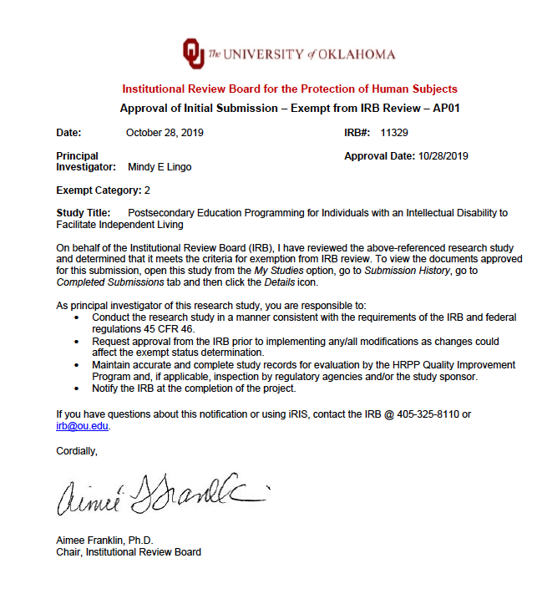

Appendix C
Recruitment Script
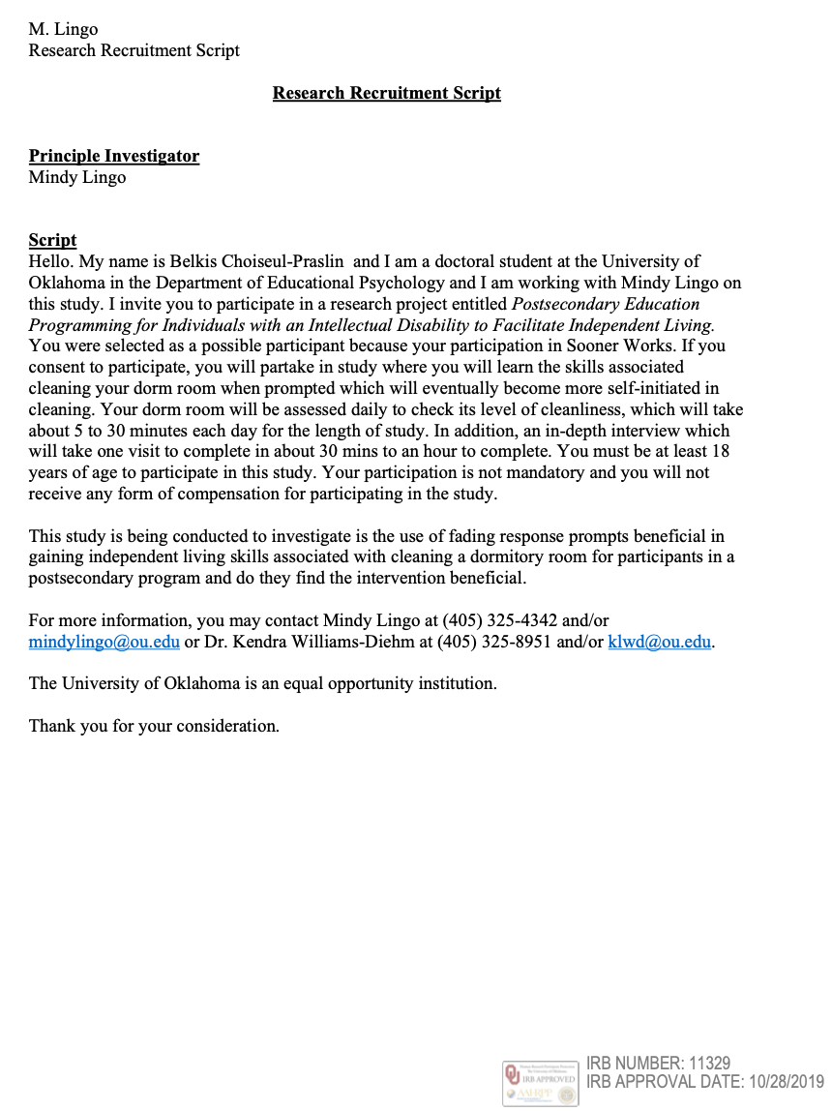
Appendix D
Informed Consent
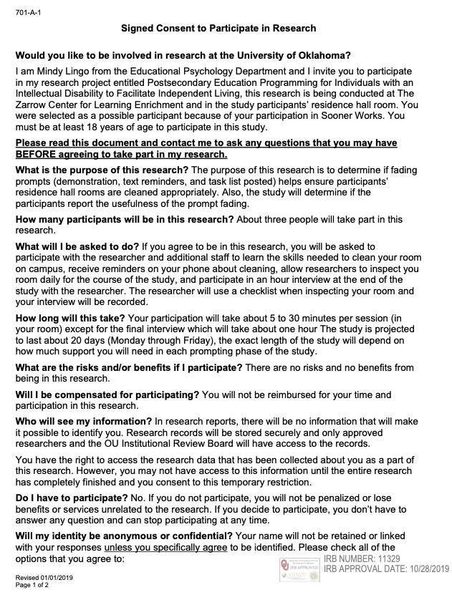
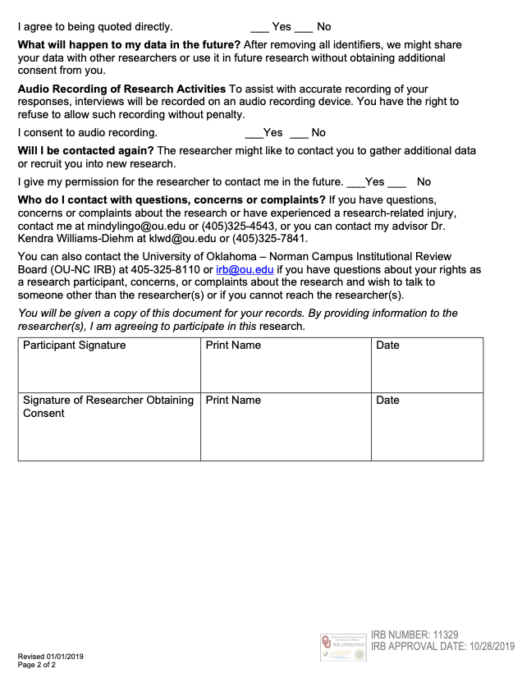

Appendix E
Measurement Tool
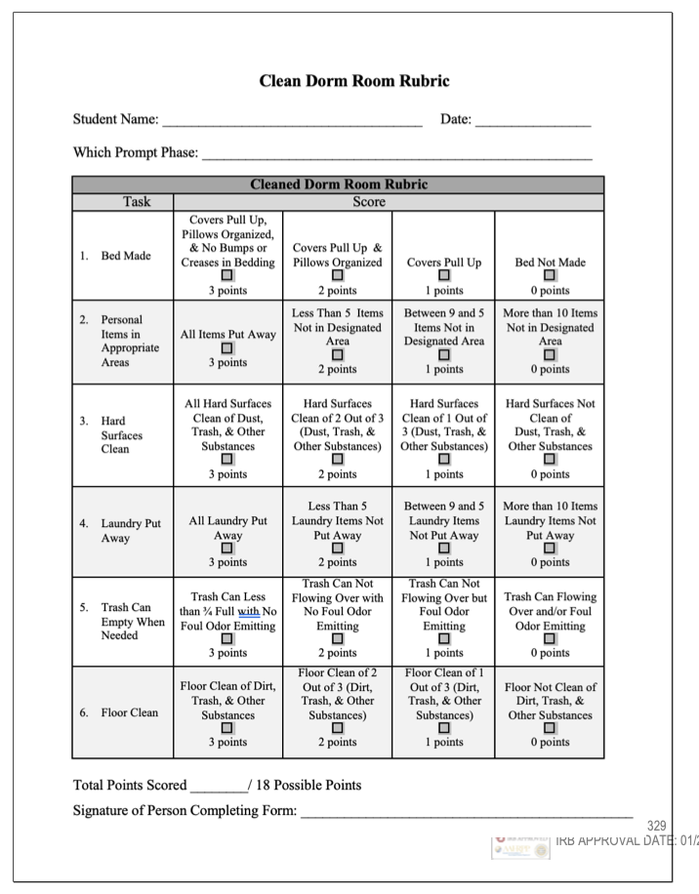
Appendix F
Interview Protocol
