University of Oklahoma

Graduate College

Sorption and RELEASE OF NICKEL AND ZINC Using a Mixed Algae Community Collected From A Mine Drainage
Passive Treatment System

A thesis

submitted to the Graduate Faculty

in partial fulfillment of the requirements for the

Degree of

Master of Science in Environmental Engineering

By

Ellen Fielding
Norman, Oklahoma
2017

sorption and RELEASE OF Zinc and nickel using a mixed algae community collected from a mine drainage
passive treatment system

A thesis approved for the
School of Civil Engineering and Environmental Science

By

______________________________
Dr. Robert Nairn, Chair

______________________________
Dr. Elizabeth Butler

______________________________
Dr. David Sabatini

© Copyright by Ellen Fielding 2017
All Rights Reserved.

Acknowledgements
I wish to express my gratitude to all of those who have helped me in the process of finishing my thesis research. A special thanks to the Grand River Dam Authority (GRDA) for funding this research. Thank you to the U.S. Environmental Protection Agency (EPA) for their funding of the Mayer Ranch Passive Treatment System (MRPTS). I would also like to acknowledge Rich Zamor and Steve Nikolai at the GRDA Ecosystems and Education Center (EEC) laboratory for their assistance and allowing me to use equipment during my repeated visits to identify samples of algae. I would like to share my gratitude to my graduate research committee, Dr. Robert Nairn, Dr. Elizabeth Butler, and Dr. David Sabatini, who provided much-needed guidance and helpful suggestions along the way. The Center for Restoration of Ecosystems and Watersheds (CREW) team all offered strong moral support, helpful suggestions, and ready assistance whenever I needed a hand. I would like to thank CREW members, Nick Shepherd, Zepei Tang, Amy Sikora, Derrick Nguyen, Bryan Page, and Kandace Steele, particularly for their help in the field and laboratory. Thank you to Dr. Caryn Vaughn and Thayer Hallidayschult who were very helpful by providing advice and useful information about how to handle my algae samples. Thanks to Marlene Smith, Susan Williams, Audre Carter, Cindy Vitt Murphy, and Noetta Harjo, of the Civil Engineering and Environmental Science (CEES) department who were always extremely helpful throughout the entire research process. Lastly, I would like to thank my family and husband for all of their outstanding support and continued confidence in me.

Table of Contents
Acknowledgements iv
Table of Contents v
List of Tables vii
List of Figures viii
Abstract x
1.0 Introduction 1
1.1 Mine Drainage Treatment 2
1.2 Algae Sorption 3
2.0 Literature Review 4
2.1 Phytoremediation and Uptake of Metals Using Algae 4
2.2 Environmental Conditions Affecting Sorption with Algae 6
2.3 Sorption to Living Algae Versus Dead Algae 7
2.4 Metal Species Preference by Certain Algal Species 9
2.5 Algae with Previous Metals Exposure Versus Laboratory Grown Cultures 9
2.6 Algae in Passive Treatment Systems 10
2.7 Release of Metals During Decomposition 11
3.0 Hypotheses and Objectives 12
3.1 Hypotheses 12
3.2 Experimental Tasks 12
4.0 Methods 13
4.1 Field Site 13
4.2 In-Situ Water Quality Measurements 15
4.3 Sample Collection 15
4.4 Algae Taxonomic Classification 17
4.5 Laboratory Sorption Experiment During Algae Growth 17
4.6 Laboratory Metals Release Experiment Post Algae Death 20
4.7 Laboratory Metals Release Experiment Post Algae Decomposition 20
4.8 Sample Analysis 22
4.9 Laboratory Testing of Effects of Using EDTA 23
5.0 Results and Discussion 25
5.1 Initial Samples 25
5.2 Algae Sample Genera 26
5.2.1 FlowCAM Algae Genera Images 29
5.2.2 Microscope Algae Genera Images 32
5.3 Growth Phase Samples 36
5.4 Chilled Phase Samples 41
5.5 Decomposition Phase Samples 49
5.6 Data Anomalies 58
6.0 Conclusions 62
6.1 Key Research Findings 62
6.2 Hypothesis Verification 63
6.3 Implications for MRPTS or Other PTS 63
6.4 Possibilities for Future Research 65
7.0 References 67
8.0 Appendices 73
8.1 YSI Data Sonde Field Measurements 73
8.2 ICP-OES Sample Raw Data 74

List of Tables
Table 4.1.1: Average Aqueous Nickel Concentrations for MRPTS Cell 6 14
Table 4.1.2: Average Aqueous Zinc Concentrations for MRPTS Cell 6 14
Table 4.3.1: Water and Algae Sampling Methods 16
Table 4.5.1: Experimental Sample Overview 19
Table 5.1.1: Average Concentrations of Nickel and Zinc in Initial Samples 26
Table 5.2.1: Genera of Algae Present in Samples Collected in June, July, August and October of 2016 28
Table 5.3.1: The Changes in Masses of Nickel and Zinc from Initial Samples to the End of the Growth Phase 37
Table 5.4.1: The Changes in Masses of Nickel and Zinc from Growth Phase to the End of Chilled Phase 43
Table 5.4.2: The Changes in Masses of Nickel and Zinc from Initial Samples to the End of Chilled Phase 46
Table 5.5.1: The Changes in Masses of Nickel and Zinc from Chilled Phase to the End of Decomposition Phase 51
Table 5.5.2: The Changes in Masses of Nickel and Zinc from Initial Samples to the End of Decomposition Phase 54
Table 5.6.1: Effects of EDTA on Nickel in Microwave Assisted Digestion of Algae When Compared to Previous Measurements 59
Table 5.6.2: Effects of EDTA on Zinc in Microwave Assisted Digestion of Algae When Compared to Previous Measurements 59
Table 5.6.3: Effects of EDTA on Zinc in Clean Sand Dried on Aluminum Weigh Dishes 59
Table 8.1.1: MRPTS Cell 6 YSI Data Sonde Field Measurements for Temperature, Conductivity, Resistivity, Total Dissolved Solids (TDS), Salinity, and Dissolved Oxygen (DO) 73
Table 8.3.1: Total Metals Concentrations in Algae for Nickel and Zinc 74
Table 8.3.2: Algae Absorbed Metals for Nickel and Zinc 75

List of Figures
Figure 4.1.1: Mayer Ranch Passive Treatment System in Commerce Oklahoma 14
Figure 4.7.1: Layout of Experimental Setup and Sample Analyses 21
Figure 5.2.1: Anabaena FlowCAM Analysis Images from Samples Collected from Cell 6 in 2016 29
Figure 5.2.2: Rhopalodia FlowCAM Analysis Images from Samples Collected from Cell 6 in 2016 30
Figure 5.2.3: Figure 8.2.3: Tribonema FlowCAM Analysis Images from Samples Collected from Cell 6 in 2016 30
Figure 5.2.4: Pennate Diatom FlowCAM Analysis Images from Samples Collected from Cell 6 in 2016 31
Figure 5.2.5: Centric Diatom FlowCAM Analysis Images from Samples Collected from Cell 6 in 2016 31
Figure 5.2.6: Mougeotia Microscope Analysis Image from Samples Collected in October 2016 32
Figure 5.2.7: Gloeocapsa Microscope Analysis Image from Samples Collected in October 2016 32
Figure 5.2.8: Oedegonium Microscope Analysis Image from Samples Collected in October of 2016 33
Figure 5.2.9: Lepocinclis Microscope Analysis Image from Samples Collected in October of 2016 33
Figure 5.2.10: Oscillitoria Microscope Analysis Image from Samples Collected in October of 2016 34
Figure 5.2.11: Monoraphidium Microscope Analysis Image from Samples Collected in October of 2016 35
Figure 5.2.12: Spirogyra Microscope Analysis Image from Samples Collected in October of 2016 35
Figure 5.3.1: Sorption Isotherm of Nickel During the Growth Phase 38
Figure 5.3.2: Sorption Isotherm of Zinc During the Growth Phase 38
Figure 5.3.3: The Changes in Mass of Nickel from Initial Samples to Growth Phase 39
Figure 5.3.4: The Changes in Mass of Zinc from Initial Samples to Growth Phase 39
Figure 5.4.1: Sorption Isotherm of Nickel During the Chilled Phase 44
Figure 5.4.2: Sorption Isotherm of Zinc During the Chilled Phase 44
Figure 5.4.3: The Changes in Mass of Nickel from Growth Phase to Chilled Phase 45
Figure 5.4.4: The Changes in Mass of Zinc from Growth Phase to Chilled Phase 45
Figure 5.4.5: The Changes in Mass of Zinc from Initial Samples to Chilled Phase 47
Figure 5.4.6: The Changes in Mass of Nickel from Initial Samples to Chilled Phase 47
Figure 5.5.1: Sorption Isotherm of Nickel During the Decomposition Phase 52
Figure 5.5.2: Sorption Isotherm of Zinc During the Decomposition Phase 52
Figure 5.5.3: The Changes in Mass of Nickel from Chilled Phase to Decomposition Phase 53
Figure 5.5.4: The Changes in Mass of Zinc from Chilled Phase to Decomposition Phase 53
Figure 5.5.5: The Changes in Mass of Nickel from Initial Samples to Decomposition Phase 55
Figure 5.5.6: The Changes in Mass of Zinc from Initial Samples to Decomposition Phase 55

Abstract
Mine water from upwellings in Commerce Oklahoma is treated by the Mayer Ranch Passive Treatment System (MRPTS) to remove contaminants. The last treatment section of MRPTS is referred to as the polishing pond (also known as cell 6). Nickel and zinc, toxic to both plants and animals when present in elevated concentrations, are still detectable at the effluent of the system out of cell 6. Research on phytoremediation for contaminants in water or soils has been around for decades. Some more recent research examines algae for sorption of metal contaminants from water to improve water quality. Research shows that living algae are capable of both adsorption and absorption of metals, whereas dead algae can only adsorb metals due to the absence of metabolic processes. Previous exposure to metal contaminants influences the levels of uptake of metals by algae as well as growth rates when contaminants are present. Researchers have hypothesized that metals will be released from algae detritus as the algae decomposes, but not enough research has been published on desorption or release of metals due to decomposition.
In this research, nickel and zinc sorption and release by a community of mixed algae species collected from MRPTS were examined. Equal concentrations of nickel and zinc were used in solutions of 0.5, 2.0, 5.0, 10.0, and 20.0, mg/L Ni and Zn. A solution of MRPTS final cell effluent water with no addition of nickel or zinc was included, along with a no algae control solution with 10.0 mg/L Ni and Zn for comparisons of results. The samples were exposed to Photosynthetically Active Radiation (PAR) light at 20 °C for five days for the growth phase. The algae were then exposed to 0 °C without light for two days for the chilled phase which was used to promote algae death. Lastly, the algae were placed at 20 °C without the presence of light to promote decomposition of the algae material. The algae and solution of each sample at the end of each phase were processed using microwave assisted acid digestions to extract the metals present in the samples. The samples were then analyzed using Inductively Coupled Plasma-Optical Emission Spectroscopy (ICP-OES).
The data obtained by this experiment showed that there was sorption of both nickel and zinc by the algae community during the growth phase. The algae released a portion of the previously sorbed metals during the chilled phase. Instead of the data showing release of metals during decomposition of the algae, the samples showed continued sorption under the conditions for decomposition. The greater concentrated solutions had greater levels of sorption by the algae. The data indicate that algae and its decomposing material are both capable of removing and retaining nickel and zinc from contaminated waters. Natural algae populations within passive treatment systems (PTS) can provide additional water treatment. Effects of seasonality on the potential of water treatment by algae, along with sorption and release of other metals by algae, still needs further study for definitive results.

Introduction
Some metal contaminants, such as nickel or zinc, are naturally occurring and the release of which into the environment can be the result of natural causes or human activity (Cempel and Nikel 2006). Both trace metals are typical by-products of mining operations such as those that occurred in the Tri-State Mining District in northeastern Oklahoma, southeastern Kansas, and southwestern Missouri from the time of the mid 1800s until 1970 (USEPA 2007a). This massive anthropogenic disturbance brought many sub-surface metal contaminants to the surface environment and continues to have an impact on water bodies from waste pile leachate and artesian discharges from underground mines.
Although zinc is a micronutrient that many living organisms require at low concentrations, in greater concentrations (especially in aquatic ecosystems) it can become toxic (Gélabert et al. 2006; Gupta and Srivastava 2006; De-Bashan and Bashan 2010). Ecotoxic zinc concentrations can negatively affect growth rates of freshwater phytoplankton species, such as communities of diatoms as studied by Gélabert et al. (2006). These algae communities serve as a food source for many zooplankton species. Some of the health defects shown by the consumption of zinc in two species of freshwater isopods (commonly referred to as woodlice) included decreased reproductive rates and appetite; at even greater concentrations many of the isopods stopped eating all together (Drobne and Hopkins 1995). Some sub-lethal effects of zinc on a freshwater fish species in a study performed by Kori-Siakpere and Ubogu (2008) included tissue damage that could lead to hypoxia (oxygen-deficiency), as well as negative effects in the veins, hemoglobin, and heart.
It is thought that nickel compounds, such as nickel sulfide as well as nickel metal dusts, can be carcinogenic to animals (De-Bashan and Bashan 2010). Water soluble nickel compounds are more of a health issue, however, since they are more easily absorbed into an animal’s digestive tract (Cempel and Nikel 2006). Water soluble forms of nickel and zinc would also be more easily introduced into aquatic systems which would affect aquatic plants, zooplankton, snails, and fish, as well as animals higher on the food chain. Because metal concentrations in macroalgae (large algae species including seaweeds) are very closely related to those in soils, they can experience concentrations of metals greater than that of the seawater in which they grow due to accumulation. This means that they can be a large source for toxic metals in animal species (marine life and humans) that consume them as a primary food source (Akcali and Kucuksezgin 2011). Bioaccumulation can become a problem for animals if they primarily eat species of animals or zooplankton that feed off algae that can accumulate large quantities of metals from their environment.

Mine Drainage Treatment
Active treatment of mine drainage and other metal-contaminated water is a chemical-based approach to treatment as opposed to biological and geochemical treatment as is seen in passive treatment systems (PTS) (Johnson and Hallberg 2005; Skousen et al. 2016). Active treatment systems may be preferred if a certain effluent water quality standard is regulated, but can be more expensive to operate and maintain over time since they require the addition of chemicals to provide functions such as adjusting pH levels or precipitating dissolved metals (Johnson and Hallberg 2005; Skousen et al. 2016). Passive treatment systems can be less expensive than active treatment systems to build as well as operate and maintain over time, depending on the type of materials available and type of treatment process chosen in the design (Skousen et al. 2016). Skousen et al. (2016) explain that biological systems in PTS can include constructed wetlands, bioreactors, and manganese removal beds. The difference between the two types of treatment systems is like the difference between a traditional wastewater treatment plant with controlled chemical additions at each step in the process versus a wastewater treatment wetland providing the same or similar functions. However, PTS often rely mainly on biogeochemical and physicochemical processes.

Algae Sorption
Algae are naturally occurring in many lentic water bodies that have enough nutrients to sustain population growth. In using algae for phytoremediation, most of the metal removal from sorption (a combination of external adsorption and internal absorption) is due to adsorption (binding to material surface) of metals to the surface of the cellular structures (Monteiro et al. 2011; Zhou et al. 2012). Algae have high surface area which provides lots of potential adsorption sites for metals in solution (Zhou et al. 2012). Because the algae in PTS are naturally occurring and do not require inoculation, culturing, or fertilization, using algae for phytoremediation follows the scheme for passive treatment very well. If algae are capable of metal removal within the PTS, then there may only be minimal amounts of operation and maintenance tasks that would be needed to see water quality benefits from this function.
Since algae can be found in most water bodies exposed to sunlight, they will be commonly found even within PTS if the water is not highly contaminated with ecotoxic levels of pollutants. However, despite numerous researchers studying metal sorption by algae, there are still questions that need to be answered before naturally growing algae communities can be attributed to improving water quality. One such question is, can the algae found growing within contaminated waters such as a passive treatment wetland be exploited to serve treatment functions? Will algae that naturally grow within the contaminated waters remove metals from the water or do they thrive there because they are resistant? If algae can remove dissolved metals from the solution in which they are growing, will all of the metals be released back into solution after the death and decomposition of the algal detritus material?
Das et al. (2009) recognized that there is a large discrepancy between studies analyzing the sorption of metals to algae and studies analyzing release of metals from algae. It has been difficult to say without further study whether algae can have an influence on the concentrations of metals at the sediment layer due to settling of the algae after cell death or if the metals released during decomposition will equal that which was originally removed. The goal of this research was to determine whether the treated water flowing through the Mayer Ranch PTS located in Commerce, Oklahoma is being further treated by the naturally growing algae community. If so, this could also be the case within other PTS or sites with moderately contaminated waters.

Literature Review

Phytoremediation and Uptake of Metals Using Algae
It has been found that trace metals that are trapped in soil sediments along contaminated waterways can create long-term slow release sources of dissolved metal contamination (De-Bashan and Bashan 2010). The use of plants or biomass to remediate metal contamination, a form of phytoremediation, has been researched and implemented over the last few decades (Padmavathiamma and Li 2007). In some cases, the uptake of metals by biomass has been measured to be as high as 50% of the dry weight of the biomass (Fomina and Gadd 2014). There is evidence showing that aquatic plant species such as water hyacinth, pennywort, duck weed and reeds, can remove certain contaminants (such as trace metals) from impaired water sources (Soldo and Behra 2000; Weis and Weis 2004; Barley et al. 2005; Padmavathiamma and Li 2007). Aquatic plants that are naturally found near contaminated water, such as algae, could prove to be very useful in the removal of trace metals when used at the tail-end of PTS through the sorption of metals to growing biomass. Contaminant concentrations at the end of a PTS can be very low due to effective removal in the previous units of the treatment train and, for certain metal species, the levels may be undetectable. Das et al. (2009) states that the presence of algae in contaminated waters can be more dependent on the presence of sufficient nutrients in the water rather than the contaminants. Metal concentrations at the end of a PTS may be too low to be targeted for further removal by traditional and potentially expensive passive treatment technologies, but should not inhibit the growth of many metal-tolerant algae species. He and Chen (2014) argue that although algae can be a great option for metal removal due to being cost-effective for both fresh-water and salt-water environments, algae do not remove metals as effectively from waters with elevated metals concentrations. This could be due to inhibited growth.
The sorption and removal of trace metals by algae has been of increasing study in the past few decades by numerous authors that have found algae to be capable of up taking metals from metal-contaminated water (Rose et al. 1998; Ivorra et al. 2000; Barley et al. 2005; Kalin et al. 2005; Gélabert et al 2006; Tripathi et al. 2006; Luengen et al. 2007; Gupta and Rastogi 2008; Das et al. 2009; De-Bashan and Bashan 2009; Luna et al. 2010; Pahlavanzadeh et al. 2010; Rajfur et al. 2010; Rathinam et al. 2010; Akcali and Kucuksezgin 2011; Ibrahim 2011; Lee and Chang 2011; Monteiro et al. 2011; Lill et al. 2012; Monteiro et al. 2012; Rajfur et al. 2012; Saunders et al. 2012; Shanab et al. 2012; Zhou et al. 2012; Sulaymon et al. 2013; Fomina and Gadd 2014; He and Chen 2014). Ibrahim (2011) reported that the uptake efficiency of cadmium in solution by Mastocarpus stellatus (red algae) was over 90% in the first nine minutes of exposure. Previous research shows that algae could be a good treatment option for metal contaminated water.

Environmental Conditions Affecting Sorption with Algae
The capacity of algae to adsorb (binding to the exterior surface) metals can vary greatly based on the metal or algal species, the age of the biologic material, or numerous other conditions (Das et al. 2009). Some of the other conditions that can affect sorption (binding onto or within) of metals to algae include the pH of the water in which the algae are growing and the growth rate of the algae itself (Ivorra et al. 2000; Zhou et al. 2012). When comparing solutions of the same metal concentration with varying pH values, it has been shown that greater amounts of cationic metals can be removed from solutions in solutions with higher pH values (Pahlavanzadeh et al. 2010; Monteiro et al. 2011). This is due to negatively charged carboxyl groups on the algae cell walls which determine the Point of Zero Charge (PZC) on the algae surface which means fewer cellular binding sites when they are occupied by H⁺ ions due to lower pH values. The concentration of algae biomass in metal contaminated solutions will also affect the mass of metals that can be removed from solution with some algae reaching maximum metal uptake at a biomass concentration of close to 10 g/L (Ibrahim 2011). The amount of contact time can also affect the sorption of metal ions, such as Pb²⁺ and Cu²⁺ to algae; most adsorption (about 95%) occurs within the first 30 minutes of exposure (Lee and Chang 2011).
The presence of charged functional groups such as amino, hydroxyl, carboxyl, phosphate, or sulfate groups within the external structure of an algae cell can increase the number of binding sites for metals due to the presence of polysaccharides, proteins and/or lipids in the cell walls (Das et al. 2009; Monteiro et al. 2011; Lill et al. 2012; He and Chen 2014). When algae are exposed to nutrient stresses, they can produce more polysaccharides which have the capability of chelating metal ions, such as that of copper by the algae Chlorella stigmatophora which has a high affinity for copper (Kaplan et al. 1987; Van Hille et al. 1999). Tripathi et al. (2006) studied short term (six hour) and long term (seven day) exposures of Scenedesmus sp. algae cultures to elevated Cu²⁺ and Zn²⁺ concentrations which showed that longer exposures to elevated metals concentrations had greater levels of copper and zinc absorption (binding within) of the cells.

Sorption to Living Algae Versus Dead Algae
Research based on living algae show that algae cells can both adsorb and absorb trace metals from an aqueous solution (Tripathi et al. 2006; Das et al. 2009; Serra et al. 2009; Rajfur et al. 2012; Zhou et al. 2012). It has also been shown that the amount of metals removed from solution based on absorption is much less than the amount removed by adsorption to the external cellular structure (Rajfur et al. 2012; Zhou et al. 2012). The Langmuir isotherm model can be used to relate the adsorption of metals onto the outer surface of a structure in a monolayer. Dead (oven-dried) algae biomass cannot absorb trace metals like living cells can because of metabolic functions, so they are only capable of removing metals from solution by adsorption onto the external cellular structure (Monteiro et al. 2011). Therefore, the Langmuir isotherm model can accurately model metal removal by dead algae biomass since it models adsorption in a singular layer onto surfaces. Living algae cells can also absorb metals which would cause more than just the single layer of adsorbed metals to be contained by the algae. This can make sorption by dead biomass easier to model than that of living biomass which could include absorption into the plant or cellular structure in addition to extracellular adsorption (Fomina and Gadd 2014). Rajfur et al. (2012) raised the argument that because living algae are capable of both adsorption as well as absorption, that the Langmuir isotherm model does not model sorption by living algae as well as with dead algae, because the Langmuir isotherm would only consider the adsorbed portion. Monteiro et al. (2011) states that since most the metals removed by algae are due to external cellular adsorption, the Langmuir isotherm can be used successfully to model the metal removal achieved by living algae.
Since the main removal mechanism of metals from an aqueous solution for a given algal species is determined by adsorption to the exterior of the cell walls, it would follow that greater surface area, like that with unicellular algae (microalgae), would result in more binding sites and a greater metal binding capacity (Zhou et al. 2012). It has been considered by some researchers to be more favorable to use dead biomass for metal removal in-situ because it has no nutrient requirement and can many times be obtained affordably as a waste product (He and Chen 2014). Using dead algae biomass may be easier to deal with, however, in a system that naturally supports the growth of algae without the need for introduction of algae to the water body or adding nutrients, living algae can be more beneficial with the possible capability for more removal due to absorption.

Metal Species Preference by Certain Algal Species
The affinity of certain species of algae for different metals has been researched and discussed by Zhou et al. (2012). Their experimental findings showed one of the two algae species that they studied (Chlorella pyrenoidosa) had a greater affinity for the removal of zinc from solution while the other algae species (Scenedesmus obliquus) had a greater affinity for removing copper from solution when both algae were exposed to the same concentrations of each metal. This preference for certain metals by different algae species is probably due to different cellular structures and the presence of different charged functional groups on the cellular surfaces. Some algae species have been found to be more tolerant or resistant to aqueous metal contaminants than others, which would affect the amount of metals that could be removed from a solution (Monteiro et al. 2012; Shanab et al. 2012). If a certain alga is not as tolerant to a certain metal or metal concentration, then the health and growth of the algae community would decrease, which would result in less biomass available for metal removal.

Algae with Previous Metals Exposure Versus Laboratory Grown Cultures
It has been shown in one study that algae that have been previously exposed to metals in their natural environment have a greater capacity for metals removal and show less inhibited growth due to greater metal concentrations than laboratory-grown cultures that have not been previously exposed to metals (Monteiro et al. 2011). Likewise, it has further been discussed how acidophilic algae can have a greater capacity to adsorb metals from solution. Instead of showing hindered growth, like other algae that grow in a more neutral pH range, they thrive in acidic conditions which have many H⁺ ions in solution since they can retain more H⁺ ions on the cell surfaces than the other types of algae. This means more possible binding sites that are freed up for metal cation bonding when the H⁺ ions are not present in such high concentrations in solution and consequently the algae cell surfaces (Das et al. 2009). Ivorra et al. (2000) studied biofilms containing algae with previous exposure to elevated zinc and cadmium concentrations against biofilms without previous exposure to metals. The biofilms with previous metal exposure did not show greater metal uptake when re-exposed to concentrations of zinc and cadmium, however did have more chlorophyll a, carbohydrates and dry mass after the same amount of time. Their results show that while the algae biofilms that had previous exposure were not necessarily more effective at metal removal, they were more resilient against the toxic effects of the elevated metal concentrations when re-exposed. Therefore, the algae within the biofilms with previous metals exposure were better at withstanding the contaminated conditions without experiencing as much diminished growth.

Algae in Passive Treatment Systems
There have been a handful of research efforts that considered the use of algae as a treatment method within PTS. A pilot PTS in England utilized what was referred to as a rock filter which was made up of rocks coated with algae that contaminated water would flow through to remove metals (Barley et al. 2005). The retention of manganese by floating mats of algae within a constructed wetland designed to treat mine drainage was studied by Edenborn and Brickett (2002). It was found that the algae mats could retain manganese when plenty of oxygen was present and the algae were growing, but the decomposition of algae would create anoxic conditions and manganese would be released. A study by Fomina and Gadd (2014) also made mention of multiple types of algae products available commercially within their study. These algae products include AlgaeSORBTM, which uses freshwater algae that are immobilized on a silica matrix, or Bio-Fix which uses algae that are immobilized within polypropylene beads for water to filter through. Products such as these being commercially available make it easier for algae to be used for treatment purposes by consumers, however, Fomina and Gadd (2014) report that these products have not yet had sustained results for treatment.

Release of Metals During Decomposition
Although there are many publications that have studied the sorptive properties of algae with many different species of metals, there are very few publications that look at metal concentrations of algae after or during the decomposition of the biomass. Even fewer publications are available that look at the metal uptake by algae and then study the release from decomposition. Das et al. (2009) stated that algae that have taken up metals may decompose and consequently the sorbed metals would be released back into the environment, but research of this effect was not included in their experimental study. A study was performed by Lill et al. (2012) looking at the metal concentrations of a few seaweed (macroalgae) species in the Baltic sea and the concentrations of metals during the decomposition of the plant material. The study was performed in-situ and did show a decrease of some metal concentrations in the algae over time during decomposition, but also showed an increase of other metals in the algae during the same time period.

Hypotheses and Objectives

Hypotheses
- Algae from the Mayer Ranch PTS with previous metal exposure will be able to remove nickel and zinc from solution because the natural algae community is capable of subsisting despite the presence of these metals.
- The concentration of trace metals that will be retained after the algal cells have begun to break down due to decomposition will be less than before decomposition.
- There will still be the presence of sorbed trace metals that remains with the algal detritus even after the decomposition stage.

Experimental Tasks
- Initial concentrations of nickel and zinc for both algae and the PTS water in which it is growing will be measured to determine the starting concentrations prior to elevating metal concentrations for the experiment.
- The uptake of nickel and zinc by algae collected from the Mayer Ranch PTS will be determined while the algae are still living and under growth conditions.
- The amount of nickel and zinc released after the introduction of conditions that will promote algae death will determine if those conditions influence the sorbed zinc or nickel concentrations prior to decomposition.
- The concentrations of nickel and zinc will be measured after decomposition of the algae material occurs to help determine how much nickel and zinc is gained or released during this stage of the experiment.

Methods

Field Site
The MRPTS is the location where samples were collected from for experimental analyses. Long-term sampling data show that water quality at MRPTS has improved drastically, but some trace elements are still detectable at the tail-end of the treatment train in cell 6 also referred to as the polishing pond (indicated by Table 4.1.1 and Table 4.1.2). Treatment cell 6 at the MRPTS apparently has sufficient nutrients available and low enough concentrations of metals so as to not be eco-toxic providing agreeable conditions for algae growth. The low levels of contaminants in cell 6 is due to the removal of metals and other contaminants in previous treatment cells. It is likely that sufficient nutrients are available in most if not all of the treatment cells, but algae growth is not observed in many of the treatment cells likely due to other conditions within those cells such as fluctuating or below grade water levels or high concentrations of metals in treatment cells closer to the inflows. Because of these conditions, algae growth can be found within cell 6 of the MRPTS during the growing season.
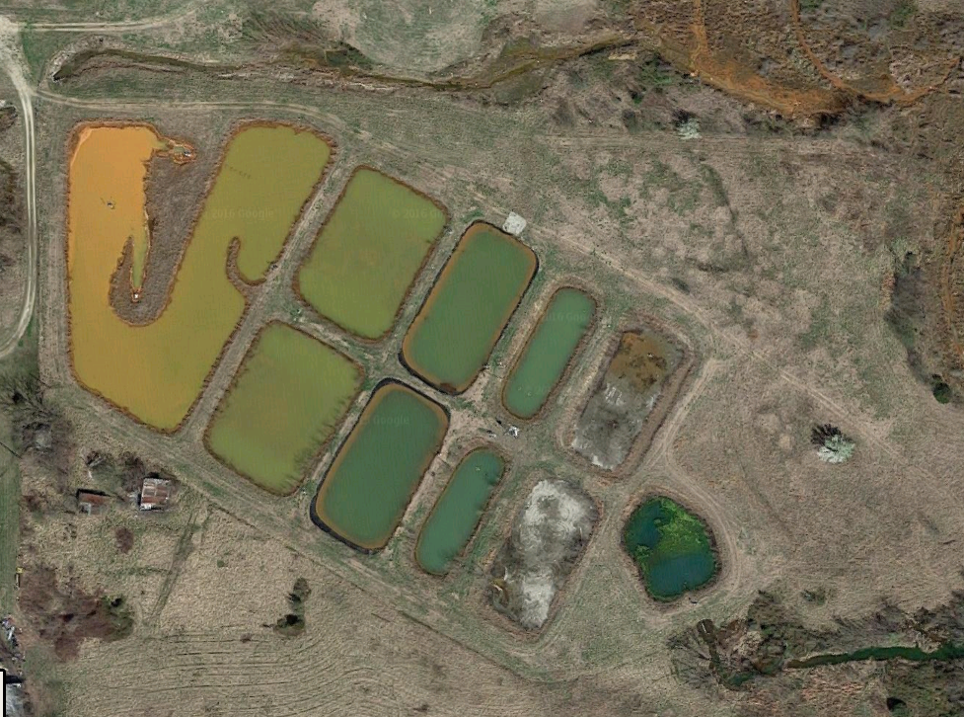
Cell 6
Polishing Pond
Figure 4.1.1: Mayer Ranch Passive Treatment System in Commerce Oklahoma
Table 4.1.1: Average Aqueous Nickel Concentrations for MRPTS Cell 6
Month | Average [Ni] (mg/L) | S | Years Included
January | 0.456 | 0.100 | 2010, 2011, 2012, 2013, & 2016
April | 0.193 | 0.041 | 2010, 2011, 2012, & 2016
July | 0.046 | 0.023 | 2010, 2011, 2013, & 2016
October | 0.027 | 0.006 | 2010, 2011, 2012, 2013, & 2016

Table 4.1.2: Average Aqueous Zinc Concentrations for MRPTS Cell 6
Month | Average [Zn] (mg/L) | S | Years Included
January | 1.043 | 0.552 | 2010, 2011, 2012, 2013, & 2016
April | 0.412 | 0.201 | 2010, 2011, 2012, & 2016
July | 0.097 | 0.059 | 2010, 2011, & 2013
October | 0.024 | 0.010 | 2010, 2011, 2012, 2013, & 2016

In-Situ Water Quality Measurements
Any time that water samples or algae were collected from MRPTS, in-situ water quality measurements were taken as well using a 600 series Yellow Springs Instrument (YSI) Co. data sonde. The YSI data sonde measured pH, specific conductance, temperature, and dissolved oxygen concentration, of the water source. Some of these parameters could affect the sorption of metals with algae, so they were measured to get average values for the sampling trips.

Sample Collection
Water samples were collected in High Density Polyethylene (HDPE) bottles that were previously acid washed with HNO₃ (Table 4.3.1). Bottles were rinsed three times with sample water before collection. The water samples were then preserved, transported, and stored (Table 4.3.1).
Algae samples were collected by using a dip net to skim the algae mass from the water surface in cell 6 of MRPTS. The algae were then placed in a cleaned cooler suspended in cell 6 water for transport back to the laboratory. In the laboratory, the algae were sifted to remove as much plant debris and aquatic organisms as possible before being portioned out for experiment samples.

Table 4.3.1: Water and Algae Sampling Methods
 | Water: | Algae:
Sample Collection & Preservation | Collected in HDPE sample bottles previously HNO₃ washed with and rinsed with DI. Acidified with concentrated trace metal grade HNO₃ before transported to the CREW laboratory at 4 °C | Collected in a cleaned cooler suspended in more MRPTS cell 6 water for transportation
Sample Preservation & Transportation | Samples were stored in a cooler at 4 °C during transport | Samples were stored in a cooler at 4 °C during transport
Field In-Situ Analysis | YSI 600QS-ORP-M Data Sonde Measurements: temperature, pH, dissolved oxygen, and conductivity
Analytes -  Field Samples | Total metal and dissolved metal (the concentration remaining in solution after being filtered to remove particulate metals) concentrations | Sorbed metal concentrations & taxonomic classification
Analytes - Laboratory Samples | Nickel and zinc total metal concentrations | Nickel and zinc total sorbed and absorbed concentrations
Experimental Sample Preservation & Storing | Supernatant placed into HDPE bottles previously HNO₃ washed and rinsed with DI. Acidified with concentrated HNO₃ and stored at 4 °C until testing could occur | Algae samples were dried at 50 °C for 15 hours, ground to powder and placed into petri dishes previously HNO₃ washed and rinsed with DI. The algae samples were stored at 4 °C until testing could occur
Acid Digestion | Followed method 3015a (USEPA 2007b) | Followed method 3052 (USEPA 1996) instead using 10 mL of HNO₃ instead of 9 mL HNO₃ and 3 mL HF
ICP-OES Analysis | Followed method 6010c (USEPA 2000) | Followed method 6010c (USEPA 2000)

Algae Taxonomic Classification
To determine the taxonomic identification of the algae community found growing onsite at MRPTS, algae samples were periodically collected for analysis. These samples were all collected from cell 6 in the MRPTS treatment train. This analysis showed which algae genera were present and helped to determine if there were drastic changes throughout the summer. All water and algae samples were collected as described in Table 4.3.1. The algae samples were then analyzed using a FlowCAM at the Grand River Dam Authority (GRDA) Ecosystems and Educational Center (EEC) Water Quality Laboratory to identify the smaller individual algae cells. The FlowCAM allows a sample of water containing unicellular algae species to flow through a small tube. As the water passes through the tube, algae pass in front of a camera with a microscope which snaps a picture of each algae cell as it passes by. The algae are magnified to a scale of 50 µm and catalogued. It is then possible to sort through these algae images, group them together, and use the images to identify the genera of algae present within the water sample. The larger strands of algae are filtered out of the water sample to prevent clogging of the small tubing and mechanisms, so an aliquot from one of the same collected samples was also analyzed under a microscope to identify the larger algae in that sample.

Laboratory Sorption Experiment During Algae Growth
All samples were analyzed for initial nickel and zinc concentrations in both the algae and water from MRPTS cell 6. The samples that were used in the sorption and release experiment were collected in large coolers and brought back with enough of both water and algae for all replicates. An initial set of algae and water triplicate samples were analyzed as described in Table 4.3.1 to determine the initial total sorbed metals of the water and algae collected from MRPTS. These initial samples represent the in-situ conditions at the MRPTS site and the starting parameters prior to the sorption and release experimental phases. The data from initial samples allowed the later determination of the amount of metals removed from the solutions during the experimental growth phase due to sorption. Testing of the initial water samples showed the water quality conditions for the naturally-occurring algae at the MRPTS as a reference to any results obtained by the experiment.
In the laboratory, the algae aliquots were placed in solutions of varying concentrations of both nickel and zinc. Stock solutions were prepared using ZnSO₄•7H₂O and NiSO₄•6H₂O dissolved in filtered MRPTS cell 6 water. From those stock solutions, five dilutions of each metal, as well as a sample of cell 6 water without any additional metals, were created as illustrated in Table 4.5.1 (Zhou et al. 2012). One of the metal dilutions was selected as the no algae control for a comparison, and was treated the same as other samples except for not adding algae. All experiments were run in triplicate.

Table 4.5.1: Experimental Sample Overview
 | No Algae Control | Cell 6 Water | 0.5 mg/L | 2.0 mg/L | 5.0 mg/L | 10.0 mg/L | 20.0 mg/L
Contain Algae | no | yes | yes | yes | yes | yes | yes
Number of Replicates | 3 | 3 | 3 | 3 | 3 | 3 | 3
Number of Sampling Sets | 3 | 3 | 3 | 3 | 3 | 3 | 3

Since periodic testing of both the algae and solution was necessary to determine the uptake and release of metals during the different experimental phases (i.e., growth, chilled, and decomposition), sampling was conducted without replacement. To achieve this, three sets of all of the experimental samples were created so that a complete set could be analyzed after each phase. Sampling without replacement eliminated the complications of removing aliquots of solution and algae at the end of each phase which would necessitate the calculation of the algae, solution, and nickel and zinc, remaining in each sample each time some was removed. Collected samples were placed in glass containers which had been previously acid-washed with HNO₃ and triple-rinsed with DI water. Algae was portioned out with at least twice the equivalent of at least 1.2 grams of algae (dry weight) in each sample bottle containing 750 mL of the sample solution to ensure that enough algae and solution was available for analysis even if no additional growth occurred during the experiment. The wet weight of algae placed into each sample solution was recorded. The samples were then exposed to photosynthetically active radiation (PAR) lighting with a temperature of 3100K and wavelength near 930 nm. The F40 T12 model 40-watt linear fluorescent light bulbs manufactured by General Electric (GE) provided 1900 lumens. The lighting was used in a 14:10 hour light/dark cycle for five days. The lighting was intended to influence growth conditions for the algae.

Laboratory Metals Release Experiment Post Algae Death
After the five days of algae growth, remaining groups of samples were then covered with parafilm and aluminum foil to eliminate light and oxygen exchange. They were placed in 0 °C for 48 hours. After incubations, the next group of samples were tested at this point to determine if there was a measurable difference in the concentrations of metals in solution or sorbed to the algae due to the death of the algae cells or from the change in light and temperature conditions. The data from this phase also helped determine the starting concentrations of both algae and solution for the decomposition stage of the experiment. These samples were collected, preserved, and analyzed as described in Table 4.3.1. The other group of samples were set on the countertop at room temperature to begin the next phase in the experiment.

Laboratory Metals Release Experiment Post Algae Decomposition
The remaining group of samples remained covered in parafilm and aluminum foil to keep light and oxygen out. The samples were stored on the countertop in the laboratory at room temperature (20 °C) for three weeks to provide sufficient time for the algae to decompose. At the end of this decomposition period, the last group of samples was collected, preserved, and analyzed as described in Table 4.3.1. A diagram illustrating the experimental phases and sampling periods is shown in Figure 4.7.1.

Figure 4.7.1: Layout of Experimental Setup and Sample Analyses
Initial Samples:
-MRPTS Cell 6 Algae
-MRPTS Cell 6 Water
Analyzed
Initial Samples
Growth Phase Samples
Decomposition Phase
Samples
Chilled Phase Samples
Growth Phase
Analyzed
Growth Samples
Growth Samples
Chilled Samples
Decomp. Samples
Chilled Phase
Analyzed
Chilled Samples
Chilled Samples
Decomp. Samples
Analyzed
Decomp Samples
Decomp. Samples
Decomposition Phase
5 Days
20 °C
With light
2 Days
0 °C
W/O light
21 Days
20 °C
W/O light

Sample Analysis
At the end of each of the three phases of the experiment, all algae and aqueous samples were separated using a Beckman J2-HS centrifuge at 3000 rpm for five minutes. The separated supernatant solutions were collected, preserved and analyzed in the same way as the other aqueous samples (Table 4.3.1). The resulting algae mass from each sample solution was then split into two roughly equal portions. The first portion was weighed, placed on an aluminum dish, and dried in an oven at 50 °C for 15 hours. The second portion of algae was rinsed in a 0.02 M ethylenediaminetetraacetic acid (EDTA) solution for ten minutes while stirring occasionally, to rinse off the externally adsorbed nickel and zinc, leaving just the absorbed metals. The algae and EDTA solution were separated by centrifuge at 3000 rpm for five minutes. The EDTA rinsed algae were then weighed, placed on an aluminum dish, and dried in an oven at 50 °C for 15 hours. Once the algae samples were dried, they were then ground to a fine powder using a glass mortar and pestle. They were then preserved at 4 °C until testing could occur.
All algae samples were digested using the microwave digestion method 3052 provided by the USEPA (1996) except for a modification using 10 mL of HNO₃, instead of 9 mL of HNO₃ with the addition of 3 mL of HF. This was modified because the hydrofluoric acid is used to break down silicon dioxide in the solid samples. The USEPA (1996) method 3052 stated that less hydrofluoric acid may be used if less silicon dioxide is present in the solid samples. While diatom algae species have siliceous outer cellular structures, they did not represent a major part of the algae biomass. The aqueous samples were acid digested following USEPA (2007b) method 3015a in preparation for Inductively Couple Plasma-Optical Emission Spectroscopy (ICP-OES) analysis which followed USEPA (2000) method 6010c.
The data produced by the ICP-OES instrument allowed for calculations of nickel and zinc concentrations and masses in solution and algae for each sample. The data were analyzed to determine the sorption and release properties of the algae at the different stages of the experiment.

Laboratory Testing of Effects of Using EDTA
Due to unexpected discrepancies in the measurements of nickel and zinc in samples that had been rinsed with 0.02 M EDTA versus those not rinsed with EDTA, a few samples were run to test the effects that EDTA could have had on these measurements. The goal was to attempt to determine the reason for the higher measurements in samples that had been rinsed with EDTA. One set of samples was previously collected and preserved algae samples that had not been rinsed with EDTA, the other set of samples was clean sand that was rinsed with 0.02 M EDTA and dried on aluminum weigh dishes in the same way as the algae samples had been.
Left over dried algae samples of those that had previously been measured for metals concentrations were digested in the same way as described in Table 4.3.1 except for the addition of a small amount of dry EDTA. The EDTA used to make to 0.02 M EDTA solutions for rinsing algae was also used during the digestions of samples to test the effects of EDTA on the nickel and zinc concentrations in the samples. Since the EDTA rinsed algae from the sorption and release experiment had been dried, the EDTA would have been present in the algae as a dried substance which were then acid digested. For this reason, dried EDTA was added to dried algae samples that had already been analyzed for metals concentrations to determine if the presence of EDTA in the acid digestion affected the results. These digested samples were analyzed to measure levels of nickel and zinc to compare with the previous measurements for those experiment samples.
Clean sand was used as an inert substitute for algae to determine if EDTA was affecting the nickel or zinc concentrations in the algae samples while they were still damp and in contact with the aluminum weigh dishes when placed in the oven to dry. The sand had previously been acid washed in 5% (v/v) HCl, rinsed with DI water and dried. The cleaned sand was then rinsed with 50 mL of 0.02 M EDTA solution for ten minutes so that it was treated in the same way as the algae samples. The EDTA rinsed sand samples were then centrifuged at 3000 rpm for five minutes. The sand was then placed on aluminum weigh dishes and dried in a drying oven for 15 hours at 50 °C. These samples were then digested as solids per USEPA Method 3051a (2007c) for soils and sediments. The digested samples were analyzed with an ICP-OES to measure the concentrations of nickel and zinc for comparison with the experiment samples.

Results and Discussion

Initial Samples
Values shown in Table 4.1.2 and Table 4.1.1 representing average nickel and zinc concentrations, show that there are seasonal changes in the concentrations of both nickel and zinc in the water at MRPTS cell 6. The general trend in the data shows nickel and zinc aqueous concentrations peak in January and decrease in concentrations for both metals from January through to October. These historical data from MRPTS cell 6 show greater concentrations of zinc in the water samples than nickel, however, both metals show the same trends in concentration increases and decreases over the course of a year. The water and algae samples used for the sorption and release experiment were collected in October 2016. The concentrations of nickel and zinc in these samples that make up the initial experimental samples prior to the addition of nickel and zinc are shown in Table 5.1.1. The MRPTS cell 6 algae and water was then used to make the samples for analysis for the subsequent phases of the sorption and release experiment as shown on Figure 4.7.1.

Table 5.1.1: Average Concentrations of Nickel and Zinc in Initial Samples
 | [Nickel] | S | [Zinc] | S
MRPTS Cell 6 Water (mg/L) | 0.050 | +/- 0.0006 | 0.012 | +/- 0.0001
Algae (mg/Kg) | 210 | +/- 11.3 | 1213 | +/- 160.7
Starting concentrations were not included in calculations for preparing the nickel and zinc solution concentrations for the experiment. These values differ slightly from those shown with the historical data for the month of October. The measured values of nickel are almost twice as much as has been measured previously, whereas zinc is almost half of what has been previously measured.
The values in Table 5.1.1 show that even though the nickel concentration in the MRPTS cell 6 water is greater than that of zinc, the initial concentration of zinc in the algae from MRPTS cell 6 is greater than that of nickel. The MRPTS cell 6 water concentrations were used instead of a blank solution in this experiment. So even though no additional nickel or zinc was added, there was already some present for uptake by the algae. The presence of nickel and zinc in the initial samples of algae also means that it is possible for the algae to release nickel and zinc prior to any uptake during the experiment, especially from the lower concentration samples since the more nickel and zinc that is added to the solutions will influence more uptake.

Algae Sample Genera
Collected water samples were analyzed for the algae taxonomic information down to the genus. Samples from the months of June, July, and August were analyzed using a FlowCAM, so the percentages of the identified community present were calculated for each genus (Table 5.2.1). Samples from October were analyzed using a microscope to identify which species were present since some of the larger algae were not able to be analyzed with the FlowCAM. Images were captured for the identified algae (Figure 5.2.1, Figure 5.2.2, Figure 5.2.3, Figure 5.2.4, Figure 5.2.5, Figure 5.2.6, Figure 5.2.7, Figure 5.2.8, Figure 5.2.9, Figure 5.2.10, Figure 5.2.11, and Figure 5.2.12).

Table 5.2.1: Genera of Algae Present in Samples Collected in June, July, August and October of 2016
Percents for June, July, and August are the number of algae of each genus out of the total number of algae counted. The algae genera that were identified, but not quantified in the sample from October are indicated as present within the sample by an "X".
 | FlowCAM |  |  | Microscope
 | % |  |  | Present
Algae Genus | June | July | August | October
Anabaena |  | 3.8 | 12.0 | x
Chroococcus |  | 1.0 | 0.6 | x
Cryptomonad | 0.4 | 0.8
Diatom | 43.2 | 39.7 | 29.0 | x
Euglena | 0.5 | 1.4 |  | x
Gloeocapsa |  |  |  | x
Lepocinclis |  |  |  | x
Lyngbya |  | 1.2 | 0.5 | x
Monoraphidium |  |  |  | x
Mougeotia |  |  |  | x
Nodularia | 0.4 |  |  | x
Oedegonium |  |  |  | x
Oscillitoria |  |  |  | x
Rhopalodia | 7.1 | 6.2 |  | x
Spirogyra |  |  |  | x
Tribonema | 8.7 | 1.9 |  | x
Unclassified Conglomerate | 35.8 | 38.5 | 24.6
Unidentified Group 1 |  |  | 7.1
Unidentified Group 2 |  |  | 3.3
Unidentified Group 3 |  |  | 13.1
Unidentified Group 4 |  |  | 2.2
Unidentified Group 5 |  |  | 3.3
Unidentified Group 6 |  |  | 1.6
Unidentified Group 7 |  |  | 2.7
Unidentified Group 8 |  | 2.6
Unidentified Group 9 |  | 0.5
Unidentified Group 10 |  | 2.4
Unidentified Group 11 | 3.9

FlowCAM Algae Genera Images
Figure 5.2.1: Anabaena FlowCAM Analysis Images from Samples Collected from Cell 6 in 2016
Numbers below the images are the order in which the images were captured.

Figure 5.2.2: Rhopalodia FlowCAM Analysis Images from Samples Collected from Cell 6 in 2016
Numbers below the images are the order in which the images were captured.
Figure 5.2.3: Figure 8.2.3: Tribonema FlowCAM Analysis Images from Samples Collected from Cell 6 in 2016
Numbers below the images are the order in which the images were captured.
Figure 5.2.4: Pennate Diatom FlowCAM Analysis Images from Samples Collected from Cell 6 in 2016
Numbers below the images are the order in which the images were captured.
Figure 5.2.5: Centric Diatom FlowCAM Analysis Images from Samples Collected from Cell 6 in 2016
Numbers below the images are the order in which the images were captured.

Microscope Algae Genera Images
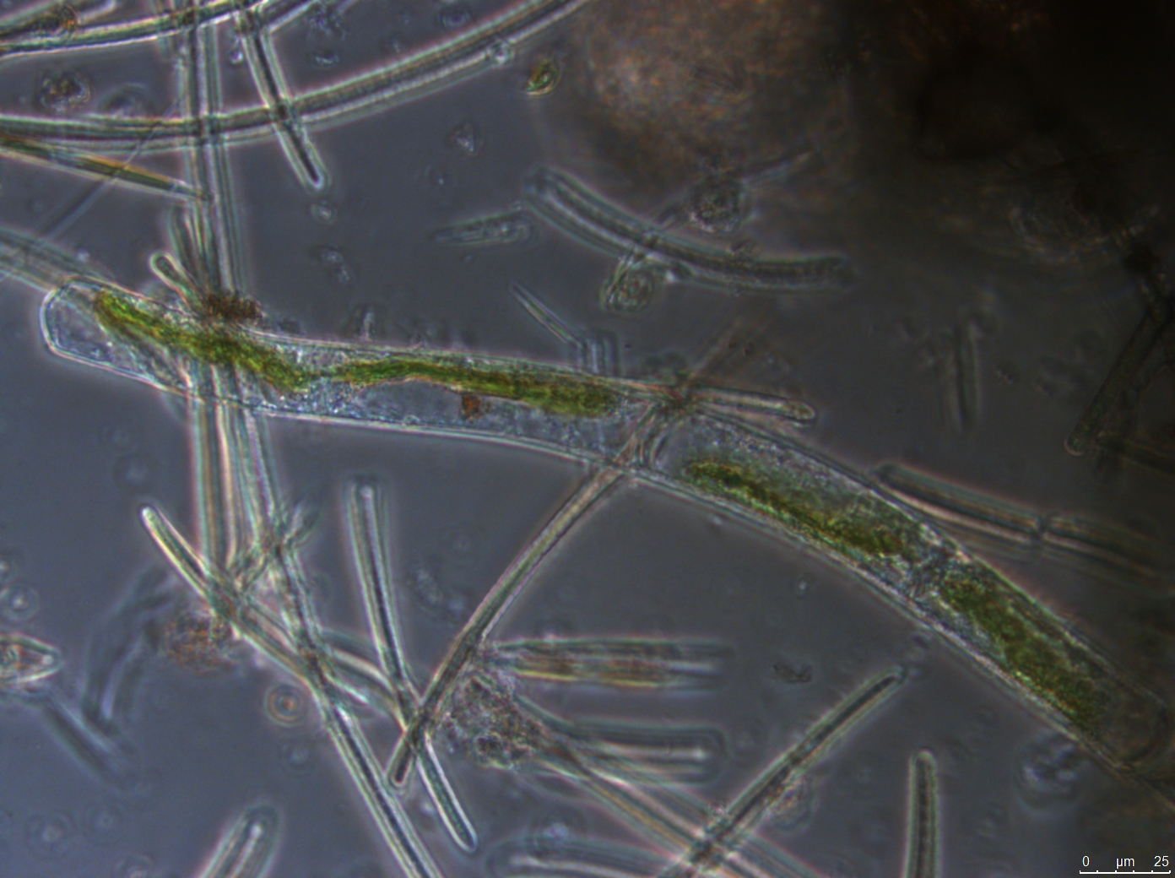
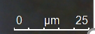
Figure 5.2.6: Mougeotia Microscope Analysis Image from Samples Collected in October 2016

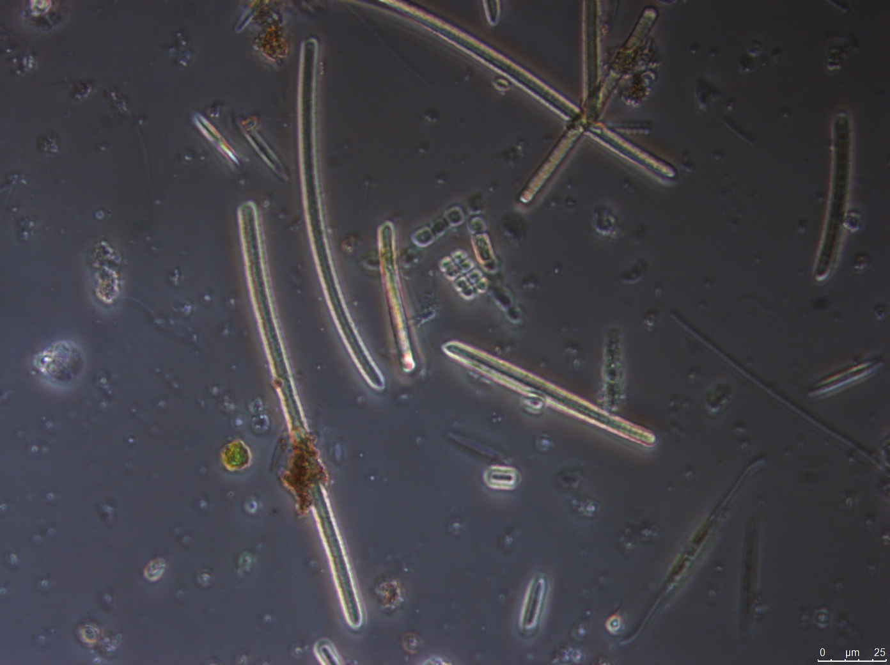
Figure 5.2.7: Gloeocapsa Microscope Analysis Image from Samples Collected in October 2016

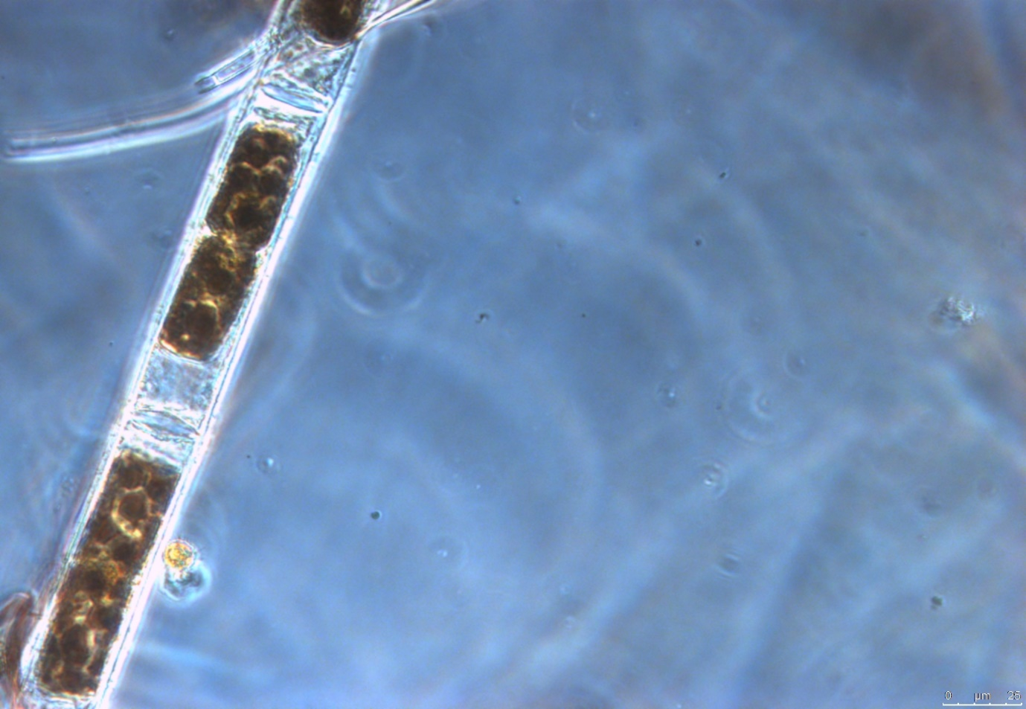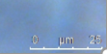

Figure 5.2.8: Oedegonium Microscope Analysis Image from Samples Collected in October of 2016
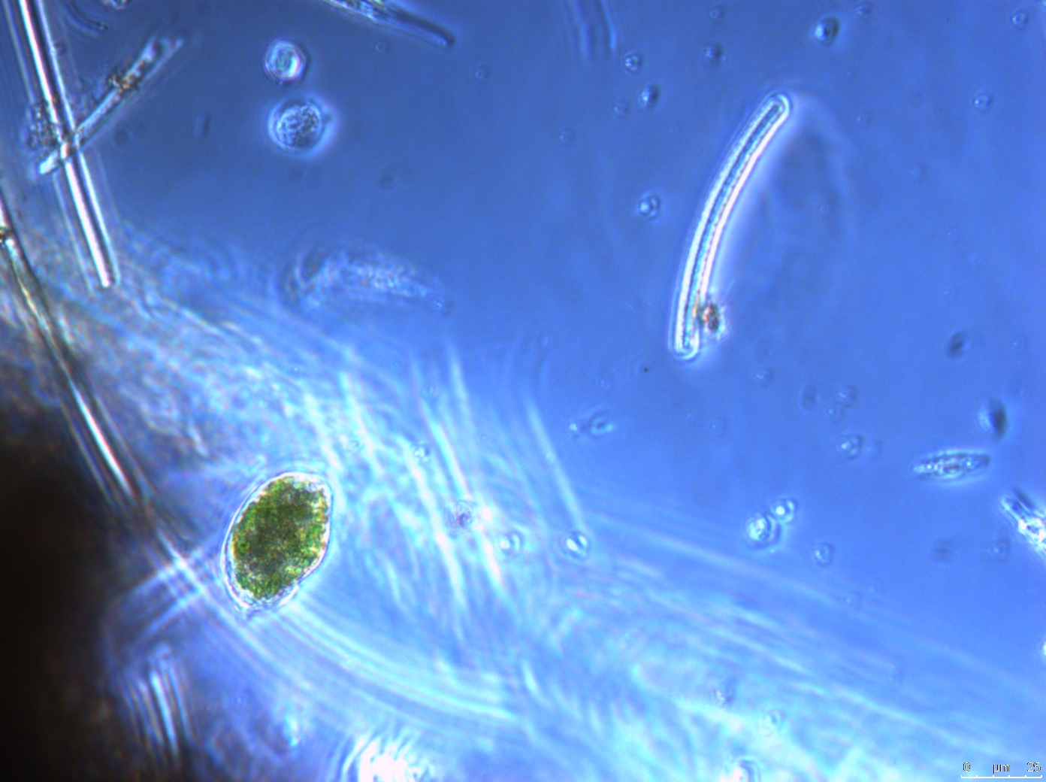

Figure 5.2.9: Lepocinclis Microscope Analysis Image from Samples Collected in October of 2016

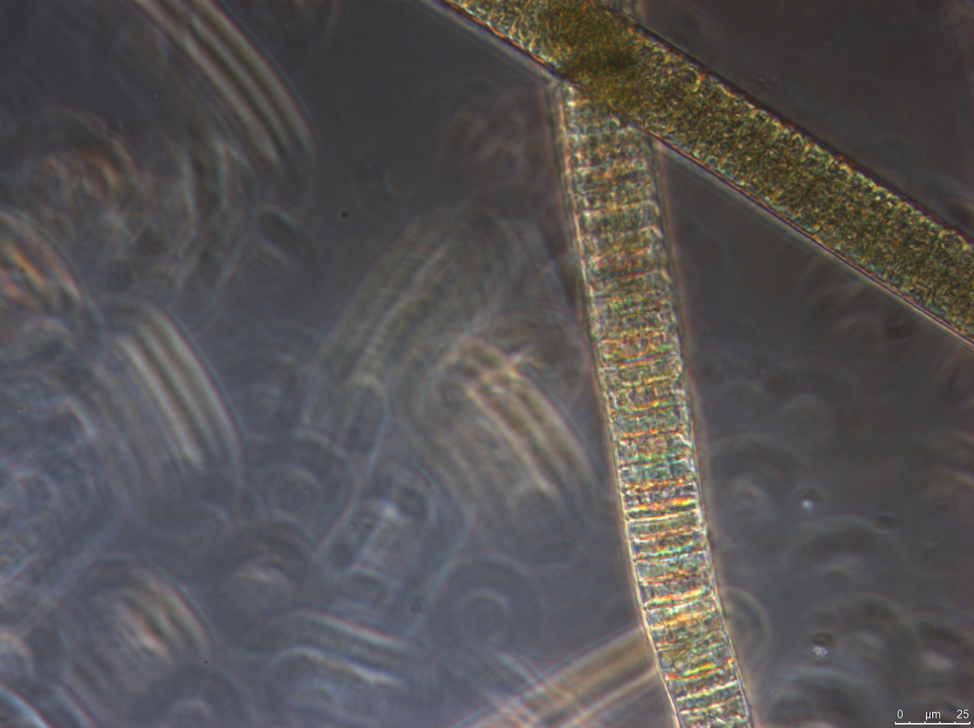
Figure 5.2.10: Oscillitoria Microscope Analysis Image from Samples Collected in October of 2016

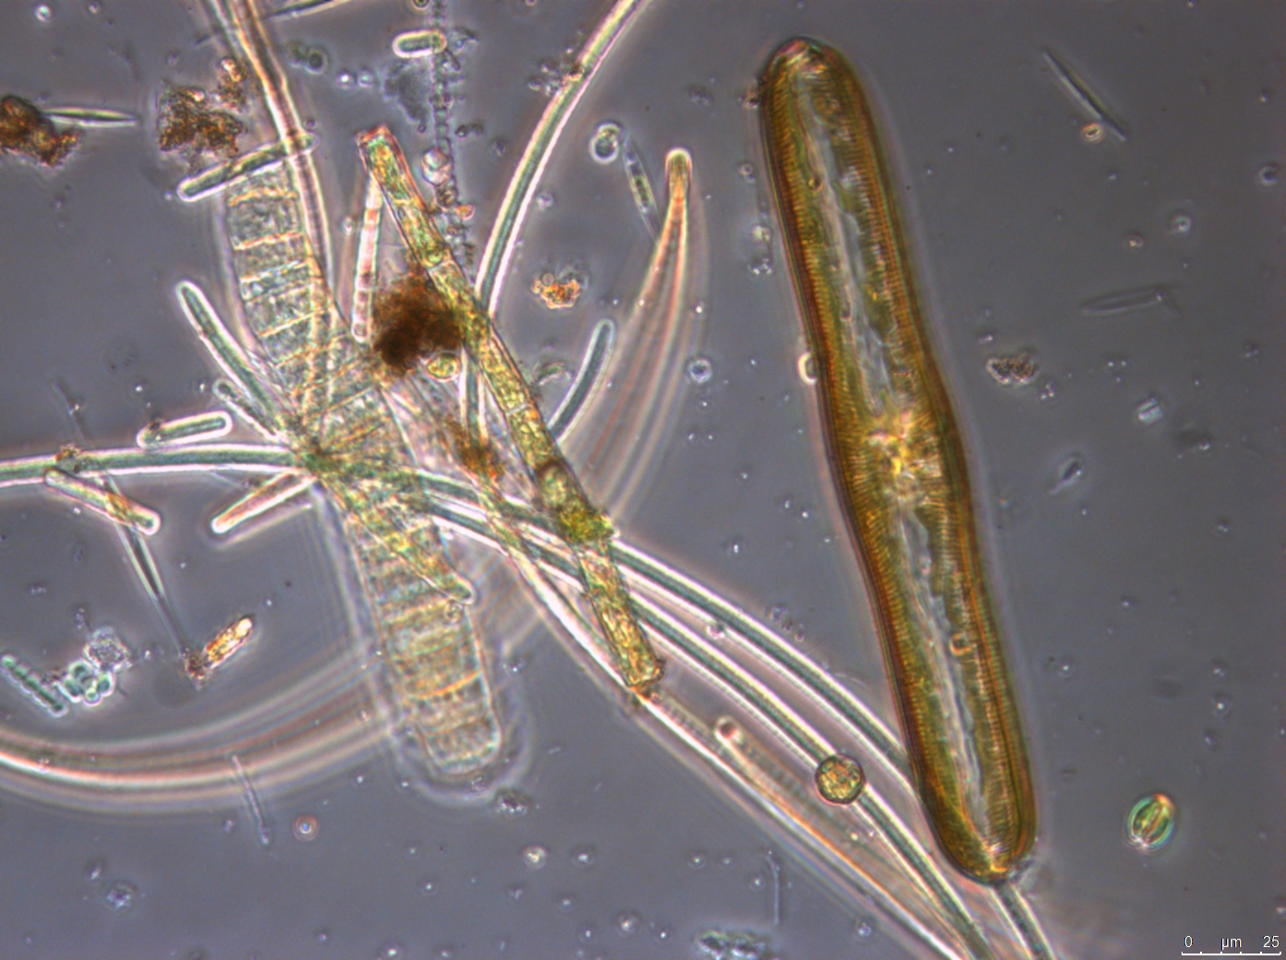

Figure 5.2.11: Monoraphidium Microscope Analysis Image from Samples Collected in October of 2016
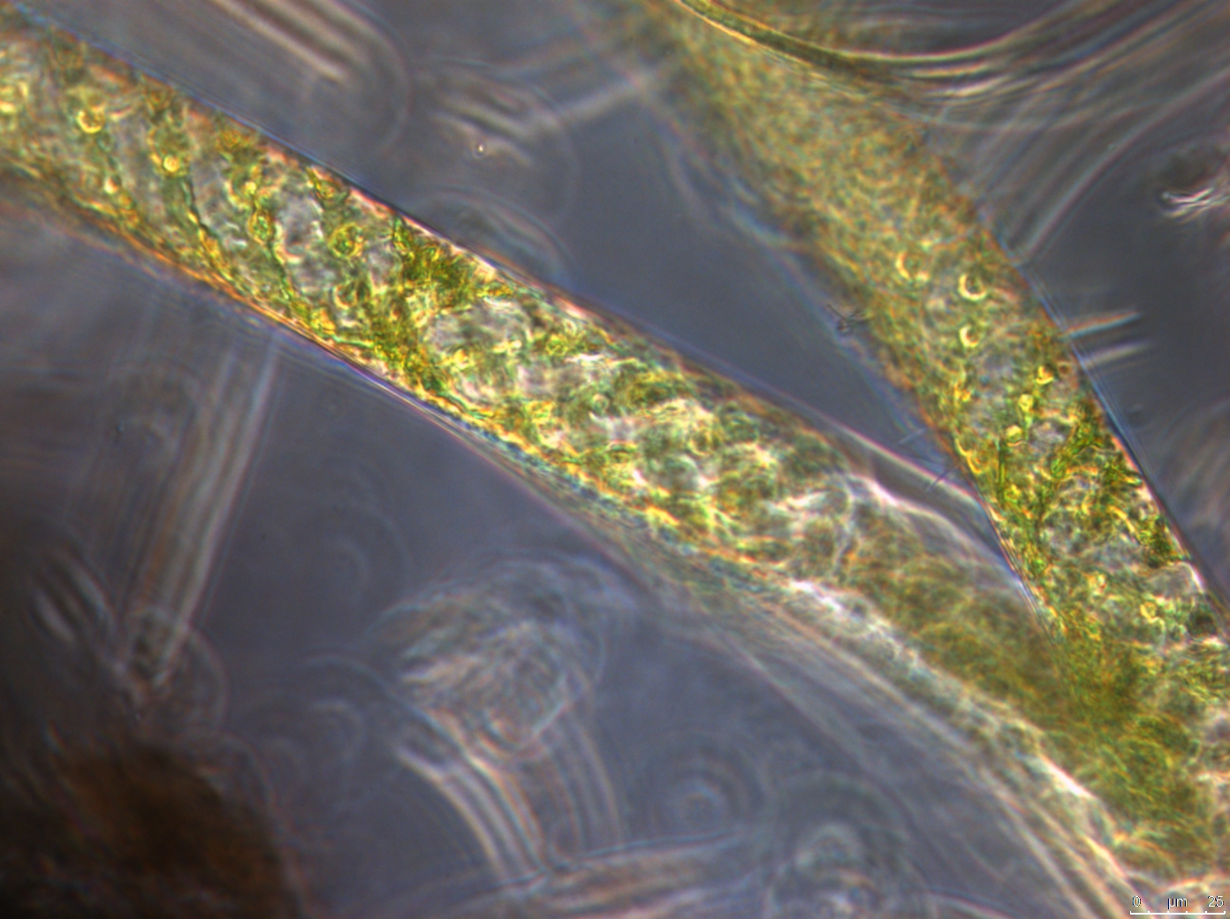
Figure 5.2.12: Spirogyra Microscope Analysis Image from Samples Collected in October of 2016

Growth Phase Samples
Samples were collected directly after the five-day period that provided conditions that promoted algae growth. These conditions included providing PAR light, allowing exposure to air, and a temperature of 20 °C. The growth phase conditions were intended to provide optimum growth conditions as would be present in cell 6 of MRPTS during the growing seasons. The results from this phase of the experiment are shown in figures Figure 5.3.3and Figure 5.3.4 as well as Table 5.3.1.
To compare the results from the solution as well as algae of each sample, the masses of nickel and zinc were calculated. Aqueous concentrations of mg/L were multiplied by the volume of liquid of the solutions to obtain a mass of nickel and zinc in each solution. The algae samples had measured concentrations of nickel and zinc as well in mg/kg, which were multiplied by the dry masses of algae that were weighed from each sample to obtain a mass. To see the relation between the gain of nickel or zinc by either algae or solution and the loss by the other during each experimental phase, the difference in masses for samples in each solution were calculated for each phase. The results in the figures show the changes in mass of nickel or zinc that were gained or lost from algae and solution.
Isotherms were created for each experimental phase with the data (Figure 5.3.1 and Figure 5.3.2). For this data, C_{e} is the equilibrium concentration of nickel and zinc in solution (mg/L) (e.g., the measured aqueous concentrations) and C_{s} is the sorbed portion on the solid (algae) (g/g). To calculate C_{s}, the mass of nickel or zinc sorbed (g) was divided by the mass of the dried algae (g) for each sample.

Table 5.3.1: The Changes in Masses of Nickel and Zinc from Initial Samples to the End of the Growth Phase
 | Nickel (mg) |  |  | Zinc (mg)
Solution | Total Sorbed | Solution | Total Sorbed |  | Solution
No Algae Control | NA | 0.059 | NA |  | -3.373
Cell 6 Water | -0.143 | 0.007 | -0.619 |  | 0.015
0.5 mg/L | -0.069 | -0.240 | -0.905 |  | -0.361
2.0 mg/L | 0.226 | -0.881 | -0.470 |  | -1.303
5.0 mg/L | 0.727 | -1.721 | 0.720 |  | -2.847
10 mg/L | 1.391 | -3.044 | 2.249 |  | -5.361
20 mg/L | 2.763 | -5.286 | 4.672 |  | -11.019

Figure 5.3.1: Sorption Isotherm of Nickel During the Growth Phase

Figure 5.3.2: Sorption Isotherm of Zinc During the Growth Phase

Figure 5.3.3: The Changes in Mass of Nickel from Initial Samples to Growth Phase
Figure 5.3.4: The Changes in Mass of Zinc from Initial Samples to Growth Phase

As seen in Figure 5.3.3and Figure 5.3.4, these conditions resulted in the uptake of nickel and zinc by algae in the solutions with greater concentrations (i.e., 5.0, 10.0, and 20.0 mg/L Ni and Zn). Algae showed a decrease of both nickel and zinc as mass of metals sorbed to the algae in the cell 6 water solution and 0.5 mg/L solution as well as a decrease of zinc in the 2.0 mg/L solution. The cell 6 water solutions showed a slight increase of both nickel and zinc accounting for the losses of sorbed metals, whereas the 0.5 and 2.0 mg/L Ni and Zn solutions and algae both exhibited losses of zinc. The 0.5 mg/L Ni and Zn solution and algae both exhibited losses of nickel. The algae and solutions from the greater concentration samples showed a clear correlation between the uptake of both metals by the algae and a loss of both metals from solution.
By looking at the isotherms for sorption of both nickel and zinc by the algae, the data follows the linear trendline with an R² value greater than 0.90 for both. This high R² value on the isotherms indicates that the sorption of nickel and zinc by the algae are closely associated with Langmuir isotherms. This association implies that sorption of nickel and zinc by algae is mainly adsorption, therefore strongly influenced by the amount of algae surface binding sites available. The number of surface binding sites available will be determined by the number and concentration of functional groups present in the algae, size of the algae for a given mass, and the concentration of algae in the solution.
The overall trend in the data shows that the algae from the MRPTS will uptake metals from solution if ample concentrations are present during growth conditions. It is also apparent that the algae will uptake more nickel and zinc when greater concentrations are present in solution. The experiment solution with the greatest concentration of nickel and zinc exhibited the greatest uptake from solution by the algae. As seen in the initial samples of algae in Table 5.1.1, zinc is removed from solution in greater amounts than nickel by the algae from MRPTS, even though zinc is present in the water at a lower concentration. The created sample solutions have nickel and zinc added in the same concentrations not considering the amount that was already present in the MRPTS cell 6 water. Since the initial algae samples seemed to have a greater affinity for zinc over nickel even when zinc was present at lower concentrations, it makes sense that when concentrations of nickel and zinc are close to equal in the starting solutions, that zinc would still be removed by the algae at aqueous concentrations greater than nickel. These trends are more evident by looking at Figure 5.3.3 and Figure 5.3.4.

Chilled Phase Samples
The chilled phase of the sorption and release experiment is the two-day period at 0 °C with the samples covered with parafilm and aluminum foil. Samples were exposed to the five-day Growth Phase and then the Chilled Phase (at 0 °C) (Figure 4.7.1). The samples were collected directly after this two-day Chilled Phase. The purpose of covering the samples was to eliminate any light that might encourage photosynthetic and metabolic functions. The decrease in temperature was meant to encourage algae death as is seen in-situ during late fall and winter months. The chilled phase was meant to kill the algae cells while having minimal effects on the chemistry in the solution, as opposed to the use of algicides or heat. The results from the samples just during the chilled phase can be found in Table 5.4.1, Figure 5.4.3, and Figure 5.4.4. Isotherms were created for the chilled phase data (Figure 5.4.1 and Figure 5.4.2). Cumulative results including both the growth and chilled phases are included in Table 5.4.2, Figure 5.4.5, and Figure 5.4.6.

Table 5.4.1: The Changes in Masses of Nickel and Zinc from Growth Phase to the End of Chilled Phase
 | Nickel (mg) |  |  | Zinc (mg)
Solution | Total Sorbed | Solution | Total Sorbed |  | Solution
No Algae Control | NA | -0.045 | NA |  | 0.707
Cell 6 Water | -0.044 | 0.002 | -0.080 |  | -0.008
0.5 mg/L | -0.032 | -0.002 | -0.008 |  | -0.003
2.0 mg/L | 0.002 | -0.024 | -0.006 |  | 0.007
5.0 mg/L | 0.093 | -0.072 | -0.103 |  | 0.017
10.0 mg/L | -0.187 | -0.019 | -1.002 |  | 0.316
20.0 mg/L | -0.267 | 0.298 | -1.442 |  | 1.695

Figure 5.4.1: Sorption Isotherm of Nickel During the Chilled Phase

Figure 5.4.2: Sorption Isotherm of Zinc During the Chilled Phase

Figure 5.4.3: The Changes in Mass of Nickel from Growth Phase to Chilled Phase
Figure 5.4.4: The Changes in Mass of Zinc from Growth Phase to Chilled Phase
Table 5.4.2: The Changes in Masses of Nickel and Zinc from Initial Samples to the End of Chilled Phase
 | Nickel (mg) |  |  | Zinc (mg)
Solution | Total Sorbed | Solution | Total Sorbed |  | Solution
No Algae Control | NA | 0.014 | NA |  | -2.665
Cell 6 Water | -0.187 | 0.009 | -0.699 |  | 0.007
0.5 mg/L | -0.101 | -0.243 | -0.912 |  | -0.365
2.0 mg/L | 0.228 | -0.905 | -0.476 |  | -1.296
5.0 mg/L | 0.820 | -1.794 | 0.617 |  | -2.829
10 mg/L | 1.204 | -3.063 | 1.247 |  | -5.045
20 mg/L | 2.496 | -4.988 | 3.231 |  | -9.323

Figure 5.4.5: The Changes in Mass of Zinc from Initial Samples to Chilled Phase
Figure 5.4.6: The Changes in Mass of Nickel from Initial Samples to Chilled Phase

It was important to determine if the conditions that were used to encourage algae death would affect sorption of metals by algae. It was also a goal to establish starting values of both nickel and zinc in algae and solution before the decomposition phase of the experiment, in case a change in metals that were sorbed occurred during the chilled phase.
As can be seen clearly from Figure 5.4.4, there is a release of the sorbed zinc from the algae back into solution during the chilled phase of the experiment, which can also be seen from Table 5.4.1 by negative changes in the mass of zinc in algae samples. The greater the concentration of zinc in solution, the greater the amount of zinc that was released by the algae. The algae in the greater concentrated solutions had greater amounts of metals sorbed during the growth phase, so it makes sense that those algae would have greater amounts of release of nickel and zinc occur in conditions favorable to metal release.
Nickel did not provide results as clearly as zinc did (Figure 5.4.3). Release of nickel did occur for most of the sample concentrations, but the sample in 2.0 mg/L Ni and Zn exhibited no metal release and the sample in the 5.0 mg/L Ni and Zn solution exhibited some sorption of nickel.
Overall during the chilled phase of the experiment, the sorption of nickel and zinc reversed, which was shown by the negative values for change in Table 5.4.1. In some of the sample solutions the sorption of nickel and zinc instead of being reversed, instead was halted resulting in changes of nickel or zinc by algae or solution being close to 0.0 mg. From these results, the presence or absence of light, changes in temperature, or living and dead algae, may all be considered factors that play a role in the sorption and release of nickel and zinc by algae. The no algae control samples also showed a decrease of zinc during this phase of the experiment, but had very little effect on nickel. Which shows that zinc in solution may be influenced by additional forces outside of those being analyzed more than nickel in the same solution.
Although the algae did exhibit some release, halted sorption, or lessened sorption, during the chilled phase, most of the nickel and zinc was retained by the algae in the greater concentrated solutions (i.e., 5.0, 10.0, and 20.0, mg/L Ni and Zn). The retention of nickel and zinc by algae is shown in Figure 5.4.6 and Figure 5.4.5 as well as in Table 5.4.2. Table 5.4.2 shows the changes in masses of nickel and zinc sorbed to the algae or in solution when compared with the initial sample masses. These data show that not all the sorbed metals will immediately be released back into solution due to the death of algae. The isotherms for this phase of the experiment also resulted in R² values greater than 0.90 for both nickel and zinc. The high R² values indicate that the release of nickel and zinc by the algae is still closely related to Langmuir isotherms, which are surface area dependent. Since sorption is also surface area dependent, it makes sense that with more sorption, you would get more of the metal released when conditions have changed.

Decomposition Phase Samples
Samples that were exposed to the five-day growth phase, two-day chilled phase, and 21-day decomposition phase were analyzed. The decomposition phase consisted of samples that remained covered in parafilm and aluminum foil at 20 °C for 21 days to allow sufficient time for some decomposition (in this case meaning the breakdown of the structure of the biological material) to occur. Since there is natural algae growth in cell 6 at MRPTS, there would also be decomposition of the algae after death at the end of the growing season. This phase was meant to emulate that process within MRPTS to determine its effects. Result from the samples for just during the decomposition phase are shown Table 5.5.1, Table 5.5.2., and Figure 5.5.3. Isotherms were created for the decomposition phase data (Figure 5.5.1 and Figure 5.5.2). Cumulative results including the growth, chilled and decomposition phases which show the retention of nickel and zinc at the end of the decomposition phase are shown in Table 5.5.2, Figure 5.5.5, and Figure 5.5.6.

Table 5.5.1: The Changes in Masses of Nickel and Zinc from Chilled Phase to the End of Decomposition Phase
 | Nickel (mg) |  |  | Zinc (mg)
Solution | Total Sorbed | Solution | Total Sorbed |  | Solution
No Algae Control | NA | 0.117 | NA |  | -0.509
Cell 6 Water | 0.030 | 0.007 | -0.100 |  | -0.011
0.5 mg/L | 0.243 | -0.105 | 0.021 |  | -0.012
2.0 mg/L | 0.520 | -0.466 | -0.108 |  | -0.185
5.0 mg/L | 1.703 | -1.666 | 1.195 |  | -0.826
10.0 mg/L | 2.534 | -2.651 | 1.651 |  | -1.459
20.0 mg/L | 4.596 | -4.426 | 3.805 |  | -1.606

Figure 5.5.1: Sorption Isotherm of Nickel During the Decomposition Phase

Figure 5.5.2: Sorption Isotherm of Zinc During the Decomposition Phase

Figure 5.5.3: The Changes in Mass of Nickel from Chilled Phase to Decomposition Phase
Figure 5.5.4: The Changes in Mass of Zinc from Chilled Phase to Decomposition Phase

Table 5.5.2: The Changes in Masses of Nickel and Zinc from Initial Samples to the End of Decomposition Phase
 | Nickel (mg) |  |  | Zinc (mg)
Solution | Total Sorbed | Solution | Total Sorbed |  | Solution
No Algae Control | NA | 0.131 | NA |  | -3.174
Cell 6 Water | -0.157 | 0.016 | -0.798 |  | -0.004
0.5 mg/L | 0.142 | -0.347 | -0.891 |  | -0.377
2.0 mg/L | 0.748 | -1.371 | -0.584 |  | -1.481
5.0 mg/L | 2.523 | -3.459 | 1.812 |  | -3.656
10 mg/L | 3.738 | -5.714 | 2.898 |  | -6.504
20 mg/L | 7.092 | -9.414 | 7.036 |  | -10.929

Figure 5.5.5: The Changes in Mass of Nickel from Initial Samples to Decomposition Phase
Figure 5.5.6: The Changes in Mass of Zinc from Initial Samples to Decomposition Phase

At the end of the decomposition phase of the experiment, the algae samples had changed in color from green to black showing that healthy or living algae was not present. The texture of the algae had also seemed to change from containing long fine strands to a fine sludge in which it did not seem to be holding together anymore. There did not seem to be a complete decomposition since there was still some solid particulate remaining, but there was breakdown of algae material visible in all of the samples. The state of the algae material at the end of the decomposition phase suggests that only partial decomposition had occurred during the 21-day period.
The samples in the greater concentrated solutions exhibited additional nickel and zinc sorption by the algae (Figure 5.5.3 and Figure 5.5.4). The overall trend is more defined for sorption of nickel by algae from all solutions with corresponding losses of nickel by all solutions except for the cell 6 water solution which had algae that had a gain of nickel (Table 5.5.1). The no algae control sample solutions showed a slight increase of nickel, but a decrease of zinc from the same samples. Since it is such a small amount of change in the no algae control it could be considered negligible, but since there are not any algae in the no algae control samples it could also suggest that other factors have small contributions to the concentrations of nickel and zinc in the solutions.
The algae samples exhibited a larger increase of nickel than zinc during this phase meaning that the overall amounts of nickel and zinc sorbed to the algae are similar since zinc exhibited more sorption than nickel during the growth phase in the samples from the greater concentrated solutions (i.e., 5.0, 10.0, and 20.0, mg/L Ni and Zn). It can be seen (Figure 5.5.5 and Figure 5.5.6) that the decomposed algae are capable of resuming sorption and retaining both nickel and zinc. This especially occurs with the samples in the greater concentrated solutions which is shown by the positive values of nickel and zinc in algae samples (Table 5.5.2).
The isotherms for nickel and zinc during this phase (Figure 5.5.1 and Figure 5.5.2) have higher R² values than during the growth phase which shows a stronger relationship with surface area and sorption than previously seen. Sorption by dead (and decomposing) algae can only adsorb metals as opposed to adsorbing and absorbing according to other research (Tripathi et al. 2006; Das et al. 2009; Serra et al. 2009; Rajfur et al. 2012; Zhou et al. 2012). Being that decomposing algae can only adsorb metals, it makes sense that the isotherms should be more closely associated with the linear trendline which indicates a closer relationship with Langmuir isotherm models since there would not have been any absorption by the algae.
The algae samples in the cell 6 water and 2.0 mg/L Ni and Zn solutions showed a decrease of zinc in both the algae and solution each with a loss of less than 0.2 mg Zn since the previous phase. These lower concentration samples show less definitive results than the greater concentration samples for zinc. All samples show sorption of nickel by algae and a loss of nickel in solution except for the cell 6 water solution samples.
These data show that when greater concentrations of nickel and zinc are present in solution, the algae will continue to sorb both metals even after decomposition. Since this is the last stage of the experiment, the data show that the greater the concentration of nickel or zinc present, the greater the accumulation will be in algae due to sorption by comparing them with initial concentrations. Because nickel and zinc continued to exhibit sorption to the decomposing algae material, it can be concluded that nickel and zinc will not be released back into solution simply due to decomposition processes. Even though the algae released some nickel and zinc during the chilled phase, the amount of sorption that the algae exhibited during the decomposition phase more than balanced that fact. By the end of the decomposition phase, the algae still showed positive retention of zinc for solution concentrations of 5.0 mg/L Ni and Zn or greater and positive retention of nickel for all solution concentrations except for the cell 6 water solution which had no additional nickel or zinc.

Data Anomalies
Part of this research included examining the absorbed and adsorbed portions of nickel and zinc in the algae samples. To accomplish this task, EDTA was used to rinse off the adsorbed portion of nickel and zinc (Zhou et al., 2012). This method allows for measurements of the absorbed portion within the algae. The adsorbed portions from each sample could then be calculated as the difference between the total sorbed nickel and zinc in the untreated algae and the absorbed portion. The adsorbed portion of sorbed metals should be the majority with absorbed metals being a minor contribution to the total values, however this was not seen in any of the data from these samples (Rajfur et al. 2012; Zhou et al. 2012). Many of the samples exhibited larger absorbed amounts of zinc than the total values. Some samples also exhibited larger amounts of absorbed nickel than the measured total values resulting in negative calculated values for the amounts of nickel and zinc adsorbed to those algae samples, a mathematical impossibility. Results from samples that were used to test the effects of EDTA on nickel and zinc concentrations in solid samples (Table 5.6.1, Table 5.6.2, and Table 5.6.3).

Table 5.6.1: Effects of EDTA on Nickel in Microwave Assisted Digestion of Algae When Compared to Previous Measurements
 | Initial Algae  Rep 1 | Initial Algae  Rep 2 | Initial Algae  Rep 3 | Exp. 3 Algae  20 mg/L Rep 1 | Exp. 3 Algae  10 mg/L  Rep 1
Previous (mg/Kg) | 209.221 | 196.468 | 224.119 | 4607.399 | 2264.149
W/EDTA (mg/Kg) | 179.293 | 168.654 | 174.735 | 3720.125 | 2144.965
Difference (mg/Kg) | -29.928 | -27.813 | -49.383 | -887.274 | -119.185
% Difference | 14.305 | 14.157 | 22.034 | 19.258 | 5.264

Table 5.6.2: Effects of EDTA on Zinc in Microwave Assisted Digestion of Algae When Compared to Previous Measurements
 | Initial Algae  Rep 1 | Initial Algae  Rep 2 | Initial Algae  Rep 3 | Exp. 3 Algae  20 mg/L Rep 1 | Exp. 3 Algae  10 mg/L Rep 1
Previous (mg/Kg) | 1234.412 | 1006.344 | 1398.250 | 6223.956 | 3629.299
W/EDTA (mg/Kg) | 1084.585 | 921.755 | 1106.478 | 4840.820 | 3256.246
Difference (mg/Kg) | -149.827 | -84.589 | -291.772 | -1383.135 | -373.053
% Difference | 12.137 | 8.406 | 20.867 | 22.223 | 10.279

Table 5.6.3: Effects of EDTA on Zinc in Clean Sand Dried on Aluminum Weigh Dishes
 | EDTA Sand Rep 1 | EDTA Sand Rep 2 | EDTA Sand Rep 3 | EDTA Sand Rep 3  Duplicate
Zinc (mg/Kg) | 3.560 | 4.204 | 3.422 | 3.519

As seen in Table 5.6.1 and Table 5.6.2, the addition of EDTA did not increase nickel and zinc recovery from microwave assisted digestion of algae samples. In all samples digested with the addition of EDTA, the measured amount of nickel and zinc recovered decreased. These results indicate that the original algae samples tested for absorbed metals did not show increased recovery of either metal due to the presence of EDTA; if anything, the presence of EDTA in the digestion slightly decrease the efficiency of recovery for both nickel and zinc. A test that was run using clean sand rinsed with 0.02 M EDTA and dried on aluminum weigh dishes showed substantial measurements for zinc (Table 5.6.3). The average value of zinc in the EDTA rinsed sand was measured at 3.7 mg/kg with a standard deviation of 0.31 mg/Kg. Nickel did not have measurable readings for the same samples of sand. The amounts of nickel present were below the calibration level and that measured in the standard blank so no values are provided in the table for nickel. These results indicate that the samples could leach zinc, but not nickel, from the aluminum weigh dishes during the experiment and could have contributed to the abnormally high levels of what was assumed to be absorbed zinc. Absorbed measurements for zinc were consistently greater than that of the total zinc in the algae samples, whereas absorbed nickel only had a couple of instances where it was greater than total nickel. There could have been other factors that were involved in the high absorbed nickel and zinc measurements in these samples, but these tests on influences of EDTA explains why zinc had more consistently greater measurements for absorbed than total concentrations and masses.
The aqueous no algae control samples with concentrations of 10.0 mg/L of Ni and Zn showed fluctuations in the concentrations of primarily zinc throughout the different stages of the experiment. During the chilled phase, when other solutions were measured with increased values due to release of zinc from the algae, the no algae control solution also exhibited an increase in aqueous concentration of zinc. Likewise, during the decomposition phase when the other samples were experiencing a loss of zinc in solution, the no algae control sample solutions also experienced a loss of zinc from solution. The cause of these effects cannot be explained without further analysis; however, it is likely that bacteria could be causing some of these results.
The measured masses of nickel and zinc in both algae and solution were calculated to determine mass transfers for samples of each solution at each phase. These values represent the masses of nickel or zinc that were gained or lost during that specific phase by either algae or solution. Theoretically, the values for the algae and solution should be equal, but opposite with the gain of nickel or zinc by one also represented as a loss by the other barring other influences. Many of the algae and solution values were typically opposite, but were not equal. The discrepancy between the masses of nickel and zinc gained or lost would indicate that other forces, such as bacteria, could be contributing to the concentration of nickel or zinc in solution or sorbed by algae. If this were the case, then it could also explain the no algae control sample solutions experiencing fluctuations of metals during the experimental phases.
Certain assumptions were made in this research including the assumption that organisms other than algae were not a major contributing role in the results. It is highly likely that other organisms, such as bacteria, were present and it is possible that they could have affected the aqueous or sorbed nickel or zinc. More research in that area would need to be performed to provide definitive answers.

Conclusions

Key Research Findings
Based on the data, algae are capable of sorbing both nickel and zinc when exposed to concentrations greater than 5.0 mg/L. In general, the samples in greater concentration solutions exhibited sorption during the growth and decomposition phase. The algae in the same sample solutions mainly exhibited release of nickel and zinc during the chilled phase. The release of both metals from the algae during the chilled phase could have been due to sorption of nickel and zinc being mainly endothermic processes. Which would cause more sorption with increased temperatures and release with decreased temperatures. Mohan and Singh (2002) found that the sorption of zinc to activated carbon was closely related to temperature, measuring more sorption with higher temperatures. When the solution had more nickel or zinc, the algae typically exhibited more sorption of both nickel and zinc. The samples in solutions with nickel and zinc concentrations below 5.0 mg/L typically showed metal release even during the growth and decomposition phases, which encouraged sorption when present in concentrations of 5.0 mg/L Ni and Zn or greater. The solutions generally showed gains or losses of nickel and zinc when the algae showed the opposite. This relationship between results from algae and solution verified that there was a transfer of nickel and zinc between algae and solution due to sorption processes. Because the experiment for this research ended during the decomposition phase, the data show that algae does not release all metals due to decomposition. Instead, the algae were still capable of sorbing and retaining a large amount of nickel and zinc overall during this experiment.

Hypothesis Verification
The first hypothesis that algae from MRPTS would sorb both nickel and zinc from solution since they can survive within the passive treatment system was consistent with the results from the experiment. When the algae from MRPTS were exposed to greater concentrations of nickel and zinc, they showed sorption of large amounts of both. This hypothesis is therefore supported.
The second hypothesis stated that the concentration of nickel and zinc in algae before decomposition would be greater than that after decomposition. The data did not support it. When compared to masses of nickel and zinc present in the algae after the chilled phase and directly after the decomposition phase, the masses of both metal are greater after the decomposition phase rather than prior to it. If looking at the chilled phase as the starting mass before decomposition, then comparison with the growth phase still reveals that the masses after the decomposition phase are greater than previous masses. Because of this, the second hypothesis is rejected.
The third hypothesis that some of both trace metal will still be present after decomposition of the algae is consistent with the results from the experiment. Decomposition was expected to cause metal release, but instead resulted in additional sorption by algae. Because the algae continued to sorb nickel and zinc during the decomposition phase as opposed to releasing it, the third hypothesis is accepted.

Implications for MRPTS or Other PTS
According to the data resulting from this research, naturally occurring algae communities growing at MRPTS can remove both nickel and zinc from treated water when nickel and zinc are present in high enough concentrations. If nickel or zinc are not present at toxic levels, it is likely that the algae will have increased uptake for greater concentrations of nickel and zinc. Algae treatment could prove to be effective in PTS that experience occasional spikes in concentrations of either metal.
The effects of temperature and light changes on the sorption and release of nickel and zinc by algae could result in sorption or release depending on the season in-situ at the PTS. Since PTS are, by design, flow through systems, any sorption or release could be observed as decreases or increases in concentrations at the effluent. Winter and fall months could reasonably result in releases of nickel and zinc from algae stores during the cooler weather or when decreased sun light is available. Similarly, spring and summer could result in decreases in concentrations of nickel and zinc due to uptake by algae when present. These trends are seen for nickel in Table 4.1.1 and zinc in Table 4.1.2. The peak concentrations for both nickel and zinc were in January which is typically the coldest month of the four sampling periods. The aqueous concentrations of nickel and zinc then decreased over the next three sampling periods to reach the lowest aqueous concentrations in October. This is similar to what was observed by the data from this sorption and release experiment.
Since both living and dead algae are capable of sorption of nickel and zinc, it makes sense that the more algae material present in solution, the better the removal could be. For this reason, increased populations of algae growth within the PTS, could mean more sorption while alive and growing as well as after death and decomposition. Both living and dead algae in voluntary communities seem to be effective at removing nickel and zinc, so water quality could improve due to these natural influences without much additional operational or maintenance efforts being required.

Possibilities for Future Research
It may be beneficial for future research to consider the sorption and release of other trace metals present by algae growing in MRPTS. Because of the complexity of trace metals and contaminants present within the treated water, there could be interactions between contaminants as well as with algae. It is possible that the algae community can uptake more of another kind of trace metal than what was considered in this research, so it could be beneficial to consider the uptake of other trace metals by present in MRPTS water by the natural algae community.
One aspect of the PTS that could be looked at to determine continued or long-term removal include concentrations of nickel and zinc in biota at the top of the sediment layer. This would be a more general look at biota instead of just algae, but it could give an idea of what long-term retention of both metals is like within cell 6 of the system. Isolating algae samples within a flow through cage at the bottom of cell 6 at MRPTS could obtain algae-specific data for long-term retention.
Because this research indicates that there is some relationship between sorption and release when it comes to temperature and light, looking at the effects from seasonality could be very informative. Future research could look at changes in sorption and release when compared to simulated or actual weather conditions. If possible, in-situ samples may tell a more complete story of metals uptake and retention by algae.
Quantifying the yearly uptake and retention of nickel, zinc, or other trace metals, could help to possibly incorporate algae growth into passive system treatment designs. If trace metal retention could be quantified, a cost analysis could be performed to determine the cost-benefit of algae growth within PTS. Mixed algae communities could be encouraged or introduced as part of the typical operation and maintenance at a PTS if the cost-benefit was a great enough incentive.

References
Akcali, I., and Kucuksezgin, F. (2011). A Biomonitoring Study: Heavy Metals in Macroalgae from Eastern Aegean Coastal Areas. Marine Pollution Bulletin, Vol. 62, No. 3: 637–645. DOI: 10.1016/j.marpolbul.2010.12.021.
Barley, RW., Hutton, C., Brown, M., Cusworth, J.E., and Hamilton, T.J. (2005). Trends in Biomass and Metal Sequestration Associated with Reeds and Algae at Wheal Jane Biorem Pilot Passive Treatment Plant. Science of the Total Environment, Vol. 338, No. 1–2 SPEC. ISS.: 107–114. DOI: 10.1016/j.scitotenv.2004.09.010.
Cempel, M. and Nikel, G. (2006). Nickel: A Review of Its Sources and Environmental Toxicology. Polish Journal of Environmental Studies, Vol. 15, No. 3: 375-382.
Das, B.K., Roy, A., Koschorreck, M., Mandal, S.M., Wendt-Potthoff, K., and Bhattacharya, J. (2009). Occurrence and Role of Algae and Fungi in Acid Mine Drainage Environment with Special Reference to Metals and Sulfate Immobilization. Water Research, Vol. 43, No. 4: 883–894. DOI: 10.1016/j.watres.2008.11.046.
De-Bashan, L.E., and Bashan, Y. (2010). Immobilized Microalgae for Removing Pollutants: Review of Practical Aspects. Bioresource Technology, Vol. 101, No. 6: 1611–1627. DOI: 10.1016/j.biortech.2009.09.043.
Drobne, D., and Hopkins, S.P. (1995). Toxicity of Zinc to Terrestrial Isopods in a ‘Standard’ laboratory Test. Ecotoxicology and Environmental Safety, Vol. 31, No. 1: 1–6. DOI: 10.1006/eesa.1995.1037.
Edenborn, H.M., and Brickett, L.A. (2002). Determination of Manganese Stability in a Constructed Wetland Sediment Using Redox Gel Probes. Geomicrobiology Journal, Vol. 19, No. 5: 485–504. DOI: 10.1080/01490450290098450.
Fomina, M., and Gadd, G.M. (2014). Biosorption: Current Perspectives on Concept, Definition and Application. Bioresource Technology, Vol. 160: 3–14. DOI: 10.1016/j.biortech.2013.12.102.
Gélabert, A., Pokrovsky, O., Viers, J., Schott, J., Boudou, A., and Feurtet-Mazel, A. (2006). Interaction between Zinc and Freshwater and Marine Diatom Species: Surface Complexation and Zn Isotope Fractionation. Geochimica et Cosmochimica Acta, Vol. 70, No. 4: 839–857. DOI: 10.1016/j.gca.2005.10.026.
Gupta, P., and Srivastava, N. (2006). Effects of Sub-Lethal Concentrations of Zinc on Histological Changes and Bioaccumulation of Zinc by Kidney of Fish Channa Punctatus (Bloch). Journal of Environmental Biology, Vol. 27, No. 2: 211–215.
Gupta, V.K., and Rastogi, A. (2008). Biosorption of Lead from Aqueous Solutions by Green Algae Spirogyra Species: Kinetics and Equilibrium Studies. Journal of Hazardous Materials, Vol. 152, No. 1: 407–414. DOI: 10.1016/j.jhazmat.2007.07.028.
He, J., and Chen, J.P. (2014). A Comprehensive Review on Biosorption of Heavy Metals by Algal Biomass: Materials, Performances, Chemistry, and Modeling Simulation Tools. Bioresource Technology, Vol. 160: 67–78. DOI: 10.1016/j.biortech.2014.01.068.
Ibrahim, W.M. (2011). Biosorption of Heavy Metal Ions from Aqueous Solution by Red Macroalgae. Journal of Hazardous Materials, Vol. 192, No. 3: 1827–1835. DOI: 10.1016/j.jhazmat.2011.07.019.
Ivorra, N., Bremer, S., Guasch, H., Kraak, M.H.S., and Admiraal, W. (2000). Differences in the Sensitivity of Benthic Microalgae to Zn and Cd Regarding Biofilm Development and Exposure History. Environmental Toxicology and Chemistry, Vol. 19, No. 5: 1332. DOI: 10.1002/etc.5620190516.
Johnson, D.B., and Hallberg, K.B. (2005). Acid Mine Drainage Remediation Options: A Review. Science of the Total Environment, Vol. 338, No. 1–2 SPEC. ISS.: 3–14. DOI: 10.1016/j.scitotenv.2004.09.002.
Kalin, M., Wheeler, W.N., and Meinrath, G. (2005). The Removal of Uranium from Mining Waste Water Using Algal/microbial Biomass. Journal of Environmental Radioactivity, Vol. 78, No. 2: 151–177. DOI: 10.1016/j.jenvrad.2004.05.002.
Kaplan, D., Christiaen, D., and Arad, S.M. (1987). Chelating Properties of Extracellular Polysaccharides from Chlorella Spp. Applied and Environmental Microbiology, Vol. 53, No. 12: 2953–2956.
Kori-Siakpere, O., and Ubogu, E.O. (2008). Sublethal Haematological Effects of Zinc on the Freshwater Fish, Heteroclarias sp. (Osteichthyes: Clariidae). African Journal of Biotechnology, Vol. 7, No. 12: 2068–2073.
Lee, Y.C., and Chang, S.P. (2011). The Biosorption of Heavy Metals from Aqueous Solution by Spirogyra and Cladophora Filamentous Macroalgae. Bioresource Technology, Vol. 102, No. 9: 5297–5304. DOI: 10.1016/j.biortech.2010.12.103.
Lill, J.O., Salovius-Lauren, S., Harju, L., Rajander, J., Saarela, K.E., Lindroos, A., and Heselius, S.J. (2012). Temporal Changes in Elemental Composition in Decomposing Filamentous Algae (Cladophora Glomerata and Pilayella Littoralis) Determined with PIXE and PIGE. Science of the Total Environment, Vol. 414: 646–652. DOI: 10.1016/j.scitotenv.2011.11.034.
Luengen, A.C., Raimondi, P.T., and Flegal, R.A. (2007). Contrasting Biogeochemistry of Six Trace Metals during the Rise and Decay of a Spring Phytoplankton Bloom in San Francisco Bay. Limnology and Oceanography, Vol. 52, No. 3: 1112–1130. DOI: 10.4319/lo.2007.52.3.1112.
Luna, A.S., Costa, A.L.H., da Costa, A.C.A., and Henriques, C.A. (2010). Competitive Biosorption of cadmium(II) and zinc(II) Ions from Binary Systems by Sargassum Filipendula. Bioresource Technology, Vol. 101, No. 14: 5104–5111. DOI: 10.1016/j.biortech.2010.01.138.
Mohan, D., Singh, K.P. (2002). Single- and Multi-Component Adsorption of Cadmium and Zinc Using Activated Carbon Derived From Bagasse - an Agricultural Waste. Water Research, Vol. 36: 2304-2318. DOI: S0043-1354(01)00447-X.
Monteiro, C.M., Castro, P.M.L., and Malcata, F.X. (2011). Biosorption of Zinc Ions from Aqueous Solution by the Microalga Scenedesmus Obliquus. Environmental Chemistry Letters, Vol. 9, No. 2: 169–176. DOI: 10.1007/s10311-009-0258-2.
Monteiro, C.M., Castro, P.M.L., and Malcata, F.X. (2012). Metal Uptake by Microalgae: Underlying Mechanisms and Practical Applications. Biotechnology Progress, Vol. 28, No. 2: 299–311. DOI: 10.1002/btpr.1504.
Niyogi, D.K., Lewis Jr., W.M., and McKnight, D.M. (2002). Effects of Stress from Mine Drainage on Diversity, Biomass, and Function of Primary Producers in Mountain Streams. Ecosystems, Vol. 5: 554–567. DOI: 10.1007/s10021-002-0182-9.
Odnevall Wallinder, I., Leygraf, C., Karlén, C., Heijerick, D., and Janssen, C.R. (2001). Atmospheric Corrosion of Zinc-Based Materials: Runoff Rates, Chemical Speciation and Ecotoxicity Effects. Corrosion Science, Vol. 43, No. 5: 809–816. DOI: 10.1016/S0010-938X(00)00136-0.
Padmavathiamma, P.K., and Li, L.Y. (2007). Phytoremediation Technology: Hyper-Accumulation Metals in Plants. Water, Air, and Soil Pollution, Vol. 184., No. 1–4: 105–126. DOI: 10.1007/s11270-007-9401-5.
Pahlavanzadeh, H., Keshtkar, A.R., Safdari, J., and Abadi, Z. (2010). Biosorption of nickel(II) from Aqueous Solution by Brown Algae: Equilibrium, Dynamic and Thermodynamic Studies. Journal of Hazardous Materials, Vol. 175, No. 1–3: 304–310. DOI: 10.1016/j.jhazmat.2009.10.004.
Rajfur, M., Kłos, A., and Wacławek, M. (2010). Sorption Properties of Algae Spirogyra Sp. and Their Use for Determination of Heavy Metal Ions Concentrations in Surface Water. Bioelectrochemistry, Vol. 80, No. 1: 81–86. DOI: 10.1016/j.bioelechem.2010.03.005.
Rajfur, M., Kłos, A., and Wacławek, M. (2012). Sorption of copper(II) Ions in the Biomass of Alga Spirogyra Sp. Bioelectrochemistry, Vol. 87: 65–70. DOI: 10.1016/j.bioelechem.2011.12.007.
Rathinam, A., Maharshi, B., Janardhanan, S.K., Jonnalagadda, R.R., and Nair, B.U. (2010). Biosorption of Cadmium Metal Ion from Simulated Wastewaters Using Hypnea Valentiae Biomass: A Kinetic and Thermodynamic Study. Bioresource Technology, Vol. 101, No. 5: 1466–1470. DOI: 10.1016/j.biortech.2009.08.008.
Rose, P.D., Boshoff, G.A., van Hille, R.P., Wallace, L.C., Dunn, K.M., and Duncan, J.R. (1998). An Integrated Algal Sulphate Reducing High Rate Ponding Process for the Treatment of Acid Mine Drainage Wastewaters. Biodegradation, Vol. 9, No. 3–4: 247–257. DOI: 10.1023/A:1008352008353.
Saunders, R.J., Paul, N.A., Hu, Y., and de Nys, R. (2012). Sustainable Sources of Biomass for Bioremediation of Heavy Metals in Waste Water Derived from Coal-Fired Power Generation. PLoS ONE, Vol. 7, No.5. DOI: 10.1371/journal.pone.0036470.
Serra, A., Corcoll, N., and Guasch, H. (2009). Copper Accumulation and Toxicity in Fluvial Periphyton: The Influence of Exposure History. Chemosphere, Vol. 74: 633–641. DOI: 10.1016/j.chemosphere.2008.10.036.
Shanab, S., Essa, A., and Shalaby, E. (2012). Bioremoval Capacity of Three Heavy Metals by Some Microalgae Species (Egyptian Isolates). Plant Signaling & Behavior, Vol. 7, No. 3: 1-8. DOI: 10.4161/psb.19173.
Skousen, J., Zipper, C.E., Rose, A., Ziemkiewicz, P.F., Nairn, R., McDonald, L.M., and Kleinmann, R.L. (2016). Review of Passive Systems for Acid Mine Drainage Treatment. Mine Water and the Environment: 1–21. DOI: 10.1007/s10230-016-0417-1.
Soldo, D., and Behra, R. (2000). Long-Term Effects of Copper on the Structure of Freshwater Periphyton Communities and Their Tolerance to Copper, Zinc, Nickel and Silver. Aquatic Toxicology, Vol. 47, No. 3-4: 181–189. DOI: 10.1016/S0166-445X(99)00020-X.
Sulaymon, A.H., Mohammed, A.A., and Al-Musawi, T.J. (2013). Competitive Biosorption of Lead, Cadmium, Copper, and Arsenic Ions Using Algae. Environmental Science and Pollution Research, Vol. 20, No. 5: 3011–3023. DOI: 10.1007/s11356-012-1208-2.
Tripathi, B.N., Mehta, S.K., Amar, A., and Gaur, J.P. (2006). Oxidative Stress in Scenedesmus Sp. during Short- and Long-Term Exposure to Cu2+ and Zn2+. Chemosphere, Vol. 62, No. 4: 538–544. DOI: 10.1016/j.chemosphere.2005.06.031.
USEPA (2007a) Tri-State Mining District – Chat Mining Waste. EPA530-F-07-016B. https://archive.epa.gov/epawaste/nonhaz/industrial/special/web/pdf/fsr67-607.pdf
USEPA (2007b) Method 3015a: Microwave assisted acid digestion of aqueous samples and extracts. SW-846. https://www.epa.gov/hw-sw846/sw-846-test-method-3015a-microwave-assisted-acid-digestion-aqueous-samples-and-extracts
USEPA (1996) Method 3052: Microwave Assisted Acid Digestion of Siliceous and Organically Based Matrices. 1–20. SW-846. https://www.epa.gov/hw-sw846/sw-846-test-method-3052-microwave-assisted-acid-digestion-siliceous-and-organically-based
USEPA (2000) Method 6010c: Inductively Coupled Plasma-Atomic Emission Spectrometry. SW-846. https://www.epa.gov/homeland-security-research/epa-method-6010c-sw-846-inductively-coupled-plasma-atomic-emission
USEPA (2007c) Method 3051a: Microwave Assisted Acid Digestion of Sediments, Sludges, Soils, and Oils. SW-846. https://www.epa.gov/sites/production/files/2015-12/documents/3051a.pdf.
USEPA (1992) Method 1311: Toxicity Characteristic Leaching Procedure. 1–35. SW-846. https://www.epa.gov/hw-sw846/sw-846-test-method-1311-toxicity-characteristic-leaching-procedure
Van Hille, R.P., Boshoff, G.A., Rose, P.D., and Duncan, J.R. (1999). A Continuous Process for the Biological Treatment of Heavy Metal Contaminated Acid Mine Water. Resources, Conservation and Recycling, Vol. 27, No. 1–2: 157–167. DOI: 10.1016/S0921-3449(99)00010-5.
Weis, J.S., and Weis, P. (2004). Metal Uptake, Transport and Release by Wetland Plants: Implications for Phytoremediation and Restoration. Environment International, Vol. 30, No. 5: 685–700. DOI: 10.1016/j.envint.2003.11.002.
Yang, W., Tang, Z., Zhou, F., Zhang, W., and Song, L. (2013). Toxicity Studies of Tetracycline on Microcystis Aeruginosa and Selenastrum Capricornutum. Environmental Toxicology and Pharmacology, Vol. 35, No. 2: 320–324. DOI: 10.1016/j.etap.2013.01.006.
Zhang, X., Yang, L., Li, Y., Li, H., Wang, W., and Ye, B. (2012). Impacts of Lead/Zinc Mining and Smelting on the Environment and Human Health in China. Environmental Monitoring and Assessment, Vol. 184, No. 4: 2261–2273. DOI: 10.1007/s10661-011-2115-6.

Zhou, G.J., Peng, F.Q., Zhang, L.J., and Ying, G.G. (2012). Biosorption of Zinc and Copper from Aqueous Solutions by Two Freshwater Green Microalgae Chlorella Pyrenoidosa and Scenedesmus Obliquus. Environmental Science and Pollution Research, Vol. 19, No. 7: 2918–2929. DOI: 10.1007/s11356-012-0800-9.

Appendices

YSI Data Sonde Field Measurements
Table 8.1.1: MRPTS Cell 6 YSI Data Sonde Field Measurements for Temperature, Conductivity, Resistivity, Total Dissolved Solids (TDS), Salinity, and Dissolved Oxygen (DO)
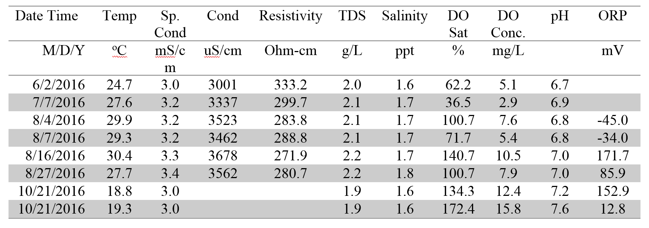

ICP-OES Sample Raw Data
Table 8.2.1: Total Metals Concentrations in Algae for Nickel and Zinc
Where:
Exp 1 - Growth Phase
Exp 2 - Chilled Phase
Exp 3 - Decomposition Phase
Rep - Replicate
[dig. Soln.] mg/L |  | [Ni] | [Zn]
Initial Samples | Rep 1 | 209.22 | 1234.41
Initial Samples | Rep 2 | 196.47 | 1006.34
Initial Samples | Rep 3 | 224.12 | 1398.25
Cell 6 Water Solution | Exp1Rep1 | 222.34 | 1368.57
Cell 6 Water Solution | Exp1Rep2 | 215.10 | 1311.56
Cell 6 Water Solution | Exp1Rep3 | 215.96 | 1360.50
Cell 6 Water Solution | Exp2Rep1 | 213.30 | 1294.78
Cell 6 Water Solution | Exp2Rep2 | 207.15 | 1440.90
Cell 6 Water Solution | Exp2Rep3 | 211.65 | 1414.32
Cell 6 Water Solution | Exp3Rep1 | 260.70 | 1245.66
Cell 6 Water Solution | Exp3Rep2 | 235.25 | 1691.39
Cell 6 Water Solution | Exp3Rep3 | 255.31 | 1603.98
0.5 mg/L Solution | Exp1Rep1 | 278.92 | 1413.62
0.5 mg/L Solution | Exp1Rep2 | 266.23 | 1246.85
0.5 mg/L Solution | Exp1Rep3 | 264.48 | 1327.23
0.5 mg/L Solution | Exp2Rep1 | 287.64 | 1465.94
0.5 mg/L Solution | Exp2Rep2 | 289.84 | 1374.41
0.5 mg/L Solution | Exp2Rep3 | 306.65 | 1746.06
0.5 mg/L Solution | Exp3Rep1 | 483.30 | 1722.78
0.5 mg/L Solution | Exp3Rep2 | 418.25 | 1416.24
0.5 mg/L Solution | Exp3Rep3 | 439.85 | 1748.54
2 mg/L Solution | Exp1Rep1 | 425.36 | 1620.37
2 mg/L Solution | Exp1Rep2 | 416.18 | 1667.03
2 mg/L Solution | Exp1Rep3 | 440.85 | 1554.85
2 mg/L Solution | Exp2Rep1 | 457.25 | 1771.39
2 mg/L Solution | Exp2Rep2 | 448.80 | 1662.94
2 mg/L Solution | Exp2Rep3 | 436.59 | 1606.33
2 mg/L Solution | Exp3Rep1 | 745.61 | 1768.20
2 mg/L Solution | Exp3Rep2 | 841.17 | 1793.77
2 mg/L Solution | Exp3Rep3 | 834.08 | 2022.03
5 mg/L Solution | Exp1Rep1 | 665.39 | 2210.60
5 mg/L Solution | Exp1Rep2 | 680.81 | 2060.74
5 mg/L Solution | Exp1Rep3 | 625.28 | 2172.10
5 mg/L Solution | Exp2Rep1 | 781.10 | 2139.39
5 mg/L Solution | Exp2Rep2 | 715.25 | 2115.11
5 mg/L Solution | Exp2Rep3 | 682.94 | 2262.98
5 mg/L Solution | Exp3Rep1 | 2066.99 | 3553.79
5 mg/L Solution | Exp3Rep2 | 1566.49 | 2889.12
5 mg/L Solution | Exp3Rep3 | 1602.25 | 2793.56
10 mg/L Solution | Exp1Rep1 | 939.05 | 2919.53
10 mg/L Solution | Exp1Rep2 | 883.40 | 2865.62
10 mg/L Solution | Exp1Rep3 | 978.54 | 2509.83
10 mg/L Solution | Exp2Rep1 | 978.67 | 2367.71
10 mg/L Solution | Exp2Rep2 | 876.53 | 2565.78
10 mg/L Solution | Exp2Rep3 | 849.58 | 2399.65
10 mg/L Solution | Exp3Rep1 | 2264.15 | 3629.30
10 mg/L Solution | Exp3Rep2 | 2525.04 | 3836.45
10 mg/L Solution | Exp3Rep3 | 2318.28 | 3388.37
20 mg/L Solution | Exp1Rep1 | 1676.32 | 3966.56
20 mg/L Solution | Exp1Rep2 | 1479.92 | 3588.27
20 mg/L Solution | Exp1Rep3 | 1329.10 | 3597.04
20 mg/L Solution | Exp2Rep1 | 1525.96 | 3444.79
20 mg/L Solution | Exp2Rep2 | 1397.18 | 3412.70
20 mg/L Solution | Exp2Rep3 | 1695.95 | 3485.19
20 mg/L Solution | Exp3Rep1 | 4607.40 | 6223.96
20 mg/L Solution | Exp3Rep2 | 3312.79 | 4733.24
20 mg/L Solution | Exp3Rep3 | 4712.95 | 6707.92

Table 8.2.2: Algae Absorbed Metals for Nickel and Zinc
Where:
Exp 1 - Growth Phase
Exp 2 - Chilled Phase
Exp 3 - Decomposition Phase
Rep - Replicate
[dig. Soln.] mg/L |  | [Ni] | [Zn]
Cell 6 Water Solution | Exp1Rep1 | 181.16 | 1764.16
Cell 6 Water Solution | Exp1Rep2 | 194.20 | 1465.16
Cell 6 Water Solution | Exp1Rep3 | 200.51 | 1695.29
Cell 6 Water Solution | Exp2Rep1 | 168.76 | 1644.51
Cell 6 Water Solution | Exp2Rep2 | 175.04 | 1488.12
Cell 6 Water Solution | Exp2Rep3 | 178.10 | 1599.28
Cell 6 Water Solution | Exp3Rep1 | 262.29 | 1607.01
Cell 6 Water Solution | Exp3Rep2 | 275.60 | 1712.91
Cell 6 Water Solution | Exp3Rep3 | 246.82 | 1758.68
0.5 mg/L Solution | Exp1Rep1 | 256.04 | 2028.51
0.5 mg/L Solution | Exp1Rep2 | 231.51 | 1581.92
0.5 mg/L Solution | Exp1Rep3 | 229.39 | 1740.66
0.5 mg/L Solution | Exp2Rep1 | 219.04 | 1817.65
0.5 mg/L Solution | Exp2Rep2 | 222.06 | 1897.23
0.5 mg/L Solution | Exp2Rep3 | 246.21 | 2191.66
0.5 mg/L Solution | Exp3Rep1 | 369.87 | 1845.01
0.5 mg/L Solution | Exp3Rep2 | 330.65 | 1739.54
0.5 mg/L Solution | Exp3Rep3 | 408.92 | 1627.08
2 mg/L Solution | Exp1Rep1 | 339.44 | 1980.91
2 mg/L Solution | Exp1Rep2 | 366.53 | 1843.84
2 mg/L Solution | Exp1Rep3 | 323.72 | 2157.82
2 mg/L Solution | Exp2Rep1 | 353.91 | 2317.68
2 mg/L Solution | Exp2Rep2 | 353.37 | 2215.02
2 mg/L Solution | Exp2Rep3 | 332.13 | 2033.66
2 mg/L Solution | Exp3Rep1 | 682.66 | 1982.80
2 mg/L Solution | Exp3Rep2 | 781.25 | 2127.41
2 mg/L Solution | Exp3Rep3 | 832.09 | 2319.05
5 mg/L Solution | Exp1Rep1 | 510.91 | 2488.59
5 mg/L Solution | Exp1Rep2 | 485.03 | 2335.43
5 mg/L Solution | Exp1Rep3 | 496.13 | 2477.43
5 mg/L Solution | Exp2Rep1 | 648.50 | 2504.78
5 mg/L Solution | Exp2Rep2 | 480.69 | 2591.94
5 mg/L Solution | Exp2Rep3 | 498.58 | 2491.21
5 mg/L Solution | Exp3Rep1 | 1349.03 | 3006.34
5 mg/L Solution | Exp3Rep2 | 1495.14 | 3113.97
5 mg/L Solution | Exp3Rep3 | 1583.28 | 3019.91
10 mg/L Solution | Exp1Rep1 | 666.13 | 2824.06
10 mg/L Solution | Exp1Rep2 | 730.05 | 2836.90
10 mg/L Solution | Exp1Rep3 | 712.51 | 2587.94
10 mg/L Solution | Exp2Rep1 | 708.70 | 2507.52
10 mg/L Solution | Exp2Rep2 | 663.03 | 2391.25
10 mg/L Solution | Exp2Rep3 | 657.79 | 2531.75
10 mg/L Solution | Exp3Rep1 | 2585.55 | 4224.01
10 mg/L Solution | Exp3Rep2 | 2528.95 | 3941.77
10 mg/L Solution | Exp3Rep3 | 2980.79 | 4533.09
20 mg/L Solution | Exp1Rep1 | 1039.90 | 3026.75
20 mg/L Solution | Exp1Rep2 | 1019.49 | 2822.81
20 mg/L Solution | Exp1Rep3 | 849.53 | 3055.08
20 mg/L Solution | Exp2Rep1 | 838.96 | 2960.55
20 mg/L Solution | Exp2Rep2 | 794.08 | 2942.24
20 mg/L Solution | Exp2Rep3 | 891.35 | 2890.98
20 mg/L Solution | Exp3Rep1 | 3842.63 | 5151.70
20 mg/L Solution | Exp3Rep2 | 3888.10 | 5765.86
20 mg/L Solution | Exp3Rep3 | 4631.21 | 6425.21

