UNIVERSITY OF OKLAHOMA
GRADUATE COLLEGE

A CERAMIC ANALYSIS OF A CADDO VILLAGE SITE IN THE NORTHERN CADDO FRONTIER: AN ARCHAEOLOGICAL INVESTIGATION OF THE SCHOOL LAND I SITE (34DL64) IN DELAWARE COUNTY, OKLAHOMA

A THESIS
SUBMITTED TO THE GRADUATE FACULTY
in partial fulfillment of the requirements for the
Degree of
MASTER OF ARTS

By
JOHN E. HUEFFED
Norman, Oklahoma
2023

A CERAMIC ANALYSIS OF A CADDO VILLAGE SITE IN THE NORTHERN CADDO FRONTIER: AN ARCHAEOLOGICAL INVESTIGATION OF THE SCHOOL LAND I SITE (34DL64) IN DELAWARE COUNTY, OKLAHOMA

A THESIS APPROVED FOR THE
DEPARTMENT OF ANTHROPOLOGY

BY THE COMMITTEE CONSISTING OF

Dr. Scott Hammerstedt, Chair

Dr. Patrick Livingood

Dr. Asa R. Randall

Dr. Amanda Regnier

© Copyright by JOHN E. HUEFFED 2023
All Rights Reserved.

Acknowledgements

First, I would like to thank my Committee Chair, Dr. Scott Hammerstedt, who helped guide and mentor me through the analysis and the writing of this thesis. He was there to help me every step of the way and I greatly appreciate his support throughout my time as a graduate student. I would also like to thank the rest of my committee: Dr. Patrick Livingood, Dr. Asa Randall, and Dr. Amanda Regnier for their advice and guidance during the writing of this thesis.
I would also like to thank Dr. Marc Levine and Susie Fishman-Armstrong of the Sam Noble Museum who allowed the use of this collection that was used for the basis of this thesis. I would like to thank the entire staff of the Oklahoma Archeological Survey for their ever-present support, help, and guidance throughout my time as a graduate student at the University of Oklahoma.
Last, but definitely not least, I want to thank my family and friends for their support and encouragement during my time at OU. Without all these people mentioned above, graduate school and the writing of this thesis would have been infinitely more difficult and arduous. Thank you.
I also want to acknowledge and thank the Caddo Nation and the Wichita and Affiliated Tribes for their continued support of archaeology and the University of Oklaoma over the decades. Ultimately, this thesis is for them, and I am honored to have contributed what little I could to the archaeological knowledge of these people.

Table of Contents
List of Figures viii
List of Tables xi
Abstract xii
Chapter 1 Introduction and Research Questions 1
The Aims of this Thesis 3
Research Goals and Questions 4
Chapters Outline 4
Chapter 2 Regional Background 7
Climate and Environmental Background 7
Geology 8
Environment 8
Soils 9
Local Climate 10
Caddo Culture 11
Woodland Period Predecessors 11
The Emergence of Caddo Culture 12
Sustenance 13
Settlement Patterns 14
Houses and Other Structures 15
Political Structure 16
Relationship to the Mississippian Traditions 17
Regional Chronology 18
Spiro 22
Reed 24
Conclusion 27
Chapter 3 Area of Study 28
Location 28
Archaeological History of School Land I 31
The Works Progress Administration (WPA) and Roosevelt’s “New Deal” 32
WPA Archaeological Methods 34
Lathel F. Duffield’s Faunal Analysis 36
The Site 37
The Structures of School Land I 39
Structure 1 40
Structure 2 42
Structure 3 43
Structure 4 45
Structure 5 46
Structure 6 47
Structure 7 48
Structure 8 49
Structure 9 50
Observations 51
Chapter 4 Methods of Analysis 53
Ceramic Analysis 53
Attributes Recorded for All Sherds 53
Diagnostic Sherds: Attributes Recorded for Decorated Sherds 60
Diagnostic Sherd: Attributes Recorded for Rim Sherds 61
Diagnostic Sherds: Attributes Recorded for Handles 66
Ceramic Typology 67
Conclusions 69
Chapter 5 Results 71
Research Biases and Limitations 71
Results 74
Sherd Count and Averages 74
Tempers 75
Surface Treatments 77
Decoration Types 78
Ceramic Ware Types 82
Vessel Form 83
Results by Structure 84
Counts 85
Tempers 87
Surface Treatments 90
Decoration Types 93
Ceramic Ware Types 96
Vessel Form 98
Conclusion 100
Chapter 6 Discussion 101
Spatial Patterns 101
Temper 102
Vessel Forms 104
Surface Treatments 106
Sherds 111
Discussion 112
Chapter 7 Conclusion 144
Appendix 149
Appendix A: Ceramic Recording Form 150
Appendix B: Sherd Count by Structure 151
Appendix C: Sherd Percentages by Structure 152
Appendix D: Sherd Thickness Graphs 153
Appendix E – Select Ceramic Photographs 155
Red Filmed 155
Cord Marked 156
Incised 159
Appendix F: Ceramic Tempering of Select Harlan Phase Caddo Sites 161
Bibliography 162

List of Figures

2.1: Map of Woodland period cultures in the Red and Arkansas river basins…..…….................12
2.2: Eastern Oklahoma Caddo chronology as defined by Brown and refined by Rogers ………18
3.1: Map of Oklahoma with School Land I……………………………..……………………….29
3.2: The Arkansas basin of eastern of Oklahoma with School Land I and other select Caddo Sites……………………………………………...……………………………………………….29
3.3: Aerial Photograph from before the construction of the Pensacola Dam. …………………..30
3.4: Close up of the Elk River with Reed to the West near the Grand River junction and the approximate location of School Land I to the east………………………………………………30
3.5: Close up and the approximate location of School Land I within the red square……………31
3.6: Plan map of School Land I created by Duffield….…………………………………………37
3.7: Plan map of School Land I created by Hammerstedt…………………………….................38
3.8: Structure 1 plan view……………………………………………………………………..…40
3.9: WPA photograph of Structure 1; facing east……………………………………………..…41
3.10: Structure 2 plan view………………………………………………………………………42
3.11: WPA photograph of Structure 2B/C; facing northwest……………………………………43
3.12: Structure 3 plan view………………………………………………………………………43
3.13:WPA photograph of Structure 3; facing northwest………………………………………...45
3.14: Structure 4 plan view map…………………………………………………………………45
3.15: WPA photograph of Structure 4; facing east………………………………………………46
3.16: Structure 5 plan view………………………………………………………………………46
3.17: Structure 6 plan view………………………………………………………………………47
3.18: WPA photograph of Structure 6; facing southeast………………………………………...48
3.19: Structure 7 plan view………………………………………………………………………48
3.20: WPA photograph of Structure 7; facing north……………………………………………..49
3.21: Structure 8 plan view………………………………………………………………………49
3.22: WPA diagram of Structure 9……………………………………………………………....51
4.1: Size chart……………………………………………………………………………………54
4.2: Temper size and concentration chart………………………………………………………..58
4.3: Rim curvature……………………………………………………………………………….62
4.4: Rim forms…………………………………………………………………………………...63
4.5: Lip shapes…………………………………………………………………………………...63
4.6: Standard diameter-measurement template…………………………………………………..64
4.7: Vessel form flow chart………………………………………………………………………65
6.1: Distribution map of shell, grog, and limestone tempers…………………………………...101
6.2: Distribution map of sand and bone tempers, and for sherds where a temper was absent…103
6.3: Distribution map of bottles, bowls, and jars……………………………………………….104
6.4: Distribution of restricted vessels, unrestricted vessels, and unknown vessel forms………105
6.5: Distribution of plain sherds and sherds with a surface treatment…………………………107
6.6: Distribution of red filmed, incised/punctated, and burnished sherds……………………...108
6.7: Distribution of cord-marked, incised, and engraved sherds……………………………….109
6.8: Distribution of fingernail impressed, pinched, applique, punctated, handle peak.sherds.....110
6.9: All the decorated sherds associated with Structure 1……………………………………...118
6.10: Structure 1 red filmed incised punctated sherd…………………………………………...119
6.11: Incised sherds from Structure 2A………………………………………………………...121
6.12: Incised/punctated sherd and outline from Structure 2A………………………………….121
6.13: Structure 2B/C incised sherd with outline………………………………………………..122
6.14: Iwi Engraved incised/punctated sherds with outline……………………………………..123
6.15: Structure 3 applique sherd………………………………………………………………..125
6.16: Structure 3 engraved and incised sherds…………………………………………………125
6.17: Structure 3 fingernail punctated base/body sher…………………………………………126
6.18: Structure 3 incised/punctated (Pennington Punctated) sherd…………………………….127
6.19: Structure 3 pinched sherds………………………………………………………………..127
6.20: Structure 4 ceramic disc fragment………………………………………………………..129
6.21: Structure 4 applique sherds……………………………………………………………….130
6.22: Structure 4 engraved sherds………………………………………………………………131
6.23: Structure 4 sherds with multiple incisions on surface……………………………………131
6.24: Structure 4 pinched sherds………………………………………………………………..132
6.25: Handle peak rim sherd……………………………………………………………………133
6.26: Structure 5 incised sherds………………………………………………………………...134
6.27: Structure 6 complicated incised sherd……………………………………………………136
6.28: Structure 6 fingernail impressed………………………………………………………….137
6.29: Structure 6 fingernail impressed with applique nodes……………………………………137
6.30: Structure 6 pinched sherds………………………………………………………………..138
6.31: Structure 6 punctated base and body sherd………………………………………….........139
6.32: Structure 6 handle peak.......................................................................................................140
6.33: Structure 8 fingernail impressed sherds..............................................................................142
6.34: Structure 8 incised sherd and outline..................................................................................143
A.1: Ceramic Recording Form.....................................................................................................150
B.1: Sherd Count by Structure.....................................................................................................151
C.1: Sherd Percentages by Structrue............................................................................................152
D.1: Body Sherd Thickness.........................................................................................................153
D.2: Rim Sherd Thickness...........................................................................................................154
D.3: Base Sherd Thickness..........................................................................................................154
E.1: Red filmed sherds.................................................................................................................155
E.2: Cord-marked sherds from Structure 2A...............................................................................156
E.3: Cord-marked sherds from Structure 2B/C............................................................................156
E.4: Cord marked sherds from Structure 3..................................................................................157
E.5: Cord marked sherds from Structure 4..................................................................................157
E.6: Cord marked sherds from Structure 6..................................................................................158
E.7: Cord-marked sherds from Structure 8..................................................................................158
E.8: Shell tempered incised sherds from Structure 4...................................................................159
E.9: Grog and limestone tempered incised sherds from Structure 4............................................159
E.10: Incised sherds from Structure 6..........................................................................................160
F.1: Ceramic Tempering of Select Harlan Phase Caddo Sites...................................................161

List of Tables

2.1: Radiocarbon Dates from Reed……………………………………………………………....25
3.1: Radiocarbon dates from School Land I……………………………………………………..39
3.2: Dimensions of the structures of School Land I…………………………………………......52
5.1: The mean, median, and range of sherd length, thickness, and weight……………………....74
5.2: Sherd count and assemblage average based on landmarks………………………………….75
5.3: Primary temper count and percents…………………………………………………………75
5.4: Secondary temper counts and percent………………………………………………………76
5.5: Secondary tempers and their associated primary tempers…………………………………..77
5.6: Surface Treatments………………………………………………………………………….78
5.7: Decorated and plain sherds..........................................................................................……...78
5.8: Decoration types, including sherds with multiple decoration types………………………...79
5.9: Primary temper count by decorated and non-decorated sherds…………………………79-80
5.10: Tempers by decoration type………………………………………………………………..82
5.11: Percentage of decorated sherds by temper………………………………………………...83
5.12: Ceramic ware types………………………………………………………………………...83
5.13: Vessel types by counts and percentage of the assemblage………………………………...84
5.14: Sherd counts and percents from total assemblage................................................................85
5.15. Sherd counts and percents from structures...........................................................................86
5.16. Primary tempers by structure................................................................................................89
5.17. Secondary tempers by structure............................................................................................90
5.18. Decorated sherds by structure...............................................................................................93
5.19: Count and percents of decorated and non-decorated sherds by structure.............................94
5.20: Decoration type by structure...........................................................................................95-96
5.21: Ceramic ware types by structure.....................................................................................96-98
5.22. Vessel forms by structure..............................................................................................99-100

Abstract
School Land I was a Spiroan Caddo village site positioned near the northern periphery of the Caddo cultural area in present-day northeast Oklahoma. This site was excavated in 1939 and 1940 as a salvage attempt to gather what information they could before the site was destroyed by the subsequent flooding caused by the construction of the Pensacola Dam. The WPA uncovered 15 structures in nine areas along with an assortment of artifacts including ceramics, lithics, and faunal materials. The focus of this thesis is on the ceramic assemblage recovered from School Land I.
I analyzed 1,497 ceramic sherds for this study. No whole vessels were recovered. This analysis focused on physical attributes such as size, wall thickness, weight, temper, and surface treatment for all sherds. Diagnostic sherds such as decorated and rim, sherds underwent additional analysis. These ceramic attributes, along with sherd counts and ethnographic evidence, are used to interpret the structures of this site were used.
The results of my analysis will show various statistics concerning sherd counts and averages of the individual sherds and such attributes such as tempers, surface treatments, and decorations as they relate to the site as a whole and to individual structures. This data will be used to answer the questions: Are there any differences in the assemblages between buildings? If there is a difference between the structure’s assemblages, do these reflect time of occupation, or do they reflect different purposes and uses of those buildings?

Introduction and Research Questions
In this chapter I will give a brief overview of who the Caddo people are and the project area. I will then give an overview of this thesis. Lastly, I will present my research questions I wish to explore in this thesis.

The Caddo People
The proper name of the Caddo people is “Kadohadacho“ (Perttula 1992:6). The term “Caddo” is derived from the French abbreviation of Kadohadacho, which is a word that means “real chief” in the Kadohadacho dialect (Perttula1992:6; Wright 1986:47). The Caddo people lived in eastern Oklahoma, southwest Arkansas, east Texas, and northwest Louisiana from at least 2,500 years ago until they were removed to Oklahoma in 1859 (Perttula 2012:1). The pre-contact history of the Caddo people will be more thoroughly discussed in Chapter 2, but it is important to understand what is meant when I refer to the Caddo people.
In the broadest sense, the Caddo archaeological and cultural tradition represents an “archaeological concept [that is] recognizable primarily on the basis of a set of long-standing and distinct cultural, social and political elements that have temporal, spatial, and geographic connotations” (Perttula 1992:7). What these elements are exactly has no simple answer and is difficult due to the variability in cultural expressions, use of landscapes, subsistence strategies and use of cultivated plants, interactions with neighbors, social and political practices, and the tempo of cultural changes (Perttula 2012:1). However, in basic terms, the Caddo archaeological traditions can be characterized by dispersed but sedentary settlements, a horticultural to agricultural economy, and a complex sociopolitical structure denoted principally by mound centers and the differential treatment of the dead by rank (Perttula 1996:297).
Since the 1940’s it has been common practice for archaeologists to refer to the archaeology of this broad area as the “Caddoan area” or as “Caddoan” despite problems that arose when archaeologists were reluctant to link a linguistic label with the archaeological record of indigenous peoples who lived in a specific geographic area (Perttula 2012:1-2). The term “Caddoan” is a linguistic term that was first used by John Wesley Powell in 1891 to refer to a language family that has two branches: Northern Caddo (which includes the Pawnee, Arikara, Kitsai, and Wichita languages), and the Southern Caddoan (which includes the Caddo language) (Perttula 1992, Perttula 2012:2).
In this paper I use the word “Caddo” to refer to the people who spoke Southern Caddoan. Using the term “Caddoan” to refer to the people is a misnomer. “Caddoan” only refers to the language, not the people, and as such the term “Caddoan” will not be used in this paper to refer to the people, their material culture, or the archaeological sites they left behind.
The Caddo people described in this thesis only represent a relatively short span of time in an otherwise long and continuous history of the Caddo people. It is important to note that the Caddo are not just an archaeological culture or a subject of history. The Caddo people exist and thrive to this day. Presently, they are called the Caddo Nation, but these modern peoples are the descendants of the people I discuss in this paper, and it is important to understand that the Caddo heritage still persists.

The Aims of this Thesis
The Caddo people have been extensively studied by archaeologists for roughly a hundred years. Most of what archaeologists understand about the Caddo people come from a misplaced focus and emphasis on the remarkable mortuary findings and Southeastern Ceremonial Complex artifacts discovered at the Spiro Mounds site in eastern Oklahoma (Brown 1996; Perttula 2012:4). Archaeologists have used the findings from Spiro and other mortuary mounds as a representation of the Caddo archaeological record (Perttula 2012:4). While archaeologists were able to learn a lot about the Caddo people and their culture from the Spiro artifacts, these artifacts reveal one aspect of Caddo life and society.
Almost everything we know about the Caddo people before European contact comes from archaeological excavations of Caddo mound sites. Investigations into village sites are rare. Known Caddo village sites without a mound context in the Arkansas Valley are extremely limited. What I present here is an investigation of one such Caddo village site called School Land I in northeast Oklahoma. With these findings, I hope to broaden the archaeological knowledge of the Caddo people and to bring to light what a Caddo village in the Arkansas Basin might look like.
I focused my investigation on the ceramic assemblage of School Land I. The research into School Land I’s ceramic assemblage can be used to answer a broad range of research questions, both inter-site and intra-site. This thesis examines the ceramic assemblage and attempts to discern any patterns and trends that can be observed within School Land I.

Research Goals and Questions
This thesis has two main goals. The first goal is to convey the data that has been obtained thus far from the analysis of the School Land I ceramic assemblage. The second goal is to seek answers on what, if any, patterns, can be observed from the data provided. The data should help answer questions such as: Are there differences in the assemblages between houses? And how do the ceramic assemblages from each house compare in terms of chronology, density, vessel form, and ceramic type? Understanding these patterns in the ceramic assemblage can potentially help answer more specific questions such as what were the people living at this site doing? The ceramic assemblage data from my analysis will be used to address the following questions: Are there any differences in the assemblages between buildings? If there is a difference between the structure’s assemblages, do these reflect time of occupation, or do they reflect different purposes and uses of those buildings?
By looking at the data and any trends in the ceramic assemblage of School Land I, it is then possible to look at the ceramic assemblages of other sites, both mound and non-mound, and make certain inferences based on a comparative analysis. By comparing School Land I’s ceramic assemblage with other Caddo sites, more broader questions might be answered that relate to Caddo village site patterns, the activities of non-elite Caddo peoples, and where School Land I fits in the greater Caddo world.

Chapters Outline
Chapter 2 provides a general background about the region of northeast Oklahoma and the Caddo people. The regional background includes a brief description of the geology, the physical environment, the soils, and the climate of northeast Oklahoma. The cultural background briefly describes the origins and development of Caddo culture. I will also describe Caddo subsistence practices, settlement patterns, architecture, political structure, relationship with Mississippian traditions, and provide a regional chronology for Caddo culture in eastern Oklahoma. I will also provide a relatively short description of the Spiro and Reed mound sites as part of a regional cultural context.
Chapter 3 discusses the area of study. This chapter will describe School Land I’s physical location and will have maps and aerial photographs showing where the site is located. Then I will discuss the site itself with a focus on the individual structures. Lastly, I will discuss the archaeological history of the site. Under this section I will describe the role of the WPA, its methodology, and end with Lathel Duffield’s (1969) faunal analysis of the site.
Chapter 4 recounts the analytical methods performed on the ceramic sherds of School Land I for this thesis. This chapter details the methodological approach taken for this study and includes the attributes recorded for every sherd. Chapter 4 ends with the ceramic typology used for this thesis.
Chapter 5 provides the results of the ceramic analysis. This chapter presents the statistics established from the results of the ceramic analysis. Sherd counts and percentages are used to detail these results. Results are first presented as parts of the whole ceramic assemblage. Then the results are presented again as they relate to the specific structures on the site.
Chapter 6 is the final chapter and will go over the discussions and conclusions based on the ceramic analyses of this site. This chapter will describe the spatial patterns of tempers, vessel forms, and surface treatments. Then the significance of certain sherds (including diagnostic sherds) will be discussed. Next, will come the key findings gleaned from the ceramic assemblage. This chapter ends with a presentation of the conclusions made from this ceramic analysis, followed by my conclusions in Chapter 7.

Regional Background

This chapter will provide the necessary regional context to place School Land I in its environmental context and connect it to the archaeological record. I will first cover the pertinent climate and environmental background including the local geology, environment, soils, and climate. I will then present broad overviews of the Caddo people with a focus on eastern Oklahoma. This overview of the Caddo people will include Caddo cultural precursors and the emergence of a distinct Caddo culture, sustenance, structures and settlement patterns, political structures, Caddo relationship with the Mississippian traditions, and regional chronology. Lastly, I will discuss the Spiro and Reed sites and their relationship to School Land I.

Climate and Environmental Background
Oklahoma is a climatic and environmentally diverse state. Annual rainfall can range between 43 cm (17 inches) at Kenton in the western panhandle and 142 cm (56 inches) in southern LeFlore County near the state’s eastern border (Albert and Wyckoff 1984:1). Elevation ranges from the lowest point of around 110 m (350 feet) in the state’s southeastern corner along the Red River, to the state’s highest point on the Black Mesa (4,368 feet (1,516 m) above sea level) in the panhandle’s northwestern corner (Albert and Wyckoff 1984:1). Temperatures in the state can range from an average of 56ºF in the Panhandle to 64ºF in the state’s southwest corner (Sutherland 1977:40).
Oklahoma consists of seven biotic districts, the short-grass plains, mixed-grass, Osage Savanna, Cherokee Prairie, Mississippi, Ouachita, and Ozark districts (Albert and Wyckoff 1984:3). Each biotic district reflects the predominant habitat and the major plant communities of the state. School Land I is in the Ozark district which extends along Oklahoma’s northeast corner encompassing the Ozark Plateau (also called the Ozark Uplift) in the north and the Boston Mountains in the south (Albert and Wyckoff 1984:3).

Geology

Oklahoma can further be divided into different geomorphic provinces that are defined by specific regional geographies. School Land I is situated within the Ozark Plateau geomorphic province (Albert and Wyckoff 1984:3). The Ozark Plateau occupies an area of approximately 40,000 square miles that crosses the states of Arkansas, Missouri, and Oklahoma.
The Ozark Plateau consists of dissected limestones, cherts, and dolomites formed during the Cambrian, Ordovician, and Mississippian periods (Albert and Wyckoff 1984:3). The plateau is primarily made up of limestones and shales (Goodman 1977:17). Locally, these rock formations are overlain by a thin veneer of terrace gravels and alluvium (Huffman et al 1958:1).
The entire region of Oklahoma’s Ozark Plateau lies within the drainage basin of the Arkansas River (Hoffman et al. 1958:11). The Oklahoma portion of the Ozark Plateau has streams that drain west and south to the Grand (Neosho) and Arkansas Rivers (Goodman 1977:17). The confluence of the Grand and Arkansas River is just west of the Ozarks (Goodman 1977:17). The Grand River is a mature river with broad and fertile floodplains and the Elk River is a west flowing tributary of Grand River (Hoffman et al. 1958:11).

Environment

The Ozark Plateau is dominated by dense oak-hickory forests (Albert and Wyckoff 1984:17). The western edge of the Ozarks is a forest-prairie border that marks the boundary to the Neosho Lowland geomorphic province to the west. The most abundant trees on the uplands and dry slopes are blackjack oak, post oak, black hickory, and winged elm (Albert and Wyckoff 1984:17). In protected areas, the dominant trees are sugar maple, hop hornbeam, redbud, flowering dogwood, linden, white oak, and chinquapin oak flourish (Albert and Wyckoff 1984:17). Along the streams, forests of silver maple, red birch, American elm, cottonwood, sycamore, linden, and several species of oak grow (Albert and Wyckoff 1984:17).
Common animals in the Ozarks include deer, beaver, mink, fox, woodchuck, rabbits, skunk, muskrat, passenger pigeon, hawks, owls, sunfish, catfish, lizards, and snakes (Albert and Wyckoff 1984:3).

Soils

The soils of the Ozark are Ultisols developed from sedimentary bedrocks (Albert and Wyckoff 1984:17). These are acidic soils with a high clay content that form in warm, humid climates with seasonal deficiency in rainfall (Albert and Wyckoff 1984:17; Goodwin 1977:14). Due to some portions of the year when precipitation exceeds evaporation, leaching of the soils occurs (Albert and Wyckoff 1984:17). The soils of the Ozark Plateau are considered to have low fertility and are not extensively used for agriculture (Albert and Wyckoff 1984:17). In the present day, agriculture is largely done in the deeper alluvial soils in the valleys (Albert and Wyckoff 1984:17).
Since School Land I is currently underwater, having been flooded by the construction of the Pensacola Dam, accurate soil profiles cannot be established. However, I will briefly describe the current soil profile found closest to where School Land I used to be. The soils nearest to School Land I are predominantly (80%) from Clarksville series, which is a very gravelly silt loam (USDA 1970, soilweb 2023). The Clarksville series is in the soil order of Ultisols, suborder of Udults, greatgroup of Paleudults, subgroup of Typic Paleudults, and family of Loamy-skeletal, siliceous, semiactive, mesit Typic Paleudults (soilweb 2023). The Clarksville series consists of deep soils that have a cherty and stoney, medium textured surface layer and a cherty and stony, moderately fine textured or fine textured subsoil (USDA 1970). This soil is well drained to excessively drained and is rapidly permeable (USDA 1970, soilweb 2023). Clarksville series soil’s parent material is loamy colluvium over clayey residuum weathered from cherty limestone (USDA 1970, soilweb 2023).
A typical Clarksville profile will have the upper part of the surface stratum a dark-grayish brown stony silt loam about 1-2 inches thick (USDA 1970, soilweb 2023). The lower part of the surface stratum is a grayish-brown stony silt loam about 8-10 inches thick (USDA 1970, soilweb 2023). The surface stratum is very friable and is slightly acidic in the upper part and strongly acidic in the lower part (USDA 1970). The subsoil extends to a depth of 60 inches (USDA 1970, soilweb 2023). The subsoil is a strong-brown, friable, and very strongly acidic (USDA 1970, soilweb 2023). From 40-60 inches deep, the subsoil grades to chert beds and interlayers of brownish-yellow, friable, very strongly acidic, stony and cherty silty clay loam that is mottled with brownish, reddish, and grayish colors (USDA 1970, soilweb 2023).

Local Climate

The climate of northeastern Oklahoma tends to have hot, humid summers and cool, dry winters (Albert and Wyckoff 1984:17; Hoffman et al. 1958:8). There is wide seasonal variation with temperatures frequently reaching 100ºF in the summer and as low as 0ºF in the winter (Hoffman et al. 1958:8). The average summer temperature is 78ºF, while the winter average is about 38ºF (Hoffman et al. 1958:8). The annual rainfall is approximately 40 inches (Hoffman et al. 1958:8). The annual rainfall and local climate create a growing season of about 200 days and favors maize horticulture (Albert and Wyckoff 1984:17; Hoffman et al. 1958:8).

Caddo Culture

Woodland Period Predecessors

Caddo culture evolved from Woodland period mobile hunter and gatherer groups such as the Mulberry River Culture, Fourche Maline, Mill Creek, and Mossy Grove cultures around AD 800-850 (Early 2000: 126; Perttula 2012:7; Perttula 2017:43). The Woodland period for this region date between approximately 2450 to 1100 years ago (Perttula 2017:43). It has generally been the consensus by many archaeologists that Caddo culture evolved from the Fourche Maline culture (Perttula 2017:43). However, it is now believed that Caddo culture did not evolve from just one culture, but from several Woodland period cultures (Perttula 2017:44).
The exact mechanisms for the evolution from different Woodland period cultures into a distinct Caddo culture between AD 800-900 are not well understood (Perttula 2017:43). A distinct Caddo culture existed around AD 900, ushering in the Mississippian period. By the tenth century the Caddo culture was living in a series of sedentary and fundamentally complex societies that is believed to have been influenced by four factors (Perttula 2012). The first factor is the rise, elaboration, and maintenance of complex social and political symbols of ritual, ceremony, and authority that centered on the construction of earthen temple and burial mounds (Perttula 2012:7). The second factor is the development of elite status positions within certain communities (Perttula 2012:7). Third, an increasingly sedentary life and the establishment of both domestic and sacred places (Perttula 2012:7). And the last factor that contributed to a distinct Caddo culture is the expanding reliance on domesticated crops that developed into a horticultural economy with an intensification in maize production after the thirteenth century, which was also accompanied by an increase in population (Perttula 2012:8).
Figure 2.1: Map of Woodland period cultures along the Red River and Arkansas River basins (Pertulla 2017:44, Fig. 21)

The Emergence of Caddo Culture

The Caddo cultural sphere can be separated into the southern Caddo of Louisiana, east Texas, and southwest Arkansas, and northern Caddo of eastern Oklahoma, northwest Arkansas, and southwest Missouri (Perttula 2009). The southern Caddo inhabited the Red River basin while the northern Caddo lived in the Arkansas River basin. This division is not just geographic but also manifest culturally (Regnier et al. 2019; Lambert 2017)
By AD 900, a distinctively Caddo material culture emerged (Perttula 2017:48). The Caddo people lived in permanent settlements practicing horticulture in what is present day Louisiana, eastern Texas, western Arkansas, eastern Oklahoma, and southwestern Missouri Perttula 2017:48). They are often considered as habituating the western most extent of the Mississippian world that dominated the eastern United States at the time (Regnier 2017:178). The eastern Mississippian world greatly influenced Caddo culture, which included the adoption of the Mississippian Ceremonial Complex (Regnier 2017). While the Caddo culture was definitely influenced in certain aspects by the more eastern cultures of the Mississippian cultural spheres, they are their own people with their own distinct ethnicity, languages, and culture (Regnier 2017:198).

Sustenance

The Caddo cultivated a number of crops including gourds, squash, and beans; beans appear to have become an important crop after c. AD 1300 (Early 2000:126; Perttula 2012:8; Perttula 2017:48). The Caddo also consumed a wide variety of wild plants like maygrass, amaranth, chenopods, and sunflowers (Early 2000:126, Perttula 2012:8). Evidence for maize cultivation come as early as AD 400, however, it did not become a staple of the Caddo diet until around AD 1300 (Perttula 2008; Perttula 2012; Wilson 2012).
The Caddo of eastern Oklahoma are known to have hunted a diverse variety of animals. Deer appears to be the most important source of meat for the Caddo people (Perttula 2012:8). They are also known to have hunted a variety of other animals including other mammals such as rabbits, opossum, squirrel, gopher, beaver, coyote, fox, raccoon, and otter (Wyckoff 1980:451). Avian prey include prairie chickens, turkeys, and egrets (Wyckoff 1980:451). They also ate fish, mussels, and turtles (Wyckoff 1980:451). In winter they hunted bear, ducks, geese, and, on occasion, bison (Perttula 2012:8, Wyckoff 1980:445).
Bison was seldom hunted by early Caddo people (Wyckoff 1980:500). Bison were not native to eastern Oklahoma at this time, and people would have had to travel great distances into the Great Plains to hunt or trade for bison. It wasn’t until about AD 1200 that bison began to live in the area (Rogers 2006). Due to climatic changes that began a long drought in the 14th and 15th centuries that saw the expansion of a plains environment that encroached into eastern Oklahoma, along with a diminishing woodland environment, bison were able to grow in number and expand into new territory (Bryson and Murray 1977:33-41). This allowed the Caddo people to hunt bison more frequently, and by the late Caddo period (about AD 1450), bison had become a staple of the northern Caddo diet (Wyckoff 1980:500).

Settlement Patterns

Caddo people lived primarily in dispersed communities led by a social hierarchy of civic leaders, priests, and other elites (La Vere 1998:12; Perttula 2017:48). Two distinct settlement types were utilized by the Caddo people, civic-ceremonial centers and small residential villages (La Vere 1998:12; Early 2000:126). The civic ceremonial centers used earthen mounds as platforms for temple structures used for religious and civic functions, for the burial of the political and social elite, and for ceremonial fire mounds (Perttula 2012:8). These civic ceremonial centers and the largest villages were primarily located along the major rivers of the Red, Arkansas, Grand, Little, Ouachita, and Sabine Rivers (Perttula 2012:8).
Caddo residential villages consisted of dispersed and isolated farmsteads (a single house), hamlets (two or three houses), and a few larger villages (four or more houses) (Perttula 2012:8; Wyckoff 1980:234). These residential settlements were as much as 30 kilometers from the civic-ceremonial centers (Perttula 1993:93). Most habitation sites in the Arkansas Valley are relatively small with half of the recorded sites being 1.5 ha or less in size (Brown 1996:33). The largest recorded habitation site is the Horton site at 8 ha (Brown 1996:33). The next largest is the Littlefield I site at 4 ha, which has been extensively excavated and has revealed the remains of at least 15 regularly arranged structures oriented on cardinal directions (Brown 1996:33).

Houses and Other Structures

The Caddo peoples lived in dispersed but sedentary communities made-up of structures of various forms and construction methods (Perttula 1993:93; Perttula 2012:8). The shape and building practices of a structure was largely influenced by the geographic location (northern or southern Caddo region) and the purpose of the structure (Perttula 2009). In the Southern Caddo region, along the Red River basin, they mostly built their homes from grass and cane in a circular shape. In the Northern Caddo region, along the Arkansas River basis, their structures were timber-framed with wattle and daub walls that were made up of upright poles placed in individual postholes or trenches and were square to rectangular in shape (Thoburn 1931:64, Wyckoff 1980:233-4).
Inside the structures of the Arkansas River basin were larger center posts to support a thatched roof (Swanton 1996:150; Thoburn 1931:64; Wyckoff 1980:233). The number of center posts depended on the shape of the structure. Circular structures had one center post, while rectangular structures had two, and square structures had four center posts (Swanton 1996:150). Ethnographic sources describe the circular houses of the southern Caddo region as having between two and ten families living in each house structure (Swanton 1996:148). Ethnography also tells us that those of higher status had bigger houses (Swanton 1996:150-1). There are distinctive geographical distinctions from the north and south Caddo areas in the distribution of circular versus rectangular structures (Perttula 2009:31).
Circular structures were constructed of grass and cane, were sixty feet in diameter, 40-50 feet tall, and were shaped like a beehive (Swanton 1996:148). Circular structures were only constructed in the southern and central Caddo regions (Perttula 2009:31). Not all structures in the south or central regions were circular; rectangular structures were also built in the south; however, circular structures were the dominant form (Perttula 2009:31).
People living in the northern Caddo region appeared to have only built square or rectangular structures (Perttula 2009; Regnier et al. 2019:311; Wyckoff 1980:233-34). It is generally believed that rectangular structures are more recent than square ones, but there is likely some overlap (Dr. Scott Hammerstedt 2023; personal communications). In the north, square structures were more pervasive than rectangular structures (Regnier et al. 2019:311). For at least east Oklahoma, the floor sizes measurements ranged between 21.2-171.8 m² with a mean of 51.9 m² (Regnier et al. 2019:311). Hearths appear to be rare in structures in the Arkansas drainage (Rogers 1982:87).

Political Structure

Caddo civic-ceremonial centers were separate and independent of each other despite all being similarly linguistically and culturally (Swanton 1996:170; La Vere 1998:13). In Caddo society there were three prominent socially prominent people: the xinesi (priest), the caddi (headman), and the canahas (elders) (Wyckoff & Baugh 1980). Each civic-ceremonial center had its own xinesí, who functioned as a religious leader (La Vere 1998:14; Wyckoff & Baugh 1980:234). Caddo government was in essence a theocracy with the xinesi serving not only as the political leader, but also as the religious high priest (La Vere 1998:14). Xinesi were considered sacred and led or participated in the special ceremonies and rites that maintained the people’s relationship with the gods (La Vere 1998:14; Wyckoff & Baugh 1980:234).
Directly under the xinesí were the caddí and canahas (Swanton 1996:170; La Vere 1998:16; Wyckoff & Baugh 1980:234). While the xinesí governed as a chief to a large multi-community chiefdom, the caddí were responsible over the governance of a single community (Le Vere 1998:16; Wyckoff & Baugh 1980:234). Assisting a caddí was an advisory council made up of elders, or canahas, from the outlying hamlets that were spread around the community’s central village (La Vere 1998:16). It was the responsibility of the caddi and the canahas to perform governmental functions (Wyckoff & Baugh 1980:234)
Under the authority of the xinesí, the caddis, and the canahas, were minor functionaries that did not take part in the decision-making process. Each village also had its own medicine man called a conna (La Vere 1998:18). Connas handled the medicine and attempted to cure people of ailments through prayer, rituals, and divination (La Vere 1998:18). Despite not participating in political decisions, connas were considered very important in Caddo society (La Vere 1998:18).

Relationship to the Mississippian Traditions

The Caddo cultural tradition has often been labeled as an extension of the Mississippian tradition from the North American Southeast. The Caddo area has often been called the western edge of the Mississippian world by archaeologists (Perttula 2012:4). This concept, however, seems to be slowly losing popularity. Caddo cultural tradition evolved independently from the emergence of the Mississippian developments in the Southeast (Perttula 1996:297). While Caddo tradition shared much with Mississippian traditions, including, the adoption of maize and the intensification of maize agricultural economies, similar platform and burial mound construction, as well as systems of social authority and ceremony it is clear that Caddo traditions are not clear representations of a Mississippian expression (Perttula 1996:298; Perttula 2012:4; Regnier 2017). Caddo tradition cannot be seen as directly comparable with, or temporally synchronous with, the of Mississippian groups from the Southeast (Perttula 1996:298).

Regional Chronology

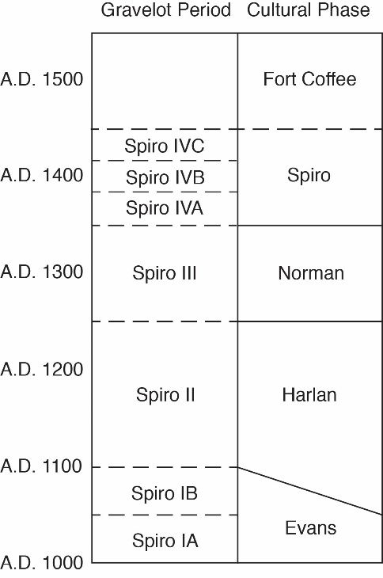
The Caddo chronological framework was originally developed in the 1940s but has since undergone several revisions and it is recognized that it varies by region (Perttula 2012:11). The regional chronology for eastern Oklahoma (Figure 2.2) was defined by Brown and slightly refined by Rogers (Brown 1996; Rogers 2011). This chronology was defined by Brown on the basis of detailed seriation of grave lots and radiocarbon dates from Spiro (Brown 1996). Through his analysis, Brown recognized five phases: Evans, Harlan, Norman, Spiro, and Fort Coffee (Brown 1996). Even though this chronology was specifically tailored for Spiro, it has been found to work just as well for northern sites that postdate AD 1100 such as Reed (Hammerstedt & Savage 2021:114).
Figure 2.2: Eastern Oklahoma Caddo chronology as defined by Brown and refined by Rogers (Brown 1996; Rogers 2011)
The Evans phase begins approximately AD 950 and lasted until approximately AD 1100 and coincides with the formative Caddo period (Brown 1996; Regnier et al. 2020:21; Rogers 2011:2). During this phase, grog temper was introduced to strengthen the walls of the ceramic vessels (Hammerstedt & Savage 2021:106; Regnier et al. 2020:21). These vessels were locally made versions of grog tempered pottery found in the Lower Mississippi Valley (Regnier et al. 2020:21). The vessels made during the Evans phase include decorated types called Coles Creek and French Fork Incised, as well as thick flat-bottomed Williams Plain jars (Hammerstedt & Savage 2021:106; Regnier et al. 2020:21). These thick flat-bottomed jars were most likely being used for stone boiling, which is a technique of indirect cooking where pots are filled with fire-heated rocks in order to bring the water in the vessel to the desired temperature (Regnier et al. 2020:21). The Evans phase is predominantly known from the premound burials beneath the Craig Mound at Spiro and the buildings beneath buried structure mounds (Regnier et al. 2020:21).
The later Harlan phase is dated between approximately AD 1100 – AD 1250 (Brown 1996; Regnier et al. 2020:21). During this phase, archaeologists see an intensification in the construction of burial, platform, and house mounds (Regnier et al. 2020:21). The Harlan phase is identified by the introduction of finely made ceramics that include Iwi (Spiro), Holly Fine Engraved, Hickory Engraved, Crockett Curvilinear Incised, and Pennington Punctate Incised ceramic types (Brown 1996; Hammerstedt & Savage 2021:107; Regnier et al. 2020:21). These fine ware ceramic types were imported from sites along the Red River (Lambert 2017; Regnier et al. 2020:21). Shell tempered vessels were first made during this phase (Regnier et al. 2020:21). Potters also introduced red clay slip to some vessels (Regnier et al. 2020:21). Most of the outlying mound sites in the Arkansas River drainage were established during the Harlan phase (Regnier et al. 2020:21).
The Norman phase lasted from approximately AD 1250 to AD 1350 (Brown 1996; Regnier et al. 2020:21). During this phase shell tempered pottery became increasingly common in both burial and domestic assemblages. Strap handles found on jars would frequently have handle peaks during this phase (Hammerstedt & Savage 2021:108). Several ceramic vessel types were common during this including: Poteau Plain, Woodward Applique, and Braden Punctate (Hammerstedt & Savage 2021:109; Regnier et al. 2020:23). Burial goods were becoming increasingly elaborate (Regnier et al. 2020:23). Stamped-sheet copper artifacts, undecorated marine shell, decorated stone earspools, and the use of red and green clays, and pigments were introduced as burial goods (Regnier et al. 2020:23).
The Spiro phase began approximately AD 1350 and lasted until approximately AD 1450 (Brown 1996; Regnier et al. 2020:23). The Spiro phase is marked by the change of the predominant building type from square to rectangular, with two central support posts instead of four (Regnier et al. 2020:23). Ceramics of this phase are primarily shell tempered Woodward and Poteau Plains, and the vessels have notched or scalloped rims (Regnier et al. 2020:23). Cemeteries from this phase also include ceramic types more frequently found along the Red River (Regnier et al. 2020:23).
The Fort Coffee phase begins approximately AD 1450 and reflects major cultural shifts (Brown 1996; Regnier et al. 2020:23; Rogers 2006; Rohrbaugh 2012). The beginning of this phase is contemporaneous with the abandonment of Spiro that was precipitated by long-term droughts and an eastward shift of the Great Plains grassland environment into the eastern woodlands forest environment (Regnier et al. 2020:23; Rohrbaugh 2012). During this phase, artifacts increasingly resemble those typical of groups living on the Plains (Regnier et al. 2020:23). This cultural shift is further reflected by shell tempered jars becoming dominant in the ceramic assemblages, large outlying cemeteries expanding, and faunal and floral materials showing a shift towards bison hunting and an increase in maize production (Regnier et al. 2020:23; Rohrbaugh 2012).
The chronology above was based on the grave goods recovered from Spiro but is applicable to eastern Oklahoma (Hammerstedt and Savage 2021). This is due to the common cultural core shared among the Caddo people who occupied the Arkansas River drainage. It has long been recognized that while the Caddo from the Arkansas River and Red River drainages shared a common cultural core, however, noticeable differences include burial practices, house shape, and ceramics (Hammerstedt and Savage 2021:99; Regnier et al. 2019). The predominant site in the Arkansas River basin was Spiro. Many artifact types found in eastern Oklahoma were originally named after and defined based on the collection from Spiro.

Spiro

Spiro is a civic-ceremonial mound complex site situated on the southern banks of the Arkansas River in what is now Le Flore County Oklahoma near the Oklahoma-Arkansas border. Spiro comprises of approximately 33 ha (80 acres) and consists of the Craig Mound (a conjoined burial mound with four lobes), two platform mounds (Brown and Copple), 10 house mounds, and other non-mound structures (Brown 1996:15-16). It is best known because of the discoveries made from Craig Mound.
Craig Mound is a conjoined mound made up of four overlapping cones set in a line roughly running in a northwest to southeast direction (Brown 1996:53). The largest and main mound cone is situated at the northwestern end and the cones get sequentially smaller to the southeast. In 1933, the landowner’s guardian (the owners were orphaned children) who oversaw Craig Mound at the time leased out mining rights for the mound to a group of men calling themselves the Pocola Mining Company. The Pocola Mining Company obtained a two-year lease by using strong arm tactics and bribery (Brown 1996:41; Amanda Regnier, personal communication 2023). The Pocola Mining Company practiced uncontrolled and indiscriminate diggings and the artifacts have since been passed all over the world to numerous institutions and private collectors (Brown 1996:41). The types and amounts of artifacts that came from Craig soon gained the attention of a larger circle in the state of Oklahoma and of people all over the United States (Brown 1996:41).
In the summer of 1935, with only months left on the lease, the miners dug a tunnel into the center of the largest cone of Craig Mound where they made an unprecedented discovery (Brown et al. 2020:93). They had inadvertently discovered a hollow chamber within the main cone of Craig that was lined and sealed with wooden poles (Brown 1996:42) Within this hollow chamber was large amounts of highly crafted prestige goods such as engraved shells, shell beads, plain copper sheets, baskets, woven garments made from animal hair and feathers, cedar masks, and human remains (Brown 1996:42; Brown 2012:117). The sheer amount of these highly crafted objects concentrated in such a relatively small space soon gained the attention of the world, with one newspaper comparing it to the discovery of King Tutankhamun’s tomb in Egypt with an article titled “ A “King Tut” Tomb in the Arkansas Basin” (Brown 1996:43; MacDonald 1935; Regnier et al. 2020:28). This chamber has since been named the Spirit Lodge (Brown 2012:117; Brown et al. 2020).
The Spirit Lodge was an earth lodge-shaped hollow chamber framed with cedar poles (Brown et al. 2020:92). The floor of the Spirit Lodge was covered with artifacts that were spiritually charged and arranged as if they were in a sacred lodge outfitted for a public ritual (Brown et al. 2020:92). The artifacts discovered within the Spirit Lodge was deposited around AD 1400 and consisted of “exaggerated or hypertrophic weaponry and sacred objects, including masks, figurines, and other objects d’art representing or referring to specific culture heroes, all arranged in a diorama, or tableau” (Brown et al. 2020:94). To add to the wonder of the Spirt Lodge, many of the artifacts used came nearly every regional area of the Mississippian world, as well as California, and the Valley of Mexico (Singleton and Reilly 2020:11).
The placement of these objects was specific within the circular stage of the Spirit Lodge and featured all of the participants and instruments that were required for humans to interact with the spirit world (Brown et al. 2020:99). When taken as a whole, the assemblage of personages and their spatial arrangements within the Spirit Lodge represented all the actors required for a performance of having to do with a creation theme (Brown et al. 2020:106).
During the period when the Spirit Lodge was created, the larger Mississippian world was experiencing social upheavals and severe and persistent droughts (Brown et al. 2020:106). It has been postulated that the reason for the creation of the Spirit Lodge, with its creation themes and its associated rituals, was as a renewal ceremony (Brown et al. 2020:106).
Other features of Spiro include Brown mound and Copple mound. Brown mound is a large pyramidal mound that stood on the crest of the site’s upper terrace northwest of Craig mound (Brown 1996:105). This mound is about 200 feet north to south, and 174 feet east to west (Brown 1996:106). Copple mound is a platform mound on the upper terrace (Brown 1996:112). Copple mound measures approximately 60 feet in diameter and 8 feet high (Brown 1996:112).

Reed

Reed is worth describing due to its proximity to School Land I. It is a mound complex located on the first terrace of a broad bottomland near the confluence of the Elk and Grand Rivers in Delaware County, Oklahoma (Purrington 1971:354; Regnier et al. 2019:278). Reed was mostly likely the seat of political and spiritual power that School Land I was subject to. What we know of Reed comes from the excavations of twelve sites (34DL1-11, 34DL14 and the nearby Huffaker site (34DL12/13) which is likely part of the same complex). The Reed site encompassed at least 15 to 20 hectares, however that exact area is not clear (Regnier et al. 2019:245). This site’s major features are a large platform mound, a conjoined burial mound, and their associated habitation zones (Purrington 1971:354; Regnier et al. 2019:245).
Reed’s location at the edges of the western prairie and the eastern woodlands allowed access to different biotic regions which would have made Reed an ideal location (Regnier et al. 2019:278). Several radiocarbon dates have been taken (Table 2.1) and the major occupation of this site likely occurred during the Harlan and Norman phases (Regnier et al. 2019:278). These dates show that Reed was contemporaneous with School Land I.
Lab # | Context | Intercept | +/- | from | to | %
WIS-46 | DL1-submound structures | 1050 | 60 | 829 | 1155 | 95.4
WIS-49 | DL1-submound structures | 1070 | 80 | 775 | 1155 | 95.4
WSU-2832 | DL1-mount unit #1 | 805 | 55 | 1048 | 1288 | 95.4
Beta-7112 | DL1-large post or fire pit in profile floor | 690 | 50 | 1226 | 1397 | 95.4
WIS-243 | DL10-cache pit 1 | 750 | 55 | 1164 | 1387 | 95.4
WIS-249 | DL11- Sq 1:5 level 8 28-32" | 870 | 60 | 1025 | 1260 | 95.4
WIS-253 | DL11-Sq 3:7 level 9, 32-36" | 670 | 55 | 160 | 1406 | 95.4
WIS-247 | DL11-Sq 4:5 level 5, 16-20" | 890 | 55 | 1027 | 1252 | 95.4
WIS-250 | DL11-Sq 4:7 level 11, 40-44" | 840 | 60 | 1042 | 1276 | 95.4
WIS-251 | DL11-Sq 4:7 level 2?, 24-28" | 800 | 60 | 1046 | 1294 | 95.4
WIS-252 | DL11-Sq SE 1:26 level 2, 4-8" | 770 | 60 | 1053 | 1387 | 95.4
WIS-246 | DL11-Sq SE 1:4 level 4, 12-16" | 820 | 60 | 1044 | 1284 | 95.4
Beta-216725 | DL4 | 1010 | 40 | 900 | 1155 | 95.4
Beta-216726 | DL 8-north side of south house | 870 | 40 | 1042 | 1256 | 95.4
M-819 | DL8-north side of south house | 1100 | 150 | 658 | 1214 | 95.4
Beta-283284 | DL14-structure 2 | 900 | 50 | 1024 | 1223 | 95.4
Oxcal 4.1 Calibration
Table 2.1. Radiocarbon Dates from Reed. (Purrington 1971:Table 38; Regnier et al. 2019:258)

The Reed site was extensively damaged and looted by the time any formal excavation was attempted (Purrington 1971:354). The first WPA excavations began in 1937 as part of the salvage effort to mitigate the destruction caused by the construction of the Pensacola Dam (Regnier et al. 2019:245). By then, a dirt road had been constructed through the platform mound and the burial mounds were looted and largely destroyed by collectors (Purrington 1971:354). Due to certain limitations only certain portions of the site could be excavated; each portion received its own site trinomial number (Purrington 1971:354).
Reed consisted of one platform mound and a conjoined burial mound made up of two lobes (Purrington 1971:354; Regnier et al. 2019:247). The platform mound (34DL1) was circular in outline with a flattened top (Regnier et al. 2019:247). The circumference of this mound was 115 feet (35 meters) with a height of approximately 2.15 meters (7 ft) (Regnier et al. 2019:247). The mound was constructed in two major stages based on the mound’s stratigraphy (Regnier et al. 2019:247-8). The first stage had a rectangular outline but was still flattened on the top (Regnier et al. 2019:248). No features were recorded in the mound; however occasional ceramic sherds, stone implements, and bone and shell refuse were recovered (Regnier et al. 2019:248).
Despite no features being found in the mound, postholes were discovered under the mound (Regnier et al. 2019:248). These postholes outlined three houses superimposed on top of each other (Regnier et al. 2019:249). One house was 8.85 m², and the other two were 6.25 m² (Regnier et al. 2019:249). All three houses showed parallel trenches that seem to indicate extended entranceways (Regnier et al. 2019:249).
Like Spiro, Reed had a conjoined burial mound. The conjoined burial mound at Reed was made up of two peaks, a larger peak (34DL4) and a smaller peak (34DL5). It was about 15 m (50 ft) in diameter and was probably about 15 m (50 ft) tall (Regnier et al. 2019:266). This mound held 25 fragmentary burials and associated grave goods (Regnier et al. 2019:266-7). The grave goods consisted of both local and imported items (Regnier et al. 2019:267).
It is also worth discussing a section of Reed that had multiple structures (34DL2). This section of the Reed site (also called Reed 2) was about 550 feet (168 m) northwest of the mound group (Regnier et al. 2019:250). Reed 2 is a possible house mound that shows evidence of 12 structure outlines in two clusters (several of which are superimposed on top of one another) (Regnier et al. 2019:250). Ten of these structures were square and two were rectangular (Regnier et al. 2019:250). Four of these 12 structures showed evidence of extended entranceways, with all four entranceways facing southeast (Regnier et al. 2019:250-51).

Conclusion
This chapter briefly describes the climatic, environmental, and cultural background of School Land I. The climatic and environmental background shows that the site was near the western edge of the Ozark Plateau in the Arkansas River drainage basin and is dominated by dense oak-hickory forests (Albert and Wyckoff 1984:3&17; Hoffman et al. 1958:11). The cultural background showed that Caddo culture evolved from Woodland period mobile hunter and gatherer groups such as the Mulberry River Culture, Fourche Maline, Mill Creek, and Mossy Grove cultures around AD 800-850 (Early 2000: 126, Perttula 2012:7, Perttula 2017:43). By approximately AD 900 a distinct Caddo culture is recognizable (Perttula 2017:43). The Caddo hunted a variety of animals for food, though deer was by far the most prevalent (Perttula 2012:8; Wyckoff 1980:451). The Caddo also cultivated a number of crops including maize, gourds, beans, squash along with a variety of wild plants (Early 2000:126; Perttula 2012:8; Perttula 2017:48). There are two distinct settlement types utilized by the Caddo people, civic-ceremonial centers and small residential villages (La Vere 1998:12; Early 2000:126). In the northern Caddo region, structures were either square with four center posts or rectangle with two center posts (Perttula 2009).

Area of Study
In this chapter I will first describe the location of School Land I using descriptions, maps, and aerial photographs. Then I will describe the general layout of the site and include radiocarbon dates. I will next describe each structure individually with a focus on their dimensions, orientation, and the direction of their entrance ways. Lastly, I will discuss the archaeological history of the School Land I site. This will include a brief history of the WPA, the WPA field methods, and the 1969 Duffield faunal analysis.

Location
School Land I was located in northeast Oklahoma, in northern Delaware County approximately 1.7 km (1 mile) south of the Delaware/Ottawa County border and approximately 10 km (6.2 miles) west of the Oklahoma/Missouri state border. School Land I originally sat on a floodplain south of the Elk River. The site was approximately 3.2 km (2 miles) upstream from the confluence of the Elk and Grand (Neosho) Rivers. The Reed site sat on the southeast corner of this intersection. School Land I was approximately 3.4 km (2 miles) as the crow flies east of the Reed site.
The location of School Land 1 is not exactly known. The only location description for School Land I came from the WPA field notes which describe the site at NE1/4 NW1/4 of Section 16, Township 25 North, and Range 24 East. However, given this description, the location of School Land I can be referenced on topographic maps and historic aerial photographs with reasonable accuracy.

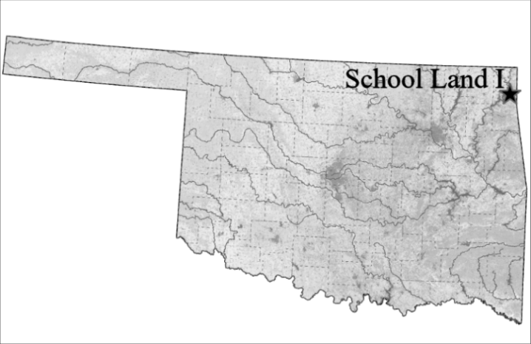

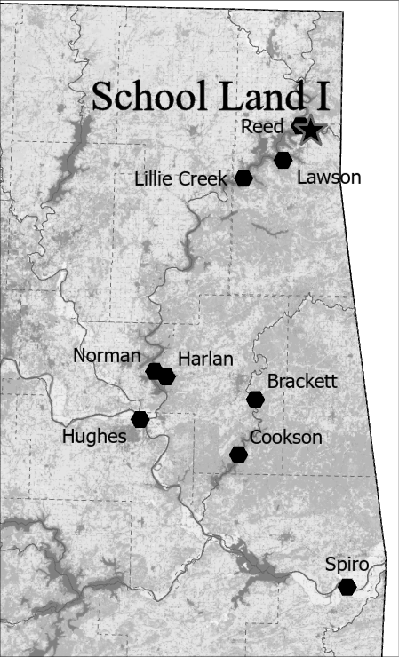

Above: Figure 3.1: Map of Oklahoma with School Land I site.
Right: Figure 3.2: The Arkansas basin of eastern Oklahoma with School Land I and other select Caddo sites.
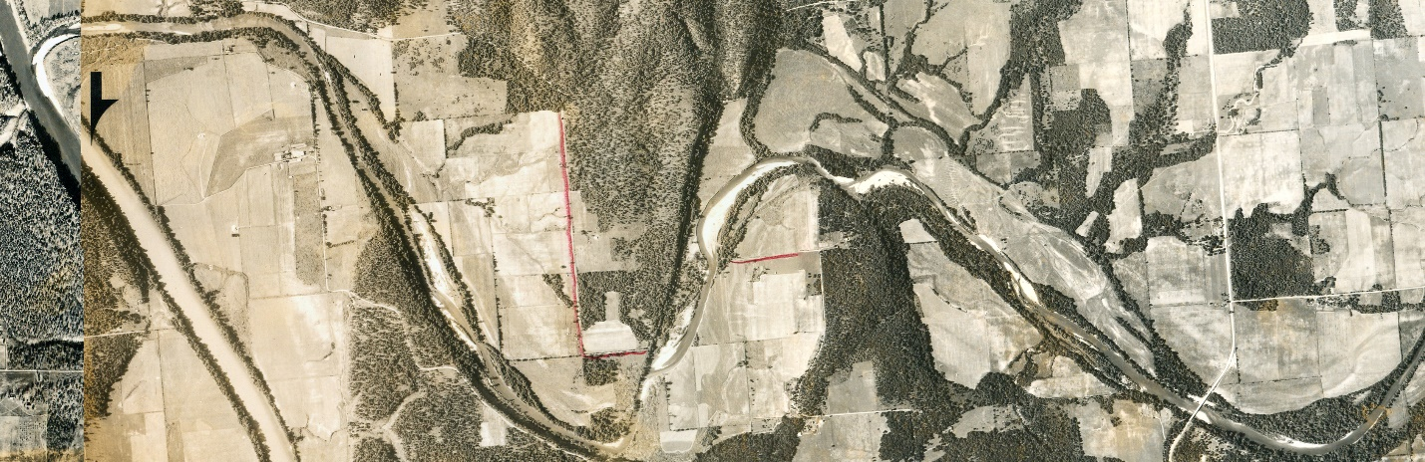
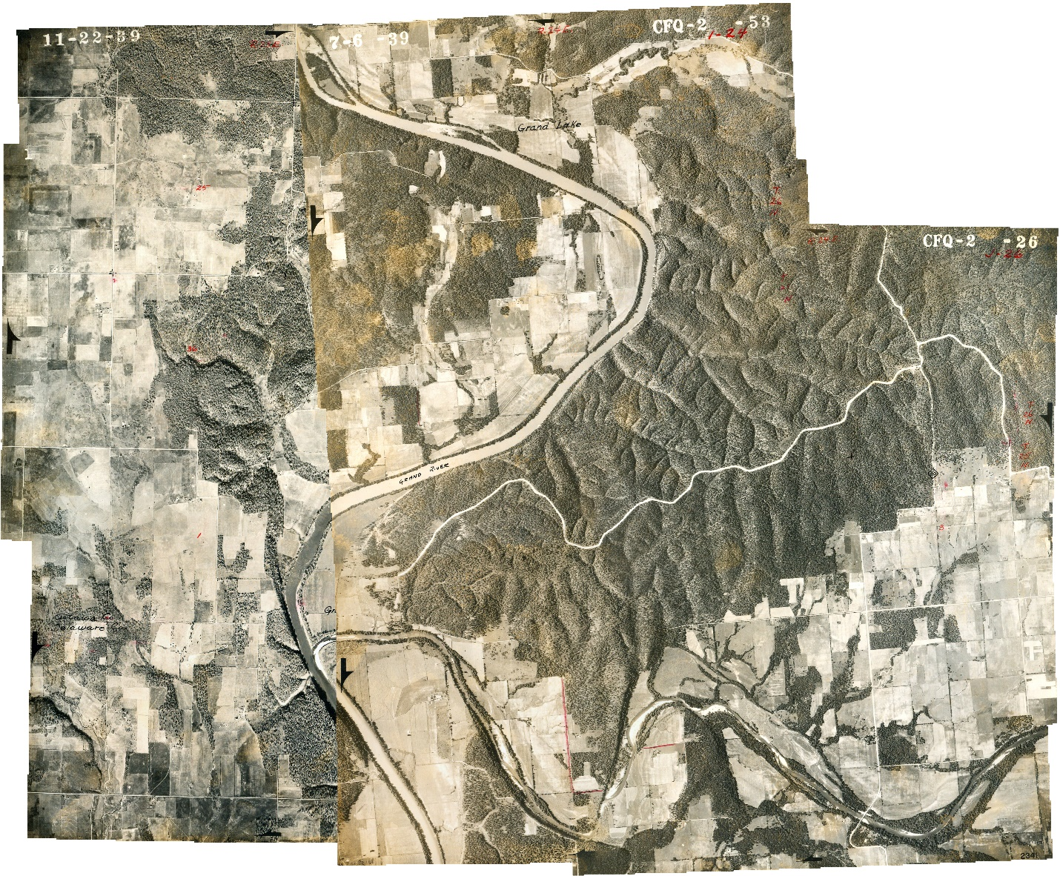

Reed

Reed
Figure 3.4: Close up of the Elk River with Reed to the west near the Grand River junction and the approximate location of School Land I to the east.

Figure 2.4: Close up of the Elk River with Reed to the west near the Grand River junction and the approximate location of School Land I to the east.
Figure 3.3: Merged 1939 aerial photographs from before the completion of the Pensacola Dam. The Elk River and the extent of Reed and School Land I in red.

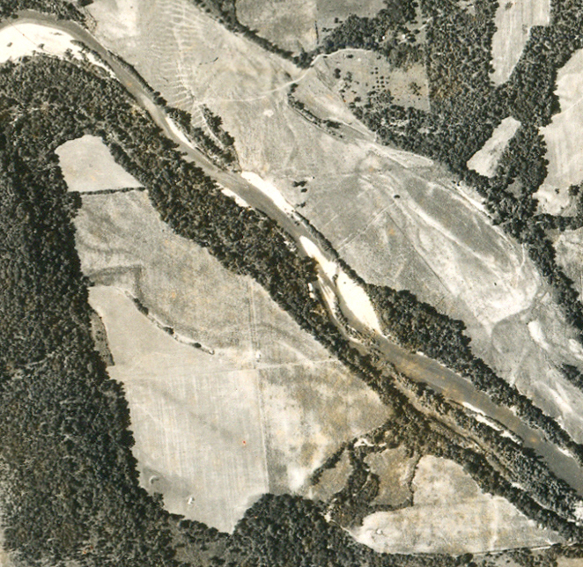
Figure 3.5: The approximate location of School Land I within the red square.

Archaeological History of School Land I
In this section I will summarize prior archaeological investigations at School Land I. Two prior archaeological investigations on School Land I were known to have occurred. The earliest excavations were carried out by the Works Progress Administration (WPA) in 1939-1940. As such, I will discuss what the WPA was and their archaeological methodology that the agency used for the excavation of School Land I. The next archaeological investigation was done by Lathel F. Duffield. In 1969, Duffield published a report titled "The Vertebrate Faunal Remains from the School Land I and School Land II Site” where he outlines his analysis of the faunal remains excavated by the WPA (Duffield 1969).
School Land II (34DL65, Dl-Sc-II ) is a nearby site about 50 m (1650 ft) upriver and northwest of School Land I on Elk River’s southern bank (Duffield 1969). During the WPA excavation of this site, one rectangular structure outline and a single burial along with an assortment of ceramic, lithic, and faunal materials were recovered throughout the site (Duffield 1969).

The Works Progress Administration (WPA) and Roosevelt’s “New Deal”

On October 24, 1929, America’s economy collapsed following the crash of the stock market; an event that instigated the Great Depression. At the time of the stock market crash, America’s unemployment was at 1.5 million people, eleven months later that number was 7.5 million, and three years after the crash, unemployment was over 12 million people (Means 2013:3). Franklin Delano Roosevelt (FDR) was elected as president in 1933 with the promise of creating work relief programs to solve the economic crisis that plagued America at the time. This promise FDR pledged became known as the “New Deal.”
Part of this New Deal was the creation of work relief agencies and programs that would use unemployed workers to build American infrastructure (Means 2013:4). Immediately after FDR was sworn in, his administration created relief agencies such as the Civilian Conservation Corps (CCC) and the Federal Emergency Relief Administration (FERA), the Civil Works Administration (CWA), and the Works Progress/Projects Administration (WPA) (Means 2013:5 Table I). All of these agencies were active in Oklahoma giving work to the unemployed (Regnier et al. 2019:10).
The first government relief program in Oklahoma came from FERA in May 1933, which provided grants to state and local governments to create work for unskilled workers and white-collar positions (Regnier et al. 2019:3). The next program in Oklahoma was the CWA. The CWA was created to provide employment during the winter of 1933-1934. The CWA built dams, roads, airports, courthouses, and college dormitories throughout Oklahoma (Bryant 1975:9). The CWA also provided the first funds to perform archaeology in Oklahoma (Regnier et al. 2019:3). Then came the WPA.
The WPA was created on April 8, 1935, and operated until June 30, 1943 (Lyon 1996). During the WPA’s duration, the agency employed over 8 million workers on nearly 1.5 million projects, that spanned 3,000 counties across America (Means 2013:6). In Oklahoma, the WPA employed 119,000 men and women between 1935 and 1937 (Mullins okhistory.org; Regnier et al. 2019:4) 259 of these workers were employed doing WPA archaeological projects (Regnier et al. 2019:38).
The WPA efforts in Oklahoma were mostly in the building of roads, with more than half the funds going to this endeavor (Mullins okhistory.org; Regnier et al. 2019:4). The WPA in Oklahoma also built schools, fire stations, courthouses, hospitals, National Guard armories, sidewalks, and drainage features (Regnier et al. 2019:4). The WPA also funded music and art projects, folklore projects, geological and mineralogical studies, historical preservation and reconstruction, and archaeological projects (Regnier et al. 2019:4).

WPA Archaeological Methods

Excavations were performed by local laborers who were otherwise unemployed due to the Great Depression. These laborers were drawn from the relief rolls and were referred to as unskilled or semiskilled as they were not trained archaeologists (Means 2013:9). These projects sometimes employed upward of 30 excavators (Regnier et al 2019:101). In Oklahoma, these crews were overseen by a field supervisor. Field supervisors were usually young college graduates with degrees in anthropology or history. Sometimes they didn’t even have a degree and only had a few relevant classes with little to no field experience (Means 2013:8). They were often drawn from existing institutions such as museums or universities (Means 2013:8). Field supervisors reported to project directors. Each state had one project director that reported to the WPA offices in Washington D.C., and the project director for Oklahoma was Forrest Clements (Regnier et al. 2019:11).
The field methods utilized in Oklahoma were established by Forrest Clements (Regnier et al. 2019:100). Sites with obvious features, such as mounds, and those endangered by the construction of dams were excavated first (Regnier et al. 2019:100). Sites were first located from descriptions and reports from local landowners (Regnier et al. 2019:100). After receiving a site lead a survey would be performed to assess the location by digging small test pits (Regnier et al. 2013:101). When a location was deemed suitable, and with permission from the landowner, a full excavation would be performed (Regnier et al. 2019:101).
When a site was identified, it was given an identifying name. At the time, Oklahoma was not using the Smithsonian trinomial site numbering system (Regnier et al. 2019:106). The naming system in Oklahoma used a two-letter county abbreviation, followed by a site name abbreviation, and a roman numeral designation if the site was large (Regnier et al. 2019:106).
After the test pits were completed, a grid system was established around the pits (Regnier et al. 2019:112). The grid size was based on the site size and density (Regnier et al. 2019:205). Smaller sites set up grids at 5-foot intervals (1.52 m), while larger sites or less dense sites were set up at 10-foot (3.05 m) intervals (Regnier et al. 2019:205). The grid began in the southwest corner of the area to be excavated with a stake labeled “1:1” (Regnier et al. 2019:204-5). Subsequent stakes were put in place at the designated intervals established for that site (either 5- or 10-feet) going both north and east in a grid pattern (Regnier et al. 2019:204-5). School Land I was set up with a 10-foot grid.
When the grid was established for a site, the digging began. Arbitrary 4- or 6-inch levels were dug using shovels (Regnier et al. 2019:101). The back dirt was thrown to the side or was leveled across the site with a mule team (Regnier et al. 2019:101). The excavation crews did not screen their soil for artifacts; objects were collected when an excavator noticed one while shoveling (Regnier et al. 2019:101). Artifacts were then catalogued using the unit coordinate of the grid system and the level that artifact was found at and given a “sack” number (Regnier et al. 2019:101).
Field supervisors and foremen were responsible for the upkeep and the filling out paperwork (Regnier et al. 2019:102). The paperwork that the WPA used includes Archaeological Data Sheets, Burial Data Forms, Survey Forms, Profile Data Sheets (Regnier et al. 2019:102). Archaeological Data Sheets were used to record feature information (Regnier et al. 2019:102). Profile Data Sheets were used to record stadia rod reading when mapping the site (Regnier et al. 2019:102). Photographs were also supposed to be taken of every feature excavated with the film roll number and shot number recorded on the data sheets (Regnier et al. 2019:103). All the measurements were recorded using the English system, except instead of inches, the crews used tenths of feet (Regnier et al. 2019:104).
In addition to the above paperwork, field supervisors and foremen were also responsible for keeping artifact catalogues and daily logs concerning their excavation. They also drew profile maps, site plan maps, plan maps of features, houses, and burials. One thing that was not recorded was a detailed record of any of the many excavated houses. Often the only information on a specific house was on loose-leaf, graph paper depicting posthole patterns and associated features (Regnier et al. 2019:102-103).

Lathel F. Duffield’s Faunal Analysis

The next archaeological investigation was done by Lathel F. Duffield. This was the formal real analysis of any of the artifacts from School Land I. In 1969, Duffield published a report titled "The Vertebrate Faunal Remains from the School Land I and School Land II Site” (Duffield 1969). For this report, Duffield identified and counted all the faunal remains excavated by the WPA. Duffield identified the type of each bone, species that bone came from, and whether the bone came from a mature or immature specimen. Using this data Duffield was able to postulate local ecology, dietary preference, cultural patterns such as butchering and animal age preference, as well as seasonal patterns of occupation for these sites (Duffield 1969).
Duffield also made two plan-view maps of the School Land I site. One map shows the structures and the number of bones found in each unit along with the portions of the site that were excavated by the WPA (Figure 3.6). The second map shows the site’s structures within the WPA’s row-alley grid system. These maps were made using the WPA field notes and drawings along with their inventory list (Duffield 1969:49). Since the WPA did not draw their own site map, the Duffield grid map was incredibly useful for my study of School Land I. I used this map to identify which unit a structure overlapped. This grid map was not published and is currently housed at the Sam Noble Museum in Norman, Oklahoma.
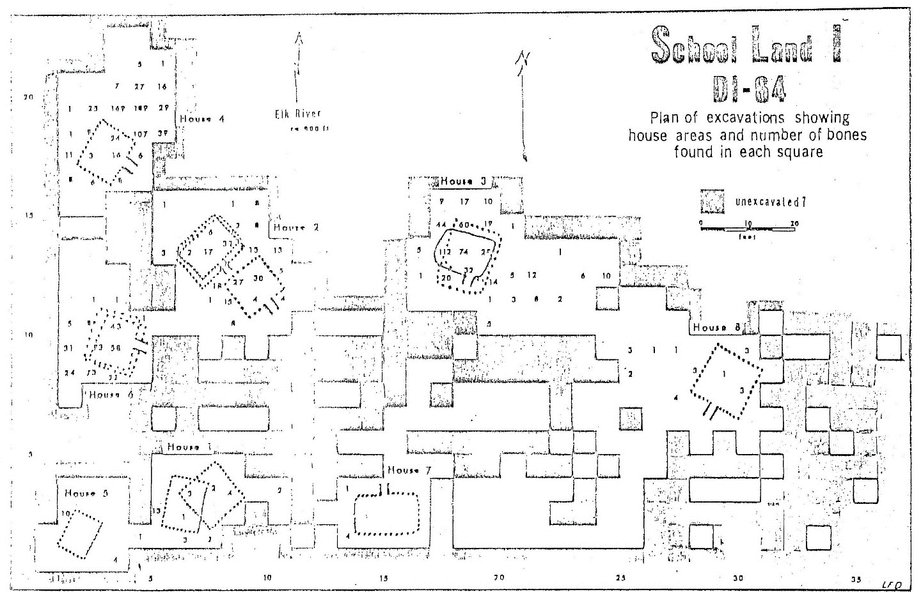
Figure 3.6: Plan map of School Land I created by Duffield. This map shows the areas the WPA excavated, the structures, and where faunal material was recovered. (Duffield 1969:48 Figure 2)

The Site
School Land I is called this due to the fact that the site was located on land owned by the school district. When the site was first being excavated by the WPA, they gave it the name “Dl-Sc-I.” “Dl” for Delaware County, “Sc” for school land, and the roman numeral one to differentiate between other potential sites on state school land (see the “WPA Archaeological Methods” section above).
Excavations at School Land I began in November 1939 and finished in June 1940. By the time they had finished, they excavated about 282 units (this number is not explicitly stated anywhere and was based on Figure 3.6). The excavation efforts were led by David Baerreis, who, during the duration of the excavation of this site, did not even have a bachelor's degree yet (he obtained his bachelor's degree in 1941 from the University of Oklahoma and would eventually obtain his M.A. in 1943 and a Ph.D. in 1948).
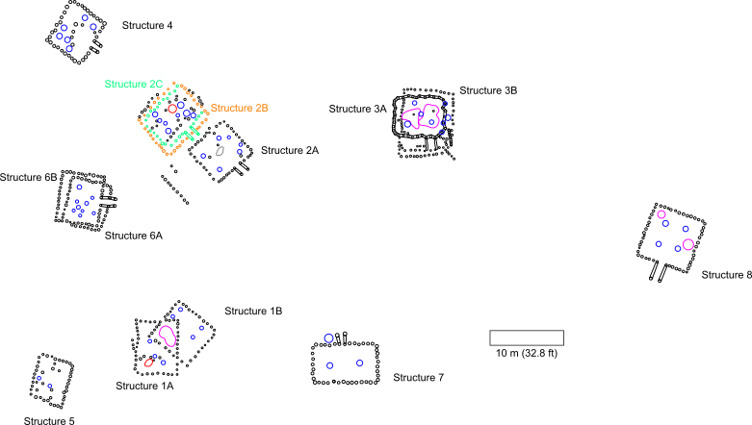
Several radiocarbon dates have been submitted from School Land I (Table 1). Four charcoal samples were sent to the University of Wisconsin by Baerreis in the late 1960s (Bender et al. 1968). The date range given for these samples was dated from AD 1024 to AD 1395. Amanda Regnier and Scott Hammerstedt of the Oklahoma Archeological Survey submitted two samples from School Land I for radiocarbon dating to Beta Analytics in 2018. These dates are currently unpublished, and the dates used here were obtained from Dr. Scott Hammerstedt directly. The date range given for these two samples was between about AD 1051 and AD 1395.
Figure 3.7: Plan map of School Land I. Map created by Dr. Scott Hammerstedt and used with his permission.

Lab # | Context | Intercept (BP) | +/- | From (BP) | To (BP) | %
WIS-257 | Structure 3 Area | 790 | 55 | 1051 | 1295 | 95.4
WIS-258 | Structure 6 Area | 710 | 55 | 1215 | 1395 | 95.4
WIS-259 | West of Structure 8 | 900 | 50 | 1024 | 1223 | 95.4
WIS-290 | Structure 8 Area | 870 | 60 | 1035 | 1260 | 95.4
Beta-292993 | Structure 4 | 820 | 40 | 1058 | 1278 | 95.4
Beta-292994 | Structure 8 | 750 | 30 | 1221 | 1287 | 95.4
OxCal 4.1 Calibration
Table 3.1: Radiocarbon dates from School Land I

It is worth noting that the radiocarbon dates from Wisconsin University (WIS) in the 1960’s are generally inaccurate by a few hundred years (Regnier et al 2019:344). Since so few radiocarbon dates exist for this site, the WIS dates will be included since they can still give a general time frame of occupation.

The Structures of School Land I
School Land I had at least 13 structures in at least eight locations. Many of these structures had extended entranceways that pointed toward an open area resembling a plaza (Figure 2.6). I say ‘resembling’ because plazas can have different definitions depending on the context. In the broadest definition a plaza is an open space adjacent to or surrounded bybuildings or plazas can be defined as a public area in a community (Kidder 2004:515). In archaeological contexts in the Southeast plazas have been defined as flat areas that lack significant evidence for domestic occupation and that are bounded by some kind of architecture (Kidder 2004:516). However, many archaeologists do not view plazas as passive features of the site, but as significant architectural endeavors to the site (Cobb and Butler 2016). Plazas can be seen as part of the built landscape that was purposely constructed and maintained in order as part of the communal architectural landscape (Cobb and Butler 2019). While School Land I does have an open space surrounded by structures, it is not know if this open area was constructed or if it was for the purpose of communal activities.
The structures were made from small to medium posts arranged in a rectangular or square pattern with medium sized center posts in the interior that were used for roof supports. The square structures had four center posts, while the rectangular structure had two. Clay was packed onto the exterior posts to form a solid wall. It appears that several of the structures at School Land I (Houses 1, 2, 3, and 6) were destroyed and rebuilt sometime during the site’s occupation.
Extended entranceways were present in six of the 13 structures. All the extended entranceways were constructed by creating wall trenches. In four, or possibly five, buildings, the structures have superimposed posthole patterns consistent with a structure being demolished and rebuilt in the same place as the previous structure. Below I will detail each structure individually.

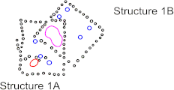
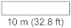
Structure 1
Figure 3.8: Structure 1 plan view.

Structure 1 was located southwest of the plaza (Figure 3.6). It consists of two superimposed structures labeled 1A and 1B. A corner of each structure overlaps (Figure 3.8, 3.9). Neither structure had a discernable entranceway. Structure 1A was rectangular and was oriented with its long sides positioned north/south. The WPA identified a fire pit in the southwest corner of this structure. The dimensions for Structure 1A were approximately 7.4 m x 5.76 m (34.36 ft x 18.9 ft). Structure 1B was square in shape and was oriented northeast/southwest. The dimensions for Structure 1B were approximately 6.7 m (22.1 ft.) x 6.4 m (21.0 ft.) with its slightly longer sides being oriented northwest/southeast.
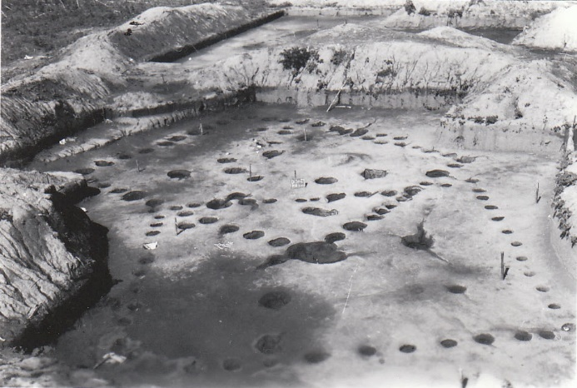
Figure 3.9: WPA photograph of Structure 1; facing east.

Structure 2
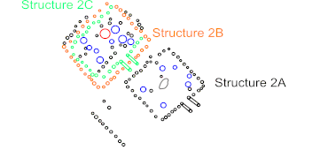
Figure 3.10: Structure 2 plan view.

Structure 2 was located northwest of the plaza (Figure 3.6). It consisted of two superimposed structures, structures 2B and 2C, and a third iteration, 2A, just southeast of the two superimposed structures (Figure 3.10, 3.11). Structure 2A was so close to 2B and 2C that it is unlikely for Structure 2A to have been standing at the same time as either Structure 2B or 2C.
All three iterations of Structure 2 were oriented southeast. Structures 2A and 2C have discernable extended entranceways that point towards the southeast. Structure 2B does not have a discernable entranceway. Structure 2A was a square structure with four center posts. The sides of 2A measure 6.7 m (22.1 ft) x 6.4 m (21.0 ft); the slightly longer sides were oriented northwest/southeast. Structure 2B was square with four center posts. The sides of 2B measure 7.0 m (23.1 ft) x 8.0 m (26.3 ft), with the slightly longer side oriented in a northeast/southwest direction. Structure 2C was slightly rectangular and had four center posts. The dimensions for 2C were 5.4 m (17.9 ft.) x 8.0 m (26.3 ft.) and the longer sides were in a northeast/southwest direction. The WPA identified a fire pit close to the center and a cache pit near the eastern corner in Structure 2B/C. In Structure 2A the WPA identified an ash heap near the center structure.
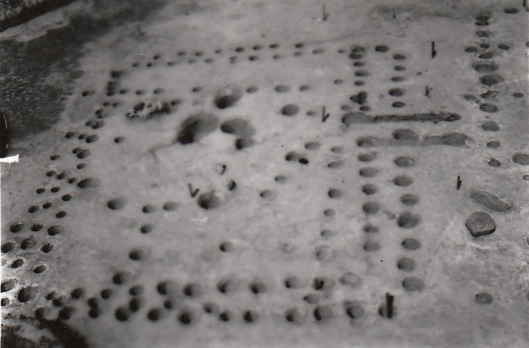
Figure 3.11: WPA photograph of Structure 2B/C; facing northwest

Structure 3
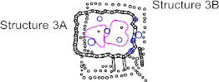
Figure 3.12: Structure 3 plan view.

Structure 3 was located just north of the plaza (Figure 3.6). It consists of two superimposed structures, Structures 3A and 3B (Figure 3.12, 3.13). Structures 3A and 3B have an unknown number of center posts, however, five medium sized post holes were recorded in the interior. The WPA recovered large amounts of burned daub from this structure which they described as “wattle heap[s]”. 3A was a unique structure in School Land I in that it is the only structure known in the Arkansas Valley to be built using wall trenches rather than single-set posts (Scott Hammerstedt, personal communication 2023). Wall trench structures are defined as having one or more wall incorporating a trench used for the placement of upright poles. This is in contrast to posthole structures that are defined by creating single postholes for each individual upright pole.
3A was a rectangular structure oriented in a north/south direction with an extended entranceway opening towards the plaza to the south. The entranceway of 3A was not situated in the approximate center of the wall but was built near the southeastern corner. The dimensions of 3A were approximately 7.4 m (24.2 ft.) x 5.76m (18.9 ft.) with the longer sides were oriented east/west. Structure 3B was a rectangular structure oriented north/south. There was no obvious entranceway for 3B, however there was a short line of post holes extending from the southeast corner in a southeast direction and it is possible this was once part of an extended entrance way. The dimensions for 3B were approximately 7.4 m (24.2 ft.) x 9.3 m (30.5 ft.) with the longer wall was oriented north/south.
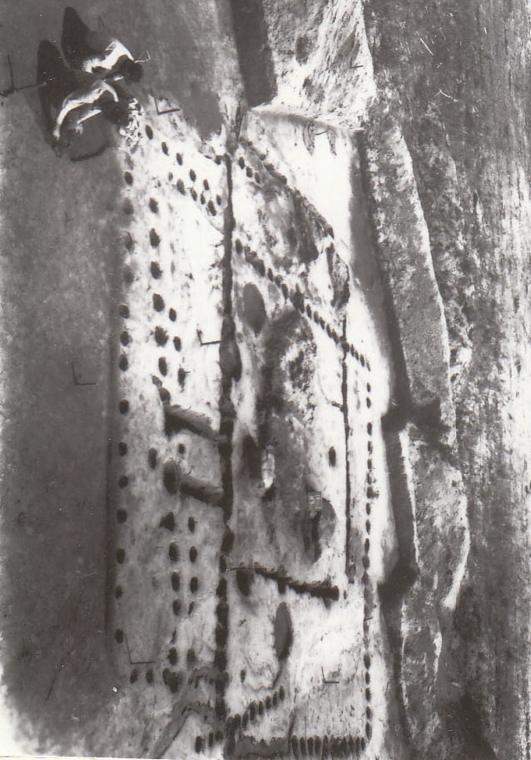
Figure 3.13: WPA photograph of Structure 3; facing northwest.

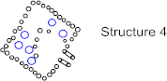
Structure 4
Figure 3.14: Structure 4 plan view map.

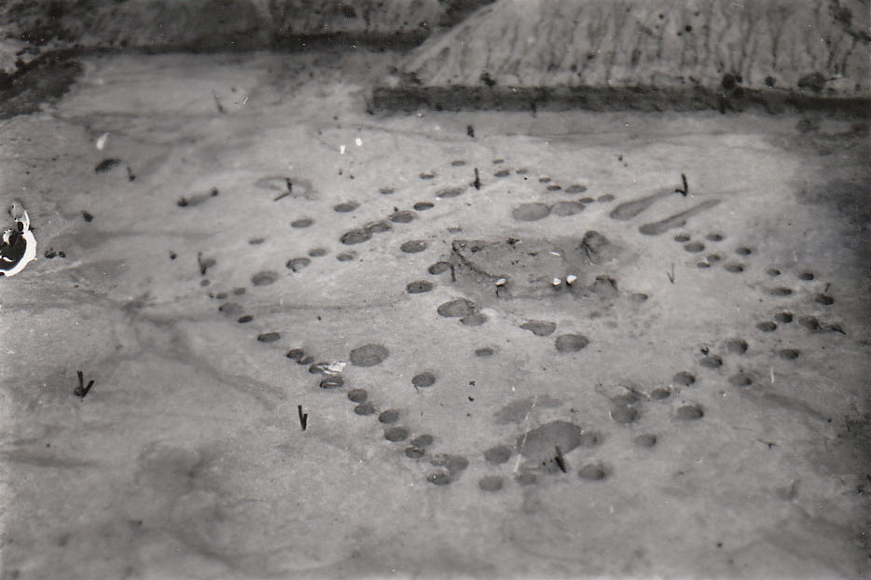
Structure 4 was located in the northwest area of the site (Figure 3.6). The structure lies northwest of Structure 2. This structure was a square structure with no superimpositions (Figure 3.14, 3.15). It had six center posts within its walls. It was oriented southeast/northwest with an extended entrance way opening to the southeast, towards the plaza. The dimensions were approximately 6.7 m (22.1 ft.) x 6.1 m (20.0 ft).
Figure 3.15: WPA photograph of Structure 4; facing east.

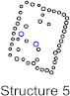
Structure 5
Figure 3.16: Structure 5 plan view.

Structure 5 was located in the southwest area of School Land I (Figure 3.6). It lies southwest of and behind structure 1. Structure 5 was slightly rectangular with two center posts and had no discernable entranceway (Figure 3.16). The structure was oriented slightly northeast/southwest with no side directly facing the plaza. The dimensions were approximately 6.4 m (21.0 ft) x 5.1 m (16.8 ft), with the longer sides were oriented northeast/southwest.

Structure 6
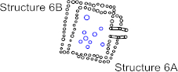
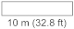
Figure 3.17: Structure 6 plan view.

Structure 6 was located just west of the plaza (Figure 3.6). It consists of two superimposed structures, Structure 6A and 6B (Figure 3.17, 3.18). Structure 6A was a near-square structure with four center posts. 6A has no discernable entranceway, however it was possible that 6A shared at least part of the same entranceway posthole profile as structure 6B. Structure 6A was mostly oriented towards the east and a little a little bit towards the southeast. 6A’s dimensions were approximately 7.0 m (23.1 ft.) x 6.4 m (21.0 ft).
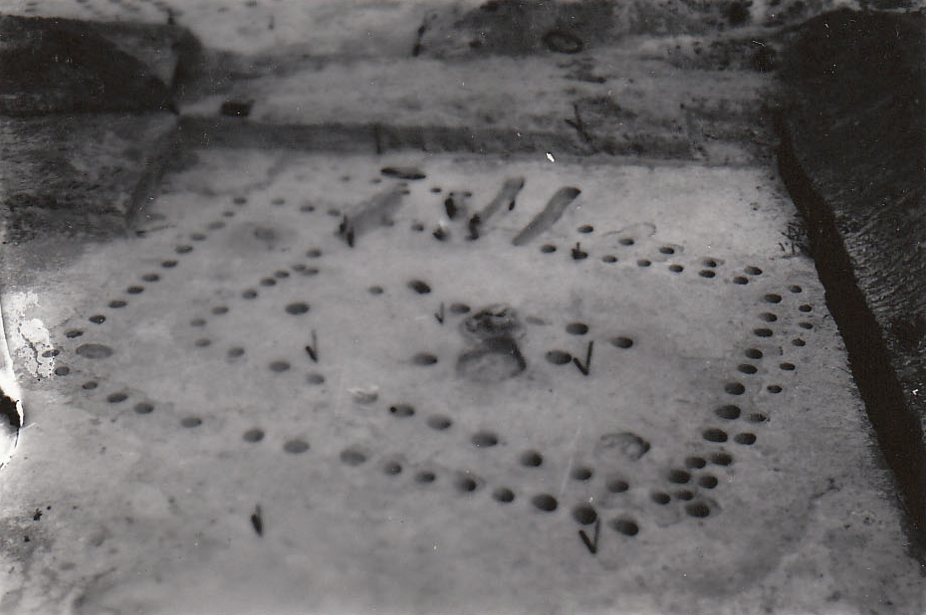
Structure 6B was rectangular and had four center posts with an extended entranceway that faces nearly due east. The dimensions of 6B were approximately 7.3 m (24.2 ft.) x 6.4 m (21.0 ft.) with its longer sides were oriented almost due north/south.
Figure 3.18: WPA photograph of Structure 6; facing southeast.

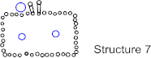
Structure 7
Figure 3.19: Structure 7 plan view.

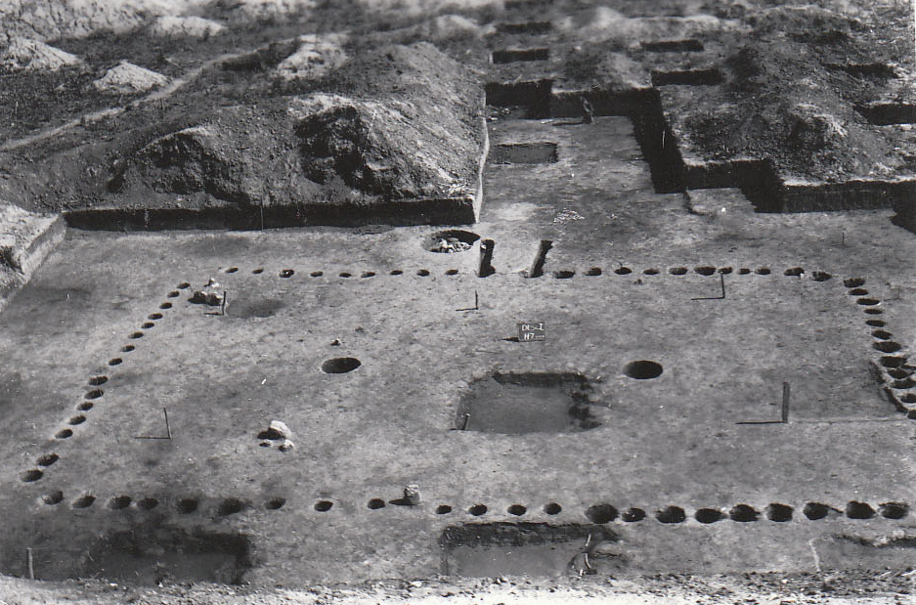
Structure 7 was located just south of the plaza (Figure 3.6). The structure had no superimpositions and was rectangular with two center posts (Figure 3.19, 3.20). The structure had an extended entranceway that faces due north and opens towards the plaza. The WPA identified a cache pit just outside, to the north of Structure 7 and just west of the entranceway. The dimensions were approximately 9.0 m (29.4 ft.) x 5.8 m (19.0 ft.) whereby the long sides were oriented east/west.
Figure 3.20: WPA photograph of Structure 7; facing north.

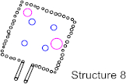
Structure 8
Figure 3.21: Structure 8 plan view.

Structure 8 was located just east of the plaza (Figure 3.6). It had no superimpositions and was square with four center posts and an extended entranceway. The WPA recorded a pit near the structure’s northern corner and a fire pit close to the southeast wall. The structure was unique within the site as it was the only structure that was not oriented towards the plaza, nor did its entranceway open towards the plaza. Structure 8 was oriented northeast/southwest with an extended entranceway that opens southwest. Its dimensions were approximately 7.6 m (24.9 ft.) x 7.7 m (25.2 ft.).

Structure 9

The only evidence for a ninth structure was a WPA drawing and a copy of that drawing (Figure 3.22). There was no other mention of this structure anywhere else. The WPA drawing was clearly labeled as “DlSc 1” and “H-9” (House 9) was written underneath, and “H-9” was written a second time near the center along with a date of “6-26-40.” On the back side of this diagram “DlSc I,” “map,” and “H-9” were written, so it was unlikely that the site name or structure number was an error. This diagram had two grid stakes written on it, “26:10” and “26:11.” This would put Structure 9 far to the north from the plaza, and approximately 70 feet (21.3 m) north from its nearest structure (structure 4). No artifacts were recorded as having come from this structure. In fact, the WPA did not record any artifacts north of row 22.
According to the diagram drawn by the WPA, Structure 9 consists of two superimposed structures, each with an extended entranceway and what looks like six center posts. For the purpose of this paper, I will call the structure whose entranceway faces northwest “Structure 9A” and the structure whose entranceway faces west will be “Structure 9B.” Structure 9A was mostly square and likely had four center posts. It was oriented northwest/southeast and had an extended entranceway that opened northwest. 9A’s dimensions were approximately 7.6 m (24.8 ft.) x 6.6 m (21.7 ft). Structure 9B was rectangular and likely had two center posts. Its entranceway opened to the west and slightly southwest. The dimensions of Structure 9B were approximately 6.4 m (21.0 ft) x 4.8 m (15.8 ft).
Since no artifacts were recorded as having been recovered from Structure 9 and because of the ambiguity surrounding this structure, it will not be included in further discussion beyond this chapter.
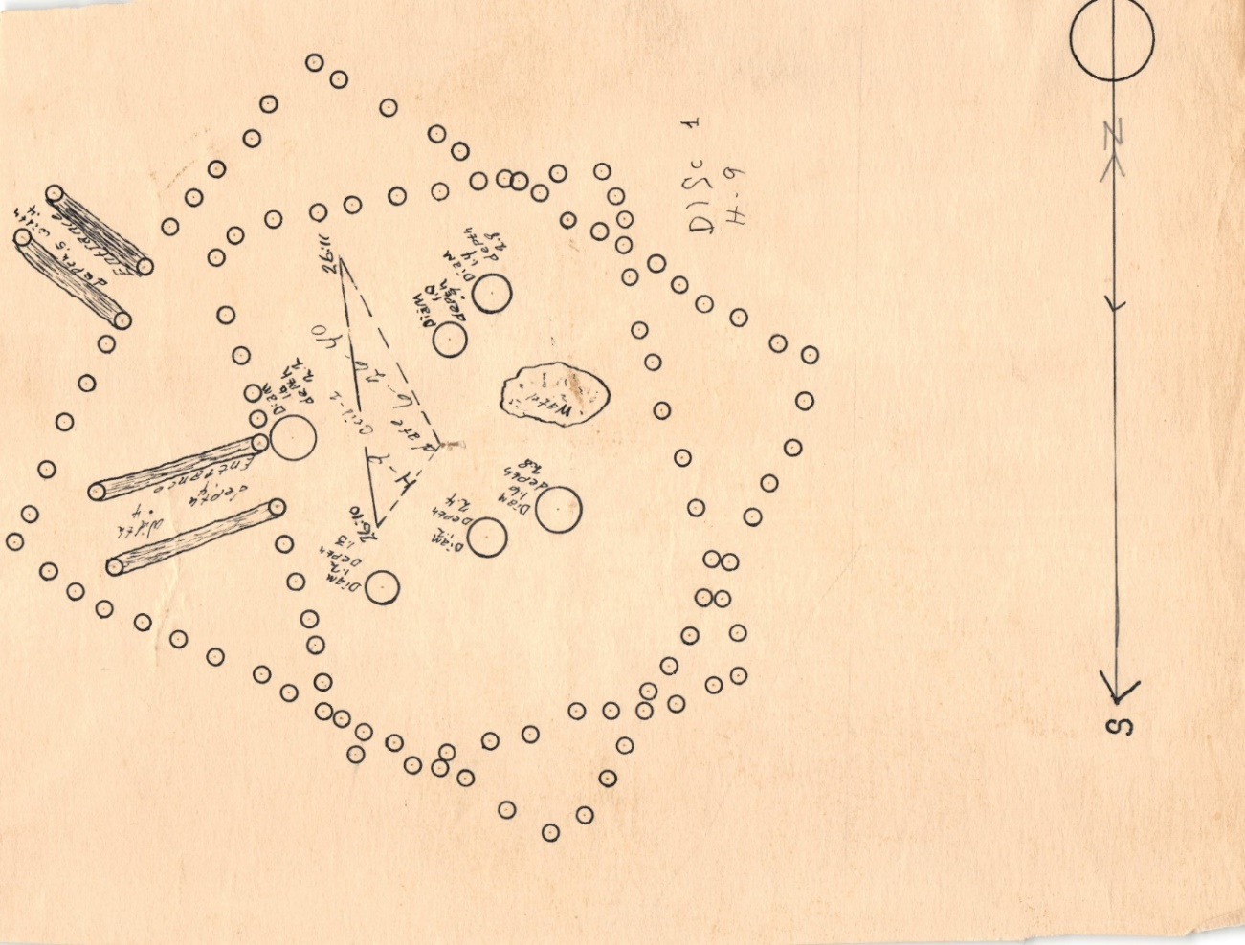
Figure 3.22: WPA diagram of Structure 9.

Observations

Table 3.2 summarizes the direction of the entrance ways, length of the walls, the orientation of the walls, and the structure’s area. For the most part, the structures were relatively uniform with many of the walls nearly the same length. The average wall length was 6.8 meters. To better judge and infer the size of a structure, I calculated the area of each structure based on the lengths of its walls.
Based on area, the largest structure at School Land I was structure 3B with an area of 68.3 m², which is noticeably more than the structure with the second largest area of 58.1 m² for structure 8. The smallest building on site was structure 5 with an area of 32.8 m². The average calculated area of all the structures was 44.3 m² with a range of 32.8 to 68.3 m². A study of east Oklahoma Caddo sites has shown that the mean floor size of 78 Caddo structures is 51.9 m² with a range of 21.2 to 171.8 m² (Regnier et al. 2019:311). These floor averages are comparable to that of School Land I, though these do have a slightly smaller average.

Structure | Entrance Direction | Long Wall Length (~m) | Long Wall Orientation | Short Wall Length (~m) | Short Wall Orientation | Structure Area (~m²)
1A | Unknown | 7.4 | N/S | 5.8 | E/W | 42.6
1B | Unknown | 6.7 | NW/SE | 6.4 | NE/SW | 43.0
2A | Southeast | 6.7 | NW/SE | 6.4 | NE/SW | 43.0
2B | Southeast | 8.0 | NE/SW | 7.0 | NW/SE | 56.3
2C | Southeast | 8.0 | NE/SW | 5.4 | NW/SE | 53.5
3A | South | 7.4 | E/W | 5.8 | N/S | 42.4
3B | Unknown | 9.3 | N/S | 7.4 | E/W | 68.3
4 | Southeast | 6.7 | NE/SW | 6.1 | NW/SE | 40.9
5 | Unknown | 6.4 | NE/SW | 5.1 | NW/SE | 32.8
6A | Unknown | 7.0 | N/S | 6.4 | E/W | 45.1
6B | East | 7.4 | N/S | 6.4 | E/W | 47.1
7 | North | 9.0 | E/W | 5.8 | N/S | 51.6
8 | Southwest | 7.7 | SW/NE | 7.6 | NW/SE | 58.1
9A | Northwest | 7.6 | NW/SE | 6.6 | NE/SW | 50.2
9B | West | 6.4 | E/W | 4.8 | N/S | 30.7
Table 3.2: Dimensions of the Structures of School Land I

Methods of Analysis
This chapter discusses the methodology used to conduct the analysis of ceramics recovered from School Land I. The collection is currently housed at the Sam Noble Museum of Natural History (SNMNH). The methods employed are based on the analyses developed by the University of Oklahoma and the Oklahoma Archeological Survey. This template is widely used for archaeological sites across the state of Oklahoma and allows for comparable data with future research of the region. The ceramic analysis combines the study of morphological, functional, and stylistic attributes.

Ceramic Analysis
Ceramic sherds were first size graded through a ½ inch wire mesh. Ceramic artifacts that passed through the wire mesh were considered sherdlets. The weight and count for sherdlets were recorded, but additional analysis was not conducted. Ceramic artifacts that did not pass through the ½ inch mesh were considered sherds and additional analysis was conducted. Sherds that could be refitted found within the same provenience were physically attached with B72 epoxy adhesive and counted as one sherd. Diagnostic sherds include decorated, rim, base, and handles. Sherds that are undecorated and from the vessel’s body are non-diagnostic. See Appendix A for an example of the ceramic recording form used for this study.

Attributes Recorded for All Sherds

I recorded the size, wall thickness, weight, temper, and surface treatment for all sherds. Sherd size was measured using a series of graded circles whereas the increasing diameter of each sequential circle is in one-centimeter increments with a maximum set at 10cm. (Figure 3.1). Sizes were measured to the nearest centimeter. Sherds larger than 10cm were measured with plastic digital calipers to the nearest centimeter. Wall thickness was measured in millimeters with a plastic digital caliper. Several measures were taken with the caliper and an average of these measurements was taken to represent the sherd’s wall thickness. Weight was measured in grams using a digital scale.
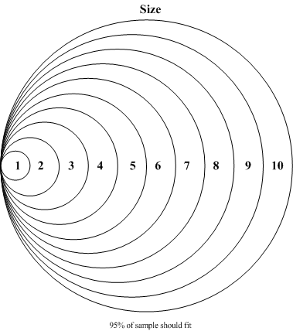
Figure 4.1: Size chart (not to scale)

Temper and its amount and concentration in each sherd were also recorded. Temper is the non-plastic inclusions purposefully added by the potter during a vessels creation to improve the clay’s working, drying, and firing properties (Rice 2015:463). Temper was observed through optical inspection with a hand lens. Five types of temper were observed in the sherds: shell, grog, limestone, sand, chert, and bone.
Shell is, by far, the most abundant temper at School Land I. The shell that was used as temper is most likely freshwater mussel shell that was harvested locally. Shell, as a temper, creates a vessel that has relatively low thermal expansion, which prevents cracking during firing and subsequent cooking, and adds strength to the vessel’s walls (Bronitsky and Hamer 1986; Rice 2015:80). The shell temper was identified by the rectangular and smooth platelike white inclusions (Brown 1996:329). If the shell has been leached from the sherd, then shell tempering is identified by the platelike voids in the paste of the sherd (Brown 1996:329).
Grog is pre-fired clay (often recycled potsherds) that has been crushed into small particles to be added to the clay of a pot (Rice 2015:457). Grog is identified by the presence of isolated irregular to angular fired clay particles (Brown 1996:329, Rice 2015:80). Grog temper adds strength to a vessel’s walls and has relatively low thermal expansion (Rice 2015:80). Because grog has already been fired, it is stable to the firing process of the new vessel (Rye 1981:33). Grog also has the benefit of being readily available (Rye 1981:33). Grog can be created from pottery vessels that have been broken during use or during the firing process, instead of being a useless waste product (Rye 1981:33). This makes sherds, and therefore, grog, readily available at the manufacturing site, without the need to transport additional materials for temper (Rye 1981:33). Sherds are also more easily broken up than most rocks and minerals, making grog an easier material to work with (Rye 1981:33).
Limestone is a “calcareous rock with a blocky fracture that is recognized by its light gray color, softness, and tendency towards friableness” (Brown 1996:641). As a temper, limestone can have either an irregular, angular, or a round shape (Rye 2015:80). Because of limestone’s softness and its chemical composition, it can easily get leached from the clay of a sherd after firing, leaving round voids within the clay paste of the sherd (Orton and Hughes 2013:280-81 Table A.2). The benefit of limestone as a temper is that it makes sticky clay more workable, significantly more resistant to mechanical stress than grit- or grog-tempers and is more resistant to thermal shock (Hoard et al 1995). A drawback of using limestone as a temper is that it causes vessels to spall when fired at temperatures over 600ºC (Hoard et al 1995). However, there are ways that have been proposed that might reduce the chance of limestone spalling, including: rapid firing of the vessel, firing in a reduced atmosphere or quenching the vessel immediately after firing with cold water (Hoard et al 1995:830). Another drawback of using limestone as a temper is that it is hard to crush and will rehydrate after firing (Rice 2015:80).
Sand is a particle size grade that measures between 2 mm and 0.05 mm in diameter that is composed of silica (Rice 2015:461; Rye:1981:34). Sand can be identified as a temper due to the relatively much larger grain size compared to that of clay, which is smaller than 0.02 mm in diameter (Rice 2015:453). Sand can be rounded, smoothed, or irregular in shape (Rye 2015:80). Due to its larger size, sand will give a noticeably rougher surface texture on the wall of a sherd that can be felt when gently rubbed with one’s finger and is observable with the naked eye. One drawback with using sand as a temper is that it may weaken a vessel’s walls by shape or porosity (Rice 2015:80).
Chert has also been observed within the paste of a few of the ceramic sherds analyzed. The chert observed was in the form of lithic debitage flakes. It is assumed that these chert flakes were the product of stone tool making or maintenance, and deliberately added to the ceramic paste. Chert will be angular in shape. Benefits for using chert as a temper is that chert will add strength to the vessel’s walls, and because the chert used is a byproduct of stone tool manufacture, the material is readily available and without the need for transport (Rye 2015:80).
Bone temper is created by crushing animal bones into smaller particles to be added into the paste recipe of a vessel. Bone can be identified as “long pieces with irregular outline and surface” (Brown 1996:329). Bone temper can further be identified by linear fractures caused during the firing process that can be observed through a hand lens or other magnification methods. It is difficult to distinguish between limestone and bone with the naked eye if the temper is not coarse enough. Magnification of some kind is often necessary to be able to distinguish between the two tempers. One advantage of using crushed bone as temper is that bone will increase the porosity of the vessel (Rye 2015:80). A disadvantage is that, due to that porosity, the vessel’s walls will be weaker (Rye 2015:80).
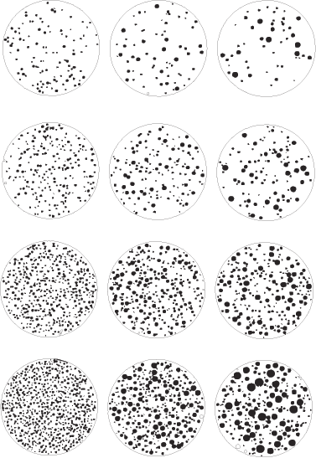
When the temper of a sherd was identified, it was then measured for its particle size range and concentration. The measurements for these attributes were determined using a particle size and concentration chart (Figure 4.2). Particle sizes can be Fine, Medium, or Coarse and recorded as “F,” “M,” or “C,” respectively. Particle concentration was described as Absent (0), Trace (T), or as a range from 1 (sparse) to 4 (abundant). If a sherd had more than one temper, then the size and concentration of each temper was recorded.
Figure 4.2: Temper size and concentration chart
Temper
Fine
Medium
Coarse
1
2
3
4
F1
M1
C1
F2
M2
C2
F3
M3
C3
F4
M4
C4
Absent (0) or Trace (T) or

Several types of surface treatment were noted for School Land sherds including plain, smoothed, burnished, red filmed, eroded, and decorated. A “Plain” surface treatment is a surface that is not decorated nor has been noticeably smoothed by the potter. A “Smoothed” surface has a finer and more regular surface that is usually accomplished by the potter by wiping the surface with a soft, pliant tool such as leather, cloth, grass, or the potter’s own hand (Rice 2015:149). A “Burnished” treatment is done by repeatedly rubbing the surface with a smooth, hard object such as a pebble, bone, or horn (Rice 2015:149). The action of rubbing the surface repeatedly compacts and reorients the clay particles and will give the surface a luster (Rice 2015:149). “Red filmed” surface treatment refers to the application of a red colored film to the surface of a ceramic vessel. A “film” is a type of slip. A slip is a fluid suspension of clay in water that is applied to an unfired clay piece to form a thin, non-vitreous coating (Rice 2015:162). A film is more watered down and thinner than a slip. The red coloration of this slip can be accomplished either by complete oxidation of iron-rich clay paste or a hematite pigment (Brown 1996:330). “Eroded” surfaces are those that have undergone a natural erosion of their surface whereby any other treatment is difficult to discern. “Decorated” surface treatments exhibit embellishments, such as appliqué, cord-marked, fingernail impressed, incised/engraved, pinched, and punctated, to their surface. If a sherd exhibited more than one surface treatment then each was recorded for that sherd.
Apart from morphological attributes, I also assigned certain sherds to a structure. As the WPA was excavating School Land I, they seldom assigned a provenience to a specific structure or feature. The provenience the WPA used to assign to artifacts was based on “rows,” “alleys,” and stratigraphy. Using the 1969 Duffield map I assigned sherds with a provenience (row and alley) that intersects a structure to that structure. For example, Unit 1:2 (Row:Alley) has the southern corner of Structure 5 in the unit’s northwest corner, therefore, all sherds with a provenience from Unit 1:2 were assigned to Structure 5.

Diagnostic Sherds: Attributes Recorded for Decorated Sherds

Decoration types found at School Land I include appliqué, cord-marking, fingernail impressed, incised/engraved, pinched, punctated, and handle peaks. Appliqué is a technique where small, shaped pieces of clay are attached to a vessel’s surface (Rice 2015:159). Appliqué for my purposes refers to purely decorative elements. While handles are technically a type of appliqué, handle sherds were not recorded as appliqué as handles serve a functional purpose and are not decorative for the ceramics from this site. All examples of appliqué found in the School Land I assemblage are a type of appliqué called nodes. Nodes are spherical clay attachments to the surface of the ceramic vessel.
Cord-marking is an impressing technique whereby cordage is impressed onto the surface of the vessel using a cord-wrapped paddles (Rye 1981:92). Fingernail impressed is a decorative technique that uses a person’s fingernail to poke the clay when it is wet to create a depression in the shape of that person’s fingernail. Incised and engraved are both cutting techniques that use a sharp or blunt implement to draw through a vessel’s surface (Rice 2015:157). Most incising is done when the clays is still wet and soft; engraving, however, is done when the clay is dry and leather-hard before it is fired (Rice 2015:157). Engraved was distinguished from incised by its shallow and jagged cut marks, whereas as incised had deeper and smoother cut marks. Pinching is a type of punction that uses fingers to displace the clay on the vessel’s surface (Rice 2015:155). Pinched decorations are where the potter used their fingers to pinch the wet clay to create a small, raised area on the surface. Punctated is a technique that creates depressions in wet clay; usually created with a sharp or pointed object such as a stick or reed (Rice 2015:155). Handles peaks are small applique nodes that surmount a handle and serve a temporally diagnostic marker (Brown 1996:158).
Apart from decoration type, decoration location and the decoration intent for incised/engraved pottery were also recorded. Decoration location was recorded as either from a rim, a body, and/or a base. Decoration intent for incised/engraved pottery was recorded as either rectilinear, curvilinear, and/or hatched.

Diagnostic Sherd: Attributes Recorded for Rim Sherds

The attributes recorded for rim sherds include the rim profile, curvature, form, treatment, lip shape, orifice diameter, and the percentage of the orifice present for the sherd. Attributes were recorded for each rim sherd, except for rim sherds that were too small, or where certain attributes were not discernable. Rim profiles were recorded as either standing or inverted. Standing profiles refer to rims that are vertical (Brown 1996:331). Inverted profiles refer to rims that incline inward (Brown 1996:331). Rim curvature was recorded as either straight (no curvature), excurvate, or incurvate (Figure 4.3). Straight curvatures have no points of inflection in the rim. Excurvate rims flare outward at the point of inflection. Incurvate rim curvatures flare inward.



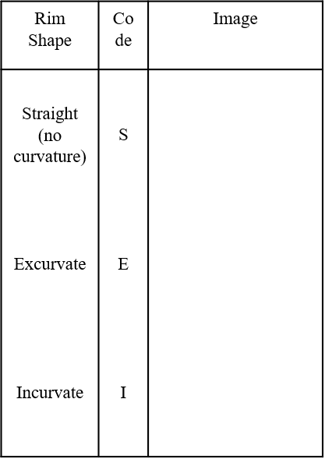
Rim form was recorded as either direct, thinned, expanding, or rolled (Figure 4.4). A direct rim is unmodified with no changes in thickness, while expanding, rolled, and thinned rims have been modified with a change in thickness (Brown 1996:331). Thinned rims have tapered lips that get thinner towards the orifice’s end point. Expanding rims can be seen as the opposite of thin rims. Expanding rims get broad closer to the orifice’s end point. Rolled rims have an outward flare of the lip. All rims recorded for School Land I have plain rim treatments. A plain rim treatment is where the lip is not modified. Lip shapes were recorded as either flat or round with differences based on whether the lip slopes were inward or outward, flat, or tapered (Figure 4.5).
Rim Curvature
Figure 4.3: Rim curvature
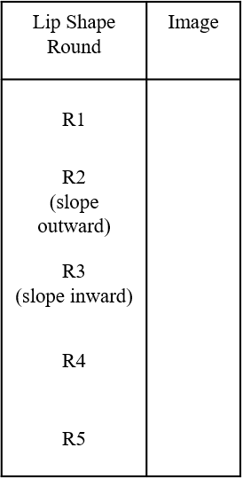
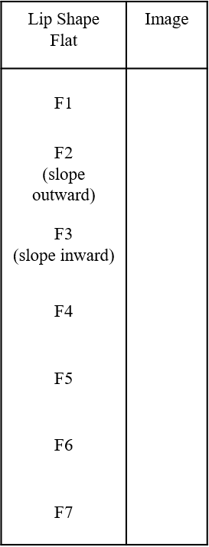
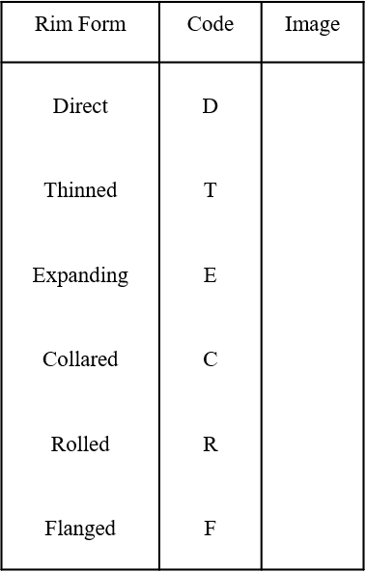
Figure 4.5: Lip shapes
Round
Lip Shape
Flat
Rim Form
Figure 4.4: Rim forms
Next, I recorded the orifice diameter of the rim sherds in centimeters. The diameter was determined using a standard diameter-measurement template (Figure 4.6). Using this same template, I also was able to record the percentage of the orifice the rim sherd represents. I then recorded the vessel’s form. Vessels for School Land I were designated as either bowls, bottles, or jars. If such firm designations could not be accurately recognized then the designations of ‘restricted vessel’ and ‘unrestricted vessel’ were used to distinguish vessels that have inflections and those that do not. Vessels whose form could not be determined were recorded as unknown. The vessel form was designated using a flow chart that takes into account the orifice’s diameter, vessel’s height, and inflections to derive a vessel form (Figure 4.7).
Figure 4.6: Standard diameter-measurement template (not to scale)

Spiro Site Ceramic Recording Resource

Use this chart to develop a first hypothesis for vessel form and then investigate for consistency with your sherd.
Other options not in flowchart:
Compound Vessel (CV)
Unknown (U)
Figure 4.7: Vessel form flowchart

Bowls are a hemispherical to subspherical unrestricted vessels (Brown 1996:337). Bowls encompass a great range of sizes and an even greater diversity in silhouettes (Brown 1996:337).
Bottles are vessels with a constricted orifice and a necked rim (Brown 1996:339). Bottles were designated if their orifice diameter was less than seven centimeters and had a standing rim profile. Jars can be defined as a shouldered vessel with a constricted orifice, everted rim, and flat base (Brown 1996:338). Vessels were recorded as jars if their orifice diameter was greater than seven centimeters and if the apparent height of the vessel was greater than the diameter of the orifice.

Diagnostic Sherds: Attributes Recorded for Handles

All handles from School Land I are closed handles. Closed handles are a type of handle that are cylindrical or flattened clay loops attached to the vessel both at the top and at the bottom of the loop (Hilgeman 2000:127). All handles were measured in width and thickness in centimeters. Only whole handle sherds were measured for height (in centimeters). Partial handle sherds were not recorded for height, just width and thickness. Handle scars on body sherds were also measured for width and thickness. I then categorized handles as either straps or loops. The difference between the two relates to the ration of middle thickness to middle width of the handle (Hilgeman 2000:129). Straps are handles where the appendage is wider than it is thick (Hilgeman 2000:129). Loops are handles that are nearly as wide as they are thick (Hilgeman 2000:129).
Two of the handles recovered from the site have handle peaks situated at the top of the handle. These nodes serve as a temporally diagnostic marker for the Spiro III-Spiro IVB phases (See chapter 2 for chronology) (Hammerstedt and Savage 2021:109). Handle peaks consist of small ears or peaks surmounting the handle and usually occur in pairs, but it is possible to have one to three peaks on a handle (Brown 1996: 158). One handle sherd from School Land I has two peaks, while the other only has one. For the sherd with one peak, it seems likely that there were originally two peaks, and that the second peak has been broken off. These sherds with handle peaks were recorded as having a decoration type of “handle peaks” along with the other attributes for handles, such as height, width, and thickness that were also recorded for these sherds.

Ceramic Typology

For this study I followed the typologies used by James A. Brown (1996) for his research on the Spiro mound complex. Decorated sherds were difficult to assign to a specific type because they were relatively small in size. Most decorated types are defined by a motif or design that is impossible to properly discern in many of the sherds from School Land I. Decorated sherds with an undiscernible type were recorded as ‘indeterminate.’ The evident types found at School Land I include:
- Iwi Engraved (Spiro Engraved): A grog, grit, and/or bone tempered ware with a continuous band of engraved lines covering the body (Brown 1996:374; Lambert et al. 2022:5). The engraved motifs consist of concentric circles and spiral motifs (Lambert et al. 2022:5).
  - A note on Iwi Engraved (Spiro Engraved) nomenclature: In the most recent volume of the “Caddo Archeological Journal,” it has been proposed that the name “Spiro Engraved” be renamed “Iwi Engraved” in an effort to decolonize the nomenclature for this particular ware (Lambert et al. 2022). Spiro Engraved was named after the Spiro mounds, which was in turn named after the nearby town of Spiro, Oklahoma. Spiro Engraved was named with no thought of the people or the culture that created these vessels, a people and culture that still thrive today. We now know that Spiro Engraved vessels were not even manufactured in the northern Caddo region, let alone at the Spiro mounds; but were imported from the southern Caddo region (Lambert 2017). The term “Spiro Engraved” is a cultural and geographic misnomer (Lambert et al. 2022:5). Thus, a new nomenclature has been put forth, as a collaboration of two prominent contemporary Caddo potters and two archaeologists, that would reflect Caddo culture and history: “Iwi Engraved” (Lambert et al. 2022). I support this effort of decolonization and so I will use Iwi Engraved in this thesis, however, because the nomenclature is so new, I will also add “Spiro Engraved” in parenthesis to prevent confusion for those who are unfamiliar with this new term.
- Pennington Punctate-Incised: A grog tempered ware with incising and punctation decorations on the external surface of the vessel (Brown 1996:360). The designs are composed of simple linear lines in parallel, diagonal, vertical, or zigzag single-spaced lines with stick or reed punctate fill (Brown 1996:360).
- Sanders Engraved: A grog tempered slipped ware with incising on the exterior surface (Brown 1996:402). The Sanders Engraved for this site have a red slip.
- Undesignated Cord-Marked: A shell or limestone tempered vessel with a cord roughened external surface. May have grog as a secondary temper. There is one instance of bone being the primary temper.
- Undesignated Fingernail Impressed: A grog or shell tempered ware with fingernail punctations on the vessel’s exterior surface.
- Undesignated Bone Plain: An undecorated bone tempered ware.
- Undesignated Limestone Plain: An undecorated limestone tempered ware.
- Undesignated Sand Plain: An undecorated sand tempered ware.
- Undesignated Red Filmed Plain: A grog tempered, red filmed ware that is without decoration.
- Williams Incised: A body sherd of Williams Plain paste whose surface has been incised (Brown 1996:355).
- Williams Plain: An undecorated, grog tempered ware (Brown 1996:343)
- Woodward Plain: An undecorated shell tempered ware (Freeman and Buck 1960:3; Brown 1996:389).

Conclusions
This chapter presents the methodology I used to analyze the ceramic assemblage from School Land I. I conducted in-depth analysis of the ceramics of School Land I due to the abundance of ceramics at this site and other contemporaneous Caddo sites in the Arkansas River Basin. Such analysis are important because in-depth analyses from non-mound sites in the region are limited and new data would be valuable. The analyses I performed for the ceramic assemblage of School Land I contribute to developing a regional comparison and understanding non-mound sites in the Arkansas River Basin.
The methodology of this analysis should be able to provide the data necessary to be able to contribute to answering of the research questions of this thesis: answer the following questions: How does the ceramic assemblages from each house compare in terms of chronology, density, vessel form, and ceramic type? Are there any differences in the assemblages between buildings? And if there is a difference between the structure’s assemblages, do these reflect time of occupation, or do they reflect different purposes and uses of those buildings?
This methodological approach should provide the data need to analyze the chronology, density, vessel form, and ceramic types as they relate to the site as a whole, to individual structures, and specific structure areas within the site. This data can then be used to investigate how the similarities and differences between different structures and areas within the site itself.

Results
In this chapter I will present the results of the ceramic analysis of School Land I. I begin with a discussion of the research biases and limitations encountered during the analysis that have impacted the results of this study. Next, I will present various statistics concerning counts and averages of the individual sherds and such attributes as tempers, surface treatments, and decorations. Then I will relate these results to the individual structures of School Land I. Results will be presented as sherd counts (N=) and as percentages (%).

Research Biases and Limitations
This research had several biases and limitations that affect how School Land I can be analyzed. The first limitation of this study is the fact that the workers who excavated the site seldom assigned a prevenience to a feature. This becomes a problem when attempting to assign ceramic sherds to a specific feature such as a structure. A structure did not get its own provenience. Separate proveniences were not given for a feature and the surrounding soil matrix within the same unit. All proveniences were assigned based on a unit’s location on the grid (its row:alley number) a stratigraphic level. The walls of the structures often overlapped a unit to some degree without fully encompassing that unit, which means that it was rarely possible to distinguish the sherds that came from a structure and those that did not if that unit was not fully within the boundaries of a structure.
For the purpose of this study, if any part of a structure is within any part of a unit, all sherds from that unit were designated as having been from that structure. This invariably means that some sherds that were recovered outside a structure are being analyzed as if they were recovered from within a structure, and that will affect the results in a way that cannot be measured or offset.
A second limitation for this research is poor documentation and recording by the WPA workers. For the most part, WPA documentation allows decent site reconstruction. However, there are several instances where, due to human error, certain artifacts or proveniences cannot be properly allocated within the site. For example, there is a bag where the only thing written on it was “C1” and a bag number of 806. “C” was shorthand for “cache,” so “C1” means “[artifact] Cache 1” (Regnier et al. 2019:107). Looking in the logbook for bag number 806 only gives you the feature, “C1”, and nothing else. The WPA maps were consulted next, and there are two C1 features drawn within the site. The last evidence available for the provenience of C1 was the actual feature form for C1, the only location given states it was in row 12, but the alley was blank; and neither of the mapped C1 features are situated in row 12. C1 could not be properly located within the site, as such, the location for the ceramics designated from C1 are unknown and could not be spatially analyzed.
Another example of this is an artifact bag that only had “House 2 Door” written on the bag. House 2 (Structure 2) had been built and destroyed three times in two different places. As such, there are two distinct doorways for House 2 that could be from where this bag’s contents came from. But there is no indication in the logbook or the maps as to which doorway the contents of this bag were recovered from.
A third limitation of this study is the fact that School Land I was not completely excavated before being destroyed by the completion of the Pensacola dam which created Grand Lake O’ the Cherokees. The excavators of School Land I knew that their time excavating the site was limited, so they concentrated their efforts on what they considered to be important, namely the known structures. Also, per WPA methodology at the time, they did not screen the soils. The only artifacts that were recovered were those observed by a worker, who was not an archaeologist by trade, either on the surface or as they were excavating. The mitigation efforts were seen at the time as appropriate and sufficient, however, by modern standards, the WPA methodology was severely lacking. This subpar methodology had impaired current research on School Land I.
The fourth research bias concerns the structures themselves. As stated earlier, several of the structures at School Land I have been destroyed and then rebuilt. Four out of the eight structures have been destroyed and a new structure was rebuilt near exactly where the previous structure was destroyed, as evidenced by the superimposed wall posts patterns. One of these rebuilt structures, Structure 2, had been rebuilt twice, with one of the rebuilt structures being constructed adjacent to, instead on top of the old structure. Sherds were analyzed based on assigning sherds of specific units to specific structures. There is no way of accounting for structures being destroyed and rebuilt in nearly the same place by separating which sherds came from which iteration of a specific structure.
The last limitation is relatively minor and concerns only fifteen of the sherds (1% of the total assemblage) that have no provenience. Since being recovered, several sherds have broken. These broken pieces were found loose in the box and had no number written on them, and therefore provenances could not be established. Also, when a bag number is directly written on a sherd it is not always legible, and without being able to read that number, its provenience could not be ascertained.

Results

Sherd Count and Averages

No whole vessels were recovered. A total of 1,497 sherds were analyzed. On average these sherds are 4.7 cm long with the smallest being about 1 cm long (everything less than 1 cm was regarded as a sherdlet; see Chapter 4), and the largest being 36 cm along its longest axis. The average thickness of these sherds is 7.3 mm, with 1 mm being the thinnest, and 24.3 mm the thickest (See Appendix D for graph of sherd thicknesses). The average weight of the total sherds is 9.4 grams, with the lightest being 0.6 g and the heaviest being 340.5 g. For the most part, these sherds are relatively small (Table 5.1). Included in the ceramic assemblage are body, base, and rim sherds (Table 5.2). School Land I had 1350 body sherds (90.2%), 110 rim sherds (7.3%), and 37 base sherds (2.5%).

 | Mean | Median | Range
Length (cm) | 4.7 | 4 | 1-36
Thickness (mm) | 7.3 | 7 | 1-24.3
Weight (g) | 9.4 | 4.9 | 0.6-340.5
Table 5.1: The mean, median, and range of sherd length, thickness, and weight

Landmark | N= | %
Base | 37 | 2.5%
Body | 1343 | 89.7
Rim | 117 | 7.8%
Grand Total | 1497 | 100.0%
Table 5.2: Sherd count and assemblage average based on landmarks

Tempers

Several different ceramic tempers were observed in the sherds, with two sherds having no added temper (Table 5.3). The primary tempers observed include shell, grog, limestone, sand, bone, and a sherd with equal parts grog and shell. Shell (N=1,400) was by far the most abundant temper used and made up 93.5% of all the sherds. The next most abundant temper is grog, with 58 sherds (3.9%). The third most abundant temper is limestone, with 27 sherds (1.8%). Sand and bone are the least abundant temper. Both sand and bone temper have five sherds each that together made up a total of 0.6% of the assemblage.
Primary Temper | N= | %
Absent | 2 | 0.1%
Bone | 5 | 0.3%
Grog | 58 | 3.9%
Limestone | 27 | 1.8%
Sand | 5 | 0.3%
Shell | 1400 | 93.5%
Grand Total | 1497 | 100.0%
Table 5.3: Primary temper count and percents

Secondary tempers were also recorded when present. Forty-one of the 1,400 sherds recovered from this site were observed as having a secondary temper (Table 5.4). The secondary tempers include grog, sand, chert, limestone, and bone. The chert temper pieces are small, flat, and angular and appear to be the debitage from stone tool production or maintenance. They were present in trace or near-trace amounts in the paste.
Secondary Temper | N= | %
Bone | 4 | 9.8%
Chert | 7 | 17.1%
Grog | 18 | 43.9%
Grog, Limestone | 1 | 2.4%
Limestone | 5 | 12.2%
Sand | 5 | 12.2%
Sand, Chert | 1 | 2.4%
Grand Total | 41 | 100.0%
Table 5.4: Secondary temper counts and percent

Another approach is to relate secondary tempers with primary tempers (Table 5.5). Out of the 4 primary bone tempered sherds, 1 (25.0%) had limestone secondary tempering. Out the 58 primary grog tempered sherds 10 (17.2%) had secondary tempers. These 18 secondary tempers include 4 bone (22.2%), 3 chert (16.7%), 1 limestone (5.6%), 1 sand (5.6%), and 1 with sand and chert (5.6%). Out of 27 primary limestone tempered sherds, 5 had secondary tempers. These secondary tempers include 4 sand (80.0%) and 1 grog (20.0%). Out of the 5 primary sand tempered sherds 1 had secondary tempers. This secondary temper includes 1 (20.0%) grog. Out of 1,400 shell tempered sherds 24 (1.7%) had secondary tempers. These secondary tempers include 16 grog (66.7%), 4 chert (16.7%), 3 limestone (12.5%), and 1 with grog and limestone (4.2%).

 | Primary Temper
Secondary Temper | Bone | Grog | Limestone | Sand | Shell | Grand Total
Bone |  | 4 |  |  |  | 4
Chert |  | 3 |  |  | 4 | 7
Grog |  |  | 1 | 1 | 16 | 18
Grog, Limestone |  |  |  |  | 1 | 1
Limestone | 1 | 1 |  |  | 3 | 5
Sand |  | 1 | 4 |  |  | 5
Sand, Chert |  | 1 |  |  |  | 1
Grand Total | 1 | 10 | 5 | 1 | 24 | 41
Table 5.5: Secondary tempers and their associated primary tempers

Surface Treatments

Six different types of surface treatment were recorded for this site (Table 5.6). Surface treatments recorded include plain, smoothed, decorated, eroded, burnished, and red filmed. Most sherds only had a single type of surface treatment present. Plain is the most abundant with 1148 sherds (76.7%). The next abundant surface treatments are smoothed (N=166, 11.1%), then decorated (N=75, 5.0%), eroded (N=71, 4.7%), burnished (N=16, 1.1%), and then red filmed (N=4, 0.3%).
Several of the sherds had multiple surface treatments present. Sherds with multiple surface treatments include decorated/smoothed (N=9, 0.6%), decorated/eroded (N=5, 0.3%), decorated/red filmed (N=2, 0.1%), and decorated/smoothed/eroded (N=1, 0.1%).

Surface Treatment | N= | % of Total
Plain | 1148 | 76.7%
Smoothed | 166 | 11.1%
Decorated | 75 | 5.0%
Eroded | 71 | 4.7%
Burnished | 16 | 1.1%
Decorated, Smoothed | 9 | 0.6%
Decorated, Eroded | 5 | 0.3%
Red Filmed | 4 | 0.3%
Decorated, Red Filmed | 2 | 0.1%
Decorated, Smoothed, Eroded | 1 | 0.1%
Table 5.6: Surface Treatments

Decoration Types

As stated earlier, 91 sherds are decorated (6.1% of the total assemblage) (Table 5.7). Decoration types include incised, engraved, appliqué, fingernail-impressed, cord marked, pinched, and punctated (Table 5.8). While most sherds express only one of these decoration types, there are several sherds that have more than one decoration type noted on its surface.
 | N= | %
Decorated | 91 | 6.1%
Not Decorated | 1406 | 93.9%
Table 5.7: Sherds that are decorated and those with no decorations

Cord-marking is the most common decoration type in the School Land I ceramic assemblage. Cord-marked sherds account for 34 sherds and make up 37.4% of the total assemblage of decorated sherds. Incised is the second most common decoration type with 22 sherds (24.2%). Next abundant decoration types are pinched with 9 sherds (9.9%). Incised/punctated and sherds with appliqué are each represented by 6 sherds (6.6% each), fingernail impressed with 5 sherds (5.5%), engraved with 4 sherds (4.4%), fingernail impressed/Appliqué with 3 sherds (3.3%). The least common decoration types are handle peaks with 2 sherds (2.2%) and punctated with only 1 (1.1%) sherd.

Decoration Type | N= | % of Decorated
Cord-marked | 34 | 37.4%
Incised | 22 | 24.2%
Pinched | 9 | 9.9%
Incised, Punctated | 6 | 6.6%
Appliqué | 5 | 5.5%
Fingernail Impressed | 5 | 5.5%
Engraved | 4 | 4.4%
Fingernail Impressed, Appliqué | 3 | 3.3%
Handle Peak | 2 | 2.2%
Punctated | 1 | 1.1%
Grand Total | 91 | 100.0%
Table 5.8: Decoration types, including sherds with multiple decoration types

Another approach taken is attempting to find any correlations between decoration and temper (Table 5.9). This can be further broken down by looking at how specific tempers might be associated with certain decoration types (Table 5.10).
Primary Temper | Decorated (N=) | Not Decorated (N=)
Absent | - | 2
Bone | 1 | 4
Grog | 30 | 29
Limestone | 16 | 12
Sand | - | 5
Shell | 44 | 1354
Grand Total | 91 | 1406
Table 5.9: Primary temper count by decorated and non-decorated sherds

Sherds with appliqué are grog tempered (N=3, 60.0%), limestone tempered (N=1, 20.0%), and shell tempered (N=1, 20.0%) sherds. Only 2 shell tempered sherds had handle peaks (2.2%). Cord-marking was found on shell tempered sherds (N=18, 52.9%), limestone tempered sherds (N=14, 41.2%), one grog tempered sherd (N=1, 2.9%), and one bone tempered sherd (N=1, 2.9%). Engraved sherds include grog tempered sherds (N=2, 50.0%) and shell tempered sherd (N=2, 50.0%). Fingernail impressed sherds include 3 frog tempered sherds (60.0%) and 2 shell tempered sherds (N=2, 40.0%). Fingernail impressed sherds with appliqué only include 3 grog tempered sherds (100.0%).
Incised sherds include 14 shell tempered (63.6%), 7 grog tempered (31.8%), and 1 limestone tempered sherd (N=1, 4.5%). Incised sherds with punctations include only 6 grog tempered sherds (100.0%). Pinched sherds include 5 grog tempered (55.6%) and 4 shell tempered (44.4%) sherds. Handle peaks include 2 shell tempered sherds (100%). Punctated sherds include one only one shell tempered sherd (0%).

Decoration Type  /Temper | N= | %
Appliqué | 5 | 5.5%
Grog | 3 | 60.0%
Limestone | 1 | 20.0%
Shell | 1 | 20.0%
Cord-marked | 34 | 37.4%
Bone | 1 | 2.9%
Grog | 1 | 2.9%
Limestone | 14 | 41.2%
Shell | 18 | 52.9%
Engraved | 4 | 4.4%
Grog | 2 | 50.0%
Shell | 2 | 50.0%
Fingernail Impressed | 5 | 5.5%
Grog | 3 | 60.0%
Shell | 2 | 40.0%
Fingernail Impressed, Appliqué | 3 | 3.3%
Grog | 3 | 100.0%
Incised | 22 | 24.2%
Grog | 7 | 31.8%
Limestone | 1 | 4.5%
Shell | 14 | 63.6%
Incised, Punctated | 6 | 6.6%
Grog | 6 | 100.0%
Pinched | 9 | 9.9%
Grog | 5 | 55.6%
Shell | 4 | 44.4%
Punctated | 1 | 1.1%
Shell | 1 | 100.0%
Handle Peak | 2 | 2.2%
Shell | 2 | 100.0%
Grand Total | 91 | 100.0%
Table 5.10: Tempers by decoration type. Bold is the % of the total assemblage, regular type is the % within each decoration type.

Alternatively, we can look at the percentage decorated sherds for each temper (Table 5.11). 96.9% (N=1354) of shell tempered sherds were not decorated, and 3.1% (N=44) were decorated. Grog tempered sherds were 49.2% (N=29) not decorated and 50.8% (N=30) decorated. Limestone tempered sherds were 42.9% (N=12) not decorated and 57.1% (N=16) decorated. Bone tempered sherds were 80.0% (N=4) not decorated and 20.0% (N=1) decorated. Sand tempered sherds were 100% (N=5) not decorated. Sherds without temper (absent) were also 100% (N=2) not decorated.
Temper | N= | % per temper
Absent
Decorated | 0 | 0.0%
Not Decorated | 2 | 100.0%
Bone
Decorated | 1 | 20.0%
Not Decorated | 4 | 80.0%
Grog
Decorated | 30 | 50.8%
Not Decorated | 29 | 49.2%
Limestone
Decorated | 16 | 57.1%
Not Decorated | 12 | 42.9%
Sand
Decorated | 0 | 0.0%
Not Decorated | 5 | 100.0%
Shell
Decorated | 44 | 3.1%
Not Decorated | 1354 | 96.9%
Table 5.11: Percentage of decorated sherds by temper.

Ceramic Ware Types

After discussing the temper and the surface treatments of the sherds of the assemblage, it would be appropriate to also discuss the ceramic ware types assigned to the sherds of School Land I (See Chapter 4 for the ware type definitions used in this paper). Table 5.12 below presents a simple table of the counts and percents of each ware. Decorated sherds were difficult to assign to a specific type because they were relatively small in size. Most decorated types are defined by a motif or design that is impossible to properly discern in many of the sherds from School Land I. Decorated sherds with an undiscernible type were recorded as ‘indeterminate.’
Ceramic Ware Types | N= | %
Indeterminate | 21 | 1.4%
Iwi (Spiro) Engraved | 2 | 0.1%
Pennington Punctated Incised | 1 | 0.1%
Sanders Engraved | 2 | 0.1%
Undesignated Bone Plain | 4 | 0.3%
Undesignated Cord Marked | 33 | 2.2%
Undesignated Fingernail Impressed | 8 | 0.5%
Undesignated Limestone Plain | 12 | 0.8%
Undesignated Non-Tempered Plain | 2 | 0.1%
Undesignated Red Filmed | 4 | 0.3%
Undesignated Sand Plain | 5 | 0.3%
Williams Incised | 6 | 0.4%
Williams Plain | 23 | 1.5%
Woodward Incised | 14 | 0.9%
Woodward Plain | 1360 | 90.8%
Grand Total | 1497 | 100.0%
Table 5.12: Ceramic ware types

Vessel Form

A total of 110 rim sherds were recovered from the site and designated a vessel type (Table 5.13). Most of the rim sherds were too small to properly discern a vessel type beyond unknown, restricted, or unrestricted vessel designations. The most common vessel type documented are rim sherds of unknown vessel types with 31 sherds (26.5%). The second most common vessel types are jars with 34 sherds (29.1%). The next common were restricted vessels with 27 sherds (23.1%), unrestricted vessels with 12 sherds (10.3%), bowls with 11 sherds (9.4%). Least numerous were 2 bottle sherds (1.7%).
Vessel Type | N= | %
Bottle | 2 | 1.7%
Bowl | 11 | 9.4%
Jar | 34 | 29.1%
Restricted Vessel | 27 | 23.1%
Unrestricted Vessel | 12 | 10.3%
Unknown | 31 | 26.5%
Grand Total | 117 | 100.0%
Table 5.13: Vessel types by counts and percentage of the assemblage
.

Results by Structure
The previous discussion included all sherds from this site, in this section I will present the results of the analysis as it relates to sherds from individual structures. I only include sherds that were found in units containing a structure. Therefore, the percentages presented(%) relate just to the sherds recovered from structures, and not the whole assemblage. As stated above in the “Research Biases and Limitations” section, many of the structures have been rebuilt and separating sherds from each rebuilding episode is not possible. For the sake of presenting these results, I will present the results without concern for the different iterations. However, the results for Structure 2 will be presented differently.
Structure 2 had three iterations named 2A, 2B, and 2C. Structures 2B and 2C are on top of each other and sherds cannot be separated, therefore, I call this Structure 2B/C. However, Structure 2 iteration 2A, while very close to Structure 2B/C, is separate from the other two iterations. And as it happens, the WPA units for Structures 2A and 2B/C do not overlap, therefore a proper distinction between Structure 2A and 2B/C can be made regarding the recovered artifacts from these structures.
Another issue concerning the Structure 2 results concerns a WPA artifact bag where the only provenience provided is “House 2 Door.” No other provenience was included. “House 2 Door” could either refer to the entranceway of Structure 2A or 2B/C, but since no distinction can be made, I did not assign one. In the result below, these sherds are only labeled as “Structure 2” as no other distinction can be made. In the following section, if no other distinction was made, I am referring to the combined sherds for Structure 2A, 2B/C, and House 2 Door.

Counts

A majority of the sherds (N=779, 52.0%) were recovered from units not associated with any structure (Table 5.14). Alternatively, 718 (48.0%) of the sherds were recovered from units with structures in them (Table 5.15).
Structure | % of Total Assemblage
Non-Structure | 51.1%
Structure 1 | 4.8%
Structure 2 | 0.4%
Structure 2A | 5.1%
Structure 2B/C | 3.5%
Structure 3 | 8.2%
Structure 4 | 7.1%
Structure 5 | 2.3%
Structure 6 | 14.2%
Structure 7 | 1.3%
Structure 8 | 0.9%
Unknown Provenience | 1.0%
Grand Total | 100.0%
Table 5.14: Sherd counts and percents from total assemblage

When looking at just sherd counts associated with a structure, Structure 6 had the most with 212 sherds, or 29.6% of all the sherds that were recovered from units with structures. Structure 2 had the second greatest number of sherds with 136 sherds (19.0%). These two structures alone account for 48.5% of all the sherds found in units associated with a structure. Structure 3 had the third most with 123 (17.2%) sherds. Structure 4 had 106 (14.8%) sherds, Structure 1 had 72 (10.0%) sherds, Structure 5 had 34 (4.7%) sherds, Structure 7 had 20 (2.8%) sherds, and Structure 8 had 14 (2.0%) sherds.

Structure | N= | % from Structures
Structure 1 | 72 | 10.0%
Structure 2 Door | 6 | 0.8%
Structure 2A | 77 | 10.7%
Structure 2B/C | 53 | 7.4%
Structure 3 | 123 | 17.2%
Structure 4 | 106 | 14.8%
Structure 5 | 34 | 4.7%
Structure 6 | 212 | 29.6%
Structure 7 | 20 | 2.8%
Structure 8 | 14 | 2.0%
Grand Total | 717 | 100.0%
Table 5.15. Sherd counts and percents just from structures

School Land I site appears to be able to be divisible into two sections based on sherd count alone. The northern four structures, Structures 2, 3, 4, and 6, have a total of 80.5% (N=577) of all the sherds that came from structures, while the southern four structures, Structures 1, 5, 7, and 8, only have 19.5% (N=140). These four southern structures together have fewer sherds than Structure 6 alone. Nearly four-fifths of all the sherds come from only half of the structures, with the other half only having one-fifth of all the sherds. It is possible that this is the result of the WPA excavation practices, however, I consider this unlikely since the same methodology was applied to both areas.

Tempers

As stated above, shell was the most commonly used temper. It is also the most common temper found at each structure, as well as being the only temper present in every structure (Table 5.16). Structure 1 had 67 shell (93.1%), 4 grog (5.6%), and 1 limestone (1.4%) tempered sherds. Structure 2A had 70 shell (90.9%), 4 grog (5.2%), and 3 limestone (3.9%) tempered sherds. Structure 2B/C had 45 shell (84.9%), 6 grog (11.3%), and 2 limestone (3.8%) tempered sherds. Structure 2 Door had 5 shell (83.3%) and 1 grog (16.7%) tempered sherds. In total, Structure 2 had 120 shell (88.2%), 11 grog (8.1%), and 5 limestone (3.7%) tempered sherds.
Structure 3 had 122 shell (99.2%) and 1 limestone (0.8%) tempered sherds. Structure 4 had 99 shell (93.4%), 6 grog (5.7%), and 1 limestone (0.9%) tempered sherds. Structure 5 had 30 shell (91.2%), 2 grog (5.9%), and 1 limestone (2.9%) tempered sherds. Structure 6 had 211 shell (92.9%), 8 grog (3.8%), 5 sand (2.4%), 1 limestone (0.5%) tempered sherds, as well as one sherd without any temper (0.5%). Structure 7 had 20 shell (95.2%) and 1 bone (4.8%) tempered sherds. Structure 8 had 12 shell (85.7%) and 2 grog (14.3%) tempered sherds.

Structure  /Primary Temper | N= | %
Structure 1 | 72 | 10.0%
Grog | 4 | 5.6%
Limestone | 1 | 1.4%
Shell | 67 | 93.1%
Structure 2 Door | 6 | 0.8%
Grog | 1 | 16.7%
Shell | 5 | 83.3%
Structure 2A | 77 | 10.7%
Grog | 4 | 5.2%
Limestone | 3 | 3.9%
Shell | 70 | 90.9%
Structure 2B/C | 53 | 7.4%
Grog | 6 | 11.3%
Limestone | 2 | 3.8%
Shell | 45 | 84.9%
Structure 3 | 123 | 17.2%
Limestone | 1 | 0.8%
Shell | 122 | 99.2%
Structure 4 | 106 | 14.8%
Grog | 6 | 5.7%
Limestone | 1 | 0.9%
Shell | 99 | 93.4%
Structure 5 | 34 | 4.7%
Grog | 2 | 5.9%
Limestone | 1 | 2.9%
Shell | 31 | 91.2%
Structure 6 | 212 | 29.6%
Absent | 1 | 0.5%
Grog | 8 | 3.8%
Limestone | 1 | 0.5%
Sand | 5 | 2.4%
Shell | 197 | 92.9%
Structure 7 | 20 | 2.8%
Bone | 1 | 5.0%
Shell | 19 | 95.0%
Structure 8 | 14 | 2.0%
Grog | 2 | 14.3%
Shell | 12 | 85.7%
Table 5.16. Primary tempers by structure. Bold is the % of the total structure’s assemblage, regular type is the % of temper types within each structure.

Sherds with secondary tempers were only recovered in units associated with Structures 2B/C, 4, 5, 6, 7, and 8 (Table 5.17). Structures 1 and 3 are the only structures where none of the associated sherds have a secondary temper. Structure 2 had 3 sand, 2 chert, 1 grog, and 1 limestone secondary tempered sherds. Structure 2A had 2 sand (50.0%), 1 sand/chert (25.0%), and 1 limestone (25.0%) secondary tempers. Structure 2B/C had 1 grog (50.0%) and 1 chert (50.0%) tempered sherds. Structure 2 Door had 1 sand (100.0%) tempered sherd. Structure 4 had 1 grog and 1 chert secondary tempered sherd. Structure 5 had 2 grog secondary tempered sherds and 1 sand secondary tempered sherd. Structure 6 had 2 grog, secondary tempered sherds. Structure 7 had 3 grog secondary tempered sherds. Structure 8 had 1 grog secondary tempered sherd.

Secondary Temper  /Structure | N= | %
Structure 2 Door | 1 | 5.6%
Sand | 1 | 100.0%
Structure 2A | 4 | 22.2%
Limestone | 1 | 25.0%
Sand | 2 | 50.0%
Sand, Chert | 1 | 25.0%
Structure 2B/C | 2 | 11.1%
Chert | 1 | 50.0%
Grog | 1 | 50.0%
Structure 4 | 2 | 11.1%
Bone | 1 | 50.0%
Grog | 1 | 50.0%
Structure 5 | 3 | 16.7%
Grog | 2 | 66.7%
Sand | 1 | 33.3%
Structure 6 | 2 | 11.1%
Grog | 2 | 100.0%
Structure 7 | 3 | 16.7%
Grog | 3 | 100.0%
Structure 8 | 1 | 5.6%
Grog | 1 | 100.0%
Grand Total | 18 | 100.0%
Table 5.17: Secondary tempers by structure. Bold is the % of the total structure’s assemblage, regular type is the % of secondary temper within each structure.

Surface Treatments

Structure 1 had 58 plain (80.6%) sherds, 6 smoothed (8.3%) sherds, 4 eroded (5.6%) sherds, 1 decorated (1.4%) sherd, 1 red filmed sherd that was also decorated (1.4%), and 1 sherd that is decorated and smoothed (1.4%). Structure 2A had 63 plain (81.8%), 7 decorated (9.1%), 4 smoothed (5.2%), and 3 eroded (3.9%) sherds. Structure 2B/C had 41 plain (77.4%), 5 decorated (9.4%), 3 eroded (5.7%), 2 smoothed (3.8%), and 2 decorated and smoothed (3.8%) sherds. Structure 2 Door had 5 plain (83.3%) and 1 smoothed (16.7%) sherd. In total, Structure 2 had 109 (80.1%) plain sherds, 12 (8.8%) decorated sherds, 7 (5.1%) smoothed sherds, 6 (4.4%) eroded sherds, and 2 sherds (1.5%) that are both decorated and smoothed.
Structure 3 had 73 (59.8%) plain sherds, 35 (28.7%) smoothed sherds, 8 (6.6%) burnished sherds, 4 (3.3%) decorated sherds, and 2 (1.6%) eroded sherds. Structure 4 had 81 (76.4%) plain sherds, 9 (8.5%) eroded sherds, 8 (7.5%) smoothed sherds, 7 (6.6%) decorated sherds, and 1 (0.9%) sherd that is both decorated and smoothed.
Structure 5 had 28 (82.4%) plain sherds, 3 (8.8%) eroded sherds, 1 (2.9%) smoothed sherd, 1 (2.9%) decorated sherd, and 1 (2.9%) sherd that is decorated and smoothed. Structure 6 had 164 (77.4%) plain sherds, 29 (13.7%) smoothed sherds, 8 (3.8%) eroded sherds, 7 (3.3%) decorated sherds, 3 (1.4%) burnished sherds, and 1 (0.5%) red film sherd. Structure 7 had 17 (85.0%) plain sherds, 2 (10.0%) smoothed sherds, and 1 (5.0%) eroded sherd. Structure 8 had 8 (57.1%) plain sherds, 3 (21.4%) decorated sherds, 2 (14.3%) eroded sherds, and 1 (7.1%) smoothed sherd.

Structure  /Surface Treatment | N= | % of Total
Structure 1 | 72 | 10.1%
Burnished | 1 | 1.4%
Decorated | 1 | 1.4%
Decorated, Red Filmed | 1 | 1.4%
Decorated, Smoothed | 1 | 1.4%
Eroded | 4 | 5.6%
Plain | 58 | 80.6%
Smoothed | 6 | 8.3%
Structure 2 Door | 6 | 0.8%
Plain | 5 | 83.3%
Smoothed | 1 | 16.7%
Structure 2A | 77 | 10.8%
Decorated | 7 | 9.1%
Eroded | 3 | 3.9%
Plain | 63 | 81.8%
Smoothed | 4 | 5.2%
Structure 2B/C | 53 | 7.4%
Decorated | 5 | 9.4%
Decorated, Smoothed | 2 | 3.8%
Eroded | 3 | 5.7%
Plain | 41 | 77.4%
Smoothed | 2 | 3.8%
Structure 3 | 122 | 17.0%
Burnished | 8 | 6.6%
Decorated | 4 | 3.3%
Eroded | 2 | 1.6%
Plain | 73 | 59.8%
Smoothed | 35 | 28.7%
Structure 4 | 106 | 14.8%
Decorated | 7 | 6.6%
Decorated, Smoothed | 1 | 0.9%
Eroded | 9 | 8.5%
Plain | 81 | 76.4%
Smoothed | 8 | 7.5%
Structure 5 | 34 | 4.7%
Decorated | 1 | 2.9%
Decorated, Smoothed | 1 | 2.9%
Eroded | 3 | 8.8%
Plain | 28 | 82.4%
Smoothed | 1 | 2.9%
Structure 6 | 212 | 29.6%
Burnished | 3 | 1.4%
Decorated | 7 | 3.3%
Eroded | 8 | 3.8%
Plain | 164 | 77.4%
Red Filmed | 1 | 0.5%
Smoothed | 29 | 13.7%
Structure 7 | 20 | 2.8%
Eroded | 1 | 5.0%
Plain | 18 | 85.0%
Smoothed | 2 | 10.0%
Structure 8 | 14 | 2.0%
Decorated | 3 | 21.4%
Eroded | 2 | 14.3%
Plain | 8 | 57.1%
Smoothed | 1 | 7.1%
Grand Total | 716 | 100.0%
Table 5.18: Decorated sherds by structure. Bold is the % of the total structure’s assemblage, regular type is the % of surface treatment within each structure.

Decoration Types

As stated above, this site had 91 sherds with decoration. A slight majority of the decorated sherds came from areas that do not have a structure (N=49, 53.8%) while a slight minority came from structures (N=42; 46.2%) (Table 5.19) . Structure 1 had 3 out of 72 sherds (4.2%) decorated. Structure 2A had 7 out of 77 sherds (9.1%) decorated. Structure 2B/C had 7 out of 53 sherds (13.2%) decorated. Structure 2 Door had zero decorated sherds. Structure 3 had 5 out of 123 sherds (4.1%) decorated.
Structure 4 had 8 out of 106 sherds (7.5%) decorated. Structure 5 had 2 out of 34 sherds (5.9%) decorated. Structure 6 had 7 out of 211 sherds (3.3%) decorated. Structure 7 had zero decorated sherds. Structure 8 had 3 out of 14 sherds (21.4%) decorated.

Structure  /Decorated | N= | % of Total
Non-Structure | 765 | 51.1%
Decorated | 49 | 6.4%
Not Decorated | 716 | 93.6%
Structure 1 | 72 | 4.8%
Decorated | 3 | 4.2%
Not Decorated | 69 | 95.8%
Structure 2 Door | 6 | 0.4%
Not Decorated | 6 | 100.0%
Structure 2A | 77 | 5.1%
Decorated | 7 | 9.1%
Not Decorated | 70 | 90.9%
Structure 2B/C | 53 | 3.5%
Decorated | 7 | 13.2%
Not Decorated | 46 | 86.8%
Structure 3 | 123 | 8.2%
Decorated | 5 | 4.1%
Not Decorated | 118 | 95.9%
Structure 4 | 106 | 7.1%
Decorated | 8 | 7.5%
Not Decorated | 98 | 92.5%
Structure 5 | 34 | 2.3%
Decorated | 2 | 5.9%
Not Decorated | 32 | 94.1%
Structure 6 | 212 | 14.2%
Decorated | 7 | 3.3%
Not Decorated | 205 | 96.7%
Structure 7 | 20 | 1.3%
Not Decorated | 20 | 100.0%
Structure 8 | 14 | 0.9%
Decorated | 3 | 21.4%
Not Decorated | 11 | 78.6%
No Provenience | 15 | 1.0%
Not Decorated | 15 | 100.0%
Grand Total | 1497 | 100.0%
Table 5.19: Count and percents of decorated and non-decorated sherds by structure. Bold is the % of the total structure’s assemblage, regular type is the % within each structure.

Structure 1 had 1 cord-marked sherd (50%) and 1 sherd that was incised and punctated (50%). Structure 2 had 8 cord-marked sherds (57.1%), 3 incised sherds (21.4%), and 3 sherds that were incised and punctated (31.4%). Structure 3 had 2 cord-marked sherds (40.0%), 2 pinched sherds (40.0%) and 1 sherd with appliqué (20.0%). Structure 4 had 3 cord-marked sherds (50.0%), 1 incised sherd (16.7%), 1 pinched sherd (16.7%), and 1 sherd with appliqué (16.7%). Structure 5 had 2 incised sherds (100.0%). Structure 6 had 2 incised sherds (28.6%), 2 sherds with fingernail impressions and appliqué (28.6%), 1 cord-marked sherd (14.3%), 1 pinched sherd (14.3%), and 1 engraved sherd (14.3%). Structure 8 had 2 cord-marked sherds (66.7%), and 1 fingernail impressed sherd (33.3%).

Structure  / Decoration Type | N= | %
Structure 1 | 3 | 7.1%
Cord-marked | 1 | 33.3%
Incised | 1 | 33.3%
Incised, Punctated | 1 | 33.3%
Structure 2A | 7 | 16.7%
Cord-marked | 4 | 57.1%
Incised | 2 | 28.6%
Incised, Punctated | 1 | 14.3%
Structure 2B/C | 7 | 16.7%
Cord-marked | 4 | 57.1%
Incised | 1 | 14.3%
Incised, Punctated | 2 | 28.6%
Structure 3 | 5 | 11.9%
Cord-marked | 2 | 40.0%
Pinched | 2 | 40.0%
Appliqué | 1 | 20.0%
Structure 4 | 8 | 19.0%
Cord-marked | 4 | 50.0%
Incised | 1 | 12.5%
Pinched | 1 | 12.5%
Appliqué | 1 | 12.5%
Handle Peak | 1 | 12.5%
Structure 5 | 2 | 4.8%
Incised | 2 | 100.0%
Structure 6 | 7 | 16.7%
Cord-marked | 1 | 14.3%
Incised | 1 | 14.3%
Pinched | 1 | 14.3%
Engraved | 1 | 14.3%
Fingernail Impressed, Appliqué | 2 | 28.6%
Punctated | 1 | 14.3%
Structure 8 | 3 | 7.1%
Cord-marked | 2 | 66.7%
Fingernail Impressed | 1 | 33.3%
Grand Total | 42 | 100.0%
Table 5.20: Decoration type by structure. Bold is the % of the total structure’s assemblage, regular type is the % of decoration type within each structure.

Ceramic Ware Types

Below is a simple table that relates ceramic ware types to specific structures. These ware types are defined by their temper, surface treatment, and decoration patterns (if available) (See the end of Chapter 4 for the definition of each ware type. Decorated sherds were difficult to assign to a specific type because of the sherd’s small sizes. Most decorated types are defined by a motif or design that was impossible to recognize in many of the sherds. Decorated sherds with an undiscernible type were recorded as ‘indeterminate.’
Structure / Ware Type | N= | %
Structure 1 | 72 | 10.0%
Indeterminate | 1 | 1.4%
Sanders Engraved | 1 | 1.4%
Undesignated Cord Marked | 1 | 1.4%
Undesignated Limestone Plain | 1 | 1.4%
Williams Plain | 1 | 1.4%
Woodward Plain | 67 | 93.1%
Structure 2 | 6 | 0.8%
Woodward Plain | 6 | 100.0%
Structure 2A | 77 | 10.7%
Indeterminate | 1 | 1.3%
Undesignated Cord Marked | 4 | 5.2%
Undesignated Limestone Plain | 1 | 1.3%
Williams Incised | 1 | 1.3%
Williams Plain | 1 | 1.3%
Woodward Incised | 1 | 1.3%
Woodward Plain | 68 | 88.3%
Structure 2B/C | 53 | 7.4%
Iwi (Spiro) Engraved | 2 | 3.8%
Undesignated Cord Marked | 4 | 7.5%
Williams Incised | 1 | 1.9%
Williams Plain | 4 | 7.5%
Woodward Plain | 42 | 79.2%
Structure 3 | 123 | 17.2%
Indeterminate | 3 | 2.4%
Undesignated Cord Marked | 2 | 1.6%
Woodward Plain | 118 | 95.9%
Structure 4 | 106 | 14.8%
Indeterminate | 2 | 1.9%
Undesignated Cord Marked | 3 | 2.8%
Williams Incised | 1 | 0.9%
Williams Plain | 3 | 2.8%
Woodward Plain | 97 | 91.5%
Structure 5 | 34 | 4.7%
Undesignated Limestone Plain | 1 | 2.9%
Williams Incised | 1 | 2.9%
Williams Plain | 1 | 2.9%
Woodward Incised | 1 | 2.9%
Woodward Plain | 30 | 88.2%
Structure 6 | 212 | 29.6%
Indeterminate | 3 | 1.4%
Undesignated Cord Marked | 1 | 0.5%
Undesignated Fingernail Impressed | 2 | 0.9%
Undesignated Non-Tempered Plain | 1 | 0.5%
Undesignated Red Filmed | 1 | 0.5%
Undesignated Sand Plain | 5 | 2.4%
Williams Plain | 3 | 1.4%
Woodward Incised | 1 | 0.5%
Woodward Plain | 195 | 92.0%
Structure 7 | 20 | 2.8%
Undesignated Bone Plain | 1 | 5.0%
Woodward Plain | 19 | 95.0%
Structure 8 | 14 | 2.0%
Undesignated Cord Marked | 2 | 14.3%
Undesignated Fingernail Impressed | 1 | 7.1%
Williams Plain | 2 | 14.3%
Woodward Plain | 9 | 64.3%
Grand Total | 717 | 100.0%
Table 5.21: Ceramic ware types by structure. Bold is the % of the total structure’s assemblage, regular type is the % of ware types within each structure.

Vessel Form

This section will summarize which vessel types recovered from each structure (Table 5.22). Vessels for School Land I were designated as either bowls, bottles, or jars. If such firm designations could not be accurately recognized then the designations of ‘restricted vessel’ and ‘unrestricted vessel’ were used to distinguish vessels that have inflections and those that do not. Vessels whose form would not be determined were recorded as unknown.
Structure 1 had 3 restricted vessels (50.0%), one jar (16.7%), 1 bowl (16.7%), and one unknown vessel type (16.7%). Structure 2A had 2 jars (66.7%) and 1 restricted vessel (16.7%). Structure 2B/C had 2 restricted vessels (50.0%), one jar (25.0%), and one unknown vessel (25.0%). Structure 3 had 6 restricted vessels (46.2%), 2 bowls (15.4%), one jar (7.7%), one unrestricted vessel (7.7%), and 3 unknown types (23.1%). Structure 4 had 2 unrestricted vessels (33.3%), 1 jar (16.7%), 1 restricted vessel (16.7%), and 2 unknown types (33.3%).
Structure 5 had 1 bottle (50.0%) and 1 restricted vessel (50.0%). Structure 6 had 7 jars (33.3%), 3 bowls (14.3%), 2 restricted vessels (9.5%), 1 restricted vessel (4.8%), and 8 unknown types (38.1%). Structure 7 had 1 bowl (33.3%), 1 jar (33.3%), and 1 unknown type (33.3%). Structure 8 only had 2 restricted vessels (100%).

Structure  /Vessel Type | N= | %
Structure 1 | 6 | 10.0%
Bowl | 1 | 16.7%
Jar | 1 | 16.7%
Restricted Vessel | 3 | 50.0%
Unknown | 1 | 16.7%
Structure 2A | 3 | 5.0%
Jar | 2 | 66.7%
Restricted Vessel | 1 | 33.3%
Structure 2B/C | 4 | 6.7%
Jar | 1 | 25.0%
Restricted Vessel | 2 | 50.0%
Unknown | 1 | 25.0%
Structure 3 | 13 | 21.7%
Bowl | 2 | 15.4%
Jar | 1 | 7.7%
Restricted Vessel | 6 | 46.2%
Unrestricted Vessel | 1 | 7.7%
Unknown | 3 | 23.1%
Structure 4 | 6 | 10.0%
Jar | 1 | 16.7%
Restricted Vessel | 1 | 16.7%
Unrestricted Vessel | 2 | 33.3%
Unknown | 2 | 33.3%
Structure 5 | 2 | 3.3%
Bottle | 1 | 50.0%
Restricted Vessel | 1 | 50.0%
Structure 6 | 22 | 36.7%
Bowl | 3 | 18.2%
Jar | 7 | 31.8%
Restricted Vessel | 2 | 9.1%
Unrestricted Vessel | 1 | 4.5%
Unknown | 8 | 36.4%
Structure 7 | 2 | 3.3%
Jar | 1 | 50.0%
Unknown | 1 | 50.0%
Structure 8 | 2 | 3.3%
Restricted Vessel | 2 | 100.0%
Grand Total | 60 | 100.0%
Table 5.22: Vessel forms by structure. Bold is the % of the total structure’s assemblage, regular type is the % of vessel types within each structure.

Conclusion
A total of 1,497 sherds were analyzed for this study. Shell tempered sherds were by far the most abundant temper at School Land I. Plain was the most common surface treatment among the sherds. 6.1% of the sherds were decorated (N=92). Of those that were decorated, the most common decoration type was cord-marked (N=34, 37.0% of decorated sherds and 2.3% of total assemblage). Jars seem to have been the most abundant vessel type at the site. The vast majority of the sherds were recovered from Structure 2, 3, 4, and 6. Structure 1, 5, 7, and 8 had relatively few sherds compared to the rest of the site. The next chapter I will interpret and discuss these results in terms of their meaning for the site.

Discussion

The purpose of this thesis was to answer the following questions: How does the ceramic assemblages from each house compare in terms of chronology, density, vessel form, and ceramic type? Are there any differences in the assemblages between buildings? And if there is a difference between the structure’s assemblages, do these reflect time of occupation, or do they reflect different purposes and uses of those buildings? In this chapter, I will discuss how the data can be interpreted to answer these questions. I will first convey the spatial patterns of the ceramic assemblage, focusing on the distribution of tempers, vessel forms, and surface treatments across the site. Then I will briefly discuss what the diagnostic sherds can tell us about the site. I then go into my interpretation of the data and what it says about this site.

Spatial Patterns
In this section I will use distribution maps to ascertain any spatial patterns in the ceramic assemblage at the site.. However, it is important to remember that the WPA did not fully excavate the site. They focused their efforts on excavating the structures and the adjacent areas. The unexcavated portions of the site are not reflected in the included maps. This makes any definitive conclusions regarding any spatial patterns difficult to determine with any certainty.
As stated earlier (see Chapter 4), sherds recovered from units that overlapped a structure were assigned as being from that structure. However, this does not fully encapsulate sherd distribution. When looking at a distribution map one can see that most of the sherds recovered are associated with structures. Despite not being recovered from units that overlap a structure, almost all the sherds are clustered around where the structures once stood.
This section will focus on the potential spatial patterns of three ceramic attributes: temper, vessel form, and surface treatments.

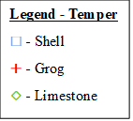
Temper

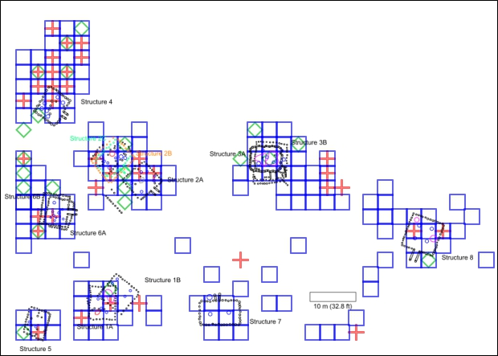
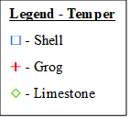
Figure 6.1: Distribution map of shell, grog, and limestone tempers overlain on the site plan.
Shell tempering was the most abundant temper seen at the site (N=1,400, 93.5%). Shell temper is seen throughout the site and was recovered in most of the units that were excavated (Figure 6.1). Grog was the second most abundant temper. While grog tempered sherds (N=58, 3.9%) were recovered throughout the site, they are more common in the northern section of the site (Figure 6.1). Grog tempered sherds were recovered from throughout the site except for near Structure 7. There appears to be a concentration of grog tempered sherds just north of Structure 4. Limestone (N=27, 1.8%) was the third most abundant temper. Like grog, limestone was also concentrated in the northern area (Figure 6.1). Limestone tempered sherds were recovered from 18 units from the north and just 3 from the south. A small concentration of limestone tempered sherds appears adjacent to and west of Structure 6, and adjacent to and immediately north of Structure 4.
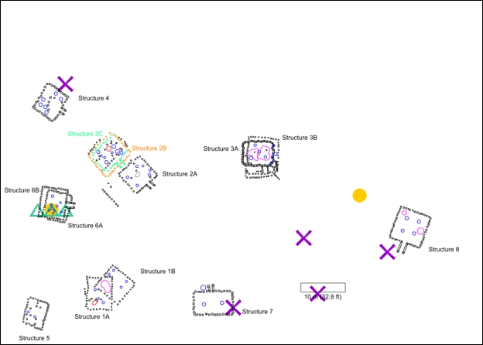
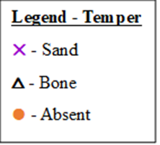
Figure 6.2: Distribution map of sand and bone tempers, and for sherds where a temper was absent.
Sand and bone tempered had the same number of sherds (N=5, 0.3% each). Sand tempered sherds were mostly recovered from the southeast area of the site; although, one unit did have a sand tempered sherd recovered from the site’s northeast corner, just north of Structure 4 (Figure 6.2). Bone tempered sherds were recovered from just one area of the site (Figure 6.2). Bone tempered sherds were recovered from three units that overlap Structure 6. Sherds with temper absent from the paste (N=2, 0.1%) came from one unit to the west that overlaps Structure 6 and from a unit near the northeast edge of the plaza near Structure 8 to the east.

Vessel Forms

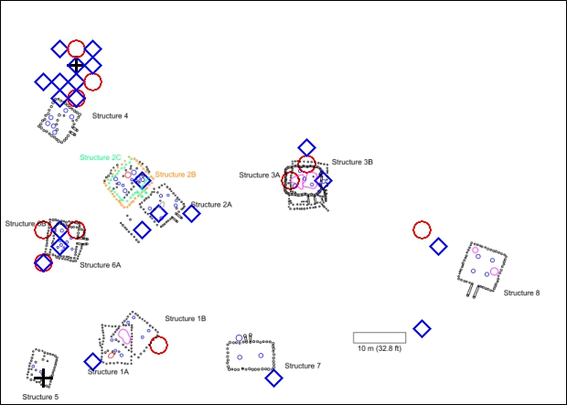
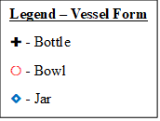
Figure 6.3: Distribution map of bottles, bowls, and jars over lain on the site plan.
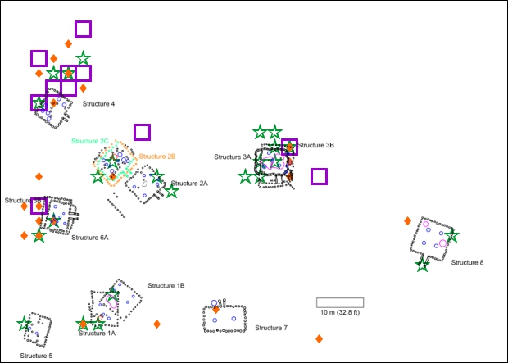
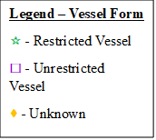
Figure 6.4: Distribution of restricted vessels, unrestricted vessels, and unknown vessel forms.
Two bottles were recovered from this site, one from Structure 5 in the southern area, and a second from a unit north of Structure 4 in the northern area (Figure 6.3). Bowls were mostly recovered from the north adjacent to Structures 3, 4 and 6 (Figure 6.3). One unit in the south had a bowl just outside Structure 1 and a second unit near the northwestern edge of the plaza also had a bowl recovered. Jars were recovered throughout the site (Figure 6.3); however, they were concentrated in the northern area of the site with a particularly large spatial concentration north of Structure 4. Jars were recovered from 18 units from the north four units from the south.

Restricted vessels were mostly recovered from units in the northern area (Figure 6.4). Restricted vessels were recovered from 17 units from the north compared to just 5 units in the south. Unrestricted vessels were only recovered from the northern area (Figure 6.4). Unrestricted vessels were recovered from 11 units with a spatial concentration north of Structure 4. Rim sherds with an unknown vessel form were recovered from 22 units throughout the site (Figure 6.4).

Surface Treatments

In this section, I will analyze the spatial distributions of plain sherds and sherds with a surface treatment. For the purpose of this analysis, I classified all plain, smoothed, and eroded sherds as being “plain.” Sherds with a surface treatment were classified by the type of surface treatment the sherd exhibited. This discussion and the maps below describe individual surface treatments as they relate per unit. A sherd with multiple surface treatments would be counted for each surface treatment that sherd exhibits.

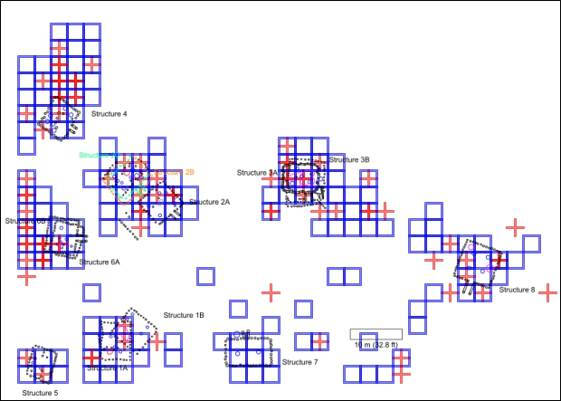
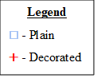
Figure 6.5: Distribution of plain sherds and sherds with a surface treatment.
Plain sherds were recovered throughout the site, though they appear to concentrate near the structures (Figure 6.5). Sherds that exhibit a surface treatment were also recovered throughout the site, although they seem to concentrate in the northern area and around Structure 8 (Figure 6.5). Sherds with a surface treatment were recovered from 19 units in the southern area; 2 units from Structure 5, 4 units from Structure 1, 9 units from Structure 8, 1 in the plaza, and three near the site’s southeastern edge. In the north, sherds with a surface treatment were recovered from 44 units concentrated around the structures.
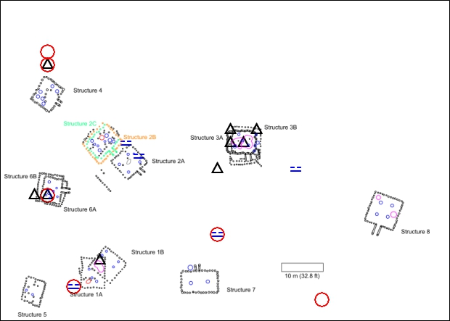
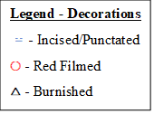
Figure 6.6: Distribution of red filmed, incised/punctated, and burnished sherds over lain on the site plan.
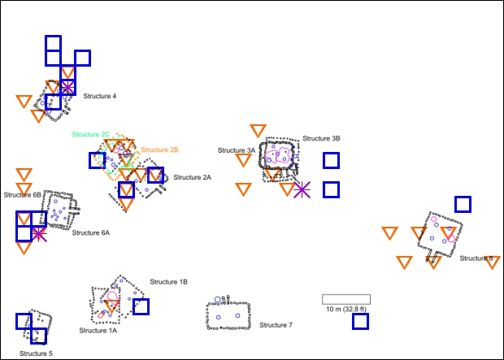
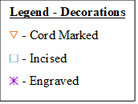
Red filmed and fine ware vessels were most likely to have been used for Caddo ceremonies and rituals (Perttula et al. 2021). Fine ware vessels were engraved and were also often burnished, and many of the fine ware vessel types also had punctations (i.e., Iwi Engraved, Crockett Curvilinear, and Pennington Punctated) (Perttula et al. 2021). Red filmed sherds (N=6) were recovered from 6 units relatively far apart, except for two adjacent units north of Structure 4 (Figure 6.6). Burnished sherds (N=16) were recovered from units associated with Structure 1, 3, and 6, and in one unit north of Structure 4 (Figure 6.6). Burnished sherds appear to be concentrated around Structure 3. Incised/punctated sherds (N=6) were recovered from five units (Figure 6.6). Incised/punctated sherds were recovered from a unit associated with Structure 1, 4, 6, and the plaza. A small concentration of incised/punctated sherds appear to have come from structure 2 where three sherds from two units were recovered.
Figure 6.7: Distribution of cord-marked, incised, and engraved sherds.

Cord-marked sherds (N=34) were recovered from units associated with every structure except Structure 5 and 7 (Figure 6.7). Most of the cord-marked sherds came from Structures 2 and 8 (N=9, 26.5% each). Structures 3, 4, and 5 each had 5 cord-marked sherds (14.7% each). Structure 1 only had 1 cord-marked sherd (2.9%). Incised sherds (N=23) were found in units associated with every structure except Structure 7 (Figure 6.7). The spatial concentration of incised sherds appears to be associated with Structure 4. Engraved sherds (N=3) are found in three units in the northern area that are associated with Structure 3, 4, and 6 (Figure 6.7).
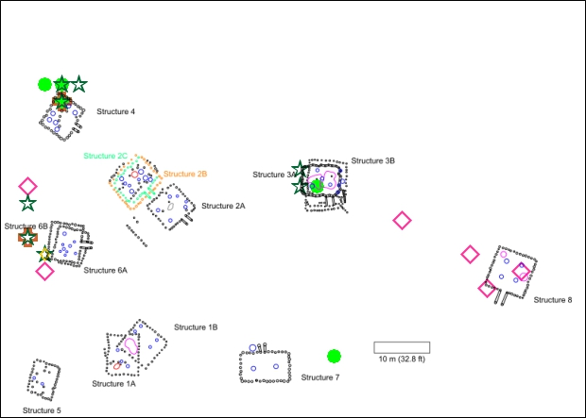
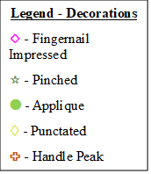
Figure 6.8: Distribution of fingernail impressed, pinched, applique, punctated, and handle peak sherds.
Fingernail impressed sherds (N=8) were recovered from units associated with Structure 6, 8, and the northeast edge of the plaza. There appears to be a spatial connection associated with Structure 8 (Figure 6.8). Pinched sherds (N=8) were recovered from units associated with Structure 3,4, and 6 (Figure 6.8). Sherds with appliqué (N=6) were recovered from units associated with Structure 3,4, and to the east of Structure 7 (Figure 6.8). One punctated sherd was recovered from the site and it was recovered from a unit that overlapped Structure 6’s southwest corner (Figure 6.8). Two handle peaks were recovered from this site, and they were recovered from units associated with Structure 4 and 6 (Figure 6.8).

Sherds
There are several diagnostic sherds that can tell us something about School Land I. Two sherds with handle peaks were recovered. Handle peaks are temporally diagnostic. They appear during the Norman phase (AD 1250-1350) which is consistent with the radiocarbon dates (See Table 2.1) and supports that School Land I was occupied during a late Harlan and early Norman phase transition period (Brown 1996:158; Hammerstedt and Savage 2021:108).
Red filmed wares first appeared early in the Harlan phase (AD 1050-1250) and were common types throughout the precontact phases (Brown 1996:158). Red filmed wares were used to serve food and to hold liquids (Brown 1996: 158; Perttula et al. 2021:12). These wares tended to have fine pastes, were frequently burnished on both the interior and exterior surfaces and had relatively thin body walls compared with plain and utility wares (Perttula et al. 2021:12) It is hypothesized that that these vessels were used for ritual or other communal and formal practices (Perttula et al. 2021:12).
Two Iwi (Spiro) Engraved sherds were recovered from this site. These sherds were recovered from adjacent units and are possibly from the same vessel. Iwi Engraved vessels have been recovered from both domestic and ceremonial contexts throughout the whole Caddo area, however they are rare in domestic contexts in the northern Caddo area (Lambert et al. 2022:5). The concentric circles and spiral motifs are indicative of an eagle and by extension, the Birdman figure (Lambert et al. 2022:8). Eagles and the birdman were prominent and powerful figures in Caddo cultural narratives and were used in many ceremonies and rituals (Gadus 2013; Lambert 2022:8). The vessel(s) these two sherds were once a part of a may have been used in rituals that honored the birdman at this site.
Iwi (Spiro) Engraved vessels were also not made locally in Oklahoma. These wares were produced in the south, probably along the Red River Valley and imported into the northern Caddo area (Lambert 2017). The fact that these sherds appear at this site may be evidence of its participation in domestic trade networks.
This is probably the best place to also mention the two sherds without temper. These sherds are both from simple pinch pot bowls small enough to easily fit in the palm of one’s hand. One of the bowls would have had a circumference of about 1.5 cm, and the other about 3 cm. The 1.5 cm circumference bowl was recovered from within Structure 6 and the 3 cm circumference bowl was recovered from a unit northwest of Structure 8 (Figure 6.2). The function of these vessels is not known. The size and construction method makes cooking, serving, or storage unlikely. The crude shape also makes them unlikely to have been used for ceremonies or rituals. It is possible these vessels were used to hold pigments. However, confirming the use of these vessels would be difficult since the WPA would have scrubbed away any kind of residues that might have remained in interior surface of these vessels.

Discussion
Looking at the data, there are two key findings at School Land I. The first is that the site can be divided into two sections based on sherd count. The four structures in the southern section, Structures 1, 5, 7, and 8, have a combined total of 19.5% (9.4% of total assemblage) of sherds recovered from structures; and the four structures in the northern section, Structures 2, 3, 4, and 6 have a combined total of 80.5% (38.5% of total assemblage). Nearly four-fifths of all the sherds come from only half of the structures, with the other half only having one-fifth of all the sherds.
This distribution pattern can also be seen in the bones recovered from the site as well. The faunal analysis conducted by Duffield found a very similar pattern as the ceramic assemblage (Duffield 1969). For his report, Duffield analyzed 1,932 animal bones and was mainly concerned with determining the species and quantifying the bones. As such, he did not go into depth concerning the distribution of the bones. However, he did write a short section on the horizontal distribution. In this section he wrote that the distribution of the bones was “principally concentrated in 4 of the 8 house areas, and, in most cases, they were found within the house outlines” (Duffield 1969:59). He then writes “In the house areas in the southern part of the village, the bones were exceedingly scarce” (Duffield 1969:59). He presented his spatial results of the bones as a plan map of the site that shows the number of bones found in each unit (See Chapter 2, Figure 2.8) (Duffield 1969:48, Figure 2).
Based on his report and his excavation map, I was unable to determine the exact number of bones that came from each structure. From the map, approximately 70 (3.7%) bones were recovered from the southern area (structures and non-structures) while approximately 1,842 (96.3%) were recovered from the northern area (structures and non-structures). Since Duffield’s excavation map did not include unit borders, it was difficult to determine which units overlapped a structure, so approximations were assigned. Structure 1 had approximately 28 bones (1.5%). 2A and 2B/C had approximately 61 bones each (3.2% each). Structure 3 had approximately 370 (19.2%).
Structure 4 had 51 (2.6%). It is also worth noting that approximately 454 (23.5%) of the bones were recovered outside Structure 4, mainly to the immediate north and northeast. Structure 5 had approximately 10 (0.5%) bones. Structure 6 had approximately 256 (13.3%) bones. Structure 7 had zero bones. And Structure 8 had approximately 7 (0.4%) bones.
Based on this estimation, Structure 3 had the most bones recovered with nearly one-fifth of the total bones from the site. Structure 6 was the second most, and Structures 2A and 2B/C are tied for third.
The first possible reason for this pattern is that Structures 2, 3, 4, and 6 were occupied for longer periods of time than Structures 1, 5, 7, and 8. The rebuilding of some of the structures at School Land I may be evidence of this. As a structure ages and becomes more dilapidated, it may be deemed easier to demolish and rebuild a structure than it is to maintain it. It is not uncommon for these destroyed structures to be rebuilt where the old structure previously stood. So, it is possible that a family, or multiple families, were living in a structure long enough for it to be considered more efficient to demolish and rebuild than to maintain their current structure. Whereas the structures that show no evidence of having been demolished and rebuilt were not occupied long enough for that structure to be deemed in need of rebuilding.
At School Land I, four structures have been rebuilt where a previous structure once existed. Three of the structures are from the northern section of the site (Structures 2, 3, and 6) and one from the southern section (Structure 1). In the northern section, Structures 3, and 6 have one rebuilt structure directly on top of the original structure and maintained the same orientations. Structure 2 is different from the others in that it was rebuilt twice instead of just once. In the southern section of the site, only Structure 1 has been rebuilt.
If evidence of a structure being rebuilt can mean that a specific location was continuously lived on long enough that at least one structure aged so much that it needed to be rebuild, then it is not such a leap to infer that these structures would have more archaeological materials associated with these structures. In respect to School Land I, the northern section has three structures that had been destroyed and rebuilt at least once, while the southern section of the site only has one structure that had been rebuilt. Of the northern structures, the one that hadn’t been rebuilt, Structure 4, had the least sherds recovered from it. Of the southern area, the only structure that was rebuilt, Structure 1, had the most sherds recovered from it. This might be the reason the northern structures have significantly more sherds than the southern structures.
Duffield (1969:59) has proposed that the lack of bones from Structures 1, 5, 7, and 8 are evidence that these structures were used as “guest houses.” To support his argument, Duffield cites an ethnographic account on a Hasinai (a Caddo band from east Texas) village from 1690 by Massanet, a missionary, that wrote the following:
Soon I noticed, outside the yard, opposite the door of the governor’s house, another long building, in which no inmates could be seen. I asked who dwelt there or what purpose it served, and was told the captains were lodged in that house when the governor called them to a meeting. On the other side I saw yet another and smaller vacant house, and upon my inquiring about this one they answered that in the smaller house the pages of the captains were lodged, … (Swanton 1996:149).

Duffield postulated that the above mentioned “long building” might describe Structure 7. If Structure 7 was a meeting house that would also be used to temporarily lodge the “captains” as described above then the smaller building next to it, Structure 5, would have been used to temporarily lodge the “pages.” Duffield acknowledged that, while this explanation based on an ethnographic account could describe Structure 5 and 7 and their low concentration of bone artifacts, he could not readily explain the reason Structure 1 and 8 also had low bone artifact concentrations as well (Duffield 1969:58-59).
While Duffield didn’t use this term, what he is essentially describing are special purpose buildings when he is describing Structure 5 and 7. Specialized buildings were defined by J. Daniel Rogers as “any of the variety of structures that provide a physical context for the integration of social organization beyond that of the household unit” and may include temples, meeting halls, charnel houses, and the residences of chiefs and other officials (Rogers 1982:49). Rogers further defines Caddo special purpose buildings as “structures found in direct association with mounds or having unusual characteristics, such as extra large dimensions” and as “structures that are markedly different from contemporaneous domestic dwellings (Rogers 1985:49).
Caddo special purpose buildings have mostly been studied in the context of mound sites with little investigation in non-mound village contexts. Some villages certainly could have had meeting houses, chief’s residences, or charnel houses, however, their recognition in the archaeological record has yet to be deciphered (Rogers 1982:49-51). An account of early historic Caddo from east Texas relates that the houses of low-level chiefs (canahas) were generally indistinguishable from other homes in the village (Rogers 1982:51). The only recognized feature of special purpose buildings are extended entranceways and a lack of internal features (Regnier 2019:231).
Extended entranceways allowed for restricted visibility and restricted access to their interiors (Brown 1996:132; Regnier et al. 2019:321). A lack of internal features such as hearths and pits indicate that their primary function was not as permanent residences (Regnier 2019:321). Even though the primary function of special purpose buildings were not as residences, domestic artifacts have been recovered from these buildings, which may indicate that some of these structures were, at times, used as a residence of some kind (Regnier 2019:323). Given the definition that special purpose buildings had extended entranceways and lacked internal features, five of the 13 total structures at School Land I could possibly have been special purpose buildings.
Out of the 13 individual structures on this site, only Structures 2A, 3A, 4, 6B, and 7 had extended entranceways and lacked internal domestic features. Structures 1A, 1B, 3B, 5, and 6A lacked extended entranceways. And while Structures 2B, 2C, and 8 had extended entranceways, they also each had a fire pit and an artifact pit within their interiors, which would exclude these structures from being considered as special purpose buildings. To better understand the possible purposes of these structures I will consider the evidence for each building in greater depth.
The data used for this discussion was taken not just from within the structure, but also from units around the building that can be interpreted as associated with a specific structure. This was done to create a more broad and extensive data set that might provide a clearer picture of what was happening at each structure area. I primarily use temper and surface treatment as evidence of vessel function to infer certain general activities associated with each structure. While vessel form can also be used as a line of evidence, I chose not to use this data as evidence since most of the rim sherds could not be designated a precise vessel form. Without precise form designations, vessel use could not be reasonably recognized.
Structures 1A and 1B both lacked extended entranceways. 1A has a fire pit near its southwestern corner. A cache pit overlaps 1A’s northeast corner and 1B’s western corner. A total of 82 sherds were associated with Structure 1. Seventy-two sherds were recovered within the structure and ten were recovered outside it. 91.5% (N=75) of the sherds associated with Structure 1AB are non-decorated and shell tempered and are most likely from utilitarian wares. However, 8.5% (N=7) of the sherds exhibit some sort of surface treatment. This assemblage includes 1 burnished sherd and 1 red filmed incised/punctated sherd (Figure 6.9C), which could be interpreted as evidence of ceremony or ritual use in this space. Other decorated sherds include cord-marked (N=1, Figure 6.9A) and an incised (N=1, Figure 6.9B) sherd. The incised sherd is a grog tempered, smoothed rim sherd that has multiple, seemingly short and shallow incised lines oriented in a mostly horizontal direction. The incised/punctated sherd is the above mentioned red filmed sherd and is grog tempered. This sherd exhibits two sets of parallel lines on different parts of the sherd and several punctations between these sets of lines (Figure 6.10).
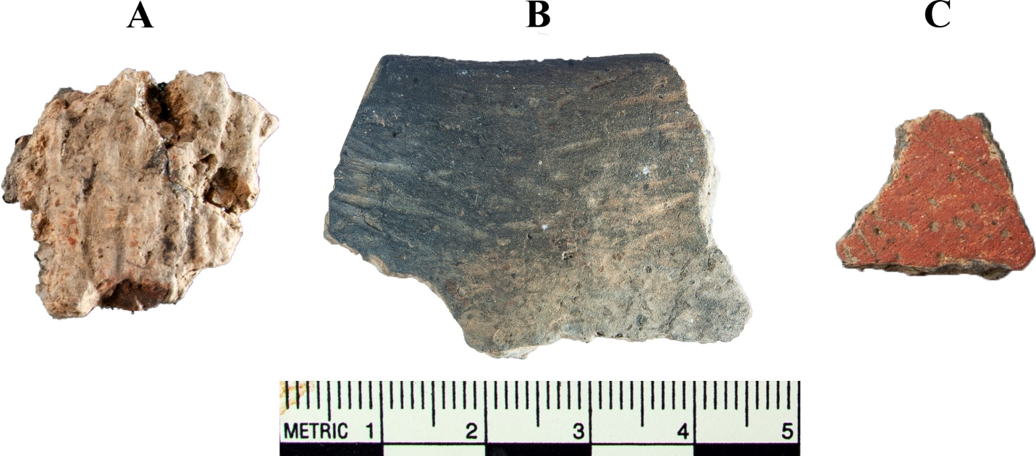
Figure 6.9: All the decorated sherds associated with Structure 1. A) cord-marked, B) incised rim, and an C) incised and punctated with red film.

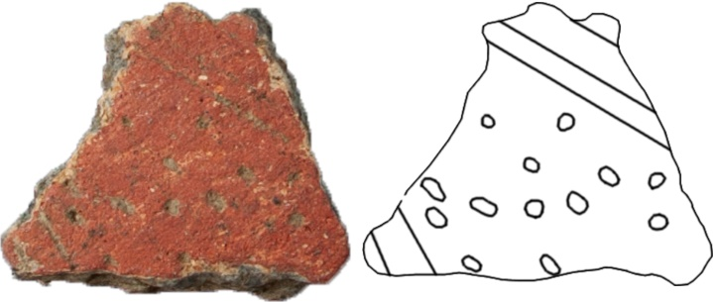
Figure 6.10: Structure 1 red filmed incised punctated sherd with outline.
Most of the sherds probably came from utilitarian wares. Not having an extended entranceway yet having a fire pit and cache pit within probably means this building was not a special purpose building. It is difficult to rule out the possibility that either Structure 1A, 1B, or both were used as guest houses as Duffield suggested. The relatively low ceramic sherd count does seem to support the notion that these buildings were occupied for short periods of time like a guest house.
Structure 2A has an extended entranceway and no internal structures. On the WPA Structure 2 diagram they drew and labeled an “ash heap” within the building. This ash heap might be evidence of a hearth having once existed there. Calling this feature an ash heap instead of a fire pit makes me believe that no hearth stones were recovered. This could be seen as evidence that the hearth was temporary and disassembled after use which would be consistent with a special purpose building (Rogers 1980:87).
Out of the 77 sherds recovered from within Structure 2A, 68 (88.3%) were non-decorated shell tempered sherds (Woodward Plain). Two other sherds were also plain, one grog and the other limestone tempered. Decorated sherds include cord-marked (N=4, Appendix E.2), incised (N=2, Figure 6.11), and incised/punctated sherds (N=1). The cord-marked and incised sherd are not necessarily indicative of ritual or ceremonial use or as a prestige good, but the incised/punctated sherd was more likely used for such purposes. The incised/punctated sherd from Structure 2A consists of two wide and shallow incised lines with multiple linear rows of punctations between the two incised lines (Figure 6.12). This sherd was classified as indeterminate as it could be either Pennington Punctated or Crockett Curvilinear. The surface of this sherd is moderately eroded, and the decorations are not highly visible. Due to the prominence of sherds from possible utilitarian vessels and a lack of sherds often associated with ceremony and ritual, it is difficult to assign this building as special purpose despite its extended entranceway and its lack of interior features.
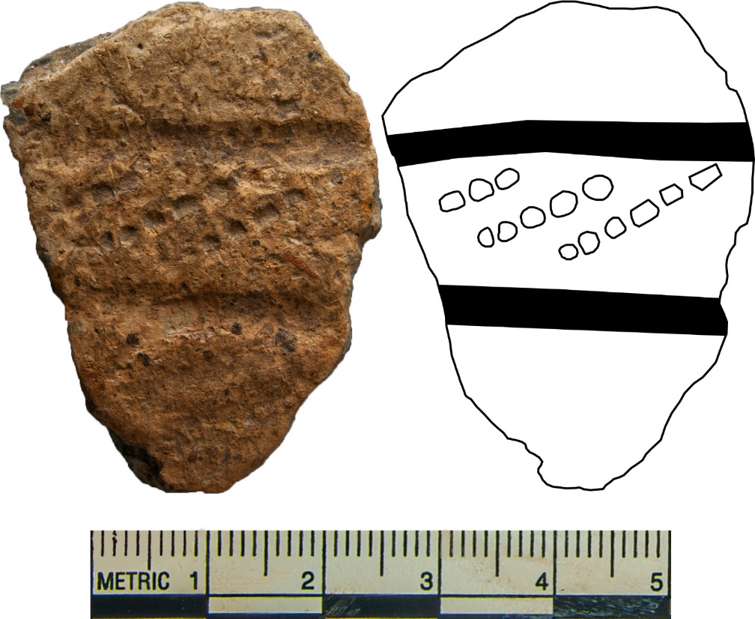
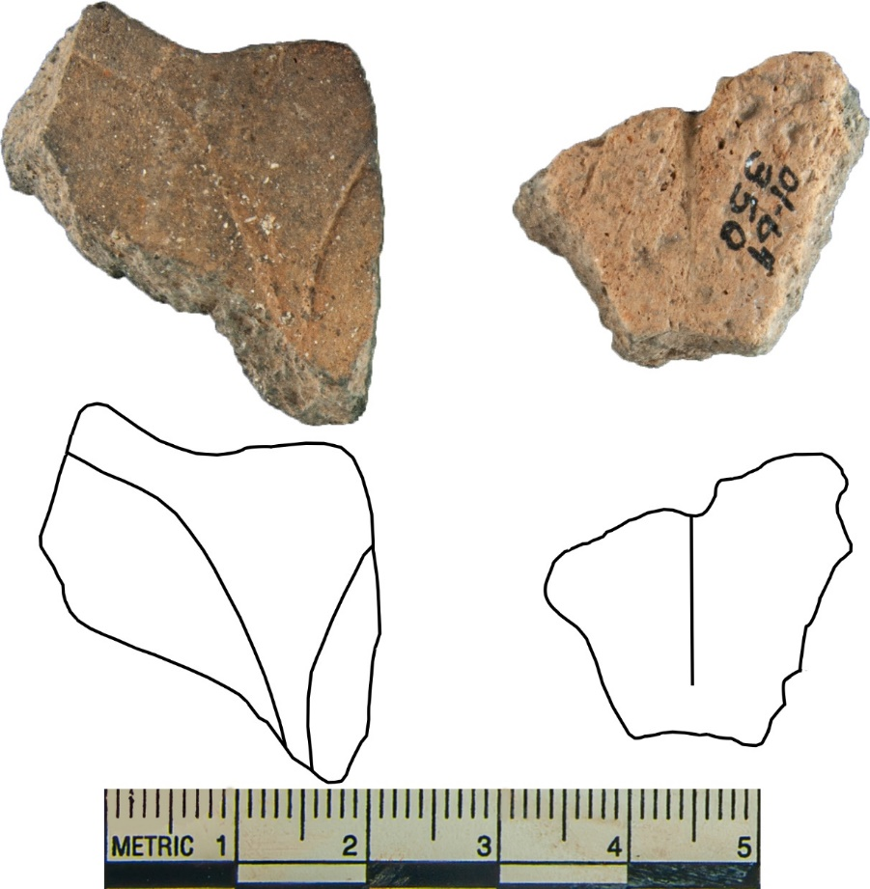
Figure 6.12: Incised/punctated sherd and outline from Structure 2A.
Figure 6.11: Incised sherds from Structure 2A above with their outline below.
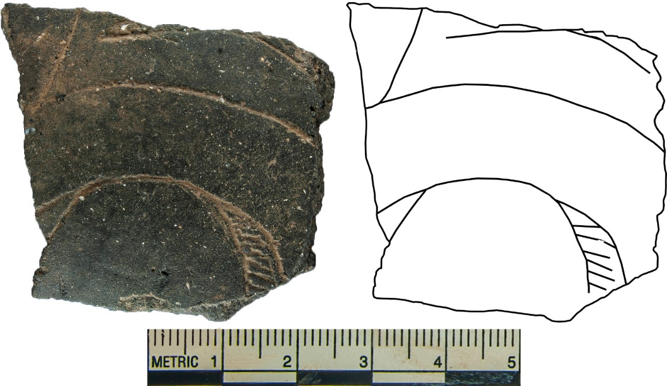
Structure 2B/C had an extended entranceway, but also had a fire pit and an artifact cache. This structure had a total of 53 sherds, of which, 43 were non-decorated shell tempered (81.1%) and 3 more were non-decorated grog tempered (5.7%). Seven sherds were decorated, four cord-marked (Appendix E.3), 1 incised, and two incised/punctated. The incised sherd exhibits curvilinear motifs and was probably burnished, although if it was burnished it was eroded off (Figure 6.13). This sherd was classified as Williams Incised, although it is possible it actually represents an Iwi (Spiro) Engraved or Crockett Curvilinear. There is not enough of the motif present to establish it as one or the other. The two incised/punctated sherds exhibit curvilinear incisions and small punctations and were also probably burnished (Figure 6.14). These two sherds were recovered from the same unit and were possibly from the same vessel. These sherds were classified as Iwi (Spiro) Engraved. It is also worth noting that, due to their similar attributes, the incised sherd could also possibly be from the same vessel as the two Iwi (Spiro) Engraved sherds. The incised sherd was recovered from a unit in the same row as the Iwi (Spiro) Engraved sherds, and three units west.
Figure 6.13: Structure 2B/C incised sherd with outline.
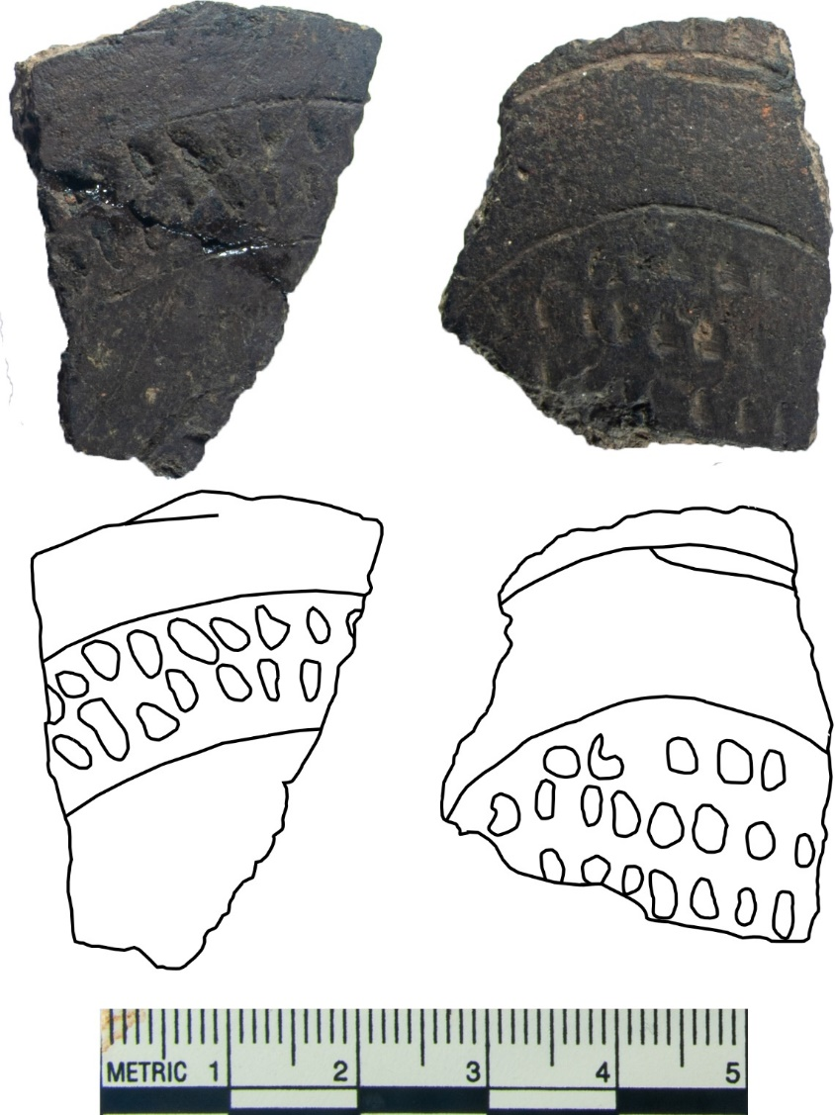
The incised and incised/punctated sherds came from vessels that were highly likely to have been used in ceremony or ritual. Structure 2B has no discernable extended entranceway, while 2C does. It is possible that Structure 2B had no extended entranceway and the fire pit and artifact cache are associated with this building iteration and not Structure 2C. It seems likely that Structure 2B was used primarily as a residence. Structure 2C may have been used as a special purpose building and the incised and incised/punctated sherds are associated with the 2C.
Figure 6.14: Iwi Engraved incised/punctated sherds with outline below.
Structure 3 consists of two overlapping structures, Structures 3A and 3B. 3A has an extended entranceway, while 3B had no such discernable entranceway. Two artifact cache pits were observed. One is just east of Structure 3A but within Structure 3B, and the second cache pit is located in a unit within both structures. Within both structures there are wattle heaps and a charcoal concentration that is evidence that at least one iteration of this structure was destroyed by fire.
185 sherds were recovered from units associated with Structure 3. 123 sherds were recovered from within the structure and another 62 were recovered in the immediate area around the building. 160 of which are non-decorated shell tempered (86.5%), 2 were non-decorated grog tempered (1.9%), and 1 was non-decorated limestone tempered (0.5%). Ten sherds were burnished (5.4%), and all ten were shell tempered.
Decorated types include applique (N=1), cord-marked (N=5), engraved (N=1, 6.16A), incised (N=2), fingernail impressed (N=1), incised/punctated (N=1), and pinched (N=2). The applique sherd is limestone tempered and consists of applique fillets in what appears to be a chevron pattern (Figure 6.15). This sherd was classified as ‘indeterminate’ due to its small size. The cord-marked sherds included three shell tempered and two limestone tempered sherds (Appendix E.4). These sherds probably come from utilitarian vessels. One of the incised sherds appears to have been burnished, but its surface is too eroded to know for sure (Figure 6.16B). The sherd is too small to determine if the incising is patterned. The second incised sherd is also small, but in one small area two thin, parallel lines can be seen (Figure 6.16C). Both incised sherds were shell tempered.
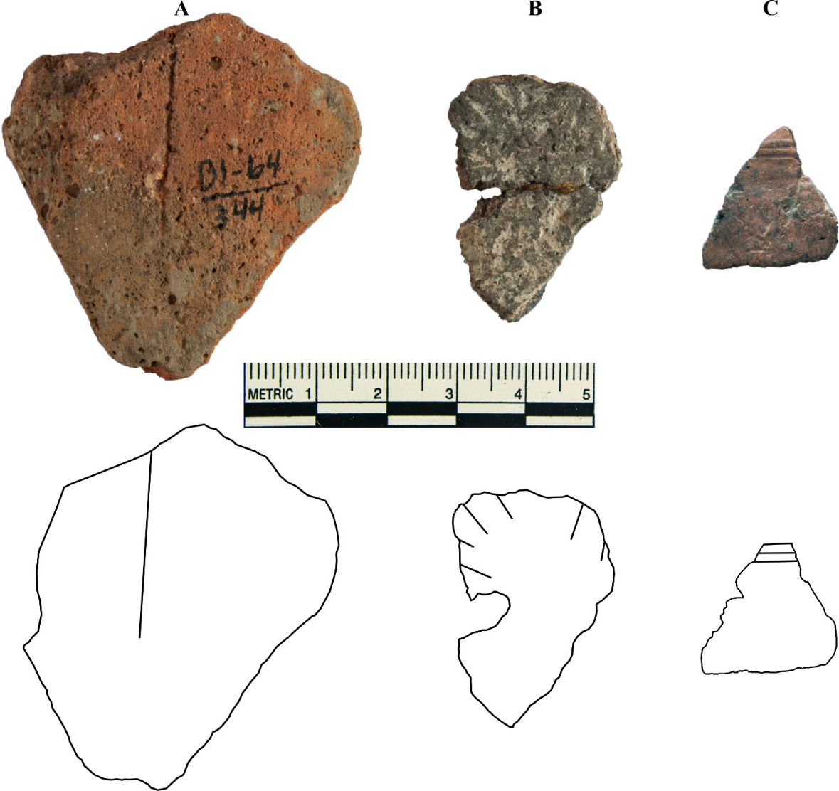
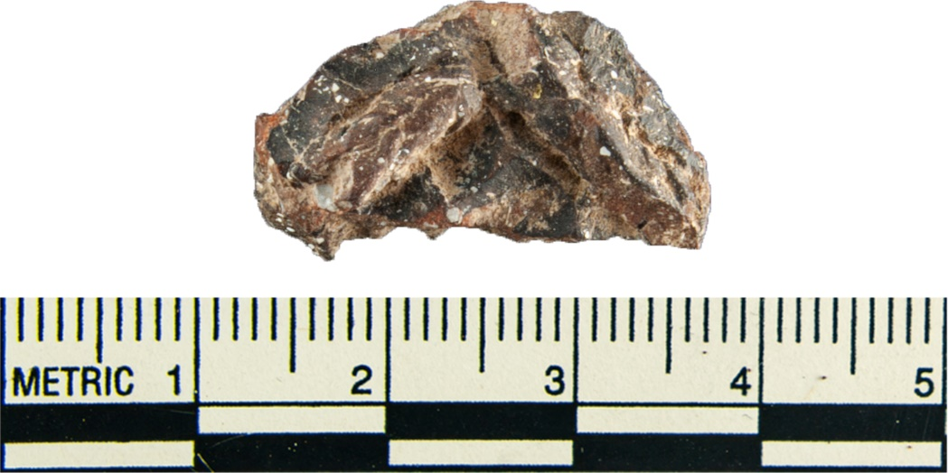
Figure 6.16: Structure 3 engraved (A) and incised (B-C) sherds.
Figure 6.15: Structure 3 applique sherd.
The fingernail impressed sherd was grog tempered and consists of a partial square base and body fragment (Figure 6.17). The fingernail impressions were positioned horizontally and were seemingly aligned in vertical and horizontal parallel rows and columns throughout the body portion of the sherd. The incised/punctated sherd was grog tempered and includes three parallel lines and a series of reed punctuations under one line (Figure 6.18). This sherd was classified as Pennington Punctated. The pinched sherds are both shell tempered. One sherd has a linear row of vertical pinched ridges spaced about 1 cm from the other (Figure 6.19A). This pinched pattern appears to have made a decorative band around the vessel. The second pinched sherd is burnished with a tight row of pinched ridges at a slight angle from the vessel’s vertical axis (Figure 6.19B).
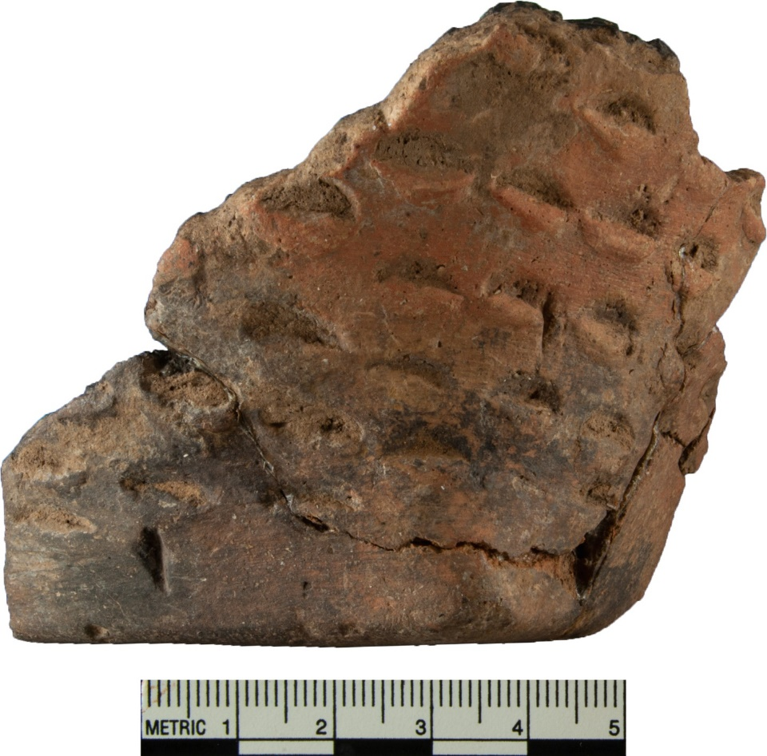
Figure 6.17: Structure 3 fingernail punctated base/body sherd.
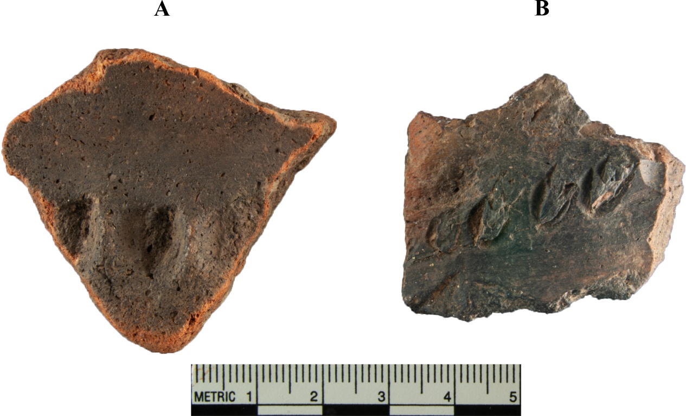
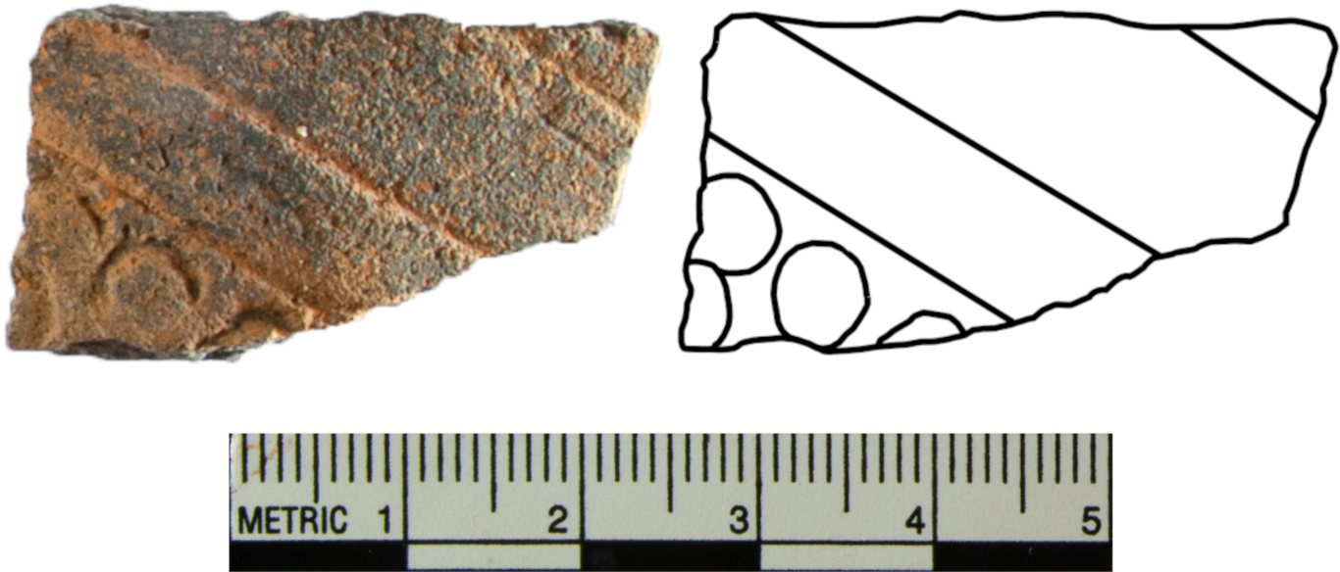
Figure 6.19: Structure 3 pinched sherds.
Figure 6.18: Structure 3 incised/punctated (Pennington Punctated) sherd.

Given the evidence it seems likely that Structure 3A was a special purpose building, while Structure 3B was a residence. It is difficult to say for sure since the two structures significantly overlap. However, due to Structure 3A’s extended entranceway, its unique architecture, and the amount of decorated and burnished sherds, it is very likely that 3A was not a mere residence but was used in some compacity as a special purpose building. It is possible the majority of utilitarian ware came from Structure 3B and not 3A. The abundance of utilitarian sherds is evidence of residential use, which fits with 3B’s lack of an extended entrance way and having at least one artifact cache pit.
Structure 4 has an extended entranceway and no interior features. This building had a total of 645 sherds associated with it. 106 sherds came from within the structure, while 539 sherds were recovered from outside the structure, most coming from units to the immediate north of the building. There appears to be a spatial concentration of sherds just north of Structure 4 and extending for about 13.7 m (45 feet) north from the structure’s north corner and about 15.2 m (50 ft) wide. It is unknown if this concentration is associated with Structure 4 or a separate feature. It is possible that this concentration represents a refuse area or some other activity area. Since this concentration cannot be accurately distinguished as a separate feature, for the purpose of this paper it will be discussed as if it is associated with Structure 4 due to the proximity to the structure.
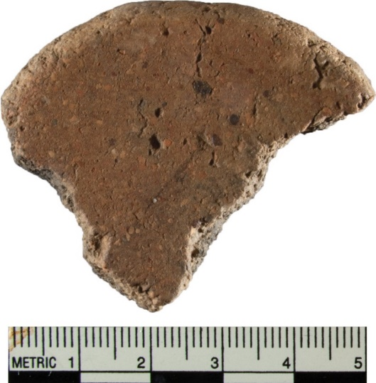
Out of the 645 sherds, 616 were not decorated (95.5%). Of those not decorated, 601 were shell tempered (93.2%), 9 were grog tempered (1.4%), 5 were limestone tempered (0.8%), and 1 was bone tempered (0.2%). Two sherds were shell tempered and burnished. The burnished sherds were recovered from outside the structure. Two sherds were red filmed and not decorated (Appendix E.1B-C). These sherds were recovered from adjacent units and are possibly from the same vessel. Both sherds were recovered outside of the structure. Two sherds were burnished and were recovered from the same unit outside the structure. A ceramic disc fragment was recovered from within the structure (Figure 6.20). The disc fragment is grog tempered and would have had a diameter of about 3 cm. It was recovered from a unit immediately west of Structure 4.
Figure 6.20: Structure 4 ceramic disc fragment.

Decorated types include applique (N=3), cord-marked (N=5, Appendix E.5), engraved (N=2), incised (N=9), pinched (N=4), and handle peak (N=1). Of the three applique sherds two were recovered outside of Structure 4 and the third from within; all were recovered from adjacent units, and all were grog tempered. All three applique sherds consist of fillets. Two of the sherds exhibit two parallel fillets with a third fillet perpendicular to the two parallel fillets (Figure 16.21A and B) and the third sherd only has a single linear fillet (Figure 16.21C). Four of the five cord-marked sherds were recovered from within the structure with one recovered outside it. Three of the cord-marked sherds were shell tempered and two were limestone tempered.
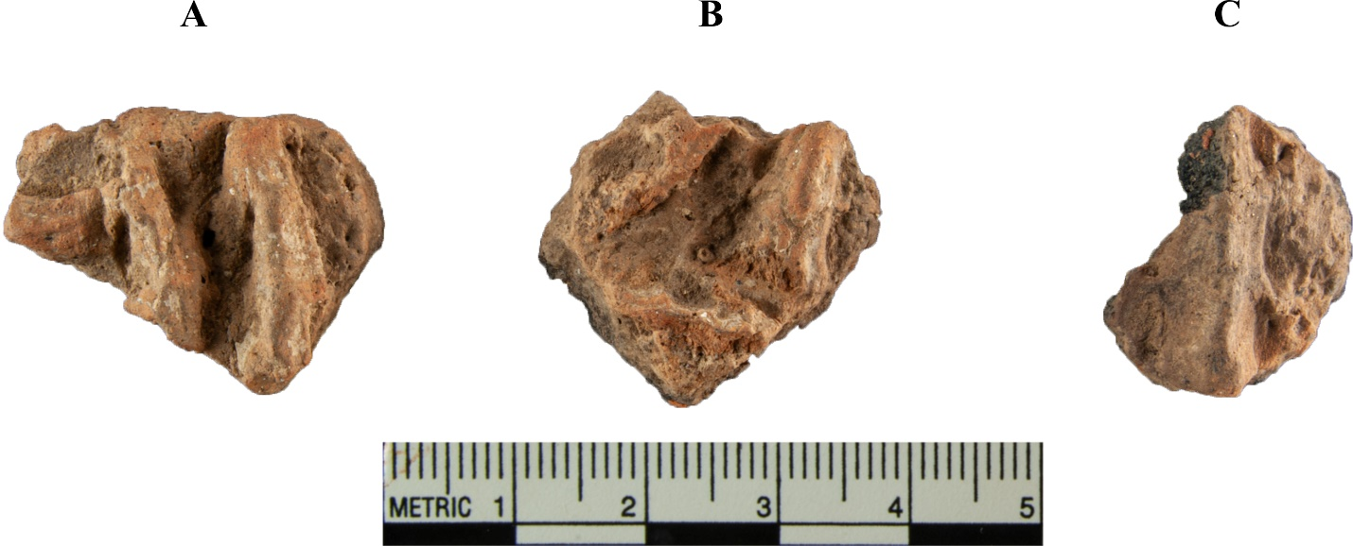
Figure 6.21: Structure 4 applique sherds.
The engraved sherds include a thin walled, grog tempered sherd that consists of a series of thin parallel engraved lines along the edge of the sherd and would extend past the broken edge (Figure 16.22A). The second engraved sherd is shell tempered and consists of only a single thin line that continues beyond the broken edges (Figure 6.22B). Both engraved sherds were recovered outside the structure. The incised sherds consist of 5 shell, 3 grog, and 1 limestone tempered sherds. Nine of the sherds were recovered outside the structure and one from within. Three of the shell tempered incised sherds exhibit a single linear incised line (Appendix E.8). Of the other two shell tempered incised sherds, one has multiple parallel incised lines along the edge that would extend past the edge (Figure 6.23A), and the second sherd show three parallel lines approximately 5mm apart from each other (Figure 6.23B). Of the grog tempered sherds, one is a thin-walled smoothed sherd with four parallel lines that extend past the broken edge (Figure 6.23C), the second has what appears to be short random overlapping incised lines, the third sherd has two shallow parallel lines that would extend past the edge (Appendix E.9A-B). The last incised sherd is grog tempered and had two nearly parallel lines (Appendix E.9C).
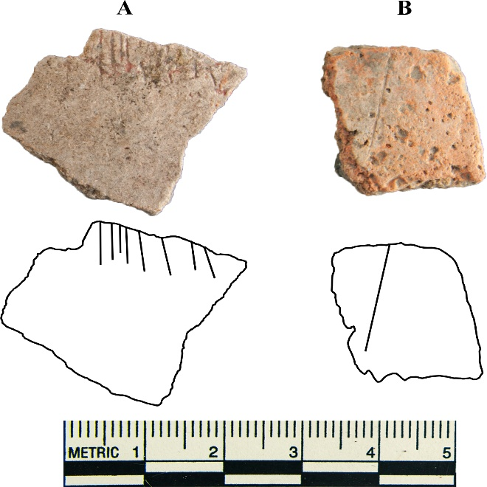
Figure 6.22: Structure 4 engraved sherds.
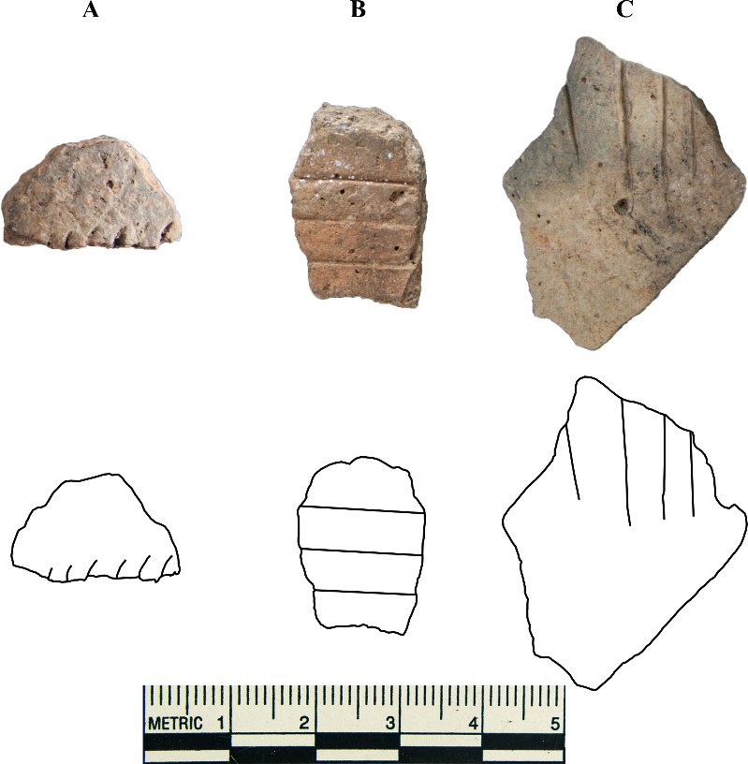
Figure 6.23: Structure 4 sherds with multiple incisions on the surface
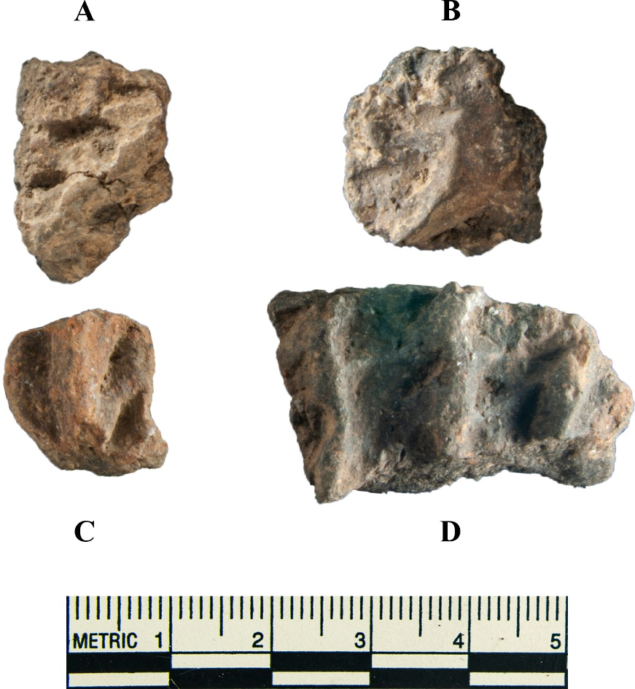
Out of the four pinched sherds three are grog tempered, and the fourth was shell tempered. Three of the sherds were recovered outside the structure and one within it. All four sherds appear to exhibit a single linear pinched ridge. Only one sherd is large enough to show three parallel pinched ridges that would extend past the edge (Figure 6.24D). This sherd was classified as ‘indeterminate.’ It is possible that this sherd is a Hollyknowe Ridge Pinched type, but it was too small to make a definitive distinction. The handle peak comes from a shell tempered rim sherd recovered inside Structure 4 (Figure 6.25). The hand peak consists of a single node on the top of the strap handle. It is possible that a second node once existed next to the existing one. The existing node is off center and the surface next to it has been chipped. The strap itself is approximately 6.7 cm tall, 4.5 cm wide, and 1.4 cm thick.
Figure 6.24: Structure 4 pinched sherds. A, B, D) grog tempered, C) shell tempered

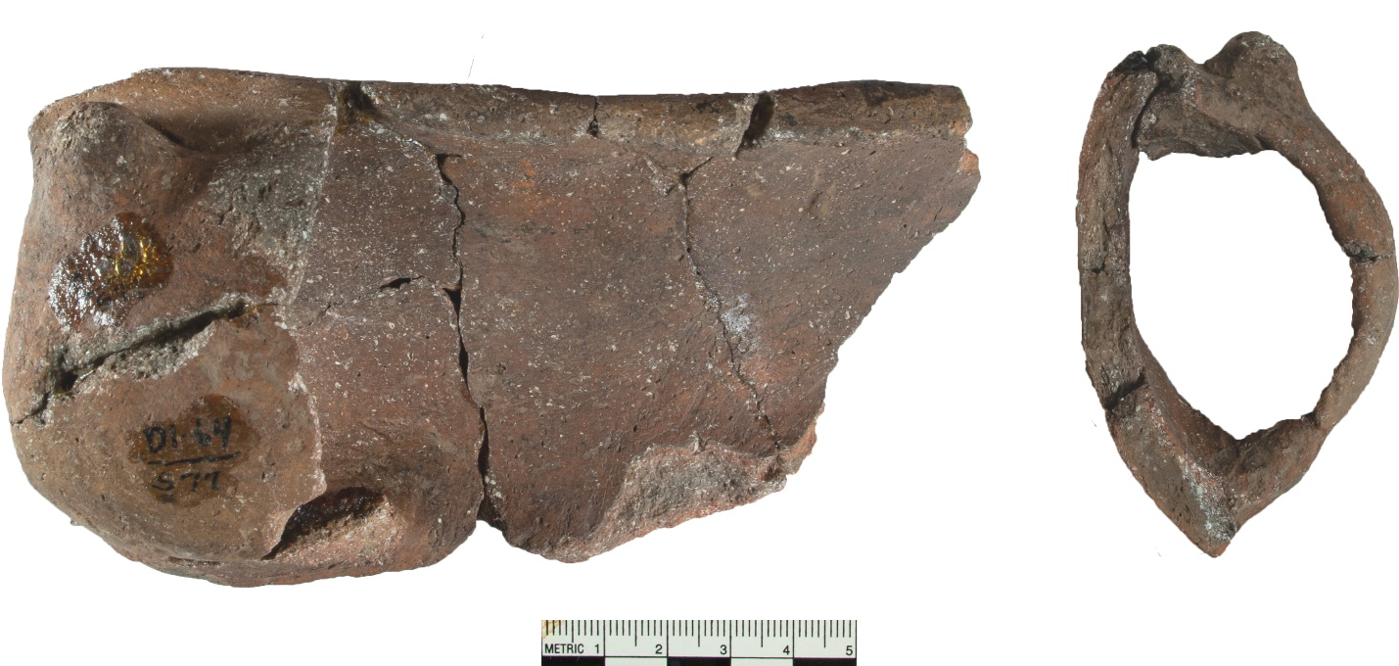
Figure 6.25: Handle peak rim sherd. Plan and profile views.
Despite Structure 4 having an extended entranceway and no interior features, the associated ceramic assemblage does not support this structure as being a special purpose building. The assemblage has very little finewares for the number of sherds recovered. What the evidence does support, at the very least, is that this structure was used as a residence. The number of likely utilitarian wares recovered support that this structure was primarily used as a residence.
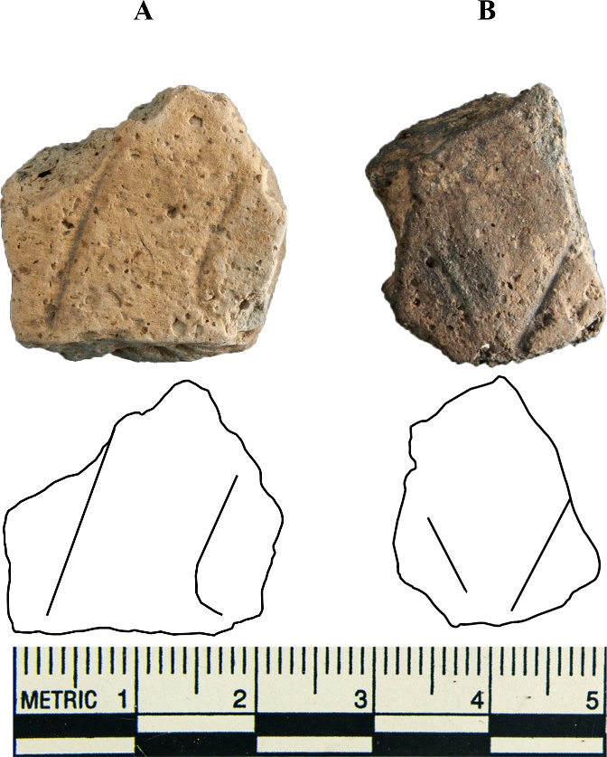
Structure 5 lay in the site’s southwest corner (Figure 3.7) and was rectangular with no extended entranceway and no internal features. Thirty-five sherds were recovered from this structure. Thirty-two were shell tempered, two were grog, and one was limestone tempered. Thirty-four of the sherds were recovered from within and 1 was recovered outside. Thirty-three of the sherds were not decorated (94.3%). One of the two decorated sherds is grog tempered and has two parallel lines about 1 cm apart (Figure 6.26A). The second decorated sherd is smoothed and has two incised lines angled away from each other (Figure 6.26B). With so few sherds, it is difficult to assign a primary use for this structure. It has no extended entranceway, and the assemblage is likely made up of mostly utilitarian wares. This building was most likely used as a residence, but due to the low number of sherds recovered, it was probably not a permanent residence or a residence that was not used for a long period of time.
Figure 6.26: Structure 5 incised sherds.

Structure 6 sat on the western side of the site (Figure 3.7). Structure 6 consists of two superimposed structures overlapping one another. Structure 6B has an extended entranceway. Structure 6A does not appear to have an extended entranceway, although this is difficult to confirm since it is possible that it shares an entranceway profile with Structure 6B. Neither structure has interior features. The ceramic assemblage for Structure 3 includes 265 sherds. Out of the 265 sherds, 211 were recovered within the structure and 54 were recovered outside it. The sherds recovered outside the structure came from units directly from the west and northwest of the structure. 247 of the 265 sherds were not decorated (93.2%). 232 of the non-decorated sherds were shell tempered (93.9%), 5 sand (2.0%), 3 grog (1.2%), 3 limestone (1.2%), and 1 sherd with no temper (0.4%). This assemblage also includes three burnished sherds (1 grog, 2 shell tempered) with no other surface treatments recovered from within the structure. Also included is a non-decorated red filmed sherd recovered from within the structure (Appendix E.1D).
Decorated types associated with Structure 6 include cord-marked (N=5), engraved (N=1), fingernail impressed (N=1), fingernail impressed/applique (N=3), incised (N=3), pinched (N=3), punctated (N=1), and handle peak (N=1). The five cord-marked sherds include four limestone tempered sherds and one shell tempered sherd (Appendix E.6). Only one of the sherds was recovered from within the structure, the other four were recovered outside. The engraved sherd was grog tempered and consists of a series of curvilinear lines, some parallel and some perpendicular to each other (Figure 6.27). The motif would have been complicated and would have spanned a large area of the vessel. This sherd was classified as indeterminate due to its size; however, it is possible this sherd is either Holly Fine Engraved or Iwi (Spiro) Engraved.

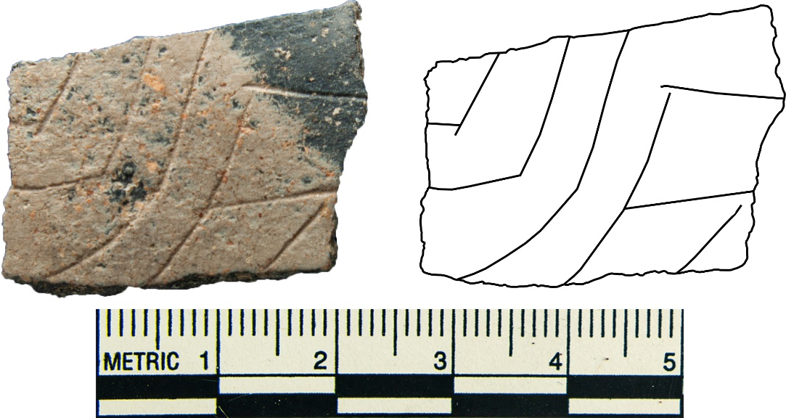
Figure 6.27. Structure 6 complicated incised sherd.
The fingernail impressed sherd is grog tempered and consists of several fingernail punctations at a near 45 º angle from the sherd’s vertical axis (Figure 6.28). This sherd was recovered outside the building. Three grog tempered fingernail impressed/applique sherds were recovered, one from outside the structure, and two from within. The two sherds recovered from within came from the same unit and level. All three sherds exhibit a single applique node. Several fingernail punctations were made on each sherd, and each node had a single fingernail impression on top it.

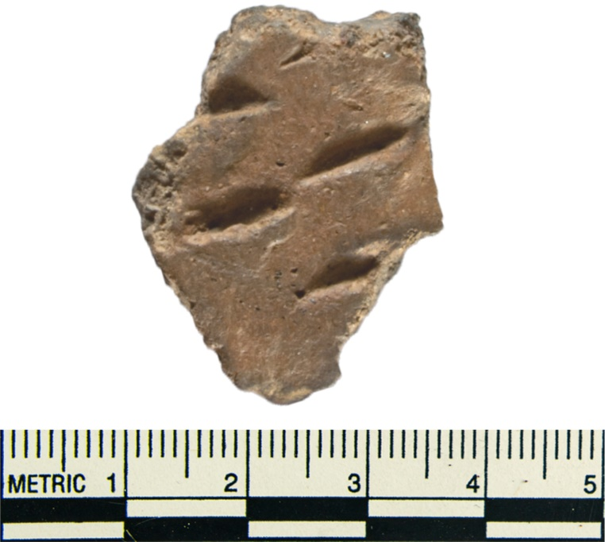
Figure 6.28: Structure 6 fingernail impressed

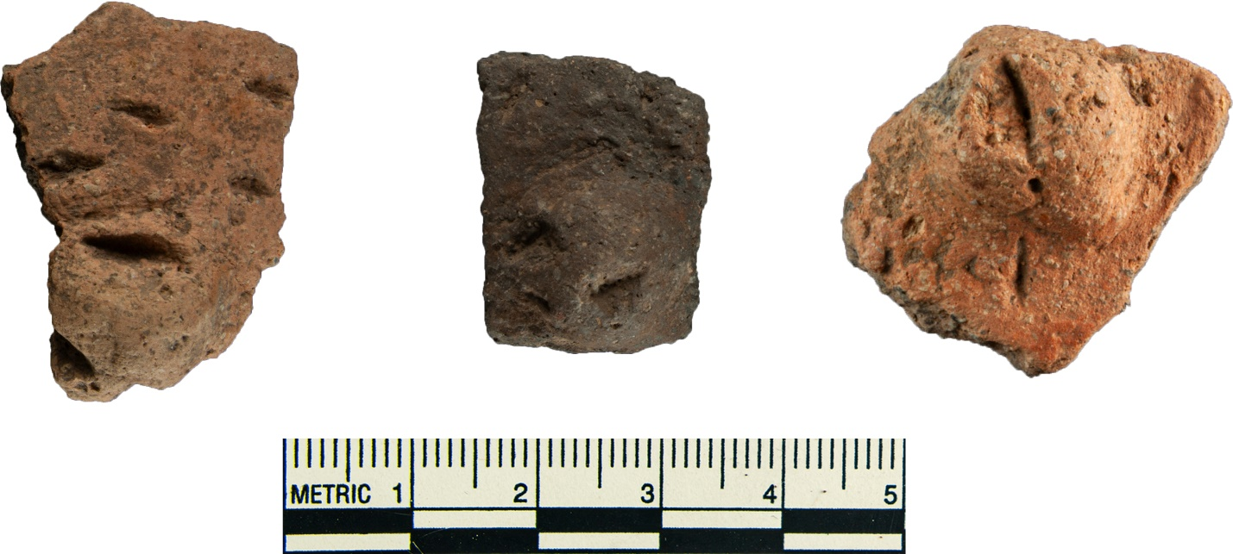
Figure 6.29: Structure 6 fingernail impressed with applique nodes

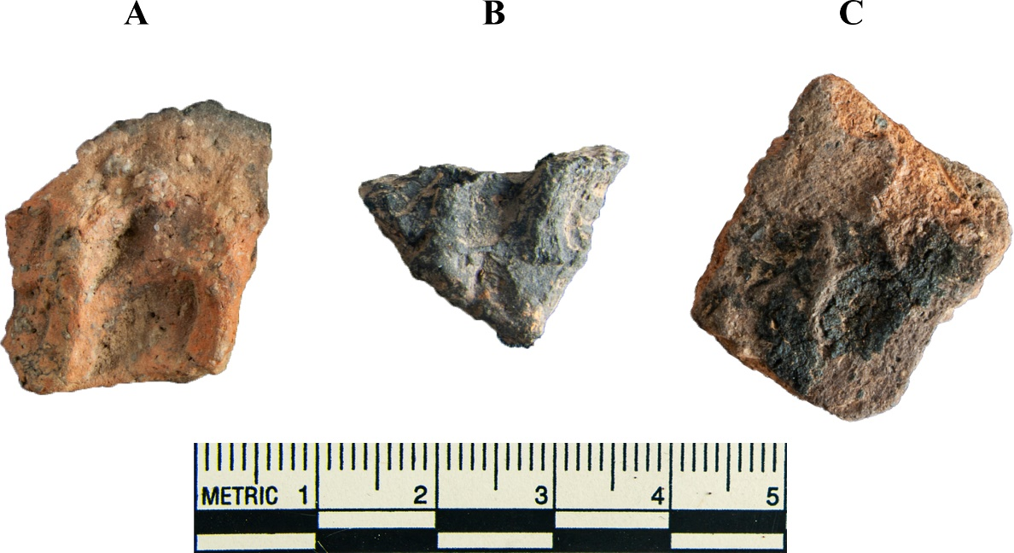
The incised sherds consist of three shell tempered sherds, one was recovered from within the structure, and the other two outside (Appendix E.10). Two of the incised sherds consist of several lines in a random pattern in similar directions (Appendix E.10A-B). The third incised sherd is a base sherd with an incised line on the body about 1 cm above the base in what looks like a band that would go around the vessel (Appendix E.10C). The three pinched sherds consist of two shell tempered, and one grog tempered sherds. Two of them consist of at least two pinched parallel ridge lines (Figure 6.30A-B) and the third sherd consists of a slightly raised area between two pinched depressions (Figure 6.30C).
Figure 6.30: Structure 6 pinched sherds

The punctated sherd is a shell tempered base/body sherd where the body is plain and the punctation is on the base of the sherd (Figure 6.31). It is difficult to determine the pattern of the punctations, but they appear to be rectangular in shape and made in parallel rows and columns that would extend past the edge of the sherd. This sherd was recovered from within the structure. The handle peak is shell tempered smoothed body sherd with a loop handle with two applique nodes on top of the handle (Figure 6.32). The handle itself is approximately 1.5 cm wide, 5.2 cm high, and 1.0 cm thick. The nodes atop the handle are small and angle lightly away from each other.
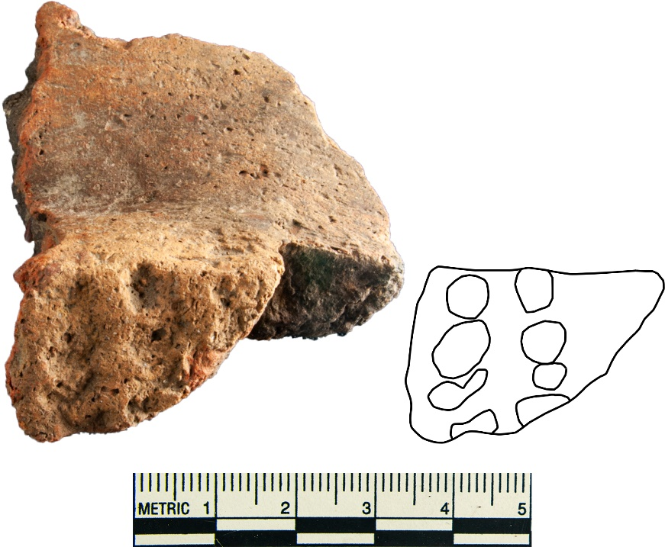
Figure 6.31: Structure 6 punctated base and body sherd with an outline of the surface of the base

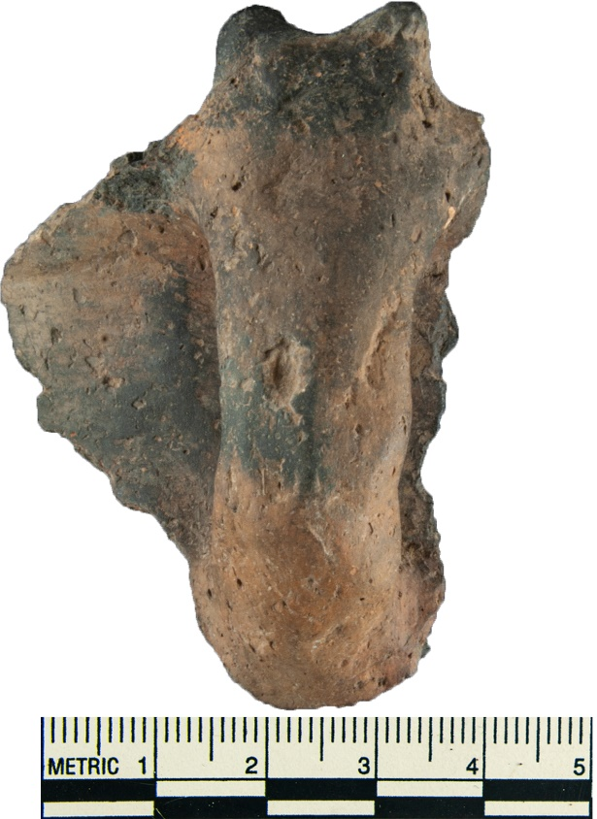
Figure 6.32: Structure 6 handle peak
Structure 6 presents evidence of at least one of its iterations being a special purpose building. Apart from the structure having an extended entranceway and no internal features, it also had a complicated engraved sherd, a red filmed, several pinched sherds, and three burnished sherds. The vast majority of the recovered sherds were shell tempered plain which likely corresponds to the use of utilitarian wares (87.5%). It is possible that Structure 6A mainly functioned as a residence, while Structure 6B was a special purpose building. It does seem likely that at least one of these structures would be a special purpose building most likely the one with an extended entranceway.
Structure 7 is rectangular with two center posts, an extended entranceway, and no internal features. Despite having no internal features, there is an artifact cache pit just outside the structure along the northern wall just west of the entranceway. Structure 7 is made up of six units that had ceramic artifacts recovered from them. The ceramic assemblage for Structure 7 is made up of 13 non-decorated sherds. Twelve of these sherds are shell tempered with one being bone tempered. The WPA did create a provenance for “Cache 2, Pit 1” which I assume to be the artifact cache fit immediately north of the building. “Cache 2, Pit 1” had a single smoothed rim sherd.
Structure 7 is uniquely rectangular compared to the other structures at this site. This building also has an extended entranceway and no interior features. The ceramics recovered were entirely plain wares with all but one tempered with shell (one was tempered with bone). These sherds most likely came from utilitarian wares. The low number of sherds may indicate that this building was not occupied for a long period of time, or only periodically throughout the year and the lack of decorated or red filmed ware can be seen an absence of evidence for ritual or ceremony. It is possible that this structure was used for civic meetings or as a guest house as Duffield suggested.
Structure 8 was situated on the far east side of the side and sat apart from the other structures. This building had an extended entrance, but it also had two internal features. Within this structure was a fire pit near its southeast wall, and an artifact cache pit in its northern corner. Only 14 sherds were recovered from within the structure and 20 came from the immediate area. Out of the 34 sherds associated with Structure 8, 21 are not decorated (61.8%); 19 shell tempered and two grog tempered. Thirteen sherds were decorated (38.2%)
Decorated types include cord-marked (N=9, Appendix E.7), fingernail impressed (N=3), and incised (N=1). Two of the cord-marked sherds were recovered from within the structure, while the other 7 were outside it. Seven were shell tempered, one was limestone tempered, and one was bone tempered. The fingernail impressed sherds include two shell tempered and one grog tempered sherds. One sherd was recovered from inside the building while two were recovered from outside it. The grog tempered fingernail impressed sherd consists of several punctations oriented in the in a mostly horizontal direction in seemly linear, parallel rows spaced vertically apart from each other (6.33A). This sherd was recovered outside the structure. One of the shell tempered fingernail impressed sherd consists of several punctations close together in a seemingly random orientations and in a random pattern (6.33B). This sherd was recovered from outside the structure. The other shell tempered sherd is a rim sherd of a restricted vessel and consists of several punctations oriented vertically and grouped tightly near each other in no obvious pattern (6.33C). The single incised sherd is shell tempered and was recovered from outside the structure. The incisions are faint and shallow, but they appear to consist of three parallel lines approximately 0.5 cm apart (Figure 6.34).
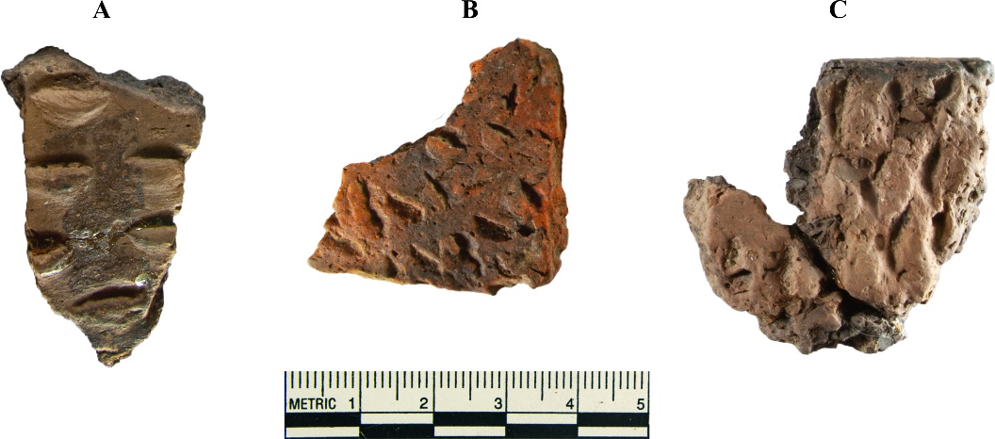
Figure 6.33: Structure 8 fingernail impressed sherds

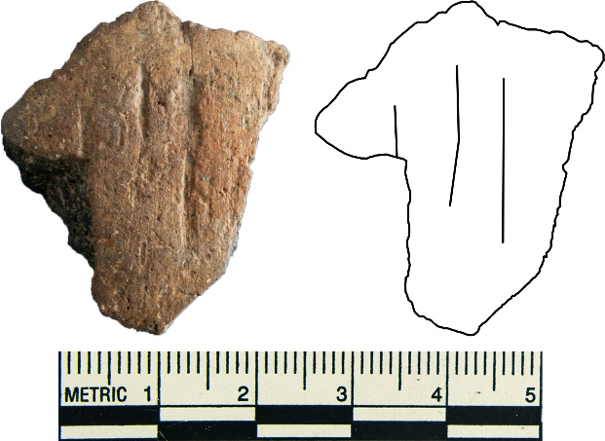
Figure 6.34: Structure 8 incised sherd and outline
Structure 8 has an extended entranceway, but also has two internal features. The ceramic assemblage for this structure gives evidence that most of the sherds were from utilitarian vessels. Only the three fingernail impressed sherds and the single incised sherd give evidence for the possibility this structure was used more than just a residence. However, due to the fire pit within the structure and the number of utilitarian ware sherds, it was most likely used as a residence. The low number of sherds maybe be evidence that this building was not lived in for a long period of time or it was lived in periodically.

Conclusion
The purpose of this thesis was to answer the following questions: How does the ceramic assemblages from each house compare in terms of chronology, density, vessel form, and ceramic type? Are there any differences in the assemblages between buildings? And if there is a difference between the structure’s assemblages, do these reflect time of occupation, or do they reflect different purposes and uses of those buildings? The results of the ceramic analysis resulted in an inconclusive answer to these questions No definitive answer was obtained from the ceramic analysis alone.
Due to the fact that the School Land I was not completely excavated and that very little notes are available from the excavators, it is difficult to come to any kind of definitive conclusion about this site. With an incomplete excavation the data is equally incomplete. However, the data available does show a couple of interesting key findings.
The first key finding is the prevalence of shell tempering. Shell tempering makes up 93.5% of the assemblage’s sherds (N=1400) with non-decorated shell tempered sherds (Woodward Plain) accounting for 90.9% (N=1361). This, however, is expected. Shell is a common temper used in cooking wares and other utilitarian vessels such as serving dishes and storage containers. Shell, as a temper, creates a vessel that has relatively low thermal expansion, which prevents cracking during firing and subsequent cooking, and adds strength to the vessel’s walls (Bronitsky and Hamer 1986; Rice 2015). While the presence of shell temper does not always correspond to cookwares, shell tempering does benefit vessels that are used for cooking.
Shell is the predominant temper not just for the site as a whole, but also for every structure. The prevalent temper of each structure is shell with the highest percentage of shell tempered wares coming from Structure 3 (99.2%), and the lowest from Structure 8 (85.7%). It can be inferred that in every structure cooking or food storage was the predominant function of pottery at School Land I.
Such a high percentage of shell tempered sherds appear to be a characteristic of Caddo sites in the far north of the Caddo cultural range when compared with other contemporaneous Harlan phase Caddo sites in eastern Oklahoma (See Appendix F). School Land I, along with the nearby Reed and Lillie Creek sites (both sites are along the Grand River in northern Delaware County, Oklahoma) have ceramic assemblages of around 90% shell tempering (Regnier et al. 2019). Caddo sites in the southeast and central-east Oklahoma have noticeably less shell tempered sherds. The reason for this discrepancy is currently unknown.
The second key finding is that about four-fifths of the total sherds came from the structures in the north. When looking at the total sherd assemblage that can be spatially allocated (N=1479), 85.7% (N=1267) came from the northern area, with 14.3% (N=212) of the sherds coming from the southern area of the site. The reason for this discrepancy is not fully understood, however, it seems most likely that these southern structures were occupied for a short period of time, or they were occupied periodically for short periods of time. These southern structures do not have compelling evidence to support the idea they were being used as permanent residential buildings.
It is difficult to assign the structures a primary function. It seems most of the buildings were used as residences of some kind. As to whether these residences were occupied for long periods of time or short periods of time, or who lived in them is impossible to determine with just the ceramic assemblage. The Reed mounds are about two miles west of School Land I and would have served School Land I’s religious and spiritual needs. School Land I probably didn’t have a temple or charnel house as Reed would have served for those functions. School Land I did probably have a meeting house, at least one guest house, and homes for the social elite. It is also possible that some of this site’s structures are not any of these types of structures. In fact it is possible that at least one of these structures may have been a menstrual hut (Swanton 1996:159) or some other type of building that served the people of School Land I in some compacity beyond residential or special purpose.
Using ethnographies, it might be possible to give an idea of what these structures were used for. Recalling the ethnographic evidence used by Duffield that stated:
Soon I noticed, outside the yard, opposite the door of the governor’s house, another long building, in which no inmates could be seen. I asked who dwelt there or what purpose it served, and was told the captains were lodged in that house when the governor called them to a meeting. On the other side I saw yet another and smaller vacant house, and upon my inquiring about this one they answered that in the smaller house the pages of the captains were lodged, … (Swanton 1996:149).
Another ethnography stated that:
The difference [the Hasinai] make in building these houses is that they used more [poles] than usual for the captains and leading men. Consequently, their houses are very much larger. (Swanton 1996:150-51)

It appears that the caddi (village head) resided in the largest structure. And across from the caddi’s home is a “long building” used for political meetings. Next to this long building is a smaller guest house used for when these meetings took place. It seems plausible that Structure 7, a rectangular structure, can refer to a “long building” that was used for meetings. If Structure 7 was used for meetings, then the building next to it, Structure 1 (either Structure 1A, 1B, or both) was used as temporary guest quarters.
The largest structure by area at the site was Structure 3B with 68.3 m² of interior space. Structure 3B also faces Structure 7 across the plaza. If the ethnographic accounts from Massanet are true for School Land I then Structure 3B could have been the home of the caddi. However, Structure 3B does not have a discernible extended entranceway and it has internal structures that include one or two artifact cache pits. This structure does not meet the current definition of a special purpose building. While Structure 3B seems like the most obvious choice for the home of the caddi, it could also be possible that it was Structure 8.
Structure 8 is the second largest structure on site with 58.1 m² of floor space. This structure’s entranceway faced southwest towards Structure 7, just to a lesser degree than Structure 3B. Structure 8 also has internal features that include a fire pit and an artifact cache pit. The presence of a fire pit and a cache pit suggest that this building functioned as a residence of some kind. Perhaps buildings with extended entranceways and internal features are indicative of a residence for the social elite. However, Structure 8 has a very low sherd count which can be seen as evidence that this building was not intensively occupied.
The nature of this site’s structures is difficult to discern, especially for the southern structures. The archaeological literature concerning Cado structure use is limited. Ultimately more evidence is needed to properly determine the purposes of these structures. The ceramic assemblage is not enough by itself to do this. There is currently a lithic analysis being prepared for this site as part of a graduate thesis. This lithic analysis, in addition to the ceramic analysis, should provide a more comprehensive look at the activities being undertaken at this site. It may also help interpret how this site and its structures were being used.
There is much that can be done to better understand this site. More radiocarbon dates from samples taken from within the structures might give evidence on the structures’ building phases. It could help identify which iterations of a structure are older and younger and which are more contemporaneous with other structures. A ceramic provenience study using Neutron activation analysis (NAA) or Laser Ablation Inductively coupled plasma mass spectrometry (LA-ICP-MS) to determine chemical composition of the paste would help identify which sherds came from locally made or imported vessels. If the ceramic was imported it might be possible to discover from where the vessel may have been manufactured. This could help identify trade networks within the Caddo area and from outside the Caddo cultural sphere.
There is still much that needs to be done to properly investigate non-mound Caddo sites in general. Villages are underrepresented in Caddo archaeology, especially in the northern Caddo area. By researching mostly mound sites, archaeologists have ignored key sections of ancient Caddo society that have not been given the same consideration. This paper presents a valuable analysis of one such village and its ceramic assemblage. While the ceramic assemblage did not provide any kind of definitive conclusion, it does highlight what a typical ceramic assemblage at a Caddo village site might look like which can be valuable in its own right. It is not presently known if School Land I represents a typical Caddo village or if it is atypical site that served a special function in Caddo society beyond farming. Ultimately, more non-mound Caddo sites need to be excavated to discern what a typical Caddo village would look like.

Appendix

Appendix A: Ceramic Recording Form

Appendix B: Sherd Count by Structure
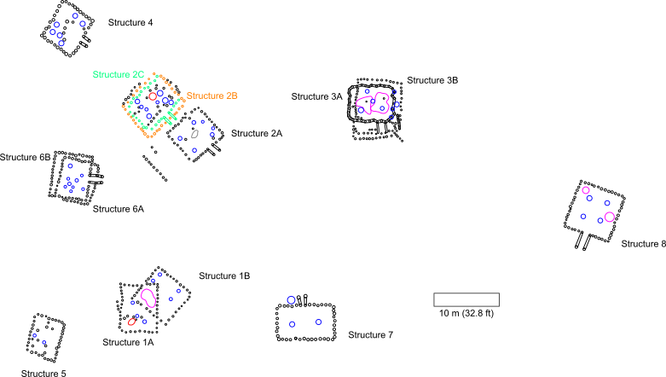
Structure 8: 14
Structure 7: 21
Structure 6: 212
Structure 5: 34
Structure 4: 106
Structure 3: 123
Structure 2 : 136
Structure 1: 72
Non-Structure: 765

Appendix C: Sherd Percentages by Structure
Structure 8: 0.9%
Structure 7: 1.4%

Structure 6: 14.2%
Structure 5: 2.3%
Structure 4: 7.1%
Structure 3: 8.2%
Structure 2 : 9.1%
Structure 1: 4.8%
Non-Structure: 51.1%

Appendix D: Sherd Thickness Graphs
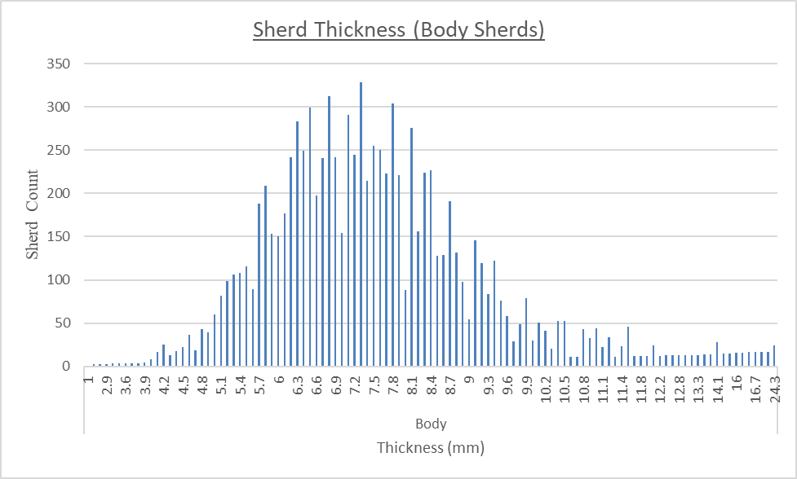

Appendix E – Select Ceramic Photographs

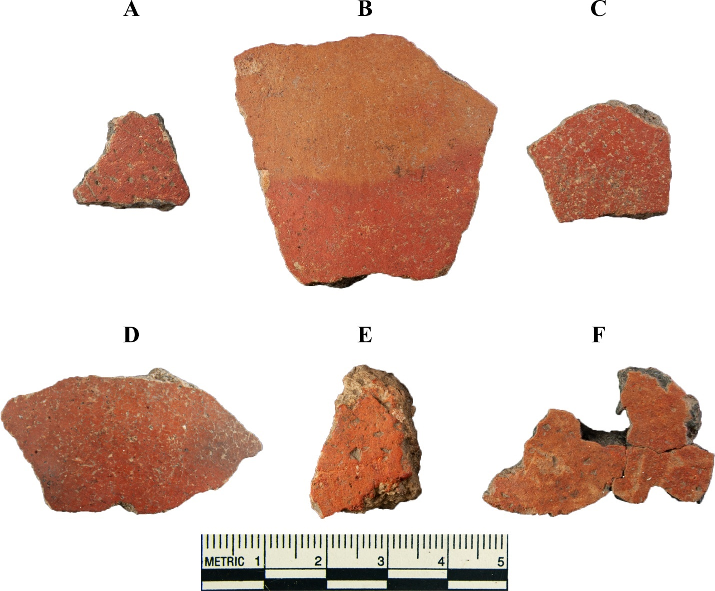
Red Filmed
Figure E.1: Red filmed shreds. A) Saunder Engraved, B-F) Undesignated red filmed. Recovered from A) outside, west of Structure 1, B-C) North of Structure 4, D) within Structure 6, E) in the plaza, and F) east of Structure 7.

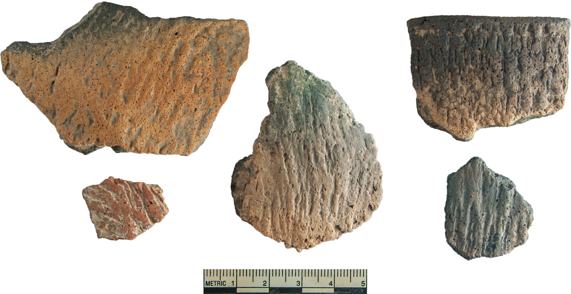
Cord Marked
Figure E.2: Cord marked sherds from Structure 2A.

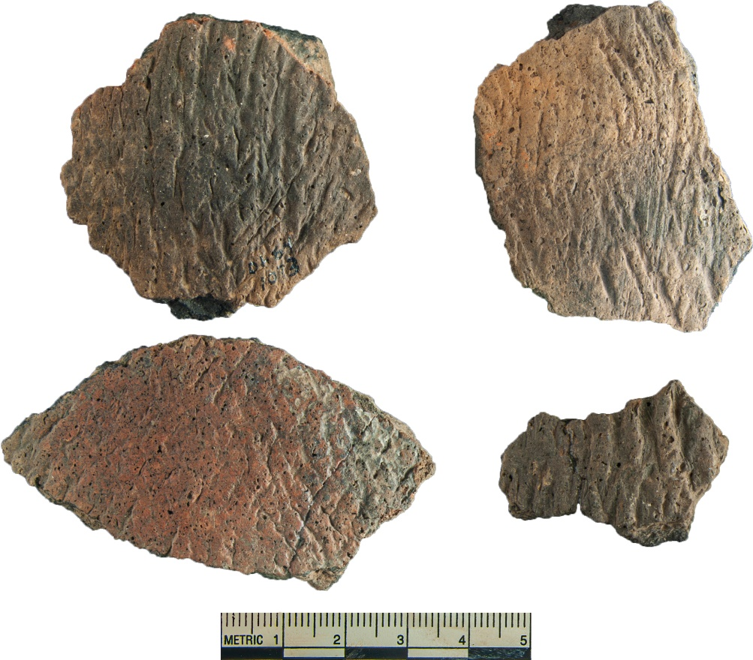
Figure E.3: Cord marked sherds from Structure 2B/C.
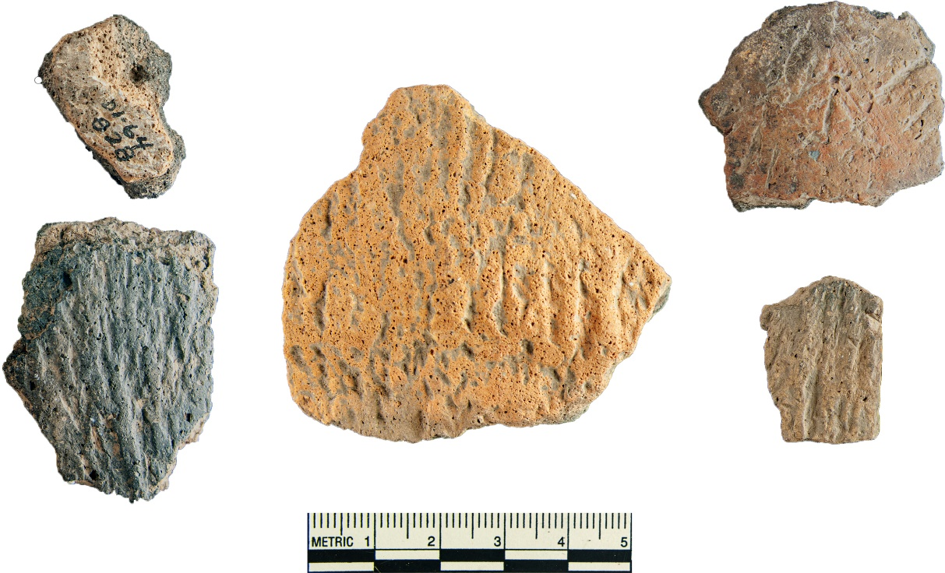
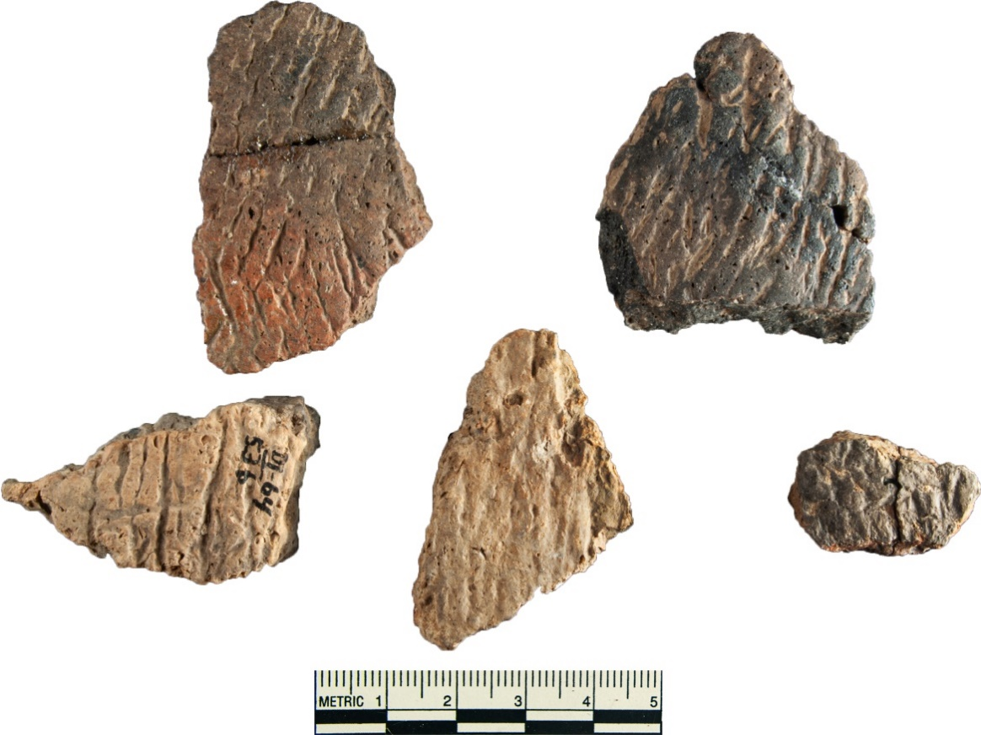
Figure E.5: Cord marked sherds from Structure 4.
Figure E.4: Cord marked sherds from Structure 3.

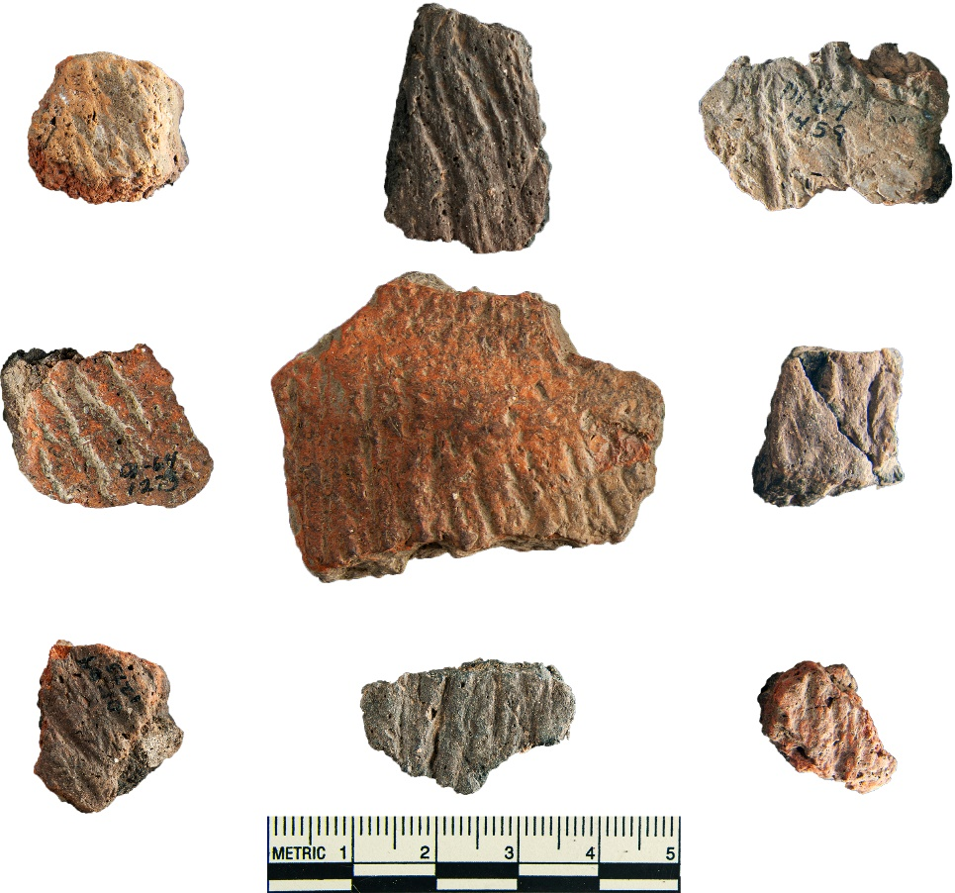
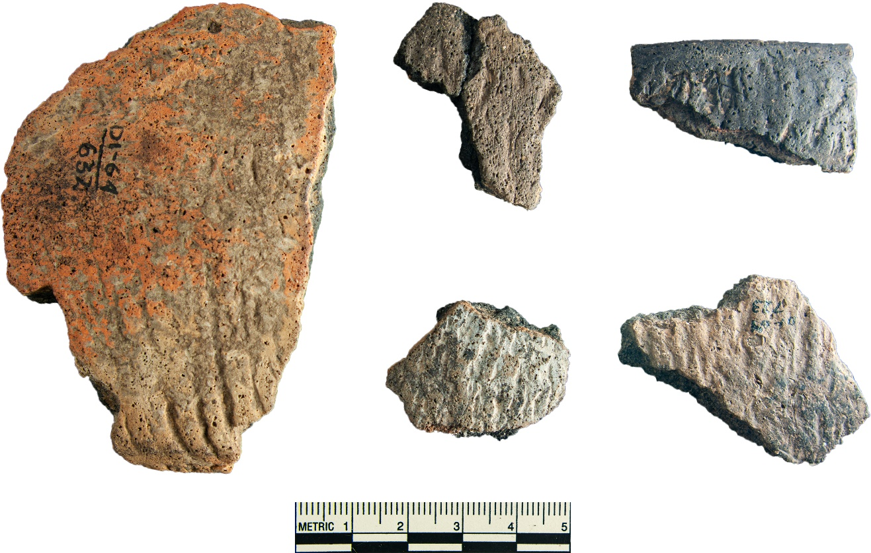
Figure E.7: Cord-marked sherds from Structure 8.
Figure E.6: Cord-marked sherds from Structure 6.

Incised
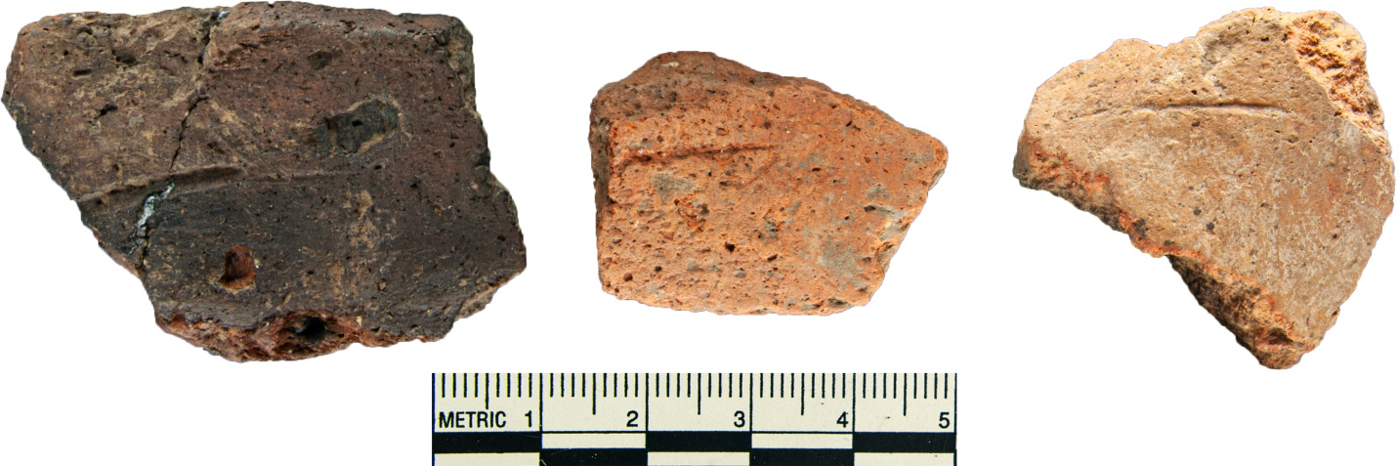
Figure E.8: Grog tempered incised sherds from Structure 4.

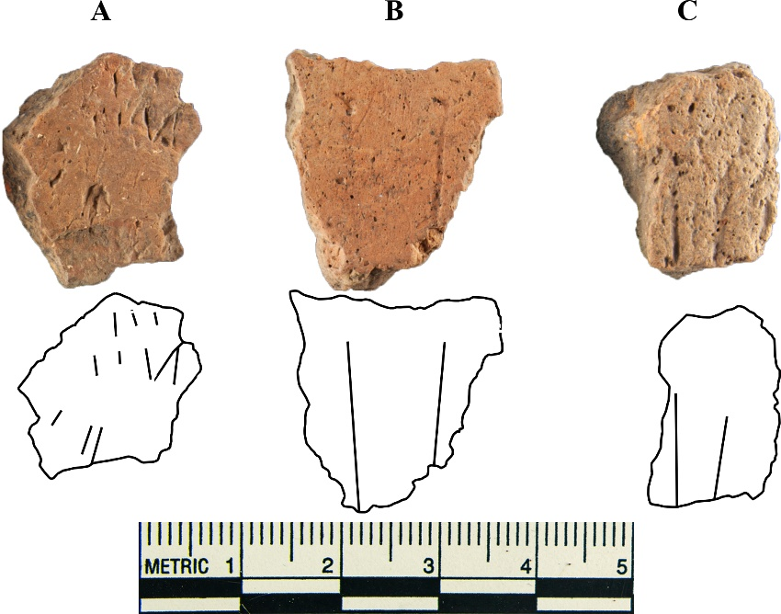
Figure E.9: Grog and limestone tempered incised sherds from Structure 4.

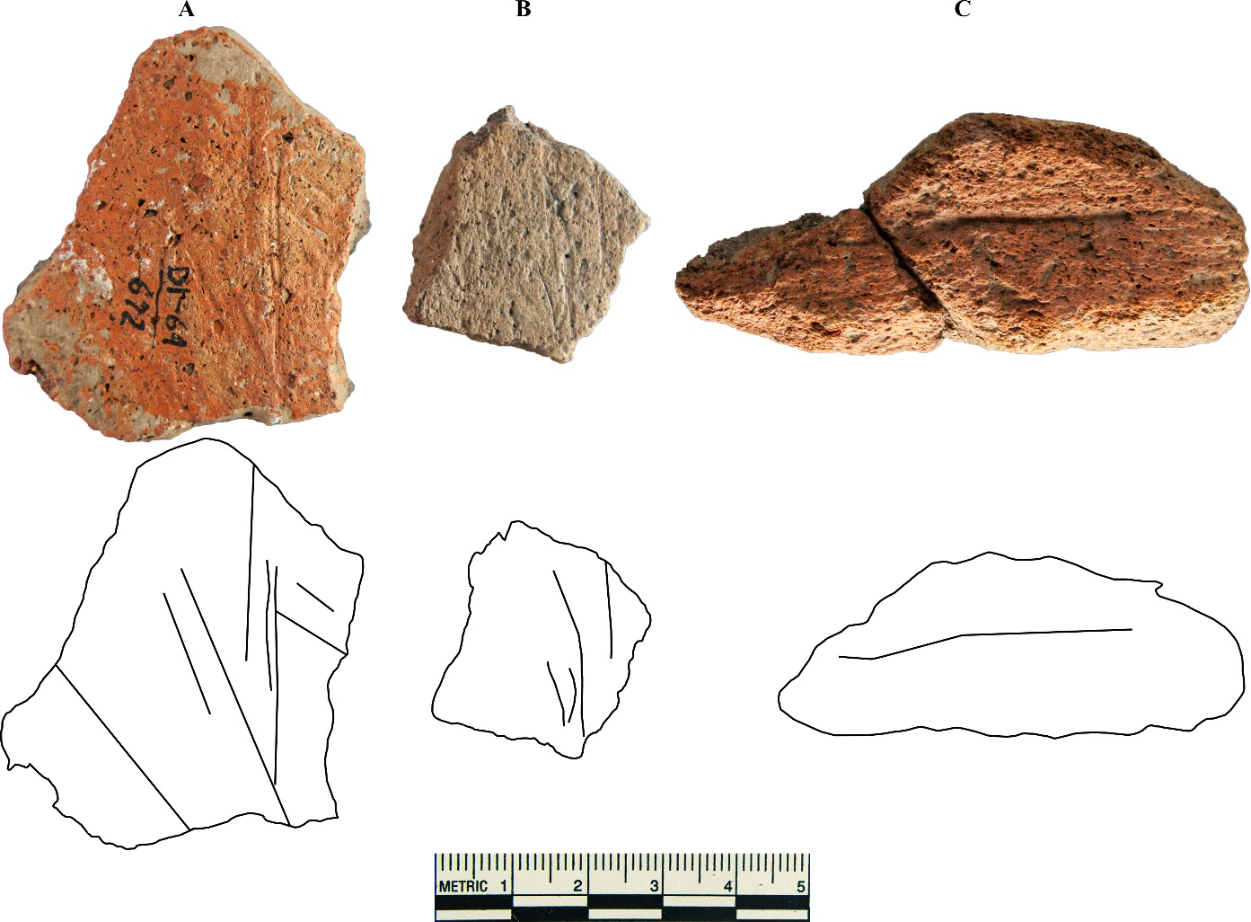
Figure E.10: Incised sherds from Structure 6.

Appendix F: Ceramic Tempering of Select Harlan Phase Caddo Sites in Eastern Oklahoma

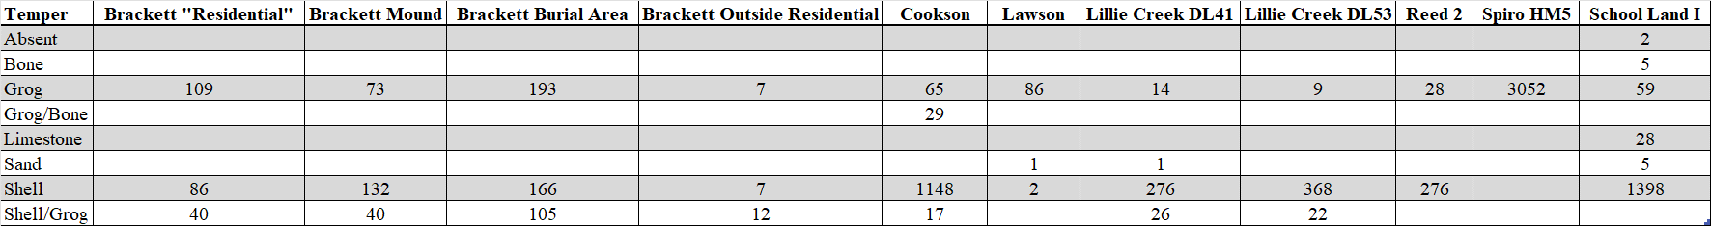
Appendix F.1 (Top): sherd count per temper.
Appendix F.2 (Bottom): sherd percentage within site per temper.

Bibliography

Albert, Lois E., and Don G. Wyckoff. “Oklahoma Environments: Past and Present.” In Prehistory of Oklahoma, edited by Robert Eugene Bell, 1–43. New World Archaeological Record. New York: Academic Press, 1984.
Bareis, Charles John. “The Brackett Site, Ck-43, of Cherokee County Oklahoma.” Bulletin of the Oklahoma Anthropological Society III (March 1955): 1–52.
Bell, Robert Eugene, ed. Prehistory of Oklahoma. New World Archaeological Record. New York: Academic Press, 1984.
Bender, Margaret M., Reid A. Bryson, and David A. Baerreis. “University of Wisconsin Radiocarbon Dates V.” Radiocarbon 10, no. 2 (1968): 473–78.
Bronitsky, Gordon, and Robert Hamer. “Experiments in Ceramic Technology: The Effects of Various Tempering Materials on Impact and Thermal-Shock Resistance.” American Antiquity 51, no. 1 (January 1986): 89–101. https://doi.org/10.2307/280396.
Brown, James A. The Spiro Ceremonial Center: The Archaeology of Arkansas Valley Caddoan Culture in Eastern Oklahoma. Vol. 1 & 2. 2 vols. Memoirs of the Museum of Anthropology, University of Michigan, no. 29. Ann Arbor: Museum of Anthropology, University of Michigan, 1996.
———. “Spiro Reconsidered: Sacred Economy at the Western Frontier of the Eastern Woodlands.” In The Archaeology of the Caddo, edited by Timothy K. Perttula and Chester P. Walker, 117–38. Lincoln: University of Nebraska Press, 2012.
Brown, James A., Alex W. Barker, and George Sabo III. “The Spirit Lodge, Sprio Ritual, and Cosmic Renewal.” In Recovering Ancient Spiro: Native American Art, Ritual, and Cosmic Renewal, edited by Eric D. Singleton and F. Kent Reilly, First edition, First printing., 92–113. Oklahoma City, Oklahoma: National Cowboy & Western Heritage Museum, 2020.
Bryant, Keith L., Jr. “Oklahoma and the New Deal.” In The New Deal: The State and Local Levels, edited by John Braeman, Robert H. Bremner, and David Brody, 166–97. Ohio State University Press, Columbus, n.d.
Cobb, Charles R., and Brian M. Butler. “Mississippian Plazas, Performances, and Portable Histories.” Journal of Archaeological Method and Theory 24, no. 3 (September 2017): 676–702. https://doi.org/10.1007/s10816-016-9281-3.
Duffield, Lathel F. “The Vertebrate Faunal Remains From the School Land I and School Land II Sites, Delaware County, Oklahoma.” Bulletin of the Oklahoma Anthropological Society 18 (1969): 47–65.
Early, Ann M. “The Caddos of the Trans-Mississippi South.” In Indians of the Greater Southeast: Historical Archaeology and Ethnohistory, edited by Bonnie G. McEwan. Gainesville, Fla: University Press of Florida, 2000.
Freeman, Joan E., and A Dewey Buck, Jr. “Woodward Plain and Neosho Punctate, Two Shell Tempered Pottery Types of Northeastern Oklahoma.” Bulletin of the Oklahoma Anthropological Society 8 (April 1960): 3–16.
Gadus, Eloise F. “Twisted Serpents and Fierce Birds: Structural Variation in Caddo Engraved Ceramic Bottle Motifs.” Bulletin of the Texas Archeological Society, no. 84 (n.d.): 215–47.
Hammerstedt, Scott W., Amanda L. Regnier, and Patrick C. Livingood. “Geophysical and Archaeological Investigations at the Clement Site, A Caddo Mound Complex in Southeastern Oklahoma.” Southeastern Archaeology 29, no. 2 (December 2010): 279–91. https://doi.org/10.1179/sea.2010.29.2.005.
Hammerstedt, Scott W., and Sheila Bobalik Savage. “Caddo Ceramics in the Arkansas River Basin in Eastern Oklahoma.” In Ancestral Caddo Ceramic Traditions, edited by Duncan P. McKinnon, Jeffrey S. Girard, and Timothy K. Perttula, 93–115. Baton Rouge: Louisiana State University Press, 2021.
Hilgeman, Sherri Lynn. “Closed and Open Handles.” In Pottery and Chronology at Angel, 127–63. Tuscaloosa: University of Alabama Press, 2000.
Hoard, Robert J., Michael J. O’Brien, Mohammad Ghazavy Khorasgany, and Vellore S. Gopalaratnam. “A Materials-Science Approach to Understanding Limestone-Tempered Pottery from the Midwestern United States.” Journal of Archaeological Science 22, no. 6 (November 1995): 823–32. https://doi.org/10.1016/0305-4403(95)90011-X.
Kidder, Tristram R. “Plazas as Architecture: An Example from the Raffman Site, Northeast Louisiana.” American Antiquity 69, no. 3 (July 2004): 514–32. https://doi.org/10.2307/4128404.
La Vere, David. The Caddo Chiefdoms: Caddo Economics and Politics, 700-1835. Lincoln: University of Nebraska Press, 1998.
Lambert, Shawn. “Alternate Pathways to Ritual Power: Evidence for Centralized Production and Long-Distance Exchange Between Northern and Southern Caddo Communities.” Dissertation, University of Oklahoma, 2017. https://shareok-org.ezproxy.lib.ou.edu/handle/11244/52939.
Lambert, Shawn, Jeri Redcorn, Chase Earles, and Timothy K. Perttula. “Decolonizing in Practice: Renaming of an Ancestral Caddo Ceramic Vessel Type.” Caddo Archeology Journal 32 (2022): 5–10.
Lyon, Edwin A. A New Deal for Southeastern Archaeology. Tuscaloosa, AL: University of Alabama Press, 1996.
MacDonald, A.B. “A ‘King Tut’ Tomb in the Arkansas Valley.” The Kansas City Star, December 15, 1935, sec. C.
Means, Bernard K., ed. Shovel Ready: Archaeology and Roosevelt’s New Deal for America. Tuscaloosa: University of Alabama Press, 2013.
Mullins, William H. “Works Progress Administration.” The Encyclopedia of Oklahoma History and Culture. Accessed August 31, 2023. https://www.okhistory.org/publications/enc/entry.php?entry=WO022.
Murray, Thomas J., and Reid A. Bryson. Climates of Hunger: Mankind and the World's Changing Weather. Madison: University of Wisconsin Press, 1977. muse.jhu.edu/book/8475
okmaps.org. “Okmaps.Org.” Accessed February 3, 2023. https://okmaps.org/ogi/Historical_Photos/OK_SS_Photos_FTP/1930-1939/ss_1939/1939-25N-24E-IM/.
Orton, Clive, and Mike Hughes. Pottery In Archaeology. Second Edition. Cambridge Manuals in Archaeology. Cambridge ; New York: Cambridge University Press, 2013.
Perttula, Timothy K. “Caddo Agriculture on the Western Frontier of the Eastern Woodlands.” Plains Anthropologist 53, no. 205 (February 2008): 79–105. https://doi.org/10.1179/pan.2008.006.
———. “Caddoan Area Archaeology Since 1990.” The Journal of Archaeological Research 4, no. 4 (December 1996): 295–348.
———. “Extended Entranceway Structures in the Caddo Archaeological Area.” Southeastern Archaeology 28, no. 1 (Summer 2009): 27–42.
———. “Kee-Oh-Na-Wah’-Wah: The Effects of European Contact on the Caddoan Indians of Texas, Louisiana, Arkansas, and Oklahoma.” In Ethnohistory and Archaeology: Approaches to Postcontact Change in the Americas, edited by J. Daniel Rogers and Samuel Meredith Wilson, 89–109. Interdisciplinary Contributions to Archaeology. New York: Plenum Press, 1993.
———. “The Archaeology of the Caddo in Southwest Arkansas, Northwest Louisiana, Eastern Oklahoma, and East Texas.” In The Archaeology of the Caddo, edited by Timothy K. Perttula and Chester P. Walker. Lincoln: University of Nebraska Press, 2012.
———. “The Beginnings of Caddo Groups and Communities, c. AD 850-1200.” In Caddo Landscapes in the East Texas Forests, 43–86. American Landscapes. Philadelphia, PA: Oxbow, 2017.
———. The Caddo Nation: Archaeological and Ethnohistoric Perspectives. 1st ed. Texas Archaeology and Ethnohistory Series. Austin: University of Texas Press, 1992.
Perttula, Timothy K., Jeffrey S. Girard, Duncan McKinnon, and David G Robinson. “Approaches to the Study of Ancestral Caddo Ceramics.” In Ancestral Caddo Ceramic Traditions, edited by Duncan P. McKinnon, Jeffrey S. Girard, and Timothy K. Perttula, 1–16. Baton Rouge: Louisiana State University Press, 2021.
Perttula, Timothy K., and Chester P. Walker, eds. The Archaeology of the Caddo. Lincoln: University of Nebraska Press, 2012.
Purrington, Burton L. “The Prehistory of Delaware County, Oklahoma: Cultural Continuity and Change on the Western Ozark Periphery.” Ph.D dissertation, Department of Anthropology, University of Wisconsin, 1971.
Regnier, Amanda. “The Relationship Between Becoming Caddo and Becoming Mississippian in the Middle Red River Drainage.” In Mississippian Beginnings, 178–202. University Press of Florida, 2017.
Regnier, Amanda L., Patrick C. Livingood, and Scott W. Hammerstedt. “The Last of WPA Archaeology in Oklahoma: The Clement And McDonald Sites.” In Shovel Ready: Archaeology and Roosevelt’s New Deal for America, edited by Bernard K. Means. Tuscaloosa: University of Alabama Press, 2013.
Regnier, Amanda L., Patrick Livingood, and Scott Hammerstedt. “The History of Spiro.” In Recovering Ancient Spiro: Native American Art, Ritual, and Cosmic Renewal, edited by Eric D. Singleton and F. Kent Reilly, First edition, First printing., 18–33. Oklahoma City, Oklahoma: National Cowboy & Western Heritage Museum, 2020.
Regnier, Amanda L, Scott W. Hammerstedt, and Sheila Bobalik Savage. The Ritual Landscape of Late Precontact Eastern Oklahoma: Archaeology from the WPA Until Today. Tuscaloosa: The University of Alabama Press, 2019.
Rice, Prudence M. Pottery Analysis: A Sourcebook. Second edition. Chicago ; London: University of Chicago Press, 2015.
Rogers, J. Daniel. “Artifacts from the Craig Mound at Spiro, Oklahoma.” In Smithsonian Contributions to Anthropology, edited by April K. Sievert and J. Daniel Rogers, 49:1–11, 2011. https://repository.si.edu/handle/10088/17285.
———. “Spiro Archaeology: 1980 Research.” Oklahoma Archaeological Survey, Studies in Oklahoma’s Past, no. 9, 1982.
———. “Chronology and the Demise of Chiefdoms: Eastern Oklahoma in the Sixteenth and Seventeenth Centuries.” Southeastern Archaeology 25, no. 1 (Summer 2006): 20–28.

Rohrbaugh, Charles L. Spiro and Fort Coffee Phases: Changing Cultural Complexes of the Caddoan Area. Edited by Scott W. Hammerstedt. Vol. Memoir 16. Oklahoma Anthropological Society, 2012.
Rye, Owen S. Pottery Technology: Principles and Reconstruction. Manuals on Archeology 4. Washington, D.C: Taraxacum, 1981.
Singleton, Eric D., and F. Kent Reilly, eds. Recovering Ancient Spiro: Native American Art, Ritual, and Cosmic Renewal. First edition, First printing. Oklahoma City, Oklahoma: National Cowboy & Western Heritage Museum, 2020.
Singleton, Eric D., and F. Kent Reilly III. “Introduction.” In Recovering Ancient Spiro: Native American Art, Ritual, and Cosmic Renewal, edited by Eric D. Singleton and F. Kent Reilly, First edition, First printing., 1–15. Oklahoma City, Oklahoma: National Cowboy & Western Heritage Museum, 2020.
Swanton, John Reed. Source Material on the History and Ethnology of the Caddo Indians. University of Oklahoma Press ed. Norman: University of Oklahoma Press, 1996.
Thoburn, Joseph B. “The Prehistoric Cultures of Oklahoma.” In Archaeology of the Arkansas River Valley, by Warren King Moorehead, 53–150. Yale University Press, 1931.
Wilson, Diane. “Bioarchaeological Evidence of Subsistence Strategies among the East Texas Caddo.” In The Archaeology of the Caddo, edited by Timothy K. Perttula and Chester P. Walker, 86–116. Lincoln: University of Nebraska Press, 2012.
Wright, Muriel H. A Guide to the Indian Tribes of Oklahoma. 9. print. The Civilization of the American Indian Series 33. Norman u.a: Univ. of Oklahoma Pr, 1986.
Wyckoff, Don G. “Caddoan Adaptive Strategies in the Arkansas Basin, Eastern Oklahoma.” Dissertation, Washington State University, 1980.
Wyckoff, Don G., and Timothy G. Baugh. “Early Historic Hasinai Elites: A Model for the Material Culture of Governing Elites.” Midcontinental Journal of Archaeology 5, no. 2 (1980): 225–88.

IIn an effort to decolonize ware names, a proposed name change from Spiro Engraved to Iwi Engraved has been proposed. See end of Chapter 4 for further explanation.

