UNIVERSITY OF OKLAHOMA
GRADUATE COLLEGE

THE ROLE OF IRON-REDUCING BACTERIA IN THE CORROSION OF CARBON STEEL: A NEW MICROBIOLOGICALLY INFLUENCED CORROSION MECHANISM

A DISSERTATION
SUBMITTED TO THE GRADUATE FACULTY
in partial fulfillment of the requirements for the
Degree of
DOCTOR OF PHILOSOPHY

By
MARIA ALEJANDRA HERNÁNDEZ-SANTANA
Norman, Oklahoma
2021

THE ROLE OF IRON-REDUCING BACTERIA IN THE CORROSION OF CARBON STEEL: A NEW MICROBIOLOGICALLY INFLUENCED CORROSION MECHANISM

A DISSERTATION APPROVED FOR THE
SCHOOL OF CIVIL ENGINEERING AND ENVIRONMENTAL SCIENCE

BY THE COMMITTEE CONSISTING OF

Dr. Mark Nanny, Chair
Dr. Joseph Suflita
Dr. Kara De León
Dr. Robert Nairn
Dr. Jason Vogel

© Copyright by MARIA ALEJANDRA HERNÁNDEZ-SANTANA 2021
All Rights Reserved.

To my family for their endless love and to all my teachers who sparked my curiosity

Acknowledgments
I would like to express my sincere gratitude to my academic advisor, Dr. Mark Nanny, for his tremendous support throughout the completion of this dissertation and for facilitating so many professional opportunities for me to learn and mature as a scientist. I would like to especially thank my mentor and role model, Dr. Joseph Suflita for helping me find the opportunities I never dreamt possible and for supporting me and encouraging me throughout them. I also want to genuinely thank my committee members, Dr. Jason Vogel, Dr. Robert Nairn, and Dr. Kara De León for their kind and generous support during my journey as a graduate student. Special thanks to Dr. Ralph Tanner, an honorary member of my graduate committee, from whom I had the good fortune to learn the tips and tricks of the microbial physiologist and get inspired by his passion and dedication to teaching.
This work would have never been possible without the kindness, guidance, help, and encouragement from my OU Microbiology family: Dr. Irene Davidova, Dr. Kathleen Duncan, and Neil Wofford. They took me in as their own student, welcomed me in their laboratories, and personally trained me in the techniques that were crucial in the making of this dissertation. I could not have asked for better mentors and friends, and I will be forever thankful to them for they have ignited my passion for anaerobic microbiology and made every second of work at GLCH a fun and memorable one.
I would also like to express my special gratitude to Dr. Steven Foster for welcoming me at the OU Mass Spectrometry Facility, training me at the ICP-MS as well as helping me with the MS needs of my research project. Many thanks are also in order to Dr. Andy Madden and Dr. Megan Madden for welcoming me at the OU X-ray diffraction laboratory and personally training me in the Raman microscope. I would also like to acknowledge the remarkable contribution of Dr. Preston Larson in helping me obtain the beautiful SEM micrographs that you will encounter in this dissertation. Special thanks go to Dr. Aifen Zhou for her guidance on culturing Shewanella. Many thanks to Dr. Stefan Wilhelm, Dr. George Richter-Addo, and their students for helping me explore the world of nanomaterials and welcoming me into their laboratories when I needed a break from Shewanella and corrosion. I feel extremely thankful for having had the opportunity to engage in outstanding side research projects with OptoKhemia Analytical, the Oklahoma Water Survey, and the Rural Educators Engaged in Bioanalytical Engineering Research and Teaching program.
I want to also express my gratitude to Dr. Jizhong Zhou, Dr. Jeffrey Gralnick, Dr. Alfred Spormann, and Dr. Benjamin Keitz for sharing with me the Shewanella oneidensis strains that were used in this dissertation.
I am especially grateful to my mentors Ale Hakala and Susanne Nichterwitz for helping me navigate graduate school and for providing their candid feedback on dozens of scholarship applications as well as their support and friendship when my motivation was challenged.
I would like to thank the OU Graduate College for supporting me through graduate school with the OU Alumni Fellowship and the Nancy L. Mergler and Bullard Dissertation Completion Fellowship. Thanks to the American Association of University Women for supporting me with the 2019 International Fellowship.
My deepest gratitude goes to my family, Mami, Papito, Hermanito, and Ririto, for being my inspiration to become a better scientist and human being each day, and to my friends for sharing so many memorable experiences during this wonderful journey throughout my university life.

Abstract
It was not too long ago that the ability of microorganisms to capture energy by engaging in electron transfer reactions with extracellular solid materials was discovered. This discovery has shifted the paradigms regarding the requirements for life and has prompted tremendous research interest in the challenges and opportunities this type of metabolism poses for humankind. Possibly, in no other field does the microbial extracellular electron transfer reactions have more direct implications today than in the corrosion of steel infrastructure. Due to the strong dependence of our society on iron and its alloys, understanding how microorganisms influence the corrosion of these materials through extracellular electron transfer reactions becomes a matter of substantial importance for industries across the globe. In this dissertation, I aimed to answer how the iron-reducing bacterium Shewanella oneidensis influences the corrosion of carbon steel. It was in this organism where researchers witnessed for the first time the ability of microorganisms to transfer electrons to extracellular substrates, and since then, S. oneidensis has become a model for the understanding of microbial extracellular electron transfer reactions. Because Shewanella spp. are also frequently found in steel infrastructure undergoing corrosion, the next logical question to address is whether or not Shewanella spp. could use extracellular electron uptake to accelerate the corrosion of steel. Addressing the aforementioned questions was the goal in the making of this dissertation.
In Chapter 1, I will introduce my motivation to pursue these fascinating research questions, present my hypotheses and goals, and provide a literature review on the ecophysiology of the genus Shewanella, our current understanding of the microbiologically influenced corrosion of steel, and the existing knowledge on the role that iron-reducing bacteria play in the corrosion of carbon steel.
In Chapter 2, I evaluate the ability of S. oneidensis to accelerate the corrosion of carbon steel by removing the iron oxide passivating layer through dissimilatory iron reduction, and I test the hypothesis that the presence of short-chain deprotonated dicarboxylic acids would exacerbate corrosion driven by S. oneidensis by accelerating the dissolution of ferric iron and increasing the microbial iron respiration rates. I found that the short-chain deprotonated dicarboxylic acids oxalate, malonate, and succinate accelerate the corrosion of carbon steel driven by S. oneidensis up to 2.6 times more relative to the sterile control experiment without dicarboxylates. The three deprotonated dicarboxylic acids tested enhanced the dissolution of ferric iron, but interestingly this did not result in increased iron respiration rates. My results suggest that a complex array of competing biological (e.g., microbial iron reduction), chemical (e.g., ligand-assisted iron dissolution), and physical (e.g., adsorption of corrosion products) processes drive the accelerated corrosion of carbon steel by iron-reducing bacteria in the presence of iron-binding ligands.
In Chapter 3, I offer a novel approach to test the ability of microorganisms to take electrons directly from carbon steel while evaluating the role of hydrogen consumption metabolism and direct electron uptake in the corrosion of carbon steel driven by S. oneidensis. I performed experiments with carbon steel and a S. oneidensis strain incapable of consuming hydrogen and a strain incapable of engaging in direct electron uptake. The results showed that S. oneidensis accelerates the corrosion of carbon steel up to four times more when compared to abiotic experiments and that direct electron uptake is the most significant corrosion mechanism in S. oneidensis.
Finally, in Chapter 4, I offer my insights on the new research questions that emerge based on the findings of this dissertation and provide my ideas on the contributions and the limitations of my Ph.D. research.

Table of Contents
Acknowledgments v
Abstract vii
Table of Contents ix
List of Figures xi
List of Tables xiv
Abbreviations xv
Chapter 1 : Introduction 1
1.1. Motivation 1
1.2. Hypotheses and Objectives 5
1.3. Literature Review 6
Chapter 2 : The influence of iron-binding ligands on the corrosion of carbon steel driven by iron-reducing bacteria 34
2.1. Introduction 34
2.2. Methods 37
2.3. Results 42
2.4. Discussion 50
2.5. Conclusions 56
Chapter 3 : Direct electron transfer as a microbiologically influenced corrosion mechanism in Shewanella oneidensis MR-1 57
3.1. Introduction 57
3.2. Methods 61
3.3. Results 66
3.4. Discussion 73
3.5. Conclusions 79
Chapter 4 : Contributions, Limitations and Future work 80
References 85
Appendix 1 Recipe for modified minimal medium 112
Appendix 2 Recipe for phosphate-buffered saline pH 7.2 113

List of Figures
Figure 1.1. SEM micrograph of Shewanella oneidensis MR-1 grown under fumarate reducing conditions and using carbon steel as the electron donor. 8
Figure 1.2. Schematic illustration of microbiologically influenced corrosion of steel via the cathodic depolarization theory. 13
Figure 1.3 Tafel extrapolation of polarization curves. Figure was taken from Kakaei, Esrafili, & Ehsani (2019). 14
Figure 1.4. Schematic of microbiologically influenced corrosion of steel via attack by sulfides. Figure was modified from Blackwood (2018). 16
Figure 1.5. Environmentally relevant midpoint reduction potential of biologically relevant molecules and proteins at standard conditions (pH = 7, 1 atm, 25 °C) unless otherwise noted. Figure was adapted from Kracke, Vassilev, & Krömer (2015). Superscripts letters denote the reference for the values used. ª Little, Hinks, & Blackwood (2020). ^{b} Bird, Bonnefoy, & Newman (2011). ^{c} Jaisi et al. (2009). ^{d} Thauer, Jungermann, & Decker (1977). ^{e} Ehrenreich & Widdel (1994). ^{f} Kracke, Vassilev, & Krömer (2015). 19
Figure 1.6. Schematic of microbiologically influenced corrosion of steel via direct electron transfer or mediator assisted – electron transfer. Med_{(red)} and Med_{(ox)} denote the reduced and oxidized forms of the mediator. Figure was modified from Blackwood (2018). 20
Figure 1.7 Schematics of iron reduction mechanisms in Shewanella oneidensis MR-1. Figure was taken from Fredrickson et al. (2008). The electron transfer from CymA to MtrA is now known to be facilitated by FccA and/or CctA (Sturm et al. 2015). 26
Figure 1.8 Metal-reductase-encoding locus in the genus Shewanella. Figure was taken from Fredrickson et al. (2008). 28
Figure 1.9. Map of the Permian basin showing the location of oil wells with Shewanella spp. 29
Figure 2.1. Total dissolved iron concentration in abiotic corrosion experiments amended with 50 mM oxalate (), malonate (), succinate (), and no ligand (). Error bars associated with the triplicate measurements represent standard deviations but are too small to be evident in the figure. 42
Figure 2.2. Time course of iron speciation in abiotic (pale color squares) and biotic (dark color circles) experiments with carbon steel and a) 50 mM oxalate (blue), b) 50 mM malonate (green), c) 50 mM succinate (red), and d) without ligand (orange). The solid lines ( ) denote total dissolved iron concentration, whereas dashed lines denote dissolved Fe(II) ( ) and Fe (III) ( ). Error bars represent standard deviations of triplicate measurements. 45
Figure 2.3. Scanning electron micrographs of the surface of oxidized carbon steel coupons after 26 h of incubation with Shewanella oneidensis MR-1 and a) 50 mM oxalate, b) 50 mM malonate, c) 50 mM succinate, and d) no ligand. Panel e) and f) show the SEM micrograph of an oxidized carbon steel coupon before experimentation and its corresponding EDS spectrum, respectively. 47
Figure 2.4. X-ray diffractogram of the surface of the coupon from the biotic experiment with oxalate (red top line). The X-ray diffractograms of humboldtine (FeC₂O₄·2H₂O) (black middle line) and C1018 steel (brown bottom line) are provided for reference. 48
Figure 2.5. Range of total (dissolved and solid phase) iron after 26 h of experimentation in abiotic and biotic microcosm experiments of oxidized carbon steel with the addition of different deprotonated dicarboxylic acids. Black lines represent the mean concentration values. 49
Figure 2.6. Corrosion potential from Linear Polarization experiments of oxidized C1018 carbon steel coupons. The different ligands were added at time = 7 h at a final concentration of 50 mM. For biotic experiments, Shewanella oneidensis MR-1 cells were also added at time = 7h. The experiments were conducted under an anoxic environment at 30 °C and circumneutral pH. 50
Figure 3.1. a) Time course measurements of dissolved Fe(II) for ∆hydA∆hyaB (), WT (), ∆Mtr (), and abiotic () experiments. Treatments without steel but with ∆hydA∆hyaB (), WT (), and ∆Mtr () are also shown. Error bars show the standard deviation of triplicates. b) Weight loss measurements of carbon steel coupons after 20 d of experimentation. Stars denote significant differences between treatments at an α = 0.05. 67
Figure 3.2. Micrographs of steel coupon’s surface after removing corrosion products at day 20 of experimentation with different treatments: A) abiotic, B) WT, C) ∆hydA∆hyaB, D) ∆Mtr. 69
Figure 3.3. Concentration of fumarate, malate, and succinate after 20 days of experimentation. The initial concentration of fumarate was 124.1 ± 6.6 meeq L⁻¹, whereas the initial concentration of malate and succinate was 0 meeq L⁻¹ for all treatments. Error bars show the standard deviation of triplicate measurements. 70
Figure 3.4. Micrograph of carbon steel coupons’ surface exposed to A) ∆hydA∆hyaB, B) WT, and C) ∆Mtr cells. 71
Figure 3.5. Hydrogen production in corrosion experiments with ∆hydA∆hyaB (), WT (), ∆Mtr (), and abiotic conditions () and experiments without steel but with ∆hydA∆hyaB (), WT (), and ∆Mtr (). B) Hydrogen consumption in experiments inoculated with cells from spent medium of corrosion experiments. Error bars show the standard deviation of the mean. 72
Figure 3.6. Proposed mechanisms for corrosion of steel driven by Shewanella oneidensis MR-1. a) Hydrogen mediated electron transfer and b) Direct electron transfer. 73

List of Tables
Table 2.1. Stability constants of ferric iron-ligand (Fe-L) complexes (Smith and Martell 1989). 36
Table 2.2. Zero-order dissolution rates of iron in abiotic microcosm experiments of oxidized carbon steel amended with short-chain deprotonated dicarboxylic acids at pH= 7.0, 30 °C, and anoxic conditions. 43
Table 3.1. Shewanella oneidensis strains used in this study 61
Table 3.2. Corrosion rates from electrochemical measurements and weight loss measurements. Superscript letters denote statistical differences. 68
Table 3.3. Initial and final protein amounts in experiments with different strains of S. oneidensis 71

Abbreviations
16S rDNA: DNA sequence for the RNA component of the 30S unit of the prokaryotic ribosome
ATP: Adenosine triphosphate
CDP: Cathodic depolarization theory
CI: Confidence interval
CMIC: Chemical microbiologically influenced corrosion
DNA: Deoxyribonucleic acid
DRC: Dynamic reaction cell
EDS: Energy-dispersive X-ray spectroscopy
EMIC: Electrical microbiologically influenced corrosion
HEPES: 4-(2-hydroxyethyl)-1-piperazineethanesulfonic acid
HPLC: High-performance liquid chromatography
ICDD: International Centre for Diffraction Data
LPR: Linear polarization resistance
MIC: Microbiologically influenced corrosion
NCBI: National Center for Biotechnology Information
PIPES: Piperazine-N,N′-bis(2-ethanesulfonic acid)
RCF: Relative centrifugal force
RHE: Reversible hydrogen electrode
RNA: Ribonucleic acid
SEM: Scanning electron microscopy
SRB: Sulfate-reducing bacteria
XRD: X-ray diffraction

Introduction

Motivation
Life as we know it depends on the ability of cells to capture, store, and release energy, with the most fundamental component of this ability being based on electron-transfer reactions. Electron transfer reactions are facilitated by chemicals such as glucose that provide electrons, i.e., electron donors, and chemicals such as molecular oxygen that accept electrons, i.e., electron acceptors. The plethora of electron transfer reactions, as well as the diversity of chemicals that act as electron donors and acceptors for cells, are not only fascinating at the cellular and molecular level, but they also have profound implications at the global environmental scale. For at least a century, it was assumed that only substances able to cross cell membranes could engage in the electron-transfer reactions that could support life, as all the known metabolic machinery was confined to the cell’s interior. However, it has recently been recognized that some microbial cells have evolved elaborate molecular mechanisms to obtain and donate electrons from and to insoluble electron donors and acceptors, respectively, that are external to the cell’s interior.
One of the most relevant examples of external substrates with enough free energy to support microbial metabolism are iron minerals. Iron is the fourth most abundant element on the Earth’s crust and naturally occurs in two forms: ferric iron which is poorly soluble at circumneutral pH, and ferrous iron, which is typically soluble. Over billions of years of evolution, microbes developed metabolic processes capable of extracting enough free energy through the oxidation of ferrous iron and reduction of ferric iron. However, about 3,500 years ago in the Ancient Near East and Aegean, iron chemistry took an interesting turn when the Iron Age began as humans learned how to produce metallic iron from iron ores. Metallic iron and iron alloys contain far more free energy than ferric or ferrous ions. Despite the abundance of free energy available in metallic iron and iron alloys, it has long been thought that microbes were unable to utilize them as electron donors due to the solid nature of these materials, but recent evidence has shown that microorganisms possess ways to overcome this limitation. Due to the pivotal role that iron has played in the development of modern civilization, and the ongoing dependence on iron alloys from almost any sphere of human activity, including transportation, construction, and energy, understanding how microorganisms obtain electrons from iron alloys becomes a matter of extraordinary significance for humankind.
In the first decade of the 21st century, the initial experimental evidence suggesting the ability of microbes to take electrons directly from metallic substrates came out from a study on corrosion mechanisms of iron (Dinh et al. 2004). When microorganisms obtain electrons from metallic infrastructure, the metallic substrate undergoes corrosion in a process known as Microbiologically Influenced Corrosion (MIC). This process sets one of the biggest challenges for industries globally at a significant impact on capital. It is estimated that MIC accounts for 20% of the total annual corrosion costs (Flemming 1996; B. J. Little et al. 2020), which reach up to 3.4% of the global gross domestic product (Koch et al. 2005; National Association of Corrosion Engineers 2016). In other words, global MIC costs for 2020 are estimated at 570 billion United States dollars (USD). Yet, the impact of MIC extends far beyond economic losses. Corrosion failure caused by MIC has resulted in several episodes of unintended release of toxic materials to the environment. For example, pipeline failure caused by MIC was responsible for a 267,000-gallon-spill of crude oil in the Prudhoe Bay (Jacobson 2007; Alaska Department of Environmental Conservation 2010), weld failure caused by MIC prompted the propane tank leak and explosion in the Umm Said Natural Gas Liquids Plant (Marsh’s Risk Consulting Practice 2002), and MIC-driven internal corrosion resulted in a natural gas leak and explosion in Carlsbad, NM (Natural Transportation Safety Board 2003).
Our current understanding of MIC remains incipient despite the economic and environmental significance of this phenomenon. This is partly because the ability of microbes to engage in direct electron uptake from metallic infrastructure is a recent discovery, albeit the recognition of this remarkable type of metabolism is rapidly increasing. The lack of innovative, robust, and multi-disciplinary approaches that allow for a definitive and conclusive determination of the way that different microorganisms interact with metals underlies our limited understanding of MIC and prevents us from developing efficient prevention and mitigation strategies that would help to preserve metallic infrastructure.
In this dissertation, I aimed to understand how iron-reducing bacteria, and specifically, the widespread bacterium Shewanella oneidensis impacts the corrosion of carbon steel, the preferred construction material in structural components and pipes across industries. Although Shewanella spp. are commonly found in corroded metallic infrastructure, it is not clear whether Shewanella spp. play a role in corrosion and if so, what their role is. Traditionally, it has been thought that iron-reducing bacteria accelerate the corrosion of carbon steel by removing the iron oxide passivating layer through the reduction of ferric iron (Esnault et al. 2011; Schütz et al. 2015). Additional, and perhaps overlooked, evidence suggests that S. oneidensis could accelerate corrosion of steel by consuming the hydrogen naturally formed on the steel surface (De Windt et al. 2003). In other words, hydrogen would act as a mediator for the corrosion of steel. Others have suggested that S. oneidensis would prevent rather than accelerate corrosion (Dubiel et al. 2002; R. B. Miller et al. 2016). Yet, a fourth alternative has been proposed in which Shewanella spp. would corrode steel through the mechanism known as direct electron uptake (Philips et al. 2018). The latter mechanism faces a strong debate due to the difficulty of providing conclusive experimental evidence because of the co-occurring ability of many microorganisms to consume hydrogen.
It is my intention for this dissertation to illuminate the different mechanisms that S. oneidensis uses to impact the corrosion of carbon steel. The knowledge facilitated in this dissertation will have two immediate impacts on the environmental science field: i) it will narrow the gap in understanding of MIC mechanisms while providing the foundation to develop efficient corrosion prevention strategies, and ii) it will advance our knowledge on the ways microorganism engage in electron transfer processes with solid substrates. This in the long term will open the door for engineering this type of metabolism into applications that help us fulfill environmentally relevant issues, such as using microbial direct electron uptake to harvest electrons from solid substrates while diverting the electrons into the conversion of oxidized molecules, like CO₂, into valuable products.

Hypotheses and Objectives

Hypotheses
It was hypothesized that the iron-reducing bacterium Shewanella oneidensis accelerates the corrosion of carbon steel by at least three different mechanisms: i) removing the iron oxide passivating layer through microbial iron reduction, ii) using molecular hydrogen as an intermediate or electron carrier, and iii) taking electrons directly from the steel surface through outer membrane c-type cytochromes.
It was also hypothesized that in the MIC mechanism relying on the microbial iron reduction of ferric iron, the presence of iron-binding ligands would exacerbate the extent of corrosion driven by S. oneidensis by increasing the bioavailability of Fe(III), and in turn, accelerating the respiration and dissolution rates of the iron oxide passivating layer.

Objectives
This research aimed to elucidate the different mechanisms used by the iron-reducing bacteria S. oneidensis to impact the corrosion of carbon steel under anoxic conditions. Specifically, I aimed to i) evaluate how S. oneidensis influences the corrosion of carbon steel when using dissimilatory iron reduction, ii) assess the impact of common short-chain iron-binding ligands in the corrosion of carbon steel driven by S. oneidensis, iii) determine the role of hydrogen consuming metabolism in the acceleration of corrosion of carbon steel, and iv) test the ability of S. oneidensis to engage in direct electron uptake through the involvement of c-type outer membrane cytochromes.

Literature Review

Physiology and ecology of the genus Shewanella
The genus Shewanella is comprised of more than 70 species isolated so far (Euzéby 1997; Parte 2014, 2018; Parte et al. 2020) with varied habitats including marine waters (Brettar, Christen, and Hölfe 2002; Yoon et al. 2004) and sediments (Miyazaki et al. 2006; Roh et al. 2006; Zhao et al. 2007; S. J. Kim et al. 2012), freshwaters (Venkateswaran et al. 1999; Skerratt, Bowman, and Nichols 2002), coastal wetlands (Yoon et al. 2004; Park and Jeon 2013), spoiled food (Jørgensen and Huss 1989; Ge et al. 2017), marine organisms (Simidu et al. 1990; Ivanova et al. 2004; Satomi et al. 2007; J. Y. Kim et al. 2016), and oil production facilities and fluids (Semple and Westlake 1987; Nazina et al. 1995; Martín-Gil, Ramos-Sánchez, and Martín-Gil 2004; Salgar-Chaparro et al. 2020). The allocation of various species within the genus Shewanella has been made based on 16S rDNA phylogeny, but members of this genus exhibit a wide range of physiological traits that make it difficult to define common phenotypic characteristics for Shewanella species. In general terms, members of the genus Shewanella are chemoheterotrophs facultative anaerobes that exhibit a rod shape (0.5 – 0.8 × 0.7 – 2.0 μm) and are Gram negative (Nealson and Scott 2006). Shewanella spp. are oxidase and catalase-positive and most of them are motile by a single, unsheathed, polar flagellum (Bowman 2015). The optimal temperature for growth of most Shewanella strains is above 16 °C, although many strains are psychrotolerant with the ability to grow at temperatures below 5 °C (Hau and Gralnick 2007).
Perhaps one of the most fascinating characteristics shared by many members of this genus is the great flexibility in the electron acceptors used for respiration. Some authors have argued that Shewanella spp. are the most diverse and flexible respiratory organisms described so far (Hau and Gralnick 2007) as they can respire around 20 organic and inorganic compounds, including oxygen, iron and manganese oxides, thiosulfate, nitrate, elemental sulfur, arsenate, and trimethylamine N-oxide (Charles R. Myers and Nealson 1988; Venkateswaran et al. 1999). Conversely, the carbon source for most Shewanella strains is restricted to fermentation end products such as lactate, pyruvate, some amino acids, and formate, (Ringo, Stenberg, and Strom 1984). Because growth is fastest with lactate as the carbon source, lactate is often the preferred substrate for the anaerobic culturing of Shewanella spp.
A notable species of this genus is Shewanella oneidensis MR-1 (Figure 1.1; formerly Alteromonas putrefaciens strain MR-1 and Shewanella putrefaciens strain MR-1), first isolated from Oneida Lake, NY (Charles R. Myers and Nealson 1988). The physiology and genetics of this strain are perhaps better studied than any of the other shewanellae (Venkateswaran et al. 1999). The unparalleled number of c-type cytochromes (more than 40) in the genome of S. oneidensis MR-1 (Heidelberg et al. 2002; Meyer et al. 2004), when compared to other bacteria of similar genome size, reflects the versatility in the respiratory activity of this organism. In addition to being able to reduce iron, manganese, chromium, and uranium oxides, S. oneidensis cells also reduce nitrate to nitrite, nitrite to nitrous oxide, thiosulfate to hydrogen sulfide, and fumarate to succinate (Nealson and Saffarini 1994). Under aerobic conditions, S. oneidensis MR-1 utilizes the complete tricarboxylic acid cycle as the main carbon metabolism route (Y. J. Tang, Hwang, et al. 2007). Under anaerobic conditions, alternative metabolic pathways are used depending on the carbon substrate and the growth conditions. For example, under anoxic conditions and when lactate is the carbon source, the phosphotransacetylase-acetate kinase (Pta-AckA) pathway drives the incomplete oxidation of lactate to acetate (Scott and Nealson 1994; Y. J. Tang, Meadows, et al. 2007; Pinchuk et al. 2011). Other carbon sources include pyruvate, acetate, succinate, formate, and some amino acids (Y. J. Tang, Meadows, et al. 2007). S. oneidensis is a halotolerant strain being able to grow at a concentration of up to 6% NaCl (Venkateswaran et al. 1999).
Figure 1.1. SEM micrograph of Shewanella oneidensis MR-1 grown under fumarate reducing conditions and using carbon steel as the electron donor.
S. oneidensis MR-1 was one of the first organisms for which unequivocal evidence that dissimilatory metal reduction is coupled to cellular metabolism and growth was reported (Charles R. Myers and Nealson 1988). Since then it has become a model organism to study microbial extracellular electron transfer processes, i.e. electron transfer processes between cells and extracellular electron donors or acceptors. Initially, only the ability of S. oneidensis MR-1 to transfer electrons to minerals or anodes was extensively studied, but in the last decade, experimental evidence has suggested that S. oneidensis MR-1 can also engage in the reverse process: electron transport from an extracellular substrate or cathode to intracellular electron acceptors, such as fumarate and oxygen (Ross et al. 2011; Hsu et al. 2012; Rowe et al. 2018). This discovery has increased the interest in the physiology of S. oneidensis, as the microbial extracellular electron uptake has important implications for the microbiologically influenced corrosion of metallic substrates and for the development of microbial electrochemical technologies that rely on microorganisms catalyzing the synthesis of valuable products with electrons derived from cathodes.
Because of their electroactive ability (i.e., their capacity to engage in extracellular electron transfer reactions), the ease of growing them in the laboratory, and the rapidly increasing understanding of their genetics, shewanellae have become excellent candidates not only as models to expand the electromicrobiology field but also for the development of biotechnological applications tailored to remediate pollutants such as uranium, technetium, chromium, and cobalt using microbial fuel cells (Hau and Gralnick 2007; Fredrickson et al. 2008; Zou, Huang, et al. 2019). The recent observations suggesting that microorganisms can take electrons directly from insoluble electron donors have driven an increasing interest in the microbial electrosynthesis field. The effective deployment of microbial electrochemical technologies will depend on our ability to understand the molecular mechanisms governing microbial electroactivity not only in Shewanella spp. but in the vast realm of organisms that exhibit this trait and that await to be studied.

Microbiologically influenced corrosion
Microbiologically influenced corrosion (MIC) is the degradation of metals and alloys caused by microorganisms. MIC is important for a wide range of industries, including aviation (Naval Research Lab Stennis Space Center MS Oceanography 1997), water distribution (G. Zhang et al. 2018), and oil and gas industries (Mori, Tsurumaru, and Harayama 2010; Skovhus, Eckert, and Rodrigues 2017; Eckert and Skovhus 2018). In the oil and gas industry, the annual corrosion costs are calculated at 170 billion USD (Dwivedi, Lepková, and Becker 2017), and MIC is estimated to account for a significant fraction of that cost (Enning and Garrelfs 2014). However, the impact of MIC is not only on the economic sphere. Serious accidents have been prompted by equipment failure driven by MIC, including oil spills (Jacobson 2007; Alaska Department of Environmental Conservation 2010) and explosions (Marsh’s Risk Consulting Practice 2002; Natural Transportation Safety Board 2003).
There is a mounting amount of evidence suggesting that carbon steel, the preferred construction material in structural components and pipes across industries (Dwivedi, Lepková, and Becker 2017), is highly susceptible to MIC (Schütz et al. 2014, 2015; Javed et al. 2016; Jia et al. 2017, 2018; Salgar-Chaparro et al. 2020; Lahme et al. 2020). Monitoring and predicting this type of corrosion is a hard task given that MIC, unlike rusting of iron exposed to air, is not frequently visible as it mainly occurs inside pipelines or in underground constructions. This sets a big challenge for industries to develop effective MIC mitigation programs (Enning et al. 2012).
Although steel corrosion influenced by microorganisms was suggested as early as 1910 in regards to pipeline corrosion during the construction of the Catskill Aqueduct (Gaines 1910), our current understanding of MIC mechanisms remains very limited. During the 1980s and 1990s, industries’ attention to MIC increased significantly as corrosion problems became more evident when failures due to corrosion increased in the aged production oilfields, and bacteria were proved to survive and proliferate in petroleum environments (Hoxha et al., 2014; Eckert and Skovhus, 2018). This prompted extensive research in the field of petroleum microbiology that resulted in the recognition of sulfate-reducing bacteria (SRB) as the main culprits of MIC due to the frequent co-occurrence of these organisms with iron sulfide (FeS) in the corroded metallic infrastructure.
According to Blackwood (2018), the increasing availability and improvement of molecular techniques have shown that SRB are not the only MIC agents, but instead, MIC is caused by a diverse array of microorganisms commonly found in the environment. These microorganisms include nitrate-reducing bacteria (Xu et al. 2013; Iino et al. 2015; Jia et al. 2017), acid-producing bacteria (Dong et al. 2018), sulfur-oxidizing bacteria (SOB) (Huber et al. 2016), iron-oxidizing bacteria (Ray, Lee, and Little 2010; H. Liu et al. 2015), iron-reducing bacteria (Herrera and Videla 2009; Schütz et al. 2015), methanogens (Mand et al. 2015), and archaeal species (Lahme et al. 2020). However, the understanding of MIC in relation to non-SRB anaerobes is still incipient, and even for SRB, it is not fully understood how these microorganisms accelerate corrosion. Both, biological alteration of the local chemistry and direct participation in the electrochemical corrosion process, have been regularly cited in the MIC literature (Enning et al. 2012; Blackwood 2018), but with some key aspects remaining to be experimentally demonstrated, none of the MIC models proposed is yet unanimously accepted.
MIC of iron and its alloys has its origin in the chemical Reaction 1, where metallic iron gives off electrons. The oxidation reaction is coupled with the reduction of a suitable oxidant. Depending on the fate of the electrons given off by Reaction 1, corrosion occurs under aerobic or anaerobic conditions. In aerobic conditions, the dissolved oxygen acts as the oxidizing agent as shown in Reaction 2. Conversely, in anaerobic conditions, proton reduction often supplies the cathodic current that supports the corrosion reaction (Blackwood 2018). In other words, the electrons obtained from the oxidation of the material under anaerobic conditions end up reducing protons as shown in Reaction 3. Therefore, an environment with a corrosion potential positive to the reversible hydrogen electrode (RHE) is classified as aerobic, whereas an environment with a corrosion potential negative to RHE is classified as anaerobic (Blackwood 2018).
${Fe}^{0}→{Fe}^{2+}+2e^{-} E^{°}=-0.469 V$ Reaction 1
$4e^{-}+O_{2}+{4H}^{+}→{2H}_{2}O E^{°}=+0.815 V$ Reaction 2
$2e^{-}+{2H}^{+}→H_{2} {E^{°}}^{'}=-0.414 V$ Reaction 3
Reaction 3 is very slow at near-neutral solutions because of the low proton availability, so intuitively, it may seem that anaerobic conditions are not as corrosive as aerobic ones. However, the corrosion risk for iron under anaerobic conditions can dramatically increase when microorganisms are present (Enning et al. 2012). Non-sterile anaerobic environments are considered, economically, to be the most destructive ones in terms of corrosion (Blackwood 2018). Hence, from now this discussion will focus on anaerobic MIC, for which two major mechanisms have been proposed: i) chemical MIC (CMIC), and ii) electrical MIC (EMIC) (Enning et al. 2012; Venzlaff et al. 2013; Enning and Garrelfs 2014). Both mechanisms are explained below.
A. Chemical microbiologically influenced corrosion (CMIC)
Under the CMIC mechanism, electrons are proposed to originate from the attack of a chemical agent on the metal (Enning et al. 2012). The presence and distribution of this chemical agent are influenced by microorganisms. This mechanism can be further divided into the cathodic depolarization theory and the attack by sulfide model.
Cathodic depolarization (CDP) theory
The cathodic depolarization theory, first proposed by von Wolzogen Kühr and van der Vlugt (1934), states that the microbial consumption of cathodic hydrogen accelerates the corrosion of iron and iron alloys. Figure 1.2 presents an illustration of the CDP theory for sulfate-reducing organisms. Cathodic hydrogen is the molecular hydrogen that is formed from proton reduction with the electrons derived from the oxidation of the metallic substrate (Reaction 1 and 3). The removal of cathodic hydrogen from the metallic surface by bacteria has been thought to accelerate the cathodic Reaction 3 by lowering the activation energy for the desorption of hydrogen, causing a positive shift in the open-circuit potential (i.e., depolarizing the electrode) that leads to increased corrosion rates. This is better understood by analyzing Figure 1.3, where a Tafel extrapolation of polarization curves is shown. If the cathodic reaction is accelerated, the cathodic branch will move towards higher current densities (right part of the graph), resulting in the intersection with the anodic branch (open circuit potential) at a more positive potential with higher corrosion rates.
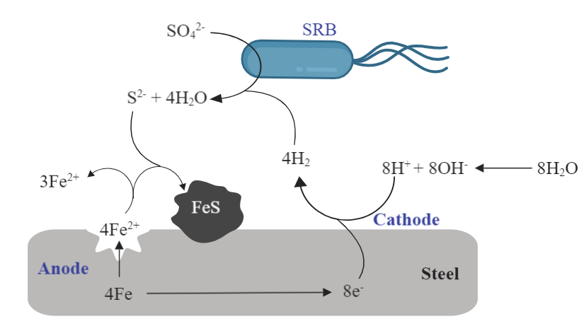
Figure 1.2. Schematic illustration of microbiologically influenced corrosion of steel via the cathodic depolarization theory.
The CDP theory was perhaps the first theory that provided an explanation for the participation of microorganisms in the corrosion of iron alloys, but multiple lines of evidence that seem to contradict its most fundamental claims have provoked a strong skepticism on the validity of this theory. One of the strongest turning points for the CDP theory came when Mori et al. (2010) evaluated the iron corrosion activities of 26 hydrogen-consuming organisms isolated from oil facilities in Japan and found that although almost all strains consumed the cathodically formed hydrogen, they did not induce significant iron corrosion (< 2x) relative to the abiotic control. Conversely, one isolate, Methanococcus maripaludis Mic1c10, caused significant iron corrosion (> 7x relative to the abiotic control) but did not consume cathodic hydrogen. This suggested that the CDP theory fails to explain MIC, at least when severe corrosion occurs.
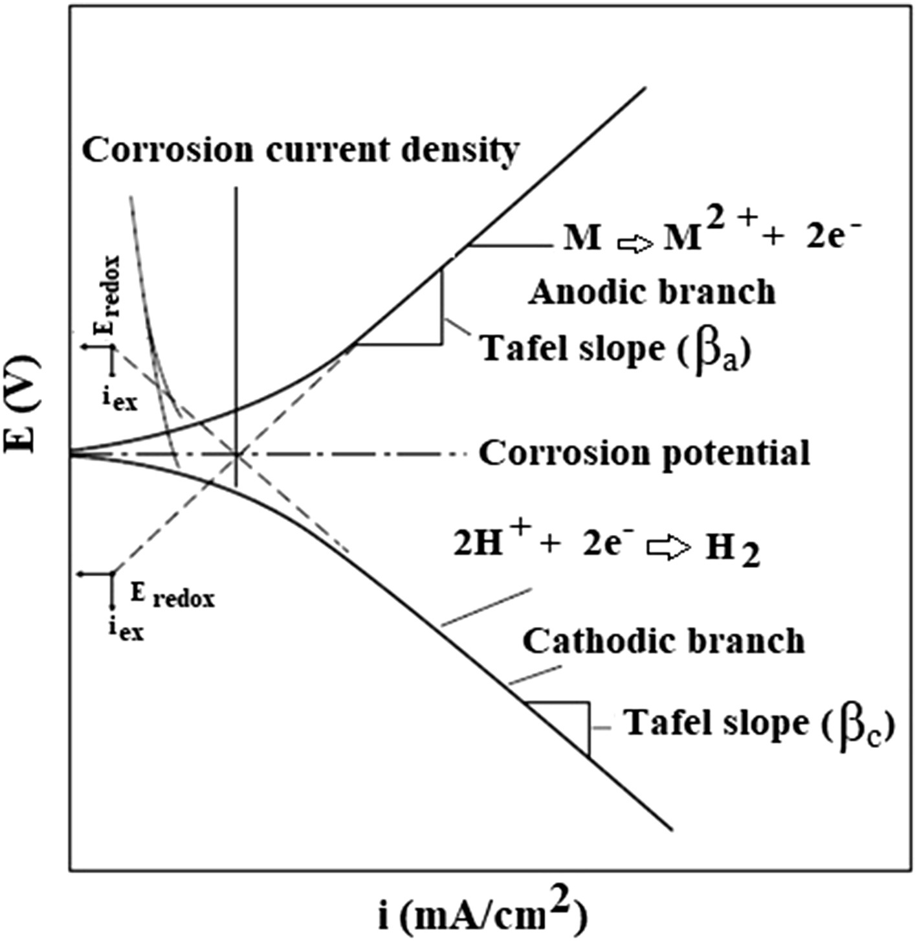
Figure 1.3 Tafel extrapolation of polarization curves. Figure was taken from Kakaei, Esrafili, & Ehsani (2019).
Before presenting the second argument that seems to contradict the CDP theory, it is necessary to understand the multi-step reaction mechanism for the hydrogen evolution on the steel surface. The first step in the hydrogen evolution reaction is the adsorption of a proton on the steel surface (H⁺ + e⁻ H_{ads}) followed by hydrogen desorption, either through a second proton-electron transfer (H_{ads} + H⁺ + e⁻ H_{2(g)}) or through the recombination of two adsorbed protons (H_{ads} + H_{ads} H_{2(g)}) (Dubouis and Grimaud 2019; Ekspong, Gracia-Espino, and Wågberg 2020).
According to Blackwood (2018), the CDP theory presents some limitations from an electrochemical point of view given that it has been previously shown that the rate-determining step for H₂ evolution on high-carbon steel in seawater is the adsorption rather than desorption step (Frankenthal and Milner 1986). This implicates that removing hydrogen from the steel surface would not accelerate the cathodic reaction. I consider it important to highlight that the determination of the rate-determining step in the hydrogen evolution reaction on high-carbon steel was conducted at slightly alkaline conditions (pH =8.3) and through the analysis of Tafel slopes (Frankenthal and Milner 1986). pH is a critical parameter influencing rate-determining steps (Dubouis and Grimaud 2019), and therefore, conclusions on whether or not a certain step is rate-determining on an environmentally relevant situation need to be carefully made only when the environmental conditions closely match those for the experimental determination of the kinetics of the hydrogen evolution reaction. Additionally, care needs to be exercised when using Tafel slopes as proxies of rate-determining steps, as this approach generally assumes extreme (complete or zero) coverage of the adsorbed species when in reality slopes are dependent on the coverage. Shinagawa, Garcia-Esparza, & Takanabe (2015) showed that although in the literature a Tafel slope of 120 mV dec⁻¹ for the hydrogen evolution reaction is generally interpreted as the proton adsorption being the rate-determining step, this slope was also observed when the desorption step determines the rate through a second proton-electron transfer at high coverage of adsorbed hydrogen (> 0.6).
Blackwood (2018) also offered the argument that the corrosion of carbon steel in 3.5% NaCl increases or remains unaffected under hydrogen overpressure (Smart, Blackwood, and Werme 2002) despite the CDP theory predicting slower corrosion rates, but Philips (2020) claims that the afore mentioned argument against the CDP theory failed to consider the different H₂ affinities and consumption characteristics of microorganisms as well as the role of excreted hydrogenases that catalyze the H₂ evolution reaction (Deutzmann, Sahin, and Spormann 2015; Tremblay, Faraghiparapari, and Zhang 2019). From the above, although the CDP theory was first proposed almost 90 years ago, it is still actively scrutinized and a consensus on its validity to explain MIC is yet to be reached.
Attack by sulfide
In the attack by sulfide model, the intracellular oxidation of organic compounds by SRB coupled to sulfate reduction produces sulfide as a byproduct that upon diffusion out of the cell is proposed to provide an additional cathodic reduction reaction (Reaction 4, Costello, 1974) and form a conductive iron sulfide layer that would catalyze the cathodic hydrogen evolution reaction (Booth, Elford, and Wakerley 1968; King, Miller, and Smith 1973). Figure 1.4 shows a schematic illustration of this model.
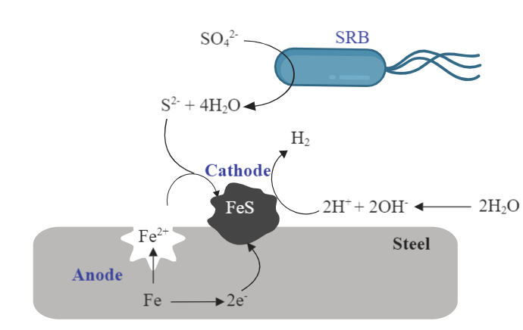
Figure 1.4. Schematic of microbiologically influenced corrosion of steel via attack by sulfides. Figure was modified from Blackwood (2018).
The redox reaction between hydrogen sulfide and iron is more thermodynamically favorable (lower Gibbs free energy) than the reaction between water and iron (Reaction 5 and 6) (Enning and Garrelfs 2014), and therefore, one might think that it is reasonable that hydrogen sulfide provides an additional cathodic reduction reaction in the oxidation of iron and its alloys. However, Kahyarian and Nesic (2019) recently showed that rather than undergoing a direct electrochemical reduction, H₂S assists in the replenishment of H⁺ in the vicinity of the metal surface.
$H_{2}S+Fe→H_{2}+FeS ∆G^{°}=-72.5 kJ{mol}^{-1}$ Reaction 4
$H_{2}O+Fe→H_{2}+FeO ∆G^{°}=-14.3 kJ{mol}^{-1}$ Reaction 5
${2H}_{2}O+Fe→H_{2}+Fe(OH)_{2} ∆G^{°}=-15.6 kJ{mol}^{-1}$ Reaction 6
The second proposition of this model states that the conductive iron sulfide layer that forms from the biological reduction of sulfate and the oxidation of iron increases the surface area for the cathodic reaction and acts as a better catalyst for hydrogen evolution than bare steel. This would cause a positive shift in the corrosion potential (i.e., electrode depolarization), a phenomenon commonly observed in the corrosion testing of SRB (Booth and Tiller 1962; Tiller and Booth 1962). To this respect, it has been argued that the increased cathodic surface area provided by the FeS film is more important at influencing the cathodic hydrogen evolution reaction than the catalytic properties of FeS (Newman, Webster, and Kelly 1991).
In the light of the attack by sulfide model, the role of microorganisms is merely the production of sulfide. Although the extended cathode mechanism seems well accepted (Blackwood 2018; B. J. Little et al. 2020), the major drawback of this model is that it fails to explain corrosion by anaerobic organisms that do not produce H₂S. Therefore, additional mechanisms are needed to explain MIC.
B. Electrical microbiologically influenced corrosion (EMIC)
Cells conserve energy by coupling the oxidation of a reduced species (electron donor) to the reduction of a more oxidized species (electron acceptor). The difference in redox potential (∆E) between the electron donor and the electron acceptor determines the amount of energy that is released or required in a redox reaction (∆G= -nF∆E). Only reactions with a negative change in the Gibbs free energy (∆G) result in potential energy gains. Therefore, in cellular electron transport chains, electrons are transferred from low redox potential donors to acceptors with more positive redox potential. Figure 1.5 shows the reduction potential of biologically relevant compounds and proteins at standard conditions. The biochemical conditions inside the cells might differ from standard conditions, and therefore, care needs to be exercised when using the values reported in Figure 1.5, but I would like to bring to the reader’s attention that both soluble and solid species are listed as redox-active molecules for microbial metabolism. This might seem contrary to what most introductory biology textbooks teach us about life. Cell metabolism does not seem restricted to the cell’s interior as insoluble molecules that cannot cross the cell membrane can engage in microbial redox reactions that result in cellular energy gain!
As I discussed before for Shewanella spp., some microorganisms have evolved fascinating molecular mechanisms that allow them to exchange electrons with extracellular solid substrates. These mechanisms provide the foundational basis for EMIC. In the EMIC model, bacteria are hypothesized to use metallic iron as the only source of reducing equivalents for microbial metabolism (Dinh et al. 2004; Venzlaff et al. 2013; Enning and Garrelfs 2014; Kato 2016). This model has been predominantly discussed for SRB, as they have been traditionally considered the main causative agents of corrosion. Under the EMIC mechanism, SRB would use electrons derived from iron as reducing equivalents for sulfate reduction as shown in Reaction 7.
Figure 1.5. Environmentally relevant midpoint reduction potential of biologically relevant molecules and proteins at standard conditions (pH = 7, 1 atm, 25 °C) unless otherwise noted. Figure was adapted from Kracke, Vassilev, & Krömer (2015). Superscripts letters denote the reference for the values used. ª Little, Hinks, & Blackwood (2020). ^{b} Bird, Bonnefoy, & Newman (2011). ^{c} Jaisi et al. (2009). ^{d} Thauer, Jungermann, & Decker (1977). ^{e} Ehrenreich & Widdel (1994). ^{f} Kracke, Vassilev, & Krömer (2015).
$4{Fe}^{0}+{SO}_{4}^{2-}+3{HCO}_{3}^{-}+H_{2}O→FeS+3{FeCO}_{3}+{5OH}^{-} ∆G^{°'}=-86.1 kJ{mol}^{-1}$ Reaction 7
Two different models propose how bacteria could take the electrons from the corrosion reaction and couple them to metabolic processes: direct electron transfer and mediator-assisted electron transfer. A schematic illustration of EMIC is provided in Figure 1.6.
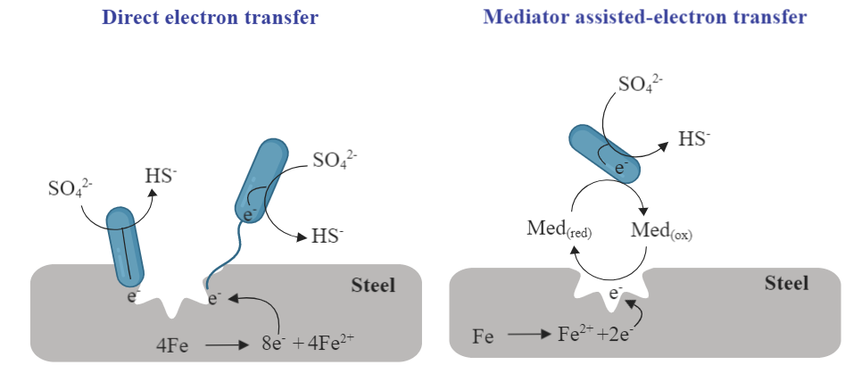
Figure 1.6. Schematic of microbiologically influenced corrosion of steel via direct electron transfer or mediator assisted – electron transfer. Med_{(red)} and Med_{(ox)} denote the reduced and oxidized forms of the mediator. Figure was modified from Blackwood (2018).
Direct electron transfer
The mechanism of direct electron transfer gained support after Dinh et al. (2004) showed that some strains of SRB –latter identified as Desulfopila corrodens strain IS4 and Desulfovibrio ferrophilus strain IS5 (Enning et al. 2012)- cause unusually high iron corrosion rates that could not be explained by the mere hydrogen consumption kinetics of related hydrogenotrophic SRB. The authors suggested that direct electron transfer from the metal to bacterial cells could occur, or in other words, that those particular organisms had the ability to electrically connect intracellular electron transport chains with extracellular solid materials. Enning et al. (2012) later showed that the ferrous sulfide layer deposited on steel coupons as a result of Reaction 7 is conductive and could provide a medium for electron flow. Further investigations claimed to provide evidence for direct electron uptake from electrochemical studies (Venzlaff et al. 2013; Beese-Vasbender et al. 2015) and thermodynamics (Gu T, Zhao K, and Nesic S 2009), but no conclusive experimental demonstration of direct electron transfer was offered as the possibility of hydrogen serving as an electron carrier was not ruled out of the reported experiments and a mere comparison of the expected hydrogen consumption based on the behavior of other organisms or based on the observations in abiotic controls does not constitute a thorough evaluation of the influence of the hydrogen metabolism on the observed corrosion dynamics. Only recently, Tang et al. (2019) proposed a robust approach to consider the effect of hydrogen consumption when testing for the ability of a microorganism to engage direct electron uptake. They eliminated the possibility of hydrogen or formate serving as electron carriers through the deletion of the genes for hydrogenase and formate dehydrogenases and showed that Geobacter sulfurreducens strain ACL can use metallic iron as a sole electron donor under those conditions, providing strong evidence for the ability of this organism to engage in direct extracellular electron uptake. It is expected that this experimental strategy provides a better criterion to determine the ability of microorganisms to engage in direct electron uptake from extracellular solid substrates.
If microorganisms were able to directly take electrons from a metallic surface, the electrons released by the corroding metal would need to move across the bacterium’s cell wall and be transferred to the cytoplasmic terminal electron acceptor. According to Blackwood (2018), this sets an important challenge for the validity of this mechanism, as the thickness of the cell wall in Gram-negative bacteria is about 7.5 to 10 nm (Salton, Shin-Kim, and Baron 1996), whereas the maximum distance for single-step electron transfer is 2 nm (Gray and Winkler 2006). Therefore, it would be impossible for electrons to cross the cell wall in a single-step electron transfer. I consider that it is important to point out here that many bacteria exhibit elaborated arrangements of redox-active proteins that span the cell wall and that could act as a conduit for electrons to cross the cell wall both inwards and outwards. Examples of these organisms include the well-studied Shewanella and Geobacter, which have a network of c-type cytochromes with different windows of redox potential that overlap with each other (MtrA, MtrC, and CymA in Figure 1.5 are examples of those cytochromes), enabling the transport of electrons between the cellular menaquinone pool and the extracellular solid substrates (Kracke, Vassilev, and Krömer 2015; Shi et al. 2016).
Mediated-assisted electron transfer
Alternative hypotheses on how the electrons are transported from the metallic surface across the cell membrane have been proposed. Those involve mediators acting as electron carriers and transferring electrons from the metallic substrate to the cell’s cytoplasm. The key aspect in this mechanism is that the electron being transferred is in association with the redox mediator. These mediators are known as extracellular electron shuttles and can be produced by the microorganisms (endogenous) or being naturally present in the environment (exogenous) (Hernandez and Newman 2001). The redox activity of electron shuttles normally stems from the presence of conjugated bonds as these can be easily reduced at biologically relevant reduction potentials (Glasser, Saunders, and Newman 2017). Electron shuttles include exogenous materials such as humic acids with quinone and/or hydroquinone moieties and endogenous molecules, such as flavins, cytochromes, and quinines (X. Liu, Shi, and Gu 2018; Huang et al. 2018).
To transport electrons in the context of MIC, the electron shuttles need to have a redox potential positive to the corrosion potential. For carbon steel at 25°C, it means a redox potential positive to that of Reaction 8. Other criteria for molecules acting as effective electron shuttles include the ability to undergo multiple redox cycles to sustain electron transfer in the long term as well as the power to provide a physiological benefit to its producer to balance out the associated metabolic costs that although estimated minor in comparison to other metabolic processes, it can require up to 25 ATP molecules to synthetize one molecule of electron shuttle (Glasser, Saunders, and Newman 2017). From my perspective, the metabolic cost of production of extracellular electron shuttles becomes more important when considering the losses due to diffusion outside the cell, and it is precisely the diffusion that occurs extracellularly what I think limits the importance of this mechanism in the environment in comparison to the closed systems we test in the laboratory; diffusion rates in open systems may be too rapid to support the electron transfer rates needed to sustain microbial metabolism.
$Fe→{Fe}^{2+}+{2e}^{-} E=-0.44+0.0295\log\left[{Fe}^{2+}\right]$ Reaction 8
Extracellular electron shuttles and their role in microbial extracellular electron transfer reactions have been better studied in the context of dissimilatory iron respiration (Coates et al. 1998; Lies et al. 2005; Marsili et al. 2008; Kotloski and Gralnick 2013; Tan et al. 2016) than in the opposite process (extracellular electron uptake), but because of the role that the electron shuttles play for iron-reducing microorganisms, one might think that these shuttles would also play a significant role in mediating the transfer of electrons from extracellular solid substrates, such as carbon steel, to the intracellular electron transport chains. The evidence supporting this is starting to pile up (P. Zhang et al. 2015; D. Wang et al. 2020, 2021). For me, the key questions to answer are: what are the diffusion rates of microbial extracellular electron shuttles in the environment, and are those rates supportive of microbial metabolism?
From the above discussion, I hope I have convinced you that despite the importance of MIC in our society and the tremendous efforts of the scientific community to understand and tackle this issue, we have not reached an agreement on the corrosion microbial players and the underlying molecular mechanism. I believe that rather than a single unifying MIC mechanism, it is feasible that different microorganisms exhibit different mechanisms depending on the local chemical and microbiological environment. It is also possible that different mechanisms overlap to some extent and co-occur under the right conditions, for example, the mediator-assisted electron transfer might be complementary to the direct electron transfer mechanisms where the outer membrane cytochromes are considered as the key actors. Regardless of the diversity of MIC mechanisms and players, it is expected that a better understanding of MIC results in improved prevention and mitigation strategies for preserving the steel infrastructure that supports our societies.

The role of Shewanella in the microbiologically influenced corrosion of carbon steel
According to Enning and Garrelfs (2014), SRB are considered the main culprits of MIC for three reasons: 1) iron in anoxic environments containing sulfate is particularly prone to corrosion; 2) SRB and their corrosion product (FeS) are commonly found on anaerobically corroded iron; 3) the corrosion rates produced by SRB in laboratory testing match the cases of corrosion in the field. However, there are several cases where corrosion cannot be explained by SRB (El-Raghy, El-Leil, and Ghazal 1997; Starosvetsky, Starosvetsky, and Armon 2007; Kan et al. 2011; Lahme et al. 2020). In production water tanks in Putumayo, Colombia, severe corrosion was evidenced, but not SRB could be identified and no sulfate-reducing activity was detected (Y. Li 2018). In contrast, Li (2018) found a microbiota comprised predominantly of iron-reducing bacteria, which suggested a possible involvement of this type of microorganisms as MIC agents.
When corrosion occurs, corrosion products adhere to the surface of the metal forming a layer that provides a diffusion barrier to the reactants, i.e., a passivating layer. When iron or its alloys undergo corrosion, the passivating layer is generally comprised of iron oxide/hydroxides. The involvement of iron-reducing organisms in the corrosion of carbon steel has been attributed to the removal of the ferric iron oxide/hydroxide passivating layer from the steel surface through the reduction of ferric iron and subsequent dissolution of the produced ferrous iron (B. Little et al. 1998). As I mentioned before, S. oneidensis strain MR-1 is a model organism for iron-reducing bacteria, so my discussion for the molecular pathways for iron reduction will focus on the knowledge we have gained by studying S. oneidensis MR-1.
Underlying the ability of S. oneidensis MR-1 to transfer electrons to extracellular substrates is the presence of a high number (> 40) of c-type cytochromes genes in its genome (Heidelberg et al. 2002; Meyer et al. 2004). Our current understanding of the way S. oneidensis MR-1 reduces ferric iron points to the participation of the periplasmic decaheme c-type cytochrome MtrA, the outer membrane decaheme c-type cytochromes MtrC and OmcA, the outer membrane protein MtrB, and the inner-membrane tetraheme c-type cytochrome protein CymA (Fredrickson et al. 2008). Although the genes encoding these proteins have paralogs (mtrD, dmsE, SO4360 paralogs for mtrA; mtrF, omcA, and undA paralogs for mtrC; and mtrE, dmsF, and SO4359 paralogs for mtrB) in the genome of S. oneidensis, the proteins in the metal-reducing cluster MtrABC/OmcA seem to be the primary components in the reduction of Fe(III). A schematic of the most widely accepted mechanism is shown in Figure 1.7.
Under anoxic conditions, electrons from carbon oxidation enter the menaquinol pool and flow to the inner membrane c-type cytochrome CymA (C. R. Myers and Myers 1997). From CymA, electrons flow to MtrA, likely through the periplasmic fumarate reductase FccA or the small tetraheme cytochrome CctA (Coursolle and Gralnick 2010, 2012; Sturm et al. 2015). From MtrA the electrons flow to MtrC. The trans-outer membrane protein MtrB is a porin molecule that forms a complex with MtrA and MtrC to stabilize these proteins and enable electron transfer (Ross et al. 2007; Hartshorne et al. 2009; Edwards et al. 2020). MtrC and OmcA are responsible for the electron transfer to extracellular electron acceptors (Xiong et al. 2006; Lower et al. 2007; Marshall et al. 2008; Eggleston et al. 2008; Zheming Wang et al. 2008; Reardon et al. 2010). I would like to highlight at this point that our understanding about the role of MtrF is not as extensive as for the role of MtrC or OmcA, and therefore most of the molecular models we find in the literature center around MtrC and OmcA, but Coursolle and Gralnick (2012) showed that MtrF can also facilitate this step when Fe(III)-citrate is the extracellular electron acceptor.
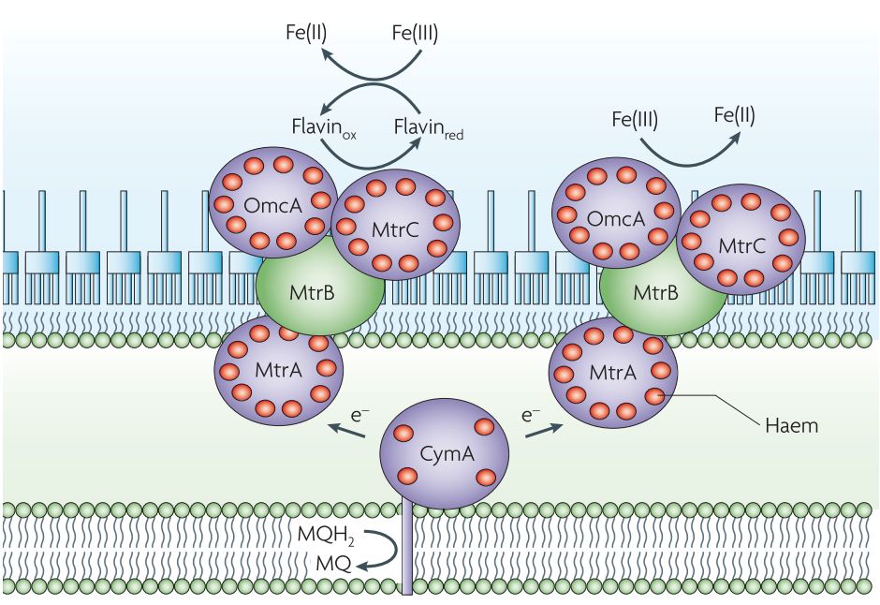
Figure 1.7 Schematics of iron reduction mechanisms in Shewanella oneidensis MR-1. Figure was taken from Fredrickson et al. (2008). The electron transfer from CymA to MtrA is now known to be facilitated by FccA and/or CctA (Sturm et al. 2015).
S. oneidensis MR-1 also uses flavins as soluble electron shuttles or bounded cofactors for the outer membrane c-type cytochromes to transfer electrons to extracellular electron acceptors (Marsili et al. 2008; Von Canstein et al. 2008; Coursolle et al. 2010; Okamoto et al. 2013). In this case, reduced flavins diffuse out of the cell and donate electrons to the solid surface. Upon extracellular oxidation, the oxidized shuttle can return to the cell, get reduced, and continue the redox cycle. It has been shown that the same c-type cytochromes that are thought to be responsible for the direct electron transfer mechanism also participate in the reduction of flavins, suggesting that both mechanisms might overlap. However, because a significant portion (> 70%) of the current produced during the reduction of a carbon electrode (Marsili et al. 2008) and a solid Fe(III) oxide (Kotloski and Gralnick 2013) by S. oneidensis is dependent on the presence of flavins, it has been argued that the mediator-assisted electron transfer is the most common mechanism for the reduction of extracellular substrates by this organism (Brutinel and Gralnick 2011; Kotloski and Gralnick 2013; Grobbler et al. 2018).
A third mechanism for iron reduction in S. oneidensis MR-1 is through nanowires (Gorby et al. 2006), which are extensions of the outer membrane that contain cytochromes and are comprised of interconnected outer membrane vesicles (Pirbadian et al. 2014; Subramanian et al. 2018). This mechanism is somehow similar to the one exhibited by Geobacter spp. which show filaments containing the multi-heme c-type cytochromes OmcS and OmcZ (F. Wang et al. 2019; Filman et al. 2019; Yalcin et al. 2020). The nanowires in Geobacter spp. have been considered to be made of electrically conductive PilA-N pili (Reguera et al. 2005; Lovley and Walker 2019), but there is new evidence that suggests that the role of the pilin filament is to help in the translocation of the c-type cytochromes rather than conducting electrons (Gu et al. 2021), making it more similar to the nanowires of Shewanella than it had been previously thought.
From a genome perspective at least, it seems like the aforementioned mechanisms are not unique to S. oneidensis MR-1 but are shared by members of the genus Shewanella as many of them have a single locus that encodes mtrA, mtrC, and mtrB (Figure 1.8). This locus also encodes 1-3 decaheme (omcA, mtrF, mtrG, and mtrH) or undecaheme (undA and undB) outer membrane c-type cytochromes. At the time of writing this dissertation, there are 34 species of Shewanella with a complete genome sequence available at NCBI, and 91% of them share this locus. This suggests that although the discussion here is centered around S. oneidensis MR-1, it is also likely relevant for other members of the genus Shewanella.

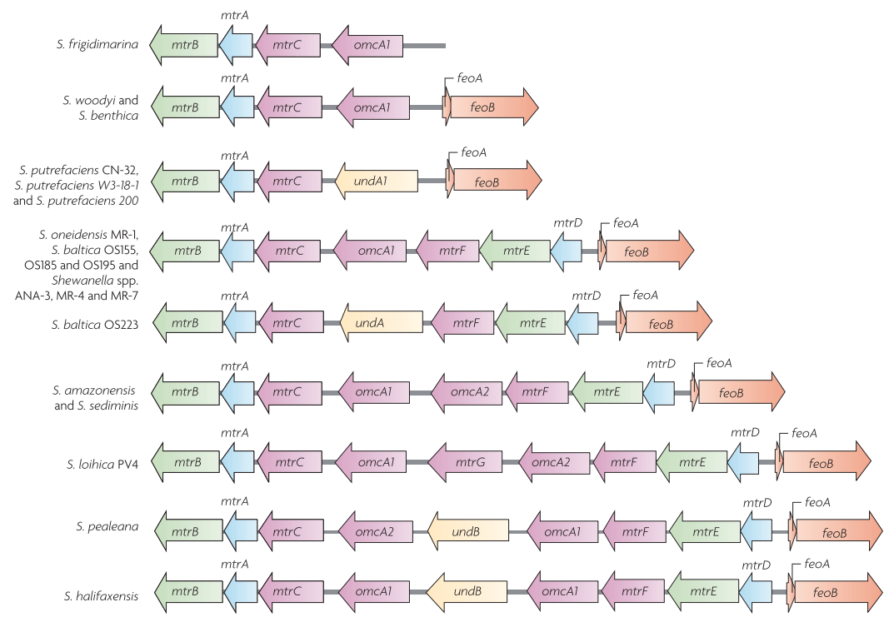
Figure 1.8 Metal-reductase-encoding locus in the genus Shewanella. Figure was taken from Fredrickson et al. (2008).
Several Shewanella strains have been isolated from produced water samples from oil storage tanks and have been linked to corrosion of metal infrastructure in the oil field environment (Semple and Westlake 1987; Venkateswaran et al. 1999). In a recent biological survey conducted by a major oil and gas operator in the Permian basin, members of the family Shewanellaceae were found in produced fluids samples of 139 wells –out of the 308 wells studied (> 45%)- in a relative abundance ranging from 0.01% to 12.81% as determined by 16S rDNA sequencing analysis. Figure 1.9 shows a map of the location of the wells whose produced fluids contain shewanellae. To provide a comparison point, members of the family Geobacteraceae, another widespread and well-studied iron-reducing family, were only present in less than 11% of the produced fluid samples in relative abundance ranging from 0.01% to 3.7%.
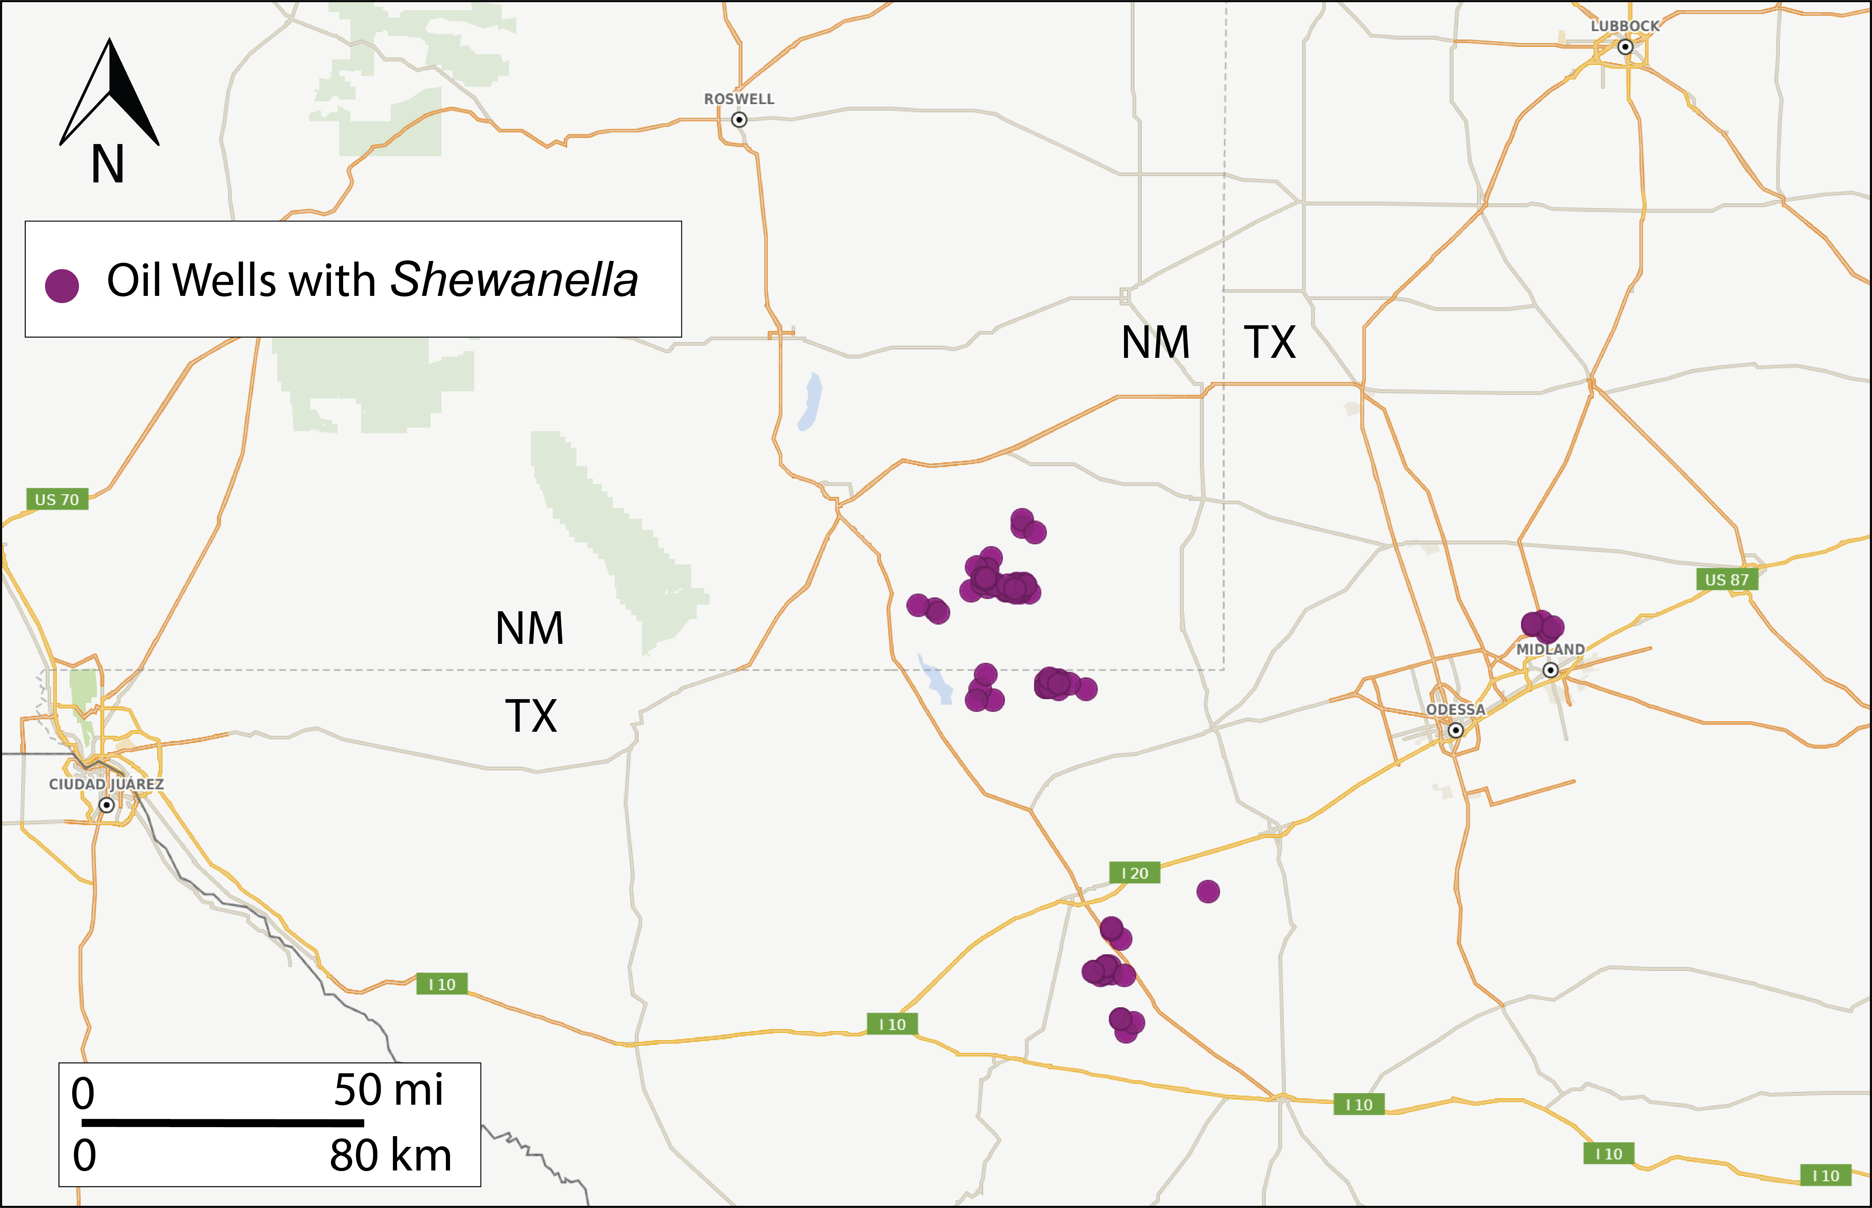
Figure 1.9. Map of the Permian basin showing the location of oil wells with Shewanella spp.
The presence of Shewanella spp. in produced fluids samples occurs despite the expensive efforts of oil and gas companies to control microbial populations through biocidal programs. One thing that I consider important to note is that Shewanella spp. were also found in the rock cuttings of more than 57% of the wells studied, but only in 11.5% of the drilling mud and 21.7% of the frac fluids samples, suggesting that Shewanella spp. could be indigenous to the petroleum reservoir and not only introduced during drilling or completion operations. This might help to explain why biocidal programs are not always effective at controlling corrosive microbial populations as the programs are frequently targeted to the microbial populations in the injected materials rather than to the indigenous microbial populations in the reservoirs.
As with other iron-reducing bacteria, the role of S. oneidensis MR-1 in the corrosion of carbon steel has been primarily attributed to the iron-reducing metabolism (Esnault et al. 2011; Schütz et al. 2015), but additional evidence supporting other mechanisms exists in the literature yet remains overlooked. First, De Windt et al. (2003) proposed that S. oneidensis MR-1 accelerates the corrosion of steel by consuming the molecular hydrogen naturally formed on the steel surface, similar to what the cathodic depolarization theory proposes. Others have suggested that S. oneidensis would prevent rather than accelerate corrosion by consuming oxygen and forming thick biofilms on the steel surface (Dubiel et al. 2002; R. B. Miller et al. 2016). And finally, since the discovery of the bidirectional extracellular electron transfer capabilities of S. oneidensis MR-1 (Ross et al. 2011; Rowe et al. 2018; Zou, Wu, et al. 2019), researchers have proposed that Shewanella sp. could oxidize metallic iron through direct electron uptake (Philips et al. 2018). Therefore, a proper investigation of the different corrosion mechanisms of S. oneidensis MR-1 is warranted.
S. oneidensis MR-1 can use molecular hydrogen as an electron donor by expressing the periplasmic HydA and HyaB hydrogenases under anoxic conditions (Meshulam-Simon et al. 2007). Although the mere ability to consume H₂ does not guarantee an accelerated microbiologically influenced corrosion (Mori, Tsurumaru, and Harayama 2010), it has been shown that free hydrogenases and presumably formate dehydrogenases can mimic apparent electron uptake that enhances iron corrosion (Deutzmann, Sahin, and Spormann 2015). Hence, one of the critical questions that need to be addressed is what is the role of the hydrogen metabolism in the corrosion facilitated by S. oneidensis MR-1?

Influence of iron-binding ligands on the corrosion of carbon steel driven by Shewanella oneidensis
Iron can readily complex with carbon-, oxygen-, nitrogen-, and sulfur-bearing ligands due to its electrons in d orbitals with π-character (Melton et al. 2014). It is estimated that more than 99% of the total dissolved iron is complexed with organic iron-binding ligands in the marine environment (Gledhiir and Buck 2012). Upon complexation, the chemistry (solubility, redox potential, bioavailability, etc.) of iron is altered, suggesting an important role for the ligands in the corrosion of carbon steel, especially when it is driven by iron-reducing bacteria, like S. oneidensis, whose iron respiration rates are known to be influenced by the iron chemistry (Haas and Dichristina 2002; Bonneville, Van Cappellen, and Behrends 2004; Bonneville, Behrends, and Van Cappellen 2009).
Short-chain dicarboxylic acids are ubiquitous iron-binding ligands that play a key role in mobilizing iron in the environment by dissolving ferric iron from naturally occurring iron oxy-hydroxides (W. P. Miller, Zelazny, and Martens 1986; Reichard, Kretzschmar, and Kraemer 2007; Zhenzhen Wang et al. 2017; Fengyi Li, Koopal, and Tan 2018; Tapparo et al. 2020). At pH 7.0, the short-chain dicarboxylic acids oxalic, malonic, and succinic acids occur at the deprotonated state, which forms soluble complexes with Fe(III). Because these dicarboxylic acids have been previously found in production waters from carbon steel tanks experiencing corrosion (Y. Li 2018) and because of their widespread occurrence in formation waters of sedimentary basins (Kharaka, Ambats, and Thordsen 1993; Prapaipong, Shock, and Koretsky 1999), I will use them as models to research the impact of iron-binding ligands on the corrosion of carbon steel and the microbial iron respiration rates.
The effect of short-chain dicarboxylic acids on the abiotic corrosion of steel has been previously investigated (Saltykov, Makarov, and Toroptseva 2001; Giacomelli et al. 2004; Saltykov et al. 2004; Wiersma 2011). For oxalic acid, three different effects are distinguished: i) under acidic conditions, the cathodic current density is higher for solutions containing oxalic acid than for oxalic acid-free solutions, suggesting an enhanced hydrogen evolution reaction in the presence of oxalic acid (Giacomelli et al. 2004); ii) evidence suggests that hydro-oxalate ions (HC₂O₄⁻) interact with the FeOH_{ads} surface (hydroxyl ions adsorbed on the steel surface), forming FeHC₂O₄⁺_{ads}, Fe(II), and releasing an electron, which suggests a direct electrochemical mechanism for the oxidation of steel by oxalic acid (Saltykov, Makarov, and Toroptseva 2001); and iii) formation of a ferrous oxalate layer through deposition on the steel surface, indicating a corrosion passivating effect (Saltykov et al. 2004). Succinic acid has been found to inhibit corrosion of carbon steel at pH < 3 but the inhibition becomes insignificant at pH > 4 (Deyab and El-Rehim 2014). Not only pH and the chemical nature of the iron-binding ligand seem to influence the corrosive effect of these molecules on steel, but the presence of oxygen has also been shown to play an important role in determining whether carboxylates passivate or not the steel surfaces (Godinez-Alvarez et al. 2004). Because the effect of short-dicarboxylic acids on the corrosion of carbon steel has not been thoroughly investigated under anoxic conditions, it is necessary to define the effect of these molecules under anoxic sterile conditions before we can understand how they influence the corrosion driven by S. oneidensis under iron-reducing conditions.
Previous research in our group investigated the effect of oxalate, malonate, and succinate on the polarization resistance and corrosion potential of carbon steel under oxic conditions and offered some exploratory work on how they impact the iron respiration by S. oneidensis under anoxic conditions (Kokbudak 2017). It was found that the presence of these short-chain deprotonated dicarboxylic acids increases the dissolution of ferric iron from oxidized carbon steel and seems to increase the microbial iron respiration and corrosion rates, but a thorough evaluation of the effect of the deprotonated dicarboxylic acids on the microbial respiration and corrosion rates was hindered by the non-uniform cell density used across the experiments. Kokbudak (2017) also found evidence for the adsorption of the dicarboxylic acids on the oxidized carbon steel surface from the increase in the polarization resistance over time, but a characterization of the surface has yet to be done. Therefore, although there is good evidence that indicates that iron-binding ligands can influence the corrosion of carbon steel driven by iron-reducing bacteria, a systematic evaluation of the effect that these molecules have on corrosion under anoxic conditions driven by S. oneidensis is needed.
By now I hope I have conveyed the complexity of corrosion chemistry and why despite the many efforts that microbiologists, electrochemists, and engineers have coordinated, our understanding of corrosion driven by microorganisms is still in its infancy. In the rest of this dissertation, I aim to provide answers to some of the critical gaps I have identified during this revision to the literature, and I will propose the new challenges that will need to be addressed next.

The influence of iron-binding ligands on the corrosion of carbon steel driven by iron-reducing bacteria
In this chapter, I evaluated the ability of Shewanella oneidensis MR-1 to accelerate the corrosion of carbon steel by dissolving the iron oxide passivating layer through the reduction of ferric iron under anoxic conditions. Given that the rates for microbial iron respiration are dictated by the kinetics of iron coordination and solubility, it was hypothesized that the presence of iron-binding ligands would increase the microbial iron respiration rates, which in turn would increase the corrosion rates of carbon steel. Part of this chapter was submitted to the NPJ Materials Degradation journal and is under revision at the time that I write this dissertation.

Introduction
Corrosion of metallic infrastructure facilitated by microorganisms is a costly phenomenon that affects a wide range of industries, including aviation (Naval Research Lab Stennis Space Center MS Oceanography 1997), water distribution (G. Zhang et al. 2018), and oil and gas (Mori, Tsurumaru, and Harayama 2010; Skovhus, Eckert, and Rodrigues 2017; Eckert and Skovhus 2018). There is mounting of literature that suggests that carbon steel, the preferred material in structural components and pipes across industries (Dwivedi, Lepková, and Becker 2017), is highly susceptible to corrosion facilitated by microorganisms (Schütz et al. 2014; Javed et al. 2016; Jia et al. 2017, 2018). Therefore, scientists and engineers across the globe face the challenge to understand how microorganisms accelerate the corrosion of carbon steel before being able to develop effective corrosion prevention and mitigation strategies.
When steel is oxidized, an iron (hydr)oxide passivating layer forms, protecting the steel surface underneath it from further corrosion events. Given that ferric iron is poorly soluble at neutral pH and cannot easily enter the interior of bacterial cells, the metabolic utilization of this redox-active substrate is challenging for most microorganisms. However, Shewanella spp. exhibit Fe(III)-reductases on their outer membrane that allow them to access the energy stored in the poorly soluble ferric iron through direct and indirect reduction mechanisms (Lies et al. 2005).
Shewanella spp. have been frequently linked to corrosion (Semple and Westlake 1987; Venkateswaran et al. 1999; R. B. Miller et al. 2018), although a consensus on the role that Shewanella spp. play in the corrosion of carbon steel is yet to be reached. Shewanella oneidensis MR-1 has been shown to accelerate the corrosion of carbon steel up to 1.3-1.8 times via the dissolution of the magnetite passivating layer (Schütz et al. 2015; Esnault et al. 2011). However, some authors have argued that S. oneidensis MR-1 would decelerate rather than accelerate the corrosion of carbon steel by decreasing the dissolved oxygen in the system through the production of Fe(II) and the ability of Shewanella species to respire oxygen (Dubiel et al. 2002) or by blocking the steel surface with a dense biofilm (R. B. Miller et al. 2016). In both cases, the Fe(III) reducing metabolism of Shewanella spp. seems to underlie the involvement of this taxon in the corrosion of carbon steel.
The dissolution of Fe(III) oxides is very slow at circumneutral pH values, but the mobility of iron in aqueous phases can be enhanced by the formation of soluble Fe(III) complexes with iron-chelating ligands. Short-chain dicarboxylic acids are effective iron-binding ligands that play a key role in mobilizing iron in the environment by dissolving ferric iron from naturally occurring iron oxy-hydroxides (W. P. Miller, Zelazny, and Martens 1986; Reichard, Kretzschmar, and Kraemer 2007; Zhenzhen Wang et al. 2017; Fengyi Li, Koopal, and Tan 2018; Tapparo et al. 2020). At neutral pH, the short-chain dicarboxylic acids oxalic acid (pK_{a1}= 1.23, pK_{a2}= 4.19), malonic acid (pK_{a1}=2.83, pK_{a2}=5.69), and succinic acid (pK_{a1}=4.19, and pK_{a2}= 5.48) (Brown, McDaniel, and Häfliger 1955) occur in the deprotonated state, which forms strong soluble complexes with Fe(III) (Table 2.1). These molecules occur naturally in the environment and in many instances, they are byproducts of microbial metabolism.
Table 2.1. Stability constants of ferric iron-ligand (Fe-L) complexes (Smith and Martell 1989).
Ligand | Most stable species | Logβ_{ab}
Oxalate | FeL₃³⁻ (a=1; b=3) | 18.6
Malonate | FeL₃³⁻ (a=1; b=3) | 16.6
Succinate | FeL₂⁻ (a=1; b=2) | 13.3
Lactate | FeL (a=1; b=1) | 6.4

Dicarboxylic acids are frequently considered corrosion inhibitors based on reports showing the deacceleration of corrosion of steel under oxic conditions due to the formation of a dicarboxylate salt that weakly adsorbs on the steel surface. Oxalic acid has been shown to inhibit corrosion of iron alloys in aerated solution at pH < 6.0 by forming a passive ferrous oxalate layer (Saltykov, Makarov, and Toroptseva 2001; Giacomelli et al. 2004; Saltykov et al. 2004), whereas succinic acid was found to inhibit corrosion of carbon steel at pH < 3 but the inhibition becomes insignificant at pH > 4 (Deyab and El-Rehim 2014). Therefore, it seems that pH conditions strongly influence the role different dicarboxylic acids play in the corrosion of carbon steel. Furthermore, It has been shown that not all dicarboxylic acids act as corrosion inhibitors in oxygen-free conditions (Godinez-Alvarez et al. 2004), highlighting the need for researching the effects on corrosion of dicarboxylic acids under anoxic conditions.
In this chapter, I aimed to determine whether S. oneidensis MR-1 accelerates the corrosion of carbon steel under anoxic and iron-reducing conditions and if so, what the impact of short-chain deprotonated dicarboxylic acids is in the corrosion driven by S. oneidensis MR-1.

Methods

Chemicals:
Sodium oxalate (CAS number: 62-76-0) ACS reagent ≥ 99.5%, sodium malonate dibasic (CAS number: 141-95-7) ≥ 97.0%, sodium succinate dibasic (CAS number: 150-90-3) ≥ 98.0%, and ferric citrate (CAS number: 3522-50-7) were purchased from Sigma Aldrich.

Bacterial culture conditions:
S. oneidensis MR-1 was kindly donated by Dr. Jizhong Zhou at the University of Oklahoma and grown in a modified minimal medium (Appendix 1) adjusted to pH 7.0 with NaOH 1 M and supplemented with 60 mM sodium lactate and 50 mM Fe(III)-citrate. The medium recipe was modified from Y. J. Tang, Meadows, & Keasling (2007). Oxygen was removed from the medium by boiling for 1 min and bubbling oxygen-free N₂ gas for 20 minutes before capping with stoppers and autoclaving at 121 °C for 15 min. After autoclaving, filter-sterilized Fe(III)-citrate was added to the medium at a final concentration of 50 mM. Cultures were incubated overnight at 30 °C and 120 rpm. A liquid inoculum from an anaerobic overnight culture was transferred (1% vol/vol) into 10 mL of fresh medium and incubated at 30 °C and at 120 rpm for 8 h. These cultures were harvested by centrifugation at 1,500 RCF for 10 min inside a Coy anaerobic chamber (5% H₂, 95% N₂ gas atmosphere) and washed and resuspended twice in the anoxic minimal medium. This was used as the inoculum for biotic microcosm experiments.

Corrosion experiments:
Round C1018 carbon steel (0.15-0.20% C, 0.6-0.9% Mn, 0.035% maximum S, 0.03% maximum P, and elemental iron as the remainder) coupons (9.53 mm diameter, 1 mm thickness) (Alabama Speciality Products) with a 1.726 cm² surface area were placed in 3 mL of 0.1M NaNO₃ solution and allowed contact with the atmosphere for 3 days. Upon the development of an iron oxide layer on the steel surface, the coupons were rinsed with nano-pure water, allowed to dry inside a Coy anaerobic chamber (5% H₂, 95% N₂ gas atmosphere), and autoclaved for 30 min at 121 °C under an N₂ atmosphere. Anoxic microcosm experiments were in sterile 120-mL serum bottles, each containing an oxidized sterile carbon steel coupon suspended by a PTFE-coated quartz string to a butyl rubber septum, as suggested by Liang and Suflita (2015), and 50 mL of minimal medium MR-1 supplemented with 60 mM lactate but without Fe(III)-citrate. The bottles were crimp-sealed and filled with an N₂ atmosphere by repeating flushing and vacuuming cycles 10 times under sterile conditions.
An ethanolic solution of chloramphenicol was added at a final concentration of 25 ug mL⁻¹ to all experiments to prevent bacteria from growing in biotic experiments as recommended by Haas, Dichristina, and Wade (2001). The corrosion microcosm experiments were conducted under both abiotic and biotic conditions in triplicate. In biotic experiments, 1.0×10⁶ cells mL⁻¹ were added to each bottle. Filter-sterilized pH= 7.0 solutions of the deprotonated dicarboxylic acids under study (oxalate, malonate, and succinate) were prepared in deaerated water and added at a final concentration of 50 mM. In the control experiments without any dicarboxylic acid, sterile and deaerated nanopure water (> 18.2 MΩ) at pH 7.0 was added at the same volume as dicarboxylic acids were added to the rest of the experiments to assure the same total volume of experimentation. All the experiments were incubated at 30 °C and 120 rpm for 26 h under dark conditions. Because oxidized carbon steel coupons were used, we could not conduct mass loss measurements at the end of the experiments.

Chemical analyses:
Liquid samples were collected under anoxic conditions with N₂-rinsed sterile syringes and acidified with HCl at a final concentration of 0.5 N. Ferrozine assay (Stookey 1970) for the quantification of Fe(II) was performed immediately following sample collection to minimize iron oxidation. Briefly, Ferrozine reagent was prepared by adding 1 g of 3-(2-pyridyl)-5,6-diphenyl-1,2,4-triazine-p,p′-disulfonic acid monosodium salt in 1 L of 50 mM HEPES pH 7.0 and stored under dark conditions at room temperature. For the assay, 2.5 mL of ferrozine reagent was mixed with 50 μL of the sample or the standard solution, and the extinction of the mixture at 562 nm was measured using a UV-1601 spectrophotometer (Shimadzu) after vigorous shaking for 15 s. Iron reduction rates were calculated over the linear portion of the Fe(II) curve.
Total dissolved iron was quantified with a NexION 2000 (Perkin Elmer) Inductively Coupled Plasma-Mass Spectrometer (ICP-MS). The isotope ⁵⁶Fe was measured in the dynamic reaction cell (DRC) mode. The plasma gas was 16 L Ar min⁻¹. Ammonia was used as DRC gas at a 0.59 mL min⁻¹ flow rate. A 500 ppb Gallium standard solution (Inorganic Ventures) was used as the internal standard, and a 10,000 ug mL⁻¹ iron standard stock solution (Perkin Elmer) was used for preparing standard solutions. The samples for total dissolved iron quantification were stored at -20 °C before analysis.
The total iron at the completion of the experiment was quantified after collecting the coupons inside a Coy anaerobic glove box (5% H₂, 95% N₂ gas atmosphere) and submerging them in 3 mL of corrosion cleaning solution (3.5 g L⁻¹ hexamethylenetetramine in 6 N HCl) for 10 min. Then, the coupons were washed with deoxygenated nanopure (> 18.2 MΩ) water and stored under an N₂ atmosphere. The liquid fraction (corrosion cleaning solution + dissolved ions from corrosion products) was mixed with the original aqueous phase from each of the microcosm experiments and acidified with HNO₃ at a final concentration of 2.0% (v/v). The total iron concentration in this liquid phase was measured using ICP-MS in a similar way to the dissolved iron measurements.
One mL liquid samples were collected and filtrated through a 0.45 μm syringe filter at the end of experimentation for organic acids analysis to corroborate that S. oneidensis MR-1 had not metabolized the iron-binding ligands as a carbon source. The samples were kept frozen at -20 °C before analysis. Organic acids were quantified with the Beckman System Gold HPLC 126 Programmable Solvent Mode and 168 Detector using an AMINEX HPX 87H column and 5 mM H₂SO₄ as the mobile phase. The flow rate was 0.9 mL min⁻¹. Detection was set at 210 nm. Compounds were identified and quantified by comparison to known standards.

Scanning electron microscopy:
Coupons were collected after experimentation inside a Coy anaerobic glove box (5% H₂, 95% N₂ gas atmosphere), washed with 1 mL of phosphate buffer saline pH 7.2 (Appendix 2), and submerged in 4 mL of 2.5% glutaraldehyde solution in phosphate buffer saline pH 7.2 and incubated for 10 h at 4°C. Then, coupons were washed with 1 mL of nanopure (> 18.2 MΩ) water, and ethanol dehydration series (30%, 50%, 60%, 70%, 80%, 90%, 95%, 100%, 100%) was performed by submerging each coupon in 4 mL of each of the ethanolic solutions for 10 min. Coupons were allowed to dry inside an anaerobic glove box and stored under N₂ atmosphere in crimp-sealed vials until examination with a Zeiss NEON 40 EsB scanning electron microscope at a 5 kV accelerating voltage. When SEM-EDS spectra were taken, a 15 kV accelerating voltage was used. SEM micrographs were analyzed with ImageJ and cells on the surface of the steel coupon were counted using the Cell Counter plugin.

X-ray Diffraction:
Powder X-ray diffraction (XRD) analyses were performed using a Rigaku Ultima IV diffractometer on the surface of the coupon after experimentation. Cu-K-alpha radiation (40 kV, 44 mA) was used with a scintillation detector and a curved graphite monochromator. The MDI Jade 2010 software with the ICDD (International Centre for Diffraction Data) PDF4+ database was used for the data analysis.

Linear Polarization Resistance Experiments:
Linear Polarization Resistance analyses were conducted using a Reference 600+ Potentiostat (Gamry Instruments). Cylindrical oxidized C1018 carbon steel coupons were used as the working electrode. The coupons were sterilized and treated as described for the microcosm experiments. The dimensions of the working electrode are 0.95 cm x 1.27 cm, and the surface area is 4.5 cm². A standard calomel electrode was used as the reference electrode, whereas a graphite rod was used as the auxiliary electrode. Electrolyte medium consisted of the modified minimal medium adjusted to pH 7.0 and supplemented with 60 mM lactate. The potential was swept ±10 mV from the open circuit potential at a rate of 0.125 mV s⁻¹. Measurements were taken every 10 min for 40 h. The experiments were conducted in EuroCells (Gamry Instruments) inside a Coy anaerobic glove box (5% H₂, 95% N₂ gas atmosphere). Anoxic and sterile solutions of the different deprotonated dicarboxylic acids were added at 7 h at a final concentration of 50 mM. S. oneidensis MR-1 cells were also added at 7 h in the biotic experiments. The inoculum was prepared as described for the microcosm corrosion experiments. The electrolyte was stirred at 200 rpm between measurements to avoid diffusion limitations. Results were analyzed using the Echem Analyst software (Gamry Instruments).

Results
Short-chain deprotonated dicarboxylic acids solubilize iron from oxidized carbon steel in a manner that positively correlates with the stability constant of the most thermodynamically favorable metal-ligand complex.
The effect of short-chain deprotonated dicarboxylic acids (oxalate, malonate, and succinate) on the dissolution of the iron oxide passivating layer of carbon steel was tested by conducting abiotic experiments with oxidized carbon steel and 50 mM amendments of deprotonated dicarboxylic acids under anoxic conditions. Figure 2.1 shows the concentration of total dissolved iron in abiotic microcosm experiments with time.

Figure 2.1. Total dissolved iron concentration in abiotic corrosion experiments amended with 50 mM oxalate (), malonate (), succinate (), and no ligand (). Error bars associated with the triplicate measurements represent standard deviations but are too small to be evident in the figure.

The addition of 50 mM deprotonated dicarboxylic acids resulted in the higher dissolution of iron in comparison to the dicarboxylate-free control. Dicarboxylic acids solubilized iron from the oxidized steel coupon following the trend: oxalate > malonate > succinate. This trend correlates well (Pearson correlation coefficient, r = 0.997) with the stability constant of the most stable species of the corresponding iron-ligand complex (Table 2.1). The zero-order iron dissolution rates with the different dicarboxylic acids are shown in Table 2.2. Up to 2.5 times faster iron dissolution rates were observed when short-chain dicarboxylic acids were present.
Table 2.2. Zero-order dissolution rates of iron in abiotic microcosm experiments of oxidized carbon steel amended with short-chain dicarboxylic acids at pH= 7.0, 30 °C, and anoxic conditions.^{ⱡ}
Dicarboxylic acid | Iron Dissolution Rate (mol h⁻¹ m⁻²) | 95% CI | R²
50 mM oxalate | 0.0128 | ± 0.0022 | 0.9785
50 mM malonate | 0.0119 | ± 0.0017 | 0.9840
50 mM succinate | 0.0100 | ± 0.0019 | 0.9726
No ligand | 0.0052 | ± 0.0014 | 0.9518
^{ⱡ} Confidence intervals (CI) at 95% and linear coefficients of determination (R²) are also shown.
Higher availability of dissolved iron results in a shorter lag phase for microbial iron reduction but not faster reduction rates.
I had hypothesized that the high concentrations of total dissolved iron driven by the presence of deprotonated dicarboxylic acids would facilitate microbial iron reduction by S. oneidensis MR-1. Figure 2.2 shows a time course of dissolved iron speciation in microcosm experiments under both biotic and abiotic conditions. In the abiotic experiments, the total dissolved iron is predominantly (> 90%) in the form of Fe(III), but in biotic experiments, the dissolved Fe(II) concentration increases over time due to microbial iron reduction by S. oneidensis MR-1. Experiments amended with 50 mM oxalate or malonate showed a shorter lag phase for the microbial reduction of Fe(III) (Figure 2.2 a-b) when compared to the experiments with 50 mM succinate (Figure 2.2 c) or the dicarboxylate-free control (Figure 2.2 d). In the biotic experiments with oxalate and malonate, the dissolved Fe(II) concentration increases linearly with time after a lag phase of 4 h at a rate of 0.86 μmol h⁻¹ and 1.40 μmol h⁻¹, respectively. These rates are lower than the total iron dissolution rates in the abiotic experiments with oxalate (2.20 μmol h⁻¹) and malonate (2.05 μmol h⁻¹; Figure 2.1). In the biotic experiments with succinate and without any ligand, the dissolved Fe(II) concentration increases after a lag phase of 15 h at a rate of 1.85 μmol h⁻¹ and 1.78 μmol h⁻¹, respectively. These rates are higher than the total iron dissolution rates in the abiotic experiments with succinate (1.73 μmol h⁻¹) and without any dicarboxylic acid (0.90 μmol h⁻¹; Figure 2.1).
The iron speciation follows a similar trend in experiments with oxalate or malonate, and this is distinct from the trends exhibited in experiments with succinate and without any dicarboxylic acid. In experiments with oxalate and malonate, the total dissolved iron concentration is the same irrespective of the presence of bacteria (Figure 2.2 a-b), whereas, in the experiments with succinate, the total dissolved iron concentration after 15 h in abiotic experiments is higher than in the biotic experiments (Figure 2.2 c). When no dicarboxylic acid is present, the total dissolved iron concentration after 15 h is slightly higher in biotic experiments than in abiotic ones (Figure 2.2 d).

a) b)

c) d)
Figure 2.2. Time course of iron speciation in abiotic (pale color squares) and biotic (dark color circles) experiments with carbon steel and a) 50 mM oxalate (blue), b) 50 mM malonate (green), c) 50 mM succinate (red), and d) without ligand (orange). The solid lines ( ) denote total dissolved iron concentration, whereas dashed lines denote dissolved Fe(II) ( ) and Fe (III) ( ). Error bars represent standard deviations of triplicate measurements.

I monitored the concentration of the added iron-binding ligands at the end of experimentation to evaluate if the microorganisms utilized them as a carbon source and that a constant concentration of the deprotonated dicarboxylic acid persisted at least through the duration of the experiment. No significant consumption of the dicarboxylic acid was observed. Final concentrations are as follow for every set of treatments: oxalate = 44.8 ± 1.4 mM; malonate = 44.7 ± 5.0 mM; and succinate = 47.1 ± 6.0 mM.
Different dicarboxylic acids distinctly change the surface of carbon steel
The surface of the oxidized carbon steel coupon from biotic experiments was examined under the scanning electron microscope (SEM) after 26 h of experimentation (Figure 2.3). The coupons from experiments with oxalate and malonate (Figure 2.3 a-b) look smoother than the surface of the coupons from experiments with succinate and without ligand (Figure 2.3 c-d). Flakes of iron oxide, as determined by SEM-EDS (Figure 2.3 e-f) are readily visible on the surface of the coupon treated with succinate and the coupon from the control (without any dicarboxylic acid). Higher density of sessile cells is observed on the surface of coupons from experiments with succinate (Figure 2.3 c; 1.91 ˟ 10⁶ cells/cm²) and without ligand (Figure 2.3 d; 1.56 ˟ 10⁶ cells/cm²) than on coupons from experiments with oxalate (Figure 2.3 a; 7.69 ˟ 10⁵ cells/cm²) and malonate (Figure 2.3 b; 7.51 ˟ 10⁵ cells/cm²). A crystalline precipitate was evidenced on the surface of the carbon steel coupon from the experiment with oxalate. This precipitate was identified by X-ray diffraction as likely ferrous oxalate (Humboldtine) (Figure 2.4).

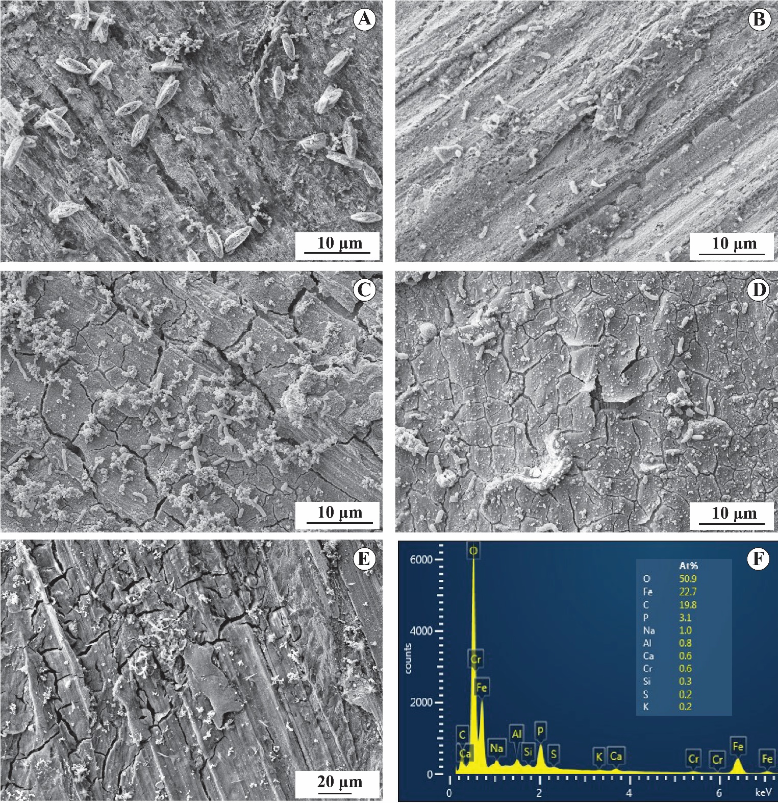
Figure 2.3. Scanning electron micrographs of the surface of oxidized carbon steel coupons after 26 h of incubation with Shewanella oneidensis MR-1 and a) 50 mM oxalate, b) 50 mM malonate, c) 50 mM succinate, and d) no ligand. Panel e) and f) show the SEM micrograph of an oxidized carbon steel coupon before experimentation and its corresponding EDS spectrum, respectively.

Figure 2.4. X-ray diffractogram of the surface of the coupon from the biotic experiment with oxalate (red top line). The X-ray diffractograms of humboldtine (FeC₂O₄·2H₂O) (black middle line) and C1018 steel (brown bottom line) are provided for reference.
Total (dissolved and solid-phase) iron concentration is higher in biotic experiments with ligands and this is consistent with an accelerated cathodic reaction
The total iron concentration was measured at the end of the experiments after removing and collecting the corrosion products from the carbon steel surface and acidifying the entire contents of the aqueous phase of the different microcosm experiments. Figure 2.5 shows the total iron concentration for the different treatments after 26 h of experimentation. The total iron concentration is up to 1.97 – 2.60 times higher in biotic experiments with ligands than in experiments without ligands. Higher total iron concentration was observed in biotic experiments
relative to abiotic experiments (1.36 mM for all abiotic experiments with the different ligands). Experiments without ligands showed the lowest total iron concentration (1.02 mM and 1.19 mM for the abiotic and biotic experiments, respectively). In all cases, the total iron concentration was higher in biotic experiments than in the abiotic counterparts.

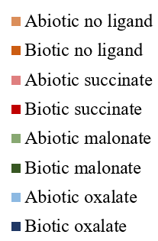
Figure 2.5. Range of total (dissolved and solid phase) iron after 26 h of experimentation in abiotic and biotic microcosm experiments of oxidized carbon steel with the addition of different dicarboxylic acids. Black lines represent the mean concentration values.
To understand better the redox dynamics responsible for the observed differences in total iron, I conducted Linear Polarization Experiments where I followed the corrosion potential of oxidized carbon steel coupons upon the addition of S. oneidensis MR-1 and the different ligands. Figure 2.6 shows the results of this experiment. The coupons exposed to the different ligands experienced a negative shift in the corrosion potential, and the potential shift is more prominent in the biotic experiments relative to the abiotic control for each ligand. A negative shift in the corrosion potential signals an acceleration in the cathodic reaction at the working electrode.

Figure 2.6. Corrosion potential from Linear Polarization experiments of oxidized C1018 carbon steel coupons. The different ligands were added at time = 7 h at a final concentration of 50 mM. For biotic experiments, Shewanella oneidensis MR-1 cells were also added at time = 7h. The experiments were conducted under an anoxic environment at 30 °C and circumneutral pH.

Discussion
Short-chain dicarboxylic acids are effective iron-binding ligands that play a key role in mobilizing iron in the environment by dissolving Fe(III) from naturally occurring iron oxy-hydroxides (W. P. Miller, Zelazny, and Martens 1986; Reichard, Kretzschmar, and Kraemer 2007; Zhenzhen Wang et al. 2017; Fengyi Li, Koopal, and Tan 2018; Tapparo et al. 2020). At neutral pH, the short-chain dicarboxylic acids oxalic, malonic acid, and succinic, occur in the deprotonated state, which forms strong soluble complexes with Fe(III) (Table 2.1). The low solubility of Fe(III) at circumneutral pH imposes significant challenges to the microbial iron respiratory metabolism, therefore, it was hypothesized that the addition of deprotonated dicarboxylic acids would result in the dissolution of the iron oxide passivating layer of carbon steel, facilitating microbial Fe(III) reduction to Fe(II) and rendering the steel surface susceptible to enhanced corrosion.
Figure 2.1 shows that the addition of short-chain deprotonated dicarboxylic acids results in higher dissolution of iron from oxidized steel when compared to the control without any dicarboxylic acid. The iron dissolution rates of the abiotic experiments amended with the 50 mM short-chain dicarboxylic acids (Table 2.2) follow the trend: oxalate > malonate > succinate > no dicarboxylic acid. The strong correlation (Pearson correlation coefficient, r = 0.997) of the ligand-promoted dissolution rates with the stability constant of the most stable species of the corresponding iron-ligand complex (Table 2.1) suggests that the formation of a thermodynamically stable product drives, at least in part, the ligand-promoted dissolution of Fe(III) from the iron oxide passivating layer of carbon steel.
Mechanistically, the ligand-promoted dissolution of iron oxides is proposed to start with an adsorption step of the dicarboxylic acid to the iron oxide surface, followed by the formation of a coordination complex with the iron atom on the surface that breaks the Fe-O bonds of the crystal lattice, facilitating the detachment of the iron-ligand complex and resulting in the solubilization of iron (W. P. Miller, Zelazny, and Martens 1986). Furrer and Stumm (1986) proposed that the detachment step is the rate-determining step of the mechanism and that five-membered chelate rings are the most readily detachable groups, followed by six- and seven-membered rings. This could help to explain the higher dissolution rate of iron by oxalate (five-membered chelate ring), followed by malonate (six-membered chelate ring), and succinate (seven-membered chelate ring).
In the abiotic experiments, the total dissolved iron was predominantly in the redox state Fe(III) (Figure 2.2). Although the oxide layer on the carbon steel is likely comprised of mixed-valence iron oxides (El Mendili, Abdelouas, and Bardeau 2013), the stability constants of the Fe(II)-dicarboxylate complexes are at least 10 orders of magnitude lower than those of the Fe(III)-dicarboxylate complexes (Smith and Martell 1989), explaining why the Fe(III) is preferentially dissolved over Fe(II) by the ligands. Despite the reports of many organic acids being capable of reducing Fe(III) to Fe(II), no significant iron reduction was observed in our abiotic experiments. This is in agreement with the need for such reductions to be activated by the presence of oxygen or light (Zhenzhen Wang et al. 2017; W. P. Miller, Zelazny, and Martens 1986). Since our microcosm experiments were carried under anoxic and dark conditions, the ligand-facilitated photochemical iron reduction was not a possibility.
In the biotic experiments, the concentration of dissolved Fe(II) increased after a lag phase as the result of microbial iron reduction by S. oneidensis MR-1. The shorter lag phase in experiments amended with 50 mM oxalate or 50 mM malonate (Figure 2.2) seems to be driven by the increased availability of Fe(III) in solution, which would support microbial iron reduction by planktonic cells. Conversely, in the experiments amended with 50 mM succinate or not amended with any dicarboxylic acid, the dissolved Fe(III) concentration is hypothesized to be too low to support microbial iron reduction by planktonic cells in the first 15 h of experimentation. Most likely, the microbial iron reduction in the latter cases is initiated once the cells reach the surface of the iron oxide layer and establish a biofilm. This is in agreement with the higher cell density observed on the surface of the steel coupons coming from the experiments with 50 mM succinate (1.91 ˟ 10⁶ cells/cm²) or without dicarboxylic acid (1.56 ˟ 10⁶ cells/cm²) in comparison to the coupons from the experiments with 50 mM oxalate (7.69 ˟ 10⁵ cells/cm²) or malonate (7.51 ˟ 10⁵ cells/cm²) as well as with the low availability of the iron oxide layer on the coupons exposed to the strong iron-binding ligands oxalate and malonate (Figure 2.3). The observed difference in cell density on the steel surface represents a difference in the microbial distribution between planktonic and surface-attached states because these were resting cell experiments that were originally amended with the same number of cells.
The distinct mechanisms for microbial iron reduction when different dicarboxylic acids are present are also evidenced by the differences in iron reduction rates and how they compare to the ligand-promoted iron dissolution rates. In the case of the experiments with oxalate and malonate, the ligand-promoted iron dissolution rates are faster than the microbial iron reduction rates, suggesting that the microbial iron reduction is not limited by the availability of Fe(III) in solution. Furthermore, the difference in iron reduction rates in experiments with oxalate (0.86 μmol h⁻¹) in comparison to the experiments with malonate (1.40 μmol h⁻¹) suggests a distinct nature of the substrate being reduced (Fe(III)-oxalate₃³⁻ vs Fe(III)-malonate₃³⁻). In the experiments with 50 mM succinate or without any dicarboxylic acid, once the microbial iron reduction starts, the reduction rates are not only faster than the corresponding iron dissolution rates, but they are similar (~ 1.80 μmol h⁻¹) for the two treatments despite the big difference in the dissolution rates (1.73 vs 0.90 μmol h⁻¹). This suggests that a similar iron reduction mechanism is used by cells exposed to succinate and the treatment without dicarboxylic acid and that this mechanism is independent of the ligand-promoted iron dissolution dynamics. The iron reduction rate for the experiments with succinate and without dicarboxylic acid is half of the reported reduction rate of Fe(III) (hydr)oxide by S. oneidensis MR-1 through a direct contact mechanism (Lies et al. 2005). However, the same authors reported a 46% reduction in the iron reduction rate when chloramphenicol was present due to the impeded synthesis of new proteins. Since our experiments had chloramphenicol, the iron reduction rates observed in our experiments without any dicarboxylic acid and with succinate support the proposed biofilm-mediated reduction process for experiments with weak iron-binding ligands.
Interestingly, cells exposed to 50 mM oxalate did not yield the highest microbial iron reduction (highest dissolved Fe(II) concentrations) despite oxalate being the ligand that promoted the dissolution of Fe(III) to the greatest extent. It is hypothesized that the Fe(III)-oxalate complex is so strong that oxalate acts as a competitor for Fe(III) relative to the S. oneidensis outer membrane cytochromes responsible for binding and reducing Fe(III). A similar equilibrium competition for Fe(III) between strong Fe(III)-chelating agents and the Fe(III)-sorbing functional groups on Shewanella putrefaciens cell surface was reported by Haas and Dichristina (2002). Similarly, Taillefert et al. (2007) proposed that S. putrefaciens produce Fe(III)-ligands that help solubilize Fe(III) oxides, and therefore a competitive equilibrium could be established with exogenous ligands that strongly bind iron. An alternative and perhaps complementary hypothesis is that formation of the low solubility (K_{sp}= 3.2x10⁻⁷ M²; F. Liu, Peng, Wilson, & Lundström, 2019) product ferrous oxalate occurs when oxalate is present and Fe(III) is reduced to Fe(II). This product was shown to form and adsorb to the carbon steel surface (Figure 2.4), lowering the Fe(II) concentration in solution, and possibly blocking to some extent further dissolution of Fe(III).
The total dissolved iron concentration is the same irrespective of the presence of bacteria when oxalate and malonate are present. However, when succinate is present, the total dissolved iron concentration in the abiotic treatment is higher than in the biotic one, despite the succinate concentration remaining constant (47.1 ± 6.0 mM for the biotic treatment at the end of experimentation vs 50 mM originally provided). This is explained by the fast iron dissolution driven by oxalate and malonate, which could result in a quick replenishment of the dissolved Fe(III) consumed by microbial iron reduction. Since the succinate-facilitated iron dissolution rate is slower than that for oxalate and malonate and a greater biofilm coverage is evidenced on the surface of coupons exposed to succinate, it is reasonable that the replenishment of the consumed dissolved Fe(III) does not occur as readily as when oxalate or malonate are present, resulting in a lower total dissolved iron concentration in the experiments with bacteria when compared to the abiotic counterpart.
To determine the combined effect of the iron-binding dicarboxylic acids and S. oneidensis MR-1 on the corrosion of carbon steel, the total iron at the end of the microcosm experiments was quantified after removing the corrosion products from the carbon steel surface and collecting them in the acidified aqueous phase. The total iron concentration is higher in biotic experiments with ligands, showing that the ligands accelerate the microbiologically influenced corrosion up to 2.6 times more compared to the experiments without dicarboxylic acids. The highest corrosion, as measured by the total iron concentration, was observed in the biotic experiments with malonate, followed by oxalate, and succinate. In the control experiment without dicarboxylic acids, S. oneidensis MR-1 accelerated the corrosion 1.2 times relative to the abiotic counterpart. This is in agreement with the corrosion acceleration rates reported by Schütz (Schütz et al. 2015). The mere presence of deprotonated dicarboxylic acids accelerated the corrosion of carbon steel 1.3 times compared to the experiment without dicarboxylic acids, showing that individually, ligand-promoted dissolution or microbial iron reduction of the iron oxide passivating layer have a mild impact on the corrosion of carbon steel under dark and anoxic conditions. However, when both iron-binding ligands and microbes with iron-reducing capabilities are present together, the corrosion of carbon steel is significantly exacerbated. This is also evidenced by the more prominent shift in the corrosion potential of the carbon steel coupons exposed to both ligand and S. oneidensis MR-1 cells when compared to the mere exposure to ligands under abiotic conditions (Figure 2.6).

Conclusions
In conclusion, it was demonstrated that the ligand-facilitated iron dissolution dynamics impact microbial iron reduction and intensify its effect on the corrosion of carbon steel under anoxic conditions. The corrosion of carbon steel as measured by the total (dissolved and solid phase) iron at the end of the experiments is accelerated in the presence of S. oneidensis MR-1 and short-chain deprotonated dicarboxylic acids. Individually, S. oneidensis MR-1 or the short-chain dicarboxylic acids have a mild impact on the corrosion rates of carbon steel (< 1.3 times relative to sterile anoxic experiments without the deprotonated dicarboxylic acids), but when combined their impact on the corrosion of carbon steel is magnified as up to 2.6 times more total iron was found in experiments with both iron-binding ligands and S. oneidensis MR-1 than in their sterile counterpart.
When weak iron-binding ligands such as succinate are present, the microbial iron reduction seems to be mainly driven by cells in close contact with the steel surface, whereas when strong iron-binding ligands are present, planktonic cells appear to drive the reduction of Fe(III). I hypothesize that the difference in cell lifestyle is driven by the sustained availability of dissolved Fe(III) when strong iron-binding ligands are present. The readily available dissolved Fe(III) could help maintain the cells metabolically active through sustained respiration, whereas when dissolved Fe(III) is not readily available or quickly replenished after microbial reduction, the cells would face energetic limitations that trigger biofilm formation. Future research will need to address this hypothesis.

Direct electron transfer as a microbiologically influenced corrosion mechanism in Shewanella oneidensis MR-1
In this chapter, I evaluated the ability of Shewanella oneidensis MR-1 to accelerate the corrosion of carbon steel through extracellular direct electron uptake and determined the role of microbial hydrogen consumption in the corrosion mechanism. To answer these questions, I adopted an experimental approach that relied on the testing of the corrosion capabilities of an S. oneidensis double hydrogenase mutant strain (∆hydA∆hyaB) and a mutant strain lacking the genes encoding for key c-type cytochromes in the Mtr pathway (∆Mtr). I found that S. oneidensis MR-1 accelerates the corrosion of carbon steel up to four times more under fumarate-reducing conditions than in the sterile and heat-killed controls. I observed more localized corrosion and higher cell density on the steel surface when cells were limited to direct electron transfer than when H₂ consumption was operational. Corrosion rates, determined by both weight loss measurements and Linear Polarization Resistance experiments, of microcosm experiments with wild-type strains and each of the mutant strains showed that S. oneidensis preferentially uses the direct electron transfer mechanism for corroding steel infrastructure under anoxic conditions. This study illustrates the use of mutant strains as an experimental approach to definitively validate the ability of organisms to engage in extracellular electron uptake through a direct mechanism. Part of this chapter will be submitted to the International Biodegradation and Biodeterioration journal.

Introduction
Microorganisms able to obtain electrons from extracellular solid substrates (i.e., electroactive organisms) are being extensively scrutinized due to their potential application in a wide variety of processes including, energy bioconversions, carbon capture, chemical synthesis, and water pollution remediation (Logan et al. 2019). Electroactive microorganisms also participate in the microbiologically influenced corrosion (MIC) of metallic structures.
The deterioration of metals by MIC on a global scale is estimated to cost 0.68% of the annual gross domestic product (or $0.57 trillion USD for 2020) (National Association of Corrosion Engineers 2016; B. J. Little et al. 2020) and presents operational challenges for numerous industrial sectors, including aviation (Naval Research Lab Stennis Space Center MS Oceanography 1997; Rcheulishvili et al. 2020), water distribution (G. Zhang et al. 2018; Dao, Ryu, and Yoon 2021; Ress et al. 2020), and oil and gas (Mori, Tsurumaru, and Harayama 2010; Skovhus, Eckert, and Rodrigues 2017; Eckert and Skovhus 2018). The significance of MIC reaches beyond economic consequences, as corrosion failures often results in the unintended spill of hazardous chemicals and the impairment of ecosystems (Natural Transportation Safety Board 2003; Jacobson 2007). Despite almost 100 years of research in MIC, the current understanding of this phenomenon is still limited (B. J. Little et al. 2020). It is generally assumed that MIC occurs through the biological production of an oxidizing chemical agent, such as sulfide (Equation 3.1 and 3.2), or the consumption of hydrogen naturally evolved at the steel surface when it comes in contact with water (Equation 3.3) (Pankhania 1988; von Wolzogen and van der Vlugt 1934). More recently, a new mechanism known as direct electron transfer was proposed (Enning et al. 2012; Venzlaff et al. 2013), where cells with outer membrane c-type cytochromes would be able to directly get electrons from metallic substrates.
$$\text{4}{\text{ H}}_{\text{2}}\text{ + }{\text{SO}}_{\text{4}}^{\text{2-}}\text{ + 2}{\text{H}}^{\text{+}}\text{ → }{\text{H}}_{\text{2}}\text{S + 4 }{\text{H}}_{\text{2}}\text{O (Equation 3.1)}$$
$$\text{F}{\text{e}}^{\text{0}}\text{ + }{\text{H}}_{\text{2}}\text{S →Fe}{\text{S}}_{\text{ (s)}}\text{ + }{\text{H}}_{\text{2 (g)}}\text{ (Equation 3.2)}$$
$$\text{F}{\text{e}}^{\text{0}}\text{ + 2 }{\text{H}}_{\text{2}}\text{O → F}{\text{e}}^{\text{2+}}\text{ + }{\text{H}}_{\text{2 (g)}}\text{+ }{\text{2 OH}}^{\text{-}}\text{ (Equation 3.3)}$$
Direct electron transfer from steel was proposed when researchers identified a strain of sulfate reducing bacteria (SRB) that exhibited unexpectedly high corrosion rates (Dinh et al. 2004; Enning et al. 2012). Since then, other organisms have been noted to possess the capability (Venzlaff et al. 2013; Su et al. 2020; Palacios et al. 2019). These claims have rarely included a corrosion assessment independent of microbial hydrogen consumption dynamics. Thus, definitive evidence for direct electron transfer remains somewhat elusive as it is difficult to differentiate the extent of corrosion due to hydrogen consumption from the corrosion due to direct electron transfer. Recently, Tang et al. tested direct electron transfer in Geobacter sulfurreducens ACL by eliminating the possibility of hydrogen and formate serving as electron carriers during the oxidation of metallic iron through deletion of the genes responsible for hydrogen and formate metabolism (H. Y. Tang et al. 2019). It is expected that as more studies adopt this kind of experimental approach, the debate over the role of direct electron transfer as a MIC mechanism will be quantitatively resolved.
Given the predominance of SRB on corroding structures, their production of corrosive metabolic products (e.g. H₂S), and the general agreement between corrosion rates in the field and the laboratory, SRB got acknowledged as the predominant MIC culprits (Hamilton 1985; Lee et al. 1995; Enning and Garrelfs 2014). The advent of molecular tools verified that SRB, albeit important, are only one of many types microbes and mechanisms causing metal deterioration (B. J. Little et al. 2020), opening an avenue for the discovery of new MIC mechanisms and players.
One group of microorganisms that has been implicated in iron corrosion by direct electron transfer are members of the genus Shewanella (Philips et al. 2018). Shewanella spp. are frequently isolated from corroded metallic infrastructure (Philips et al. 2018; Salgar-Chaparro et al. 2020), and Shewanella oneidensis has been linked to metal deterioration issues in oil fields as well as other industrial settings (Semple and Westlake 1987; Schütz et al. 2014, 2015). S. oneidensis is a remarkably flexible facultative anaerobe with the ability to use different terminal electron donor and acceptor combinations, including solid metal substrates, to supply its nutritional needs. S. oneidensis is thus a model organism for the study of extracellular electron transfer reactions, but the ability of this organism to corrode steel through direct electron transfer remains to be evaluated.
Hydrogen metabolism by S. oneidensis is well understood and includes the periplasmic [Fe-Fe] and [Ni-Fe] hydrogenases called HydA and HyaB, respectively (Meshulam-Simon et al. 2007). The molecular pathway for the direct electron transfer from extracellular surfaces is less studied, but it is known that MtrCAB , an outer membrane protein complex, is required (Ross et al. 2011). Therefore, it is possible to evaluate the role of each of these components in the corrosion of carbon steel by S. oneidensis by using mutant strains that lack the genes encoding hydrogenases and Mtr proteins.
Here I independently tested the ability of S. oneidensis MR-1 to corrode carbon steel through both direct electron transfer and hydrogen consumption. By testing an S. oneidensis strain unable to consume hydrogen (∆hydA∆hyaB), I aimed to provide an independent assessment of the ability of this organism to corrode by directly extracting electrons from the steel. Likewise, I tested the corrosion capabilities of an S. oneidensis strain that is defective in extracellular electron transfer (∆Mtr) and found that although both mechanisms (hydrogen consumption and direct electron transfer) are operational in S. oneidensis, direct electron transfer seems to contribute the most to MIC. These results suggest that direct electron transfer must be considered an important MIC mechanism in S. oneidensis. I hope that this approach helps to set a framework for further validation of direct electron transfer in other MIC agents.

Methods

Bacterial strains and growth conditions:
Table 3.1 lists the strains used in this study. Frozen stocks (stored at -80 °C in 15% glycerol) of S. oneidensis were recovered in a modified minimal medium (Appendix 1) adjusted to pH 7.0 with NaOH 1 M and supplemented with 60 mM sodium lactate and 60 mM sodium fumarate. The medium recipe was modified from Y. J. Tang, Meadows, & Keasling (2007).
Anaerobic cultures were grown in 10 mL of the modified minimal medium supplemented with 60 mM fumarate and 60 mM lactate in 28-mL Balch tubes sealed with butyl rubber stoppers. Oxygen was removed from the medium by boiling for 1 min and bubbling oxygen-free N₂ gas for 20 minutes before capping with stoppers and autoclaving at 121°C for 15 min. Anaerobic recovery cultures were incubated overnight at 30 °C with shaking at 120 rpm. An inoculum from the overnight culture was transferred (1% vol/vol) into 10 mL of the same medium and incubated under identical conditions for another 8 h until the culture reached an optical density of around 0.400 at 600 nm. These cultures were then used as inocula for subsequent experiments.
Table 3.1. Shewanella oneidensis strains used in this study
Strain | Relevant Genotype | Relevant Phenotype | Source
WT (JG274) | S. oneidensis MR-1 | Wild type | (Myers and Nealson 1988)
∆hydA∆hyaB (JG2642) | ∆hydA/∆hyaB | Incapable of consuming hydrogen | (Joshi et al. 2019)
∆mtr (JG1194) | ∆mtrC/∆omcA/∆mtrF/∆mtrA/∆mtrD/∆dmsE/∆SO4360/ ∆cctA/∆recA | Incapable of engaging in extracellular electron transfer | (Coursolle and Gralnick 2012)

Corrosion experiments:
Carbon steel 1018 (0.15-0.20% C, 0.6-0.9% Mn, 0.035% maximum S, 0.03% maximum P, and elemental iron as the remainder) round coupons (9.53 mm diameter, 1 mm thickness, Alabama Specialty Products) were sonicated for 15 min in acetone, dried, weighed to the fifth significant figure, and stored under an N₂ atmosphere in stoppered and crimp-sealed bottles. Coupons were autoclaved at 121°C for 30 min under an N₂ atmosphere. Anaerobic incubation experiments were set up in 160-mL serum bottles containing a coupon suspended with a PTFE-coated quartz string to a butyl rubber septum as suggested by Liang and Suflita (Liang and Suflita 2015). Sterile anaerobic modified minimal medium supplemented with 60 mM fumarate (80 mL) was transferred aseptically under N₂ atmosphere to each bottle. The biotic experiments received a 1% (vol/vol) inoculum. Before inoculation, cells were harvested inside a Coy glove box (5% H₂, 95% N₂ gas atmosphere) by centrifuging at 1,500 RCF for 10 min. Cells were washed twice with deaerated and sterile 0.5 M PIPES buffer pH 7.0 to avoid carryover of organics. Abiotic, heat-killed, steel-free, and fumarate-free experiments were included as controls. Cells for the heat-killed controls were incubated at 95 °C for 10 min before inoculation. Experiments were run in triplicates and incubated in dark conditions at 30 °C.
Experiments were monitored for 20 d by periodically analyzing liquid and gas samples. Liquid samples were taken with a sterile syringe previously purged with N₂. One mL of each sample was filtered (0.45 μm syringe filter) and stored at -20 °C prior to organic acid analysis. Another 1.0 ml aliquot was similarly filtered and mixed with 40 μL of 6 N HCl for ferrous iron determination. Samples of the gaseous headspace (0.5 ml) phase were taken with a sterile 1.0 mL-gas-tight syringe that was previously purged with N₂ gas. Gas samples were immediately analyzed for H₂ quantification.

Chemical analyses:
Dissolved ferrous iron was quantified with the Ferrozine assay (Stookey 1970). Briefly, Ferrozine reagent was prepared by adding 1 g of 3-(2-pyridyl)-5,6-diphenyl-1,2,4-triazine-p,p′-disulfonic acid monosodium salt in 1 L of 50 mM HEPES pH 7.0 and stored under dark conditions at room temperature. For the assay, 2.5 mL of ferrozine reagent was mixed with 50 μL of sample or standard solution. After vigorous shaking for 15 s, the extinction of the mixture at 562 nm was measured using a UV-1601 Spectrophotometer (Shimadzu). Ferrozine assay was performed immediately following sample collection to minimize iron oxidation.
Organic acids were quantified with the Beckman System Gold HPLC 126 Programmable Solvent Mode and 168 Detector using an AMINEX HPX 87H column and 5 mM H₂SO₄ as the mobile phase. The flow rate was 0.9 mL min⁻¹, and detection was at 210 nm. Compounds were identified and quantified by comparison to known standards.
Headspace samples were injected into a reduction gas hydrogen analyzer Peak Performer I 910- Series (Peak Laboratories) immediately after collection. The instrument is operated at room temperature using 99.998% N₂ as the carrier gas. Hydrogen was quantified according to a standard calibration curve and total hydrogen concentration in the bottle was calculated by using Henry’s constant of 7.8*10⁻⁴ M atm⁻¹ at 25 °C (Sander 2015).

Weight loss measurements:
At the completion of the experiment, coupons from each treatment were collected inside a Coy anaerobic glove box (5% H₂, 95% N₂ gas atmosphere), and submerged in corrosion cleaning solution (3.5 g L⁻¹ hexamethylenetetramine in 6 N HCl) for 10 min, dried under N₂, and weighed. Mass was determined to the fifth significant figure. This washing/weighing cycle was repeated until a graph of the mass loss versus the number of cycles showed no slope. The mass loss due to corrosion was taken as the point right before the slope reached zero as suggested by ASTM G1-03 (ASTM International 2017). The corrosion rate from weight loss measurements was calculated with Equation 3.4.
$$\text{Corrosion rate} \left(\text{mpy}\right)\text{ = }\frac{\text{3.45*}{10}^{6}\text{*mass loss (g)}}{\text{area} \left({\text{cm}}^{\text{2}}\right)\text{*time of exposure}\left(\text{h}\right)\text{*density (g }\text{c}{\text{m}}^{\text{-3}}\text{)}} \text{ (Equation 3.4)}$$

Linear polarization resistance (LPR) experiments:
Anaerobic experiments were set up in electrochemical cells and incubated for 20 d at 30 °C in the dark. Polarization resistance measurements were taken every 3-4 days using a Reference 600+ Potentiostat (Gamry Instruments). Initial LPR measurements were taken 6 h after setup of the experiments to allow for open circuit potential equilibration. A cylindrical carbon steel 1018 coupon (Gamry Instruments) was used as the working electrode. The dimensions of the working electrode were 0.95 cm ˟ 1.27 cm, and the surface area was 4.5 cm². A standard calomel electrode was used as the reference electrode and a graphite rod was as the auxiliary electrode. Electrolyte medium consisted of the modified minimal medium supplemented with fumarate 60 mM. The potential was swept ±10 mV from the open circuit potential at a rate of 0.125 mV s⁻¹.

Scanning electron microscopy:
A coupon for each treatment was washed with 1 mL of phosphate buffer saline pH 7.2 (Appendix 2) and submerged in 4 mL of 2.5% glutaraldehyde solution in phosphate buffer saline pH 7.2 for 10 h at 4°C. Then, coupons were washed with 1 mL of nanopure (> 18.2 MΩ) water, and ethanol dehydration series (30%, 50%, 60%, 70%, 80%, 90%, 95%, 100%, 100%) was performed by submerging each coupon in 4 mL of each of the ethanolic solutions for 10 min. Coupons were allowed to dry inside an anaerobic glove box (5% H₂, 95% N₂ gas atmosphere), and stored under N₂ atmosphere in crimp-sealed vials until examination with a Zeiss NEON 40 EsB scanning electron microscope. A 5kV accelerating voltage was used.

Protein quantification:
The initial and final protein amount in biotic experiments was quantified using the Coomassie Plus-Bradford Assay Kit (Thermo Scientific) following manufacturer instructions. For the measurements at the end of experiments, the protein amount in both the spent liquid medium and the carbon steel surface were quantified separately. To quantify the protein associated with the carbon steel surface, the coupons were treated as described elsewhere (Bretschger et al. 2015). Briefly, the coupons were harvested and immediately submerged in 4 ml of 0.2 N NaOH. Then, three freeze/thaw cycles were conducted before quantifying protein concentration with the Coomassie Plus-Bradford Assay Kit.

Statistical Analysis:
The statistical difference in weight loss measurements and average corrosion rates were evaluated using a one-way analysis of variance (ANOVA) followed by a Tukey’s multiple comparisons test. A significance level of 0.05 was used in all tests. Assumptions of normality and homoscedasticity were checked before using ANOVA. When assumptions were not met, such as in the analysis of corrosion rates derived from Linear Polarization Resistance experiments, the non-parametric Kruskal-Wallis test was used followed by the Pairwise Wilcoxon test. All statistical tests and graphs were made using R software (R Development Core Team 2020).

Results
Shewanella oneidensis MR-1 accelerates the corrosion of carbon steel
The concentration of dissolved Fe(II) in anoxic microcosm corrosion experiments was monitored over time to understand the corrosion dynamics of carbon steel driven by the S. oneidensis strains tested (Table 3.1). Figure 3.1a shows that for experiments without carbon steel, the concentration of dissolved Fe(II) remained constant at 0.075 ± 0.028 mmol of electron equivalents (meeq) L⁻¹, a concentration similar to what was originally provided to the medium (0.100 meeq L⁻¹). Conversely, for experiments with coupons, the dissolved Fe(II) concentration increased with time, signaling the oxidation of carbon steel. Higher concentrations of dissolved Fe(II) were observed in biotic experiments with coupons than in the abiotic counterpart. The highest dissolved Fe(II) concentration was observed in experiments with coupons exposed to the ∆hydA∆hyaB strain, followed by the WT strain, and the ∆Mtr strain. Heat-killed controls behave identically to the abiotic experiment, but the data are not shown for clarity of the figure.
Weight loss measurements of the carbon steel coupons were conducted after 20 days of experimentation, and the results are shown in Figure 3.1b. The carbon steel coupons exposed to the different biotic treatments showed significantly higher (p < 0.05) weight loss measurements than the abiotic counterpart. Carbon steel coupons exposed to the WT strain and the ∆hydA∆hyaB showed a similar weight loss, whereas the weight loss of coupons exposed to the WT strain was significantly higher than coupons exposed to the ∆Mtr strain. Although the mean value of the weight loss measurements for the carbon steel coupons exposed to the ∆hydA∆hyaB strain is higher than for coupons exposed to the ∆Mtr strain, the difference was not found significant (p > 0.05), likely due to the wide distribution in the weight loss measurements for coupons exposed to the ∆Mtr strain.
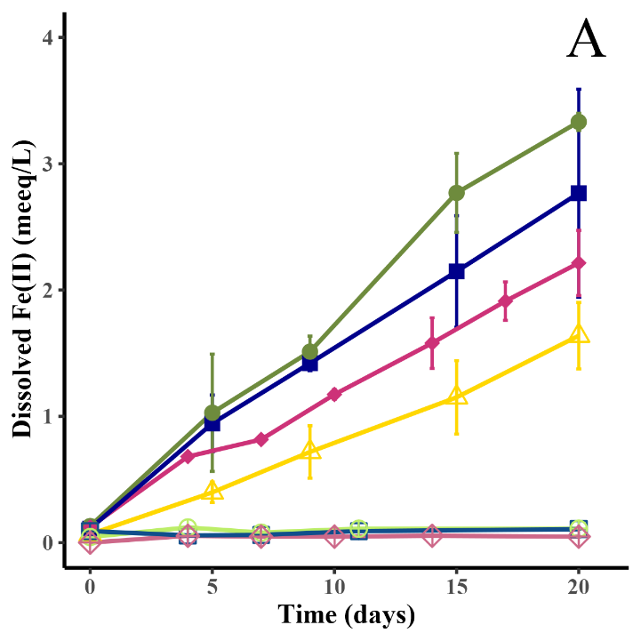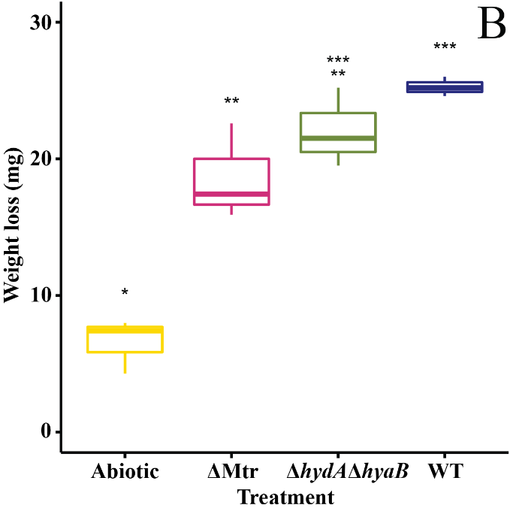
Figure 3.1. a) Time course measurements of dissolved Fe(II) for ∆hydA∆hyaB (), WT (), ∆Mtr (), and abiotic () experiments. Treatments without steel but with ∆hydA∆hyaB (), WT (), and ∆Mtr () are also shown. Error bars show the standard deviation of triplicates. b) Weight loss measurements of carbon steel coupons after 20 d of experimentation. Stars denote significant differences between treatments at an α = 0.05.
The corrosion rates of carbon steel exposed to the different S. oneidensis strains were calculated from both weight loss measurements and LPR experiments (Table 3.2). Carbon steel coupons exposed to the WT strain showed the highest corrosion rates, followed by the coupons exposed to the ∆hydA∆hyaB strain, and the ∆Mtr strain. The corrosion rate of carbon steel coupons not exposed to S. oneidensis was significantly lower (p < 0.05) than the comparable measure upon exposure to the different bacterial strains. There were differences between the corrosion rates calculated from weight loss measurements and the rates calculated from LPR experiments. In all cases, the corrosion rates calculated from LPR experiments were lower than the rates calculated from weight loss measurements, however, both data sets converged on the same trends. The corrosion rates calculated from LPR experiments were found to be statistically different (p < 0.05) between the different treatments, whereas the corrosion rates calculated from weight loss measurements were only statistically different between the abiotic and all the biotic experiments and between the experiments with ∆Mtr cells and those with WT cells.
Table 3.2. Corrosion rates from electrochemical measurements and weight loss measurements. Superscript letters denote statistical differences.
Treatment | Corrosion rates from LPR experiments (mpy) | Corrosion rates from weight loss measurements (mpy)
Abiotic | 0.686 ± 0.113 ª | 1.20 ± 0.36 ^{e}
wt | 2.816 ± 0.850 ^{b} | 4.62 ± 0.53 ^{f}
∆hydA∆hyaB | 1.755 ± 0.281 ^{c} | 4.03 ± 0.13 ^{f,g}
∆mtr | 1.079 ± 0.240 ^{d} | 3.40 ± 0.64 ^{g}

The carbon steel coupons submerged in the corrosion cleaning solution for weight loss measurements were also imaged with a scanning electron microscope. Figure 3.2 shows micrographs of the surface of the coupons exposed to the different strains. More uniform corrosion was evidenced in the coupons exposed to abiotic conditions (Figure 3.2 a) and the ∆Mtr strain (Figure 3.2 d), whereas heavily localized corrosion was observed in the coupons exposed to the WT (Figure 3.2 b) and ∆hydA∆hyaB (Figure 3.2 c) strains.
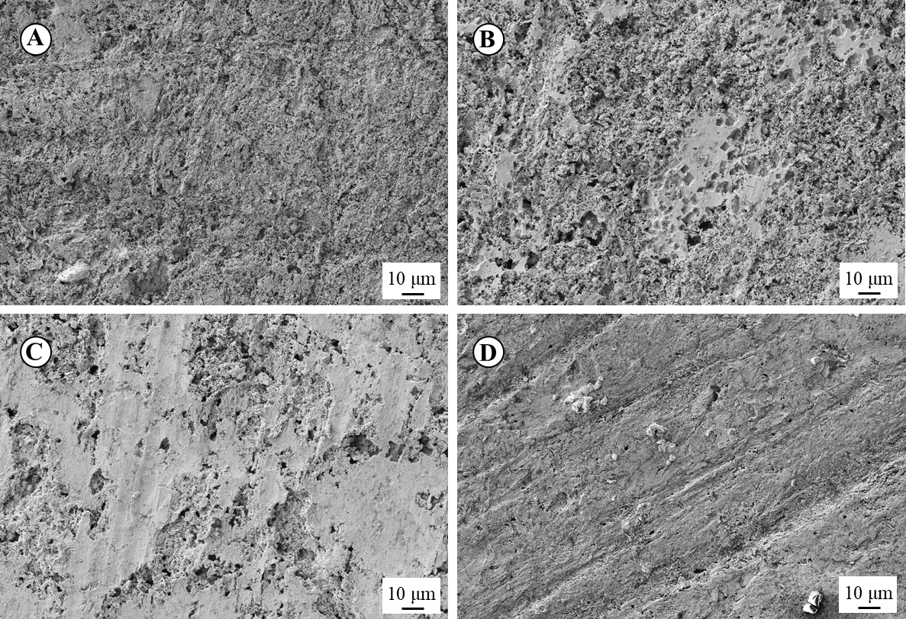
Figure 3.2. Micrographs of steel coupon’s surface after removing corrosion products at day 20 of experimentation with different treatments: A) abiotic, B) WT, C) ∆hydA∆hyaB, D) ∆Mtr.
Shewanella oneidensis MR-1 reduces fumarate to succinate using electrons derived from steel
The concentration of the organic acids fumarate, malate, and succinate were monitored at the start and end of the experiments. The initial concentration of fumarate for all the experiments was 124.1 ± 6.6 meeq L⁻¹. Initial malate and succinate concentrations were zero in all cases. Figure 3.3 shows the concentration of the different organic acids at the end of the experimentation. No significant loss of fumarate was evident in the abiotic experiment as the final concentration of fumarate was measured as 117.7 ± 6.3 meeq L⁻¹. However, fumarate concentration decreased in the biotic experiments. For experiments with WT and ∆hydA∆hyaB cells and carbon steel coupons, there was a significant reduction in the fumarate concentration accompanied by the formation of malate and succinate. There was a less significant reduction in the fumarate concentration in the experiments with the ∆Mtr strain compared to the experiments with the WT and ∆hydA∆hyaB strains. As in the latter case, the decrease in the fumarate concentration co-occurred with the formation of malate and succinate. For experiments with WT cells but without carbon steel coupons, there was a minor reduction in the fumarate concentration accompanied by the proportional formation of succinate. The malate and succinate concentration in experiments without fumarate was negligible (< 1 meeq L⁻¹).

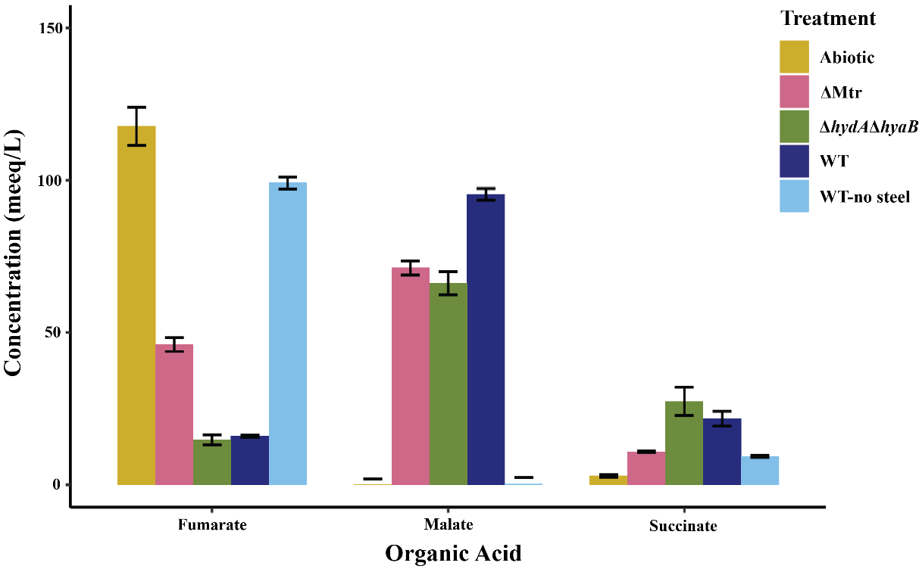
Figure 3.3. Concentration of fumarate, malate, and succinate after 20 days of experimentation. The initial concentration of fumarate was 124.1 ± 6.6 meeq L⁻¹, whereas the initial concentration of malate and succinate was 0 meeq L⁻¹ for all treatments. Error bars show the standard deviation of triplicate measurements.

Shewanella oneidensis colonizes the surface of the steel
Figure 3.4 shows the surface of carbon steel coupons after 20 days of experimentation with the different strains tested. The carbon steel coupons exposed to ∆hydA∆hyaB cells show abundant colonization of cells on the steel surface (Figure 3.4 a), whereas the coupons exposed to the ∆Mtr strain exhibited far less if any surface colonization (Figure 3.4 c). For the carbon steel coupons exposed to the WT cells (Figure 3.4 b), colonization on the steel surface is evident, but it seems to be less abundant than for the coupons exposed to the ∆hydA∆hyaB strain.
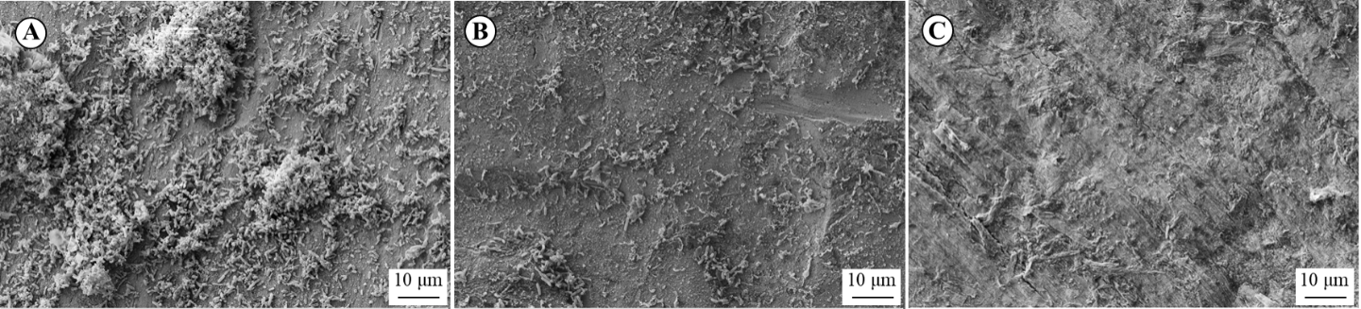
Figure 3.4. Micrograph of carbon steel coupons’ surface exposed to A) ∆hydA∆hyaB, B) WT, and C) ∆Mtr cells.
To get a better understanding of the distribution of cells in the liquid medium vs. the cells attached to the carbon steel surface, the protein concentration in the liquid medium was quantified and compared to the protein concentration associated with the carbon steel coupons. The results are shown in Table 3.3.
Table 3.3. Initial and final protein amounts in experiments with different strains of S. oneidensis
Treatment | Initial Protein (μg) | Final Protein (μg) | % Protein from planktonic cells | % Protein from surface-attached cells
wt | 247.2 | 286.2 | 89.2 | 10.8
∆hydA∆hyaB | 275.4 | 357.5 | 82.7 | 17.3
∆mtr | 356.6 | 340.2 | 96.6 | 3.4

Shewanella oneidensis MR-1 utilizes both a hydrogen-dependent and hydrogen-independent mechanisms to get electrons from carbon steel
The hydrogen concentration was monitored over time. For the experiments with coupons and WT and ∆Mtr cells as well as for the biotic experiments without carbon steel, H₂ remained below 0.001 meeq L⁻¹, whereas for the abiotic experiment and the experiment with ∆hydA∆hyaB cells and carbon steel, H₂ increased over time (Figure 3.5a). I tested the ability of ∆hydA∆hyaB and WT cells to consume H₂ by harvesting the cells from the spent medium at the conclusion of corrosion experiments and transferring them to fresh medium supplemented with 0.426 ± 0.022 mmol of hydrogen and 60 mM fumarate. After monitoring the hydrogen concentration (Figure 3.5b), it was found that the H₂ decreased in the experiments with WT cells but remained constant in the experiments with ∆hydA∆hyaB cells, confirming that ∆hydA∆hyaB cells were not able to consume H₂, whereas WT cells were actively using H₂ as an electron donor.
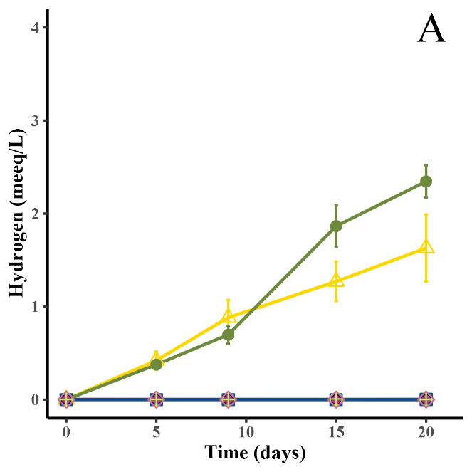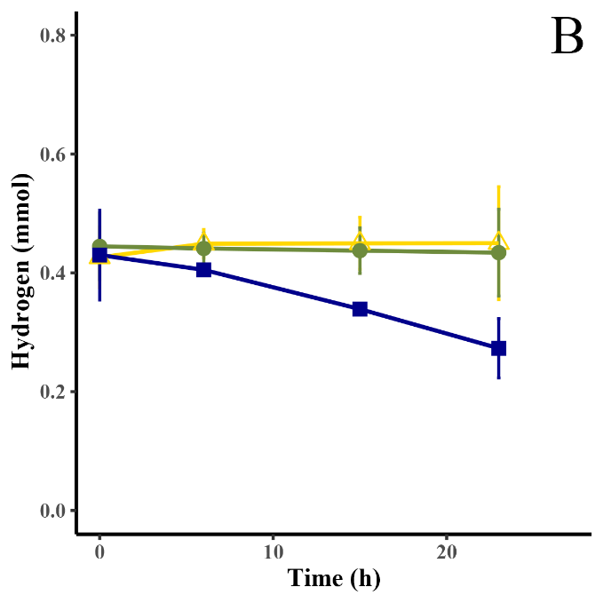
Figure 3.5. Hydrogen production in corrosion experiments with ∆hydA∆hyaB (), WT (), ∆Mtr (), and abiotic conditions () and experiments without steel but with ∆hydA∆hyaB (), WT (), and ∆Mtr (). B) Hydrogen consumption in experiments inoculated with cells from spent medium of corrosion experiments. Error bars show the standard deviation of the mean.

Discussion
The ability of S. oneidensis to accelerate the corrosion of carbon steel was tested with a series of anaerobic corrosion experiments. I hypothesized that the organism could accelerate corrosion by multiple mechanisms including, hydrogen-mediated electron transfer (Figure 3.6a) and/or a direct electron transfer (Figure 3.6b). A prediction of hydrogen-mediated electron transfer is that the S. oneidensis cells would increase corrosion rates of carbon steel by maintaining a low molecular hydrogen concentration even as this electron donor is both produced from the metal and consumed by the bacterium In the direct electron transfer mechanism, S. oneidensis cells would form contact with the carbon steel surface and directly obtain electrons from it by using outer membrane c-type cytochromes of the Mtr pathway.
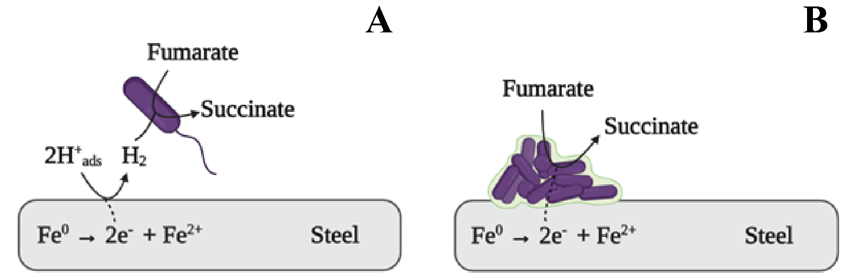
Figure 3.6. Proposed mechanisms for corrosion of steel driven by Shewanella oneidensis MR-1. a) Hydrogen mediated electron transfer and b) Direct electron transfer.
It has been shown that the decaheme c-type cytochromes MtrA, MtrC, and OmcA are key components of the direct electron transfer mechanism. Research by Ross and coworkers (2011) showed that an S. oneidensis mutant strain lacking the gene encoding for MtrA was capable of producing only ~3% of the cathodic current produced by wild-type cells. Similarly, Rowe and coworkers showed that cells lacking the genes encoding for MtrC and OmcA showed an 88.1 ± 6.7% reduction in the cathodic current with respect to wild-type cells (Rowe et al. 2018). To distinguish the preferred MIC mechanism used by S. oneidensis, in addition to the wild type (WT) strain I tested a mutant strain unable to use molecular hydrogen as an electron donor (∆hydA∆hyaB) and a mutant strain (∆Mtr) lacking the genes encoding for several of the Mtr c-type cytochromes and homologs, including MtrA, MtrC, and OmcA (Table 3.1).
Regardless of corrosion mechanism, the oxidation of carbon steel under anoxic conditions results in the production of Fe(II). I measured the dissolved Fe(II) concentration over time to understand the corrosion dynamics of the different test strains (Figure 3.1a). For all experiments with carbon steel, the dissolved Fe(II) concentration increased linearly with time, showing that even under anoxic and abiotic conditions, the coupons experienced corrosion. However, the dissolved Fe(II) concentration was higher in all experiments with S. oneidensis (∆hydA∆hyaB > WT > ∆Mtr) relative to the abiotic counterpart. The fact that the dissolved ferrous iron concentration remained constant in biotic experiments without coupons, confirm that the increase in carbon steel corrosion was a function of the different S. oneidensis strains tested.
To quantify the effect of each of the proposed mechanisms on the corrosion of carbon steel, corrosion rates (Table 3.2) were calculated using weight loss measurements (Figure 3.1b) and LPR experiments. The corrosion rates detailed here are consistent with the rates reported for carbon steel corrosion reported elsewhere. In the case of baseline abiotic corrosion under anoxic and circumneutral conditions, corrosion rates between 0.39 mpy and 1.19 mpy have been reported (Schütz et al. 2014; Smart, Blackwood, and Werme 2001). Here, I report corrosion rates between 0.686 to 1.20 mpy (Table 3.2). In anoxic experiments with S. oneidensis MR-1 wild type cells, the corrosion rate of carbon steel of 1.3 to 3 times higher than in abiotic experiments (Schütz et al. 2014, 2015) were reported, although the findings were not determined under precisely the same electron donor and acceptor combinations evaluated in my study. Interestingly, weight loss measurements and associated corrosion rates did not show a significant difference (p > 0.05) between experiments with WT and double mutant (∆hydA∆hyaB) cells. Nonetheless, from the corrosion rates calculated with LPR measurements, WT cells were found to produce significantly higher corrosion rates than ∆hydA∆hyaB cells (p < 0.05). This is contrary to what the dissolved ferrous iron measurements suggested (Figure 3.1a), where a higher concentration of dissolved ferrous iron was found in experiments with ∆hydA∆hyaB cells than in experiments with WT cells. It is known that upon anoxic oxidation of carbon steel, some of the released ferrous ions may adsorb on the carbon steel surface in the form of minerals such as vivianite (Schütz et al. 2015). The thick biofilm on the surface of the coupons exposed to ∆hydA∆hyaB cells (Figure 3.4a) might have limited the adsorption of ferrous iron onto the carbon steel, resulting in higher concentrations of ferrous iron in the dissolved phase than in experiments with WT cells. The differences found between the corrosion proxies I analyzed (dissolved ferrous iron, weight loss, and LPR measurements) highlight the importance of assessing corrosion through multiple quantitative approaches.
In all cases the corrosion rates calculated from LPR experiments were lower than the ones from weight loss measurements, but both methods exhibited the same trends in corrosion rate determinations (WT > ∆hydA∆hyaB > ∆Mtr > abiotic). The discrepancies in the corrosion rates calculated with the two methods might arise from the fact that weight loss measurements represent an average rate over the duration of the experiment, whereas the LPR measurements are limited to rates at the specific time when the electrochemical test was conducted. The initial LPR measurement was taken 6 h after the start of the experiment to allow for equilibration of the corrosion potential. The first hours of coupon immersion in an electrolytic medium are generally associated with the highest corrosion rates. The fact that I did not measure corrosion rates during the first 6 hours of the LPR experiments might help explain why the average corrosion rates were lower than the rates calculated from the weight loss determinations. For these reasons, I consider the LPR rates as more representative of the longer-term conditions of the experiments.
Regardless of the differences in corrosion rates determinations, both methods show that S. oneidensis WT cells accelerate the corrosion of carbon steel up to four times more relative to abiotic control and that the mutant strain unable to use H₂ as an electron donor (∆hydA∆hyaB) accelerated carbon steel corrosion up to 1.6 times more than the mutant strain lacking key c-type cytochromes but with intact hydrogen consumption capabilities (Table 3.2, Figure 3.5a). This suggests that the direct electron transfer mechanism (Figure 3.6b) would contribute predominantly to MIC, despite both mechanisms being potentially operable in S. oneidensis.
To better understand the role of each of the proposed mechanisms (Figure 3.6) on carbon steel MIC, we also analyzed the surface of the coupons, the changes in the concentration of the electron acceptor and its related organic acids, and the hydrogen concentration with time. I found that S. oneidensis strains able to engage in direct electron transfer (WT and ∆hydA∆hyaB) produced localized corrosion (Figure 3.2b-c) and formed biofilms on the steel surface (Figure 3.4a-b, Table 3.3), whereas S. oneidensis cells unable to engage in direct electron transfer (∆Mtr) produced more uniform corrosion (Figure 3.2d) and remained largely suspended or planktonic (Figure 3.4c, Table 3.3). These results were consistent with the proposed mechanisms, as biofilm formation by WT and ∆hydA∆hyaB cells would allow for the required close contact necessary for direct electron transfer from carbon steel to the outer membrane c-type cytochromes of S. oneidensis. In this case, the area of the steel coupon in direct contact with the cells is preferentially oxidized, supporting the formation of the pits observed in Figure 3.2b-c. Conversely, in abiotic experiments or in experiments with ∆Mtr where the corrosion of carbon steel is driven by the reduction of protons to molecular hydrogen and the subsequent consumption of molecular hydrogen (in the case of ∆Mtr experiments), anodic and cathodic areas on the steel coupon are not preferentially localized and therefore more uniform corrosion is observed in these cases (Figure 3.2a and d). Since hydrogen is freely diffusible, cells are not required to be in close contact with the steel surface to access the electrons from molecular hydrogen, therefore, the fact that ∆Mtr cells remained planktonic (Figure 3.4c, Table 3.3) is consistent with a mechanism where molecular hydrogen serves as the electron carrier.
All the tested S. oneidensis strains reduced fumarate to succinate and partially converted fumarate to malate (Figure 3.3), but a significant conversion of fumarate to succinate and malate was dependent on the presence of a carbon steel coupon, suggesting that the electrons released from the oxidation of carbon steel supported the microbial reduction of fumarate, likely through the periplasmic fumarate reductase FccA (Leys et al. 1999; Maier, Myers, and Myers 2003). FccA has been shown to sustain the cathodically generated current when fumarate is added to thin films on S. oneidensis MR-1 attached to a graphite electrode (Ross et al. 2011) poised at -0.36 V vs SHE, so it is not surprising that this protein could be involved in the direct electron uptake from carbon steel. FccA engages in direct and reversible electron transfer with MtrA in vitro (Schuetz et al. 2009), but Ross et al. (2011) propose that this is a secondary reaction in vivo and that the preferred mechanism inside the cell is the reduction of CymA by MtrA given that the mutant strain ∆cymA is severely impeded in its ability to reduce fumarate despite the unchanged expression of the Mtr pathway. CymA would then transfer the electrons to FccA.
I could not directly compare the number of moles of electron equivalents of iron being released with the number of moles of electron equivalents of succinate being produced. In all cases, succinate concentrations were between 4.9 to 8.2 times higher than the measured dissolved ferrous iron concentrations. When comparing the succinate concentrations with the expected concentration of Fe(II) based on weight loss measurements, the succinate concentration was 1.0 to 2.1 times higher than the expected Fe(II) concentrations. This kind of electron imbalance has been evidenced before with S. oneidensis under fumarate reducing conditions in a microbial fuel cell and the authors have hypothesized that an extra electron pool could exist in the extracellular biofilm matrix or an energy storage polymer (Hsu et al. 2012). Also, I would like to point of that not all the ferrous iron that forms from the oxidation of steel is dissolved in the liquid phase. Some of the released ferrous iron might adsorb on the steel surface or precipitate out of solution, so it is likely that by measuring only dissolved ferrous iron, I am not capturing the whole extent of the corrosion, and therefore, the exact numbers of electrons being exchanged, which could contribute to the observed electron imbalance. Low levels of succinate formation were observed in experiments with WT cells but without carbon steel. In that case, I hypothesize that the fumarate reduction might be supported by the oxidation of minimal levels of electron donors in the tryptone added to the medium or by the extra electron pool suggested by Hsu et al. (2012).
The formation of malate from fumarate has been reported during iron corrosion experiments with Shewanella sp. strain 4t3-1-2LB (Philips et al. 2018). The authors attributed this to the reversible hydration reaction catalyzed by the enzyme fumarate hydratase FumB. Contrary to what Philips et al. (2018) found, I did not detect malate formation in the biotic experiments without carbon steel coupons, suggesting a low activity of FumB under these conditions. I hypothesize that the high concentration of Fe(II) in the experiments with coupons relative to the experiments without carbon steel (Figure 3.1a) played a role in the activation of FumB activity, as it was shown that excess Fe(II) increases the expression of fumB (Tseng 1997).
Succinate concentration was higher in experiments with ∆hydA∆hyaB and WT cells than in experiments with ∆Mtr (Figure 3.3), confirming that cells with the ability to engage in direct electron transfer can obtain more electrons from carbon steel than the cells that entirely rely on hydrogen-mediated electron transfer. This helps explain why WT and ∆hydA∆hyaB cells were found to be the most corrosive strains tested. However, H₂ measurements showed that WT cells not only used the direct electron transfer mechanism but at least partially relied on the hydrogen-mediated electron transfer. That is, the H₂ concentrations in experiments with WT cells remained below 0.001 meeq L⁻¹, whereas it increased linearly to 2.346 meeq L⁻¹ in experiments with ∆hydA∆hyaB (Figure 3.5a). The ∆hydA∆hyaB cells were confirmed not to be able to produce or consume H₂ (Figure 3.5b), but interestingly, the experiments with ∆hydA∆hyaB cells were found to have a higher concentration H₂ than abiotic experiments. I hypothesize that malate produced through fumarate hydration (Figure 3.3) might accelerate the H₂ evolution reaction on the carbon steel surface, as has been demonstrated with other organic acids, such as oxalic and acetic acid (Giacomelli et al. 2004; Tran et al. 2014). This will require further experimental confirmation.

Conclusions
Our results showed that S. oneidensis accelerates the anoxic corrosion of carbon steel up to four times more relative to abiotic conditions and that it uses at least two distinct mechanisms, hydrogen mediated electron transfer (Figure 3.6A) and direct electron transfer (Figure 3.6B). The latter mechanism contributed predominantly to carbon steel MIC. This distinction was possible due to the exploitation of mutants that were either incapable of consuming hydrogen or engaging in direct electron transfer reactions. It is my hope that as more studies adopt this kind of approach, the existing gap on the microbiologically influenced corrosion mechanisms is alleviated to the point where we can start proposing effective corrosion and mitigation strategies.

Contributions, Limitations and Future work
The iron and steel industry in the United States had an estimated value of $91 billion in 2020 with more than 72 million metric tons of raw steel being produced according to the US Geological Survey (Mineral Commodity Summaries, 2021). Iron is the most widely used metal substrate. From transportation, water and oil distribution pipelines, buildings, wind turbines to spacecraft, iron and its alloys are unquestionably the foundation of our modern lifestyle.
For my doctoral research, I decided to investigate a phenomenon that severely degrades iron and steel infrastructure and that relies on the extraordinary ability of microorganisms to exchange electrons with extracellular metallic substrates: the microbiologically influenced corrosion of carbon steel. I investigated the different ways Shewanella oneidensis MR-1 influences the corrosion of carbon steel under oxygen-deprived conditions. S. oneidensis MR-1 is a widespread organism that has fascinated researchers for decades due to its impressive metabolic flexibility. Shewanella spp. are frequently isolated from metallic infrastructure experiencing corrosion, but the mechanisms used by these organisms to accelerate the corrosion of carbon steel had not been thoroughly examined. S. oneidensis MR-1 is also a model for the so-called “electroactive bacteria”, organisms that can exchange electrons with substrates that reside outside their cell membranes and couple those reactions with intracellular electron transport chains, so a question that needed to be addressed was whether carbon steel was part of the substrates that S. oneidensis can use as an electron donor.
The first contribution of this dissertation is that we now know that S. oneidensis, and likely, other members of the genus Shewanella, accelerate the corrosion of carbon steel through at least three different mechanisms. Not only does S. oneidensis remove the iron oxide passivating layer of steel surfaces as previously thought, but it also engages in direct extracellular electron uptake and can use molecular hydrogen to mediate the extracellular electron transfer reaction. Under fumarate reducing conditions, direct electron uptake was found to contribute more to corrosion than hydrogen-mediated electron transfer.
A second contribution of this research is that it showed that planktonic and surface-attached cells distinctly impact the corrosion of carbon steel. Under iron reducing conditions, strong iron-binding ligands favor microbial iron respiration by planktonic cells, whereas in the absence of these ligands a direct contact mechanism with surface-attached cells seems to be favored. Under fumarate reducing conditions, planktonic cells can engage in hydrogen-mediated electron transfer, whereas surface-attached cells can engage in both hydrogen-mediated electron transfer and direct electron uptake. These results suggest that a comprehensive evaluation of corrosion needs to include a way to independently determine the role of planktonic vs surface-attached cells. Similarly, corrosion prevention and mitigation strategies should independently target planktonic and biofilm sub-populations to effectively control the corrosion driven by microorganisms.
Although previously thought of as a unique characteristic of a few bacterial genera, we now know that electroactive organisms are ubiquitous in the environment, and it almost seems like everywhere we look, we find them. However, one of the main hurdles electromicrobiologists face today is how to properly evaluate the electroactive ability of microorganisms. In contrast to other types of bacterial metabolism, electroactive microorganisms are not phylogenetically confined, and no gene has been found responsible for electroactivity in all electroactive microorganisms, therefore, screening tools such as 16S rDNA sequencing, PCR of biomarker genes, or fluorescence hybridization tools work great for screening other microbial groups but are not very informative in the field of electromicrobiology. Here I offered an approach to screen for microbial electroactivity in a way that allows researchers to properly account for the role of the prevalent hydrogen consuming metabolism. I advocate for the use of hydrogenase mutant strains lacking hydrogen consumption capabilities when testing for the ability of microorganisms to engage in extracellular electron transfer reactions. This is by no means a one-fit-all solution, as it is limited to well-studied organisms for which we have a good understanding of the molecular machinery responsible for hydrogen consumption and production as well as the ease of the genetic manipulation of their genome. However, with the revolution in genome sequencing and the advent of new tools for the rapid manipulation of bacterial genomes (e.g., CRISPR gene editing), it is not unreasonable to think that this approach will prove feasible for many other microorganisms.
I want to point out that an important contribution of this dissertation is the advancing of our understanding of the ways S. oneidensis MR-1 interacts with metallic substrates, and of particular importance is to know that removing the hydrogen metabolic machinery in this organism does not seem to have a negative effect on the extracellular electron transfer rates. Advancing the understanding in the newly minted Ph.D.’s field would seem to be a mandatory statement in any dissertation, but I am truly convinced it is the case here. Synthetic biology is rapidly expanding as a tool to increase the electron flux performance of known electroactive microorganisms in microbial electrochemical technologies (Johnson et al. 2010; Feng Li et al. 2018; Ueki et al. 2018), and S. oneidensis MR-1 is often the go-to chassis organism for the engineered genetic manipulation in this field (Cao et al. 2019; Tefft and TerAvest 2019). Authors have claimed that control over extracellular electron transfer flux in S. oneidensis is challenging due to our limited understanding of the molecular mechanisms underlying electroactivity, with one critical aspect being how to divert electrons entirely to the desired reactions while minimizing coulombic losses through, for example, protons reduction by hydrogenases (Dundas, Walker, and Keitz 2020). Therefore, for all the microbiologists out there trying to improve coulombic efficiencies in S. oneidensis MR-1 biofilms, one thing that would be worth trying is to test whether or not the coulombic efficiency of the microbial electrochemical system can be improved by using hydrogenase mutant strains.
One important limitation of my doctoral research is that it was conducted under highly controlled conditions in the laboratory, and thus, it might not be representative of the dynamic conditions in the field. Laboratory testing is only the first step towards the determination of the importance and interplay of these mechanisms in the environment and it needs to be followed by proper field testing. The questions that will need to be address are under what environmental conditions do Shewanella members favor one mechanism over the others? And how relevant are these mechanisms relative to other abiotic and biotic corrosion processes? Another important limitation of my study is that it involved a single species when in reality we know that millions of different microorganisms can be present in a particular habitat, and that the way every species behaves is strongly dependent on community-level chemistry and biology. However, I hope that my findings provide the foundation to begin studying these new mechanisms in Shewanella members in future field efforts.
Another limitation of my experimental approach is that did not test the effect of soluble redox shuttles (e.g., riboflavin) that have been shown to enhance extracellular electron transfer rates in S. oneidensis. My rationale was that previous investigations on the extracellular electron uptake by S. oneidensis from cathodes have demonstrated that although the addition of 1 μM riboflavin increases the cathodically generated current, it cannot restore the electron flow in ∆mtrB or ∆mtrA mutant strains (Ross et al. 2011), highlighting the role of the outer membrane proteins in delivering the extracellular electrons into the periplasm, and demonstrating that electron shuttles, although complementary, could not replace the direct pathway. However, on every limitation lies an opportunity, and one of the questions that needs to be addressed is what is the role of electron shuttles –other than hydrogen- in the corrosion of carbon steel driven by S. oneidensis? Flavin electron shuttles have been proven to be extremely important in the reduction of solid ferric iron, and therefore, a proper investigation of the role of these molecules on the corrosion of carbon steel by the different mechanisms revealed here seems prudent.

References
Alaska Department of Environmental Conservation. 2010. “North Slope Spills Analysis.” https://dec.alaska.gov/spar/ppr/response-resources/publications-conferences/nssa-reports/.
ASTM International. 2017. “ASTM G1-03 Standard Practice for Preparing, Cleaning, and Evaluating Corrosion Test.” https://doi.org/10.1520/G0001-03R11.2.
Beese-Vasbender, Pascal F., Simantini Nayak, Andreas Erbe, Martin Stratmann, and Karl J.J. Mayrhofer. 2015. “Electrochemical Characterization of Direct Electron Uptake in Electrical Microbially Influenced Corrosion of Iron by the Lithoautotrophic SRB Desulfopila corrodens Strain IS4.” Electrochimica Acta 167 (June): 321–29. https://doi.org/10.1016/J.ELECTACTA.2015.03.184.
Bird, Lina J., Violaine Bonnefoy, and Dianne K. Newman. 2011. “Bioenergetic Challenges of Microbial Iron Metabolisms.” Trends in Microbiology 19 (7): 330–40. https://doi.org/10.1016/j.tim.2011.05.001.
Blackwood, Daniel. 2018. “An Electrochemist Perspective of Microbiologically Influenced Corrosion.” Corrosion and Materials Degradation 1 (1): 59–76. https://doi.org/10.3390/cmd1010005.
Bonneville, Steeve, Thilo Behrends, and Philippe Van Cappellen. 2009. “Solubility and Dissimilatory Reduction Kinetics of Iron(III) Oxyhydroxides: A Linear Free Energy Relationship.” Geochimica et Cosmochimica Acta 73: 5273–82. https://doi.org/10.1016/j.gca.2009.06.006.
Bonneville, Steeve, Philippe Van Cappellen, and Thilo Behrends. 2004. “Microbial Reduction of Iron(III) Oxyhydroxides: Effects of Mineral Solubility and Availability.” Chemical Geology. https://doi.org/10.1016/j.chemgeo.2004.08.015.
Booth, G. H., Lynette Elford, and D. S. Wakerley. 1968. “Corrosion of Mild Steel by Sulphate-Reducing Bacteria: An Alternative Mechanism.” British Corrosion Journal 3 (5): 242–45. https://doi.org/10.1179/000705968798326073.
Booth, G. H., and A. K. Tiller. 1962. “Polarization Studies of Mild Steel in Cultures of Sulphate-Reducing Bacteria. Part 3.-Halophilic Organisms.” Transactions of the Faraday Society 58 (0): 2510–16. https://doi.org/10.1039/TF9625802510.
Bowman, John P. 2015. “Shewanella.” In Bergey’s Manual of Systematics of Archaea and Bacteria, 1–22. John Wiley & Sons, Inc. https://doi.org/10.1002/9781118960608.gbm01100.
Bretschger, Orianna, Crystal Snowden, Lisa McDonald, Shino Suzuki, and Shun’ichi Ishii. 2015. “Characterization of Electrode-Associated Biomass and Microbial Communities.” In Biofilms on Bioelectrochemical Systems, 83–120. Hoboken, NJ.
Brettar, Ingrid, Richard Christen, and Manfred G. Hölfe. 2002. “Shewanella denitrificans sp. Nov., a Vigorously Denitrifying Bacterium Isolated from the Oxic-Anoxic Interface of the Gotland Deep in the Central Baltic Sea.” International Journal of Systematic and Evolutionary Microbiology 52 (6): 2211–17. https://doi.org/10.1099/ijs.0.02255-0.
Brown, H.C., D.H. McDaniel, and O. Häfliger. 1955. “Dissociation Constants.” In Determination of Organic Structures by Physical Methods, edited by E.A. Braude and F.C. Nachod, 1:624. New York: Academic Press. https://doi.org/10.1016/C2013-0-12413-0.
Brutinel, Evan D., and Jeffrey A. Gralnick. 2011. “Shuttling Happens: Soluble Flavin Mediators of Extracellular Electron Transfer in Shewanella.” Applied Microbiology and Biotechnology 93 (1): 41–48. https://doi.org/10.1007/S00253-011-3653-0.
Canstein, Harald Von, Jun Ogawa, Sakayu Shimizu, and Jonathan R. Lloyd. 2008. “Secretion of Flavins by Shewanella Species and Their Role in Extracellular Electron Transfer.” Applied and Environmental Microbiology 74 (3): 615–23. https://doi.org/10.1128/AEM.01387-07.
Cao, Yingxiu, Mengyuan Song, Feng Li, Congfa Li, Xue Lin, Yaru Chen, Yuanyuan Chen, Jing Xu, Qian Ding, and Hao Song. 2019. “A Synthetic Plasmid Toolkit for Shewanella oneidensis MR-1.” Frontiers in Microbiology 10: 410. https://doi.org/10.3389/FMICB.2019.00410.
Coates, John D., Debra J. Ellis, Elizabeth L. Blunt-Harris, Catherine V. Gaw, Eric E. Roden, and Derek R. Lovley. 1998. “Recovery of Humic-Reducing Bacteria from a Diversity of Environments.” Applied and Environmental Microbiology 64 (4): 1504–9. https://doi.org/10.1128/AEM.64.4.1504-1509.1998.
Costello, J A. 1974. “Cathodic Depolarization by Sulphate-Reducing Bacteria.” South African Journal of Science 70: 202–4.
Coursolle, Dan, Daniel B. Baron, Daniel R. Bond, and Jeffrey A. Gralnick. 2010. “The Mtr Respiratory Pathway Is Essential for Reducing Flavins and Electrodes in Shewanella oneidensis.” Journal of Bacteriology 192 (2): 467–74. https://doi.org/10.1128/JB.00925-09.
Coursolle, Dan, and Jeffrey A. Gralnick. 2010. “Modularity of the Mtr Respiratory Pathway of Shewanella oneidensis Strain MR-1.” Molecular Microbiology 77 (4): 995–1008. https://doi.org/10.1111/j.1365-2958.2010.07266.x.
Coursolle, Dan, and Jeffrey A. Gralnick. 2012. “Reconstruction of Extracellular Respiratory Pathways for Iron(III) Reduction in Shewanella oneidensis Strain MR-1.” Frontiers in Microbiology 3: 56. https://doi.org/10.3389/fmicb.2012.00056.
Dao, Van Hung, Hyung Ki Ryu, and Kee Bong Yoon. 2021. “Leak Failure at the TP316L Welds of a Water Pipe Caused by Microbiologically Influenced Corrosion.” Engineering Failure Analysis 122 (April): 105244. https://doi.org/10.1016/j.engfailanal.2021.105244.
Deutzmann, Jörg S., Merve Sahin, and Alfred M. Spormann. 2015. “Extracellular Enzymes Facilitate Electron Uptake in Biocorrosion and Bioelectrosynthesis.” MBio 6 (2): e00496-15. https://doi.org/10.1128/mBio.00496-15.
Deyab, M. A., and S. S.Abd El-Rehim. 2014. “Effect of Succinic Acid on Carbon Steel Corrosion in Produced Water of Crude Oil.” Journal of the Taiwan Institute of Chemical Engineers 45 (3): 1065–72. https://doi.org/10.1016/j.jtice.2013.09.004.
Dinh, Hang T., Jan Kuever, Marc Mußmann, Achim W. Hassel, Martin Stratmann, and Friedrich Widdel. 2004. “Iron Corrosion by Novel Anaerobic Microorganisms.” Nature 427 (6977): 829–32. https://doi.org/10.1038/nature02321.
Dong, Yuqiao, Baota Jiang, Dake Xu, Chengying Jiang, Qi Li, and Tingyue Gu. 2018. “Severe Microbiologically Influenced Corrosion of S32654 Super Austenitic Stainless Steel by Acid Producing Bacterium Acidithiobacillus caldus SM-1.” Bioelectrochemistry 123: 34–44. https://doi.org/10.1016/J.BIOELECHEM.2018.04.014.
Dubiel, M., C. H. Hsu, C. C. Chien, F. Mansfeld, and D. K. Newman. 2002. “Microbial Iron Respiration Can Protect Steel from Corrosion.” Applied and Environmental Microbiology 68 (3): 1440–45. https://doi.org/10.1128/AEM.68.3.1440-1445.2002.
Dubouis, Nicolas, and Alexis Grimaud. 2019. “The Hydrogen Evolution Reaction: From Material to Interfacial Descriptors.” Chemical Science 10: 9165. https://doi.org/10.1039/c9sc03831k.
Dundas, Christopher M., David J.F. Walker, and Benjamin K. Keitz. 2020. “Tuning Extracellular Electron Transfer by Shewanella oneidensis Using Transcriptional Logic Gates.” ACS Synthetic Biology 9 (9): 2301–15. https://doi.org/10.1021/ACSSYNBIO.9B00517.
Dwivedi, Deepak, Kateřina Lepková, and Thomas Becker. 2017. “Carbon Steel Corrosion: A Review of Key Surface Properties and Characterization Methods.” RSC Advances 7 (8): 4580–4610. https://doi.org/10.1039/C6RA25094G.
Eckert, Richard B., and Torben Lund Skovhus. 2018. “Advances in the Application of Molecular Microbiological Methods in the Oil and Gas Industry and Links to Microbiologically Influenced Corrosion.” International Biodeterioration & Biodegradation 126: 169–76. https://doi.org/10.1016/J.IBIOD.2016.11.019.
Edwards, Marcus J, Gaye F White, Julea N Butt, David J Richardson, and Thomas A Clarke. 2020. “The Crystal Structure of a Biological Insulated Transmembrane Molecular Wire.” Cell 181: 673. https://doi.org/10.1016/j.cell.2020.03.032.
Eggleston, Carrick M., Janos Vörös, Liang Shi, Brian H. Lower, Timothy C. Droubay, and Patricia J.S. Colberg. 2008. “Binding and Direct Electrochemistry of OmcA, an Outer-Membrane Cytochrome from an Iron Reducing Bacterium, with Oxide Electrodes: A Candidate Biofuel Cell System.” Inorganica Chimica Acta 361 (3): 769–77. https://doi.org/10.1016/J.ICA.2007.07.015.
Ehrenreich, A., and F. Widdel. 1994. “Anaerobic Oxidation of Ferrous Iron by Purple Bacteria, a New Type of Phototrophic Metabolism.” Applied and Environmental Microbiology 60 (12): 4517–26. https://doi.org/10.1128/AEM.60.12.4517-4526.1994.
Ekspong, Joakim, Eduardo Gracia-Espino, and Thomas Wågberg. 2020. “Hydrogen Evolution Reaction Activity of Heterogeneous Materials: A Theoretical Model.” J. Phys. Chem. C 124: 20911–21. https://doi.org/10.1021/acs.jpcc.0c05243.
El-Raghy, Saad M, Hussein M Abou El-Leil, and Hany H Ghazal. 1997. “Microbial Induced Corrosion Of Subsea Pipeline in the Gulf Of Suez.” Society of Petroleum Engineers. https://doi.org/10.2118/37791-MS.
Enning, Dennis, and Julia Garrelfs. 2014. “Corrosion of Iron by Sulfate-Reducing Bacteria: New Views of an Old Problem.” Applied and Environmental Microbiology 80 (4): 1226–36. https://doi.org/10.1128/AEM.02848-13.
Enning, Dennis, Hendrik Venzlaff, Julia Garrelfs, Hang T. Dinh, Volker Meyer, Karl Mayrhofer, Achim W. Hassel, Martin Stratmann, and Friedrich Widdel. 2012. “Marine Sulfate-Reducing Bacteria Cause Serious Corrosion of Iron under Electroconductive Biogenic Mineral Crust.” Environmental Microbiology 14 (7): 1772–87. https://doi.org/10.1111/j.1462-2920.2012.02778.x.
Esnault, L., M. Jullien, C. Mustin, O. Bildstein, and M. Libert. 2011. “Metallic Corrosion Processes Reactivation Sustained by Iron-Reducing Bacteria: Implication on Long-Term Stability of Protective Layers.” Physics and Chemistry of the Earth 36: 1624–29. https://doi.org/10.1016/j.pce.2011.10.018.
Euzéby, J. P. 1997. “List of Bacterial Names with Standing in Nomenclature: A Folder Available on the Internet.” International Journal of Systematic Bacteriology, 590–92. https://doi.org/10.1099/00207713-47-2-590.
Filman, David J., Stephen F. Marino, Joy E. Ward, Lu Yang, Zoltán Mester, Esther Bullitt, Derek R. Lovley, and Mike Strauss. 2019. “Cryo-EM Reveals the Structural Basis of Long-Range Electron Transport in a Cytochrome-Based Bacterial Nanowire.” Communications Biology 2 (1): 1–6. https://doi.org/10.1038/s42003-019-0448-9.
Flemming, H. C. 1996. “Biofouling and Microbially-Influenced Corrosion (MIC) - an Economical and Technical Overview.” In Microbially Influenced Corrosion of Materials - Scientific and Technological Aspects, 5–14. Heidelberg: Springer Verlag.
Frankenthal, R. P., and P. C. Milner. 1986. “ Technical Note: Hydrogen Evolution Kinetics on a High-Carbon Steel and on Tin in Seawater.” CORROSION 42 (1): 51–53. https://doi.org/10.5006/1.3584879.
Fredrickson, James K., Margaret F. Romine, Alexander S. Beliaev, Jennifer M. Auchtung, Michael E. Driscoll, Timothy S. Gardner, Kenneth H. Nealson, et al. 2008. “Towards Environmental Systems Biology of Shewanella.” Nature Reviews Microbiology 2008 6:8 6 (8): 592–603. https://doi.org/10.1038/nrmicro1947.
Furrer, Gerhard, and Werner Stumm. 1986. “The Coordination Chemistry of Weathering: Dissolution Kinetics of δ-A12O3 and BeO.” Geochimica et Cosmochimica Acta 50 (9): 1847–60.
Gaines, Richard H. 1910. “Bacterial Activity as a Corrosive Influence in the Soil.” Journal of Industrial & Engineering Chemistry 2 (4): 128–30. https://doi.org/10.1021/ie50016a003.
Ge, Y., J. Zhu, X. Ye, and Y. Yang. 2017. “Spoilage Potential Characterization of Shewanella and Pseudomonas Isolated from Spoiled Large Yellow Croaker (Pseudosciaena Crocea).” Letters in Applied Microbiology 64 (1): 86–93. https://doi.org/10.1111/lam.12687.
Giacomelli, C., F. C. Giacomelli, J. A.A. Baptista, and A. Spinelli. 2004. “The Effect of Oxalic Acid on the Corrosion of Carbon Steel.” Anti-Corrosion Methods and Materials 51 (2): 105–11. https://doi.org/10.1108/00035590410523193.
Glasser, Nathaniel R., Scott H. Saunders, and Dianne K. Newman. 2017. “The Colorful World of Extracellular Electron Shuttles.” Annual Review of Microbiology 71 (1): 731–51. https://doi.org/10.1146/annurev-micro-090816-093913.
Gledhiir, Martha, and Kristen N. Buck. 2012. “The Organic Complexation of Iron in the Marine Environment: A Review.” Frontiers in Microbiology 3: 69. https://doi.org/10.3389/fmicb.2012.00069.
Godinez-Alvarez, J M, J L Mora-Mendoza, E Rodriguez-Betancourt, G Zavala-Olivares, and M A Gonzalez-Nunez. 2004. “Inhibition of Ferrous Metal Corrosion by Carboxylates.” NACE Corrosion, March, 04412. http://onepetro.org/NACECORR/proceedings-pdf/CORR04/All-CORR04/NACE-04412/1853858/nace-04412.pdf.
Gorby, Yuri A., Svetlana Yanina, Jeffrey S. McLean, Kevin M. Rosso, Dianne Moyles, Alice Dohnalkova, Terry J. Beveridge, et al. 2006. “Electrically Conductive Bacterial Nanowires Produced by Shewanella oneidensis Strain MR-1 and Other Microorganisms.” Proceedings of the National Academy of Sciences 103 (30): 11358–63. https://doi.org/10.1073/PNAS.0604517103.
Gray, H. B., and J. R. Winkler. 2006. “The Currents of Life: The Terminal Electron-Transfer Complex of Respiration.” Proceedings of the National Academy of Sciences 92 (26): 11949–51. https://doi.org/10.1073/pnas.92.26.11949.
Grobbler, Christy, Bernardino Virdis, Amanda Nouwens, Falk Harnisch, Korneel Rabaey, and Philip L. Bond. 2018. “Effect of the Anode Potential on the Physiology and Proteome of Shewanella oneidensis MR-1.” Bioelectrochemistry 119: 172–79. https://doi.org/10.1016/j.bioelechem.2017.10.001.
Gu T, Zhao K, and Nesic S. 2009. “A Practical Mechanistic Model for MIC Based on a Biocatalytic Cathodic Sulfate Reduction Theory.” In Corrosion. Houston, Texas: NACE International. https://store.nace.org/09390-a-practical-mechanistic-model-for-mic-based-on-a-biocatalytic-cathodic-sulfate-reduction-theor.
Gu, Yangqi, Vishok Srikanth, Aldo I. Salazar-Morales, Ruchi Jain, J. Patrick O’Brien, Sophia M. Yi, Rajesh Kumar Soni, Fadel A. Samatey, Sibel Ebru Yalcin, and Nikhil S. Malvankar. 2021. “Structure of Geobacter Pili Reveals Secretory Rather than Nanowire Behaviour.” Nature 597 (7876): 430–34. https://doi.org/10.1038/s41586-021-03857-w.
Haas, Johnson R., and Thomas J. Dichristina. 2002. “Effects of Fe(III) Chemical Speciation on Dissimilatory Fe(III) Reduction by Shewanella putrefaciens.” Environmental Science and Technology 36 (3): 373–80. https://doi.org/10.1021/es0109287.
Haas, Johnson R., Thomas J. Dichristina, and Roy Wade. 2001. “Thermodynamics of U(VI) Sorption onto Shewanella putrefaciens.” Chemical Geology 180: 33–54. https://doi.org/10.1016/S0009-2541(01)00304-7.
Hamilton, W A. 1985. “Sulphate-Reducing Bacteria and Anaerobic Corrosion.” Annual Review of Microbiology 39 (1): 195–217. https://doi.org/10.1146/annurev.mi.39.100185.001211.
Hartshorne, Robert S., Catherine L. Reardon, Daniel Ross, Jochen Nuester, Thomas A. Clarke, Andrew J. Gates, Paul C. Mills, et al. 2009. “Characterization of an Electron Conduit between Bacteria and the Extracellular Environment.” Proceedings of the National Academy of Sciences 106 (52): 22169–74. https://doi.org/10.1073/PNAS.0900086106.
Hau, Heidi H., and Jeffrey A. Gralnick. 2007. “Ecology and Biotechnology of the Genus Shewanella.”Annual Review of Microbiology 61: 237-58. https://doi.org/10.1146/ANNUREV.MICRO.61.080706.093257.
Heidelberg, John F., Ian T. Paulsen, Karen E. Nelson, Eric J. Gaidos, William C. Nelson, Timothy D. Read, Jonathan A. Eisen, et al. 2002. “Genome Sequence of the Dissimilatory Metal Ion–Reducing Bacterium Shewanella oneidensis.” Nature Biotechnology 20 (11): 1118–23. https://doi.org/10.1038/nbt749.
Hernandez, M.E., and D.K. Newman. 2001. “Extracellular Electron Transfer.” Cellular and Molecular Life Sciences CMLS 2001 58:11 58 (11): 1562–71. https://doi.org/10.1007/PL00000796.
Herrera, Liz Karen, and Hector A. Videla. 2009. “Role of Iron-Reducing Bacteria in Corrosion and Protection of Carbon Steel.” International Biodeterioration and Biodegradation 63: 891–95. https://doi.org/10.1016/j.ibiod.2009.06.003.
Hoxha, Gazmend, Clara Di Iorio, and Francesca De Ferra. 2014. “Microbial Corrosion. New Investigation Techniques.” In Abu Dhabi International Petroleum Exhibition and Conference. Society of Petroleum Engineers. https://doi.org/10.2118/171805-MS.
Hsu, Lewis, Shelly A. Masuda, Kenneth H. Nealson, and Massoud Pirbazari. 2012. “Evaluation of Microbial Fuel Cell Shewanella Biocathodes for Treatment of Chromate Contamination.” RSC Advances 2 (13): 5844–55. https://doi.org/10.1039/C2RA20478A.
Huang, Bin, Shumei Gao, Zhixiang Xu, Huan He, and Xuejun Pan. 2018. “The Functional Mechanisms and Application of Electron Shuttles in Extracellular Electron Transfer.” Current Microbiology 75 (1): 99–106. https://doi.org/10.1007/s00284-017-1386-8.
Huber, Bettina, Bastian Herzog, Jörg E Drewes, Konrad Koch, and Elisabeth Müller. 2016. “Characterization of Sulfur Oxidizing Bacteria Related to Biogenic Sulfuric Acid Corrosion in Sludge Digesters.” BMC Microbiology 16 (1): 153. https://doi.org/10.1186/s12866-016-0767-7.
Iino, Takao, Kimio Ito, Satoshi Wakai, Hirohito Tsurumaru, Moriya Ohkuma, and Shigeaki Harayama. 2015. “Iron Corrosion Induced by Nonhydrogenotrophic Nitrate-Reducing Prolixibacter sp. Strain MIC1-1.” Applied and Environmental Microbiology 81 (5): 1839–46. https://doi.org/10.1128/AEM.03741-14.
Ivanova, Elena P., Olga I. Nedashkovskaya, Tomoo Sawabe, Natalia V. Zhukova, Galina M. Frolova, Dan V. Nicolau, Valery V. Mikhailov, and John P. Bowman. 2004. “Shewanella affinis sp. Nov., Isolated from Marine Invertebrates.” International Journal of Systematic and Evolutionary Microbiology 54 (4): 1089–93. https://doi.org/10.1099/ijs.0.02992-0.
Jacobson, Gretchen A. 2007. “Corrosion at Prudhoe Bay – A Lesson on the Line.” Materials Performance 46 (8): 26–34. https://www-s.corrosionanalysisnetwork.org/events/-/journal_content/56/33542825/NACEMP4608P026/PUBLICATION-PERIODICALARTICLE-TEMPLATE.
Jaisi, Deb P., Hailiang Dong, Andrew E. Plymale, James K. Fredrickson, John M. Zachara, Steve Heald, and Chongxuan Liu. 2009. “Reduction and Long-Term Immobilization of Technetium by Fe(II) Associated with Clay Mineral Nontronite.” Chemical Geology 264 (1–4): 127–38. https://doi.org/10.1016/J.CHEMGEO.2009.02.018.
Javed, M.A., W.C. Neil, P.R. Stoddart, and S.A. Wade. 2016. “Influence of Carbon Steel Grade on the Initial Attachment of Bacteria and Microbiologically Influenced Corrosion.” Biofouling 32 (1): 109–22. https://doi.org/10.1080/08927014.2015.1128528.
Jia, Ru, Jie Long Tan, Peng Jin, Daniel John Blackwood, Dake Xu, and Tingyue Gu. 2018. “Effects of Biogenic H₂S on the Microbiologically Influenced Corrosion of C1018 Carbon Steel by Sulfate Reducing Desulfovibrio vulgaris Biofilm.” Corrosion Science 130 (January): 1–11. https://doi.org/10.1016/J.CORSCI.2017.10.023.
Jia, Ru, Dongqing Yang, Jin Xu, Dake Xu, and Tingyue Gu. 2017. “Microbiologically Influenced Corrosion of C1018 Carbon Steel by Nitrate Reducing Pseudomonas aeruginosa Biofilm under Organic Carbon Starvation.” Corrosion Science 127: 1–9. https://doi.org/10.1016/J.CORSCI.2017.08.007.
Johnson, Ethan T., Daniel B. Baron, Belén Naranjo, Daniel R. Bond, Claudia Schmidt-Dannert, and Jeffrey A. Gralnick. 2010. “Enhancement of Survival and Electricity Production in an Engineered Bacterium by Light-Driven Proton Pumping.” Applied and Environmental Microbiology 76 (13): 4123–29. https://doi.org/10.1128/AEM.02425-09.
Jørgensen, Birthe Ravn, and Hans Henrik Huss. 1989. “Growth and Activity of Shewanella putrefaciens Isolated from Spoiling Fish.” International Journal of Food Microbiology 9 (1): 51–62. https://doi.org/10.1016/0168-1605(89)90037-8.
Joshi, Komal, Aunica L. Kane, Nicholas J. Kotloski, Jeffrey A. Gralnick, and Daniel R. Bond. 2019. “Preventing Hydrogen Disposal Increases Electrode Utilization Efficiency by Shewanella oneidensis.” Frontiers in Energy Research 7 (95). https://doi.org/10.3389/fenrg.2019.00095.
Kahyarian, Aria, and Srdjan Nesic. 2019. “H2S Corrosion of Mild Steel: A Quantitative Analysis of the Mechanism of the Cathodic Reaction.” Electrochimica Acta 297: 676–84. https://doi.org/10.1016/j.electacta.2018.12.029
Kakaei, Karim, Mehdi D. Esrafili, and Ali Ehsani. 2019. “Graphene and Anticorrosive Properties.” In Graphene Surfaces - Particles and Catalysts, 309. Elsevier.
Kan, J., P. Chellamuthu, A. Obraztsova, J. E. Moore, and K. H. Nealson. 2011. “Diverse Bacterial Groups Are Associated with Corrosive Lesions at a Granite Mountain Record Vault (GMRV).” Journal of Applied Microbiology 111: 329–37. https://doi.org/10.1111/j.1365-2672.2011.05055.x.
Kato, Souichiro. 2016. “Microbial Extracellular Electron Transfer and Its Relevance to Iron Corrosion.” Microbial Biotechnology 9 (2): 141–48. https://doi.org/10.1111/1751-7915.12340.
Kharaka, Y. K., G. Ambats, and J. J. Thordsen. 1993. “Distribution and Significance of Dicarboxylic Acid Anions in Oil Field Waters.” Chemical Geology 107 (3–4): 499–501. https://doi.org/10.1016/0009-2541(93)90239-F.
Kim, Ji Young, Han Su Yoo, Dong Heon Lee, So Hyun Park, Young Ju Kim, and Duck Chul Oh. 2016. “Shewanella algicola sp. Nov., a Marine Bacterium Isolated from Brown Algae.” International Journal of Systematic and Evolutionary Microbiology 66: 2218–24. https://doi.org/10.1099/ijsem.0.001014.
Kim, So Jeong, Soo Je Park, Yong Sik Oh, Sang Ah Lee, Kee Sun Shin, Dong Hyun Roh, and Sung Keun Rhee. 2012. “Shewanella arctica Sp. Nov., an Iron-Reducing Bacterium Isolated from Arctic Marine Sediment.” International Journal of Systematic and Evolutionary Microbiology 62 (5): 1128–33. https://doi.org/10.1099/ijs.0.031401-0.
King, R. A., J. D. A. Miller, and J. S. Smith. 1973. “Corrosion of Mild Steel by Iron Sulphides.” British Corrosion Journal 8 (3): 137–41. https://doi.org/10.1179/000705973798322251.
Koch, Gerhardus H, Michiel P H Brongers, Neil G Thompson, and Y Paul Virmani. 2005. “Degradation Economics.” In Handbook of Environmental Degradation of Materials, edited by Myer Kutz, 1st ed. Norwich, NY: William Andrew Publishing.
Kokbudak, Hatice Nursah. 2017. “Effect of Dioic Acids on Ferric Ion Reduction by Shewanella oneidensis MR-1 and Carbon Steel Corrosion.” University of Oklahoma.
Kotloski, Nicholas J., and Jeffrey A. Gralnick. 2013. “Flavin Electron Shuttles Dominate Extracellular Electron Transfer by Shewanella oneidensis.” MBio 4 (1): e00553-12. https://doi.org/10.1128/mBio.00553-12.
Kracke, Frauke, Igor Vassilev, and Jens O. Krömer. 2015. “Microbial Electron Transport and Energy Conservation - The Foundation for Optimizing Bioelectrochemical Systems.” Frontiers in Microbiology 11 (6): 575. https://doi.org/10.3389/fmicb.2015.00575.
Lahme, Sven, Jaspreet Mand, John Longwell, Ramsey Smith, and Dennis Enning. 2020. “Severe Corrosion of Carbon Steel in Oil Field Produced Water Can Be Linked to Methanogenic Archaea Containing a Special Type of [NiFe] Hydrogenase.” Applied and Environmental Microbiology 87 (3): e01819-20. https://doi.org/10.1128/aem.01819-20.
Lee, Whonchee, Zbigniew Lewandowski, Per H Nielsen, and W Allan Hamilton. 1995. “Role of Sulfate-Reducing Bacteria in Corrosion of Mild Steel: A Review.” Biofouling 8 (3): 165–94. https://doi.org/10.1080/08927019509378271.
Leys, David, Alexandre S. Tsapin, Kenneth H. Nealson, Terrance E. Meyer, Michael A. Cusanovich, and Jozef J. Van Beeumen. 1999. “Structure and Mechanism of the Flavocytochrome c Fumarate Reductase of Shewanella putrefaciens MR-1.” Nature Structural Biology 6 (12): 1113–17. https://doi.org/10.1038/70051.
Li, Feng, Yuan-Xiu Li, Ying-Xiu Cao, Lei Wang, Chen-Guang Liu, Liang Shi, and Hao Song. 2018. “Modular Engineering to Increase Intracellular NAD(H/+) Promotes Rate of Extracellular Electron Transfer of Shewanella oneidensis.” Nature Communications 9 (September): 3637. https://doi.org/10.1038/s41467-018-05995-8.
Li, Fengyi, Luuk Koopal, and Wenfeng Tan. 2018. “Roles of Different Types of Oxalate Surface Complexes in Dissolution Process of Ferrihydrite Aggregates.” Scientific Reports 8 (1): 2060. https://doi.org/10.1038/s41598-018-20401-5.
Li, Yan. 2018. “The Influence of Organic Metabolites Binding with Ferric Iron on Corrosion Mechanisms in Oil and Gas Production Water.” The University of Oklahoma.
Liang, Renxing, and Joseph M. Suflita. 2015. “Protocol for Evaluating the Biological Stability of Fuel Formulations and Their Relationship to Carbon Steel Biocorrosion.” In Hydrocarbon and Lipid Microbiology Protocols, edited by T McGenity, K Timmis, and B Nogales, 211–26. Springer, Berlin, Heidelberg. https://doi.org/10.1007/8623_2015_76.
Lies, Douglas P., Maria E. Hernandez, Andreas Kappler, Randall E. Mielke, Jeffrey A. Gralnick, and Dianne K. Newman. 2005. “Shewanella oneidensis MR-1 Uses Overlapping Pathways for Iron Reduction at a Distance and by Direct Contact under Conditions Relevant for Biofilms.” Applied and Environmental Microbiology 71 (8): 4414–26. https://doi.org/10.1128/AEM.71.8.4414-4426.2005.
Little, B. J., D. J. Blackwood, J. Hinks, F. M. Lauro, E. Marsili, A. Okamoto, S. A. Rice, S. A. Wade, and H. C. Flemming. 2020. “Microbially Influenced Corrosion—Any Progress?” Corrosion Science 170: 108641. https://doi.org/10.1016/j.corsci.2020.108641.
Little, Brenda J., Jamie Hinks, and Daniel J. Blackwood. 2020. “Microbially Influenced Corrosion: Towards an Interdisciplinary Perspective on Mechanisms.” International Biodeterioration and Biodegradation 154 (October): 105062. https://doi.org/10.1016/J.IBIOD.2020.105062.
Little, Brenda, Patricia Wagner, Kevin Hart, Richard Ray, Dennis Lavoie, Kenneth Nealson, and Carmen Aguilar. 1998. “The Role of Biomineralization in Microbiologically Influenced Corrosion.” Biodegradation 9: 1–10. https://doi.org/10.1023/a:1008264313065
Liu, Fupeng, Chao Peng, Benjamin P. Wilson, and Mari Lundström. 2019. “Oxalic Acid Recovery from High Iron Oxalate Waste Solution by a Combination of Ultrasound-Assisted Conversion and Cooling Crystallization.” ACS Sustainable Chemistry and Engineering 7 (20): 17372–78. https://doi.org/10.1021/acssuschemeng.9b04351.
Liu, Hongwei, Chaoyang Fu, Tingyue Gu, Guoan Zhang, Yalin Lv, Haitao Wang, and Hongfang Liu. 2015. “Corrosion Behavior of Carbon Steel in the Presence of Sulfate Reducing Bacteria and Iron Oxidizing Bacteria Cultured in Oilfield Produced Water.” Corrosion Science 100: 484–95. https://doi.org/10.1016/J.CORSCI.2015.08.023.
Liu, Xiaobo, Liang Shi, and Ji-Dong Gu. 2018. “Microbial Electrocatalysis: Redox Mediators Responsible for Extracellular Electron Transfer.” Biotechnology Advances 36 (7): 1815–27. https://doi.org/10.1016/J.BIOTECHADV.2018.07.001.
Logan, Bruce E., Ruggero Rossi, Ala’a Ragab, and Pascal E. Saikaly. 2019. “Electroactive Microorganisms in Bioelectrochemical Systems.” Nature Reviews Microbiology 17: 307–19. https://doi.org/10.1038/s41579-019-0173-x.
Lovley, DR, and DJF Walker. 2019. “Geobacter Protein Nanowires.” Frontiers in Microbiology 10: 2078. https://doi.org/10.3389/FMICB.2019.02078.
Lower, Brian H., Liang Shi, Ruchirej Yongsunthon, Timothy C. Droubay, David E. McCready, and Steven K. Lower. 2007. “Specific Bonds between an Iron Oxide Surface and Outer Membrane Cytochromes MtrC and OmcA from Shewanella oneidensis MR-1.” Journal of Bacteriology 189 (13): 4944–52. https://doi.org/10.1128/JB.01518-06.
Maier, Tamara M., Judith M. Myers, and Charles R. Myers. 2003. “Identification of the Gene Encoding the Sole Physiological Fumarate Reductase in Shewanella oneidensis MR-1.” Journal of Basic Microbiology 43 (4): 312–27. https://doi.org/10.1002/JOBM.200390034.
Mand, Jaspreet, Hyung S Park, Chuma Okoro, Bart P Lomans, Seun Smith, Leo Chiejina, and Gerrit Voordouw. 2015. “Microbial Methane Production Associated with Carbon Steel Corrosion in a Nigerian Oil Field.” Frontiers in Microbiology 6: 1538. https://doi.org/10.3389/fmicb.2015.01538.
Marsh’s Risk Consulting Practice. 2002. “The 100 Largest Losses (1972-2001): Large Property Damage Losses in the Hydrocarbon-Chemical Industries.” New York.
Marshall, Matthew J., Andrew E. Plymale, David W. Kennedy, Liang Shi, Zheming Wang, Samantha B. Reed, Alice C. Dohnalkova, et al. 2008. “Hydrogenase- and Outer Membrane c-Type Cytochrome-Facilitated Reduction of Technetium(VII) by Shewanella oneidensis MR-1.” Environmental Microbiology 10 (1): 125–36. https://doi.org/10.1111/j.1462-2920.2007.01438.x.
Marsili, Enrico, Daniel B. Baron, Indraneel D. Shikhare, Dan Coursolle, Jeffrey A. Gralnick, and Daniel R. Bond. 2008. “Shewanella Secretes Flavins That Mediate Extracellular Electron Transfer.” Proceedings of the National Academy of Sciences of the United States of America 105 (10): 3968–73. https://doi.org/10.1073/pnas.0710525105.
Martín-Gil, J., M. C. Ramos-Sánchez, and F. J. Martín-Gil. 2004. “Shewanella putrefaciens in a Fuel-in-Water Emulsion from the Prestige Oil Spill.” Antonie van Leeuwenhoek 86: 283–85. https://doi.org/10.1023/B:ANTO.0000047939.49597.eb.
Melton, Emily D., Elizabeth D. Swanner, Sebastian Behrens, Caroline Schmidt, and Andreas Kappler. 2014. “The Interplay of Microbially Mediated and Abiotic Reactions in the Biogeochemical Fe Cycle.” Nature Reviews Microbiology 12: 797–808. https://doi.org/10.1038/nrmicro3347.
Mendili, Y. El, A. Abdelouas, and J. F. Bardeau. 2013. “Insight into the Mechanism of Carbon Steel Corrosion under Aerobic and Anaerobic Conditions.” Physical Chemistry Chemical Physics 15 (23): 9197–9204. https://doi.org/10.1039/c3cp50853f.
Meshulam-Simon, Galit, Sebastian Behrens, Alexander D. Choo, and Alfred M. Spormann. 2007. “Hydrogen Metabolism in Shewanella oneidensis MR-1.” Applied and Environmental Microbiology 73 (4): 1153–65. https://doi.org/10.1128/AEM.01588-06.
Meyer, Terry E., Alexandre I. Tsapin, Isabel Vandenberghe, Lina De Smet, Dmitrij Frishman, Kenneth H. Nealson, Michael A. Cusanovich, and Jozef J. Van Beeumen. 2004. “Identification of 42 Possible Cytochrome C Genes in the Shewanella oneidensis Genome and Characterization of Six Soluble Cytochromes.” OMICS A Journal of Integrative Biology 8 (1): 57–77. https://doi.org/10.1089/153623104773547499.
Miller, Robert B., Kenton Lawson, Anwar Sadek, Chelsea N. Monty, and John M. Senko. 2018. “Uniform and Pitting Corrosion of Carbon Steel by Shewanella oneidensis MR-1 under Nitrate-Reducing Conditions.” Applied and Environmental Microbiology 84: e00790-18. https://doi.org/10.1128/AEM.00790-18.
Miller, Robert B., Anwar Sadek, Alvaro Rodriguez, Mariano Iannuzzi, Carla Giai, John M. Senko, and Chelsea N. Monty. 2016. “Use of an Electrochemical Split Cell Technique to Evaluate the Influence of Shewanella oneidensis Activities on Corrosion of Carbon Steel.” PLoS ONE 11 (1): e0147899. https://doi.org/10.1371/journal.pone.0147899.
Miller, William P, Lucian W Zelazny, and D C Martens. 1986. “Dissolution of Synthetic Crystalline and Noncrystalline Iron Oxides by Organic Acids.” Geoderma 37: 1–13.
“Mineral Commodity Summaries 2021.” 2021. Reston, Virginia. https://pubs.usgs.gov/periodicals/mcs2021/mcs2021.pdf.
Miyazaki, Masayuki, Yuichi Nogi, Ron Usami, and Koki Horikoshi. 2006. “Shewanella surugensis sp. Nov., Shewanella kaireitica sp. Nov. and Shewanella abyssi sp. Nov., Isolated from Deep-Sea Sediments of Suruga Bay Japan.” International Journal of Systematic and Evolutionary Microbiology 56 (7): 1607–13. https://doi.org/10.1099/ijs.0.64173-0.
Mori, Koji, Hirohito Tsurumaru, and Shigeaki Harayama. 2010. “Iron Corrosion Activity of Anaerobic Hydrogen-Consuming Microorganisms Isolated from Oil Facilities.” Journal of Bioscience and Bioengineering 110 (4): 426–30. https://doi.org/10.1016/J.JBIOSC.2010.04.012.
Myers, C. R., and J. M. Myers. 1997. “Cloning and Sequence of CymA, a Gene Encoding a Tetraheme Cytochrome c Required for Reduction of Iron(III), Fumarate, and Nitrate by Shewanella putrefaciens MR-1.” Journal of Bacteriology 179 (4): 1152. https://doi.org/10.1128/JB.179.4.1143-1152.1997.
Myers, Charles R., and Kenneth H. Nealson. 1988. “Bacterial Manganese Reduction and Growth with Manganese Oxide as the Sole Electron Acceptor.” Science 240 (4857): 1319–21. https://doi.org/10.1126/science.240.4857.1319.
National Association of Corrosion Engineers. 2016. “International Measures of Prevention, Application, and Economics of Corrosion Technologies Study.” http://impact.nace.org/economic-impact.aspx.
Natural Transportation Safety Board. 2003. “Pipeline Accident Report: Natural Gas Pipeline Rupture and Fire Near Carlsberg, New Mexico, August 19, 2000.” Natural Transportation Safety Board. https://www.ntsb.gov/investigations/ AccidentReports/Reports/PAR0301.pdf.
Naval Research Lab Stennis Space Center MS Oceanography. 1997. “An Overview of Microbiologically Influenced Corrosion in Aircraft.” Stennins Space Center. https://apps.dtic.mil/docs/citations/ADA413907.
Nazina, T., A. Ivanova, O. Golubeva, R. Ibatullin, S. Belyaev, and M. Ivanov. 1995. “Occurrence of Sulfate- and Iron-Reducing Bacteria in Stratal Waters of the Romashkinskoe Oil Field.” Microbiology 64: 203–8.
Nealson, Kenneth H., and James Scott. 2006. “Ecophysiology of the Genus Shewanella.” In The Prokaryotes, edited by Stanley Falkow, Eugene Rosenberg, Karl-Heinz Schleifer, and Erko Stackebrandt, 3rd ed., 1133–51. Springer. https://doi.org/10.1007/0-387-30746-x_45.
Nealson, Kenneth H, and Daad A Saffarini. 1994. “Iron and Manganese in Anaerobic Respiration: Environmental Significance, Physiology, and Regulation.” Annual Review of Microbiology 48: 311–43. https://doi.org/10.1146/annurev.micro.48.1.311.
Newman, R. C., B. J. Webster, and R. G. Kelly. 1991. “The Electrochemistry of SRB Corrosion and Related Inorganic Phenomena.” ISIJ International 31 (2): 201–9. https://doi.org/10.2355/ISIJINTERNATIONAL.31.201.
Okamoto, Akihiro, Kazuhito Hashimoto, Kenneth H. Nealson, and Ryuhei Nakamura. 2013. “Rate Enhancement of Bacterial Extracellular Electron Transport Involves Bound Flavin Semiquinones.” Proceedings of the National Academy of Sciences of the United States of America 110 (19): 7856–61. https://doi.org/10.1073/pnas.1220823110.
Palacios, Paola Andrea, Oona Snoeyenbos-West, Carolin Regina Löscher, Bo Thamdrup, and Amelia Elena Rotaru. 2019. “Baltic Sea Methanogens Compete with Acetogens for Electrons from Metallic Iron.” ISME Journal 13 (12): 3011–3023. https://doi.org/10.1038/s41396-019-0490-0.
Pankhania, Ishverlal P. 1988. “Hydrogen Metabolism in Sulphate-Reducing Bacteria and Its Role in Anaerobic Corrosion.” Biofouling 1 (1): 27–47. https://doi.org/10.1080/08927018809378094.
Park, Hye Yoon, and Che Ok Jeon. 2013. “Shewanella aestuarii sp. Nov., a Marine Bacterium Isolated from a Tidal Flat.” International Journal of Systematic and Evolutionary Microbiology 63 (12): 4683–90. https://doi.org/10.1099/ijs.0.055178-0.
Parte, Aidan C. 2014. “LPSN - List of Prokaryotic Names with Standing in Nomenclature.” Nucleic Acids Research 42 (D1): D613–16. https://doi.org/10.1093/nar/gkt1111.
Parte, Aidan C. 2018. “LPSN - List of Prokaryotic Names with Standing in Nomenclature (Bacterio.Net), 20 Years On.” International Journal of Systematic and Evolutionary Microbiology 68: 1825–29. https://doi.org/10.1099/ijsem.0.002786.
Parte, Aidan C., Joaquim Sardà Carbasse, Jan P. Meier-Kolthoff, Lorenz C. Reimer, and Markus Göker. 2020. “List of Prokaryotic Names with Standing in Nomenclature (LPSN) Moves to the DSMZ.” International Journal of Systematic and Evolutionary Microbiology 70: 5607–12. https://doi.org/10.1099/ijsem.0.004332.
Philips, Jo. 2020. “Extracellular Electron Uptake by Acetogenic Bacteria : Does H₂ Consumption Favor the H 2 Evolution Reaction on a Cathode or Metallic Iron ?” Frontiers in Microbiology 10: 1–13. https://doi.org/10.3389/fmicb.2019.02997.
Philips, Jo, Niels Van den Driessche, Kim De Paepe, Antonin Prévoteau, Jeffrey A. Gralnick, Jan B.A. Arends, and Korneel Rabaey. 2018. “A Novel Shewanella Isolate Enhances Corrosion by Using Metallic Iron as the Electron Donor with Fumarate as the Electron Acceptor.” Applied and Environmental Microbiology 84: e01154-18. https://doi.org/10.1128/AEM.01154-18.
Pinchuk, Grigoriy E., Oleg V. Geydebrekht, Eric A. Hill, Jennifer L. Reed, Allan E. Konopka, Alexander S. Beliaev, and Jim K. Fredrickson. 2011. “Pyruvate and Lactate Metabolism by Shewanella oneidensis MR-1 under Fermentation, Oxygen Limitation, and Fumarate Respiration Conditions.” Applied and Environmental Microbiology 77 (23): 8234–40. https://doi.org/10.1128/AEM.05382-11.
Pirbadian, Sahand, Sarah E. Barchinger, Kar Man Leung, Hye Suk Byun, Yamini Jangir, Rachida A. Bouhenni, Samantha B. Reed, et al. 2014. “Shewanella oneidensis MR-1 Nanowires Are Outer Membrane and Periplasmic Extensions of the Extracellular Electron Transport Components.” Proceedings of the National Academy of Sciences of the United States of America 111 (35): 12883–88. https://doi.org/10.1073/pnas.1410551111.
Prapaipong, Panjai, Everett L. Shock, and Carla M. Koretsky. 1999. “Metal-Organic Complexes in Geochemical Processes: Temperature Dependence of the Standard Thermodynamic Properties of Aqueous Complexes between Metal Cations and Dicarboxylate Ligands.” Geochimica et Cosmochimica Acta 63 (17): 2547–77. https://doi.org/10.1016/S0016-7037(99)00146-5.
R Development Core Team. 2020. “R: A Language and Environment for Statistical Computing.” Vienna, Austria: R Foundation for Statistical Computing. https://www.r-project.org/.
Ray, Richard I, Jason S Lee, and Brenda J Little. 2010. “Iron-Oxidizing Bacteria: A Review of Corrosion Mechanisms in Fresh Water and Marine Environments.” In NACE Corrosion . San Antonio, Texas: NACE International. https://www.onepetro.org/download/conference-paper/NACE-10218?id=conference-paper%2FNACE-10218.
Rcheulishvili, Nino, Ying Zhang, Dimitri Papukashvili, and Yu-Lin Deng. 2020. “Survey and Evaluation of Spacecraft-Associated Aluminum-Degrading Microbes and Their Rapid Identification Methods.” Astrobiology 20 (8): 925–34. https://doi.org/10.1089/ast.2019.2078.
Reardon, C. L., A. C. Dohnalkova, P. Nachimuthu, D. W. Kennedy, D. A. Saffarini, B. W. Arey, L. Shi, et al. 2010. “Role of Outer-Membrane Cytochromes MtrC and OmcA in the Biomineralization of Ferrihydrite by Shewanella oneidensis MR-1.” Geobiology 8 (1): 56–68. https://doi.org/10.1111/J.1472-4669.2009.00226.X.
Reguera, Gemma, Kevin D. McCarthy, Teena Mehta, Julie S. Nicoll, Mark T. Tuominen, and Derek R. Lovley. 2005. “Extracellular Electron Transfer via Microbial Nanowires.” Nature 435 (7045): 1098–1101. https://doi.org/10.1038/nature03661.
Reichard, P. U., R. Kretzschmar, and S. M. Kraemer. 2007. “Dissolution Mechanisms of Goethite in the Presence of Siderophores and Organic Acids.” Geochimica et Cosmochimica Acta 71 (23): 5635–50. https://doi.org/10.1016/j.gca.2006.12.022.
Ress, J., G. Monrrabal, A. Díaz, J. Pérez-Pérez, J. M. Bastidas, and D. M. Bastidas. 2020. “Microbiologically Influenced Corrosion of Welded AISI 304 Stainless Steel Pipe in Well Water.” Engineering Failure Analysis 116 (October): 104734. https://doi.org/10.1016/j.engfailanal.2020.104734.
Ringo, E., E. Stenberg, and A. R. Strom. 1984. “Amino Acid and Lactate Catabolism in Trimethylamine Oxide Respiration of Alteromonas putrefaciens NCMB 1735.” Applied and Environmental Microbiology 47 (5): 1084–89. https://doi.org/10.1128/aem.47.5.1084-1089.1984.
Roh, Yul, Haichun Gao, Hojatollah Vali, David W. Kennedy, Zamin K. Yang, Weimin Gao, Alice C. Dohnalkova, et al. 2006. “Metal Reduction and Iron Biomineralization by a Psychrotolerant Fe(III)-Reducing Bacterium, Shewanella sp. Strain PV-4.” Applied and Environmental Microbiology 72 (5): 3236–44. https://doi.org/10.1128/AEM.72.5.3236-3244.2006.
Ross, Daniel E., Jeffrey M. Flynn, Daniel B. Baron, Jeffrey A. Gralnick, and Daniel R. Bond. 2011. “Towards Electrosynthesis in Shewanella: Energetics of Reversing the Mtr Pathway for Reductive Metabolism.” PLoS ONE 6 (2). https://doi.org/10.1371/journal.pone.0016649.
Ross, Daniel E., Shane S. Ruebush, Susan L. Brantley, Robert S. Hartshorne, Thomas A. Clarke, David J. Richardson, and Ming Tien. 2007. “Characterization of Protein-Protein Interactions Involved in Iron Reduction by Shewanella oneidensis MR-1.” Applied and Environmental Microbiology 73 (18): 5797–5808. https://doi.org/10.1128/AEM.00146-07.
Rowe, Annette R., Pournami Rajeev, Abhiney Jain, Sahand Pirbadian, Akihiro Okamoto, Jeffrey A. Gralnick, Mohamed Y. El-Naggar, and Kenneth H. Nealson. 2018. “Tracking Electron Uptake from a Cathode into Shewanella Cells: Implications for Energy Acquisition from Solid-Substrate Electron Donors.” MBio 9: e02203-17. https://doi.org/10.1128/mBio.02203-17.
Salgar-Chaparro, Silvia J., Adam Darwin, Anna H. Kaksonen, and Laura L. Machuca. 2020. “Carbon Steel Corrosion by Bacteria from Failed Seal Rings at an Offshore Facility.” Scientific Reports 10: 12287. https://doi.org/10.1038/s41598-020-69292-5.
Salton, Milton R.J., Kwang Shin-Kim, and Samuel Baron. 1996. “Structure.” In Medical Microbiology, 4th edition. University of Texas Medical Branch at Galveston. https://doi.org/10.1007/978-3-319-13503-8_3.
Saltykov, S. N., G. V. Makarov, and E. L. Toroptseva. 2001. “A Mechanism of the Anodic Dissolution of Armco Iron and High-Strength Ferritic Cast Iron in an Oxalate Medium.” Protection of Metals 37 (2): 186–91. https://doi.org/10.1023/A:1010382306992.
Saltykov, S. N., G. V. Makarov, E. L. Toroptseva, and Ya B. Filatova. 2004. “Anodic Behavior of White Iron Phases in Oxalic Media.” Protection of Metals 40 (1): 62–67. https://doi.org/10.1023/B:PROM.0000013113.69317.89.
Sander, R. 2015. “Compilation of Henry’s Law Constants (Version 4.0) for Water as Solvent.” Atmospheric Chemistry and Physics 15 (8): 4399–4981. https://doi.org/10.5194/acp-15-4399-2015.
Satomi, Masataka, Birte Fonnesbech Vogel, Kasthuri Venkateswaran, and Lone Gram. 2007. “Description of Shewanella glacialipiscicola sp. Nov. and Shewanella algidipiscicola sp. Nov., Isolated from Marine Fish of the Danish Baltic Sea, and Proposal That Shewanella affinis Is a Later Heterotypic Synonym of Shewanella colwelliana.” International Journal of Systematic and Evolutionary Microbiology 57: 347–52. https://doi.org/10.1099/ijs.0.64708-0.
Schuetz, Bjoern, Marcus Schicklberger, Johannes Kuermann, Alfred M. Spormann, and Johannes Gescher. 2009. “Periplasmic Electron Transfer via the C-Type Cytochromes MtrA and FccA of Shewanella oneidensis MR-1.” Applied and Environmental Microbiology 75 (24): 7796. https://doi.org/10.1128/AEM.01834-09.
Schütz, Marta K., Rebeca Moreira, Olivier Bildstein, Jean-Eric Lartigue, Michel L. Schlegel, Bernard Tribollet, Vincent Vivier, and Marie Libert. 2014. “Combined Geochemical and Electrochemical Methodology to Quantify Corrosion of Carbon Steel by Bacterial Activity.” Bioelectrochemistry 97: 61–68. https://doi.org/10.1016/J.BIOELECHEM.2013.07.003.
Schütz, Marta K., Michel L. Schlegel, Marie Libert, and Olivier Bildstein. 2015. “Impact of Iron-Reducing Bacteria on the Corrosion Rate of Carbon Steel under Simulated Geological Disposal Conditions.” Environmental Science and Technology 49: 7483–90. https://doi.org/10.1021/acs.est.5b00693.
Scott, J. H., and K. H. Nealson. 1994. “A Biochemical Study of the Intermediary Carbon Metabolism of Shewanella putrefaciens.” Journal of Bacteriology 176 (11): 3408–11. https://doi.org/10.1128/jb.176.11.3408-3411.1994.
Semple, K. M., and D. W. S. Westlake. 1987. “Characterization of Iron-Reducing Alteromonas putrefaciens Strains from Oil Field Fluids.” Canadian Journal of Microbiology 33 (5): 366–71. https://doi.org/10.1139/m87-064.
Shi, Liang, Hailiang Dong, Gemma Reguera, Haluk Beyenal, Anhuai Lu, Juan Liu, Han Qing Yu, and James K. Fredrickson. 2016. “Extracellular Electron Transfer Mechanisms between Microorganisms and Minerals.” Nature Reviews Microbiology 14: 651–62. https://doi.org/10.1038/nrmicro.2016.93.
Shinagawa, Tatsuya, Angel T. Garcia-Esparza, and Kazuhiro Takanabe. 2015. “Insight on Tafel Slopes from a Microkinetic Analysis of Aqueous Electrocatalysis for Energy Conversion.” Scientific Reports 5: 13801. https://doi.org/10.1038/srep13801.
Simidu, U., K. Kita-Tsukamoto, T. Yasumoto, and M. Yotsu. 1990. “Taxonomy of Four Marine Bacterial Strains That Produce Tetrodotoxin.” International Journal of Systematic Bacteriology 4 (4): 331–36. https://doi.org/10.1099/00207713-40-4-331.
Skerratt, Jennifer H., John P. Bowman, and Peter D. Nichols. 2002. “Shewanella olleyana sp. Nov., a Marine Species Isolated from a Temperature Estuary Which Produces High Levels of Polyunsaturated Fatty Acids.” International Journal of Systematic and Evolutionary Microbiology 52 (6): 2101–6. https://doi.org/10.1099/ijs.0.02351-0.
Skovhus, Torben Lund, Richard B. Eckert, and Edgar Rodrigues. 2017. “Management and Control of Microbiologically Influenced Corrosion (MIC) in the Oil and Gas Industry—Overview and a North Sea Case Study.” Journal of Biotechnology 256 (August): 31–45. https://doi.org/10.1016/j.jbiotec.2017.07.003.
Smart, N. R., D. J. Blackwood, and L. Werme. 2002. “Anaerobic Corrosion of Carbon Steel and Cast Iron in Artificial Groundwaters: Part 2—Gas Generation.” CORROSION 58 (8): 627–37. https://doi.org/10.5006/1.3287691.
Smart, N.R., D.J. Blackwood, and L. Werme. 2001. “The Anaerobic Corrosion of Carbon Steel and Cast Iron in Artificial Groundwaters.” Stockholm. https://www.osti.gov/etdeweb/biblio/20206319.
Smith, Robert M., and Arthur E. Martell. 1989. “Carboxylic Acids.” In Critical Stability Constants, 1st ed., 6:299–359. Springer, Boston, MA. https://doi.org/10.1007/978-1-4615-6764-6_12.
Starosvetsky, J., D. Starosvetsky, and R. Armon. 2007. “Identification of Microbiologically Influenced Corrosion (MIC) in Industrial Equipment Failures.” Engineering Failure Analysis 14: 1500–1511. https://doi.org/10.1016/j.engfailanal.2007.01.020.
Stookey, Lawrence L. 1970. “Ferrozine-a New Spectrophotometric Reagent for Iron.” Analytical Chemistry 42 (7): 779–81. https://doi.org/10.1021/ac60289a016.
Sturm, Gunnar, Katrin Richter, Andreas Doetsch, Heinrich Heide, Ricardo O Louro, and Johannes Gescher. 2015. “A Dynamic Periplasmic Electron Transfer Network Enables Respiratory Flexibility beyond a Thermodynamic Regulatory Regime.” The ISME Journal 2015 9:8 9 (8): 1802–11. https://doi.org/10.1038/ismej.2014.264.
Su, Hong, Ruohao Tang, Xiaowei Peng, Aiguo Gao, and Yejun Han. 2020. “Corrosion Behavior and Mechanism of Carbon Steel Influenced by Interior Deposit Microflora of an In-Service Pipeline.” Bioelectrochemistry 132: 107406. https://doi.org/10.1016/j.bioelechem.2019.107406.
Subramanian, Poorna, Sahand Pirbadian, Mohamed Y. El-Naggar, and Grant J. Jensen. 2018. “Ultrastructure of Shewanella oneidensis MR-1 Nanowires Revealed by Electron Cryotomography.” Proceedings of the National Academy of Sciences of the United States of America 115 (14): e3255. https://doi.org/10.1073/pnas.1718810115.
Taillefert, Martial, Jordon S. Beckler, Elizabeth Carey, Justin L. Burns, Christine M. Fennessey, and Thomas J. DiChristina. 2007. “Shewanella putrefaciens Produces an Fe(III)-Solubilizing Organic Ligand during Anaerobic Respiration on Insoluble Fe(III) Oxides.” Journal of Inorganic Biochemistry 101: 1760–67. https://doi.org/10.1016/j.jinorgbio.2007.07.020.
Tan, Yang, Ramesh Y. Adhikari, Nikhil S. Malvankar, Joy E. Ward, Kelly P. Nevin, Trevor L. Woodard, Jessica A. Smith, et al. 2016. “The Low Conductivity of Geobacter uraniireducens Pili Suggests a Diversity of Extracellular Electron Transfer Mechanisms in the Genus Geobacter.” Frontiers in Microbiology 7: 980. https://doi.org/10.3389/FMICB.2016.00980.
Tang, Hai Yan, Dawn E. Holmes, Toshiyuki Ueki, Paola A. Palacios, and Derek R. Lovley. 2019. “Iron Corrosion via Direct Metal-Microbe Electron Transfer.” MBio 10: e00303-19. https://doi.org/10.1128/mBio.00303-19.
Tang, Yinjie J., Judy S. Hwang, David E. Wemmer, and Jay D. Keasling. 2007. “Shewanella oneidensis MR-1 Fluxome under Various Oxygen Conditions.” Applied and Environmental Microbiology 73 (3): 718–29. https://doi.org/10.1128/AEM.01532-06.
Tang, Yinjie J, Adam L Meadows, and Jay D Keasling. 2007. “A Kinetic Model Describing Shewanella oneidensis MR-1 Growth, Substrate Consumption, and Product Secretion.” Biotechnology and Bioengineering 96 (1): 125–33. https://doi.org/10.1002/bit.21101.
Tang, Yinjie J, Adam L Meadows, James Kirby, and Jay D Keasling. 2007. “Anaerobic Central Metabolic Pathways in Shewanella oneidensis MR-1 Reinterpreted in the Light of Isotopic Metabolite Labeling.” Journal of Bacteriology 189 (3): 894–901. https://doi.org/10.1128/JB.00926-06.
Tapparo, Andrea, Valerio Di Marco, Denis Badocco, Sara D’Aronco, Lidia Soldà, Paolo Pastore, Brendan M. Mahon, Markus Kalberer, and Chiara Giorio. 2020. “Formation of Metal-Organic Ligand Complexes Affects Solubility of Metals in Airborne Particles at an Urban Site in the Po Valley.” Chemosphere 241: 125025. https://doi.org/10.1016/j.chemosphere.2019.125025.
Tefft, Nicholas M., and Michaela A. TerAvest. 2019. “Reversing an Extracellular Electron Transfer Pathway for Electrode-Driven Acetoin Reduction.” ACS Synthetic Biology 8 (7): 1590–1600. https://doi.org/10.1021/ACSSYNBIO.8B00498.
Thauer, R. K., K. Jungermann, and K. Decker. 1977. “Energy Conservation in Chemotrophic Anaerobic Bacteria.” Bacteriological Reviews 41 (1): 100–180. https://doi.org/10.1128/mmbr.41.1.100-180.1977.
Tiller, A. K., and G. H. Booth. 1962. “Polarization Studies of Mild Steel in Cultures of Sulphate-Reducing Bacteria. Part 2.—Thermophilic Organisms.” Transactions of the Faraday Society 58 (0): 110–15. https://doi.org/10.1039/TF9625800110.
Tran, Thu, Bruce Brown, Srdjan Nešić, and Bernard Tribollet. 2014. “Investigation of the Electrochemical Mechanisms for Acetic Acid Corrosion of Mild Steel.” Corrosion 70 (3): 223–29. https://doi.org/10.5006/0933.
Tremblay, Pier Luc, Neda Faraghiparapari, and Tian Zhang. 2019. “Accelerated H₂ Evolution during Microbial Electrosynthesis with Sporomusa ovata.” Catalysts 9: 166. https://doi.org/10.3390/catal9020166.
Tseng, Ching-Ping. 1997. “Regulation of Fumarase (fumB) Gene Expression in Escherichia coli in Response to Oxygen, Iron and Heme Availability: Role of the arcA, fur, and hemA Gene Products.” FEMS Microbiology Letters 157 (1): 67–72. https://doi.org/10.1111/J.1574-6968.1997.TB12754.X.
Ueki, Toshiyuki, Kelly P. Nevin, Trevor L. Woodard, Muktak A. Aklujkar, Dawn E. Holmes, and Derek R. Lovley. 2018. “Construction of a Geobacter Strain With Exceptional Growth on Cathodes.” Frontiers in Microbiology 9 (JUL): 1512. https://doi.org/10.3389/FMICB.2018.01512.
Venkateswaran, Kasthuri, Duane P Moser, Michael E Dollhopf, Douglas P Lies, Daad A Saffarini, Barbara J MacGregor, David B Ringelberg, et al. 1999. “Polyphasic Taxonomy of the Genus Shewanella and Description of Shewanella oneidensis sp. Nov.” International Journal of Systematic Bacteriology 49 (2): 705–24. www.microbiologyresearch.org.
Venzlaff, Hendrik, Dennis Enning, Jayendran Srinivasan, Karl J.J. Mayrhofer, Achim Walter Hassel, Friedrich Widdel, and Martin Stratmann. 2013. “Accelerated Cathodic Reaction in Microbial Corrosion of Iron Due to Direct Electron Uptake by Sulfate-Reducing Bacteria.” Corrosion Science 66 (January): 88–96. https://doi.org/10.1016/J.CORSCI.2012.09.006.
Wang, Di, Pruch Kijkla, Magdy E. Mohamed, Mazen A. Saleh, Sith Kumseranee, Suchada Punpruk, and Tingyue Gu. 2021. “Aggressive Corrosion of Carbon Steel by Desulfovibrio ferrophilus IS5 Biofilm Was Further Accelerated by Riboflavin.” Bioelectrochemistry 142 (December): 107920. https://doi.org/10.1016/J.BIOELECHEM.2021.107920.
Wang, Di, Jialin Liu, Ru Jia, Wenwen Dou, Sith Kumseranee, Suchada Punpruk, Xiaogang Li, and Tingyue Gu. 2020. “Distinguishing Two Different Microbiologically Influenced Corrosion (MIC) Mechanisms Using an Electron Mediator and Hydrogen Evolution Detection.” Corrosion Science 177 (December): 108993. https://doi.org/10.1016/J.CORSCI.2020.108993.
Wang, Fengbin, Yangqi Gu, J. Patrick O’Brien, Sophia M. Yi, Sibel Ebru Yalcin, Vishok Srikanth, Cong Shen, et al. 2019. “Structure of Microbial Nanowires Reveals Stacked Hemes That Transport Electrons over Micrometers.” Cell 177: 361–69. https://doi.org/10.1016/j.cell.2019.03.029.
Wang, Zheming, Chongxuan Liu, Xuelin Wang, Matthew J. Marshall, John M. Zachara, Kevin M. Rosso, Michel Dupuis, James K. Fredrickson, Steve Heald, and Liang Shi. 2008. “Kinetics of Reduction of Fe(III) Complexes by Outer Membrane Cytochromes MtrC and OmcA of Shewanella oneidensis MR-1.” Applied and Environmental Microbiology 74 (21): 6746–55. https://doi.org/10.1128/AEM.01454-08.
Wang, Zhenzhen, Hongbo Fu, Liwu Zhang, Weihua Song, and Jianmin Chen. 2017. “Ligand-Promoted Photoreductive Dissolution of Goethite by Atmospheric Low-Molecular Dicarboxylates.” Journal of Physical Chemistry A 121 (8): 1647–56. https://doi.org/10.1021/acs.jpca.6b09160.
Wiersma, Bj. 2011. “Treatment Tank Corrosion Studies for the Enhanced Chemical Cleaning Process.” SRNL-STI-2010-00535, Rev. 1. http://sti.srs.gov/fulltext/SRNL-STI-2010-00535.pdf.
Windt, Wim De, Nico Boon, Steven D. Siciliano, and Willy Verstraete. 2003. “Cell Density Related H₂ Consumption in Relation to Anoxic Fe(0) Corrosion and Precipitation of Corrosion Products by Shewanella oneidensis MR-1.” Environmental Microbiology 5 (11): 1192–1202. https://doi.org/10.1046/j.1462-2920.2003.00527.x.
Wolzogen, Kühr von, and L.S. van der Vlugt. 1934. “Graphitization of Cast Iron as an Electro-Biochemical Process in Anaerobic Soils.” Water 18 (16): 147–65.
Xiong, Yijia, Liang Shi, Baowei Chen, M. Uljana Mayer, Brian H. Lower, Yuri Londer, Saumyaditya Bose, Michael F. Hochella, James K. Fredrickson, and Thomas C. Squier. 2006. “High-Affinity Binding and Direct Electron Transfer to Solid Metals by the Shewanella oneidensis MR-1 Outer Membrane c-Type Cytochrome OmcA.” Journal of the American Chemical Society 128 (43): 13978–79. https://doi.org/10.1021/ja063526d.
Xu, Dake, Yingchao Li, Fengmei Song, and Tingyue Gu. 2013. “Laboratory Investigation of Microbiologically Influenced Corrosion of C1018 Carbon Steel by Nitrate Reducing Bacterium Bacillus licheniformis.” Corrosion Science 77: 385–90. https://doi.org/10.1016/J.CORSCI.2013.07.044.
Yalcin, Sibel Ebru, J. Patrick O’Brien, Yangqi Gu, Krystle Reiss, Sophia M. Yi, Ruchi Jain, Vishok Srikanth, et al. 2020. “Electric Field Stimulates Production of Highly Conductive Microbial OmcZ Nanowires.” Nature Chemical Biology 16 (10): 1136–42. https://doi.org/10.1038/s41589-020-0623-9.
Yoon, Jung Hoon, Soo Hwan Yeo, In Gi Kim, and Tae Kwang Oh. 2004. “Shewanella marisflavi sp. Nov. and Shewanella aquimarina sp. Nov., Slightly Halophilic Organisms Isolated from Sea Water of the Yellow Sea in Korea.” International Journal of Systematic and Evolutionary Microbiology 54 (6): 2347–52. https://doi.org/10.1099/ijs.0.63198-0.
Zhang, Guijuan, Bing Li, Jie Liu, Mingqiang Luan, Long Yue, Xiao-Tao Jiang, Ke Yu, and Yuntao Guan. 2018. “The Bacterial Community Significantly Promotes Cast Iron Corrosion in Reclaimed Wastewater Distribution Systems.” Microbiome 6 (1): 222. https://doi.org/10.1186/s40168-018-0610-5.
Zhang, Peiyu, Dake Xu, Yingchao Li, Ke Yang, and Tingyue Gu. 2015. “Electron Mediators Accelerate the Microbiologically Influenced Corrosion of 304 Stainless Steel by the Desulfovibrio vulgaris Biofilm.” Bioelectrochemistry 101: 14–21. https://doi.org/10.1016/J.BIOELECHEM.2014.06.010.
Zhao, Jian Shen, Dominic Manno, Sonia Thiboutot, Guy Ampleman, and Jalal Hawari. 2007. “Shewanella canadensis sp. Nov., and Shewanella atlantica sp. Nov., Manganese Dioxide- and Hexahydro-1,3,5-Trinitro-1,3,5-Triazine-Reducing, Psychrophilic Marine Bacteria.” International Journal of Systematic and Evolutionary Microbiology 57 (9): 2155–62. https://doi.org/10.1099/ijs.0.64596-0.
Zou, Long, Yun hong Huang, Zhong-er Long, and Yan Qiao. 2019. “On-Going Applications of Shewanella Species in Microbial Electrochemical System for Bioenergy, Bioremediation and Biosensing.” World Journal of Microbiology and Biotechnology 35 (1): 9. https://doi.org/10.1007/s11274-018-2576-7.
Zou, Long, Xian Wu, Yunhong Huang, Haiyan Ni, and Zhong-er Long. 2019. “Promoting Shewanella Bidirectional Extracellular Electron Transfer for Bioelectrocatalysis by Electropolymerized Riboflavin Interface on Carbon Electrode.” Frontiers in Microbiology 9: 3293. https://doi.org/10.3389/fmicb.2018.03293.

Appendix 1 Recipe for modified minimal medium
 | Reagent | Final Concentration
Modified Minimal Medium | PIPES Buffer pH 7.0 | 20.0 mM
Modified Minimal Medium | NH₄Cl | 28.0 mM
Modified Minimal Medium | KCl | 1.34 mM
Modified Minimal Medium | NaH₂PO₄ | 4.35 mM
Modified Minimal Medium | MgCl₂·6H₂O | 1.00 mM
Modified Minimal Medium | CaCl₂·2H₂O | 1.00 mM
Modified Minimal Medium | Tryptone | 0.02 % w/v
Modified Minimal Medium | Trace Minerals Solution | 1 X
Modified Minimal Medium | Vitamins Solution | 1 X
100 X Trace Minerals Solution | Nitrilotriacetic acid | 12.80 g / L
100 X Trace Minerals Solution | FeCl₂·4H₂O | 1.00 g / L
100 X Trace Minerals Solution | MnCl₂·4H₂O | 0.50 g / L
100 X Trace Minerals Solution | CoCl₂·6H₂O | 0.35 g / L
100 X Trace Minerals Solution | ZnCl₂ | 0. 20 g / L
100 X Trace Minerals Solution | Na₂MoO₄·2H₂O | 0.044 g / L
100 X Trace Minerals Solution | H₃BO₃ | 0.02 g / L
100 X Trace Minerals Solution | NiSO₄·6H₂O | 0.10 g / L
100 X Trace Minerals Solution | CuCl₂·2H₂O | 0.002 g / L
100 X Trace Minerals Solution | Na₂SeO₃ | 0.006 g / L
100 X Trace Minerals Solution | Na₂WO₄·2H₂O | 0.008 g / L
1,000 X Vitamins solution  (adjusted to pH 7.0 with NaOH) | Biotin | 0.02 g / L
1,000 X Vitamins solution  (adjusted to pH 7.0 with NaOH) | Folic acid | 0.02 g / L
1,000 X Vitamins solution  (adjusted to pH 7.0 with NaOH) | Pyridoxine HCl | 0.10 g / L
1,000 X Vitamins solution  (adjusted to pH 7.0 with NaOH) | Thiamine HCl | 0.05 g / L
1,000 X Vitamins solution  (adjusted to pH 7.0 with NaOH) | Riboflavin | 0.05 g / L
1,000 X Vitamins solution  (adjusted to pH 7.0 with NaOH) | Nicotinic acid | 0.05 g / L
1,000 X Vitamins solution  (adjusted to pH 7.0 with NaOH) | DL-pantothenic acid | 0.05 g / L
1,000 X Vitamins solution  (adjusted to pH 7.0 with NaOH) | p-aminobenzoic acid | 0.05 g / L
1,000 X Vitamins solution  (adjusted to pH 7.0 with NaOH) | Lipoic acid | 0.05 g / L
1,000 X Vitamins solution  (adjusted to pH 7.0 with NaOH) | Choline chloride | 2.00 g/ L
1,000 X Vitamins solution  (adjusted to pH 7.0 with NaOH) | Vitamin B12 | 0.01 g / L

Appendix 2 Recipe for phosphate-buffered saline pH 7.2
Reagent | Final Concentration
NaCl | 137 mM
KCl | 2.7 mM
Na₂HPO₄ | 10 mM
KH₂PO₄ | 1.8 mM

Adjust the pH to 7.2 with HCl and autoclave at 121 °C for 15 min on liquid cycle.

