THE EFFECTS OF TRAINING STATUS AND RECOVERY TIME ON THE RECONSTITUTION OF IMPULSE ABOVE ELECTRICALLY STIMULATED CRITICAL TORQUE.

A THESIS
SUBMITTED TO THE GRADUATE FACULTY
In partial fulfillment of the requirements for the
Degree of
MASTER OF SCIENCE

By:
Ryann Shepherd
Norman, Oklahoma
2022

THE EFFECTS OF TRAINING STATUS AND RECOVERY TIME ON THE RECONSTITUTION OF IMPULSE ABOVE ELECTRICALLY STIMULATED CRITICAL TORQUE.

a thesis approved for the
Department of Health and Exercise Science

By THE COMMITTEE CONSISTING OF

Dr. Christopher D. Black, Chair

Dr. Rebecca D. Larson

Dr. Hugo Pereira

© Copyright by Ryann shepherd 2022
All Rights Reserved

ACKNOWLEDGMENTS
For me to complete my thesis, I had the amazing support from the Muscle Sensory and Function lab, Dr. Chris Black, Kristina Woodford, Elise Hodges, Richard Yang and our undergrad honors student, Claire Nagel. You all kept me sane, comforted, encouraged with lots of company downstairs; I couldn’t have imagined my time with anyone else. I will miss you all dearly and I can’t wait to see you all succeed.
I would like to personally thank Dr. Black for allowing me into his lab for the past two years and for pushing me out of my comfort zone. It has been a great experience and helped me grow in more ways than one. As well, I would like to thank Sean Quinsenberry for helping create the MatLab Script used to analyze the data.
Additionally, I could not have done it without the overwhelming amount of support from my family, my dear friends, and specifically, Jessica Peterson for always cheering me on and encouraging me. Lastly, I would like to thank all my participants for volunteering to help me complete my thesis project, you all were so kind and lenient with the resting situation.
Thank you all for believing in me.

TABLE OF CONTENTS
ACKNOWLEDGMENTS.................................................................................................................................. iv
LIST OF TABLES.............................................................................................................................................. vii
LIST OF FIGURES …....................................................................................................................................... vii
ABSTRACT......................................................................................................................................................... ix
Chapter 1 – Introduction ................................................................................................................................. 1
1.1 Purpose ........................................................................................................................................................ 5
1.2 Research questions ..................................................................................................................................... 5
1.3 Research Hypotheses ................................................................................................................................. 5
1.4. Null Hypotheses ......................................................................................................................................... 5
1.5 Significance.................................................................................................................................................. 5
1.6 Limitations .................................................................................................................................................. 6
1.7 Delimitations ............................................................................................................................................... 6
1.8 Assumptions ................................................................................................................................................ 7
1.9 Operational definitions .............................................................................................................................. 7
Chapter 2 – Review of Literature.................................................................................................................... 9
2.1 Peripheral Fatigue ......................................................................................................................................9
2.2 Electrical Muscle Stimulation ...................................................................................................................11
2.3 Critical Power and Critical Torque ........................................................................................................ 12
2.4 VO2 ............................................................................................................................................................ 13`
2.5 W’ (W Prime) ............................................................................................................................................ 15
2.6 W’ reconstitution ...................................................................................................................................... 16
2.7 Conclusion ................................................................................................................................................. 17
Chapter 3 – Methods ...................................................................................................................................... 18
3.1 Sample ........................................................................................................................................................ 18
3.2 Experimental design ............................................................................................................................... 20
3.3 Experimental procedures........................................................................................................................ 24
3.4 Statistical analysis.................................................................................................................................... 27
Chapter 4 – Results ....................................................................................................................................... 29
4.1 Stimulated Exercise ................................................................................................................................ 30
4.2 Stimulated IACT ..................................................................................................................................... 32
4.3 CT during 100 Hz Stimulation ............................................................................................................... 38
4.4 CT during 20 Hz Stimulation ................................................................................................................ 40
Chapter 5 – Discussion.................................................................................................................................. 42
5 Stimulated IACT ........................................................................................................................................ 44
5.2 Peripheral Fatigue .................................................................................................................................. 45
5.3 Limitations .............................................................................................................................................. 46
5.4 Conclusion ............................................................................................................................................. 46
5.5 Significance and Future Study Recommendations.............................................................................. 46
REFERENCES.............................................................................................................................................. 47
APPENDIX A: IRB APPROVAL LETTER ............................................................................................. 52
APPENDIX B: STUDY FLYER ................................................................................................................. 53
APPENDIX B: INFORMED CONSENT FORM....................................................................................... 54
APPENDIX C: HIPAA................................................................................................................................. 57
APPENDIX D: HEALTH STATUS QUESTIONNAIRE......................................................................... 60
APPENDIX E: INTERNATIONAL PHYSICAL ACTIVITY QUESTIONNAIRE.............................. 63
APPENDIX F: PHYSICAL ACTIVITY READINESS QUESTIONNAIRE......................................... 69

List of Tables
Table 1: Averages and standard deviations of the participants cycling VO₂ peak test
Table: 2: Pearson Correlation table for 20 Hz stimulation with 100 Hz starting torque.

List of Figures
Figure 1: The absolute torque values (Nm) over 75 contractions during round 1 and round 2 of exercise at 20 Hz when 5 min of rest were provided between rounds (A) and 15 minutes of rest were provided (C). The relative torque value (expressed relative to peak torque during that round) over 75 contractions during round 1 and round 2 of exercise at 20 Hz when 5 minutes of rest were provided (B) and 15 minutes of rest were provided (D).Values are mean ± SE.

Figure 2: The absolute torque values (Nm) over 75 contractions during round 1 and round 2 of exercise at 100 Hz when 5 min of rest were provided between rounds (A) and 15 minutes of rest were provided (C). The relative torque value (expressed relative to peak torque during that round) over 75 contractions during round 1 and round 2 of exercise at 100 Hz when 5 minutes of rest were provided (B) and 15 minutes of rest were provided (D).Values are mean ± SE.

Figure 3: Displays IACT during round 1 and 2 of exercise evoked at 100hz between trained and untrained groups when given 5 and 15 minutes of rest between rounds. # indicates a main effect of testing round.

Figure 4: Displays IACT during round 1 and 2 of exercise evoked at 20hz between trained and untrained groups when given 5 and 15 minutes of rest between rounds.

Figure 5. The relationship between VO₂ Peak vs. Relative CT.

Figure 6. The relationship between Starting Torque vs. Relative CT.

Figure 7: Displays CT as a percentage of peak 100 Hz torque during round 1 and 2 of exercise evoked at 100hz between trained and untrained groups when given 5 and 15 minutes of rest between rounds.

Figure 8: Displays absolute values for CT during round 1 and 2 of exercise evoked at 100hz between trained and untrained groups when given 5 and 15 minutes of rest between rounds. # indicates a significant main effect for testing round.

Figure 9: Displays CT as a percentage of peak 100 Hz torque during round 1 and 2 of exercise evoked at 20hz between trained and untrained groups when given 5 and 15 minutes of rest between rounds. # indicates a significant main effect for “rest” indicating higher values during the 15 min testing session.

Figure 10: Displays absolute values for CT during round 1 and 2 of exercise evoked at 20 hz between trained and untrained groups when given 5 and 15 minutes of rest between rounds. # indicates a significant main effect for testing round.

ABSTRACT
Fatigue represents a reduction in the desired or expected muscular force (Porter, 1981) often as a result of intense or prolonged exercise. Critical power (CP) provides a framework to understand fatigue and exercise intolerance, in that it represents a threshold power output below which it is possible to maintain steady-state exercise. Above CP time-to-exhaustion occurs in a predictable manner often termed the “power-duration relationship” whereby the higher the work rate is above CP, the shorter the exercise duration. W’ represents the curvature constant for work performed above CP. It represents a fixed amount of total work that can be performed before fatigue is reached. Little is known about W’ reconstitution and its rate (kinetics) of recovery during and following exercise, but has been linked to the recovery of muscle phosphocreatine concentrations and state of aerobic training. No data exist on the kinetics of W’ reconstitution using isometric contractions where it is termed impulse above critical torque (IACT) and the extent to which it is affected by training state and peripheral fatigue. The purpose of this study was to examine the time-course of the reconstitution of IACT’ following its depletion during electrically evoked isometric exercise examine the effects of aerobic training status on IACT reconstitution. Twenty six participants (10 trained, 16 untrained) completed 4 bouts of electrically stimulated exercise consisting of 75 contractions using a 2-sec:2-sec on/off duty cycle of the knee extensors. IACT was calculated as the sum of the area under the torque-time curve above the critical torque (CT) across all contractions; determined as the average of the final 6 contractions. Five or 15 minutes of rest was provided and then exercise as repeated. A mixed methods ANOVA revealed the three-way interaction among rest period (5-min vs. 15-min), exercise bout (1st or second on that day), and training status was not significant (p=0.79). A significant (p < 0.001) main effect for exercise bout was found with values from bout 2 being reduced (~21%) compared to round 1 to a similar extent regardless of training status or rest provided. The findings of this study are in contrast to previous studies that found that additional rest and higher aerobic training status lead to faster recovery of W’/IACT. Our findings clearly indicate that peripheral occurs during exercise and that it does not recovery, even when 15-min of rest are provided.

Chapter I: Introduction
Fatigue represents a reduction in the desired or expected muscular force (Porter, 1981) often as a result of intense or prolonged exercise. Fatigue can be separated into two categories: 1) central and 2) peripheral. Central fatigue is fatigue of the central nervous system (CNS) generally involving the brain and spinal cord, and is defined as any reduction in voluntary maximal contraction force during exercise that is not accompanied by a fall in maximal evocable muscular force (Vøllestad, 1997)—fatigue not explained by peripheral phenomena. On the other hand, peripheral fatigue originates in the peripheral nervous system (e.g. a failure of the motor axon, or at the neuromuscular junction), or within the muscle fiber itself (Porter, 1981). Furthermore, peripheral fatigue may occur due to metabolic demands not being met. Although central fatigue can also occur due to metabolic build up, the area of this study will focus on the functions of peripheral fatigue. The impairments that cause peripheral fatigue are often due to having an insufficient amount of ATP leading to the muscle fibers’ inability to restore resting membrane potentials, return calcium to the sarcoplasmic reticulum, and/or impair formation of cross brides within the muscle (Kent-Braun et al., 2012). This stimulates a higher reliance on the anaerobic metabolic pathways which have a lower capacity to generate the ATP needed for prolonged force production, thus leading to fatigue.
One way to examine the capacity of aerobic metabolism to supply energy for prolonged force production that is predictive of exercise performance is critical power (CP). Critical power provides a framework to understand fatigue and exercise intolerance (Jones et al., 2010), in that it represents a threshold power output below which it is possible to maintain steady-state exercise for a prolonged period of time, yet above which the time-to-exhaustion occurs in a predictable manner (Skiba et al., 2014) due to the accumulation of H⁺ ions and inorganic phosphate (P_{i}). This power output is termed the “power-duration relationship” whereby the higher the work rate is above CP, the shorter the exercise duration (Janzen et al., 2018). The power-duration relationship and the exercise time-to-exhaustion (T_{lim}) can be modeled with the following equation (Poole et al., 2016): T_{lim}= W’/ (P - CP). Where W’ (W prime) is the curvature constant above CP and represents the fixed amount of total work that can be performed above CP before fatigue is reached. W’ is a function of both exercise duration and cycling power output (P). T_{lim} can be impacted by either a magnitude of P or W’; a higher power output above CP would result in a faster T_{lim} than a power output that is only slightly above CP, as W’ would be depleted more rapidly at higher power outputs (Poole et al., 2016). Conversely, a larger W’ would allow for greater work to be performed above CP prior to exhaustion, or fatigue.
Data has shown that the power/work-duration relationship holds across different exercise modalities (such as running, cycling, or intermittent isometric exercise) (Janzen et al., 2018; Kellawan & Tschakovsky, 2014; Vanhatalo et al., 2007). During running a threshold velocity (e.g. critical velocity; CV) exists and during isometric exercise a threshold force/torque values (CT) exists above which fatigue will occur in a predicable manner (Burnley, 2009). CT represents the maximal torque output a muscle can sustain for a long duration without experiencing extreme fatigue that leads to task failure (Monod & Scherrer, 1965). Burnley et al. developed a protocol in which the use of 60 intermittent, maximal voluntary isometric contractions were performed over 5 minutes (Burnley, 2009) at a 3:2 sec work to rest cycle. This protocol demonstrated a leveling off torque production during the final minute (Burnley, 2009). The end-test torque value was found to approximate to the CT determined using isometric contractions at multiple torque levels that exceeded CT—similar to how CP is commonly determined from multiple bouts of cycling exercise that exceed the CP. Similarly, the use of electrical muscle stimulation (EMS) has been shown in several studies to evoke skeletal muscle contractions which can provide information regarding the contribution of peripheral fatigue to the decline in torque production (Bickel et al., 2003; Burnley, 2009; Slade et al., 2003). Janzen et al., (2018) demonstrated that the torque output evoked by intermittent electrical stimulation mirrors the decline and subsequent plateau observed during voluntary isometric contractions, suggesting that involuntary muscle contractions via EMS can lead to the attainment of a critical end test torque (Janzen et al., 2018) which likely represents the attainment of a steady-state of peripheral fatigue.
While not entirely understood, it is thought that W’ represents a finite amount of energy available to perform work in excess of CP (Skiba et al., 2014), perhaps reflected by anaerobic energy stores such as intramuscular ATP and creatine phosphate (PCr) and stored intramuscular oxygen (Jones et al., 2008a). The magnitude of W’ also seems to be affected by oxygen availability thus it is not solely reflective of anaerobic energy stores (Chorley et al., 2019). Interestingly, W’ has been found to be correlated with muscle size and the development of the slow component rise in VO₂ peak (Chorley & Lamb, 2020) as well as muscle glycogen levels, and the state of aerobic training (VO₂ max) , but not fiber type distribution. Specifically, the slow component rise of VO₂ is the slow developing increase in VO₂ during constant work rate exercise performed above lactate threshold. During this constant work rate exercise, the slow component rise has been shown to be associated with the progressive recruitment of additional type 2 muscle fiber types, which are presumed to have lower efficiency (Jones et al., 2011). But it has been shown that muscle efficiency is also lowered during these fatiguing, high intensity bouts of exercise. The slow component rise may then help improve the performance of athletes as well (Jones et al., 2011). The phenomenon of W’ reconstitution and its rate (kinetics) of recovery has gained attention recently, as very little is known despite it potentially being a key determinant of exercise performance. Reconstitution has been linked to the recovery of muscle phosphocreatine concentrations (PCr) (Chorley et al., 2019), but does not appear to exactly follow the curvilinear recovery kinetics of PCr, pH, or VO₂. It may also be dependent on the presence and magnitude of peripheral fatigue (e.g. metabolic disturbances within the muscle). Hence, if W’ is depleted, allowed to recover, and then depleted again, as seen from Chorley et. al. (2019), then W’ reconstitution slowed in their second recovery period which indicated that the reconstitution period was subject to a slower recovery. (Chorley et al., 2019).
W’ reconstitution has primarily been studied during and following cycling exercise. To our knowledge no data exist on the kinetics of W’ reconstitution using isometric contractions where it is termed impulse above critical torque (IACT). IACT has been previously shown to approximate W’ calculated from dynamic exercise and thus is likely dependent on similar underlying factors (Burnley, 2009). Additionally, since reconstitution may be affected by components of peripheral fatigue, the use of electrically stimulated exercise may be advantageous over voluntary exercise. The assessment of CT and the work performed above CT using voluntary isometric contractions leads to the development of both central and peripheral fatigue (Burnley, 2009). Afferent signaling from peripheral fatigue has also been shown to lead to additional central fatigue further complicating the contribution of each to the attainment of CT (Amann et al., 2011). Therefore, by using EMS in this study, the central nervous system will not be affected, indicating no central fatigue will occur and the primary focus was on the peripheral portion of fatigue.

  - Purpose
- The purpose of this study will be two-fold: 1) to examine the time-course of the reconstitution of IACT’ following its depletion during electrically evoked isometric exercise and 2) examine the effects of aerobic training status, and strength on the stimulated CT, IACT’, and IACT’ reconstitution.
  - Research Questions
- Does the amount of recovery time provided (5 and 15 min) affect the magnitude of IACT’ reconstitution?
- Does aerobic training status affect rate of IACT’ reconstitution?
1.3 Research Hypotheses
- Longer recovery time will result in greater IACT’ reconstitution
- Higher aerobic training status (e.g. VO₂ peak) will result in a greater IACT’ reconstitution at each recovery time point (5 and 15 min).
1.4 Null Hypotheses
- There will be no differences in IACT’ reconstitution among the 2 recovery times
- There will be no differences in IACT’ reconstitution between higher and lower aerobic training status (e.g. VO₂ peak).
  - Significance
- CP/CV/CT represent important parameters of aerobic metabolic function and have been shown to be strong predictors of endurance exercise performance. However, most endurance performance events involve intermittent, alternating periods of high intensity efforts that exceed CP/CV during which W’ will be partially depleted followed by periods of work that occurs below CP/CV during which W’ will recover. As IACT is analogous to W’, and as CP is to CT, the comparison of the two suggests similarities. Thus, a better understanding of the physiological parameters that contribute to the recovery of IACT/W’, could lead to better “pacing” strategies during races.
  - Limitations
- Only individuals who can tolerate EMS will participate
- Participant recruitment was limited by training status, age, location, and those willing to volunteer the results may not be representative of the sample population.
- Eating habits/diet will not be controlled.
- Given the differences in recruitment patterns between EMS evoked contractions and voluntary exercise the results will not be directly applicable to voluntary CT and IACT’
- The results will only be applicable to EMS evoked CT and IACT’ and not to cycling or running assessments of CP/CV and W’
  - Delimitations
- Men and women 18-35 years of age.
- Inclusion of healthy men and women who live in Norman, OK and the surrounding area.
- Inclusion of males and females who can tolerate EMS.
- Inclusion of males and females who are capable of CT testing
- Exclusion of males and females with health issues as established via the physical activity readiness questionnaire (PAR-Q) and the Health Status Questionnaire.
- Inclusion of males and females who are qualified as “trained” individuals.
  - Train at least 4 times a week.
  - VO2max Values:
    - Men: >50 ml∙kg⁻¹∙min⁻¹
    - Women >43 ml∙kg⁻¹∙min⁻¹
- Inclusion of males and females who are not qualified as “non-trained” individuals.
  - Assumptions
- Measuring the end test torque of the 5-minute-all-out test is a valid and reliable method to estimate critical torque and IACT’.
- Participants gave maximal effort during each visit.
- Participants followed instructions throughout the study.
- Participants gave correct health information prior to the study.
  - Operational definitions
- Critical Power (CP)- the power output below which it is possible to maintain steady state exercise and above which the time to exhaustion becomes predictable (Skiba et al., 2014)
- Critical Torque (CT)- a maximal isometric work rate that a muscle can withstand for a very long duration without fatiguing (Monod & Scherrer, 1965).
- Fatigue- the inability to produce the desired or expected muscular force (Porter, 1981)
- Peripheral Fatigue- one type of fatigue that has an effect on force production during an exhaustive bout and can be accredited to alterations at or below the neuromuscular junction (Boerio et al., 2005)
- W’- represents a finite amount of energy available for work performed, the excess of CP (Skiba et al., 2014)
- Impulse above Critical Torque- considered the isometric analog of W’, The work done above the end test power, the impulse above CT (IACT), was also determined and compared to the curvature constant (W’) (Burnley, 2009).
- Electrical Muscle Stimulation (EMS)- the use of electrical current to stimulate the muscle fibers to contract (Gregory & Bickel, 2005).

Chapter II: Literature Review
The work done above critical power, W’, has been shown to have underlying factors that affect the time course of recovery. Critical Power (CP) is an important parameter of aerobic function as it provides a framework to understand fatigue and exercise intolerance (Jones et al., 2010). As there is more research about the concepts of W’ and the reconstitution for recovery while working at intensities above CP, it is still unknown of how long it will take for the variables to fatigue and which metabolic markers are responsible.
The purpose of this study will be to examine the effects/influence of aerobic training status on the time course of recovery of W’ and critical torque following peripheral fatigue. This section provides a brief overview of published literature that are related to this study. This chapter is broken down into the following sections, respectively: Peripheral Fatigue, Electrical Muscle stimulation, Critical Power, Critical Torque, VO2, W Prime, and W’ Reconstitution.
This literature review includes studies from Sport Discus, Academic Search Premier, and Google Scholar databases. Likewise, this literature review also contains studies that were manually searched from the reference list of previously used articles. The search process included a few key words: “Peripheral Fatigue”, “Electrical Muscle Stimulation”. “Critical Power”, “Critical Torque”, “VO2”, “W”, “W’ Reconstitution”, “Recovery”, “Aerobic Training”, and “Electrical Muscle Stimulation.” Studies were included regardless of whether they showed significance or not in their results.

  - Peripheral Fatigue
Peripheral Fatigue is one type of fatigue that has an effect on force production during an exhaustive bout and can be accredited to alterations at or below the neuromuscular junction (Boerio et al., 2005). Fatigue itself is defined as the inability to produce the desired or expected muscular force (Porter, 1981). However, there are a few specific places in the body that will fail or be disrupted to signal fatigue to begin. Peripheral fatigue originates from either a fail on the motor axon, the distal structures at the neuromuscular junction, or within the muscle itself (Porter, 1981). Usually, the impairments that cause peripheral fatigue to be signaled is often the lack of ATP in the body. ATP is a source of energy that can come from either anaerobic or aerobic metabolism. ATP is important because the Na+/K+-ATPase hydrolyzes ATP to power sodium-potassium pumps and maintain electrochemical gradient, in which Ca2+ATPase hydrolyzes ATP to power calcium pumps which transports cytosolic Ca2+ into the lumen of the sarcoplasmic reticulum (released from there and binds to troponin). And then myosin ATPase hydrolyzes ATP to allow myosin head to take on high energy form (Muangkram et al., 2020). This then leads to another possible mechanism of peripheral fatigue is the reduction in the intracellular calcium release paired with a reduced calcium sensitivity of the myofilaments during prolonged exercise and this could have a detrimental effect on the excitation-contraction-coupling process (Allen et al., 1992). The inability to restore resting membrane potentials, calcium levels returning to the sarcoplasmic reticulum, and the formation of cross bridges within the muscle can be caused by these failures in the body as peripheral fatigue sets in (Kent-Braun et al., 2012). The limitation that is caused by the body trying to counteract the other limitations cause a higher reliance on anaerobic pathways. The lack of ATP produced for more force production is what leads to fatigue. There are a few ways to assess the role of peripheral fatigue during an exercise test. To do so, the motor units that are activated need to be recruited using a constant stimulus. One way to do so, would be to use Electrical muscle stimulation (EMS) to stimulate the muscle to fatigue from an outside force. Therefore, fatigue can be modulated and assessed from the use of electrical muscle stimulation. This could potentially help lead to the understanding of why fatigue occurs at certain exercise intensities above CT and CP and if it depends on the training state or within the muscle.
2.2 Electrical Muscle Stimulation (EMS)
To help gather some more information about the role of peripheral fatigue, an exercise test using a constant stimulus to recruit motor units can be performed. Specifically, the use of EMS is one way this can be accomplished. EMS involves the use of electrical current to stimulate the muscle fibers to contract (Gregory & Bickel, 2005). EMS can be used in combination with a maximal power output test to see the effect of generating maximal capacity. The stimulus is applied through the skin over the motor point of muscle via surface electrodes which induces the preferential recruitment of motor units. EMS does not facilitate intermuscular coordination or induce great muscle strength; it only stimulates the muscle in which the electrodes are placed. EMS activates anaerobic glycolysis for energy production by PCr and glycogen degradation with lactate formation and a decline of the intracellular pH, leading to early fatigue (Nussbaum et al., 2017). This test can be used to estimate Critical Torque (CT) and it was validated in a study by Burnley et. al as the 5-minute-all-out test protocol (Burnley, 2009). The threshold that is held constant under the CP/power-duration concept is critical torque. The protocol that was validated by Burnley, was to evaluate CT in a single testing visit with 60 intermittent maximal isometric contractions over 5 minutes, it was shown for torque to decline and then plateau over the final 30 of the test (Burnley, 2009). This protocol has been used in multiple studies to determine how much toque has declined over the 5 minutes and evaluate CT in one session. Specifically, a study done by Janzen et. al 2018, they used this protocol and neuromuscular electrical stimulation to evoke the skeletal muscle contractions to provide more information on the contribution of peripheral fatigue (Janzen et al., 2018). This study found that before the final 30 seconds of the 5-minute exercise test, the ETT plateaued regarding the duty cycle and the stimulation frequency that was used. Therefore, intermittent exercise that was evoked by NMES yielded a steady state ETT, and when the evoked torque fell before ETT, there was no fatigue observed (Janzen et al., 2018). In end, using EMS during a CT test could fatigue the muscle completely to gain the most information on the time course for recovery.
2.3 Critical Power (CP) and Critical Torque (CT)
CP can be defined as an intensity at which one can theoretically exercise indefinitely (Jones et al., 2010; Monod & Scherrer, 1965). CP is a parameter of aerobic function that can help predict exercise performance. This phenomenon represents the power output below what it is possible to maintain steady state exercise and above which the time to exhaustion becomes predictable (Skiba et al., 2014). CP has been an understudied concept but there is more information about how the work done above CP results in fatigue in a time predicted manner, this work above CP, has often been termed the power-duration relationship. This relationship represents where the higher the work rate done above CP, the shorter the duration of exercise will be (Janzen et al., 2018). CP is the upper boundary of work output that can be maintained at a metabolic steady state without leading to fatigue or task fatigue (Jones et al., 2010). Therefore, more information known about how CP reacts with fatigue can help determine if there are other ways to measure and if the time of recovery differs with either anaerobic or aerobic pathways.
From a few studies, it was also found that the CP/Power-duration relationship has shown to hold constant across different exercise modalities such as running, cycling, and intermittent isometric exercise (Janzen et al., 2018). The threshold that is held constant under the CP/power-duration concept is often termed critical torque (CT). CT represents the maximal torque output a muscle can sustain for a long duration without extreme fatigue (Monod & Scherrer, 1965). To evaluate CT, Burnley et. al validated a protocol that involved a single testing visit with 60 intermittent maximal isometric contractions over 5 minutes. From this protocol, torque was seen to decline and then plateau over the final 30 of the test (Burnley, 2009). Assessing CT can also determine the development of both central and peripheral fatigue factors. This was shown as the potentiated doublet torque and voluntary action declined which demonstrates that CT represents a critical threshold for neuromuscular fatigue development (Burnley et al., 2012). Therefore, using this protocol, or one similar, would be beneficial to determine where peripheral fatigue is affected the most and potentially, how long it will take the muscle to fatigue and recover.
2.4 VO₂
The maximal Oxygen Uptake, VO2Max, can be measured to reflect the efficiency of the lungs and the bodily tissues for how well they are able to utilize the available oxygen for aerobic metabolism. This can be determined by performing a reliable method of a graded maximal exercise test. A graded maximal exercise test provides more insight to the capacity of the workload and how much of one’s effort was put forth and it can also give insight to the workload in which elicits adaptation to exercise and to improve overall performance. This can be shown in the comparison between an athlete and a non-athlete, there will be a better chance to assess peak performance in the trained athlete. As well, in doing a graded exercise test, it can give insight to the workload in which elicits adaptation to the exercise and also to improve overall performance. In regard to aerobic metabolism, there are a few key measures that help determine the fitness of an individual. Not only can these measures help determine the fitness of an individual, but it can also potentially help diagnose diseases and disorders for an induvial who do not have values in ranges of the norms as there could be a lag in the metabolic responses. There are a few measures to establish the fitness of the individual and can include Maximal Oxygen Uptake (VO2MAX), Lactate Threshold (LT), and Ventilatory Threshold (VT). More specifically, Maximal Oxygen Uptake, or VO2max, can be measured to reflect the efficiency of the lungs and the bodily tissues for how well they are able to utilize the available oxygen for aerobic metabolism. Similarly, the point at which metabolism becomes predominantly anaerobic is Lactate Threshold. LT is due to the accumulation of lactate beyond what the body is capable to clear at that given moment. There has been a large amount of evidence, as proven by Faude et al., that LT concepts are of considerable importance for the diagnosis and prediction of aerobic performance. (Faude et al., 2009). Furthermore, the slow component rise of VO₂ is the slow developing increase in VO₂ during constant work rate exercise performed above lactate threshold. During this constant work rate exercise, the slow component rise has been shown to be associated with the progressive recruitment of additional type 2 muscle fiber types, which are presumed to have lower efficiency (Jones et al., 2011). But it has been shown that muscle efficiency is also lowered during these fatiguing, high intensity bouts of exercise. The slow component rise may then help improve the performance of athletes as well (Jones et al., 2011). Lastly, Ventilatory Threshold is caused by the accumulation of hydrogen ions and CO2, also known as metabolic acidosis. Additionally, VT reflects the point at which ventilation increases exponentially during exercise (Beaver et al., 1986). By testing an individual’s VO2max during exercise, it can not only determine their fitness levels and how much aerobic capacity they hold, but it can also determine how fatigue will settle in the body and how quickly dependent on the protocol.

2.5 W Prime (W’)
W’ can be interpreted as a finite, primary anaerobic magnitude of work done above CP, the excess of CP (Skiba et al., 2014). There is not a huge body of literature concerning work done above CP, but it is noted that W’ is funded by muscle phosphocreatine, anaerobic glycolysis, and stored oxygen (Broxterman et al., 2014; Fukuba et al., 2003) and it can result in fatigue in a time predicted manner following exercise (Janzen et al., 2018). There are a few ways in which W’ can be determined and one of those is by the integration of several mechanisms. The mechanisms are not due to the performance of unlimited amount of work, therefore, the work done above CP requires a greater anaerobic contribution (Jones et al., 2008; Poole et al., 1988).
Similarly, the availability of oxygen plays a role of fatigue on the body and this correlates with W’ as it also seems to be affected by oxygen availability; this explains the notion that W’ is solely using anaerobic pathways for energy (Chorley et al., 2019). Likewise, it has been shown that when utilizing W’, it can result in fatigue-like metabolic distresses including a fall in pH, an increase in inorganic phosphate, and a decline in muscle phosphocreatine concentrations until exercise stops (Jones et al., 2008). Therefore, when considering these concepts for athletes, as exercise intensity is below CP and steady state is reached, the allocation of W’ should be considered in a competitive setting. This is important because the athlete’s results could vary with their training status level. Looking at the training status level differences under W’ is notably not as studied so it would be interesting to see which markers are used more in “trained” versus “untrained” individuals. As well, the time course of W’ between trained and untrained subjects.

2.6 W’ Reconstitution
To determine how fast an individual will recover after fatiguing the muscle completely and if there are changes in the muscle metabolic markers, this would be seen by W’ reconstitution. The reconstitution of W’ begins once it is completely depleted as the power output falls below where CP was. This has been linked back to the recovery of muscle phosphocreatine concentrations (PCr) (Chorley et al., 2019). If you completely deplete W’, there is evidence supported by Chorley et. al. from a repeated ramp test (RRT), tested to be valid, that would affect the reconstitution of W’. After the repeated bouts of exercise, the reconstitution of W’ was shown to have slowed in the second recovery period of their RRT. This indicates that this period of the exercise protocol is subject to fatigue (Chorley et al., 2019). The depletion and the reconstitution of W’ during exercise are shown to be more of an interest to athletes. This is because of the amount of W’ remaining at any point in the exercise depends on the frequency, duration, and intensity of the surges above CP (Skiba et al., 2014). Specifically, these variables are important to track because it could be that surge above CP that may make an athlete close the gap or escape their competitor (Skiba et al., 2014). From this study, they examined if the variety of work and recovery durations during intermittent exercise before an exhaustive constant work rate (CWR) would predict the W’ remaining and what is available for use during the bout of exercise. For furthering their investigation of W’ remaining and the CWR exercise, they tested for Vo2 immediately following the start of the CWR bout (Skiba et al., 2014). As a result from this study, they determined that W’ is not a representation of an “energy store,” but is also related to the deletion of other substrates, or the accumulation of metabolites. These metabolites could be implicated in fatigue, and/or the greater depletion of substrates that would reduce the W’ left over (Skiba et al., 2014). Therefore, looking at these substrates under W’ could determine which affects fatigue most, and if there are time differences for the reconstitution of W’ dependent on the individuals training status.

2.7 Conclusion:
In Conclusion, taking the current research into consideration, there is still a gap in knowledge when measuring the metabolic markers under the reconstitution of W’ and if they affect the time of recovery. It is certain that aerobic training status has some effect on W’ and critical power as these are important parameters for recovery. Analyzing these variables can increase the current level of knowledge that is known about the time course of W’ and which variables will cause an increase or decrease in the duration of recovery. As well, if these variables can be seen from completely fatiguing the muscle from EMS and CT testing.

Chapter 3: Methodology

3.1 Sample
We aimed to recruit 30 male and female participants aged between 18-35 years, which we separated into two groups; 15 highly aerobically trained and 15 non-trained. Thirty participants were recruited, but only 26 are included for analysis (see Ch4.). Participants were classified as highly trained if they reported training ≥4 days per week for at least 30 minutes and met the following VO₂ peak criteria: men had a VO₂ peak ≥ 50 ml∙kg⁻¹∙min⁻¹and women had a VO₂ peak ≥ 43 ml∙kg⁻¹∙min⁻¹ –which represents values that are 1 standard deviation (SD) above the “normative” values for the age and sex of our sample (Balady, 1993). The participants that did not meet these criteria were considered as non-trained individuals. Both males and females were recruited as sex differences in the reconstitution of IACT’ needs further exploration. Random sampling was violated, and convenience sampling was employed as participants were volunteers from the OU community.
Inclusion | Exclusion
People living in proximity to the OU Norman campus. | Those who answered “yes” to any questions on the PAR-Q and/or have any known cardiovascular, pulmonary, or metabolic diseases.
Males and Females within the age range of 18-35 | Cannot tolerate EMS
Those who are qualified as a “trained” individual; train at least 4 days a week and are a man with a VO₂ peak ≥ 50 ml∙kg⁻¹∙min⁻¹ or a woman with a VO₂ peak ≥ 43 ml∙kg⁻¹∙min⁻¹ | Women who are pregnant or considering pregnancy.
Those who are qualified as a “non-trained” individual; did not meet the criteria for the “trained” individual.

Determined through the familiarization visit, the exclusion criteria for this study include: intolerance of electrical muscle stimulation (EMS), have existing health conditions that would preclude strenuous exercise, are pregnant or considering pregnancy, if they answered “yes” to any questions on the Physical Activity Readiness Questionnaire (PAR Q) or are classified as moderate or high risk based upon ACSM risk factor criteria--unless cleared by a doctor to exercise (See Table 1). All participants were recruited from the University of Oklahoma (Norman, Oklahoma Campus) and surrounding areas. Email, flyers, announcements, and word of mouth were used for recruitment
Prior to the start of the data collection, informed consent was obtained, and participants were instructed to honestly fill out the PAR-Q, Health Status Questionnaire (HSQ) and the International Physical Activity Questionnaire (IPAQ). Participants were told to not perform strenuous leg workouts 72 hours before participating in this study to ensure data was accurate. This study was approved by the University of Oklahoma Institutional Review Board before data collection begins.

3.3 Experimental Design
This study employed a mixed-model design where two groups of participants were tested across 3 occasions: Visit 1) Familiarization, Visits 2 & 3) random assignment of 5 minutes or 15 minutes of recovery; this study consisted of 3 visits and all visits were performed within the Sensory and Muscle function Laboratory, Department of Health and Exercise Science, The University of Oklahoma, Norman, OK.
Familiarization (Visit 1):
The familiarization visit involved paperwork: a signed consent form, a physical activity readiness questionnaire (PAR-Q), an international physical activity questionnaire (IPAQ), a talent release form, and a health status questionnaire (HSQ). These forms gave us more information about the participants health status and training habits. Each participant was provided with their own copy of the consent form to keep for their own records. Participants were briefed on the study procedures and what is to be expected. They restated the purpose of the study to ensure that they understand what is expected from them and that they read the protocol in the informed consent. Once the participant completed all necessary paperwork, the initial testing and familiarization began.
A VO₂ peak graded exercise test was then performed using a ramp protocol on a cycle ergometer. After the ramp protocol, participants were familiarized to the EMS exercise protocol. Next, the participants performed 3 maximal voluntary isometric contractions (MVC) with their quadriceps. They were then familiarized to the EMS protocol and EMG electrode placement. The stimulated CT task was described to the participants and then practiced whereby a duty cycle of 2 seconds on (contraction) and 2 seconds off (relaxation) for a total of 75 contractions was performed at a stimulation amplitude that is deemed “tolerable” by the participant. Protocols of 20 Hz stimulation was used on one leg and 100 Hz was used on the contralateral leg. The participant was encouraged to relax as best as possible throughout.

Visit 2-3:
The second and third visits were performed at least 2 days following the previous visits to limit fatigue. During visit 2, the maximal tolerable EMS current at 100 Hz and 20Hz was determined (MVC protocol). Following a rest period of 10 minutes, participants underwent a stimulated CT test in both legs with a stimulation of 100 Hz in one leg and 20 Hz in the other. The legs were not stimulated simultaneously, each were stimulated separately to ensure the legs were well rested. The CT test consisted of 75 contractions with electrical stimulation with a 2:2 duty cycle of 2 seconds on (contraction) 2 seconds off (relaxation) After completion, the participant completed a randomly assigned and counterbalanced rest period of either 5 minutes or 15-minutes. Following this, the participant performed each EMS CT protocol again.
Visit | Procedures
Familiarization (Visit 1) | VO2 Peak Assessment on bike  - Participants warmed up for 5 minutes at 50 W while instructed to keep rotations per minute (RPM) above 60.  - Workload was increased at a rate of 1W every 2 seconds (30 W/min)  - The test was terminated when the participant could not maintain a pedal cadence of 50 rpm.  - Once the test was terminated, the workload will be reduced to 30 W and the participant was allowed a 3-minute cool down period.  - RPE by the Borg scale (6-20) was provided for the patient to rank their rating of perceived exertion  Familiarized with EMG, EMS, CT, and MVC  Introduced the CT test Procedures  - Tested for MVC on both legs  - A total of three, 3 sec contractions, with 2 minutes of rest in between.  - Average of 3 contractions is Maximal Voluntary Contraction value. Taking 25% at 100Hz determined current used for EMS protocol.  - Rested 10 minutes  - CT Stim test in both legs  - received a stimulated duty cycle of 2 second on (current train) 2 second off (no current/relaxation) with 100 Hz or current determined.  - Randomly chose which leg received stimulation frequency.  - 100Hz CT in one leg.  - 20HZ CT in other leg.  - Rest randomized time; 5 minutes or 15 minutes.  - Completed one more round for a total of 2 stim tests.
Testing Visits 2-3 (Randomized rest periods) | - Tested for MVC on both legs (Visit 2)  - A total of three, 3 sec contractions, with 2 minutes of rest in between.  - Average of 3 contractions is Maximal Voluntary Contraction value. Taking 25% at 100Hz determined current used for EMS protocol.  - Rested 10 minutes  - CT Stim test in both legs  - received a stimulated duty cycle of 2 second on (current train) 2 second off (no current/relaxation) with 100 Hz or current determined.  - Randomly chose which leg received stimulation frequency.  - 100Hz CT in one leg.  - 20HZ CT in other leg.  - Rest randomized time; 5 minutes or 15 minutes.  - Completed one more round for a total of 2 stim tests.

3.4 Experimental Procedures
Dynamometer and Electrical Stimulation:
The participants were placed in an upright seated position on a custom-made dynamometer. The distance of the moment arm was recorded and remained constant for each participant across all 3 visits. The participants shins were strapped snugly to the cushioned force application device using an inelastic strap with their hip at 90-degree flexion and their knee fixed at an angle of 70 degrees below horizontal. The participant position was marked and recorded to ensure continuity throughout the study. To record torque production, the lever arm that their ankle was strapped to, was connected to a force transducer (model SB-500; Transducer Techniques, Temecula, CA) and sampled at 2000 Hz. Electrical signals from the transducer were amplified and interfaced with Biopac MP150 hardware. Once the participant was seated and securely strapped in place, the 3 inch x 4 inch stimulating electrodes were placed on the distal vastus medialis and the proximal vastus lateralis. The current received by the electrodes came from a constant current stimulator (model DS7AH; Digitimer, Hertfordshire, England) controlled by a custom written software program (Biopac Acknowledge software v.4.3). This process was repeated for each visit and at the end of each testing visit, the electrode placement was marked with permanent ink to ensure similar placement for the next visit.

Maximal Voluntary Isometric Contractions
Participants were asked to perform 3 MVC’s with their knee extensor muscles, each leg performed separately. Each maximal voluntary contraction was held for approximately 3 seconds and then a 2-minute rest was given between each contraction. The participants were verbally instructed when to contract and relax by the researcher and was encouraged to kick as forcefully as possible for the 3second bout. The mean torque value was determined from the plateau region of the force tracing and was averaged and serve as the criterion value for the MVC of that participant.

Train Current Determination
Participants initially received a 20mA stimulation train at 100 Hz train for 2 seconds. The stimulation intensity was then increased by 20 mA and additional stimulations was applied until the force produced reached 25% of the participant’s MVC, or until the participant indicated the applied current could not be tolerated. This was performed for each leg on each testing day. The goal was to obtain a similar force from each level during 100Hz stimulation at approximately the same stimulation current during each testing visit.

Stimulated Critical Torque
Each participant completed a total of 4 stimulated CT tests on each leg. With each leg stimulated separately, one leg was randomly chosen to receive 100 Hz stimulation and the contralateral received 20 Hz stimulation. Seventy-five contractions were performed during each test (2 second contractions followed by 2 seconds of rest for 5 minutes). Following completion of the test, a randomized rest period of 5 minutes or 15 minutes was given and then the protocol was repeated. During each test, 1 ms stimulations was applied prior to, after every 5th contraction, and following the CT protocol to assess the muscle compound action potential (M-wave). CT was calculated as the average torque value of the final 6 contractions (30 seconds) of the protocol. Additionally, prior to and following the CT protocol a series of 100 Hz and 20 Hz trains were performed to assess low frequency fatigue calculated as the ratio of torque production at 20 Hz:100 Hz.
The isometric analog to W’—impulse above critical torque (IACT) was calculated by determining the total area under the torque-time curve using the trapezoid method and then subtracting the area under the critical torque. The IACT from each individual contraction were added together to obtain a value for total IACT across the 5-min exercise protocol.

VO₂ Peak Assessment:
The aerobic capacity test was conducted on the same cycle ergometer for each participant (Excalibur Sport; Lode BV, Groningen, The Netherlands). The seat height was adjusted to allow for approximately 160 degrees of the knee extension at the bottom of the pedal stroke. The body weight, height, and environmental conditions were recorded before the exercise. For the VO2 data collection, the TrueOne 2400 Metabolic Measurement System (ParvoMedics, Inc., Sandy, Utah, USA) was used and calibration of the Metabolic cart was completed prior to data collection.
For the VO2max test a ramp protocol on the cycle ergometer (Excalibur Sport; Lode BV, Groningen, The Netherlands) was used and ergometer adjustments were made to ensure the participant is comfortable. The headpiece (Head Supporter for Rudolph Valves Hans Rudolph, Inc. Shawnee Mission, KS) was fitted to the subject so that the air tube and connected valves (Rudolph Valves Hans Rudolph Inc. Shawnee Mission, KS) remained in place during the graded maximal exercise test. Once the pieces were connected and in place, the mouthpiece was inserted into the participants mouth and the other end of the tube was connected to the metabolic cart. Once set up, the subject had a nose clip pinched to their nose so that their nostrils were closed to prevent airflow from escaping and ensure we were collecting all of the inspired and expired gas.
Participants performed a protocol previously described by Gonglach et. al, (2016). The participant warmed up for 5 minutes at 50 W on the bike while instructed to keep rotations per minute (RPM) above 60. The workload was increased at the rate of 1 W every 2 seconds. The test was terminated if the participant could not maintain a pedal cadence of 60 RPM. After termination, the workload decreased to 30 W and the participant was allowed a cool down period for at least 3 minutes. Color and demeanor was monitored after the cool down period for an additional 5 minutes. During the test, the VO2, respiratory exchange ratio (RER), and heart rate (HR) were continuously recorded and averaged every 15 seconds. As well, ratings of perceived exertion (RPE) were provided by the participant using the 6 to 20 Borg Scale (Borg, 1982) at the end of every minute.
The VO₂ peak is defined as no further increase in VO₂ with a corresponding increase in work rate. The criteria for the achievement of a VO₂ peak was indicated by the attainment of a plateau in VO₂ with an increase in work rate, and two of the three following measures; an RER of 1.10 or greater, and RPE of 18 or greater, and a peak HR within 10 beats of the age predicted max heart rate (220 – age). All participants demonstrated a plateau or meet the secondary criteria (Gonglach et al., 2016).
Statistical Analysis:
All statistical analyses were performed using SPSS 26 (IBM Armonk, New York, NY, USA). Data were checked for normality, outliers, and conformance to assumptions. Data are reported as mean ± SD unless otherwise indicated. Independent-measures t tests were used to compare values for all descriptive variables, values from the cycling VO₂ peak test, and baseline MVC, VA%, and twitch torque between the trained and untrained participants. IACT, absolute CT, and CT expressed relative to peak 100 Hz torque values were compared using a 2 group (untrained vs. trained) x 2 rest period (5 min vs. 15 min) x 2 tests performed during a given session (round 1 vs round 2) mixed model repeated measures ANOVA. Separate analyses were performed for contractions performed at 100 Hz and 20Hz. Pairwise comparisons of simple effects were performed using a Bonferroni post hoc corrections for multiple comparisons. Bivariate correlations were performed among IACT, absolute CT, CT%, MVC, initial torque, and VO₂ peak using a Pearson product moment correlation. For all tests, the alpha level was set at a priori p < 0.05.

Chapter 4- Results
A total of 31 subjects (21 males and 10 females) complied with instructions concerning participation, and 30 participants (20 males and 10 females) completed all testing procedures for the study. Data from 26 participants were included for the analysis, 15 males and 9 females due to the need to re-test VO₂ peak due to equipment malfunctions. Of those participants, 16 were classified as untrained, and 10 were categorized as trained. Participants characteristics are shown in table 1.

Table 1: Averages and standard deviations of the participants cycling VO₂ peak test
Measure | Trained  (n = 10) | Untrained  (n = 16)
Age | 25.5 ± 4.7 | 25.7 ± 5.3
Weight | 72.4 ± 7.5 | 79.2 ± 12.7
Height | 175.0 ± 6.6 | 168.4 ± 29.1
VO₂ Peak (L/min) | 3.93 ± 0.66 | 3.00 ± 0.63*
VO₂ Peak (ml/kg/min) | 54.3 ± 6.8 | 38.0 ± 5.6*
Respiratory Exchange Ratio (RER) | 1.16 ± 0.05 | 1.19 ± 0.09
Peak Heart Rate (bpm) | 185.2 ± 7.5 | 182.0 ± 9.2
Peak V_{E} (L) | 140.8 ± 36.8 | 103.7 ± 20.9*
Max Power Output (Watts) | 338.6 ± 31.5 | 292.4 ± 59.8*
MVC Right Leg (N) | 380.9 ± 104.9 | 439.4 ± 137.4
MVC Left Leg (N) | 363.5 ± 112.4 | 432.3 ± 138.4
Twitch Torque at Rest | 84.5 ± 34.3 | 106.6 ± 28.6
% Activation at Rest | 77.4 ±12.11 | 78.6 ± 13.3
Values are means ± SD between trained and untrained individuals. *Significantly different values between training status for Absolute V02 (p=0.002), Relative V02 (p<0.001), Minute ventilation (V_{E}) (p=0.005), and the maximal power output (p=0.04).

Data from the VO₂ Peak test and other preliminary testing values can be found in table 1. Out of the variables listed in table 1, only a few were found to be significantly different between trained and untrained participants. VO₂ peak absolute (p=0.002) and VO₂ _{peak} relative values (p<0.001) revealed to be different between groups which correlates to their training status. As well, the peak VE (p=0.005) and Maximal Power out pout (p=0.04) on the bike were shown to be different between groups which also correlates to their training status. Before the stimulated CT protocol began, the participant was asked to perform their maximal voluntary contraction (MVC) on both legs (right and left). As well, the twitch torque and percent of voluntary activation were examined between each group. An independent T-test revealed that there was no difference seen between the two training groups on the right leg MVC (p=0.271), the left leg MVC (p=0.258), the twitch torque at rest (p=0.55), and the percent voluntary activation (p=0.9620).
Stimulated Exercise
The force that was produced during the stimulated exercise was expressed as absolute torque (N) and normlized as a percent of 100 Hz torque during that testing session. Mean values during 20 Hz stimiulation can be seen below in Figure 1 and values during 100 Hz stimulation can be seen in Figure 2 for illustrative purposed. As changes in contration by contraction torque values were not a primary outcome measure of the present study statistical analysis was not performed on these data.

Figure 1: The absolute torque values (Nm) over 75 contractions during round 1 and round 2 of exercise at 20 Hz when 5 min of rest were provided between rounds (A) and 15 minutes of rest were provided (C). The relative torque value (expressed relative to peak torque during that round) over 75 contractions during round 1 and round 2 of exercise at 20 Hz when 5 minutes of rest were provided (B) and 15 minutes of rest were provided (D).Values are mean ± SE.

Figure 2: The absolute torque values (Nm) over 75 contractions during round 1 and round 2 of exercise at 100 Hz when 5 min of rest were provided between rounds (A) and 15 minutes of rest were provided (C). The relative torque value (expressed relative to peak torque during that round) over 75 contractions during round 1 and round 2 of exercise at 100 Hz when 5 minutes of rest were provided (B) and 15 minutes of rest were provided (D).Values are mean ± SE.

Stimulated IACT
100 Hz Stimulation: Data for IACT during stimulated contractions at 100 Hz can be found in Figure 3. A mixed methods ANOVA revealed the three-way interaction among rest, round, and training status was not significant (p=0.79). Additionally, the interactions of rest and round (p=0.749), rest and training status (p=0.860), and training status and round (p=0.864) were not significant. The main effect for round was significant (p < 0.001) with values from round 2 being reduced compared to round 1. The main effect for rest was not significant (p=0.43) indicating the additional rest provided moving from 5 minutes of rest to 15 minutes of rest did not alter the recovery of IACT. Additionally, the main effect for training status was also not significant (p=0.38). Additionally, data for the change of IACT between time points can be found in figure 3. A mixed methods ANOVA revealed the two-way interaction among round and status were not significant (p=0.774) indicating training status has no effect on round at 20 Hz. Likewise, the main effect for round was not significant (p=0.513) indicating there was not a large change between the period of rest given between the rounds.
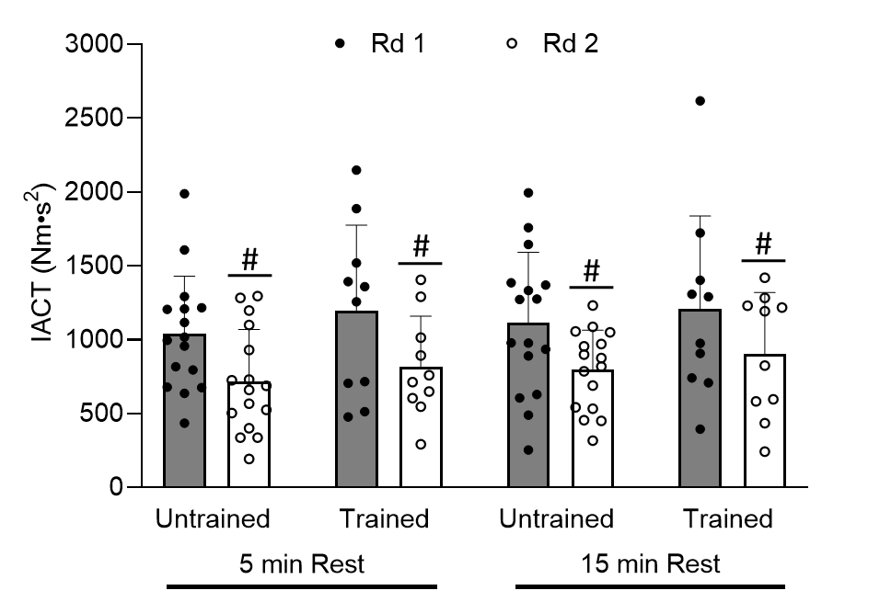
Figure 3: Displays IACT during round 1 and 2 of exercise evoked at 100hz between trained and untrained groups when given 5 and 15 minutes of rest between rounds. # indicates a main effect of testing round.

20 Hz Stimulation: Data for IACT during stimulated contractions at 20 Hz was analyzed using peak torque values and mean torque values that can be found in Figure 4. A mixed methods ANOVA revealed the three-way interaction among rest, round, and training status was not significant (p=0.523). Additionally, the interactions of rest and round (p=0.945), rest and training status (p=0.714), and training status and round (p=0.992) were not significant. The main effect for round was also not significant (p =0.056) indicating there was not enough of a reduction between the rounds. The main effect for rest was not significant (p=0.114) indicating the additional rest provided moving from 5 minutes of rest to 15 minutes of rest did not alter the recovery of IACT.

Figure 4: Displays IACT during round 1 and 2 of exercise evoked at 20hz between trained and untrained groups when given 5 and 15 minutes of rest between rounds.

Table: 2: Pearson Correlation table for 20 Hz stimulation with 100 Hz starting torque.
Variable | 1 | 2 | 3 | 4 | 5 |  |  | 6 | 7 | 8 | 9 | 10 | 11
Abs. CT Round 1, 5 min (1) | -- | .539** | .159 | -.059 |  | .344 | .704 |  | .023 | .431* | .421* | .049 | .702**
Abs. CT Round 1, 15 min (2) |  | -- | -.103 | .088 |  | .114 | .276 |  | .055 | .474* | .266 | -.29 | .402*
% Change CT round 1, 5 min (3) |  |  | -- | .733 |  | .258 | -.335 |  | -.727** | -.283 | .273 | .154 | -.438
% Change CT round 1, 15 min (4) |  |  |  | -- |  | .132 | -.501** |  | -.643** | -.256 | .095 | -.025 | -.543**
VO₂ Peak (5) |  |  |  |  |  | -- | .126 |  | -.202 | .046 | -.023 | .103 | .055
100 Hz Starting Torque (6) |  |  |  |  |  |  | -- |  | .577** | .434* | .081 | .157 | ---
Round 1 IACT (5 min) (7) |  |  |  |  |  |  |  |  | -- | .177 | -.492* | .032 | .702**
Round 1, IACT 15 min (8) |  |  |  |  |  |  |  |  |  | -- | .292 | -.534** | .404*
IACT Change, 5 min (9) |  |  |  |  |  |  |  |  |  |  | -- | -.200 | -.021
IACT Change, 15 min (10) |  |  |  |  |  |  |  |  |  |  |  | -- | .092
20 Hz Starting Torque (11) |  |  |  |  |  |  |  |  |  |  |  |  | --
Abs. CT: absolute value of critical torque; % Change CT: critical torque expressed as a percentage of initial torque; IACT: impulse above critical torque
Correlation is significant at the .01 level*
Correlation is significant at the .05 level**

Data for the 20 Hz stimulation CT test was compared to one another to determine if there was a correlation due to the lack of significance seen between training groups. A Pearson Product Moment Correlation Coefficient test was calculated between each variable as displayed in tables 2 and 3. When comparing Absolute CT at 5 minutes with the other variables, there is a strong correlation between absolute CT at 15 minutes (r=0.539, p=0.005), at 100 Hz starting torque (r=0.704, p<.001), and a moderate correlation with round 1 at 15 minutes (r=0.431, p=0.028), the IACT change at 5 minutes of rest (r=0.421, p=0.032), as well as 100 Hz starting torque compared with round 1 at 15 minutes (r=0.434, p=0.027). When comparing absolute CT at 15 minutes, there was a moderate correlation shown with round 1 at 15 minutes (r=0.474, p=0.015). Additionally, a strong correlation was seen between the percent change at 5 minutes and round 1 at 5 minutes (r=-0.727, p<0.001), percent change at 15 minutes with100 Hz starting torque (r=-0.501, p=0.009), percent change at 15 minutes with round 1 at 5 minutes (r=-0.643, p<0.001), 100 Hz starting torque compared with round 1 at 5 minutes (r=0.577, p=0.002), and round 1 at 15 minutes compared to the IACT at 15 minutes (r=-0.534, p=0.005). A moderate correlation was also shown between round 1 at 5 minutes with IACT at 5 minutes (r=-0.492, p=0.011).
Lastly, when 20 Hz starting torque was compared to the other variables, there was a strong correlation seen between absolute CT at 5 minutes (r=0.702, p<0.001), percent change at 5 minutes (r=-0.543, p=0.004), and the round 1 at 5 minutes (r=0.702, p<0.001). As well, a moderate correlation was seen between 20 Hz starting torque with absolute CT at 15 minutes (r=0.402, p=0.042), percent change at 5 minutes (r=-0.438,p=0.25), and round 1 at 15 minutes (r=0.404, p=0.041).
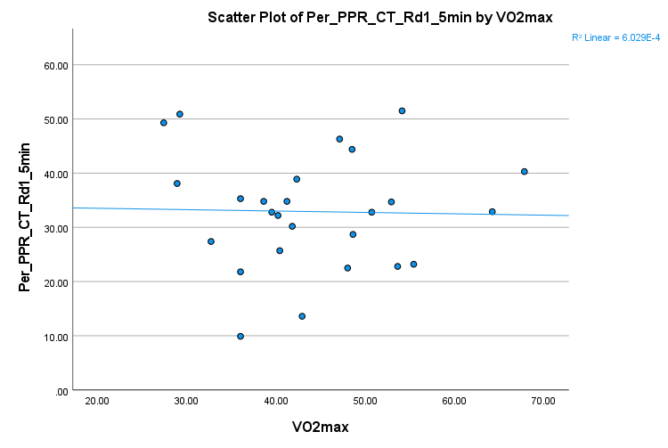
Figure 5. The relationship between VO₂ Peak vs. Relative CT.
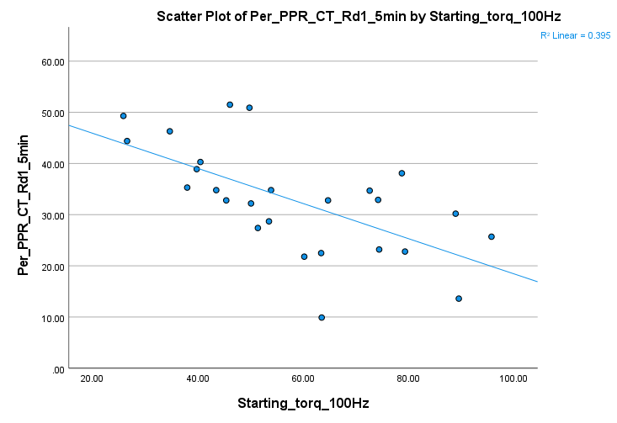
Figure 6. The relationship between Starting Torque vs. Relative CT.

The relationships between relative CT and VO2 peak, and the starting torque relative to strength were examined and plotted. There was no relationship seen between Vo2 peak and relative CT, however, there was a negative relative correlation between starting torque values and relative CT.

Critical Torque during 100 Hz Stimulation
Relative CT: Data for the percent change at 100Hz between trained and untrained groups and time points (5 minutes and 15 minutes) during the stimulated contractions can be seen in figure 7. A mixed methods ANOVA revealed the three-way interaction among rest, round, and training status was not significant (p=0.97). Additionally, the interactions of rest and round (p=0.263), rest and training status (p=0.724), and training status and round (p=0.88) were not significant. The main effect for round was also not significant (p =0.454). The main effect for rest was not significant (p=0.526) indicating the additional rest provided moving from 5 minutes of rest to 15 minutes of rest did not alter the recovery of the percent change. Additionally, the main effect for training status was also not significant (p=0.343).

Figure 7: Displays CT as a percentage of peak 100 Hz torque during round 1 and 2 of exercise evoked at 100hz between trained and untrained groups when given 5 and 15 minutes of rest between rounds.

Absolute CT: Data for absolute CT values during stimulated contractions at 100 Hz can be found in Figure 8. A mixed methods ANOVA revealed the three-way interaction among rest, round, and training status was not significant (p=0.864). Additionally, the interactions of rest and round (p=0.108), rest and training status (p=0.432), and training status and round (p=0.864) were not significant. The main effect for round was significant (p =0.003; marginal means of 18.5 Nm vs. 16.4 Nm for round 1 and round 2, respectively) with values from round 2 being reduced compared to round 1. The main effect for rest was not significant (p=0.398) indicating the additional rest provided moving from 5 minutes of rest to 15 minutes of rest did not alter the recovery. Additionally, the main effect for training status was also not significant (p=0.743).
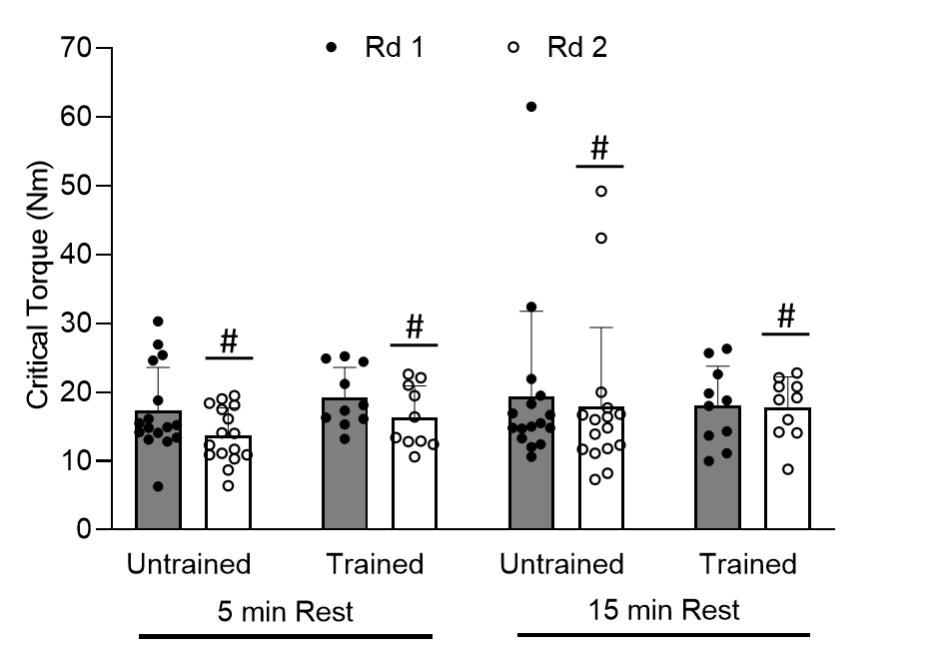
Figure 8: Displays absolute values for CT during round 1 and 2 of exercise evoked at 100hz between trained and untrained groups when given 5 and 15 minutes of rest between rounds. # indicates a significant main effect for testing round.

Critical Torque during 20 Hz Stimulation
Relative CT: Data for the percent change (expressed relative to peak torque at 100 Hz determined immediately prior to the CT protocol) at 20Hz between trained and untrained groups and time points (5 minutes and 15 minutes) during the stimulated contractions can be seen in figure 9. A mixed methods ANOVA revealed the three-way interaction among rest, round, and training status was not significant (p=0.584). Additionally, the interactions of rest and round (p=0.202), rest and training status (p=0.666), and training status and round (p=0.257) were not significant. The main effect for round was also not significant (p =0.76.). The main effect for rest was significant (p=0.009; marginal means of 41.6% vs. 44.4% for round 1 and 2, respectively) indicating values from the testing session where 15 min of rest were provided were higher than those from the testing session where 5 min were provided. Additionally, the main effect for training status was also not significant (p=0.085).

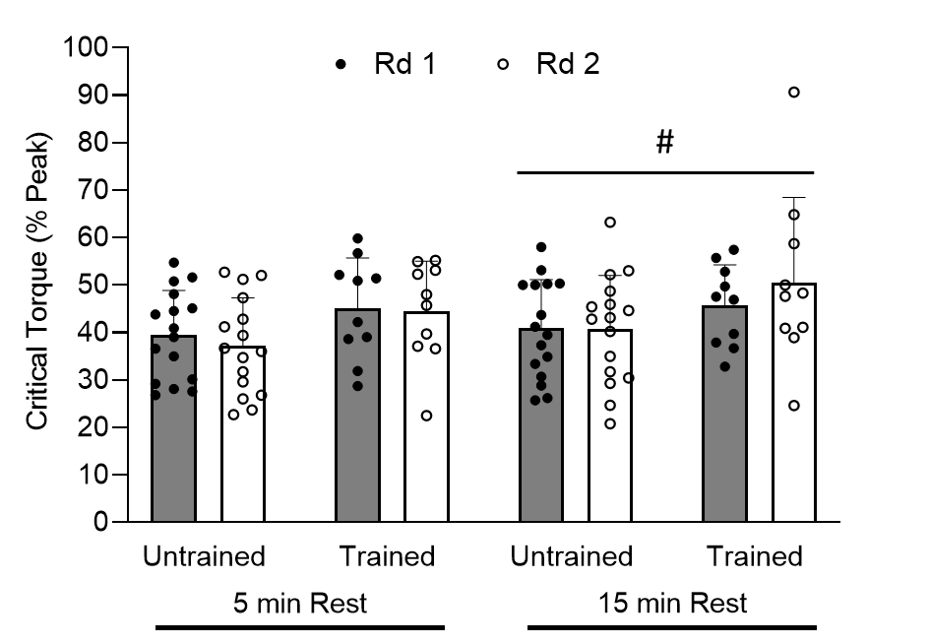

Figure 9: Displays CT as a percentage of peak 100 Hz torque during round 1 and 2 of exercise evoked at 20hz between trained and untrained groups when given 5 and 15 minutes of rest between rounds. # indicates a significant main effect for “rest” indicating higher values during the 15 min testing session.

Absolute CT: Data for absolute CT values during stimulated contractions at 20 Hz can be found in Figure 10. A mixed methods ANOVA revealed the three-way interaction among rest, round, and training status was not significant (p=0.724). Additionally, the interactions of rest and round (p=0.278), rest and training status (p=0.277), and training status and round (p=0.996) were not significant. The main effect for round was significant (p < 0.001; marginal means of 35.6 Nm vs. 29.9 Nm for round 1 and round 2, respectively) with values from round 2 being reduced compared to round 1. The main effect for rest was not significant (p=0.125) indicating the additional rest provided moving from 5 minutes of rest to 15 minutes of rest did not alter the recovery. Additionally, the main effect for training status was also not significant (p=0.595).
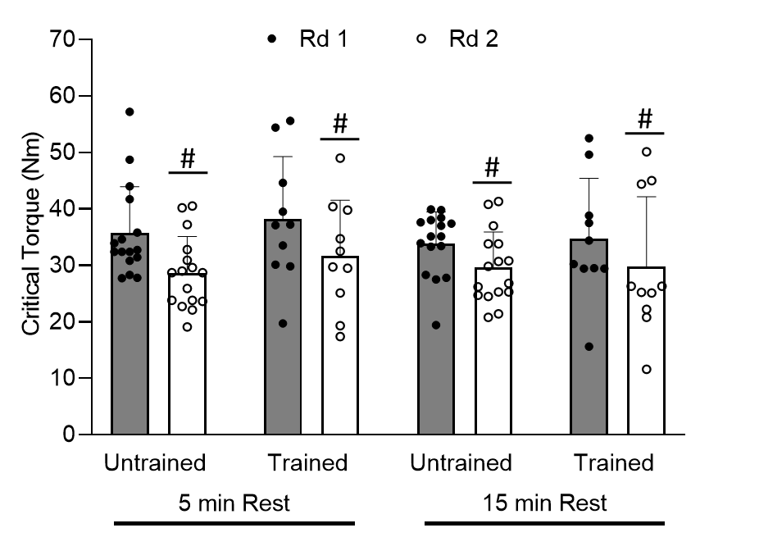
Figure 10: Displays absolute values for CT during round 1 and 2 of exercise evoked at 20 hz between trained and untrained groups when given 5 and 15 minutes of rest between rounds. # indicates a significant main effect for testing round.

Chapter 5: Discussion and Conclusion
The primary findings of the present study were that at a stimulation intensity of 100 Hz, the absolute torque values and the IACT between the two rounds of the CT test in the separate visits, both decreased, indicating that the muscle fatigued from stimulus. However, when stimulated with 20 Hz, absolute CT decreased from round 1 to round 2, but values for IACT did not differ. Our findings also show that there was no difference between training status or the amount of rest in between the rounds of the stimulating CT test at both 100 Hz and 20 Hz. As it is still an understudied concept, this contrasts with previous studies that indicated training status and recovery time in between fatiguing bouts, affected the reconstitution of IACT/W’ (Chorley & Lamb, 2020). Although this study tested CT measures, it can be compared to CP measures as they are isometric analogs to one another.
Similar to previous studies, this study showed a decline in the torque production followed by a plateau which suggests the attainment of a metabolic steady-state (Janzen et al., 2018). This study saw a decrease in both visits, one visit of 5 and 15 minutes, before and after the period of rest assigned to each participant. By understanding how EMS contractions affect the muscle being stimulated the results can then be explained more clearly. EMS based contractions follow a nonselective, spatially fixed, and temporarily synchronous recruitment pattern (Crameri et al., 2007; Gregory & Bickel, 2005). The electrode placement and stimulation intensity were held as constant as possible throughout the study, which helped to limit day-to-day differences, and thus we assume the differences seen between the two rounds of each visit reflect a decrease in force production due to peripheral fatigue. Absolute CT declined following exercise at both 20 Hz and 100 Hz and had not recovered with 5 min or 15 min of rest. This clearly indicates peripheral fatigue occurred, and had not resolved by 15 minutes post exercise. It is difficult to determine the precise location of the peripheral fatigue given the measures made in the present study. However, given that is was observed during/following both 100 Hz and 20 Hz stimulation suggests it was not primarily due to low frequency fatigue—if so larger reductions would have been observed at 20 Hz.
Stimulated IACT
The impulse above critical torque, IACT, is the isometric torque analog of W’ that likely represents a finite amount of energy stored above CT. From this study, there was only one main effect with a difference between each round in each visit at 100 Hz stimulation, but no difference between training status or the rest time given between the rounds. Additionally, there was no main effect between the two rounds, training groups and rest periods at 20 Hz stimulation. This could indicate that although there was a reduction in all of the variables, it was not large enough to make an effect. However, since there was a difference between rounds at 100 Hz stimulation, this is likely due simply to reduced torque due to peripheral fatigue. Although it is an understudied concept, the availability of oxygen plays a large role of fatigue on the body and correlates with W’/IACT and seems to be affected by oxygen availability (Chorley et al., 2019). This would dispel the notion of solely using anaerobic pathways for energy, but there was no difference in the IACT between the two training status groups from this study as has been observed in a previous study (Chorley et al., 2019). Therefore, it is possible that using stimulation instead of a voluntary exercise may not affect oxygen availability in W’/IACT as seen with voluntary contractions, and there could be more underlying physiological reasons; whether that be from a fall in pH, increase in inorganic phosphate, or a decline in muscle phosphocreatine concentrations (Jones et al., 2008). It would be interesting to track mitochondrial function during the stimulated CT to determine its role more fully on the reconstitution of W”/IACT.

Peripheral Fatigue
Peripheral fatigue occurs when the force needed or expected is not met. More specifically, peripheral fatigue originates from the peripheral nervous system or within the muscle itself (e.g. a failure on the motor axon or at the neuromuscular junction (Porter, 1981). The impairments that cause peripheral fatigue are often due to having an insufficient amount of ATP which leads to the muscle fibers inability to restore the resting membrane potentials, calcium levels returning to the sarcoplasmic reticulum, and/or the formation of cross bridges within the muscle (Kent-Braun et al., 2012). This impairment stimulates a higher reliance on the anaerobic metabolic pathways that have a lower capacity to generate ATP needed for force production, which leads to fatigue. Analyzing peripheral fatigue, this study shows that after the first round of stimulated muscle contractions, peripheral fatigue was present.
Low-Frequency Fatigue (LFF) was analyzed as well to further understand the peripheral fatigue. LFF indicates impairments in both the excitation-contraction coupling and calcium kinetics. From previous studies, it has been reported that a ratio of torque from 1 Hz/50 Hz has been shown to decrease following a fatiguing bout. Our findings show no significant differences following each round of the stimulated CT test. Therefore, it is possible that some of the decline in the torque production during the CT test can be attributed to peripheral fatigue due to the impairments to calcium kinetics from the lack of ATP produced to then begin the cross bridge cycle.

Limitations
During the time of data collection, the metabolic cart that was used to test the participants V02 Max was not calibrating correctly. After realizing the issue, it was asked of the participants to retest their V02 and the data provided in this study only included those who were able to retest.
Conclusion:
In conclusion, we reject our hypothesis as there was no difference in recovery after stimulated contractions between the highly trained group and the non-trained individuals. Additionally, there was no difference between the two randomized periods of rest assigned to the participants to track the effect of peripheral fatigue on the reconstitution of W’/IACT.
Significance and Future Study Recommendations:
Since it seems as though central fatigue may play a larger role in the reconstitution of W’, doing involuntary exercise did not leave a main effect. Therefore, doing voluntary exercise to incorporate the effects of central fatigue could potentially show more of a difference between training status. As well, instead of looking at endurance trained athletes, resistance trained athletes could potentially have a larger effect between rest periods. Since the effect of muscle size and strength shows a relationship, resistance trained individuals may show more of an effect.
Similarly, if we increased the range in which our training criteria was under for more elite athletes, or the use of actual athletes may be more beneficial. Being more specific with the trained and non-trained groups may show a larger effect. Understanding the metabolites under W’ could lead to a greater understanding for exercise performance in highly trained athletes.

References
Allen, D. G., Westerblad, J. A. L., & Lannergren, J. (1992). Role of Excitation-Contraction Coupling in Muscle Fatigue. Sports Medicine, 13, 116–126. https://doi.org/10.2165/00007256-199213020-00007
Amann, M., Blain, G. M., Proctor, L. T., Sebranek, J. J., Pegelow, D. F., & Dempsey, J. A. (2011). Implications of group III and IV muscle afferents for high-intensity endurance exercise performance in humans: Muscle afferents, peripheral fatigue and endurance exercise. The Journal of Physiology, 589(21), 5299–5309. https://doi.org/10.1113/jphysiol.2011.213769
Balady, G. J. (1993). Types of Exercise. Cardiology Clinics, 11(2), 297–308. https://doi.org/10.1016/S0733-8651(18)30180-2
Beaver, W. L., Wasserman, K., & Whipp, B. J. (1986). A new method for detecting anaerobic threshold by gas exchange. Journal of Applied Physiology, 60(6), 2020–2027. https://doi.org/10.1152/jappl.1986.60.6.2020
Bickel, C. S., Slade, J. M., Warren, G. L., & Dudley, G. A. (2003). Fatigability and Variable-Frequency Train Stimulation of Human Skeletal Muscles. Physical Therapy, 83(4), 366–373. https://doi.org/10.1093/ptj/83.4.366
Boerio, D., Jubeau, M., Zory, R., & Maffiuletti, N. A. (2005). Central and Peripheral Fatigue after Electrostimulation-Induced Resistance Exercise. 6.
Borg, G. A. V. (1982). Psychophysical bases of perceived exertion. Medicine & Science in Sports & Exercise, 14(5), 377–381.
Broxterman, R. M., Ade, C. J., Wilcox, S. L., Schlup, S. J., Craig, J. C., & Barstow, T. J. (2014). Influence of duty cycle on the power-duration relationship: Observations and potential mechanisms. Respiratory Physiology & Neurobiology, 192, 102–111. https://doi.org/10.1016/j.resp.2013.11.010
Burnley, M. (2009). Estimation of critical torque using intermittent isometric maximal voluntary contractions of the quadriceps in humans. Journal of Applied Physiology, 106(3), 975–983. https://doi.org/10.1152/japplphysiol.91474.2008
Burnley, M., Vanhatalo, A., & Jones, A. M. (2012). Distinct profiles of neuromuscular fatigue during muscle contractions below and above the critical torque in humans. Journal of Applied Physiology, 113(2), 215–223. https://doi.org/10.1152/japplphysiol.00022.2012
Chorley, A., Bott, R. P., Marwood, S., & Lamb, K. L. (2019). Slowing the Reconstitution of W ′ in Recovery With Repeated Bouts of Maximal Exercise. International Journal of Sports Physiology and Performance, 14(2), 149–155. https://doi.org/10.1123/ijspp.2018-0256
Chorley, A., & Lamb, K. L. (2020). The Application of Critical Power, the Work Capacity above Critical Power (W′), and Its Reconstitution: A Narrative Review of Current Evidence and Implications for Cycling Training Prescription. Sports, 8(9), 123. https://doi.org/10.3390/sports8090123
Crameri, R. M., Aagaard, P., Qvortrup, K., Langberg, H., Olesen, J., & Kjaer, M. (2007). Myofibre damage in human skeletal muscle: Effects of electrical stimulation versus voluntary contraction: Uniform versus heterogenic activation of muscle fibres. The Journal of Physiology, 583(1), 365–380. https://doi.org/10.1113/jphysiol.2007.128827
Faude, O., Kindermann, W., & Meyer, T. (2009). Lactate Threshold Concepts: How Valid are They? Sports Medicine, 39(6), 469–490. https://doi.org/10.2165/00007256-200939060-00003
Fukuba, Y., Miura, A., Endo, M., Kan, A., Yanagawa, K., & Whipp, B. J. (2003). The Curvature Constant Parameter of the Power-Duration Curve for Varied-Power Exercise: Medicine & Science in Sports & Exercise, 35(8), 1413–1418. https://doi.org/10.1249/01.MSS.0000079047.84364.70
Gonglach, A. R., Ade, C. J., Bemben, M. G., Larson, R. D., & Black, C. D. (2016). Muscle Pain as a Regulator of Cycling Intensity: Effect of Caffeine Ingestion. Medicine & Science in Sports & Exercise, 48(2), 287–296. https://doi.org/10.1249/MSS.0000000000000767
Gregory, C. M., & Bickel, C. S. (2005). Recruitment Patterns in Human Skeletal Muscle During Electrical Stimulation. Physical Therapy, 85(4), 358–364. https://doi.org/10.1093/ptj/85.4.358
Janzen, N. R., Hight, R. E., Patel, D. S., Campbell, J. A., Larson, R. D., & Black, C. D. (2018). Estimation of critical end-test torque using neuromuscular electrical stimulation of the quadriceps in humans. European Journal of Applied Physiology, 118(7), 1407–1414. https://doi.org/10.1007/s00421-018-3872-5
Jones, A. M., Grassi, B., Christensen, P. M., Krustrup, P., Bangsbo, J., & Poole, D. C. (2011). Slow Component of V˙O2 Kinetics: Mechanistic Bases and Practical Applications. Medicine & Science in Sports & Exercise, 43(11), 2046–2062. https://doi.org/10.1249/MSS.0b013e31821fcfc1
Jones, A. M., Vanhatalo, A., Burnley, M., Morton, R. H., & Poole, D. C. (2010). Critical Power: Implications for Determination of V˙O2max and Exercise Tolerance. Medicine & Science in Sports & Exercise, 42(10), 1876–1890. https://doi.org/10.1249/MSS.0b013e3181d9cf7f
Jones, A. M., Wilkerson, D. P., DiMenna, F., Fulford, J., & Poole, D. C. (2008). Muscle metabolic responses to exercise above and below the “critical power” assessed using ³¹ P-MRS. American Journal of Physiology-Regulatory, Integrative and Comparative Physiology, 294(2), R585–R593. https://doi.org/10.1152/ajpregu.00731.2007
Kellawan, J. M., & Tschakovsky, M. E. (2014). The Single-Bout Forearm Critical Force Test: A New Method to Establish Forearm Aerobic Metabolic Exercise Intensity and Capacity. PLoS ONE, 9(4), e93481. https://doi.org/10.1371/journal.pone.0093481
Kent-Braun, J. A., Fitts, R. H., & Christie, A. (2012). Skeletal Muscle Fatigue. In R. Terjung (Ed.), Comprehensive Physiology (p. c110029). John Wiley & Sons, Inc. https://doi.org/10.1002/cphy.c110029
Monod, H., & Scherrer, J. (1965). The Work Capacity of a Synergic Muscular Group. Ergonomics, 8(3), 329–338. https://www.tandfonline.com/doi/abs/10.1080/00140136508930810
Muangkram, Y., Honda, M., Amano, A., Himeno, Y., & Noma, A. (2020). Exploring the role of fatigue-related metabolite activity during high-intensity exercise using a simplified whole-body mathematical model. Informatics in Medicine Unlocked, 19, 100355. https://doi.org/10.1016/j.imu.2020.100355
Nussbaum, E. L., Houghton, P., Anthony, J., Rennie, S., Shay, B. L., & Hoens, A. M. (2017). Neuromuscular Electrical Stimulation for Treatment of Muscle Impairment: Critical Review and Recommendations for Clinical Practice. Physiotherapy Canada, 69(5), 1–76. https://doi.org/10.3138/ptc.2015-88
Poole, D. C., Burnley, M., Vanhatalo, A., Rossiter, H. B., & Jones, A. M. (2016). Critical Power: An Important Fatigue Threshold in Exercise Physiology. Medicine & Science in Sports & Exercise, 48(11), 2320–2334. https://doi.org/10.1249/MSS.0000000000000939
Poole, D. C., Ward, S. A., Gardner, G. W., & Whipp, B. J. (1988). Metabolic and respiratory profile of the upper limit for prolonged exercise in man. Ergonomics, 31(9), 1265–1279. https://doi.org/10.1080/00140138808966766
Porter, R. (Ed.). (1981). Human muscle fatigue: Physiological mechanisms. Pitman Medical.
Skiba, P. F., Jackman, S., Clarke, D., Vanhatalo, A., & Jones, A. M. (2014). Effect of Work and Recovery Durations on W′ Reconstitution during Intermittent Exercise. Medicine & Science in Sports & Exercise, 46(7), 1433–1440. https://doi.org/10.1249/MSS.0000000000000226
Slade, J. M., Bickel, C. S., Warren, G. L., & Dudley, G. A. (2003). Variable frequency trains enhance torque independent of stimulation amplitude: Variable frequency trains and torque. Acta Physiologica Scandinavica, 177(1), 87–92. https://doi.org/10.1046/j.1365-201X.2002.01053.x
Vanhatalo, A., Doust, J. H., & Burnley, M. (2007). Determination of Critical Power Using a 3-min All-out Cycling Test. Medicine & Science in Sports & Exercise, 39(3), 548–555. https://doi.org/10.1249/mss.0b013e31802dd3e6
Vøllestad, N. K. (1997). Measurement of human muscle fatigue. Journal of Neuroscience Methods, 74(2), 219–227. https://doi.org/10.1016/S0165-0270(97)02251-6

Appendix A: IRB Outcome Letter
Appendix B: Study Flyer

Appendix C: Informed Consent Form
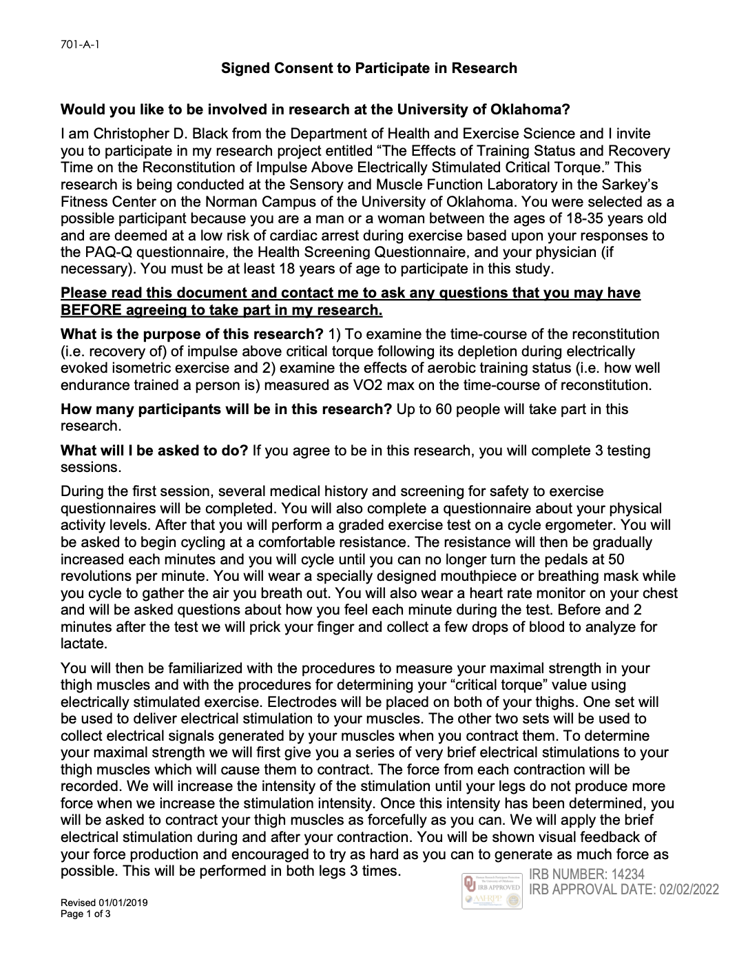
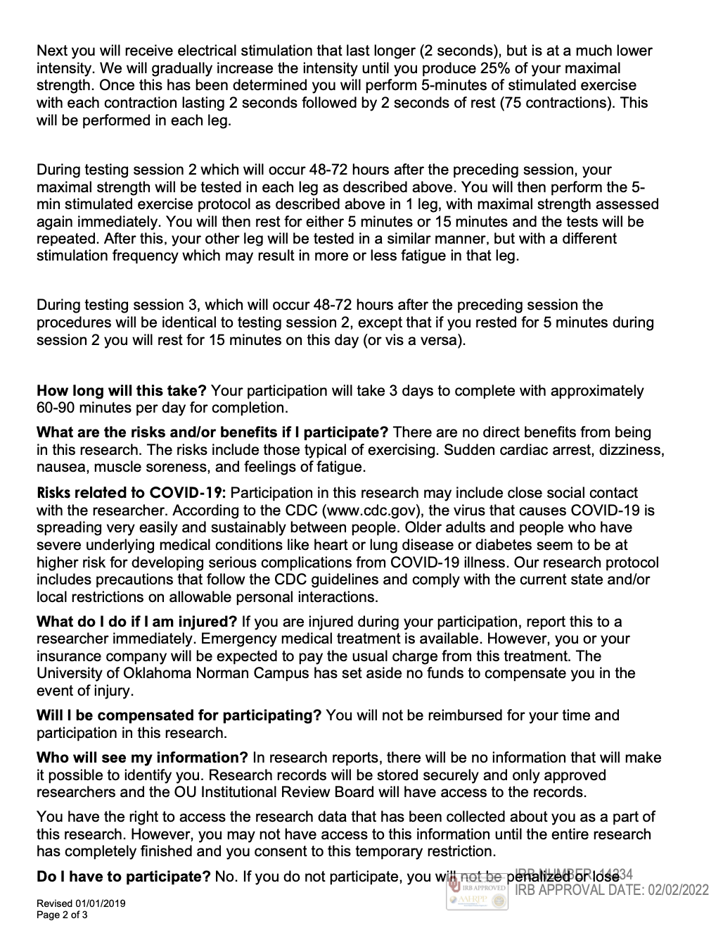

Appendix D: HIPPA Form
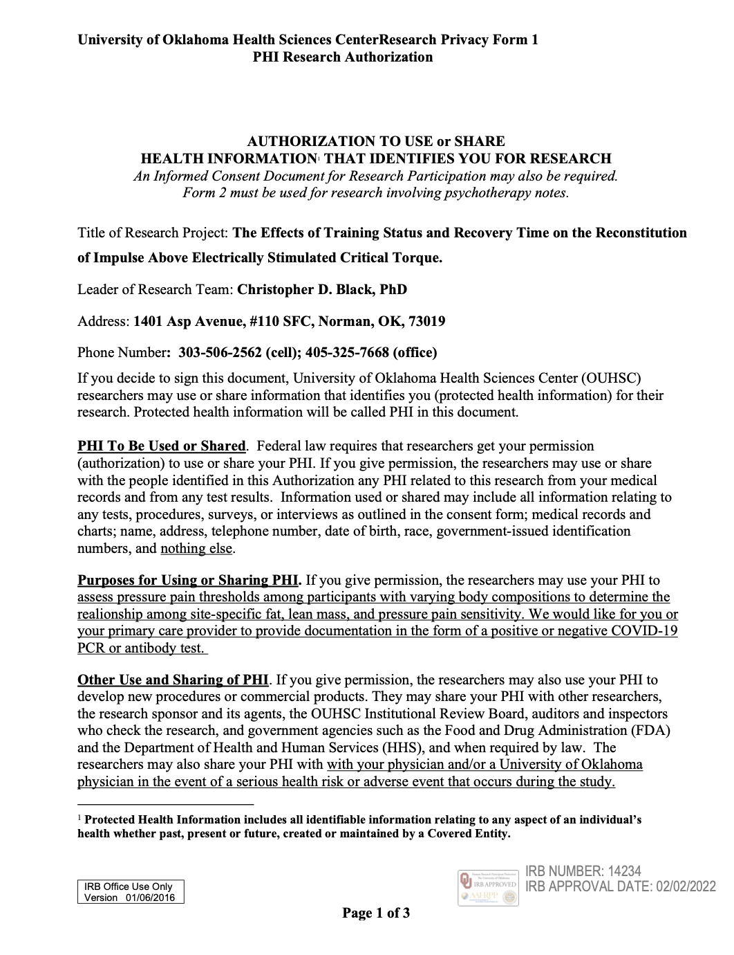


Appendix E: Health Status Questionnaire 

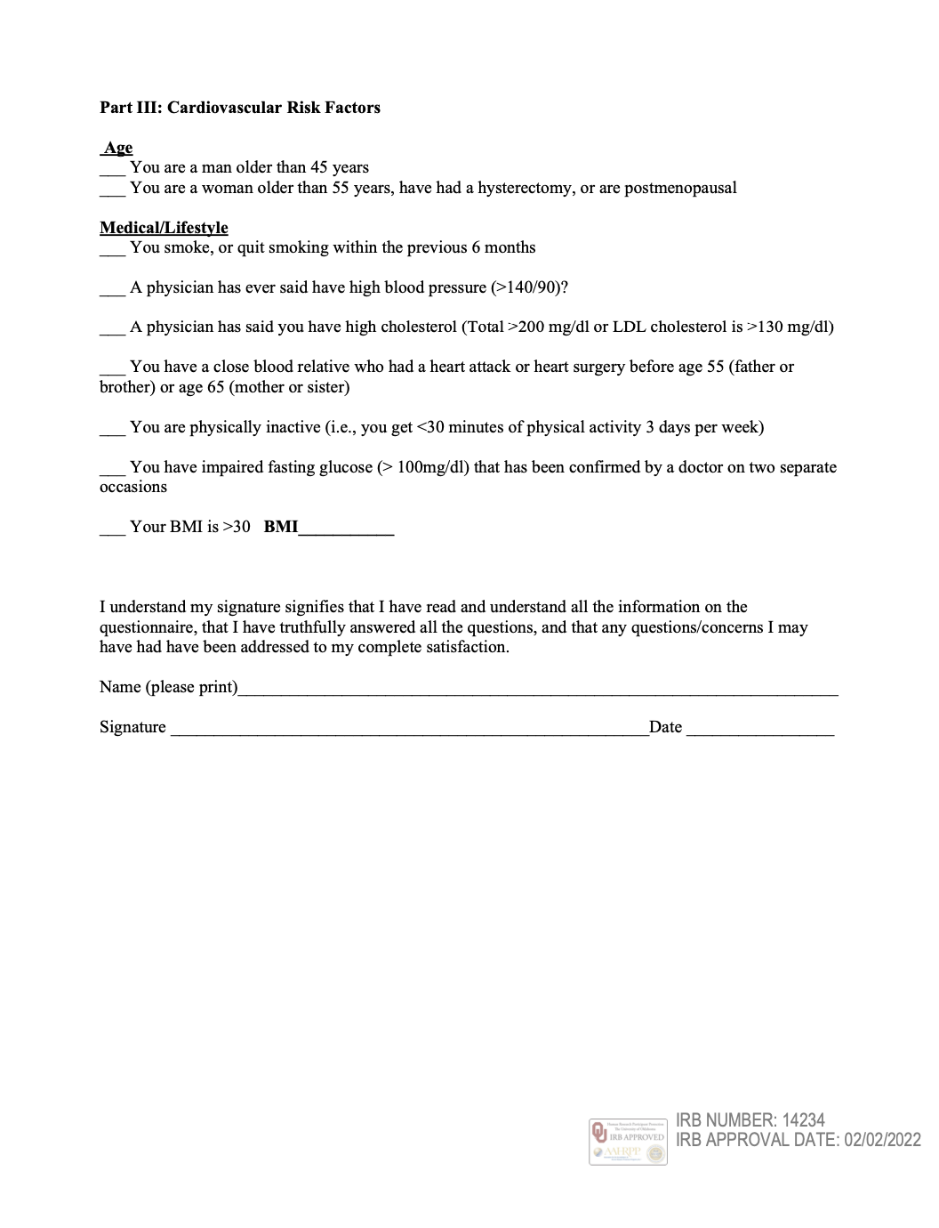
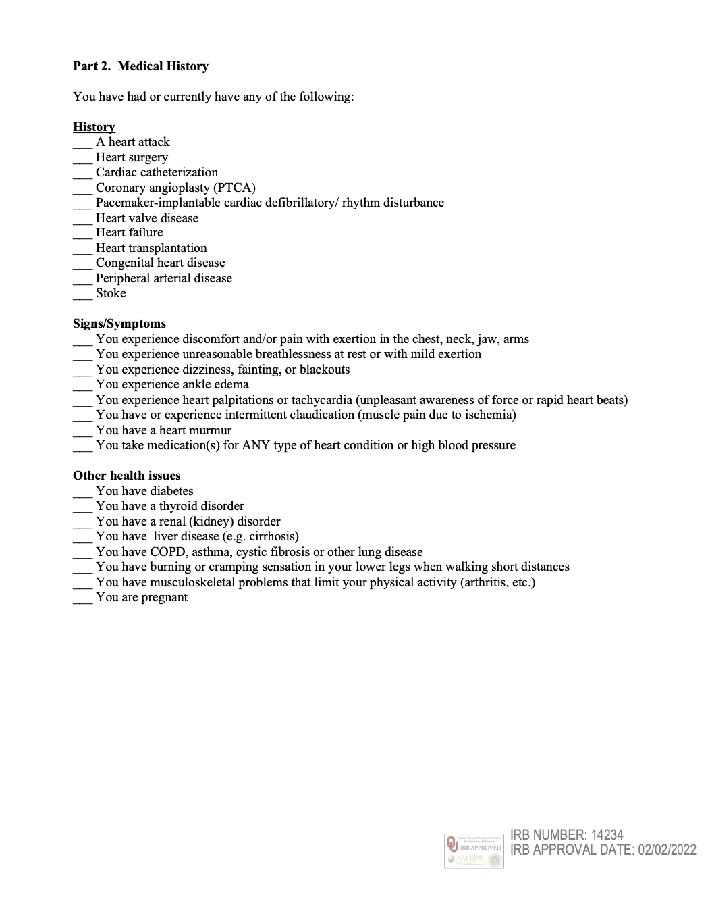

Appendix F: International Physical Activity Questionnaire 
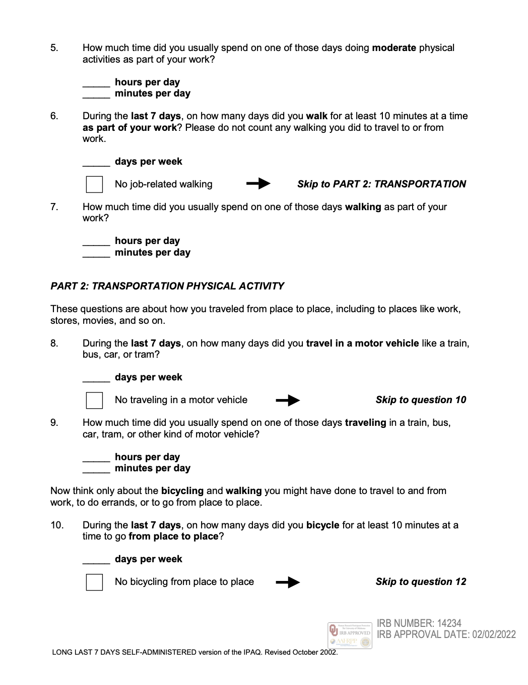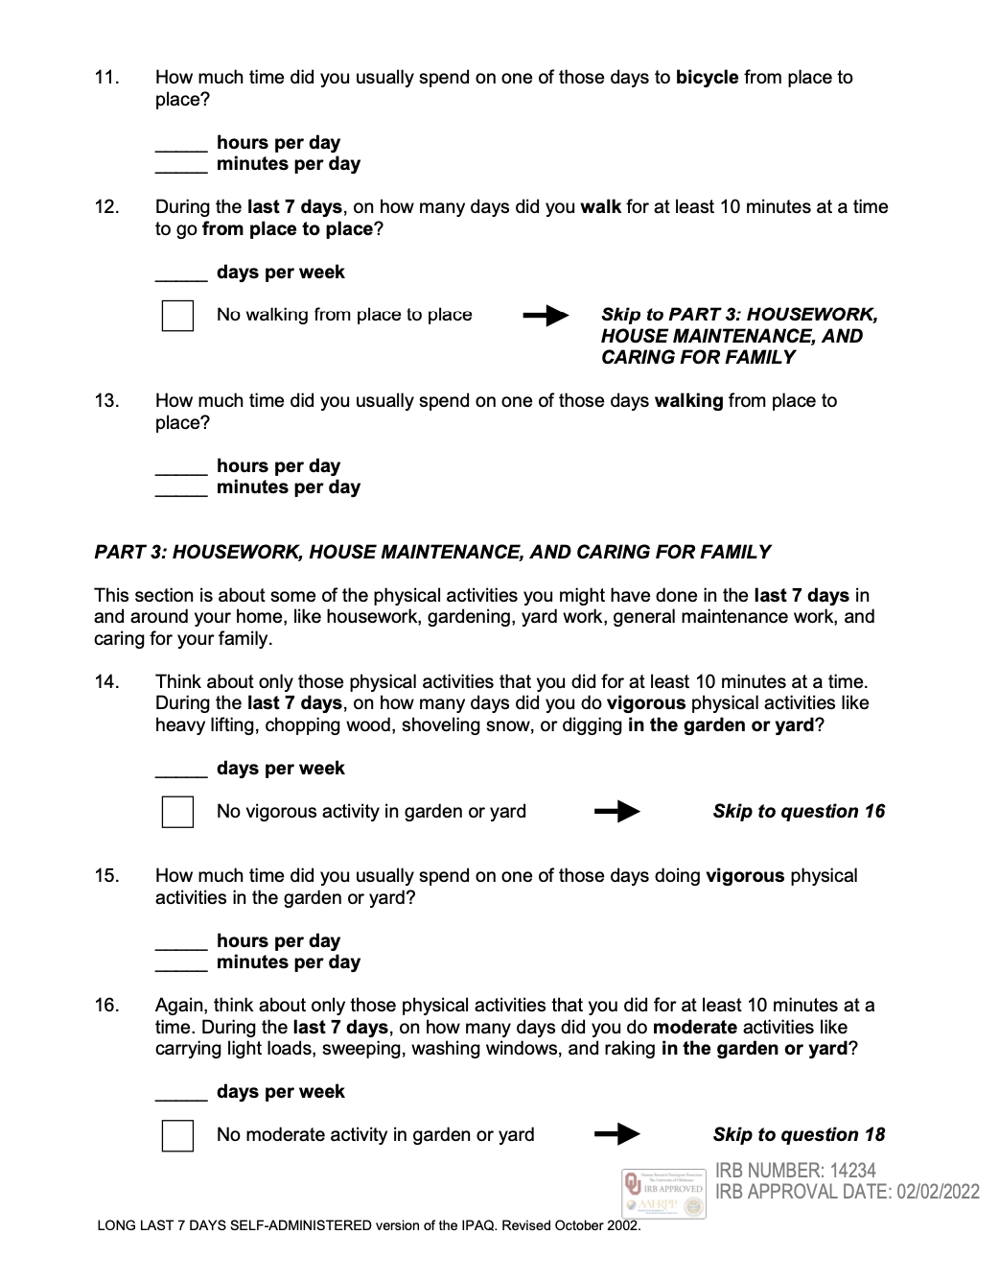
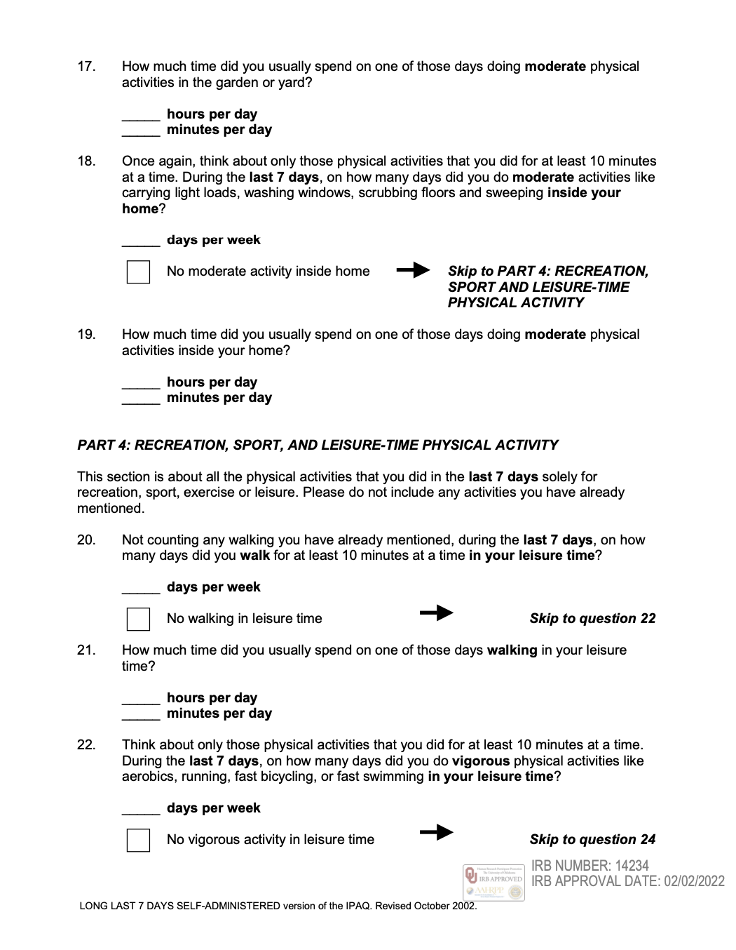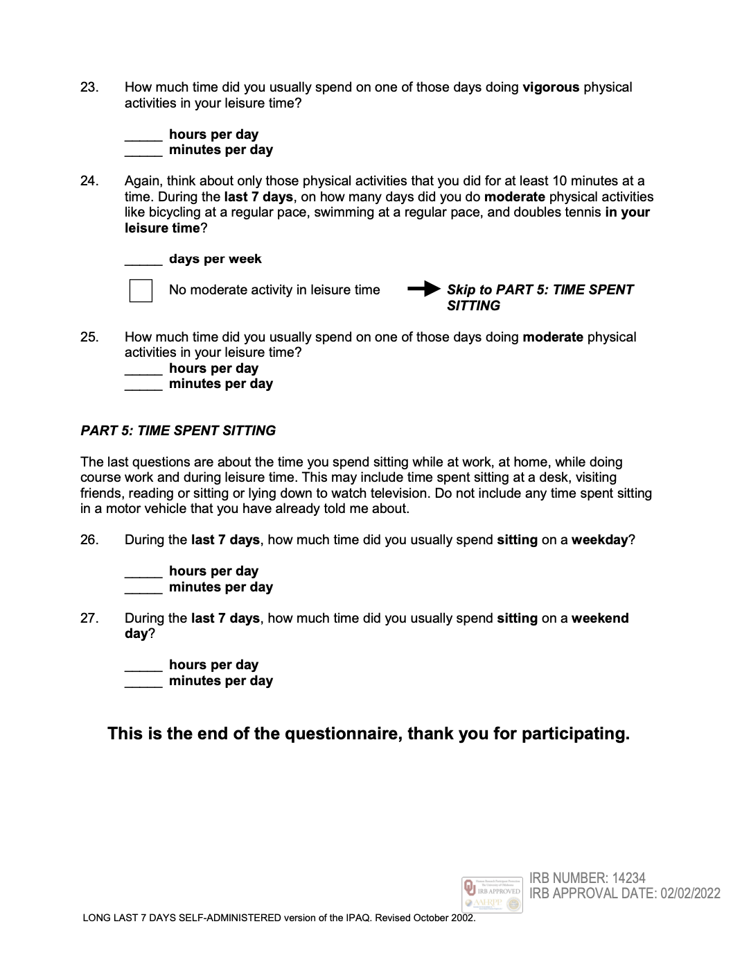

Appendix G: Physical Activity Readiness Questionnaire
