UNIVERSITY OF OKLAHOMA
GRADUATE COLLEGE

THE ROLES OF BEDROCK MORTARS IN ROCKSHELTERS OF EASTERN OKLAHOMA

A THESIS
SUBMITTED TO THE GRADUATE FACULTY
in partial fulfillment of the requirements for the Degree of
MASTER OF ARTS

By
HARMONY C. COLE
Norman, Oklahoma

THE ROLES OF BEDROCK MORTARS IN ROCKSHELTERS OF EASTERN OKLAHOMA

A THESIS APPROVED FOR THE DEPARTMENT OF ANTHROPOLOGY

BY THE COMMITTEE CONSISTING OF

Dr. Bonnie Pitblado, Chair
Dr. Asa Randall
Dr. Patrick Livingood
Dr. Debra Green

© Copyright by HARMONY COLE 2022
All Rights Reserved.

Acknowledgements
I would like to thank Dr. Bonnie Pitblado for her leadership, patience, and kindness throughout my term at the University of Oklahoma, both as an undergraduate and as a graduate student, as well as Dr. Asa Randall for his experience with rockshelters and excavating Dust Cave, and his frankness when I was emboldened to return to OU to complete my Master’s. I would also like to express my immense gratitude to Dr. Debra Green for her guidance and leadership, in both her capacity as my immediate supervisor at the Oklahoma Archaeological Survey, and as an inestimable expert in geoarchaeology. I would also like to thank Dr. Patrick Livingood for his precise insights into landscape archaeology, predictive modeling, and statistical analysis. I sincerely thank Dr. Kary Stackelbeck for permitting me to access the site files and database information from the OAS, and for her patience in keeping me on at the OAS for nearly my entire term at OU. I thank the faculty and my fellow students in the University of Oklahoma Anthropology department for sharing their knowledge, experiences, and advice, in particular Dr. K.G. Anderson. I thank my siblings, Christina Lakish and Zed Akhmetova, and my grandmother, Caroline for their constant and unerring support and encouragement. I thank my father, Victor Arthur Cole, for encouraging me to follow my ambitions despite the difficulties in our relationship. I thank my friends both in the anthropology department and those I have made in Norman for always being there for me.

Table of Contents
Acknowledgements iv
List of Tables . . . . . . . . . vii
List of Figures . . . . . . . . . viii
Abstract . . . . . . . . . . ix
Chapter 1: Introduction . . . . . . . . 1
Definitions . . . . . . . . . 4
Chapter 2: Environmental Background . . . . . . 8
Geologic History of Eastern Oklahoma . . . . . 8
Rockshelter Formation and Dynamics . . . . . 11
Hydrology . . . . . . . . . 15
Modern Ecology of Eastern Oklahoma . . . . . 17
Ecoregions . . . . . . . . 19
Region 3 Ecoregions . . . . . . 19
Region 6 Ecoregions . . . . . . 20
Fauna and Flora in Eastern Oklahoma . . . . . 24
Fauna . . . . . . . . . 24 Flora . . . . . . . . . 26
Chapter 3: Archaeological Background . . . . . . 28
Archaeological Theory Framework . . . . . . 28
Evolutionary Ecology . . . . . . . 28
Post-Processualism . . . . . . . 29
Rockshelter Archaeological Context . . . . . . 31
Early and processual rockshelter archaeology . . . 31
Post-processual perspectives on rockshelters . . . . 34
Bedrock Mortar Archaeological Context . . . . . 38
Behavioral ecology . . . . . . . 38
Post-processualism . . . . . . . 41
Cultural History Context of Eastern Oklahoma . . . . 44
Chapter 4: Methods . . . . . . . . . 53
Data Collection . . . . . . . . 53
Exploratory Statistics . . . . . . . . 55
Chapter 5: Results . . . . . . . . . 60
BRM Rockshelter Site Summaries . . . . . . 62 34CG14 . . . . . . . . 62
34DL24 . . . . . . . . 62
34LT59 . . . . . . . . 63
34MS256 . . . . . . . . 64
34NW76 . . . . . . . . 64
34RO119 . . . . . . . . 65
34SQ41 . . . . . . . . 66
34WG127 . . . . . . . . 66
34WG128 . . . . . . . . 67
34WG131 . . . . . . . . 68
34WG155 . . . . . . . . 68
34WG168 . . . . . . . . 69
34WG169 . . . . . . . . 70
Geological Formation . . . . . . . . 71
Ecoregion and Resources . . . . . . . 73
Faunal and floral remains results . . . . . 77
Archaeological Results . . . . . . . 78
Artifacts . . . . . . . . 78
Rockshelter Features and Characteristics . . . . 80
BRM Results . . . . . . . . . 84
Size . . . . . . . . . 84
Form . . . . . . . . . 85
Positioning . . . . . . . . 86
Chapter 6: Interpretations and Future Directions . . . . . 89
Geological Formation . . . . . . . . 90 Ecoregion . . . . . . . . . 92
Size . . . . . . . . . . 93
Form . . . . . . . . . . 93
Positioning . . . . . . . . . 96
Diagnostic Material . . . . . . . . 98
Social Interaction Sites. . . . . . . . 98
Gendered Spaces . . . . . . . . 100
Ceremonial or Spiritual Functions . . . . . . 101
Interpretation Summary . . . . . . . 103
Future Directions for Research . . . . . . 105
Expanding the scope . . . . . . . 105
Future testing . . . . . . . . 106
Residue analysis . . . . . . . 108
Conclusion . . . . . . . . . 110
References . . . . . . . . . . 111
Appendix A: BRM Rockshelter Data . . . . . . . 121
Appendix B:Basic Data and Major Artifacts . . . . . . 122
Appendix C: Minor Artifacts, Faunal, Floral, and Miscellaneous Data . . 129

List of Tables
Table 2.1: Counties and OAS Region Codes , , . . . . 9
Table 2.2: Sample local medicinal plants . . . . . . 27
Table 4.1: Fields included in JMP database . . . . . . 56
Table 5.1: Summaries of Faunal Remains Counts . . . . . 77
Table 5.2: Distances to water and slope of BRM rockshelter sites. . . . 82
Table 5.3: Recorded dimensions of BRMs . . . . . . 84
Table 5.4: Recorded forms of BRMs . . . . . . . 85
Table 5.5: Recorded positioning of BRMs . . . . . . 86

List of Figures
Figure 1.1: Examples of round and ovoid metates . . . . . 5
Figure 1.2: Examples of profile views for BRMS . . . . . 6
Figure 1.3: Cylindrical bedrock mortar . . . . . . 7
Figure 2.1: The Counties of Regions 3 and 6 . . . . . . 9
Figure 2.2: Comparative plan and profile views of rockshelters and caves . . 12
Figure 2.3: Rivers and lakes of Oklahoma . . . . . . 15
Figure 2.4: Ecoregions of Eastern Oklahoma . . . . . 18
Figure 3.1: Dalton PaleoIndigenous projectile point . . . . . 45
Figure 3.2: Examples of Calf Creek points . . . . . . 47
Figure 3.3: Example Scallorn and Fresno Woodland points . . . . 49
Figure 3.4: Map of Spiroan mound village sites . . . . . 51
Figure 5.1: Distribution of rockshelter sites through the counties of eastern Oklahoma 61
Figure 5.2: Illustration of BRM impressions from 34LT59 . . . . 63
Figure 5.3: Sketch map of site 34NW76. . . . . . . 64
Figure 5.4: Sketch map of site 34RO119 . . . . . . 65
Figure 5.5: Example Fresno points . . . . . . . 65
Figure 5.6: Sketch map of site 34WG127 . . . . . . 66
Figure 5.7: Sketch map of site 34WG128 . . . . . . 67
Figure 5.8: Example Washita points . . . . . . . 68
Figure 5.9: 34WG167 example and loose groundstone fragment from 34WG168 . 69
Figure 5.10: Detail view of Wagoner County rockshelter sites Ecoregion Distribution 71
Figure 5.11: Rockshelter site distribution and bedrock formations . . . 73
Figure 5.12: Ecoregion density by square mile. . . . . . 74
Figure 5.13: Ecoregions and rockshelter site distribution . . . . 76
Figure 5.14: Distribution of BRM rockshelters and loose groundstone . . 79
Figure 5.15: Comparative facing distributions . . . . . 81
Figure 5.16: Proportions of slope percentage of BRM rockshelters . . . 83

Abstract
Rockshelters form an important part of the archaeological landscape. Rockshelters served a number of purposes, and in pursuit of those purposes they could be altered or adjusted. A prominent example of these rockshelter alterations is the presence of bedrock mortars, which consist of grinding and pounding surfaces deliberately carved into bedrock floors or large, immobile boulders.
The functions of these bedrock mortars have long been assumed to be purely economic, only used for processing food plants. However, recent research has broadened the scope of bedrock mortars to investigate larger connotations of their contributions to the archaeological record.
This thesis compares the combined implications of rockshelters and bedrock mortars to assess possible uses in Eastern Oklahoma. Based on the characteristics recorded in existing site files and survey reports, I propose that bedrock mortars in the study area were small-scale, specialized features placed in Pennsylvanian sandstone that were designed to efficiently process local environmental resources, and that they were potentially places of small-scale interpersonal communication and cultural transmission, and most likely used by women. Evidence of these bedrock mortar rockshelters having intense symbological or spiritual associations is lacking, but not impossible.
I also propose future directions of research, to raise awareness of their significance to the archaeological record, and to expand the study of these features into the Midwest.

Chapter 1: Introduction
Rockshelters have served a vital purpose for humanity throughout much of our history. They provide permanent, reliable spaces in the environment that offer protection from the elements and safety or secrecy from animals or other people, as well as places of concentrated spiritual and social meaning. Some rockshelters serve several of these functions simultaneously.
The use of rockshelters has been under archaeological scrutiny since the late nineteenth century, but one class of anthropogenic features sometimes associated with rockshelters has not been much discussed. These consist of imbedded grinding or pounding surfaces created by humans, henceforth referred to in this thesis by the umbrella term of “bedrock mortars” (abbreviated to BRMs).
BRMs began receiving increased attention in the 2010’s, particularly in the western half of the US in California and New Mexico and in the Southern Levant (Israel, Palestine, Jordan) with studies of Neolithic Natufian examples (Quigg et al 2001, Manchen 2015, Buonasera 2016, Lynch 2017, Pino et al 2018, Rosenberg and Nadel 2017, Hayes et al 2018). So far, however, little work has been done with BRMs in rockshelters even in these areas and no comprehensive investigations of BRMs or rockshelters themselves have been conducted in Oklahoma.
To remedy this, I conducted intensive research on previously documented rockshelters in eastern Oklahoma, several of which contained BRMs. Since these BRMs were, from an archaeological perspective, a new and unexamined part of Oklahoma’s archaeological heritage, I examined them with an eye towards identifying their function and significance. Toward this end, the purpose of this thesis is to provide the necessary archaeological and environmental background to test several hypotheses about BRM function and significance in the specific study area:
1. If the qualities of the materials in which a BRM is placed is important, then there should be higher concentrations of BRMs in some bedrock formations than in others.
2. If BRMs mortars are made to process specific resources, they will be in ecologies with resources that require their use. Furthermore, if all BRMs were constructed to process the same particular resource, they will all have similar sizes and forms. If they are made to process different resources, there will either be a variety of shapes and sizes, or a generalized form that processes all materials with equal efficiency.
3. If BRMs are made to efficiently process resources, they will be of a size and a shape that can cost-effectively process these resources in the quantity required.
4. If BRMs are crafted to be efficient tools, on a regional scale they will be positioned in places where it is more cost-effective to craft a BRM than to carry loose groundstone mortars and metates. They will also be positioned in areas within the site that allows them to be used and maintained.
5. If BRM rockshelter sites are centers of intensive social interaction and interpersonal communication, there should be many BRMs constructed near each other.
6. If BRM rockshelters was used more frequently by a specific gender, then there should be artifacts associated with one or the other, according to principles of division of labor as interpreted from cultures of that region and period.
7. If BRM rockshelters have ceremonial or spiritual connotations, there should be at least a high density of artifacts, including specifically identifiable offering artifacts. If comparing them to spiritually significant Ozark sites, there should also be rock art, interments, and notable impediments of access like steep slopes or distance from water.
Chapter 2 details the geological/environmental context of eastern Oklahoma. The chapter describes the geological history of the study area, the development of bedrock formations, and the processes of rockshelter formation. It also describes the modern ecology and climate, such as the range of ecological regions, fluvial or drainage systems, and the current patterns of flora and fauna.
Chapter 3 is dedicated to the archaeological context regarding BRMs, rockshelters, and the study area of Eastern Oklahoma, starting with a section to present the theoretical lenses that I used to evaluate the BRMs and rockshelters of this area. The theory used places a special emphasis on the application of behavioral ecology to rockshelter and BRM research, but also includes an examination of the post-processual applications used in rockshelter and BRM sites. The rest of the chapter summarizes the history of human occupation of eastern Oklahoma’s rockshelters, from the early inhabitants in the PaleoIndigenous period through to the Village/Mississippian.
Chapter 4 reports my methods of data collection and analysis, including the reviewing of site files and survey reports, compiling a large database of all the rockshelters in eastern Oklahoma, and evaluating their distribution across the study area, and I describe how I extracted information about BRMs from that research. This chapter will primarily detail my process of thought as to why I included the data I did, and how I processed and compared both previous research and research I had conducted.
Chapter 5 presents the results of this analysis, providing the details of the information set I collected and organized, in particular the details obtained that are in relation to the seven hypotheses detailed above.
Chapter 6 presents the interpretations suggested by the combination of the background literature and collected research data, and how much support is present for the original seven hypotheses. It will also present additional avenues for future research including how to expand the research of these subjects into new geological and theoretical areas, and new techniques that can be applied to evaluate and test BRMs.
Definitions
What do I mean by “rockshelter”?
Despite BRMs being the main topic of this thesis, much of their archaeological context is dependent on the rockshelter they are associated with. Therefore, I believe it is important to clarify what I mean when I refer to a rockshelter.
For the purposes of this thesis, a rockshelter was defined as an overhang, in which erosional forces wore away the softer rock underneath a shelf of harder rock, or as a slab rockshelter in which a large fragment of bedrock is supported in some manner off the ground, forming a roof over an open space. Both kinds of rockshelter are distinguished from caves by topography and geological origins.
Overhangs are geologic features in which a cavity has been carved out from an exposed section of bedrock. These features can be created through differential erosion from water or wind, where the softer stone is slowly worn away, leaving the remaining harder bedrock. As eolian erosion requires a consistent high energy wind system and the assistance of a sandy environment to abrade bedrock features (Jolivet et al 2021), the majority of the rockshelters in Eastern Oklahoma are likely formed from alluvial erosion, from the multiple streams and rivers that flow through the region.
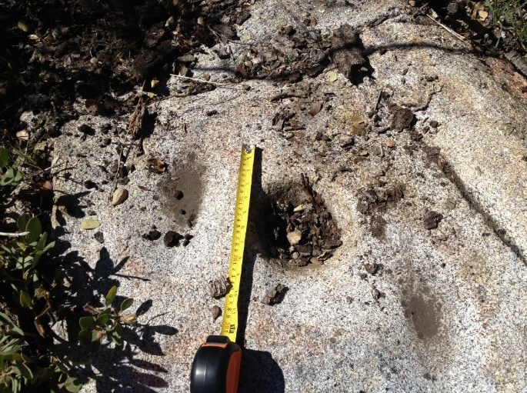
What do I mean by “bedrock mortar”?
The term “bedrock mortar” technically covers two ends of a spectrum. The first category is pounding holes (which includes mortars, cupules, cupmarks), which tend to be round and deeper than they are wide. The next category is “metates”, which are oblong, shallower surfaces that are wider than they are deep (grooves, slicks, basins, and grinding surfaces). And then you have those BRMs in the middle of the spectrum, which are as wide as they are deep, and can be round or ovoid, that tend to be classified as one of the former two categories (Rosenberg and Nadel 2017b). Examples of the shapes and proportions are portrayed in Figures 1.1 and 1.2.
Figure 1.1: Examples of one round, deeper mortar and two ovoid metates. Cuyamaca Ovals, California (Manchen 2015:44).
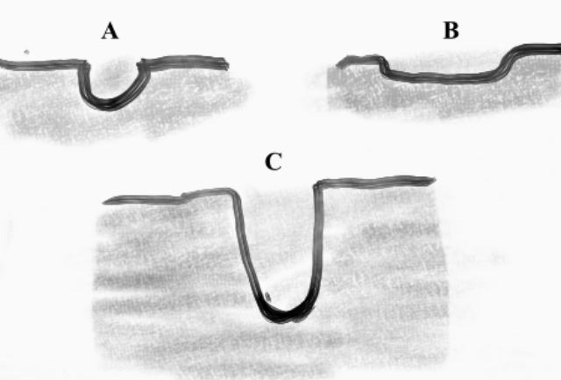
However, the usage of a BRM is not directly tied to its form. For instance, mortar-shaped BRMs can be used for grinding, twisting a rock in a circular motion like a modern mortar and pestle. A bedrock metate is normally used for back and forth grinding but can also be used for cracking or pounding. (Hayes 2018). Due to this ambiguity of purpose, while the shape of a BRM can provide strong suggestions towards how it was used, one cannot conclusively state the function of a BRM by its shape alone. Therefore, this thesis will continue to refer to them as bedrock mortars, unless the form of such a feature requires specification.
Figure 1.2: Examples of profile views for BRMs; A is a common cup-shaped BRM type, B is more typical for “metates”, and C is more typical for “mortars”
In addition, how the term “bedrock” itself is defined can also be ambiguous. Some BRMs are carved into exposed surfaces of bedrock, basically on the ground, and some BRMs are placed in large, bedrock boulders that had fragmented from an exposure somewhere else. Some BRMs are large features formed entirely out of bedrock, still immobile but with a basin large enough as to leave no room for other rock around it, an open cylinder, as shown below in Figure 1.3 (Rosenberg and Nadel 2014).
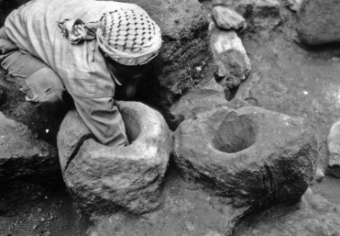
As a result, despite this diversity in form, for the sake of brevity I will continue using the term “bedrock mortars” as an umbrella term for the features described in this thesis. While the shapes of some BRMs were described in site and survey files, without detailed usewear and residue analysis it is not currently possible to conclusively determine whether a BRM was used for pounding or grinding, so I will continue using the term “bedrock mortar” to describe all forms of these imbedded depressions or surfaces unless the description requires greater specificity.
Figure 1.3: Cylindrical bedrock mortar from Jericho. Rosenberg and Nadel 2014:788.

Chapter 2: Environmental Background
This section outlines the environmental context of Eastern Oklahoma. The study area consists of two regions defined by the Oklahoma Archaeological Survey (OAS), Region 3 in the northeast and Region 6 in the southeast. These regions were established based on geological and archaeological consistencies and commonalities. This context is important to understand the formation, composition, and distribution of rockshelters and BRMs across the study area. It is also important to understand the resources available which may have been used within BRMs. The Regions and counties included in this study area are listed in Table 2.1 below.
Geological History of Eastern Oklahoma and Rockshelters
The geological history of eastern Oklahoma has been mostly defined by periods of marine sedimentation, followed by periods of slow erosion. The oldest rocks in Eastern Oklahoma date from the Precambrian Period, about 1.4 billion years ago (Johnson and Luza 2008), in the form of large formations of igneous and metamorphic rocks that formed a basement layer of granite, rhyolite, and basalt.

Region 3 | Region 6
AD - Adair | CH - Choctaw
CG - Craig | HS - Haskell
CK - Cherokee | LF - Le Flore
DL - Delaware | LT - Latimer
MS- Muskogee | MC - McCurtain
MY - Mayes | PS - Pittsburg
NW - Nowata | PU - Pushmataha
OT - Ottawa
RO - Rogers
SQ - Sequoyah
WG - Wagoner
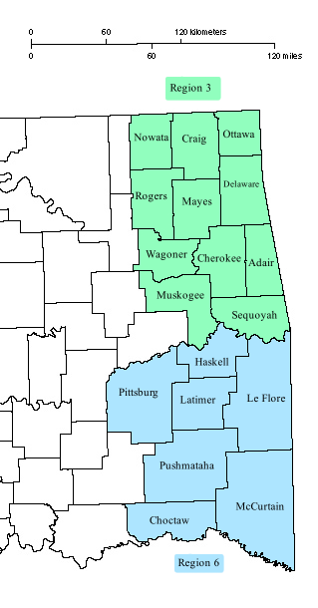
Table 2.1: Counties and OAS Region codes Figure 2.1: The Counties of Regions 3 and 6

During the Late Cambrian and Ordovician Periods, the study area was covered with seawater, depositing thick layers of sandstone, limestone, and shale. During the Silurian and Devonian, thick sediments of limestone and dolomite topped by black dolomite covered most of Oklahoma, except in the Ouachita Basin in Region 6 where sandstone and shale were deposited.
In the Mississippian Period, during the first part of the Carboniferous Period, shallow seas covered most of Oklahoma, and limestone, shale, and sandstone were deposited. In the southeast in Region 6, however, basins were rapidly subsiding due to pending uplift, resulting in thick sedimentary deposits of shale, with some layers of limestone and sandstone (Johnson and Luza 2008).
The following Pennsylvanian Period, the later portion of the Carboniferous, is a complex period of orogeny and basin subsidence. In the Early or Lower Pennsylvanian, the primary geological event in Oklahoma was the Wichita Orogeny, which created deep basins between the Wichita Mountains and the Nemaha Uplift. This Wichita orogeny created deep, wide basins between the Wichita Mountains and the Nemaha Uplift (Johnson 2008). Coarse-graded Cambrian granite and rhyolite began eroding into these basins, grading into smaller particles the further they were from the uplift and incorporating into the marine shale and sandstones that were accumulating. This created a strong foundation of sandstone, which remained mostly intact to the present due to the Ozark/Ouachita Uplift in the Middle Pennsylvanian(Johnson 2008, DiPietro 2013).
In the Middle Pennsylvanian, the Ozark uplift accelerated; this sequence had been part of a long period of orogeny associated with the larger Appalachian Mountains formation since the Mississippian as the continent of Pangaea slowly pulled together (DiPietro 2013, p.277). The effect of this uplift was that the region that would become eastern Oklahoma was raised in elevation, preserving the landscape from getting inundated by marine sediments again.
The Late or Upper Pennsylvanian marked the stabilization of the topography of eastern Oklahoma; while the Arbuckle uplift was deforming and shaping the west, the landscape in the east would begin a long, slow period of erosion toward the west. Starting from after the beginning of the Permian Period, Eastern Oklahoma would not see depositional episodes again until the Quaternary, after the uplift of the Rocky Mountains in the Late Cretaceous and Early Tertiary. This mountain-forming event resulted in a broad uplift of western Oklahoma and the Great Plains which shifted the erosional tilt towards the east (DiPietro 2013, p. 417). This continental shift resulted in the water systems of Oklahoma to transition to flow to the west, forming the modern major stream systems in place today. These streams began flowing through the state and depositing loose sand, clay, and gravel, decreasing in grain size from west to east.
Rockshelter Formation and Dynamics
The most common process of overhang creation stems from bank erosion, when the stream is cutting into the bedrock and removing the softer materials. Over time, the stream erodes its bed and decreases in elevation, which carves out lower materials and increases the height of the overhang roof. The stream is also capable of changing its course over time, and as the stream moves away from the rockshelter it leaves a dry floor on which sediments can accumulate as the net erosion decreases, as well as leaving the overhang suitable for habitation. In the case of the overhang rockshelters in Eastern Oklahoma, shale would be the most common erodible material, washed away and leaving the harder sandstone and limestone behind (Donahue and Adovasio 1990, Johnson and Luza 2008), as shale is common in both regions.
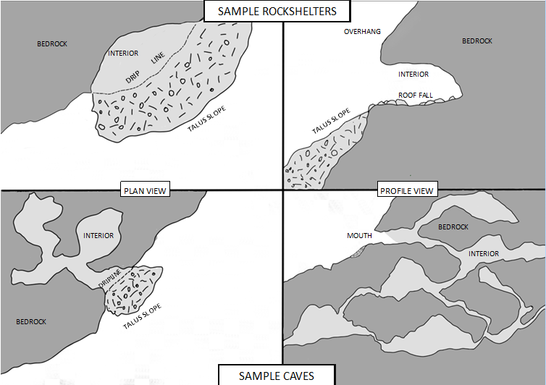
Cave formation is slightly different. Caves tend to have a greater depth than overhangs and may or may not have additional chambers beyond the entrance. Caves also have the possibility of connecting to larger networks of tunnels and chambers. Cave formation differs from overhangs in that the primary form of erosion is chemical, in the form of dissolution. Marine limestone is formed of calcite deposited from layers of deposited diatom shells, which reacts to water and is dissolved and removed from the parent material, leaving gaps and fractures through natural planes of weakness which widen with increased removal of calcite. This can result in the creation of complex structures, with the deposition of calcite forming stalactites, stalagmites, and pillars, and the large gaps and passages of empty space resulting from calcite being removed, forming cave systems. This form of dissolution is frequently associated with landforms known as a karst, which is the case in Region 3 in northeast Oklahoma, on the border of the Ozarks. The differences in topography between rockshelters and caves is demonstrated in Figure 2.2 above.
Figure 2.2: Comparative plan and profile views of rockshelters and caves
Both overhangs and caves can be geologically dynamic, especially at the mouth of the cave or at the drip line of the rockshelter and can change quite rapidly. Generally erosional forces undercut the rock, so a long roof or brow begins to form, but eventually the brow begins to lack sufficient support, causing roof fall or even collapse (Farrand 2001). So current measurements of rockshelters may not have been the maximum extent of the space available, and evidence of earlier occupations may be buried under the talus of the new drip line.
Site formation is but one consideration when it comes to understanding the geoarchaeological history of a rockshelter. Depositional processes are another factor that must be accounted for to draw conclusions of human behavior. Advances in stratigraphic analysis have refined the scale of analysis to distinguish individual depositional events, resulting in a finer scale of chronological and relational context when uncovering cultural material (Naumann 2008, Martin et al 1993). These methods of deposition can result from geogenic processes, biogenic sedimentation, or anthropogenic events (Farrand 2001). Geogenic processes include sediments derived from sources such as roof fall, colluvial inwashing, or stream deposition (Farrand 2001) or chemical precipitates in limestone caves from dissolution (Goldberg and Sherwood 2006). Biogenic sedimentation consists of vegetal and faunal matter that gets deposited over time, including bones and pollen, and anthropogenic sedimentation includes ash accumulation and fire features, as well as importing soil to level the floor, or bringing in material to build structures inside the rockshelter (Farrand 2001, Greer 1976).
Sources of disturbance include colluvial processes that distort levels in talus slopes, and animals that dig burrows (Farrand 2001). People themselves pose difficulties to detailed excavation; “In eastern North America perhaps the single most destructive cultural force that has disturbed early Holocene deposits in rockshelters is Middle Archaic (8,000-5,000 B.P.) pit digging” (Walthall 1998 p. 225). Historic-period pothunting and vandalism are also all too common sources of disturbance in rockshelter sites.
Depending on the energy of the fluvial and colluvial deposition processes, the depth of sediments in rockshelters can vary to wild extremes, going from completely empty and exposing the bedrock, to completely sealed and buried by the neighboring stream or river (Farrand 2001, Sherwood et al 2004).
All of this demonstrates that rockshelters are widely varied, unique features, each with its own characteristics. But by and large, the definition of rockshelter in this thesis is defined as the eroded overhang, with a single cavity and formed from fluvial erosion.

Hydrology
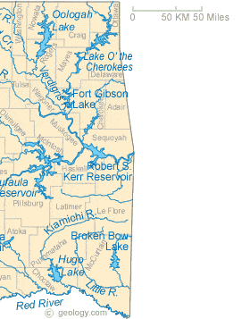
Next to lithology and geographical history, the movement of water is one of the most powerful methods of transforming landscapes. The state of Oklahoma lies within two major river basins, the Arkansas River and the Red River. The Arkansas River flows across the state until it joins with the Mississippi in Arkansas, while the Red River forms part of the southern border between Oklahoma and Texas as it flows into Louisiana. Region 3 is almost entirely within the Arkansas River drainage, as is a significant portion of Region 6. Within this area there are numerous streams and tributaries to the Arkansas River, the most prominent of which is the Neosho River which drains most of Region 3, but also includes the Illinois and Verdigris Rivers flowing from the west, and the Fourche Maline Creek flowing from the valley between the Sans Bois Mountains and the Ouachitas. These water sources have been subject to an intensive system of water management from 1941 through 1974, resulting in the creation of several reservoirs along these rivers, including the Grand Lake o’ the Cherokees (dammed 1941), Fort Gibson Lake (1953), Lake Eufaula (1964), the Robert S. Kerr Reservoir (1974), and Oologah Lake (1974) (OHS 2020).
Figure 2.3: Rivers and lakes of Oklahoma (Geology.com n.d.)
In the Red River basin, the streams flow south from the Ouachita Mountains. These include the Kiamichi River, the Little River, Muddy Boggy Creek, and the Washita River. As in the Arkansas River, the tributaries in this area have also been developed, with the creation of reservoirs such as Hugo Lake (1974) and Broken Bow Lake (1970) (OHS 2020).
When relating these fluvial networks to the study of rockshelter sites, the most influential factors to consider are the effects of erosion, alluviation, and dissolution. As mentioned above, the Red River drainage has higher energy due to the higher relief of the Ouachita Mountains, which results in more effective erosion (Splinter et al 2011). The distribution of the Red River tributaries corroborates this, as in the same counties where there is the least amount of rockshelters (Bryan, Choctaw, and McCurtain) there are the highest density of streams, flowing south from the Ouachitas’ slopes. This higher energy fluvial system is therefore a likely factor in erosion, limiting the stable formation of overhangs or caves in the region, and carrying sediments south, creating continual layers of sediment throughout the Mesozoic, and thick layers of alluvium during the formation of the Red River (Johnson 2008).
In Region 3, however, the lower energy water network promotes slower erosion and more stable rockshelter creation. Without the decreased risk of overhangs collapsing or being buried when compared to Region 6, there is the opportunity for more rockshelters to continue to the present, instead of getting infilled or having banks fall into the streambed. The increased density of calcareous marine limestone in this region also means that, in addition to limestone rockshelters being carved by fluvial erosion, there is the increased probability of dissolution occurring to create overhangs, caves, and other karst features (Splinter et al 2011).

Modern Ecology of Eastern Oklahoma
During the late Pleistocene, cold, wet conditions were prevalent across the Midwest, with extensive pine forests covering the landscape (Albert and Wyckoff 1984). Warming trends and a shift in global temperatures began to result in a warmer, wetter environment, which was interrupted by a return to a glacial climate approximately 12,900 to 11,600 years ago in the Younger Dryas (Alley 2000). After the Younger Dryas had passed, temperatures rose again, and, Oklahoma’s environments transitioned into a mosaic of grassland and oak forests, with the trees getting particularly dense in river valleys and highlands.
Today, Eastern Oklahoma is one of the most ecologically diverse areas of the state. This is at least partially due to the geological history of the region creating a variety of topographies. In a small region of the state, you can find plains, valleys, mountains, and plateaus all tightly clustered together. In addition, this region is also the most forested section of Oklahoma, with oak and hickory hardwoods in the northeast and pine forest in the southeast. Further to the west, the terrain flattens and steadily gains elevation, and gives way to a forest/prairie mosaic termed the Cross Timbers (Johnson 1995, Woods et al 2005). The variations between these different ecological systems are termed ecoregions; the ecoregions of Eastern Oklahoma are summarized below.
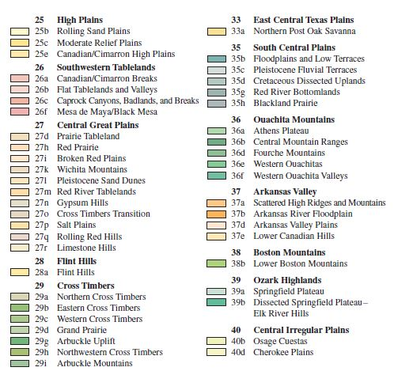
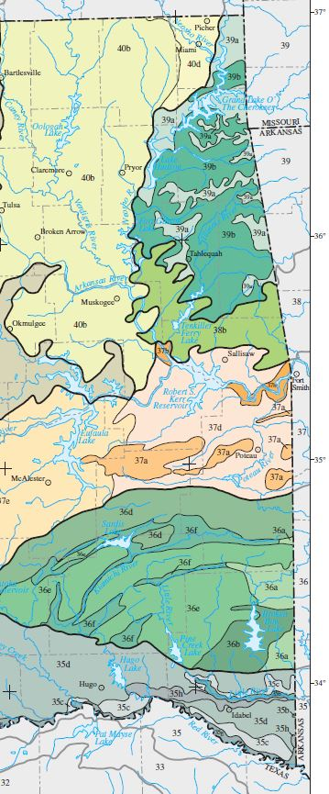
Figure 2.4: Ecoregions of Eastern Oklahoma. Woods et al 2005.

Ecoregions
Region 3 ecoregions
The Central Irregular Plains (40b and 40d on Figure 2.4)– This ecoregion is a band of prairie grasslands between the Cross Timbers and the Ozark Highlands and Boston Mountains. The Osage Cuestas (40b) make up much of this ecoregion, a wide stretch of tall-grass prairie over irregular stretches of sandstone, forming east-facing escarpments and hills. Plant species associated with the Osage Cuestas consist mostly of tall grass prairies, dominated by bluestems, switchgrass, and Indiangrass, but in floodplains or on hills grow bottomland forest or dry upland woodlands. These forests feature an array of food trees, including hackberries, pecans, and walnuts, as well as a variety of hardwood trees such as boxelder, silver maple, bur oak, Shumard oak, American Elm, sycamore, and eastern cottonwood.
The Cherokee Plains (40d) consist of a small portion in the west half of Ottawa County and consists of similar vegetation over flatter plains and wider valleys which grow hackberry, black walnut, and pecans.
The Ozark Highlands (39a and 39b on Figure 2.4): This ecoregion consists of a level to highly dissected plateau of cherty limestone. This ecoregion includes most of the rest of Region 3, including the entirety of Delaware and Adair Counties, and the eastern portions of Ottawa, Mayes, and Cherokee Counties. This region is a medley of 39a, or the Springfield Plateau, and 39b, the Dissected Springfield Plateau-Elk River Hills. Vegetation in the uplands largely consists of oak-hickory-pine forest with black, white, blackjack, and post oak and shortleaf pines, while vegetation in the floodplains and slopes includes bottomland species such as maple, American elm, sycamore, and willow.
Boston Mountains (38b on Figure 2.4) – This ecoregion in Oklahoma technically consists of the Level IV ecoregion of the Lower Boston Mountains. It is comprised of a deeply dissected sandstone mountainous plateau, covered in oak-hickory forest. It is relatively small, covering small portions of southern Adair County and southeast Muskogee County, the southwest half of Cherokee County, and the northern half of Sequoyah County. It is primarily defined as a border ecoregion, consisting of a mosaic of woodland and forest that is geologically distinct from the Ozark Highlands, and has a different vegetation regime than the Ouachita Mountains and the Arkansas Valley to the south.
Region 6 ecoregions
Arkansas Valley (37a, 37b, 37d, and 37c on Figure 2.4)– This ecoregion is a transitional area between the Ozark Plateau and the Ouachita Mountains. This ecoregion has a wide variety of level IV ecoregions, including the Scattered High Ridges and Mountains (37a), the Arkansas River Floodplain (37b), the Arkansas Valley Plains (37d), and the Lower Canadian Hills (37e). The ecology largely consists of cross-timbers and open woodlands of oak-hickory forest in the uplands, while bottomlands contain hardwoods like hackberry, willow, and pecan.
The Scattered High Ridges and Mountains (37a) are intermixed with the Arkansas Valley Plains (37d); together they include the north half of Latimer County and the majority of Haskell and Le Flore Counties. The ecologies of 37a and 37d largely consist of cross timbers with forests of oaks and hickory in higher elevations, and oaks, sycamore, hackberry, and ash in the lowlands.
The Arkansas River Floodplain (37b), covers only small portions through Haskell and Le Flore Counties along the Arkansas River, with native vegetation consisting of southern floodplain forest of oaks, sycamore, sweetgum, willow, ash, pecan, hackberry, and elm. Meanwhile, the Lower Canadian Hills (37e) covers most of Pittsburg County, and includes cross timbers with tallgrass prairie with oaks, redcedar, bluestem grasses, switchgrass, and Indian Grass on higher elevations, and cottonwood, sycamore, oaks, willow, ash, pecan, sweetgum and black walnut.
Ouachita Mountains (36a, 36b, 36d, 36e, 36f on Figure 2.4)– A collection of folded, sedimentary Paleozoic rocks, this region is heavily influenced by topography. These mountains were part of the western extremity of the Pennsylvanian orogeny and are composed of a wide variety of rock types, including sandstone, chert, shale, quartzite, and other miscellaneous conglomerates (Banks 1990, Woods 2005). The Ouachita Mountains receive a considerable amount of rainfall and have a higher relief in terms of its elevation, resulting in its watershed possessing a higher energy than the Ozark Highlands (Splinter et al 2011).
The level IV ecoregions associated with the Ouachitas include the Athens Plateau (36a), the Central Mountain Ranges (36b), the Fourche Mountains (36d), the Western Ouachitas (36e), and the Western Ouachita Valleys (36f). Floral commonalities in these ecoregions tends to consist of upland oak-hickory-pine forests, and bottomland forests with sweetgum, willows, and oaks in lowlands, transitioning to oak savanna and grassland further west.
The Athens Plateau (36a) covers small portions of eastern McCurtain County and consists of open hills and low ridges with deep, rocky valleys, with large pools of water; notable vegetation includes loblolly and shortleaf pines mixed with the deciduous uplands, and sweetgum and southern red oak in the floodplains.
The Central Mountain Ranges (36b) cover a central portion of McCurtain County and are a set of low mountains transitioning to low hills in the south. The Central Mountain Ranges have high energy waterfalls and rapids between the narrow gaps between the ridges, and large pieces of rock can be carried down the valleys. The vegetation is divided between north and south; the northern slopes have oak and hickory forest, the southern slopes have shortleaf pine-oak-hickory forest, and the bottomlands have oaks, hickories, and sweetgum and blackgum.
The Fourche Mountains (36d) are a band of mountain ridges stretching east to west along the northern edge of the Ouachitas, bordering the Arkansas Valley through Atoka, Pittsburg, Latimer, and Le Flore Counties. The vegetation present varies along various grades and slopes, from high exposed peaks with gnarled oaks and hickory, north slopes with oak, linden, blackgum, and hickory, south slopes with shortleaf pine, to shrubs along deep slopes into floodplains with hickories, maples, ash, sweetgum, blackgum, sycamore, and shortleaf pine.
The Western Ouachitas (36e) and Western Ouachita Valleys (36f) are intermixed low mountains and valleys that cover Atoka and Pushmataha County, the southern edge of Le Flore County, and the northwest half of McCurtain County. Vegetation is typical of the Ouachita Mountains; oak-hickory pine forests in the uplands, and bottomland forests in the floodplains and uplands.
South Central Plains (35b, 35c, 35d, 35g, 35h on Figure 2.4)– This region covers the territory south of the Ouachita Mountains to the Red River, and thus Oklahoma’s southern border. This area is defined by irregular plains and forests, cut by shallow valleys between broad terraces. The South Central Plains cover the east half of Bryan County, the south half of Atoka County, the entirety of Choctaw County, and the southern half of McCurtain County, and extend into Texas and Arkansas. The component Level IV ecoregions present in Oklahoma are the Floodplains and Low Terraces (35b), the Pleistocene Fluvial Terrace (35c), the Cretaceous Dissected Uplands (35d), the Red River Bottomlands (35g), and the Blackland Prairie (35h).
The Floodplains and Low Terraces (35b) are flat, broad floodplains separated by low terraces of Holocene alluvium, where water meanders and pools into floods, oxbow lakes, and wetlands, with associated floodplain forest of willows, water oak, and ash. This ecoregion is in the floodplains of the Little River in southern McCurtain County, surrounded by the Pleistocene Fluvial Terraces (35c) on the north shore and Blackland Prairie (35h) on the south.
The Pleistocene Fluvial Terraces (35c) are a flat weaving system of terraces, leveled at different strata with older and more variegated layers at higher elevations. These terraces form on the north slopes above the floodplains of the Little River and the Red River, and are populated with pine flatwoods of loblolly pine, sweetgum, and oaks, with lower elevations dipping into deciduous forests of elm, hackberry, and oaks, and wetlands in the lowest bottomlands.
The Cretaceous Dissected Uplands (35d) are rolling dissected uplands and shelf cuestas of exposed marine limestones and shale, carved by deep, slow streams that form the transition from the Ouachitas to the floodplains of the south. They are the largest component of the South Central Plains ecoregion in Oklahoma, and stretch from southern Atoka County, eastern Bryan County, Pushmataha County, and the southern half of McCurtain County. Vegetation includes oak-hickory-pine forests with shortleaf pines transitioning into floodplains of elm, hackberry, oak, and ash.
The Red River Bottomlands (35g) are the broad, flat floodplains and terraces along the Red River, full of meanders and wetland vegetation of cottonwood, sycamore, sweetgum, green ash, pecan, willow, elm, oak, and river birch. The Blackland Prairie (35h) are uplands along the south side of the Little River and beyond to the west, formed of Quaternary alluvium cut through into rolling hills and north-facing cuestas. Prior to European contact, the vegetation was prairie, but after the early 19th century it developed into oak-hickory woodlands in higher elevations and elm, hackberry, oak, and ash in floodplains and stream valleys.
Fauna and Flora in Eastern Oklahoma
The modern biomes in Eastern Oklahoma are some of the most diverse in the state, as I have described in the previous section on the present ecoregions. As a result, there was once a wide diversity of animals and plants in the area throughout most of the region’s history. Agricultural, commercial, and urban development has had a dramatic impact on the diversity of wildlife and plant life, especially in the removal or extinction of large mammals such as bison, bears, wolves, and mountain lions, but this section provides the botanical and zoological context as it existed during the pre-contact period.
Fauna
According to the Oklahoma Department of Wildlife Conservation (ODWC n.d.), the wide diversity of the ecoregions present in eastern Oklahoma supports a correspondingly wide diversity of animals, which Indigenous peoples were able to utilize. This is corroborated with the fact that deer, bison, small mammals, birds, reptiles, fish, and mollusks have all been recorded in eastern Oklahoma rockshelters. In discussing the faunal categories of the study area,.
Some prominent large mammals utilized by Indigenous people of the study area included bison and deer. In my review of the OAS site files, the bison described in the site forms are from the modern genus of bison, Bison bison, as no examples of Bison antiquus was recorded in the study area’s rockshelters. Bison were widespread throughout Oklahoma before their near-extinction at the hands of white American colonists (Albert and Wyckoff 1984).
The population of deer fared better than the buffalo and are still common. The dominant species of deer in Eastern Oklahoma are white-tailed deer, with mule deer and pronghorn antelope being more at home in the grasslands or the prairie-mosaic further west (Albert and Wyckoff 1984).
The Small Mammals category, as defined on OAS site forms, includes a wide variety of phylogenetic families, including the previously mentioned mustelids, but also includes small omnivores such as opossums, raccoons, armadillos, and skunks. These could also include lagomorphs such as the blacktailed jackrabbit, eastern cottontails, and swamp rabbits, as well as rodents such as numerous species of gopher, mice, squirrels, mice, rats, and beaver (ODWC n.d.).
There is an enormous variety of birds that live in Oklahoma including prominent game birds such as bobwhite quail, Greater prairie chicken, wild turkey, geese, and ducks.
The most common reptiles in eastern Oklahoma are turtles. Aquatic turtles include common snapping turtles, Mississippi mud turtles, alligator snapping turtles, Missouri sliders, red-eared turtles, stinkpots, three-toed box turtles, and ornate box turtle. Tortoises prefer drier habitats and are not adapted for aquatic life, and thus are not very well-represented in Eastern Oklahoma. Likewise, most lizards prefer the territory further west, and only a few species are found in the study area, such as the prairie lizard and a few skinks. Snakes do live in the study area, including various species of venomous snakes such as rattlesnakes, copperheads, and cottonmouths/water moccasins (ODWC n.d.).
The rivers of Oklahoma are rich in medium- to large-sized game fish, including numerous species of bass, catfish, and sunfish (ODWC n.d.). They also feature various mollusks, such as mussels, distinguished by usually being longer than they are wide, and clams which are rounder or wider than they are long. Native species include Neosho mucket, rabbitsfoot, scaleshell, winged maple leaf, monkeyface mussel, and Ouachita rock pocketbook (ODWC n.d.).
Flora
There are many non-domesticated plants native to the study area that are edible or have other uses, including herbaceous plants, tubers, nuts, berries, and fruits (Gilmore 1919, Kane 2021). Notable examples of these plants in the archaeological literature associated with rockshelters are the cultivated amaranth (Amaranth hypochondriacus) and chenopod (Chenopodium berlandieri) found in the northwest Ozarks (Fritz 1984). The majority of these plants can be found across Oklahoma, but chenopod has a denser distribution in Region 3, and American lotus is more common in Region 6 (Kane 2021).
However, only a limited number of possible food plants require grinding or pounding to make them digestible:
Plants that require pounding or cracking include black walnut (Juglans nigra), hickory (numerous species in genus Carya), pecans (Carya illinoinensis, though these can be opened by hand), and persimmon (Diospyros virginiana) (Kane 2021).
Plants that require grinding include amaranth, cattail root (Typhus latifolia), chenopod, hackberry (Celtis occidentalis), American lotus (Nelumbo lutea), peppergrass (Lepidium densiflorum and virginicum), and sugarberry (Celtis laevigata) (Kane 2021).
Table 2.2 Sample local medicinal plants that require pounding/grinding (Gilmore 1919)
Species | Treatment
Jack-in-the-pulpit Arisaema triphyllum | Eye treatment
Heartleaf four-o-clock Mirabilis nyctaginea | Parasites, swelling
White prairie clover Dalia candida | Stomachache
Kentucky coffeetree Gymnocladus dioicus | Laxative
Butterfly weed Asclepias tuberosa | Lung conditions
Bush morning-glory Ipomea leptophyllia | Psychoactive, fever
Plants that can be either ground or pounded include greenbrier (Smilax bona-nox), acorn (numerous oak species in genus Quercus) (Kane 2021).
For non-food plants, numerous species in the area were utilized in the form of medicinal plants, fibers, and cosmetics (dyes, perfumes, hair styling) (Gilmore 1919). Medicines which required crushing, pounding, or pulverizing included the sample listed in Table 2.2, and more (Gilmore 1919). Plants that were used for fibers to make rope, cords, and clothing included bark fiber from elms (various species in the genus Ulmus), basswood (Tillia americana) or nettle (Urtica gracilis). Lichens and black walnuts could be used to create various dyes, usually yellow, red columbine (Aquilegia canadensis) could be used for perfumes, and wild bergamot (Monarda fistulosa) could be used for hair styling (Gilmore 1919).

Chapter 3: Archaeological Context
As the previous chapter detailed the environmental and geological context of the BRM-containing rockshelters of eastern Oklahoma, this chapter will describe the cultural and archaeological context of BRMs, rockshelters, and the study area. This chapter’s primary focus is to provide the background necessary to introduce the concepts that shape the seven implications outlined in the Introduction.
Archaeological Theory Framework
When discussing the people and cultures of the past, I and other archaeologists view them through different lenses, shaped by our experiences and our training. As I write about the cultures and periods in this chapter, I acknowledge that I am doing so with individual, personal objectives and concepts already in place. Therefore, it is appropriate for me to make these factors explicit and delineate the lines of archaeological theory that I am following for the rest of this chapter and this thesis. For the purposes of this thesis, I am relying most heavily on the processualist-rooted principles of behavioral ecology and the post-processual perspectives of feminism, social and sanctified landscapes, and cultural reproduction through habitus.
Evolutionary ecology
Evolutionary ecology is a contemporary expression of processual theory, and covers a broad variety of approaches, including central foraging theory, optimal foraging theory, and diet-breadth theory. Central foraging theory attempts to model subsistence systems by assuming human beings attempt to obtain the most resources using the least amount of energy and time (Gremillion 2002), and how they make decisions about collecting food, water, tool raw material, and other things from the environment.
These decisions can be described in terms of optimal foraging theory models. Optimal foraging theory suggests that human beings will favor foraging strategies or movement patterns between patches that maximize returns for the minimum investment of resources (typically designated as calories) (Smith 2015). As an example, if a dense patch of highly-desired resources was considerably further away than a patch of less-desirable materials, the decision would be weighed according to efficiency.
An adaptation of optimal foraging theory is known as diet-breadth theory, where resources are ranked as higher or lower priority in terms of energy invested to obtain them, based on both cultural preferences (as interpreted through middle-range theory), or processing costs/nutritional value (Gremillion 1996). For instance, a certain food may not provide as much calories as a lower-ranked one, but if cultural preferences rank it as a prestige item it will be ranked higher, and people will put more energy to acquire it. But if that prestige food becomes scarce, then the more nutritional food rises in rank and more energy will be dedicated to acquiring it.
Post-Processualism
On the other hand, I am a romantic, and I think it is necessary to consider other elements of human existence than sheer efficient calculation. People are not automatons who always follow the most mathematically, calorically balanced path, individuals make illogical decisions all the time. People can have opinions or feelings about rockshelters beyond their use solely as a dry roof, or BRMs beyond just a hole in the rockshelter floor to grind corn or pound nuts. Post-processualism attempts to challenge the concept that archaeological studies are objective or infallible, and that there can be valuable information that can be accessed beyond raw, mathematical data.
For the purposes of this thesis, I define post-processualism as a collection of theories that critique the objectivity of positivism and the study of archaeology exclusively as a science. While post-processualism uses many of the scientific techniques of the past, it also challenges some of the techniques and perspectives of processualism. These challenges take shape in the recognition that many areas of anthropological and archaeological study get overlooked due to unconscious (or conscious) biases in research. This includes the importance of gender, agency, power and conflict, and symbolism and meaning (Hegmon 2003). Archaeological sites can have meanings and interpretations beyond what is present at the site; a pottery sherd can be a product of resistance or cultural retention in the face of change (Pauketat and Emerson 1991), and a lithic accumulation can be a sign of intercultural contact (Ballenger 1998).
. Accepting the ambiguity of the archaeological record and acknowledging the potentialities of these cultural interpretations is the key to painting colorful, meaningful pictures of the past, enabling the conceptualization of complex, evolving social and cultural associations with rockshelters, instead of being limited to the depiction of rockshelters as solely a roof over your head while you shell mollusks or skin rabbits. And it is the key to asking deeper questions about BRMs, a feature previously dismissed as having purely economic, utilitarian functions.
It is these two perspectives of behavioral ecology and post-processualism that I will utilize for the remainder of this thesis, as I work to understand the functions and significance of BRMS at eastern Oklahoma rockshelters.

Rockshelter Archaeological Context
While BRMs are their own features and will be elaborated on separately later in this chapter, when BRMs are found in rockshelters or other sites they are often dependent on the conclusions that can be drawn from the associated site. Therefore, it is necessary to review the archaeological context of rockshelter sites prior to reviewing that of BRMs.
Early and processual rockshelter archaeology
Archaeological study of rockshelters began in 1868, when a set of rock paintings in a cave in Altamira, Spain, triggered a tidal wave of controversy about their age, whether they really could have been made by Paleolithic peoples or if they were of more recent origin (Watson 2001). While that debate was hotly debated, after the furor and conflict faded rockshelters remained extremely understudied. They continued to be studied by archaeologists who mostly saw them as tight, dark, damp places that were places of utter last resort only used by the truly desperate (Watson 2001).
During the 1920’s and 1930’s archaeologists stepped up their studies of rockshelters, seeing both their significant potential as places where fragile, non-lithic artifacts could be preserved, and that rockshelters served as living spaces for the people who used them (Harrington 1924). As a result, when WPA salvage archaeology began to be implemented in the US during the Great Depression, rockshelters were one of the prime targets for WPA excavations, especially in the Southeast (Hollenbach 2009).
Rockshelters have been assessed and analyzed through all the major archaeological theory movements and paradigms in the 20th century; cultural-history (Harrington 1924), processualism (particularly middle range theory and behavioral ecology) (Sherwood et al 2004, Martin 1993, Binford 1978, Gorecki 1991), and post-processualism (Claassen 2011, Hegmon 2003). Each has its own strengths and weaknesses, and each can still be used in combination with other theories depending on the research question. But there are several developments in rockshelter research that all theories have the capacity to utilize in some form or other.
One of these developments is in the form of specialized geoarchaeology. Depending on the energy of the fluvial and colluvial deposition processes, the depth of sediments in rockshelters can vary to wild extremes, going from completely empty and exposing the bedrock, to completely infilled and buried by the neighboring stream or river (Farrand 2001, Sherwood et al 2004). This means that there may be instances of rockshelters that had habitation where all artifacts and features were washed away; this might be exceptionally prevalent in Oklahoma in rockshelters near reservoirs, as water levels rise and fall. Additionally, there may be rockshelters with evidence of human habitation that are completely infilled, buried under the surrounding sediment, or under a completely collapsed roof. This dynamic nature of the sediments makes even shallow deposits very complex to interpret.
The geometry of the rockshelter itself has important implications. Caves and rockshelters share some anthropological similarities, though for the purposes of habitation most activities generally take place closer to the entrance, where there is usually more space and more light. Both rockshelters and caves have this area, where people cook, clean, make fires, tell stories, with larger openings or spaces being able to host more people and more activities (Gorecki 1991). However, most caves have at least some spaces that never receive natural daylight, usually called a dark zone (Goldberg and Sherwood 2006, p20, Moyes 2012 p. 6). While archaeological evidence is rare, the utilization of deeper segments of caves is possible. Examples include numerous rock painting sites in Europe, and the artifacts excavated deep within Dust Cave in Kentucky, very far into the dark zone (Sherwood et al 2004).
Since rockshelters serve as geographically fixed points in the environment (Gorecki 1991) as well as ideal preservation environments for palaeoecological data, they can be useful for revealing what resources were available and which resources people were using or not using. Palaeoecological data has helped shift perspectives of rockshelters away from considering them as solely hunting camps, but also as places where plant foods were collected, processed, and cooked (Fritz 1984). Numerous researchers have utilized the concepts of evolutionary ecology and optimal/central foraging theories when studying rockshelters. Examples in the Southeastern US included the work of Rees and Brandon (2017) who elaborated on Harrington’s cultural-historical examination to refine the image of the inhabitants of the Ozark rockshelters and used their subsistence strategies to link them to Caddoan populations. Hollenbach (2009) used rockshelters in Alabama and Arkansas to model foraging strategies in the Tennessee River Valley. Walthall also used rockshelters to examine changes in subsistence strategies at the Holocene boundary (1998).
The preservation properties of rockshelters also make them ideal places to study diet and resource use using optimal foraging theory models. Such models assess the decisions about which rockshelters are actually used. Rockshelters are natural formations created by erosion or dissolution; however, what defines a rockshelter as an archaeological site is the presence of human activity in it. There are many overhangs and depressions, but only some were used by people. Behavioral ecology would suggest that the ones selected for use offered some advantage not offered by the others, possibly in terms of accessibility, available resources, size, or internal climate (Rees and Brandon 2017, Gremillion 1996).
An optimal foraging theory model would suggest that the rockshelters that were chosen to be used were the ones that were centrally positioned vis a vis a resource patch, increasing the efficiency of foraging in that area by providing a shelter to return to after every foray (Gamble 1991). When using diet-breadth theory, the presence of preserved early domesticated plants in rockshelters assists archaeologists who are interested in the transition between staple foods, especially from hunting and gathering to an agricultural pattern of subsistence. When preserved domesticated or cultivated plants supplant naturally occurring ones (Gremillion 1996 and 2002, Fritz 1994, Auban et al 2001),this suggests that these plants were beginning to be ranked higher than others, and thus more energy invested in their acquisition and use. Thus, if preserved plants or plant matter are found in rockshelters, they can provide valuable contributions to the diet-breadth field or other subsistence-focused theoretical approaches.
Post-processual perspectives on rockshelters
As envisioned by traditional cultural-historic and processual theorists, rockshelters were men’s spaces, used as temporary camping spaces while hunting for animal game (Binford 1978, Gorecki 1991, Greer 1976). Post-processual studies by Claassen (2011), Turpin et al (1986), MacDonald et al (2009), and many more have challenged this male perspective and provided evidence that the use of rockshelters was actually much more complex. Rockshelters could also function as women’s spaces of birth and childbirth (Greer 1976, Claassen 2011, MacDonald et al 2009)., sanctified and symbolically rich interment sites, and places of spiritualism and worship, frequently in conjunction with the previously proposed function of a temporary logistical hunting camp. Rockshelters were also places of women for growing and processing plants (Fritz 1994, Gremillion 1993 and 1996) and for preservation and storage (Homsey-Messer 2015, Walthall 1998).
The division of labor between gender can appear in the archaeological record in the form of differentiation of artifacts. Some societies have more intense gender segregation, some have less, or have different expressions (Conkey and Gero 1997). If we assume the division of labor by gender is highly visible in BRM rockshelters, there may be evidence of negotiable but fixed divisions of labor. In these cases, such as with Mississippian Tennessee, women were running domestic operations and cooking, and preparing pottery, basketry, animal skins, and men were toolcrafting, constructing domestic and public buildings, and engaging in hunting and warfare (Polhemus 1998).
An association of rockshelters and caves with supernatural forces or spiritual devotion is well-documented around the world and through time, from Africa (Walker and Thorp 1997) to Malaysia (Hobbs 2012), from Ireland (Dowd 2008) to Australia (Taçon et al 2012), from Nebraska (Sundstrom 2003 and 2004) to the Andes (Craig 2012). Interest in the ritual or religious utilization of rockshelters and caves of the Southeastern United States and the Ozark region has resulted in a large body of research from which we can determine some characteristics of a spiritually significant site.
As a summary, rockshelters with readily identifiable symbological or spiritual significance in the Ozarks featured (from Sabo et al 2012):
1. West-facing aspects
2. Steeper terrain, 11-35% slopes
3. Rockshelters featuring rock art are located farther away from water, about 900 meters or less
4. Rockshelters containing interments are much closer to water, being less than 300 meters from the nearest stream source.
5. Artifacts associated with Mississippian funerary practices were in high density, and usually include Southeast Ceremonial Complex motifs.
Sabo and his other researchers chose rockshelters that had plainly visible evidence of intensely spiritual or cultural impact, featuring rock art or interments to distinguish culturally or religiously significant sites.
However, there is another approach. If the rockshelters were used by people coming from the Great Plains instead of the Arkansas Basin mound sites, they may have different characteristics for denoting whether BRMs in those rockshelters were culturally significant or not.
Great Plains rockshelter archaeology has faced some obstacles, primarily because there are few suitable rock formations in which rockshelters formed. As a result, the definition of “cave” or “rockshelter” is even broader and more nebulous than in the rest of the world and includes such features as capstone gaps or narrow valleys (Blakeslee 2012).
The rockshelter sites with cultural or spiritual meanings are thinly spread across the Great Plains and reflect a number of different belief systems (Blakeslee 2012). Therefore, it is difficult to say whether the people using rockshelters in this broad region had the same relative cultural unity as the rockshelters described in the Ozarks. But some beliefs surrounding rockshelters have been to some level preserved, at least from Great Plains groups like the Cheyenne, Hidatsa, and Pawnee (Blakeslee 2012), and passed down to the present day.
To these groups, underground spaces were places of origin, where game like buffalo would emerge or where their ancestors walked out into the wide world, such as Tule Canyon on the south bank of the Red River (Blakeslee 2010, p. 93). These sites could be of many designs, sizes, and features, both naturally formed and adapted. One particularly compelling feature of one such spiritually significant site where the bedrock was altered is a small cave near Quitaque, in roughly the same area as Tule Canyon. This cave was described as positioned halfway up a cliff face, and to reach it someone took the time and effort to carve steps and handholds, suggesting that the site was important enough as to make these access features permanent (Blakeslee 2010, p.93). In this case, there is some similarities with the Ozark tradition, of having culturally significant rockshelter sites located in steep, difficult to climb cliffs.
For the Pawnee, it was understood that rockshelters, caves, and springs were places where spirit or animal lodges were kept, and they were places of healing (Blakeslee 2010 p. 94-103). One of the most significant Pawnee sites affiliated with the underground is Wakonda Springs in southern Kansas, much closer geographically to the Eastern Oklahoma study area than the Tule Canyon or Quitaque site. In Wakonda Springs, it was understood that a large animal lodge was established there, founded and led by a white beaver and hosting a panoply of other animal spirits. The water from underneath was used to bless children or infants, create face paint, or dip their arrows to imbue them with power (Blakeslee 2010 p. 101). It was also a place where people would treat the sick, combining the water from the springs with medicinal plants to create especially effective cures, elevated by the benevolence of the various animal spirits who lived there (Blakeslee 2012 p.356).
When comparing these Great Plains rockshelter sites with the Ozark tradition previously described, there are some similarities and some differences. Rock art appears frequently in Great Plains rockshelters (Blakeslee 2012 p. 360), and like the Ozarks some of them have obstacles of some kind to access or are associated with water. However, an important difference between Great Plains cultural rockshelter sites and the Ozark tradition is that they did not frequently inter their dead in such places, according to both the Cheyenne and Pawnee (Blakeslee 2012 p. 354). This is a significant distinction, and makes detecting a culturally significant rockshelter, and thus the BRMs within them, a little more difficult, as rockshelters without interments, or rock art, or any obstacles of any kind may still have been places of intense cultural importance.
To discern such places, Plains rockshelter archaeology has depended more on artifacts than the features of the rockshelter itself. According to Blakeslee (2012, p. 360), offerings and deposits of artifacts were important features in rockshelters that were understood to be shrines, particularly shells or shell artifacts such as beads, arrowpoints, pottery, and pipes. There may also be evidence of structures constructed in a shrine, similar to the Gotschall Rockshelter wooden platforms in southwestern Wisconsin (Naumann 2008). As such, our expectations for assessing the cultural significance of a BRM rockshelter would depend on concentrations of these types of objects.
Bedrock Mortar Archaeological Context
Behavioral ecology
From a behavioral ecology perspective, BRMs are defined by being deliberately, permanently emplaced features, placed where resources were plentiful or predictable, and where people would be returning repeatedly to use them (Manchen 2015). This perspective proposes that the investment of intensive time and energy into creating an immobile BRM was worth the rewards that were able to be obtained by using that feature (Schlanger 1991, VanPool and Leonard 2002). This decision would also include weighing the costs and benefits between crafting an immobile BRM instead of carrying a portable groundstone metate, calculating whether it is more efficient to create a BRM that you can travel to repeatedly, or to carry a heavy piece of equipment repeatedly back and forth during logistical expeditions. Research on specialized groundstone grinding basins in Mexico (VanPool and Leonard 2002) have proposed that the larger and heavier a metate is, the more stable it is, and thus more energy is directed into grinding, rather than using additional energy to keep the metate from rocking or tipping. In cultural ecological terms, this is another example of cost/benefit analysis in determining whether it is worthwhile to make large or immobile grinding surfaces versus light portable ones. In those same studies in Mexico, metates used in longer-term settlements were deliberately and thoughtfully designed for extended, long-term use with the capacity to be retouched and maintained, versus smaller, more expedient metates used at “temporary” sites (VanPool and Leonard 2002).
The material itself is an important consideration in the decision-making process. Not every type of stone is suitable for using as a BRM; according to research regarding BRMs in Cuyamaca, California, the ideal bedrock and groundstone grinding surfaces are formed in porous, durable rock (Manchen 2015, p. 12). To be effective and efficient grinding surfaces, the bedrock must be durable enough to be able to resist becoming worn smooth and polished like softer sandstones, which would make grinding ineffective. However, rocks that are too rough or large-grained can potentially break off small pieces and become mixed in the material being processed, potentially resulting in tooth damage.
Size is a component of efficiency as well, in terms of available grinding surface area and the amount of material that needs processing. Making a BRM too large for your needs is wasteful, and one that’s too small is inefficient in terms of time and energy invested. Groundstone basins from Ethiopia, for example, represent a heavily agricultural culture, processing large amounts of small-grained material as a staple of their diet. These tools have an average of about 1660 cm² of surface area (Nixon-Darcus and D’Andrea 2017). In another example, in Cuyamaca, California, the BRMs there represent intensified acorn/mesquite processing, which while still large in volume are not consumed in the volume as in Ethiopia. The grinding surfaces in Cuyamaca consist of ovals with surface areas that average out to about 1,112 cm² (Manchen 2015). On the other hand, Australian BRMs represent features used for small amounts of a wider variety of materials and have an average of about 706 cm² (Hayes, Pardoe, and Fullagar 2018).
The cross-sectional forms of BRMs are also created according to similar efficiency decision-making. For hard materials that need to be pounded, a metate shaped BRM is not as efficient as deeper, narrow mortars. The deeper shape makes pounding more efficient by directing the downward strike to a smaller surface area, subjecting the material to higher impact force and preventing it from losing effective impact energy by having the material fly outwards (Ebeling and Rowan). For small-grained materials like small seeds or maize, maximizing surface area is the key, allowing maximum contact between the basin, the metate, and the material being processed (Diehl 1996). A more formalized shape conforms to the most efficient movements needed to process the materials; trough-shaped basins begin arising as the need for back-and-forth grinding develops, the most efficient way to grind large quantities (Adams 1993, Diehl 1996).
Shape is also affected by the variety of materials being processed, where someone processes a different substance on each visit instead of using the same substance for the same BRM every time. According to behavioral ecology, for places with diversified uses it would be a waste of energy and time to make a specialized, formalized BRM like a fine-grinding metate shape, or a directed deep pounding mortar shape (Hayden 2017), so we get a more generalized, scoop or half-sphere-shaped feature that can be used for both grinding and pounding but isn’t as optimized for either as a more diagnostic shape.
Post-processualism
One benefit of the study of BRMs being so recently introduced to archaeology is they have had the opportunity to be studied through various post-processual perspectives. BRM’s had not previously been given much academic attention, presumed to just be simple food processing sites, but looking at them through a different lens suggests that BRMs may have been the sites of activities rich with sociocultural implications. These implications could derive from the presence, positioning, and number of BRMs, as well as from the substances being processed in a BRM, including food and medicines, pigments, hides, plant fiber or other materials that were being used for non-food purposes (Buonasera 2011).
Part of the nascent origins of BRM research is the narrative about how processual, behavioral ecological perspectives of food as a quantifiable resource transitioned to discussions and perspectives on the social dynamics of cooking and cuisine. In a behavioral ecological perspective, food is a calculation, the net balance of calories invested versus calories obtained. This was in part due to something of a research bias of men considering cooking to be a fully pragmatic experience, a survival tool in which the procurement of calories was more interesting and prestigious than how they were cooked and processed at home (Graff 2020). Nonetheless in recent years we have come to recognize the true intricacies inherent in the “tools, gestures, timing, and ingredients” (Gragg 2020:343) involved in the reproduction and the evolution of cuisine. If we view BRMs as primarily food-processing features, then it is important to understand what it meant to be using it in the first place.
We can first view food preparation as a sustaining, reiterating activity. When people cook food, they are not only doing so to render the calories in the ingredients edible, but they are remembering and reproducing the techniques they learned and passing them on to the future. All the knowledge of what to eat, how to prepare it, is part of a chain of habitus, the daily rituals and patterns that help shape our understanding of the world but can shift through time (Graff 2020).
This is indirectly observable in the changes groundstone technology can undergo, to change shape as a certain food source grows in importance, such as the Southwest metates becoming more oblong (Diehl 1996) or shifting bedrock mortars away from remote places in boulders and caves to villages and homes in the Neolithic Levant (Rosenberg and Nadel 2017b). It also appears in the level of dedication, skill, strength, and time towards constructing BRMs in the first place (Rosenberg and Nadel 2017a). The fact that a “correct shape” for a BRM can change over time is due to cultural concerns just as much as practical considerations.
These sociocultural communications are not only passed down through time, in vertical cultural transmission, but across space as well through transmission through social networks in horizontal cultural transmission . BRMs provide some of the most durable evidence of group interaction through a communal activity, as most BRM sites have many working surfaces close together. While working together, the people utilizing these BRMs would have the opportunity to have conversations and dialogues with the people around them, sharing and hearing news, stories, and reifying or reworking the social network around them, and spreading information as individuals shifted between different group memberships (Nixon-Darcus and D’Andrea 2017, Pino et al 2018, Lynch 2017). These elements are reinforced by the density of BRMs, and their proximity to each other; BRMs further apart mean it is that much harder to speak with your neighbor and could impact power and hierarchy structures by methods of inclusion or exclusion (Pino et al 2018). Different techniques or food staples can also reinforce these power dynamics, such as feasting to expand influence, or assigning preferential status of specialized cuisine consumed by the elite versus foods prepared by lower classes (Graff 2020, Mayes 2016).
As places typically associated with women, the use of BRMs opens avenues to explore a unique facet of life in the past. The presence of material-processing surfaces such as grinding slabs or pounding holes may provide suggestions of who were the primary users of a given archaeological site. However, the presence of BRMs alone does not necessarily imply that it was women using them; in some societies, such as in the southern Levant during the Early Natufian, the process of grinding is conducted almost equally between men and women, as sample of both of those genders showed similar signs of musculoskeletal strain (Ebeling and Rowan 2004). This is more of a reminder of the differing role of women and men through time than to claim this pattern also existed in Eastern Oklahoma; the Levant Natufian people using these BRMs were early-stage Neolithic peoples, with some elements of gender egalitarianism still in place. Societies with more intense divisions of labor will have more distinctly gendered artifacts and features..
Another cultural spatial utilization of BRMs could include the creation of a soundscape. There has been increasing research on the soundscapes associated with BRMs and groundstone food-processing events; these sounds could include using singing along with the sound of grinding and pounding and making it into a rhythm, as has been recorded in Sumerian texts (Bombardieri 2019), or the pounding/grinding was amplified and broadcast by the shape of the rockshelter, using the roof as a lithophone (Till 2014). The use of instruments may also have been used to help coordinate or elevate the experience of the event (Bombardieri 2019). Or the BRMs themselves could have been used as instruments, as in the example of Late Natufian BRMs and their association with burial ceremonies in the southern Levant. In this example, enormous limestone boulders located near burial sites have deep, round holes bored into them, relatively easy to drill, but also somewhat fragile, as some have the bottoms shattered or the walls cracked (Rosenberg and Nadel 2014). The authors proposed that these BRMs were used during burial rites, processing food or substances used during the ceremony, with the soundscape consisting of “the sounds of actual pounding accompanying these ceremonies may have been used to signal members of the relevant group that such events were taking place and together with the material processed, designated either to the living and/or the dead” (Rosenberg and Nadel 2014:798).
Cultural History Context of Eastern Oklahoma
PaleoIndigenous Period: 13,000 to 7,000 BCE
There are a few contested examples of sites in Oklahoma or the southern Great Plains that are claimed to pre-date Clovis, such as the Friedken site in central Texas which was dated from 14,000 BCE (Jennings 2012) and the Burnham Site in western Oklahoma, which was dated to about 35,000 BCE (Wyckoff et al 2003). However, Clovis still remains the most recognizable, widespread manifestation in the early peopling of North America. Numerous Clovis sites put the widescale introduction of people arriving in Oklahoma approximately 13,000 to 12,000 BCE (Waters et al 2020). This period is most clearly identified through unique styles of projectile points and the association of human-made artifacts with extinct megafauna at the termination of the last Ice Age, and the transition of a warming climate and the extinction of those megafauna marking dramatic changes in economy and toolkits, such as the expanding toolkit demonstrated by the Dalton culture (Ballenger 2001).
The PaleoIndigenous Period was characterized by high mobility, low density hunting-gathering, and is frequently assumed to have been socially and sexually egalitarian (Carlson and Bement 2018). This is supported largely by evidence of a wide distribution of Paleoindian projectile points with very little variation in the style and construction of their lithics (Walthall 1998), although increasing variation is demonstrated by increasing diversity in projectile forms during the middle (Folsom, Plainview) and late Paleoindian (Dalton) period that correlated with an increasing diversity of ecological zones during the post-glacial period. (Walthall and Holley 1997, Walthall 1998).
Figure 3.1: Dalton PaleoIndigenous projectile point (Illinois State Museum 2006)
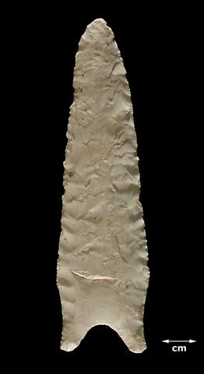
In eastern Oklahoma Dalton points (Figure 3.1 above) and adzes provide an excellent example of this regionalization and specialization. Dalton lithics and a diagnostic adze present a possible intensification of aquatic resources as opposed to hunting large megafaunal mammals, with adzes possibly used for the construction of dugout canoes or watercraft (Yerkes and Koldehoff 2018, Morrow 2014). Additional research in the Arkansas Ozarks suggest that rockshelter use also began to dramatically intensify during this time, as many rockshelters contain Dalton components (Walthall 1998), many times more than rockshelters with older Paleoindian components. This regionalization and specialization trend would continue into the Archaic period.
Archaic Period: 7,000 BCE- 1 BCE
The Archaic Period in Oklahoma saw increasing complexity of foraging societies, as well as the introduction of new technologies and economies (Phillips 2019). During the Archaic that lithic projectile point types diversify, and the first signs of groundstone artifacts begin to emerge, as well as the first evidence of plant domestication.
The line separating the Late PaleoIndigenous and Early Archaic Periods (about 7000 to 4000 BCE) (Sabo et al 2012, Phillips 2019) in eastern Oklahoma can be vague and difficult to discern, as populations were still residentially mobile, moving between established campsites and sending logistic expeditions to hunt and collect floral and lithic resources (Larson 1997) While still fairly mobile, Archaic societies were becoming bounded into regional territories, thus limiting economies to localized resources, such as local Ozark cherts (Galm and Flynn 1978). This territorialism may have promoted the development of trade networks to access resources not found locally, both as an economic development and possibly as a peacekeeping measure (Galm and Flynn 1978).
Research on sites in elsewhere in the Ozarks and the Appalachian mountain belt, including Dust Cave (Homsey-Messer 2015) suggests that while rockshelters could be revisited and used for centuries, during the early Archaic they continued in their primary role as short-term logistic camps, serving a wide variety of social and economic functions including interments, nut processing, and storage pits. During this time, elaborate projectile points termed Calf Creek (see Figure 3.2) were frequently found in association with rockshelters (Thurmond and Wyckoff 1999).
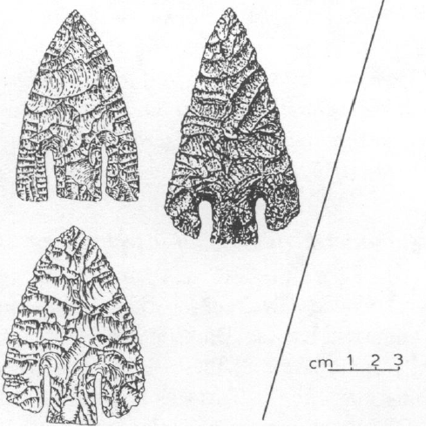
Figure 3.2: Examples of Archaic Calf Creek points (Thurmond and Wyckoff 1999: 232).
It is sometime through the development of the Middle Archaic that some of the earliest BRMs were recorded, as some rockshelters began to specialize as nut- and plant-processing sites (Homsey-Messer 2015). ,
By the Middle Archaic, about 4000 to 2000 BCE (Phillips 2019), the increased localization also demanded a diversification of subsistence; where before Paleoindian toolkits appeared to be specialized towards the hunting of large game animals, during the Archaic people began to draw sustenance from an increased diversity of sources, requiring the development of new technologies. This can be observed in the proliferation of techniques designed for river and lake environments, such as a large cache of Archaic canoes in Florida’s Newnans Lake (Wheeler et al 2003) or the Kiamichi Fish Weir of the late Archaic in southeast Oklahoma. This is also evident in the development of large shell middens that emerge from this period (Leith 2011 p. 4).
It’s also during this period in the Middle and Late Archaic that we can observe the increased use of heat-treated points and groundstone tools, especially axes and hoes which might have been introduced from developments further east (Jurney 1982). These groundstone tools also included grinding basins with manos and metates, suggesting increased utilization of plants or other materials that required specially crafted tools (Homsey-Messer 2015, Fritz 1984).
By the late Archaic, about 2000 to 1 BCE, three major cultural manifestations were present in eastern Oklahoma: the Lawrence culture in the, the Wister phase in the southeast, and a transitional form of the Fourche-Maline in the Arkansas river valley that persisted into the Woodland period and may have served as a formative period for later Caddoan societies (Leith 2011).
Woodland Period: 1-900 CE
This period saw the intensification of the trends observed in the Archaic, with increasing technological complexity and diversity (Leith 2011). The Woodland is defined by the adoption and elaboration of pottery and ceramics, as well as the development of a large-scale North American spiritual movement with the influence of Hopewell symbolism (Keener and Nye 2007). This was also the period when the bow was developed, and thus the reduction in size of projectile points from large lanceolate or dart forms to smaller, lighter, and less formalized arrow points (Lyman et al 2009). Scallorn points (see Figure 3.3) are some of the most distinct evidence of Woodland occupations in northeastern Oklahoma and are associated with rockshelters in the area. These were identified with what was termed the Cooper culture, along with Fresno points (Bell 1996) (see Figure 3.3). Meanwhile in the southeast, the Fourche Maline phase persisted well into the 9th century, establishing a position as horticulturalists who were beginning to explore social complexity, while still relying on foraging to supplement their diet (Leith 2011).
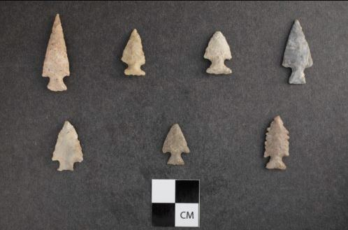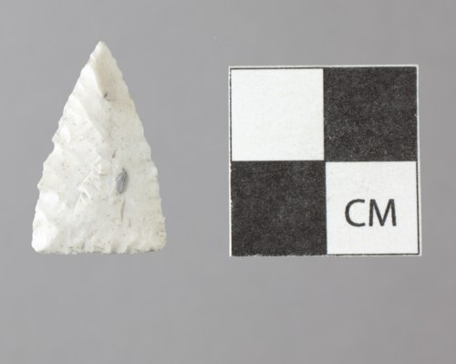
Figure 3.3: Example of Scallorn (left) and Fresno (right) Woodland points (from Kansas Historical Society)
It was also during the Woodland period that population densities began to rise in the Southeast United States, and the first establishment of longer-term settlements occurred. This increased sedentism was caused or enabled by the increased reliance on cultivation of native plants, such as chenopod, sumpweed, or sunflowers (Perttula 2008 p. 83). There is some evidence that maize was beginning to be introduced during this period (Fritz 1986), but not yet in quantity that would later be seen later during the Mississippian Period.
The development of larger, more permanent settlements shifted the primary focus of rockshelter occupation, and while they may have seen continued use as hunting camps their roles may also have become more frequently used for agricultural activities, with an increasing presence of BRMs with Woodland rockshelter sites (Gremillion 1996).
Village/Mississippian Period: 900-1500 CE
This period is marked most prominently in eastern Oklahoma with the construction of large mound sites, most famously Spiro. Much of the archaeology of this period is heavily focused on these sites, as they are a rich source of archaeological data in the form of house construction and orientation, hierarchical social systems, and advanced symbolism and elaboration of ceramic forms.
The Mississippian period in eastern Oklahoma is roughly divided into three periods, Harlan, Spiro, and Fort Coffee/Neosho foci, based on introduction of Caddoan forms of pottery and projectile points, their climax, and their decline (Flores 2020). These were marked with the construction of mounds, an intensification of farming, and the establishment of hierarchical social ranking which distinguished between higher- and lower-class economic status. These changes were suggested through evidence of differential diet, where individuals with higher status continued consuming game and wild plants, while lower class individuals relied more heavily on maize (Mayes 2016). As a result of this continued dietary diversity, rockshelters continued to be used as logistical bases for collecting local plant and animal resources (Trubowitz 1983). It is also during the Mississippian period that the presence of rockshelter interments and association with funerary rites increases; while evidence of spiritual associations could be suggested to extend back to the Archaic Period, it’s from Mississippian sites that most burials remain preserved (Sabo et al 2012). It was also a period of intense inter-regional interaction, marked by the transportation of exotic goods across North America and beyond (Lambert 2017).
Research analyzing Mississippian mound sites and their distribution in Eastern Oklahoma indicates that these major settlement patterns were most highly concentrated in the eastern portion of this study area, along the Neosho/Grand and Arkansas Rivers (Brown 1996, Kusnierz 2016). These sites include the Harlan, Norman, and Spiro Mounds, as well as smaller sites such as the Reed and Brackett Sites (see Figure 3.4).
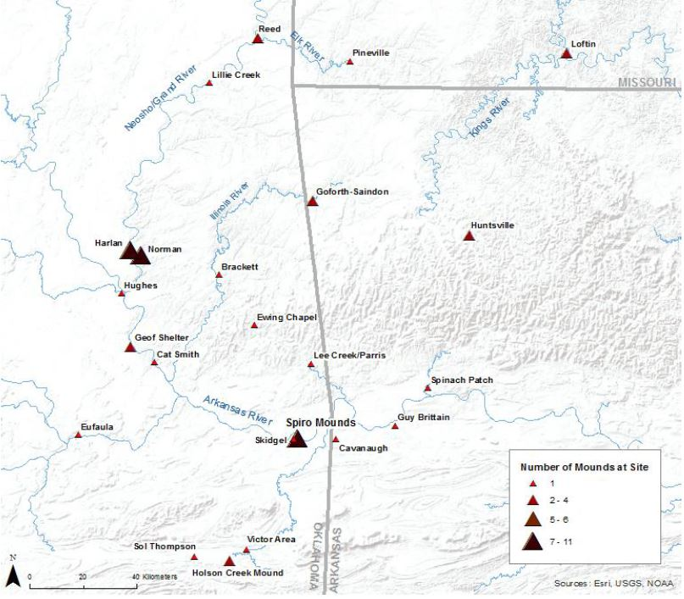
Figure 3.4: Spiroan mound sites in Eastern Oklahoma (from Kusnierz 2016, p.3)

Pericolonial Period to 21st Century: 1500 CE - Present
Population density had increased significantly by the time that Europeans began encountering Indigenous populations in this area, with records of large villages along the riverbanks belonging to the Wichita and the Caddo (Wiegers 1985). But the most powerful group in this region during the Pericolonial period were the Osage. They strongly resisted Spanish and French development in the Mississippi Basin and to the plains to the west from the 17th to the 18th century (Wiegers 1985). However, by the beginning of the 19th century they had been sufficiently weakened that their territory in Oklahoma began to be encroached by forcibly displaced Cherokee and Choctaw tribes. This process began approximately in 1824 when the Choctaw Nation was relocated to southwest Oklahoma (OHS 2020) and continuing through 1830 after the passage of the Indian Removal Act when the Western Cherokee were removed during the Trail of Tears.
During this period, Indigenous use of rockshelters continued, though in a diminishing capacity. To the Osage, rockshelters remained to be used by women as places where they could weave and make oils (Claassen 2011). However, to encroaching Euro-American settlers, rockshelters were primarily places of subterfuge, used by “Boomers” to hide from surveyors in the late 19th century, in order to stake claims to land before they were legally able to (Baird 2008)., or by outlaws and bootleggers such as Pretty Boy Floyd (Obert 2021, Wallis 1992). Otherwise, rockshelters were occasionally used as cattle shelters, but most frequently they were used as sources of artifacts for looters and pothunters, and remain some of Oklahoma’s most vulnerable archaeological sites.

Chapter 4: Methods
Summary
This chapter details the methodology that I used to collect information and analyze the BRMs in the rockshelters of Eastern Oklahoma. While the process was involved and data were collected over several years, the comprehensive data I collected on these rockshelters allowed me to analyze the trends and patterns of those rockshelters with BRM’s present.
In summary, to answer the questions posed by the seven hypotheses listed in the introduction, I needed to know, at minimum
1. Which sites in Eastern Oklahoma were rockshelter sites, and which rockshelter sites had BRMs?
2. What are the rockshelter’s properties? What are the characteristics of the BRMs associated with them? What artifacts are associated with these sites?
3. Where are these sites located?
The methodology to answer these questions unfolded in three phases. The first phase was the period of data collection, the second phase was doing basic exploratory statistics, and the third phase was plotting the sites on mapping software and understanding their geographic distributions.
Data Collection
To answer those questions, I needed to obtain a perspective on rockshelters in Eastern Oklahoma. To do so, I compiled a broad data set from the Oklahoma Archaeological Survey (OAS) archives. As a graduate research assistant there, I had the opportunity to collect data from the OAS’ facilities, under a signed agreement of confidentiality and final review with State Archaeologist Kary Stackelbeck.
To collect the sample pool for my data set, I first began to collect all information on rockshelter sites available. My primary method of data collection during this phase was the information from the OAS FileMaker Pro database and scanned site files maintained at the Survey. The FileMaker Pro database codes all recorded sites, organized by region (Regions 3 and 6, as mentioned earlier). I searched the database by the code for rockshelters to collect a list of sites that were recorded as “Rockshelters” that were listed in Region 3 or 6. It should be acknowledged that there were other sites in the database that were coded as “Cave”, but at the time I began collecting data in 2019 I believed that since caves were much more complex than rockshelters geologically and potentially archaeologically, they deserved more in-depth attention than my scope of research allowed. I also did not believe that there were enough “cave” sites to meaningfully influence my conclusions.
Next, I needed to familiarize myself with the nature of the rockshelter sites, and the archaeological context associated with them. With the sample set defined, I began to use the OAS database to assess what knowledge I needed from the site files. The fields of information I decided to collect expanded and contracted over this research and review period; but for the most part I chose fields that would be most useful in determining rockshelter use on a regional scale. These fields are included in Table 4.1 below, but in broad strokes they include the physical aspects of each site, and the artifacts, faunal remains, and floral remains that were recorded in association with them.
It was during the process of reading through the site files that I became aware of numerous weaknesses and shortfalls of using the site files only, which were only compounded when I eventually turned my attention to BRM’s as a focal point in the research. Many of the site files had been written years after the site was initially recorded, and the site may have been recorded in the 1930s through the 1970s. As a result, some of the site files did not have information fields that other, later site files had (such as the direction of rockshelter facing).
To remedy these shortcomings, I needed to organize the data. I compiled the information obtained from the OAS database and imported it into Excel spreadsheets and eventually JMP data analysis software. Part of the process of organization included converting all English measurements into the metric system, such as the site area or deposition depth. This was needed because different authors would sometimes use feet or meters as a matter of preference, so some conversion was necessary.
When BRMs became the subject of my thesis, I reviewed and collected all sites in which BRMs are mentioned in the site form or the survey report. This created a smaller subset of the larger rockshelter data set, which allowed me to look at those BRM sites in more precise detail and to compare them to other rockshelters in the region and their suggested uses.
Exploratory Statistics
Finally, with all the necessary information accumulated, I began working with the data in the JMP program. The complete dataset is included in the Appendices, but the fields compared are shown in Table 4.1.

Table 4.1: Fields included in JMP database.
General Characteristics: | Artifact Fields | Faunal and Floral Fields
Geophysical Region | Ceramics | Unknown
Ecoregion | Projectile points/fragments | Bison
BRM present | Hafted scrapers | Deer
Depth in cm | Drills | Small mammal
Area in m² | Bifaces/Fragments | Mussel/shellfish
Facing | Perforators/gravers | Fish
 | Unhafted scrapers | Bird
 | Flake debitage | Reptile
 | Core debitage | Ash
 | Groundstone | Charcoal
 | Worked bone/shell | Seeds/Nuts
 | Diagnostic identification | Baskets/fibers/other plant material

Regarding the “General Characteristics” (listed in Column 1 on Table 4.1), the “Geophysical Region” and “Ecoregion” fields were based off the maps designed by Curtis et al (2008) and Woods et al (2005). This was determined by using a Google Earth layer which had all the rockshelter sites plotted by their UTM (Universal Transverse Mercator) coordinates (see Figure 5.1). Image overlays of those maps were placed over, and the BRM rockshelter sites were emphasized to increase their visual impact and more readily identify their position.
The “BRM Present” field was filled out in binary Yes/No responses, primarily to identify which sites did have BRMs. However, this field is not on standard OAS forms like most of the other fields. Therefore, I had to read the additional grey literature of the survey reports to confirm the presence or absence of BRMs at each rockshelter site collected. If a report described at least one feature as a bedrock mortar, bedrock metate, and nutting stone, it was included in the BRM sub-dataset. The data of the rockshelters with BRMs present was copied into a separate database to conduct separate analyses from the rest of the sites. Of course, I did keep both sets of data together in the original database so I could compare BRM rockshelters with non-BRM rockshelters.
I standardized the “Depth in cm” and “Area in square meters” fields into metric measurements, and into standardized length by width square meters. The depth represents the maximum depth of deposition recorded in site forms, usually in shovel tests. Area represents the square footage of the rockshelter as measured by the surveyors of the site, the length and width of the site; very few files recorded the height to the ceiling from the floor.
I determined “Facing” by observing the slope of the landform in which the rockshelter was embedded. This information was from the USGS 7.5’ 1:26000 topographic maps on which sites were plotted by the Oklahoma Archaeological Survey (OAS). My rationale was that the erosional formation processes that create overhangs removes material from the portion of a landform closest to the fluvial source. As a result, I reasoned that the mouth of the site would be in the same direction as decreasing elevation.
. I filled out the “Artifact”, “Faunal”, and “Floral” in presence/absence responses for each category, a Yes for present, a No for not. As I was conducting research at a regional scale, I believed that the presence of certain artifacts or biological remnants was more important than the specific quantity at any given site. The “Diagnostic identification” field was labelled according to the conclusions reached in the obtained site forms and survey reports.
I did basic descriptive analysis for all these fields, determining the counts and proportions of rockshelters and their contents over the study area. Comparative statistical methods analyses were difficult to conduct due to the nature of the dataset, but I did make some attempts. For example, when comparing BRM rockshelters to non-BRM rockshelters, I used Chi-Square Test of Goodness of Fit (or Pearson’s test) to assess differences between facing.
I determined distance to water by using Google Earth to draw a measuring circle from the recorded UTM coordinates of each BRM rockshelter until it intersected with a fluvial water source. These courses were determined with KMZs available from the Oklahoma Water Resources Board (OWRB), divided into Streams and rivers, higher and lower order water systems. The river layout was published in 3/24/2020 and is updated weekly. In cases where reservoirs expanded the width of river courses, I used the lines plotted by the OWRB instead of the modern shoreline, as I reasoned they were the closest to the configuration before damming began, short of referencing historic maps. However, the results from this method should be taken as estimates, not as completely accurate values, as the original OWRB data included a disclaimer that they were “not guaranteed to be useable, timely, or complete.” For the large-scale analysis being conducted in this thesis, however, I considered it sufficiently accurate for my purposes
Finally, I determined the slope associated with each rockshelter. This was done by using Google Earth’s elevation profile function, drawing a line through the UTM coordinates angled so it was facing in the same direction as the site’s facing, using the contour lines on a topographic map layer. Since the UTM only covers a single point, not the entire area of the site, I based the slope calculation on the most intensive slope present in the profile to gain an estimate of the slope in the area. I used the highest and the lowest point of elevation as the Y coordinates, and the length along the line of those points for the X coordinates. I used the standard formula for calculating the slope of a line:
$$m=\frac{y_{2}- y_{1}}{x_{2}-x_{1}}=⁡\tan{θ}$$
Then I converted the degrees to a percent of slope value using the formula [tan (degree value)]x100. The results of these calculations are recorded in Table 5.3.
After using these methods, I now had concepts of which sites were rockshelters, what was in those rockshelters, and where they were. But the time has come to present what these methods produced.

Chapter 5: Results
In total, I recorded details of over 161 rockshelter sites that had been previously recorded in Eastern Oklahoma. Thirteen of these contained features which could be described as bedrock mortars. Figure 5.1 below presents their relative distribution.
Of these thirteen BRM rockshelters, there are six in Wagoner County(Figure 5.10), and there is one each in Rogers, Nowata, Muskogee, Delaware, Craig, Sequoyah, and Latimer Counties (Figure 5.1). All BRM rockshelters except for 34LT59 are in the northeast Region 3.
For information of these sites, all the mentioned rockshelters have their information recorded in the previously mentioned JMP database. Details on those can be reviewed in Appendix A, but regarding detailed summaries it is more fitting for the scope of this thesis to focus on the description of the BRM rockshelters being investigated
In the following section, I have included additional information regarding the year in which each site was recorded, and the authors who did the initial recording or revisits. I also include descriptions of the setting or nature of the rockshelter site itself, and any BRMs within it, concluded by the artifacts that were recorded in association. The amount of information and the level of detail can vary greatly between the various sites, but I have put forth every effort to showcase all saliant data available for each.
I have included all figures and images available to me as of writing this thesis, and images of any diagnostic material mentioned in the description. Any included sketch maps have coordinates redacted to maintain site confidentiality.
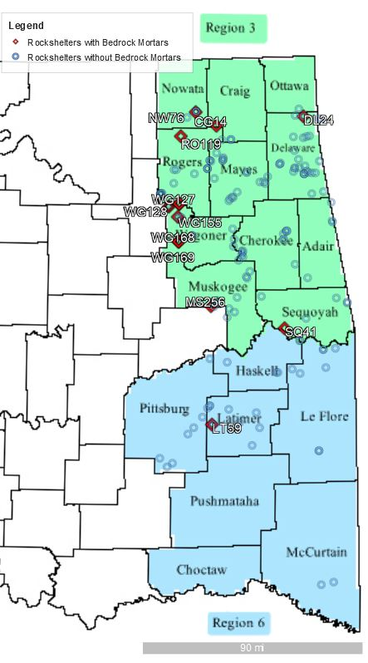
Figure 5.1: Distribution of rockshelter sites through the counties of eastern Oklahoma; only sites with BRMs have been labeled.
BRM Sites Plotted:
CG14
DL24
LT59
MS256
NW76
RO119
SQ41
WG131*
WG127
WG128
WG155
WG168
WG169

*WG131 present, but obscured by other Wagoner Co. sites; see Figure 5.10

BRM Rockshelter Site Summaries
34CG14
This site was recorded in 1976 by Patrick Harden. This site consists of two small rockshelters facing southeast, with a small heap of dirt (4m x 4m, <1m high) 30m to the south. The BRM associated with this site was described as a “4-inch (10 cm) diameter and 12-inch (30 cm) deep hole in a large sandstone slab south of the mound” (Harden 1976). In addition to the hole in the sandstone slab, one of the rockshelters had four steps carved into the sandstone leading to the ridge top. Artifacts recorded included several flakes.
34DL24
This site was recorded by David Baerreis in 1955 on the shores of the Grand Lake o’ the Cherokees, which was dammed in 1940. The BRMs associated with this site consist of two features positioned on a ledge inside of the shelter, described as “two depressions made by grinding stones” (Barreis 1955). This site is the only representative of a BRM rockshelter in Delaware County. Baerreis included a special remark, that “It might be noted that these were the only bedrock metates recorded in the survey work in this area.” No artifacts were recorded in association with 34DL24. However, in a bulletin of the Texas Archaeological and Paleontological Society (Bell and Baerreis 1955) Robert Bell and David Baerreis mentioned Delaware rockshelters and associated them with what they termed the Grove Focus, an early- to mid-Archaic cultural period. However, while “small metates and mortars” for grinding seeds were mentioned, imbedded bedrock mortars were not specified.

34LT59
This site was recorded by James H. Howard in 1977. This site consists of a deep incision into a sandstone outcrop that created multiple overhangs. The largest of these overhangs has smoke stains on the ceiling. The BRMs associated with this site are positioned on a large boulder of roof-fall, and include a large, circular depression 5.5 inches (14 cm) in diameter and 8 inches (20) in depth, and three smaller "nutting stone" impressions that are 1.5 inches (4 cm) in diameter and 1.5 inches (4 cm) in depth. Artifacts associated with this rockshelter are numerous debitage flakes of brown chert that were found on the surface of the shelter. The site was also reported to contain numerous projectile points, supposedly Gary, Scallorn, Washita, and Fresno types, as well as deer bone and shell tempered pottery sherds. According to a note on the site file 34LT59 was destroyed by pot hunters in 1979.
The loss of the site is unfortunate because the alignment of these depressions on the sandstone slab are unique in eastern Oklahoma rockshelters and is the second-highest confirmed density of depressions in a single rockshelter site. Figure 5.2 below demonstrates the alignment and position of the depressions on the sandstone slab.
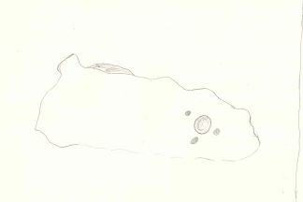
Figure 5.2- Illustration of BRM impressions from 34LT59 (from Howard 1977:2)

34MS256
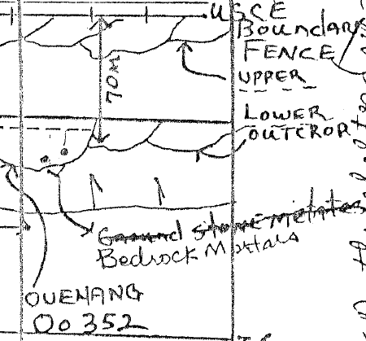
This site was recorded by Lee Woodard in 1988. It consists of a medium to large sized rockshelter, which may have been bigger in the past as it was described as having a large, collapsed rock shelf. If the rockshelter was fully intact, the rockshelter would have been twice as large as it was when it was recorded. The BRMs associated with this site are located on a scenic bluff overlooking a waterhole. Though plural, the exact number of BRMs was not specified. Artifacts recorded in association with this site are Fresno arrowheads and shell tempered potsherds, as well as a high density of chert debitage on the bluff above the rockshelter. It was suggested to be a Village/Mississippian site, though Woodard did propose that if excavated the site might produce evidence of multiple occupations.
34NW76
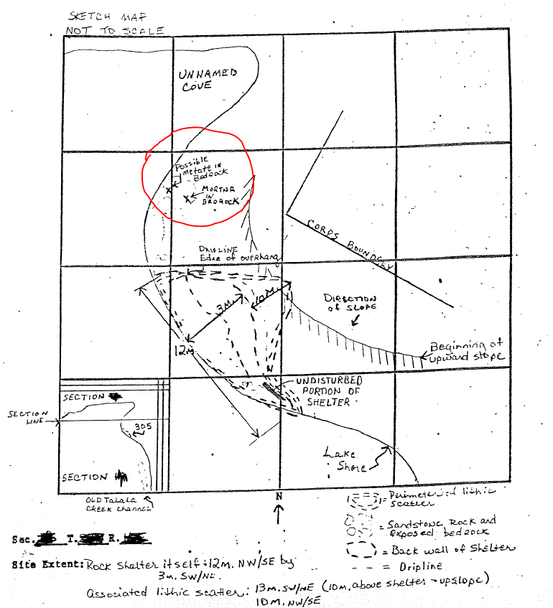
This site was recorded by Mike Davis in 1980. It consists of the southernmost overhang of a dense collection of five west-facing rockshelters along Kentucky Creek (Figure 5.3). The BRMs associated with the site is located on top of the bluff above the rockshelter, described as two utilized metates. Artifacts recorded with this site were two small flakes of chert debitage.
Figure 5.3- Sketch map of site NW76 (From Davis 1980:3)
Figure 5.4: Sketch map of site 34RO119 (Figure from Espey, Huston, and Associates, Inc. 1980:3).
34RO119
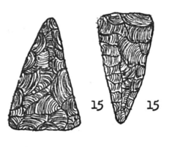
This site was recorded in 1980 by Espey, Huston, and Associates as part of a survey of the Oologah Lake Project. It consists of a medium-sized rockshelter on the shore of the lake. The two BRMs associated with this site are located in the bedrock above the shelter, described as “mortar and possible metate” suggesting that they were different enough to distinguish their function (Figure 5.4). Artifacts recorded include an arrow point base (suggested to be Fresno) (Figure 5.5), a biface fragment, two flint scrapers, two utilized flakes, one small, burned bone fragment, a large mussel shell accumulation and a dense lithic scatter above and within the rockshelter, and a sample of burned sandstone rock.
Figure 5.5: Example Fresno points such as those suggested in 34RO119 (Figure from Igleheart 1970:156)

34RO119 is one of the densest BRM rockshelters in terms of cultural material, although the remarks in the site file suggest that the recorders were not able to distinguish whether the mussel shells were recent or used by people in the deeper past. This site is also notable in that it is isolated from other rockshelter sites, the nearest one being 13 km north along the Verdigris River (now Oologah Lake, a reservoir completed in 1963).
34SQ41
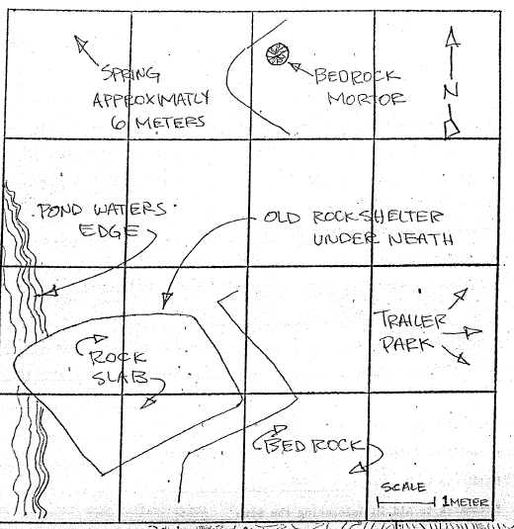
This site was recorded by Don Wyckoff in 1969. It consists of two northwest-facing rockshelters along the Arkansas River floodplain, near Vian Creek. The BRMs associated with this site are two small mortar holes in a bedrock boulder near the water line. Artifacts associated with the site include two bison scapula hoes and the distal end of a bison scapula.
Figure 5.6: Sketch map of site 34WG127 (Figure from McClung 1979a:2)
34WG127
This site was recorded in 1979 by Terry L. McClung. It consists of a large, mostly collapsed rockshelter, in which a large slab of sandstone about eight meters in diameter slid down and blocked off most of the mouth of the rockshelter, leaving only a small opening. The BRM associated with this site is described as a bedrock mortar, located about 8-15 meters from a natural spring, and 5-10 meters north of the rockshelter (Figure 5.6 above). No artifacts were recorded in association with the site, though the landowner claimed that Indigenous people once lived there.
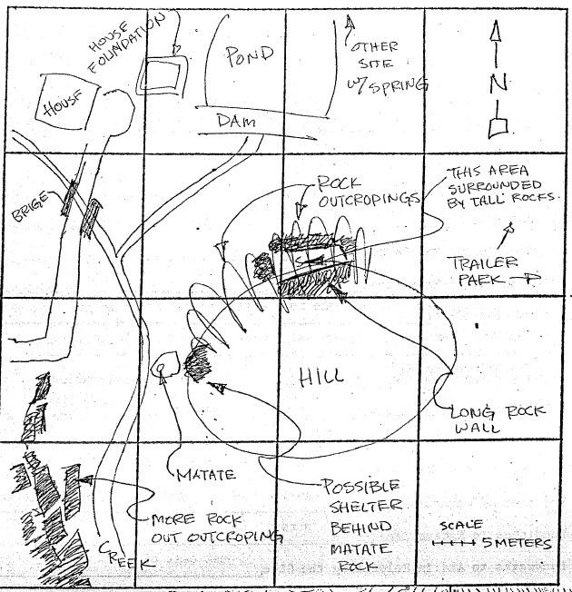
34WG128
This site was recorded by Terry L. McClung in 1979. It consists of three rockshelters, formed from three overhanging sandstone slabs with enough overhang to provide a roof and a floor. It is located very close to 34WG127, about 240 meters. These rockshelters are quite sizable, with one wall being 25 meters long and 6-10 meters tall. The BRM associated with this site is located one meter from the nearby creek and was described as a bedrock grinding basin or metate about 20cm in diameter (Figure 5.7). Other artifacts recorded with the site include some chert cobbles which may have been tested for toolstone suitability.
Figure 5.7: Sketch map of site 34WG128 (Photo from McClung 1979b:2)

34WG131
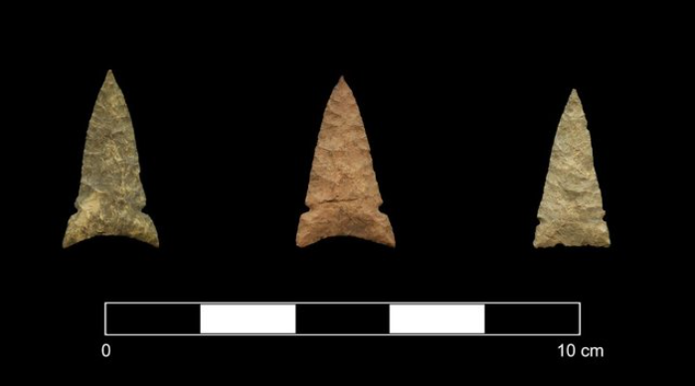
This site was originally recorded in 1980 by Terry L. McClung and was revisited in 2021 by Michael Prouty and Jordan Kluver of Alpine Archaeological Consultants, Inc.. However, while they were able to relocate the site during that revisit and take pictures from a distance, it was not physically revisited or resurveyed, due to the site being outside of the property that was being surveyed for that project. It consists of a collection of rockshelters and a possible open site near the creek or up the slope that is in association with the rockshelter. The BRMs associated with this site are described as six or seven bedrock mortars in front of a set of three rockshelters, and one large rock on the bluff on the other side of the creek with “bedrock mortars” of an unspecified plural amount. Artifacts recorded in association with the rockshelters included about 35 pieces of chert debitage and a broken Washita point (examples in Figure 5.8), suggesting that the site may be associated with Plains Village/Mississippian. for the Robson Ranch Wild Horse and Burro pasture project, and the owner of the property denying permission.
Figure 5.8: Sample intact Washita points such as the fragment recorded in 34WG131 (Photo from Sitters 2018:16)
34WG155
This site was recorded by George Odell, Pilar Arias, David Hagen, and Dorthy Gaston in 1988. The rockshelter of this site was described as a very small, “semi-sheltered area although no overhang is presently available” (Odell et al 1988), my emphasis. This site was recorded on the basis of a pair of sandstone and limestone historic – period foundations, and “one or possibly two bedrock mortars.” The observed mortar was described in the site form as being conical and was located on top of the bluff. No artifacts were recorded at this site.
34WG168
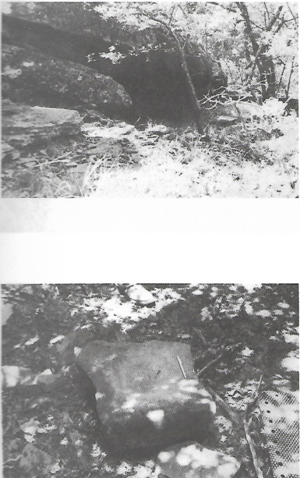
This site was recorded by Odell et al in 1988 (Archaeological Survey of Western Wagoner County). It consists of a small south facing rockshelter situated on a steep slope near an upland bluff. This site is a little dubious as the BRM was described as “a possible bedrock mortar”, so it appears that the recorders of this site were unsure about how to label it. Regardless of their doubts, they did take the time to measure it and described it as a smooth cup-shaped depression 8 cm in diameter and 4 cm deep and showed marks of wear that they speculated was used for the grinding of relatively soft materials. They probably took the extra time to record this information in greater detail because it was described as on the sandstone slab that forms the roof, and as “hard to get to”, because the slope was so steep and the top of the rockshelter was so high above the creek channel. This site is also special in that it is the only BRM-containing rockshelter in which loose sandstone was also recorded, as the only artifact recorded in association with this site is a fragment of a sandstone metate (Figure 5.9 above). The presence of this artifact is peculiar and unique, especially given that the site is near 34WG169, which also had BRMs recorded on top of the sandstone roof slab.
Figure 5.9: Top: 34WG167, example of rockshelter in vicinity of 34WG168 (1.67 km to north).
Bottom: loose groundstone fragment from 34WG168. (Odell et al 1988:129)
34WG169
This site was recorded by Odell et al in 1988. It consists of a medium south-facing rockshelter, with a small lithic scatter. The BRMs associated with this site were described as two conical deep-hole mortars, placed in the sandstone slab that made the roof of the rockshelter. The artifacts associated with this site consisted of various pieces of debitage, including both shatter and flakes, and a discarded side scraper of Florence B chert that was apparently heat-treated, located throughout the talus slope in front of the drip line of the rockshelter.
This site is similar to 34WG168 in that the BRMs were recorded as being difficult to reach, placed on the roof over 2 m high. It is possible that the positioning of these BRMs in both 34WG168 and 34WG169 is due to the deep layers of sediment on the floor of the rockshelter, covering the bedrock and preventing it from being utilized for BRM construction.
Figure 5.10 below depicts the distribution of the Wagoner County BRM rockshelter sites in higher detail.

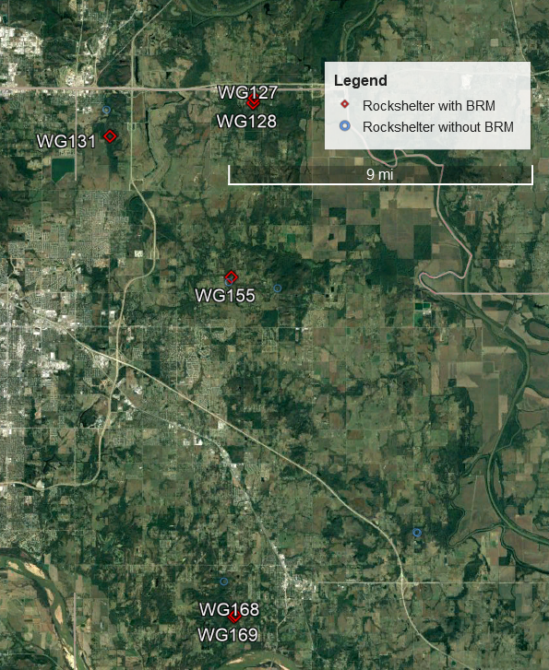
Figure 5.10: Detail view of Wagoner County rockshelter sites

Geological Formation
According to the overlay map of rockshelter sites and bedrock formations in Figure 5.11 (pg 73), we can identify two things readily:
First, there are dense clusters of rockshelters in specific places associated with different kinds of bedrock. For instance, there is a high density of rockshelters in the Mississippian and Silurian-Devonian marine limestone in the middle of Delaware County, or along the Neosho River in Mayes and Cherokee Counties.
Second, the BRM rockshelters are strongly associated with Lower and Middle Pennsylvanian sandstone bedrock. Despite later Quaternary sediments that may have filled in some rockshelters along the floodplains, and except for 34DL24 in its marine limestone, BRM rockshelters are all located along sandstone bedrock with similar origin, composition, and texture, the durable, rough-grained granite-imbued sandstone described in Chapter 2. These differences may have important implications for some of the questions asked in this thesis, which will be detailed in Chapter 6.
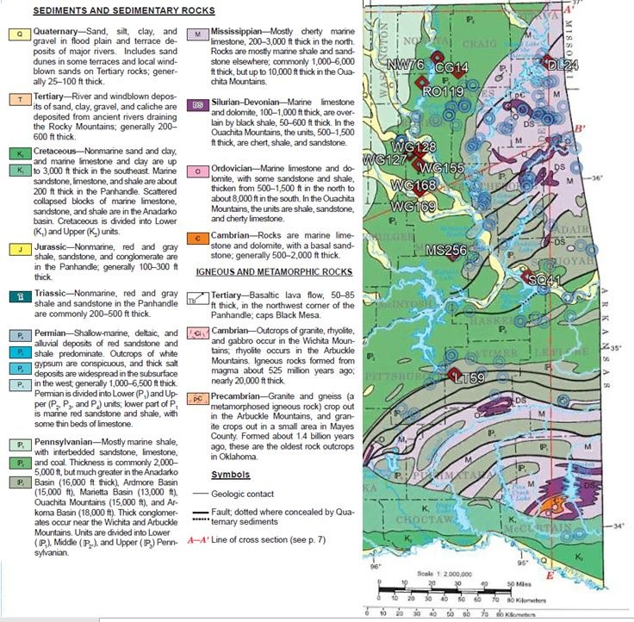
Figure 5.11: Rock formations of Eastern Oklahoma with rockshelter sites plotted.
Ecoregion and Resources
Previously, I described the various ecoregions recorded in the study area, and the various faunal and floral resources available. This section clarifies the relationship between BRM rockshelters and the various ecologies present in the study area.
Using a similar method as when examining the geological context for comparing the bedrock types, I cross-referenced the ecoregion map drafted by Woods et al (2005) to identify the distribution of all rockshelter sites by ecoregion. Since the ecoregions have widely varying areas, I categorized the data as the density of rockshelters per square mile for each ecoregion that contained such sites, resulting in the data presented in Figure 5.12 (below).
Figures 5.12 and 5.13 (below) indicate that rockshelters as a whole are most densely concentrated in the Dissected Springfield Plateau (39b) and the Lower Boston Mountains (38b), which are the ecoregions in the northeastern Ozarks where the highest concentration of karstic landscapes was formed. More concentrations of rockshelters are found in the Scattered High Ridges and Mountains (37a) and the Osage Cuestas (40b), environments underlain by the durable Pennsylvanian sandstone previously mentioned. The Arkansas Valley Plains and the Lower Canadian Hills are also underlain by the same sandstone. So theoretically, there should be BRM rockshelters scattered throughout these ecoregions, since most of them have roughly the same resources available.
However, when the rockshelters with BRMs are singled out for their ecoregion distribution, the results are much different. The majority of BRM rockshelters are concentrated in the Osage Cuestas, with 10 being in that ecoregion. The rest are scattered through a few other ecoregions; one in the Dissected Springfield Plateau- Elk River Hills (39b) (34DL24), one in the Lower Canadian Hills (37e) (34LT59), and one in the Arkansas Valley Plains (37d) (34SQ41).

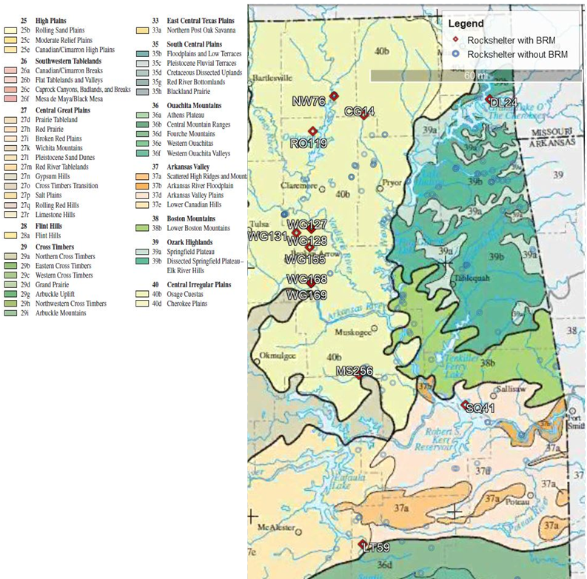
Figure 5.13: Ecoregions and rockshelter site distribution (Woods et al 2005)
As described in the environmental context, eastern Oklahoma has a high diversity of ecoregions and ecosystems. These are broadly classified into highland and lowland components, with highland forests mostly composed of oak-hickory forest, with some pine components in higher elevations such as the Ozark Plateau or the Ouachita Mountains, and lowland and floodplain forests with a staggering diversity of trees and plants. As one goes further westward, the environments begin to incorporate more short- and tall-grass savannah, whether in cross timber mosaics or in larger open spaces. This exposure to prairie or cross timber environment is held in common between the Osage Cuestas, Lower Canadian Hills, and Arkansas Valley Plains.
Faunal and floral remains results
Table 5.1: Summaries of Faunal Remains Counts in Counties Containing BRM Rockshelters
County | Number of sites with faunal remains | Faunal remains present
Craig | 1 | Unknown, Mussel
Delaware | 12 | Unknown, Mussel
Latimer | 1 (excluding 34LT59) | Unknown, Mussel
Muskogee | 6 | Unknown, Small Mammal, Mussel, Bird, Reptile
Nowata | 1 | Unknown
Rogers | 8 (excluding 34RO119) | Unknown, Mussel, Mussel, Fish, Bird
Sequoyah | 1 (Excluding 34SQ41) | Unknown, Deer, Bison
Wagoner | 2 | Unknown, Small Mammal
Biological remains are relatively scanty in eastern Oklahoma rockshelters. It should be acknowledged that this may be due to sampling bias; only one BRM rockshelter (34NW76) was tested with shovel tests, so the data is composed almost entirely of surface finds. In all only 54 rockshelter sites studied had faunal remains, and only 18 sites had any floral components, 14 of which were represented primarily by ash and charcoal. In BRM rockshelter sites only 34LT59, 34RO119, and 34SQ41 had any faunal remains, represented by the deer bone in 34LT59, the mussel shell accumulation in 34RO119, and the bison scapula hoes and fragments in 34SQ41. Figures for faunal remains in non-BRM sites are summarized in Appendix C, and counts for the counties in which BRM sites were located are summarized in the Table 5.1.
Floral remains are even more scarce, and mostly represented by ash and charcoal. No BRM rockshelter sites were recorded with preserved plants that were observable by the naked eye. Counts for floral remains of the other rockshelters are summarized in Appendix C.
Archaeological Results
Artifacts
Most artifacts recorded in BRM rockshelters are flake and core debitage, projectile points, and ceramics, in roughly that order. There are isolated examples of biface/biface fragments (34RO119), unhafted scraper (34RO119, 34WG 155), and worked bone (bison scapula hoes) (34SQ41), but no perforators/gravers, drills, or hafted scrapers were recorded in these rockshelters.
An interesting interaction exists between rockshelters with BRMs and rockshelters with loose groundstone tools. Whereas the BRM rockshelters are concentrated towards the western edge of the study area, loose groundstone is concentrated further east, particularly in Delaware County rockshelters near the Neosho River (Figure 5.14). A few loose groundstone rockshelters are in proximity to BRM rockshelters in Wagoner County, but BRM rockshelters clearly outnumber them in that area (Figure 5.14). The majority of loose groundstone rockshelters are far away from any BRM rockshelters.
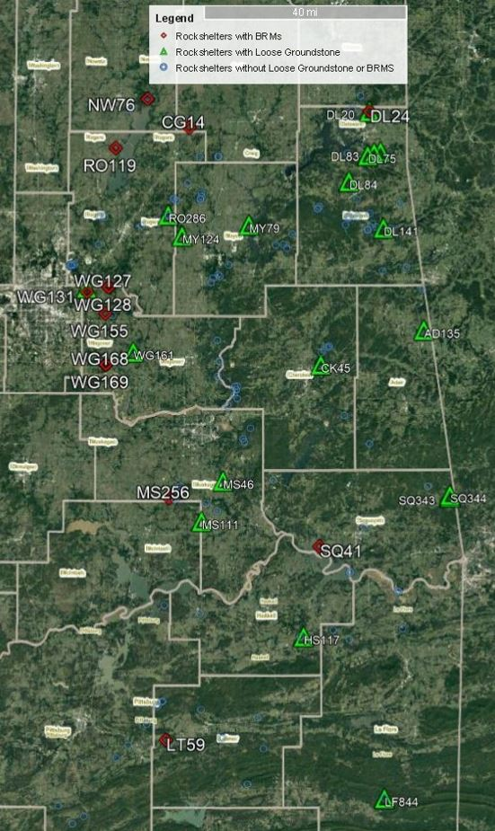
Figure 5.14: Distribution of BRM rockshelters and rockshelters with loose Groundstone
Nor do any rockshelters contain high densities of artifacts; according to the descriptions, some BRM rockshelters were recorded solely because of the BRM, or two or three flakes. 34RO119 has the highest concentration of artifacts, but those are entirely utilitarian tools or debitage, certainly not any of the religiously charged objects described as offerings (Blakeslee 2012).
Reported diagnostic material is likewise scanty in BRM rockshelters. Only four of such sites were ascribed a diagnostic designation, 34LT59, 34MS256, 34RO119, and 34WG131. 34LT59 and 34MS256 were designated due to the presence of both ceramics and projectile points, while 34RO119 and 34WG131 were designated due to solely points. Between all four of them, the diagnostic identifications were listed as Gary, Scallorn, Washita, and Fresno as specific types, and Spiro and Village/Mississippian as broader categories.
However, it should be acknowledged here as well that there is likely a sampling bias present. As large, highly visible archaeological sites, rockshelter sites are vulnerable to looting and pothunting. Six of the thirteen BRM rockshelter sites, and 30% of rockshelters, were recorded with signs of looting or vandalism. Therefore, it should be recognized that diagnostic or symbolic artifacts have been removed from the rockshelters before the sites were recorded.
Rockshelter features and characteristics
No BRM rockshelters contain any rock art or interments, unless you want to stretch credulity and declare that BRMs were rock art. If this is done, perhaps 34LT59 is the best candidate, for its geometric arrangement of BRMs, but these rockshelters lack any pigmented, pecked, or other forms of rock art. The most interesting example of additional non-artifact features in BRM rockshelters is the carved series of four steps recorded in 34CG14. 34WG155 also had historic-period limestone and sandstone foundation remnants in proximity to the site.
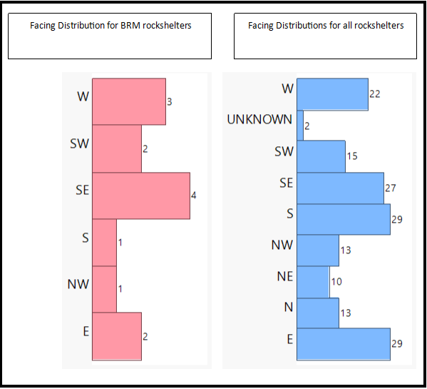
BRM rockshelters in the study are like the rest of eastern Oklahoma, in that they predominantly face south or east. The difference between the direction BRM and non-BRM rockshelters faced was not significantly different when tested using a chi-square test (x²=0.79, p=0.2605). The facing distributions are illustrated in Figure 5.15.
Figure 5.15: Comparative facing distributions

Table 5.2: Distances to water and slope of BRM rockshelter sites
Site | Distance to Stream in meters | Distance to River in meters | Slope %
34CG14 | <5m | 15,546m | 14%
34DL24 | 297m | 297m | 8%
34LT59 | 132m | 32,257m | 8%
34MS256 | 9m | 17,583m | 12%
34NW76 | 676m | 2,361m | 47%
34RO119 | 75m | 2,000m | 50%
34SQ41 | 92m | 2,122m | 9%
34WG127 | 126m | 4,026m | 10%
34WG128 | 96m | 4,212 | 3%
34WG131 | 60 | 7,024 | 30%
34WG155 | 1,173 | 8,731 | 15%
34WG168 | 473 | 1,864 | 8%
34WG169 | 377 | 1,881 | 22%
The distances to water are presented in Table 5.3. The average distance to a lower order stream is about 276 meters, with a median of 126. The average distance to a higher order river is 7,684 meters, with a median of 4,026. In the case of 34DL24, the nearest body of fluvial water was a branch off the Neosho River, expanded by reservoir to the Grand Lake o’ the Cherokees. 34CG14 is located on a tributary of Pryor Creek, which flows into the Neosho. 34SQ41 is in a tributary of the Arkansas River which was engulfed by the Roger S. Kerr Dam. 34LT59 is closest to the Kiamichi River, as the crow flies, but the foothills of the Hogback Frontal Belt and ridges of the Ouachita Mountains poses a barrier to water flow; 34LT59 is within the drainage basin of the lower Canadian, near Gaines Creek flowing into the dammed Eufaula Lake. 34MS256 is between the drainages of the Arkansas River and the Canadian River, between Eufaula Lake and the Webbers Falls Reservoir. 34WG168 and 34WG169 are closest to the Arkansas River, but all remaining BRM rockshelters (34WG131, 34WG155, 34WG127, 34WG128, 34RO119, and 34NW76) are firmly within the drainage basin of the Verdigris River.
Because of the gentle profiles of the terrain, most BRM rockshelters are located in relatively gentle slope grades, demonstrated in Table 5.2 and Figure 5.16. Eight out of thirteen BRM rockshelter sites (about 60%) recorded have slopes of less than 15%
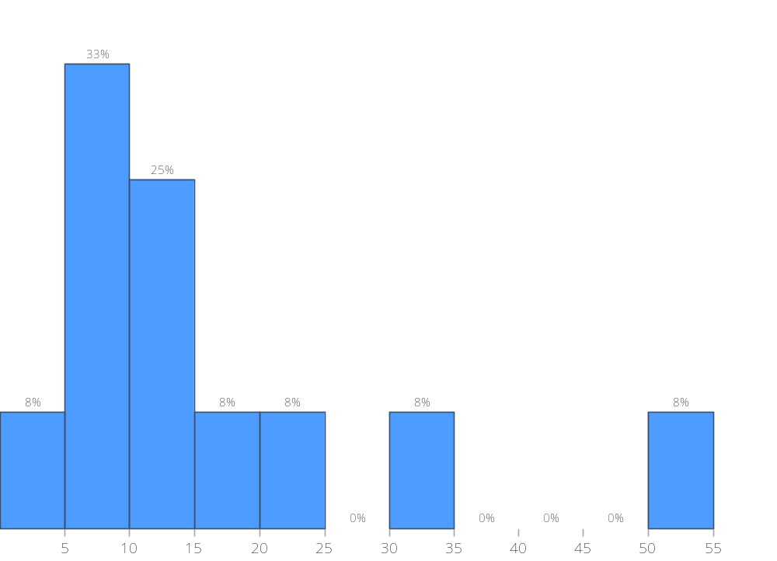
Percentage of slope
5.16: Proportions of slope percentages of BRM rockshelters

BRM Results
Size
Table 5.3: Recorded dimensions of BRMs.
Site Number | Diameter in cm | Area in cm² | Depth in cm | Volume in cm³
34CG14 | 10 | 78 | 30 | 15,315
34LT59 | 14 | 154 | 20 | 5,728
34LT59 smaller marks | 4 | 13 | 4 | 58
34WG128 | 20 | 314 | Unknown | Unknown
34WG168 | 8 | 50 | 4 | 134
Of the thirteen sites with BRMs, only four sites had recorded the dimensions of these features. Surface areas were a maximum of 314 cm², a minimum of 12 cm², and a mean of 121 cm².

These figures were calculated assuming that, since most of these BRMs were recorded as cup-shaped, that they had a round perimeter and a cup-shaped/rounded bottom.

Form
While exact measurements were not included, there were enough qualitative descriptions of BRMs to define at least three categories of shape:
Table 5.4: Recorded Forms of BRMs
Deeper than wide | Wider than deep | Same depth and width
34CG14 | 34NW76 | 34LT59**
34RO119* | 34RO119*
34WG155 | 34WG128
34WG169 | 34WG168
34LT59**

*As a clarification for Table 5.5, 34RO119 was included in two categories because the bedrock groundstone features associated with it were described as “a bedrock mortar and a bedrock metate,” which in my educated guess indicates that they appeared different enough in form as to be described with two different words.
**34LT59 was also included in two categories, as described in their measurements, the one larger BRM was deeper than it was wide, and the smaller BRMs were the same depth and diameter.
34WG128 did not have the depth of the BRM recorded, but in the survey report it was described as a “bedrock grinding basin or metate” about 20cm in diameter, so I interpreted that to mean that it was wider than it was deep. 34WG155 and 34WG169 were described as cone-shaped, but since the shape of the bottoms of the deeper BRMs associated with 34CG14 and 34RO119 were not described I was uncertain as to whether that qualified as a fourth category of form or whether the conical forms were the norm for deeper BRMs.
Positioning
In the descriptions from the site files and the survey reports, there were largely two types of BRM rockshelters: those with the BRM on top above or on the roof of the site, and those with the BRM outside of the rockshelter, usually close to water (numbers described in Table 5.6) Only two rockshelters have BRMs behind the dripline inside the shelter itself, 34DL24 and 34LT59.
Table 5.5: Recorded positioning of BRMs in association with rockshelters
Outside | 34CG14, 34SQ41, 34WG127, 34WG128
On Top | 34MS256, 34NW76, 34RO119, 34WG155, 34WG168, 34WG169
Within Dripline | 34DL24, 34LT59,
Both outside and on top | 34WG131
Several rockshelters had more than one BRM. However, the non-systemic manner of recording these features has made some of the information vague. 34DL28 and 34MS256 are both described as having multiple BRMs, but the number was not specified. As a result, we have only a few examples of sites with confirmed multiple BRMs present.
34WG131 has the most BRMs of a definitive quantity, which had at least six or seven BRMs located in front of a series of three rockshelters, with additional plural BRMs of an unknown number (interpreted to be at least two) recorded on a bluff nearby. LT59 has the second most dense assemblage of BRMs with four, the large cavity with the three cavities around it on the boulder described previously. Other than those two examples, 34NW76, 34RO119, 34SQ41, 34WG155, and 34WG169 all have a maximum of two BRMs, with all other BRM rockshelters only having one.
All the sites which had BRMs recorded as positioned on top of the rockshelter or the bluff above had at least two BRMs, including 34NW76, 34RO119, 34WG155, and 34WG169, with at least one of those being located on top. Only one site had two BRMs located outside of the shelter 34SQ41, and 34WG131 had BRMs both outside and on top of a nearby bluff (though not the actual bluff that the rockshelter was eroded from).
Summary
According to the data analyzed, BRM rockshelters are highly concentrated in Lower to Middle Pennsylvanian sandstone bedrock, and in the Osage Cuestas, Dissected Springfield Plateau-Elk River Hills, Lower Canadian Hills, and Arkansas Valley Plains ecoregions. Background data indicates that there are plenty of available resources in the study area, including game, food plants, medicines, dyes, and fibrous plants.
However, in BRM rockshelters according to previously recorded OAS site files and survey reports, there are no visible remnants of plant matter, and only a few examples of faunal remains. Artifacts are very low in density and diagnostic material. The rockshelters share similar facing to the rest of the rockshelters of the region and are remote from major river systems, more frequently found close to smaller order rivers.
The BRMs themselves take a variety of forms, including deeper mortar shapes, shallower metate shapes, and half-spheroid cup shapes. Regardless of shape, the BRMs are fairly small, with a maximum recorded diameter of 20cm. They are positioned in a variety of ways, primarily either in front of the rockshelter by the water source or on top of the shelter, with only two examples being under the rockshelter itself. Several sites have more than one BRM, but not more than eight or nine; however, all sites that do have more than one, have them situated on the roof.

Chapter 6: Interpretations and Future Directions
To interpret the implications associated with BRMs in eastern Oklahoma, we have a few hypotheses to evaluate whether the data do or do not align with them. The hypotheses are reviewed here:
1. If a particular bedrock type is more suitable for the construction of useful, efficient BRMs, then we will observe higher concentrations of BRMs in that bedrock type when compared to others; if the qualities of the bedrock are irrelevant to the crafting and use of a BRM, then we would observe BRMs equally and randomly distributed across the landscape.
2. If the BRMs were used for specific kinds of resources, they will be located in ecologies in which they are needed, and there will be materials that require their use. there will be a predominance of one form or another – deeper mortars for pounding, cracking, and pulverizing, or grinding basins for processing smaller components. If there is a diversity of uses for different resources, we would observe multiple forms of BRMs. If form is independent of resources, then we would observe BRMs of generalized shape equally and randomly distributed across the environment.
3. If BRMs were used for practical purposes, they will be constrained in certain qualities, crafted to the shape and minimum surface area needed for the quantity of material that is to be processed. They will not be of a size smaller or larger than what is required, and they will be of a shape that is appropriate to the material being processed.
4. If BRMs were used for practical purposes, on a regional scale they will be positioned where it is more efficient to make a BRM than to carry loose groundstone metates or mortars. On a local scale, they will be positioned in places inside the rockshelter that are easy to access and easy to use. Additionally, they will be placed in positions where maintaining them and keeping them clear and unburied requires little additional effort.
5. If BRMs were places of intense sociocultural interactions as suggested by other BRM sites, there should be a high density of BRMs placed closely together to facilitate interpersonal communication between multiple individuals while using them.
6. If the rockshelter BRMs of eastern Oklahoma have highly visible evidence of a division of labor by gender, then it would be expected to find tools associated with men or women, or a mix of both. It would be suggested that the BRMs would be used by men if projectile points, debitage, and axes were recorded in association with the rockshelter, and by women if scrapers, awls, drills, or ceramics were present. Materials from both categories may represent either women and men utilizing the shelter together, or a group of the same gender utilizing a wider variety of tools.
7. If BRM rockshelters were places with high religious or spiritual significance, they should at least have high densities of artifacts, including artifacts which are specifically associated with religious symbolism. If they follow the pattern of spiritually significant rockshelters in the Ozarks, they will also have some or all of the following features: west-facing aspects, steeper terrain, distance from water, and rock art or interments. If BRMs are associated with rockshelters with these characteristics, it’s possible that the BRMs present were used to prepare food or materials necessary for carrying out religious activities at the site.
Geological Formation
Previously in this thesis, I suggested that if certain bedrocks are superior to others in terms of deciding whether to construct a BRM, then we would observe a concentration of BRMs in specific rock formations sharing similar properties. If all bedrocks were equally qualified to have BRMs crafted in them, then we would see BRMs roughly evenly and randomly distributed across all formations.
According to my results, all BRM rockshelters except for 34DL24 were located in Lower to Middle Pennsylvanian sandstone. With this high concentration in these specific rock formations, I suggest that this sandstone bedrock had an ideal texture and durability for the crafting of BRMs. Other bedrock formations in the study area are largely composed of older marine limestone laid down from the Ordovician through to the Mississippian; while these formations are perfectly suitable for the creation of rockshelters, bedrock mortars are not found in these rock types.
It is the presence of this coarse-grained, durable Lower to Middle Pennsylvanian sandstone in the study area that may have had a major impact on the distribution of BRMs. As described in Chapter 3 regarding BRMs, not every bedrock is suitable for BRMs, as it needs certain qualities of porosity, grain size, and durability to be an effective grinding or pounding surface (Manchen 2015).
It is not impossible that BRMs can be placed in limestone, For example, they are recorded in limestone of the Natufian Levant, large, deep holes in boulders and bedrock, but bedrock grinding surfaces are more typically made of basalt or other tough, granular stones (Rosenberg and Nadel 2017a). I would propose similar constraints in the eastern Oklahoma study area. According to Figure 5.14, the highest concentration of loose groundstone tools found in rockshelters are found in these limestone settings, especially in Delaware County. That might imply that the bedrock was so unsuitable for the creation of BRMs that it was necessary to carry loose groundstone up to those locations. 34DL24, previously described in the survey report as “the only bedrock metates recorded in the survey work in this area,” as a BRM site situated in limestone is a unique and rare exception which requires further investigation.
Based on the distribution of BRMs across the various rock formations in eastern Oklahoma, it appears that the Middle to Lower Pennsylvanian sandstone was the preferred medium in which to craft BRMs. Directions for extending such analysis of the influence of bedrock on BRMs will be detailed later in this chapter.
Ecoregion
According to the descriptions provided by Woods et al (2005), the common feature shared by the ecoregions in which BRM rockshelters were recorded may be that they all have access to long-grass prairie, and the Osage Cuestas have the largest exposure to this biome. With the exception of 34DL24 and its ecoregion (always the outlier!), BRM rockshelters are located in ecoregions that occupy a transitional area between two different environments, between the woodland resources and grassland opportunities. If access to tallgrass prairie is preferential for deciding to construct a BRM, then the Osage Cuestas certainly have the most surface area with that biome, the most of any ecoregion in eastern Oklahoma.
The ramifications of this alignment among BRMs, rockshelters, prairies, and forests are still unclear, and require additional study. But it appears that the presence of plentiful woodland resources was not sufficient to craft BRMs in the durable lower Pennsylvanian sandstone, but that whoever created them required them to be in at least some proximity to the open plains. This introduces new questions about the relationship between the BRMs and their creators; were they foragers coming from the east, setting up waystations on their way to the plains? Or were they coming from the west, seeking woodland resources?
The resources available in these ecoregions would likely have influenced the size and form of the BRMs within them; the interpretation of those implications is detailed below.
Size
I mentioned in Chapter 3 that there had been research conducted to assess whether a set of BRMs were more specialized or more generalized based on its size, and how larger quantities of material requires larger grinding surfaces (VanPool and Leonard 2002, Nixon-Darcus and D’Andrea 2017, Manchen 2015, Hayes, Pardoe, and Fullagar 2018). That section compared highly specialized agricultural societies like Ethiopia (averaging 1,660 cm²), less formalized but intensive utilization with the Cuyumaca ovals (averaging 1,112 cm²), and occasional, generalized use in Australia (averaging 706 cm²).
When compared to those results, the BRMs of eastern Oklahoma align most closely with the Australian example. Noting again that the data are incomplete for the measurements of most of the BRMs recorded in the study area, and that there may be a sample bias due to the absence of testing in most BRM rockshelters, I suggest that with a mean of 121 cm² that makes the eastern Oklahoman BRMs on average even smaller than the ones used in Australia.
The diversity of sizes available suggests that some rockshelters, 34WG128 and 34LT59, were used more frequently or for larger amounts of material than others. The size of the smaller ones doesn’t seem impractically small, for pounding seeds or nuts, but are clearly too small to process any large quantities of material without taking an excessive amount of time and effort..
Form
The design of a BRM’s form has implications in how efficient it is, and how much energy must go into creating and maintaining it (Adams 1993, Nixon-Darcus and D’Andrea 2017). To this end, there are a few expectations that we can make for the description of the forms of BRMs.
First, that they be geographically centered in a place where it is practical and useful to be constructed, with numerous factors being present. These factors include needing to have a suitable type of bedrock that promotes the creation of rockshelters AND is suitable for constructing BRMs, a nearby fluvial system which promotes the erosion and creation of the rockshelter and provides water for the people using it and having at least some resources in the ecologies around a BRM rockshelter for which a BRM is necessary.
In chapter 5, I recorded that there were multiple plants in the study area that could require pounding or grinding. If a BRM is created in a rockshelter to take advantage of a local resource, it would be created in a shape most useful for processing the resources around it. Therefore, if we could observe that the majority of BRMs were pounding mortars, deeper than they are wide, that would suggest that they were being used to process materials by smashing, pulverizing, or cracking them, like nuts, medicines, or other non-food plants. If we observe that the majority of BRMs were grinding basins, that would suggest that they were more frequently used for grinding, which would be most efficacious for small seed plants or animal bone or antler.
According to my results, however, in the study area, BRMs have a diversity of forms. The fact that there are a mixture of shapes and sizes throughout the study area suggests that not every BRM was used for the same resource. However, there is some evidence for some amount of specialization. According to the report on 34RO119, the BRMs were described as having both a bedrock mortar and a bedrock metate. Though these descriptions are vague, the fact that two forms were present in the same site suggests that each one may have been used for different resources. It’s possible that at this site there were multiple resources that were different enough that they required different BRM forms.
There is a similar situation of two forms of BRM in close association with 34LT59; the three small mortars are described as cup-shaped, while the larger one is deeper than its diameter. It seems possible that these BRMs, crafted on the same boulder, processed different resources at the same time, or that they served as different stages of processing (first processed in the big BRM, then further processed with the smaller ones, or vice versa).
Finally, there’s the case of 34WG169 and 34WG168; while these are two different sites, they are close at an environmental/regional scale, about 100 meters apart. 34WG169 has the deeper BRM and is cone-shaped, 34WG168 has the wider one and is cup-shaped. It would be reasonable to suggest that these two BRM rockshelter sites were being used by the same people for the same resources, which required two different forms of BRM.
I would suggest that while each BRM rockshelter was used in association with a specific, local resource, there was enough specialization to craft different BRMs for different materials. It’s possible that this specialization was so prevalent that two BRMs of different shape needed to be crafted when there were several resources which required processing that couldn’t be handled by one generalist form. More confidently, I can suggest that there certainly wasn’t a holistic trend of specialized BRMs dedicated to processing one type of material in the region. If form is associated with specialization to process available resources, the diversity of forms seems to reflect the diversity of resources available.

Positioning
Previously conducted research (Chapter 3) suggests that BRMs were positioned in such a way that they were easy to access. In rockshelters, BRMs could be placed in large bedrock boulders as well as on bedrock floors, but most practical BRMs are usually positioned in such a way to maximize the efficiency of the people using it. In societies where grinding was an intensive process that occupied most of the day, BRMs were usually located near residential sites, either in the middle of the village for communal use or within individual houses (Ebeling and Rowan 2004, Lynch 2017).
However, according to my results BRMs in eastern Oklahoman rockshelters tend to be located some distance away from residential population centers, along secondary streams and creeks. I could suggest that this might be due to a cost/benefit analysis of setting up a BRM versus hauling a heavy groundstone basin to the location (Lynch 2017). Figure 5.14 shows that there was considerable geographical distance between rockshelters with BRMs and rockshelters with loose groundstone tools. I would suggest that there was a decision-making process that determined that some rockshelters were worth the effort to carry groundstone metates, while for others it was more efficient to take the time and energy to create a BRM. However, that also makes BRMs remote from larger population centers, clearly not in village centers.
But why weren’t BRMs more frequently crafted underneath the rockshelter roofs? Common sense might suggest that you would want to take advantage of the shelter or shade while you worked and protect your material from getting damp or contaminated with dirt or mud. Darkness and being able to see your work should not have been a factor, none of the BRM rockshelters except 34SQ41 were facing northwards, so natural sunlight would not have been lacking, and even with S34Q41 it would be overcast at most, not dark as a full cave.
I believe this tendency may be due to a sample bias, at least to some degree. None of the rockshelters with BRMs were fully excavated, and it is possible there were indeed BRMs crafted in the floor underneath the overhang that have been buried by accumulated sediments. Nevertheless, this is the reality of the data set that we have available, but we should acknowledge that possibility and not claim that BRMs were only placed in those particular places of outside the shelter near water or on the bluff above.
I would also suggest that the BRMs are situated on the roof because these features tend to be positioned in places that would protect them from being covered by sediment or soil accumulation (Lynch 2017). BRMs were not just left as they were, they were cleaned or kept clear, using scrubs as brushes or brooms. Ironically, in contrast to other archaeological site types which frequently depend on soil layers to establish relative dating or context, for the study of BRMs in rockshelters it is almost ideal for there to be minimal sedimentation or soil formation. In dry climates, being exposed helps prevent contamination from other biological material, keeping bacteria growth to a minimum (Pino et al 2018). In these drier climates, BRMs were also used to hold rainwater, so keeping it clean from moss or contaminants was an important consideration.
Additional explanations include the possible utility of these higher positions in its visual position, in that these locations allowed those who were using the BRMs on top to monitor what was happening below them. Viewshed analysis is a methodology that would need to be elaborated in future research, but at the very least the positions on top of the rockshelter could observe the immediate surroundings.
The positioning of the BRMs above the rockshelter creates the possibility for interesting social dynamics, between the people who were up there and the people who were below near the water or in the rockshelter. These dynamics depend partially on the interpretation of the other cultural material associated with these sites.
Diagnostic Material
In Chapter 3 of this thesis, I discussed the cultural context of eastern Oklahoma, and in Chapter 5 I discussed the results of the material found in these sites. Based on geological and ecological factors and diagnostic artifacts, I suggest that BRMs were constructed in these rockshelters principally during the Early to Middle Plains Village Period.
As a point of interest, Fresno and Washita points described in the site forms are most typically associated with the plains. Although they have been found throughout Oklahoma, these point styles are most strongly associated with central and western Oklahoma, along the Washita River (Drass and Swenson 1986), This lends at least a little support to the proposition I suggested earlier when describing ecoregions; that people preferred to craft BRMs in places where the forest could meet the prairie. If this is true, the points described in the site form suggest that the BRMs in those rockshelters were possibly made for people from the Plains Villages venturing to the woods, rather than people from the mounds venturing to the fringes of the plains. But for now, diagnostic material is too scanty to declare anything conclusively; as permanent, durable features, the BRMs present could have been crafted earlier than these points.
Social Interaction Sites
If BRMs had primary or secondary functions as places where people would converge and talk together while working, we should find multiple BRMs in a site in relatively close proximity to each other.
If BRMS in eastern Oklahoma were centers of social interaction, 34WG131 is certainly the most qualified candidate for this model of a multitude of BRMs arranged together, but the case of 34LT59 has interesting implications. The BRMs associated with that site were organized with one larger, bowl-shaped bedrock feature, surrounded by three smaller ones. According to Figure 5.2 (pg. 63), these features were placed on the narrow end of an oblong boulder. While the drawing is crude, if this collection of BRM mortars were designed to be used together simultaneously, then one person would use the larger depression from the northeast side, and one to three other people would use the smaller features on the southeast, southwest, and northwest positions. The distance measurements between each of the depressions is unknown, so it’s not certain whether four people would be able to cram together to use the BRMs simultaneously. The depressions themselves were very small, as Table 5.4 (pg. 81) indicates, with the larger one being 14 cm in diameter, and the smaller ones being only 4 cm., so large amounts of material couldn’t be processed here without doing so in very small portions. The small sizes might also represent a chain of operations, processing one material in the larger BRM and then continuing the next stage in the smaller ones, so it’s possible this boulder wasn’t used by multiple people simultaneously. But the spatial arrangement of the BRMs remains intriguing, and if 34LT59 can be recovered from its destruction it would certainly be a worthy site to revisit.
Despite the vagaries of the document record regarding the other sites with unquantified, plural BRMs, I would propose that even rockshelters with only two BRMs could still have been places of sociocultural interactions. All of the sites which had BRMs recorded as positioned on top of the rockshelter or the bluff above had at least two BRMs, including 34NW76, 34RO119, 34WG155, and 34WG169. Only one site had two BRMs located outside of the shelter 34SQ41, and 34WG131 had BRMs both outside and on top of a nearby bluff (though not the actual bluff that the rockshelter was eroded from).
The elevated positioning of the BRMs has the potential to increase the social or cultural significance of these sites, even without the larger density of rockshelters used by other societies. But this elevation was not restricted to one person, towering over an audience, but instead there might have been at least two people working together, if all BRMs were utilized simultaneously. This could have interesting implications for social interaction and proxemics (the study of how space affects communication and status negotiation), especially in 34WG131 where BRMs were located both on top of a bluff and outside a rockshelter.
If BRM rockshelters had functions as focuses of social interaction and interpersonal negotiation, the evidence suggests most strongly that they were places of very small-scale interactions, but still possibly intense and significant due to their unique positioning.
Gendered Spaces
To continue the discussion of artifacts in BRM rockshelters, the proposition is that if BRM rockshelters were places of highly separated gender dynamics, then there should be a preponderance of specifically gendered tools. It would be suggested that the BRM rockshelters would be used by men if projectile points, debitage, and axes were recorded, and by women if scrapers, awls, drills, or ceramics were present. Materials from both categories may represent either women and men utilizing the shelter together, or a group of the same gender utilizing a wider variety of tools. The presence of the bison scapula hoes in 34SQ41 does possibly suggest an association with women’s farming implements, but there are no other tools associated with women, like awls or shafted scrapers. Likewise, there are few instances of tools specifically for men; beyond the flakes and projectile points, there are no axes, and almost no faunal remains from game animals (one instance of deer bone in 34LT59).
If these sites were open camps, the low density of artifacts and preponderance towards lithic debitage would make these sites most frequently attributed to logistic hunting or foraging parties, most likely associated with men (Polhemus 1998). However, the presence of a BRM shifts the scale back towards grinding or milling activities, most likely done by women. Since the BRM requires considerable time and investment to construct a permanent surface, it suggests that grinding, milling, and pounding were at least very important activities taking place at the rockshelter, and thus more important to one gender over another. But the relationship between BRMs and gender can still not be conclusively determined.
Ceremonial or Spiritual Functions
According to previous research described in chapter 3, a BRM rockshelter associated with the Ozarks may have religious or cultural implications if it contains rock art, interments, high densities of artifacts, impediments to easy access, and /or faces west. If this is the case, very few BRMs contain any of the associated characteristics. Other rockshelters in eastern Oklahoma contain these features, so it’s not solely a matter of geography and a BRM’s location.
No BRM rockshelters contain rock art or interments, and most BRM rockshelters have very low concentrations of artifacts. Additionally, there is no demonstrated preference for facing west. BRM rockshelters share the tendency of rockshelters in eastern Oklahoma to face east and south. Whether there are rockshelters in this study area that do match those qualifications is a topic for another thesis, but currently I can confidently say that those qualities are not present in these particular BRM rockshelters.
If we assess the remaining criteria, the impediments of excessive slope or distance from water, there is little credibility. Assuming the distance to water and the slope is an indication of remoteness or difficulty of access, this might be seen as a method of costly display practice (Sabo et al 2012); in order to access the rockshelter, one must leave the well-travelled rivers and game trails, and walk steeply uphill, with slopes from 15-30%, keeping the rockshelter isolated and protected from more casual visitors.
When looking at the slopes which these BRM rockshelters are located (Table 5.3, pg. 79 and Figure 5.16, pg.80), while there are a few outliers, most BRM rockshelters have a slope under 15%. This distribution is possibly due to not being directly within the Ozark Mountains like the examples Sabo et al studied. If 15-30% slopes are sufficient to mark a culturally significant impediment, then that particular obstacle is not present for most of the BRM rockshelters in the study area.
In terms of distance to water, however, as described in Table 5.2 (pg. 82), most BRM rockshelters are located in second order streams, not major rivers. If BRMs are a form of rock art, and distance to water is a property held by religiously/culturally significant sites with rock art in the Ozarks, that is the only quality possessed by the BRM rockshelters in the study area.
These criteria were conducted researching Ozark rockshelters, and a more cohesive, Mississippian/Caddoan cultural complex. But if we recall, and is suggested by the diagnostic artifacts and ecoregion distribution, there is a strong influence from the plains as well. Determining a spiritually significant site from these traditions is more ambiguous and is largely a matter of potentiality rather than confirmation. The plains traditions typically also have high quantities of artifacts as offerings when they use rockshelters as shrines, so with the low artifact count in BRM rockshelters the plains are not necessarily a solid match either. Though again, sample bias and looting may have had distorting effects on the evidence available. There are just numerous factors that point towards the concept that if BRM rockshelters had intense spiritual or cultural significance, they would more likely reflect patterns from the Plains rather than from Spiro.
Interpretation Summary
To wrap up the interpretations derived from the data, it would be useful to review them in association with the implications introduced in Chapter 1:
- In my sample, there is a much higher concentration of BRM mortars in specific, durable sandstone bedrock from the Lower to Middle Mississippian Periods than in limestone from the Mississippian or Ordovician Periods. In addition, rockshelters with loose groundstone tend to be located far away from BRM rockshelter sites, with a dense concentration of such sites in the limestone Ozarks. This suggests that the limestone in the Ozark rock formations was sufficiently unsuitable for creating BRMs that people needed to bring their own groundstone tools rather than using permanent fixtures.
- BRM rockshelter sites are located in ecological regions with a wide variety of resources. If the resources available affects the design of BRMs, this ecological diversity appears to be reflected in the variety of shapes and sizes of the BRMs in that area, and sufficient specialization for local resources as to have different shapes of BRMs in the same site, or in sites in immediate proximity to each other.
- The size, form, and design of recorded BRMs suggest that they were not used for intensive material processing, but for occasional, small-scale use during short visits, possibly seasonally.
- The positioning of BRMs within a site suggests that BRMs located on top of rockshelters were a common trend, and may have had implications of preservation and cleanliness, and of an increased range of visual monitoring compared to working inside the rockshelter or by the water.
- The BRMs of eastern Oklahoma are atypical of BRM patterns of other regions (American Southwest, California) in that there are relatively few BRMs per rockshelter site, thus lack the connotation of large, intersocial communication events on the scale as those other regions. However, the premise of interesting interpersonal interactions is still present in the fact that every BRM rockshelter site with multiple BRMs have at least two BRMs on top, presenting a unique configuration between positioning and social meaning regarding the social connotations between those who were working on top versus in the rockshelter below.
- The BRMs of the study area do not have sufficient, specialized artifacts that would suggest any one gender using it more frequently than another. However, the presence of the BRMs themselves tilt the balance slightly in favor of the rockshelters being used more commonly by women.
- BRM rockshelters do not have any features that are associated with ceremonial or spiritual meaning, lacking culturally dense features such as rock art or interments, low densities of artifacts, and no meaningful impediments to access. Regarding the possibility of BRMs in the study area acting as lithophones, there has been no evidence accumulated or any sites being tested for such qualities.
.
Future Directions for Research
Expanding the Scope
This section offers some of the additional avenues of investigation that I believe would help clarify the picture of BRMs in Oklahoma, the Great Plains, and the Arkansas and Mississippi drainage.
My first suggestion would be to expand the search for BRMs, outside of my study area of eastern Oklahoma, and outside rockshelters. My investigations into BRMs largely began as a matter of coincidence. My initial interest in eastern Oklahoma rockshelters as a regional feature gradually revealed BRMs to be intriguing features that piqued my interest and turned out to be important features that deserve further attention. This was a fortuitous circumstance, as these rockshelter sites turned out to have a lot of the exposed bedrock necessary to craft a BRM, and I chose a study area with the highest density of rockshelters.
However, eastern Oklahoma is not the only region in the state that has rockshelters. It may be beneficial to seek records of BRMs in the rockshelters elsewhere in Oklahoma. Some promising candidates may be to expand the study area westward through the rest of the Lower Pennsylvanian formation in which the Wagoner cluster of BRM rockshelters were located, looking at potential sites in Tulsa, Okmulgee, McIntosh, Hughes, and Coal Counties (Johnson 2008). Pontotoc County and the Arbuckle Mountains have another high density of rockshelters and examining the ancient Ordovician and pre-Cambrian formations there may also bear fruit. The granite outcrops of the Wichita Mountains in southwestern Oklahoma may also be particularly good candidates for BRMs and rockshelters that may be worth investigating.
It may also be worthwhile to look at non-rockshelter sites in these formations too, to determine if BRMs were crafted in open or village sites as well. This would also be valuable to determine differences in usage, and whether the positioning of a BRM in the site has similar implications as those in rockshelters. It would also be useful to expand the search along the ecoregions in which the BRMs described in this thesis were recorded, to assess whether BRMs were crafted in open sites through the Osage Cuestas or the Arkansas Valley. It may also be valuable to determine whether BRMs were created in other ecoregions, whether the confluence of plains and forest is as important as I suggested by looking at the Cross Timbers.
Following the Lower to Middle Pennsylvanian rock formations and relevant ecoregions outside of the state, into Kansas, Missouri, and Arkansas, could also be valuable, as certainly the distribution of BRMs and rockshelters were not encapsulated by modern political units. Documenting additional BRMs in Arkansas would be extremely useful, as it would provide a larger dataset on the differences between limestone and sandstone for deciding where to construct BRMs.
Future testing
In terms of future research for the sites described in this thesis, revisiting sites remains problematic as of the completion and publication of this thesis. Many of these BRM rockshelter sites are located on private property, and during efforts to access some of the sites we were rebuffed by the landowners. Many others are excessively difficult to visit; some are on USACE land, in particular 34NW76 which is now in a managed wetland. Others are located on reservoir shorelines, which requires a boat and assistance from the reservoir authorities, such as the Grand River Dam Authority for sites on the Grand Lake o’ the Cherokees. Some are now flooded or totally destroyed, others are damaged by potholing and looters.
Due to this difficulty of access, the most valuable way to improve study of these BRM rockshelter sites in Eastern Oklahoma may be to conduct more detailed geospatial analyses, particularly to examine viewsheds, proximity to water sources, and association with village or other residential sites. These analyses could clarify the relationship the BRM rockshelters had with other non-rockshelter sites of the region, and thus their position in time and their cultural affiliations.
In terms of recording and researching future BRM sites, one of the essentials needed is to spread awareness of how to document them accurately. The review conducted during research for this thesis has demonstrated that it is vital to accurately measure, photograph, and plot BRMs. At the very least, the length, width, and depth of any BRMs should be recorded, and photographs taken, but other necessary information includes the slope of the bedrock surface, its distance to or position within a rockshelter, and degree of polish (Lynch 2017). Implementing standardized recording protocols will help provide more valuable data about these features in future research.
Another avenue of research would be designing an experimental archaeology project to assess the quality of different forms of bedrock and their suitability for constructing BRMs. In the Eastern Oklahoma study area, this difference would primarily be between the Pennsylvanian sandstone of the Claremore Cuesta Plains and the Mississippian limestone of the Ozark Plateau. The experiment should be designed in such a manner that it can measure several factors, such as usewear analysis to test marks used by abrading stones of different toughness and hardness (Hayes et al 2018), or to test rates of deterioration and use-wear rates, how many hours it takes to create a certain kind of surface (Lynch 2017).
Additionally, it would be valuable during these experiments to evaluate whether different lithologies/rock types are more efficient for different kinds of resources, such as using seeds, herbs, grains, minerals [especially ochre (Ebeling and Rowan 2004)], wood, and faunal components in both mortars and grinding surfaces. If research expands out from the Claremore Cuestas and Osage Plateau rock formations, it would be beneficial to incorporate other rock types into this experiment, such as granite, basalt, or other grades of toughness or coarseness of other sandstones and limestones. Additionally, one could use this design in comparing bedrock of the same type, such as comparing eastern Oklahoman sandstone with New Mexican sandstone. Establishing a library of usewear, polish patterns, and residues, such as that devised by Australian archaeologists (Hayes et al 2018) would be invaluable to expanding research in this field.
Another important, new avenue of research is to evaluate the possibilities of the BRMs in eastern Oklahoma being soundscapes. This would require some degree of experimental archaeology not currently recorded in the literature. But some features that may lend credence towards this hypothesis would be to have BRMs positioned in similar places, made in similar shapes and in similar rock forms, that can transmit percussive or grinding sounds. The rockshelter itself may also be of a suitable shape to amplify sounds.
Residue analysis
Regarding residue analysis, the potential for preserved lipids or plant particles on BRM rockshelters in eastern Oklahoma has not been robustly assessed and what potential is there may be severely limited. The majority of successful residue analyses on BRM features were conducted in very dry climates (Buonasera 2016, Hayes et al 2018, Lynch 2017, Manchen 2015, Pino et al 2018, Rosenberg and Nadel 2017b). The most promising example with climate even modestly comparable to the eastern Oklahoma study area is a study on Archaic groundstone near Laredo, Texas. Although it is a semi-arid environment in the present day, the region experienced wet periods and still retained enough lipids to be studied (Quigg et al 2001). Therefore, while the potential for preserving residues in eastern Oklahoma may be very low, this technique is worth exploring.
If residue analysis is done, there are several different techniques that can be used to extract samples and analyze them. Quigg et al (2001) used solvent washes and chemicals to extract lipids; but this method did require partial destruction of the sample groundstone, grinding off contaminants and crushing the interior into a dust with a hammer mortar and pestle. It would be difficult to retrieve data in this fashion from an immobile archaeological feature like a BRM. Other extraction methods have included gentle brushing or guanine hydrochloride; but sodium dodecyl sulphate was suggested to be the best choice for fieldwork because it doesn’t require refrigeration (Manchen 2015 p. 17). Buonasera (2016) used solvent-cleansed, diamond-embedded drills to collect small core samples from mortars and cupules in her study area of the Gila Cliff Dwelling, also using a chromatograph to assess present lipids, and she used a gas chromatograph to analyze the residues in the lab. As with residue analysis with other forms of artifacts, preventing contamination from modern substances is a major concern, as is distinguishing between substances embedded in the BRM stone matrix through use and substances which have accumulated through natural processes, through the wind and water.

Conclusion
As I hope I have emphasized during the course of this thesis, bedrock mortars are vitally important archaeological features with untapped research potential. This work represents the first toehold on climbing this mountain, it will take many more participants and curious minds to reach the summit, if there ever is one. In closing, when I set out to write a thesis, I had a desire to write something that would be informative, useful, and thought-provoking.

References
Adams, Jenny L. 1993. “Toward Understanding the Technological Development of Manos and Metates.” Kiva 58: 331-344.

Albert, Lois E. and Don G. Wyckoff. 1984. Oklahoma Environments: Past and Present. In Prehistory of Oklahoma, edited by Robert Bell. Orlando: Academic Press.

Araujo, Astolfo, Andre M. Strauss, James K. Feathers, Julio Cesar Paisani, and Thomas Schrager. 2013. “Paleoindian Open-Air Sites in Tropical Settings: A Case Study in Formation Processes, Dating Methods, and Paleoenvironmental Models in Central Brazil.” Geoarchaeology: An International Journal 28: 195-220.

Auban, Joan Bernabeu, Michael Barton and Manual Perez Ripoll. 2001. “A Taphonomic Perspective on Neolithic Beginnings: Theory, Interpretation, and Empirical Data in the Western Mediterranean.” Journal of Archaeological Science 28: 597-612.

Baerreis, David.1955. “DL24” Site form. Norman: Oklahoma Archaeological Survey.

Baird, W. David and Danney Goble. 2008. Oklahoma: A History. Norman, OK: University of Oklahoma Press.

Ballenger, Jesse A. M. 1998. “The McKellips Site: Contributions to Dalton Occupation, Technology, and Mobility in Eastern Oklahoma.” In Southeastern Archaeology 17(2): 158-165.

-------------------------. 2001 “Dalton Settlement in the Arkoma Basin of Eastern Oklahoma.” Robert E. Bell Monographs in Anthropology. Number 2. University of Arizona.

Banks, Larry D. 1990. From Mountain Peaks to Alligator Stomachs: A Review of Lithic Sources in the Trans-Mississippi South, the Southern Plains, and Adjacent Southwest. Oklahoma Anthropology Society Memoir Volume 4. Norman, OK.

Bell, Robert E. 1984. Prehistory of Oklahoma. Orlando, Florida: Academic Press Inc. .

-----------------. 1996. Guide to Identification of Certain American Indian Points. Norman, OK: Oklahoma Geological Survey.

Bell, Robert E. and David A. Baerreis 1951 “A Survey of Oklahoma Archaeology”. Bulletin of the Texas Archeological and Paleontaeological Society 22:10-13.

Binford, L. R. 1978. Nunamiut Ethnoarchaeology. New York: Academic Press.

Blakeslee, Donald J. 2010. Holy Ground, Healing Water: Cultural Landscapes at Waconda Lake, Kansas. Environmental History Series, Volume 24. College Station, TX: Texas A&M University Press.
----------------------. 2012. “Caves and Related Sites in the Great Plains of North America.” In Sacred Darkness: A Global Perspective on the Ritual Use of Caves. Edited by Holley Moyes. Boulder, CO: University Press of Colorado.

Bombardieri, Luca. 2019. “Mill-songs. The soundscape of collective grinding in the Bronze and Iron Age Near East and Eastern Mediterranean.” In Stone Tools in the Ancient Near East and Egypt. Oxford: Archaeopress Publishing, Ltd.

Brown, James A. 1996. The Spiro Ceremonial Center: The Archaeology of Arkansas Valley Caddoan Culture in Eastern Oklahoma vol. 1., Ann Arbor, MI: University of Michigan Press.

Brownlow, Russel Kent. 1998. “Evaluating Late Prehistoric Arrow Point Co-occurrences in South Texas: Archaeological Investigations at the Batot-Hooker Site (41ME34), Medina County, Texas.” MA Thesis, University of Houston.

Buonasera, Tammy. 2016. “Lipid residues preserved in sheltered bedrock features at Gila Cliff Dwelling National Monument, New Mexico.” Journal of Lithic Studies 3:78-101.

Carlson, Kirsten and Leland C. Bement. 2018. The Archaeology of Large-Scale Manipulation of Prey: The Economic and Social Dynamics of Mass Hunting. Louisville: University Press of Colorado.

Claassen, Cheryl. 2011. “Rock Shelters as Women's Retreats: Understanding Newt Kash.” American Antiquity 76:628-641.

Conkey, Margaret W and Joan M. Gero. 1997. “Programme to Practice: Gender and Feminism in Archaeology.” Annual Review of Anthropology 26(1): 411-437.

Craig, Nathan. 2012. “A Quantitative Literature Survey Regarding the Uses and Perceptions of Caves among Nine Indigenous Andean Societies.” In Sacred Darkness: A Global Perspective on the Ritual Use of Caves. Edited by Holley Moyes. Boulder, CO: University Press of Colorado.

Curtis, Neville M. Jr., William E. Ham and Kenneth S. Johnson. 2008. “Geomorphic Provinces of Oklahoma.” Map in Earth Sciences and Mineral Resources of Oklahoma, Educational Publication #9. Edited by Kenneth Johnson and Kenneth Luza. Luza. Norman, Oklahoma: Oklahoma Geological Survey.

Davis, Mike. 1980. “NW76” Site form. Norman: Oklahoma Archaeological Survey.

Diehl, Michael W. 1996. “The Intensity of Maize Processing and Production in Upland Mogollon Pithouse Villages A.D. 200-1000.” American Antiquity 61:102-115.

DiPietro, Joseph A. Landscape Evolution in the United States. Saint Louis: Elsevier.

Donahue, Jack and James Adovasio. 1990. "Evolution of sandstone rockshelters in eastern North America: a geoarchaeological perspective”. In Archaeological Geology of North America, Vol. 4: Geological Society of America.

Dowd, Marian A. 2008. “The Use of Caves for Funerary and Ritual Practices in Neolithic Ireland.” Antiquity 82(316):305-17.

Drass, Richard R. 1999. “Redefining Plains Village Complexes in Oklahoma: The Paoli Phase and the Redbed Plains Variant.” Plains Anthropologist 44(168):121-140.

Drass, Richard R.; Fern E. Swenson 1986 “Variation in the Washita River Phase of Central and Western Oklahoma.” Plains Anthropologist 31(111):35-49.

Ebeling, Jennie R. and Yorke M. Rowan. 2004. “The Archaeology of the Daily Grind: Ground Stone Tools and Food Production in the Southern Levant.” Eastern Archaeology Jun. 2004, 67(2):108-117.

Espey, Huston, and Associates, Inc. 1980. “RO119.” Site form from A Survey and Assessment of the Cultural Resources of Oologah Lake Project. Austin, TX: Espey, Huston, and Associates.

Flores, Alexandra. 2020. “Place, Space, and Community in the Spiro Region: A Multi-Sensor Geophysical Survey of the Brackett Site (34CK43) In Cherokee County, Oklahoma.” MA Thesis, University of Oklahoma.

Fritz, Gayle J. 1984 “Identification of Cultigen Amaranth and Chenopod from Rockshelter Sites in Northwest Arkansas.” American Antiquity 49(3):558-572.
---------------- 1994 “Precolumbian Cucurbita argyrosperma ssp. argyrosperma (Cucurbitaceae) in the Eastern Woodlands of North America.” Economic Botany 48:280-292.

Galm, Jerry R. and Peggy Flynn. 1978. “The Cultural Sequences at the Scott (34LF11) and Wann (34LF27) Sites in the Prehistory of the Wister Valley.” In Research Series No. 3, Archaeological Research and Management Center. Norman: University of Oklahoma.

Geology.com. N.D. “Oklahoma Lakes, Rivers, and Water Resources.” Accessed 5/1/2022, https://geology.com/lakes-rivers-water/oklahoma.shtml.

Gilmore, Melvin Randolph. 1919. “Use of Plants by the Indians of the Missouri River Region.” In Annual Report of the Bureau of American Ethnology. Washington D.C.

Goldberg, Paul and Sarah Sherwood. 2006. “Deciphering Human Prehistory Through the Geoarcheological Study of Cave Sediments.” Evolutionary Anthropology 15:20-36.

Gorecki, Pael B. 1991. “Horticulturalists as hunter-gatherers : rock shelter usage in Papua New Guinea” In Ethnoarchaeological Approaches to Mobile Campsites: Hunter-Gatherer and Pastoralist Case Studies. Edited by Clive Gamble and W.A. Boismier, 237-262. Ann Arbor, MI: International Monographs in Prehistory.

Graff, Sarah R. 2020. “Archaeology of Cuisine and Cooking.” Annual Review of Anthropology 49:337-354.

Greer, John W. 1976. “A Late Archaic Burial from Southwestern Texas.” Plains Anthropologist 21:181-186.

Gremillion, Kristen J. 1993. “Plant Husbandry at the Archaic/Woodland Transition: Evidence from the Cold Oak Shelter, Kentucky.” Midcontinental Journal of Archaeology 18:161-189.
------------------------- . 1996. “Early Agricultural Diet in Eastern North America: Evidence from Two Kentucky Rockshelters.” Midcontinental Journal of Archaeology 18:161-189.
------------------------. 2002. “Foraging Theory and Hypothesis Testing in Archaeology: An Exploration of Methodological Problems and Solutions.” Journal of Anthropological Archaeology 21:142-164.

Harden, Patrick. 1976. “CG14” Site form. Norman: Oklahoma Archaeological Survey.

Harrington, M. R. 1924. “The Ozark Bluff-Dwellers.” American Anthropologist 26:1-21.

Hayes, Elspeth, Colin Pardoe and Richard Fullagar. 2018. “Sandstone grinding/pounding tools: Use-trace reference libraries and Australian archaeological applications.” Journal of Archaeological Science Reports 20:97-114.

Hegmon, Michelle. 2003. “Setting Theoretical Egos Aside: Issues and Theory in North American Archaeology.” American Antiquity 68:213-243.

Hobbs, Joseph A. 2012. “Ritual Uses of Caves in West Malaysia.” In Sacred Darkness: A Global Perspective on the Ritual Use of Caves. Edited by Holley Moyes. Boulder, CO: University Press of Colorado.

Hollenbach, Kandace D. 2009. Foraging in the Tennessee River Valley. Tuscaloosa, AL: University of Alabama Press.

Homsey-Messer, Lara. 2015. “Revisiting the Role of Caves and Rockshelters in the Hunter-Gatherer Taskscape of the Archaic Midsouth.” American Antiquity 80(2):332-352.

Howard, James H. 1977. “LT59” Site form. Norman: Oklahoma Archaeological Survey.

Igleheart, E.H. 1970. “Kentucky Projectile Points Clear Creek, Shelby County.” The Register of the Kentucky Historical Society 68(2): 147-170.

Illinois State Museum. 2006. “Dalton.” Projectile Points Type Collection. Accessed 5/1/2022 http://www.museum.state.il.us/ismdepts/anthro/proj_point/gallery.html?RollID=group1&FrameID=04daltonx802876.

Jennings, Thomas A. 2012. “Clovis, Folsom, and Midland components at the Debra L. Friedkin site, Texas: context, chronology, and assemblages.” Journal of Archaeological Science 39:3239-3247.

Johnson, Eileen and Leland C. Bement. 2009. “Bison Butchery at Cooper, a Folsom site on the Southern Plains.” Journal of Archaeological Science 36:1430-1446.

Johnson, Kenneth S. 2008. Geologic Map of Oklahoma.” In Earth Sciences and Mineral Resources of Oklahoma, Educational Publication #9. Edited by Kenneth Johnson and Kenneth Luza. Luza. Norman, Oklahoma: Oklahoma Geological Survey.

Johnson, Kenneth S. and Kenneth V. Luza. 2008. Earth Sciences and Mineral Resources of Oklahoma, Educational Publication #9. Edited by Kenneth Johnson and Kenneth Luza. Luza. Norman, Oklahoma: Oklahoma Geological Survey.

Jolivet, M., Braucher, R., Dovchintseren, D., Hocquet, S., and Schmitt, J. 2021. “Erosion around a large-scale topographic high in a semi-arid sedimentary basin: Interactions between fluvial erosion, aeolian erosion and aeolian transport.” Geomorphology 386:107747

Jurney, David H. Jr. 1982. “The source and distribution of specialized stone tools in the Ozarks.” Midcontinental Journal of Archaeology 6(1):17-31.

Kane, Charles W. 2021. Wild Edible Plants of Oklahoma. Oracle, Arizona: Lincoln Town Press.

Keener, Craig S. and Kevin Nye. 2007. “Early Woodland Upland Encampments of Central Ohio.” Midcontinental Journal of Archaeology 32:263-295.

Klein, James Edward. 2003. “A Social History of Prohibition in Oklahoma, 1900-1920.” PhD diss., University of Iowa.

Kusnierz, Nicole Elizabeth. 2016. “Leadership and Social Dynamics at Brackett (34CK43): An Archaeological Study of a Mississippi Period Mound Site in Eastern Oklahoma.” MA thesis, University of Oklahoma.

Lambert, Shawn Patrick. 2017. “Alternate Pathways to Ritual Power: Evidence for Centralized Production and Long-Distance Exchange Between Northern and Southern Caddo Communities.” PhD dissertation, University of Oklahoma.

Larson, M. L. 1997. “Rethinking the Early Plains Archaic.” In Changing Perspectives on the Archaic of the Northwestern Plains and Rocky Mountains. Vermillion: University of South Dakota Press.

Leith, Luther J. 2011. “A Re-Conceptualization of the Fourche Maline Culture: The Woodland Period as a Transition in Eastern Oklahoma.” PhD diss., University of Oklahoma.

Lyman, R. Lee, Todd L. VanPool, Michael J. O’Brien. 2009. “The diversity of North American projectile-point types, before and after the bow and arrow.” Journal of Anthropological Archaeology 28(1):1-13.

Lynch, Elizabeth M. 2017. “Bedrock Ground Stone Features on Chacuaco Creek, Southeastern Colorado.” Plains Anthropologist 62(243):219-246.

McClung, Terry L. 1979a. “WG127” Site form. Norman: Oklahoma Archaeological Survey.
----------------------. 1979b. “WG128” Site form. Norman: Oklahoma Archaeological Survey.
----------------------. 1980. “WG131” Site form. Norman: Oklahoma Archaeological Survey.

Macdonald, Douglas H., Bruce Manzano, Jonathan Lothrop, David Cremeens, et al. 2009. “With Mica We Mourn: Fort Ancient Mortuary Practices at Clark Rockshelter, Kentucky.” Midcontinental Journal of Archaeology 34:249-277.

Manchen, Kent S. 2015. “An Investigation of Cuyamaca Oval Bedrock Milling Basins.” PhD diss., San Diego State University.

Martin, James E., Robert A. Alex, Lynn Marie Alex, Jane P. Abbot, et al. 1993. “The Beaver Creek Shelter (39CU779): A Holocene Succession in the Black Hills of South Dakota.” Plains Anthropologist 38:17-36.

Mayes, A. T. 2016. “Spiro Mounds, Oklahoma: Dental Evidence for Subsistence Strategies.” International Journal of Osteoarchaeology 26(5):749-758.

Morrow, Juliet E. 2014. “Early Paleoindian Mobility and Watercraft: An Assessment form the Mississippi River Valley.” Midcontinental Journal of Archaeology 39(102-129).

Moyes, Holley. 2012. “Introduction.” In Sacred Darkness: A Global Perspective on the Ritual Use of Caves. Edited by Holley Moyes. Boulder, CO: University Press of Colorado.

Naumann, Aaron Joseph. 2008. “An Initial Analysis of the Gottschall Rockshelter Lithic Assemblage.” PhD diss., Michigan State University.

Nixon-Darcus, L. and A. C. D'Andrea. 2017. “Necessary for Life: Studies of Ancient and Modern Grinding Stones in Highland Ethiopia.” The African Archaeological Review 34:193-223.

Obert, Jonathan. 2021. “Inlaws, Outlaws, and State Formation in Nineteenth-Century Oklahoma.” Social Science History 45(3): 439-467.

Odell, George, Pilar Arias, David Hagen, Dorthy Gaston. 1988. “WG155”, “WG168”, and “WG169” site reports in An Archaeological Survey of Western Wagoner County. Contributions in Archaeology No. 16. Tulsa, OK: University of Tulsa.

Oklahoma Department of Wildlife Conservation. n.d. “Oklahoma Species.” By Clara Sue Kidwell in The Encyclopedia of Oklahoma History and Culture. Accessed 4/26/2022 https://www.wildlifedepartment.com/wildlife/field-guide.

Oklahoma Historical Society. 2020, “Choctaw (tribe)” Accessed 4/26/2022 https://www.okhistory.org/publications/enc/entry.php?entry=CH047 .
----------------------------------. 2020 “Lakes and Reservoirs.” By Kenneth Johnson, In The Encyclopedia of Oklahoma History and Culture., Accessed 4/11/2022 https://www.okhistory.org/publications/enc/entry.php?entry=LA010.

Oklahoma Water Resources Board. 2021, OWRB General Viewer. Accessed 4/26/2022 https://owrb.maps.arcgis.com/apps/webappviewer/index.html?id=d735090843144751b7373a9b5b8db3bc.

Pauketat, Timothy R. and Thomas Emerson. 1991. “The Ideology of Authority and the Power of the Pot.” American Anthropologist 93(4):919-941.

Perttula, Timothy K. 2008. “Caddo Agriculture on the Western Frontier of the Eastern Woodlands.” Plains Anthropologist 53(205):79-105.

Phillips, Christopher F. 2019. “Foragers and Collectors in the Archaic and Woodland Periods: Lithic Evidence from Lake Hudson, Mayes County.” MA thesis, University of Oklahoma.

Pino, Mariela; Andres Troncoso, Carolina Belmar and Daniel Pascual. 2018. “Bedrock mortars in the Semiarid North of Chile (30° S): Time, Space, and Social Processes Among Late Holocene Hunter-Gatherers.” Latin American Antiquity 29:793-812.

Quigg, J. Michael; Mary E. Malainey, Roman Przybylski and Gregory Monks. 2001. “No Bones About It: Using Lipid Analysis of Burned Rock and Groundstone Residues to Examine Late Archaic Subsistence Practices in South Texas.” Plains Anthropologist 46:283-303.

Reed, Charles A., Michael J. Prouty, and Jody A. Clauter. 2020. “WG131” Site form in Hughes Cattle Company, LLC Operating Robson Ranch Wild Horse and Burro Off-Range Pasture Contract Renewal, in Rogers and Wagoner Counties, Oklahoma. Prepared by Alpine Archaeological Consultants, Inc. for Bureau of Land Management Oklahoma Field Office.

Rees, Lydia I.; Jamie C. Brandon. 2017. “Beyond the Bluff Dweller - Excavating the History of an Ozark Myth.” The Arkansas Historical Quarterly 76(2):125-143.

Rosenberg, Danny and Dani Nadel. 2014. “The Sounds of Pounding: Boulder Mortars and Their Significance to Natufian Burial Customs.” Current Anthropology 55(6):784-812.
------------------------------------------. 2017a. ‘“Down to bedrock" - General perspectives on bedrock features.” Quaternary International 439:1-4.
------------------------------------------. 2017b. “The significance of the morphometric and contextual variation in stone hewn mortars during the Natufian-PPNA transition in the southern Levant.” Quaternary International 439:83-93.

Sabo, George, Jerry E. Hilliard, and Jami J. Lockhart. 2012. “The Ritual Use of Caves and Rockshelters in Ozark Prehistory.” In Sacred Darkness: A Global Perspective on the Ritual Use of Caves. Edited by Holley Moyes. Boulder, CO: University Press of Colorado.

Schlanger, Sarah H. 1991. “On Manos, Metates, and the History of Site Occupations.” American Antiquity 56:460-474.

Schneider, Fred. 1967. "Eight Archaeological Sites in the Webber's Falls Lock and Dam Area, Oklahoma.". In ORBS Archaeological Site Report, Vol. #7.

Sherwood, Sarah C., Boyce Driskell, Asa Randall, and Scott Meeks. 2004. “Chronology and Stratigraphy at Dust Cave Alabama.” American Antiquity 69:533-554.

Sitters, Julian Drew. 2018. “Research Opportunities at the Gregg County Historical Museum: The Buddy Calvin Jones Collection.” Austin, TX: Texas Historical Commission.

Smith, Bruce D. 2015. “A Comparison of Niche Construction Theory and Diet Breadth Models as Explanatory Frameworks for the Initial Domestication of Plants and Animals.” Journal of Archaeological Research 23:215-262.

Splinter, Dale K., Daniel D. Dauwalter, Richard A. Martson, and William L. Fisher. 2011. “Watershed Morphology of Highland and Mountain Ecoregions in Eastern Oklahoma.” The Professional Geographer 63:131-143.

Sundstrom, Linea. 2003. “Sacred Islands: An Exploration of Religion and Landscape in the Northern Great Plains.” In Islands on the Plains: Ecological, Social, and Ritual use of Landscapes. Edited by Marcel Kornfeld and Alan J. Osborn. Salt City, UT: University of Utah Press.
---------------------. 2004 Storied Stone: Indian Rock Art of the Black Hills Country. Norman, OK: University of Oklahoma Press.

Taçon, Paul S. C.; Wayne Brennan, Matthew Kelleher, and Dave Pross. 2012. “Differential Australian Cave and Rockshelter Use during the Pleistocene and Holocene”. In Sacred Darkness: A Global Perspective on the Ritual Use of Caves. Edited by Holley Moyes. Boulder, CO: University Press of Colorado.

Thomas Gilcrease Institute of American History and Art. 2022. Gary Point: Triangular shaped dart point with a contracting stem. Accessed 4/26/2022. https://collections.gilcrease.org/points-gary.

Thurmond, J. Peter and Don G. Wyckoff. 1999. “The Calf Creek Horizon in Northwestern Oklahoma.” Plains Anthropologist 44(169):231-250.

Till, Rupert. 2014. “Sound archaeology: terminology, Palaeolithic cave art and the soundscape.” World Archaeology 46:292-304.

Turpin, Solveig A., Maciej Henneburg and David H. Riskind. 1986. “Late Archaic Mortuary Practices of the Lower Pecos River Region, Southwest Texas.” Plains Anthropologist 31:295-315.

VanPool, Todd L., Robert D. Leonard. 2002. “Specialized Ground Stone Production in the Casas Grandes Region of Northern Chihuahua, Mexico.” American Antiquity 67:710-730.

Walker, Nicholas, Carolyn Thorp. 1997. "Stone-Age Archaeology in Zimbabwe". In Monuments and Texts: Zimbabwean Archaeology Today. Edited by Gilbert Pwiti. Studies in African Archaeology Vol. 14. Uppsala, Finland: University of Uppsala Department of Archaeology and Ancient History

Wallis, Michael. 1992. Pretty boy: the life and times of Charles Arthur Floyd. New York: St. Martin’s Press.

Walthall, John A. 1998. “Rockshelters and Hunter-Gatherer Adaptation to the Pleistocene/Holocene Transition.” American Antiquity 63:223-238

Walthall, John A.; George R. Holley. 1997. “Mobility and Hunter-Gatherer Toolkit Design: Analysis of a Dalton Lithic Cache.” Southeastern Archaeology 16(2):152-162.

Waters, Michael R., Thomas W. Stafford Jr., and David L. Carson. 2020. “The age of Clovis- 13,050 to 12,750 cal yr B.P.” Science Advances 6.

Watson, Patty Jo. 2001. “Theory in Cave Archaeology.” Midcontinental Journal of Archaeology 26(Fall):139-143.

Wheeler, Ryan J., James T. Miller, Ray M. McGee, Donna Ruhl, et al. 2003 “Archaic Period Canoes from Newnans Lake, Florida.” American Antiquity 68(Jul.):533-551.

Wiegers, Robert Paul. 1985. “Osage Culture Change Inferred from Contact and Trade with the Caddo and the Pawnee.” PhD diss. University of Missouri- Columbia.

Woodard, Lee. 1988. “MS256” Site form. Norman: Oklahoma Archaeological Survey.

Woods, A. J., J. M Omernik, D.R. Butler, J.G.Butler, et al. 2005. “Ecoregions of Oklahoma (Color poster with map, descriptive text, summary tables, and photographs.” Reston, Virginia: U.S. Geological Survey (map scale 1:250,000).

Wyckoff, Don G. 1969. “SQ41” Site form. Norman: Oklahoma Archaeological Survey.

Wyckoff, Don G.; J. Theler, and B.J. Carter. 2003. “The Burnham Site in Northwestern Oklahoma: Glimpses Beyond Clovis?” In Oklahoma Anthropological Society Memoir 9. Norman, OK: Sam Noble Museum of Natural History

Wyckoff, Don G.; Robert L. Brooks. 1983. Oklahoma Archaeology: A 1981 Perspective. Norman, OK: Oklahoma Archaeological Survey.

Yerkes, Richard W., and Brad H. Koldehoff. 2018. “New tools, new human niches: The significance of the Dalton adze and the origin of heavy-duty woodworking in the Middle Mississippi Valley of North America.” Journal of Anthropological Archaeology 50:69-84.

Appendix A: BRM Rockshelter Data
Site Nominal | Region | County | Site Name | Ecoregion | Distance to Stream | Distance to River | Testing Method | Depth in CM | Area in Square Meters | Facing | Ceramics Present | Projectile Points/Base Fragments Present
CG14 | 3 | CG |  | 40b | 5 | 15546 |  |  | 30 | SE | No | No
DL24 | 3 | DL | KARIHO #2 | 39b | 297 | 297 | SURFACE |  |  | SE | No | No
LT59 | 6 | LT | GOWEN ROCKSHELTER | 37e | 132 | 32257 | SURFACE |  |  | S | Yes | Yes
MS256 | 3 | MS | BOB HILL |  | 9 | 17583 | SURFACE |  | 90 | E | Yes | Yes
NW76 | 3 | NW | Oo-352 | 40b | 676 | 2361 | SHOVEL TEST | 100 | 16 | W | No | No
RO119 | 3 | RO | "Nominal", | 40b | 75 | 2000 | SURFACE |  |  | SW | No | Yes
SQ41 | 3 | SQ | VIAN CREEK SHELTER | 37d | 92 | 2122 |  | 45.7 |  | NW | No | No
WG127 | 3 | WG | MORGAN SITE | 40b | 126 | 4026 | SURFACE | 0 |  | W | No | No
WG128 | 3 | WG | MORGAN NO. 2 | 40b | 96 | 4212 | SURFACE | 0 | 250 | SW | No | No
WG131 | 3 | WG | TOOK-A-BOO-CHEE STIE | 40b | 60 | 7024 | SURFACE |  | 60 | E | No | Yes
WG155 | 3 | WG |  | 40b | 1173 | 8731 | SURFACE |  |  | W | No | No
WG168 | 3 | WG |  | 40b | 473 | 1864 | SURFACE |  |  | SE | No | No
WG169 | 3 | WG |  | 40b | 377 | 1881 | SURFACE |  |  | SE | No | No

Site Nominal | Hafted Scrapers Present | Drills Present | Bifaces/Fragments Present | Perforators/Gravers Present | Unhafted Scrapers Present | Flake Debitage Present | Core Debitage Present | Worked Bone/Shell Present | Other Prehistoric Artifacts Present | Historic Artifacts Present | Diagnostic Identifications | Faunal Components
CG14 | No | No | No | No | No | Yes | No | No | No | No |  | None
DL24 | No | No | No | No | No | No | No | No | No | No |  | None
LT59 | No | No | No | No | No | Yes | No | No | No | No | GARY, SCALLORN, WASHITA, FRESNO | Deer
MS256 | No | No | No | No | No | Yes | No | No | No | No | MISS, FRESNO, SPIRO | None
NW76 | No | No | No | No | No | Yes | No | No | No | No |  | None
RO119 | No | No | Yes | No | Yes | Yes | No | No | No | No | FRESNO | Unknown, mollusc
SQ41 | No | No | No | No | No | No | No | Yes | No | No |  | None
WG127 | No | No | No | No | No | No | No | No | No | No |  | None
WG128 | No | No | No | No | No | No | Yes | No | No | No |  | None
WG131 | No | No | No | No | No | Yes | No | No | No | No | WASHITA | None
WG155 | No | No | No | No | No | No | No | No | No | Yes |  | None
WG168 | No | No | No | No | No | No | No | No | No | No |  | None
WG169 | No | No | No | No | Yes | No | No | No | No | No |  | None

Appendix B: Basic Data and Major Artifacts
Site Nominal | Region | Site Name | Testing Method | Depth in CM | Area in Square Meters | Facing | Ceramics Present | Projectile Points/Base Fragments Present | Hafted Scrapers Present | Drills Present | Bifaces/Fragments Present | Perforators/Gravers Present | Unhafted Scrapers Present | Flake Debitage Present | Core Debitage Present | Groundstone Present
AD135 | 3 | BALLARD CREEK SHELTERS #1 | SURFACE |  | 300 | W | No | No | No | No | No | No | No | No | No | Yes
AD139 | 3 | BALLARD CREEK SHELTERS #2 |  |  | 100 | W | No | No | No | No | No | No | No | No | No | No
AD14 | 3 | SPRING CAVE | TEST PIT |  | 300 | SE | No | Yes | No | No | Yes | No | Yes | No | No | No
AD53 | 3 | SMALL SHELTER |  |  |  | E | No | No | No | No | No | No | No | Yes | No | No
CG14 | 3 |  |  |  | 30 | SE | No | No | No | No | No | No | No | Yes | No | No
CG30 | 3 | BRANDON #1 |  |  |  | SW | Yes | No | No | No | Yes | No | Yes | Yes | No | No
CG31 | 3 | BRANDON #2 |  |  |  | E | No | No | No | No | No | No | Yes | No | No | No
CK177 | 3 | POTHOLE CITY |  |  |  | SW | No | No | No | No | No | No | No | Yes | Yes | No
CK179 | 3 | CRIED A RIVER |  |  |  | E | No | No | No | No | No | No | No | Yes | No | No
CK212 | 3 | ASHMORE SHELTER |  |  |  | E | No | No | No | No | No | No | No | Yes | No | No
CK217 | 3 | GOAT BLUFF | SURFACE |  |  | SE | No | No | No | No | Yes | No | No | Yes | No | No
CK224 | 3 | ROCKWALL | SURFACE |  |  | E | No | No | No | No | No | No | No | Yes | No | No
CK243 | 3 |  | SURFACE |  | 100 | N | No | No | No | No | No | No | No | Yes | No | No
CK271 | 3 | CANYON ROAD SITE | SURFACE |  | 150 | W | No | No | No | No | No | No | No | Yes | No | No
CK312 | 3 | WILLIAMS SHELTER | SURFACE |  | 30 | S | No | No | No | No | No | No | No | Yes | No | No
CK313 | 3 | RANGER CREEK SHELTER | SURFACE |  | 30 | W | No | No | No | No | Yes | No | No | Yes | No | No
CK44 | 3 | SMULLINS #1 | WPA |  |  | S | Yes | Yes | Yes | No | Yes | No | No | No | No | No
CK45 | 3 | SMULLINS #2 (WEEPING ROCK) | TEST PIT |  |  | E | Yes | Yes | No | No | No | No | Yes | No | No | Yes
CK57 | 3 | FLOWER CREEK CAVE | SURFACE | 30 | 0.92 | NE | No | Yes | No | No | No | No | No | Yes | No | No
CK79 | 3 | SUTTON SITE/MCSPADDEN FALLS | SURFACE |  | 9.29 | E | Yes | Yes | No | No | No | No | Yes | No | Yes | No
DL126 | 3 | BOLTON CAVE | SURFACE | 3048 | 44.59 | S | No | Yes | No | No | No | No | No | No | No | No
DL141 | 3 | MITCHELL | SURFACE, EXCAVATION | 182 | 35 | S | Yes | Yes | No | No | No | No | No | No | No | Yes
Site Nominal | Region | Site Name | Testing Method | Depth in CM | Area in Square Meters | Facing | Ceramics Present | Projectile Points/Base Fragments Present | Hafted Scrapers Present | Drills Present | Bifaces/Fragments Present | Perforators/Gravers Present | Unhafted Scrapers Present | Flake Debitage Present | Core Debitage Present | Groundstone Present
DL143 | 3 |  |  |  | 30 | SW | No | No | No | No | No | No | No | No | No | No
DL155 | 3 | BUSHY SHELTER CREEK | SURFACE |  |  | S | Yes | Yes | No | No | No | Yes | No | No | No | No
DL159 | 3 | MORRISON SHELTER | TEST PIT | 46 |  | SE | No | Yes | No | No | No | No | No | Yes | No | No
DL160 | 3 | SMALL SHELTER | SURFACE |  |  | S | No | Yes | No | No | No | No | Yes | No | No | No
DL164 | 3 | LONDAGIN |  |  |  | S | Yes | Yes | No | No | No | No | No | No | No | No
DL177 | 3 | RED BLUFF |  |  |  | SE | No | No | No | No | No | No | No | Yes | No | No
DL190 | 3 |  |  |  | 880 | N | No | No | No | No | No | No | No | No | No | No
DL195 | 3 | ALLEN SHELTER |  |  |  | SW | Yes | Yes | No | No | Yes | No | No | Yes | No | No
DL20 | 3 | KARIHO #1 |  |  |  | S | Yes | Yes | No | No | No | No | Yes | No | No | Yes
DL225 | 3 | BEATTY'S CREEK SHELTER #1 |  |  |  | S | No | No | No | No | Yes | No | No | Yes | No | No
DL234 | 3 | CLOUD CREEK #11 |  | 0 | 30 | E | No | No | No | No | No | No | No | Yes | No | No
DL24 | 3 | KARIHO #2 | SURFACE |  |  | SE | No | No | No | No | No | No | No | No | No | Yes
DL240 | 3 | CLOUD CREEK #7 |  |  | 50 | S | No | No | No | No | No | No | No | Yes | No | No
DL245 | 3 | SPAVINAW #1 |  | 30 | 60 | W | No | No | No | No | No | No | No | Yes | No | No
DL247 | 3 | SPAVINAW SHELTER #2 | SURFACE |  | 120 | S | No | Yes | No | No | No | No | Yes | Yes | No | No
DL248 | 3 | SPAVINAW SHELTER #3 |  |  | 40 | W | No | No | No | No | No | No | No | Yes | No | No
DL250 | 3 | CLOUD CREEK #12 | SURFACE |  | 100 | S | No | No | No | No | No | No | No | No | No | No
DL252 | 3 | HICKORY CREEK SHELTER |  |  |  | N | No | Yes | No | No | No | No | Yes | No | No | No
DL277 | 3 |  | SHOVEL TEST | 25 |  | N | No | No | No | No | No | No | No | Yes | No | No
DL278 | 3 |  |  |  | 200 | N | No | No | No | No | No | No | No | Yes | No | No
DL279 | 3 |  |  |  | 300 | SW | Yes | Yes | No | No | No | No | No | Yes | No | No
DL28 | 3 | EVANS #1 |  |  |  | S | Yes | Yes | No | No | No | No | No | No | No | No
DL319 | 3 | BERRY 2 | SHOVEL TEST | 30 | 600 | NE | No | Yes | No | No | No | No | No | Yes | Yes | No
DL75 | 3 |  |  |  |  | SE | Yes | Yes | No | No | Yes | No | No | No | No | Yes
Site Nominal | Region | Site Name | Testing Method | Depth in CM | Area in Square Meters | Facing | Ceramics Present | Projectile Points/Base Fragments Present | Hafted Scrapers Present | Drills Present | Bifaces/Fragments Present | Perforators/Gravers Present | Unhafted Scrapers Present | Flake Debitage Present | Core Debitage Present | Groundstone Present
DL83 | 3 |  |  |  |  | NE | Yes | Yes | Yes | No | Yes | No | No | No | No | Yes
DL84 | 3 |  |  |  |  | SW | Yes | Yes | No | No | Yes | No | No | No | No | Yes
DL92 | 3 |  | WPA |  |  | UNKNOWN | Yes | Yes | No | No | No | No | No | No | No | Yes
DL93 | 3 |  |  |  |  | UNKNOWN | Yes | Yes | No | Yes | No | No | No | No | No | Yes
HS116 | 6 | RAY PORTER ROCKSHELTER | SURFACE |  |  | S | No | No | No | No | No | No | No | Yes | No | No
HS117 | 6 | FRED WALKER ROCKSHELTER | SURFACE |  |  | SE | No | Yes | No | No | Yes | No | No | Yes | Yes | Yes
HS155 | 6 | WAGNON | SURFACE |  | 420 | E | No | No | No | No | No | No | No | Yes | No | No
LF274 | 6 | WOLF BRANCH SHELTER |  | 31 |  | S | No | No | No | No | No | No | No | Yes | No | No
LF535 | 6 |  | SURFACE | 35 | 60 | S | No | No | No | No | Yes | No | Yes | Yes | No | No
LF603 | 6 | CAMPFIRE SPRING MTN ROCKSHELTER | SURFACE |  | 40 | SE | No | Yes | No | No | Yes | No | No | Yes | No | No
LF843 | 6 |  | SHOVEL TEST |  | 300 | E | No | No | No | No | No | No | No | No | No | No
LF844 | 6 |  | SHOVEL TEST | 50 | 1250 | E | Yes | No | No | No | No | No | No | Yes | No | Yes
LT153 | 6 | BENT TREE SHELTER | TEST PIT | 50 | 25 | S | No | No | No | No | Yes | No | No | Yes | No | No
LT156 | 6 | DEBI SHELTER | TEST PIT | 50 | 16 | S | No | No | No | No | No | No | No | Yes | No | No
LT158 | 6 | TURTLE SHELTER | TEST PIT |  |  | E | No | No | No | No | Yes | No | No | Yes | No | No
LT174 | 6 | NORTH LONG CREEK SHELTER | SURFACE |  | 100 | S | No | No | No | No | No | No | No | Yes | No | No
LT353 | 6 | DOVIE WEAVER #3 | SURFACE |  | 54 | SW | No | No | No | No | No | No | No | Yes | No | No
LT359 | 6 | HILL SIDE SHELTER | TEST PIT | 10 | 8.5 | SW | No | No | No | No | No | No | No | Yes | No | No
LT361 | 6 | EMPTY SHELTER | SURFACE |  | 30 | NW | No | No | No | No | No | No | No | No | No | No
LT362 | 6 | DRY SHELTER | TEST PIT |  | 8 | NW | No | No | No | No | No | No | No | No | No | No
LT363 | 6 | STUBORN SHELTERS | TEST PIT |  | 929 | SW | No | No | No | No | No | No | No | Yes | No | No
LT365 | 6 | LARRY SAND SHELTER | SURFACE |  | 32 | S | No | No | No | No | No | No | No | No | No | No
LT59 | 6 | GOWEN ROCKSHELTER | SURFACE |  |  | S | Yes | Yes | No | No | No | No | No | Yes | No | Yes
Site Nominal | Region | Site Name | Testing Method | Depth in CM | Area in Square Meters | Facing | Ceramics Present | Projectile Points/Base Fragments Present | Hafted Scrapers Present | Drills Present | Bifaces/Fragments Present | Perforators/Gravers Present | Unhafted Scrapers Present | Flake Debitage Present | Core Debitage Present | Groundstone Present
LT66 | 6 | ROCK SHELTERS | SURFACE |  |  | W | No | Yes | No | No | Yes | No | No | Yes | No | No
MC335 | 6 | COLLAPSED SHELTER | TEST PIT |  | 16 | NW | No | No | No | No | Yes | No | No | Yes | Yes | No
MC337 | 6 | GARY SITE | TEST PIT | 10 | 120 | N | No | Yes | No | No | No | No | No | Yes | No | No
MS111 | 3 | SHELTERED SHELTER | SURFACE |  | 22.29 | SW | Yes | Yes | No | No | No | No | No | Yes | Yes | Yes
MS170 | 3 | DUNCAN-ALFRED | SURFACE |  | 300 | SE | Yes | Yes | No | No | Yes | No | No | No | No | No
MS24 | 3 |  | SURFACE | 20 |  | N | Yes | No | No | No | No | No | Yes | Yes | No | No
MS256 | 3 | BOB HILL | SURFACE |  | 90 | E | Yes | Yes | No | No | No | No | No | Yes | No | Yes
MS339 | 3 | SHELTER 1 | SHOVEL TEST | 40 | 72 | E | No | Yes | No | No | No | No | No | Yes | No | No
MS340 | 3 |  | SHOVEL TEST | 75 | 8 | W | No | No | No | No | No | No | No | Yes | No | No
MS343 | 3 |  |  |  | 50 | SE | No | No | No | No | No | No | No | Yes | No | No
MS418 | 3 |  | SHOVEL TEST | 63 | 18 | SE | No | No | No | No | Yes | No | Yes | Yes | No | No
MS423 | 3 |  | SHOVEL TEST | 100 | 11.175 | W | No | No | No | No | Yes | No | No | Yes | No | No
MS425 | 3 |  | SHOVEL TEST | 60 |  | W | No | No | No | No | No | No | No | Yes | No | No
MS46 | 3 | H. STOUT #2 (GOLF SHELTER) | TRENCH |  | 127 | E | Yes | Yes | No | No | No | No | Yes | Yes | No | Yes
MS541 | 3 |  | SURFACE |  |  | NW | No | No | No | No | No | No | No | No | No | No
MY100 | 3 | LANGLEY | TEST PIT |  |  | SE | Yes | Yes | No | No | Yes | No | No | Yes | No | No
MY104 | 3 |  | TEST PIT |  | 36.26 | S | No | Yes | No | No | Yes | No | No | Yes | Yes | No
MY109 | 3 | WARES SITE #9 | SURFACE |  | 822.96 | NE | No | Yes | No | No | No | No | No | Yes | No | No
MY111 | 3 |  | TEST PIT |  | 13.71 | NW | No | No | No | No | No | No | No | Yes | No | No
MY122 | 3 | WRIGHT SHELTER | SURFACE |  | 3.7 | SE | No | Yes | No | No | Yes | No | No | Yes | No | No
MY124 | 3 | PETROGLYPH BLUFF | SURFACE |  | 1000 | E | Yes | Yes | No | No | No | No | No | Yes | No | No
MY137 | 3 |  | SURFACE |  |  | SE | No | No | No | No | No | No | No | Yes | No | No
MY143 | 3 | SNOW SHELTER | TEST PIT | 30 | 40 | NW | Yes | No | No | No | No | No | No | Yes | No | No
MY156 | 3 | BUCCEPHALUS 19 | SURFACE |  | 100 | NE | No | No | No | No | No | No | No | Yes | Yes | No
Site Nominal | Region | Site Name | Testing Method | Depth in CM | Area in Square Meters | Facing | Ceramics Present | Projectile Points/Base Fragments Present | Hafted Scrapers Present | Drills Present | Bifaces/Fragments Present | Perforators/Gravers Present | Unhafted Scrapers Present | Flake Debitage Present | Core Debitage Present | Groundstone Present
MY216 | 3 | LIVERMORE SHELTER #1 | SURFACE |  | 2000 | E | No | No | No | No | No | No | No | Yes | No | No
MY218 | 3 | LIVERMORE SHELTER #2 | SURFACE |  | 1500 | S | No | No | No | No | No | No | No | Yes | Yes | No
MY242 | 3 |  | SURFACE |  | 20 | E | No | No | No | No | No | No | No | Yes | No | No
MY271 | 3 | HIDEOUT |  |  | 600 | SE | No | No | No | No | No | No | No | Yes | No | No
MY53 | 3 | BLUFF SHELTER | TEST PIT |  |  | E | No | Yes | No | No | No | No | No | Yes | No | No
MY54 | 3 | POHLY SITE | EXCAVATED |  | 1000 | S | No | Yes | No | No | No | No | No | Yes | No | No
MY77 | 3 | SHETLEY SHELTER | EXCAVATED | 243 | 37.1856 | E | Yes | Yes | No | No | No | No | Yes | Yes | No | No
MY79 | 3 | SATTERFIELD SHELTER | EXCAVATED | 121.92 |  | E | Yes | Yes | No | No | No | No | No | Yes | No | Yes
MY97 | 3 | LOW WATER DAM SHELTER | SURFACE | 100 | 18 | E | No | No | No | No | No | No | No | Yes | No | No
NW20 | 3 | Oo-51 | SHOVEL TEST | 70 | 30 | NW | No | No | No | No | No | No | No | Yes | No | No
NW21 | 3 | Oo-52 | TEST PIT | 40 | 18 | W | No | No | No | No | No | No | No | Yes | No | No
NW22 | 3 | Oo-53 | SURFACE | 5 |  | W | No | No | No | No | No | No | No | Yes | No | No
NW30 | 3 | Oo-62 | SURFACE |  | 706 | SW | No | Yes | No | No | No | No | No | Yes | Yes | No
NW76 | 3 | Oo-352 | SHOVEL TEST | 100 | 16 | W | No | No | No | No | No | No | No | Yes | No | No
NW77 | 3 | Oo-353 | SHOVEL TEST | 70 | 46 | W | No | No | No | No | No | No | No | Yes | No | No
OT83 | 3 | HIGGENBOTTOM | SURFACE |  | 4.5 | SW | Yes | Yes | No | No | No | No | Yes | Yes | No | No
PS279 | 6 | CHIPPEWA CREEK SHELTERS | TEST PIT | 270 |  | SE | No | No | Yes | No | Yes | No | No | Yes | Yes | No
PS310 | 6 | PITTSBURG LAKE | SURFACE |  | 800 | N | No | No | No | No | No | No | No | Yes | No | No
PS311 | 6 | ROCK CREEK SHELTERS SITE | TEST PIT, CORING |  |  | NW | No | Yes | No | No | Yes | No | No | Yes | Yes | No
PS313 | 6 |  |  | 45 |  | SE | Yes | Yes | No | No | No | No | No | No | No | No
PS323 | 6 | COAL MINE RIDGE SHELTER | SURFACE |  | 150 | S | No | No | Yes | No | No | No | No | Yes | No | No
PS368 | 6 |  | TEST PIT | 20 | 50 | S | No | No | No | No | No | No | No | No | No | No
PS66 | 6 | COPE | SURFACE |  |  | SE | No | No | No | No | Yes | No | No | Yes | Yes | No
RO119 | 3 | OO-305 TALALA CREEK SHELTER | SURFACE |  |  | SW | No | Yes | No | No | Yes | No | Yes | Yes | No | Yes
Site Nominal | Region | Site Name | Testing Method | Depth in CM | Area in Square Meters | Facing | Ceramics Present | Projectile Points/Base Fragments Present | Hafted Scrapers Present | Drills Present | Bifaces/Fragments Present | Perforators/Gravers Present | Unhafted Scrapers Present | Flake Debitage Present | Core Debitage Present | Groundstone Present
RO146 | 3 | HANKS SHELTER | SURFACE |  | 300 | N | No | No | No | No | No | No | No | No | No | No
RO147 | 3 | HANKS SHELTER #2 | SURFACE |  |  | NW | No | No | No | No | No | No | No | Yes | No | No
RO154 | 3 | WEST SHELTER | SURFACE |  | 40 | N | No | Yes | No | No | No | No | No | No | No | No
RO156 | 3 | PRESERVE SHELTER/CAVE | SURFACE |  |  | NW | No | Yes | No | No | No | No | No | Yes | No | No
RO157 | 3 | WILDLIFE SHELTER | SURFACE |  | 1200 | NW | No | No | No | No | No | No | No | Yes | No | No
RO158 | 3 | WILDLIFE SHELTER #2 | SURFACE |  | 450 | NE | No | No | No | No | No | No | No | Yes | No | No
RO159 | 3 | WILDLIFE SHELTER #3 | SURFACE |  | 450 | NW | No | No | No | No | No | No | No | Yes | No | No
RO161 | 3 | WILDLIFE SHELTER #4 | SURFACE |  | 375 | N | No | No | No | No | No | No | No | Yes | No | No
RO162 | 3 | WILDLIFE SHELTER #5 | SURFACE |  | 375 | NW | No | No | No | No | No | No | No | Yes | No | No
RO169 | 3 |  | SURFACE |  |  | E | Yes | No | No | No | No | No | No | No | No | No
RO170 | 3 | DEBBIE'S SHELTER | SURFACE |  | 200 | E | No | No | No | No | No | No | No | Yes | No | No
RO271 | 3 |  | SURFACE |  |  | SE | No | No | No | No | No | No | No | No | No | No
RO286 | 3 | SWEETIN' CANYON SHELTER #1 | SURFACE | 121.92 | 1000 | S | Yes | Yes | No | No | No | No | No | No | No | Yes
RO287 | 3 | SWEETIN' CANYON SHELTER | SURFACE |  | 20 | W | No | No | No | No | No | No | No | Yes | No | No
RO288 | 3 | SWEETIN' CANYON SHELTER | SURFACE |  | 15 | SE | Yes | No | No | No | Yes | No | No | Yes | No | No
RO291 | 3 | CLUCK SHELTER | SURFACE |  | 45 | SE | No | No | No | No | Yes | No | No | Yes | No | No
RO292 | 3 | FERNECLIFFE SHELTER | SURFACE |  | 75 | E | No | No | No | No | No | No | No | No | No | No
RO55 | 3 | NEWMAN 2 | SURFACE |  | 4.5 | E | No | Yes | No | No | Yes | No | No | Yes | No | No
SQ101 | 3 | REDLAND ROCK SHELTER I | TEST PIT |  |  | W | No | No | No | No | Yes | No | No | Yes | No | No
SQ102 | 3 | REDLAND ROCK SHELTER II | TEST PIT | 10 | 730 | W | No | No | No | No | No | No | No | Yes | No | No
SQ30 | 3 | OA-1 | TEST PIT | 213.36 | 240 | SE | No | No | No | No | No | No | No | Yes | No | No
SQ31 | 3 | OA-2 | SURFACE |  |  | S | No | Yes | No | No | No | No | No | Yes | No | No
SQ343 | 3 | MCDANIEL SHELTER | SURFACE |  | 1500 | SW | Yes | Yes | No | No | Yes | No | Yes | Yes | Yes | Yes
SQ344 | 3 | FISHBECK SHELTER | SURFACE |  | 220 | S | Yes | Yes | No | No | Yes | No | Yes | Yes | No | Yes
Site Nominal | Region | Site Name | Testing Method | Depth in CM | Area in Square Meters | Facing | Ceramics Present | Projectile Points/Base Fragments Present | Hafted Scrapers Present | Drills Present | Bifaces/Fragments Present | Perforators/Gravers Present | Unhafted Scrapers Present | Flake Debitage Present | Core Debitage Present | Groundstone Present
SQ360 | 3 | CRYSTAL CAVE |  |  |  | W | No | No | No | No | No | No | No | No | No | No
SQ41 | 3 | VIAN CREEK SHELTER |  | 45.72 |  | W | No | No | No | No | No | No | No | No | No | No
SQ52 | 3 | CATES SHELTER 1 & 2 | SURFACE |  |  | SE | No | Yes | No | No | No | No | No | No | No | No
SQ9 | 3 | SELLS |  |  |  | E | No | No | No | No | No | No | No | No | No | No
SQ96 | 3 | ROBERTS SHELTER |  |  |  | S | Yes | No | No | No | No | No | No | No | No | No
WG119 | 3 | MCLENDON SHELTER | SURFACE |  |  | NE | Yes | Yes | No | No | No | No | No | No | No | No
WG127 | 3 | MORGAN SITE | SURFACE | 0 |  | W | No | No | No | No | No | No | No | No | No | Yes
WG128 | 3 | MORGAN NO. 2 | SURFACE | 0 | 250 | SW | No | No | No | No | No | No | No | No | Yes | Yes
WG131 | 3 | TOOK-A-BOO-CHEE SITE | SURFACE |  | 60 | W | No | Yes | No | No | No | No | No | Yes | No | No
WG132 | 3 |  | SURFACE | 60 |  | NE | No | No | No | No | No | No | No | Yes | No | Yes
WG154 | 3 | CALF CREEK SHELTER | SURFACE |  |  | NE | No | Yes | No | No | No | No | No | No | No | No
WG155 | 3 |  | SURFACE |  |  | W | No | No | No | No | No | No | No | No | No | Yes
WG161 | 3 |  | TEST PIT |  |  | N | No | No | No | No | Yes | No | No | Yes | No | Yes
WG162 | 3 |  | TEST PIT |  |  | N | No | No | No | Yes | No | No | No | Yes | No | No
WG167 | 3 |  | SURFACE |  |  | SE | No | Yes | No | No | No | No | No | No | No | No
WG168 | 3 |  | SURFACE |  |  | SE | No | No | No | No | No | No | No | No | No | Yes
WG169 | 3 |  | SURFACE |  |  | SE | No | No | No | No | No | No | Yes | No | No | Yes
WG203 | 3 | JACKSON BAY | TEST PIT | 2 | 35 | E | No | Yes | No | No | No | No | No | Yes | No | No
WG204 | 3 | TAYLOR'S FERRY ROCKSHELTER | SURFACE |  | 100 | E | No | Yes | No | No | No | No | No | Yes | Yes | No
WG6 | 3 |  |  |  | 334.451 | NE | No | Yes | No | No | No | No | No | Yes | No | No

Appendix C – Minor Artifacts, Faunal, Floral, and Miscellaneous Data
Site Nominal | Worked Bone/Shell Present | Other Prehistoric Artifacts Present | Historic Artifacts Present | Diagnostic Identifications | Faunal: Unknown Present | Faunal: Bison | Faunal: Deer Present | Faunal: Small Mammal Present | Faunal: Mussel/Shellfish Present | Faunal: Fish Present | Faunal: Bird Present | Faunal: Reptile Present | Faunal Remains Present | Floral: Ash Present | Floral: Charcoal Present | Floral: Seeds/Nuts Present | Floral:Culturally Manipulated Present | Floral Remains Present | Vandalism/Looting Present | Further Research Potential | Additional Notes
AD135 | No | No | No |  | No | No | No | No | No | No | No | No | NO | No | No | No | No |  | Yes | Yes
AD139 | No | No | No |  | No | No | No | No | No | No | No | No | NO | Yes | No | No | No | YES | No | Yes
AD14 | No | No | No | ARCHAIC | No | No | No | No | No | No | No | No | NO | No | Yes | No | No | YES | No | No
AD53 | No | No | No |  | No | Yes | No | No | No | No | No | No | YES | No | No | No | No |  | Yes | No
CG14 | No | No | No |  | No | No | No | No | No | No | No | No | NO | No | No | No | No |  | No | No
CG30 | No | No | No |  | Yes | No | No | No | Yes | No | No | No | YES | No | No | No | No |  | Yes | No
CG31 | No | No | No |  | No | No | No | No | No | No | No | No | NO | No | No | No | No |  | Yes | No
CK177 | No | No | No |  | No | No | No | No | No | No | No | No | NO | No | No | No | No |  | Yes | No
CK179 | No | No | No |  | No | No | No | No | No | No | No | No | NO | No | No | No | No |  | Yes | No
CK212 | No | No | No |  | Yes | No | No | No | No | No | No | No | YES | No | No | No | No |  | Yes | No
CK217 | No | No | No |  | No | No | No | No | No | No | No | No | NO | No | No | No | No |  | Yes | No
CK224 | No | No | Yes |  | No | No | No | No | No | No | No | No | NO | No | No | No | No |  | No | No
CK243 | No | No | No |  | No | No | No | No | No | No | No | No | NO | No | No | No | No |  | No | Yes
CK271 | No | No | No |  | No | No | No | No | No | No | No | No | NO | No | No | No | No |  | No | No
CK312 | No | No | No |  | No | No | No | No | No | No | No | No | NO | No | No | No | No |  | No | No
CK313 | Yes | No | No |  | Yes | No | No | No | No | No | No | No | YES | No | No | No | No |  | No | No
CK44 | No | Yes | No | ARCHAIC, WOODLANDS | Yes | No | No | No | Yes | No | No | No | YES | No | No | No | No |  | No | No
CK45 | No | No | No |  | Yes | No | No | No | Yes | No | No | No | YES | No | No | No | No |  | Yes | Yes
CK57 | No | No | No | GARY | No | No | No | No | Yes | No | No | No | YES | No | No | No | No |  | No | No
Site Nominal | Worked Bone/Shell Present | Other Prehistoric Artifacts Present | Historic Artifacts Present | Diagnostic Identifications | Faunal: Unknown Present | Faunal: Bison | Faunal: Deer Present | Faunal: Small Mammal Present | Faunal: Mussel/Shellfish Present | Faunal: Fish Present | Faunal: Bird Present | Faunal: Reptile Present | Faunal Remains Present | Floral: Ash Present | Floral: Charcoal Present | Floral: Seeds/Nuts Present | Floral:Culturally Manipulated Present | Floral Remains Present | Vandalism/Looting Present | Further Research Potential | Additional Notes
CK79 | No | No | No | GARY | No | No | No | No | No | No | No | No | NO | No | No | No | No |  | Yes | No
DL126 | No | No | No |  | No | No | No | No | No | No | No | No | NO | No | No | No | No |  | No | No
DL141 | No | No | No | NEOSHO | Yes | No | No | No | No | No | No | No | YES | No | No | No | No |  | No | No
DL143 | No | No | No |  | No | No | No | No | No | No | No | No | NO | No | No | No | No |  | No | Yes
DL155 | No | Yes | No | ARCHAIC, MISS | No | No | No | Yes | No | No | No | No | YES | No | No | No | No |  | Yes | No
DL159 | No | No | No |  | Yes | No | No | No | No | No | No | No | YES | No | No | No | No |  | No | No
DL160 | No | No | No |  | Yes | No | No | No | No | No | No | No | YES | No | No | No | No |  | No | No
DL164 | No | No | No |  | No | No | No | No | No | No | No | No | NO | No | No | No | No |  | Yes | No
DL177 | No | No | No |  | No | No | No | No | No | No | No | No | NO | No | No | No | No |  | Yes | Yes
DL190 | No | No | No |  | No | No | No | No | No | No | No | No | NO | No | No | No | No |  | No | No
DL195 | No | No | No | MISS | Yes | No | Yes | Yes | Yes | No | No | Yes | YES | No | No | No | No |  | No | Yes
DL20 | No | Yes | No |  | Yes | No | No | No | No | No | No | No | YES | No | No | No | No |  | No | No
DL225 | No | No | No |  | No | No | No | No | No | No | No | No | NO | No | No | No | No |  | No | Yes
DL234 | No | No | No |  | No | No | No | No | No | No | No | No | NO | No | No | No | No |  | No | No
DL24 | No | No | No |  | No | No | No | No | No | No | No | No | NO | No | No | No | No |  | No | No
DL240 | No | No | No |  | No | No | No | No | No | No | No | No | NO | No | No | No | No |  | No | No
DL245 | No | No | No |  | No | No | No | No | No | No | No | No | NO | No | No | No | No |  | Yes | Yes
DL247 | No | No | No | GARY | No | No | No | No | No | No | No | No | NO | No | No | No | No |  | No | Yes
DL248 | No | No | No |  | No | No | No | No | No | No | No | No | NO | No | No | No | No |  | No | Yes
DL250 | No | No | No |  | No | No | No | No | No | No | No | No | NO | No | No | No | No |  | No | Yes
DL252 | Yes | No | No | MISS, WOODLAND | No | No | No | No | No | No | No | No | NO | No | No | No | No |  | No | No
Site Nominal | Worked Bone/Shell Present | Other Prehistoric Artifacts Present | Historic Artifacts Present | Diagnostic Identifications | Faunal: Unknown Present | Faunal: Bison | Faunal: Deer Present | Faunal: Small Mammal Present | Faunal: Mussel/Shellfish Present | Faunal: Fish Present | Faunal: Bird Present | Faunal: Reptile Present | Faunal Remains Present | Floral: Ash Present | Floral: Charcoal Present | Floral: Seeds/Nuts Present | Floral:Culturally Manipulated Present | Floral Remains Present | Vandalism/Looting Present | Further Research Potential | Additional Notes
DL277 | No | No | Yes |  | Yes | No | No | No | No | No | No | No | YES | No | No | No | No |  | Yes | No
DL278 | No | No | No |  | Yes | No | No | No | No | No | No | No | YES | No | No | No | No |  | Yes | No
DL279 | No | No | No | MISS MORRIS PT | No | No | No | No | No | No | No | No | NO | No | No | No | No |  | Yes | No
DL28 | Yes | No | No |  | No | No | No | No | No | No | No | No | NO | No | No | No | No |  | No | No
DL319 | No | No | No |  | No | No | No | No | No | No | No | No | NO | No | No | No | No |  | No | Yes
DL75 | No | No | No |  | Yes | No | No | No | Yes | No | No | No | YES | No | Yes | No | No | YES | No | No
DL83 | No | No | No |  | Yes | No | No | No | Yes | No | No | No | YES | No | No | No | No |  | No | No
DL84 | No | No | No |  | Yes | No | No | No | No | No | No | No | YES | No | No | No | No |  | No | No
DL92 | Yes | No | No |  | No | No | No | No | No | No | No | No | NO | No | No | No | No |  | No | No | Not Plotted
DL93 | No | No | No |  | Yes | No | No | No | No | No | No | No | YES | No | No | No | No |  | No | No | Not Plotted
HS116 | No | No | No |  | No | No | No | Yes | No | No | No | No | YES | No | No | No | No |  | No | No
HS117 | No | No | Yes |  | No | No | No | No | No | No | No | No | NO | No | No | No | No |  | No | No
HS155 | No | No | No |  | Yes | No | No | No | No | No | No | No | YES | No | No | No | No |  | No | Yes
LF274 | No | No | No |  | No | No | No | Yes | No | No | No | No | YES | No | No | No | No |  | Yes | No
LF535 | No | No | No |  | No | No | No | No | No | No | No | No | NO | No | No | No | No |  | Yes | Yes
LF603 | No | Yes | No | GARY, MISS | Yes | No | No | No | No | No | No | No | YES | Yes | No | No | No | YES | No | Yes
LF843 | No | No | No |  | No | No | No | No | No | No | No | No | NO | No | No | No | No |  | No | Yes
LF844 | No | No | No |  | No | No | No | No | No | No | No | No | NO | No | No | No | No |  | No | Yes
LT153 | No | No | No |  | No | No | No | No | No | No | No | No | NO | No | Yes | No | No | YES | No | Yes
LT156 | No | No | No |  | No | No | No | No | No | No | No | No | NO | No | Yes | No | No | YES | No | Yes
LT158 | No | No | No |  | No | No | No | No | No | No | No | No | NO | No | Yes | No | No | YES | No | No
LT174 | No | No | No |  | No | No | No | No | No | No | No | No | NO | No | No | No | No |  | No | Yes | FILLED IN
Site Nominal | Worked Bone/Shell Present | Other Prehistoric Artifacts Present | Historic Artifacts Present | Diagnostic Identifications | Faunal: Unknown Present | Faunal: Bison | Faunal: Deer Present | Faunal: Small Mammal Present | Faunal: Mussel/Shellfish Present | Faunal: Fish Present | Faunal: Bird Present | Faunal: Reptile Present | Faunal Remains Present | Floral: Ash Present | Floral: Charcoal Present | Floral: Seeds/Nuts Present | Floral:Culturally Manipulated Present | Floral Remains Present | Vandalism/Looting Present | Further Research Potential | Additional Notes
LT353 | No | Yes | No |  | No | No | No | No | No | No | No | No | NO | No | No | No | No |  | No | Yes
LT359 | No | Yes | No |  | No | No | No | No | No | No | No | No | NO | No | No | No | No |  | No | Yes
LT361 | No | No | No |  | No | No | No | No | No | No | No | No | NO | No | No | No | No |  | No | Yes
LT362 | No | No | No |  | No | No | No | No | No | No | No | No | NO | No | Yes | No | No | YES | No | Yes
LT363 | No | No | No |  | Yes | No | No | No | Yes | No | No | No | YES | No | Yes | No | No | YES | No | Yes
LT365 | No | Yes | No |  | No | No | No | No | No | No | No | No | NO | No | No | No | No |  | No | No
LT59 | No | No | No | GARY, SCALLORN, WASHITA, FRESNO | No | No | Yes | No | No | No | No | No | YES | No | No | No | No |  | Yes | No | DESTROYED
LT66 | No | No | Yes |  | No | No | No | No | No | No | No | No | NO | No | No | No | No |  | No | No
MC335 | No | No | No |  | No | No | No | No | No | No | No | No | NO | No | No | No | No |  | No | No
MC337 | No | No | No | MID/LATE ARCHAIC | Yes | No | No | No | Yes | No | No | No | YES | No | No | No | No |  | No | No
MS111 | Yes | No | No | WOODLAND, LANGTRY, FRESNO, MORRIS | Yes | No | No | Yes | No | No | Yes | Yes | YES | No | No | No | No |  | No | Yes
MS170 | No | No | No | FRESNO | No | No | No | No | No | No | No | No | NO | No | No | No | No |  | No | Yes
MS24 | No | No | No |  | Yes | No | No | No | No | No | No | Yes | YES | No | No | No | No |  | No | No
MS256 | No | No | No | MISS, FRESNO, SPIRO | No | No | No | No | No | No | No | No | NO | No | No | No | No |  | Yes | Yes
MS339 | No | No | No | WILLIAMS | No | No | No | No | No | No | No | No | NO | No | No | No | No |  | No | No
MS340 | No | No | No |  | No | No | No | No | No | No | No | No | NO | No | No | No | No |  | No | No
MS343 | No | No | No |  | No | No | No | No | No | No | No | No | NO | No | Yes | No | No | YES | Yes | No
Site Nominal | Worked Bone/Shell Present | Other Prehistoric Artifacts Present | Historic Artifacts Present | Diagnostic Identifications | Faunal: Unknown Present | Faunal: Bison | Faunal: Deer Present | Faunal: Small Mammal Present | Faunal: Mussel/Shellfish Present | Faunal: Fish Present | Faunal: Bird Present | Faunal: Reptile Present | Faunal Remains Present | Floral: Ash Present | Floral: Charcoal Present | Floral: Seeds/Nuts Present | Floral:Culturally Manipulated Present | Floral Remains Present | Vandalism/Looting Present | Further Research Potential | Additional Notes
MS418 | No | No | No |  | Yes | No | No | No | Yes | No | No | No | YES | Yes | No | No | No | YES | No | Yes
MS423 | No | No | No |  | Yes | No | No | No | No | No | No | No | YES | No | No | No | No |  | No | Yes
MS425 | No | No | No |  | Yes | No | No | No | No | No | No | No | YES | No | No | Yes | No | YES | No | Yes
MS46 | No | Yes | No |  | Yes | No | No | No | Yes | No | No | No | YES | No | No | No | Yes | YES | No | No
MS541 | No | No | No |  | No | No | No | No | No | No | No | No | NO | No | No | No | No |  | No | No
MY100 | No | Yes | No |  | Yes | No | Yes | Yes | Yes | No | No | No | YES | No | Yes | Yes | No | YES | Yes | No
MY104 | No | No | No |  | No | No | Yes | No | No | No | No | No | YES | No | No | No | No |  | Yes | No
MY109 | No | No | No |  | No | No | Yes | No | No | No | No | No | YES | No | No | No | No |  | Yes | No
MY111 | No | No | No |  | No | No | No | No | No | No | No | No | NO | No | No | No | No |  | No | No
MY122 | No | No | No |  | No | No | No | No | No | No | No | No | NO | No | No | No | No |  | No | No
MY124 | No | No | No | ARCHAIC, VILLAGE/MISS | No | No | No | No | No | No | No | No | NO | No | No | No | No |  | No | No
MY137 | No | No | No |  | No | No | No | No | No | No | No | No | NO | No | No | No | No |  | No | No
MY143 | No | No | No | VILLAGE | Yes | No | No | No | Yes | No | No | No | YES | No | Yes | No | No | YES | No | No
MY156 | No | No | No |  | No | No | No | No | No | No | No | No | NO | No | No | No | No |  | No | No
MY216 | No | No | No |  | No | No | No | No | No | No | No | No | NO | No | No | No | No |  | No | No
MY218 | No | No | No |  | Yes | No | No | No | Yes | No | No | No | YES | No | No | No | No |  | No | No
MY242 | No | No | No |  | No | No | No | No | No | No | No | No | NO | No | No | No | No |  | Yes | No
MY271 | No | No | Yes |  | No | No | No | No | No | No | No | No | NO | No | No | No | No |  | Yes | No
MY53 | No | No | No |  | No | No | No | No | Yes | No | No | No | YES | No | No | No | No |  | No | No
MY54 | No | No | No | ARCHAIC, LATE PREHISTORIC | Yes | No | No | No | No | No | No | No | YES | No | No | No | No |  | Yes | No
Site Nominal | Worked Bone/Shell Present | Other Prehistoric Artifacts Present | Historic Artifacts Present | Diagnostic Identifications | Faunal: Unknown Present | Faunal: Bison | Faunal: Deer Present | Faunal: Small Mammal Present | Faunal: Mussel/Shellfish Present | Faunal: Fish Present | Faunal: Bird Present | Faunal: Reptile Present | Faunal Remains Present | Floral: Ash Present | Floral: Charcoal Present | Floral: Seeds/Nuts Present | Floral:Culturally Manipulated Present | Floral Remains Present | Vandalism/Looting Present | Further Research Potential | Additional Notes
MY77 | Yes | Yes | No | NEOSHO, GIBSON, WOODLAND, GROVE | Yes | No | No | No | No | No | No | No | YES | Yes | No | No | No | YES | Yes | Yes
MY79 | Yes | No | No | VILLAGE, MISS, FT. COFFEE | Yes | No | Yes | Yes | Yes | No | No | Yes | YES | No | No | No | No |  | No | No
MY97 | No | No | No |  | No | No | No | No | Yes | No | No | No | YES | No | No | No | No |  | Yes | No
NW20 | No | No | Yes |  | No | No | No | No | No | No | No | No | NO | No | No | No | No |  | No | Yes
NW21 | No | No | Yes |  | Yes | No | No | No | No | No | No | No | YES | No | No | No | No |  | No | Yes
NW22 | No | No | Yes |  | No | No | No | No | No | No | No | No | NO | No | No | No | No |  | Yes | Yes
NW30 | No | No | No | FRIO | No | No | No | No | No | No | No | No | NO | No | No | No | No |  | No | Yes
NW76 | No | No | No |  | No | No | No | No | No | No | No | No | NO | No | No | No | No |  | Yes | No
NW77 | No | No | No |  | No | No | No | No | No | No | No | No | NO | No | No | No | No |  | Yes | No
OT83 | No | No | No | NEOSHO | No | Yes | Yes | No | No | No | No | No | YES | No | No | Yes | No | YES | No | No
PS279 | No | No | No | PALEO, ARCHAIC | No | No | No | No | No | No | No | No | NO | No | No | No | No |  | No | Yes
PS310 | No | No | No |  | No | No | No | No | No | No | No | No | NO | No | No | No | No |  | No | Yes
PS311 | No | No | Yes | DALTON, SCOTTSBLUFF | No | No | No | No | No | No | No | No | NO | No | No | No | No |  | Yes | No
PS313 | No | No | No | LATE ARCHAIC | Yes | No | No | No | Yes | No | No | No | YES | No | No | No | No |  | Yes | Yes
PS323 | No | No | Yes |  | No | No | No | No | No | No | No | No | NO | No | No | No | No |  | No | No
PS368 | No | No | No |  | No | Yes | No | No | No | No | No | No | YES | No | No | No | No |  | No | No
PS66 | No | No | No |  | No | No | No | No | No | No | No | No | NO | No | No | No | No |  | No | No
RO119 | No | No | No | FRESNO | Yes | No | No | No | Yes | No | No | No | YES | No | No | No | No |  | No | No
Site Nominal | Worked Bone/Shell Present | Other Prehistoric Artifacts Present | Historic Artifacts Present | Diagnostic Identifications | Faunal: Unknown Present | Faunal: Bison | Faunal: Deer Present | Faunal: Small Mammal Present | Faunal: Mussel/Shellfish Present | Faunal: Fish Present | Faunal: Bird Present | Faunal: Reptile Present | Faunal Remains Present | Floral: Ash Present | Floral: Charcoal Present | Floral: Seeds/Nuts Present | Floral:Culturally Manipulated Present | Floral Remains Present | Vandalism/Looting Present | Further Research Potential | Additional Notes
RO146 | No | No | No |  | No | No | No | No | No | No | No | No | NO | No | No | No | No |  | No | No
RO147 | No | No | No |  | Yes | No | No | No | No | No | No | No | YES | No | No | No | No |  | Yes | No
RO154 | No | No | No |  | No | No | No | No | Yes | No | No | No | YES | No | No | No | No |  | No | No
RO156 | No | No | No |  | Yes | No | No | No | No | No | No | No | YES | No | No | No | No |  | No | No
RO157 | No | No | No |  | Yes | No | No | No | Yes | No | No | No | YES | No | No | No | No |  | Yes | No
RO158 | No | No | No |  | Yes | No | No | No | No | No | No | No | YES | No | No | No | No |  | No | No
RO159 | No | No | No |  | No | No | No | No | No | No | No | No | NO | No | No | No | No |  | No | No
RO161 | No | No | No |  | No | No | No | No | No | No | No | No | NO | No | No | No | No |  | No | No
RO162 | No | No | No |  | No | No | No | No | No | No | No | No | NO | No | No | No | No |  | No | No
RO169 | No | No | No |  | No | No | No | No | Yes | No | No | No | YES | No | No | No | No |  | No | No
RO170 | No | No | No |  | Yes | No | No | No | No | No | No | No | YES | No | No | No | No |  | Yes | No
RO271 | No | No | Yes |  | No | No | No | No | No | Yes | No | No | YES | No | No | No | No |  | No | No
RO286 | No | No | Yes |  | No | No | No | No | No | No | No | No | NO | No | No | No | No |  | Yes | Yes
RO287 | No | No | No |  | No | No | No | No | No | No | No | No | NO | No | No | No | No |  | No | No
RO288 | No | No | No |  | Yes | No | No | No | Yes | No | Yes | No | YES | No | No | No | No |  | Yes | No
RO291 | No | No | No |  | No | No | No | No | No | No | No | No | NO | No | No | No | No |  | No | No
RO292 | No | No | No |  | No | No | No | No | No | No | No | No | NO | No | No | No | No |  | No | No
RO55 | No | Yes | No |  | No | No | No | No | No | No | No | No | NO | No | No | No | No |  | Yes | No
SQ101 | No | Yes | No |  | No | No | No | No | No | No | No | No | NO | No | No | No | No |  | Yes | Yes
SQ102 | No | No | No |  | No | No | No | No | No | No | No | No | NO | No | No | No | No |  | No | Yes
SQ30 | No | No | Yes |  | No | No | No | No | No | No | No | No | NO | No | No | No | No |  | No | No
SQ31 | No | No | No | LANGTRY | No | No | No | No | No | No | No | No | NO | No | No | No | No |  | No | No
SQ343 | No | No | No | WILLIAMS, FRESNO | Yes | No | Yes | No | Yes | No | No | No | YES | No | No | No | No |  | Yes | No
Site Nominal | Worked Bone/Shell Present | Other Prehistoric Artifacts Present | Historic Artifacts Present | Diagnostic Identifications | Faunal: Unknown Present | Faunal: Bison | Faunal: Deer Present | Faunal: Small Mammal Present | Faunal: Mussel/Shellfish Present | Faunal: Fish Present | Faunal: Bird Present | Faunal: Reptile Present | Faunal Remains Present | Floral: Ash Present | Floral: Charcoal Present | Floral: Seeds/Nuts Present | Floral:Culturally Manipulated Present | Floral Remains Present | Vandalism/Looting Present | Further Research Potential | Additional Notes
SQ344 | No | No | No | CADDOAN, FRESNO | No | No | No | No | No | No | No | No | NO | No | No | No | No |  | No | Yes
SQ360 | No | No | No |  | No | No | No | No | No | No | No | No | NO | No | No | No | No |  | No | No
SQ41 | Yes | No | No |  | No | No | No | No | No | No | No | No | NO | No | No | No | No |  | Yes | No
SQ52 | No | No | No | SCALLORN | No | No | No | No | No | No | No | No | NO | No | No | No | No |  | No | No
SQ9 | No | No | No |  | No | No | No | No | No | No | No | No | NO | No | No | No | No |  | No | No
SQ96 | No | No | No |  | No | No | No | No | No | No | No | No | NO | No | No | No | No |  | Yes | No
WG119 | No | No | No | ARCHAIC | Yes | No | No | Yes | No | No | No | No | YES | No | No | No | No |  | Yes | Yes
WG127 | No | No | No |  | No | No | No | No | No | No | No | No | NO | No | No | No | No |  | Yes | No
WG128 | No | No | No |  | No | No | No | No | No | No | No | No | NO | No | No | No | No |  | Yes | No
WG131 | No | No | No | WASHITA | No | No | No | No | No | No | No | No | NO | No | No | No | No |  | No | No
WG132 | No | No | No |  | No | No | No | No | No | No | No | No | NO | No | No | No | No |  | No | No
WG154 | No | No | Yes | CALF CREEK | No | No | No | No | No | No | No | No | NO | No | No | No | No |  | No | Yes
WG155 | No | No | Yes |  | No | No | No | No | No | No | No | No | NO | No | No | No | No |  | No | No
WG161 | Yes | No | No |  | Yes | No | No | No | No | No | No | No | YES | No | No | No | No |  | No | Yes
WG162 | No | No | No |  | No | No | No | No | No | No | No | No | NO | No | No | No | No |  | Yes | No
WG167 | No | No | No |  | No | No | No | No | No | No | No | No | NO | No | No | No | No |  | No | No
WG168 | No | No | No |  | No | No | No | No | No | No | No | No | NO | No | No | No | No |  | No | No
WG169 | No | No | No |  | No | No | No | No | No | No | No | No | NO | No | No | No | No |  | No | No
WG203 | No | No | No |  | No | No | No | No | No | No | No | No | NO | No | No | No | No |  | No | No
WG204 | No | No | No | ARCHAIC | No | No | No | No | No | No | No | No | NO | No | No | No | No |  | No | No
WG6 | No | No | No | ARCHAIC | No | No | No | No | No | No | No | No | NO | No | No | No | No |  | No | Yes

