UNIVERSITY OF OKLAHOMA
GRADUATE COLLEGE

MATHEMATICS TEACHING IN AN URBAN SCHOOL:
A CASE STUDY OF TWO TEACHERS

A DISSERTATION
SUBMITTED TO THE GRADUATE FACULTY
in partial fulfillment of the requirements for the
Degree of
DOCTOR OF PHILOSOPHY

By
CACEY L. WELLS
Norman, Oklahoma
2019

MATHEMATICS TEACHING IN AN URBAN SCHOOL:
A CASE STUDY OF TWO TEACHERS

A DISSERTATION APPROVED FOR THE
DEPARTMENT OF INSTRUCTIONAL LEADERSHIP AND
ACADEMIC CURRICULUM

BY

Dr. Stacy Reeder, Chair

Dr. Neil Houser

Dr. Jiening Ruan

Dr. Heidi Torres

Dr. Gregg Garn

© Copyright by CACEY L. WELLS 2019
All Rights Reserved.

This work is dedicated to my son, Hudson. I will forever be grateful for our time together and the ways in which you impacted my life. You taught me to have a perspective that is not of this world, and to be grateful for each day that we have. Your life may have been short, but your influence has been long-lasting. I miss you dearly and I will see you again.

Acknowledgements
I’d like to express my appreciation for each of my committee members for their input throughout this project. Dr. Garn, thank you for your thoughts on education policy and helping me see how my research fits into the larger scope of education. Dr. Torres and Dr. Ruan, I sincerely appreciate your encouragement throughout this process and for your enthusiasm for my work. To Dr. Houser, I appreciate how you have pushed me to look deeper into issues and for teaching me to consider multiple perspectives. I have learned more from you than I could have ever imagined. Finally, I am especially grateful to my chair, Dr. Stacy Reeder. Thank you for encouraging me to pursue this degree, for showing me that there is “another way” to teach, and for your countless hours spent discussing this project. You have taught me that teaching is a human endeavor and I am thankful to call you my teacher and friend.
To Nicole and Bailey, thank you for allowing me to tell your stories. This dissertation would be impossible without you and your willingness to let me into your lives. Thank you for sharing your experiences so openly with me and with others. And, thank you for teaching in ways that consider students’ perspectives and that make others feel valued. You all are doing the “real work.”
Most importantly, to my wife Lauren and my daughter Harper. Lauren, this degree would not be possible without you. Thank you for your unconditional love and support throughout these years, but above all thank you for being my best friend and fellow adventurer. There is no doubt that you have sacrificed the most for me and for that I am forever grateful. Harper, you are such a blessing to me, and I couldn’t imagine doing this without your laughs, smiles, and endless joy. I love you both!
Table of Contents
Acknowledgements………………………………………………………………….………..…v
List of Figures………………………………………………………………….....……………xiii
Abstract……………………………..…………………………………...…..………………...xiv
Chapter 1: Introduction…………………………………………………………..………………1
Research Purpose…..………………………………………………………….…………3
Guiding Questions..…………………………………………...……...……………….…4
Research Rationale..…...……………………………………...……...……………….…4
Chapter 2: Review of Related Literature………………………………………….…………..….9
Foundations of Authenticity…………………………………………………………....10
Defining Authenticity…………………………………...….…………………..11
Authenticity in Mathematics Education………………………….……………..15
Potential Issues Impacting Authenticity…………...…………….……………..18
Accountability…...………………………………….……...……….….18
Access to Qualified Teachers…………………………….……………..20
Factory Models of Schooling and Oppression…………..………………22
Cultural Mismatches in Education……………………….……………………..24
Culturally Relevant Pedagogies………………………………….………………..……25
Conceptions of Self and Others…………………………...…….………………26
Social Relations…………………………………...…...……..……………...…26
Conceptions of Knowledge…………………………………………..................27
Culturally Relevant Mathematics………………………………….................…28
Summary…………………………………………………………..………..…………..29
Chapter 3: Methodology……………………………………...…………………...............……32
Theoretical Perspectives…………..…………………..………...………………....…………...32
Research Design…………………………………………………...……………………..…….33
Qualitative Case Study………………………………………………………………………….34
Selecting the Cases……………………………………………………...……………………...35
Case for Bailey………………………………………………………………………………….37
Case for Nicole…………………………………………………………...…………………….39
Setting……………………………………………………………..……………………………40
Role of the Researcher……..…………………………...…………………..…………………..42
Data Collection…………………………………….………………...……..…………..43
Interviews………………………………….…...……………...……………….43
Observations ………………………………………………….....…..................44
Documents ………………………………………...…………….................…..46
Data Analysis………………………………………………………………...….……..46
Trustworthiness……………………………………………...……………… …………48
Chapter 4: The Case of Nicole……………………………………………………..................…50
Nicole’s Background and Teaching Philosophy…………………………..................…51
Classroom Setting…………..………………………………………………………..…54
Initial Observations……………………………...………………………….…..54
The Transformation……………………………..……………………………...56
Classroom Environment and Culture……………………………………...…………....60
Positive Relationships……………………………………...……………….…..61
Shared Ownership………………………………………………………....……64
Shared Classroom Design………………………………………....……65
Construction of Norms………………………………...............……….70
Respectfulness………………...………………………………………..73
A Typical Class…………………………………………...……………………………74
Mini Lesson…………………………………………...…………………..……75
Work Time…………………………………………...………………………....76
Reflection…………………………...…………………………....………….…78
“The Cycle Continues” ………………………………………………...………78
Teaching and Learning Approaches…………………………………………………….79
Driven Curriculum……………………………………………………………...80
Collaboration………………………………………...……....…………80
Shared Responsibility for Learning……………………………………………..83
Approaching Teaching with Care………………………………………....……85
Care for Students…………………………………………..……………85
Care for Space…………………………………………………………..86
Care for Content………………………………………………………...87
Contributing Factors to Teaching………………….……………………………………88
Relinquishing Control…………………………………………………………..88
Cultural Diversity………………………………………………………………91
Constraints.….….….……………………………………………...........……………....92
“No One Will Play with Me” ………………………………………………..….93
Time……………………...………………………………………...…...……………....94
Summary of Findings…………..…………………………………………………….…94
Chapter 5: The Case of Bailey………………………………………………………..................96
Bailey’s Background and Teaching Philosophy……………………………………..….96
Classroom Setting…………………………………………………………………....…99
Classroom Environment and Culture……………………………………….…………106
Feelings of Acceptance….…………...………………………………………..106
Co-creating Norms…………………………………………………………….107
Connecting with Students…………………………….………….................…108
The Fridge………………………………………………………………..……110
Collaboration…………………………...……………………………………..113
Self-regulation…………………………………...…………………................114
A Typical Class……………………………… …………………………...…………..115
Beginning…………………………… …………...………………………...…115
Middle…………………………………………...……….……...…………….116
End……………………………………………………….…........................…118
Teaching and Learning Approaches…………………………………………………...118
Curricular Connections………………………………………………………..118
Valued Mistakes………………………………………………………………122
Constraints………………………………………………………….........................…125
Time and Resources………………………………….………………………..126
Philosophical Dilemma………………………………………………………..127
Expectations from Others…………………………………………...…128
Differentiating for Students………………………..…………….……129
Contributing Factors………………………..………………………….……………...130
Attitudes and Attributes……………………..……………….………………..130
Positivity……………...…………………….…….…………………...130
Tenacity…………………………………………………...…………..132
Teaching with Care……………………………………………………………133
Summary of Findings………………………………………………………………….136
Chapter 6: Discussion and Implications……………………………………………………….138
Extensions to Authenticity……………………………………...……………………..139
Teacher-student-driven Curriculum…………………………………………...141
Shared Responsibility for Learning……………………………………………143
Transformative Expectations for Learning………………………...….144
Learning Zones versus Performance Zones…………...………………145
Teaching with Care… …………………...……………………………………146
Extensions to Culturally Relevant Pedagogy………………………………………….148
Value of Culture and Overall Diversity………………………...……………..148
Co-creation of Unique Classroom Cultures……………………………...……149
Vulnerability…………………………………………………………………..151
Handling Constraints and Limitations…………………………………………………151
Implications of this Case Study………………………………………………………..153
Limitations…………………………………………………………………………….155
Possibilities for Future Research………………………………………………………156
Conclusion……………………….…………………………………………….……...156
References……………………………………………………………….…………………....158
Appendix A: Chronological Definitions of Authenticity…………………………….…..……171
Appendix B: Subjectivity Statement…………………………………………………………..175
Appendix C: Teacher Movement Maps for Nicole…………………………………….………177
Appendix D: Teacher Movement Maps for Bailey...…………………………………………..179
Appendix E: Relevant Classroom Artifacts for Nicole………………………………………...181
Appendix F: Relevant Classroom Artifacts for Bailey………………………………………...190

List of Figures
Figure 1. Photographs of Nicole’s Classroom Before and After “The
Transformation” ………………………………...……….………………………….…………57
Figure 2. Photographs of Student Norms and Teacher Norms in Nicole’s
Classroom………………………………………………………………………………………72
Figure 3. “I Can…” Statements and Standards in Bailey’s Classroom ………………………102
Figure 4. Photographs of Bailey’s Classroom Setting………………………………………...103
Figure 5. Photograph of the First Iteration of “The Fridge” in Bailey’s
Classroom…………………………………………………………………………………..…111
Figure 6. Photograph of the Second Iteration of “The Fridge” in Bailey’s
Classroom…………………………………………………………………………………..…112
Figure 7. Photograph of Standards Expected to be Posted in Bailey’s
Classroom………………………………………………………….……………………….…119
Figure 8. Photograph of “Growth Mindset” and “Fixed Mindset” Examples
in Bailey’s Classroom…………………………………………………………………………123
Figure 9. Extensions to Authenticity and Culturally Relevant Pedagogies………...............…155

Abstract
Authentic teaching and learning practices have been part of the educational landscape for over two decades and include student-centered approaches such as construction of knowledge, disciplined inquiry, and finding value in learning beyond school. Literature often defines authentic teaching without discussing cultural contexts and learning environments. This case study examined two mathematics teachers in a culturally diverse, urban school looking specifically at their curricula and instructional practices. Taking into consideration both internal and external factors, teachers were found to extend practices associated with authentic teaching and learning, while also integrating elements of culturally relevant pedagogies.
Findings for this case study include teachers enacting curricula that are driven by both students’ and teachers’ interests, integrating high levels of care into mathematics curriculum and instruction, and sharing responsibility for student learning. Further, teachers were observed co-creating unique classroom cultures with their students. This was made possible due to teachers’ vulnerability with students, while also persevering through internal and external constraints and limitations.
Keywords: Authentic Teaching; Culturally Relevant Teaching; Co-created Classrooms; Shared Responsibility; Teaching with Care
Chapter 1: Introduction
Mathematics education has a rich and complex history of what and how mathematics should be taught in schools. Over the past two decades, major accountability reforms in education, like No Child Left Behind, have had significant implications for how mathematics curriculum is enacted in public schools. Reforms focusing on accountability value performance-driven results from uniform tests. While some accountability has shifted from a centralized, national focal point, most states continue to implement homogeneous, standardized examinations and evaluate schools based on students’ performances on these high-stakes assessments. Accountability systems routinely disregard and fail to differentiate curriculum and instruction based on “individual differences and local conditions” (Elliot, Bradbury, & Gardner, 2014, p. 181). Further, Agarwal (2011) adds “standardization serves to only narrow the curriculum, undermine teachers’ professional judgment, and impose a limited form of assessment, without recognizing and/or eliminating inequities in schools” (p. 53). Homogeneous curricula fail to account for diverse student populations, thus creating cultural mismatches between students and curricula. With this in mind, teachers’ roles are often reduced to enacting scripted curricula to large classroom populations.
While schools across the US continue to become more diverse, teacher demographics have remained mostly unchanged since the 1980s (Godring, Gray, & Bitterman, 2013; McGee & Hostetler, 2014). In addition to mismatches between students and curricula, cultural mismatches between students and teachers have also perpetuated inequalities produced when mainstream, societal norms do not match norms within underrepresented social groups in classrooms (Stephens, Fryberg, Markus, Johnson, & Covarrubias, 2012; Stephens, Townsend, Markus, & Phillips, 2012; Stephens & Townsend, 2015). Cultural mismatches occur in schools between teachers and students, between students and curriculum, and between schools and broader societal factors.
While these issues may be normalizing in many public-school districts, there are some educators attempting to create, implement, and research learning experiences that are considered to be authentic in nature. That being said authenticity can be a precarious term to define. One reason for this is that when terms like these are used to describe learning experiences, we often create in our minds potential binaries. For example, if X is presumed to be authentic, then it could imply that Y is not. Because of this, authenticity has connotations of absolutism that can be problematic when working in fields like education. Problems arise because authenticity tends to be subjective and dependent on individuals’ perspectives. What is authentic to one may be less authentic to another. In the 1990s, emerging research was conducted around ideas of authentic teaching, learning, and evaluation, which were built around constructivists’ views about teaching and learning. Researchers identified teachers who implement authentic practices in their classrooms generally do so around five foundations: (1) Students constructing knowledge for themselves, (2) students engaging in substantive conversations with their peers, (3) using meaningful questions to add to students’ depth of knowledge, (4) connecting learning experiences in ways that promote value beyond school, and (5) facilitating student-centered learning experiences (Newmann, Secada, & Wehledge, 1996; Newmann, Marks, & Gamoran, 1996).
Knowing that cultural mismatches exist between students and curriculum, and between students and teachers, attempts at facilitating what authentic learning experiences for students oftentimes fail. In a strange twist of irony in my personal research, I have observed many “authentic” lessons implemented in lower-income, working-class schools that have turned out to be been very inauthentic in nature. As a mathematics educator, this has led me to wonder how authentic teaching and learning practices manifest themselves in schools that are culturally diverse and economically disadvantaged.
Research Purpose
The purpose of this research study is to highlight a case of mathematics teachers in an urban school setting who have been characterized by their colleagues, former professors, and others in the broader mathematics education community as excellent, innovative teachers. Potential participants in whom I am interested could theoretically teach in more “desirable” school districts in their state, not to mention schools in other, neighboring states with considerably higher salaries. Despite this, teachers in this study have chosen to work in a school that has scored below average by their state’s academic report card. This study specifically aims to provide insights into how selected teachers foster classroom environments that value students’ cultures, how they help students connect with mathematics curriculum, and how they define authentic work in which they engage their students. This study can be best described as an intrinsic, descriptive case study through three primary modes of investigation: individual, semi-structured interviews, classroom observations, and analysis of classroom documents.
My research is directed by a sensitizing lens of extant literature surrounding authentic teaching and learning, both in general and in mathematics. Additionally, believing that many definitions of authenticity are lacking information around classroom environments and students’ lived experiences, I have also been sensitized to literature surrounding culturally relevant pedagogies. These pedagogic constructs provide a theoretical framework in which to conduct my research; however, teachers involved in my study would not necessarily self-identify themselves as teachers who utilize authentic or culturally relevant pedagogies. The broader goal of this research project is to shed light on participating teachers’ practices that are starkly different than that of many teachers within their district and school, and to see how they consider their work to be meaningful, engaging, and relevant. Additionally, I am interested in how participants teach in congruence to their pedagogical philosophies, while also meeting the demands associated with an initiative-heavy, urban school district.
Guiding Questions
My study seeks to answer the following research questions:
1. What teaching and learning approaches do these teachers use when constructing curriculum in a culturally diverse school?
2. What do these teachers consider to be contributing factors to their teaching practices and enacted curriculum?
3. What factors potentially promote their ability to create and enact their curriculum? What factors might mitigate it?
Research Rationale
As a pedagogical framework, authenticity has undergone several iterations since the mid-1990s when Newman et al. (1995) first formalized the notion of curricula being defined as “authentic.” Since then, the overall premise of what is considered to be authentic teaching and learning primarily lies within the construct itself. Definitions of authentic teaching and learning fail to incorporate issues of cultural relevance, nor do they involve aspects of relationships between students, teachers, and subject matter. As I delve deeper into understanding what authentic teaching and learning looks like in different contexts, I cannot help but draw on my personal experiences with authentic teaching and learning.
In 2012, while working as high school mathematics teacher, I was tasked with collaborating with then-current twelfth-graders to revamp their senior portfolio projects. Traditionally, students were asked to present their cumulative learning over their four years of high school using a metaphor to tie meaningful experiences together. Portfolios were developed in order for students to present a substantive body of work which exhibited their growth over time. For teachers, this evaluative process was unique given they could assess students’ growth and learning in a more holistic manner. The issue, though, was that portfolios were in need of a makeover. Over the years, it had become a burdensome albatross for students as they transitioned into their post-secondary lives. This was seemingly due to external factors like poor time management from students and unclear expectations from staff.
When listening to students’ impressions of senior portfolios, what struck me was their collective desire to highlight their most meaningful and authentic learning experiences in high school. As I engaged in dialogue with students, there seemed to be consensus that some meaningful experiences occurred within formal constructs of our school, while others were more unconventional. Meaningful learning for these students included experiences such as conversations with teachers and peers, travel experiences, internships, and long-term interdisciplinary projects. Each student articulated that their most meaningful learning experiences were authentic in the sense that they had personal value. This experience began my foray into what meaningful, authentic learning experiences meant to individuals.
In 2016, I found myself in a new position working with mathematics teachers in an urban school setting as a professional development coordinator. My job was to work with high school mathematics teachers in professional development workshops around constructs of authenticity as defined by Newmann et al. (1995). After an intensive professional development during the summer months, teachers returned to their classrooms with new strategies for implementing authentic lessons and scheduled dates for me to observe them teaching. In each scheduled observation, participants were tasked with teaching a premade lesson to fidelity using a 5E model conducive to Newmann’s authenticity framework.
Over the course of two years working with participants in this school district, I observed 17 teachers implement approximately 50 lessons that were developed using Newmann’s authenticity framework as a guide. Ironically, many of the lessons I observed seemed to come across as contrived, rather than meaningful and authentic. That is not to say that all lessons were unsuccessful in this project. There were several instances where Newmann’s ideas about authenticity were evident in lesson implementations, but what I noticed, though, was a fairly consistent disconnect between the office culture in which lessons were written and school cultures in which they were enacted. One teacher, in particular, commented that she loved what she was learning in our professional developments around authentic instruction, but her students “just [couldn’t] handle this type of work.” After further dialogue, she shared that she believed her students were not capable of discussing mathematics through substantive dialogue, nor were they able to construct meaning for themselves without being explicitly told what to do.
My observations seemed to be consistent with Anyon’s (1980) research around hidden curricula and social reproduction theory, where teachers and students were unknowingly reproducing their current social status. Socially, students in this working-class school seemed to have been conditioned to be told how and what to think. They routinely articulated that they wanted to be given formulas and would make statements like, “Just tell us what to do.” This indicated students’ comfort with lower-order thinking skills described in Bloom’s Taxonomy (Bloom, 1989). The lessons this teacher and others were asked to implement required students to engage in learning in ways that were at odds with how they had been conditioned. This is one example of a mismatch between curriculum and culture during my time observing teachers. There are several more that can be shared elsewhere.
In my work as a professional development coordinator and doctoral student, I began to find the idea of authenticity to be more intriguing as a research topic. With prior research observations in mind, my aim is to better understand what authentic learning might look like for mathematics teachers who work in culturally diverse settings. If authentic lessons written by curriculum coordinators, who were well-versed in these learning constructs, were misfiring upon implementation, then what might teachers consider to be more meaningful than prefabricated, “authentic” lessons.
Many scholars have researched and written extensively about authentic instruction, which is built around constructivist teaching philosophies. Still, though, the sheer irony of how inauthentic implementations of supposedly “authentic” lessons was something that furthered my interests. For researchers, it can be difficult to grasp complex interdependencies that exist within schools. Dominant social narratives tend to manifest themselves in day-to-day teaching practices, further complicating systems in which teachers work. When considering approaches for conducting research for this study, I decided to use qualitative research methods to explore the dynamic nature of two teachers’ classrooms in an urban school district in hopes of better understanding their approaches for engaging students in meaningful mathematics content.
My aim for this study was to learn more about participating teachers’ relationships with students, how they posed authentic problems, and established norms and expectations that were culturally responsive to their students’ needs. More particularly, my study utilized characteristics of case study research to better understand how these mathematics teachers worked within an educational system influenced by accountability reform movements, while also addressing cultural mismatches and providing students with authentic learning experiences.
In the following chapter, foundational literature for this study will be discussed. Included is literature detailing authenticity as a pedagogical construct, specifically in mathematics education. This chapter also includes relevant literature focused on culturally relevant pedagogies and contributions to the field of mathematics education pertaining to culturally relevant mathematics. The purpose is to create a foundation for a sensitizing lens through which to collect and analyze data for this study. The methodology used to conduct this case study will be discussed in depth in Chapter 3. Chapters 4 and 5 present findings for each participating teacher and the final chapter will discuss findings and implications for this study.
Chapter 2: Review of Related Literature
This chapter contains a review of related literature pertaining to authentic teaching and learning constructs and culturally relevant pedagogies. To conduct this review of literature, many sources were accessed, including journals, books, and dissertations. These sources were accessed through Eric, EbscoHost, ProQuest, Jstor, and Google Scholar. A number of synonyms and related phrases were used in my searches, including “authenticity”; “authenticity in urban schools”; “authentic teaching”; “authentic mathematics”; “meaningful mathematics”; “value beyond school”; “authenticity framework”; and “real-world mathematics.” Additionally, I hoped to learn more factors potentially impacting authentic curriculum implementations. This included cultural mismatches in schools. Therefore, I added to my search terms such as “culturally relevant pedagogy”; “cultural mismatch”; and “culturally relevant mathematics.” Further, having some background knowledge in teaching mathematics for social justice and criticalmathematics, I added various combinations of these terms to my search as well to better understand literature grounding these critical pedagogies.
The United States has seen a myriad of reforms in mathematics education come and go. This is in part due to “consistent reform rhetoric with little actual reform of the mathematics curriculum” (Stanic & Kilpatrick, 1992, p. 407). This was true in the early 1990s and is still true today. That is not to say there has been no change. Some educators have felt empowered to transcend mandated curricula to teach in non-traditional ways in many subject areas, including mathematics. However, walking into a fairly typical high school, one will most likely observe markings of a curriculum mostly influenced by social efficiency models of education.
Theoretical concepts of authenticity have been well-established by many scholars in education. Several empirical studies have confirmed the basic components of authentic teaching and learning from past decades (Center for Global Education, 2017; Collins, 1988; Collins, Brown, & Newman, 1989; Maina, 2004; Newmann, Rutter & Smith, 1989; Renzulli, Gentry, & Reis, 2014; Resnick, 1987). There are two primary purposes of this literature review. One is to show how authentic teaching and learning has been well-defined by scholars in education as a whole, and to understand what scholars say about authentic mathematics curriculum. Another includes highlighting aspects of cultural mismatches in education and culturally relevant pedagogies to more fully understand how teachers can implement authentic learning experiences for their students.
Foundations of Authenticity
Authentic teaching and learning practices are built on constructivists’ epistemologies and theories for how curriculum ought to be enacted in schools (Newmann et al., 1995; 1996). As far back as the turn of the 20th century, progressive constructivists, like Dewey (1899; 1903), have been vocal advocates for learner-centered curricula designed to provide students with meaningful learning experiences that have intrinsic value. Constructivists tend to believe that students learn best when curriculum and instruction revolve around students’ interests and when students can construct meaning for themselves (Bruner, 1960; Dewey, 1899; Noddings, 2013; Schiro, 2013). Newman et al. (1995) note that student-centeredness is one of the building blocks of authentic instruction. Dewey’s (1899) cosmic metaphor captures this sentiment in that “the child become the sun about which the appliances of education revolve; he is the center about which they are organized” (p. 35). In general, constructivism differs greatly from models of education designed to fulfill needs within society (Schiro, 2013). Constructivism hinges on student development, and students’ interests tend to drive the direction of curricula.
As constructivist teaching theory was becoming more formalized, Vygotsky’s social learning theory provided a basis for intentional collaboration and meaningful discourse in classrooms (1978). In particular, Vygotsky showed that students learning is a social endeavor, built around students’ zones of proximal development. Newmann et al. (2001) used this in their approach to defining authentic teaching and learning. Social learning theory manifests itself within authenticity frameworks through disciplined forms of inquiry like using meaningful questions and substantive conversations to engage students (Newmann et al., 1995; 1996). While constructivism and social learning theory provide foundations for authentic pedagogy, the manner in which authentic practices are defined by scholars have had various nuances and have taken different forms. However, generalities can be made from extant literature. Appendix A provides a chronological list of how authentic curriculum and instruction have been defined in the literature since the late 1980s. The following paragraphs add contextual narrative to these views.
Defining Authenticity
Prior to Newmann, other scholars were researching what they considered to be authentic curriculum and instruction. Building upon constructivist approaches to curriculum, Resnick (1987) defined authenticity in classrooms through bridging theory and practice. He says that applying knowledge directly to work environments provides students with authentic learning experiences to help them build meaning. While this could be considered by some to be a social efficiency ploy to produce students to fill economic needs, Resnick’s ideas are more benign in that students connect theory to practice in practical ways such as work experiences and internships. In a similar sense, Collins (1988) states that authentic experiences within curricula happen in situated learning environments. Situated learning is where students’ experiences are integrated into real-world scenarios. Although defining what constitutes the “real world” can be problematic, scholars advocating for situated learning cite problem-based learning and engaging students in meaningful tasks as their basis (Collins et al., 1989).
As progressive educators continued to wrestle with fallout from A Nation at Risk, work around authentic curriculum and instruction was beginning to take shape. In 1995, Newmann et al. published their seminal work on authenticity and clearly defined what it meant in terms of instruction, learning, and evaluation. Through this publication, and several that followed, authentic pedagogy was formalized into three core components: construction of knowledge, disciplined inquiry, and value beyond school (Newmann et al., 1995; Newmann, Marks, & Gamoran, 1996, p. 282). I noted previously that authenticity, as defined by Newmann et al. (1995) consisted of five parts. The reason for this discrepancy is that disciplined inquiry can be broken into two subcategories: using meaningful questions and engaging in substantive conversations. Additionally, student-centeredness is a constructivist approach Newmann et al. (1995) use as metaphorical glue to bind these pillars together.
Through the 1990s, general authenticity constructs remained mostly unchanged. After the turn of the new millennium, scholars began adding additional factors when defining authentic instruction. The first was highlighting exhibitions of work for audiences beyond those found in classrooms. (Callison & Lamb, 2004; Maina, 2004; Renzulli, Gentry, & Reis, 2004). While at first glance, this seems similar to “value beyond school” as defined by Newmann et al. (1995; 1996), I believe it is significantly different. Value beyond school has connotations of being connected to the “real world.” Newmann et al. put a disclaimer in their work in that real-life is “not to insist that schoolwork should imitate all work outside of school but to consider examples of authentic intellectual accomplishment outside of school to help define standards of intellectual quality for schooling” (Newmann et al., 1996, p. 282). That being said, exhibitions of work for outside audiences add a layer of authenticity in that students are sharing their work in meaningful ways to authentic audiences.
Scholars have also shown that personal and practical connections are important to authentic teaching and learning. This includes reproducing tasks done by students in their personal and sometimes professional lives (Lombardi, 2007; Tran & Daugherty, 2014, Harris & Marx, 2009). Because of the varying definitions of authentic teaching and learning, it becomes essential to begin looking for commonalities between them. Because of the constructivist nature of authentic pedagogy, nearly every definition has elements of student-centeredness and places value in learning beyond school (Callison & Lamb, 2004; Center for Global Education, 2017; Collins, 1988; Jonassen, 1999; Maina, 2004; Newmann et al., 1995; Newmann et al., 1996; Renzulli et al., 2004; Resnick, 1987).
One area of authenticity that can be problematic is reproduction of learning in “real world” scenarios. This is problematic in the sense that learning happening beyond school is not necessarily more meaningful than learning that exists within school. Despite this qualm, real world authenticity for some have various components of its own. Consistent with other scholars, Burton (2011) defines real-world learning as 1) replicating what professionals do in their work environments, 2) utilizing tools similar to these professionals, and 3) mimicking conditions found in professionals’ scenarios and work conditions. This is challenging because meaningful learning for students does not necessarily have to be work-related. By assuming that meaningful, authentic work is what professionals do in their careers minimizes learning for personally bettering oneself. I believe this also plays into unhealthy social efficiency models of education by attempting to produce students for specific needs in society.
Factors associated with school cultures and classroom environments are also worth considering in terms of authentic teaching and learning. Dennis and O’Hair (2010) found that class sizes are important factors to consider when implementing authentic curricula. Smaller class sizes tended to fair better than larger classes when observing impacts of authentic teaching and learning. This is a reasonable argument considering teachers are often able to connect with their students on more personal levels by building rapport and positive relationships when their classes are not overcrowded. Additionally, classroom cultures of respect within schools tend to foster environments where students feel comfortable and can engage more deeply in areas of cognition associated with authentic learning. This includes higher-order thinking skills and substantive conversations. In a study by Petty, Wang, and Harbaugh (2013), these factors were shown to have positive correlations with student achievement. They found that classroom communities where students were supported through positive, interpersonal relationships performed better than where this was not the case. Finally, classrooms where respectfulness is valued tends to provide an environment for more successful implementations of authentic instruction (Preus, 2012). These studies have shown that authentic pedagogies often perpetuate respectful relationships within classrooms and schools.
School cultures and classroom environments are important to consider, but according to some scholars, teachers often have the most important role when implementing authentic classroom practices (Darling-Hammond, 2000; Dennis & O’Hair, 2010; Sanders & Rivers, 1996). Teachers have a unique role in that their relationships with students and with their content areas both contribute to being able to foster learning environments where students can construct meaning for themselves. Because of the importance placed on relationships, respect, and classroom culture, I do not think authentic pedagogy can be separated from these factors. Therefore, key components on which scholars agree should be found in authentic teaching include literature to better understand the importance of classroom teachers, relationships with students, and classroom environments. Each definition of authenticity is therefore multifaceted in that each domain may have different gradations based on teachers, fields of study, and school/cultures.
Authenticity in Mathematics Education
Similar to constructs defined by scholars in other disciplines, authenticity in mathematics education follows many of the same tenants. At the same time, authenticity in mathematics education is not as prevalent in extant literature. That being said, there are several prominent mathematics educators who have provided valuable insight into authentic mathematics. A challenge for many teachers is connecting mathematics to students’ lives and finding value in mathematics beyond school. Boaler (2016) says that making real-world connections in mathematics can often seem superficial. This may be due to mathematics curricula looking very different than the work of actual mathematicians (Boaler, 2016). As previously discussed, real-world application of school work does not necessarily make learning experiences meaningful.
Additionally, school mathematics may not be applicable to the real world at all, yet some tasks may be found to be quite memorable and authentic for students who engage in them. This harkens back to the notion that authenticity can be subjective and depends heavily on perspectives of people. Meyer (2014) makes a compelling argument for placing value on mathematics considered to be “real work.” That is, mathematical tasks which may include elements of problem-solving, number sense, and constructing meaning through interesting tasks. While there is a difference between real-world mathematics and mathematics that is real work, for Meyer the importance lies within the task, how students engage with it, and how they make sense of it.
In order to make sense of what might be considered authentic mathematics, Garrett, Huang, and Calhoun Charleton (2016) outlined a construct for how to better define authenticity in the field of mathematics education. Their definition makes a distinction that authentic mathematics can be professionally and/or personally meaningful. These larger categories serve as an umbrella over which authentic contexts, authentic tasks, and authentic impacts lie. These distinctions take pressure off teachers in different ways. One, teachers no longer have to ensure they are teaching mathematics as it relates to the job market. And two, teachers are freed from making contrived arguments for how mathematics might be used in the “real world.”
For Garrett et al. (2016), authentic mathematical contexts include what students are studying, as well as making sense of why they are studying it. This allows students opportunities to explore mathematical contexts through various methods. Students may be engaged in project- or problem-based learning, using real-world data to make sense of issues of social justice, or engaging in areas similar to those where professionals use mathematics (Aslan et al., 2011; Bartell, 2013; Chagas et al., 2012; Gutstein, 2013; Lombardi, 2007; Sarina & Namukasa, 2010). Further, the context of authentic mathematics curriculum could occur in either an abstract or literal sense, depending on mathematical topics being discussed in classrooms (Tran & Dougherty, 2014, p. 678). As mathematics curricula has potential to serve both professional and personal needs, contexts in which mathematics is studied is deemed authentic based on perspectives of students. This is also consistent with Boaler’s (2016) and Meyer’s (2014) notions of engaging students in real work that is not contrived.
In addition to contexts, authentic mathematical tasks focus mainly on students’ uses of mathematics as they make sense of their content. Like contexts, tasks can be both personally and/or professionally relevant (Garrett et al., 2016). Some consider authentic mathematical tasks to be open-ended in order for students to approach tasks in various ways and potentially find multiple solutions (Tran & Dougherty, 2014, p. 678). Tasks are heavily dependent on contexts in which students engage in their mathematics learning. In contexts like problem-based learning, students may have opportunities to investigate and discover multifaceted problems that do not have pre-planned templates for solving them (Marklin Reynolds & Hancock, 2001). Similarly, curricular contexts built around ideas like teaching mathematics for social justice can provide space for students to engage in open-ended tasks that do not have prescribed solutions.
Finally, authentic mathematical impacts are as equally important to contexts and tasks. This element has overtones of application, but not in a sense that might be considered contrived by Boaler (2016). Authentic impacts provide ambiguity for how students may apply their learning. This might be in a more traditional sense of understanding a mathematical concept in the “real world,” but it could also include sharing one’s learning with an authentic audience. Authentic mathematical impacts also have potential to allow students to make personal connections with their learning. This construct is important because impacts of authentic mathematics allows students to find value in their work (Garrett et al., 2016).
Authenticity in mathematics connects with many of the overarching constructs of authenticity as it is defined in broader views of education. Constructivism influences authentic mathematical frameworks in similar ways as it does general authenticity frameworks. What I find most appealing is that mathematics education scholars have found a creative way for mathematics to be accessible to students either through a prospective profession or through personal value. That being said, as I search literature on authenticity, a potential gap exists in implementing authentic mathematics curricula in culturally diverse schools. To further my investigation into authenticity, my goal is to shift to looking at potential issues that impact authentic teaching and learning. This includes understanding cultural mismatches in education, as well as culturally relevant pedagogies.
Potential Issues Impacting Authenticity
A critical lens lends itself nicely to examining concepts of authentic teaching and learning by challenging oppressive cultures in schools. Oppressive constructs found in schools mitigate quality teaching and learning. Transcending oppressive cultures is a complex task and does not simply mean changing the outward ways in which teachers enact curriculum (Kumashiro, 2004, p. 33). When schools face oppressive inequalities such as inequitable access to quality teachers, unfair surveillance from administration, and public scrutiny, students’ opportunities are limited. Authentic teaching, in general, and particularly mathematics curriculum is something that many teachers strive to implement. There exist societal factors, though, that often limit or prevent authentic instruction from being effective in schools. Problems in authentic teaching and learning can be linked to both large-scale, national reforms, as well as issues faced by school districts at state and local levels. Furthermore, larger societal factors perpetuate oppressive school cultures that limit student perspectives and fail to consider students’ lived experiences. Additionally, cultural mismatches in schools, I believe, are contributing factors to limiting authentic learning experience for underprivileged students.
Accountability. In the mid-1990s, the US was in the midst of so-called math wars. These were fierce debates between progressive constructivists (reformers) and traditional social efficiency educators (anti-reformers). Over time, each side became more sophisticated, using political savvy and emotional rhetoric to advocate for their positions. Reformers called for mathematics education to emphasize methods promoting ideas like problem solving and number sense, while anti-reformers favored back-to-basics approaches (Shoenfeld, 2010). In the end, mathematics education became deeply divided, and debates on what should constitute mathematics curricula continue to exist.
During this time, there was popular consensus that schools should be held accountable for students’ performances on standardized tests (Johnson & Immerwahr, 1995). This view became more widely accepted as the US was perceived to be underperforming in mathematics when compared to other industrialized nations (McKnight et al., 1987). At the turn of the 21st century, legislation passing the implementation of No Child Left Behind forever changed the culture of schools in the United States. With this, schools began to be held accountable for how they performed on standardized tests. This reform, centered around accountability, emphasized teaching uniform standards (Raymond, 2018). Teachers, feeling pressure for students to perform well, were more apt to forsake constructivist teaching methods in favor of rote learning and thus teaching more directly to what content would be tested.
One consequence of accountability measures in schools is that it has promoted a sense of fear among teachers. This has led to mandated administrator observations where teachers are scored based on sets of arbitrary standards to quantifiably measure their effectiveness. These modes of operation are widely accepted nowadays and parallel Foucault’s (1977) writings on hierarchical observation. Because of pressures associated with test performance and fears of being surveilled, teachers often revert to “back-to-basics” approaches that have proven, time and again, to be ineffective (Broom, 2015).
To make matters worse, states like Oklahoma have implemented what they have named an A to F Report Card which scores individual schools on subjective measures to determine their quality. Scores are based on student achievement in English (reading and writing), mathematics, science, social studies, overall student growth, and student growth from those testing in the lowest quartile. Additional “bonus points” can be earned from measurables such as graduation rate, offering advanced coursework, and end of instruction examination performance (Oklahoma State Department of Education, 2016). These types of reports publicly shame schools without considering other factors that may contribute to low performance.
Many “failing,” or near failing schools, are generally located in less affluent areas, including rural communities and urban city centers. Schools labeled in this way are often comprised of students from lower socio-economic backgrounds and diverse cultures. Reports like the A to F Report Card are hegemonic processes of manipulation that perpetuate social class stratification, while appearing to be in the best interests of schools. Keeping in mind that this observation is not absolute, minority students generally face inequities not found in predominantly white, middle-class school districts.
Access to Qualified Teachers. In parts of the US, access to qualified teachers is becoming more problematic. For many years, and in many states, teachers have endured low salaries and substandard classroom resources. In the spring of 2018, teachers in several states felt they had no other option than to strike. Following the lead of educators in West Virginia, teachers across Oklahoma, Colorado, Kentucky, and Arizona walked out of their classrooms and rallied at their state capitol in an effort to advocate for higher salaries and quality classroom resources. Particularly in Oklahoma, teachers were enduring dire situations pertaining to resources and salaries. According to the Oklahoma State Department of Education (OSDE), Oklahoma’s average salary was nearly $13,000 less than the national average and had not increased since 2008 (OSDE, 2017). After the statewide teacher walkout in the spring of 2018, legislators agreed to provide teachers with a marginal raise. Although this was a small success, teachers continue to endure low pay in comparison to teachers in nearby states and other professions with similar educational qualifications. This has led to many quality teachers leaving Oklahoma for higher pay in nearby states.
In addition to low salaries, many states are facing teacher shortages. Oklahoma, in particular, is especially short in areas like secondary mathematics. To alleviate stresses placed on schools and to prevent class sizes from ballooning, emergency certifications have been issued by the state department as a form of crisis management. While initially implemented as a short-term solution to fill positions in rare circumstances, these numbers have unfortunately begun to exponentially grow over the past decade. According to the OSDE (2017), in 2011 there were 32 emergency certifications for the entire state. By 2017, that number had skyrocketed to over 1,800 emergency certifications. This is simply unacceptable. Numbers have not been released for the 2018-2019 school year, but anecdotal reports suggest numbers will continue to be unacceptably high.
Whether or not progressive reform happens in states like Oklahoma, the reality is that a significant number of teachers in classrooms are underqualified and not properly prepared to enter classrooms. Other states in the US have faced similar crises of their own. For instance, in the late 1980s, Connecticut was in the midst of a similar situation where teachers were underpaid and achievement gaps between White students and minorities were growing. After a significant progressive reform initiative, which included increased teacher salaries and access to high quality professional development, students from diverse backgrounds began to outperform students in nearby states (Goldberg, 2001). Linda Darling-Hammond (2001) provides critical insight equitable access to quality teachers:
In my policy research, I’ve seen how hundreds of curriculum reforms have failed because, where the rubber meets the road, no curriculum reform succeeds if teachers do not have the knowledge of the content and strategies to teach it well. (as cited in Goldberg, 2001, p. 690)
Factory Models of Schooling and Oppression. Inequities marginalized groups face are exacerbated by teacher shortages in schools. In order to rectify this problem, social efficiency models of education are often implemented to overhaul schools. New teachers arrive, generally serving as technicians, implementing procedurally- and computationally-based mathematics curricula in hopes of schools raising their rankings. Pinar (1994) identifies this crisis as the model of schooling itself, referring to it as a factory. He says that “in its press for efficiency and standardization, the factory model tends to reduce teachers to automata” (p. 242). Furthermore, he goes on to say that “the factory-model school achieves social control at the cost of intelligence, intelligence understood as including problem solving, critical thinking, and creativity as well as memorization and calculation” (Pinar, 1994, p. 242). While this is happening in schools, in general, mathematics education has not been able to escape the grasps of efficiency education and accountability cultures.
Prior to A Nation at Risk in the early 1980s, Jean Anyon (1980) conducted a study in which she studied the social reproduction of students in schools with different social classifications. In her study she found that teachers were unknowingly teaching a hidden curriculum to students which reinforced social norms associated with hierarchical social status. In short, working class students were groomed for working class jobs. They performed rote tasks and compliant behavior was rewarded. The ways schools “socially reproduce” (Bourdieu, 1977) are forms of oppression. Critical pedagogues have called for educators to examine the “roles that teachers might play as engaged critics and intellectuals in both the classroom and as part of a wider movement for social change” (Giroux & McLauren, 1989, p. 132).
After A Nation at Risk was made public, Giroux (1985) stressed that public educators are transformative intellectuals rather than passive transmitters of information. Thus, threats to education come in forms of social efficiency reforms which “display little confidence in the ability of public school teachers to prove intellectual and moral leadership to today’s youth” (p. 376). To fight against socially conditioning students and popular political rhetoric that suggests schools are failing, critical educators strive to connect theory to practice through “praxis” (Freire, 2000). This calls for educators to conceptualize oppression and to also address its many forms directly. Dover (2013) says that “critical pedagogy has a specific social justice agenda” and that critical educators must “challenge the political neutrality of curriculum, pedagogy, and education systems to seek to develop students’ sociopolitical consciousness through co-investigation, problem posing, and dialogue” (p. 5).
Kozol (2012) characterizes challenges faced by schools in areas of high need as having “savage inequalities.” It is no coincidence that in the US people from lower socioeconomic backgrounds are faced with oppressive societal structures. That being said, complexities found in underserved schools do not have simple, one-size-fits-all solutions that can be implemented through short-term reforms to address inequalities. Kumashiro (2004) illustrates this in the following paragraph:
...the process of teaching involves not only what we do but also what we do not do, what we say as well as what we do not say, what we include as well as we do not include, how we interact as well as how we do not interact. We can never teach in ways that do not involve hidden lessons, especially hidden lessons that reflect the oppressive norms of society. (p. 33)
Cultural Mismatches in Education
Over the last two decades, public schools in the US have seen significant changes in demographics. According to the National Center for Educational Studies (NCES), in 1995, White students comprised approximately 65% of public school enrollment. By 2013 (the last year of non-projected data), that number dropped to 50%. The 2018 projection shows White students will make up less than half of the student population: 47.8% White, 15.4% Black, 27.3% Hispanic, 5.5% Asian/Pacific Islander, 1.0% American Indian/Alaska Native, 3.1% Multi-Ethnic (NCES, 2018). This trend is expected to continue, yet nearly 80% of teachers in public schools are White (Godring, Gray, and Bitterman, 2013; McGee & Hostetler, 2014). This is what some scholars consider to be a cultural mismatch (Stephens & Townsend, 2015).
Broadly speaking, cultural mismatch theory is defined to be inequalities produced when mainstream, societal norms do not match norms within underrepresented social groups (Stephens, Fryberg, Markus, Johnson, & Covarrubias, 2012; Stephens, Townsend, Markus, & Phillips, 2012). When applied to authentic pedagogy, it begins to make sense how implementations of authentic lessons can be impacted by potential cultural mismatches in education. Stephens and Townsend (2015) define cultural mismatch theory as having two key components:
1) U.S. institutions tend to promote mainstream, independent cultural norms, and exclude interdependent cultural norms that are common among underrepresented groups
2) when institutions promote only mainstream norms, they inadvertently fuel inequality by creating barriers to the performance of underrepresented groups. (p. 1304)
In light of Bourdieu’s (1977) social reproduction theory, cultural mismatches in education are a form of oppression in the sense that normalized curriculum is oftentimes enacted without taking students’ lived experiences into account.
Cultural mismatches occur in schools between teachers and students, between students and curriculum, and between schools and broader societal norms. For some educators, this has been an area of concern for many years (Banks et al., 2001; Delpit, 1995; Heath, 1983; Irvine, 1991; Villegas, 1988). Significant cultural differences in student and teacher populations can lead to unintended conflicts and discrimination (Oates, 2003; Huerta & Brittain, 2009). Because of mismatches in teacher and student demographics, many teachers are hired to work in schools where their lived experiences are different than those of their students.
Culturally relevant pedagogies, therefore, can be vital to providing authentic learning experiences for students. Despite cultural and racial differences, teachers can continue to be effective in diverse classrooms, especially when they are caring and culturally responsive (Sampson & Garrison-Wade, 2010). Based on this, authentic learning experiences for underrepresented student populations may look different than how authenticity is traditionally defined within pedagogical constructs.
Culturally Relevant Pedagogies
Culturally relevant pedagogy (CRP) evolved from multicultural education reforms of the 1960s as a pedagogical approach, rather than a curriculum or content area (Meyers, 2017). Multicultural education is “a field of study designed to increase educational equity for all students that incorporates, for this purpose, content, concepts, principles, theories, and paradigms from history, the social and behavioral sciences, and particularly from ethnic studies and women studies” (Banks, 1995, p. xii). According to Ladson-Billings (1995), CRP can be characterized by three assertions: conceptions of self and others, social relations, and conceptions of knowledge. Each of these are integral to teaching diverse groups of students in authentic ways.
Conceptions of Self and Others
Culturally responsive teachers are referred to as transformative intellectuals rather than technicians (Giroux, 1985). The manner in which teachers conceptualize themselves and others is foundational to forming ethics of care and empathy into their classrooms (Noddings, 2013; Nieto, 1998). Conceptions of self and others require teachers to reflect upon their cultural frames of reference and to recognize perspectives of their students. This includes acknowledging cultures of students, recognizing that students offer valuable knowledge, and fostering environments that encourage critical thinking (Meyers, 2016; Rychly & Graves, 2012).
Social Relations
The manner in which social relations form in schools requires supportive classroom communities to exist. As students and teachers interpret their worlds, they do so through the lenses of social relationships and lived experiences. Supportive classrooms communities can aid in this process. According to Noddings (2005, 2013), healthy, caring relationships between students and teachers are essential to building positive relationships in classrooms. These relationships are generally formed through dialogue. Dialogical relationships are built upon reciprocity and respect for the individual (Freire & Macedo, 1995). bell hooks (1994) adds: “to engage in dialogue is one of the simplest ways we can begin as teachers, scholars, and critical thinkers to cross boundaries, the barriers that may or may not be erected by race, gender, class, professional standing, and a host of other differences” (p. 130). By providing spaces for supportive communities to develop, individuals’ perspectives find value and respect.
Conceptions of Knowledge
Conceptions of knowledge, based on social constructivists’ views, assert that knowledge is built through social interactions and personal experiences. It is also important to keep in mind that knowledge is empowering. Teachers have opportunities to create classrooms that empower students to co-construct knowledge in order to develop critical consciousness (Freire, 2000). Teachers must first recognize that it is possible to create classrooms that empower. This includes enacting curriculum and supporting learners using methods that are participatory, problem-posing, dialogical, democratic, inquiring, and that promote calls for action (Shor, 1992).
Enacting CRP in today’s schools can be an overwhelming task for many teachers. Coupling this with pressures from accountability cultures in schools, cultural mismatches, and other outside pressures teachers face, CRP can seem like just one more thing for teachers to add to their plate. That being said, “educators can create supportive learning and school connectedness by relating genuinely, sharing their unknowing with students, and accepting multiple perceptions and perspectives” (Sampson & Garrison-Wade, 2011, p. 302). Howard (2001) adds that by simply listening to students, teachers can gain insight into what they value and what major school reforms have missed. Finally, Ladson-Billings (2014) states:
In this era of state-mandated high-stakes testing, it is nearly impossible for teachers to ignore mundane content and skills-focused curricula. However, teachers undertaking culturally informed pedagogies take on the dual responsibility of external performance assessments as well as community and student-driven learning. The real beauty of a culturally sustaining pedagogy is its ability to meet both demands without diminishing either. (p. 84)
While CRP may be overwhelming for some, teachers simply posturing themselves to hear where their students’ interests lie, attempting to understand students’ perspectives, and establishing a classroom cultures of care and respect are small, but critical, steps in connecting learning to students’ lives in culturally responsive ways.
Culturally Relevant Mathematics
In recent years, culturally relevant mathematics have become more prevalent topics of research. Like culturally relevant pedagogies, culturally relevant mathematics curricula require mathematics teachers to be conscientious of students’ interests, needs, and cultures. Throughout the history of education, mathematics curricula in the US have tended to be traditionally Eurocentric. In the 1980s, however, critical mathematics educators began questioning structures of power around mathematics curricula and proposed a new lens through which to study mathematics. This idea became known as ethnomathematics, which is a conceptualization of mathematics that is “practiced among identifiable cultural groups, such as national-tribal societies, labor groups, children of a certain age bracket, professional classes, and so on” (D’Ambrosio, 1985, p.45). Critical areas like ethnomathematics provide alternatives to traditional mathematical thinking by allowing students to explore how mathematics was used in different cultures and ethnic groups (Borba, 1990).
As with many areas of education, minority groups are often underrepresented in mathematics. However, by confronting under representations, learning about alternatives to traditional curriculum, and engaging in critical dialogue around these issues, students gain better understandings of cultural diversity often hidden within traditional disciplines (Battey, 2013). Work in areas like ethnomathematics has provided space for other scholars to begin further reconceptualizing mathematics curricula in areas like criticalmathematics and teaching mathematics for social justice. These alternatives to traditional curricula provide spaces to rethink “the roles and responsibilities of students, the pressures on teachers, the complexities of moving students from massified to critical consciousness, and the tenuousness of the link between and emerging critical consciousness to radical change” (Frankenstein, 1983, p. 334).
Critical mathematics educators have shown that building curricula around students’ interests allows them to better connect with content and complete meaningful tasks (Delpit, 2012; Johnson, 2011). McNamee (2013) says “critical students grow up to become better citizens who participate in a democracy and are more likely to question the status quo” (p. 178). Teaching mathematics for social justice helps students “develop a less mystified view of mathematics” (Brelias, 2015, p. 9). Furthermore, Gutstein (2006) encourages teachers to explore themes within everyday occurrences of students’ lives. By thinking critically about social injustices, students can form well-educated opinions and propose solutions to complex problems. Rethinking mathematics curriculum in culturally sensitive ways can provide teachers and students opportunities to engage in meaningful dialogue around issues directly pertaining to students’ lives.
Summary
The primary aim of public schooling is to serve the public. This includes empowering students to transcend oppressive societal structures that prevent schools from achieving this purpose. Implementing authentic curriculum built on constructivists’ philosophies is one way to do this. In traditional disciplines like mathematics, providing students access to authentic learning experiences can be especially empowering. As indicated by the literature, authentic mathematics has varied nuances that fit into most definitions of authentic teaching and learning in other fields of education (See Garrett et al., 2016; Newmann et al., 1995; etc.). However, it seems as if cultural contexts for authentic teaching and learning are absent from these frameworks. This perpetuates a dehumanization of underrepresented minorities and further oppresses already marginalized groups. By learning more about culturally relevant pedagogies, teachers can foster learning environments where students’ backgrounds and perspectives are valued, thus “(re)humanizing mathematics” for students (Greer & Skovsmose, 2012).
Dennis and O’Hair (2010) note several obstacles to implementations of authentic lessons. These include teachers’ lack of time, lack of materials and funding, and inflexible and ill-equipped teachers. I would add to these a lack of cultural connections to students’ lived experiences and little recognition of teachers’ cultural references. Large-scaled reforms around accountability in education have successfully quashed individuals’ voices and promoted cultures of fear and uncertainty. To complicate matters, many teachers in high-need schools are not well equipped to teach due to emergency certification initiatives. In addition, schools often function as factories as a way to cope with increased populations, essentially pumping out students to fill social efficiency needs. When this happens, students’ perspectives and cultures are often deemed insignificant and are silenced. To be considered “authentic,” teaching and learning practices particularly in mathematics education, must consider culturally relevant pedagogies to potentially demystify content and transcend current oppressive school cultures. Authentic teaching and learning will continue to be lacking until cultural mismatches are addressed in schools.
While authentic teaching and learning constructs are not necessarily new, the notion of what is considered to be authentic is still ambiguous, especially when thinking about these frameworks being implemented in culturally diverse school settings. This study will focus on two teachers who work in a culturally diverse, urban school. The following chapter (Chapter 3) will present the research methodology for this study. Also included are the cases for each participating teacher and pertinent background information about the setting where this research study was conducted. In terms of findings, each participant’s case will be separated into two distinct chapters (Chapter 4 and Chapter 5). The Case of Nicole will be presented in Chapter 4 and the Case of Bailey will be presented in Chapter 5. While the cases of each participant are separate, the final chapter of this dissertation will examine and analyze the two cases as a whole in order to explore relevant extensions to theoretical constructs outlined in this review of literature.

Chapter 3: Methodology
In this chapter, the research design and methodology used for this qualitative case study will be discussed. Also presented in this chapter are theoretical perspectives that provide philosophical foundations for conducting this research, rationales for the purposeful selection of the two cases examined, and the methods of data collection and analysis used to examine findings for this project.
Theoretical Perspectives
For the purposes of this research project, accepting the ontological notion that multiple realities can exist for individuals, my epistemological stance served to provide direction for my research. My epistemological beliefs are primarily constructionist in nature, meaning that individuals’ beliefs cannot be easily described completely objectively or subjectively (Crotty, 2006). Taking this perspective, it follows that knowledge is “contingent upon human practices being constructed in and out of interaction between human beings and their world” and is “transmitted within an essentially social context” (Crotty, 2006, p. 42). Rather than waiting to be discovered, I believe knowledge is both constructed by individuals and developed within social contexts. Constructionist positioning allowed me, as a researcher, to embrace notions of intentionality, which meant I could posture myself in such a way as to better understand subjects in their life worlds. According to Crotty (2006), this epistemological approach can assist researchers observe “humans engaging with their human world” (p. 45).
My theoretical perspectives are influenced by my ontological and epistemological beliefs for this study. Particularly, my research study is designed as a case study. The primary purpose of my research is to generate a “thick description” of factors that influence authentic teaching in urban schools (Merriam, 2009). As individuals, humans have experiences and perspectives unique to themselves. Therefore, subjects uniquely exist in their worlds as free-thinking and subjective individuals (Freire, 2000). Understanding individuals’ perspectives is crucial to understanding emerging themes, generating emic perspectives, and crafting a thick description of my findings.
For Dewey (1933) a research problem could be anything that “perplexes and challenges the mind so that it makes belief...uncertain” (p. 13). Thus, problems are “situations resulting from the interaction or juxtaposition of two or more factors” (Guba, 1978, p. 44). Problems associated with implementing authentic teaching and learning practices in culturally diverse settings are certainly perplexing to me, and potentially arise from interactions of multiple factors. Gaining an insider’s perspective into teachers’ environments is critical to understanding problems that exist when implementing authentic curricula in culturally diverse classrooms. Painting a holistic picture of factors contributing to successful teaching practices and learning environments can provide understanding and perspective to complex problems associated with authenticity.
Research Design
According to Merriam (1988; 2009), qualitative studies are typically inductive in nature, meaning they lend themselves to emergent studies. This is different than traditional quantitative research which often attempts to measure objective truths through testing hypotheses. My research methods are guided by prior theories developed around authenticity frameworks in education, as well as building on theories surrounding culturally relevant pedagogies. Using an inductive approach, my purpose in conducting this research is to provide insight into how teachers work within diverse schools to implement culturally responsive and authentic approaches to teaching and learning. This will help me build theoretical insight into teachers’ perspectives and experiences. My study will approach research in ways that allows readers to gain deeper understandings about participants and their experiences, rather than attempting to make sweeping generalizations about larger populations. I believe using case study research methods will allow me to “catch the complexity” of factors that contribute to teachers’ beliefs and enactments of what they perceive to be authentic mathematics curriculum (Stake, 1995).
Qualitative Case Study
Implementing qualitative case studies allows researchers to approach problems from a holistic standpoint (Merriam, 1988). What makes case study different than other forms of qualitative research is focus on a single unit of analysis within a “bounded system” (Merriam, 1988; 2009; Smith, 1978; Stake, 1995). Cases can be bounded by different factors. In fact, Stake (1995) suggests that cases can be bounded by intrinsic, instrumental, and collective elements. Merriam (1988) defines cases somewhat differently, as particularistic, descriptive, heuristic, and inductive. Despite nuances in terminology, each case is still considered bounded by a set of criteria.
Using terminology from both Stake (1995) and Merriam (1998), I used an intrinsic, descriptive case study because of complexities existing within educational research in teachers’ natural environments. This felt appropriate since I was interested in providing detailed descriptions of the case itself, which included learning about teachers’ classroom environments, how teachers interacted with students, how teachers approached working with diverse student populations, and how teachers chose and enact mathematics curricula in their classrooms. Descriptive case studies implement the use of “thick description” of a phenomenon under study (Merriam, 2009) and was a foundation on which I wanted to build my study.
Thick description is an anthropological term meaning the “complete, literal description” of what is being investigated (Merriam, 1988, p. 11). Because of my interests in cultural factors that potentially contribute to authentic teaching and learning, providing thick descriptions is imperative to “interpreting the meaning of...demographic and descriptive data in terms of cultural norms and mores, community values, deep-seated attitudes and notions, and the like” (Merriam, 1998, p. 119). Constructing thick descriptions through interviews, observations, and participant-generated documents assisted in providing holistic, thematic accounts of participants’ lived experiences.
Determining a unit of analysis is based on what one wants to be able to say about a particular phenomenon and how a phenomenon can be described at the end of the study (Merriam, 1988). For me, this description was based on my research questions and required researching teachers in a culturally diverse school. Although I was an outsider to participants’ settings, by immersing myself in teachers’ classrooms and building upon established positive relationships, I was able to gain more of an insider’s perspective about phenomena surrounding my research questions. More than simply understanding teachers’ perceptions about authentic teaching and learning practices, I was able to create saturated data set that provided rich, holistic descriptions.
Selecting the Cases
The unit analysis for my study was a pair of teachers employed at the same culturally diverse high school. Each teacher could be considered as their own case, as they have unique insights, backgrounds, and perspectives. However, I intended to study them collectively in order to search for common emergent themes that characterized their styles of teaching and learning within their school’s setting. In order to protect identities of participating teachers, pseudonyms were assigned for their names, school, professional affiliations, and awards that could potentially lead to identifying them. Both participants chose their own pseudonyms.
Sampling for my study included both purposeful and criterion-based sampling. Using purposeful sampling in my case study helped me use existing professional relationships and insights into selecting participants to study. In fact, the two teachers in this study emerged as participants stemming from personal and collegial relationships. These teachers were unique in their approaches to teaching and learning mathematics, and at the time of this study, were teaching in an urban school characterized by diverse demographics. Goetz and Lecompte (1984) share that criterion sampling can be used for case selection based on different attributes. For my study, I used what they describe as a unique-case selection. This was based on participants having “unique or rare attributes inherent in a population” (Goetz & Lecompte, p. 82). Participants sampled for this case study were unique in several ways, including their approaches to teaching mathematics. Additionally, each had unique aspects within their teacher training and backgrounds. Both teachers I worked with had won awards for their work in education and were active in their local mathematics education community.
I met with participants, Bailey and Nicole, through a previous project to discuss possibly working with them for my dissertation research. I asked if they would be willing to share their stories of working in their school and their approaches to teaching mathematics. Particularly, I spoke with them about sharing their ideas and stories about teaching and learning in a culturally diverse school. They were both open to discussing their curricula and instructional strategies, as well as participating in one-on-one interviews. They also were open to participating in classroom observations. By engaging in conversations about curriculum and instruction, more formal interviews about practice, and observing their classrooms, I was able to gain a deeper understanding of what it is like for these teachers to work within their particular setting.
Bailey and Nicole were not only described by others as being excellent teachers, but they were eager to engage their students in meaningful mathematical work, while also considering their students’ backgrounds. Furthermore, Bailey and Nicole had résumés that could theoretically land them more prestigious teaching positions in or out of their state, yet they chose to teach at a school that faced challenges often found in urban cities with culturally diverse and economically disadvantaged students.
Case for Bailey. Bailey was recommended for this study due to her unique approach to teaching mathematics as both as an undergraduate mathematics education student and student intern. Her former professors in mathematics education were keen on her desire to implement socially sensitive and curricula based on constructivist theories of learning, while also taking students’ backgrounds into consideration. I was also fortunate to work with Bailey both as an undergraduate and during her student-teaching internship. She routinely submitted intriguing mathematics lessons that incorporated issues of social justice, and she was highly sensitive to developmental and social factors that impact students.
In a conversation with Bailey during her internship and prior to forming this proposal, she was deliberating how to teach a pre-calculus concept on constructing the unit circle with her students. She was torn between having to disseminate information using a traditional lecture format and constructing a hands-on learning experience which might take more time to implement. What struck me was that she said creating discovery-based learning experiences for her students was more natural for her than lecturing. Having conducted dozens of observations in mathematics classrooms, this was the first time I had heard a teacher articulate this. Her comfort as a teacher resided in providing hands-on approaches to learning mathematics in order that students could construct meaning for themselves.
In addition to her unique approach to teaching mathematics, Bailey also won an outstanding intern award for her accomplishments in her student teaching. As an undergraduate mathematics education student, she consistently wowed her professors and mentors with her thoroughness and attention to detail. Her high level of care for her students manifested itself in her curricular designs and instructional strategies. During her internship, Bailey experimented with various grouping strategies, engaged students in substantive dialogue around mathematical topics, and invested her time building personal relationships with her students.
Finally, Bailey was a first-year teacher at West Central High School when this study was conducted. She interned at this school during the previous semester and her mentor teacher is also a participant for this study. As Bailey navigated the genesis of her career, I was interested in how she implemented her teaching philosophy and approaches to mathematics teaching. As a first-year teacher, her insights were different from veteran teachers who knew more about the school’s culture or who had more experience working in schools like West Central. During the semester in which this study took place, Bailey was teaching Algebra 1 to freshmen. She also had one class described as a “sheltered Algebra 1 course”, which was comprised solely of students who were new to United States and spoke little to no English. Finally, Bailey’s final class period of the day was an Algebra 2 class which consisted of upperclassmen. As she experimented with different approaches to mathematics teaching, it was interesting to gain deeper understandings into her thought processes as she tried to engage students in learning mathematics, while also dealing with pressures often associated with first-year teachers.
Case for Nicole. Nicole was, and still is, an enigma in mathematics education in her school, her district, and in her state. During the time of this study, she was a veteran teacher of color, who found her niche in creating project-based learning experiences for her students. I came to know Nicole through an interesting chain of events. We initially met two years prior to this study through a state mathematics teacher organization, where she was serving as president-elect. She had participated in professional development workshops offered by the center where I worked as a graduate research assistant, although I did not work directly with her on these. Further, we had a mutual connection through a former colleague of mine in a different state. They collaborated in a national professional development organization where Nicole mentored my friend in project-based learning approaches. Finally, Nicole served as Bailey’s mentor teacher while she was interning at West Central and where I supervised Bailey.
Nicole was serving as president of our state’s mathematics teaching organization when this study took place. She continued to work with a national organization in project-based learning and had recently received a prestigious award for her teaching in mathematics education. Nicole consistently worked to improve her craft through readings and attending professional development to better her teaching practice. Unlike more traditional teachers, Nicole shared her interest in using interesting grouping strategies to help students engage in mathematical dialogue. She also shared her passion for incorporating technology and connecting mathematics to students’ lives. To some, her classroom may have seemed somewhat chaotic, but she appeared to have a method to this perceived madness.
Like Bailey, Nicole’s reputation was held in high regard in her circles of influence, and she was regularly asked to serve as a mentor for pre-service teachers. Colleagues spoke highly of her as she had served as department head at her school in previous years. Interestingly, Nicole began her teaching career through an alternative certification route. While not a graduate of a college of education, she had professional experiences in journalism that impacted the way in which she taught and helped connect mathematics to applications beyond school. She was engaged in her local community and continued to educate herself on issues that could improve her teaching practice. During data collection for this study, she was teaching a section AP Calculus for the first time and she also had several sections of Algebra 2. She with me shared her interest in approaching her content in both courses using non-traditional methods.
While neither Nicole nor Bailey would describe themselves as “authentic” teachers, they both ascribed to teaching philosophies that seemed to be aligned to many authenticity frameworks. Further, Nicole had success with engaging students in meaningful, hand-on learning that was starkly different than many mathematics teachers in her school and district. Bailey, who had not had time to hone her teaching since she was a first-year teacher, did have experiences from her internship that suggested she was trying to think and enact different types of learning experiences for her students that some may consider to be authentic in nature.
Setting
The school where my research project took place, West Central High School, can be described in terms of its public perception, demographics, and student performance. West Central was part of a large urban school district (LUSD) consisting of nine traditional high schools and one magnet high school. The reputation of this particular school district was one of constant flux and, unfortunately, was not always painted in a fair light. According to their website, between June 2000 and when this study took place there had been more than a dozen different superintendents overseeing the district. In a national school climate that emphasizes top-down leadership through accountability measures, one can imagine the uncertainty this has placed on school administrators and teachers. Public perception of this district was usually unfavorable in the way it was described in casual conversations. When discussing LUSD with family members, teachers in other districts, friends who lived in the district, and colleagues, the district was routinely described as “rough,” “a tough place to work,” “unprofessional,” “a mess,” and “failing.” When LUSD was spoken of in a more positive light, comments were typically directed towards individual teachers, elementary schools, and former colleagues who had worked in the district. West Central, however, was spoken of more favorably than some of the other schools within LUSD. This may be due to teachers’ reputations and where it was located geographically within LUSD. While not an affluent school, West Central was located in an area of the city experiencing gentrification. New businesses and young professionals were becoming attracted to this area during the time of this study. The school also has a historical reputation based on notable graduates who became both regionally and nationally famous later in life. As I engaged teachers in interviews for this project, I sought to also hear their perspectives of West Central and LUSD.
According to the most recent data provided by LUSD when this study took place, West Central High School’s peak enrollment was 1,209 students. Of those enrolled, student demographic information was as follows: 53.9% Hispanic, 16.4% Black, 14.5% White, 6.5% Asian, 4.2% American Indian, 4.2% Multi-Ethnic, 0.4% Hawaiian/Pacific Islander. English language learners comprised 28.3% of the student population and 72.0% were considered to economically disadvantaged. Additionally, students faced other social issues such as a 47.6% mobility rate for students, a 33.6% turnover rate for teachers, and 8.0% of students were considered homeless. Mobility rate refers to incoming students who were new to the school. Turnover rate refers to the percentage of teachers who were new to the school. While students were incredibly diverse, only 15.4% of teachers were considered minorities. While statistics can be telling, they may not paint a complete picture of students and teachers at West Central.
The state where West Central was located had implemented an A to F Report Card which scored every public and public charter school on a scale ranging from “A+” to “F” and was based on a 100-point scale. Scores were determined by criteria such as student achievement in core content courses, overall student growth in these courses, and growth from students in the lowest quartile. “Bonus points” were awarded for high graduation rates, offering advanced placement courses, and performing well on state examinations. In the most recent release of the state’s report card, West Central received a “C-.” On a 100-point scale, West Central’s “C-” translates to a 70 out of 100. According to LUSD statistics, only 9% of Grade 10 Math students scored “satisfactorily or advanced” on the most recent state test results. While it is my personal belief that homogeneous standardized tests are not a holistic nor completely accurate measure of success, mathematics teachers at West Central faced both cultural and academic challenges in their classrooms (Citation removed to preserve teacher anonymity).
Role of the Researcher
Merriam (1998) states that qualitative research requires investigators to be the primary instrument of data collection. As the primary investigator of this research project, I felt well-equipped to engage in qualitative research with these purposefully selected teachers. My personal relationships with Bailey and Nicole, along with knowledge of extant literature around authenticity and culturally relevant pedagogies, assisted in conducting case study research. Furthermore, qualitative research requires researchers to be comfortable with ambiguity and emergent data (Merriam, 2009). My role as a researcher required me to recognize my biases and presuppositions about my participants, personal experiences, and expertise in my area of research. Guba and Lincoln (1981) say the best remedy for biases is to recognize how they “slant and shape what we hear, how they interface with our reproduction of the speaker’s reality, and how they transfigure truth into falsity” (p. 148). Appendix B contains a subjectivity statement that shares how my biases, background, and knowledge potentially impacted my position as a researcher.
Data Collection
Collecting qualitative data has been described by scholars as a laborious process (Merriam, 2009; Stake, 1995). While this may be the case, understanding perspectives of teachers, listening to their stories of how they enact their curriculum, and observing their lessons can provide descriptive insight that can shed light on how they approach teaching in a culturally diverse school. To collect data for this dissertation, I implemented three primary methods: interviews, observations, and documents. I observed and interviewed teachers at least once per week for approximately ten weeks. This resulted in eight interviews, eight semi-structured interviews and three informal interviews with each participant. To aid in protecting potentially sensitive information, data were stored in a secure, password-protected computer. Only key research personnel had access to participants’ data. Further, once data were collected, they were documented and archived in a color-coded spreadsheet. This served to help organize and manage data before, during, and after they were analyzed.
Interviews
Merriam (2009) shares that interviews are critical to qualitative research and cites three primary methods for conducting interviews. For this project, I enacted two of her suggestions: semi-structured interviews and informal interviews. Semi-structured interviews were scheduled multiple times throughout the semester with each participant as a more formal way for understanding teachers’ perspectives of their teaching and learning practices. I conducted interviews to primarily understand participating teachers’ perspectives to generate themes that emerged from these more structured conversations. Each semi-structured interview was approximately 30 minutes to one hour in length and were conducted during routine breaks and/or outside of regular school hours. Topics centralized around the following topics: teachers’ backgrounds, teaching and learning practices, classroom environments, culturally relevant pedagogies, authentic learning experiences, and teachers’ philosophical views of teaching mathematics.
In my first interviews with teachers, I intended to ask questions that were general in nature, which included asking teachers about demographics, their teaching philosophies, and their general approaches to teaching and learning. Subsequent interview questions were developed after observations, interviews, and speaking with teachers about their course documents. These subsequent interviews focused on teachers’ classroom cultures, their mathematics curricula, how they worked with culturally diverse populations, and potential limitations and constraints. In addition to planned interviews, I routinely engaged teachers in informal conversations centered around classroom practices and their experiences at their school. These informal interviews and conversations were used as a secondary source of information to help gain an emic perspective into participants’ experiences and classroom cultures.
Observations
Classroom observations were conducted multiple times throughout the semester for my study. Each observation included taking field notes to capture teachers’ classroom environments and factors that potentially impact their pedagogic practices. Through observations, I noted how teachers interacted with their students, how they engaged students in mathematical learning experiences, how teachers facilitated conversations, and what instructional methods and strategies teachers used to engage students in learning. Additionally, I composed field notes to help craft informal interview prompts for discussing and debriefing observations with teachers. Due to the sensitive nature of working with vulnerable populations, including children, students were not the intended subject of scheduled observations.
While my study is not an ethnography, thorough observations were crucial to providing detailed descriptions of teachers’ instructional methods and mathematics curricula. By conducting multiple observations, I was able to capture several vantage points for describing teachers as completely and as fully as possible. This provided insights into participants’ ways of looking at the world. Frank (1999, p. 56) outlines several focal points for observations that assisted in generating a thick description of teachers’ environments and interactions. This is what she refers to as “the descriptive review” and includes taking detailed field notes around the following: 1) physical presence and gestures of participants, 2) participants’ dispositions, 3) relationships between teachers, students, and others, 4) classroom activities and interests, and 5) formal learning. I have added to this list mappings of teachers that track their movement throughout their classrooms, as well as descriptions of the physical space in which teachers work. In keeping in step with Merriam (2009), I have recorded direct quotations “or at least the substance” of conversations and verbal descriptions of the setting, participants, and activities (p. 131).

Documents
To gain a full picture of how participating teachers engaged students in mathematics learning, I was able to obtain documents as a way to better understand teachers’ approaches in their practice. Glaser and Strauss (1967) share that collecting documents in field work is like being “surrounded by voices begging to be heard” (p. 163). This requires researchers to keep an open mind when considering what may or may not be useful. Merriam (2009) states that being open to various types of documents can “lead to serendipitous” documents not otherwise considered (p. 150). Documents, in this study, provided more contextual information for interviews and observations, while also being forms of data in and of themselves.
The types of documents I collected included lesson plans, teacher reflections, seating arrangements, classroom posters, curriculum guides, public data records, photographs of teachers’ classrooms. Like observations, analyzing documents was also a means to generate questions for conversations with participants and informal interviews about their approaches. My intention was to meet with teachers to discuss selected lesson plans, personal reflections, seating arrangements, and other documents that pertain to teaching and learning in authentic and culturally sensitive ways. Finally, I used some public records to help describe the setting in which my study took place. This included demographic and testing data provided by state and national databases.
Data Analysis
As the primary source of data collection, my task as a researcher was to provide detailed descriptions of teachers’ experiences in their classrooms. This included analyzing field notes, transcripts of formal and informal interviews, and documents. Data analysis for case study includes “a detailed description of the setting or individuals followed by analysis of the data for themes or issues” (Creswell, 2013, p. 196). Further, “examining the context and other complex conditions related to the case(s) being studied are integral to the understandings of the case” (Yin, 2012, p. 3). Due to the emergent, qualitative nature of this case study, I used a constant, comparative approach for analyzing data (Merriam, 2009). Within my study are three primary data points. Each has provided opportunity to provide thick descriptions for answering my research questions.
In order to create thick descriptions of my cases, I felt it is necessary to be systematic in my approach. This was partly due to the large amount of data I collected, but also because of my personal relationships with my participants. Particularly knowing myself and how my participants could often jump from topic to topic in conversation, having a more structured plan for data analysis helped me stay focused as a researcher. With this in mind, I used a six-step method for analyzing data. This included: 1) organizing and preparing data to be analyzed, 2) thoroughly reading all data, 3) coding data, 4) using codes to generate descriptions of setting, which later developed into categories and themes 5) developing a method for how descriptions and themes will be represented in my findings, 6) interpreting findings and/or results (Creswell, 2013). Although this process is quite linear and seems highly structured, I was able to heed Merriam’s (1988) caution to not to get stuck in this hierarchical progression, as qualitative data analysis is both iterative and simultaneous.
By engaging in this process, my intention was to provide detailed descriptions in such a way that readers could “vicariously experience the setting of the study” (Merriam, 1998, p. 238). As I began to sift through data once it was collected and read thoroughly, I was able to implement a constant, comparative approach. This allowed me to inductively mine data through multiple sources (interview transcripts, field notes from observations, document analysis) and compare/contrast emergent themes across teachers and experiences.
Constant, comparative analysis requires multiple rounds of coding (open, axial, and selected). Merriam (1988) explains that “categories and subcategories are most commonly constructed through constant comparative methods of data analysis” (p. 179). I began analyzing my data using open coding to uncover emerging ideas and thematic contents within my data. After open coding unearthed initial themes, axial coding around my research questions was implemented to form categories in which open codes could be organized. By using open coding and axial coding, I began to refine data with a third type of coding called selective coding. By using selective coding, data were further thematized into broader, macro-level categories that aided in generating descriptions of settings.
Trustworthiness
Because of the subjective nature of qualitative research, Merriam (1998) states that “rigor in qualitative research derives from the researcher’s presence, the nature of the interaction between researcher and participants, the triangulation of data, the interpretation of perceptions, and rich, thick description” (p. 151). Triangulating my data through the use of multiple data sources like interviews, observations, and document analysis was how I intended to make a trustworthy case for my analysis and findings. Further, I used member checking with participants in order to ensure I accurately reflected their points of view. In addition, I included within interviews, both formally and informally, frequent checks for understanding as recorded interviews took place. This included summarizing participants’ responses and checking that I heard them correctly.
In the chapters to follow, I will consider each teacher as an individual case by highlighting their accounts of their teaching practices, philosophies, and approaches to enacting mathematics curriculum in a highly diverse high school. Each chapter will describe the settings in which each participant teaches, including teachers’ classroom cultures, descriptions of a typical day in each classroom, participants’ approaches to teaching mathematics, and contributing factors that have impacted their ability to teach. Interwoven throughout these teachers’ stories are external factors that have promoted and mitigated their abilities to teach mathematics at West Central High School. Chapter 4 will focus on Nicole’s story and Chapter 5 will focus on Bailey’s story. My final chapter will address significant, emergent themes common to both participants as viewed through sensitizing lenses of authenticity and culturally relevant pedagogies, while also discussing implications for this research project.
Chapter 4: The Case of Nicole
Findings for this research project are separated into two chapters. Reasons for this include Nicole and Bailey having had similar, but distinctly different approaches to teaching and learning in their classrooms. Additionally, Nicole had more than a decade of experiences teaching at West Central when compared to Bailey, so parsing out issues related to Bailey’s inaugural year teaching were much different than those of Nicole. In this chapter the case of Nicole will be presented. Specifically, this chapter outlines Nicole’s background and teaching philosophy, the classroom setting in which she works, her classroom culture, a typical day in Nicole’s classroom, and major themes that define Nicole’s pedagogic practices in light of my guiding research questions. Findings in this chapter are viewed through sensitizing lenses of authenticity and culturally relevant pedagogies, as defined in Chapter 2. Finally, these findings seek to answer what teaching and learning approaches Nicole used when constructing curriculum in a culturally diverse school, what Nicole considered to be contributing factors to her teaching practices and enacted curriculum, and what factors promoted and limited her ability to create and enact her curriculum.
Nicole’s Background and Philosophy
Much like Nicole’s teaching practice and her philosophy, she also entered the classroom non-traditionally. Her teaching story began with a not-so-subtle conversation while planning her ten-year high school reunion. Having attended West Central High School herself, Nicole was chatting with her friend, Mark, catching up on years past when he shared that he was currently a teacher at WCHS. He shared with her how they were in need of teachers from underrepresented, minority populations and that she would be excellent in that role. Nicole, though, had no interest in teaching at the time. In fact, she was already well-established in her career as a journalist “on the road to creating her own magazine.” She said that over the course of the next year they met five times to plan their reunion and he essentially worked to wear her down.
All along, Nicole had reservations about working with students. She even told him that she was not sure if she could do it. Despite her hesitancy, she went to observe his class and felt a sense of empowerment. Over the next year, she obtained her certification through the state department of education. When it came time for her to choose which subject she would teach, she chose mathematics, but not for reasons many would assume. She said, “I’ll do math because I’m tired of people saying they’re bad at it.” Upon her certification, her first teaching job was located in the same neighborhood as WCHS but was a charter school which focused on project-based learning. Unknowingly, Nicole figured that most schools were moving toward a project-based learning model of teaching, so she embraced this style as her own.
During her two years at the charter school, she began learning more about project-based learning and a model of teaching she referred to as “the workshop model.” Each mode of teaching was designed around a sole goal of students discovering concepts and making meaning for themselves. Project-based learning accomplishes this through students engaging in projects that allows them to connect the content they are learning to different scenarios. The workshop model, on the other hand, is a method of teaching that Nicole used in her day-to-day teaching. When I observed Nicole’s classroom, the components were clear. It essentially had three components: a miniature lesson opening, work time for students to practice, and a dedicated time for reflection/evaluation. Both project-based learning and the workshop model were implemented in Nicole’s classroom for the purpose of students making sense of mathematics for themselves rather than mimicking practices and procedures. She said, “[The workshop model] frees me up to not spend most of my time explaining something that some people could have gotten in three minutes. Some people would take the whole hour.” So instead of lecturing to everyone for the whole hour, she provided a classroom structure that allowed those who could have "gotten it in three minutes" to start practicing with the new concepts. Those who "take the whole hour" could then get individualized assistance from Nicole.
During her first years in the classroom, Nicole found it fortunate that she did not go directly into the teaching profession upon graduating with her bachelor’s degree. In fact, she recounted that entering a different profession “really changed her outlook on learning.” As a journalist, she routinely found herself as a “trainer of people” in leadership roles where she had to work with a variety of learners. She “realized that not everybody learns the same way” and began “researching and trying to figure out if there were other ways [of learning].” As she transitioned into her career as a teacher, there were a handful of mathematics educators that began shaping her as a teacher. Mathematics educators are familiar with the work of Jo Boaler and Dan Meyer, but these names were new to Nicole and she clung to their suggestions for teaching during her first years.
Nicole described herself as a constructivist. She believed that students were capable of constructing knowledge with guidance from a well-trained teacher. She said that her path to becoming who she was as a teacher was an “evolution.” She recalled what this evolution was like:
I knew there was a different way to teach, but I didn’t know what it was called. I didn’t know what it could be, but I was open from the very beginning that I should reach every kid and I needed to figure out how to do that. Because of my alternative certification, you have to take some courses, so I started learning about two basic pedagogies. I didn’t realize there was even a constructivist side. I had only gotten behaviorists’, so I was like, “You really can construct your own learning--that is a thing!”
While this was Nicole’s belief in how students learn best, she said that sometimes she had to revert to what she called “behaviorist” modes of teaching because her “students [did not] have a deep skill-set in constructivists’ mindset.” For Nicole, she was repelled by behaviorist teaching, because she saw that it was essentially teaching student behavior modification rather than content. She said that her style of teaching relied on students coming to her class with their interests and curiosities. She articulated this nicely when she stated, “[My teaching style] requires students to come with their own curiosities, which sometimes get killed over time in school. We don’t ask them to be curious anymore. We just constantly ask them to [mimic] the behavior. So, I have to build them up.” Nicole used encouragement and praise to “build them up.” She encouraged students to collaborate with one another, share their thoughts, and to learn from their mistakes. She recalled how she would speak to her students: “I’m so glad you’re throwin’ everything out there. There’s no reservation in telling me what you’re thinking.” What this seemed to convey was that in her classroom there was a space of safety. She said her students “really [were] safe here” and they believed she would not ridicule them for “stepping out there.”
There were a couple of interesting takeaways from Nicole’s background and teaching philosophy. First, Nicole seemed to have a genuine interest in her students’ well-being. She appeared to care about them. Secondly, Nicole articulated multiple times in our interviews that her students were “conditioned to listen” prior to entering her classroom. West Central’s student population, while incredibly diverse, also had a large number of students who qualified for free lunch or lunch at a reduced price. In US schools, a population of students qualifying for free and/or reduced lunch indicates many of their families may be economically disadvantaged. Moreover, Nicole’s belief that her students had been conditioned to listen seemed reminiscent of the assertions made by Jean Anyon (1980) in her social reproduction theory. Over the years, Nicole had noticed that prior to entering her classroom students’ curiosities had been muted and their interactions in classrooms were centered around listening and maintaining “respectful” behavior. While Nicole said this is very much the case at WCHS, she was attempting to recondition her students to think differently, to explore their curiosities, and to think for themselves.
Classroom Setting
Nicole’s classroom was as unique as she was and underwent a substantial transformation during the course of data collection for this study. The description of Nicole’s classroom setting is broken into two sections due to this transformation. The initial paragraphs detail Nicole’s classroom setting when I first began data collection. These paragraphs are then followed by details surrounding the substantial transformation that took place in Nicole’s classroom.
Initial Observations
When I first entered Nicole’s classroom, nothing out-of-the-ordinary caught my attention. In fact, during my first three observations before West Central’s Fall Break, Nicole’s classroom looked rather dull. The classroom itself was a large, rectangular room about twice as long as it was wide. Three of the four sides of her classroom consisted of relatively bleak walls, with little on them, while one of the longer sides of her classroom contained a series of windows that let in a substantial amount of natural light on sunny days. The wall opposite the windows contained a large dry erase board with two empty bulletin boards affixed to each side. In front of one bulletin board was a copier for departmental use and two large rolling carts plugged into the wall. One cart was filled with iPads, while the other was comprised of Google Chromebooks—which were lightweight laptop computers with no hard drive, used primarily for accessing web applications.
One of the two shorter sides of the room was what I considered to be the “front of the classroom” that housed a Smartboard displaying images from Nicole’s laptop, that happened to be slightly off-center. To each side of the Smartboard were two more empty bulletin boards with tattered borders around them. Next to the front wall was a student desk with a laptop atop it and chords hanging off the sides. The “rear of the classroom” contained a long wooden table and two doors leading to a large storage closet which contained teaching supplies and snacks Nicole sold between class periods. The table contained two file folders for students to turn in their completed assignments.
In the center of the classroom, but slightly toward the front, were seven makeshift tables formed by pushing four student desks together. Students most always sat three to a table, leaving an empty desk at each table. On top of each table was a binder. The binder consisted of several sections that outline students’ roles, the normative behaviors agreed upon by students and Nicole, and descriptions of the current classroom project or unit of study. Behind the students’ tables was another, larger table comprised of five students’ desks. This was what Nicole called the help-desk, where students could gather for additional support in their learning. On most days, the help-desk was filled with stacks of papers consisting of worksheets and completed student work in the process of being graded. Between the helpdesk and the rear of the classroom, was a significant amount of open space. Nicole was very excited about this space and alluded to a coming “transformation” that would happen after the first nine-weeks grading period ended.
I have to admit that for all the accolades that Nicole has received for teaching, I was expecting her classroom to look as dynamic as she was; however, this was not the case. Aside from the copier, technology, the desk groupings, and the sheer size of her class, there was really nothing unique or noteworthy about her classroom. That being said, when I returned after Fall Break to resume data collection, I was shocked to see how different Nicole’s class looked. It truly had undergone a transformation and seemed to better fit her teaching style.
The Transformation
I asked Nicole what prompted the transformation. She said she wanted to have students to have input in how the classroom was decorated, how it was arranged, and what they could do with the empty space behind the helpdesk. Nicole provided students with a $500 dollar budget to decide what they would like to purchase to transform their shared space. This money came from Nicole’s personal bank account and was not provided by school or district funds. Students articulated to her that they would like a “relaxation area” where they could “chill” if they needed a break. Nicole had students rationalize their justification for why they needed this area and all classes provided input into what this would look like.
With the input from her students, the creative eye of Nicole’s colleagues, and the $500 budget, Nicole’s classroom became much more dynamic. It now had a comfortable and inviting aspect to it. The relaxation area became populated with a new futon from a large department store, two secondhand easy chairs bought from a private seller on Craigslist, a coffee table, and two end tables. Under the furniture was a large black rug and attached to the ceiling were string lights mirroring the outline of the rug.
As students entered the classroom, they appeared shocked that this area existed, and that Nicole was true to her word in transforming the classroom space. In addition to the relaxation area, one of Nicole’s colleagues helped created posters and borders for the bulletin boards. These consisted of posters stating both teacher and student norms that both students and Nicole co-created at the beginning of the year and which they had agreed upon. More will be shared about the process Nicole used to establish norms when sharing about her classroom culture. Along the wall consisting of windows, there were now curtains affixed to each window, muting the brightness of the sun and creating softer light for class. Figure 1 illustrates Nicole’s classroom before and after “The Transformation.”
Figure 1. Photographs of Nicole’s Classroom Before and After “The Transformation”
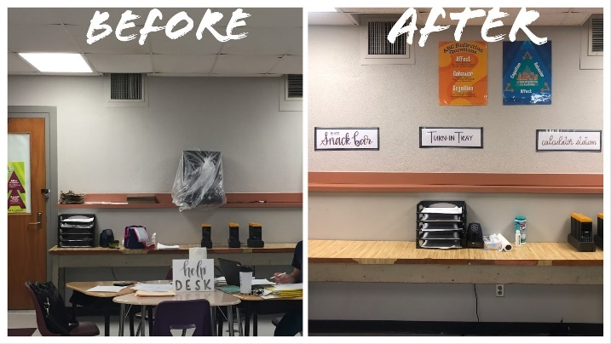
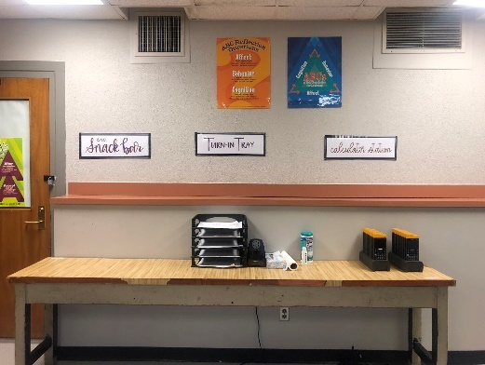
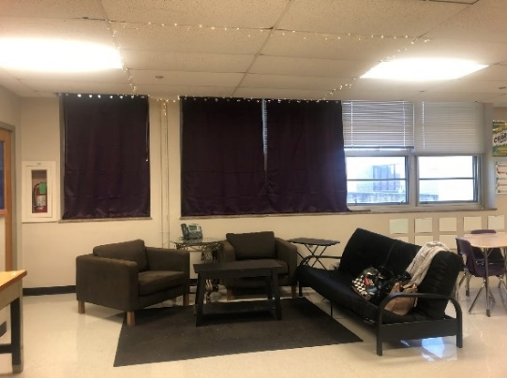
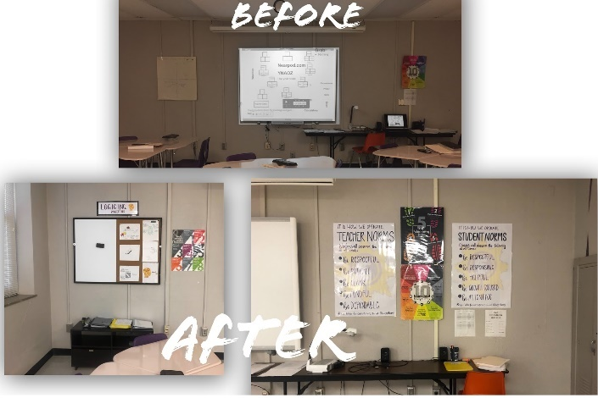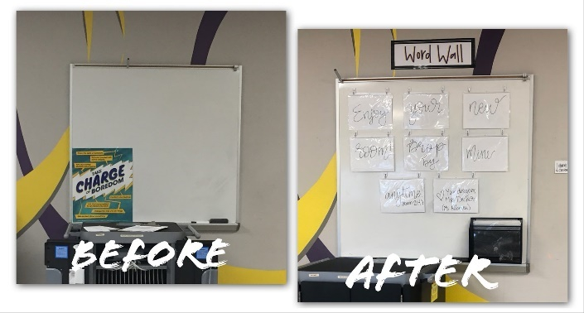
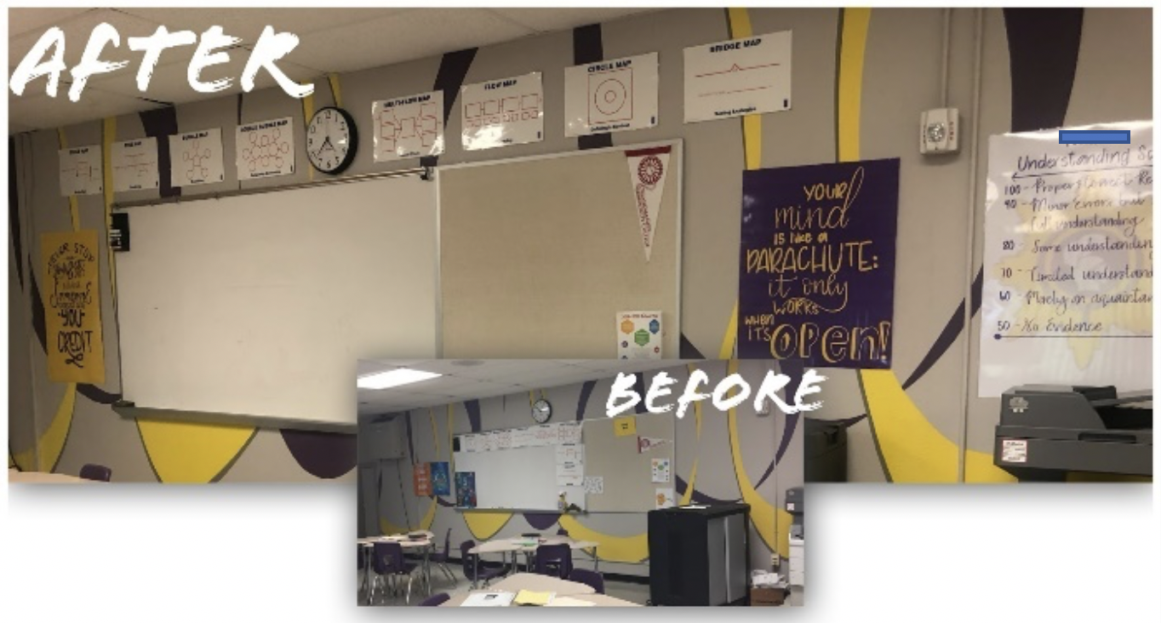
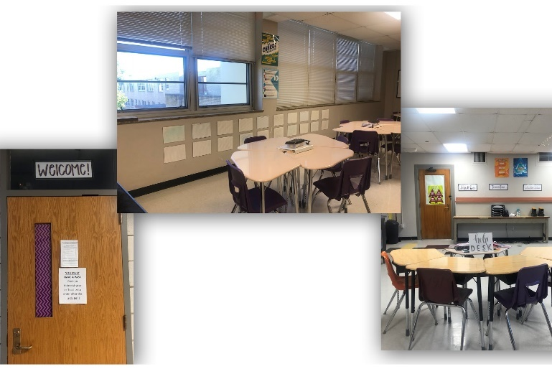
Classroom Environment and Culture
Nicole’s classroom culture was quite unique in comparison to many mathematics teachers in her district. Her classroom was built on foundations of positive relationships, shared responsibility, and vulnerability with her students. Her background, philosophy, and classroom environment each played critical roles in how her classroom culture was cultivated. In our conversations together, Nicole twice used the term “driven” when describing her classroom. The two driving forces for Nicole were relationships and student-interests. These will be discussed in terms of positive relationships and shared responsibility.
Positive Relationships
Nicole shared early-on in our conversations that “relationships drive” her curriculum and instruction. I was struck by her choice of the word “drive,” so in my observations I looked specifically for how she allowed relationships to drive what she was doing and the content she was teaching. At the start of the school year, Nicole asked students to fill out notecards. There was nothing special about the notecard itself other than how it was utilized by Nicole throughout the semester. Students were asked to share some of their personal information with Nicole on the notecard, which is fairly typical of many teachers. Students jotted down their names, a good contact number and the names of their parents and/or guardians, but more interestingly, students also complete a series of sentence stems. This provided a starting point for students to be able to share more deeply about their lives with Nicole.
Nicole asked students to share what they wished Nicole knew about them. They were also asked to share if they were facing any “-isms.” Nicole said she did this because she had “a lot of cultural diversity” and she felt like “racism [had] started to be on the rise.” So, rather than assuming that she knew what students were facing, she simply asked them. Nicole also shared with me that she asked her students to assess themselves on their beliefs about their abilities in mathematics. She used a Likert-like scale where a self-score of one meant “they are horrible” and a score of four meant “they are wonderful at it.”
Nicole worked to take students’ learning styles into consideration, which fit with her philosophical beliefs of constructivist teaching and learning theories. Using the same ratings, she asked students how they learn best. She used “the basic learning styles: auditory, visual, kinesthetic,” and if they were “internal or external thinkers.” Nicole said she wanted to understand each of her students, as she believed in “educating the whole child.” Additionally, Nicole asked students what they do outside of school, besides sleeping and eating. While these note cards were valuable in helping Nicole get to know her students personally, they also served a critical role in her pedagogy. She utilized this information throughout the semester to create seating arrangements and to assist in planning units of study. She said she wanted to see what students can “bring to [the unit].”
In addition to getting to know her students, Nicole was also observed engaging with students before, during, and after class. Between each class period, Nicole retrieved a cart of snacks from the closet in the back of her room. She then pushed her cart into the hallway just outside her door. For the full five minutes of each passing period, Nicole engaged with students, addressed most by their first name and seemed to genuinely care about their well-being. She did all this while selling students inexpensive snacks like potato chips, bottles of water, and candy. The profits from the sales went to the senior class for events like dances and other social engagements. Nicole served as the senior class faculty sponsor. During each observation, Nicole cheerfully engaged with students as she was selling snacks.
As each class began, Nicole greeted her students warmly. She typically asked students in the class how they were doing, collectively. One could sense that she genuinely cared about her students when she greeted them. Many students responded to her and shared little bits about how they were doing, what they had been doing since they saw her last, and how they were feeling. Not all responses from students were positive. In one instance, a student shared that they were having a really difficult time. Nicole reacted positively but took a few seconds of class time to address this student to help set their mind at ease.
Nicole did not come across as a person who was superficial in her interest and concern for her students. She said that she cared about them and their well-being. She said, “I'm really about the whole child. Not just the math, but who they are as a person, who they can be, and using math as a conduit to help them be a better person.” This notion seemed to epitomize Nicole’s teaching beliefs and framed how building personal relationships with her students helped her to create a space where students learn mathematics. Over her tenure at WCHS she developed a reputation of being a kind and caring teacher. As she built relationships with students in her class, Nicole shared that students felt valued and accepted for who they were as human beings first and foremost.
A key component to how Nicole built relationships with her students was her vulnerability. Nicole asked students to share their thoughts, share pertinent information about their personal lives (to the extent they were comfortable), and their mathematical knowledge. Interestingly, this was very much reciprocated by Nicole. Relationships in her class were not one-sided; Nicole was willing to share with students how she was feeling and what she was thinking. In one observation during her AP Calculus class, students were working on understanding instantaneous rates of change. The concept of an instantaneous rate of change is a foundational and profound concept in calculus classes, and Nicole was vulnerable with her students about her difficulty in fully grasping the concept in conceptual way to help her students learn it best.
Historically, the instantaneous rates of change and the methods by which mathematicians could calculate them revolutionized science and mathematics in the 18th century. Students in Nicole's class were on the precipice of discovering this profundity themselves. In her class, her calculus students articulated that they were having some difficulty in how they would connect the process of calculating instantaneous rates of change with their prior knowledge of understanding average rates of change. As students were sharing this, Nicole was willing to share with her students that she was struggling with this as well. She said that it had been a really long time since she had first learned calculus and that she was struggling to understand the concept, as well. She routinely divulged to students that she was new to teaching calculus and that she was still learning how to best teach some of the concepts. This seemed to appease students and set their minds at ease. If their teacher was willing to share her struggles with the concepts, they seemed more willing to ask questions and make sense of it for themselves.
Nicole’s relationships with her students were on full display, not only when she was formally teaching, but also when she was working with students in small groups and in one-on-one situations. She made it a point to speak with each student every day. This was an admirable goal, and I was able to see how she did this on multiple occasions. Appendix C illustrates two movement charts for Nicole over the course of two full class periods (Appendix D also illustrates two movement charts for Bailey). In each chart, Nicole visited each group of students multiple times. Moreover, she also spent ample amounts of time with each table as she helped guide them through their mathematics tasks.
Shared Ownership
While positive relationships were a vital component to Nicole’s classroom culture, there was another aspect to her classroom that was quite unique. Nicole seemed to recognize that her role as a teacher was not built on a foundation of power and control. In fact, she said that her style of teaching required teachers to be willing to give up control of the classroom. At first, I was not sure what was meant by this. Control as a term can be quite loaded, full of meaning and connotation. Control in Nicole’s classroom essentially meant having a voice. Students had a voice, they had power and control over what happened in Nicole’s classroom and how it happened. Students’ collective voice was balanced by Nicole’s voice and input. The two, Nicole and students, worked in tandem to co-create a classroom that was shared by all. Even saying that this was Nicole’s classroom was a bit troubling. The classroom was just as much students’ as it was Nicole’s. There were a couple of aspects of the classroom that were unlike many typical high school mathematics classrooms. This included the way in which the classroom was designed, how Nicole co-constructed norms and expectations with students, and a shared sense of responsibility that existed within the classroom.
Shared Classroom Design. As aforementioned, Nicole’s classroom underwent a transformation that was quite substantial. The way in which this happened, though, came through a project that Nicole aptly named, The Ultimate Classroom Project. The project began with Nicole creating space for students to work collaboratively to synthesize how they envision their classroom. This included how the classroom looked, what students’ roles looked like in the classroom, and how Nicole facilitated learning. This project was assigned at the beginning of the school year and students spent a significant portion of their first month grading period working on it periodically.
At the heart of the project, Nicole shared what the project felt like from a student’s perspective in that “it’s organized in a way that it helps students as learners.” She went on to say (speaking from the perspective of a student):
Me, as a learner, what are my needs? What do I bring? What do I have struggles with? What are the environmental constraints for me? What are the outside constraints for me? So, they are able to really process that and keep coming back to it the rest of the year. And, as a group they choose the layout of the class. They choose the reassessment practice. They determine what the qualifications of the student roles have to be.
In essence, students were given time and a structured space in which they could better understand who they were as learners, what they could offer to the class to make it a more positive learning environment, what they needed to be successful in her class, and they provided input into how they could structure the physical space to make it more conducive to their learning needs. Nicole also mentioned student roles in this example. Within the context of Nicole’s classroom, she had students help her create student roles to better facilitate projects throughout the year.
Generally, students’ roles for projects consisted of managers, subject matter experts, hosts, and class reporters. While the names of the roles were consistent from year to year in Nicole’s classroom, the descriptions changed based on how students defined them. For instance, this year students collectively decided that managers helped everyone, they supported people, made sure everyone was present, they often led discussions, and kept their group on task. Subject matter experts were defined as students interested in the current mathematical subject matter and they primarily helped their peers understand concepts in class. While the term expert was used in the role’s description, students may not have been true experts, but they felt confident in the subject matter.
Hosts played a unique role in Nicole’s classroom culture in that they helped welcome visitors and clients into the classroom. Within Nicole’s project-based curriculum, she had friends, family, and community members serve as clients who were in need of help from her students. For instance, in one project, Nicole had several clients who came to her class to meet with her students. For one particular project, students assessed the clients’ financial situation and helped them devise a plan for saving, investing, and/or planning their finances going into the future. The host, then, was responsible for welcoming these guests, making them feel at home, and comfortable. This role also freed Nicole to keep the classroom running and so she could continue working with students if need be.
Finally, classroom reporters filled an administrative need for the classroom. Students decided that reporters would put together handouts and take notes for absent students. This way, when a student returned to the classroom from an absence, they could more easily get caught up with topics being taught. Each of the roles were initially developed by Nicole as a way to provide a sense of investment for students. Students who had a role to play, she found, were generally more engaged in their learning. Nicole said:
Learning is an investment. You have to feel like you really want to do it or that you really want to commit to it. So, sometimes [students] may not really want to learn in math, but they want to be committed to the people around them.
Combatting the question “When will I ever use this?” is something that every mathematics teacher is asked during their tenure. Nicole said she did not have an issue with this because students found value in learning because they were committed to helping their peers.
With Nicole having spent many years in the private sector as a journalist, she has felt it necessary to help prepare her students for the workplace. This manifested itself in the way in which students assumed roles within the classroom. To be a manager, subject matter expert, host, or classroom reporter, students were required to apply for the role. Students were able to apply for whatever role they wished. There could be several of each, depending on the total number of students in the class, who was interested in the positions, the type of project students were working on, and depending on who applied. It should be noted that there was an expectation for students to apply, but it was not mandatory. To apply for a role, students filled out a half-sheet of paper containing prompts. The prompts were simple and can be found in Appendix D. They asked why students wanted to be in the role, why they felt they were qualified, and how they saw themselves within the role. After they submitted their application, they were interviewed by Nicole or her student-teaching intern. The interviews I observed lasted approximately three minutes and were conducted during class at the back of the room in the “relaxation area.” When I observed students being interviewed, the questions were simple, unintimidating, and provided students with an opportunity to both share why they would be a good fit in the role and to provide them with a skill of having interview experience.
Roles within the classroom changed approximately every month, but some lasted longer or ended sooner depending on the length of a unit of study. Students who were managers did not have to reapply to be managers for subsequent projects, but they were given the option to do so if they desired. Students could also apply for different roles or no role at all. In other words, students were not stuck in a role for a long period of time.
In addition to providing input into how the classroom was designed and the roles students played, students also had input in sharing how they best learn. During the first month of school, Nicole provided time for students to try out various learning styles and strategies for learning. This happened while students were learning new content and applying for roles. She described this process in her Algebra 2 class:
It is new content for Algebra 2. And that’s what makes it so much more powerful because they get to think back to what it was about what happened today that really helped me. Is a jigsaw really helpful for me? Is working with people really where I get solidification? Is Cornell Notes the best way for me to record? So, they keep analyzing because they are learning something new, but it is hard for the because I’m also pushing them to be like What really worked? And they had never thought about that before. They had just thought, “I take notes…”
To accomplish this, students were given activities in which to engage using an iPad application called Nearpod. When using Nearpod, Nicole would preload a series of activities onto slides in which students could individually work through on their iPad. Nicole said she likes using Nearpod because it provides students with time to work individually and with groups, but they were not tied to learning along with the remainder of the class. If a student or a group of students had a solid understanding of their content, they could get started on the assignment and Nicole would track their progress using the application. While some students may have initially understood the content rather well, others may have been struggling. Using Nearpod allowed Nicole time to sit with students who may have been struggling, helping them clarify any misconceptions they had about the mathematical content.
As the school year progressed, Nicole continued to use Nearpod as one of her primary modes of engaging students. By doing so, students were able to engage in the type of note-taking or learning activity that was best suited for them, they could work at their own pace, and they were given space to work collaboratively within their group to collectively construct meaning of the mathematical content they were learning.
Construction of Norms. Part of the Ultimate Classroom Project was built on the sense that students were able to share control and power within Nicole’s classroom. The process by which students accessed their voice came through a guided exploration of sorts into co-creating shared normative behaviors that were best for the class as a whole. This process began with students writing down negative experiences they had had in school in years past. Students could write down up to five. Nicole collected these and compiled them digitally into an online word cloud generator. The result was a jumble of words projected onto her Smartboard. Larger, bolded words indicated words and phrases that occurred more frequently.
I asked Nicole if she would be willing to share how this process looks since I was not able to directly observe it. She provided the following description:
It starts out with them writing on a notecard, “What’s a problem?” I have them think through all their classroom experiences. What has a teacher done that was a problem for them? What has another student done that is a problem for them? And then I compile it into a word cloud and so that the big things come out.
I also asked her why she began this process with negative experiences. She shared that her students “can easily think about what they don’t like and then turn that into a positive.” Once students articulated their negative experiences in the past, Nicole worked with her students to turn these negative past experiences into positive normative behaviors for their classroom.
One example of a classroom norm for Nicole’s AP Calculus class was that students and teachers should use the name of the student that he or she preferred. This came out when students were asked to articulate their negative experiences. Nicole stated, “So, apparently everybody in here hates it when somebody doesn’t use their name when they are referring to them. So, what we should do is use the name you prefer. That’s our norm.” Once major themes came out of the word cloud, Nicole asked students to write what they felt should be five possible norms for the class. They then spent time discussing the norms and each class decided what they should be. The norm of referring to students by the name they preferred was later consolidated into a larger themed norm called “Be Mindful”, which asks Nicole to be mindful of students’ situations outside of class and to what students feel is important to them.
After students decided on the classroom norms, these were compiled by Nicole and included in a binder that sat on top of students’ desks. There was one binder for each table of desks. Within the binder were the classroom norms, the references for how the class handled issues, and a team contract for how the group would work together as a team on projects and assignments.
This process of developing classroom norms was not something that was created, stashed in a binder, and forgotten about by Nicole and her students. Norms for Nicole were an ongoing process that were visited frequently throughout the year. After Nicole’s classes established their norms, I was able to observe her discussing the classroom norms with her students each day. During the beginning minutes of each class period observed, Nicole would reference the classroom norms, asking students to pay attention to particular norms that would be especially pertinent to the day’s work.
So, what exactly are the classroom norms for Nicole’s classes? As aforementioned students’ negative experiences in school were compiled by Nicole into two categories. These were teacher-related and student-related. The teacher-related norms were what students asked to Nicole to follow, and student-related norms were agreed upon by Nicole and students together. In addition to being posted in each table’s binder, the established teacher norms were also posted at the front of the classroom to the right of Nicole’s smartboard screen. Figure 2 depicts the posted norms for Nicole’s classroom.
Figure 2. Photographs of Co-created Student and Teacher Norms in Nicole’s
Classroom
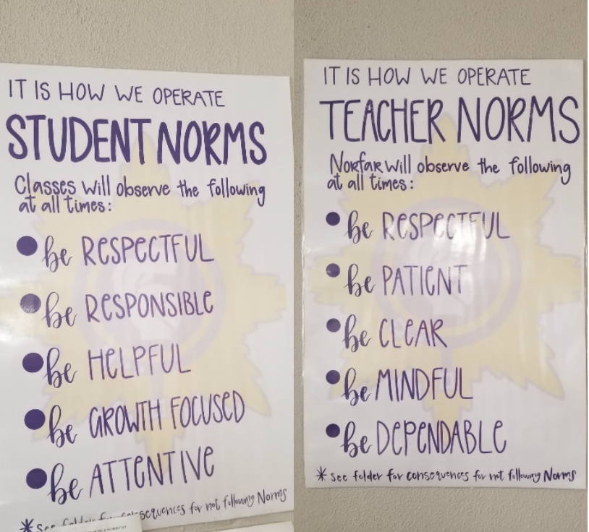
In both cases, students’ negative experiences in schools were transformed to be positive behaviors for classroom interactions. The bottom of each poster contained a statement for not following the posted norms. These included losses of privileges like using smartphones during class. Nicole stated multiple times that by creating normative behaviors with students and having students provide their input into how the classroom operates, she had very little behavioral issues in her class. Each binder on students’ desks contains a section for “solutions for common problems” students may encounter in class. This can be found in Appendix E.
Nicole did state, though, that the process of establishing norms with her students was quite laborious and it took considerable time to develop. By the end of the first nine weeks grading period, norms were just being decided upon and solidified. In addition to simply taking time to create, Nicole had to work around issues of absenteeism at WCHS and scheduling changes/conflicts. So, by drawing out her timeline for establishing norms, Nicole also had a better idea for who would be in each class period for the semester. As students entered and left her class throughout the year, Nicole revisited and provided time for re-establishing norms for students who were not able to be part of the process at the beginning of the year. Amending norms did not change the collectively established norms completely, but it did give new students a chance to feel as if their voice was heard and valued.
Respectfulness. When I previously observed teachers across multiple school districts across the state where Nicole teaches, respect was often demanded by teachers and students. Rarely, though, would students and teachers define respect in the same way. Within Nicole’s classroom was a sense of mutual respect and cordiality that flowed through conversations, assignments, projects, and teaching. Students seemed to like and respect one another, they worked collaboratively most days and their conversations were mostly substantive. Additionally, I observed students laughing, smiling, and sharing. Respect for Nicole was also prevalent. Part of this seemed to come from Nicole placing significant emphasis on students’ responsibility for their actions, their work, and their mathematical knowledge. Her ability to share responsibility also seemed to convey trust. Nicole rarely policed students and never did I observe her berate students verbally. She shared that she does not give referrals, nor does she raise her voice outside of projecting to the back of the classroom.
In addition to students’ respect for one another and towards Nicole, Nicole’s respect for her students was quite evident. In building positive relationships with students, she appeared to have built credibility with students, her disposition was consistent week-to-week, and she mentioned in several interviews that she “loves” her students. In one instance, she even referred to former students as her “kids” going as far to say she viewed one student as her “son.” Many teachers refer to students as kids, but Nicole’s use of the term seemed to carry depth and emotional connections.
In terms of Nicole’s classroom environment, there was also a respectfulness for the space in which she and students worked. She recalled in conversations that she wanted to teach at WCHS to “give back” to the school that gave her so much. Nicole shared that she lived in the community where WCHS was located and prided herself in her work. While “giving back” may harken impressions of a savior mentality, Nicole by contrast seemed invested in her school community and she did not retreat to the suburbs each evening to escape the urban center.
Investment in Nicole’s classroom was evident in her willingness to share her own money and resources to help transform her classroom. Additionally, Nicole regularly included students’ input, curiosities, and creativity in how the physical space was constructed. Additionally, norms were established collectively, not in isolation and not solely from a singular perspective. Nicole’s willingness to relinquish her power and control in order to trust students to create something that was uniquely “ours” was further evidence of mutual respect.

A Typical Class
The following descriptions take into consideration each observation to craft what is reminiscent of a typical class period for Nicole. This is not a fictional description, rather my intention was to synthesize each observation into the essence of a typical class period. This description will be structured through Nicole’s description of the three components of “the workshop model” which consisted of a "mini lesson, work time, and debrief.” Nicole stated that this “cycle continued’ throughout her teaching, so an additional section was added to provide additional information about Nicole’s class procedures. A typical class period was 47 minutes from start to finish.
Mini Lesson
As the bell rang for Nicole’s class to begin, students entered the classroom through the door towards the rear of the room. Each student who entered passed by Nicole who could be found in the hallway by the door selling snacks and bottles of water to raise money for the West Central senior class. I overheard Nicole greeting students, asking them how they were doing, and welcoming them to class. Once the bell sounded, Nicole pushed her snack cart into her classroom and parked it in the closet near the door.
Without prompting, students began to congregate round Nicole’s iPad cart near the door. Each student took a tablet out of the cart and found their seat, which was indicated by a seating chart projected to Nicole’s Smartboard screen at the front of the classroom. As students sat down, they logged into their iPad and opened an application called Nearpod. On the Nearpod application was a set of instructions, beginning with a quick question (or mini lesson). Students answered a short mathematics question related to their topic of study and submitted their answer. As Nicole finished parking her snack cart, she moved to the laptop at the front of the room and opened her computer, logged into her Nearpod account that showed her who had and who had not answered the question. This process took approximately three minutes to complete.
Next, Nicole projected a set of data on the Smartboard. The data consisted of percentages next to four letters: A, B, C, and D. The question that students were asked to answer was a multiple-choice question with four choices from which students could select. Nicole could instantly see who was correct in their thinking and who was not as students submitted their responses. This data led Nicole into a full class discussion about the problem. Typically, if students answered mostly correctly, she would ask a student to volunteer to share their process into how they found the correct answer. If most students were incorrect in their thinking, the next few minutes were used to discuss the problem in more depth to ensure more students are grasping the concept at hand. In today’s lesson, most students were incorrect, so the subsequent discussions around the students’ responses involved students answering questions prompted by Nicole in order to understand why their responses were incorrect. Nicole called on students to write out solutions to the problem as she guided them. Once the opening problem sequence had finished, approximately seven minutes had elapsed. Nicole spent the next three minutes outlining the objectives for the day and instructions for completing the tasks that were assigned.
Work Time
Once the opening sequence finished, students were tasked with exploring concepts at their table with help from their peers, subject matter experts within their group, Nicole, and Nicole’s student-teaching intern. Students worked in groups of three or four. Each table had at least one open seat for Nicole to sit at as she moved about the room. Students utilized their Nearpod application rather than a textbook. The application students used consisted of many slides one may find in formats such as PowerPoint or Google Slides. Other slides consisted of videos and instructional strategies for taking notes and learning the concept. Some students took notes about the material with which they were presented, but this was not forced. Students were able to choose methods that worked best for them in order to construct meaning. Each table where students worked usually had at least one empty desk.
Nicole emphasized in our conversations that students in her class did not mimic processes and procedures. Rather, Nicole provided multiple entries into the concept and allowed students to determine what works best for them. During “work time,” students were working. They were collaborating with their peers to make sense of what they are learning. Occasionally, a student would get off-task, but their peers or Nicole were quick to redirect them. While students were working, Nicole moved about the classroom and frequently stopped to ensure students were understanding the concepts for the day. I observed Nicole sitting with her students rather than standing over them. She sat and engaged them in conversation by asking questions to help students articulate what it was they were doing.
The primary exception to a typical day was observed on days considered to be Graded Assignment Days. These days were part of what Nicole described as a “two for one cycle.” On graded assignment days students had two days prior to explore and gain understanding on a topic before they were assessed on how well they knew the subject matter. The assessment was in the form of a graded assignment, in which students used resources at their disposal other than Nicole or Nicole’s student teaching intern. The assignment itself usually took the entire class period to complete. Students were not allowed to take the assignment with them, but they could come back to class during lunch or after school to complete their work. Nicole said the purpose of this was so students could show what they know about the mathematical concept.

Reflection
Nicole admitted she struggled with this portion of her class. Ideally, she said she would like to have a time for students to reflect on their learning through writing, an exit ticket, or some other form of informal assessment. During my observation of a typical class, time seemed to go by quickly for both students and Nicole. With approximately one or two minutes left before the bell sounded, Nicole reminded students how much time they had to finish, what they needed to finish later or the next day, and where the class would be going in terms of exploring content in the coming days. The end of class seemed rather frantic, but this was indeed normative for my time in Nicole’s classroom.
As the bell rang, students finished what they had completed and turned it into the designated file folder at the rear of the classroom. Since every student used an iPad to access Nearpod, they returned these to the cart, plugged them in, and then left the classroom. Immediately following the bell to signal the end of class, Nicole continued conversations with individual students while making her way to the door near the rear of the classroom. Nicole then proceeded to retrieve her cart full of snacks and water bottles from the closet and pushed it into the hallway to sell snacks during the five-minute passing period.
“The Cycle Continues”
After several observations in both Nicole’s Algebra 2 and Calculus classes, it became evident that this cycle of “mini lesson, work time, and debrief” continued to happen day-in and day out. On one occasion in Nicole’s Algebra 2 class, I was especially surprised to see this model of teaching unfold. This surprise came on a review day. Review days are typically allotted to allow students time to clarify misconceptions they may have about mathematics content before taking a summative assessment like a quiz or test. On this particular review day, students went through the same mini lesson routine. They selected an iPad, went to their seats and began working on a problem that could be found after logging into Nearpod. Afterwards, Nicole discussed the problem with which students were asked to complete, then shared instructions for the day, and modeled the task for students since it was new to them. This particular task was called “quiz-quiz-trade.”
To engage in quiz-quiz-trade, students were each given two problems to solve (quiz-quiz) on a clipboard. These problems were simple, fairly rote problems around ideas of factoring and simplifying polynomials. Students were asked to move around the room and find someone they do not normally sit with. Then, they were asked to exchange (trade) clipboards and solve another student’s problems. They checked their work with the solution which could be found on the reverse side of the problem. If students were confused to a point of frustration, they could raise their hand to get help from Nicole, her student-teaching intern, or a subject matter expert. Students were asked to trade at least two times to allow for a variety of problems. For approximately 25 minutes in this observation, students moved around the room looking for people with whom to trade clipboards while Nicole mingled throughout students, helping students as needed. To conclude the day, students had two options: They could continue reviewing and reflecting on the concepts they were learning, or if they felt ready, they could begin the test early.
Teaching and Learning Approaches
In terms of teaching and learning approaches Nicole used to enact her curriculum in a culturally diverse school, three major themes emerged in this particular case. These themes involved Nicole’s approaches towards creating a student-driven curriculum, sharing responsibility for students’ learning, and deep levels of care for students, the overall physical space, and her mathematics content.
Driven Curriculum
Authentic teaching and learning approaches are founded on theories supporting student-centered learning. Adopting philosophical approaches set forth from scholars such as Dewey and Bruner, student-centered curricula places students as the focal point for all instruction. Work in Nicole’s classroom was characterized by student-centered learning approaches. Handouts, use of technology, and assessments each placed her students central to each experience in her classroom. What was unique to Nicole’s classroom, though, was that her classroom was not only student-centered, but it was driven by students’ curiosities and relationships. More specifically, Nicole’s student-driven curricula was predicated on collaboration and valuing students’ input.
Collaboration. Upon entering Nicole’s classroom, collaboration seemed inevitable. Students were situated in groups, there were normative behaviors established and agreed upon that suggested students would collaborate on a regular basis in her classroom, and the structure of Nicole’s typical daily lessons were built on students collaborating with her and each other. Oftentimes, students were required to work without the oversight of Nicole to determine whether or not mistakes on computations or procedures were made. This required students to collaborate with one another in order complete tasks. Nicole shared that collaborating in her class relied mostly on students understanding that they are responsible for their learning. She said, "Putting the responsibility of really owning the content on them and having them delve into it in different ways that fit them."
As mentioned before, Nicole’s primary lesson structure followed what she referred to as “the workshop model.” This model was quite conducive to students collaborating. In fact, during the “work time” portion of her lesson structure, Nicole was observed moving most of the time. This involved moving from table to table assisting students. It was impossible for her to be everywhere at once, thus collaboration was key to successful lesson implementation. She stated, "Like, how many classes can you say you are going to where you can say nobody needed me—other than a couple of questions." My observations confirmed that students were not discouraged from asking questions, but they asked one another questions and worked through problems together, with guidance from Nicole.
In one particular observation in Nicole’s calculus class I observed students working through problems that were given to them on a paper handout. The group I chose to observe most closely was a group of six students all sitting together. They decided to forego their assigned seats for the day in order to work as a large group. One student seemed to take charge of the group and began working through one of the more challenging problems on a dry-erase board next to where the group was sitting. While I was observing, I noticed students giving suggestions as to how the student at the dry-erase board should proceed when she would reach a point of impasse in her calculations. I watched the student at the board make two crucial mistakes. She found an answer to the problem, but she seemed to be perplexed because her peers were discussing together that it did not make sense. She reviewed her work, found her error and seemed to be satisfied with the answer.
I asked Nicole later in our interview about how she navigated times when she would see students making blatant mistakes that could easily be corrected. She told me that her style of teaching was ideal for allowing students space to make mistakes and to learn from them. She articulated this when she said, "One of the things that helped me switch is that you really learn from your mistakes rather than what you do right." So, by allowing students to make mistakes and to rectify said mistakes, this provided space for students to better understand what they were learning in her mathematics class.
To assist in the overall collaboration in her classroom, Nicole had students sitting in groups. Students were facing one another rather than facing the “front” of the classroom. Nicole shared with me that many of her colleagues and many of the students’ former teachers structure their classrooms to where students are sitting in rows, facing the front of the classroom where teachers would disseminate information to them. Nicole said that this type of teaching was pervasive in students’ past experiences and she felt like students were “conditioned to listen.” She also recognized that her style of teaching was difficult for students to adjust to, so she tried to gently wean students onto her style. She shared this experience:
They are going to have to switch back to listening mode for next hour. So, depending on when they have my class during the day, they are still also sort of switching...she's going to do it this way, unlike my other four classes.
For Nicole though, she felt as if student collaboration and students driving her curriculum were still best practices in mathematics. She reflected, "I've discovered you can only do so much in front of the class. You have to get elbow to elbow."
To help students adjust to her style of teaching and to collaborate with peers, Nicole structured her class in such a way that students had a significant amount of input in her curriculum. She said that "[students] usually don't get to have a say in other classes." To help with this, Nicole asked students what they liked about school, what they did not care for, and what other teachers had done that she could continue to implement. Part of this was then incorporated into building classroom norms with students, as mentioned above. Students shared how they preferred to learn and what they enjoyed about mathematics. Having student input was key to Nicole’s uniqueness as a teacher.
Shared Responsibility for Learning
Over the course of her career, Nicole recalled that most students “never really thought about what they need in most classes...they just go with whatever the teacher is doing and sometimes they are doing it well, based upon the teachers’ role, or sometimes they are failing miserably, but they don’t know why.” Again, Nicole believed many of her students had been socially conditioned to think a certain way. This was evidenced by her belief that many students did not know how they were doing in class, they were subjected to teaching styles that may not be helping them become better mathematics students, and most learning was driven by teachers. To help rectify this, Nicole created a culture in her classroom that revolved around shared responsibility for student learning.
In Nicole’s classroom, students collaborated regularly and there seemed to exist a sense of comradery in her classroom that was built around students’ responsibility for their learning. Students were given opportunities to understand how they learned best. Nicole shared that when students understand how they learn, they tended to perform better in her class. Regarding how students learn, Nicole shared the following anecdote:
What was it about what happened today that really helped me? Is it a jigsaw that really helped me? Is working with people really where I get solidification? Is Cornell notes the best way for me to record notes? So, they keep analyzing because they are learning something new, but is hard for them because I'm also pursuing them to be like, 'What really worked for me?
As students were trying on different learning approaches that fit their personal needs, Nicole also seemed to feel a sense of responsibility for how students were learning. In one of our interviews, she recalled several questions that seemed to be at the forefront of her teaching, “How do you honor the introvert, the extrovert, the external thinker, the internal thinker, the quiet, the loud, the ADD, and the autistic?" In Nicole’s classroom, both students and teacher were sharing responsibility for students’ learning.
This process of sharing responsibility was not an easy task. Nicole laments, "Overall the students find it very weird at first. It isn't something they have encountered before, so they are sort of in a shell-shock state." This seemed to only last for few weeks. During my observations, students appeared quite comfortable with Nicole’s style of teaching and expectations for interacting with mathematics in her classroom.
Not only was there a sense of shared responsibility, but there was also shared ownership of Nicole’s classroom curriculum and her approaches. She said:
The biggest piece, I think, is setting them up at the beginning of the year. We're co-creating this classroom together in every aspect. So, letting them know that I want them to say how they want me to act and how they want themselves to act really sets the tone. And so, saying to them, “Hey, I want us to have this environment that will work for both of us.
The takeaway here was that students and Nicole were co-creating a space in which they could learn. This entailed shared ownership of the classrooms’ physical space, the methods in which Nicole enacted her curriculum, and expected student behaviors.
Part of sharing ownership was how student’s roles were defined. This was discussed in much more detail above in relation to Nicole’s classroom culture. Roles, though, played a significant part in how ownership of Nicole’s classroom was organized. She said:
Everyone feels more invested they more they have something they feel is a tangible state. So, learning is an investment. You have to feel like you really want to do it or that you really want to commit to it. So sometimes they may not really want to learn in math, but they want to be committed to the people around them.
For Nicole, having roles provided students with a sense of responsibility to their peers. This helped them take ownership of their learning, as they were invested in their role within their group. This notion of shared ownership also seemed to tie into the level of care in which Nicole approached her practice. Nicole cared about her students and wanted them to be successful in not only mathematics, but in their lives as well.
Approaching Teaching with Care
During the course of my observations in Nicole’s classroom, one of the first elements that was most obvious to me was her level of care for her students. Less obvious, but later confirmed, was her level of care for the physical environment in which she taught, and care for her curriculum.
Care for Students. Like most teachers, Nicole connected better with some students than others. That being said though, Nicole approached her teaching with a level of care for all of her students. She ascribed to a philosophy of loving her students as human beings. She said, “I love them first… and then I want them to learn second...Kids don’t learn from people they don’t like” Loving first and learning second was observed multiple times during my time in Nicole’s classroom. She regularly praised students for trying, for making mistakes and learning from them, and even for being present. Asking students what they needed to be successful in her class seemed to be positively received by her students. She said, “[Students] have shared that the fact that I ask them what they need, so it is so refreshing and something they haven't had anybody ask before." Her positive relationships with students provided a level of care that was refreshing for many students, something they have not often experienced.
To help better illustrate Nicole’s care for her students, Nicole took time out of her schedule to better understand students’ lives. She made them feel welcomed and appreciated when they were in her classroom. She shared a little more about this:
I notice little things about their life and check back in on them and the fact that I ask what's happening with their life lets them know that I care about them...They just know that I'm there for them and that I will on-the-spot do things for them if they need me to...One student really took me aback one day...she mentioned I'm one of the few teachers who don't make her feel stupid. And this was an honors class!
Each interaction I observed between Nicole and her students was positive. Some conversations struck a harsher tone if students were not abiding by the agreed-upon classroom norms. This tone, though, did not convey anger, but care. She cared about her students, wanted to see them succeed, and pushed each student to be the best version of his or her self.
Care for Space. In addition to Nicole's care for students, she also cared about the physical space in which she taught. This was evidenced through conversations centered around Nicole’s choice to work at WCHS and the transformation the classroom underwent during data collection. First, Nicole wanted to work at WCHS, she chose to be at this school when she had opportunities to leave for more “desirable” schools. She felt a sense of responsibility to “give back” WCHS, as it is her alma mater. She said:
I could probably go anywhere, but this is the school I graduated from...I felt that if I was going to be in this area, then I should be where I graduated from and give back to a place that gave me what I have.
Adding to Nicole’s care for her alma mater, was her investment in the community. She and her husband lived in the community where WCHS was located. While Nicole felt she sometimes needed some separation from being constantly surrounded by students, she valued living in her community.
Care for the physical space of Nicole’s classroom was further evidenced by Nicole’s willingness to set aside personal money to help students transform their classroom to include their ideas and desires for how the classroom should look and feel. Additionally, students co-creating norms with Nicole to have input into what they needed to be successful showcased her care for students’ opinions and value she placed on their thoughts and feelings. Even within the norms themselves, there were undertones of care. Nicole said, "So like today we just finally agreed upon our norms this week and the classroom has been transformed to support the norms and to support how we are being cordial together."
Care for Content. Finally, Nicole carried with her a sense of care for her content. As aforementioned, Nicole chose to teach mathematics because she was unsatisfied with people saying they could not do it. Nicole did not necessarily have a love for mathematics, but a care for students having success with it. Even in how she taught mathematical content, she helped students make connections to the world around them. This was done through teaching soft skills like perseverance, critical thinking, and problem solving, but was more tangibly seen through creating projects in which students engaged. Projects were created with a high level of care in order to help students connect with and apply mathematical content. Two examples of this can be found in Appendix E. These include an outline for a Profit Project and rubric for Quadratics.
Additionally, Nicole’s approach to teaching and her commitment to teaching non-traditionally were imbued with care. She desired that her students be active learners who engaged with mathematics and with one another. She said her style of teaching was “much more beneficial than being mindless all day.” For Nicole, sitting quietly, taking notes from lectures, and mimicking processes and procedures was considered boring and ineffective. She strived to foster a space and a curriculum that engaged students in order to construct meaning and assume responsibility for their individual learning.
Contributing Factors to Teaching
In terms of factors that contributed to Nicole’s teaching, care also played a prominent role in this area; however, I felt that care was more fitting with how Nicole developed and enacted her curriculum rather than being a contributing factor to her teaching. Therefore, in addition to care, two different themes have emerged that contributed to Nicole’s teaching practice. These included relinquishing control of power within her classroom and the cultural diversity students brought with them to her classroom. Additionally, Nicole’s years of experience also seemed to contribute to her teaching practice. There were some mitigating factors as well. This included time (or lack thereof), student absenteeism, and few colleagues who aligned philosophically with Nicole.
Relinquishing Control
One of the first aspects of Nicole's teaching practice I found compelling was her ability to share ownership of her classroom. To do this, she and her students agreed upon normative behaviors and expectations that placed an extraordinary amount of power in the hands of students. Nicole said that her style of teaching required the teacher to "be cool with not controlling every aspect of what happens [in the classroom]." This was a process for Nicole as well. While power dynamics were shared in Nicole’s classroom, it did not necessarily begin that way. Nicole mentioned on multiple occasions how students had been conditioned to listen. They had also been conditioned to assume that teachers would tell them rules and expectations. Nicole shared that she had to work with students diligently to help them transition into her style of teaching and this process took a considerable amount of time.
When she was in the process of obtaining her alternative certification through the state department she said she was introduced to two primary modes of teaching “constructivist” and “behaviorist.” For Nicole, she recognized behaviorists models of teaching to primarily relied on mimicking. Students would take notes from a teacher, complete example problems given by the teacher, and would model processes described by the teacher. On the other hand, Nicole found theories around constructivists’ views of learning to be much more liberating for students. To be able to construct meaning for oneself felt revolutionary for Nicole. She did not realize that there was another way to teach other than how she herself was taught in high school. As Nicole researched constructivist theories of teaching she began to notice that students were the people in the classroom doing most of the work. Her role in teaching to was to be a guide, rather than a sage.
Coinciding with Nicole’s willingness to sharing control in her classroom was Nicole’s flexibility with her teaching practice. Like a performer on Broadway, she was able to improvise and adapt her teaching to her students’ specific needs. In other words, she was willing to bend to accommodate different learning styles. She even went so far as to say, that if she was doing “something they don’t like, we don’t do it. Students are always able to add to my toolbox.” Nicole was willing to adjust her teaching, try new techniques, and even teach contrary to her core beliefs if it was something that would benefit students in the long run. Being somewhat facetious, I asked her if she would be willing to teach from a “behaviorist” or more traditional philosophy if that was something that her students needed. Without missing a beat, she said, “absolutely I would, but fortunately they haven’t asked me to do that.”
Furthermore, Nicole’s flexibility was also evidenced in her willingness to allow students to try different learning styles during her class. This was discussed in depth earlier and will not be discussed here, except to say that Nicole’s practice of trying on various learning styles is at the heart of her ability to be flexible. Nicole also mentioned on multiple occasions that she invested time reading books on teaching, engaged in professional development workshops, and was a member of multiple teacher’s organizations. She embodied life-long learning and modeled this for her students. She was willing to grow within her practice and adopt new models of teaching, even if it meant discarding her previous practices.
Finally, Nicole’s flexibility was observed first-hand when I asked her about her teacher's desk. Nicole shared that she did not have a need for one anymore. She may have found a teacher’s desk to be appealing early in her career, but in more recent years she embodied an approach to teaching that kept her moving throughout the room. Therefore, when Nicole’s classroom underwent its transformation, Nicole decided she did not need that space and that it could be transformed into what was designated as her classroom’s relaxation area. Nicole was observed moving constantly, even on review days. She made it a point to visit every student during the course of the class period and therefore saw no need for a place to retreat. She had a small student-sized desk for her laptop and used the helpdesk to store papers and handouts. Nicole did most of her planning and grading at home and found that her teacher’s desk was taking up room that could be used by students. She said if students needed to find her, that she would be in the middle of the action in the classroom, working one-on-one with students. That was where she preferred to be.
Cultural Diversity
West Central’s cultural diversity was significant. Nicole mentioned that approximately 40 different languages could be heard at any given time in her school. In addition to language, the WCHS student body was both racially and economically diverse, which Nicole felt added to the uniqueness of her school. That being said, Nicole felt it necessary to be culturally responsive in her teaching. I asked Nicole how she worked within the diverse makeup of her school. She said:
Well it makes me definitely have to be culturally responsive...and what I mean by that is that it's not just about me bringing in you know a Hispanic mathematician, so they can see them or an African American mathematician. But, it is truly understanding that cultural way of navigating the world. And trying to make sure that I am bringing that out and praising it and utilizing it for their learning. For instance, in many people of colors' background, especially African American and Hispanic cultures, celebration and socialization is a core feature in their learning process. At their home, their places of worship, they are very active in it. So, like we'll be doing line dancing as a way to review and bring out the movement and celebration together.
Nicole was aware of the cultural diversity of her school and of her students. She celebrated it and worked within the cultural diversity to create unique and meaningful learning experiences for her students.
Since Nicole was an alumna of WCHS, I asked her how the cultural diversity had changed over the years. She was quick to say that "the diversity was just as strong then as it is now." In fact, the cultural diversity of WCHS was something that Nicole loved being immersed within. She further articulated:
It is why I love this school. I love the fact that we have different cultures and different backgrounds. I think it makes you a better person and more well-rounded in what you know and feel about people.
Nicole’s willingness to embrace the cultural diversity seemed to have permeated everything she did within her classroom. What I mean by this is that Nicole embraced the diverse perspectives that her students possessed and created a classroom environment that allowed them to flourish and to be celebrated.
Students entered Nicole’s classroom with a wide array of abilities and experiences with mathematics. Nicole took those into consideration when she was constructing curricula and teaching practices to best serve her students. While the school itself was quite diverse, so was the culture that was co-created in Nicole’s classroom. Students used multiple perspectives to explore mathematics, their unique voice was valued when helping define physical spaces and normative behaviors, and their learning preferences were taken into consideration which created a unique classroom culture in and of itself.

Constraints
Nicole’s ability to enact her curriculum and her views of teaching and learning were starkly different than many of her colleagues’. That being said, Nicole experienced some conflicts between other teachers and herself, she experienced seasons of loneliness, and like most teachers she was pressed for time and resources.
“No One Will Play with Me”
Nicole said she had very little pushback from her administration over the years, and although her most recent administrator had yet to comment on her teaching, she felt like she was free to teach in her style. Nicole shared that her reputation has helped her circumvent a lot of pushback from administration. She worked with a Planned Learning Community (PLC) of which the majority of her colleagues ascribed to more traditional teaching methods; however, her style was viewed by her colleagues as being different and something that Nicole could do, but they could not. Nicole experienced various seasons in her teaching career where she has had support from colleagues or, at the very least, colleagues who shared similar teaching philosophies.
At the time of data collection for this study, Nicole had two colleagues within the mathematics department that shared similarities to her teaching philosophy. Nicole spoke with joy when sharing that she felt like she had a hand in recruiting them to WCHS. While she had some support from colleagues, this was not always the case. During seasons of loneliness in her building, Nicole found solace through social media and professional communities to which she belonged and contributed. Nicole found herself alone for many years “with no one to play with,” but with the invention of social media and her savviness to get involved with teachers’ organizations, she found a supportive and collaborative community. Nicole saw many teachers come and go, many of whom felt pressure to leave her state due to low pay and lack of resources. Nicole did not blame her former colleagues and, in our conversations, did not pass judgment on them for doing what they felt was best for their livelihood. Whatever their reasons for leaving, though, they left Nicole once more in her building with a need to reach out to others to “recruit them.”
The two teachers Nicole had “to play with” were both new to WCHS. One teacher was Bailey and the other was a friend Nicole knew from teaching Sunday school at her local church. Nicole mentioned other teachers who liked Nicole’s ideas, but did not have the time nor energy to teach to the extent to which Nicole did. One teacher was a soccer coach who had commitments to his team and a young family at home. That being said, Nicole’s conflict with others was lower than usual during this study, allowing for her to collaborate with and serve as a mentor to others.
Time
Like most teachers in her school and across her state, Nicole was pressed for time. This was partly due to external circumstances, but also came from some commitments she willingly participated in. Planning for mathematics lessons in which students could actively engage was time-consuming in comparison to disseminating notes and assigning problems for students to work from a textbook. Nicole spent a significant amount of time outside of her contracted hours planning for lessons and grading assignments. Additionally, and as mentioned before, Nicole was active in my different professional organizations. These had commitments as well that took time away from her practice. Nicole had to miss class to attend conferences and to fulfill some of her commitments outside of WCHS. This added to pressures already associated with teaching in an age of high-stakes testing and accountability.
Summary of Findings
This chapter presented findings from Nicole’s classroom. As a veteran teacher of fourteen years, Nicole had developed a unique and noteworthy curricular model that was enacted using several non-traditional teaching and learning approaches. Underlying these approaches was her willingness to relinquish power over her students to support a co-created classroom culture that allows Nicole to teach in a way that seems to empower students to think critically and take responsibly for their learning. While there are some constraints facing Nicole, she has found solace in collegial support through professional organizations and social media outlets. Finally, Nicole’s ability to teach with an ethic of care seems to be a theme that is unique to many definitions of authenticity and culturally relevant pedagogies. The following chapter will present findings from Bailey’s classroom as a unique, standalone chapter.

Chapter 5: The Case of Bailey
In this chapter, the case of Bailey will be presented. Findings include Bailey’s background and teaching philosophy, her classroom setting, the culture that had been established in her classroom, a detailed description of a typical day in her classroom, and major themes that emerged from interviews, documents, and observations. Like the case of Nicole, findings are viewed through sensitizing lenses of authenticity and culturally relevant pedagogies, as defined in Chapter 2. Finally, findings in this chapter seek to answer what teaching and learning approaches Bailey used when constructing curriculum in a culturally diverse school, what Bailey considered to be contributing factors to her teaching practices and enacted curriculum, and what factors promoted and limited her ability to create and enact her mathematics curriculum.
Bailey’s Background and Teaching Philosophy
Bailey was an exemplary undergraduate student at the university where she studied mathematics education. In fact, during her internship she received an award from her department for “Outstanding Intern,” which was given to one outstanding individual for their work during their student-teaching internship. To some, like myself, this came as no surprise. I had heard about Bailey from other instructors in our mathematics education program. She had a reputation of being creative, thoughtful, and as one who thinks outside the box in terms of mathematics lessons. Bailey’s background and teaching philosophy helped to shed light on why she was held in such high regard.
As one may assume from the paragraph preceding, Bailey entered the teaching profession through a fairly typical route. Typical in the sense that she completed her undergraduate degree in mathematics education and obtained her teaching certification upon successfully fulfilling the requirements of coursework and student-teaching. However, her entry into teaching was the only thing Bailey would consider traditional about herself and her teaching. In fact, when I asked Bailey how she would describe her teaching, she said she was “anything but traditional.”
According to Bailey, traditional mathematics teaching can be defined through practices like long lectures accompanied by copious note-taking, assigning problems for students to solve out of a textbook, and having students work independently to demonstrate their understanding of complex mathematical procedures. Traditional teaching for Bailey also includes homework and multiple choice exams in which students are assigned grades, A through F. This was how Bailey described how she was taught mathematics in her high school and, to some degree, in her college mathematics courses. Bailey recalled her first mathematics education methods course in which she “saw there was another way to learn.” This alternative approach to teaching seemed to catch her attention and was where she began to explore her creativity in creating lesson plans in which students could discover concepts for themselves.
Bailey had a fascination for lesson planning that revolved around what she referred to as “discovery learning.” Much like student-centered approaches to teaching and learning, discovery learning places students at the focal point of a mathematics lesson and intends to have students make meaning for themselves, rather than mimicking procedures and processes that are teacher-directed. That being said, Bailey also believed strongly in collaboration between students. As one who ascribed to a constructivist teaching philosophy, she shared with me that students learn best when they can work collaboratively to discover key insights into mathematics. To achieve this, Bailey went so far as to remove all of the desks in her room, aside from a teacher’s desk, and replaced them with five large tables. This, she said, forced students to have to collaborate with one another in a way that was more natural than pushing desks together.
In addition to fostering a collaborative classroom, Bailey also believed in minimizing the amount of time she “gives notes” to students. In an ideal world, Bailey said she would engage in discovery learning 100 percent of the time; however, she felt constraints from high-stakes testing accountability and running out of time to engage students in content. Constraints and limitations will be discussed in more detail later in this chapter. In addition to discovery learning, Bailey has also adapted some of her teaching practice to look similar to Nicole’s. This was partly due to Bailey interning with Nicole the previous semester. Bailey had many similarities to Nicole, but as a first-year teacher there were some significant differences. These were based on Bailey as a first-year teacher who was encountering many issues that are often associated with new teachers. Additionally, Bailey had three subjects for which she was expected to prepare. Initially, Bailey was told she would be teaching geometry. However, once Bailey was hired, she was asked to teach Algebra 1 and Algebra 2. To add to her teaching load, one of Bailey’s Algebra 1 courses had been designated as a “sheltered” class. Students designated as “sheltered” were what Bailey referred to as “newcomers,” meaning they were new to the United States. They also had limited English proficiency, and most were typically a grade level behind other students at WCHS. Having three distinct courses to prepare for each day came with challenges, especially for a first-year teacher.
Adding to Bailey’s sense of non-traditional teaching style was her attraction to culturally diverse schools, specifically West Central. Bailey identified as being part of the LGBTQ community and was initially drawn to WCHS for its diverse student population. This aspect of Bailey’s identity seemed to convey a sense of vulnerability and empathy to her teaching. Moreover, she felt like she could be open and honest about her life if she worked and lived in the surrounding community, whose diversity mirrored that of the school’s. Part of Bailey’s teaching philosophy revolved around transparency with students and an earnest desire for her and her students to be true to themselves. Bailey said she grew up in a suburban community where her peers mostly looked and spoke the same. Thus, she felt that the lack of cultural diversity stifled her ability to true to herself. She said it was challenging to be a gay woman growing up in that space. Knowing this, Bailey purposefully sought to teach at school with the demographic makeup of West Central where she hoped she could be more transparent with students and colleagues.
Classroom Setting
Bailey possessed a sanguine, infectious personality. She was kind-hearted, caring, and genuine. When entering Bailey’s classroom these character traits became instantly apparent. Her room was bright. This was partly due to the wall of windows that greet you upon entry opposite the main door. The shape of Bailey’s room was fairly typical in the sense that it was nearly square. Once entering the door, one would be located at the rear of the classroom. The rear consisted of a whiteboard with two smaller bulletin boards on either side. The whiteboard had multi-colored pennants across the top. It also contained information regarding “bell schedules,” an abbreviated agenda for each of Bailey’s three course preps, and some miscellaneous information regarding classroom supplies. The bulletin boards were significant in that Bailey intentionally created these to aid in the aesthetic of her classroom.
The bulletin board to the right of the whiteboard contained words associated with a growth and a fixed mindset. Bailey mentioned in our interviews together that she was inspired by Jo Boaler’s Mathematical Mindsets. In this book, Bailey particularly found ideas around growth mindset to be particularly appealing, thus she incorporated its major themes into her classroom. One particular phrase that stood out to me on this board was, “How you THINK changes how you DO!” This seemed to capture the feeling associated with Bailey’s class. Students were generally doing mathematics together. They collaborated and shared ideas. How students chose to think about mathematics very much influenced what they did in Bailey’s class.
To the left of the whiteboard at the rear of Bailey’s classroom was another colorful and creatively designed bulletin board. This one focused on what students could do with mathematics. On the bulletin board was a thought bubble that read, “When will I use this in real life?” This question is very common in mathematics classrooms. Bailey shared that she was concerned less about how students use mathematics in a specific profession and was more concerned about teaching students how to think. Under the thought bubble were words and short phrases that depicted how students would use mathematics. These included: “Discover Patterns,” “Explain,” “Persevere,” “Problem Solve,” and “Think Critically.” In essence, these words and short phrases were soft skills that students were learning in Bailey’s classroom that can be applied to many aspects of life.
Moving around the room counterclockwise was Bailey’s teacher’s desk. This was markedly separate from the rest of the class and served as a sort of haven for Bailey to which she could retreat during lulls in the class period, breaks, and her planning time. Bailey’s desk contained some personal mementos, a personal teacher’s chair that Bailey brought from home, her computer, a microwave, and a smaller desk butted up to it. This smaller desk was often used for one-on-one tutoring and also housed handouts and assignments for students.
Continuing a counterclockwise motion through Bailey’s room and across from the main door was the wall of windows. Each window had a colorful, paper bird affixed to it. The windows did not have blinds or curtains and allowed a significant amount of natural sunlight to enter the room. Through the windows one would see a large courtyard. In front of the windows in the rear was Bailey’s desk. In front of Bailey’s desk was a large HVAC unit, which had a moment of mechanical failure during my observations.
At the end of the wall of windows, now at the front of the classroom, was a sink. The sink was functioning with both hot and cold water; however, this was not used during the course of my observations. Above Bailey’s sink were posters which indicated mathematics standards that were being taught in her class. To the left of the sink was a small student desk with a laptop on it. Cords coming forth from the sides and back of the laptop connected to an interactive whiteboard at the center of the wall at the front of the room. To the left of the interactive whiteboard were two posters, one higher than the other. These posters presented “student norms” and “teacher norms.”
Rotating counterclockwise from the interactive whiteboard, one would return to a wall containing the door which was initially entered. Towards the front of this wall was a secondary door that was not in use. To the left of the door was a large bulletin board with a label on top of it that says, “The Fridge.” This was a unique part of Bailey’s classroom and will be discussed in more detail later.
To the left of “The Fridge” was a set of four unused student lockers inside the classroom. Before returning to the door used to enter the classroom, was a tall drafting table that students would occasionally use if they chose to work alone. Above the drafting table was one final bulletin board with “I can” statements. These statements helped Bailey better understand how well students understood the topics they were learning. For example, each statement had a number and a picture with a hand and fingers raised that correspond to numbers 1 through 4. Below each of the four statements were standards in which students were expected to master at the end of the current unit of study. Figure 3 illustrates this board.
Figure 3. “I Can…” Statements and Standards in Bailey’s Classroom
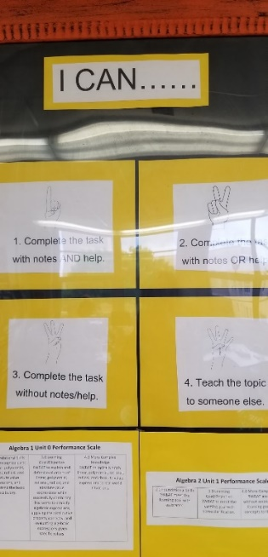
In the center of the room were student tables. Bailey intentionally asked to remove all of the individual student desks inherited with her classroom. She felt as if students learned best when they collaborated with one another. She replaced all of her student desks with five large tables. Four of the five tables were rectangular, while the fifth was a concave, hexagonal shape. The fifth table consisted of two smaller trapezoidal tables which had been pushed together to form a larger table. While this table was used, students mostly sat at the other tables while only two or three students typically worked at this oddly shaped table. Each table had approximately six chairs around it. Bailey said she personally sat in and tested each chair to ensure it would be accessible for all of her students in height and width.
Finally, the inviting and accepting nature of Bailey’s classroom was unavoidable. Every aspect seemed to be crafted with care. Bailey had this to say about the physical space of her classroom:
The windows are open, it is very inviting. It smells good. I have a plug-in in the wall. Bright colors make it— it's just— everyone who walks in is like, “Oh wow this room is very happy, it looks very inviting.” There’s student work posted, and it looks like people want to be in here and they are proud to be in here. Because they are wanted in here and valued.
Figure 4 contains photos of Bailey’s classroom to help provide more context to the physical layout of her classroom.
Figure 4. Photographs of Bailey’s Classroom Setting
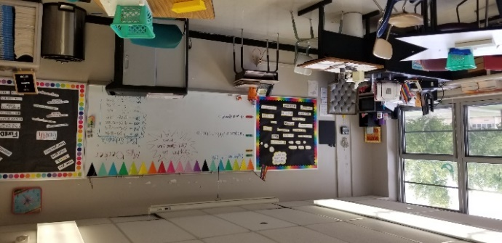
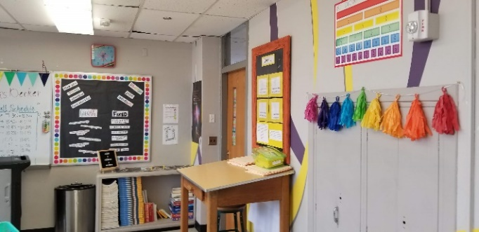
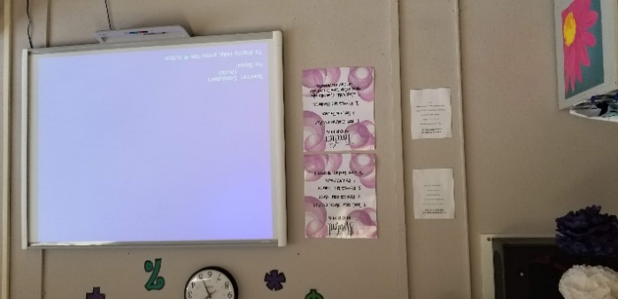=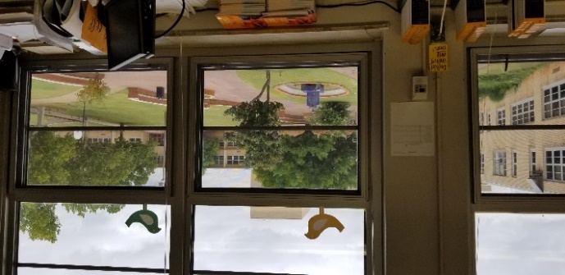
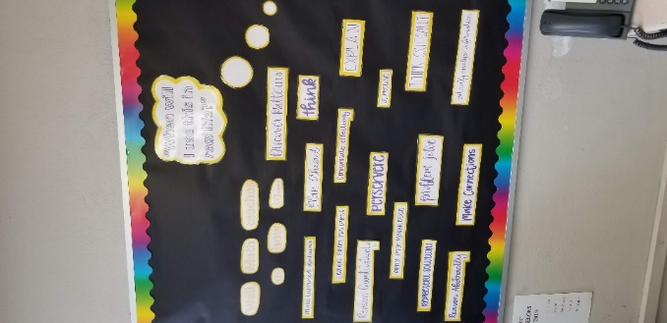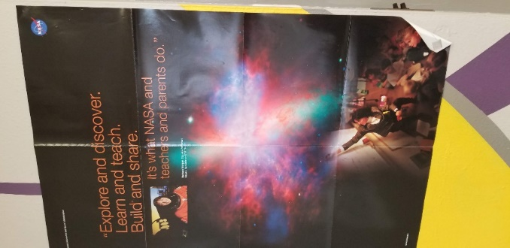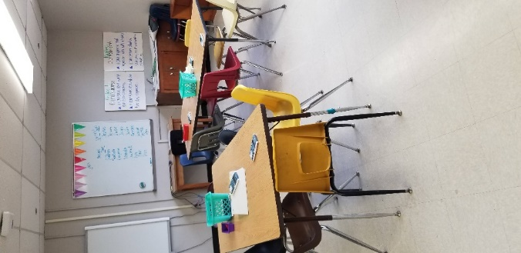
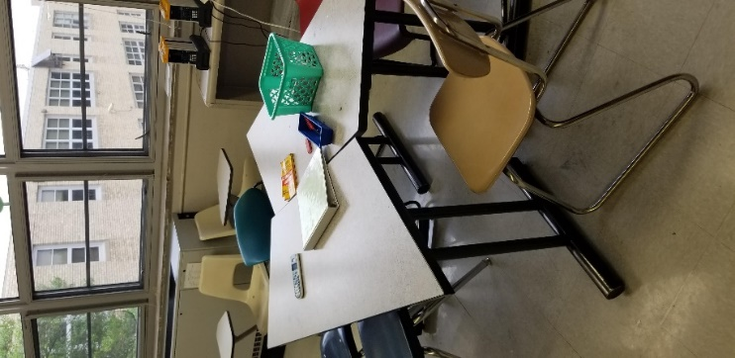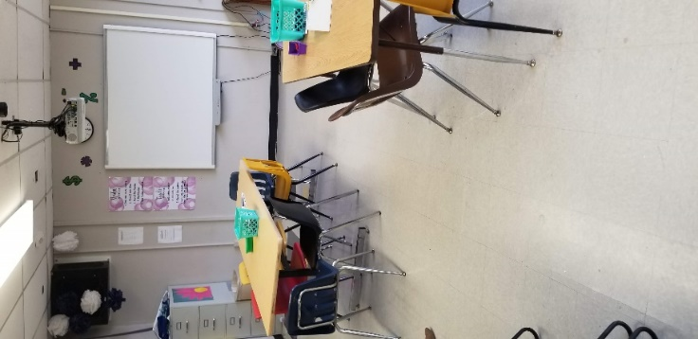

Classroom Environment and Culture
Like Nicole, Bailey’s classroom environment and classroom culture were at the center of her approaches to teaching and learning. Nicole’s classroom culture was built around foundations of positive relationships and shared responsibility. Bailey, as a first year, teacher implemented elements of these themes, but her classroom culture felt different. Bailey’s classroom culture was built primarily on acceptance and humanization. In early observations with Bailey, it became clear that Bailey valued her students feeling accepted in her classroom for who they were. Bailey modeled this through co-creating classroom norms with her students and finding meaningful ways in which she could connect with students. In terms of humanization, Bailey saw her students as people first. She worked to build relationships around honesty and transparency.
Feelings of Acceptance
Bailey grew up in a fairly conservative, suburban town. She felt like she could not truly be herself in that setting. Knowing that WCHS was diverse, she intentionally asked to complete her student teaching there and hoped there would be a job opening upon graduation. Bailey mentioned on multiple occasions that she felt like she could be herself at WCHS, that she felt accepted and hoped to create space for her students to be accepted, too. In order to create an inclusive classroom, Bailey strategically implemented several practices that helped make this a reality. Like Nicole, Bailey co-constructed norms with her students and structured her classroom in such a way that was conducive to high levels of student collaboration. She also intentionally tried to connect with her students through positive interactions and building positive relationships. Finally, Bailey valued students’ work and dedicated wall space to display it prominently in her classroom.
Co-creating Norms
In order to co-construct norms with students, Bailey asked students to write down negative experiences they had in school. In a very similar structure to Nicole, Bailey compiled these into a word cloud to be displayed. Larger words and phrases indicated experiences shared most frequently. Bailey then worked with her students to turn these experiences into positives they could agree to uphold within their classroom. Bailey shared that she also had input in this process and shared with students that she had some non-negotiables that she also included. The final product of classroom norms consisted of both teacher-oriented and student-oriented norms. Bailey was expected by her students to follow an agreed-upon code and her students were expected to follow the norms they agree upon for each other.
Unlike Nicole, recapitulation of classroom norms did not occur during my observations. There seemed to be other, external pressures that were more pressing for Bailey as a first-year teacher. That being said, co-created norms for Bailey’s class were prominently displayed in the room for students and Bailey to see. If a student or group of students was not following the agreed-upon norms, Bailey would remind them in the moment to “be respectful” or “be helpful;” however, there was not a set-aside time to review norms as part of her normal classroom routine.
Processes for Bailey and Nicole for creating norms with their students were very similar. Each teacher asked students to consider past experiences with school that were negative and then worked collaboratively with students to rethink those experiences and to consider how they could become positive aspects of their classroom. Because of this, both Bailey and Nicole cultivated a similar sense of belonging and acceptance of one another in their classrooms. Students were expected to maintain a positive sense of responsibility towards their learning and one another. This seemed to starkly contrast many behaviorist-oriented rules and expectations that hinge on accountability and consequences.
Differences, though, between Bailey and Nicole primarily revolved around how classroom norms were revisited throughout my data collection for this study. In addition, Nicole housed her norms in two places. Like Bailey, her norms were posted on the wall near her Smartboard. Unlike Bailey, Nicole also included additional explanations for what they entailed within a binder that was kept at each group of student desks. Bailey, on the other hand, simply had her classroom norms posted in her classroom. For Nicole, she would refer students to the binder during planned class time, whereas Bailey revisited norms in the moment when students were not abiding to what was originally agreed upon.
Connecting with Students
As a new teacher, Bailey was much younger than the majority of her colleagues at WCHS. With this in mind, Bailey shared that felt like she was much more lenient in her classroom than some of her peers. Additionally, Bailey also articulated that she felt as if she could better connect with her students since the generational gap was significantly less than that of other teachers in her school. I asked Bailey if she would be willing to describe her relationship with her students. She said, "I mean it's not a friend, it's not a boss, it's just a teacher." Bailey found her relationships with students difficult to describe. She shared that they were not exactly like that of a peer or “friend,” yet she also did not feel that she was in a position of power over her students like that of a manager or “boss.” For Bailey, her relationships with students and her ability to connect with them fell somewhere in the middle. Simply put, she said she was a teacher—having a unique relationship that was oftentimes challenging to describe. On a separate occasion, Bailey provided the following analogy to describe her relationships with her students and the boundaries that existed between them and herself:
It’s like a fence. Like a chain-link fence...It is chain-linked, not barbed wire. Like, you can see through it, you can sometimes put your arm over it, but you’re never in the other yard. So, like we can joke, and I’ll laugh at your joke….If we’re standing at the door and if class hasn’t started yet, then we can have a conversation about whatever thing just happened in your class. I’ll inquire. I’ll let you vent and then I’ll tell you to go sit down. So, it's just like this push and pull of like, “I love you. I want the best for you. I’m going to joke with you because I want us to have a good time, but also you need to respect me and listen to me.”
For Bailey, a boundary existed between her and her students, but the boundary was something more permeable that could be seen through, where one could poke their fingers through, or even reach over. However, students could not get completely over the fence. In my observations, Bailey maintained professional boundaries, but was also willing to be transparent with students about various aspects of her life.
Bailey shared on two separate occasions that she felt the age difference between herself and students helped her to better connect with them. Because she was in her first year of teaching and having completed her undergraduate degree just one year prior to this study, Bailey was less than ten years older than the vast majority of her students. With this in mind, Bailey shared that she understood students’ sense of humor, the generational pop culture references, and also students’ colloquialisms. These helped Bailey better connect with her students. She stated that she joked with her students and they joked with her. This was evident in each of my observations in Bailey’s classroom. Jokes, colloquialisms, and pop culture references were used frequently. Bailey articulated that she “gets” her students more than many of her older colleagues because of this shared use of language.
The Fridge
A unique aspect of Bailey’s classroom was how students’ mathematical work was prominently displayed. According to Bailey, “The Fridge” was a “fake refrigerator” for displaying student work. She indicated that many students rarely had their work displayed on their parents’ or guardians’ refrigerators at home, so she created a space in her classroom to display student work. Bailey was quick to indicate that “not everything goes on The Fridge.” In fact, some work was intentionally not displayed because the level of care put into it was not worthy of being on display.
At first glance, The Fridge was just a bulletin board, but to Bailey it represented more than that. Bailey shared that she wanted students to do work in her classroom that they could be proud of and share with others. When speaking about this part of her classroom, she said:
It’s just like bringing in that nostalgic [element] where you did something in class and now it’s on the fridge. Instead of being on the fridge at home, it is on our fake fridge on the wall in class. So now, everyone can see how great your work is.
The work on the fridge changed twice during my classroom observations. First, the fridge consisted of posters created by her “sheltered” class around the concept of inequality. In the work displayed, students created artistic examples of how inequalities manifested themselves in everyday life. Figure 5 illustrates this.

Figure 5. Photograph of the First Iteration of “The Fridge” in Bailey’s Classroom
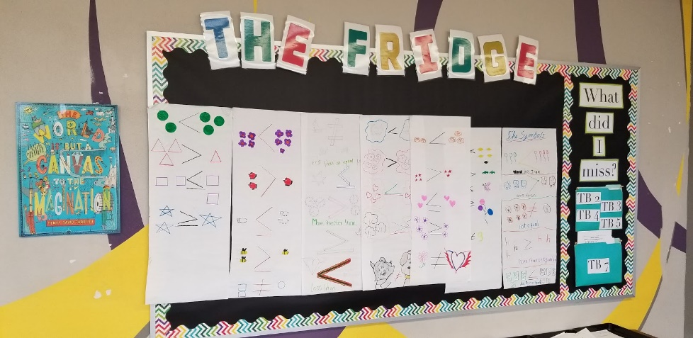
Bailey shared more about this assignment:
And so, they show, like, [points out an example] four balloons are greater than three balloons. Or, like, [points to a different example] cat does not equal dog. And they had so much fun drawing all the symbols and they get to put that on the wall. They were asking for more time to do the assignment. They were like, “Can we please do this again tomorrow and finish it?” They didn’t even know that it was going up there, they just wanted to finish it. And I was like, “This has to go up there!” They were doing math. They were learning symbols. They didn’t have any knowledge of those symbols before this class.
The second iteration of work on the fridge consisted of colorful wheels with mathematical work on them from her Algebra 1 class. The work consisted of what could be considered fairly routine work that many teachers assign their students. However, in this case, students not only completed the work, but they had to organize it in a way pleasing to the eye. The result can be seen in Figure 6.

Figure 6. Photograph of the Second Iteration of “The Fridge” in Bailey’s Classroom
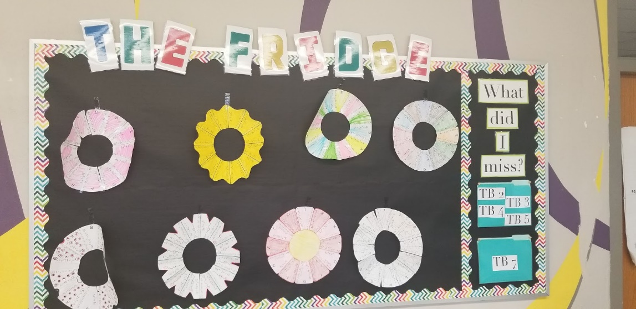
I asked Bailey if she would share more about “The Fridge” and the type of work that she displayed on it. She shared this example of something that would not be considered worthy of being displayed:
I had these color sheets that I was going to have them put up there, and it was just solving equations, color in the answer, whatever. And so, it wasn’t anything fancy and I was going to put them up there, but I mean it wasn’t— it wasn’t fun enough, they didn’t enjoy it enough for it to be something to display. I want them to look up there and be like, “That was fun and that’s what that means.”
The work Bailey included on the fridge consisted of work that was engaging for students, work that was meaningful to them, and work that was fun to complete. Students in Bailey’s class seemed to have a sense of pride in the work they completed for her that would eventually be displayed on The Fridge.

Collaboration
In addition to displaying student work and the sense of pride that came from sharing work with others, there was a feeling of comradery in Bailey’s classroom. This seemed to exist because of the way her classroom was structured, with tables rather than individual desks and the fact that students were encouraged to engage in conversations with one another. Bailey said:
I have five grouped tables with six chairs at each. And this automatically creates a culture of talking. Which, most teachers are like--it eats them away. But, when they are working on stuff and I take a minute to come sit at my desk and send a quick email or something, and I hear someone say or argue a point about whatever math they are doing, it’s like that’s why I do it...Today I heard someone over there argue a math point, like without being prompted to do so. Like, they just know that when they have in-class assignments they get to work together.
While the physical space directly correlated with student collaboration, Bailey’s instructional strategies were also integral to students collaborating in class. Bailey used strategies like “Think-Pair-Share” regularly. This particular strategy required students to think for a few seconds about the mathematics concept they were working on before they shared with another student sitting next to them. And finally, Bailey would solicit student responses as a whole class. While simple, this strategy provided students with a time to think about their understanding and, rather than being put “on the spot” in front of the whole class, they could share their thinking with a person next to them before being asked to share in front of everyone.
Finally, Bailey shared that her classroom “feels comfortable.” During the course of my observations, students worked collaboratively and shared responses to question prompts. If a student shared an incorrect answer, Bailey would kindly work through the problem with the students in order that they might see their error. Mistakes were valued in Bailey’s class.
Self-regulation
Bailey mentioned on several occasions that she relied heavily on students’ abilities to self-regulate their behavior in her classroom. She indicated that she did not want to police students or enforce punitive consequences for negative behaviors. Rather, she worked with her students to understand why a behavior may not be acceptable, then trusted them to be able to self-regulate themselves in the future. This idea of students being able to assume responsibility for their behavior, their grades, and their overall learning was built on trust. Bailey had an uncanny trust in her students. She engaged with them regularly and trusts them to be responsible individuals. In one observation, a student was disengaged from the rest of the class. She was sitting alone in the back of the room presumably texting someone on her smartphone. I watched as Bailey kindly gave her time to herself during the class period. I inappropriately assumed Bailey did not want to confront the student about her behavior. Bailey shared that this student had been struggling with some personal issues outside of class. After class ended, I observed Bailey having a poignant conversation with the student and their sincere conversation seemed to resonate well with this particular student.
In terms of monitoring behavior, Bailey did not assume the role of a classroom manager. She relied on her students to help each other make good decisions about their behaviors in class. Bailey shared the following:
Because of where they are sitting and because they feel comfortable about who they are sitting by and they care about their friends’ grades, they help them. And they are tutoring them and if the friend is off task, they stand up and say, ‘Get on task!’
This became evident I spoke with Bailey about how she handled issues with smartphones and devices in her classroom. Unlike Nicole, Bailey rarely asked students to put their phones away. I asked her about this on two separate occasions. Bailey articulated that smartphone use was part of her everyday life and was something that was prevalent in her formative years in secondary school. Bailey did have expectations regarding phone use in her classroom, but it was not policed—even on a day that Bailey explicitly had written on her whiteboard as a “No Cell Phone Day.” Being able to provide students with space to take responsibility for self-regulating their behavior was a key component of the relationships she had built with her students. Bailey relied heavily on mutual respect and trusted her students to do the “right” thing when it came to regulating their behavior.
A Typical Class
The following descriptions take into consideration each observation to craft what was reminiscent of a typical class period for Bailey. This is not a fictional description, rather my intention was to synthesize each observation into the essences of a typical class period. While Bailey’s classroom looks similar to Nicole’s workshop model, this amalgamation does not use the language as described in Nicole’s typical class in Chapter 4. Therefore, this description will depict a typical 47-minute class period using terms “beginning,” “middle”, and “end.”
Beginning
As the bell rang for Bailey’s class to begin, students could be heard talking to one another and laughing. The overall mood of the classroom seemed to be positive. After the bell rang, students slowly found their way to their seats and Bailey greeted them with a warm smile and directions for their opening task called a “Success Starter.” The task was a practice problem based on the current concept they were working on. Bailey gave students about three minutes to complete the problem. Students worked with one another to determine the solution and to share it with their tablemates. As students worked, Bailey walked throughout the room checking in with students, redirecting them if and when they were off-task.
The “success starter” for this day was part of an Algebra 1 topic of determining a function’s value given a particular x-value. Bailey asked students to share their solutions at their table to see if they were on the right track. Bailey called on one student to then share with the whole class. Bailey then worked through the example using the process given by the student she called on. Bailey then posed a second problem based on the first one. Students were asked to solve this one. Bailey positioned herself primarily at the front of the room during this time, but she was not lecturing. Rather, she called on students to fill in missing information about the problem in which the class was engaged in solving.
After the Success Starter, Bailey instructed students as to what their task was for the day. She did not spend much time on instructions, as the directions were also projected to her Smartboard screen. Bailey then walked to the back of the room to pick up a stack of papers. She distributed one paper to each student and instructed students to work collaboratively on the assignment for the day. The whole process of greeting, completing the success starter, and giving instructions lasted approximately ten minutes.
Middle
The middle of Bailey’s lesson consisted of students working collaboratively with one another. The assignment for today followed naturally from the Success Starter and built on the concepts covered in the beginning of class. As students began working, Bailey circled the room and frequently sat at the tables where students were working. When sitting with an individual group, Bailey fielded questions and walked students through processes they appeared to have questions about. As Bailey moved from one table to another, some students remained on-task, while some groups were off-task. Bailey became seemingly frustrated with some of the louder boys in her class. She exhorted them to stop talking from across the classroom. Despite frustrations from having to redirect students, Bailey remained patient and positive.
As Bailey moved from group to group, she would typically spend just a few minutes at each table. I could overhear Bailey talking with students primarily about the tasks they were asked to complete, but occasionally I could hear Bailey asking students how they were doing, joking with them, and talking about events happening outside of class. As the lesson continued to progress, students were observed experiencing frequent periods of engagement and disengagement. They could be seen getting up periodically to throw things away, to get writing utensils, and to talk with peers at other tables. Students seemed free to check in and out during the class. Bailey did not seem to be affected by their behavior as long as they were able to finish the tasks from the day’s lesson.
I noticed Bailey sitting with one group longer than some of the others. These students appeared to need extra attention in grasping the concept at hand. Bailey had with her a small, square dry-erase board in which she could help walk students through processes associated with the problems they were asked to solve. While sitting at the table, Bailey would frequently look up to check on other students in the room. She kindly redirected students who were off-task and asked if she could see their work. Students generally obliged and would get back to their assignment. Bailey seemed to understand the nature of the students in her classroom and was not deterred by their inability to focus quietly for long periods of time. In fact, Bailey encouraged students to talk to one another and to help one another on the assignment. The middle portion of class was approximately 35 minutes, leaving two minutes for the end of class.
End
The end of class was initially marked by students gradually putting their things away and congregating together near the door. Bailey then gave a few last-minute directives for students to finish working on the problems they practiced in class and to turn in what they have completed. She does not, however, assign this as homework. She encouraged students to come in during lunch and/or after school for tutoring if they needed extra help with the topics learned in class this day. Lastly, the bell then rang to release students to the next period.
Teaching and Learning Approaches
Over the course of my data collection for this study, several themes emerged that provided insights into Bailey’s teaching and learning approaches. The pedagogic approaches in which Bailey engaged cannot and should not be separated from the physical and cultural space in which she worked. Findings for this study are situated within the context of Bailey’s classroom and are integral to her classroom culture, just as the classroom culture was integral to her teaching practices. These approaches included Bailey creating mathematics curricula that provided students with opportunities to make connections, collaborate with one another, and to foster growth mindsets.
Curricular Connections
For Bailey, having students make connections between topics they were learning, connecting learning beyond her classroom, and connecting learning to students’ lives were foundational within her classroom. In terms of making connections between topics, Bailey regularly taught in such a way that reviewed past concepts while weaving new concepts into it. In our conversations together, Bailey shared how standards can oftentimes atomize curricula to where it becomes commonplace to teach mathematical concepts separately rather than holistically. The mathematics standards for the state where Bailey taught were not designed this way; however, Bailey shared that she felt pressure from her administration to articulate the standards students were to have learned each particular day. Figure 7 illustrates how Bailey shared standards she was teaching.
Figure 7. Photograph of Standards Expected to be Posted in Bailey’s Classroom
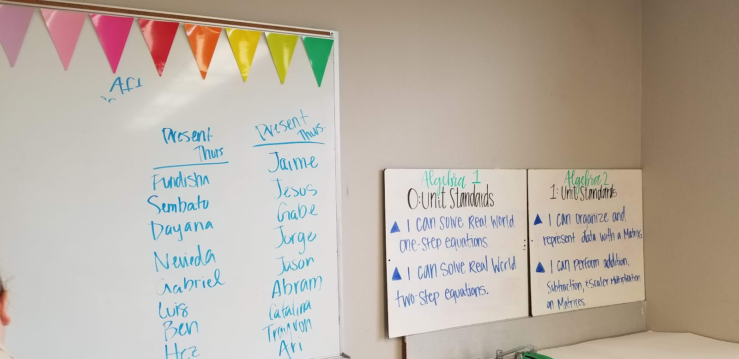
Bailey shared that she had a difficult time with writing content standards on her whiteboard to appease her administrators when they observed her. Instead, Bailey often utilized process standards to engage students in mathematical content. Bailey shared that process standards were standards that were more flexible and could be applied to multiple content standards that students were expected to learn in her class. By emphasizing process standards, Bailey was able to help students make connections across content standards. Some process standards that Bailey emphasized included: problem solving, communication, and mathematical reasoning.
In addition to using process standards to help students make connections between mathematics content standards, Bailey also helped students make connections with mathematics beyond the classroom. I have intentionally not used the phrase “real world mathematics” in this section for a reason. Bailey shared on multiple occasions that students in her class often asked her when they would use the content they were learning. To answer her students, Bailey shared that she tried to help students in her class recognize that they were using strategies and were engaging in activities that could help them change their thinking about the world around them. While Bailey also used her mathematics content to make connections to ideas that some may consider to be “real world” she made a distinction between “real world” and “real life.”
I asked Bailey if she could elaborate further on how she distinguished real life from real world. Bailey shared that “real life is the kids’ experiences” while “real world” is “how students understand [mathematics] happening somewhere else. Bailey shared an example of how this manifested itself in her classroom. In this example, Bailey engaged her students in an exercise where they were asked to provide data regarding times and distances of their daily commutes to school. Bailey would consider this example to be “real life mathematics” because students were “talking about themselves and they were seeing their peers’ data.” In other lessons, Bailey shared that she and her students would discuss “other things that are happening in the world and why what [they] are doing helps or impacts that or is derived from that.” Making this distinction seemed to provide students with different contexts in which they could connect their learning in Bailey’s class to other areas of their lives and/or the “real world.”
To further complicate the notion of making connections to the “real world,” I asked Bailey if she felt that meaningful mathematics had to connect to the “real world.” She answered with the following reflection from her Algebra 2 class:
Meaningful [mathematics] doesn’t have to be real world...Yesterday we just finished quadratics, and the quadratics was like really real world... It was project-based, so it was like it was rough on them—especially because it was a lot of their first time doing project-based learning and it was my first time doing it too. So anyway, yesterday I planned Bingo... so I just did Bingo over greatest common factor polynomials. So, we did a short mini lesson, two examples to remind them how to do it, and then they were like we’re good to go. So, then we got through like probably fifteen problems, and that’s including them having to fill out the thirty-six boxes of answers (on the bingo card) so they could go mark their Bingo card. And I was so surprised. I was thrilled. My kids who are apathetic weren’t. They were paying attention—my kids who get distracted really easily because of their friends were paying attention the entire time.
In this example, Bailey engaged her students in a two-week unit exploring quadratic functions. This concept generally lends itself nicely to real world applications. However, because of time constraints and unfamiliarity with how the topics were taught in class, the “real world” concepts were not as meaningful for her students. Additionally, Bailey was not able to help students make connections to other areas of mathematics or to their personal lives. Further, a more routine set of tasks that traditionally has less value outside of mathematics seemed to be more engaging for students when they practiced these types of problems through a game of Bingo.
I asked Bailey why she thought a task like Bingo seemed to resonate more with her students than a project-based learning unit around quadratics. She shared the following:
They were just so down about how rough things were [with the project-based learning unit on quadratics]. A lot of them got 60s on the test, which by the rubric is not good at all...So I was like let’s bring up the beat and make this a little better. I feel like that to me was meaningful. Like they were engaged [with Bingo] and it was routine problems...And so, it was just like — it was nice to see that it doesn’t always have to be an elaborate thing for them to be engaged…. And if there’s like reason behind whatever I’m doing, then it’ll mean something to them.
In this example, Bailey shared that the work that was more engaging for her students were the more routine tasks rather than the project around quadratics. In both of these examples that Bailey shared, the significance seemed to lie in Bailey working with her students to help them understand what mathematics they were doing and why they were doing it. The project-based unit may have been more engaging on paper, but students were missing why they were learning the concepts in such a compressed amount of time. On the other hand, students engaged in a seemingly routine task through a game of Bingo, but Bailey was able to take time to share why they were learning the concepts and how they connected to the bigger mathematics picture.
Valued Mistakes
A major component of Bailey’s classroom culture was how she fostered a culture of mistake making. For Bailey, mistakes were expected and were considered valuable for her students’ growth. On Bailey’s wall in the back of her classroom was a bulletin board with several statement that revolved around “growth mindset,” as shown in Figure 8.

Figure 8. Photograph of “Growth Mindset” and “Fixed Mindset” Examples in Bailey’s Classroom
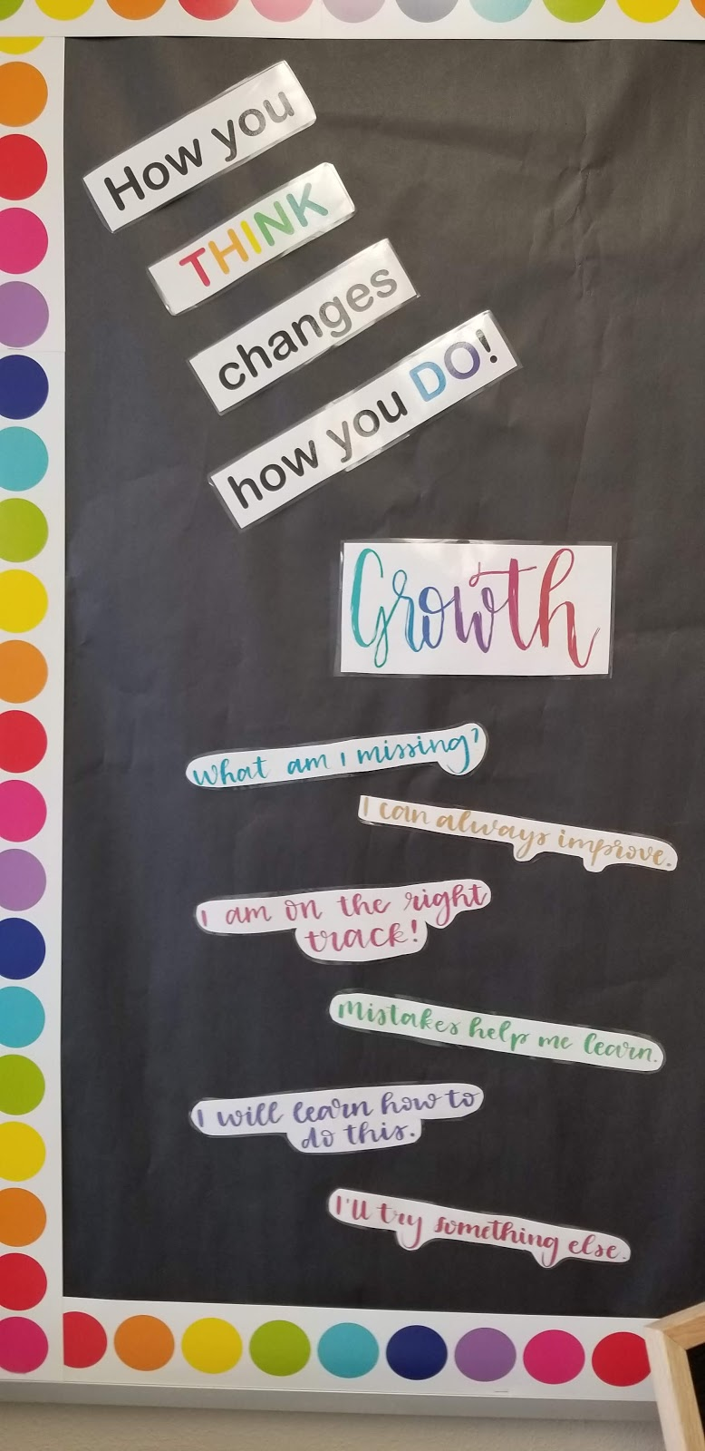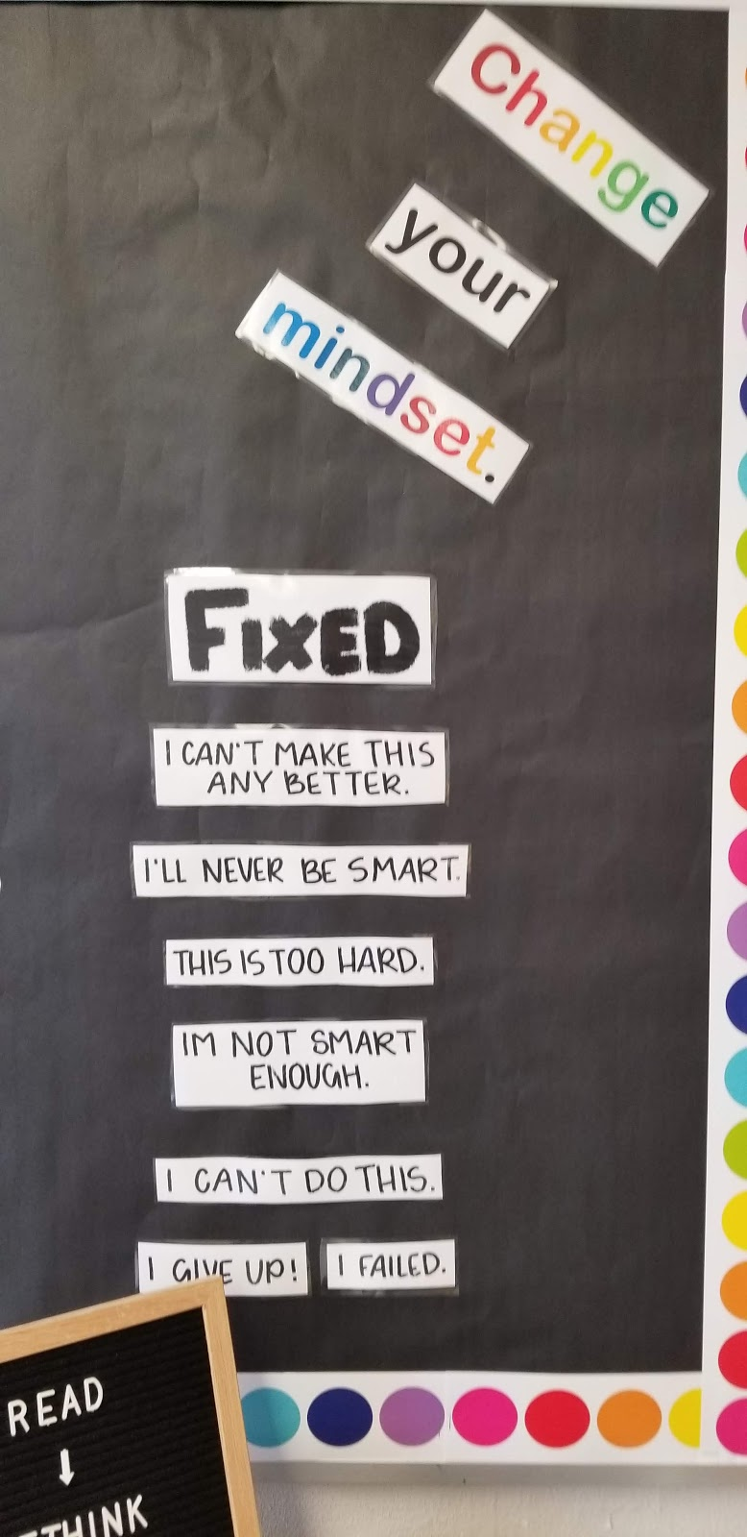
I asked Bailey why making mistakes was valued in her classroom. She shared that as an undergraduate student, she was inspired after reading Mathematical Mindsets by Jo Boaler and wanted to make student growth an integral piece in her classroom from the very beginning of her career. Moreover, she planned space for students to share their work with one another through collaborative exercises in order to understand where mistakes were made. Bailey’s teaching practice rested heavily on students learning from their mistakes and growing from them.
For Bailey, her students’ learning existed on a continuum rather than within a binary system. Instead of students coming to “one right answer,” Bailey emphasized the importance of process in her classroom. Instead of thinking about right versus wrong, Bailey encouraged students to think about their mathematical processing and how they might move from wrong to right. To do this, Bailey allowed students to make corrections on assignments and assessments. She also used collaborative work time, so students could share their processes with others. To further illustrate, Bailey said:
But not everyone is going to do that one thing...as a math teacher you teach skills that’s more than just solving for x. [Students are] thinking critically, problem solving, discovering patterns, like it just teaches you all of these different things. Especially in here, like we learn from mistakes and we make a lot of them.
Mistake making forms part of the fabric of Bailey’s classroom through helping students develop a growth mindset. Bailey shared that she “did a whole week of growth mindset activities” at the start of the school year to help students understand what it would entail. Each of Bailey’s lesson plans during this period revolved around understanding differences between growth mindsets and fixed mindsets. I asked why she would sacrifice class time for something like this. She responded with: “The growth and fixed mindsets are really important for mathematics because if you’re not willing to accept that you can grow from wherever you’re at, then you’re not going to grow, you’re not going to get anywhere.” Providing students with opportunities to grow was more valuable to Bailey’s teaching practice than simply knowing procedures and facts.
By creating a classroom culture where mistakes were valued, and where students could grow, Bailey believed that her students were learning to think for themselves and advocate for their learning. Moving from fixed mindset mentalities to growth mindset mentalities required Bailey to model mistake making for her students. Otherwise, she felt like her students would be stuck in an unhealthy mode of thinking. This process did not happen quickly but took time to cultivate. Bailey said, “So we have spent a long time on [developing growth mindset]. It’s important for our classroom culture too. Learning how to make mistakes and learning how to use those mistakes, not just erasing them.” For Bailey, erasing mistakes on mathematical work would not help students learn to move forward.
Constraints
During the course of my data collection for this study, Bailey articulated several constraints that directly impacted her teaching practice and her curriculum. Some were not unique to Bailey, but to new teachers, in general. However, one constraint for Bailey that became a recurring theme was a deep philosophical dilemma between her ideal teaching and what she was able to accomplish in her class. This section will discuss findings specifically around constraints. More specifically, I will explore general constraints associated with beginning-career teachers, lack of time and resources, and details impacting Bailey’s philosophical dilemma.
Writing engaging lesson plans, figuring out how to work with students who find themselves occasionally off-task, learning to say no to service opportunities, knowing the optimal time for taking attendance, finding time to grade and plan for an upcoming unit, and carving out time to take care of oneself are issues many new teachers face in today’s schools. On top of that are pressures associated with high stakes testing cultures that permeate American schools today. As a new teacher, Bailey felt the strain of the daily grind of teaching, especially constraints associated with being a first-year teacher.
Time and Resources
All humans experience 24-hour days. To say that Bailey was constrained by a lack of time seems somewhat absurd, since we all have the same amount of time in any given day. But, lack of time for Bailey refers more to the fact that the time she had during the course of my data collection was consumed almost entirely by meetings, planning for lessons outside of class, and grading. This led to other areas of her life becoming strained when she became pressed for time. Bailey shared that she spent a large portion of her time at home working, planning, and thinking about teaching. While Bailey felt that this was a good thing, it also became harder to balance as the semester waned. Bailey expressed that it was challenging to maintain a healthy work-life balance. In one of our conversations together, Bailey said, “My wife is mad at me because I’ve been planning all night.” Despite conflicts arising outside of class, Bailey felt that she could not forego planning because of her commitment to her students.
In addition to planning, much of Bailey’s planning period was consumed by meetings. All teachers at Bailey’s school had a common planning period called a Planned Learning Community (PLC). Bailey is in two PLCs, one with other Algebra 1 teachers and the other is with Algebra 2 teachers. Many of these meetings that are meant for planning are dominated by other conversations around students’ behaviors and other factors experienced by teachers in her school. Bailey shared the following about time constraints:
Time is a challenging because I hardly have any planning time. First hour is my other plan period and it is taken up by PLCs every day. Sixth hour is my second planning period, and I normally have meetings, or I have a student coming in or something. I may need to grade. My plan period is not spent planning, and so a lot of my time in the evening is taken up by planning. And then I try to take Friday night and Saturday [off] and not do anything. And so, then Sundays — it's just like another day of work.
Bailey also felt constraints from her districts’ scope and sequence and fear of getting off-track. Because teachers had a common planning period, it was essential for them to stay close to times allotted to learn different subjects. Bailey expressed that because there were many students who transferred in and out of West Central, and between classes within West Central, it was important to stay as close to the scope and sequence as possible, so students did not experience gaps in their learning. In other words, if Bailey was teaching about function transformation and spent too long on that topic, a student could transfer out of her class and into another teachers’, but they would be significantly behind due to differences in teachers’ schedules. While it seemed plausible to simply tutor a small minority of students who transferred to help them catch up, this was a significant concern for Bailey.
As aforementioned, Bailey shared that she was encouraged to teach quadratics in only two weeks. Because her planned project was not implemented as seamlessly as she had hoped, she had to move on to the next topic despite knowing her students had not mastered the content. This was problematic for Bailey, but because of the pressures to conform to her colleagues and the district guidelines, she felt forced to move on to the next topic.
Philosophical Dilemma
In our first conversations together during data collection, Bailey described herself as “anything but traditional,” meaning she was drawn to non-traditional teaching methods both as an undergraduate and in her student-teaching internship. She had a strong desire to create learning experiences for her students that would allow them to discover concepts and make meaning in a socially constructive manner. Bailey shared that she was first drawn to “discovery learning” as an undergraduate when she experienced “another way” of learning that was contrary to how she was taught as an adolescent. For Bailey, discovery learning offered an alternative to top-down lecture models that permeated her formal schooling. Bailey worked to create learning experiences in her student-teaching internship that were highly engaging and where students had space to make mathematical discoveries. After teaching for the better part of her first semester, Bailey had encountered a bit of a dilemma between her philosophical beliefs and the realities she experienced as a first-year teacher with three different courses in which she has to prepare. If many of the time constraints and pressures did not exist, Bailey would have ample time to plan ideally for any lesson. There have been two primary factors that have contributed to Bailey’s inability to teach in a way that was completely in-step with her philosophical beliefs. These included expectations from administrators and the wide range of ability levels in which her students possessed.
Expectations from Others. In one of our last conversations during data collection for this study, Bailey seemed to be experiencing a high level of stress. She articulated before that she felt a significant amount of pressure from her administration and her professional learning community. Bailey’s administrators required her to collect data on students’ performance in her class in the form of pre- and post-tests surrounding a unit of study. Additionally, Bailey also shared that there were lesser expectations like posting standards for students to see that seemed to impede her teaching practice. In addition to expectations, there were observations that seemed to come with a significant level of stress for Bailey because her classroom did not always look the same as many of her colleagues.
At the end of the semester, Bailey shared that she was not able to complete the pre- and post-tests in the time frame that she was asked. Part of this was due to unclear expectations of how and when they were to be completed by Bailey and her students. Bailey became concerned that she was not meeting the expectations of her administration and that she would be penalized for not doing exactly what she was supposed to do. For Bailey, these pre- and post-assessments did not align with her pedagogic practices and became difficult to integrate seamlessly.
Bailey shared that she was required by her administrators to have her standards posted in her room. Bailey shared that sometimes she did not have time change them out on a regular basis. She also articulated that most of her students rarely noticed that they were written, had or had not changed, or even cared that they were posted. For Bailey, this was just “one more thing” to do on top of her already busy schedule as a first-year teacher.
Finally, Bailey was nervous about being observed by her administrators. She knew that her style of teaching was different than many of her colleagues’, but she felt that her way of teaching was best for students to learn mathematics. She feared that she would be counted off for classroom management and not doing many of the small things, like posting standards, that were valued by her observers.
Differentiating for Students. In our last conversation together, Bailey shared with me how different her “sheltered” Algebra 1 class was from her on-level Algebra 1 class. She shared that her students came into her class with many deficits in their understanding of mathematics that other students did not have. For Bailey, this became a constraint since she needed to plan separately for her sheltered class than her other Algebra 1 classes. This created not only a time constraint, but a mental constraint related to understanding where her students were in their mathematical understandings.
Bailey’s sheltered class was an extreme case, but her other Algebra 1 courses consisted of students from a wide range of ability levels. Bailey’s ability to connect with students in a positive and personable manner, aided in her ability to differentiate for students, but also created more work for her. And when she planned her lessons she wanted to create opportunities for her students to “discover the why” behind the mathematics they were learning. Bailey shared that her desire to create a differentiated learning environment was worthwhile, but it also limited her ability to create more meaningful experiences because she was pressed for time and energy.
Contributing Factors
Despite constraints, I observed several contributing factors to Bailey’s practice. In addition to the culture she created in her classroom, Bailey’s attitudes and attributes were major contributing factors to her teaching. Bailey did her best to maintain a positive attitude towards her students and her performance, especially in light of many of the challenges she faced as a new teacher and pressures she felt from external forces. In addition, Bailey’s level of care towards students, teaching, and curriculum were observed and discussed in depth.
Attitudes and Attributes
Attitudes and attributes played a significant role in contributing to Bailey’s classroom culture, curriculum, and instruction. Even if students were not on task or were misbehaving, Bailey was observed maintaining a positive, yet firm disposition with her students, worked to get students on task, and would casually joke and connect with her students when it was appropriate. In addition to maintaining a positive attitude, Bailey also maintained a larger perspective on her teaching practice. Bailey’s tenacity to strive toward her teaching goals was noteworthy.
Positivity. There were times during my observations that I cringed at the types of behaviors I observed in Bailey’s classroom. Rather than expressing anger or raising her voice, Bailey maintained a positive attitude despite her frustrations with students’ behaviors. When students were on task, working collaboratively with their peers, Bailey would routinely praise her students for their work. She would thank them for their hard work and willingness to try. In order to maintain her positive attitude in her classroom, Bailey addresses students in a very personable and intentionally way. She shared:
We ended on a positive note, there were no tiffs, everything was fine. So, on days where like I feel that I need to intervene, I’ll pull them in the hallway and be like, “Dude what is wrong, and why are you so on edge, why are you so quick to interrupt? What’s happening?”
So, in order to maintain a positive attitude for herself, and a positive classroom climate, Bailey rarely took away whole-class teaching time to address her entire class if only one or two students were misbehaving. For Bailey, this also gave her time to process students’ behaviors and to not react in the heat of the moment.
Bailey also relied on her classroom norms to help maintain a positive attitude in her class. Not only did norms help foster a sense of self-regulation between students, but the norms co-created with Bailey helped her focus on learning rather than behavior. For instance, one of Bailey’s norms was to “treat every student equally.” Bailey created a space for her students to share many negative elements they had experienced outside of class that she was not aware were happening in her students’ lives. Bailey said many of her students brought up that their “race inhibited them” in one way or another. So, treating everyone equally became a major part of Bailey’s class and added to the positive environment. For Bailey that meant she had to keep students’ realities of race and socioeconomic status in the forefront of her mind. When a student misbehaved in class, or when they appeared tired, apathetic, or disengaged, Bailey was able to maintain a positive disposition towards them rather than assuming her students were being disrespectful in that moment.
As I continued to observe Bailey throughout my data collection, I observed Bailey getting to know her students and, not only maintaining a positive attitude, but she was building positive relationships with her students. These positive relationships contributed her being able to stay positive even when she was experiencing external pressures outside of her classroom. She was able to rely on her relationships with students to help students engage in substantive mathematical conversations and also encouraged students to stick with challenging content when they became frustrated.
Tenacity. Although Bailey felt she had to make several consolations in her teaching philosophy due to time and external pressures, Bailey remained tenacious and possessed grit. Although she was not able to teach every class period in a way that was that was completely integrated into discovery learning, she was able to see her teaching practice evolving over time into what she envisioned as an undergraduate. Bailey’s consolations felt like failures in the moment, but her ability to take lecture-style notes and make them interactive illustrated this long-term attitude.
I spoke with Bailey about how she reconciled this dilemma. She shared the following anecdote about an example of how she was able to take a routine set of notes and make it more discovery-based, although it was not how she ideally would have wanted it to be. She said:
The goal is to at least get most of them to realize “why” though the instruction. And so, planning discovery-based lesson— and sometimes it isn’t 100% discovery, sometimes it is a guided discovery. It allows them to discover the reason behind what we do. For instance, we did a Desmos activity for one day. It wasn’t contextual, but it was conceptual.
Desmos is an online mathematical graphing application that allows students to graph functions in color. Desmos also has a platform for teachers to create guided learning activities where students can explore concepts. Some of these created activities are free for anyone to use. Bailey was able to access one of these free guided lessons for this particular instructional activity. While it was not exactly as Bailey envisioned, she was able to keep her beliefs for how students learn best in the forefront of her mind so that she could create activities that would benefit her students.
Teaching with Care
Both during and after my data collection, I was able to reflect on some of the major contributing factors that made Bailey’s teaching practice unique to her. I was surprised to find that care was not simply interrelational. Bailey conveyed a great deal of care for her students and for her colleagues. Those relationships were defined by care; however, Bailey also had a deep level of care for her teaching practice and for her curriculum. This multifaceted ethic of care permeated Bailey’s teaching practice. Care was also enveloped in co-created classroom norms for Bailey’s classroom. Bailey shared the following to help illustrate care in her classroom:
And so, I think having care while I teach, having care while I plan, and having care while I’m just like being a teacher. Like all of that in one teacher is what I think the goal was. And I mean it has really worked out well, I think. I think it— There’s no question as to if am following the norm (of caring).
Bailey expounded upon this by defining care within her teaching practice as “doing things with purpose.” For Bailey, care was an action verb and she was able to demonstrate her care for her students by what she does for them. Those actions were done with thought and purpose.
Norms created for students and Bailey were part of how Bailey modeled care in an interpersonal and inter-relational manner. Bailey cultivated positive relationships with her students. She said that she would joke with them, she could share common experiences with them, and she could be transparent about her life. For Bailey, care played a major role in helping her humanize her mathematics curriculum. She valued mistakes, students growing in their learning, and she strived to help them both socially and emotionally. Bailey shared that she regularly engaged students in conversations outside of class to help them process challenges they may be facing and helped them work through those challenges.
For Bailey, caring as a teacher involved looking out for the well-being of her students and purposefully engaging with them on a personal level. Bailey articulated that her students responded well to how much she cared about the work in which they engage in class. While talking about care, she shared the following sentiment:
(sighs) I mean I feel like I do everything with care. I’m very meticulous and so it comes naturally to me, but I think they really do see — like a lot of them have said this took a lot of work. I’m like, “Mm hmm, it really did!”
For Bailey, care was a quality integrated into many aspects of her teaching practice. She cared for her students’ well-being and the work they were doing. Bailey also shared that many of her students have had past experiences with teachers where care was not evident.
Upon hearing what students had experienced in their past experiences with school, teachers, and curriculum, Bailey was pleased when her students made care part of her shared classroom norms. More specifically, students shared that they wanted care to be a primary norm that Bailey followed. She gave the following example of what this looked like in her classroom:
They even made it to where one of the teacher norms that I have to follow is that I teach with care. Because they — I heard multiple stories of how they hated when teachers assigned book work, they hate it when teachers just pick random numbers in the book for them to do. And they just don’t feel like that is important to them. They don’t feel like my teacher hand-picked this for me because they think it is important. They didn't make this for me because they think it will help me. They just chose it.
Bailey saw this as a way to change the nature of assigning work for her students. If she could craft assignments with a level of care that many students had not experienced, then she could create a space where students could feel value in the work they were doing and potentially invest more deeply in their content.
In addition to caring for Bailey’s curriculum, care for her local community and physical space was also prevalent in Bailey’s practice. There was a human element to Bailey’s teaching, and she said it had to do with her comfortability to be herself. She cared about her students and wanted to set an example for what it meant to be an authentic person. She said:
Like, I feel comfortable here. I feel protected here and I feel like I can be myself. And they see that. I think that they know that when I laugh at their jokes or when do something that’s just like silly or whatever, that’s me being authentic. And, like I tell them about my life. I mean there is a line there too. I mean some things are too much, but I’m honest— and probably more honest than most teachers are. I’m honest about my life and about what I’ve gone through and am going through... I’m the same person here that I am at home.
There was an element of honesty and transparency to Bailey’s life and to her teaching practice that helped illustrate the level of care to which she entered her classroom. I asked Bailey how this fit into her curriculum. She shared the following:
It just fits right in. Like me being passionate about my curriculum is — it just melts right into me being passionate about knowing each student and me being passionate about… Like it all just makes everything meaningful. And you can clearly tell when there is a lesson that I’ve had to make on the fly. Students can tell it's not as meaningful.
Bailey’s level of care came through in her curriculum and instruction. She strived to create meaningful learning experiences for her students. And, when she was not able to do so, students recognized that something was different.
Summary of Findings
This chapter presented findings from Bailey’s classroom. As a first-year teacher, Bailey developed a unique style of her own. While she faced a philosophical dilemma as to how she would be able to enact a mathematics curriculum focused on students’ discovery of mathematical content, she was able to create a unique classroom culture of her own. To a great extent this was built on caring relationships and vulnerability with her students. While Bailey felt constrained by policies set forth by her administration, she tenaciously continued to strive to create meaningful and authentic content for her students in which they could engage. Bailey maintained a positive attitude throughout my time observing her and continued to build a collaborative and constructive environment where her students could learn.
Both Bailey’s and Nicole’s classroom cultures and teaching practices were quite unique. Although there were many constraints that both teachers faced, they each felt like their non-traditional methods were worthwhile to better engage their students in meaningful learning. Whether their curricula followed a “workshop model,” “project-based learning” model, “discovery learning,” or “guided learning,” both Nicole and Bailey felt strongly about engaging their students in these types of non-traditional models. There were mitigating factors and limitations that inhibited their teaching practices, but both teachers were learning to navigate these constraints so that they could work within the system to provide students with what they considered to be meaningful mathematics instruction. The following chapter will discuss the major implications of the findings from this study and how Nicole’s and Bailey’s cases challenge notions of authenticity and culturally relevant pedagogies.

Chapter 6: Discussion and Implications
Aims of case study research seek to answer questions of “why” and “how” relative to the participants within their natural environment. This study has taken an approach to understand why participants taught alternatively to many of their fellow educators and how they went about doing so. In an effort to understand the complexities that exist within the cases of Nicole and Bailey, there is a risk that these cases will be seen as isolated events, unable to be reproduced in settings different than West Central High School. Rather, findings associated with participating teachers have the potential to be reproduced in broader contexts. On the other end of the spectrum, the goal is not to discuss findings from this study in absolute terms such that Bailey’s and Nicole’s practices can be seen as formulae for other teachers to follow. Due to the subjective nature of case study research, my intent is to discuss findings in such a way that teachers and scholars can be inspired by the essences of many of Bailey’s and Nicole’s teaching practices in hopes of transforming their own work, thinking about the integrated nature of Bailey’s and Nicole’s approaches, and to inspire further research that highlights teachers in culturally diverse school settings.
Findings from this study will be discussed in terms of implications in how participating teachers’ pedagogic practices extend theoretical frameworks of authenticity and culturally relevant pedagogies. From my review of relevant literature, authenticity as a framework seems potentially limited in scope, especially considering that definitions of authentic teaching and learning have remained mostly unchanged over the previous two decades. Additionally, definitions of authentic pedagogies are primarily defined as singularities that tend to be formulaic in nature. In other words, if teachers are following a framework set forth by Newmann et al. (1994), they may have elements of student-centered teaching practices, disciplined inquiry, or value beyond school; however, how “authentic” their teaching depends primarily on the environments in which students and teachers interact. Teachers in this case study have discussed and modeled authentic teaching and learning constructs, while also enveloping their curricula and instructional methods with genuine care, cultures of shared responsibility, and inclusive classroom environments. Moreover, teachers in this study were found to be sensitive to students’ cultural backgrounds and have worked to co-construct learning environments with unique cultures of their own.
The following paragraphs explore further how teachers in this case study extended existing constructs of authenticity and culturally relevant pedagogies to create learning environments that valued students’ learning and well-being. Again, it should be noted that findings presented are not one-size-fits-all solutions but serve as models that could be reproduced by teachers in various contexts.
Extensions to Authenticity
In the mid-1990s Newmann et al. (1994) presented a framework for authentic pedagogies built on student-centered learning approaches. This framework consisted of students constructing knowledge for themselves, engaging in forms of disciplined inquiry, and connecting learning so that it has value beyond school. Other scholars have defined authentic teaching differently. For them, authentic work consists of engaging tasks, to have those tasks fit within contexts of personal and professional relevance, and to understand impacts of their learning in broader contexts (Garrett et al., 2016). Both Nicole and Bailey were observed implementing curricula using instructional methods that fit with both authenticity constructs defined above. Neither teacher was found to teach contrary to how authenticity has been defined.
Consistent with Garrett et al. (2016), Nicole and Bailey helped illustrate how “value beyond school” could be broken into personal and professional categories. Bailey’s thoughts on how she saw learning having value beyond school was more for personal gain. For Bailey this included helping students develop growth-minded attitudes and practices that may help them find success in their future endeavors. Nicole, on the other hand, worked to help students develop growth mindset, but she was more apt to help students connect their learning in more tangible ways by implementing projects that used professional contexts.
Bailey and Nicole were both adamant about students learning best when they could construct meaning for themselves. This was consistent with literature around authentic teaching and learning (Garrett et al., 2016; Newmann et al., 1995; 1996; Petty et al, 2013; Preus, 2012; Tran & Dougherty, 2014). Bailey and Nicole were able to work with students to create spaces where students were driving conversations around mathematical content. This included having students fulfill roles within projects (in the case of Nicole) and working with students to help them work through their mistakes to better understand mathematical practices (in the cases of both Nicole and Bailey). To help students construct knowledge, both participating teachers engaged students by using meaningful questions and by encouraging students to have substantive conversations.
While Bailey and Nicole both seemed to embrace constructs of authenticity, neither described themselves as being “authentic.” Teaching, for both teachers, was an endeavor in engaging students in best-practices, meeting them where they were in their learning, and helping them master mathematical content. Each teacher provided examples of where they extended constructs of teaching and learning. In essence, Bailey and Nicole had envisioned something different that pushed the boundaries of what has been defined by scholars as authentic pedagogies. The following paragraphs discuss how findings in this case study evidenced extension to authentic teaching and learning practices.
Teacher-student-driven
Mathematics teaching at the turn of the 20th century and many models of mathematics teaching today revolve mostly around teachers. Teachers serve as knowledge-bearers and disseminators of knowledge to their neophytic students. While other models of teaching exist and are proven to be effective in student engagement and learning, many teachers find themselves resorting to familiar methods that are generally top-down. There are many reasons for this: time constraints, underprepared teachers with little exposure to multiple methods of instruction, and high stakes testing just to name a few. That being said, mathematics teaching in the case of Nicole and Bailey looked starkly different.
Like Copernicus radically postulating a heliocentric solar system in an age when society knew of only a geocentric view of the cosmos, Dewey (1902) envisioned a teaching model in which the student was at the center rather than the teacher. Student-centered teaching models have been in existence for many years; however, many teachers continue to ascribe to scholar-centered methods that are often less impactful for student learning than approaches that place students at the focal point of curriculum. Nicole and Bailey consider themselves to be “non-traditional” in the sense that they are not the focal point of their classrooms or their instruction. However, that is not to say that their students are the sole center of instruction either. Both teachers’ practices suggest that neither student nor teacher are the center of gravitational focus in classrooms. Teacher and students exchanged roles frequently in Bailey’s and Nicole’s classrooms, where they were sharing roles of learning and teaching. This is very reminiscent of Freire’s (2000) notion of “students-teacher” and teacher-student.” In visualizing Freire’s model, teachers’ and students’ share of power is leveled, allowing relationships to be dialogical in nature.
Bailey’s and Nicole’s teaching practices followed this model—especially in the case of Nicole. One subtle difference, though, is that one classroom entity was not static while the other evolved over time. In observing Nicole and Bailey there was both literal physical movement where teachers and students moved around one another, while there was also metaphorical movement in that teaching and learning was in a state of flux. Teachers and students exchanged power positions, but they both revolved around the subject of mathematics while working collaboratively to come to a conceptual understanding of what was to be learned. Put another way, if Bailey’s and Nicole’s classrooms were described using another cosmic metaphor, mathematics would be at the center, the teacher would be the earth, and students would be represented by the moon. The earth is essentially determining the trajectory around the sun, but the moon and its gravitational forces have direct impacts on the earth. Likewise, the earth is influencing the moon. Both earth and moon are also revolving around the sun together. Bailey and Nicole were working in a system in which mathematics was the focus. The subject itself was the focus of what their classrooms were about, but the more interesting aspect was how they, as teachers, worked in tandem with their students on their quest around understanding mathematical concepts.
With this metaphor in mind, I believe findings in the study suggest that Bailey and Nicole have modeled teaching practices that move beyond teacher-centered and student-centered approaches and are what I call teacher-student-driven. The term “teacher-student-driven” has a sense of action to it that both “student-centered” and “teacher-centered” lack. Neither teachers nor students are any more central to the classroom than the other; however, mathematics learning is central to how Bailey and Nicole taught. They kept this at the focus, and, with their students, they worked together to better understand mathematical processes, procedures, and concepts.
Shared Responsibility for Learning
Participating teachers’ classrooms exemplified authenticity constructs of disciplined inquiry, which included students engaging in substantive conversations and meaningful questions. As defined by Newmann et al (1996), disciplined inquiry relies on teachers guiding conversations and using probing questions to help students engage with content. Bailey and Nicole seemed to have extended this concept to include a sense of responsibility for students’ learning. This notion moves past superficial accountability measures that often fail in classrooms and pushes towards a community built on personal responsibility (Noddings, 2013). Derrida (1995) suggests that “[r]esponsible action always involves both being responsible to/before a singular other...and also being responsible toward others generally and to what we share with them” (as cited in Dimitriadis & Kamberelis, 2006, p. 107-108). By engaging in shared learning, Nicole said her students found value in their roles. This included being responsible to others and engaging in “shared learning.” Whether they were interested in the ongoing mathematical content or not was moot. Nicole shared that students were committed to helping their group mates.
In addition, Nicole and Bailey articulated that they did not police their students’ behavior. The culture of each teachers’ classroom was built on collaboration and there was a feeling that students were “in it together.” In a follow-up interview, Bailey mentioned that the culture established in her “sheltered” Algebra 1 class exemplified this mentality. She said that her students felt the need to make sure everyone in the class had a grasp of the content they were covering. She said that one day they articulated to her: “If one of us fails, we all fail.” This conveyed what shared responsibility for learning meant to Bailey. For both teachers, though, students were expected to be engaged in learning and to use their time working collaboratively to help one another master content.
Transformative Expectations for Learning. Both Nicole and Bailey taught with an expectation that students would work together. This was evidenced by both teachers’ intentional grouping strategies. Students were rarely isolated from one another in either class. While the occasional student would sit alone, the vast majority of students worked in groups. The ways in which Bailey and Nicole structured their class, along with the co-created classroom culture, helped foster a community of learning. Specifically, in Nicole’s classroom, students adapted to routines of “the workshop model.” This was seen on multiple occasions when students would follow unwritten classroom routines like finding their assigned seat, logging into Nearpod on their iPad, and submitting answers to Nicole to start the “mini lesson.” Even during routine procedures, students were expected to work collaboratively and help each other in their learning.
In a recent study by Liou and Rojas (2016), transformative expectations refer to both strategies and pedagogic practices that define teachers’ belief and commitment to social justice pedagogy. Nieto (2005) characterized teachers engaged in socially just pedagogic practices as those who significantly value students’ cultural identity, maintain high expectations for students, challenge inequity, and demonstrate deep levels of care and love for students. Both Nicole and Bailey were found to exemplify these notions. While neither Nicole nor Bailey defined themselves as social justice educators, their beliefs, practices, and dispositions towards students would indicate consistency with literature around teaching in a socially just manner. This was especially true when considering the emphasis Bailey and Nicole placed on building personal relationships with their students.
Learning Zones versus Performance Zones. Teachers in this case study viewed their classrooms as learning laboratories for their students to make progress in their mastery of mathematical content. Both teachers encouraged their students to work collaboratively to learn from one another. This required Bailey and Nicole to create safe spaces for their students to make mistakes without being shamed for them. Brown (2016) states that “educators have the ability to position learning as discomfort” (p. 4), meaning that teachers can create spaces that place students in states of disequilibrium to help them grow in their understanding. This is reminiscent of Vygotsky’s Zones of Proximal Development (1978) in that students are given opportunities to rely on a more capable peer when working collaboratively.
In observations and interviews with participating teachers, both teachers integrated a focus on growth mindset. Essentially, this meant that students’ learning was not fixed, but had an element of plasticity in that they could grow in their understanding of mathematical content. Scholars have uncovered more about growth mindset and some of the malleable characteristics that are often found associated with it. These include both academic and social resilience (Dweck, 2006; Yeager & Dweck, 2012).
As these teachers worked to help students construct meaning, engage in disciplined inquiry, and help students make connections between mathematics and their lived experiences, they embodied the idea that “practice makes progress” rather than “practice makes perfect.” Both teachers in this study felt pressures to prepare students for standardized tests, but their classrooms served as learning zones rather than performance zones. Bailey and Nicole encouraged students to make mistakes. For instance, if they did poorly on an assessment, students were encouraged by Bailey and Nicole to correct their mistakes and to try the assessment again. By fostering an environment where students could grow, Bailey and Nicole were helping students develop attributes like grit and tenacity associated with growth mindset.
Teaching with Care
Notions of curriculum driven by students and teachers, along with shared responsibility for learning seem to better connect to theories grounded in culture and community. Transformative experiences like these, especially when found in culturally diverse schools, seem to be deeply rooted in the ethic of caring (Liou & Rojas, 2016). Noddings (2016) shares that “[h]uman beings are born from and into relation” (Noddings, 2010, p. 390). Relationships in classrooms of participating teachers were one of the driving characteristics of teachers’ practices. This included building caring relationships between students, between teachers and students, and between teachers, students, and curriculum.
In both cases in this study, teachers enacted their curriculum with high levels of care. Each teacher was highly sensitive to the needs of their students and worked to build relationships with them. Simultaneously, both teachers felt that students learned best when working collaboratively with one another to construct meaning for themselves. This social constructivist approach was predicated on students caring for one another. Part of the shared responsibility for learning was built around caring for others. Most surprisingly though was the level of care around which teachers built their curriculum. Both Bailey and Nicole spent inordinate amounts of time outside of school creating tailored lesson plans to help meet their students where they were in their learning. For Bailey specifically, this meant crafting assignments that went beyond randomly assigning problems to solve from a textbook. Her students appeared to recognize her level of care and were appreciative.
The notion of the ethic of care is built on relationships. In the context of classrooms, this manifests itself most commonly when students are working together in groups. Noddings states that “teachers concerned with the development of people prepared to care must remind their students that they are working in groups to help one another and to accomplish a common task” (2010, p. 395). Both Bailey and Nicole predicated their instructional methods on students working collaboratively in groups. This involved more than students simply sitting together. Teachers in both cases encouraged students to work with one another. This involved both listening and doing. “Approaching the world through the relational ethic of caring, we are more likely to listen attentively to others” (Noddings, 2010, p. 391). Listening to others’ perspectives allowed both teachers to create unique cultures in each of their classrooms.
One interesting aspect of Nicole’s caring relationship with her students was how she worked with her students to “unlearn” what she considered to be unhealthy learning habits they had developed prior to entering her classroom. Time and again she mentioned that her students had been conditioned to listen to teachers, mimic procedures, and to ask questions of “how” and “why” in mathematics. This was reminiscent of Anyon’s (1980) social reproduction theory where she observed students in communities defined by socioeconomic status. Anyon (1980) found that students in lower socioeconomic communities were conditioned to listen, mimic, and to not question authority.
Central to caring is the notion of empowering students to think autonomously. As Nicole worked with her students to “unlearn” how they had been conditioned to learn, she was empowering her students to think, make decisions, and to find meaning and value in the work they were doing. Nicole’s care for her students and her curriculum were evident in each observation and interview. She routinely expressed how much she loved her students, how much she cared for them, and how she created an environment that allowed students to do the same. In a similar sense, Bailey also developed a curriculum of care. She believed students saw the effort she put into creating assignments that went beyond the minimum that her students had experienced in other classes.
Extensions to Culturally Relevant Pedagogy
Ladson-Billings (1995) outlined characteristics of what she considered to be culturally relevant pedagogies. This included understanding one’s conception of self and others, social relations, and conceptions of knowledge. Both Bailey and Nicole were found embody these constructs in their teaching practices. The following paragraphs will share how teachers in the case study exemplified constructs of culturally relevant pedagogies, while also extending this theoretical construct into unique areas. This includes valuing “the other” and what they bring to the overall diversity of the classroom, and also how Bailey and Nicole have illustrated how they co-created a unique classroom culture of their own.
Value of Culture and Overall Diversity
Culturally relevant pedagogies are predicated equally on cultural content and teaching practices (Gay, 2013; Ladson-Billings, 2006; Sampson & Garrison-Wade, 2011). In particular, Nicole was willing to go so far as to ask students to explore how they learn best, how their personalities meshed with others in group interactions, how they communicate with others, and how their backgrounds could add to the diversity of the classroom. These findings were consistent with Gay (2013). Further, effective teaching in culturally diverse schools can be challenging, and unfortunately, many teachers have been shown to be motivated by pity to lower expectations for student learning (Ladson-Billings, 2009; Landsman, 2004; Rojas & Liou, 2016; Zembylas, 2013). That being said, both Nicole and Bailey have instituted teaching practices in their classrooms that value students as individuals, while maintaining sensitivity to students’ individual cultures. Bailey and Nicole never felt badly for their students, nor did they lower expectations for teaching “those kids.”
Oftentimes relationships between teachers and students are characterized by their “otherness” and obvious differences in authority, status, and power. “Othering” creates an unequal, hierarchical relationship between those in power (colonizers) and those without (“subalterns”) (Spivak, 1995 as cited in Dimitriadis & Kamberelis, 2006). Spivak’s postcolonial, critical theory “moves us away from simple binary oppositions to more nuanced and complex spaces” (Dimitriadis & Kamberelis, 2006, p. 189). In the cases of Bailey and Nicole, though, they worked to build dialogical relationships where both teachers and students shared power and control. Freire’s (2000) notion of dialogical relationships was on full display in my observations of Bailey and Nicole. These relationships focus on dialogue and reflection while also serving to create knowledge through reflection (Freire, 2000). Each teacher created spaces for their students to share feelings, concerns, and knowledge. Interestingly, both teachers worked to create learning environments in their classrooms that were unique cultures of their own.
Co-creation of Unique Classroom Cultures
“Ironically, those who spend the most time in schools and classrooms are given the least opportunity to talk” (Nieto, 2005, p. 188). In the cases of Nicole and Bailey, each teacher provided space in their classroom to allow students to speak. Reminiscent of Barbra Brodhagan’s (1995) work, both participating teachers worked within their situated spaces to create something that did not exist prior. Not only did students speak, but their collective voice was valued to the extent that both teachers worked with students to co-create physical spaces and normative classroom behaviors. As a result, each classroom in this study became a unique culture of its own. The way in which Bailey and Nicole developed normative behavior considered “other” voices. There was no singular voice valued more highly than another. In each classroom there was strong sense of emotional support within classroom communities. There existed a sense of collegiality and connectedness between teachers and students (Brodhagen, 1995).
Nieto (2013) suggests students’ perspectives are a valuable component to constructing knowledge, but they should not be the only perspective considered:
This focus on students is not meant to suggest that their ideas should be the final and conclusive word in how schools need to change. Nobody has all the answers and suggesting that students’ views should be adopted wholesale is to accept a romantic view of students that is just as partial and condescending as excluding them completely from the discussion. (p. 165)
While both teachers valued students’ voices, they were not the only voice considered in deciding what should be taught and how. Interestingly, both Nicole and Bailey worked to consider all perspectives in their classrooms, which also included their perspective. Nicole and Bailey would be considered experts in their classrooms and they had beliefs about how they felt students learn best. This being the case, Nicole’s and Bailey’s perspectives were equally as valued in their classrooms as their students’. Thus, they were each able to co-create an open space for discourse, which is an essential component for developing critically responsive teaching through inquiry, dialogue, and shared power (hooks, 1994). By creating safe spaces for students’ voices to be valued, Bailey and Nicole were able to change the power dynamic of their classrooms to encourage care and trust.
Vulnerability
Bailey’s analogy of using a fence to illustrate her relationship with students is a prime example of the significance vulnerability plays in this case study. Sampson and Garrison-Wade (2011) found that “educators can create supportive learning and school connectedness by relating genuinely, sharing their unknowing with students, and accepting multiple perceptions and perspectives” (p. 302). Both Nicole and Bailey modeled this in different ways; however, the notion of vulnerability was at the forefront of each teacher's’ practice. For Nicole, this meant sharing her “unknowing” about new content she was teaching, how she was feeling on any given day, and genuinely asking students how they were feeling. In the case of Bailey, this meant sharing aspects of her life that helped with “relating genuinely” with her students. Authentic teaching for both teachers relied heavily on being genuine with students. Honesty and transparency were often reciprocated in my observations. As teachers worked to build relationships with their students, there was a level of transparency with which students seemed to be able to relate.
Handling Constraints and Limitations
Constraints and limitations are a part of every teacher’s story. Oftentimes constraints and limitations are out of teachers’ control. This can involve federal and state level initiatives placed on schools for accountability purposes, budget shortfalls, and large class size. Other times, constraints and limitations are a result to teachers trying to teach in ways not compatible with the system. Bailey and Nicole experienced both external and internal constraints that limited their approaches to teaching and learning. An important part of this study was to understand factors that could be limiting in nature to participating teachers’ pedagogic practices.
Both participating teachers experienced and handled constraints differently. Nicole, as a veteran teacher of fourteen years, was able to handle constraints with more ease than Bailey. Nicole’s resolve over the course of her tenure seemed to come with confidence. It would be easy to say that Nicole “did not care” about what others thought of her teacher practice, but this would not be fully truthful. Nicole expressed a deep level of care, but she also seemed to possess a moral obligation to teach in ways that were consistent with what she believed were best practices. This included creating experiences for students to construct meaning for themselves and where relationships were a focal point of her classroom.
Nicole possessed a confidence in her teaching practice that seemed to transcend administrative constraints and conflicts with other teachers. Nicole shared that many of her colleagues felt that her way of teaching was okay for her, but not something in which they would engage. This seemed to work for Nicole, as she was comfortable existing as an enigma within her school and school district. Bailey, on the other hand, dealt with pressures from administration differently than Nicole. What was surprising about Bailey’s case was the dilemma she felt between appeasing those in power and teaching consistently with her philosophical beliefs. Bailey felt strongly about teaching students in ways that allowed students to discover concepts, but because of time and resources available to a first-year teacher, she felt that she could not do it all.
Bailey’s case was profound in that she was not willing to give up on her philosophy. She expressed that she would continue to create new experiences for students to engage in discovery learning, even though she was not able to do everything she had hoped in her first semester of teaching. In a follow-up conversation with Bailey, she shared that she had experienced her “best teacher day ever.” This included creating a “personalized standards-based station” where every student was able to create their own learning plan. This day also included an evaluation by her school administrator which, according to Bailey, went very well. It seems as if small victories for Bailey are what will help her gain confidence in her practice and will help her solidify her beliefs in her teaching practices.
Implications of this Case Study
There seems to be a reductive quality when using terms like “authentic.” When something is considered to be authentic, it becomes easy to critique it in such a way that the qualities that make this authentic thing authentic are no longer authentic in and of itself. Additionally, rarely does a an “authentic” person claim to be so. In terms of teaching, this seems to be the case as well. Teachers who have integrated authentic constructs into their pedagogies rarely say they are “authentic” teachers. They simply are. That being said, this research has demonstrated that authenticity is not a singularity but is a construct that can be molded based on individuals’ classroom cultures and learning environments. Moreover, authentic pedagogic constructs should not be stripped of the cultural relevance that exists in classrooms. Each teacher and student bring with them a unique voice into every classroom. These voices, when valued, work in tandem to create unique classroom cultures of their own.
Teachers in this case study have been found to teach in ways that are consistent with most authenticity frameworks. My observations found students to be highly engaged in mathematics learning through meaningful lessons that were carefully crafted to meet needs of students. These lessons would pass any test of authenticity, yet teachers consistently were shown to extend existing authenticity frameworks to include curricula that is driven by both teachers and students that is predicated on shared responsibility for leering. Tying these together is an innate sense of care that existed in participating teachers’ classrooms.
Furthermore, this case study has shown how teachers value individuals’ cultural identities in socially just ways to help create unique classroom cultures. This extension to culturally relevant pedagogies was determined by teachers’ and students’ willingness to be vulnerable with one another. Classrooms were built around relationships that were founded on transparency and trust. This helped to reduce power struggles often found in classrooms between teachers and students.
Authentic teaching and learning practices should not be formulas to be followed. Rather, authentic teaching practices are those that are teacher-student-driven, engage students in substantive conversations, and connect learning to both professional and personal experiences. These constructs can subjectively manifest themselves in many ways in different classrooms and cultures. In other words, cultural co-created in classrooms allow for teachers to teach in ways that value individual differences and multiple perspectives. Furthermore, authentic teaching and learning has been found in this study to be enveloped in care for individuals and curriculum. Teaching without a profound ethic of care perpetuates hierarchical binaries that cause separation between teachers and subaltern students. Finally, teachers in this case study articulated multiple times and in multiple ways how they co-construct spaces with their students. Thus, they have created environments that are transformative in nature and that are empowering to students’ well-being—both in mathematics and in their lives. Figure 9 illustrates how Bailey’s and Nicole’s cases have extended both authenticity and culturally relevant pedagogies to more transformative practices.

Figure 9. Extensions to Authenticity and Culturally Relevant Pedagogies
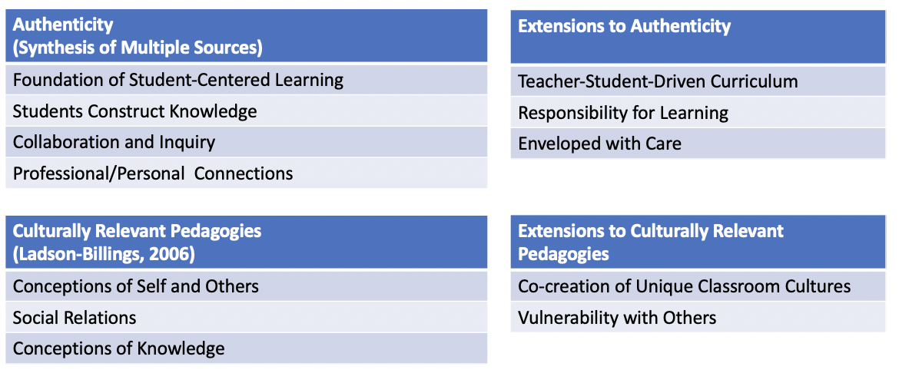
Limitations
By its very nature, case study research can be limited because of small sample size and subjectivity of individuals, not to mention the biases researchers bring with them into data collection. While this research contributes to the discussion of authentic teaching and learning approaches, it is limited in scope. Another limitation is the setting in which this study took place since it included only one culturally diverse, urban high school. Therefore, generalizations to other high schools and to other mathematics teachers may be challenging due to the limited number of participants and contained setting.
In addition to having a limited scope in sample size and setting, another limitation can be found in the personal connections I have with both participants. While I knew both teachers prior to this research, it would be challenging to recreate a similar project with teachers who were unknown to me or conducting a project with random sampling. I felt, though, that by limiting the number of participants to teachers who had reputations of being non-traditional mathematics teachers, I would be able to dive deeper into both “how” and “why” Nicole and Bailey taught the way they did.
Possibilities for Further research.
One of the more profound findings of this study was the theme of “co-creation,” which included teachers and student working together to create normative behaviors and curricula. Further research could be conducted to explore how teachers in other settings go about doing similar processes with their students. Conducting similar studies of teachers who ascribe to alternative approaches to teaching and learning may be a worthwhile endeavor. Studies like this could lend themselves well to phenomenological methodologies in that researchers could look for essences of authentic teaching and learning approaches while considering cultures existing in classrooms. A research project with a larger scope may add to more definitive definitions of what scholars consider to be authentic teaching practices.
While this study was conducted in culturally diverse, urban mathematics classrooms, there seems to be potential to conduct similar studies in both rural and suburban schools. Both rural and suburban schools have unique cultures of their own and possibly face different challenges that teachers find in urban settings. In addition, there may also be something of note when understanding approaches teachers across grade levels in elementary and middle schools, consider to be authentic teaching and learning practices. This study focused solely on mathematics teachers but considering perspectives of teachers in multiple disciplines may also be a worthwhile endeavor.
Conclusion
Both Nicole and Bailey have engaged in alternatives to traditional mathematics education. While Nicole was a seasoned veteran with fewer constraints and Bailey found dissonance between her philosophy and enacted curriculum, both teachers sought to transform their classrooms to empower students. Paulo Freire (2000) profoundly stated:
The role of the educator is not to ‘fill’ the educatee with ‘knowledge,’ technical or otherwise. It is rather to attempt to move towards a new way of thinking in both educator and educatee, through the dialogical relationships between both. The flow is in both directions. (p.109)
Both teachers in this study engaged in developing dialogical relationships with their students through sharing power and control, working with students to engage them on their level. They have modeled what co-created learning environments can look like, and it turn teachers can take aspects of their practices and embed them into their own.
Despite major reforms in mathematics education over the years, students’ perspectives have often been ignored. Bailey and Nicole have both demonstrated what inclusive teaching and learning can look like in a culturally diverse, urban high school setting. Schools like WCHS tend to be characterized by how they have failed to measure up to their affluent, suburban counterparts. Teachers working in challenging districts often discount their students and their potential to be change agents in the world. Bailey and Nicole have moved beyond the notion of working with “these” kids to create unique classroom cultures that embrace student diversity and have connected student learning in ways that are empowering and uniquely authentic.

References
Anyon, J. (1980). Social class and the hidden curriculum of work. Journal of Education, 67-92.
Agarwal, R. (2011). Negotiating visions of teaching: Teaching social studies for social justice. Social Studies Research and Practice, 6(3), 52-64.
Aslan Tutak, F., Bondy, E., & Adams, T. L. (2011). Critical pedagogy for critical mathematics education. International Journal of Mathematical Education in Science & Technology, 42(1), 65–74.
Banks, J. A., Cookson, P., Gay, G., Hawley, W. D., Irvine, J. J., Nieto, S., Schofield, J.W., Stephan, W. G.. (2001). Diversity within society: Essential principles for teaching and learning in a multicultural society. The Phi Delta Kappan, 83(3), 196–203.
Bartell, T. G. (2013). Learning to teach mathematics for social justice: Negotiating social justice and mathematical goals. Journal for Research in Mathematics Education, 44(1), 129–163.
Battey, D. (2013). Access to mathematics: "A possessive investment in whiteness". Curriculum Inquiry, 43(3), 332-359.
Bloom, B. S. (1989). Engelhart, M.D., Furst, E.J., Hill, W.H., & Krathwohl, D.R. (1956). Taxonomy of educational objectives: The classification of educational goals. Handbook 1: Cognitive domain.
Boaler, J. (2016). The importance of teaching in the promotion of open and equitable mathematics environments. In E. A. Silver & P. A. Kenney (Eds.), More lessons learning from research: Helping all students understand important mathematics Volume 2 (19-26). Reston, VA: National Council of Teachers of Mathematics.
Borba, M. (1990). Ethnomathematics and education. For the Learning of Mathematics, 10(1), 39-43.
Bourdieu, P. (1977). The economics of linguistic exchanges. Information (International Social Science Council), 16(6), 645-668.
Brelias, A. (2015). Mathematics for what? High school students reflect on mathematics as a tool for social inquiry. Democracy & Education. 23(1), 1-11.
Brodhagen, B. L. (1995). The situation made us special. In Apple, M. W. & Beane, J. A. (Eds.), Democratic schools (pp. 83-100). Alexandria, VA: ASCD.
Broom, C. (2015). Empowering students: Pedagogy that benefits educators and learners. Citizenship, Social, and Economics Education, 14(2), 79-86.
Brown, B. (2016). Brené Brown encourages educators to normalize the discomfort of learning and reframe failure as learning. About Campus, 20(6), 3-7.
Bruner, J. (1960). The process of education. Boston, MA: Harvard University Press.
Burton, K. (2011). A framework for determining the authenticity of assessment tasks: Applied to an example in law. Journal of Learning Design, 4(2), 20–28.
Callison, D., & Lamb, A. (2004). Key words in instruction: Authentic learning. School Library Media Activities Monthly, 21(4), 34-39.
Center for Global Education. (2017, September 26). SAGE advice. Retrieved from http://asiasociety.org/education/sage-advice
Chagas, I., Faria, C., Mourato, D., Pereira, G., & Santos, A. (2012). Problem- based learning in an online course of health education. European Journal of Open, Distance and E-Learning, I, 1–10.
Collins, A. (1988). Cognitive apprenticeship and instructional technology (Technical report no. 6899). Cambridge, MA: BBN Labs, Inc.
Collins, A., Brown, J. S., & Newman, S. E. (1988). Cognitive apprenticeship: Teaching the craft of reading, writing and mathematics. Thinking: The Journal of Philosophy for Children, 8(1), 2-10.
Creswell, J. (2013). Qualitative inquiry & research design: Choosing among five approaches (3rd ed). London: SAGE.
Crotty, M. (2006). The foundations of social research meaning and perspective in the research process. London: SAGE.
D'Ambrosio, U. (1985). Ethnomathematics and its place in the history and pedagogy of mathematics. For the Learning of Mathematics, 5(1), 44-48.
Darling-Hammond, L. (2000). Teacher quality and student achievement. Education Policy Analysis Archives, 8(1), 1-49.
Delpit, L. (1995). Other people's children: Cultural conflict in the classroom. New York: New Press.
Delpit, L. (2012). Multiplication is for white people. New York, NY: New Press.
Dennis, J. & O’Hair, M.J. (2010). Overcoming obstacles in using authentic instruction: A comparative case study of high school math & science teachers. American Secondary Education, 38(2), 4-22.
Derrida, J. (1995). The gift of death. University of Chicago Press.
Dewey, J. (1899). The school and society. Chicago, IL: The University of Chicago Press.
Dewey, J. (1903). Democracy in education. The Elementary School Teacher, 4(4), 196-204.
Dewey, J. (1933). How we think: A restatement of the relation of reflective thinking to the educative process. Boston: D.C. Heath.
Dimitriadis, G. & Kamberelis, G. (2006). Theory for education. New York, NY: Taylor & Francis.
Dover, A. (2013). Teaching for social justice: From conceptual frameworks to classroom practices. Multicultural Perspectives, 15(1), 3-11.
Dweck, C. (2006). Mindset: The new psychology of success (1st ed.). New York: Random House.
Elliot, S., Bradbury, J., & Gardner, J. (2014). Finding the cracks: Progressive, democratic education in an era of standardization. Schools: Studies in Education, 11(2).
Foucault, M. (1977). Discipline and punish: The birth of the prison. New York: Vintage.
Frank, C. (1999). Ethnographic eyes. Portmouth, NH: Heinemann.
Frankenstein, M. (1983). Critical mathematics education: An application of Paulo Freire's epistemology. Journal of Education, 315-339.
Freire, P. (1973). Education for critical consciousness. (1st American ed.). New York: Seabury Press.
Freire, P. (2000). Pedagogy of the oppressed. New York, NY: Continuum.
Freire, P. & Macedo, D. (1995). A dialogue: Culture, language and race. Harvard Educational Review, 65(3), 377.
Garrett, L., Huang, L., & Charleton, M. C. (2016). A Framework for authenticity in the mathematics and statistics classroom. Mathematics Educator, 25(1), 32-55.
Gay, G. (2013). Teaching to and through cultural diversity. Curriculum Inquiry, 43(1), 48-70.
Giorgi, A. (2009). The descriptive phenomenological method in psychology: A modified Husserlian approach. Duquesne University Press.
Giroux, H. A. (1985). Critical pedagogy, cultural politics and the discourse of experience. Journal of Education, 167(2), 22-41.
Giroux, H. A. (1985). Teachers as transformative intellectuals. Social Education, 49(5), 376-379.
Giroux, H., & McLaren, P. (Eds.). (1989). Critical pedagogy, the state, and cultural struggle. Albany, NY: SUNY Press.
Glaser, B.G., & Strauss, A.L. (1967). The discovery of grounded theory. Chicago, IL: Aldine.
Goetz, J. P., & LeCompte, M. D. (1984). Ethnography and qualitative designs in ethnographic research. New York: Academic.
Goldberg, M. (2001). An interview with Linda Darling-Hammond: Balanced optimism. Phi Delta Kappan, 82(9), 687-690.
Goldring, R., Gray, L., and Bitterman, A. (2013). Characteristics of public and private elementary and secondary school teachers in the United States: Results from the 2011–12 schools and staffing survey (NCES 2013-314). U.S. Department of Education. Washington, DC: National Center for Education Statistics. Retrieved from http://nces.ed.gov/pubsearch.
Greer, B., & Skovsmose, O. (2012). Seeing the cage? The emergence of critical mathematics education. In O. Skovsmose & B. Greer (Eds.), New Directions in Mathematics and Science Education Opening the Cage: Critique and Politics of Mathematics Education
Guba, E. G. (1978). Toward a methodology of naturalistic inquiry in educational evaluation. CSE Monograph Series in Evaluation, 8.
Guba, E. G., & Lincoln, Y. S. (1981). Effective evaluation: Improving the usefulness of evaluation results through responsive and naturalistic approaches. Jossey-Bass.
Gutstein, E. (2006) Reading and writing the world with mathematics: Toward a pedagogy for social justice. New York, NY: Routledge.
Gutstein, E. (2013). Mathematics education in a time of crisis: For what purpose? Association of Mathematics Teacher Educators Seventeenth Annual Conference. Orlando, Florida.
Harris, C., & Marx, R. (2009). Authentic tasks. Retrieved from http://www.education.com/reference/article/authentic-tasks/
Heath, S. B. (1983). Ways with words: Language, life and work in communities and classrooms. Cambridge, UK.: Cambridge University Press.
hooks, b. (1994). Teaching to transgress: Education as the practice of freedom. New York, NY: Routledge.
Huerta, T. M., & Brittain, C. M. (2009). Effective practices that matter for Latino children. In E. G. Murillo Jr, S. Villenas, R. T. Galván, J. S. Muñoz, C. Martínez & M. Machado-Casas (Eds.), Handbook of latinos and education: Theory, research, and practice (p. 382-399). New York: Routledge.
Hycner, R. (1985). Some guidelines for the phenomenological analysis of interview data. Human Studies, 8, 279-303.
Irvine, J. (1991). Black students and school failure: Policies, practices, and prescriptions. New York: Praeger Press.
Johnson, J. (2011). Social justice lessons & mathematics. Mathematics Teaching in the Middle School, 17(3), 174 - 179.
Johnson, J., & Immerwahr, J. (1995). Teaching values: What does the public really want? USA Today Magazine, 124(2602), 90-91.
Jonassen, D. H. (1999). Designing constructivist learning environments. In C. M. Reigeluth (Ed.), Instructional design theories and models: A new paradigm of instructional theory (Vol. 2, pp. 371- 396). Mahwah, NJ: Lawrence Erlbaum Associates, Inc.
Kozol, J. (2012). Savage inequalities: Children in America's schools. Broadway Books.
Kumashiro, K. (2004). Against common sense. New York, NY: Routledge Falmer.
Ladson-Billings, G. (1995). Toward a theory of culturally relevant pedagogy. American Educational Research Journal, 32, 465-491.
Ladson-Billings, G. (2006). It's not the culture of poverty, it's the poverty of culture: The problem with teacher education. Anthropology & Education Quarterly, 37(2), 104–109.
Ladson-Billings, G. (2006). Yes, but how do we do it? Practicing culturally relevant pedagogy. In J. Landsman & C.W Lewis (Eds.), White teachers/diverse classrooms: A guide to building inclusive schools, promoting high expectations, and eliminating racism (p. 29-42). Sterling, VA: Stylus
Ladson-Billings, G. (2014). Culturally relevant pedagogy 2.0: a.k.a. the remix. Harvard Educational Review, 84(1), 74-84.
Landsman, J. (2004). Confronting the racism of low expectations. Educational Leadership, 62, 28-33.
Liou, D. D., & Rojas, L. (2016). Teaching for empowerment and excellence: The transformative potential of reaching expectations in an urban Latina/o classroom. Urban Review: Issues and Ideas in Public Education, 48(3), 380–402.
Lombardi, M. M. (2007). Authentic learning for the 21st century: An overview (ELI Paper 1: 2007). Retrieved from https://net.educause.edu/ir/library/pdf/eli3009.pdf
Maina, F. W. (2004). Authentic learning: Perspectives from contemporary educators. Journal of Authentic Learning, 1(1), 1-8.
Marklin Reynolds, J., & Hancock, D. R. (2010). Problem-based learning in a higher education environmental biotechnology course. Innovations in Education and Teaching International, 47(2), 175–186.
McGee, E. & Hostetler, A. (2014). Historicizing mathematics and mathematizing social studies for social justice: A call for integration. Equity & Excellence in Education, 47(2), 208-229.
McKnight, C., Crosswhite, J., Dossey, J., Kifer, E., Swafford, J., Travers, K. et al. (1987). The underachieving curriculum: Assessing U.S. mathematics from an international perspective. Champaign, IL: Stipes.
McNamee, R. (2013). Teaching social justice mathematics in a privileged setting (Doctoral dissertation). Retrieved from ProQuest, LLC. (ED553487)
Merriam, S.B. (1998). Qualitative research and case study applications in education. San Francisco, CA: Jossey-Bass.
Merriam, S.B. (2009). Qualitative research: A guide to design and implementation. San Francisco, CA: Jossey-Bass.
Meyer, D. (2014). Real work v. real world. Dy/Dan Blog. Retrieved from http://blog.mrmeyer.com/2014/developing-the-question-real-work-v-real-world/
Meyers, A. (2016). Learning from student perceptions: A dialogical approach to culturally relevant pedagogy. Retrieved from ShareOK Dissertations.
Moustakas, C. (1994). Phenomenological research methods. Thousand Oaks, CA: Sage.
National Center for Educational Statistics. (2018). [Table of race/ethnicity and region- Selected years, fall 1995 through fall 2025] Table 203.50: Enrollment and percentage distribution of enrollment in public elementary and secondary schools. Retrieved from https://nces.ed.gov/programs/digest/d15/tables/dt15_203.50.asp.
Newmann, F. M., Secada, W. G., & Wehlage, G. (1995). A guide to authentic instruction and assessment: Vision, standards and scoring. Wisconsin Center for Education Research.
Newmann, F. M. (1996). Authentic achievement: Restructuring schools for intellectual quality. Josey-Bass.
Newmann, F.M., Bryk, A., & Nagoaka, J. (2001). Authentic intellectual work and standardized tests: Conflict or coexistence? Improving Chicago's schools. Consortium on Chicago School Research, IL. 2-49.
Newmann, F.M., Marks, H.M., & Gamoran, A. (1996). Authentic pedagogy and student performance. American Journal of Education,104(4), 280-312.
Newmann, F. M., Rutter, R. A., & Smith, M. S. (1989). Organizational factors that affect school sense of efficacy, community, and expectations. Sociology of Education, 221-238.
Newmann, F. M., Secada, W. G., & Wehlage, G. (1995). A guide to authentic instruction and assessment: Vision, standards and scoring. Wisconsin Center for Education Research.
Nieto, S. (1998). Fact and fiction: Stories of Puerto Ricans in US schools. Harvard Educational Review, 68(2), 133-164.
Nieto, S. (2005). Public education in the twentieth century and beyond: High hopes, broken promises, and an uncertain future. Harvard Educational Review, 75(1), 43-64.
Nieto, S. (2013). Language, literacy, and culture: Aha! moments in personal and sociopolitical understanding. Journal of Language and Literacy Education, 9(1), 8-20.
Noddings, N. (2005). The challenge of care in schools: an alternative approach to education. (2nd ed.). New York: Teachers College Press.
Noddings, N. (2013). Education and democracy in the 21st century. New York, NY: Teachers College Press.
Oates, G. L. (2003). Teacher-student racial congruence, teacher perceptions, and test performance. Social Science Quarterly, 84(3), 508-525.
Oklahoma State Department of Education. (2016). 2016 statewide grades [Data file]. Retrieved from http://afreportcards.ok.gov
Oklahoma State Department of Education. (2017). Oklahoma public schools: Fast facts 2016-2017 [Data file]. Retrieved from http://sde.ok.gov/sde/sites/ok.gov.sde/files/documents/ files/Fast%20Facts%20FY17%20September%205%202017%20Update%20.pdf
Petty, T., Wang, C., & Harbaugh, A. P. (2013). Relationships between student, teacher, and school characteristics and mathematics achievement. School Science and Mathematics, 113(7), 333-344.
Pinar, W. (1992). “Dreamt into existence by others”: Curriculum theory and school reform. Theory into Practice, 31(3), 228-235.
Preus, B. (2012). Authentic instruction for 21st century learning: Higher order thinking in an inclusive school. American Secondary Education, 40(3), 59-79.
Raymond, K., (2018). M is not just for STEM: How myths about the purposes of mathematics education have narrowed mathematics curricula in the United States. Education Sciences, 8(2), 1-11.
Renzulli, J. S., Gentry, M., & Reis, S. M. (2004). A time and a place for authentic learning. Educational Leadership, 62(1), 73-77.
Resnick, L. B. (1987). Learning in school and out. Educational Researcher, 16(9), 13- 20.
Rojas, L., & Liou, D. D. (2017). Social justice teaching through the sympathetic touch of caring and high expectations for students of color. Journal of Teacher Education, 68(1), 28–40.
Rychly, L., & Graves, E. (2012). Teacher characteristics for culturally responsive pedagogy. Multicultural Perspectives, 14(1).
Sampson, D. and Garrison-Wade, D.F. (2011). Cultural Vibrancy: Exploring the preferences of African American children toward culturally relevant and non-culturally relevant lessons. The Urban Review, 43, 279-309.
Sanders, W.L., & Rivers, J.C. (1996). Cumulative and residual effects of teachers on future student academic achievement. Knoxville, TN: University of Tennessee Value-Added Research and Assessment Center.
Schiro, M. (2013). Introduction to the curriculum ideologies. Curriculum theory: conflicting visions and enduring concerns. 2nd ed. Thousand Oaks: Sage
Schoenfeld, A. (2004). The math wars. Educational Policy, 18(1), 253-286.
Shor, I. (1992). Empowering education: Critical teaching for social change. Chicago, IL: University of Chicago Press.
Smith, L. (1978). An evolving logic of participant observation: Educational ethnography and other case studies. In L. Shulman (ed.), Review of Research in Education. Chicago, IL: Peacock.
Spivak, G. C. (1988). Can the subaltern speak? Reflections on the History of an Idea, 21-78.
Stake, R. E. (1995). The art of case study research. Thousand Oaks, CA: Sage.
Stephan, W. G.. (2001). Diversity within unity: Essential principles for teaching and learning in a multicultural society. The Phi Delta Kappan, 83(3), 196–203.
Stephens, N. M., Fryberg, S. A., Markus, H. R., Johnson, C., & Covarrubias, R. (2012). Unseen disadvantage: How American universities’ focus on independence undermines the academic performance of first-generation college students. Journal of Personality and Social Psychology, 102, 1178-1197.
Stephens, N., & Townsend, S. (2015). The norms that drive behavior: Implications for cultural mismatch theory. Journal of Cross-Cultural Psychology, 46(10), 1304-1306.
Stephens, N. M., Townsend, S. S. M., Markus, H. R., & Phillips, T. (2012). A cultural mismatch: Independent cultural norms produce greater increases in cortisol and more negative emotions among first-generation college students. Journal of Experimental Social Psychology, 48, 1389-1393
Strauss, A., & Corbin, J. (1994). Grounded theory methodology. Handbook of qualitative research, 17, 273-85.
Villegas, A. M. (1988). School failure and cultural mismatch: Another view. The Urban Review, 20, 253-265.
Vygotsky, L.S. (1978). Mind in society: The development of higher psychological processes. Cambridge, MA: Harvard University Press.
Yeager, D. S., & Dweck, C. S. (2012). Mindsets that promote resilience: When students believe that personal characteristics can be developed. Educational psychologist, 47(4), 302-314.
Yin, R. K. (2012). Applications of case study research. Thousand Oaks, CA: Sage.
Zembylas, M. (2013). Critical pedagogy and emotion: Working through ‘troubled knowledge’ in posttraumatic contexts. Critical Studies in Education, 54(2), 176-189.
Appendix A: Chronological Definitions of Authenticity
Author(s) | Date | Definition
Resnick | 1987 | - Connects theory to practice  - Application of knowledge in the work environment
Collins | 1988 | Situated Learning:  - Connecting learning to apply knowledge to real life scenarios.
Collins, Brown, & Newman | 1988 | Authentic Tasks:  - Problem-based learning  - Case method  - Project-based learning  - Cognitive apprenticeship
Newmann, Secada, & Wehlage | 1995 | Authenticity Framework for Instruction and Assessment:  - Students constructing meaning to produce deep knowledge  - Use of disciplined inquiry through meaningful questions and substantive conversation  - Connecting learning so that it has value beyond school
Newmann, Marks, & Gamoran | 1996 | Authentic Pedagogy:  - Construction of Knowledge  - Disciplined Inquiry  - Value Beyond School  Classroom Instruction  - Higher-order thinking  2. Substantive conversation  3. Deep knowledge  4. Connections to the world beyond the classroom
Jonassen | 1999 | Authentic learning requires:  - Situated learning  - Constructive learning environments
Nelson | 1999 | Authenticity includes collaborative problem solving
Schank, Berman, & MacPerson | 1999 | Authentic instruction presents goal-based scenarios
Maina | 2004 | Authentic Instruction:  - Tasks are similar situations found in the real world  - Meaningful contexts that are extensions of the students’ perceived world  - Focus on student-centeredness
Callison & Lamb | 2004 | Seven Approaches:  - Student-centered learning  - Accessing of multiple resources beyond the school  - Students as scientific apprentices  - Opportunities to gather original data,  - Lifelong learning beyond the assignment  - Authentic assessment of process, product and performance  - Team collaboration
Renzulli, Gentry, & Reis | 2004 | - Authentic learning in real-life problems  - Emotional connection in addition to a cognitive interest  - Open-ended problems  - Solutions intended for change in action, beliefs, and attitudes  - Targets a real audience outside the classroom
Lombardi | 2007 | Creates personal and practical connections to learning
Harris & Marx | 2009 | Authentic instruction connects learning to personal and professional lives.
Burton | 2011 | Real world authenticity:  - Mimics what people in real world situations do  - Uses tools people in real world situations use  - Mimics conditions people in real world situations
Tran & Daugherty | 2014 | Authenticity as defined by authentic tasks being completed by students.
Garret, Huang, & Calhoun Charleton | 2016 | Authentic mathematics has professional and personal aspects and centers around:  - Context  - Task  - Impact
Center for Global Education | 2017 | Four elements of authentic work:  - Student choice  - Authentic work done by professionals in the real world  - Global significance  - Exhibition of work

Appendix B: Subjectivity Statement
My hope is to be able to better understand teachers’ perspectives about teaching and learning in a culturally diverse school. I believe it is important to understand teachers’ views in mathematics education to better prepare teachers and inform mathematics teacher educators. My research focus is centered around better understanding the following: 1. What teaching and learning approaches do these teachers use when constructing curriculum in a culturally diverse school? 2. What do these teachers consider to be contributing factors to their teaching practices and enacted curriculum? 3.What factors potentially promote their ability to create and enact their curriculum? What factors might mitigate it?
In conducting this research project, I bring an array of experiences and ideas about the topic at hand. I am a former mathematics teacher having taught in public schools in south Texas for six years. I also have current ties to classrooms in the district where I hope to conduct my study. In my work as a professional development coordinator, I have had many experiences observing teachers in the school district where my study takes place. This includes both positive and negative interactions with teachers and biases as to what I consider to be authentic mathematics curriculum. Finally, my current positions as a graduate student and a graduate research assistant bring with them a social constructivist ideology to which I ascribe in terms of curriculum, instruction, and epistemology. The current research team with whom I collaborate includes other teachers with similar views on best practices in classrooms and similar constructivist approaches to teaching. Our current research projects are centered around constructs of authenticity that are derived from social constructivist epistemologies.
While my experiences in education are varied, I believe there is merit in my background that will enhance this research study. For instance, because of my social constructivist viewpoints on teaching and learning, I tend to have an open mind about beliefs held by teachers and students. I believe that individuals construct meaning for themselves as they interact with the world around them based on individual experiences and social spheres of influence. It is my belief that one should not shy away from listening to and attempting to understand perspectives of others. I am therefore open to what teachers have to say about authentic teaching and learning rather than trying to prove a point or theory about this topic.
Additionally, my former position in teaching in public schools will allow me to connect with my subjects on a personal level and will potentially allow them to speak openly and honestly about the topics at hand. As a graduate student, I feel as if I can position myself in the role of an equal, rather than coming from a perceived position of power in higher education. Conversely, in my current work as a graduate student, I bring with me several preconceived notions and biases about how I think one could potentially respond to aspects of my research question. This could be a potential limitation. I have also conducted a substantial amount of research about the importance of authenticity, though not in this setting or with these participants. Thus, I am aware of my potential biases that I bring with me about the research topic itself. Finally, as a white male, I recognize the privilege that comes with this position in society. I recognize that I face far fewer social challenges than the subjects who will be asked to participate in this research study.

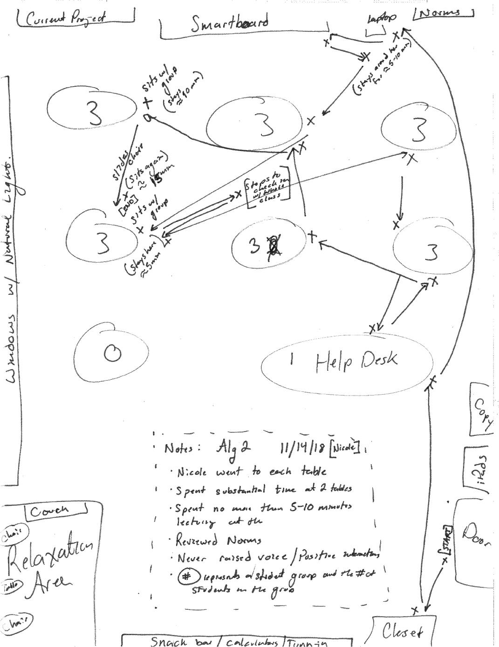
Appendix C: Teacher Movement Maps for Nicole

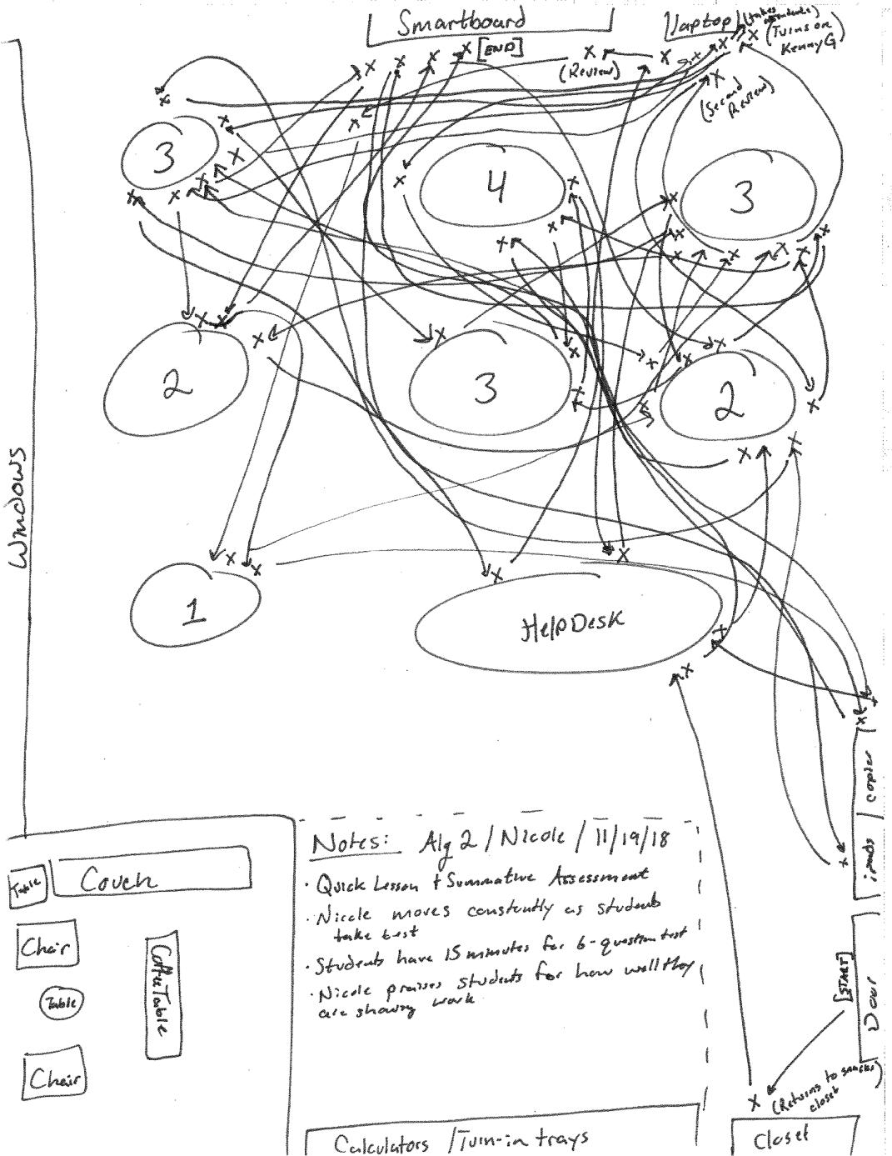

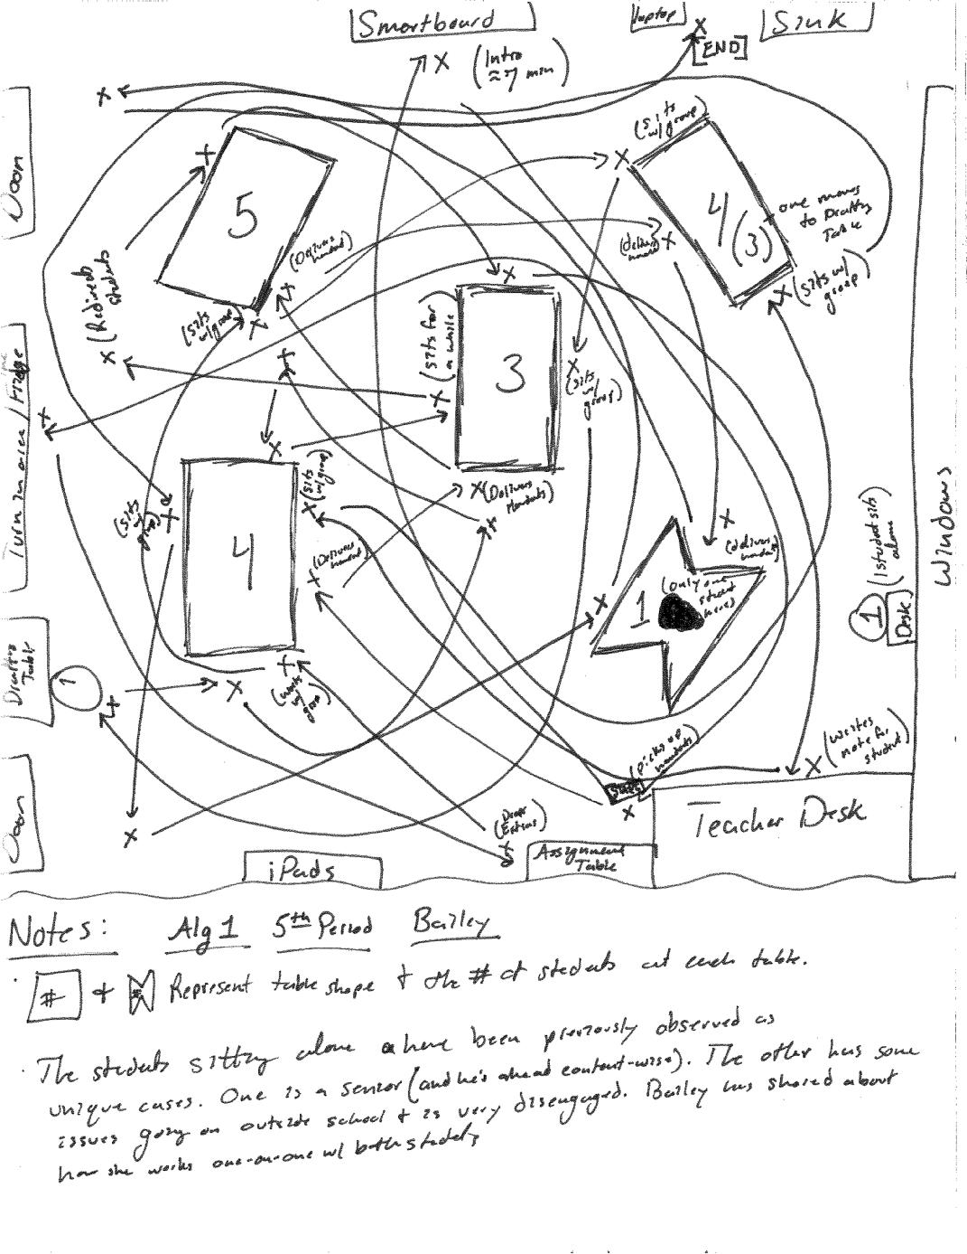
Appendix D: Teacher Movement Maps for Bailey

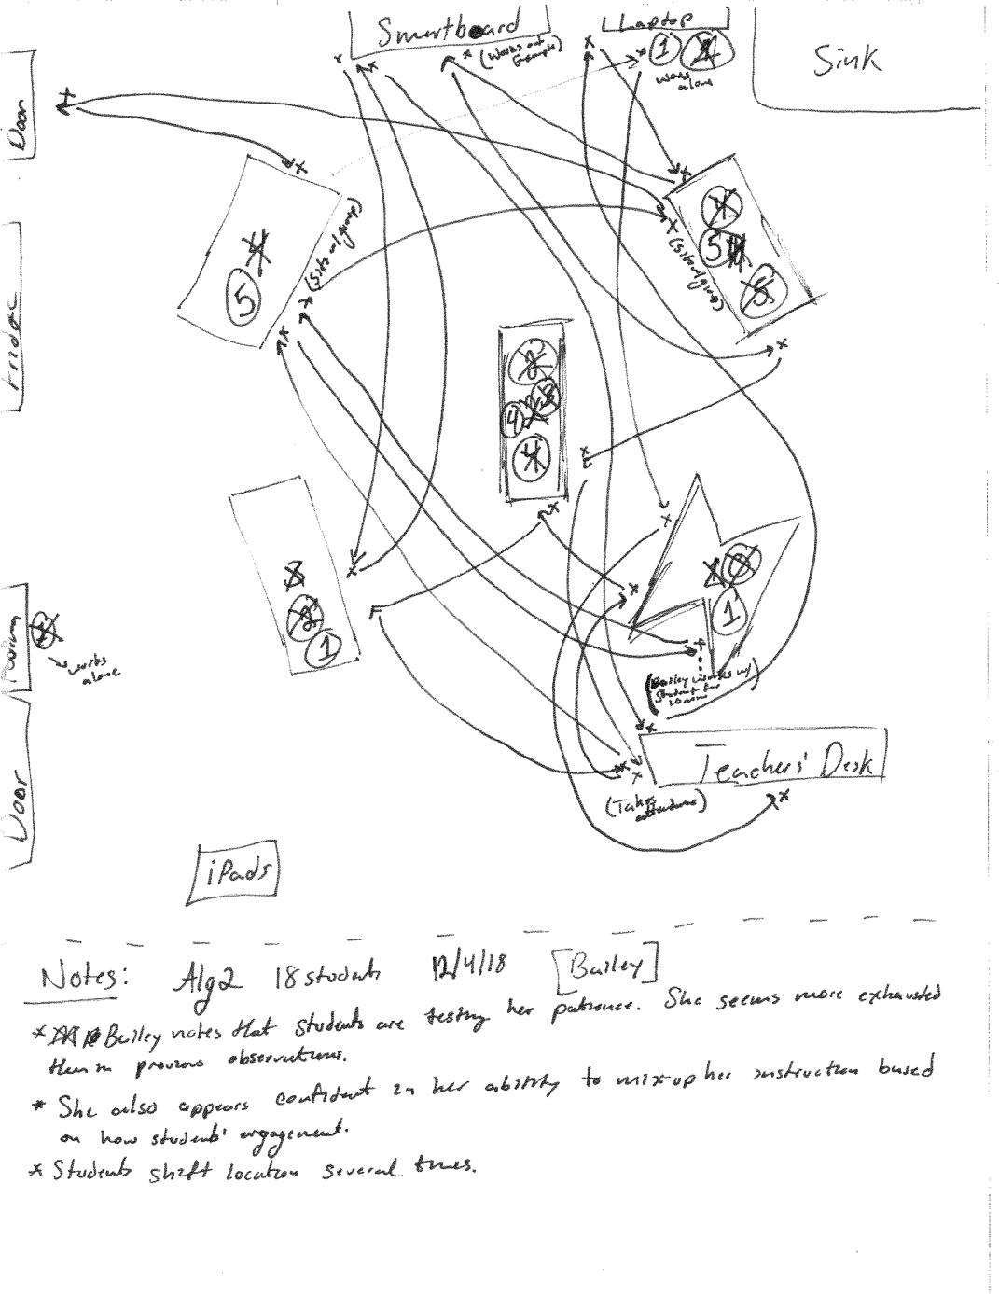


Appendix E: Relevant Classroom Artifacts for Nicole


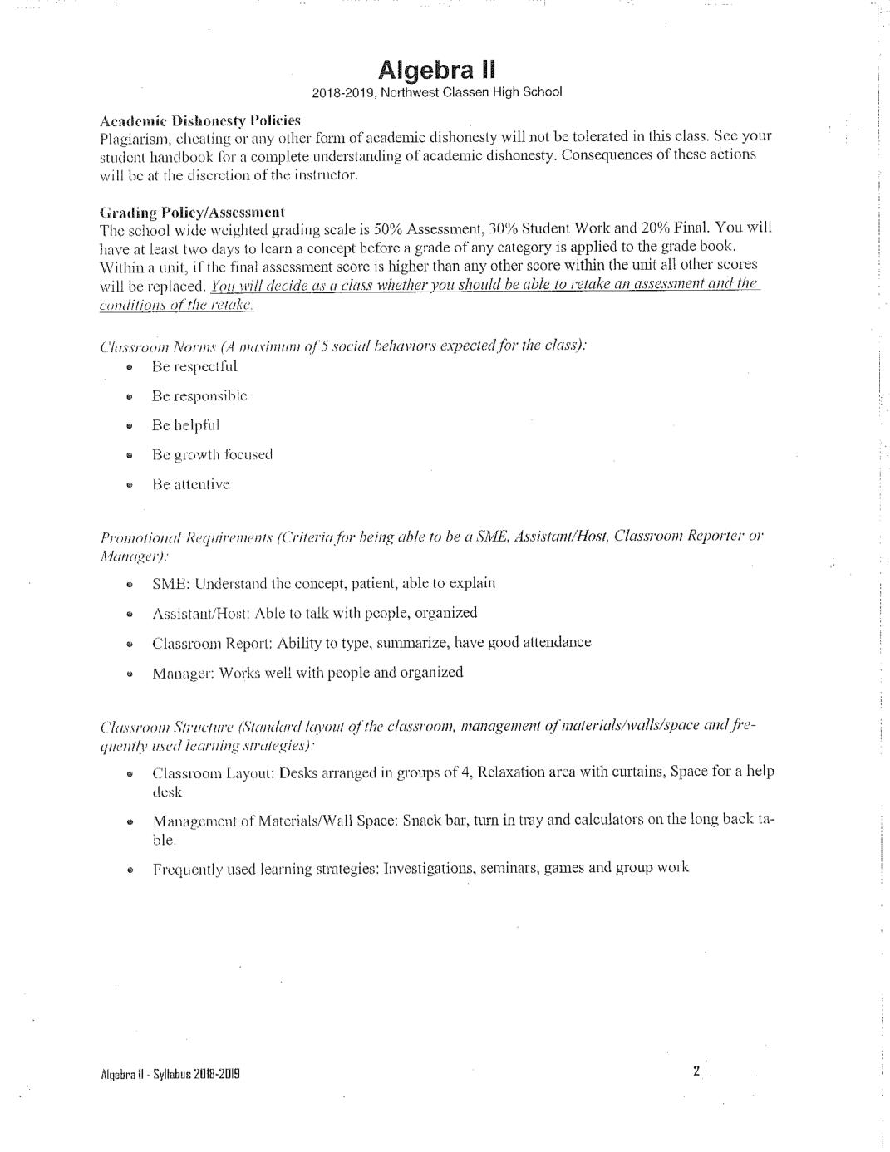
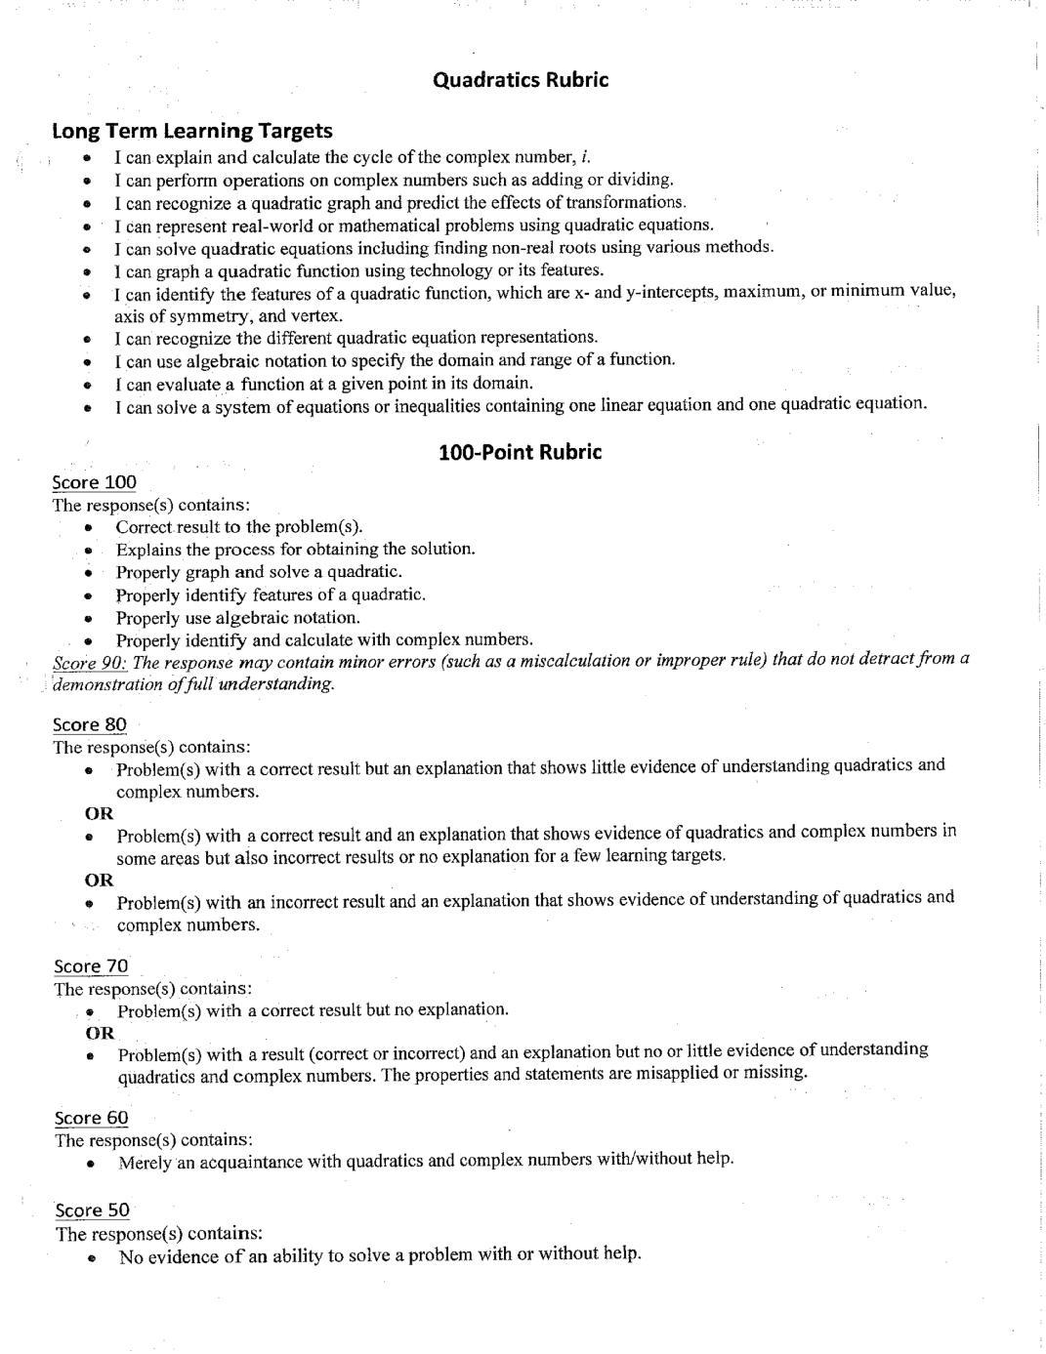
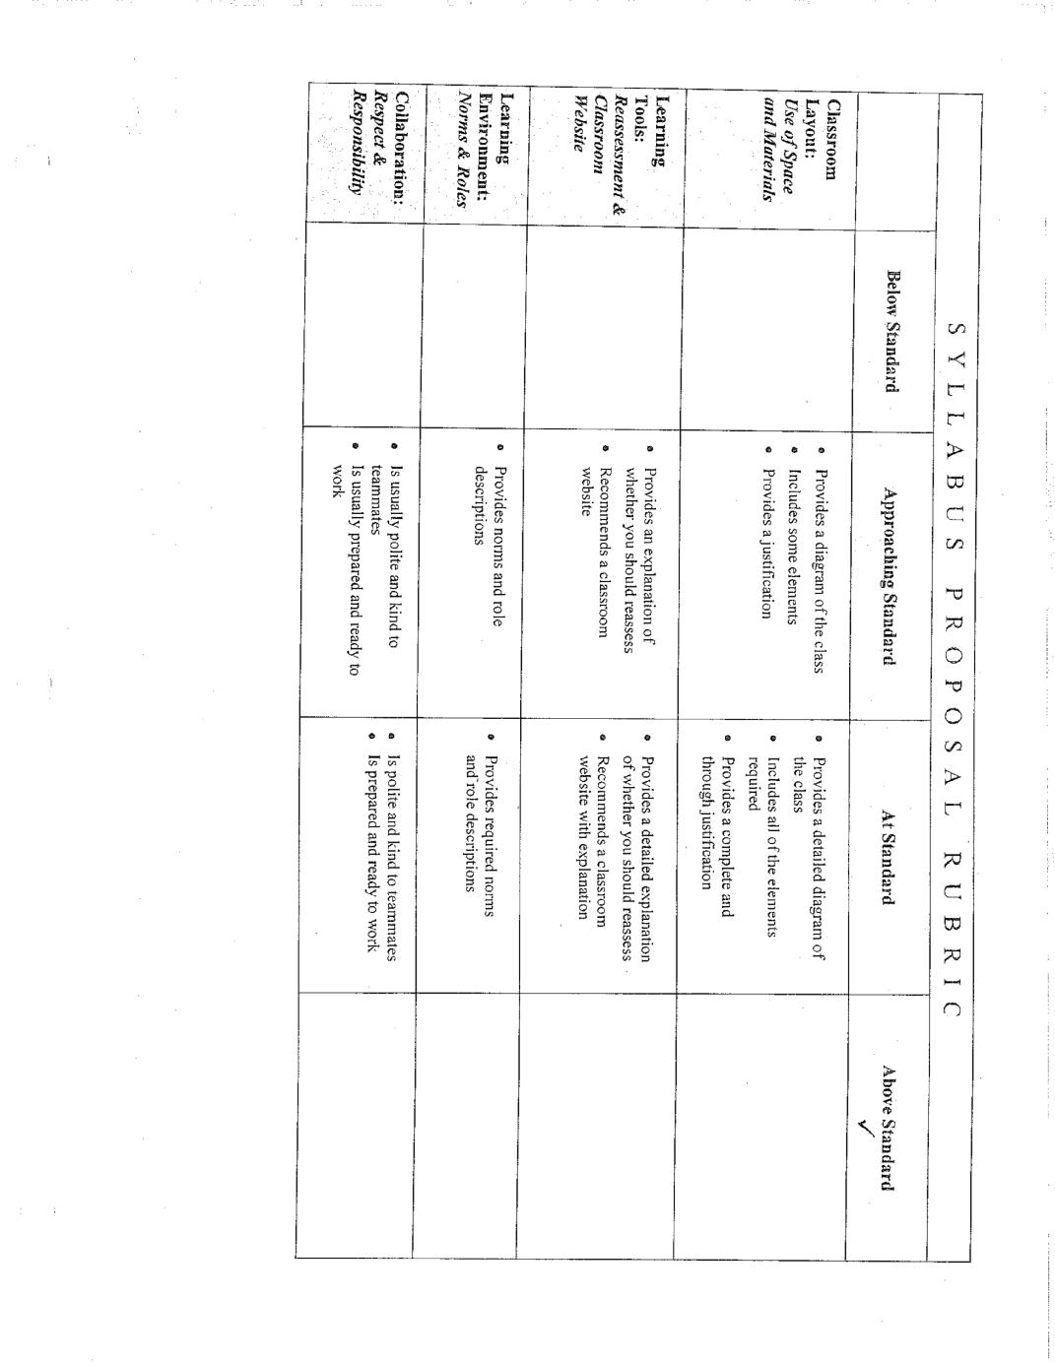

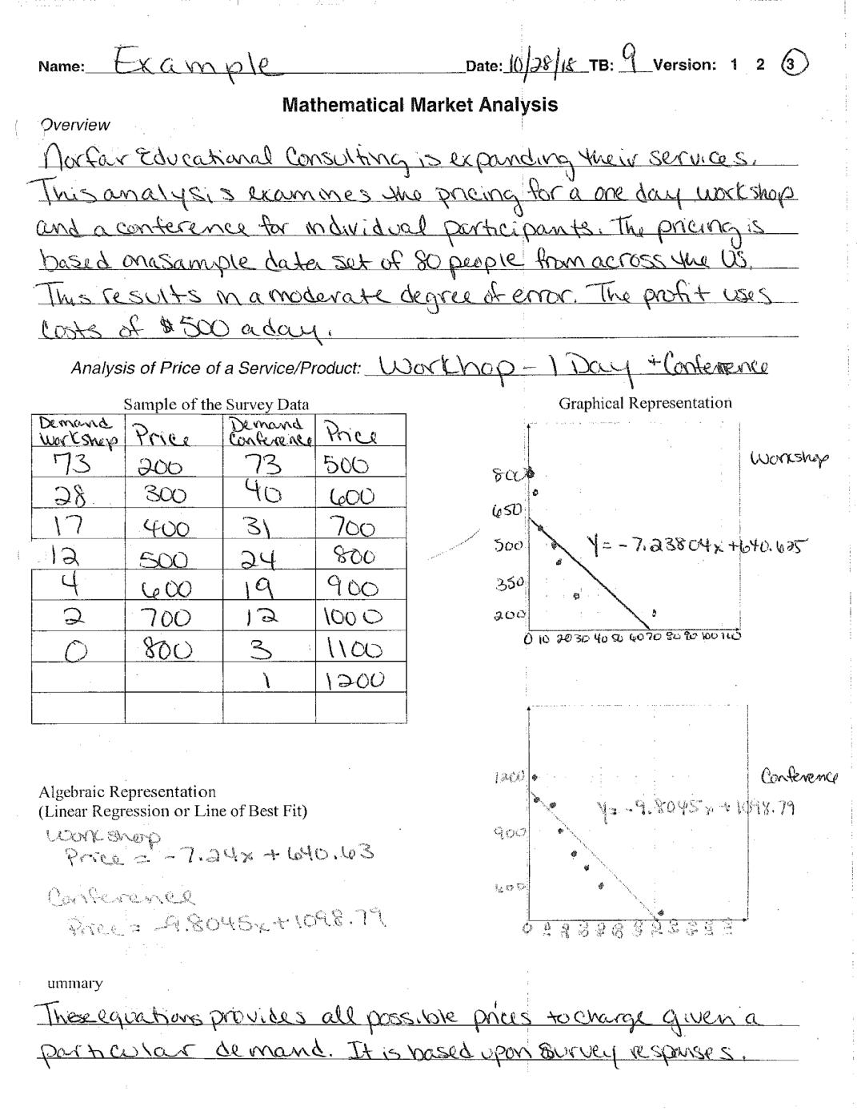
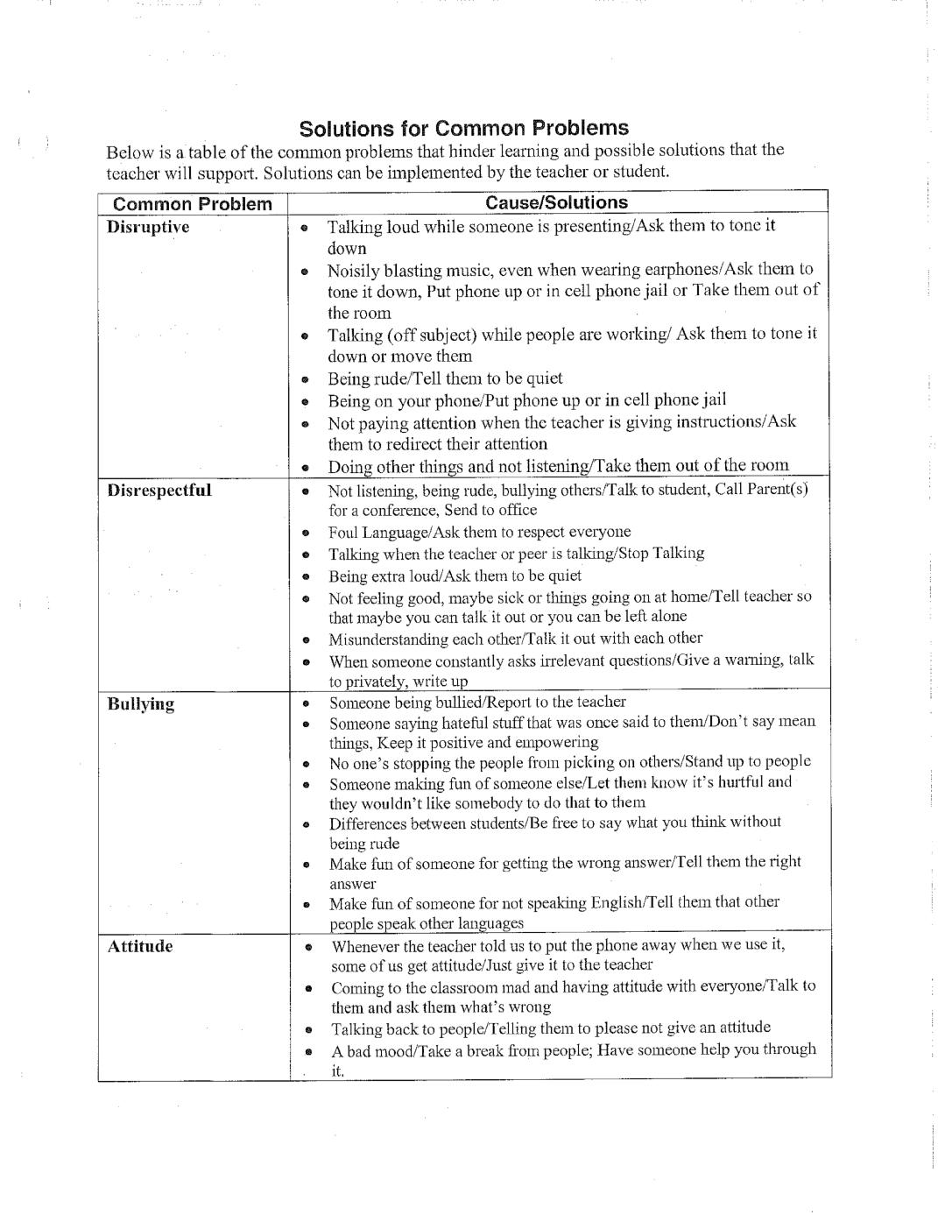

Appendix F: Relevant Classroom Artifacts for Bailey
