University of Oklahoma

Graduate College

The Early Archaic record in the gunnison basin, colorado: an investigation of projectile point technology and settlement patterns

A thesis

submitted to the Graduate Faculty

in partial fulfillment of the requirements for the

Degree of

Master of Arts

By

William r. Ankele
Norman, Oklahoma
2018

The early arcahic record in the gunnison basin, colorado: an investigation of projectile point technology and settlement patterns

A thesis approved for the
Department of Anthropology

By

______________________________
Dr. Bonnie L. Pitblado, Chair

______________________________
Dr. Asa R. Randall

______________________________
Dr. Patrick Livingood

© Copyright by william r. ankele 2018
All Rights Reserved.

To my family and friends who never stopped believing in me. Without all the love and support through the years, I would not be where I am today.

Acknowledgements
It would be nearly impossible to express the gratitude that I have for everyone who made this thesis, and my graduate school career, possible in the space provided, but I will do my best. First and foremost, I want to express my gratitude to my thesis committee for sticking with me and for all the support during this process. Bonnie Pitblado has been an awe-inspiring source of support and guidance over the years, not only academically, professionally, and financially, but also personally. She is someone who I consider not only a mentor, but a friend and I am a better person for knowing her. Asa Randall provided valuable insights and without his guidance, I would not be the scholar I am today. Through statistical and GIS instruction, Patrick Livingood guided me through the various analyses in this thesis. It was also his GIS class that set me on my career path and opened doors that I never knew existed.
I also want to thank my family who have been by my side since the beginning of this journey. I would call them my rock, but a rock can be moved. It seems more appropriate to call them my mountain for their unwavering love and support. I especially want to express my undying gratitude to my parents who have been my biggest fans since I, as a 20-year-old undergraduate from Ohio, first said I wanted to go west and have my first field experience. Since then my eyes have always pointed towards the Rockies, but a part of my heart will always be in Ohio with you. I also want to thank my Aunt Carol who claims she pushed me towards this career. While I do not recall this specific “push”, it was the best push that I have ever received in my life.
Any acknowledgements would not be complete without thanking my fellow graduate students. As anyone who has been through graduate school will tell you, it’s a community. At times a community of misery, but the majority is spent laughing and enjoying each other’s company. Whether that time is spent at the bar over drinks, or at a game-night slaying monsters, those days are what makes graduate school an enjoyable process and I consider all of you friends for life. Special recognition goes out to Meghan Dudley for her hours of help talking through my writing roadblocks and her constant support. Without you this would not have been possible.

Table of Contents

Acknowledgements iv
List of Tables ix
List of Figures x
Abstract xii
Chapter 1: Introduction 1
Chapter 2: Environmental Background 8
Physiography 10
Current Environment 13
Paleoenvironment 15
Paleoenvironment in Adjacent Regions 19
Colorado Plateau/Great Basin 19
Southwest 20
Great Plains 21
Summary 22
Chapter 3: Archaeological Background 24
Gunnison Basin Culture History 24
Paleoindian 27
Archaic 28
Compliance Work in the Basin Related to the Early Archaic 29
Academic Work in the Basin Related to the Early Archaic 32
Early Archaic Research in Adjacent Regions 33
Summary 34
Chapter 4: Methods 36
Typology 36
Identifying Early Archaic Projectile Points in the UGB 37
GIS Analysis 39
Least-Cost Path 40
Viewshed Analysis 44
Monte-Carlo Analysis 46
Summary 47
Chapter 5: Typology 48
Great Basin 48
Northern Side Notch 49
Sudden Side Notch 51
Pinto Basin 52
Southwest 56
Jay Phase of the Oshara Tradition 57
Bajada Phase of the Oshara Tradition 59
Great Plains 60
Hawken 60
Rocky Mountains 62
Mount Albion Complex 63
Summary 65
Chapter 6: Results 66
Projectile Point Typology in the Upper Gunnison Basin 66
Lithic Material 72
GIS Analysis 74
Spatial Patterning 74
Distance to Nearest Lithic Quarry 75
Distance to Nearest Least-Cost Path 77
Viewshed Analysis 81
Monte-Carlo GIS Analysis 87
Monte-Carlo Analysis of Distance to Nearest Lithic Quarry 87
Monte-Carlo Analysis of Site Elevation 88
Summary 90
Chapter 7: Discussion and Conclusion 91
Conclusions 94
References Cited 98
Appendix A: Projectile points analyzed for this thesis 108

List of Tables

Table 3.1: Cultural chronology for the Northern Colorado River Basin (Reed and Metcalf 1999)…………………………………………………………………………..26
Table 3.2: Six characteristics of the Mountain Tradition………………………………32
Table 4.1: Layers used in GIS analysis………………………………………………...45
Table 5.1: Information on Northern Side Notch points………………………………...49
Table 5.2: Information on Sudden Side Notch points………………………………….51
Table 5.3: Information on Pinto Basin points………………………………………….52
Table 5.4: Rodger's (1939) description of Pinto Basin projectile points……………….53
Table 5.5: Harrington's (1957) Pinto Basin types53
Table 5.6: Information on Jay points…………………………………………………...56
Table 5.7: Information on Bajada points……………………………………………….58
Table 5.8: Information on Hawken points……………………………………………...60
Table 5.9: Information on Mount Albion points……………………………………….62
Table 6.1: Total projectile points by site……………………………………………….67
Table 6.2: Projectile points by region…………………………………………………..68
Table 6.3: Projectile Point Lithic Material……………………………………………..72

List of Figures
[
Figure 1.1: Location of the Upper Gunnison Basin……………………………………..1
Figure 1.2: Possible geographic origins or affiliations for Early Archaic projectile points from regions adjacent to the UGB……………………………………………………….3
Figure 2.1: Mountain ranges surrounding the UGB……………………………………..9
Figure 2.2: Major waterways in the UGB……………………………………………...12
Figure 2.3: Paleoclimate coring locations……………………………………………...17
Figure 3.1: Location of archaeological surveys in the UGB…………………………...25
Figure 3.2: Location of the Kezar Basin Site…………………………………………..31
Figure 4.1: Model created in ArcGIS Modelbuilder to perform the FETE least-cost path analysis to identify the mathematically easiest routes into the UGB from adjacent regions………………………………………………………………………………….43
Figure 5.1: Example of "high" side notch points………………………………………50
Figure 5.2: Example of "low" side notch points……………………………………….50
Figure 5.3: Cherry Gulch Types 1 (e) and 2 (g)………………………………………..64
Figure 5.4: Magic Mountain Type 3……………………………………………………64
Figure 6.1: Distrubution of all Early Archaic sites……………………………………..67
Figure 6.2: Pinto Point from 5GN817………………………………………………….70
Figure 6.3: Sudden Side Notch from 5GN223…………………………………………70
Figure 6.4: Northern Side Notch from 5GN2275………………………………………70
Figure 6.5: Jay point from 5GN1870…………………………………………………..70
Figure 6.6: Bajada point from 5GN5101………………………………………………70
Figure 6.7: Hawken point from 5GN5780……………………………………………..70
Figure 6.8: Early Archaic sites in relation to known lithic quarries……………………74
Figure 6.9: Box and whisker plot of distance to nearest lithic quarry………………….75
Figure 6.10: Box and whisker plot of distance to modeled least-cost from each site….76
Figure 6.11: Modeled least-cost path from the Great Basin/Colorado Plateau………...77
Figure 6.12: Modeled least-cost path from the Southwest…………………………….78
Figure 6.13: Modeled least-cost path from the Great Plains…………………………...79
Figure 6.14: Viewshed from sites with Hawken Points………………………………..81
Figure 6.15: Viewshed from sites with Jay points……………………………………..82
Figure 6.16: Viewshed from sites with Pinto points…………………………………...83
Figure 6.17: Viewshed from Sudden Side Notch Points……………………………….84
Figure 6.18: Viewshed from sites with Bajada points………………………………….85
Figure 6.19: Monte-Carlo comparison of distance to nearest lithic quarry…………….87
Figure 6.20: Monte-Carlo comparison of site elevation………………………………..88

Abstract
In comparison to the Late Paleoindian Period (11,500–8,400 B.P.), the Early Archaic (8,400–6,400 B.P.) in the Gunnison Basin, Colorado is a poorly understood time because of its relatively light archaeological signature. Not only is the archaeological record more ephemeral, but we also see a change in technologies, such as projectile points types, in this transitional period. Some archaeologists explain these observations as a result of changing environments caused by the Altithermal and shifting settlement processes as people adjusted to these changes. Adding to the muddled picture of the Early Archaic is the sometimes inappropriate application of projectile point typologies to diagnostic bifaces found in the Gunnison basin. No comprehensive typology exists for Archaic projectile points in the Southern Rocky Mountains and, as a result, archeologists often apply the typology they are most familiar with on projects in the Gunnison Basin. Using established typologies from regions adjacent to, and from, the Southern Rocky Mountains, I examine projectile points from the Gunnison Basin to determine what Early Archaic projectile points are present in the area. Then, using ArcGIS, I investigate the settlement patterns of the people who lived in the Gunnison Basin during the Early Archaic period. Based on the results of my study, I argue that during the Early Archaic a link exists between the Great Basin and the Gunnison Basin in the form of a movement of people or the movement of knowledge and ideas, or possibly both. More investigation is required to make a definitive statement, but this thesis can serve as a basis for more research into the Early Archaic record of the Gunnison Basin.

Chapter 1: Introduction
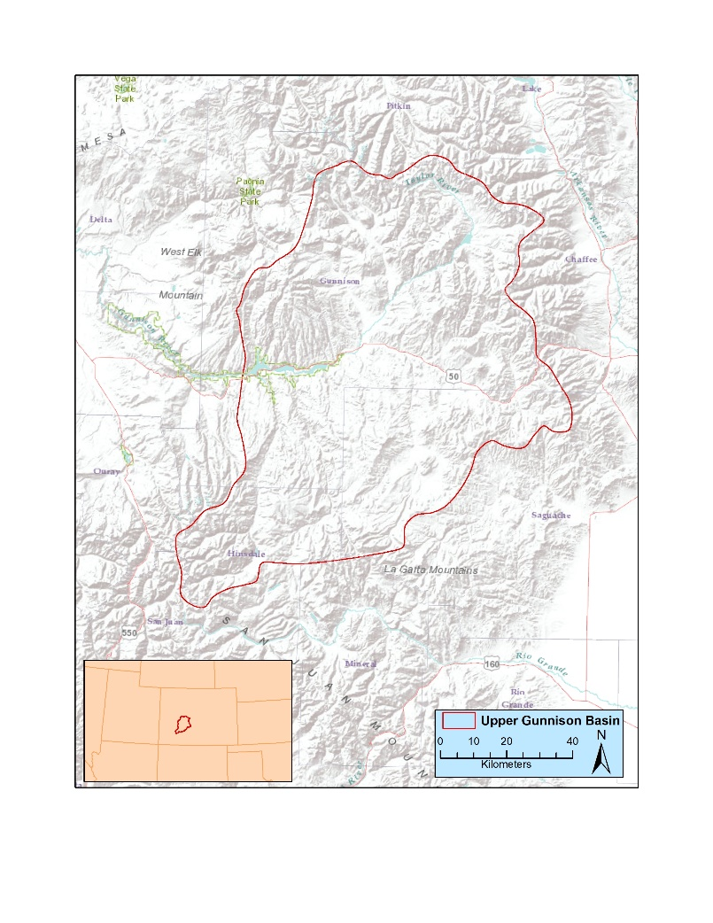
Figure 1.1: Location of the Upper Gunnison Basin.

Located in the Southern Rocky Mountains, the Upper Gunnison Basin (UGB) (Figure 1.1) has been the subject of numerous archaeological investigations over the last 100 years (e.g., Andrews 2010; Chambellan 1984; Cotter 1935; Dalpra 2016; Hurst 1943; Jones 1991; Merriman et. al. 2008; Pitblado 1998, 2002, 2003, 2016; Pitblado et al. 2007; Reanud 1934, 1942; Stiger 1981, 2001, 2006; Stiger and Euler 1978). Many of these investigations have been academic research projects, with numerous additional reports contained in CRM gray literature (Stiger 2001). An academic project (Merriman et. al. 2008) first brought me to the Gunnison area in 2007. As a 20-year-old undergraduate from Ohio, I had never been west of the Mississippi River when I applied for a field school in Gunnison, Colorado. I will never forget my wonderment and awe when I first saw the Rocky Mountains slowly appearing over the horizon of the Colorado plains. It is that wonderment and awe that draws me back to the Rockies year after year and that has driven this research. I know how I first arrived in the UGB, I know where I came from to get there, and I know why I left my home to spend a summer in a place I had never been before. It only seems fitting that my research asks these questions of the people who lived in the UGB between 8,400 and 6,400 years ago, a time frame we know little about. Using projectile points, the only diagnostic artifacts available to many Rocky Mountain archaeologists, along with GIS analyses, I consider in this thesis: 1) How people moved into the UGB during the Early Archaic; 2) Where Early Archaic people came from; and 3) Why did people come to the UGB during this time. To answer these questions, I investigate the possible geographic origins of Early Archaic points in the UGB (Figure 1.2) along with the mobility and resource procurement strategies of the people who called the Basin home during the Early Archaic era, 8,400 to 6,400 years ago.

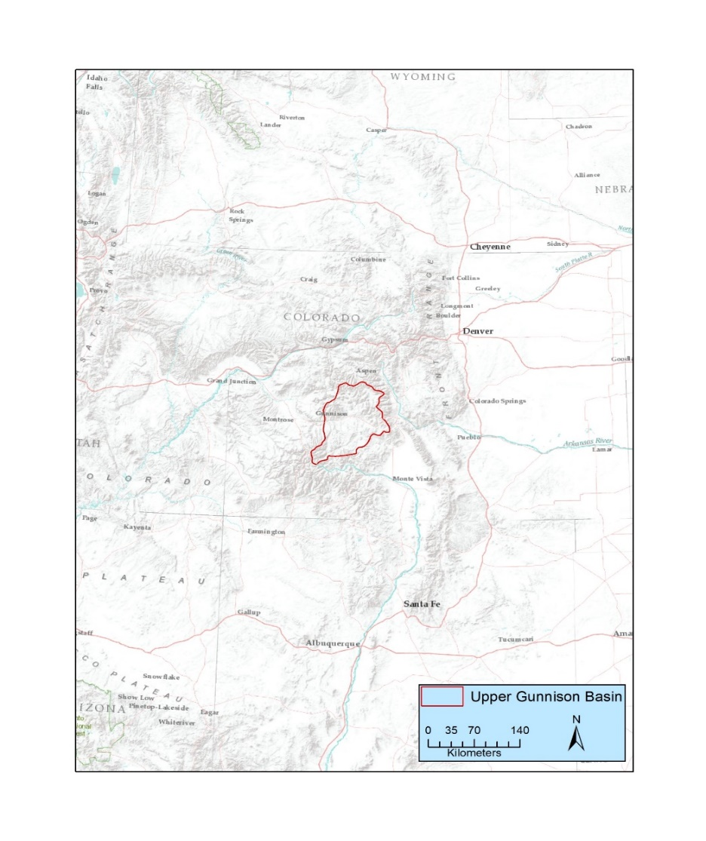
Figure 1.2: Possible geographic origins or affiliations for Early Archaic projectile points from regions adjacent to the UGB.
Great Basin/Colorado Plateau
Great Plains
Southwest

Much of the academic research in the UGB has focused on the Paleoindian period. In 1926, the discovery of projectile points at the New Mexico Folsom type site in association with the bones of an extinct species of bison, triggered a fountain of research that spread across the country that flooded into southern Colorado. The Mountaineer Folsom Site located just outside of Gunnison, Colorado has been the subject of many research projects (Andrews 2010; Stiger 2001, 2006). Bonnie Pitblado has intensively investigated the Late Paleoindian occupation at the Chance Gulch Site (5GN817) in the UGB along with many other sites that have Late Paleoindian components (Pitblado 2002, 2003, 2016).
Sedentary pre-contact societies in Colorado have also received similar attention. However, Pre-Contact people living in the UGB never adopted a sedentary lifestyle (Cassells 1997) and as a result have never garnered the interest that places like Mesa Verde and Chaco Canyon have. Sandwiched between the well-studied Paleoindian period and the architecture of the Ancestral Puebloans of the Southwest is the Archaic period. This period of roughly 6,000 years of human history has not excited researchers like other time periods and, as a result, we know little about the people who lived during this time. McElrath et al. (2009) argued that the attention given to Paleoindian and ceramic-making societies has caused people to overlook the Archaic. This is especially true for the Early Archaic which has received far less research than the Late Paleoindian period.
The beginning of the Early Archaic in the UGB is marked by the onset of the Altithermal Climate Event which brought warmer and drier conditions, not only to the Basin, but to most of North America (Anderson et. al. 1999; Benedict and Olson 1978; Wigand et. al. 1995). This climate shift had a significant impact on not only humans, but also on the flora and fauna. In the Great Basin, Madsen (2010) noted a rapid shift in subsistence strategies during the terminal Pleistocene/Early Holocene transition. On the Colorado Plateau, Janetski et. al. (2012) described similar changes.
Writing about Colorado, Kevin Black (1991) attributed these changes to radical Pleistocene-Holocene environmental transition brought on by the Altithermal. James Benedict and Byron Olson (1978) hypothesized that people living on the Great Plains retreated to the Colorado Front Range and used it as a refuge from drier adjacent lowlands, while Black (1991) argued that the harsh Early Archaic environment of the Great Basin may have caused people to seek refuge in the Rocky Mountains. In both cases, they argued that the vertical environmental zones of the mountains buffered the effects of the Altithermal and created living conditions more favorable than surrounding areas. Benedict and Olson (1978) and Black (1991) argued that this migration from adjacent regions into the mountains created a different archaeological signature than the Great Plains and Great Basin as people adapted their lifeways, including their lithic technology, to a new environment.
Possibly contributing to the apparent dearth of Early Archaic research in the UGB is the sometimes inappropriate application of projectile point typologies to diagnostic bifaces found in the region. Through the course of my career both in cultural resource management and academic archaeology, I have observed that archaeologists often apply the typology they are most familiar with when they encounter cultural material on projects in areas new to them, which can be problematic. In the UGB, for example, archaeologists recording sites have invoked projectile point typologies created for the Great Basin, Great Plains, Southwest, and Rocky Mountains to describe Early Archaic finds in that area, but with the typology often reflecting the archaeologists training more than any real differences in projectile point morphology or technology. Using these geographically specific typologies for Early Archaic artifacts in the Gunnison Basin implies a particular geographic affiliation for the people who made the artifacts, and this has led to a muddled understanding of where the Basin’s Early Archaic people really originated or shared the closest ties.
Projectile point typologies, for good or ill, are necessary in archaeology. This is especially the case in Rocky Mountain archaeology where preservation is generally poor, and pottery is not a major part of the archaeological record. Early research for this thesis began with the typing of projectile points found during a 2013 survey in the UGB. The points in question have distinct Southwestern characteristics such as heavy serration, however; similar points recovered in the Basin were typed by archaeologists working for the Bureau of Land Management (BLM) using typologies from areas as far away as southeast Texas. By not having a comprehensive typology for the Archaic period in the Southern Rocky Mountains, this issue is common among assemblages in the area, especially with Early Archaic projectile points.
In an attempt remedy this for this thesis, I assembled an Early Archaic typology for the UGB that captured both geographic and chronological data. I created the typology as a tool to assist me in evaluating the possible geographic affiliation of the people who lived in the Basin during the Early Archaic time period. The typology includes point types from the regions most likely to have been the home to the people who lived in the Gunnison Basin during the Early Archaic era: The Great Basin, Southwest, Great Plains, and the Rocky Mountains. I then evaluated collections of UGB projectile points based on the typology I created. I also examined the raw material of the projectile points in my study. However, except for quartzite which is of high-quality and found in abundance, other lithic sources in the Basin are poorly understood making it difficult to determine local vs. exotic material for non-quartzite artifacts. I did not consider other tool types for my research because systematic excavation of sites with Early Archaic components are rare in the Basin making it impossible to control the temporal association of other artifacts.
To avoid assigning a geographic affiliation to UGB Early Archaic occupants based solely on projectile points, I also performed various analyses using Geographic Information System (GIS) software to tease out subtle differences in sites containing different point types. I did this assuming that people from different areas practiced different lifeways and I used the analyses to evaluate factors that may indicate variations in subsistence and resource procurement strategies that might indicate the possibility of different populations with different geographic heritage living in the Basin during the Early Archaic.
In the pages that follow, I begin by presenting my environmental background in Chapter 2 with an emphasis on the Early Archaic paleoenvironment of the UGB and adjacent regions. I continue reporting background data in Chapter 3 with an overview of the archaeological record in the UGB, paying particular attention to the Paleoindian and Archaic records. In Chapter 4, I discuss the methods and analyses I used to identify Early Archaic projectile points and the subsistence and resource procurement strategies that people employed during that time. Chapter 5 presents the typology I created to classify Early Archaic projectile points from the UGB. Then, in Chapter 6 I show the results of my typological analysis of UGB Early Archaic projectile points and the GIS analyses I used to evaluate mobility and resource procurement strategies. Finally, in Chapter 7 I discuss the implications of my research on the question of geographic origins or affiliations of Early Archaic hunter-gatherers in the UGB, along with the mobility and resource procurement strategies they practiced.
Chapter 2: Environmental Background
The UGB is a closed mountain basin located in south-central Colorado. It is situated between the Elk Mountains to the North, West Elk Mountains to the West, the Sawatch Mountains to the northeast, the Cochetopa Hills to the southwest, and the La Garitas Mountains and San Juan Mountains to the south (Figure 2.1). The elevation ranges from greater than 4200 m above sea level (ASL) at the mountain peaks to 2100m ASL at the basin floor. Despite being physiographically similar to the other Colorado mountain parks and basins, the UGB is unique in that the only access to the basin below 3000 m ASL is a small, narrow gorge at 2650 m ASL. The significance of this restricted access will be discussed later in this thesis. Environmentally, the UGB exhibits a wide variety of ecological zones (Andrews 2010; Pitblado 2003, 2016; Stiger 2001). At the lowest elevations of the basin, foothills of the previously mentioned mountain ranges occur. When climbing higher in elevation one encounters, montane, parkland, subalpine, and alpine environments in that order. In this chapter, I describe the current environment, the paleoenvironment, and the ecology of these different zones along with the physiography of this unique mountain basin. I particularly emphasize the foothills and montane/parkland zones where the majority of Early Archaic sites occur.

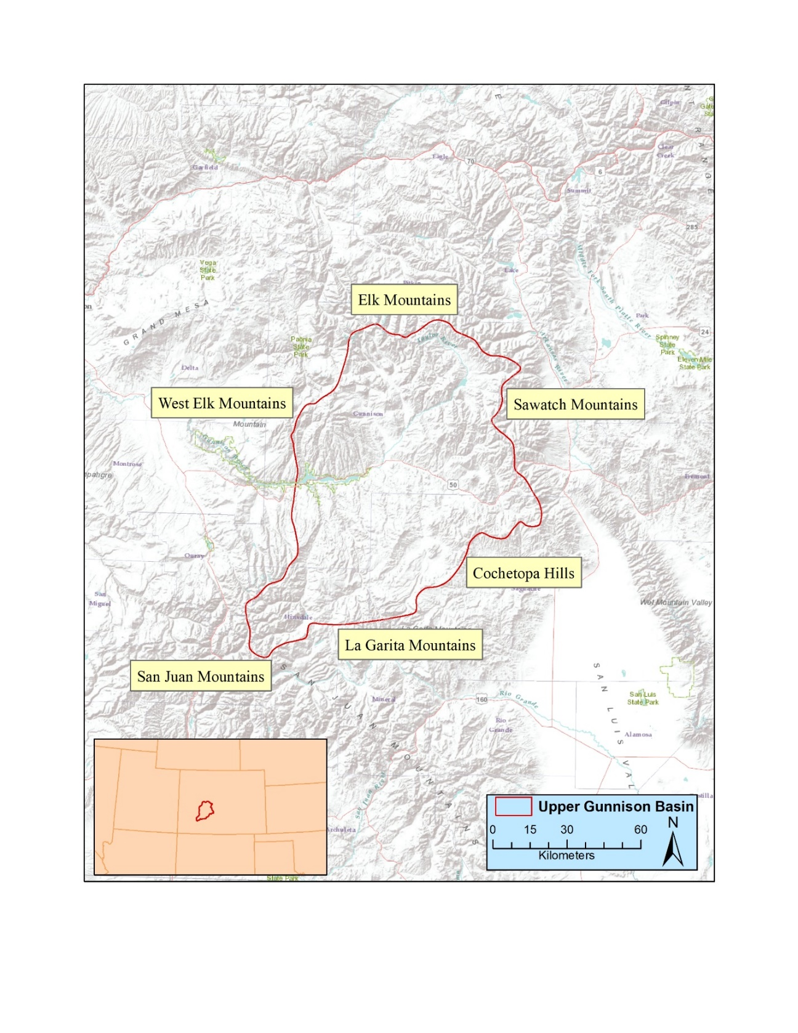
Figure 2.1: Mountain ranges surrounding the UGB.

Physiography
Located in the Southern Rocky Mountains, the UGB is ringed by peaks with elevations that commonly exceed 4000 m ASL. In fact, five of the six highest peaks in Colorado surround the Basin. Located in the Sawatch Range, Mount Elbert (4401 m ASL), Mount Massive (4398 m ASL), Mount Harvard (4396 m ASL), and La Plata Peak (4377 m ASL), create the northeastern boundary of the Basin in what is known as the Collegiate Peaks area. In the San Juan Mountains to the south is Uncompahgre Peak at 4360 m ASL. Many other “fourteeners,” as they are known to hiking and climbing enthusiasts for being over 14,000 feet ASL, surround the Basin in all directions. These high mountains peaks create both a visually striking and physically challenging landscape. At the foothills of these massive peaks, the Basin floor is characterized by rolling, sagebrush covered hills and many terraces above myriad streams, creeks, and rivers.
Evidence for Pleistocene cirque glaciation in the UGB occurs in Taylor Park and near the current town of Crested Butte in the form of terminal moraines (Stiger 2001). Around 15,000 B.P (for this thesis, all dates are presented in calendar years before present), the glaciers at the lower elevations (<3,200 m ASL) of the Basin receded and glaciers at higher elevations were greatly reduced in size. By 9,000 B.P. all the glaciers in the UGB had disappeared (Andrews et. al. 1975; Carrara et. al. 1984). These glaciers cut the canyons and valleys in the Basin, creating the rivers and streams that now flow in the area.
Sedimentary, metamorphic and volcanic processes created a suite of different rock types in the Basin. Of particular interest to archaeologists is obsidian and basalt created from the San Juan and West Elk volcanic events. Despite the low quality of the basalt and small size of the obsidian nodules (<1 cm), these materials occasionally occur in modified form at Basin sites (Stiger 2001). Across the UGB, various uplift events created numerous outcrops of high quality quartzite that people heavily exploited throughout time. The abundance and quality of this quartzite led people to use that lithic material to the near exclusion of most others. The majority (>90%) of the lithic assemblages at sites in the Basin consist of mainly quartzite (Stiger 2001). According to Stiger (2001) very few (n=5) usable sources of chert have been documented in the Basin. He noted that it is likely other sources exist, but as of 2001 he was unable to locate them (Stiger 2001). During the 2015 field season using site forms and information provided by avocational archaeologist Mike Pearce, I led a team of University of Oklahoma graduate students to locate other sources of chert. We had minimal success, locating one area where small fist-size nodules of orange chert were eroding out of a hillside. Other locations yielded only small cobbles of low-quality chert with no evidence of human quarrying activity.
Today, nine major waterways cross-cross in the UGB. The most important of these is the Gunnison River which flows east to west through the Basin (Figure 2.2). The Gunnison River is fed by many tributaries, primarily with snow melt leaving these tributaries dry gulches for much of the year. In the early 1960’s the Gunnison River was dammed to create the Blue Mesa Reservoir. At the location of the dam that created the reservoir, the Gunnison River flows into the deep, narrow Black Canyon. The Black Canyon lies on the western edge of the UGB and is the only entrance into the region below 3,000 m ASL. This geologic phenomenon has created a closed mountain basin environment in the UGB that is unique among other mountain basins in the Rockies (Stiger 2001). This closed-basin environment currently restricts the migration patterns of animals living in the Basin and may have impacted the mobility of people in the past (Stiger 2001).
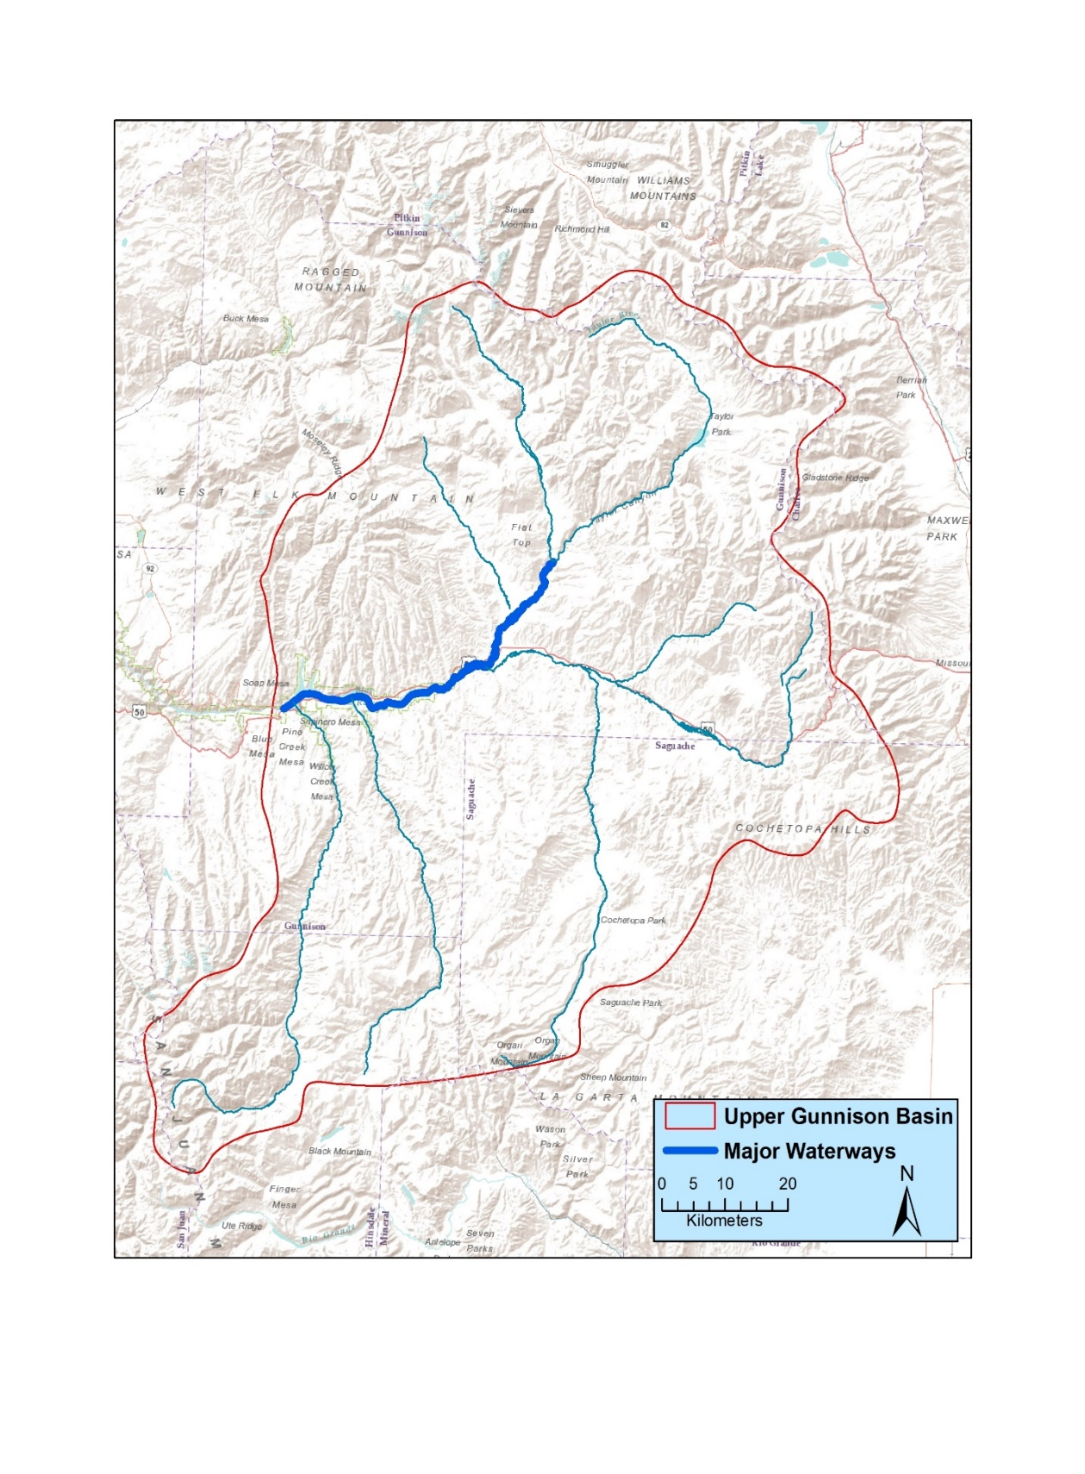
Figure 2.2: Major waterways in the UGB with the Gunnison River highlighted.

Current Environment
The UGB features four distinct environmental zones. At the lowest elevations (2,300-2,800 m ASL), the foothills of the surrounding mountain ranges are characterized by rolling sagebrush-covered hills and river terraces. Climbing in elevation, the increasing presence of aspen and fir trees defines the montane/parkland zone (2,800-3,800 m ASL) with aspen trees more common at lower elevations and gradually transitioning to fir trees at higher elevations. Above the montane/parkland zone is the subalpine. Located between 3,800m-4,300 m, disappearing trees characterizes the subalpine zone with long grasses and wildflowers being common. Finally, located above 4,300 m ASL is the alpine zone. In the alpine regions, long grasses give way to short grass with many areas having little to no vegetation due to rocky soils and steep slopes.
Basin precipitation and temperature vary by elevation. Generally, temperature drops approximately 6.5º C for every 1,000 m of elevation gained (Andrews 2010). According to weather stations from the High Plains Regional Climate Center, the average temperature at the lowest elevation station near the town of Gunnison (2320 m ASL) range from a low of -13º C in the winter months to 16º C in the summer months (http://climod.unl.edu/). Precipitation in the form of rain during the summer months and snow in the winter months is common. Over the last 30 years, the basin has averaged approximately 27 cm of rain per year, with the majority of that falling during the summer months. Annual snowfall averages over the last 30 years are approximately 115 cm with most of that falling during the winter months. Located 50 km north and 400 m higher in elevation of the town of Gunnison, the Crested Butte station reports similar average temperatures to the Gunnison station. Despite the similar temperatures, however, there is a disparity between the average rainfall and snowfall. The Crested Butte area receives approximately 60 cm of rainfall and 550 cm of snowfall per year. This difference in precipitation may have impacted people’s mobility and resource procurement patterns in the past, prompting them to seasonally use the resources available at these higher elevations rather than accessing them year-round.
In the foothills of the UGB, sagebrush dominates the landscape, covering roughly 33% of this environmental zone (Andrews 2010). This short, scrubby brush provides an important food source for many animal species in the area. Mule deer, elk, and pronghorn antelope, for example, rely on this food source throughout the year. In the winter when grasses are covered in snow, sagebrush can be easily accessed by foraging mammals, making this an important food source at that time (Baker and Hobbs 1982; Nelson and Leege 1982). Other grasses are also available in the foothills, however, not as abundant as sagebrush. These grasses provide food and shelter for other small mammals (rabbit, mouse, prairie dog, squirrel, etc.) and many species of birds. While no longer present in the area, bison once roamed the open sagebrush foothills and were an important food source for residents of the Basin (Andrews 2010; Stiger 2001).
In the montane and parkland environmental zones, aspen and fir trees begin to appear as elevation increases; however, fluctuations in climate and precipitation cause the lower treeline to move farther up or down the slope into the foothills. Like the foothills, these areas are also important to large mammals because the saplings offer valuable nutrition to elk, mule deer, moose, and in the past, bison. At the lower elevations of the montane and parkland zones, aspen occurs abundantly, especially in grasslands and areas with year-round water sources. Higher in this zone, spruce and fir trees manifest themselves in thick bands of coniferous forests. Spruce and fir trees and not generally consumed by large mammals during the summer months, and only sparingly during the winter months because snow depth limits access to them. Unlike in the foothills, black bear commonly occupy the montane and parkland zone where they forage for wild berries and flowers.
Beginning at upper treeline, long grasses and the absence of trees characterizes the subalpine zone. The cooler temperatures and change in precipitation limits the growth of trees. However, as mentioned earlier, variations in climate promotes changes in the treeline. This fluctuation of the treeline is important for paleoenvironmental studies and will be discussed later in this chapter.
The alpine tundra occurs above the subalpine zone. Short grasses replace the long grass of the subalpine, and although the growing season is brief, these short grasses offer excellent forage opportunities for ungulate mammals that migrate to the higher elevations during the summer. Yellow-bellied marmots and pika, for example, roam both the subalpine and alpine tundra to forage for grasses, berries, flowers, and insects.

Paleoenvironment
The beginnings of the Early Archaic in North America coincide with the Altithermal climate event that brought a general warmer and dryer climate to the continent. However, on a local scale, the effects of the Altithermal were highly variable (Benedict 1979, 1992; Benedict and Olson 1978; Black 1991; Meltzer 1991; Meltzer and Collins 1987). James Benedict argued that during the Altithermal, the Rocky Mountains functioned as a refugium from the arid conditions in surrounding areas, especially the Great Plains. He suggested that the mountains, with their vertically structured environmental variability, buffered the effect of the Altithermal, creating a “refuge” where the change caused by the Altithermal was less pronounced (Benedict 1979, 1992; Benedict and Olson 1978). Below, I present paleoenvironmental data first from the Gunnison Basin to characterize the environment of the Basin during the Early Archaic and then from the surrounding areas to contextualize the UGB data. These data hint at why people left their homeland in search of new country.
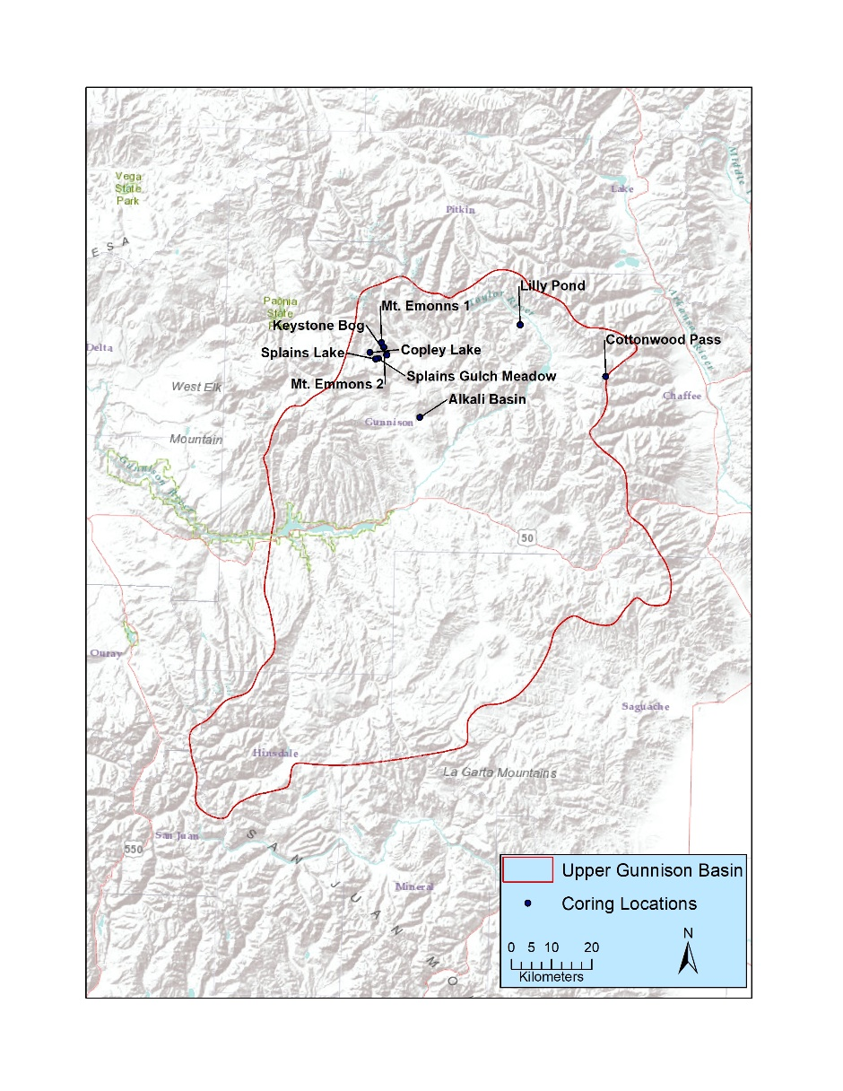
Upper Gunnison Basin: In the UGB, paleoclimatic data has been collected at eight locations in the northern UGB ranging in elevation from 2,750 to 3,670 m ASL. (Briles et. al. 2012; Fall 1988, 1997; Markgraf and Scott 1981) (Figure 2.3). By coring at six different locations (three above modern treeline and three just below the upper limits of treeline), Fall (1988, 1997) focused on recreating the upper limits of the treeline. The three locations above modern treeline include Cottonwood Pass Pond and two locations on Mount Emmons (Fall 1997). Fall also cored three locations just below the upper limit of the modern treeline at Copely Lake, Splains Lake, and Splains Gulch Meadow. Markgraf and Scott (1981) also evaluated treelines in the past as evidence for climate change, focusing on their lower limits by coring at two locations below modern treeline at Keystone Bog and Alkali Basin. Briles et al. (2012) cored Lily Pond to explore what vegetation changes have occurred over time in the UGB. Lily Pond is located near Taylor Reservoir in the northern reaches of the Basin and has a pollen record that spans nearly 12,000 years (Briles at al. 2012). Although Briles and her colleagues focused mainly on the last glacial maximum in the UGB, they reported findings from the Early Holocene as well. These show an increase in pine forest around 8,000 B.P. suggesting warmer summers with stronger monsoons than in previous time periods. Most importantly, they noted that during the Early Archaic, pollen from pinus edulis, more commonly known as pinyon pine, was concentrated at its highest levels throughout their entire sample. They also observed a spike in quercus (oak) pollen. These two species of trees produce seeds (pinyon pine nuts and acorns) known as past diet staples for people who lived in the Great Basin (Bettinger 1976, 1981; Eerkens et al. 2004; Haney 1992; Simms 1985). The importance of these food sources will be discussed later in this thesis.
Figure 2.3: Paleoclimate coring locations.

Using modern mean temperature and precipitation as baselines for evaluating treeline fluctuation, Fall (1997) inferred that past fluctuations in treeline elevation indicate differences in temperature and precipitation. Using these parameters, Fall compiled data from her own work and the work of Markgraf and Scott (1981) to conclude that during the Early Archaic, treeline was approximately 270 m above modern limits (Fall 1997). Fall interpreted this change in treeline as an indication that during the Altithermal, UGB temperatures were approximately 2º C warmer than during previous time periods.
Fall’s conclusions support the results of bog and pond coring undertaken by Carrara et. al (1991) in the Northern San Juan Mountains (see Figure 2.1) around Silverton, Ouray, and Lake City, Colorado located just south of the UGB. Carrara and his coauthors concluded that based upon the species of trees found in their core samples, climate was roughly 2º C warmer during the Early Holocene than it is today. They also concluded that the Northern San Juan Mountains experienced more summer precipitation than in previous time periods. Markgraf and Scott (1981) reached a similar conclusion based on their work at Alkali Basin and Keystone Bog, where they hypothesized that a northern shift of the monsoon boundary accounted for the increased precipitation in the UGB circa 8,500 B.P. This shift in the monsoon boundary, while bringing more precipitation to the UGB, left adjacent regions, including the Southwest, Great Basin, and Great Plains, with an arid climate.

Paleoenvironment in Adjacent Regions

Colorado Plateau/Great Basin
While the climate in the UGB during the Early Archaic was ideal for both oak and pinyon pine to flourish, the same does not hold true for the nearby Colorado Plateau and Great Basin to the west. Paleoclimate studies on the Colorado Plateau by Anderson et. al. (1999) show that during the outset of the Early Archaic, the presence of pinyon pine and oak significantly decreased from the preceding time periods. Although pinyon and oak are the most conspicuous results from their studies, Anderson et al. (1999) also showed a significant decrease in many other plant types at the outset of the Early Archaic. They also concluded that during the Early Archaic, temperatures were generally higher than in previous time periods, with variable precipitation manifesting in unpredictable summer monsoon activity (Anderson et. al. 1999).
In the Great Basin, Early Archaic paleoenvironment conditions mirrored those of the Colorado Plateau. While not adjacent to the UGB, the Great Basin was often incorporated into the mobility patterns of people living on the Colorado Plateau (Simms 2016). As such, paleoclimate data from the Great Basin is important because the climate affected people living on the Colorado Plateau, which I identified as one of the possible geographic affiliations for people living in the UGB during the Early Archaic. Investigations by Wigand et. al. (1995) at several locations in Nevada, Oregon, and California showed that during the onset of the Altithermal, widespread drought and general warming affected the area. They also found evidence, including drowned forests located 10-15 m below the modern surface of Lake Tahoe, that this drought and warming trend lasted until circa 6,500 B.P. (Wigand et. al. 1995). Pollen in packrat middens dating to 8,500 B.P. in southern Nevada show that pinyon pine occurred much less frequently than in previous time periods (Spaulding 1991). This coincides with evidence for reduced Native American populations in the area during the Early Holocene (Aikens 1993).

Southwest
Paleoenvironment data from the Southwest is derived from a variety of sources. Waters and Haynes (2001) measured the erosion of arroyos in southern Arizona to determine periods of wet and dry conditions. They concluded that during the onset of the Altithermal, arroyo cutting occurred at a steady rate. This arroyo cutting indicated that the area experienced a period of warm and dry climate that caused the water table to fall and expedited the formation of arroyos. Poore et. al. (2005) echoed the conclusions of Waters and Haynes. They used sediment cores from the Gulf of Mexico in combination with packrat middens to reconstruct past monsoonal patterns. They determined that at the onset of the Altithermal, monsoon activity decreased, as evidenced by sparse packrat middens and a decrease of g. sacculifer (plankton) in the sediment cores.
Lake cores from northern Arizona show that at the onset of the Altithermal, vegetation cover fluctuated among various plant species (Weng and Jackson 1997). Notably, Weng and Jackson (1999) reported that circa 8,400 B.P., the percentage of pine pollen dropped, indicating a period of drier climate. They did note that preservation was poor during the Altithermal making it difficult to identify specific pine pollen types in their sample.

Great Plains
The Early Holocene paleoenvironment of the Great Plains was comparable to that of both the Southwest and Great Basin/Colorado Plateau. Investigations of sand dunes in Northeast Colorado by Steven Forman and his colleagues (1992) indicate that during that time, eolian sand accumulated as dunes. They interpreted this accumulation as the result of reduced vegetation caused by warming temperatures and reduced precipitation (Forman et. al. 1992). Dry conditions affected the distributions of plant and animal resources, and mobile hunter-gatherers responded accordingly (Kornfeld at. al. 2010). Consequently, it is prudent to consider paleoclimatic data from other parts of the Great Plains apart from the Colorado Plains because it may have affected the mobility patterns of hunter-gatherers across the broader area including perhaps the adjacent Rockies. Cores taken by Laird et. al. (1996) from Moon Lake in southeast North Dakota corroborate the findings by Forman et. al. (1992) indicating that warm, arid conditions existed across the Great Plains. Measuring salinity in the lake cores, Laird et. al. (1996) determined that a period of high salinity beginning around 8,100 indicated that the lake shifted from an open water system to a closed lake. They argued this demonstrated a period of arid climate that caused the lake level to drop so much that it no longer fed associated creeks and streams. The drought and warmer temperatures on the Plains would have forced hunter-gatherers to change their mobility strategies in search of reliable resource patches, which some may have found in Rocky Mountains (i.e. Benedict and Olson 1978).
Evidence for changes in bison populations on the Great Plains suggests that Altithermal climate change affected these animals. On the Southern Plains, Meltzer (1999) argued that starting around 7,500 B.P. bison populations decreased. He based this argument on evidence for increased hunter-gatherer diet breadth and decreased presence of bison in the archaeological record. He interpreted this decrease as a result of arid conditions that reduced grass and water sources on the Southern Plains and, with them, the bison populations that relied on them. Meltzer (1999) also mentioned that sites on the Alberta Plains at higher latitude and elevation did not exhibit an increase in diet breadth and that bison continued to be a diet staple there. He contended that this may be evidence that areas of higher latitudes in the Northern Plains acted as a refugium for bison populations during the Altithermal.

Summary
The UGB is a closed mountain basin located in south-central Colorado. Its current temperatures range from -13º C in the winter to 16º C in the summer, and precipitation fluctuates depending on elevation and the physiography of specific locations within the Basin. Paleoenvironmental studies have shown that during the onset of the Early Holocene and continuing through the duration of the Early Archaic, the general warming trend of the Altithermal encouraged people to adapt to changing environments. In the UGB, the Altithermal manifested in treelines moving approximately 270 m upslope in response to an average warming of 2º C (Carrara et. al. 1991 Fall 1997, Markgraf and Scott 1981). This warming, combined with increased precipitation, allowed some species of plants to flourish in the area that no longer do, including pinyon pine (Briles et. al. 2012). In contrast, the Colorado Plateau and Great Basin experienced drought conditions that caused populations of plant species, including pinyon pine, to markedly decrease (Spaulding 1985; Wigand et. al. 1995). This decrease coincides with reduced archaeological evidence for people in the Great Basin during the Early Holocene (Aikens 1993). Drought and warming temperatures also affected bison populations on the Great Plains, causing a decline of bison at least on the Southern Plains (Meltzer 1999). In the Southwest, Waters and Haynes (2001) investigated arroyo cutting and determined that during the Altithermal, drought and higher temperatures accelerated erosion. Based on their findings, it is possible that bison populations declined in the Southwest and sought refuge in areas of higher elevation (Meltzer 1999).

Chapter 3: Archaeological Background
Numerous archaeologists have studied the archaeology of the UGB throughout the past few decades of research (e.g. Andrews 2010; Black 1991; Pitblado 1998, 2003, 2007; Stiger 1979, 2001, 2006). Sites ranging in age from Folsom times (11,500 B.P.) to historic miners and settlers (19th and 20th century) are located within the Basin (Stiger 2001). The locations of these sites are known primarily as a result of compliance projects. However, academic research projects have also contributed greatly to archaeological knowledge of the UGB. These ventures have resulted in a robust comprehension of some periods of UGB archaeology, most especially the Paleoindian, while others like the Archaic, have garnered less attention. This paucity of Archaic research has limited our understanding of the people who lived in the UGB at that time, most particularly during the Early Archaic.
Before delving into the possible origins of the people who lived in the UGB during the Early Archaic period and why that landscape attracted people, I provide archaeological background information on the UGB and adjacent regions to contextualize my study. In this chapter, I provide a brief culture-history of the UGB with a focus on the Paleoindian and Archaic time periods. Then I discuss the previous research in the Basin that informs our current understanding of the people who called the area home 8,400-6,400 years ago.

Gunnison Basin Culture History
To date, archaeologists have surveyed roughly 1,200 km² of the 11,000 km² basin (Figure 3.1). Many of these surveys have occurred at the lower elevations of the Basin, leaving the high elevations relatively untouched. During those surveys, archaeologists recorded over 3,000 Pre-Contact sites in the UGB, ranging in age from the Folsom time period (11,500 B.P.) to the beginning of European settlement (250 B.P.). By far the best represented, in number of known archaeological sites, is the Archaic time period that spanned roughly 6,000 years, from 8,400 B.P. to 2,500 B.P. (Baker 1981; Black 1983; Harrison 1993; Reed and Metcalf 1999; Stiger 2001). These sites include thousands of lithic scatters, a variety of fire features, game drive systems at low and high elevations, and various sorts of structural remains (Stiger 2001).
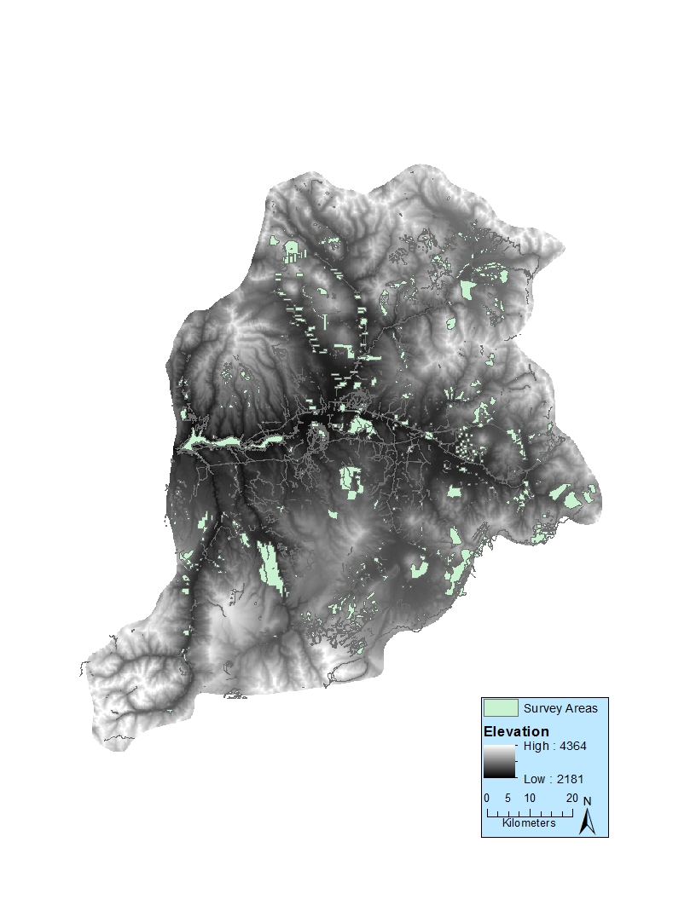
Figure 3.1: Location of archaeological surveys in the UGB.

Pre-Contact sites post-dating 2,500 B.P. also occur in the UGB in relative abundance. These sites are characterized by decreased feature size and diversity, increased use of game drives, and increased use of non-local lithic material (Black 1983; Stiger 2001). Both Black (1983) and Stiger (2001) hypothesized that a shift in climate around 3,000 B.P. marked the end of resident populations in the UGB and led to more mobility, in distance and frequency, and an increase in short-term camp and kill sites.
Reed and Metcalf (1999) summarized the cultural traditions in the Northern Colorado River Basin (NCRB), which includes the UGB. They divided the cultural traditions into four different time periods, each with their own distinct repertoire of material culture (Table 3.1). For this culture history, I focus on the Paleoindian and the Archaic time periods with emphasis on the Foothill Mountain Tradition (Late Paleoindian) and the Pioneer Period (Early Archaic).
Table 3.1: Cultural chronology for the Northern Colorado River Basin (Reed and Metcalf 1999)
Era | Tradition Phase or Period | Age Range
Paleoindian | Clovis Tradition | 13,500-12,500 B.P.
Paleoindian | Goshen Tradition | 12,900-12,600 B.P.
Paleoindian | Folsom Tradition | 12,700-11,500 B.P.
Paleoindian | Foothill Mountain Tradition | 11,500-8,400 B.P.
Archaic | Pioneer Period | 8,400-6,400 B.P.
Archaic | Settlement Period | 6,400-4,400 B.P.
Archaic | Transitional Period | 4,400-3,000 B.P.
Archaic | Terminal Period | 3,000-2,400 B.P.
Formative | Gateway Tradition | 2,400 B.P.- A.D. 1300
Formative | Aspen Tradition | 1-1300 A.D.
Formative | Fremont Tradition | 200-1500 A.D.
Formative | Anasazi Tradition | 900-1100 A.D.
Protohistoric | Canalla Phase | 1100-1650 A.D.
Protohistoric | Antero Phase | 1650-1881 A.D.

Paleoindian
In the UGB, the Paleoindian period spans approximately 5,000 years from 13,500 B.P. to 8,400 B.P. This time period can further be broken down into the Clovis, Goshen, Folsom, and Foothill Mountain Tradition. To date, no Clovis age material has been identified in the UGB. According to the Colorado SHPO’s Office of Archaeology and Historic Preservation online database, named “COMPASS”, there were 62 Paleoindian age sites in the UGB as of March 3, 2018. However, Pitblado (2016) identified 82 Paleoindian components from a total of 69 sites, some not yet in the state site database, indicating reoccupation of some sites.
Nine Folsom components have been identified in the UGB. The best known and intensively researched Folsom locale is the Mountaineer site (5GN1835). Mountaineer site located on Tenderfoot Mountain (known locally as “W” Mountain) at an elevation of 2640 m ASL, 280 m above the Gunnison River (Andrews 2010). Between 2001 and 2005, Western State Colorado University (WSCU) and Southern Methodist University (SMU) conducted field investigations at two areas of the site, known as Blocks A and D (Andrews 2010; Stiger 2006). Five years of investigations at Block A revealed 35,000+ chipped stone artifacts, including 68 Folsom points and fragments (Stiger 2006). Stiger also noted the remains of a possible residential structure in the form of welded tuff and daub, an external hearth, and postholes of a possible windbreak structure.
The Late Paleoindian record is better represented in the UGB than previous time periods (Stiger 2001). Due to the better representation, academic investigation into the Late Paleoindian period in the Gunnison Basin has been extensive. Mark Stiger (1981, 2001, 2006) and Bonnie Pitblado (1998, 2002, 2003) have documented numerous Late Paleoindian sites in the Basin and each has extensively researched several of those sites. Stiger’s work has focused on the area around Blue Mesa Reservoir and salvage operations prompted by eroding deposits around the reservoir’s shore. Pitblado has focused on how people living during the Late Paleoindian period used the environments they occupied, including the higher elevations of the Basin.
Pitblado (2003) identified two distinct populations living in the Southern Rocky Mountains, including the UGB, during the Late Paleoindian period. She argued that people who made Jimmy Allen points utilized the higher elevations of the Southern Rockies on a seasonal basis while people who made Angostura points lived in the area year-round (Pitblado 2003). In her 2016 synthesis of UGB Paleoindian archaeology, she noted that evidence in that region, although limited, may support that broader mode.
Indeed, Pitblado has also spent over 13 years leading teams from Utah State University and the University of Oklahoma on survey and test excavations in the UGB and has recorded numerous Late Paleoindian sites in the area. The Chance Gulch Site (5GN817) is one of these sites. Chance Gulch is a multicomponent site located roughly six kilometers southeast of Gunnison, Colorado. The site yielded 24 Paleoindian projectile points, nearly all were Angostura with seven of them in situ, along with a hearth dated to approximately 8,900 B.P. (7,990 +/- 50 rcybp) (Pitblado 2016).

Archaic
The Archaic period in the Gunnison Basin spans nearly 6,000 years and is divided into three different stages (see Table3.1 for cultural chronology) (Reed and Metcalf 1999). Despite this very long age, little is known about the people who lived in the Gunnison Basin during this time (Black 1991). In the UGB and elsewhere, the Archaic period is characterized by an increase in groundstone artifacts, the emergence of storage features, and a shift from unlined boiling pits to slab-lined roasting pits (Stiger 2001). According to Stiger (2001) the emergence of these artifacts and features indicates a shift from a hunting-centric to a broad-spectrum diet. It also coincides with the increased presence of pinyon pine in the UGB. This resource was highly predictable and required groundstone tools for processing and the construction of storage pits to store the excess, explaining the increase in those technologies (Stiger 2001). Stiger also hypothesized that the predictability and abundance of pinyon pine nuts allowed overwintering in the Basin when other resources were scarce (Stiger 2001).

Compliance Work in the Basin Related to the Early Archaic
An April 2018 search of Colorado’s COMPASS online site file system revealed that there are 397 sites attributed to the Archaic period. How many of those sites belong to the Early, Middle, and Late periods of Archaic time is unclear, however, because site documentation often lacks that level of resolution. Searching COMPASS by radiocarbon dated features revealed 11 sites have C¹⁴ dates from the Early Archaic, 18 from the Middle Archaic, and 13 from the Late Archaic as opposed to just four sites with dates from the preceding Paleoindian time period. Despite this disparity in C¹⁴ data, less is widely known about the Archaic period, especially the Early Archaic, because these dates are mostly contained within little-circulated grey literature and little to no research having been completed beyond the requirements for compliance projects.
Much of the compliance work in the Basin revolved around the construction of the Blue Mesa Reservoir and the subsequent erosion of archaeological sites. Construction on the reservoir began in 1961 and was completed in 1966. Robert H. Lister (1962) completed a survey of the area to be impacted by the inundation and recorded 10 archaeological sites consisting of lithic scatters and petroglyphs. Based on the dozens of sites that are now impacted by the wave action of the reservoir, it is likely that Lister’s hurried inventory missed now-submerged sites (Pitblado 2016). In subsequent decades, archaeologists from the National Park Service completed more intensive and thorough survey of the areas surrounding the reservoir and documented dozens of sites in what is now the Curecanti National Recreation Area (CNRA). Many of these sites were deemed “significant” and subjected to excavation and test-excavation (Dial 1984; Euler and Stiger 1981; Jones 1984; Stiger 1981). This work led to a proposal to create the Curecanti Archaeological District, which was approved in 1982. Several of the sites identified during these surveys included Early Archaic components identified through radiocarbon dating or projectile point typologies. One of these sites is the Kezar Basin Site (5GN191) on the southwest shore of the reservoir (Figure 3.2).

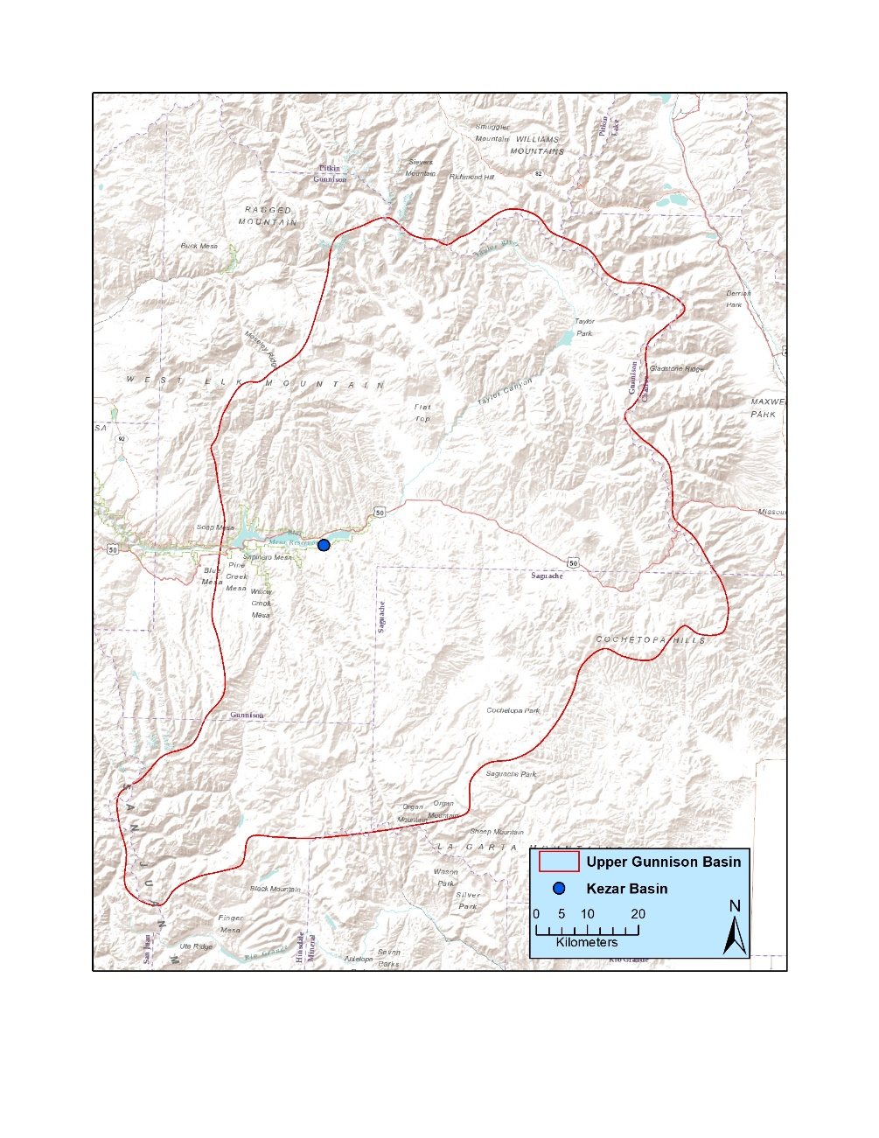
Figure 3.2: Location of the Kezar Basin Site.

During excavations at this site, Kezar Basin produced 87 fire features, most of which dated to the Early Archaic, along with projectile points with stemmed and bifurcated bases identified as Pinto points (Euler and Stiger 1978). This site also showed a change in subsistence technology from stone boiling pits to slab lines roasting pits, with many Early Archaic fire features exhibiting this shift to slab-line roasting pits. In 1991, NPS archaeologist Bruce Jones reinvestigated the Kezar Basin site and identified pinyon pine seeds and burned pinyon in four fire features exposed by erosional processes (Jones 1991).

Academic Work in the Basin Related to the Early Archaic
Academic work in the UGB focused on the Early Archaic period is scarce. In 1991, Kevin Black (then Colorado’s Assistant State Archaeologist) created a typology for Archaic lithic artifacts, including the Early Archaic, for the Southern Rocky Mountains dubbing it the “Mountain Tradition”. Note that Black’s work differs from a more traditional projectile point typology in that it only includes basic chipped-stone trends and other certain characteristics that archaeologists can expect to see at Archaic period sites (Black 1991). While not specifically focused on the UGB, archaeologists often apply Black’s work to artifacts from the area. The Mountain Tradition includes six characteristics often found on artifacts associated with the Archaic in the Southern Rocky Mountains (Table 3.2) (Black 1991)

Table 3.2: Six characteristics of the Mountain Tradition (Black 1991).
1)Settlement systems emphasizing upland environments on a year-road basis.
2)Frequent use of a split cobble core reduction strategy and derivative split cobble tools, particularly in the Late Paleoindian and Early Archaic.
3)Presence of microtools especially after 6,000 B.P.
4)Divergent styles of projectile points with general similarities to Great Basin types.
5)Habitations and shorter-term dwelling structures in upland settings.
6)Distinctive rock art with general similarities to Great Basin styles.

Early Archaic Research in Adjacent Regions
To contextualize UGB Early Archaic data, I also reviewed Early Archaic research in regions adjacent to my study area. I examined Early Archaic data from the regions that I hypothesize could have been places of origin and/or affiliation of Early Archaic people in the UGB. Much like the paleoenvironment data, I used archaeological evidence as indications of why people may have left their homes in search of new territory.
In the Great Basin, the shift from the Late Paleoindian (called “Paleoarchaic” in the region) to the Archaic was characterized by a change in subsistence and resource procurement strategies (Janetski et. al. 2012; Jones et. al. 2012). The shift included a change from residential mobility, a broad-spectrum diet, and use of exotic tool-stone during the Paleoarchaic to reduced mobility, an emphasis on big game and locally available plant material, and local tool-stone use; a result of reduced mobility during the Early Archaic. Janetski et. al. (2012) argued that on the Colorado Plateau, the change was largely the same. Through excavations at North Creek Shelter in southern Utah, his team found evidence of increased hunting specialization of large game and reduced mobility as indicated by groundstone artifacts, roasting pits, and storage features.
Archaeologists have excavated few sites with Early Archaic components on the Great Plains and as a result, not much is known about this time period. One excavated site, the Hawken site, is a bison kill site located in northeast Wyoming (Frison et. al. 1976). Frison and his colleagues (1976) identified Early Archaic projectile points in association with bison bones from a kill event leading to the determination that Early Plains Archaic people were bison hunters much like their Paleoindian predecessors. They did, however, mention that the Black Hills, where the Hawken site is located, may have acted as an oasis for bison during the Early Archaic and other areas of the Great Plains would not have been nearly as attractive for both people and bison during this time. Furthering this argument, Meltzer (1999) argued for an expansion of diet-breadth with decreased emphasis on bison during the Early Archaic on the southern Great Plains due to increased aridity pushing bison populations to migrate north to areas such as the Black Hills.
In the Southwest, evidence from excavated Early Archaic contexts suggest that people began adopting a more broad-spectrum diet much like their counterparts in the Great Basin, Colorado Plateau, and Great Plains. Evidence from several excavated Early Archaic sites in the San Luis Valley indicate an increase in groundstone and plant usage in the form of millingstones and one-handed manos. These sites also contained burned plant remains and mammal bones of various sizes suggesting that people consumed animals of various sizes along with plants (Vierra et. al. 2012).

Summary
In the UGB, more academic focus has been paid to the Paleoindian record than any other time period. Research into the Folsom and Late Paleoindian occupation on the Basin has been plentiful, and fruitful. Investigations by Pitblado (2003, 2007, 2016), Stiger (2001, 2006) and Andrews (2010) have given archaeologists a reasonably clear picture of how the first people to live in the Basin utilized the landscape. However, we know far less about the Archaic period in the UGB, especially the Early Archaic, despite the presence of more excavated sites dating to the Archaic than the preceding Paleoindian period.
What is known about the Early Archaic in the UGB is limited to inferences drawn from a few excavated sites and conclusions extrapolated from adjacent regions. Stiger (2001) stated that the emergence of the Early Archaic in the UGB was marked by the presence of groundstone tools, slab-lined roasting pits, and storage features. All of these elements occurred at the Kezar Basin site, one of the few excavated Early Archaic sites, by NPS archaeologists during salvage operations at the site. Stiger suggested that the presence of these artifacts and features point to a subsistence strategy focused on pinyon nuts that, while now absent in the Basin, were abundant during the Early Archaic.

Chapter 4: Methods
To investigate the possible geographic affiliations of Early Archaic projectile points in the UGB along with the resource procurement and mobility strategies of the people who made them, I used several lines of investigation. Analysis of projectile points located in the UGB provided typological data that allowed me to identify sites that had Early Archaic components. The points also provided geographic control as I identified Early Archaic points with characteristics associated with the various regions surrounding the UGB, which generally look and are manufactured quite different from one another. Only projectile points were analyzed for this thesis because very few Early Archaic sites have been excavated in the UGB and other artifacts (flakes, bifaces, scrapers etc.) are rarely not collected from the surface (Stiger 2001). After identifying sites with Early Archaic components, I used the location data of those sites to perform analyses using Geographic Information Systems (GIS) software. I used these analyses to determine if differences exist among sites with different projectile point types, which could indicate variations in mobility and resource procurement strategies as well. In this chapter, I describe the methods used to identify Early Archaic points and the GIS analyses I performed to determine if differences exist between sites with point styles reminiscent of different regions.

Typology
A comprehensive typology for Early Archaic projectile points in the UGB does not exist and as a result, I have observed that points found during excavation and survey have often been typed using the typology with which the archaeologist is most familiar with (Dudley and Ankele 2015). This has led to the classification of projectile points using typologies from as far away as southeast Texas potentially implying regions of origon or affiliation that are incorrect. To remedy this problem, I compiled my own typology of Early Archaic projectile points as a tool to help evaluate the geographic origins or affiliations of people who lived in the UGB 8,400 – 6,400 years ago.
To assemble my typology, I first identified Early Archaic point types from regions adjacent to the UGB. I examined typologies from the Great Basin, Southwest, Great Plains, and Rocky Mountains for Early Archaic style points. I only considered Early Archaic point types with a geographic distribution adjacent to the southern Rocky Mountains, operating under the premise that these are the regions likeliest to have been the places of origin or the places with which UGB point makers may have some sort of affiliation.

Identifying Early Archaic Projectile Points in the UGB
After compiling my typology (Chapter 5), I conducted a search in COMPASS (Colorado’s digital site form repository) to identify sites with Early Archaic projectile points. Based upon my typology research, I determined that projectile points with side notches or stemmed, convex, and unnotched bases were likely to be of mountain Early Archaic age. Earlier Paleoindian points are typically lanceolate (Pitblado 2003) and late Middle Archaic points are corner-notched (Black 1991). I created a list of sites that either had documented Early Archaic types or points listed in COMPASS that exhibited the above characteristics. I then contacted artifact repositories for the Bureau of Land Management (BLM) and the National Park Service (NPS), including the Anasazi Heritage Center (AHC) in Dolores, Colorado and the Midwest Archaeological Center (MWAC) in Lincoln Nebraska regarding their holdings. The AHC curates collections from sites on UGB land managed by the BLM and the MWAC curates artifacts from the Curecanti National Recreation Area (CURE), an NPS property. I contacted the United States Forest Service (USFS) to determine the location of their collections, but I learned that they do not have a central repository (Justin Lawrence, Personal Communication, 2015). This made locating collections from USFS land essentially impossible for this thesis because they are spread all over the Western United States in museums, and some are still in the possession of the CRM firm that first identified the site that produced them. To attempt to plug this data gap, I used site forms and project reports to identify Early Archaic projectile points from land managed by the USFS.
After identifying the relevant repositories, I visited them to analyze their Early Archaic collections. At the AHC, I viewed material from 59 sites. Focusing on basal morphology, I typed each projectile point using the typology I had developed. I used the same methods at the MWAC, where I analyzed projectile points from 52 sites. Following my visits to the AHC and MWAC, I initiated a second search of the COMPASS program to identify more sites containing Early Archaic projectile points that were not housed at the AHC or MWAC. This search yielded 63 more sites with possible Early Archaic material. However, many of the site forms and associated reports either did not include photos or drawings of the artifacts or they were of very low quality. In the end, only a handful were useful. In total, I analyzed 112 projectile points from 174 sites in the UGB. Through the analysis of these projectile points, I positively identified 49 Early Archaic projectile points from a total of 36 sites in the UGB. I determined that the remaining 63 projectile points were not from the Early Archaic, despite their morphological description matching the characteristics I described previously.
I also analyzed the basic lithology of each point to determine if different material choices existed among the different styles that may indicate different populations in the UGB. Knowing that high quality quartzite is abundant in the Basin, I operated under the assumption that any quartzite I observed came from local sources, although it is of course possible it could have been imported from elsewhere. Identifying the use of local, as opposed to non-local, chert was more difficult because so few local chert sources are known, and even those few are poorly documented. I was particularly interested in any Early Archaic points made from obsidian, because obsidian sourcing studies can inform mobility patterns by pinpointing the exact source of the obsidian.

GIS Analysis
In addition to typological and raw material assessments of Early Archaic UGB projectile points, I also analyzed the geospatial contexts of sites identified as containing Early Archaic material. This allowed me to determine if differences existed among sites containing projectile points affiliated stylistically with different regions outside the UGB. I created a GIS database of sites in the UGB containing Early Archaic projectile point types. Using ArcGIS (v. 10.5), I plotted the location of the sites and coded the data by projectile point type. This produced a distribution on the landscape of not only sites, but also which sites contained specific projectile point types.
Using projectile points as proxies for human movement is problematic because points can be traded over long distances or picked up and re-used over time, sometimes by people living long after an artifact was made. Diffusion of knowledge can also cause the spread of different point types. McElrath and his coauthors (2009) recognize typologies as necessary to understand the archaeological record, but they also argue for corroborating evidence to strengthen the connection between projectile points and discrete groups of people. For my research, I am concerned with which geographical region may have spawned migration into, or otherwise been affiliated with, the UGB.
With that in mind, I began a GIS analysis to determine if variations existed in how sites are spatially patterned on the landscape. Specifically, I analyzed the physical location of each site including its slope, aspect, elevation, proximity to water, distance to lithic resources to assess differences in site selection practices. I also examined the viewshed of each site to determine if variations existed in that dataset. Such differences can indicate different mobility and resource procurement strategies along the collector-forager continuum (Binford 1980). They can also have the potential to indicate social differences among different populations. However, assessing differences in social constructions among different populations is beyond the scope of this thesis. If these differences do exist and they co-occur with different project point styles, it is possible to see the presence of populations who practiced different mobility and resource procurement strategies on the landscape.

Least-Cost Path
The first analysis that I conducted was a least cost path model from the Western Slope of Colorado, San Luis Valley, and Colorado Front Range into the UGB. Instead of creating a traditional least-cost path model that only allows for an analysis from one point to another location or one point to multiple locations, I followed the example of Devin White and Sarah Barber (2012) and created a from-everywhere-to-everywhere (FETE) least-cost model. A FETE least-cost model differs from a more traditional least-cost analysis in that it captures the potential path from one point on a grid to every other point on that grid. These points do not represent actual archaeological sites, but rather, are meant to capture the efficient routes across a landscape (White and Barber 2012). I used the results of this FETE analysis to compare the distance of site locations to the mathematically easiest routes into the Basin from the adjacent areas with sites located closer to the least-cost path possibly representing more mobility than sites located farther from the path.
To create the FETE model, I first generated 100 random points each in the UGB, San Luis Valley, Western Slope of Colorado, and the Colorado Front Range for reasons discussed below. This differed from White and Barber (2012) who used points on an evenly spaced grid. I chose a random distribution over a grid of points to better represent archaeological sites on the landscape rather than points on an evenly spaced grid. I used the San Luis Valley as the most likely entrance into the Basin from the Southwest because of its proximity to both the Southwest and UGB. I chose the Western Slope of Colorado because people traveling into the UGB from the Great Basin and Colorado Plateau would have passed through that area to enter the UGB. For the path from the Great Plains, I selected the Colorado Front Range because, much like the Western Slope, people would have traveled through that area to enter the UGB. Next, using a 10 m digital elevation model (DEM), I generated the slope across the UGB. Slope was the only variable considered for this model because, as previously mentioned in Chapter 2, many of the streams and creeks in the UGB are seasonal and dry most of the year. In addition, the construction of the Blue Mesa Dam altered the flow of many rivers in the Basin and it is not possible to accurately reconstruct that landscape with the data that are currently available. I did not consider other environmental factors because constructing a layer in GIS that accurately depicts the Early Archaic vegetation is beyond the scope of this thesis. After constructing the necessary layers to perform a least-cost path analysis, I used ArcGIS’s model builder to construct a model (Figure 4.1) to calculate the least cost path between the 100 points located outside the UGB to the 100 points located inside the Basin. I ran this analysis for each region and then overlaid the site locations onto the map generated by the model. This allowed me to compare the distance from site locations to the hypothetical paths into the UGB for the appropriate regions. I then subjected the results to a Kruskal-Wallace test of variance and a Wilcoxen significance test. If these tests indicated that sites were located significantly closer to a least-cost path, I concluded that indicated greater mobility, and vice-versa for sites located farther away from the least-cost path.

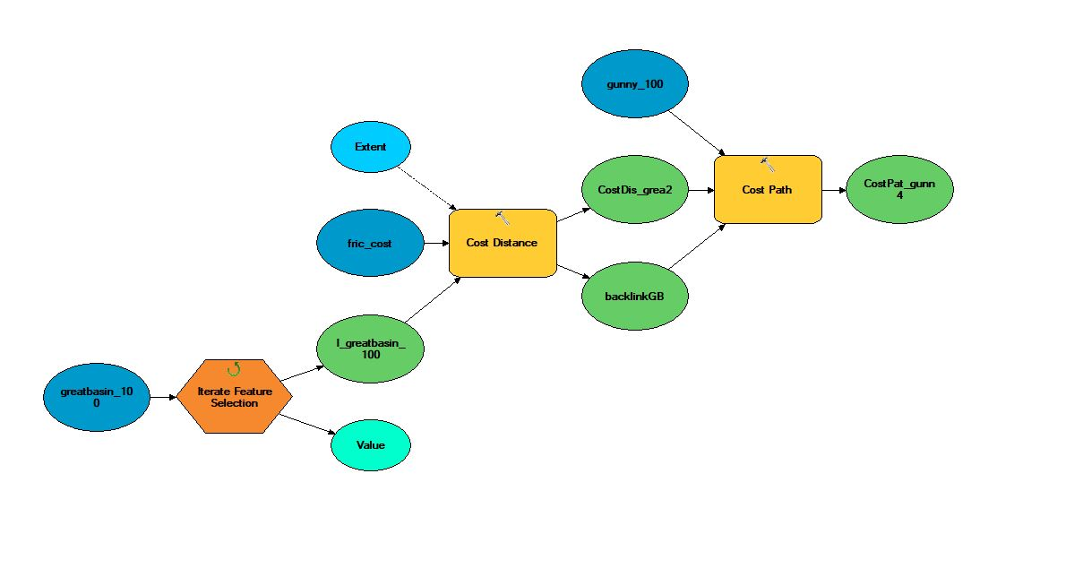
Figure 4.1: Model created in ArcGIS Modelbuilder to perform the FETE least-cost path analysis to identify the mathematically easiest routes into the UGB from adjacent regions.

Viewshed Analysis
I also performed a viewshed analysis to determine if Early Archaic people living in the UGB chose site locations to view specific places. If so, I predicted that differences in viewsheds may indicate different site selection practices related to subsistence or social practices (e.g. Bernardini et. al. 2013). For each point type, I ran the visibility tool in ArcGIS with an observer height of 1.5 m to account for the viewer’s height. I then examined the results to determine if any interregional or intraregional variations existed within the data set. I used this analysis to determine if differences in a location’s viewshed played a role in site location processes as variations may indicate different populations on the landscape.
To determine if statistically different viewsheds existed among sites with different projectile points, I analyzed the data using JMP (V. 14) software. First, I converted the viewshed rasters to a series of polygons on the landscape indicating visible and non-visible area. Next, to apply real-world data to each viewshed, I analyzed the area of each polygon representing the viewable area. Then, I performed a Kruskal-Wallace test to determine if the samples came from the same distribution. If the Kruskal-Wallace test produced a significant result, I proceeded to perform a Wilcoxen analysis on pairs of sites with different projectile point types to test for significance. This test was chosen as it does not require normally distributed data as opposed to the more commonly used student’s t-test that requires normality. If the statistical test result was significant, I concluded that the differences in viewsheds may be an indication of different site location practices related to either subsistence or social practices. I chose these tests because they do not require normally distributed data as opposed to the more commonly used student’s t-test that requires normality. If the statistical test result was significant, I concluded that the differences in viewshed may indicate different site selection practices related to either subsistence or social systems.
Other Layers of Analysis. Along with the least-cost path and viewshed analyses, I added five layers to my analysis (Table 4.1), each representing possibly differences in site location strategies. Using a 10 m DEM, I generated the slope, elevation, and aspect of the UGB to determine if these factors played a role in site selection by Early Archaic people. I extracted the data from each layer for each site in my study. To generate the distance-to-water layer, I accessed hydrology data from ColoradoView’s online database of GIS layers (http://www.coloradoview.org/). Then, I calculated the Euclidean distance from water source in the UGB. Using this analysis, I determined the shortest straight-line distance to water from each site in my study.

Table 4.1: Layers used in GIS analysis.
1)Slope
2)Elevation
3)Aspect
4)Distance to Water
5)Distance to quarry.

I also analyzed the distance to lithic quarries in the UGB. Myriad studies have shown the importance of lithic material to mobile hunter-gathers (e.g., Andrefsky 2009; Beck et. al. 2002; Binford 1980; Odell 2000). With that in mind, I plotted the known lithic quarries from the UGB using GIS. Then, using the same methods as previously described, I calculated the Euclidean distance from known lithic quarries and extracted those data for each site. I used this analysis to determine if the distance from known lithic quarries may have affected where people chose to settle on the landscape (e.g., Beck et. al. 2002).
After the completion of the analyses in Table 4.1, I compared their results to determine if differences identified through these analyses were statistically significant. Similar to the methods used to determine significance for the distance to least-cost path and viewshed analyses, I performed a Kruskal-Wallace analysis to test for variance and then subjected the results to a Wilcoxen test to determine if they were statistically different.

Monte-Carlo Analysis
To determine if the locations of archaeological sites are the result of a random distribution or the result of real-world differences, I also performed a Monte-Carlo analysis. This analysis allowed me to test the geospatial data of the sites in my thesis against a random sample of locations within the UGB. I created 300 random points within the areas of the Basin that have been subject to archaeological surveys. I removed survey area in land managed by the USFS for this analysis because I was unable to analyze material from those area in person. Next, I subjected the random sample to the same analyses from Table 4.1 along with the distance to least-cost path and I performed a viewshed analysis. Then, using a Kruskal-Wallace test of variance followed by a Wilcoxen significance test, I compared the results of the Monte-Carlo random sample to the sites in this thesis to determine if statistically significant differences existed between the two datasets. Statistically significant differences between the two datasets indicates that the locations of archaeological sites on the landscape may be the result real-world differences as opposed to a random distribution.

Summary
To evaluate the Early Archaic record in the UGB, I first created a projectile point typology to identify sites that contained Early Archaic projectile points. After identifying sites reported to have yielded Early Archaic projectile points, I travelled to two artifact repositories to view their collections. I confirmed which sites did in fact contain Early Archaic projectile points and created a GIS database for those sites. To illuminate differences between sites that contained projectile points affiliated with different regions, I initiated an exploratory data analysis using various GIS methods and compared those results with statistical methods. Using these methods, I evaluated the Early Archaic record in the UGB. Specifically, I focused on identifying the possible geographic regions where Early Archaic projectile points found in the UGB may have originated, either through the migration of people or diffusion of ideas, along with the mobility and resource procurement strategies of the people who made Early Archaic points found in the Basin.

Chapter 5: Typology
In my experience, archaeologists often apply the typology they are most familiar with when they encounter cultural material on projects. This can be problematic when projects are located outside of their area of geographic expertise. In the UGB, for example, archaeologists recording sites have invoked projectile point typologies developed for the Great Basin, Great Plains, Southwest, and Rocky Mountains to describe Early Archaic finds in the Basin, but with the typology often reflecting the archaeologist’s training more than real differences in projectile point morphology or technology (Dudley and Ankele 2015). Using these geographic-based typologies for Early Archaic artifacts in the Gunnison Basin carries the side-effect of implying a geographic origin for the people who made the artifacts, and this has led to a muddled understanding of where the Basin’s Early Archaic people originated or shared ties. In this chapter I present a typology for the Early Archaic projectile points from regions adjacent to the Gunnison Basin that I will then use as a tool to evaluate the origins of the people who lived in the Basin during the Early Archaic time period. This typology includes point types from the regions most likely to have been the geographic origin of Early Archaic projectile points found in the UGB: The Great Basin, Southwest, Great Plains, and the Rocky Mountains themselves.

Great Basin
The archaeological record of the Great Basin consists mainly of open-air lithic scatters with shallowly buried deposits. Cave and rock shelter sites in the Great Basin are rare and present a challenge to archaeologists because despite sometimes excellent preservation, stratigraphic levels are often intermixed and convoluted. For this reason, Great Basin archaeologists have struggled to create a comprehensive projectile point typology. However, sites like Danger Cave, Hogup Cave, Cowboy Cave (Jennings 1973, 1980), Sudden Shelter (Holmer 1986), and Wilson Butte Cave (Gruhn 2006) have yielded projectile points dating to the Early Archaic and provided the basis for the typology for the Great Basin during that time period.

Northern Side Notch
Table 5.1: Information on Northern Side Notch points. Drawings from Jennings (1978:83)
 | First Named | Ruth Gruhn (2006)
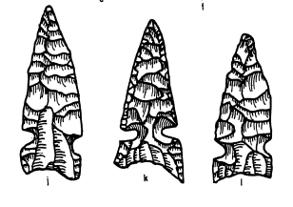 | Morphology | Notches on the side, high enough to create a straight edge below base (Holmer 1986)
 | Dates | 8,000 B.P - 6,950 B.P. (Holmer 1986)
 | Geographic Distribution | Great Basin and Colorado Plateau (Holmer 1986)

Ruth Gruhn (2006) named Northern Side Notch projectile points (Table 5.1) during her excavations at Wilson Butte Cave (10JE6) in south-central Idaho, and Richard Holmer (1986) later characterized them as having a large geographic distribution across the Great Basin and Colorado Plateau. Holmer did not, however, provide a detailed morphological or technological description of Northern Side Notch points. He divided Great Basin notched points into two major forms: 1) Those with notches high enough on the side to have straight edges below the notch (Figure 5.1), and 2) Specimens with notches low enough on the side to create a point with the base (Figure 5.2). Holmer concluded that by splitting notched points into these two categories, a temporal pattern emerged with “high” side notch points occurring earlier in time (7,500-3,500 B.P.), and “low” side notch points occurring later in time (3,500-1,500 B.P.).
Figure 5.2: Example of "low" side notch points. (Holmer 1986)
Figure 5.1: Example of "high" side notch points (Holmer 1986)

In Utah, Jesse Jennings recovered Northern Side Notch points from archaeological sites across the state. His excavations at Danger Cave (42TO13) in northwest Utah, Hogup Cave (42BO36) also in northwest Utah, and Cowboy Cave (42WB48) in southwest Utah each produced Northern Side Notch points (Jennings 1973, 1980). At Danger Cave, Jennings excavated the points primarily from undated stratigraphic layers; however, the lowest level in which he recovered a Northern Side Notch point dated to 6,950 B.P. providing a minimum age for this point type at this site. At Hogup Cave, Jennings recovered Northern Side Notch points in stratigraphic layers dating to as early as 7,800 BP, but he could not determine a terminal date for the type. Cowboy Cave yielded the oldest dates for Northern Side Notch points in the Great Basin, having been excavated in layers that date to 8,000 B.P. Based on their occurrences at Danger Cave, Hogup Cave, and Cowboy Cave, Northern Side Notch points have been assigned dates of 8,000 BP to 6,950 BP in the Great Basin (Holmer 1986).

Sudden Side Notch
Table 5.2: Information on Sudden Side Notch points. (a) from 5AA1407 (Charles 1995). (b) from LA130740.
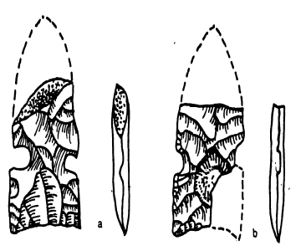 | First Named | Richard Holmer (1986)
 | Morphology | Notches on the side creating a contracting or well-rounded base (Holmer 1986)
 | Dates | 8,000 B.P - 6,950 B.P. (Holmer 1986)
 | Geographic Distribution | Great Basin and Colorado Plateau (Holmer 1986)

Holmer (1986) coined the term Sudden Side Notch (Table 5.2) for the projectile points excavated from Sudden Shelter in central Utah. The defining characteristic of Sudden Side Notch points are higher side notches than those of Northern Side Notch points, which create a square base (Holmer 1986). Specimens of this point type were also recovered from Danger Cave and Hogup Cave (Jennings 1973, 1978). Excavations at these and other sites have yielded an age range for Sudden Side Notch of 7,000 - 4,000 B.P. (Holmer 1986).
Holmer (1986) described the morphological characteristics of Sudden Side Notch as having a contracting to well-rounded base with notches high on the side. They also fit into his generic description of projectile points that occur earlier in time and when combined with radiocarbon data, place this point type firmly into the Early Archaic time period.

Pinto Basin

Table 5.3: Information on Pinto Basin points.
 | First Named | Campbell et. al. (1936)
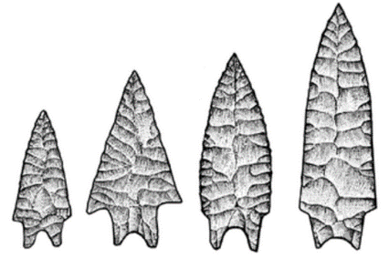 | Morphology | Amsden (1935), Rodgers (1939), Harrington (1957)
 | Dates | 12,000 B.P. (Campbell et. al. 1936), 4,000 B.P. (Rodgers 1939, Harrington 1957), 7,500 B.P. (Holmer 1978, Jennings 1975)
 | Geographic Distribution | Eastern California (Campbell et. al. 1936), Great Basin (Warren 1980)

Elizabeth and William Campbell and Charles Avery Amsden introduced the term Pinto Basin projectile points (Table 5.3) in their report (1936) on the Pinto Basin Site in Joshua Tree National Park, southern California. Unlike Northern Side Notch and Sudden Side Notch points, morphological characteristics of Pinto Basin points have been well defined. However, three distinct descriptions (Amsden 1935; Harrington 1957; Rodgers 1939) have made distilling a single version challenging. Charles Avery Amsden (1935), in his companion article to the Pinto Basin report, described Pinto Basin points as having a narrow shoulder with an indented base. Malcom Rodgers (1939) then divided Pinto Basin points into five distinct types (Table 5.4).

Table 5.4: Rodger's (1939) description of Pinto Basin projectile points.
Type 1 | Concave Base with faint shoulders | 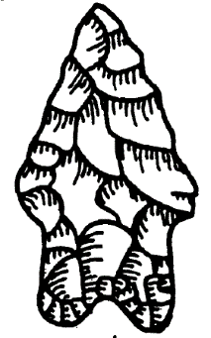
Type 2 | Broad stemmed with weak shoulders | 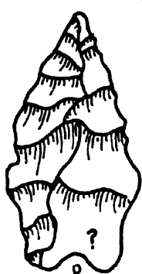
Type 3 | Both the base and sides are notched | 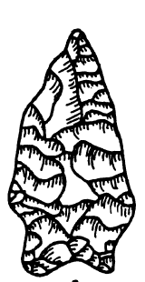
Type 4 | Straight base and side notched | 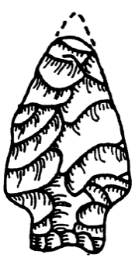
Type 5 | Small, slender and leaf shaped | 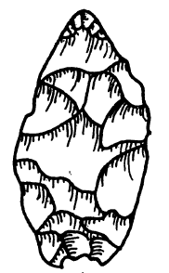

Finally, in 1957 Mark Harrington used points from the Stahl Site (CA-INY-182) in southwest California to reframe the definition of Pinto Basin points into what is now the most commonly used typology in the Western United States. Like Rodgers, Harrington (1957) also divided Pinto Basin into five categories (Table 5.5). For the UGB typology, I accept the variations put forth by Harrington.

Table 5.5: Harrington's (1957) Pinto Basin types.
Type 1 | Shoulderless | 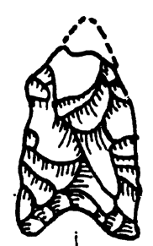
Type 2 | Sloping Shoulders | 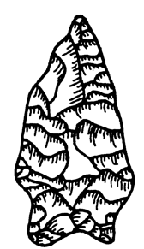
Type 3 | Square Shoulders | 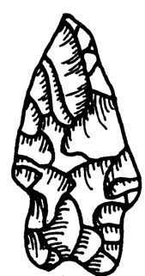
Type 4 | Barbed Shoulders | 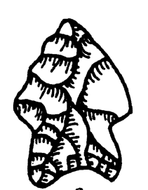
Type 5 | One Shoulder | 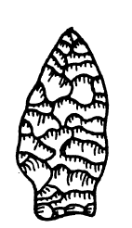

Dating Pinto Basin points has challenged archaeologists. Originally dated at the Pinto Basin Site to 12,000 B.P. based on the geomorphology of the area (Campbell et. al. 1936), that very early date has since been revised to 4,000 B.P. by Rodgers (1938) and Harrington (1957). However, Jennings and Holmer recovered Pinto Basin points from Sudden Shelter and Cowboy Cave in stratigraphic layers dating to about 7,500 B.P. (Holmer 1978; Jennings 1975). Not only is the earliest date for Pinto Basin points contentious, excavations at the Awl Site (CA-SBR-4562) in southeast California revealed a date of just 2,000 B.P. for Pinto Basin points, creating a long date range for the type (Vaughan and Warren 1987). Claude Warren (1980) discussed this problem in the often-cited article, “The Pinto Problem”. In the piece, he noted that Pinto Basin points found in the eastern Great Basin generally date to the Early Archaic, whereas Pinto Basin points in the western Great Basin occur in Middle to Late Archaic contexts. I accept Warren’s view for the UGB based on its even-more eastern location.

Southwest
Here I focus on the Northern Southwest; specifically, the area that is now northern New Mexico. I focus on this region due to its proximity to the Southern Rocky Mountains, where the Gunnison Basin is located. Unlike the Great Basin where Early Archaic point types occur over large geographic expanses, Southwestern archaeologists have developed different Early Archaic typologies for sub-regions of the Southwest. For example, Bruce Huckell (1996) describes the Sulphur Springs Stage of the Cochise Culture and the Gardner Springs Phase of the Chihuahua Tradition for the southern Southwest Early Archaic and Cynthia Irwin-Williams (1973) characterized the Jay and Bajada Phases of the Oshara Tradition for the northern Southwest.
Irwin-Williams introduced the term “Oshara Tradition” to describe the projectile points made by ancestors of the Ancestral Puebloans in northern New Mexico and northeast Arizona (Irwin-Williams 1973). She described different phases of the Oshara tradition from the Jay and Bajada Phase of the Early Archaic to the Trujillo Phase of the Late Archaic, when pottery first appeared. Irwin-Williams (1973) described the Oshara Tradition from a technological standpoint and focused on artifacts as opposed to the settlement patterns and lifeways of those who made them.

Jay Phase of the Oshara Tradition
Table 5.6: Information on Jay points. (b) and (c) from Wills (1988: 80); (d) from Gunnerson (1987)
 | First Named | Cynthia Irwin-Williams (1973)
 | Morphology | Irwin-Williams (1973), Honea (1969)
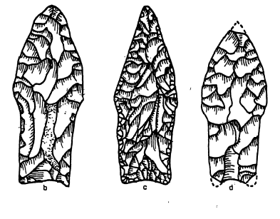 | Dates | 7,500 B.P. - 6,800 B.P. (Irwin-Williams 1973), 8,000 B.P. - 6,800 B.P. (Pitblado 1999), 8,500 B.P. - 6,800 B.P. (Huckell 1996)
 | Geographic Distribution | Northern New Mexico and Northeast Arizona (Irwin-Williams 1973)

Jay points (Table 5.6) have a complicated history. Cynthia Irwin-Williams (1973) first named the Jay Phase, the earliest component of the broader Oshara Tradition, after completing extensive work in the Arroyo Cuervo Valley of northwestern New Mexico (Irwin-Williams 1973). Irwin-Williams (1973) assigned dates to the Jay Phase of circa 7,500 B.P. to 6,800 B.P. Huckell (1996), however, proposes an earlier date of 8,500 B.P. for the appearance of Jay points. Pitblado (1999) discussed the problems surrounding the dates that Irwin-Williams (1973) assigned to Jay points (Irwin-Williams invoked only one radiocarbon date for Jay points) and argued for an initial age of 8,000 B.P.
Adding to the dynamic history of Jay points are Quemado points of the Rio Grande Complex, which are morphologically quite similar to Jay points. Kenneth Honea (1969) named and assigned dates of 7,000 B.P. to 6,000 B.P. to Quemado points. For this thesis, I use the dates presented by Pitblado (1999) of 8,000 B.P. to 6,800 B.P. for Jay points based on her thorough discussion and similarity to dates for Early Archaic projectile points from excavated contexts in the Great Basin (Holmer 1986; Jennings 1974).
Irwin-Williams did not provide a detailed morphological description for many Oshara Tradition projectile points. As for Jay points, she noted that they are reminiscent of Lake Mojave projectile points from California and Arizona (Irwin-Williams 1979). Honea (1969), however, provided a more detailed morphological description of Quemado Points from his Rio Grande Phase. He described Quemado Points as being generally lanceolate in shape with slight shoulders, grinding along the stem, and as having a concave, rounded, or straight base. Irwin-Williams (1973, 1979) and Honea (1969) did not address the similarities between these two point types, but Honea (1969) reported that George Agogino recovered a “J” point from a stratigraphic layer dating to the Quemado time period suggesting a similarity between the two types. For the purposes of my research, I consider Quemado points as part of the Jay Phase and refer to all projectile points dating between 8,000 B.P. and 6,800 B.P. and meeting the description offered here as Jay Points. That is, I do not attempt to distinguish Irwin-Williams’s (1973, 1979) Jay Points from Honea’s (1969) Quemado Points.

Bajada Phase of the Oshara Tradition

Table 5.7: Information on Bajada points. (a) from Wills (1988: 80): (e) from Cibola National Forest
 | First Named | Cynthia Irwin-Williams (1973)
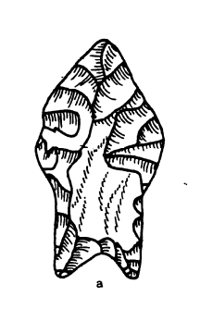  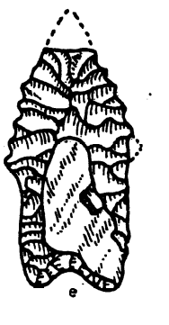 | Morphology | Increase in basal indentation and more prominent shoulders than Jay points (Irwin-Williams 1973).
 | Dates | 6,800 B.P. - 5,300 B.P. (Irwin-Williams 1973)
 | Geographic Distribution | Northern New Mexico and Northeast Arizona (Irwin-Williams 1973)

Like the Jay Phase, Irwin-Williams (1973) named the subsequent Bajada Phase (Table 5.7) based on her work in the Arroyo Cuervo Valley in northwest New Mexico (Irwin-Williams 1973). She assigned dates to the Bajada Phase of 6,800 B.P. to 5,300 B.P. Irwin-Williams (1973) noted that there is considerable continuity between the Jay and Bajada Phases and that the shift from Jay Phase points to Bajada Phase points may have resulted from a population increase and the need to adopt a broad-spectrum resource base.
As previously discussed, Irwin-Williams did not provide detailed morphological descriptions of Oshara Tradition projectile points. Her description of Bajada points highlights an increase in basal indentation and more prominent shoulders as the characteristics that distinguish Jay points from Bajada points (Irwin-Williams 1973). Wirt Wills (1988) later suggested that Early Archaic points in northern New Mexico (Jay and Bajada) actually represent a single type. He noted that both Jay and Bajada points are almost always (83.0% of specimens he analyzed) made from basalt or other dark material with no edge modification, and that they display many similarities in their morphology (Wills 1988).

Great Plains
Due to the existence of many Early Archaic projectile points sharing similar morphological characteristics, the Plains Early Archaic record is convoluted. Kornfeld et al. (2010) offered a general description of Plains Early Archaic points by stating that unlike large, leaf-shaped projectile points from the Late Paleoindian period, Early Plains Archaic points have either side or corner notching. Early Archaic Side-Notched points (Hawken) and Logan Creek Complex projectile point types exemplify this characteristic.

Hawken
Table 5.8: Information on Hawken points. Drawings from Frison (1991:84)
 | First Named | George Frison (1991)
 | Morphology | Lanceolate shape with notches roughly 5 mm above the base (Frison 1991)
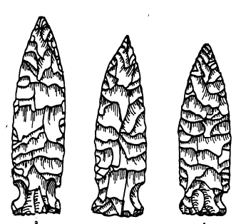 | Dates | Dates range from 7,630 B.P. at Mummy Cave (Husted and Edgar 2002) to 5,030 B.P. at the Split Rock Ranch Site (Kornfeld et al. 2010).
 | Geographic Distribution | Northern Plains (Frison 1991), Colorado Front Range (DesPlanques 2001)

George Frison (1991) first described what he called Early Archaic Side-Notched points (Table 5.8), more commonly known as Hawken points (Des Planques 2001), from the Hawken Site in northeast Wyoming. Hawken points date from 7,630 B.P. at Mummy Cave (48PA201) in northwest Wyoming (Husted and Edgar 2002) to 5,030 B.P. at the Split Rock Ranch Site (48FR1481) in central Wyoming (Kornfeld et. al. 2010). Logan Creek points, which are morphologically similar to Hawken points, date to 8,600 B.P. - 6,000 B.P. (Kay 1998). For this thesis, I accept the dates presented by Husted and Edgar (2002) and Kornfeld et. al. (2010).
Morphologically, Kornfeld and collegues (2010) described Hawken points as being lanceolate in shape with side notches that occur roughly 5 mm above the base. Wilifred Husted (1991) expanded on Kornfeld and colleagues’ description, characterizing the base as straight or slightly concave with notches that are slightly oblique toward the distal end. Logan Creek points share these morphological characteristics. Marvin Kay (1998) defined the morphological characteristics of Logan Creek points as lanceolate in shape with side notches and a concave base. Because Kay and Marvin Kivett (1962), who first named Logan Creek points, did not publish photographs or drawings of these points, it is difficult to determine if Logan Creek Points and Hawken Points represent of the same technology (Des Planques 2001). However, based upon the similarities between the morphological description of the two point types, I refer to all Plains Early Archaic projectile points as Hawken Points.

Rocky Mountains
Early Archaic projectile points in the Southern Rocky Mountains have a complicated history. As this thesis has emphasized, archaeologists have struggled to consistently type projectile points because no comprehensive typology exists for that culture area. As a result, many archaeologists have attributed different names to morphologically similar Early Archaic projectile. (e.g. Benedict 1979; Gunnerson 1987; Nelson 1981).
To address the typological issues plaguing the region, Kevin Black (1991) provided a general morphological description of projectile points that belong to what he calls the “Mountain Tradition.” According to Black (1991:11),
Mountain Tradition projectile points tend to be relatively thick with biconvex, longitudinal cross-sections and collateral flaking patterns. The flaking quality is moderately to well executed, and reworking of broken specimens is extremely common. Serrated blade edges are common features that crosscut all styles in the post – 7,000 B.P. era.

Black (1991) later described the hafting edges as typically not ground, although he pointed out that exceptions, such as the Mount Albion type, occur in the Rocky Mountains. He intended the “Mountain Tradition” moniker to be used as a way to describe the morphological characteristics spanning the entire Archaic time period (Black 1991). Unfortunately, the term “Mountain Tradition” has appeared in many CRM reports as a specific “type” of projectile point recovered on survey and excavation projects.

Mount Albion Complex
Table 5.9: Information on Mount Albion points. Drawings from Benedict (1978).
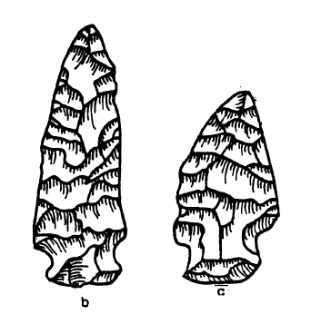 | First Named | James Benedict (1978)
 | Morphology | Broad leaf-shape with shallow, low side-notches (Des Planques 2001).
 | Dates | 5,730 +/- 145 B.P. (Benedict 1975) to 4,620 +/- 95 (Gunnerson 1987)
 | Geographic Distribution | Colorado Front Range (Benedict 1978)

James Benedict (1978) introduced the term “Mount Albion Complex” (Table 5.9) after completing excavations at the Hungry Whistler Site (5BL67) in the mountains west of Denver, Colorado. Benedict assigned dates to the Mount Albion Complex of 5,730 +/- 145 B.P. based on a single radiocarbon date from a piece of charcoal deposited by slope wash. Benedict (1978) acknowledged that the date is questionable due to the context of the charcoal, but further stated that other data are consistent with the 5,730 +/- 145 date. Benedict (1978) correlated this date to a time during which the Front Range of the Rocky Mountains were intensely occupied. Other sites along the Colorado Front Range later confirmed Benedict’s (1975) dates for Mount Albion projectile points. The Cherry Gulch Site (5JF63), also located in the mountains west of Denver, likewise yielded a radiocarbon date for Mount Albion points, in this case 5,730 +/- 230 B.P. (Nelson 1981). The Helmer Ranch Site, yet again in the mountains west of Denver, yielded a date for Mount Albion points of 5,780 +/- 160 B.P. (Des Planques 2001). Finally, the Ptarmigan Site (5BL170) produced the most dates associated with a Mount Albion projectile point: 4,620 +/- 95 and 4,745 +/- 95 B.P. (Gunnerson 1987). Together, these sites suggest a date range for Mount Albion projectile points of 5,730 +/- 230 B.P. - 4,620 +/- 95 B.P. This time frame places the Mount Albion type near the end of the Early Archaic era (Kornfeld et. al. 2010) and (or) within the Middle Archaic (Reed and Metcalf 1999).
Benedict (1978) described the morphology of Mount Albion points as broad and leaf-shaped with shallow, low side notches. Black (1991) noted that other point types share these morphological attributes. That has led archaeologists working in the region to bestow many different names to projectile points with only minor morphological differences. Projectile points such as Cherry Gulch Types 1 and 2 (Figure 5.3) (Nelson 1981) and Magic Mountain Type 3 (Irwin-Williams and Irwin 1966) (Figure 5.4) projectile points are technologically and morphologically similar to Mount Albion points (Black 1991). Based on these similarities, I will refer to all projectile points with these morphological characteristics as Mount Albion.

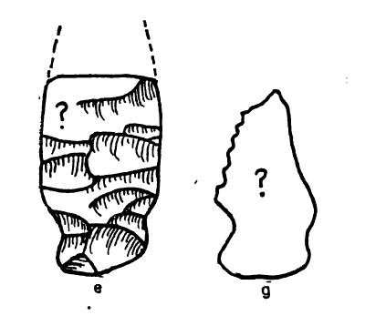
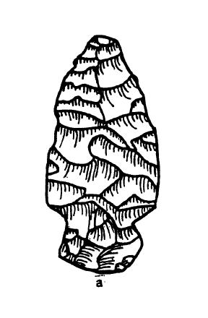
Figure 5.3: Cherry Gulch Types 1 (e) and 2 (g). (Cassels 1997:126)
Figure 5.4: Magic Mountain Type 3. (Cassells 1997:126)

Summary
In this chapter I have presented the Early Archaic projectile point types typically found in regions in, or adjacent to, the Gunnison Basin: The Great Basin, Southwest, Great Plains, and the Rocky Mountains. Despite belonging to typologies that are outside of the Gunnison Basin (with the exception being the Mount Albion type) the point types discussed here appear in survey and excavation reports from the Basin and have muddled understanding of where Early Archaic people may have originated or had associations of some sort. I will use this typology as a tool to evaluate the origins or affiliations of Early Archaic people in the Gunnison Basin and it will provide readers with context for subsequent chapters where I discuss these point types and the people who made them.

Chapter 6: Results
In this chapter, I present the results of my investigation into the Early Archaic record of the UGB. First, I describe the results of my typing of the Early Archaic projectile point assemblage. Next, I present the results of the lithic material analysis. I finish with the results of my GIS analysis to identify variability in how sites are spatially patterned on the landscape.

Projectile Point Typology in the Upper Gunnison Basin
An examination of UGB archaeological sites with reported Early Archaic projectile points, yielded 49 Early Archaic projectile points from 36 sites (Figure 6.1, Table 6.1). The 36 sites represent the sample size that I analyzed to identify the possible geographic origins of Early Archaic projectile points in the UGB either through the migration of people or the diffusion of knowledge. I divided the sites into three separate groups based on where the projectile points from that site may have originated and then by individual projectile point type (Table 6.2).

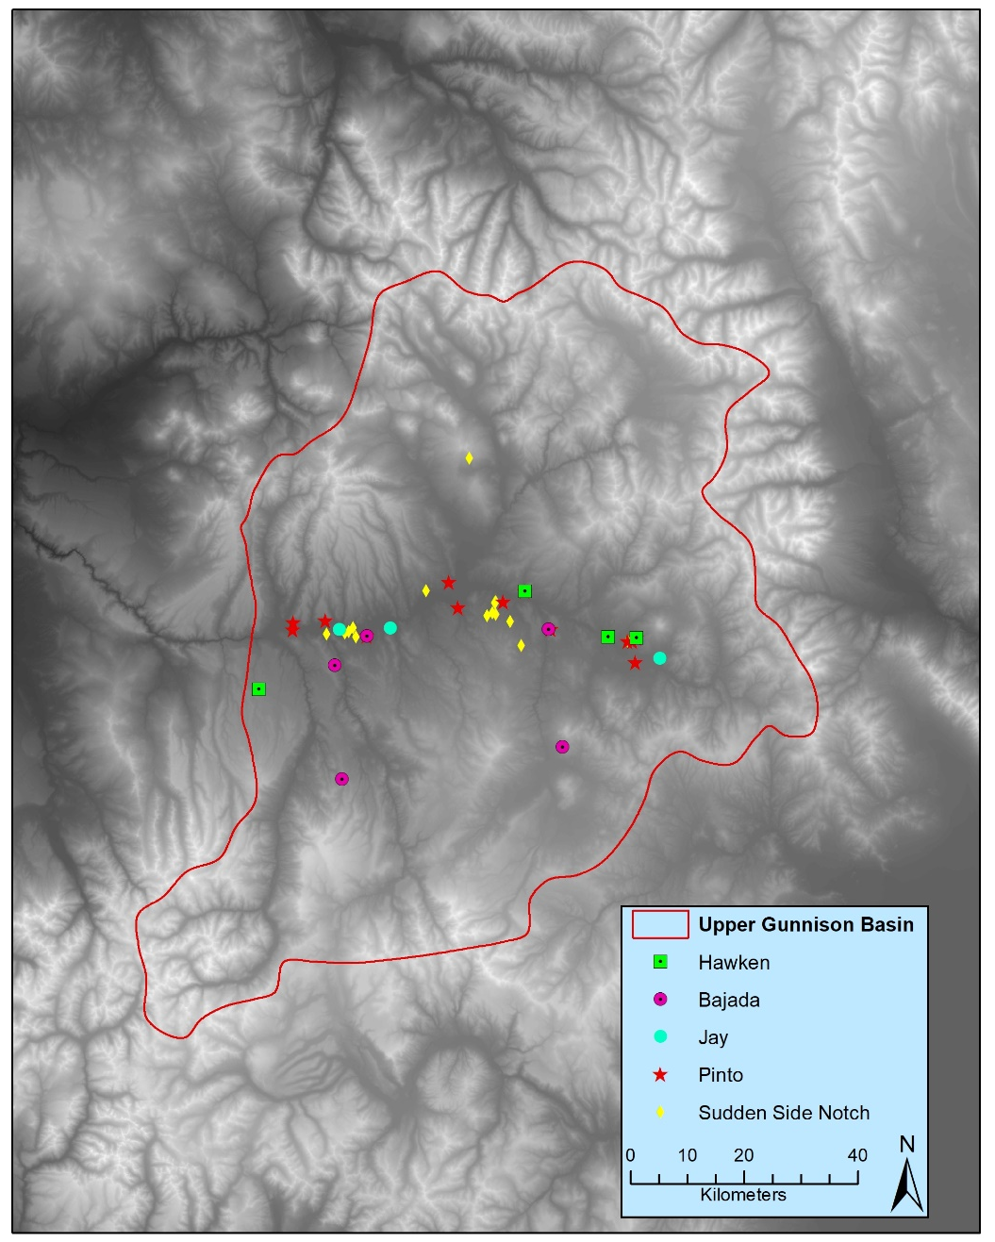
Figure 6.1: Distrubution of all Early Archaic sites.

Table 6.1: Total projectile points by site. Each X represents one point.
 | Point Type | Sudden Side Notch (GB) | Northern Side Notch (GB) | Pinto (GB) | Jay (SW) |  | Bajada (SW) | Hawken (GP) | Total
Site Number
5GN175 |  | XX |  |  |  |  |  |  | 2
5GN1276 |  |  |  |  |  |  | XX |  | 2
5GN1870 |  |  |  |  | X |  |  |  | 1
5GN191 |  |  |  | XX | X |  |  |  | 3
5GN204 |  | X |  |  |  |  |  |  | 1
5GN2192 |  |  |  |  | X |  |  |  | 1
5GN2219 |  |  |  | X |  |  |  |  | 1
5GN222 |  | X |  |  |  |  |  |  | 1
5GN223 |  | X |  |  |  |  |  |  | 1
5GN2275 |  | X | XX |  |  |  |  |  | 3
5GN2341 |  |  |  |  |  |  |  | X | 1
5GN2354 |  |  |  |  | X |  |  |  | 1
5GN2440 |  |  |  | X |  |  |  |  | 1
5GN2556 |  |  |  | X |  |  |  |  | 1
5GN2609 |  |  |  | X |  |  |  |  | 1
5GN2786 |  |  |  |  |  |  |  | X | 1
5GN2915 |  |  |  |  |  |  | X |  | 1
5GN2916 |  |  |  | X |  |  |  |  | 1
5GN3439 |  |  |  | X |  |  |  |  | 1
5GN344 |  | XX |  |  |  |  |  |  | 2
5GN402 |  |  |  | XX |  |  |  | X | 3
5GN5101 |  |  |  |  |  |  | X |  | 1
5GN5618 |  | X |  |  |  |  |  |  | 1
5GN5692 |  |  |  | X |  |  |  |  | 1
5GN5707 |  |  |  | XXX |  |  |  |  | 3
5GN5780 |  |  |  | X |  |  |  | X | 2
5GN5784 |  | X |  | X |  |  |  |  | 2
5GN5801 |  | X |  |  |  |  |  |  | 1
5GN5804 |  | X |  |  |  |  |  |  | 1
5GN810 |  | X |  |  |  |  |  |  | 1
5GN813 |  | X |  |  |  |  |  |  | 1
5GN829 |  | X |  |  |  |  |  |  | 1
5GN845 |  | X |  |  |  |  |  |  | 1
5GN866 |  | X |  |  |  |  |  |  | 1
5GN890 |  |  |  | X |  |  |  |  | 1
5SH1813 |  |  |  |  |  |  | X |  | 1
36 |  | 17 | 2 | 17 | 4 |  | 5 | 4 | 49

Table 6.2: Projectile points by region
Great Basin/Colorado Plateau | 36
Southwest | 9
Great Plains | 4
Total | 49

Projectile points with Great Basin/Colorado Plateau characteristics constitute most of my sample and, therefore, I believe the results from that region are the most robust. However, I present the results of the analyses from all regions with the caveat that more research needs to be done to more fully interpret what those results might mean.
Most of the sites I identified as having Early Archaic projectile points contained a single point type. Five sites, however, contained multiple point types. Sites 5GN191 (Pinto /Jay), 5GN402 (Pinto/Hawken), and 5GN5780 (Pinto/Hawken) contained projectile points representative of different regions. 5GN2275 (Sudden Side Notch/Northern Side Notch) and 5GN5784 (Sudden Side Notch/Pinto) both contained two different Great Basin types. Interestingly, 5GN2275 is also the only site with positively identified Northern Side Notch points.
Great Basin style points occurred in greater numbers than any of the other styles by a large margin. As discussed previously (see Chapter 5), there are many variations of Pinto projectile points. This variation made accurately typing Pinto points difficult. The 17 Pinto points (Figure 6.2) from 13 different sites in this study represent the points that I could confidently identify as Pinto. Sudden Side Notch points (N=17) (Figure 6.3) were much easier to identify due to their shape and definitive morphology (e.g. Holmer 1986). Northern Side Notch points (Figure 6.4) were also easy to identify but occurred far less frequently (N=2) in UGB archaeological contexts than did their Great Basin counterparts. Southwestern style points comprised two types, Jay (Figure 6.5) and Bajada (Figure 6.6). Jay points (N=3) occurred less frequently than Bajada points (N=5), but considered together, points with a Southwestern flavor contributed the second most of any region to the database. Projectile points with Great Plains characteristics were even less common. Four Hawken points (Figure 6.7) made up the Great Plains assemblage. I did not identify any Mt. Albion points, the only mountain style in my typology, during my analysis.

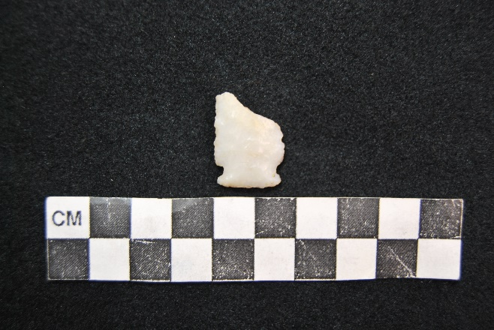
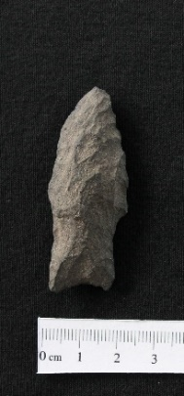
Figure 6.7: Hawken point from 5GN5780.
Figure 6.6: Bajada point from 5GN5101.

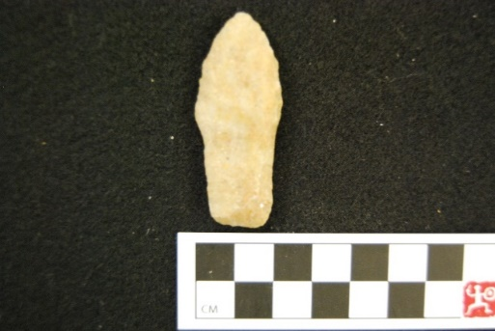
Figure 6.5: Jay point from 5GN1870

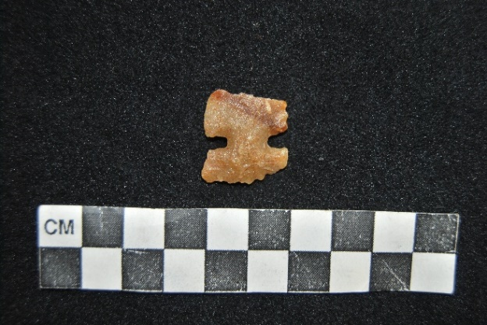
Figure 6.4: Northern Side Notch from 5GN2275.

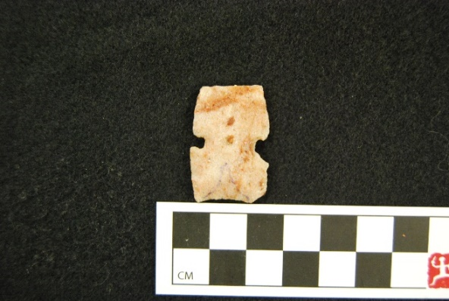
Figure 6.3: Sudden Side Notch from 5GN223.

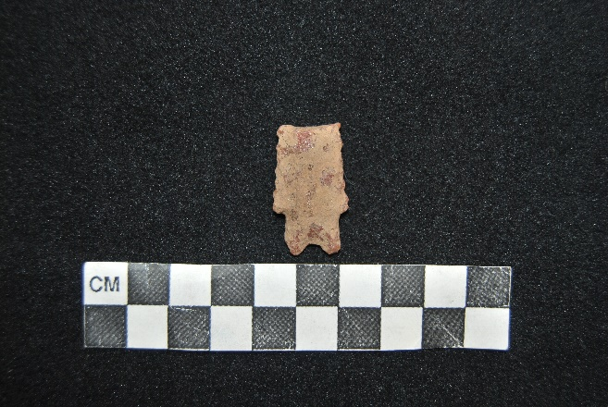
Figure 6.2: Pinto Point from 5GN817.

Lithic Material
I analyzed the lithic material of each projectile point in my sample. Of the 49 points I analyzed, 37 (76%) were made from quartzite (Table 6.3). I expected this result because high-quality quartzite is abundant throughout the UGB. Of the 37 quartzite points, 24 were made from white quartzite. This may indicate that white is the main color of quartzite available in the UGB or it could indicate a social preference for white quartzite. However, an in-depth analysis of the quarries in the UGB is beyond the scope of this thesis and, thus, the significance of color selection cannot be evaluated. Chert was the next-most common with six points. I also identified chalcedony, welded tuff, and basalt in my sample with one point each. Using black-and-white photographs in reports provided by the Colorado SHPO, I identified three more points. However, these reports did not specify raw materials and the photos were of insufficient quality to make a determination. Interestingly, none of the points were made from obsidian despite the ubiquity of obsidian in the Great Basin/Colorado Plateau, Southwest, and its local availability at Cochetopa Dome in the UGB (albeit in often small nodules).

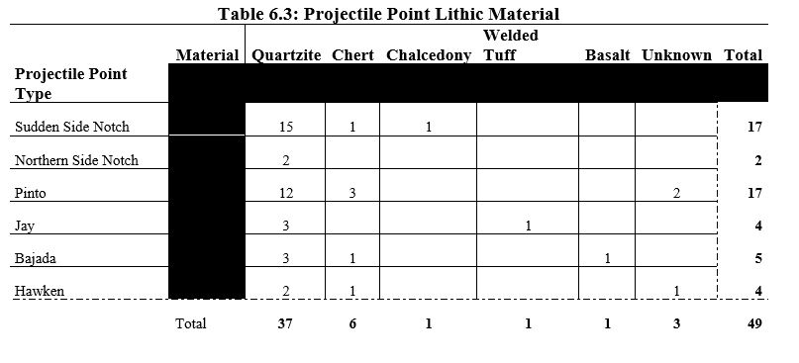

GIS Analysis
Using the methods described in chapter 4, I investigated the geographic location of each site (see Figure 6.1 for a map of all sites) to determine if variations existed among sites with projectile points from different regions. I focus here on the spatial distribution of sites along with the results of the distance to lithic quarries, FETE least-cost path, viewshed, and Monte-Carlo analyses because they produced statistically significant results.

Spatial Patterning
Before diving into the results of the various analyses I performed, a basic examination of how Early Archaic sites are patterned on the landscape is warranted. Early Archaic sites in the UGB are clustered at the lower elevations of the Basin along one major river valley (see Figure 6.1). This is a departure from the Late Paleoindian where sites are found at all elevations of the Basin. Four sites are not in the immediate vicinity of the valley; two Bajada sites, one Hawken site, and one Sudden Side Notch site. These sites are all located in close proximity to the modeled least-cost paths into the UGB from their respective regions. Detailed discussion of the distance from sites to the modeled least-cost path will be discussed later in this chapter.
While I was unable to perform any spatial statistical analyses on the sites due to the limitations of GIS (the analysis requires 50 individual data points and I only have 49 sites in my sample), a visual inspection of the sites reveals two potential clusters of sites. A cluster of sites with Sudden Side Notch sites occurs in the area around what is now the Blue Mesa Reservoir and another cluster occurs southeast of the modern town of Gunnison, Colorado.

Distance to Nearest Lithic Quarry
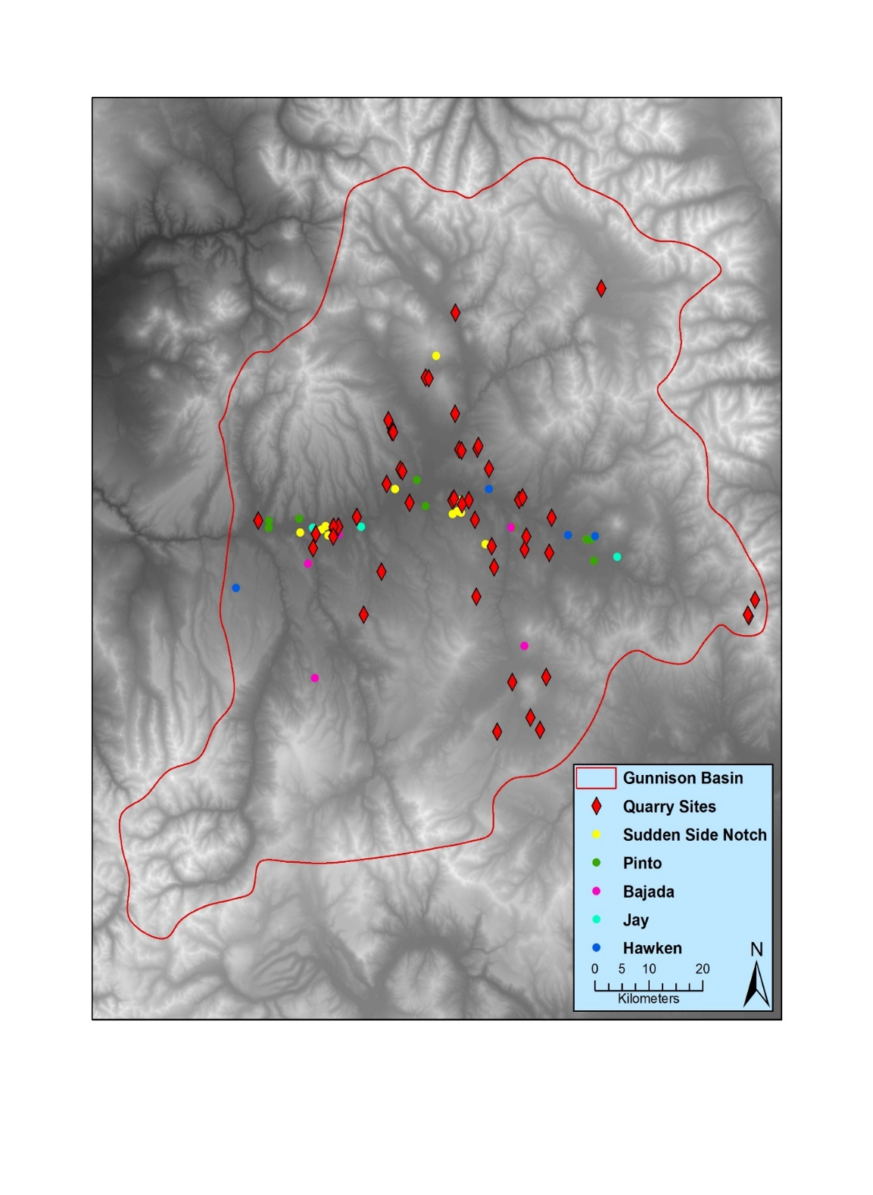
The first analysis that I present is the distance from known lithic quarries to Early Archaic sites in the UGB (Figure 6.8). When considering all sites in my sample, the distances from known lithic quarries ranges from 0 m at 5GN890 and 5GN5804, both known lithic quarries, to 14.3 km at 5GN5101. Breaking down the sites by their individual point types (Figure 6.9), I detected subtle differences.
Figure 6.8: Early Archaic sites in relation to known lithic quarries.

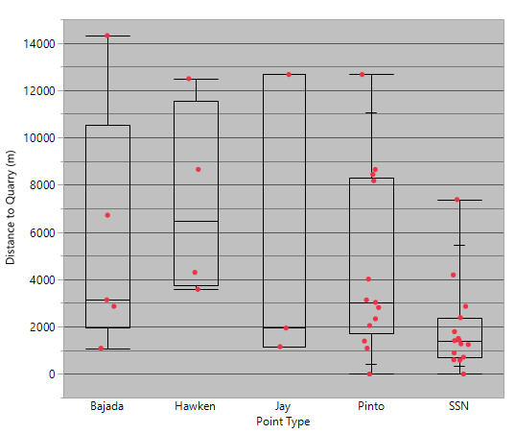
Figure 6.9: Box and whisker plot of distance to nearest lithic quarry.

The results of significance tests on the distances to lithic quarries produced mixed results. The results showed that sites with Sudden Side Notch are statistically significantly closer to lithic quarries than sites with Pinto points (p=0.0286). The significance test also indicated that sites with Sudden Side Notch points are significantly closer to quarries that sites with Hawken points (p=0.008). The remaining tests produced statistically non-significant results. I suggest that the results of a significant difference between sites with Pinto points and sites with Sudden Side Notch points may indicate different lithic procurement strategies, possibly along the forager/collector spectrum (e.g. Binford 1980). However, the difference is negligible and while the results are statistically significant, they may not be meaningfully different. More data is needed to determine what meaningful differences may exist within this dataset.

Distance to Nearest Least-Cost Path
The second analysis that I present here is the distance from each site to the nearest modeled hypothetical least-cost path into the UGB from the adjacent regions (Figure 6.11, Figure 6.12, Figure 6.13). Patterns, like those found in the distance to nearest lithic quarry, emerge when the sites are split into their respective point types and the distances from each site to the nearest modeled least-cost path are compared (Figure 6.10).

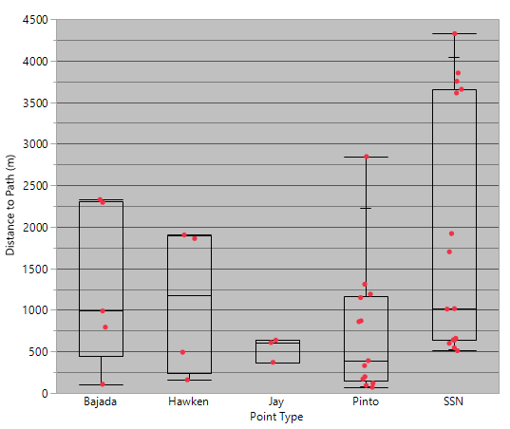
Figure 6.10: Box and whisker plot of distance to modeled least-cost from each site.

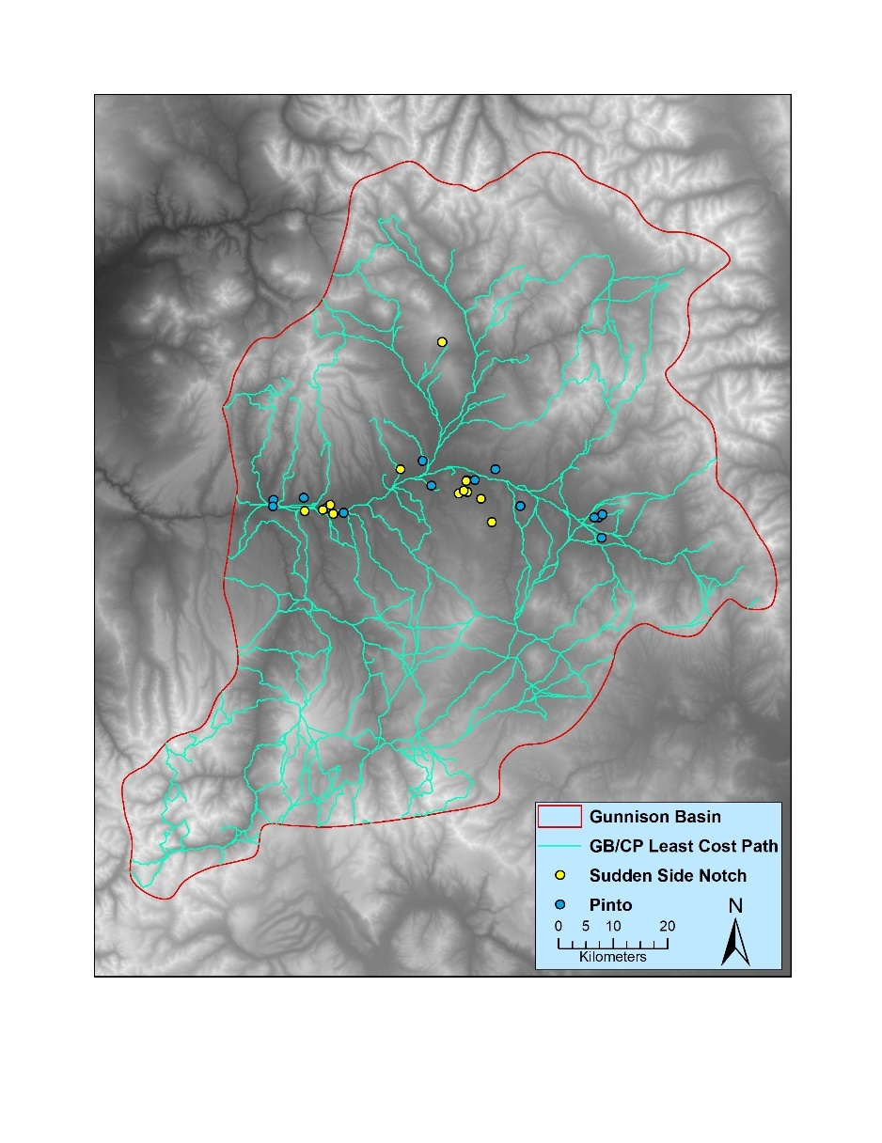
Figure 6.11: Modeled least-cost path from the Great Basin/Colorado Plateau. Sites with Sudden Side Notch and Pinto points are plotted on the map.

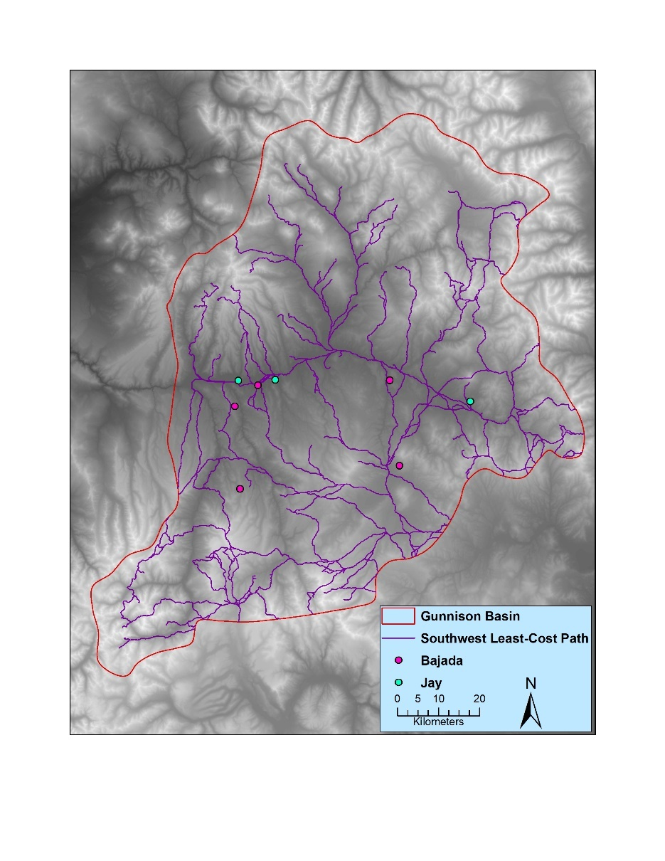
Figure 6.12: Modeled least-cost path from the Southwest. Sites with Bajada and Joy points are plotted on the map.

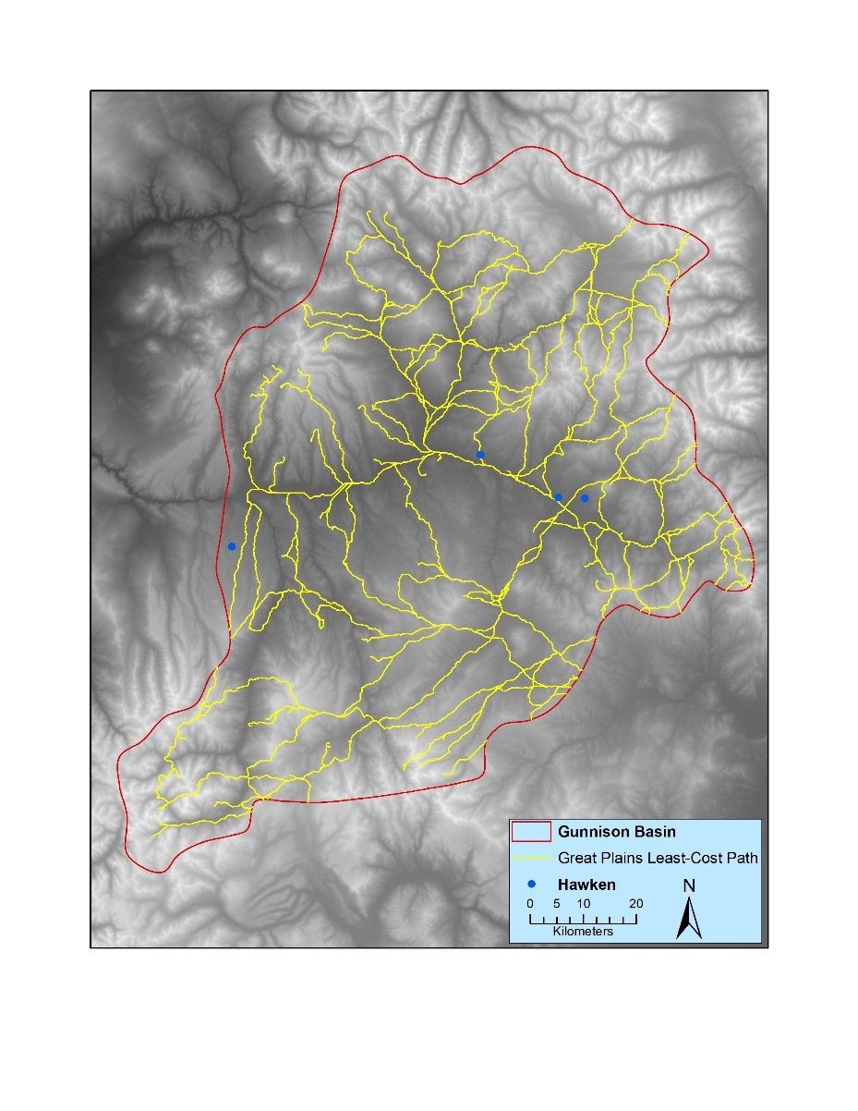
Figure 6.13: Modeled least-cost path from the Great Plains. Sites with Hawken points are plotted on the map.

To determine if the observed variations in distances were significantly different, I again performed a Kruskal-Wallace test of variance followed by a Wilcoxen test to determine significance. The results of this test showed that sites with Pinto points were statistically closer to the modeled path from the Colorado Plateau into the UGB than sites with Sudden Side Notch Points (p=0.188). Unlike the results for the distance to nearest lithic quarry analysis, differences between other pairs of sites were not statistically significant. I suggest that the significant result of the differences between Sudden Side Notch and Pinto Sites, demonstrates possible variations in mobility strategies with Sudden Side Notch sites exhibiting decreased mobility while Pinto sites exhibit increased mobility. However, much like the distance to lithic quarries, the differences, while statistically significant, may not represent meaningful variations and more data is required to determine if these differences have real-world meaning.

Viewshed Analysis
While testing the differences between the area of each site’s viewshed did not produce a statistically significant result, the differences in what each site is viewing warrants reporting. Hawken (Figure 6.14), Jay (Figure 6.15), and Pinto (Figure 6.16) sites are located primarily in areas that allow for viewing the lower elevation, open spaces of the Basin. Many of these sites are located on the edge of terraces overlooking the UGB’s large river valleys. In contrast, Sudden Side Notch (Figure 6.17) and Bajada (Figure 6.18) sites are located in areas that allow for viewing of the UGB’s higher elevations.

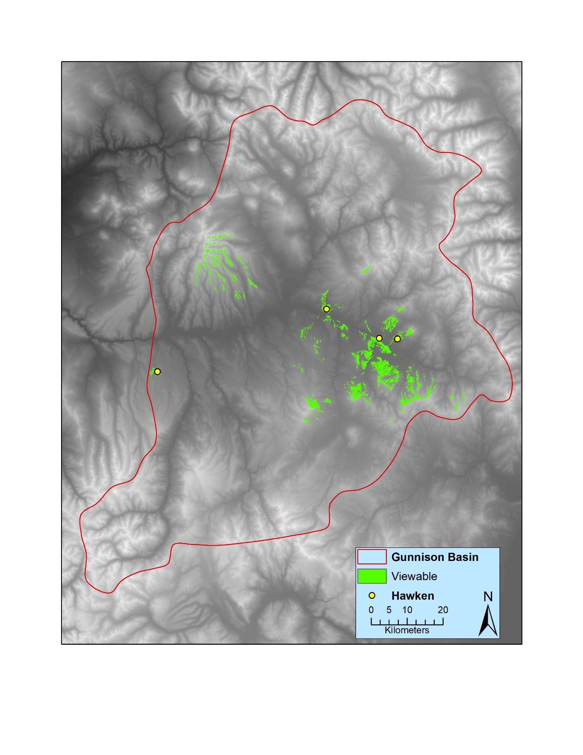
Figure 6.14: Viewshed from sites with Hawken points.

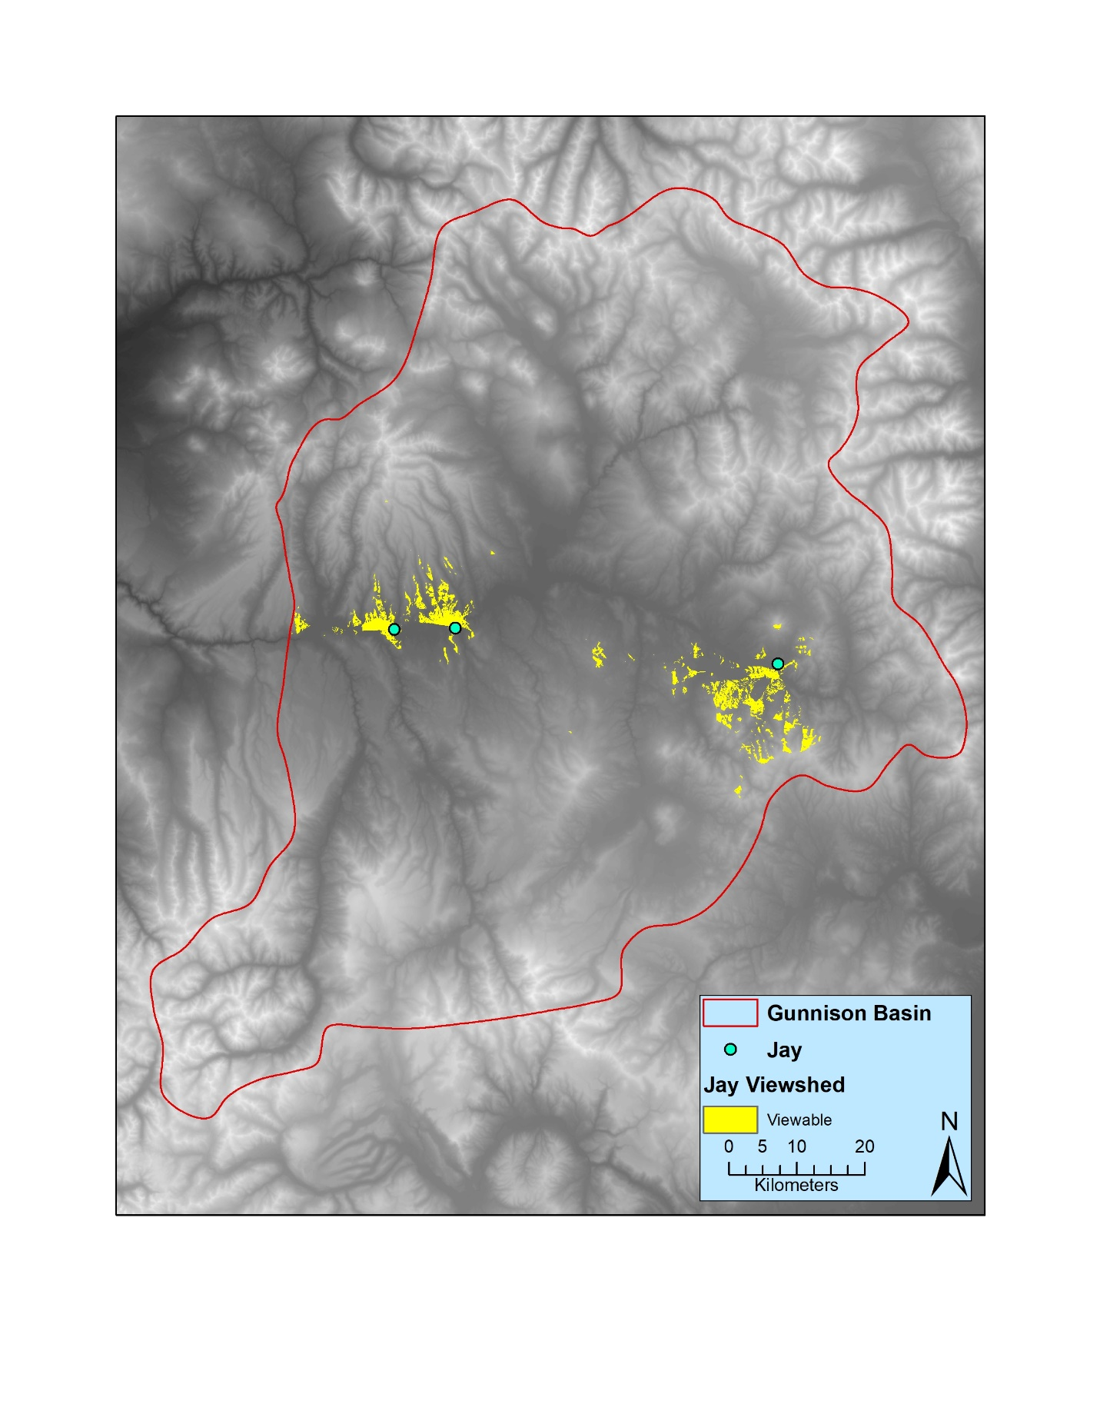
Figure 6.15: Viewshed from sites with Jay points.

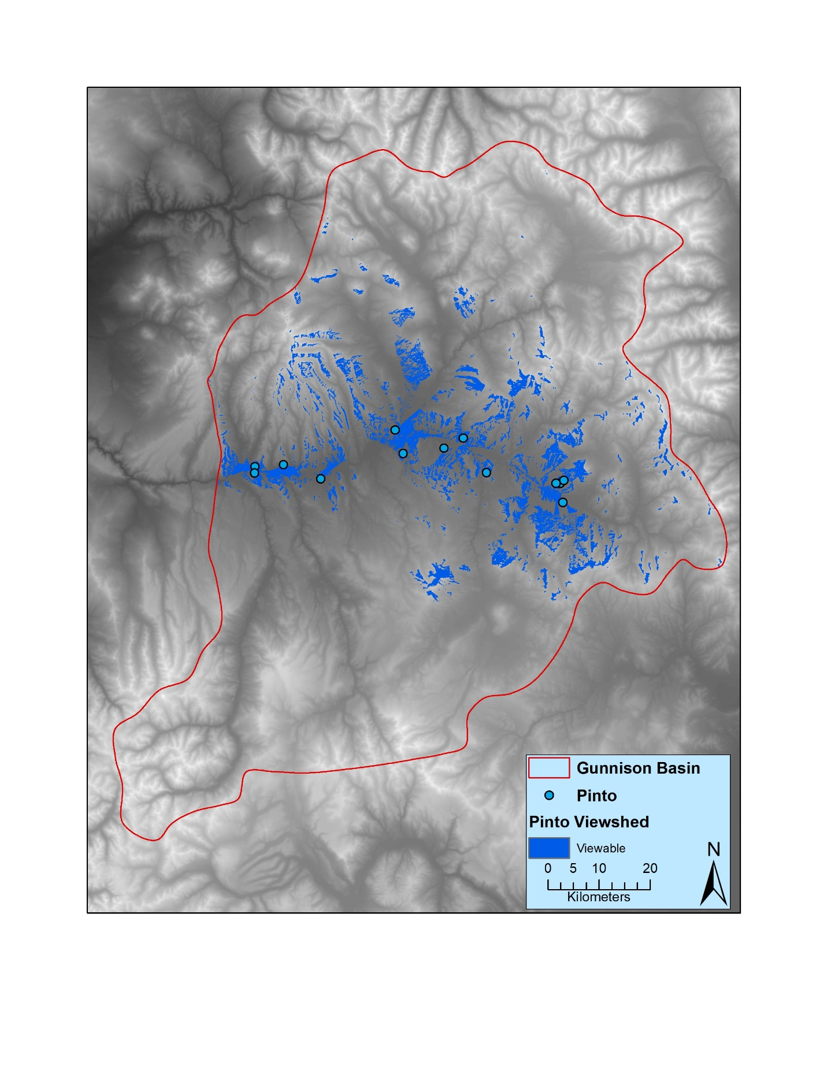
Figure 6.16: Viewshed from sites with Pinto points.

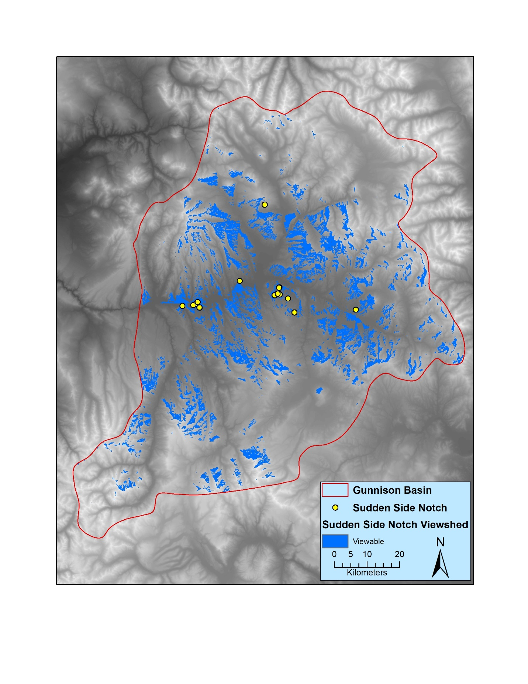
Figure 6.17: Viewshed from sites with Sudden Side Notch Points

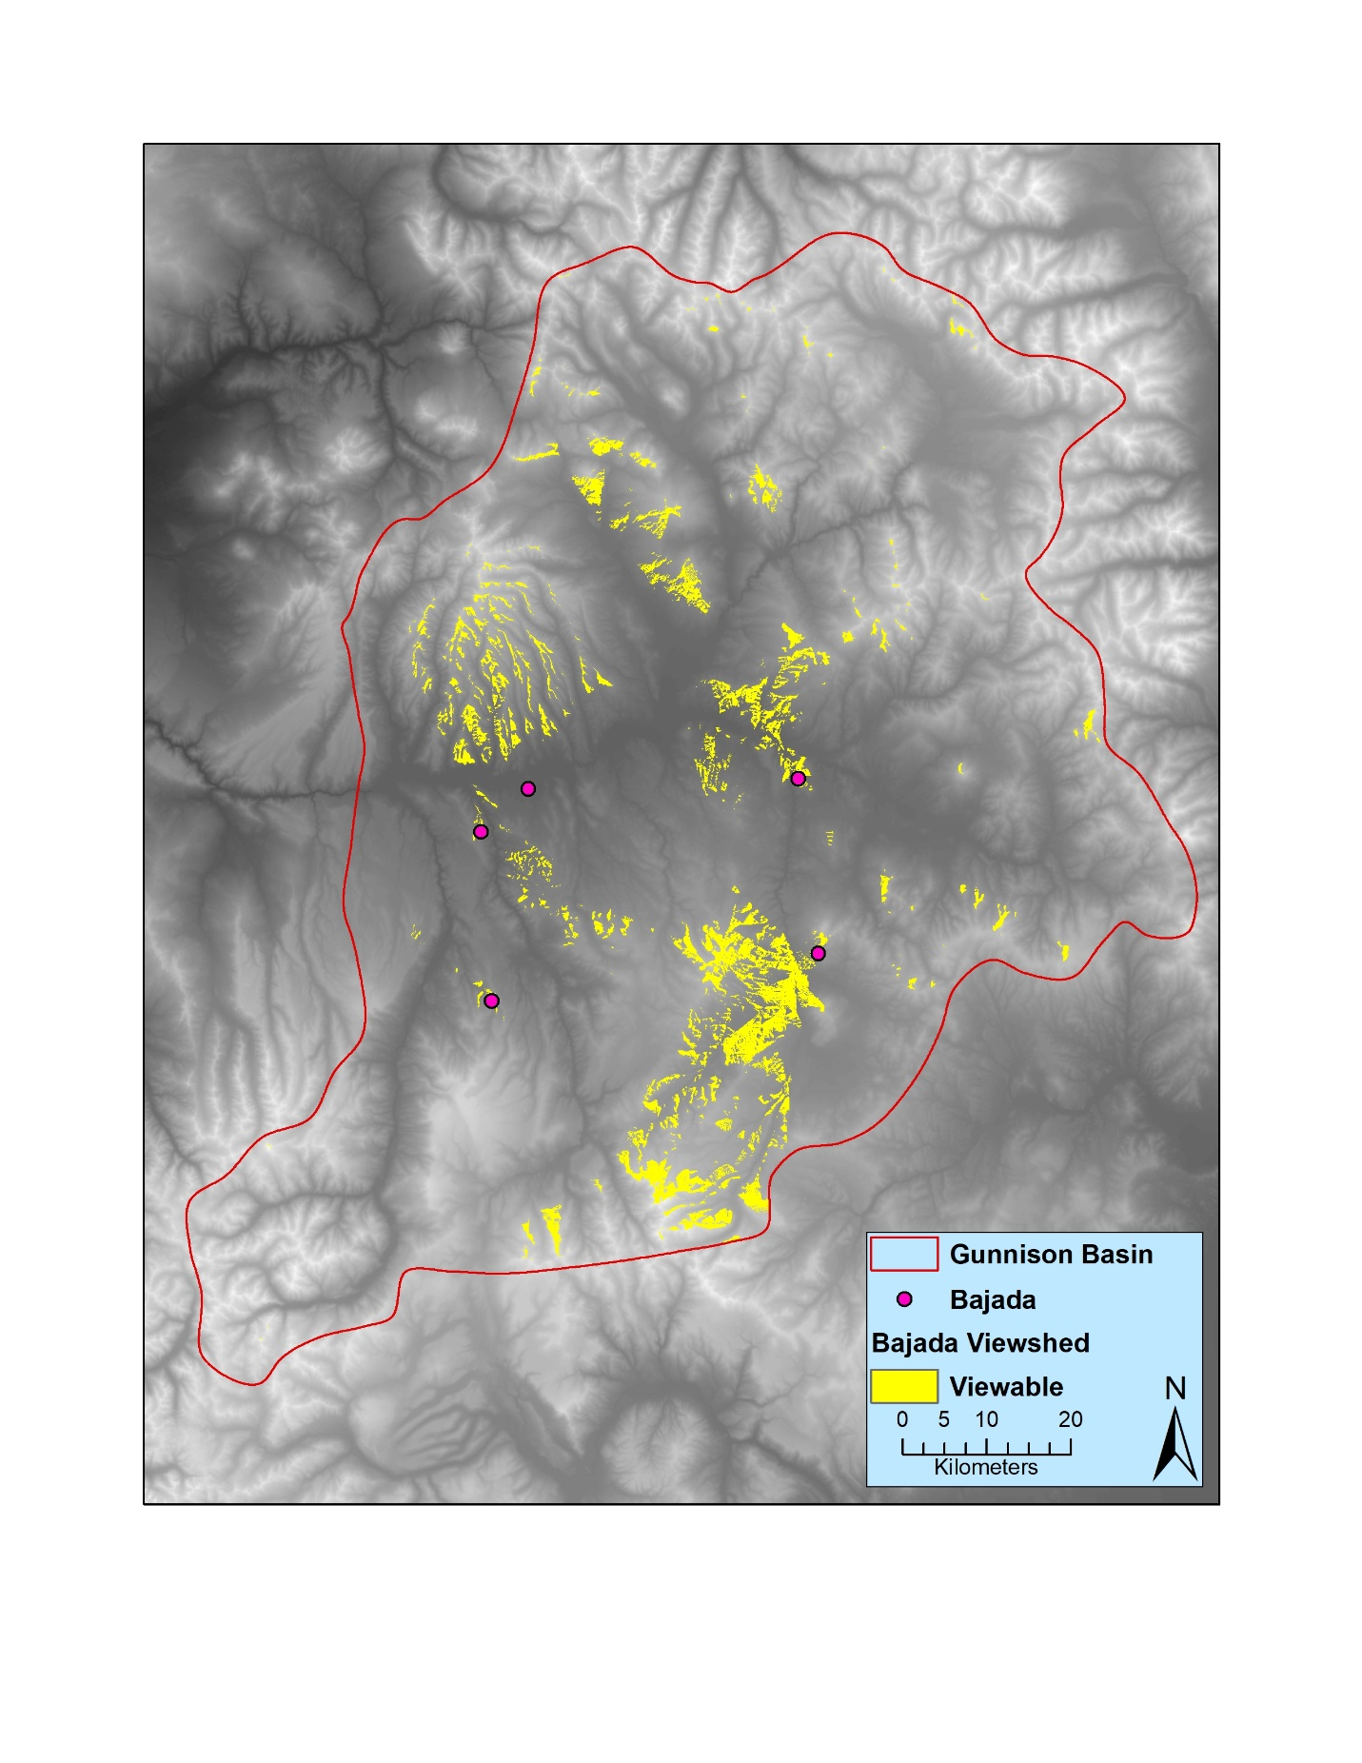
Figure 6.18: Viewshed from sites with Bajada points.

Monte-Carlo GIS Analysis
This test was performed to determine if the data from known Early Archaic sites differed significantly from a randomly generated data set. This was used to determine if the locations of Early Archaic sites in the UGB were random or the result of conscious choices by people living at that time. Like the previous GIS analysis, I will only report on the results of the tests that produced statistically significant results.

Monte-Carlo Analysis of Distance to Nearest Lithic Quarry
This first test produced statistically significant result between the random sample and sites with Sudden Side Notch points (Figure 6.19). The Kruskal-Wallace test of variance produced a result of p>0.0001 and the Wilcoxen test indicated that Sudden Side Notch sites are statistically significantly closer (p<0.0001). All other sites tested against the random sample produced a non-statistically significant result.

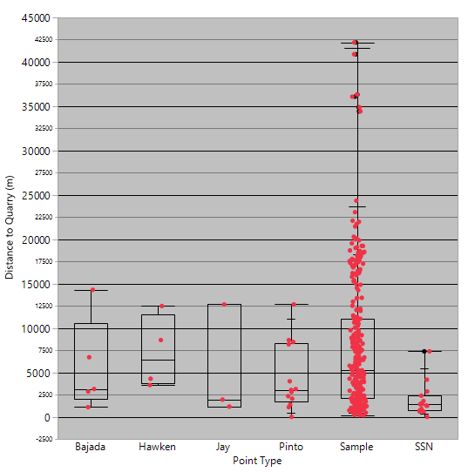

Figure 6.19: Monte-Carlo comparison of distance to nearest lithic quarry.

I also examined the results of this analysis to determine if any sites exceeded the 10th and 90th percentile for distance to nearest lithic quarry when compared against the random sample. No Early Archaic sites exceeded the 90th percentile (n=18,327.2 m) of the random sample, however, six sites fell below the 10th percentile (n=950.3 m). Five Sudden Side Notch sites and one Pinto site were below the 10th percentile of the random sample.

Monte-Carlo Analysis of Site Elevation
While the traditional GIS analysis of site elevation did not produce statistically significant results, the Monte-Carlo analysis did detect differences (Figure 6.20). Sites with Pinto and Sudden Side Notch points differed in elevation from the random sample. The Kruskal-Wallace test of variations produced and significant result and both Pinto (p=0.0029) and Sudden Side Notch (p=0.009) sites are statistically significantly lower in elevation than the random sample. This indicates that Early Archaic people who made these point styles were selecting sites at a lower elevation. This suggests that the environmental zone at this lower elevation was more desirable than others to the people who lived at these sites.
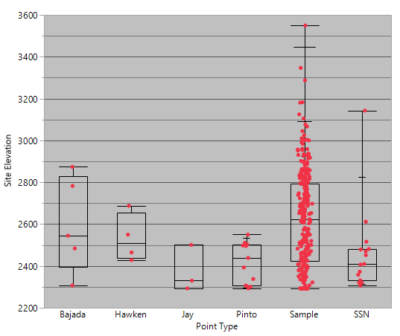
Figure 6.20: Monte-Carlo comparison of site elevation.

When examining the percentiles, no sites fell below the random sample 10th percentile (n=2293 m) of elevation. However, one site exceeded the 90th percentile, a Sudden Side Notch site. With the result that Sudden Side Notch sites are statistically at lower elevations than the random sample, this one site (5GN344) that exceeds the 90th percentile of elevation is intriguing and warrants further examining. It is possible that this site represents a different mobility or resource procurement strategy along the collector/forager spectrum (e.g. Binford 1980)

Summary
Here, I have presented the results of my typological, raw material, and GIS analyses to determine the possible geographic origins of Early Archaic projectile points in the UGB either through the migration of people or the diffusion of ideas along with the differences in mobility and resource procurement strategies of the people who made these points. While the statistical analyses produced significantly different results, the real-world differences are negligible and may not reflect meaningful variations in site locations. Small sample size may also be affecting these results. As previously mentioned, sites with Jay, Bajada, and Hawken points are few in number and this small sample may be skewing the results. Also, despite the number of sites with Pinto and Sudden Side Notch points being equal at 17, this is a relatively small sample when compared to the over 300 known Archaic sites in the UGB. In the future, adding more known sites to my sample will make this study more robust.
The results of the Monte-Carlo analysis, while intriguing, are difficult to draw definitive conclusions from. Only two analyses from this analysis produced statistically significant results and provide and avenue for further research, but without the data from land managed by the USFS it is difficult to make any definitive statements about what these results may mean.

Chapter 7: Discussion and Conclusion
My results suggest that the majority of Early Archaic projectile points in the UGB exhibit similar morphological characteristics to Early Archaic projectile points from the Great Basin. The presence of 36 Great Basin type points from 27 sites indicate that people who made Great Basin style points utilized the resources in the UGB much more frequently than people who made Great Plains and the Southwest style points. Five sites in my sample exhibited more than one projectile point type. These five sites are all along major waterways and within 1,800 m of the nearest least-cost path into the UGB from their respective regions. These sites may represent interactions between two different groups or different occupations of the same area. Without systematic excavations it is impossible to determine.
The greater presence of Great Basin style points as opposed to points originating from other regions, is a shift from the Late Paleoindian period. For this time period, Pitblado (2003) argued that a population of people who made Angostura points lived in the Southern Rocky Mountains, of which the UGB is a part, year-round and a population that made Jimmy Allen points, a Great Plains style, utilized the high elevations on a seasonal basis. While difficult to definitively determine if the people who made the points in my study used the Basin on a year-round or seasonal basis, my findings support arguments made by Black (1991) concerning hunter-gatherer responses to the Altithermal. He argued that the Mountain Tradition had its origins in the Great Basin and that technology diffused into the Rocky Mountains, possibly as a reaction to the Altithermal. According to Black, due to the change in climate, the productivity of the Great Basin dropped, reducing the carrying capacity of the land. This may have made the Southern Rocky Mountains an attractive place for hunter-gatherers looking to escape the effects of the Altithermal. My data supports Black’s argument; however, I am unable to definitively discern whether projectile points found in the UGB with a Great Basin flavor were brought in by people or were a result of knowledge diffusion.
The results of my GIS analysis allow for the beginnings of a discussion on mobility and resource procurement strategies, however, more research is necessary to make definitive statements on how Early Archaic people utilized the UGB landscape and incorporated it into their mobility patterns. My analysis of distance to lithic quarries lays the foundation for discussion on how people used the landscape, however, more data from known Early Archaic sites is needed before making a definitive statement. Examining the lithic raw material from excavated Early Archaic contexts is necessary to determine if non-local material is being used and where it may be coming from. My analysis showed that sites with Sudden Side Notch points are statistically closer to lithic quarries than Pinto sites and examining the lithic raw material at these sites may provide clues as to how people who made these points interacted with the landscape in the UGB.
The results of my distance to modeled least-cost path shows differences in how Early Archaic people may have moved around the UGB landscape using either efficient or non-efficient paths. Adding data from sites on USFS where the elevations are generally higher and farther away from modeled least-cost paths may provide hints as to how people where moving around the landscape and using resources at higher elevations. My analysis demonstrated that sites with Sudden Side Notch points are statistically farther away from modeled least-cost paths than sites with Pinto points possibly indicating a difference in how people moved on the landscape. This difference suggests that people who made Sudden Side Notch points moved around the landscape in a non-efficient manner, whereas people who made Pinto points practiced a more efficient mobility strategy. These variations may be manifestations of different mobility strategies along the forager/collector spectrum (e.g. Binford 1980). Investigating the types of sites where these different projectile points are being found may shed more light on and lead to more definitive statement on what these divergent numbers mean.
I also believe that my sample size and nature of work driving archaeological investigations has biased some of my results. Archaeological investigations in the area around Blue Mesa Reservoir has likely skewed my data in favor of sites located around the reservoir. While the small sample size of Jay, Bajada, and Hawken sites make drawing conclusions difficult, the comparison between Pinto and Sudden Side Notch sites, both Great Basin types, are robust enough to posit preliminary conclusions. Sudden Side Notch Sites are located farther from the modeled least-cost paths into the Basin, and closer to known lithic quarries than Pinto sites. It is possible that these differences illustrate the change in subsistence strategies discussed by Black (1991) and Janetski et. al. (2012) or variations of the same population along the collector/forager spectrum (Binford 1980). Groups of people may have utilized parts of the Basin at different times of the year creating the variability in the GIS results. Further investigation is required to make a more definitive statement.
The connection between the results of viewshed analysis subsistence or mobility patterns is more nuanced. The location of Pinto, Hawken, and Jay sites allows the people at those sites to view the large, open valleys of the Basin potentially for the monitoring of game. Sites with these point types fit nicely into Binford’s (1980) collector model as stations for the monitoring of animal and/or human movement. Binford also states that stations and field camps may be combined in that locations which are ideal to view animals may also be a place where groups of people lived for a time. Sites with Sudden Side Notch points are split with eight sites having a valley viewshed with the remaining nine not having a specific viewshed. This observed difference may indicate different site types along the forager/collector spectrum as described by Binford (1980). For Bajada sites, 5SH1813 exhibits a valley viewshed while the other Bajada sites do not appear to be located in areas that view specific area. While this is tantalizing, with the data I gathered for this thesis it is impossible to definitively attribute any of these sites to a specific site type as described by Binford (1980) and more investigation into the other materials at these sites is required before conclusive interpretations can be drawn.

Conclusions
My analysis has shown that Early Archaic projectile points with characteristics from neighboring regions are found in varying quantities in the UGB. Point styles originating in the Great Basin/Colorado Plateau are found in, by far, the highest numbers, with Southwestern and Great Plains styles found much less often. I believe my data, combined with observations and discussions from other archaeologists, suggest a link of some kind to the Great Basin. My data, however, is not substantial enough to determine if this link resulted from the movement of people or ideas. The examination of other archaeological materials from the sites that I identified, and from sites in the adjacent regions, may provide more insight into whether a group of people brought these points with them or if it was a diffusion of ideas across space.
Examining the paleoclimate data available from the adjacent regions shows that during the Altithermal the Great Basin, Great Plains and Southwest experienced a warmer, drier climate than preceding time periods. In contrast, the UGB was warmer but also wetter. This dichotomy of climate between the UGB and adjacent regions may have drawn people to the area, especially considering vegetational changes that occurred as a result of this climate change. Pinyon was abundant in the Basin, while in neighboring areas, climate change had drastically reduced their numbers. This resource was especially valued by people living in the Great Basin and Colorado Plateau where decreasing numbers of pinyon trees in those areas may have led them to the UGB where it was plentiful. On the Southern Great Plains and in the Southwest, bison populations decreased as a result of the Altithermal forcing them to move into areas with enough grass and water to sustain their herds. While no bison bones have been recovered in Early Archaic contexts, possibly due to poor bone preservation, it is likely that the UGB supported herds of bison during the Early Archaic. While the presence of bison in the area lends itself to an argument of an increased presence of Great Plains style points in the area, entry into the Basin from the east is difficult and would require the crossing of several mountain chains with peaks reaching over 14,000 ft ASL. The only entry into the basin below 8,000 ft ASL is from the west, a natural entry way from the Great Basin/Colorado Plateau. The presence of both pinyon and bison in the UGB at a time when their populations were diminished in adjacent regions would have made the Basin an attractive place for people seeking refuge from the Altithermal.
The presence of bison and pinyon in the Basin may also account for the variations in the GIS results. The differences in the analyses might be the result of different resources being exploited at different times of the year. Sites with viewsheds of the valleys may be stations or field camps to view the movement of bison and sites without a particular viewshed could possibly represent residential bases where harvested pinyon was stored in preparation for winter (Binford 1980). Excavated sites with Early Archaic components that contain preserved faunal or floral material is needed to substantiate that possibility.
While the results of my analyses are intriguing, there is plenty of room for improvement. First, more data in the form of other artifacts (flakes, scrapers, bifaces, groundstone, etc.) needs to be added before any final conclusions can be drawn. Data from the northern and southern portion of the basin will also bolster the results of this study. These two areas have received minimal survey coverage and more investigation into those areas may reveal more sites that will strengthen my results. Also, collections from USFS land need to be analyzed, but due to the lack of central repository, it was out of the scope for this thesis. Land managed by the USFS is generally at a higher elevation with an increased presence of trees than BLM and NPS land. As a result, the archaeological material has the potential to be different than material coming from lower, less tree covered elevations. Second, an accurate model representing Early Archaic vegetational and landscape change needs to be constructed in GIS. Using this model, more accurate least-cost path model can be constructed to measure the distance to various resources on the landscape. Third, instead of modeling the straight-line distance to places on the landscape, such as quarries and paths, a least-cost path analysis using the previously mentioned environmentally accurate model would give more robust results as it represents a possible path that people can take. Last, a comparison of sites with the same points may tease out subtle variations that indicate differences in site types as described by Binford (1980) along the forager/collector spectrum. This type of analysis was not performed for this thesis as I determined more data in the form and entire assemblages, as opposed to just projectile points, was needed to answer this question.
With these improvement in mind, I intend to continue this research, not only in the UGB, but for the Rocky Mountains as a whole. These future studies will consider the lessons I have learned during this research and, moving forward, I intend to include more data as it becomes available through more survey and excavation work along with more accurate GIS analyses. This study has shed light on an understudied time period in the Rocky Mountains and continuing this research is vital to creating a complete picture of the people who called this beautiful place home during the Early Archaic.

References Cited

Aikens, C. Melvin
1993 Archaeology of Oregon. U.S. Department of the Interior, Bureau of Land Management, Oregon State Office, Portland

Amsden, C. A
1935 The Pinto Basin Artifacts. In, The Pinto Basin Site, by E. W. Campbell and W. H. Campbell, 31-51. Southwest Museum Papers, No. 9, Los Angeles.

Anderson, R. Scott, Jim Hasbargen, Peter A. Koehler, and Eric J. Feiler
1999 Late Wisconsin and Holocene Subalpine Forest of the Markagunt Plateau of Utah. Arctic, Antarctic, and Alpine Research 31(4): 366-378

Andrefsky, Jr., William
2009 The Analysis of Stone Tool Procurement, Production, and Maintenance. Journal of Archaeological Research 17: 65-103.

Andrews, Brian N.
2010 Folsom Adaptive Systems in the Upper Gunnison Basin, Colorado: An Analysis of the Mountaineer Site. Unpublished PhD Dissertation, Department of Anthropology, Southern Methodist University, Dallas.

Andrews, J.T., P.E. Carrara, F.B. King, and R. Stuckenrath
1975 Holocene Environmental Changes in the Alpine Zone, Northern San Juan Mountains, Colorado: Evidence from Bog Stratigraphy and Playnology. Quarternary Research 5: 173-197.

Baker, Steven G.
1981 Summary Site Evaluations and Resource Management Recommendations. In The 1979 Test Excavations Program at Alkali Creek Study Area, edited by Kevin D. Black, Steven M. Horvath Jr., and Steven G. Baker, pp: 203-211. Centuries Research Inc. Montrose, Colorado.

Baker, D.L. and N.T. Hobbs
1982 Composition and Quality of Elk Summer Diets in Colorado. Journal of Wildlife Management 46: 694-703.

Beck, Charlotte, Amanda K. Taylor, George T. Jones, Cynthia M. Fadem, Caitlyn R. Cook, and Sara A. Millward
2002 Rocks are Heavy: Transport Costs and Paleoarchaic Quarry Behavior in the Great Basin. Journal of Anthropological Archaeology 21(4): 481-507.

Benedict, James B.
1975 The Albion Boardinghouse Site: Archaic Occupation of a High Mountain Valley. Southwestern Lore 41(3) 1-12.

1979 Getting Away From it All: A Study of Man, Mountains and the Two-Drought Altithermal. Southwestern Lore 45(3): 1-12.

1992 Footprints in the Snow: High-Altitude Cultural Ecology of the Colorado Front Range, U.S.A. Arctic and Alpine Research 24(1): 1-16.

Benedict, James B., and Byron L. Olson
1978 The Mount Albion Complex: A Study of Prehistoric Man and the Altithermal. Research Report 1, Center for Mountain Archaeology Research, Ward, Colorado.

Bernardini, Wesley, Alicia Barnash, Mark Kumler, and Martin Wong
2013 Quantifying Visual Prominence of Social Landscapes. Journal of Archaeological Science 40: 3946-3954.

Bettinger, Robert L.
1976 The Development of Pinyon Exploitation in Central Eastern California. The Jounral of California Anthropology 3(1): 81-95.

Binford, Lewis R.
1980 Willow Smoke and Dogs’ Tails: Hunter-Gatherer Settlement Systems and Archaeological Site Formation. American Antiquity 45(1): 4-20.

Black, Kevin D.
1991 Archaic Continuity in the Colorado Rockies: The Mountain Tradition. Plains Anthropologist 36: 1-29.

1983 Shelter and Subsistence at 5GN344, High Altitude Short-Term Camp near Almont, Colorado. Southwestern Lore 49: 1-27.

Briles, Christy E., Cathy Whitlock, and David J. Meltzer
2012 Last Glacial-Interglcaial Environments in the Souther Rocky Mountains, USA and Implications for Younger Dryas-Age Human Occupation. Quarternary Research 77: 96-103.

Campbell, E. W. C. and W. H. Campbell
1935 The Pinto Basin Site. Southwest Museum Papers No. 9, Southwest Museum, Los Angeles.

Carrara, P.E., W.N. Mode, M. Rubin, S.W. Robinson
1984 Deglaciation and Postglacial Timberline in the San Juan Mountains, Colorado. Quarternary Research 21: 42-55.

Carrara, Paul E., Deborah A. Trimble, and Meyer Rubin
1991 Holocene Treeline Fluctuations in the Northern San Juan Mountains, Colorado, U.S.A., as Indicated by Radiocarbon-Dated Conifer Wood. Arctic and Alpine Research 23(3): 233-246.

Cassels, E. Steve
1997 The Archaeology of Colorado. Revised Edition. Johnson Books, Boulder, Colorado.

Chambellan, C.C.
1984 Archaeology of the Gunnison River Basin, Colorado. Unpublished Master’s Thesis, Department of Anthropology, University of Wisconsin, Madison.

Cotter, J.L.
1935 Yuma and Folsom Artifacts. Unpublished Master’s Thesis, University of Denver, Colorado.

Dalpra, Cody L.
2016 Petrographic Quartzite Source Discrimination in the Upper Gunnison Basin, Colorado. Implications for the Archaeological Study of Prehistoric Hunter-Gatherers. Unpublished Master’s Thesis, Department of Anthropology, University of Oklahoma, Norman.

Des Planques, Scott A.
2001 Early and Middle Archaic Projectile Point Technologies in the Closed Basin Area of the San Luis Valley, Colorado. Unpublished PhD Dissertation, Department of Anthropology, University of Montana, Missoula.

Dial, Janis L.
1989 The Curecanti Archaeological Project: The Late Prehistoric Componenet at Pioneer Point. Midwest Archaeological Center Occasional Studies in Anthropology, National Park Service, Lincoln Nebraska.

Dudley, Meghan J., and William R. Ankele
2015 Project Pelko: A reassessment of Elko and Pelican Lake Projectile Points. Poster Presented at the 73rd Annual Meeting of the Plains Anthological Conference, Iowa City.

Eerkens, Jelmer W., Jerome King, and Eric Wohlgemuth
2004 The Prehistoric Development of Intensive Green-Cone Piñon Processing in Eastern California. Journal of Field Archaeology 29 (1/2): 17-27

Euler, R. Thomas, and Mark Stiger
1981 1978 Test Excavations at Five Archaeological Sites in the Curecanti National Recreation Area, Intermountain Colorado. Report on file National Park Service, Midwest Archaeological Center, Lincoln, Nebraska.

Fall, Patricia Lynn
1988 Vegetation Dynamics in the Southern Rocky Mountains: Late Pleistocene and Holocene Timberline Flucutation. Unpublished PhD Dissertation, Department of Anthropology, University of Arizone, Tucson.

1997 Timberline Fluctuations and Late Quarternary Paleoclimates in the Southern Rocky Mountains, Colorado. GSA Bulletin 109: 1306-1320.

Forman, Steven L., Alexander F.H. Goetz, and Roberta H. Yunes
1992 Large-Scale Stablized Dunes on the High Plains of Colorado: Understanding the Landscape Response to Holocene Climates with the Aid of Images from Space. Geology 20: 145-148.

Frison, George C.
1991 Prehistoric Hunters of the High Plains. Second Edition. Academic Press, Inc., San Diego.

Frison, George C., Michael Wilson, and Diane J. Wilson
1976 Fossil Bones and artifacts from an Early Altithermal Period Arroyo Trap in Wyoming. American Antiquity 41(1): 28-57.

Gunnerson, James H.
1987 Archaeology of the High Plains. Rocky Mountain Region, USDA Forest Service, Denver.

Gruhn, Ruth
2006. New excavations at Wilson Butte Cave, south-central Idaho. Idaho Museum of Natural History, Boise.

Haney, Jefferson W.
1992 Acorn Exploitation in the Eastern Sierra Nevada. Journal of California and Great Basin Anthropology 14(1): 94-109.

Harrington, Mark Raymond
1957 A Pinto Site at Little Lake. California. Southwest Museum Papers No. 17, Los Angeles.

Harrison, Cheryl
1993 Rural Improvement-Gunnison West Project, Gunnison County, Colorado. Powers Elevation Co. Inc. Aurora, Colorado.

Holmer, Richard
1986 Common Projectile Points of the Intermountain West. In, Anthropology of the Desert West: Essays in Honor of Jesse D. Jennings, pp. 253-327, edited by Carol J. Condie and Don D. Fowler, University of Utah Anthropological Papers No. 110, University of Utah press, Salt Lake City.

Honea, Kenneth
1969 The Rio Grande Complex and the Northern Plains. Plains Anthropologist 14(43): 57-70.

Huckell, Bruce B.
1996 The Archaic Prehistory of the North American Southwest. Journal of World Prehistory Vol. 10(3): 305-373.

Hurst, C.T.
1943 A Folsom Site in a Mountain Valley of Colorado. American Antiquity 8: 250-253.

Husted, Wilfired M.
1991 Bighorn Canyon Archaeology. Reprints in Anthropology Volume 43. J and L Reprint Company, Lincoln.

Husted, Wilfred M. and Robert Edgar
2002 The Archaeology of Mummy Cave, Wyoming: An Introduction to Shoshonean Prehistory. Midwest Archaeological Center Special Report No.4. Lincoln.

Irwin-Williams, Cynthia
1973 The Oshara Tradition: Origins of Anasazi Culture. Eastern New Mexico University Contributions in Anthropology 5(1).

Irwin-Williams, C., & Irwin, H.
1966 Excavations at Magic mountain. In Proceedings of the Denver Museum of Natural History (12).

Janetski, Joel C., Mark L. Bodily, Bradley A. Newbold, and David T. Yoder
2012 The Paleoarchaic to Early Archaic Transition on the Colorado Plateau: The Archaeology of North Creek Shelter. American Antiquity 77(1) 125-159.

Jennings, Jesse D.
1973 Prehistory of Utah and the Eastern Great Basin. University of Utah Anthropological Papers, University of Utah Press, Salt Lake City.

1980 Cowboy Cave. University of Utah Anthropological Papers, University of Utah Press, Salt Lake City.

Jones, Bruce A.
1984 Radiocarbon Dates from the Gunnison Basin, Curecanti National Recreation Area, Colorado. Southwestern Lore 50: 14-22.

1991 Inventory and Evaluation around Blue Mesa Lake, Curecanti National Recreation Area, Colorado. Midwest Archaeological Center Technical Report No. 42. National Park Service, Midwest Archaeological Center, Lincoln, Nebraska

Jones, George T., Lisa M. Fontes, Rachel A. Horowitz, Charlotte Beck, and David G. Bailey
2012 Reconsidering Paleoarchaic Mobility in the Central Great Basin. American Antiquity 77(2): 351-367.

Kay, Marvin
1998 The Central and Southern Plains Archaic. In, Archaeology on the Great Plains, edited by W. Raymond Wood, 173-200. University Press of Kansas.

Kivett, Marvin F.
1962 Logan Creek Complex. Nebraska State Historical Society. Lincoln

Kornfeld, Marcel, George C. Frison, Mary Lou Larson
2010 Prehistoric Hunter-Gatherers of the High Plains and Rockies. Third Edition. Left Coast Press, Walnut Creek.

Laird, Kathleen R., Sherilyn C. Fritz, Eric C. Grimm, and Pietra G. Mueller
1996 Centruy-Scale Paleoclimate Reconstruction of Moon Lake, a Closed-Basin Lake in the Northern Great Plains. Limnology and Oceanography 41(5): 890-902.

Lister, Robert H.
1962 Archaeological Survey of the Blue Mesa Reservoir, Colorado. Southwestern Lore 28: 41-45.

Madsen, David B.
2010 The Paleoarchaic to Archaic Transition in the Great Basin. In Paleoindian or Paleoarchaic? Great Basin Human Ecology at the Pleistocene-Holocene Transition. Edited by Kelly E. Graf and Dave N. Schmitt. The University of Utah Press, Salt Lake City.

Markgraf, Vera, and Louis Scott
1981 Lower Timberline in Central Colorado During the Past 15,000 Years. Geology 9: 231-234.

McElrath, Dale L., Andrew C. Fortier, and Thomas E. Emerson
2009 An Introduction to the Archaic Societies of the Midcontinent. In Archaic Societies: Diversity and Complexity Across the Midcontinent. Edited by Thomas E. Emerson, Dale L. McElrath, and Andrew C. Fortier, pp. 3-22. State University of New York Press, Albany.

Meltzer, David J.
1999 Human Responses to Middle Holocene (Altithermal) Climate on the North American Great Plains. Quarternary Research 52: 404-416.

Merriman, Christopher W., Bonnie L. Pitblado, Holly Andrew, Ben Fowler, Katie Harris, Ashley Smith, and Melissa Jackson
2008 5GN3418: A Multicomponent Prehistoric Site in the Gunnison Basin, Southwest Colorado. Final archaeological report prepared for the Colorado Department of Transportation and the Colorado State Historical Society State Historic Fund.

Nelson, Charles E.
1981 Cherry Gulch Site (5JF63): A Projectile Point Study. Southwestern Lore 47(2): 1-27.

Nelson, J.R., and T.A. Leege
1982 Nutritional Requirements and Food Habits. In Elk of North America: Ecology and Management, edited by J.W. Thomas and D.E. Toweill, pp: 323-368. Stackpole Books, Harrisburg, Pennsylvania.

Odell, George H.
2000 Stone Tool Research at the End of the Millennium: Procurement and Technology. Journal of Archaeological Research 8(4): 269-331.

Pitblado Bonnie L.
1998 Peak to Peak in Paleoindian Time: Occupation of the Southwest Colorado. Plains Anthropologist 43(166): 333-348.

2002 The Chance Gulch Late Paleoindian Site, Gunnison Basin, Colorado. Current Research in the Pleistocene 19:74-76.

2003 Late Paleoindian Occupation of the Southern Rocky Mountains. University Press of Colorado, Niwot.

2016 Paleoindian Archaeology of the Upper Gunnison Basin, Colorado Rocky Mountains. North American Archaeologist 37:20-60.

Pitblado, Bonnie L., Hector Neff, Scott Nelson, Carol Dehler
2007 AD-ICP-MS vs. LA-ICP-MS Analysis of Quartzite Sources, Gunnison Basin, Colorado. Current Research in the Pleistocene 24:133-136.

Poore, R.Z., M.J. Pavich, and H.D. Grissino-Mayer
2005 Record of North American Southwest Monsoon from Gulf of Mexico Sediment Cores. Geology 33(3): 209-212.

Reed, Alan D. and Michael D. Metcalf
1999 Colorado Prehistory: A Context for the Northern Colorado River Basin. Colorado Council of Professional Archaeologists, Denver.

Renaud, E.B.
1934 The First Thousand Yuma-Folsom Artifacts. Denver: University of Denver Department of Anthropology Archeological Report 4.

1942 Reconnaissance Work in the Upper Rio Grande Valley, Colorado, and New Mexico. Denver: Department of Anthropology Archaeological Series Paper 3.

Rogers, Malcolm J.
1939 Early Lithic Industries of the Lower Basin of the Colorado River and Adjacent Desert Areas. San Diego Museum Papers, No. 3, San Diego.

Simms, Steven R.
1985 Acquisition Cost and Nutritional Data on Great Basin Resources. Journal of California and Great Basin Anthropology 7(1): 117-126.

2016 Ancient People of the Great Basin and Colorado Plateau. Routledge, New York.

Spaulding, W. Geoffrey
1991 A Middle Holocene Vegetational Record from the Mojave Desert of North America and its Paleoclimate Significance. Quarternary Research 35(3): 427-437

Stiger, Mark
1981 Investigations at Seven Archaeological Sites in the Curecanti National Recreation Area. Report for the National Park Service, Midwest Archaeological Center, Lincoln, Nebraska.

2001 Hunter-Gatherer Archaeology of the Colorado High Country. University Press of Colorado, Boulder.

2006 A Folsom Structure in the Colorado Mountains. American Antiquity 71:321-351

Stiger, Mark and R.T. Euler
1978 Test Excavations in Curecanti National Recreation Area, Intermountain Colorado. Paper Presented at the Thirty-Sixth Annual Plains Conference, Denver.

Vierra, Bradley J., Margaret A. Jodry, M. Steven Shackley, and Michael J. Dilley
2012 Late Paleoindian and Early Archaic Foragers in the Northern Southwest. In From the Pleistocene to the Holocene: Human Organization and Cultural Transformations in Prehistoric North America, edited by C. Britt Bousman and Bradley Jay Vierra, Texas A&M University Press, College Station.

Waters, Michael R. and C. Vance Haynes
2001 Late Quarternary Arroyo Formation and Climate Change in the American Southwest. Geology 29: 399-402.

Weng, Chengyu and Stephen T. Jackson
1999 Late Glacial and Holocene Vegetation History and Paleoclimate of the Kaibab Plateau, Arizona. Palaeogeography, Palaeoclimatology, Palaeoecology 153: 179-201.

White, Devin A., and Sarah B. Barber
2012 Geospatial Modeling of Pedestrian Transportation Networks: A case Study from Precolumbian Oaxaca, Mexico. Journal of Archeological Science 39: 2684-2696.

Wigand, Peter E., Martha L. Hemphill, Saxon E. Sharpe, and Sikha (Manna) Patra.
1995 Great Basin Semi-Arid Woodland Dynamics During the Quarternary. In Proceedings of the Workshhop: Climate Change in the Four Corner and Adjacent Regions: Implications for Environmental Restoration and Land-Use Planning. Workshop Organized by W.J. Waugh, K.L. Petersen, P.E. Wigand, B.D. Louthan, and R.D. Walker, Mesa State College, Grand Junction, Colorado.

Wills, W. H.
1988 Early Prehistoric Agriculture in the American Southwest. School of American Research Press, Santa Fe.

Appendix A: Projectile points analyzed for this thesis
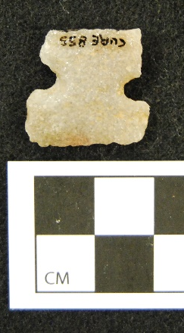
Figure A.1: Sudden Side Notch from 5GN175

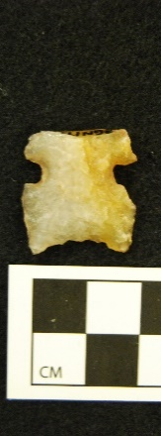
Figure A.2: Sudden Side Notch from Site 5GN175.

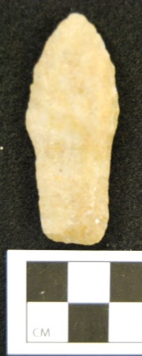
Figure A.3: Jay Point from Site 5GN1870.

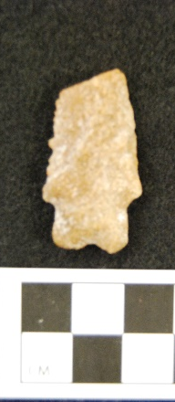
Figure A.4: Pinto Point from 5GN191
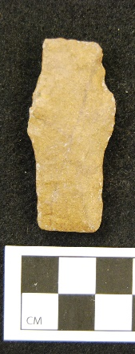
Figure A.5: Jay Point from 5GN191
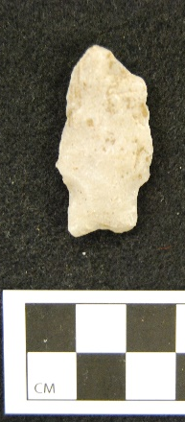
Figure A.6: Pinto point from 5GN191
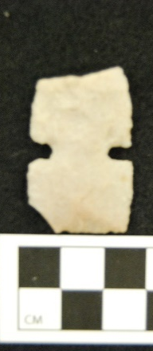
Figure A.7: Sudden Side Notch from 5GN204.

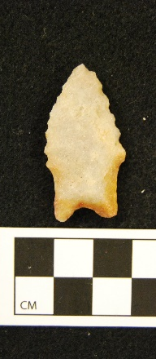
Figure A.8: Pinto point from 5GN2219

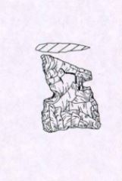
Figure A.9: Sudden Side Notch from 5GN222

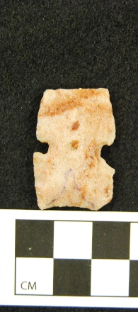
Figure A.10: Sudden Side Notch from 5GN223

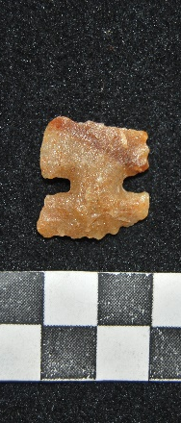
Figure A.11: Northern Side Notch from 5GN2275

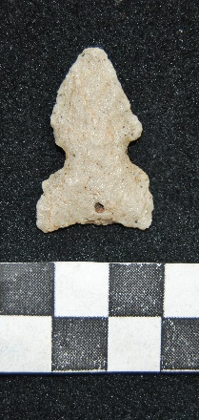
Figure A.12: Sudden Side Notch from 5GN2275

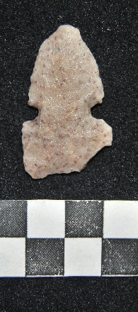
Figure A.12: Sudden Side Notch from 5GN2275

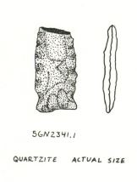
Figure A.13: Hawken from 5GN2341

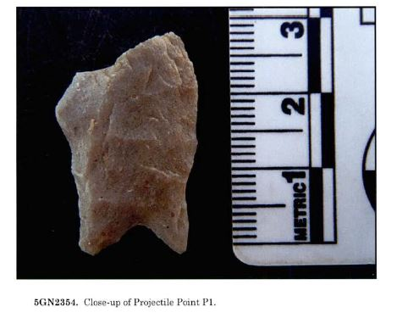
Figure A.14: Jay point from 5GN2354

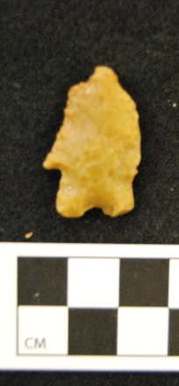
Figure A.15: Pinto point from 5GN2440.

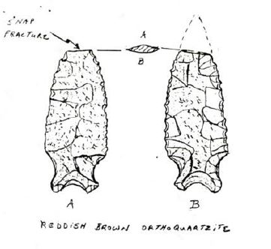
Figure A.16: Pinto point from 5GN2556.

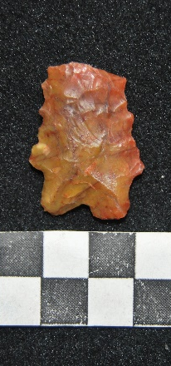
Figure A.17: Pinto point from 5GN2609.

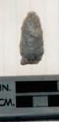
Figure A.18: Hawken point from 5GN2786.

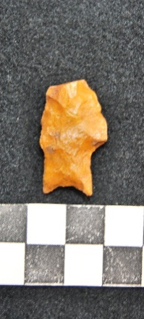
Figure A.19: Bajada point from 5GN2915.

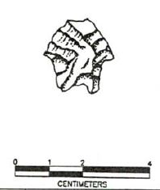
Figure A:20: Pinto point from 5GN2916.

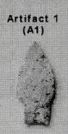
Figure A.21: Pinto point from 5GN3439.

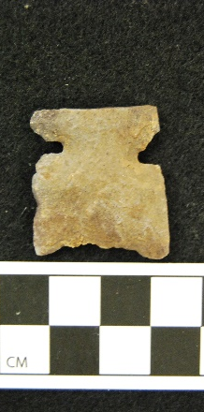
Figure A.22: Sudden Side Notch from 5GN344.

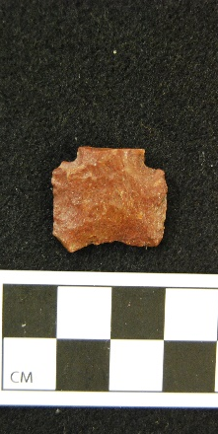
Figure A.23: Sudden Side Notch from 5GN344.

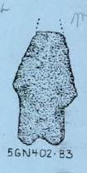
Figure A.24: Pinto point from 5GN402.

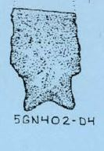
Figure A.25: Pinto Point from 5GN402.

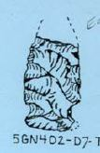
Figure A.26: Hawken pint from 5GN402.

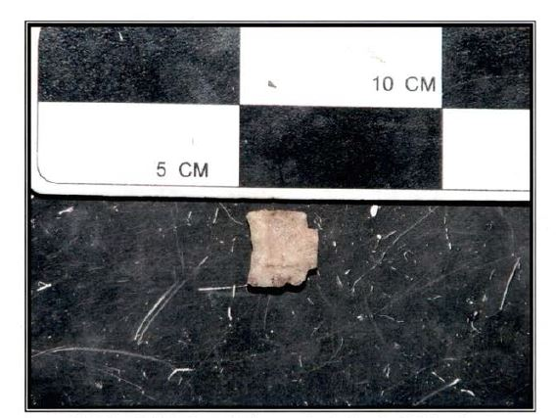
Figure A.27: Sudden Side Notch from 5GN5618.

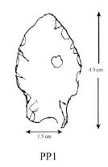
Figure A.28: Pinto from 5GN5692.

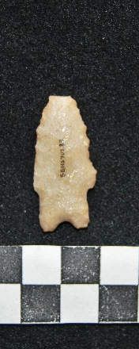
Figure A.29: Pinto from 5GN5707.

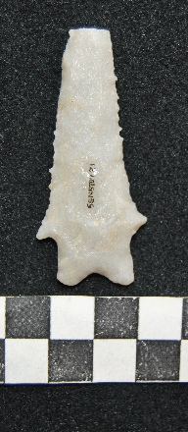
Figure A.30: Pinto from 5GN5707.

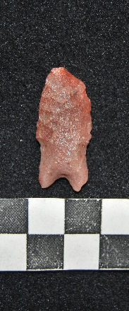
Figure A.31: Pinto from 5GN5707.

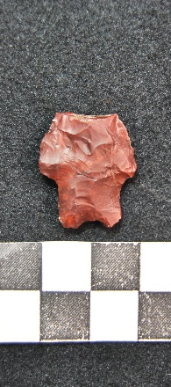
Figure A.32: Pinto from 5GN5780.

Figure A.33: Hawken from 5GN5780.

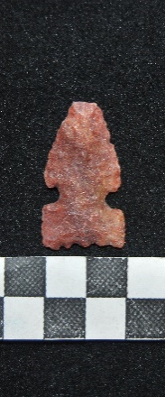
Figure A.34: Sudden Side Notch from 5GN5784.

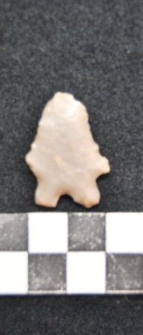
Figure A.35: Pinto from 5GN5784.

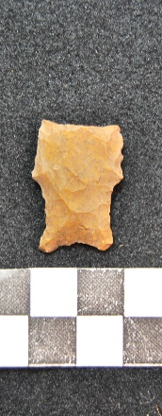
Figure A.36: Bajada from 5SH1813.

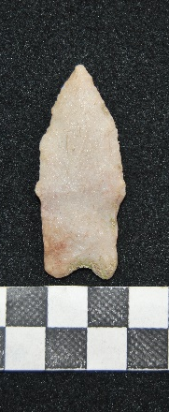
Figure A.37: Bajada from 5GN1276.

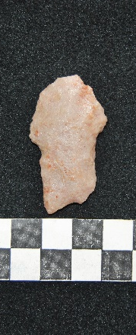
Figure A.38: Bajada from 5GN1276.

Figure A.39: Pinto from 5GN817.

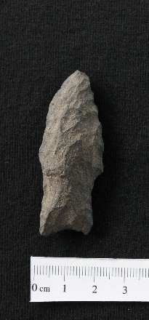
Figure A.40: Bajada from 5GN5101.

