University of Oklahoma

Graduate College

THE EFFECTS OF EXERCISE-INDUCED MUSCLE DAMAGE IN TRAINED FEMALES FOLLOWING REPEATED SPRINT ACTIVITY

A thesis

submitted to the Graduate Faculty

in partial fulfillment of the requirements for the

Degree of

Master of Science

By

NICHOLAS CARL HODGSON
Norman, Oklahoma
2018

THE EFFECTS OF EXERCISE-INDUCED MUSCLE DAMAGE IN TRAINED FEMALES FOLLOWING REPEATED SPRINT ACTIVITY

A thesis approved for the
Department of Health and Exercise Science

By

______________________________
Dr. Jason A. Campbell, Chair

______________________________
Dr. Christopher D. Black

______________________________
Dr. Rebecca D. Larson

© Copyright by NICHOLAS CARL HODGSON 2018
All Rights Reserved.

Acknowledgements
First, I would like to thank my committee, Dr. Jay Campbell, Dr. Rebecca Larson, and Dr. Christopher Black, as well as the rest of my professors from the Health and Exercise Science department. You all have been instrumental to my educational development, and I am forever grateful for you continuing to challenge me academically and for making coming to class/work enjoyable. Next, I’d like to say thanks to my lab mates, Nicole McGuire and Joel Prowting, for putting up with me constantly asking for help with data collection and carrying equipment to and from the Huff. From sharing funny YouTube videos to complaining about the daily struggle, y’all made sitting in that unbelievably hot office enjoyable. Next, I have to say thank you to my parents. You have given me more than I could possibly ask for, and it’s because of your positive influence that I’ve gotten this far. Y’all have helped me to become the man I am today, and for that I owe all of my accomplishments to you. Last, but certainly not least, thank you Karolina for being my best friend, for constantly pushing me to better myself, and for being my forever travel buddy. Whether you’re getting on to me for procrastinating or dragging me on a new adventure, you always find a way to make my life better. I love you!

Table of Contents
Acknowledgements iv
List of Tables viii
List of Figures ix
Abstract x
Chapter 1: Introduction 1
Purpose of the Study 4
Research Questions 5
Hypotheses 5
Significance of the Study 6
Delimitations 6
Limitations 7
Assumptions 7
Operational Definitions 8
Chapter II: Review of Literature 10
Exercise-Induced Muscle Damage and Delayed Onset Muscle Damage 11
Plyometric and Repeated Sprint EIMD Protocols 12
Repeated Bout Effect 13
Gender Differences 14
Countermovement Jump 15
Inertial Measurement Units 16
Session RPE 18
Summary 18
Chapter III: Methodology 20
Participants 20
Inclusion Criteria 21
Exclusion Criteria 21
Experimental Design 22
Data Collection Procedure 24
Visit 1: Informed consent and familiarization 24
Visits 2, 4, 6, 8: Repeated Sprint Protocol 24
Visits 3, 5, 7, 9: Post-Test Evaluations 26
Countermovement Jump Metrics 26
Sprint Measurements 27
Blood Lactate 28
Perceived Muscle Soreness and Session RPE 28
Research Design 29
Data Management and Analysis 29
Chapter IV: Results 31
Participant Characteristics 31
Sprint Performance 32
Player Load 33
Countermovement Jump Metrics 36
Exercise Performance and CMJ 39
Blood Lactate 39
Perceived Soreness 40
Session RPE 42
Chapter 5: Discussion 44
Sprint Performance 44
Player Load 45
Countermovement Jump Metrics 47
Exercise Performance and CMJ 48
Blood Lactate 49
Perceived Soreness 50
Session RPE 50
Chapter VI: Conclusion 51
Key Findings 51
Limitations 51
Future Research Directions 52
References 54
Appendix A: IRB Approval Letter 60
Appendix B: Informed Consent Form 61
Appendix C: HIPAA 64
Appendix D: Health Status Questionnaire 67
Appendix E: International Physical Activity Questionnaire 70
Appendix F: Physical Activity Readiness Questionnaire 76
Appendix G: Rhabdomyolysis Screening Form 77
Appendix H: Menstrual History Questionnaire 78

List of Tables
Table 1. Subject Characteristics 31
Table 2. Sprint Performance 32
Table 3. Velocity Change Scores 32
Table 4. Countermovement Jump Metrics 38
Table 5. Blood Lactate 40

List of Figures

Figure 1. Overview of experimental procedures. 23
Figure 2. Schematic of EIMD protocol. 26
Figure 3. Mean total player load across visits 2, 4, 6, and 8. 34
Figure 4. Mean relative player load across visits 2, 4, 6, and 8. 34
Figure 5. Mean values for average player load across visits 2, 4, 6, and 8. 35
Figure 6. Mean lactate values at Pre, IP, and 3P across visits 2, 4, 6, and 8. 41
Figure 7. Upper Body Soreness 42
Figure 8. Lower Body Soreness 42
Figure 9. Total Body Soreness 43
Figure 10. Mean RPE for IP and 30P time points across visits 2, 4, 6, and 8. 44

Abstract

Purpose: The purpose of the study was to evaluate the use of a sprinting protocol to consistently generate exercise-induced muscle damage using an active female population, and to observe how jumping metrics and sprint performance change due to muscle damage. The study also looked to examine the relationship between sprint velocity and player load, and how they relate to repeated sprint ability and lactate clearance. By using a field-based EIMD protocol in an active female population, the relationship between sprinting, jumping, and physiological markers of fatigue were examined. Methods: 10 trained females who routinely participate in sprint-based activity performed a repeated sprint protocol consisting of five sets of 8 maximal sprints, 20-meters in length, with a 5-meter deceleration zone. Immediately following the completion of each set of sprints, the participants performed a series of three countermovement jumps on a dual force plate, followed by a 2-minute period of rest prior to the start of the next set of sprints. Blood lactate and RPE were assessed immediately following the completion of the fifth set, with a repeated lactate test performed 3-minutes post and RPE 30-minutes post. Following 24-48 hours of rest, participants returned and provided soreness ratings, performed a set of three 20-meter maximal sprints with a 5-meter deceleration zone, and 3 countermovement jumps on a force plate to determine if the performance declines during the repeated sprint protocol are due to fatigue, muscle damage, or a combination of the two. Results: The repeated sprint protocol resulted in decreased sprint times and CMJ force metrics that persisted for up to 24-48 hours. The protocol also induced a high physiological load, as evidenced by elevated lactate values post-exercise and significant soreness in follow-up visits. Conclusion: Through this investigation, it was concluded that the protocol was a valid and reliable means of eliciting EIMD, with decrements in both sprinting and jumping performance persisting for up to 24-48 hours following the completion of the protocol.

Chapter 1: Introduction
Performance in sports requires the ability to quickly make decisions and sustain high levels of intensity throughout the duration of the competition (8). Repeated sprint sports frequently expose players to situations that demand maximal neuromuscular effort and require athletes to perform bouts of intermittent high-intensity muscle contraction that can place a large emphasis on eccentric contractions (9, 13). Eccentric (lengthening) contractions place a large amount of stress on muscles, with repeated contractions leading to exercise-induced muscle damage (EIMD), which is characterized by soreness, swelling, and a decreased ability to generate force (7). Research has indicated that inability to generate explosive force leads to diminished functional performance ability (14) and can be indicative of increased risk of future injury (12).
EIMD in athletes is observed when performing novel tasks or exercise that heavily relies on an eccentric component (14). To evaluate the timeline of recovery from EIMD, several different protocols involving jumping or cycle-ergometers have been established for inducing EIMD (5). A field-based protocol that may be more applicable for intermittent sprint sports was validated by Woolley et al. (14) which used repeated sprinting as a test to elicit EIMD and was shown to produce similar results when compared to a plyometric muscle damage protocol. Performance of multiple trials of a sprinting protocol was able to evaluate the damage response in an active female population (7) and accounted for adaptations that limit EIMD (16). The use of multiple trials can account for the repeated bout effect (RBE), which serves to attenuate force loss, soreness, and swelling associated with EIMD, allowing the athletes to maintain maximal performance during high intensity exercise or competition (10).
A countermovement jump (CMJ) test performed on a force plate has been shown to be an effective assessment of neuromuscular function due to the in-depth analysis of many kinetic and kinematic variables within the jumping motion related to both force production and power output. CMJ testing provides long-term decreases in performance that are highly repeatable (CV <5%) and is ecologically valid as it is a familiar motion for team-sport athletes (23). By examining changes in the timing and force production of these variables, EIMD and neuromuscular fatigue have been accurately measured in female athletes when compared to traditional isometric MVC testing. Traditional jump testing tends to focus on the concentric force output during the jump, but including eccentric components can better relate CMJ testing to repeated sprinting as an assessment of exercise performance monitoring (23). A single countermovement jump is highly practical to repeated sprint activity due to the emphasis on the stretch-shortening cycle and has low physiological strain on the body. This allows multiple jumps to be used within a testing session and averaged together for higher reliability without significantly impacting the protocol (27). Additionally, long-term monitoring of training load coupled with CMJ testing can be a useful tool for observing mechanical adaptations to training and competition related to force production and performance. These changes in jumping related to muscle damage are of great value for evaluating events which can increase an athlete’s injury risk (28).
Inertial measurement units (IMU) are trunk-mounted devices that are used to track an athlete’s movements during sporting events. Utilizing Global Navigation Satellite Systems (GNSS), accelerometers, gyroscopes, and magnetometers, the units can identify and quantify sport-related movements (30). IMU’s are used to quantify an athlete’s physical exertion beyond simply measuring speed and distance. They also offer the ability to group movement patterns together based on intensity to assess the total physical load experienced during a training session or competition (31). Repeated use of IMU’s creates a movement profile for an individual, and over time deviations from expected movement patterns can be observed, indicating fatigue, muscle damage, or an increased risk for future injury associated with high intensity exercise.
During high intensity exercise the demand for energy exceeds the body’s ability to produce it via aerobic pathways, leading to an increased reliance on glycolysis for energy. The insufficient amount of oxygen available results in an increased conversion of pyruvate from glycolysis to lactate in an attempt to meet ATP demands. When lactate production exceeds the body’s ability to consume it, lactate threshold (LT) is reached, leading to decreased blood pH and fatigue (25). Previous research has shown that endurance training increases lactate threshold due to an increase in oxidative enzymes, which increases lactate clearance (26). However, the relationship between lactate clearance to sprint velocity and player load during repeated sprint exercise is currently uncharacterized. Coupling blood lactate measurements with player load from an IMU could relate repeated sprint ability in female athletes to lactate clearance and maximum velocity during sprints. Additionally, the use of blood lactate provides an internal quantification of training load, which can be examined across repeated exercise bouts to compare exercise intensity.
Previous research has shown that a jumping protocol can elicit EIMD, and a field-based sprinting protocol has been validated against jumping protocols to induce muscle damage in sport-related tasks (14). Additionally, countermovement jumps have been shown to be suitable for evaluating neuromuscular fatigue, as the force plate is able to provide a detailed analysis of kinetic and kinematic variables throughout the entirety of the jump (23). By performing a repeated sprint protocol coupled with CMJ and lactate analysis utilizing an active female population, there is potential to validate the field-based protocol and characterize muscle damage in female athletes in sports such as soccer, lacrosse, field hockey, and possibly basketball. The previous work that has shown a repeated sprint protocol can elicit EIMD (7, 14) and that CMJ testing can identify changes in neuromuscular function (23, 27, 28) does not directly relate the two tasks within the same testing protocol. Therefore, including CMJ testing intermittently throughout a repeated sprint protocol may provide insight into the fatigue-related changes to acceleration/deceleration capabilities and the rate of decay of proper technique. Characterizing these changes are critical to proper prescription of training loads and determination of correct intermittent recovery periods during match play.

Purpose of the Study
The purpose of the study is to evaluate the use of a sprinting protocol to consistently generate exercise-induced muscle damage using an active female population, and to observe how jumping metrics and sprint performance change due to muscle damage. The study also looks to examine the relationship between sprint velocity and player load, and how they relate to repeated sprint ability and lactate clearance. By using a field-based EIMD protocol in an active female population, the relationship between sprinting, jumping, and physiological markers of fatigue can be examined.

Research Questions
- How are changes in countermovement jump metrics and repeated sprint performance related in female athletes?
  - Will the fatigue characteristics of repeated sprinting reflect the changes in countermovement jump performance?
- What is the relationship between changes in sprint velocity and player load in female athletes?
- What is the relationship between repeated sprint ability and lactate clearance in female athletes?
Sub-Question
  - How do subjective damage ratings change following a repeated sprinting protocol?

Hypotheses
- There will be a decline in sprint performance during the repeated sprint protocol, determined by time increases and velocity decreases in the final sprints of the protocol.
  - There will be a significant relationship between fatigue characteristics of repeated sprinting and countermovement jump performance
- There will be a significant relationship between sprinting metrics and countermovement jump metrics during the repeated sprint protocol.
- Sprint velocity and player load will have a significant relationship with repeated sprint ability and lactate clearance.

Significance of the Study
Literature shows that plyometric protocols have been able to consistently generate exercise-induced muscle damage, which causes decline in sports performance (2,5,7,12,14). Additionally, studies have shown that a sprint protocol with a short deceleration phase compared to the acceleration phase is a valid measure to induce muscle damage due to a heavy reliance on eccentric contractions (7,14). However, the current research is lacking when focusing specifically on a female population. Performing a sprint protocol on well-trained female athletes would have the benefit of validating the protocol across genders, as well as comparing the recovery timeline after exercise-induced muscle damage between men and women. Most current research in EIMD focuses on male populations, and the lack of female research could prove beneficial in evaluating potential differences in muscle damage between genders and determine training strategies that prevent decline in match performance. Additionally, the study could be continued further to examine RBE on heavy eccentric loading to establish a training protocol for injury reduction.

Delimitations
Delimitations for this study include:
- Participants were active females with a history of repeated sprint sports (18-35 years).
- Participants were recruited from the University of Oklahoma.
- Participants could not participate in the study if they answered “yes” to any questions on the PAR-Q, or indicated any reason that they are unable to perform high-intensity physical activity.
- Participants could not have experienced lower body injury within the previous six months.
- No exercise took place within 24 hours of testing to prevent residual fatigue present during testing.
- Caffeine consumption was maintained consistently within the last 24 hours prior to each trial.

Limitations
Limitations for this study include:
- Previous sporting events could have exposed subjects to eccentric loading, diminishing the effects of the EIMD protocol.
- No muscle fiber typing was used during the current investigation. (differences in fiber type composition may impact the extent of muscle soreness due to the preferential recruitment of Type II muscle fibers during eccentric contractions).
- A menstrual cycle history was included to ensure that a normal menstrual cycle is occurring, but the phase of menstrual cycle where testing occurs was not standardized.

Assumptions
- Subjects were honest when reporting any lower body injuries in the previous six months.
- All performance tests, as well as the sprint protocol, were performed with maximal effort.
- Researchers were experienced with the necessary equipment and collected data accurately.
- All equipment used in the collection of data was valid and reliable for the current study.

Operational Definitions
- Delayed Onset Muscle Soreness (DOMS) – Muscle soreness or pain that occurs 24-48 hours after exercise that is either unfamiliar or higher intensity than previously performed (1).
- Exercise-Induced Muscle Damage (EIMD) – Damage at the cellular level of skeletal muscle due to eccentric exercise; characterized by inflammation, soreness, and decreased force production (2).
- Rate of Force Development (RFD) – An individual’s neuromuscular ability to rapidly generate force at the onset of muscular contraction (10).
- Repeated Bout Effect (RBE) – A protective effect experienced following unaccustomed exercise in order to prevent future muscle damage (16).
- Visual Analogue Scale (VAS) – A scale from 0-10 that allows subjects to estimate soreness following a muscle damage protocol, with 0 meaning “no soreness at all” and 10 meaning “most intense pain imaginable” (12).
- Inertial Measurement Units (IMU) – A trunk-mounted device that records a person’s location via GNSS, as well as the body’s specific force, orientation, and torque about the center of gravity using an accelerometer, gyroscope, and magnetometer.
- Neuromuscular Fatigue – The inability to maintain a required force output, due to either central or peripheral limitations (24).
- Player Load – A measure of an athlete’s work rate through a combination of the accelerations produced by three planes of body movement (32).
√((fwd_{t=i=1} – fwd_{t=i})² + (side_{t=i=1} – side_{t=i})² + (up_{t=i=1} – up_{t=i})²)

Chapter II: Review of Literature
Intermittent high-intensity muscle contraction is a requirement to meet the demands of sport-specific performance. Meeting this demand requires maximal neuromuscular effort (9), which can result in an athlete sustaining damage to their working muscles. Exercise-induced muscle damage (EIMD) is a well-studied field, as it is a major contributor to athlete soreness and decline in performance (1, 2). It has been shown that trained subjects have a reduced susceptibility to the effects of EIMD, and that chronically trained individuals experience a smaller decline in performance (2, 15). Repeated trials of eliciting EIMD have shown that the repeated bout effect (RBE) lessens decline in rate of force development, which is attributed to increased resistance to muscle damage due to eccentric loading (3, 10, 16).
Numerous studies have been performed to examine the effects of EIMD on athletic performance (2, 5, 7, 12, 14), and a plyometric protocol has been established as a valid way to induce EIMD (2, 5). Research has also demonstrated that a protocol involving repeated sprinting, which has strong ecological validity for use with field-based, intermittent sports can elicit EIMD when the deceleration interval is shortened compared to the acceleration interval. This places a larger bias toward eccentric loading and has been used in place of a plyometric protocol when studying EIMD (5, 12, 14). However, while the criterion validity has been established for a repeated sprint damage protocol, research in the area primarily focuses on male athletes, with very little research focusing on the damage response of female athletes (7). Additionally, there is no research examining how the RBE mechanism differs between genders, and if training status can affect response to multiple bouts of EIMD in elite female athletes. It is possible that while validating the use of a sprint protocol for EIMD in active female athletes, additional insight to gender differences could be observed based on recovery time from muscle damage and declines in performance over time.

Exercise-Induced Muscle Damage and Delayed Onset Muscle Damage
Literature has indicated that one of the symptoms indicative of EIMD is delayed onset muscle soreness (DOMS) following exercise that is unfamiliar or at a higher intensity than an athlete is accustomed to, occurring 24-48 hours after the completion of exercise (1, 7, 12, 14). DOMS is categorized as a type I muscle strain, which is accompanied by stiffness and a reduced range of motion due to pain during movement. The believed mechanism of EIMD leading to DOMS is that large eccentric loading during an EIMD protocol causes disruptions during the stretch-shortening cycle of a muscle contraction, leading to breakage in the actin-myosin connections and damage of muscular protein structures (1, 2). This disconnecting of cross-bridges disturbs the cell membrane, increasing intracellular calcium levels and activating calcium-sensitive degradative pathways which further the damage to the muscle. An inflammatory response to muscle damage transfers fluid into the damaged area, which serves to initiate the repair and regeneration process (2, 33). This swelling and pressure within the muscle may account for the reduced range of motion and hyperalgesia (2).
A study by Thompson et al. examined the effects of a high-intensity shuttle running regimen on muscle soreness, where participants completed a ninety-minute protocol that involved movement at a variety of speeds designed to mimic the actions of competitive multiple-sprint sports (12). The subjects were assessed based on muscle soreness and blood markers for EIMD. The results indicated significant increases in both the level of muscle soreness and blood plasma markers for muscle damage-related metabolites. These findings agree with other work (1, 2, 3) in establishing that DOMS can serve as an indicator of EIMD following high intensity exercise.

Plyometric and Repeated Sprint EIMD Protocols
There have been multiple studies indicating that a plyometric damage protocol is a valid method of eliciting EIMD (2 ,5, 7, 14). This protocol involves performing ten sets of ten countermovement or drop jumps, with emphasis on returning to ninety-degrees of knee flexion upon landing to exaggerate the eccentric component of the jump movement. The exaggerated eccentric motion elicited EIMD in each study performed, supporting is use as a reliable protocol for inducing muscle damage (5, 14). However, a new protocol for muscle damage involving repeated sprints would have greater ecological validity, as the sprints are more specific to the most common movements of repeated sprint sports.
Several experiments established that a sprinting protocol is sufficient in creating EIMD due to the eccentric loading placed on the legs, specifically the hamstrings, during repeated sprinting (1, 12, 13). To establish criterion validity for a sprinting protocol, Woolley et al. designed a study in which subjects performed both a plyometric protocol and a sprint protocol that included a short deceleration zone to emphasize eccentric loading, with a four-month washout period between testing sessions to prevent RBE interference. The results of the study showed that both protocols successfully elicited EIMD, with the sprint protocol generating EIMD to a greater extent than the traditional plyometric protocol (14). These findings help establish the agreement between studies and potential use of a sprint protocol for EIMD (1, 12, 13), as well as validating the protocol to be used in place of plyometrics (14).

Repeated Bout Effect
The repeated bout effect (RBE) is a protective mechanism used by the body after exposure to eccentrically based muscle damage (16). This mechanism occurs through changes in neural input, as centrally-mediated force-inhibiting neural mechanisms reduce the response to voluntary contraction (11, 14). The result is a decreased activation during the stretch-shortening of muscle contraction in order to prevent further damage to muscles when additional bouts of eccentric exercise are performed (14). To examine the time course of the repeated bout effect, Clarkson et al. (3) examined muscle damage and adaptation following an eccentric overload in the elbow flexors. The findings of the experiment indicated that rapid adaptation is observed between repeated bouts of exercise, as serum creatine kinase activity, an indicator of muscle damage, was significantly reduced in repeated trials. However, these results seem to differ from a study that measured EIMD in resistance-trained men, which used EMG to determine that neural adaptations had not occurred in chronically trained individuals (15). While overall ability to recruit muscle fibers decreased in all individuals in the study, the researchers determined that EMG activity remained unchanged following repeated studies. The author also stated limitations of measuring EMG activity following eccentric exercise rather than during the protocol, so further research is warranted to determine if RBE effects agree with previous work (2, 11, 14, 15, 16).

Gender Differences
Men and women have been shown to respond differently to exercise, observed through both external and cellular examination. Fulco et al. (38) indicated that women fatigue at a slower rate than men, and have faster recovery times between muscle contractions. At a cellular level, Kellawan et al. (39) demonstrated that exercise vasodilation is significantly greater in females following submaximal exercise. For measuring responses to high intensity exercise, there are many indirect measures of muscle damage with known time courses that are commonly used in place of invasive muscle biopsies, including loss of force production, soreness, inflammation, and increases in serum muscle protein markers (35). However, conflicting results of studies attempting to differentiate muscle damage between genders indicate that the true EIMD response between genders is still unknown.
A study by Stupka et al. (36) examined the muscle damage response between genders following eccentric exercise. The study consisted of measuring blood protein markers, direct cellular structure, and an inflammatory response. They found that cellular damage was similar between genders, and that creatine kinase activity was not significantly correlated to muscle damage. However, the females in the study had an attenuated inflammatory response despite the same amount of muscle damage. These findings were suggested to be attributed to the antioxidant effects of 17β-estradiol, but it was noted that further investigation was needed. Similarly, Sewright et al. determined that there were no differences between sexes in soreness or myoglobin levels following eccentric exercise, but it was noted that men experienced greater CK levels than women, and women experienced greater strength loss immediately following exercise (35).
While much research has been done to examine EIMD in sports-related athletics (2, 3, 5, 8, 10, 12, 13, 14), these studies focus their attention on a male population. A lone study verifies the use of a repeated sprint protocol to elicit EIMD in elite female athletes (7), and currently only one study has been published comparing RBE responses between genders (20). Hunter (6) determined that women are less fatigable compared to their male counterparts, and that the difference is task specific due to how women react to certain stressors and intensities compared to males. It is further stated that a possible explanation is a lower pain threshold in women, which alters voluntary activation and prevents fatigue and muscle damage (6). A separate study by Hunter (37) indicated that sex differences in fatigability during dynamic exercise are task and velocity dependent, and that the differences are due to contractile mechanisms rather than sex differences in voluntary activation. Additional mechanic studies are needed to determine differences between genders in EIMD and RBE, and the lack of study in the area of elite female athletes provides a large potential for new research.

Countermovement Jump
A countermovement jump (CMJ) is a form of vertical jumping useful for assessing neuromuscular function. CMJ tests utilizing a force plate also provide the ability to obtain data related to both force and power output, which is valuable for monitoring changes in performance over time. CMJ testing is more standardized than performance of a simple vertical jump or drop jump and therefore can provide more consistent data for analysis (29). When performed properly, CMJ testing on a force plate provides useful data that mimics a common action during repeated sprint sports, and places low physiological strain on the participant, allowing it to be repeated without significantly contributing to a fatiguing protocol (27).
A study performed by Markström and Olsson (40) looked to examine the relationship between multiple forms of jumping performance and sprint performance in track and field athletes. Through multiple regression analyses, the results indicated that CMJ peak force regulated for body weight was a significant predictor of sprint performance in track athletes. Furthermore, it was determined that CMJ was the most accurate form for jumping performance, as the drop jumps and squat jumps did not yield significant results. These findings agree with Gathercole et al. (23), who determined that CMJ testing is the most suitable jumping test for monitoring neuromuscular function due to high repeatability and sensitivity to changes in performance, as well as Cormack et al. (29) who determined that a single CMJ was the most reliable method of observing responses to acute and chronic exercise. By performing a single countermovement jump in between sets of repeated sprints during an EIMD protocol, the sensitivity of metrics such as peak force and rate of force development allow a decline curve to be formed, providing valuable insight for future prediction of injury risk.

Inertial Measurement Units
A trunk-mounted Inertial Measurement Unit (IMU) is a device used to quantify movements of repeated sprint sports to determine a player’s total workload. In addition to GNSS data such as speed and distance, IMUs use accelerometers, magnetometers, and gyroscopes to capture high intensity movements including jumping, collisions, tackling, accelerations, and decelerations, and other physically demanding actions that would otherwise be considered low intensity (31). The sum of all movements detected by the IMU indicate an athlete’s player load, which can be used to monitor workload throughout acute or chronic bouts of exercise (32). Long-term monitoring of a single athlete using an IMU can create a movement profile where the device can recognize specific motions and movement patterns, and any deviations from normal patterns may be indicative of future injury during exercise. Given that a female athlete is 6-8 times more likely to experience a non-contact ACL injury than a male performing the same exercise (41), monitoring female athletes provides valuable insight for preventing future injury due to high intensity exercise.
A multifaceted study by Boyd et al. (42) sought to determine the reliability of an IMU for use in repeated sprint sports. In a laboratory setting, eight IMUs were attached to a hydraulic shaker, and the field-based component consisted of ten athletes each wearing two units taped together to ensure that the axes of the accelerometers were aligned with each other. The findings of the study were showed that the between- and within-device coefficients of variation were less than 2% for all trials of the laboratory protocol, and the field-based testing revealed very strong correlation between units (r=0.996-0.999). These findings agree with the work of Varley et al (18) who determined that GPS units are valid and reliable when compared to a criterion measure of laser timing gates. Very strong Pearson correlations (>0.9) indicate that the units are valid for use during acceleration, deceleration, and constant velocity for multiple speeds. These studies show that a valid and reliable IMU device can be used successfully for athlete monitoring. While previous work has used IMU tracking for a female population, these is currently no research that couples an IMU with CMJ performance to determine if there is a relationship between force declines and changes in movement profiles and player load during a muscle damage protocol.

Session RPE
Session RPE is a concept designed by Foster et al. (43) to quantify the intensity of an entire bout of exercise by combining instantaneous RPE with training impulse. The use of session RPE allows for all physiological stressors an athlete experiences to be combined into a single score, which allows for a simple evaluation of how physically demanding a training session or competition is for an athlete (44). Through a series of changing exercise modalities, it was determined that session RPE is strongly correlated to heart rate during exercise and can be used as an indirect measure of heart rate (43). Additionally, Pustina et al. (45) determined that session RPE is a valid indicator of training response. Using collegiate soccer players, it was determined that session RPE was significantly correlated with distance covered and minutes played during competitions, indicating that it can be used to evaluate workloads of participants in repeated sprint sports.

Summary
Both plyometric and repeated sprint protocols have been validated for use to elicit EIMD based on their heavy eccentric components, and that muscle damage can be observed through DOMS, blood plasma markers, and declines in exercise performance (2, 5, 7, 12, 14). It is clear that there is a knowledge gap in the effects of muscle damage in a female population. While a large amount of research has been done recently to study the effects of EIMD, the tendency to focus on a male population needs to be balanced with similar investigations into the female population. A study involving a repeated sprint protocol in female athletes could serve to validate the use of the protocol for women, and inclusion of countermovement jumping throughout the protocol can provide a valuable force decline curve without influencing the results of the sprint protocol. Repetition of the protocol over time is also important to study the RBE mechanism in women. Lastly, this research would be beneficial for female athletes to construct training regimens with the hopes of minimizing declines in performance, highlight the time-course and characteristics of recovery, as well as, potentially reduce injury risk following muscle damage.

Chapter III: Methodology
As previously stated, the purpose of this study was to investigate the utility of a repeated sprint protocol as a field-based test for evaluating fitness and fatigue characteristics in in female athletes. This fatiguing protocol was expected to generate exercise-induced muscle damage (EIMD), and thus a second purpose was to evaluate the recovery process in these active females (e.g. subjective soreness, force production) by relating changes in jumping metrics and repeated sprint performance. Lastly, the study also looked to examine the relationship between velocity and player load to repeated sprint ability and lactate clearance. There is a growing interest in the use of microtechnology for tracking athletes in order to assess physical performance and injury risk. However, most of the current use of these technologies has been with male athletes in rugby, Australian rules football, soccer, and American football. Thus, acceleration and velocity-based metrics are missing in the female athlete population. Additionally, there is little research examining EIMD with a specific focus on females, and current literature does not articulate changes in performance at different stages of the protocol.

Participants
Based on a power analysis (G*power) using a 1-β of 0.80, 19 participants were required, thus up to 25 active women between the ages of 18 and 35 were recruited from the University of Oklahoma women’s rugby team, as well as additional active females who routinely participate in sprint-based activity to allow for participant attrition. Participants could not have been previously exposed to an eccentric loading protocol prior to participating in the current study. Participants needed to be free of any lower body injury within the previous six months. All participants consented to voluntary participation and were not given compensation for participation in the study. All participants were highly active females, capable of performing countermovement jumps and repeated sprints. Informed consent, health history status questionnaire, rhabdomyolysis screening, PAR-Q, and menstrual history documents were reviewed and signed by all subjects prior to the start of testing. All participants were active females on the University of Oklahoma women’s rugby team or females participating in similar levels of repeated sprint activity, which satisfied the criteria for inclusion (14).

Inclusion Criteria
- Participants were either active female athletes from the University of Oklahoma rugby team, or other active females routinely participating in sprint-based activity.
- Participants had not been previously exposed to an EIMD protocol, eccentrically-biased training, and had not experienced significant lower body injury within the previous six months.
- Participants between 18 and 35 years of age.
- Participants experience normal menstrual history.

Exclusion Criteria
- Men, as this study was based on the validation of a sprinting protocol in a female population.
- Participants who had experienced significant lower body injury in the previous six months were not allowed to participate.
- Any participants previously exposed to eccentric loading protocol in order to elicit EIMD were excluded.
- Any female participants not experiencing a normal menstrual cycle.

Experimental Design
This study employed a within-participant, repeated measures design where each participant acted as their own control. Repeated measures testing throughout the experimental protocol were used in order to identify a sprint performance and force decline curve. A total of nine visits were required to account for all measurements, including a familiarization visit prior to data collection. An overview of the protocol can be seen in Figure 1 below:
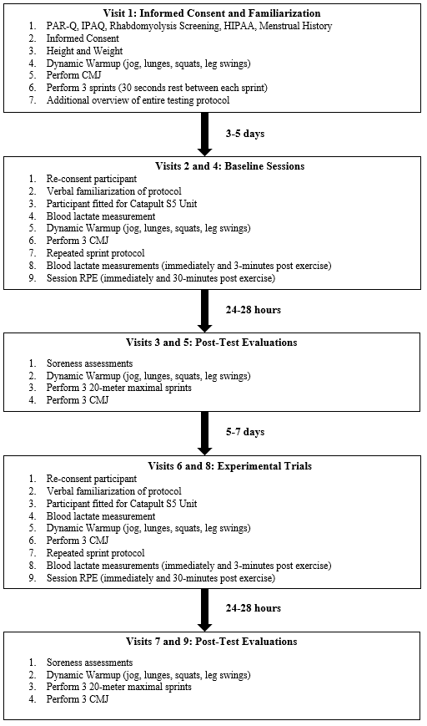
Figure 1. Overview of experimental procedures.

Data Collection Procedure

Visit 1: Informed consent and familiarization
The first visit was used to obtain informed consent, as well as to provide a familiarization to all participants in the study. Upon completion of the informed consent, health status questionnaire, rhabdomyolysis screening form, PAR-Q, HIPAA, and menstrual history documents, participants were fitted to determine the proper size of the Catapult compression garment. Height was measured using a Stadi-O-Meter (Novel Products, Inc., Rockton, IL, USA), and weight was recorded using the ForceDecks (FD4000, NMP ForceDecks Ltd., London, England). A dynamic warmup consisting of a 2-3-minute jog, 10 lunges with each leg, 10 body weight squats, and 10 forward leg swings with each leg was shown to the participants, as it was used before each testing session. Participants were then shown the proper mechanics of a countermovement jump and asked to perform a series of three jumps on the force plate to familiarize the testing procedure. Following jumping, participants were then shown the sprinting course and instructed to perform three sprints, consisting of a twenty-meter sprint zone and a five-meter deceleration zone. A thirty-second break was given between each of the sprints. Once the participants had gone through a familiarization, an additional overview of the entire testing protocol was given in order to ensure that participants were fully informed about all aspects of the protocol, including lactate testing procedures.

Visits 2, 4, 6, 8: Repeated Sprint Protocol
Visits 2 and 4 served to provide baseline measurements for each participant, and to observe any changes in force decline due to the repeated bout effect. Visits 6 and 8 served as experimental trials for each participant. The testing visits began by obtaining a verbal re-consent from the participants, followed by a verbal familiarization of the protocol. Participants were fitted for the Catapult OptimEye S5 units (Catapult Sports, Melbourne, Australia) which were turned on and allowed to link to a locally positioned data acquisition tower before being inserted into the garments. Participants were taken through the dynamic warmup previously outlined and performed three countermovement jumps to determine proper recovery from the previous session, and blood lactate was assessed. If not fully recovered, the participants were given 48 more hours of rest in order to ensure that trials began from a consistent starting point. Once the Catapult device and radar gun were active, the participants began the sprinting protocol, which consisted of five individual sets. Each set consisted of eight, 20-meter maximal sprints with a 5-meter deceleration zone. Participants were give 30 seconds of rest between each sprint. Participants came to a complete stop within the deceleration zone to emphasize eccentric loading. After reaching a complete stop, participants walked to the next starting point during the rest period, as shown in Figure 2. Immediately following the completion of each set of sprints, the participants completed a series of three countermovement jumps, followed by a 2-minute period of rest. Blood lactate was assessed immediately following the completion of the fifth set, with a repeated test performed 3-minutes post.
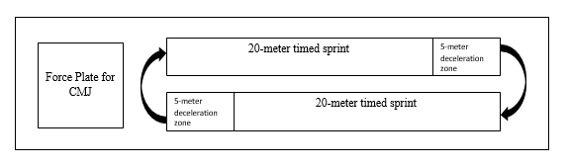
Figure 2. Schematic of EIMD protocol.

Visits 3, 5, 7, 9: Post-Test Evaluations
Following the completion of each repeated sprint protocol (visits 2, 4, 6, 8), participants were asked to return for a follow-up visit after 24-48 hours of rest. Participants were asked to assess their upper body, lower body, and global soreness levels using the VAS. The participants then performed the dynamic warmup previously outlined, and performed a total of three 20-meter maximal sprints with 30 seconds of rest between each sprint. Participants then performed a series of three countermovement jumps. These post-test visits were used to determine if the performance declines during the repeated sprint protocol are due to fatigue, muscle damage, or a combination of the two.

Countermovement Jump Metrics
All jumping metrics were assessed using a countermovement jump. The ForceDecks bilateral force plate system and accompanying software was used for measurement with a sampling rate of 1000Hz. The ForceDecks has been used in previous work to accurately portray countermovement jump power output (17). Participants started from a standing position, squatted down to a 90-degree knee angle and jumped vertically, keeping their hands on their hips so that power was only generated from the legs. Concentric mean force (ConMF), concentric peak force (ConPF), eccentric mean force (EccMF), eccentric peak force (EccPF), peak power output (PPr), concentric mean power output (ConMP), eccentric mean power output (EccMP), concentric rate of force development (ConRFD), as well as concentric time to peak force (ConTPF) and flight time to contraction time ratio (FTCT), were recorded during each series of jumps and compared within subjects to characterize the resulting fatigue curve.

Sprint Measurements
Sprint performance was measured by means of a 20-meter maximal sprint test where sprints were recorded using a Stalker II ATS radar gun (Applied Concepts, Plano, TX, USA). Previous literature has shown that the radar gun is an accurate means of measuring sprint time and velocity and is often used as the gold standard in comparison studies versus timing gate systems (46). A sprint percentage decrement score (S_{dec}) was calculated using the following formula:
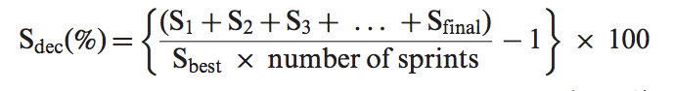
Girard et al. (4) found the S_{dec} calculation was the most valid and reliable method to quantify fatigue in tests of repeated-sprint ability.
Additionally, participants were equipped with inertial motion-analysis units (IMU). The IMU’s contain accelerometers and gyroscopes and were utilized to quantify linear and angular kinetics associated with the subjects’ movement patterns during maximal sprinting. The Catapult device has previously been shown to accurately and reliably measure repeated sprint ability across a wide variety of sport performance levels (18).

Blood Lactate
Blood lactate was analyzed using a Nova Biomedical Lactate Plus Meter (NOVA Biomedical, Waltham, MA, USA) using capillary blood from the participant’s finger. The Lactate Plus meter is a valid and reliable instrument for the assessment of blood lactate during exercise testing (21). Use of the finger for blood lactate has been shown to be a valid measure, as previous work has indicated that there are no statistical differences between measurements from the brachial artery and finger capillary blood (22). Lactate measurements were obtained by puncturing the skin of the finger with a lancet, then using capillary action to draw blood onto the testing strip of the meter. Use of lactate measurements provided a method of quantifying internal work load to compare across all trials within each participant.

Perceived Muscle Soreness and Session RPE
Subjective muscle soreness was reported by the subjects using a visual analogue scale (VAS) with a scale of 0-10. The scale consists of a 100mm line that participants place a mark on to indicate their level of soreness. The mark is measured as a distance from the 0 value to obtain the perceived soreness ranking. A value of 0 indicates “no soreness at all” and a value of 10 represents “most intense pain imaginable”. Soreness was assessed prior to the start of the sprinting protocol once the subject performed 3 squats with approximately 90 degrees of flexion and then returned to the standing position (12). Measurements of soreness included lower body, upper body, and global soreness. The VAS was utilized to ensure that participants did not have any soreness prior to the EIMD protocol.
The rating of perceived exertion for each sprinting session (sRPE) was recorded immediately upon completion of the sprinting protocol, as well as following a 30-minute washout period once all sprinting sets were completed in a trial. Session RPE was used to help evaluate whether the intensity of each experimental session was comparable across trials.

Research Design
The design of this study allowed for research questions to be answered because it relied on an active female population without previous eccentric loading training. By testing both running and jumping as performance indices, as well as measuring blood lactate, the study examined changes in sport-specific tasks, which increases external validity of the study. Repetition of the same protocol multiple times allowed for buffering due to the repeated bout effect to be observed, and still examine the changes in sprint and jumping metrics due to eccentric overload. The first two testing days served as a buffer period, while the final two testing days were used to answer the research questions.

Data Management and Analysis
All participants in the study were given a subject identification number, which was used separately from identifying information when collecting data during the protocol. Identifying information was stored in a secure location separate from data so that anonymity can be preserved. The data obtained from the visits where the EIMD sprint protocols, CMJ performance, player load metrics, and lactate values were each analyzed using one-way analysis of variance (ANOVA) with repeated measures. Changes in velocity and CMJ performance between EIMD inducing visits (2,4,6,8) and their follow up visits (3,5,7,9), were analyzed using a 4 (trial) x 2 (time) repeated measures ANOVA. Significant interactions and main effects for performance indices were then analyzed using post-hoc testing with Bonferroni corrections. Correlations between jumping metrics, sprint performance, player load, and blood lactate were also performed to identify associations between variables. To assess the absolute agreement of performance across trials, a two-way, mixed effects intraclass correlation (ICC_{3,1}) for visits 2, 4, 6, and 8. Additionally, coefficients of variation (COV) were derived to assess the consistency of the relationship between sprint performance means and the resulting standard deviation, as well as CMJ-based metrics. IBM SPSS Statistical Software for Macintosh, Version 23 (Armonk, NY, IBM, 2015) was used for all analyses. Statistical significance was set at p ≤ 0.05. All data are presented as mean ± SD.
Protocol Overview for Testing Days
- Blood lactate measure
- Dynamic warmup
- Set 1 (8 sprints, 3 countermovement jumps)
- Set 2 (8 sprints, 3 countermovement jumps)
- Set 3 (8 sprints, 3 countermovement jumps)
- Set 4 (8 sprints, 3 countermovement jumps)
- Set 5 (8 sprints, 3 countermovement jumps)
- Blood lactate measure (0-, 1-, 3-minutes post)

Chapter IV: Results
The purpose of this study was to evaluate a sprinting protocol as a means of generating exercise-induced muscle damage, and to observe changes in jumping metrics and sprint performance due to muscle damage. Additionally, the relationship between player load and sprint velocity was examined, as well as how they relate to physiological markers of fatigue in an active female population.

Participant Characteristics
Nineteen active females enrolled in this study; however, 9 did not complete the study due to injuries sustained outside of the study. Most of the participants were actively participating in collegiate-level rugby, where they experience high physical demands related to collisions, scrums, and abrupt changes of direction. The participants were active females aged between 19 and 27 years (mean = 21.70 ± 2.50 years) with a history of participation in repeated sprint sports. Participants were free of any significant lower body injuries within the previous six months and did not have any history of cardiovascular disease. Descriptive data for all participants can be found in Table 1, presented as means ± SD.
Table 1. Subject Characteristics
Variable | Mean ± SD
n | 10
Age (years) | 21.7±2.5
Height (cm) | 166.3±5.9
Weight (kg) | 68.54±9.2
Values are mean ± SD.

Sprint Performance
One-way repeated measures ANOVA with Bonferroni pairwise comparisons were conducted to compare average and peak velocity across experimental sessions and post-damage evaluations. No significant differences were observed for average velocity (p=0.345) or peak velocity (p=0.685). The average measure ICC_{3,1} across visit 2, 4, 6, and 8 for average velocity was 0.917 with a 95% confidence interval from 0.779 to 0.977 (F(9,27)=11.015, p<0.001), whereas the ICC_{3,1} for peak velocity was 0.792 with a 95% confidence interval from 0.472 to 0.941(F(9,27)=4.990, p<0.001). These findings support a high degree of agreement across time for the damaging sprint protocol. Table 2 describes the peak and average velocities for the first three sprints of the repeated sprint protocol and the three sprints of the post-damage evaluations, while Table 3 describes the peak and average velocity change scores for each experimental session.
Table 2. Sprint Performance
Variable |  | Visit 2 | Visit 4 | Visit 6 | Visit 8
Peak Velocity (m/s) | Pre | 6.45±0.38 | 6.39±0.39 | 6.38±0.41 | 6.38±0.41
 | Post | 6.36±0.37 | 6.44±0.43 | 6.36±0.39 | 6.45±0.34
Avg Velocity (m/s) | Pre | 4.71±0.25 | 4.74±0.25 | 4.71±0.21 | 4.76±0.21
 | Post | 4.51±0.29* | 4.68±0.30* | 4.58±0.25* | 4.60±0.30*
Values are mean ± SD. Pre = average of the first three sprints of the repeated sprint protocol (visits 2, 4, 6, and 8). Post = average of the three sprints of the post-damage protocol evaluations (visits 3, 5, 7, and 9).
*indicates significant difference from Pre.

Table 3. Velocity Change Scores
Variable | Visits 2&3 | Visits 4&5 | Visits 6&7 | Visits 8&9
Peak Velocity (m/s) | 1.28±4.70 | -0.88±2.90 | 0.06±6.84 | -1.57±8.48
Avg Velocity (m/s) | 4.15±5.92 | 1.29±2.03 | 2.84±1.87 | 3.53±4.09
Values are mean ± SD. Values indicate a decline in velocity, expressed as a percent difference of the average of the first three sprints of the repeated sprint protocol (visits 2, 4, 6, and 8) and the average of the three sprints of the post-damage protocol evaluations (visits 3, 5, 7, and 9. No significant differences were observed for peak (p=0.685) or average (p=0.345) velocities.

The two-way repeated measures ANOVA compared average and peak velocities across time for the average of the first three sprints of the repeated sprint protocol during trials 2, 4, 6, and 8 and the average of the three sprints of visits 3, 5, 7, and 9. Average velocity showed no main effect for trial (p=0.507) and no significant interaction effect for trial*time (p=0.344). However, there was a significant main effect for time (p=0.002), indicating that average velocity significantly decreased from the repeated sprint protocol to the post-damage evaluations. When peak velocity was analyzed, there were no significant main effects for trial (p=0.874) or time (p=0.937), and no significant interaction for trial*time (p=0.699).
Pearson’s correlations were conducted to compare velocity metrics to player load and lactate measurements. Average velocity did not correlate with total player load (r= -0.132, p=0.416), average player load (r=-0.143, p=0.378), relative player load (r=0.121, p=0.457), IP lactate (r=-0.294, p=0.065), or 3P lactate (r=-0.226, p=0.161). Maximum velocity did not correlate with total player load (r= 0.083, p=0.611), average player load (r=0.069, p=0.672), relative player load (r=0.100, p=0.541), IP lactate (r=0.054, p=0.739), or 3P lactate (r=-0.005, p=0.975). However, a moderate, positive correlation between average and maximum velocity (r=0.465, p=0.003) was noted.

Player Load
Figures 3, 4, and 5 represent each of the three player load metrics (total, relative, and average player load) across all four testing visits.

Values are mean ± SD. Total player load is the sum of player load of all sprints, expressed in arbitrary units (AU). No statistically significant differences were observed between visits 2, 4, 6, and 8 (p=0.331).
Figure 3. Mean total player load across visits 2, 4, 6, and 8.
Figure 4. Mean relative player load across visits 2, 4, 6, and 8.
Values are mean ± SD. Relative player load = total player load relative to body weight (kg). No statistically significant differences were observed between visits 2, 4, 6, and 8 (p=0.309).

Values are mean ± SD. Average player load = the player load incurred during each individual sprint. No statistically significant differences were observed between visits 2, 4, 6, and 8 (p=0.358).
Figure 5. Mean values for average player load across visits 2, 4, 6, and 8.

A one-way repeated measures ANOVA was conducted to compare total player
load, average player load (player load per sprint), and relative player load (player load/kg) across all four trials. The Greenhouse-Geisser correction was utilized following a statistically significant finding on Mauchly’s test of sphericity, revealing equal variance of differences for all pairs could not be assumed. There were no significant differences between trials for total player load (p=0.331), player load per sprint (p=0.358), or relative player load (p=0.309).
Pearson’s correlations were conducted to determine if player load measurements were related to post-sprinting lactate values. Total player load was positively correlated with IP lactate (r=0.386, p=0.014) and 3P lactate (r=0.548, p<0.001). Average player load was also positively correlated with IP lactate (r=0.367, p=0.020) and 3P lactate (r=0.531, p=0.003).
Pearson’s Correlations were also performed to compare perceived upper, lower, and total body soreness to total and relative player load measures. A significant positive correlation was observed between visit 4 total player load and visit 5 total body soreness (r=0.684, p=0.029) as well as between visit 4 total player load and visit 5 lower body soreness (r=0.777, p=0.008).

Countermovement Jump Metrics
One-way ANOVA with repeated measures were conducted to compare CMJ variables across the four experimental sessions and the four post-damage evaluations to determine is significant differences existed. Two-way, trial*time repeated measures ANOVA were utilized to compare CMJ performance prior to the damaging sprint protocol (visits 2,4,6,8) and to the concomitant follow up trial (visit 3,5,7,9). Table 4 represents CMJ metrics of interest as means ± SD, and Table 5 represents change scores as a percent decrease from baseline values following the EIMD protocol. PPr, ConRFD, ConMP, EccMP, ConPF, and EccPF are expressed relative to body weight, while ConMF and EccMF are absolute values.
There were no significant differences in the percent decline between visits 2 and 3, 4 and 5, 6 and 7, or 8 and 9 for PPr (p=0.802), ConRFD (p=0.652), ConMP (p=0.892), EccMP (p=0.285), ConPF (p=0.721), EccPF (p=0.588), ConMF (p=0.196), EccMF (p=0.377), ConIMP (0.201), ConTPF (0.576), and FTCT (p=0.198). These findings indicate that participants experienced similar declines in jump performance following each EIMD protocol.
Results of the two-way ANOVA indicated that there were no trial*time interactions for PPr (p=0.714), ConRFD (p=0.455), ConMP (p=0.773), EccMP (p=0.535), ConPF (p=0.649), EccPF (p=0.598), ConMF (p=0.222), EccMF (p=0.360), ConIMP (p=0.262), ConTPF (p=0.223), or FTCT (p=0.215). No significant trial effects were observed for PPr (p=0.850), ConRFD (p=0.272), ConMP (p=0.299), EccMP (p=0.133), ConPF (p=0.168), EccPF (p=0.552), ConMF (p=0.431), (p=0.518), ConIMP (p=0.251), ConTPF (p=0.649), or FTCT (p=346). However, a significant time effect did exist for some CMJ variables. Pairwise comparisons with Bonferroni corrections revealed that PPr (p=0.006), ConRFD (p=0.001), ConMP (p<0.001), EccMP (p=0.002), ConPF (p<0.001), EccPF (p=0.001), ConMF (p<0.001), and ConIMP (p=0.046), demonstrated a decreased performance between baseline and post-damage protocol values. No significant time effects were observed for EccMF (p=0.148), ConTPF (p=0.756) or FTCT (p=0.059).
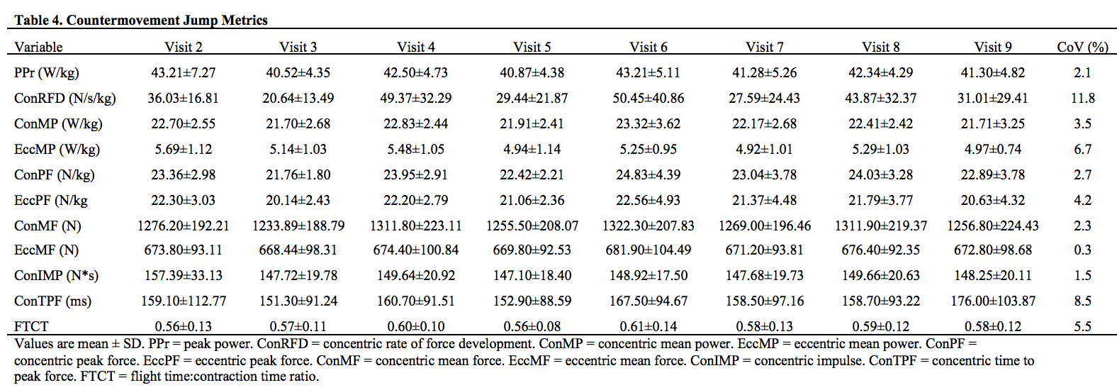
Table 4. Countermovement Jump Metrics

Exercise Performance and CMJ
Pearson’s correlations were conducted to compare FTCT declines and S_{dec} and one-way repeated measures ANOVA compared performance decrement measures between visits 2, 4, 6, and 8. FTCT measures did not significantly correlate with S_{dec} (r=0.10, p=0.950). FTCT declines were not significantly different between all visits (p=0.098). S_{dec} was not significantly different between visits (p=0.246).
Additionally, one-way repeated measures ANOVA was also used to compare FTCT declines, as well as, S_{dec} across all follow-up visits. There were no significant differences between visits 3, 5, 7, and 9 for FTCT (p=0.166).

Blood Lactate
A 4 (trial) x 3 (time) repeated measures ANOVA was conducted to compare blood lactate values between visits for pre-sprinting, immediately post-sprinting, and three-minutes post-sprinting lactate levels. Values can be found in Table 5.
Table 5. Blood Lactate
Variable | Visit 2 | Visit 4 | Visit 6 | Visit 8
Pre (mmol/L) | 1.61±0.64 | 1.44±0.57 | 1.56±0.53 | 1.44±0.25
IP (mmol/L) | 5.88±2.36^{a,b} | 5.21±2.39^{a,b} | 6.10±2.82^{a,b} | 5.36±2.55^{a,b}
3P (mmol/L) | 4.41±2.10ª | 4.12±2.23ª | 4.66±2.28ª | 4.12±2.25ª
Values are mean ± SD. Pre = baseline. IP = immediately post. 3P = 3-minutes post.
ªindicates significant difference from Pre
^{b}indicates significant difference from 3P

There was no interaction effect for trial*time main effect for trial indicating lactate levels were consistent across all visits (p>=0.784). However, there was a main effect for time (p<0.001). Post-hoc testing was performed to reveal where significant differences existed. Mean values ± SD can be seen in Figure 6 across all time points for all EIMD sprinting visits. Bonferroni pairwise comparisons showed that visit 2, IP (p<0.001) and 3P (p=0.001) were significantly greater than pre-sprinting values, and IP was significantly greater than 3P (p=0.028). For visit 4, IP (p=0.003) and 3P(p=0.020) were significantly greater than pre, and IP was significantly greater than 3P (p=0.001). For visit 6, IP (p=0.004) and 3P (p=0.013) was significantly greater than pre, and IP was significantly greater than 3P (p=0.001). For visit 8, IP (p=0.003) and 3P (p=0.016) were significantly greater than pre, and IP was significantly greater than 3P (p=0.005).
Values are mean ± SD. Pre = baseline. IP = immediately post. 3P = 3-minutes post. *indicates significant difference from Pre and 3P for all visits (p≤0.05).

Figure 6. Mean lactate values at Pre, IP, and 3P across visits 2, 4, 6, and 8.
*

Perceived Soreness
Upper, lower, and total body soreness results can be seen in Figures 7, 8, and 9, respectively. A one-way repeated measures ANOVA was performed to compare upper body, lower body, and total body soreness following repeated sprint activity (visits 3, 5, 7, 9). There was no significant difference between time points for upper body (p=0.136), lower body (p=0.124), or total body soreness (p=0.176). Separate one-way ANOVAs were conducted to compare upper, lower, and total body soreness for each visit. No significant difference was found between upper, lower, and total body areas for visit 3 (p=0.146), visit 5 (p=0.062), visit 7 (p=0.258), or visit 9 (p=0.136). However, because no significant differences were found, all measurements were collapsed, and a single one-way ANOVA was performed. The results indicated that total body soreness (p=0.014) and lower body soreness (p<0.001) were both significantly greater than upper body soreness. Lower body and total body soreness were not significantly different (p=0.898). Pearson’s correlations revealed that total body soreness had a strong, positive correlation to lower body (r=0.839, p<0.001) and upper body (r=0.677, p<0.001) soreness. Lower body and upper body soreness had a weak, positive correlation (r=0.362, p=0.022).
Figure 7. Upper Body Soreness
*
*
*
*
Values are mean ± SD. Soreness ratings are measured on a scale from 0-10. *indicates a significant difference from baseline measures (p≤0.05).
Figure 8. Lower Body Soreness
*
*
*
*
Values are mean ± SD. Soreness ratings are measured on a scale from 0-10. *indicates a significant difference from baseline measures (p≤0.05).

Figure 9. Total Body Soreness
*
*
*
*
Values are mean ± SD. Soreness ratings are measured on a scale from 0-10. *indicates a significant difference from the sprinting session that occurred 24-48 hours prior (p≤0.05).

Session RPE
A 4 (trial) x 2 (condition) ANOVA was conducted to compare RPE immediately post (IP) and 30-minutes post (30P) across visits 2, 4, 6, and 8. A condition effect was observed (p=0.009), while trial (p=0.206) and trial*condition (p=0.274) effects were not statistically significant. Bonferroni pairwise comparisons indicated that RPE-IP was significantly greater than RPE-30P (p=0.009). RPE-IP was not significantly different across all four visits (p=0.416). RPE-30P was not significantly different across all four visits (p=0.102). RPE mean values across all time points are illustrated in Figure 10.
Figure 10. Mean RPE for IP and 30P time points across visits 2, 4, 6, and 8.
Values are mean ± SD. IP = immediately post. 30P = 30-minutes post. RPE values are measured using the Borg Scale (6-20). A condition*time effect for RPE was not significant (p=0.274).

Chapter 5: Discussion
The purpose of the study was to evaluate the use of a sprinting protocol to consistently generate exercise-induced muscle damage using an active female population, and to observe how jumping metrics and sprint performance change due to muscle damage. It was hypothesized that: 1) there would be a decline in sprint performance during the repeated sprint protocol, 2) there would be a significant relationship between fatigue characteristics of repeated sprinting and countermovement jumps, 3) there would be a significant relationship between sprinting metrics and countermovement jump metrics during the repeated sprint protocol, and 4) sprint velocity and player load would have a significant relationship with repeated sprint ability and lactate clearance.

Sprint Performance
Results showed that peak velocity and average velocity between visits 2, 4, 6, and 8 were not significantly different. This lack of significance was expected due to the sprint-trained nature of the participants and supports the absence of a learning effect or training effect across trials. Additionally, ICC_{3,1} values were shown to be high, indicating that there was a strong level of agreement between experimental trials for both peak velocity and average velocity. Average velocity was significantly lower following the muscle damage protocol for all follow-up visits occurring 24-48 hours later. This agrees with previous work (1, 12, 13, 14) as the reductions in sprint performance are most likely the result of EIMD-induced decreases in force production, considered a hallmark effect of this condition. However peak velocity achieved did not decrease, but the two variables were moderately correlated to each other. This may indicate that the force loss due to muscle damage diminished the acceleration phase where the largest requirement for force production is required and thus delayed rather than prevented the participants from reaching their peak velocities.
Percent change scores were also similar for both average and peak velocity, which may suggest that the reduction in performance was stable across all experimental trails. This finding shows that participants were able to function at the same level each visit as they completed four EIMD protocols within a 30-day period, which suggests that all participants recruited were highly trained. This high training status may explain why RBE interference was not observed or points to the stability of the RBE in trained females once it occurs.
Sprint performance did not demonstrate the expected correlations to total player load, average player load, or relative player load. The expected outcome was that increasing sprint velocity would be associated with an increased player load. A possible explanation for the lack of agreement could be that player load is calculated from accelerometer-based data but considers all athlete movements in the X, Y, and Z planes including arm swings, lateral motion, and up and down movements throughout the duration of each sprint, while radar data only includes linear velocity on a fixed target and extraneous movements are removed during data filtering. The study cohort had a varied running efficiency; therefore, each participant’s player load was likely influenced more so by differences in running economy and mechanics than by sprint velocity.

Player Load
Player load is a value derived through quantification of changes in inertia and used to quantify the intensity of a training session or competition through the examination of an individual’s movement patterns or external work (18). These derived values have arbitrary units and can be used to evaluate both acute and chronic bouts of exercise (32). Player load metrics from the current study were not different across all four visits, which indicated that participants achieved similar intensities and workloads during each muscle damage protocol. This is a key finding that points to the participants’ ability to replicate effort and the consistency of their run technique.
Total and average player load were correlated with post-test lactate measurements. Player load is a validated method of quantifying external training load (18, 42) and blood lactate is a valid means of measuring internal response to an imposed external demand (55). Previous work has examined the relationship between external and internal training load (56) but has not used blood lactate as an internal measurement for comparison. The current findings indicate that player load might be used in place of blood lactate in order to non-invasively quantify physiological workload during training or competition or used in conjunction with lactate analysis to better understand how an individual may respond to changes in training that impose an increased or differing external work load. Since individuality in training responses are common, the combination of these two outcome variables may provide valuable information and thus be warranted.
Correlation between total player load and total body soreness, as well as between total player load and lower body soreness were found, but only during visits 4 and 5. Previous literature (61) has shown that external training load was significantly related to athlete soreness using male rugby players, however the external training load was derived utilizing a modified sRPE method. While both correlations in the current study were strong, the lack of any other significance between player load and soreness indicates that further research is required to determine if an association truly exists.

Countermovement Jump Metrics
Countermovement jumps (CMJ) were used to assess force output, as previous work has shown that CMJ testing is the best jump test to assess neuromuscular function due to high sensitivity to change and high repeatability in both acute and chronic exercise (23, 29). These works support the findings of the current study, as CMJ variables of interest were not significantly different from each other between visits 2, 4, 6, and 8, indicating that the participants gave similar effort and produced consistent CMJ during each testing session.
Results from the current investigation revealed that several of the CMJ force and power variables of interest (PPr, ConRFD, ConMP, EccMP, ConPF, EccPF, ConMF, ConIMP) decreased in the visits following the repeated sprint protocol. These findings agree with McLean et al. (52) who found that neuromuscular performance measures such as relative power output are reduced for at least 48 hours following repeated sprint sports. The results showed that participants exhibited decreased force generating capacity indicative of exercise-induced muscle damage during the post-damage protocol evaluations, consistent with the findings of others (51). This suggests that the current protocol is not only a valid means of eliciting EIMD similar to previous work (1, 12, 13, 14) but it is also reproducible, as force decrements were not eliminated due to the repeated bout effect (14). The observed changes in ConTFP indicate that participants were slower at reaching peak force following the repeated sprint protocol, which could be detrimental during competition when maximal neuromuscular effort is required. A 2016 study by Martinez (53) stated that an 8% decline in the ratio of flight time to contraction time was a strong predictor of declines in athlete readiness, slow stretch-shortening cycle (SSC) activity, and neuromuscular fatigue than traditional jump testing as they account for changes in jump strategy in order to maintain jump height. Observed declines in FTCT ratio in the current study ranged from -2.2% to -7.5%, indicating that either the subjects could not maintain their pre-damage flight time or required a longer period of time (time under tension) for contraction to elicit a similar flight time. In either case, these changes seem indicative of a reduction in force-producing capacity of the lower body musculature.

Exercise Performance and CMJ
Analysis of FTCT and S_{dec} scores determined that sprinting and jumping declines were similar between trials 2, 4, 6, and 8. This finding suggests that participants did not experience attenuated force loss due to the repeated bout effect. The S_{dec} formula used to determine decrement in sprint performance was determined by Glaister et al. (58) to be the best method of quantifying fatigue during repeated sprints. The inclusion of every sprint time in the calculation of the formula accounts for noise in the measurements due to biological variability, as well as unexplained speed increases during the final sprint (58, 59). The S_{dec} formula appears to be a valuable method for analyzing reduction in sprint performance over multiple attempts and thus warrants use in future studies.
Sprinting is an exercise that produces a very high RFD, requires a large amount of energy, and is considered a fast SSC movement (50). Countermovement jumps are classified as slow SSC movements (49) that place low physiological strain on participants (27), allowing them to be used in conjunction with the repeated sprint protocol without significant contribution to overall fatigue. However, CMJ performance was not correlated to sprint performance in the current study. This finding does not agree with previous literature (40, 59) which states that CMJ can be used as a predictor of sprint performance. However, it should be noted that the present study attempted to correlate performance decrements rather than predict maximal performance. Additionally, decrements in both sprint performance and CMJ performance were observed in post-damage protocol visits.

Blood Lactate
An accumulation of blood lactate, commonly associated with fatigue, occurs when metabolic energy demand causes an increased reliance on glycolysis, resulting in a shift in the balance between production and removal (54). Blood lactate values were not significantly different between visits for any time points, indicating that participants experienced a similar internal physiological response for each muscle damage protocol. The increase from pre to IP measurements indicated that the 40 sprints induced a high physiological load similar to what would be expected in an interval training session or repeated sprint sports (47). The significant difference between IP and 3P values indicated that the participants had already experienced significant clearance in the first three minutes following the protocol. This finding supports the assumption that participants were well trained. Training has been shown to increase an athlete’s ability to clear lactate rather than reducing production (57). The current study did not control for menstrual cycle during the testing sessions. However, a study by Smekal et al. (48) found no effect on blood lactate by menstrual cycle phase in female participants.

Perceived Soreness
VAS ratings of DOMS, which is one of the most common symptoms indicative of EIMD (1, 7, 12, 14), showed that participants experienced significant levels of upper, lower, and total body soreness following each testing session, and that lower and total body soreness were higher than upper body. The indicated levels of soreness were not significantly different between each post-damage evaluation, which indicates that the participants experienced similar levels of perceived damage after each testing session. Lower body and total body measures were not significantly different from each other and were strongly correlated.

Session RPE
No differences in sRPE were indicated between visits 2, 4, 6, and 8 for IP or 30P time points, indicating that participants viewed the intensity of the repeated sprint protocol similarly across all four visits. These findings agree with Foster et al. (43), who indicated that sRPE was a reliable means of evaluating exercise intensity. The present findings also support Pustina et al. (45), who stated that sRPE is a strong indicator of training response using athletes participating in repeated sprint sports.

Chapter VI: Conclusion

Key Findings
The purpose of this study was to evaluate the use of a sprinting protocol as a consistent field-based means of generating EIMD in a well-trained female population, as well as to observe changes in sprinting and jumping metrics due to incurred muscle damage. Additionally, this study sought to examine the relationship between sprint velocity and player load, and to determine how they relate to repeated sprint ability and lactate clearance. Through this investigation, it was concluded that the protocol was a valid and reliable means of eliciting EIMD, with measurable decrements in both sprinting and jumping performance for up to 24-48 hours following the completion of the protocol. Although a significant relationship between fatigue characteristics of repeated sprinting and CMJ performance did not occur, both exhibited decrements in post-exercise evaluations that are indicative of muscle damage that could hinder performance. Sprint performance and player load were not significantly related, but player load was shown to be associated with lactate levels following repeated sprints. The practical significance of the current study is that sports teams could use this protocol to evaluate fatigue characteristics for their athletes and utilize CMJ metrics or sprint decrement scores to determine an athlete’s readiness for competition.

Limitations
Several limitations exist in this study. The reduction in the participant pool due to attrition may have reduced the potential to find some significant relationships between variables due to a reduced variability. However, the a priori power analysis was based on the variables with the smallest expected treatment effect and highest variability in order to reduces chances for Type II error. The researchers feel the study was sufficiently powered as evidenced by the significance findings of the study and the size of the subject cohorts typical of this type of investigation in the literature.
Participation in previous sporting events may have exposed participants to eccentric loading, diminishing the effects of the EIMD protocol. Muscle fiber typing was not used in the current investigation, as differences in fiber type composition may have impacted soreness due to preferential recruitment of Type II muscle fibers during eccentric contractions.
A menstrual history was included to ensure that participants were experiencing normal cycling, but the phase of menstrual cycle was not standardized. Finally, testing was performed indoors to eliminate external confounding variables, so velocity data could not be collected from the Catapult units for comparison to radar gun velocities, however the radar gun used for the current study is considered the “gold standard” for measurements of linear velocity and used to establish criterion validity when testing advanced timing gate systems.

Future Research Directions
Future research should examine recovery modalities that might be utilized to attenuate force loss so that athletes may streamline the process of returning to peak performance capacity. Future studies may also investigate the critical power and critical rest interval needed to preserve sprint ability in repeated sprint sports. Finally, because sport involves sprints with short deceleration and immediate change of direction, future research could investigate the decline in performance related to eccentrically biased change-of-direction movements performed in a repeated trial manner and with the use of a timing gate system to capture changes at different distance intervals that may shed light on how peak velocities are maintained over the entirety of distance and how acceleration curves are modified by fatigue and muscle damage.

References
- Cheung, K., Hume, P., & Maxwell, A. (2003). Delayed Onset Muscle Soreness. Sports Medicine, 33(2), 145-164.

- Clarkson, P. M., & Hubal, M. J. (2002). Exercise-induced muscle damage in humans. American journal of physical medicine & rehabilitation, 81(11), S52-S69.

- Clarkson, P., & Tremblay, I. (1988). Exercise-induced muscle damage, repair, and adaptation in humans. Journal of Applied Physiology (Bethesda, Md:1985), 65(1), 1-6.

- Girard, O., Mendez-Villanueva, A., & Bishop, D. (2011). Repeated-Sprint Ability Part I. Sports Medicine, 41(8), 673-694.

- Highton, Twist, & Eston. (2009). The Effects of Exercise-Induced Muscle Damage on Agility and Sprint Running Performance. Journal of Exercise Science & Fitness, 7(1), 24-30.

- Hunter, S. (2014). Sex differences in human fatigability: Mechanisms and insight to physiological responses. Acta Physiologica, 210(4), 768-789.

- Keane, K., Salicki, R., Goodall, S., Thomas, K., & Howatson, G. (2015). Muscle damage response in female collegiate athletes after repeated sprint activity. 29(10), 2802.

- Knicker, Axel J., Renshaw, Ian, Oldham, Anthony R.H., & Cairns, Simeon P. (2011). Interactive processes link the multiple symptoms of fatigue in sport competition. Sports Medicine, 41(4), 307.

- Nédélec, M., Halson, S., Abaidia, A., Ahmaidi, S., & Dupont, G. (2015). Stress, Sleep and Recovery in Elite Soccer: A Critical Review of the Literature. Sports Medicine, 45(10), 1387-1400.

- Peñailillo, L., Blazevich, A., Numazawa, H., & Nosaka, K. (2015). Rate of force development as a measure of muscle damage. Scandinavian Journal of Medicine & Science in Sports, 25(3), 417-427.

- Ross, A., Leveritt, M., & Riek, S. (2001). Neural Influences on Sprint Running. Sports Medicine, 31(6), 409-425.

- Thompson, D., Nicholas, C., & Williams, C. (1999). Muscular soreness following prolonged intermittent high-intensity shuttle running. Journal of Sports Sciences, 17(5), 387-95.

- Thorpe, Robin, & Sunderland, Caroline. (2012). Muscle damage, endocrine, and immune marker response to a soccer match. Journal of Strength and Conditioning Research, 26(10), 2783.

- Woolley, B. P., Jakeman, J. R., & Faulkner, J. A. (2014). Multiple Sprint Exercise with a Short Deceleration Induces Muscle Damage and Performance Impairment in Young, Physically Active Males. J Athl Enhancement 3: 2. of, 7, 2.

- Ye, X., Beck, T., & Wages, N. (2015). Reduced susceptibility to eccentric exercise-induced muscle damage in resistance-trained men is not linked to resistance training-related neural adaptations. Biology of Sport, 32(3), 199-205.

- Zourdos, Michael C., Paul C. Henning, Edward Jo, Andy V. Khamoui, Sang-Rok Lee, Young-Min Park, Marshall Naimo, Lynn B. Panton, Kazunori Nosaka, and Jeong-Su Kim. (2015). Repeated Bout Effect in Muscle-specific Exercise Variations. Journal of Strength and Conditioning Research, 29(8), 2270.

- de Hoyo, M., Cohen, D. D., Sañudo, B., Carrasco, L., Álvarez-Mesa, A., del Ojo, J. J., ... & Otero-Esquina, C. (2016). Influence of football match time–motion parameters on recovery time course of muscle damage and jump ability. Journal of sports sciences, 34(14), 1363-1370.

- Varley, Matthew C., Fairweather, Ian H., & Aughey, Robert J. (2012). Validity and reliability of GPS for measuring instantaneous velocity during acceleration, deceleration, and constant motion. Journal of Sports Sciences, 30(2), 121.

- James, C., Dufek, J., & Bates, B. (2006). Effects of Stretch Shortening Cycle Exercise Fatigue on Stress Fracture Injury Risk During Landing. Research Quarterly for Exercise and Sport, 77(1), 1-13.

- Eston, R., Lemmey, A., McHugh, P., Byrne, C., & Walsh, S. (2000). Effect of stride length on symptoms of exercise‐induced muscle damage during a repeated bout of downhill running. Scandinavian Journal of Medicine & Science in Sports, 10(4), 199-204.

- Hart, S., Drevets, K., Alford, M., Salacinski, A., & Hunt, B. E. (2013). A method-comparison study regarding the validity and reliability of the Lactate Plus analyzer. BMJ open, 3(2), e001899.

- Williams, J. R., Armstrong, N., & Kirby, B. J. (1992). The influence of the site of sampling and assay medium upon the measurement and interpretation of blood lactate responses to exercise. Journal of sports sciences, 10(2), 95-107.

- Gathercole, R. J., Sporer, B. C., Stellingwerff, T., & Sleivert, G. G. (2015). Comparison of the capacity of different jump and sprint field tests to detect neuromuscular fatigue. The Journal of Strength & Conditioning Research, 29(9), 2522-2531.

- Boyas, S., & Guével, A. (2011). Neuromuscular fatigue in healthy muscle: underlying factors and adaptation mechanisms. Annals of physical and rehabilitation medicine, 54(2), 88-108.

- De Backer, D. (2003). Lactic acidosis. Intensive care medicine, 29(5), 699-702.

- Donovan, C. M., & Brooks, G. A. (1983). Endurance training affects lactate clearance, not lactate production. American Journal of Physiology-Endocrinology And Metabolism, 244(1), E83-E92.

- Gathercole, R., Sporer, B., Stellingwerff, T., & Sleivert, G. (2015). Alternative countermovement-jump analysis to quantify acute neuromuscular fatigue. International journal of sports physiology and performance, 10(1), 84-92.

- Gathercole, R., Sporer, B., & Stellingwerff, T. (2015). Countermovement jump performance with increased training loads in elite female rugby athletes. International journal of sports medicine, 36(09), 722-728.

- Cormack, S. J., Newton, R. U., McGuigan, M. R., & Doyle, T. L. (2008). Reliability of measures obtained during single and repeated countermovement jumps. International journal of sports physiology and performance, 3(2), 131-144.

- Wundersitz D, et al. Classification of team sport activities using a single wearable tracking device. Journal of Biomechanics. 2015.

- Dalen, T., Jørgen, I., Gertjan, E., Havard, H. G., & Ulrik, W. (2016). Player load, acceleration, and deceleration during forty-five competitive matches of elite soccer. The Journal of Strength & Conditioning Research, 30(2), 351-359.

- Hollville, E., Couturier, A., Guilhem, G., & Rabita, G. (2016, May). MinimaxX player load as an index of the center of mass displacement? A validation study. In ISBS-Conference Proceedings Archive (Vol. 33, No. 1).

- Clarkson, P. M., & Sayers, S. P. (1999). Etiology of exercise-induced muscle damage. Canadian journal of applied physiology, 24(3), 234-248.

- McHugh, M. P., Connolly, D. A., Eston, R. G., & Gleim, G. W. (1999). Exercise-induced muscle damage and potential mechanisms for the repeated bout effect. Sports Medicine, 27(3), 157-170.
- Sewright, K. A., Hubal, M. J., Kearns, A., Holbrook, M. T., & Clarkson, P. M. (2008). Sex differences in response to maximal eccentric exercise. Medicine and Science in Sports and Exercise, 40(2), 242-251.

- Stupka, N., Lowther, S., Chorneyko, K., Bourgeois, J. M., Hogben, C., & Tarnopolsky, M. A. (2000). Gender differences in muscle inflammation after eccentric exercise. Journal of applied physiology, 89(6), 2325-2332.

- Hunter, S. K. (2016). Sex differences in fatigability of dynamic contractions. Experimental physiology, 101(2), 250-255.

- Fulco, C. S., Rock, P. B., Muza, S. R., Lammi, E., Cymerman, A., Butterfield, G., ... & Lewis, S. F. (1999). Slower fatigue and faster recovery of the adductor pollicis muscle in women matched for strength with men. Acta Physiologica Scandinavica, 167(3), 233-240.

- Kellawan, J. M., Johansson, R. E., Harrell, J. W., Sebranek, J. J., Walker, B. J., Eldridge, M. W., & Schrage, W. G. (2015). Exercise vasodilation is greater in women: contributions of nitric oxide synthase and cyclooxygenase. European journal of applied physiology, 115(8), 1735-1746.

- Markström, J. L., & Olsson, C. J. (2013). Countermovement jump peak force relative to body weight and jump height as predictors for sprint running performances:(in) homogeneity of track and field athletes?. The Journal of Strength & Conditioning Research, 27(4), 944-953.

- Hughes, G., & Watkins, J. (2006). A risk-factor model for anterior cruciate ligament injury. Sports Medicine, 36(5), 411-428.dicine, 36(5), 411-428.

- Boyd, L. J., Ball, K., & Aughey, R. J. (2011). The reliability of MinimaxX accelerometers for measuring physical activity in Australian football. International Journal of Sports Physiology and Performance, 6(3), 311-321.

- Foster, C., Florhaug, J.A., Franklin, J., Gottschall, L., Hrovatin, L.A., Parker, S., Doleshal, P., Dodge, C. (2001). A new approach to monitoring exercise training. Journal of Strnegth and Conditioning Research; 15(1), 109-115.

- Lambert, M.I. & Borreson, J. (2010). Measuring training load in sports. International Journal of Sports Physiology and Performance; 5, 406-411.

- Pustina, A.A., Sato, K., Liu, C., Kavanaugh, A.A., Sams, M.L., Liu, J., Uptmore, K.D., Stone, M.H. (2017). Establishing a duration standard for the calculation of session rating of perceived exertion in NCAA division I men’ soccer. Journal of Trainology; 6, 26-30.
- Haugen, T., & Buchheit, M. (2016). Sprint running performance monitoring: methodological and practical considerations. Sports Medicine, 46(5), 641-656.

- Faude, O., Kindermann, W., & Meyer, T. (2009). Lactate threshold concepts. Sports medicine, 39(6), 469-490.

- Smekal, G., Von Duvillard, S. P., Frigo, P., Tegelhofer, T., Pokan, R., Hofmann, P., ... & Bachl, N. (2007). Menstrual cycle: no effect on exercise cardiorespiratory variables or blood lactate concentration. Medicine & Science in Sports & Exercise, 39(7), 1098-1106.

- Laffaye, G., Wagner, P. P., & Tombleson, T. I. (2014). Countermovement jump height: Gender and sport-specific differences in the force-time variables. The Journal of Strength & Conditioning Research, 28(4), 1096-1105.

- Taylor, M. J. D., & Beneke, R. (2012). Spring mass characteristics of the fastest men on Earth. International journal of sports medicine, 33(08), 667-670.

- Byrne, C., Twist, C., & Eston, R. (2004). Neuromuscular function after exercise-induced muscle damage. Sports medicine, 34(1), 49-69.

- McLean, B. D., Coutts, A. J., Kelly, V., McGuigan, M. R., & Cormack, S. J. (2010). Neuromuscular, endocrine, and perceptual fatigue responses during different length between-match microcycles in professional rugby league players. International journal of sports physiology and performance, 5(3), 367-383.

- Martinez, D. B. (2016). The use of reactive strength index, reactive strength index modified, and flight time: contraction time as monitoring tools. Journal of Australian Strength and Conditioning, 24(5), 37-41.

- Hoff, J., Støren, Ø., Finstad, A., Wang, E., & Helgerud, J. (2016). Increased blood lactate level deteriorates running economy in world class endurance athletes. The Journal of Strength & Conditioning Research, 30(5), 1373-1378.

- Eniseler, N. (2005). Heart rate and blood lactate concentrations as predictors of physiological load on elite soccer players during various soccer training activities. Journal of Strength and Conditioning Research, 19(4), 799.

- Casamichana, D., Castellano, J., Calleja-Gonzalez, J., San Román, J., & Castagna, C. (2013). Relationship between indicators of training load in soccer players. The Journal of Strength & Conditioning Research, 27(2), 369-374.

- Donovan, C. M., & Brooks, G. A. (1983). Endurance training affects lactate clearance, not lactate production. American Journal of Physiology-Endocrinology And Metabolism, 244(1), E83-E92.
- Glaister, M., Howatson, G., Pattison, J. R., & McInnes, G. (2008). The reliability and validity of fatigue measures during multiple-sprint work: an issue revisited. The Journal of Strength & Conditioning Research, 22(5), 1597-1601.

- Robinson, J. M., Stone, M. H., Johnson, R. L., Penland, C. M., Warren, B. J., & Lewis, R. D. (1995). Effects of different weight training exercise/rest intervals on strength, power, and high intensity exercise endurance. The Journal of Strength & Conditioning Research, 9(4), 216-221.

- Hennessy, L., & Kilty, J. (2001). Relationship of the stretch-shortening cycle to sprint performance in trained female athletes. Journal of Strength and Conditioning Research, 15(3), 326-331.

- Montgomery, P. G., & Hopkins, W. G. (2013). The effects of game and training loads on perceptual responses of muscle soreness in Australian football. International journal of sports physiology and performance, 8(3), 312-318.

Appendix A: IRB Approval Letter

Appendix B: Informed Consent Form

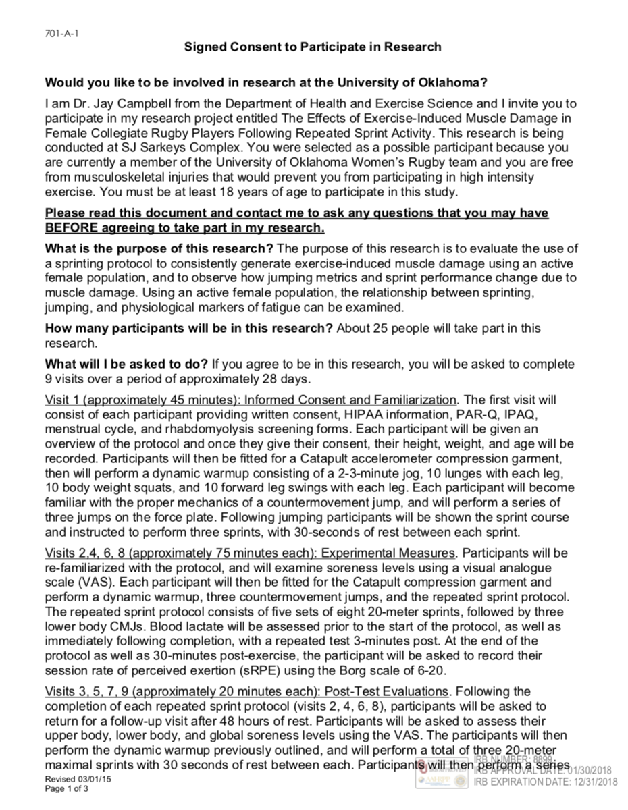

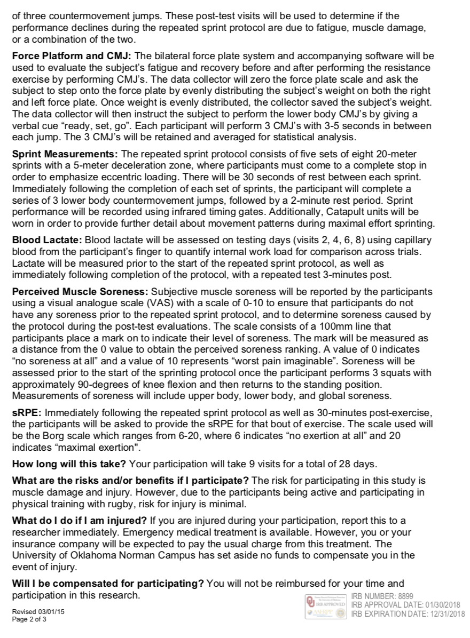



Appendix C: HIPAA

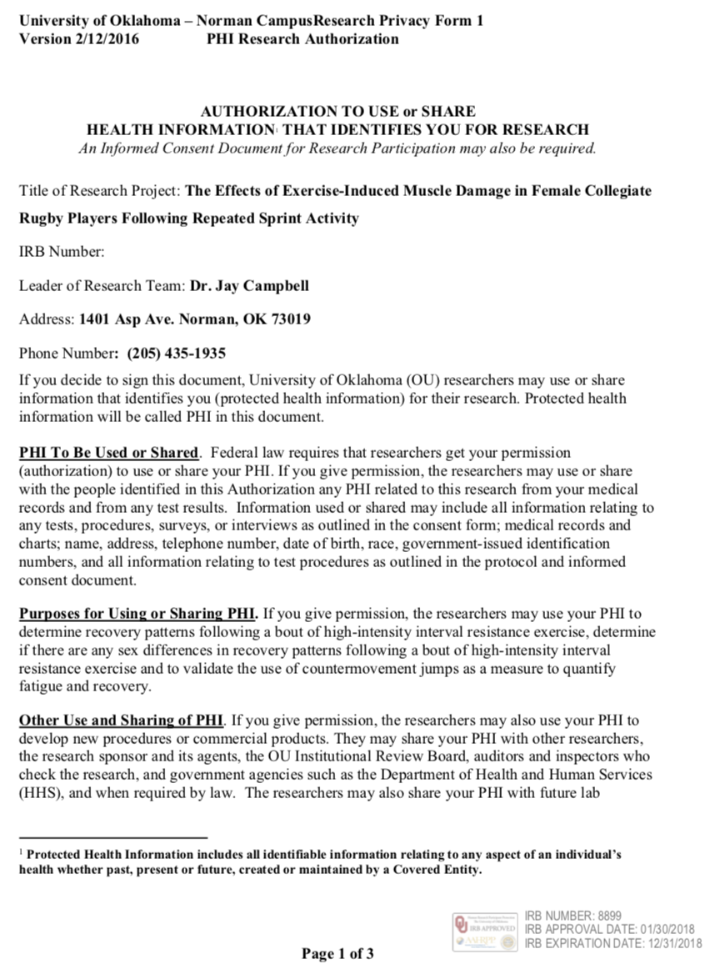

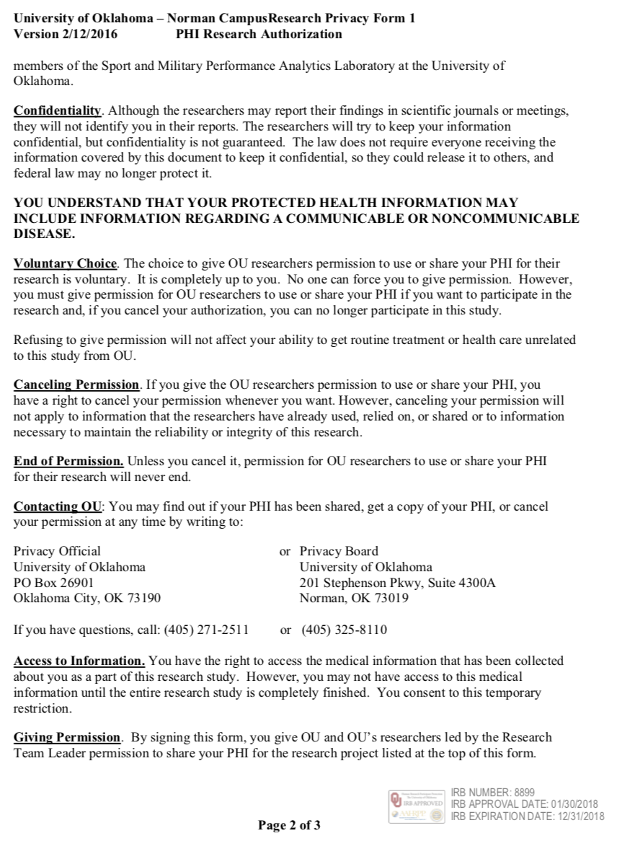

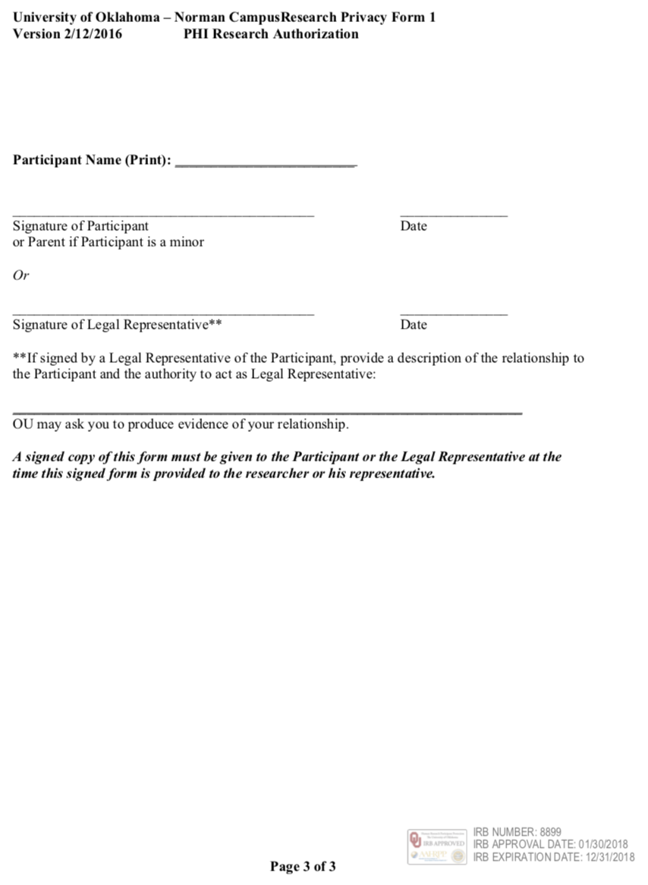

Appendix D: Health Status Questionnaire
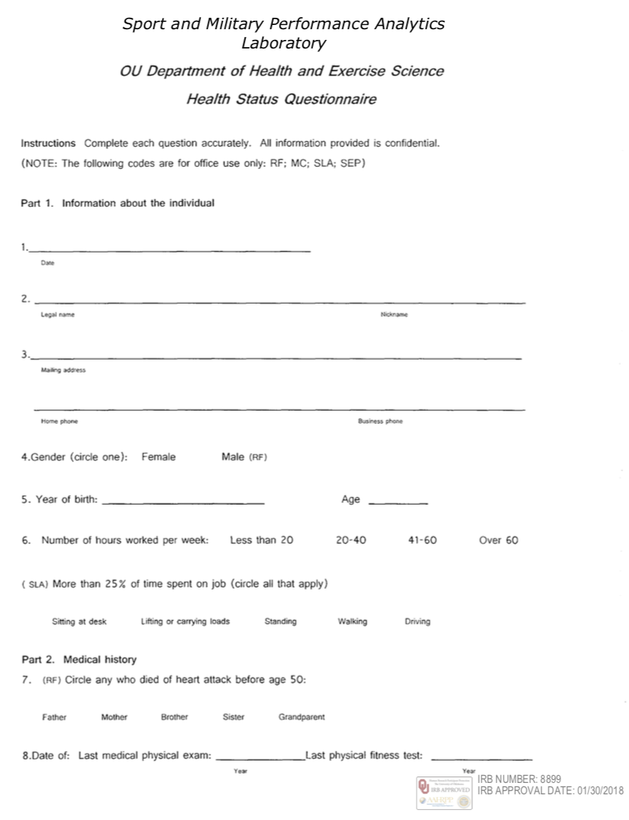

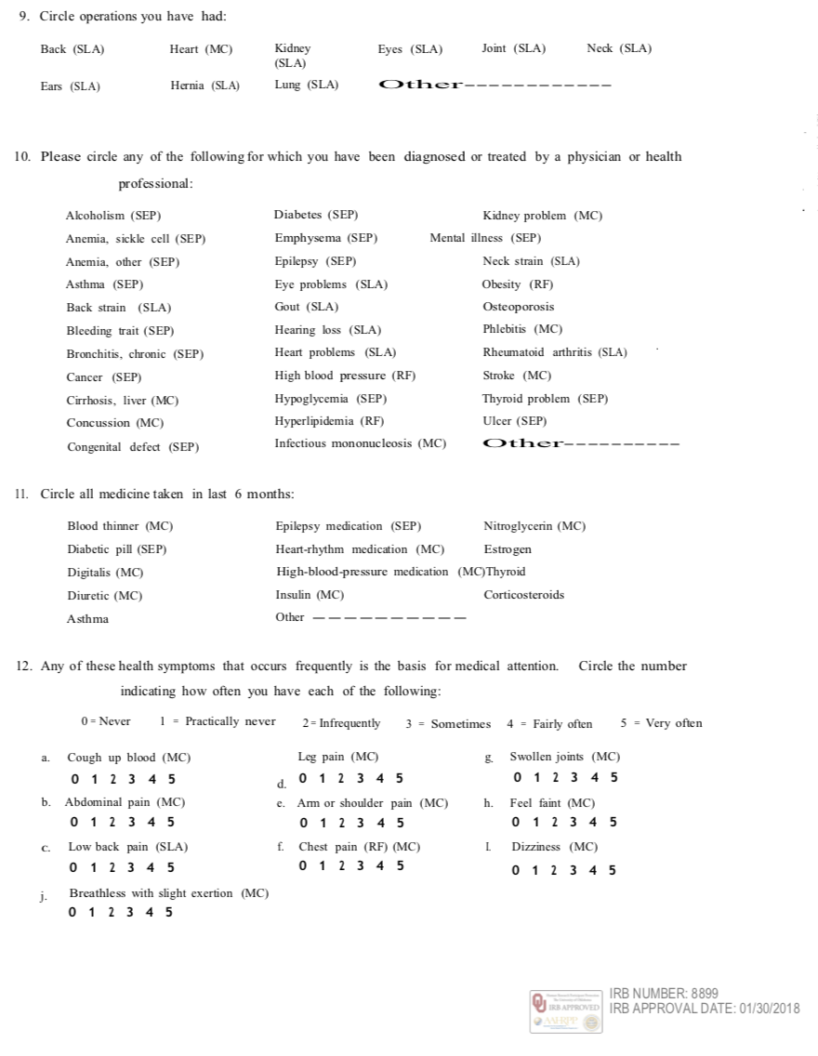



Appendix E: International Physical Activity Questionnaire

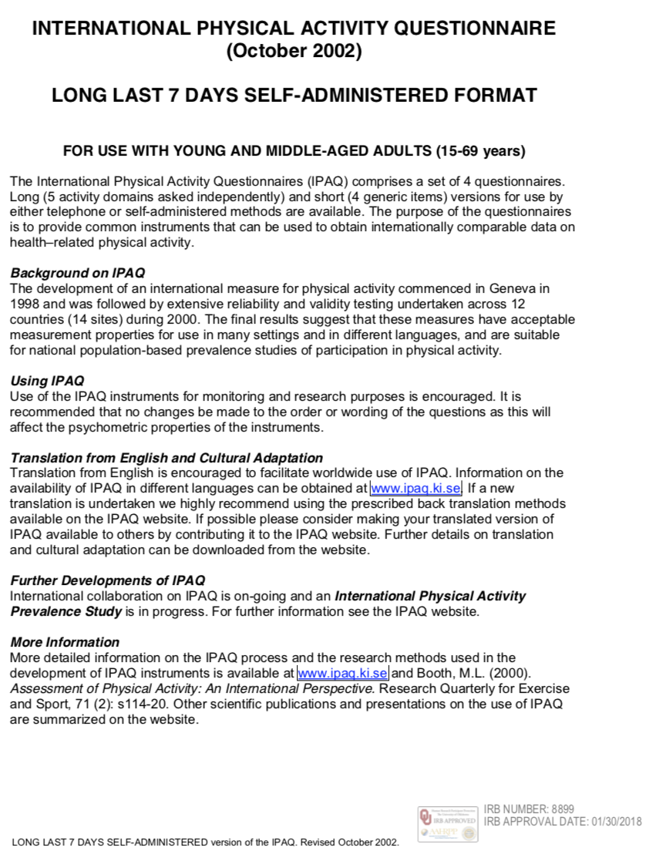



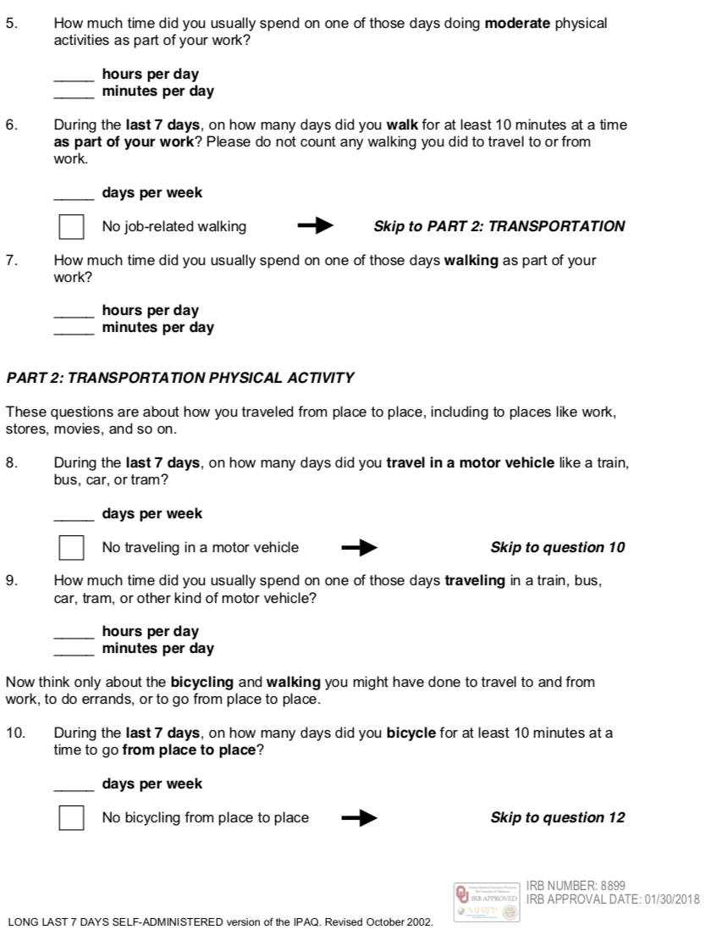



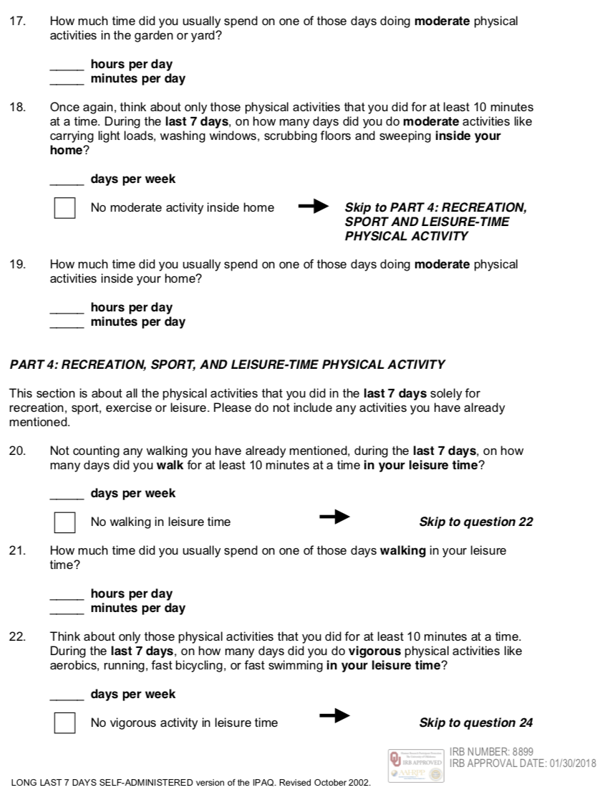

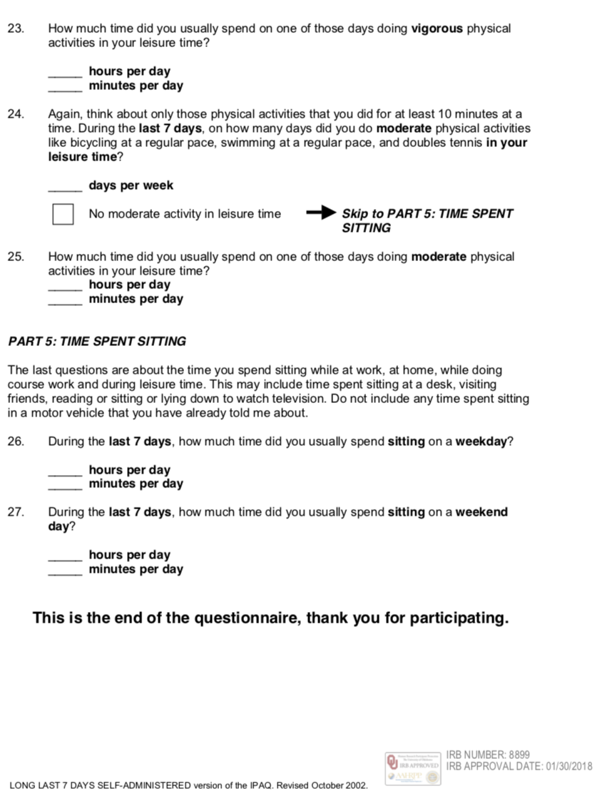

Appendix F: Physical Activity Readiness Questionnaire



Appendix G: Rhabdomyolysis Screening Form

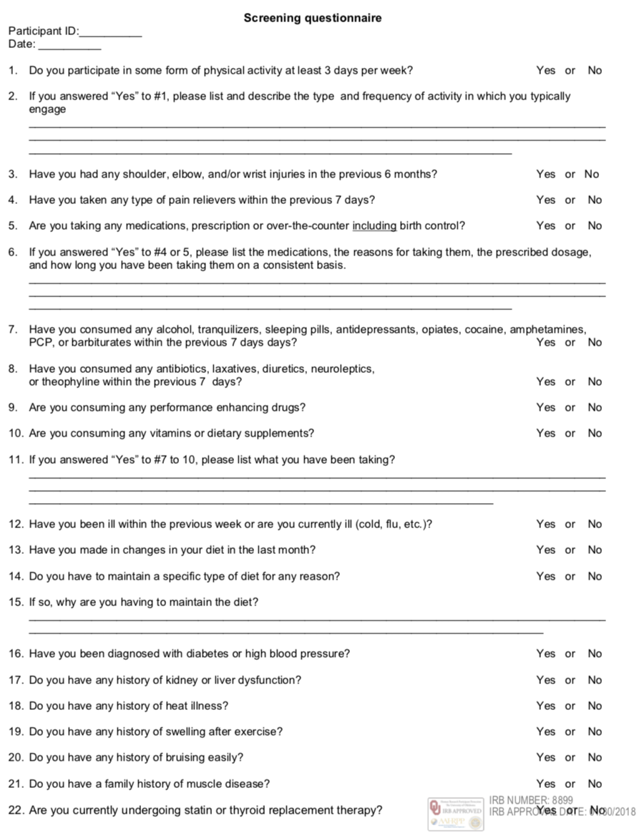

Appendix H: Menstrual History Questionnaire

