UNIVERSITY OF OKLAHOMA

GRADUATE COLLEGE

THE APPLICATION OF USING COMPUTATIONAL FLUID DYNAMICS (CFD)

TO MODERN BUILDING DESIGN

A THESIS

SUBMITTED TO THE GRADUATE FACULTY
in partial fulfillment of the requirements for the
Degree of

MASTER OF SCIENCE IN ARCHITECTURE

By
MAHDI AFKHAMIAGHDA
Norman, Oklahoma
2017

tHE APPLICATION OF USING COMPUTATIONAL FLUID DYNAMICS (cfd)
TO MODERN BUILDING DESIGN

A thesis approved for the
College of Architecture

BY

______________________________
Prof. Lee Fithian, Chair

______________________________
Prof. Marjorie Callahan

______________________________
Prof. Shideh Shadravan

© Copyright by MAHDI AFKHAMIAGHDA 2017
All Rights Reserved.

To Mom and Dad
For always being there for me

Acknowledgments

I would like to thank my committee members and my family. Without their help and moral support this body of work wouldn’t have been possible. I would like to express my deepest gratitude to my advisor, Professor Lee Fithian, for her excellent guidance and care through my two-year program. Always believing in me, she helped me to achieve many milestones. I would also like to thank Dr. Shadravan, Dr. Pilat, and Professor and graduate Liaison for the Division of Architecture Callahan for supporting me through my program. Special thanks goes to my parents and elder brother. They were always supporting me and encouraging me with their best wishes.

Table of Contents

Acknowledgments iv
List of Figures vi
Abstract vii
CHAPTER 1: INTRODUCTION 1
1.1 CFD 5
CHAPTER 2: LIMITATIONS OF STUDY 5
CHAPTER 3: METHODOLOGY 6
3.1 Data Availability and Resources 8
3.1.1 Geometric Modeling 9
3.1.2 Computational Grid 10
CHAPTER 4: RESEARCH 11
4.1 Method 11
4.2 Case Studies 12
4.2.1 Zion National Park Visitor Center 12
4.2.2 Badgirs 29
4.3 Findings 42
CHAPTER 5: CONCLUSIONS 42
References 44

List of Figures

Figure 1: The high pressure leads to damages and discomfort 3
Figure 2: ASHRAE climate regions 13
Figure 3: Springdale climate data 14
Figure 4: Zion National Park Visitor Center’s building wind flow 14
Figure 5: Zion National Park Visitor Center 18
Figure 6: Cooling Towers of the buildinga) Wind Tower 19
Figure 7: Clerestory windows in different height 20
Figure 8: Clerestory windows in the building in two different levels 21
Figure 9: Openings located in different heights helps the natural ventilation process 21
Figure 10: The pressure change between different zones of the building 23
Figure 11: The effect of building orientation on the wind flow 28
Figure 12: The dense form of Yazd, located in Dashte- Kavir in Iran 29
Figure 13: Wind turbulence through the building 31
Figure 14: Different kinds of Badgirs based on their plan shape 32
Figure 15: The flow behavior around the same building 39
Figure 16: The annual wind rose pattern 40

Abstract
In the last few years, constructing buildings that do not cause any bad destructive effects on the environment (green buildings) has become one of the priorities around the world, especially in the United States (USGBC Research Committee 2008). Passive design is one of the most vital ways to reduce building energy consumption and to improve the built environment. “Passive Design” is a strategy that employs natural ventilation and renewable energies, like solar energy, to this end.
Computational Fluid Dynamics (CFD) is considered one of the best methods that can assist in evaluating how natural ventilation and wind flow occur in our outdoor environment and how this in turn, renders our designs’ effect in their surroundings. CFD has a wide variety of applications in the Automotive and Aerospace industry, and it can also be applied in the building industry, consider this information helping architects understanding how wind behaves around the design of buildings. This method specifically helps in finding the regions in which vortex flow, downward air flow, leeward, and buoyancy occur which can have detrimental effects on the environment.
This research will show the effectiveness and importance of using CFD technology in the early design process as a design assistance tool for architects and for all involved in the design of buildings. Many different models have been created and tested using Autodesk Flow Design- a CFD simulation software which assists in demonstrating the air flow around the building. Subsequently, these models have been studied both individually and compared with each other to 1.) Observe the intensity of wind flow in each environment and 2.) To find correlations between the different variables. The data collected and assimilated in this body of work has assisted in showing the effects of using CFD in the early design process and how the use of CFD would benefit the designers, architects, and the occupants.
This will impact the application and translation of a vernacular architectural feature in a broader scope as a result to offset mechanical ventilation needs. Also showing how CFD can be effective, we suggest the use of a committed design team who do building simulation and analysis, starting from the earliest conceptual design phase to the point of finishing the building, a process which needs to become mandatory in firms just like structural analysis.

CHAPTER 1: INTRODUCTION
As wind hits an obstacle, the friction between the wind and the surface alters the kinetic energy of the air flow into potential energy of pressure on various parts of buildings (Onouye and Kane 2012). This energy depends on numerous factors such as:
- Geographical location
- Height of structure above ground
- Type of terrain around the structure
- Density of the district (American Society of Civil Engineers 2003)
Natural ventilation can meet human comfort needs of the occupants of the building through evaporative and convective cooling of the skin. Wind accelerates heat transfer by creating a stream, thus conveying heat between the outside environment and through the building envelope (any surface that separates the inside and outside environment). The importance of ventilation becomes even more significant in humid places, due to the risk of mold and fungus in these areas where air is stagnant (Autodesk 2014). High rise buildings, narrow spacing between buildings, as well as the shape of buildings are all factors that can strengthen potential energy by creating low pressure regions, which cause the wind to accelerate (Irwin 2010).
Wind, when properly utilized, can assist in the natural ventilation of buildings, helping to save energy. The orchestration of these variables working together results in natural ventilation which in turn is also beneficial to the health of the residents of a building. In contrast, mechanical equipment requires energy inputs, constant maintenance and has expensive first costs. However, this does not mean that mechanical HVAC needs to be omitted completely from the building because there are times when human comfort cannot be maintained solely through passive means. Using a hybrid ventilation system where the main focus is natural ventilation, not only would save energy, but also can save money and time by reducing the size of the mechanical equipment. Combining natural ventilation with mechanical equipment can lead to better air quality and a healthier environment (Atkinson, et al. 2009). This feature can be seen in Masdar City, a net-zero energy city in Abu Dhabi located in The United Arab of Emirates where designers have used the natural flow of wind, low rise buildings and high density patterns in order to mitigate the heat load (Hassan, Lee and Yoo 2015).
However, using natural ventilation without considering the wind impact on a building may lead to dire consequences. Choosing the wrong size and position of inlet and outlets, inappropriate orientation of the building, and overlooking the spacing between the buildings are major factors that result in evident energy loss, and occupant discomfort. If two tall buildings were to be built adjacent to each other with a narrow passageway between them, the flow behavior caused by this arrangement can lead to damage to the building and pedestrians. Since the pathway is too narrow compared to its height (W/H < 2.0), the vortex created by wind pressure in the pathway intensifies (f= P/A) (Lawson 2010). This high pressure applied to the leeward side of the buildings will result in intolerable wind pressures in the leeward sides of the buildings, while a relative vacuum on the other sides of the pathway are created which will result in discomfort for the pedestrians around the building(Fig 1).

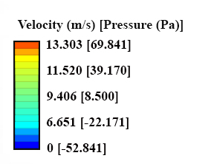
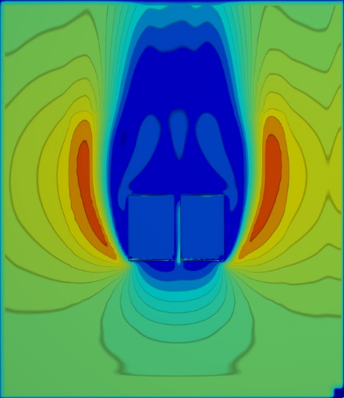

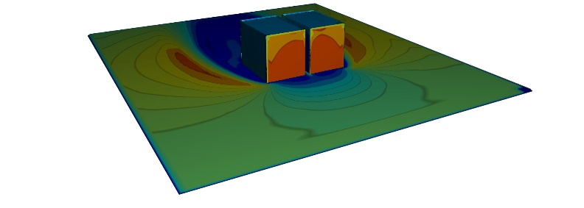
Figure 1: The high pressure leads to damages to the building and discomfort for pedestrians

In addition, pedestrian comfort is yet another important factor that stems from the wind flow around buildings (Mittal, et al. 2013). The building morphological design impacts the flow around the buildings and therefore, the pedestrian comfort. Unfortunately, with the current design process used in most architectural firms, wind flow analysis is not performed until the final steps of the design and after the main morphological shape has been formed (Autodesk 2014). By this time, it is almost too late to alter the design and not economically rational to make amendments to the building form.
These problems can be averted if the wind impact on these building forms early design is taken into consideration as a factor in the architects’ Schematic Design Phase. Computational Fluid Dynamics (CFD) can help us evaluate the indoor and outdoor wind flow systems by calculating the air movement around and inside the building. The wind flow pattern in this computer-based mathematical modeling tool is utilized by calculating and simulating the thermal effects such as wind velocity, air pressure, contaminant concentrations, relative humidity, natural convection, buoyancy, and forced effects (Chen and Srebric 2000).
Other alternatives for evaluating the airflow around the building are wind tunnel testing (WTT) and full scale experiments (FSE). However, both WTT and FSE require an in-depth understanding of physics and mathematical equations. Traditionally, these unfamiliar or unaccustomed process leads to a reluctance by architects to use these methods or to pay for additional modeling services. Subsequently, CFD is not implemented and therefore architects rely primarily on mechanical equipment for ventilation. For the future, CFD provides a means for a convenient, cost effective, and the rapid analytical ability to remodel and retest concepts numerous times as the architect makes changes to the project in the early design phase (Surry 1991). These reasons make CFD a significant resource for architects to consider and use in their design conceptualizations.

CFD
Using CFD, designers and researchers are able to observe and evaluate the building performance in the built environment in greater detail with the visual display of the quantitative output by making a virtual 3D model (Kim 2013). CFD software such as ANSYS FLUENT and Autodesk Flow Design give the designer an understanding of where there may be risks of:
- Elevated velocities and/or stagnant regions
- Areas where outdoor air quality is of concern due to building exhausts or other contaminants.
These features of CFD software use mathematical modeling to simulate the fluid flow pattern and behavior around an obstacle. Many researchers have studied and proven the validation and accuracy of CFD by comparing the results founded from CFD tests with the experimental data (Oberkampf and Trucano, 2002; DeeHaan, et al, 2008; Blocken and Carmeliet, 2007).

CHAPTER 2: LIMITATIONS OF STUDY
- In order to predict the air flow, data such as wind speed, temperature, and humidity were gathered from weather stations which are mostly located in airports, not the city itself. Springdale, the city in which our project is located, does not have weather data and our research is based on the data collected from the Saint George weather station, a city 40.2 miles away from the project site. This factor will affect the data by a small factor and must be considered as a source of error.
- Wind speed and direction are never fixed in real life- buildings, and are also part of a broader landscape with other buildings and topography that are difficult or impossible to fully account for in a traditional CFD or physical wind tunnel tests. This produces an effect on the microclimate of the buildings which will result in minute data deviations.
- The wind effects on the buildings could not be shown exactly as the size and scale of our site and topography of the building became larger. Due to these restrictions of the wind flow analysis software, the scope of our site and landscape was narrowed in order to be able to calculate the wind effects. Because of this, some wind behaviors due to the topographic effects were effected which lead to a margin of error.

CHAPTER 3: METHODOLOGY
This research utilizes a combination of qualitative and quantitative methods in two sequential phases. In Phase One, the researcher met with representatives from the architectural firm that had introduced and agreed to work with us through this research, including the landscape architect, mechanical engineer, and the lighting supervisor. The main advantage of these meetings was that different topics could be evaluated from many points of view, creating a holistic impression of the design methods.
In Phase Two, simulation modeling was employed to develop a parametric model that describes the form of the building and the environment, and constructs the representational pattern of the air circulation in the area. Using the documents- architectural plans, elevations, and sections- gathered from the meeting with the National Park Service Center, we were able to model the Zion Visitor Center in a 3D environment using building information modeling software, Autodesk Revit. In order to do that, early on we contacted the National Park Service, then their Denver Service Center architectural design firm, which then turn to our meeting to the firm to obtain the needed information about the case study. The architectural design firm also put us in contact with the Visitor Center directly which is located in Springdale (described in our research). A site visit to the Visitor Center was conducted in order to gain more information about the case study.
Content analysis was utilized to study the circulation and ventilation with consideration to the related environment and the pre-existing conditions. By studying the outcome of each simulation model, every item was categorized in a way that offered a description. Afterward, we studied the link and relations between these categories and listed them in major and minor categories. Lastly, we compared and contrasted this link in order to be able to have a comprehensive evaluation of the topic. In order to reduce the threats to validity, all the tests have been performed by the same software throughout the project.

3.1 Data Availability and Resources
The 3D models created in Revit were imported to Autodesk Flow Design software, a virtual wind tunnel for visualizing airflow around buildings, vehicles, consumer products, and other objects, in order to assess airflow. For the purpose of multi-climate analysis and thermal simulation, data has been taken from the U.S. Department Energy Database, and collected from each city’s International Airport WMO Stations. The cities chosen for our studies, according to our variables such as topographic situation, wind speed, and building characteristics are the followings:
- Springdale, Utah
- New York City, New York
- San Francisco, California
The database files which will be used by the Adaptive Comfort Model in ASHRAE Standard 55-2010 in order to generate design conditions, are listed below:
https://energyplus.net/weatherdownload/north_and_central_america_wmo_region_4/USA/UT/USA_UT_Saint.George.AWOS.724754_TMY3/all
https://energyplus.net/weatherdownload/north_and_central_america_wmo_region_4/USA/NY/USA_NY_New.York-Central.Park.725033_TMY3/USA_NY_New.York-Central.Park.725033_TMY3.epw
https://energyplus.net/weatherdownload/north_and_central_america_wmo_region_4/USA/CA/USA_CA_San.Francisco.Intl.AP.724940_TMY3/USA_CA_San.Francisco.Intl.AP.724940_TMY3.epw
This climate data was interpreted using the Climate Consultant 6.0 software, a graphic-based computer program designed at UCLA and sponsored by the Department of Energy for evaluating thousands of weather stations around the world to help users understand the local climate. Climate Consultant translates the aforementioned raw climate data imported from the Department of Energy database into dozens of meaningful graphic displays. The purpose is not simply to plot climate data, but rather to organize and represent this information in easy-to-understand ways that show the subtle attributes of climate and its impact on built form.
Using the climate databases with the Climate Consultant software, we were able to simulate the weather conditions important to our study such as annual wind direction, wind pressure, wind speed, humidity, and the temperature of the site in the flow software. Once we import our 3D models that were created in Autodesk Revit based on the design brief, concepts, plans and other documents, into the Autodesk Flow Design, we can see the airflow and circulation around our buildings.

3.1.1 Geometric Modeling
Using architectural drawings and specifications that were obtained through the meetings and the visit to the site, we were able to create a Revit model that realistically represents the building proportions and form. Proper modeling helped create an accurate model for CFD processing. The topographic pattern and landscape of the environment is an important element in our study. In order to have a reliable topography for the site, the terrain is modeled by Google SketchUp and then imported into Autodesk Revit. Google SketchUp uses Google Maps as a database for creating the topographical model.

3.1.2 Computational Grid
Grids are the basic elements of the 3D model which define the model concept, therefore the more mesh grids used for a project, the more accurate will be the outcomes. Although using more grids will lead to more accurate calculations, it would also make the model “heavy”, thus increasing the data processing time (Bakker 2002). In Autodesk Flow Design, “voxels” are the primary modular of the computing process, where each mesh grid and piece of information is made of numerous voxels put together. By solving the flow equation on each voxel and solving them together, the system is able to simulate the CFD analysis, therefore more voxels results in more accurate and detailed outcomes (Autodesk 2015).
However, using more voxels will also result in the file becoming “heavier” and the process becoming slower. In our study, it can become cumbersome up to the point where the software will lose its main feature as being a tool that can quickly show the flow changes. Therefore, a compromise between the number of voxels and the project must be decided (Autodesk 2015). According to COST, (Franke, et al. 2007) which is a guideline for the CFD simulation of flows in the urban environment, the number of voxels largely depends on the area that needs to be presented. Using this guideline a minimum of 10 cells per building side and at least 10 cells per cubic volume of the building is recommended for the initial grid resolution.

CHAPTER 4: RESEARCH

4.1 Method
For the study, simulations were run with wind directions and wind speeds of different locations using the climate data obtained from Climate Consultant. Simulations in Autodesk Flow Design were run at different orientations using the annual mean wind speed of the region derived from Climate Consultant data and a tunnel size large enough minimize wall effects. It is important to note that building geometries provide an understanding of where wakes or separation of flows (Princeton University 2017) will form, where there will be high and low pressure regions, and approximately where recirculation will occur. This understanding can provide the designer with an understanding of critical areas that should be considered when proceeding into detailed design.
The building model was created and imported in the Autodesk Flow Design software in less than ten minutes using the wind flow patterns and pressure differences in each side of the building. From this we can study the areas that show the greatest potential for supporting natural ventilation. This data was collected using the Autodesk Flow Design software. Once all of the samples were modeled in the software, we then performed the content analysis by comparing all the samples in order to find the magnitude of each variable on the design. This then produced new visions to which helped to determine a general pattern for the designs to focus on support of optimal air circulation.

4.2 Case Studies
There are six major variables in this study: Wind speed, topographic situation, building orientation, opening sizes and their positions in relation to each other, distribution of the buildings, and surrounding site and form of the landscape. In this study, CFD simulation technology was employed in multiple case studies as a virtual wind tunnel, each in different climate zones.

4.2.1 Zion National Park Visitor Center
Zion National Park is located in Utah, a dry cooling dominated climate zone (Fig 2) with cold winters and hot summers. Due to the lack of water and the aridity of this place, there is a noticeable fluctuation in the dry bulb temperature throughout day (Fig 3). This makes the natural ventilation particularly important in architectural design as the method and implementing natural ventilation can either alleviate or intensify these temperature variations and its’ effect on peoples.

Figure 2: ASHRAE climate regions
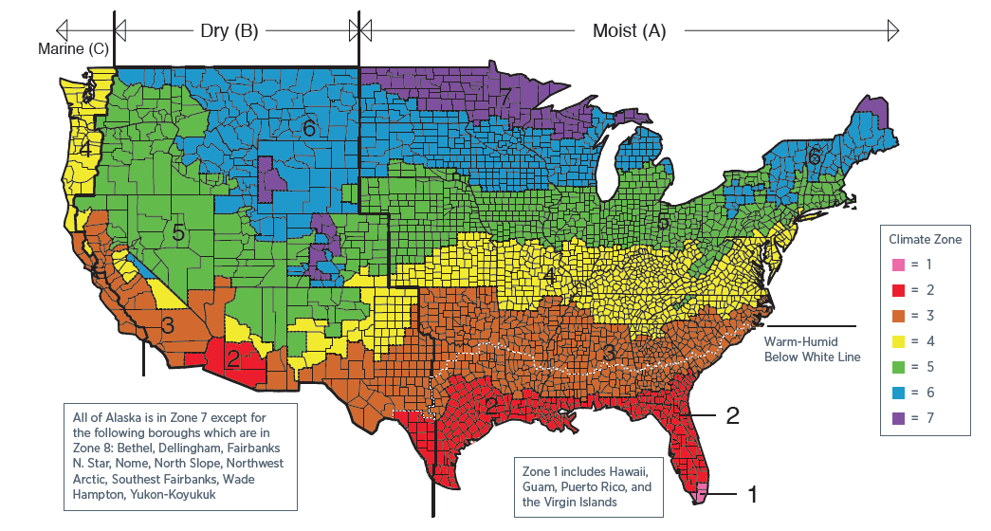

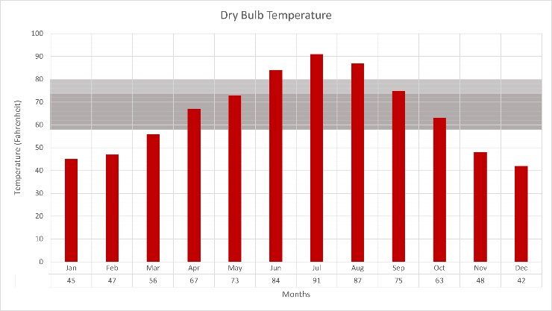
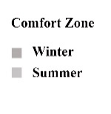
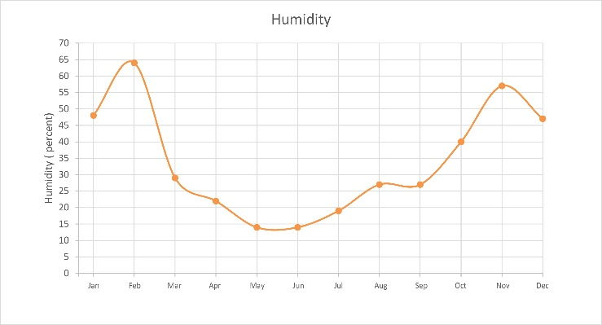
a))

Figure 3: Springdale climate data
a) Dry Bulb Temperature b) Humiditya))
Figure 4: Springdale climate data
a) Dry Bulb Temperature b) Humidity

Figure 5: Springdale climate data
a) Dry Bulb Temperature b) Humidity

b)))

Figure 6: Zion National Park Visitor Center’s building wind flowb)))

Zion National Park Visitor Center, erected in 2000, is a low energy, sustainable, and pedestrian-centered visitor center located in the heart of Zion Canyon, Springdale, Utah (Fig 5). This code-compliant building supervised by the National Renewable Energy Laboratory (NREL) (Barajas 2017) is one of the case studies that was analyzed and presents the effects of wind flow around the building (Fig 4).

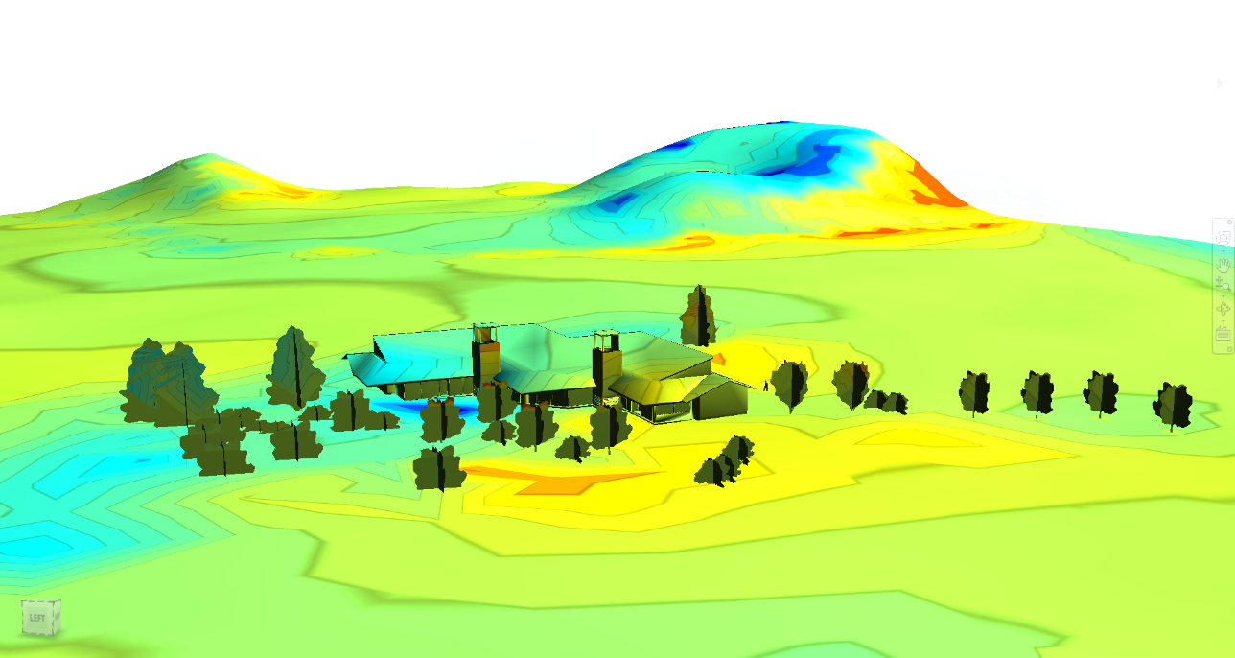
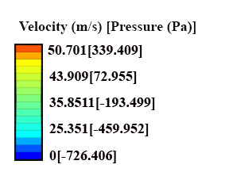

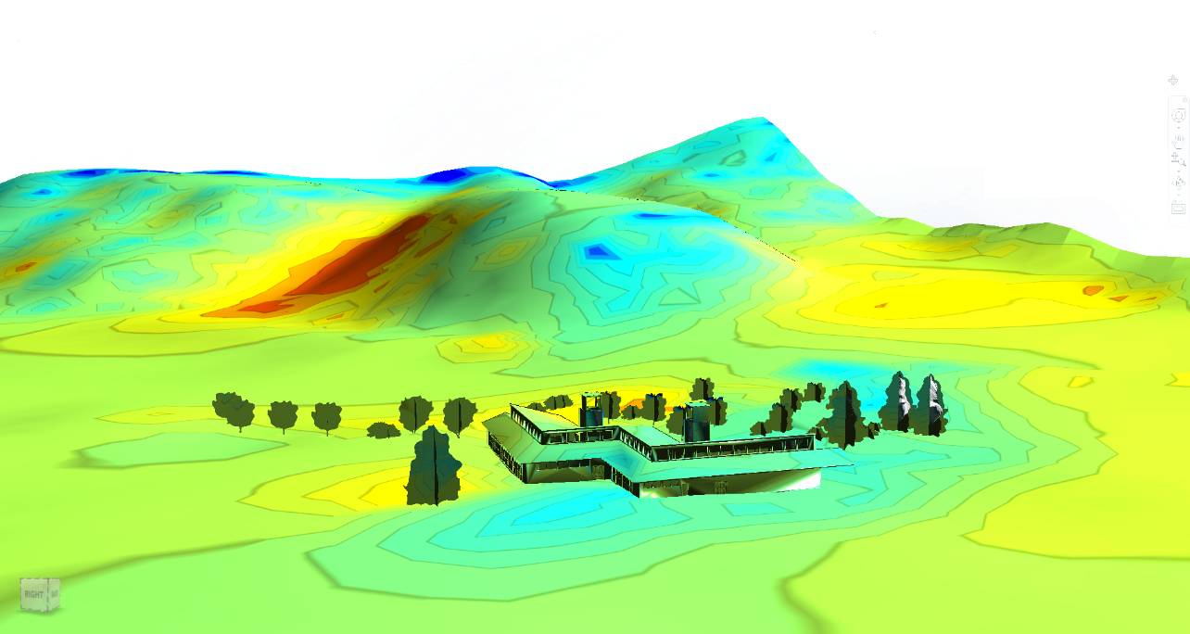
Figure 7: Zion National Park Visitor Center’s building wind flow
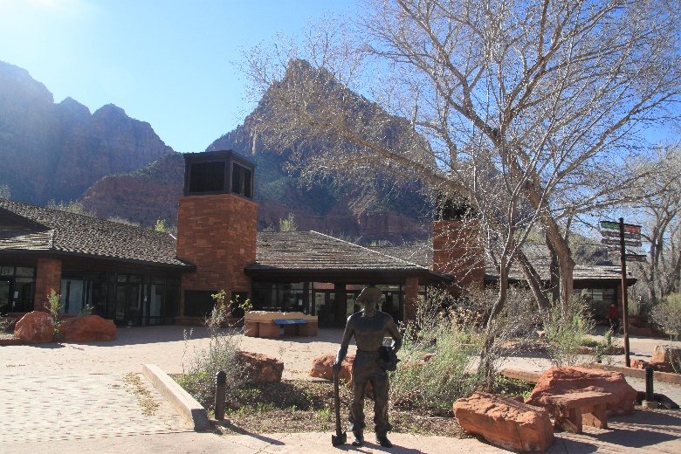
With a gross area of 7,600 square feet, it contains a retail store, public assembly, and an educational division (The American Institute of Architects 2001). Passive design and minimization of the impact of natural resources for the building are the main characteristics of the Zion National Park Visitor Center. It is designed to be 70% more efficient in energy usage comparted to other buildings of its type (Torcellini, Judkoff and Hayter 2002).

Figure 8: Zion National Park Visitor Center
Downdraft cooling towers and operable windows for natural ventilation cooling were used as well. Hot dry air is drawn into the evaporative cooling pads at the top of the tower which cools the air as it enters the cooling tower and passes the soaked cell decks. The cooled air is now denser compared to the peripheral flow and falls naturally through the tower into the space (Fig 6). A fan is also used in the cooling towers to help the tower to draw the cooled airstream into and through the building.

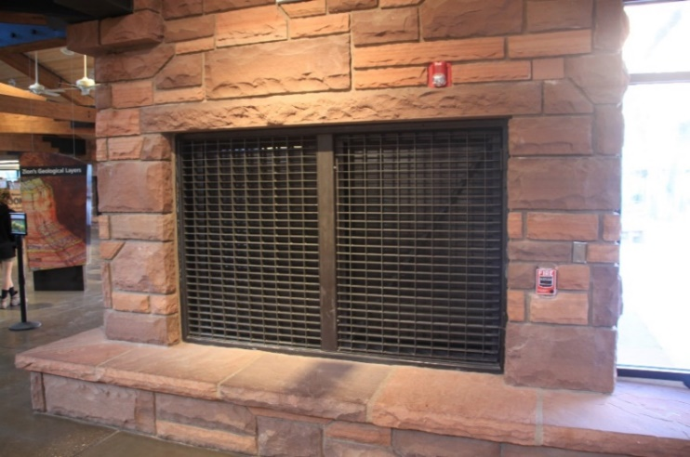
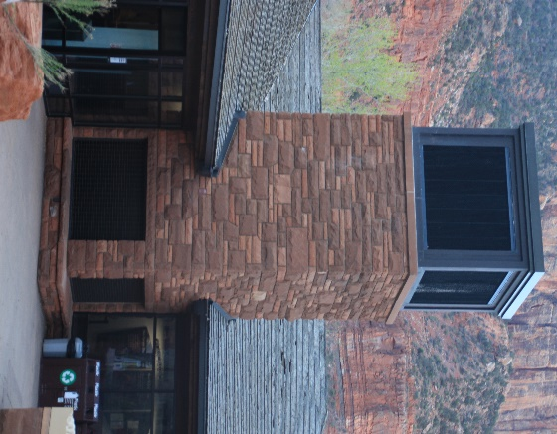
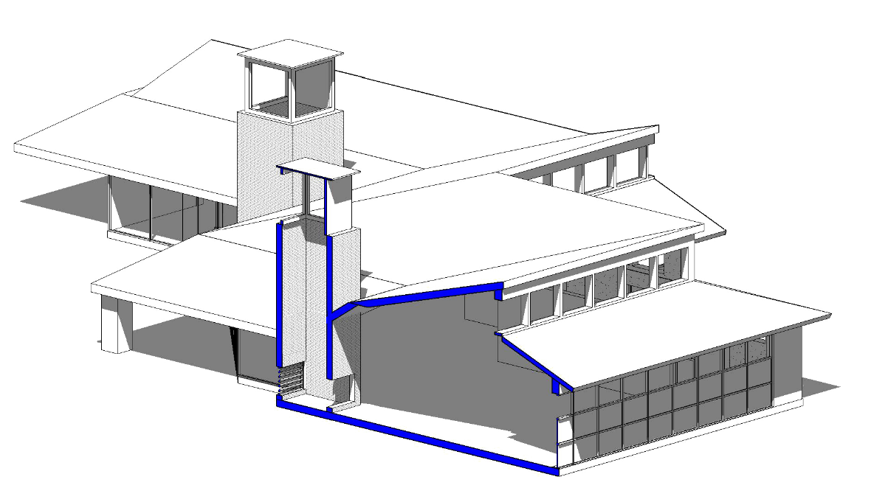
b)

b)

a)

a)

  - b) Wind Tower Inlet

  - Figure 9: Cooling Towers of the buildinga) Wind Tower

  - a) Wind Tower

  - Figure 10: Cooling Towers of the buildinga) Wind Tower

  - Figure 11: Cooling Towers of the building
The inlet (b), where the fresh breeze from the outside enters the building is highlighted in the 3D model

  - Figure 12: Clerestory windows in different heightFigure 13: Cooling Towers of the building
The inlet (b), where the fresh breeze from the outside enters the building is highlighted in the 3D model

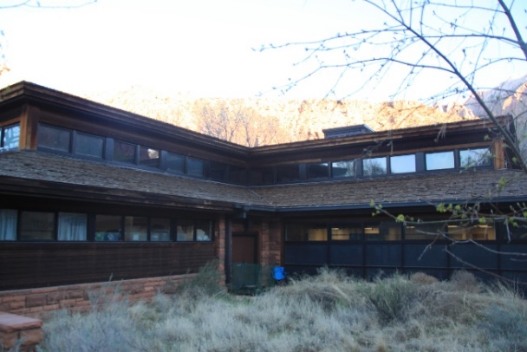
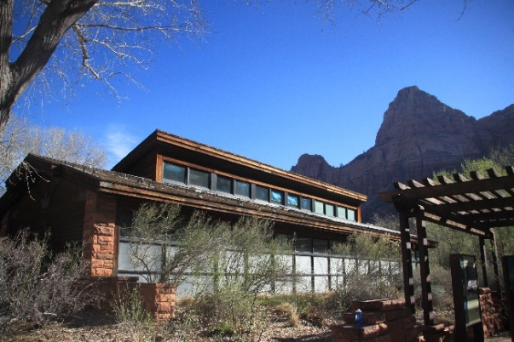
The Zion National Park Visitor Center is equipped with automated systems and temperature sensors. Instead of having a switch or thermostat, these sensors decide when to open the cooling tower shutters, windows, or turn on the fans according to the temperature. These windows, on two different height levels (Fig 7), help natural ventilation into the building.
Figure 14: Clerestory windows in different height

4.2.1.1 Opening Sizes and Positions:

The clerestory windows are one of the techniques used in order to enhance the natural ventilation (Fig 8). By installing windows at different heights, the rate of circulation and the natural ventilation will increase compared to a building with no openings. In this scenario, as the inside air gets hot, it rises due to its low density (Klote 1991) while the cooler air from the outside fills in the relative vacuum, thus making an circulation of air which leads to an induced breeze (Fig 9).

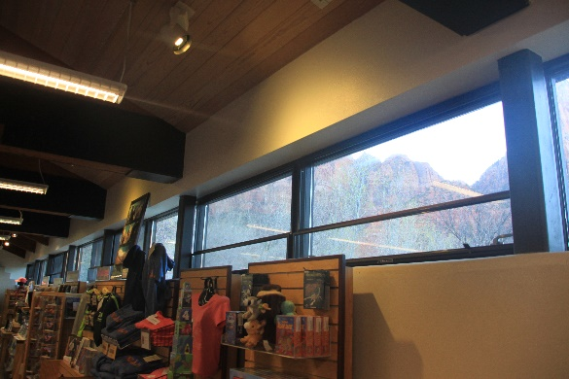
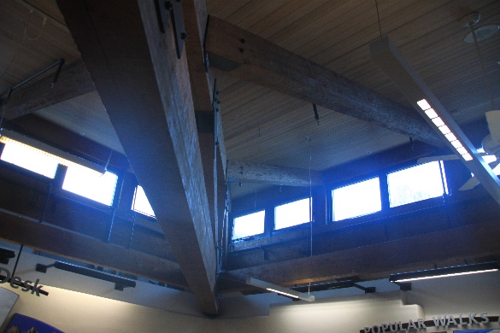
Figure 15: Clerestory windows in the building in two different levels
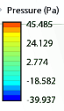
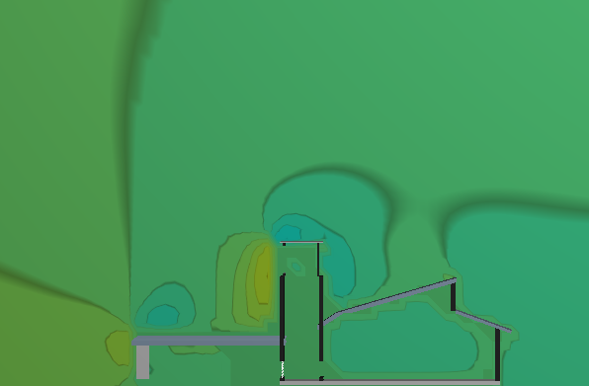

  - a) Clerestory windows on different levels

  - a) Clerestory windows on different levels
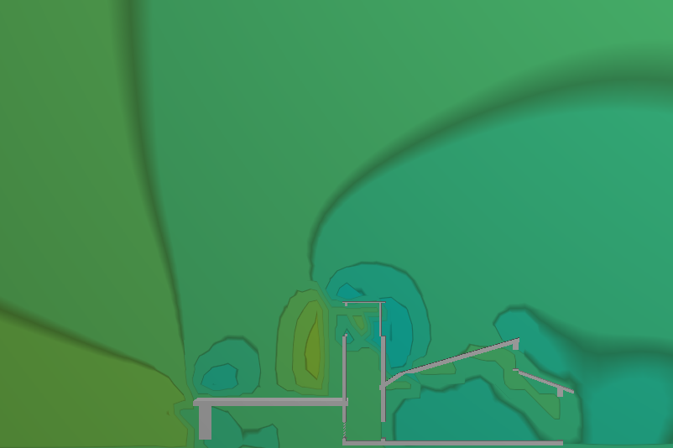

Figure 16: Openings located in different heights helps the natural ventilation process
  - b) No clerestory windows

  - b) No clerestory windows
Another important factor that significantly effects the natural ventilation is the size, locations, and the proportions of openings compared to each other. Stream changes as wind hits an obstacle (Autodesk 2014). As the wind comes to a stop in the impingement point, where the flow hits the building, the air pressure rises. The border experiences an absence of wind due to the pressure differential, therefore the leeward side of the building becomes a low pressure region (Afkhamiaghda, 2016). This pressure change is a cause of the wind turbulence where the high pressured wind enters through the vertical shaft of the wind catcher (Fig 10). If an opening was installed in the opposite side of the room, the natural ventilation would penetrate to the building up to five times the floor-ceiling height. The amount of penetration plummets to two times the floor-ceiling height if the windows are only on one side of the building. Therefore to reach an optimal ventilation in a building, it is recommended to have openings on opposite sides if possible, or at least have openings on more than one side of the building (Martin and Fitzsimmons 2000).

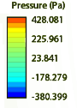

a) Openings on different sides of building

Figure 17: The pressure change between different zones of the building leading to natural flow.
Having opening in different sides of the building (a) expedites this ventilationa) Openings on different sides of building



b) Opening on just one side

b) Opening on just one side

Figure 18: The pressure change between different zones of the building leading to natural flow.
Having opening in different sides of the building (a) expedites this ventilation

4.2.1.2 Orientation:

Desirable view, natural daylighting, and the benefits of natural ventilation are the main factors that form the buildings orientation. Using the particular angle for the building and orienting the structure in the right direction leads to a pleasant space for the occupants, which includes both using the breezes in cooling dominated months and sheltering from cold winds in the winter. Knowing the prevailing wind direction and speeds of the region by using the wind roses, architects are able to maximize wind ventilation in the building by choosing the right orientation for their buildings.
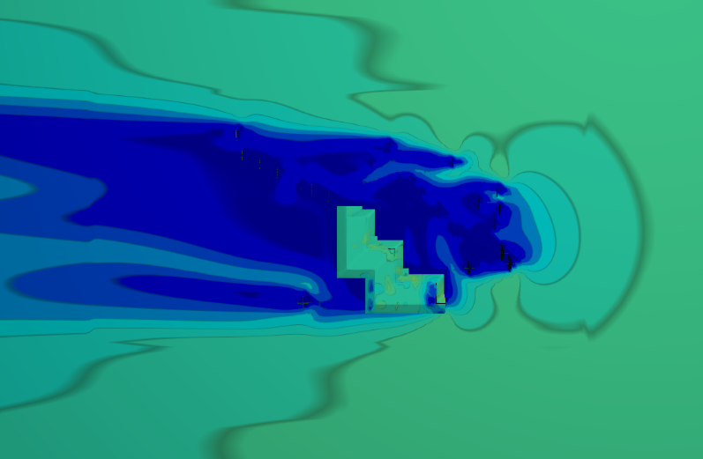
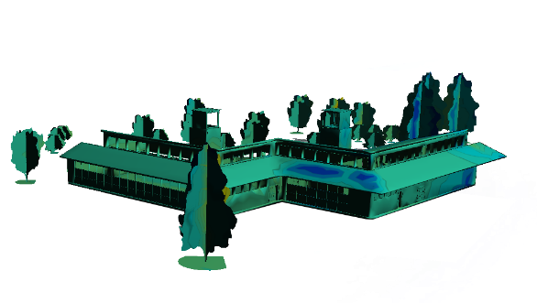
Maximizing the pressure difference between the inlet and outlets of the buildings can enhance the natural ventilation, a feature which can be studied through CFD analysis in the design stage process. As shown in Fig 11, as wind hits the Zion National Park Visitor Center, different air flow zones are created around the building. The velocity and pressure difference in these zones create air movements in the environment that causes the natural ventilation. These turbulences are most efficient with the right orientation and the placement of openings. Failure to decide the right orientation for the building will also result in poor ventilation.
a) No orientation, parallel to the dominant wind flow
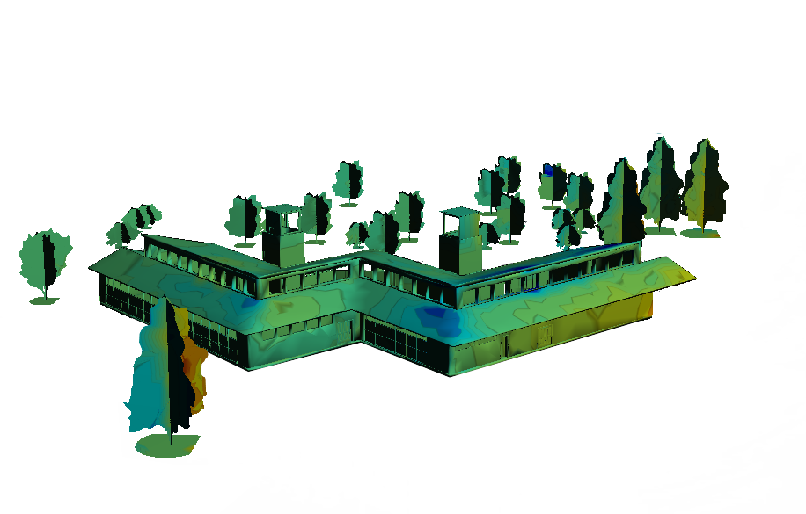
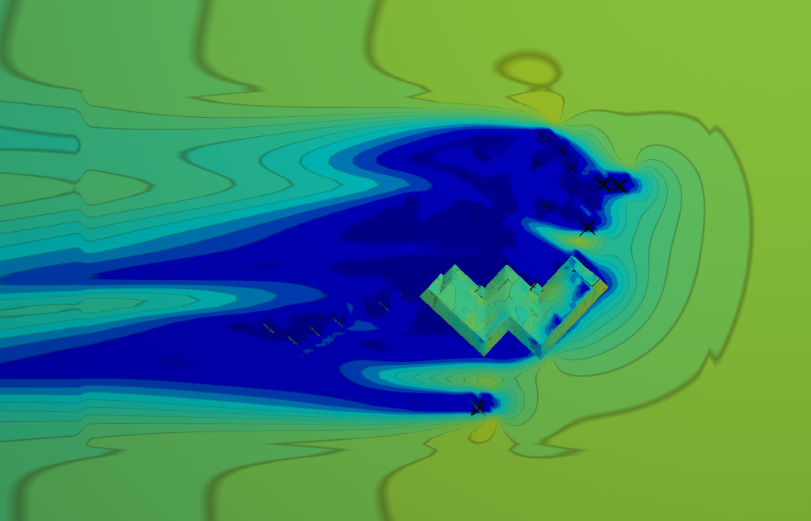
The wind blows from right to left with the speed of 40 miles/hour in all four scenarios. As you can see in the first scenario where the openings are parallel with the dominant wind, there is almost no significant wind speed or pressure difference on the surface. This results in poor natural ventilation system.
b) 45 degree clockwise orientation to the dominant wind flow
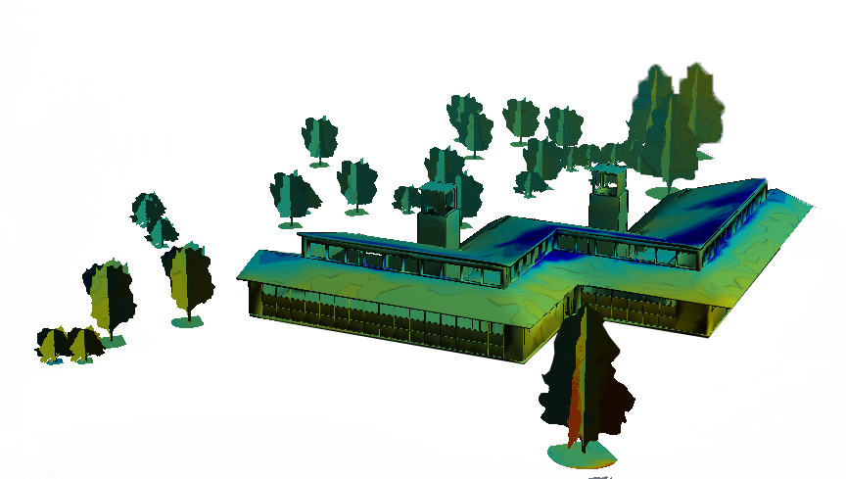
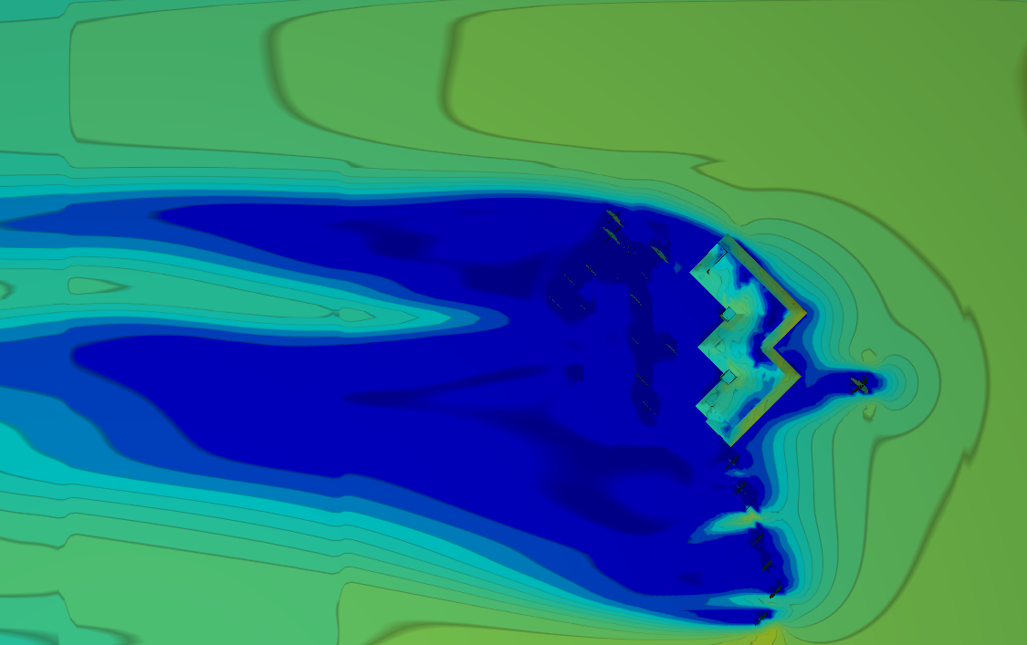
c) 135 degree clockwise orientation to the dominant wind flow

Orienting the building so that the wind hit the openings in an oblique angle will result in the formation of different zones on the building’s surface. These zones, each with different speed and pressure (Fig11, b and c) enhance the natural ventilation and will create a pleasant ambiance.

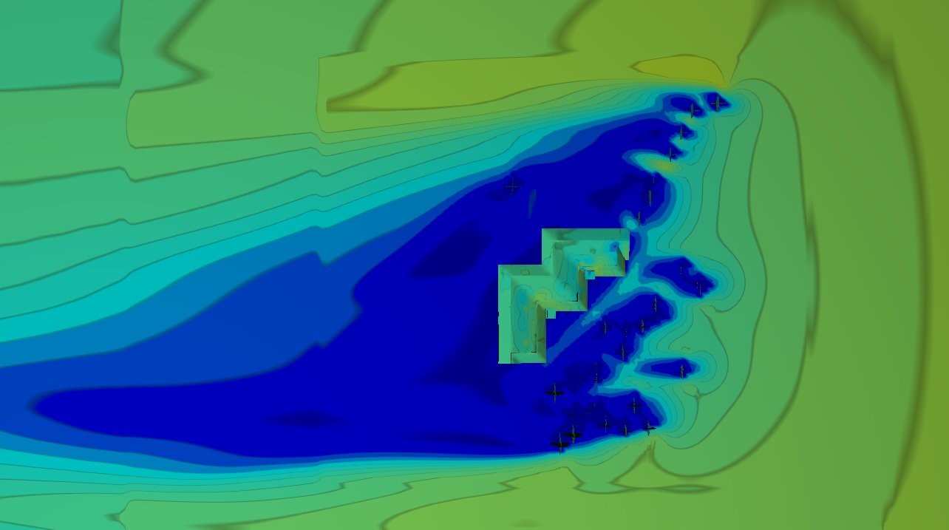
Figure 19: The influence of building orientation against the dominant wind on the wind flow
a) 0 degrees b) 45 degrees c) 135 degrees d) 270 degrees
d) 270 degree clockwise orientation to the dominant wind flow

4.2.2 Badgirs
In previous research (Afkhamiaghda, 2016), we have studied the functionality of Badgirs and how they can be used as a natural ventilation system here in the United States. Badgirs, or wind towers, are vertical hollow architectural elements built with materials with high heat capacity, usually bricks and concrete, which carry the outside breeze inside the building using openings that face the local dominant winds (Foruzanmehr 2012). This passive natural ventilation system which promotes a comfortable environment for the occupants is another system that was studied in this research in order to show the application of CFD in architecture. This kind of natural ventilation system is mostly used in hot-arid and hot- humid climates by routing natural ventilation within the space. Badgirs are frequently used in the Middle East, mostly in desert areas where the topography is typically flat, where the form of the cities are dense and buildings are directly adjacent to each other (Fig 12) (Bahadori and Dehghani-sanij, Wind Towers Architecture, Climate and Sustainability 2014).

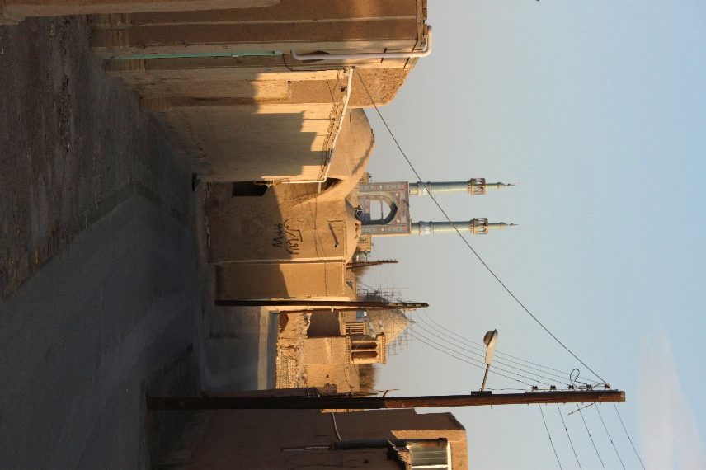
Figure 20: The dense form of Yazd, located in Dashte- Kavir in Iran
Image courtesy by Mahdi Afkhamiaghda

Figure 21: The dense form of Yazd, located in Dashte- Kavir in Iran
Image courtesy by Mahdi Afkhamiaghda
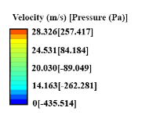
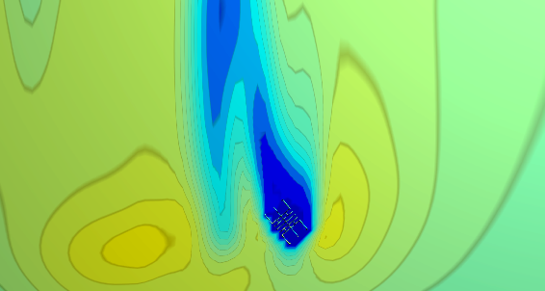
The function of the wind catcher stems from both Bernoulli’s and Stack effect (Bahadori and Dehghani-sanij, Wind Towers Architecture, Climate and Sustainability 2014). As mentioned before, a pressure difference is created as wind hits an obstacle, making an air diversion around the object. There are fins embedded on top of the wind catchers facing the dominant wind, pulling the high pressure wind inside due to the pressure difference between the windward turbulence and the inside environment (Abeini Rad 2014),creating a human comfort zone exchanging the inside air with the renewed breeze of outside (A'zami 2005) (Fig 13).

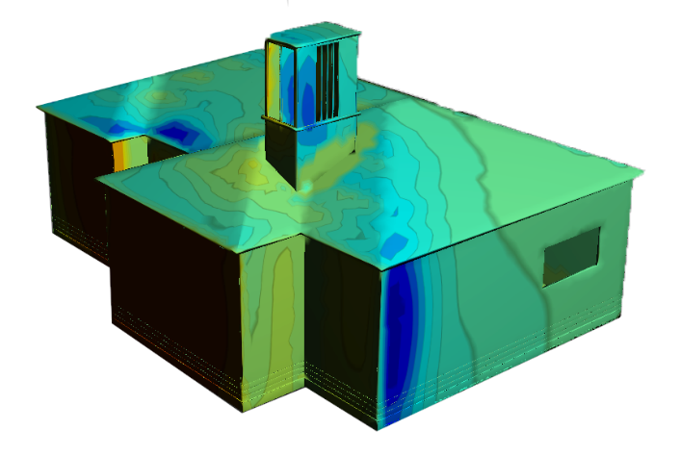


Figure 22: Wind turbulence through the building that causes the natural ventilation stemmed by the wind catcher
Windward
Leeward

In different types of wind catchers, known as two-side, four side, or hexagon wind catchers, there are fins on other sides of the wind catcher (Fig 14) so that as the fresh, dense breeze penetrates the building from the windward side while the hot air departures from other sides. As the sun radiates on one of side of wind catcher, the air temperature on that side begins to rise. This temperature difference also creates a difference in pressure enhancing air circulation (Bahadori , Viability of wind towers in achieving summer comfort in the hot arid regions of the Middle East 1994).

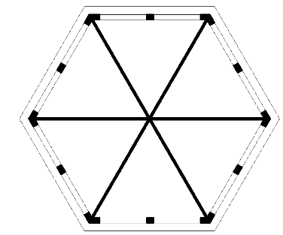
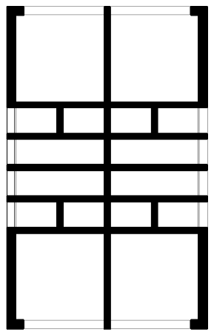
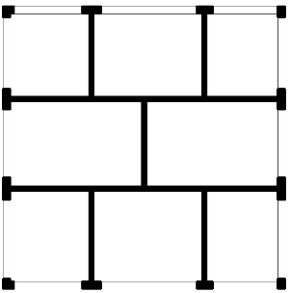

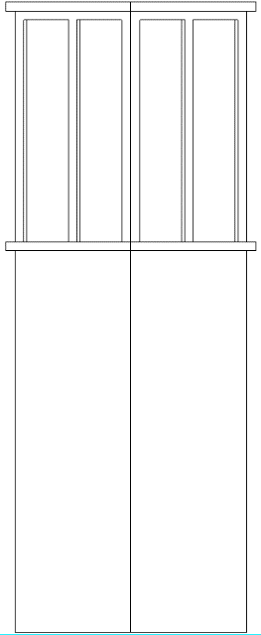
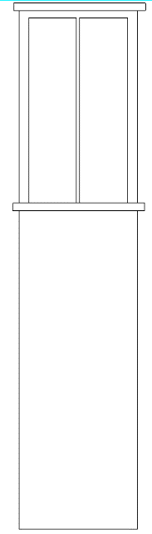
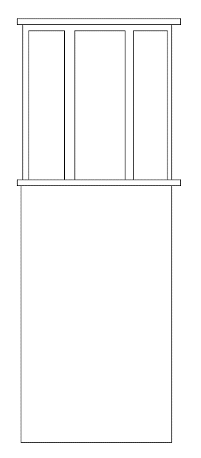

a) Square b) Rectangular c) Hexagon

Figure 23: Different kinds of Badgirs based on their plan shape

4.2.2.1 Location

We subsequently studied the effects of site topography, wind speed, and form of the surrounding neighborhood on the efficacy of the system. We tested badgirs, which originally belong to hot-arid and hot-humid regions in Middle East, in different climates and different cities, each with diverse climate situation and different neighborhood density. The results from each test were compared in order to find a correlation between the variables.

Fig 15 compares the flow behavior around the same building located in three different cities, (Zion, New York, and San Francisco) to study the effect of these variables on the flow behavior. The neighborhood topography was again modeled using Google Sketch Up and then imported to Autodesk Revit to build the neighborhood. Using Google Map and Google Map 3D street view we were able to model the surrounding buildings fairly accurately.

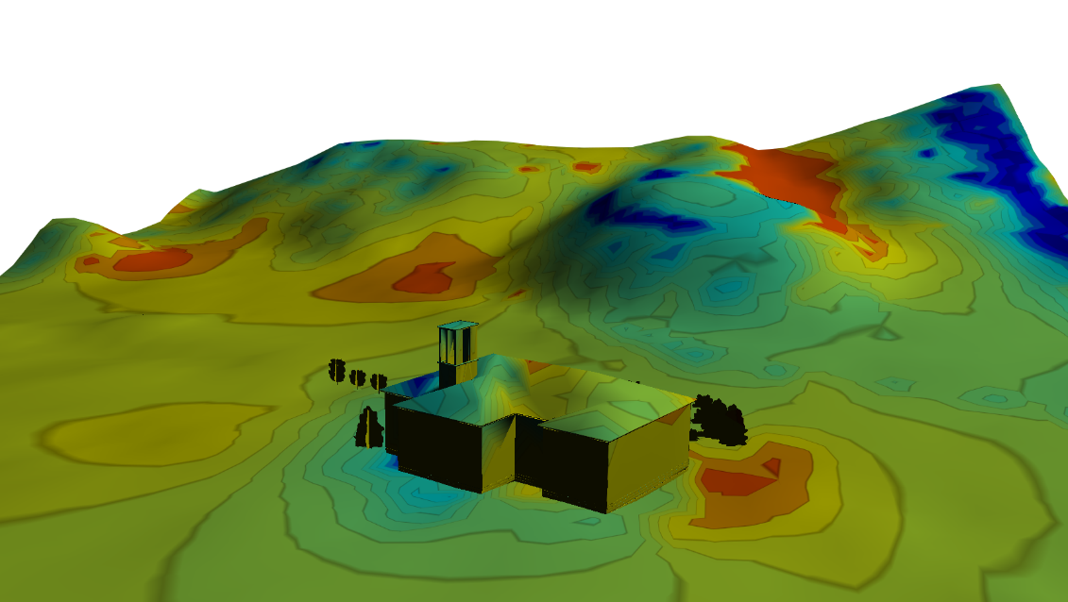
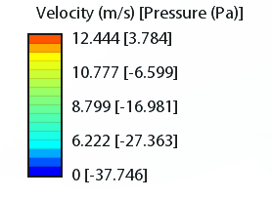

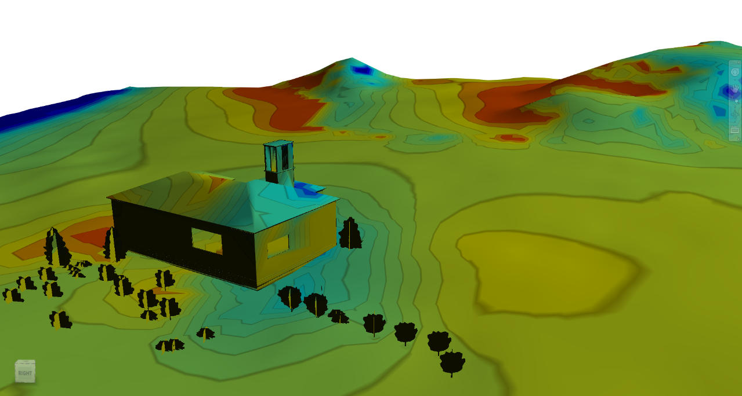
a) Zion, Utah’s hilly topography. The building is located in a sprawl neighborhood
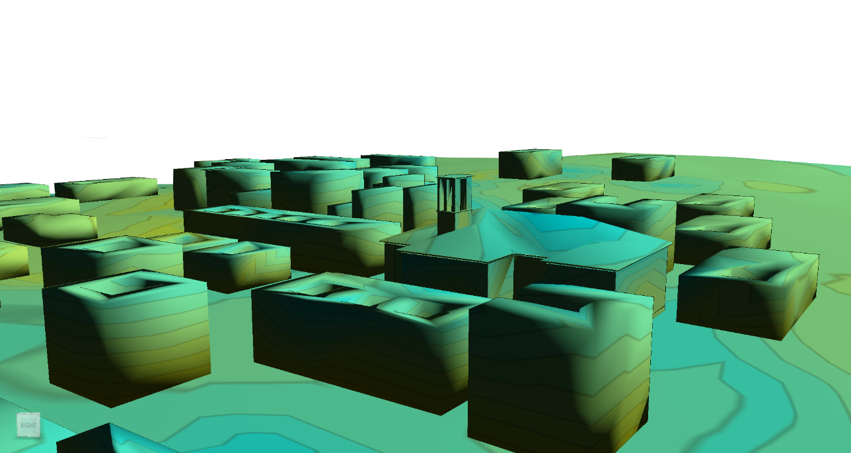
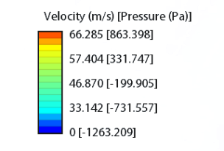

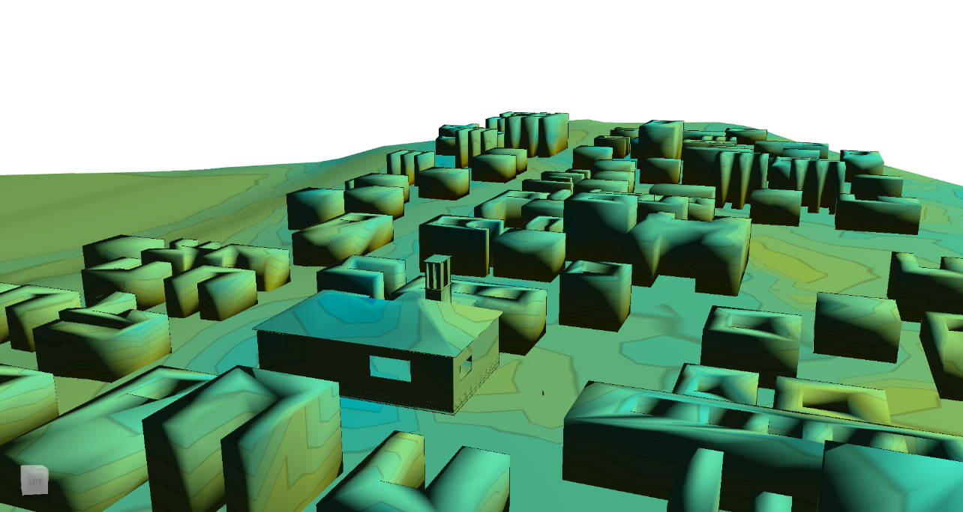

b): Upper Manhattan, New York’s almost level topography. The building is located in a very dense neighborhood
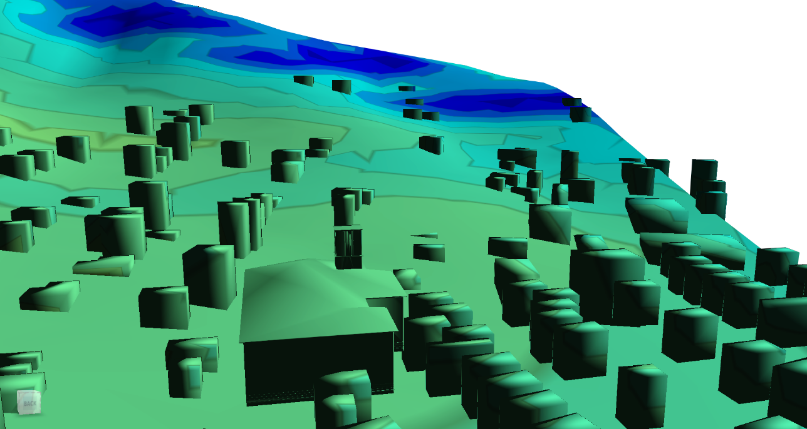
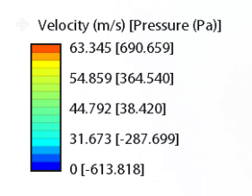

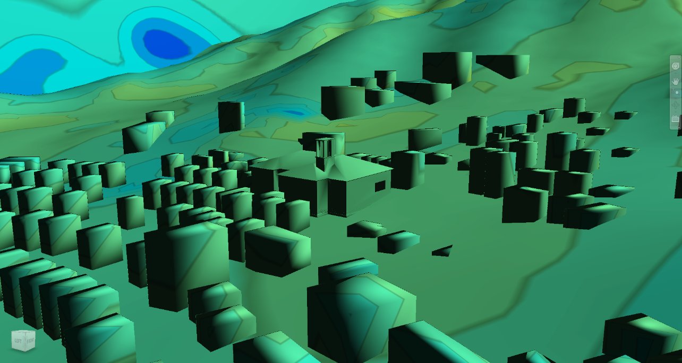

c): San Francisco, California’s hilly Topography. The building located in a very dense neighborhood
Figure 24: The flow behavior around the same building in:
a) Zion b) New York c) San Francisco
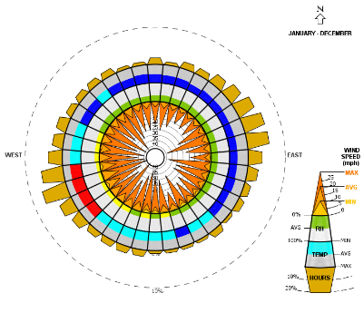
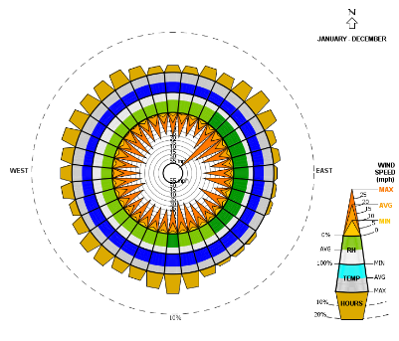
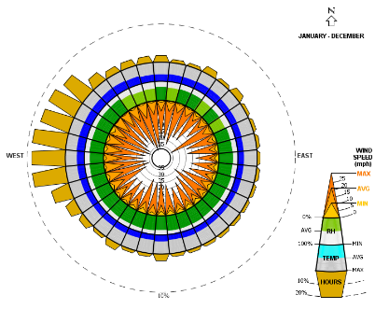
According to the weather data derived from the EPW Weather Data site and interpreted by the Climate Consultant software, the dominant winds in Springdale through the whole year can get as high as 40 miles/hour (Fig 16) and come from Southwest and Northeast. Here we studied the situation where the wind is originating from Southwest and the building is oriented as in the current orientation of Zion Natural Park Visitor Center. As you can see in Fig 16, different zones each with diverse wind speed are formed around the building.
Figure 25: The annual wind rose pattern for:
a) Saint George b) New York c) San Francisco
a) Saint George b) New York c) San Francisco

Figure 26: The annual wind rose pattern for:
a) Saint George b) New York c) San Franciscoa) Saint George b) New York c) San Francisco

While the Manhattan winds are considerably varied, we have chosen the Northeast gusts which has the highest speed of 30 miles/hour to demonstrate the effects of wind for our model. As the prevailing wind rises from Northeast in Manhattan (Fig 16), the speed and pressure of the wind decreases as it flows through the city due to dense neighborhood around the building. The surrounding buildings and obstacles stop the wind turbulence which results in a smooth flow with a minute pressure difference in the different zones of our building. While the flow movement and the natural process of air circulation in this scenario may not be as effective as what we have in the Zion situation, the stream still ventilates because of the pressure discrepancy between the different zones created on the surface.
This occurrence hardly happens in the hilly San Francisco where the building is surrounded by the dense neighborhood. These two factors (mountainous topography and dense area) occlude the turbulence from effecting the building which results in stagnant areas around the structure and virtually no wind speed difference on the surface in order to cause a turbulence.
According to Bernoulli’s effect, an increase in the speed of a fluid accompanies a decrease in pressure, and vice versa .As the wind hits the wind catcher, a positive pressure is made on the windward while a negative pressure is created on the opposite side of the wind catcher. The orientation of the wind catchers is influenced by the flow of the dominant wind in the region. This pressure change is the cause of a wind turbulence where the high pressured wind enters through the vertical shaft of the wind catcher. Using a window on the other side of the room accompanies the natural ventilation that has been created.
According to the analysis using Autodesk Flow Design software, we can see that in places with more air flow and pressure differences around the building, badgirs are more effective since the pressure change is the cause of a wind turbulence where the high pressured wind enters through the vertical shaft of the wind catcher. Therefore while badgirs can be implemented in Springdale and New York, they won’t have the same efficacy in a city like San Francisco where there is no turbulence.

4.3 Findings
The Autodesk Flow Design software is considered as an effective tool for architects to use in order to create a more passive and energy efficient design that takes the environment and the site conditions into consideration. By showing the changes in pressure and velocity of the wind turbulence, the architects are able to see their design flows in regard to wind behavior and diagnose the possible errors in the early design stages. While this software is not considered as accurate as ANSYS FLUENT or WTT, it clearly shows the effects of different variables such as topography, neighborhood density, and the openings on the wind flow around a structure. In addition to these features, simplicity in modeling and importing files make the Autodesk Flow Design a promising software for architects to use.

CHAPTER 5: CONCLUSIONS
Although CFD might not be considered as an accurate method when compared to WTT and FSE, due to its simplicity it brings convenience to architectural processes and opens up new considerations in design, with a specific focus on the effects of wind around and through the buildings. With the CFD wind environment simulation technology, architects are able to more accurately project and utilize greater performance analyses to describe the wind environment in a design scheme. This will allow them to conduct their analyses based on relevant building technologies and simulation results, which will provide a strong basis for evaluation and performance quantification of wind based environmental design.
Showing the effects of CFD studies and simulation and its crucial role in the early design process, we suggest the use of a committed design team who do building simulation and analysis, starting from the earliest conceptual design phase to the point of finishing the building. Including CFD analysis in this process will result in occupant’s comfort while minimizing the energy consumption in the building design. This strategy could be implemented by either 1.) Educating the young basic fundamentals 101 which are:
- Interpreting the counters and wind pressures in different regions
- Importing the model correctly
- Setting the variables in the correct order

References

Abeini Rad, Maryam. 2014. "Creating a Future for an Ancient Sustainable City, Yazd." 22-68.
Afkhamiaghda, Mahdi. “The Feasibility of Using Wind Catchers in the United States.” Presentation at Student Research & Creativity Day, Norman, OK, March 14, 2016.
American Society of Civil Engineers. 2003. Minimum Design Loads for Buildings and Other Structures. Reston: The American Society of Civil Engineers.
Atkinson, J, Y Chartier, CL Pessoa-Silva, and et al. 2009. Natural Ventilation for Infection Control in Health-Care Settings. Geneva: World Health Organization.
Autodesk. 2014. Autodesk Flow Design. Accessed January 13, 2017. http://download.autodesk.com/us/flow_design/Flow_Design_Preliminary_Validation_Brief_01072014.pdf.
—. 2015. Autodesk Knowledge Network. February 12. Accessed February 2, 2017. https://knowledge.autodesk.com/support/flow-design/learn-explore/caas/CloudHelp/cloudhelp/ENU/FlowDesign/files/GUID-290D85CF-7A15-463C-A924-4423AEDF6B7F-htm.html.
—. 2015. "Flow Design Ahmed Body Validation Study." Autodesk Simulation Resources. February 2. Accessed February 16, 2017. http://simhub.autodesk.com/resources/flow-design-ahmed-body-validation-study.
—. 2014. Natural Ventilation. Accessed March 1, 2017. http://autodesk.efrontlearning.com/courses/www/student.php?view_unit=2400.
A'zami, A. 2005. "Badgir in traditional Iranian architecture." Passive and Low Energy Cooling for the Built Environment. Santorini. 1021-1025.
Bahadori , Mehdi N. 1994. "Viability of wind towers in achieving summer comfort in the hot arid regions of the Middle East." Renewable Energy 879-892.
Bahadori, Mehdi N, and Alireza Dehghani-sanij. 2014. Wind Towers Architecture, Climate and Sustainability. Edited by Ali Sayigh. Cham: Springer International Publishing.
Bakker, Andre. 2002. "Meshing." Applied Computational Fluid Dynamic. Accessed February 17, 2017. www.bakker.org/dartmouth06/engs150/07-mesh.pdf.
Barajas, Alexander, interview by Mahdi Afkhamiaghda. 2017. Zion (March 16).
Blocken, Bert, and Jan Carmeliet. 2007. "Validation of CFD simulations of wind-driven rain on a low-rise building facade." Building and Environment 2530-2548.
Chen, Qingyan, and Jelena Srebric. 2000. "Application of CFD Tools for Indoor and Outdoor Environment Design." International Journal on Architectural Science 14-29.
DeHaan, Mark A, John C Vassberg, S Melissa Rivers, and Richard A Wahls. 2008. "Developement of a Common Research Model for Applied CFD Validation Studies." AIAA Applies Aerodynmics Conference. Honolulu : American Institute of Aeronautics and Astronautics. 18-21.
Foruzanmehr, Ahmadreza. 2012. "The wind-catcher: users’ perception of a vernacular passive cooling system ." Architectural Science Review 250-257.
Franke, Jorg, Antti Hellsten, Heinke Schlunzen, and Bertrand Carissimo. 2007. COST; BEST PRACTICE GUIDELINE FOR THE CFD SIMULATION OF FLOWS IN THE URBAN ENVIRONMENT. Hamburg: University of Hamburg.
Hassan, A M, H Lee, and U S Yoo. 2015. "From medievel Cairo to modern Masdar City: lessons learned through a comparative study." Architectural Science Review 43-52.
Irwin, Peter A. 2010. "Wind Design on Tall Buildings." Pacific Earthquake Engineering Research Center. May 7. Accessed January 23, 2017. peer.berkeley.edu/tbi/wp-content/uploads/2010/09/Irwin.pd.
Jauregui, Ricardo, and Ferran Silva. 2011. Numerical Validation Methods, Numerical Analysis - Theory and Application. Edited by Jan Awrejcewicz. Rijeka: InTech.
Kim, Daeung. 2013. THE APPLICATION OF CFD TO BUILDING ANALYSIS AND DESIGN: A COMBINED APPROACH OF AN IMMERSIVE CASE STUDY AND WIND TUNNEL TESTING. Blacksburg: Virginia Polytechnic Institute.
Klote, John H. 1991. A General Routine for Analysis of Stack Effect. National Institute of Standards and Technology,.
Lawson, Tom. 2010. Building Aerodynamics. London: Imperial College Press.
Martin, Andrew, and Jason Fitzsimmons. 2000. Making Natural Ventilation Work. Guidance Note, Bracknell: BSRIA.
Mittal, A K, D Ghosh, S Behera, I A Siddiuqui, and D S Dharmshaktu. 2013. "Wind Flow Simulation in the Vicinity of Tall Buildings Through CFD." The Eight Asia-Pacific Conference on Wind Engineering. Chennai: Research Publishing. 682-688.
Oberkampf, William L, and Timothy G Trucano. 2002. "Verification and validation in Computational Fluid Dynamics." Progress in Aerospace Sciences.
Onouye, Barry, and Kevin Kane. 2012. Statics and Strenght of Materials for Architecture and Building Construction. New Jersey: Pearson Education .
Princeton University. 2017. Seperation and Wakes. April 17. Accessed April 24, 2017. https://www.princeton.edu/~asmits/Bicycle_web/separation.html.
Schmitz, Barb. 2014. Autodesk Goes with the Flow, Releases New Simulation Tool. January 16. Accessed January 21, 2017. http://www.3dcadworld.com/autodesk-goes-flow-releases-new-simulation-tool/.
Surry, D. 1991. "Pressure measurements on the Texas Tech Building: Wind Tunnel Measurements and Comparisons with Full Scale." Wind Engineering and Industrial 235-247.
The American Institute of Architects. 2001. Top AIA Projects. Accessed January 19, 2017. http://www.aiatopten.org/node/202.
Torcellini, P, R Judkoff, and S Hayter. 2002. "Zion National Park Visitor Center: Significant EnergySavings Achieved through aWhole-Building Design Process." American Council for an Energy-Efficient Economy (ACEEE) Summer Study on Energy Efficiency in Buildings. Pacific Grove: U.S. Department of Commerce.
USGBC Research Committee. 2008. A National Green Building Research Agenda. USGBC.
Yeo, DongHun, and Arindam Gan Chowdhury. 2013. "Simplified Wind Flow Model for the Estimation of Aerodynamic Effects on small structures." Eng. Mech 367-375.

