UNIVERSITY OF OKLAHOMA
GRADUATE COLLEGE

Governance, Ideology, Citizen Perceptions and
the Management of the Nuclear Waste Stalemate in USA

A DISSERTATION
SUBMITTED TO THE GRADUATE FACULTY
in partial fulfillment of the requirement for the
Degree of
DOCTOR OF PHILOSOPHY

By
Ani Ter-Mkrtchyan
Norman, Oklahoma
2020

Governance, Ideology, Citizen Perceptions and
the Management of the Nuclear Waste Stalemate in USA

A DISSERTATION APPROVED FOR THE DEPARTMENT OF POLITICAL SCIENCE

BY THE COMMITTEE CONSISTING OF

Dr. Hank Jenkins-Smith, Chair

Dr. Joseph Ripberger

Dr. Scott Robinson

Dr. Carol Silva

Dr. Justin Reedy

© Copyright by Ani Ter-Mkrtchyan 2020
All Rights Reserved.
Dedication

This dissertation is dedicated to all those little girls who have big dreams. You deserve to pursue your education and it does not have to turn into a dream. Particular sentiment of gratitude to my grandma Julieta Kalantarian who urged me to move on in search of my aspirations.

Acknowledgements

This dissertation would not have been possible without the support and encouragement of my committee. I am grateful to my chair, Hank Jenkins-Smith for his support and for believing in me even more than I did. I am thankful for his intellectual guidance and direction in this dissertation and other research projects that I had the chance to work on in the Center. I am also thankful to him for providing me with the opportunity of being his apprentice in all those interesting courses that he is teaching.
I have also immensely enjoyed working with Carol Silva in her undergraduate methods as well as environmental policy classes. These valuable experiences have shaped my graduate studies and have provided me with many learning and growth opportunities. I am also grateful to Carol for all her kindness and positivity. Every step in this journey has felt much more achievable thanks to her. Hank and Carol have not only provided me with enormous professional opportunities but have also opened their hearts for the people who came with me; my husband and my children.
I owe enormous gratitude to Joe Ripberger for his intellectual input, and valuable guidance in this dissertation and many other research projects. My learning experience at the University of Oklahoma has profoundly benefited thanks to Joe Ripberger’s high professionalism, kind mentorship, patience and inspiration.
I would also like to offer my sincere appreciation to Scott Robinson for his expertise and valuable feedback and suggestions in this project. I am indebted to Scott for his time as a committee member and a department chair. Being what qualifies as a first generation student, my completion of the PhD program could not have been accomplished without his encouraging academic, professional and moral support.
I am also truly grateful to Justin Reedy for serving in my committee as the Graduate College representative. I am thankful for his positivity and inclusiveness and I appreciate his time reading this work and providing detailed feedback.
There are many wonderful scholars, teachers and mentors who have not been in my dissertation committee but have significantly contributed to my growth. I am indebted to Kuhika Gupta for her gracious and generous mentorship and for holding my hand when I needed the most. Kuhika’s expertise in nuclear policy issues has a big impact on my academic trajectory. Many thanks also to Sam Workman, Deven Carlson, Alisa Fryar and Aimee Franklin for serving in my Advisory Committee during the initial years of grad school and for continuing to support me all these years. I first met Aimee Franklin when I came to OU for my MPA degree and I will forever cherish the valuable contribution that she has in my graduate career. Dean Lee Williams deserves a special mention as well for providing me with the opportunity to work for the Graduate College. This experience has influenced my fascination for OU and I am tremendously grateful to him for that. I want to also acknowledge Millie Audas, who so positively shaped my first experiences at OU and made sure that I am well integrated and ready for my academic endeavors.
This journey has also been influenced by my wonderful friends and colleagues who have made me feel the warmth of a family. I am particularly thankful to Elizabeth Bell for listening to my semi baked ideas and making me believe that I am a superwoman, to Wesley Wehde who besides being a great friend has inspired me to be fearless and to jujutsu with R. I have also been spoiled with the kind and inspiring friendship from Tracey Bark.
This has been a long journey that has included lots of miles of travel, both literally and metaphorically and I am incredibly thankful to my husband for leaving his magnifique life in France with all the charcuteries and boulangeries and is voyaging with me. And of course, I so much appreciate my mom’s choice of school where I was taught English from the first grade and had so many dedicated teachers who cultivated my love for knowledge. I have dreamt about being a teacher since seven years old, and I am excited that the path is about to start. All those wonderful people that I mentioned have had many responsibilities and demands on their schedule, but have given lots of space and attention to me every time I needed it. I know I will never be able to thank these people enough, instead, I will aspire to do the same for my students.

Table of Contents

List of Figures vii

List of Tables ix

Abstract 1

Chapter 1: Political Stalemate and Individual Preferences in Nuclear Waste Debate 2
Chapter 2: Public Opinion Literature and Policy Preferences 10
Chapter 3: Public Preferences in Spent Nuclear Fuel Siting: The Impact of Risk Perceptions, Trust and Knowledge 21

Chapter 4: Can Local Policy Concerns of NYMBYism Reshape Partisan and Ideological Landscape in the State of Nevada? 59
Chapter 5: Nuclear Impasse: Cultural Bias in Support for Carbon-Free Energy Sources 84

Chapter 6: Conclusion 105

References 110

List of Figures
Figure 1-1. Continuum of Micro-foundation of Individual Decision Making 8
Figure 2-1. The U.S. Political Environment According to Systems Approach 18
Figure 2-2. The Policy Making Milieu 19
Figure 3-1. Nuclear Energy Mean Risk Perceptions from 2006-2019 32
Figure 3-2. Nuclear Energy Mean Benefit Perceptions from 2006-2019 33
Figure 3-3. Mean Public Trust towards Experts for Regulation and Management of Nuclear Technology 34
Figure 3-4. Knowledge about SNF Management and Storage Policy Options 35
Figure 3-5. Mean Preferences in SNF Storage Policy Options 36
Figure 3-6. Line Charts of Differenced Independent and Dependent Variables 38
Figure 3-7. Risks of Nuclear Waste Transportation/Storage and SNF Deep Geologic Storage 41
Figure 3-8. Benefits of Reduced Mining and Support for SNF Onsite Storage 42
Figure 3-9. Benefits of Reduced Mining and Support for SNF Interim Storage 42
Figure 3-10. Trust in the Department of Defense & SNF Deep Geologic Storage 43
Figure 3-11. Trust in the National Labs & SNF Deep Geologic Storage 43
Figure 3-12. Trust in the EPA & Support for SNF Onsite Storage 44
Figure 3-13. Trust in the EPA & Support for SNF Interim Storage 44
Figure 3-14. Trust in the NRC & Support for SNF Onsite Storage 45
Figure 3-15. Trust in the NRC & Support for SNF Interim Storage 45
Figure 3-16. Knowledge about Actual SNF Storage Processes & Support for Interim Storage 46
Figure 3-17. Knowledge about Actual SNF Storage Processes & Support for Onsight Storage 46
Figure 3-18 Knowledge about Actual SNF Storage Processes & Support for Deep Geologic Option 47
Figure 4-1. Nevada County Map 66
Figure 4-2. Coefficient Plot for Event-Study Model Testing the Effect of NWPA on Democratic Votes 76
Figure 4-3. Coefficient Plot for Event-Study Model Testing the Effect of NWPA on Republican Votes 76
Figure 4-A1. The Map of the State of Nevada with NWPA Affected Counties 81
Figure 4-C1. Coefficient Plot for Event-Study Model Testing the Effect of NWPA on Election Turnout 83
Figure 5-1. Ternary Plot Demonstrating Respondents’ Energy Source Preferences 89
Figure 5-2. The Probability of Energy Source Preference among Cultural Subgroups 98
Figure 5-3. The Probability of Energy Source Preference among Strong Cultural Subgroups 99
Figure 5-4. The Probability of Energy Source Preference among Ideological Subsets 100
Figure 6-1. The Preference Formation Factors for “Homo-Politicus” Model of the Individual 105

List of Tables

Table 1-1. Comparison of Individual Preference Formation Models 9
Table 3-A1. Measurement of Key Variables 51
Table 3-B1. Augmented Dickey Fuller (ADCF) Test Results 53
Table 3-C1: Correlations by lag between Series of Risk and Benefit Perceptions and SNF Preferences 54
Table 3-C2: Correlations by lag between Series of Trust Perceptions and SNF Preferences
56
Table 3-C3. Correlations by lag between Series of Fraction of Correct Knowledge Response and SNF Preferences 58
Table 4-1. Descriptive Statistics 70
Table 4-2. The Effect of NWPA of 1982 on Voting Behavior and Election Turnout in Geographically Affected Counties, Non-Affected Ones as Controls 73
Table 4-3. The Effect of NWPA of 1982 and its 1987 Amendment on Majority Republican or Democratic Votes in Geographically Affected Counties, Non-Affected Ones as Controls 74
Table 4-4. Event-Study Results for the Effect of NWPA on Voting Behavior 75
Table 4-B1. The Effect of NWPA of 1987 on Voting Behavior and Election Turnout in Geographically Affected Counties, Non-Affected Ones as Controls 82
Table 5-1: Variables and Models 88
Table 5-2: Descriptive Statistics 91
Table 5-3: Frequency Distribution of Demographic Covariates 92
Table 5-4: OLS Regression Results for Energy Source Preferences in Interaction with Cultural Worldviews 93
Table 5-5: OLS Regression Results for Energy Source Preferences in Interaction with Political Ideology 97
Table 5-A1: Study Variables and Measures 103

Abstract
This dissertation research examines the prolonged nuclear stalemate in USA by investigating “the NIMBY syndrome” or the local opposition to spent nuclear fuel siting policy options from a public policy perspective. Nuclear energy production in general and nuclear waste disposal in particular is a highly contentious debate and a partisan policy issue that has evolved through many years. Using a range of quantitative analyses of cross-sectional data as well as data over time, I find evidence for localized nuclear opposition to result in reshaping the political landscape in terms of citizen partisan and ideological dispositions in the state of Nevada. The analyses of a nationwide representative sample of respondents reveal increased risk perceptions in nuclear waste transportation over time negatively affects public support for SNF deep geologic disposal five years later. Likewise, increased benefit perceptions in reduced mining is likely to lead an above average support for SNF onsite storage policy option 1 year later. While the nuclear impasse in its essence is a tangle of governance problems and management processes, its resolution seems far-fetched. The findings of this dissertation imply that changes in public perceptions and awareness in the long run may result in policy change.
Chapter 1: Political Stalemate and Individual Preferences in Nuclear Waste Debate

Introduction
Despite broad scientific consensus that deep geologic isolation is the preferred method for disposing of long-lived radioactive wastes (National Research Council 2001; IAEA 2014), siting facilities for the storage and disposal of these wastes has historically been among the most contentious policy problems and the most difficult tasks that governments have attempted to undertake (Hadden et al. 1983; O'Hare et al., 1983; Matheny and Williams 1985; Kraft and Clary 1991). The heart of this controversial policy debate concerns the distribution of perceived costs and benefits, a topic that has been the subject of study by public choice theorists (Buchanan & Tullock 1962) and political economists (Wilson 1984; Wilson et al 2018). The decision about where to site a nuclear waste disposal facility has typically been characterized as one that would concentrate the risks and costs (e.g., the potential effects on human health and environment near the facility) on a small segment of population whose residences are geographically concentrated around the disposal facility, while the benefits (e.g., increased security, reduced environmental and health risks from geographically dispersed temporary storage facilities) are spread across the general population (Matheny and Williams 1985; Kraft and Clary 1991). Absent public support by those near the proposed disposal facility, political opposition can – and often has – effectively blocked efforts to site such facilities. Public opinion and citizen participation in the policy opportunity structures of democratic political systems thus play a critical role in hazardous waste disposal facility siting (Rosenbaum 1983; Barber 1984; Matheny and Williams 1985; Kraft and Clary 1991).
The political stalemates confronting nuclear waste disposal policies are an example of a broader class of policy conflicts, known as "the NIMBY syndrome" (Matheny and Williams 1985, p. 1). “NIMBY (“Not In My Back Yard”) refers to intense, sometimes emotional, and often adamant local opposition to siting proposals that residents believe will result in adverse impacts” (Kraft and Clary 1991, p. 2). While the critics of NIMBYism often claim that technical and economic development or broader safety gains are being delayed because of myopic local concerns and overstated risks (Mazmanian and Morell 1990), a more positive assessment argues that NIMBYism is a rational and legitimate expression of local concerns and interests (Shrader-Frechette 1988; Matheny and Williams 1985, Slovic’s 1993).
However, the tenacity over many decades of the NIMBY syndrome as it applies to nuclear waste disposal has resulted in the persistent and growing problem of the accumulation of radioactive wastes in temporary storage sites (including “orphaned” waste at the growing number of shut-down reactors), increasing risks and costs for the entire community in the long run (Matheny and Williams 1985). Scientific consensus has established the urgency of this issue both nationally in the US and internationally by global organizations (US National Academy of Sciences National Research Council 2001; International Atomic Energy Association 2014). Large volumes of spent nuclear fuel (SNF) and high-level radioactive wastes (HLW) have accumulated, and experts have consistently concluded that deep-geologic disposal will be the most effective way to isolate these long-lived radioactive materials from people and the environment. In addition, continued (or expanded) reliance on nuclear energy is seen by many experts as necessary to reduce carbon emissions to address climate change (Lynas 2011b; Shaw 2011; Mulligan 2011), which would result in additional stocks of SNF that will require disposal in the future.
But controversy persists. Some policy experts have maintained staunch opposition to nuclear energy in any form (Green 2016). In part this opposition stems from a series of highly publicized nuclear disasters at operating nuclear power plants (Three Miles Island, Chernobyl, Fukushima) which have threatened both local populations and ecosystems. Another perceived threat is that spent nuclear fuel could be reprocessed into plutonium and made into nuclear weapons (Carter 1987). The highly-irradiated materials could also be used as improvised radiation bombs by terrorists. These arguments continue to fuel local opposition to the siting of a permanent disposal facility for spent nuclear fuel.
Irrespective of support or opposition of the usage of nuclear energy, the global stocks of spent nuclear fuel continue to grow. “The total cumulative amount of spent fuel that will be generated by 2020 is estimated at 445 000 tHM, of which about 324 000 tHM will still be in storage rather than recycled” (IAEA 2007, p. 3). Currently there are two pathways available for countries for safe disposal of spent nuclear fuel: storage on (or near) earth’s surface or in deep underground repositories. Surface storage is widely seen as only a temporary solution, requiring active management by future generations who may – or may not – have the technical capabilities required for the task. “After four decades of study, the geological repository option remains the only scientifically credible, long-term solution for safely isolating waste without having to rely on active management” (National Research Council 2001). Yet, waste-management programs around the world and in the US have failed not because of the lack of technological solutions but societal and political challenges (Carter 1987; Cravens 2007; National Research Council 2001; IAEA 2014). Extended nuclear waste management programs are blocked by NIMBY-like reactions at the local level when public authorities try to site nuclear disposal facilities. Public support is considered to be the biggest challenge in “achieving safe and secure storage and permanent waste disposal” (National Research Council 2001).
Scholars have found that general political attitudes shape support or opposition to potentially risky technologies (Rothman and Lichter 1987, Slovic 1993). Paul Slovic (1993) claimed that society’s levels of risk perception and trust to government is reflected in its risk management mechanisms and the level of public participation and control in representative democracy. In this regard, political ideology and partisanship, as expressions of competing public values, are important because they influence policy debates and are linked to policy preferences for nuclear waste technologies (Conover and Feldman 1981; Jenkins-Smith and Smith 1994; Rothman and Lichter 1987). Previous studies have demonstrated that Democrats and liberals are more likely to express opposition in nuclear waste policy debate than Republicans and conservatives (Jenkins-Smith et al. 2011; Hunter and Leyden 1995; Rothman and Lichter 1987).
Ideological and partisan influences are coupled with perception of justice and fairness, as evident in findings by Frey and Oberholzer Gee (1996). Like Slovic (1993), they found that while expected economic impacts and risk estimates influence individuals’ willingness to accept/oppose the siting of nuclear waste repositories, such procedural aspects as perceived fairness of the rules for disposal site selection also influence acceptance of these facilities (Frey and Oberholzer Gee 1996).
In this dissertation, I will explore public preferences for hazardous waste disposal policy options. The question that I am seeking to understand is how partisanship and ideology shape public preferences for spent nuclear waste (hereafter SNF) disposal policy options in general, and location based policies, in particular. I will also explore whether SNF disposal policy issues at the local level have reshaped the political landscape by influencing partisan and ideological preferences of residents of communities that are identified as potential hosts for SNF disposal facilities. Will local policy concerns have the potential of affecting levels of political participation locally?

Theoretical Framework
An overview of the research findings from the NIMBY literature shows that there are distinct sets of arguments about why local opposition to SNF siting develops. One set of arguments is based on homo economicus. This argument views individuals as self-interested utility maximizers, as posited by the rational choice model of the individual. By this argument, when individuals are faced with a choice situation, they consider all the possible options, weigh the costs and benefits associated with each option, and then choose the option that is calculated to bring the highest net utility to them (Riker 1990, Hindmore 2010). By implication, when individuals are faced with a decision option that would impose greater localized costs in pursuit of diffuse benefits for the larger society, they naturally oppose that option. Support can be expected only when localized benefits off-set the localized costs (Jenkins-Smith and Kunreuther 2001). In some instances, arguments that local community members are best understood as self-interested utility maximizers focus narrowly on proximity to the site (as a proxy for perceived costs) in their explanations. Despite the potential sophistication of rational choice models, I will argue that the usage of proximity as the main explanatory variable for support or opposition of a proposed disposal facility is based on an overly simplistic assumption about the individual’s utility function and their decision making in general.
In the NIMBY literature, another set of arguments about local opposition to SNF siting draws more heavily on behavioral economics – the homo-heuristicus set. NIMBY models based on behavioral economics (Tversky and Kahneman 1974; Kahneman and Tversky 2013), or psychometrics of risk perceptions (Jenkins‐Smith and Kunreuther 2001; Slovic et al. 1991) consider the central role of psychological biases and heuristics in shaping individuals’ views and beliefs for policy preferences. In this literature, people use simplifying heuristics to identify and rate risks (Slovic 2010). Nuclear risks are among the most dreaded, and are particularly salient and impactful when the exposure to radiation is seen as imposed (involuntary) by other actors or the government (Slovic 1987). Importantly, high perceived risks lead homo-heruisticus to see the benefits as lower, making it very difficult to secure local support for nuclear waste disposal sites when the facility is seen as imposed upon the local community.
In this dissertation, in contrast to both the homo-economicus and the homo-heuristicus models, I focus on NIMBY decision-making from a broader public policy perspective, based on the homo-politicus as the model of the individual. One of the major theories of policy process argues that public policy preferences within a policy domain are formulated based on deep core beliefs that serve as a foundation for the formulation of more specific policy positions (Jenkins-Smith et al. 2017; Jenkins-Smith et al. 2014a). From this perspective, we assume that an individual is boundedly rational and is motivated by systems of structured beliefs (Lindblom 1959; Simon 1985, Jones 2001; Ripberger et al. 2014; Jenkins-Smith et al. 2014b). This model of the individual is in contrast with the sets of assumptions more commonly employed in the NIMBY literature, as described above.

Figure 1-1. Continuum of Micro-foundation of Individual Decision Making
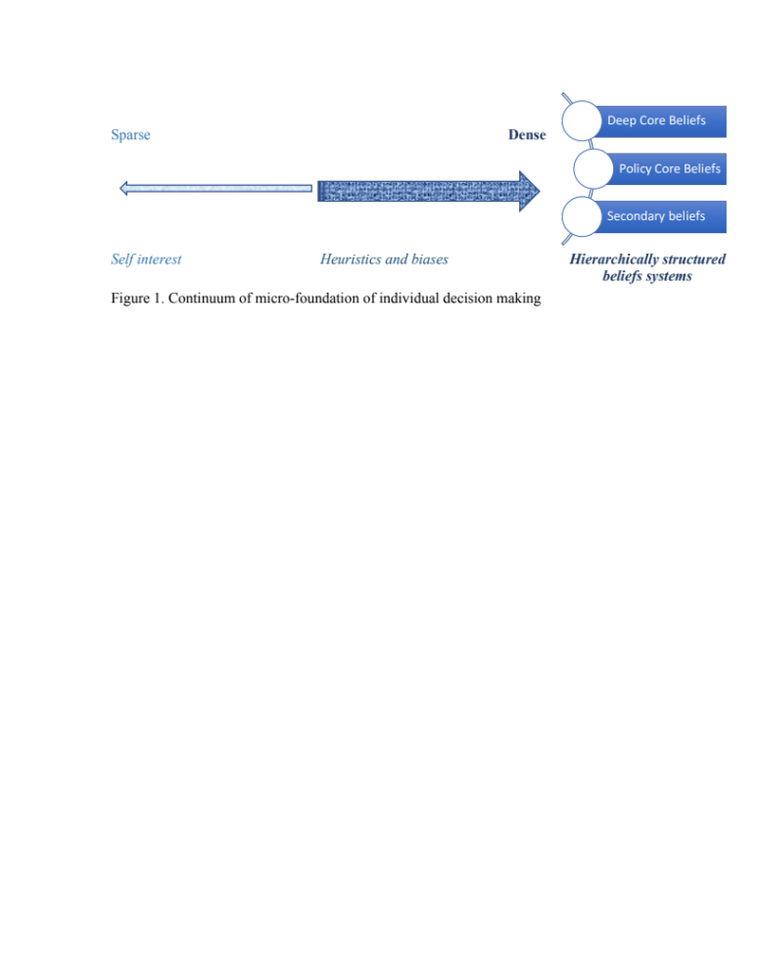

As it can be seen from Figure 1-1, both for NIMBY (Hadden et al. 1983; O'Hare et al., 1983; Matheny and Williams 1985; Kraft and Clary 1991; Armour 1991; Greenberg 1993; Benford et al. 1993; Lui 1997; Williams et al. 1999; Schively 2007; Smith 2015; Davy 2016; Lester 2018; Slovic et al. 1991; Jenkins-Smith and Kunreuther 2001; Sjoberg 2004; Schively 2007) and for the traditional public opinion literature (Lippmann 1922; Campbell et al. 1960; Dewey 1927; Gallup 1939; Converse 1964; Peters 1995; Zaller 1992, Jenkins-Smith and Herron 2006; Schudson 2008; Dewey and Rogers 2012), individuals are assumed to be self-interested players who are driven by heuristics and biases. Whereas from public policy perspective individuals or “homo-politicus” have hierarchically structured beliefs systems with deep core beliefs as the essential driver for their policy preferences. In addition, belief systems in the ACF implies that individuals are driven by broader societal considerations that are formed through their values and belief systems (Jenkins-Smith et al. 2014b). Whereas traditional NIMBY literature implies that individuals are merely driven by their local narrow concerns. Table 1-1 presented below briefly summarizes these differences:

Table 1-1. Comparison of Individual Preference Formation Models
Preference formation factors | Homo-economicus | Homo-heuristicus | Homo-politicus
Values | Self interest | Biased motivations | Political culture and ideology
Belief structure | Sparse | Dense societal belief structures | Hierarchically structured complex system
Reasoning | Pure rational | Heuristics | Mixture of both

Hence, these questions have traditionally been centered around social response to hazardous waste disposal facilities by focusing on physical proximity of local residents to the facilities. In this dissertation, I will focus on public preferences in SNF policy options from public policy perspective by focusing on the homo-politicus as the model of the individual. By incorporating “political” variables in the study of NIMBYism syndrome and accounting for the impact of political ideology in the formulation of hierarchically structured complex belief systems I will investigate the political side of SNF policy subsystem.

Overview of the Dissertation
In chapter 2 of this dissertation I review the literature about the role of public opinion in the policy making process and what we know so far about NIMBYism syndrome. In chapter 3 I examine the changes in public preferences in spent nuclear fuel (hereafter SNF) siting over time in parallel with respondents risk and benefit perceptions and their trust in government. In chapter 4 I explore whether a highly contested local SNF siting issue has the potential of reshaping partisan and ideological positions among local communities. In chapter 5, I zoom out of this narrow policy area to cast a broader look at the complex interconnection between environmental and energy policy preferences. Finally, chapter 6 provides a summary of this dissertation.
Chapter 2: Public Opinion Literature and Policy Preferences
The Role of Public Opinion in a Democracy
A survey of political science literature demonstrates that public opinion is formed due to the external cultural-ideological environment of the overall political system (Dahl 2005; Mayo 1960). This environment shapes the inputs of the system. American cultural values, attitudes and habitual patterns of behaviors that individuals acquire due to their political socialization eventually influence their policy preferences that later serve as inputs into the system (Almond and Verba 2015; Dahl 2005). In less contemporary political science literature ideology is viewed as part of culture in broad terms (Gerberding 1970). While the conceptual definitions and their empirical operationalization has evolved in contemporary applications, the influence of culture and ideology in public opinion formation have always been recognized (Jenkins‐Smith et al. 2014b; Ripberger et al. 2014; Ripberger et al. 2011) In this dissertation I will test hypotheses connected with public preferences for SNF policy options with the help of these political variables.
Policy type is another essential aspect that plays a determining role how various interests are shaped, preferences formed, and interests organized. According to policy sciences typology policies have been classified into distributive, redistributive and regulatory policies (Lowi 1964). The latter were divided into two categories: protective regulatory and competitive regulatory (Ripley and Franklin 1984). In old Lasswellian policy sciences these classifications were intended to avoid conflict by predicting how various interests would react to different kinds of policies (Lasswell 1970). James Wilson (1995) classified policies in terms of the extent to which their costs and benefits are focused on one particular interest or are spread across various people, groups or interests. Fiorina (2004) argues that on average members of the public tend to prefer policies that will yield them highest benefit at the lowest cost. This is the rationale for efficiency on individual level (Fiorina 2004). At the same time, this is the reason that American politics is formed around lobbying, mobilization and interest group politics (Skocpol and Fiorina 2004). Among many others, the aim and service of political parties per se is to balance narrow interests and to avoid collective action problems in government (Aldrich 1995). However, with the decline of political parties in American politics scholars have also found “decline in collective responsibility” (Fiorina 1980). It can be threatening to liberal democracy when systems are more involved with distribution of benefits to particular interests (Lowi 1979). It is obvious that public interest should be in the center but when individuals are thinking about themselves it is hard for them to distinguish between their own private interests and the public interest overall.
All these policy characteristics play an essential role in shaping public policy preferences. Soroka and Wleizen (2010, p. 7) make a distinction between public policy preferences and interests. They claim that “many people have a preference for a level of redistributive policy that clearly is not in their best interest, for instance – they are wealthy themselves but support policies that favor the less advantaged.”
John Dewey’s (1927) work titled the Public and Its Problems comes to critique Lippmann and his views about the public (Schudson 2008). Dewey believed in representative democracy and in the central role of public opinion for deliberative democracy (Dewey and Rogers 2012). Dewey is considered to be the founder of what Jenkins-Smith and Herron (2006) call the revisionist view of public opinion. “Revisionists expect to find at the aggregate level reasoned preferences driving from stable and persistent belief structures in which logical connections exist between broad ideological dispositions and more specific policy beliefs” (Jenkins-Smith and Herron 2006, p. 18). Here we can see, that as opposed to traditionalist views these scholars have different approach and assessment of public capabilities. They recognize that individuals have multiple competing issues and that public is ill-formed because of complex social life (Key 1961; 1966; Page and Shapiro 1992/2010; Erikson, MacKuen and Stimson 2002). Scholars in the revisionist tradition believe that the public is mostly rational and reasonable when forming views on the political issues that are salient to them (Dewey 1927) Key 1961; 1966; Page and Shapiro 1992/2010; Erikson, MacKuen and Stimson 2002). The research conducted by Page and Shapiro (1992/2010) demonstrates that despite fluctuations of opinions of individuals, collectively public opinion is coherent and stable. This stability represents public’s shared value systems and its sensitivity to major events (Page and Shapiro 1992/2010). Page and Shapiro (2010) demonstrate that public opinion is subject to manipulation when government control of information is great. This is an alarming factor for the sustainability of democracy: while the role of public opinion is important in formulating policy decisions, it is as important to have well informed public opinion which formulated freely and independently.
Key (1961) considered that public opinion is especially necessary for determining broad policy directions, rather than day-to-day pragmatic solutions for detailed aspects of policies. Key (1961, p. 81) claimed that “… policy decisions by legislatures and by other authorities exercising broad discretion are made under such circumstances when extremely small proportions of the general public have any awareness of the particular issues, much less any understanding of the consequences of the decision.”
Peters (1995) claims that there is a tension at the core of the discussions of public opinion. Although “…public opinion claims to be the voice of the people, a clear and direct utterance from the citizenry…” for the legitimacy of government, it is still unclear in what institutional means and capacities can people do so (Peters 1995, p. 3). Elections are one of the major institutional fora of expressing public opinion. Voter turnout and high political participations are indicators for a healthy democracy. Research in Political Science demonstrates the effect of individuals’ various socio-economic conditions and demographic variables on their level of political participation (Zukin et al. 2006).

Political Polarization as a Threat to Democracy
Political parties play vital role in translating public preferences to public policies (Eldersveld and Walton 1982). On the one hand, they provide keys to voters for options to choose, on the other hand, they assist elected officials in preparing policy options that would be appealing for their constituency (Green and Coffey 2010). On macro-political level, the organization of political parties in ranks and seniority creates structurally induced equilibria to avoid incoherent political outcomes when necessary (Aldrich 1995). Scholars have found that American public opinion is strongly related to partisanship and polarized attitudes enhanced by communications from elites on a wide range of issues (Abramowitz and Saunders 2008, Baldassarri and Gelman 2008; DiMaggio et al. 1996; Levendusky 2009).
Rising elite polarization has been at the center of the study of political scientists for decades. Scholars argue that political parties and politicians have become more likely to take extreme ideological positions on certain number of policy issue areas (McCarty, Poole, and Rosenthal 2006). In addition, polarization of political parties and political elites results mass polarization on a broad set of political issues (McCarty, Poole, and Rosenthal 2006; Taber and Lodge 2006). This public polarization driven from elites, limits individuals’ preferences and is seen as a threat to democracy (Baldassarri and Gelman 2008; Levendusky and Pope 2011). Baldassarri and Gelman (2008, p. 409) claim that polarization “induces alignment along multiple lines of potential conflict and organizes individuals and groups around exclusive identities, thus crystallizing interests into opposite factions.” They found that among general public those individuals who identify with a political party or ideology are more likely to be politically polarized than those who do not (Baldassarri and Gelman 2008). In addition, they found increased partisanship of the general public compared with previous years, which in its turn implied increased polarization among public (Baldassarri and Gelman 2008).
However, not all scholars agree that American public is polarized. Fiorina and Abrams (2008) found evidence for “party sorting” or increased partisan polarization, nonetheless they do not agree with the conception that there is wide geographic polarization among voters. Fiorina, Abrams, and Pope (2006, p. 2) claim that “culture war” is a myth by referring to sociologist James Davison Hunter’s 1992 book, titled Culture Wars, denoting differences between “orthodox” and “progressive” Americans. They conclude that American’s policy positions on certain contentious issues are not polarized, instead their choices are polarized (Fiorina, Abrams, and Pope 2006). This partisan polarization creates a shadow of popular polarization which is just an impression and not a reality (Fiorina, Abrams, and Pope 2006). Red state versus blue state generalization seems to be overstated (Fiorina, Abrams, and Pope 2006; Levendusky and Pope 2011). These findings confirm an earlier study (1998) by Alan Wolf, titled One Nation After All, which was criticized for its sample of 200 suburban Americans. However, Fiorina et al. (2006) have surveyed tens of thousands of Americans all over the country. In addition, the picture of a largely centrist population even on abortion and religious issues that they demonstrate is in line with Anthony Downs (1957) Economic Theory of Democracy. Downs (1957) demonstrated that in a two-party system party ideologies are loosely integrated to attract more votes, which results in voters that strive towards the center or the mid-point of the ideological spectrum. In a later work titled Disconnect: The breakdown of representation in American politics, Fiorina and Abrams (2012) demonstrate the divide between polarized political elites and their moderate voters. They claim that because of this disconnect these officials do not represent the people that they are supposed to represent (Fiorina and Abrams 2012).
The divide among scholars about the issue of political polarization and its extension to public opinion in general has dominated political science literature for decades. Some scholars have demonstrated that public opinion in USA has remained stable in general or has become more moderate on number of issues (Baldassarri and Gelman 2008). At the same time, strong polarization is assumed to be present on certain heated policy areas, like abortion, and sexual morality (DiMaggio, Evans, and Bryson 1996; Evans 2003; Shapiro and Bloch-Elkon 2006). For instance, research in anthropogenic climate change beliefs shows that on average in the long run individuals’ beliefs in climate change are stable with significant partisan and ideological polarization (Dunlap et al. 2001; Egan and Mullin 2017; McCright and Dunlap 2011).
Thus, some scholars consider that political polarization means opinion and belief differences on broad set of issues and therefore argue that American public opinion is not polarized (DiMaggio et al. 1996; Fiorina et al. 2006). Others believe that because there are broad ideological and partisan differences American public opinion is polarized even though noticeable divergence of opinions are on specific issues (Abramowitz and Saunders 2008; Kohut et al. 2000; Mayer 2004). What matters for this dissertation is whether increased partisanship would affect public preferences for individuals’ SNF citing policy options. As questioned by Fiorina et al. (2005), would increased partisanship be due to higher ideological coherence? By looking at the role of political ideology in public preferences for individuals’ SNF citing policy options, I will explore whether partisanship and political ideology have the same effect in public preferences for these policy options or partisanship is the main driving force for individuals’ SNF citing policy preferences. In SNF citing policy dispute we see a collision between uniquely “local” concerns – those that induce NIMBY responses – and belief system (or polarized partisan/ideology) based concerns. In this dissertation, I will investigate whether the localized nature of the issue (siting a nuclear waste repository) induces a different set of connections within belief systems than do other kinds of issues (e.g., taxation or abortion). I am curious to see whether political beliefs still matter in these location-based policy disputes.

Public Opinion and Public Policy Preferences
Public opinion polls are a common way of collecting information about public preferences on certain policies. While public opinion polls provide policymakers with broad measures of public sentiments about certain policy issues, they are not always taken into account. One of the central questions of democratic theory is “whether policy outputs are related to public preferences” (Hakhverdian 2010, p. 835). Soroka and Wleizen (2010, p. 10) introduce the concepts of “public responsiveness” and “policy representation” as essential features of sustainable democracy. From the aspect of public responsiveness they are interested to see the extent to which public preferences are informed and responsive to public policy changes (Soroka and Wleizen 2010). The question they ask for public responsiveness aspect is whether public is informed enough to express if they would prefer more or less of a certain policy on daily basis. Whereas by policy representation they are interested in the extent public opinion is reflected in actual policy. Referring to Hannah Pitkin’s (1967) work, titled The Concept of Representation, Soroka and Wleizen (2010) are concerned whether public policy-making represents aggregated preferences of the general public. It is also in line with the literature on whether government partisanship has an effect on policy outcomes (Schmidt 1996). By testing their “thermostatic” model of public opinion, Soroka and Wlezien (2010) find that public responsiveness is high in important policy domains and among substantial segment of public. Characteristics of issue salience, political institutions and the level of federalism are influencing the level of policy representation. Overall, they find that public in general does have an impact on “degrees” of democracy in a given country.
The role of public opinion in public policy preferences and eventually in policy outputs is well depicted in Figure 2-1 that demonstrates the “Systems Approach” of classical Political Science literature (Deutsch 1966; Easton 1965; Wiseman 1966). The inputs in the form of preferences of citizens are transformed into outputs reflected in public policies. The system can be self-maintaining in the sense that outputs go back and get converted into inputs with the feedback loop that monitors the systems and stimulates further inputs into the system. In an ideal representative democracy, this dynamic policy system can determine the efficiency of the overall political system (Soroka and Wleizen 2010).
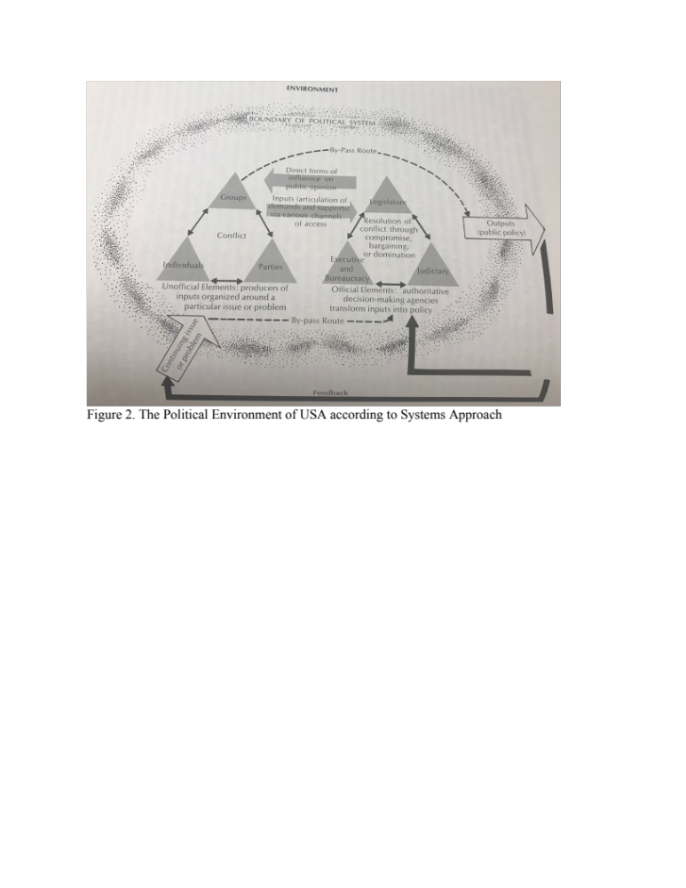
Figure 2-1. The U.S. Political Environment According to Systems Approach

In addition to this, Figure 2-2 demonstrates that voters/citizens, who are the subject of the study in this dissertation are one of four “extra-governmental” entities that play a decisive role in “inter-governmental” policy making process in USA (Cairney 2012).

Figure 2-2. The Policy Making Milieu
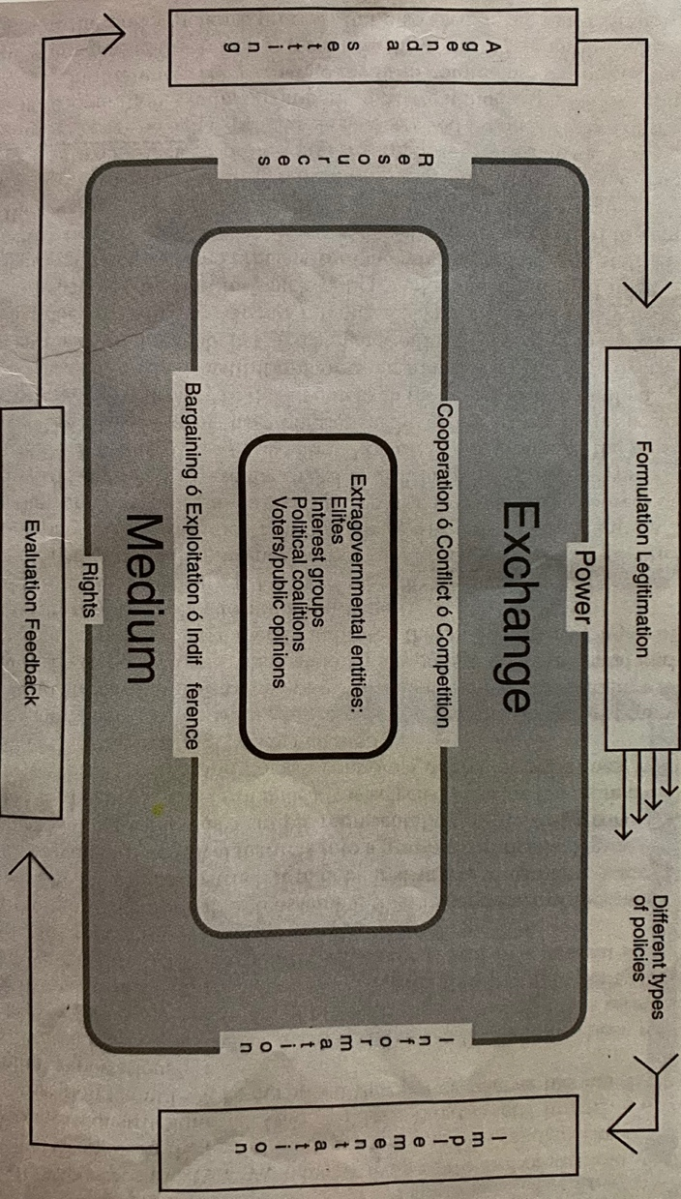

NIMBY and LULU Sentiments in Public Policy Preferences
NIMBYism (“Not-in-my-backyard”) goes side by side with LULU (“locally-unwanted-land-use”) attitudes among residents closest to “…municipal landfills, electricity generating facilities, solid waste transfer stations, airports, sewage plants, highways, maximum security prisons, drug halfway houses, housing projects, hospices for people with AIDS, garbage incinerators…” and other facilities that can raise health, safety and environmental concern among local communities (Greenberg 1993, p. 2).
Traditionally NIMBY/LULU literature focuses on proximity as the main explanatory variable for risk perception among local residents closest to hazardous sites (Hadden et al. 1983; O'Hare et al., 1983; Matheny and Williams 1985; Kraft and Clary 1991; Armour 1991; Greenberg 1993; Benford et al. 1993; Lui 1997; Williams et al. 1999; Schively 2007; Smith 2015; Davy 2016; Lester 2018). Previous research has found that proximity of the residents closest to the hazardous sites has resulted in higher risk perceptions posed by environmental hazards of the sites (Slovic et al. 1991; Jenkins-Smith and Kunreuther 2001; Sjoberg 2004; Schively 2007). Higher risk perceptions connected with environmental hazards of the sites in their turn result in local opposition towards those sites (Matheny and Williams 1985; Kraft and Clary 1991; MacGregor et al. 1994; Williams et al. 1999). However, a counter example is the case of the Waste Isolation Pilot Plant (WIPP) in southern New Mexico. Jenkins-Smith et al. (2011) found that the acceptance of WIPP was greater among those residents who were closet to the WIPP facility or who lived closest to the nuclear waste transportation route.
Proximity also explains higher risk perception among residents along nuclear waste transportation routes. Previous research has found that people who are along nuclear waste transportation route have high risk exposure perception (MacGregor et al. 1994; Falcone and Orosco 1998; Drew et al. 2003). In addition, residential property values along the nuclear waste transportation route are impacted because of risk perceptions (Gawande and Jenkins-Smith 2001). A group of scholars view this issue from the perspective of environmental equity. They argue that LULU cites are a result of "toxic or environmental racism" as they are disproportionately located in poor or minority communities (Greenberg 1993, p. 235). Other studies have found no support for this proposition and have concluded that poor and minority communities around LULU allocations are a result of post-citing neighborhood dynamics (Liu 1997; Wolsink 2007).

Chapter 3: Public Preferences in Spent Nuclear Fuel Siting: The Impact of Risk Perceptions, Trust and Knowledge
Abstract

The purpose of this chapter is to examine the evolution of public preferences regarding the disposition of spent nuclear fuel (hereafter SNF) over time. Using data from nationwide surveys of American public 2006 to 2019, descriptive time series analysis demonstrates key trends in public risk and benefit perceptions in relation to nuclear energy, trust in government for nuclear energy regulation and waste management, and knowledge about current SNF processing options. Further, by employing explanative time series analysis also known as cross correlation analysis, I test hypotheses to determine whether public risk and benefit perceptions, trust in government and knowledge about nuclear energy have caused changes in public preferences in SNF storage and disposal policy options over time. The results of times series cross correlation analyses show increased risk perceptions in nuclear waste transportation over time negatively affects public support for SNF deep geologic disposal five years later. I also find that increased benefit perceptions in reduced mining is likely to lead an above average support for SNF onsite storage policy option 1 year later. These findings imply that, within a representative political system like that of the U.S., changes in perceptions and awareness might also result in policy change in the long run.

Introduction

When will the debate about the spent nuclear fuel waste in USA be resolved? The answer to this question seems far-fetched as the plan for building permanent nuclear waste repository in USA has been subject to controversy and scrutiny for ages. The 1987 Amendment to the Nuclear Policy Act of 1982 has focused on selection and licensing of a facility at Yucca Mountain, Nevada, as a permanent repository for spent nuclear fuel nationwide (US GAO 2018). However, after $15 billion was spent for studying the SNF siting location and the Department of Energy had filed for licensing the site, the Obama administration halted the project (Eureka County Yucca Mountain Information Office 2018). President Trump’s budget request in 2017 for fiscal year 2018 included $120 million for Yucca mountain project revival. These funds were planned to be allocated for resuming Yucca mountain and interim storage site license review (US GAO 2018). However, the “blue wave” of opposition (Democratic) successes in the 2018 midterm elections once again halted the success of Yucca mountain project revival (Las Vegas Sun 2019). While it is necessary to wait and see what happens to Yucca mountain project debate both in the near and long term-future, I will demonstrate in this chapter that it is important to understand the trends and inclinations in public concerns and preferences for nuclear waste siting policy options in USA.

The central role of public opinion in democracy has been the subject of debate among political philosophers from ancient Greece to the present (Peters 1995). The most critical questions involved are: to what extent should the public participate in the civic life; what are the forms and means of participation; and is information provided by mass media an objective basis for public opinion formation? (Peters 1995). For nearly a century now, opinion polling has remained one of the primary instruments for informing public officials about the preferences of the public (Gallup 1939). Gallup (1939) argued that opinion polls enhance democratic processes as they present public attitudes to elected officials. Since that time, the essential nature of public opinion remains a controversial topic of discussion. Some critiques argue that elected officials pay too much attention to polls which, instead of making informed decisions, leads them to base their decisions on public opinion that fluctuates, is inconsistent and uninformed (Lippman 1922; Allport 1937).

Herron and Jenkins-Smith (2006) characterize the contradictory accounts of public opinion scholarship as falling into “traditionalist” and “revisionist” camps. “Traditionalists argue that the public lacks the requisite belief structures to consistently and reasonably connect broad integrating beliefs, such as political ideology, with specific beliefs and preferences about …” policies (Herron and Jenkins-Smith 2006, p. 17). According to traditionalist scholars, the public is uninformed and lacks the ability to form sophisticated preferences on policy or political issues (Lippmann 1922; Campbell et al. 1960; Converse 1964; Zaller 1992). Campbell at al. (1960) claimed that the American public cast their ballots and present their preferences in accordance to their party lines inherited from their parents. They criticize how members of public form their opinions and expect them to be more rational or reasonable than they are (Campbell et al. 1960). The findings of Converse (1964) have the same underlying assumption that members of public are incapable of making sophisticated opinion. He compared members of public with elites and found that elites have a major role in belief formulation among the public (Converse 1964).

In addition, it has well been established that general political attitudes shape support or opposition to potentially risky technologies (Rothman and Lichter 1987, Slovic 1993). Paul Slovic (1993) claimed that society’s levels of risk perception and trust to government is reflected in its risk management mechanisms. Previous research has found that perceived risks, benefits, trust in government and knowledge about nuclear technology are strong predictors for public support for nuclear energy (Jenkins‐Smith and Kunreuther 2001; Kuklinski et al. 1982; Robinson et al. 2017; Slovic et al. 1991; Stoutenborough et al. 2013; Visschers et al. 2011). These psychometric and cognitive explanatory models also determine the level of public participation and control in representative democracy (Slovic 1993). In line with the previous research, this chapter examines public preferences for nuclear energy support in connection with individuals’ risk perceptions, trust in government and knowledge. However, this examination particularly centers on SNF siting policy options for over 13-year timeframe.

Research in social sciences faces the challenge of establishing causality of relationship between the variables of consideration. In this chapter I address that challenge by the methodological choice for the analysis. The cross correlation analysis of time series data establishes causality by registering the effect of change in an independent variable on the dependent variable (Box et al. 1994; Chatfield 2013). I investigate public preferences in the controversial policy debate on SNF siting policy options by analyzing public opinion survey data spanning from 2006 to 2019. While this study is utilizing measures at only 13 data points in time, it allows me to give insightful description of changes in public preferences for SNF siting policy options over time in parallel with a set of explanatory variables that I hypothesize will account for changes in policy preferences.

In line with previous research I inquire whether public support for SNF siting policy options is preconditioned by individuals’ perceptions of risks and benefits in connection with nuclear energy (Spence et al. 2010; Stoutenborough et al. 2013; Visschers et al. 2011). I expect to find low risk perceptions and higher benefit perceptions in association with nuclear energy result in increased support for deep geologic disposal of SNF over time. Evidence from research has also shown that the erosion of public trust in nuclear authorities is associated with public opposition towards nuclear energy policy support (Stoutenborough et al. 2013; Walker et al. 2010). Therefore, I expect to find higher levels of public trust in regulation and management of nuclear technology resulting in increased support for a deep geologic disposal of SNF. In addition, Stoutenborough et al. (2013) have found that people who are more knowledgeable about energy issues are more supportive of nuclear energy. Therefore, I propose that once become more knowledgeable about nuclear waste management and disposal options and the differences between deep geologic and on-site disposal, over time their knowledge will affect their likely to support for deep geologic disposal of SNF. These expectations are reflected in the hypotheses that are presented in the next section. Those hypotheses, specifically, will help me answer the following research questions:
- How does public perception in SNF siting preferences evolve over time in parallel with public risk perceptions, knowledge and trust in government in relation to nuclear waste management technologies?
- To what extent do changes in public risk perceptions, trust in government for nuclear waste management technologies and knowledge in SNF processing affect their SNF siting preferences over time?

In the next section, I review the literature on public risk perceptions, trust in government and knowledge about nuclear energy to elaborate the theoretical expectations of the study. In the following section, I describe the data and variables to be used in the analysis. Next, I provide the results of the descriptive analysis, in which I first examine the evolution of public risk and benefit perceptions, trust in government and preferences in SNF siting over time. After that I employ explanative time series analysis, to assess whether changes over time in public risk and benefit perceptions, trust in government and knowledge about nuclear energy have caused changes in public preferences in SNF storage and disposal policy options over time. Overall, the findings provide evidence for the predictive power of psychometric variables in explaining changes in public preferences for SNF storage policy options over time.

Theoretical Expectations

The Impact of Risk Perceptions

Public support for nuclear energy has been traditionally explained by psychometric models that take into account risk and benefit perceptions for formulating policy preferences (Jenkins‐Smith and Kunreuther 2001; Slovic et al. 1991; Slovik 2010). Scholars have found that public risk perceptions affect their preferences in policy support (Spence et al. 2010; Stoutenborough et al. 2013). In particular, support for nuclear energy is explained by models of risk and benefit perception given the findings that nuclear risks are among the most dreaded by the public (Kristiansen et a. 2018; Slovic et al. 1991).

Psychometrics studies of risk perceptions also consider the central role of psychological biases and heuristics in shaping individuals’ views and beliefs for policy preferences (Jenkins‐Smith and Kunreuther 2001; Slovic et al. 1991; Visschers et al. 2011). While identifying and rating risks scholars have found that nuclear risks are particularly salient and impactful when the exposure to radiation is seen as involuntary, and as imposed on the subject by other actors or the government (Slovic 1987; Visschers and Siegrist 2013). Studies have shown that high perceived risks lead to low perceived benefits (De Groot and Steg 2010; De Groot et al. 2013; Fischhoff et al. 1983; Slovic et al. 1984). Consequently, due to high perceived public health and environmental risks posed by the sites lead individuals to see the benefits of nuclear energy as low, making it very difficult to secure local support for nuclear waste disposal sites when the facility is seen as imposed upon the local community (Slovic et al. 1991; Jenkins-Smith and Kunreuther 2001; Sjoberg 2004; Schively 2007). Bassett, Jenkins‐Smith and Silva (1996) studied the attitudes of local residents about onsite storage of nuclear waste and found that public is concerned for adverse effects due to increased perceptions of risk and stigmatization of the region. Almost all of the prior studies mentioned above are cross-sectional and static. The contribution of this study is the examination of risk perceptions and policy support over time that allows to look at causal relationships, rather than simple correlations. To assess whether public support for SNF siting policy options is preconditioned by individuals’ perceptions of risks and benefits in connection with nuclear energy, I have formulated the following expectation.

H1.: In line with extant literature I expect to find low risk perceptions and higher benefit perceptions in association with nuclear energy will result in increased support for deep geologic disposal of SNF over time.

The Impact of Trust

Public trust is found to be a predictor of specific political attitudes and perceptions particularly for such policy areas that have high complexity for an individual to comprehend (Earle & Cvetkovich 1995; Robinson et al. 2017). For instance, the opponents of nuclear energy mostly justify their resistance in issues connected with SNF management and disposal (Verbruggen 2008; Butler, Parkhill & Pidgeon 2011). In general, at the cornerstone of nuclear opposition are concerns about SNF safety, low trust in SNF disposal practices as well as issues of justice and ethics in relation to SNF disposal locations (Verbruggen 2008; Butler, Parkhill & Pidgeon 2011; Back 2013; Cotton 2015). Individuals with low trust in management and disposal of SNF are worried about the potential catastrophic consequences that nuclear energy production can cause and do not consider nuclear accidents as “black swan” events (Rani 2011; Shrader-Frechette 2007; 2011; Kraft 2013). For these and other reasons, the extant literature has consistently found evidence for direct influence of trust on energy policy support (Stoutenborough et al. 2013; Walker et al. 2010). In particular, the acceptance of nuclear energy is associated with higher trust in the management of nuclear technology.

H2.: Based on previous scholarly findings I expect to see higher levels of public trust in regulation and management of nuclear technology resulting in increased support for a deep geologic disposal of SNF.

The Impact of Knowledge

Knowledge and information have central roles for finding solutions to public policy issues (Baumgartner and Jones 1993). However, individual cognitive biases and heuristics impact information processing among boundedly rational individuals (Tversky and Kahneman 1974; Riker 1990; Kahneman 2003). Individuals are more likely to use imperfect or biased information in search for solutions to complex policy problems (Ostrom 2007). This is problematic for the sustainability of democracy because, when they are based on imperfect and biased information, public preferences are less likely to result in policies that serve the public interest (Lupia, McCubbins & Arthur 1998; Sabatier & Jenkins-Smith 1988). In this regard, scholars have inquired about the role of citizens in decision making processes especially for issues with high complexity (Kuklinski et al. 1982). It has well been established that for especially more complex, challenging or uncertain policy areas and issues public views vastly differ from that of the scientists (Hansen et al. 2003; Slovik 2010; Savadori et al. 2010). However, in such situations the views of policymakers are more likely to reflect that of the citizens than the scientific community (Stoutenborough et al. 2013).

Nevertheless, the question remains how public chooses one policy option over the other especially in the nuclear energy policy domain. Are informed or knowledgeable citizens more likely to choose one policy option over the other? When looking into individual decision making mechanisms of informed versus uninformed citizens Kuklinski et al. (1982) found that “knowledgeable” citizens rely on ideology as their decision calculus, whereas the “unknowledgeable” draw on their generalized attitudes toward technology. Cues provided by groups involved in the nuclear energy controversy are more effective for “unknowledgeable” than “knowledgeable” citizens (Kuklinski et al. 1982). This implies that if “unknowledgeable” people are more prone to trust anti-nuclear groups, then they will be less likely to support nuclear energy. In that regard, Stoutenborough et al. (2013) have found that people who are more knowledgeable about energy issues are more supportive of nuclear energy.

H3.: Drawing from previous literature I posit that individuals who become more knowledgeable about nuclear waste management and disposal over time will be more likely to support deep geologic disposal of SNF.
Data and Methods

The data used in the analysis were collected in annual series of nationwide Internet surveys on preferences of U.S. residents concerning the environment and energy sources. The surveys were conducted since 2006 by the National Institute of Risk and Resilience at the University of Oklahoma. The respondents were recruited by web-based samples. Respondent invitations and quotas were employed to assure that the demographic characteristics of the samples matched the characteristics of the adult U.S. population as estimated in the U.S. Census (for sampling details see Jenkins-Smith, Silva, Gupta 2016; 2017). The data used in the analysis was collected from 2006 to 2019 through annual series. These are discrete times series as the observations are taken at equally spaced specific time intervals with 13 data points available for the analysis (Chatfield and Xing 2019). With time series analysis a consideration to make is whether 13 data points can be methodologically convincing enough to state with confidence that the results of the analysis matter. The suggested minimum optimal data points for time series analysis varies from 36 to 60 (Box, Jenkins and Reinsel 1994; Makridakis et al. 1982). Scholars have competing viewpoints about this. Hyndman and Athanasopoulos (2018) argue that these minimum requirements are mostly for time series forecasting techniques, however he also states that it is possible to forecast for 1–2 years from 4–5 years of data. The reading of various approaches towards this make me understand that there is no uniformly agree on formula to determine the least sample size for time series (Box, Jenkins and Reinsel 1994; Makridakis et al. 1982; Hyndman and Athanasopoulos 2018). For the most part it is the responsibility of the researcher to subjectively assess whether the data that they have fits the modeling approach in their scientific inquiry (Chatfield and Xing 2019).

In that regard the review of an important body of literature in Political Sience demonstrates that there are many important studies that have provided valuable contribution to our theoretical understanding of political phenomena with fewer than 30 data points (Palm et al. 2017; Jenkins-Smith et al. 2020; Robinson et al. 2014; Flink 2019). For the purposes of the analysis 13 data periods might be sufficient to demonstrate whether the change in the independent variable has resulted in a change of the dependent variables several years later. However, it is necessary to state that we would be able to have more confidence in the analysis with at least 30 data periods. These limitations will be considered when evaluating the results of the analyses.

This inquiry begins by describing the trends in public views on three foundational components of the conceptual framework of this study: (a) How does the U.S. public assess the risks and benefits of nuclear energy over time? (b) How is the U.S. public trust in regulation and management of nuclear technology evolving over time? (c) How has knowledge about nuclear waste management and disposal changed over time among American public?

The second section of the inquiry is built on explanative times series analysis to examine whether evolving public risk perceptions, trust in government and knowledge in nuclear waste management technologies have affected public perceptions in SNF siting policy options over time. Explanative times series analysis, also known as cross correlation analysis, is used to determine the relationship between the series given the number of lags or lapses of time periods between them (Chatfield 2013). The choice of this method is determined by the research question the study aims to answer. As mentioned above, the central question of the study is how and to what extent changes in public risk perceptions, trust in government and knowledge about nuclear energy affect their SNF siting policy preferences over time. This question has resulted in the choice of the methodological approach because explanative times series analysis has the potential of estimating the relationship between two or more series to detect whether changes in one series have resulted in changes in the other (Box et al. 1994; Chatfield 2013).

Findings and Discussion

Part I: Evolution of Public Perceptions in Risk, Trust and Knowledge on Nuclear Energy

To answer the first question of this inquiry I track the evolution of public perception in SNF siting preferences over time in parallel with public risk perceptions, knowledge and trust in government in relation to nuclear waste management technologies. First, I explore nuclear energy risk and benefit perceptions as the central explanatory variables for public support in nuclear energy.

In line with the theoretical underpinning stated above, over 13-year timeframe respondents in the U.S. have been asked annually to assess the risks associated with nuclear energy production on a continuous scale from 0 (no risk) to 10 (extreme risk). They have been asked to evaluate their risk perceptions in connection with nuclear energy by the likelihood of the potential risks occurring because of an operational accident at a nuclear power plant, or nuclear waste transportation or storage accident, a terrorist attack at a nuclear power plant, or a diversion of nuclear fuel to nuclear weapons. As we can see from figure 1 the mean risk perceptions among U.S. public have historically been above midpoint with increasing trends for all measures of risk perceptions. As we can see from figure 3-1, the risk of terrorist attack is perceived to be the most threatening, followed by the risk of an operational accident in nuclear power plant.

Figure 3-1. Nuclear Energy Mean Risk Perceptions from 2006-2019

Note: The figure depicts Nuclear Energy Mean Risk Perceptions. X-axis represents the years and Y-axis represents the mean values for risk perceptions. Data are interpolated through missing values.

Respondents were also asked to rate the benefits of nuclear energy use and production in the U.S., using a continuous scale from 0 (not at all beneficial) to 10 (extremely beneficial). They were asked to evaluate whether nuclear energy production helps to reduce environmental threats, provides reliable power, ensures U.S. energy independence, and reduces mining/extraction. Figure 3-2 displays trends in mean responses for each of the four benefits. As we can see U.S. public has historically assessed energy independence to be the most beneficial aspect of nuclear energy production, followed by the provision of reliable power. However, we do see a spike for the assessment of reduced mining/extraction in 2016. The overall declining trend over time statistically is not significant.

Figure 3-2. Nuclear Energy Mean Benefit Perceptions from 2006-2019

Note: The figure depicts the trends in Nuclear Energy Mean Benefit Perceptions. X-axis represents the years and Y-axis represents the mean values for benefit perceptions. Data are interpolated through missing values.

Another important component of the psychometric basis of support for nuclear energy among public is their perceptions of trust for regulation and management of nuclear technology. From 2010-2019 our respondents have been asked to assess their level of trust towards experts on a continuous scale from 0 (no trust) to 10 (complete trust) in federal and state regulators, in the national laboratories and in the Department of Defense. Figure 3-3 shows that overall the mean assessment of trust among public has increasing trends. However, the change over time is not statistically significant. Public perceives the highest level of trust towards experts from national laboratories followed by federal regulators and Department of defense. While trust towards state regulators is at the lowest level compared to other three organizations, nonetheless, it has the least aggregate change over time.

Figure 3-3. Mean Public Trust towards Experts for Regulation and Management of Nuclear Technology

Note: The Evolution of Public Perceptions of Trust in Experts for Nuclear Energy Management and Regulation from 2012-2019. X-axis represents the years and Y-axis represents the mean values for trust perceptions. Data are interpolated through missing values.

Knowledge as another explanatory factor is hypothesized to impact public support for SNF management and storage policy options. To measure knowledge about SNF policy options respondents were given four mutually exclusive options and were asked to choose the option that applies best to what is currently being done to SNF produced in the U.S. to the best of their knowledge. Figure 3-4 shows the percentage of respondents choosing one of the given four policy options about SNF processing and storage. As we can observe from the graph the percentage of people who think SNF is shipped to regional facilities has been at 30% in 2006 and have gradually decreased over time to 20%. In 2006 almost 36% of respondents thought that SNF is being shipped to the state of Nevada for deep geologic depository. However this number has decreased to 25% in 2019. Inversely, the number of respondents who correctly believe that SNF is stored onsite at nuclear facilities around the U.S. has been 22% in 2006. This number has spiked to 41% in 2011 and has gradually decreased to 38% in 2019. Overall, the fraction of people who correctly believe that SNF is stored onsite has increased in 2011 and has stayed stable compared to the segment of people who believe in other three options.

Figure 3-4. Knowledge about SNF Management and Storage Policy Options

Note: changes in Percent of Respondents Choosing One of the Given Four Policy Options about SNF disposal options. X-axis represents the years and Y-axis represents the percentage of respondents choosing given disposal option. Data are interpolated through missing values.

The dependent variable of the study is support for SNF policy options. Respondents were asked to rate their level of support for SNF storage policy options on a scale from 1 (strongly oppose) to 7 (strongly support). They were asked to evaluate whether they prefer SNF to be stored in interim, onsite or deep underground facilities. As we can see from figure 3-5 respondents support for onsite storage has been above midpoint in 2006 with observable increasing trend over the course of the series till 2019. Despite missing data periods, in line with public preference for onsite support we observe that respondents’ support for interim storage has been above mid-point with decreasing trend over the course of the series. Public support for deep geologic storage option has historically been above midpoint and has stayed in that range till 2019.
Figure 3-5. Mean Preferences in SNF Storage Policy Options

Note: Mean Score for SNF Storage Preferences Among American Public from 2006-2019. X-axis represents the years and Y-axis represents mean support for SNF storage policy options. Data are interpolated through missing values.

Part II: Testing the Impact of Risk Perceptions, Trust and Knowledge on SNF Siting Preferences

To address the second question of the inquiry I analyze how changes in public risk and benefit perceptions, and trust in government in relation to nuclear waste management technologies affect their SNF siting preferences over time. For this objective I first test the proposition whether low risk perceptions and higher benefit perceptions in association with nuclear energy will result in increased support for deep geologic disposal of SNF by employing explanative time series analysis. This method allows to test whether changes in risk and benefit perception series have resulted in changes in public preferences for SNF policy options given the number of lags (time shifts).

Running cross correlations helps determine a sample set of correlations between x[t+k] and y[t] series. This function is particularly helpful for identifying the lags of the x variable that might be useful predictors of y[t] and at which the correlation between two time series is the strongest. Thus, the lag k value estimates the correlation between x[t+k] and y[t] (Box et al. 1994; Chatfield 2013). In time series cross correlation analysis it is very important to focus on the temporal structure of the data. As mentioned earlier, a special feature of the cross correlation analysis is the opportunity to identify the dependencies between the series. However, the key to this identification of the dependencies in the temporal order of the successive observations. When successive observations are dependent, future values may be predicted from past. Substantively, this means that in those instances when a positive correlation is identified between the series, this cannot be interpreted as being driven by the past values of the independent variable. The results of the analysis below are presented in accordance with these considerations.

However, before running cross correlations it is necessary to ensure that data meet the basic assumptions of seasonality and trend stationarity (Box et al. 1994). Following the methodological recommendations in the literature I have tested this assumption for all the variables in the study by Augmented Dickey Fuller (hereafter ADCF) Test (Box et al. 1994; Chatfield 2013).

Figure 3-6: Line Charts of Differenced Independent and Dependent Variables

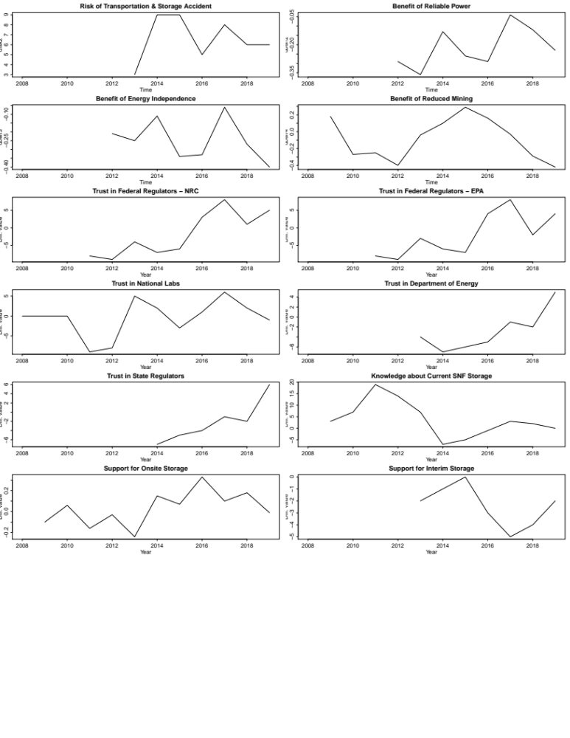

In instances when the test showed that the series in my analysis were non-stationery, I have followed the recommended course of action – differencing - after which I have run the ADCF Test again to make sure that the series meet the assumptions of the explanatory time series analysis (Box et al. 1994; Chatfield 2013). Thus, the series predominantly were non-stationary and differencing was employed for all variables except for the one measuring public preferences for SNF deep geologic disposal. Figure 3-6 above presents the line charts of both independent and dependent differenced variables. After performing differencing techniques I ran thirty pairs of correlations to test the propositions set forth in the study. In what follows, I present the results of the estimated correlations between the pairs of series for each sets of the independent variables of the study – risk perceptions, benefit perceptions, trust and knowledge. While the autocorrelations table between the series is very helpful for detecting the exact correlation coefficient between the series at a given lag, it is the dependencies graphs that visually reveal the significantly strong correlations between the series. For the given series, dependencies were tested at lag five, meaning five years proceeding (contemporaneous lead ) and five years succeeding zero (contemporaneous lag). To state this in simpler terms, this method tests the strongest correlations between two series at time shift 0 to begin with when r = 1 as at time shift 0 we are comparing the same values with each other. These correlations are further tested by time shifts -/+1, -/+2, -/+3, -/+ 4, -/+5 to compare them with each other. From the values for each time shifts we then observe the strength of the correlation between the independent and dependent series. A negative value for k represents a correlation between the x series at a time before t (for differenced series the interpretation needs to focus on the current year where the strongest correlation is significant) and the y series at the given time period t. When t is smaller than 0 ( a negative number), then we can interpret that x independent series lead to y dependent series. When t is bigger than zero (a positive number), it means that x series follow y. While statistically this may occur, substantively it does not make any sense due to the importance of the temporal order between the series as in our analysis as we are testing to see whether changes in our independent series lead changes in the dependent ones.

Therefore, I present the results of the significantly strong correlations through dependencies graphs (figures 3-7 to 3-17) and include a table demonstrating all the hypotheses of the study with their correlation coefficients at each lag in the appendices. The dependencies graphs of autocorrelations represent the set of correlations between the two series in the form of the vertical line segments. The x-axis represents the lagging indicator, while the y-axis represents cross correlations between the two series which can be either negative (below the black horizontal line at zero value on y-axis) or positive (above the black horizontal line at zero value on y-axis). The height of the vertical line segments shows the strength of correlations. The most dominant correlations are the highest vertical lines that get closer to the blue dotted horizontal lines or cross them. These correlations are also an indicator of the lags at which series x causes changes in series y. In simpler terms, correlations that fall within the band marked by the dotted blue lines are deemed not to be significantly different from zero. As a result, any values outside of the band marked by the dotted blue lines is significant.

The first expectation of this analysis was to ascertain whether low risk perceptions and higher benefit perceptions of nuclear energy are associated with increased support for deep geologic disposal of SNF over time. In line with this expectation cross correlations between nuclear waste transportation risks and SNF deep geologic storage option granted strong negative association revealed in figure 3-7. I found no evidence of correlation over time between the pairs of series measuring nuclear waste transportation risks and SNF on-site and interim storage policy options.
Figure 3-7. Risks of Nuclear Waste Transportation/Storage and SNF Deep Geologic Storage.
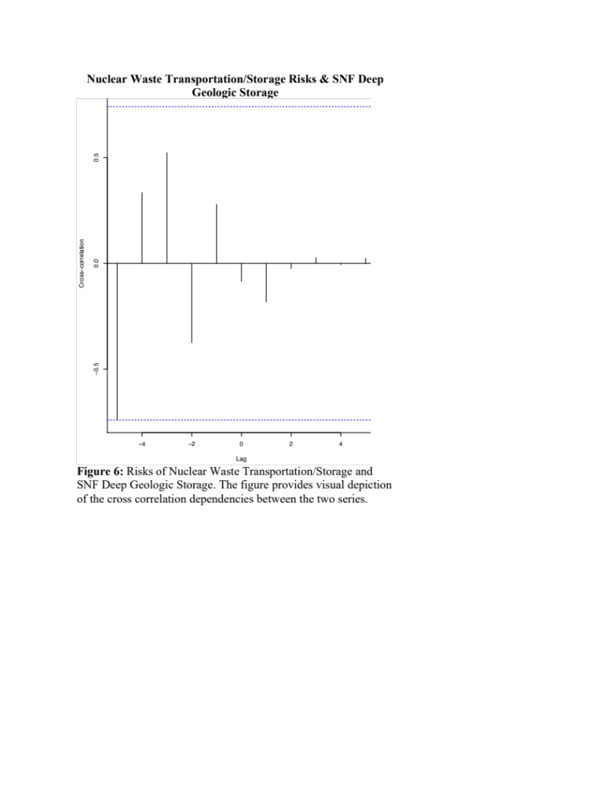
Note: the figure provides visual depiction of the cross correlation dependencies between the mean risk perception series of nuclear waste transportation/storage accident and public support for SNF deep geologic storage. The strongest negative correlation (r = -0.69) occurs at lag -5.

Figure 3-7 demonstrates a negative correlation between the risk of nuclear waste transportation and storage accident and public support in SNF deep geologic depository at lag -5. Substantively this means that for the given year of the value of support for SNF deep geologic policy option, an above average value of risk perceptions is likely to lead to a below average value of support for SNF deep geologic policy option five years later. This finding is in line with the theoretical expectations about the impact of risk perceptions on nuclear energy policy preferences set forth in hypothesis #1.

In line with the same theoretical expectations tests of cross correlations presented in figures 3-8 and 3-9 subsequently yielded positive significant relationships between public benefit perceptions of reduced mining/extraction and support in SNF onsite policy preferences at lag -1 and interim storage preferences at lag +1.

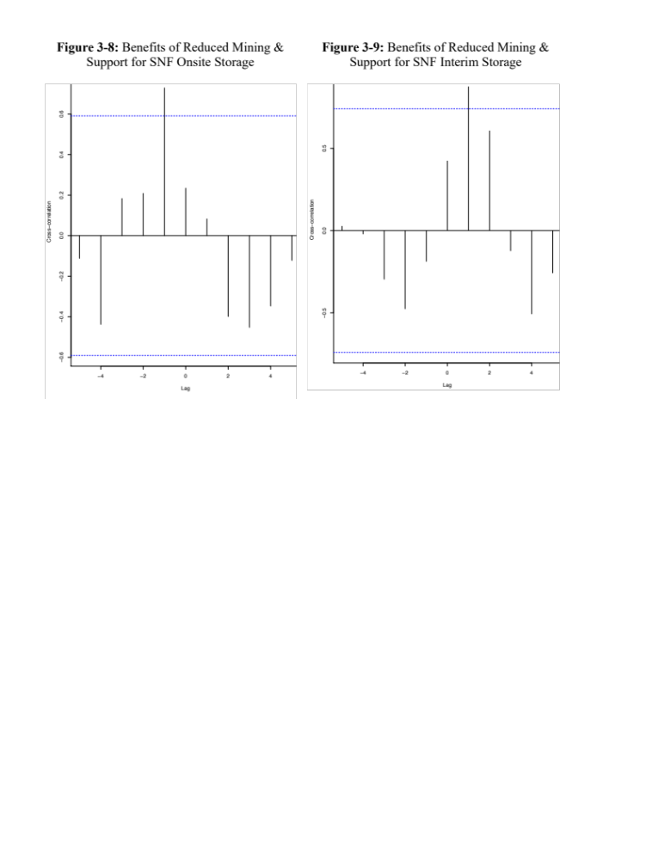

In particular, the findings presented in table 3-8 reveal that for the given year of the value of support for SNF onsite storage, an above average benefit perception in reduced mining is likely to lead an above average support for SNF onsite storage policy option 1 year later. Although the findings for the SNF interim storage presented in figure 3-9 are similar, they are significant for lag +1, which does not make substantive contribution in our analysis. I found no evidence of correlation over time between the pairs of series measuring nuclear energy benefit of reliable power and SNF on-site, interim and deep geologic storage policy options; the benefit of energy independence and SNF on-site, interim and deep geologic storage policy options; and the benefit of reduced mining and SNF and deep geologic storage policy options.

The second proposition of the analysis was to assess whether increased public trust in regulation and management of nuclear technology over time may result in increased support for deep geologic disposal of SNF. In line with this proposition the results of the cross correlation analysis presented in figures 3-10 and 3-11 showed positive and significant relationships between public trust in the experts of the Department of Energy and the National Laboratories and support for SNF deep geologic storage at lags +1, +2, and +3.

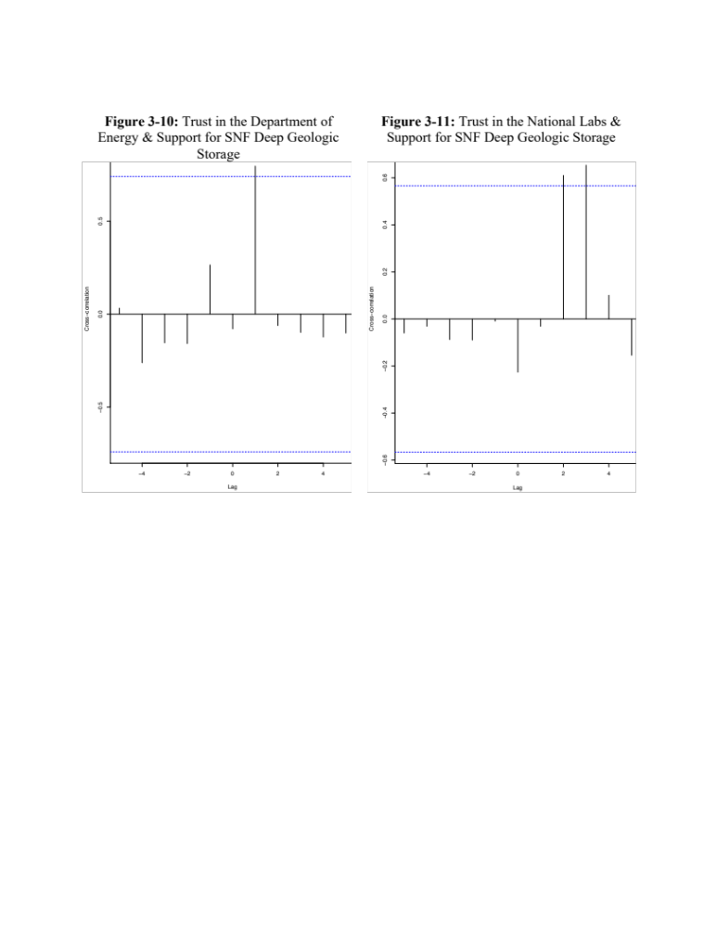

Despite their statistical significance, these outcomes do not make any substantive revelation in our analysis having in mind the discussion of the temporal structure of the data and its necessity for being deterministic. I also found no evidence of correlation over time between the pairs of series measuring public trust in the experts of Department of Energy and the National laboratories and support for SNF on-site, and interim storage policy options.

Next, I present cross correlation tests for public preferences in SNF onsite and interim storage policy options predicted by public trust in federal regulatory agencies. As figures 3-12 and 3-13 show, higher trust in the Environmental Protection Agency results in increased support for SNF onsite policy option at lag +1 and in less support for SNF interim storage option at lag 0.

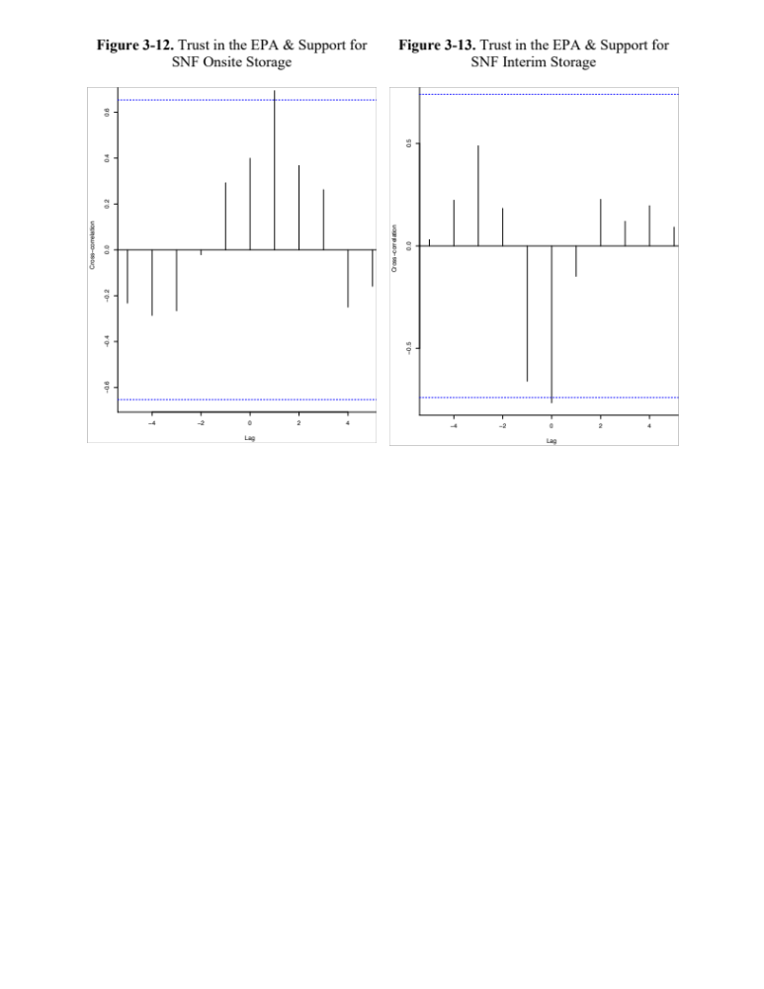

Despite being statistically significant, these results do not matter substantively because of the issue of time order and causality. In other words, if the change in the outcome variable has not happened after the change in the independent variable it means that practically the independent variable has not affected our dependent variable even if statistically the correlations between them are significant. I found no evidence of correlation over time between the pairs of series measuring public trust in the experts of Environmental Protection Agency and the Nuclear Regulatory Commission and support for SNF deep geologic storage policy option (table 3-C2 in the appendix).

Likewise, figures 3-14 and 3-15 reveal that higher public trust in Nuclear Regulatory Commission yields increased support for SNF onsite policy option at lag +1 and in less support for SNF interim storage option at lag 0.

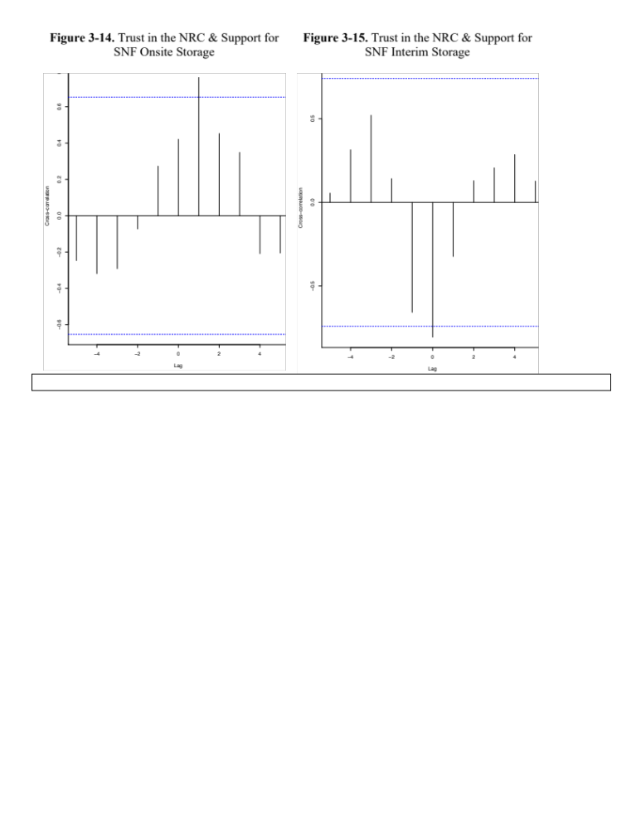

Similar to the results for public trust in the EPA, despite having statistical significance these results do not have practical value due to the temporal mismatch between cause and effect. In addition, no evidence of correlation over time was found between the pairs of series measuring public trust in State Regulators and support for SNF onsite, interim and deep geologic storage policy options (table 3-C2 in the appendix).

The third expectation of the analysis claimed that the surge in knowledge about nuclear waste management and disposal will increase public support in deep geologic disposal of SNF over time. I want to remind that the knowledge measure is a percent count of individuals who have correctly indicated how SNF is currently treated in the U.S. Since by definition, the third hypothesis of the study limits my interest in the fraction of respondents who have correctly answered this question, I have recoded the variable such that I separate the fraction of respondents who have given a correct answer to this question.

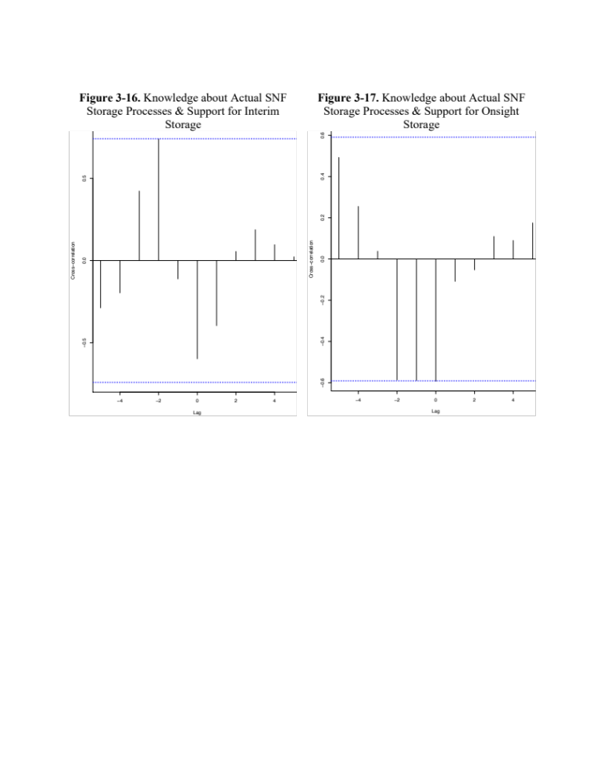

Figure 3-16 and 3-17 reveal a positive correlation between the percent of individuals who have correctly indicated the actual processing method of SNF and their support of SNF interim storage at lag -1 and at lag 0 and a negative correlation of SNF on-site storage at lag -2, -1, and 0. This results substantively denote that the increase in the percent of individuals who correctly know SNF actual disposal options for the given year results in an above average support for the interim storage option 1 year later. Likewise, an increase in the percent of individuals who correctly know SNF actual disposal options for the given year results in an above average support for the on-site storage option 1 year and 2 years later.

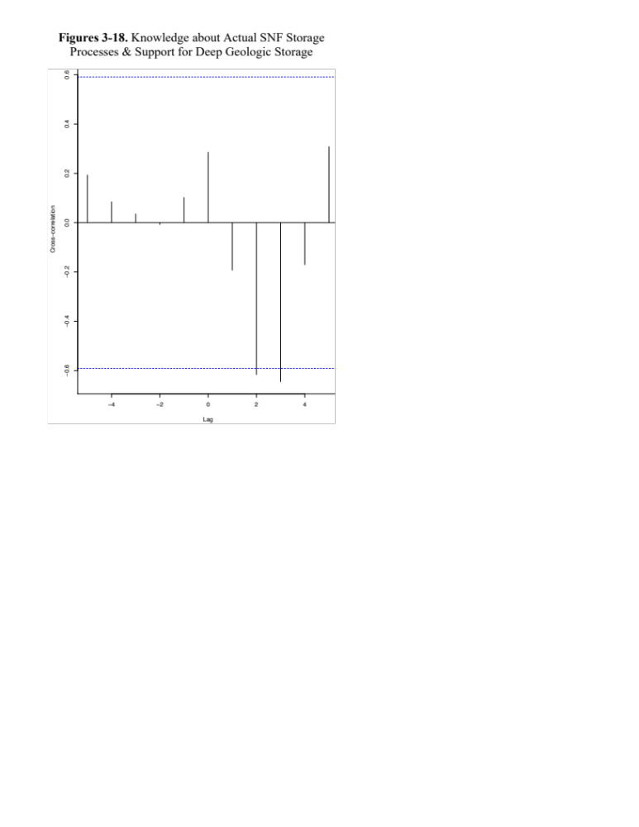

Figure 3-18 shows a negative correlation between the percent of individuals who have correctly indicated the actual processing method of SNF and support of SNF deep geologic storage at lag 2 and 3. These results are substantively not in line with the logic of the temporal order between cause and effect. In line with this figure, table 3-C3 in the appendix shows the correlation coefficient of these variables at each lag. Contrary to what was expected, the analysis showed that despite increased number in the fraction of people with correct knowledge about current SNF processing practices over time support in deep geologic and onsite storage is decreased, support for interim storage option is increased. This can be explained by the fact that due to the structure of the knowledge measure, modelling the impact of knowledge on SNF preferences did not make compelling substantive sense to begin with.

Implications and Conclusion

The study focused on the evolution of public preferences in SNF disposal policy options from 2006-2019. Through descriptive time series analysis I first examined how public perception in SNF siting preferences evolved over time in parallel with public risk perceptions, trust in government and knowledge in nuclear waste management technologies. Further, by employing explanative time series analysis I assessed whether changes in public risk and benefit perceptions, trust in government and knowledge in nuclear waste management technologies have affected public preferences in SNF disposal policy over time. The evolution of public nuclear energy risk perceptions over time showed increasing trends and, in line with that, benefit perceptions were characterized by decreasing trends. These descriptive results were also confirmed inferentially.

The results of times series cross correlation analyses granted that increased risk perceptions in nuclear waste transportation over time negatively affects public support for SNF deep geologic disposal five years later. In line with the theoretical expectations about the impact of benefit perceptions on nuclear energy policy preferences, tests of cross correlations generated positive significant relationships between public benefit perceptions of reduced mining/extraction and support in SNF onsite as well as interim storage preferences 1 year later. While these findings demonstrate that over time individuals are more supportive of nuclear energy production, they still prefer to avert accepting deep geologic disposal as a viable policy option for solving the issue with SNF.

The descriptive analysis of public trust in experts for management and regulation of nuclear technologies have increased over time. The inferential test of my proposition even showed that increased trust in government and in national labs over time induces public support for deep geologic disposal of SNF. While this finding shows statistical significance it does not have both practical and theoretical implications because the temporal structure of time series data assumes that cause needs to proceed the effect. In those instances where relationships matter at positive lags, these finding do not carry any substantive value.

Likewise, the proposition about the impact of knowledge on SNF policy did not find support, I did examine changes in increased percentages of respondents being correctly aware about the current SNF disposal options. This finding as well adds value to the above theoretical point as it shows awareness increase over the years. It is worthless to mention that awareness change has a potential for policy change as well.

The overall theoretical implications of this study relates to policy change. In line with the discussion of issue attention cycle, this finding implies that changes in perceptions eventually might also result in policy change in the long run.

It is important to acknowledge that the results of the analysis would be elevated first with additional data points. Only thirteen data points were available for this analysis. While scholars have different recommendations about the amount of the minimum recommended data points in time series analysis, most prominent work in political science seem to have at least twenty data points. Non-stationarity was another limitation of this study that was addressed by differencing. While this is a commonly accepted technique to achieve stationarity in data, this consideration needs to be reflected in interpreting the results of cross correlation analysis.

The cross correlations analysis that I conducted in this chapter gave me an opportunity to test the effect of one independent series on the dependent series. However, each time I have looked at single pairs of series. In a follow up study I will test these hypotheses by utilizing a Vector autoregressive (VAR) model that will help me predict multiple time series variables using a single model. Having multiple series in one model will enhance the explanatory power of the model in predicting the effect of the independent series on the dependent one.

Table 3- A1. Measurement of Key Variables

Variable | Question Wording | Measurement
Nuclear Energy Risk Perceptions | We want to know about your beliefs concerning some of the possible risks associated with nuclear energy use in the U.S. Please consider both the likelihood of a nuclear event occurring and its potential consequences when evaluating the risk posed by each of the following on a scale from zero to ten, where zero means no risk and ten means extreme risk.  - An event at a U.S. nuclear power plant within the next 20 years that results in the release of large amounts of radiation.  - An event during the transportation and temporary storage of spent nuclear fuel from nuclear power plants in the U.S. within the next 20 years that results in the release of large amounts of radiation.  - A terrorist attack at a U.S. nuclear power plant within the next 20 years that results in the release of large amounts of radiation.  - The diversion of nuclear fuel from a nuclear power plant in the U.S. within the next 20 years for the purpose of building a nuclear weapon. | 10 – Extreme Risk  –  –  –  –  –  –  –  –  –  0 – No Risk
Nuclear Energy Benefit Perceptions | We want to know about your beliefs concerning some of the possible benefits associated with nuclear energy use in the U.S. Please evaluate each of these possible benefits of nuclear energy use on a scale from zero to ten, where zero means not at all beneficial and ten means extremely beneficial.  - Reducing environmental threats because the generation of nuclear energy produces much less of the greenhouse gases that are believed to cause climate change.  - Reliable power because nuclear energy generates large amounts of electricity and is not affected by weather conditions, such as low rainfall or no wind.  - Greater U.S. energy independence because nuclear energy production does not require oil or gas from foreign sources.  - Reduced environmental damage because of less need for mining coal or extracting oil and gas. | 10 – Extremely Beneficial  –  –  –  –  –  –  –  –  –  0 – Not At All Beneficial
Perceptions in Trust for Regulation and Management of Nuclear Technology | Issues concerning nuclear energy and nuclear waste are often technically complex. Please indicate the level of trust you have in experts on nuclear issues who represent the following organizations, using a scale from zero to ten, where zero means no trust and ten means complete trust.  - The U.S. Nuclear Regulatory Commission.  - The U.S. Environmental Protection Agency.  - U.S. national laboratories for energy and security.  - The National Academy of Sciences.  - The U.S. Department of Energy.  - State regulatory agencies. | 10 – Complete Trust  –  –  –  –  –  –  –  –  –  0 – No Trust
Knowledge about SNF | As nuclear fuel is used to generate electricity, it becomes contaminated with radioactive byproducts. When it can no longer efficiently produce electricity, it is called “spent” nuclear fuel. To the best of your knowledge, what is being done currently with most of the spent nuclear fuel produced in the U.S.?  - Stored in cooling pools or special containers at nuclear power plants throughout the U.S.  - Shipped to Nevada and stored in a facility deep underground.  - Chemically reprocessed and reused.  - Shipped to regional storage sites. | Percent of total respondents selecting one of the four mutually exclusive categories.
Support in SNF Policy Options | - Using a scale from one to seven, where one means strongly oppose and seven means strongly support, how do you feel about continuing the current practice of storing spent nuclear fuel at or near nuclear power plants for the next years?  - Using a scale from one to seven, where one means strongly oppose and seven means strongly support, how do you feel about siting and constructing one or more interim storage facilities for consolidating spent nuclear fuel in the U.S.?  - Using the scale from one to seven, where one means strongly oppose and seven means strongly support, how do you feel about the option of constructing a storage facility deep underground where spent nuclear fuel from all over the U.S. would be stored? | 7 – Strongly Support  –  –  –  –  –  1 – Strongly Oppose

Table 3-B1. Augmented Dickey Fuller (ADCF) Test Results

Variables | P-Value before Differencing | P-Value after Differencing
Risk of Transportation & Storage Accident | 0.78 | 0.01
Benefit of Reliable Power 2 | 0.41 | 0.01
Benefit of Energy Independence 3 | 0.35 | 0.02
Benefit of Reduced Mining/Extraction 4 | 0.51 | 0.01
Trust in Federal Regulators - NRC | 0.96 | 0.04
Trust in Federal Regulators - EPA | 0.98 | 0.01
Trust in National Labs | 0.97 | 0.02
Trust in Department of Energy | 0.80 | 0.01
Trust in State Regulators | 0.87 | 0.01
Knowledge about Current SNF Storage | 0.46 | 0.01
Support for Onsite Storage | 0.86 | 0.01
Support for Interim Storage | 0.55 | 0.03
Support for Deep Geologic Storage | 0.04 | NA
Note: series are considered non-stationary if the p-value for the ADCF test is more than 0.05. In those instances series were differenced to reduce seasonal volatility. After differencing (when necessary) stationarity was checked again by running the ADCF test for a second time.
Table 3-C1: Correlations by lag between Series of Risk and Benefit Perceptions and SNF Preferences
Lags | -5 | -4 | -3 | -2 | -1 | 0 | 1 | 2 | 3 | 4 | 5
Nuclear Waste Transportation Risk & Onsite Storage | -0.24 | -0.02 | -0.19 | 0.17 | 0.21 | 0.39 | -0.13 | -0.45 | 0.20 | -0.21 | 0.06
Nuclear Waste Transportation Risk & Interim Storage | 0.29 | 0.28 | -0.38 | -0.58 | 0.04 | 0.25 | 0.10 | 0.18 | 0.01 | -0.07 | -0.05
Nuclear Waste Transportation Risk & Deep Geologic Storage | -0.69* | -0.24 | 0.44 | -0.34 | 0.21 | 0.06 | 0.02 | 0.02 | -0.02 | 0.00 | -0.02
Nuclear Energy Benefit of Reliable Power & Onsite Storage | -0.20 | -0.089 | -0.27 | -0.06 | 0.07 | 0.45 | 0.25 | 0.19 | 0.30 | -0.31 | -0.38
Nuclear Energy Benefit of Reliable Power & Interim Storage | 0.24 | 0.23 | -0.05 | -0.06 | -0.01 | -0.53 | -0.46 | 0.24 | 0.36 | 0.11 | -0.00
Nuclear Energy Benefit of Reliable Power & Deep Geologic Storage | -0.51 | 0.22 | 0.13 | -0.70 | -0.08 | 0.18 | -0.00 | 0.06 | 0.03 | 0.05 | 0.06
Benefit of Energy Independence & Onsite Storage | -0.07 | 0.23 | -0.00 | 0.09 | -0.12 | 0.01 | -0.14 | -0.02 | 0.07 | -0.37 | -0.17
Benefit of Energy Independence & Interim Storage | 0.05 | -0.21 | -0.20 | 0.28 | 0.23 | -0.39 | -0.07 | 0.55 | 0.22 | -0.24 | -0.17
Benefit of Energy Independence & Deep Geologic Storage | -0.39 | 0.47 | 0.14 | -0.64 | 0.34 | 0.44 | -0.20 | -0.01 | -0.04 | -0.02 | 0.01
Benefit of Reduced Mining & Onsite Storage | -0.11 | -0.44 | 0.18 | 0.21 | 0.73* | 0.23 | 0.08 | -0.40 | -0.45 | -0.35 | -0.12
Benefit of Reduced Mining & Interim Storage | 0.03 | -0.02 | -0.30 | -0.48 | -0.19 | 0.42 | 0.88* | 0.61 | -0.12 | -0.51 | -0.26
Benefit of Reduced Mining & Deep Geologic Storage | -0.07 | -0.07 | 0.02 | 0.22 | -0.14 | -0.18 | 0.02 | 0.35 | 0.40 | 0.11 | -0.21
Note: The *denotes a significantly strong correlation at a given lag period.

Table 3-C2: Correlations by lag between Series of Trust Perceptions and SNF Preferences
Lags | -5 | -4 | -3 | -2 | -1 | 0 | 1 | 2 | 3 | 4 | 5
Trust in DOE & Onsite Storage | 0.06 | -0.03 | -0.11 | -0.34 | -0.17 | -0.24 | 0.55 | 0.28 | 0.64 | -0.15 | 0.06
Trust in DOE & Interim Storage | 0.00 | 0.19 | 0.37 | 0.28 | -0.17 | -0.37 | -0.65 | -0.49 | -0.02 | 0.50 | 0.28
Trust in DOE & Deep Geologic Storage | 0.11 | -0.33 | -0.25 | -0.25 | -0.14 | 0.72* | -0.14 | -0.19 | -0.20 | 0.21 | 0.20
Trust in the National Labs & Onsite Storage | -0.30 | -0.24 | -0.01 | 0.26 | 0.45 | 0.26 | 0.25 | 0.20 | 0.15 | -0.23 | -0.24
Trust in the National Labs & Interim Storage | -0.16 | -0.34 | 0.14 | 0.71 | 0.10 | -0.67 | -0.22 | 0.44 | 0.25 | -0.13 | -0.12
Trust in the National Labs & Deep Geologic Storage | -0.06 | -0.03 | -0.09 | -0.09 | -0.01 | -0.23 | -0.03 | 0.61* | 0.65* | 0.10 | -0.15
Trust in the EPA & Onsite Storage | -0.23 | -0.29 | -0.27 | -0.02 | 0.29 | 0.40 | 0.69* | 0.37 | 0.26 | -0.25 | -0.16
Trust in the EPA & Interim Storage | 0.03 | 0.22 | 0.49 | 0.18 | -0.66 | -0.77* | -0.15 | 0.23 | 0.12 | 0.20 | 0.09
Trust in the EPA & Deep Geologic Storage | 0.17 | 0.18 | -0.17 | -0.19 | 0.13 | -0.47 | -0.30 | -0.09 | -0.25 | -0.31 | 0.23
Trust in the NRC & Onsite Storage | -0.25 | -0.32 | -0.29 | -0.07 | 0.27 | 0.42 | 0.76* | 0.45 | 0.35 | -0.21 | -0.21
Trust in the NRC & Interim Storage | 0.06 | 0.31 | 0.52 | 0.14 | -0.66 | -0.81* | -0.32 | 0.13 | 0.21 | 0.29 | 0.13
Trust in the NRC & Deep Geologic Storage | 0.19 | 0.15 | -0.11 | -0.18 | 0.06 | -0.46 | -0.30 | -0.15 | -0.31 | -0.28 | 0.15
Trust in the State Regulators & Onsite Storage | 0.27 | 0.08 | 0.12 | -0.41 | -0.05 | -0.56 | 0.25 | -0.14 | 0.60 | -0.21 | 0.04
Trust in the State Regulators & Interim Storage | -0.06 | 0.14 | 0.36 | 0.30 | -0.18 | -0.30 | -0.52 | -0.48 | -0.05 | 0.49 | 0.29
Trust in the State Regulators & Deep Geologic Storage | 0.41 | 0.01 | -0.02 | -0.26 | -0.05 | -0.76 | 0.35 | 0.07 | 0.09 | 0.08 | 0.08
Note: The *denotes a significantly strong correlation at a given lag period.

Table 3-C3. Correlations by lag between Series of Fraction of Correct Knowledge Response and SNF Preferences

Lag | -5 | -4 | -3 | -2 | -1 | 0 | 1 | 2 | 3 | 4 | 5
Current Knowledge & Deep Geologic Storage | 0.19 | 0.09 | 0.04 | -0.01 | 0.11 | 0.29 | -0.19 | -0.62 | -0.65 | -0.17 | 0.31
Current Knowledge & Onsite Storage | 0.49 | 0.26 | 0.04 | -0.59 | -0.59 | -0.59 | -0.11 | -0.05 | 0.11 | 0.09 | 0.18
Current Knowledge & Interim Storage | -0.29 | -0.20 | 0.42 | 0.74 | -0.11 | -0.60 | -0.40 | 0.06 | 0.19 | 0.10 | 0.02

Chapter 4. Can Local Policy Concerns of NYMBYism Reshape Partisan and Ideological Landscape in the State of Nevada?

Abstract
The purpose of this chapter is to investigate whether uniquely shaped local policy issues associated with NIMBYism shape partisan and ideological dispositions among local public. By utilizing voting behavior and election turnout data for presidential general elections from 1970s to 2016 for 17 counties in Nevada I estimate the effect of the Nuclear Waste Policy Act of 1982 and as amended in 1987 on reshaping the local political landscape in a difference-in-differences design. My main finding is that the enactment of NWPA is associated with 7 percentage point increase in the propensity of residents of the counties most affected by the NWPA to vote Republican (and a comparable decrease in Democratic vote). While the findings imply that locally shaped policy dispositions in the long run feedback into politics and reshape local ideological and partisan landscape, the discovered shift is in the opposite direction supporting partisan identification rather than issue identification hypothesis.

Introduction
Public policy scholars have traditionally been concerned about the role of individual values, attitudes and beliefs in shaping policy preferences among mass public (Allport 1937, Converse 1964; Conover and Feldman 1984a; Zaller 1992; Herron and Jenkins-Smith 2006; Swedlow and Wyckoff 2009; Page & Shapiro 2010; Ripberger et al 2014). Such demographic characteristics as age, gender, income and education influence public policy perceptions on a broad set of political issues (Downs 1957; Campbell et al. 1960; Finucane et al. 2000, Handmer and Proudley 2007). The literature on political polarization claims that American public opinion merely been polarized on such policy issues as government spending, assistance to the poor, gay adoption, abortion rights, and other sensitive policy issues (Abramowitz and Saunders 2008; DiMaggio and Bryson 1996; McCarty, Poole, and Rosenthal 2006; Fiorina, Abrams, and Pope 2005). Political ideology and partisanship have provided complementary explanations in explaining individual differences in policy preferences and beliefs (Allport 1937; Downs 1957; Converse 1964; Conover and Feldman 1984a; 1984b; Baldassarri and Gelman 2008; Zaller 1992).
These explanations have been particularly important for describing individual differences in nuclear energy policy preferences (Back 2013; Bickerstaff et al 2008; Butler and Pidgeon 2011). Nuclear policy was not a partisan polarizing issue in the early days. However, the situation changed after the Three Mile Island accident in 1979. As a result environmental groups shifted positions to oppose it or to become aligned with the Democratic party that also contested nuclear energy. Thus, over time this policy area as well became one the polarizing policy issues on which political parties and politicians are more likely to take extreme ideological positions (Clemmer et al 2018; Cotton 2015; Darst and Dawson 2010, Kraft 2013). In line with this, previous research has established that individuals with Republican party affiliation are more supportive of nuclear energy use than those with Democratic party affiliation (Rothman and Lichter 1987; Conover and Feldman 1981). Likewise, individuals with conservative political ideology are more supportive of nuclear energy use than those individuals with liberal ideological leaning (Rothman and Lichter 1987; Conover and Feldman 1984a; Ripberger et al. 2012).
While mainstream public behavior research claims that American mass public opinion is strongly related to partisanship and polarized attitudes, and is enhanced by communications from the elites on a wide range of issues, there are some scholars who argue that the causal arrow points in the opposite direction (Abramowitz and Saunders 2008; Broockman and Butler 2017; Baldassarri and Gelman 2008; DiMaggio et al. 1996; Levendusky 2009). Some studies have found evidence to support the claim that voters’ issue positions affect their vote intention for the party that holds similar positions on salient issues at the time of election (Ansolabehere, Rodden, and Snyder 2008; Broockman and Butler 2017). My focus is on whether positions on nuclear siting issues – which can become highly salient to voters in communities near prospective sites – can lead voters to shift their patterns of partisan support. Unfortunately, prior research testing the capacity of nuclear policy disputes to affect the public’s partisan choices has been shallow, largely because the salience of nuclear policy issues has been viewed as transient and associated with major nuclear accidents (Van der Brug 2001; Latré et al. 2019).
Building on this literature, in this chapter I inquire whether support or opposition to nuclear waste siting policy in potentially impacted communities has the potential to affect pubic partisan and even ideological choices. I leverage longitudinal voting behavior data from the state of Nevada to assess the effect of the enactment of Nuclear Waste Policy Act of 1982, and as amended in 1987 (hereafter NWPA), on partisan choices as well as on the pattern of election turnout rates. As described in a section of this chapter, this policy context provides an ideal venue for this analysis, in which I aim to address the following research questions:
- Does a policy issue such as the decision to site a nuclear waste facility have the potential to reshape local partisan and ideological positions?
- Do local policy concerns have the potential to affect levels of political participation and make people become politically more engaged?
In the next section, I provide a review of the literature on voting behavior and election turnout as well as policy feedback theory. I further introduce the theoretical expectations for the effect of NWPA on voting behavior and participation across time in the state of Nevada. After presenting the policy context in more detail, I describe the unique panel dataset underlying this analysis and detail the empirical approach. Finally, I present the findings of the empirical analysis and its implications for public policy theory and practice.

Theoretical Expectations
To answer the research questions raised here, I leverage the political science literature on voting behavior and election turnout with the policy feedback theory to test hypotheses about the likely impact of policies on politics in a local context. Voting behavior literature examines the impact of sociological and psychological characteristics of citizens on their preferences and participation in elections (Eldersveld 1951; Balogun and Olapegb 2007), largely omitting discussion of locally-salient issues in driving partisanship and participation.
The early theories of voting behavior claim that voters are influenced by party identification, issue orientation or candidate orientation (Lazarsfeld et al. 1944; Campbell et al. 1960; Lipset and Rokkan 1967). The party identification theory of the Michigan school claims that people tend to stay loyal to a specific party that they were socialized to from their early years, and are likely to vote for all of their candidates in any election (Berelson, Lazarsfeld, and McPhee 1954; Lazarsfeld et al. 1944; Eldersveld 1951). A competing theory to party identification is candidate orientation that claims specific candidate’s image or personality has the potential to swing voters in any specific election (Rosenberg et al. 1986; Hayes 2009). Alternatively, scholars from the Columbia school of voting research found that voting behavior is instead impacted by high interest in given issues as opposed to partisanship (Key 1966; Nie, Petrocik and Verba 1999). Scholars have found that such salient issues as civil rights, war, scandals or economy have historically swayed voters (Nie, Petrocik and Verba 1999). Issue salience is also influential for non-voting voters. While voter turnout varies from election to election, on average voter turnout is higher during elections for statewide offices and the presidency (U.S. Census 2012). Voter turnout also increases due to issue salience or other effects that reinforce voter’s positions and preferences (Fiorina 1981). Nuclear energy policy has been a salient issue mostly during major nuclear accidents (Latré et al. 2019). After the Chernobyl accident European voting behavior has changed based on issue identification (Van der Brug 2001). Therefore, the contribution of this study is particularly important as it tests whether a highly contested local nuclear waste siting issue has impacted voting behavior and election turnout in a quasi-experimental design.
In addition to party identification, candidate and issue voting, political ideology is another determinant for voting behavior. Levendusky (2009) found that due to polarizing issues political ideology had a significant effect in reconstructing individual’s long term commitments to political parties. Sorting of liberal and conservative ideologies with specific parties reshaped American partisan landscape in the 1970s. This reconfiguration eliminated each major party having both liberal and conservative faction to sorting liberal ideology with Democratic party and conservative ideology with the Republicans (Levendusky 2009). In parallel with this sorting, voter’s long-term impressions on party’s policy records have gradually created issue ownership (Petrocik 1996) and trait ownership (Hayes 2005) between the two parties in the U.S. In that regard the evidence has shown that individuals with Republican party affiliation and conservative political ideology are more supportive of nuclear energy use than those with Democratic party affiliation and liberal ideology (Conover and Feldman 1981; Rothman and Lichter 1987; Ripberger et al. 2012).
Policy feedback theory focuses on how policies affect and shape politics, political behavior, or perception of one’s standing in society (Béland 2010; Mettler and Sorelle 2018; Pierson 1992; 1993). The existing research in the area primarily includes single-policy case studies that have demonstrated how policies affect the political behavior of ordinary citizens. Campbell (2003) found the threat of a policy change is related to increased participatory efforts among citizens. Other scholars have found evidence for policies to promote or discourage civic engagement among mass publics (Mettler 2002; Bruch, Ferree and Soss 2010). Studies have also shown that material resources and the demographic attributes associated with a propensity to participate politically positively affect political activism and civic engagement even among urban poor respondents (Verba, Schlozman and Brady 1995; Lawless and Fox 2001). Current research in policy feedback theory is substantively focused on social welfare and criminal justice programs and mostly employs historical analysis, interviews and statistical analysis of cross-sectional survey data (Mettler and Sorelle 2018). This study examines the effect of policies on politics in nuclear policy domain. In particular, I inquire whether a highly contested local spent nuclear fuel siting issue has the potential for reshaping the partisan landscape of the state of Nevada by changing citizen voting behavior and their levels of civic engagement. This policy context provides an excellent case for observing changes in the political behavior of ordinary citizens effected by nuclear policy domain. The next section introduces the local policy context in more detail.

Local Policy Context and Nuclear Waste Policy Act
Spent nuclear fuel waste disposal in USA has been debated for nearly half a century, with resolution bogged down by a stalemate over building a permanent repository for spent nuclear fuel and high-level nuclear waste in USA (Hadden et al. 1983). Despite robust scientific consensus that deep geologic isolation is the technically preferred method for disposing of long-lived radioactive wastes (National Research Council 2001; IAEA 2014), siting facilities for the storage and disposal of these wastes has historically proven to be extraordinarily difficult for governments due to the opposition from local host communities (O'Hare, Bacow and Sanderson 1983).
United States currently has over 90,000 metric tons of nuclear waste that requires disposal (US GAO 2020). The 1987 Amendment to the Nuclear Policy Act of 1982 has established the selection of Yucca Mountain as a permanent repository for spent nuclear fuel nationwide (US GAO 2020). As the map below demonstrates, there are seventeen counties in the state of Nevada, nine of which are officially considered to be geographically affected by the NWPA because they are either in the vicinity of Yucca mountain site or on the potential rail route to Yucca mountain (Eureka County Yucca Mountain Information Office, 2019).

Figure 4-1. Nevada County Map
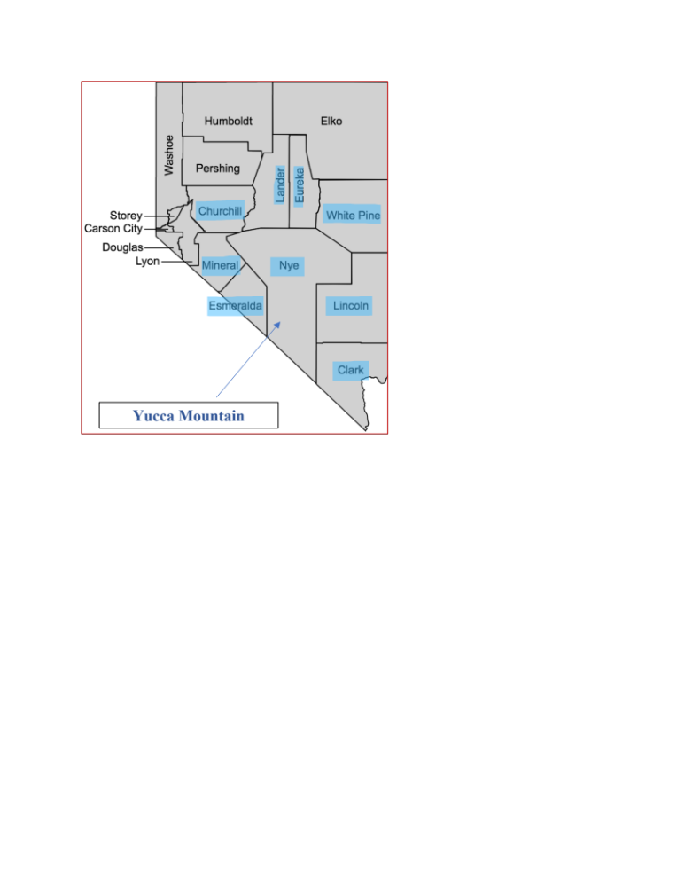
Note: The map is borrowed from GISGeography (2020). The figure demonstrates the geographic locations of the 17 counties in Nevada. The affected counties highlighted with blue are the following: Eureka County, Churchill County, Clark County, Esmeralda County, Mineral County, Nye County, Lander County, Lincoln County and White Pine County. Yucca Mountain is located in Nye County.

In general there are ten (10) designated “Affected Units of Local Governments (AULG’s)” nationally recognized to be in relative proximity to Yucca Mountain (Eureka County Yucca Mountain Information Office, 2020). Due to their geographic proximity these AULG’s have been granted authority to provide information and public involvement opportunities regarding federal decisions about Yucca Mountain. As figure 4-1 demonstrates, nine of these AULG’s are located in the state of Nevada with one being in California. In this dissertation I refer to these nine AUGU counties in the state of Nevada as “affected counties.”
The state of Nevada was the nuclear weapons test site until around 1990s while the investigation of a possible high level nuclear waste storage facility in USA started in the 1970s (U.S. NRC 2018). With the enactment of NWPA in 1982 Nevada was designated as one of the five candidates for a site (U.S. GAO 2020). In 1987 NWPA amendment designated Yucca Mountain the only site under consideration (U.S. GAO 2020). This decision to focus only on one site was broadly opposed by the local community in Nevada contributing to an unsettled policy debate (Eureka County Yucca Mountain Information Office 2020). Thus, the Obama administration halted the project after four decades of research and development and the expenditure of over 15 billion dollars in the Yucca mountain siting program (Eureka County Yucca Mountain Information Office 2020). Although the Department of Energy had filed to obtain a license from the Nuclear Regulatory Commission to construct the Yucca Mountain facility in 2002, President Obama cancelled funding for the program in 2010 and sought to cancel the NRC licensing process. President Trump has supported restarting the project, and his budget request in 2017 for fiscal year 2018 included $120 million for work on the Yucca Mountain project. These funds were planned to be allocated for resuming Yucca Mountain and an interim storage site license review (US GAO 2020). However, the decision about a disposal site in the United States is still pending, as is license application to authorize construction of a nuclear waste repository at the Yucca Mountain site in Nevada. President Trump continues to signal his support for Yucca Mountain, and recently tweeted a promise to the residents of Nevada about “exploring innovative approaches” to the Yucca Mountain policy debate (Macfarlane 2020). This policy context provides an excellent case with which to test hypotheses about the likely effect of NWPA on the political behavior of local residents in quasi experimental design. In particular, I will compare whether there are differences among residents of counties that are geographically affected by NWPA as opposed to those that are not affected. As defined above, the geographically affected counties are identified as the treatment group in the analysis and the remaining ones as control group. Based on the above theoretical discussions on party identification, issue ownership and policy feedback, I empirically examine the following hypotheses.
Hypothesis 1: In line with the extant literature on long term effects of partisan identification and issue ownership I expect to find local residents from counties directly affected by NWPA (treatment group) as opposed to those who are not directly affected by it (control group) to reflect a change in their voting behavior caused by the adoption of NWPA in 1982 or its amendment of 1987.
Having in mind the issue identification hypothesis and the empirical evidence from previous research we know that individuals with Republican party affiliation and conservative political ideology are more supportive of nuclear energy use than those with Democratic party affiliation and liberal ideology (Conover and Feldman 1981; Rothman and Lichter 1987; Ripberger et al. 2012). Therefore, in line with these predispositions I particularly expect that historically partisan and ideological sentiments in Nevada from around 1980ies when NWPA policy discussions came into play have shifted towards Democratic and liberal ideology at the expense of the Republican and conservative voters.
Hypothesis 2: Based on the claims of policy feedback theory about the salience of policy contextual effects and increased civic engagement I expect to find local residents from counties directly affected by NWPA (treatment group) to have increased election turnout caused by the adoption of NWPA in 1982 or its amendment of 1987.

Data and Methods
To investigate the impact of NWPA on voting behavior and election turnout in the state of Nevada I constructed a unique four-year panel dataset for all 17 counties for the years 1964-2016. These data used in the analysis are collected from the state of Nevada Secretary of State (NSS) website. The website publishes overall count of election and turnout results per candidate/party for all types of elections. For the purposes of this study I focused on general presidential elections given the evidence that voter turnout is highest at presidential elections (U.S. Census 2012). The measure of voting behavior indicates the aggregated preferences of individual voters per candidate/party and is constructed form the election result reports for presidential general elections of 1964 to 2016 in all seventeen counties in Nevada (Nevada Secretary of State 2020). The measure for election turnout is the percent of registered voters that cast a vote in the given election collected from the voter turnout reports for presidential general elections of 1964 to 2016 for all seventeen counties in Nevada (Nevada Secretary of State 2020). These dependent variables reflect the main outcome of interest of the study.
To assess the impact of NWPA and the 1987 amendments on reshaping the political landscape in the state of Nevada it is first necessary to remember the geographic disposition of its counties revealed in figure 4-1 and described in the previous section. From the total seventeen counties in the state, nine geographically affected counties affected by the enactment of NWPA are considered as the treatment group in the research design and the remaining eight counties serve as controls in the analysis.
Table 4-1. Descriptive Statistics
 | Source | Mean | SD | Min | Max | N
Outcome Variables
Voted Republican | NSS | 58.45 | 12.70 | 28.82 | 84.66 | 238
Voted Democrat | NSS | 33.67 | 11.58 | 2.97 | 71.176 | 238
Election Turnout | NSS | 79.99 | 7.10 | 56.00 | 96.53 | 170
NWPA Policy Variables
Post1982*Treatment | Constructed | 0.29 | 0.45 | 0 | 1 | 252
Post1987*Treatment | Constructed | 0.25 | 0.50 | 0 | 1 | 252
Note: NSS= Nevada Secretary of State

The key variables in the dataset are summarized in Table 4-1. Data underlying this analysis fall into two main categories. First, I collected voting behavior and election turnout data for the seventeen counties in the state of Nevada. These data measure the main outcomes of interest for this analysis. Second, I include indicators that capture the enactment of NWPA. Specifically, I constructed a dichotomous measure that indicates the counties in Nevada that are affected by NWPA (the treatment group). I also created a dichotomous time measure to indicate the years post approval of NWPA and its reform.
To estimate the effect of NWPA on voting behavior and election turnout in the state of Nevada two empirical approaches are employed. First, I utilize a standard difference-in-differences (DID) approach. This modeling strategy will estimate the impact of the NWPA by comparing the difference between the pre-intervention (pre-NWPA enactment) to post-intervention (post-NWPA enactment) changes between treated (affected) and untreated (control) counties for an outcome of interest (Angrist and Pischke 2009). I implement the difference-in-differences approach in a regression framework, summarized in Equation 1 below.
$${\text{Y}}_{\text{it}}\text{= }α\text{ + β}{\text{(F}}_{\text{i}}\text{*}T_{t}\text{)}+{\text{λ}}_{\text{t}}+{\text{ϵ}}_{\text{i,t}}$$ | (1)

In this model, the vote outcome variables ${\text{(Y}}_{\text{it}}$) in county i in election year t are a function of a constant ($α$), a year fixed effect (${\text{λ}}_{\text{t}})$, an error term (${\text{ϵ}}_{\text{i,t}})$, and an interaction between a dichotomous variable for treated counties (${\text{F}}_{\text{i}})$ and a dichotomous variable indicating post NWPA enactment ($T_{t})$. The parameter of interest ($\text{β}$) reveals the association between NWPA adoption and voting behavior and election turnout in post-NWPA enactment years for treated counties.
I also include year fixed effects to account for individual-invariant unobserved time factors. These fixed effects are included because I expect that there are time-specific impacts that might influence voting behavior and election turnout.
The second modeling strategy entails an event-study or dynamic DID approach, as it allows me to estimate if there is variation in the effect of the NWPA on electoral outcomes over the post-enactment time period (Abraham and Sun 2018). This strategy also enables me to estimate whether there were any significant differences across treated and control counties leading up to the policy changes that could bias the estimates. I implement the event-study or dynamic DID in the regression framework summarized in Equation 2.
$${\text{Y}}_{\text{it}}\text{= }\text{α}\text{ +}{\text{β}}_{\text{n}}{\text{D}}_{\text{n}}\text{+ }{\text{λ}}_{\text{t}}\text{+ }{\text{ϵ}}_{\text{i,t}}$$ | (2)
In this model, the outcome variables ${\text{(Y}}_{\text{it}}$) are estimated as a function of an error term (${\text{ϵ}}_{\text{i,t}})$, a constant ($\text{α}$), year fixed effects (${\text{λ}}_{\text{t}})$, and an interaction between whether the county has been affected by the policy change and a set of dichotomous variables capturing the year relative to NWPA enactment for all counties in Nevada. The flexibility that this model introduces into the difference-in-difference set up will allow for the associations between NWPA enactment and voting behavior and turnout to vary based on the year relative to NWPA adoption. In order to construct this model, I create dichotomous variables to represent plus or minus four election years relative to NWPA enaction. Further, I exclude the dichotomous variable representing one election year prior to NWPA adoption as the reference group; thus, all comparisons are made to the year prior to adoption.
Results
The results for the difference-in-differences analysis for the effect of NWPA of 1982 on voting behavior and election turnout in Nevada are presented in Table 4-2. This table shows that the average treatment effect of NWPA is significantly impacting the outcomes of interest for hypothesis 1. First, the estimates reveal a positive impact of NWPA on the percentage of voters in the treatment counties voting for Republican candidates. Consistent with that finding, the estimates show a negative effect of NWPA of 1982 on the likelihood of citizens from treatment counties voting for the Democratic candidates. In terms of magnitude, these estimates suggest that NWPA of 1982 is associated with a 7 percentage point decrease in the likelihood of voting for the Democratic candidates and increase in voting for Republican candidates at the same rate. Finally, the NWPA did not have a significant effect on election turnout.

Table 4-2. The Effect of NWPA of 1982 on Voting Behavior and Election Turnout in Geographically Affected Counties, Non-Affected Ones as Controls
 | Voted Democrat | Voted Republican | Election Turnout
Treatment Counties | 3.891 | -4.580 | -0.903
 | (2.362) | (2.704) | (3.394)
Post-NWPA | -4.067 | 1.099 | -1.962
 | (2.143) | (2.454) | (2.603)
Post-NWPA x Treatment | -7.185** | 7.101** | -1.869
 | (2.945) | (3.372) | (3.577)
R-squared | 0.130 | 0.052 | 0.050
N | 238 | 238 | 170
Note: Models include covariates and time fixed effects. Standard errors in parentheses. Significant at * p < 0.1; ** p < 0.05; *** p < 0.01
I also tested the effect of the enactment of NWPA in a subset where the outcomes of interest were majority Republican or Democratic votes. As we can see from table 4-3, NWPA did nominally impact the majority of Republican or Democratic votes consistent with the previous models, however these associations are not statistically significant. This suggests that the changes in the percentage of the electorate voting for Democrats and Republicans found in Table 2 were not large enough to change whether the county was voting for majority Democrats or Republicans.

Table 4-3. The Effect of NWPA of 1982 and its 1987 Amendment on Majority Republican or Democratic Votes in Geographically Affected Counties, Non-Affected Ones as Controls
 | NWPA Enactment of 1982 |  | NWPA Enactment of 1987
 | Voted Democrat | Voted Republican | Voted Democrat | Voted Republican
Treatment Counties | 0.136* | -0.192 | 0.113 | -0.160
 | (0.067) | (0.098) | (0.062) | (0.090)
Post-NWPA | -0.147* | 0.039 | -0.115 | -0.036
 | (0.061) | (0.089) | (0.060) | (0.087)
Post-NWPA x Treatment | -0.102 | 0.181 | -0.075 | 0.148
 | (0.083) | (0.122) | (0.082) | (0.119)
R-squared | 0.107 | 0.036 | 0.071 | 0.015
N | 238 | 238 | 238 | 238
Note: Models include covariates and time fixed effects. Standard errors in parentheses. Significant at * p < 0.1; ** p < 0.05; *** p < 0.01

To provide insight into the dynamic effects of NWPA on geographically affected counties over time, I present the event-study analyses in Table 4-4 and their illustrations in Figures 4-2 and 4-3. This method allows the estimated effects to vary across years relative to the year of implementation.

Table 4-4. Event-Study Results for the Effect of NWPA on Voting Behavior
 | Voted Democrat | Voted Republican | Election Turnout
4 Elections before*  Treatment Counties | 9.856*  (4.630) | -9.626*  (4.412) | -3.922  (5.879)
3 Elections before*  Treatment Counties | 11.601*  (4.607) | -16.489***  (4.390) | -0.259  (4.529)
2 Elections before*  Treatment Counties | 9.668*  (4.412) | -9.521*  (4.204) | 2.180  (5.541)
1 Election before*  Treatment Counties | 10.242*  (4.388) | -9.403*  (4.181) | -8.606*  (3.928)
Base year | OMIT | OMIT | OMIT
1 Election after*  Treatment Counties | 5.439  (4.392) | -5.649  (4.185) | 4.719  (3.346)
2 Elections after*  Treatment Counties | 4.191  (4.410) | -3.806  (4.202) | 4.879  (3.367)
3 Elections after*  Treatment Counties | 5.803  (4.650) | -4.857  (4.431) | 4.647  (3.559)
4 Elections after*  Treatment Counties | 4.112  (4.514) | -8.433  (4.302) | 2.889  (3.458)
R-squared | 0.042 | 0.073 | 0.177
N | 238 | 238 | 170
Note: The reference year utilized in both models is the election year that has taken place two years before NWPA adoption. This is the baseline year to compare whether the treatment and control groups were significantly different in pre-treatment years. Standard errors in parentheses. Significant at * p < 0.1; ** p < 0.05; *** p < 0.01

The results of the event study analyses summarized in Table 4-4 and figures 4-2 and 4-3 reveal that the enactment of NWPA is not associated with political outcomes for post-treatment years if we observe the results on year by year basis. Overall, these models suggest that among treatment counties, before 1982, the percent voting Democrat was higher than it was in the control counties. In addition, when we compare voting outcomes for Democratic versus Republican candidates, the model coefficients suggest increased support for Democratic candidates.
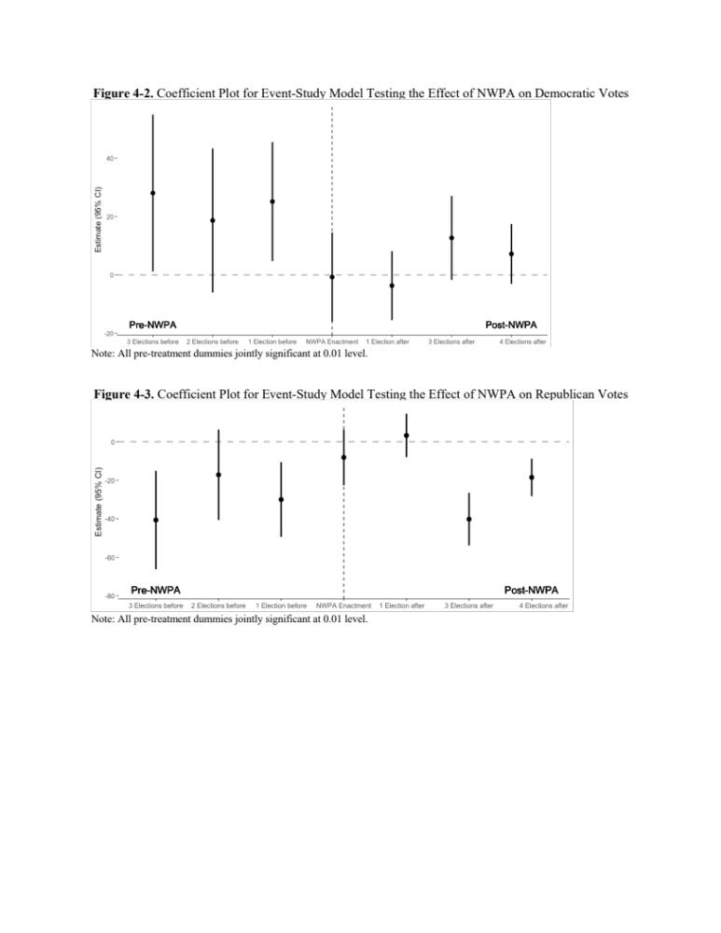
Discussion and Conclusion
In this chapter I leveraged the political science literature on issue identification and voting behavior with policy feedback theory to examine whether a highly contested local spent nuclear waste siting issue reshaped partisan positions and political engagement in the state of Nevada. While policy feedback theory claims that policies shape politics, the literature has yet to investigate the explanatory power of this theory in nuclear energy policy domain. Building on the issue position and policy feedback literatures, this inquiry analyzed the effect of NWPA on the political outcomes in a quasi-experimental design.
By employing a difference-in-differences research design I tested hypotheses on the likely effect of NWPA on voting behavior and civic engagement for presidential general elections across seventeen counties in Nevada from 1970s to 2016. While we do know that NWPA was adopted in 1982 and amended in 1987, we assume that the effect of the policy on voting behavior will likely follow its adoptions. However, it might be possible that public resentment or reaction and thus effect of the policy was before its enactment when it was being discussed. To make sure that these dynamic changes are revealed in the analyses I also employ an event-study or dynamic DID approach. The event study approach reveals predominantly null findings on the likely effect of NWPA on treatment counties. However, it does show higher vote support for Democratic candidates pre-NWPA in treatment counties as compared to control counties.
In this chapter I utilized two methods for testing hypotheses about the effect of NWPA on voting behavior in Nevada. By testing the hypotheses with DID approach I found enough evidence to support the claim that NWPA affects voting behavior in treatment counties in Nevada. In particular NWPA is associated with a 7 percentage point decrease in the likelihood of voting for the Democratic candidates and increase in voting for Republican candidates at the same rate. It is important to underscore, that the direction of these findings is opposite to what I expected. While I did expect to find a shift in voting behavior due to NWPA, I expected that shift to be in favor of the Democratic party at the expense of the Republican party due to their nuclear energy issue positions and Nevada’s local opposition to nuclear energy.
In addition, the analysis found no support for hypothesis 2. Although presidential general elections draw the highest election turnout in general, many missing values for this outcome variable of interest might be one of the reasons for the consistency in insignificant coefficients in these models. Therefore, there seem to be no significant changes and variation in election turnout across all counties in Nevada.
While DID approach is very helpful in identifying the effect of intervention on treatment group in comparison to control group, it also has strong assumptions about the effect of time of intervention (Angrist and Pischke 2009; Greene 2000). In this study I have identified 1982 enactment of the NWPA as the time effect. However, critiques of this approach offer utilizing an event study approach as a remedy against the assumption of the time of the treatment effect (Abraham and Sun2018). The results of the event study approach showed increased support for Democratic votes at the expense of the Republican votes. While these results substantively are in line with the expected effect of the policy, they have no statistical significance.
Overall, the major finding and the implications of this study show that local policy preferences and concerns in the long run have the potential to reshape local political landscape by changing public ideological dispositions and shifting their partisan preferences. The study confirms that regional stigma and risk perceptions are at the root of local opposition to spent nuclear fuel disposal policy in Nevada (Jenkins-Smith 1993; Jenkins-Smith, Silva and Gupta 2017). However, due to this finding being in an unexpected direction of change, it might undermine the explanatory power of the issue orientation hypothesis.
There are different competing explanations for this outcome. Some scholars argue that presidential voters are different from congressional voters and having voting behavior data from all previous 14 general presidential elections might be the reason for the unexpected outcome (McDonald 2011; Wolfinger, Rosenstone and McIntosh 1981). The counter-argument to this point is the explanation that those differences are mostly in their demographic characteristics and affect election turnout. Those differences also distinguish voters from non-voters. However, it is difficult to assess whether the demographic differences in turnout between congressional and presidential elections would affect the outcome to that extent. A potential avenue for exploration is also a look into higher turnout and its effect on Democratic candidates (Tucker et al. 1986; Radcliff 1994; Grofman et al. 1999; Martinez and Gill 2005).
Another potential explanation for the findings being in the opposite direction can be the rebuttal of the issue orientation hypothesis and the confirmation of the party identification hypothesis (Levendusky 2009). One might argue that voting preferences and behavior are formulated mostly by individual’s political socialization and their socio-identification group. This argument especially gets traction if we consider recent population growth in the state of Nevada and population migration to the Sun Belt region. Population changes can significantly impact the outcome of elections in opposite direction as newly settled residents of Nevada would not share the historical opposition and contempt toward one party or another due to NWPA.
From the methodological standpoint, my theory suggests a systematic level of analysis. A major limitation of this data is the scarcity of observations after policy 1 and before policy 2 (there is only 1 election between those two). A further robust analysis would entail using NWPA of 1885 and its 1987 revision separately in two different models.
While this study is a demonstration of policies feeding back into the political environment and reformulating the distribution and shape of that environment, it has also other limitations. The inferences drawn from this analyses are based on general presidential elections utilizing county level data. If we recall, there are merely 17 counties in Nevada. The analysis would be more robust if the models could utilize precinct level data. The data points will multiply and the big standard error will probably shrink after increasing the sample size of the observations. This is something that I intend to pursue in a follow up study. Yet another limitation is the absence of sufficiently nuanced control variables to capture important features for the local political context. In future work I will be adding measures of local economic and political trends as time-variant contextual factors to address this. If the results of this analysis hold after addressing all these issues, a follow up qualitative study with focus group format will help determine the reasons for changing voting behavior in an unexpected direction. My future research will also investigate whether the NWPA has also impacted voting behavior in other local elections – for example, around the sites that had been candidates for a nuclear waste repository in the 1982 Act but were withdrawn in the 1987 amendments.

Figure 4-A1. The Map of the State of Nevada with NWPA Affected Counties
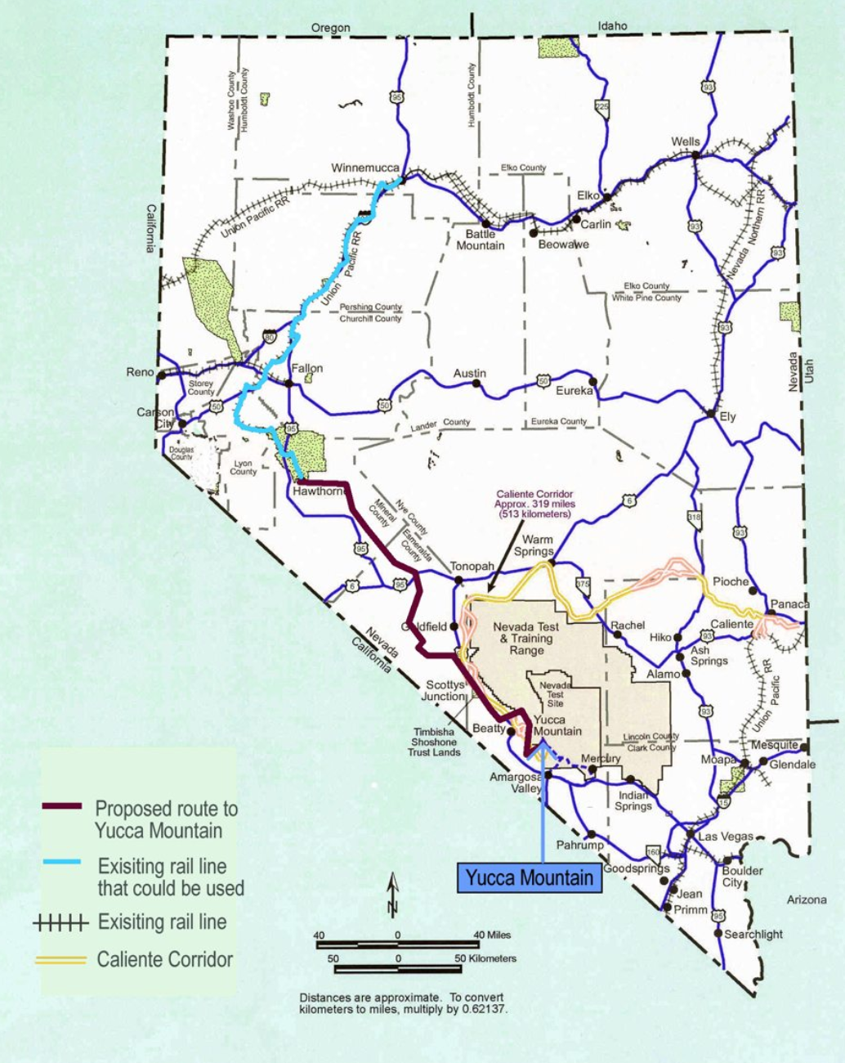
Source: The source of this map is Eureka County Yucca Mountain Information Office, 2019.

Table 4-B1. The Effect of NWPA of 1987 on Voting Behavior and Election Turnout in Geographically Affected Counties, Non-Affected Ones as Controls
 | Voted Democrat | Voted Republican | Election Turnout
Treatment Counties | 3.339 | -4.041 | -0.655
 | (2.222) | (2.508) | (2.369)
Post-NWPA | -1.522 | -2.653 | -2.103
 | (2.139) | (2.414) | (1.927)
Post-NWPA x Treatment | -7.117** | 7.047** | -2.413
 | (2.939) | (3.318) | (2.649)
R-squared | 0.076 | 0.021 | 0.074
N | 238 | 238 | 170
Note: Models include covariates and time fixed effects. Significant at * p < 0.1; ** p < 0.05; *** p < 0.01

Figure 4-C1. Coefficient Plot for Event-Study Model Testing the Effect of NWPA on Election Turnout

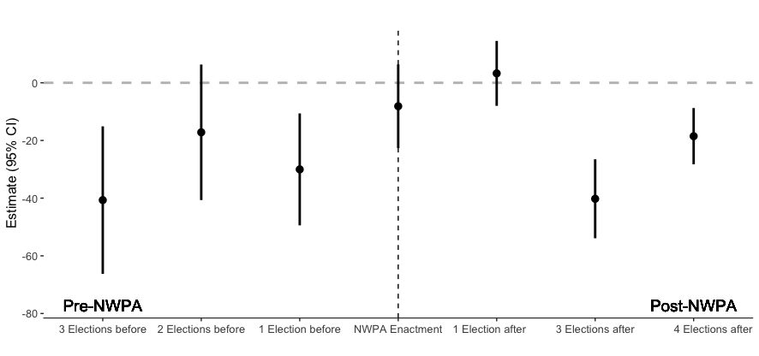

Chapter 5. Nuclear Impasse: The Cultural Bias in Support for Carbon-Free Energy Sources
Abstract
Beliefs about climate change vary widely among members of the American public, including whether the climate is changing, what is causing it, and what humans can do (or should do) to combat its effects. Some policy elites and environmentalists have argued that nuclear energy – as the largest source of carbon-free energy in the US – will be an essential bridge in the shift to renewable energy, while others have maintained strong opposition to it. Using data from a nationwide Internet surveys including over 2000 American adults, I explore the relationship between beliefs about global warming and support for nuclear energy among members of the broader US public. Further, I investigate whether political ideology, cultural worldviews and other demographic characteristics underlie the differences among environmentalists over the future role of nuclear energy. The findings reveal that individuals who are more concerned with global warming tend to prefer energy coming from renewable sources rather than nuclear.

Introduction
Historically most of the consumption of energy in USA has originated from fossil fuels. In 2017, in line with these historic trends US primary energy production combined from three major fossil fuels was about 77.6% (petroleum 28%, natural gas 31.8% and coal 17.8%) with a 4% decline from 2016. Only 12.7% of energy production originated form renewable energy sources and only 9.6% from nuclear electric power (EIA 2017). While historic trends of energy consumption in USA show fossil fuels as major production source, starting from 1950s there were some emerging trends of searching alternative sources of energy. These trends have gradually increased because of the ecological consequences resulting from the consumption of fossil fuels (EIA 2017).
Alarming discussions about the transportation and other fossil fuel combustion, inverse effects of coal surface mining, instances of petroleum and chemical spills in U.S. waters add to the concern for reducing the emission of pollutants (Verweij 2011; Lynas 2013). It is well known that fossil fuels are a major pollutant that add carbon dioxide to the environment and create greenhouse gasses in the atmosphere (Lynas 2013). It is for this reason that recent policy debates both in government and private sector have focused on searching alternative energy sources as a solution to the climate change problem (Verweij 2011; Lynas 2013). With emerging concerns about global climate change major policy makers and environmental activists have focused their attention to the nuclear solution to fight climate change.
In this paper, we are interested to test whether the shift towards nuclear energy among environmental elites and policy makers is also apparent among broader public. We also explore whether beliefs about climate change influence public preferences for nuclear energy sources as a solution to climate change among some cultural and ideological subgroups of population. Using original data from a representative survey of 2000 American adults we explore the ways in which preferences for nuclear energy are influenced by individuals cultural worldview or political ideology.
Previous Literature
From 1980s many resources were invested towards building infrastructure for renewable energy sources in developed Western European counties (Verweij 2011). Nuclear power plants were closed down due to the fear of accidents. However, there are some difficulties connected with renewable energy production. First, specific geographic and ecological conditions are necessary for renewable energy production (Clemmit 2011). Second, when it became clear that renewable energy sources do not have the potential to provide energy sufficient enough to cover all consumption demands, it resulted in “unleashing the renewable revolution” (Verweij 2011, p. 25). Many developed countries, like Germany and the UK, including USA have turned to coal to satisfy the needs of energy consumption while harming the environment and intensifying the speed of global warming (Lynas 2013, Jenkins, Nordhaus & Shellenberger 2011).
Seeing these developments environmental activities, scientists, and policy makers have come to consider nuclear energy as a solution to global climate change (Lynas 2013, Jenkins, Nordhaus & Shellenberger 2011, Conca 2017). Support for nuclear energy among these groups of individuals have several justifications. First, it has already been established that nuclear energy is economical and has the potential to satisfy energy consumption demands. Second, nuclear energy resources are limitless. Third, following the strict guidelines for nuclear plant construction, management and operation as well as safety standards for nuclear waste storage will eliminate the possibility of nuclear accidents. Fourth, nuclear energy production will reduce CO2 emissions (Lynas 2013, Jenkins, Nordhaus & Shellenberger 2011).
In this study, we explore whether preferences for energy sources among American public is shaped by individuals’ global warming risk perception mediated by their cultural orientation or political ideology as competing antecedents for explaining individual policy preferences.
The role of individual beliefs shaping public preferences have long been studied by social scientists (Douglas and Wildavsky 1982; Wildavsky 1987; Thompson, Ellis and Wildavsky 1990; O’Connor, Bord, and Fisher 1999; Ellis and Thompson 1997; Herron and Jenkins Smith 2006; Ripberger et al. 2011). Using “group/grid” cultural theory by Mary Douglas and Aaron Wildavsly (1982) scholars have found strong egalitarians are highly concerned about the environment whereas individualists seem to be less concerned about the environment and do not object the usage of natural resources for economic activity (Douglas and Wildavsky 1982; Wildavsky 1987; Thompson, Ellis and Wildavsky 1990; O’Connor, Bord, and Fisher 1999; Ellis and Thompson 1997). Hierarchs consider the environment to be relatively robust and tend to be only concerned with the environment when they see an eminent threat to it. There is no evidence for fatalists to support any particular concern for the environment.
The concepts of political ideology proposed by Anthony Downs (1957), the spatial differentiations between left (liberals) and right (conservatives) provides a competing explanation to individual differences for policy preferences. It has been a historical fact and well established knowledge that individuals with conservative ideology are less concerned for the environment than those individuals who hold liberal ideological leaning (Buttel and Flinn 1976; Rothman and Lichter 1987; Conover and Feldman 1981; Jenkins-Smith and Smith 1994; Dryzek et al. 2003; Herron and Jenkins Smith 2006; Jacques, Dunlap and Freeman 2008; Ripberger et al. 2012; Frankovic 2015).
In addition, we also include a number of demographic variables as covariates for the predicted relationships in our analytic models (Finucane et al. 2000, Handmer and Proudley 2007).

Data and Methods
The Data used in the analysis is collected by a nationwide Internet survey administered in May 2017 to measure public preferences on Energy and Environmental policy. Respondents were recruited by Survey Sampling International (SSI) so that the demographic characteristics of the respondents mirrors national census characteristics.
A total of 2,004 respondents completed the survey. The average age of the survey participants was 47 years old, 53% of survey respondents were female, 78% were non-Hispanic whites and 41% had at least two-year college degree or Associates degree. Survey respondents’ median annual household income fell between the range of $40,000 and $50,000.
Variables and Measures
In order to test whether global climate change risk influences individual energy policy preferences contingent upon individual’s cultural worldview or political ideology we have employed ordinary least squares regression (OLS) with interaction terms. The variables and their corresponding models of analysis are presented in Table 5-1.

Table 5-1: Variables and Models
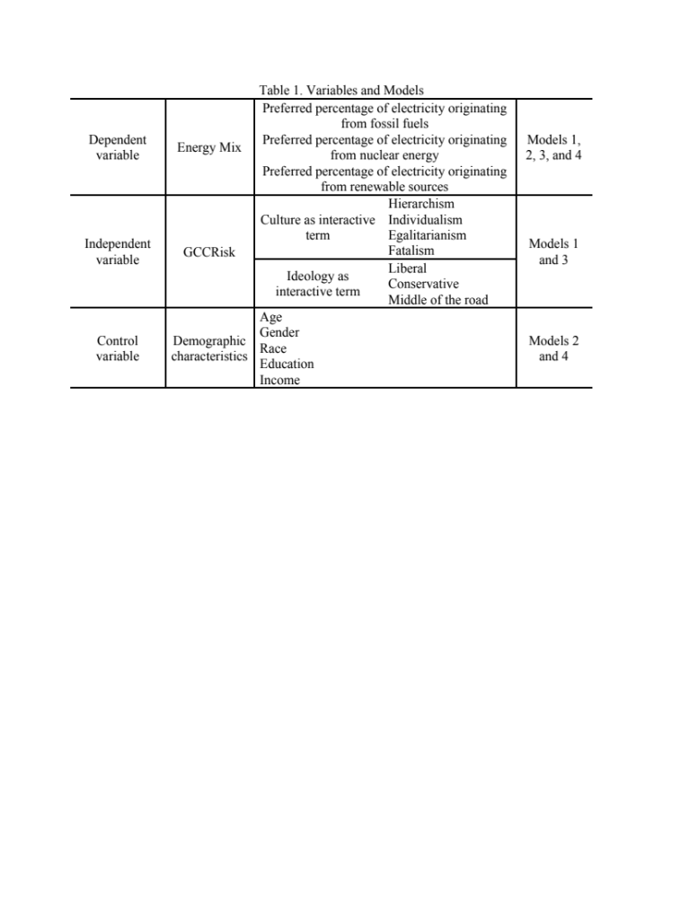
The dependent variable of the study is the preferences for overall mix of electricity for the U.S. Respondents provided their preferred energy mix percentage for fossil fuels, nuclear energy and renewable energy as the three primary sources of electricity. The sum of the expressed preferences equals to 100 per individual respondent. Since our dependent variable can be characterized as a composition variable the ternary plot presented in Figure 1 demonstrates each respondent’s preferences in fossil fuel, nuclear and renewable energy sources.

Figure 5-1. Ternary Plot Demonstrating Respondents’ Energy Source Preferences.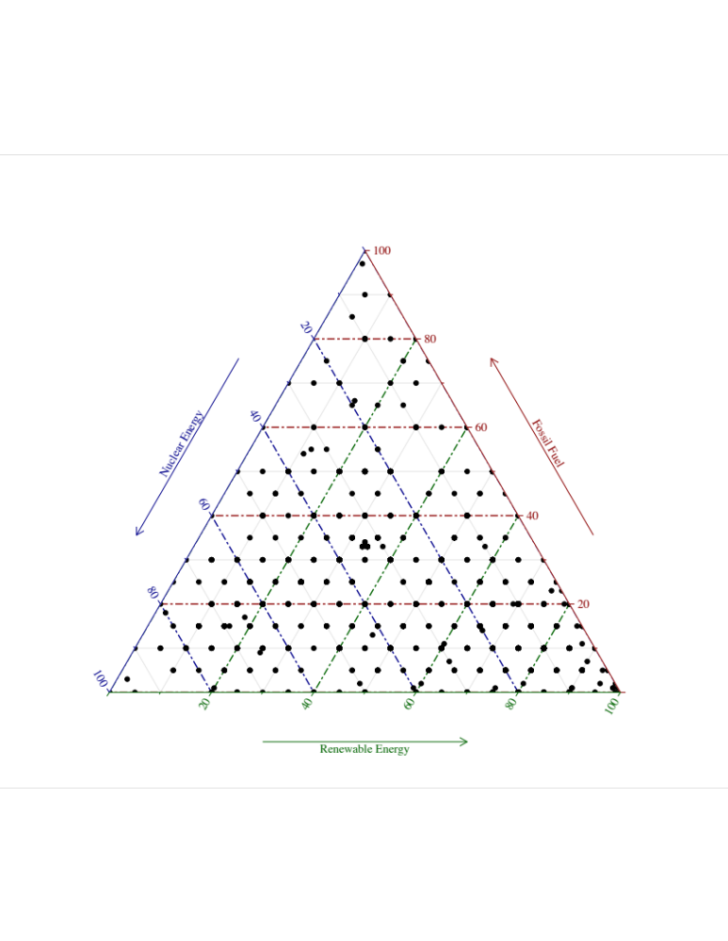
The primary independent variable is the individual perception of risk of global warming. With the help of randomization half of the respondents were asked to rate how much risk they think global warming poses for people and environment on a scale from zero to ten. The other half of the respondents were asked the same question on a scale from one to five. For the purposes of our analysis the responses from ten-point scale measure were collapsed and were combined with those of the five-point scale to increase the sample size for the analysis.
As we discussed in theoretical section the purpose of this paper is to estimate the effect of global warming risk on preferences for energy sources as a function of individuals’ cultural worldview or political ideology. Individual cultural worldviews were measured by asking the respondents to rate on a scale from zero to ten the degree to which each of the four groups of statements on hierarchism, individualism, egalitarianism and fatalism describes their own outlook on life. To capture political ideology respondents were asked to identify themselves on the ideological spectrum on a scale from one to seven where one indicates strongly liberal and seven indicates strongly conservative.
To control for rivalry explanations demographic characteristics of the individuals were accounted for in the models as covariates. In particular, we included measures of age (in years), gender (one for male and zero for female), race (one for white and zero for non-white, one for Hispanic and zero for non-Hispanic), education (one for lowest level and eight for highest level of education) and the estimated total household income (measured on a twenty-one point scale). The exact wording of the measures for each variable is presented in table 5-A1 as an appendix to this chapter.

Table 5-2: Descriptive Statistics
Variable | n | Mean | SD | Median | Min | Max
Percent of electricity to come from fossil fuels | 2004 | 28.79 | 21.3 | 25 | 0 | 100
Percent of electricity to come from nuclear energy | 2004 | 19.32 | 15.89 | 20 | 0 | 100
Percent of electricity to come from renewable sources | 2004 | 51.89 | 26.7 | 50 | 0 | 100
Global warming risk perception | 1994 | 3.71 | 1.06 | 4 | 1 | 5
Hierarchism index | 2004 | 5.6 | 2.77 | 6 | 0 | 10
Individualism index | 2004 | 6.18 | 2.79 | 7 | 0 | 10
Egalitarianism index | 2004 | 5.27 | 2.91 | 5 | 0 | 10
Fatalism index | 2004 | 4.87 | 2.92 | 5 | 0 | 10
Political ideology | 1995 | 3.94 | 1.64 | 4 | 1 | 7
Age | 2004 | 47.15 | 16.96 | 47 | 18 | 93
Education | 1993 | 4.15 | 1.89 | 4 | 1 | 8
Income | 1983 | 6.47 | 4.59 | 6 | 1 | 21

As descriptive statistical analysis demonstrates in Table 5-2 there are no extreme values that would make us believe that the data are not normally distributed. In general, respondents give higher preferences to electricity coming from renewable sources (mean percent is 51.89 from the hundred possible). This is not surprising having in mind that respondents have demonstrated higher concern for global warming (mean score is 3.71 on a scale from 1 to 5). However, the surprising element is the fact that the respondents’ second preference for energy source is electricity coming from fossil fuels (mean percent is 28.79 from the 100 possible) as opposed to nuclear energy (mean percent is 19.32 from the hundred possible) despite their concern for the environment. As for their cultural worldview, respondents are more prone to individualism (mean score of 6.18 on a scale from 0 to 10), followed by hierarchism (mean score of 5.6 on a scale from 0 to 10) and egalitarianism (mean score of 5.3 on a scale from 0 to 10). Fatalistic worldview (mean score of 4.9 on a scale from 0 to 10) has comparatively the lowest disposition in our distribution, however it is not very low in its absolute value. In terms of their political ideology, on average respondents lean more to the liberal spectrum of the ideological continuum (mean score of 3.94 on a scale from 1 to 7, where 1 means strongly liberal and 7 means strongly conservative). Table 5-3 displays the frequency distribution of the categorical demographic covariates.
Table 5-3: Frequency Distribution of Demographic Covariates
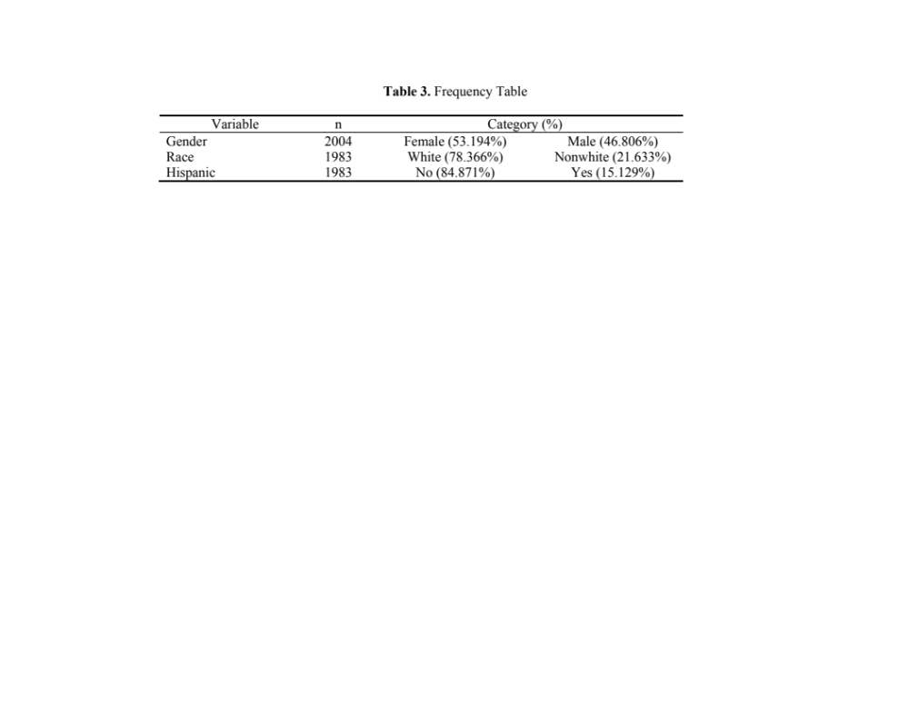
Findings and Discussion
We tested number of hypotheses concerning the preferences of energy sources among American public influenced by their global warming risk perceptions that we proposed might be mediated through their cultural worldview (Model 1), political ideology (Model 3) or demographic characteristics (Models 2 and 4). Each of these hypotheses were tested first using polynomial regression with interaction terms. However, due to the number of problems associated with interpreting interactions between two continuous variables OLS regression models were run with standardized interaction terms (Aiken and West 1991; Dawson 2013; Dawson and Richter 2006; Jaccard, Turrisi and Wan 2003). Following the procedures described by Aiken and West (1991), Dawson (2013) and Dawson and Richter (2006) the variables of interest were first centered (the mean is subtracted from each case) and then standardized to a z-score. The outcomes of standardized regression coefficients allow more substantive interpretation of the magnitude of the observed interaction effects (Aiken and West 1991; Dawson 2013; Dawson and Richter 2006; Jaccard, Turrisi and Wan 2003).

Table 5-4: OLS Regression Results for Energy Source Preferences in Interaction with Cultural Worldviews

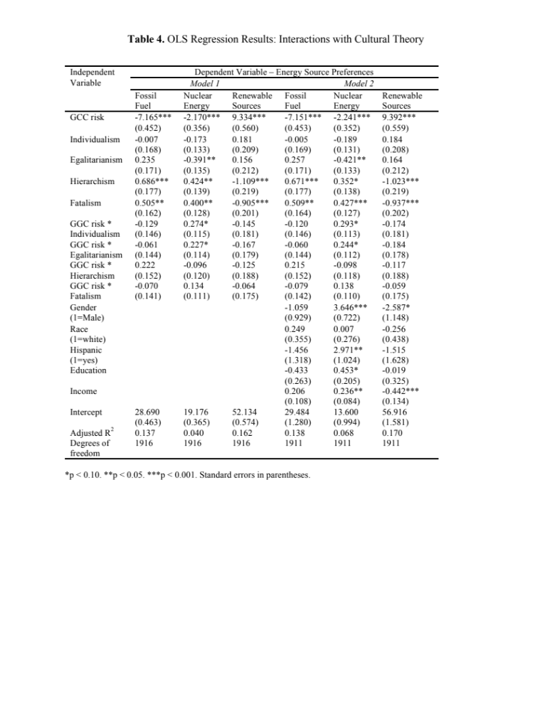
OLS Regression results of energy source preferences with interaction effects representing different cultural subgroups of American public are presented in table 5-4. The results of the analysis show that global warming risk perceptions for some instances in interaction with cultural worldview (for individualistic and egalitarian cultural types) systematically effects energy mix preferences among respondents even when holding the influence of other co-variates on the dependent variable constant. Consistent with our theoretical expectations there is a strong negative relationship between global warming risk perception and the likelihood of preferring fossil fuels as a prime energy source when individual’s cultural worldview is held at its mean (-7.165, p < 0.001 in Model 1 and -7,151, p < 0.001 in Model 2). Similarly, we found statistically significant positive relationship between global warming risk perception and the likelihood of respondents to choose renewable energy as a primary energy source when individual’s cultural worldview is held at its mean (+9.334, p < 0.001 in Model 1 and +9.392, p < 0.001 in Model 2). We also found statistically significant negative relationship between global warming risk perception and the likelihood of selection of nuclear energy as a primary energy source preferences when individual’s cultural worldview is held at its mean (-2.170, p < 0.001 in Model 1 and -2.241, p < 0.001 in Model 2). This finding does not correspond with our initial theoretical expectations.
When observing the effect of cultural subtypes on energy source preferences when individual’s global warming risk perception is held on its mean, we do not find results consistent with our theoretical expectations. We found a statistically significant negative relationship between egalitarianism and the likelihood of respondents to choose nuclear energy as a primary energy source when individual’s global warming risk perception is held constant (-0.391, p < 0.05 in Model 1 and -0.421, p < 0.05 in Model 2). Our findings demonstrate that hierarchs have stronger preferences for fossil fuels (+0.686, p < 0.001 in Model 1 and +0.671, p < 0.001 in Model 2) and nuclear energy (+0.424, p < 0.05 in Model 1 and +0.352, p < 0.10 in Model 2) and are less likely to select renewable energy (-1.109, p < 0.001 in Model 1 and -1.023, p < 0.001 in Model 2) in the energy mix when their global warming risk perception is held on its mean. Our findings show similar results for fatalists. According to our results fatalists have stronger preferences for fossil fuels (+0.505, p < 0.05 in Model 1 and +0.509, p < 0.05 in Model 2) and nuclear energy (+0.400, p < 0.05 in Model 1 and +0.427, p < 0.001 in Model 2) and are less likely to select renewable energy (-0.905, p < 0.001 in Model 1 and -0.937, p < 0.001 in Model 2) in the energy mix when their global warming risk perception is held on its mean.
The findings of interaction effects of are consistent with our theoretical expectations. There is statistically significant and positive, yet mild interaction effect between individualistic cultural archetype on respondents’ preferences for nuclear energy sources at different values of respondents’ global warming risk perception (+0.274, p < 0.10 in Model 1 and +0.293, p < 0.10 in Model 2). Likewise, for those respondents who are more prone to egalitarian cultural worldview, we observed statistically significant and positive, but mild interaction effect on their preferences for nuclear energy sources at different values of respondents’ global warming risk perception (+0.227, p < 0.10 in Model 1 and +0.244, p < 0.10 in Model 2).
Table 5-5 shows the OLS Regression results of energy source preferences influenced by the respondents global warming risk perception in interaction with political ideology. As we had predicated respondents who have demonstrated higher global warming risk perception have little preference for energy originating from fossil fuels (-6.091, p < 0.001 in Model 3) and more likely to prefer energy originating from renewable sources (+8.196, p < 0.001 in Model 3) when their political ideology was held on its mean. These findings were true when these hypotheses were tested with demographic covariates (-6.084, p < 0.001 for fossil fuels in Model 4 and +8.294, p < 0.001 for renewable sources in Model 4). However, some of our findings are not consistent with our original theoretical expectations. Among those, first, we found a statistically significant negative relationship between respondents’ global warming risk perception and their preference for nuclear energy sources when their political ideology is held on its mean (-2.105, p < 0.001 in Model 3 and -2.210, p < 0.001 in Model 4). Second, our data demonstrates that respondents with liberal political ideology are less likely to prefer fossil fuel (+1.472, p < 0.001 in Model 3 and +1.482, p < 0.001 in Model 4) and are more likely to prefer renewable energy sources (-2.051, p < 0.001 in Model 3 and -2.068, p < 0.001 in Model 4) when their global warming risk perception is held on its mean. However, respondents with liberal political ideology are less likely to prefer nuclear energy sources (+0.579, p < 0.10 in Model 3 and +0.586, p < 0.10 in Model 4).
Finally, our findings of interaction effects are consistent with our theoretical expectations. We found a negative significant interaction effect of global warming risk perception on respondents’ renewable energy source preferences at different values of respondents’ political ideology (-0.618, p < 0.10 in Model 3). However, this is a mild interaction effect and it did not hold true when this hypothesis was tested along with other demographic covariates (Model 4).

Table 5-5: OLS Regression Results for Energy Source Preferences in Interaction with Political Ideology.

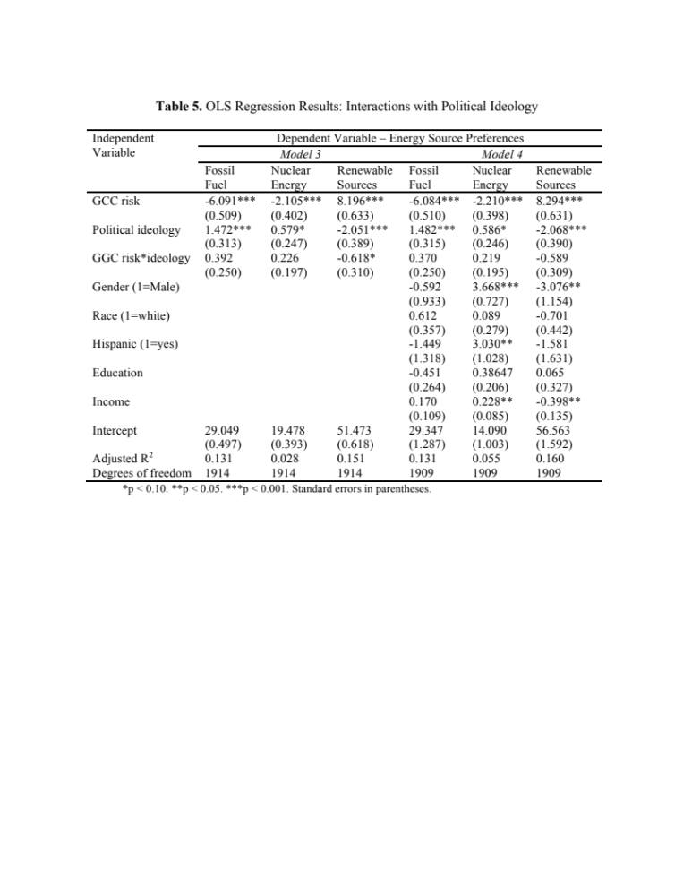
There are some noteworthy results when testing our proposed hypotheses with demographic covariates. We found statistically significant positive relationship between respondents’ preferences for nuclear energy sources and their gender (+3.646, p < 0.001 in Model 2 and +3.668, p < 0.001 in Model 4), Hispanic race (+2.971, p < 0.05 in Model 2 and +3.030, p < 0.05 in Model 4), income (+0.236, p < 0.05 in Model 2 and +0.228, p < 0.05 in Model 4) and level of education (+0.453, p < 0.10 in Model 2). We also found statistically significant negative relationship between respondents’ preferences for renewable energy sources and their gender (-2.587, p < 0.10 in Model 2 and -3.076, p < 0.05 in Model 4) and income (-0.442, p < 0.001 in Model 2 and -0.398, p < 0.05 in Model 4).
Up until now, we explored how beliefs about global warming influence individuals’ energy source preferences based on their cultural worldview and political ideology. We also look at the predicted probabilities of respondents’ preferences for energy sources contingent upon their strong cultural subtype (2 points higher than the mean).

Figure 5-2. The Probability of Energy Source Preference among Cultural Subgroups
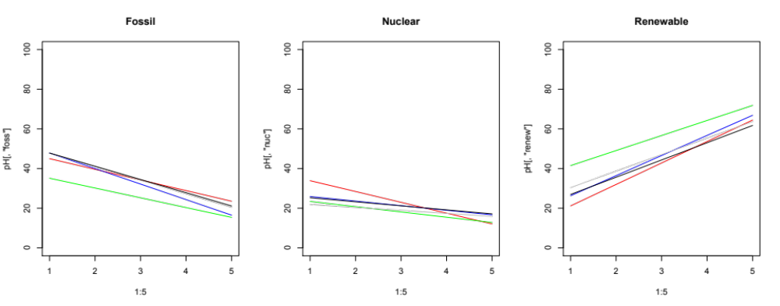
Red – hierarchs  Blue – individualists | Green – egalitarians  Grey – fatalists | Black – non-affiliated respondents

As we can see from figure 5- 2, for each value of global warming risk perception the predicted probability of energy source preferences among respondents is consistent with the results discussed above and presented in model 1 and model 2 in Table 5-4.

Figure 5-3. The Probability of Energy Source Preference among Strong Cultural Subgroups
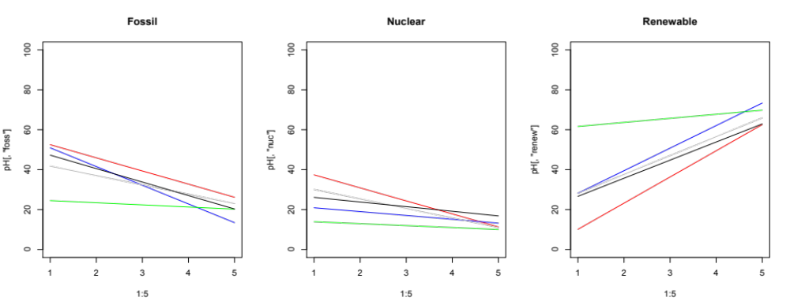
Red – hierarchs  Blue – individualists | Green – egalitarians  Grey – fatalists | Black – non-affiliated respondents

However, when we looked at subgroups with stronger cultural archetypes (4 points higher than the mean) we have a different result (figure 5-3). While the slope for hierarchs remains almost unchanged, except for their preferences for renewable energy (the slope is steeper), for individualists: the negative slope becomes steeper for their preferences for fossil fuel energy sources and the intercept changes for their preferences for nuclear energy. Here we see that for stronger egalitarians energy source preferences do not seem to be connected with their global warming risk perception.

Figure 5-4. The Probability of Energy Source Preference among Ideological Subsets
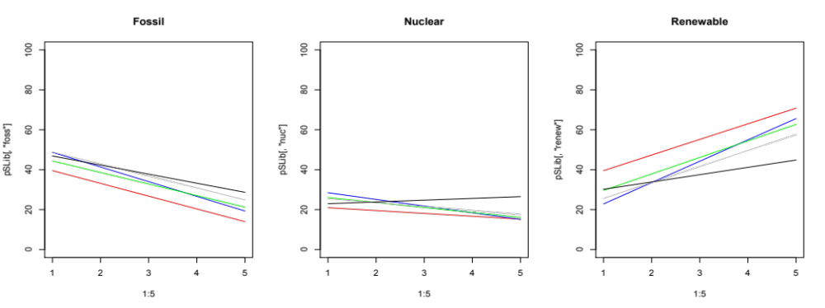
Red – strongly liberal  Blue – liberal | Green – middle of the road | Grey – conservative  Black – strongly conservative

In figure 5-4, the predicted probabilities of the respondents’ preferences of energy sources contingent upon their political ideology demonstrate that liberal respondents are less likely to select fossil fuel energy sources and more likely to prefer renewable energy. While former finding is consistent with our theoretical expectations we also find some inconsistencies. Conservative respondents, although with less steep slope, yet do not prefer fossil fuels and do prefer renewable energy when concerned with global warming. While historically people on the right side of the ideological spectrum have been more supportive for nuclear energy sources, we only have enough evidence to support this claim among stronger conservative respondents in our sample.
Conclusion
Overall, our findings demonstrate that there is a strong link between individuals global warming risk perception and their energy source preference. Individuals who are more concerned with global warming do not tend to prefer energy coming from fossil fuel and logically do prefer energy originating from renewable sources. It is interesting to note, that respondents who are concerned for the environment and do not prefer fossil fuels, do not see nuclear energy as a solution for climate change either. Believing in global warming and climate change does not impact public support for nuclear energy. Instead it supports public preferences for renewable energy sources. This observation is true for different subgroups of respondents varying both in their cultural archetypes and political ideology.
Consistent with previous literature respondents with higher egalitarian cultural worldview did consider nuclear energy as a solution to climate change. Likewise, we found that respondents leaning to conservative political ideology are more likely to give higher preference to fossil fuels and nuclear energy and less likely to prefer renewable energy.
The results of this study make us believe that the strength of nuclear impasse seems to be undefeatable. Even though nuclear energy could be viewed as a solution to climate change it does not seem to be a viable option among American public. The shift of the image of the nuclear energy was radical after the Three Mile Island incident (Baumgartner and Jones 1993). While support for nuclear energy consumption has been increasing in 2009 this was not the case after the Fukushima accident (Jones 2009). This resulted in reinforcement of the fear from nuclear accidents, which in its turn had its impact on public preferences for nuclear energy (Lynas 2013).
Although nuclear energy is considered to be a solution for global climate change even among environmental activists; general public still holds its inhibitions towards nuclear energy (Lynas 2013, Jenkins, Nordhaus & Shellenberger 2011). Recent scientific evidence in global warming resulted in the creation of green grassroots organization even by politically conservative groups rooted in the realization that the earth belongs to everyone irrespective to their political ideology. Yet, cognitive biases and stigma associated with social amplification of risk is deeply engrained in American public (Kasperson, Jhaveri, and Kasperson 2001). Interestingly enough, male respondents showed more support for nuclear energy. This finding again is in line with risk perception literature that has found that fear is more embedded among females than among males (Finucane, et al. 2000; Kahan, et al. 2010). Along these lines our data showed that people with higher level of education and higher income are more likely to demonstrate higher preferences for nuclear energy. This is a noteworthy finding as it shows that once people are more educated or have a higher social status they are less likely to be scared from nuclear energy as they have more understanding about the treatment and safety of nuclear waste storage. This directs us to the conclusion that only more knowledge and education about the potential of nuclear energy, and the safety of nuclear waste storage will help us getting past the nuclear impasse.

Table 5-A1: Study Variables and Measures

Variable |  | Measure
Dependent variable | Energy Mix  (must sum to 100) | What percent of our electricity should come from fossil fuels, which currently provide about 65% of total U.S. electricity?
Dependent variable | Energy Mix  (must sum to 100) | What percent of our electricity should come from nuclear energy, which currently provides about 20% of total U.S. electricity?
Dependent variable | Energy Mix  (must sum to 100) | What percent of our electricity should come from renewable sources (hydroelectric dams, wood, biofuels, wind, waste products, geothermal, and solar), which currently provide about 15% of total U.S. electricity?
Independent variables | Risk of global warming | On a scale from zero to ten, where zero means no risk and ten means extreme risk, how much risk do you think global warming poses for people and the environment? (half of the respondents, other half had to choose on scale from one to five)
Independent variables | Cultural orientation | Please rate the degree to which each of the following four groups of statements describes your outlook on life, using a scale from zero to ten, where zero means not at all and ten means completely
Independent variables | Cultural orientation | Hierarchism - I am more comfortable when I know who is, and who is not, a part of my group, and loyalty to the group is important to me. I prefer to know who is in charge and to have clear rules and procedures; those who are in charge should punish those who break the rules. I like to have my responsibilities clearly defined, and I believe people should be rewarded based on the position they hold and their competence. Most of the time, I trust those with authority and expertise to do what is right for society.
Independent variables | Cultural orientation | Individualism - Groups are not all that important to me. I prefer to make my own way in life without having to follow other peoples’ rules. Rewards in life should be based on initiative, skill, and hard work, even if that results in inequality. I respect people based on what they do, not the positions or titles they hold. I like relationships that are based on negotiated “give and take,” rather than on status. Everyone benefits when individuals are allowed to compete.
Independent variables | Cultural orientation | Egalitarianism - My most important contributions are made as a member of a group that promotes justice and equality. Within my group, everyone should play an equal role without differences in rank or authority. It is easy to lose track of what is important, so I have to keep a close eye on the actions of my group. It is not enough to provide equal opportunities; we also have to try to make outcomes more equal.
Independent variables | Cultural orientation | Fatalism- Life is unpredictable and I have very little control. I tend not to join groups, and I try not to get involved because I can't make much difference anyway. Most of the time other people determine my options in life. Getting along is largely a matter of doing the best I can with what comes my way, so I just try to take care of myself and the people closest to me. It's best to just go with the flow, because whatever will be will be.
 | Political ideology | On a scale of political ideology, individuals can be arranged from strongly liberal to strongly conservative. Which of the following categories best describes your views? (1=strongly liberal and 7=strongly conservative).
Control variables | Demographic characteristics | Age measured in years
Control variables | Demographic characteristics | Gender measured 1=male and 0=female
Control variables | Demographic characteristics | Race 1=white, Hispanic; 0=non-white, non-Hispanic
Control variables | Demographic characteristics | The highest level of education completed (1=lower than high school; 8=PhD / JD (law) / MD
Control variables | Demographic characteristics | Total estimated household income (1=up to $10,000 to 21=more than $200,000).

Chapter 6. Conclusion
As nuclear stalemate in USA is protracted and incessant, this dissertation studies what is at the nucleus of this impasse – “the NIMBY syndrome” or the local opposition to SNF siting proposals. Scholarship examining “the NIMBY syndrome” has explained individual decision making among local community members by two modes of determining factors. One set of arguments about local opposition to SNF siting uses rational choice models. In their explanations these scholars focus on individuals’ proximity to the site as a proxy for perceived costs (Hindmore 2010; Jenkins-Smith and Kunreuther 2001; Riker 1990). The other category of explanations about local opposition of community members uses models based on behavioral economics and consider the central role of psychological biases and heuristics in shaping individuals’ views and beliefs for policy preferences (Tversky and Kahneman 1974; Kahneman and Tversky 2013). While recognizing the value of these sophisticated models, I argue in this dissertation, that we need to focus on the impact of NIMBY on decision-making from a broader public policy perspective. I incorporate “political” variables in the study of NIMBYism syndrome and conventionally name this model of the individual as “homo-politicus.”

Figure 6-1. The Preference Formation Factors for “Homo-Politicus” Model of the Individual

Figure 6-1 reveals that following the tradition of the one of the major theories of the policy process I assume public policy preferences within nuclear policy domain are formulated based on individuals’ deep core beliefs that serve as a foundation for the formulation of their more specific SNF policy positions (Jenkins-Smith et al. 2017; Jenkins-Smith et al. 2014a). This model accounts for the impact of political ideology in the formulation of hierarchically structured complex belief systems and assumes that the individual is boundedly rational (Lindblom 1959; Simon 1985, Jones 2001; Ripberger et al. 2014; Jenkins-Smith et al. 2014b). These theoretical discussions are presented in chapter 1 of this dissertation.
As mentioned above, debate about SNF disposal has evolved through years in USA and has come to a stalemate due to public opposition to the proposed policy options. Therefore, in chapter 2 of this dissertation I review the literature about the role of public opinion in the democracy in general and in the policy process in particular. Figure 2-2 demonstrates that voters/citizens, who are the subject of the study in this dissertation are one of four “extra-governmental” entities that play a decisive role in “inter-governmental” policy making process.
Consequently, in chapter 3 of this dissertation I track the evolution of public preferences in SNF disposal siting over time by using data from nationwide surveys of American public form 2006-2019 collected by the National Institute of Risk and Resilience at the University of Oklahoma. By employing descriptive time series analysis I first examine how public perception in SNF siting preferences evolve over time in parallel with public risk perceptions, trust in government and knowledge in nuclear waste management technologies. The evolution of public nuclear energy risk perceptions over time reveals increasing trends in parallel with benefit perceptions exposing decreasing trends.
In addition, I employ explanative time series analysis to test hypotheses to determine whether public risk and benefit perceptions, trust in government and knowledge about nuclear energy have caused changes in public preferences in SNF storage and disposal policy options over time. The results of times series cross correlation analyses show that increased risk perceptions in nuclear waste transportation over time negatively affect public support for SNF deep geologic disposal five years later. I also find that increased benefit perceptions in reduced mining is likely to lead an above average support for SNF onsite storage policy option 1 year later. These findings imply that, within a representative political system like that of the U.S., changes in perceptions and awareness might also result in policy change in the long run. Prior studies in this area have been cross sectional. This chapter makes a major contribution to the literature by looking at causal relationships between risk perceptions and policy support over time. While the resolution of the nuclear stalemate seems far-fetched these findings imply that changes in public perceptions and awareness in the long run may result in policy change (Gupta and Jenkins-Smith 2015).
As a follow up of the above discovery, as question comes up: does highly contested local SNF siting policy issue have the potential of reshaping partisan positions? Chapter 4 of this dissertations aims to answer this question in a difference-in-differences design by utilizing voting behavior and election turnout data for presidential general elections from 1970s to 2016 for 17 counties in Nevada. Overall, the empirical analyses reveal that the enactment of NWPA of 1982 is associated with 7 percentage point increase in republican vote and decrease in democratic vote at the same rate in the counties that are geographically affected by SNF disposal policy. While this direction of change is opposite to my initial expectations, an and implication of this study is that local policy preferences and concerns in the long run have the potential to reshape local political landscape by changing public ideological dispositions and shifting their partisan preferences. This study does not find a confirmation of the issue orientation hypothesis and reveals that while nuclear policy has been a salient issue in the state of Nevada from 1980s it is unclear whether preferences are formed based on partisan identification or issue orientation. While we did find change in voting behavior however we still need to discover whether these results hold if test them along with control variables. The second theoretical contribution of this chapter is the validation of the proposition about policies feeding back into the political environment and reformulating the distribution and shape of that environment. The evidence found in this chapter indirectly demonstrates the powerful role that voters/citizens play in the policy making process depicted in figure 2-2 in this dissertation.
Finally, in chapter 5 of this dissertation I retract from the narrow policy issue of SNF and approach the nuclear stalemate from a broader perspective: I wonder whether public support in nuclear energy production is conditioned by their belief in climate change. In this chapter I utilize data of over 2000 respondents collected in May 2017 by the National Institute of Risk and Resilience at the University of Oklahoma in a nationwide annual Internet survey series to measure public preferences on Energy and Environmental policy. Overall, the findings of this chapter demonstrate that there is a strong link between individuals’ global warming risk perception and their energy source preference. Individuals who are more concerned with global warming do not tend to prefer energy coming from fossil fuel or nuclear sources. Instead, their preferred energy sources are renewables. This is an interesting finding in itself because many environmental groups and policy makers recently view nuclear energy as a solution to climate change (IPCC 2018). However, these sentiments are not reflected yet in general public. Belief in global warming and climate change does not impact public support for nuclear energy. This observation is also true for different subgroups of respondents varying both in their cultural archetypes, partisanship and political ideology.
Thus, the final empirical chapter of this dissertation attests that the strength of nuclear impasse seems to be undefeatable for the American public. While the nuclear might be “the power to save the world” from the climate change (Cravens 2010; Lynas 2013), the “nuclear imperative” is the stalemate of the SNF disposal in USA (Carter 2015). In this final concluding chapter of this dissertation I contest that the nuclear impasse in its essence is a tangle of governance problems and processes. The development of SNF disposal revolves in the policy process, yet, its acceptance is conditioned by the actions of the advocacy and non-profit groups, and by the management practices of public and private officials (Lynas 2013; Shaw 2011; Mulligan 2011). Any policy, while developed through the policy process, relies on public management for its implementation (Weible and Carter 2017). In addition, it is necessary to acknowledge the impact the actions and interests of various stakeholders make in the nuclear policy subsystem. All these considerations and omitted factors will be taken into account in the follow up studies in my future research. The role of public opinion in the nuclear policy process and its potential impact on policy change is one modest contribution in understanding the governance of SNF disposal policy and its potential impact on public management.
References

Abraham, S., & Sun, L. (2018). Estimating dynamic treatment effects in event studies with heterogeneous treatment effects. Available at SSRN 3158747.
Abramowitz, A. I., & Saunders, K. L. (2008). Is polarization a myth? The Journal of Politics, 70(2), 542-555.
Aiken, L. S., & West, S. G. (1991). Multiple regression: Testing and interpreting interactions. Newbury Park, London, Sage.
Aldrich, J. H. (1995). Why parties?: The origin and transformation of political parties in America. University of Chicago Press.
Allport, F. H. (1937). Toward a science of public opinion. Public opinion quarterly, 1(1), 7-23.
Almond, G. A., & Verba, S. (2015). The civic culture: Political attitudes and democracy in five nations. Princeton University Press.
Angrist, J. D., & Pischke, J. S.(2009). Mostly Harmless Econometrics: An Empiricist’s Companion. Princeton University Press. Princeton, NJ.
Ansolabehere, S., Rodden, J., & Snyder, J. M. (2008). The strength of issues: Using multiple measures to gauge preference stability, ideological constraint, and issue voting. American Political Science Review, 102(2), 215-232.
Armour, A. M. (1991). “The siting of locally unwanted land uses: Towards a cooperative approach.” Progress in Planning, 35, 1-74.
Back, L. (2013). “8 Nuclear Power after 3/11.” Nuclear Disaster at Fukushima Daiichi: Social, Political and Environmental Issues, 21, 135.
Baldassarri, D., & Gelman, A. (2008). Partisans without constraint: Political polarization and trends in American public opinion. American Journal of Sociology, 114(2), 408-446.
Balogun, S. K., & Olapegb, P. O. (2007). Majority Carry the Vote: Psycho-Demographic Influence on Voting Behaviour. Studies of Tribes and Tribals, 5(1), 5-7.
Barber, Benjamin R. 1984. Strong Democracy: Participatory Politics for a New Age. Berkeley, CA: University of California Press.
Bassett Jr, G. W., Jenkins‐Smith, H. C., & Silva, C. (1996). On‐site storage of high level nuclear waste: Attitudes and perceptions of local residents. Risk Analysis, 16(3), 309-319.
Baumgartner, F.R. and Jones, B.D. (1993/2010). Agendas and instability in American politics. University of Chicago Press.
Béland, D., 2010. Reconsidering policy feedback: How policies affect politics. Administration & Society, 42(5), pp.568-590.
Benford, R. D., Moore, H. A., & Williams, J. A. (1993). “In whose backyard?: Concern about siting a nuclear waste facility.” Sociological Inquiry, 63(1), 30-48.
Berelson, B. R., Lazarsfeld, P. F., & Mc Phee, W. N. (1954). Voting. Chicago University Press.
Bickerstaff, K., Lorenzoni, I., Pidgeon, N. F., Poortinga, W., & Simmons, P. (2008). “Reframing nuclear power in the UK energy debate: nuclear power, climate change mitigation and radioactive waste.” Public understanding of science. 17(2), 145-169.
Box, G. E., Jenkins, G. M., & Reinsel, G. C. (1994). Time series analysis: Forecasting and control. 3rd Prentice Hall. Englewood Cliffs NJ.
Broockman, D. E., & Butler, D. M. (2017). The Causal Effects of Elite Position‐Taking on Voter Attitudes: Field Experiments with Elite Communication. American Journal of Political Science, 61(1), 208-221.
Bruch, S.K., Ferree, M.M. and Soss, J. (2010). From policy to polity: Democracy, paternalism, and the incorporation of disadvantaged citizens. American Sociological Review, 75(2), pp.205-226.
Buchanan, J. M., & Tullock, G. (1962). The calculus of consent (Vol. 3). Ann Arbor: University of Michigan Press.
Butler, C., Parkhill, K. A., & Pidgeon, N. F. (2011). Nuclear power after Japan: The social dimensions. Environment: Science and Policy for Sustainable Development, 53(6), 3-14.
Buttel, Frederick H. and William L. Flinn. 1976. “Environmental Politics: the Structuring of Partisan and Ideological Cleavages in Mass Environmental Attitudes.” The Sociological Quarterly. 17: 477-490.
Cairney, P. (2012). Understanding public policy: Theories and issues. Palgrave Macmillan.
Campbell, A., Converse, PE, Miller, WE, & Stokes, DE (1960). The American voter. New York. Wiley
Campbell, A., & Kahn, R. L. (1952). The people elect a president: A study of the presidential vote. Ann Arbor: University of Michigan Survey Research Center.
Carter, L. J. (2015). Nuclear imperatives and public trust: Dealing with radioactive waste. Routledge.
Chatfield, C. (2013). The analysis of time series: theory and practice. Springer.
Clemmer, Steve; Richardson, Jeremy; Sattler, Sandra and Dave Lochbaum (2018). The Nuclear Power Dilemma: Declining Profits, Plant Closures, and the Threat of Rising Carbon Emissions. Union of Concerned Scientists.
Clemmit, M, (2011). “Nuclear Power: Can Nuclear Energy Answer Global Power Needs?” CQ Researcher 21, no. (2) 507.
Conca, J. “Nuclear Energy Gets an Early Christmas Present in Georgia.” Retrieved at: https://www.forbes.com/sites/jamesconca/2017/12/22/nuclear-energy-gets-an-early-christmas-present-in-georgia/#4afb95d93cf0
Converse, P. E. (1964). The nature of belief systems in mass publics. Critical review, 18(1-3), 1-74.
Conover, Pamela Johnston, and Stanley Feldman. (1981). “The Origins and Meaning of Liberal/Conservative Self-identifications.” American Journal of Political Science 25: 617–45.
Conover, P. J., & Feldman, S. (1984a). How people organize the political world: A schematic model. American Journal of Political Science, 95-126.
Conover, P. J., & Feldman, S. (1984b). Group Identification, Values, and the Nature of Political Beliefs. American Politics Quarterly, 12(2), 151–175.
Cotton, M. (2015). “Structure, agency and post-Fukushima nuclear policy: an alliance-context-actionality model of political change.” Journal of Risk Research, 18(3), 317-332.
Cravens, G. (2010). Power to save the world: The truth about nuclear energy. Vintage.
Dahl, R. A. (2005). Who governs?: Democracy and power in an American city. Yale University Press.
Darst, R., & Dawson, J. I. (2010). “Waiting for the nuclear renaissance: exploring the nexus of expansion and disposal in Europe.” Risk, Hazards & Crisis in Public Policy. 1(4), 49-82.
Davy, B. (2016). Land policy: Planning and the spatial consequences of property. Routledge.
Dawson, J. F. (2014). “Moderation in Management Research: What, Why, When and How.” Journal of Business and Psychology, 29, 1-19.
Dawson, J. F., & Richter, A. W. (2006). “Probing three-way interactions in moderated multiple regression: Development and application of a slope difference test.” Journal of Applied Psychology, 91, 917-926.
De Groot, J. I., Steg, L., & Poortinga, W. (2013). Values, perceived risks and benefits, and acceptability of nuclear energy. Risk Analysis: An International Journal, 33(2), 307-317.
De Groot, J. I., & Steg, L. (2010). Morality and nuclear energy: Perceptions of risks and benefits, personal norms, and willingness to take action related to nuclear energy. Risk Analysis: An International Journal, 30(9), 1363-1373.
Deutsch, K. W. (1966). The Nerves of Government: models of political communication and control; with a new introduction (Vol. 90729). Free Press of Glencoe.
DiMaggio, Paul, John Evans, and Bethany Bryson. (1996). “Have Americans’ Social Attitudes Become More Polarized?” American Journal of Sociology 102:690–755.
Douglas, M., & Wildavsky, A. (1982). Risk and culture: An essay on the selection of technical and environmental dangers. Berkeley. Cal.: University of California Press.
Downs, A. (1957). An economic theory of democracy.
Drew, Christina H., Deirdre A. Grace, Susan M. Silbernagel, Erin S. Hemmings, Alan Smith, William C. Griffith, Timothy K. Takaro, and Elaine M. Faustman. (2003). “Nuclear Waste Transportation: Case Studies of Identifying Stakeholder Risk Information Needs.” Environmental Health Perspectives. 111(3): 263-272.
Dryzek, John S., David Downes, Christian Hunold, David Scholsberg, and Hans-Kristian Hernes. (2003). Green States and Social Movements: Environmentalism in the United States, United Kingdom, Germany, and Norway. Oxford: Oxford University Press.
Earle, T. C., & Cvetkovich, G. (1995). Social trust: Toward a cosmopolitan society. Greenwood Publishing Group.
Easton, D. (1965). A systems analysis of political life.
Egan, P. J., & Mullin, M. (2017). Climate change: US public opinion. Annual Review of Political Science, 20, 209-227.
Eldersveld, S. J. (1951). Theory and method in voting behavior research. The Journal of Politics, 13(1), 70-87.
Eldersveld, S. J., & Walton, H. (1982). Political parties in American society (p. 13). Nueva York: Basic Books.
Ellis, R. J., and F. Thompson. (1997). “Culture and Environment in the Pacific Northwest.” American Political Science Review 91: 885–97.
Erikson, R. S., MacKuen, M. B., & Stimson, A. A. (2002). Public Opinion and Policy. Navigating public opinion: Polls, policy, and the future of American democracy, 33.
Eureka County Yucca Mountain Information Office. 2020. The Inside Story. Retrieved on January 5, 2020. https://www.yuccamountain.org/#
Eureka County Yucca Mountain Information Office. Retrieved on January 17, 2019. https://www.yuccamountain.org/purpose.htm#aulg
Eureka County Yucca Mountain Information Office. 2018. The Inside Story. Retrieved on December 10, 2018. https://www.yuccamountain.org/#
Evans, J. H. (2003). Have Americans' attitudes become more polarized? — An update. Social Science Quarterly, 84(1), 71-90.
Falcone, Santa, and Kenneth Orosco. (1998). “Coming through a City near You: The Transport of Hazardous Wastes.” Policy Studies Journal 26(4): 760-773.
Finucane, M. L., P. Slovic, C.K. Mertz, J. Flinn and T.A. Satterfield (2000). “Gender, Race, and Perceived Risk: ‘The White’ Male Effect.” Health, Risk, & Society 2(2): 159–172.
Fiorina, M. P., Abrams, S. J., & Pope, J. (2005). Culture war?: The myth of a polarized America. Longman Publishing Group.
Fiorina, M. P. (1981). Retrospective voting in American national elections. Yale University Press.
Fiorina, M. P. (2004). Congress: Keystone of the Washington establishment. 2nd. Ed. New Haven, CT: Yale University Press.
Fiorina, M. P., & Abrams, S. J. (2008). Political polarization in the American public. Annu. Rev. Polit. Sci., 11, 563-588.
Fiorina, M. P., Abrams, S. J., & Pope, J. (2006). Culture war?: The myth of a polarized America. Longman Publishing Group.
Fiorina, M. P., & Abrams, S. J. (2012). Disconnect: The breakdown of representation in American politics (Vol. 11). University of Oklahoma Press.
Fischhoff, B., Slovic, P., & Lichtenstein, S. (1983). “The Public” Vs.“The Experts”: Perceived Vs. Actual Disagreements About Risks of Nuclear Power. In The analysis of actual versus perceived risks (pp. 235-249). Springer, Boston, MA.
Flink, C. M. (2019). Predicting budgetary change: The effect of performance gaps. Journal of Public Administration Research and Theory, 29(2), 227-237.
Frankovic, Kathy, “Most Republicans do not think Humans Are Causing Climate Change,” retrieved at: https://today.yougov.com/news/2015/11/25/most-republicans-do-not-think-humans-causing-clima/
Gallup, G. (1939). Public opinion in a democracy. Random House. New York.
Gawande, Kishore, and Hank Jenkins-Smith. (2001). “Nuclear Waste Transport and Residential Property Values: Estimating the Effects of Perceived Risks.” Journal of Environmental Economics and Management. 42(2): 207-233.
Gerberding, W.P. (1970). “Liberals and Radicals: A Conflict of Ideologies?” In Readings on the American Political System edited by L. E. Shaw and J. C. Pierce. 47-53. (1970). D.C. Heath and Company
GISGeography (2020). Nevada County Map and Independent City. Published on: February 16, 2013 | Last Updated: March 20, 2020. Retrieved from: https://gisgeography.com/nevada-county-map/
Grofman, B., Owen, G., & Collet, C. (1999). Rethinking the partisan effects of higher turnout: so what's the question?. Public Choice, 99(3-4), 357-376.
Green, J. C., & Coffey, D. J. (2010). The state of the parties: The changing role of contemporary American parties. Rowman & Littlefield Publishers.
Green, Jim. (2016). “Manufacturing Dissent: Environmentalists and Nuclear Power.” Nuclear Monitor 826(4566) June 7th, 2016 (Accessed February 27, 2018, at: https://www.wiseinternational.org/nuclear-monitor/826/manufacturing-dissent-environmentalists-and-nuclear-power)
Greene, W. H. (2000). Econometric analysis. 4th edition. International edition, New Jersey: Prentice Hall, 201-215.
Greenberg, M. (1993). “Proving environmental inequity in siting locally unwanted land uses.” Risk, 4, 235.
Gupta, K., & Jenkins-Smith, H. (2015). Anthony Downs, “Up and Down with Ecology: The ‘Issue-Attention’ Cycle”. In The Oxford handbook of classics in public policy and administration. OUP Oxford.
Hadden, S. G., Veillete, J., & Brandt, T. (1983). State roles in siting hazardous waste disposal facilities: from state preemption to local veto. In Duke Press Policy Studies (pp. 196-211). US Duke University Press.
Hakhverdian, A. (2010). Political representation and its mechanisms: A dynamic left–right approach for the United Kingdom, 1976–2006. British Journal of Political Science, 40(4), 835-856.
Handmer, J., & Proudley, B. (2007). “Communicating uncertainty via probabilities: The case of weather forecasts.” Environmental Hazards, 7(2), 79-87.
Hansen, J., Holm, L., Frewer, L., Robinson, P., & Sandøe, P. (2003). Beyond the knowledge deficit: recent research into lay and expert attitudes to food risks. Appetite, 41(2), 111-121.
Hayes, D. (2009). Has television personalized voting behavior? Political Behavior, 31(2), 231-260.
Hayes, D. (2005). Candidate qualities through a partisan lens: A theory of trait ownership. American Journal of Political Science, 49(4), 908-923.
Herron, K. G., & Jenkins-Smith, H. C. (2006). Critical masses and critical choices: Evolving public opinion on nuclear weapons, terrorism, and security. University of Pittsburgh Press.
Hindmore, A. (2010). Rational choice. Palgrave Macmillan.
Hunter, J. D. (1992). Culture wars: The struggle to control the family, art, education, law, and politics in America. Basic Books.
Hunter, S., & Leyden, K. M. (1995). Beyond NIMBY. Explaining opposition to hazardous waste facilities. Policy studies journal, 23(4), 601-619.
Hyndman, R. J., & Athanasopoulos, G. (2018). Forecasting: principles and practice. OTexts.
International Atomic Energy Agency. (2014). “Planning and Design Considerations for Geological Repository Programmes of Radioactive Waste”, IAEA-TECDOC-1755, IAEA, Vienna
International Atomic Energy Agency. (2007). “Storage and Disposal of Spent Fuel and High Level Radioactive Waste” Accessed on 06.14.2018. https://www.iaea.org/About/Policy/GC/GC50/GC50InfDocuments/English/gc50inf-3-att5_en.pdf
Jaccard, J., & Turrisi, R. (2003). Interaction effects in multiple regression (No. 72). Sage.
Jacques, Peter J., Riley E. Dunlap and Mark Freeman. (2008). “The Organisation of Denial: Conservative Think Tanks and Environmental Skepticism.” Environmental Politics 17(3):349-385.
Jenkins, J., Nordhaus, T., & Shellenberger, M. (2011). “Energy emergence: rebound and backfire as emergent phenomena.” Breakthrough Institute.
Jenkins-Smith, H. C. (1993). Nuclear imagery and regional stigma: Testing hypotheses of image acquisition and valuation regarding Nevada. University of New Mexico, Institute for Public Policy, Albuquerque, NM.
Jenkins-Smith, H. C., & Smith, W. K. (1994). “Ideology, culture, and risk perception.” Politics, policy, and culture, 17-32.
Jenkins-Smith, Hank, and Howard Kunreuther. (2001). “Mitigation and Benefits Measures as Policy Tools for Siting Potentially Hazardous Facilities: Determinants of Effectiveness and Appropriateness.” Risk Analysis 21(2): 371-382.
Jenkins‐Smith, H. C., Silva, C. L., Nowlin, M. C., & DeLozier, G. (2011). Reversing nuclear opposition: Evolving public acceptance of a permanent nuclear waste disposal facility. Risk Analysis, 31(4), 629-644.
Jenkins-Smith, H. C., Ripberger, J. T., Silva, C. L., Carlson, D. E., Gupta, K., Carlson, N., Ter-Mkrtchyan, A. & Dunlap, R. E. (2020). Partisan asymmetry in temporal stability of climate change beliefs. Nature Climate.
Jenkins-Smith, H. C., Silva, C. L. and Gupta, K. (2017). Public Views on Nuclear Facility Siting and Radioactive Waste Management in the United States: Methodology and Response Reference Report for the 2017 Energy and Environment Survey. Sandia Report: SAND2017. Albuquerque, NM: Sandia National Laboratories.
Jenkins-Smith, Hank, C., Daniel Nohrstedt, Christopher M. Weible and Karin Ingold. (2017). “The Advocacy Coalition Framework: An Overview of the Research Program. In Theories of the Policy Process, 4th ed., edited by Christopher M. Weible and Paul A. Sabatier. 135-171. Boulder, CO: Westview Press.
Jenkins-Smith, H. C., Silva, C. L. and Gupta, K. (2016). Public Preferences Related to Consent-Based Siting and Radioactive Waste Management in the United States: Methodology and Response Reference Report for the 2016 Energy and Environment Survey. Sandia Report: SAND2016. Albuquerque, NM: Sandia National Laboratories.
Jenkins-Smith, Hank, C., Daniel Nohrstedt, Christopher M. Weible and Paul A. Sabatier. (2014a). “The Advocacy Coalition Framework: Foundations, Evolution and Ongoing Research.” In Theories of the Policy Process, 3rd ed., edited by Paul A. Sabatier and Christopher M. Weible. 183-223. Boulder, CO: Westview Press.
Jenkins‐Smith, H., Silva, C. L., Gupta, K., and Ripberger, J. T. (2014b). Belief system continuity and change in policy advocacy coalitions: Using cultural theory to specify belief systems, coalitions, and sources of change. Policy Studies Journal, 42(4), 484-508.
Jones, B.D. (2001). Politics and the architecture of choice: Bounded rationality and governance. University of Chicago Press.
Kahan, Dan M. et al. 2010. “Who Fears the HPV Vaccine, Who Doesn’t, and Why? An Experimental Study of the Mechanisms of Cultural Cognition.” Law and Human Behavior 34(6): 501–516.
Kahneman, D., & Tversky, A. (2013). Prospect theory: An analysis of decision under risk. In Handbook of the fundamentals of financial decision making: Part I (pp. 99-127).
Kahneman, D. (2003). Maps of bounded rationality: Psychology for behavioral economics. The American economic review, 93(5), pp.1449-1475.
Kasperson, Roger E., Nayna Jhaveri, and Jeanne X. Kasperson. 2001. “Stigma and the Social Amplification of Risk.” In Risk, Media and Stigma: Understanding Public Challenges to Modern Science and Technology. London: Earthscan Publications Ltd, eds. James Flynn, Paul Slovic, and Howard Kunreuther. London, UK: Earthscan Publications, p. 9–27.
Kettle, Donald F. 2000. “The Transformation of Governance: Globalization, Devolution, and the Role of Government.” Public Administration Review 60 (6): 448–97.
Key, V. O. (1961). Public opinion and American democracy.
Key, V. O. (1966). The responsible electorate (p. 150). Belknap Press of Harvard University Press.
Kohut, A., Green, J. C., Keeter, S., & Toth, R. C. (2001). The diminishing divide: Religion's changing role in American politics. Brookings Institution Press.
Kraft, M. E., & Clary, B. B. (1991). “Citizen participation and the NIMBY syndrome: Public response to radioactive waste disposal.” Western political quarterly, 44(2), 299-328.
Kraft, M. E. (2013). “Nuclear power and the challenge of high-level waste disposal in the United States.” Polity. 45(2), 265-280.Kristiansen, S., Bonfadelli, H., & Kovic, M. (2018). Risk perception of nuclear energy after Fukushima: Stability and change in public opinion in Switzerland. International Journal of Public Opinion Research, 30(1), 24-50.
Kuklinski, J. H., Metlay, D. S., & Kay, W. D. (1982). Citizen knowledge and choices on the complex issue of nuclear energy. American Journal of Political Science, 615-642.
Latré, E., Thijssen, P., & Perko, T. (2019). The party politics of nuclear energy: Party cues and public opinion regarding nuclear energy in Belgium. Energy Research & Social Science, 47, 192-201.
Lasswell, H. D. (1970). The emerging conception of the policy sciences. Policy sciences, 1(1), 3-14.
Las Vegas Sun. Midterms May Have Spelled the End of Yucca Mountain. Retrieved on January 8, 2019. https://m.lasvegassun.com/news/2018/dec/26/midterms-may-have-spelled-the-end-of-yucca-mountai/
Lazarsfeld, P. F., Berelson, B., & Gaudet, H. (1944). The people's choice.
Lawless, J.L. and Fox, R.L., 2001. Political participation of the urban poor. Social Problems, 48(3), pp.362-385.
Lester, J. (2018). Environmental injustice in the US: myths and realities. Routledge.
Levendusky M. (2009). The Partisan Sort: How Liberals Became Democrats and Conservatives Became Republicans. Chicago: Univ. of Chicago Press
Levendusky, M. S., & Pope, J. C. (2011). Red states vs. blue states: Going beyond the mean. Public Opinion Quarterly, 75(2), 227-248.
Lippmann, W. (1922). Public opinion. Harcourt, Brace.
Lipset, S. M., & Rokkan, S. (Eds.). (1967). Party systems and voter alignments: Cross-national perspectives (Vol. 7). Free press.
Liu, F. (1997). “Dynamics and causation of environmental equity, locally unwanted land uses, and neighborhood changes.” Environmental Management, 21(5), 643-656.
Lowi, T. J. (1964). American business, public policy, case-studies, and political theory. World politics, 16(4), 677-715.
Lowi, T. J. (1979). The end of liberalism: The second republic of the United States.
Lupia, A., McCubbins, M. D., & Arthur, L. (1998). The democratic dilemma: Can citizens learn what they need to know?. Cambridge University Press.
Lynas, M. (2013). Nuclear 2.0: Why a Green Future Needs Nuclear Power. UIT Cambridge Limited.
Macfarlane, A. (2020). The Bulletin of the Atomic Scientists. “The Yucca Mountain nuclear waste site has always been a political football. Trump is the latest president to fumble.” Retrieved from: https://thebulletin.org/2020/02/the-yucca-mountain-nuclear-waste-site-has-always-been-a-political-football-trump-is-the-latest-president-to-fumble/#
MacGregor, Donald, Paul Slovic, Robert G. Mason, John Detweiler, Stephen E. Binney, and Brian Dodd.1994. “Perceived Risks of Radioactive Waste Transport Through Oregon: Results of a Statewide Survey.” Risk Analysis 14(1): 5-14.
Makridakis, S., Andersen, A., Carbone, R., Fildes, R., Hibon, M., Lewandowski, R., ... & Winkler, R. (1982). The accuracy of extrapolation (time series) methods: Results of a forecasting competition. Journal of forecasting, 1(2), 111-153.
Martinez, M. D., & Gill, J. (2005). The effects of turnout on partisan outcomes in US presidential elections 1960–2000. The Journal of Politics, 67(4), 1248-1274.
Matheny, A. R., & Williams, B. A. (1985). Knowledge vs. NIMBY: Assessing Florida's strategy for siting hazardous waste disposal facilities. Policy Studies Journal, 14(1), 70-80.
Mayer, J. D. (2004). Christian fundamentalists and public opinion toward the Middle East: Israel's new best friends?. Social Science Quarterly, 85(3), 695-712.
Mayo, H. B. (1960). An introduction to democratic theory. Oxford University Press.
Mazmanian, Daniel, and David Morell. 1990. “The ’NIMBY’ Syndrome: Facility Siting and the Failure of Democratic Discourse.” In Norman J. Vig and Michael E. Kraft, eds., Environmental Policy in the 1990s: Toward a New Agenda. Washington, DC: CQ Press.
McCarty, N., Poole, K. T., & Rosenthal, H. (2006). Polarized America: The dance of ideology and unequal riches (Vol. 5).
McCright, A. M., & Dunlap, R. E. (2011). The politicization of climate change and polarization in the American public's views of global warming, 2001–2010. The Sociological Quarterly, 52(2), 155-194.
McDonald, M. P. (2011, January). Voter turnout in the 2010 midterm election. In The Forum (Vol. 8, No. 4). De Gruyter.
Mettler, Suzanne and Mallory Sorelle. (2018). “Policy Feedback Theory.” In Theories of the Policy Process, 4th ed., edited by Christopher M. Weible and Paul A. Sabatier. 103-134. Boulder, CO: Westview Press.
Mettler, S. (2002). Bringing the state back in to civic engagement: Policy feedback effects of the GI Bill for World War II veterans. American Political Science Review, 96(2), 351-365.
Mulligan, S. (2011). “Energy and human ecology: a critical security approach.” Environmental Politics, 20(5), 633-649.
National Research Council. 2001. Disposition of High-Level Waste and Spent Nuclear Fuel: The Continuing Societal and Technical Challenges. Washington, DC: The National Academies Press.
Nevada Secretary of State Barbara K. Cegavske. (2020). “Election Results – 1962 To Present.” Retrieved on August 1, 2018: https://www.nvsos.gov/sos/elections/election-information/previous-elections/election-results
Nie, N. H., Petrocik, J. R., & Verba, S. (1999). The changing American voter. To Excel.
O’Connor, Robert E., Bord, Richard J., and Ann Fisher. 1999. “Risk Perceptions, General Environmental Beliefs, and Willingness to Address Climate Change.” Risk Analysis 19(3):461-471.
O'Hare, M. H., Bacow, L., & Sanderson, D. (1983). Facility siting and public opposition. New York: Van Nostrand.
Ostrom, E. 2007. “Institutional rational choice: an assessment of the institutional analysis and development framework.” In P.A. Sabatier (Ed.). Theories of the Policy Process (second ed.), Westview Press, Boulder, CO.
Page, B. I., & Shapiro, R. Y. (2010). The rational public: Fifty years of trends in Americans' policy preferences. University of Chicago Press.
Palm, R., Lewis, G. B., & Feng, B. What causes people to change their opinion about climate change? Annals of the American Association of Geographers 107(4), 883-896 (2017).
Peters, J. D. (1995). Historical tensions in the concept of public opinion. Public opinion and the communication of consent, 3-32.
Petrocik, J. R. (1996). Issue ownership in presidential elections, with a 1980 case study. American journal of political science, 825-850.
Pierson, P. (1993). When effect becomes cause: Policy feedback and political change. World politics, 45(4), 595-628.
Pierson, P., 1992. “Policy Feedbacks” and Political Change: Contrasting Reagan and Thatcher's Pension-Reform Initiatives. Studies in
Pitkin, H. F. (1967). The concept of representation. University of California Press.
Radcliff, B. (1994). Turnout and the democratic vote. American Politics Quarterly, 22(3), 259-276.
Rani, O. “It’s Time Humans Heeded Nature Warning.” China Daily, August 4, 2011, accessed August 4, 2011. http://www.chinadaily.com.cn/cndy/2011-03/19/content_12195463.htm.
Rosenberg, S. W., Bohan, L., McCafferty, P., & Harris, K. (1986). The image and the vote: The effect of candidate presentation on voter preference. American Journal of Political Science, 108-127.
Riker, W. H. (1990). Political science and rational choice. Perspectives on positive political economy, 163-81.
Ripberger, J. T., Gupta, K., Silva, C. L., and Jenkins‐Smith, H. C. (2014). Cultural theory and the measurement of deep core beliefs within the advocacy coalition framework. Policy Studies Journal, 42(4), 509-527
Ripberger, J. T., Jenkins-Smith, H. C., & Herron, K. G. (2011). “How cultural orientations create shifting national security coalitions on nuclear weapons and terrorist threats in the American public.” PS: Political Science & Politics, 44(4), 715-719.
Ripberger, J. T., Rabovsky, T. M., & Herron, K. G. (2011). “Public opinion and nuclear zero: a domestic constraint on ditching the bomb.” Politics & Policy, 39(6), 891-923.
Ripberger, J. T., Song, G., Nowlin, M. C., Jones, M. D., & Jenkins‐Smith, H. C. (2012). “Reconsidering the relationship between cultural theory, political ideology, and political knowledge.” Social Science Quarterly, 93(3), 713-731.
Ripley, R. B., & Franklin, G. A. (1984). Congress, the bureaucracy, and public policy. Dorsey Press.
Robinson, S. E., Stoutenborough, J. W., & Vedlitz, A. (2017). Understanding trust in Government: Environmental sustainability, fracking, and public opinion in American politics. Taylor & Francis.
Robinson, S. E., Flink, C. M., & King, C. M. (2014). Organizational history and budgetary punctuation. Journal of Public Administration Research and Theory, 24(2), 459-471.
Rogelj, J., D. Shindell, K. Jiang, S. Fifita, P. Forster, V. Ginzburg, C. Handa, H. Kheshgi, S. Kobayashi, E. Kriegler, L. Mundaca, R. Séférian, and M.V. Vilariño, 2018: Mitigation Pathways Compatible with 1.5°C in the Context of Sustainable Development. In: Global Warming of 1.5°C. An IPCC Special Report on the impacts of global warming of 1.5°C above pre-industrial levels and related global greenhouse gas emission pathways, in the context of strengthening the global response to the threat of climate change, sustainable development, and efforts to eradicate poverty [Masson-Delmotte, V., P. Zhai, H.-O. Pörtner, D. Roberts, J. Skea, P.R. Shukla, A. Pirani, W. Moufouma-Okia, C. Péan, R. Pidcock, S. Connors, J.B.R. Matthews, Y. Chen, X. Zhou, M.I. Gomis, E. Lonnoy, T. Maycock, M. Tignor, and T. Waterfield (eds.)]. In Press.
Rosenbaum, Walter A. (1983). "The Politics of Public Participation in Hazardous Waste Management." Pp. 176-195 in James P. Lester and Ann O'M. Bowman, eds.. The Politics of Hazardous Waste Management. Durham, NC: Duke University Press.
Rothman, S., & Lichter, S. R. (1987). “Elite ideology and risk perception in nuclear energy policy.” American Political Science Review, 81(2), 383-404.
Sabatier, P. A., & Jenkins-Smith, H. C. (1988). Symposium editors' introduction. Policy Sciences, 123-127.
Savadori, L., Savio, S., Nicotra, E. F., Rumiati, R., Finucane, M., & Slovic, P. (2010). “Expert and public perception of risk from biotechnology.” In The Feeling of Risk, 1st ed., edited by Paul Slovic (pp. 245-260). Routledge.
Schively, C. (2007). “Understanding the NIMBY and LULU phenomena: Reassessing our knowledge base and informing future research.” Journal of planning literature, 21(3), 255-266.
Schmidt, M. G. (1996). When parties matter: A review of the possibilities and limits of partisan influence on public policy. European Journal of Political Research, 30(2), 155-183.
Schudson, M. (2008). The" Lippmann-Dewey Debate" and the Invention of Walter Lippmann as an Anti-Democrat 1985-1996. International Journal of Communication, 2, 12.
Shapiro, R. Y., & Bloch-Elkon, Y. (2006, May). Political polarization and the rational public. In annual conference of the American Association for Public Opinion Research, Montreal, Canada.
Shaw, K. (2011). “Climate deadlocks: the environmental politics of energy systems.” Environmental Politics, 20(5), 743-763.
Shrader-Frechette, K. (2007). Taking action, saving lives: our duties to protect environmental and public health. Oxford University Press.
Shrader-Frechette, K. (2011). “Fukushima, flawed epistemology, and black-swan events.” Ethics, Policy & Environment, 14(3), 267-272.
Shrader-Frechette, Kristin. 1988. “Producer Risk, Consumer Risk, and Assessing Technological Impacts.” Policy Studies Review 8: 155-64.
Simon, H. A. (1985). Human nature in politics: The dialogue of psychology with political science. American Political Science Review, 79(2), 293-304.
Sjoberg, Lennart. (2004). “Local Acceptance of a High-Level Nuclear Waste Repository.” Risk Analysis 24(3): 737-749.
Skocpol, T., & Fiorina, M. P. (Eds.). (2004). Civic engagement in American democracy. Brookings Institution Press.
Slovic, P. (2010). The feeling of risk: New perspectives on risk perception. London: Routledge.
Slovic, P. (1993). Perceived risk, trust, and democracy. Risk analysis, 13(6), 675-682.
Slovic, Paul, Mark Layman, Nancy Kraus, James Flynn, James Chalmers, and Gail Gesell. (1991). “Perceived Risk, Stigma, and Potential Economic Impacts of a High-Level Nuclear Waste Repository in Nevada.” Risk Analysis 11(4): 683-696.
Slovic, P. (1987). Perception of risk. Science, 236(4799), 280-285.
Slovic, P., Fischhoff, B., & Lichtenstein, S. (1984). Perception and acceptability of risk from energy systems. Advances in environmental psychology, 3, 155-169.
Smith, Z. A. (2015). The Environmental Policy Paradox. Routledge.
Soroka, S. N., & Wlezien, C. (2010). Degrees of democracy: Politics, public opinion, and policy. Cambridge University Press.
Spence, A., Poortinga, W., Pidgeon, N., & Lorenzoni, I. (2010). Public perceptions of energy choices: The influence of beliefs about climate change and the environment. Energy & environment, 21(5), 385-407.
Stoker, Gerry. 1998. “Governance as Theory: Five Propositions.” International Social Science Journal 50 (155): 17–28.
Stoutenborough, J. W., Sturgess, S. G., & Vedlitz, A. (2013). Knowledge, risk, and policy support: Public perceptions of nuclear power. Energy Policy, 62, 176-184.
Swedlow, B., & Wyckoff, M. L. (2009). Value preferences and ideological structuring of attitudes in American public opinion. American Politics Research, 37(6), 1048-1087.
Thompson, M., Ellis, R., & Wildavsky, A. (1990). Cultural theory. Boulder, CO: Westview Press.
Treier, S., & Hillygus, D. S. (2009). The nature of political ideology in the contemporary electorate. Public Opinion Quarterly, 73(4), 679-703.
Tucker, H. J., Vedlitz, A., & DeNardo, J. (1986). Does heavy turnout help Democrats in presidential elections?. The American Political Science Review, 1291-1304.
Tversky, A., & Kahneman, D. (1974). Judgment under uncertainty: Heuristics and biases. Science, 185(4157), 1124-1131.
U.S. Census Bureau, Statistical Abstract of the United States: 2012. “Participation in Elections for President and U.S. Representatives.” Retrieved from: https://www2.census.gov/library/publications/2011/compendia/statab/131ed/tables/election.pdf
U.S. Energy Information Administration (EIA). “Total Energy Consumption” Available at https://www.eia.gov/totalenergy/data/monthly/pdf/sec1_7.pdf.
U.S. Government Accountability Office. 2020. Disposal of High Level Nuclear Waste. Retrieved on January 10, 2020 https://www.gao.gov/key_issues/disposal_of_highlevel_nuclear_waste/issue_summary#t=0
U.S. Government Accountability Office. 2018. Disposal of High Level Nuclear Waste. Retrieved on December 10, 2018 https://www.gao.gov/key_issues/disposal_of_highlevel_nuclear_waste/issue_summary#t=0
U.S. Nuclear Regulatory Commission. (2018). Backgrounder on Licensing Yucca Mountain. Retrieved from: https://www.nrc.gov/reading-rm/doc-collections/fact-sheets/yucca-license-review.html
Van der Brug, W. (2001). Perceptions, opinions and party preferences in the face of a real world event: Chernobyl as a natural experiment in political psychology. Journal of Theoretical Politics, 13(1), 53-80.
Verba, S., Schlozman, K. L., & Brady, H. E. (1995). Voice and equality: Civic voluntarism in American politics. Harvard University Press.
Verbruggen, A. (2008). Renewable and nuclear power: A common future?. Energy Policy, 36(11), 4036-4047.
Verweij, Marco. 2011. Clumsy Solutions for a Wicked World: How to Improve Global Governance. New York: Palgrave.
Visschers, V. H., & Siegrist, M. (2013). How a nuclear power plant accident influences acceptance of nuclear power: Results of a longitudinal study before and after the Fukushima disaster. Risk Analysis: An International Journal, 33(2), 333-347.
Visschers, V. H., Keller, C., & Siegrist, M. (2011). Climate change benefits and energy supply benefits as determinants of acceptance of nuclear power stations: Investigating an explanatory model. Energy policy, 39(6), 3621-3629.
Walker, G., Devine-Wright, P., Hunter, S., High, H., & Evans, B. (2010). Trust and community: Exploring the meanings, contexts and dynamics of community renewable energy. Energy policy, 38(6), 2655-2663.
Weible, C. M., & Carter, D. P. (2017). Advancing policy process research at its overlap with public management scholarship and nonprofit and voluntary action studies. Policy Studies Journal, 45(1), 22-49.
Wildavsky, A. 1987. “Choosing Preferences by Constructing Institutions: A Cultural Theory of Preference Formation.” American Political Science Review 81: 4–21.
Williams, B. L., Brown, S., Greenberg, M., & Kahn, M. A. (1999). “Risk perception in context: The Savannah River site stakeholder study.” Risk Analysis, 19(6), 1019-1035.
Wilson, J. Q. (1984). “The politics of regulation.” T. Ferguson, & J. Rogers, The Political economy: readings in the politics and economics of American Public Policy, 82-103.
Wilson, J. Q. (1995). Political organizations. Princeton: Princeton University Press.
Wilson, J. Q., DiIulio Jr, J. J., Bose, M., & Levendusky, M. S. (2018). American government: Institutions and policies. Cengage Learning.
Wiseman, H. V. (1966). Political systems; some sociological approaches.
Wolfe, A. (1998). One nation, after all: How middle-class Americans really think about: God, country, family, racism, welfare, immigration, homosexuality, work, the right, the left, and each other. Viking.
Wolfinger, R. E., Rosenstone, S. J., & McIntosh, R. A. (1981). Presidential and congressional voters compared. American Politics Quarterly, 9(2), 245-256.
Wolsink, Maarten. 2007. “Wind Power Implementation: The Nature of Public Attitudes: Equity and Fairness Instead of 'Backyard Motives'.” Renewable and Sustainable Energy Reviews 11(6): 1188-1207.
Zaller, J. R. (1992). The nature and origins of mass opinion. Cambridge university press.
Zukin, C., Keeter, S., Andolina, M., Jenkins, K., & Carpini, M. X. D. (2006). A new engagement?: Political participation, civic life, and the changing American citizen. Oxford University Press.

Two other disposal options – submergence in the deep seabed and launching the highly radioactive materials into space (or the sun) – have been widely rejected as unacceptable to the international community or too risky (National Research Council 2001).
The figure is borrowed from Shaw, L. E., & Pierce, J. C. (Eds.). (1970). Readings on the American political system. D.C. Heath and Company.
The figure is borrowed from Cairney, P. (2012). Understanding public policy: Theories and issues. Palgrave Macmillan.
I detail the measurement of all the key independent and dependent variables in 3-A1 as an appendix to this chapter.
As it can be seen from figure 3-5 data for SNF interim storage option is collected since 2013 onwards. That is not an issue for the analysis, since the principal dependent variable of interest is respondents’ preference between SNF deep geologic versus onsite storage options.
For some time periods no data has been collected for this category. For such situations the recommended course of action is data interpolation at the average values of the series (Box et al. 1994; Chatfield 2013). This is not an ideal course of action, yet it is considered satisfactory for modeling reasons (Chatfield 2013).
Table 3-B1 as an appendix to this chapter presents the results of ADCF Tests for all the variables before and after differencing when appropriate.
Table 3-C1 presented as an appendix to this chapter shows the correlation coefficients between the risk and SNF policy preference series by lag.
Table 3-C1 presented as an appendix to this chapter shows the correlation coefficients between the benefits of nuclear energy and SNF policy preference series by lag.
Table 3-C2 presented as an appendix to this chapter shows the correlation coefficients between public trust in experts from various agencies and SNF policy preference series by lag.
I did not operationalize this variable as a dummy variable since that strategy would not allow me to account for year to year variation in the fraction of respondents who had chosen the correct option from the given four options.
Figure 4-A1 presented as an appendix to this chapter demonstrates the administrative map of the state of Nevada with detailed transportation routes.
Clark County is among the treatment group. Much of the opposition to the enactment of NWPA came from Clark County which is also the largest county (in population) in Nevada by a fair margin.
This opposition was led by state-level officials and state representatives to Congress. The most vociferous opponent was Senator Harry Reid – who opposed Yucca Mountain project over his entire career.
In fact, Senator Reid rose to become Senate Majority leader in President Obama’s first term, and was very effective in blocking and then encouraging President Obama to attempt to cancel the licensing process for the Yucca Mountain.
The courts have rejected the cancellation of the licensing process and have ruled that the NRC must continue the licensing process, because the NWPA is still the law and remains unchanged (U.S. GAO 2020).
I would prefer to collect precinct level data, however it was available on line only starting from 2014 till nowadays, therefore I decided to collapse one level and collect county level data that captures all fourteen presidential general elections.
I have also conducted the same analysis testing the effect of NWPA of 1987. The results are consistently similar to what we see in table 4-2 in text having in mind that those models also encompass the effect NWPA of 1982 as well. Table 4-A1 with this analysis is presented as an appendix to this chapter.
Since no significant findings are suggested by the models for election turnout the coefficient plot for event study models testing the effect of NWPA on turnout is presented in figure 4-C1 as an appendix to this chapter.
Among many others: Center for Climate Change Communication: https://www.climatechangecommunication.org/portfolio-view/bob-inglis/; Conservatives for Clean Energy. https://www.cleanenergyconservatives.com/about/
I follow Weible and Carter’s (2017) definition of the term “governance” in reference to studies that focus on politics and government, specifically, while also including scholarship on public policy, public management, and the roles of nonprofits therein, as well as societal outcomes that result from these ordered processes and collective actions (Kettle, 2000; Stoker, 1998).

