UNIVERSITY OF OKLAHOMA

GRADUATE COLLEGE

ASSESSING THE POTENTIAL FOR BENEFICIAL REUSE OF PASSIVELY-TREATED

MINE WATERS FOR LIVESTOCK WATERING AND CROP IRRIGATION

A THESIS

SUBMITTED TO THE GRADUATE FACULTY

in partial fulfillment of the requirements for the

Degree of

MASTER OF SCIENCE IN ENVIRONMENTAL ENGINEERING

By

HARPER T. STANFIELD
Norman, Oklahoma
2020

ASSESSING THE POTENTIAL FOR BENEFICIAL REUSE OF PASSIVELY-TREATED
MINE WATERS FOR LIVESTOCK WATERING AND CROP IRRIGATION

A THESIS APPROVED FOR THE
SCHOOL OF CIVIL ENGINEERING AND ENVIRONMENTAL SCIENCE

BY THE COMMITTEE CONSISTING OF

Dr. Robert W. Nairn, Chair

Dr. Robert C. Knox

Dr. Keith A. Strevett

© Copyright by HARPER T. STANFIELD 2020
All Rights Reserved.

Acknowledgements

First, thank you, Dr. Nairn, for mentoring me and remaining supportive and available during a pandemic. Your careful attention shines throughout this document, and I hope to emulate the patient guidance you’ve shown me and the steadfast zeal for learning you’ve shared with all of us. Dr. Knox, thank you for affirming my work while simultaneously identifying the details I’ve overlooked and the ways I can improve. Dr. Strevett, thank you for asking difficult questions and coaching me through the answers.
I am grateful for the assistance of George Martin and Dr. Caryn Vaughn, who coordinated my access to the ARF, answered many questions, and graciously helped me continue my research during uncertain times. I am also thankful for the fertilizer and pest-management recommendations of Courtney DeKalb-Meyers and Bradley Secraw at the Cleveland County Extension Office. I owe many thanks to all of my CREW colleagues for their assistance in the lab, field, and elsewhere. Brandon, Nick, M’Kenzie, Carlton, Justine, JD, Maggie, Juan, David, Nikhila, Duncan, and Dillon – it was a privilege to work with you, my friends. Tram, thank you for joining me in this endeavor and sharing the load.
I did not get here alone. Thank you, Mom, Dad, John, Gib, Ree, Big Harp, Granny, and Papa, for pointing me in the right direction and matching my every step. I began this journey atop an accumulation of love and encouragement, and I continue with so much more in tow.

Table of Contents
I. Introduction 1
II. Literature Review 4
a. Passive Treatment of Mine Drainage in the TSMD 4
b. Reuse of Treated Wastewaters for Animal Consumption 7
c. Reuse of Treated Wastewaters for Crop Irrigation 12
d. Plant Growth and Development 24
III. Hypotheses, Objectives, and Goals 28
IV. Approach and Methods 29
a. Approach 29
b. Modeling of Reuse for Livestock Watering 29
c. Crop Irrigation Proof-of-Concept Experimental Setup 30
d. Proof-of-Concept Planting, Irrigation, and Data Collection 31
e. Assessment of Grass Germination 32
f. Crop Irrigation Full-Scale Experimental Setup 32
g. Full-Scale Planting, Irrigation, and Data Collection 33
V. Results and Discussion 38
a. Livestock Watering 38
b. Proof-of-Concept Experiment 44
i. Seedling Emergence 44
ii. Assessment of Grass Germination 50
c. Full-scale Plant Growth Experiment 52
i. Daily Light Integral (DLI) 52
ii. Temperature and Growing Degree Units 54
iii. Irrigation and Precipitation Quantities 56
iv. Fertilizer 58
v. Irrigation Water Quality 60
vi. Seedling Emergence 64
vii. Plant Growth 68
viii. Plant Biomass 73
ix. Plant Metal Uptake 79
x. Substrate pH and Metal Concentrations 104
VI. Conclusions 108
VII. Literature Cited 112
VIII. Appendices 126
a. Appendix A: Irrigation Water Quality 126
b. Appendix B: Plant Height and Biomass Production 126
c. Appendix C: Metals Concentrations in Plants 135
d. Appendix D: Metals Concentrations in Substrate 171

List of Tables
Table 1: MRPTS water quality 6
Table 2: MRPTS water quality and cattle drinking water MCLs 9
Table 3: MRPTS water quality and irrigation water criteria 21
Table 4: Guidelines for interpretations of water quality for irrigation (Ayers and Westcot, 1985a) 23
Table 5: Vegetative and reproductive corn growth stages, partially adapted from (Australian OGTR, 2008) 25
Table 6: Sorghum growth stages, partially adapted from (Vanderlip and Reeves, 1972) 26
Table 7: Cumulative GDUs and associated growth stages for average grain corn and grain sorghum varieties in addition to accumulated GDUs for successful Bermuda grass establishment, adapted from (Duncan et al., 2007; Gerik et al., 2003; Schiavon et al., 2012) 27
Table 8: Data Collection Matrix 37
Table 9: Ottawa County cattle population 41
Table 10: Environmental parameters and water intake calculations for Ottawa County cattle 43
Table 11: Descriptive statistics for average daily air temperature and GDU 56
Table 12: Estimated irrigation and precipitation quantities per pot 58
Table 13: Miracle-Gro Water Soluble All Purpose Plant Food 24-8-16 estimated mass loadings per pot 60
Table 14: Dissolved metals, anions, and physicochemical parameters measured in the irrigation waters 63
Table 15: Mean dry biomass generation in each plant structure under groundwater or mine water irrigation, measured in g 79
Table 16: Mixed ANOVA main effects and interaction effects of treatment and plant structure on corn metal uptake 91
Table 17: Mixed ANOVA main effects and interaction effects of treatment and plant structure on sorghum metal uptake 91
Table 18: Mixed ANOVA main effects and interaction effects of treatment and plant structure on Bermuda grass metal uptake 92
Table 19: Means, standard deviations of plant Ca concentrations in mg/kg compared via mixed ANOVA 94
Table 20: Means, standard deviations of plant Cd concentrations in mg/kg compared via mixed ANOVA 96
Table 21: Means, standard deviations of plant Mg concentrations in mg/kg compared via mixed ANOVA 98
Table 22: Means, standard deviations of plant Na concentrations in mg/kg compared via mixed ANOVA 101
Table 23: Means, standard deviations of plant S concentrations in mg/kg compared via mixed ANOVA 103
Table 24: Median subtrate metal concentrations (mg/kg) from groundwater- and mine water-irrigated pots pre- and post-experiment 105

List of Figures
Figure 1: Map of mined areas in the Tri-State Mining District (Spruill, 1987) 3
Figure 2: Aerial images of MRPTS and SECPTS (Nairn, 2019) 5
Figure 3: Species-specific livestock water consumption for Oklahoma (Nairn and Strevett, 2009) 12
Figure 4: Pot setup and surroundings during full-scale experiment 33
Figure 5: Proof-of-concept seedling emergence by species 44
Figure 6: The greenhouse proof-of-concept experiment on (a) day 0, (b) day 8, and (c) day 13 45
Figure 7: Cumulative corn emergence during groundwater and mine water irrigation 46
Figure 8: Cumulative sorghum emergence during groundwater and mine water irrigation 47
Figure 9: Cumulative corn and sorghum emergence in amended and non-amended soil 47
Figure 10: Corn survival curves during groundwater and mine water irrigation 49
Figure 11: Sorghum survival curves during groundwater and mine water irrigation 50
Figure 12: Corn and sorghum survival curves in amended and non-amended substrate 50
Figure 13: Indiangrass and Bermuda grass ten days after planting 51
Figure 14: Daily light integrals of photosynthetically active radiation during the full-scale experiment 52
Figure 15: Rolling corn leaves were an indicator of drought stress 55
Figure 16: Daily temperature extremes and GDUs 56
Figure 17: Inverted v-shaped yellowing of lower corn leaf indicative of nitrogen deficiency 59
Figure 18: Full-scale field experiment seedling emergence by species 65
Figure 19: The full-scale field experiment on (a) day 0 and (b) day 12 65
Figure 20: Cumulative corn emergence during groundwater and mine water irrigation 66
Figure 21: Cumulative sorghum emergence during groundwater and mine water irrigation 67
Figure 22: Corn survival curves during groundwater and mine water irrigation 67
Figure 23: Sorghum survival curves during groundwater and mine water irrigation 68
Figure 24: Mean apex leaf height of corn plants during groundwater and mine water irrigation (bars represent standard deviation; each point represents n=6) 70
Figure 25: Mean apex leaf height of sorghum plants during groundwater and mine water irrigation (bars represent standard deviation; each point represents n=6) 72
Figure 26: Mean percent coverage of Bermuda grass pots during groundwater and mine water irrigation (bars represent standard deviation; each point represents n=6) 73
Figure 27: Mean total biomass of each species-treatment group (bars represent standard deviation; n=6) 74
Figure 28: Corn, sorghum, and Bermuda grass three weeks prior to harvest (plants were consolidated for pictures and during high winds) 75
Figure 29: Total dry biomass of all corn plants 77
Figure 30: Total dry biomass of all sorghum plants 78
Figure 31: Box plots of Fe concentrations in each plant and structure in mg/kg 83
Figure 32: Box plots of Ni concentrations in each plant and structure in mg/kg 85
Figure 33: Box plots of Pb concentrations in each plant and structure in mg/kg 86
Figure 34: Box plots of Zn concentrations in each plant and structure in mg/kg 87
Figure 35: Box plots of Ca concentrations in each plant and structure in mg/kg 95
Figure 36: Box plots of Cd concentrations in each plant and structure in mg/kg 97
Figure 37: Box plots of Mg concentrations in each plant and structure in mg/kg 99
Figure 38: Box plots of Na concentrations in each plant and structure in mg/kg 102
Figure 39: Box plots of S concentrations in each plant and structure in mg/kg 104
Figure 40: Changes in soil Cd concentrations under groundwater and mine water irrigation before and after a single growing season, visualized with a combination of scatter plots, box plots, connected means with standard error bars, and smoothed histograms 107

List of Equations
Equation 1: Adjusted Na Adsorption Ratio…………………………………………………………..……………...22
Equation 2: Growing Degree Units………………………………………………………………………..………...27
Equation 3: Current Effective Temperature Index…………………………………………………………………..43
Equation 4: NASEM Cattle Water Intake…………………………………………………………………………...43
Equation 5: Kaplan Meier Survivor Function Estimation….……………………………………………..………...48

Abstract

Passive treatment of mine drainage provides demonstrated water quality improvements and substantial removal of ecotoxic metals via biogeochemical, microbiological, and physical mechanisms. When mine drainage is treated to a quality that satisfies the pertinent ambient water quality criteria, it is often discharged into a receiving water body. If sufficiently treated mine water could be safely reused in agricultural applications – crop irrigation or livestock watering –available surface and groundwater reserves could be freed up for other beneficial uses. Three common Oklahoma crops – field corn (Zea mays var. indentata), sorghum (Sorghum bicolor), and Bermuda grass (Cynodon dactylon) – were irrigated in potting mix from seed with either groundwater from Canadian River alluvium or treated lead-zinc mine water from the effluent of the Mayer Ranch Passive Treatment System (Tar Creek Superfund Site, Commerce, OK). Crop growth and chemical composition were monitored through regular measurements of above-ground height and growth stage as well as final determinations of biomass production and trace metals concentrations.
Mine water irrigation did not have a significant effect on seedling emergence, plant growth, or biomass production for corn or Bermuda grass, whereas sorghum exhibited a temporary reduction in growth and a decrease in biomass production under mine water irrigation. The crops were exposed to metals in irrigation waters, fertilizer, and commercial potting mix; irrigation was the smallest contributor of many of the metal species. Cd, Na, and S accumulated in mine water-irrigated substrate. Mine water irrigation did not significantly increase concentrations of Fe, Mn, Zn, K, Ni, or Pb in any of the three species, had mixed effects on Ca concentrations, and increased concentrations of Cd in roots and Mg in belowground and aboveground biomass of some structures. Na and S concentrations in some corn and sorghum root structures and in all Bermuda grass biomass were elevated by mine water irrigation. Hard-rock, net-alkaline mine drainage can be treated in ecologically-engineered systems and reused for the irrigation of some plant species without detriment to emergence patterns, growth, or biomass production. Conversely, passively-treated mine water reuse for livestock watering would be limited by high SO₄²⁻ levels and transportation costs.

Introduction
The proliferation of farmland represents one of humanity’s most impactful legacies. Agriculture facilitated the transition from nomadic hunting and gathering to permanent settlements, enabled explosive population growth, and reshaped the surface of the Earth (Harari, 2015). Pasture and cropland account for 37% of terrestrial land use and the greatest freshwater consumption, soil erosion, nutrient runoff, and greenhouse gas emission of any human activity (Carpenter et al., 2011). Because 40% of the planet’s food is grown by irrigated farming operations, which must feed more people around the world with every passing day, optimizing efficiency in irrigation and water use should be a critical goal of farmers, scientists, and policymakers (Pimentel et al., 2004). A 70% increase in global food production is anticipated between 2009 and 2050; irrigated farmland will be responsible for supplying a substantial portion of this demand (USEPA, 2012). In addition to new conservation practices, technologies, and government interventions, water reuse in agriculture has been identified by many as a necessary innovation for a sustainable future (Grant et al., 2012; Grewar, 2019; OWRB, 2020; Pettygrove, 2018; Pimentel et al., 2004).
The Mayer Ranch Passive Treatment System (MRPTS) and Southeast Commerce Passive Treatment System (SECPTS) capture and treat artesian discharges of lead-Zn mine water in the Tar Creek Superfund Site. During the first half of the twentieth century, this historic mining area fueled vigorous economic growth in northeastern Oklahoma’s Ottawa County alongside similar operations in southeastern Kansas and southwestern Missouri, the other portions of the aptly-named Tri-State Mining District (TSMD) (USEPA, 1994a). A map of mined areas within the TSMD is provided in Figure 1. The Tar Creek Superfund Site contains Oklahoma’s section of the Picher Mining Field and a productive segment of the Boone Formation, the primary ore source. Mining the Boone Formation, which is also a groundwater aquifer, required operators to continuously pump groundwater as they chipped away at the rock, revealing and oxidizing metal sulfide minerals that would later introduce acidity and trace metals into the resulting mine pool (USEPA, 1994a). A decade after the final lead and Zn mines were shut down, so were the remaining groundwater pumps. By 1979, the mine pool had reached its approximately 94 million cubic meter capacity, and the mine waters chose paths of least resistance: artesian surface discharges throughout the Tar Creek and adjacent watersheds (Nairn, 2015; USEPA, 1994a). Tar Creek was added to the National Priorities List in 1983, and the Environmental Protection Agency (EPA) Record of Decision for Operable Unit 1 came one year later, with two purposes: addressing surface water contamination from acid mine drainage and the potential well-facilitated vertical infiltration of mine water from the Boone Formation into the underlying Roubidoux Aquifer (USEPA, 1994a). This marked the beginning of a long and costly cleanup process, influenced by countless public and private actors, that is still far from resolution.
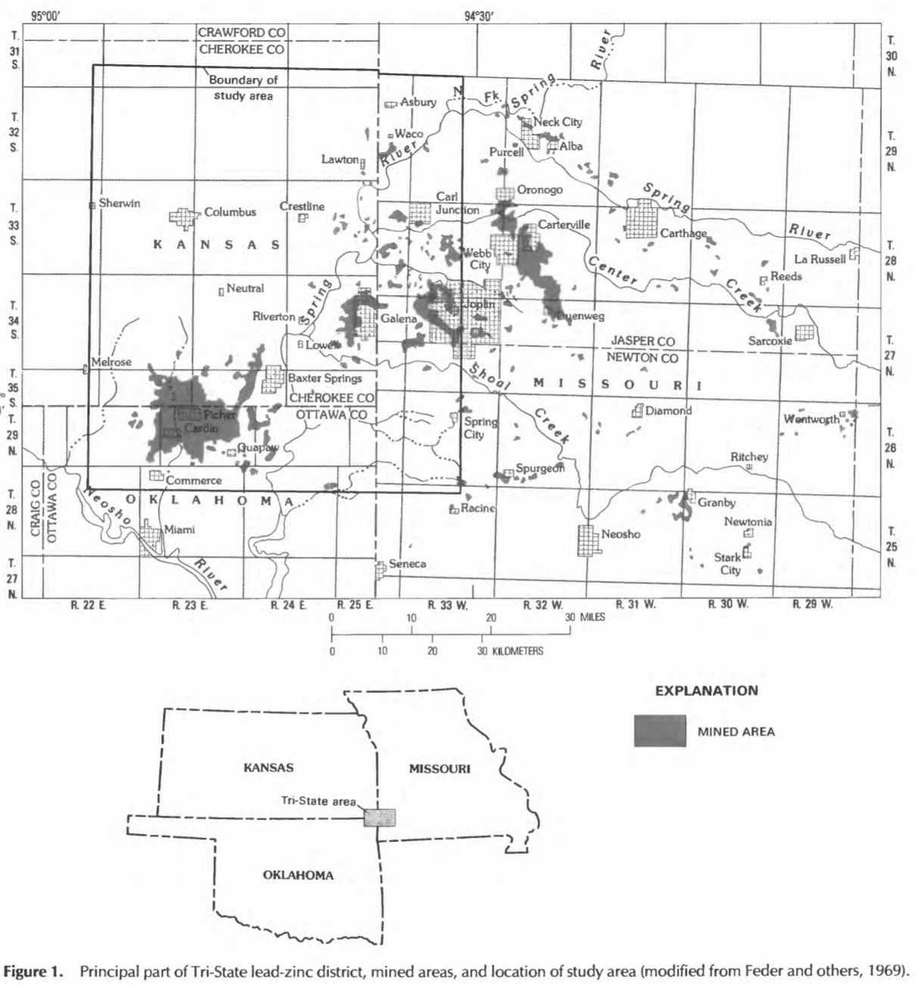
Figure 1: Map of mined areas in the Tri-State Mining District (Spruill, 1987)

MRPTS and SECPTS are the culmination of decades of University of Oklahoma (OU) Center for Restoration of Ecosystems and Watersheds (CREW) research in the Tar Creek region and throughout Oklahoma and the surrounding states. These ecologically engineered passive treatment systems capture artesian mine water discharges and process the water through a series of constructed ponds, wetlands and bioreactors. During the systems’ multi-day detention times, water quality improvements and substantial removal of ecotoxic metals are realized via natural biogeochemical, microbiological, and physical mechanisms. Treated effluent from both systems currently satisfies the pertinent ambient water quality criteria and is discharged into Unnamed Tributary (UT), which is a tributary of Tar Creek (Oklahoma Water Resources Board, 2017; USEPA, 2009).
However, passively-treated mine water might have additional beneficial reuses beyond surface water augmentation. The reuse of sufficiently treated mine water for livestock watering or crop irrigation would free up cleaner surface and groundwater reserves for human consumption. Worldwide, 69% of freshwater withdrawals are for agriculture; this number drops to 40% in the USA, but any technology or policy that safely supplants freshwater use in agriculture with treated wastewater should be given careful consideration (UN FAO, 2015). In contrast with the current state of mine drainage remediation, which is widely practiced but rarely financially self-sufficient, implementing reuse and resource recovery during the remediation of mine drainage would usher in a new, sustainable era of mining remediation (Naidu et al., 2019). This project will evaluate the potential of passively-treated mine water to safely and effectively raise animals and plants in an agricultural setting.

Literature Review

Passive Treatment of Mine Drainage in the TSMD
Passive mine water treatment begins with a thorough understanding of subsurface geology, which dictates what was once extracted at historic mining sites and influences the chemistry of the water within and flowing from abandoned mine workings or emanating from surface mine spoils. Sulfide minerals, ubiquitous in many mining operations, are disturbed and oxidized en masse during anthropogenic extraction, leading to acidity generation and metal mobilization (USEPA, 1994b). The process of acid production takes place primarily in the presence of a few important constituents, all of which are present at Tar Creek: metal sulfide minerals, oxygen, water, and bacteria (USEPA, 1994b). However, some of this acid production in the TSMD is mitigated by the elevated alkalinity generated by the dissolution of the carbonate host strata (limestone and dolomite), producing CO₂-rich, ferruginous discharges (Nairn et al., 2009). Although not identical, the treatment trains at MRPTS and SECPTS harness the same fundamental mechanisms to achieve trace metal removal. In short, under net alkaline conditions, Iron is oxidized and settles out of the water as iron oxyhydroxide solids, removing trace metals via sorption in the process. Iron solids continue to settle out of the water column in subsequent surface-flow wetlands. Next, Zn, Pb, Cd, Ni, and other trace metals are retained as metal sulfides courtesy of bacterial sulfate reduction in anaerobic organic substrate bioreactors, so the water must then be reaerated before it is discharged into the receiving stream (Robert W Nairn et al., 2020). MRPTS and SECPTS are visible in Figure 2, with flow progressing from left to right in both systems.
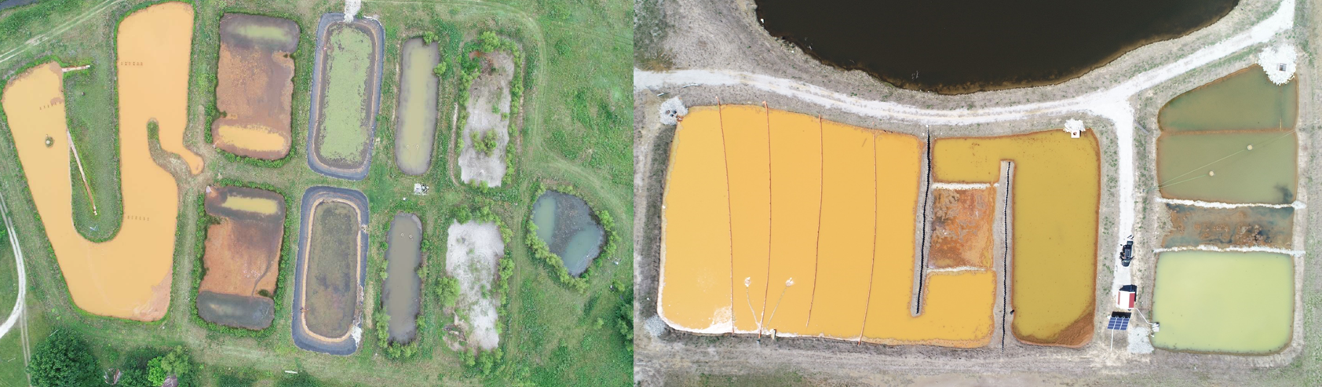
Figure 2: Aerial images of MRPTS and SECPTS (Nairn, 2019)

MRPTS and SECPTS receive net alkaline waters with circumneutral pH values and elevated concentrations of Fe, Zn, Cd, Pb, Ni, As, and SO₄²⁻ (Nairn et al., 2020). These systems effectively sequester the targeted metals while maintaining the circumneutral pH and net alkaline status of the mine water. However, the passively-treated mine water retains substantial salinity in the form of elevated Total Dissolved Solids (TDS) and concentrations of Na, SO₄²⁻, Ca, Mg, and Cl⁻. Water quality at the MRPTS inflows and outflows has been monitored on a monthly or quarterly basis for over a decade. A selection of the water quality parameters and contaminant concentrations from the MRPTS dataset is presented in Table 1.
Table 1: MRPTS water quality
Parameter | Influent (mg/L) | Effluent (mg/L)
Alkalinity (mg/L as CaCO₃ eq.) | 394 ± 1.98 | 193 ± 6.70
As (mg/L) | 0.061 ± 0.001 | BDL (0.022)
Cd (mg/L) | 0.016 ± 0.001 | BDL (0.0012)
Fe (mg/L) | 175 ± 1.34 | 0.489 ± 0.062
Ni (mg/L) | 0.890 ± 0.006 | 0.205 ± 0.034
Pb (mg/L) | 0.077 ± 0.003 | 0.032 ± 0.004
Zn (mg/L) | 8.40 ± 0.097 | 0.480 ± 0.116
pH | 5.97 ± 0.01 | 7.05 ± 0.03
Salinity (ppt) | 1.79 ± 0.011 | 1.63 ± 0.024
TDS (g/L) | 2.22 ± 0.011 | 2.04 ± 0.028
SO₄²⁻ (mg/L) | 2190 ± 19.3 | 2100 ± 75.1
Sample size n ranges from 169 to 257 for influent parameters and 47 to 49 for effluent parameters.
Artesian discharge rates of mine drainage in Ottawa County are influenced by weather, as precipitation and infiltration alter the mine pool elevation. Mine water discharges via seeps, springs, and upwellings in places where the mine pool elevation is greater than the land surface elevation. MRPTS and SECPTS treat a combined average flow of approximately 0.53 MGD, which is almost identical to the average water demand of Ottawa County cattle (Nairn, 2019). It is estimated that contaminated mine waters enter eastern Oklahoma streams at rates between 3 and 8 MGD; these flows pose a considerable threat to the environment when left untreated, but could become a valuable natural resource following the implementation of passive treatment (Nairn and Strevett, 2009).

Reuse of Treated Wastewaters for Animal Consumption

The Food and Agriculture Organization of the United Nations broadly defines ‘marginal quality’ water as water that would be problematic when applied for its designed use (Pescod, 1992). This includes domestic, industrial, and agricultural wastewater, which for the purposes of this study will be referred to simply as ‘wastewater.’ This catch-all term describes any water which has expended beneficial use in its current state and is therefore no longer wanted. Due to the finite supply of accessible freshwater at a given point in space and time, however, treating wastewater to extend its use has long been a focus of United Nations development goals and has increased in prevalence worldwide (Baum et al., 2013). Cattle typically drink fresh surface water or groundwater, but scientists concerned about water scarcity are beginning to look into watering pastures or livestock with treated wastewater (Elahi et al., 2017; Terré et al., 2019). Although secondary-treated municipal wastewater was recently shown to “cause an increase in apoptosis, intestinal primary cell damage, and inflammation” of dairy cattle intestine cell cultures, the in vivo follow-up experiment watered calves with both tap water and the secondary effluent after tertiary ultrafiltration and ultraviolet disinfection and concluded that there was no acute risk to the calves (Terré et al., 2019). Chronic risks associated with long-term consumption of reclaimed municipal effluent were not evaluated. Reuse of raw wastewater for pasture irrigation poses documented threats to cattle and human health, primarily due to the transmission of the beef tapeworm Taenia saginata from wastewater to grass to beef cow to human. The tapeworm eggs can be deposited on cattle forage during raw wastewater irrigation or untreated sludge application, but proper wastewater treatment with stabilization ponds achieves sufficient removal of the eggs, as well as most viruses, bacteria, and protozoa (Shuval, 1991b).
Comparatively, research into the impacts of treated mine water reuse on the growth, reproduction, and productivity of livestock is lacking, and barely ventures outside of the theoretical. Doupé and Lymbery (2005) discussed the environmental impacts of the myriad potential reuses of mine water and noted the possible public health concerns associated with metal and chemical accumulation in the edible portions of livestock as a result of mine water consumption. This assertion cited only a 1997 study in which cattle were subjected to elevated concentrations of SO₄²⁻ in their drinking water; despite being one of the few live-subject experiments that exposed cattle to mine water-like conditions, it did not in fact assess the uptake of other metals or chemicals besides SO₄²⁻ in the edible tissue (Harper et al., 1997). That said, the authors rightly point out that mine water recycling could increase agricultural water availability and, as a result, expand livestock land usage, which might accelerate erosion and threaten biodiversity (Doupé and Lymbery, 2005). However, if treated mine drainage were to replace ground or surface waters currently used for irrigation, rather than augment the agricultural water supply, the geographic expansion of grazing could be mitigated. In some ways, implementing pumped or gravity-fed mine water supplies would be an environmental boon; the accompanying reduction in livestock interaction with surface waters, farm ponds, and riparian areas would protect these sensitive resources from erosion and the resulting water quality degradation (Platts, 1979).
A dataset describing MRPTS and cattle-related water quality is presented in Table 2. Some elements measured in MRPTS effluent have not been thoroughly assessed in the context of livestock watering. Establishing whether treated mine drainage is safe for cattle consumption will require further investigation and experimentation, and will likely be a site-specific endeavor. This question will also be informed by water demand. Reported livestock population numbers for Ottawa County and the corresponding drinking water demand are discussed later in this section.

Table 2: MRPTS water quality and cattle drinking water MCLs
Parameter⁷ | Influent (mg/L) | Effluent (mg/L) | Cattle MCL (mg/L)
Alkalinity (mg/L as CaCO₃ eq.) | 394 ± 1.98 | 193 ± 6.70 | 2000²
Al (mg/L) | 0.232 ± 0.030 | 0.060 ± 0.008 | 5.0¹
As (mg/L) | 0.061 ± 0.001 | BDL (0.022) | 0.2¹
Ca (mg/L) | 716 ± 2.98 | 690 ± 13.1 | 1000⁶
Cd (mg/L) | 0.016 ± 0.001 | BDL (0.0012) | 0.05¹
Cl⁻ (mg/L) | 34.5 ± 2.00 | 32.6 ± 0.670
Co (mg/L) | 0.057 ± 0.002 | 0.010 ± 0.002 | 1.0¹
Cr (mg/L) | 0.003 ± 0.0002 | 0.005 ± 0.0005 | 1.0¹
Cu (mg/L) | 0.004 ± 0.0003 | 0.004 ± 0.0004 | 0.5¹
F⁻ (mg/L) | 2.55 ± 0.157 | 1.84 ± 0.044 | 2.0¹
Fe (mg/L) | 175 ± 1.34 | 0.489 ± 0.062 | 2.0⁵
K (mg/L) | 25.0 ± 0.141 | 24.5 ± 0.957
Li (mg/L) | 0.311 ± 0.006 | 0.300 ± 0.017
Mg (mg/L) | 187 ± 1.23 | 175 ± 4.20 | <250-400¹
Mn (mg/L) | 1.48 ± 0.011 | 1.15 ± 0.171 | 0.05¹
Na (mg/L) | 94.2 ± 0.701 | 94.3 ± 2.50 | 1000⁴
Ni (mg/L) | 0.890 ± 0.006 | 0.205 ± 0.034 | 0.25^{5,6}
NO₂-N (mg/L) | 1.44 ± 0.086 | 1.28 ± 0.114 | 10.0¹
Pb (mg/L) | 0.077 ± 0.003 | 0.032 ± 0.004 | 0.1¹
pH | 5.97 ± 0.01 | 7.05 ± 0.03 | Between 5.5 and 8.5²
Salinity (ppt) | 1.79 ± 0.011 | 1.63 ± 0.024 | 3.0⁶
Se (mg/L) | BDL | BDL | 0.05¹
TDS (g/L) | 2.22 ± 0.011 | 2.04 ± 0.028 | 10^{2,3}
Zn (mg/L) | 8.40 ± 0.097 | 0.480 ± 0.116 | 24-25^{1,3}
SO₄²⁻ (mg/L) | 2190 ± 19.3 | 2100 ± 75.1 | Varies, 1000⁴, 2000^{2,3}
PO₄³⁻ (mg/L) | 3.76 ± 0.223 | 4.03 ± 0.659 | 1.0²
¹(Ayers and Westcot, 1985b) ²(Pfost et al., 2001) ³(Sallenave, 2016) ⁴(USEPA, 2012) ⁵(Waldner and Looper, n.d.) ⁶(Beede, 2008)

MRPTS treats most influent constituents to well below the cattle maximum contaminant level (MCL). Although the presence of an MCL does not always mean that any chemical or metal concentration below the MCL is adequate for cattle dietary needs, the important macro-minerals (P, K, S, Mg, Na, and Cl) and micro-minerals (Cu, Zn, I, Mn, Se, Co, and Fe) are normally present in the cattle feed or forage at concentrations that promote healthy growth and development (Paterson and Engle, 2005). Therefore, livestock water quality guidance generally assumes that nutrient and mineral needs will be met by the food source, and that the variable water quality of groundwater or surface water supplies is acceptable so long as it conforms to widely accepted MCLs.
Mines in the Tar Creek Superfund Site generated massive quantities of Pb and Zn before operations ceased. Whereas the former is ecotoxic at any concentration, Zn is an essential nutrient for animal life. While some sources list a Zn MCL of 25 mg/L, the same sources also note that dietary Zn consumption between 40 and 100 mg/L is normal for cows (Sallenave, 2016). Because Zn deficiency in cattle has been linked to decreased nutrient utilization, lethargy, and stunted growth, farmers sometimes opt for Zn supplements when the normal dietary supply is inadequate (Miller, 1970). MRPTS removes almost 99% of influent Zn, resulting in relatively low effluent Zn concentrations around 0.5 mg/L. Similar Zn concentrations were measured in the drinking water sampled from 39 California dairy farms (Castillo et al., 2013). Therefore, as with most other livestock drinking water supplies, cattle relying on MRPTS effluent would obtain the necessary Zn intake from some combination of feed, forage, incidental soil consumption, and dietary supplements.
Whereas healthy steers can tolerate up to 2000 mg/L SO₄²⁻ in drinking water without harm, pregnant cows should not consume water with SO₄²⁻ concentrations exceeding 1000 mg/L (Hunter et al., 2002). The MRPTS effluent exhibits SO₄²⁻ concentrations exceeding both of these criteria. Moreover, a 2014 live-cow study found that high dietary S decreased retention of Cu, Mn, and Zn in cattle, potentially limiting long-term growth and productivity (Pogge et al., 2014).
Mn concentrations in the effluent are roughly 25 times greater than the human MCL, which was published by the UN Food and Agriculture Organization (FAO) in lieu of a still-undetermined cattle MCL (Ayers and Westcot, 1985b). The FAO also noted that Pb bioaccumulates and could be dangerous at a concentration of 0.05 mg/L, which is only around 1.5 times greater than the effluent Pb concentration at MRPTS (Ayers and Westcot, 1985b). Nevertheless, the majority of water quality parameters and metal concentrations fall within the recommended cattle MCLs.
To be economically sustainable, treated mine drainage reuse would need to be implemented close to the treatment site. Consequently, the analysis of the potential reuse of treated effluent in the Tar Creek Superfund Site will focus on local industries. MRPTS and SECPTS are located in Ottawa County, which was home to an estimated 54000 cattle and calves in 2019 (USDA, n.d.). As shown in Figure 3, USDA’s National Agricultural Statistics Service (NASS) estimated an average cattle water demand of 10 GPD and a hot weather water demand of 22.5 GPD (Nairn and Strevett, 2009). Therefore, the 2019 cattle population in Ottawa County represented an average water demand of 0.54 MGD and a hot weather water demand of 1.2 MGD. These numbers are likely overestimates, because juvenile cows are included in the Ottawa County totals but do not require as much water as the adults. However, cows generally double their water consumption when lactating, so the presence of pregnant cattle drives the water demand closer to the stated estimate (Rasby, n.d.). Other livestock such as hogs, pigs, chicken, and sheep were not considered when calculating Ottawa County’s livestock water demand, because NASS reported negligible numbers of these animals in Ottawa County (USDA, n.d.).

Figure 3: Species-specific livestock water consumption for Oklahoma (Nairn and Strevett, 2009)

Reuse of Treated Wastewaters for Crop Irrigation
Planned wastewater reuse in agriculture dates back to at least 5000 years to the Minoan civilization, which occupied Crete and other Aegean islands until around 1100 BC (Asano and Levine, 1996). In the mid-1800s, England endorsed wastewater use and sludge application in agriculture as a response to the environmental and human health consequences of inadequate wastewater disposal capacity (Shuval, 1991a). A century later, wastewater reuse regulations were present in some form on most every continent (Asano and Levine, 1996; Pescod, 1992; Shuval, 1991a). However, safe implementation of agricultural reuse was delayed by the widespread global adoption of California’s stringent 1918 wastewater reuse regulations, which to this day mandate a maximum total coliform count of 2.2 cfu/100 mL for irrigation of produce to be eaten raw (Asano and Levine, 1996; Shoushtarian and Negahban-Azar, 2020; Shuval, 1991a; USEPA, 2012). Total coliform bacteria serve as an indicator for potential pathogenic contamination of water, but they are not usually harmful themselves, and numbered in the thousands or tens of thousands in European rivers that directly supplied irrigation water (Shuval, 1991a; WSDH, 2016). The California standards were impractical or unattainable for most wastewater treatment facilities, but the first reuse guidelines codified in the United States spread to many other states and countries nevertheless (Shuval, 1991a). Consequently, either wastewater reuse for irrigation did not happen in these areas until new, more lenient regulations were implemented, or farmers shirked the prohibitively expensive requirements and irrigated their fields with wastewater of variable quality as officials turned a blind eye; the latter practice grew out of economic necessity, especially in water-scarce regions, and put consumers at risk when produce for direct human consumption was grown with raw or inadequately-treated sewage (Shuval, 1991a; USEPA, 2012). Agricultural reuse of wastewater developed more rapidly in some countries that chose not to adopt the California standards. The Chinese government elevated wastewater reuse in agriculture to a national development priority by the late 1960s, and farmers in China now irrigate more than 1.3 million hectares of farmland this way (Lili et al., 2011; Pescod, 1992). The World Health Organization (WHO) and US EPA first published notable guidelines on wastewater reuse for agriculture in 1989 and 1992, respectively, which reflected realistic assessments of the microbial risks associated with municipal wastewater reuse in agriculture (Asano and Levine, 1996; Shuval, 1991a). The primary microbial contaminants in domestic wastewater are helminths and enteric bacteria and viruses, which are effectively removed in stabilization ponds over sufficiently long detention times (Shuval, 1991a). Microbial contamination is typically monitored with some combination of total coliform, fecal coliform, E. coli, and helminth egg counts in a standardized volume of water, but the indicators, standards, and resulting implications for agricultural reuse vary widely throughout the world and within countries (Shuval, 1991a; USEPA, 2012).
Researchers have supplemented regulatory guidelines for reclaimed wastewater irrigation, which in most cases were developed to safeguard plant health during generalized wastewater reuse scenarios, with numerous studies assessing the plant and human health risks of wastewater irrigation under local conditions (Chang et al., 2001). Despite its role in propagating prohibitively strict wastewater reuse standards, California played host to a five-year experiment evaluating vegetable irrigation with tertiary-treated domestic wastewater in water-strapped Monterey County (Burau et al., 1987). The irrigation of six crops grown for raw consumption with well water and two types of highly treated wastewater was closely monitored through extensive water, soil, and plant quality data collection (Burau et al., 1987). The researchers concluded that irrigation with reclaimed wastewater posed no significant threat to crop development, soil quality, or human health, and that by most metrics the three water treatments produced statistically indistinguishable outcomes (Burau et al., 1987). The Monterey County wastewater treatment provider touts the study as proof that recycled wastewater resulted in greater yields and higher quality plants compared to groundwater irrigation, but it is important to note the local conditions that made this possible, and that limit the widespread application of such conclusions for other regions and wastewater streams (M1W, 2020). The municipality’s ability to harness the high nutrient concentrations from reclaimed domestic wastewater while negating the microbial and chemical risk was made possible by a $150 million wastewater treatment plant, which ensures that average metal concentrations in the tertiary-treated wastewaters satisfy California’s drinking water regulations (Burau et al., 1987; M1W, 2020). Many communities that would benefit from wastewater reclamation cannot afford such a steep investment; this widespread reality has prompted studies of lower cost wastewater reuse alternatives.
Pescod’s guide to reclaiming and reusing wastewater in agriculture provides a thorough explanation of wastewater treatment methods, reuse guidelines, irrigation practices, and a selection of case studies throughout the world (1992). Tunisian farms have employed secondary-treated wastewater in irrigation for over half a century, and many of the country’s wastewater treatment plants supply effluent to be mixed with groundwater for irrigation at citrus tree farms and forage crop operations (Pescod, 1992). The Tunisian government actively regulates agricultural reuse and oversees research in the sector; government-sponsored studies determined that wastewater from existing, economical activated sludge plants produced higher crop yields than groundwater, without significantly impacting shallow groundwater quality (Pescod, 1992). Indeed, the elevated nutrient levels in treated domestic wastewater have been widely credited with increasing crop yields and biomass, and allow farmers to reduce fertilizer application, although excessive nutrients can degrade crop and environment quality (Asano and Pettygrove, 1987; Libutti et al., 2018; Pescod, 1992; Urbano et al., 2017). Kuwait planned to water 12000 hectares of intensive agriculture and forests with tertiary- and advanced-treated municipal wastewater by 2010, much of which materialized, but some have raised concerns that the arid country needs to consider expanding reuse in other sectors as well, such as groundwater recharge or domestic and industrial water supply (Abusam and Shahalam, 2013; Pescod, 1992). In contrast with more conservative approaches to wastewater reclamation, Mexican farmers in the Mezquital Valley began irrigating with raw sewage as early as 1886, and other communities that experience unreliable rainfall followed suit (Pescod, 1992). The Mexican government determined which crops could be safely irrigated with the raw sewage, and studies observing community health deemed this approach to be sufficient for protecting the public, although farm workers were exposed to enhanced risk when working with raw sewage (Pescod, 1992). Contaminated or poorly treated municipal wastewater can be a vector for pathogens, but the benefits of wastewater reclamation in agriculture fueled research and implementation on a global scale.
Microbial contamination, the primary threat in municipal wastewater, can generally be eliminated or sufficiently reduced for agricultural reuse through adequate treatment with activated sludge, stabilization basins, or similar practices that encourage long detention times, particle settling, and disinfection. However, irrigation with domestic wastewater can create permeability and toxicity problems for soil and plants over time if low levels of inorganic pollution are not appropriately managed and salts and specific ions accumulate in the soil (Asano and Pettygrove, 1987; Bauder et al., 2014; Shakir et al., 2017). Inorganic pollutants are of even greater concern in industrial wastewaters, which typically contain higher concentrations of salts and metals than domestic wastewater. Compared to biochemical oxygen demand (BOD) and total suspended solids (TSS), which are common metrics for evaluating wastewater treatment, the concentrations of salts, chemicals, and metals are less likely to be monitored during wastewater treatment and are far more important determinants of irrigation water quality (Asano and Pettygrove, 1987; Shakir et al., 2017). The issue of inorganic contamination going unaddressed during treatment is exacerbated by the massive quantities of wastewater that receive little to no treatment. Flörke et al. estimated that 47% of domestic and manufacturing wastewater flows go untreated, but the true proportion could be much higher: researchers conducting a global spatial analysis of wastewater irrigation reported that the average country treats only 24% of its wastewater (Flörke et al., 2013; Thebo et al., 2017). This same spatial analysis found that as many as 36 Mha of cropland worldwide are supplied with treated, partially-treated, or raw wastewater, a practice often born out of environmental or economic necessity (Thebo et al., 2017). Scientists in numerous countries have connected trace metal contamination of soil and plants to the regulated or unsanctioned irrigation with raw sewage and treated domestic or industrial wastewater (Chang et al., 2001; Khan et al., 2008; Liu et al., 2005; Tiwari et al., 2011). Vegetables watered with biologically-treated wastewater at farms outside of Beijing exhibited levels of Cd, Cr, Cu, Ni, Zn, and Pb above the WHO permissible limits; a human health risk assessment deemed the contaminated vegetables safe for consumption, but failed to account for other exposure pathways like dust inhalation and ingestion (Khan et al., 2008). In India, a similar study of vegetable irrigation with treated and raw industrial effluent identified elevated concentrations of As, Cd, Cr, Ni, and Pb in the edible portions of half of the ten study species (Tiwari et al., 2011). Despite their propensity for bioaccumulation, all five of the aforementioned metals were present in the soil at lower levels than Fe, Mn, and Zn, indicating that plant uptake of metals depends on a combination of soil makeup, contaminant solubility, and plant type (Tiwari et al., 2011). Even in the absence of significant microbial and metal contamination, treated wastewater irrigation can irreversibly damage soil and diminish yields, as was the case during one study in Burkina Faso. Treated alkaline industrial effluent collapsed the soil structure, drove the soil pH up, and deposited excessive Na and bicarbonate, which led to soil sodification and cut eggplant yields in half (Sou/Dakouré et al., 2013).
Oklahoma provides an extensive framework for municipalities and permittees to reuse treated municipal wastewater for irrigation. In the Oklahoma Administrative Code, Title 252, Chapter 656, the Oklahoma Department of Environmental Quality (ODEQ) identifies six categories of reclaimed water, which are each afforded specific beneficial reuses based on the associated level of treatment. As treatment requirements increase from primary to tertiary and the range of allowable uses expands, the monitoring requirements outlined in Title 252, Chapter 627 also become more stringent. Whereas wastewaters that have undergone primary treatment in a wastewater lagoon can irrigate timber and certain pastures, seeds, and forages so long as the water supplier provides ODEQ with a monthly report of volume, weather, and irrigated plant type, tertiary-treated wastewaters can water range cattle, spray irrigate landscapes, and drip irrigate orchards and vineyards (ODEQ, 2015a). In addition to the monthly operating report, these tertiary-treated waters are subjected to continuous chlorine and turbidity monitoring, daily fecal coliform tests, and other weekly and monthly water quality assessments (ODEQ, 2015a). No level of treatment certifies reclaimed wastewaters for any irrigation of crops to be eaten raw, spray irrigation of orchards and vineyards, or foods that will be harvested within the month and processed for human consumption (ODEQ, 2015b). ODEQ also restricts reuse based on a plethora of point-of-use concerns. Land application of reclaimed wastewater cannot exceed crop nutrient uptake rates, result in ponding, or take place during precipitation events or on excessive slopes or frozen soil (ODEQ, 2015a). These restrictions, among others, are designed to protect human health, the environment, and water supplies from the dangers of wastewater pollution while simultaneously encouraging sustainable water management practices. The University of Oklahoma waters its golf course with treated municipal wastewater from the City of Norman, and farmers in Guymon, OK irrigate grain and forage crops with reclaimed wastewater in the agricultural center of the state (OWRB, 2020). Reuse will continue to proliferate as Oklahoma grapples with growing water demands and a changing climate.
Thus far, the discussion of wastewater reclamation for irrigation has focused on the reuse of domestic and industrial flows, which has been studied for decades and practiced for centuries. The same cannot be said for mining-impacted surface and groundwater, which is generally characterized by elevated metal, salt, and SO₄²⁻ concentrations (Lottermoser, 2011). However, there is a growing body of literature on the potential reuses of treated mine water that merits examination. Many mine water discharges flow unabated and untreated, but in some parts of the world these highly contaminated flows are the most reliable source of irrigation water. In Bolivia, a team of researchers found that mining-impacted irrigation water and the associated soil and potato crops contained elevated concentrations of a host of ecotoxic metals, including As, Cd, Pb, and Zn (Garrido et al., 2017). Aqueous concentrations between 20 and 1100 times greater than established international criteria translated into dangerous levels of multiple trace metals in potatoes at almost every study site; human health risk assessments confirmed that the consumption of this staple food could singlehandedly expose adults and children to significant risk without accounting for other exposure pathways (Garrido et al., 2017). Brazilian Cu mine water receiving no treatment beyond extended storage in a reservoir, which decreased dissolved Cu concentrations, was deemed unsafe for irrigation after it demonstrably elevated Cu levels in banana tree roots and fruits (Oliveira et al., 2019).
However, mine water can be treated in-situ at a variety of price points and energy inputs, and the evolution of novel technologies and treatment methods has enabled the production of irrigation-quality water from vastly different types of mine drainage. Membrane filtration of mine water, while expensive and energy-intensive, resulted in effluent COD, NH₃-N, TSS, and pH levels that satisfied Malaysia’s National Water Quality Standards, although the study did not address any metal or chemical concentrations (Yeit Haan et al., 2017). Passive treatment of acid mine drainage (AMD) via settling and anaerobic bacterial sulfate reduction achieved circumneutral pHs and decreased SO₄²⁻, Fe, Zn, and Cu content to levels sufficiently below Portugal’s irrigation water quality criteria (Martins et al., 2010). Furthermore, South African researchers treated metal contamination in gold mine drainage with pervious concrete filtration, which is an economical method of satisfying irrigation water metal criteria under certain conditions, but effluent alkalinity and salinity levels remained problematic (Shabalala and Ekolu, 2019). It should be noted that these success stories all share one thing in common: they make claims about the suitability of treated mine water for irrigation by comparing produced water quality to local irrigation standards. The next step, which will help fill a much-needed gap in the literature, is to irrigate crops with treated mine water and document changes in soil and plant composition.
Governments and intergovernmental organizations like the UN FAO have published irrigation water quality criteria that recommend maximum concentrations of many potential inorganic constituents; while these recommendations were not developed with mine drainage in mind, they provide a benchmark against which treated mine water quality can be compared (Ayers and Westcot, 1985a; Chang et al., 2001; USEPA, 2012). In Table 3, MRPTS effluent water quality data are juxtaposed against widely accepted irrigation criteria. These criteria represent maximum concentrations of aqueous constituents for appropriate irrigation of all soils over an extended period of time (USEPA, 2012). Therefore, exposing crops to elevated concentrations or excessive irrigation may not significantly impact plants in every case; conversely, some species with extreme sensitivity to contamination could respond negatively at lower concentrations (Pescod, 1992; USEPA, 2012). For this reason, implementing treated wastewater reuse requires careful consideration of crop selection as well as water quality (Pescod, 1992). Furthermore, the mechanisms via which the chemical subjects of Table 3 render water unsuitable for irrigation vary widely. The precipitation of carbonate species due to high alkalinity can damage drip irrigation networks and reduce the effectiveness of certain pesticides (UMass Extension, 2015). Lithium is one of many elements that are essential or beneficial to plant growth at low concentrations but harmful at elevated concentrations. Low concentrations of Li can increase plant biomass production, but at higher levels the alkali metal disrupts plant physiological processes and is responsible for a host of negative consequences: chlorosis, leaf curling and necrosis, severely reduced biomass production, and abnormal or diminished elemental uptake and translocation (Shahzad et al., 2016). Although Li levels in the MRPTS effluent are far from concerning, Ca, Cl⁻, F⁻, Mg, Mn, and K, normally healthy in moderation, exceed irrigation criteria and pose direct or indirect toxicity risks to plants.
Table 3: MRPTS water quality and irrigation water criteria
Parameter⁶ | Influent (mg/L) | Effluent (mg/L) | Irrigation Criteria (mg/L)
Alkalinity (mg/L as CaCO₃ eq.) | 394 ± 1.98 | 193 ± 6.70 | 200⁵
Al (mg/L) | 0.232 ± 0.030 | 0.060 ± 0.008 | 5^{1,2,3}
As (mg/L) | 0.061 ± 0.001 | BDL (0.022) | 0.10^{1,2,3}
B (mg/L) |  |  | 0.75^{1,2}, See Table 4
Ca (mg/L) | 716 ± 2.98 | 690 ± 13.1 | 40-100⁴
Cd (mg/L) | 0.016 ± 0.001 | BDL (0.0012) | 0.01^{1,2,3}
Cl⁻ (mg/L) | 34.5 ± 2.00 | 32.6 ± 0.670 | 0.05-5¹, See Table 4
Co (mg/L) | 0.057 ± 0.002 | 0.010 ± 0.002 | 0.05^{1,2,3}
Cr (mg/L) | 0.003 ± 0.0002 | 0.005 ± 0.0005 | 0.1^{1,2,3}
Cu (mg/L) | 0.004 ± 0.0003 | 0.004 ± 0.0004 | 0.2^{1,2,3}
F⁻ (mg/L) | 2.55 ± 0.157 | 1.84 ± 0.044 | 1.0^{1,3}
Fe (mg/L) | 175 ± 1.34 | 0.489 ± 0.062 | 5.0^{1,2,3}
K (mg/L) | 25.0 ± 0.141 | 24.5 ± 0.957 | 2⁵
Li (mg/L) | 0.311 ± 0.006 | 0.300 ± 0.017 | 2.5^{1,2,3}
Mg (mg/L) | 187 ± 1.23 | 175 ± 4.20 | 30-50⁴
Mn (mg/L) | 1.48 ± 0.011 | 1.15 ± 0.171 | 0.2^{1,2,3}
Mo (mg/L) |  |  | 0.01^{1,2,3}
Na (mg/L) | 94.2 ± 0.701 | 94.3 ± 2.50 | See Table 4
Ni (mg/L) | 0.890 ± 0.006 | 0.205 ± 0.034 | 0.2^{1,2,3}
Pb (mg/L) | 0.077 ± 0.003 | 0.032 ± 0.004 | 5^{1,2,3}
pH | 5.97 ± 0.01 | 7.05 ± 0.03 | 6-8¹, 6.5-8.4³
Conductivity (dS/m) | 1.79 ± 0.011 | 1.63 ± 0.024 | See Table 4
Se (mg/L) |  |  | 0.02^{1,2,3}
TDS (g/L) | 2.22 ± 0.011 | 2.04 ± 0.028
Zn (mg/L) | 8.40 ± 0.097 | 0.480 ± 0.116 | 2.0^{1,2,3}
SO₄²⁻ (mg/L) | 2190 ± 19.3 | 2100 ± 75.1 | >50⁴
¹(USEPA, 2012) ²(Chang et al., 2001) ³(Pescod, 1992) ⁴(UMass Extension, 2015) ⁵(Ayers and Westcot, 1985a)
Table 4 provides a more detailed analysis of potential irrigation concerns associated with the electrical conductivity of water (EC_{w}), adjusted sodium adsorption ratio (adj SAR), and concentrations of a few key ions. This table was adapted by the FAO in 1985 from a 1974 University of California publication, and in the decades since has regularly been republished in wastewater reclamation’s seminal works (Ayers and Westcot, 1985a; Pescod, 1992; USEPA, 2012). Saline waters, which can be characterized by elevated electrical conductivities or TDS, deposit salts throughout the soil and reduce water availability in the root zone. Perhaps counterintuitively, increasing the salinity of a water can increase water infiltration into the soil. The relationship between a water’s salinity and adj SAR, which compares the aqueous Na concentration to the aqueous Ca and Mg concentrations, dictates the infiltration rate (Ayers and Westcot, 1985a). Soil structure breakdown, low permeability, and correspondingly low infiltration rates can directly harm crops by promoting shallow root development and stunting growth, and cause indirect damage through ponding, root rot, and anoxic zones (Ayers and Westcot, 1985a). The calculation for the SAR is presented in Equation 1. Na, Ca, and Mg concentrations in the irrigation water are measured in meq/L. Ca_{x} is an estimate of the equilibrium soil-water Ca concentration after irrigation, which is influenced by the water’s carbonate equilibria and electrical conductivity (Ayers and Westcot, 1985a).
Equation 1
$$adj SAR=\frac{Na}{\sqrt{\frac{{Ca}_{x}+Mg}{2}}}$$
Table 4 outlines the risks associated with Na, Cl⁻, and B concentrations in irrigation water. The impact of specific ion toxicity on crop yield depends on complex interactions between species tolerance, climate, soil type, irrigation practice, and irrigation water composition, but researchers have made great strides in understanding the mechanisms of toxicity. Researchers have shown that Na toxicity in corn is a result of the ion’s ability to disrupt the uptake and translocation of K, a key macronutrient (Botella et al., 1997; Drew and Dikumwin, 1985). As Na concentrations increase in the irrigation solution, Zea mays grows less capable of excluding Na at the roots; Na predominance in the roots and shoots is exacerbated by anoxia, which impedes K transport into and through the plant (Drew and Dikumwin, 1985). Salt-tolerant hybrids can reduce Na toxicity by sequestering the ion in older leaves and shedding these lower leaves, but more sensitive strains exhibit a variety of physiological symptoms after three days of salt stress: diminished chlorophyll counts, slowed photosynthesis, and lower biomass water content (Gao et al., 2016).
Table 4: Guidelines for interpretations of water quality for irrigation (Ayers and Westcot, 1985a)
Potential Irrigation Problem |  | Units | Degree of Restriction on Irrigation
 |  | Units | None | Slight to Moderate | Severe
Salinity (affects crop water availability)
 | EC_{w} | dS/m | < 0.7 | 0.7 - 3.0 | > 3.0
 | or TDS | mg/L | < 450 | 450 - 2000 | > 2000
Infiltration (affects infiltration rate of water into the soil; evaluate using EC_{w} and adj SAR together)
adj SAR | 0 - 3.0 | and EC_{w} = | > 0.7 | 0.7 - 0.2 | < 0.2
adj SAR | 3.0 - 6.0 | and EC_{w} = | > 1.2 | 1.2 - 0.3 | < 0.3
adj SAR | 6.0 - 12.0 | and EC_{w} = | > 1.9 | 1.9 - 0.5 | < 0.5
adj SAR | 12.0 - 20.0 | and EC_{w} = | > 2.9 | 2.9 - 1.3 | < 1.3
adj SAR | 20.0 - 40.0 | and EC_{w} = | > 5.0 | 5.0 - 2.9 | < 2.9
Specific Ion Toxicity (affects sensitive crops)
 | Na (Na)
 | surface irrigation | SAR | < 3.0 | 3.0 - 9.0 | > 9.0
 | sprinkler irrigation | meq/L | < 3.0 | > 3.0
 | Chloride (Cl⁻)
 | surface irrigation | meq/L | < 4.0 | 4.0 - 10.0 | > 10.0
 | sprinkler irrigation | meq/L | < 3.0 | > 3.0
 | Boron (B) | mg/L | < 0.7 | 0.7 - 3.0 | > 3.0
Miscellaneous Effects (affects susceptible crops)
 | Nitrate (NO₃-N) | mg/L | < 5.0 | 5.0 - 30.0 | > 30.0
 | Bicarbonate (HCO₃⁻) | meq/L | < 1.5 | 1.5 - 8.5 | > 8.5
 | pH |  | Normal Range 6.5 - 8.4

Crop agriculture and animal husbandry were largely responsible for the ascension of Homo sapiens from hunter gatherer to dominant global influence. Humanity’s prolific expansion has long forced scientists and farmers to adapt to changing landscapes and populations. By developing new technologies and agricultural methods, humans have increased the geographic range, efficiency, and resiliency of plant and animal production. In the recent past, water scarcities have been mitigated by the introduction of more sustainable water management practices in the agricultural sector and beyond. Reclamation and reuse of municipal and industrial wastewaters is a thoroughly studied solution that benefits from centuries of practice and experimentation. However, very little is known about the intersection of agriculture and treated mine water. Mine water can be reclaimed in low cost, ecologically engineered passive treatment systems, but unlike other forms of reclaimed wastewater, its potential for reuse in agriculture has yet to be adequately evaluated. To that end, this project will present an informed evaluation of the potential for beneficial reuse of passively-treated mine drainage for livestock watering based on previous research and CREW water quality data, and will attempt to understand the effects of irrigating crops with treated mine drainage through a robust experimental design.

Plant Growth and Development
Zea mays var. indentata, Sorghum bicolor, Sorghastrum nutans, and Cynodon dactylon are all warm-season grasses found in Oklahoma. Zea mays var. indentata, or yellow dent corn, will primarily be referred to as field corn or corn in this document, and is an annual tropical grass that has been cultivated for a plethora of uses: animal feed grain, corn meal, corn oil, corn starch, corn syrup, and ethanol (Duncan et al., 2007; USDA, 2015). Corn growth is described by vegetative and reproductive stages (Table 5). Following emergence, the vegetative stage number indicates how many leaves on the plant have created a visible collar near the junction of the leaf and the stalk. Tassel development inside the whorl begins between stages V5 and V7, and the emergence of the male inflorescence from the whorl marks the final vegetative growth stage, VT (Trecker, 2018). One or more ears, which are the female organs, begin growing shortly after the tassel. As the ear develops, eggs attached to the surface of the cob produce silks that spill out of the husk, awaiting pollination. Flowers lining the tassel drop pollen from their anthers onto the waiting silks, which then fertilize the attached egg to produce a starch-filled kernel in its place (Trecker, 2018). The reproductive growth stages are distinguished first by the appearance of silks, and from then on by the condition of the kernel.
Table 5: Vegetative and reproductive corn growth stages, partially adapted from (Australian OGTR, 2008)
Corn Growth Stages
Vegetative | VE | Emergence
 | V1-Vn | n Leaf Collars Visible
 | VT | Tasseling
Reproductive | R1 | Silking
 | R2 | Blister
 | R3 | Milk
 | R4 | Dough
 | R5 | Dent
 | R6 | Maturity

Sorghum bicolor will be referred to as sorghum or grain sorghum, and is an annual tropical grass commonly grown for animal feed grain, forage, biofuel, and syrup, although humans have found other culinary and industrial uses for the cereal (Dial, 2012). Like corn, sorghum growth is described by vegetative or reproductive stages found in Table 6 (Gerik et al., 2003; United Sorghum Checkoff, n.d.). Post-emergence vegetative growth is characterized by the number of full-length leaves with visible collars until the final vegetative stage. During the boot stage, the seed head (panicle) is visible as a flag-leaf-wrapped bulge atop the stalk. The panicle emerges and flowers to begin the reproductive phase. After approximately one week of self-pollination, sorghum grains begin accumulating starch and absorbing nutrients. Grain starch content and weight increase from soft dough to physiological maturity, although the exact stage during which the crop is harvested depends on the intended use (Vanderlip and Reeves, 1972) .
Table 6: Sorghum growth stages, partially adapted from (Vanderlip and Reeves, 1972)
Sorghum Growth Stages
Vegetative | 0 | Emergence
 | 1 | V3-V4
 | 2 | V5-V6
 | 3 | V8
 | 4 | Flag-leaf visible
 | 5 | Boot
Reproductive | 6 | Flowering
 | 7 | Soft Dough
 | 8 | Hard Dough
 | 9 | Physiological Maturity

Sorghastrum nutans and Cynodon dactylon, or Indiangrass and Bermuda grass, are warm-season perennial grasses. Indiangrass is native to the North American prairies, but its extent is not limited to the prairie (Houseal et al., 2007). The tall grass can serve as forage for livestock or habitat and food supply for birds, deer, and various insects (Brakie, 2017). Bermuda grass is a tropical grass that proliferates through belowground rhizomes, aboveground stolons, and airborne seeds (Vandevender, 2006). Bermuda grass can be used as forage for livestock and wildlife, turf grass for recreation and public spaces, and as an erosion control measure (Vandevender, 2006).
Because plant growth rates are heavily influenced by air temperature, tracking daily temperature fluctuations throughout the growth cycle provides an estimate of growth stage duration and time to maturity (Gerik et al., 2003). Growing degree units (GDUs), which can be calculated from Equation 2, account for the influences of planting date and spatial and temporal weather variability that are often neglected in calendar day approximations of the growing season (Duncan et al., 2007; Gerik et al., 2003). GDUs are calculated for each day after a crop is planted; daily maximum air temperatures above 30 ℃ are reported as 30 ℃ and daily minimum air temperatures below 10 ℃ are reported as 10 ℃ (Duncan et al., 2007). Some sources suggest reporting exact maximum daily air temperatures until temperatures exceed 37.8 ℃, but plant roots struggle to uptake sufficient water for growth above 30 ℃ and might not benefit from temperature increases above the 30 ℃ threshold (Duncan et al., 2007; Gerik et al., 2003). The approximate cumulative GDUs for corn and sorghum to reach certain growth stages and for Bermuda grass to successfully establish after planting are provided in Table 7.
Equation 2
Equation 2
$$GDU=\frac{daily\max{T+daily\min{T}}}{2}-10 ℃$$

Table 7: Cumulative GDUs and associated growth stages for average grain corn and grain sorghum varieties in addition to accumulated GDUs for successful Bermuda grass establishment, adapted from (Duncan et al., 2007; Gerik et al., 2003; Schiavon et al., 2012)
Corn (mid-season hybrid) |  |  | Sorghum (short season hybrid) |  |  | Bermuda grass
Growth Stage | GDUs (℃) |  | Growth Stage | GDUs (℃) |  | Optimum Establishment | GDUs (℃)
VE | 52 |  | 0 | 93 |  | GDUs between planting  and first frost | >950
V6 | 246 |  | 1 | 260 |  | GDUs between planting  and first frost | >950
VT | 621 |  | 2 | 349
R1 | 760 |  | 3 | 496
R4 | 1052 |  | 4 | 697
R5 | 1343 |  | 5 | 917
R6 | 1482 |  | 6 | 1009
 |  |  | 7 | 1211
 |  |  | 8 | 1376
 |  |  | 9 | 1467

Hypotheses, Objectives, and Goals
  - The hypotheses for this research are:
      - Livestock consumption of treated mine drainage would expose cattle to chemical concentrations greater than accepted criteria
      - Select crops irrigated with treated mine drainage will not exhibit significant reductions in biomass production when compared to crops irrigated with groundwater
      - Select crops irrigated with treated mine drainage will experience elevated recoverable metals concentrations in above- or belowground biomass compared to crops irrigated with groundwater
      - Soils irrigated with treated mine drainage will experience elevated recoverable metals concentrations compared to soils irrigated with groundwater
  - The objectives for this research are:
      - Examine MRPTS effluent quality to understand if it could be beneficially reused in raising cattle and how the consumption of treated mine drainage might affect the growth, reproduction, and productivity of livestock
      - Evaluate biomass production of three Oklahoma crops irrigated with either passively-treated mine drainage or groundwater during a series of common garden experiments
      - Determine total recoverable metals concentrations in periodic samples of three Oklahoma crops irrigated with either passively-treated mine drainage or groundwater during a series of common garden experiments
      - Determine pre- and post-irrigation total recoverable metals concentrations in soils irrigated with either passively-treated mine drainage or groundwater during a series of common garden experiments

Approach and Methods

Approach
The research approach first required water quality and quantity assessments of the existing Tar Creek passive treatment systems and artesian mine water discharges. To complement these data, a literature review of relevant parameters for cattle watering was carried out, followed by a literature review of relevant parameters for crop irrigation. The influent and effluent water quality data that CREW has collected from the MRPTS during more than a decade of operation and research was compared to cattle and crop irrigation water quality criteria from the literature. Finally, a three-stage experiment was conducted, in which two irrigation treatments were applied to three Oklahoma crops to assess the suitability of passively-treated mine water for agricultural use.

Modeling of Reuse for Livestock Watering
Before any experimentation, a thorough assessment of effluent water quality and quantity at MRPTS was conducted. Because an experiment involving live animals was impractical, the potential for beneficial reuse of passively-treated mine drainage for livestock watering was assessed with the help of spreadsheet modeling and a comprehensive literature review. Treated mine water flow rates at MRPTS were compared to the water demands of local cattle populations. Water quality data were used to determine the contaminant concentrations to which cattle populations would be exposed and to investigate how cattle have responded to similar concentrations according to the literature. The water quality constituents of interest included salinity, hardness, trace metals, and nutrients. Data on livestock weight and consumption habits were also gathered.

Crop Irrigation Proof-of-Concept Experimental Setup
In the proof-of-concept stage of this study, which took place in a greenhouse at the University of Oklahoma’s Aquatic Research Facility (ARF) from January 16, 2020 to February 3, 2020, three Oklahoma crops - field corn (Zea mays), sorghum (Sorghum bicolor), and Indiangrass (Sorghastrum nutans) - were irrigated from seed to juvenile in topsoil with either groundwater, treated mine water, or a combination thereof. The “combination” treatment consisted of irrigating with groundwater until germination occurred, and then switching to treated mine water to help examine possible germination constraints. Each species received twelve dedicated pots, which were divided evenly between the three treatments in a randomized block design. The 9-cm wide square seed-starting pots were filled with 0.5 L of Vigoro All-Purpose Potting Mix. Nine pots, randomly selected from the replicates but representative of the nine unique combinations of species and treatment, were amended with spent mushroom compost (SMC) in a 1:3 ratio of SMC to potting mix to evaluate the effect of soil amendments on seedling emergence. Six GE Lighting Plant and Aquarium 48” 40-W grow lights and two Phillips 48” 32-W lights were installed in randomized pairs above the pots. The lights provided a 16 hour photoperiod controlled by a digital timer, and were powered each day from 6:00 to 20:00 (Eddy and Hahn, 2013). Whereas natural light is sufficient for germination and emergence of most plants grown in greenhouses between March and September in the Northern Hemisphere, supplemental lighting can beneficially augment the shorter and less intense photoperiods from October to February (Houseal et al., 2007; Torres et al., 2012). The greenhouse maintained a temperature of approximately 26.7 ℃, which is sufficiently above the minimum temperature of 21.1 ℃ recommended for warm-season grass establishment (Houseal et al., 2007).

Proof-of-Concept Planting, Irrigation, and Data Collection
Thirty-five (35) g of Indiangrass seed and 450 g of grain sorghum seed were purchased from Roundstone Native Seed LLC (roundstoneseed.com). Nine-hundred (900) g of yellow-dent corn seed were purchased from Ross Seed Company in Chickasha, OK. Planting took place on January 16, 2020. Each corn and sorghum pot received three seeds, planted 5 cm and 2.5 cm below the surface, respectively (Brandenberger et al., 2017; Dial, 2012). Nine seeds were planted at a depth of 0.5 cm in each Indiangrass pot (Brakie, 2017). Seeds were chosen randomly and distributed evenly throughout each pot. The pots were watered five times between January 16, 2020 and January 31, 2020. Groundwater was collected in small quantities from a well at the ARF on the days that irrigation took place. A 20-L carboy of treated mine water was collected from the final outflow of the Mayer Ranch Passive Treatment System before the experiment began. Irrigation volumes were calculated from initial growth state evapotranspiration estimates provided in the UN FAO Manual for the Design and Construction of Water Harvesting Schemes for Plant Production (Critchley and Siegert, 1991). The total irrigation volumes per pot over the course of the proof-of-concept were 251 mL, 220 mL, and 146 mL for corn, sorghum, and Indiangrass. The “combination” irrigation treatment did not switch from groundwater to mine water because the experiment was cut short by mice, who dug up a substantial number of seeds between days 15 and 18, but no germination bottleneck was observed. Emergence rates were evaluated for each treatment and crop. Results indicated that irrigation treatment had no significant effect on emergence rates, which were similarly high for corn and sorghum but near-zero for Indiangrass.

Assessment of Grass Germination
To investigate poor Indiangrass emergence rates, a second proof-of-concept experiment compared Indiangrass and another common Oklahoma grass, Bermuda grass. In an NK Pro-Hex Seed Starting Tray, 360 seeds of each species were divided evenly between potting mix and topsoil and watered with groundwater until germination. The total irrigation volumes were approximately 14 mL for each cell of Indiangrass and 12 mL for each cell of Bermuda grass.

Crop Irrigation Full-Scale Experimental Setup
Consequently, the following phase of the study, during which crops were grown from seed to maturity in potting mix, excluded the “combination” treatment and substituted Bermuda grass (Cynodon dactylon) for Indiangrass. This full-scale experiment began on June 10, 2020 on private property in Norman, OK, to comply with University of Oklahoma COVID-19 travel and contact restrictions. Pots were moved from private property to the ARF on September 1, 2020, after approval of research-specific COVID-19 Conduct of Operations Plans, and they remained at the ARF until the plants were harvested on September 25, 2020. Polyethylene, 22-cm diameter, black nursery pots were filled with 6 L of Vigoro All-Purpose Potting Mix. Again, 36 pots were split between the three species in a randomized block design with two treatments and six replicates per treatment-species combination. The randomized block design is provided as Figure 4. Each pot was assigned a four character unique identifier: species, irrigation treatment, and row-column location within the species block. The pots spent the first two weeks of the study underneath a covered carport, where they still received sunlight in the afternoon due to eastern-exposure. The carport provided protection from rain, which could dislodge seeds and fledgling root systems in loose, uncompacted potting mix, and enabled the hanging of a mosquito net to deter pests. During the third week of the experiment, the pots were moved out onto the open lawn, where they were typically exposed to direct sunlight from noon until nightfall.
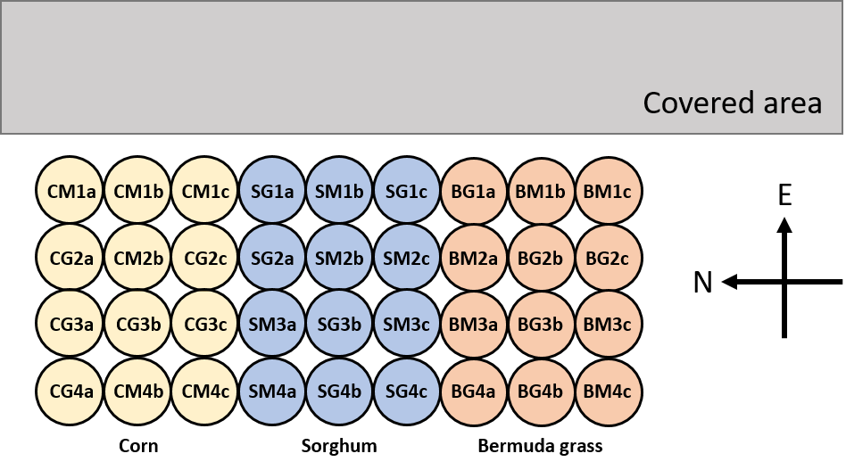
Figure 4: Pot setup and surroundings during full-scale experiment

Full-Scale Planting, Irrigation, and Data Collection
The corn and sorghum seeds were randomly selected from the same batches that supplied the proof-of-concept study. The Bermuda grass seed was purchased from Ellison Feed and Seed in Norman, OK. Each pot received either three corn seeds, three sorghum seeds, or 1 g of Bermuda grass seed. The corn and sorghum pots were trimmed to one plant each after 16 and 28 days, respectively, to mitigate competition between plants for water and nutrients. Groundwater was collected from a well at the ARF in 20-L carboys as often as necessary for irrigation. Treated mine water was collected in 20-L or 60-L carboys from the final outflow of the Mayer Ranch Passive Treatment System, typically during CREW trips to Tar Creek. The plants were irrigated according to crop evapotranspiration calculations provided in the UN FAO Manual for the Design and Construction of Water Harvesting Schemes for Plant Production (Critchley and Siegert, 1991). This manual outlines the process for calculating a crop evapotranspiration value, which fluctuates throughout the growing season. The Oklahoma Mesonet irrigation planner (https://www.mesonet.org/index.php/agriculture/irrigation_planner) was also consulted throughout the experiment, because it generated a daily water budget by comparing crop-specific evapotranspiration to rainfall and recommended appropriate water application rates, taking the weather, species, and growth stage into account (University of Oklahoma, 2020b). Lastly, soil moisture and plant status were observed before each irrigation application and throughout the day, and more water was applied when deemed necessary. During the first three weeks of the study, all plants were watered by hand. Afterward, a drip irrigation system was constructed to ensure that the corn and sorghum pots were watered consistently and throughout the day. Irrigation intervals and durations were controlled by a digital timer, and changed as the plants matured. Groundwater and mine water were stored in 18.9-L buckets adjacent to the pots. The timer controlled the power supply to submersible pumps, which pushed water from the reservoir buckets through 1.3-cm diameter polyethylene tubing. Two 0.64-cm diameter distribution tubes and 1.9-LPH drip emitters supplied each sorghum and corn pot, resulting in a combined flow of 3.8 LPH to every pot. Drip emitter flow rates were periodically collected from multiple pots to track changes in water pressure and dripline clogging. Bermuda grass was exclusively watered by hand because it had a smaller and less variable water demand than either corn or sorghum. Miracle-Gro Water Soluble All Purpose Plant Food 24-8-16 was applied to every pot eight times throughout the study. On days when fertilizer was applied, one tablespoon weighing approximately 12 g was added to 3.78 L of each irrigation water.
Weather and climate data were sourced from the Norman station in the Oklahoma Mesonet system, which reported daily air temperature, soil temperature, and rainfall data. The presence of foreign pests, disease, plants, and animals in the pots was recorded visually and descriptively. Pests were eliminated by physical methods, rather than via chemical controls. Soil temperature, irrigation water quality, and light intensity were monitored over the duration of the experiment. A Photosynthetically Active Radiation (PAR) Meter was employed to track levels of photosynthetic photon flux density (PPFD), or photons with wavelengths between 400 and 700 nm, in μmol/m²/s. The SpotOn Quantum PAR Light Meter also generated a daily light integral (DLI), which is a running 24-hour total of the moles of PAR photons entering the surrounding square meter.
Water quality was monitored on-site with a YSI 600 multiparameter datasonde and 650 MDS controller, which records pH, salinity, TDS, and dissolved oxygen (DO). Total and dissolved metals samples were collected from the irrigation waters and preserved with trace-metal grade nitric acid for trace metals analyses. Prior to acidification, samples for dissolved analyses were filtered with 0.45-µm Whatman nylon membrane filters. A Hach 2100P turbidimeter was used to monitor turbidity (EPA 180.1), and a Hach digital titrator was used to calculate alkalinity (EPA 310.1). Nutrient concentrations were measured with various Hach methods, listed in Table 8 on CREW’s Hach DR2800 Portable Spectrophotometer. Trace metals concentrations were analyzed with EPA Method 6010D on a Varian Vista-PRO Inductively Coupled Plasma – Optical Emission Spectrometer (ICP-OES). ICP-OES trace metal analysis of irrigation water was carried out on aqueous samples that underwent microwave-assisted aqueous digestion according to EPA Method 3015.
Quantity and quality of plants were evaluated through data collection of percent emergence, plant height, growth stage, leaf firing, and above- and belowground biomass production. Corn heights were measured from the base to the apex of the highest leaf with a downward-pointing tip (Pérez-Harguindeguy et al., 2013). This same method was employed in measuring sorghum height, but the apex point of the highest leaf was measured regardless of how the leaf tip was oriented because adult sorghum leaves can be rigid and upright. Bermuda grass growth was assessed by a visual estimation of percent ground coverage on the 0 to 100 scale (Andújar et al., 2010; Lotz et al., 1994). All crops were harvested and analyzed to determine above- and belowground biomass quantity, quality, and total recoverable (bioavailable) metals concentrations. Harvested plants were separated into roots, shoots, leaves, and reproductive structures. Roots were considered belowground biomass, whereas all other plant structures were classified as aboveground biomass. Aboveground biomass was dried to constant weight in forced-air ovens at 80 ℃, while belowground biomass was dried at 105 ℃. Plant biomass remained in the ovens for between 12 and 48 hours, depending on how long the samples were air dried prior to oven drying. Biomass samples were ground and homogenized using a Wiley Mill and Wiley Mini-Mill to a size passing a #40-mesh (0.420 mm) screen. Approximately 0.25 g biomass samples were digested in 10 mL HNO₃ following EPA Method 3052, which describes microwave-assisted organic digestions, and then analyzed with ICP-OES to determine the magnitude of metal uptake in different portions of the plants via EPA Method 6010.
Two replicates from each species-treatment combination were randomly selected for paired sample substrate analysis before and after the study. Potting mix samples from the upper and lower horizons of the subsampled pots were oven dried at 60 ℃ for 24 hours, then ground and homogenized using a Wiley Mill to a size passing a #10-mesh (2 mm) screen. Trace metal concentrations were measured following EPA Method 3051A microwave-assisted solid digestions of 0.5-g samples in 10 ml HNO₃ and ICP-OES analysis (EPA Method 6010). Soil pH was measured in the potting mix samples before and after the study; 5 g composites of substrate from the top and bottom horizons were stirred with 25 mL of distilled water for five minutes and allowed to sit for an hour. pH of the resulting supernatant was measured with a Fisher Accument pH probe (EPA 9045D). The data that were collected over the course of the experiment are listed in Table 8. SPSS and Microsoft Excel were used to perform data analysis, and some data visualization was conducted in R.
Table 8: Data Collection Matrix
 | Parameter | Unit | Method or Instrument
Water Quality | Trace Metals (e.g., Ca, Cd, Fe, K, Mg, Mn, Na, Ni, Pb, S, Zn) | mg/L | EPA 3015A (2007); EPA 6010D (2018)
Water Quality | Nitrate-Nitrogen | mg/L | Hach TNT835
Water Quality | Total Reactive Phosphorus | mg/L | Hach TNT843
Water Quality | Sulfate | mg/L | Hach TNT864
Water Quality | Alkalinity | mg/L as CaCO₃ eq. | EPA 310.1 (1978)
Water Quality | Turbidity | NTU | EPA 180.1 (1993)
Water Quality | pH |  | YSI 600R
Water Quality | Total Dissolved Solids | g/L | YSI 600R
Water Quality | Dissolved Oxygen | mg/L | YSI 600R
Water Quantity | Irrigation Volume | mL
Environmental | Air Temperature | °C
Environmental | Soil Temperature | °C
Environmental | Precipitation | cm
Environmental | Photosynthetic photon flux density | µmol/m2/s | Innoquest, 2020
Environmental | Daily light integral | mol | Innoquest, 2020
Crop Quality | Plant height | m | Pérez-Harguindeguy et al., 2016
Crop Quality | Growth stage | unitless | Abendroth et al., 2011
Crop Quality | Biomass (fresh and dry weight) | g | Pérez-Harguindeguy et al., 2016
Crop Quality | Trace Metals (e.g., Ca, Cd, Fe, K, Mg, Mn, Na, Ni, Pb, S, Zn) | mg/kg | EPA 3051A (2007); EPA 6010D (2018)
Substrate Quality | Trace Metals (e.g., Ca, Cd, Fe, K, Mg, Mn, Na, Ni, Pb, S, Zn) | mg/kg | EPA 3052 (1996); EPA 6010D (2018)
Substrate Quality | Soil pH |  | EPA 9045D

Results and Discussion

Livestock Watering
Livestock reuse of treated mine water is a complex hypothetical informed by science, economics, ethics, and regulatory guidance. This review focused primarily on the scientific and regulatory components, although it delved briefly into the economics of such a proposition as well. An extensive literature review revealed that the Cattle Drinking Water MCLs presented in Table 2 were largely consistent across many different sources (Ayers and Westcot, 1985b; Beede, 2008; Higgins et al., 2008; Olkowski, 2009; Pfost et al., 2001; Sallenave, 2016; USEPA, 2012; Waldner and Looper, n.d.). In the absence of an established toxic concentration, MCLs represent the amount of a chemical that might impact cattle metabolism by interfering with the uptake or usage of other nutrients, or might drive cattle to avoid a water source altogether (Beede, 2008; Olkowski, 2009). Although most water quality constituents in MRPTS outflow were well below MCLs, choosing a single cutoff to describe a recommended concentration for cattle, irrespective of type, maturity, feed, and environment, is rarely possible; therefore, several relatively concerning parameters were specifically addressed (Olkowski, 2009).
Assessing the suitability and safety of reusing MRPTS outflow for livestock watering in the context of certain chemicals like Ca and Mg could require an analysis of diet. Ca and Mg concentrations were within the recommended criteria that have not been known to alter cattle drinking habits or health, but elevated aqueous Ca or Mg concentrations of 1000 and 400 mg/L, respectively, could contribute to potentially toxic levels of the metals in combination with high dietary intake (Beede, 2008; Olkowski, 2009). F⁻ concentrations were also close to the MCL, at which point metabolic disruption or teeth mottling might occur, but the greater concern is chronic fluorosis after months or years of low toxicity exposure (Beede, 2008; Olkowski, 2009; Sallenave, 2016). Mn concentrations at MRPTS were well above the MCL of 0.05 mg/L, which was the recommended level to avoid distribution pipe blockages and prevent taste and odor concerns that might discourage drinking (Beede, 2008; Olkowski, 2009). Such taste and odor precautions address a health concern, but the low drinking water criterion that was exceeded by MRPTS effluent was not indicative of direct toxicity; cattle obtain most Mn in their diets at much higher concentrations from solid food (Olkowski, 2009). Although the PO₄³⁻ concentration in MRPTS discharge exceeded the MCL of 1 mg/L, this concentration was listed as the desirable or expected range from two sources that also noted that a problematic range had not yet been established (Beede, 2008; Pfost et al., 2001). None of the aforementioned metal species posed a serious challenge to the beneficial reuse of passively-treated mine water for livestock watering, however, S was problematic.
Common sulfur species in mine waters include oxidized sulfate (SO₄²⁻), and reduced sulfide (S²⁻, HS⁻ or H₂S), depending on environmental conditions. Sulfate is the dominant S species in the aerated surface water MRPTS discharge; although some sources list a SO₄²⁻ MCL as high as 2000 mg/L and note that cattle seem to adjust to concentrations in that range after some time, calves and pregnant or lactating cows are more sensitive than other cattle to many chemicals including elevated SO₄²⁻ concentrations (Higgins et al., 2008; Olkowski, 2009; Waldner and Looper, n.d.). At around 1000 mg/L, dairy cow milk output and reproduction are negatively affected, and cattle gain less weight in feedlots (Beede, 2008). At 2000 mg/L, cattle may initially exhibit diarrhea and reject the water, but they have been shown to adapt to high SO₄²⁻ levels in the past (Beede, 2008; Waldner and Looper, n.d.). However concentrations around 3000 mg/L have recently been blamed for weight loss and outbreaks of polioencephalomalacia, a central nervous system disorder responsible for myriad neurological damages and documented mortality (Olkowski, 2009; Weeth and Hunter, 1971). Long-term SO₄²⁻ exposure has also been causally linked via copper sulfide formation to Cu deficiencies, which manifest as hair loss, decreased growth and development, and impaired reproduction (Olkowski, 2009). Although ranches certainly exist where cattle drinking water contains elevated SO₄²⁻, the concentrations present in MRPTS discharge are likely dangerously high, and would likely decrease livestock productivity in the long-term.
Agricultural producers can reduce cattle exposure to SO₄²⁻ and other constituents of concern by implementing membrane filtration or ion exchange technologies. Nano-filtration could reduce SO₄²⁻ concentrations at a cost of $45/head/year for a 100 head operation and $20/head/year for a 500 head operation, but most operations would not benefit from economies of scale in polishing a water source; fewer than 25% of Oklahoma cattle operations managed 100 or more head in 2017 (Olkowski, 2009; USDA, 2019). Alternatively, treated mine water could provide a secondary water source to supplement an existing supply and thereby dilute SO₄²⁻ accumulations, but unless the waters were blended it is possible that cattle would reject MRPTS water in favor of the alternative. Without additional treatment or contaminant mitigation, treated mine water would not be recommended for calves or pregnant or lactating cows, so calculations of Ottawa County cattle water demand excluded these more sensitive groups.
MRPTS discharges approximately 1000 L/min with some seasonal variation influenced by precipitation and the mine pool elevation (ITRC, 2013). This substantial flow was compared to the estimated drinking water demands of Ottawa County cattle using population data from 2019 Oklahoma Agriculture Statistics and water intake estimations based on Oklahoma Mesonet weather data and a cattle water use model developed by the National Academy of Sciences, Engineering, and Medicine (NASEM, 2015; University of Oklahoma, 2020a; USDA, 2019). USDA (2019) provided three data points by county and year over the previous three years: quantities of all cattle and calves, all beef cows, and all milk cows. The quantity of interest was the number of cattle excluding calves and milk cows, so statewide totals that divided all cattle and calves into sub-classifications were used to estimate the amounts of Ottawa County cattle classified as beef cows, steers, heifers, or bulls. These data are presented in Table 9. The mean quantity of Ottawa County beef cows, steers, heifers, and bulls across 2017, 2018 and 2019 was 44386 head.
Table 9: Ottawa County cattle population
Class | 2017 | 2018 | 2019 | Mean
Beef cows | 29000 | 26500 | 27500 | 27667
Milk cows | 200 | 200 | 200 | 200
Steers, heifers, bulls | 14005 | 17804 | 18351 | 16720
Calves | 6295 | 7496 | 7949 | 7247
Beef cows, steers, heifers, and bulls | 43005 | 44304 | 45851 | 44386
All cattle | 49500 | 52000 | 54000 | 51833

The collective water demand of the chosen cattle population was estimated by month from an assumed average cattle bodyweight and a variety of environmental parameters. Because calves were excluded, an average Oklahoma cattle live weight of 500 kg was assumed; this number was multiplied by a conversion factor of 0.96 to estimate shrunk bodyweight (SBW), 479 kg, which accounts for food being actively digested (Lalman, 2018; Ward et al., 2017). Monthly temperature (Tc), relative humidity (RHc), wind speed (WS), and sunshine hours (HRS) were collected or estimated from the Miami Mesonet station’s long-term 2005-2019 averages (University of Oklahoma, 2020a). These environmental parameters were used in calculating the Current Effective Temperature Index (CETI), per Equation 3 (NASEM, 2015). Using Equation 4, the water intake (WI) was estimated by month for the mean 2017-2019 population of beef cows, steers, heifers, and bulls in Ottawa County; these monthly data are found in Table 10 (NASEM, 2015). The 1000 L/min discharge from MRPTS translates into a daily flow of 1440000 L/d, which exceeded daily water intake of Ottawa County cattle from December through February, was approximately 400000 L less than average monthly WI, and represented 40% of peak WI in July. In summary, MRPTS produces a substantial amount of treated mine water relative to the water demand of Ottawa County cattle, and could therefore be considered for future beneficial reuse on the basis of water quantity.
However, water quality improvement and transportation currently serve as financial and logistical obstacles. Although passive treatment is generally more economical than active treatment, the cost of water transport to end users via piped systems or trucks cannot be disregarded (Ford, 2003). Pipeline construction, while cheaper than trucking, still represented the largest capital expense of two reclaimed water treatment systems in Nevada (Plappally and Lienhard, 2012). Supplying the Ottawa County cattle water demand with reclaimed water would require substantial capital investments, and the elevated SO₄²⁻ concentrations render this water unsavory if not unsafe for cattle consumption. Economic and health concerns currently constitute a compelling case against the reuse of passively-treated mine water for livestock drinking, but the livestock reuse scenario should be reevaluated in the future as advancements in treatment technologies and fluctuations in water supply and demand inform water reclamation practices.

$$CETI=27.88-0.456×Tc+0.010754×{Tc}^{2}-0.4905×RHc+0.00088×{RHc}^{2}+1.1507×\frac{WS}{3.6} -0.126447×{\left(\frac{WS}{3.6}\right)}^{2}+0.019867×Tc×RHc-0.046313×Tc×\frac{WS}{3.6}+0.41267×HRS$$
Equation 4
Equation 3
$$WI \left(\frac{L}{d}\right)= 7.3+0.0805×SBW-0.00008×{SBW}^{2}-1.225×CETI+0.0411×{CETI}^{2}+0.0023268×SBW×CETI$$

Table 10: Environmental parameters and water intake calculations for Ottawa County cattle
Parameter | January | February | March | April | May | June
Temp (℃) | 2.22 | 3.89 | 10.00 | 15.00 | 19.44 | 25.00
RHc (%) | 70.00 | 70.00 | 67.00 | 67.00 | 75.00 | 74.00
WS (mph) | 9 | 9 | 9 | 9 | 8 | 7
Sunshine (%) | 59 | 58 | 56 | 58 | 60 | 69
HRS (hr) | 14.16 | 13.92 | 13.44 | 13.92 | 14.4 | 16.56
CETI | 7.66 | 9.04 | 15.27 | 20.61 | 26.09 | 34.82
WI (L/d) | 29.07 | 29.86 | 35.40 | 42.68 | 52.59 | 73.49
Ottawa County WI (L/d) | 1290287 | 1325430 | 1571207 | 1894434 | 2334503 | 3261760
Parameter | July | August | September | October | November | December | Average
Temp (℃) | 26.67 | 25.56 | 21.67 | 15.00 | 8.89 | 3.33 | 14.44
RHc (%) | 71.00 | 72.00 | 75.00 | 73.00 | 69.00 | 74.00 | 71.00
WS (mph) | 6 | 6 | 6 | 7 | 8 | 8 | 8
Sunshine (%) | 70 | 67 | 69 | 66 | 64 | 52 | 62
HRS (hr) | 16.8 | 16.08 | 16.56 | 15.84 | 15.36 | 12.48 | 14.88
CETI | 37.03 | 35.28 | 30.22 | 21.04 | 14.56 | 6.64 | 20.11
WI (L/d) | 79.78 | 74.77 | 61.71 | 43.38 | 34.61 | 28.58 | 41.90
Ottawa County WI (L/d) | 3541222 | 3318568 | 2738940 | 1925384 | 1536302 | 1268717 | 1859893

Proof-of-Concept Experiment

Seedling Emergence
Emergence occurs when a seedling pushes through the soil surface in search of light. Emerged seedlings were counted every one or two days during the proof-of-concept experiment; therefore, the change in emergence percentage from one observation to the next reflects the increase in seedlings that sprouted during that time interval. Sorghum and corn exhibited similar overall seedling emergence rates, which are visible in Figure 5. Cumulative corn emergence lagged behind sorghum emergence. Maximum sorghum emergence of 92% was reached eight days after planting. Maximum corn emergence of 81% occurred 11 days after planting. 1.9% of Indiangrass seeds sprouted over the 13-day period. Photos of the progression of the proof-of-concept experiment are provided in Figure 6.

Figure 5: Proof-of-concept seedling emergence by species

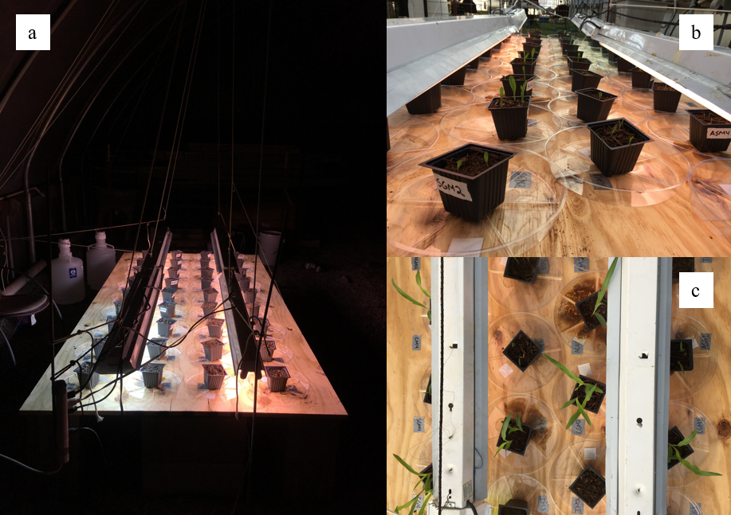
Figure 6: The greenhouse proof-of-concept experiment on (a) day 0, (b) day 8, and (c) day 13

The cumulative emergence curves for groundwater-irrigated corn (CG) and mine water-irrigated corn (CM) are plotted together in Figure 7. The first CG and CM sprouts appeared five days after planting. After two days of rapid emergence, emergence rates for CG and CM decreased to zero by days 11 and 13, respectively. A cumulative 79% of CG seeds and 83% of CM seeds sprouted over the course of the experiment, and at least one seed sprouted in every CG and CM pot. The cumulative emergence curves for groundwater-irrigated sorghum (SG) and mine water-irrigated sorghum (SM) are plotted together in Figure 8. The first SG sprout appeared four days after planting while the first SM plants emerged five days post-planting. SG and SM emergence rates decreased to zero on day eight after 92% of seeds from both groups had emerged, but SM emergence rates appeared to lag behind SG during the period of rapid emergence. Similar to corn, every SG and SM pot contained at least one seedling by day 13.
Figure 9 plots the emergence curve for corn and sorghum seeds planted in spent mushroom compost (SMC) amended soil alongside the emergence curve for corn and sorghum grown in non-amended potting mix. Although three Indiangrass pots were amended with SMC, the resulting emergence data are omitted from the comparison due to the general absence of Indiangrass germination. The non-amended soil produced corn and sorghum seedlings earlier than the amended soil, but by day seven approximately 75% of corn and sorghum seeds had emerged in both amended and non-amended pots. 89% of corn and sorghum seeds planted in amended soil and 85% of corn and sorghum seeds planted in non-amended soil sprouted over the course of the experiment, and at least one seed sprouted in every amended and non-amended pot.

Figure 7: Cumulative corn emergence during groundwater and mine water irrigation

Figure 8: Cumulative sorghum emergence during groundwater and mine water irrigation

Figure 9: Cumulative corn and sorghum emergence in amended and non-amended soil

The temporal nature of seed germination and emergence is characterized by an initial delay, a period of rapid expansion, and a leveling off. Because calculating and describing final germination percentages captures only a small portion of the holistic emergence pattern, Kaplan-Meier survivor functions were computed, plotted, and compared using the non-parametric log-rank test in Excel. The survivor function is a form of time-to-event analysis in which S(t) represents the probability that an event occurs after a given time (McNair et al., 2012). The Kaplan-Meier estimate of the survivor function $\hat{S}\left(t\right)$ calculates a cumulative distribution function (CDF) for count data without assuming a particular distribution (Helsel, 2005). The Kaplan-Meier estimate is presented in Equation 5; d_{i} represents the number of seeds that emerge at time t_{i}, and n_{i} is the number of non-emerged viable seeds just before t_{i} (McNair et al., 2012) .
Equation 3
Equation 5
$$\hat{S}\left(t\right)=\prod_{i:t_{i}<t}{\left(1-\frac{d_{i}}{n_{i}}\right)}$$
At time 0, when no seedlings have emerged, $\hat{S}\left(0\right)=1$. The survival function, or the probability that a seed sprouts at a later time, decreases in a step-wise manner with each recorded emergence after an initial delay inherent to seed germination. The log-rank test evaluates the null hypothesis (H₀) that the survival curves for two groups of seeds are the same by comparing the groups’ values of d_{i} and n_{i}. The survival curves for CG and CM plotted in Figure 10 are not significantly different at an alpha level of 0.05 (p = 0.968). Likewise, the survival curves for SG and SM plotted in Figure 11 are not significantly different at an alpha level of 0.05 (p = 0.871). Because irrigation treatment did not have a significant effect on the temporal emergence patterns of corn or sorghum seedlings during the proof-of-concept greenhouse experiment, the proposed “combination” treatment of irrigating with groundwater until emergence and then switching to mine water to overcome a mine water-induced germination bottleneck would not be necessary during the full-scale experiment. Per Figure 12, the survival curves for corn and sorghum seeds planted in amended and non-amended soil are not significantly different at an alpha level of 0.05 (p = 0.702). The addition of SMC to potting mix visibly increased soil moisture content in the amended pots when compared to non-amended pots; the surface and subsurface of the amended soil remained moist to the touch between watering events, whereas the non-amended potting mix drained and dried out between irrigation water applications. However, SMC-amended substrate did not have a significant effect on corn and sorghum seedling emergence patterns when compared to non-amended substrate.

Figure 10: Corn survival curves during groundwater and mine water irrigation

Figure 11: Sorghum survival curves during groundwater and mine water irrigation

Figure 12: Corn and sorghum survival curves in amended and non-amended substrate

Assessment of Grass Germination
Of the 108 Indiangrass seeds planted during the proof-of-concept greenhouse experiment, only two germinated and emerged. The cause of this germination bottleneck was unclear, but a variety of possible reasons were proposed: sterile seeds, irrigation water quality, substrate quality, or environmental conditions inside the greenhouse. The follow-up experiment compared 180 Bermuda grass seeds planted alongside 180 Indiangrass seeds, which were divided evenly between topsoil and potting mix and irrigated with groundwater four times over a ten day period. By the tenth day, none of the Indiangrass seeds planted in topsoil emerged and only one (0.6%) of the potting mix seeds sprouted. Bermuda grass exhibited much higher emergence rates in both topsoil (28.3%) and potting mix (51.1%). Because the available batch of Indiangrass seed was not viable under the experimental conditions, Bermuda grass replaced Indiangrass in the full-scale experiment. As seen in Figure 13, the potting mix produced noticeably taller Bermuda grass seedlings than the topsoil likely because the high porosity of potting mix promoted rapid root growth and aeration (Houseal et al., 2007).
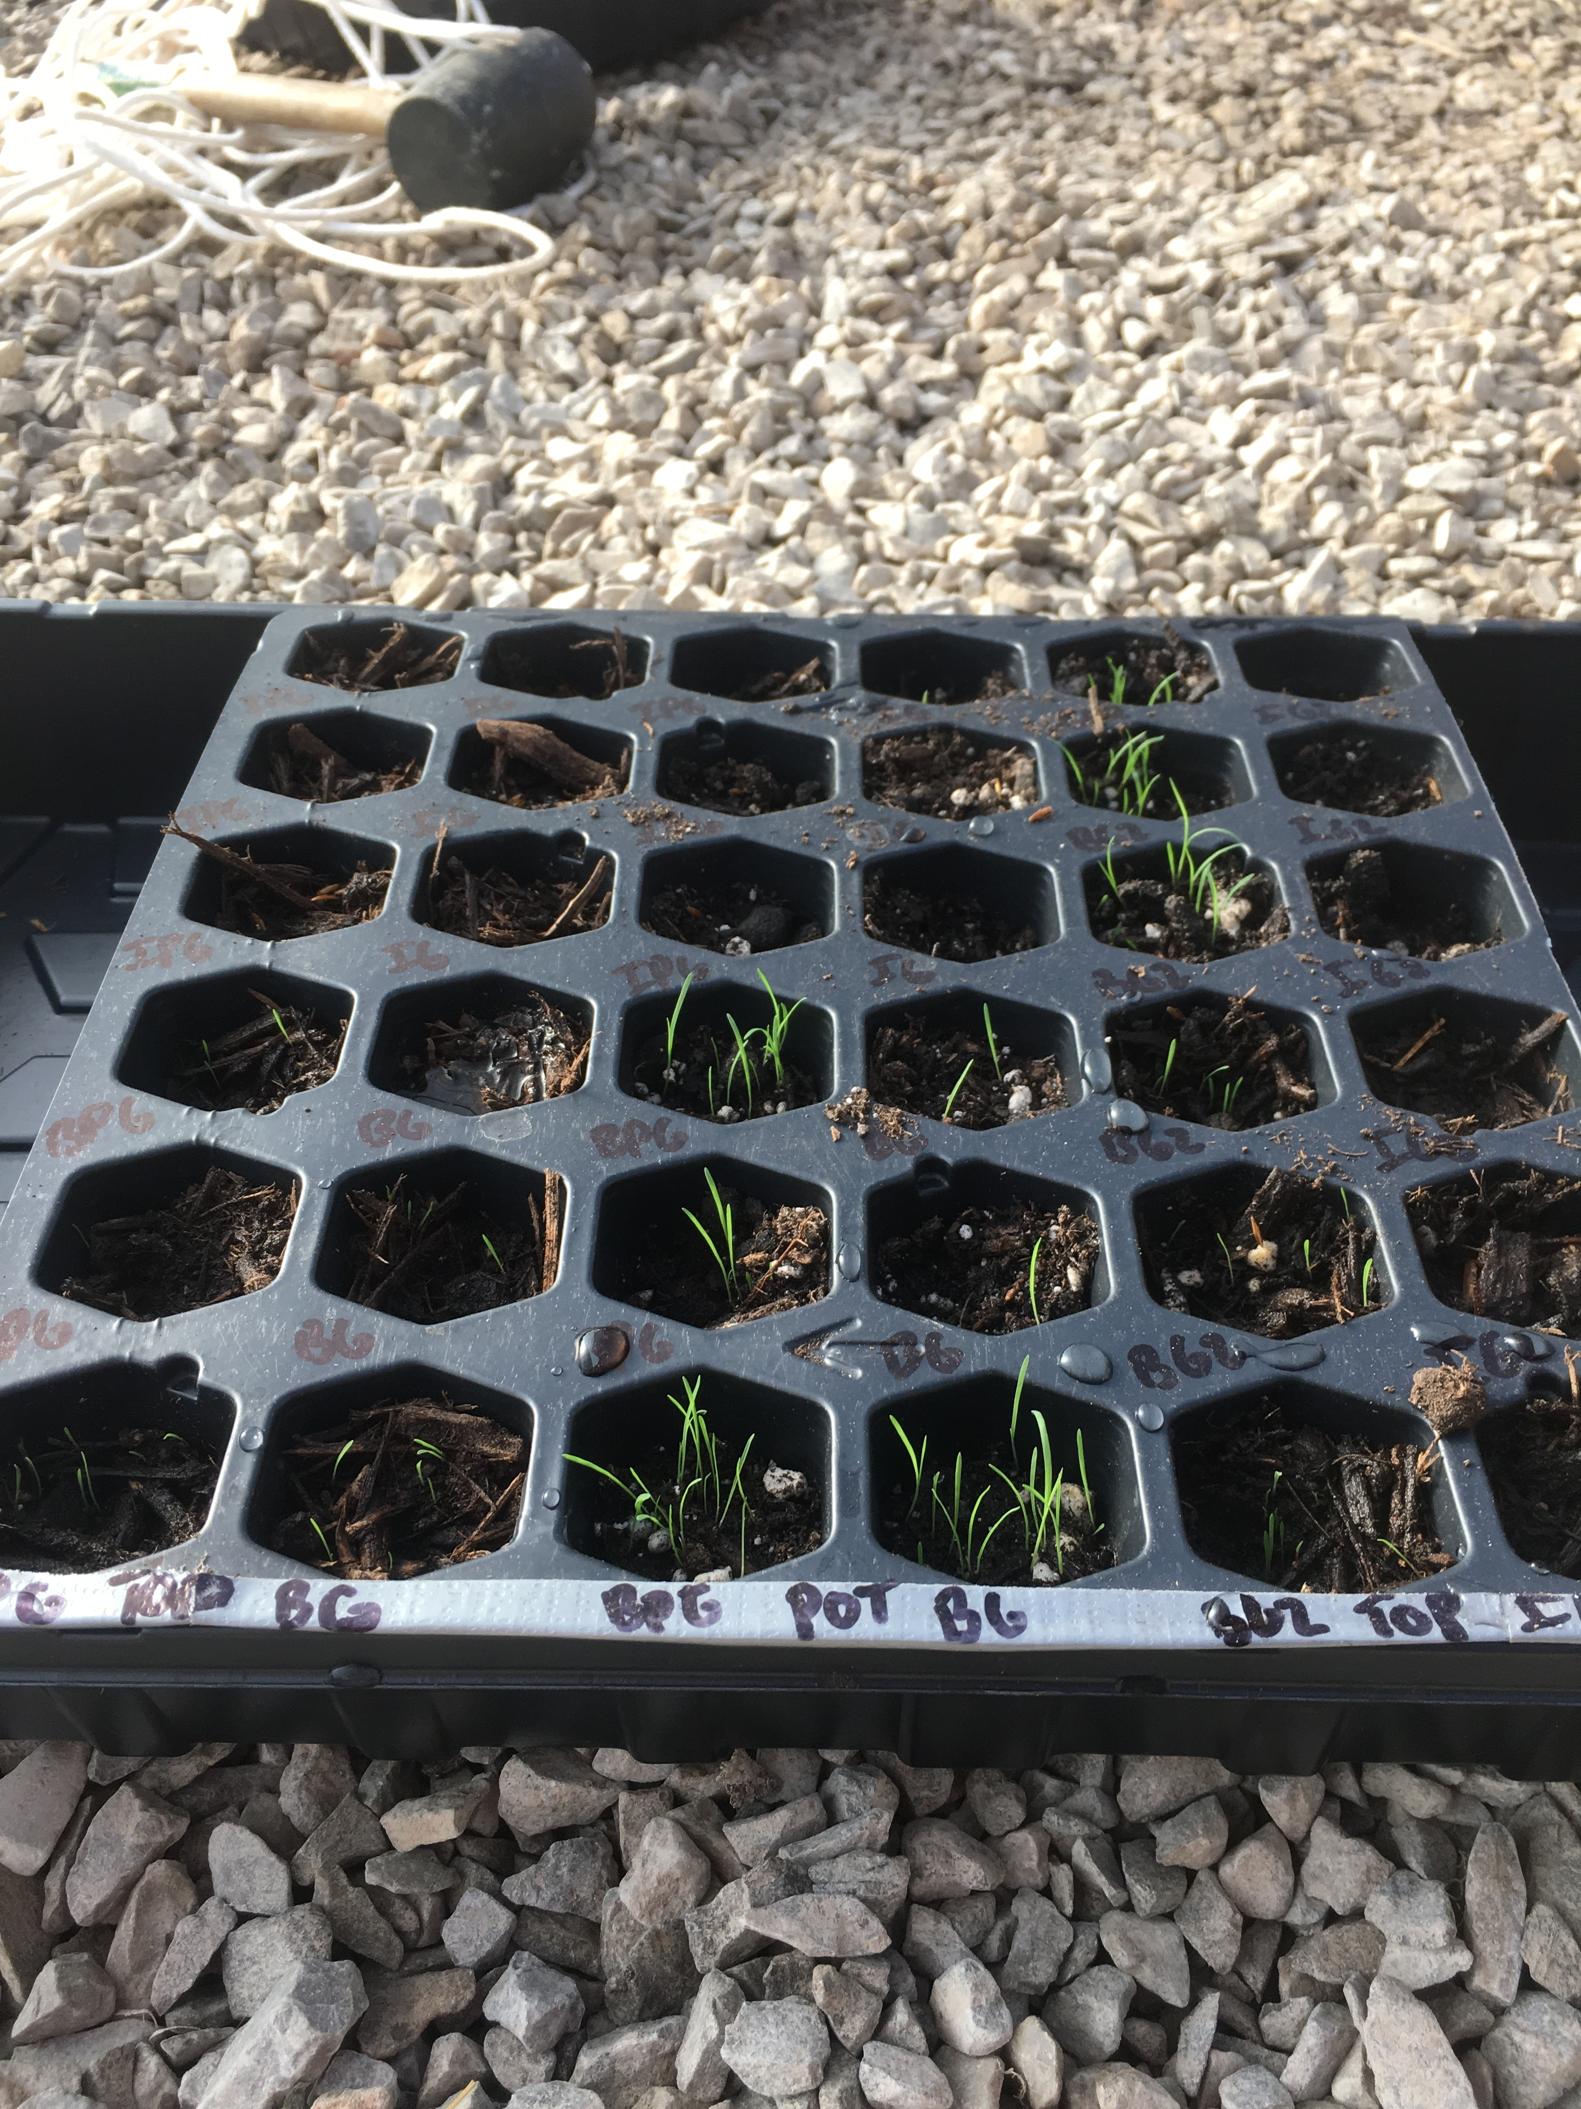
Figure 13: Indiangrass and Bermuda grass ten days after planting

Full-scale Plant Growth Experiment

Daily Light Integral (DLI)
Wavelengths in the visible portion of the electromagnetic spectrum, located between 400 and 700 nm, are conventionally referred to as photosynthetically active radiation (PAR) (Mõttus et al., 2011; Torres et al., 2012). The photons of PAR that are absorbed by vegetation provide a critical input to be converted into chemical energy during photosynthesis. PAR expresses the quantity of photons with wavelengths between 400 and 700 nm that impact an area in a given time frame, and is often measured in units of µmol/m²/s (Torres et al., 2012). PAR is an instantaneous measurement but it can be easily converted into the daily light integral (DLI), which relates the total PAR contacting a square meter over a 24-hour period in mol/m²/d. The DLI values recorded over the duration of the experiment are provided in Figure 14.

Figure 14: Daily light integrals of photosynthetically active radiation during the full-scale experiment

The cluster of DLI values below 10 mol/m²/d during the first two weeks were recorded underneath a covered carport, which protected the seeds from being dislodged by rain and facilitated the hanging of a mosquito net to exclude pests. Once the pots were moved into direct sunlight shortly after the summer solstice, DLI spiked to a maximum of 44.1 mol/m²/d followed by a gradual decline as the sun rose later and set earlier in the day. DLI is strongly influenced by weather conditions, which can explain much of the variability between adjacent DLI measurements. Excessive light and elevated DLIs were not prominent concerns during this experiment because corn, sorghum, and Bermuda grass can mitigate inefficient photorespiration under full sunlight through the C4 photosynthetic pathway (Australian OGTR, 2008; Schmer et al., 2012; Sushil et al., 2017). Conversely, extended periods of low-light conditions later in the growing season can be problematic for plant growth, but even overcast skies during the experiment transmitted sufficient solar radiation for plant growth prior to September (Eddy and Hahn, 2013). Whereas some specialized plant growth chambers maintain DLI upwards of 50 mol/m²/d to take advantage of corn’s C4 photosynthetic pathway, researchers have reported that corn can grow and reproduce at much lower values (Eddy and Hahn, 2013). Greenhouse-grown corn has produced above-average yields at DLI as low as 8 to 10 mol/m²/d, but tassel development in some corn lines can suffer when the DLI falls below 23.7 mol/m²/d for a week or longer (Eddy and Hahn, 2013; Trecker, 2018). Because the corn pots were moved into direct sunlight before the onset of tassel development, which takes place between vegetative stages 5 (V5) and 7 (V7), it is unlikely that spending the first two weeks after sowing under shade negatively impacted tassel development. The first tassel appeared 65 days after planting, and by day 79 every corn plant was visibly tasseling (VT) or farther along in the reproductive growth stages. The first time that recorded DLI measurements dropped below 23.7 mol/m²/d for a week or longer began on day 78. Therefore, tassel development during the vegetative growth stages should not have been limited by the availability of PAR.

Temperature and Growing Degree Units
Corn, the most heat- and drought-sensitive of the three plants examined, can tolerate temperatures between 8 ℃ and 40 ℃ although pollen viability and grain yield are negatively affected by temperatures greater than 35 ℃ or less than 15 ℃ (Australian OGTR, 2008; Sushil et al., 2017; Vandevender, 2006). Sorghum and Bermuda grass can accommodate more extreme temperatures and drought; this spectrum of tolerances was visible in plant behavior during hot days in July and August, when leaves on many or all of the corn plants rolled up as seen in Figure 15 (Assefa et al., 2010; Vandevender, 2006). This adaptation, which reduces the surface area of leaves exposed to the sun in an effort to reduce water loss via evapotranspiration, was also present in some sorghum plants, albeit less frequently than in corn (Assefa et al., 2010; Lauer, 2003). Moving the plants out of direct sunlight completely reversed leaf roll after eight to ten minutes, but this sort of micromanagement is time-consuming and dramatically reduces PAR. Leaf roll is a visible indicator of drought stress, which was likely initiated or exacerbated by constriction of the root systems inside the pots. Corn and sorghum roots can reach depths of 1 to 2.5 m, can reliably source soil water from depths of approximately 1 to 1.5 m, and can extend outwards by more than a meter in search of soil moisture; inside the pots, root growth was restricted to approximately 0.006 m³ and could not access soil moisture reserves in the subsurface soil horizons (Assefa et al., 2010; Dial, 2012; Duncan et al., 2007; Ross, 1997). Furthermore, potting mix is quick-draining and porous by design. Irrigating once in the early morning or late evening resulted in excessive water loss to evaporation and drainage. To ensure that the plants had access to water throughout the day, daily irrigation volumes were divided and applied at multiple times over the course of the mornings and afternoons per Purdue University Plant Growth Facility recommendations, but no modification of irrigation techniques completely eliminated corn leaf roll when temperatures approached 35 ℃ (Rink et al., 2010). Because leaf roll manifested similarly in the mine water and groundwater irrigated plants, drought stress by proxy might have been a function of water quantity, root constriction, and air temperature, rather than water quality.
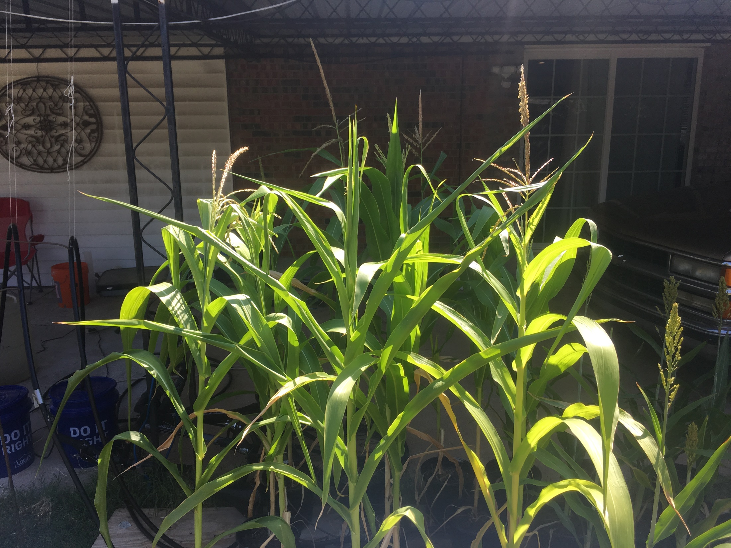
Figure 15: Rolling corn leaves were an indicator of drought stress

Selected descriptive statistics for average air temperature and GDU are presented in Table 11, and daily minimum and maximum air temperatures are plotted alongside GDUs in Figure 16. Air temperatures rose above 35 ℃ on 12 days, mainly during mid-July and early August, and never fell below 8 ℃. Relative humidity dropped below 40% during nine consecutive days in mid-August, just as many of the corn and sorghum plants were undergoing critical reproductive stages: tassel emergence and ear development in the corn and panicle emergence (heading) and flowering in the sorghum. In total, 1565 GDUs accumulated between planting and harvesting. This accrual of temperature units exceeded the cumulative GDUs estimated in Table 7 for maturation of mid-season corn, short-season sorghum, and an established Bermuda grass crop by 5.6%, 6.6%, and 65%, respectively.
Table 11: Descriptive statistics for average daily air temperature and GDU
 | Average Daily Air Temperature (℃) | GDU (℃)
Minimum | 11.82 | 2.29
Maximum | 30.33 | 18.31
Mean | 25.59 | 14.49

Figure 16: Daily temperature extremes and GDUs

Irrigation and Precipitation Quantities
All plants were hand-watered for the first three weeks of the experiment. Following installation of the drip-irrigation system, corn and sorghum received automated pump irrigation for the remainder of the growing cycle. Bermuda grass pots were not attached to the irrigation system because they required much less water than sorghum or corn, which had similar water demands. The volumes of groundwater and mine water applied each day fluctuated in accordance with UN FAO growth stage-modified irrigation recommendations, Oklahoma Mesonet Irrigation Planner recommendations, air temperature, soil moisture content, plant health, and past or forecasted precipitation events, but groundwater and mine water pots within each species always received the same irrigation volumes on any given day (Critchley and Siegert, 1991; University of Oklahoma, 2020b).
Estimations of cumulative irrigation and precipitation quantities are presented in Table 12. Field corn requires a reported 56 to 76 cm of water to reach maturity; sorghum seasonal water demand is between 45 and 65 cm (Assefa et al., 2010; Duncan et al., 2007; New, 2004). Bermuda grass is deep-rooted for a forage grass, and the plant’s ability to draw from soil water reserves has led some researchers to report annual minimum irrigation requirements as low as 16.3 to 22.4 cm, but the total annual water demand of Bermuda grass in arid environments can reach 131 cm (Fu et al., 2004; Garrot and Mancino, 1994). The corn and sorghum pots received average and high irrigation volumes, respectively, when compared to the recommended ranges. When precipitation is included in the total water supply, all three species were operating at a theoretical water surplus. However, the precipitation events were not evenly distributed throughout the growing season; once the pots were saturated during multi-day storm clusters, further precipitation continued to recharge the soil water and water table but was not accessible to the plants. Upon first examination, it may appear that precipitation accounted for almost one-third of the corn and sorghum water supply and over half of the Bermuda grass supply, but the enhanced drainage of the aboveground pot experiments renders precipitation far less impactful insofar as water quantities are concerned.

Table 12: Estimated irrigation and precipitation quantities per pot
 | Irrigation |  |  |  |  | Precipitation
Quantity | Corn | Sorghum | Bermuda grass |  |  | Precipitation
Depth (cm) | 64.16 | 63.35 | 26.97 |  |  | 25.81
Volume (L) | 20.81 | 20.54 | 8.75 |  |  | 8.37
Irrigation + Precipitation (cm) | 89.98 | 89.15 | 52.78
Irrigation + Precipitation (L) | 29.18 | 28.91 | 17.12

Fertilizer
To address nitrogen deficiencies observed in corn and sorghum plants, Miracle-Gro Water Soluble All Purpose Plant Food 24-8-16 was applied in manufacturer-recommended intervals and amounts eight times to every plant during the growing season at the recommendation of Cleveland County Extension Office agriculture specialists. Despite these regular applications of urea, which is the recommended nitrogen source for fertilizer application with irrigation, the symptoms of nitrogen deficiency – inverted v-shaped yellowing beginning in the lower leaves (Figure 17), late onset of flowering, and stunted ears – were witnessed in every corn plant (Australian OGTR, 2008).
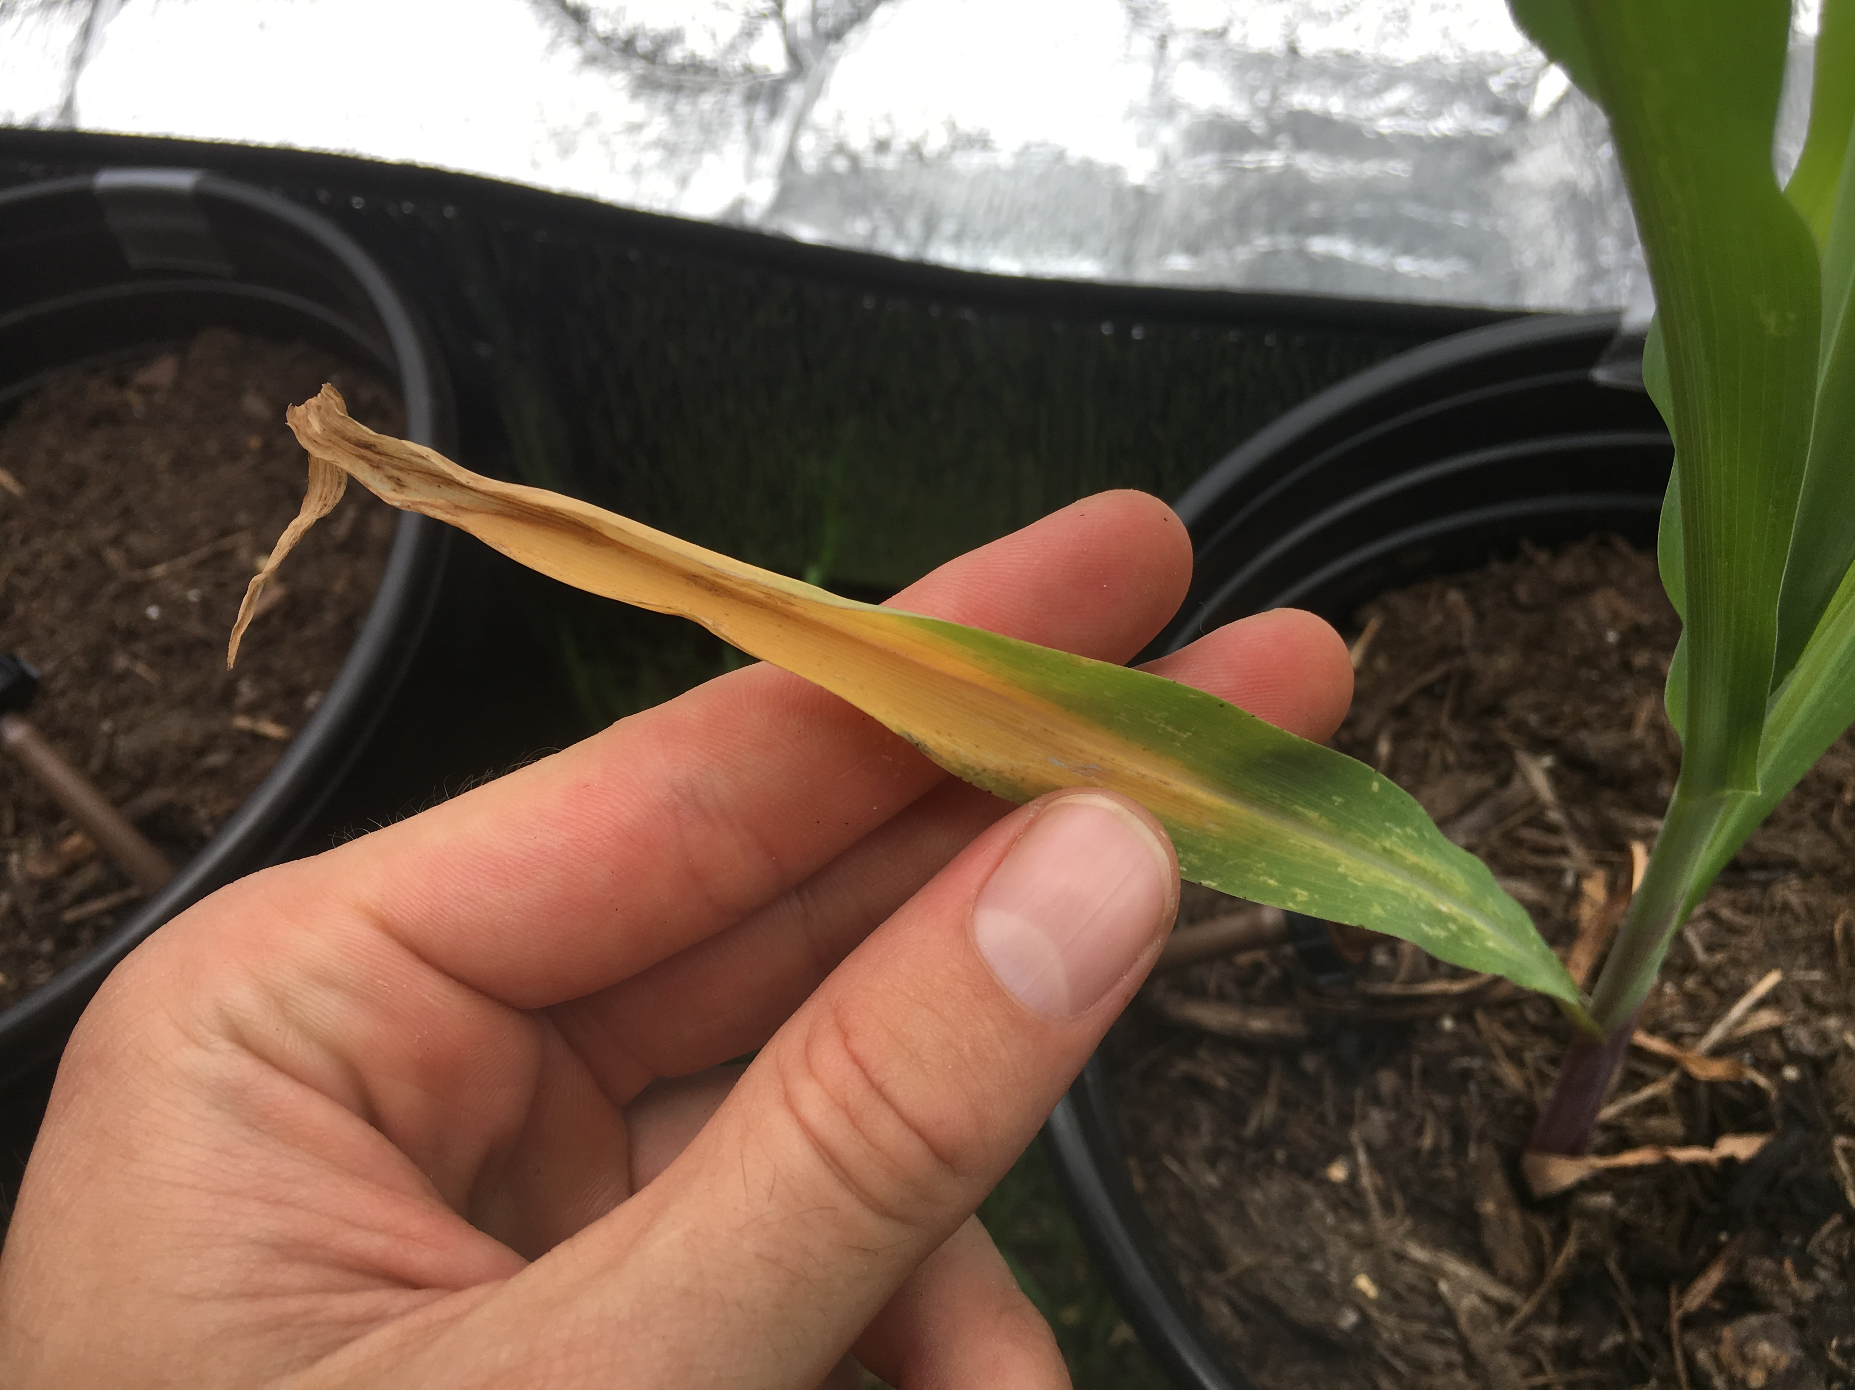
Figure 17: Inverted v-shaped yellowing of lower corn leaf indicative of nitrogen deficiency

Concentrations from the “guaranteed analysis” of macro- and micronutrients were provided on the fertilizer’s packaging. Concentrations of “reported metals” that must be below regulatory limits were found online (WSDA, 2020). Total mass loadings were estimated from the nutrient and metal concentrations in the fertilizer, the manufacturer-recommended dilution rate, and the plant-specific volumes of irrigation water that were spiked with fertilizer and applied by hand. The mass loadings of all guaranteed and reported nutrients and metals can be found in Table 13. Aqueous nutrient concentrations in irrigation waters spiked with fertilizer could not be measured via available spectrophotometric methods because the fertilizer salts substantially altered water color. Mass loadings from fertilizer applications were higher than the mass loadings from both irrigation waters for every element included in the “guaranteed analysis.” Conversely, mass loadings from fertilizer applications were lower than the mass loadings of every “reported metal” that was present in measurable concentrations from both irrigation waters, namely Cd, Co, Ni, and Pb.
Table 13: Miracle-Gro Water Soluble All Purpose Plant Food 24-8-16 estimated mass loadings per pot
 | Parameter | Corn (mg) | Sorghum (mg) | Bermuda grass (mg)
Guaranteed Analysis | N | 1638 | 1600 | 861.0
Guaranteed Analysis | P | 238.2 | 232.7 | 125.2
 | K | 906.4 | 885.3 | 476.4
 | B | 1.365 | 1.333 | 0.717
 | Cu | 4.778 | 4.667 | 2.511
 | Fe | 10.238 | 10.000 | 5.381
 | Mn | 3.413 | 3.333 | 1.794
 | Mo | 0.034 | 0.033 | 0.018
 | Zn | 4.095 | 4.000 | 2.152
Reported Metals | As | 0.00597 | 0.00583 | 0.00314
Reported Metals | Cd | 0.00040 | 0.00039 | 0.00021
 | Co | 0.00102 | 0.00100 | 0.00054
 | Hg | 0.00004 | 0.00004 | 0.00002
 | Ni | 0.00349 | 0.00341 | 0.00183
 | Pb | 0.00102 | 0.00100 | 0.00054
 | Se | 0.00597 | 0.00583 | 0.00314

Irrigation Water Quality
A suite of total and dissolved metals was measured periodically throughout the experiment, and the dissolved concentrations of 11 metal species of particular importance are compared across irrigation waters in Table 14. Elements were chosen to represent all of the macronutrients as well as a selection of micronutrients and non-essential elements that are targeted for removal from mine water at MRPTS and can produce toxic responses in plants. The dissolved fractions are displayed because they are generally more mobile and bioavailable than their particulate counterparts (John and Leventhal, 2004). A variety of two-tailed hypothesis tests for two independent samples were considered for comparing ARFGW and MRPTS irrigation waters, and the appropriate parametric or nonparametric test was selected based on normality of the data, homogeneity of variances, and the presence of outliers. Normality was assessed through an inspection of box plots and the Shapiro-Wilk test; a significant p-value (p ≤ 0.05) indicated non-normality. Homogeneity of variances could be assumed with a non-significant p-value (p ≤ 0.15) from Levene’s test for equality of variances based on group means. The presence of outliers was noted in the box plots. If all three assumptions were satisfied, a Student’s t-test was used to compare structural biomass. If normality was assumed and no outliers were present but homogeneity of variances was not satisfied, Welch’s t-test for unequal variances was used. If the data were non-normal, variances were unequal, and outliers were present, the Mann-Whitney U test was carried out.
The six macronutrients – Ca, K, Mg, S, NO₃⁻-N, and orthophosphate – are used by plants in relatively large amounts. Of these macronutrients, concentrations of four species were significantly different in the two irrigation waters at an alpha level of 0.05 (Ca, Student’s t-test, p < 0.001; K, Mann-Whitney U test, p < 0.001; Mg, Welch’s t-test, p < 0.001; S, Welch’s t-test, p < 0.001). Because K, N, and P mass loadings from irrigation water were substantially smaller than their mass loadings from fertilizer applications, associated toxicity, which was not witnessed in any plants, would have nonetheless been the result of over-fertilization. The secondary macronutrients – Ca, Mg, and S – were well above irrigation criteria in the treated mine water and approached irrigation criteria in the groundwater. Although elevated concentrations of Ca, Mg, and S are not commonly associated with direct toxicity in plants, they can directly and indirectly affect plant health by suppressing growth and fruiting and influencing soil structure (Ayers and Westcot, 1985a; McCauley et al., 2011; Pearson, 2003; Richards, 1954; Ward, 1976).
The micronutrients – Fe, Mn, Ni, and Zn – are beneficial for plants in small quantities but can become toxic influences at elevated concentrations (McCauley et al., 2011). However, these particular micronutrients are efficiently sequestered during treatment at MRPTS and were within recommended irrigation criteria in both water sources. Of the four micronutrients, only Ni concentrations were significantly different between irrigation waters (Welch’s t-test, p = 0.003). Furthermore, with the exception of Ni, fertilizer was responsible for the majority of micronutrient mass loading. In one sense, the use of fertilizer obscured the treatment effect, but this ambiguity is indicative of the irrigation waters’ low micro-mineral and nutrient concentrations and minimal irrigation-induced toxicity risk – not of abnormal fertilization practices – although direct comparison of these results to field-scale agricultural practices warrants more study. The non-essential elements (Cd, Pb, and Na) were predominantly contributed on a mass-load basis by the irrigation waters – not the fertilizer – albeit at concentrations below irrigation criteria. Furthermore, Cd concentrations in both irrigation waters were below the PQL (practical quantitation limit) but were above the method detection level (MDL) in all MRPTS samples and in half of the ARFGW samples; per EPA recommendation, concentrations above the MDL but below the PQL were reported to communicate the relative presence of Cd in both irrigation waters (USEPA, 2006). Alkalinity as CaCO₃ was significantly different in the irrigation treatments (Mann-Whitney U test, p = 0.001), and the mean groundwater concentration exceeded the irrigation criterion.

Table 14: Dissolved metals, anions, and physicochemical parameters measured in the irrigation waters
Parameter |  | ARFGW | MRPTS | p | Irrigation Criteria
Dissolved metals (mg/L) | Ca | 94.2 ± 59.8 | 608 ± 29.3 | < 0.001 ª | 40-100⁴
Dissolved metals (mg/L) | Cd | 0.0004 ± 0.0001 | 0.0007 ± 0.0001 | 0.009 ª | 0.01^{1,2,3}
Dissolved metals (mg/L) | Fe | 0.014 ± 0.010 | 0.014 ± 0.010 | 0.992 ª | 5.0^{1,2,3}
Dissolved metals (mg/L) | K | 2.55 ± 1.19 | 21.4 ± 2.21 | < 0.001 ^{c} | 25
Dissolved metals (mg/L) | Mg | 31.3 ± 1.92 | 140 ± 15.0 | < 0.001 ^{b} | 30-50⁴
Dissolved metals (mg/L) | Mn | 0.002 ± 0.003 | 0.029 ± 0.042 | 0.081 ^{c} | 0.2^{1,2,3}
Dissolved metals (mg/L) | Na | 33.4 ± 1.38 | 84.8 ± 5.43 | < 0.001 ^{b} | See Table 4
Dissolved metals (mg/L) | Ni | 0.034 ± 0.002 | 0.113 ± 0.042 | 0.003 ^{b} | 0.2^{1,2,3}
Dissolved metals (mg/L) | Pb | 0.048 ± 0.016 | 0.172 ± 0.128 | 0.463 ^{c} | 5^{1,2,3}
Dissolved metals (mg/L) | S | 20.4 ± 2.45 | 747 ± 55.2 | < 0.001 ^{b} | >17⁴
Dissolved metals (mg/L) | Zn | 0.026 ± 0.022 | 0.015 ± 0.004 | 0.606 ^{c} | 2.0^{1,2,3}
Anions (mg/L) | NO₃-N | 6.02 ± 2.06 | BDL
 | PO₄³⁻ | 0.394 ± 0.066 | 0.602 ± 0.361 | 0.690 ^{c}
Alkalinity (mg/L as CaCO₃ eq.) |  | 220 ± 100 | 83.3 ± 35.2 | 0.001 ^{c} | 200 ⁵
Turbidity (NTU) |  | 2.04 ± 2.44 | 1.60 ± 1.23 | 0.799 ^{c}
pH |  | 7.92 ± 0.538 | 7.74 ± 0.370 | 0.116 ^{b} | 6-8¹, 6.5-8.4³
Specific conductance (dS/m) |  | 0.585 ± 0.122 | 3.05 ± 0.154 | < 0.001 ^{c} | See Table 4
adj SAR |  | 0.946 | 0.974 |  | See Table 4
The type of two-tailed hypothesis test used to compare independent samples is indicated by the superscript: ªStudent's t-test; ^{b}Welch's t-test (unequal variances); ^{c}Mann-Whitney U test. Significant p-values at alpha = 0.05 are bolded. ¹(USEPA, 2012) ²(Chang et al., 2001) ³(Pescod, 1992) ⁴(UMass Extension, 2015) ⁵(Ayers and Westcot, 1985a)

Adjusted sodium adsorption ratios were used to predict irrigation infiltration rates per Table 4. Ca_{x} values were estimated using the “Estimation of expected soil water Ca (Ca_{x}) concentrations for adj SAR calculation” table provided in Appendix D. Despite their significantly different alkalinities and Na, Mg, and Ca concentrations, mine water and groundwater produced remarkably similar adjusted SARs: 0.946 and 0.974. However, when the adjusted SARs are viewed in the context of the irrigation waters’ specific conductance values (EC_{w}), Ayers and Westcot recommend different degrees of irrigation restriction for the waters (1985a). Slight to moderate restrictions on irrigation could be considered for ARF groundwater over concerns about low water infiltration, whereas MRPTS mine water salinity could be cause for moderate to severe irrigation restriction. Ca and Mg salts substantially contribute to salinity in groundwater and mine water and help maintain infiltration rates and soil porosity through the aggregation of clay particles (Ayers and Westcot, 1985a; Pearson, 2003). Na, also a prominent salinity component, has an opposite, destabilizing effect when it binds to the clay fraction in soil; elevated Na concentrations in irrigation water will break up clay flocs and clog pore spaces when Ca and Mg ions are not present in sufficient quantities to compete for clay binding sites (Ayers and Westcot, 1985a; Pearson, 2003). The groundwater’s predominance of Na over expected Ca and Mg concentrations in post-irrigation soil water could cause infiltration and hydraulic conductivity problems, whereas the treated mine water contains enough of the latter two ions to counteract Na-induced soil dispersion. However, even if soil irrigated with treated mine water facilitates movement of water, oxygen, and roots, elevated salinity will increase the osmotic stress on plant roots and reduce availability of water that filters into the root zone (Ayers and Westcot, 1985a; Gao et al., 2016; Pearson, 2003; Richards, 1954). This study was not designed to assess mine water irrigation’s short- or long-term impacts on soil structure – potting mix is technically soilless. There were few clay particles for Na ions to destabilize and disperse, and the substrate was formulated to prioritize water infiltration and drainage; all of these factors mitigated salinity and Na hazards (Richards, 1954).

Seedling Emergence
Sorghum and corn exhibited similar overall seedling emergence rates during the full-scale experiment; emergence curves for both plants are presented in Figure 18. Corn emergence began one day after sorghum, but matched and surpassed cumulative sorghum emergence by day seven. The final sorghum emergence percentage, 92%, was identical to the rate achieved by sorghum plants during the proof-of-concept experiment, but the crop required an additional three days to reach 92% emergence during the full scale study. Corn emergence peaked 11 days after planting in both studies; the total corn emergence percentage substantially increased from the proof-of-concept study to the full scale iteration: from 81% to 97%. Photos from the first two weeks of the full-scale experiment are included in Figure 19.

Figure 18: Full-scale field experiment seedling emergence by species

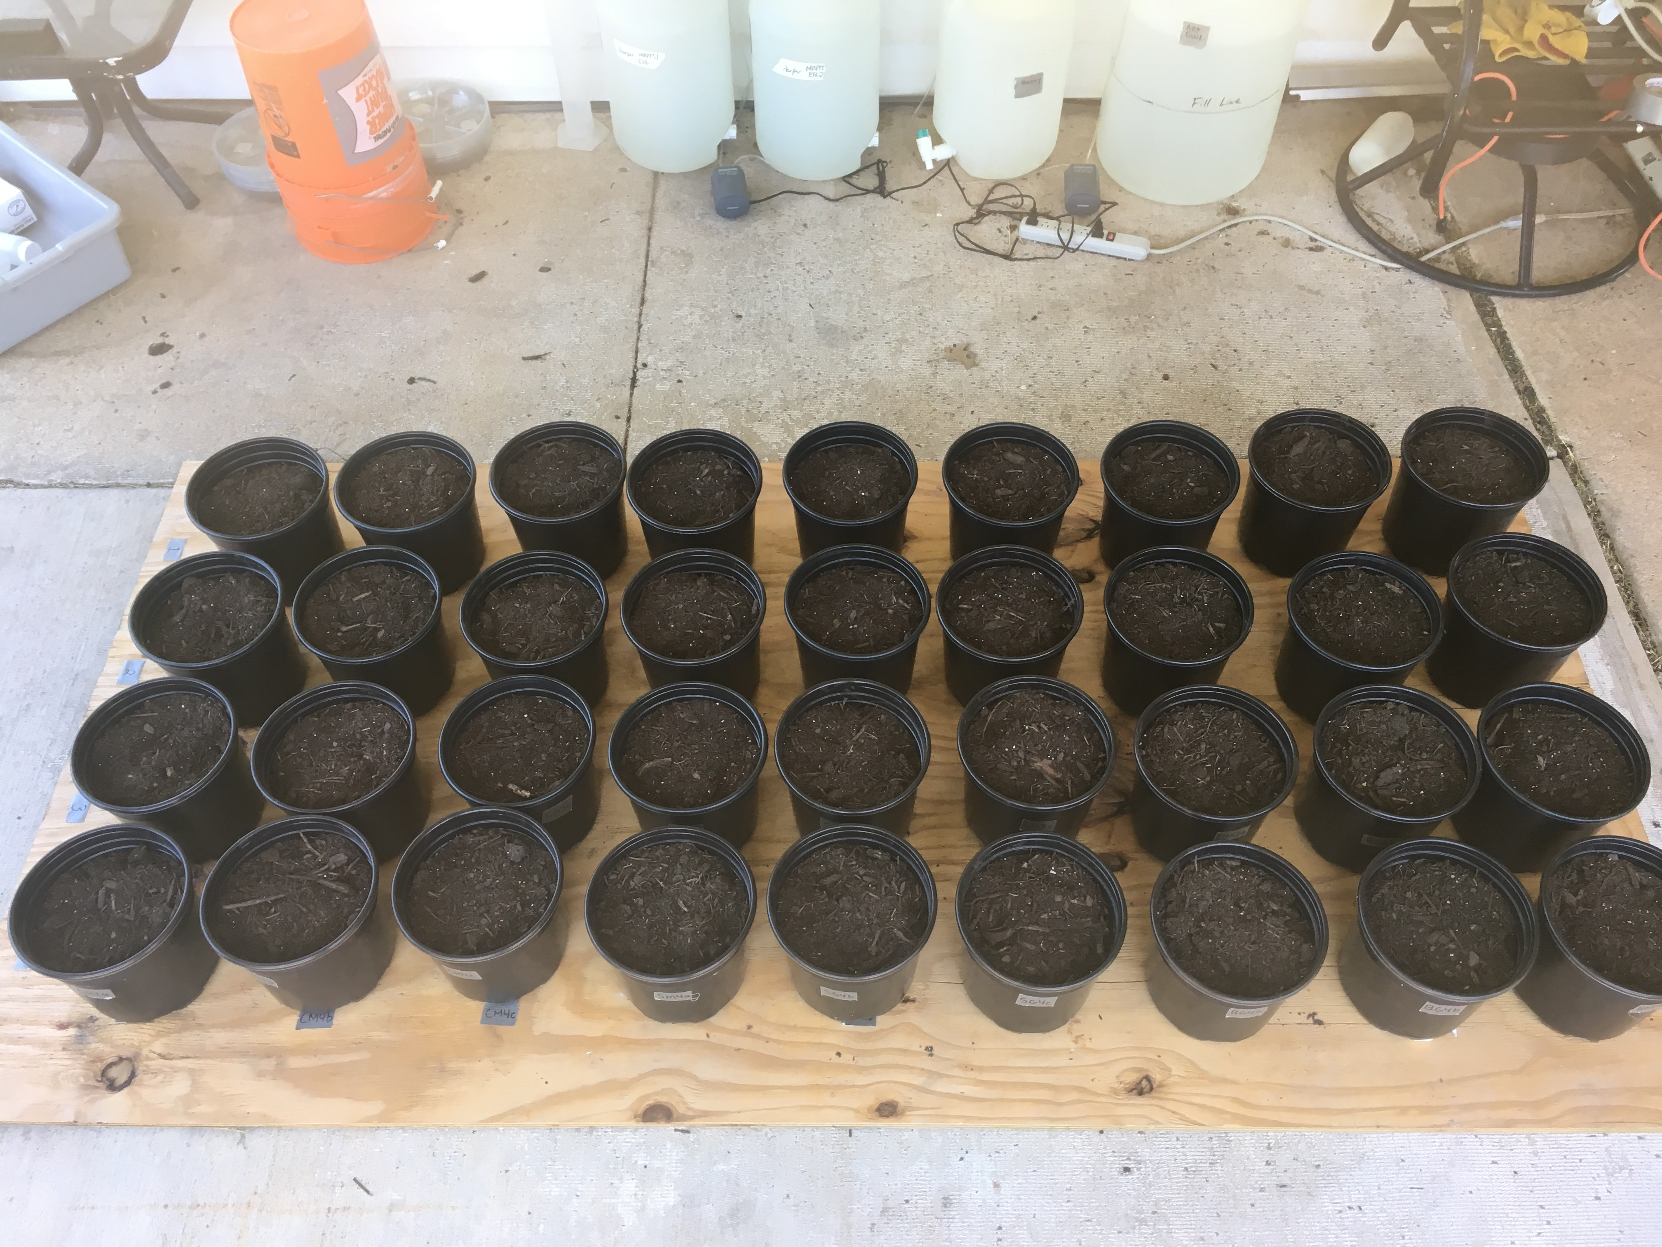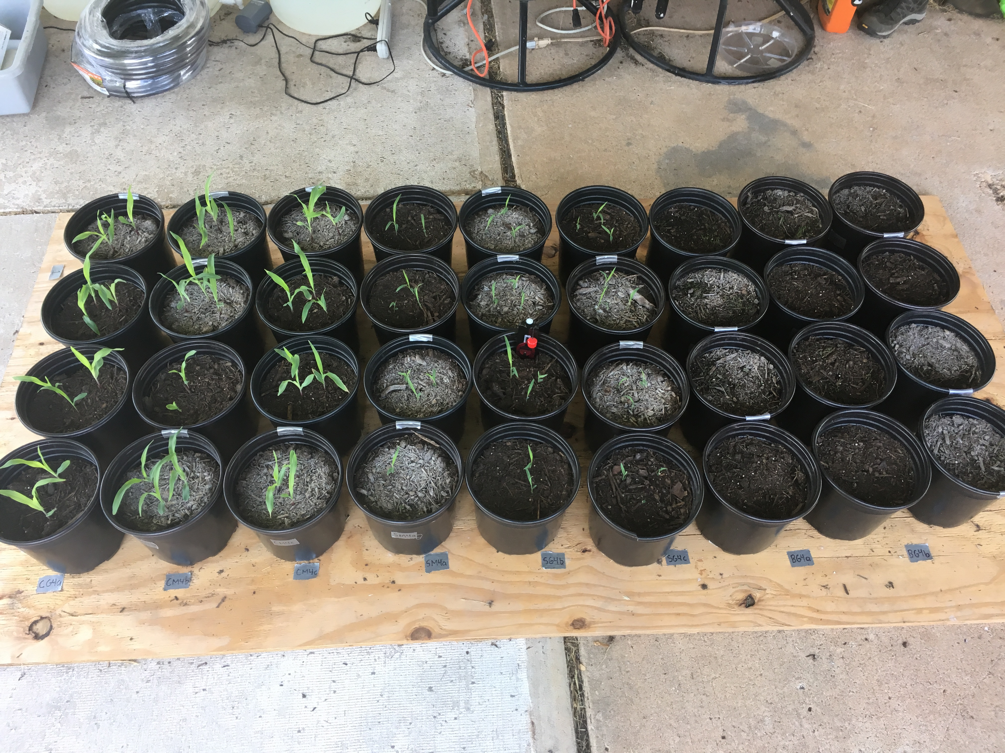
a
b
Figure 19: The full-scale field experiment on (a) day 0 and (b) day 12

The cumulative emergence curves for groundwater-irrigated corn (CG) and mine water-irrigated corn (CM) are plotted together in Figure 20. The first CG and CM sprouts appeared five days after planting. CG and CM exhibited similar gains between days four and five, but groundwater-irrigated plants emerged at a slower pace than the mine water-irrigated seedlings in the following days. Every CM plant sprouted by day seven, whereas CG seedlings continued to emerge incrementally until day eleven. 94% of CG seeds and 100% of CM seeds sprouted over the course of the experiment, and at least one seed sprouted in every CG and CM pot.
The cumulative emergence curves for groundwater-irrigated sorghum (SG) and mine water-irrigated sorghum (SM) are plotted together in Figure 21. The first SG and SM sprouts appeared four days after planting, and SG and SM emergence rates were identical between days five and eleven. Although during the proof-of-concept study initial SM emergence rates appeared to lag behind SG, the opposite was true during this experiment. Similar to corn, every SG and SM pot contained at least one seedling by day 11.

Figure 20: Cumulative corn emergence during groundwater and mine water irrigation

Figure 21: Cumulative sorghum emergence during groundwater and mine water irrigation

The survival curves for CG and CM plotted in Figure 22 are not significantly different at an alpha level of 0.05 (p = 0.478). The survival curves for SG and SM plotted in Figure 23 are not significantly different at an alpha level of 0.05 (p = 0.455).

Figure 22: Corn survival curves during groundwater and mine water irrigation

Figure 23: Sorghum survival curves during groundwater and mine water irrigation

Plant Growth
The effects of irrigation treatment on height or percent coverage were evaluated with a two-way mixed ANOVA. The between-subjects factor was irrigation treatment, the within-subjects factor was measuring event, and the continuous dependent variables were plant height for corn and sorghum, and percent coverage for Bermuda grass. Conditions for running the two-way mixed ANOVA were evaluated separately for the between- and within-subjects groups. Normality of the data was established with boxplots and Q-Q plots of the Studentized residuals, although mixed ANOVAs are robust to violations of this assumption (Laerd Statistics, 2018). Homoscedasticity, the equality of error variances, was established with a non-significant (p ≤0.05) result from Levene’s test for homogeneity of error variances for each group of between-subjects and within-subjects factors (e.g., mine water-irrigated plants, all plants during the seventh measuring event). Sphericity, or homogeneity of variances of the differences between within-subjects groups, was assessed with Mauchly’s test of sphericity and the Greenhouse-Geisser (GG) epsilon. In the event of a significant result (p ≤ 0.05) or a non-significant result but a GG epsilon below 0.75, the GG correction was applied to the within-subjects and interaction main effects to reduce their degrees of freedom and conservatively compensate for potential violations of sphericity (Frey et al., 2018; NAU, 2012).
After assumptions were verified, the mixed ANOVA tested the between-subjects (BS) main effect, the within-subjects (WS) main effect, and the interaction effect. In the context of plant height, these main effects can be restated as (BS) the difference in plant height across all measurement events, (WS) the difference in plant height between measurement events irrespective of irrigation treatment, and the differences in plant height by treatment during each measuring event. When a significant interaction effect was detected (p ≤ 0.05), the simple main effects of both factors were computed, reported, and interpreted. Simple main effect tests used pairwise comparisons based on estimated marginal means to compare plant heights by irrigation treatment (BS) at each measuring event (e.g., mine water-irrigated corn heights vs. groundwater-irrigated corn heights during the third measuring event) and to compare plant heights by measuring event (WS) separately for each irrigation treatment (e.g., groundwater-irrigated corn heights on the first measuring event vs. groundwater-irrigated corn heights from every other measuring event). When the interaction effect was not significant, the main effects were reported and interpreted instead of the interaction effect. In the event of a significant main effect, pairwise comparisons for each level of the associated factor were conducted, reported, and interpreted. The Sidak correction for multiple comparisons was applied for every pairwise comparison of the main effects and simple main effects; the Bonferroni correction was deemed too conservative for the number of comparisons made during these mixed ANOVAs but some protection against the inflation of Type I error through multiple comparisons was desired (Lee and Lee, 2018). Main and interaction effects reported in-text are formatted as follows: F(df[effect],df[error]) = F statistic, p-value.
Mean corn heights and standard deviations from each treatment over the duration of the growing season are plotted in Figure 24. There was not a significant main effect of irrigation treatment (F(1,10) = 0.004, p = 0.951) on corn height. There was a significant main effect of measuring event (F(2.97,29.74) = 470, p < 0.001) on corn height such that corn heights increased as time passed, which is to be expected in a plant-growth experiment. The interaction effect between irrigation treatment and measuring event was not significant (F(2.97,29.74) = 1.54, p = 0.225). While irrigation with mine water or groundwater did not result in significantly different mean plant heights, average plant height irrespective of treatment did change with time.

Figure 24: Mean apex leaf height of corn plants during groundwater and mine water irrigation (bars represent standard deviation; each point represents n=6)

Mean sorghum heights and standard deviations from each treatment over the duration of the growing season are displayed in Figure 25. There was not a significant main effect of irrigation treatment (F(1,10) = 0.660, p = 0.436) on sorghum height. There was a significant main effect of measuring event (F(2.78,27.78) = 392, p < 0.001) on sorghum height, which, again, is to be expected in a plant-growth experiment. Additionally, there was a significant interaction effect between irrigation treatment and measuring event (F(2.78,27.78) = 3.86, p = 0.022). Pairwise comparisons of mean sorghum height under both irrigation treatments confirmed that groundwater- and mine water-irrigated plant heights changed with time; in fewer words, the plants grew with time as they were irrigated. Testing the simple main effect of treatment revealed that irrigation treatment had a significant effect on sorghum height during the July 30 sampling event (F(1,10) = 6.50, p = 0.029). At this point in time, roughly 1.5 months into the growing season, groundwater-irrigated sorghum plants reached maximum height separation from their mine water-irrigated counterparts: 0.173 m. Height peaked and then declined in the groundwater pots shortly thereafter, and the mine water-irrigated sorghum caught up with and surpassed groundwater-irrigated height by early September. Mine water salinity could have delayed the maturation of mine water-irrigated sorghum, but plant height decreased under both irrigation treatments towards the end of the experiment (Maas et al., 1986). The decreases in average plant height under both treatments could be explained by continued leaf biomass accumulation and salinity- or stress-induced fluctuations in leaf turgor pressure (Beauzamy et al., 2014). As the uppermost leaves gained mass and lost rigidity, their apex points may have decreased in height.

Figure 25: Mean apex leaf height of sorghum plants during groundwater and mine water irrigation (bars represent standard deviation; each point represents n=6)

The mean percentages of pot area covered by Bermuda grass under each irrigation treatment are plotted in Figure 26. There was not a significant main effect of irrigation treatment (F(1,10) = 0.1.48, p = 0.251) on percent coverage. There was a significant main effect of measuring event (F(2.29,22.92) = 15.4, p < 0.001) on percent coverage, indicating that Bermuda grass coverage differed between at least two measuring events. The interaction effect between irrigation treatment and measuring event was not significant (F(2.29,22.92) = 0.610, p = 0.573). Percent coverage decreased on August 20 when Bermuda grass was harvested for the first of two times; all grass stems from tip of blade to five cm above the substrate surface were removed and dried, ground, and homogenized by pot, thereby creating 12 samples from each harvest. Because the first five cm of grass were left intact in all pots, coverage areas rebounded by the next time they were recorded.

Figure 26: Mean percent coverage of Bermuda grass pots during groundwater and mine water irrigation (bars represent standard deviation; each point represents n=6)

Plant Biomass
Within each species, dry biomasses were compared between irrigation treatments for each unique plant structure (e.g., roots, stems, leaves, and reproductive organs). A variety of two-tailed hypothesis tests for two independent samples was considered for each statistical comparison, and the appropriate parametric or nonparametric test was selected based on normality of the data, homogeneity of variances, and the presence of outliers. Normality was assessed through an inspection of box plots and the Shapiro-Wilk test; a significant p-value (p ≤ 0.05) indicated non-normality. Homogeneity of variances could be assumed with a non-significant p-value (p ≤ 0.15) from Levene’s test for equality of variances based on group means. The presence of outliers was noted in the box plots. If all three assumptions were satisfied, a Student’s t-test was used to compare structural biomasses. If normality was assumed and no outliers were present but homogeneity of variances was not satisfied, Welch’s t-test for unequal variances was used. If the data were non-normal, variances were unequal, and outliers were present, the Mann-Whitney U test was carried out. The results of these statistical tests are presented in Table 15 alongside descriptive statistics for biomass production. The mean total biomasses of each species-treatment combination are presented in Figure 27, and the plants approximately three weeks prior to harvest are pictured in Figure 28. Sorghum was the only species to exhibit significantly different dry biomass generation by treatment (Student’s t-test, p = 0.047). However, the vastly different standard deviations between treatments in corn plants and the apparent increase in mine water-irrigated Bermuda grass biomass production relative to groundwater-irrigated Bermuda grass merit investigation.

Figure 27: Mean total biomass of each species-treatment group (bars represent standard deviation; n=6)
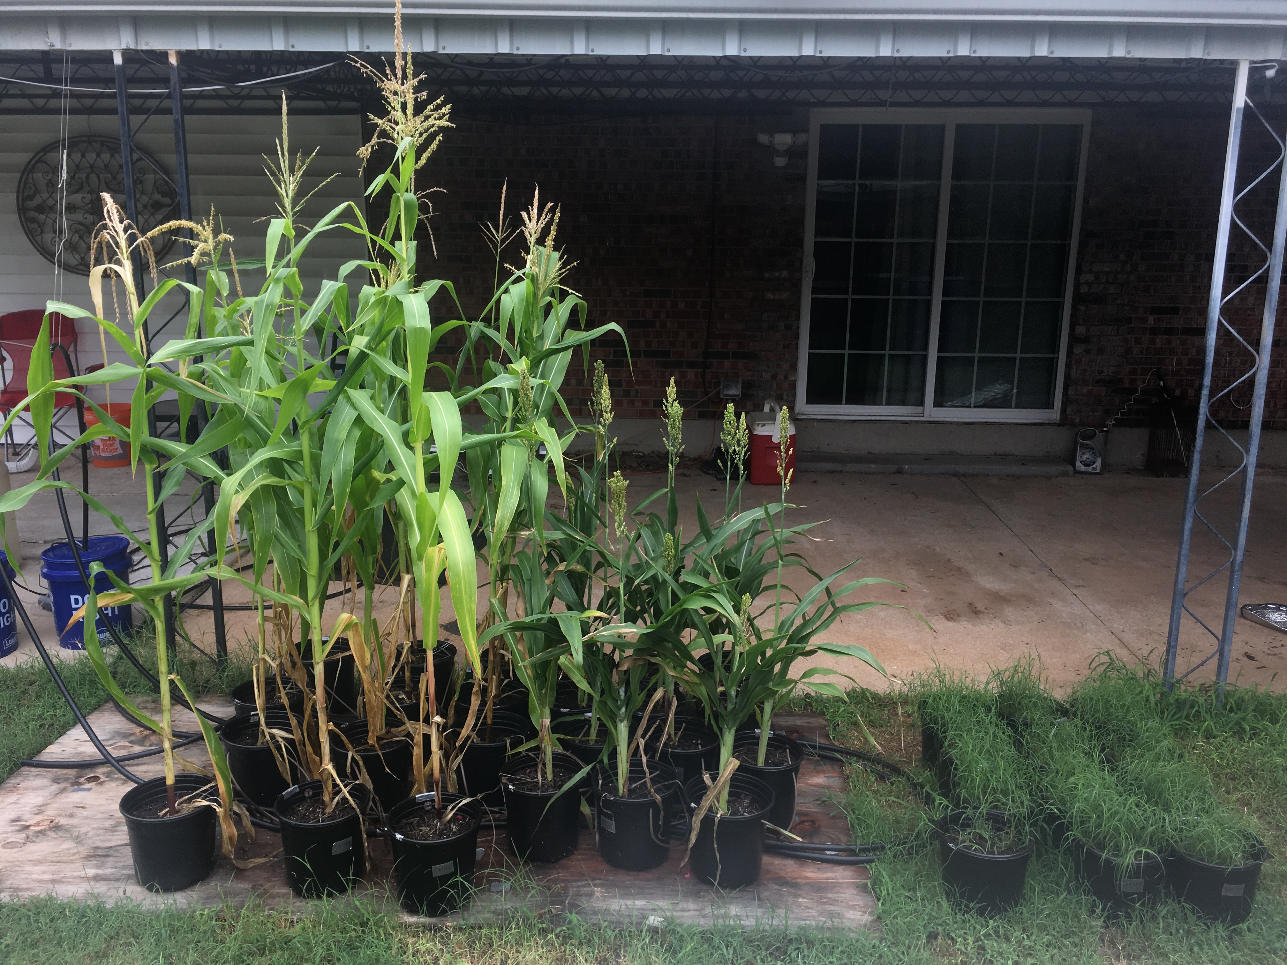
Figure 28: Corn, sorghum, and Bermuda grass three weeks prior to harvest (plants were consolidated for pictures and during high winds)

Of the twelve corn plants, mine water-irrigated plants accounted for the three smallest corn plants and the two largest corn plants in terms of dry biomass production. This heterogeneity is presented graphically in Figure 29. At first glance, it appears that irrigation treatment had a sizeable impact on biomass allocation to the reproductive portions of aboveground biomass. Groundwater-irrigated corn allocated 11.4% of total plant biomass to the female inflorescence (husk, cob, grain), whereas the same structures represented 22.0% of dry biomass in the mine water-irrigated plants. Almost half (48.3%) of the dry weight in CM1c was bound up in the husk, cob, and grain. However, because the study ended before the corn plants reached maturity, comparisons of reproductive biomass are actually contrasting the growth stages at harvest. Corn plants were at different growth stages during harvest, so grain fill was ongoing and the most developed plants had already accumulated substantially more starch in their kernels than the less developed plants. As such, the fact that female inflorescences represented 22% of dry biomass in mine water-irrigated corn and 11% of dry biomass in groundwater-irrigated corn indicates that mine water corn plants were on average more developed than groundwater corn plants. It does not imply that mine water irrigation results in heavier reproductive structures in a fully-matured corn plant. Therefore, the most appropriate interpretation of these discrepancies in biomass generation is that mine water-irrigated plants matured more rapidly than the groundwater-irrigated corn, although the support for this observation is more descriptive than statistical. CM1c was the first corn plant to tassel, and did so ten days before the next plant: CM4c. Accordingly, these two mine water-irrigated plants also generated the most grain biomass, and were at more advanced growth stages than any other corn plant at harvest. However, per Table 15, the only corn structure in which biomass differed significantly by treatment was the cob (Welch’s t-test, p = 0.045). Given the lack of a statistically significant irrigation effect on any other corn structure, the appearance of accelerated maturity under mine water irrigation might just be a product of the randomness inherent to plant growth and development. Alternatively, the presence of elevated Pb, Zn, Ni, and Cd has been shown to decrease root and shoot nitrogen content, and nitrogen deficiency can cause early maturity (Chibuike and Obiora, 2014; Uchida, 2000). However, plant nitrogen concentrations were not analyzed and the aforementioned metals were generally present at greater concentrations in groundwater-irrigated crops. In any case, the variance of mine water biomass generation stands in stark contrast with the more consistent growth and biomass allocation witnessed in groundwater-irrigated corn.

Figure 29: Total dry biomass of all corn plants

As seen in Figure 30, sorghum plants exhibited similar variances in biomass production under both irrigation treatments, which were associated with significantly different root biomasses (Mann-Whitney U test, p = 0.009) in addition to whole plant masses. Depressed root growth is sometimes associated with increases in aboveground biomass allocation; in this case, grain was the only sorghum structure with a higher mean biomass in mine water-irrigated pots than in groundwater pots (Poorter et al., 2012). The increased reproductive biomass under mine water irrigation parallels the trend of accelerated maturity implied by mine water-irrigated corn biomass allocation, although the difference in sorghum grain production was not statistically significant at an alpha of 0.05 (Mann-Whitney U test, p = 0.093).

Figure 30: Total dry biomass of all sorghum plants

Bermuda grass biomass production was measured twice, and the aboveground fractions were not significantly different by treatment during either sampling event despite the germination of only two seeds in one of the groundwater-irrigated pots. Below-ground biomass production was significantly different between irrigation treatments (Mann-Whitney U test, p = 0.041). Whereas mean root production and total biomass generation were diminished during mine water irrigation of corn and sorghum, both root mass and cumulative biomass were greater on average during mine water irrigation of Bermuda grass. However, it is not possible to assert that overall dry biomass production in mine water-irrigated Bermuda grass pots represent any significant difference from overall dry biomass production in groundwater-irrigated pots.

Table 15: Mean dry biomass generation in each plant structure under groundwater or mine water irrigation, measured in g
 | Groundwater |  | Mine water
Biomass | Mean | SD | Mean | SD | p
Corn
Tassel | 1.77 | 0.85 | 1.19 | 0.56 | 0.196 ª
Leaf | 22.36 | 3.08 | 18.94 | 8.99 | 0.410 ^{b}
Husk | 3.85 | 1.68 | 5.02 | 3.13 | 0.437 ^{b}
Grain | 3.08 | 2.35 | 6.31 | 5.83 | 0.310 ^{c}
Cob | 1.52 | 0.79 | 3.30 | 1.62 | 0.045 ^{b}
Stalk | 28.68 | 3.44 | 25.01 | 10.32 | 0.440 ^{b}
Roots | 12.38 | 2.26 | 11.44 | 4.03 | 0.628 ª
Total | 73.64 | 6.66 | 71.21 | 23.08 | 0.813 ^{b}
Sorghum
Tillers | 4.37 | 4.80
Leaf | 13.99 | 5.93 | 8.98 | 3.04 | 0.180 ^{c}
Grain | 9.96 | 3.19 | 13.18 | 4.41 | 0.093 ^{c}
Stalk | 21.31 | 6.70 | 15.49 | 3.03 | 0.094 ^{b}
Roots | 9.63 | 2.29 | 6.17 | 1.21 | 0.009 ^{c}
Total | 59.27 | 11.66 | 43.81 | 8.35 | 0.047 ª
Bermuda grass
Grass Harvest 1 | 3.38 | 2.89 | 4.04 | 1.53 | 0.699 ^{c}
Grass Harvest 2 | 7.59 | 1.16 | 10.20 | 0.44 | 0.079 ª
Roots | 4.01 | 1.50 | 5.12 | 0.56 | 0.041 ^{c}
Total | 14.98 | 4.66 | 19.36 | 2.15 | 0.063 ª
The type of two-tailed hypothesis test used to compare independent samples is indicated by the superscript: ªStudent's t-test; ^{b}Welch's t-test (unequal variances); ^{c}Mann-Whitney U test. Significant p-values at alpha = 0.05 are bolded.

Plant Metal Uptake
The effects of irrigation treatment on recoverable plant trace metal concentrations were evaluated with separate two-way mixed ANOVAs for every combination of plant species and metal species excluding Na, which was not sufficiently measured in corn or sorghum to conduct this test. The between-subjects factor was irrigation treatment, the within-subjects factor was plant structure, and the continuous dependent variable was chemical concentration. Conditions for running the two-way mixed ANOVA were evaluated separately for the between- and within-subjects groups. Normality of the data was established with boxplots and Q-Q plots of the Studentized residuals, although mixed ANOVAs are robust to violations of this assumption (Laerd Statistics, 2018). Homoscedasticity was established with a non-significant (p ≤ 0.05) result from Levene’s test for homogeneity of error variances for each group of between-subjects and within-subjects factors (e.g., groundwater-irrigated plants, the grain portion of all sorghum plants). Sphericity, or homogeneity of variances of the differences between within-subjects groups, was assessed with Mauchly’s test of sphericity and the Greenhouse-Geisser (GG) epsilon. In the event of a significant result (p ≤ 0.05) or a non-significant result but a GG epsilon below 0.75, the GG correction was applied to the within-subjects and interaction main effects to reduce their degrees of freedom and conservatively compensate for potential violations of sphericity (Frey et al., 2018; NAU, 2012). Cook’s distance was calculated for every sample to identify outliers that might be influencing the model. Samples that produced Cook’s D values greater than 0.5 were removed and the mixed ANOVA was rerun. While heterogeneity of population variance-covariance matrices is not a concern in mixed ANOVAs with equal sample sizes, removing samples can create unbalanced models in which heterogeneity could be problematic (Nimon, 2012). After potential outliers were removed and ANOVA was rerun, Box’s M test was consulted; homogeneity of variance-covariance matrices could be assumed when p > 0.001 (Nimon, 2012). If removing possible outliers did not change the significance of either main effect or the interaction effect, then these observations were retained. If removing outliers changed the significance of either main effect or the interaction effect, the data were log-transformed and the mixed ANOVA was rerun with the transformed values.
After assumptions were verified, the mixed ANOVA tested the between-subjects (BS) main effect, the within-subjects (WS) main effect, and the interaction effect. In the context of plant trace metal uptake, these main effects can be restated as (BS) the difference in metal concentration between treatments across all structures of the plant, (WS) the difference in metal concentration between plant structures irrespective of irrigation treatment, and the differences in metal concentration by treatment in each of the structures. When a significant interaction effect was detected (p ≤ 0.05), indicating that the effect of irrigation treatment on plant metal uptake changed depending on which plant structure was being considered, the simple main effects of both factors were computed, reported, and interpreted. Simple main effect tests used pairwise comparisons based on estimated marginal means to compare plant metal uptake between irrigation treatments (BS) in each type of structure (e.g., Cd concentrations in the roots of mine water-irrigated corn plants vs. Cd concentrations in the roots of groundwater-irrigated corn plants) and to compare plant metal uptake in each type of plant structure (WS) separately for each irrigation treatment (e.g., corn Cd concentration in groundwater-irrigated corn cobs vs. Cd concentrations from all other distinct parts of groundwater-irrigated corn). When the interaction effect was not significant, the main effects were reported and interpreted instead of the interaction effect. In the event of a significant main effect, pairwise comparisons for each level of the associated factor were conducted, reported, and interpreted. Sidak corrections for multiple comparisons were applied for every pairwise comparison of the main effects and simple main effects. Main and interaction effects reported in-text are formatted as follows: F(df[effect],df[error]) = F statistic, p-value. A small number of metal concentrations that were below detectable limits in ICP analysis were replaced with 0.5×PQL to allow for mixed ANOVA, which excludes samples with missing values. Farnham et al. showed that this substitution method is more reliable than other simple substitutions when less than 25% of groundwater geochemistry data are censored (2002). This substitution was performed for 4/72 corn Ni concentrations, 1/48 sorghum Ni concentrations, 2/72 corn Pb concentrations, and 1/36 Bermuda grass Pb concentrations.
The main effects and interaction effects of irrigation treatment and plant structure on corn, sorghum, and Bermuda grass metal uptake are presented in Tables 16, 17, and 18. Each table reports degrees of freedom, F statistics, p-values, and the effect size, partial eta squared (η_{p}²), which is a standardized measure of the variance in metal concentration explained by the associated effect (Lakens, 2013). The elements of concern were separated into two groups based on mass loading from the fertilizer, which could have obscured the effects of certain metals, as well as irrigation criteria and the statistical comparison of concentrations in the mine water and groundwater. The first group, which did not play a major role in differentiating metals uptake by irrigation treatment due to various combinations of the aforementioned factors, received a cursory follow-up analysis after being subjected to mixed ANOVA. For this first group, which consisted of Fe, K, Mn, Ni, Pb, and Zn, the pairwise comparisons of main effects and simple main effects can be found in Appendix C alongside exploratory graphs of biomass K and Mn concentrations.
Fe concentrations of mine water- and groundwater-irrigated plants, presented in Figure 31, were not significantly different for any of the three species. However, plant structure had a significant main effect on Fe uptake for all species. Corn (F(2.81,28.08) = 83.3, p < 0.001) and sorghum (F(1.07,10.68) = 94.3, p < 0.001) plants exhibited the same pattern of Fe accumulation: uptake was greatest in the roots, then the leaves, and was equally low in all other structures. In the Bermuda grass, structures accumulated Fe in the following order: Roots > Grass2 > Grass1, where Grass1 and Grass2 refer to the first and second samplings of the aboveground biomass respectively (F(1.12,11.2) = 26.1, p < 0.001). The interaction between irrigation treatment and plant structure was not significant for any of the species.
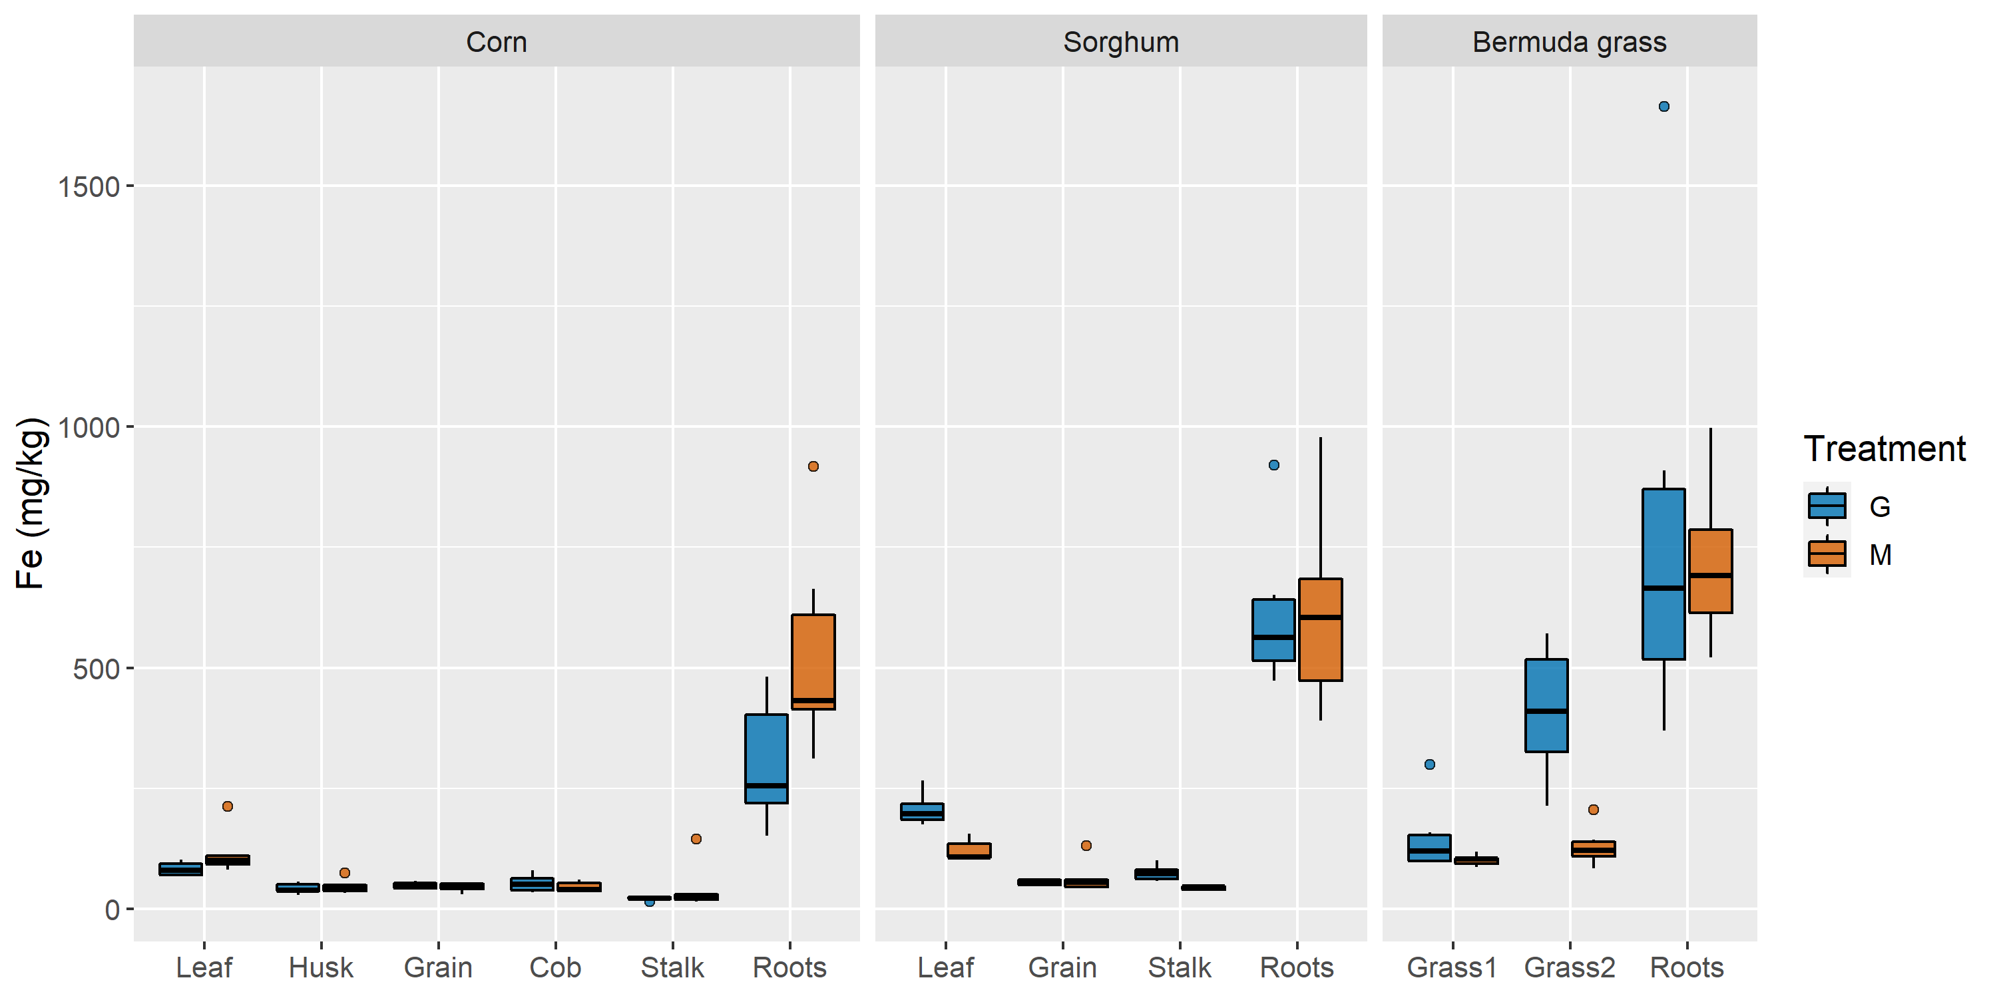
Figure 31: Box plots of Fe concentrations in each plant and structure in mg/kg

K concentrations in mine water- and groundwater-irrigated plants, which can be found in Appendix C, were not significantly different for any of the three species, whereas plant structure had a significant main effect on K concentrations for all species. Corn leaves accumulated greater concentrations of K than all other corn structures except stalks; both leaves and stalks contained significantly higher K concentrations than husks. However, stalk K concentrations were not significantly higher than K concentrations in corn grain, cobs, or roots (F(1.89,18.90) = 9.45, p < 0.001). Sorghum structures exhibited a slightly different hierarchy of K uptake: Leaf = Stalk > Roots > Grain (F(1.84,18.44) = 86.7, p < 0.001). Bermuda grass structures accumulated K in the following order: Grass1 > Grass2 > Roots (F(2,20) = 559, p < 0.001). The interaction between irrigation treatment and plant structure was not significant for any of the species.
Mn concentrations in mine water- and groundwater-irrigated plants, which are provided in Appendix C, were not significantly different for any of the three species. Plant structure had a significant main effect on Mn concentrations for corn and sorghum, but not for Bermuda grass. Corn leaves and roots accumulated higher concentrations of Mn than were present in husks, cobs, and stalks; none of the corn structures contained significantly different Mn concentrations from grain, which exhibited middling concentrations but high standard deviations (F(3.04,30.43) = 18.0, p < 0.001). Sorghum structures accumulated Mn in the following order: Grain = Roots > Leaf > Stalk (F(1.60,16.05) = 55.0, p < 0.001). The interaction between irrigation treatment and plant structure was not significant for any of the species.
Ni concentrations in mine water- and groundwater-irrigated plants, seen in Figure 32 were significantly different for Bermuda grass, but not for corn or sorghum. Bermuda grass irrigated with groundwater contained higher concentrations of Ni than mine water-irrigated Bermuda grass (F(1,10) = 5.69, p = 0.038). Plant structure had a significant main effect on Ni concentrations for all species. Corn roots accumulated higher concentrations of Ni than were found in stalks, but neither the roots nor stalks could be statistically distinguished from the leaves, husks, grain, and cobs in terms of Ni concentrations (F(2.44,24.39) = 5.42, p = 0.008). Sorghum structures exhibited similar uncertainties but inverted the hierarchy of Ni accumulation. Sorghum grain accumulated higher Ni concentrations than the leaves, but neither structure could be statistically separated from Ni concentrations in the stalks and roots (F(2.04,20.43) = 3.73, p = 0.041). Bermuda grass roots contained higher concentrations of Ni than either grass1 or grass2, which accumulated similar concentrations of Ni (F(2,20) = 22.0, p < 0.001) The interaction between irrigation treatment and plant structure was not significant for any of the species.
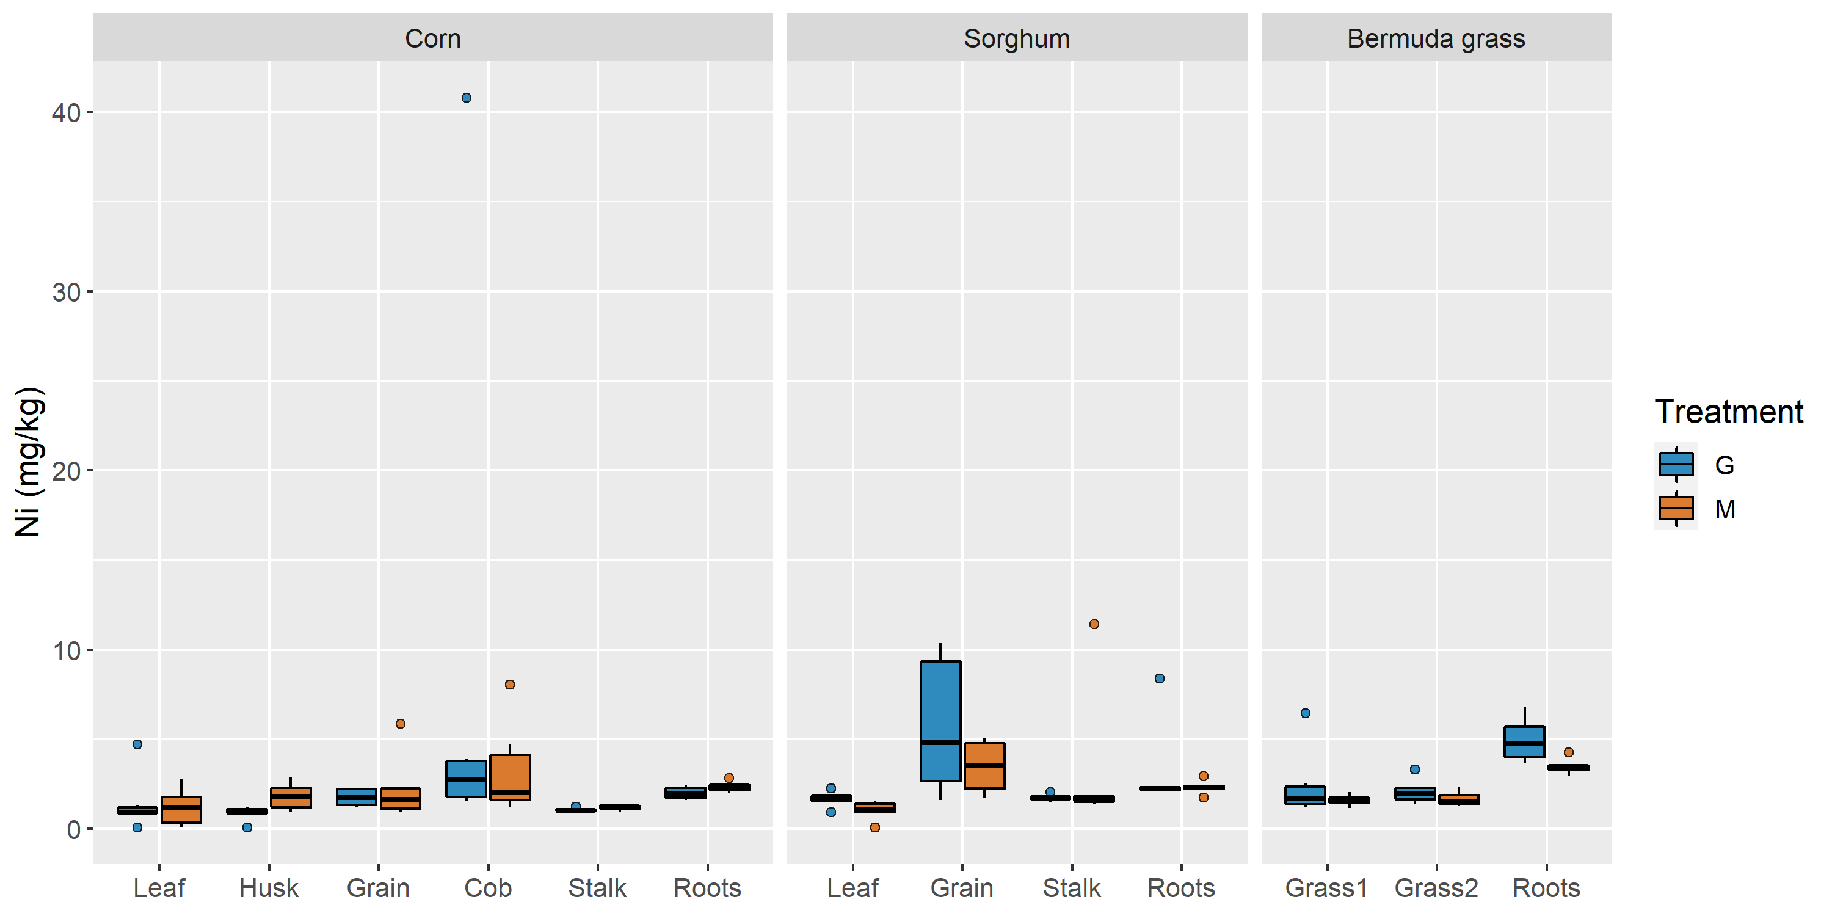
Figure 32: Box plots of Ni concentrations in each plant and structure in mg/kg

Pb concentrations in mine water- and groundwater-irrigated sorghum plants, plotted in Figure 33, were significantly different. Sorghum irrigated with groundwater contained higher concentrations of Pb than mine water-irrigated sorghum (F(1,10) = 9.91, p = 0.010). Plant structure had a significant main effect on Pb concentrations in sorghum but not corn. Sorghum grain Pb concentrations were higher than leaf and stalk Pb concentrations but were not significantly different from Pb concentrations in the roots (F(2.16,21.64) = 26.37, p < 0.001). There was a significant interaction between irrigation treatment and plant structure for Bermuda grass (F(2,20) = 3.92, p = 0.037). Bermuda roots accumulated higher Pb concentrations than the grasses under both groundwater and mine water irrigation, and Pb concentrations in groundwater-irrigated roots and grass2 were higher than their mine water-irrigated counterparts.
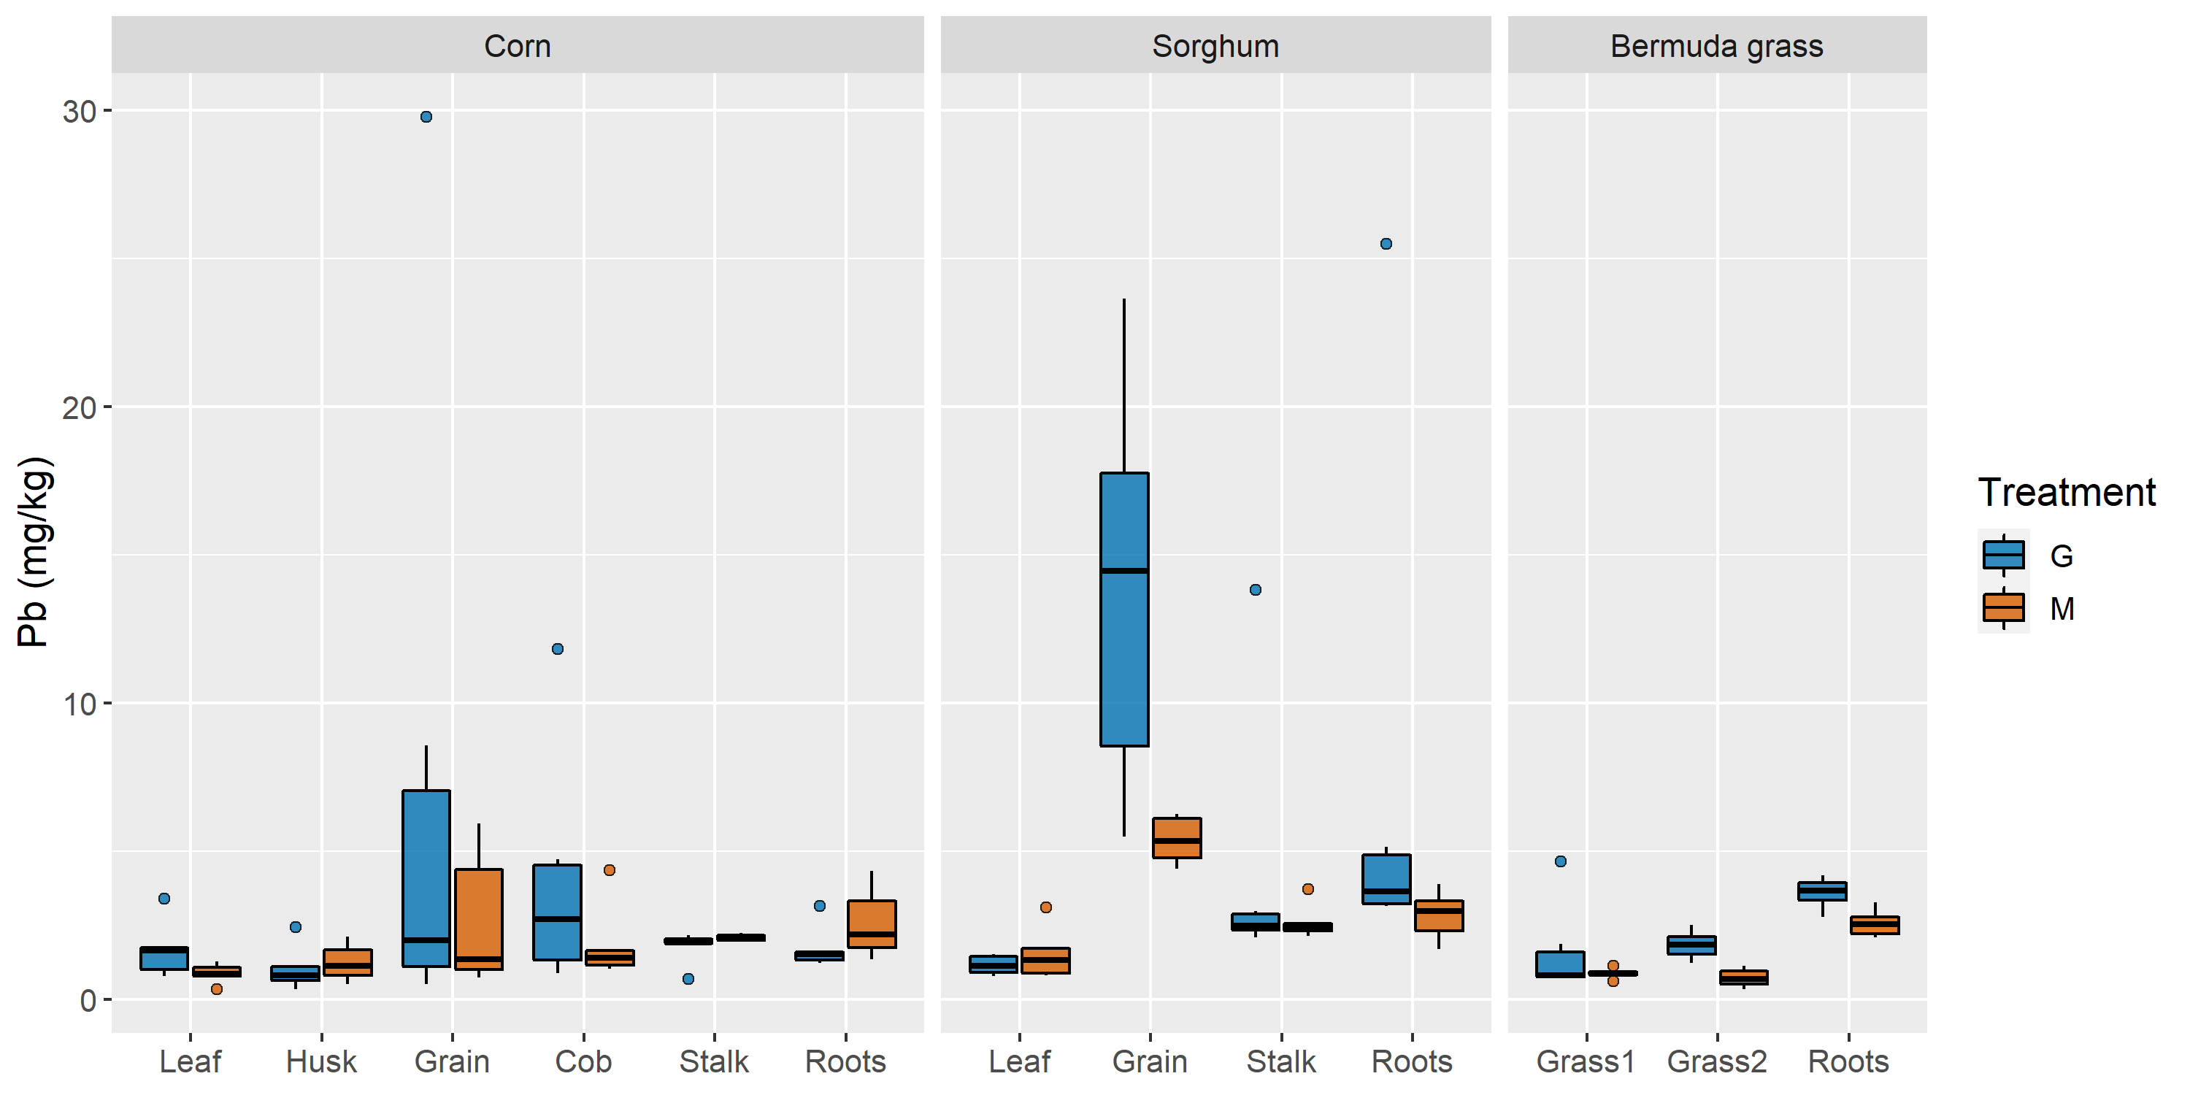
Figure 33: Box plots of Pb concentrations in each plant and structure in mg/kg

Zn concentrations in mine water- and groundwater-irrigated sorghum plants, provided in Figure 34, were significantly different. Sorghum irrigated with groundwater contained higher concentrations of Zn than mine water-irrigated sorghum (F(1,10) = 5.12, p = 0.047). Plant structure had a significant main effect on Zn concentrations in corn and sorghum. Corn structures accumulated Zn along a gradient of concentrations that resulted in many statistically similar nearest neighbors. This gradient, which included some non-significant differences between adjacent structures but generally reflected decreasing mean concentrations of Zn, was as follows: Grain > Cob > Leaf = Husks = Roots > Stalk (F(1.88,18.79) = 34.0, p < 0.001). Sorghum grain Zn concentrations were higher than leaf, stalk, and root concentrations (F(1.75,17.45) = 109, p < 0.001). There was a significant interaction between irrigation treatment and plant structure for Bermuda grass (F(1.26,12.58) = 5.10, p = 0.036). Groundwater-irrigated Bermuda grass accumulated Zn concentrations such that Grass1 > Roots > Grass2, whereas mine water-irrigated Bermuda grass accumulated Zn concentrations in the following hierarchy: Grass1 > Grass2 > Roots. Groundwater irrigation produced higher root Zn concentrations than mine water irrigation, but irrigation treatments did not produce significantly different Zn concentrations in either set of grass samples.
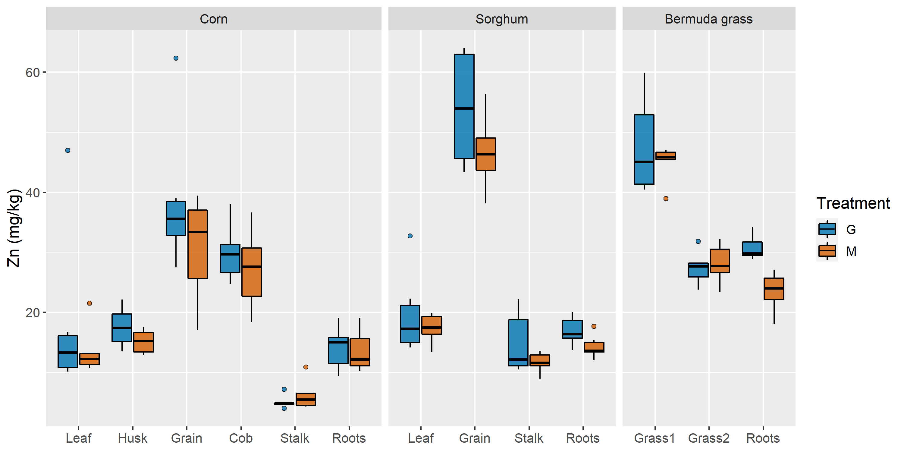
Figure 34: Box plots of Zn concentrations in each plant and structure in mg/kg

Fe, Zn, and Pb are three of the four trace metals that are primarily targeted for removal at the MRPTS. Fe concentrations in plant biomass irrigated with groundwater or mine water were not significantly different. Furthermore, mean Fe concentrations in the leaves of all species were above 66 mg/kg Fe, the critical deficiency concentration for the leaves of C4 plants, but were not so high that toxicity was a concern (Broadley et al., 2012a). Additionally, Zn and Pb concentrations were significantly higher in groundwater-irrigated sorghum and Bermuda grass. Zn concentrations were contributed predominantly by the fertilizer and were not significantly different in the irrigation waters. Therefore, the significant main effect of irrigation treatment on Zn concentrations could indicate that the groundwater chemistry promotes uptake of Zn from the fertilizer, water, or substrate more efficiently than the mine water chemistry; one possibility is that higher mean PO₄³⁻ concentrations in mine water led to greater P uptake and decreased Zn translocation, although this mechanism is not fully understood (Broadley et al., 2012b). Fe, Ni, Pb, and Mn tended to accumulate in the roots – an avoidance strategy of excluder plants that can reduce translocation by complexing excess metals with phytochelatins, sequestering metals with root-bound transporters, and preventing root uptake through root exudate metal chelation in the rhizosphere – whereas Zn and K were more prevalent in aboveground biomass (Mehes-Smith et al., 2013). Zn concentrations in the roots of grass species approached nutrient deficiency between 10-15 mg/kg; the mean Zn concentrations in corn and sorghum roots were within or just above this range for both treatments (Marschner, 1993). Bermuda grass roots averaged 30.7 mg/kg Zn in groundwater pots and 23.5 mg/kg Zn in mine water pots, presumably because Bermuda grass elemental concentrations were not diluted by the substantial biomass generation characteristic of sorghum and corn. Zn deficiency was a greater concern than Zn toxicity for these irrigation waters. The characteristic interveinal chlorosis in Zn-deficient leaves was not recorded in any plants, but lower concentrations of Zn in mine water-irrigated sorghum could have prevented tiller growth, a sign of vigor that was completely absent under mine water irrigation but present in multiple groundwater-irrigated sorghum plants (McCauley et al., 2011). However, because late-flowering tillers can delay harvests and reduce grain quality, some farmers might prefer nutrient-regulated tiller suppression when the alternative is laborious destruction of unwanted tillers (Gerik et al., 2003). Lead concentrations in the irrigation waters, which contributed substantially more Pb than the fertilizer mass loading, were well below criteria and not significantly different. And yet, Pb concentrations in groundwater-irrigated plants matched or exceeded the human and livestock consumption limits, which range from 1.33 to 3.33 mg/kg on a dry weight (DW) basis (Armienta et al., 2020). The vegetative portions of most mine water-irrigated plants barely passed these criteria, but grain Pb concentrations violated regulatory levels regardless of species or treatment.
Despite Ni concentrations in the treated mine water being significantly higher than Ni levels in groundwater, it was groundwater irrigation that increased Ni concentrations in Bermuda grass; mine water irrigation did not increase concentrations of Fe, Mn, Zn, K, Ni, or Pb in any of the three species. Ni plays an important role in germination as a micronutrient, and is typically found in healthy plants at concentrations between 0.01 and 10.0 mg/kg DW (Broadley et al., 2012b; McCauley et al., 2011). The mean Ni concentration in every plant structure analyzed during this study falls within that range. K, a macronutrient, is needed for vegetative growth at concentrations of 20-50 g/kg DW, although Na can sometimes compensate for K deficiencies (Hawkesford et al., 2012). Average K concentrations in the leaves and stems of the experimental subjects were between 15 and 20 g/kg DW with the exception of the first harvest of Bermuda grass. As the recoverable K concentrations reported in this study were lower than the plants’ total K concentrations on which the critical deficiency concentration is based, potential K deficiencies might have suppressed growth and reduced drought tolerance; this could help explain the rolling corn leaves and slow development. Mn deficiency takes place when leaf concentrations drop below 10-20 mg/kg DW, whereas toxicity in corn occurs above 200 mg/kg DW (Broadley et al., 2012b). Leaf and stem Mn concentrations were as low as a mean of 15.7 mg/kg DW in mine water-irrigated sorghum leaves and as high as a mean of 76.8 mg/kg DW in mine water-irrigated Bermuda grass from the first harvest. In any case, Mn was neither toxic nor deficient in the sampled plants.
The increased accumulations of Ni, Pb, and Zn in some structures as a result of groundwater irrigation despite statistically similar or, in the case of Ni, greater concentrations in mine water could be explained by the irrigation water salinities. A study of salt-tolerant plant species found that moderately saline irrigation waters increased bioaccumulation of Cd, Cr, Ni, and Na relative to the non-salinized control, whereas high salinity waters apparently activated an exclusionary mechanism that reduced metal uptake and translocation (Zurayk et al., 2001). The authors theorized that the purported chemical or biological adjustment to elevated soil water salinity was intended to restrict Na accumulation but incidentally excluded the other metals (Zurayk et al., 2001). Perhaps then the increased Ni, Pb, and Zn accumulations under groundwater irrigation would be better reframed as decreased accumulations during irrigation with high salinity mine water.

Table 16: Mixed ANOVA main effects and interaction effects of treatment and plant structure on corn metal uptake
 | Treatment |  |  |  |  | Structure |  |  |  |  | Treatment $×$ Structure
Parameter | df | F | p | Partial η_{p}² |  | df | F | p | Partial η_{p}² |  | df | F | p | Partial η_{p}²
Ca | (1,10) | 2.60 | 0.138 | 0.206 |  | (1.72,17.16) | 93.76 | < 0.001 | 0.904 |  | (1.72,17.16) | 4.43 | 0.033 | 0.307
Cd | (1,10) | 0.04 | 0.848 | 0.004 |  | (2.77,27.71) | 50.22 | < 0.001 | 0.834 |  | (2.77,27.71) | 3.59 | 0.029 | 0.264
Fe | (1,10) | 3.65 | 0.085 | 0.267 |  | (2.81,28.08) | 83.33 | <0.001 | 0.893 |  | (2.81,28.08) | 1.92 | 0.152 | 0.161
K | (1,10) | 0.76 | 0.404 | 0.070 |  | (1.89,18.90) | 9.45 | 0.002 | 0.486 |  | (1.89,18.90) | 1.75 | 0.201 | 0.149
Mg | (1,10) | 21.42 | < 0.001 | 0.682 |  | (2.24,22.43) | 20.52 | < 0.001 | 0.672 |  | (2.24,22.43) | 6.42 | 0.005 | 0.391
Mn | (1,10) | 0.92 | 0.361 | 0.084 |  | (3.04,30.43) | 17.95 | < 0.001 | 0.642 |  | (3.04,30.43) | 1.97 | 0.139 | 0.164
Ni | (1,10) | 0.14 | 0.716 | 0.014 |  | (2.44,24.39) | 5.42 | 0.008 | 0.352 |  | (2.44,24.39) | 1.05 | 0.377 | 0.095
Pb | (1,10) | 0.55 | 0.475 | 0.052 |  | (2.03,20.27) | 2.93 | 0.076 | 0.226 |  | (2.03,20.27) | 1.10 | 0.353 | 0.099
S | (1,10) | 36.49 | < 0.001 | 0.785 |  | (2.61,26.08) | 121.60 | < 0.001 | 0.924 |  | (2.61,26.08) | 57.14 | < 0.001 | 0.851
Zn | (1,10) | 1.87 | 0.201 | 0.158 |  | (1.88,18.79) | 34.01 | < 0.001 | 0.773 |  | (1.88,18.79) | 0.78 | 0.466 | 0.072
Significant effects at alpha = 0.05 are bolded.

Table 17: Mixed ANOVA main effects and interaction effects of treatment and plant structure on sorghum metal uptake
 | Treatment |  |  |  |  | Structure |  |  |  |  | Treatment $×$ Structure
Parameter | df | F | p | Partial η_{p}² |  | df | F | p | Partial η_{p}² |  | df | F | p | Partial η_{p}²
Ca | (1,10) | 1.69 | 0.223 | 0.145 |  | (1.38,13.76) | 105.78 | < 0.001 | 0.914 |  | (1.38,13.76) | 6.09 | 0.020 | 0.379
Cd | (1,10) | 9.08 | 0.013 | 0.476 |  | (1.69,16.94) | 73.07 | < 0.001 | 0.88 |  | (1.69,16.94) | 4.09 | 0.041 | 0.29
Fe | (1,10) | 0.75 | 0.408 | 0.069 |  | (1.07,10.68) | 94.32 | < 0.001 | 0.904 |  | (1.07,10.68) | 0.65 | 0.447 | 0.061
K | (1,10) | 0.41 | 0.535 | 0.04 |  | (1.84,18.44) | 88.66 | < 0.001 | 0.899 |  | (1.84,18.44) | 1.08 | 0.355 | 0.098
Mg | (1,10) | 0.17 | 0.693 | 0.016 |  | (3,30) | 167.46 | < 0.001 | 0.944 |  | (3,30) | 4.20 | 0.014 | 0.296
Mn | (1,10) | 3.03 | 0.112 | 0.233 |  | (1.60,16.05) | 55.04 | < 0.001 | 0.846 |  | (1.60,16.05) | 0.69 | 0.483 | 0.065
Ni | (1,10) | 1.41 | 0.263 | 0.124 |  | (2.04,20.43) | 3.73 | 0.041 | 0.272 |  | (2.04,20.43) | 1.23 | 0.314 | 0.11
Pb | (1,10) | 9.91 | 0.010 | 0.498 |  | (2.16,21.64) | 26.37 | < 0.001 | 0.725 |  | (2.16,21.64) | 2.24 | 0.127 | 0.183
S | (1,10) | 23.65 | < 0.001 | 0.703 |  | (2.23,22.33) | 33.38 | < 0.001 | 0.769 |  | (2.23,22.33) | 16.56 | < 0.001 | 0.623
Zn | (1,10) | 5.12 | 0.047 | 0.339 |  | (1.75,17.45) | 109.47 | < 0.001 | 0.916 |  | (1.75,17.45) | 0.16 | 0.827 | 0.016
Significant effects at alpha = 0.05 are bolded.

Table 18: Mixed ANOVA main effects and interaction effects of treatment and plant structure on Bermuda grass metal uptake
 | Treatment |  |  |  |  | Structure |  |  |  |  | Treatment $×$ Structure
Parameter | df | F | p | Partial η_{p}² |  | df | F | p | Partial η_{p}² |  | df | F | p | Partial η_{p}²
Ca | (1,10) | 0.75 | 0.406 | 0.070 |  | (1.49,14.89) | 15.58 | < 0.001 | 0.609 |  | (1.49,14.89) | 0.94 | 0.386 | 0.086
Cd | (1,10) | 0.09 | 0.767 | 0.009 |  | (1.26,12.55) | 152.20 | < 0.001 | 0.938 |  | (1.26,12.55) | 1.17 | 0.315 | 0.105
Fe | (1,10) | 4.52 | 0.059 | 0.311 |  | (1.12,11.21) | 26.09 | < 0.001 | 0.723 |  | (1.12,11.21) | 0.95 | 0.363 | 0.086
K | (1,10) | < 0.001 | 0.974 | < 0.001 |  | (2,20) | 558.75 | < 0.001 | 0.982 |  | (2,20) | 0.67 | 0.522 | 0.063
Mg | (1,10) | < 0.001 | < 0.001 | 0.696 |  | (2,20) | 425.77 | < 0.001 | 0.977 |  | (2,20) | 1.67 | 0.214 | 0.143
Mn | (1,10) | 4.52 | 0.059 | 0.311 |  | (2,20) | 0.89 | 0.427 | 0.082 |  | (2,20) | 1.58 | 0.230 | 0.137
Na | (1,10) | 62.78 | < 0.001 | 0.863 |  | (2,20) | 148.65 | < 0.001 | 0.937 |  | (2,20) | 1.22 | 0.317 | 0.108
Ni | (1,10) | 5.69 | 0.038 | 0.363 |  | (2,20) | 22.01 | < 0.001 | 0.688 |  | (2,20) | 0.87 | 0.435 | 0.080
Pb | (1,10) | 10.63 | 0.009 | 0.515 |  | (2,20) | 41.70 | < 0.001 | 0.807 |  | (2,20) | 3.92 | 0.037 | 0.282
S | (1,10) | 18.67 | 0.002 | 0.651 |  | (2,20) | 350.08 | < 0.001 | 0.972 |  | (2,20) | 3.63 | 0.045 | 0.266
Zn | (1,10) | 2.48 | 0.146 | 0.199 |  | (1.26,12.58) | 151.28 | < 0.001 | 0.938 |  | (1.26,12.58) | 5.10 | 0.036 | 0.338
Significant effects at alpha = 0.05 are bolded.

In contrast with the previously discussed metals, there were four chemical species measured in the plant biomass that were elevated relative to irrigation criteria and were present in significantly different concentrations in the irrigation waters: Ca, Mg, Na, and S. Furthermore, mass loadings of Ca, Cd, Mg, Na, and S predominately originated in the irrigation waters rather than the fertilizer. The means, standard deviations, and mixed ANOVA results for each of these metals are presented in the following pages. Ca concentrations, found in Table 19 and Figure 35, were not significantly different in mine water- and groundwater-irrigated Bermuda grass plants (F(1,10) = 0.75, p = 0.406), but groundwater irrigation resulted in higher Ca concentrations in sorghum grain and lower concentrations in corn roots and sorghum stalks than mine water irrigation (Table 19). Ca concentrations were generally higher in the leaves and roots than in other portions of the plants (Table 19); the common symptoms of Ca deficiency, namely dark green leaves, dry leaf tips, and brittle stems, were not observed in any plants (McCauley et al., 2011). Optimal Ca concentrations range from 1 to 50 g/kg DW, but corn, sorghum, and Bermuda grass are monocots and typically have low critical Ca deficiency concentrations (Hawkesford et al., 2012). Irrigation water and soil Ca requirements increase in the presence of elevated metals, Al, and Na concentrations because these chemicals can induce toxicity by replacing Ca in binding sites that support cell membrane integrity (Hawkesford et al., 2012).

Table 19: Means, standard deviations of plant Ca concentrations in mg/kg compared via mixed ANOVA
 | Treatment
 | Groundwater |  | Mine water |  |  | Partial η_{p}²
Structure | Mean | SD | Mean | SD | p | Partial η_{p}²
Corn
Leaf | 6422.92 | 1224.75 | 6998.1 a | 2518.92 | 0.626 | 0.025
Husk | 736.08 a | 422.89 | 909.37 b | 662.59 | 0.601 | 0.028
Grain | 1005.55 ab | 497.77 | 657.35 bc | 380.24 | 0.203 | 0.156
Cob | 632.23 ac | 199.81 | 687.36 b | 270.19 | 0.696 | 0.016
Stalk | 1405.47 bc | 314.82 | 1647.57 c | 679.60 | 0.447 | 0.059
Roots | 3533.94 | 983.55 | 6332.26 a | 1670.41 | 0.005 | 0.556
Sorghum *
Leaf | 7641.03 a | 1115.02 | 8802.31 | 865.12 | 0.065 | 0.301
Grain | 1872.39 b | 1884.06 | 634.30 | 88.63 | 0.044 | 0.346
Stalk | 1984.77 b | 265.94 | 2602.96 | 296.99 | 0.003 | 0.601
Roots | 5739.52 a | 916.72 | 5362.99 | 932.65 | 0.520 | 0.043
Bermuda grass
Grass1 † | 9132.89 | 1308.73 | 8977.23 | 517.45 | 0.406 | 0.07
Grass2 ‡ | 5928.40 | 758.01 | 7039.15 | 639.01 | 0.406 | 0.07
Roots †‡ | 7676.18 | 2443.27 | 8140.45 | 1237.23 | 0.406 | 0.07
Species whose data were log-transformed for mixed ANOVA are indicated with an asterisk. When the interaction effect was not significant, the results of Sidak-corrected pairwise comparisons of main effects are indicated by a single value in the p column (irrigation treatment main effect) and symbols (e.g., †‡) next to structure names (plant structure main effect). Plant structures that share a symbol were not significantly different (p ≤ 0.05). When the interaction effect was significant for a species, the results of Sidak-corrected pairwise comparisons of simple main effects are indicated by a value in every row of the p column for the species (irrigation treatment simple main effect) and letters (e.g., ab) next to mean concentrations. Structure concentrations from the same species and irrigation treatment that share a letter were not significantly different (plant structure simple main effect, alpha = 0.05).

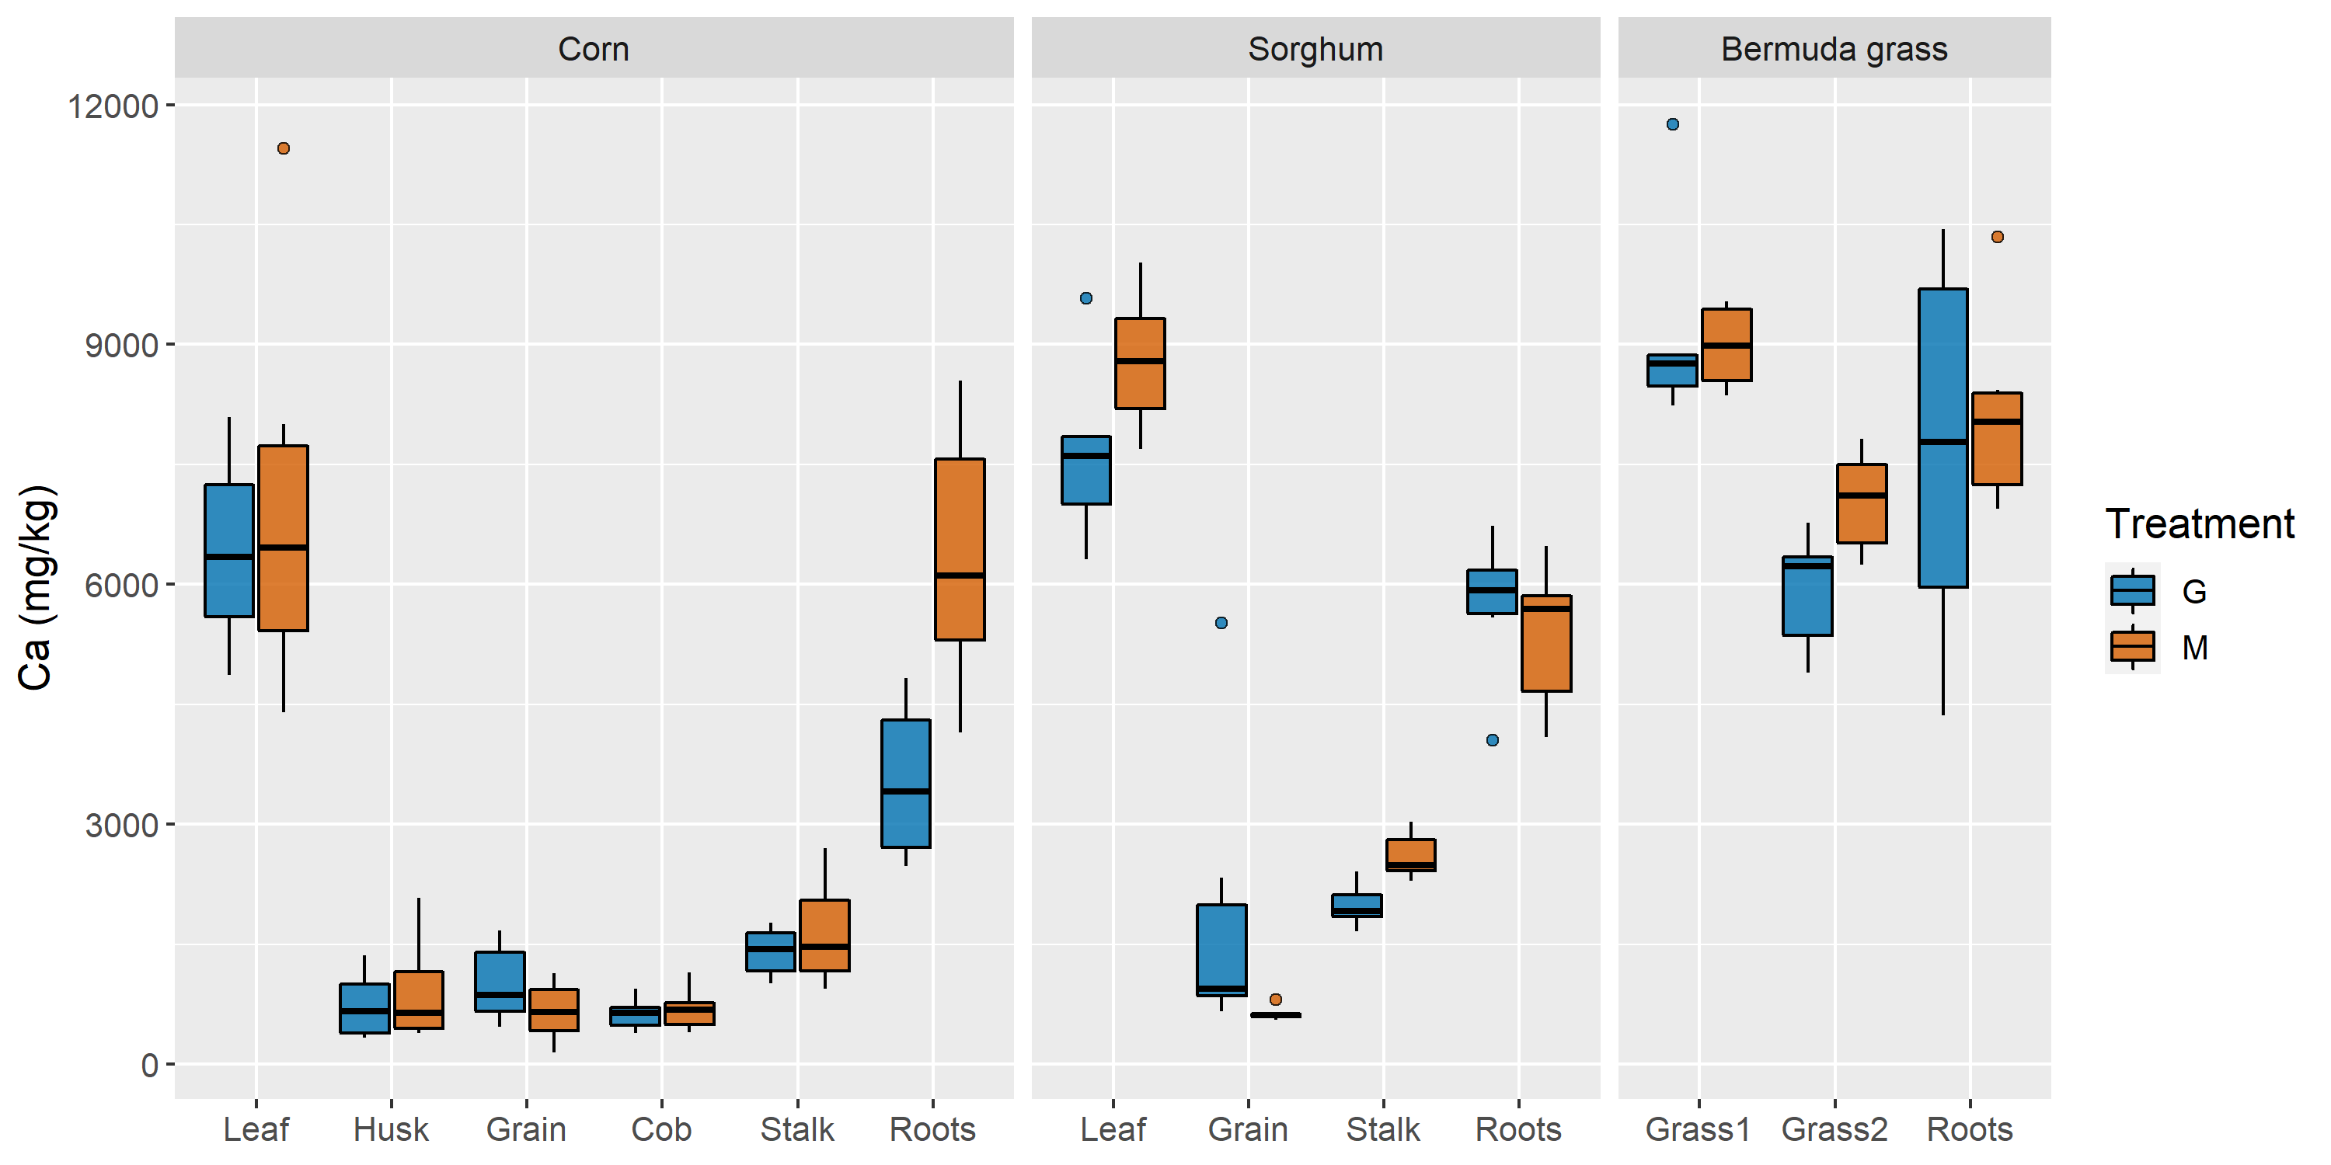
Figure 35: Box plots of Ca concentrations in each plant and structure in mg/kg

Cd concentrations, presented in Table 20 and Figure 36, were highest in the roots for every species under both irrigation treatments. Mine water-irrigated corn and sorghum plants accumulated higher root Cd concentrations than their groundwater-irrigated counterparts (Table 20); no other structures exhibited significantly different Cd concentrations as a result of irrigation treatment (Student’s t-test, p > 0.05). This suggests that, while higher mine water Cd concentrations result in elevated Cd exposure and accumulation in corn and sorghum, Cd translocation is mitigated by complexation and sequestration in the roots, rendering groundwater and mine water-irrigated aboveground biomass indistinguishable in terms of Cd concentrations. Cd uptake was similar to accumulation observed in the roots and leaves of corn grown near mine tailings, and although root Cd concentrations were above the normal range of 0.05 to 0.2 mg/kg DW in all species, they consistently remained below toxic levels of 5 to 20 mg/kg DW (Armienta et al., 2020).
Table 20: Means, standard deviations of plant Cd concentrations in mg/kg compared via mixed ANOVA
 | Treatment
 | Groundwater |  | Mine water |  |  | Partial η_{p}²
Structure | Mean | SD | Mean | SD | p | Partial η_{p}²
Corn
Leaf | 0.160 ab | 0.087 | 0.105 a | 0.020 | 0.164 | 0.184
Husk | 0.090 a | 0.031 | 0.081 a | 0.026 | 0.579 | 0.032
Grain | 0.100 a | 0.029 | 0.088 a | 0.019 | 0.423 | 0.065
Cob | 0.087 a | 0.035 | 0.086 a | 0.020 | 0.956 | < 0.001
Stalk | 0.094 a | 0.010 | 0.096 a | 0.018 | 0.798 | 0.007
Roots | 0.234 b | 0.035 | 0.295 | 0.045 | 0.024 | 0.415
Sorghum
Leaf | 0.132 a | 0.038 | 0.129 a | 0.032 | 0.864 | 0.003
Grain | 0.111 a | 0.015 | 0.110 a | 0.012 | 0.841 | 0.004
Stalk | 0.128 a | 0.013 | 0.128 a | 0.022 | 0.981 | 0.000
Roots | 0.238 | 0.039 | 0.307 | 0.036 | 0.009 | 0.508
Bermuda grass
Grass1 | 0.122 | 0.024 | 0.112 | 0.018 | 0.767 | 0.009
Grass2 | 0.162 | 0.031 | 0.136 | 0.012 | 0.767 | 0.009
Roots | 0.372 | 0.082 | 0.397 | 0.028 | 0.767 | 0.009
When the interaction effect was not significant, the results of Sidak-corrected pairwise comparisons of main effects are indicated by a single value in the p column (irrigation treatment main effect) and symbols (e.g., †‡) next to structure names (plant structure main effect). Plant structures that share a symbol were not significantly different (p ≤ 0.05). When the interaction effect was significant for a species, the results of Sidak-corrected pairwise comparisons of simple main effects are indicated by a value in every row of the p column for the species (irrigation treatment simple main effect) and letters (e.g., ab) next to mean concentrations. Structure concentrations from the same species and irrigation treatment that share a letter were not significantly different (plant structure simple main effect, alpha = 0.05).

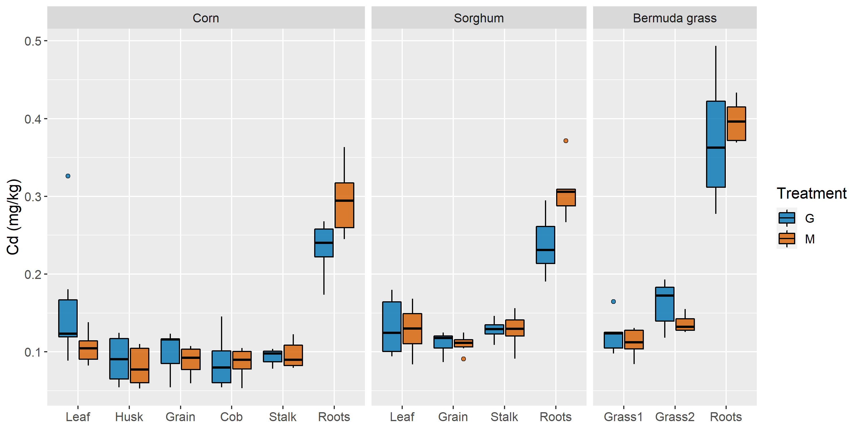
Figure 36: Box plots of Cd concentrations in each plant and structure in mg/kg

Mg can be a growth-limiting constraint at vegetative concentrations below 1.5 to 3.5 g/kg DW (Hawkesford et al., 2012). It is possible that all three species, seen in Table 21 and Figure 37, were Mg-deficient despite elevated concentrations in both irrigation waters. The groundwater contained significantly less Mg than mine water (Welch’s t-test, p < 0.001), and groundwater-irrigated corn leaves, stalks, and roots accumulated smaller Mg concentrations than their mine water-irrigated counterparts, accordingly (Table 21). Sorghum roots were the only sorghum structures with significantly lesser Mg concentrations under groundwater irrigation (Student’s t-test, p = 0.031); irrespective of treatment, sorghum leaves contained sufficient Mg but stalks and roots did not. Unlike the first Bermuda grass harvest, the shoots and roots collected during the second harvest were at or below the critical deficiency concentration for Mg. This stark difference was likely due to rainfall frequency; the pots received three more inches of rain during the 36 days between first and second Bermuda grass harvests than they did during the 71 days between planting and the first Bermuda grass harvest. The increased frequency and intensity of rainfall during the last month of the growing period reduced the amount of Mg-rich irrigation water applied to the pots and could have leached Mg from the substrate, further reducing availability (Ayers and Westcot, 1985a; Römheld, 2012). This same environmental influence could explain the significant reduction in Ca concentrations of aboveground Bermuda grass from the first harvest to the second (Student’s t-test, p < 0.001).
Table 21: Means, standard deviations of plant Mg concentrations in mg/kg compared via mixed ANOVA
 | Treatment
 | Groundwater |  | Mine water |  |  | Partial η_{p}²
Structure | Mean | SD | Mean | SD | p | Partial η_{p}²
Corn
Leaf | 1589.23 abc | 553.86 | 2183.56 a | 240.10 | 0.037 | 0.368
Husk | 1120.56 b | 215.11 | 1058.43 b | 135.52 | 0.563 | 0.035
Grain | 1947.48 c | 507.54 | 1581.59 ab | 266.24 | 0.149 | 0.196
Cob | 1376.73 bcd | 331.47 | 1134.37 bc | 376.37 | 0.264 | 0.123
Stalk | 583.36 d | 152.96 | 889.49 b | 280.76 | 0.041 | 0.355
Roots | 784.40 ad | 139.37 | 1628.20 ac | 98.34 | < 0.001 | 0.936
Sorghum *
Leaf | 2521.69 a | 279.19 | 2684.73 a | 556.67 | 0.593 | 0.030
Grain | 3099.95 a | 409.02 | 2879.05 a | 229.90 | 0.297 | 0.108
Stalk | 1218.26 | 267.95 | 1029.20 b | 80.57 | 0.161 | 0.186
Roots | 925.22 | 164.21 | 1190.34 b | 207.19 | 0.031 | 0.387
Bermuda grass
Grass1 | 2583.32 | 242.02 | 3076.19 | 220.46 | < 0.001 | 0.696
Grass2 | 1207.75 | 266.86 | 1662.90 | 170.68 | < 0.001 | 0.696
Roots | 880.24 | 109.36 | 1150.86 | 109.27 | < 0.001 | 0.696
Species whose data were log-transformed for mixed ANOVA are indicated with an asterisk. When the interaction effect was not significant, the results of Sidak-corrected pairwise comparisons of main effects are indicated by a single value in the p column (irrigation treatment main effect) and symbols (e.g., †‡) next to structure names (plant structure main effect). Plant structures that share a symbol were not significantly different (p ≤ 0.05). When the interaction effect was significant for a species, the results of Sidak-corrected pairwise comparisons of simple main effects are indicated by a value in every row of the p column for the species (irrigation treatment simple main effect) and letters (e.g., ab) next to mean concentrations. Structure concentrations from the same species and irrigation treatment that share a letter were not significantly different (plant structure simple main effect, alpha = 0.05).

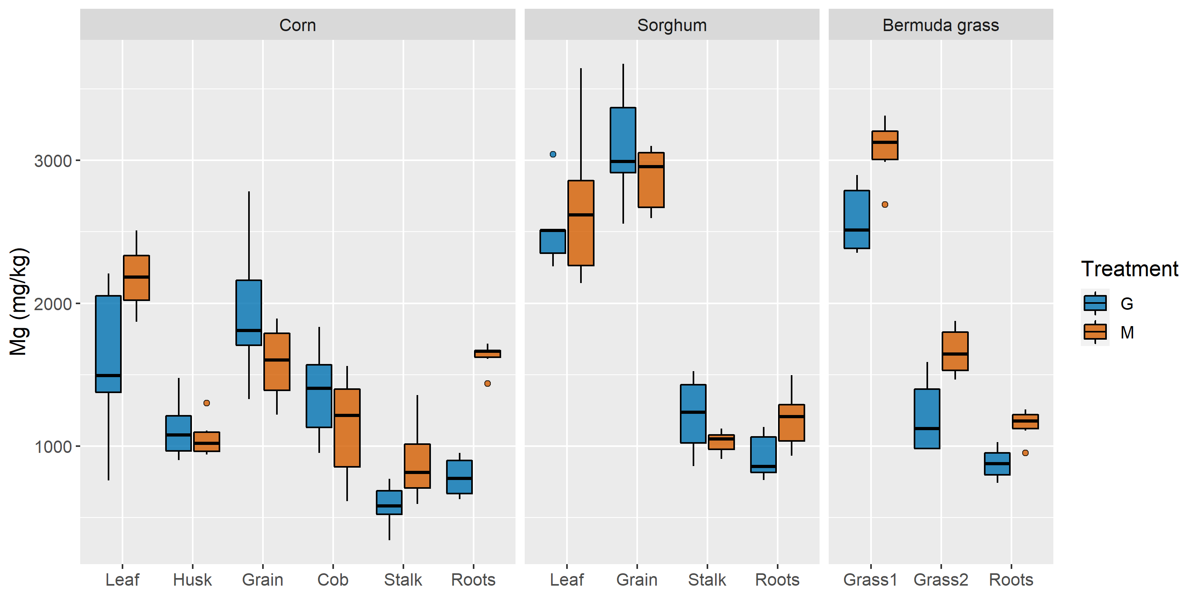
Figure 37: Box plots of Mg concentrations in each plant and structure in mg/kg

Na concentrations were elevated above either Na toxicity- or soil sodicity-derived irrigation criteria in both waters, and were significantly higher in mine water than in groundwater (Welch’s t-test, p < 0.001), but were effectively excluded from aboveground biomass in almost all corn and sorghum plants as seen in Table 22 and Figure 38. As with Ca and Mg, Na concentrations in Bermuda grass shoots decreased from the first to second harvest (Table 22), most likely due to the same discrepancies in rainfall and irrigation mass loadings identified during the discussion of Mg uptake. Mine water irrigation did not increase Na concentrations in corn roots (Table 22), but did result in significantly higher Na uptake in sorghum roots (Student’s t-test, p < 0.001) and Bermuda grass (F(1,10) = 62.78, p < 0.001). Significantly greater Na concentrations in Bermuda grass shoots compared to roots could reflect the irrigation method; Bermuda grass was watered from above, which initiated foliar contact with high concentrations of Na avoided during drip irrigation of corn and sorghum. However, another explanation for Bermuda grass Na uptake that could be more consequential examines the Na tolerances of C4 plants. Na is an essential element for a select number of warm-season C4 grasses for which deficiencies can disrupt conversion of pyruvate and accumulation of CO₂ in leaves during C4 photosynthesis, but corn and sorghum – intolerant Na excluders – are specifically omitted from this characterization alongside most other plants, C4 or otherwise (Broadley et al., 2012a). Bermuda grass, on the other hand, is more tolerant to Na and actively translocates Na from roots to shoots, wherein Na can optimize grass growth by compensating for K deficiencies, increasing cellular expansion and turgor, and better regulating water conservation during drought-induced stress (Broadley, et al., 2012a). These phenomena likely contributed to higher mean biomass production of mine water-irrigated Bermuda grass, although the increase was not statistically significant (Student’s t-test, p = 0.063). Additionally, Na translocation in Bermuda grass can benefit more than just plant health; elevated Na concentrations in pasture grasses can actually be desirable for livestock, which sometimes exhibit Na demands greater than what is provided by Na-excluding forage (Broadley et al., 2012a).
Corn, sorghum, and Bermuda grass have been reported as sensitive, semi-tolerant, and tolerant to Na, respectively (Ayers and Westcot, 1985a). Relative sensitivities are used in place of Na concentrations that cause direct toxicity because “usually, nutritional factors and adverse soil conditions stunt growth before reaching these levels” (Ayers and Westcot, 1985a). Corn’s status as the most sensitive of the three species is exhibited by elevated Na uptake in corn roots, which far surpassed concentrations in sorghum and Bermuda grass roots. Na exerts toxic effects on corn and sorghum through a plethora of mechanisms, some of which are related to the mechanisms by which Bermuda grass benefits from Na. For example, researchers have shown that Na decreases K uptake and translocation in corn grown in saline solutions, although the effect of increasing solution Na concentrations on the roots’ ability to exclude Na has been disputed (Botella et al., 1997; Drew and Dikumwin, 1985). Na’s tendency to interfere with corn and sorghum K usage can decrease biomass production and increase vegetative necrosis and water stress (Botella et al., 1997; Farooq et al., 2015). Furthermore, salt stress decreased sorghum grain production and growth and was associated with reduced concentrations of K, P, and Mg in various sorghum structures depending on when salt stress occurred; similar decreases in grain weight and quantity as well as diminished uptake of the aforementioned elements in addition to nitrogen, Ca, and Fe have been attributed to Na toxicity in corn plants (Farooq et al., 2015; Maas et al., 1986). Salt-tolerant corn hybrids have been developed to mitigate direct Na toxicity by accumulating the element in old leaves which are then shed from the plant, but this adaptation does not address indirect toxicity from salinization of soil and the resulting decreases in available soil water (Ayers and Westcot, 1985a; Gao et al., 2016; Pearson, 2003).
Table 22: Means, standard deviations of plant Na concentrations in mg/kg compared via mixed ANOVA
 | Treatment
 | Groundwater |  | Mine water |  |  | Effect size
Structure | Mean | SD | Mean | SD | p | Effect size
Corn
Stalk (n = 3) | 160.30 | 3.04 | 205.53
Roots | 2270.04 | 652.17 | 2238.03 | 793.97 | 0.941 | 0.044
Sorghum
Stalk (n = 1) |  |  | 154.80
Roots | 286.32 | 20.88 | 461.93 | 45.38 | < 0.001 | 4.970
Bermuda grass
Grass1 | 651.75 | 20.69 | 737.81 | 96.52 | < 0.001 | 0.863
Grass2 | 272.90 | 58.86 | 402.63 | 47.92 | < 0.001 | 0.863
Roots | 187.46 | 34.45 | 355.82 | 68.86 | < 0.001 | 0.863
When the interaction effect was not significant, the results of Sidak-corrected pairwise comparisons of main effects are indicated by a single value in the p column (irrigation treatment main effect) and symbols (e.g., †‡) next to structure names (plant structure main effect). Plant structures that share a symbol were not significantly different (p ≤ 0.05). Insufficient data were available to compare corn and sorghum structures and treatments with mixed ANOVA, so a Student’s t-test was used to compare the effects of irrigation treatment on Na concentrations in corn and sorghum roots. The effect sizes presented are Cohen’s d for corn and sorghum and partial eta squared for Bermuda grass.

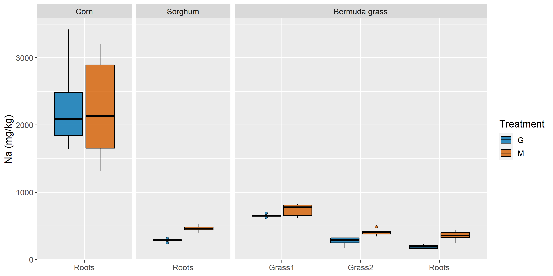
Figure 38: Box plots of Na concentrations in each plant and structure in mg/kg

Irrigation with treated mine water increased S concentrations in corn stalks and roots, sorghum roots, and Bermuda grass shoots and roots (Table 23). Plants need between 1000 and 5000 mg/kg S for normal growth; grasses skew towards the lower end (Hawkesford et al., 2012). Sulfur is often present in sufficient concentrations to satisfy corn growth needs in Kansas irrigation waters, and this seems to be the case in this study as well (Duncan et al., 2007). Mine water irrigation resulted in significantly higher S concentrations in the roots of corn and sorghum plants (Student’s t-test, p < 0.001). While groundwater-irrigated corn and sorghum roots contained elevated S, root concentrations were not significantly higher than concentrations in groundwater-irrigated leaves and grain (Student’s t-test, p > 0.05). Roots seemed to accumulate excess S without translocating it into the aboveground biomass; this sequestration is especially noticeable for corn in Figure 39. This suggests that while S deficiency and toxicity can stunt plant growth and fruiting, grass roots can maintain healthy aboveground S concentrations by regulating S uptake and translocation, at least under drip irrigation schemes (Ward, 1976). Bermuda grass aboveground S concentrations were significantly higher than levels in the roots (Student’s t-test, p < 0.001), likely due to the irrigation method as previously discussed. The significant decrease in aerial S from first to second harvest mirrors the rainwater- and time-induced pattern witnessed in Ca, Mg, and Na concentrations (Student’s t-test, p < 0.001). The harvestable concentrations of S in corn and sorghum are acceptable, but the elevated belowground biomass concentrations imply potentially unsustainable soil accumulation. Furthermore, the use of Bermuda grass with such elevated S concentrations for livestock grazing could negatively impact cattle development and productivity via reduced retention of dietary Cu, Zn, and Mn (Pogge et al., 2014).
Table 23: Means, standard deviations of plant S concentrations in mg/kg compared via mixed ANOVA
 | Treatment
 | Groundwater |  | Mine water |  |  | Partial η_{p}²
Structure | Mean | SD | Mean | SD | p | Partial η_{p}²
Corn
Leaf | 1419.97 a | 449.66 | 1638.25 a | 557.01 | 0.472 | 0.053
Husk | 630.44 b | 78.65 | 579.89 b | 68.00 | 0.261 | 0.124
Grain | 1660.46 a | 423.89 | 1263.24 ac | 287.45 | 0.087 | 0.265
Cob | 1272.29 ac | 457.00 | 1039.17 ab | 338.47 | 0.339 | 0.092
Stalk | 503.97 bc | 169.94 | 888.45 bc | 328.95 | 0.029 | 0.393
Roots | 1997.39 a | 373.26 | 6330.59 | 899.17 | < 0.001 | 0.922
Sorghum
Leaf | 1044.40 a | 168.38 | 1137.68 a | 194.13 | 0.395 | 0.073
Grain | 1122.83 a | 138.77 | 1066.14 a | 50.88 | 0.370 | 0.081
Stalk | 985.76 a | 224.48 | 1179.78 a | 432.06 | 0.352 | 0.087
Roots | 1295.92 a | 184.87 | 2475.65 | 330.30 | < 0.001 | 0.854
Bermuda grass
Grass1 | 8293.78 | 804.87 | 9631.83 | 905.41 | 0.022 | 0.423
Grass2 | 4527.71 | 742.04 | 6185.55 | 857.59 | 0.005 | 0.562
Roots | 1806.12 | 203.64 | 2098.29 | 220.21 | 0.038 | 0.363
When the interaction effect was significant for a plant, the results of Sidak-corrected pairwise comparisons of simple main effects are indicated by a value in every row of the p column for the species (irrigation treatment simple main effect) and letters (e.g., ab) next to mean concentrations. Structure concentrations from the same species and irrigation treatment that share a letter were not significantly different (plant structure simple main effect, alpha = 0.05).
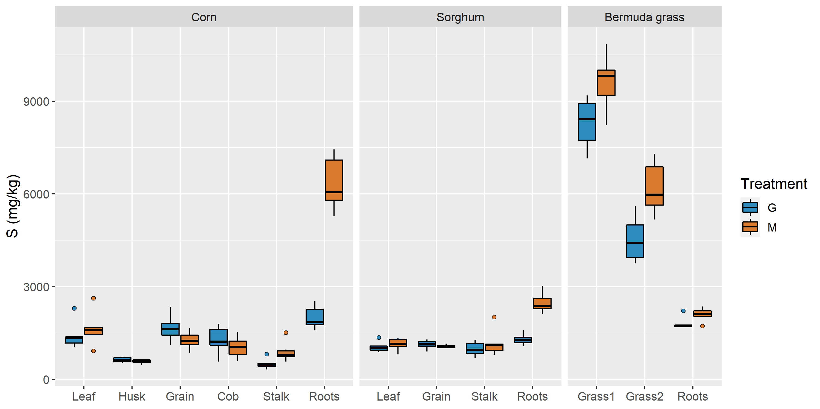
Figure 39: Box plots of S concentrations in each plant and structure in mg/kg

Substrate pH and Metal Concentrations
Soil pH increased in both groundwater- and mine water-irrigated pots after a single growing season. Average pH increased from 6.81 to 7.60 in groundwater-irrigated substrates and 7.26 in mine water-irrigated substrates. Soil pH values were affected by soil composition, irrigation water inputs, fertilizer inputs, and rainwater-induced leaching of well-draining potting mix, although the increases in pH correlate with the irrigation waters’ respective pH values and alkalinities. As such, it is difficult to draw conclusions beyond perhaps the general increase in soil pH during both irrigation regimes, but this is an important determination nonetheless. Corn and Bermuda grass experience optimal growth in soils with pH between 5.5-7.0 and 5.7-7.0, respectively, and many Oklahoma farmers use lime to raise pH values to this range following soil acidification from nitrogen fertilizers (Arnall et al., 2018; Australian OGTR, 2008). The pH 8 groundwater and mine water would continually add bicarbonate to the soil, buffering fertilizer-derived acidity and potentially reducing the need for lime amendments.
Recoverable metals concentrations in blocked random samples of pre- and post-experiment substrate were compared to evaluate the effect of irrigation treatment on substrate metal composition. The upper and lower horizons were sampled simultaneously for each selected pot, analyzed, and then averaged to allow for hypothesis testing of independent samples. Wilcoxon signed-rank tests for paired samples were performed on pre- and post-experiment concentrations separately for mine water-irrigated pots and groundwater-irrigated pots to test the null hypothesis, H₀, that the median difference between pre- and post-experiment metals concentrations is zero. Symmetry of the paired differences was confirmed with the Shapiro-Wilk test. The results of these nonparametric tests are provided in Table 24.
Table 24: Median subtrate metal concentrations (mg/kg) from groundwater- and mine water-irrigated pots pre- and post-experiment
 | Groundwater |  |  |  | Mine water
Parameter | Pre, Median | Post, Median | p |  | Pre, Median | Post, Median | p
Ca | 37500 | 35300 | 0.438 |  | 37800 | 39300 | 0.844
Cd | 0.896 | 1.02 | 0.156 |  | 0.922 | 1.01 | 0.031
Fe | 7550 | 5760 | 0.094 |  | 7050 | 6330 | 0.156
K | 5460 | 3550 | 0.031 |  | 5550 | 3090 | 0.031
Mg | 2130 | 2140 | 1.00 |  | 2600 | 3320 | 0.219
Mn | 258 | 245 | 0.438 |  | 264 | 250 | 0.219
Na | 251 | 517 | 0.031 |  | 267 | 643 | 0.031
Ni | 6.12 | 5.77 | 0.094 |  | 6.44 | 7.82 | 0.156
Pb | 19.5 | 16.0 | 0.094 |  | 19.3 | 16.5 | 0.031
S | 1820 | 1580 | 0.563 |  | 1660 | 5060 | 0.031
Zn | 31.8 | 30.3 | 0.063 |  | 32.0 | 28.4 | 0.031
P-values were calculated from Wilcoxon signed-rank tests for paired samples (n = 6), alpha = 0.05.
Substrate Na concentrations were increased and K concentrations were decreased during groundwater irrigation, whereas Cd, Na, and S were increased and K, Pb, and Zn were decreased during mine water irrigation (Table 24). Of the metals that were significantly increased or decreased after irrigation, mass loadings of K, Cd, Pb, and Zn in the substrate dwarfed contributions from the fertilizer and irrigation waters. The decreasing concentrations of K, Pb, and Zn during the growing season were the expected consequence of a system with miniscule inputs and multiple demanding outflows; the increase in Cd was unexpected. Of course, nonparametric tests sacrifice power for flexibility, and testing for significance at an alpha of 0.10 would extend statistical significance to differences in four more elemental concentrations under groundwater irrigation: increased Fe and decreased Ni, Pb, and Zn. Data visualization of multiple representations of substrate metal concentration changes can provide more nuanced insight into the effects of irrigating with groundwater and treated mine water. Figure 40 presents soil Cd concentrations before and after the experiment through a combination of scatter plots, box plots, connected means with standard error bars, and smoothed histograms (Allen et al., 2019). Cd concentrations were significantly increased during mine water irrigation (p = 0.031) and not groundwater irrigation (p = 0.156), but Table 24 shows a larger difference in median Cd concentrations under groundwater irrigation than under mine water irrigation. Figure 40 shows that comparing changes in box plots and means for Cd concentrations does not provide an obvious case for significance of only one irrigation treatment’s effect on Cd. However, the histogram and scatter plots reveal two high outliers in pre-groundwater irrigation Cd concentrations that were substantially reduced over the course of the study and likely rendered the apparent increase during groundwater irrigation non-significant. Whether these outliers changed due to groundwater irrigation or just heterogeneity in the substrate is unknown, but the latter seems more likely when considering the high Cd concentrations in the potting mix and a low Cd loading from groundwater. Similar plots for other metals of interest can be found in Appendix D.
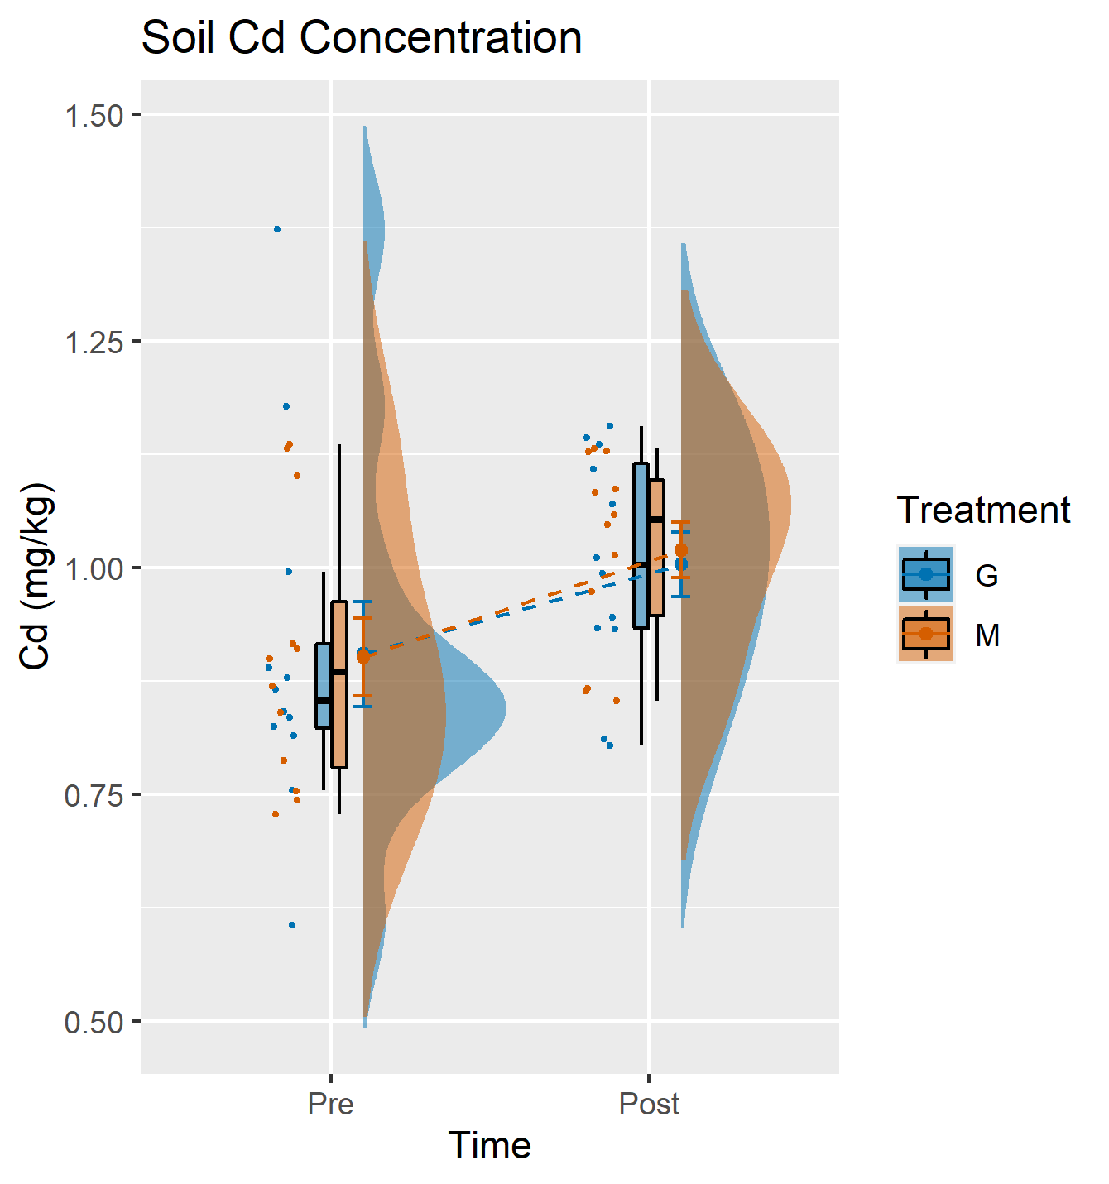
Figure 40: Changes in soil Cd concentrations under groundwater and mine water irrigation before and after a single growing season, visualized with a combination of scatter plots, box plots, connected means with standard error bars, and smoothed histograms

Substrate metal concentration increases likely reflect organic matter sorption and accumulation of chemicals from fertilizer and irrigation waters, whereas decreases are indicative of phytoaccumulation or leaching. Extrapolating from well-draining soilless potting mix performance to predict irrigation-driven metal accumulation in soil with clay, silt, and sand fractions and less organic matter is ill-advised. For example, potting mix has been explored as a filter media to treat trace metal storm water contamination and demonstrated high removal efficiencies of Cu, Cd, Pb, and Zn (Lim et al., 2015). Furthermore, rainfall over the course of the growing season leached unknown quantities of salts from the substrate and out of the pots, whereas during conventional farming those salts would just move slightly deeper into the root zone. However, what can be safely asserted is that mine water irrigation under these experimental conditions substantially increased substrate concentrations of Na and S, both of which were absorbed by plant roots but predominantly excluded from the aboveground biomass. Cd concentrations also increased slightly, perhaps due to the propensity of potting mix for heavy metal sorption, and K, Pb, and Zn decreased as a result of plant uptake and leaching. Na concentrations, while concerning because of the salinity-induced toxicity threat, were significantly increased during groundwater irrigation as well (p = 0.031), and are sufficiently balanced in treated mine water by Ca, Mg, and alkalinity to theoretically prevent soil sodification.

Conclusions
The livestock study determined that although the volume of mine water treated by MRPTS could satisfy livestock drinking water demands in Ottawa County, SO₄²⁻ levels in the discharge render the passively-treated mine water unsuitable for cattle consumption – particularly calves and pregnant cows. Unless additional treatment for SO₄²⁻ removal was implemented, it is unlikely that ranchers in Ottawa County would consider funding the costly and logistically-challenging transportation of treated mine water from MRPTS to livestock operations when existing water sources presumably meet current demands.
During the irrigation study, corn, sorghum, and Bermuda grass were irrigated from seed with either treated net-alkaline mine water or groundwater from Canadian River alluvium. The primary goal was to examine crops grown with mine water and make a recommendation as to whether mine water could be beneficially reused for crop irrigation. This recommendation was informed by comparisons of mine water- and groundwater-irrigated plants in a variety of predominantly quantitative metrics: plant emergence, growth, biomass generation, metals concentrations, and associated substrate quality. A recommendation based on such comparisons presumes that this groundwater source was suitable for irrigation; efforts to contrast the groundwater against irrigation criteria in the literature identified high alkalinity as a potential concern to be monitored, but were otherwise encouraging. Conversely, the treated mine water contained elevated concentrations of Ca, Mg, Na, S, and alkalinity; trace metals like Cd, Fe, Pb, and Zn were present at ecotoxic levels in the mine water prior to passive treatment, but were so thoroughly sequestered and removed that they were no longer primary irrigation concerns.
Mine water irrigation did not have a significant effect on seedling emergence, plant growth, or biomass production for corn or Bermuda grass. Sorghum exhibited a temporary reduction in growth and a decrease in biomass production under mine water irrigation. On these grounds, the hypothesis that select crops irrigated with treated mine drainage will not exhibit significant reductions in biomass production when compared to crops irrigated with groundwater is accepted for corn and Bermuda grass but rejected for sorghum.
The crops were exposed to metals in irrigation waters, fertilizer, and potting soil, and irrigation was the smallest vector for many of the metal species. Mine water irrigation did not significantly increase concentrations of Fe, Mn, Zn, K, Ni, or Pb in any of the three species. Mine water irrigation had mixed effects on Ca concentrations, and resulted in increased concentrations of Cd in roots and Mg in belowground and aboveground biomass of some structures. Na and S concentrations were elevated in some corn and sorghum root structures and in all Bermuda biomass as a result of mine water irrigation. As such, the hypothesis that select crops irrigated with treated mine drainage will experience elevated recoverable metals concentrations in above- or belowground biomass compared to crops irrigated with groundwater is rejected for Fe, Mn, Zn, K, Ni, and Pb and accepted for Ca, Cd, Mg, Na, and S.
Mine water-irrigated substrate accumulated concentrations of Cd, Na, and S while concentrations of K, Pb, and Zn decreased. The decreased concentrations were indicative of miniscule mass loadings from the mine water. The increase in Cd, while statistically significant in mine water-irrigated pots, was of similar magnitude under both treatments. Na and S were primarily contributed by the irrigation water and were partially excluded by plant roots, which increased concentrations in the substrate. Therefore, the hypothesis that soils irrigated with treated mine drainage will experience elevated recoverable metals concentrations compared to crops irrigated with groundwater is accepted for Cd, Na, and S, and rejected for all other analyzed metals.
Hard-rock, net alkaline mine drainage can be treated in ecologically-engineered systems and successfully reused for the irrigation of some plant species without detriment to emergence patterns, growth, or biomass production. Treated mine water can increase concentrations of certain elements in plants and soil, particularly Cd, Na, and S, but these metals are largely sequestered in the belowground biomass.
These conclusions should be understood in the greater context of the study. As with the livestock reuse scenario, the issue of water transportation would present a substantial challenge to implementation of treated mine water reuse for irrigation. Furthermore, the plants were grown in a soilless medium, which limits comparisons of metals accumulation and pH with other substrates. Pots restricted root growth, and corn and sorghum exhibited visible symptoms of drought stress. Finally, the experiment was ended before corn and sorghum had fully matured, so observations and analyses of the reproductive structures should be approached with caution.
In the future, this experiment would benefit from a larger scale in-situ planting with less frequent irrigation and more reliance on soil water, as is typically the case under field conditions. If repeated over multiple years, such a study could assess the long-term impacts of elevated Na, Ca, Mg, and alkalinity on soil structure and composition. Finally, the potential reuse of treated mine water should be extended to irrigating other C4 pasture grasses, which might benefit from elevated Na concentrations, although the effect of S biomagnification in grazing animals should also be considered.

Literature Cited
Abusam, A., and Shahalam, A. (2013). Wastewater reuse in Kuwait: Opportunities and constraints. WIT Transactions on Ecology and the Environment, 179, 745–754. https://doi.org/10.2495/SC130632
Allen, M., Poggiali, D., Whitaker, K., Marshall, T. R., and Kievit, R. A. (2019). Raincloud plots: A multi-platform tool for robust data visualization. Wellcome Open Research, 4, 63. https://doi.org/10.12688/wellcomeopenres.15191.1
Andújar, D., Ribeiro, A., Carmona, R., Fernandez-Quintanilla, C., and Dorado, J. (2010). An assessment of the accuracy and consistency of human perception of weed cover. Weed Research, 50, 638–647. https://doi.org/10.1111/j.1365-3180.2010.00809.x
Armienta, M. A., Beltrán, M., Martínez, S., and Labastida, I. (2020). Heavy metal assimilation in maize (Zea mays L.) plants growing near mine tailings. Environmental Geochemistry and Health, 42(8), 2361–2375. https://doi.org/10.1007/s10653-019-00424-1
Arnall, B., Hanks, T., Jones, J., Payne, J., Penn, C., Pugh, B., Redfearn, D., Rice, C., Warren, J., and Zhang, H. (2018). Oklahoma forage and pasture fertility guide (E-1021; p. 56). Oklahoma State University Extension Service, Division of Agricultural Sciences and Natural Resources.
Asano, T., and Levine, A. D. (1996). Wastewater reclamation, recycling and reuse: Past, present, and future. Water Science and Technology; London, 33(10–11), 1–14.
Asano, T., and Pettygrove, G. S. (1987). Using reclaimed municipal wastewater for irrigation. California Agriculture, 15–18.
Assefa, Y., Staggenborg, S. A., and Prasad, V. P. V. (2010). Grain Sorghum Water Requirement and Responses to Drought Stress: A Review. Crop Management, 9(1), 1–11. https://doi.org/10.1094/CM-2010-1109-01-RV
Australian OGTR. (2008). The Biology of Zea Mays L. ssp mays (maize or corn) (p. 81). Australian Government, Department of Health and Ageing, Office of the Gene Technology Regulator.
Ayers, R. S., and Westcot, D. W. (1985a). Water quality for agriculture. Food and Agriculture Organization of the United Nations. http://www.fao.org/3/t0234e/t0234e00.htm
Ayers, R. S., and Westcot, D. W. (1985b). Water quality for livestock and poultry. Food and Agriculture Organization of the United Nations. http://www.fao.org/3/t0234e/T0234E07.htm
Bauder, T. A., Waskom, R. M., Sutherland, P. L., and Davis, J. G. (2014, October). Irrigation Water Quality Criteria. Colorado State University Extension. https://extension.colostate.edu/topic-areas/agriculture/irrigation-water-quality-criteria-0-506/
Baum, R., Luh, J., and Bartram, J. (2013). Sanitation: A Global Estimate of Sewerage Connections without Treatment and the Resulting Impact on MDG Progress. Environmental Science and Technology, 47(4), 1994–2000. https://doi.org/10.1021/es304284f
Beauzamy, L., Nakayama, N., and Boudaoud, A. (2014). Flowers under pressure: Ins and outs of turgor regulation in development. Annals of Botany, 114(7), 1517–1533. https://doi.org/10.1093/aob/mcu187
Beede, D. K. (2008). Evaluation of Water Quality and Nutrition for Dairy Cattle. 24.
Botella, M. A., Martinez, V., Pardines, J., and Cerdá, A. (1997). Salinity induced potassium deficiency in maize plants. Journal of Plant Physiology, 150(1), 200–205. https://doi.org/10.1016/S0176-1617(97)80203-9
Brakie, M. (2017). Plant Guide for Indiangrass (Sorghastrum nutans) (p. 7). USDA-Natural Resources Conservation Service.
Brandenberger, L., Kahn, B., and Rebek, E. (2017). Sweet Corn Production (HLA-6021; Oklahoma Cooperative Extension Fact Sheets, p. 4). Oklahoma State University Extension Service. https://extension.okstate.edu/fact-sheets/sweet-corn-production.html
Broadley, M., Brown, P., Cakmak, I., Ma, J. F., Rengel, Z., and Zhao, F. (2012a). Chapter 8—Beneficial Elements. In P. Marschner (Ed.), Marschner’s Mineral Nutrition of Higher Plants (Third Edition) (pp. 249–269). Academic Press. https://doi.org/10.1016/B978-0-12-384905-2.00008-X
Broadley, M., Brown, P., Cakmak, I., Rengel, Z., and Zhao, F. (2012b). Chapter 7 - Function of Nutrients: Micronutrients. In P. Marschner (Ed.), Marschner’s Mineral Nutrition of Higher Plants (Third Edition) (pp. 191–248). Academic Press. https://doi.org/10.1016/B978-0-12-384905-2.00007-8
Burau, R. G., Sheikh, B., Cort, R. P., Cooper, R. C., and Ririe, D. (1987). Reclaimed water for irrigation of vegetables eaten raw. California Agriculture, July-August, 4–7.
Carpenter, S. R., Stanley, E. H., and Vander Zanden, M. J. (2011). State of the World’s Freshwater Ecosystems: Physical, Chemical, and Biological Changes. Annual Review of Environment and Resources, 36(1), 75–99. https://doi.org/10.1146/annurev-environ-021810-094524
Castillo, A. R., St-Pierre, N. R., Silva del Rio, N., and Weiss, W. P. (2013). Mineral concentrations in diets, water, and milk and their value in estimating on-farm excretion of manure minerals in lactating dairy cows. Journal of Dairy Science, 96(5), 3388–3398. https://doi.org/10.3168/jds.2012-6121
Chang, A., Pan, G., Page, A., and Asano, T. (2001). Developing human health-related chemical guidelines for reclaimed water and sewage sludge applications in agriculture (No. WHO/EOS/95.20; p. 13). World Health Organization European Environmental Bureau.
Chibuike, G. U., and Obiora, S. C. (2014). Heavy Metal Polluted Soils: Effect on Plants and Bioremediation Methods [Review Article]. Applied and Environmental Soil Science; Hindawi. https://doi.org/10.1155/2014/752708
Critchley, W., and Siegert, K. (1991). A Manual for the Design and Construction of Water Harvesting Schemes for Plant Production. Food and Agriculture Organization of the United Nations. http://www.fao.org/3/U3160E/u3160e00.htm
Dial, H. (2012). Plant guide for sorghum (Sorghum bicolor L.) (p. 5). USDA-Natural Resources Conservation Service.
Doupé, R. G., and Lymbery, A. J. (2005). Environmental Risks Associated with Beneficial End Uses of Mine Lakes in Southwestern Australia.pdf. Mine Water and the Environment, 24, 134–138. https://doi.org/10.1007/s10230-005-0084-0
Drew, M. C., and Dikumwin, E. (1985). Sodium Exclusion from the Shoots by Roots of Zea mays (cv. LG 11) and its Breakdown with Oxygen Deficiency. Journal of Experimental Botany, 36(1), 55–62. https://doi.org/10.1093/jxb/36.1.55
Duncan, S., Fjell, D., and Vanderlip, R. (2007). Corn Production Handbook. Kansas State University. https://bookstore.ksre.ksu.edu/pubs/c560.pdf
Eddy, R., and Hahn, D. T. (2013). Optimizing Greenhouse Corn Production: What Is the Best Lighting and Plant Density? (Paper 13; Purdue Methods for Corn Growth, p. 5). http://docs.lib.purdue.edu/pmcg/13
Elahi, E., Abid, M., Zhang, L., and Alugongo, G. M. (2017). The use of wastewater in livestock production and its socioeconomic and welfare implications. Environmental Science and Pollution Research, 24(21), 17255–17266. https://doi.org/10.1007/s11356-017-9263-3
Farnham, I. M., Singh, A. K., Stetzenbach, K. J., and Johannesson, K. H. (2002). Treatment of nondetects in multivariate analysis of groundwater geochemistry data. Chemometrics and Intelligent Laboratory Systems, 60(1–2), 265–281. https://doi.org/10.1016/S0169-7439(01)00201-5
Farooq, M., Hussain, M., Wakeel, A., and Siddique, K. H. M. (2015). Salt stress in maize: Effects, resistance mechanisms, and management. A review. Agronomy for Sustainable Development, 35(2), 461–481. https://doi.org/10.1007/s13593-015-0287-0
Flörke, M., Kynast, E., Bärlund, I., Eisner, S., Wimmer, F., and Alcamo, J. (2013). Domestic and industrial water uses of the past 60 years as a mirror of socio-economic development: A global simulation study. Global Environmental Change, 23(1), 144–156. https://doi.org/10.1016/j.gloenvcha.2012.10.018
Ford, K. L. (2003). Passive Treatment Systems for Acid Mine Drainage. U.S. Bureau of Land Management Papers. https://digitalcommons.unl.edu/usblmpub/19
Frey, B. B., Murrar, S., and Brauer, M. (2018). Mixed Model Analysis of Variance. In The SAGE Encyclopedia of Educational Research, Measurement, and Evaluation (pp. 1075–1078). SAGE Publications, Inc. https://doi.org/10.4135/9781506326139
Fu, J., Fry, J., and Huang, B. (2004). Minimum Water Requirements of Four Turfgrasses in the Transition Zone. HortScience, 39(7), 1740–1744. https://doi.org/10.21273/HORTSCI.39.7.1740
Gao, Y., Lu, Y., Wu, M., Liang, E., Li, Y., Zhang, D., Yin, Z., Ren, X., Dai, Y., Deng, D., and Chen, J. (2016). Ability to Remove Na+ and Retain K+ Correlates with Salt Tolerance in Two Maize Inbred Lines Seedlings. Frontiers in Plant Science, 7(1716), 1–15. https://doi.org/10.3389/fpls.2016.01716
Garrido, A. E., Strosnider, W. H., Wilson, R. T., Condori, J., and Nairn, R. W. (2017). Metal-contaminated potato crops and potential human health risk in Bolivian mining highlands. Environmental Geochemistry and Health, 39(3), 681–700. https://doi.org/10.1007/s10653-017-9943-4
Garrot, D. J., and Mancino, C. F. (1994). Consumptive Water Use of Three Intensively Managed Bermudagrasses Growing under Arid Conditions. Crop Science, 34(1), 215–221. https://doi.org/10.2135/cropsci1994.0011183X003400010039x
Gerik, T., Bean, B., and Vanderlip, R. (2003). Sorghum Growth and Development (B-6137 7-03; p. 8). Texas A&M University.
Grant, S. B., Saphores, J.-D., Feldman, D. L., Hamilton, A. J., Fletcher, T. D., Cook, P. L. M., Stewardson, M., Sanders, B. F., Levin, L. A., Ambrose, R. F., Deletic, A., Brown, R., Jiang, S. C., Rosso, D., Cooper, W. J., and Marusic, I. (2012). Taking the “Waste” Out of “Wastewater” for Human Water Security and Ecosystem Sustainability. Science, 337(6095), 681–686. https://doi.org/10.1126/science.1216852
Grewar, T. (2019). South Africa’s options for mine-impacted water re-use: A review. Journal of the Southern African Institute of Mining and Metallurgy, 119(3), 321–331. https://doi.org/10.17159/2411-9717/2019/v119n3a12
Harari, Y. N. (2015). Sapiens: A Brief History of Humankind. Harper Collins.
Harper, G. S., King, T. J., Hill, B. D., Harper, C. M. L., and Hunter, R. A. (1997). Effect of coal mine pit water on the productivity of cattle, II. Effect of increasing concentrations of pit water on feed intake and health. Australian Journal of Agricultural Research, 48(2), 155–164.
Hawkesford, M., Horst, W., Kichey, T., Lambers, H., Schjoerring, J., Møller, I. S., and White, P. (2012). Chapter 6—Functions of Macronutrients. In P. Marschner (Ed.), Marschner’s Mineral Nutrition of Higher Plants (Third Edition) (pp. 135–189). Academic Press. https://doi.org/10.1016/B978-0-12-384905-2.00006-6
Helsel, D. R. (2005). More than obvious: Better methods for interpreting nondetect data. Environmental Science and Technology, 39(20), 419A-423A. https://doi.org/10.1021/es053368a
Higgins, S. F., Agouridis, C. T., and Gumbert, A. A. (2008). Drinking Water Quality Guidelines for Cattle (ID-170; p. 4). University of Kentucky Extension Service.
Houseal, G. A., Kaiser, J., Wuebker, E., and Butler, B. (2007). Tallgrass Prairie Center’s Native Seed Production Manual. University of Northern Iowa.
Hunter, R. A., Harper, G. S., and Mccrabb, G. J. (2002). The effect of ingestion of coal mine pit water on the productivity of pregnant and lactating beef cows. Animal Production in Australia, 24, 105–108.
ITRC. (2013, November). B.2 Mayer Ranch Commerce Site. https://itrcweb.org/bcr-1/Content/Appendix%20B%20Case%20Studies/B2%20Mayer%20Ranch%20Commerce%20Site.htm
John, D. A., and Leventhal, J. S. (2004). Bioavailability of metals. United States Geological Survey. https://www.semanticscholar.org/paper/BIOAVAILABILITY-OF-METALS-John-Leventhal/f97e54c1307528fb149d641b505c6643e3cd5b13
Khan, S., Cao, Q., Zheng, Y. M., Huang, Y. Z., and Zhu, Y. G. (2008). Health risks of heavy metals in contaminated soils and food crops irrigated with wastewater in Beijing, China. Environmental Pollution, 152(3), 686–692. https://doi.org/10.1016/j.envpol.2007.06.056
Laerd Statistics. (2018). How to perform a Mixed ANOVA in SPSS Statistics. Laerd Statistics. https://statistics.laerd.com/spss-tutorials/mixed-anova-using-spss-statistics.php
Lakens, D. (2013). Calculating and reporting effect sizes to facilitate cumulative science: A practical primer for t-tests and ANOVAs. Frontiers in Psychology, 4. https://doi.org/10.3389/fpsyg.2013.00863
Lalman, D. (2018). Supplementing Beef Cows (ANSI-3010). Oklahoma State University Extension Service, Division of Agricultural Sciences and Natural Resources. https://extension.okstate.edu/fact-sheets/supplementing-beef-cows.html
Lauer, J. (2003). What happens within the corn plant when drought occurs. Corn Agronomist, 10(22), 153–155.
Lee, S., and Lee, D. K. (2018). What is the proper way to apply the multiple comparison test? Korean Journal of Anesthesiology, 71(5), 353–360. https://doi.org/10.4097/kja.d.18.00242
Libutti, A., Gatta, G., Gagliardi, A., Vergine, P., Pollice, A., Beneduce, L., Disciglio, G., and Tarantino, E. (2018). Agro-industrial wastewater reuse for irrigation of a vegetable crop succession under Mediterranean conditions. Agricultural Water Management, 196, 1–14. https://doi.org/10.1016/j.agwat.2017.10.015
Lili, Y., Jiao, W., Chen, X., and Chen, W. (2011). An overview of reclaimed water reuse in China. Journal of Environmental Sciences (China), 23, 1585–1593. https://doi.org/10.1016/S1001-0742(10)60627-4
Lim, H. S., Lim, W., Hu, J. Y., Ziegler, A., and Ong, S. L. (2015). Comparison of filter media materials for heavy metal removal from urban stormwater runoff using biofiltration systems. Journal of Environmental Management, 147, 24–33. https://doi.org/10.1016/j.jenvman.2014.04.042
Liu, W., Zhao, J., Ouyang, Z., Söderlund, L., and Liu, G. (2005). Impacts of sewage irrigation on heavy metal distribution and contamination in Beijing, China. Environment International, 31(6), 805–812. https://doi.org/10.1016/j.envint.2005.05.042
Lottermoser, B. G. (2011). Recycling, Reuse and Rehabilitation of Mine Wastes. Elements, 7(6), 405–410. https://doi.org/10.2113/gselements.7.6.405
Lotz, L. a. P., Kropff, M. J., Wallinga, J., Bos, H. J., and Groeneveld, R. M. W. (1994). Techniques to estimate relative leaf area and cover of weeds in crops for yield loss prediction. Weed Research, 34(3), 167–175. https://doi.org/10.1111/j.1365-3180.1994.tb01984.x
M1W. (2020). Monterey One Water History. Monterey One Water. https://montereyonewater.org/about_history.html
Maas, E. V., Poss, J. A., and Hoffman, G. J. (1986). Salinity sensitivity of sorghum at three growth stages. Irrigation Science, 7(1). https://doi.org/10.1007/BF00255690
Marschner, H. (1993). Zinc Uptake from Soils. In A. D. Robson (Ed.), Zinc in Soils and Plants: Proceedings of the International Symposium on ‘Zinc in Soils and Plants’ held at The University of Western Australia, 27–28 September, 1993 (pp. 59–77). Springer Netherlands. https://doi.org/10.1007/978-94-011-0878-2_5
Martins, M., Santos, E. S., Pires, C., Barros, R. J., and Costa, M. C. (2010). Production of irrigation water from bioremediation of acid mine drainage: Comparing the performance of two representative systems. Journal of Cleaner Production, 18(3), 248–253. https://doi.org/10.1016/j.jclepro.2009.10.013
McCauley, A., Jones, C., and Jacobsen, J. (2011). Functions and Deficiency and Toxicity Symptoms. Montana State University Extension.
McNair, J. N., Sunkara, A., and Frobish, D. (2012). How to analyse seed germination data using statistical time-to-event analysis: Non-parametric and semi-parametric methods. Seed Science Research, 22(2), 77–95. https://doi.org/10.1017/S0960258511000547
Mehes-Smith, M., Nkongolo, K., and Cholewa, E. (2013). Coping Mechanisms of Plants to Metal Contaminated Soil. Environmental Change and Sustainability. https://doi.org/10.5772/55124
Miller, W. J. (1970). Zinc Nutrition of Cattle: A Review. Journal of Dairy Science, 53(8), 1123–1135. https://doi.org/10.3168/jds.S0022-0302(70)86355-X
Mõttus, M., Sulev, M., Frederic, B., Lopez-Lozano, R., and Noorma, A. (2011). Photosynthetically Active Radiation: Measurement and Modeling. In Encyclopedia of Sustainability Science and Technology (pp. 7970–8000). Springer.
Naidu, G., Ryu, S., Thiruvenkatachari, R., Choi, Y., Jeong, S., and Vigneswaran, S. (2019). A critical review on remediation, reuse, and resource recovery from acid mine drainage. Environmental Pollution, 247, 1110–1124. https://doi.org/10.1016/j.envpol.2019.01.085
Nairn, R. W. (2015). Restoring a Severely Disturbed Watershed via Ecological Engineering: The Role of Passive Treatment Technologies. Oklahoma Clean Lakes and Watersheds Association, Stillwater, OK. http://www.oclwa.org/pdf/2015Presentations/A2-Nairn-Role%20of%20Passive%20Treatment%20Tech.pdf
Nairn, R. W. (2019). A Decade of Successful Performance: Ecotoxic Metal Retention in Ecologically Engineered Passive Treatment Systems Contributes to Stream Recovery in a Mining-Disturbed Watershed. CREW Meeting, Norman, OK.
Nairn, R. W., Beisel, T., Thomas, R. C., LaBar, J. A., Strevett, K. A., Fuller, D., Strosnider, W. H., Andrews, W. J., Bays, J., and Knox, R. C. (2009). Challenges in design and construction of a large multi-cell passive treatment system for ferruginous lead-zinc mine waters. Proceedings of the 26th National Conference of the American Society of Mining and Reclamation, 2009, 871–892. https://doi.org/10.21000/JASMR09010871
Nairn, R. W., and Strevett, K. A. (2009). Evaluating Wastewater Reuse for Livestock Watering.
Nairn, Robert W, LaBar, J. A., Oxenford, L. R., Shepherd, N. L., Arango, J. G., Tang, Z., Dorman, D. M., Folz, C. A., McCann, J. I., Ingendorf, J., Stanfield, H. T., and Knox, R. C. (2020). Toward Sustainability of Passive Treatment in Legacy Mining Watersheds: Operational Performance and System Maintenance. Mine Water Solutions, 123–128.
NASEM. (2015). Nutrient Requirements of Beef Cattle (8th ed., p. 19014). National Academies Press. https://doi.org/10.17226/19014
NAU. (2012). Sphericity in repeated measures analysis of variance. Northern Arizona University Oak. http://oak.ucc.nau.edu/rh232/courses/EPS625/Handouts/RM-ANOVA/Sphericity.pdf
New, L. (2004). Grain sorghum irrigation (B-6152; p. 8). Texas A&M University, AgriLife Extension.
Nimon, K. F. (2012). Statistical Assumptions of Substantive Analyses Across the General Linear Model: A Mini-Review. Frontiers in Psychology, 3. https://doi.org/10.3389/fpsyg.2012.00322
ODEQ. (2015a). 627.pdf (Title 252, Chapter 627; Oklahoma Administrative Code, p. 11). Oklahoma Department of Environmental Quality (ODEQ). https://www.deq.ok.gov/wp-content/uploads/deqmainresources/627.pdf
ODEQ. (2015b). 656.pdf (Title 252, Chapter 656; Oklahoma Administrative Code, p. 63). Oklahoma Department of Environmental Quality (ODEQ). https://www.deq.ok.gov/wp-content/uploads/deqmainresources/656.pdf
Oklahoma Water Resources Board. (2017). Implementation of Oklahoma’s Water Quality Standards (Unofficial Chapter 45; p. 132). https://www.owrb.ok.gov/rules/pdf/current/Ch45.pdf
Oliveira, D. P., Nóbrega, G. N., Ruiz, F., Perlatti, F., Soares, A. A., Otero, X. L., and Ferreira, T. O. (2019). Risk assessment and copper geochemistry of an orchard irrigated with mine water: A case study in the semiarid region of Brazil. Environmental Geochemistry and Health, 41(2), 603–615. https://doi.org/10.1007/s10653-018-0154-4
Olkowski, A. A. (2009). Livestock Water Quality: A field guide for cattle, horses, poultry and swine. University of Saskatchewan. https://www.ag.ndsu.edu/waterquality/livestock/Livestock_Water_QualityFINALweb.pdf
OWRB. (2020). Water for 2060: Water Reuse. Oklahoma Water Resources Board. https://www.owrb.ok.gov/2060/pdf/Reuse.pdf
Paterson, J. A., and Engle, T. E. (2005). Trace Mineral Nutrition in Beef Cattle. Presented at the 2005 Nutrition Conference Sponsored by Department of Animal Science, UT Extension and University Professional and Personal Development The University of Tennessee, 2005, 22.
Pearson, K. E. (2003). Basics of Salinity and Sodicity Effects on Soil Physical Properties. Montana State University Extension. https://waterquality.montana.edu/energy/cbm/background/soil-prop.html
Pérez-Harguindeguy, N., Díaz, S., Garnier, E., Lavorel, S., Poorter, H., Jaureguiberry, P., Bret-Harte, M. S., Cornwell, W. K., Craine, J. M., Gurvich, D. E., Urcelay, C., Veneklaas, E. J., Reich, P. B., Poorter, L., Wright, I. J., Ray, P., Enrico, L., Pausas, J. G., de Vos, A. C., … Cornelissen, J. H. C. (2013). New handbook for standardised measurement of plant functional traits worldwide. Australian Journal of Botany, 61(3), 167–234. https://doi.org/10.1071/BT12225
Pescod, M. B. (1992). Wastewater treatment and use in agriculture. Food and Agriculture Organization of the United Nations. http://www.fao.org/3/t0551e/t0551e00.htm#Contents
Pettygrove, G. S. (2018). Irrigation With Reclaimed Municipal Wastewater—A Guidance Manual. CRC Press.
Pfost, D. L., Fulhage, C. D., and Casteel, S. (2001). Water Quality for Livestock Drinking (New 2/01/7M; MU Guide, p. 4). University of Missouri-Columbia. https://extensiondata.missouri.edu/pub/pdf/envqual/eq0381.pdf
Pimentel, D., Berger, B., Filiberto, D., Newton, M., Wolfe, B., Karabinakis, E., Clark, S., Poon, E., Abbett, E., and Nandagopal, S. (2004). Water Resources: Agricultural and Environmental Issues. BioScience, 54(10), 909–918. https://doi.org/10.1641/0006-3568(2004)054[0909:WRAAEI]2.0.CO;2
Plappally, A., and Lienhard, J. H. (2012). Costs for water supply, treatment, end-use and reclamation. Desalination and Water Treatment, 51(1), 1–33. https://doi.org/10.1080/19443994.2012.708996
Platts, W. S. (1979). Livestock grazing and riparian/stream ecosystems: An overview. Animal Studies Repository, 39–45.
Pogge, D. J., Drewnoski, M. E., and Hansen, S. L. (2014). High dietary sulfur decreases the retention of copper, manganese, and zinc in steers. Journal of Animal Science, 92(5), 2182–2191. https://doi.org/10.2527/jas.2013-7481
Poorter, H., Niklas, K. J., Reich, P. B., Oleksyn, J., Poot, P., and Mommer, L. (2012). Biomass allocation to leaves, stems and roots: Meta-analyses of interspecific variation and environmental control. New Phytologist, 193(1), 30–50. https://doi.org/10.1111/j.1469-8137.2011.03952.x
Rasby, R. (n.d.). How much water do cows drink. UNL Beef. Retrieved December 17, 2019, from https://beef.unl.edu/amountwatercowsdrink
Richards, L. A. (1954). Diagnosis and Improvement of Saline and Alkali Soils. Soil Science, 78(2), 154.
Rink, W., Gambrel, D., Eddy, R., and Hahn, D. T. (2010). Optimizing Greenhouse Corn Production: What Is the Best Irrigation Strategy? (Paper 15; Purdue Methods for Corn Growth, p. 6). http://docs.lib.purdue.edu/pmcg/15
Römheld, V. (2012). Chapter 11—Diagnosis of Deficiency and Toxicity of Nutrients. In P. Marschner (Ed.), Marschner’s Mineral Nutrition of Higher Plants (Third Edition) (pp. 299–312). Academic Press. https://doi.org/10.1016/B978-0-12-384905-2.00011-X
Ross, E. (1997). NRCS Irrigation Guide (No. 210-vi-NEH; p. 820). United States Department of Agriculture, Natural Resources Conservation Service. https://www.nrcs.usda.gov/Internet/FSE_DOCUMENTS/nrcs144p2_033068.pdf
Sallenave, R. (2016). Water Quality for Livestock and Poultry (Guide M-112; p. 4). NM State University - College of Agricultural, Consumer and Environmental Sciences.
Schiavon, M., Leinauer, B., Serena, M., Sallenave, R., and Maier, B. (2012). Bermudagrass and Seashore Paspalum Establishment from Seed Using Differing Irrigation Methods and Water Qualities. Agronomy Journal, 104(3), 706–714. https://doi.org/10.2134/agronj2011.0390
Schmer, M. R., Xue, Q., and Hendrickson, J. R. (2012). Salinity effects on perennial, warm-season (C4) grass germination adapted to the northern Great Plains. Canadian Journal of Plant Science, 92(5), 873–881. https://doi.org/10.4141/cjps2012-001
Shabalala, A. N., and Ekolu, S. O. (2019). Assessment of the Suitability of Mine Water Treated with Pervious Concrete for Irrigation Use. Mine Water and the Environment, 38(4), 798–807. https://doi.org/10.1007/s10230-019-00633-1
Shahzad, B., Tanveer, M., Hassan, W., Shah, A., Anjum, S., Alam, S., and Ali, I. (2016). Lithium toxicity in plants: Reasons, mechanisms and remediation possibilities – A review. Plant Physiology and Biochemistry, 107, 104–115. https://doi.org/10.1016/j.plaphy.2016.05.034
Shakir, E., Zahraw, Z., and Al-Obaidy, A. H. M. J. (2017). Environmental and health risks associated with reuse of wastewater for irrigation. Egyptian Journal of Petroleum, 26(1), 95–102. https://doi.org/10.1016/j.ejpe.2016.01.003
Shoushtarian, F., and Negahban-Azar, M. (2020). Worldwide Regulations and Guidelines for Agricultural Water Reuse: A Critical Review. Water, 12(4), 971. https://doi.org/10.3390/w12040971
Shuval, H. I. (1991a). Health Guidelines and Standards for Wastewater Reuse in Agriculture: Historical Perspectives. Water Science and Technology, 23(10–12), 2073–2080. https://doi.org/10.2166/wst.1991.0663
Shuval, H. I. (1991b). Effects of wastewater irrigation of pastures on the health of farm animals and humans: -EN- -FR- -ES-. Revue Scientifique et Technique de l’OIE, 10(3), 847–866. https://doi.org/10.20506/rst.10.3.564
Sou/Dakouré, M. Y., Mermoud, A., Yacouba, H., and Boivin, P. (2013). Impacts of irrigation with industrial treated wastewater on soil properties. Geoderma, 200–201, 31–39. https://doi.org/10.1016/j.geoderma.2013.02.008
Spruill, T. B. (1987). Assessment of Water Resources in Lead-Zinc Mined Areas in Cherokee County, Kansas, and Adjacent Areas (Water-Supply Paper No. 2268; p. 74). U.S. Geological Survey.
Sushil, T., Bob A, S., and Qingwu, X. (2017). Grain sorghum transpiration efficiency at different growth stages. Plant, Soil and Environment, 63(No. 2), 70–75. https://doi.org/10.17221/796/2016-PSE
Terré, M., Bosch, C., Bach, A., Fàbregas, F., Biel, C., Rusiñol, M., Bofill, S., Calderer, M., Jubany, I., and Martínez-Lladó, X. (2019). Exploring the use of tertiary reclaimed water in dairy cattle production. Journal of Cleaner Production, 229, 964–973. https://doi.org/10.1016/j.jclepro.2019.04.391
Thebo, A. L., Drechsel, P., Lambin, E. F., and Nelson, K. L. (2017). A global, spatially-explicit assessment of irrigated croplands influenced by urban wastewater flows. Environmental Research Letters, 12(7), 074008. https://doi.org/10.1088/1748-9326/aa75d1
Tiwari, K. K., Singh, N. K., Patel, M. P., Tiwari, M. R., and Rai, U. N. (2011). Metal contamination of soil and translocation in vegetables growing under industrial wastewater irrigated agricultural field of Vadodara, Gujarat, India. Ecotoxicology and Environmental Safety, 74(6), 1670–1677. https://doi.org/10.1016/j.ecoenv.2011.04.029
Torres, A., Lopez, R., and Floriculture, P. (2012). Measuring Daily Light Integral in a Greenhouse (HO-238-W; p. 7). Department of Landscape Architecture and Horticulture, Purdue University.
Trecker, E. A. (2018). Quantifying the effects of daily light integral or photoperiod on maize tassel morphology across developmental stages (p. 12331563) [Master of Science, Iowa State University, Digital Repository]. https://doi.org/10.31274/etd-180810-6105
Uchida, R. (2000). Essential Nutrients for Plant Growth: Nutrient Functions and Deficiency Symptoms. In Plant Nutrient Management in Hawaii’s Soils, Approaches for Tropical and Subtropical Agriculture (pp. 31–55). University of Hawaii at Manoa.
UMass Extension. (2015, April 13). Water Quality for Crop Production [Text]. Center for Agriculture, Food and the Environment. https://ag.umass.edu/greenhouse-floriculture/greenhouse-best-management-practices-bmp-manual/water-quality-for-crop
UN FAO. (2015). AQUASTAT - FAO’s Global Information System on Water and Agriculture. Food and Agriculture Organization of the United Nations. http://www.fao.org/aquastat/en/overview/methodology/water-use
United Sorghum Checkoff. (n.d.). Sorghum Growth and Development. United Sorghum Checkoff. https://www.sorghumcheckoff.com/for-farmers/grain-production/growth-and-development
University of Oklahoma. (2020a). Oklahoma Mesonet. Mesonet. http://mesonet.org/
University of Oklahoma. (2020b). Oklahoma Mesonet Irrigation Planner. Mesonet. https://www.mesonet.org/index.php/agriculture/irrigation_planner
Urbano, V. R., Mendonça, T. G., Bastos, R. G., and Souza, C. F. (2017). Effects of treated wastewater irrigation on soil properties and lettuce yield. Agricultural Water Management, 181, 108–115. https://doi.org/10.1016/j.agwat.2016.12.001
USDA. (n.d.). USDA/NASS QuickStats Ad-hoc Query Tool [Database]. U.S. Department of Agriculture National Agricultural Statistics Service. Retrieved December 17, 2019, from https://quickstats.nass.usda.gov/
USDA. (2015). USDA Coexistence Factsheets—Corn (p. 3). United States Department of Agriculture, Office of Communications.
USDA. (2019). 2019 Oklahoma Agriculture Statistics (Oklahoma Agriculture Statistics, p. 88). USDA-National Agricultural Statistics Service and Oklahoma Department of Agriculture, Food and Forestry.
USEPA. (1994a). Five Year Review: Tar Creek Superfund Site, Ottawa County, Oklahoma (p. 164). U.S. Environmental Protection Agency Region 6. https://semspub.epa.gov/work/06/1005834.pdf
USEPA. (1994b). Technical Document: Acid Mine Drainage Prediction (p. 52). U.S. Environmental Protection Agency Office of Solid Waste.
USEPA. (2006). Region III Quality Assurance MDL Factsheet. https://www.epa.gov/sites/production/files/2015-06/documents/whatthel.pdf
USEPA. (2009). National Recommended Water Quality Criteria (p. 25). U.S. Environmental Protection Agency Office of Water.
USEPA. (2012). 2012 Guidelines for Water Reuse (EPA/600/R-12/618; p. 643). U.S. Environmental Protection Agency Office of Wastewater Management. https://www3.epa.gov/region1/npdes/merrimackstation/pdfs/ar/AR-1530.pdf
Vanderlip, R. L., and Reeves, H. E. (1972). Growth Stages of Sorghum [Sorghum bicolor, (L.) Moench.]1. Agronomy Journal, 64(1), 13–16. https://doi.org/10.2134/agronj1972.00021962006400010005x
Vandevender, J. (2006). Plant guide for Bermudagrass (Cynodon dactylon L.) (p. 3). USDA-Natural Resources Conservation Service.
Waldner, D. N., and Looper, M. L. (n.d.). Water for Dairy Cattle (ANSI-4275). Oklahoma State University Extension Service, Division of Agricultural Sciences and Natural Resources. Retrieved November 17, 2020, from https://www.landcan.org/pdfs/ANSI-4275%20Water%20for%20Dairy%20Cattle.pdf
Ward, G. M. (1976). Sulphur deficiency and toxicity symptoms in greenhouse tomatoes and cucumbers. Canadian Journal of Plant Science, 56(1), 133–137. https://doi.org/10.4141/cjps76-020
Ward, M. A., Ashcroft, N. K., Scholljegerdes, E. J., and Smallidge, S. T. (2017). Estimating water intake for range beef cattle (B-231). NM State University - College of Agricultural, Consumer and Environmental Sciences.
Weeth, H. J., and Hunter, J. E. (1971). Drinking of Sulfate-Water by Cattle. Journal of Animal Science, 32(2), 277–281. https://doi.org/10.2527/jas1971.322277x
WSDA. (2020). Fertilizer Product Lookup. Washington State Department of Agriculture. https://agr.wa.gov/departments/pesticides-and-fertilizers/fertilizers/fertilizer-database/fertilizer-product-lookup
WSDH. (2016). Coliform Bacteria and Drinking Water (DOH 331-181; p. 2). Washington State Department of Health - Environmental Health Division - Office of Drinking Water.
Yeit Haan, T., Wan Mohammad Hamdan, W. N. A., Rosnan, N. A., Mohamad Mazuki, N. I., and K.C., H. (2017). Application of Membrane Technology towards The Reusability of Lake Water, Mine Water, and Tube Well Water. Jurnal Kejuruteraan, 29(2), 131–137. https://doi.org/10.17576/jkukm-2017-29(2)-09
Zurayk, R. A., Khoury, N. F., Talhouk, S. N., and Baalbaki, R. Z. (2001). Salinity-Heavy Metal Interactions in Four Salt-Tolerant Plant Species. Journal of Plant Nutrition, 24(11), 1773–1786. https://doi.org/10.1081/PLN-100107311

Appendices

Appendix A: Irrigation Water Quality

Table A.1: Total metals measured in the irrigation waters
Parameter |  | ARFGW | MRPTS | p | Irrigation Criteria
Dissolved metals (mg/L) | Ca | 97.7 ± 62.1 | 602 ± 52.3 | < 0.001 ª | 40-100⁴
Dissolved metals (mg/L) | Cd | 0.0004 ± 0.0001 | 0.0006 ± 0.0001 | 0.003 ^{c} | 0.01^{1,2,3}
Dissolved metals (mg/L) | Fe | 0.044 ± 0.046 | 0.089 ± 0.121 | 0.529 ^{c} | 5.0^{1,2,3}
Dissolved metals (mg/L) | K | 2.58 ± 1.18 | 21.0 ± 2.36 | < 0.001 ^{c} | 25
Dissolved metals (mg/L) | Mg | 31.4 ± 1.99 | 138 ± 14.1 | < 0.001 ^{b} | 30-50⁴
Dissolved metals (mg/L) | Mn | 0.003 ± 0.003 | 0.017 ± 0.035 | 0.836 ^{c} | 0.2^{1,2,3}
Dissolved metals (mg/L) | Na | 33.5 ± 1.65 | 84.2 ± 5.07 | < 0.001 ^{b} | See Table 4
Dissolved metals (mg/L) | Ni | 0.035 ± 0.002 | 0.122 ± 0.042 | < 0.001 ^{b} | 0.2^{1,2,3}
Dissolved metals (mg/L) | Pb | 0.045 ± 0.021 | 0.154 ± 0.129 | 0.481 ^{c} | 5^{1,2,3}
Dissolved metals (mg/L) | S | 20.0 ± 2.28 | 739 ± 56.0 | < 0.001 ^{b} | >17⁴
Dissolved metals (mg/L) | Zn | 0.027 ± 0.022 | 0.041 ± 0.075 | 0.897 ^{c} | 2.0^{1,2,3}
The type of two-tailed hypothesis test used to compare independent samples is indicated by the superscript: ªStudent's t-test; ^{b}Welch's t-test (unequal variances); ^{c}Mann-Whitney U test. Significant p-values at alpha = 0.05 are bolded. ¹(USEPA, 2012) ²(Chang et al., 2001) ³(Pescod, 1992) ⁴(UMass Extension, 2015) ⁵(Ayers and Westcot, 1985a)

Appendix B: Plant Height and Biomass Production

Figure B.1: Box plots of corn heights for mixed ANOVA between-subjects

Figure B.2: Box plots of corn height for mixed ANOVA within-subjects

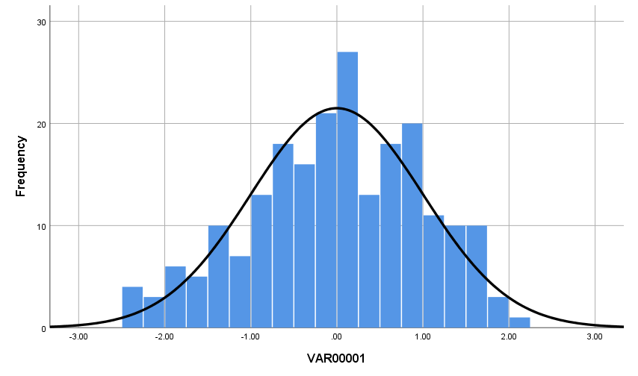
Figure B.3: Histogram of Studentized residuals from corn height mixed ANOVA

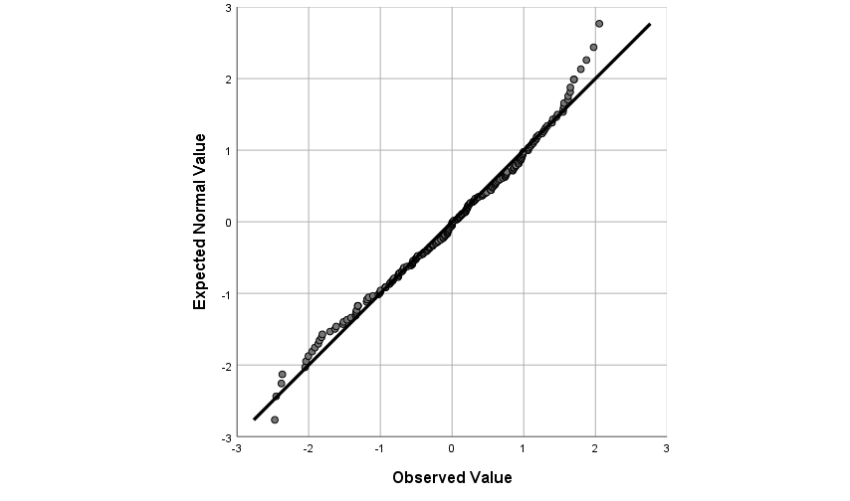
Figure B.4: Q-Q plot of Studentized residuals from corn height mixed ANOVA

Figure B.5: Box plots of sorghum heights for mixed ANOVA between-subjects

Figure B.6: Box plots of sorghum height for mixed ANOVA within-subjects

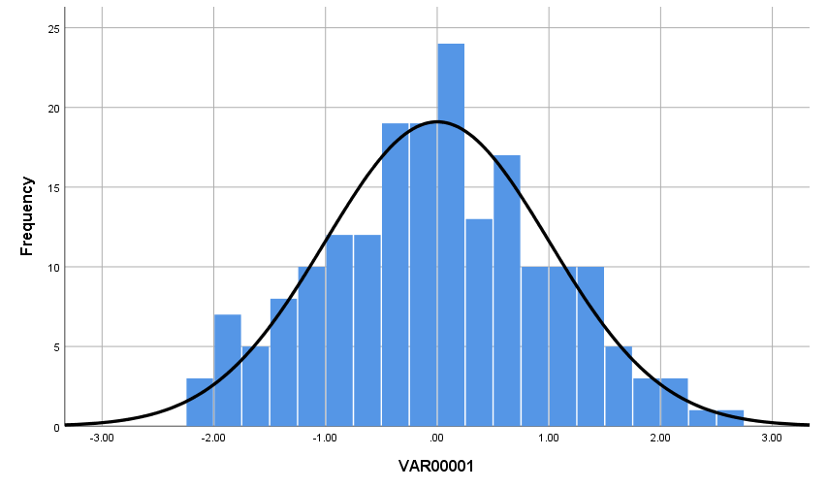
Figure B.7: Histogram of Studentized residuals from sorghum height mixed ANOVA

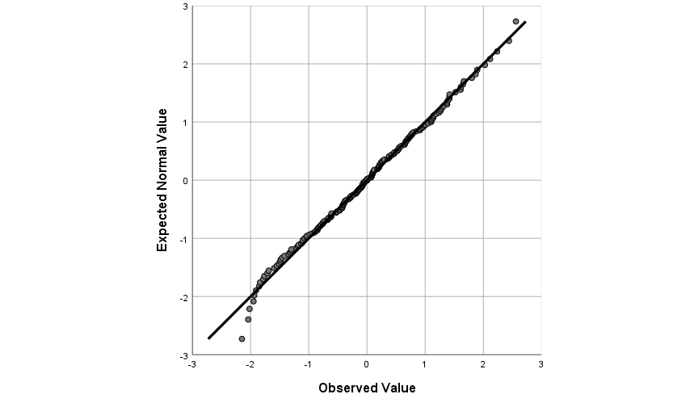
Figure B.8: Q-Q plot of Studentized residuals from sorghum height mixed ANOVA

Figure B.9: Box plots of Bermuda grass percent coverages for mixed ANOVA between-subjects

Figure B.10: Box plots of Bermuda grass percent coverages for mixed ANOVA within-subjects

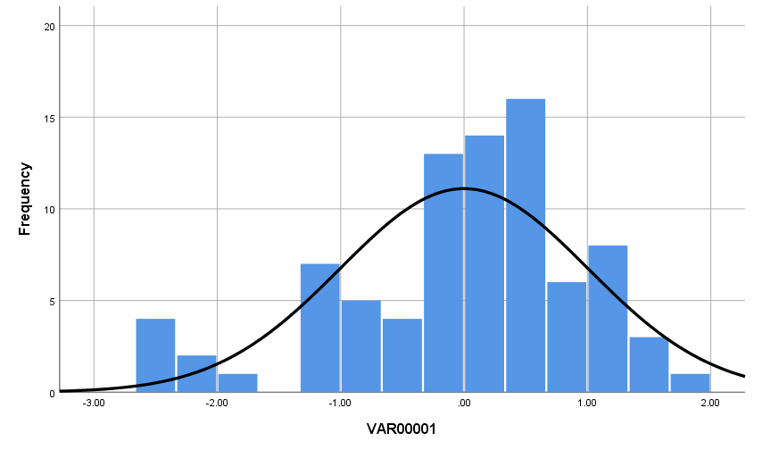
Figure B.11: Histogram of Studentized residuals from Bermuda grass percent coverage mixed ANOVA

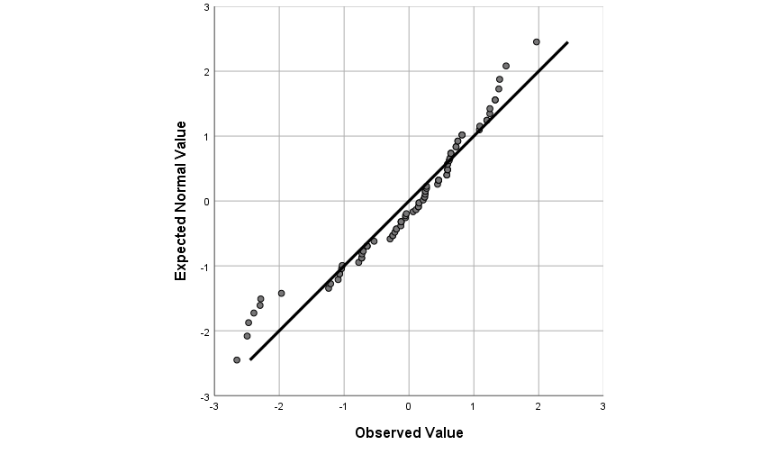
Figure B.12: Q-Q plot of Studentized residuals from Bermuda grass percent coverage mixed ANOVA

Figure B.13: Total dry biomass of all Bermuda grass plants

Figure B.14: Corn biomass allocation under groundwater irrigation

Figure B.15: Corn biomass allocation under mine water irrigation

Figure B.16: Sorghum biomass allocation under groundwater irrigation

Figure B.17: Sorghum biomass allocation under mine water irrigation

Appendix C: Metals Concentrations in Plants

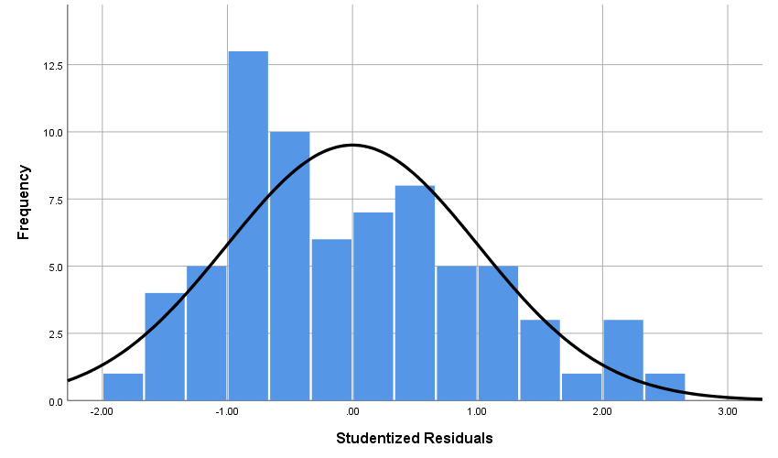Figure C.1: Histogram of Studentized residuals from corn Ca mixed ANOVA

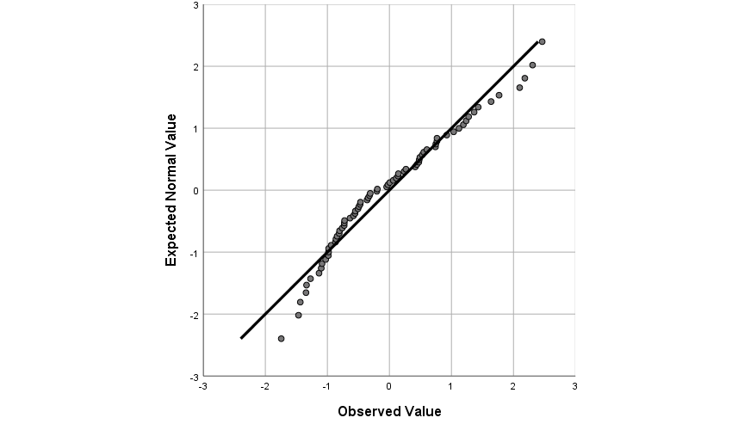Figure C.2: Q-Q plot of Studentized residuals from corn Ca mixed ANOVA

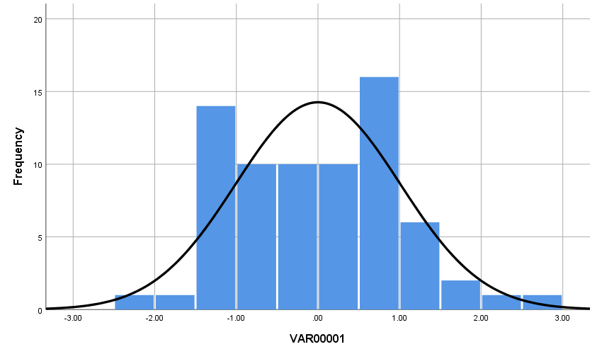 Figure C.3: Histogram of Studentized residuals from corn Cd mixed ANOVA

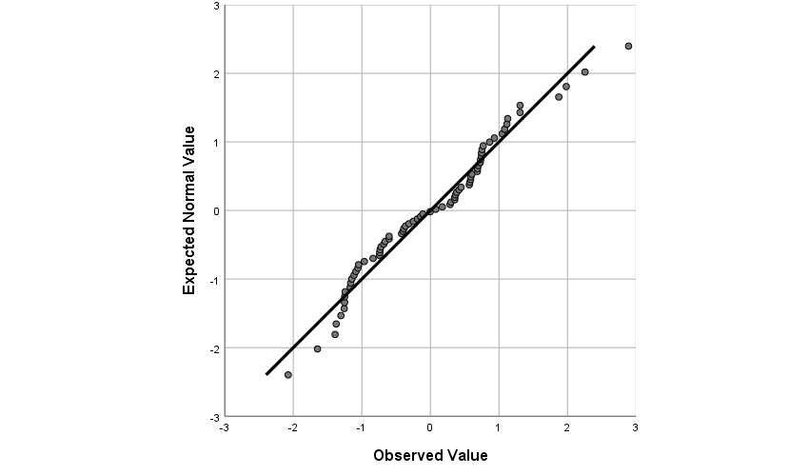 Figure C.4: Q-Q plot of Studentized residuals from corn Cd mixed ANOVA

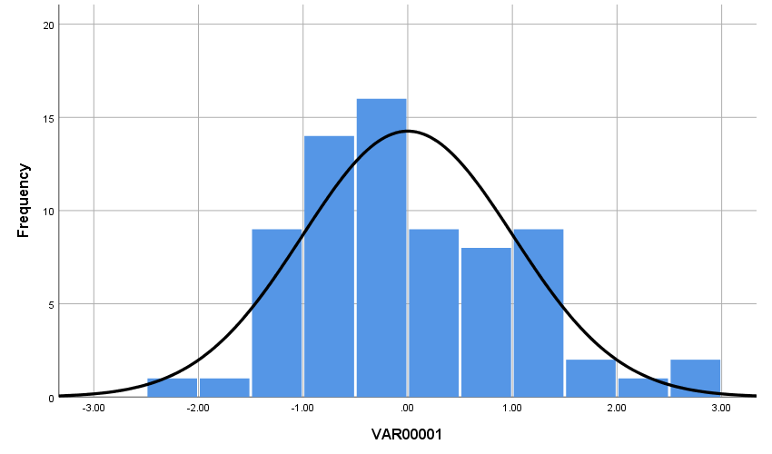 Figure C.5: Histogram of Studentized residuals from corn Fe mixed ANOVA

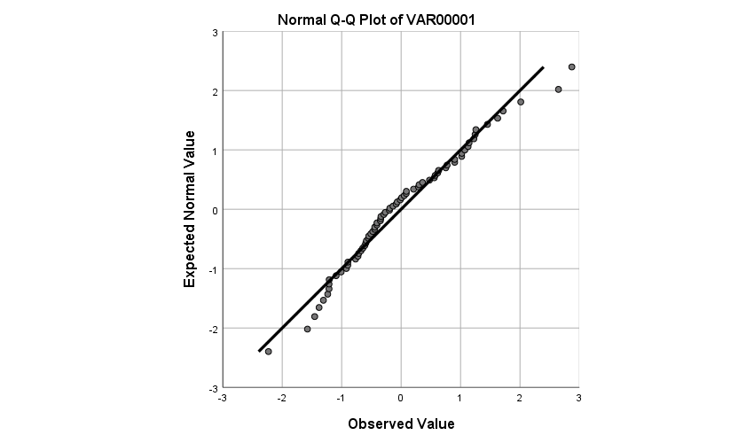 Figure C.6: Q-Q plot of Studentized residuals from corn Fe mixed ANOVA

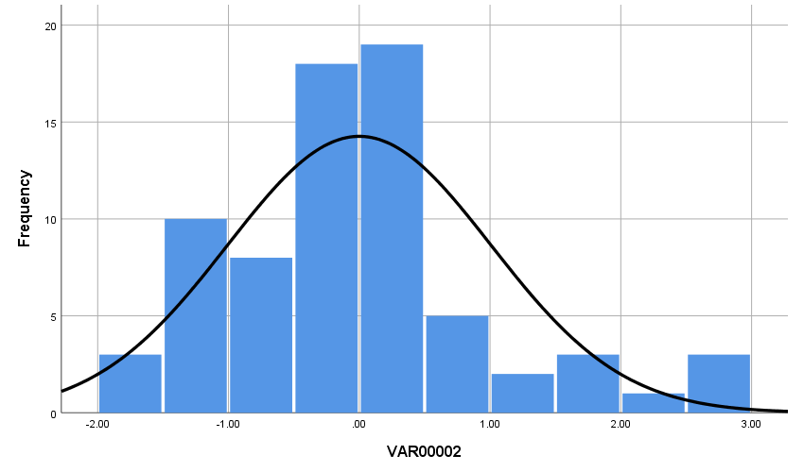 Figure C.7: Histogram of Studentized residuals from corn K mixed ANOVA

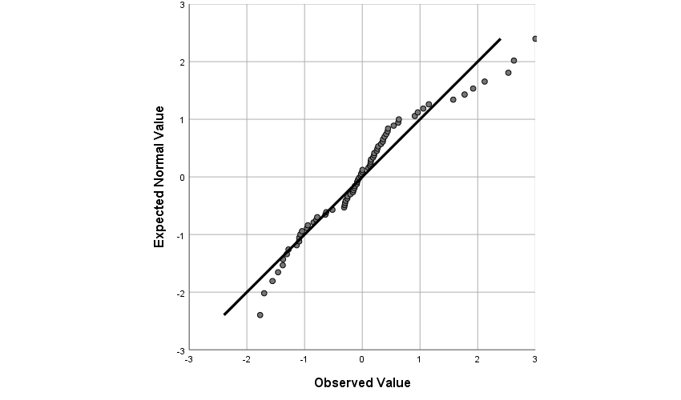 Figure C.8: Q-Q plot of Studentized residuals from corn K mixed ANOVA

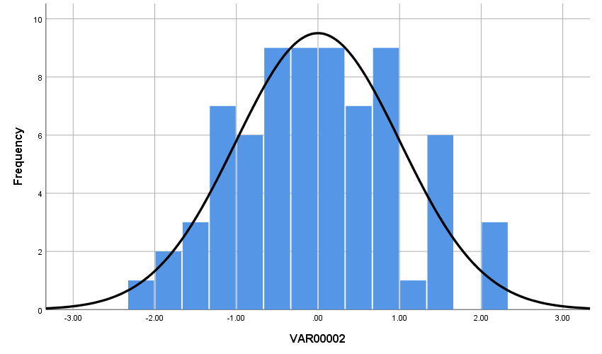 Figure C.9: Histogram of Studentized residuals from corn Mg mixed ANOVA

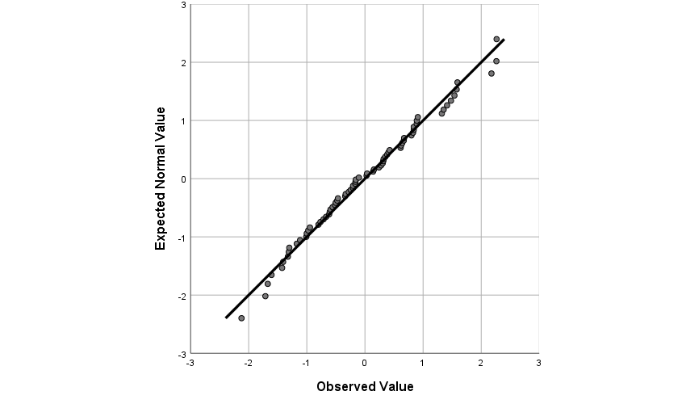 Figure C.10: Q-Q plot of Studentized residuals from corn Mg mixed ANOVA

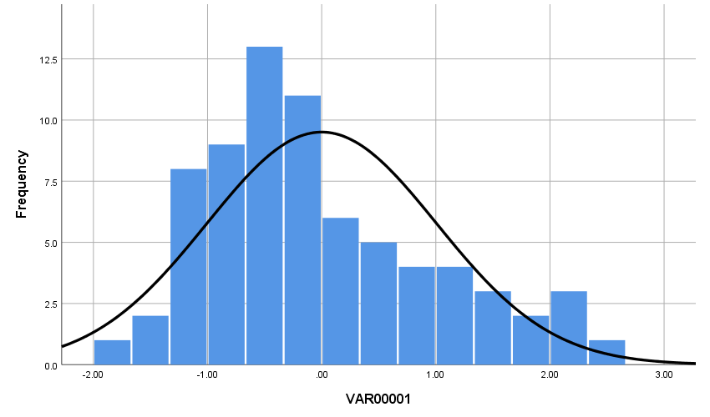 Figure C.11: Histogram of Studentized residuals from corn Mn mixed ANOVA

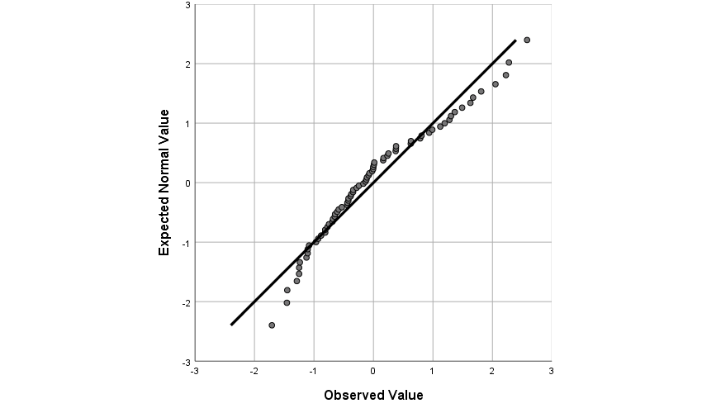 Figure C.12: Q-Q plot of Studentized residuals from corn Mn mixed ANOVA

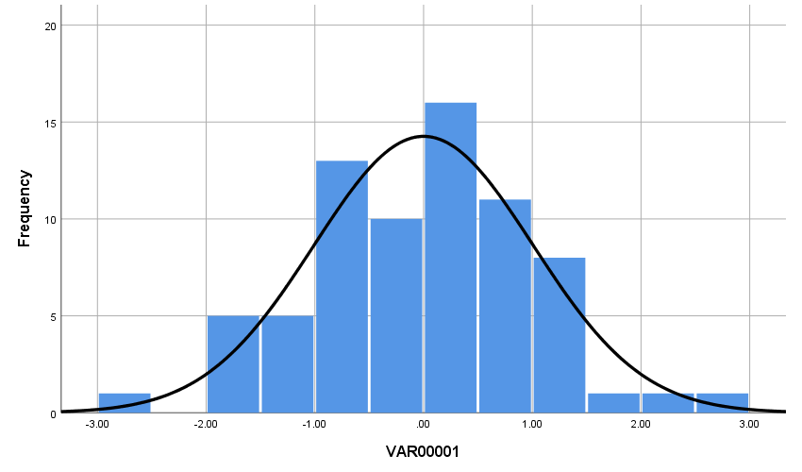 Figure C.13: Histogram of Studentized residuals from corn Ni mixed ANOVA

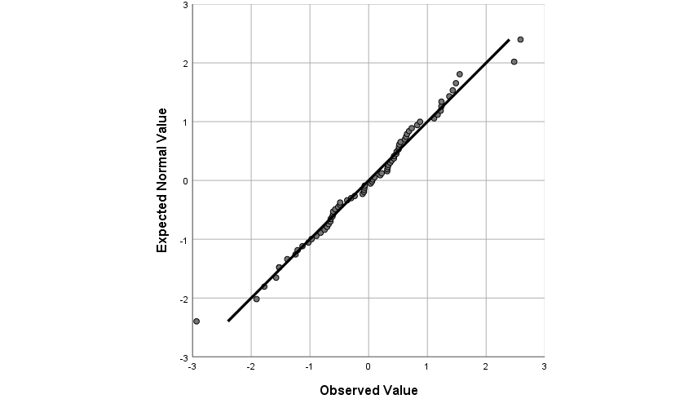 Figure C.14: Q-Q plot of Studentized residuals from corn Ni mixed ANOVA

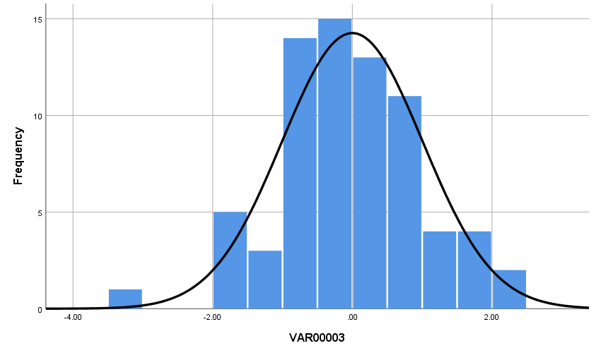 Figure C.15: Histogram of Studentized residuals from corn Pb mixed ANOVA

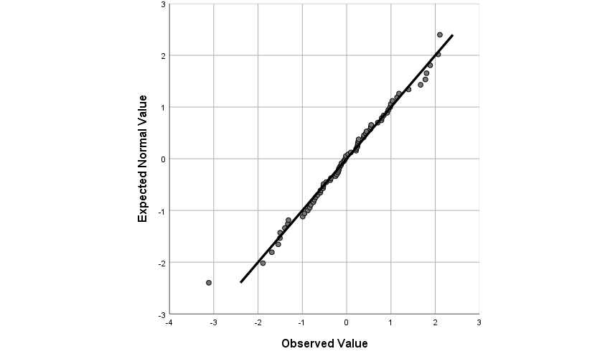 Figure C.16: Q-Q plot of Studentized residuals from corn Pb mixed ANOVA

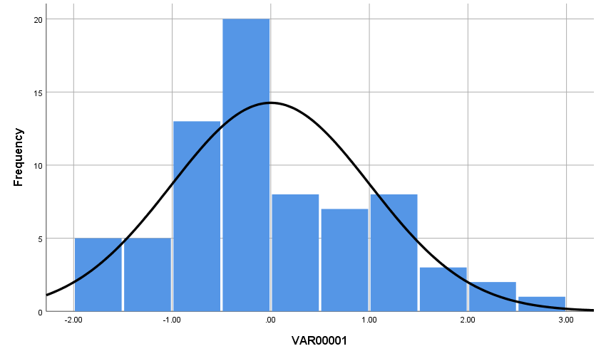 Figure C.17: Histogram of Studentized residuals from corn S mixed ANOVA

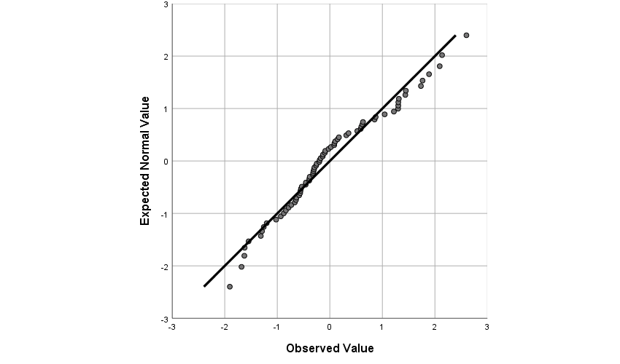 Figure C.18: Q-Q plot of Studentized residuals from corn S mixed ANOVA

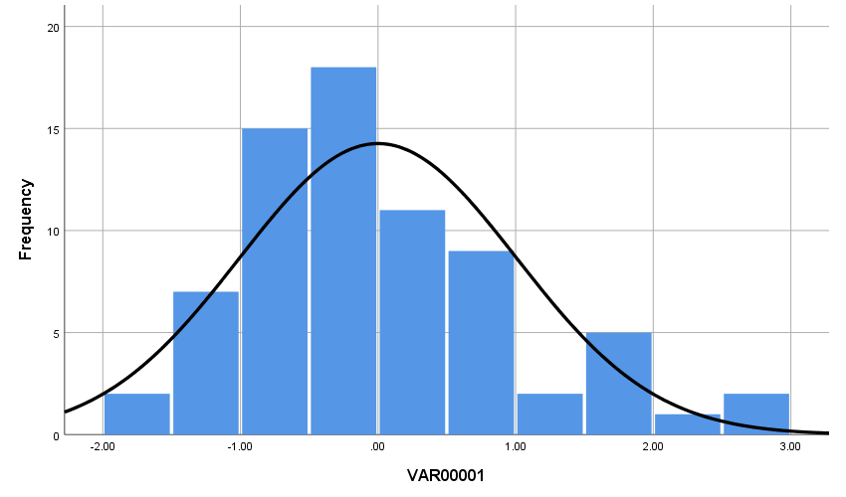 Figure C.19: Histogram of Studentized residuals from corn Zn mixed ANOVA

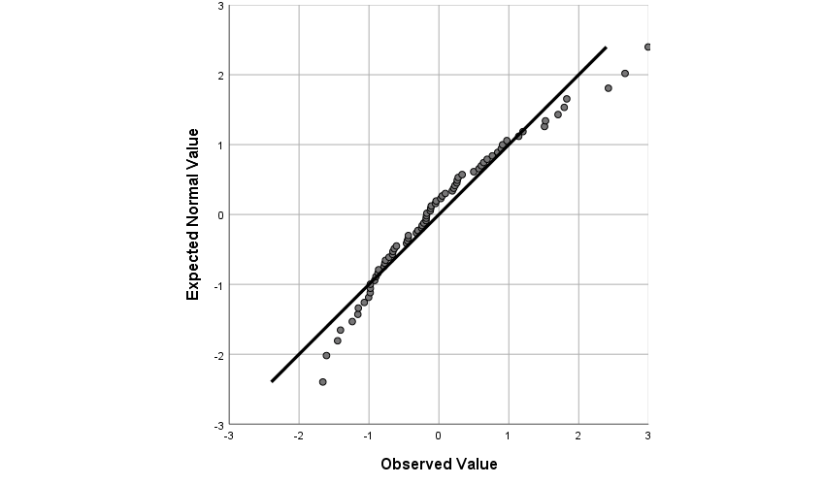 Figure C.20: Q-Q plot of Studentized residuals from corn Zn mixed ANOVA

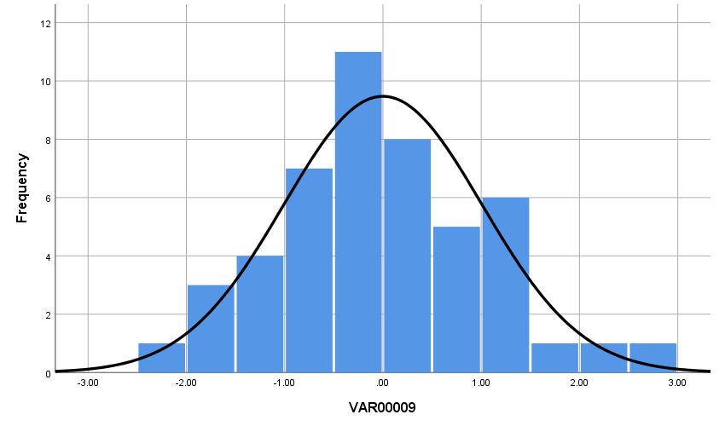Figure C.21: Histogram of Studentized residuals from sorghum Ca mixed ANOVA

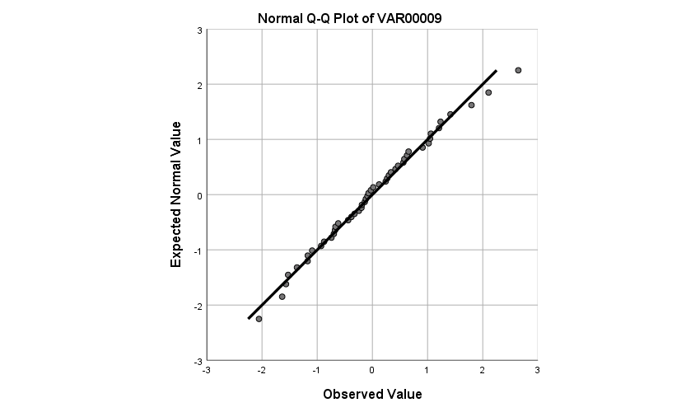Figure C.22: Q-Q plot of Studentized residuals from sorghum Ca mixed ANOVA
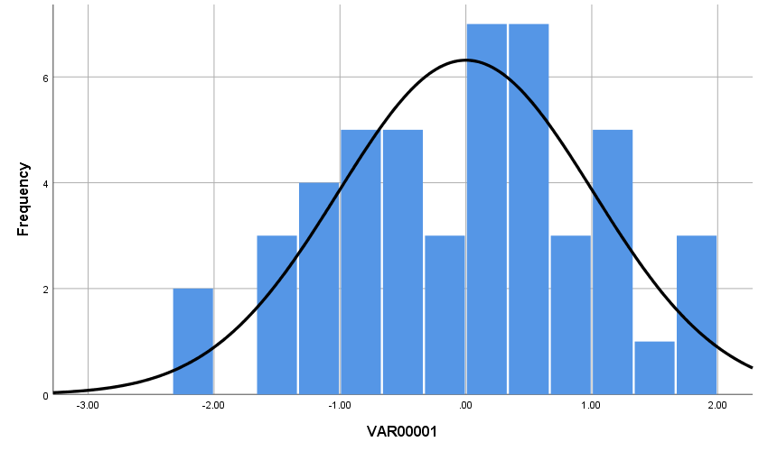Figure C.23: Histogram of Studentized residuals from sorghum Cd mixed ANOVA

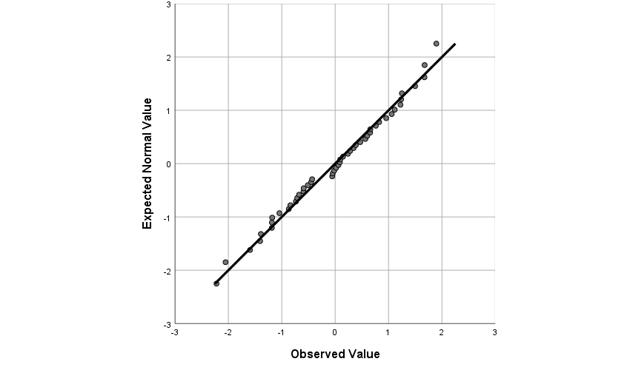Figure C.24: Q-Q plot of Studentized residuals from sorghum Cd mixed ANOVA
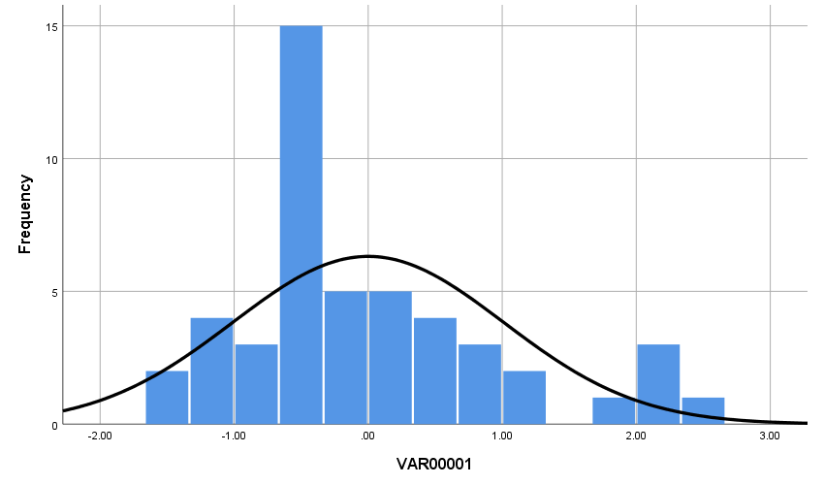Figure C.25: Histogram of Studentized residuals from sorghum Fe mixed ANOVA

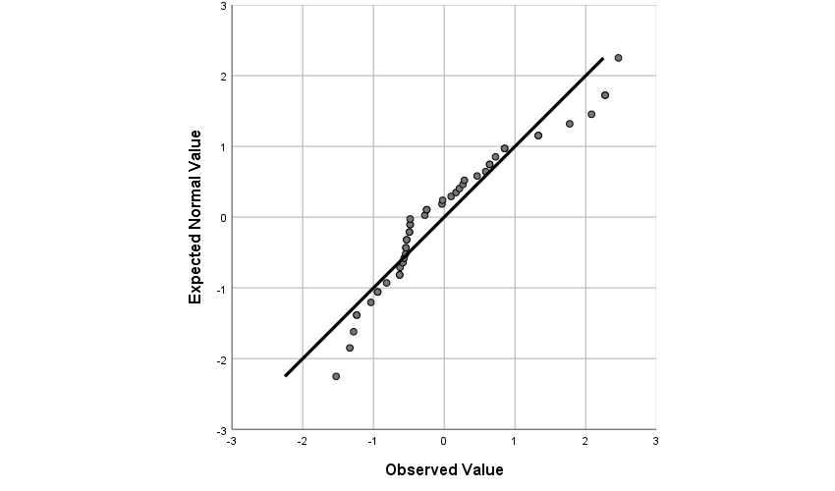Figure C.26: Q-Q plot of Studentized residuals from sorghum Fe mixed ANOVA
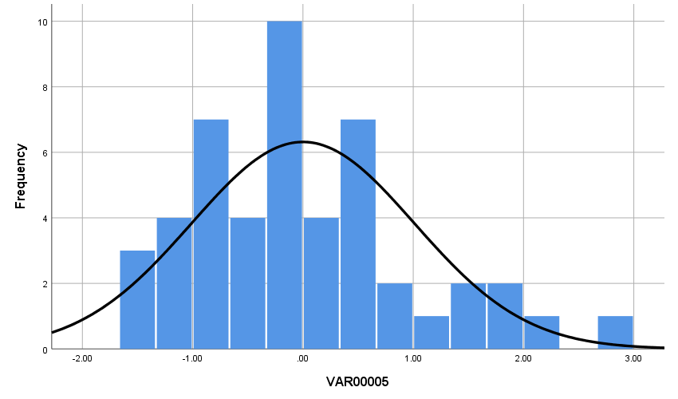Figure C.27: Histogram of Studentized residuals from sorghum K mixed ANOVA

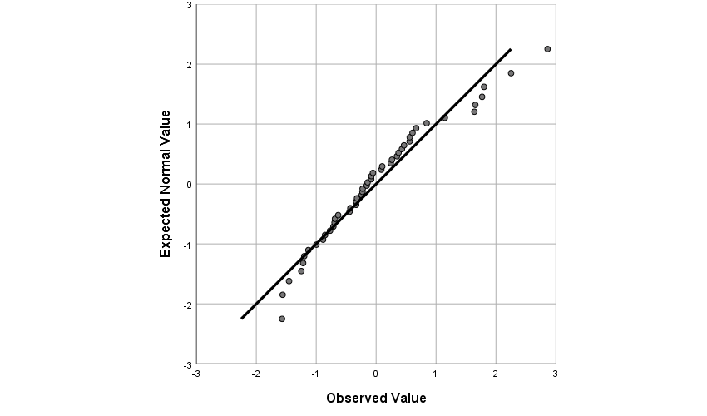Figure C.28: Q-Q plot of Studentized residuals from sorghum K mixed ANOVA
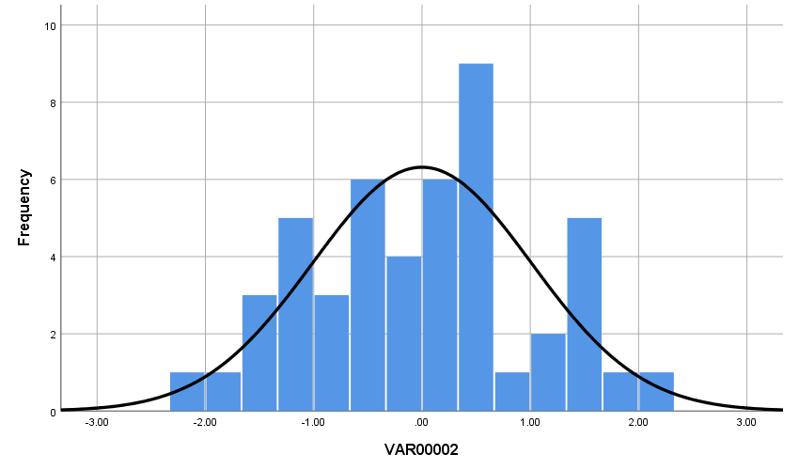Figure C.29: Histogram of Studentized residuals from sorghum Mg mixed ANOVA

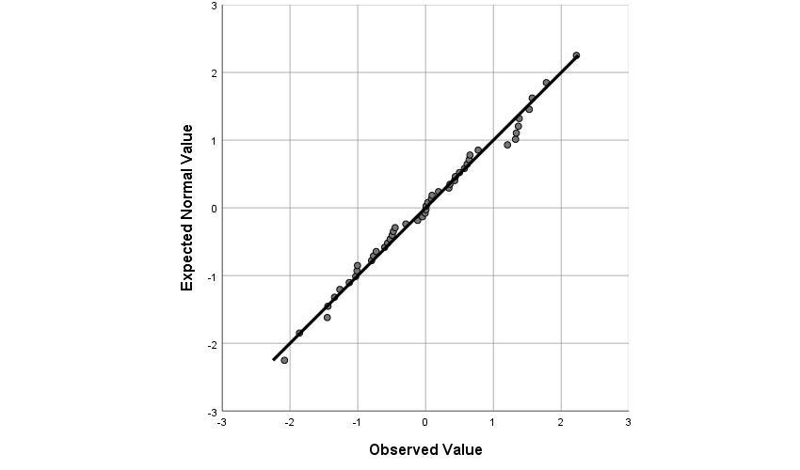Figure C.30: Q-Q plot of Studentized residuals from sorghum Mg mixed ANOVA
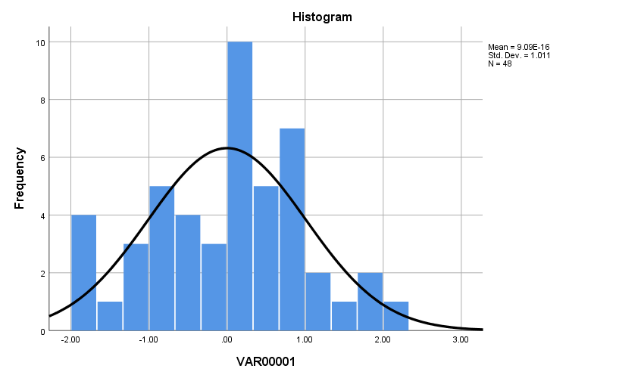
Figure C.31: Histogram of Studentized residuals from sorghum Mn mixed ANOVA

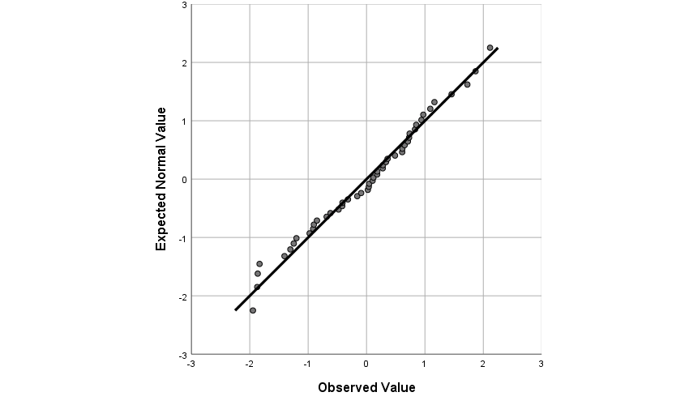Figure C.32: Q-Q plot of Studentized residuals from sorghum Mn mixed ANOVA
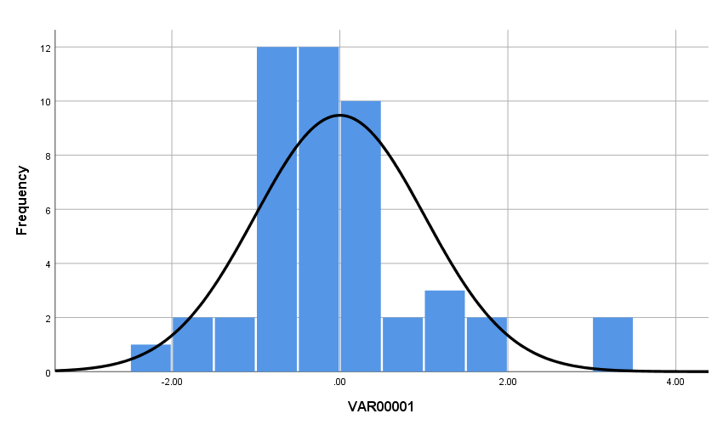Figure C.33: Histogram of Studentized residuals from sorghum Ni mixed ANOVA

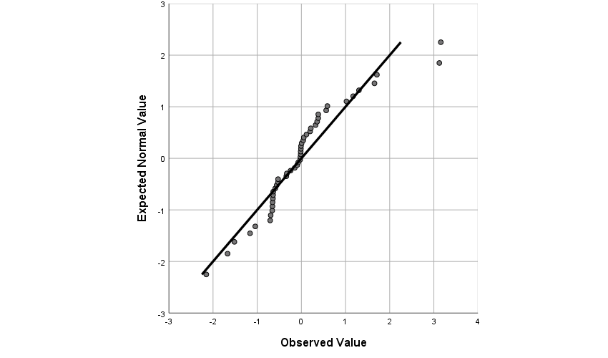Figure C.34: Q-Q plot of Studentized residuals from sorghum Ni mixed ANOVA
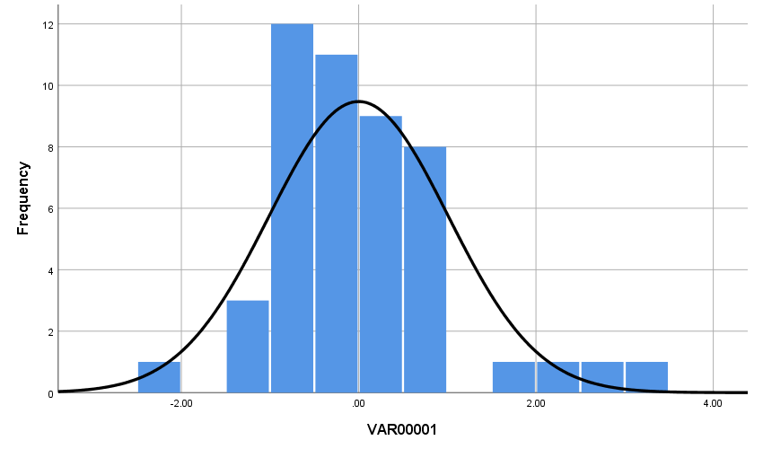Figure C.35: Histogram of Studentized residuals from sorghum Pb mixed ANOVA

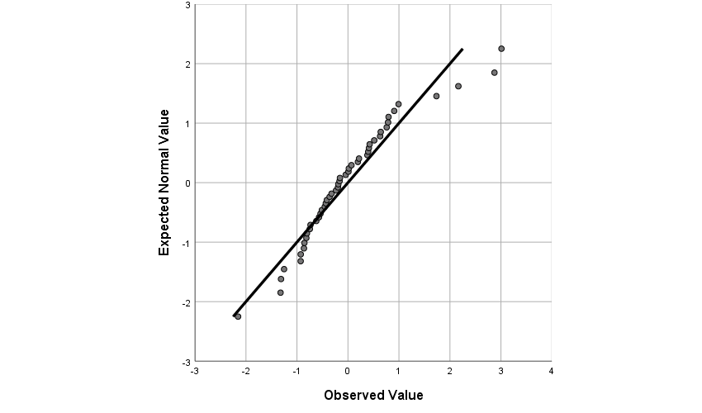Figure C.36: Q-Q plot of Studentized residuals from sorghum Pb mixed ANOVA
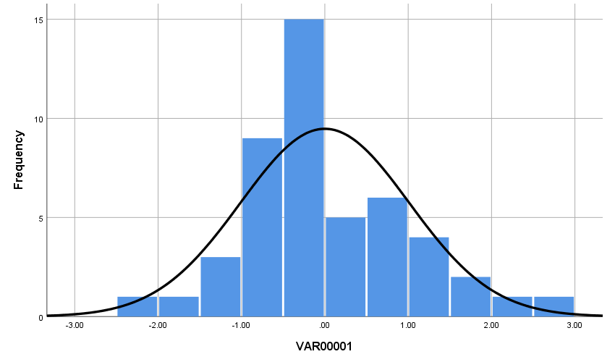Figure C.37: Histogram of Studentized residuals from sorghum S mixed ANOVA

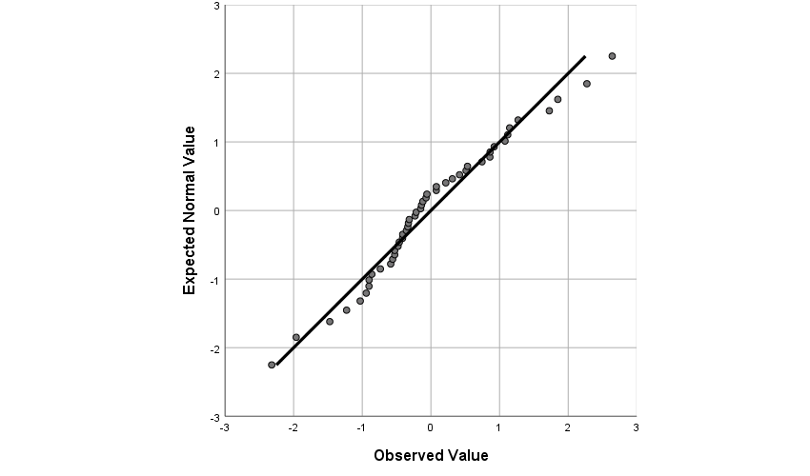Figure C.38: Q-Q plot of Studentized residuals from sorghum S mixed ANOVA
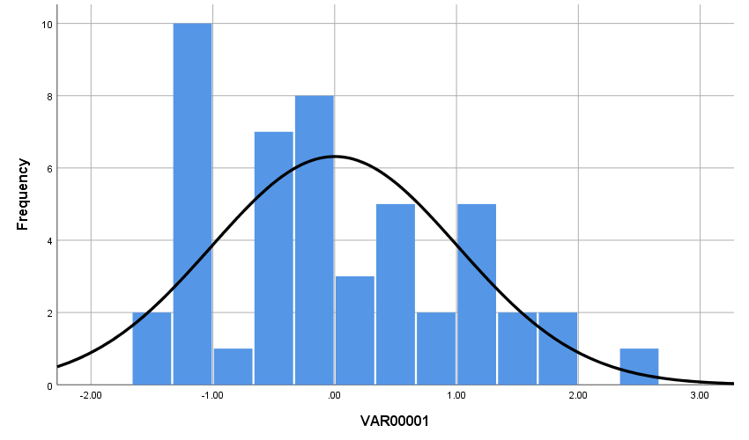Figure C.39: Histogram of Studentized residuals from sorghum Zn mixed ANOVA

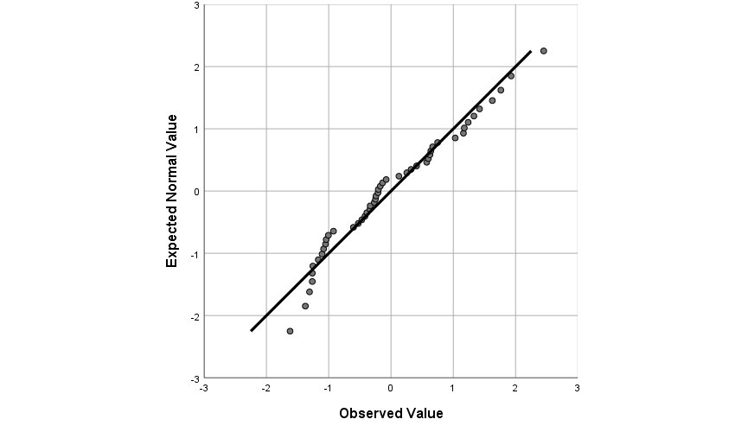Figure C.40: Q-Q plot of Studentized residuals from sorghum Zn mixed ANOVA
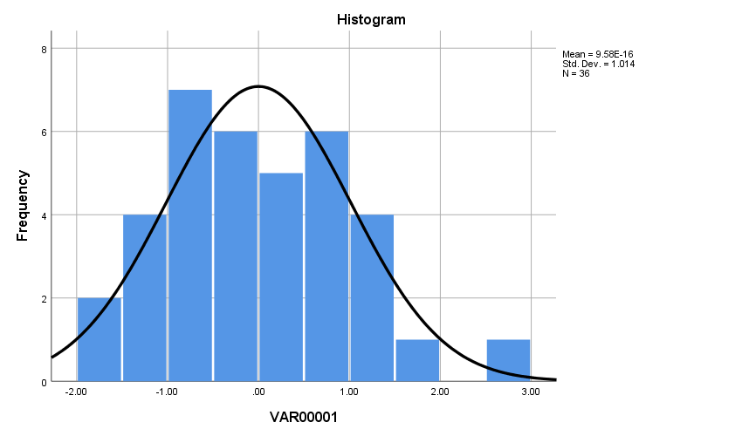
Figure C.41: Histogram of Studentized residuals from Bermuda grass Ca mixed ANOVA

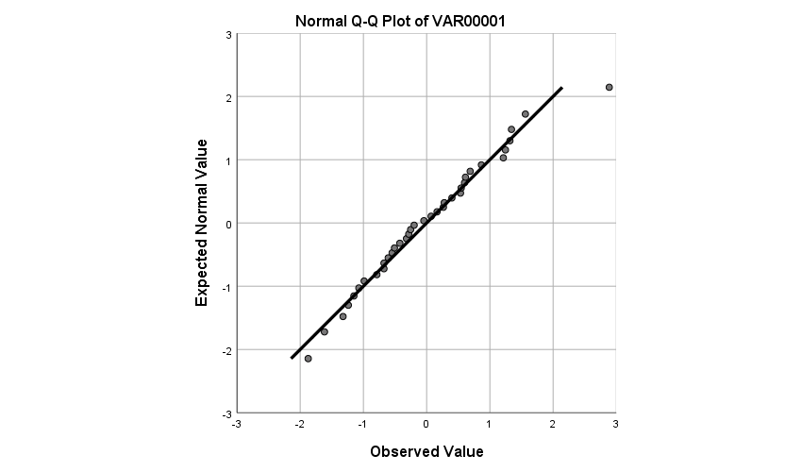Figure C.42: Q-Q plot of Studentized residuals from Bermuda grass Ca mixed ANOVA
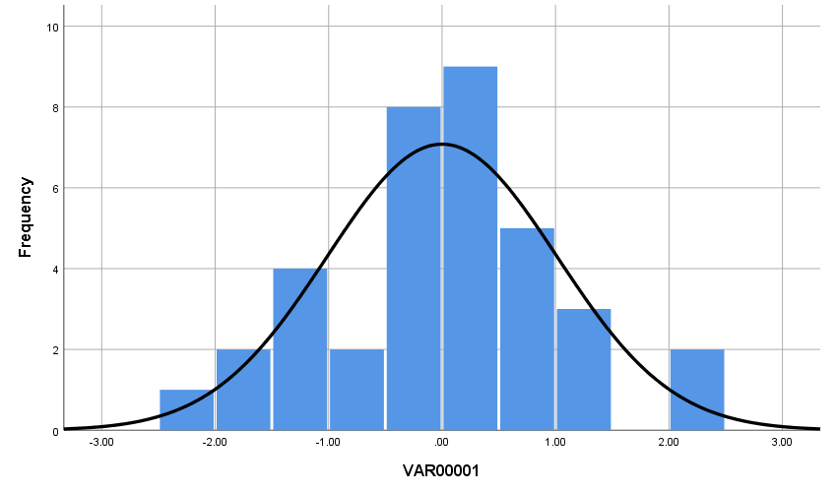Figure C.43: Histogram of Studentized residuals from Bermuda grass Cd mixed ANOVA

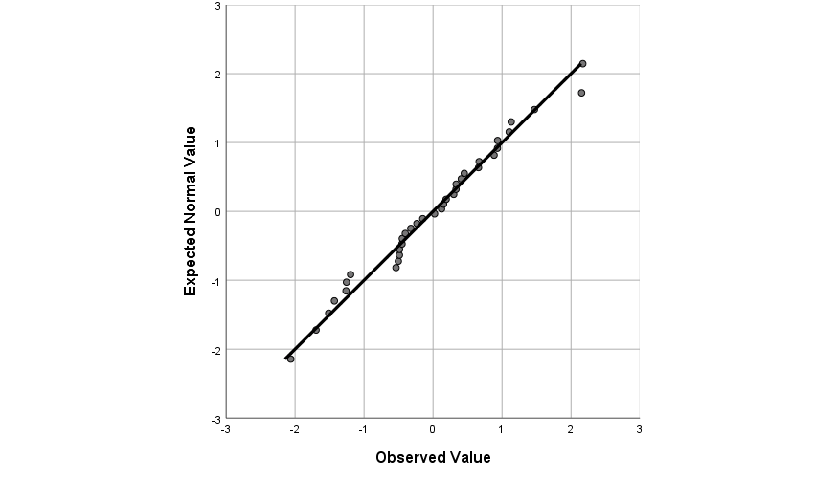Figure C.44: Q-Q plot of Studentized residuals from Bermuda grass Cd mixed ANOVA
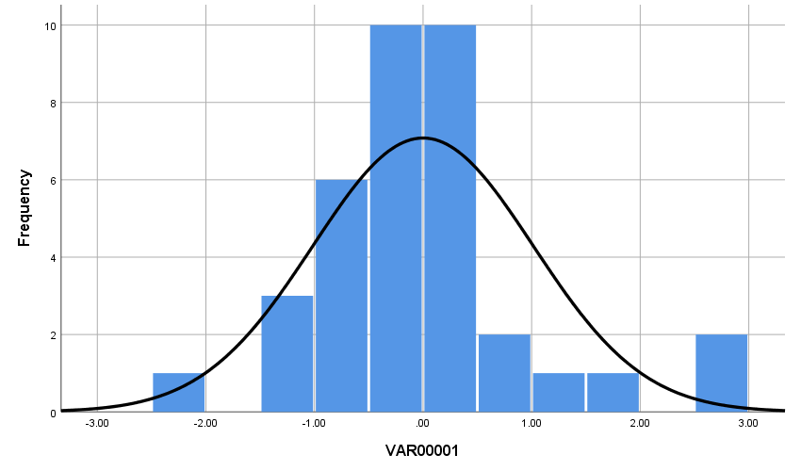Figure C.45: Histogram of Studentized residuals from Bermuda grass Fe mixed ANOVA

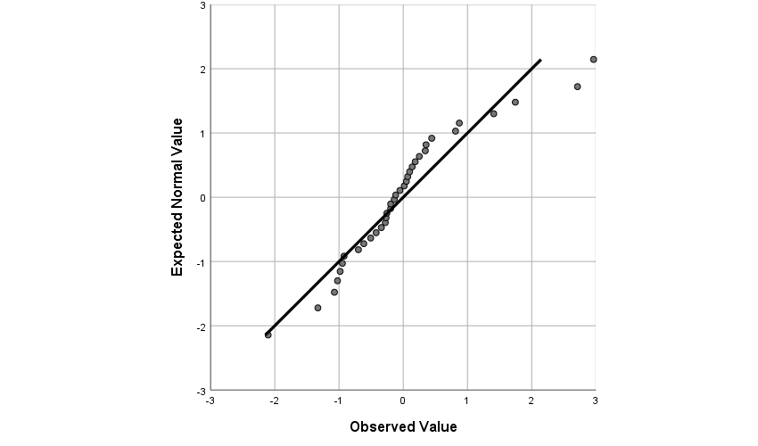Figure C.46: Q-Q plot of Studentized residuals from Bermuda grass Fe mixed ANOVA
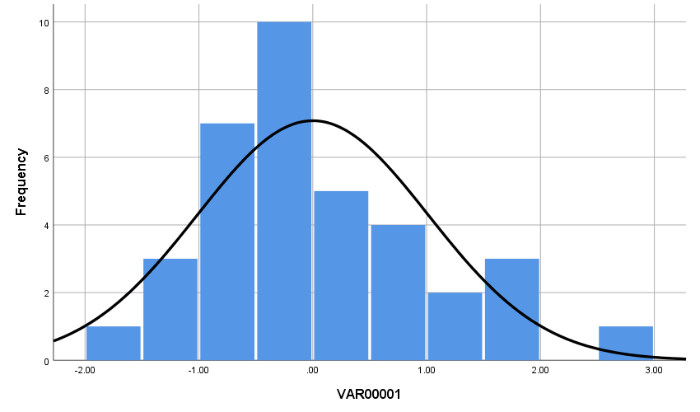Figure C.47: Histogram of Studentized residuals from Bermuda grass K mixed ANOVA

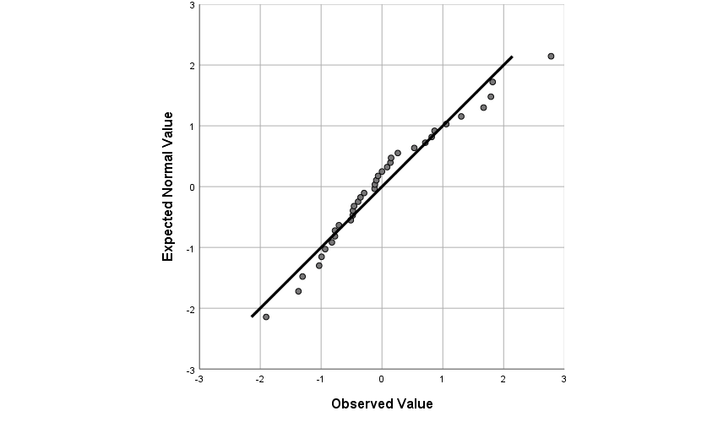Figure C.48: Q-Q plot of Studentized residuals from Bermuda grass K mixed ANOVA
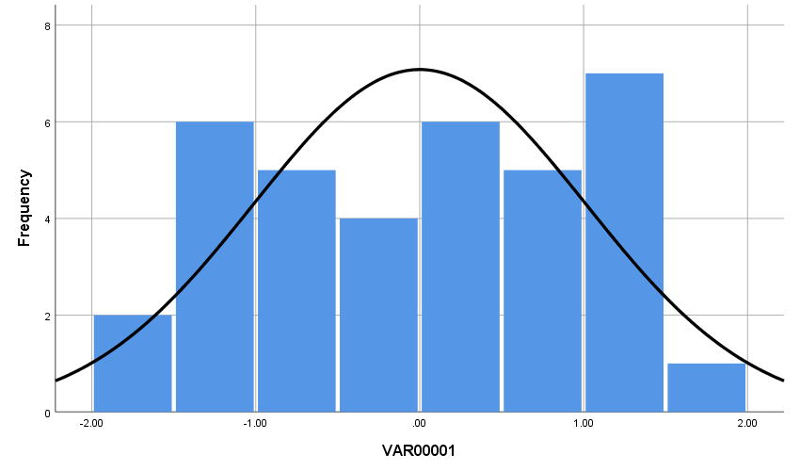Figure C.49: Histogram of Studentized residuals from Bermuda grass Mg mixed ANOVA

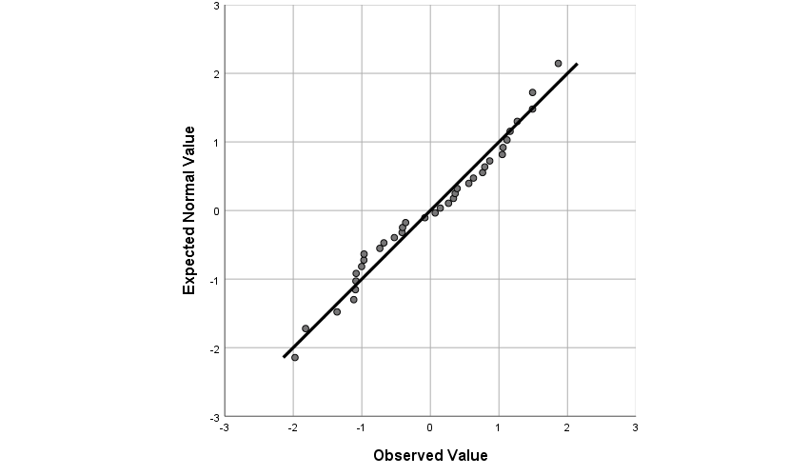Figure C.50: Q-Q plot of Studentized residuals from Bermuda grass Mg mixed ANOVA
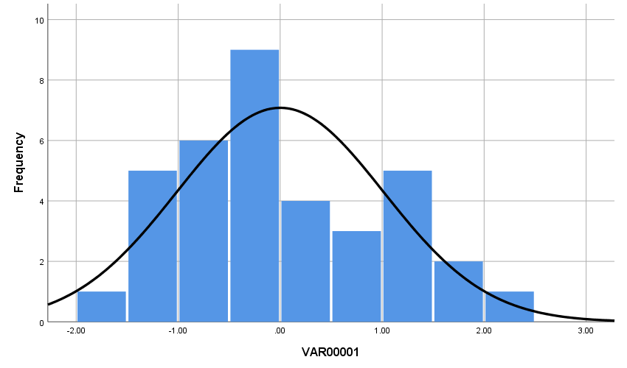Figure C.51: Histogram of Studentized residuals from Bermuda grass Mn mixed ANOVA

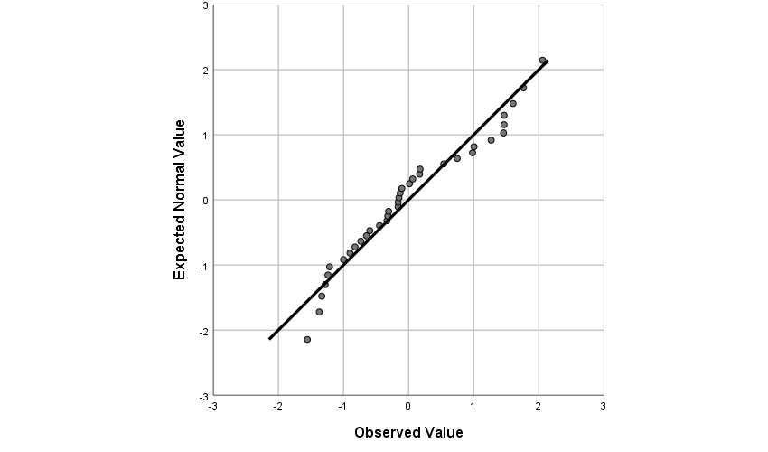Figure C.52: Q-Q plot of Studentized residuals from Bermuda grass Mn mixed ANOVA
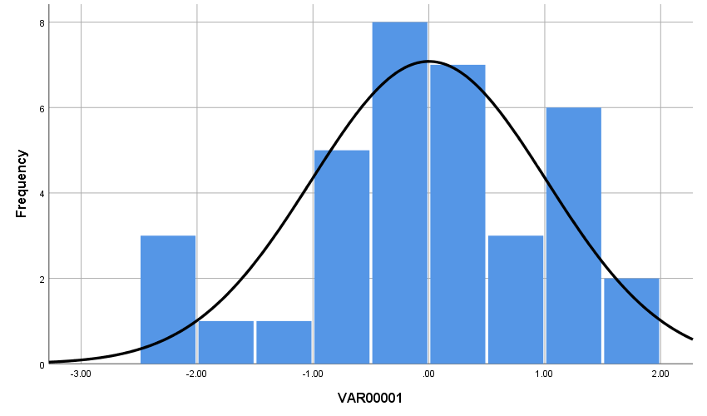Figure C.53: Histogram of Studentized residuals from Bermuda grass Na mixed ANOVA

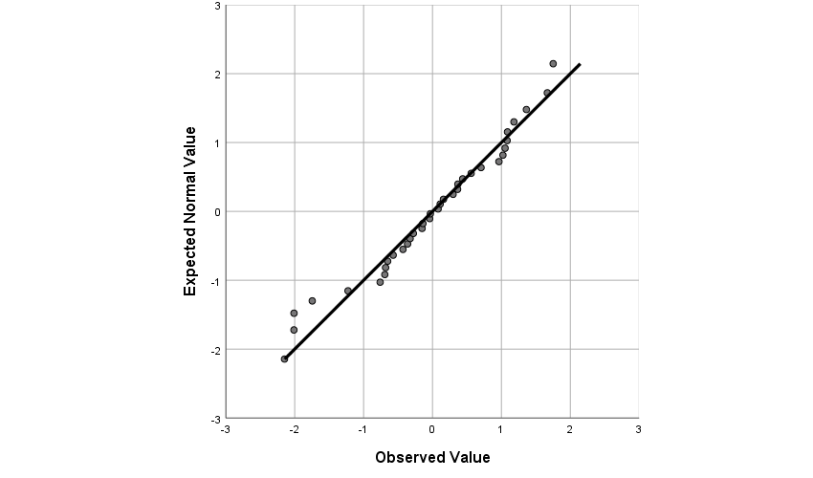Figure C.54: Q-Q plot of Studentized residuals from Bermuda grass Na mixed ANOVA
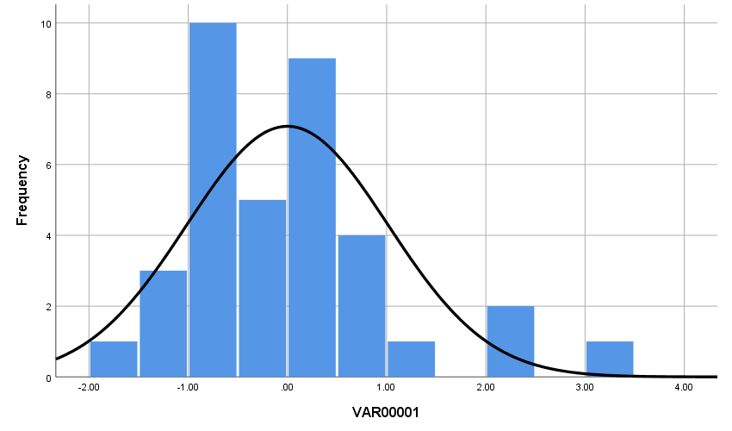Figure C.55: Histogram of Studentized residuals from Bermuda grass Ni mixed ANOVA

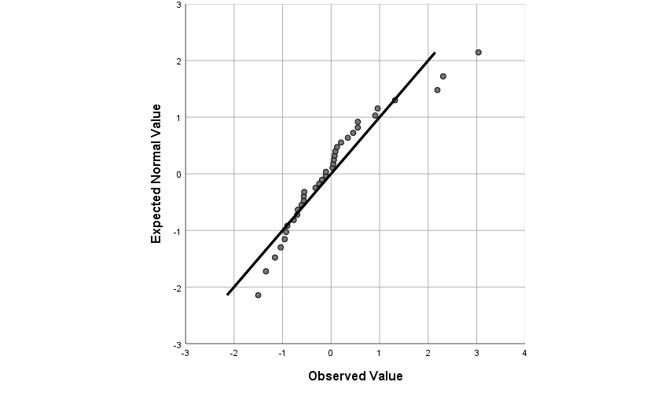Figure C.56: Q-Q plot of Studentized residuals from Bermuda grass Ni mixed ANOVA
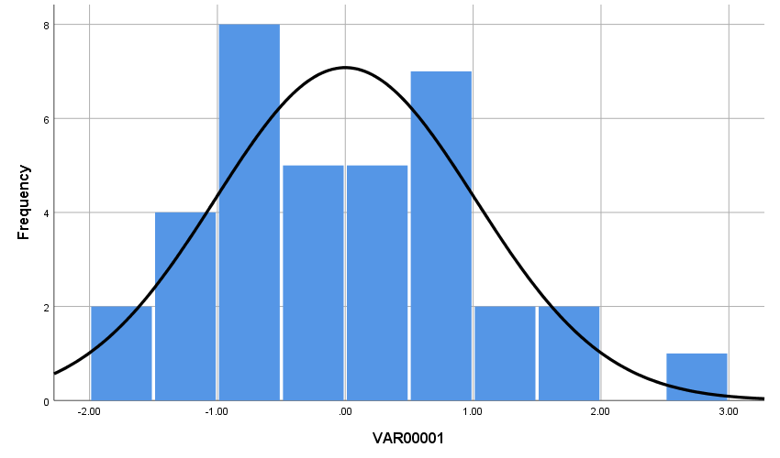Figure C.57: Histogram of Studentized residuals from Bermuda grass Pb mixed ANOVA

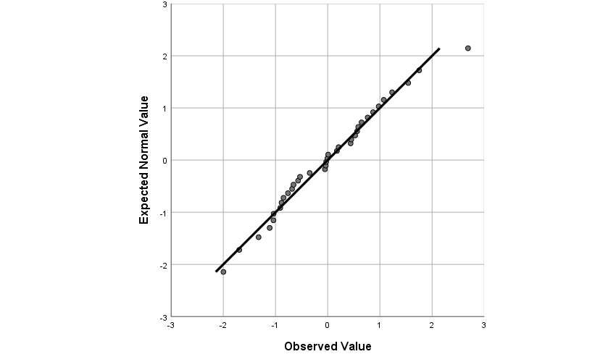Figure C.58: Q-Q plot of Studentized residuals from Bermuda grass Pb mixed ANOVA
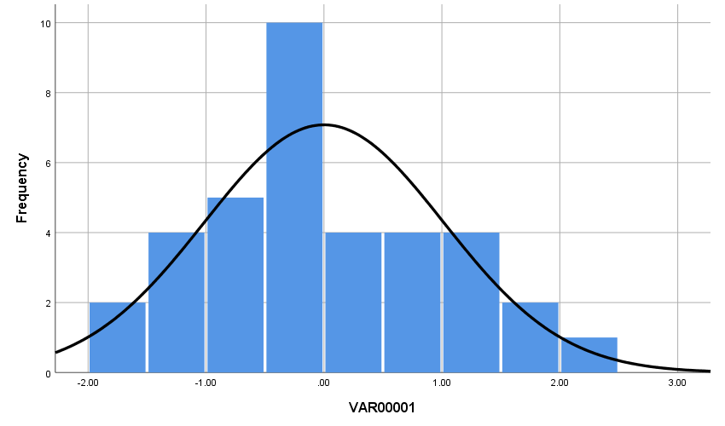Figure C.59: Histogram of Studentized residuals from Bermuda grass S mixed ANOVA

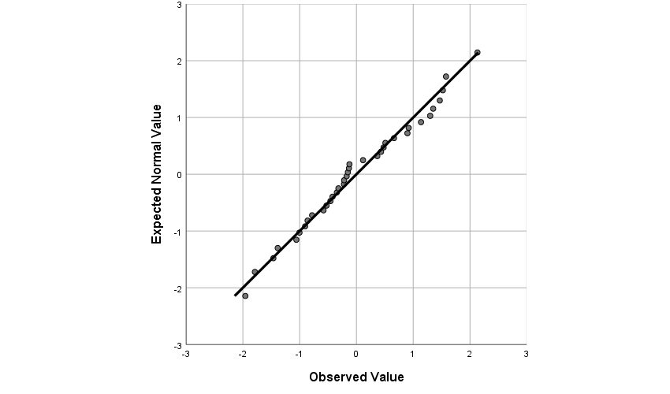Figure C.60: Q-Q plot of Studentized residuals from Bermuda grass S mixed ANOVA
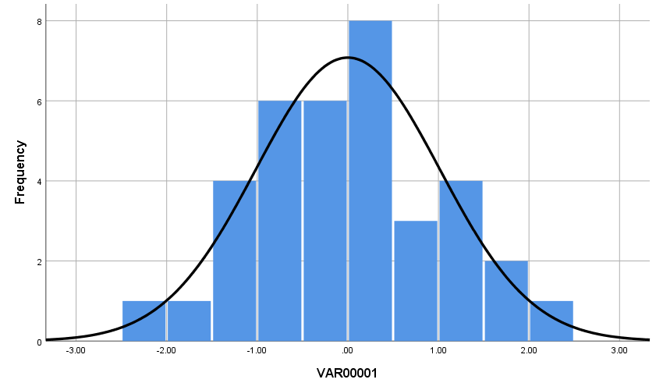Figure C.61: Histogram of Studentized residuals from Bermuda grass Zn mixed ANOVA

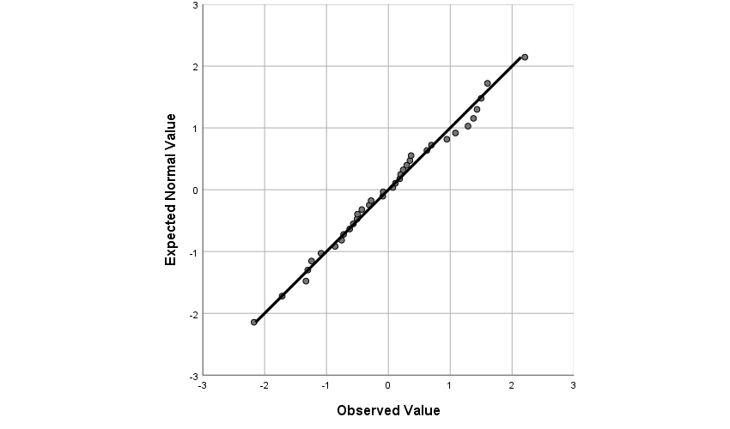Figure C.62: Q-Q plot of Studentized residuals from Bermuda grass Zn mixed ANOVA

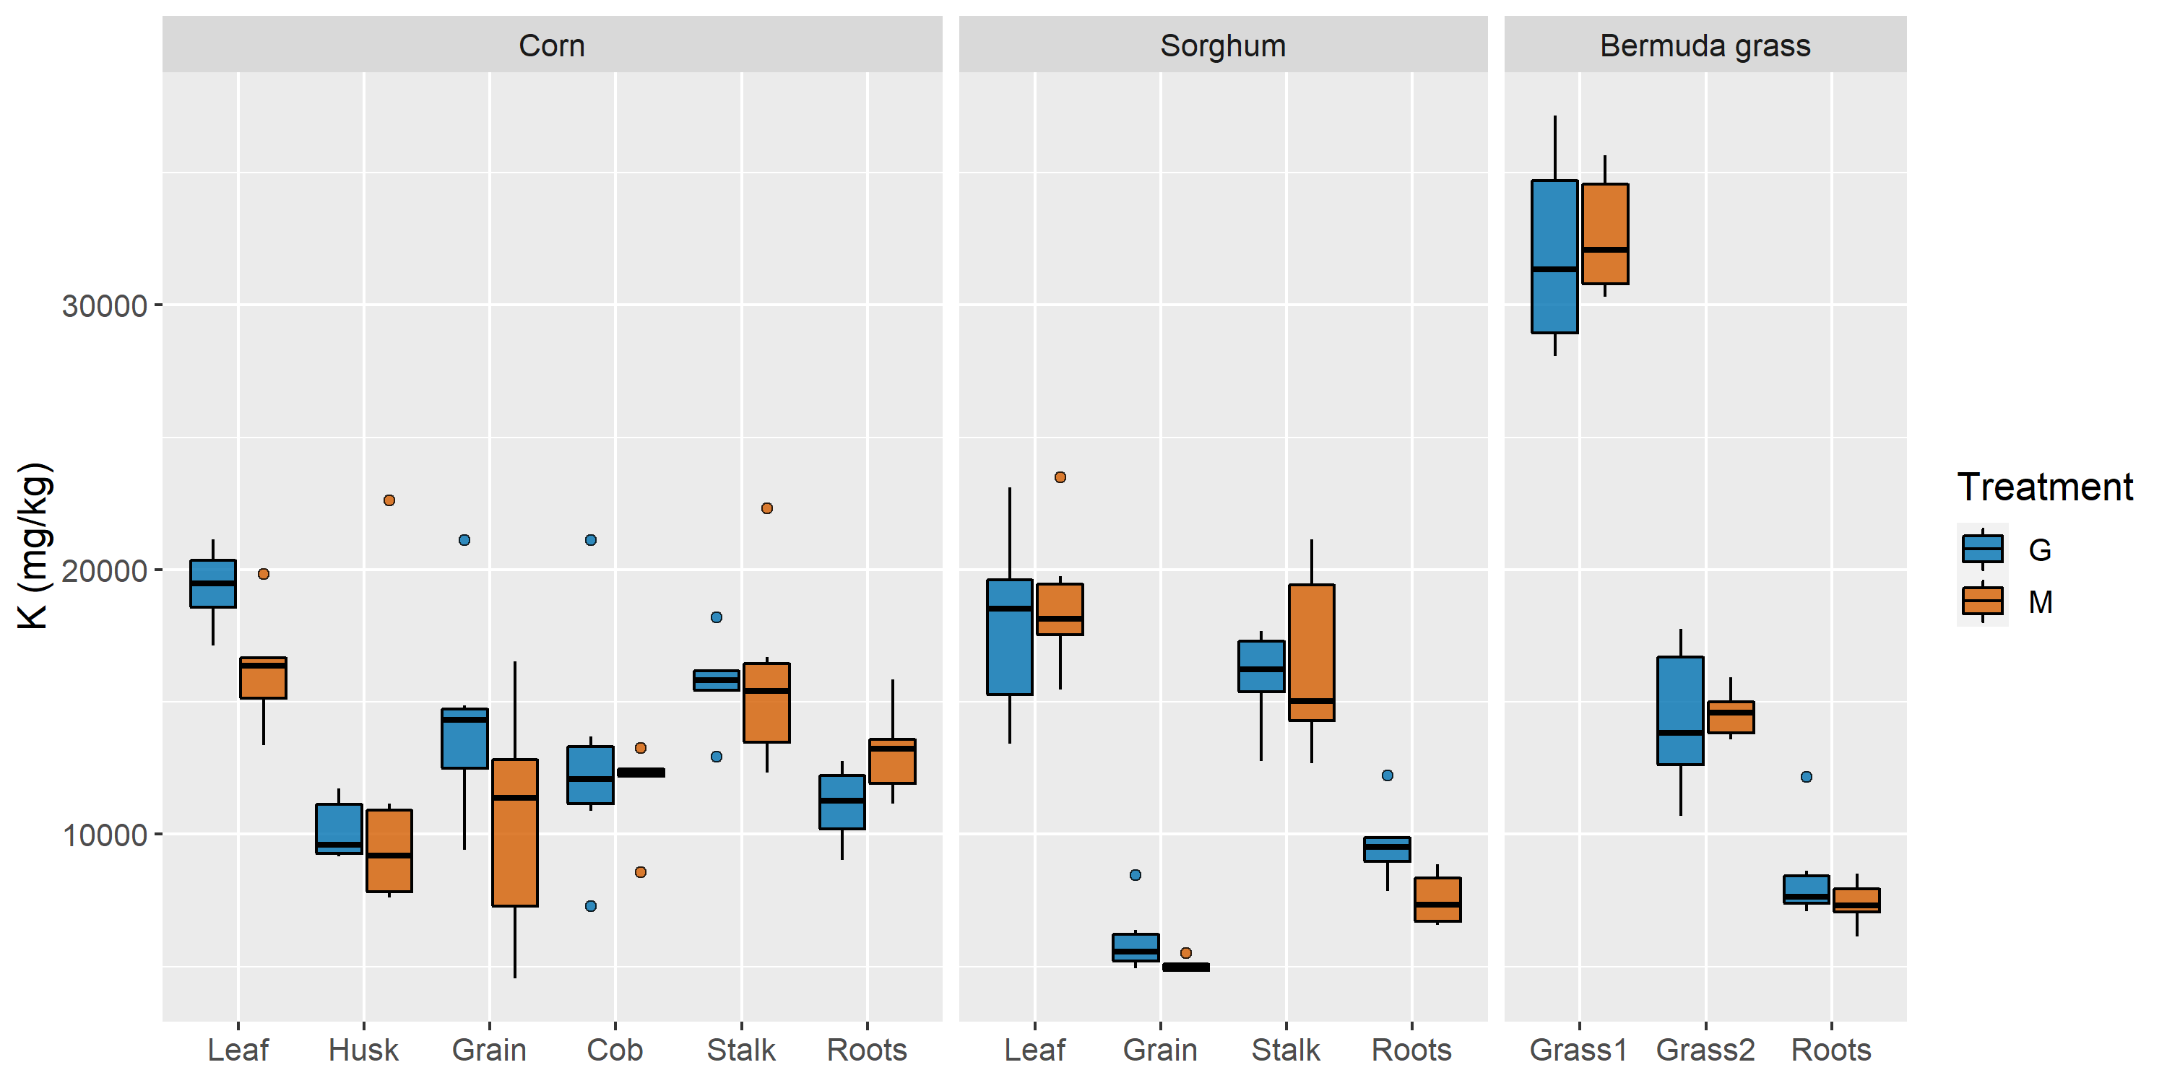
Figure C.63: Box plots of K concentrations in each plant and structure in mg/kg

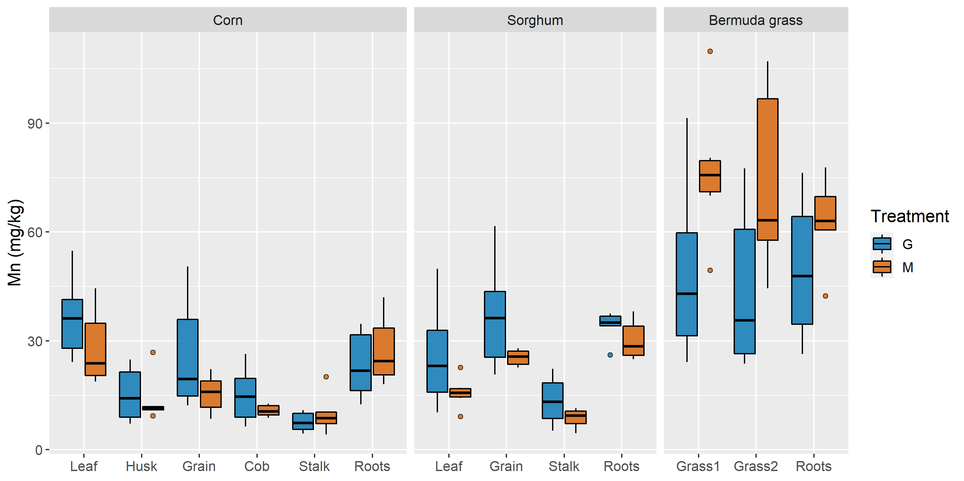
Figure C.64: Box plots of Mn concentrations in each plant and structure in mg/kg

In the following tables, species whose data were log-transformed for mixed ANOVA are indicated with an asterisk. When the interaction effect was not significant, the results of Sidak-corrected pairwise comparisons of main effects are indicated by a single value in the p column (irrigation treatment main effect) and symbols (e.g., †‡) next to structure names (plant structure main effect). Plant structures that share a symbol were not significantly different (p ≤ 0.05). When the interaction effect was significant for a species, the results of Sidak-corrected pairwise comparisons of simple main effects are indicated by a value in every row of the p column for the species (irrigation treatment simple main effect) and letters (e.g., ab) next to mean concentrations. Structure concentrations from the same species and irrigation treatment that share a letter were not significantly different (plant structure simple main effect, alpha = 0.05).
Table C.1: Fe concentrations in plant biomass in mg/kg

 | Treatment
 | Groundwater |  | Mine water |  |  | Partial η_{p}²
Structure | Mean | SD | Mean | SD | p | Partial η_{p}²
Corn *
Leaf | 82.38 | 14.60 | 116.31 | 48.47 | 0.085 | 0.267
Husk † | 42.78 | 11.04 | 46.82 | 15.33 | 0.085 | 0.267
Grain † | 49.36 | 7.10 | 44.70 | 9.06 | 0.085 | 0.267
Cob † | 53.25 | 17.46 | 45.20 | 11.17 | 0.085 | 0.267
Stalk † | 22.23 | 4.55 | 43.87 | 49.80 | 0.085 | 0.267
Roots | 300.35 | 132.21 | 528.48 | 223.15 | 0.085 | 0.267
Sorghum
Leaf | 206.93 | 33.45 | 121.36 | 22.32 | 0.408 | 0.069
Grain † | 54.78 | 6.37 | 64.78 | 33.24 | 0.408 | 0.069
Stalk † | 74.61 | 15.95 | 44.05 | 5.11 | 0.408 | 0.069
Roots | 614.17 | 163.79 | 619.67 | 210.91 | 0.408 | 0.069
Bermuda grass
Grass1 | 148.76 | 78.11 | 101.44 | 11.19 | 0.059 | 0.311
Grass2 | 409.49 | 137.65 | 130.61 | 42.06 | 0.059 | 0.311
Roots | 795.24 | 466.54 | 717.71 | 169.53 | 0.059 | 0.311
Table C.2: K concentrations in plant biomass in mg/kg

 | Treatment
 | Groundwater |  | Mine water |  |  | Partial η_{p}²
Structure | Mean | SD | Mean | SD | p | Partial η_{p}²
Corn
Leaf † | 19352.31 | 1473.11 | 16242.90 | 2172.85 | 0.404 | 0.070
Husk ‡ | 10152.47 | 1192.67 | 11248.56 | 5743.75 | 0.404 | 0.070
Grain ‡◊ | 14320.44 | 3906.76 | 10504.52 | 4463.47 | 0.404 | 0.070
Cob ‡◊ | 12861.12 | 4586.64 | 11848.64 | 1655.59 | 0.404 | 0.070
Stalk †◊ | 15730.20 | 1695.36 | 15858.99 | 3578.84 | 0.404 | 0.070
Roots ‡◊ | 11117.29 | 1431.64 | 13108.81 | 1672.69 | 0.404 | 0.070
Sorghum
Leaf † | 17961.62 | 3576.56 | 18742.76 | 2723.20 | 0.535 | 0.040
Grain | 6007.14 | 1297.33 | 5044.59 | 257.51 | 0.535 | 0.040
Stalk † | 15947.98 | 1824.50 | 16473.13 | 3591.40 | 0.535 | 0.040
Roots | 9649.56 | 1459.55 | 7555.08 | 996.14 | 0.535 | 0.040
Bermuda grass
Grass1 | 31975.23 | 3769.27 | 32646.59 | 2309.09 | 0.974 | < 0.001
Grass2 | 14333.74 | 2816.22 | 14574.96 | 895.61 | 0.974 | < 0.001
Roots | 8421.88 | 1914.16 | 7407.24 | 835.95 | 0.974 | < 0.001
Table C.3: Mn concentrations in plant biomass in mg/kg

 | Treatment
 | Groundwater |  | Mine water |  |  | Partial η_{p}²
Structure | Mean | SD | Mean | SD | p | Partial η_{p}²
Corn
Leaf † | 36.62 | 11.41 | 28.11 | 10.61 | 0.361 | 0.084
Husk ‡ | 15.26 | 7.52 | 13.64 | 6.52 | 0.361 | 0.084
Grain †‡ | 26.05 | 15.78 | 15.49 | 5.23 | 0.361 | 0.084
Cob ‡ | 15.08 | 7.70 | 10.73 | 1.63 | 0.361 | 0.084
Stalk ‡ | 7.67 | 2.71 | 9.87 | 5.48 | 0.361 | 0.084
Roots † | 23.36 | 9.46 | 27.48 | 9.52 | 0.361 | 0.084
Sorghum *
Leaf | 26.00 | 14.73 | 15.74 | 4.36 | 0.112 | 0.233
Grain † | 37.13 | 15.37 | 25.39 | 2.22 | 0.112 | 0.233
Stalk | 13.54 | 6.74 | 8.71 | 2.64 | 0.112 | 0.233
Roots † | 34.18 | 4.19 | 30.19 | 5.45 | 0.112 | 0.233
Bermuda grass
Grass1 † | 49.06 | 25.14 | 76.84 | 19.52 | 0.059 | 0.311
Grass2 † | 44.18 | 22.93 | 73.63 | 26.75 | 0.059 | 0.311
Roots † | 49.70 | 19.93 | 63.01 | 12.07 | 0.059 | 0.311
Table C.4: Ni concentrations in plant biomass in mg/kg

 | Treatment
 | Groundwater |  | Mine water |  |  | Partial η_{p}²
Structure | Mean | SD | Mean | SD | p | Partial η_{p}²
Corn *
Leaf †‡ | 1.465 | 1.643 | 1.219 | 1.070 | 0.716 | 0.014
Husk †‡ | 0.866 | 0.416 | 1.811 | 0.763 | 0.716 | 0.014
Grain †‡ | 1.758 | 0.498 | 2.249 | 1.853 | 0.716 | 0.014
Cob †‡ | 8.910 | 15.656 | 3.270 | 2.655 | 0.716 | 0.014
Stalk † | 1.057 | 0.112 | 1.192 | 0.163 | 0.716 | 0.014
Roots ‡ | 2.012 | 0.341 | 2.360 | 0.284 | 0.716 | 0.014
Sorghum
Leaf † | 1.669 | 0.441 | 1.027 | 0.535 | 0.263 | 0.124
Grain ‡ | 5.732 | 3.939 | 3.481 | 1.472 | 0.263 | 0.124
Stalk †‡ | 1.753 | 0.185 | 3.244 | 4.012 | 0.263 | 0.124
Roots †‡ | 3.233 | 2.535 | 2.312 | 0.385 | 0.263 | 0.124
Bermuda grass
Grass1 † | 2.482 | 2.000 | 1.589 | 0.301 | 0.038 | 0.363
Grass2 † | 2.103 | 0.683 | 1.664 | 0.418 | 0.038 | 0.363
Roots | 4.958 | 1.256 | 3.482 | 0.439 | 0.038 | 0.363
Table C.5: Pb concentrations in plant biomass in mg/kg

 | Treatment
 | Groundwater |  | Mine water |  |  | Partial η_{p}²
Structure | Mean | SD | Mean | SD | p | Partial η_{p}²
Corn *
Leaf † | 1.685 | 0.953 | 0.883 | 0.329 | 0.475 | 0.052
Husk † | 1.037 | 0.742 | 1.244 | 0.623 | 0.475 | 0.052
Grain † | 7.298 | 11.406 | 2.611 | 2.361 | 0.475 | 0.052
Cob † | 4.022 | 4.129 | 1.834 | 1.266 | 0.475 | 0.052
Stalk † | 1.784 | 0.544 | 2.086 | 0.116 | 0.475 | 0.052
Roots † | 1.728 | 0.718 | 2.566 | 1.171 | 0.475 | 0.052
Sorghum *
Leaf | 1.163 | 0.322 | 1.533 | 0.868 | 0.010 | 0.498
Grain † | 13.915 | 6.913 | 5.386 | 0.796 | 0.010 | 0.498
Stalk ‡ | 4.362 | 4.640 | 2.600 | 0.570 | 0.010 | 0.498
Roots †‡ | 7.391 | 8.903 | 2.848 | 0.812 | 0.010 | 0.498
Bermuda grass *
Grass1 | 1.608 a | 1.560 | 0.879 a | 0.172 | 0.310 | 0.103
Grass2 | 1.844 a | 0.475 | 0.731 a | 0.312 | 0.001 | 0.670
Roots | 3.601 | 0.507 | 2.573 | 0.451 | 0.004 | 0.575
Table C.6: Zn concentrations in plant biomass in mg/kg

 | Treatment
 | Groundwater |  | Mine water |  |  | Partial η_{p}²
Structure | Mean | SD | Mean | SD | p | Partial η_{p}²
Corn
Leaf †‡● | 18.45 | 14.19 | 13.52 | 4.06 | 0.201 | 0.158
Husk ‡ | 17.55 | 3.34 | 15.12 | 2.01 | 0.201 | 0.158
Grain ◊ | 38.71 | 12.23 | 30.75 | 8.84 | 0.201 | 0.158
Cob ◊● | 29.92 | 4.74 | 27.16 | 6.68 | 0.201 | 0.158
Stalk † | 5.07 | 1.09 | 6.20 | 2.51 | 0.201 | 0.158
Roots ‡ | 14.16 | 3.63 | 13.50 | 3.52 | 0.201 | 0.158
Sorghum *
Leaf † | 19.69 | 7.02 | 17.36 | 2.44 | 0.047 | 0.339
Grain | 54.03 | 10.00 | 46.64 | 6.24 | 0.047 | 0.339
Stalk † | 14.78 | 5.25 | 11.65 | 1.66 | 0.047 | 0.339
Roots † | 16.89 | 2.40 | 14.29 | 1.96 | 0.047 | 0.339
Bermuda grass
Grass1 | 47.68 | 8.04 | 44.97 | 3.03 | 0.456 | 0.057
Grass2 | 27.42 | 2.74 | 28.13 | 3.23 | 0.687 | 0.017
Roots | 30.73 | 2.07 | 23.47 | 3.31 | 0.001 | 0.675

Appendix D: Metals Concentrations in Substrate

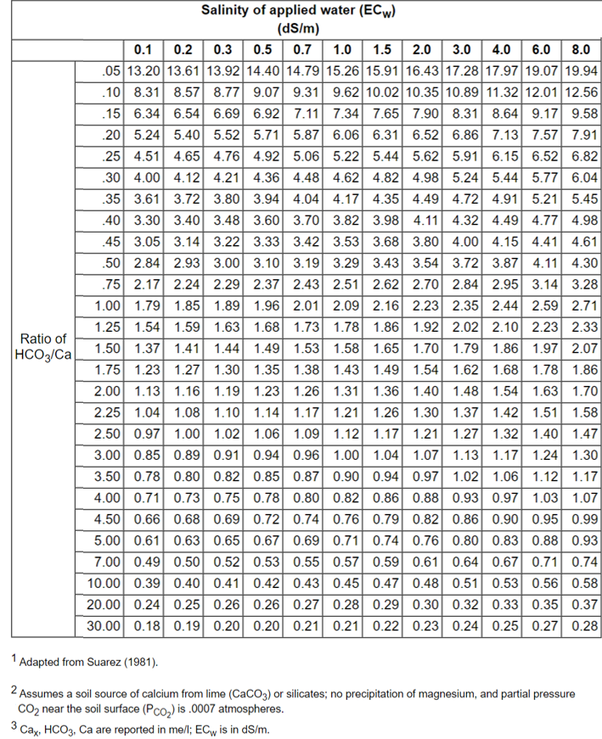
Figure D.1: Estimation of expected soil water Ca (Ca_{x}) concentrations for adj SAR calculation (Ayers and Westcot, 1985a)

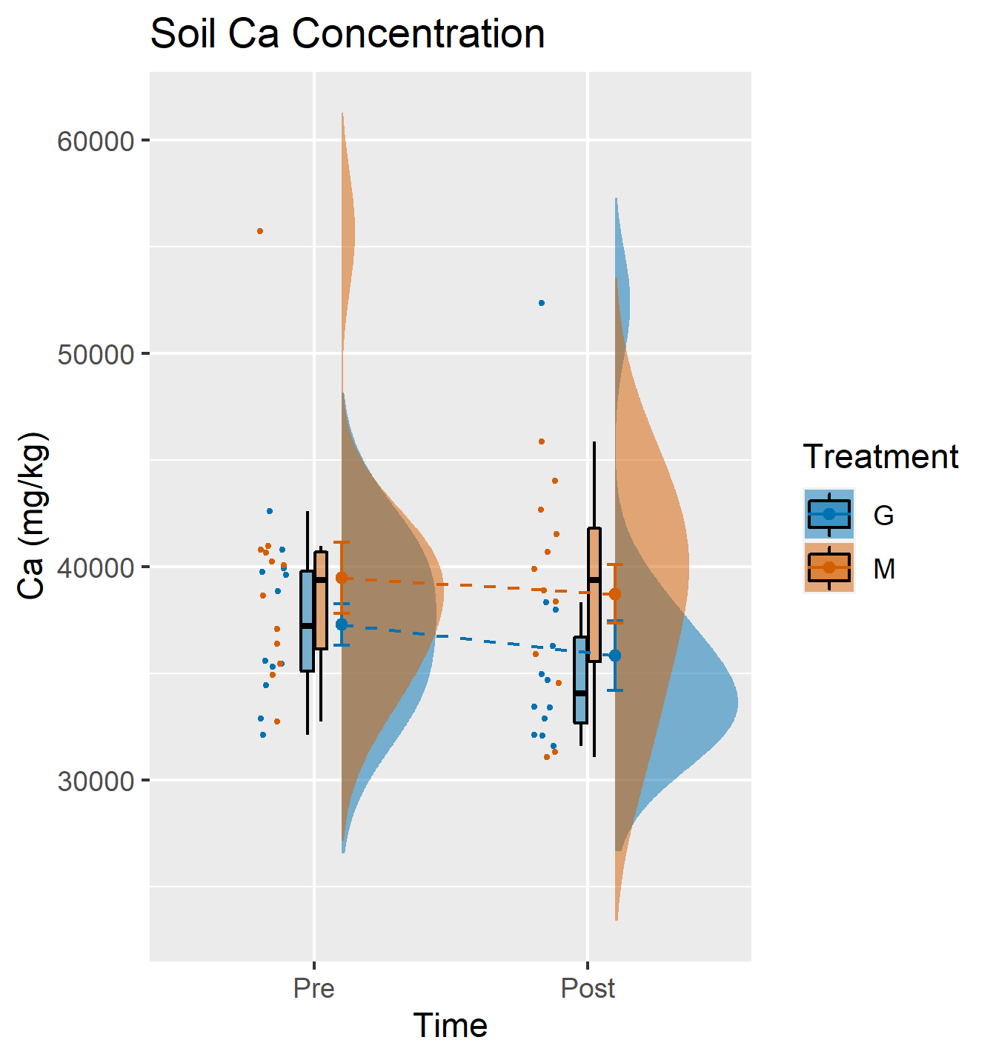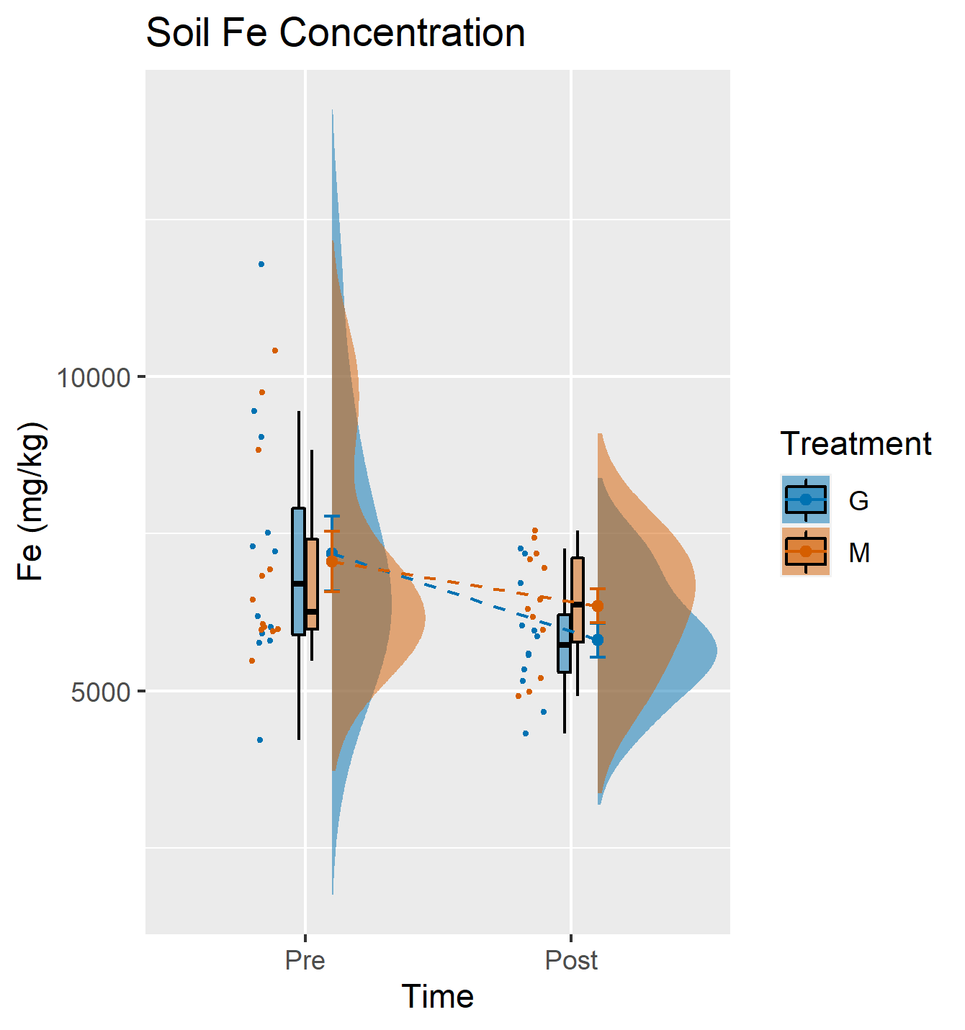
Figure D.3: Changes in soil Fe concentrations under groundwater and mine water irrigation before and after a single growing season, visualized with a combination of scatter plots, box plots, connected means with standard error bars, and smoothed histograms
Figure D.2: Changes in soil Ca concentrations under groundwater and mine water irrigation before and after a single growing season, visualized with a combination of scatter plots, box plots, connected means with standard error bars, and smoothed histograms
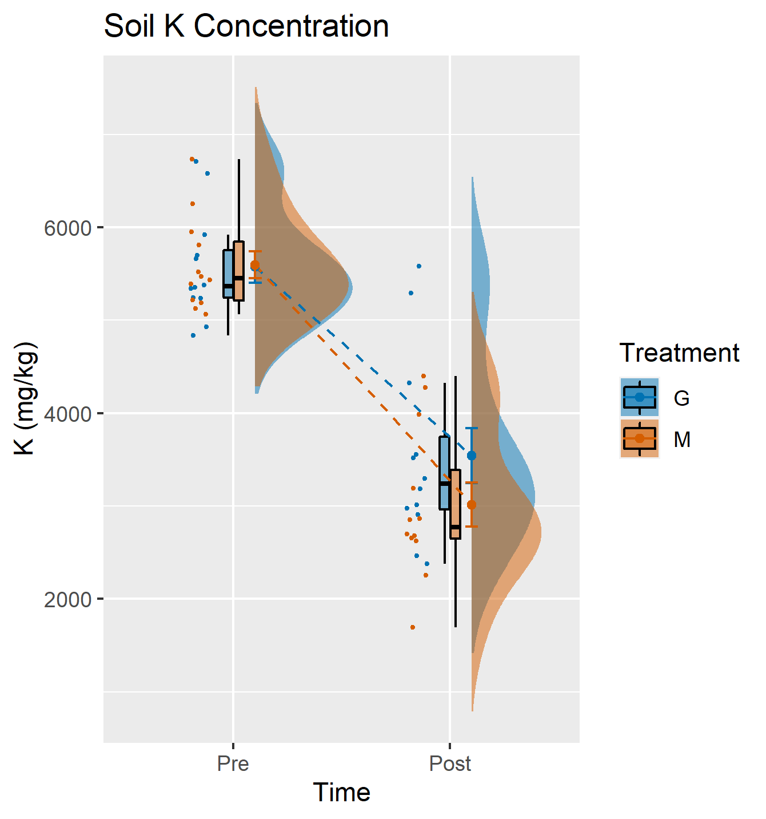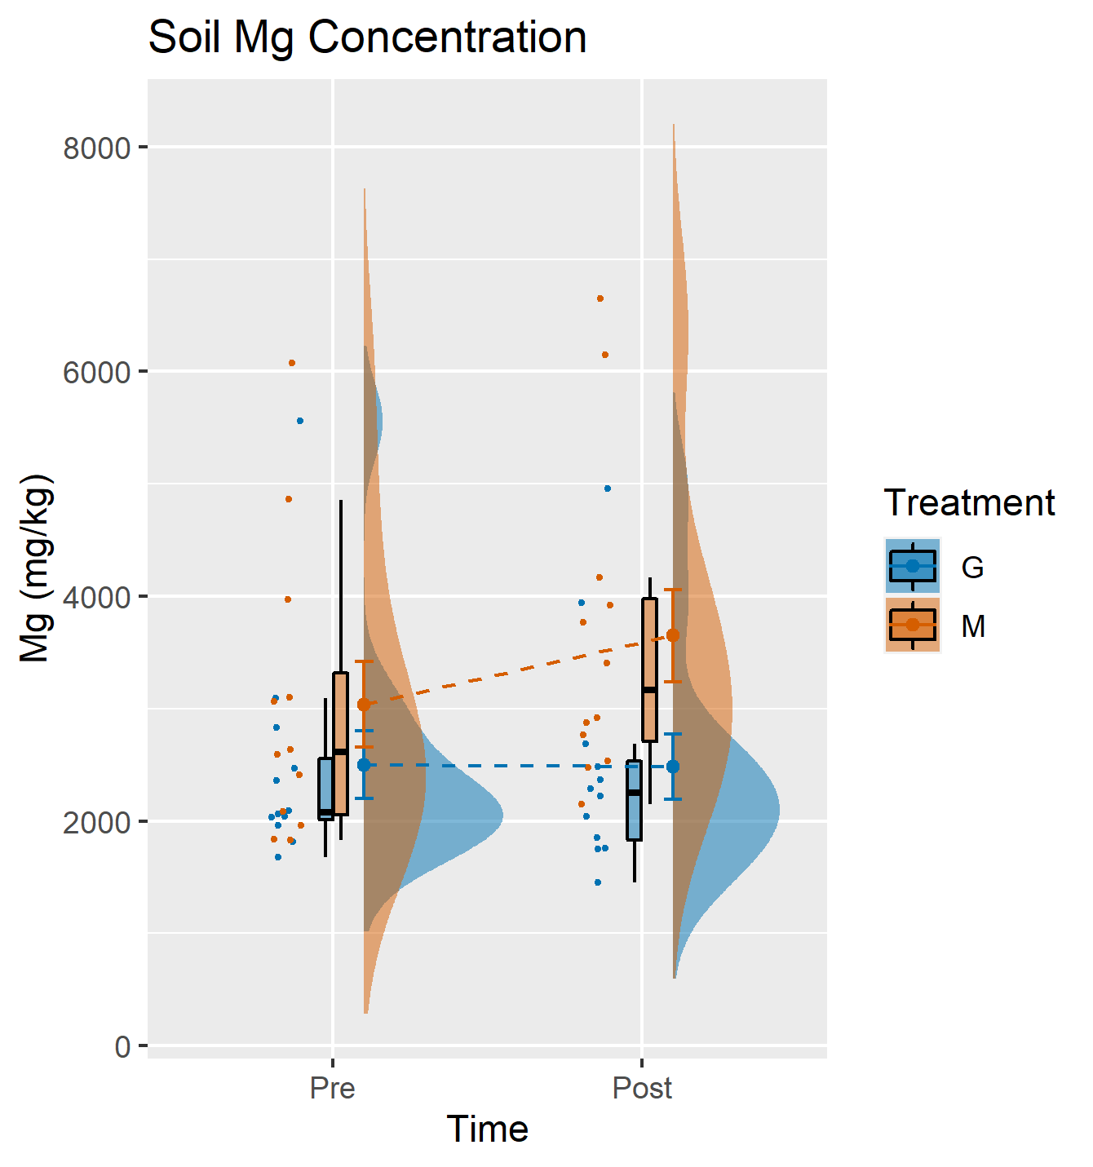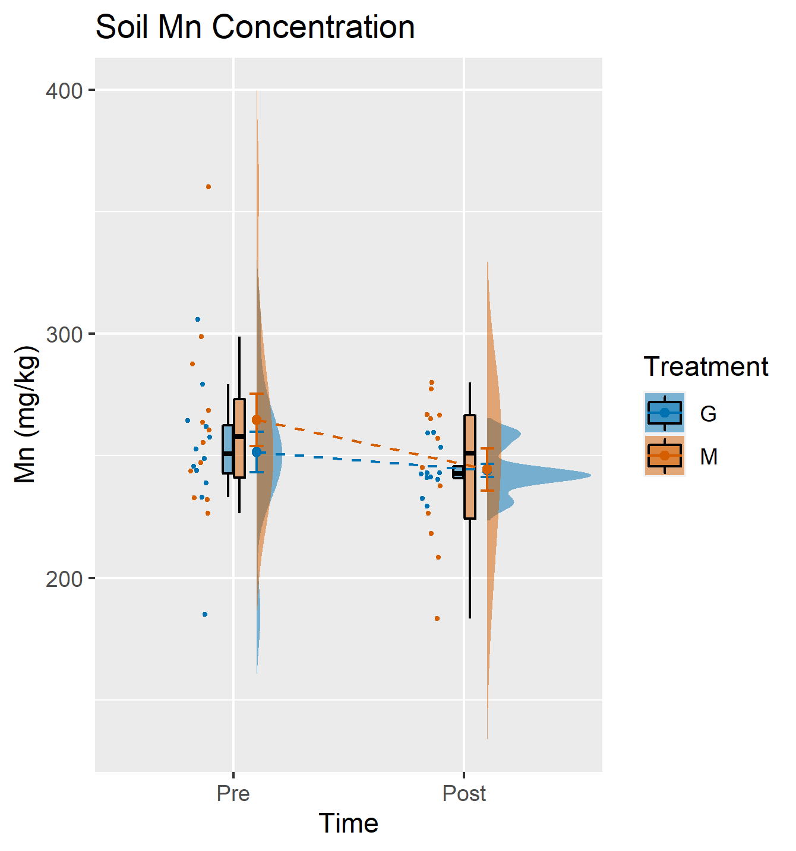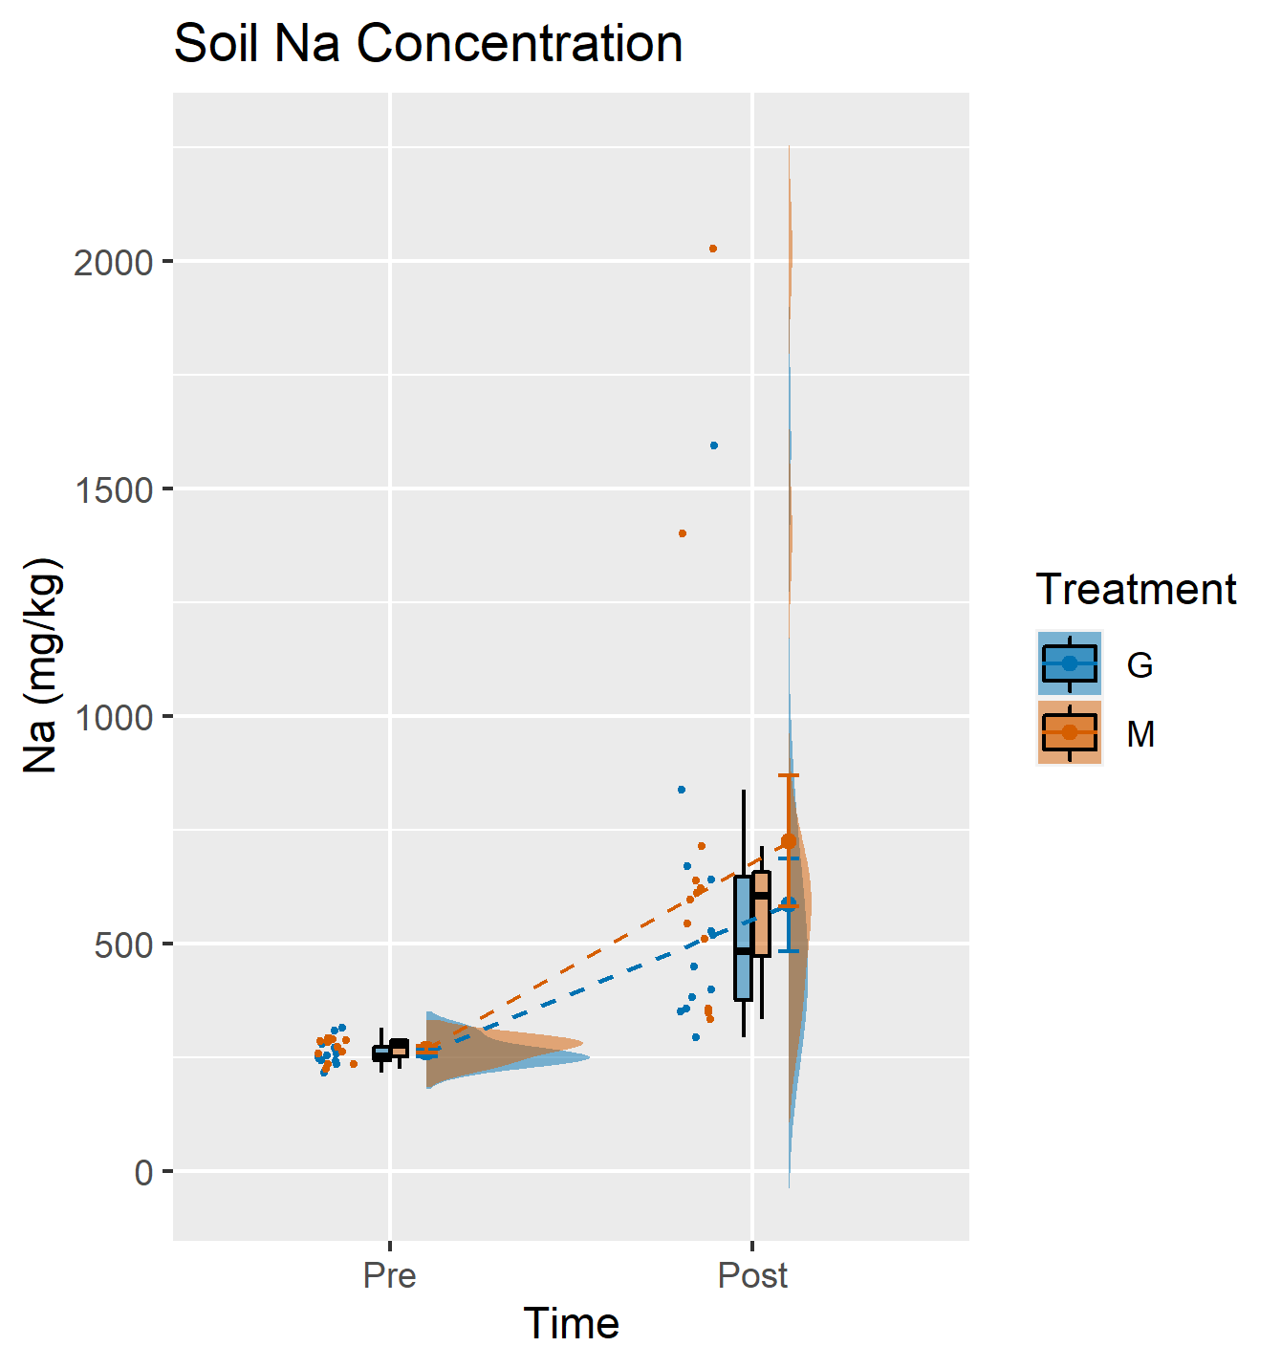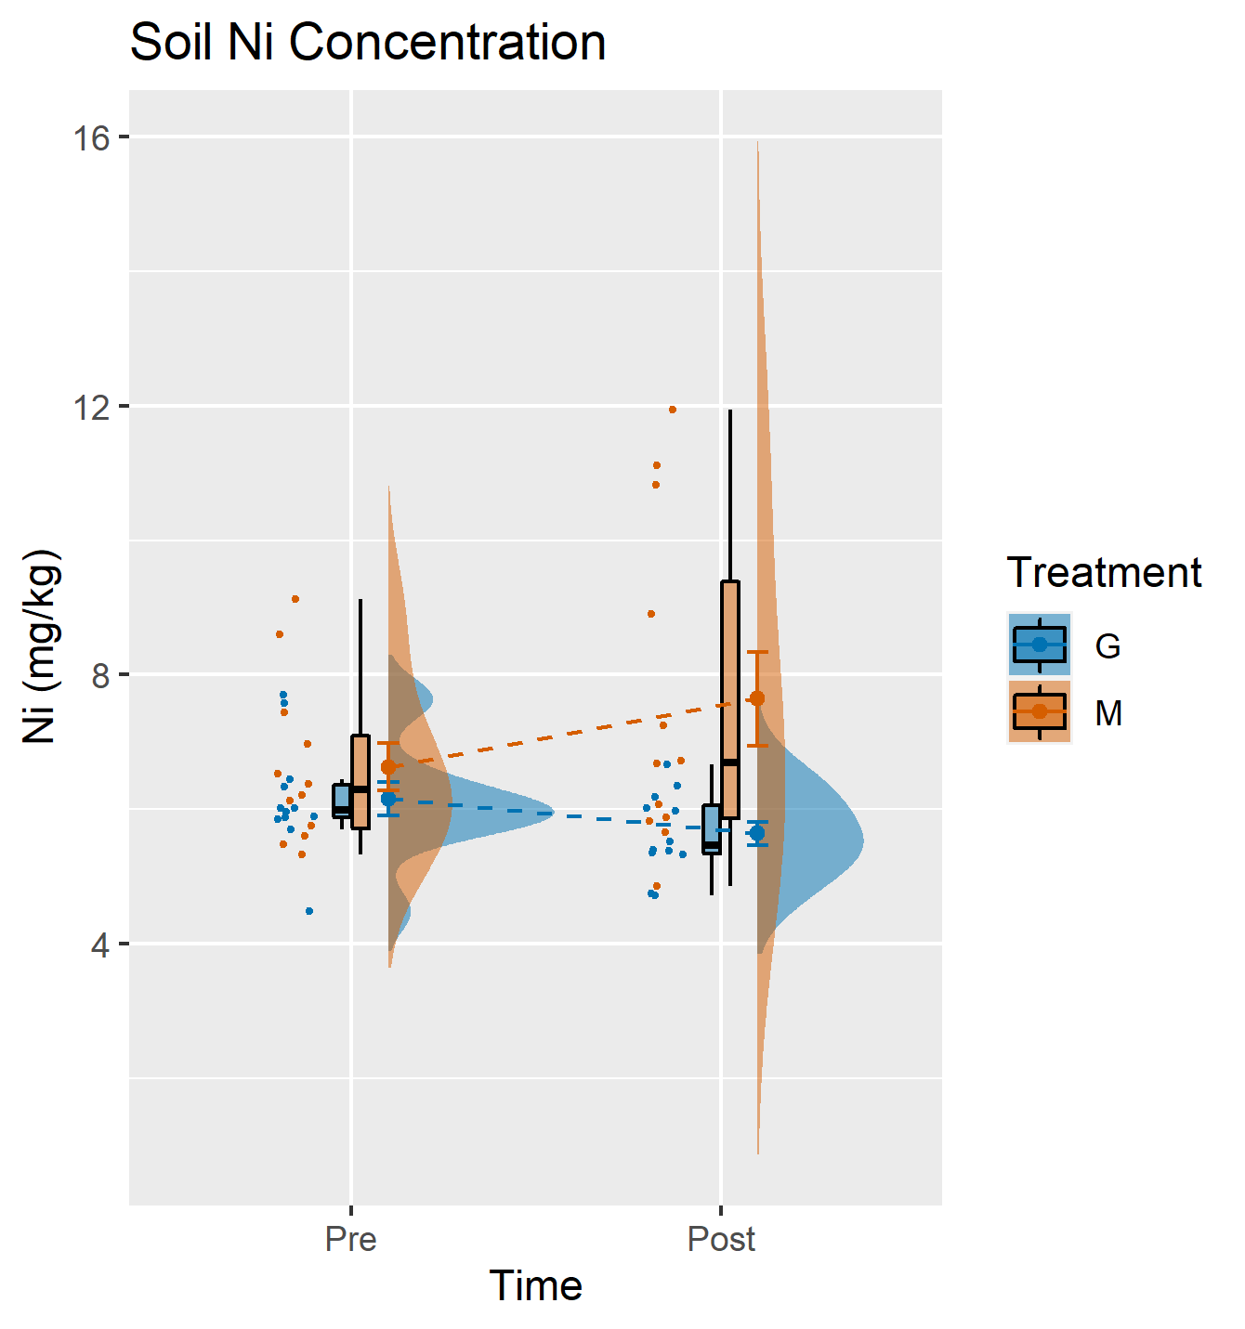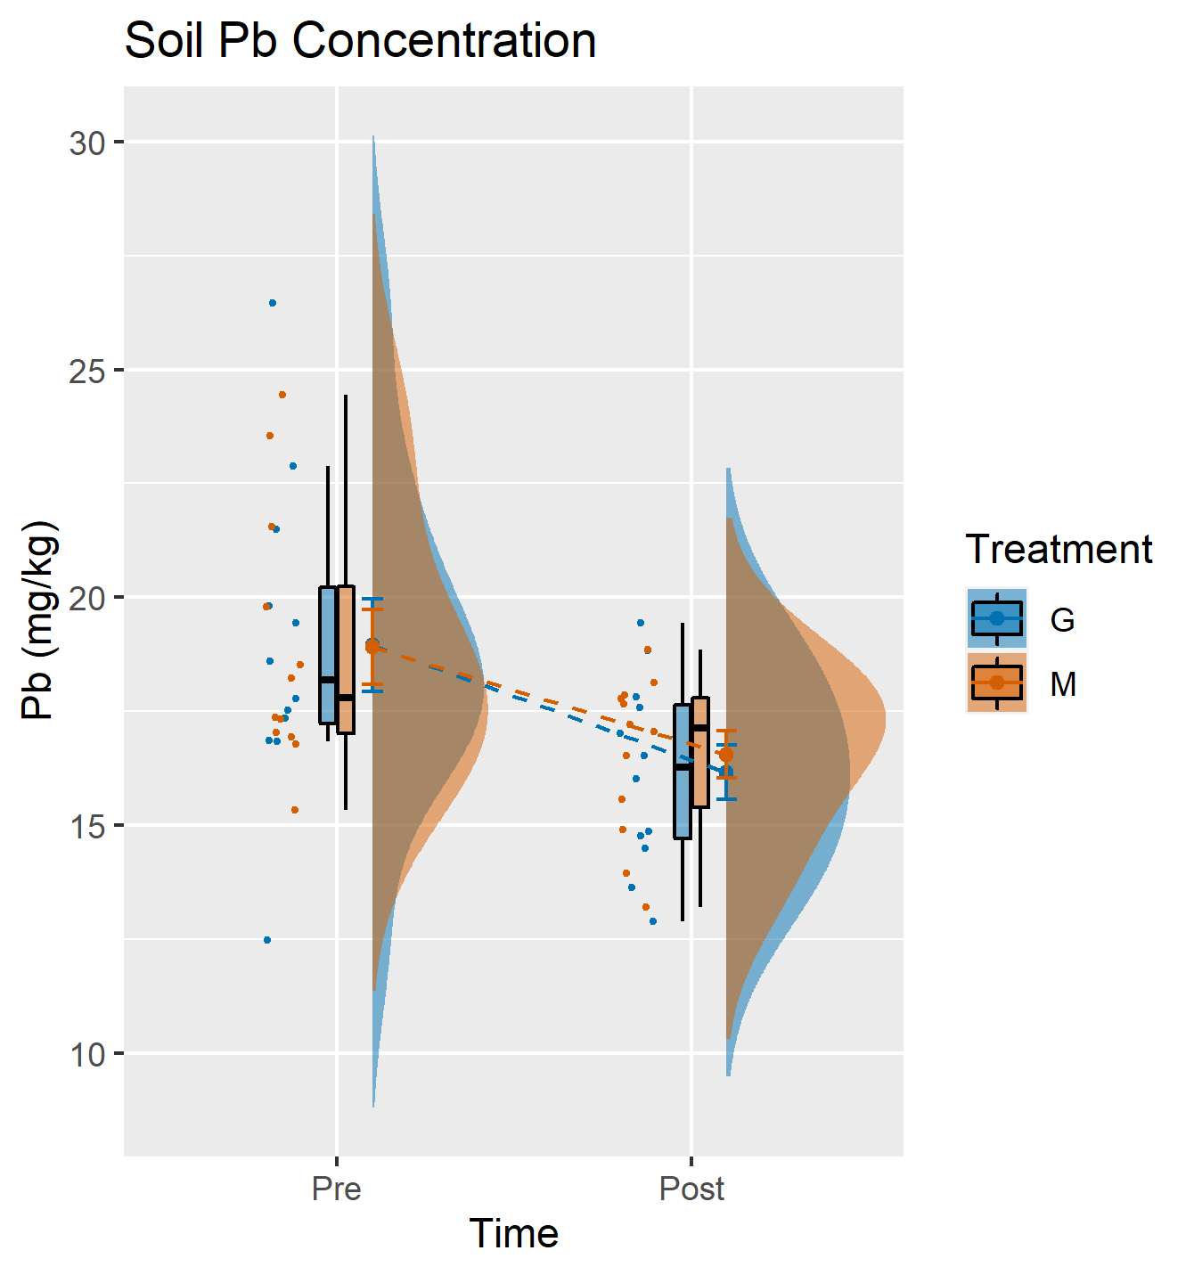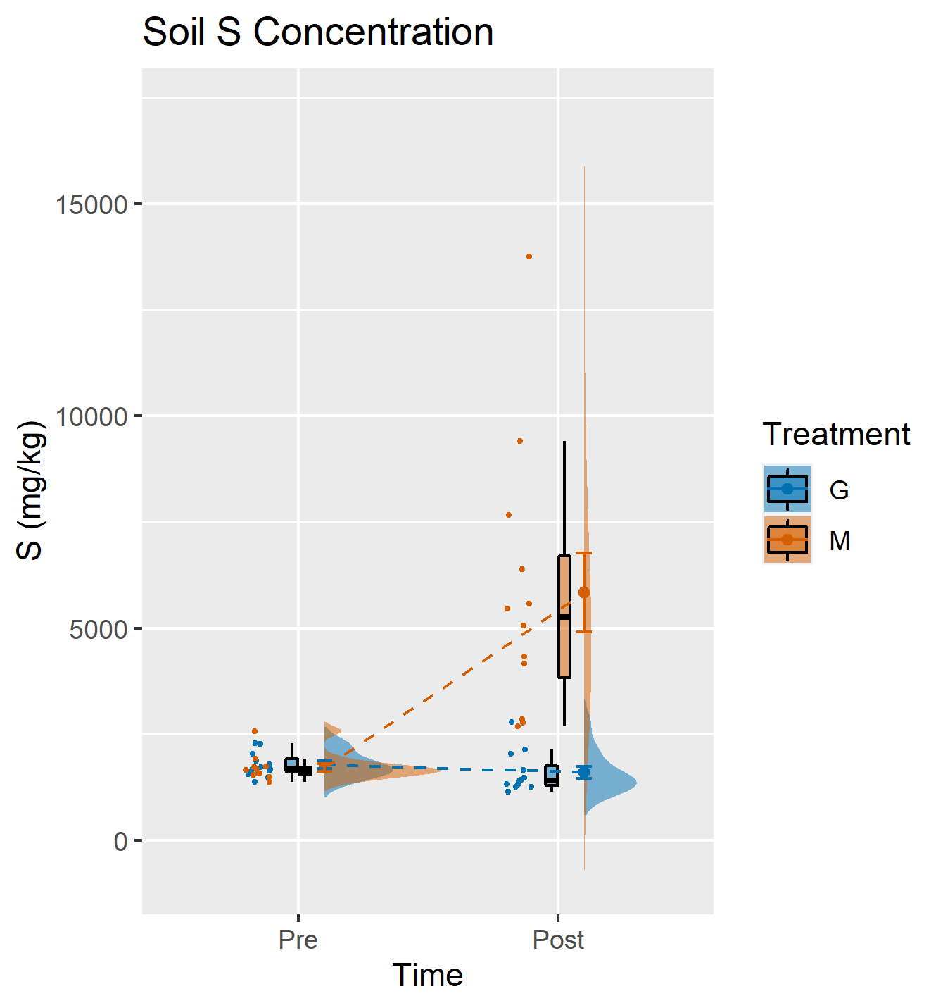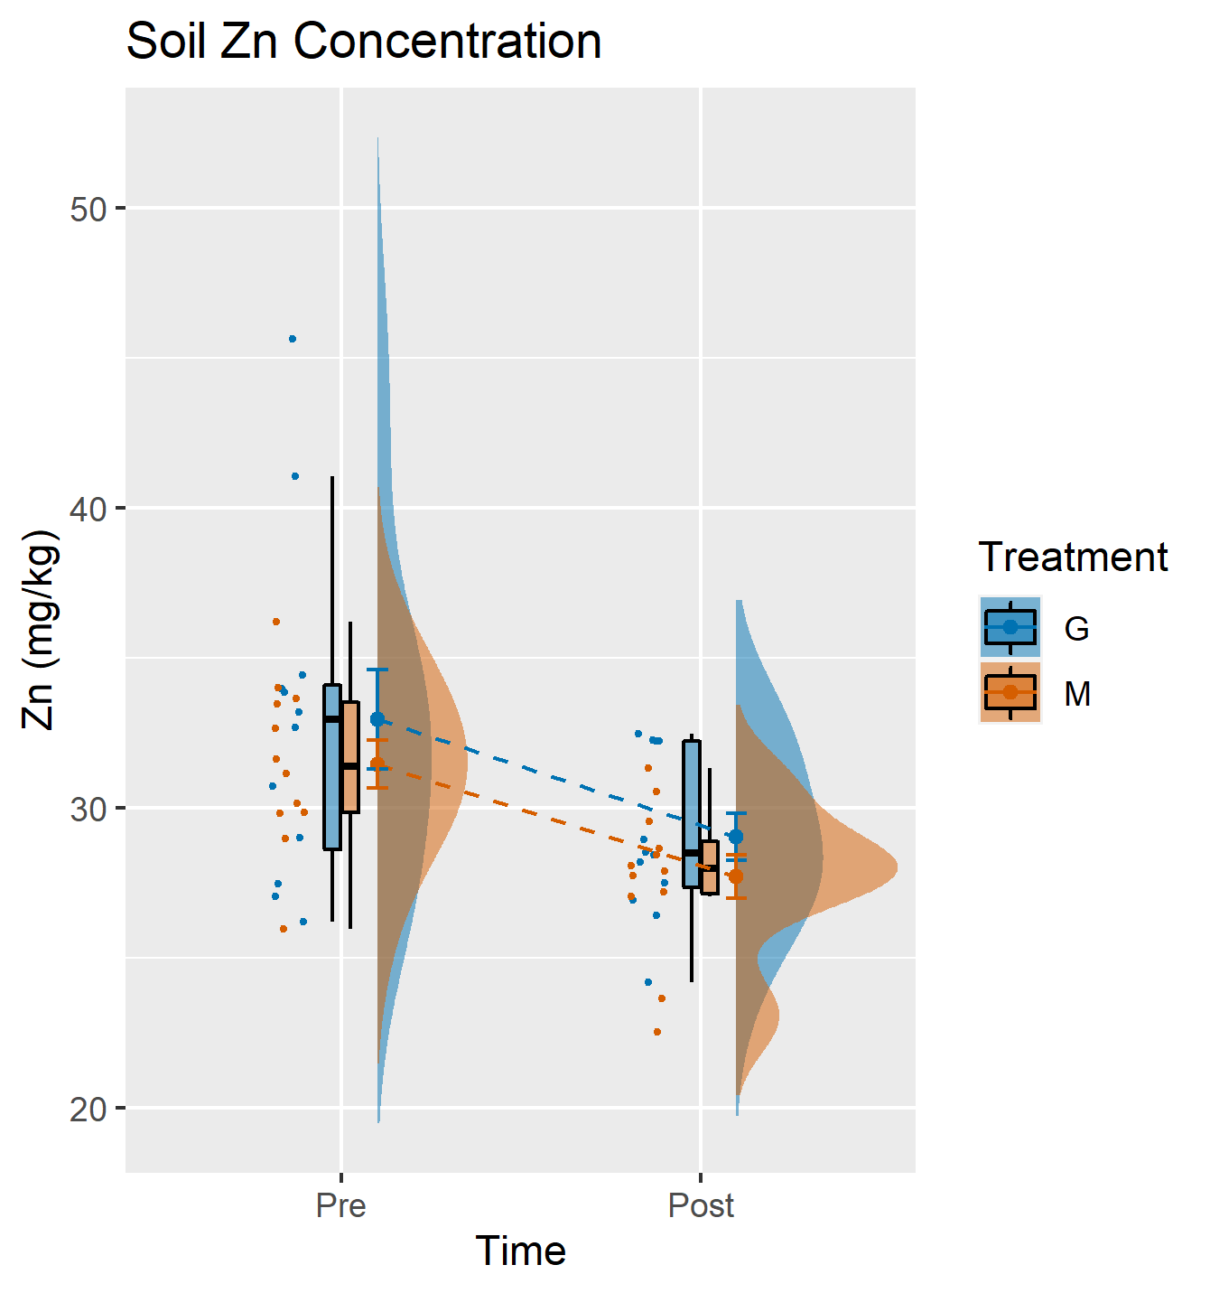
Figure D.4: Changes in soil K concentrations under groundwater and mine water irrigation before and after a single growing season, visualized with a combination of scatter plots, box plots, connected means with standard error bars, and smoothed histograms
Figure D.5: Changes in soil Mg concentrations under groundwater and mine water irrigation before and after a single growing season, visualized with a combination of scatter plots, box plots, connected means with standard error bars, and smoothed histograms
Figure D.6: Changes in soil Mn concentrations under groundwater and mine water irrigation before and after a single growing season, visualized with a combination of scatter plots, box plots, connected means with standard error bars, and smoothed histograms
Figure D.7: Changes in soil Na concentrations under groundwater and mine water irrigation before and after a single growing season, visualized with a combination of scatter plots, box plots, connected means with standard error bars, and smoothed histograms
Figure D.9: Changes in soil Pb concentrations under groundwater and mine water irrigation before and after a single growing season, visualized with a combination of scatter plots, box plots, connected means with standard error bars, and smoothed histograms
Figure D.8: Changes in soil Ni concentrations under groundwater and mine water irrigation before and after a single growing season, visualized with a combination of scatter plots, box plots, connected means with standard error bars, and smoothed histograms
Figure D.11: Changes in soil Zn concentrations under groundwater and mine water irrigation before and after a single growing season, visualized with a combination of scatter plots, box plots, connected means with standard error bars, and smoothed histograms
Figure D.10: Changes in soil S concentrations under groundwater and mine water irrigation before and after a single growing season, visualized with a combination of scatter plots, box plots, connected means with standard error bars, and smoothed histograms

