UNIVERSITY OF OKLAHOMA
GRADUATE COLLEGE

HELPING STUDENTS FIND THEIR VOICES: A STUDY IN STUDENT SELF-ADVOCACY

A THESIS
SUBMITTED TO THE GRADUATE FACULTY
In partial fulfillment of the requirements for the
Degree of
MASTER OF EDUCATION

By
KARA HOFMAN STOLTENBERG
Norman, Oklahoma
2018

HELPING STUDENTS FIND THEIR VOICES: A STUDY IN STUDENT SELF-ADVOCACY

A THESIS APPROVED FOR THE DEPARTMENT OF
INSTRUCTIONAL LEADERSHIP AND ACADEMIC CURRICULUM

BY

Dr. Crag Hill, Chair

Dr. Lawrence Baines

Dr. Kristy Brugar

© Copyright by KARA HOFMAN STOLTENBERG 2018
All Rights Reserved.

Table of Contents

Acknowledgements……………………………………………………………………………..vii
Abstract………………………………………………………………………………………...viii
Chapter 1: Introduction…………………………………………………………………………1
The Problem………………………………………………………………………………..….1
Purpose of the Study…………………………………………………………………………..3
Research Questions……………………………………………………………………………6
Chapter 2: Review of Literature………………………………………………………………..7
Rationale………………………………………………………………………………..……..7
Background of Self-Advocacy………………………………………………………………..8
Self-Advocacy vs. Self-Determination………………………………………………………11
Conceptual Framework of Self-Advocacy………………………………………...…………14
Influences on Self-Advocacy……………………………………………………………...…17
Classroom Applications…………………………………………………………………...…19
Teacher Perceptions……………………………………………………………………….…21
Holes in the Literature…………………………………………………………………….…22
Chapter 3: Methodology……………………………………………………………………….24
Significance of the Study………………………………………………………………….…24
Nature of the Study…………………………………………………………………………..25
Setting and Participants………………………………………………………………………28
Data Collection………………………………………………………………………………30
Data Analysis………………………………………………………………………………...36
Assumptions……………………………………………………………………………….…40
Ethical Assurances………………………………………………………………………...…41
Chapter 4: Findings…………………………………………………………………………….42
Student Self-Advocacy Survey………………………………………………………………43
Student Interviews (Cases)………………………………………………………………..…56
Teacher Self-Advocacy Survey……………………………………………………………...68
Themes………………………………………………………………………………………74
Chapter 5: Discussion…………………………………………………………………………..81
What are student perceptions of self-advocacy?………………………………………….….81
In what ways does self-advocacy influence student success? ……………………………....82
What factors contribute to one’s willingness to self-advocate?……………………………...83
How can educators encourage students to advocate for themselves?………………………..90
Limitations……………………………………………………………………………….…..91
Implications of the Study…………………………………………………………………….92
Future Research………………………………………………………………………….…..93
Conclusion…………………………………………………………………………………...94
References……………………………………………………………………………………….96
Appendices……………………………………………………………………………………..101
Appendix A: District Letter of Approval…………………………………………………...101
Appendix B: IRB Letter of Approval………………………………………………………102
Appendix C: IRB Letter of Approval Extension of Study………………………………….103
Appendix D: Student Assent Form………………………………………………………....104
Appendix E: Parent Consent Form…………………………………………………………106
Appendix F: Teacher Consent Form………………………………………………………..108
Appendix G: Recruitment Script (Students)………………………………………………..110
Appendix H: Script for Survey Administrator……………………………………………...111
Appendix I: Student Self-Advocacy Survey………………………………………………..112
Appendix J: Interview Protocol…………………………………………………………….114
Appendix K: Interview Questions [Self-Advocates]……………………………………….115
Appendix L: Interview Questions [Not Self-Advocates]…………………………………...116
Appendix M: Teacher Self-Advocacy Survey……………………………………………...117
Appendix N: Interview Transcription- Taylor……………………………………………...118
Appendix O: Interview Transcription- Pryor………………………………………………124
Appendix P: Interview Transcription- Sylvia……………………………………………....127
Appendix Q: Interview Transcription- Harriet……………………………………………..132
Appendix R: Interview Transcription- Briana……………………………………………...136
Appendix S: Interview Transcription- Jackson……………………………………………..139

Acknowledgements
I am extremely thankful for my committee members and professors, specifically Dr. Crag Hill who was a constant source of encouragement, especially in those moments when I was doubting myself. Thank you, Dr. Hill, for meeting with me at coffee shops to answer numerous questions, for providing constructive feedback on my writing, and for being patient with me as I overthought every step of this process. My gratitude extends as well to Dr. Lawrence Baines and Dr. Kristy Brugar, both of whom are exceptional professors and have inspired me to be a stronger student, researcher, and teacher. These three individuals embody the best of education and I am extremely thankful that I had the opportunity to learn from each of them.
I would also like to thank my colleagues and friends for encouraging me throughout this process and serving as a sounding board for my ideas. Not only did they talk me through the IRB process and the basic steps associated with my study, but they also helped me balance teaching full time while also working on this project. They are a constant source of support and I feel very blessed to work with such accomplished and encouraging individuals.
In addition, I would also like to thank my current and former students. Regardless of whether they directly participated in the study or not, they are the reason I wanted to pursue this topic. They challenge me every single day and inspire me to be a better teacher and person. This study was first and foremost for them.
Finally, I would like to thank my parents for their unending love and support. Mom and Dad, while this experience was certainly challenging, I enjoyed every moment of it in large part because of the genuine love of learning you instilled in me. Thank you for encouraging me to continue my education and for giving me numerous hugs and advice when I needed it. I am thankful to have such exceptional role models in my life.

Abstract
This study explores student perceptions of self-advocacy, as well as the ways in which self-advocacy influences student success in the classroom. While there have been multiple research studies exploring the benefits of self-advocacy instruction in special education classes or in post-secondary institutions, this qualitative cross-case study looks into the benefits of self-advocacy instruction in all secondary classrooms. To explore the complexities of self-advocacy and its relationship to success in the classroom, high school sophomores completed an open-ended survey about self-advocacy and from those responses, six students participated in a follow-up interview. Lastly, the English teachers of these six students completed a survey as well, to triangulate the findings collected from each student.

Keywords: Self-advocacy, Secondary Education, Cross-Case Study, Qualitative Research

Chapter 1: Introduction
As a student, I always struggled to ask for help. In classes, I made sure to listen closely to my teachers, I contributed in class discussions, and always turned in work on time. I appeared to be a student who was a self-starter and someone who was “good” at school. However, because of the persona I created, when I needed help, I was always afraid to ask for it. I felt like I was letting my teachers down; I was confident they had taught me everything I needed to know, and ultimately it was my fault for not understanding.
The Problem
Now, as a teacher, I think back to those moments as a young adult and see similar behaviors in my students. I have students who are fearless at asking questions and feel empowered to seek out the answers to their inquiries. I have students who struggle with self-advocacy, but regardless of their comfort level, they find a way to ask for the support they need to succeed in that moment. Lastly, I have students who are silent when it comes to confusion. Some will converse with their classmates and me, but when it comes to the assignment, they freeze up and avoid the topic entirely. These students are not necessarily those struggling with the particular skill we are practicing; sometimes they are extremely strong students but, like me, unwilling to ask for help. The students that worry me the most are those who stop trying at the very moment they experience any type of resistance, despite how comfortable they are in the classroom environment we have created. Unfortunately, the latter group draws my attention much more than the former.
In order to combat this passive instinct, I am interested in exploring student self-advocacy, defined by Luckner and Becker (2013) as a means of developing confidence and skills to seek help, express choices, and assert one’s individual rights. Specifically, I am interested in student perceptions of self-advocacy and the factors that lead to a student being a self-advocate or not. Self-advocacy interests me in large part because of experiences in my own classroom and the hesitancy I often see from students who have learned to embrace this passivity. Throughout my years of teaching, I have been surprised by the significant number of students who are uncomfortable or unwilling to ask for help in my class and in their other classes. Many of these students do not ask questions when they are confused, they do not ask for work when they’ve missed class, they are uncomfortable when the unit is student-driven, and they would rather just be told what to do. While these behaviors do not reflect all of my students, I have a significant number of students who exhibit some, if not all, of these traits.
As the problem continued to persist in my classroom, I reached out to the other teachers of these students, wondering if it was possibly my teaching style that was to account for the lack of apathy I was seeing in my classroom. As I talked to other teachers, it was clear that the behaviors I was witnessing were similar to the behaviors they described of those same students. Based on the responses, the behaviors of these students did not seem to stem from their dislike of English or my teaching style. Oftentimes, I really felt as though I had a good relationship with these students. They would come to class early, they would engage in conversation with me, and then once we got back to the curriculum, they seemed to stop trying. I would see these personable, vivacious students suddenly close off themselves and I kept thinking about how much they could accomplish if they would just allow themselves to seek out the support they needed in those moments of struggle. I wanted to find ways to encourage these students to feel empowered to ask for help and understand that they were entitled to that support.

Purpose of the Study
As I moved away from my own experiences and started searching for answers, I found many articles showing how instrumental self-advocacy skills are to the larger success of students, both in traditional school settings and outside of the classroom. While the definition of success is fairly subjective, Matt Leland (2015) suggests that student success includes the following attributes: “general learning skills that affect academic performance, critical thinking skills, behavior and self-control, and job specific skills” (p. 20). Even though student success should be considered more holistically, for the purposes of my study, I will focus primarily on intellectual development, which Joe Cuseo (n.d.) defines as “developing skills for acquiring and communicating knowledge, learning how to learn, and how to think deeply” (p. 2). Cuseo’s definition moves beyond just content knowledge, but focuses on the metacognitive nature of learning and the critical thinking skills required, as well as how knowledge is obtained and communicated. The metacognitive nature of learning relates directly to self-advocacy because of the understanding needed about oneself to truly advocate for one’s needs, as well as the communication needed in order to do this effectively.
In order for most students to achieve success in the area of intellectual development, they must be able to ask for help when they need it, ask for additional resources, and ask for accommodations that will help them to learn skills and think deeply (Cuseo, n.d.; Stamp, Banerjee, & Brown, 2014). The articles I have consulted emphasize the importance of self-advocacy, but they focus almost exclusively on special education classes or college freshmen with learning disabilities. The authors suggest the importance of self-advocacy for these two populations because of the need for students to take control of their education and make sure they are doing what is necessary to be successful in each class, specifically in relation to their needed accommodations (Stamp, Banerjee, & Brown, 2014; Barnard-Brak & Fearon, 2012; Hong, et al., 2011; Hapner & Imel, 2002; Pocock, et al., 2002; Gil, 2007). While I certainly do not want to take away from the importance of research prioritizing this community, the reasoning they provide for the necessity of self-advocacy skills is exactly what I want for all of my students, regardless of their learning disabilities or age. Test et al. (2005) notes at the end of their study that while their focus was on students with learning disabilities, self-advocacy “does not need to be limited to students with disabilities” (p.52). They argue that “all students need to be effective advocates for their interests, needs, and rights” (p. 52). Even so, the research focuses almost exclusively on students with learning disabilities, specifically in relation to accommodations, IEP (Individualized Education Program) meetings, and transitions into the post-secondary world.
Having attended many IEP meetings throughout my career, I have been able to witness students, parents, and teachers coming together to ensure students are doing well in classes, while also working on interpersonal skills and goal-setting. These meetings include very pointed questions about how students are using the resources at their disposal and how they are asking for help if needed. For those students who don’t have a resource teacher or even a teacher who they have for more than one academic year, I fear that they will be overlooked. General education teachers are tasked with addressing specific standards and are potentially assuming students will learn self-advocacy skills and other interpersonal skills at a later date, if they have not already. As class sizes continue to grow, it is getting more and more challenging for secondary teachers to keep track of all of the needs their students require, in terms of curriculum and the more soft skills. Ultimately, those students who are not technically in special education classes and the students whose parents are not as involved, are the ones who are most at risk of being overlooked. As teachers, we are called to teach specific standards, but also life skills that will help our students to be successful outside of school. I believe self-advocacy is a skill that will benefit these children in whatever they pursue after high school. They need to feel comfortable and feel empowered to ask questions. They need to look out for themselves and learn about ways to advocate for their own well-being.
General education teachers will benefit from this study because encouraging self-advocacy in our students could have a drastic impact on not only the students but the individual teachers’ classrooms as well. With 150+ students, it is nearly impossible to keep track of every individual need (missing assignments, students who were absent, extra time on work, etc.). With students knowing how to ask for help and at the appropriate times, their advocacy will ultimately help to make everything run more smoothly in the classroom. Administrators could benefit from the findings as well, potentially implementing school wide programs which could help the overall climate of the school as teachers are able to empower students to advocate for themselves. Ultimately, my main motivation is for the benefit of students. I wholeheartedly believe that students need this skill and educators can help to teach it to them.
With all of this in mind, the purpose of this cross-case study, defined by Yin (1994) as an empirical study meant to focus on a specific social phenomenon grounded in its real-life context, is to develop an understanding of the effect of self-advocacy in relation to student success amongst sophomore high school students taking English II in a suburban high school setting. At this stage in the research, self-advocacy is defined as a means of people developing confidence and skills to seek help, express choices, and assert their individual rights (Luckner and Becker, 2013).

Research Questions
The research questions explored in this study have been narrowed down to four total.
- What are student perceptions of self-advocacy?
- In what ways does self-advocacy influence student success?
- What factors contribute to one’s willingness to self-advocate?
- How can educators encourage students to advocate for themselves?

Review of the Literature
Rationale
To explore the many factors influencing self-advocacy in the classroom, the Literature Review is divided into five parts as they relate to self-advocacy within the context of secondary education.
- Background of Self-Advocacy
- Self-Advocacy vs. Self-Determination
- Classroom Applications
- Perspectives from Teachers
- Holes in the Literature
The first section focuses on the historical context of self-advocacy groups and the literature available about the benefits of teaching self-advocacy skills. The second section explores the differences between self-advocacy and self-determination seeing as there is far more literature about self-determination, while self-advocacy remains a crucial component. The third section outlines the basic self-advocacy framework along with how teachers have tried to incorporate self-advocacy skills within a school setting. The fourth section reviews teacher perspectives about self-advocacy and the importance of the skill for future success. And lastly, the fifth section explores holes in the literature.
The review of the literature was conducted using resources from the University of Oklahoma Library to obtain peer-review and scholarly articles to ensure credibility of this study. Specifically, the online databases JSTOR, ProQuest, and the Education Resources and Information Center (ERIC) were used to find most of the articles cited in this study. An interlibrary loan service was used to request articles not owned by the University of Oklahoma. Search items included self-advocacy, secondary education, success, teaching. Terms were searched using all possible combinations, focusing on peer reviewed articles found within the last two decades.
Background of Self-Advocacy
Test, Fowler, Wood, Brewer, & Eddy (2005) explain the historical context of self-advocacy, suggesting the movement was structured after the Civil Rights Movement, helping to empower individuals with disabilities to speak up for themselves (p. 43). Trausstadottir (2006) explains as well that at its core, self-advocacy is ultimately about speaking up for oneself and extending that self-advocacy out to others as well. While inspired by the 1950s, the self-advocacy “movement” can be traced back to Scandinavia in the 1960s, where young adults gathered to discuss their lives and their learning difficulties (Trausstadottir, 2006, p. 175). A decade later, similar groups were found in the United States and Great Britain, and since then international self-advocacy organizations have developed and continue to develop worldwide (Trausstadottir, 2006, p. 175-176). The need for these groups stemmed from the assumption that individuals with disabilities were incapable of articulating, understanding, and making decisions for themselves (Test et al. 2005; Trausstadottir, 2006). These decisions were left to the prominent “authority figures” in the lives of these individuals, ultimately leaving them to feel unempowered and nonautonomous in their day to day lives (Test et al., 2005, p. 43). Because of this cycle, many of these young adults struggled to properly transition into adulthood. As these groups started to emerge, there were two major issues addressed: first, to “insist on their common humanity and explain that people with learning difficulties had the same needs and aspirations as other people” and second, “to insist that people with learning difficulties could, and should, speak for themselves and make their own decisions” (Trausstadottir, 2006, p. 176). These individuals were searching for a sense of “normalization” in which they could be recognized as self-sufficient individuals (Anderson & Bigby, 2015, p. 109). Unfortunately, a fear of being different is still an issue plaguing the identity of those who have learning disabilities and those who struggle academically (Anderson & Bigby, 2015, p. 110). There is a social stigma towards asking for help and admitting that one does not understand a concept. The social stigma associated with needing help leads many students to believe that their learning disability is a character flaw or equated with low intelligence; therefore decades after the movement began, many are still resistant to disclose this information (Stamp, Banerjee, & Brown, 2014).
The overall resistance these students feel toward asking for help comes as no surprise considering the literature has proven time and time again that “the development of self-advocacy skills [is] crucial to the successful transition of students with disabilities into adult life” (Test et al., 2005, p. 43; Luckner & Becker, 2013; McCarthy, 2007). Deborah McCarthy (2007) argues that public schools are doing their students a disservice, focusing on accommodations and student success, instead of self-advocacy and student growth (p. 11). Michael Wehmeyer (2007) cautions educators by explaining that “if students do not learn to make choices based on their own interests and to experience and learn from the consequences of these choices in the structured environment of school, it is unlikely that they will be able to do so in response to the ever-changing demands of home, community, and work” (p. 18). Students experience very little ownership of their education from preschool to secondary, despite teachers’ efforts to create student-centered classrooms and meaningful curriculum. The system itself, with 50 minute class periods, seven periods a day, with each subject taught separately is not conducive to empowering students to take control of their educational experiences. In addition, factors outside of the school’s control can have a negative impact on students as well, such as a lack of funding, larger class sizes, state mandated tests and standards, etc. Because of these outside influences and more, our job, as educators, is even more crucial. If one of our primary goals is to “prepare students with the skills that modern life demands, then we are charged with the responsibility of encouraging advocacy in all students” (McCarthy, 2007, p. 16).
The difficulty for students to identify what they need help with and to ask for the support they need is seen both in students who have been identified as having a learning disability, along with those who have not. These students, regardless of label, often feel a sense of shame and blame themselves for struggling (Stamp, Banerjee, & Brown, 2014 ). They fear judgment from their teachers, embarrassment asking for help, and ultimately are reluctant to seek extra help. These feelings were present in spite of students “possessing an intellectual ability comparable to that of their peers” (Stamp, Banerjee, & Brown, 2014, p. 148). Despite their intellectual ability, many students develop a sense of learned helplessness throughout their time in K12 schooling, essentially “getting by in high school” and letting their parents or teachers “initiate and manage tasks” for them” (Stamp, Banerjee, & Brown, 2014, p. 148). Learned helplessness is impacting students’ abilities to be 21st century learners and ultimately preventing them from developing skills such as problem-solving, adaptability, initiative, and effective communication; skills that will help them far beyond high school (Saavedra & Opfer, 2012, p. 8).
Asking students to advocate for themselves is a significant shift from what many students have been asked to do in their school careers. While there have been significant changes in the last decade towards a more student-centered classroom, many students are still most comfortable with “rote learning,” and would prefer essentially waiting until the teacher tells them what to do, how to do it, and when it is due in large part because of this learned helplessness (Agran, Snow, & Swaner, 1999; Saavedra & Opfer, 2012). Even at the secondary level, students are not expected to be in charge of their own learning; instead we assign that responsibility to parents, teachers, and administrators. When a student is struggling, the adults make arrangements to ensure the success of that student, often with very little input or ownership from the student at all. The irony is that parents and teachers try to provide supports for the benefit of students, however as we make those day-to-day decisions for them, we may be unknowingly hindering their self-advocacy and learning (McCarthy, 2007, p. 11). By implementing the development of self-advocacy skills, teachers are not just asking students to practice a new skill or increase their self-confidence, instead we are asking them to “change the whole way that they understand themselves, their world and the relationship between the two” (McCarthy, 2007, p. 11). Rather than passively moving through the steps of public education, we will be reinforcing the goals of education: “to promote the independence, active involvement, and commitment of students to their learning and self-development” (Agran, Snow, & Swaner, 1999, p. 293). To put it simply, we will be preparing students to have more control over their lives.
Self-Advocacy vs. Self-Determination
In the literature, self-advocacy is often referred to as a skill used within the larger umbrella of self-determination; ultimately, these self-advocacy skills have been identified as a key component to achieving self-determination (Barnard-Brak & Fearon, 2012). While there are a variety of definitions for self-determination, most researchers refer to Wehmeyer’s original definition of the term in which he describes a person who has an awareness of one’s own needs, sets goals and works toward them, creates solutions to problems, advocates for self, identifies needed supports, and creates unique solutions to solving problems (Wehmeyer & Schwartz, 1998; Eisenmann & Tascione, 2002). In addition, one who is self-determined is described as “psychologically empowered and self-realizing,” along with being the primary person in charge of the decisions that impact one’s quality of life (Eisenmann & Tascione, 2002, p. 35). This is a person who knows what they want and how to go about achieving their goals.
Both self-determination and self-advocacy are important and help students to be more involved in their own learning, in addition to helping them assume responsibility for their actions (Agran, Snow, & Swaner, 2016). The acquisition of these skills directly correlates to success in post high school experiences. Multiple studies show that students who are self-determined are more likely to have successful post-secondary experiences, be gainfully employed, and appreciate a better quality of life (Hong, Haefner, & Slekar, 2011; Wehmeyer & Schwartz, 1998). While movement toward a more student-driven education has been at the forefront of education reform for the last two decades, it has yet to transfer to post-secondary education (Hong, Haefner, & Slekar, 2011). This highlights yet another reason why teaching these skills at the secondary level is so crucial. Research shows that students who utilize self-advocacy skills in college tend to be more self-determined, and consequently are far more successful than their peers who do not speak up for themselves.
While these skills are widely valued, multiple studies show that teachers and students avoid discussions about self-determination and self-advocacy because it requires a level of self-realization that can be uncomfortable to discuss (Eisenmann & Tascione, 2002; McCarthy, 2007). Students must have a clear understanding of what their weaknesses are, and oftentimes teachers and students alike would prefer to avoid these difficult conversations. This is especially true for those with learning disabilities, where there is a general lack of information about the needs of these students. A general lack of information can lead to a culture where these students are stereotyped and ultimately their self confidence is hindered (Eisenmann & Tascione, 2002). Eisenmann and Tascione (2002) point out in their study that most of the students they interviewed, a combination of seniors and juniors with learning disabilities, did not remember ever discussing their disabilities or accommodation needs aside from specified IEP meetings. Some students acknowledged that it was not until their senior year that they truly understood their learning disability and why they struggled so much in school. Once teachers began discussing the specifics of their learning disabilities, students were eager to learn and to help make sense of their difficult learning experiences. These revelations not only helped to empower students, but also helped them to self-reflect and redefine their own identities. One student in particular, who often remained silent about his learning disability, had an epiphany after advocating for himself, and told the interviewers that he now understands “life can be easier” (Eisenmann & Tascione, 2002, p. 41). The realization that self-advocacy can make life easier, while simplistic in diction and syntax, is extremely insightful. By teaching students the skills and tools necessary for life in the 21st century, not only are we preparing them to feel ownership of their lives, but educators will also be helping to make life’s obstacles feel a little less impossible.
While these 21st century skills encompass both self-determination and self-advocacy, this study focuses primarily on self-advocacy because of how narrow the concept is in comparison. Self-advocacy skills, while certainly relating to self-determination, are skills one needs to master prior to truly being self-determined. The narrow concept of self-advocacy versus the larger concept of self-determination, which includes multiple skills within the definition, allows for a more focused study exploring how to help give students ownership of their education and potentially make their lives a bit easier. Arguably, by focusing on self-advocacy first, students will be on their way to becoming more self-determined as well.
Conceptual Framework of Self-Advocacy
Based on an extensive literature review and input from stakeholders, Test and his colleagues (2005) identified four key components of self-advocacy: “knowledge of self, knowledge of rights, communication, and leadership” (p.45). Test et al.’s framework has been adopted by others and elaborated on, in large part because there is very little research outlining the ways in which self-advocacy skills are actually developed (Daly-Cano et al., 2015; Luckner & Becker, 2013; Barnard-Brak & Fearon, 2012). There are numerous studies expressing the importance of this skill, but as Luckner & Becker (2013) explain, self-advocacy skills must be explicitly taught, with structured time to practice these skills, and there is very little guidance on how to do so.
Arguably the most important component of the framework is to gain self-awareness and understanding of one’s self-knowledge. This self-awareness refers to an understanding of one’s “preferences, goals, learning style, strengths, weaknesses, accommodation needs and the characteristics of one’s disability” (Daly-Cano et al., 2015, p. 215). To take it a step further, students must be encouraged to “accept their strengths and weaknesses as a step toward developing their self-advocacy skills” (Test et al., 2005, p. 50). Knowledge of oneself is crucial for self-advocacy because in order to communicate needs, one must understand themselves and their situation enough to know what they need.
Knowledge of rights is an important element as well, especially for those with learning disabilities. Students must know their rights as a citizen and as a student. Knowledge of rights relates specifically to services provided under federal law in the Individuals with Disabilities Education Act from 1997, but could also be connected to the general education population in terms of understanding personal rights, community rights, educational rights, steps to correct violations, and steps to advocate for change (Daly-Cano et al., 2015, p. 215). Oftentimes, students in secondary education feel as though they have no rights at all. They are passively moving through the steps of high school, doing as they are told, often with no explanation of why they are being required to follow certain rules and do certain assignments. Somehow, schools are still resorting to the transmission model where students “learn information, but typically don't have much practice applying the knowledge to new contexts, communicating it in complex ways, using it to solve problems, or using it as a platform to develop creativity,” leaving students to feel unempowered and uninspired (Saavedra & Opfer, 2012). By reminding students they have rights and can advocate for those rights, we are giving students their power back and helping them to wield that power effectively.
Once students have a better understanding of their strengths and weaknesses, along with their rights as a student, then they will be better prepared to communicate their needs. In the study completed by Test and colleagues (2005), all of the data-driven studies analyzed included “communication skill development” as an important step towards self-advocacy (p. 50). Among those skills were “negotiation, persuasion, and compromise,” along with body language, listening skills, and an overall awareness of how one is communicating (Test et al., 2005, p. 50). These communication skills are crucial to ensure students have the tools necessary to interact with another person who is often the one in a position of power. Students must be able to articulate their reasoning in a way that appeals to this person.
The final piece of the framework relates leadership, which involves understanding the complexities and roles within a group, along with being a voice not only for oneself, but for others (Test et al. 2005). In the studies analyzed, leadership was largely connected to student leadership regarding their IEP or transition meeting (Test et al., 2005, p. 50). In addition, there were a few examples that included teaching students with disabilities about their responsibility to advocate for themselves and others like them, in a school setting and in terms of political lobbying (p. 51). Leadership is less represented in educational literature, and that is in large part because one can be an effective self-advocate without this final step. Instead, the emphasis on leadership is seen more in self-made groups and among adults with learning disabilities who have already transitioned to the workforce or post-secondary education.
In addition to Test et al.’s framework, Daly-Cano, Vaccaro, & Newman (2015) provide a bit more structure by describing the ways in which students with learning disabilities choose to advocate in a postsecondary setting. In their qualitative study, their participants all understood the need for self-advocacy, however their strategies in how they communicated their needs differed between being proactive, reactive, and/or retrospective. Students who were proactive found accommodations prior to needing them, oftentimes before the semester even began. Others found themselves responding to a particular event or challenge and reactively self-advocating for their emerging needs. They could not foresee these difficulties; however, they had the motivation to confront the conflict, express their needs and sometimes exert their rights. Lastly, some students found themselves self-advocating retrospectively after they felt they had not advocated well the first time. Essentially, these students learned from their mistakes and were able to reflect and adjust accordingly (Daly-Cano et al., 2015). All of these participants described positive outcomes, despite the anxiety of speaking up for themselves.
In terms of self-advocacy interventions, Fowler, Konrad, Walker, Test, and Wood (2007) briefly address them in their article “Self-Determination Interventions’ Effects on the Academic Performance of Students with Developmental Disabilities,” stating that “role pay, direct instruction, and beginning and end-of-day monitoring by instructors” will help students to “self-recruit teacher assistance” (p. 277). However, they do not go into specifics or outline ways to facilitate these types of activities. They do not even elaborate on what specifically instructors would be monitoring in these situations or what scenarios students could role play. Luckner and Becker (2013) attempt to provide more concrete examples of ways to teach these skills, however their suggestions are also quite minimal. They start by outlining Test et al.’s framework, then suggest having students practice self-advocacy skills in situations where the success rate is high, and then provide an opportunity later for the student to practice independently. They also mention role-playing situations where teachers and students work through different scenarios and identify the appropriate skills for that situation. Lastly, Luckner and Becker (2013) recommend having students practice these skills in their IEP meetings, eventually building up confidence to at some point lead the meeting. While these articles give teachers a starting point, they hardly provide any guidance for teachers who are wanting to implement self-advocacy skills into their classroom, especially skills that can and should be taught alongside current curriculum.
Influences on Self-Advocacy
While we know very little about how self-advocacy skills are developed, we do know most young people and adolescents learn these skills from their families, teachers, and friends (Daly-Cano et al., 2015). Families often begin teaching these skills during childhood by encouraging students to be successful. Unfortunately, if parents are too hands-on and overprotective, they can hinder the child’s development by inadvertently communicating doubt about the child’s ability to be successful (Daly-Cano et al., 2015). Families have to find the balance of providing familial support while also holding their child accountable for their success.
Likewise, teachers are charged with a similar challenge: finding ways to support students while also preparing them for the “reality” of postsecondary life. In the study completed by Daly-Cano, et al. (2015), many students mentioned feeling as though their teachers or teacher aids were being unnecessarily mean when they forced the student to complete tasks for themselves. The teachers were constantly reminding students to be proactive and to plan ahead, while also preparing them for those moments of failure when they would need to be reactive or retrospective in their actions. However, in hindsight, these students appreciated the efforts made by these teachers and they ultimately felt more prepared to speak up for themselves in other contexts as well.
The final influence outlined by Daly-Cano et al. (2015) relates to classmates and peers. While there is very little literature to support the positive influence peers can have on the development of self-advocacy, aside from college students helping provide guidance for students transitioning into college, there is support to show that peer relations can have a negative effect on developing those skills (Daly-Cano et al., 2015). In studies about self-advocacy, social isolation has actually been found to be a protective factor in relation to self-advocacy, resulting in students seeking out their parents and teachers for help, rather than their classmates (Daly-Cano et al., 2015). These influences are important to consider because not all students have these resources. For those kids who don’t have a strong family, with parents who are encouraging them to succeed and speak up for themselves, they are left with essentially two other influences: teachers and peers. While peer interactions are not inherently bad, most peers cannot provide the support and perspective that an educator can, especially an educator whose job is to empower students to feel ownership of their lives.
Classroom Applications
Deborah McCarthy (2007) argues that the very first step of guiding students towards self-advocacy and ultimately finding their own voices is to encourage students to ask questions and acknowledge uncertainty (p. 11-12). She explains that for students with disabilities, it is crucial for them to understand that there will be certain aspects of their lives they cannot control and certain questions that will not have direct answers. She argues that one of the most difficult tasks for educators is guiding students through the process of differentiating between what is onerous because of one’s disability versus what is difficult because learning is inherently a challenge (McCarthy, 2007, p. 14). Having these impactful discussions will ultimately help students to learn how to make calculated risks in those situations when the answer is not clear-cut. Consequently, their teachers can help to remind them that “more often than not, learning comes from the process of evaluating options and evidence rather than immediately knowing a definitive answer” (McCarthy, 2007, p. 12). This realization relates as well to the social anxiety students feel when they do not know something and are fearful to ask for help in front of others. If students as whole understand the complexities involved with learning, then potentially the stigma associated with needing help could be lessened. McCarthy also encourages reflection and responsibility for one’s choices, which helps to affirm the development of self-advocacy within that student as well as emphasizes the ownership they have over their choices (p. 12). Lastly, she emphasizes the level of interdependence present between the student and teacher, ensuring that the role of the teacher is important and they are there to “celebrate, console, and learn” with the student (McCarthy, 2007, p. 15).
McCarthy (2007) is one of the few authors who focuses on self-advocacy with students who have learning disabilities but also acknowledges the need for direct instruction of these skills for those who are not identified as LD. She explains that students who are in the top 10% of their grade and are highly motivated, often default to the adults in their lives, showing an unwillingness to adopt self-advocacy (McCarthy, 2007, p. 12). Then, as they move from the supportive walls of high school, to a completely self-directed environment, they are shocked and ill prepared (McCarthy, 2007). As educators, it is our responsibility to help students and parents recognize the differences in educational standards not only between high school and higher education, but even just across their classes within high school. Students must be able to adapt or seek out supports to help them succeed in these different environments.
In “Successful Strategies for Promoting Self-Advocacy Among Students with LD,” Pocock, Lambros, Karvonen, Test, Algozzine, Wood, & Martin (2002) discuss many ways in which self-advocacy skills can be taught, some of which include: focusing on a student’s rights and responsibilities, “effective communication and negotiation skills, identifying and requesting accommodations and modifications, and instruction on participating in and even directing one’s own Individualized Education Program (IEP)” (p. 210). These skills are highlighted to ultimately lead to a second level of self-advocacy in which individuals are able to apply those skills beyond personal gain, ideally using each skill to ensure “that society honors the rights of all individuals with disabilities” (Pocock et al., 2002, p. 210). The article also outlines a group called LEAD where many of these skills were practiced. This group was founded by a guidance counselor as result of parents and students feeling like the general education teachers were reluctant to provide accommodations and modifications for students with learning disabilities (Pocock et al., 2002, p. 210). The guidance counselor noticed that many of these students “lacked the self-awareness and disability awareness necessary to effectively explain their needs to teachers,” so she created a support group with the goal of helping students to better understand their strengths and weaknesses (Pocock et al., 2002, p. 210). Because self-awareness is so central to being able to advocate for oneself, the group decided to focus first on helping students self-reflect and become more aware of themselves academically (Pocock et al., 2002). In these moments, students greatly benefitted from learning where their strengths were, but also identifying the areas where they needed support. By understanding what supports they needed, these students could role-play their conversations with teachers, were more equipped to communicate their needs and more accurately negotiated with authority figures. Other benefits included student ownership, leadership skills, and a change in the school culture with more awareness and support for those with learning disabilities. Pocock et al.’s study helped to conceptualize, to an extent, the possibilities of the direct instruction of self-advocacy. It showed many benefits associated with the skill and also buy-in from the student population. The participants in this group had a level of willingness to be open and honest about their learning disabilities which was one of the main reasons for its success. It was also a separate class from their core subjects and the curriculum was student driven, which is a not a reality in many classrooms. This study led me to wonder if students in general education classrooms would see the same benefits.
Teacher Perceptions
While it is widely accepted that self-determination and self-advocacy skills are important, many teachers admit to not knowing how to actually provide instruction of these skills (Eisenmann & Tascione, 2002; Wehmeyer, Agran, & Hughes, 2000). Agran et al. (1999) focus specifically on self-determination and explain that the discrepancy between the understanding of these skills and actually teaching students how to be self-determined exists because teachers either do not understand what behaviors are considered self-determination skills, or they view self-determination as an end goal rather than a process where skills can be taught over time. Wehmeyer and colleagues (2000) add to the discussion by explaining that in their research, most teachers did not have sufficient training or services to implement more self-determination skills. Teachers lack specific aids, such as materials and instructional strategies that enhance these skills. Lastly, they also addressed an overall “lack of authority to provide instruction” in this area, meaning that self-determination and self-advocacy are not specific skills teachers are being required to teach, and there is overall confusion about why and how these skills should be taught (Wehmeyer et al., 2000, p. 67). This dilemma speaks to the fact that teachers are inundated by more and more required skills and content they have to teach, and consequently, some of the “life skills” are not prioritized.
Hong et al. (2011) point out that even in higher education, these skills are not prioritized. While educators in these post secondary institutions overwhelming agree that self-determination and self-advocacy are beneficial for students, over half of them reported not having the time or proper resources to effectively teach these skills. Even so, Hong and colleagues (2011) emphasized repeatedly that “for many students with or without disabilities, transitioning into higher education is a major challenge” and this challenge is amplified when students “do not develop skills of self-determination early in their college careers” (p. 182-183).
Holes in the Literature
Arguably, the greatest limitation of this study is the lack of research on self-advocacy as it related my interests, especially in general education classrooms. Most of the research I found, using the search terms self-advocacy and secondary education, referred to specific students with learning disabilities who suffered specifically with ADHD, autism, or other learning difficulties that were more generally categorized. Most of the research I encountered also related specifically to self-determination. While self-determination does certainly relate to self-advocacy, as explained earlier, it is not synonymous. The limitations on the research regarding self-advocacy complicated my ability to synthesize information and draw conclusions, because once the articles that referred to self-determination and not specifically self-advocacy were excluded, there was really only one seminal study to reference, which was Test et al (2005). Daly Cano et al. (2015), Eisenman and Tascione (2002), Luckner and Becker (2013), and Pocock et al. (2002) all refer to this seminal piece and add to the conceptual framework that was developed, but again, they focus on students who are identified as special education and consequently have additional supports in school to help reinforce self-advocacy. Like Daly and colleagues (2015), many of the articles focused on self-advocacy in postsecondary education or group homes, in addition to specific learning difficulties among those students (Anderson & Bigby, 2015; Gil, 2007; Stamp et al., 2014). McCarthy (2007) was the only author who addressed self-advocacy in relation to student with learning disabilities, along with students who were part of the general population. She really helped to connect the importance of self-advocacy to a student’s overall success in school and beyond.
Ultimately, the holes in the literature are quite substantial. Wehmeyer, Agran and Hughes (2000) attempted to collect teacher perceptions of self-determination, but there is no research focusing solely on the perceptions of self-advocacy from the perspective of teachers or general education students. There is also very little research about specific strategies to teach self-advocacy skills in the classroom at the secondary level. While there were many directions the study could have moved in, the main purpose of this research was to explore overall student perceptions of self-advocacy and the factors that influence one’s ability to self-advocate. It is not limited to special education or specific learning difficulties, but instead an exploration of self-advocacy as seen through the eyes of a variety of students.

Methodology
Significance of the Study
The justification for this research primarily comes from experience in my classroom and the difficulty students have in feeling ownership in their learning. I see these behaviors frequently as a high school English teacher who teaches sophomores in Pre-AP English II and seniors in AP English IV. I am passionate about preparing students for success after high school and finding ways to encourage all students to ask for help. I am lucky to have a unique perspective as a teacher who is able to have students as sophomores and again later as seniors. I see the incredible changes that take place starting at the beginning of their sophomore year and ending with graduation. Due to the relationships that are built, I feel a large sense of responsibility because of how much time these students spend with me. I want to do my best to provide them with the skills needed to be successful in whatever they pursue outside of high school. My school, as a community, also values these traits and our mission is to “prepare and inspire all students to achieve their full potential.” Specifically, we have simplified that mission to focus on three main values, citizenship, character, and scholarship, emphasizing the growth and development of each child as a whole person. The mission encompasses the need for skills such a self-advocacy in order to truly prepare students to reach their “full potential.”

Nature of the Study
The design for this study is qualitative in large part because of the emerging nature of the research. Creswell and Creswell (2018) describe qualitative research as “an approach for exploring and understanding the meaning individuals or groups ascribe to a social or human problem” rather than the meaning determined by the researcher (p. 4). In this particular study, the problem relates to student perceptions of self-advocacy and how students use or do not use those skills in an academic setting. Since there is very little literature pertaining to self-advocacy in the general education classroom, there is not enough information about the topic to hypothesize potential results or test a theory. Before generalizations can be made, the topic as a whole needs to be explored and elaborated on, especially from the viewpoint of students. The catalyst of this research is a genuine interest in “insight, discovery, and interpretation rather than hypothesis testing” (Merriam p. 28-29). Using open-ended questions about student perceptions of self-advocacy will help to add to the body of literature relating to these skills and from there future researchers can build off of this qualitative study.
The data to explore this topic was collected within the participants’ natural school setting and the analysis of the data led to general themes which outline the complexities of the issue, along with the many factors involved. While mixed-methods was considered at one point due to the survey administered in the first round of data collection, after further consideration and the open-ended nature of the questions, a qualitative approach was determined to be the best fit, since the data was not truly quantifiable. Other characteristics that also make this study qualitative include my role as the researcher; I examined the data, created my own survey instruments, and interviewed the participants. In addition, multiple forms of data were collected and they were analyzed using inductive and deductive data analysis, such as working back and forth between cases to determine themes and using evidence from the surveys to provide support. Overall, the study takes a holistic approach to ensure multiple perspectives and to identify the many factors involved to support the larger picture. This “larger picture is not necessarily a linear model of cause and effect but rather a model of multiple factors interacting in different ways” (Creswell & Creswell, 2018, p. 182). It reflects real life and the complexities associated with human behavior as a whole.
Case Study. Specifically, this will be a case study because of the ways in which this type of design allows researchers to conduct an in depth analysis of the topic and the people involved with the specific topic, in this case, self-advocacy. When first considering what type of design to use, I originally considered an ethnography because of the way that design focuses on a culture or group of people over an extended period time and I was viewing my classroom and students as “the group” or “case.” However, as I worked more with the literature on self-advocacy, I realized that it is the process I really want to understand and how those skills can help my students.
Yin (1994) defines case study as an “empirical inquiry that investigates a contemporary phenomenon within its real-life context, especially when the boundaries between phenomenon and context are not clearly evident” (p. 13). A case study specifically is best used in situations where it is impossible to separate the phenomenon from its context. Merriam (1988) further explains that the topic must be “intrinsically bounded” meaning that there is a limit to the number of people who can be involved or a limited amount of time for observations (p. 27). By concentrating on self-advocacy within the bounded context of sophomores in Pre-AP English II, I aim to uncover “significant factors characteristic of the phenomenon” (Merriam, 1988, p. 29). The definition of case study that most closely connects to my research is from Becker (1968) in which he explains that the purpose is to “arrive at a comprehensive understanding of the group under study,” in this case sophomores in high school, to ultimately “develop general theoretical statements about regularities in social structure and process,” specifically self-advocacy (p. 233). Ultimately, I want to understand the intricacies associated with self-advocacy, specifically in regards to how adolescents use these skills in general education classrooms.
In addition to the definitions above, my research closely aligns with the features of a case study because it can be “characterized as being particularistic, descriptive, and heuristic” (Merriam, 1988, p. 29). Due to self-advocacy being a practical problem arising from everyday interactions, this lends itself to being particularistic in the sense that I am focusing my attention on how students confront or avoid using self-advocacy skills. The approach will also provide a holistic view of the situation, taking into consider the environment, the group, and the process. In order to accurately portray this information, thick descriptions of participants and responses will be used to address the connections between variables and draw conclusions. Lastly, my hope is to “illuminate the reader’s understanding of the phenomenon under study” along with my own understanding of the topic through the wide range of data and the meaning derived from it (Merriam, 1988, p. 30).
My research, specifically the semi-structured interviews, explores the perspectives and actions associated with self-advocacy across six different students, all attending the same high school. This cross-case study adds to the validity of my research because of the greater opportunity for variation across each case, which ultimately leads to more compelling themes (Merriam, 1988, p. 40). Not only will I be able to analyze the data within each case, but also across each case. By comparing and contrasting each participant’s interview, it allows for more validity in terms of drawing conclusions about the phenomenon itself. Meanwhile, a single case study tends to be more appropriate when focusing on one individual or one group (Yin, 1994). In addition to the cross-case analysis, the results will be triangulated and further developed by taking into consideration the student survey and teacher survey. By looking at a “range of similar and contrasting cases” and data points, we can understand a phenomenon by grounding it and focusing primarily on “how and where, and if possible why it carries on as it does” (Merriam, 1988, p. 40).
Setting and Participants
I am interested in self-advocacy in large part because of my students. So, when I decided to pursue this study, I chose my school as the setting along with my students and colleagues as participants. This “backyard research,” while convenient, leads to ethical issues in terms of the potential for an imbalance of power between researcher and participants, as well as potential bias in regards to data analysis (Creswell & Creswell 2018, p. 184). These ethical concerns will be addressed in full, as the data collection process is outline in the following section.
The school itself is located in the southern plains, in a suburban community serving nearly 2,000 students, with 50% of its population qualifying for Free and Reduced Lunch. Information borrowed from the Office of Educational Quality and Accountability show the demographics to be 71% Caucasian, 11% Hispanic, 8% Black, 7% Native American and 3% Asian (2015). While this choice in setting was certainly convenient in the sense that I am familiar with the school, staff, and students, it was also purposeful because of what I know about the culture of the school and its mission, along with the behaviors and expectations of students within the building. Through conversations with colleagues and interactions with students, the behaviors that inspired me to do this research have been a common thread throughout my five years of teaching at this location. Each group I have had the pleasure of teaching has included a mixture of students who advocate and those who do not.
While I saw deficits in self-advocacy skills across all of my classes, I purposefully chose my three sophomore Pre-AP classes because there was a larger pool of students to recruit from and my data collection spanned two years in total. My three sections of Pre-AP English II classes consisted of 32 students in my 2nd hour, 28 students in 6th hour, and 24 students in my 7th hour. The first round of data collection took place in the Spring Semester of 2017, followed by round two and three in the Fall Semester of 2017. While I have three separate rounds of data collection, the primary source will be the interviews and individual cases for this study. These students were chosen based on their willingness to participate in the interview and their responses to the first survey (see table 1 for their demographic information).
Table 1

Student Interview Demographics
Student Pseudonym | Age | Sex | Ethnicity | Preferred Pronoun
Taylor | 15 | F | Native American | she/her
Pryor | 16 | M | Asian Indian | he/him
Sylvia | 16 | F | Hispanic/Latinx & Caucasian | she/her
Harriet | 15 | F | Caucasian | she/her
Briana | 15 | F | Hispanic/Latinx & African American | they/them
Jackson | 16 | M | Caucasian | he/him

Data Collection
Unlike other research methods, case study does “not claim any particular methods for data collection or data analysis” (Merriam, p. 28). Even so, face-to-face interviews are common in qualitative research and help to provide information filtered through the views of those interviewed. Meanwhile, surveys are less common, in large part because of the tendency to collect quantitative and numeric data. This was a major reason why I considered mixed methods because of the connection surveys have with quantitative research and the data analysis associated with that type of data. However, as explained earlier, with the free response questions taking up the majority of the survey items, the data was more qualitative than it was quantitative.
Obtaining Permission. While “backyard research” is not uncommon in qualitative studies, the relationship does raise ethical issues in terms of the imbalance of power between myself as the researcher, and the participants. While I am the sole researcher for this study, I am first and foremost the participants’ English teacher; the last thing I wanted was for my students to feel pressured in any way to participate in the study if they are uncomfortable or unwilling. I understand that as their teacher, in a position of power, students could feel responsible to participate and while there were no risks or benefits for participating in my study, students could have felt pressured regardless. In order to ensure the comfort of my students and maintain credible data collection, I had to make certain that students would not feel pressured to participate. To accomplish this, I first approached the administrator at my school to explain the motivations behind my study and ask permission to begin my research. From there, I contacted the school district to seek approval for my study which was contingent on IRB approval (see Appendix A for the letter of approval). I quickly began the IRB process, submitted my first draft, made one round of corrections, and then received approval shortly thereafter (see Appendix B and C for letters of approval). Once I had approval for data collection, I did not take part in conversations with students about my study, but instead a fellow teacher, and OU student researcher, helped to explain the specifics of my research and recruited my participants. I made sure to take extreme measures, considering my participants are minors, and I made a point to not be in the room while discussions were happening about my study, so that students did not feel pressured or obligated to participate.
Recruitment of Participants. After receiving the appropriate permissions to proceed with my research, my colleague met with my three Pre-AP English II classes, including 97 students in total, while I was in another classroom, and explained the basic premise of my study (see Appendix G for the recruitment script). She also passed out student assent forms and parent consent forms, where they were asked if the student would be willing to participate in a survey and at a later date an interview (see Appendix D and E for a copy of assent and consent forms). She emphasized that I would not know who participated until the end of the year, after grades had been submitted, and the interview would not take place until the following year when they were no longer in my class. They would be contacted by email if they were willing to participate in the interview, and again they could decline at any point. Students who were interested in participating in the survey and/or interview, were instructed to return the signed forms to her classroom where she safeguarded them in a locked closet that only she could access. During the week prior to the actual survey, there were six students who approached me with consent/assent forms in an attempt to turn them in; I instructed them to talk to my colleague, whose classroom was down the hall from mine, and then moved on to the task for the day. I did not follow up with them to ask if they ever turned in their forms.
Stage One Data Collection. After recruiting participants and obtaining forms, I moved on to data collection. Due to the participants being minors and my current students, in my first year of the study I could only complete stage one of data collection which was the self-advocacy survey (see Appendix I for the survey questions). While a survey has limitations, I chose to have students complete the survey first to get a wider range of responses than I would if I only interviewed a few students individually. Ideally, I would have preferred to interview each student who was willing to participate, but realistically there was not enough time to complete those interviews and transcribe all of that information. Instead of interviewing each student, I created the survey with open-ended questions so students were not limited to only a few answers; they could provide as much or as little detail as they wanted. While this round of data collection was not explicitly part of the case study, it helped to obtain information from a larger variety of students and also helped to inform the questions asked in the interviews. To facilitate the survey, my colleague, who recruited participants, was also willing to help with this round of data collection. At the beginning of each hour, I stepped out of the classroom and my colleague stepped in to begin the survey (see Appendix H for the script used by the survey administrator). She posted the link to the self-advocacy survey on the Smartboard in my classroom and asked the students who had turned in assent and consent forms to complete the survey (Google Form), if they were still willing. Out of the original 97 students, forty-four students in total participated in the survey. Students were able to use a class set of MacBooks that were provided, or their phones, to complete the survey. The survey itself which was anonymous aside from a question asking for their school identification (ID) number (none of the questions were required). The school ID number is unique to each student and could only be accessed in Infinite Campus (the school’s online gradebook) by their teachers, counselors, and administrators; even so these numbers were not easily matched to students. ID numbers were used so that students could be identified for the second round of data which included interviews, but were vague enough that students could not be identified by simply glancing at the number. The data from the survey was compiled in Google Sheets and was not shared with me until the end of the semester, after grades had been submitted for the year. My colleague did not have access to the student ID numbers, so the data could not be connected to individual student names. When all students were finished taking the survey, my colleague left and I returned to the room, continuing class as normal.
Stage Two Data Collection. Stage two of data collection took place at the beginning of the following year when the students were no longer in my class. While the lapse in time is not ideal, it was necessary in order to receive IRB approval so that students did not feel pressured to participate. The second stage was a semi-structured interview, with questions still relating to perceptions of self-advocacy (see Appendix K and L for the interview questions). One of the major advantages of interviews was the opportunity for students to expand on their responses from the survey and provide more detailed explanations. By having the interviews be semi-structured, I was able to ask students to elaborate on their specific responses in the survey, provide examples to help add more context, and also ask follow-up questions. Out of the potential 43 participants, 27 assented to participate in the interview. Of those 26 students, one moved out of state, seven wished not to be audio recorded, and four did not respond at all to the question regarding audio recording. These eleven students were taken out of the total pool of interview participants, leaving only thirteen potential interviewees, and then finally only six participants were chosen for the second stage of data collection. The number of participants, while fairly arbitrary, was chosen to represent varying responses to the survey, while also being a realistic number of interviews to transcribe. Two of the students were anonymously chosen from the seven students who identified themselves as self-advocates. The next two were the only students who agreed to participate in the interview and also identified themselves as sometimes being self-advocates, but not always. And lastly, the final two were picked anonymously from four total responses identifying themselves as not being self-advocates. While I did not know the names of the students I was choosing, I did pick responses based on the completeness of their explanation and also if the response portrayed a different perspective from others. If students did not attempt to explain why (one total), they were taken out of the drawing, and if I had already drawn a response with a similar answer (one total), I randomly drew another response. Since this study is exploratory, I wanted to investigate differing perspectives for why students identified as one of the three categories. By interviewing students who identify themselves across the spectrum, it allowed for the opportunity to explore the varying reasons for choosing to self-advocate or not.
Once the six participants were chosen, I emailed each student and asked if they were still willing to participate in the interview. I heard back from five out of six students, and not wanting to add additional pressure to the student who did not respond, I anonymously picked from the remaining two responses and reached out to another student who identified as not being a self-advocate. From there, I scheduled a time for each participant to complete the interview and facilitated each interview in my classroom during lunch. Again, to ensure reliable responses and the comfort of my students (now former students), participants were reminded in the email and at the beginning of the interview that they could refuse to answer any question or stop the interview at any time, and there would be no negative consequences for withdrawing from the project. Lastly, each participant was asked again if the interview could be audio-recorded. The interviews ranged from five minutes to sixteen minutes and all took place within one week. After the interviews, over the next several months, I transcribed their responses verbatim (see Appendices N through S for the interview transcriptions) and then reread them while listening to check for any typing or transcribing errors.
Stage Three Data Collection. For the final stage of data collection, I started immediately after stage two interviews, while still transcribing the interviews. To triangulate the data, I wanted to incorporate responses from the current English teachers of those participating in the interview. English teachers were chosen in large part because the initial survey was taken in an English classroom. Because students were in that environment as they were taking the survey, it seemed appropriate to maintain that consistency throughout the study. The responses served as triangulation of the student survey and interviews to see if teachers were witnessing the same behaviors the students were describing. After the interviews, I reached out to the students’ junior English teachers through email to see if they would be willing to complete a short survey over one or more of their current students. Out of the four English III teachers at my school, the six participants shared the same two teachers, both of whom agreed to participant. I gave them the consent form (see Appendix F for the teacher consent form) and quickly thereafter I shared the open-ended survey with them through Google Forms, along with a list of the students who they had in class and who also participated in the interview (see Appendix M for the survey questions). Since these participants are not minors and not considered a “protected” group, I did not need to go to great lengths to obtain consent. With that being said, I did not want any of my colleagues to feel pressured to participate, so by emailing them rather than talking to them in person, it allowed them time to process the request and made it a bit easier to decline if they were not comfortable participating. While neither teacher declined, if they had, due to the qualitative design of this study, I could have made minor changes if needed for the final stage of data collection.
Data Analysis
Once the first stage of data collection was complete, I created a Google Sheet of the student survey results. To make sense of the data, I first created a graph or chart for each question and the corresponding responses. By looking at the responses holistically, I was able to more easily see trends in responses to the individual questions. From there, I went through the consent and assent forms that identified those interested in participating in the follow up interview, and highlighted their responses on the Google Sheet, without attaching names to their actual answers. Out of the original 43 participants, 13 agreed to participate in the interview the following year if contacted. Out of these 13 responses, I looked at their answers to the question: “Do you consider yourself a self-advocate while at school? Why or why not?” I chose two students who identified as self-advocates, two who identified as sometimes self-advocating, and two who identified themselves as not being self-advocates. As stated earlier, after not hearing back from one the students in the latter group, I chose another one who categorized himself as not being a self-advocate. I chose each student anonymously. Their responses are seen in Table 2.
Table 2

Do you consider yourself a self-advocate while at school? Why or why not?
Student | Identified as Self-Advocate | Response to Question
Taylor | Yes | Yeah, because I keep those who will push me further into success close to me.
Pryor | Yes | Yes, however when work piles up, it becomes difficult to communicate to all of the teachers that I need to.
Sylvia | Sometimes | Most of the time I do well at communicating what I need help with, but sometimes I have trouble.
Harriet | Sometimes | For the most part. Sometimes I don't like to ask for help because I want to as able to do things myself, which is a weakness.
Briana | No | Not really, I would rather figure it out myself than ask for help.
Jackson | No | I know what I could do to succeed, but sadly my laziness overcomes my ability to succeed.

After interviewing each of these participants, I personally transcribed all the interviews and created pseudonyms for the students. I organized the interviews in the order I facilitated them and then read through them once to look at them holistically. To begin developing themes, I followed Creswell & Creswell’s (2018) description of “Tesch’s Eight Steps in the Coding Process” (p. 196). I began by reading through all of the interviews a second time to get a sense of the whole, while also jotting down notes in the margins about main ideas. Then, I directed my attention to each interview separately, considering what the “underlying meaning” was for each piece of information provided. From there I began making a list of the all of the topics and began categorizing them by similarity. The topics I noted were: parental influence, environment, knowledge of rights, goal related advocacy, social issues, ownership, feeling, relationships, asset mapping, interest in topic, lack of knowledge, comfort with teacher, support system, communication, location, audience, code-switching, social awareness, peer pressure, anxiety, time sensitivity, fear of being burdensome, and modeling. From there, I narrowed these categories by combining similar topics into one larger category (Creswell & Creswell, 2018). For example, I combined location, audience, code-switching, awareness, and time sensitivity into one category because they all were related to the environment and could change depending on that particular setting. Similarly, I combined knowledge of rights, asset mapping, and an overall lack of knowledge into the category of knowledge of self, seeing as all of these topics relate to one’s awareness of their strengths and weaknesses. Ultimately, I narrowed all of my topics into six emerging themes, including knowledge of self, ownership of learning/topic, relationships and communication, environment, social pressure, and lastly, unexplained feeling. The only outlier I had related to modeling; I chose not to include it as theme seeing as only one student mentioned it in the interview. The only reason I considered keeping it as a theme was because of Test et al. (2005), along with Luckner and Becker (2013) who mention role-playing and modeling as a means to teach self-advocacy skills; however it was not as well supported by the surveys and interview as the other themes I identified. Once the themes were identified and defined, I returned to the transcriptions and added the codes/themes in the margins, next to each section of the interview that reflected the specific theme. From there, I created a chart showing the prevalence of each individual theme across the six interviews and assembled the data.

Table 3

Themes Presented in Each Interview
Theme | Taylor | Pryor | Sylvia | Harriet | Briana | Jackson
Knowledge of Self | X | X | X | X | X | X
Ownership of Learning/Topic | X | X | X | X | X
Relationships/Communication | X | X | X | X | X | X
Environment | X | X | X | X |  | X
Social Pressures | X | X | X | X |  | X
Unexplained Feeling | X |  | X |  |  | X

Since the data was collected at the school I work at, to add an additional level of validity to my data analysis, I emailed my notes about the main themes identified in each interview, along with the definitions of each theme, and a copy of the transcribed interview to each of the student participants, asking them to confirm or correct my conclusions. I heard back from five of the six student participants and they all confirmed the accuracy of the transcription and the main ideas.
As I was waiting for the member-check responses, I also created a Google Sheet for the teacher responses. I exchanged the names of each student participant with the pseudonyms I established and created pseudonyms for the teachers as well, Mrs. Douglas and Mr. Frazier. From there, I looked at the student survey, interview transcriptions, and teacher survey to ensure triangulation.
According to Merriam (2009), the trustworthiness of data derived from a qualitative study depends on four factors: credibility, transferability, dependability, and confirmability. To address these factors and maintain the validity of this study, three different data collections were used, along with a variety of participants, including both students and teachers. By starting with the open-ended survey and then comparing the overall student surveys with the more thorough interviews, I was able to gain a better understanding of the overall perceptions of self-advocacy and identify what strategies students use to ask for assistance. The survey helped to inform the semi-structured interview and allowed an opportunity to ask for clarification of answers from the survey. Member checking allowed for another layer of credibility, ensuring the student participants had the opportunity to confirm the accuracy of their responses. Also, by incorporating observations and reflections from teachers as well, this allowed for triangulation of the student data. Lastly, by providing rich descriptions of the participants’ responses, backgrounds, and the overall procedures, it allows for a more accurate understanding of the research context and participants.
Assumptions
In order to maintain researcher reflexivity, I would be remiss if I did not address the assumptions regarding this study. The first assumption was that explicit instruction of self-advocacy skills was not taking place in general education classrooms. While I understand that there may certainly be exceptions, these practices are not identified as a state mandated skill that must be taught in K-12 classrooms. The second assumption was that students and teachers would not only understand the questions asked of them, but also provide honest and accurate explanations of their personal experiences. Specifically, this request asked students to be vulnerable and honest about their struggles within the classroom and show a level of willingness to share those personal experiences with their former teacher. The third assumption was that participants would not exhibit bias based on the perceived preferences of the researcher.

Ethical Assurances
As explained earlier, permission to complete this study was obtained from the University of Oklahoma Institutional Review Board, along with the school administrators and the school district. The ethical assurances for each of the participants included informed consent and assent, right to privacy, confidentiality, full transparency, and protection from harm.
To maintain data security, all consent and assent forms were locked in a safe and secure closet, accessible only by the researcher. All electronic forms of data were stored on the computer, on a secure server, with a password known only by the researcher. Names of students were never attached to the student survey or the interviews. For the teacher survey, once responses were collected, the names of students were immediately changed to match their assigned pseudonym. While the names of the teachers involved in the study were never attached to any of the collected data, they were given pseudonyms as well. All paper and electronic forms of data, study documentation, and research materials will be deleted or shredded after completion of this study.
Chapter 4: Findings
The purpose of this cross-case study was ultimately to gain insight on student perceptions of self-advocacy in relation to success. This chapter provides an overview of results from the surveys and interviews, along with the themes developed as a result of those data collections. Further discussion of the individual cases and implications of the findings will take place in the following chapter. The findings are organized into three sections and reflect the exploration of the following research questions:
- What are student perceptions of self-advocacy?
- In what ways does self-advocacy influence student success?
- What factors contribute to one’s willingness to self-advocate?
- How can educators encourage students to advocate for themselves?
In order to begin addressing these questions, the first section addresses the responses to the student self-advocacy survey where students explored their perceptions of success and self-advocacy, along with discussing how they asked for help inside and outside the classroom. They were also asked to describe characteristics associated with teachers who are willing to help and how willing they are to ask teachers for help. The second section discusses the six interviewees who are the “cases” in this study and their responses to the interview questions. This section explores in more detail student perceptions of self-advocacy, but also the factors that contribute to one’s willingness to self-advocate, where these students learned these skills, along with suggestions for teachers. The final section outlines the responses collected from teachers and how their observations either supported or complicated the findings in the previous two data sets. The teacher survey primarily focused on the ways in which student self-advocacy influenced student success and how students asked for help during moments on confusion. Finally, I conclude this chapter by discussing the themes developed across the six cases and their corresponding definitions.
Student Self-Advocacy Survey
The student participants responded to a combination of open-ended questions, Likert scale questions, and multiple response questions. They started the survey by identifying their school identification (ID) number and their current age. Out of the 43 participants, one identified as being 17 years old at the time of the survey (2.3%), twenty-seven identified as being 16 years old (62.8%), fourteen identified as being 15 years old (32.6%), and one identified as being 14 years old (2.3%).
Prior to asking pointed questions about self-advocacy, I asked students to list characteristics (traits) they associated with students who are successful and then rank themselves as to how successful they are based on the listed traits (1 being not successful to 5 being successful). While the question regarding characteristics was open-ended, there were many similarities across the responses. Out of the 38 characteristics identified in total, the most commonly mentioned traits included being a hard-worker (listed 15 times), intelligent (9), motivated (9), determined (9), responsible (9), persistent (7), confident (6), respectful (5) and having the ability to work well with others (4). The remaining characteristics listed all related to interpersonal skills (being social and collaborative), behaviors (caring and patient), or motivation (studious and ambitious).
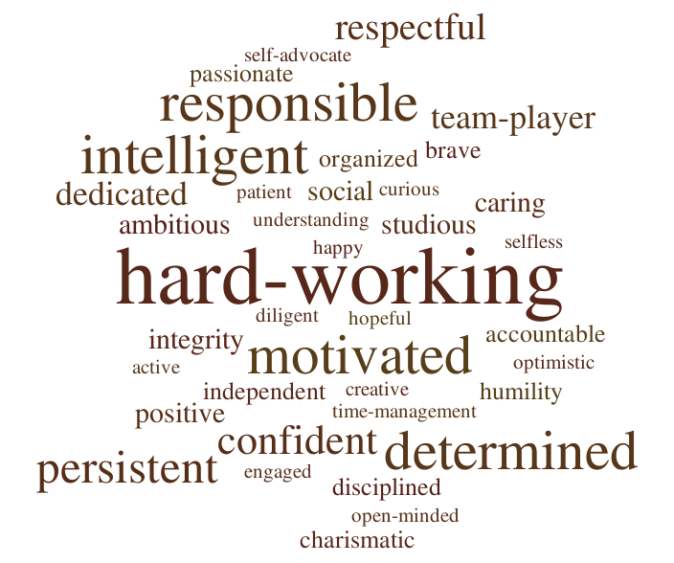
After identifying these characteristics, students ranked how successful they were in school. Out of the 43 responses, only three said they were not successful (1), eight identified themselves as being somewhat successful, and the majority of students (28) ranked themselves as a 4, with only four students ranking themselves as very successful (see Figure 2).
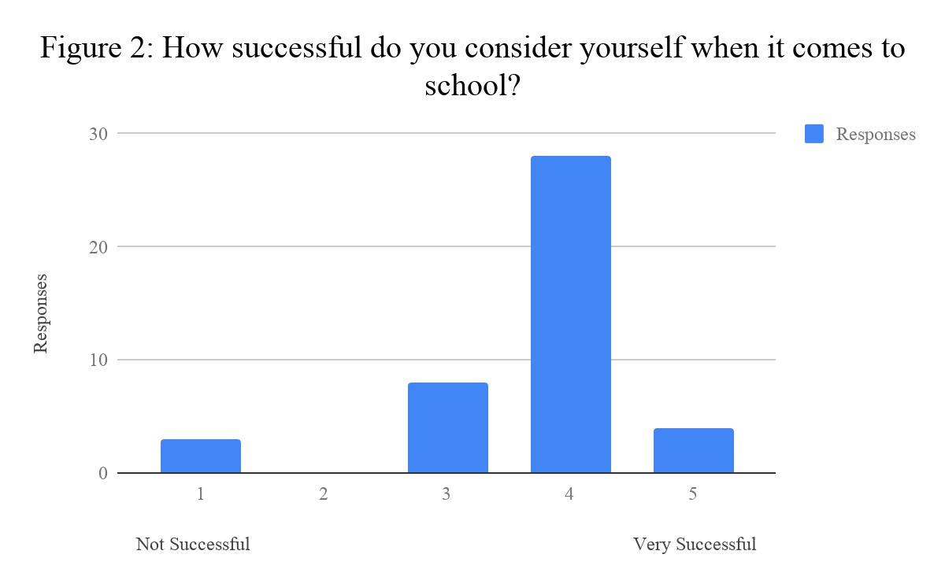
From there, I asked students to identify whether they believed they were self-advocates or not while at school and why. In the question I provided them the definition by Luckner & Beckner (2013), which describes a self-advocate as someone who can identify the supports that he or she needs to succeed and communicate that information to others. Nine students total identified themselves as not being self-advocates, three of whom were the same students who identified themselves as not being successful in school. Their responses were as follows:

Table 4

Students Who Identified as Not Being Self-Advocates and Not Being Successful
Student | Success Ranking | Response to Question
Student 1: | 1 | “I know what I could do to succeed, but sadly my laziness overcomes my ability to succeed”
Student 2: | 1 | “No, school gives me anxiety and I don't know how to deal with it so I just don't talk”
Student 3: | 1 | “No, because I struggle to speak up for myself.”

Out of the six other students who said they were not self-advocates, two of them ranked themselves as a 3 (somewhat successful) in terms of their success in school and four of them ranked themselves as a 4. Their responses range from struggling with anxiety, lacking self-confidence, to a desire to work out problems on their own.

Table 5

Students Who Identified as Not Being Self-Advocates and Somewhat Successful
Student | Success Ranking | Response to Question
Student 4: | 3 | “no, i struggle with identifying what i need and my homework and deadline habits struggle because of that.”
Student 5: | 3 | “No, because i dont go for my best because of my lack of confidence.”
Student 6: | 4 | “No I'm not brave at all and I stand in other people's shadows. I do whatever is thrown at me nothing more.”
Student 7: | 4 | “Nope because I'm bad with asking for help and helping others I usually figure everything out for myself.”
Student 8: | 4 | “Not really, I would rather figure it out myself than ask for help.”
Student 9: | 4 | “I do want to be a self-advocate but talking to people is really hard for me and it creates a lot of anxiety. I really do try by best when it comes to self advocacy.”

Five students overall identified as sometimes being self-advocates. Their responses highlighted the main causes of their issues with self-advocacy as struggling with communicating their needs, having to balance the workload, or struggling to get help from a teacher.

Table 6

Students Who Identified as Sometimes Being Self-Advocates and Somewhat Successful
Student | Success Ranking | Response to Question
Student 10: | 3 | “In a way, I can identify the needs to succeed but I don't really communicate the information to others.”
Student 11: | 3 | “Somewhat, I feel like I can identify the support I need to succeed in school but I do not communicate this information to my teachers. It would be beneficial to me if my curriculum involved more hands on teaching, and my teachers gave me packets with the notes already in them.”
Student 12: | 4 | “Kind-of . I am only when I really need to, but not when it's in a gray area. If I don't absolutely need it for my goals then it's not really worth it in my opinion.”
Student 13: | 4 | “Partially. When work piles up, it becomes difficult to communicate to all of the teachers that I need to.”
Student 14: | 4 | “Kinda because I believe it is hard to get help from teachers.”

Lastly, out of the 28 students who said they self-advocate in school, four of these students identified as being somewhat successful (3), twenty-one identified as a 4 on the same scale, and four students identified as being very successful (5). The explanations were fairly similar across all responses. The majority of students explained that they always ask a teacher, friend, or parent for help if they need it. Students also identified the need to be successful as one reason they were self-advocates or identified grades as the biggest motivator. Others described specific skills they have that help to self-advocate, such as being able to work hard, having communication skills, and being able to “do what is necessary.” Lastly, similar to some of the students who did not identify as self-advocates, some students explained that they were using those skills because they always tried to do things for themselves. Table 7 shows some student responses that reflect these main ideas, along with the success ranking the students identified.
Table 7

Students Who Identified as Being Self-Advocates with Various Success Rankings
Success Ranking | Response to Question
3 | “Yes, I feel like I can identify the support I need to succeed in school but I do not communicate this information to my teachers.”
 | “Yes, because I always try to do things for myself.”
 | “Yes because I know what I need to do I just dont do it”
4 | “yes because i am constantly checking my grades wondering how i can improve them”
 | “Yes, because when I feel like something needs to change so that I can better understand things I address it and make the adjustments necessary for me to do my best.”
 | “I think I am. I am willing to get the help I need to get my work done but I am also able to work harder to understand something that is difficult.”
5 | “Yes. When i need things from people, i just ask. Worst case, they just say no. I wouldn't want it to negatively affect anyone, and i make that known. I wouldn't ask for help if it were to negatively affect others.”
 | “Yeah, because I keep those who will push me further into success close to me.”
 | “Yes, because if I need help and help can be given, I will definitely ask for it. You can't truly understand something on your own without another persons perspective, I think.”

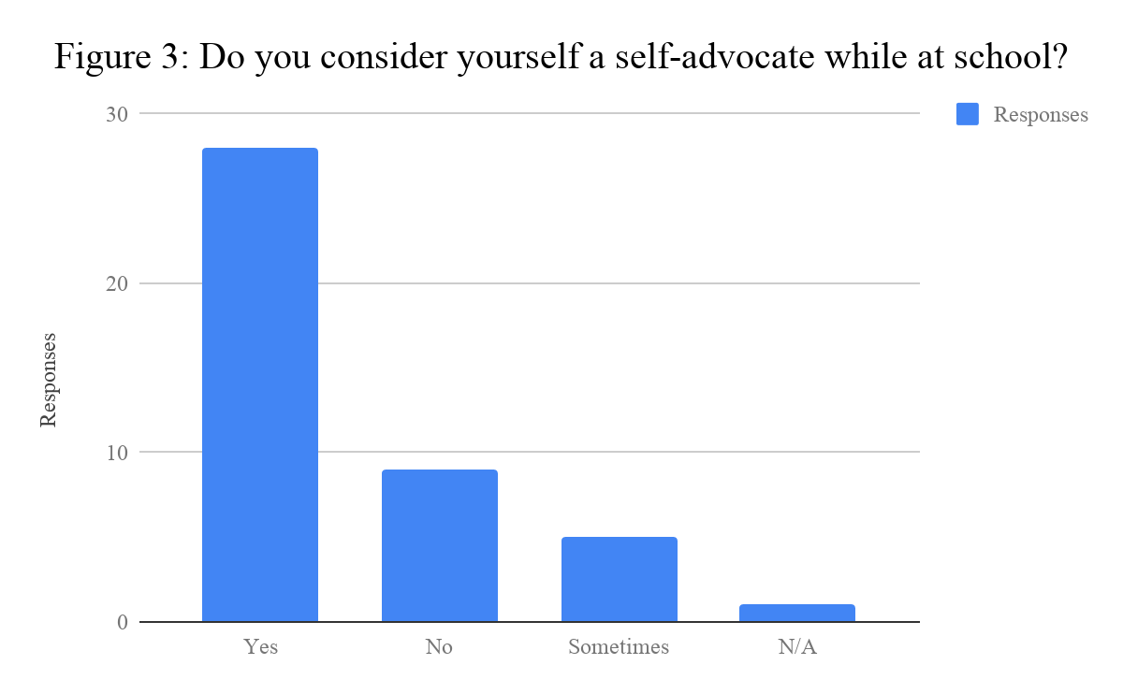
When asked if students considered themselves self-advocates outside of school, results were very similar; the majority of students said yes, only three said sometimes, eight said no, and two said that the question was not applicable. Those who fell into the category of being self-advocates, explained that they were comfortable asking for help, wanted to be successful and wanted to make good decisions. These responses all correlate to the reasons why students also self-advocate in school. The only differences worth noting relate to feeling a sense of comfort outside of school and ultimately being more willing to seek out help because of that level of comfort. In response to this question, I expected to see more students mentioning activities they participated in outside of school; however only one student mentioned extracurriculars as being a major factor and another mentioned his job. Most students described working hard at anything they participate in outside of school and feeling at ease asking their parents for help. The three students who identified as sometimes self-advocating attributed it to not caring enough and also feeling less comfortable outside of school. Lastly, the students who identified as not being self-advocates cited no motivation as one of the main reasons, along with being introverted, forgetful, and finding it difficult to “make correct decisions.”
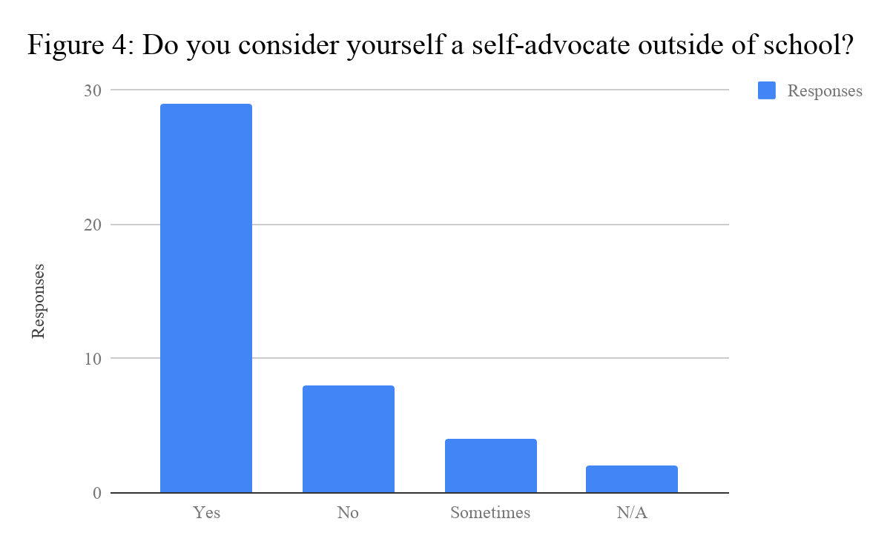
Next, I asked students what they do when they are confused by something, inside of school and outside of school. I wanted to get a sense of whether students preferred certain ways of asking for help over others, and I was curious to find out if students would lean more towards one over the other. In addition, Daly-Cano and colleagues (2015) explored the passive ways of receiving help, like waiting for the teacher to approach them, or the proactive methods of asking for help, like specifically asking a teacher for more help. I was curious to see if any trends would emerge to support their study as well.
The two questions specifically asking about how students ask for help allowed for multiple responses, some of which I provided, along with an option for “other” where students could add a response that was not listed. For the question regarding their actions in school, the provided responses included: I don’t do anything, I wait until the teacher asks if I need anything, I find the answer on my own, I ask a friend, I ask my parents, and I ask the teacher for further clarification. A few students wrote in that they relearn the subject, guess as to what the answer is, visit the teacher during lunch to get extra help, and refer to overall motivation as well. Surprisingly, 32 students identified that they are proactive and ask the teacher for further clarification, whereas only five said they simply wait for the teacher to approach them. The second highest response was to ask a friend (26 responses), followed closely by finding the answer on their own (25 responses). The four students who said they do not do anything were also the same four who identified as not being self-advocates.
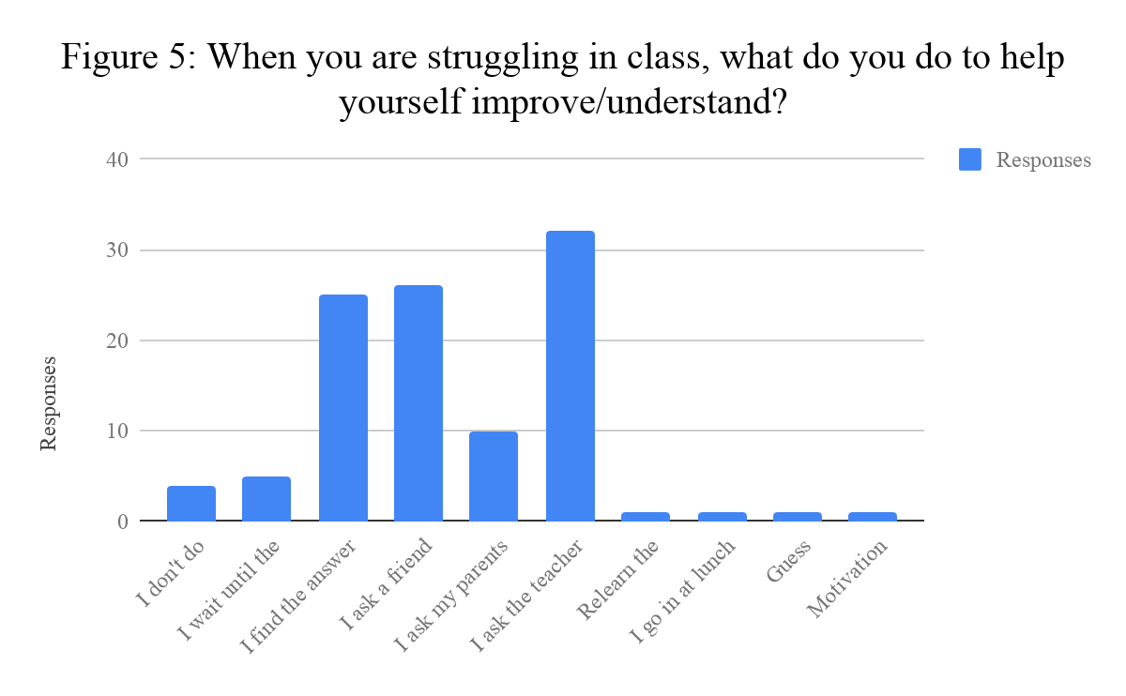
For the question asking about students’ actions outside of school, the provided responses included: I don’t do anything, I seek out the answer on my own, I ask a friend, I ask my parents, and I find an expert. Two students added answers that referred to finding the answer on Google or more generally online. The majority of students (33 responses total) acknowledged that they find the answer on their own, followed by asking a friend (29 responses), and then asking a parent (24 responses). In response to this question, only four students identified as not doing anything when they were in these situations, similar to the same number of students in a school setting. However, the same four students are not common across each question. One person, in response to the latter question said she does ask for help outside of school but not in school, in large part because she feels comfortable with her family and therefore is more willing to ask them for help. Meanwhile, a different student responded that in a school setting he does ask for help, but does not at home (no explanation). Curiously, he also identified himself as a self-advocate both inside and outside of the classroom.
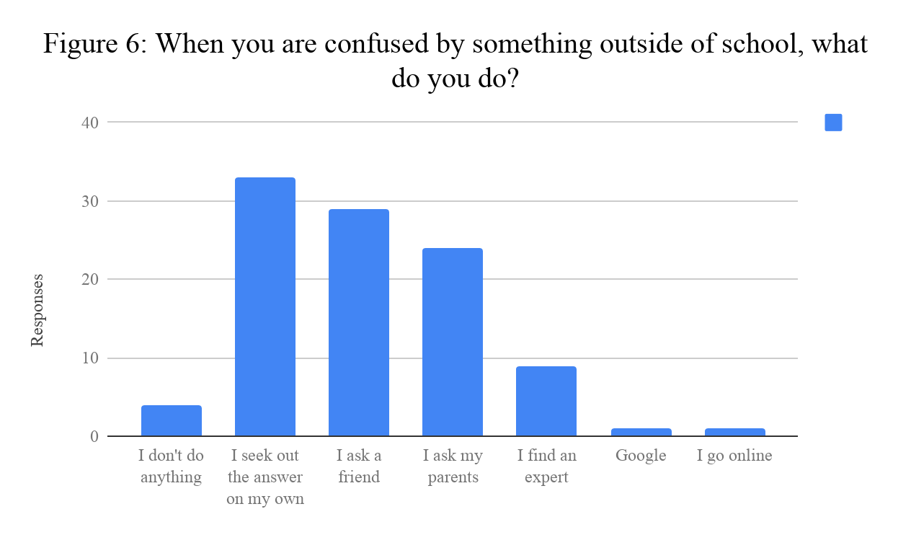 The final topic of exploration in the student survey related to the teacher’s role in helping to encourage self-advocacy. In the literature, it was addressed multiple times the role teachers play in encouraging and facilitating these skills (Test et al., 2005; McCarthy, 2007; Luckner & Becker, 2013). However, in my own experiences and through conversations with students, it was clear that students were more willing to ask for help from certain teachers over others. I wanted to explore what traits students associated with teachers they deemed were more willing to help them. I asked students to list at least three characteristics they felt described teachers who were willing to help. This question was open-ended and 39 characteristics total were suggested, with many characteristics listed multiple times. The most common characteristics included: being friendly (listed 16 times total), understanding (13), caring (12), helpful (10), patient (9), knowledgeable (7), enthusiastic (5), and happy (5).
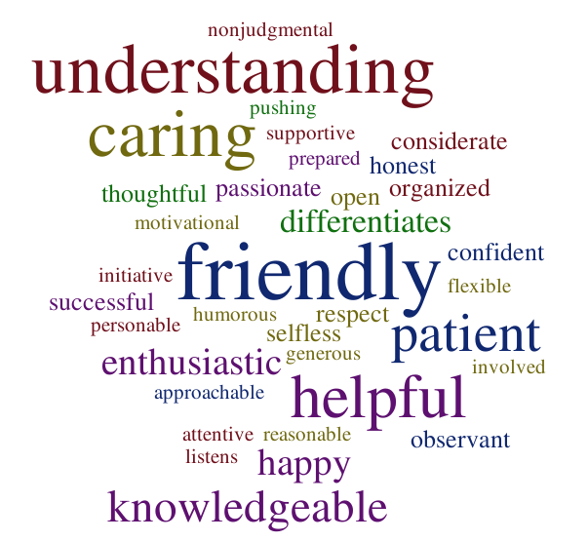
While the responses were thought-provoking due to the nature of the survey and the limitations, there are no explanations of these traits. If I were to ask this question again, I would limit the traits to maybe one or two and then ask students to explain how each trait made the teacher more willing to help. Based on some of the responses such as humorous, confident, and motivational, I worry that students were listing traits they believe good teachers embody or potentially terms they thought teachers would want to hear, not necessarily traits that help make students feel more comfortable asking for help. I am curious to know how each trait relates to the question and that particular student.
Finally, I asked each student to scale themselves and identify how comfortable they felt asking their teachers for help (1 being least comfortable to 5 being very comfortable). While I understood that this answer could vary depending on multiple factors, such as availability of the teacher, what subject they teach, and the relationship students have with the teacher, my hope was that students would respond with the answer that most closely related to their overall tendencies. I did not want to ask them the same question multiple times with different scenarios (How comfortable are you asking for help in English? How comfortable are you asking for help from teachers at the beginning of the year versus the end of the year?) but instead wanted them to self-assess based on their experiences as a whole.
Overall, the results show that the majority of students surveyed felt comfortable asking their teachers for help, with the highest category including 18 ranking themselves as a four on the scale and 10 ranking themselves as a five. The latter group was closely followed by those who ranked themselves as a three, with 8 total responses. Then, finally, just three responses were collected for the ranking of 2 on the scale and four students identified themselves as not feeling comfortable at all (1). Three of the students who identified themselves as not feeling comfortable asking help also identified as not being self-advocates; however, one said he always asked for help from a teacher or parent when needed, but even so, does not feel comfortable doing so. Interestingly, two students who identified as not being self-advocates, ranked themselves as a 4 in comfortability asking for help from teachers. Yet, when asked if they ask for help in the classroom, they explained that they “are bad at asking for help” or are “not brave at all” and consequently do not self-advocate.
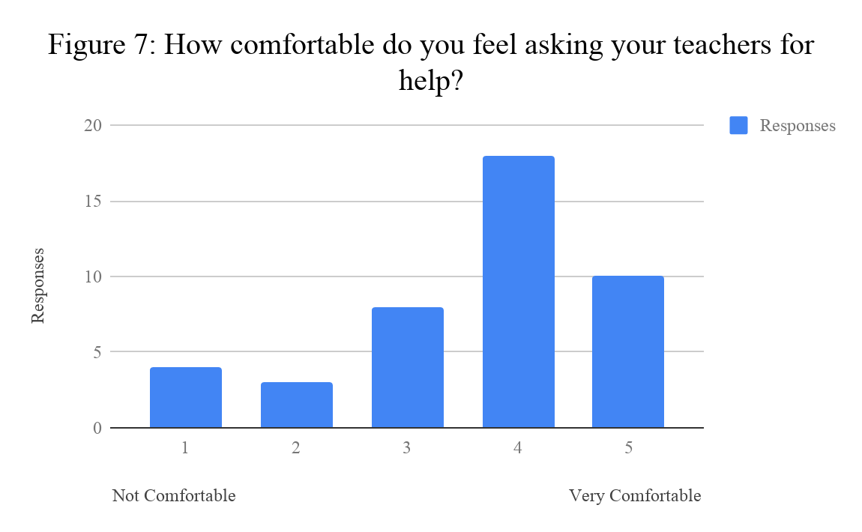
Student Interviews (Cases)
This section addresses the participants’ responses to questions about their perceptions of self-advocacy and success, the ways in which they have asked for help in difficult situations, and what teachers could do to help students like them feel empowered to ask for help. Each student represents a distinct case and embodies a different reason for why they chose to self-advocate or not. Due to the exploratory nature of this cross-case study and the relatively small number of participants, in order to truly understand the implications associated with each case, in conjunction with the data collected by the surveys, we must have a detailed picture of each case in which to draw conclusions.
Taylor. Out of all the participants, Taylor was the one who most resembled a student who had mastered the skills of self-advocacy. As we talked, it was clear she not only understood her strengths and weaknesses as a student, but she also illustrated an overall awareness of the factors associated with self-advocacy. She acknowledged the complexities with not only identifying support but communicating those needs with teachers, parents, etc. She was quick to illustrate her knowledge of self by identifying her biggest obstacle was procrastination, sometimes waiting “until the last minute” to ask for help. Even so, she overcame that difficulty with being incredibly observant. It is through those observations that Taylor learned how to self-advocate. She learned these skills from her parents while also observing her older brother who struggled to do things on his own. She explained that her parents “were always busy helping one kid or at work,” so she learned that if she needed help, she had to ask. She watched her brother consistently lose interest in school because “he thought it was dumb and he just didn’t understand” the material. He felt no ownership in his education, even though he was “completely capable” of doing the work. Instead, he fell into a habit of not asking for help and “so he never learned how.” Taylor, as his younger sister, watched her brother struggle and jokingly described her reasons for learning how to advocate as a way of competing with him and learning how to “one up him.” In the survey and interview she explained that she was always working towards her goals in some way, stating that “hard work doesn’t take a break” and “I keep those who will push me further into success close to me.” Taylor used her observations of her family, both positive and negative, to essentially teach herself how to accomplish her goals. While she identified procrastination as a downfall and something that kept her from being successful, she did not show those tendencies in other aspects of her interview. Instead, she described working hard, asking for help, and experiencing success as a result of those efforts.
While Taylor was learning how to self-advocate through observing her family, she was extremely cognizant of not being a burden to her parents, an awareness she extended to her teachers as well. Her sensitivity toward this issue showed in her interview as she was constantly referencing others and wanting to be respectful of their time. She explained that it was challenging to ask for help in the school setting because she did not want to burden her teachers who were not “paid very well” and have “so many students in each class.” She talked about finding the right time to ask for help, like before class or through email, ultimately “not want[ing] to take away from [class] if the question could be answered another time.” She referenced relationships consistently throughout her interview, moving from her family, to teachers, and to peers, wanting to ensure that no one was bothered by her needs. In addition, she talked about the approach she used to ask for help as depending on the person she was asking or the environment itself. She equated it almost to code-switching, a strategy in which a person changes their way of communicating to appropriately fit their environment and audience. This skill speaks again to her observant nature and her awareness of those around her, both of which positively impacted her ability to self-advocate.
While Taylor certainly embodies someone who is successfully a self-advocate, she also talked about being shy and having to work up the courage to ask questions. She feared asking a question that had been “said a million times,” and even feeling “embarrassed to ask for help in an advanced course.” This social pressure was a common thread across all of the interviews, in which students felt self-conscious and judged by their peers for needing help. Similar to some of the other participants, Taylor recalled many times when she needed help but “just didn’t ask” in the moment. She described feeling afraid and remembering the actual act of asking for help as being extremely challenging. She attributed this discomfort to her personality, but could not find the words to elaborate more on the feeling she described. Then, when asked what teachers could do to help students like her to feel empowered to ask for help, she responded with the following:
I feel like that’s a hard question to answer just because there’s a range of questions and I know everyone’s like, “there’s no stupid questions,” but there are stupid questions. Like it really annoys me when teachers say stuff over and over and over and over. Then two minutes later it’s like, wait, what? […] I feel like that is a hard part of like having to deal with self-advocacy. I feel like those questions take away from the kids who do need help and do need to ask questions because it’s like, well what if I sound dumb or what if I get that annoying to people?
Taylor’s response highlights the social pressures associated with asking for help in the classroom. Students are incredibly aware and while they occasionally struggle to pay attention in class, as Taylor explained, they certainly pay attention to the students who disrupt it.
Taylor’s reflections show that even those students who identify as being self-advocates, who challenge themselves by taking rigorous classes, and are overwhelmingly successful, still feel a sense of anxiety as they face these situations. The difference seems to be that some students find an alternate way to accomplish their goal, whether they ask for help outside of class or seek out the answer on their own. Others, simply stop.
Pryor. The second participant who identified as a self-advocate is one who is more extrinsically motivated to be successful. When asked if he felt comfortable asking for help in class, he explained that most of the time he felt comfortable and would be “completely clueless” in most of his classes if he did not speak up. Even so, sometimes he felt a sense of embarrassment for not knowing a specific answer and essentially had “too much pride to ask.” In those cases, he just looked up the answer and figured it out for himself. He mentioned as well that in those moments when he needed help, it crossed his mind to ask the teacher or to get extra help during lunch, but procrastination set in and he could not follow through with the initial thought. He would continue to push it off and then when his grade began to suffer, suddenly that provided the motivation necessary to actually act. He also emphasized the importance of the topic or subject, and said that he tends to care more about extracurriculars and asks far more questions in classes that he enjoys.
When asked to recall a specific moment when he did not ask for help and wished he had, Pryor explained that oftentimes when he missed school for extracurriculars, he did not ask the teacher for help because “they’ve already moved on from that point.” In those moments he did not want to take up more class time and negatively impact his relationship with the teacher, so instead he decided to “figure it out” on his own. Interestingly, his awareness of his surroundings, similar to Taylor’s, put his needs as secondary. Even so, based on previous experiences and his tendency to procrastinate, Pryor’s strategy to “figure it out” was not always successful. He acknowledged in the student survey that “when work piles up, it becomes difficult to communicate” to the teachers he needs to. Even though Pryor tended to struggle a bit more with self-advocacy than Taylor appeared to, he was still viewed as a successful student by his own perceptions and Mr. Frazier’s, who completed the teacher survey.
Surprisingly, at the end of the interview he cautioned teachers who might be interested in teaching self-advocacy skills, in large part because of the poor habits he developed. He explained that teachers would be spending their time essentially “break[ing] habits” that students in high school had already developed years before. He argued that even if a teacher “openly encourage[d] people to keep asking questions,” their poor habits would win out. While he agreed that self-advocacy skills are important, especially considering success at jobs in the future, he also acknowledged that teaching self-advocacy in the classroom could take away from curriculum and the needs of other students.
Sylvia. Sylvia’s response to the interview was unique in the sense that she felt empowered in a school setting and has felt “comfortable” advocating for herself since the end of her freshman year. Her mom was a teacher at the school Sylvia attended at the time of the interview and because of this she quickly began to understand her rights as a student. Sylvia explained that her mom was “in the same position as any teacher,” so she did not hesitate to ask her teachers for extra help outside of class. In addition, when she was in situations where a teacher was treating her unfairly, she did not hesitate going over his or her head to an administrator, explaining that she “always felt like [she had] the upper hand.” Even with this realization, Sylvia related it back to her rights as a student and explained that she would never abuse this power, but rather learned how to advocate from her mom and believed it was important to speak up for herself when necessary.
While Sylvia clearly felt comfortable asserting herself at school, she explained that she was not that way outside of school. Around friends, she described herself as not being as quick to speak up for herself and at work she said she did “not self-advocate at all.” She described working an “eight hour shift without going on break” simply because she did not “want to ask.” She attributed this change in self-advocacy to feeling a level of comfort at school and a clear understanding of her role as a student. She also described a general lack of interest at her job, seeing adults who did not share the same interests as her and seeing them pursue a career that she did not want long-term. Later in the interview she explained as well that a significant factor was the relationship she had with the managers. When she was at work, she was more willing to ask for a break when a certain manager was working because he made a point of checking in on her and assuring her it was okay to ask for a break. Whereas the other manager was not as perceptive and was often distracted by her phone. While these reasons are certainly intriguing, they do not account for the reasons why she did not advocate more around her friends. If relationships and feelings of comfort influence one’s willingness to self-advocate, it is surprising that Sylvia did not describe feeling more at ease speaking up for herself around her friends.
When asked about moments in school when she wished she would have advocated for herself, she described two moments that really impacted her. One of these moments took place her freshman year when she was enrolled in a class full of seniors. She acknowledged that she was really “loud” about her opinions in terms of being a feminist and an advocate for the LGBTQ community, but when it came to the curriculum in her Physics class, she was afraid of “look[ing] stupid in front of a bunch of seniors” and would suddenly feel overcome with anxiety. While she was fearless to share her opinions and ideas surrounding somewhat controversial topics, that fearlessness suddenly escaped her when she showed confusion or needed help. Sylvia then went on to explain that what changed at the end of the year was that her mom was hired to teach at the school. Suddenly she had an advocate and she “just blossomed.” She explained that “knowing [her mom] was there and if anything bad happened [she] could just leave and go to her room,” gave Sylvia the confidence to take risks in her classes. Reflecting back on her growth, Sylvia was incredibly thoughtful about her experiences learning to self-advocate and explained:
Most of the time I do well at communicating what I need help with, but sometimes I have trouble. I am becoming a better self-advocate than I used to be. I tell the people in my life when I need help or when I need a break from something.
A few years later, Sylvia experienced a temporary setback in another class where she started to struggle as she studied for the AP Calculus exam. Her teacher was supportive and Sylvia felt comfortable asking for help, but in this particular situation, the barrier was that she did not “know what [she] needed help on.” She reached a point in the year where she realized she “should have asked for help,” but was at a loss for what to say or even how to begin. In response to these moments, Sylvia explained that teachers “having a personal connection” with students is helpful. By “getting to know them and joking around with them,” it helps to build a relationship with that person and provide a level of comfort that they may need in the classroom. Then, when students do experience those moments like Sylvia did, they will be more willing to share their concerns with the teacher.
Harriet. Harriet embodies the student who feels empowered by her surroundings. She described learning self-advocacy by observing her parents along with learning through interactions with others. As a young girl, she would watch her parents speak up against injustices regarding “homophobia or racism” and consequently Harriet learned at a young age how to speak up for others. However, she did not learn to speak up for herself until high school. She described herself as incredibly quiet in middle school and her freshman year, but as she started to get more involved in school, specifically in Student Council, she began to feel more empowered to speak up in class. As Student Council got more and more competitive, Harriet was surrounded by students who were self-advocates as well. This environment, along with support from friends of hers, encouraged her to speak up even more because people around her were sharing their ideas and she wanted to be a part of that as well.
While Harriet explained that certain environments fostered a feeling of self-advocacy, others certainly did not. In her quieter classes, she would not advocate for herself as much because she did not want to be the “only person that’s out there advocating.” She explained that she “definitely felt peer pressure” when she tried to speak up for herself and was self-conscious about asking too many questions. In most situations outside of Student Council, Harriet would wait to see if her question was answered by the teacher and if it was not, she would wait until after class. She emphasized in the survey that she truly does try to advocate for herself most of the time, but explained: “Sometimes I don’t like to ask for help because I want to as able to do things myself. Which is a weakness.”
When asked if she considered self-advocacy to be an important skill, Harriet immediately returned to talking about Student Council and other extracurriculars, explaining that in these situations a person has “to speak up when [they] have an idea” or else they are essentially ignored. She described many students who attempted to join the competitive acting class or even the tennis team, but if they did not make their presence known and did not speak up for themselves, they typically did not last long in either organization. They would come in with high hopes and see outgoing individuals “having so much fun,” and then they would “get rolled over” and never rejoin the activity.
In response to the question about what teachers could do to help students self-advocate, Harriet explained:
I feel like just creating the safest space possible as you can, like in your hands. Because obviously if there's a person in that class they don't like, it's not going to like ever, I mean you can't really change that. But it's like if you can create the most like open nonjudgmental space as possible with them knowing you won't judge them, which I feel like you already do well. But it's like knowing that no matter what you say, like if someone says something that you're against, you're obviously not going to be like you're stupid, you're wrong. Shut up. You're going to be like, well, like let's look at it a different way. And so I feel like more teachers need to be like that.
Harriet articulates the fine balance between encouraging students to speak up for themselves and to feel comfortable asking for help, while also being sensitive to student personalities and preferences. Ultimately, she says teachers need to “be more open” and more willing to offer support and encouragement, especially to students who lack these self-advocacy skills.
Briana. Briana’s responses to the interview questions complicate my findings because she embodies someone who is successful regardless of self-advocacy. In the student survey they identified as not being a self-advocate and remained truly adamant that they did not ask for help in the classroom. Even so, they considered themselves successful based on the characteristics of ambition, study skills, and overall will-power. These findings were supported by the teacher survey as well, where Mrs. Douglas described Briana as someone who is quiet, analytical, and hardworking. She further explained that she had yet to “see this student struggle or visibly struggle” but mentioned that “they can at times seem withdrawn but also are very high functioning.” While Mrs. Douglas acknowledged that Briana had never asked for help in her class, she has “seen this student speak up with fellow students when they notice they are making sweeping generalizations--this isn't necessarily advocacy in the traditional way but shows that they do speak up for themself.” Interestingly, Briana is similar to Harriet and Sylvia in the sense that with social issues, they are much more willing to speak up for others. While Harriet and Sylvia have also seen the benefits of speaking up for themselves, there are factors still preventing Briana from doing that as well.
In the interview, Briana explained further that they would “rather look it up and try to figure out” the problem on their own, in large part because their “parents [we]re very much like that.” Due to these observations while growing up, and Briana’s overall personality, they feel “more comfortable” doing things on their own. When asked how successful they have been in high school, they explained that they have certainly experienced success, but sometimes it did not work and they had to ask for help. They emphasized trying every other outlet to receive help, like Khan Academy and other online resources, before asking a teacher for help, in fear of adding unnecessary stress to that teacher. When asked it if was the location that influenced their willingness to advocate, they explained that it “more depends on the topic.” When it was a social issue they were much more likely to speak up, whereas if it was a problem related to a particular skill or standard in class, they would not feel the need to ask for help.
Despite not feeling comfortable asking for help and preferring to do it on their own, Briana did acknowledge that they believed self-advocacy was an important skill. They explained that one needs “to know when [they] need to ask for help cause if [they] don’t it will negatively impact [them] in the future.” They explained that using self-advocacy skills would contribute to their success as a student by making “things easier.” When asking Briana what teachers could do to help encourage students to advocate for themselves, they said:
I’m not really sure about that because some kids just struggle with that so maybe it’s like pulling them outside of class and like there aren’t any people there and telling them if they need to talk or they need to help, I’m here. But I think for the most part, they have to make that decision themselves, whether they want help or not.
This was a surprising response because based on my experiences with this student and the response from Mrs. Douglas. Briana shows no signs of using these skills for their own benefit. While this student remains successful and hardworking, the data shows that success is certainly possible without self-advocacy, but even as a student who identifies as successful, they still see how it could contribute to success and at the very least could make life a little bit easier.
Jackson. The final participant was very candid about his reasons for not self-advocating and seemed to be comfortable with his decision to not ask for help. In the survey he acknowledged that he knows “what [he] could do to succeed, but sadly [his] laziness overcomes [his] ability to succeed. In the interview he explained that when he found himself in a situation needing help, the idea of asking for help certainly came to mind, but he would get a feeling in his gut that he could not get past. He explained:
So most of the time whenever I don’t understand a question that I’ve been asked in class, I go to, I think of asking the teacher, of course it pops in the brain of course, and I just feel a little feeling in my gut, a little bit, whenever I tried to raise my hand and ask the teacher, like a nervousness or something that I get. I get pretty nervous. And so I just kind of don’t. I kinda feel like I shouldn’t for some reason.
Instead of asking for help, he would go through “trial and error” and “rely on what [he] knew already instead of asking someone else.” He felt a sense of pride finding the answers on his own and a severe sense of nervousness when he needed to rely on someone else.
When asked if self-advocacy was an important life skill, similar to Jackson’s survey responses, he explained that he does believe it is important and having those skills would “speed things up.” He explained that self-advocacy is beneficial in terms of “conveying knowledge” to others and lessens the need for trial and error. While he clearly understood what he should do to be successful, he explained that his laziness prevented him from taking those steps. He even acknowledged in “times of confusion...whenever [he] was sitting there trying to figure it out [himself], that wasted a lot of time.” By asking for help, he explained that he could have spent less time struggling through learning the material and his grades could have potentially improved as well. In an effort to understand what steps could be taken to help Jackson learn how to utilize these skills, I asked him what teachers could do to help students like him feel empowered to self-advocate. He replied:
Well in my case, it wasn't really that I didn’t feel like I could or couldn’t advocate for myself. It was just that weird feeling that I got. Yeah. So it’s kind of like just an instinct somewhat embedded in there that I can’t really explain. So it’s kind of hard for me to answer that because I don’t really, I’m not in a case where it’s, you’re like discouraging me from doing it.
Interestingly, in the interview and when I had him in class, Jackson always was so receptive to feedback and genuinely seemed open to improving. He talked about enjoying the learning process and enjoying school, but again just feeling something in his gut preventing him from asking for help.
Teacher Self-Advocacy Survey
As a final piece of triangulation, I asked the English teachers of each student who participated in the interview to reflect on the self-advocacy skills they had seen from those students in class. This survey was meant to provide an additional layer of validity to either confirm or refute the findings in the first two rounds of data collection. For the most part, the responses from each teacher reinforced the reflections from the interviewees, with only a few variations.
What traits would you use to describe this student in your classroom?
Would you consider this student successful in your classroom?
Would you consider this student a self-advocate?

The first question I asked teachers to answer was an open response question, asking them to list characteristics of each student. Then, I asked them to identify whether the student was successful in their class and whether they would identify that student as a self-advocate (see Table 6 for responses). The two students who identified themselves as self-advocates, Taylor and Pryor, were described as successful in their respective English classes and their teachers also considered them self-advocates. The two students who identified themselves as sometimes being self-advocates, Sylvia and Harriet, were also described as successful and self-advocates within their English classes. Jackson, one of the students who identified as not being a self-advocate was described by his teacher as someone who had the potential to be successful and the ability to be a self-advocate, but was falling short of both goals. However, Briana identified themself as someone who is not a self-advocate, but their teacher described them as successful and an advocate for others, especially when classmates were making “sweeping generalizations” of others. She also noted that this behavior while certainly advocacy, is not quite in line with the provided definition. Based on the definition given to each participant by Luckner and Becker (2013), self-advocacy suggests that one can identify the supports needed and will communicate those needs with others. Briana, while certainly willing to communicate the needs of others, does not do for themself. This reinforces the survey and interview findings, showing that Briana understands self-advocacy and the value associated with it, but prefers still to do things on their own, unless it involves coming to the aid of others.
Table 8
Teacher Reflections about Student Traits, Level of Success, and Self-Advocacy
Student | Traits | Level of Success in Class | Self-Advocate
Taylor | Hardworking, strong-minded, intelligent | She is successful. Mainly through her hard work and willingness to take intellectual risks. | Yes. She is outspoken and willing to advocate for both herself and others.
Pryor | Funny,  sarcastic,  participatory | Yes. He maintains a high grade and does care about those grades. I also am aware of when he is struggling with a concept because he does express those struggles. | Definitely. He won't let himself slip below a place where he's comfortable. He may not put in a ton of extra effort to do everything I know he could do -- at least not in English -- but he will absolutely do everything he can to do well. Ultimately, he's comfortable asking for help if he needs it, and knows what help he needs.
Sylvia | Hard-working, passionate,  articulate | Yes, definitely. She works hard and doesn’t give up. | Yes, she is comfortable in the school setting and knows her rights as a student.
Harriet | Hard-working,  sweet,  caring | She is successful. She works very hard. | I would. She may not be asking me out in the open but does work with me to understand writing elements that she needs to work on.
Briana | Quiet,  analytical,  hard-working | Yes. They are a very hardworking and intelligent student. | I have seen this student speak up with fellow students when they notice they are making sweeping generalizations--this isn't necessarily advocacy in the traditional way but shows that they do speak up for themself.
Jackson | Extremely quiet, overwhelmed,  clever | Not as successful as he could be. Based on some of the work I've seen, I know he could do way more than he's done. Some of it is from not turning work in, but I do worry he didn't do an assignment because he didn't understand it, not from a place of laziness. | I wouldn't. I think he has the ability. I think he knows when he doesn't understand, but I think that knowledge turns into intimidation and he starts to feel overwhelmed instead of turning into the idea that he should just ask for help.

When this student is struggling with a concept in class, how do they respond?
In what ways does this student ask for help in your class?

The next few questions focused on setbacks students may have faced in the classroom and how they went about asking for help when they needed it. Based on the survey they completed at the beginning of this study, the observations from each teacher about how students asked for help confirmed the answers provided in the survey aside from a few differences. Taylor identified only asking her parents for help when at school, but in her interview she talked about asking teachers for help inside and outside of the actual class, which is also confirmed by her teacher’s response.
Table 9

Teacher Responses to How Students Respond to Struggles and Ask for Help
Student | Response to Struggles | How They Ask for Help
Taylor | She often will speak up and ask for further explanation. She is also willing to come in and work on an assignment with me. | In class during times when I'm explaining a concept and also one on one.
Pryor | Typically, he'll come right out and say it. It's not usually in the middle of class, though. He has stayed after class, or come in at Stretch for help.  Occasionally, he'll also wait until most others are busy working on a task, and then he and a couple of his friends will ask me to reexplain. Typically, that puts him on track and he's good to go. | Grades are the ultimate motivating factor. When reading Scarlet Letter, his questions were almost always grade based. Questions like "how can I read this better to get an A on the next quiz" or "I didn't get this chapter, can we talk about it so I do well on the quiz"  His questions are almost always conceptual. Once he understands a concept he can make the assignments work for him. I don't think I've ever really helped him on specific assignments much.
Sylvia | She asks for help and does what is necessary to overcome whatever obstacle she is facing. | As I got to know her better, she would ask for help during class and come in before school or at lunch to receive extra help.
Harriet | I think she often internalizes but will speak up on occasion. I know she will often seek out other teachers to talk to. She might not feel comfortable talking to me? | She has spoken with me about getting help on her writing. We meet one on one.
Briana | I'm not sure I see this student struggle or visibly struggle. They can at times seem withdrawn but also are very high functioning. | I haven't noticed this happening.
Jackson | Most of the time I don't know. He's not always the best at turning in work so I'm often not sure if he doesn't understand something or just didn't do it. He seems overwhelmed the majority of the time, but when he turns work in, it's usually very good. I think he has trouble trusting himself. | Most of the time he doesn't. Especially if I'm at the front of the room. When I wander back to his area, he'll ask me there, but not by himself. He was more confident asking questions last semester when one of his good friends was in the same class. This semester he's much more reserved.

Do you think self-advocacy has any influence on this student's success in your classroom?

The final question I asked each teacher was whether they believed self-advocacy contributed in any way to the success of each student. For the students who identified as self-advocates and sometimes self-advocating (Taylor, Pryor, Sylvia, and Harriet) their teachers were adamant that those skills contributed to their success in class. Taylor’s teacher described her as someone who is not “a shrinking violet--she speaks up and works well with others to succeed.” She is someone who is able to balance her rights as a student while also being respectful and understanding of others involved. Pryor’s teacher described the influence of self-advocacy as “noticeable,” suggesting that since “he is generally quiet in class” that as his teacher, he would struggle to “notice when [Pryor was] really missing a concept.” Mr. Frazier further explained that without the self-advocacy skills, he would not know “where the disconnect was happening” with Pryor’s understanding. Harriet’s teacher, Mrs. Douglas, suggested that “if she weren’t willing to advocate for herself, she might struggle more on her writing.” In response to some of the other questions, Mrs. Douglas explained that Harriet had to work a bit harder than some of her classmates to achieve the same grade in the class. Without self-advocacy, she suggested that Harriet would not be as successful because of this additional barrier. Sylvia, who also identified as sometimes being a self-advocate, was described by her teacher as “a strong student to begin with, but because she asks questions, she is even stronger.” Similarly to Harriet, Sylvia seemed to benefit from the questions she asked and the supports she asked for within the classroom. While the reasons varied in each case, for these four participants it was clear that self-advocacy benefited them.
On the other hand, the students who did not identify themselves as self-advocates, also were not identified as such by their teachers. Their responses were confirmed by Mr. Frazier and Mrs. Douglas, acknowledging that for each student, self-advocacy had not contributed to their success in the classroom. This finding was comforting in the sense that both student and teacher were on the same page and had a clear understanding of the student’s willingness to self-advocate. Had the responses not lined up, that would have raised even more questions about the reasons for that discrepancy. Even so, the findings did not leave us with solid answers, but instead add to the holistic picture of self-advocacy and the many factors involved.
While Mr. Frazier confirmed Jackson’s responses in the survey and interview, he also added a colorful comparison showing the necessity for Jackson to self-advocate. He compared Jackson’s predicament to that of a squeaky wheel, explaining that a “squeaky wheel gets the grease as the cliche goes. [Jackson] doesn't squeak in the back of the room, and I've got some wheels that are barely on the axel. I won't know an issue until there's a blow out.” He goes on to say that he believes Jackson would be more successful in school if he did speak up for himself and that due to the needs of other students, Jackson must do this in order to be heard in class. In contrast to Jackson’s teacher, Briana’s teacher Mrs. Douglas was a bit less elaborate, simply stating, “Sad to say, probably not!” in response to the question. Based on the other responses from Mrs. Douglas, Briana shows that success does not need to be directly linked to self-advocacy if the student or individual has other traits helping them reach their goals. Briana was consistently working hard and using resources available to them, therefore self-advocacy skills were not as closely linked to success. Whereas Jackson certainly could have benefited from asking for those supports.
Themes
Based primarily on the interviews, along with triangulation from the surveys, six broad themes emerged: (1) knowledge of self, (2) ownership of learning, (3) relationships and communication, (4) environment, (5) social pressure, and (6) an unexplained feeling. These themes reflect the major factors that contribute to one’s willingness to self-advocate, how self-advocacy influences student success, and how students ask for help when needed.
Knowledge of Self. This theme was borrowed from Test et al. (2005) who describe knowledge of self as including an understanding of strengths, weaknesses, preferences, goals, and specific learning styles (p. 49). While Test et al. created a separate category for knowledge of rights, in my research, this element was only addressed by one student. I still consider it an important component of self-advocacy, but not a prominent theme I could derive from my cross-case analysis. Even so, it relates directly to knowledge of self and what one has the right to expect and ask for. This realization is the foundation of self-advocacy because without understanding oneself and one’s rights as a student and person, people may not feel entitled to ask for the help they need.
Five of the six participants identified some level of self-knowledge as they talked about their tendencies towards self-advocacy. Many mentioned their particular personality traits and how those helped or hindered their pursuits of self-advocacy. Pride and procrastination were two of the main characteristics that emerged across three of the cases, and surprisingly each person identified as having a different level of self-advocacy. What seemed to distinguish each participant from the others was how they used that self-knowledge to their benefit. While many mentioned procrastination, those who identified as self-advocates were those who were able to overcome that weakness whether through intrinsic motivation such as goal setting or extrinsic motivation like grades.
The two students who identified themselves as not being self-advocates acknowledged that they have a “do it yourself” attitude and both admitted that their lives would be easier, and they would be more successful, if they did ask for help when needed. Curiously, while they had this self-realization, they did not act on it. While Briana was able to achieve success by not asking for help, Jackson unfortunately was not. Meanwhile, their peers who identified as self-advocates, also mentioned wanting to do things themselves, but seemed more willing to ask for help when needed. This shows that while knowledge of self is important as a starting point, there are certainly other factors at play as well.
Ownership of Learning. One such factor is the ownership a student has for their learning of a specific class or topic. This theme is not supported by the literature, but based on my interviews, there seems to be a connection between one’s willingness to self-advocate and the overall interest or value seen in the topic. Five of the six participants mentioned the importance of their interest in the subject, mentioning specific classes they enjoy because of the topic, along with extracurricular activities and jobs. They explained that they were much more likely to ask questions and seek extra help when they felt they had more of a choice in regards to their participation. Students also identified feeling especially empowered to advocate in regards to social issues they were passionate about.
While this theme is not explicitly identified in the literature, it relates closely to Test et al.’s (2005) description of leadership within their conceptual framework of self-advocacy. They argue that the final step of self-advocacy relates to establishing a sense of leadership by understanding the group dynamics and advocating for others and for causes (p. 49). This theme in Test et al.’s work was the least supported in the literature, in large part because one can be a self-advocate without taking on a leadership role. However, within the context of my study, students made it clear that it was their interest in those specific topics that led them to participate in these moments and advocate for themselves. Specifically, three cases referred to social justice issues in which a group or a person was being treated unfairly and the participants felt empowered to speak up on behalf of those individuals. They felt this way because of the topic, not because of a leadership role they felt they embodied. Instead, these students were simply doing what they thought was right and all other concerns were put to the side.
Relationships and Communication. Test and colleagues (2005) emphasize in their framework as well the importance of communication, including negotiation, assertiveness, persuasion, and compromise (p. 49). While I saw elements of communication in the student interviews, specifically referring to the need to teach students how to communicate their needs, most students focused on the importance of relationships and having a support system in which to communicate with. I saw no common themes regarding ways of communicating, but instead students emphasized more who they were communicating with.
Daly-Cano and colleagues (2015) identify the three main influences in which students learn to self-advocate, including families, peers, and teachers. While these influences were mainly addressed in terms of how much they contributed to training students to advocate, there was very little discussion in the literature of the actual importance of the relationships themselves and how those relationships encouraged or hindered students in their attempts to self-advocate. All of the interviewees mentioned the importance of relationships and how those interactions influenced their self-advocacy. Four out of the six participants identified their parents as the primary influence; three students watched their parents advocate in a variety of contexts and as a result felt more empowered to advocate on their own behalf as well. One student watched her parents not ask for help, but rather handle issues on their own, so she as well has approached obstacles in the same way. Three students mentioned not wanting to burden their teachers and negatively impact the relationships they have. Lastly, one student talked generally about classmates and teachers, along with enjoying the process of getting to know others, but not necessarily speaking up for himself.
Based on the interviews, the impact of relationships on self-advocacy seems to be two-fold. Students learned their self-advocacy skills according to the relationships that were closest to them and the most consistent, which for most of them was through observing their parents and family members. In addition, students seem to be most willing to self-advocate with teachers, peers, and coworkers who they felt the most comfortable with. Even so, regardless of the comfort level, students were cautious to find the right time and place to seek out help from family and teachers in order to preserve those relationships.
Environment. Another theme that is not explicitly supported by the literature relates to the many factors that influence environments. While Daly-Cano and colleagues (2015) explore the interactions between students across social settings, educational settings, and employment settings, they do not address the impact those locations have on individuals and their abilities to self-advocate. Instead, they focused on how students with ADHD navigated the different settings and their interactions with those who did not have ADHD.
In the interviews for this study, five out of six students discussed the actual impact that locations had on their willingness to self-advocate which was closely linked to relationships as well. They talked about timing and being sensitive to finding the right time to speak up, ultimately not wanting to add distractions to the overall environment. They mentioned the ability to code-switch, in which they altered their ways of communicating depending on the environment and audience. In addition, they discussed changing behaviors depending on the extracurricular activity or expectations in a particular classroom. They also discussed policies and procedures within classrooms and feeling more at ease depending on the expectations set for that time and place. Lastly, many students acknowledged having a social awareness within the environment, wanting to ensure they did not take away from other’s experiences in those locations along with not being a burden to others.
Overall, while the environment was influenced by the people who were also a part of the setting, students kept referring to locations and the comfort they felt or did not feel in those places. They emphasized that depending on the location, advocating for oneself was potentially more challenging. While the specific factors were unclear, this theme shows that the environment, along with other influences, can impact a student’s ability to self-advocate.
Social pressure. Another factor impacting one’s ability to self-advocate is the social pressure that is placed on students and is inherently felt by many of them as well. Daly-Cano et al. (2015) address societal perceptions in terms of trivializing a learning disability and viewing it as a character flaw. The negative connotation associated with a learning difficulty is similar to the negative perceptions often associated with struggling in a class and even asking for help. Five out of the six interview participants identified a level of social pressure they felt or feared in terms of asking for help in front of their peers. They talked about feeling a sense of embarrassment and not wanting to be “that person” or “to look stupid.” They especially felt this pressure in their advanced classes where it was even more frowned upon to ask for help or for the teacher to slow down.
While most students in the survey and interviews admitted to asking for help when they needed it, the way in which they sought that help varied depending on the situation. Surprisingly, in the interviews the students who were most fearful of judgement from their peers were the ones who identified as being self-advocates or sometimes self-advocating. Those who identified as not self-advocating at all, focused more on their fear of taking up too much class time to ask their questions. The responses as a whole suggest that asking questions in class and struggling through the learning process is frowned upon by other students. This leads one to wonder at what point this assumption is established.
Unexplained Feeling. The final and most interesting theme that emerged was one that some of my students could not even find the words to describe, but could potentially relate to the social pressures associated with asking for help. This theme was the least represented across all six participants, only mentioned by three total, but identified across all three levels of self-advocacy (self-advocate, sometimes a self-advocate, and not a self-advocate). While this is not supported by the literature, I included it as a theme because I think it is important to address, especially for those who do not consider themselves a self-advocate.
The interviewees, across the spectrum, explained that they knew they should advocate for themselves and that it would impact their success as well as make their lives easier. Even so, they described “a feeling” that impacted their decision to self-advocate or not. Taylor, who identified as a self-advocate explained that she would feel this and then find another time to address whatever issue had come up. While this feeling made her pause, it did not prevent her from still seeking help. Sylvia also described this feeling in relation to being a freshman in classes full of upperclassmen, where she lacked confidence and feared speaking up for herself. Lastly, Jackson, who identified as not being a self-advocate, mentioned this feeling being fairly consistent and preventing him from getting the supports he needed in those moments, even when he was comfortable within the environment and with the teacher.
While difficult to articulate, this feeling was very real to each participant who identified it. Regardless of whether it was anxiety, fear, or some other emotion, it was making students pause when they needed help. For Jackson especially, it was directly impacting his ability to communicate with others even though he knew he would benefit from asking for help. This theme, more so than the other five, is inconclusive. However, as Deborah McCarthy (2007) explains, one benefit of teaching students to self-advocate is helping them to acknowledge uncertainty. By recognizing these feelings in students, and helping them to process the anxiety, fear, and/or uncertainty, these students will hopefully learn that self-advocacy is about the process and not necessarily the final result.

Chapter 5: Discussion
Based on the data as a whole, students clearly saw value to self-advocacy as well as the struggles associated with using these skills in their day to day lives. In order to unpack and make sense of the multiple pieces of data the students provided, the following section is organized by the guiding research questions that inspired this study.
What are student perceptions of self-advocacy?
Students illustrated an overall understanding of the importance of self-advocacy as seen in their responses to the survey and the interviews. The majority of students identified self-advocating in some way, ranging from being proactive and seeking out the teacher or answer, to being a bit more passive and emailing a question or concern. Even so, they acknowledged experiencing moments of confusion and needing to speak up for themselves in some way. Only four students out of the 43 responses said that they did not advocate in a school setting or outside of school. They attributed these reasons primarily to being introverted and preferring to figure things out for themselves. This was a common thread across multiple responses in the survey and the interviews. For some reason, a few students who did not identify as self-advocates seemed to believe that asking for help and support were synonymous with not doing the work themselves. As teachers, while we certainly want students to be self-motivated and attempt problems on their own, if they cannot identify the moment when they need to seek help from an outside source, then we are setting them up for failure.
In addition, these findings were complicated even more in the interviews completed with those who identified as not being self-advocates. These students had a clear understanding of the benefits associated with self-advocacy and while they did admit to not using the skills, they also acknowledged the usefulness and value of such skills. These participants, along with the other four cases, could also recall times when they wished they would have asked for help. That common feeling of regret that each participant described speaks volumes about the importance of self-advocacy. While they may not feel comfortable asking for help and may not know the best ways to communicate those needs, they do seem to understand that it can help.
Based on the data as a whole, students acknowledged that when they were experiencing moments of confusion or needed help accomplishing some task, they could ask for help from someone close to them. Whether this person was a teacher, parent, or friend, students understood that self-advocacy is a natural step toward learning and overcoming obstacles. Even so, this understanding did not translate to action. While students seem to have this knowledge, there are still factors that influence whether they are willing to act on this knowledge or not.
In what ways does self-advocacy influence student success?
Overwhelmingly all six cases identified self-advocacy as an important skill needed within the context of school and specifically in relation to being successful. Those who identified as being self-advocates mentioned that understanding their needs and asking for help not only benefited them in the moment, but made school as a whole much easier. They were more willing to participate in extracurricular activities, they were more determined when facing challenges, and they were more involved in their rigorous classes. By experiencing the benefits of self-advocacy and observing people around them who also advocate, students felt more prepared to take on these challenges and felt more successful at the same time. They even saw connections to self-advocacy outside of the school setting; they mentioned needing this skill in their future careers and in moments where they needed to speak up for others. While they all addressed occasional difficulties speaking up for themselves or even assessing what they needed help with in the moment, most of them persevered at one point or another and found the help they were asking for. Even those who did not identify as self-advocates mentioned that using these skills would lead to more knowledge, more time, and would make school easier for them. Ultimately, as Harriet beautifully described in her interview, learning how to self-advocate helps give people the skills to “keep fighting,” especially in the most difficult circumstances.
While acknowledging and understanding the many benefits, somehow those reasons did not seem to be motivation enough to actually act. There remained a hesitancy for some to utilize the resources around them and to speak up when they needed help. This shows the complexity surrounding self-advocacy and the many factors that influence one’s willingness to advocate.
What factors contribute to one’s willingness to self-advocate?
While each theme was well-represented across the six cases, it was clear that like most qualitative studies, the development of self-advocacy skills does not reflect a linear model of cause and effect. Instead, there are multiple factors interacting in different ways, mirroring real life and adding to the complexity of human interactions in our world. The themes outlined below certainly add to this larger picture, but are by no means the final illustration of the factors that contribute to self-advocacy.
Self-knowledge. Arguably, self-knowledge is the foundation needed for being able to self-advocate. Not only is self-advocacy the act of asking for help, but also assessing what one needs help with and then finding the best ways to communicate that need. The ability to assess one’s strengths and weaknesses is central to understanding the needs necessary to achieve whatever goal is being worked towards. Surprisingly, self-knowledge was addressed in some way across all of the case studies. Students were quick to identify personality traits they felt negatively contributed to their self-advocacy. Primarily procrastination and pride were listed, but also positive traits like genuine curiosity and the need to ask questions to process knowledge. Students identified these traits as reasons why they struggled to self-advocate or how they learned best in a certain environment. This self-awareness was important across all participants and contributed to their feelings of empowerment in terms of seeking that support.
Other ways of addressing their self-knowledge included identifying preferences in regards to asking for help, preferring certain ways over others, like asking for help outside of class versus in the middle of an activity. One student in particular used her knowledge of rights as a student to help her feel empowered to ask questions and not fear burdening her teachers with inquiries. A few students also chose to advocate based on a particular goal they were working on and the overall awareness of that goal. They had to be familiar with their strengths and weaknesses in order to understand the steps necessary to reach that goal. Ultimately, this awareness allowed students to be experts about themselves and to know what works best for them. It gave them a sense of agency and ownership of their education that is sometimes missing in general education classrooms.
Ownership of learning. When a student feels ownership in their work, whether they were given choice in their topic or enjoyed the subject as a whole, they felt a level of investment and pride associated with it. While not every student in this study addressed this aspect of self-advocacy, it was implicit in their responses as they talked about having a sense of self-advocacy in classes they enjoyed and extracurriculars they were proud of. When they reflected on the moments when they wished they would have asked for help, undoubtedly it was in a subject they did not enjoy. As students talked about these differences, they did not place blame on the teachers or the curriculum; instead they were very matter-of-fact about it and were simply stating an aspect of their reality. They suggested that while they lacked interest, it was not a good enough reason to not self-advocate in those classes, and even acknowledged that it was in those specific classes they needed the most help.
Even so, this is a common reality of high school students and a reality of life outside of high school. Students spend the majority of their day, in classes where they are asked to be alert and involved in each subject they attend. This can be tiresome and challenging to say the least, so some students choose exert most of their energy in the classes where their interest is highest. Similarly, in a postsecondary environment, whether a college or career setting, these students will be tasked with experiencing the same sense of monotony. That is why it is important for students to not use a lack of interest as an excuse to not seek help when needed. Undoubtedly, they will experience some aspect of adult life that will be challenging and uninteresting, even so, they must be able to advocate for themselves if need be.
Relationships and communication. As the interviewees were talking about their experiences regarding self-advocacy, it was clear that many of them learned those skills from their parents. The participants watched as their parents spoke up for themselves at their jobs, in social situations, and for the students themselves. These observations helped the participants to be perceptive and to learn strategies to communicate their needs with others. Some learned to be fairly forthright with their communication, while others were much more passive. Regardless, students seemed to learn these skills almost exclusively from their parents and primarily through observations. There was no mention of learning these skills from teachers or direct instruction of self-advocacy in any way.
While the relationships with parents were clearly important, so were relationships between teacher and student. The students were very sensitive to their interactions with teachers and did not want to negatively impact those relationships by seeking individualized attention. There was a level of awareness and sensitivity that was surprising, especially in relation to the topic of self-advocacy, which demands a sense of agency. Unlike the experiences described in Daly-Cano et al.’s (2015) study where students felt teachers were being unnecessarily mean when encouraging self-advocacy, the students in this study focused almost entirely on not ruining their relationship with the teacher. These relationships seemed to be one of the main hindrances to asking for help in the classroom. Students were conscientious of the many expectations teachers were being tasked with and they did not want to add one more complication to their teacher’s day.
This finding was one of the most unexpected. The awareness and concern to maintain these relationships with their teachers then affected their ability to communicate their needs. Suddenly, the person students should be willing to ask questions is someone they do not want to burden with their inquiries. Instead of speaking up for themselves they essentially minimized their needs so as not to burden the person whose primary role is to teach them. While there seem to be larger issues at play with this particular theme, as mentioned by students (teacher pay, teacher morale, Oklahoma politics), students clearly view teachers as individuals with the power to help them achieve their goals, however they also respect their time and do not want to take too much of it. Teachers must do a better job of showing the students the “interdependence” associated with developing self-advocacy (McCarthy, 2007, p.15). It is the role of the teacher to encourage, support, and learn with the student.
Environment. Environmental factors also contributed greatly to whether an individual was willing to self-advocate or not. Students discussed feeling more comfortable in certain locations over others and consequently being more willing to self-advocate depending on the environment. This referred to the differences between school and out of school activities, but also the differences in classrooms and the overall culture of the room. These factors, such as whether it was acceptable to shout out questions or if students needed to wait to raise their hands, made some of the participants far more willing to participate. One student talked about classrooms where her peers were extremely vocal and it was normal to yell out a question in the middle of a lecture. Another student talked about being surrounded by classmates who also self-advocated and how that influenced her willingness to speak up as well. Others talked about large class sizes and not feeling comfortable speaking up in those rooms in large part because teachers already had their hands full. Multiple students also took into consideration the timing of asking for help and again being socially aware of who they were asking. Many of these factors are difficult to control and depending on the student they not be preferential. However, creating an environment where asking questions is the norm and students should not feel self-conscious about wanting to learn is potentially something a teacher can at least work towards.
Another trend across the survey and the interviews was that even though a student was a self-advocate in one context, that did not mean they were self-advocates in others. Students struggled to use these skills across different settings even when they were successful utilizing the skills in a particular situation. There are so many factors that students were taking into consideration when they decided to ask for help, that the smallest change could influence that decision. One student said that depending on the location and the person she was asking for help, her entire strategy would change. If she was talking to friends, she approached it differently than she would with a teacher. She even talked about the differences between asking for help from younger teachers versus older teachers.
This theme highlights the importance of context. While there are strategies teachers could implement to help students feel more comfortable with policies and procedures throughout the school, it is also important for students to understand that self-advocacy skills are adaptable. Students may have to change their strategy depending on who they are talking to and what the environment is like. These conversations would be beneficial to have with students and like can Luckner and Becker (2013) explain, these situations would be a good opportunity to incorporate role-play for students to practice strategies that work best for them.
Social pressure. Five of the six cases also addressed issues regarding feeling social pressure to not ask for help. Interestingly, the students who were interviewed were extremely self-aware of asking questions at the right time and not asking too many questions, in fear of being criticized by their peers. Then, moments later, some of those same participants criticized students for taking up so much time and asking questions that were unnecessary. Because of these students, they argued that those who really needed to ask for help were afraid to, due to the social stigma associated with asking questions in class. Students talked about feeling this way especially in their advanced courses where there was an expectation to learn quickly and to not need extra help. They did not want to look stupid or appear to struggle, while others seemed to understand without further explanation. One student even mentioned the old adage, “there are no stupid questions” and explained that while she could think of many stupid questions, mostly relating to students just not paying attention, she did have moments as well when she asked a question and her classmates were thankful for her inquiry. It was in those moments that her self-advocacy was reaffirmed. By experiencing moments like that, the fear of social pressure lessened, however still certainly remained.
What was most surprising about this theme was that these feelings were experienced primarily in the groups that identified as self-advocating, even if only sometimes. While they found ways to overcome this fear, like speaking to the teacher outside of class or emailing a question, these feelings seemed to be one of the main reasons students feared asking for help. Whereas the students who rarely ask for help, if at all, did not identify this as concern. These students did not seem to fear the judgment of their peers, but focused rather on other influences that impacted their willingness to self-advocate.
An unexplained feeling. In some cases, students were overcome by a feeling in their stomachs and could not force themselves to ask for help in that particular moment, regardless of if they identified as a self-advocate or not. The main difference across each case seemed to be whether the student attempted to ask for help again or did not. Those who identified as self-advocates found another time to ask their teacher for help, whereas the student who was not a self-advocate never seemed to get past that initial feeling. Interestingly though, this hindrance was accounted for across all three groups of self-advocates and did not pertain solely to asking questions in front of the class. Students described feeling this way frequently and in a variety of contexts, from one on one conferences with teachers to participation in extracurriculars. This speaks again to a level of awareness and sensitivity that is potentially doing a disservice to these students. In situations where they feel this extreme level of anxiety or fear, enough to make their stomachs hurt, they certainly are not going to want to experience that feeling time and time again. This is true especially for students who struggle in the first place to speak up for themselves.
This theme is certainly the one that is the least developed and least supported. Had I noticed this common thread earlier, I could have asked more questions about why students felt this way and if they experienced these moments more in certain contexts over others. I also could have asked those students who did not identify this as a factor and see if it affected them as well. Even so, the unnerving feeling was the primary reason Jackson never felt comfortable asking for help inside or outside of class. In the interview he was adamant that this was the major obstacle preventing him from seeking out support from his teachers. Because of Jackson’s response, along with confirmation of the feeling from Sylvia and Taylor, this leads me to believe the theme deserves further exploration.
How can educators encourage students to advocate for themselves?
This question was asked explicitly to participants at the end of each interview. Surprisingly, there were not many commonalities across their answers. While the question specifically asked what teachers could do, the two participants who identified as not being self-advocates emphasized that there was not much teachers could do. Students needed to make that decision themselves and learn to overcome the feelings of discomfort they felt when in those situations. These students embody those who feel the need to figure things out on their own and are truly comfortable with that decision. They know that asking for help would save time and energy, but even so, they have this need to do it themselves.
The other students gave suggestions of what teachers could do by describing the teachers they felt encouraged self-advocacy. In the classrooms they were the most comfortable, they felt they had a relationship with their teacher. Not only did they believe their teacher cared for them, but there was a liveliness to their classes where students felt comfortable joking around and being playful. They also talked about environments where teachers modeled self-advocacy and encouraged others to speak up, while at the same time ensuring a nonjudgmental community. Students did not go into specifics about how these environments were created and whether these traits were felt by everyone in the class, but they did emphasize feeling at ease and safe in those settings, in large part because of choices made by the teacher. In these environments the social anxiety and pressures seemed to become less prominent and students were less overwhelmed by social interactions and more willing to interact with the curriculum.
Students also acknowledged that some factors are out of the teacher’s control. Sometimes the dynamics between classmates or habits that have been developed prior to being in that class contribute to the overall climate of a room and the comfort of each individual person. It is difficult to ensure a nonjudgmental space and to also ensure that each student feels comfortable with their teachers. As educators we can certainly take steps to achieve all of these goals, however it is unrealistic to think we can achieve this with every class and every student, every year.
Limitations
There are a number of limitations to this study, one of which is that due to the qualitative design of this study, the findings are not generalizable. Instead, my hope is that this study can be used to provide more understanding of self-advocacy as it pertains to students and can allow context for future studies. In addition, the study as a whole was small in scale, with only 43 survey participants, six of whom were interviewed, along with two teacher participants. These participants reflect a very small number of high school students and teachers, and the demographics of these participants do not reflect the racial, ethnic, or gender diversity of those in general education classrooms. In addition, the 43 survey participants all chose to enroll in Pre-AP English II, a more challenging English course than the other offering, CP English II. The reasons for this choice, while unknown (higher motivation, parent involvement, etc.), could potentially have influenced their self-advocacy skills.
Although I made every effort to ensure the validity of the data collected, this study was done with students whom I had built relationships with, which could have influenced their participation in the study and their responses. All participants were under the age of 18, and while there were no risks or benefits to the students who participated, they could have been less willing or more willing to participate considering my role as their teacher. In addition, seeing that the survey and interview were clearly focused on self-advocacy, students could easily have inferred that the topic was of importance to me. My presence as their teacher and the interviewer could have led to bias in their responses.
There were several limitations to the actual survey instruments as well, including the student survey as a whole. While it was necessary to have this step in order to choose the interview participants, there were multiple students I would have liked to follow-up with to get a better understanding of their answers. It would have been extremely helpful to have a discussion with the students who had conflicting answers or their responses lacked clarification. If I were to use the student survey again, I would keep the free response questions, but I would limit the number of traits I asked students to list and then include a follow-up question where they explained their answers. In addition, I would ask more questions in the follow-up interview about teachers and the environments they created that encouraged self-advocacy. As an English teacher who loves detail and storytelling, it was challenging to analyze data from the survey without having the full picture. While I do not think this diminished my study in any way, this limitation more so speaks to researcher preference.
Implications of the Study
Although multiple studies have been developed in the last several years about the importance of self-advocacy, little research has been done on student perceptions and the ways in which they self-advocate in their day-to-day lives. This is also one of the few studies that focuses on self-advocacy in the general education classroom. While the literature supports direct instruction of these skills for students with learning disabilities, this study shows that all students could benefit from more awareness and specific strategies to foster self-advocacy skills. As students move beyond high school and begin postsecondary education, and eventually step into their careers, they will be tasked with being autonomous and self-directed. Even so, in those moments when they do not feel capable or are unable to solve a problem, they will hopefully be able to reflect back on their time in school when they were encouraged to speak up for themselves and ask for support. By helping students to adopt self-advocacy skills in high school, we will be giving them the tools they need to be successful beyond our walls.
While this study does not provide conclusive strategies to help teach these skills to students, it does contribute to the growing understanding of self-advocacy and helps to add to the discussion about the importance of this skill. It shows that regardless of one’s ability or willingness to self-advocate, there is value to the skill and learning how to ask for help can benefit students. This study also explores the factors that influence a student’s willingness to self-advocate and the complexities associated with developing that skill. By providing reflections from students, along with teacher observations, this cross-case analysis extends the emerging research base and provides support for future research.
Future Research
Those interested in self-advocacy within the context of general education classrooms have numerous opportunities for new and exploratory research. One such direction should include the specific techniques used by students to self-advocate inside and outside of the classroom. Observational data would be extremely helpful in identifying skills students have that they may not be able to articulate themselves. Also, asking parents of students who identify as self-advocates and exploring how those parents implicitly or explicitly taught their child those skills would add another layer of understanding to how students develop self-advocacy. This could potentially help educators to build off of this foundation and fill in the holes for those who did not learn the skills at home. In addition, exploring how students ask for help across a variety of contexts and at different times throughout the year would help to clarify the role of the environment on self-advocacy. This could also help to explain some of the anxieties associated with asking for help. Also, exploring an environment that has been described as inclusive and fostering a climate of self-advocacy could also provide for some interesting data as to the how comfortable all students feel in that setting. Lastly, building off of Test et al. (2005) and Luckner and Becker (2013), future research should include identifying concrete lessons and strategies that teachers can implement across all disciplines to help encourage students to obtain more self-knowledge and learn how to communicate their needs with others.
Conclusion
When I decided to become a teacher, I was inspired by the opportunity to help students find success, in whatever they were passionate about. I chose to teach English as a way of connecting to students and learning about their lives through our discussions and through their writing. In addition to exploring the world through literature and their respective identities within that world, I also wanted to help prepare students for life beyond high school. I wanted to help them feel empowered to speak up for themselves and ask for help when they struggle, in a way that I am still learning to do myself.
In order to truly prepare students for all that modern life demands, teachers must teach beyond basic content standards. As Deborah McCarthy (2007) explains, all teachers are charged with answering this one question: “What will we do today to ensure that next year’s graduates are individuals of character, are more sensitive to the needs of community, more competent in their ability to contribute to society, and more civil in their habits of thought, speech, and action?” (p. 16). Self-advocacy skills contribute to each part of that question. In terms of character, self-advocacy shows a willingness to try and an ability to understand oneself within a larger context. It allows for an awareness of one’s own needs and the ability to ask for help, which ultimately translates to an ability to speak for the larger community as well. Self-advocacy also shows a level of competence and an inclination to say something and to do something. The skills associated with self-advocacy lend themselves to helping individuals communicate with other members of their community and it encourages an atmosphere of collaboration and support. This ability not only to reflect but then act is crucial for living a life that is intertwined within the larger community.
This is what I want for my students. I want them to have self-knowledge and to understand their rights as students but also as human beings. I want them to feel a sense of ownership when it comes to learning and to have the ability to see value in a variety of topics and subjects. I want students to build positive relationships with family members, friends, teachers, and mentors. I want them to surround themselves with people who will make them better and will challenge them, but also support them when they need it. I want students to feel confident communicating and expressing their ideas with people of all walks of life. I want them to feel comfortable and capable in a variety of settings and to not succumb to the fear associated with social pressures. I want them to understand the reasons behind each unexplained feeling they experience throughout their lives and more importantly, I want them to be able to overcome those feelings if need be. Lastly, I want them to have skills that will make their lives a little bit easier so they can spend time enjoying each moment and not living in fear of it.

References
Anderson, S., & Bigby, C. (2017). Self-advocacy as a Means to Positive Identities for People with Intellectual Disability: “We Just Help Them, Be Them Really.” Journal of Applied Research in Intellectual Disabilities, 30(1), 109–120. Retrieved from http://content.ebscohost.com/ContentServer.asp?T=P&P=AN&K=120039262&S=R&D=afh&EbscoContent=dGJyMMvl7ESeprY4zdnyOLCmr1Cep7dSs6a4S66WxWXS&ContentCustomer=dGJyMPGuskyurLZLuePfgeyx44Dt6fIA
Agran, M., Snow, K., & Swaner, J. (1999). Teacher Perceptions of Self-Determination: Benefits, Characteristics, Strategies. Education And Training In Mental Retardation And Developmental Disabilities, 34(3), 293-301. Retrieved from http://www.jstor.org.ezproxy.lib.ou.edu/stable/pdf/23879781.pdf?refreqid=excelsior:a61778feecde9a9a5270dcd71730db08
Barnard-Brak, L., & Fearon, D. (2012). Self-advocacy skills as a predictor of student IEP participation among adolescents with autism. Education and Training in Autism and Developmental Disabilities, 47(1), 39-47. Retrieved from http://www.jstor.org/stable/23880560
Creswell J. & Creswell D. (2018). Research Design: Qualitative, Quantitative, and Mixed Methods Approaches. Los Angeles: SAGE Publishing.
Cuseo, J. (n.d.). Student success: Definition, outcomes, principles and practices. The Big Picture. Retrieved from https://www2.indstate.edu/studentsuccess/pdf/Defining%20Student%20Success.pdf
Daly-Cano, M., Vaccaro, A., & Newman, B. (2015). College Student Narratives about Learning and Using Self-Advocacy Skills.Journal Of Postsecondary Education And Disability, 28(2), 213-227. Retrieved from https://files.eric.ed.gov/fulltext/EJ1074673.pdf
Eisenman, L. T., & Tascione, L. (2002). "How come nobody told me?" Fostering self-realization through a high school English curriculum. Learning Disabilities: Research & Practice, 17(1), 35-46. Retrieved from http://content.ebscohost.com/ContentServer.asp?T=P&P=AN&K=5889250&S=R&D=afh&EbscoContent=dGJyMNHX8kSeqLY4v%2BbwOLCmr1CeqK5SsKe4SrCWxWXS&ContentCustomer=dGJyMPGuskyurLZLuePfgeyx44Dt6fIA
Fowler, C., Konrad, M., Walker, A., Test, D., & Wood, W. (2007). Self-Determination Interventions' Effects on the Academic Performance of Students with Developmental Disabilities. Education and Training in Developmental Disabilities, 42(3), 270-285. Retrieved from https://www-jstor-org.ezproxy.lib.ou.edu/stable/pdf/23879622.pdf?refreqid=excelsior%3Aeeabff89b4dc34788c361c45b1cabfa2
Gil, L. A. (2007). Bridging the Transition Gap from High School to College: Preparing Students with Disabilities for a Successful Postsecondary Experience. TEACHING Exceptional Children, 40(2), 12-15. http://libraries.ou.edu/access.aspx?url=http://search.ebscohost.com.ezproxy.lib.ou.edu/login.aspx?direct=true&db=eric&AN=EJ849797&site=ehost-live
Hapner, A., & Imel, B. (2002). The Students' Voices: "Teachers Started To Listen and Show Respect.". Remedial And Special Education, 23(2), 122-26. http://libraries.ou.edu/access.aspx?url=http://search.ebscohost.com.ezproxy.lib.ou.edu/login.aspx?direct=true&db=eric&AN=EJ849797&site=ehost-live

Hong, B., Haefner, L., & Slekar, T. (2011). Faculty Attitudes and Knowledge toward Promoting Self-Determination and Self-Directed Learning for College Students with and without Disabilities. International Journal Of Teaching And Learning In Higher Education, 23(2), 175-185. Retrieved from https://files.eric.ed.gov/fulltext/EJ946142.pdf
Leland, M. (2015). Mindfulness and student success. Journal Of Adult Education, 44(1), 19-24. Retrieved from https://files.eric.ed.gov/fulltext/EJ1072925.pdf
Luckner, J. L., & Becker, S. J. (2013). Fostering Skills in Self-Advocacy: A Key to Access in School and Beyond. Odyssey: New Directions In Deaf Education, 1434-38. Retrieved from: https://files.eric.ed.gov/fulltext/EJ1018884.pdf
McCarthy, D. (2007). Teaching Self-Advocacy to Students with Disabilities. About Campus, 12(5), 10–16. Retrieved from http://content.ebscohost.com/ContentServer.asp?T=P&P=AN&K=27968735&S=R&D=aph&EbscoContent=dGJyMMvl7ESeqLQ4zOX0OLCmr1Cep7ZSs6u4TLaWxWXS&ContentCustomer=dGJyMPGuskyurLZLuePfgeyx44Dt6fIA
Merriam, S. B. (1988). The Jossey-Bass education series, The Jossey-Bass higher education series and The Jossey-Bass social and behavioral science series. Case study research in education: A qualitative approach. San Francisco, CA, US: Jossey-Bass
Pocock, A., Lambros, S., Karvonen, M., Test, D. W., Algozzine, B., Wood, W., & Martin, J. E. (2002). Successful Strategies for Promoting Self-Advocacy among Students with LD: The LEAD Group. Intervention In School And Clinic, 37(4), 209-16. Retrieved from http://content.ebscohost.com/ContentServer.asp?T=P&P=AN&K=6297998&S=R&D=afh&EbscoContent=dGJyMNHX8kSeqLY4v%2BbwOLCmr1CeqK5SsKu4SrKWxWXS&ContentCustomer=dGJyMPGuskyurLZLuePfgeyx44Dt6fIA
Saavedra, A., & Opfer, V. (2012). Learning 21st-century skills requires 21st-century teaching. The Phi Delta Kappan, 94(2), 8-13. Retrieved from https://www-jstor-org.ezproxy.lib.ou.edu/stable/pdf/41763587.pdf?refreqid=excelsior%3A1e4a3c90acb006a576401d1da347ed76
Stamp, L., Banerjee, M., & Brown, F. C. (2014). Self-Advocacy and Perceptions of College Readiness among Students with ADHD. Journal Of Postsecondary Education And Disability, 27(2), 139-160. Retrieved from https://files.eric.ed.gov/fulltext/EJ1040529.pdf
Test, D. W., Fowler, C. H., Wood, W. M., Brewer, D. M., & Eddy, S. (2005). A Conceptual Framework of Self-Advocacy for Students with Disabilities. Remedial and Special Education, 26(1), 43–54. Retrieved from http://content.ebscohost.com/ContentServer.asp?T=P&P=AN&K=15692293&S=R&D=pbh&EbscoContent=dGJyMMvl7ESeqLQ4zOX0OLCmr1Cep7ZSsqu4Ta%2BWxWXS&ContentCustomer=dGJyMPGuskyurLZLuePfgeyx44Dt6fIA
Traustadottir, R. (2006). Learning about Self-Advocacy from Life History: A Case Study from the United States. British Journal Of Learning Disabilities, 34(3), 175-180. Retreived from http://content.ebscohost.com/ContentServer.asp?T=P&P=AN&K=22172264&S=R&D=afh&EbscoContent=dGJyMMvl7ESeprY4zdnyOLCmr1Cep7dSsqm4Sa6WxWXS&ContentCustomer=dGJyMPGuskyurLZLuePfgeyx44Dt6fIA
Wehmeyer, M.L. (2007). Promoting self-determination in students with developmental disabilities. New York: Guilford Press.
Wehmeyer, M. L., & Schwartz, M. (1998). The Self-Determination Focus of Transition Goals for Students with Mental Retardation. Career Development for Exceptional Individuals, 21(1), 75–86. Retrieved from http://journals.sagepub.com.ezproxy.lib.ou.edu/doi/pdf/10.1177/088572889802100107
Wehmeyer, M. L., Agran, M., & Hughes, C. (2000). A National Survey of Teachers' Promotion of Self-Determination and Student-Directed Learning. Journal Of Special Education, 34(2), 58-68. Retrieved from http://content.ebscohost.com/ContentServer.asp?T=P&P=AN&K=3382511&S=R&D=afh&EbscoContent=dGJyMMvl7ESeprY4zdnyOLCmr1Cep7dSsa%2B4SrSWxWXS&ContentCustomer=dGJyMPGuskyurLZLuePfgeyx44Dt6fIA
Yin, R. K. (1994). Discovering the Future of the Case Study Method in Evaluation Research. Evaluation Practice (Vol. 15, pp. 283–90). Retrieved from https://www-sciencedirect-com.ezproxy.lib.ou.edu/science/article/pii/088616339490023X

Appendices
Appendix A
District Letter of Approval

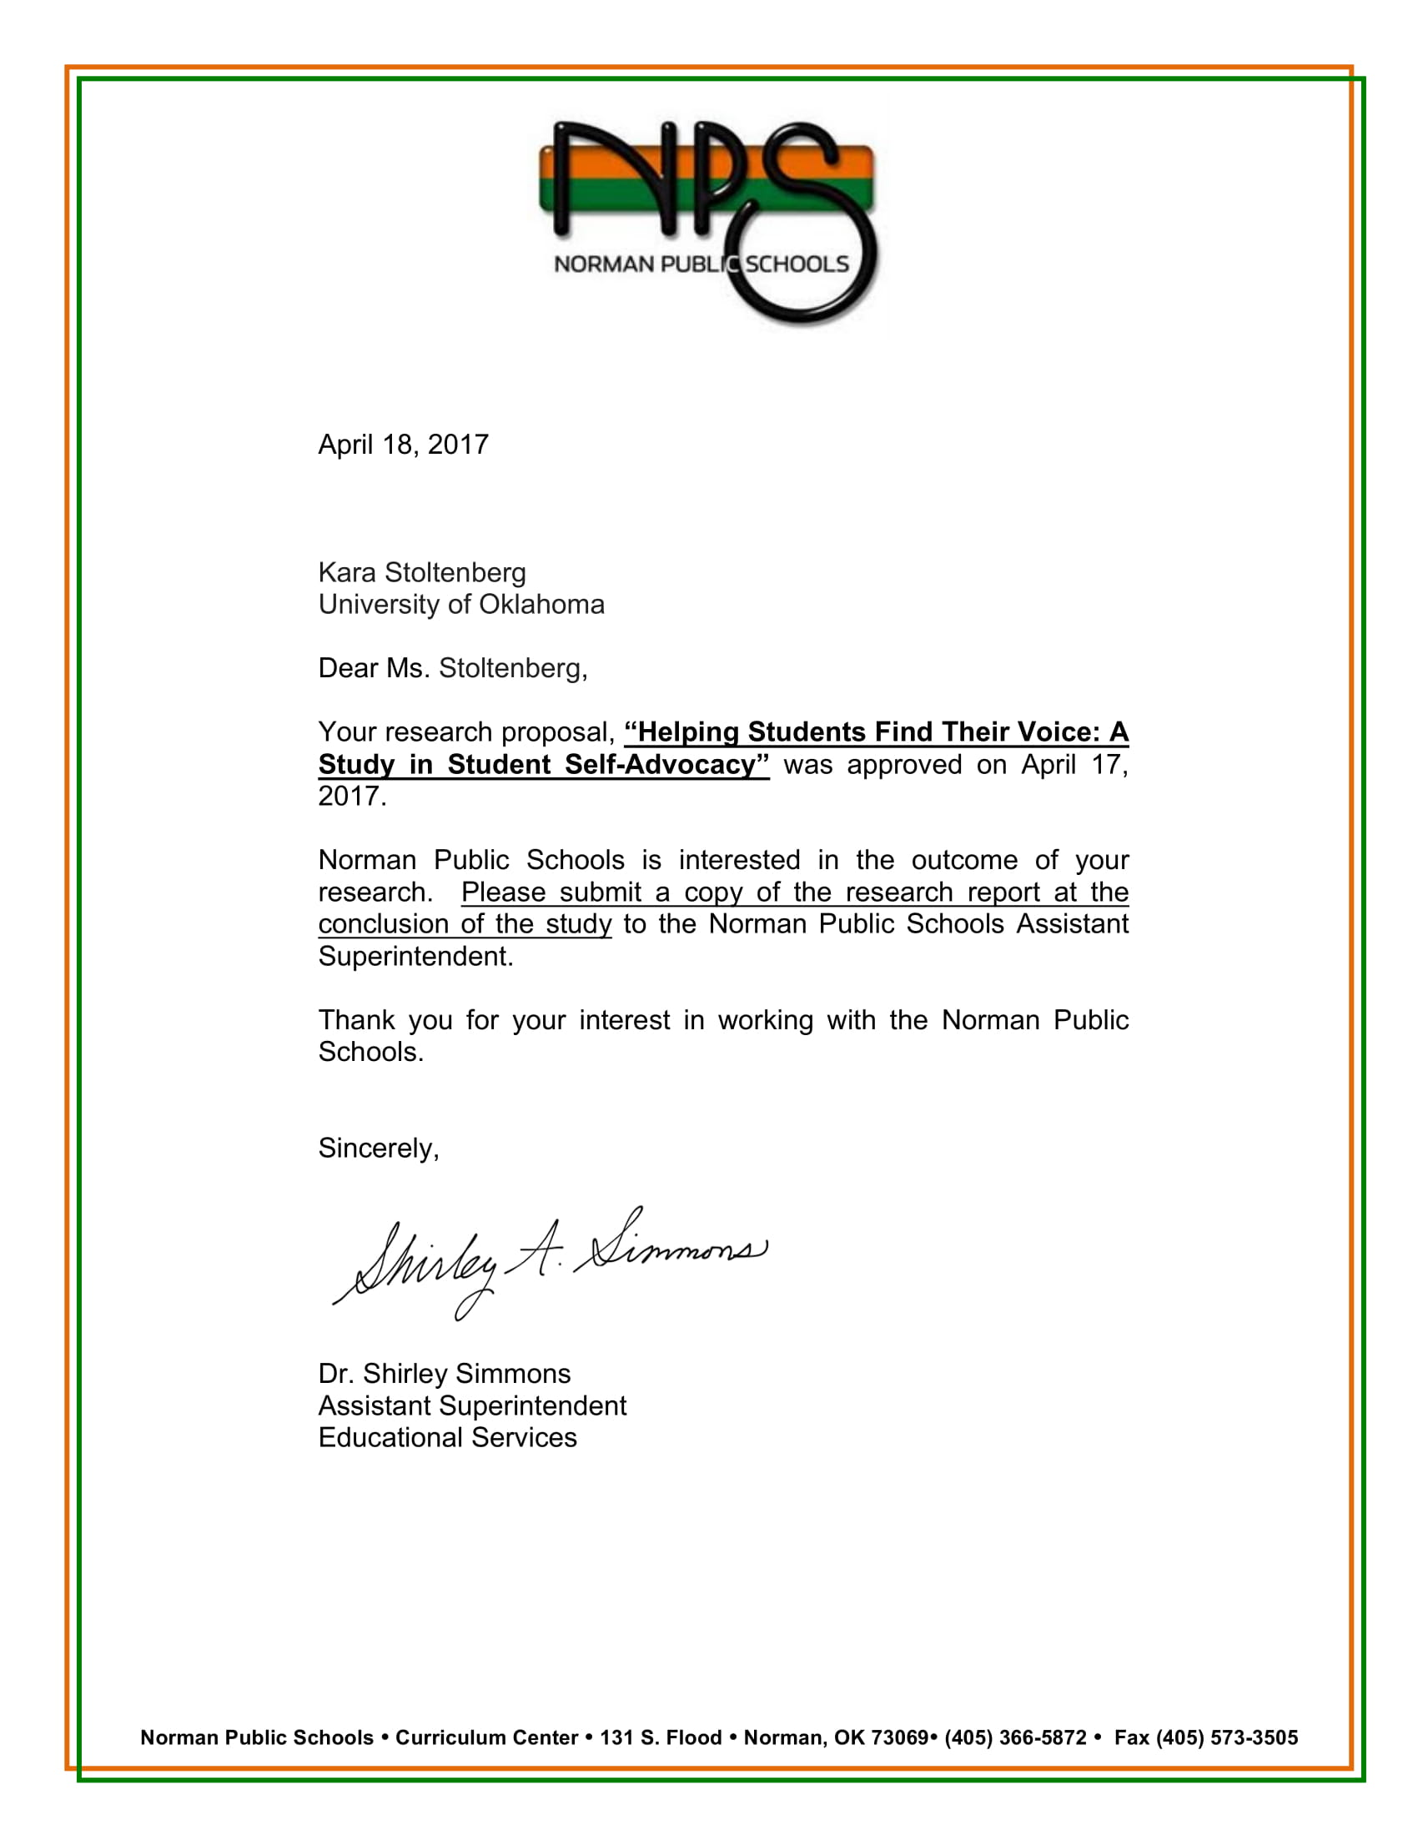
Appendix B
IRB Letter of Approval
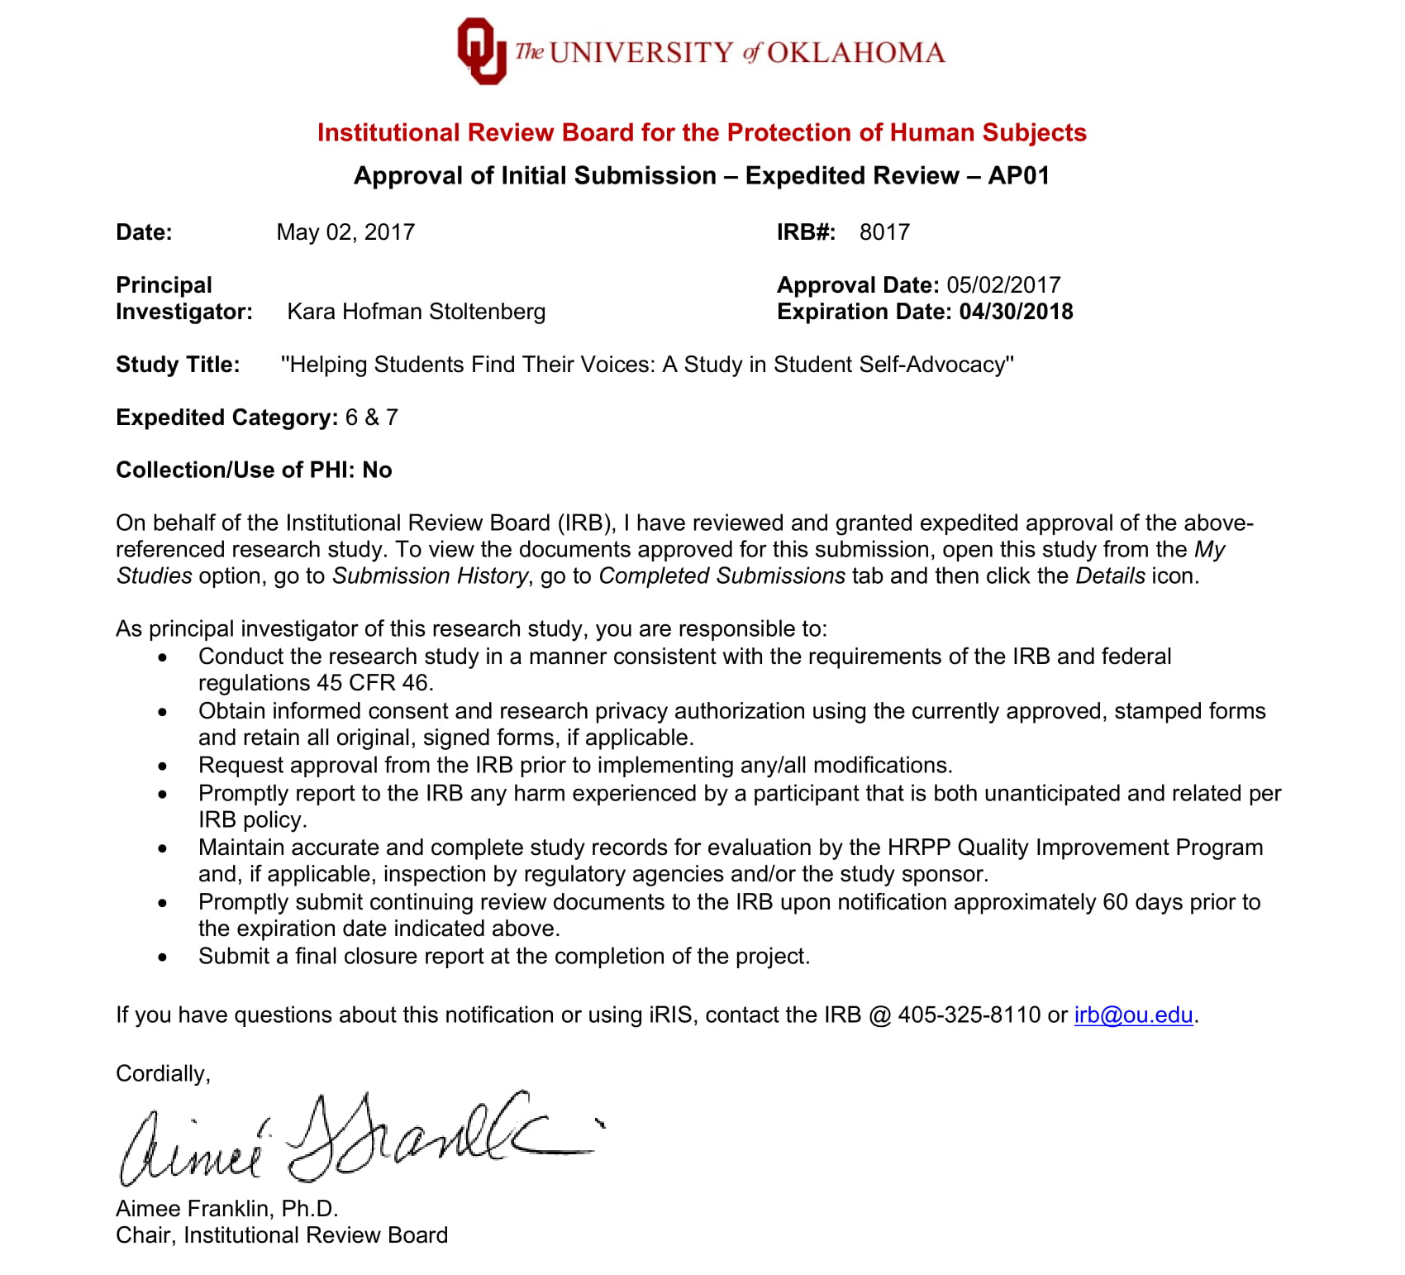

Appendix C
IRB Letter of Approval: Extension of Study
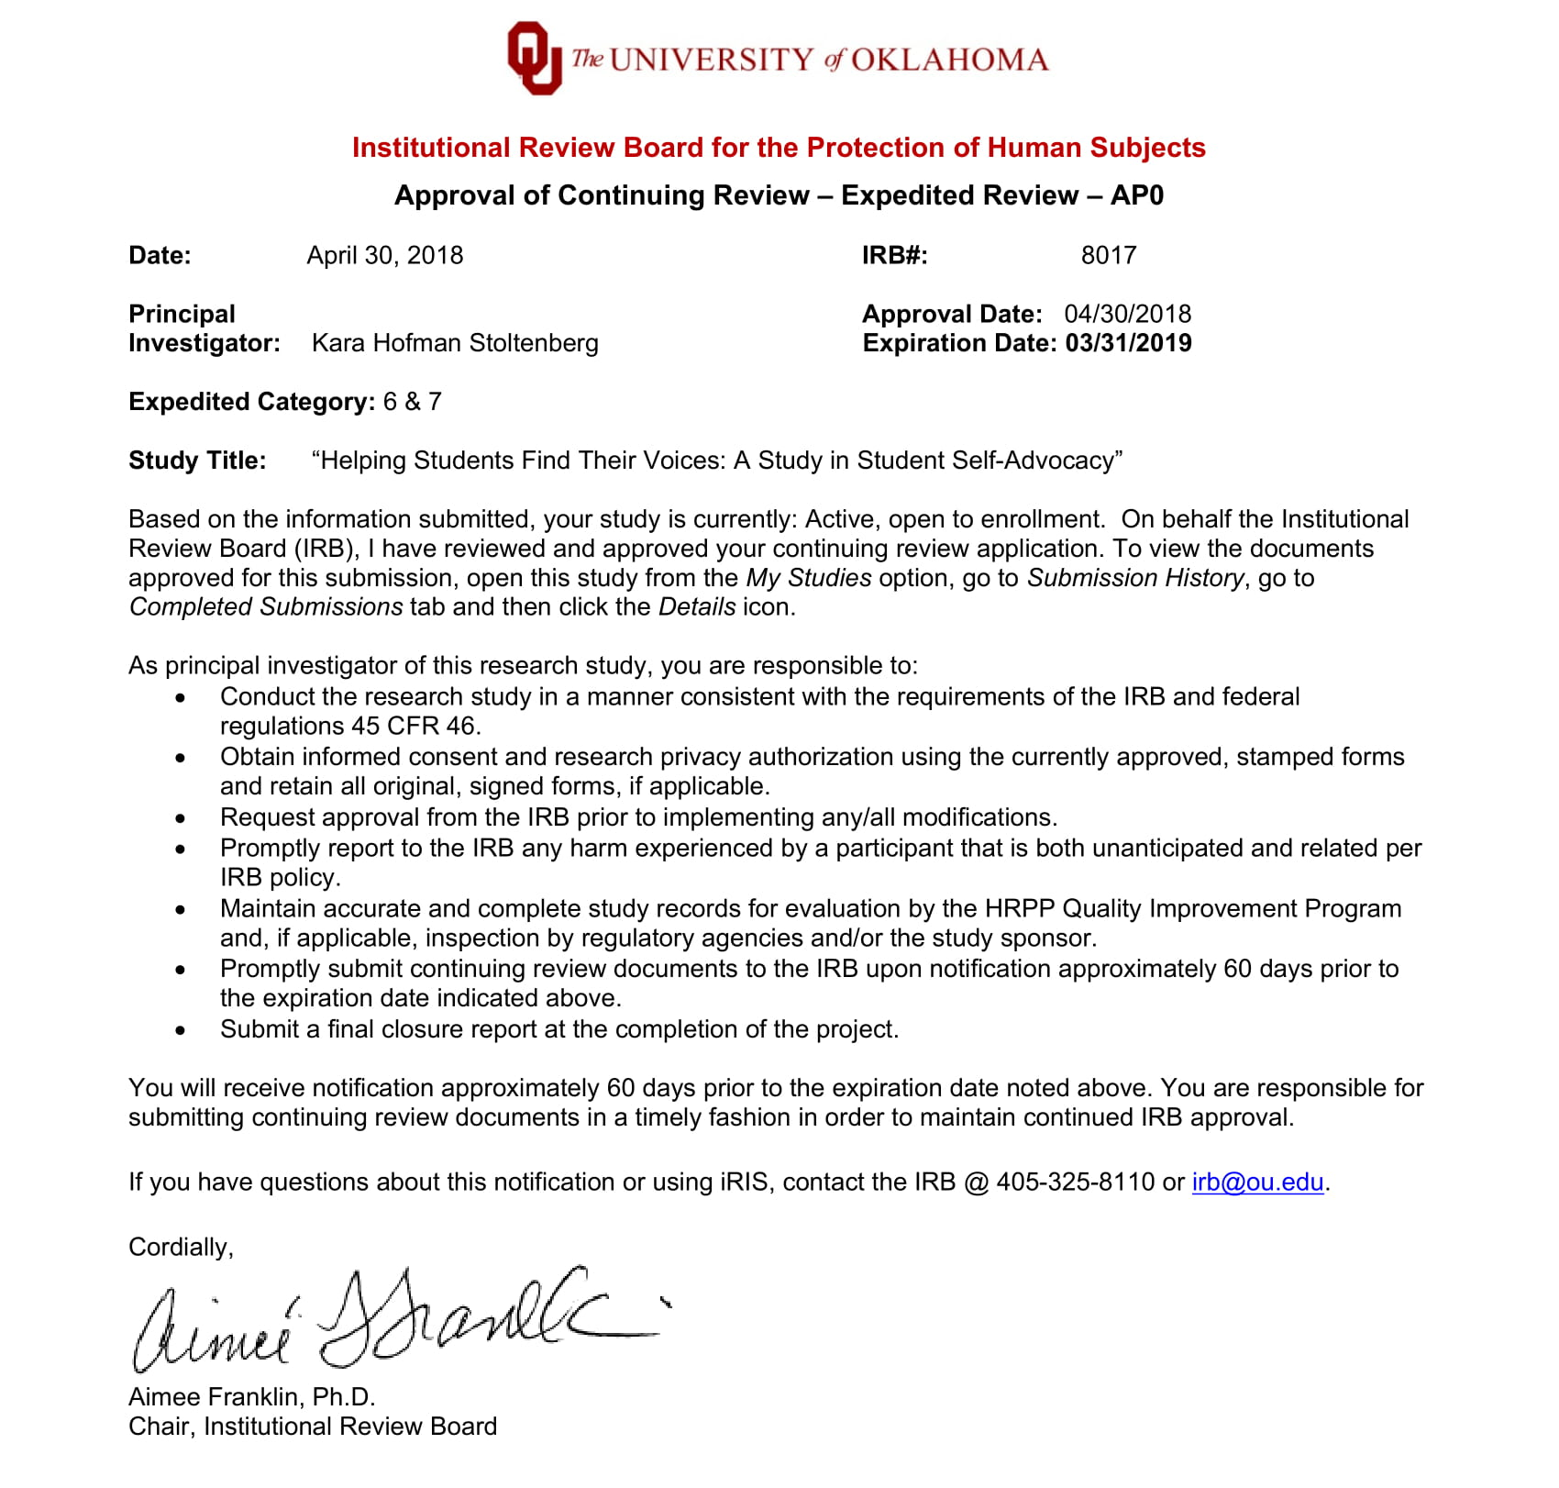

Appendix D
Student Assent Form

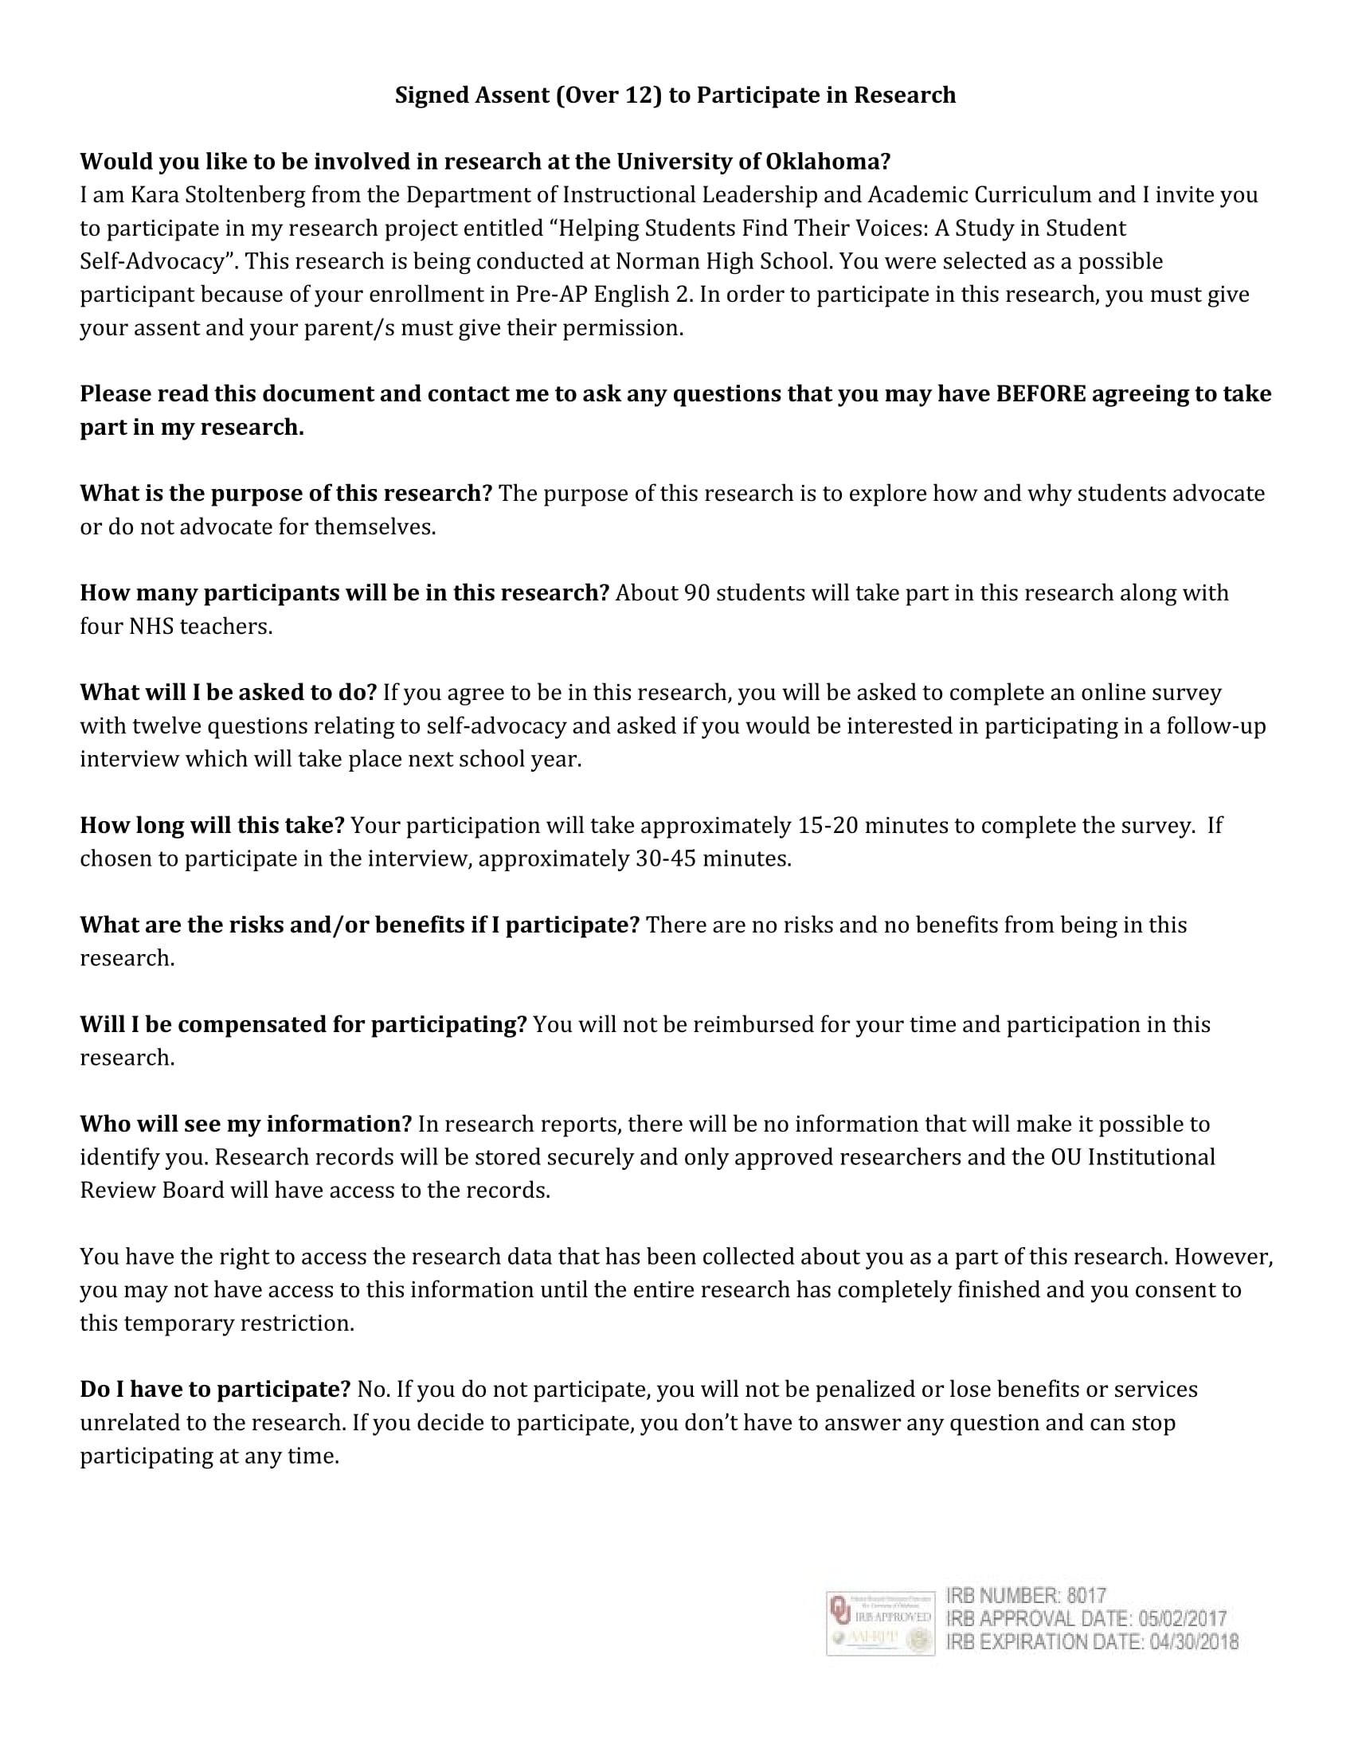
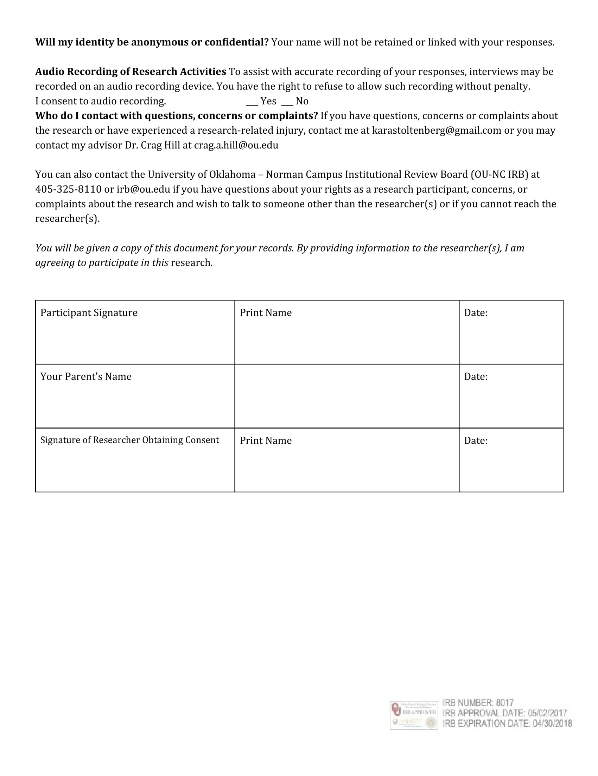

Appendix E
Parent Consent Form
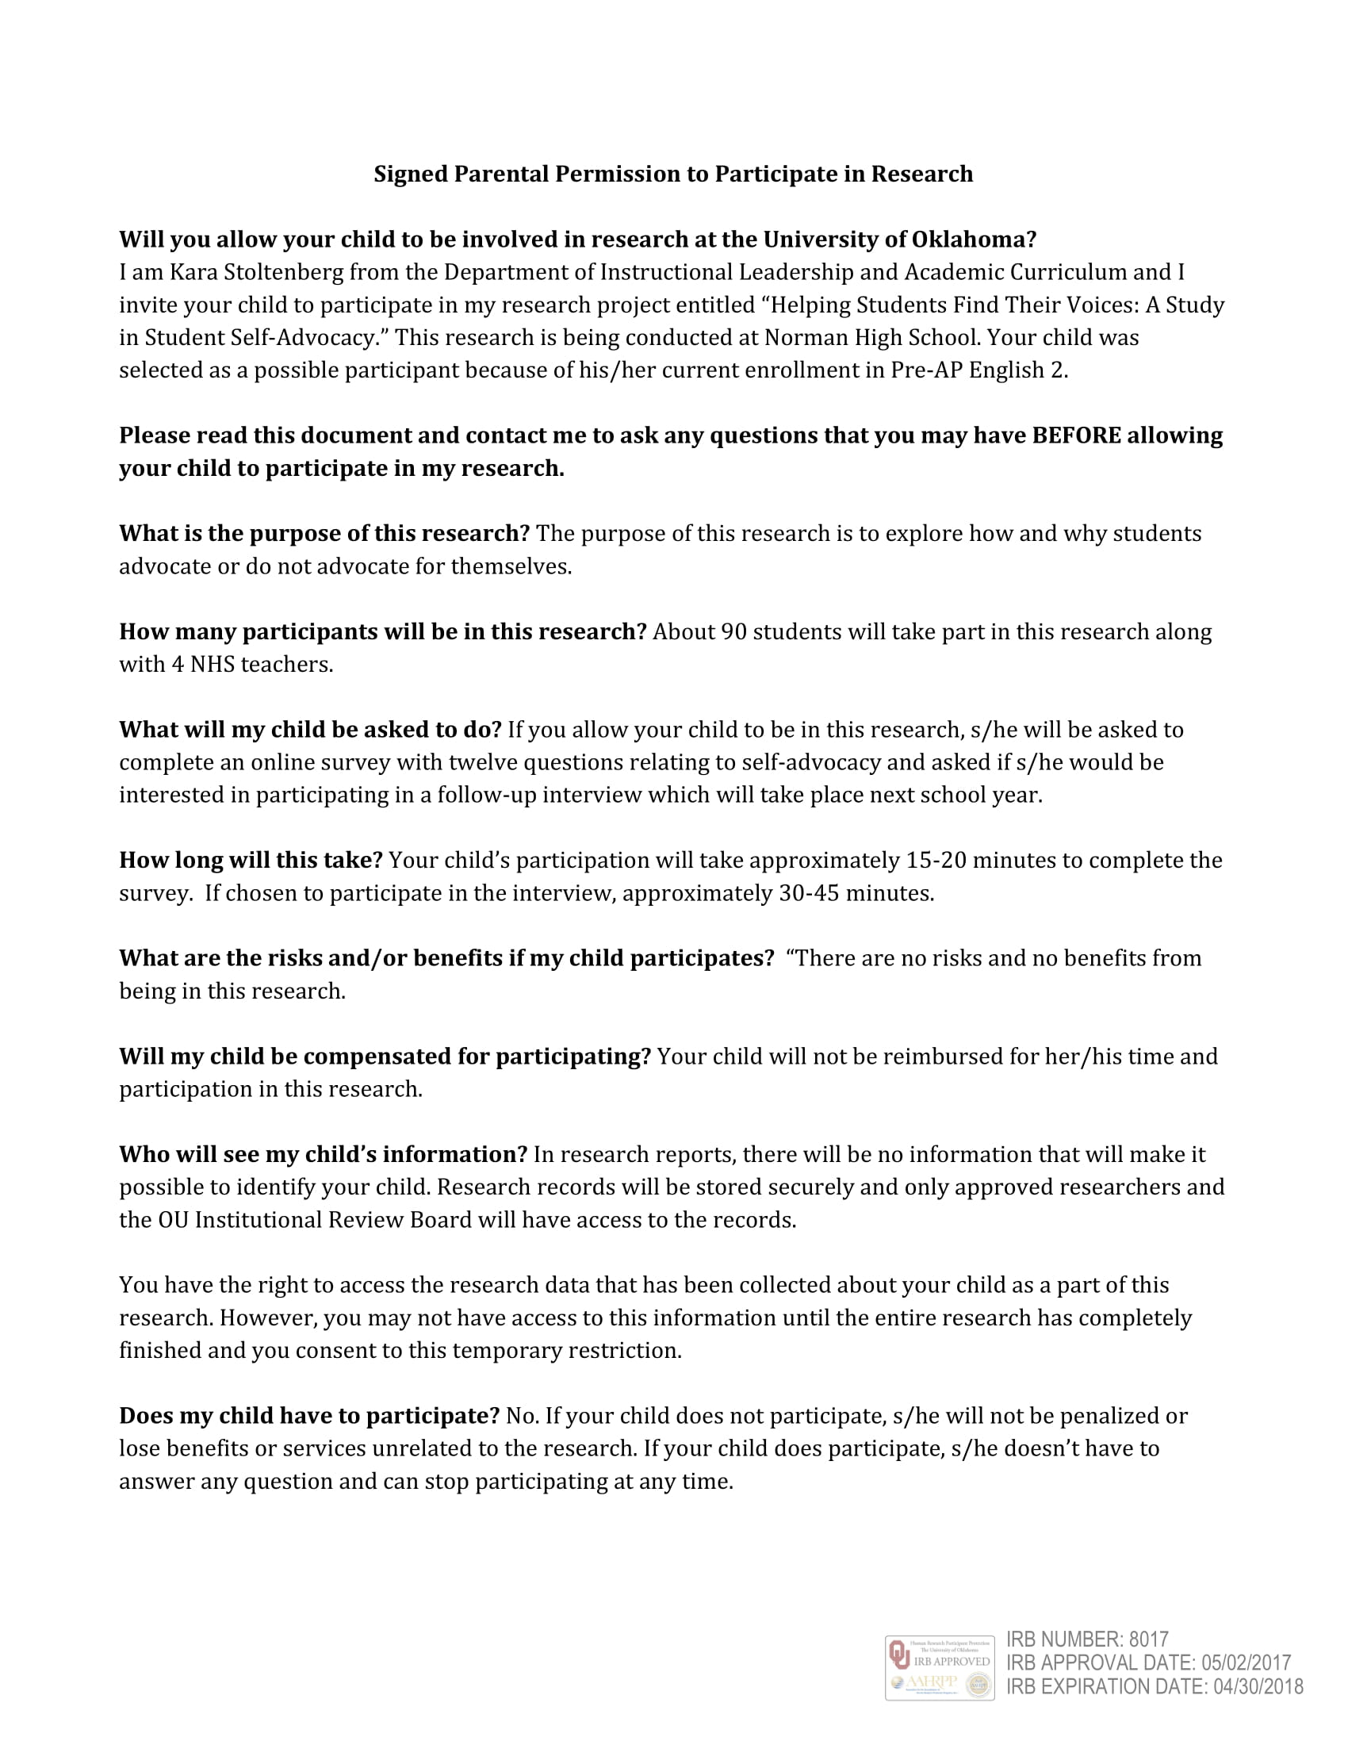
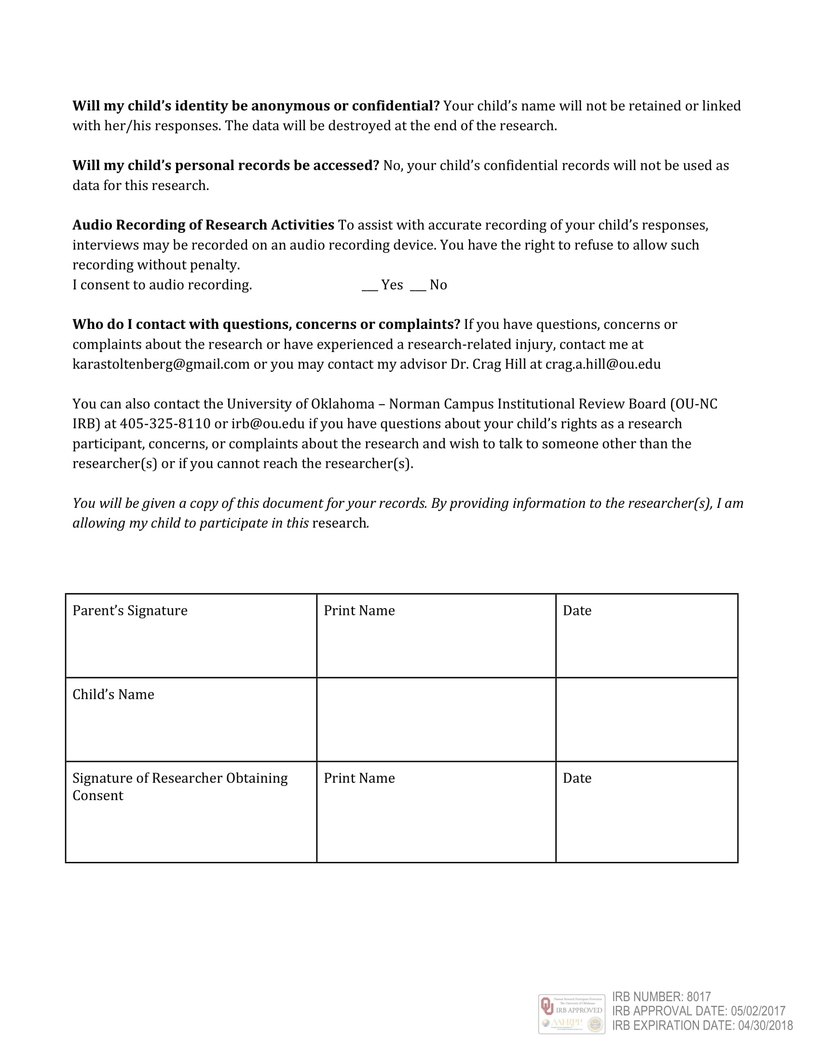

Appendix F
Teacher Consent Form
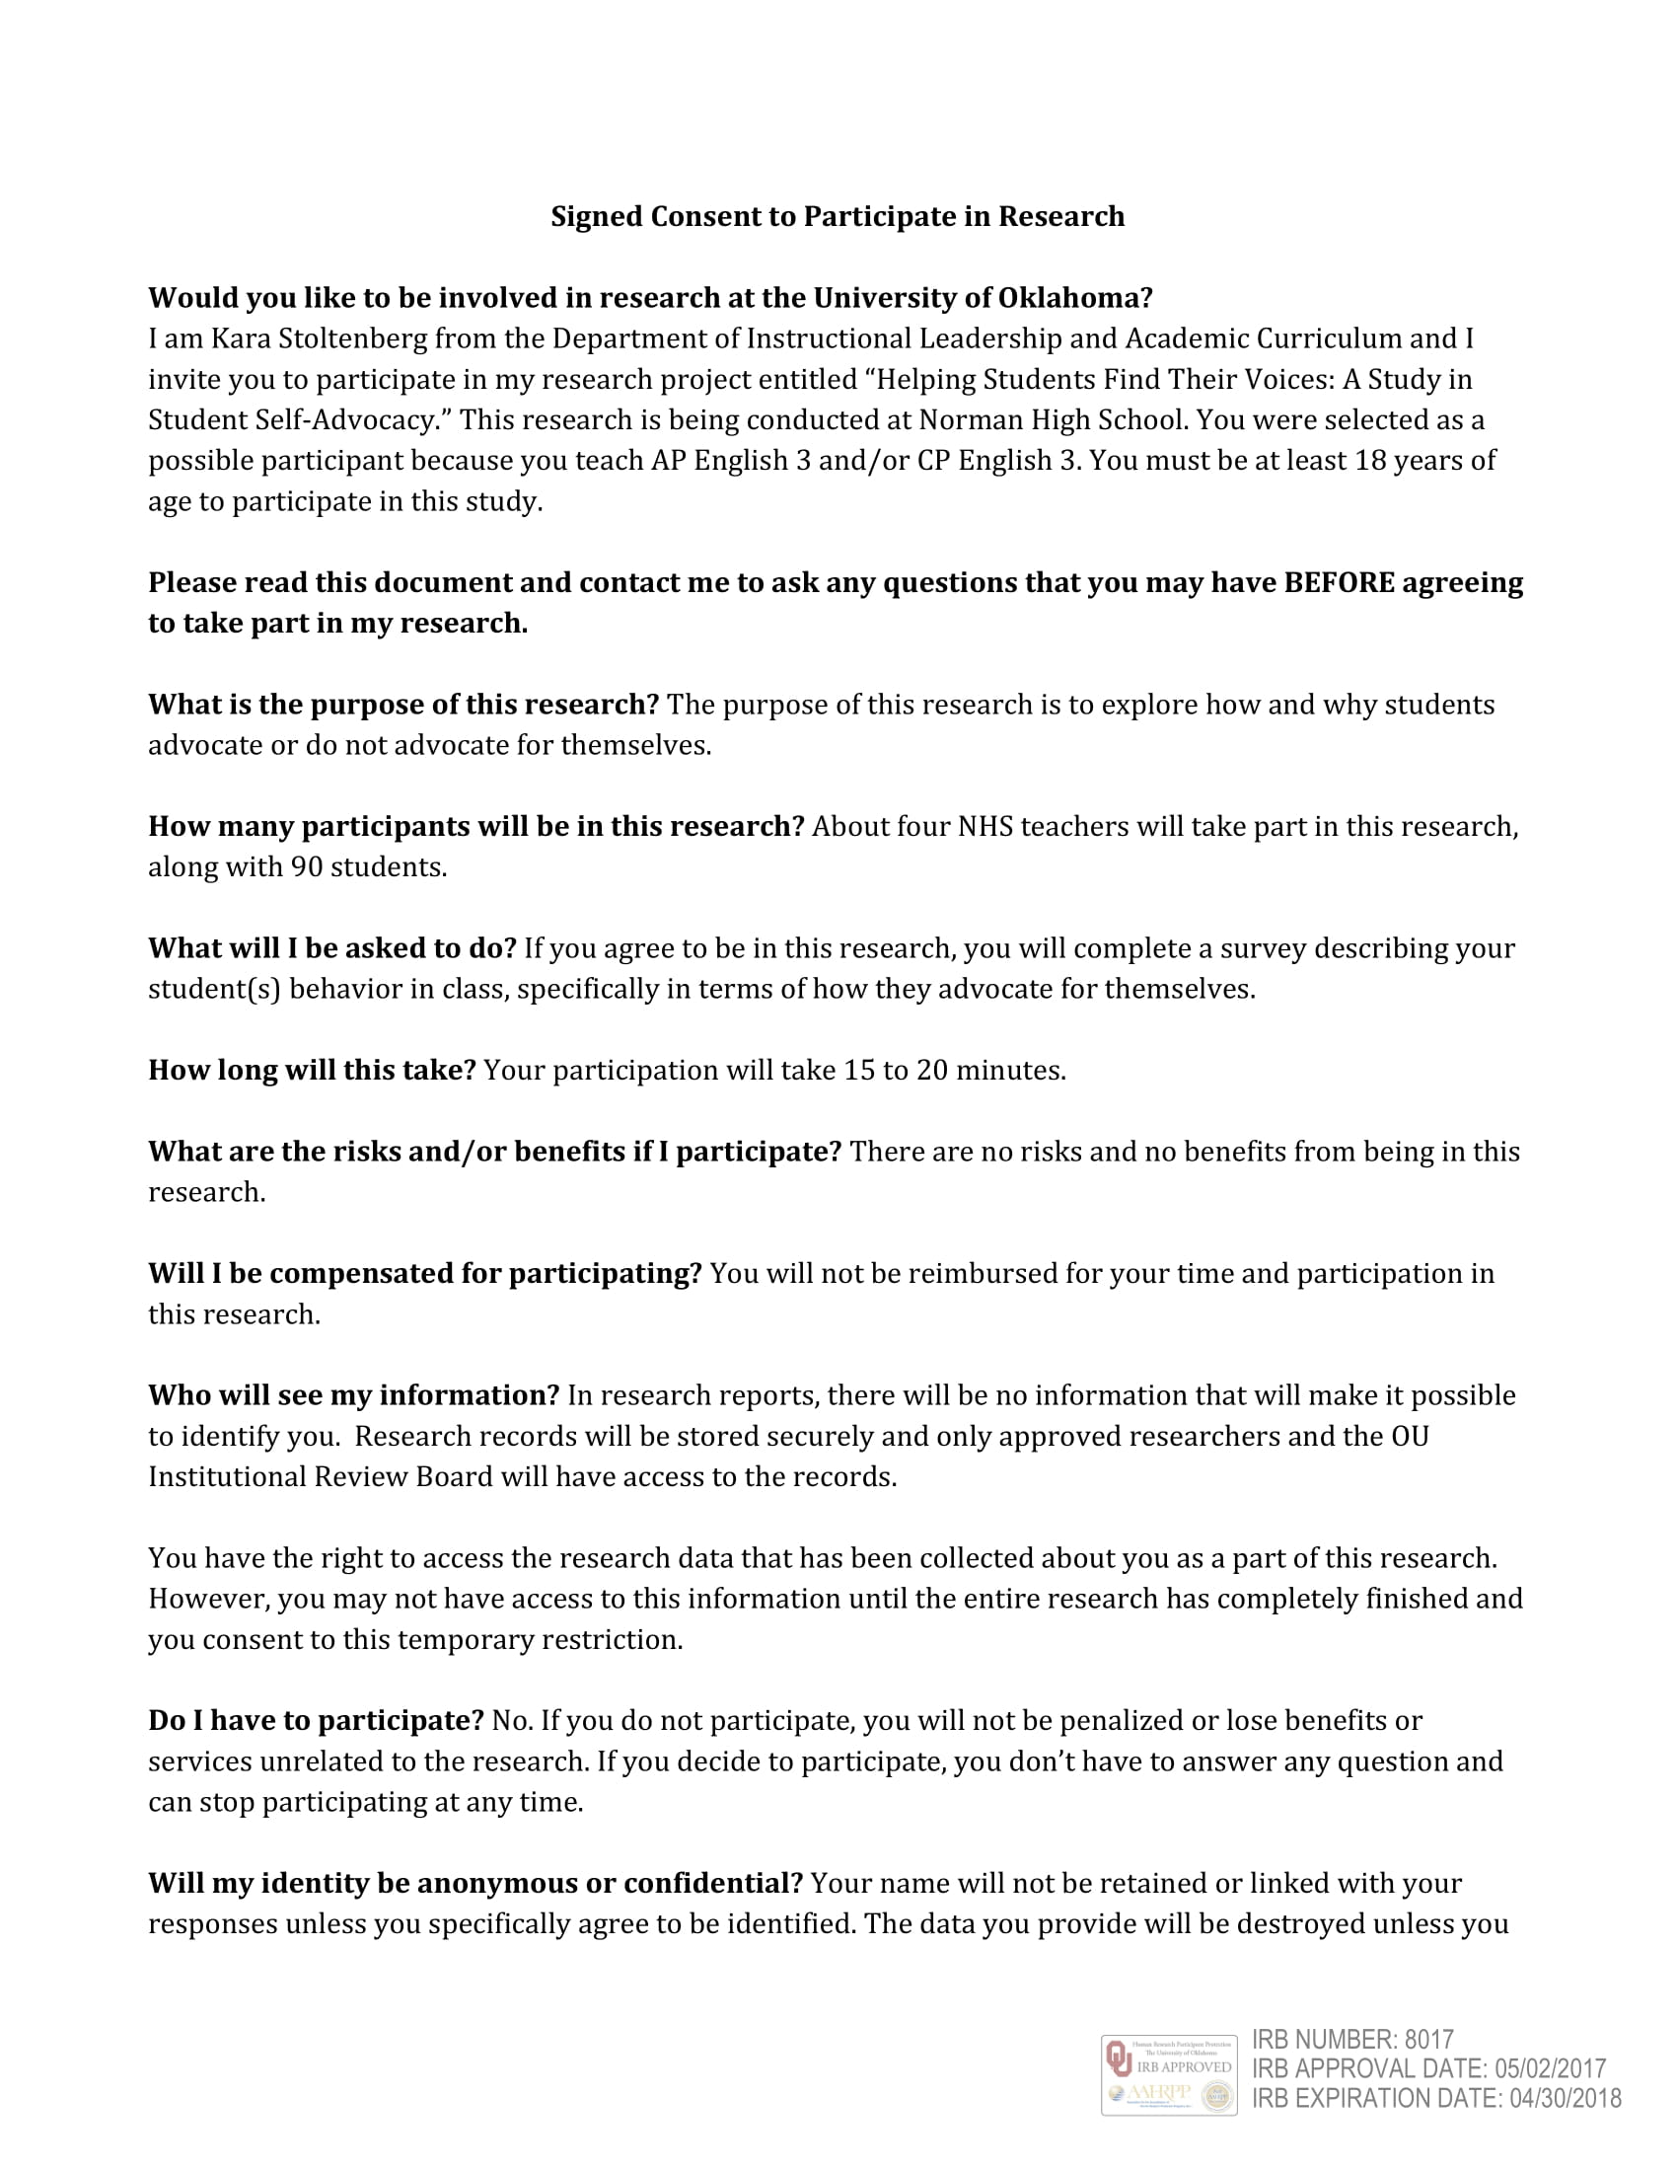
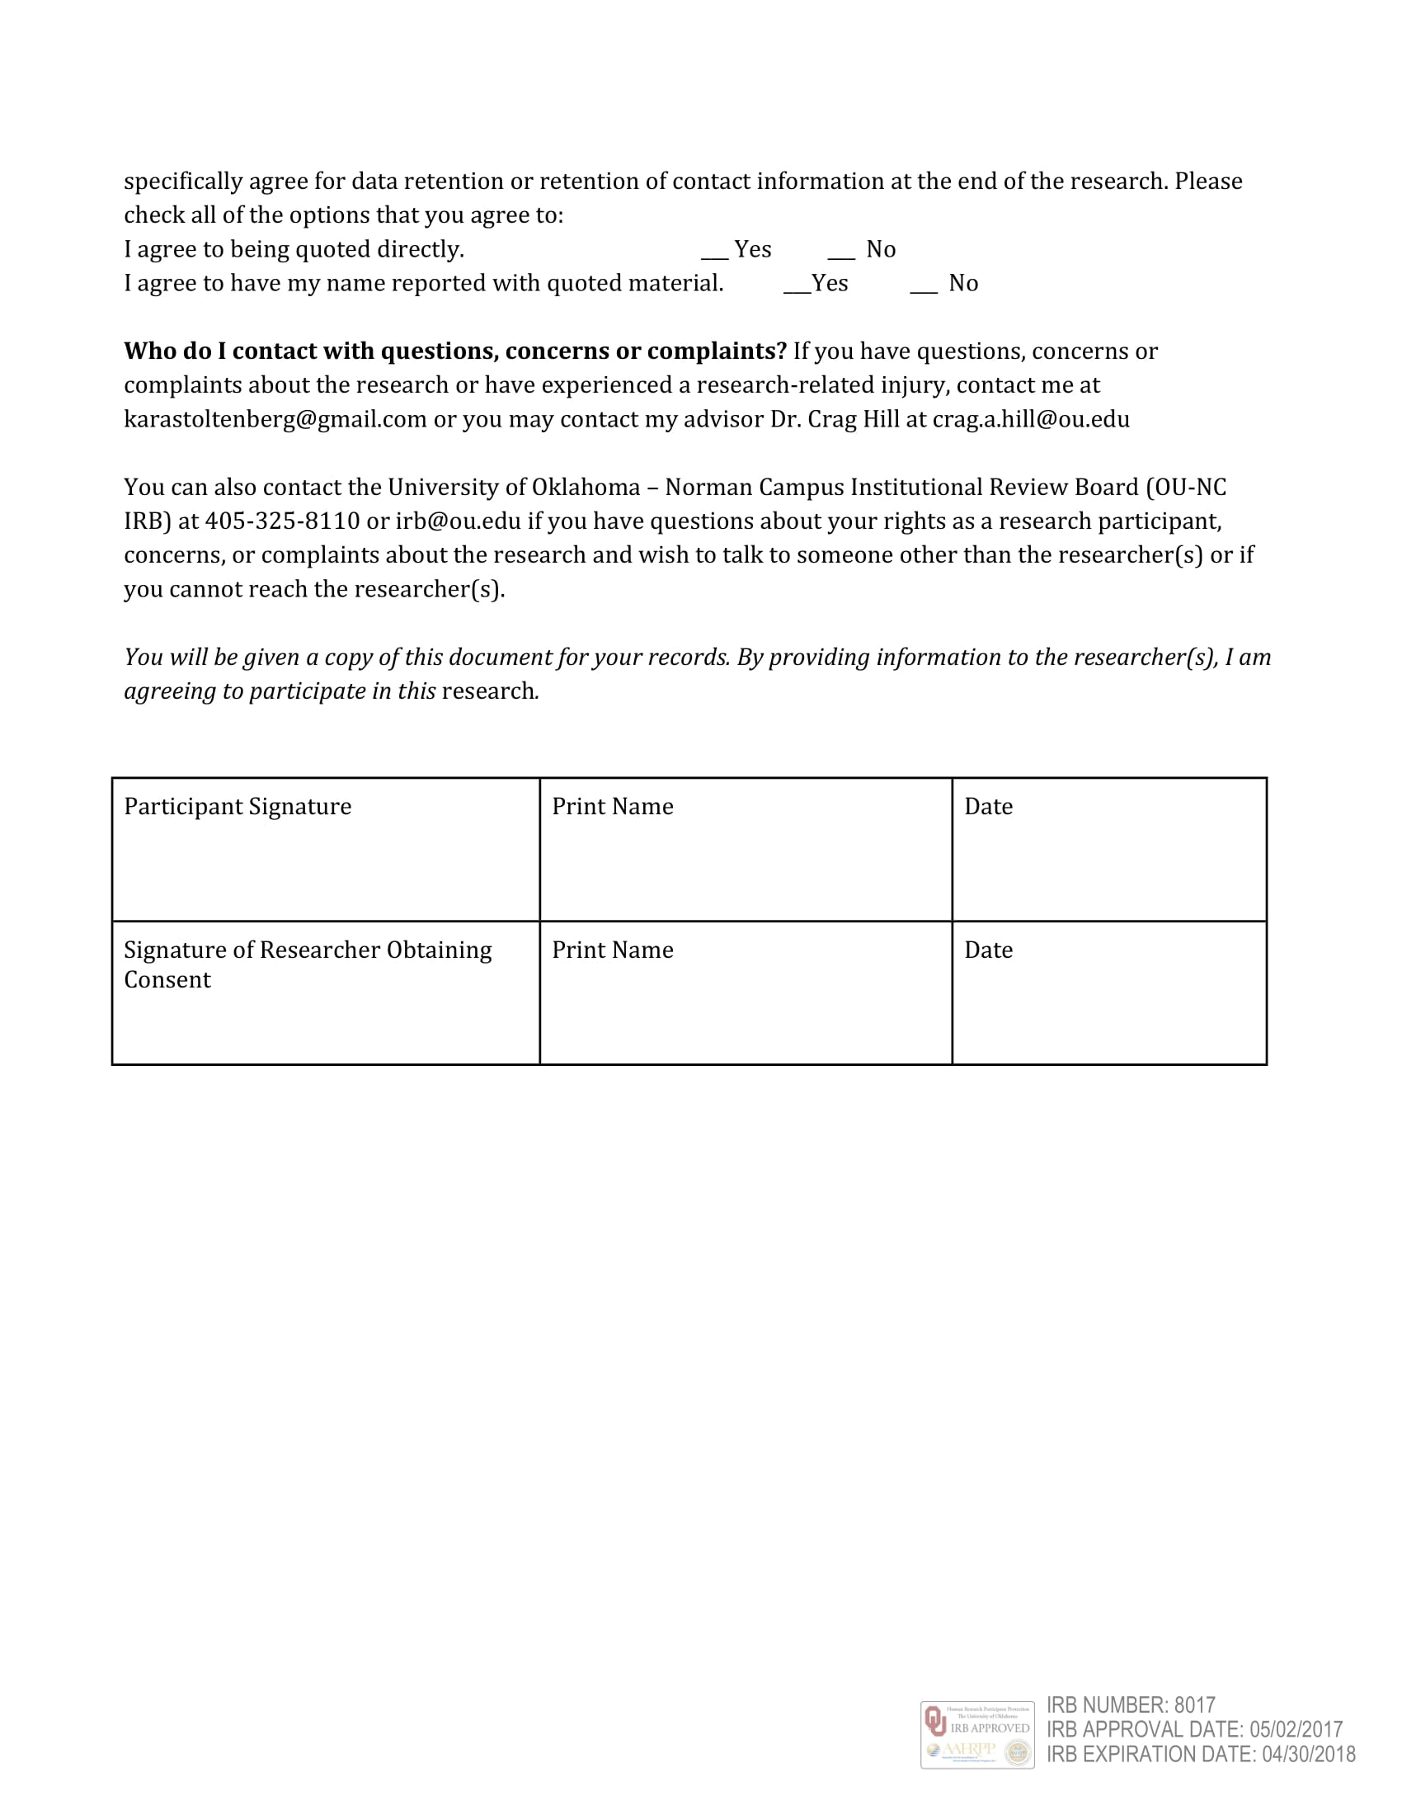

Appendix G
Recruitment Script (Students)

Good (morning or afternoon). My name is [_______________]. I am here to invite you to participate in a survey as part of Ms. Stoltenberg’s research for the Department of Instructional Leadership and Academic Curriculum at The University of Oklahoma. The survey focuses on student self-advocacy which refers to how a student identifies supports and how those supports are communicated to others. Ms. Stoltenberg has a brief survey that will take about 15-20 minutes to complete and includes twelve questions total. This survey will take place next week, during class time.

Your participation is entirely voluntary and you may skip any questions that you don’t want to answer. Any personally identifiable information collected during the survey will be kept strictly confidential and saved on a secure server. Please know that Ms. Stoltenberg will not be viewing the responses of this survey until the end of the school year, after grades have been submitted and finalized.

As part of the survey, you will be asked if you would be interested in participating in a follow-up interview with Ms. Stoltenberg at the beginning of next year. The interview consists of ten questions and will last around 30-45 minutes. Again, participation in the interview is entirely voluntary and you may choose to take part in the survey but not the interview.

If you are interested in participating in the survey and/or interview, please fill out the student assent form. Since you are under the age of 18, you must also take home the parent consent form for your parents/guardians to sign as well. Please bring back both of these forms by Friday and place them in the manila folder on Ms. Stoltenberg’s door.

Do you have any questions?

Thank you for considering.

Appendix H
Script for Survey Administrator

Good (morning or afternoon). My name is [___________]. I am here to administer this survey as part of Ms. Stoltenberg’s research for the Department of Instructional Leadership and Academic Curriculum. The survey focuses on student self-advocacy, meaning how a student identifies supports and how those supports are communicated to others. Please know that Ms. Stoltenberg will not be viewing the responses of this survey until the end of the school year, after grades have been submitted and finalized.

Participation in this survey is entirely voluntary. You may skip an item or stop at any time during the administration process. Please note that the first question asks for your student ID number, meaning your lunch number. Ms. Stoltenberg will be using this to later identify people interested in participating in the second phase of data collection, an interview. The final question of the survey will ask if you would be willing to participate in the follow-up interview. This will take place next year, and again, it is entirely voluntary. Ms. Stoltenberg will only contact you if you say yes.

If you are not participating in the survey, please remain in the classroom during the administration.

If you have not grabbed a computer from the front of the room, please do so. Once you login, please open safari and type the following web address (the URL is also located on the smartboard): https://tinyurl.com/ld3s94y

You have 15-20 minutes to complete the survey. When you have finished, please submit your responses and shut down your computer.

[When all students are finished, or when time has run out, have students return computers to the cart.]

We are out of time. Thank you for participating in this survey.

Appendix I
Student Self-Advocacy Survey

Thank you so much for taking this survey! Please know that these responses will not be viewed by Ms. Stoltenberg until after the semester has been completed and grades are submitted. Only Ms. Stoltenberg and her professor, Dr. Crag Hill, will be viewing the results of this survey and once the study is completed, your responses will be destroyed. You can refuse to answer any question or stop the survey at any time. Withdrawing from the project will not result in any negative consequences for you.

- What is your student identification number?
- How old are you?
  - 14
  - 15
  - 16
  - 17
- What characteristics (traits) do students who are successful have? (please list at least 3.)
- Based on the traits above, how successful do you consider yourself when it comes to school?
Not successful | 1 | 2 | 3 | 4 | 5 | Very successful

- Do you consider yourself a self-advocate (a person who can identify the supports that he or she needs to succeed and communicate that information to others) while at school? Why or why not?
- When you are struggling in class, what do you do to help yourself improve/understand? (check all that apply.)
- I don’t do anything.
- I wait until the teacher asks if I need help.
  - I find the answer on my own.
  - I ask a friend.
  - I ask my parents.
  - I ask the teacher for further clarification.
  - Other.
- What characteristics (traits) describe a teacher who is willing to help? (please list at least 3.)
- How comfortable do you feel asking your teachers for help?
Not at all | 1 | 2 | 3 | 4 | 5 | Very comfortable

- In what ways do you ask for help from a teacher? (check all that apply.)
  - Raise my hand during class.
  - Go up to the teacher’s desk for more directions/clarification.
  - Ask teacher outside of class (before school, at lunch, or after school).
  - Email a question or concern.
  - I don’t ask for help.
  - Other.
- Do you consider yourself a self-advocate outside of school? Why or why not?
- When you are confused by something outside of school, what do you do? (check all that apply.)
  - I don’t do anything.
  - I seek out the answer on my own.
  - I ask a friend.
  - I ask my parents.
  - I find an expert.
  - Other.
- Would you be interested in participating in a follow-up interview (Fall 2017)?
  - Yes
  - No

Appendix J
Interview Protocol

Thank you for agreeing to talk with me today. I am researching students’ abilities to identify supports that they need to succeed and communicate that information to others The interview will last approximately 10-20 minutes. Although I will ask some questions to guide the discussion, this is meant to be a semi-structured interview with possible follow-up questions.

Before we begin, I would like to share a few procedures for this conversation. Although we will be on a first name basis today, no names will be used when I report the results of this session. You can be assured of complete confidentiality. With your permission, I would like to record our session today so that I will be able to more carefully listen to your responses. The audio will only be used for the purpose of note taking and transcription, and will be destroyed following the completion of the study.

You can refuse to answer any question or stop the interview at any time. Withdrawing from the project will not result in any negative consequences for you. You have been provided a copy of the consent form that you and your guardian signed. I have some extra copies if necessary.

Do you have any questions before we get started? Let’s begin.

(Start the recording, identify the interview, location, and date.)

Appendix K
Interview Questions
[for students who identified as self-advocates]

- In the survey you participated in last year, you identified yourself as being a self advocate, meaning you are a person who can identify the supports needed to succeed and can communicate that information to others. Is this a trait you learned or do you think you inherently have this skill? Please explain.
- In a school setting, in what ways do you communicate that you need help? In what ways do you advocate for yourself on a day-to-day basis?
- Based on these moments, do you notice advocating for yourself more so in certain places? For example at home, at school, in extracurriculars, with friends? Do you advocate for yourself in certain areas/groups more than others?
- Do you recall any moments when you should have asked for help, but didn’t? Can you explain why you didn’t?
- Do you think your experiences and/or success in school would change at all if you didn’t have this skill? Please explain.
- This may be a bit challenging, but can you remember where, when, or from whom you learned to self-advocate?
- Do you think self-advocacy is an important life skill? Why or why not?
- How would you describe a successful student at Norman High? Would you consider yourself one of these people.
- Do you think advocating for yourself has contributed to your success as a student?
- Ultimately I am curious about self-advocacy because I want to help my students feel empowered to speak up for themselves inside my classroom and outside of it. As a teacher, how do you think I could help to encourage my students to advocate for themselves in my classroom?
- Do you see any potentially negative effects of self-advocacy in the classroom?

Appendix L
Interview Protocol
[for students who did not identify as self-advocates]

- In the survey you participated in last year, you identified yourself as someone who does not advocate for oneself, meaning you do not find yourself identifying the supports needed to succeed and as a result do not communicate that information to others. Could you explain why you identified yourself in this way?
- Tell me about a time you did not understand a concept. How did you figure it out?
- Is there a particular moment that comes to mind when you wish you would have advocated for yourself in a school setting? Outside of school?
  - Can you explain further why you chose not to?
- Based on these moments, are there any places and/or situations where you may feel empowered to advocate for yourself? For example at home, at school, in extracurriculars, with friends?
  - Do you see a difference in the locations? For example, are there reasons you would be willing to advocate for yourself in certain locations over others?
- Do you think self-advocacy is an important life skill? Why or why not?
- How would you describe a successful high school student?
- Based on your previous answers, do you think advocating for yourself would contribute to your success as a student?
- Ultimately I am curious about self-advocacy because I want to help my students feel empowered to speak up for themselves inside my classroom and outside of it. As a teacher, how do you think I could help to encourage my students to advocate for themselves in my classroom?
- Do you see any potentially negative effects of self-advocacy in the classroom?
- Do you think your experiences and/or success in school would change at all if you felt comfortable asking for help? Please explain.

Appendix M
Teacher Self-Advocacy Survey

Thank you for taking the time to help me! My thesis is focusing on student self-advocacy among sophomores/juniors in high school. The student(s) you're describing have taken a survey about their self-advocacy inside and outside of the classroom. They participated in a follow-up interview where I asked them for more specific information about their perceptions relating to self-advocacy. For the final stage of data collection, I would like to know how they advocate or do not advocate for themselves in your class. Please be honest. I am the only person who will be viewing your name with these responses. Once collected, I will give you and the student a pseudonym and will ensure none of this information will be linked back to you.

- What is your email address?
- What is the first name of the student? (Please do not include last name.)
- What traits would you use to describe this student in your classroom? (Include at least 3.)
- When this student is struggling with a concept in class, how do they respond? (Feel free to use specific anecdotes.)
- In what ways does this student ask for help in your class?
- Would you consider this student a self-advocate (someone who can identify the supports needed to succeed AND communicate those needs to others)? Why or why not?
- Would you consider this student successful in your classroom? Why or why not?
- Do you think self-advocacy has any influence on this student’s success in your classroom? Please explain.

Appendix N
Interview Transcription: Taylor

Interviewer: Kara Stoltenberg
Student Participant: Taylor

K: Okay, so in the survey you participated in last year, which seemed forever ago, you identified yourself as being a self advocate, meaning you are a person who can identify the supports needed to succeed and can communicate that information to others. Is this a trait you learned or do you think you inherently have this skill? Please explain.

T: Um, I think I learned it but it was very early on in my childhood. I have a lot of older siblings. So, and my parents were, they weren't too busy but they were always busy like helping one kid or at work or try and get something done. And so I kind of learned to kind of like if I really needed help I should ask because like even now I asked my mom to help me do a project and she just put down what she was doing and she helped me. But I also feel like in a school setting it's very hard,

K: Hard to ask for help?

T: It's hard to ask for help because I know especially in Oklahoma, teachers aren't paid very well and there's so many students in each class, like I don't want to like if I can like figure it out on my own, I will try to. And then if I absolutely can't, I will ask for help because I know there's probably students who need their help a little bit more than I do and who need the guidance of a teacher more than I do.

K: You're so sweet. I did notice, um, that. So it just locked me out of that. You said you asked for help from your parents first and foremost in the survey that you took last year and that makes a lot of sense based on your explanation. Okay. In a school setting, what ways do you communicate that you need help? I know that you, you think about it before asking a teacher, but when you do ask a teacher, how do you do that? And even not even in the traditional classroom, if you need something, like if you have an issue with a teacher or you need something in an extracurricular activity, how do you communicate that you need help?

T: Well, in a school setting I usually go up to the teacher or I will ask them like after before class because I feel like class time, especially if we're taking notes or something, I don't want to take away from that if and especially if my question can be answered within the class setting then or someone else asks it, I’m fine. But like in a classroom setting I usually try to do it outside of the classroom just because I feel like, you know, class time is important. Whether and if they give us work days I will, I will try to ask. But sometimes it's also hard to like work up the courage to ask because it's like, you've probably said this a million times and I don't need you to repeat it, but I need you to repeat it.

K: Does that, I don't know. Do you notice yourself, depending on the teacher kind of changing the way that you asked for help or is it pretty across the board, you do the same thing in every class? [3:05]

T: I think it's different for each teacher because with some of the newer teachers I feel a little bit more comfortable asking them, but with like older teachers and stuff like that, I do feel like I have a little bit more of a formal approach. Okay. And I don't know, I think it's just like I have, I have siblings, the ages of the younger teachers, so it's like, hey, for older teachers, like I grew up around a lot of adults so it's like I have to bring this respect with me and that I have to do that. And it's really funny because I'll like email one of my older teachers and I'm like very formal and they're like, “sure” sent from my iphone,

K: Haha, yeah they're very casual. You took so much time, like composing the email. That's funny. Okay. You kind of just answered that question for me. Um, but do you notice yourself outside of school advocating more so an extra curriculars at home with friends or is it primarily in school where you feel like you need to have that voice? [4:02]

T: So when you mean advocating…

K: it's just asking for help and communicating something that you need. So not even necessarily school work, but like if you are with your friends and you need them to work with your schedule or something like that. Or even with your parents, do you feel like you're pretty much the same in terms of expressing those needs?

T: I'm not the same. I, I do know that I act differently in school around my friends and my parents. So my parents, I take an approach where it's like I, I've laid everything out on the table so they know where I'm at. But I also have this like if they're like, why are you doing this? Like, like if I'm like I need help on this, like I know they're going to get really frustrated with me easily if I don't like put everything else. So I put everything out. But with my friends it's like they're a little bit more willing to do it, so it's like I don't have to be like explain everything to you and Yada. Yeah, I'll just tell them my.

K: You don't have to justify it. Yeah. Okay. That makes sense.

T: So, and then also in like school, like I do get very shy about asking for help sometimes. Especially when it's like in classes, like I'm taking advanced courses and it's like I feel embarrassed to ask for help because it's like I'm in an advanced course, I should know this, I should know that. But then it's like also I don't know it.

K: Yeah. And you're worried they said it, like those factors. Yeah. Um, do you recall any moments when you should have asked for help but didn't? Can you explain why you didn't? It's kind of a hard question, but just anything that comes to mind or we can skip it. [6:07]

T: I can't recall a certain moment, but I do know a lot that I don't ask questions and it especially happens towards the middle of the year because it's like, even though I know the teacher, I don't really know them because at the beginning you're like coming in it's like it's okay to be timid, but towards the end, towards the middle it's like everyone's kind of like stopped being as timid, but I still hold back.

K: Yeah.

T: And I, I can't recall a certain time but I know I have needed help but I just didn't ask for them which is wide, like a lot of times my grades go from a's to b's or c's in the middle because I'm like too afraid to ask for help. I feel like sometimes like it's just hard to. But then towards the end of the year it's like I need help but I also need to bring my grade up. I got to do all this stuff and it starts to get stressful, which is. I do view, view that as like one of my weaknesses is like I don't ask for help until the last minute.

K: Yeah. Is there anything that your teachers could do middle of the year when you're feeling that way to help you feel more comfortable asking questions or do you think it's just like a your personality type thing?

T: I think it's more of just my personality just because I don't. Yeah, I don't know.

K: I think you’re really perceptive too and so you just understand the craziness and at that point in the year that it's usually pretty stressful and so you're just kind of can pick up on that. All right. Do you think your experiences and/or success in school would change at all if you didn't have this skill? If you didn't speak up for yourself, if you didn't ask for help?

T: Yes.

K: Can you explain why?

T: So [7:57] all my siblings, all my older siblings, they all had trouble in high school and I know with the two oldest they don't like asking for help. They just tried to figure out on their own and if they can't, they just give up. And so I saw them. I watched them as a kid, like struggle with that as students and I watched like I watched their lives through the lens of a little kid and um, I made sure to be observant cause I'm like, cause my mom expects me to go to college. She didn't expect any of them to go to college but she stressed me go to college. So I just became perceptive and I realized like asking questions makes a difference. And like, and my older brother who he could get into college, he could probably get into any college he wants, but he didn't ask questions which made it kind of confused me because he knew like what the teachers were talking about. He barely needed help and he did not ask questions. But then when he needed them, he didn't ask them either.

K: That's what I'm trying to understand.

T: And he did not like school from since the fourth grade. He didn't do homework, like he didn't do it because he thought it was dumb and he and he just didn't understand. But he's very smart. And my mom mentioned when he was a kid that he didn't talk a lot in all the teachers were like, he has a speech impediment like we need to fix that. And she's like, no, he speaks like he can talk, he can do that. And so he would talk to my parents just fine. But with other people he like seized up and he does have anxiety about that sort of stuff. And with my parents, like he would be like, he would just sigh and they know, oh he's tired and he's hungry. Like they did that. So we never really asked a lot of questions cause he, he was their first kid, like we kept, we took care of other kids but he was their first kid and so they like new and that sort of stuff. And he could by age four. He could describe how a locomotive train works in detail. Like he was reading chapter books in kindergarten. Like he's very, very smart and he knows it. And so he just thinks that it's sometimes it's a waste of time to do stuff and probably hasn't had to ask for help often. So he never learned how.

T: Yeah. And then me being the second kid, it's like he's doing stuff and I'm like, what is he doing? How can I, how can I one up him? And so that's my goal in life is to one of him. Chuckled

K: Uh, you kind of already touched on this, but can you remember where, when or from whom you learn to self advocate? [11:09]

T: Yes. Thank you. Um, yeah, my parents and my siblings mostly. Um, I do feel like my early school, like in school, because I did go to a preschool called Middle Earth. They were very like hands on learning that sort of stuff and they were like in like, so I felt like I had the freedom to ask and even in kindergarten I had this amazing kindergarten teacher and she was like, she was like spunky. And like I don't get a lot of that now that I'm in higher ed education and about to go to college. Like I know I won't get that. I won't get a classroom that has cows everywhere. Or an Elvis picture.

K: That's funny.

T: But I feel like those gave me the, uh, like at my house and then also are my early education. Like those gave me the room to be like, it's okay to ask questions. It's okay to learn about stuff. So.

K: Great. Um, do you, uh, you kind of already answered that. So ultimately I'm curious about self advocacy because I want to help those kids who were like your brother who are just afraid. I don't even know if that's the right word, but just hesitant to ask for help. So as a teacher, how do you think I could help to encourage my students to advocate for themselves in my, my classroom? Any suggestions for me. [12:56]

T: Mm. I feel like that's a hard question to answer just because there's a range of questions and I know everyone's like, there's no stupid questions, but there are stupid questions. Like it really annoys me when teachers say stuff over and over and over and over. And then two minutes later it's like, wait, what? Yeah. And it's like you were talking the whole time, you're not paying attention. And I feel like that is a hard part of like with having to deal with self advocacy, but like, and I feel like those questions take away from the kids who do need help and do need to ask questions because it's like, well what if I sound that dumb or what if I get that annoying to people. But like I'm in classes where there's a lot of kids where there's like, like my math class, there's one girl who asks a lot of questions but it's not like what are you in like when it is, what did you just do?

T: It's more like how did you get from there to there like specific process and that sort of stuff. Which I think is good and like it helps me understand more even though like I might may have understood it, but when the teacher goes more in depth it's more helpful. And I feel like if those kids knew how helpful that was to even kids who might not be struggling as much.

K: Yeah, because it kind of model that process of feeling like they can ask questions

T: And I do feel like also like if you were to speak with the kids who do, I'm like who are kind of more ahead and just be like, like if you have a question you should ask it. And because I feel like that would like bring it in because you know, an Aegis we're always like. So it's really funny because like I'll think I have a stupid question but then it's like half class has and so and I know sometimes she gets a little mad but it's fine because she's just happy that we're asking you questions because it's like okay, this is the right format that we're supposed to be writing this essay.

T: And then she'll be like, yes. And I feel like that is helpful, but it is really. But I know this is going to be really hard with the stupid question.

K: Yeah. I mean, you're so right though, because if you open it up to you, like if you have a classroom environment where everyone feels like you know, there's, there's no shame associated with asking a question, no matter if it's been answered already. Then suddenly you're bombarded with questions you've already answered and things that students who are just not paying attention, aren't listening, so yeah. Okay. That's all that I have. You are like a boss.

Appendix O
Interview Transcription: Pryor

Interviewer: Kara Stoltenberg
Student Participant: Pryor

K: Alright, so in the survey you participated in last year, you identified yourselves as being self-advocates, meaning you are someone who can identify supports, you know that you need help, but you're also willing to communicate that with other people. Okay. So you take that extra step of like, “Hey, I know I need help and I'm going to seek out help.” Is this a trait you learned or do you think you inherently have this skill? Like it's a part of your personality?

P: Oh, it was partially both. Um, because if I was less talkative or more shy I would probably have a harder time communicating with, with that and actually taking the initiative in the beginning. But I also think that not knowing who to ask, that's not just something that you know automatically. Right?

K: Okay. In a school setting, in what ways do you communicate that you need help? So you're in a class, you are in extracurriculars, you're in athletics, music, whatever. You need something from your teacher. How do you go about asking them, telling them, communicating that?

P: Well, I used to mostly ask questions during class, but since everyone has MacBooks now I just put something on Google Classroom, directly to the teacher or an email. Yeah. It’s more like you going to the teacher, not the teacher coming to you. Okay. Okay.

K: Do you notice yourself advocating more in certain places? Like in extracurriculars versus the classroom or at home versus the classroom, friends, so on and so forth.

P: For me, I do tend to be like I care more about extracurriculars. Right. Then some school subjects, so if I know, I mean in certain cases I have too much pride, pride in myself to like just ask. Probably look it up or something else. Okay.

K: Do you guys both feel pretty comfortable asking for help in front of an entire class or do you prefer to be like one on one with the teacher or send an email or something like that? Because P___ you didn't talk much in my class.

P: Yeah, I guess it's like a, I guess you're kind of embarrassed and also like a pride thing. There's those days when kind of loopy. I like go off, like ask questions. So it depends on the day, but I prefer not to take up too much class time.

K: Okay. Um, this one's kind of hard, but if you can recall any moments where you feel like you should've asked for help but didn't. And then can you explain maybe any reasons why you wouldn't ask for help? Whether it's a teacher, a personality thing or taking up time, you don't want to take up too much time.

P: Yeah. So, um, for me at least when I miss a few days for some activity or whatnot, I usually just still don't want to take up the time and the cost to ask because they've already moved on from that point and I also think that I can figure it out if I look, look for it hard enough, look it up, stuff like that. But uh, some of the time that doesn't actually work out and that ends up not doing it

H: Same for me. Like I, I sometimes like thing that I can just look at it and by myself and I'm like, oh, I'll just like get it later. But it's like, it's just like a procrastination thing about asking.

K: Okay. Okay. But you feel like you can take the initiative to do at first and then maybe you just don't take the initiative?

P: Yeah

K: Um, do you think your experiences and/or success in school, I consider you both successful, would change at all if you didn't have this skill? If you, if you were afraid to ask help or didn’t know how?

P: Completely. I would be completely clueless in most of my classes if I didn’t ask a bunch of questions almost certain because a lot of the time, the first time something has been explained, it doesn't actually set in for me at all and if I don't ask 2,000 questions about it, nothing's going to come from it.

K: Do you think self advocacy is a skill needed outside of the confines of school? Like is it a life skill? Is it something that you think could serve you in potential careers outside of school?

P: I mean yes because like you still keep learning outside of like after you graduate college and at least until your mid thirties or something like you try, you try to like, like learn stuff outside of like what you already know in order to like make yourself better I guess.

P: And you're not going to easily get a raise unless you ask.

K: Yeah. Yeah. Um, okay. Ultimately, I'm curious about self advocacy because of those students who don't feel empowered to ask questions even through email, even one-on-one and especially not in class. So as a teacher, how do you two as students think I could help encourage my students to advocate for themselves in my classroom?

P: That's a difficult question because for a lot of these people they fall into the habit of not doing it since it's, I mean you teach like 10th grade and twelfth grade kids right? By that time they're in the habit of it and maybe if you, even if you openly encourage people to keep asking questions and comment a lot. Then…

K: It's just a habit by that point. Yeah.

P: But. That’s tough.

K: Okay. Haha, that’s okay if you can’t answer.

Teacher: Do you want me to make copies of the CV review for you? Um, I'm going to look at it first. Think so. Okay.

Me: Do you see any potential negative effects of self-advocacy in the classroom? Could it be bad in any way?

P: I mean, I guess you could take attention away from entire class right. Okay. If you focus too much on your problems and you're just wasting time and you might not get through everything you need to get through.

K: One student is just constantly asking questions even if a group of students or questions. Yeah.

P: Yeah. (chuckles).

K: Alright. That's all I have. Thank you so much. I really appreciate it. That didn't take long at all. You are fast. Seven minutes. That's a record.

Appendix P
Interview Transcription: Sylvia

Interviewer: Kara Stoltenberg
Student Participant: Sylvia

Kara: In the survey you participated in last year, you identified yourself as being a self-advocate, most of the time, meaning you are a person who can not only identify supports, you know what you need help with, but you’ll also communicate that information to others. Is this a trait you learned or do you think you inherently have this skill?

Sylvia: I didn’t learn it in like formal teaching, but I think like from being raised this way is how I am. I think my mom taught me to be this way.

K: Yeah, just kind of seeing how she lives her life…

S: Yeah and how she is, she is definitely a self-advocate.

K: In a school setting, in what ways do you communicate that you need help? So how do you ask for help from teachers or peers.

S: Um, from teachers I’ll straight up say can I come in during lunch or whatever to just go over something. But in another situation, like in a school, if a teacher is screwing me over, um I have no issues just going over their head to Dr. Beck. (1:14)

K: Good, good. And you think you just learned this from your mom, feeling empowered, that you know what you deserve.

S: Not only that but because she is like with me most of the time, um and she is in the same position as any teacher, not the same position, but has the same amount of authority as anyone else who might be screwing me over. I have just always felt like I could have the upper hand, ya know?

K: And you know the other side, you know what she does and you know what a teacher should do.

S: Exactly, and I would never be like, I would never think someone is screwing me over unless I had a reason to I would be like oh this teacher just doesn’t like me, unless I genuinely thought that.

K: Um, let’s see. Based on the moments you described, do you notice yourself advocating more so in certain places? In school? Extracurriculars? With friends?

S: Definitely in school, with friends it’s a little different. Like if a friend says something I don’t like usually I’ll like stew it over and then I’ll like think about it until it makes me really mad and then I’ll tell them. I’ve gotten a lot better at like not getting mad at them when I tell them it made me mad, like hey I just wanted to let you know that this thing really made me upset. But it’s a little harder for me. At work I do not self-advocate at all. I’ll work like an 8 hour shift without going on break just because I don’t want to ask to go on a break.

K: Okay, so environment is definitely a factor, the people you’re surrounded by.

S: I just feel comfortable at school and at work there are a bunch of adults that aren’t interested in the same type of things I’m interested in. They’re like interested in their job but I'm not planning to work at my job for my career.

K: Right. Right. OKay do you recall any moments where you should have asked for help and didn’t.

S: In calculus, this year. (chuckles)

K: And can you explain why?

S: Um I didn’t ask for help this year probably, in calculus, because I felt like I shouldn’t need it cause I took calc last year too and also just because in the class I haven’t needed help like I’ve been making straight A’s on all of the tests and stuff, but since it’s AEGIS, it’s not, and even in AP Calc last year the class wasn’t based towards the test, Mrs. K wanted to teach us the content she wanted to teach us which is perfectly fine, but I didn't, I’ve never had a class like that before and so I wasn’t prepared to be ready for the test without any outside studying and then like a month ago I started studying for the AP exam and realized that I don’t have anything that I need to have memorized memorized and I probably should have asked for help but I just didn’t really, I had other priorities and stuff like that. (4:13)

K: Sometimes it’s hard too to know what to ask.

S: Exactly. In this situation, I needed to learn the calculus curriculum. Like I didn’t know what I needed help on.

K: Do you think your experiences and/or success in school would change at all if you didn’t have this skill?

S: Yeah, I think I wouldn’t be as successful as I am if I didn’t ask for help. I make straight A’s because I come in for lunch and ask for help from my teachers.

K: Um, this may be a bit challenging, but you talked about your mom, can you remember a specific moment or specific age where you feel like you realized I can speak up for myself, I can ask for help, I can do this and I benefit from it.

S: I think it was sophomore year because yeah she had always taught me to be independent about my opinions and stuff. and in middle school I like found myself and I realized I was a feminist and came out as queer of some sort, I don;t know and I was very loud about it. But I still didn’t ask for help when I needed it. I was loud about my opinions that I already knew, but I didn’t ask for help in class and I got my first B on my high school transcript, in middle school. I think freshmen year was my most anxious year and I didn’t ask for help from anyone. I was in physics with a bunch of seniors and I didn’t want to ask for help because I didn’t want to look stupid in front of a bunch of seniors. I was also in math analysis and I was also with juniors and seniors and I just felt uncomfortable. And then my mom got here the next year, my sophomore year and I just blossomed. Knowing she was here and if anything bad happened I could just leave and go to her room. Just made it more comfortable. And then whenever I would have problems with my one teacher that I’ve ever had problems with um I would go straight to her and she would either tell me that I was being dramatic or like that I was overreacting, when I was, or she would say let's go talk to Dr. Beck. (6: 39)

K: Okay, so in those classes where you were with upperclassmen, and self-conscious about asking for help, do you think there is anything your teacher could have done to help you feel more comfortable or did you just kinda need to mature a little bit and understand?

S: I think a little bit of both. In math analysis, my teacher made it very easy for me to like, not not she didn’t make it very easy, but she tried to make it easy for me to feel comfortable in there. In physics, my teacher didn’t even realize I was a freshman until like the end of the year when I was having health problems and he asked if my doctor was letting me drive and I was like, I’m fourteen, I can’t drive. He’s a very very smart man, but he’s ditsy.

K: Do you think self-advocacy is an important life skill beyond just the confines of a school setting?

S: Yeah, like I said at work, sometimes I will go 8 hours on my feet the entire time without a break and then I’ll get home and feel like absolute trash garbage and I’ll pass out and fall asleep. I’ll go 8 hours without eating and rationally I tell myself I should be asking for a break, but I don’t because I don’t know, I don’t want to.

K: Well, and there are factors that are contributing to that (8:12)

S: Also, it depends on the manager that I have. I have one manager who is known as the mean one among everyone else, but like because I’m the youngest one at my job and because I’m the youngest and everyone knows I’m the youngest, he treats me so much differently than everybody else. And I like it. I don’t mind being treated like a baby. He, for the first three weeks, he would come up to me and he’d be like you need to go on a break, and then I’d be like, okay. The next week he didn’t ask me that, I guess he assumed I would tell him when I needed to go on a break, and then on the next three shifts I didn’t ask for a break and he was like, hey, do you want to start going on break, like what’s happening. Oh yeah, well I didn’t want to ask and well, you didn’t ask me, and he said just ask me when you want to go on a break. So I’m comfortable asking him when I want to go on break but the other manager, I dislike one of my managers because she sits on her phone the entire time. We’ll be completely slammed and I’ll be the only server and like on a Friday night dinner rush and she’ll be playing candy crush.

K: So, this is kind of switching gears, but it will relate back to self-advocacy. How would you describe a successful student at Norman High and based on those descriptions would you consider yourself successful?

S: Um, I’d say successful is… [long pause]

K: Like character traits, accomplishments

S: Hardworking, I’d say. I have different standards for myself than I do for other people. So I have to make all A’s or else I feel unsuccessful. But for other people you can be failing a class and be working hard and I would consider that successful, well, maybe not successful but obviously it’s not your fault at that point if you’re failing. If you have an F but you are trying your very best and your best is a normal amount of effort, then you shouldn’t, you should be proud of yourself.

K: So do you think advocating for yourself, and you kind of already answered this, but has advocating for yourself contributed to your success as a student?

S: I think in later years, yeah, but I’ve just always had really high standards for myself and I’ve just met them. (10:51) But, throughout middle school and taking high school classes in middle school. I think sophomore year in calculus I probably wouldn't have made an A if I hadn’t asked for help from my teacher.

K: Sweet. So ultimately I am curious about self-advocacy because I want to help those students who don’t feel empowered, to feel like they can speak up for themselves and ask questions if a teacher is being a turd I want them to be able to seek out administrators so on and so forth. So as a teacher, how do you think I could help encourage my students to speak out for themselves, those who haven’t?

S: This is a hard question to answer for you because I think you are fine, I think you’re another big part of the reason why I asked for help last year.

K: Maybe just in terms of teachers in general that you’ve had maybe where you felt, like...

S: I think having a personal connection with your students, is a good thing to have, obviously not too close, but just getting to know them and joking around with them. Not just being teacher student but having fun with them plays a big part in it. Like, I think the main reason I had such a weird discord with that one teacher was because he was so apathetic and he just played it off on purpose, like as if he didn’t care about anyone or anything, except his wife, barely. So like, I don’t like unemotional people.

K: So, just showing that…

S: Showing that you care about them.

K: Last question, do you see any potentially negative effects of self-advocacy in the classroom?

S: I’m trying to think of anything, but I feel like no.

K: Thank you so much!

Appendix Q
Interview Transcription: Harriet

Interviewer: Kara Stoltenberg
Student Participant: Harriet

K: In the survey you participated in last year, you identified yourself as being a self advocate, sometimes. Meaning you are a person who can identify supports needed to succeed and you'll tell people what you need. What supports do you need. What help you need. Is this a trait you learned or do you think you inherently have this skill? Or it's a part of your personality? Please explain.

H: Um, I feel like, well my parents are both like pretty self advocate, especially my mom, so I feel like it was, I don't think it was born with it, but I think I definitely got it like whenever I was little, but then, I was like very shy throughout middle school and even freshman year. But then I started doing like student council and stuff like that. I feel like that helped kind of.

K: Okay. How did it help? Was it just because it forced you to?

H: I feel like it was more like the people in student council because at first I was still like quiet because I was like whoa. I got into student council like because in middle school is kind of like competitive because there's only two spots and so, but then there was like people like, I don't know if you could say these are, if I can say names for like ____ and like _____, they would just tell me like if I had an idea that would be like, oh, you should say this. And they're like, no, you should say this is so great.

K: So they encouraged you?

H: Yeah, it kind of helped.

K: In a school setting, in what ways do you can, do you, I cannot speak today. Do you communicate that you need help? So when you're in that situation, whether it's in school and Stuco, in a specific class, how do you communicate with the teacher, with classmates that you need help on something?

H: Um, well classes, it depends on the teacher and if I feel like comfortable, like sometimes it's just kind of an environment where like people will just shout out questions. So I'll be like, like in physics I'll be like, hey Mr Askey, wait, where did that number come from? Like in the middle of a problem. Just because that's kind of the environment, but in my English class I raised my hand and I'll wait even though some other people do just kind of talk out like that. It's just not kind of a situation where I necessarily feel comfortable asking for help urgently if I need it, I'll usually wait or contact them later.

H: Sometimes I wait and just see if my question gets answered because sometimes I don't want to be like the person. You ask all the questions. Sometimes I'll like wait a while and then I usually ask after class rather than raise my hand.

K: And based on these moments that you described, do you notice advocating for yourself more so in certain places? For example, at home, at school and extracurriculars with friends. Like do you feel like you have to advocate for yourself more in certain places?

H: I feel like whenever there's more people who also advocate for themselves. I have to advocate for myself more because it's a lot of ideas being thrown out and so obviously you want yours heard and you want yeah, but like in some situations like some of my more quiet classes and stuff, I feel like I don't advocate for myself as much just because I don't want to like be the only person that's out there advocating for myself.

K: Do you recall any moments where you should have asked for help that didn't? Can you explain why you didn't?

H: [3:24] Um, let me think. It's like emotional health or like actual health or like

K: either like you just needed support from someone and you didn't ask for some reason.

H: Last year, or actually this year, wow time flies. But um, I really wanted to run for president, for student council, but I just, I didn't like, it was just kind of me advocating for myself where other people were advocating for ______. And so I wish that I would've asked someone to like help me out in this situation and like, cause I still regret it and it's kind of like sad because every time I think about it it's just like I wish I would have because it's like worse comes to worse. I would have just been like a senior representative rather than like in big five.

K: Do you know or can you articulate why you didn't? Was it just like societal or peer pressure?

H: [04:21] I felt. I definitely felt peer pressure. People were telling me like I'm not sure if they'll win in that, like how it helped him, but like it just kind of helped bring me down because then I was like, what if they're right? Like, because the thing is as I have connections, like I have friends in all grades and I do a lot of stuff. So I was like, because whenever it was just like him advocating for himself and me advocating for myself. I was like, I can do this. But then other people started like advocating for him also. Yeah.

K: Yeah. Do you think your experiences and/or success in school would change at all if you didn't have this skill?

H: Um definitely, yes. I'm not sure if I would have kept doing some of the stuff that I do just because a lot of the extracurriculars I'm in and like, like stu co or even tennis or compet, you have to speak up for yourself and you have to speak when you have an idea or else like I've watched people come in and out of these organizations where they’re just kind of rolled over and I try to encourage them to like speak out, but then sometimes it just like it's a miss and then it's just kinda sad because you see them come in and have like all these like hopes like, oh, it's going to be so much fun because like people who talk a lot are having so much fun and then they just kind of get rolled over and then they don't rejoin the activity, which is sad.

K: This may be a bit challenging. You kind of touched on it already, but can you remember when, where, from whom you learn to self advocate?

H: [06:02] Um, I mean it was just kind of like whenever I was younger, like my parents- my mom just like if she saw something that wasn't right, like examples of like homophobia or like racism or something like that, she would like talk out when the other person wouldn't and then I kind of learned that and I've always been an advocate for like things like that. Not always like myself because I feel like I learned like self advocacy for others for my parents, but then I learned it from myself like in student council or like just from those leadership type people like ______ and _______. Yeah.

K: Do you think self advocacy is an important life skill?

H: Yes, because I just think it's important that you learn. Like if you have something that you really want to say that you do have, like you can be determined enough to put it out there and keep fighting for it because I feel like sometimes people put it out there once, which I do a lot, but then it's like you kind of backed down

K: And like follow up really being persistent.

H: And so I feel like self advocacy with like another set of self advocacy is like a really good skill. Yeah.

K: [07:22] Yeah. So ultimately this is the last question. Ultimately I'm curious about self advocacy because I want to help students feel empowered to speak up for themselves inside classroom and outside of it as a teacher, as a student, do you have suggestions for teachers and how they can encourage your classmates to advocate for themselves?

H: Um, I definitely feel like it's kind of hard because it's like you don't want to force the people to talk whenever they have an idea and then I kinda like, oh nevermind. Because then you're like scared of making them feel like um nevermind.

K: Yeah, it can be traumatizing for people.

H: Yeah. But it's like I've talked to like my peers who are like, oh I wish I could like talk up like you do and stuff like that. Like people have said that to me before and I just say like, it's hard like as a teacher perspective because it's like you just want to tell them like I feel like just creating the safest space possible as you can like in your hands. Because obviously if there's a person in that class they don't like, it's not going to like ever, I mean you can't really change that. But it's like if you can create the most like open nonjudgmental space as possible with them knowing you won't judge them, which I feel like you already do well.

H: But it's like knowing that no matter what you say, like if someone says something that you're against, you're obviously not going to be like you're stupid, you're wrong. Shut up. You're going to be like, well, like let's look at it a different way. And so I feel like more teachers need to be like that. Because I definitely had some teachers who just kind of like shut you down or they'll say things like, it's just an example, but like freshman shouldn't be opinionated and stuff like that. And so yeah, I feel like teachers need to be more open.

K: Thank you!

H: Yeah, no problem.

Appendix R
Interview Transcription: Briana

Interviewer: Kara Stoltenberg
Student Participant: Briana

K: Can you explain why you identify yourself as someone who does not ask for help?

B: Typically just because when I do like, say I can’t figure out a math problem I won’t try to ask the teacher, I’d rather go on like Khan Academy. I rather look it up and try to figure it out myself than actually go and ask about it.

K: Do you know why that is? Is it a product of your family? Or your personality?

B: It’s probably both. Cause both my parents are very much like that. Do their own thing and figure it out.

K: And have you been successful in everything you’ve tried to figure out on your own?

B: Most things I’m successful but obviously sometimes it doesn’t work and I do have to ask for help. But i usually just try to figure it out on my own first.

K: Tell me about a time you did not understand a concept. How did you figure it out?

B: So last year in math I had a harder time so I would just go on Khan Academy and watch all the videos and work through it. They have the problems you can do and I would do that to help me with math to learn that correctly.

K: And do you feel like that is more beneficial to approach it that way because you’re struggling through it and finding the answer on your own versus asking a teacher or asking for help from a classmate?

B: I think for me it is just because I’m more comfortable doing that, trying to figure it out on my own.

K: Is there a particular moment that comes to mind when you wish you would have advocated for yourself in a school setting? And it doesn’t even have to be about curriculum it could be about something social that was happening or..

B: Yeah, I guess cause like I went to private school there were some situations where I definitely felt like I should have said something like at All Saints a religion teacher made a statement about how being gay is wrong and how the church still accepts people and I kinda wanted to say something but like I didn’t. or like when I went o CCS they were kinda racist and I probably should have said something at the time.

B: And I probably should have told my mom what was happening cause I like waited a couple years before I ever really said anything so I probably should have done that sooner.

K: Why do you think you didn’t say anything?

B: I just didn’t want to stress her out because they had a lot going on and I can just deal with it.

K: Are there any places and/or situations where you feel empowered to advocate for yourself? At school? At work? At home?

B: I mean it more depends on the topic. Like now with social issues I am very vocal about that. I guess in debate a lot because we have those conversations quite often. (2:46)

K: And you’d be willing, depending on the topic, in a variety of locations, you will say something. You feel empowered to.

B: Yeah, like I participated in that walkout in March and stuff like that.

K: What about psychology? Have you said anything in response to what.

B: I don’t know, like she’s trying really hard to like win us over and I’m also not in her 3rd hour with Jack and if I was in there I would probably say something.

K: Do you think self-advocacy is an important skill. Why or why not?

B: Yeah I think it is. Like you need to know when you need to ask for help cause if you don’t it will negatively impact you in the future.

K: This is a bit of a tangent, but how would you describe a successful high school student? What traits would you use to describe them?

B: Not procrastinating. Definitely willing to work hard and not just going for the easy A. Because long term that isn’t going to help you actually get to college and I guess also being able to know when you need help and when to go seek help

K: Do you think advocating for yourself would contribute to your success as a student.

B: I say probably would. It would make things easier.

K: Ultimately I am interested in self-advocacy because I have students who, like you are a self-starter and I always trusted that you would figure it out, that you were good and you would let me know if you needed help. But I have other students who I have a good relationship with and they still don’t tell me that they are struggling and they are really struggling. And so I am trying to figure out how to encourage them to feel like they can ask for help. So, as a student, do you have any suggestions for a teacher and how I can go about encouraging kids, your peers to feel like they can speak up for themselves.

B: I’m not really sure about that because some kids just struggle with that so maybe it’s like pulling them outside of class and like there aren’t people there and telling them if they need to talk or they need to help, I’m there. But I think for the most part, they have to make that decision themselves, whether they want help or not.

K: Yeah, I think so too. Last question. Do you see any potentially negative effects of self advocacy?

B: Not really. I don’t think anything bad would really stem from that.

Appendix S
Interview Transcription: Jackson

Interviewer: Kara Stoltenberg
Student Participant: Jackson

K: So in the survey you participated in last year, you identified yourself as someone who does not advocate for oneself, meaning you do not find yourself identifying the supports needed to succeed and as a result you do not communicate that information with others. Could you explain why you identified yourself this way and do you still think you consider yourself not a self advocate?

J: Okay. So most of the time whenever I don't understand a question that I've been asked in class I, I go to, I think of asking the teacher, of course it pops in the brain of course, and I just feel a little feeling in my gut a little bit whenever I tried to raise my hand and ask the teacher like a nervousness or something like that I get, I get pretty nervous. And so I just kind of a don't [inaudible] I kinda feel like I shouldn't for some reason.

K: Okay. And do you feel that way, like in all of your classes?

J: Yeah. Yeah, for sure.

K: Okay. Um, tell me about a time you did not understand a concept and idea and how did you figure it out?

J: Oh goodness. Just in general?

K: Yeah, in general, like if you don't ask a teacher for help and how do you move forward?

J: Mainly trial and error. Like um, for example, in my math class, let's, uh, I usually right now we're studying for a final and all my final review it, it's of course some of the content and it was old and so I didn't understand to do it but I usually just go through some of my really old notes, kind of bring it back like in my answers and kind of see how I can get to there. So it kinda like rely on what I know already instead of asking someone else.

K: Alright, is there a particular moment that comes to mind when you wish you would have advocated for yourself in a school setting or outside of school

J: That comes to mind? I think mainly whenever I just get a bad grade on a test, obviously I always look back and think, yeah, if I asked the teacher I probably would have known that.

K: Yeah. Okay. Um, can you explain like if you know, asking for help could improve that test grade, is it just that feeling in your gut that makes you not want to, or are there some other factors that make it to where you just still rely on yourself and don't ask for help?

J: I'm a kind of, uh, it's a little, it's a little mixture of both to be complete honest, I of course get the nervousness and then I kind of pride myself on being able to figure things out myself. Okay. So it's a little mixture of both.

K: Yeah. Okay. I get that. Um, based on these moments, are there any places or situations where you feel empowered to advocate for yourself, whether that's outside of school with your friends, with your parents, or is it just your personality, you're just kind of go with the flow?

J: Like empowered. Do you mean just feel happy that I did that or?

K: Um, you feel like you can.

J: Like I can. Yeah. Okay. Um, some like whenever I'm having a conversation with someone, I sometimes like to restate the question, well, something they told me I can ask questions about and it kind of makes me feel like I'm letting them know that I understand. So something like that where I kind of asked him a question about what they said, it makes me feel better and that I should do that sometimes.

K: Do you think self advocacy is an important life skill? Why or why not?

J: I, I do think it's, it's a very important life skill because it's an easy, easy way to convey knowledge to down the line, you know, instead of having to make each generation go through trial and error. And I think it'll just, it speeds things up. Yeah, definitely.

K: [3:53] That's a great way to describe it too. With that, like the sharing of knowledge. If you advocate for yourself, you can kind of skip some of the steps of that trial and error and then as a result you can kind of get ahead. That's a great connection. Um okay. This is kind of switching gears, but if you were to describe a successful high school student, how would you describe them? What traits?

J: Okay, so ambitious. I'm trying to think of a good adjective for it. Like where they're willing to doubt stuff, you know,

K: Like to question like that.

J: Like advocate for themselves especially. And I want to say like they can pay attention really well, like instead of being distracted by things around

K: They know how to focus. Maybe attention to detail. Okay. Um, you kind of already answered this, but do you think advocating for yourself would contribute to your success as a student? Do you think you would be more successful if you advocated for yourself more?

J: Oh yeah, yeah, I, I, I, but I believe I would because like I said, with that whole knowledge thing being passed down and trial and error being a waste of time and there's other opportunity there that's, that's basically my opinion on it. Asking someone is much faster and easier than trying it yourself. Yeah.

K: So you see, you see the benefits, but it's still that hurdle of like, of doing it. Um, okay. So ultimately I want, I'm curious about self advocacy because I want to know if there's a way I can help my students develop that skill because I do think it's so important later in life. So do you have any suggestions for me and how I could do that? How I could have encouraged you last year? Um, to advocate for yourself or for just my classes as a whole.

J: Well, in my case I wasn't really that I didn't feel like I could, couldn't advocate for myself. It was just that weird feeling that I got. Yeah. So it's kind of like just an instinct somewhat embedded in there that I can't really explain. So it's kind of hard for me to answer that because I don't really, I'm not in a case where it's, you're like discouraging me from doing it.

K: Do you see any negative effects of self advocacy? Do you think it could be bad?

J: [6:23] Um, if it, if it happens so much and to such an acute detail that is unnecessary to where it's just an interruption from overall knowledge with everyone. So like asking a question that is overall unimportant is in my opinion, not too good for this learning environment.

K: I agree, I agree. Last question: Do you think your experiences and/or success in school would change at all if you felt comfortable asking for help?

J: Yeah, yeah, definitely for sure. Because those, those times of confusion I had whenever I was sitting there trying to figure it out myself, that wasted a lot of time that I could have had getting other knowledge and stuff in and my overall grades would probably shoot up if I were able to ask for help, because I can retain information. Yeah. Good, good for myself. But it's the matter of getting that information that really gets me right. So of course if I advocated for myself and ask questions, I would probably do much better.

K: Thank you very much. It's so good to see you!

