UNIVERSITY OF OKLAHOMA
GRADUATE COLLEGE

NARRATIVE AND ALLUSION IN FRIEDRICH KUHLAU’S INTRODUCTION AND VARIATIONS ON EURYANTHE FOR FLUTE AND PIANO, OP. 63

A DOCUMENT
SUBMITTED TO THE GRADUATE FACULTY
In partial fulfillment of the requirements for the
Degree of
DOCTOR OF MUSICAL ARTS

by
LAUREN RAE HUGHES
Norman, Oklahoma
2018

NARRATIVE AND ALLUSION IN FRIEDRICH KUHLAU’S INTRODUCTION AND VARIATIONS ON EURYANTHE FOR FLUTE AND PIANO, OP. 63

A DOCUMENT APPROVED FOR THE
SCHOOL OF MUSIC

By

Dr. Valerie Watts, Chair

Dr. Jeffrey Swinkin, Co-Chair

Dr. Eugene Enrico

Dr. Dan Schwartz

Dr. Allison Palmer

© Copyright by LAUREN RAE HUGHES 2018
All Rights Reserved

This document is dedicated with love to my parents, Mike and Terry Hughes,
and to Sergio Monteiro. Te amo!

Acknowledgements
I extend my deepest gratitude to those whose invaluable guidance and generous contributions of time and effort made this document and this degree possible. As a mentor, Dr. Watts has been an inexhaustible source of inspiration and encouragement. She molded me into the flutist I am today, and I stand in awe not only of her musical acumen, but of her contagious optimism and warmth. I am humbly indebted to Dr. Swinkin for his thoughtful advice and indispensable input, and for his fascinating and rigorous music theory seminars. Beside his charitable investment of time and energy, Dr. Swinkin also gave me the courage to undertake this analytic endeavor, so I thank him for motivating me to exceed my own expectations. I am also extremely grateful to the University of Oklahoma for my teaching assistantship, which provided me with classroom experience, as well as the financial assistance that made this degree possible.
I would like to thank Dr. Enrico for informing and cultivating my interest in the rich tradition of Music Drama, and for giving me such rewarding performance opportunities of early music with Collegium Musicum. I am also thankful to Dr. Schwartz whose pithy wisdom was refreshing and uplifting throughout this process. His generosity with his time and talent as a musical coach was also very helpful while I prepared orchestral excerpts. I would also like to thank Dr. Palmer for her time, kindness, and support as my outside member, and Dr. Paula Conlon for her extensive involvement throughout my degree program, and for making me fall in love with Native-American Flute, although her retirement prevented her from serving a committee role in the final stages of this document.
As this is the culmination of my formal education, I would not have gotten here without the incalculable contributions of my former mentors and teachers. I thank Dr. Christopher Chaffee, Richard Sherman, Laura Larson, Sharon Sparrow, and Dr. Jessica Cech for their mentorship, inspiration, kindness, and encouragement throughout my development as a musician and artist. Additionally, I owe a debt of gratitude to my former piano teacher, Dr. Dan Stevens for introducing me to music theory and cultivating my love of music, as well as my high school band and orchestra directors, Steven R. Burns, and Davin Pierson Torre who pushed me and inspired me in my formative years.
Finally, I thank my amazing family for their years of love, and for always encouraging me to pursue my passions, and to my wonderful fiancé, Sergio for his loving support and uplifting inspiration throughout this process. I can’t wait to begin the next chapter of our lives together. Words cannot convey my gratitude for your abundant outpouring of love, patience, and grace.

Thank you all from the bottom of my heart.

Table of Contents
Acknowledgements ..………………………………..……………………..……………… iv
List of Tables and Figures ..……………………………………………...………....…….. vii
Abstract .................................................................................................................................. x
Introduction ............................................................................................................................ 1
Chapter 1: Musicological Reception of Friedrich Kuhlau ..................................................... 4
Chapter 2: Weber’s Euryanthe as Music Drama ................................................................... 9
Synopsis ..................................................................................................................... 9
Tonal Symbolism ..................................................................................................... 13
Character-Specific Vocal Attributes ........................................................................ 16
Deceit Motive .......................................................................................................... 22
Chapter 3: Kuhlau’s Model Approach to Variation ............................................................ 27
The “Romance” Theme............................................................................................. 29
Chapter 4: Analysis of Introduction and Variations on Euryanthe Op. 63 ......................... 40
Introduction: Establishing the Conflict .................................................................... 40
Variation I: An Exposition of Motivic Gestures ...................................................... 49
Variation II: A Dialogue of Opposites ..................................................................... 57
Variation III: Polonaise ............................................................................................ 63
Variation IV: Minore ............................................................................................... 67
Variation V: Flute Feature ....................................................................................... 73
Variation VI: Finale ................................................................................................. 77
Conclusion ............................................................................................................... 83
Bibliography ........................................................................................................................ 87
List of Tables and Figures
Table 1: Motivic and vocal characteristics and tonalities by character ............................... 26
Figure 1: Euryanthe Act I, No. 5 “Cavatina,” mm. 1–13; cascading gesture, dotted-rhythm
followed by trill motive ........................................................................................... 17
Figure 2: Act I, No. 4 Trio and Chorus, mm. 120–27; con fuoco “My Heart Trusts Heav’n,”
Adolar’s declaration of faith .................................................................................... 18
Figure 3: Act II, No. 11 Eglantine and Lysiart Duet, mm. 95–98; rhythmic dissonance .... 20
Figure 4: Act II, No. 11 Eglantine and Lysiart Duet mm. 99–106; “Rache” gesture .......... 21
Figure 5: Act I, No. 5a mm. 1-4; Eglantine’s Deceit Motive, supported by the Deceit
Chord ....................................................................................................................... 23
Figure 6: Act I, No. 2 Adolar’s Romance, mm. 21–25; modulation to Bb major and Deceit
Chord ....................................................................................................................... 31
Figure 7: Formal Outline of Kuhlau’s Theme ..................................................................... 33
Figure 8: Harmonic Outline of Kuhlau’s Theme ................................................................. 34
Figure 9: Comparison of Weber’s Act I No. 2, Adolar’s “Romance” m. 22 and Kuhlau’s
Op. 63 Theme m. 18; Deceit Chord ......................................................................... 37
Figure 10: Weber’s Act 1 No. 2, Adolar’s “Romance,” mm. 1–5 ....................................... 41
Figure 11: Kuhlau Op. 63 Introduction, mm. 1–4..................................................................41
Figure 12: Introduction, mm. 5–7; modulation from G minor to E minor.............................43
Figure 13: Introduction mm. 8–12; E minor section..............................................................44
Figure 14: Introduction mm. 12–16; modulation to G minor via tonicization of C minor . 45
Figure 15: Introduction mm. 17–19; cadential progression ................................................ 46
Figure 16: Introduction mm. 20–22; flute “Rage Coloratura” outlining Deceit Chord ...... 46
Figure 17: Introduction mm. 28–31; piano cadenza; Deceit Chord resolution to D7;
rinforzando on syncopated Eb, and ritardando ........................................................ 47
Figure 18: Theme mm. 19–25; doubled voice leading from D# to E with sforzando ......... 48
Figure 19: Var. I, mm. 1–2; and the B section of the Theme, mm. 13–18 .......................... 50
Figure 20: Theme mm. 7–12; chromatic A#, ascending scalar chromaticism in m. 9 ........ 51
Figure 21: Var. I, mm. 9–10; ascending scalar chromaticism in m. 9 ................................. 51
Figure 22: Var. I, mm. 12–17; syncopation, neighbor tones, and tonicization of E minor . 52
Figure 23: Var. I, mm. 1–8; Cascading Love Motive and Idyllic Dotted-Trill Motive ....... 53
Figure 24: Var. I, mm. 24–27; Cascading Love Motive in playful imitation ...................... 54
Figure 25: Var. I, mm. 21–23; Eglantine’s Deceit Motive paraphrase ................................ 55
Figure 26: Var. I, mm. 18–20; Deceit Chord oscillation, chromatic planing ...................... 56
Figure 27: Var. I, mm. 21–27; D# to E voice leading ......................................................... 57
Figure 28: Var. II, triadic leaps in mm. 1 and 3, Idyllic Dotted-Trill Motive, m. 3 ............ 58
Figure 29: Var. II, mm. 8–13; driving triplets, scalar chromaticism ................................... 59
Figure 30: Var. II, mm. 19–21; rhythmic dissonance, heroic leaps, scalar chromaticism,
ornamental D#-E chromatic lower neighbor ........................................................... 60
Figure 31: Var. II, mm. 4–8; circle of fifths progression .................................................... 61
Figure 32: Var. II, mm.22–25; driving triplet rhythms, doubled D#-E voice leading ......... 62
Figure 33: Var. II, mm. 17–18, omission of Deceit Chord .................................................. 63
Figure 34: Var. III, mm. 1–3; Cascading Love Motive, rhythmic conflict; polonaise
rhythm, driving chromatic triplets ........................................................................... 64
Figure 35: Var. III, mm. 4–8; Circle of Fifths, neighbor motive; Love paraphrase; Eb
passing tone in m. 7 ................................................................................................. 65
Figure 36: Var. III, mm. 23–25; syncopated neighbor motives, accented D# with
dangling displaced voice leading, m. 23 .................................................................. 67
Figure 37: Var. IV, mm. 8–9; ascending scalar chromaticism with diatonic scale ............. 68
Figure 38: Var. IV, mm. 4–8; secondary dominant of III, Deceit Chord as vii°4/3 of G ... 69
Figure 39: Var. IV, mm. 14–17; mediant section, Deceit Chord as vii°4/3 of Bb major ... 70
Figure 40: Var. IV, mm. 19–24; Deceit Chord modulating to G minor, via Ger+6 ........... 72
Figure 41: Var. IV, mm. 27–32; melodic emphasis on Eb at cadence ............................... 73
Figure 42: Var. V, mm. 17–19; omission of Deceit Chord ................................................ 74
Figure 43: Var. V, mm. 10–12; arpeggiated Deceit Chord m. 12 ....................................... 74
Figure 44: Var. V, mm. 23–27; omission of D# ................................................................. 75
Figure 45: Var. V, mm. 28–34; cadenzas, triplet motive, scalar chromaticism .................. 75
Figure 46: Var. V, mm. 8–9; chromatic neighbor motive ................................................... 76
Figure 47: Var. V, m. 14; chromatic neighbor motive ....................................................... 76
Figure 48: Var. VI, mm. 1–8; octaves, scalar chromaticism, neighbor-note
chromaticism, secondary dominants of B minor and E major ................................. 78
Figure 49: Weber, Euryanthe No. 9 Finale to Act I, “Gaily Sing” mm. 173–182 .............. 79
Figure 50: Var. VI, mm. 9–15; B section, flute figure; “Finale Act I” figurations ............. 80
Figure 51: Var. VI, mm. 21–32; Eglantine’s Deceit Motive, “Rage coloratura” cadenza;
bVI substitution for I; Eb section ............................................................................. 81

Abstract
During his lifetime, Friedrich Kuhlau was a successful composer of opera and incidental music for the stage. Additionally, Kuhlau’s wealth of woodwind chamber music earned him the moniker “Beethoven of the Flute.” Kuhlau’s early biographers focused largely on his dramatic works, downplaying his chamber music. More recent scholars, particularly Gorm Busk and Arndt Mehring, have made large strides to correct this imbalance and shed light on his musical contributions, with Busk providing insight into Kuhlau’s dramatic work and broad musical legacy, and Mehring focusing specifically on his flute works.
Following the work of these scholars, this document explores Friedrich Kuhlau’s Op. 63 Introduction and Variations on Euryanthe for Flute and Piano from a dramaturgical perspective, illuminating his sophisticated parody technique. This analysis explicitly demonstrates how Kuhlau’s immersion into the world of early Music Drama profoundly influenced this variation set by integrating leitmotivs, operatic gestures, and tonal symbolism from Weber’s Grand Romantic Opera in Three Acts into the fundamental structure of his work. This document contends that Kuhlau expertly uses allusion and exploits a tonal conflict to drive his musical narrative—one which ultimately subverts that of his model.
Introduction
Friedrich Kuhlau’s Introduction and Variations on Euryanthe is among the most enjoyable duos for flute and piano that I have had the pleasure to perform. As a flutist, my interest in this work began on a purely sensational level. As I became more intimately acquainted with this work, Kuhlau’s wit, and his voice as a composer, became evident. When I watched Weber’s opera, from which he borrowed the theme, I was convinced beyond a doubt that Kuhlau had truly done something remarkable with this variation set.
Kuhlau “does not belong among the greats, but nor does he belong among the light-weights,” according to leading biographer Gorm Busk. He clarifies this back-handed compliment by explaining that “[Kuhlau’s] model technique displayed ‘inventiveness in dependence,’ but he was – particularly in his eminent professionalism – an artist with his own inventiveness and individuality.” In other words, Kuhlau is at his best when he is able to figuratively stand on the shoulders of giants; dependent on a model, he excels in creatively commenting and elaborating on borrowed themes and musical concepts.
In contemporary conversational language, the term “parody” has a satirical connotation. However, as a compositional technique, the “parody” exists as a long-established tradition of using an existing work as a model for another. This tradition originated not out of mockery or derision of the model, but out of admiration. Kuhlau used parody techniques of borrowed themes extensively—a choice that to modern sensibilities may seem unoriginal or derivative on the surface. However, a closer look at his parody technique in Introduction and Variations on Euryanthe reveals a great deal of ingenuity.
This work is performed relatively frequently by flutists as a brilliant virtuoso showpiece; even without contextual understanding of the source material, Euryanthe Variations is a compelling, engaging work. However, upon discovering the extent of Kuhlau’s allusions to Weber’s opera, the work can also be understood in a new, character-driven way, lending it another level of musical interest.
Kuhlau seemed to have entirely organized this work around these allegorical references and tonal associations. The effectiveness of these quotations and associations rely on a well-established system of conventional key symbolism, as well as a familiarity with Weber’s use of leitmotiv and representational musical characteristics. This document explores these aspects of Weber’s music drama, as well as their role in Kuhlau’s variation set.
This document serves not to dictate a particular performative interpretation of Op. 63, but rather provide context, and an analysis based on the work’s relationship to Weber. As a performer, understanding the musical allusions to Weber’s operatic work profoundly influenced the way I approached Kuhlau’s variation set, and I believe other performers will find the analysis interesting as well, regardless of their artistic or interpretive choices.
Additionally, I offer this document as a resource for the musical community as a whole—to students, scholars, musicologists, and theorists alike, as it illuminates not only the interpretive possibilities of this particular variation set, but offers insight into Kuhlau’s ingenious compositional parody technique, potentially elevating his status among serious nineteenth-century composers.
The structure of this document is as follows: Chapter 1 addresses the existing scholarly research on Kuhlau and traces the musicological reception of his output; Chapter 2 explores interpretations of Weber’s opera Euryanthe, as it relates to the allegorical musical language of operatic convention and music drama, which inform my analysis of Kuhlau’s work; Chapter 3 outlines the premise of my analysis and establishes the organizational principles of Kuhlau’s Introduction and Variations on Euryanthe Op. 63, beginning with an analysis of the theme itself; Chapter 4 consists of a theoretical analysis of each formal section of the piece, supporting the premise outlined in Chapter 3; and Chapter 5 is a summary of the conclusions of this analysis and its implications.

Chapter 1: The Musicological Reception of Friedrich Kuhlau
Friedrich Kuhlau’s contemporaries regarded him as a reputable composer of chamber music. The strong reception of his flute music, in particular, even earned him the nickname “the Beethoven of the flute,” for which he wrote at least 30 works. In addition to his chamber music, Kuhlau’s output also includes several operas and works of incidental music for the stage, which despite their initial success, have all but disappeared from the canon.
Due to Kuhlau’s operatic success during his lifetime, leading biographers and scholars have failed to sufficiently recognize the significance of his contributions to the flute repertoire. Carl Thrane, Kuhlau’s first biographer, tried to “rid Kuhlau of the nickname ‘the Beethoven of the Flute,’ and present him rather as an important composer of substantial operas” in his 1886 biography. As a result, much of Kuhlau’s most popular work has been overlooked by scholarly research, simply because of the genre in which it was written.
After Thrane’s biography, Carl Graupner produced the next piece of substantive research on Kuhlau in his 1930 dissertation “Friedrich Kuhlau.” Unfortunately, Graupner’s work reinforced a negative opinion of Kuhlau’s writing for flute, stating outright that “you find so many insignificant pieces among his flute compositions.” Many musicological references to Kuhlau thereafter occur in passing with little substantive research, and usually address his contributions to the genre of piano sonatas and sonatinas. One such example is William Newman’s treatment of Kuhlau in his overview of sonatas in the Romantic period, The Sonata Since Beethoven, published in 1969. Newman portrays his work as conventional, unremarkable, and derivative. Any praise of Kuhlau’s keyboard writing is usually presented with a qualifying statement regarding the composer’s limitations, as he was “no Weber or Schumann.”
However, Kuhlau remains popular among flutists, who with good reason, overwhelmingly hold him in high regard. Within the last half-century, scholarly research has begun to reflect this attitude, as several scholars and performers have furthered our understanding of Kuhlau’s invaluable contributions to the flute repertoire. In flutist Leonardo de Lorenzo’s 1951 autobiographical account of his career, My Complete Story of the Flute, he praises Kuhlau’s writing with glowing fondness. He asserts that Kuhlau’s music “never palls; on the contrary, one may play it every day, year after year, without its losing its freshness, and the more intimately one becomes acquainted with it, the more strongly one becomes impressed with the genius of its illustrious composer.” In another excerpt from his memoir, Lorenzo laments the little respect given to Kuhlau by non-flutists, arguing that Kuhlau has been unfairly neglected by musicologists:
More than one eminent musicologist apparently knows Kuhlau only as the composer of piano sonatinas and some successful operas. They do not mention in their writings that 46 years of his life were devoted mostly to creating so much beautiful flute music that he was called “the Beethoven of the flute.”

After Lorenzo affirmed the importance of Kuhlau’s flute works, several scholars in recent years have given attention to previously unstudied, but popular works, the most significant being Ann Fairbanks’ 1975 dissertation which provides structural analysis of Kuhlau’s works for two, three, and four flutes, and which sheds light on the level of importance Kuhlau’s music holds in the genre of chamber music for the flute.
Gorm Busk is now the leading scholar of Kuhlau, with his 1986 biography Friedrich Kuhlau: His Life and Work, as well as his 1990 edition of Kuhlau’s letters. In Busk’s 2010 article “Kuhlau’s Model Technique and Musical Style,” he specifically explores Kuhlau’s parody and “model” technique. Busk defines parody technique as “taking another piece of music as the starting point for a composer’s own,” and asserts that this is “an approach Friedrich Kuhlau may have used more than any other composer.” He adds that “there are just as many instances – perhaps, even more – in which [composers] go beyond parody and paraphrase and compose something new, which still has so many similarities to another work that you can call it a “model technique.” Busk offers high praise of Kuhlau’s use of “model technique;” in his estimation, “what is surprising is that he [Kuhlau] … allows a foreign idea to be resurrected in a new light in his own works, which in many cases are equal to the model or may even surpass it.” Kuhlau’s parody technique, and more specifically, his model technique, is of particular importance in understanding the Euryanthe Variations, Op. 63, and will be addressed further in Chapters 3 and 4.
Arndt Mehring’s short biography, published in 2000, Friedrich Kuhlau in the Mirror of his Flute Works is, although less comprehensive than Thrane’s or Busk’s, is unique in its emphasis on Kuhlau’s flute works, and the role of the flute in Kuhlau’s life. Mehring also articulates the strengths of Kuhlau’s writing for the flute, describing them as “tailor-made” for the instrument. This observation is apt; Kuhlau’s display of idiomatic intelligence is evident to flutists who perform his pieces. Even in Kuhlau’s modest estimation of his own flute-playing, he admits in an 1813 letter, “I play this instrument only a little, but I know it very well.” While playing to the flute’s strengths, he also pushes the virtuosic limits of the instrument. Mehring also includes brief overviews of many of Kuhlau’s more prominent flute works, including the Euryanthe Variations Op. 63, in which he describes the structure and stylistic features of the work.
Mehring’s accounts, as well as those found in Fairbanks’ dissertation, succeed in highlighting the importance of Kuhlau within the genre of flute music; however, they provide analyses from a largely formalist perspective. This dissertation serves to complement the existing scholarship on Kuhlau by exploring his model technique by which to approach his compositions, a paradigm that illuminates the dramaturgical elements in his writing.
The title “Beethoven of the flute” certainly denotes a high level of distinction, but in some ways, the appellation “Weber of the Flute” may be more appropriate. The operatic influence of Weber and Rossini is apparent in Kuhlau’s instrumental works, as well as in his operas. Given his career as an operatic and dramatic composer, Kuhlau seems to have prioritized conveying character and narrative highly in his writing. As is sometimes the case with nineteenth-century opera variations, at first glance, Kuhlau’s figurations appear superficially ornamental. However, when analyzed in relation to its model, Kuhlau’s variation set displays a remarkably sophisticated referential network of operatic allusions. Furthermore, Kuhlau’s integration of material from Weber’s opera does not stop at mere motivic and thematic borrowing: he has essentially built the entire set around a tonal problem that is derived directly from the opera. When analyzed allegorically, these tonal and motivic elements combine to tell a compelling musical narrative, illuminating why Kuhlau’s work has maintained a time-honored place in the standard flute repertoire for nearly two centuries.
As the ‘Euryanthe’ Variations are derived from the opera, one cannot properly understand the work without also understanding motivic references. This document explores both Kuhlau’s variation set, as well as its inseparable relationship to Weber’s Grand Romantic Opera. Chapter 2 will explore the pertinent tonal, motivic, and dramatic aspects Carl Maria von Weber’s Euryanthe.

Chapter 2: Weber’s Euryanthe as Music Drama
As previously stated, performers of Kuhlau’s Op. 63, as well as students and scholars of opera, would do well to acquaint themselves with Weber’s 1823 “Grand Romantic Opera in Three Acts,” Euryanthe. A comprehensive familiarity with Kuhlau’s operatic source material is integral to understanding the significance of the musical allusions and relationships which Kuhlau so artfully employs in his variation set. A meaningful exploration of this opera also serves to better understand its place in the history of Romantic Music Drama—a genre that Euryanthe played a pivotal role in developing, earning a place in opera history as a profoundly influential work, if not a canonized one.
Synopsis
Euryanthe is set in Medieval France, at the court of King Louis VI. In Act I, Count Adolar sings of the virtues and beauty of his fiancé, Euryanthe. Count Lysiart, in an attempt to win Adolar’s land and fortune, then challenges the fidelity of Euryanthe, wagering that he could succeed in convincing Euryanthe to betray Adolar. Affronted, Adolar accepts the wager. Meanwhile, Euryanthe has given refuge to Eglantine, the daughter of a mutineer. Eglantine feigns friendship with Euryanthe, while plotting to undermine her relationship with Adolar, because she herself is in love with him.
Euryanthe confides in Eglantine, sharing with her a secret regarding Adolar’s sister, effectually betraying his trust. Adolar’s deceased sister Emma had committed suicide by drinking poison, and as a result, her soul cannot find peace. Her ghost told Euryanthe that her soul cannot rest until her ring that contains remnants of the poison with which she ended her life is “moistened with the tears of an injured and innocent maiden.” After Euryanthe disclosed this secret to Eglantine, she repents, but not before Eglantine shares this information with Lysiart. The two then conspire to prove Euryanthe’s disloyalty to Adolar.
In Act II, Eglantine steals Emma’s ring from her tomb, and gives it to Lysiart, who in return, proposes marriage to her in his happiness at having obtained proof to win his wager against Adolar. Lysiart then presents this evidence to Adolar at court, claiming that Euryanthe had told him the story about Emma herself. Convinced of Euryanthe’s disloyalty, Adolar relinquishes his estate to Lysiart, conceding defeat. Adolar then takes Euryanthe into the forest where he plans to enact vengeance and kill her for her infidelity.
In Act III, the couple find themselves in a rocky gorge, where despite Euryanthe’s insistence that she is innocent, Adolar attempts to kill her. However, before he is able to do so, a large serpent attacks him. Euryanthe selflessly throws herself in front of the snake to protect Adolar, allowing him to kill it. Although he still believes Euryanthe guilty of betraying him, he no longer can kill her, so he instead abandons her in the forest.
King Louis and his hunting party discover her, and she tells them the whole story, before collapsing. Meanwhile, Eglantine has become engaged to Lysiart, despite her love for Adolar. When Adolar arrives at court, he challenges Lysiart to a fight. However, the king appears before the fight can ensue, and tells Adolar that Euryanthe has died. Eglantine confesses her involvement in the scheme and is immediately slain by the enraged Lysiart. Lysiart is taken away by the king’s guards, presumably to be executed. Euryanthe awakens from her unconscious state, and is reunited with Adolar, who at last, recognizes that he was wrong. Lastly, Emma’s soul is able to rest, as the ring was moistened by Euryanthe’s innocent tears.
Much scholarly and critical debate has surrounded the merits of Carl Maria von Weber’s 1823 Romantic Opera in Three Acts. Robert Schumann, in the minority of public opinion, praised Euryanthe as Weber’s “life-blood, the noblest that he ever created,” lamenting the opera as “far too little known or appreciated.” Euryanthe has also been subject to considerable criticism, with prominent figures such as Franz Grillparzer, Franz Schubert, and Louis Spohr finding it far inferior to Freischutz.
At first glance, it is unsurprising that Euryanthe failed to earn a place beside Der Freischutz as a standard staple of the contemporary opera stage. Helmina von Chézy’s outlandish libretto generally receives the brunt of the blame for the opera’s failings, having come under “intense critical attack.” Weber’s handling of the material has also been subject to critical scrutiny. As Euryanthe is a through-composed venture into a relatively new genre of opera, the Romantic Music Drama, Weber faced the unique challenge of reconciling organic dramaturgy with a balanced and appealing musical aesthetic—a challenge which proved difficult, as he was criticized harshly for his misshapen formal structures. According to Edward J. Dent, “Weber has hardly any sense of musical form. He can invent the most fascinating initial phrases, but he cannot balance them. He is quite incapable of planning the form of a number and holding a climax in reserve. . .”
Others have offered alternative perspectives, arguing that Weber’s critics simply misunderstand what he intended to do with Euryanthe. Despite describing it as Weber’s “mangled, failed magnum opus,” Carl Dalhaus also offers a compelling justification of Weber’s structurally unorthodox approach to Euryanthe in his Nineteenth-Century Music. He posits that the work exemplifies the aesthetic quality of “the Characteristic.” In contrast with the aesthetic of “the Beautiful,” Dahlhaus defines “the Characteristic” specifically as a preference for the unique, or “idiosyncratic” over the “typical,” or the “coloristic” over the “statuesque.” In Euryanthe, Weber embraces these musical peculiarities in order to distinguish his operatic personae from one another. These unique musical qualities lend a singularity to Weber’s characters, and which by extension, allow Kuhlau to make clear and affective references to these characters. In this way, Kuhlau was able to tether his variation set to its source material.
John Daverio also defends Weber’s dramaturgical approach to Euryanthe, arguing that although “Weber’s associative web may not be as tightly woven as that of Wagnerian music drama …what matters is that the associative network was a reality for Weber.” Furthermore, he qualifies this by emphasizing that Weber should not be viewed merely through the lens of proto-gesamtkunstwerk. He argues that Weber does not foreshadow Wagner, but instead, offers an alternative to the seamless cohesion and organicism of music drama, wherein the “textual and musical meaning come into conflict.” According to Daverio, the “radicality of…Euryanthe resides not in the manner through which the arts of poetry and tone are fused [as in music drama], but rather in the assertiveness with which their mutual boundaries are proclaimed.” In the context of this opera, whose plot hinges primarily on deception, distrust, and treachery, Daverio argues that Weber’s implicit musical meaning is appropriately often at odds with its accompanying textual meaning.
Stephen C. Meyer expands on the “characteristic” qualities of Weber, asserting that audiences should “approach Euryanthe as Weber’s effort to . . . create a distinct Charakter on every level of the artwork: for each of the individual characters, for the various “sound worlds” in which they operate, and within the opera as a whole.” Meyer also asserts that despite its failings, Weber was drawn to Chézy’s libretto for the unique opportunities it offered him, citing its “diversity of ‘character’ and ‘situation.’”
In the light of the critique of Dalhaus, Daverio, and Meyer, it would seem that instead of adhering to either the Classical or Romantic ideologies surrounding form, Weber instead prioritized the dramaturgical effect of the work. In the pursuit of dramatic realism, Weber allows the character-driven action to dictate his “style,” as defined by Meyer as “a set of musical strategies—conventional forms, harmonic procedures, melodic types, [and] large-scale tonal planning.”
Michael Tusa’s exhaustive analysis of Euryanthe is by far the most in-depth look into this complex and musicologically perplexing opera. Tusa offers a great deal of insight into Weber’s dramaturgical treatment of the opera, focusing overwhelmingly on his tonal organization.
Tonal Symbolism
An analysis of the tonal organization of Euryanthe suggests that Weber’s symbolism is not limited to gestural, melodic, or rhythmic conventions; instead, Weber’s tonal organization is based on the symbolic connotation of key-centers. As Tusa explains, “alongside purely musical considerations for tonal structure, most of the key choices in Euryanthe are also determined by a well-developed network of key symbolism that, to a great extent, is rooted in traditional theories of key character and prior practice.” As evidenced by the composer’s own testimony, his primary concern when drafting the opera was the tonal organization of the work. Daverio also concurs, noting that “there is no denying that specific tonalities are often coupled with specific ideas, affects, or groups of characters” in Weber’s opera.
In accordance with operatic tradition and the established associations of key signatures, as outlined by Rita Steblin in A History of Key Characteristics in the Eighteenth and Early Nineteenth Centuries, Weber symbolically juxtaposes sharp keys against flat keys. Tusa observes that “all of Adolar’s major utterances are in flat keys—B-flat major (No. 2, 22), E-flat major (No. 4), and A-flat major (No. 12)—whereas the more sinister elements in the opera … tend to be set in the strongly sharp keys of E major [and minor] and B major; thus a symbolic opposition of virtuous elements and their evil counterparts is inherent in the tonal structure of the opera.” Additionally, Tusa’s translation of G. W. Fink’s 1812 review of the opera claims that “Weber himself spoke of A-flat major as being appropriate to the character of a ‘sensitive, faithful heart’.” Euryanthe, representing “lily-white” purity and innocence, generally sings in C major, a key with connotations of youth and naiveté. Eglantine, on the other hand, primarily sings in E minor, a key associated with darkness, jealousy, or unrequited love. As noted by Tusa, and as evidenced by Eglantine and Lysiart’s diabolical duet in Act II, B major is also a symbolically wicked key center. According to C. F. D. Schubart’s Characteristik der Töne, “anger, fury, envy, frenzied rage, despair, and every burden of the heart lie in its domain.” Key signatures with many sharps, and the particularly bright quality of B major, according to Tusa, are well-established in the operatic tradition as evoking evil connotations, and representing complex and duplicitous characters. B major also happens to be the dominant to Eglantine’s signature E minor tonality, so naturally these keys often go hand in hand in the context of Weber’s Euryanthe.
E-flat major is the tonal center that symbolically brings about resolution to the dramatic conflict. Schubart described E-flat major as “the key of love, of devotion, of intimate conversations with God; expressing the Holy Trinity through its three flats.” Building on nearly a century of operatic convention, Weber uses E-flat major to represent virtue, faith, the Holy Trinity, and majesty—all of which contribute to the resolution of the opera’s plot, in one way or another. Adolar and Euryanthe’s loyalty to each other, their courage and faith, (i.e. Adolar’s eventual forgiveness, Euryanthe’s self-sacrificial act in protecting Adolar, and the fact that prayer plays an important role in the introspective lives of both protagonists) bring about the happy conclusion as does the moderating role of King Louis VI (who sings almost exclusively in E-flat major).

Character-Specific Vocal Attributes
In pioneering the genre of German Romantic Opera, Weber utilizes and expands on a dramatic technique inherited from previous opera composers. As expressed by Daverio, “Weber fashioned a whole array of distinctive musical ideas for the purpose of characterizing individual details as precisely as possible.” Meyer expands on this, stating that “sometimes [Weber’s] sound worlds manifest themselves in distinct melodies or harmonic progressions [such as Eglantine’s “deception motive” which I will address presently] . . . akin in some respects to the Wagnerian leitmotiv. But far more often, Weber characterizes the various musico-dramatic spheres of the opera in much less direct ways. They are best described as musical colors that “emerge out of a combination of features: melody, harmony, rhythm, and orchestration all help differentiate them from one another.”
Euryanthe represents an archetypal female ideal, embodying beauty, purity, loyalty, tenderness, and a demure naiveté. Correlatively, her musical gestures are generally simple and diatonic; she sings lyrical, unassuming melodies confined to a limited range. (“Limited range” is to be interpreted relatively, as the nineteenth-century Romantic style permits even the more docile characters to sing some sweeping melodic lines which may cover quite a wide range by eighteenth-century standards.) Euryanthe’s vocal leaps, when they occur, are usually triadic and consonant.
Weber also infuses his orchestral accompaniments with motives representative of his characters’ dispositions and actions. Euryanthe’s reflective Cavatina No. 5 in Act I, scene ii, for example, has accompanimental motives that typify her character. The scene, in which she sings of the beauty of the evening and of her love for Adolar, is set alone in her garden. According to Tusa, the aria “depicts a lover’s quiet reverie” and is “in accordance with German practice of the early nineteenth century, …a slow aria in a single movement with relatively little coloratura, and conspicuous use of obbligato solo instruments.” The oboe obbligato in particular contains a gesture that Euryanthe and Adolar share and is present when either is expressing love for the other. The latter is generally represented by a cascading arpeggiated gesture, as seen in the introduction to Euryanthe’s Cavatina No. 5 and also heard in Adolar’s “Romance,” from Act I.
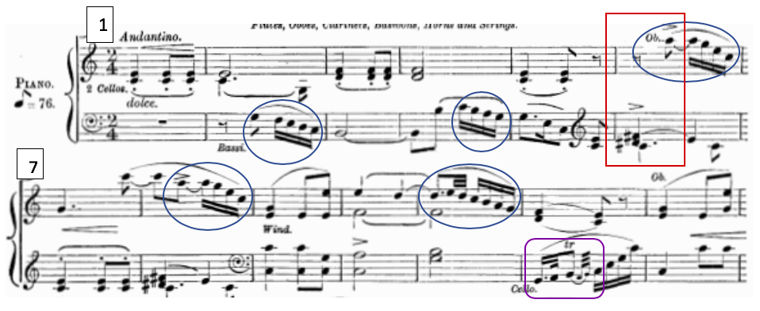
Figure 1: Euryanthe Act I, No. 5 “Cavatina,” mm. 1–13; cascading gesture in mm. 2, 4, 6, 8, and 11; dotted-rhythm followed by trill motive in m. 12

This particular example also contains another motive associated with Euryanthe: a dotted-rhythm followed by a trill occurring in the cello line (m. 12), which lends the aria an idyllic and innocent character. Interestingly, this otherwise diatonic aria is also tinged with an undercurrent of uncertainty or even villainy, with the recurring presence of a fully-diminished seventh chord, seen in m. 6. This particular chord has strong associations with Eglantine. This harmonic signifier will be addressed in greater detail subsequently.
Adolar exemplifies the operatic archetype of a Romantic hero, hence his musical language is stately and dignified, exhibiting declamatory fanfare-like statements and dotted rhythms. His musical character is also boldly heroic, singing sweeping lyrical melodies, and employing an extended range. As a nobleman, his lines tend to be more complex than those sung by Euryanthe, but his harmonic language remains generally diatonic and consonant as emblematic of his virtue. His entrance in the opening number in Act I, seen below in Figure 2, is an excellent example of this courtly and valorous quality. He sings of his unwavering faith in God and in his faith in his beloved Euryanthe at his entrance at the con fuoco.
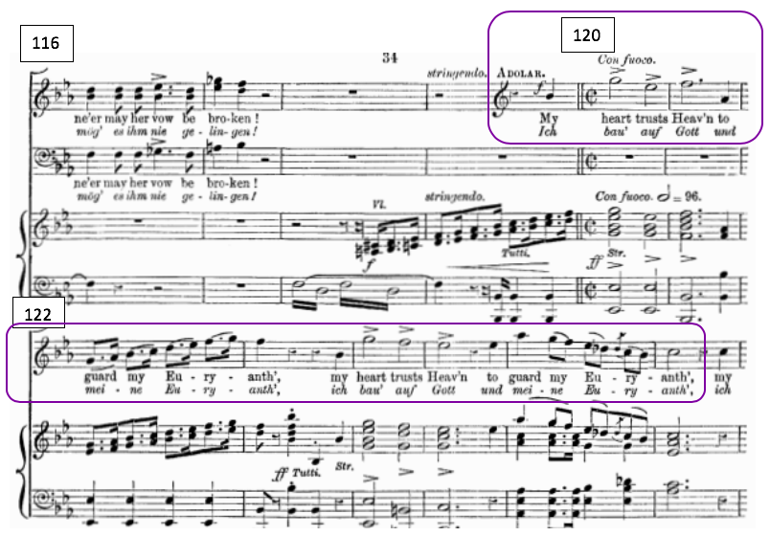
Figure 2: Act I, No. 4, Trio and Chorus, mm. 120–27, con fuoco “My Heart Trusts Heav’n,” Adolar’s declaration of faith
Weber’s villains, Lysiart and Eglantine, tend to sing in a much more wild, chromatic, and mercurial manner. Their lines are virtuosic and impassioned, distinguished by large, often dissonant leaps, dense chromaticism, and tonal instability, unpredictably weaving between keys. According to Tusa, the presence of driving triplet rhythms throughout opera has evil connotations. Offering Duetto No. II as a prime example, he notes that “rapid triplet motion [is a] gesture typically associated with either of the two villains.” The chromatic-neighbor-tone is also a recurring motive in the vocal lines of both villains. Serpentine chromatic lines, representing diabolical duplicity, are common in their melodies and accompanimental figurations. (Weber and Chézy’s symbolism involving the Biblical serpent of Genesis, the “Father of Lies,” is anything but subtle; the opera’s dramatic climax culminates with Adolar literally slaying a snake, having emerged victorious over Lysiart and Eglantine’s manipulative schemes.) Meyer also describes Eglantine’s music as “punctuated . . . by explosions of ‘rage coloratura’,” claiming that the “jagged outlines” of Eglantine’s melodies . . . place her firmly in the sound world of evil and the implacable enemy of Euryanthe and Adolar’s love.”
The duet between Lysiart and Eglantine in Act II serves as an exemplary musical display of wickedness. The scene, although relatively obscure to modern audiences, influenced not only Kuhlau (regarding his variation set) but Wagner as well. In Motives for Allusion, Christopher Reynolds notes that Wagner likely based his duet between Telmarund and Ortrud in Lohengrin on Weber’s duet between Lysiart and Eglantine. This duet, beginning and ending in B major, serves as a turning point in the plot, culminating with the villains forming an alliance against Euryanthe and Adolar. Eglantine, jealous of Adolar’s preference for Euryanthe, had procured, through a grizzly act of grave-robbery, the ring of Adolar’s deceased sister, Emma. Eglantine offers the ring to Lysiart, and the two conspire to use it to convince Adolar of Euryanthe’s betrayal. This scene exhibits several musical traits associated with Weber’s villains, in particular, rhythmic volatility, e.g. the syncopations and conflicting polyrhythms. Although the duo is united in a common cause with this particular scheme, each character is motivated entirely out of self-interest—their tumultuous relationship ultimately culminating in Lysiart murdering Eglantine. Weber’s use of rhythmic dissonance (conflicting rhythm) depicts this discord musically, as seen in Figure 3.
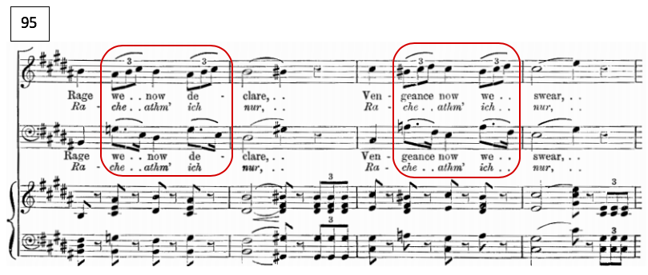
Figure 3: Act II, No. 11, Eglantine and Lysiart Duet, mm. 95–98, rhythmic dissonance

The duet also features a chromatically adorned descending line, setting a text professing the duo’s intent to enact vengeance. Seen in Figure 4, the climactic gesture on the text “rache” is an excellent example of what Meyer called “rage coloratura,” typical of Weber’s villainous vocal idioms. The melodic outlines of both voices are noteworthy as well, as Lysiart begins in m. 99 with a dissonant leap of a minor 7th from F# to E, and Eglantine’s melody outlines a similarly ungainly interval of a minor 9th from F# to G in mm. 100–101.
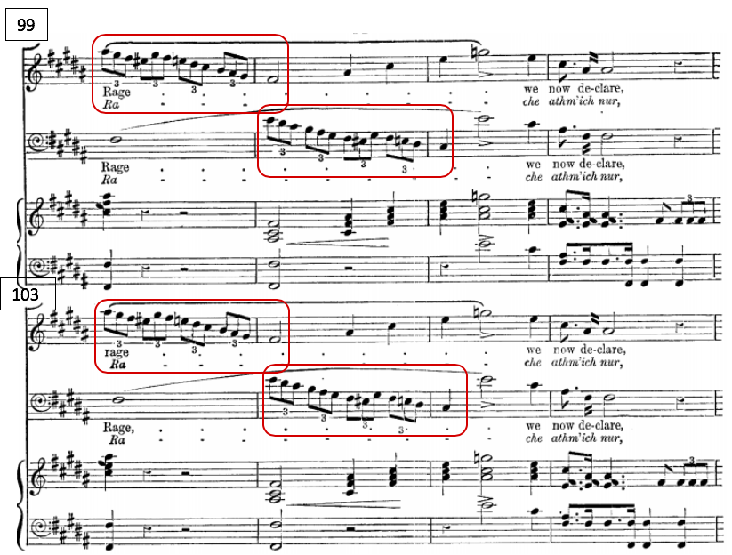
Figure 4: Act II, Eglantine and Lysiart Duet, mm. 99–106; “Rache” gesture

Weber inherited this tradition of character-specific musical attributes from eighteenth-century composers, and like those who came before him, he often used this network of symbolism in surprising ways to suggest dramatic action. Among others, composers like Handel and Mozart assigned to different characters different sorts of gestures and figures, that would not only distinguish those characters, but also help advance the plot. Just as Handel’s Armida conveys her wild, impassioned, and vengeful character in part through her large vocal leaps, melodic dissonance, and chromaticism, Weber’s villains, Eglantine and Lysiart, also sing with these conventional musical attributes to convey their unscrupulous character. Likewise, Mozart’s Don Giovanni conveys his elusive malleability of character and his powers of persuasion by adapting his musical language to appeal variously to nobility like Donna Elvira or a peasant girl like Zerlina. Thematically, the plot of Euryanthe centers around not only the suspicion and uncertainty of Euryanthe’s loyalty to Adolar, but also around Lysiart’s and Eglantine’s manipulation and persuasion. Weber reflects this musically by allowing his characters to exhibit musical traits of other characters to illustrate influence of one character over another. In Euryanthe, the character being influenced, the innocent Euryanthe, actually takes on the musical characteristics of the opera’s villains exerting such influence, as seen in Duetto No. 7 in Act I. In this particular scene, Eglantine tricks Euryanthe into confiding in her, and Euryanthe begins singing in sharp keys, and even singing some chromatically-tinged recitatives, which are not typical of her melodic lines.
Deceit Motive
As noted in reference to Euryanthe’s Love Motive and Idyllic Dotted Trill Motive, Weber’s accompanimental choices are often as telling as the vocal lines themselves. In this regard, Weber’s musical associations go beyond the tonal and the gestural. The use of leitmotiv is one feature that unifies this opera and positions it historically as an important stepping stone in the development of the Romantic Germanic music drama. In fact, it has even been argued by Donald Tovey that Euryanthe, by virtue of its motivic and structural continuity, is “a more mature work of art and a more advanced development of Wagnerian music-drama than Lohengrin, though it is a generation earlier.”
One of the most prominent examples of leitmotiv in Euryanthe is the “Deceit Motive.” Identified by Tusa as “Eglantine’s Motive,” it is broadly associated with treachery, but is mostly heard throughout the opera in reference to Eglantine herself, her duplicity, or her underhanded influence over other characters. Eglantine’s Deceit Motive is a jaggedly descending line, marked with chromatic neighbor tones, and outlining a fully-diminished seventh chord. A model statement of this motive appears in the introduction to Eglantine’s recitative, heralding her entrance into Act I, Scene iii. In this scene, she feigns friendship with Euryanthe in order to gain her trust. This leitmotiv is seen in Figure 5.
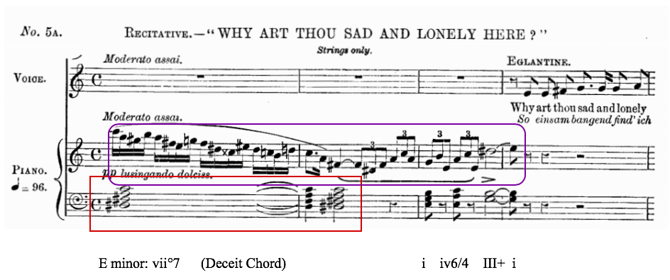
Figure 5: Act I, No. 5 mm. 1–4; Eglantine’s Deceit Motive, supported by the Deceit Chord, from piano reduction

This chromatic, serpentine motive is representative of Eglantine and her symbolic connection to the poisonous snake that appears in the forest in the final act and that Adolar ultimately vanquishes. This gesture melodically outlines a fully-diminished seventh chord with a D# as the root (D#, F#, A, C). As this chord in block form also accompanies the Deceit Motive, it is also associated with betrayal, and specifically with Eglantine. Following Tusa, this chord will henceforth be referred to as the “Deceit Chord.” This chord serves as a dramatically significant sonority in the opera—and in fact, its aforementioned presence in Euryanthe’s idyllic Cavatina No. 5 scene foreshadowed Eglantine’s treacherous influence over Euryanthe.
Broadly speaking, the fully-diminished seventh chord is unsurprisingly used frequently to signal dramatic tension. The dissonance of this sonority itself is only partially what makes this chord so dramatically effective. Specifically, it is the uncertainty and ambiguity of this chord’s potential resolution which creates an added level of suspense. Its potentiality for respelling and modulation to foreign and remote key centers gives the chord an inherent ambiguity and volatility. This chord embodies both the visceral experience of foreboding (as used famously in Weber’s “Wolf’s Glen” scene in Der Freischutz), but also the primary literary themes of Euryanthe: uncertainty and deception. This dissonant, unstable, and potentially enigmatic sonority is used by Weber to foreshadow Eglantine’s diabolical schemes and to indicate betrayal throughout the opera.
In the context of the Deceit Motive, this chord almost always resolves to E minor, establishing this key as Eglantine’s “trademark” tonality, which, as aforementioned, has connotations of unrequited love and jealousy, as established in the German musical canon by convention. The Deceit Chord is also of particular significance in Kuhlau’s variation set, as its spelling, and by extension, its resolution, serves as the basis of the overarching tonal conflict in the work.
In summary, Weber’s use of motivic and tonal association as demonstrated in Euryanthe, and his use of these techniques for dramatic purposes, influenced the compositional styles of the Romantic German tradition of the later generation, in the form of Wagnerian music-drama. Weber’s dramaturgical emphasis, tonal symbolism, leitmotivs and character-specific vocal attributes also presented Kuhlau ample opportunity to allude to the narrative of the opera. Furthermore, Weber’s musical portrayal of one character’s influence over another may have inspired Kuhlau’s parody technique, which will be explored in the following chapters. For reference, Table 1 summarizes Weber’s musical qualities associated with each character.

CHARACTER | PRIMARY KEYS | MOTIVES | VOCAL ATTRIBUTES
Euryanthe | C Major | - Cascading Love Motive  - Idyllic Dotted Trill Motive | - Diatonic  - Limited range  - Conjunct  Melodies  - Mostly lyrical  - Leaps are triadic
Adolar | Ab Major  Bb Major  Eb Major | - Cascading Love Motive  - Stately Dotted Rhythm | - Mostly diatonic  - large triadic leaps  - Exhibits lyricism and brilliance  - Declamatory style
Lysiart | B Major  F# Major | - Rage Motive  - Driving Triplet Motive | - Extended Range  - Dissonant Leaps  - Syncopation  - Rhythmic Dissonance
Eglantine | E Minor  E Major  B Major | - Deceit Motive  - Deceit Chord  - Rage Motive  - Driving Triplet Motive | - Extended range  - Rage coloratura  - Chromatic lines  - Dissonant leaps  - Rhythmic dissonance
King Louis VI | Eb Major | - Stately Dotted Rhythm | - Limited lyricism  - Declamatory style

Table 1: Motivic and vocal attributes and tonalities by character

Chapter 3
Kuhlau’s Model Approach to Variation
Arndt Mehring’s synopsis of Euryanthe Variations, although brief, acknowledges that Kuhlau’s work displays remarkable sophistication. He notes that “in the introduction and the six variations, [Kuhlau] makes use of the tonal [timbral] and technical possibilities of both instruments in such a way that the theme appears as if viewed through a kaleidoscope in a constantly new light.” In order to clarify what Mehring might mean by this in the context of a variation set, I turn to Theodore Adorno, who uses strikingly similar language to describe Schubert’s approach to variation.
Adorno likens Schubert’s theme to “a wanderer who encounters the same passages again, unchanged, yet in a new light.” According to Adorno, Schubert’s themes “know no history, only perspectival circulation: all their changes are changes of light.” Adorno also makes a distinction between Schubert’s type of variation and Beethoven’s developmental approach, observing that Schubert’s “wanderer” “circles his way through [the landscape] without progressing: all development is its complete antithesis.” Adorno also asserts that these “perspectival” variations consist of themes “devoid of any dialectical history,” and that “Schubert’s variations, unlike Beethoven’s, never disturb the fabric of the theme, but rather encircle and evade it.”
In light of Adorno, Mehring’s observation is only partially correct: Kuhlau does exploit the idiomatic techniques of both instruments, displaying their virtuosic capacities equally, which lends the work an array of tonal colors. However, Mehring’s definition of “kaleidoscopic” seems to end here, resting entirely on Kuhlau’s idiomatic writing and the timbral possibilities he facilitates. Taking Adorno’s precise definition of prospective-oriented variation into account, Kuhlau’s variations do not resemble Schubert’s unchanging character seen in different peripheral lighting; instead, Kuhlau’s variations are distinct changes in character. Kuhlau’s theme also clearly has a “dialectical history”—a quality of which Schubert’s themes are devoid, according to Adorno. This is to say that Kuhlau’s theme, unlike Schubert’s, presents a conflict of forces, which subsequently battle each other throughout the set.
A motivic and harmonic analysis of Op. 63 suggests that the “kaleidoscopic” lens through which Kuhlau presents the theme is better understood as a succession of certain motivic and tonal attributes that directly relate to Weber’s opera. In other words, each variation showcases a particular motivic or tonal allusion or a combination thereof. Furthermore, if the listener is to take account of the dramatic associations of Weber’s borrowed motives and tonal symbolism, each variation would then, in a sense, take on the character traits signified by the allusions. This “constantly new light” in which Mehring hears the theme in each variation, could be explained by this constantly shifting character association.
A comparative analysis of the Op. 63 Variations and Weber’s Euryanthe supports the premise that Kuhlau’s work is best understood from a dramaturgical perspective. Its affects hinge on Kuhlau’s adoption of Weber’s operatic motives and tonalities to allude to dramatic action from his operatic source material. In the chapter “The Importance of Parody,” in Beethoven’s ‘Diabelli Variations,’ William Kinderman argues that “a fundamental aspect of parody . . . is the allusion that points beyond itself; with or without irony, such an evocation enjoys a complex existence between two modes of being—literal, and referential.” Furthermore, he goes on to define one of the techniques of parody as “travesty,” or the deliberate distortion of the theme. If we interpret “travesty” as altering the dramatic connotations of the theme, it would seem that Kuhlau exploited this technique in Op. 63 by tinging Adolar’s “Romance” Theme with several duplicitous musical associations.
The remainder of Chapter 3 presents an analysis of Kuhlau’s Op. 63 based on the motivic, harmonic, and dramatic elements of Weber’s opera, as outlined in Chapter 2. Chapter 3 begins with an analysis of the Theme, followed by an analysis of the organizational principles of the work—namely the tonal problem around which Kuhlau has built the variation set, and its narrative implications.
The “Romance” Theme
Kuhlau uses Adolar’s “Romance” from Act I as the basis for his Op. 63 Euryanthe Variations, and it seems that he has selected this aria with expert care. This particular aria gave Kuhlau a wealth of harmonic interest, while simultaneously alluding to the plot of the opera: Adolar’s tenuous faith in Euryanthe’s loyalty.
In Adolar’s “Romance” No. 2 Act I “Unter blühenden Mandelbäumen,” Adolar admiringly sings of the purity, loyalty, and constancy of his betrothed Euryanthe, referencing the overarching narrative theme of the opera. A poetic translation provided by William Hornthwaite reads:
‘Neath the almond blossom waving,
By the Loire’s Flowing stream,
Where my lov’d one first did charm me,
There of her I fondly dream.

She the purest, sweetest, dearest!
Chaste as snow, a rose most rare,

Neath the almond blossom waving,
She appears in vision fair.
When the Golden stars were shining
On the Loire’s fertile shore,
Flash’d to Heav’n her radiant glances
Pledging love for evermore.
Joyful, hopeful, fond and faithful,
Eye to eye spoke love to love.

‘Neath the stars forever shining,
Hearts were knit by Heav’n above.
Lovely rose, of faith the token
On the Loire’s verdant strand,
E’en when storm and wave are raging,
Thou the pledge of spring shalt stand.
Fondest, purest, sweetest, dearest!
I am thine, and thou mine own!
Lovely rose of faith the token,
Grace my darling’s breast alone.

While the general character of Adolar’s aria is anthemic and dignified—a sweet and earnest ode to the feminine ideal—Weber’s harmonic language subtly foreshadows a darker undercurrent of doubt. The aria’s brief four-bar introduction opens not in the bright and cheerful B-flat major, but in its relative minor, G minor, associated with discontent, uneasiness, and resentment. The stately dotted rhythms evoke the Baroque French overture style, and a spirit of nobility and honor; the sweeping lyricism of this theme also underscores Adolar’s sensitive qualities. However, Weber also creates an air of harmonic uncertainty by momentarily modulating to the mediant, a sharp key, D major, and by using Eglantine’s Deceit Chord, as a transitional chord to modulate back to the tonic key, B-flat major, as seen in Figure 6. The Deceit Chord, identified by Tusa, and explained in Chapter 2 is associated with ominous or duplicitous dramatic action, and with Eglantine. In this example, the Deceit Chord can be seen on the downbeat of the second measure of the top system. This chord, (F#, C, A, Eb) is notably voiced in a way that emphasizes the diabolical tritones, and is spelled with an F# which is diatonically indigenous to the mediant key of D major (i.e., naturally occurring in the key of D major). However, the F# unexpectedly resolves downward in the next beat to an F-natural, returning to the tonic key of B-flat major. (The Deceit Chord or F#°7 already shares three common tones with a dominant F7 chord: A, C, and Eb. This essentially smooths out the harmonic “non-sequitur” from the first stanza.)
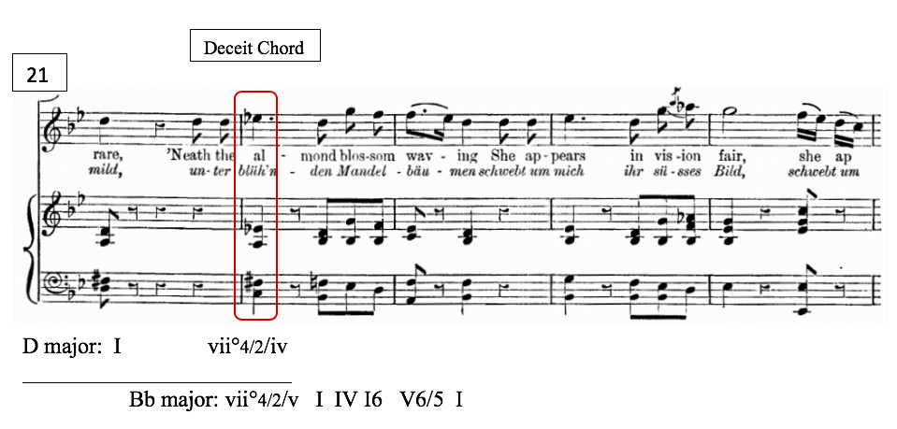
Figure 6: Act I, No. 2 Adolar’s Romance, mm. 21–25; modulation back to Bb major and Deceit Chord

From a dramatic standpoint, this brief allusion to Eglantine’s unstable harmonic sonority might be interpreted as foreshadowing Adolar’s impending doubt of Euryanthe’s loyalty. Lysiart’s schemes to compromise Euryanthe’s honor, aided by his accomplice Eglantine, nearly succeed in sabotaging the lovers’ betrothal by shaking Adolar’s faith. Weber’s injection of a rancorous harmonic reference into Adolar’s otherwise sincere profession of love seems to have influenced Kuhlau’s interpretation of this aria, and his subsequent treatment of this theme. Kuhlau uses this brief tonicization of the mediant, and the harmonic ambiguity of the Deceit Chord to create an overarching tonal conflict—a conflict which he underscores by incorporating motivic characteristics of the operatic villains’ musical language, and by alluding to their symbolically sinister key centers.
Kuhlau has conveniently transposed the aria tune from the original key of B-flat major to the more technically manageable G major, but this is his only significant alteration to Weber’s theme. The melodic and harmonic structure remain unaltered from the original aria (with the exception of mm. 2–3, where Kuhlau sustains the dominant across these measures; Weber’s model returns to the tonic on m. 3.) For reference, Figure 7 outlines the formal structure of the “Romance” theme, as it appears in Kuhlau’s Op. 63. As shown in this example, the form may be understood as a rounded binary form: A B A’ followed by a transition, which harmonically prepares the succeeding variation. The first statement of A is comprised of an antecedent and consequent phrase, and a continuation into the B section. The modulation to the mediant occurs in m. 14.

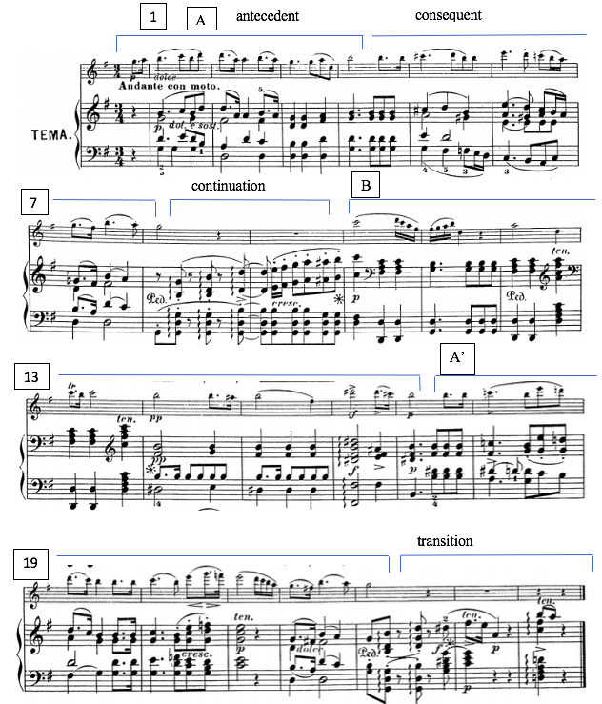
Figure 7: Formal Outline of Kuhlau’s Theme
A harmonic outline of Kuhlau’s theme is found below in Figure 8. 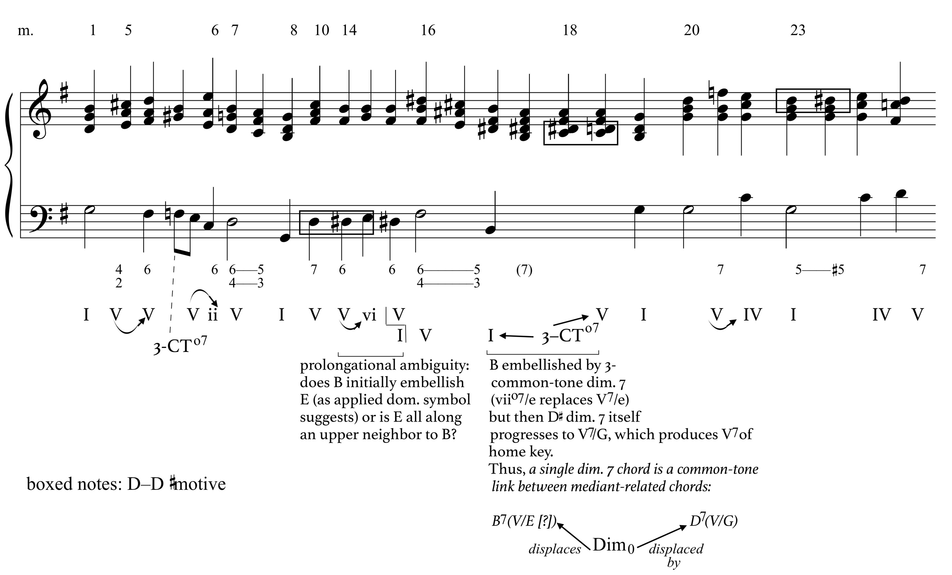
Figure 8: Harmonic Outline of Kuhlau’s Theme

As Kuhlau was a flutist himself, and as earlier stated, was lauded for his ability to write music “tailor-made” for the flute, it is likely that playability was a consideration when selecting a key in which to write. G major would have admittedly been more conducive to a virtuoso piece than B-flat major on the early-nineteenth-century “simple system” flute. However, Kuhlau may have had an additional motive for transposing Weber’s “Romance.” It was extremely rare for composers to transpose a model to a different key. According to Busk, when using the “model technique,” composers did not transpose borrowed material arbitrarily:

How great the admiration of the model and his music was – and in no way did they try to hide this—appears from the central aspect of the model technique: that, in most cases by far, the “imitation” was so close to the music that had inspired the composer that the tempo, the key, the time signature, and the whole character and mood of the piece remained the same. This applies especially to the key. A key that deviates from the model – though almost always in the relevant major or minor—can be found, but it is a rarity.

Further, he explains that the primary reason for this is the careful attention composers of the past gave to the symbolic meaning attached to key centers. This would seem to suggest that Kuhlau did not transpose the theme arbitrarily, or at least, not merely to facilitate playability. By placing the theme in G major, the mediant (to which the contrasting Section B modulates in m.14) becomes B major—the primary key in which Lysiart sings, and the dominant to the key in which Eglantine primarily sings, E minor. As discussed previously, Weber carefully assigned particular keys to particular characters based on the conventional connotations of those keys—B major and E minor were among the most diabolical. Kuhlau, likewise, would have at least been, at the very least, aware of these key associations. Kuhlau’s tonic key, G major, although not explicitly associated with a particular character, has pleasant, tranquil connotations; according to Tusa’s tonal analysis of Euryanthe, “the three important uses of G major all convey a sense of calm or peace.” As such, simply by transposing the aria for this theme, Kuhlau has tonally manifested a symbolic dichotomy of good and evil within the theme—a dichotomy that was subtly implied by Weber’s insertion of Eglantine’s Deceit Chord in Adolar’s “Romance.”
Kuhlau’s decision to transpose the aria to G major also presented him with the opportunity for motivic quotation at the exact pitch level presented in Weber. Notably, this includes a recurring [B-A#-B] neighbor motive associated with villainy, which will be addressed in detail in Chapter 4. It also includes a significant harmonic motive as well: the Deceit Chord.
By transposing the entire theme down by a minor third, the Deceit Chord is aurally the same as it was in the opera, only spelled enharmonically. This is a convenient property of the fully-diminished-seventh quality of this chord: it is invariant when transposed by a minor third. In both instances (Weber and Kuhlau), the chord is still comprised of F#, A, C, and Eb/D#. This exact sonority recurs throughout the opera, at pitch, signifying Eglantine. As seen below in Figure 9 (a comparison), Kuhlau allows his enharmonic spelling of the Deceit Chord to serve the same functional purpose as it did in Weber’s “Romance” theme—occurring at the same moment, modulating back to the tonic in the first full measure of the A’ section.

Weber: (See Figure 6 for harmonic analysis)
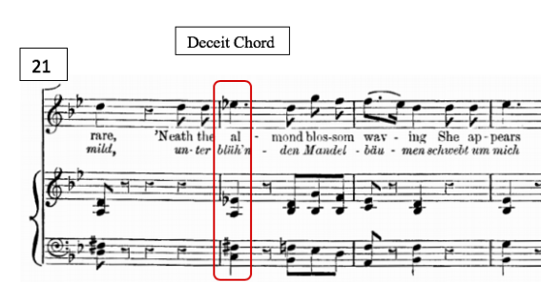
Kuhlau
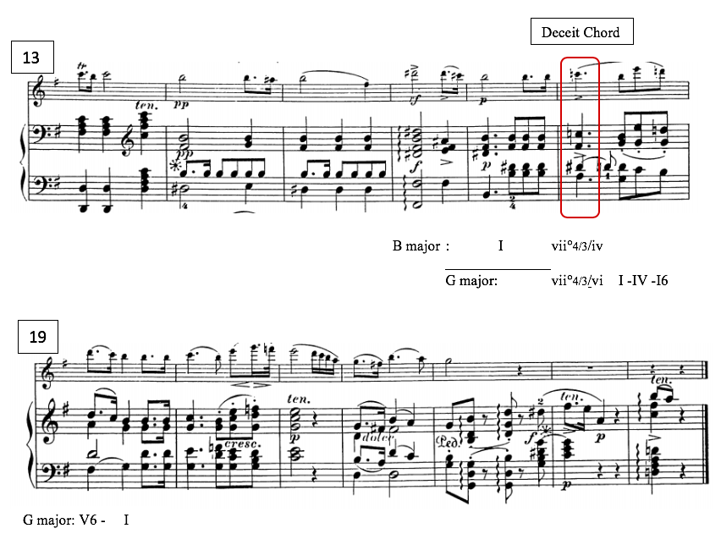
Figure 9: Comparison of Weber’s Act I, No.2, Adolar’s “Romance” m. 22 and Kuhlau’s Op. 63 Theme, m. 18; Deceit Chord

In the context of Kuhlau’s transposed theme, the D# of the Deceit Chord serves the same function that the F# served in its context in Weber’s aria. As seen above, Kuhlau’s D# resolves downward to D-natural which initiates the modulation back to the tonic of G major. However, the enharmonic spelling suggests some ambiguity in functionality. As explored in the next chapter, Kuhlau seems to play with this ambiguity, letting it serve as a focal point of dramatic conflict in the variation set.
Kuhlau’s work hinges on a “tonal problem,” derived from the enigmatic nature of the Deceit Chord, exploiting the disparity between the enharmonic spellings of D# and Eb. As I will demonstrate throughout this analysis, this enharmonic disparity is introduced early in the piece (in the Introduction), and remains an important motive throughout the set. This theory is grounded largely in the work of Schoenberg and outlined in Patricia Carpenter’s article “Tonality: A Conflict of Forces.” A tonal conflict can arise from an ambiguity of the functionality of a particular pitch-class. A pitch-class may either function centripetally (leading the ear toward the piece’s tonal center), or it may function centrifugally (leading the ear away from the piece’s tonal center, toward an alternative key center). In this variation set, Kuhlau exploits this dichotomy, and poses the question of whether he is ultimately favoring G major via the predominant-functioning flat-VI, Eb, or if he is pointing toward E minor via its leading tone, D#. In other words, the listener must determine whether this pitch-class is a D#, functioning as a lower neighbor to E, or if the pitch-class is actually an Eb, serving as a tone derived from modal mixture in the home key of G major.
The theme of Weber’s “Romance” lends itself well to variation, as the loosely strophic form of the aria parallels the structure of a theme and variation form. Adolar sings three distinct iterations of the same thematic material with varying accompaniment patterns, and vocal embellishments, each time, changing the character of the theme. Similarly, Kuhlau presents each variation as if seen through a new lens, as observed by Mehring. In light of the aforementioned tonal implications, perhaps the “kaleidoscopic lens” Mehring described could more precisely be attributed to the shifting presence of villainous or virtuous musical elements, and specifically, the functionality of the D# or Eb pitch-class, and by extension, the tonicization of E minor/B major or G major, respectively. Throughout the set, Kuhlau varies the intensity of the tonal problem—at times neutralizing it, and at times exacerbating it. He does this primarily by incorporating the D# or Eb into seemingly ornamental figurations, while varying the directionality by which the tone resolves. The following analysis, presented chronologically by formal section, explores Op. 63 Euryanthe Variations from this perspective, discovering Kuhlau’s integration of operatic motives, as well as his working out the tonal problem.

Chapter 4
Analysis of Introduction and Variations on Euryanthe, Op. 63
Introduction
Establishing the Conflict
Kuhlau’s Introduction serves several expositional purposes: it sets the stage by evoking the ominous mood of Weber’s opera, presents the tonal centers at play and their relationships, introduces some important motives, and most importantly, it establishes the tonal problem.
The Introduction embodies the Sturm und Drang of Weber’s operatic writing. As seen in the various modulatory passages discussed previously, progressive animation and detached arpeggiations figuratively set the volatile scene, underscoring the tension and harmonic instability of the prevalent fully-diminished 7th chords. This instability reflects the opera’s pervasive literary themes of uncertainty and deception. Unfortunately, the extensive use of Weber’s music to accompany silent films during the early Twentieth Century has turned this operatic compositional technique into a melodramatic cliché to modern audiences. However, Kuhlau’s audience would likely not have been as desensitized to the dramatic effect of the diminished seventh chord.
Formally, Kuhlau’s Introduction could be understood as an elaboration on Weber’s simple four-bar introduction to Adolar’s “Romance.” In fact, the first four bars of Kuhlau’s Introduction share a similar, simple chordal structure with Weber’s introduction. A comparison can be seen below in Figure 10 and Figure 11. Weber’s Romance emerges from a number in G major, so these measures serve as a transition, but could also be heard simply as an auxiliary cadence in B-flat major.
Weber:
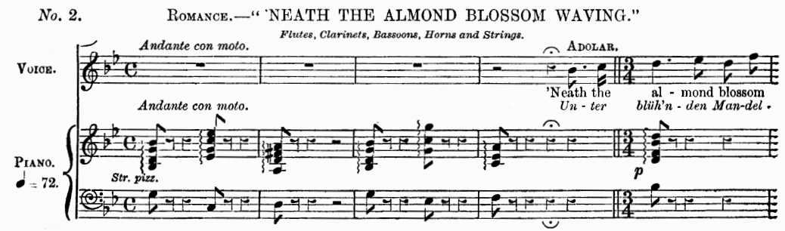
G minor: I iv V I iv
Bb: ii V7 I
Figure 10: Weber Act 1 No. 2, Adolar’s “Romance,” mm. 1–5

Kuhlau:
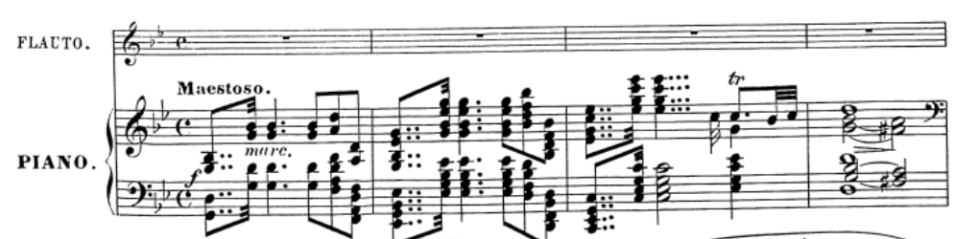
G minor: I ii6/4 bVI III iv V6/4-5/3
Figure 11: Kuhlau Op. 63 Introduction, mm. 1–4

Furthermore, the large-scale harmonic outline of Kuhlau’s 32-bar Introduction also shares a similar structure with these initial four bars of the piece (Figure 11). In skeletal form, the entire 32-bar Introduction outlines i-vi-iv-V. (The dangling dominant leads directly into the G-major Theme.) Interestingly, the only significant difference between the harmonies outlined in the initial four bars and those outlined by the entire Introduction is the quality of the sixth scale degree: m. 2 uses the lowered sixth (E-flat major), while the formal outline instead moves to the raised sixth, (E minor).
The most salient role of Kuhlau’s Introduction is establishing the overarching tonal problem of the work; it accomplishes this by featuring the enigmatic Deceit Chord, and its possible resolutions. It appears throughout the Introduction in the context of G minor, and in E minor, and it is spelled diatonically in each key (Eb in G minor, and D# in E minor.) At the first entrance of the flute in the fifth measure, Kuhlau presents the Deceit Chord, (spelled F#, A, C, Eb), and subsequently lays out the Tonal Problem. As the opening four bars of the piece clearly establish a G minor tonality, the entrance of the “Deceit Chord” in m. 5 is naturally heard as vii°4/3 in the key of G, (F#°4/3). This introduces the pitch-class, Eb, as part the diatonic minor mode. Kuhlau uses the Deceit Chord in m. 5 as a pivot chord to modulate to E minor. vii°4/3 in G enharmonically becomes vii°4/2 in E minor. This B-natural in m. 6 reinforces the dominant function of the chord in its new context of E minor, sounding a B7 on beat 1. On the third beat of m. 6, the Deceit Chord returns, the enharmonicism made explicit, spelled with a D# instead of an Eb. The D# then expectedly resolves upward to E in m.7, establishing the new nefarious tonality of E minor. This modulatory passage from measures 5–7 can be seen below in Figure 12.
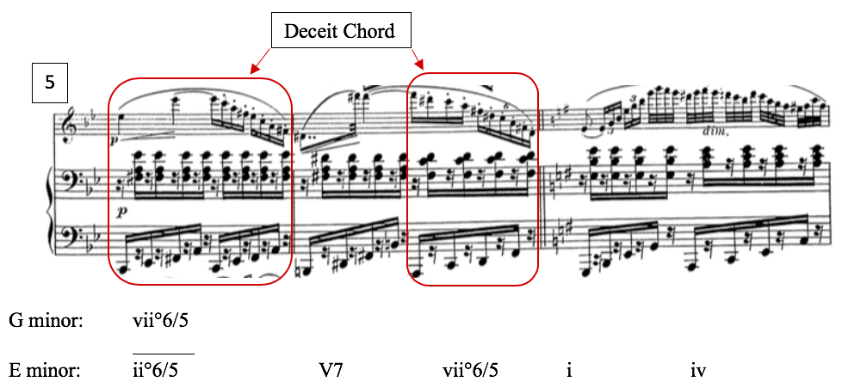
Figure 12: Introduction, mm. 5–7, modulation from G minor to E minor

In mm. 8, now comfortably in E minor, the Deceit Chord is heard again, in the flute, as vii°7, establishing the new tonic at the arrival at m. 9. Mm. 9–12 restate the opening melody with the exact harmonic progression as before, only now in the key of E minor. Mm. 8–12 can be seen below in Figure 13.
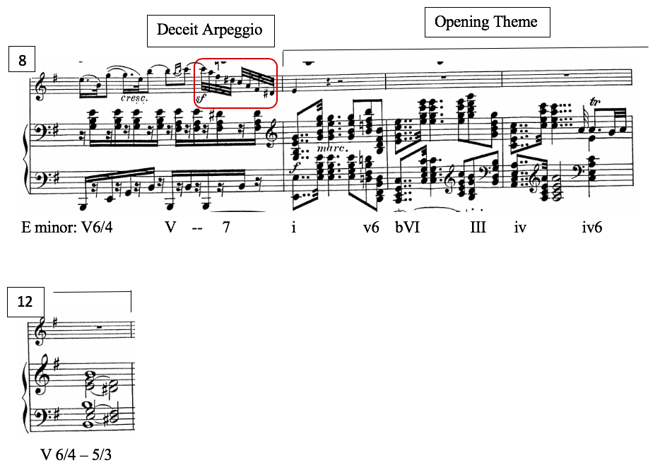
Figure 13: Introduction mm. 8–12, E minor section

As shown in Figure 14, mm.13–16 serve as a modulatory passage, leading back to G minor, by way of a strong tonicization of iv (C minor). The route to C minor, as with the previously discussed modulation to E minor, uses the enharmonic respelling of a fully-diminished-seventh chord. Melodically, this passage also parallels the earlier modulation in mm. 5–6. The harmony in m. 13 is a G#°7, and coming out of E minor, the chord sounds as a vii°7/iv. The G# bass slides by semitone to the G7 chord in M. 14, supporting a C minor scalar passage in the flute line, both clearly tonicizing C minor.

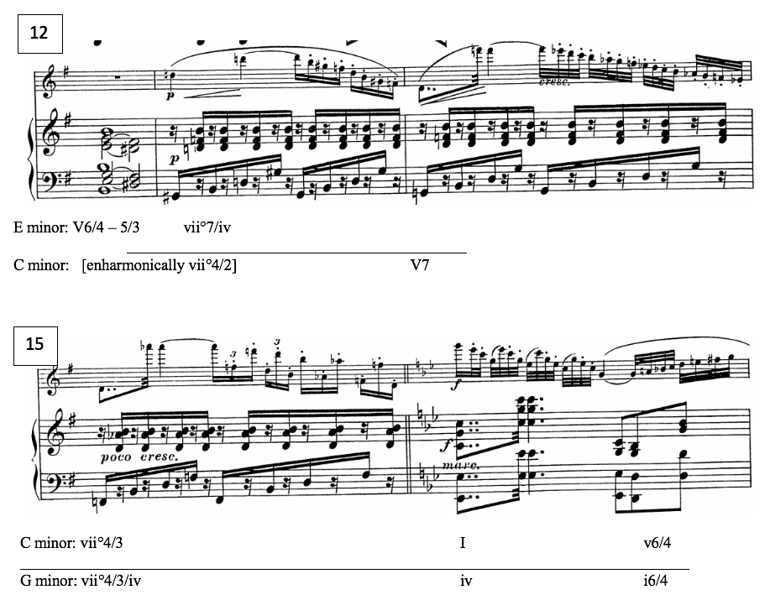
Figure 14: Introduction mm. 12–16, modulation to G minor through a tonicization of C minor

After this lingering tonicization of iv, Kuhlau returns to G minor (Figure 15) with a Neapolitan as a pivot chord in m. 17, followed by a cadential 6/4 in mm. 18–20; however, in operatic fashion, the flute’s A-B trill breaks away into a “rage coloratura” passage, outlining the Deceit Chord, instead of resolving to G minor as would be expected. In this context, the Deceit Chord functions as a vii°7 in G minor.
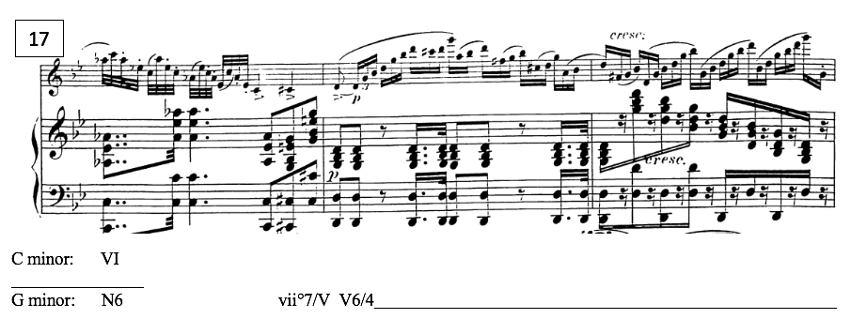
Figure 15: Introduction mm. 17–19, cadential progression

Rather than resolving this diminished chord at the conclusion of the flute passage, the piano entrance in m. 22 harmonically extends the melodic cadence in the flute, eliding into a piano cadenza, seen in Figure 16, and continued in Figure 17. This passage prolongs the harmonic instability while suggesting that the question of this enigmatic Deceit Chord’s resolution is a focal point on which this variation set balances.
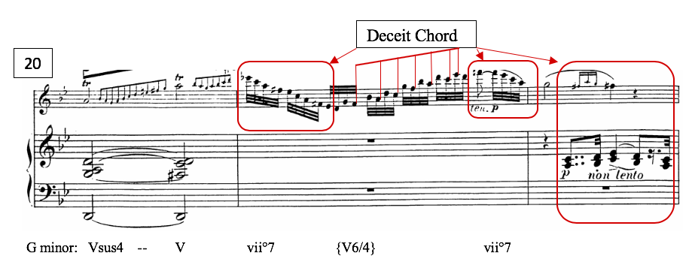
Figure 16: Introduction mm. 20–22, flute “Rage Coloratura” outlining Deceit Chord, piano elision

This virtuosic exchange between the instruments establishes the egalitarian treatment of the flute and piano as equal chamber music partners, and also signifies the importance of the Deceit Chord, as both cadenzas are based on this sonority. The piano cadenza also presents an alternative resolution of the Deceit Chord: a D7, as seen in Figure 17. Both flute and piano cadenzas feature the Deceit Chord spelled diatonically with an Eb, and both instruments accordingly resolve the chord downward to D, indicating the tonic key of G minor. Kuhlau then weaves a transitional passage that chromatically leads the listener into the bright and cheerful G-major Theme. Kuhlau includes one final allusion to the tonal problem in beat 3 of the penultimate measure, placing a rinforzando on a syncopated Eb, which moves chromatically upward to E natural (with a ritardando beginning exactly on that motion). This curious accent confirms the tonal conflict surrounding Eb. It is also a moment derived directly from the Theme: mm. 30–31 in the Introduction foreshadow a harmonically similar ascending chromatic gesture in mm. 23–25 in the Theme, seen in Figure 17 and Figure 18, respectively.
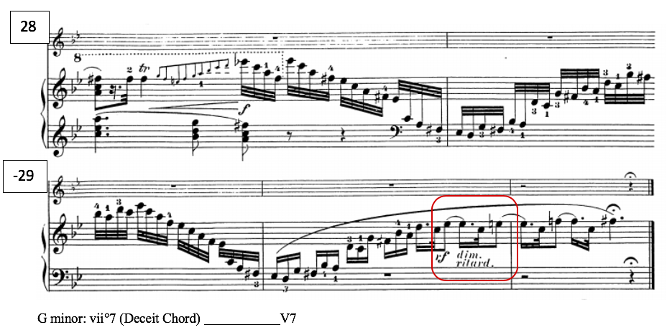
Figure 17: Introduction mm. 28–31, piano cadenza; Deceit Chord resolution to D7; circled rinforzando on syncopated Eb, and ritardando on its moving up to E
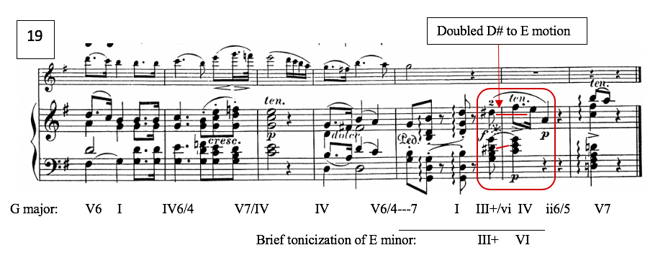
Figure 18: Op. 63 Theme mm. 19–25; Doubled voice leading from D# to E, with sforzando

One last consideration is the Introduction’s tonal symbolism. Symbolically the G minor tonality of the Introduction (Kuhlau’s as well as Weber’s four-bar introduction) could reasonably be interpreted as an allusion to the opera’s darker plot elements. Tusa asserts that “slow G-minor arias” are often associated with “isolation, abandonment, or lost love”—all predicaments faced by the opera’s heroes. The lovers are divided by duplicity, Adolar convinced of Euryanthe’s betrayal. Furthermore, the modal shift in tonality at the onset of the peaceful G major theme could be representative of the eventual reconciliation of the separated Euryanthe and Adolar.
In conclusion, this Introduction is not based on the theme itself, but is a self-standing section that forges links to the opera as a whole, embodying the volatile instability of the opera’s conflict. Even more importantly, it extrapolates the tonal problem from the Theme, establishing the Deceit Chord as a salient contentious sonority in the piece.

Variation I
An Exposition of Motivic Gestures
Kuhlau’s first variation serves as a playful exposition of some operatic motives featured in the subsequent variations. Following the template established by the “Romance” theme, Kuhlau uses the B section (in mm. 14–17, and the following modulatory measures) to highlight the tonal problem, and also to allude to some of Weber’s symbolic musical idioms.
Kuhlau immediately introduces several musical traits representative of the language of Lysiart and Eglantine namely, syncopation, chromaticism, dissonance, and the B-A#-B motive, and by extension, chromatic “neighborness” in general. The A# is introduced in the first full measure of the variation—and on a syncopated rhythm, no less, and followed by a descending chromatic line in the next measure, as seen in Figure 19.

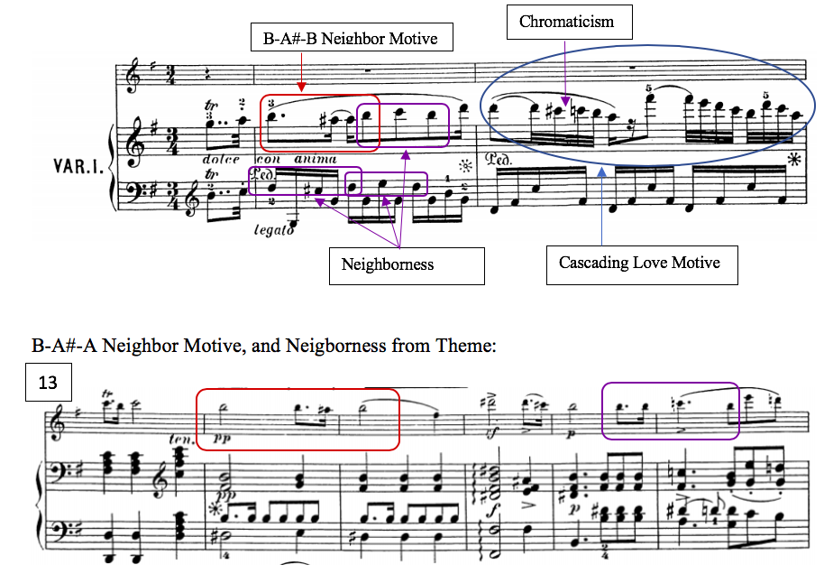
Figure 19: Var I, mm. 1–2, and the B section of the Theme, mm. 13–18; neighbor motives

This neighbor motive, extracted from the B section of the Theme, is accentuated in this context by the same figuration in the bass. From this point onward, neighborness—on B-A# and on other pitches—becomes a feature in its own right, one that is exemplified throughout the variation. As the figuration is derived from the Theme, naturally chromatic neighbor tones pervade the B section of Variation I, and even bleed into the return to the tonic in the A’ section. Specifically, the neighbor motives can be found in m. 10, mm. 14–22.
Scalar chromaticism is another motivic idea, derived from a moment in the Theme, which Kuhlau introduces in this Variation, and later exemplifies, ultimately becoming a recurring motive in the variation set. The basis for the incorporation of linear chromaticism (as opposed to neighbor-note chromaticism) is found in m. 9 of the theme, the continuation from the A section into the B section. Figure 20 and Figure 21 demonstrate the parallelism between measure 9 in the Theme and measure 9 in Variation I.
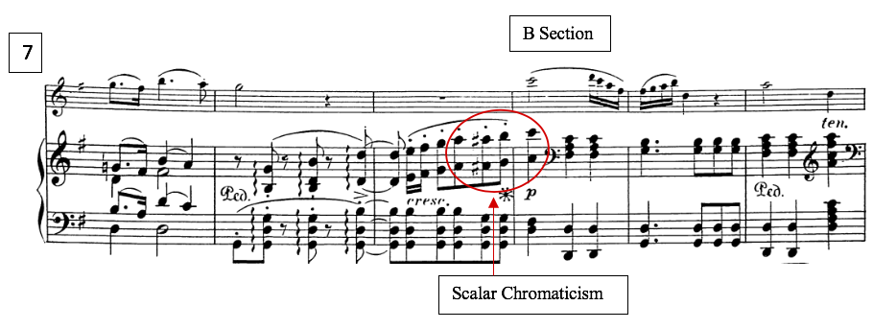
Figure 20: Theme m. 7–12; chromatic A#, ascending scalar chromaticism in m. 9

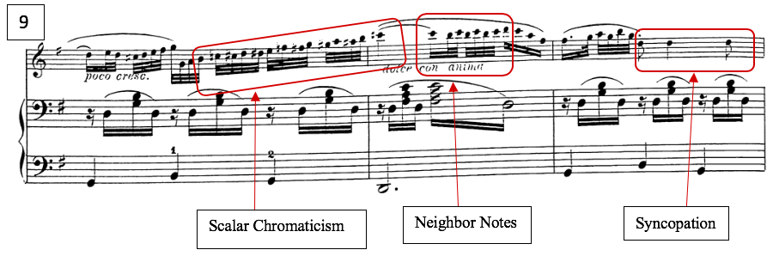
Figure 21: Var I mm. 9–10; ascending scalar chromaticism in m. 9

In addition to chromaticism, the recurring motive of syncopation ostensibly derives from this continuation of the theme in m. 8 as well, as seen in Figure 20. As noted previously, the first measure of Variation I features a syncopated rhythm, which also highlights the B-A# neighbor motive—both motives associated with deceit (Figure 19). Syncopation is also featured prominently in m. 4 (Figure 23), m. 11 (Figure 21), and mm. 13–15, seen in Figure 22.
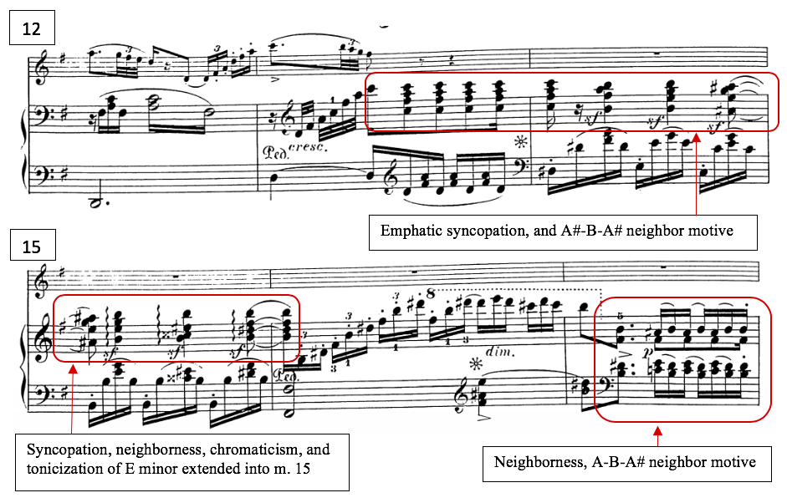
Figure 22: Var I, mm. 12–17; emphatic syncopation, neighbor tones, and tonicization of E minor

Not all of Kuhlau’s motivic allusions are pernicious; Variation I also features musical gestures associated with the opera’s protagonists, Adolar and Euryanthe. Kuhlau borrows two motives from the accompaniment of Euryanthe’s Cavatina, No. 5 from Act I: a diatonic cascading gesture, previously identified as the Love Motive, and a dotted-rhythmic motive with a trill and a turn into the following beat, recurring in the bass line of the orchestral accompaniment. Both of these motives are shown in their original operatic context in Figure 1 (Chapter 2).
Notably, the cascading Love Motive is also present in Adolar’s Romance, and by extension, is present in Kuhlau’s Theme. This is among the shared motives between Euryanthe and Adolar, representing their affectionate sentiments toward each other. Kuhlau reiterates this motive, working it into mm. 2, 6, and 10 (where it appears in the original theme).
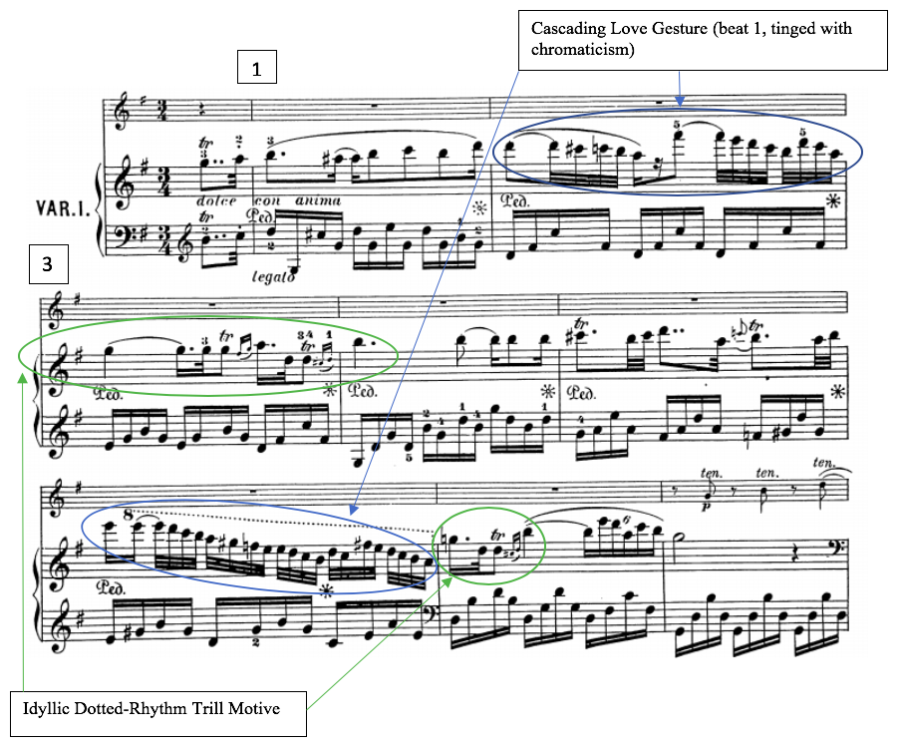
Figure 23: Var I, mm. 1–8; “Cascading Love” and “Idyllic Dotted-Trill” motives

Kuhlau also features the Cascading Love Motive at the very end of Variation I in a playful imitation between flute and piano in mm. 25–26, seen in Figure 24.
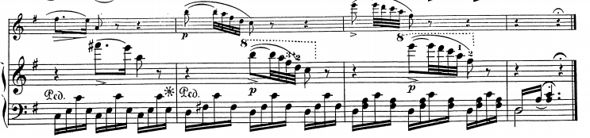
Figure 24: Var I, mm. 24–27; Cascading Love Motive in playful imitation
24

Kuhlau’s most significant allusion is a paraphrase of Eglantine’s Deceit Motive heard in m 21. For comparison, Weber’s Deceit Motive is found in Figure 5 (Chapter 2). Interestingly, Kuhlau’s paraphrase occurs not in m. 18 with the iteration of the Deceit Chord in the parallelism with the Theme, but rather it occurs precisely at the moment of the theme when the harmonic tension should subside. On m. 21 in the Theme, the harmony is simply a IV chord (C in the Key of G major). However, in Variation I, we get more harmonic interest, with an A minor chord, with G# leading tone, seen in Figure 25. Although transposed from the pitch level from the opera, Kuhlau’s paraphrase retains the distinct melodic outline of the leitmotiv.
This paraphrase of the Deceit Motive embodies the overwhelming concept of Variation I as a whole, as a playful mixture of symbolically polarized musical ideas. Kuhlau has cleverly melded two opposing motives from the opera into these two measures, concluding the gesture with Euryanthe’s idyllic Dotted-Trill Motive, rather than the expected dotted-eighth-note followed by a sixteenth-note rhythm. Furthermore, rather than proceeding from the dotted rhythm into an ascending triplet gesture, Kuhlau leaps upward, allowing the gesture to cascade gracefully to the cadence in G major, reminiscently of Adolar’s Love Motive. Kuhlau’s paraphrase in Variation I can be seen in Figure 25.
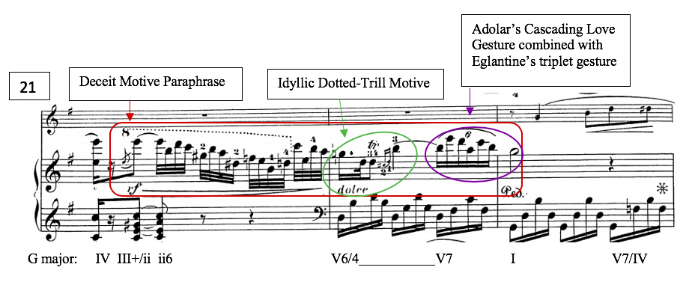
Figure 25: Var I, mm. 21–23; Eglantine’s Deceit Motive paraphrase

As previously mentioned, Variation I also draws attention to the work’s tonal problem. A moment that particularly exemplifies the motivic neighbor-note and scalar chromaticism of the variation also serves another purpose in explicitly reiterating the tonal problem of the D#. Kuhlau draws attention to the significance of the D#, a moment featuring chromatic planing in the piano that oscillates obsessively between D# and D-natural in m. 18, prolonging the resolution of the Deceit Chord at this crucial structural juncture. Although spelled as a D#, the reiteration of the downward resolution of this pitch-class neutralizes the tension with a centripetal function leading the listener back to G major. In measure 19, this functionality is affirmed with the respelling of the Deceit Chord with an Eb, resolving downward to D, and harmonically back to G major. This resolution in measures 18–19 can be seen in Figure 26.
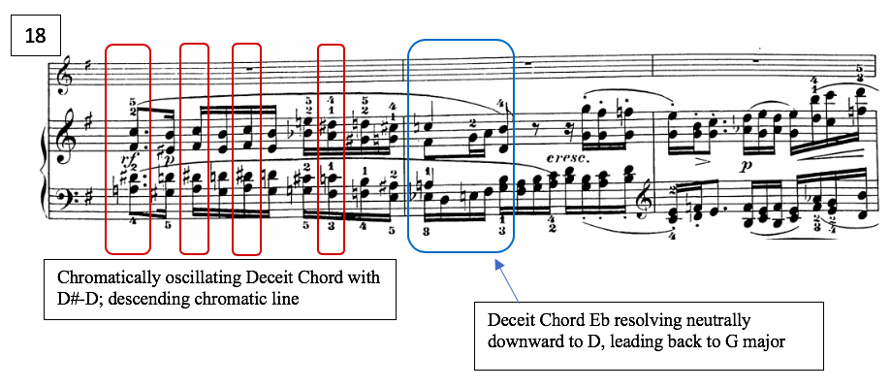
Figure 26: Var I, mm. 18–20; Deceit Chord oscillation, chromatic planing

After the harmonic conflict seems to resolve peacefully back to G major (albeit by way of A minor, instead of C major), Kuhlau retains the E minor-leading D# that was present the Theme, rather than neutralizing it. This brief escape tone, as seen in Figure 27, has more significance than merely a passing dissonance; it reintroduces the tonal problem, and thus establishes the need to resolve it in subsequent variations.
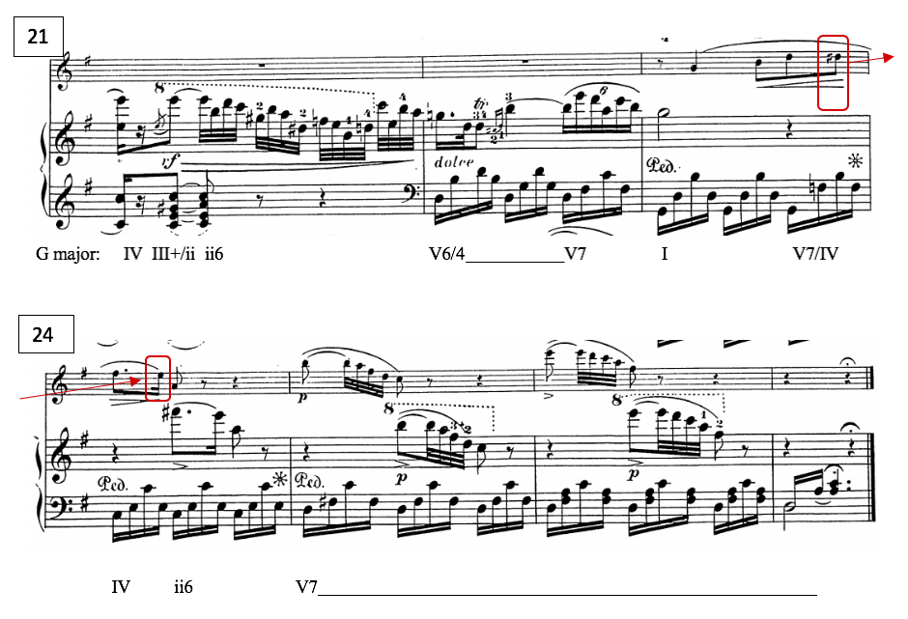
Figure 27: Variation I, mm. 21–27; D# to E voice leading

From a narrative standpoint, this variation’s eclectic motivic references, and inconclusive resolution of the D#/Eb problem, both serve to emphasize the stark contrast in character between the wholesome heroes and the devious villains. This contrast actualizes the dichotomy which was present in the theme, highlighting the underlying uncertainty in Adolar’s sweet profession of love.
Variation II
A Dialogue of Opposites
Variation II is probably best characterized by the concept of textural and rhythmic juxtaposition. As in Variation I, Var. II also features contrasting motivic features representing the dichotomy between characters of the opera. The bold, detached leaps heard throughout this variation, seen in m. 1 and 3 of Figure 28, could be reminiscent of Adolar’s declamatory heroism, as they are nearly all triadic, consonant leaps. However, spikey, leaping lines are not uncommon for the underhanded characters either, so it is possible that these leaps may be morally neutral motivic gestures. Either way, it is a consistent motive throughout Variation II, so the character of this gesture is worthy of consideration.
The first section of Variation II also features a fairly substantial amount of dotted-rhythms, a prominent example being Euryanthe’s Idyllic Dotted-Trill Motive from Cavatina No. 5, heard in the left hand of m. 3 (Figure 28). Given the prevalence of these motivic gestures, Var. II begins in a way that seems to be dominated by music of the gallant operatic heroes, with stately dotted-rhythms featured through m. 6.
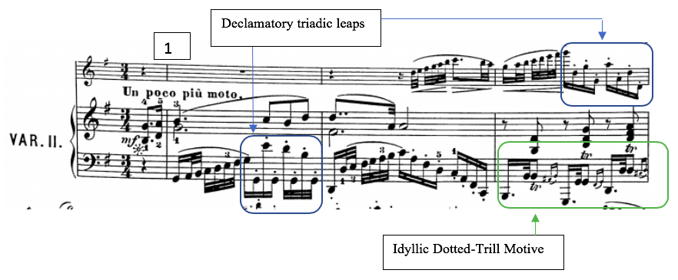
Figure 28: Var II, mm. 1–3; triadic leaps in mm. 1 and 3, Idyllic Dotted-Trill Motive, m. 3

After m. 10, however, the more sinister motivic traits become more prominent, and eventually overtake the other motives, with the exception of the spikey, detached leaping gesture, which as noted earlier, could conceivably be associated with either type of musical language. Variation II also features extended passages of scalar chromaticism, even more so than Variation I, as well as occasional chromatic-neighbor tones—both motives associated with Eglantine and Lysiart. In addition to these previously established motives, Variation II most prominently features a driving triplet motive. Supporting the association of running triplets with villainy (as discussed in Chapter 2), the triplet pattern does not appear until the B section, in m. 10, as seen in Figure 29. These detached driving triplets overtake the B section and persist through m. 23.

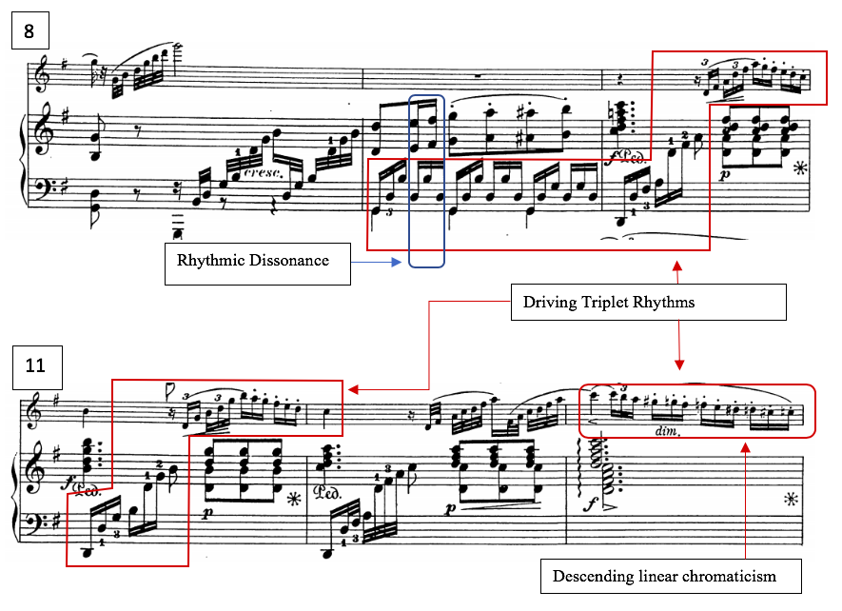
Figure 29: Var II, mm. 8–13; driving triplets, linear descending chromaticism

As previously mentioned, this variation of “juxtaposition” features great rhythmic diversity, mostly highlighting the established dichotomy of good and evil musical language. However, this variation also contains at least two instances of rhythmic opposition or rhythmic dissonance, which represent the conflict between Lysiart and Eglantine. Even though they have a common goal in sabotaging Adolar’s marriage, their motivations are entirely different. The first moment of this rhythmic conflict in Variation II is a momentary 2-against-3 gesture in m. 9 (see Figure 29). The other instances of this occur on the fourth beats of mm. 19 and 21 and are seen in Figure 30 where an ascending linear chromatic thirty-second-note line occurs simultaneously with a descending, chromatically adorned sixteenth-note triplet line. As noted in Chapter 2, incompatible rhythms heard simultaneously are present in the musical language of the villains, as heard in rhythmically dissonant duet between Eglantine and Lysiart.
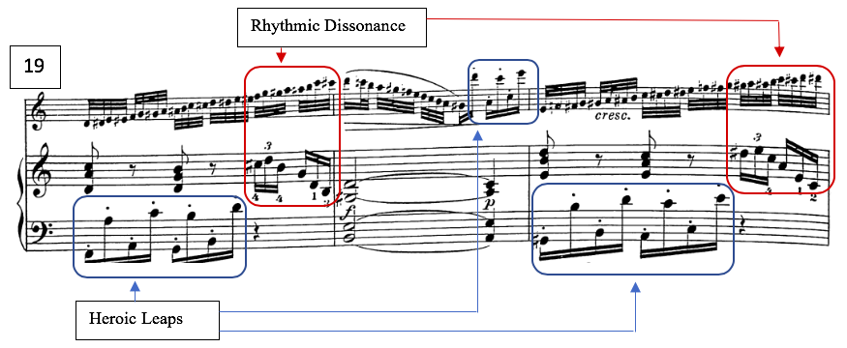
Chrom. Lower Neighbor D#
#
#
#
Figure 30: Var. II, mm. 19–21, rhythmic dissonance, heroic leaps, ascending linear chromaticism, and the only ornamental D#-E chromatic lower neighbor

Harmonically, the structure of Variation II deviates slightly from the Theme. In mm. 4–8, consequent statement of the A Section, Variation II uses a circle of fifths progression beginning with a secondary dominant of iii (B minor), instead of a secondary dominant of V (D major) as the Theme had. Figure 31 presents the harmonic structure of this passage. Although both resolve back to G major in m. 8, the subtle difference in route holds significance, as Variation II brings more attention and emphasis to the mediant, and with it, the accompanying sinister operatic associations.
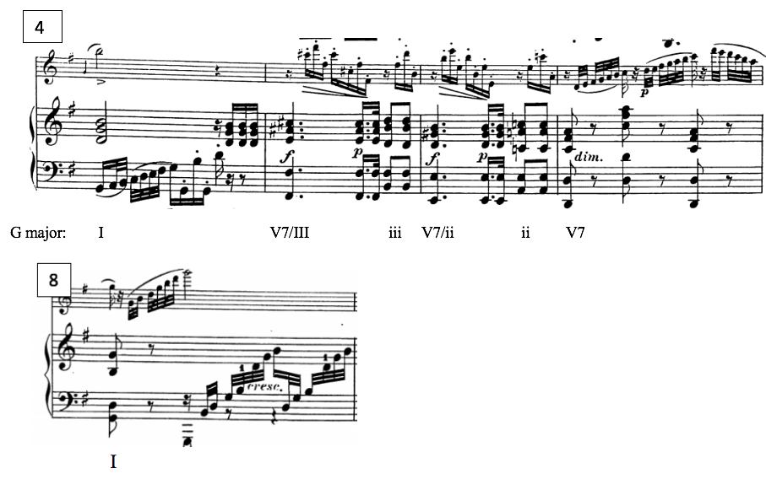
Figure 31: Var. II, mm. 4–8; Circle of Fifths progression

Variation II also approaches the tonal problem in a significantly different way than did the previous variation, but reaches a similarly inconclusive solution to it. The D# appears ornamentally as a chromatic lower neighbor to E only once (seen in m. 21 of Figure 30). D# does occur occasionally in the context of a chromatic scale, and it occurs harmonically in mm. 14 and 16 in the B section and in m. 24, where it is expected (Figure 32).

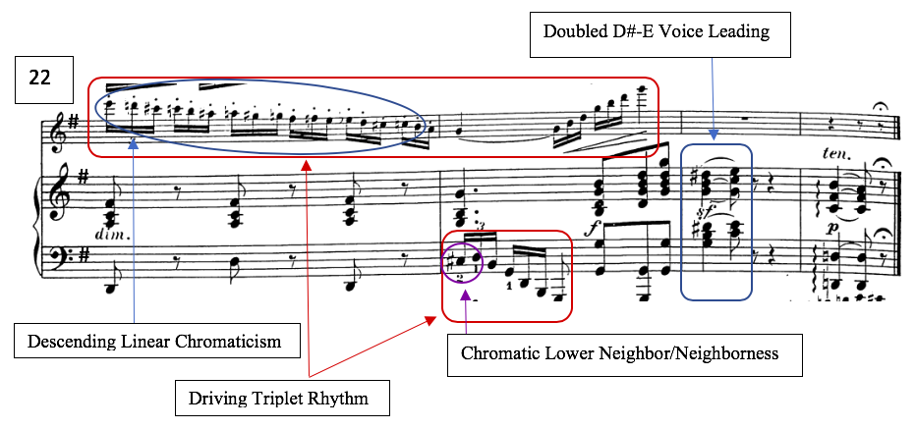
Deceit Chord
Figure 32: Var II, mm.22–25; driving triplet rhythms, doubled D#-E voice leading

Fleeting as they are, any occurrences of this neighbor relationship between D# and E, as seen in Figure 30, are fairly significant in the overarching battle for the pitch-class resolution. The pitch Eb occurs only once, and it is within the context of a descending chromatic scale (mm. 22). This one occurrence notably coincides with a D7 chord, momentarily voicing the pitches of the Deceit Chord, along with the D as the root, and resolving to G via D7. This moment can be seen in the third beat of measure 22, in Figure 32, above.
The most telling evidence of Variation II’s inconclusive take on the tonal problem is the complete omission of the Deceit Chord (with the exception of the aforementioned momentary triplet-sixteenth-note-length occurrence in in m. 22). At the structural junction where the Deceit Chord had occurred in the Theme and in Variation I, Kuhlau lands directly on the D dominant seventh chord, instead of moving to it by way of the D#/Eb, as would be expected. In Variation II, both piano and flute simply move to the D7 chord chromatically from B to C-natural in m. 18, as seen in Figure 33. The symbolic significance of omitting the Deceit Chord is unclear. On the one hand, the D# is not present at the juncture of return to G major, possibly suggesting the absence of treacherous connotations. On the other hand, the neutralizing Eb, or its centripetal functionality is also absent, leaving the pitch-class entirely within the realms of the infernal B major and E minor, unextinguished.
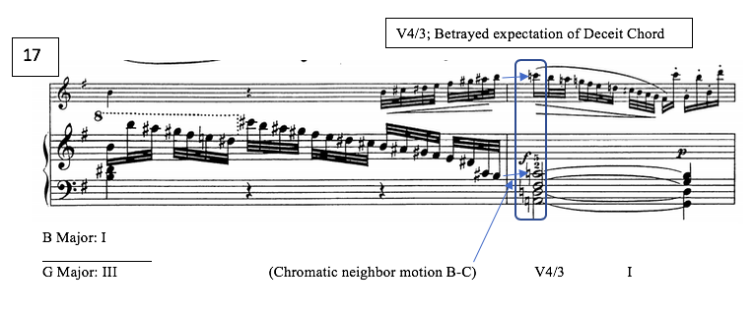
Figure 33: Var II, mm. 17–18, omission of Deceit Chord

Variation III
Polonaise
Marked Con Allegrezza, Variation III primarily features a stylized, jaunty Polonaise, charming and replete with regal dotted-rhythms. But despite the heroic connotation of this declamatory style, Variation III is also pervaded by detached, chromatic, driving triplets from the very first measure, sometimes in rhythmic conflict with the accompaniment. With the exception of the stately dotted rhythms, and momentary references to Adolar’s Cascading Love Motive in mm. 2 and 7 (seen in Figures 34 and 35, respectively), most of Kuhlau’s motivic references in this variation have pernicious connotations.
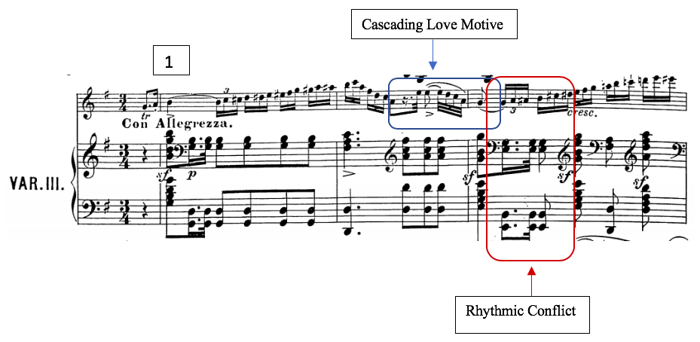
Figure 34: Var III, mm. 1–3; Cascading Love Motive, rhythmic conflict; polonaise rhythm, driving chromatic triplets

Chromaticism persists through this variation, as well as the A#-B motive. Specifically, this A#-B relationship is intensified by the slight harmonic departure from the Theme in m. 5, where Kuhlau follows the pattern established in Variation II, incorporating a secondary dominant of B minor (iii), instead of D (V). Figure 34 demonstrates how mm. 5–8 form a chain of fifths progression, unprecedented by the Theme, whose parallel harmonic structure is proved below the analysis of the passage from Var. III. Highlighted by a trill, the B/A-sharp neighbor motive sets this progression into motion.
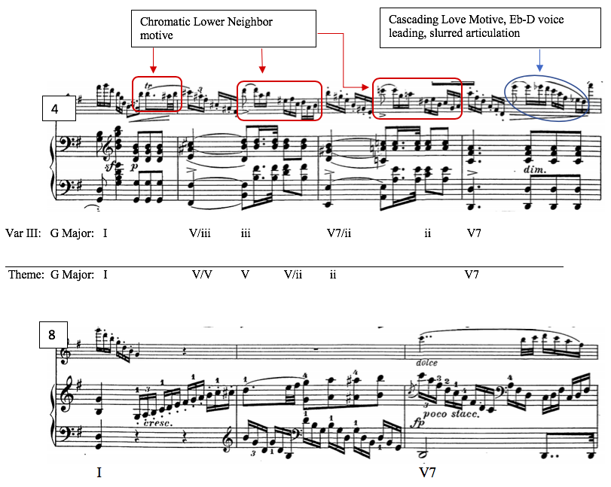
Figure 35: Var III, mm. 4–8, Circle of Fifths, neighbor motive; Love paraphrase in measure 7, Eb passing tone in m. 7

Kuhlau’s momentary references to Adolar’s Cascading Love Motive are brief but treated carefully. Notice that the iterations in mm. 2 and 7 (Figures 34 and 35, respectively) are presented with a slurred articulation. These moments are the only examples of slurred passagework in the entire variation. (Other slurs occur only in lyrical statements quoted directly from the Theme, mm. 10–11, 18, and 20–22.) All driving triplet passages and chromatic scalar passages are detached, and often staccato. In the context of these bravura sections, the slurred gestures come across as striking departures from the overall style of the Variation, which is ultimately overtaken by agitated, driving triplets.
Adolar’s Love reference in m. 7 is noteworthy from a harmonic standpoint, as well as a motivic one. This cascading gesture contains the only appearance of an Eb (as opposed to D#) in the entire variation. Notably, this passing Eb pitch-class occurs without any structural association with the impending harmonic modulation to B major or E minor, but instead functions centripetally as an upper neighbor to D, directing our ear back to the tonic of G major. The presence of the Eb resolving downward to D foreshadows the diatonicism of the Eb in following variation. At a glance, this moment appears as an ornamental, or incidental passing dissonance; however, given that the Eb happens to be ornamenting a D7 chord, the Eb creates the sonority of the very same Deceit Chord with a D in the bass, serving a flat-VI-V cadential function.
This pitch-class is much more often presented as a D#, either in as a lower neighbor passagework in m. 6 (Figure 35), as part of ascending chromatic scales (mm. 1, 3, and 17), or as part of the harmonic structure in the B major section. The final iteration of D#, as prescribed by the Theme, is part of the G augmented chord in m. 23. This measure, consistent with much of this variation, highlights devious stylistic traits. Pictured in Figure 36, this passage features accented syncopation, detached driving triplets, chromatic lower neighbor tones (including B-A#-B), and finally the D# to E voice leading into the following measure, disjointedly displaced by an octave.

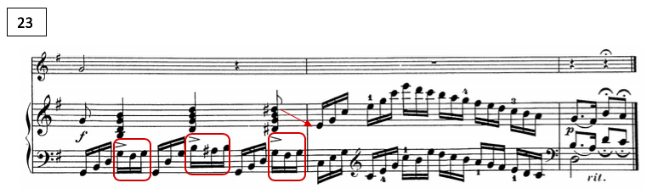
Figure 36: Var. III, mm. 23–25; syncopated neighbor motives, accented D# with dangling displaced voice leading, m. 23

Variation IV
Minore
The Minore Variation IV embodies the Weber-like Sturm und Drang style that was featured in the Introduction. The palpably dramatic tension of this piano-centric variation is achieved primarily through pervasive presence of diminished chords, minor tonality, and dramatic pianistic configurations like heavy stride-accompanimental patters, rapid scales, and rumbling tremolos. In addition to its tonal and stylistic distinctions, Variation IV is the most formally removed from the theme of all variations thus far. Kuhlau extends the final three measures of the Theme into ten—the only ten measures that the flute plays at all.
Paradoxically, this stormy Minore momentarily neutralizes the harmonic tension of the D# and the motivic A# by enharmonically integrating them into the diatonic scale, the minor. The tension of this tumultuous variation, when understood in the light of Weber’s tonal symbolism, seems to represent a heroic struggle rather than an antagonistic hostility. Even the expected “sharpness” or wickedness of the harmonic shift in the B section is averted by the lowered Minore mediant, B-flat major—a primary key of Adolar. Variation IV also seemingly strives to “reclaim” the Deceit Chord for a noble purpose, using this chord primarily as a means of modulation back to G. Kuhlau also emphatically reinforces this centripetal treatment of the Deceit Chord in the final section.
Kuhlau’s motivic choices also underscore the valiant connotation of Variation IV. Notably, the detached running triplet motive, so prevalent in the previous two variations, appears only in the B section and the continuation into it (mm. 8–18), and does not survive through the return of A’. The rhythms used in the A and A’ sections are largely straight and duple-oriented, with the occasional dotted rhythm.
Overall, a prevalence of melodic diatonicism and a conspicuous lack of linear chromaticism support the heroic tone of Variation IV. M. 8 is the clear exception, as seen in Figure 37—a moment when some element of ascending chromaticism is to be expected, considering the parallelism with the theme and its formal function. Even then, the chromaticism is interrupted by a diatonic scalar passage.
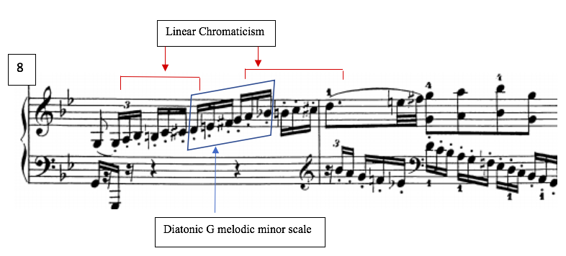
Figure 37: Var IV, mm. 8–9; ascending linear chromaticism with diatonic scale

The harmonic structure of the consequent phrase of the A section (mm. 4–8) is somewhat of a harmonic hybrid. This passage in Variation IV more closely resembles the Theme than the circle of fifths progressions of Variations II and III; however, like those previous variations, Var. IV does incorporate a secondary dominant of the mediant (B-flat major) in m. 5 instead of the V/V presented in the Theme. Figure 38 demonstrates this progression.
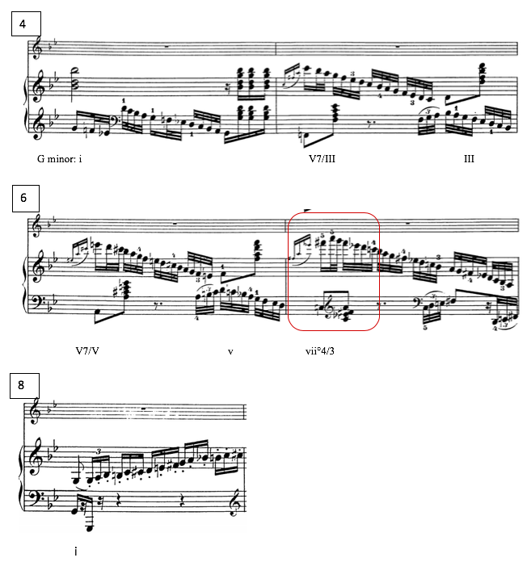
Figure 38: Var. IV, mm. 4-8; Secondary dominant of III, Deceit Chord as vii°4/3 of G

Variation IV also addresses the tonal problem early by introducing the Deceit Chord at an earlier structural moment. The problematic sonority is heard in m. 7, at the conclusion of the A Section—a measure that serves a dominant function to the resolution to G minor in the following measure. This premature occurrence of the Deceit Chord, functioning as a vii°4/3 of G minor, can be seen above in Figure 38.
The second and third iterations of the Deceit Chord seem a bit more problematic than the first, as they appear in the mediant section, on the third beats of mm. 14 and 16. This passage, seen in Figure 39, follows the same harmonic structure as the Theme, only one step lower because of the flat-III, which is diatonic in the minor mode.
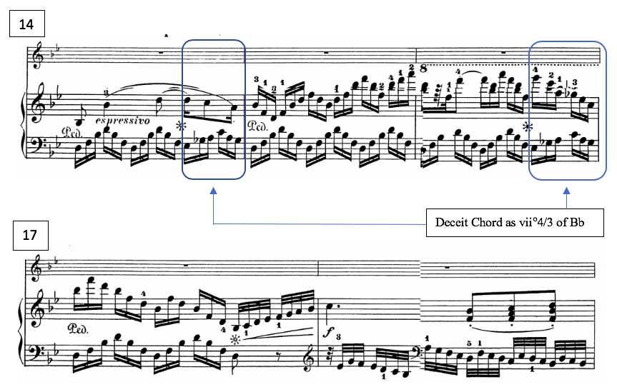
Figure 39: Var IV, mm. 14–17; mediant section, Deceit Chord as vii°4/3 of Bb major

In this context, the Deceit Chord (Eb, Gb, A, C) functions as a vii°4/3 of B-flat major. Technically, this is a centrifugal function; it leads away from G major. Additionally, this entire passage is overrun by driving triplet rhythms and accented syncopations, which suggest discord and duplicity. The B-flat tonality however, is a decidedly heroic and cheerful one, particularly associated with Adolar. Kuhlau makes an interesting choice in the following measure that could potentially suggest a heroic victory. Whereas previous variations generally retain motives through to the end once introduced, Variation IV abruptly rids itself of all triplet figures in the pickup to m. 18 (the return of A’).
At this structurally crucial juncture, seen in Figure 39, Kuhlau omits the expected statement of the Deceit Chord on the A’ arrival at m. 18, as he did in Variation II. Instead, the tonality remains decidedly in B-flat major for nearly three additional measures. Without a harmonic change as a formal signpost, Kuhlau instead signals the arrival of A’ at m. 18 with a recognizably thematic melody, and with the previously discussed rhythmic change. The significance of this is ultimately unclear, but it could conceivably be a continued effort to assert B-flat as a potentially victorious tonality, one associated with heroism.
The Deceit Chord does finally occur again on the third beat of m. 20, two measures after it did in the Theme, now serving its expected purpose: it functions as a vii°4/3 of G minor in mm. 20 and 21. Kuhlau then transforms the Deceit Chord into a German augmented-sixth in the key of G minor, the bassline underscoring this centripetal function of Eb. This cadential passage from measure 20 through 23 can be seen in Figure 40.

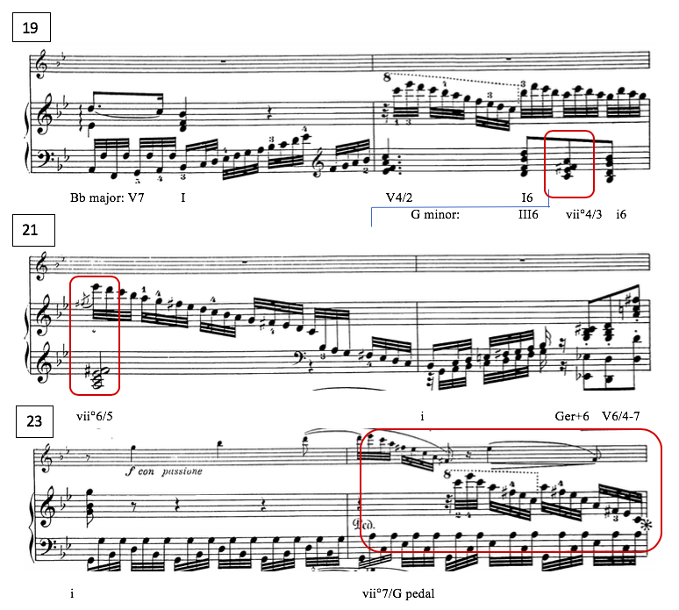
Figure 40: Var IV, mm. 19–24; Deceit Chord modulating to G minor, via Ger+6

The entrance of the flute in m. 23 occurs after the return to the tonic key. The remainder of Variation IV serves as the transition, firmly iterating the Deceit Chord in its diatonic G minor context, and the Eb’s downward resolution to G minor. This cadential section features a dichotomy of symbolic motivic figurations, including an emphasis on the appoggiatura gesture (on an Eb, no less), which according to Daverio, represents a “musical emblem of grief or evil, depending on its placement in the music for the principals or the villains.” Figure 41 shows the last six measures of the variation, featuring chromatic neighbor tones, accented syncopation in measure 28, a paraphrase of the Love Motive in the flute line (outlining the Deceit Chord), an ominous tremolo and a syncopated rhythm in the final four measures.
The numerous instances of melodic emphasis on Eb, including the flute’s insistent syncopated statements, and repeated downward resolving statements of the Eb reflect this variation’s primary purpose—a struggle to redefine this pitch-class in favor of centripetal diatonicism. Handled in this way, the Minore is not merely a formality, but a necessary outgrowth of the musical plot.
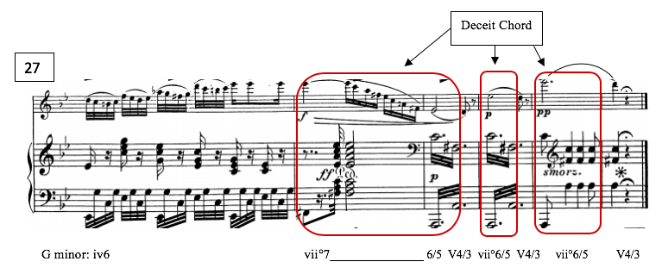
Figure 41: Var IV mm. 27-32; melodic emphasis on Eb at cadence

Variation V
Flute Feature
From a technical perspective, Variation V is the most demanding for the flutist, and showcasing the flute seems to be the primary purpose of this particular variation, in contrast with the piano-virtuosic Minore. Similarly to Variation II, Variation V approaches the tonal problem from a somewhat neutral position, and also like Variation II, Variation V omits the Deceit Chord at the structural juncture between the B and A’ Sections. Instead, Kuhlau simply moves chromatically to a D7 chord in m. 18, as seen in Figure 42.
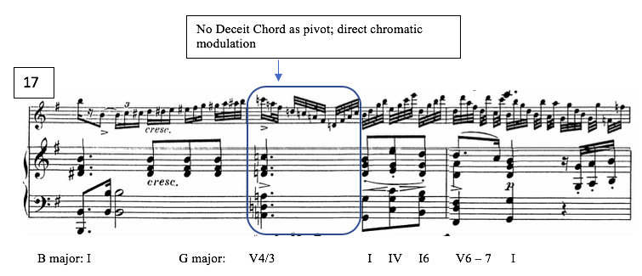
Figure 42: Var V Mm. 17–19; omission of Deceit Chord

Although absent at the expected structural juncture at m. 18, the Deceit Chord is introduced in m. 12 in an arpeggiated figuration in the flute, over a D major chord in the piano, as seen in Figure 43.
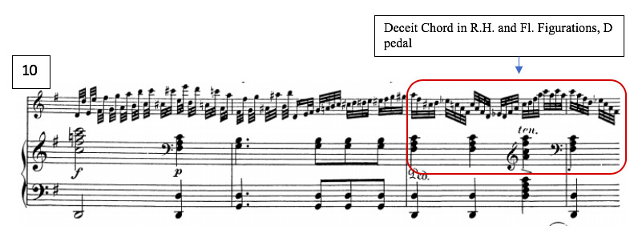
Figure 43: Var V, mm. 10–12 arpeggiated Deceit Chord m. 12
Furthermore, the D# expected in m. 23 (continuation) is also omitted in Variation V. Instead, a simple progression, beginning with a secondary dominant leading to IV -V6/4-7 sets up the piano solo in m. 28. Figure 44 depicts this cadential passage. Reminiscent of the exchange between solo cadenzas in the Introduction, Variation V features two brief cadenzas. Figure 45 shows first the piano cadenza in mostly diatonic configurations, followed by the flute cadenza with a chromatic triplet pattern.
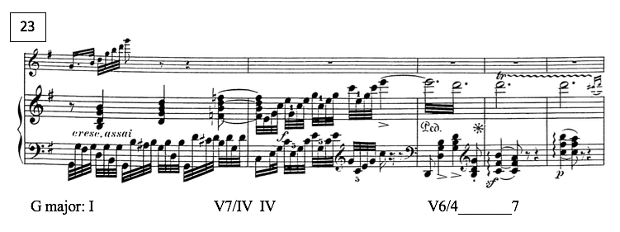
Figure 44: Var. V, mm. 23–27; omission of D#

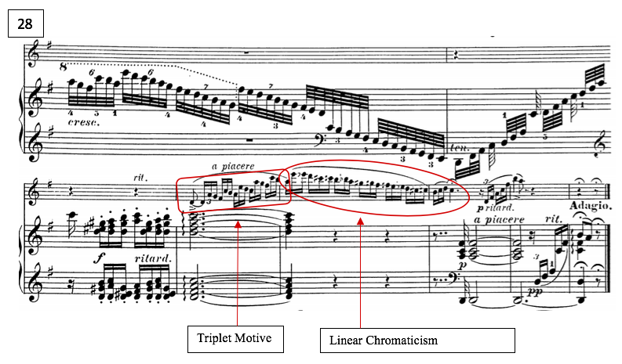
Figure 45: Var. V, mm. 28–34; cadenzas, triplet motive, linear chromaticism
Motivically, this variation does not feature many direct operatic allusions. Instead, it might be heard as a juxtaposition of the salient motivic elements of Variations II and III, namely the octave leaps from Var. II and the ascending chromatic triplet figurations from Var. III, again featured primarily in the B section. There are however, three moments that feature the chromatic neighbor motive: mm. 8-9 (Figure 46) and m. 23 (Figure 44) in the accompanimental left-hand pattern, and once in the flute obbligato in measure 14 (Figure 47).
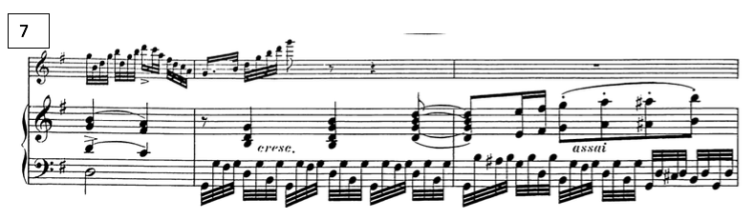Figure 46: Var. V, mm. 7–9; chromatic neighbor motive

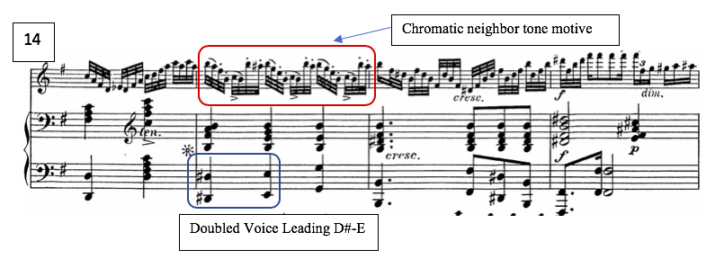
Figure 47: Var. V, m. 14–17; chromatic neighbor motive

With the exception of these moments of chromatic neighborness (two of which, predictably occurring in the B section), Variation V does not reflect an entirely iniquitous or chivalrous tone, nor does it strongly advocate for one resolution of the tonal problem over another. Instead, its relative neutrality leaves the listener in suspense for the Final Variation.
Variation VI
The Finale
Throughout the set, the driving forces have been the push and pull between G major and B major/E minor, the functionality of the Eb/D#, and the motivic conflict between protagonists and villains, respectively. We might expect Variation VI to be the culmination of this struggle, determining definitively which tonality or motivic allusion “wins out” in the end. However, the prevalence of these motives, and the style in which they are presented, effectively give the variation a frivolous character—a marked departure from the dramatic Introduction and Minore, or the noble, courtly Theme. Recalling Busk’s and Kinderman’s thoughts on parody, Variation VI seems to be an example of travesty, or a complete distortion of the theme into something entirely different.
Nearly every motivic or characteristic feature which has been previously featured is integrated into the final Variation. Kuhlau uses octave leaps, neighborness, scalar chromaticism, syncopation, imitation, and a lilting 6/8 dance meter, and a flippant grace-note motive which is the most striking feature of Var. VI. The effect is unabashedly ornamental, allowing the flutist to display a brilliant slurred octave technique. Seen in Figure 48, the opening A section exemplifies all of these motivic ideas.

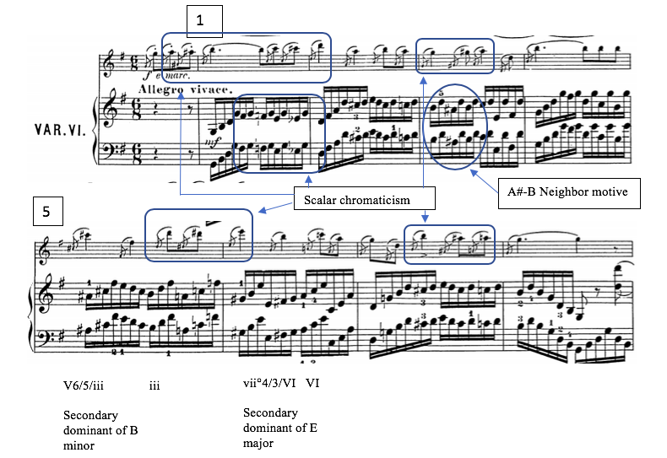
Figure 48: Var VI, mm. 1–8, octaves, linear chromaticism, neighbor-note chromaticism, secondary dominants of B minor and E major

In the Finale, Kuhlau makes yet another reference to his operatic model. Kuhlau quotes passages from Finale to Act I, in which Lysiart’s scheme begins to fall into place, as a melodic and rhythmic basis for the variation. Weber’s number is set in a lilting compound meter and features a flute and violin countermelody. Kuhlau borrows the meter as well as melodic elements such as grace notes, arpeggios and neighbor motives from this operatic number. Throughout Variation VI, the flute takes on a sixteenth-note arpeggiated melody which very closely resembles these Act I figurations (see Figure 49)
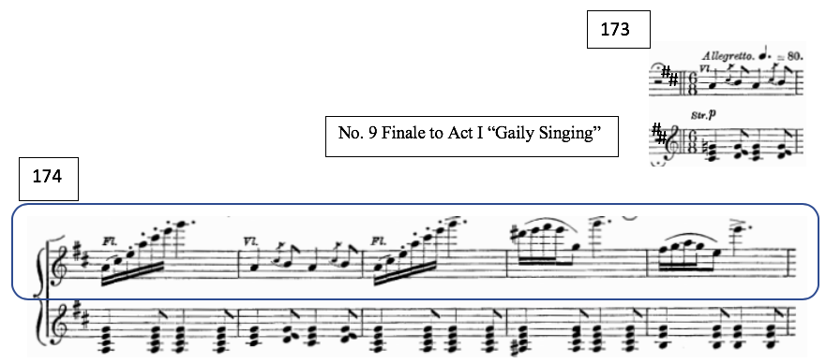
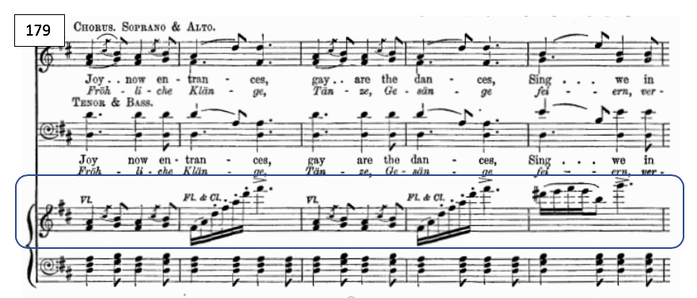
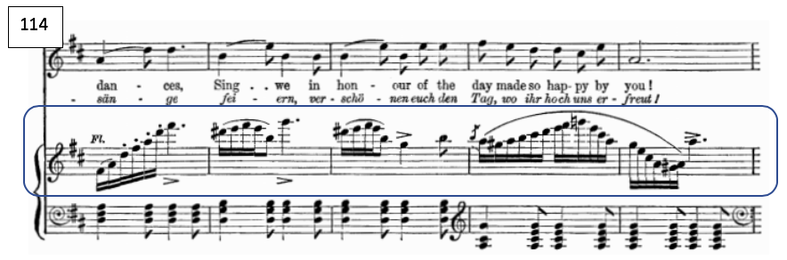
Figure 49: Weber, No. 9 Finale to Act I “Gaily Sing” mm. 173–182; allegretto

Var. VI also presents the most overt manifestation of the tonal problem established in the set. In measure 1, Kuhlau uses an Eb as a part of a descending chromatic line in the piano accompaniment. However, at the beginning of the B section in m. 14, D# reemerges in the bass, bringing with it the corresponding A#-B motive, as well as melodic emphasis on the D# in the flute. Throughout the variation, the A#-B motive is flagrantly exploited, particularly in the B section. This is heard distinctly in the flute’s repetitive accented figure that oscillates between B and A#, just before the double-barline, seen in Figure 50.
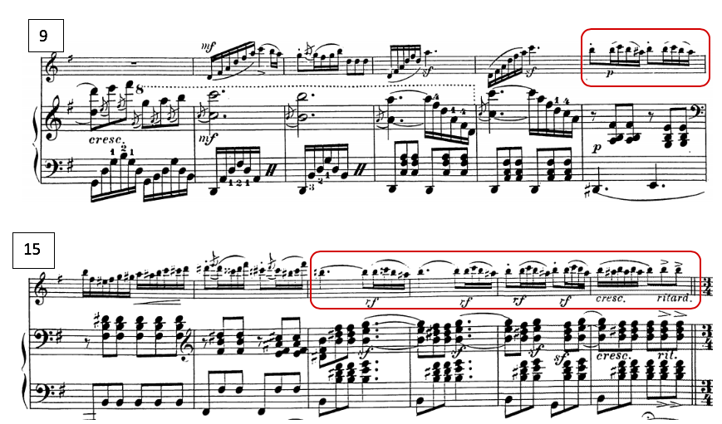
Figure 50: Var VI, mm. 9–15, B section, flute figure; A#-B motive; “Finale Act I” figurations

As the A’ section returns in m. 21, Kuhlau briefly returns to Adolar’s anthemic triple meter. This is immediately followed by another flute cadenza paraphrasing Eglantine’s Deceit Motive with serpentine “rage coloratura” figurations outlining the Deceit Chord (supported by an A minor chord, however). The “rage” style is smoothed out on the last beat of m. 25 with a diatonic cascading gesture into the cadence.
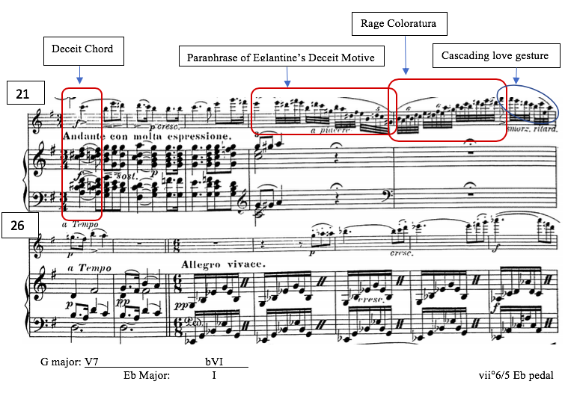
Figure 51: Var VI, mm. 21–32; Eglantine’s Deceit Motive, “Rage coloratura” cadenza; bVI substitution for I; Eb major section

The Variation’s parallelism to the Theme essentially ends at m. 27, as the Theme concludes on this G7 chord. At this point, Kuhlau suddenly cadences on E-flat major, as a flat-VI substitution for I. This moment comes as a lovely surprise to the listener, as well as an alternative solution to the tonal problem. This solution is also not without association to the source material: recall that Weber resolves his own narrative and tonal conflict within the opera by concluding it in E-flat major. According the symbolic associations of Weber’s key signatures, E-flat major is not only moral and majestic, but divine. Kuhlau’s harmonically unprepared shift from G major to E-flat major, seen in Figure 51, underscores the modal mixture of the somewhat mystical relationship between these tonal centers. The appearance of E-flat also has narrative implications; recall that in the final act, King Louis and his hunting party rescued Euryanthe from the forest after Adolar had abandoned her.
This moment in Variation VI also clarifies why Kuhlau decided to emphasize the D# gesture (or Eb, in the Minore) in mm. 23–24 of the theme; he was foreshadowing not only the importance of the pitch-class at this particular structural juncture, but also hinting at the same flat-VI substitution progression. (Recall that the harmonic structure of mm. 23–34 of the Theme is [G major, G augmented, C major]. Given the G major tonality of the passage, the D# in the G augmented chord sounds like a leading tone to E minor (vi) in the context of the chord. Kuhlau instead moves to a C major chord IV in mm. 24, giving the brief, vague impression of a flat-IV substitution for i in E minor.)
As per Weber’s solution to their shared tonal problem, Kuhlau’s Eb extinguishes the function of the D# briefly. This resolution to E-flat major is short-lived, as the piece begins the modulation back to the the tonic key of G major in m. 36 by turning the E-flat major chord into a Ger+6 of G by adding a C#.
Although the Variation returns to the bright, cheerful key of G major, Kuhlau’s allegorical references remain overwhelmingly wicked throughout Variation VI. The A#-B motive not only remains present, but is conspicuously exploited, and the conflict between the D# and Eb remains, at best a stalemate. The pitch-class appears as an Eb for the last time in measure 54, and henceforth appears as a D# no less than eight times before the close of the piece. This would suggest that Kuhlau has actually rejected Weber’s righteous and regal Eb, in favor of Lysiart and Eglantine’s devilish D#.
Conclusion
In conclusion, my analysis suggests that Kuhlau’s Introduction and Variations on the ‘Romance’ of Euryanthe, when considered in the light of contemporary understandings of operatic convention and tonal connotation, displays a remarkable interconnectedness with Weber’s opera. Kuhlau clearly crafted these variations around a tonal problem based on the villainess, Eglantine’s leitmotiv, and its underlying harmony, the Deceit Chord. This chord, which serves a momentary modulatory function within the aria on which Kuhlau based his variations, has an inherent instability and potentiality for deceptive resolution. Kuhlau capitalized on the multifunctionality of the chord’s fully-diminished quality to create and exemplify a tonal dichotomy between two possible resolutions, each tonality symbolically related to the opera.
The tonal problem hinges on whether or not the chord is spelled with an Eb which would resolve down to D as a predominant function in G major (the key of peace and reconciliation), or if the chord is spelled with a D# which would resolve upward to E minor (the key associated with Eglantine, and by extension, deceit and division.) He ultimately makes a bold reference to Weber’s resolution of the opera in E-flat major, the key of divinity, but quickly rejects it, resolving to the G-major tonic, insistently favoring the mediant and the sixth with abundant chromatic tonicizations of both B and E.
In working out his tonal problem, Kuhlau also alludes to motives and idioms representative of various characters from the opera. Many of the figurations throughout the set that appear superficially ornamental are actually motivic allusions with symbolic significance—specifically the idyllic, pastoral language of Euryanthe; the noble dotted-rhythms of Adolar; and the serpentine chromaticism of Eglantine and Lysiart, the later winning out in the final variation.
Kuhlau’s overwhelming tendency to favor the more nefarious musical ideas (with the exception of Variation IV, the Minore) may not necessarily represent a definitive triumph for the villains; it may simply be a virtuosic display of the theme, exploiting the central conflict of the opera, without necessarily accepting Weber’s solution, or overtly declaring a victor. As the motivic allusions in Variation VI are from the Finale to Act I, it might also be interpreted as a glimpse of the opera at that point in the plot, when Lysiart and Eglantine momentarily have the upper hand.
Considering that this variation set was based on a popular contemporary opera, it was not necessary for Kuhlau to accurately depict its precise narrative. As the opera was premiered in 1823, and the variation set was composed the following year, this was a story with which performers and listeners would most likely be familiar. The mere allusion to Weber’s thematic and motivic material would suffice in recalling the greater musical and narrative conflict within the opera. I rather prefer the more provocative interpretation that Kuhlau subverted Weber’s anthemic model in a travesty of chromaticism and “rage coloratura” in order to reimagine of the opera’s outcome. However, this interpretive decision ultimately falls into the hands of the performer and the imagination of the listener.
One additional consideration is the possible reading of Variation VI as an actualization of the latent potentialities of the Theme. Kuhlau’s “travesty” of the Theme might alternatively be conceptualized as commentary on Adolar’s internally conflicted character, tonally and motivically manifesting and exemplifying his vengeful and jealous qualities. Although manipulated by external forces, this supposedly valiant gentleman demonstrates surprisingly little charity, and a shocking malevolence, first vowing to kill Euryanthe, then abandoning her in a forest after she saves his life. As established in Chapter 3, the seeds of the tonal and motivic conflicts were present in Weber’s “Romance” (and even more prominent in Kuhlau’s Theme). Consequently, Kuhlau’s corruption of Adolar’s ode to Euryanthe could be a subtle suggestion that just as the tonal problem was essentially present in the theme all along, Adolar’s suspicion and wrath were also intrinsic to his character from the beginning—the actions of Eglantine and Lysiart simply brought these traits to the fore. As discussed in Chapter 2, Weber’s approach to Music Drama favored a type of musical allegory which at times contradicts the explicit meaning of the text. Kuhlau may have used a similar approach in his treatment of Adolar’s Theme to expose the shallow insincerity of his pompous, chivalrous text. This character-driven interpretation potentially adds another layer of meaning to this work and could be compatible with either take on the outcome of the “plot.”
My analysis serves to inform performers, listeners, and scholars about the symbolic associations and relationships in this popular, but understudied work. The Euryanthe Variations hold a respected place in the flute repertoire; it is one of Kuhlau’s more frequently performed works. This analysis potentially explains one facet of why this piece is so compelling: Kuhlau created not only an enjoyable and skillfully composed showpiece for the virtuoso flutist, but also a sophisticated work with nuance, harmonic intrigue, and symbolic depth.
Perhaps further analysis of Kuhlau’s other theme-and-variation sets would illuminate a pattern in his specific treatment of musical narrative. Hopefully this exploration of Introduction and Variations on Euryanthe, Op.63 will serve as a starting point for further dramaturgical analyses of this often undervalued and understudied Romantic master.

Bibliography

Benedict, Sir Julius. Carl Maria von Weber. London: S. Low, Marston, 1894.

Busk, Gorm. “Friedrich Kuhlau's Operas and Theatre Music and their Performances at the
Royal Theatre in Copenhagen (1814–1830): a Mirror of European Music Drama and
a Glimpse of the Danish Opera Tradition.” Music in Copenhagen, ed. N. Krabbe
(Copenhagen, 1996), 93–127.

_______. Friedrich Kuhlau: His Life and Works. Copenhagen: 1986.

_______. “Kuhlau,” The New Grove Dictionary of Music and Musicians second edition.
Edited by Stanley Sadie and John Tyrrell. Vol.14, 4–5. London: Macmillan, 2001.

_______. “Kuhlau’s Model Technique and Musical Style.” Translated by Russell L.
Dees. International Friedrich Kuhlau Society Newsletter, 2010.

Caplin, William E. Classical Form: A Theory of Formal Functions for the Instrumental
Music of Haydn, Mozart, and Beethoven. New York: Oxford University Press Inc., 1998.

Carpenter, Patricia. “Tonality: A Conflict of Forces.” In Music Theory in Concept and
Practice. Edited by James Baker. Rochester: University of Rochester Press, 1997.

Clements, Gretchen Rowe. “Situating Schubert: Early Nineteenth-Century Flute Culture and
the ‘Trockne Blumen’ Variations, D. 802.” PhD diss., State University of New York,
2007.

Dahlhaus, Carl. “What is Developing Variation?’ In Schoenberg and the New Music.
Translated by Derrick Puffett and Alfred Clayton, 128–33. Cambridge: Cambridge University Press, 1987.

_______. Nineteenth-Century Music. Translated by J. Bradford Robinson. Berkeley:
University of California Press, 1989.

_______. Realism in Nineteenth-Century Music. Translated by Mary Whittall.
Cambridge: Cambridge University Press, 1985.

Daverio, John. Nineteenth-Century Music and the German Romantic Ideology. New York:
Schirmer Books, 1993.

Dawe, Edmond Noel. “Three Piano Sonatas by Friedrich Kuhlau.” DMA thesis, The
University of British Columbia, 1988.

Dineen, Murray. “The Tonal Problem as Method of Analysis.” Theory and Practice 30
(2005): 69–96.

Dunsby, Jonathan, “Thematic and Motivic Analysis.” In The Cambridge History of Western
Music, Edited by Thomas Christensen, 907–926. Cambridge: Cambridge University
Press, 2002.

Everest, Mark. “Translating Weber’s Euryanthe: German Romanticism at the Dawn of
French Grand Opéra.” Revue de Musicologie 87 no. 1 (2001): 67–104.

Fairbanks, Ann Kozuch. “Music for Two, Three, and Four Flutes by Friedrich Kuhlau.”
DMA Document, The Ohio State University, 1975.”

Frisch, Walter. Brahms and the Principle of Developing Variation. Berkeley: University of
California Press, 1984.

Graupner, Karl. Friedrich Kuhlau. Remscheid:1930.

Kinderman, William. Beethoven’s Diabelli Variations. Oxford: Clarendon Press, 1987.

Kinnard, Jennifer Christine. “Neglected Chamber Works for the Flute and the Correlating
Historical Background.” DMA diss., Michigan State University, 2006.

Lorenzo, Leonardo de. My Complete Story of the Flute: The Instrument, the Performer, the
Music. Lubbock, TX: Texas Tech University Press, 1992.

Lott, Marie Sumner. “Audience and Style in Nineteenth-Century Chamber Music, c.
1830-1880.” PhD diss., Eastman School of Music, 2008.

_______. The Social Worlds of Nineteenth-Century Chamber Music: Composers,
Consumers, Community. Chicago: University of Illinois Press, 2015.

Meyer, Stephen C. Carl Maria von Weber and the Search for a German Opera.
Bloomington: Indiana University Press, 2003.

Mehring, Arndt. Friedrich Kuhlau in the Mirror of his Flute Works. Edited by Jane Rausch.
Translated by Laszlo Tikos and Doris Tikos. Warren: Harmonie Park Press, 2000.

Newman, William S. The Sonata in the Classic Era. 2nd ed. New York: W. W. Norton and
Company Press, 1972.

_______. The Sonata Since Beethoven. 2nd ed. New York: W. W. Norton and
Company Press, 1972.

Reynolds, Christopher A. Motives for Allusion: Context and Content in Nineteenth-Century
Music. Cambridge: Harvard University Press, 2003.

Rosen, Charles. The Romantic Generation. Cambridge, MA: Harvard University Press,
1995.

Saunders, William. Weber. New York: Da Capo Press, 1970.

Shore, Dan. “The Emergence of Danish National Opera, 1779-1846.” PhD diss., The City
University of New York, 2008.

Sisman, Elaine. Haydn and the Classical Variation. Cambridge: Harvard University Press,
1993.

Swinkin, Jeffrey. “Reference and Schenkerian Structure: Toward a Theory of Variation.”
Indiana Theory Review 25 (2004): 177–222.

_______. “Variation as Thematic Actualization: the Case of Brahms Op. 9.” Music
Analysis 31, no. 1 (March 2012): 37–39.

Thrane, Carl. Friedrich Kuhlau. Leipzig: Druck und Verlag, 1886.

Tusa, Michael. Euryanthe and Carl Maria von Weber’s Dramaturgy of German Opera.
Oxford: Claredon Press, 1991.

_______. “Richard Wagner and Weber’s ‘Euryanthe’.” Nineteenth-Century Music 9,
No. 3 (Spring 1986): 206–221.

Weber, Carl Maria von. Writings on Music. Translated by Martin Cooper. Edited by John
Warrack. Cambridge: Cambridge University Press, 1981.

Musical Scores
Kuhlau, Friedrich. Introduction et Variations sur la Romance de l’Opéra Euryanthe
“Unter blühenden Mandelbäumen.” Op. 63. Edited by Louis Winkler. Brunswick: Litolff Plate 553, n.d., ca. 1870.

_______. Introduktion und Variationen über ein Thema aus Carl Maria von
Webers "Euryanthe" für Flöte und Klavier. Op. 63. Hrsg. von Hans-Peter Schmitz. Bärenreiter: 1971.

Weber, Carl Maria von. Euryanthe: A Romantic Opera in Three Acts. Edited and arranged
for pianoforte by Berthold Tours. Translated by William Thornthwaite. London:
Novello Ewer & Co., n.d., ca. 1880.

_______. Euryanthe: Grosse Romantische Oper in drei Aufzügen. Op. 81,
Libretto by Helmine von Chezy. Edited by Ernst Rudorff. Berlin: Schlesinger, 1866.

Gorm Busk, “Kuhlau’s Model Technique and Musical Style.” International Friedrich Kuhlau Society Newsletter, 2010. Translated by Russell L. Dees.
Ibid.
Arndt Mehring, Friedrich Kuhlau in the Mirror of His Flute Works, (Warren, MI: Harmonie Park Press, 2000), xvii.
Carl Graupner, “Friedrich Kuhlau” (Ph.D. diss., University of Munich, 1930), 53. Translation from Arndt Mehring, xv.
William S. Newman, The Sonata Since Beethoven 2nd Ed. (New York: W. W. Norton and Company Press, 1972), 604.
Leonardo de Lorenzo, My Complete Story of the Flute: The Instrument, the Performer, the Music, (Lubbock, TX: Texas Tech University Press, 1992), 109.
Ibid., 354.
Gorm Busk, “Kuhlau’s Model Technique and Musical Style.” International Friedrich Kuhlau Society Newsletter, 2010. Translated by Russell L. Dees. http://www.kuhlau.gr.jp/e/e_library/ee_impotant_article_from_newsletter/ee_kuhlaus_modeltechnique.html, accessed October 8, 2018
Ibid.
Ibid.
Arndt Mehring, Friedrich Kuhlau in the Mirror of His Flute Works, (Warren, MI: Harmonie Park Press, 2000), xvii.
Ibid., 47
Helmina von Chezy, Libretto to Euryanthe.
John Daverio, Nineteenth-Century Music and the German Romantic Ideology, (New York, Schirmer: 1993), 90.
Michael Tusa, Euryanthe and Carl Maria von Weber’s Dramaturgy of German Opera (Oxford: Clarendon Press, 2011), 1–5.
Stephen C. Meyer, Carl Maria von Weber and the Search for a German Opera (Indiana University Press: 2003), 119.
Edward J. Dent, The Rise of Romantic Opera, ed. by Winton Dean (Cambridge, 1976), 159.
Carl Dahlhaus, Nineteenth-Century Music, trans. J. Bradford Robinson (Berkeley: University of California Press, 1989), 69–70.
Daverio, 122.
Ibid., 96.
Ibid., 97.
Meyer, 122
Ibid., 122
Michael Tusa, Euryanthe and Carl Maria von Weber’s Dramaturgy of German Opera (Oxford: Claredon Press, 1991), 160.
Ibid., 160.
Daverio, 100.
Rita Steblin, A History of Key Characteristics in the Eighteenth and Early Nineteenth Centuries (Ann Arbor, Mich., 1983), 103–33.
Tusa, 164.
Ibid., 172.
Ibid., 168.
Quote and translation in Meyer, 123.
Tusa, 164.
Ibid., 172. Quote from Christian Feidrich Daniel Schubart, Ideen zu einer Ästhetik der Tonkunst (Vienna, 1806), 377. The present translation is adapted from Rita Steblin, A History of Key Characteristics in the Eighteenth and Early Nineteenth Centuries (Ann Arbor, Mich., 1983), 122.
Daverio, 101.
Meyer, 119.
Tusa, 205.
Ibid., 34.
Ibid., 204.
Meyer, 133–134.
Christopher A. Reynolds, Motives for Allusion: Context and Content in Nineteenth-Century Music (Cambridge: Harvard University Press, 2003), 63.
Meyer, 134.
Donald Francis Tovey, “Illustrative Music,” in Essays in Musical Analysis. (London: Oxford University Press, 1935), 54.
Grove Book of Operas, 2nd ed., Ed. By Stanley Sadie, (Oxford University Press, 2009), 191.
John Hamilton Warrack, Carl Maria von Weber, (Cambridge: 1976), 368.
Tusa, 168.
Ibid., 160–180.
Mehring, 46–47.
Theodore Adorno, “Schubert,” Night Music, 32.
Ibid., 32.
Ibid., 32.
Ibid., 33.
Kinderman, 69.
Novello’s Original Edition Piano Reduction Vocal Score with German and English Translation 1880.
Tusa, 173.
Ibid., 34.
William E. Caplin, Classical Form: A Theory of Formal Functions for the Instrumental Music of Haydn, Mozart, and Beethoven, (Oxford Univerisy Press: 1998).
Thanks to Dr. Jeffrey Swinkin for help with the analysis and engraving.
Mehring, xvii.
Busk.
Refer to Chapter 2: Tonal Symbolism, based on the analytic work of Michael Tusa.
Busk.
Tusa, 167.
Patricia Carpenter, “Tonality: A Conflict of Forces,” in Music Theory in Concept and Practice, ed. James Baker (University of Rochester, 1997).
Murray Dineen, “The Tonal Problem as a Method of Analysis,” Theory and Practice 30 (2005).
Mehring, 46-47.
Patrick Miller, “Music and the Silent Film,” Perspectives of New Music 21, no. 1/2 (Autumn, 1982-Summer, 1983): 582–83.
Tusa, 173
Refer to Chapter 2, Reference to Tusa
Daverio, 101.
Tusa.
Jeffrey Swinkin, “Variation as Thematic Actualization: the Case of Brahms’s Op. 9,” Music Analysis, 31, no. 1 (March 2012): 37-89. Swinkin argues that “a variation actualizes thematic potentialities in one of two . . . opposing yet complementary ways: first it may render a latent feature of the theme more explicit—more audible, repetitive and salient (. . . “exemplification”); second, it may afford such a feature greater structural significance.” p. 42. This seems to be an accurate description of Kuhlau’s approach bringing the thematic tonal problem to the fore.

