UNIVERSITY OF OKLAHOMA
GRADUATE COLLEGE

UNDERSTANDING THE SPATIAL ECOLOGY AND SPACE UTILIZATION OF COPPERHEAD SNAKES IN TENNESSEE

A THESIS
SUBMITTED TO THE GRADUATE FACULTY
in partial fulfillment of the requirements for the
Degree of
MASTER OF SCIENCE

By
AKPOEZI ROSEMARY ONONEME
Norman, Oklahoma
2024
UNDERSTANDING THE SPATIAL ECOLOGY AND SPACE UTILIZATION OF COPPERHEAD SNAKES IN TENNESSEE

A THESIS APPROVED FOR THE
DEPARTMENT OF GEOGRAPHY AND ENVIRONMENTAL SUSTAINABILITY

BY THE COMMITTEE CONSISTING OF

Dr. Rebecca Loraamm, Chair
Dr. Anni Yang
Dr. Nishan Bhattarai

© Copyright by AKPOEZI ROSEMARY ONONEME 2024
All Rights Reserved.

Acknowledgements
Whew! I did it! I have worked hard at this document that I am literally living and breathing it. When I look back at my journey 2 years ago, adjusting to a different country, the weather, embracing technologies, struggling to stay afloat academically especially after been away from school after 4 years, I can smile knowing that I have triumphed. Glory be to God!
I am grateful for having a wonderful advisor, Dr. Rebecca Loraamm who has guided me through this program, for her understanding and encouragement as this thesis presented a learning curve for me. For your unwavering support, I want to say thank you. It will be remiss of me not to acknowledge the DGES family, faculty and graduate students, with some of you I have made lasting friendships. I also want to thank Dr. Anni and Dr Nishan for their input and willingness to sit on my committee. To Dr Neeson and Dr Bruce, thank you for your assistance in propelling me to my next chapter. Thank you, Jim, for allowing me to pick your brain and your unofficial role in teaching me some of this method.
Thank you to my Nigerian family in Norman and to the Wesley for giving us the opportunity to unwind and chill a couple of hours every Thursday, this helped my mental health and reduced my homesickness. To all my friends in Norman and Nigeria, thank you for being my sounding board, providing writing tips and not been bored with my snake conversations.
Lastly, I want to say a big thank you to my husband and family in Nigeria, thank you for cheering me on! I know I am making mummy proud with all my achievements. To my professors whose recommendations got me here, I have made our alma-mater proud, Uniben to the world! To the United States of America, thank you for sponsoring the education of that young African girl child who dared to dream for more!
Table of Contents
Acknowledgements iv
List of Figures viii
Abstract x
Chapter 1: Background on Species Conservation, Human-Environment Interactions, Animal Movement and Models 1
1.1 Species Conservation 1
1.2 Anthropogenic Impacts 2
1.2.1 Habitat fragmentation and Loss 2
1.2.2 Land Practices 4
1.3 Human-Environment Interactions 5
1.3.1 Human-Wildlife Conflicts 5
1.3.2 Urban-Wildlife Conflicts. 6
1.4 Animal Movement 8
1.4.1 Movement Ecology 9
1.5 Movement Models 10
1.5.1 Time Geography 10
1.5.2 Probabilistic Space Time Prisms (PSTPs) 11
1.5.3 Other Movement Models 11
1.6 Geographic Information Systems/Science (GIS) and Biodiversity Conservation 13
1.7 Summary and Structure of Thesis 13
Chapter 2: Understanding the Spatial Ecology and Space Utilization of Copperhead Snakes in Tennessee 14
2.1 Abstract 14
2.2 Introduction 16
2.3 Background 19
2.3.1 Copperhead snakes 19
2.3.2 Time Geography and Probabilistic Space Time Prisms 21
2.4 Methods 23
2.4.1 Study Area and Copperhead Snakes Trajectory 23
2.4.2 Landcover Composition of Overton and Meeman Parks 26
2.4.3 Data Processing and Movement Interactions 27
2.5 Results 28
2.5.1 Land cover types in Overton and Meeman Park 28
2.5.2 PSTPs and CPS 30
2.5.3 Utilization Distribution 34
2.5.3.1 Copperheads Habitat Selection 34
2.5.4 Human-Snake Conflicts 38
2.6 Discussion and Conclusion 46
2.6.1 Movement and Interactions 46
2.6.2 Habitat Preferences 46
2.6.3 Human-wildlife Conflicts 48
2.7 Limitations 49
2.8 Conclusion 50
Chapter 3: Extended Discussion, Limitations and Conclusion 51
References 53

List of Figures
Figure 1. Copperhead Snake……………………………………..……………………………...21
Figure 2. Copperhead Trajectory in Overton Park, Memphis, Tennessee………………………25
Figure 3. Copperhead trajectory in Meeman Biological Station, Tennessee…………………...26
Figure 4. Percentage of land cover type in Overton Park………………………………………29
Figure 5. Percentage of land cover type in Meeman Park……………………………………...30
Figure 6. PSTP generated for snakes in Overton Park on day 10/11/16. The entire prism depicts the potential locations of copperhead snakes. However, the probability of encountering a snake is highest in the light-colored areas than the dark orange areas. The light-colored areas also indicate the straight-line path of copperheads’ interaction.……………………………………………..31
Figure 7. PSTP generated for snakes in Meeman Park on day 10/11/16. The entire prism depicts the potential locations of copperhead snakes. However, the probability of encountering a snake is highest in the light-colored areas than the dark orange areas. The light-colored areas also indicate the straight-line path of copperheads’ interaction.……………………………………………..32
Figure 8. CPS of Overton snakes during morning hours (6am – 11am) overlaid with study area imagery. The inset map shows a zoomed look of copperhead’s comprehensive surface, the potential of finding a snake at a particular location is highest in the light-colored areas and decreases as it gets to darkest orange……………………………………………......................33
Figure 9a. Copperheads’ habitat preferences in the morning (6am – 11am) at Overton Park....35
Figure 9b. Copperheads’ habitat preferences in the afternoon (11am – 3pm) at Overton Park…35
Figure 9c. Copperheads’ habitat preferences in the evening (3pm – 9pm) at Overton Park……36
Figure 10a. Copperheads’ habitat preferences in the morning (6am – 11am) at Meeman Park…37
Figure 10b. Copperheads’ habitat preferences in the afternoon (11am – 3pm) at Meeman Park………………………………………………………………………………………………37
Figure 10c. Copperheads’ habitat preferences during evening period (3pm – 9pm) at Meeman Park………………………………………………………………………………………………38
Figure 11a. Human-snake conflicts in the morning (6am – 11am) at Overton Park. The inset map shows a zoomed look of copperheads’ road ecology, the potentials of a human-snake conflict is highest where the light-colored snake comprehensive surface intersects the lighter road gradient…………………………………………………………………………………………..39
Figure 11b. Human-snake conflicts in the afternoon (11am – 3pm) at Overton Park. The inset map shows a zoomed look of copperheads’ road ecology, the potentials of a human-snake conflict is highest where the light-colored snake comprehensive surface intersects the lighter road gradient……………………………………………………………………………………40
Figure 11c. Human-snake conflicts in the evening (3pm – 9pm) at Overton Park. The inset map shows a zoomed look of copperheads’ road ecology, the potentials of a human-snake conflict is highest where the light-colored snake comprehensive surface intersects the lighter road gradient…………………………………………………………………………………………..41
Figure 12a. Human-snake conflicts in the morning (6am – 11am) at Meeman Park……………43
Figure 12b. Human-snake conflicts in the morning (11am – 3pm) at Meeman Park……………44
Figure 12c. Human-snake conflicts in the morning (3pm – 9pm) at Meeman Park…………......45

Abstract
The exploration of animal movement data has greatly advanced animal habitat studies with broad applications in conservation planning, land management practices that improve habitat quality and connectivity, and resolving wildlife related problems such as Human-Wildlife Conflicts (HWC). Majority of these studies have been applied to birds and ungulates, but less is known about reptile species, especially snakes. Copperhead snakes account for the second most reported snake bites due to their abundance and are of Least Concern to the International Union for Conservation of Nature (IUCN). However, it is beneficial to study them because of the potential HWC they present and to dispel the bad reputation surrounding snakes leading to their persecution as they are very important in maintaining food security. The first chapter of this document explains the importance of species conservation and a literature review of concepts such as habitat fragmentation and loss, human-environmental interactions, movement models and the utility of Geographic Information Science/Systems (GIS) in biodiversity conservation. The second chapter delves into the research executed to mitigate human-snake conflicts. We use a time geographic method – Probabilistic Space-Time Prisms (PSTPs) – to analyze copperhead snakes’ trajectory recorded for three years in Overton Park (urban) and Meeman Park (rural), Tennessee to understand their daily activity patterns and space utilization. We highlight copperheads’ habitat preferences by time of day and created risk maps to identify areas where incidents of HWC may likely occur. Our research reveals that urban and rural copperheads are very active in the morning periods and do not alter their spatial behavior regardless of time of day and landscape composition as their habitat use is consistent across the rural and urban park. The third chapter is an extended discussion of the applicability and replicability of this research as well as study limitations. This research may be utilized by park and wildlife managers to construct caution signages alerting the public of the presence of snakes in the park thereby increasing visitor satisfaction. It could also be used by the government and other conservation agencies to prioritize areas that require conservation interventions.
Keywords: Human-wildlife conflicts, animal movement, habitat selection, time geography

Chapter 1: Background on Species Conservation, Human-Environment Interactions, Animal Movement and Models

1.1 Species Conservation
Sustainable use of natural and wildlife resources is an ongoing discourse in academia that cannot be over-emphasized because of man’s whims and caprices, his innate needs and desire for dominance, acquisition, subjugation and mastery of the world. This has been realized through changing land use/land cover, urban expansion, pillage of minerals, deforestation etc. resulting in climate change related problems; anthropogenic impacts on the landscape such as habitat fragmentation and loss; pollution of water resources resulting in loss of viable habitats which has disrupted the environment with dire consequences meted on the physical and cultural ecosystem, biodiversity (plant and animal life) as well as pressure on these natural and wildlife resources. Habitat fragmentation and habitat loss has been touted as the major causes of biodiversity loss worldwide (Fahrig, 2003; Gonçalves-Souza et al., 2020; Mukeka et al., 2019; Nordberg et al., 2021; Salem, 2003), marginalization of viable lands, human-wildlife conflicts and in extreme cases species extinction. It requires proper knowledge of some of these concepts to understand how far gone and the imminent collapse of biodiversity/wildlife ecosystems in the foreseeable future if all these excesses are not curbed.
The National Geographic Society (2024) defines biodiversity as the various living life forms on the earth to include plants and animals, bacteria and fungi, humans. They are very important and involved in several ecological processes and perform ecosystem functions that are beneficial to human existence. For example, bees pollinate flowers causing fruits to ripen, birds disperse seeds and snack on pests, we have some predators that hunt preys, basically as on the hierarchy of the food web chain which man is at the top of the list. Every species is essential to drive continuity, therefore, humans are presented with the herculean tasks of biodiversity sustainability by promoting a mutual coexistence between us and animals.
This first chapter addresses anthropogenic factors such as habitat fragmentation, human-wildlife interactions (conflicts) that threatens species conservation and divulge solutions on how to curb them, explain why species conservation is important with examples in different regions, tools and solutions for biodiversity. This chapter will also take a step back from the diverse biological organisms on earth and concentrate on wildlife species and concepts such as human-wildlife interactions – urban-wildlife, human-wildlife conflicts. It answers questions such as why we should care about species conservation, animal movement and provides some historical and contemporary methods used to solve biodiversity related issues. It is necessary to reiterate that these issues are causes for concern and if left unchecked, it spells dismal consequences for wildlife.

1.2 Anthropogenic Impacts

1.2.1 Habitat fragmentation and Loss
Habitat fragmentation refers to the separation of habitats into smaller land patches that in its entirety once occupied a larger area resulting in isolated and disconnected habitats (Fahrig, 2003). Habitat fragmentation is caused by human activities and development such as changing land uses, urban expansion, construction of roads and bridges, dams and water diversions and population growth (Fahrig, 2003; Roberts et al., 2000, Stein et al., 2000). Their repercussions are enormous and have a ripple effect on the ecosystem. When a landscape is fragmented, it displaces plants and animals that depend on the land resources for survival as they are now small parcels that support species population resulting in edge effects. It reduces key habitats and habitat connectivity for species that require extensive spaces for foraging and breeding; affects gene flow and limits easy movement (Hromada et al., 2020, Stein et al., 2000). For example, habitat loss and fragmentation affect choice of locations for resting and foraging for migratory animals. Habitat loss on the other hand is an extreme case and as the name implies, it is a total loss of viable habitat for species. Habitat loss and fragmentation are used interchangeably in literature, Fahrig (2003) reviews this literature and opines that these terms must be measured independently to deduce their influence on biodiversity which many studies have failed to do as they lumped habitat fragmentation and loss together. Notwithstanding this, there is a consensus among researchers that habitat fragmentation/loss are global causes for biodiversity decline (Fahrig, 2003; Gonçalves-Souza et al., 2020; Mukeka et al., 2019; Nordberg et al., 2021; Salem, 2003).
Habitat loss modelling of terrestrial ecoregions of the world reveals an extinction crisis of over 4000 endemic vertebrate species by 2040 (Gonçalves-Souza et al., 2020). Biodiversity is important for the continuity of all life forms, as they perform ecosystem functions that are beneficial to human existence such as pollination, seed dispersal, nutrient cycling, and pest control. Aside from global species decline, local effects for plants could be introduction of invasive species (Roberts et al., 2000) that compete for the limited soil nutrients, sunlight and water resources, and reduction in species richness (Gurd et al. 2001). The study of a fragmented woodland forest in Ontario reported a decline of woodland species, erosion, habitat degradation and invasive species (Roberts et al., 2000). Wildlife may likely be impacted as they must adapt to worsening environmental conditions affecting dispersal, gene flow and reproduction rates (Hromada et al., 2020); may experience reduced resources affecting foraging habits which propels them to venture into unfamiliar territories; and prosecution in their interactions with other animals or humans giving the common themes of predator-prey relationships and human-wildlife interactions.

1.2.2 Land Practices
Land use/land practices refers to how humans use the landscape for agricultural, residential, commercial/industrial activities. The land use practiced may accelerate or decelerate biodiversity loss. Land managers and researchers advocate for protected lands/parks, nature conservation areas for biodiversity; others are for land practices that cater to both biodiversity and humans termed land-sparing and land-sharing respectively (Fischer et al., 2008; Phalan et al., 2011). Land sparing requires setting aside undisturbed habitats for biodiversity specifically for conservation purposes and land sharing implies that all landscapes should be used for multiple purposes (Fischer et al., 2008; Phalan et al., 2011). A study of rattlesnakes in a rural reserve revealed that snakes exceeded the boundaries and used other habitats outside the natural preserve, they concluded that biodiversity with large movement metrics cannot necessarily be contained in a land protection situation (Nordberg et al., 2021). Thus, a combination of land sharing and land sparing may be necessary for species conservation. We are therefore led to an earlier point of mutual coexistence as most times biodiversity cannot be relegated to the background or to a certain protected area. They usually push beyond man’s structural constructs or boundaries. These are issues to think about when considering a land sharing or land sparing provision for biodiversity. It is this interaction between wildlife and humans that leads to our next concept.

1.3 Human-Environment Interactions

1.3.1 Human-Wildlife Conflicts
In a land-sharing situation or even in a protected landscape, it is not inconceivable for incidences or occurrences between wildlife and humans either through wildlife destruction of crops or human livelihoods, human mortality (Abrahms et al., 2023; Buchholtz et al., 2020; Peterson et al., 2010), disease transmission such as the deer-human zoonosis disease, tick-borne diseases and eastern equine encephalitis virus that affects horses and humans (Burch et al 2020). In Wisconsin, complaints on wolf-human conflicts lodged over a twelve year period was investigated, it revealed wolf attacks on livestock, hunting dogs, pet dogs, and raised concerns for human health and safety (Olson et al., 2019). On the flip side, humans may also pose threats to wildlife sustainability and survival by deforestation, destruction of viable habitats, wildlife hunting and poaching (Hegglin et al., 2015; Peterson et al., 2010; Webb & Shine, 1997), road kills and animal mortality (J. Downs et al., 2014; R. Loraamm et al., 2021; R. W. Loraamm et al., 2019; Nordberg et al., 2021). These are referred to as human-wildlife conflicts and can cause biodiversity decline or lead to extinction of species.
Human-wildlife conflicts refers to interactions between humans and wildlife. If there is a deer-vehicle collision leading to loss of life and properties, this potential interaction becomes negative (Messmer, 2009) as it leaves one or both parties adversely affected (Abrahms et al., 2023). Human modifications such as roads and bridges can also create problems for wildlife, R. W. Loraamm & Downs (2016) illustrates how roads impair panther crossing in Florida. During the study of rattlesnakes, five snakes met their end, with one of them occurring on a paved road (Nordberg et al., 2021). The effects of road ecology on wildlife have been studied by researchers as it limits gene flow and wildlife may be knocked down when trying to cross roads and bridges to disconnected habitats (J. Downs et al., 2014; Hromada et al., 2020; R. W. Loraamm & Downs, 2016). They posit the construction of corridors/under bridges/barricades to curb these conflicts or link habitat connectivity. Climate change has also been said to magnify human-wildlife conflicts as it intensifies resource shortages, changes human and animal behaviors/distribution and encounters between them (Abrahms et al., 2023). Globally, accelerated rates of plant species decline from habitat loss are precipitated by climate change (Giam et al., 2010).

1.3.2 Urban-Wildlife Conflicts.
Human-wildlife conflicts are extensive especially at the interface of human and urban systems. It is particularly interesting to note that communities within the boundaries of protected areas may experience human-wildlife conflicts. Human-onager conflicts (Asian wild ass) in Iran were particularly experienced by communities within the protected area who engaged in farming and livestock rearing (Esmaeili et al., 2019). Communities surrounding the Yankari Game Reserve in Bauchi state, Nigeria complained about crop destruction by monkeys, elephants and baboons (Kopnina et al., 2022). Since biodiversity cannot be commanded to sit still, they most definitely venture out of their space into urban areas. This could be because of the blurry divide between urban and rural areas due to urban expansion or human population growth. Urban areas present unique ecosystems for biodiversity but with critical challenges for wildlife adaptation and human-wildlife interactions. Lowry et al (2013) opine that some animals have bold personalities that enable them to thrive in urban environments. Deer in urban areas are high contributors of urban-wildlife conflicts as they are major carriers of ticks, high deer-vehicle collisions and zoonosis disease transmission (Honda et al., 2018; R. Loraamm et al., 2021). Hyenas in disturbed human environments and those in relatively low disturbed environments were tested for their boldness, responses to explore and access unfamiliar objects. Spotted hyenas in a disturbed environment were more inclined to explore and access foreign objects than the latter (Greenberg & Holekamp, 2017).
Species conservation have been weakened by poor management plans and human factors such as bureaucracies, legislations and jurisdictions (Hauser et al., 2019; Hegglin et al., 2015; Honda et al., 2018). Proposed solutions to curb human-wildlife damages such as selective culling and thinning of bold deer was met with a public outcry (Honda et al., 2018); non-lethal methods of making urban wildlife (deer, foxes) avoid contact with humans by instilling fear and increasing shy individuals (Hegglin et al., 2015; Honda et al., 2018); and corridors and bridge passes to link fragmented lands (Buchholtz et al., 2020; J. Downs et al., 2014; Hromada et al., 2020; R. W. Loraamm et al., 2019). Studies have emphasized that identifying human attitudes to wildlife is the first step in ensuring mutual co-existence of humans and biodiversity (Bonnet et al., 2016; Kopnina et al., 2022; Störmer et al., 2019). Humans sometimes see wildlife as aesthetics and are wont to engage with them by hand-feeding them, leaving leftovers or trash outside encouraging reliance (Honda et al., 2018). Researchers and wildlife managers bemoan these attitudes as it makes wildlife less wary of humans. For example, in Switzerland, zoonotic parasitic infections were promoted by increased red fox population in urban areas primarily because of human friendliness, and this increased the chances of contagion (Hegglin et al., 2015). Positive human attitudes towards wildlife – except feeding them as it promotes human-wildlife conflicts – is important for conservation. Bonnet et al (2016) conserved viper species in a park over a 7-year period by cutting down trees and growing bramble bushes. This initiative was met with wide acceptance from the public due to continuous sensitization and education (onsite outreach efforts, conferences and media events). His conservation efforts would have been unproductive and frustrating if there had been any negative perception from park users. Respondents in the human-onager conflict confirmed that they can change from a traditional farming and nomadic cattle rearing lifestyle to modern forms of crop and livestock production in order to reduce competition for pasture in ungulates thereby reducing human-wildlife conflicts (Esmaeili et al., 2019). Arguably, the attitudes of individuals that bear the brunt of human-wildlife conflicts or damage shapes the perception of wildlife depending on threshold limits (Messmer, 2009). Human-wildlife conflicts should be examined on a case by case basis, as studies has shown that it can be multi-faceted (Olson et al., 2019), and solutions provided should serve humans and wildlife equitably (Kopnina et al., 2022).
We have established that when these conflicts occur, they may be fatal, lead to the destruction of life and properties, and can happen within urban fringes or anywhere with attractive resources that meets either’s needs. The question that remains is how or what causes the occurrence of human-wildlife conflicts? A basic and fundamental characteristic or trait of living organisms is movement. Now we will examine the root of this problem – animal movement – as this will provide an understanding of why we should conserve species and proffer solutions on how to mitigate human-wildlife conflicts.

1.4 Animal Movement
Just as humans move to fulfill their needs for survival, so do animals. Humans and animals move for different reasons, in search of food, water, shelter, for social organization or during seasonal events, they may migrate to other habitats that support their existence. Researchers has since recognized that knowledge of an animal’s life history, distribution, dispersal, habitat preferences can be gleaned if they accessed their movement data/trajectory (Ahearn et al., 2017; J. A. Downs, Horner, et al., 2014; Hromada et al., 2020; R. W. Loraamm et al., 2019; Webb & Shine, 1997) thus providing insights on how they can be adequately managed and conserved either by habitat restoration efforts, designation of protected lands etc.
With the advent and development of tracking technologies, movement trajectories of biodiversity are readily available surpassing the available methodologies or computational tools needed to analyze and transform these data into actionable information (Dodge et al., 2016). Wildlife is captured and trackers are mounted on them and are released into the wild. With these transmitters, they receive GPS locations thus arming researchers with the animal trajectories. Previously, researchers had to contend with the weight of the backpacks of these trackers, ensuring that they are not too heavy. Another issue was the batteries had low capacities which required excessive handling of the animals to change the pouches. Some trackers or radio telemetry are now solar powered for example, R. W. Loraamm et al., (2020) in their study of Amazonian Black Skimmers in Peru used solar powered batteries that it reduced the handling of birds. They also gave a time lag or allowance for any inefficiency resulting from mechanical issues. With advancements in technology and the miniaturization of these devices, all of these have become a moot point. Other technologies that can be used alongside trackers are satellite imageries, cameras can be mounted within the study areas which when combined with telemetry data could inform animal behavior which supports their conservation.

1.4.1 Movement Ecology
Tracking animal movement is referred to as the field of movement ecology which has gained momentum over the last few decades. Movement ecology is concerned with when, why, and where animals move (Nathan et al. 2008, Nathan and Giuggioli 2013). The possibilities and applications of movement data is endless, it can provide information on habitat selection, animal space-use, core areas, home ranges and site fidelity (Abrahms et al., 2023; Baruch‐Mordo et al., 2008; Bonnet et al., 1999, 2016; Buchholtz et al., 2020, 2020; Burch et al., 2020; Carrasco-Harris, Bowman, et al., 2020; Carrasco-Harris, Cole, et al., 2020; Corbit & Hayes, 2022; J. A. Downs, Horner, et al., 2014; Hegglin et al., 2015; Ho & Loraamm, 2023; Honda et al., 2018; Hromada et al., 2020). Researchers have theorized methods that can be used to analyze animal trajectories; several methods abound which we will consider under the umbrella term of movement models.

1.5 Movement Models
Numerous research techniques and models have been designed to analyze animal movement to inform their ecology. Some studies focus on the pattern of space use and visit probability (Downs and Horner 2009, Kie et al. 2010, Benhamou and Riotte-Lambert 2012, Song and Miller 2014); others evaluate the complex interface between movement behavior and differences in environmental conditions (Ovaskainen 2004, Morales et al. 2005, Moorcroft et al. 2006, Forester et al. 2007, Ovaskainen et al. 2008, Ahearn 2010).

1.5.1 Time Geography
The time geographic framework emphasizes the temporal and spatial dimensions of species movement. It basically studies the potential movement opportunities available to a moving agent in space at a given time and speed (Hagerstrand, 1970; Miller, 2017). It assesses the spatial patterns of individuals which could be applied to wildlife management, behavior, habitat use and home ranges (Downs et al., 2011; Downs et al., 2014), as well as conservation planning and policies (Loraamm & Downs, 2016). Fundamentally, Haggerstrand’s (1970) Time Geography answers questions based on a mobile individual’s location at different times (Winter and Yin, 2010). It views movement opportunities as based on three main components. First, the point locations of the mobile individual at a given time which is called space-time anchors. The sequential arrangement of these point locations is termed the animal’s trajectory. Second, the straight-line path which is formed by connecting straight lines amongst space-time anchors (Downs et al, 2014). Third, the space-time prism which refers to a bounding volume that denotes all the possible locations available to the mobile individual within a maximum velocity (Loraamm et al., 2018; H. J. Miller, 2005; Winter & Yin, 2011).

1.5.2 Probabilistic Space Time Prisms (PSTPs)
The PSTP is a derivative of the classical space-time prisms which shows the possible locations available to an animal. PSTPs estimate the probability that an animal occupied a cell in space and time (Loraamm et al 2020) and it operates on the Least Effort Principle (Long, 2018; Zipf 1949). In movement, animals will choose to conserve energy by moving in a straight line. This research uses PSTPs to reveal copperhead snakes’ daily habitat preferences, space utilization and interactions with the landscape based on certain time, speed and distance constraints (Loraamm et al 2020, Joni et al 2014). As a movement simulation model, it could be used to observe cryptic species as it produces more information with less data (Anderson et al., 2017; J. Downs et al., 2018; J. A. Downs, Horner, et al., 2014; Ho & Loraamm, 2023; R. Loraamm et al., 2021; Technitis et al., 2015)

1.5.3 Other Movement Models
Traditionally, habitat use has been evaluated using home range estimators such as the Kernel Density Estimator (KDE) and Minimum Convex Polygons (MCPs). An animal’s home range boundary is defined as the core area of its daily activity (Burt 1943 and Worton 1987). MCPs are polygons enclosing a set of points within the smallest possible location (Mohr 1947). Ahearn et al (2017) tracked two female tigers in Thailand and with the trajectory dataset, they evaluated their home ranges using 100% MCP (Mohr 1947) and a characteristic hull polygon (Duckham et al. 2008). Nordberg et al (2021) used MCPs in estimating the home range of rattlesnakes within a small nature reserve to understand their habitat utilization. Carrasco et al (2020) also estimated home range sizes of copperhead snakes using MCPs, KDE, and local convex hull methods (LoCoH).
KDE is a popular data smoothing technique in statistics and GIScience; it generates a continuous intensity surface of an animal’s spatial distribution by smoothing the point pattern of animal locations (Downs et al 2018). Despite MCPs and KDE been widely used and preferred methods for calculating home range and utilization distribution of species (Borger et al. 2006), ecology literature argue that they are not the best for trajectory data (Blundell et al. 2001, Hemson et al. 2005, Row and Blouin-Demers 2006, Downs et al. 2012). MCP provides inaccurate home range computations (Downs and Horner 2009). Home range estimates calculated by KDE are very sensitive to bandwidth choice (Scott 2012). If the value is too big, it will over smooth the points and overestimate home ranges and vice-versa (Downs et al 2018). MCPs and KDE can be grouped as static methods of analyzing animal habitat use as they treat all points as equal, each point having the same weight. This makes them different from the time geographic model that treats each point pair as a sequence of events with varying degrees thereby enabling us to separate habitat use by time of day.

1.6 Geographic Information Systems/Science (GIS) and Biodiversity Conservation
GIS has widespread use in so many fields such as transportation planning, ecology, urban planning etc but this research aims to explore the varied ways the deployment of GIS have helped researchers, state governments in monitoring biodiversity, protected lands and habitats, creating, managing and updating species database, for identifying loopholes and informing managerial decisions for biodiversity conservation. Since species distribution is based on locational data, the impact of GIS in biodiversity conservation cannot be overemphasized.

1.7 Summary and Structure of Thesis
This research examines copperheads’ habitat use by time of day and identifies areas of possible human-snake conflicts in an urban and rural park in Tennessee. In Chapter Two, we expand on how PSTPs can be used to designate habitat preferences of copperheads with the associated landcover and estimate if these preferences change based on the landscape they are found and different time periods. It also evaluates the behavior of copperheads towards roads which indicates the potentiality of a human-wildlife incident in both parks. This chapter will be published in a peer-reviewed journal as a paper co-authored by R. Loraamm. In Chapter Three, we give an extended discussion and demonstrate the utility of this research beyond the thesis as well as the challenges faced by the author in conducting this research.

Chapter 2: Understanding the Spatial Ecology and Space Utilization of Copperhead Snakes in Tennessee

2.1 Abstract
The exploration of animal movement data has greatly advanced animal habitat studies with broad applications in conservation planning, land management practices that improve habitat quality and connectivity, and resolving wildlife related problems such as human-wildlife conflicts (HWC). Majority of these studies have been applied to birds and ungulates, but less is known about reptile species, especially snakes. Copperhead snakes account for the second most reported snake bites due to their abundance and are of Least Concern to the International Union for Conservation of Nature (IUCN). However, it is beneficial to study them because of the potential HWC they present and to dispel the bad reputation surrounding snakes leading to their persecution as they are very important in maintaining food security. Some studies propose using fences, wildlife corridors, and selective thinning of bold wildlife to mitigate these conflicts. This study uses a time geographic method – Probabilistic Space-Time Prisms (PSTPs) – to analyze copperhead snakes’ trajectory recorded for three years in Overton Park (urban) and Meeman Park (rural), Tennessee to understand their daily activity patterns and space utilization. We highlight copperheads’ habitat preferences by time of day and created risk maps to identify areas where incidents of HWC may likely occur. Our research reveals that urban and rural copperheads are very active in the morning periods and prefer the same habitats – deciduous forest, mixed forest, developed open space and cultivated crops – regardless of time of day and landscape composition. Copperheads do not alter their spatial behavior by time of day as their habitat use is consistent across the rural and urban park; and it corroborates literature that snakes are biosystem indicators. This research may be utilized by park and wildlife managers to construct caution signages alerting the public of the presence of snakes in the park thereby increasing visitor satisfaction. It could also assist the government and other conservation agencies to prioritize areas that require conservation interventions.
Keywords: Human-wildlife conflicts, animal movement, habitat selection, time geography

2.2 Introduction
Human-wildlife conflicts refers to interactions between humans and wildlife. Sometimes, it can be negative (Messmer, 2009); for example, if someone tramples on a snake and he gets bitten, this incident can leave one or both parties adversely affected (Abrahms et al., 2023). Human-wildlife conflicts arise from the growth of human and wildlife populations, and land use changes (Mukeka et al., 2019). While common in urban areas due to unprecedented population growth causing cities to grow in density and extent, rural areas are becoming more urbanized and with the demand for more space, natural environments that are resident to a plethora of biodiversity are continually invaded. Urban-wildlife interactions are often observed within the fringes of urban cities. As urbanization occurs, green spaces and parks are created as artificial modifications of natural reserves, centers of recreation, relaxation and hubs of social events. They are an avenue for humans to connect with nature (Bonnet et al., 2016); provide mental health benefits to humans (Crimmins et al., 2021); are abodes for multitudes of species and essential to wildlife (Bonnet et al., 2016). This interaction can either be positive or negative based on human attitudes towards wildlife in that area, so it is important to understand these interactions to mitigate potential conflicts.
Measurement of human-wildlife interactions has implored various methods, including home range analysis overlap, habitat selection and suitability (Abrahms et al., 2023; Baruch‐Mordo et al., 2008; Bonnet et al., 1999, 2016; Buchholtz et al., 2020, 2020; Burch et al., 2020; Carrasco-Harris, Bowman, et al., 2020; Carrasco-Harris, Cole, et al., 2020a; Corbit & Hayes, 2022; J. A. Downs, Horner, et al., 2014; Hegglin et al., 2015; Ho & Loraamm, 2023; Honda et al., 2018; Hromada et al., 2020; Kopnina et al., 2022; R. Loraamm et al., 2021; R. W. Loraamm et al., 2019, 2020; R. W. Loraamm & Downs, 2016; Mukeka et al., 2019; Nordberg et al., 2021; Olson et al., 2015, 2019; Peterson et al., 2010; Webb & Shine, 1997). Some human-wildlife studies are purely from a humanistic standpoint using qualitative data collection – questionnaires and surveys to elicit information and feelings of respondents towards wildlife (Carter et al., 2024; Esmaeili et al., 2019; Greenberg & Holekamp, 2017; Gulati et al., 2021; Klich et al., 2021; Kopnina et al., 2022; Ogra, 2009; Störmer et al., 2019; Wood et al., 2022) or a combination of both qualitative and quantitative methods (Bonnet et al., 2016; Buchholtz et al., 2020; Tamrat et al., 2020). Quantitative studies of wildlife have also been undertaken by many researchers to understand their ecology, animal space-use, habitat selection and suitability, foraging habits and movement patterns etc (Bonnet et al., 2016; Buchholtz et al., 2020; J. Downs et al., 2017; J. A. Downs, Horner, et al., 2014; Ho & Loraamm, 2023; R. W. Loraamm et al., 2020). These studies have shown that in certain cases where resource needs of both humans and wildlife overlap (Esmaeili et al., 2019), resulting in direct competition typically in shared landscapes (Mukeka et al., 2019), can lead to certain behavioral changes in the animals (Abrahms et al., 2023; Carrasco-Harris, Cole, et al., 2020a; Nordberg et al., 2021) such as exploring new habitats and reduced home ranges.
A growing area for looking at wildlife movement is analyzing trajectory data. Here, wildlife is captured, fitted with tracking technologies, and released, their movement data generates locations visited called trajectories which are then analyzed with statistical tools, GIS and simulation methodologies. Biodiversity trends and loss can be predicted if we know where habitats have been modified or will be modified by human activities; and can be mitigated with the availability of species data (Davis et al., 1990). Improvements in global positioning systems (GPS) and tracking technologies have infinitely made animal trajectories available (Dodge et al., 2016); so wildlife conservation and management of their prime habitats is possible if we have their movement data and possess knowledge of their habitat preferences. To take appropriate management actions to combat issues, such as habitat fragmentation or loss, human-wildlife conflicts, and human modifications that threaten wildlife sustainability in the environment, it is important to look at not just where human-wildlife interactions are occurring, but when.
Movement of various species have been studied (Anderson et al., 2017; Baruch‐Mordo et al., 2008; Buchholtz et al., 2020; Burch et al., 2020; J. Downs et al., 2017; J. A. Downs, Horner, et al., 2014; Hegglin et al., 2015; Ho & Loraamm, 2023; R. Loraamm et al., 2021; R. W. Loraamm et al., 2020; R. W. Loraamm & Downs, 2016; Olson et al., 2015; Schultz et al., 2021), however they have mostly been mammals and birds. Reptiles remain relatively understudied in how we can use trajectory data to explore their movements and habitat preferences (Bonnet et al., 1999, 2016; Carrasco-Harris, Bowman, et al., 2020; Carrasco-Harris, Cole, et al., 2020a; Corbit & Hayes, 2022; Hromada et al., 2020; Sawada & Kadowaki, 2023; Webb & Shine, 1997) even though they play prominent roles as disease and pest controllers in the ecosystem. The morphology, spatial ecology, behavior, habitat selection and suitability have been assessed for copperhead snakes (Carrasco-Harris, Bowman, et al., 2020; Carrasco-Harris, Cole, et al., 2020a; Yates et al., 2023), and other snake species (Bonnet et al., 2016; Corbit & Hayes, 2022; Nordberg et al., 2021; Sawada & Kadowaki, 2023; Webb & Shine, 1997; Yates et al., 2023). However, none of these authors identified where and when they may be interacting to mitigate human-wildlife conflicts, neither did they study snake interactions on a fine scale basis. This paper seeks to bridge that gap by investigating copperhead snakes in an urban and rural park in Tennessee and follows a similar method to the formulations found in (J. Downs et al., 2017; J. A. Downs, Horner, et al., 2014; J. A. Downs, Lamb, et al., 2014; R. Loraamm et al., 2021; R. W. Loraamm et al., 2019, 2020; R. W. Loraamm & Downs, 2016). First, we use a time geographic approach to analyze copperheads’ trajectories to identify movement patterns by time of day. Then using these results, we identify areas of potential conflicts to mitigate human-snake conflicts. Specifically, this research (1) compares the land cover compositions of both parks, (2) demonstrates the use of Probabilistic Space Time Prisms (PSTPs) for identifying snake movements and habitat selection, and (3) how this could be used by landscape managers to identify areas of human-snake interactions throughout the day.

2.3 Background

2.3.1 Copperhead snakes
Copperhead snakes (Agkistrodon contortrix) are endemic to the eastern, southern, and central USA (Ernst 1992, Department of Defense Partners in Amphibian and Reptile Conservation (DDPARC), 2017) and are found in natural and cultural landscapes. They account for the second most reported snake bites (Carter et al. 2014, Wasko and Bullard 2016) due to their abundance. Copperheads do not act on humans unless they are provoked as they rely on their camouflage – when curled, resembles a pile of fallen leaves – for evasion. Thus, the greater the tree density or vegetation cover, the greater their chances of being undetected. In the case where an unsuspecting human treads upon them, this is sufficient grounds for provocation. DDPARC (2017) reports that copperheads are the most abundant lethal snakes on military lands and are state endangered in Iowa and Massachusetts; yet they are of least concern to the International Union for Conservation of Nature (IUCN).
Snakes are amongst the most feared animals in urban green spaces (Bonnet et al., 2016). Aside from the human-wildlife conflicts they present, it is beneficial to study and conserve them because of the ecosystems functions they perform. First, because of their trophic position as prey and predator in the ecosystem (Beri & Bhaumik, 2021; Mullin & Seigel, 2009). Snakes are responsible for the control of pest population in the environment by foraging on rats, mice, insect, frogs etc (Beri & Bhaumik, 2021; Yates et al., 2023). Without the presence of snakes, these pests will eat up and damage crops leading to food security issues; and increase the spread of infectious diseases. Some pests like rats are carriers of ticks which cause Lyme disease and other zoonotic diseases (Center for Disease Control, 2022). In eastern US, timber rattlesnakes’ prey on mice that are carriers of black-legged ticks. Snakes are sources of food to predators like falcons, skunks, hawks, wild boars, and even other snakes that feed on them for survival. For example, the eastern Kingfisher snake predated on a timber rattlesnake during a field study (Nordberg et al., 2021). Second, snakes are ecosystem bioindicators as they are habitat generalists (Nordberg et al., 2021). They can inform other species population statistics and habitat degradation (Beaupre and Douglas, 2009), which is defined as the deterioration of the natural environment, thereby reducing habitat quality and suitability for native species often caused by pollution, non-native species and over-utilization of natural resources. Third, snakes aid telemetry studies for data gathering as they are responsive to environmental changes, have large home ranges and low migratory habits, hence, they provide ample information about a landscape for decision-making (Beaupre and Douglas, 2009; Webb & Shine, 1997). Lastly, snakes’ venom is used in biomedical applications and drug production (Beri & Bhaumik, 2021).
Copperhead snakes in an urban and rural park in Tennessee are examined using Probabilistic Space-Time Prisms (PSTPs) to determine the impacts of urbanization on wildlife behavior. The noteworthy dynamics in these landscapes is the access afforded to humans; the regularity of multitudes of people traipsing around an open-access park is different from a closed rural park. Thus, levels of disturbance will vary. Consequently, knowledge of copperheads’ habitat and space utilization by time of day could aid conservation plans and wildlife management, reduce the risks they represent, and educate park managers and visitors on the dangers of working and living around snakes.
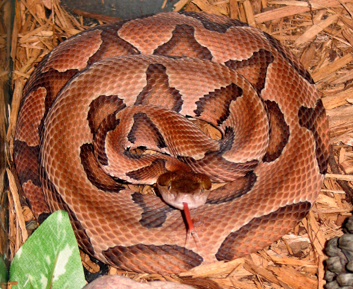
Figure 1: Copperhead snake
Source: Center for Disease Control (CDC) – Public Health Image Library

2.3.2 Time Geography and Probabilistic Space Time Prisms
Movement ecology is concerned with how, when, why, where animals and plants move (Nathan et al. 2008, Nathan and Giuggioli 2013). Rubenstein and Hobson (2004) discuss movement as a primary activity for many species that once understood, reveals their ecology, life history, and behavior. Animal movement has been related to problems like species invasion, biodiversity conservation, habitat fragmentation, disease spread, gene flow and human-wildlife conflicts (Hromada et al., 2020; Technitis et al., 2015; Forman 1995; MacDonald 2003; Quammen 1996). Movement analysis is hinged on the premise of Time Geography developed by Hagerstrand in 1970. Time Geography studies the potential movement opportunities available to an object in space at a given location, time and speed (Hagerstrand, 1970; Miller, 2017). This spatio-temporal concept has gained popularity among geographers, ecologists, and other researchers because of its value at assessing the spatial patterns of individuals that informs decisions on wildlife management, animal interactions and behavior, habitat use and home ranges (J. Downs et al., 2017, 2017; J. A. Downs, Horner, et al., 2014) as well as conservation planning and policies (Loraamm & Downs, 2016).
Fundamentally, Haggerstrand’s (1970) Time Geography answers questions based on a mobile individual’s location at different times (Winter and Yin, 2010). It views movement opportunities as based on three main components. First, a mobile individual’s point locations recorded at longitude and latitudes (x and y) within a given time (t), which are called space-time anchor locations. The sequential positions of these space-time anchors/control points give the trajectory dataset of that individual. An individual is said to move in a straight line, giving us the second component – a space time path – plotting the straight-line connections along the control points of the animal’s trajectory (Downs et al, 2014). Third, the space-time prism is a bounding volume of the known individual interactions achieved within a maximum velocity (Loraamm et al., 2018; H. J. Miller, 2005; Winter & Yin, 2011). Space time prism studies the movement of individuals by identifying their potential locations at different times (Kwan 1999, 2000, Neutens et al. 2008, 2012, Kuijpers and Othman 2009). They are formed by processing multiples/stacks of space time disks and are limited by their fixed control points (coordinate locations), the time elapsed between consecutive points, and a function of the individual’s maximum speed. For any two consecutive points in space, a location is accessible to an individual if it could arrive that location given the time elapsed since the first anchor and reach its destination given the time left (Loraamm et al 2020).
The PSTP is a derivative of the classical space-time prisms which shows the possible locations available to an animal. PSTPs on the other hand, estimates the probability that an animal occupied a cell in space and time. Simply put, PSTPs generates animal-habitat visit probabilities (Loraamm et al 2020). PSTPs operates on the Least Effort Principle (Long, 2018; Zipf 1949), that in movement, animals will choose to conserve energy. Animals would rather move in a straight line than meander across space as reflected in the straight-line space-paths between space anchors in every prism. Thus, the farther away from the space-time path, the less likely the animal considers that route (Loraamm et al 2020). This research uses Probabilistic Space-Time Prisms (PSTPs) to reveal diel habitat preferences, space utilization and interactions of copperheads based on certain time, speed and distance constraints (Loraamm et al 2020, Joni et al 2014). As a movement simulation model, it could produce more information with less data (Anderson et al., 2017; J. Downs et al., 2018; J. A. Downs, Horner, et al., 2014; Ho & Loraamm, 2023; R. Loraamm et al., 2021; Technitis et al., 2015) which are especially valuable in assessing cryptic species.

2.4 Methods

2.4.1 Study Area and Copperhead Snakes Trajectory
This research is based on the movement trajectory of copperhead snakes in an urban and rural park in Memphis, Tennessee (Carrasco-Harris, Cole, et al., 2020a). Overton Park (urban park) is a 342-acre public area that houses a zoo, an art school, a golf course, hiking trails, lake, and an old forest arboretum (Overton Park Conservancy, 2022). For over ten decades, it has been surrounded by roads, residential and commercial areas (Bearden 2004). Conversely, Edward J Meeman Biological Station (rural park) is located 24km north of Overton Park, in Shelby County, Tennessee. It is bordered by private and public forest, woody wetlands, low-traffic roads bisect this property. As a biological conservation centre for the University of Memphis dedicated to scientific inquiries, it is not open to the public. Meeman Park is a relatively undisturbed environment compared to Overton Park (Carrasco-Harris, Cole, et al., 2020a).
A total of 243 snakes were captured for their morphological data – snout length, body mass, sex – to estimate their body condition. However, only 44 snakes were implanted with transmitters and radio-tracked during their active season when the snakes were actually moving (March 15 – November 15) two times per week from June 2015 – July 2018 to understand their spatial ecology (Carrasco-Harris, Cole, et al., 2020a). With these data, they made inferences that urban copperheads had reduced body sizes, home ranges, core areas and distance travelled in comparison to rural copperheads. Copperheads’ trajectory was sourced from Movebank.org (Carrasco-Harris, Cole, et al., 2020b) containing 2031-point locations of copperhead sightings in Overton Park (urban) and Meeman Park (rural) in Tennessee. The park polygons from a directory hosting GIS server and the roads layer from TigerLine Shapefiles. The projected coordinate system used is WGS 1984 UTM Zone 16N. National Land Cover Dataset (NLCD) 2019 was sourced from United States Geological Survey (USGS) as this is the best data available for the scale of our study.
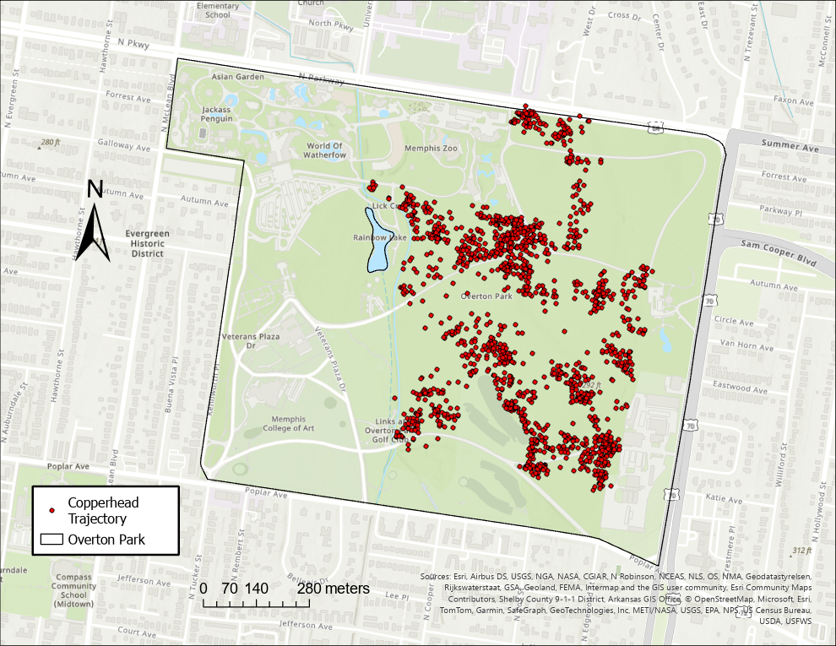
Figure 2: Copperhead trajectory in Overton Park, Memphis, Tennessee
Source: (Carrasco-Harris, Cole, et al., 2020a, 2020b)
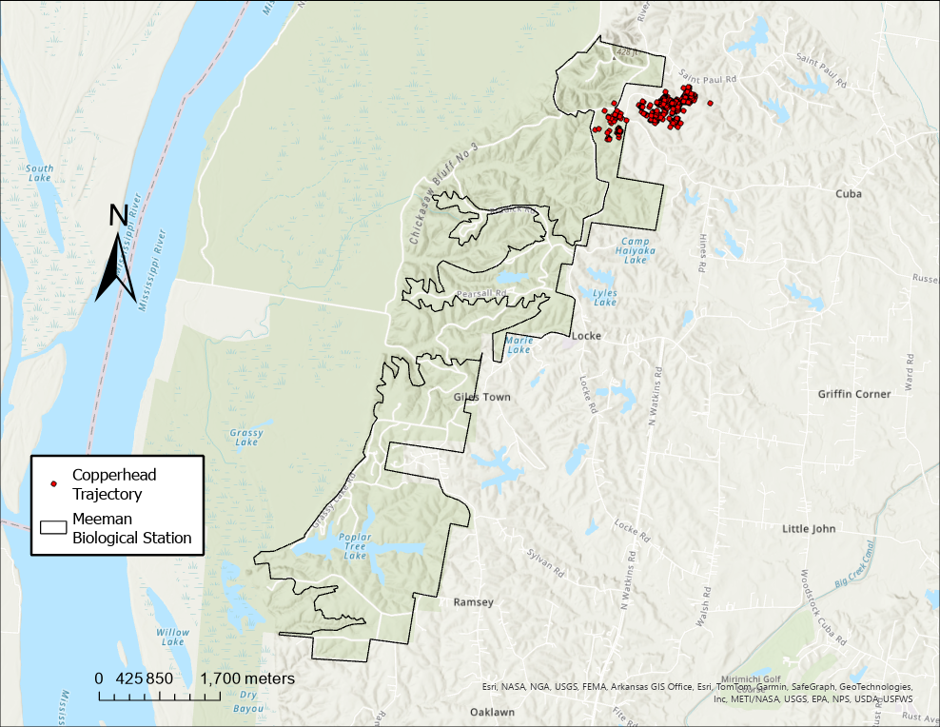
Figure 3: Copperhead trajectory in Meeman Biological Station, Tennessee
Source: (Carrasco-Harris, Cole, et al., 2020a, 2020b)

2.4.2 Landcover Composition of Overton and Meeman Parks
We downloaded National Land Cover Data (2019) for contiguous US from USGS as this is the best data available for the scale of our study, then we masked it to the study areas. Then calculated the proportion of each landcover type by running zonal statistics on both parks to inform landscape compositions available for copperheads’ usage.

2.4.3 Data Processing and Movement Interactions
Copperheads’ trajectories were first filtered and separated on Park basis into two layers. Overton Park contained 1630 locations where thirty-six (36) copperhead snakes were sighted and Meeman park had 401 locations generated by eight copperheads. The layers were reprojected to WGS 1984 UTM Zone, the data was cleaned, ordered, and prepared for analysis. A custom GIS toolbox – PySTPrism – was imported and executed in ArcGIS Pro 3.2.1 as outlined in (R. Loraamm et al., 2020). It comprises four tools – Generate Probabilistic Voxel Space–Time Prism (PSTP), Generate Voxel Space–Time Prism (STP), Calculate Probability Surface and Save Pre-Processed Trajectory (R. Loraamm et al., 2020).
This study follows the formulations found in (J. Downs et al., 2017; J. A. Downs, Horner, et al., 2014; J. A. Downs, Lamb, et al., 2014; R. Loraamm et al., 2021; R. W. Loraamm et al., 2019, 2020; R. W. Loraamm & Downs, 2016). PSTPs applies certain time, distance and velocity constraints in its computation as discussed earlier. We ran 5-minute probabilistic iterations at a minimum distance of 5m and 1.5x maximum velocity for copperhead snakes. Effective parameterization of PSTP is (1) that accurately models the behavior of the species studied; we generated distance travelled, time elapsed and velocities between consecutive snake locations. Based on this, we selected minimum values for the observed snake ‘behavior’. (2) That captures most of the data for accurate estimation of animal-visit probabilities. For example, we ran PSTPs on a 10-minute interval for the first time, timestamps that were not within this threshold were excluded from analysis (approximately 20% urban snakes and 9% rural snakes). So, we reduced the time interval to 5 minutes which translated to only 3% each of the original data eliminated from the study. After generating the PSTPs, we computed copperheads’ Comprehensive Probability Surfaces (CPS) by time of day. CPS aggregates individual prisms to obtain the total of their interaction probabilities (one raster) and serves for easy comparation of habitat preferences in space and time. CPS utility has been explored in animal movement and conservation studies (R. W. Loraamm et al., 2019, 2020; R. W. Loraamm & Downs, 2016). We organized CPS into morning (6am – 11am), afternoon (11am – 3pm), and evening (3pm – 9pm) periods in line with (J. Downs et al., 2017), then overlaid it with landcover data to determine copperheads habitat preferences by time of day.
Human-wildlife interactions were analyzed from overlaying CPS and road features which we downloaded from the US Tigerline website. Where they intersect one another reveals a potential human-snake conflict.

2.5 Results

2.5.1 Land cover types in Overton and Meeman Park
Overton Park occupies 342 acres, and there are 11 land cover types available to copperhead snakes. Developed open space is the highest landcover type with 31.2%, followed by deciduous forest 21.8%. Open water and shrubs have the lowest percent of land cover with 0.1% and 0.06% respectively.
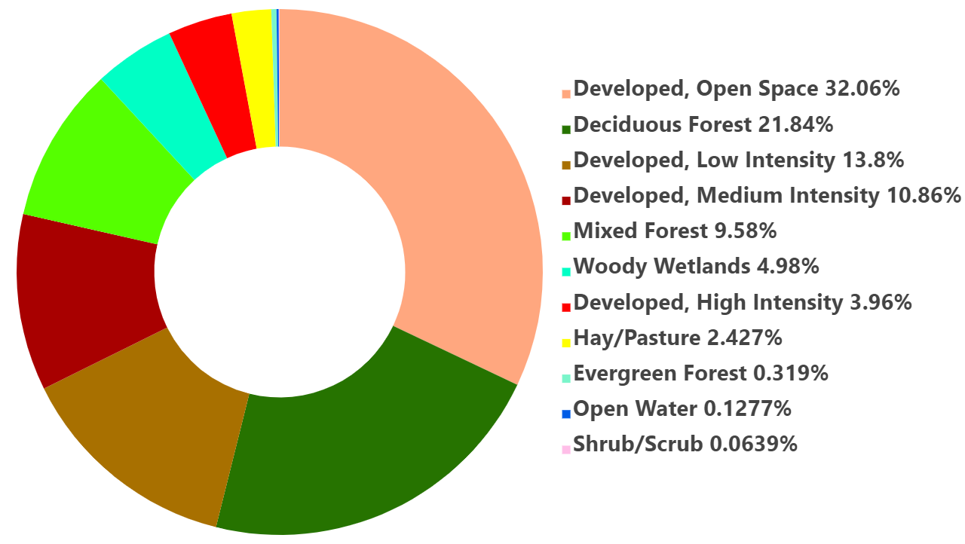
Figure 4: Percentage of land cover type in Overton Park.
Conversely, we identified 13 land cover types available to copperheads at Meeman Biological station. This park occupies 673 acres, and its land composition differs significantly from the urban park. Mixed forest is the highest land cover type with 48.3% followed by deciduous forest with 36.1%. Developed open space is 8.4% meanwhile in the urban park, it was the highest. Emergent herbaceous wetland and developed medium intensity account for the lowest cover type in Meeman Park with 0.02%.
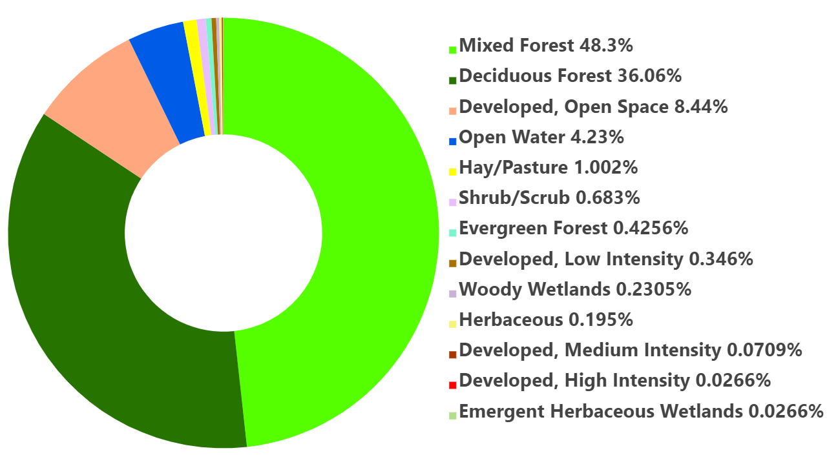
Figure 5: Percentage of land cover type in Meeman Park.

2.5.2 Probabilistic Space Time Prisms (PSTPs) and Comprehensive Probability Surface (CPS)
We determined probable locations of snakes on a 5-minute interval resulting in the probabilistic space-time prisms which is the entire gradient (bounding volume) of potential locations where copperheads may be interacting. Figures 6 and 7 are illustrations of PSTPs generated on a day in both parks as we are examining their diel habitat interactions (a 24-hour period).

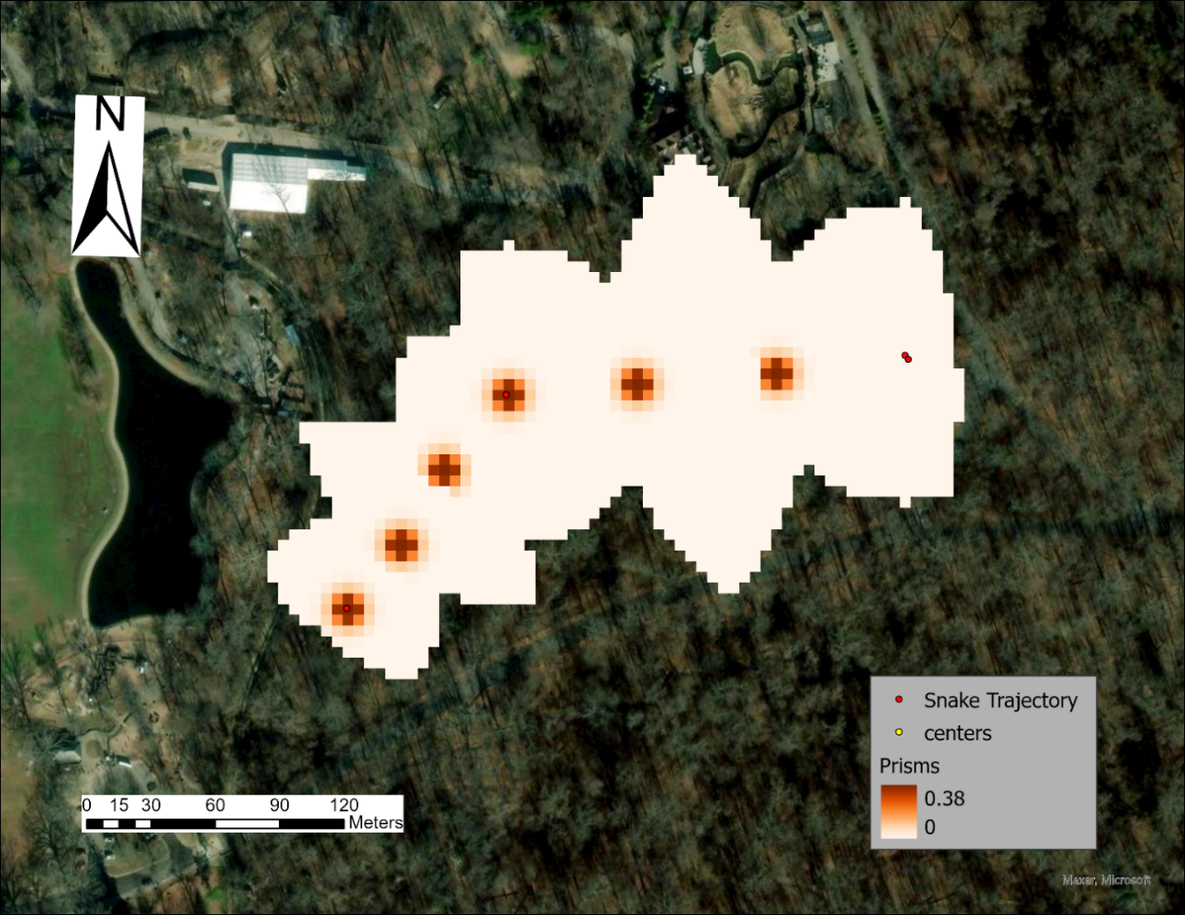
Figure 6: Probabilistic Space Time Prism (PSTP) generated for snakes in Overton Park on day 10/11/16. The entire prism depicts the potential locations of copperhead snakes. However, the probability of encountering a snake is highest in the dark orange areas than the light-colored areas. The dark-colored areas also indicate the straight-line path of copperheads’ interaction.

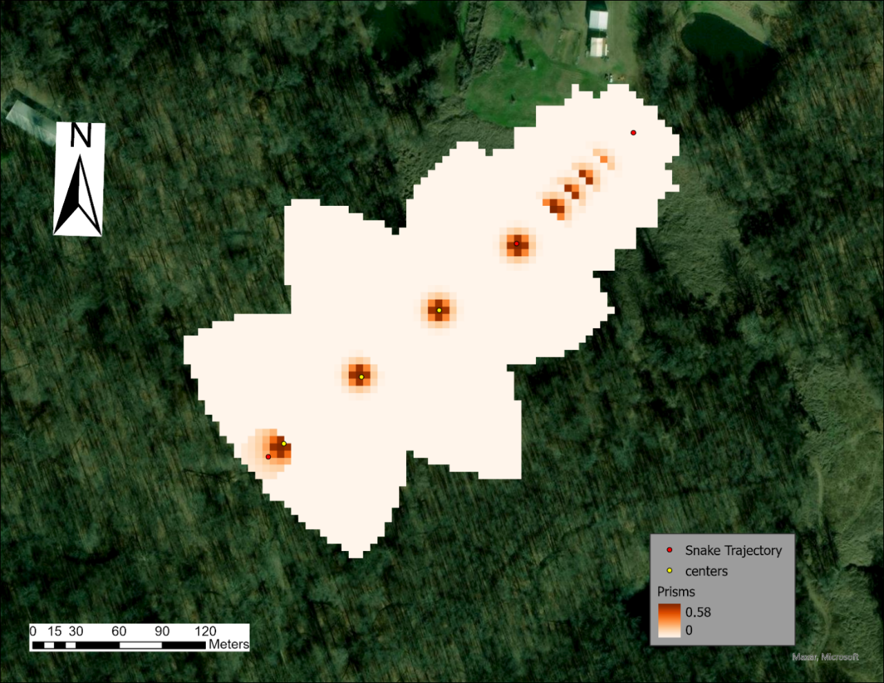
Figure 7: Probabilistic Space Time Prism (PSTP) generated for snakes in Meeman Park on day 06/30/16. The entire prism depicts the potential locations of copperhead snakes. However, the probability of encountering a snake is highest in the dark orange areas than the light-colored areas. The dark-colored areas also indicate the straight-line path of copperheads’ interaction.
Since we are examining copperhead snakes’ interactions by time of day, PSTPs were aggregated into morning, afternoon and evening periods to get their comprehensive surface which reveals snakes’ overall interactions giving a total of three CPS per park. Figure 5 visualizes the Comprehensive Probability Surface (CPS) for snakes in Overton Park during morning periods only throughout the lifetime of the study.
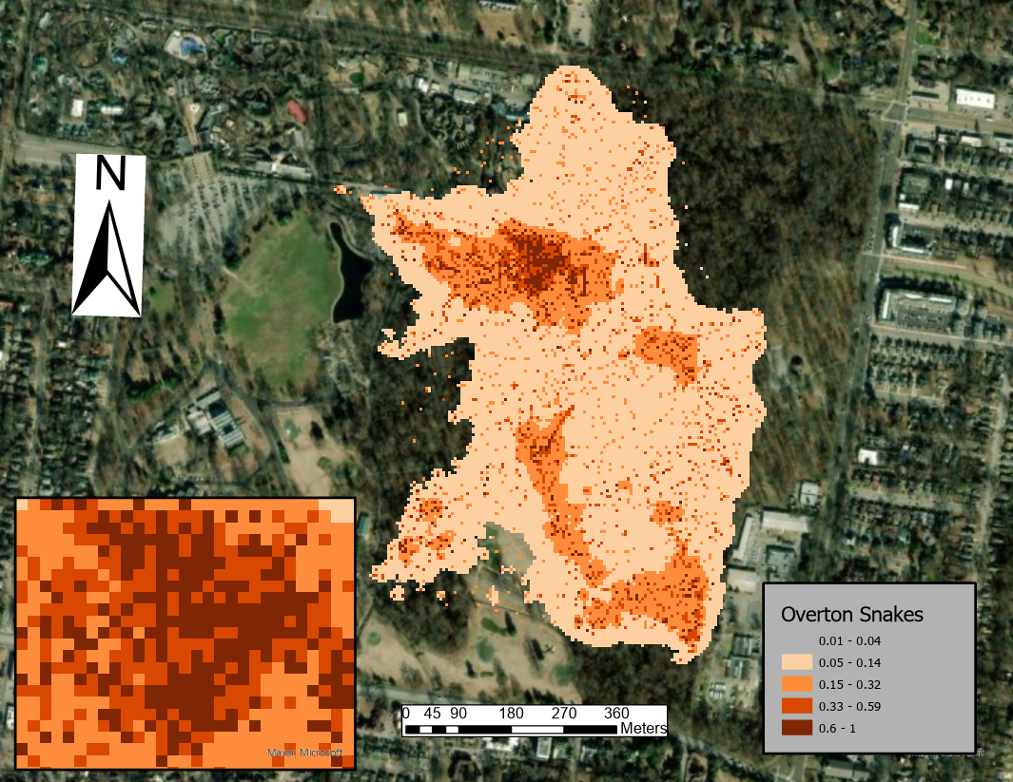
Figure 8: Comprehensive Probability Surface (CPS) of Overton snakes during morning hours (6am – 11am) overlaid with study area imagery. The inset map shows a zoomed look of copperhead’s comprehensive surface, the possibility of finding a snake at a particular location is highest in the dark-orange areas and decreases as it gets to light-colored areas.
The CPS reveals snakes’ total interactions, the dark orange colors indicate a high probability of snake interactions, and as we get to the light-colored areas, the likelihood of encountering a snake within an associated land cover is less as shown in the zoomed map frame. With the overlay of comprehensive surface on landcover data, we can discuss not only when snakes are interacting but where. This overlay produces a bar graph of copperheads’ utilization distribution defining their habitat preferences within the landscape.

2.5.3 Utilization Distribution

2.5.3.1 Copperheads Habitat Selection
The objective of this study is to theorize the potential locations where copperhead snakes may be interacting with the landscape by time of day on a fine scale basis thereby understanding their habitat preferences at different time periods. Their habitat selection is derived from the overlay of the CPS and the land cover data giving total probabilities where each cell intersects a particular cover type termed habitat-visit probabilities on a cell-by-cell basis. These values are then transformed graphically for easy observation and interpretation. Figures 9a – 9c demonstrate copperheads habitat selection in the morning, afternoon and evening periods in Overton Park.

Figure 9a: Copperheads’ habitat preferences in the morning (6am – 11am) at Overton Park.

Figure 9b: Copperheads’ habitat preferences in the afternoon (11am – 3pm) at Overton Park.

Figure 9c: Copperheads’ habitat preferences in the evening (3pm – 9pm) at Overton Park.
Out of 11 cover types available in Overton Park (Fig 1), copperhead snakes used about 5 – 8 cover types. In the morning, the highest usage is seen across vegetative areas; deciduous forest emerges as the most preferred, followed by mixed forest, developed open space and woody wetlands. The least cover type used by copperheads’ is developed high intensity. These same habitats are selected by copperhead snakes in the afternoon and evening periods with fewer variations in the cover type and levels of usage. For example, in the evening, copperheads did not select developed high intensity habitats as evidenced by the lack of that cover type in Fig 6 (evening period) but high usage of deciduous and mixed forests, developed open space and woody wetlands is witnessed across all time periods.
Figures 10a – 10c depict copperheads’ habitat selection in the morning, afternoon and evening periods in Meeman Park.

Figure 10a: Copperheads’ habitat preferences in the morning (6am – 11am) at Meeman Park

Fig 10b: Copperheads’ habitat preferences in the afternoon (11am – 3pm) at Meeman Park.

Fig 10c: Copperheads’ habitat preferences during evening period (3pm – 9pm) at Meeman Park.
Although Meeman Park supports 13 land cover types (Fig 2), copperhead snakes only utilized about 6 cover types. The predominant habitats used are mixed forest, deciduous forest and cultivated crops across all time periods with little variations occurring between developed open space and cultivated crops. Even in comparison of copperheads’ preferences across parks within same timeframes that is morning-morning in Overton and Meeman Parks, reveals the top 3 dominant land cover selected by copperheads as deciduous forest, mixed forests, cultivated crops and developed open space interchangeably.

2.5.4 Human-Snake Conflicts
To identify areas of potential human-snake conflicts, we designated roads in both parks to represent the human factor as it indicates the possibility of humans navigating with cars or walking, hiking, jogging etc. We snapped where roads intersect copperheads’ comprehensive surfaces as high-risk areas for both humans and wildlife by time of day. This can also be regarded as a risk map. Figures 11a – 11c show copperheads’ road ecology in the morning, afternoon and evening periods in Overton Park.
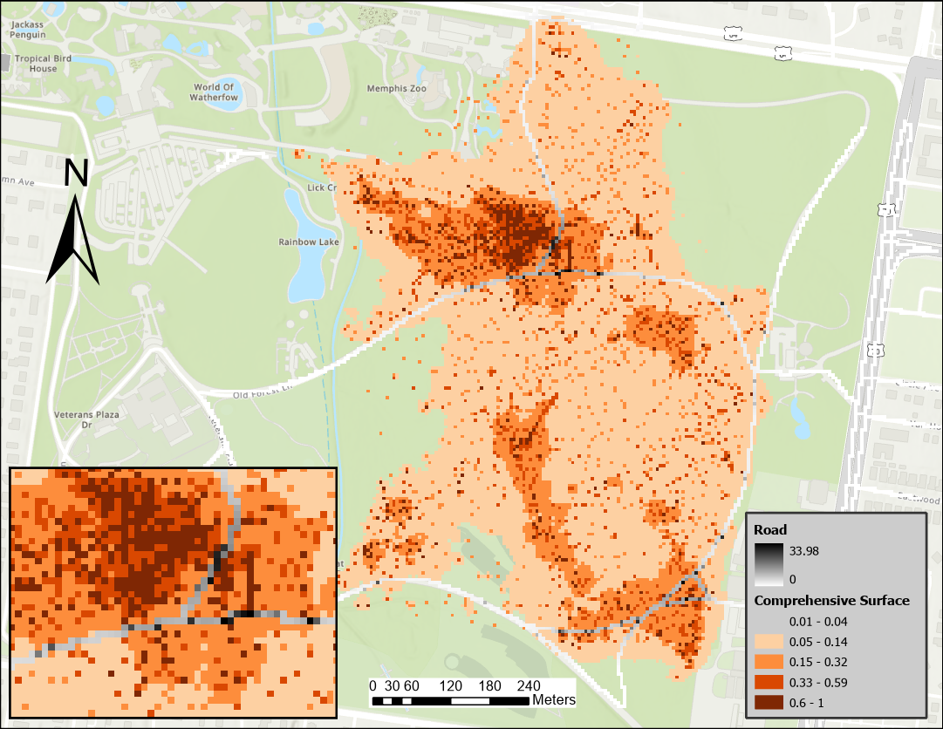
Figure 11a – Human-snake conflicts in the morning (6am – 11am) at Overton Park.
The inset map shows a zoomed look of copperheads’ road ecology, the potentials of a human-snake conflict is highest where the dark-colored snake comprehensive surface intersects the black road gradient.
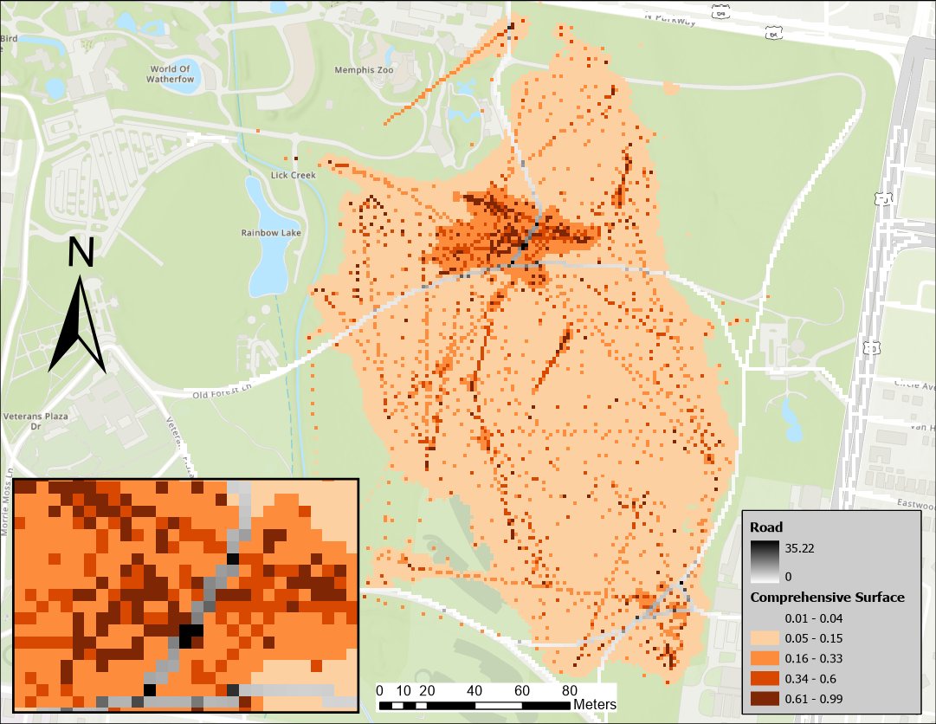
Figure 11b – Human-snake conflicts in the afternoon (11am – 3pm) at Overton Park.
The inset map shows a zoomed look of copperheads’ road ecology, the potentials of a human-snake conflict is highest where the dark-colored snake comprehensive surface intersects the black road gradient.
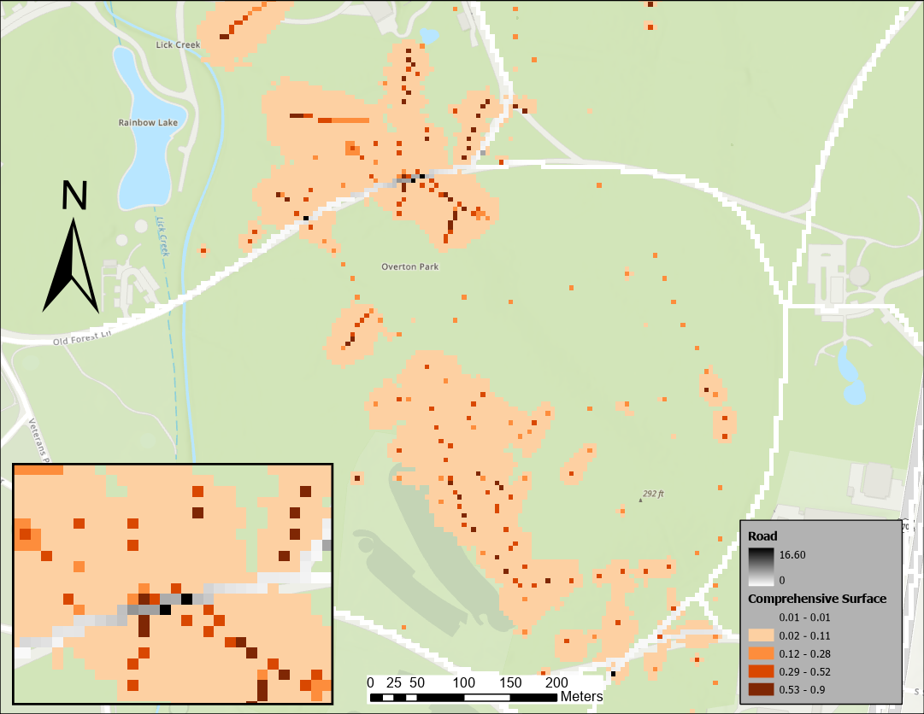
Figure 11c – Human-snake conflicts in the evening (3pm – 9pm) at Overton Park.
The inset map shows a zoomed look of copperheads’ road ecology, the potentials of a human-snake conflict is highest where the dark-colored snake comprehensive surface intersects the black road gradient.
The likelihood of copperhead snakes encountering humans (designated as roads) in Overton Park is very high with values ranging from 16.6 – 35.2. The same rule applies in that the darker areas for both comprehensive surface and roads reflect high interaction probabilities. If the dark-colored road intersects the dark-colored CPS, there is the possibility of a human-snake conflict, which we can refer to as a hotspot. Cold spots indicate areas where light road gradients intersect dark colored CPS, though this reflects high snake activity with the associated land cover but no interaction with the road. Other cold spots are light colored road gradient intersecting light-colored CPS – where the chance of finding a snake is very low; light colored road gradients intersecting light-colored CPS or where the road gradients do not intersect any comprehensive surface. Therefore, to delineate areas of potential human-snake conflicts, there must be a match between both the dark gradients of copperheads’ comprehensive surface and roads. Copperhead snakes generally avoid roads irrespective of time of day as illustrated in Figures 8. However, the potential of a human-wildlife conflict is highest in the morning and lowest in the evening.

Figures 12a – 12c show copperheads’ road ecology in the morning, afternoon and evening periods in Meeman Park.
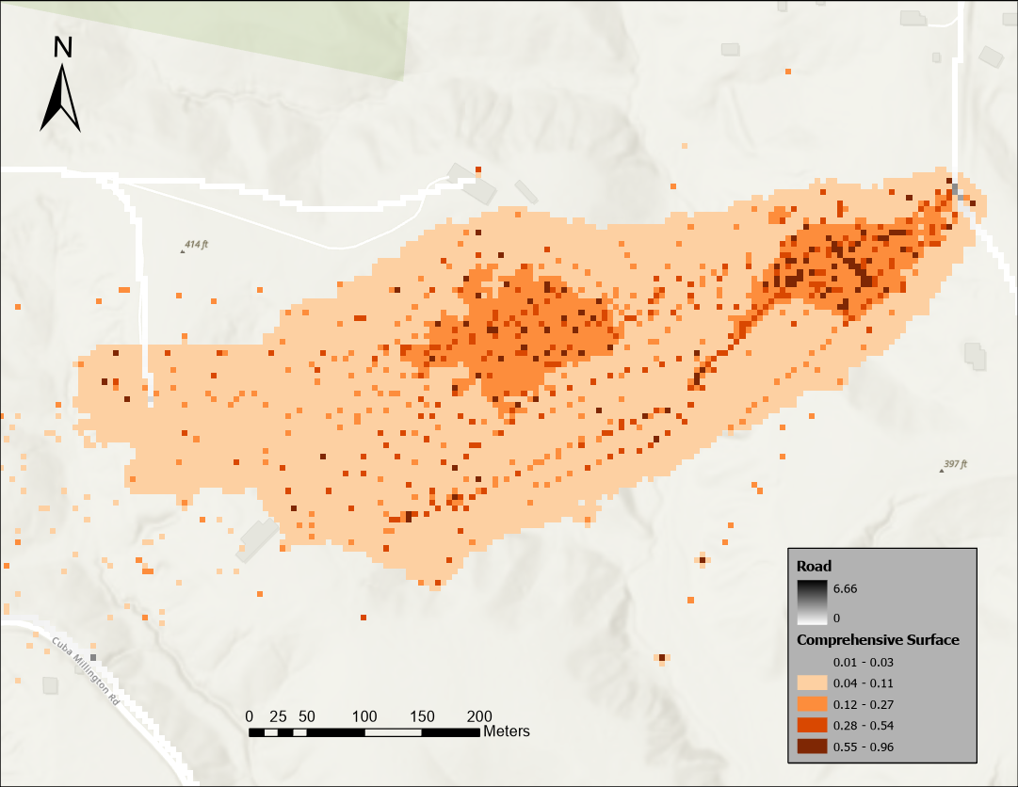
Figure 12a – Human-snake conflicts in the morning (6am – 11am) at Meeman Park.
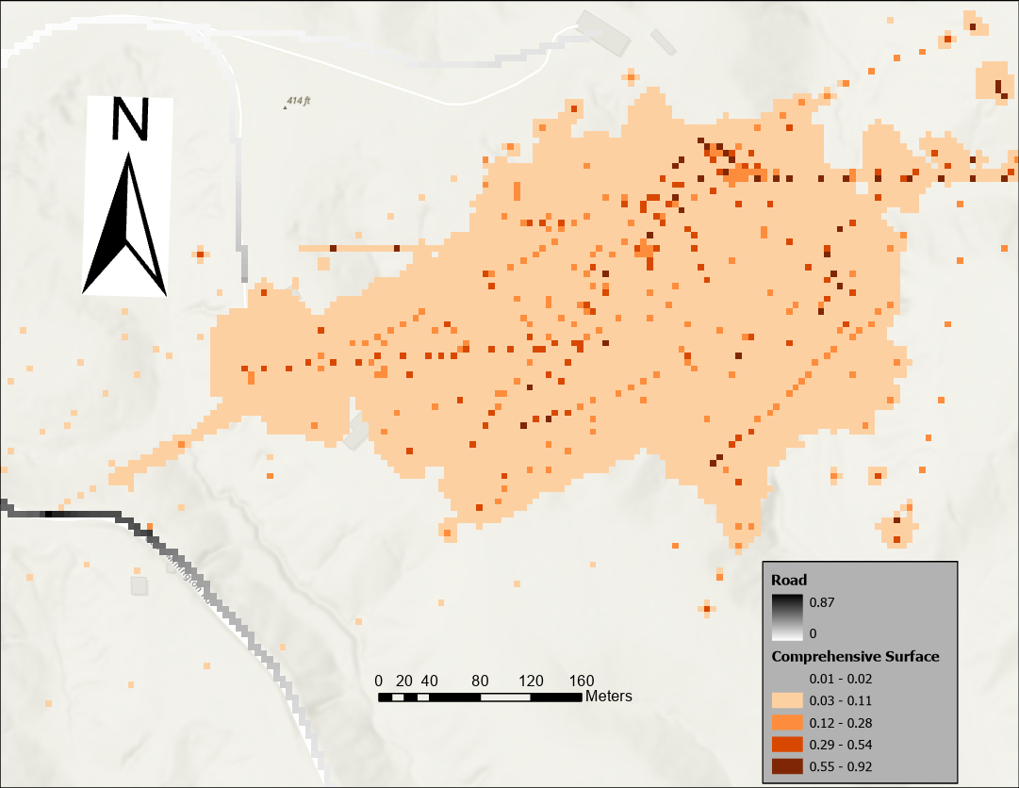
Figure 12b – Human-snake conflicts in the morning (11am – 3pm) at Meeman Park.
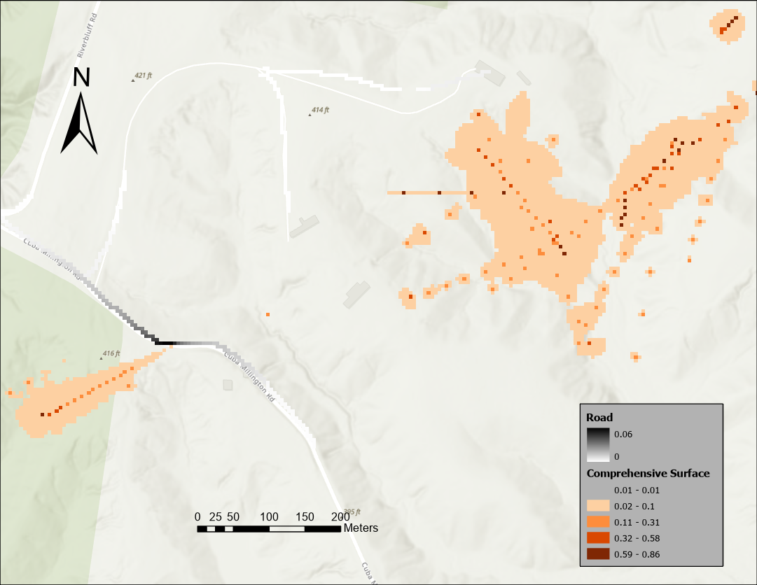
Figure 12c – Human-snake conflicts in the morning (3pm – 9pm) at Meeman Park.
The possibility of copperhead snakes encountering humans (designated as roads) in Meeman Park is low with values ranging from 0.06 – 6.6. The roads in Meeman Park are negligible and where they exist, copperheads avoid them. This correlates with Bearden (2010) in his deduction that Overton Park has extensive roads networks as shown by high values (35) of road rasters in Figures 8a – 8c while Meeman has a value less than 6 for its snake-roadway interactions.

2.6 Discussion and Conclusion

2.6.1 Movement and Interactions
This research attempts to understand copperheads’ daily movement interactions and habitat preferences by time of day on a fine scale basis using the time geographic method which has not been applied to any snake species or reptiles by previous researchers. Our study could assist wildlife managers to mitigate human-wildlife conflicts and promote snake conservation simultaneously. Probabilistic Space-Time Prisms (PSTPS) computed for copperhead snakes show their potential locations and when overlaid with land cover data defines potential areas of higher habitat use by time of day. Our findings reveal different movement interactions by time of day within the same park, and consistent movement interactions by time of day across parks. In Overton and Meeman Parks, snakes seem to be more active in the morning (6am – 11am) than afternoon and evening periods. This is especially useful for park visitors who engage in hiking, running, picnics, dog walks within these periods to be aware of copperhead snakes. The distinctiveness of our results separates itself from other methods that do not summarize animal-habitat interactions by time of day (fine scale basis).

2.6.2 Habitat Preferences
We identified copperheads’ habitat selection by time of day and our results show that copperheads prefer the same habitat irrespective of time periods. Deciduous forests, mixed forest, developed open space and cultivated crops/woody wetlands (4 landcover types in total) were the most frequented habitats by copperhead snakes in both Meeman and Overton Park even though there were about 13 and 11 landcover types available for their use respectively. Copperheads may have chosen these forested habitats because their food sources such as rats, rabbits and other rodents are abundant in these areas. Also, these habitats provide a cover for them from their predators, such as eagles and hawks who hunt snakes as prey. Since snakes are cold blooded animals, developed open space in the urban park and cultivated crops in the rural park may serve as basking sites for them to warm up as these are relatively low-level and plain lands.
In Overton Park, mixed forest is the 2nd highest habitat used by copperheads however it constitutes only 9.58% of the total proportion of landcover. Even though this cover type is small, copperheads spend considerable time, so wildlife managers could take appropriate measures to conserve this fragmented land and probably link connecting habitats. Developed open space is the 3rd most utilized habitat by copperheads and is the largest cover type with 32%, this emphasizes that urban cities, green areas and parks have a range of suitable habitats for biodiversity and thus, should be adequately managed to promote environmental sustainability. Agricultural lands are also prime habitats for copperheads though observed in the rural park but could also be found within cities and suburbs.
Habitat studies are done at different spatial scales, other research suggest favorable habitats for snakes as crevices, rock outcropping ( Webb & Shine, 1997) but this research is based on broad habitat types, therefore conservation of these habitats is inclusive of other species with similar habitat preferences. The occupancy of developed open space by copperheads in Overton Park correlates with literature that open habitats are favorable for reptiles (Nordberg et al., 2021, Edgar et al 2010) and viper snakes (especially snakes in temperate climes) in regulating their body temperature (Bonnet et al., 2016). Copperhead snakes do not alter their spatial behavior by time of day as their habitat use is consistent in both parks. This calls for wildlife managers to increase habitat quality and connectivity across these prime habitats if it is sorely lacking. This characteristic corroborates literature and validates snakes as biosystem indicators (Nordberg et al., 2021), as copperheads used the same habitats during different time periods for 3 years when they were monitored. Discrepancies or changes in their space use can alert wildlife managers and may indicate resources deficiencies necessary for their survival. This study may also be used as reference to confirm site fidelity amongst copperhead snakes or other snake species as they returned to the same landscape regardless of time of day.

2.6.3 Human-wildlife Conflicts
We identified potential locations for human-snake conflicts using the time-geographic approach by quantifying copperheads’ roadway interactions. This differentiates our research from other studies that have examined human-wildlife conflicts except for (R. W. Loraamm & Downs, 2016) who used this approach to examine panther interactions with roads to optimally locate crossing structures. These HWC locations identified can be termed risk maps as it informs the likely locations for conflicts and where it can be averted (areas of low risk). Risk maps are useful to everyone visiting, living and working on park grounds or military reserves. With this information, wildlife managers could probably install caution signages informing the public of the potential areas where copperhead snakes could be found or take non-lethal actions towards reducing this conflict. However, it is important to note that human decisions and animal behavior can change at any time, so risk maps are always evolving. As (Olson et al., 2019) opines, HWC cases are diverse, multifaceted and overlapping in space so risk maps may not in its entirety be relied upon.
Generally, our research highlights that copperheads avoid roads in both study areas and because Meeman Park lacks extensive road network, we do not see a lot of road-way interactions unlike Overton Park.

2.7 Limitations
We assessed copperhead snakes at the group level and not as individuals (male and female snakes) in both parks. There are many ways this data could have been examined, at the individual level or gender specific behavior to see if habitat preferences are uniform across time periods. Also, copperhead trajectory was generated only twice a week for three years, it reflects a lot of gaps that are inconsistent with the time geographic method used that looks at diel (24 hour) habitat interactions. Future studies can replicate this method using more detailed and constant tracking data to see if there will be different space use. Also, even though 243 snakes were captured, only 44 of them were tracked, 36 snakes in the urban park and 8 snakes in the rural park. This uneven sample size between both parks raises some questions however, some animal movement studies have used between 12-20 subjects (Wilber et al., 2022; Yang et al., 2021, 2023) so this may not be a problem. Notwithstanding, it will be intriguing to note that if evenly sampled in both parks, we get the same results.
Copperhead snakes’ comprehensive surfaces exceed the boundaries of the parks, though we speculate low interactions there. We acknowledge the scale of this study and note that we are limited by examining copperheads’ interactions only within park boundaries and not the surrounding areas. Since we are investigating from a HWC perspective, we will not concern ourselves with making recommendations (such as caution signs) outside the park. However, from a habitat conservation or quality view, it is judicious to ensure connecting habitats or corridors therefore, future studies can look beyond the park.

2.8 Conclusion
This research could possibly aid wildlife management and conservation. First, it can reduce human-wildlife conflicts and promote snake conservation by adopting adequate management strategies such as increasing habitat quality and connectivity in the spaces utilized by snakes. If snakes had used different cover types by time of day, wildlife managers would need to find creative ways (such as flashing caution signs) to appraise the public of the locations and times they could be found but since that is not the case, a regular sign board will suffice. At the same time, by examining copperheads’ interactions by time of day, we are effectively mitigating HWC as we do not want to generalize that copperheads are always at a certain location which could be injurious to humans if accurate information is not given. Second, this research distinguishes itself from other snake studies due to the dynamic time geographic method and broad habitat scales used which determines copperheads’ potential habitats in real-time and accounts for changing animal behavior within environmental contexts. It is necessary to reiterate that this research may be of significance to wildlife managers, state and federal conservation managers for its utility in mitigating human-wildlife conflicts, encouraging snake conservation and managing prime habitats for wildlife sustainability.

Chapter 3: Extended Discussion, Limitations and Conclusion
Different movement models and methods abound in the field of geography with intersections in biology, ecology and other disciplines concerned with biodiversity conservation alongside rapid ongoing developments to them. This research uses one of such movement models – time geography – to demonstrate the efficacy of such methods in solving real world conservation problems to provide actionable information that fosters wildlife conservation and mitigates human-wildlife conflicts. Our research can be replicated for other wildlife species if the researcher is furnished with their trajectory dataset. For example, studies on other snake species could be replicated in other locations using this model and the copperheads research as a guideline in terms of appropriate parameterization of snakes’ movement behavior. This applied research could be beneficial to stakeholders and conservationists such as federal and state government departments who are tasked with controlling wildlife resources, so limited financial resources can be appropriated to areas or habitats favored by wildlife thereby prioritizing habitats that demand conservation efforts. Park and wildlife managers who are tasked with recreation management in urban or green spaces could possibly increase visitor satisfaction as visitors will not be bitten by snakes on their tour of the park facilities. In the case of a land-sparing scenario, where protected lands are set aside for nature conservation, this research might identify possible lands by designating habitats that support wildlife sustainability and potentially aid management plans for improving habitat quality and landscape connectivity.
The challenges encountered during this research were in getting the accurate parameters that represented copperheads’ behavior based off their movement data. This meant that we had to run the tool a couple of times on different parameters before we settled on the parameters that best modeled copperheads’ behavior. At our discretion, we also ran the prisms manually to increase confidence in how we applied the time geographic method, but this process could be automated with arcpy – python programming in ArcGIS. Also, since I was learning the time geographic method for the first time, it took quite a bit of time to understand the mechanism behind it.
The promise of this research by comparing copperhead snakes’ usage of a rural and urban park by time of day is to avoid generalization and to accurately portray areas (with the use of risk maps) that may threaten human safety and copperhead survival. It is also noteworthy to mention that this research will contribute to the growing literature in wildlife behavior and movement and the discipline of GIScience and Conservation. Studies have not identified potential areas where human-snake conflicts may occur so it can be mitigated in these parks and beyond; researchers have not examined habitat use by time of day for copperheads and other snake species, as well as the reptile class using the time-geographic model on a fine scale basis. This research corroborates other urban ecology studies depicting that urban areas have unique ecosystems that can support biodiversity and wildlife species. Anthropogenic factors and activities such as deforestation, pollution of land resources due to commercial and industrial activities, changing land use types and wildlife persecution all contribute to wildlife populations decline. Thus, this research is also advocating for better environmental practices and positive attitudes towards biodiversity by all urban and earthly residents to foster a mutually beneficial society that is conducive for humans, plants and animals alike. As the British Explorer, Robert Swan (2020) calls it: “The greatest threat to our planet is the belief that someone else will save it”.

References
Abrahms, B., Carter, N. H., Clark-Wolf, T. J., Gaynor, K. M., Johansson, E., McInturff, A., Nisi, A. C., Rafiq, K., & West, L. (2023). Climate change as a global amplifier of human–wildlife conflict. Nature Climate Change, 13(3), 224–234. https://doi.org/10.1038/s41558-023-01608-5
Ahearn, S. C., Dodge, S., Simcharoen, A., Xavier, G., & Smith, J. L. D. (2017). A context-sensitive correlated random walk: A new simulation model for movement. International Journal of Geographical Information Science, 31(5), 867–883. https://doi.org/10.1080/13658816.2016.1224887
Anderson, J. H., Downs, J. A., Loraamm, R., & Reader, S. (2017). Agent-based simulation of Muscovy duck movements using observed habitat transition and distance frequencies. Computers, Environment and Urban Systems, 61, 49–55. https://doi.org/10.1016/j.compenvurbsys.2016.09.002
Baruch‐Mordo, S., Breck, S. W., Wilson, K. R., & Theobald, D. M. (2008). Spatiotemporal Distribution of Black Bear‐Human Conflicts in Colorado, USA. The Journal of Wildlife Management, 72(8), 1853–1862. https://doi.org/10.2193/2007-442
Beri, D., & Bhaumik, S. (2021). Snakes, the ecosystem, and us: It’s time we change.
Bonnet, X., Lecq, S., Lassay, J. L., Ballouard, J. M., Barbraud, C., Souchet, J., Mullin, S. J., & Provost, G. (2016). Forest management bolsters native snake populations in urban parks. Biological Conservation, 193, 1–8. https://doi.org/10.1016/j.biocon.2015.11.001
Bonnet, X., Naulleau, G., & Shine, R. (1999). The dangers of leaving home: Dispersal and mortality in snakes. Biological Conservation, 89(1), 39–50. https://doi.org/10.1016/S0006-3207(98)00140-2
Buchholtz, E. K., Fitzgerald, L. A., Songhurst, A., McCulloch, G. P., & Stronza, A. L. (2020). Experts and elephants: Local ecological knowledge predicts landscape use for a species involved in human-wildlife conflict. Ecology and Society, 25(4), art26. https://doi.org/10.5751/ES-11979-250426
Burch, C., Loraamm, R., Unnasch, T., & Downs, J. (2020). Utilizing ecological niche modelling to predict habitat suitability of eastern equine encephalitis in Florida. Annals of GIS, 26(2), 133–147. https://doi.org/10.1080/19475683.2020.1730962
Carrasco-Harris, M. F., Bowman, D., Reichling, S., & Cole, J. A. (2020). Spatial ecology of copperhead snakes (Agkistrodon contortrix) in response to urban park trails. Journal of Urban Ecology, 6(1), juaa007. https://doi.org/10.1093/jue/juaa007
Carrasco-Harris, M. F., Cole, J. A., & Reichling, S. (2020a). Cozy in the City: The Morphology and Spatial Ecology of Copperheads in an Urban Forest. 35.
Carrasco-Harris, M. F., Cole, J. A., & Reichling, S. (2020b). Data from: Cozy in the city: the morphology and spatial ecology of copperheads in an urban forest [Csv]. Movebank Data Repository. https://doi.org/10.5441/001/1.1RS3J824
Carter, H., Glaudas, X., Whitaker, R., Chandrasekharun, G., Hockings, K., & Nuno, A. (2024). Venomous snakebites: Exploring social barriers and opportunities for the adoption of prevention measures. Conservation Science and Practice, e13063. https://doi.org/10.1111/csp2.13063
Corbit, A. G., & Hayes, W. K. (2022). Human-Wildlife Conflict at a Suburban–Wildlands Interface: Effects of Short- and Long-Distance Translocations on Red Diamond Rattlesnake (Crotalus ruber) Activity and Survival. Diversity, 14(2), 130. https://doi.org/10.3390/d14020130
Crimmins, T. M., Posthumus, E., Schaffer, S., & Prudic, K. L. (2021). COVID-19 impacts on participation in large scale biodiversity-themed community science projects in the United States. Biological Conservation, 256, 109017. https://doi.org/10.1016/j.biocon.2021.109017
Davis, F. W., Stoms, D. M., Estes, J. E., Scepan, J., & Michael Scott, J. (1990). An information systems approach to the preservation of biological diversity. International Journal of Geographical Information Systems, 4(1), 55–78. https://doi.org/10.1080/02693799008941529
Dodge, S., Weibel, R., Ahearn, S. C., Buchin, M., & Miller, J. A. (2016). Analysis of movement data. International Journal of Geographical Information Science, 30(5), 825–834. https://doi.org/10.1080/13658816.2015.1132424
Downs, J. A., Horner, M. W., Hyzer, G., Lamb, D., & Loraamm, R. (2014). Voxel-based probabilistic space-time prisms for analysing animal movements and habitat use. International Journal of Geographical Information Science, 28(5), 875–890. https://doi.org/10.1080/13658816.2013.850170
Downs, J. A., Lamb, D., Hyzer, G., Loraamm, R., Smith, Z. J., & O’Neal, B. M. (2014). Quantifying spatio-temporal interactions of animals using probabilistic space–time prisms. Applied Geography, 55, 1–8. https://doi.org/10.1016/j.apgeog.2014.08.010
Downs, J., Horner, M., Lamb, D., Loraamm, R. W., Anderson, J., & Wood, B. (2018). Testing time-geographic density estimation for home range analysis using an agent-based model of animal movement. International Journal of Geographical Information Science, 32(7), 1505–1522. https://doi.org/10.1080/13658816.2017.1421764
Downs, J., Horner, M., Loraamm, R., Anderson, J., Kim, H., & Onorato, D. (2014). Strategically Locating Wildlife Crossing Structures for F lorida Panthers Using Maximal Covering Approaches. Transactions in GIS, 18(1), 46–65. https://doi.org/10.1111/tgis.12005
Downs, J., Loraamm, R., University of Oklahoma, Anderson, J., University of Oklahoma, Perry, J., University of South Florida, Bullock, J., & University of Texas-Arlington. (2017). Habitat Use and Behaviours of Introduced Muscovy Ducks (Cairina moschata) in Urban and Suburban Environments. Suburban Sustainability, 5(1). https://doi.org/10.5038/2164-0866.5.1.1028
Esmaeili, S., Hemami, M.-R., & Goheen, J. R. (2019). Human dimensions of wildlife conservation in Iran: Assessment of human-wildlife conflict in restoring a wide-ranging endangered species. PLOS ONE, 14(8), e0220702. https://doi.org/10.1371/journal.pone.0220702
Fahrig, L. (2003). Effects of Habitat Fragmentation on Biodiversity. Annual Review of Ecology, Evolution, and Systematics, 34(1), 487–515. https://doi.org/10.1146/annurev.ecolsys.34.011802.132419
Giam, X., Bradshaw, C. J. A., Tan, H. T. W., & Sodhi, N. S. (2010). Future habitat loss and the conservation of plant biodiversity. Biological Conservation, 143(7), 1594–1602. https://doi.org/10.1016/j.biocon.2010.04.019
Gonçalves-Souza, D., Verburg, P. H., & Dobrovolski, R. (2020). Habitat loss, extinction predictability and conservation efforts in the terrestrial ecoregions. Biological Conservation, 246, 108579. https://doi.org/10.1016/j.biocon.2020.108579
Greenberg, J. R., & Holekamp, K. E. (2017). Human disturbance affects personality development in a wild carnivore. Animal Behaviour, 132, 303–312. https://doi.org/10.1016/j.anbehav.2017.08.023
Gulati, S., Karanth, K. K., Le, N. A., & Noack, F. (2021). Human casualties are the dominant cost of human–wildlife conflict in India. Proceedings of the National Academy of Sciences, 118(8), e1921338118. https://doi.org/10.1073/pnas.1921338118
Hauser, C. E., Southwell, D., Lahoz-Monfort, J. J., Rumpff, L., Benshemesh, J., Burnard, T., Van Hespen, R., Wright, J., Wintle, B., & Bode, M. (2019). Adaptive management informs conservation and monitoring of Australia’s threatened malleefowl. Biological Conservation, 233, 31–40. https://doi.org/10.1016/j.biocon.2019.02.015
Hegglin, D., Bontadina, F., & Deplazes, P. (2015). Human–wildlife interactions and zoonotic transmission of Echinococcus multilocularis. Trends in Parasitology, 31(5), 167–173. https://doi.org/10.1016/j.pt.2014.12.004
Ho, K., & Loraamm, R. (2023). Using a Cost-Distance Time-Geographic Approach to Identify Red Deer Habitat Use in Banff National Park, Alberta, Canada. ISPRS International Journal of Geo-Information, 12(8), 339. https://doi.org/10.3390/ijgi12080339
Honda, T., Iijima, H., Tsuboi, J., & Uchida, K. (2018). A review of urban wildlife management from the animal personality perspective: The case of urban deer. Science of The Total Environment, 644, 576–582. https://doi.org/10.1016/j.scitotenv.2018.06.335
Hromada, S. J., Esque, T. C., Vandergast, A. G., Dutcher, K. E., Mitchell, C. I., Gray, M. E., Chang, T., Dickson, B. G., & Nussear, K. E. (2020). Using movement to inform conservation corridor design for Mojave desert tortoise. Movement Ecology, 8(1), 38. https://doi.org/10.1186/s40462-020-00224-8
Klich, D., Łopucki, R., Perlińska-Teresiak, M., Lenkiewicz-Bardzińska, A., & Olech, W. (2021). Human–Wildlife Conflict: The Human Dimension of European Bison Conservation in the Bieszczady Mountains (Poland). Animals, 11(2), 503. https://doi.org/10.3390/ani11020503
Kopnina, H., Muhammad, N. Z., & Olaleru, F. (2022). Exploring attitudes to biodiversity conservation and Half-Earth vision in Nigeria: A preliminary study of community attitudes to conservation in Yankari Game Reserve. Biological Conservation, 272, 109645. https://doi.org/10.1016/j.biocon.2022.109645
Loraamm, R., Anderson, J., & Burch, C. (2021). Identifying road avoidance behavior using time‐geography for red deer in Banff National Park, Alberta, Canada. Transactions in GIS, 25(3), 1331–1346. https://doi.org/10.1111/tgis.12748
Loraamm, R., Downs, J., Anderson, J., & Lamb, D. S. (2020). PySTPrism: Tools for voxel-based space–time prisms. SoftwareX, 12, 100499. https://doi.org/10.1016/j.softx.2020.100499
Loraamm, R. W., & Downs, J. A. (2016). A wildlife movement approach to optimally locate wildlife crossing structures. International Journal of Geographical Information Science, 30(1), 74–88. https://doi.org/10.1080/13658816.2015.1083995
Loraamm, R. W., Downs, J. A., & Lamb, D. (2019). A time‐geographic approach to quantifying wildlife–road interactions. Transactions in GIS, 23(1), 70–86. https://doi.org/10.1111/tgis.12497
Loraamm, R. W., Goodenough, K. S., Burch, C., Davenport, L. C., & Haugaasen, T. (2020). A time-geographic approach to identifying daily habitat use patterns for Amazonian Black Skimmers. Applied Geography, 118, 102189. https://doi.org/10.1016/j.apgeog.2020.102189
Messmer, T. A. (2024). Human–wildlife conflicts:
Mukeka, J. M., Ogutu, J. O., Kanga, E., & Røskaft, E. (2019). Human-wildlife conflicts and their correlates in Narok County, Kenya. Global Ecology and Conservation, 18, e00620. https://doi.org/10.1016/j.gecco.2019.e00620
Mullin, S. J., & Seigel, R. A. (Eds.). (2009). 9. Snakes as Indicators and Monitors of Ecosystem Properties. In Snakes (pp. 244–261). Cornell University Press. https://doi.org/10.7591/9780801459092-013
Nordberg, E., Ashley, J., Hoekstra, A. A., Kirkpatrick, S., & Cobb, V. A. (2021). Small nature preserves do not adequately support large-ranging snakes: Movement ecology and site fidelity in a fragmented rural landscape. Global Ecology and Conservation, 28, e01715. https://doi.org/10.1016/j.gecco.2021.e01715
Ogra, M. (2009). Attitudes Toward Resolution of Human–Wildlife Conflict Among Forest-Dependent Agriculturalists Near Rajaji National Park, India. Human Ecology, 37(2), 161–177. https://doi.org/10.1007/s10745-009-9222-9
Olson, E. R., Van Deelen, T. R., Wydeven, A. P., Ruid, D. B., MacFarland, D. M., & Ventura, S. J. (2019). A landscape of overlapping risks for wolf-human conflict in Wisconsin, USA. Journal of Environmental Management, 248, 109307. https://doi.org/10.1016/j.jenvman.2019.109307
Olson, E. R., Van Deelen, T. R., Wydeven, A. P., Ventura, S. J., & Macfarland, D. M. (2015). Characterizing wolf–human conflicts in Wisconsin, USA. Wildlife Society Bulletin, 39(4), 676–688. https://doi.org/10.1002/wsb.606
Peterson, M. N., Birckhead, J. L., Leong, K., Peterson, M. J., & Peterson, T. R. (2010). Rearticulating the myth of human–wildlife conflict. Conservation Letters, 3(2), 74–82. https://doi.org/10.1111/j.1755-263X.2010.00099.x
Roberts, S. A., Hall, G. B., & Calamai, P. H. (2000). Analysing forest fragmentation using spatial autocorrelation, graphs and GIS. International Journal of Geographical Information Science, 14(2), 185–204. https://doi.org/10.1080/136588100240912
Salem, B. B. (2003). Application of GIS to biodiversity monitoring. Journal of Arid Environments, 54(1), 91–114. https://doi.org/10.1006/jare.2001.0887
Sawada, K., & Kadowaki, S. (2023). Change in the Guild Structure of a Snake Community in Japan over 30 Years. Current Herpetology, 42(1). https://doi.org/10.5358/hsj.42.74
Schultz, H., Chang, K., Bury, S. J., Gaskett, A. C., Dennis, T. E., Ismar‐Rebitz, S. M. H., Southey, I., Hohnhold, R. J., & Millar, C. D. (2021). Sex‐specific foraging of an apex predator puts females at risk of human–wildlife conflict. Journal of Animal Ecology, 90(7), 1776–1786. https://doi.org/10.1111/1365-2656.13496
Störmer, N., Weaver, L. C., Stuart-Hill, G., Diggle, R. W., & Naidoo, R. (2019). Investigating the effects of community-based conservation on attitudes towards wildlife in Namibia. Biological Conservation, 233, 193–200. https://doi.org/10.1016/j.biocon.2019.02.033
Tamrat, M., Atickem, A., Tsegaye, D., Nguyen, N., Bekele, A., Evangelista, P., Fashing, P. J., & Stenseth, N. Chr. (2020). Human–wildlife conflict and coexistence: A case study from Senkele Swayne’s Hartebeest Sanctuary in Ethiopia. Wildlife Biology, 2020(3), 1–10. https://doi.org/10.2981/wlb.00712
Technitis, G., Othman, W., Safi, K., & Weibel, R. (2015). From A to B, randomly: A point-to-point random trajectory generator for animal movement. International Journal of Geographical Information Science, 29(6), 912–934. https://doi.org/10.1080/13658816.2014.999682
Webb, J. K., & Shine, R. (1997). A field study of spatial ecology and movements of a threatened snake species, Hoplocephalus bungaroides. Biological Conservation, 82(2), 203–217. https://doi.org/10.1016/S0006-3207(97)00032-3
Wilber, M. Q., Yang, A., Boughton, R., Manlove, K. R., Miller, R. S., Pepin, K. M., & Wittemyer, G. (2022). A model for leveraging animal movement to understand spatio‐temporal disease dynamics. Ecology Letters, 25(5), 1290–1304. https://doi.org/10.1111/ele.13986
Wood, L., Ngari, C., Parkurito, S., Barnes, K., Otundo, D., Misiani, D. A., Kephah, G. M., Trelfa, A., Olouch, G. O., Harrison, R. A., & Tianyi, F.-L. (2022). “Then they prayed, they did nothing else, they just prayed for the boy and he was well”: A qualitative investigation into the perceptions and behaviours surrounding snakebite and its management in rural communities of Kitui county, Kenya. PLOS Neglected Tropical Diseases, 16(7), e0010579. https://doi.org/10.1371/journal.pntd.0010579
Yang, A., Proffitt, K. M., Asher, V., Ryan, S. J., & Blackburn, J. K. (2021). Sex‐Specific Elk Resource Selection during the Anthrax Risk Period. The Journal of Wildlife Management, 85(1), 145–155. https://doi.org/10.1002/jwmg.21952
Yang, A., Wilber, M. Q., Manlove, K. R., Miller, R. S., Boughton, R., Beasley, J., Northrup, J., VerCauteren, K. C., Wittemyer, G., & Pepin, K. (2023). Deriving spatially explicit direct and indirect interaction networks from animal movement data. Ecology and Evolution, 13(3), e9774. https://doi.org/10.1002/ece3.9774
Yates, J. R., McBride, D., Harding, S. F., Rodriguez, D., & Mullin, S. J. (2023). Changes in the Community Composition of Riverine Snakes (Squamata: Serpentes) Over Five Decades. Herpetological Conservation and Biology.

