University of Oklahoma

Graduate College

Collecting architecture: a case study of ancient architectural fragments held by the milwaukee public museum

A thesis

submitted to the Graduate Faculty

in partial fulfillment of the requirements for the

Degree of

Master of Arts

By

brittany a. puhrmann
Norman, Oklahoma
2017

Collecting architecture: a case study of ancient architectural fragments held by the milwaukee public museum

A thesis approved for the
College of PROFESSIONAL AND CONTINUING STUDIES

By

______________________________
Dr. Michael Mares, Chair

______________________________
Dr. Allison Palmer

______________________________
Ms. Barbara Bilek

© Copyright by brittany a. puhrmann 2017
All Rights Reserved.

Acknowledgements
I have several people to thank for contributing to the completion of this thesis. Firstly, I would like to thank my thesis committee, Dr. Michael Mares, Dr. Allison Palmer, and Prof. Barbara Bilek, for their patience, guidance, and insight. Their comments and questions helped me hone my research and perfect my thesis.
I’d like to thank everyone at the Milwaukee Public Museum for providing me access to their collections, records, and research facilities. Thanks to MPM interns Jocelyn Slocum, Natasha Khan, and Jackie Carpenter for helping me gather documentation and photograph fragments and for responding to my many emails requesting further details on donors and fragments. I would especially like to express my sincere gratitude to Dawn Scher Thomae at the MPM for providing me the incredible opportunity to learn from her as an intern and for her constant support, guidance, and motivation throughout my internship and thesis writing process.
My sincere thanks also go to Julie Huffman-klinkowitz and Jerry Klinkowitz who read draft after draft and who provided constant encouragement and guidance throughout the writing process. Thanks also to everyone at the Cedar Falls Historical Society for providing me a great workspace to do my research and for acting as sounding boards when I needed to talk through my research.
Last but certainly not least, I’d like to thank my friends and family for their unceasing support and encouragement and for the game nights which kept me sane. I am especially grateful to my parents and my partner, Aaron, who have supported me and contributed to my achievements in more ways than I can express. Without them, none of this would have been possible. Thank you.

Table of Contents
Acknowledgements iv
List of Tables vi
List of Figures vii
Abstract viii
Introduction 1
Collecting through the Ages 7
An Analysis of the Collection and its Donors 18
Results and Conclusions 50
References 55
Appendix A: Fragment Photos 65

List of Tables
Table 3.1. Fragment Totals 19
Table 3.2. Roman Architectural Fragments by Country 20
Table 3.3. MPM Architectural Fragment Collection Donors 24

List of Figures
Figure 1.1 Mosaic Floor Fragment ................................................................................. 2
Figure 3.1 Architectural Fragment by Culture .............................................................. 19
Figure 3.2 Tesserae, or Mosaic Tiles ............................................................................. 21
Figure 3.3 Marble Relief Fragment ............................................................................... 21
Figure 3.4 Architectural Fragments by Material ........................................................... 21
Figure 3.5 Mosaic Fragment with Multicolored Pattern ............................................... 22
Figure 3.6 Fused Mosaic Glass Fragment ..................................................................... 23

Abstract
Museums care for millions of objects, and therefore cannot possibly put their entire collections on display. Often, it is the grander objects that are pushed into service to illustrate the past while the broken and unimpressive pieces stay tucked away in a drawer. Such pieces, however, have their own stories to tell and lessons to teach. One such collection of fragmented and unassuming objects can be found at the Milwaukee Public Museum (MPM). It is a unique collection of ancient architectural fragments from buildings of Greek and Roman origin. The collection consists of mosaic fragments, tesserae, bricks, tiles, and other building fragments primarily donated to the MPM by members of the Milwaukee elite who collected them during their travels in the late 19th and early 20th centuries.
This thesis is a case study focusing on this unusual collection. The purpose is to examine the collection through the lens of the period in which it was collected, namely the American Renaissance, and to explore the methods and motivations for collecting the fragments. To accomplish this, I conducted biographical research on the donors and historical research focusing on the practice of collecting antiquities and architectural fragments. This allowed for the identification of themes including wealth, culture, interest, and memory. By analyzing this collection as a whole, it is possible to gain a better understanding of the collecting culture in Milwaukee at the turn of the 20th century. Uncovering the narratives of these fragments shines a light on their importance to the MPM and the Milwaukee community.

Introduction
Every artifact in a museum collection has a story to tell. Each has its own history, and each has been assigned meaning by its owners, by its curators, and through its context. However, not all objects have an equal opportunity to make their stories known. The purpose of this thesis is to tell the story of a specific museum collection, which, due to its nature, is often overlooked. Nevertheless, the artifacts in this collection elicit intriguing questions: What are these objects and how are they defined in museum collections? Where are they from and how did they make their way into a museum? Who collected them and why? These are questions I will address in this study.
This thesis explores the practice of collecting ancient architectural fragments. It is a case study of an assemblage of architectural fragments collected as souvenirs by American travelers during the late nineteenth and early twentieth centuries. This collection, held by the Milwaukee Public Museum (MPM), consists of more than 200 fragments of marble, plaster, clay, and other building materials originating from ancient Greek and Roman structures including, among others, the Colosseum, the prison of Socrates, the Roman Forum, and the Palace of the Caesars.
The Milwaukee Public Museum is a natural history museum located in Milwaukee, Wisconsin. The museum began in 1851 as a collection of organic, geological, and archaeological specimens gathered on field trips by students of Milwaukee’s German-English Academy. The collection was further developed through donations from academy alumni and others. As the collection expanded, a natural history society was established to help care for it. Eventually, the collection outgrew the academy. It was then handed over to the City of Milwaukee; in 1882 the Milwaukee Public Museum was founded. When interviewed, the MPM’s Curator of Anthropology Collections, Dawn Scher Thomae, said:
As part of the early growth of the MPM, there was a concerted effort to collect and purchase objects from around the world. These items were part of the continuing endeavor to expand the collections to cover the world across time. (Personal communication, October 26, 2017)
To help with this effort, community members donated and sold specimens and artifacts to the museum, among which were many of the architectural fragments in this study. One such donor was Adolph Meinecke who gifted several Roman fragments that were accessioned into the MPM’s collection in 1901, including the mosaic fragment pictured below. These fragments and others like them, as well as their donors, will be discussed further in the analysis. A photo and description of every fragment included in this study can be found in Appendix A.
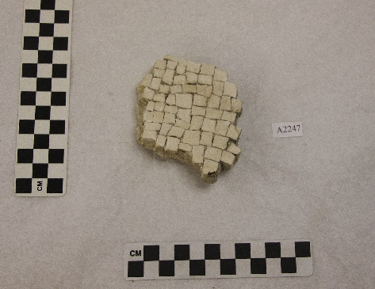

Figure 1.1. Mosaic floor fragment from Paestum, Italy. Donated by Adolph Meinecke.
MPM Cat. #A2247

This collection is important because, when viewed as a whole, it can provide insight into the collecting habits of late 19th and early 20th century Americans. Furthermore, these fragments are important to the MPM and the Milwaukee community, because they bring a certain level of prestige to Milwaukee and the MPM as unique, site-specific ancient artifacts. They also provide a strong local connection to the Milwaukee community, as the fragments were collected by Milwaukee locals (D. Scher Thomae, personal communication, October 26, 2017).
While scholars have studied the collection patterns of 19th and 20th century patrons of art and history in general, the detailed examination of the collection of ancient architectural fragments at the MPM undertaken in this study has never been done. Most literature regarding the acquisition of ancient architectural fragments focuses on fragments of sculptures or merely mentions the existence of fragments in well-known collections throughout history. Thomas Howard, 2nd Earl of Arundel (1586-1646), for example, was known for his collection of classical sculptures. While it has been documented that the Earl’s collection also included “inscribed stones” and “fragments,” most of those fragments were not from buildings, but rather were remnants of what were once whole sculptures (Michaelis, 1882).
This case study has two main goals. The first is to demonstrate that artifacts that are often overlooked have a story to tell and to describe that story through the analysis of a collection of ancient Greek and Roman architectural fragments held by the MPM. The second goal is to compare this collection to the historical record, including the method and purpose of collecting these fragments. To accomplish these goals, I conducted this study in three phases that involved inventory and data collection on the architectural fragments held by the MPM, biographical research on the donors of the fragments, and comparative historical research on the history of, and motivations for, collecting.
In the first phase of this study, I spent several days in the Anthropology lab of the MPM gathering data on the Greek and Roman architectural fragments held by that institution. Much of the MPM’s collections are organized in drawers. Each drawer contains its own individual inventory list. Upon my arrival, I was provided with several inventory lists from drawers believed to contain fragments. I used those lists to compile a master inventory of the Greek and Roman architectural fragments held by the MPM. I then attempted to physically locate each of the fragments based on the locations provided in the inventory. By doing so, I determined which fragments, if any, were unaccounted for and attempted to track them down.
As it turned out, many of the fragments were indeed missing. Some of the fragments were on display or being prepared for display. I removed the objects on display to examine and photograph them before returning them to their cases. A few of the fragments on display could not easily be removed, so I was provided with photos and measurements of those fragments taken previously by museum staff. I then requested access to the fragments being prepared for display, which was granted. Unfortunately, there were several fragments listed that I could not locate. A few did not have object numbers associated with them, making it difficult to identify them. I was, however, able to reconcile some of those that did not have object numbers using the descriptions on the drawer lists and in the catalog books. Others I was simply unable to locate.
Once the fragments were located, I began the process of gathering descriptive data. I first gathered all existing data on the fragments located in the various records at the MPM. These records included donor files, accession files, exhibit files, and catalog entries. At the time that I was gathering this information, the MPM’s records had not yet been digitized. It was therefore necessary to photocopy or transcribe all relevant information. With the help of some interns, we located and made photocopies of the appropriate accession, donor, and exhibit files. We then looked up each individual object in the old catalog ledgers and transcribed the information provided. In addition to collecting the data available on the fragments, I also gathered new data. This consisted of taking object measurements and photographing each fragment before returning it to its proper location in the MPM’s collection.
In the second phase of this study, I conducted biographical research on each donor involved in the MPM’s acquisition of the architectural fragments including those who sold or donated fragments to the MPM, as well as those who donated funds used to purchase fragments. Information on how and why these fragments were collected was not documented in the MPM’s records, so in order to make these determinations, it was necessary to examine each donor’s socioeconomic status, interest in art, history, or collecting, as well as any evidence of traveling to Europe and collecting while traveling.
For this phase, I relied heavily on U.S. Census data available online and biographies and archival documents available at the Wisconsin Historical Society, the Milwaukee County Historical Society, the University of Wisconsin-Milwaukee, and Lawrence University. A few cases required I look outside of Wisconsin and, in the case of one donor, I had to request information from the Westport Historical Society in Connecticut.
The third phase of this study involved analyzing the collection and its donors for thematic content. Themes were identified through a systematic review of the donor records and their biographical information. This thematic review also included an examination of the physical properties of the collection. Several themes were identified during this phase which were presented and confirmed using evidence from the analyses. I then completed a comparative historical and theoretical analysis between the themes present in this collection and the themes discussed in Chapter 2.
Identifying the relevant themes also involved extensive research into the history of collecting. Because the fragments in this study were largely collected in the late 19th and early 20th centuries, I researched the history of collecting leading up to and through this period. This research also included an examination of collectors throughout history as well as an examination of the possible motivations for collecting. Although several reasons for collecting were explored, specific focus was given to the motivations for collecting antiquities and souvenirs. Ultimately, the historical and theoretical research and the analysis of the data will provide new perspectives on an otherwise overlooked collection of ancient artifacts.

Collecting through the Ages
The practice of collecting has generally been guided by the predominant mood and values of each individual culture and time period (Muensterberger, 1994). During the medieval period in Europe, for example, holy relics were highly sought after due to the religious fervor that gripped that era. Understanding the factors that contributed to shifts in collecting practices over time can provide insight into the motivations of collectors. Only by analyzing the architectural fragments in this study and their donors through the lens of the period in which they were collected, namely the American Renaissance, will it be possible to gain a better understanding of how and why these fragments were collected.
Like holy relics, the acquisition of classical antiquities, including architectural fragments, became popular during the latter part of the medieval period (AD 1000-1300) in Europe (MacGregor, 2007). This was due, in large part, to the popularization of classical scholarship, a product of a shift in philosophical views from spiritualism to realism, which manifested late in the medieval period (Muensterberger, 1994), as well as the simple fact that classical monuments were still very much a part of the visible landscape in the Mediterranean region (MacGregor, 2007).
Throughout the medieval period, collecting was reserved for the few upper-class members of society. As Blom (2003) put it, “…until the sixteenth century collecting had been the prerogative of princes…” (p. 16). The private collections of the medieval period were a representation of the owner’s fortune, and objects were almost exclusively collected for their rarity and monetary value; rarely were objects collected for their aesthetic value (MacGregor, 2007). Some of the more commonly collected items included coins, especially from the Roman period, and objects made from rare and valuable materials such as gold or ivory. As such, and because it often required the ability to travel, collecting was a costly endeavor out of reach to the vast majority of people.
While medieval collections were used to showcase their owner’s wealth, they also had the ability to boost their owner’s social status through authentication, both real and invented. Objects have the power to authenticate the nobility of families by serving as evidence of a family’s relationship with other known noble families or individuals (Thompson, 2013). Some collectors have even gone so far as to assign their own meaning to objects to “prove” their noble heritage. Thompson (2013) used, as an example of this, the bovattieri, a new class of elites in fourteenth century Rome who had recently acquired their wealth. To hide their provincial origins and gain acceptance as nobles, the bovattieri invented ancient ancestors and then repurposed their own archaeological collections to serve as evidence for their claims to nobility (Thompson, 2013).
Along the same lines, objects have the power to demonstrate the authority of kingdoms by serving as evidence of a kingdom’s history (Stewart, 1984), or by simply creating a perceived authority through affiliation. During the medieval period, entire columns were transplanted from Italy to British governmental buildings to make them, and in turn the British government, appear more legitimate (MacGregor, 2007). Similarly, medieval churches collected relics to affiliate themselves with religious icons. According to MacGregor (2007), “Possession of quantities of relics undoubtedly increased the standing of a church…” (p.4).
Following the medieval period, there was an explosion of collecting in Europe (Blom, 2003). Several factors were catalysts for this drastic increase, including the development of technological innovations during the Renaissance (AD 1400-1600) and the following centuries. These technological innovations contributed to an overall rise in wealth and an expansion of knowledge (Blom, 2003). “Collections flourished wherever commerce did” (Blom, 2003, p. 21), and commerce boomed in sixteenth and seventeenth century Europe. Improvements in shipbuilding and navigation, as well as the development of a more sophisticated banking system, allowed for an advanced system of global trade (Blom, 2003; Muensterberger, 1994). More and cheaper goods flooded into Europe, thus producing an explosion of wealth among the merchant classes. In turn, Europe’s accumulation of wealth, along with an influx of curiosities and tales of distant lands, encouraged a collecting culture.
Curiosities and antiquities were both highly sought after by those who benefited from Europe’s increased wealth. In a letter written in 1625, the Duke of Buckingham requested that merchants bring him “any thing that is strang [sic]” from foreign lands (Blom, 2003, p. 54). The attraction to antiquities collecting had become so widespread by the seventeenth century that clubs and societies were founded around the practice. One such club consisted of wealthy English travelers, amateurs, and dealers who began removing antiquities from Italy in the 1600s. Because of their shared enthusiasm for “souvenirs of antiquity,” they eventually established a group known as the Society of Dilettanti in the 1700s (MacGregor, 2007).
During the 1700s, scholars began to collect specimens for comparison, classification, and methodical study (Blom, 2003). As the purpose of collecting shifted to a more scholarly one, this necessarily brought about a more scientific and systematic approach to collecting (Phillips, 1998), creating a greater demand for all kinds of objects to be collected. Thus, throughout this period, collectors could be found collecting everything from art, ancient sculptures, and coins to models, machines, natural history specimens, and gems (MacGregor, 2007).
This new scientific approach to collecting affected the practice of collecting antiquities, as well. No longer were antiquities collected for mere display, but for study. The collector and historian, William Camden (1551-1623), collected “inscribed monuments” and “stones” to use as physical evidence of Roman Britain in his work, Britannia, a chorographical text describing Great Britain (MacGregor, 2007, p. 195). “For the first time, man dared to ask: Where did all this come from?” (Muensterberger, 1994, p. 183). Collectors were no longer satisfied with simply describing the antiquities in their possession. Instead, they began to question the origins of the artifacts. As a result, the practice of collecting antiquities gained a new purpose and antiquities were now seen as more than luxury items; they were seen as artifacts that were imbued with deeper meaning and could serve as evidence of human history.
In this way, collecting became a means of investigating and connecting with the past. This is still a common reason for collecting today. In some cases, this type of collecting is used as an investigation of roots (Thompson, 2013; Muensterberger, 1994). This could be the collector’s roots, the roots of a particular civilization, or the roots of humankind. Many scientific disciplines, such as archaeology, were founded out of this desire to collect as a means of investigating roots. Others collect as a means of connecting with a past that is not their own (Anderson, 2009). This desire to commune with the past seems to be especially true of antiquities collectors, who often feel a special bond with the past through the ownership of ancient objects (Thompson, 2013). For them, antiquities act as a portal to another time, another region, and even previous owners (Muensterberger, 1994).
For some, the collection of antiquities is about more than just connecting with the past, it’s also about guarding it. Such collectors view themselves as safe-keepers of history and believe it is their responsibility to conserve the image of the past (Filippoupoliti, 2009). This notion has often been used as the justification for the removal of the Parthenon marbles from Greece, as many felt they were in danger of destruction during Greece’s period of Ottoman rule (AD 1453-1821). In a more extreme illustration of this concept, Elsner and Cardinal (1994) used the biblical story of Noah. They referred to Noah’s attempts to collect two of every creature as “not just casual keeping but conscious rescuing from extinction – collection as salvation” (Elsner & Cardinal, 1994, p. 1).
The shifts in philosophy and worldview seen following the Renaissance also meant a shift in the types of people that collected. While collecting valuable items and antiquities continued to be a practice of the upper classes, collecting itself was becoming more widespread. Scholars began collecting natural history specimens for comparison, and like the nobility, some of the merchant class began to collect curiosities and other ephemera on their travels. Owning a reputable collection continued to give collectors a certain amount of social standing and allowed them to partake in social interactions above their station (MacGregor, 2007). There are several cases in which the collections of individuals were visited by royalty and other high-ranking members of society. For example, the guest book of collector Phillip Hainhofer, a merchant of Augsburg, was signed by King Christian IV of Denmark, Gustavus Adolphus of Sweden, and several Medici princes, among many other well-known figures (MacGregor, 2007).
Interest in antiquities grew during the 1700s thanks in large part to an increase in travel among the upper classes, especially to regions rich in classical art and architecture. During this period, it was common practice for European travelers to go on what was known as a “Grand Tour” of Europe (National Endowment for the Humanities, 2016). Some of the popular destinations included France, Greece, and Italy, especially Rome. The tour was meant to serve as an educational experience and eventually became a rite of passage among the European elite. Increased exposure to classical settings spurred a revived interest in classical thought, politics, and fine arts referred to as Neoclassicism (National Endowment for the Humanities, 2016). Classical and Renaissance art and architecture were vigorously studied and recreated, and hundreds of classical pieces were fought over and removed from Greece and Italy (Haskell & Penny, 1981). This revival lasted through the 18th and 19th centuries and would eventually make its way to the United States.
By the late 1700s, the Industrial Revolution had begun. It lasted throughout the nineteenth and into the early twentieth centuries, and, although it was several decades before its effects became apparent, many changes to the practice of collecting came out of this period. One of the Industrial Revolution’s most influential factors on collecting practices was a greater distribution of wealth among social classes. This meant that more people now had access to luxuries that were previously reserved for the upper classes, including recreational travel.
As the effects of the industrial revolution spread during the middle decades of the nineteenth century, members of the expanding middle classes began to seek the experiences of recreational travel that had previously been available only to the upper classes. (Phillips, 1998, p. 6)
Consequently, more people now had access to collecting. Souvenirs, which “attest to experiences of travel” (Phillips, 1998, p. 7), became a hot commodity with the travel boom. According to Blom (2003), souvenirs “are that holiday, solitary representatives of … a different life, a brief sojourn in a different world” (p. 168). They allow their owners to more vividly relive travels and experiences that may have been once-in-a-lifetime opportunities. Eighteenth and nineteenth century British travelers were especially interested in collecting objects produced by Native Americans during their travels to North America, as such objects were particularly iconographic of North America (Phillips, 1998). This phenomenon was so popular that many Native American groups began to produce wares for the express purpose of being sold as souvenirs. Indeed, many of the objects were altered versions of true Native American goods, such as miniaturized baskets, (Phillips, 1998), and could therefore serve no functional purpose beyond carrying the memory of the buyer’s travels. Such objects, produced to serve only as souvenirs, were often classified under less ‘authentic’ terms, such as knickknack, trinket, or bibelot (Phillips, 1998).
The ability for objects to facilitate memory is arguably one of the most common reasons for collecting today. Objects can serve as a reminder of a time, place, or person. They are part of the collector’s “life-story,” as they hold specific memories, and serve as reminders of when, where, and how they were acquired (Edwards, 2009, p. 39). Objects considered memorabilia are known as such because they aid in the recall of events or people, i.e. memories. A modern-day collector who was interviewed about his collection of memorabilia said “his objects helped him recall still more of the events of his past” (Muensterberger, 1994, p. 42).
Although the Industrial Revolution reduced the socioeconomic obstacles faced by many collectors, American collectors historically faced cultural obstacles, as well. During America’s formative years, collecting antiquities, or anything from the ‘Old World’ for that matter, was not only unpopular, it was considered unpatriotic. This disregard for the past was attributed by Lowenthal (1985) to three popular ideas of early Americans: youth, autonomy, and an exemption from decay and decline.
Americans viewed their newly established country as young and innocent, free from the burden of history. When a nation boasted of its past or lived amidst ruins and relics, it signified that the nation was in decline and all that was left for its citizens was to “console themselves with the splendors of the past” (Lowenthal, 1985, p. 109). Additionally, Americans envisioned the United States to be an autonomous nation. They felt this vision was threatened by nostalgia; “Americans condemned historic European scenes as immoral, decadent, unpatriotic – symbolic of the oppression and tyranny cast off by the Founding Fathers” (Lowenthal, 1985, p. 116). Americans also believed their new nation was “divinely exempt from decay and decline” (Lowenthal, 1985, p. 105), allowing them to stand above the rest as their deity’s chosen nation. Because of their assumed superiority, Americans condemned antiquities and anything else that reminded them of the distant past.
It wasn’t until the American Civil War in the 1860s that these ideas of America as eternally youthful, autonomous, and exempt from decline were seriously challenged. The war led many Americans to become disenchanted with the United States and the direction in which it was heading, which in turn led to a growing nostalgia for the early days of America’s founding; “Increasing dissatisfaction with the present led Americans to yearn for the fantasized ideals and artifacts of the Colonial or Revolutionary golden age” (Lowenthal, 1985, p. 121). As Americans turned to history in an attempt to rediscover themselves as a nation, a new attitude emerged that held that “since the United States had no past to speak of, the lessons of the past had to be learned from Europe” (Saisselin, 1984, p. 88).
Europe’s Neoclassicism greatly influenced Americans as they underwent this period of self-discovery. In 1894, the American Academy in Rome was founded under the belief that “just as other countries had gone to Rome to learn ‘the splendid standards of Classic and Renaissance art,’ so must Americans” (Brooklyn Museum, 1979, p. 12). American artists who studied at academies in Europe returned home with new knowledge and ideas (Brooklyn Museum, 1979). At the same time, several books and articles about the Renaissance were being published and circulated. As a result, Americans’ interest in Renaissance culture and thought burgeoned. Indeed, Americans became so infatuated with the Renaissance that the period from 1876 to 1917 became known as the American Renaissance (Brooklyn Museum, 1979).
Although European history and art had come to represent intellectualism and spirituality in America, essays on art outnumbered works of art in the United States (Saisselin, 1984). In response, the late 1800s saw a variety of Americans including college graduates, social climbers, art raiders, and millionaires drawn to Europe in large numbers for its “intellectual and aesthetic ideals” (Saisselin, 1984, p. 78). There, they “did the sights and returned with culture to create museums” (Saisselin, 1984, p. 111).
Blom (2003) called this phenomenon the “age of the Moguls” (p. 128), as it was during this period that wealthy businessmen like J.P. Morgan, William Randolph Hearst, Andrew Mellon, John D. Rockefeller, and Andrew Carnegie began their collections of European art and antiquities which would one day become world renowned. As Blom (2003) described it, “There was plenty of money in the United States and plenty of old, valuable art in Europe” (p. 128). Americans began to view the acquisition of Classical and Renaissance artifacts as not only their duty, but their birthright. On this subject, the American architect and European art importer, Standford White, claimed: “In the past, dominant nations had always plundered works of art from their predecessors… America was taking a leading place among nations and had, therefore, the right to obtain art wherever she could” (Brooklyn Museum, 1979, p. 15).
Consequently, it was during this period in which many of the United States’ major cultural institutions were founded including museums, libraries, and universities (Brooklyn Museum, 1979), and the Milwaukee Public Museum was no exception. As previously mentioned, the MPM was founded as a public museum in 1882 when the collection outgrew the German-English Academy where it had its start. Many of its historical and archaeological objects, including the architectural fragments in this study, were donated in the museum’s early years by prominent members of the community. By analyzing the fragments and their donors through the lens of the American Renaissance, it will be possible to gain a better understanding of how and why these fragments were collected.

An Analysis of the Collection and its Donors
This chapter contains a detailed summary of the collection of Greek and Roman architectural fragments held by the MPM and includes tables and figures illustrating the origins of the artifacts, physical attributes including size and material, and acquisition details including when and by whom the fragments were collected and donated.
This analysis also provides a comparative look between the donors associated with these fragments and the historical practice of collecting. To accomplish this, I conducted biographical research relating to the donors. This resulted in a brief biographical sketch on each donor with the purpose of establishing his or her socioeconomic status, interest in art, history, and/or collecting, evidence of travels, and method of procurement for each artifact. Additionally, photos of each fragment can be found in Appendix A.
The collection of architectural fragments held by the MPM is made up of a total of 227 fragments including individual mosaic tiles, or tesserae, that were, in some cases, given a single object number. The fragments, belonging to 12 known accessions, were collected by entrepreneurial citizens of the Milwaukee area and were acquired by the MPM via purchase, donation and, in one instance, exchange. Of the 227 fragments recorded in documents, 42 could not be located in the collections. Consequently, they were not included in this study. An additional 34 fragments, including one that was the result of an artifact exchange between the MPM and the National Museum of Hungary, were not included in the study due to a lack of acquisition details and donor information. Of the remaining 151 fragments, 124 were donated to the MPM and 27 were purchased by the MPM using donated funds (Table 3.1).
Table 3.1. Fragment Totals
Total number of MPM Greek and Roman architectural fragments
227
Number included in study  151 |  | Number not included in study  76
Number donated  124 | Number purchased  27 | Number missing  42 | Number w/o donor details  34

Most of the fragments originated from Roman sites with a few from Greek sites (Figure 3.1). Those from Greek sites originate in Athens, Malta, and, in one instance, Italy, whereas the Roman fragments originated from sites all over Europe and the Mediterranean.
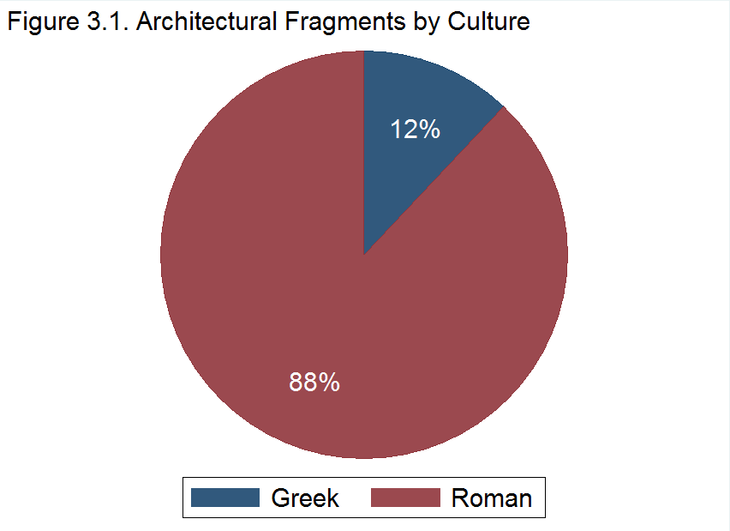
The Greek fragments were collected from sites such as the Prison of Socrates, the Acropolis in Cumae, and the Theatre of Dionysus on the Acropolis in Athens. The Roman fragments were found in Switzerland, Germany, Hungary, Libya, Egypt, Malta, England, and Italy (Table 3.2). Some of the more well-known sites include the Palace of the Caesars, the Roman Catacombs, the Colosseum, Pompeii, the Roman Forum, the Temple of Saturn in Rome, and Hadrian’s Villa.

Table 3.2. Roman Architectural Fragments by Country
Country of Origin | Percentage
Italy | 73.7%
Unknown | 8.3%
Malta | 7.5%
England | 3.8%
Germany | 2.3%
Switzerland | 2.3%
Libya | 1.5%
Egypt | .75%

Prior to the period in which these fragments were collected, archaeology was increasingly becoming more scientific in its approach. By the late 1800s, archaeologists were conducting systematic excavations at sites like Pompeii, the Acropolis in Athens, and the Roman Forum. Such sites attracted large numbers of tourists. As a result of the Grand Tour popular among 18th century elites, travel had come to be considered an educational and cultural experience (Ellerbee, 2010). Those looking for such an experience were naturally drawn to archaeological sites where discoveries of the ancient world were regularly being made through scientific investigation.
This style of tourism was also viewed by 19th century Americans as an opportunity to climb the social ranks. “They sought to establish themselves as cultured citizens – and therefore worthy members of society” (Ellerbee, 2010, p. 2). These newly minted world travelers brought home genuine antiquities as souvenirs, including architectural fragments. Such fragments may have been purchased at tourist markets or roadside vendors, or they may have been picked up by the tourists directly from the archaeological sites they visited.

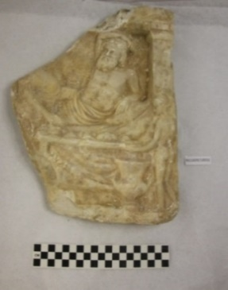
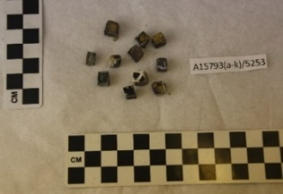

Figure 3.3. Marble relief fragment.
MPM Cat. # N11609
Figure 3.2. Iridescent tesserae.
MPM Cat. # A15793A-K

Most of the fragments in this study are small, making them easy to carry and easy to pick up from an archaeological site, the perfect souvenir. They range in size from one cubic centimeter to 32.7 x 24 x 5.6 cm. The smallest fragments (A15793A-K) are individual mosaic tiles or tesserae, small cubes of glass, stone, or other materials used in the construction of a mosaic (Figure 3.2). The largest fragment (N11609), purchased at auction, was once part of a marble relief (Figure 3.3).
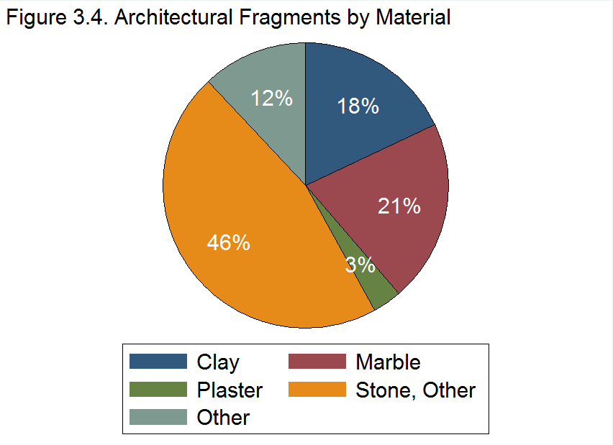

The fragments are made up of a variety of materials including clay, plaster, marble and other stones such as limestone, alabaster, granite, and porphyry. There are also a few fragments made up of other materials including concrete, glass, and mixed materials (Figure 3.4). The most common materials are clay, marble, and other stones. Many of the fragments of marble and other varieties of stone have both raw, broken edges and smooth or polished edges. The fragments come from a variety of architectural features including walls, roofs, floors, and streets. Some of them, such as the mosaic fragments, were clearly once parts of decorative features. Most of the fragments are nothing more than bricks or chunks of stone.
There are a few fragments, however, which exhibit distinguishing features, possibly offering the fragments some aesthetic value. One of those fragments is the marble relief (N11609) discussed previously as the largest fragment in the collection (See figure 3.3). Some of the relief image is still visible, depicting a man and a woman eating while reclining on a couch. A nude boy pouring what is probably wine can also be seen. The tesserae (A15793A-K), also discussed previously but as the smallest fragments in the collection, may also exhibit some aesthetic value because of their color and iridescence (See figure 3.2).
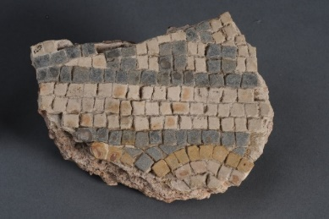
Figure 3.5. Mosaic fragment with multicolored pattern.
MPM Cat.# A2256.
Some other fragments of note include four mosaic fragments made up of colored tesserae including black, white, yellow, and red. These fragments exhibit colorful designs and patterns still partially intact and include objects A2256 (Figure 3.5), N14635, and N21338A-B.
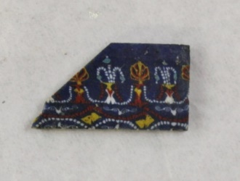
Figure 3.6. Fused mosaic glass fragment.
MPM Cat.# N11397.
The most elaborately decorated fragment in the collection is a Roman-Egyptian glass fragment (N11397), which has a colorful and detailed design (Figure 3.6). The MPM’s catalog describes this fragment as having a “classic floral design in white, yellow, torquois [sic], and red in blue matrix” (Milwaukee Public Museum, 2015).
Due to their lack of aesthetic value, it is likely the majority of these fragments were collected for other purposes. Unfortunately, there are no records available to explain how or why the fragments in this study were collected. The catalog records list each fragment as either donated or purchased, and include the name of the associated donor. The records also include the geographical origin of each fragment, but rarely do they specify whether the fragments were actually collected from those sites and by those donors. It is for this reason that I conducted biographical research into the lives of the donors to determine whether they had the means and opportunity to collect the fragments themselves. The biographical data also helps establish the donors’ motives for collecting the fragments, and why they chose to gift them to the MPM.
There are 17 individuals and couples associated with the donation of these fragments, including nine who donated fragments and five who donated funds to purchase fragments (Table 3.3). There were also two sellers associated with the fragments including the Leopardis who both sold and donated fragments to the MPM.

Table 3.3. MPM Architectural Fragment Collection Donors
Donor/Seller Name | Donation Type | Collection Date | Acquisition Date | Number of Fragments
Holton | Unknown | 1864-1891 | 1964 | 8
Mary E. Merrill | Unknown | 1880-1901 | 1964 | 81
Mrs. Fred Merrill | Object Donor | 1880-1887 | 1928 | 8
Streit | Object Donor | --- | 1885 | 3
Plum | Object Donor | 1899 | 1910 | 1
Doerflinger | Object Donor | --- | 1901 | 3
Meinecke | Object Donor | --- | 1901 | 7
Adams | Object Donor | --- | 1910 | 1
Titus | Object Seller | --- | 1916 | 11
Newman | Object Donor | Early 20th C. | 1962 | 1
Elser, Fitch, & Herzfeld | Money Donors | --- | 1963 | 1
Leopardi | Object Donor and Seller | --- | 1968 | 9
Whyte | Money Donor | --- | 1964 | 1
James | Money Donor | --- | 1967 | 14
Hubbell | Object Donor | --- | 1973 | 2
Total Number of Donors/Sellers: 17 |  | Total Number of Fragments: 151

The dates of collection and acquisition of the fragments range from 1864 to 1973. There was a large gap in activity from 1916 to 1962. This was due in large part to the World Wars and other conflicts taking place during those decades. Although many of the fragments in this study were not added to the MPM’s collections until the 1960s, nearly all of the fragments were collected much earlier, during the period referred to as the American Renaissance (1876-1917). At that time, Milwaukee was largely populated by German immigrants, many of whom were well-educated liberals and intellectuals who fled from Germany during the 1848 Revolution, a period of political and social upheaval in Europe (Schumacher, 2009). These immigrants were wealthy and cultured citizens who valued education and sought to establish themselves and their family reputations in this new country by bringing pieces of Europe’s high culture to Milwaukee (Schumacher, 2009).
Included among the ranks of this Milwaukee elite were most of the donors associated with the fragments in this study. They were industrialists, entrepreneurs, philanthropists, and civil servants who were intimately involved in the social and economic growth of Milwaukee. Their lives spanned much of the 19th and 20th centuries with birth dates ranging from 1815 to 1905. Although the donors varied in age, their shared interests, social status, and community involvement suggest that many of them most certainly knew each other. Two of the donors, for example, were both affiliated with Milwaukee-Downer College near the end of the 19th century.
E. D. Holton and Mary E. Merrill each had a collection named after them at Milwaukee-Downer College, a women’s college formed by the consolidation of Milwaukee College and Downer College in 1895 (Lawrence University, n.d.). In 1964, Milwaukee-Downer merged again with Lawrence University (Lawrence University, n.d.), and its collections were spread out to other area institutions including the MPM. According to the MPM’s records, all of the fragments that were transferred from Milwaukee-Downer College to the MPM were originally in either the E. D. Holton Collection or the Mary E. Merrill Collection. These fragments make up the largest portion of the collection in this study. Those in the E. D. Holton collection have the earliest known collection dates of all the fragments, with the first being collected in 1864. A total of 91 fragments are cataloged as donations from Milwaukee-Downer College. Of those, eight belonged to the E. D. Holton Collection and 83 belonged to the Mary E. Merrill Collection while they were held by Milwaukee-Downer College.
The eight fragments associated with E. D. Holton were all collected in Italy. Six of the fragments were collected in 1864 including a marble fragment (N12892) from the Roman Catacombs dating to the 1st-4th centuries A.D., two building fragments (N12876A-B) from Pompeii dating to the 1st century A.D., a marble fragment (N12898) from the Roman Forum dating to the 2nd century A.D., and two building fragments (N12908A-B) from Hadrian’s Villa in Tivoli, Italy dating to 117-138 A.D. (Milwaukee Public Museum, 2015). Two more fragments were collected from Pompeii at later dates. A flat stone tile (N12877) was collected in 1867, and a marble tile fragment (N12878) was collected from the Temple of Bacchus in 1891 (Milwaukee Public Museum, 2015).
Edward Dwight Holton was a wealthy and respected Milwaukee resident. He was born in New Hampshire in 1815 and moved to Milwaukee in 1840, where he and his brother opened a general store (“Death of E. D. Holton,” 1892). Throughout his life Holton worked as an indentured servant, merchant, railroad man, banker, and farmer (American Biographical Publishing Company, 1877). He held several high-ranking positions including president of the Farmers and Millers’ Bank of Milwaukee, Allotment Commissioner for the state of Wisconsin, and manager of the Northwestern National Insurance Company (American Biographical Publishing Company, 1877).
Holton was quite effective and highly regarded in each of these positions. When he first became president of the Farmers and Millers’ Bank of Milwaukee, the bank’s stock was at $50,000. By the time he left, ten years later, the bank’s stock had risen to half a million dollars (American Biographical Publishing Company, 1877). In his first three years as manager at the Northwestern National Insurance Company, Holton took the company’s paid-up capital from $150,000 to $1 million (American Biographical Publishing Company, 1877).
During the Civil War, Holton experienced a breakdown in his health due to disease. With his health failing, Holton was forced to resign from his posts and, in the summer of 1863, he and his family sailed for a yearlong trip to Europe. According to his diary, this trip was the first of many and focused on Turkey, Egypt, the Holy Land, and Rome, though he also visited several other locations including England, France, Switzerland, and Russia (Holton, 1842-1909).
During his travels, Holton wrote letters about his experiences that were published in The Milwaukee Sentinel, Milwaukee’s local newspaper (American Biographical Publishing Company, 1877). In one of his letters, Holton discussed the Roman architecture he toured during a visit to Chester, England:
It is said this town was occupied by the Romans, and that they laid the foundations of its present walls, and some of its buildings… We walked around the walls – still kept in good repair – and visited its towers…[At] the old Roman part of the wall… one could fancy Julius Caesar sitting there on a pleasant evening smoking his pipe as his legions come marching in, from some foray upon the ancient Britons. (Holton, Oct. 1863)
In another letter describing his visit to London, Holton expressed his awe at the Greek and Roman architectural exhibits on display at the Crystal Palace:
Would you walk of an evening among the old Romans? Just step in here. Here is a Roman Mansion, with courts, and halls, and baths, and beds, and rooms, as in the days of the Caesars. Would you pass an hour with one of the wealthy friends of Demosthenes? Come here, and you can, in the mansion of one of the most sumptuous of the old Grecians. How chaste, and yet how beautiful is all the architecture and decorations. (Holton, Dec. 1863)
Unfortunately, Holton was so busy admiring the sites in Italy that he failed to write much about that leg of his journey. In a letter from Amsterdam, Holton expressed his apologies and explained that he was simply too busy. He then attempted to make up for his failure to write by briefly mentioning each city he visited. Of Naples, for example, he said: “So Naples… with its smoking Vesuvius, with its unburied Pompeii, wonderful! wonderful!” (Holton, 1864).
In addition to being a world traveler, Holton was a philanthropist. Late in life, Holton donated both land and money to several local schools including Milwaukee College, which all three of his daughters attended. In 1891, Holton donated property valued at $37,500 to Milwaukee College to serve as the foundation for an endowment fund (“Generous Edward D. Holton,” 1891). He also donated an estimated $35,000 each to Milwaukee College, Ripon College, and Beloit College (“Death of E. D. Holton,” 1892). By the time of his death in 1892, Holton’s estate was valued at over $1 million (“Death of E. D. Holton,” 1892).
E. D. Holton’s connection to Milwaukee College and his expressed interest in Roman architecture make it quite possible that he did indeed collect the fragments that were transferred from Milwaukee-Downer College to the MPM. The evidence of his travels to and around Italy during the same years in which the fragments were collected also lends credence to this idea.
The 83 architectural fragments associated with Mary E. Merrill were collected between 1880 and 1901 with the majority having been collected in 1880. They were collected from sites all over Italy and Greece, including the Palace of the Caesars (N12887 and N12888 [lot of 24 mosaic tiles]), the Baths of Caracalla in Rome (N12889 [lot of 32 mosaic tiles], the Roman Catacombs (N12890-N12891), the Forum (N12895-N12897, N12899, and N12902B), Nero’s Palace (N12903), the Temple of Saturn in Rome (N12905), the Aventine Hill (N12906A-B), Hadrian’s Villa in Tivoli (N12907A-D), the Acropolis in Athens (N12910), the Roman Colosseum (N12911A-B), the “Chiesa di San Marco” or St. Mark’s Basilica in the Piazza di San Marco, Rome (N12912), the Theatre of Dionysus in Athens (N12913), the Prison of Socrates in Athens (N12914), the Greek Acropolis of Cumae in Campania (N12915), the Via Sacra in Rome (N12916B), and one from Aleppo found on the Palatine Hill (N12904) (Milwaukee Public Museum, 2015). Two of the 83 fragments, N12902A and N12916A, could not be located and were, therefore, not included in this study.
Conducting research on Mary E. Merrill was quite difficult. The most likely match was a Mary-Ellen Merrill nee Freeman, the wife of Sherburn Sanborn Merrill. Mary E. Merrill was born in New York (U.S. Census Bureau, 1880) in 1831 (Merrill, 1924, Merrill to Bashford).
In a 1924 letter, Mary discussed her time at the Normal School for Teachers in Albany, NY, which she attended in 1851-1852 (Merrill, 1924, Merrill to Bashford). She then worked for two years as a teacher in New York before moving west in 1854 (Merrill, 1924, Merrill to Bashford). Mary was the first woman appointed to the school board in the state of Wisconsin; she was also the president of the Public School Art League as well as the Woman’s Club of Wisconsin for several terms (Merrill, 1924, Merrill to Bashford).
Mary’s husband, Sherburn Merrill, was born in New Hampshire in 1818 (Western Historical Company, 1881b). He moved to Milwaukee in 1850 where he became a railroad manager. He was successful in his position and quickly advanced to the “highest rank as an executive railroad official” (Western Historical Company, 1881b, p. 1340). At the time of his death in 1883, Sherburn’s estate was valued at $775,000 (“Estate of S. S. Merrill,” 1885).
I could not find any evidence of Mary E. Merrill traveling abroad or collecting artifacts. As such, there is not enough information to determine with certainty whether or not the architectural fragments in this study were actually collected and donated by Mary E. Merrill. I was also unable to find any information regarding Mary’s connection to Milwaukee-Downer College. However, due to the wealth and influence of the Merrill family, as well as the fact that Mary worked in the education sector, it is plausible that this is the Mary E. Merrill for whom the collection at Milwaukee-Downer College was named. The identity of the next donor supports the identification of the Mary E. Merrill discussed here as the same one for whom the collection at Milwaukee-Downer College was named.
The next donor was a Mrs. Fred Merrill. The only information available in the MPM records regarding the identity of Mrs. Fred Merrill is a street address sans city or state. That street address, however, is the same as the home of Mary and Sherburn Merrill. Indeed, according to the 1910 Census, Mary and Sherburn had a son, Fredrick, who was married and living in the same household (U.S. Census Bureau, 1910). Based on this information, it is not unlikely that Mrs. Fred Merrill was the daughter-in-law of Mary E. Merrill.
Mrs. Fred Merrill donated eight bricks to the MPM in 1928. According to the MPM catalog, three of the bricks (A32848-A32850) were collected in 1880 from the subterranean level floor of the Colosseum in Rome and were found in a herringbone pattern (Milwaukee Public Museum, 2015). The other five bricks (A32851-A32855) were collected in 1887 from the ruins of a 1st or 2nd century A.D. Roman villa on the Isle of Wight in England (Milwaukee Public Museum, 2015).
It is interesting to note that the fragments donated by Mrs. Fred Merrill were collected in the same years as some of the fragments in the Mary E. Merrill collection at Milwaukee-Downer College. It is conceivable that the fragments associated with the two Merrill women were collected together and possibly, in the case of Mrs. Fred Merrill’s fragments, passed down from one generation to the next.
Around the same time that the Merrill’s fragments were collected, the MPM received a donation of objects from F. W. Streit. In 1885, the Milwaukee Public Museum published its Third Annual Report. In this document is a list of objects acquired by the museum during that year, including several objects donated by F. W. Streit. Such objects include several coins, a Roman oil lamp, Roman jugs, photographs and ancient Roman ruins, two pieces of mosaic floor from the Roman baths at Treves, Prussia (i.e. Trier, Germany), and six pieces of marble also from the Roman baths at Treves (Milwaukee Public Museum, 1885).
The collection of architectural fragments in this study contains three objects donated by F. W. Streit, two marble fragments (A2255a and A2255b) and one mosaic fragment (A2256). According to the museum’s catalogs, all three fragments were cataloged in 1901 and originated from the ruins of Roman baths located in Treves, Prussia (Milwaukee Public Museum, 2015). Based on the descriptions, it is likely that these three fragments were part of Mr. Streit’s 1885 donation. The status of the remaining architectural fragments donated by Mr. Streit that year is unknown.
Frederick William Streit was born in Germany in 1842. In his early twenties, he lived in Trier, Germany, where he studied and practiced photography until immigrating to Chicago in 1865 (Western Historical Company, 1881b). In 1874, Mr. Streit relocated to Milwaukee to become the successor of another photographer (Western Historical Company, 1881b). No further information on Mr. Streit’s life appears to have been recorded. It is unclear when or how Mr. Streit acquired the fragments. Because he lived in the same location from which the fragments originated before he immigrated to the U.S., it is possible he carried them with him in his initial move out of Germany. Alternatively, he may have collected them later in life, although there is no evidence suggesting Mr. Streit returned to Germany after emigrating.
The next donor, Miss Anna Plum, gifted a marble fragment (A171) from the Arch of Septimius at the Roman Forum. According to the MPM’s records, the fragment was collected by Miss Plum in 1899, but was not cataloged by the museum until 1910 (Milwaukee Public Museum, 2015). Anna Plum, born in Ohio around 1869, was the daughter of Mr. and Mrs. Louis H. Plum. Her family moved to Milwaukee sometime between 1870 and 1880 (U.S. Census Bureau, 1870, 1880). According to the 1880 U.S. Census, Anna’s father listed himself as a plumber (U.S. Census Bureau, 1880). Beyond that, there is little information about her family’s socioeconomic status, although the address of Miss Plum’s family home is listed in the 1890-91 Directory of Milwaukee Elite (Rohr, 2012).
Regardless of her status, Miss Plum did have the opportunity to personally collect the fragment donated by her to the MPM. She was a soprano in the Arion Musical Club in Milwaukee, and performed regularly in local musical productions. Throughout the 1890s, Miss Plum’s name appeared in The Milwaukee Journal on multiple occasions for her vocal talents. In 1894, Miss Plum traveled to Florence, Italy where she studied vocal music (“Miss. Plum to go to Europe,” 1894; “Society,” 1894). She returned to Milwaukee after a two-year period; however, according to a Milwaukee Journal article from 1896, Miss Plum planned to return to Italy in January of 1897 to “complete her studies and make her debut in Milan” (The Milwaukee Journal, 1896). Indeed, she was recorded as having a Milan address when she donated the fragment from the Arch of Septimius to the MPM (Milwaukee Public Museum, 2015).
Two of the fragment donors were instrumental in the establishment, governance, and maintenance of the MPM, Charles Doerflinger and Adolf Meinecke. Charles H. Doerflinger donated three architectural fragments to the MPM that were cataloged in 1901. They are object numbers A2250, A2253, and A2257. One of the fragments is made of brick, while the other two are made of plaster. According to the museum catalogs, all three fragments were from the ruins of Roman baths at the sites of “Brünelli, Ottenhausen” and “Zelle, Henhausen” in Zurich, Switzerland (Milwaukee Public Museum, 2015).
Charles (Carl) Doerflinger was born in Baden, Germany in 1843. His family immigrated to America in 1849, settling in Milwaukee, Wisconsin (Western Historical Company, 1881b). As a child, Charles was described as having a “deep interest in nature, in scientific reading and in the promotion of popular scientific endeavors” (Watrous, 1909, p. 50). He later became an influential figure in Milwaukee and Wisconsin history. Throughout his life, Charles held several public service positions and was involved in education, business, and publishing, specifically the publication of educational papers, books, and pamphlets “devoted to progressive educational ideals” (Watrous, 1909, p. 50). After losing a leg in the Civil War, Charles became the proprietor of the Doerflinger Artificial Limb Co. (Watrous, 1909).
As an educator, Charles taught at the German-English Academy (Watrous, 1909), served as a member of the Board of Regents of the State Normal School (Western Historical Company, 1881b), and was one of the founders of the First Kindergarten Society of Milwaukee (Watrous, 1909). His influence led Wisconsin to become the first state to incorporate kindergarten into its school system (Watrous, 1909). Charles also used his influence to push for the establishment of a public museum, which led to the founding of the Milwaukee Public Museum in 1883. Charles was then elected to serve as the museum’s first secretary and custodian, a position he held until 1887, when his failing health forced him to resign (Bruce, 1936; Watrous, 1909).
According to the Memoirs of Milwaukee County (Watrous, 1909), Charles took two separate trips to Europe. Little is recorded about his first trip other than it occurred after the war but prior to 1874 (Watrous, 1909). His second trip occurred from 1889 to 1893 after resigning his post as custodian at the Milwaukee Public Museum. The purpose of this trip was to recover his health while “pursuing amateur studies and explorations in the regions of Switzerland and France…” (Watrous, 1909, p. 51).
In November of 1898, Charles Doerflinger wrote a letter addressed to the Board of Trustees of the Milwaukee Public Museum in which he described his explorations and methods for collecting artifacts during his trip as well as his intentions to donate his findings to the museum. According to this letter, Doerflinger visited several “cave-dweller” sites in France and collected “partly by purchase directly from farmers and others, partly by exchange, etc., a considerable number of the cave-dwellers’ relics of early pre-historic times” (Doerflinger, 1898, Doerflinger to Board of Trustees, p. 1).
Mr. Doerflinger further described how he collected artifacts during his trip in an 1896 article in The Milwaukee Sentinel: “I collected them personally while traveling in the valleys of the Somme, Garonne, Dordogne and Vezere rivers. Nearly all were purchased for cash from farmers and collectors, the rest were picked up in ‘situ’ by a companion and myself” (“Offer to the Museum,” 1896, para. 5). Doerflinger also collected artifacts by means of an “excavation in the pile-dwellers’ region at Pfaefficon Lake in Switzerland, which excavation was kindly made at my [i.e. Doerflinger’s] request and expense by the renowned discoverer Dr. Jacob Messikomer in 1892” (Doerflinger, 1898, Doerflinger to Board of Trustees, p. 2).
Although Mr. Doerflinger’s focus was on the collection of “cave-dweller” and “pile-dweller” relics, it is likely that the three architectural fragments donated to the MPM by Mr. Doerflinger were collected during one of these two trips. Additionally, Mr. Doerflinger certainly belonged to a wealthier class given his ability to travel abroad for an extended period of time as well as his ability to fund an excavation. Finally, his involvement in the establishment and maintenance of the Milwaukee Public Museum along with his previously stated purpose for traveling are evidence of his interest in history.
Indeed, in his letter, Doerflinger stated that the purpose of the collection of the “cave-dweller” and “pile-dweller” relics is one of research (Doerflinger, 1898, Doerflinger to Board of Trustees). Given that there is no mention of an intent to study Roman artifacts, it is likely Mr. Doerflinger collected the three Roman architectural fragments in this study to serve as mementos of his travels.
Adolph Meinecke donated seven architectural fragments of Roman origin to the Milwaukee Public Museum, all cataloged in 1901. The fragments include a piece of brick (A2251) and two fragments of plaster from house walls (A2249 and A2252) which were found at Pompeii in Italy (Milwaukee Public Museum, 2015). Also donated by Meinecke was a brick from the Colosseum in Rome (A2254) as well as three mosaic floor fragments (A2247 and A2248[a-b]) from Paestum, Italy (Milwaukee Public Museum, 2015).
Adolph Meinecke was born in 1830 in Germany (Barton, 1886). He came to the United States in 1848 and settled in Milwaukee in 1855 (Barton, 1886; Western Historical Company, 1881b). Upon his arrival in Milwaukee, Meinecke founded his first business. Nine years later, he founded his second. Meinecke’s businesses proved to be highly successful and he quickly became a prosperous entrepreneur.
As a merchant and a manufacturer, Mr. Meinecke has honestly and industriously worked his way to the foremost rank among the business men of Milwaukee, both houses of which he is the head taking the highest rank as to financial ability and extent of business. (Western Historical Company, 1881b, p. 1513)
The first of his businesses, Meinecke & Co., was established in 1855 and was considered one of the largest and strongest importing businesses of toys and “fancy goods” in the West (Western Historical Company, 1881b); “They employ a force of thirty-five hands in the store, and do an immense annual business” (Barton, 1886, p. 88). Most goods came from Europe, and Meinecke’s business partner and adopted son Carl Penshorn traveled to Europe repeatedly to act as the purchasing agent for the company (Western Historical Company, 1881b).
Meinecke’s second business, A. Meinecke & Son (also known as the Milwaukee Willow Works), was established in 1864 and was a manufactory of willowware, including baskets, furniture, toys, etc. A. Meinecke & Son was “the only establishment of its kind in the Northwest” (Western Historical Company, 1881b, p. 1512). Their products were sold throughout the United States and Canada, and by 1885 annual sales had “amounted to the sum of $250,000” (Barton, 1886, p. 112), translating to over $6 million by today’s standards.
In addition to his adopted son, Carl, Adolph Meinecke had two biological sons, Adolph Jr. and Ferdinand. All three sons held high-ranking positions in their father’s businesses. Ferdinand managed the willow factory, while Adolph Jr. and Carl headed the toy department (Aikens & Proctor, 1897).
Mr. Meinecke used his wealth and standing to pursue his interest in history and the collection of historical artifacts. He was a member of the Milwaukee Natural History Society and was instrumental in the development and maintenance of the Englemann Museum, which later became the foundation for the Milwaukee Public Museum (Wisconsin Natural History Society, 1903). In 1883, Meinecke became a trustee of the Milwaukee Public Museum, a position he held until 1900 (Milwaukee Public Museum, 2015). Meinecke’s interest in history was shared by his sons. Together, Meinecke and his sons donated hundreds of objects to the Milwaukee Public Museum, the origins of which spanned through time and across regions from Egyptian mummies to Scandinavian runestones to Native American artifacts (Milwaukee Public Museum, 2015).
According to the MPM (2015) records, Mr. Meinecke traveled frequently and was authorized by the museum board to collect items of interest during his travels. A news article from The Milwaukee Sentinel (1885) shows he did just that: “The large and varied collection gathered by Mr. Meinecke during a year’s visit to Europe was displayed to the public gaze for the first time yesterday” (“Local Matters,” 1885, para. 5). It was a result of one of his trips to Norway, Denmark, and Sweden that the Scandinavian rune stones, for example, came to be included in the museum’s collection. Unfortunately, it is unclear whether the Roman architectural fragments were also collected in this same manner.
Inevitably, it was impossible to find information on every donor. A John H. Adams donated a triangular fragment of hand-carved marble (A12417) to the MPM that was cataloged in 1910. The fragment is Roman in origin. According to the museum’s catalog, it was found in Rome, Italy (Milwaukee Public Museum, 2015). The MPM’s records contained no further information except a possible connection between Mr. Adams and the township of Elmore, Illinois. With “John Adams” being such a common name, it was impossible to find a positive match in my biographical research of Mr. Adams.
In 1916, the MPM purchased hundreds of Mediterranean objects from a Mr. William Albert Titus. In this purchase were eleven iridescent mosaic tiles (A15793A-K) that were once part of a design on a Roman wall (Milwaukee Public Museum, 2015). The MPM paid 75 cents for the lot of tiles (Milwaukee Public Museum, 2015).
William Albert Titus was born in 1868 and lived in Fond du Lac, Wisconsin (U.S. Census Bureau, 1940). He was a businessman, educator, historian, and politician. In business, he worked as the secretary and treasurer of the Standard Lime & Stone Company located in Fond du Lac (Milwaukee Public Museum, 2015). He held public office as a state senator from 1920 to 1928 and was a member of multiple boards including the University Board of Visitors (1913-1923) and the Fond du Lac School Board (1913-1922), the latter of which he served as president for a time (Sellery, 1951).
As an historian, he worked in the role of curator at the Wisconsin State Historical Society from 1920 until his death in 1951. In that time, he authored several historical books and articles (Sellery, 1951). He was an avid collector, and especially sought out documents related to President Lincoln (Sellery, 1951).
It is not explicitly clear whether Mr. Titus ever traveled to Europe or how he came to own the Roman mosaic tiles. In a 1916 letter addressed to Henry L. Ward, the director of the MPM, Titus said, “I have spent years in gathering this collection together, and have it all catalogued and numbered with all the data that I was able to secure with the specimens when I got them” (Titus, 1916, Titus to Ward, p. 2). Along with the letter, Titus enclosed a list of specimens for sale that included the mosaic tiles. At the end of the list, he noted that many of the objects were collected by colleagues:
The Ancient Egyptian specimens above listed were mostly secured from Prof. Maspero in charge of the Dept. of Antiquities at Cairo, Egypt. The Babylonian specimens were secured through Dr. E. J. Banks who conducted the excavations at Bismya in Ancient Babylonia. (Titus, 1916, Titus to Ward, p. 5)
Unfortunately, there was no specific mention of how Mr. Titus acquired the Roman artifacts.
Raymond and Marion Newman donated a mosaic glass fragment (N11397) originating from Roman Egypt, 100 B.C. – A.D. 100, to the MPM. Although it wasn’t donated until 1962, the MPM catalog lists the fragment’s collection date as “early 20th c.” (Milwaukee Public Museum, 2015). The museum’s records describe the fragment as having a “classic floral design in white, yellow, torquois [sic], and red in blue matrix” (Milwaukee Public Museum, 2015). This object was one of hundreds donated to the MPM by the Newmans.
Raymond F. Newman was born in Wisconsin in 1898; his wife, Marion, was born in Kansas in 1910 (U.S. Census Bureau, 1940). As of the 1940 Census, the couple owned a home valued at $18,000 in Milwaukee where they lived with their two daughters and four live-in servants (U.S. Census Bureau, 1940). The median value of a house in Wisconsin was only $3,232 in 1940 (U.S. Census Bureau, 2012). Mr. Newman worked as an Investment Counselor in the securities industry and Mrs. Newman was unemployed (U.S. Census Bureau, 1940).
The Newmans shared an interest in the collection of historical artifacts and were both members of Friends of the Museum, Inc. They donated a wide range of items to the MPM including clothing, dolls, toys, and ancient artifacts; however, most of their donations were household items of “antique” glass such as bottles, lamps, jars, and a variety of dishes (Milwaukee Public Museum, 2015). Their donations were appraised to have a combined monetary value of over $17,000 at the time of donation (Milwaukee Public Museum, 2015). Although both Mr. and Mrs. Newman are listed as the donors for some of the objects, Mrs. Newman’s name appears alone on most of the donations.
It is unclear how Mr. and Mrs. Newman acquired most of their objects including the Egyptian architectural fragment. A few references to their methods of procurement can be found in newspaper articles published by The Milwaukee Sentinel. In a 1966 article regarding Mrs. Newman’s dollhouse collection, Mr. Newman said of his wife, “First thing when we get any place she looks in the yellow pages for antique shops, picks up the phone, and asks: ‘Have you any dolls?’” (Vonder Haar, 1966). The same article also stated that some of the items in Mrs. Newman’s collection were “purchased in San Francisco, some items came from a friend in France, and others were found in shops while traveling” (Vonder Haar, 1966).
There is also a 1976 article about Mrs. Newman’s involvement in the construction of miniature representations of historic Milwaukee rooms. According to this article, Mrs. Newman’s dollhouse collection took several decades and extensive research to assemble (Mueller, 1976). Mrs. Newman was quoted in the article as saying, “I spent most of my days running around nursing homes in Milwaukee asking my mother’s friends if they had anything I could use… Often I had to write to California or Florida to get things from children or grandchildren” (Mueller, 1976).
Mr. and Mrs. Alfred Elser, Mr. and Mrs. Eliot Fitch, and Mr. and Mrs. Richard Herzfeld together donated funds to the MPM for the purchase of a marble relief fragment from the Munzen & Medaillen auction in Basel, Switzerland in 1963 (Milwaukee Public Museum, 2015). The relief fragment (N11609) depicts a woman and a bearded man reclining on a couch while a nude boy pours wine. It has been dated to the Greek Attic period, 375-350 BC (Milwaukee Public Museum).
Like most of the fragment donors, the Elser, Fitch, and Herzfeld families were all wealthy and socially prominent families in Milwaukee. Each family played a major role in the development and prosperity of Milwaukee through their business ventures, philanthropy, and local involvement. They all made contributions to Milwaukee’s cultural scene through their connections with local cultural institutions including the Milwaukee Art Museum and the MPM.
Alfred Uihlein Elser was born in Milwaukee in 1905 (U.S. Census Bureau, 1940) into two very wealthy families. His father, Albert Elser, was the founder and president of the First Wisconsin National Bank of Milwaukee and the First Wisconsin National Bank Trust Company (“Alfred Uihlein Elser Jr.,” 2013; Horne, 2015). His mother’s father, Alfred P. Uihlein, was the principal stockholder of the First Wisconsin National Bank of Milwaukee and the president of the Joseph Schlitz Brewing Co. As further evidence of family wealth, at the age of 19, Alfred Elser was given permission by his father to travel to Europe as a minor (Wisconsin’s age of majority in 1923 was 21) (National Archives and Records Administration, 1906-1925).
Eventually, Alfred Elser took over his grandfather’s position as president of the Joseph Schlitz Brewing Co. (Horne, 2015). He also became involved in the local community and, in the 1950s, served as Chairman of the Board for the Layton Art Gallery (precursor to the Milwaukee Art Museum) (Horne, 2015).
Alfred’s wife, Gertrude Emma Deuster, was also a member of one of Milwaukee’s elite families. Gertrude, born in Milwaukee in 1912 (U.S. Census Bureau, 1920), was the daughter of former U.S. Congressman Hugo Deuster (Horne, 2015). Her grandfather, Peter Deuster, also served in Congress and was the founder of The Milwaukee Journal newspaper (“Alfred Uihlein Elser Jr.,” 2013).
Eliot Grant Fitch was born in Milwaukee in 1895 (Gregory, 1931; U.S. Census Bureau, 1930). Fitch served in the military overseas during WWI and, upon his return from the war, attended Yale University, earning a BA and then a MA in economics (Gregory, 1931). In 1923, he returned to Milwaukee where he became an assistant cashier of the National Exchange Bank, founded by his grandfather, William Grant Fitch, in 1857 (Gregory, 1931; Milwaukee County Historical Society, 2017). Mr. Fitch ascended to the role of vice president when the National Exchange Bank merged with Marine National (Gregory, 1931). By the time he retired in 1972, Mr. Fitch held the positions of chairman of the board and CEO of the Marine National Exchange Bank and the Marine Corporation (University of New Hampshire Library, 2017). According to the Milwaukee County Historical Society (2017), Mr. Fitch regularly “contributed works of art from his own collections” to the Milwaukee Art Museum.
Richard Phillip Herzfeld was born into wealth in Milwaukee in 1898 (U.S. Census Bureau, 1940). His father, Carl Herzfeld, and uncle, Richard Phillipson, were two of three co-founders of the Herzfeld-Phillipson Corporation, founded in 1903 (University of Wisconsin-Milwaukee Libraries, n.d.). Their company managed several of the Boston Store’s departments, and in 1906 they bought the Boston Store from its founder, Julius Simon (University of Wisconsin-Milwaukee Libraries, n.d.). Richard Herzfeld began his career as a stock boy at the Boston Store. By 1940, he had become the president of the company. Eight years later, Richard sold the Boston Store for $8 million to Federated Department Stores, Inc. He then became the vice president and director of that company until he retired in 1953 (University of Wisconsin-Milwaukee Libraries, n.d.).
Richard’s wife, Ethel Ann Davis, was born in Chicago in 1896 (University of Wisconsin-Milwaukee Libraries, n.d.). She attended Milwaukee-Downer College and, in 1920, earned a BA from Wellesley College (The Richard and Ethel Herzfeld Foundation, Inc., 2016).
Richard and Ethel were both deeply involved in the growth of Milwaukee and contributed significantly to the enrichment of its cultural life (The Richard and Ethel Herzfeld Foundation, Inc., 2016). According to the University of Wisconsin-Milwaukee Libraries (n.d.), Mr. Herzfeld was involved in a number of community organizations; He:
was a member of the Greater Milwaukee Committee for Community Development, a founder of the Better Business Bureau of Milwaukee… and a campaign manager for the Community Fund (now the United Way), among other organizations. As a member of the Greater Milwaukee Committee for Community Development, Richard Herzfeld helped to develop plans for the Milwaukee Public Museum, the Milwaukee County Stadium, the Milwaukee County Zoo, and the Expressway. (para. 2)
The couple’s philanthropy continued after their deaths with the establishment of the Richard and Ethel Herzfeld Foundation. According to its mission, The Herzfeld Foundation is a granting organization that provides financial support “in the areas of Arts and Culture, Education, Arts Education and limited funding in Civic Improvements” (The Richard and Ethel Herzfeld Foundation, Inc., 2016).
While this donation to the MPM does not appear to have been the result of a traveler collecting souvenirs, it was made possible by the financial support of these wealthy families. This was also the case of several fragments that came to the MPM by way of the Leopardi family. Some of the fragments were part of a donation from the Leopardis, while others were purchased by the MPM using donated funds from local Milwaukeeans including the Whyte and James families.
Mr. and Mrs. E. R. Leopardi sold and donated to the MPM a total of 177 objects of Maltese origin dating to the Phoenician, Punic, and Roman periods. The Leopardis lived in Malta. Edward Romeo Leopardi was an historian and author of the book Malta’s Heritage (Manley, 2010), published posthumously in 1969. His wife, Francoise, was born in Malta in 1909. The daughter of Guido de Piro, Francoise belonged to a family of Maltese nobility dating back to the early 18th century (“De Piro family,” 2016).
The Leopardis’ connection to the MPM appears to be through relatives who lived in the Milwaukee area. In an initial letter from the MPM’s then director Dr. Stephan Borhegyi to the Leopardis (1965), Dr. Borhegyi said, “Cissie and John Pick were kind enough to call to our attention the possibility that you might be willing to part with your archaeological collection...” (p. 1). Indeed, “Cissie” was in reference to Mrs. Leopardi’s cousin, Cecilia de Piro (“De Piro family,” 2016). That letter was the first of many exchanges between the MPM and the Leopardis.
By June of 1966, the Leopardis had shipped several cases of artifacts from their home in Malta to the museum in Milwaukee (E. Leopardi, 1966, E. R. Leopardi to Borhegyi). Upon receiving the artifacts, the MPM began to search for financial backers to facilitate the purchase of the Leopardi collection. It was at this time that community members including Mr. and Mrs. Charles James and Mr. and Mrs. Malcolm Whyte donated funds, and the MPM was then able to begin making payments to the Leopardis in installments (Milwaukee Public Museum, 2015).
Before business was concluded, however, Mr. Leopardi died. At the time of his death, the MPM still owed the Leopardis a little over $1000 for their collection. Instead of collecting the remaining balance, Mrs. Leopardi chose to donate the remaining artifacts in memory of her late husband (F. Leopardi, 1968, F. Leopardi to Gorski). In a letter detailing her wishes, Mrs. Leopardi explained that the collection belonged to the de Piro family and, as such, should also be dedicated to her father, Dr. Guido de Piro (F. Leopardi, 1968, F. Leopardi to Gorski). This suggests that the objects in this collection were acquired by previous generations of the de Piro family. Based on the history of the de Piro family, it is plausible that these artifacts were passed down as family heirlooms for generations.
In Mrs. Leopardi’s donation were several architectural fragments dating to 300-100 B.C. including three carved stone building fragments (N16160 A-C), three diamond-shaped stone floor fragments (N16161 A-C), and three marble wall fragments (N16162 A-C) (Milwaukee Public Museum, 2015).
Mr. and Mrs. Whyte donated funds that were used to purchase a mosaic fragment (N14635) and a lot of 15 mosaic tiles (N14636, not included in this study due to a failure to locate the fragments in the MPM’s collection) of Punic-Roman origin (3rd to 1st centuries BC) in 1964 (Milwaukee Public Museum, 2015).
Malcolm K. Whyte was born in Watertown, Wisconsin in 1891 (U.S. Census Bureau, 1940). He practiced law, specializing in corporate law, and was the senior partner in one of Milwaukee’s largest law firms (“Malcolm Whyte Dies,” 1967). His wife, Bertha Kitchell Whyte, was born in Kansas in 1892. An historian, she authored books on a number of topics including pre-Columbian Peruvian art and the history of Latin America as well as Wisconsin heritage (Milwaukee Public Museum, 2015).
Bertha and Malcolm both were avid art enthusiasts and collectors. Malcolm served for 13 years as the president of the board of trustees for the then Layton Art Gallery (“Malcolm Whyte Dies,” 1967). Both were members of Friends of the Museum, Inc. (Milwaukee Public Museum). They kept a private collection in their home, much of which they eventually donated. Among their donations to the MPM was a large collection of pre-Columbian Peruvian art, of which many pieces were appraised in the several thousand-dollar range (Milwaukee Public Museum, 2015).
All of the architectural fragments donated to the MPM by Malcolm and Bertha Whyte were purchased from Mr. and Mrs. E.R. Leopardi of Malta (Milwaukee Public Museum, 2015).
Like the Whytes, the James family donated funds to the MPM which allowed the museum to purchase architectural fragments from the Leopardis. Charles Durand James and his wife, Grace Velie, were both born in 1905; Charles was born in Milwaukee, Wisconsin and Grace in Minnesota (U.S. Census Bureau, 1940). In 1939 Charles followed in the footsteps of both his father and his grandfather and became the president of Northwestern National, a life insurance agency (Milwaukee Public Museum, 2015). He later became an owner of the Milwaukee Brewers Major League Baseball team (“Woman who urged,” 1992).
In 1965, Mr. and Mrs. James sponsored a display hall featuring Ancient Greece that was under construction at the MPM. They donated $12,000 through Friends of the Museum, Inc., a private fundraising organization established in 1959 in Milwaukee. The funds were used for the development and enrichment of the exhibit (Milwaukee Public Museum, 2015). The donation was given in memory of Charles James’s parents, Alfred F. and Kathryn Durand James. His father served in Greece during World War I, and brought home many Greek artifacts which he later donated to the Layton Art Gallery (now known as the Milwaukee Art Museum) (Milwaukee Public Museum, 2015).
The James Fund was used by the MPM to purchase over one hundred objects including Greek coins, pottery, and figurines (Milwaukee Public Museum, 2015). Among those objects were several architectural fragments including one hexagonal (N14650) and thirteen diamond-shaped (N14648 A-I and N14649 A-I) terracotta floor tiles of Punic-Greek origin, 5th-3rd centuries B.C. According to the MPM’s records (2015), these tiles were purchased in 1967 from Mr. E. R. Leopardi of Malta through the James Fund.
The most recent donation of architectural fragments came from Mrs. R. H. Hubbell, who donated two mosaic fragments to the MPM in 1973 (N21338a and N21338b). Both fragments are layered with tesserae, lime grout, and concrete. According to the museum’s catalog, the fragments were collected by Mrs. Hubbell from a suburb east of Tripoli, Libya on the coast (Milwaukee Public Museum, 2015). Both fragments have been dated to the Late Roman period (A.D. 200-400) (Milwaukee Public Museum, 2015).
At the time she donated the fragments, Mrs. Hubbell lived in Westport, Connecticut. A Mr. Robert H. Hubbell is listed as being the head of the household for her address in 1972 (Price & Lee Company, Inc., 1972). Unfortunately, I have been unable to find any further information on this donor. It is, therefore, impossible to determine her connection to the MPM or her means and motivations for collecting these fragments.
Although lacking in some particulars, the information provided in accession records coupled with the biographical research I have done on the donors allows for conclusions to be drawn about this collection. Those conclusions are detailed in the following chapter.

Results and Conclusions
When studied individually, the ancient Greek and Roman architectural fragments held by the Milwaukee Public Museum do not tell us much about collecting practices. But, when viewed as a whole, patterns begin to emerge, and the picture of collecting in Milwaukee at the dawn of the 20th century becomes clearer. Four primary themes emerged from the examination of these fragments and their donors that include notions of wealth and culture, as well as ideas on interest and memory. By identifying the themes present in the MPM’s collection of architectural fragments and their donors, it is possible to compare those themes to the historical record.
Wealth as a theme refers to each donor’s socioeconomic status within the Milwaukee and wider communities. Although the practice of collecting became more widespread throughout the course of history, collecting remained a costly endeavor as it often required the ability to travel. Consequently, by the time the fragments in this study were acquired, collecting was still out of reach to most people. It is no surprise, then, that nearly every donor of the MPM’s collection of architectural fragments belonged to the wealthier classes of society. Their socioeconomic statuses were apparent through their lifestyles, professions, and, in some cases, records of their estate holdings. While the wealth of the donors influenced their ability to travel and collect, it also influenced them culturally.
Culture as a theme refers to the shared social factors that contributed to the collectors’ desires to travel or collect as well as their interest in classical antiquity. The donors in this study were influenced by the culture of elite Milwaukee, but also, for many of them, by their German heritage. Nineteenth century upper- and middle-class Americans were often motivated to travel simply as a form of conspicuous consumption, in essence, proving they belonged among the wealthy elite. As German immigrants or descendants of German immigrants, many of the donors in this study were driven by the same erudite fascination with classical antiquity that Europeans had been experiencing for a century, namely the Neoclassical Era. Indeed, the journey described by Holton in his letters to the Milwaukee newspaper is reminiscent of the Grand Tour partaken by 18th century European nobility. While culture was certainly an influencing factor in the donors’ decisions to collect these fragments, their general interests were also a factor.
Interest as a theme refers to each donor’s interest in and connection to art, history, or collecting. Most of the donors appear to have had some interest in one of these areas. Many of the donors were involved in the establishment and governance of art and history related organizations within their local communities. They served on museum boards and established foundations in an effort to grant funds for the proliferation of arts, culture, and education in the Milwaukee area. A few of the donors actively participated in the collection and study of artifacts for institutions such as the MPM by traveling for the express purpose of finding artifacts to grow an institution’s collection or by conducting archaeological excavations. Some even maintained their own personal collections in their homes. As many of the donors in this study demonstrated an interest in history and culture, it is probable that their motivations for collecting fragments of historical significance are a direct result of those interests.
Memory as a theme refers to the motivations for collecting as discussed in the second chapter of this thesis, specifically, collecting as a means of facilitating memory and connecting with the past. Many of the fragments in this study were collected to serve as personal and historical mementos. As previously discussed, facilitating memory is one of the most common motivations for collecting. Souvenirs and mementos help collectors recall people, places and events that were a part of their personal histories. How these fragments were collected lends credence to the likelihood that they were collected to serve as mementos of the donors’ voyages, as do their physical characteristics.
Most telling are the physical attributes of the fragments. Both the average size and the general lack of aesthetic value of the fragments suggests that the majority were picked up and carried home as souvenirs. Only a handful of fragments hold any kind of aesthetic value. Most would appear to be nothing more than everyday rocks and bricks to the average observer. It is therefore unlikely these fragments were collected for aesthetic purposes. Taking all fragments included in this study into account, the average fragment length is 6.65 cm, the average height is 4.72 cm, and the average width is 2.64 cm. Most of the fragments in this study are small and unassuming. They would have been easy to pick up and easy to transport.
The fragments in this study were collected during the donors’ travels, and in most cases, collecting these fragments was not the primary reason for traveling. In E. D. Holton’s letters about his tours of Europe, he did not mention collecting artifacts. Based on the descriptions of some of his experiences, Holton had a somewhat romanticized view of ancient history. For example, he likened his experience in the Roman exhibit at the Crystal Palace to “walk[ing] of an evening among the old Romans” (Holton, Dec. 1863). Furthermore, Holton did not appear to have any connections to any history related institutions beyond donating money to some of the local colleges. It is unlikely he collected the fragments for systematic study. Instead, they were souvenirs of his brush with ancient history.
Taken together, these themes support the idea that collecting practices are influenced by the time period. The American Renaissance was a period of renewed interest in Classical and Renaissance culture. Wealthy Americans traveled across Europe and brought home evidence of their journeys to the classical world. American museums, such as the MPM, were established to care for such artifacts, which in turn led to more collecting. Thanks to the efforts of these donors and others like them, the MPM is one of the largest Natural History museums in the U.S., and these ancient architectural fragments are just as important to the MPM’s collection today as they were 100 years ago. Many of the fragments are on display in the MPM’s exhibition galleries, and for many patrons, these fragments are the closest they will ever get to experiencing the awe-inspiring structures built by the ancient Greeks and Romans. The fragments in this study may not look impressive, but the lessons they can teach are numerous.
This study presented several challenges; the biggest was the lack of acquisition details accompanying the fragments. Although museums have begun to standardize the acquisition process and have become more descriptive in detailing the provenance of artifacts, such has not always been the case. Many of the fragments in this study were added to the MPM’s collection not long after the museum was founded in 1882 at a time when determining the history of the artifacts was less of a priority. As such, there was very little information available on the donors and how they came into the possession of the architectural fragments.
Regardless, the examination of this overlooked collection of architectural fragments has shown that every object in a museum’s collection has an important story to tell. Individually, these fragments provide a glimpse into the construction materials and architectural styles of the various periods they represent. But, when viewed as a whole, it is evident from this research that the fragments found in this collection served their owners as more than an academic representation of Greek or Roman architecture. Instead, these fragments served to reconnect them with their travels to foreign lands, providing the owner with personal possession of a small part of Classical Greece or the Roman Empire.

References
Aikens, A. J., & Proctor, L. A. (Eds.). (1897). Men of progress: Wisconsin: A selected list of biographical sketches and portraits of the leaders in business, professional and official life: together with short notes on the history and character of Wisconsin. Milwaukee, WI: Evening Wisconsin Co.
Alfred Uihlein Elser Jr. (2013, February 28). The Milwaukee Journal Sentinel. Retrieved from http://www.legacy.com/obituaries/jsonline/obituary.aspx?pid=163357873
American Biographical Publishing Company. (1877). The United States biographical dictionary and portrait gallery of eminent and self-made men: Wisconsin volume. Chicago: Author. Retrieved from https://archive.org/details/unitedstatesbiogwi00amer
Anderson, A. (2009). ‘Chinamania’: Collecting Old Blue for the House Beautiful, c. 1860-1900. In J. Potvin & A. Myzelev (Eds.), Material cultures, 1740-1920: The meanings and pleasures of collecting (pp. 109-128). Burlington, VT: Ashgate.
Barton, E. E. (1886). Industrial history of Milwaukee: The commercial, manufacturing and railway metropolis of the north-west… Milwaukee: E. E. Barton. Retrieved from https://hdl.handle.net/2027/mdp.39015021091460
Blom, P. (2003). To have and to hold: An intimate history of collectors and collecting. New York: Penguin Books.
Borhegyi, S. F. (1963, January 18). [Letter to Malcolm K. Whyte]. Milwaukee Public Museum (Donor Files, Malcolm K. Whyte), Milwaukee, WI.
Borhegyi, S. F. (1965, November 29). [Letter to Mr. and Mrs. Leopardi]. Milwaukee Public Museum (Donor Files, E. R. Leopardi), Milwaukee, WI.
Brooklyn Museum. (1979). The American renaissance, 1876-1917. Brooklyn, N.Y.: Brooklyn Museum.
Bruce, W. G. (1936). A short history of Milwaukee. Retrieved from http://hdl.handle.net/2027/wu.89071670251
Death of E. D. Holton. (1892, April 28). The Weekly Sentinel and Wisconsin Farm Journal, p. 7. Available in Nineteenth Century U.S. Newspapers Database.
De Piro family (Baronial branch). (2016). Retrieved from http://www.maltagenealogy.com
Doerflinger, C. H. (1898, November 2). [Letter to the Board of Trustees, Milwaukee Public Museum]. Milwaukee Public Museum (Donor Files, Charles Doerflinger), Milwaukee, WI.
Edwards, C. (2009). Women’s home-crafted objects as collections of culture and comfort, 1750-1900. In J. Potvin & A. Myzelev (Eds.), Material cultures, 1740-1920: The meanings and pleasures of collecting (pp. 37-52). Burlington, VT: Ashgate.
Ellerbee, G. (2010). Voyage to Italia: Americans in Italy in the nineteenth century. Sheldon Museum of Art Catalogues and Publications, 83. Retrieved from http://digitalcommons.unl.edu/sheldonpubs/83
Elsner, J., & Cardinal, R. (Eds.). (1994). The cultures of collecting. Cambridge, Mass.: Harvard University Press.
Estate of S. S. Merrill. (1885, February 18). Milwaukee Daily Journal. Available in Nineteenth Century U.S. Newspapers Database.
Filippoupoliti, A. (2009). Spatializing the private collection: John Fiott Lee and Hartwell House. In J. Potvin & A. Myzelev (Eds.), Material cultures, 1740-1920: The meanings and pleasures of collecting (pp. 53-69). Burlington, VT: Ashgate.
Generous Edward D. Holton. (1891, October 8). The Milwaukee Sentinel and Wisconsin Farm Journal, p. 6. Available in Nineteenth Century U.S. Newspapers Database.
Gregory, J. G. (1931). History of Milwaukee Wisconsin, Volume IV. Milwaukee: S. J. Clarke.
Haskell, F., & Penny, N. (1981). Taste and the antique: The lure of classical sculpture, 1500-1900. New Haven: Yale University Press.
Holton, E. D. (1842-1909). Papers, 1842-1909. [Personal papers of E. D. Holton]. Manuscripts Collection (Wis Mss Z MAD 4 /16/D4). Wisconsin Historical Society, Madison, Wisconsin.
Holton, E. D. (1863, October 10). Letter from a Milwaukeean in Paris. [Letter to the editor]. The Milwaukee Daily Sentinel, (244). Available in Nineteenth Century U.S. Newspapers Database.
Holton, E. D. (1863, December 3). Letter from a Milwaukeean abroad. [Letter to the editor]. The Milwaukee Daily Sentinel, (289). Available in Nineteenth Century U.S. Newspapers Database.
Holton, E. D. (1864, April 28). Letter from a Milwaukeean abroad. [Letter to the editor]. The Milwaukee Daily Sentinel, (101). Available in Nineteenth Century U.S. Newspapers Database.
Horne, M. (2015, June 3). The house that song lyrics bought. Urban Milwaukee. Retrieved from http://urbanmilwaukee.com/2015/06/03/house-confidential-the-house-that-song-lyrics-bought/
Lawrence University’s Seeley G. Mudd Library. (n.d.). Milwaukee-Downer College. Retrieved from https://www.lawrence.edu/library/archives/milwaukee-downer_college
Leopardi, E. R. (1966, June 4). [Letter to Dr. Stephan F. Borhegyi]. Milwaukee Public Museum (Donor Files, E. R. Leopardi), Milwaukee, WI.
Leopardi, F. (1968, August 31). [Letter to Robert Gorski]. Milwaukee Public Museum (Donor Files, E. R. Leopardi), Milwaukee, WI.
Local matters: The Public Museum. (1885, November 19). The Milwaukee Sentinel, p. 3. Available in Nineteenth Century U.S. Newspapers Database.
Lowenthal, D. (1985). The past is a foreign country. New York: Cambridge University Press.
MacGregor, A. (2007). Curiosity and enlightenment: Collectors and collections from the sixteenth to the nineteenth century. New Haven, Conn.: Yale University Press.
Malcolm Whyte dies; lawyer, civic leader. (1967, November 9). The Milwaukee Sentinel, p. 22. Milwaukee Public Museum documentation records, Milwaukee, WI.
Manley, D. (Ed.). (2010). Malta: A traveller’s anthology. Oxford: Signal Books.
Michaelis, A. (1882). Ancient marbles in Great Britain. Cambridge: Cambridge University Press.
Milwaukee County Historical Society. (2017). Artifact Collection: Eliot Grant Fitch. Retrieved from https://milwaukeehistory.net/research/artifact-collections/paintings-collection/paintings-collection-portraits/eliot-grant-fitch/
The Milwaukee Journal. (1896, July 7). Retrieved from https://news.google.com/newspapers?nid=1499&dat=18960707&id=Gw4aAAAAIBAJ&sjid=fyAEAAAAIBAJ&pg=3369,459803&hl=en
Milwaukee Public Museum. (1885, October 1). Third annual report of the Board of Trustees of the Public Museum of the City of Milwaukee (Sept. 1, 1884, to Aug. 31, 1885). Milwaukee, WI: Godfrey & Crandall.
Milwaukee Public Museum. (2015). [Documentation sources]. Milwaukee Public Museum Documentation Records, Milwaukee, WI.
Miss. Plum to go to Europe. (1894, August 9). The Milwaukee Journal, p. 3. Available in Nineteenth Century U.S. Newspapers Database.
Merrill, M. E. (1924, March 17). [Letter to Mrs. C. L. Bashford]. Milwaukee County Historical Society Archives, Milwaukee, WI.
Mueller, H. C. (1976, November 20). City’s past all dolled up. Milwaukee Sentinel, p. 1, part 3. Milwaukee Public Museum documentation records, Milwaukee, WI.
Muensterberger, W. (1994). Collecting, an unruly passion: Psychological perspectives. San Diego: Harcourt Brace & Company.
Music & Drama. (1898, January 25). The Milwaukee Journal, p. 6. Available in Nineteenth Century U.S. Newspapers Database.
National Archives and Records Administration. (1906-1925). U.S. passport applications, January 2, 1906 - March 31, 1925 [database on-line]. Available at ancestry.com
National Endowment for the Humanities. (2016). Neoclassicism and America 1750-1900. Retrieved from http://www.neoclassicism.us/Main/HomePage
Noble, G. (2004). Accumulating being. International Journal of Cultural Studies, 7(2), 233-256.
Offer to the Museum. (1896, November 30). The Milwaukee Sentinel. Available in Nineteenth Century U.S. Newspapers Database.
Phillips, R. B. (1998). Trading identities: The souvenir in native North American art from the Northeast, 1700-1900. Seattle: University of Washington Press.
Price & Lee Company, Inc. (1972). Price & Lee’s Westport city directory, volume 31. New Haven: Author.
Rohr, E. M. (2012). 1890-91 Directory of Milwaukee Elite. Retrieved from http://www.linkstothepast.com/milwaukee/1891mkeelite3.php
Schumacher, J. W. (Ed.). (2009). German Milwaukee. Charleston, SC: Arcadia Publishing.
Sellery, G. C. (1951). William Albert Titus, 1868-1951. Wisconsin Magazine of History, 34(3), 144. Retrieved from http://content.wisconsinhistory.org/cdm/ref/collection/wmh/id/18574
Social and Personal. (1899, August 17). The Milwaukee Journal, p. 2. Available in Nineteenth Century U.S. Newspapers Database
Society. (1894, August 26). The Milwaukee Journal, p. 2. Available in Nineteenth Century U.S. Newspapers Database
Stewart, S. (1984). On longing: Narratives of the miniature, the gigantic, the souvenir, the collection. Durham, NC: Duke University Press.
Thompson, E. (2013, October). Private collections of Greek antiquities: History and consequences. Paper presented at the 14th Unisa Classics Colloquium, Pretoria, South Africa.
Titus, W. A. (1916, September 21). [Letter to Henry L. Ward]. Milwaukee Public Museum (Donor Files, William Albert Titus), Milwaukee, WI.
University of New Hampshire Library. (2017). Guide to the Eliot Grant Fitch Papers, 1910-1920. [Finding aid]. Retrieved from https://www.library.unh.edu/find/archives/collections/eliot-grant-fitch-letters-1910-1920
University of Wisconsin-Milwaukee Libraries. (n.d.). Finding Aid of the Richard and Ethel Herzfeld Papers, 1847-1980. Retrieved from http://digital.library.wisc.edu/1711.dl/wiarchives.uw-mil-uwmmss0232
U.S. Census Bureau. (1870). 1870 United States Federal Census. Retrieved from http://search.ancestry.com/search/db.aspx?dbid=7163
U.S. Census Bureau. (1880). 1880 United States Federal Census. Retrieved from http://search.ancestry.com/search/db.aspx?dbid=6742
U.S. Census Bureau. (1910). United States Census, 1910. Retrieved from https://familysearch.org/ark:/61903/1:1:MPVF-ZD2
U.S. Census Bureau. (1920). United States Census, 1920. Retrieved from https://familysearch.org/search/collection/1488411
U.S. Census Bureau. (1930). United States Census, 1930. Retrieved from https://familysearch.org/search/collection/1810731
U.S. Census Bureau. (1940). Sixteenth Census of the United States: 1940. Retrieved from http://search.ancestry.com/cgi-bin/sse.dll?h=78299415&db=1940usfedcen&indiv=1&gss=seo1940&nreg=1
U.S. Census Bureau. (2012). Census of housing: Historical census of housing tables, home values. Retrieved from https://www.census.gov/hhes/www/housing/census/historic/values.html
Vonder Haar, T. (1966, December 14). Dollhouse appeals to all ages. Milwaukee Sentinel. Milwaukee Public Museum (Donor Files, Mr. & Mrs. Raymond F. Newman), Milwaukee, WI.
Watrous, J. A. (Ed.). (1909). Memoirs of Milwaukee County from the earliest historical times down to the present, including a genealogical and biographical record of representative families in Milwaukee County (Vol. 2). Retrieved from http://content.wisconsinhistory.org/cdm/compoundobject/collection/wch/id/64746/show/63744/rec/4
Western Historical Company. (1881a). History of La Crosse County, Wisconsin, containing an account of its settlement, growth, development and resources; an extensive and minute sketch of its cities, towns and villages – their improvements, industries, manufactories, churches, schools and societies; its war record, biographical sketches, portraits of prominent men and early settlers; the whole preceded by a history of Wisconsin, statistics of the state, and an abstract of its laws and constitution and of the constitution of the United States. Retrieved from http://content.wisconsinhistory.org/cdm/compoundobject/collection/wch/id/4912/show/4810/rec/2
Western Historical Company. (1881b). History of Milwaukee, Wisconsin, from pre-historic times to the present date, embracing a summary sketch of the native tribes, and an exhaustive record of men and events for the past century; describing in elaborate detail the city as it now is; its commercial, religious, educational and benevolent institutions, its government, courts, press, and public affairs; its musical, dramatic, literary, scientific and social societies; its patriotism during the late war; its development and future possibilities; and including nearly four thousand biographical sketches of pioneers and citizens. Retrieved from http://hdl.handle.net/2027/wu.89065944977
Wisconsin Natural History Society. (1903). In memoriam: Adolph Meinecke. Bulletin of the Wisconsin Natural History Society, 4, 59-60. Retrieved from https://books.google.com/books?id=6boTAAAAYAAJ&lpg=RA1-PA59&dq=adolph%20meinecke%20travel&pg=RA1-PA59#v=onepage&q=adolph%20meinecke%20travel&f=false
Woman who urged loon watch dies. (1992, August 11). The Journal Times. Retrieved from http://journaltimes.com/news/local/obituaries/woman-who-urged-loon-watch-dies/article_08022056-51f5-5acb-a9e6-decf9ebc6b75.html

Appendix A: Fragment Photos
This appendix contains photos and brief descriptions of the architectural fragments included in this study.
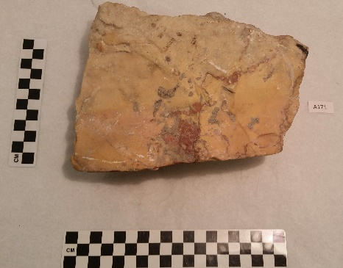

A171
Marble fragment.
Arch of Septimius, Roman Forum
Rome, Italy
A2247
Mosaic floor fragment.
Paestum, Italy
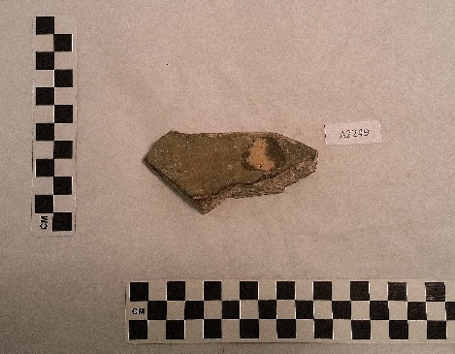
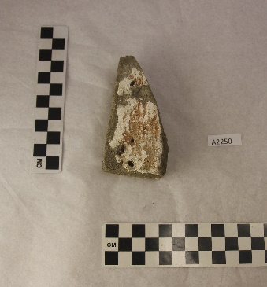
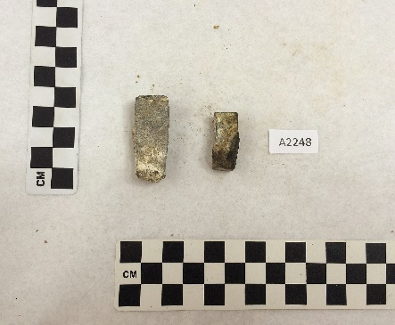
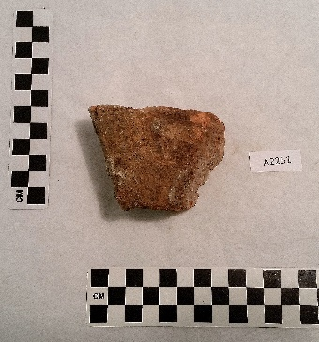
A2251
Brick fragment.
Pompeii, Italy
A2249
Plaster from house wall.
Pompeii, Italy
A2250
Plaster from Roman baths.
Zurich, Switzerland
A2248
Two stone pieces from mosaic floor.
Paestum, Italy

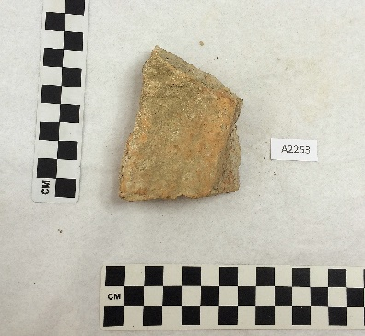
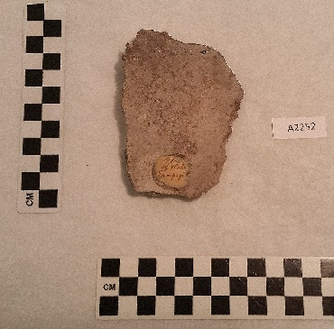
A2252
Plaster from house wall.
Pompeii, Italy
A2253
Brick from Roman baths.
Zurich, Switzerland

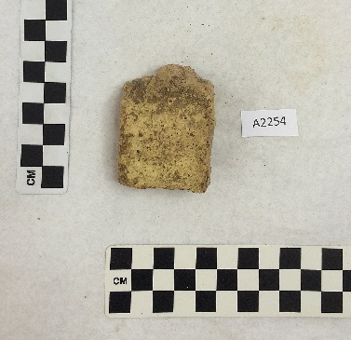
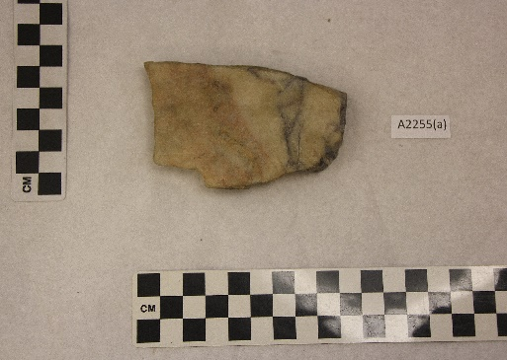
A2254
Brick from Roman Colosseum.
Rome, Italy
A2255A
Marble fragment from Roman baths.
Trier, Germany

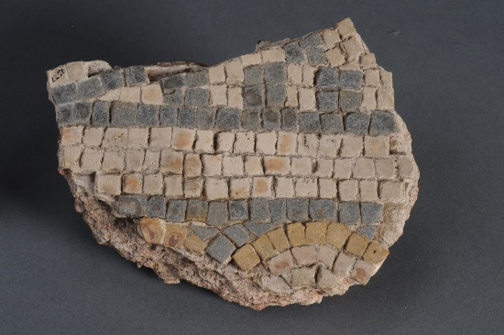
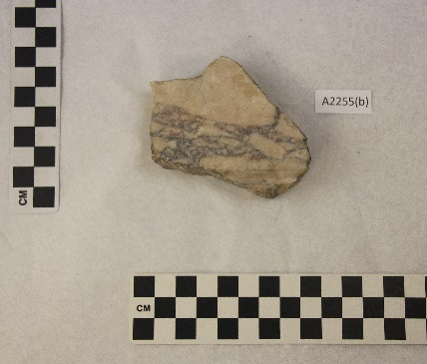

A2255B
Marble fragment from Roman baths.
Trier, Germany
A2256
Mosaic fragment with marble tesserae from Roman baths.
Trier, Germany
Photo used with permission of Milwaukee Public Museum

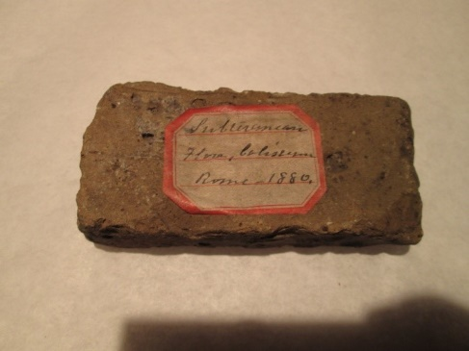
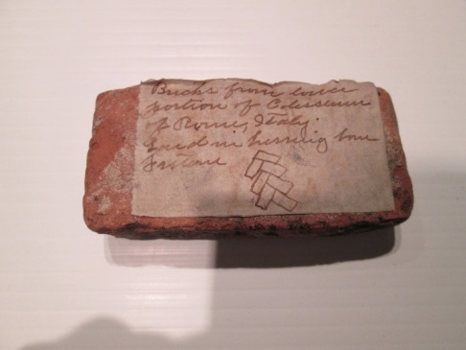
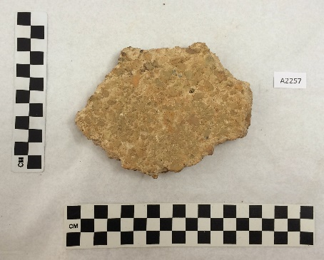
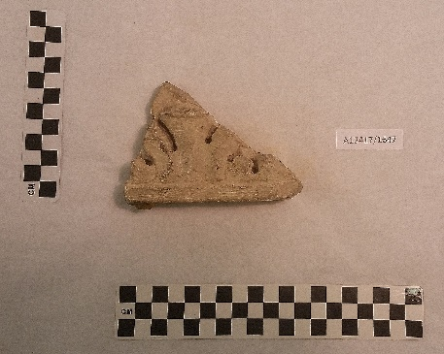
A2257
Plaster from wall of Roman baths.
Zurich, Switzerland
A12417/1647
Hand-carved marble fragment.
Rome, Italy

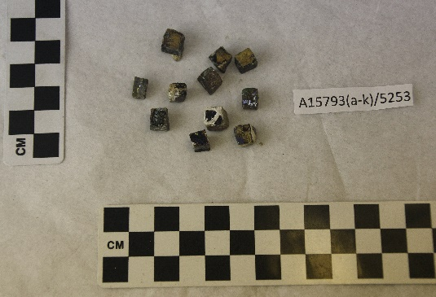
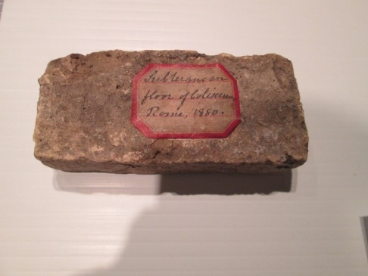
A32848/9154
Brick from subterranean floor of the Roman Colosseum. Found in a herring bone pattern with A32849 & A32850.
Rome, Italy
Photo used with permission of Milwaukee Public Museum
A15793A-K/5253
Lot of 11 iridescent tesserae from wall mosaic.
Rome, Italy

A32850/9154
Brick from subterranean floor of the Roman Colosseum. Found in a herring bone pattern with A32848 & A32849.
Rome, Italy
Photo used with permission of Milwaukee Public Museum
A32849/9154
Brick from subterranean floor of the Roman Colosseum. Found in a herring bone pattern with A32848 & A32850.
Rome, Italy
Photo used with permission of Milwaukee Public Museum
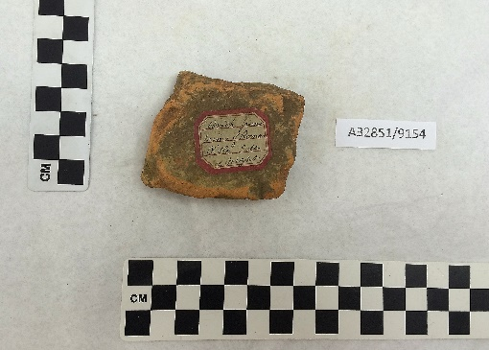
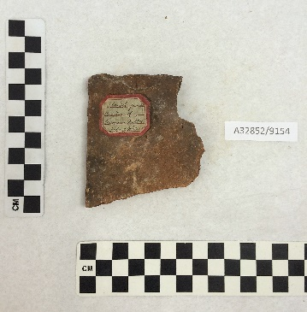
A32851/9154
Brick from ruins of Roman villa.
Isle of Wight, England
A32852/9154
Brick from ruins of Roman villa.
Isle of Wight, England

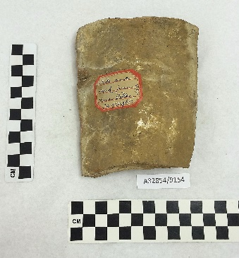
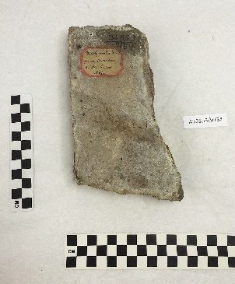
A32853/9154
Brick from wall of Roman villa.
Isle of Wight, England
A32854/9154
Clay tile fragment from Roman villa.
Isle of Wight, England

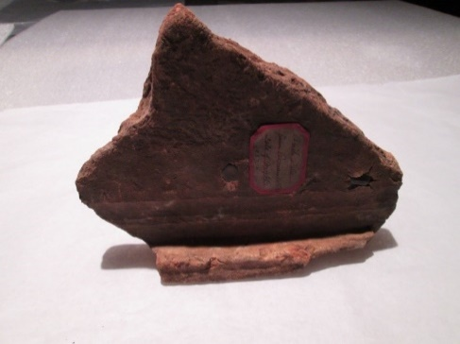
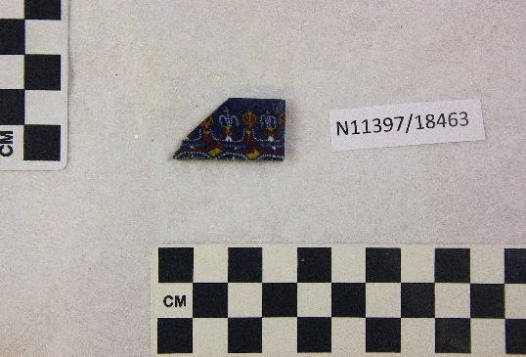

A32855/9154
Clay tile fragment from Roman villa.
Isle of Wight, England
Photo used with permission of Milwaukee Public Museum
N11397/18463
Fused mosaic glass fragment.
Roman Egypt

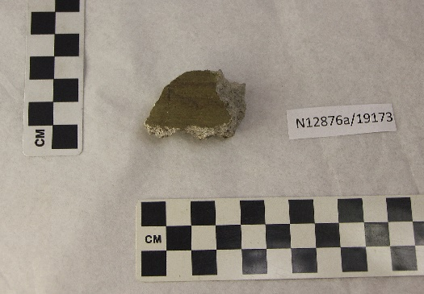
N12887/19173
Stone fragment from Palace of the Caesars.
Rome, Italy
N11609/18932
Marble relief fragment.
Greece
N12878/19173
Marble tile fragment from Temple of Bacchus.
Pompeii, Italy
N12877/19173
Flat marble tile fragment.
Pompeii, Italy
N12876B/19173
Tile fragment.
Pompeii, Italy
N12876A/19173
Painted plaster fragment.
Pompeii, Italy

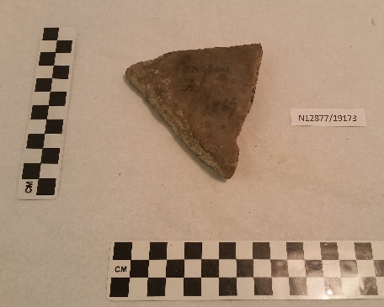
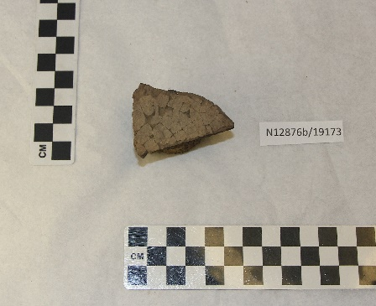

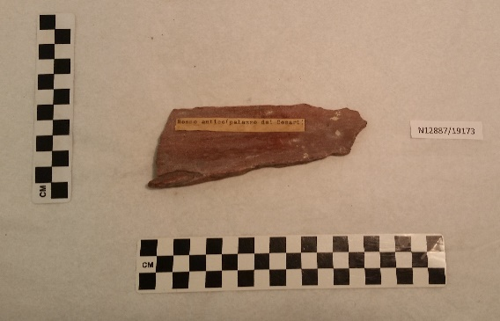
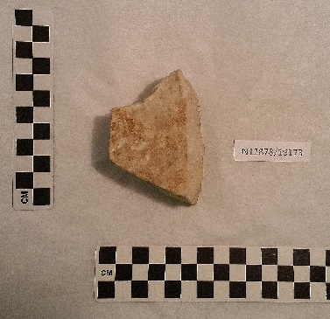

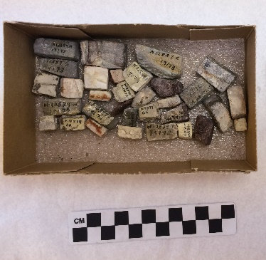
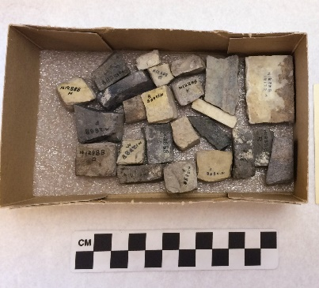
N12888/19173
Lot of 24 mosaic tesserae from Palace of the Caesars.
Rome, Italy
N12889/19173
Lot of 32 mosaic tesserae from Bath of Caraculla.
Rome, Italy

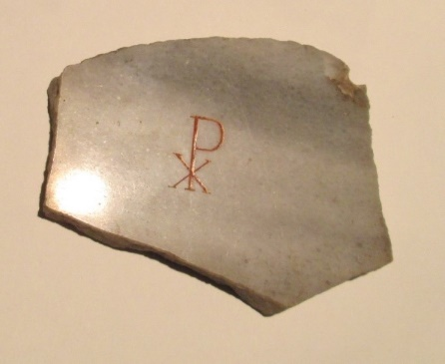
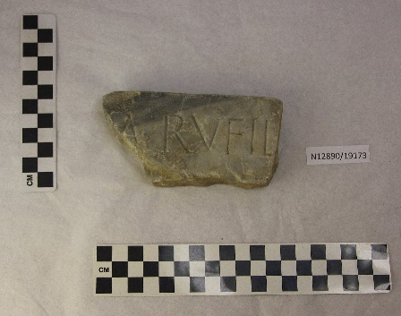
N12891/19173
Marble fragment with Greek Chi-Rho from Roman Catacombs.
Rome, Italy
Photo used with permission of Milwaukee Public Museum

N12890/19173
Marble fragment with Latin inscription: “A RVFIL” from Catacomb of Callixtus.
Rome, Italy
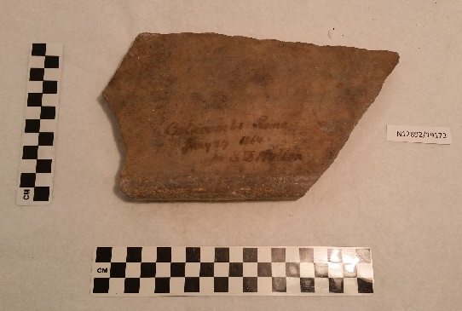
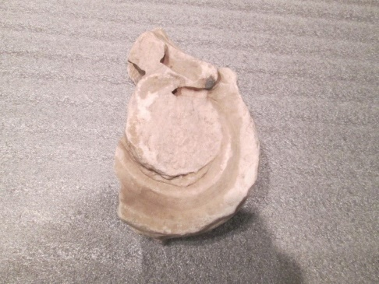
N12892/19173
Marble fragment from Roman Catacombs.
Rome, Italy
N12895/19173
Marble fragment of a capital from the Roman Forum.
Rome, Italy
Photo used with permission of Milwaukee Public Museum

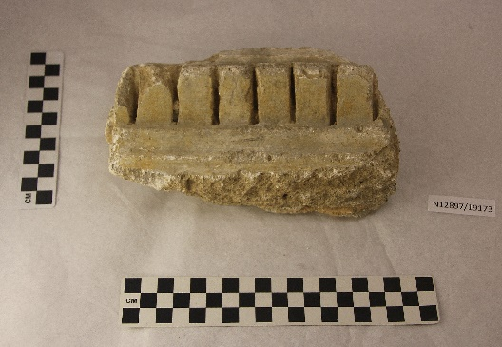
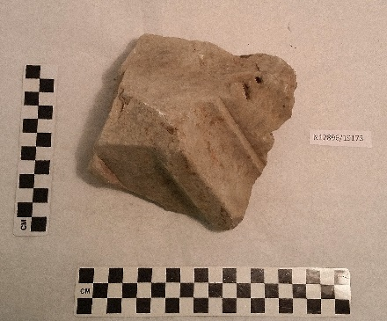
N12896/19173
Marble pediment fragment from top edge of wall of Roman Forum.
Rome, Italy

N12897/19173
Limestone fragment from Roman Forum.
Rome, Italy
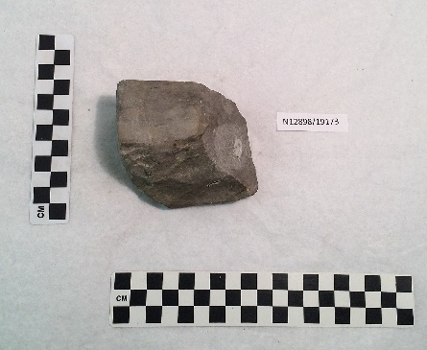
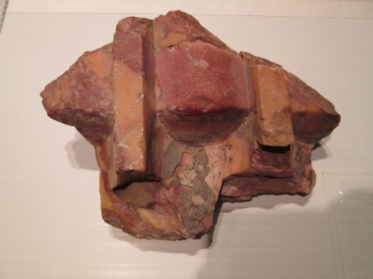
N12899/19173
Marble fragment of a column from Roman Forum.
Rome, Italy
Photo used with permission of Milwaukee Public Museum
N12898/19173
Marble fragment from Roman Forum.
Rome, Italy

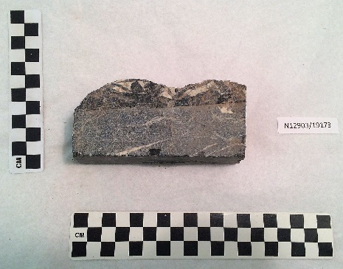
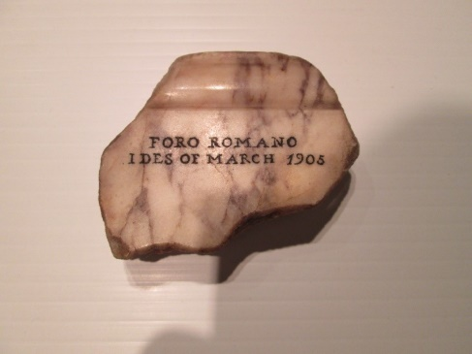

N12902B/19173
Marble fragment from Roman Forum.
Rome, Italy
Photo used with permission of Milwaukee Public Museum
N12903/19173
Marble fragment from Nero’s Palace.
Rome, Italy
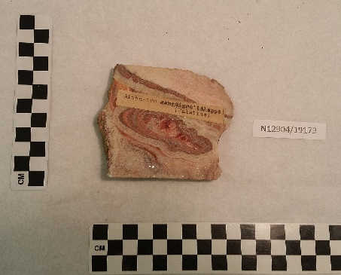
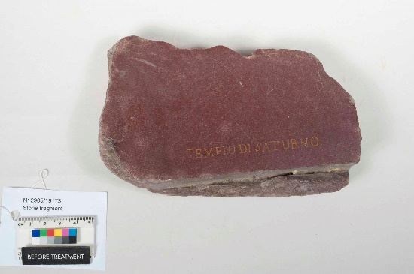
N12904/19173
Alabaster fragment found on Palatine Hill in Rome.
Aleppo, Syria

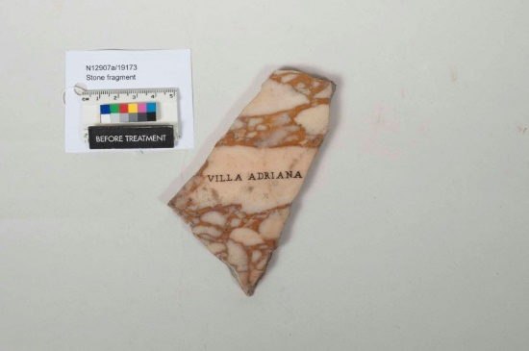
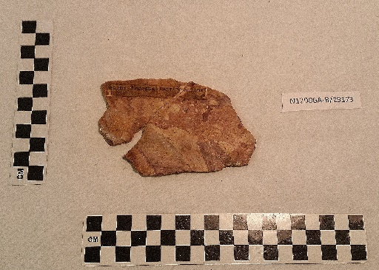
N12906A-B/19173
Two marble fragments from Aventine Hill.
Rome, Italy
N12907A/19173
Marble fragment from Hadrian’s Villa.
Tivoli, Italy
Photo used with permission of Milwaukee Public Museum
N12905/19173
Granite fragment from Temple of Saturn.
Rome, Italy
Photo used with permission of Milwaukee Public Museum

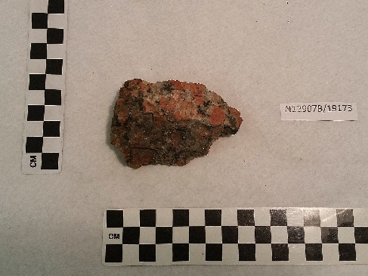
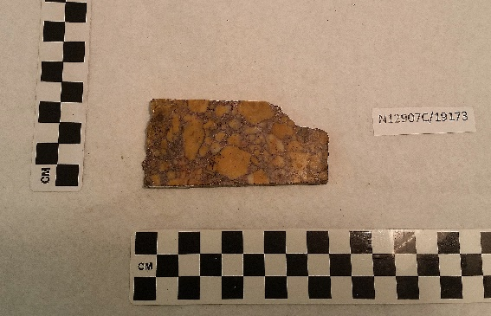

N12907B/19173
Marble fragment from Hadrian’s Villa.
Tivoli, Italy
N12907C/19173
Marble fragment from Hadrian’s Villa.
Tivoli, Italy

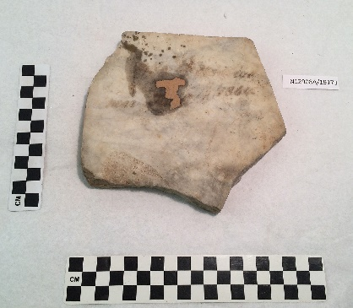
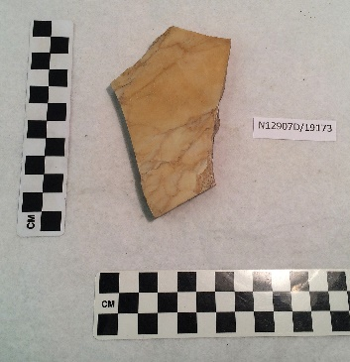
N12907D/19173
Marble fragment from Hadrian’s Villa.
Tivoli, Italy

N12908A/19173
Marble fragment from Hadrian’s Villa.
Tivoli, Italy
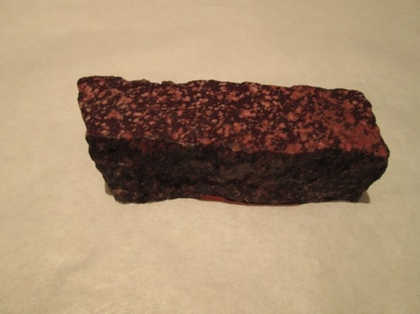
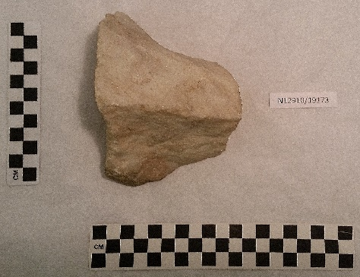

N12910/19173
Marble fragment from the Acropolis.
Athens, Greece
N12908B/19173
Porphyry fragment from Hadrian’s Villa.
Tivoli, Italy
Photo used with permission of Milwaukee Public Museum

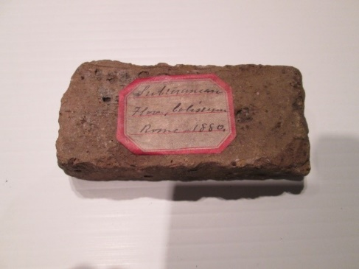
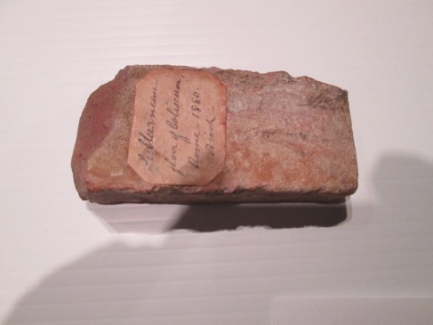

N12911A/19173
Brick from subterranean floor of Roman Colosseum. Found in a herring bone pattern.
Rome, Italy
Photo used with permission of Milwaukee Public Museum
N12911B/19173
Brick from subterranean floor of Roman Colosseum. Found in a herring bone pattern.
Rome, Italy
Photo used with permission of Milwaukee Public Museum
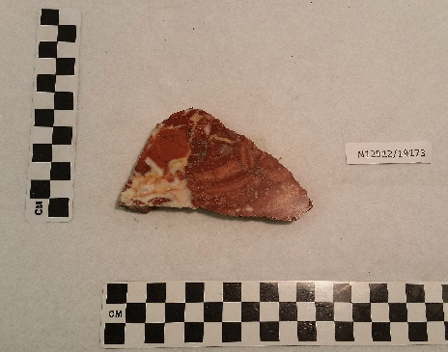
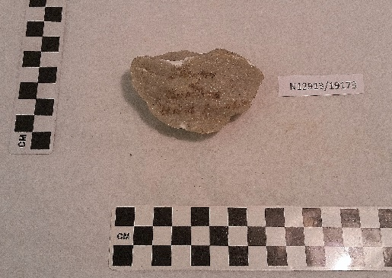

N12912/19173
Marble fragment from Chiesa di San Marco.
Rome, Italy
N12913/19173
Marble fragment from Theatre of Dionysus.
Athens, Greece
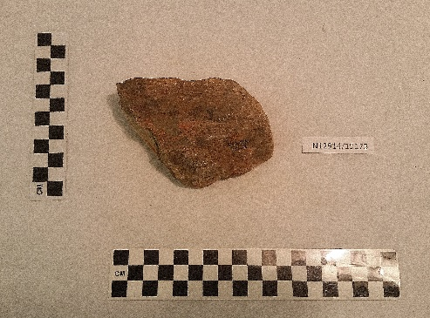
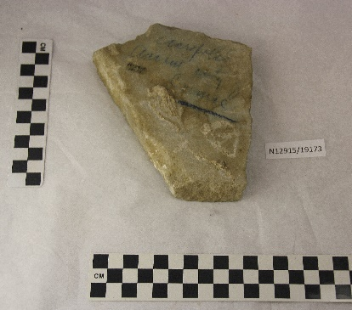
N12914/19173
Stone fragment from Prison of Socrates.
Athens, Greece
N12915/19173
Marble fragment from Greek Acropolis of Cumae.
Campania, Italy

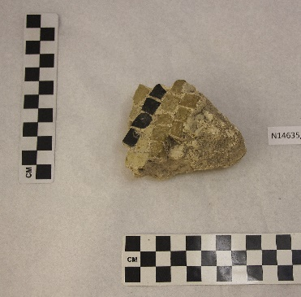
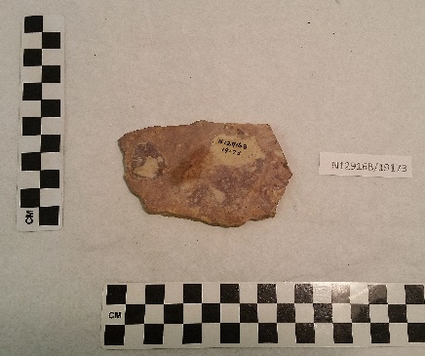

N14635/20643
Mosaic fragment.
Malta
N12916B/19173
Marble road fragment from Via Sacra.
Rome, Italy

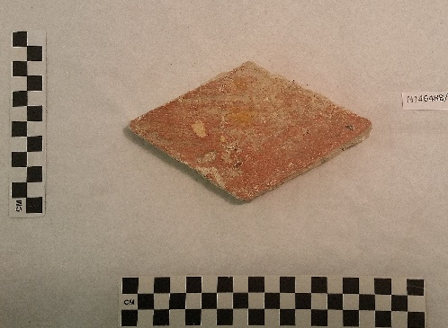
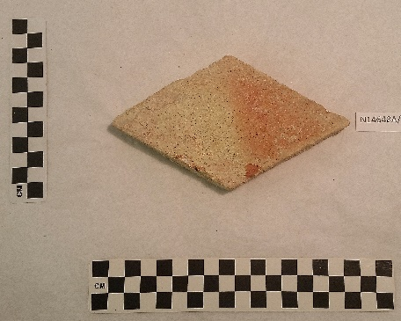
N14648A/20651
Pottery tile.
Greece

N14648B/20651
Pottery tile.
Greece
N14648C/20651
Pottery tile.
Greece
N14648D/20651
Pottery tile.
Greece
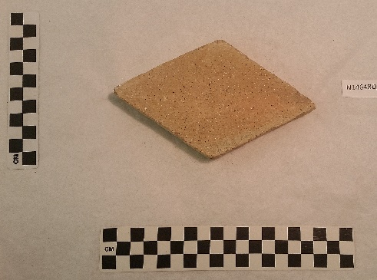
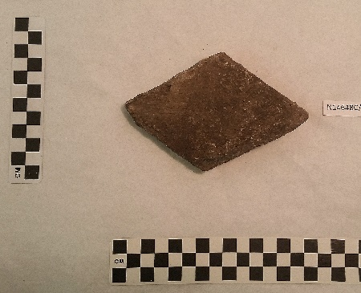

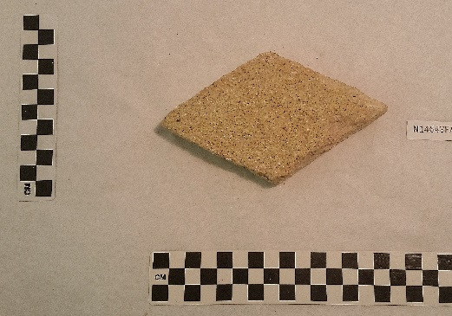
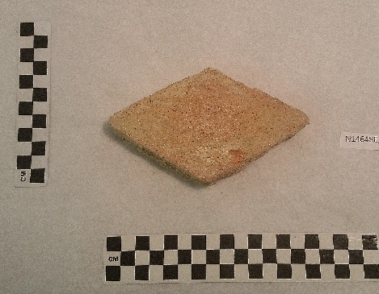
N14648E/20651
Pottery tile.
Greece
N14648F/20651
Pottery tile.
Greece
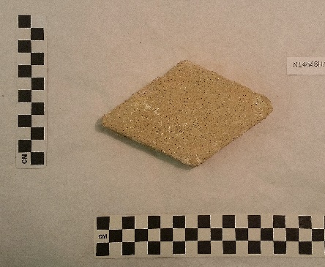
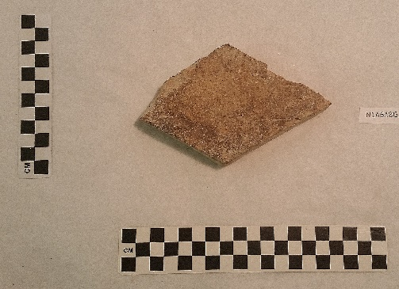
N14649E/20651
Pottery tile.
Greece
N14649D/20651
Pottery tile.
Greece
N14649C/20651
Pottery tile.
Greece
N14648I/20651
Pottery tile.
Greece
N14648H/20651
Pottery tile.
Greece
N14648G/20651
Pottery tile.
Greece

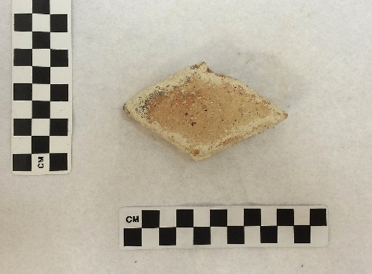
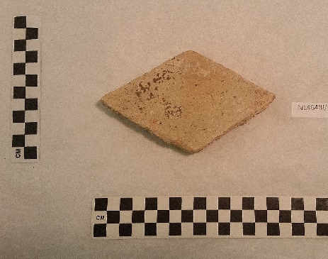

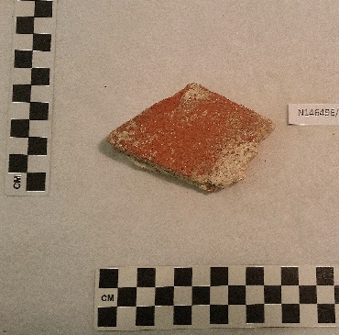
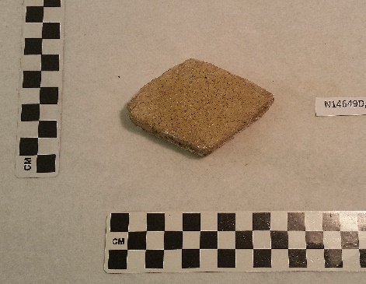

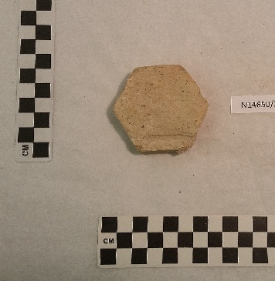
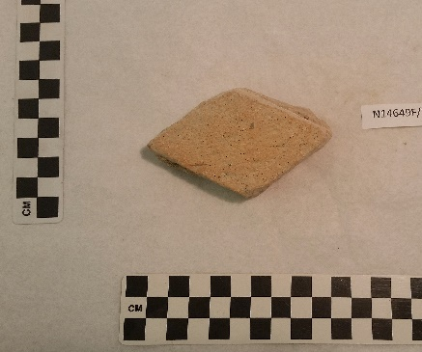
N16161A/21500
Stone floor tile fragment.
Malta
N16160C/21500
Stone fragment.
Malta
N14650/20651
Pottery tile.
Greece
N14649F/20651
Pottery tile.
Greece

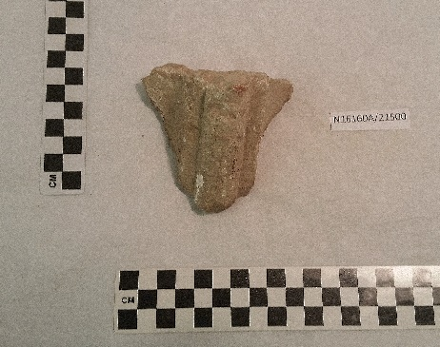
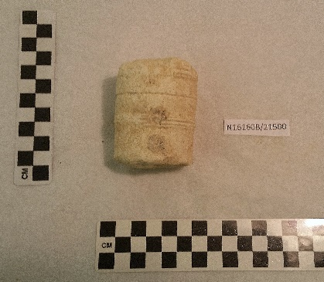

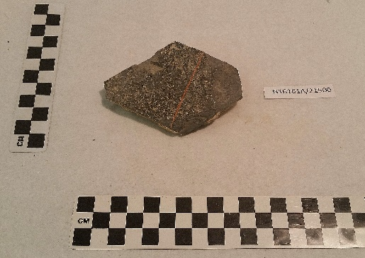
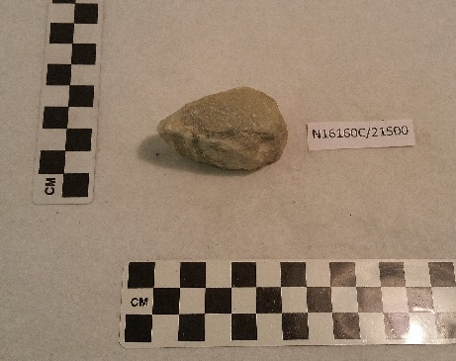
N16160B/21500
Stone fragment.
Malta
N16160A/21500
Stone fragment.
Malta

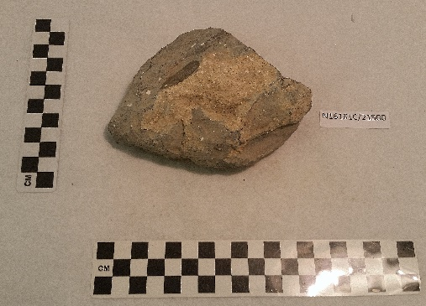
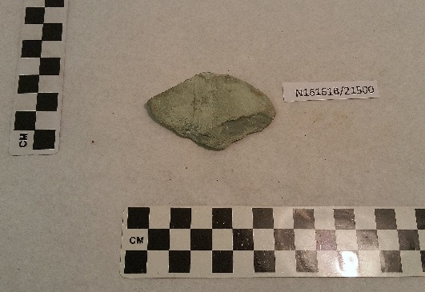
N21338A/23391
Mosaic fragment.
Tripoli, Libya
N16162C/21500
Marble wall fragment.
Malta
N16162B/21500
Marble wall fragment.
Malta
N16162A/21500
Marble wall fragment.
Malta

N16161C/21500
Stone floor fragment.
Malta
N16161B/21500
Stone floor fragment.
Malta
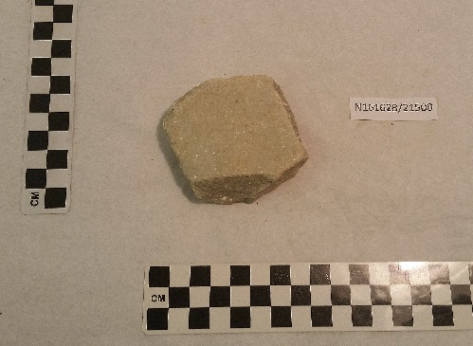
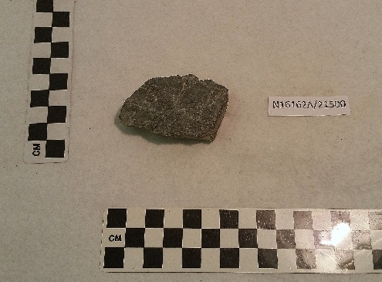

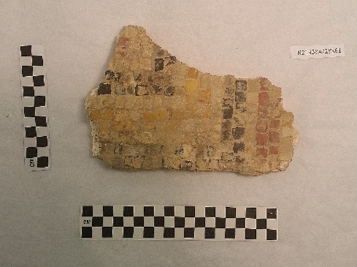
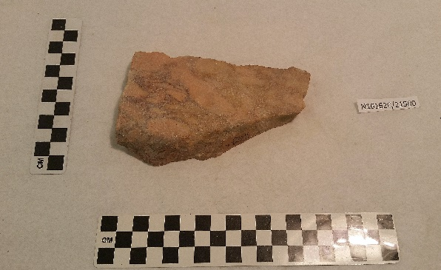

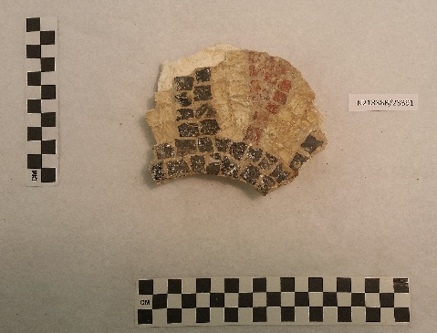

N21338B/23391
Mosaic fragment.
Tripoli, Libya

