UNIVERSITY OF OKLAHOMA
GRADUATE COLLEGE

DOES ACUTE MELATONIN SUPPLEMENTATION AFFECT CEREBROVASCULAR REACTIVITY IN HEALTHY YOUNG ADULTS?

A THESIS
SUBMITTED TO THE GRADUATE FACULTY
in partial fulfillment of the requirements for the
Degree of
MASTER OF SCIENCE

By
CHRIS MIXON
Norman, Oklahoma
2024

DOES ACUTE MELATONIN SUPPLEMENTATION AFFECT CEREBROVASCULAR REACTIVITY IN HEALTHY YOUNG ADULTS?

A THESIS APPROVED FOR THE
DEPARTMENT OF HEALTH AND EXERCISE SCIENCE

BY THE COMMITTEE CONSISTING OF

Dr. J. Mikhail Kellawan, Chair

Dr. Michael M. Markham

Dr. Hugo M. Pereira

© Copyright by CHRISTOPHER MIXON 2024
All Rights Reserved.

Table of Contents
CHAPTER I: INTRODUCTION ……………………………………………………………..1
Purpose of Study ……………………………………………………………………. 3
Research Questions ………………..……………………………………………………4
Research Hypotheses ……………………………………………………………………..4
Significance of Study ……………………………………………………...……………...4
Delimitations/Limitation/Assumptions …………………………………………………..5
Operational Definitions ……………………..………………………………………...7
CHAPTER II: LITERATURE REVIEW ………………………………………………….....9
Cerebrovascular Anatomy …………………………….………………………………10
Cerebrovascular Blood Flow Control …..………………………………………………12
Production and Secretion of Melatonin …………………………………………….…...15
Melatonin’s Interaction with Cardiovascular Control Tissues …………….…..16
Pharmacokinetics and Dosing of Melatonin .…………………………………………..20
Computation of Estimated Flow during Hypercapnia …………………………………21
Clinical Implications ………………………………………………….………………….…..23
Conclusion ……………………………………………………………...……………24
CHAPTER III: METHODOLOGY ……………………………………...……………25
Participants ….…………………………………………………………………... 25
Research Design …………………………………………………………………27
Experimental Protocol ………………………………………………………………...27
Instrumentation ……………………………………………………………………….29
Measurements …………………………………………………………………………30
Threats to Validity …………………………………………………………………….31
Data Acquisition and Analysis ……………………………………………………33
Statistical Analysis ……………………………………………………………………………34
CHAPTER IV: RESULTS ……………………………………………………………………35
Subject Demographics ………………………………………………………..35
Central Cardiovascular Variables ……………………………………………….36
Cerebrovascular Variables ...………………………………………………………….39
Time to Peak Analysis ...………………………………………………………….46
Experimental Estimated Flow Analysis ……………………………………………47
IPAQ and PSQI Correlations ……………………………………………………51
CHAPTER V: DISCUSSION ……………………………………………………………53
Melatonin and Cerebral Hemodynamics …..…………………………….……………...53
Melatonin Central Cardiovascular Effects and CO₂ Rebreathing ……..……………..55
Time to Peak Analysis ……………………………………………………………56
Experimental Cerebral Flow Analysis …...……………………………………….57
IPAQ and PSQI Correlations ……………………………………………………58
Implications of the Present Study ………………………………………………...………..58
Limitations and Considerations ……………………………………………….…………60
CHAPTER VI: CONCLUSION ……………………………………………………63
REFERENCES ……………………………………………………………………………65
SUPPLEMENTARY MATERIALS ……………………………………………………………78
APPENDIX ……………………………………………………………………………98
CVR Results ……………………………………………………………………………98
Experimental Flow Results ……………………………………………………………99
Recruitment Poster …………………………………………………………………..100
Informed Consent Document ………………………………………………………...101
HIPPA Consent Document ………………………………………………………………….108
Medical History Questionnaire ………………………………………………………114
IPAQ …………………………………………………………………………………………….117
PSQI …………………………………………………………………………………..123

List of Tables
- Inclusion and Exclusion Criteria ……………………………………………………26
- Subject Characteristics ……………………………………………………………35
- Central Pulmonary and Cardiovascular Variables ……………………………………36
- Cerebral Vascular Variables ……………………………………………………………39
- Rebreathing Cerebrovascular Reactivity ……………………………………………40
- End-tidal CO₂ Time to Peak Responses ………………………………………...…….46
- Estimated ∆Cerebral Blood Flow ……………………………………………………48
- Correlations Between IPAQ, PSQI, and CVR Outcomes ……………………………52

Lists of Figures
- Protocol Outline ……………………………………………………………………29
- ∆MAP Responses ……………………………………………………………………38
- ∆MCAv Responses ……………………………………………………………40
- ∆CVCi Responses ……………………………………………………………………42
- ∆TSI Responses ……………………………………………………………………43
- CVR_{MCAv} Responses ……………………………………………………………………44
- CVR_{CVCi} Responses ……………………………………………………………………45
- ΔCVR_{MCAv} Percent Change Responses ……………………………………………45
- ΔCVR_{CVCi} Percent Change Responses ……………………………………………46
- Estimated ∆Cerebral Blood Flow ……………………………………………………49
- Estimated ∆Cerebral Blood Flow Percent Change ……………………………………50
- Estimated CVR_{∆Cerebral Blood Flow} Percent Change ……………………………………51

Abstract
Melatonin receptors have been found in the cerebrovasculature in animal models, and melatonin has been shown to improve systemic vascular control. While there is a correlation between low melatonin production and cardiovascular disease, the effect of acute melatonin supplementation on the cerebrovasculature, and more specifically, cerebrovascular reactivity (CVR), is unknown. PURPOSE: To determine if acute melatonin supplementation alters CVR via CO₂ rebreathing in healthy, young adults. METHODS: 14 healthy young adults (Age 23.7±4.39, 7 females tested during the first 5 days of their menstrual cycle) participated in a familiarization visit followed by 2 experimental visits separated by ³48hrs. Participants received a sublingual dose of either a placebo (PLA, mixture of mint extract and filtered water, to mimic taste of melatonin) or 5mg of melatonin (MEL, mint flavor) in a single-blind, randomized, crossover design. After ingestion, participants rested for 30 minutes prior to the experiment to allow for melatonin levels to reach peak concentration in the blood (Bartoli et al., 2013). After which, mean arterial pressure (MAP, mmHg, finger photoplethysmography), middle cerebral artery velocity (MCAv, cm/s, Transcranial Doppler), and end-tidal CO₂ concentration (PetCO₂, mmHg, Gas Analyzer) were measured continuously for 5 minutes of supine rest while breathing atmospheric air followed by a CO₂ rebreathing challenge (CO₂=3%, O₂=40%, balanced N₂) until the participant displayed a PetCO₂ increase of ³10mmHg. Cerebrovascular conductance index was calculated as CVCi = MCAv/MAP (cm/s/mmHg). CVR was calculated in absolute ∆MCAv/∆PetCO₂, ∆CVCi/∆PetCO₂, and percent change from resting values. RESULTS: Data presented as change (Δ) from rest to CO₂ rebreathing, as mean ± SD. All values were not different between treatments during rest. No value was significantly different between treatments when comparing ∆ from rest to CO₂ rebreathing (MCAv PLA ∆13.35±5.1 vs. MEL ∆11.62±6.03, p = 0.31, d = 0.28, MAP PLA ∆1.75±3.91 vs. MEL ∆-0.55±4.49, p = 0.20, d = 0.34, CVCi PLA ∆0.11±0.04 vs. MEL ∆0.11±0.05, p = 0.55, r = 0.16, CVR_{MCAv} PLA ∆2.75±1.30 vs. MEL ∆3.54±2.57, p = 0.92, r = 0.03, %CVR_{MCAv} PLA ∆18.41±7.07 vs. MEL ∆16.12±10.00, p = 0.36, r = 0.24, CVR_{CVCi} PLA ∆0.02±0.03 vs. MEL ∆0.02±0.02, d = 0.28, p = 0.31, %CVR_{CVCi} PLA ∆2.32±2.58 vs. MEL ∆1.52±1.83, d = 0.28, p = 0.31). CONCLUSION: Our results indicate that melatonin does not affect MCAv, CVCi, MAP, or CVR during rest or CO₂ rebreathing. Reactivity was variable individually and did not trend in any direction when comparing PLA treatment to MEL treatment. Thus, melatonin supplementation does not improve cerebrovascular function indicating melatonin supplementation may have differential responses between the cerebral and peripheral vasculature in humans.

Chapter I
Introduction
The brain is an extremely metabolically demanding organ with minimal intracellular substrate storage. Thus, the brain must rely on cerebral blood flow (CBF) for sustained neuronal metabolism (Tarumi et al., 2018). A constant supply of blood flow is required to maintain homeostatic conditions regardless of exogenous conditions, in order to avoid neurological damage, ischemic stroke, and possible death (Xing et al., 2017). In the United States, the lifetime risk of stroke has increase by >8.5% in the last 30 years, 87% of which are considered ischemic (Tsao et al., 2022). Since reliance on CBF is crucial for the maintenance of homeostatic conditions, proper cerebrovascular function is required to avoid disruption of neuronal homeostasis and to avoid neurological damage and death.
In daily life, humans experience numerous conditions that call for the redistribution of blood flow throughout the body. Simultaneously, because of the brain’s high metabolic demand cerebral blood flow must remain constant not matter the metabolic demand of other tissues of the external environment. Cerebrovascular reactivity (CVR) represents the ability of cerebral vessels to dilate in response to increased tissue demand and is expressed as the magnitude of flow response (∆CBF) per unit change in arterial CO₂ (∆P_{aCO2}, Carr et al., 2021). To be clear, cerebral flow (CBF) if the total amount of blood traveling through a cerebral artery, while cerebral vascular reactivity (CVR) is the vessel’s ability to respond to a stimulus and dilate or constrict. While the arterial concentration of CO₂, or PaCO₂, does not directly influence CVR, CO₂ is able to rapidly diffuse across the blood-brain barrier and induce changes in cerebrospinal fluid and interstitial fluid H⁺ concentration, resulting in alterations to smooth muscle tone and thus significant cerebrovascular vasodilation, increasing blood flow (Willie et al., 2014; Hoiland et al., 2019). Measurement of CVR, which will be described thoroughly in the methods and literature review sections, can be used as a metric to assess an individual’s risk of experiencing a cerebrovascular event (Vernieri et al., 1999; Silvestrini et al., 2000; King et al., 2011; Hoiland et al., 2019). Dampened or dysfunctional CVR has been shown to have a link to an increase in ischemic event incidence and stroke (Hu et al., 1999; Chen et al., 2014; Hoiland et al., 2019).
Melatonin release is regulated via sympathetic innervation modulated by beta-adrenergic receptor stimulation through the pineal gland and is known to play a substantial role in regulating human circadian rhythm (Cajochen et al., 2003). Despite this, the melatonin receptor MT1 has been found in the aorta and left ventricle, while the melatonin receptor MT2 has been found in the brain vasculature, suggesting that the hormone may play a role in other unfounded mechanisms (Ekmekcioglu et al., 2003; Pandi-Perumal, 2007; Baker & Kimpinski, 2018). Both of these receptors have been associated with vasoconstriction and vasodilation (Pandi-Perumal, 2008; Baker & Kimpinski, 2018). Patients with cardiovascular disease have been shown to produce less nocturnal melatonin in comparison to healthy populations, meaning that there may be a link between low melatonin production and cardiovascular diseases (Brugger et al., 1995; Yaprak et al., 2003). While no mechanism of the lower release of melatonin in patients with cardiovascular disease has been identified, melatonin has been shown to both reduce free radical production and increase antioxidant reserves in humans and rats (Girouard et al., 2004; Koziróg et al., 2011; Reiter 2003) suggesting that lower melatonin release could at least in theory be related to the excess free radical production and damage consistently observed in patients with cardiovascular diseases (Panth et al., 2016; Moris et al., 2017; Peoples et al., 2019). In combination with reducing free radical production, melatonin has been shown to blunt α-adrenergic receptors in rats, reducing sympathetic outflow (Girouard et al., 2004). Furthermore, potentially due to the blunting effect of α-adrenergic receptors, melatonin serves as a potent anti-hypertensive agent in humans (Holmes et al., 1976; Cunnane et al., 1980; Simko et al., 2007; Katsi et al., 2012; Baker & Kimpinski, 2018). Despite this, it has been demonstrated that proper cerebral autoregulatory function indicates that there should not be a noticeable change in CBF in healthy individuals when comparing a melatonin and a placebo treatment group (Mil et al., 2003). Therefore, as mentioned before, a stimulus that alters CBF directly can be used to measure a potential difference in change in CBF between taking melatonin and taking a placebo. In other words, a clear stimulus that alters CBF directly may highlight whether or not melatonin presents with any cerebrovascular vasoactive properties.
Because a major contributing factor that determines CVR is the effect of P_{CO2} on H⁺ concentrations in the CSF and the interstitial fluid (ISF), the creation of hypercapnic conditions via CO₂ rebreathing serves as a valuable tool for observing differences in CVR between treatment groups. It has been demonstrated in rats that the pineal gland and melatonin play a role in the regulation of blood flow to the brain (Capsoni et al., 1995). Regardless, the direct effect of melatonin’s cerebrovascular properties has not yet been studied in humans. Changes to CVR in humans during rebreathing under the effects of melatonin has also yet to be studied.

Purpose
The purpose of this study is to determine the role of acute melatonin supplementation on cerebrovascular reactivity and flow during rest and CO₂ rebreathing in healthy, young adults.

Research Questions
- Does acute melatonin supplementation affect cerebrovascular flow during rest and CO₂ rebreathing?
- Does acute melatonin supplementation affect cerebrovascular reactivity during rest and CO₂ rebreathing?
- Does acute melatonin supplementation affect prefrontal cortex oxygenation during CO₂ rebreathing?

Research Hypotheses
- Acute melatonin supplementation will increase cerebrovascular flow at rest and during CO₂ rebreathing in healthy, young adults.
- Acute melatonin supplementation will increase cerebrovascular reactivity by means of increasing the cardiovascular conductance index (CVCi), decreasing mean arterial pressure (MAP), and increasing middle cerebral artery velocity (MCAv) during rest and CO₂ rebreathing in healthy, young adults.
- Acute melatonin supplementation will increase prefrontal cortex oxygenation during rest and CO₂ rebreathing.

Significance of Study
Proper delivery of blood to the brain is essential for everyday function and to avoid neurological damage. While melatonin has been shown to attenuate sympathetic outflow in animal models, and melatonin receptors have been discovered in cerebrovasculature, the effect of melatonin on cardiovascular and cerebrovascular variables has not yet been studied during CO₂ rebreathing. Low melatonin production has been positively correlated with increasing cardiovascular disease, establishing a possible connection between the two. As a potent hypotensive agent as well as a sympathetic outflow attenuator in animal models, understanding the effects of melatonin on cerebrovascular reactivity has the potential to add valuable insight into possible therapeutic approaches towards populations with dampened cerebrovascular reactivity.

Delimitations
- All subjects are considered healthy and do not have cardiovascular, metabolic, or pulmonary diseases, and have no history of autonomic dysfunction.
- All subjects are normotensive and have a resting systolic blood pressure of < 130 mmHg and a resting diastolic blood pressure of < 85 mmHg.
- All subjects are not taking any cardiometabolic medications that would interfere with the present study by interfering with cerebral or systemic blood flow.
- All subjects are 18-35 years of age.
- All subjects have a BMI of less than 30 kg/m².
- All subjects are not pregnant.
- All female subjects are tested between days 1 and 7 of the follicular phase of their menstrual cycle.
- All subjects have not used nicotine products within the last 6 months.
- All subjects do not regularly use any melatonin products.

Limitations
- Middle cerebral artery velocity (MCA_{v}) has been measured and used to estimate flow and thus vasodilation rather than directly measuring middle cerebral artery vessel diameter.
- Melatonin has been administered sublingually and not venously or intra-arterially.
- CO₂ balloon volume was not measured directly during rebreathing.
- Total brain oxygenation was not measured, only prefrontal cortex oxygenation has been measured.
- Subject light exposure, which is a main determining factor for melatonin release, has not been controlled for outside of the experimental protocol.
- Data may not adequately represent any population beyond young, healthy individuals.

Assumptions
- All subjects have adhered to the pre-protocol requirements.
- ∆MCA_{v} accurately represents ∆cerebral blood flow.
- ∆CVCi accurately represents ∆cerebrovascular conductance.
- Sublingually administered melatonin was absorbed into the blood stream as previously described (Bartoli et al., 2013).
- 5mg of sublingually-administered melatonin reached peak concentration within the circulation ~30 minutes after administration as previously described (Bartoli, 2014).
- Balloon volume did not limit CO₂ consumption during rebreathing protocol.
- Subjects were properly blinded by placebo treatment.

Operational Definitions
- Cardiac Output (Q): The amount of blood that leaves the heart over one minute, calculated by multiplying stroke volume and heart rate.
- Stroke Volume (SV): The amount of blood pumped out of the left ventricle of the heart during one systolic contraction.
- Total Peripheral Resistance (TPR): Total systemic resistance to blood flow in the circulatory system.
- Transcranial Doppler (TCD): A rapid, noninvasive method used to measure cerebrovascular function and flow velocity. The Doppler effect allows for ultrasonic waves to reflect off moving erythrocytes to provide cerebrovascular information (Purkayastha & Sorond, 2012).
- Middle Cerebral Artery Velocity (MCA_{v}): The speed at which blood travels within the middle cerebral artery.
- Cerebrovascular Conductance Index (CVCi): An index that divides middle cerebral artery velocity by mean arterial pressure and represents conductance, or ease of flow, within an artery.
- Mean Arterial Pressure (MAP): The average arterial pressure throughout one complete systolic and diastolic cardiac cycle (DeMers & Wachs, 2022).
- End-tidal CO₂ (EtCO₂): The volume of CO₂ exhaled at the end of one breathing cycle.
- End-tidal O₂ (EtO₂): The volume of O₂ exhaled at the end of one breathing cycle.
- Near-infrared Spectroscopy (NIRS): A method that uses relative infrared light absorption wavelengths to determine oxygenated hemoglobin, deoxygenated hemoglobin, and total hemoglobin levels (Sanni & McCully, 2019).
- Total Saturation Index (TSI): A ratio between oxygenated hemoglobin and total hemoglobin (Sanni & McCully, 2019)
- Oxygenated Hemoglobin (HbO₂): Oxygen bound to hemoglobin complexes.
- Deoxygenated Hemoglobin (HHb): Hemoglobin that does not have oxygen molecules bound to itself.
- Total Hemoglobin (tHb): Total amount of hemoglobin in a sample of red blood cells, which can be used to measure oxygen transport capacity.
- Sympathetic Nervous System (SNS): The part of the autonomic nervous system that prepares the body for periods of activity.
- CO₂ Rebreathing: A method of inhaling large amounts of CO₂ to elicit a rise in EtCO₂ of at least 5 mmHg without a decrease in ventilation (Barrie & Beatty, 1995).
- Placebo (PLA): A mixture of one microliter of McCormicks Pure Mint Extract and 29 mL of filtered water, administered via sublingual spray.
- Melatonin (MEL): Consists of 5 mg of sublingual spray (10 total sprays, Onnit, Austin, Texas, United States).

Chapter II
Literature Review
Introduction
It has been demonstrated that melatonin is a hormone that is responsible for the regulation of sleep patterning and the Circadian Rhythm (Cajochen et al., 2003). Beyond this, recent evidence has shown that melatonin may have wider implications on systems like the cardiovascular system in both human and animal models (Cunnane et al., 1980; Simko et al., 2007; Katsi et al., 2012; Baker & Kimpinski, 2018). It has been suggested that α-adrenergic receptor inhibition may be related to melatonin production and thus exogenous melatonin supplementation, implying that melatonin produces anti-hypertensive effects in addition to anti-inflammatory and antioxidant effects (K-Laflamme et al., 1998; Baker & Kimpinski, 2018).
The brain is an organ that lacks substantial substrate storage and thus requires very controlled blood flow matching in order to meet metabolic demand (Tarumi et al., 2018). Because of the recent >8.5% increase in lifetime stroke risk in the United States, the proper establishment of potential therapeutic targets as well as exogenous aids with cardiovascular implications is of the upmost importance (Tsao et al., 2022). While no specific clinical significant difference has been determined detailing the risk between dampened CVR and stroke risk, studies have shown that there was a 9.8% increased annual risk of experiencing an ischemic brain event in those with lower CVR and a statistically increased risk of experience a first-time lacunar infarction (Molina et al., 1999; Silvestrini et al., 2000) Because measurement of CVR is commonly used to represent an individual’s risk of an ischemic or traumatic brain event, and dampened CVR is typically associated with an increase in ischemic event incidence, using a CO₂ rebreathing challenge in order to evaluate CVR can be considered a potential predictive clinical tool (Silvestrini et al., 2000; Vernieri et al., 1999; King et al., 2011; Hu et al., 1999; Chen et al., 2014). The purpose of this literature review is to investigate the effects of melatonin supplementation on cerebrovascular blood flow and CVR during a CO₂ rebreathing challenge. Search terms were organized and utilized beginning in the order of the present review. Commonly used terms included CO₂ rebreathing, CO₂ and blood brain barrier, Middle Cerebral Artery Diameter, Melatonin, Melatonin Cerebrovasculature, Melatonin Receptors, Melatonin Receptors Cerebrovasculature, and other extensions or combinations of the above terms.
This chapter will discuss the production and secretion of melatonin from the pineal gland and extra-pineal locations, the functions and proposed functions of melatonin, the potential interaction of melatonin with cardiovascular control tissues, the pharmacokinetics and dosing of melatonin supplementation, cerebrovascular anatomy, sex differences in cerebrovascular blood flow and CVR, cerebrovascular responses to CO₂ rebreathing, the computation and interpretation of estimated flow changes during hypercapnic conditions, and the clinical implications of melatonin use on cardiovascular and cerebrovascular health.

Cerebrovascular Anatomy
Comprehensive understanding of the anatomy of the cerebral vasculature is important in forming a foundation of studying cerebrovascular health outcomes. Blood flows to the brain via four large cerebral arteries; the right and left vertebral arteries (VA) and the right and left internal carotid arteries (ICAs) (Traystman, 2017; Vavilala et al., 2002). The former is responsible for the distribution of blood to the posterior side of the brain while the latter is responsible for the distribution of blood to the anterior part of the brain. The carotid arteries and the VAs then combine at the base of the brain’s vasculature to form the Circle of Willis (Traystman, 2017). In particular, and in relevance to the present study, the anterior-supplying ICAs branch on both sides to the middle cerebral arteries (MCAs), which continue to branch into the anterior cerebral arteries (ACAs). In the posterior circulation, the right and left VAs integrate with one another, becoming the basilar artery (BA), which branch into the posterior cerebral arteries (PCAs). In redundant fashion, anterior and posterior communicating arteries integrate with the PCAs at the Circle of Willis, ensuring that there is an equal and adequate distribution of blood throughout the entire brain (Traystman, 2017). Through different branches blood then flows into arterioles, marking the point during which blood is no longer considered to be flowing in the large arteries of the brain. The distribution of nutrients and metabolites occurs at the level of capillary beds, which are fed by said arterioles.
Cerebral Vascular Anatomical Variability
Many of the common vascular pathways within the brain appear with differing degrees of variability, presenting an issue for the measurement and interpretation of cerebrovascular data. In particular and most relevant to the present study, the MCA is a vessel that is commonly bifurcated, trifurcated, or quadfurcated. Gunnal (2019) concluded in a cadaveric study with a sample size of 170 preserved brains that 64.70% had at least one bifurcated MCA, 12.35% had at least one trifurcated MCA, and 2.35% had at least one quadfurcated MCA. Other studies have concluded between 70 and 80 percent of individuals have at least one MCA bifurcation and between 9 and 30 percent of individuals have at least one MCA trifurcation (Idowu et al., 2002; Tanriover et al., 2003; Pai et al., 2005; Vuiller et al., 2008). Similar results have been found in different arteries associated with the Circle of Willis (Papantchey et al., 2013; Payne, 2016). Abnormalities in cerebral vascular anatomy can make obtaining symmetrical data without some degree of variation difficult, as many of the variations in cerebral anatomy do not present with any obvious pathology (Alpers et al., 1959).
Cerebral Vascular Sex Differences
Alongside variations present in the cerebral vasculature of humans, there are measurable differences in both anatomical and blood flow-related variables when comparing males and females. It has been shown that females typically have higher global and regional cerebral blood flow compared to men, ranging depending on the study between an increase of ~6-11%, not normalized by volume of neural tissue, but as a change from a self-baseline (Rodriguez et al., 1988; Gur & Gur, 1990). Females also may present with more symmetrical flow in comparison to men (Rodriguez et al., 1988). End-tidal CO₂ concentrations were not different, indicating that there may be a hormonal difference that contributes to blood flow in females compared to men, which is an important factor when considering any sex difference analyses. Estrogen replacement therapy (ERT) has been shown to increase global cerebral blood flow in postmenopausal women, suggesting that the hormonal differences between males and females could contribute to cerebral blood flow responses both between males and females as well as within the same females at different stages of their menstrual cycles (Ohkura et al., 1994; Resnick et al., 1998; Nevo et al., 2007).

Cerebrovascular Blood Flow Control
Poiseuille’s Law is fundamental to understanding cerebral hemodynamics, similar to any other part of the cardiovascular system. It states that the flow through a vessel is determined by changes in blood velocity, viscosity, diameter, and the vessel length. The equation can be seen as:
$$Q= \frac{∆Pπr^{4}}{8ɳl}$$
∆P = change in pressure, r = vessel radius, ɳ = blood viscosity, l = vessel length
Under ideal conditions, the length of the vessel and viscosity of blood flowing through said vessel can typically be excluded when comparing groups. This leaves the effect of pressure and radius as two variables that can alter flow dramatically, with the most influential contribution being derived from changes in the radius of a blood vessel. Therefore, particular examination of vessel diameter alterations is crucial in terms of changes to cerebral blood flow.
Neurogenic Contributions to Flow
The degree of contribution of the sympathetic and parasympathetic nervous systems on vasodilatory and vasoconstrictive responses, particularly in the cerebrovasculature, is to this day debated within the scientific community. Most current research agrees that the parasympathetic nervous system either does not play a role or only plays a minor role in the vasodilatory and vasoconstrictive responses of the cerebral vasculature (Willie et al., 2014). It is known that the sympathetic nervous system does present adrenergic receptors within the vascular smooth muscle of the cerebral vasculature (Ainslie & Brassard, 2014; Brassard et al., 2017). Beyond this, adrenergic nerve endings have been discovered innervating the above-mentioned receptors (Ainslie & Brassard, 2014). It has not been concluded the extent to which sympathetic innervation contributes to cerebral blood flow control, but the influence of the SNA is evident, at least within the larger arteries of the brain, where removal of sympathetic outflow results in higher total blood flow (Jeng et al., 1999; Claassen et al., 2021).
Cerebrovascular Responses to CO₂ Rebreathing – Metabolic Contributions to Flow
Arterial CO₂ concentration is inversely proportional to alveolar ventilation and directly proportional to the total volume of CO₂ production as described by:
$$P_{a}CO_{2}=\frac{V_{CO2}}{V_{A}}$$
Where P_{a}CO₂ = arterial CO₂ concentration, V_{CO2} = whole-body CO₂ production, and V_{A} = alveolar ventilation (Willie et al., 2014)
So, arterial concentration of CO₂ can be derived through the measurement of CO₂ output and ventilation. Increases in arterial CO₂ concentration leads to a rapid passive diffusion of CO₂ across the blood-brain barrier, which changes hydrogen ion concentration via the bicarbonate buffering system in the intracellular and extracellular cerebrospinal and interstitial fluids of the brain, eventually leading to alterations in cyclic GMP production and causing vascular smooth muscle relaxation (Willie et al., 2014; Jensen et al., 1988). The subsequent change in the vascular tone of the cerebral vessels results in changes to CBF, and CO₂ concentrations have been established as the most potent regulator of cerebral tone itself (Hoiland et al., 2019). It has further been estimated that there is an ~4% increase in cerebral blood flow for every increase of 1 mmHg of CO₂ (Dagal & Lam, 2009). Therefore, controlled alterations in the concentration of inspired CO₂ will lead to possibly-predicted alterations in vasodilatory responses via the above-mentioned change in arterial tone, with arterial CO₂ concentration displaying a direct relationship with vascular smooth muscle relaxation and vasodilation (Hoiland et al., 2019).
CO₂ Rebreathing as a Tool to Assess Cerebrovascular Reactivity
Alteration of the concentration of inspired CO₂ will lead to possibly-predicted vasodilatory responses, and so CO₂ rebreathing can serve as a valuable tool to assess a vessel’s ability to respond to a stimulus. To restate, if it is understood that a vessel will dilate in response to a particular stimulus, assessing the vessel’s capability to dilate to that stimulus could be predictive of cerebrovascular health. Indeed, there is evidence to show that impaired CVR to stimuli is associated with predicted risk of ischemic or traumatic brain events (Vernieri et al., 1999; Silvestrini et al., 2000; King et al., 2011; Hoiland et al., 2019). Since it has been demonstrated that a dampened or weakened CVR is associated with an increase in ischemic event incidence, using CO₂ rebreathing as a tool to assess the capacity to which a vessel can react to stimulus proves extremely useful (Hu et al., 1999; Chen et al., 2014; Hoiland et al., 2019).

Production and Secretion of Melatonin
Melatonin Production from the Pineal Gland
Under low light conditions melatonin is secreted from the pineal gland. Through the retina, and in the presence of low light, a cascade beginning with activation of the suprachiasmatic nuclei (SCN) begins (Pandi-Perumal et al., 2008; Baker & Kimpinski, 2018). Activation of the SCN inhibits the paraventricular nucleus (PVN) which projects to the sympathetic intermediolateral nucleus in the spinal cord, projecting to the pineal gland via cervical ganglia (Pandi-Perumal et al., 2008; Baker & Kimpinski, 2018). Under light conditions, contrarily, the PVN remains inhibited and the cascade for melatonin release from the pineal gland ceases. When the cascade is allowed to continue, melatonin is released from the pineal gland and can interact with targets in the brain that relate to the Circadian Rhythm but is also released into the peripheral and cerebrovascular bloodstreams as well as the cerebrospinal fluid where its proposed cardiovascular mechanisms may take form (Baker & Kimpinski, 2018). Physiologically, and because of the dependence of melatonin release on the presence or absence of light, the highest concentrations of melatonin are seen during the night and the lowest concentrations of melatonin are seen during the day in humans (Cajochen et al., 2003).
Melatonin Extra-Pineal Gland Production
Extra-pineal sources of melatonin include immune tissues, bone marrow cells, the gastrointestinal tract, and many more (Acuna-Castroviejo et al., 2014). Despite this, in most situations, extra-pineal melatonin release is local and does not leak into the peripheral circulatory system (Acuna-Castroviejo et al., 2014). One explanation for this is a molecule specifically designed to “buffer” melatonin to keep its highly lipophilic profile within the cell, but specific mechanisms have not yet been discovered (Acuna-Castroviejo et al., 2014). With recent investigation into the anti-inflammatory and antioxidant effects of melatonin, it would reason that extra-pineal and local melatonin release would be of high importance (Acuna-Castroviejo et al., 2014). Furthermore, locally produced and locally-maintained melatonin release would be able to exert its anti-inflammatory and antioxidant effects without leaking into the circulatory system.

Melatonin’s Interaction with Cardiovascular Control Tissues
Melatonin Receptor Physiology
While it has been established that melatonin plays an important role in sleep and the regulation of the Circadian Rhythm, it also has been suggested that it plays an important role in various cardiovascular disease risk factor attenuation. Some of these areas include oxidative stress, diabetes, dyslipidemia, obesity, hypertension, arrythmias, and atherosclerosis (Imenashidi et al., 2020). Three types of melatonin receptors have been identified in humans, but only the G protein-coupled receptors MT1 and MT2 have thus far been demonstrated to exist in humans (Pandi-Perumal et al., 2008; Baker & Kimpinski, 2018). In humans, after the pineal melatonin release cascade through the SCN and PVN becomes active, melatonin binds to MT1 or MT2 receptors where its signaling is mediated via adenylate cyclase, guanylate cyclase, and calcium channels (Pandi-Perumal et al., 2008; Baker & Kimpinski, 2018). Typically, activation of MT1 receptors results in a vasoconstrictive response whereas activation of MT2 receptors results in a vasodilatory response (Pandi-Perumal et al., 2008). After intracellular signaling occurs, cyclic AMP production becomes inhibited and intracellular calcium concentrations increase (Baker & Kimpinski, 2018). The melatonin receptor MT3, otherwise known as the enzyme quinone reductase 2, acts as a mechanism that prevents oxidative stress by preventing electron transfer reactions of quinones, but have only been demonstrated thus far to be present in rats and hamster models (Pandi-Perumal et al., 2008).
Melatonin Receptors and Cerebrovascular Control
Previous work has found that there are melatonin receptors found outside of well-established locations like the hypothalamus and pineal gland. Besides the periphery, MT2 receptors have been discovered in the Circle of Willis in the brain, which suggests that there may be a mechanism of cardiovascular action derived from melatonin binding on the cerebral vasculature (Capsoni et al., 1994; Viswanathan et al., 1990). Separate from MT1 receptors, MT2 receptors also modulate guanylyl cyclase and resulting cGMP production, which can cause vasorelaxation and dilation by increasing conductance through potassium channels and decreasing vascular smooth muscle cell (VSMC) calcium sensitivity (Baker & Kimpinski, 2018; Hoiland et al., 2019). This implicates MT2 receptors as a potential location of melatonin’s proposed cerebrovascular influence. Since MT2 receptors mediate the production of cGMP, and MT2 receptors have been found lining the large arteries of the cerebral vasculature, investigation of their activation and thus subsequent vasorelaxation is warranted.
The Effect of Melatonin on the Nervous System
It has been suggested that the mechanism through which melatonin exerts positive cardiovascular effects is via the attenuation of sympathetic α-adrenergic receptors and the stimulation of parasympathetic beta-receptors. Direct intravenous injection of melatonin resulted in increased concentrations of gamma aminobutyric acid (GABA), a central sympatho-inhibitory molecule, and decreased concentrations of glutamate, a central sympatho-excitatory molecule, which displayed a following decrease in MAP (Xia et al., 2008). This may have to do with the close connection between the SCN, which mediates melatonin release from the pineal gland, and the rostral ventrolateral medulla (RVLM), which extends into projections towards sympathetically-oriented cell bodies (Baker & Kimpinski, 2018). Furthermore, sympathetic activity was significantly decreased in response to simulated hypovolemic-induced stress after exogenous supplementation of melatonin (Ray, 2003). Numerous studies have also observed decreases in MAP, pulsatility, and norepinephrine and epinephrine release following acute supplementation of exogenous melatonin (Arangino et al., 1999; Cagnacci et al., 1997).
The Effect of Melatonin as an Antioxidant and Anti-inflammatory Agent
When cells metabolize oxygen there is a potential for deleterious reactive oxygen species (ROS) if an imbalance between pro-oxidant and antioxidant enzymatic presence, potentially causing damage to proteins, DNA, and lipids (Touyz, 2004). Applied to hypertensive humans and rat models, ROS production is markedly enhanced with a subsequent reduction in antioxidant bioactivity (Touyz & Schiffrin., 2001). Melatonin has clearly demonstrated antioxidant effects to a large capacity by the direct clearance of ROS, through the stimulation of enzymes associated with antioxidant activity, and through the inhibition of enzymes associated with pro-oxidant activity (Reiter et al., 2016). Consideration of melatonin as a possible route of supplemental help towards clinical populations with hypertension or other cardiovascular disorders that are associated with increased levels of ROS and considering that melatonin has shown to improve antioxidant bioactivity in both human and rat models, has become more popular in recent years (Cunnane et al., 1980; Simko et al., 2007; Katsi et al., 2012; Baker & Kimpinski, 2018).
Following suit, as melatonin acts as an antioxidant hormone, its antioxidant activity produces anti-inflammatory responses that have been shown to benefit multiple chronic diseases which have an inflammatory underlying physiological cause or response (Nabavi et al., 2019). For instance, metabolic disease, hypertension, and obesity are typically associated with high levels of chronic and systemic inflammation (Prado et al., 2018). It has been demonstrated that melatonin supplementation is associated with a reduction in said inflammation in similar populations through multiple intracellular and extracellular processes, many of which are associated with mitochondrial protective mechanisms as well as a reduction in the previously-mentioned ROS reduction rates (Prado et al., 2018).

Pharmacokinetics and Dosing of Melatonin
Exogenous supplementation of melatonin orally or intravenously ultimately ends up with excretion through the urinary system (Tordjman et al., 2017). As typically seen with exogenous supplementation of other substances, intravenous melatonin supplementation is effective more quickly and eliminated more quickly than oral supplementation, which can take up to 60 minutes to reach maximal plasma concentrations (Tordjman et al., 2017). Once concentrations are reached, the liver clears up to 90% of exogenous melatonin in a so-called “first-pass effect” within 30 to 60 minutes (Bartoli et al., 2013). Intake of a usual exogenous dose of melatonin can result in up to between 10 and 100 times normal physiological nocturnal peak concentrations with a return to basal values within 4 to 8 hours (Tordjman et al., 2017). Potential side effects of high dosages of melatonin include mood alterations, fatigue, a decrease in cognitive performance, and more rarely cardiovascular or endocrine system differences (Imenshahidi et al., 2020). Studies that displayed larger amounts of adverse effects, including endocrine or cardiovascular effects, were administering doses of between 20 and 100mg of melatonin, while typically only between 1 to 5mg of melatonin are used for research and daily purposes, including the present study (Imenshahidi et al., 2020).
In terms of the purposes of the present study, melatonin emulsion at the buccal mucosal level through a spray has been demonstrated to display no difference in absorption rate when compared to oral tablet intake (Bartoli et al., 2013). The larger surface area allows for more absorption through the mucosa, avoiding some of the effects of the previously mentioned so-called “first-pass phase” (Bartoli et al., 2013). Furthermore, the total amount of melatonin that reaches the systemic circulatory system is statistically higher in melatonin consumed via a spray format than melatonin consumed via an oral tablet (Bartoli et al., 2013).

Computation of Estimated Flow during Hypercapnia
Limitation of Transcranial Doppler Ultrasonography in Calculating Flow
If it is to be assumed that MCA diameter remains constant then TCD, which measures blood velocity, serves as a potent estimator of blood flow responses (Bishop et al., 1986). Despite this, CO₂ challenges similar to the present study have displayed varying results as to whether or not MCA diameter changes during hypercapnic conditions (Serrador et al., 2000; Valdueza et al., 1997; Coverdale et al., 2014). More recently, and using a high-tesla MRI system, it was determined that there is a nonlinear relationship between 7.5 and 15 mmHg (or 1 and 2 kPa) PetCO₂ changes from baseline normocapnia and MCA vessel diameter (Verbree et al., 2014). This implies that the typical assumption of a static MCA diameter and thus proper estimation of blood flow through the measurement of blood velocity using TCD may underestimate true changes.
Computation of Normalized Estimated Cross-Sectional Area
The true outcome variable of the measurement of blood velocity using TCD is the derivation or assumption of blood flow alterations. As previously stated, and especially during hypercapnic conditions above 7.5 mmHg compared to normocapnia, TCD may underestimate blood flow response alterations. In using a 7-Tesla MRI system, it was concluded that there are alterations in MCA vessel diameter under CO₂ challenges above 7.5 mmHg, so a third-order polynomial was derived and compared to MRI diameter measurements allowing for an estimation of vessel diameter change depending on CO₂ challenge magnitude (Verbree et al., 2014). The third-order polynomial is displayed as:
$$y=0.93x^{3}+1.22x^{2}+1.99x+99.64$$
Where y = MCA normalized area, x = ∆PetCO₂ (Verbree et al., 2014)
Following Poiseuille’s Law, this normalized area formula could serve as a key tool in more accurate estimation of blood flow alterations when measuring blood velocity changes using TCD under CO₂ challenges.
Novel Computation of Estimated Flow using Normalized Estimated Cross-Sectional Area
In following Poiseuille’s Law once again, and under ideal circumstances in which vessel length and blood viscosity are not considered, blood flow can be calculated as:
$$Q= vA$$
Where v = blood velocity, A = vessel area
In applying the third order polynomial designed to derive normalized vessel area during CO₂ challenges it should then be possible, during CO₂ rebreathing within the present study, to estimate a more accurate change in blood flow based on the calculated vessel area by multiplying it by the blood velocity measured using TCD (Verbree et al., 2014). In doing so, we are estimating blood flow using an estimated normalized area, and so error becomes a relevant problem-source. Despite this, with the relative reported accuracy of estimating normalized vessel diameter using the above-stated polynomial (R² = 0.51), and with the knowledge that MCA diameter does change when measured by a 7-Tesla MRI system during CO₂ challenges, it may be more apt to use estimations to derive blood flow than to assume that vessel diameter does not change, contradicting previous literature (Verbree et al., 2014).

Clinical Implications
The Effect of Melatonin on Cardiovascular Disease and Hypertension
While many of the mechanisms surrounding the cardiovascular effects are currently unknown on a physiological level, it is clear and has been demonstrated that acute exogenous melatonin supplementation improves blood pressure, parameters of oxidative stress, and serum lipid profile in clinical populations like metabolic syndrome (Koziróg et al., 2011). Multiple studies have also found that melatonin supplementation results in improved blood pressure profiles in patients diagnosed with hypertension (Sun et al., 2016). Furthermore, and while evidence linking the physiological cause to the clinical outcome is limited, there is a clear association between sleep deprivation or lack of sound sleeping and cardiovascular and metabolic diseases, implicating a possible role of melatonin in terms of cardiovascular health (Tobaldini et al., 2017). Melatonin’s anti-inflammatory and antioxidant effects have also been associated with a protective mechanism against myocardial infarctions, hypertension, and ischemia-related injury (Chitimus et al., 2020). Therefore, while the physiological mechanisms that underly the protective effects of melatonin as well as the supplemental positive effects of exogenous melatonin supplementation, investigation regarding the mechanisms through which melatonin exerts its beneficial influences is worthwhile. Few studies have investigated the effect that melatonin has on cerebrovasculature, but even fewer studies have examined how melatonin effects cerebrovascular reactivity under potent vasodilatory stimuli such as CO₂ rebreathing. Elucidation of how melatonin, with its potential α-adrenoreceptor inhibition and reduction in sympathetic outflow as a result, may affect how the brain vasculature responds to different stimuli may provide insight as to whether or not it is effective clinically in the prevention of ischemia and brain-related trauma events.

Conclusion
Melatonin has been established to play an important role in the regulation of sleep patterning and the Circadian Rhythm. Beyond this, it has been suggested and demonstrated that melatonin can exert cardiovascular effects. The presence of MT2 receptors, which have vasodilatory effects by acting on cGMP production, in large arteries of the brain vasculature suggests that some of the cardiovascular effects seen with exogenous melatonin supplementation may also be present in cerebrovasculature (Pandi-Perumal, 2007). As stated, it has been shown that there is an association between decreased melatonin release or absorption and cardiovascular disease. There is also an association between decreased CVR and ischemic or traumatic brain events, and it has been demonstrated that CO₂ rebreathing is an effective methodology for the assessment of CVR in humans (Hoiland et al., 2019). The combination of novel techniques that can be used to estimate flow via measurements in cerebral blood velocity and standardized MCA diameters as well as the knowledge that dampened melatonin release and CVR result in cardiovascular disease and disorder prompts a study that investigates a gap in knowledge regarding the effects of exogenous melatonin supplementation on CVR using effective CVR-assessment techniques.
Chapter III
Methodology
The ability for our cerebrovasculature to maintain proper flow is vital to supplying nutrients that are necessary for proper cognitive function as well as in avoiding neurological damage, stroke, and death. It has been established that CO₂ rebreathing is a useful technique in determining CVR (Silvestrini et al., 2000; Vernieri et al., 1999; King et al., 2011). The purpose of this study was to determine the role of acute melatonin supplementation on cerebrovascular reactivity and changes in flow during a CO₂ challenge. This chapter will elucidate the participants that have been included, ethical approval, the equipment and methods that have been implemented, threats to internal and external validity, and data collection and statistical analyses that has been completed.
Ethical Approval
This study has been approved by the Institutional Review Board of the University of Oklahoma Health Science Center (IRB #13084). All subjects were informed about the implications of participation before completion of the study and all guidelines have been abided by.
Participants
Prior to recruitment, a power analysis was performed using an a priori α value of 0.05. Data gathered from a pilot for the present study (n=10) was with CVR as the key dependent variable, displayed as the change in MCAv (cm/s) per unit change in CO₂ (mmHg). Pilot data was not normally distributed, so a Wilcoxon signed-rank test was specified in the program G*Power as a two-tailed test comparing CVR during rebreathing between the placebo and Melatonin conditions (Faul et al., 2009). Because of the non-normal distribution of the data, a Spearman’s rho correlation value was used alongside the mean and standard deviation of the placebo and Melatonin conditions in order to determine the effect size. To achieve a power of 0.85, 18 subjects were required to complete both experimental visits. Participants were between the ages of 18 to 35 years old. They were considered healthy with no conflicting comorbidities, neurological or cardiovascular disorders, and no absolute contraindications. All females were tested during the early follicular phase within the first 5 days of their menstrual cycles to avoid hormonal interferences in vasodilatory responses (Mannon et al., 2020). Sampling and recruitment was localized to the University of Oklahoma and surrounding areas via flyer-posting on the Norman campus, student base mass emails, and representative verbal recruitment during classes held in the Health and Exercise Science department at the University of Oklahoma. Participants were only enrolled in the study if they met the inclusion criteria outlined in this chapter.

Inclusion Criteria | Exclusion Criteria
- 18-35 years of age  - No known metabolic, neurological, or cardiovascular disease  - No autonomic dysfunction  - Females are premenopausal with regular cycles (26-30 days)  - Systolic blood pressure of <130mmHg, diastolic blood pressure of <85mmHg | - Use of any form of tobacco or nicotine  - Regular use of melatonin as a supplement  - Any history of autonomic dysfunction, cardiovascular disease, metabolic disease, or neurological disease (Harrell et al., 2014)  - Females that are pregnant  - Anyone with an allergic reaction to melatonin  - Systolic blood pressure >130mmHg, diastolic blood pressure >85mmHg  - Individuals engaging in sex hormone replacement therapies

Research Design
This study was a true experimental, randomized, placebo-controlled, crossover, single-blind (participant only) design. Threats to internal and external validity were be limited through the true experimental placebo-controlled design.
Experimental Protocol
Visit 1 – Informed Consent and Screening
Subjects were required to attend an initial familiarization and qualification session before participation in the protocol. Immediately upon attendance of the first visit, subjects were informed of the potential risks and benefits of participation, after which they signed an approved (IRB #13084) informed consent document. Health Insurance Portability and Accountability Act (HIPAA) authorization was then collected from the subject after informing the subject of the implications of the use of their data on an approved authorization form. A Pittsburgh Sleep Quality Index (PSQI) form was completed by the subject in order to further understand sleeping habits, as melatonin is known to affect Circadian Rhythm signaling. The International Physical Activity Questionnaire (IPAQ) was then completed by the subject to determine their recent physical activity level. After completion of all forms and after all risks and benefits were discussed, if subjects agreed to continue, pregnancy tests were administered for female participants. To account for differences in cerebral blood flow and blood flow regulation across different menstrual cycle phases, it was ensured that each female participant experienced regular menstrual cycles with little variation (Peltonen et al., 2016). The participant then laid in a supine position while resting for 10 minutes, after which measurements of blood pressure were taken. After this, height, weight, waist and hip circumference, and finger circumference measurements were taken as 3 total measurements averaged with 1 minute breaks between each measurement. Gathered data was used to determine whether or not the participant met the inclusion criteria of the study. If the subject did, they were fitted for equipment, experienced CO₂ rebreathing sensation, and became familiarized with the protocol. Anatomical location, gate, and depth for the transcranial doppler ultrasonography probes were found to make experimental visit acquisition of the MCA quicker and easier during future experimental visits. Subjects were then scheduled for visit 2.
Visits 2 & 3
Upon arrival for visits 2 and 3 subjects indicated verbally that they had adhered to the pre-protocol requirements established earlier in this chapter. Participants were reminded of the protocol as they were shown during their first visit. They were instructed to use the restroom and don the Equivital ECG vest that they were fitted for during their first visit. Participants were then instrumented with the equipment detailed below. During instrumentation, administration of either the melatonin treatment (5mg, Onnit, Austin, TX, mint flavor) or the placebo treatment (one µL of McCormicks Pure Mint extract and 29 mL of filtered water, to mimic flavor of melatonin treatment) was given sublingually in the form of 10 sprays under the tongue, randomized via a coin flip and not investigator-blinded. Whether the participant received the melatonin was randomized and counterbalanced with a placebo upon their next visit. Subjects were seated in the supine position and further instrumentation and verification of measurements occurred for 30 minutes (the amount of time melatonin has been described to reach peak blood concentration when consumed via a spray) (Bartoli et al., 2018). The laboratory was kept dark and temperature-controlled (22-24°C). After a measurement line-up, 5 minutes of baseline was followed by 2 CO2 rebreathing challenges, which occurred until the participant displayed a ≥ 10mmHg increase in End-tidal CO₂, was continuously measured.
Figure 1. Protocol Outline. Placebo (PLA); Melatonin (MEL). Rebreathing 1 and 2 was conducted until a physiological increase in end-tidal CO₂ of +10 mmHg was observed. Central cardiovascular variables described above, MCAv, CVCi, and TSI were collected during all stages.

Instrumentation
Transcranial Doppler Probes (Neurovision Transcranial Doppler Ultrasound, Multigon Industries, Elmsford, New York) are 2MHz probes that are ideally insonated at an ~90° angle to the middle cerebral artery to accurately measure flow velocity. The Equivital Life Monitor and Vest (EQ life monitor, Equivital Limited, Cambridge, United Kingdom) detects alterations in chest expansion and relaxation to output breathing frequency (BF) and uses a 2-lead ECG to detect heart rate (HR). The Hans Rudolph V2 oro-nasal Mask (Hans Rudolph, Shawnee, KS) fits over the subject’s nose and mouth and is attached to a custom 3-way valve allowing for breath-by-breath sampling and CO₂ rebreathing to be switched to seamlessly. The Finapres Finometer (Finapres® NOVA, Finapres Medical Systems B.V, Enschede, Netherlands) is a finger plethysmography unit that allows for the measurement of beat-to-beat mean arterial blood pressure (MAP), stroke volume (SV), total peripheral resistance (TPR), and cardiac output (Q) by means of small-balloon expansion within a cuff placed around the subject’s middle finger.

Measurements
Middle Cerebral Artery Velocity (MCAv):
Alterations in middle cerebral artery velocity have been assessed using 2MHz transcranial robotic doppler probes. Just before or after administration of the treatment, subjects were seated while two technicians placed one probe on the temporal window of the skull of the participant. Each probe was affixed to an adjustable headset. Participants were asked to limit head and neck movement from the point of signal acquisition until the end of the experiment. Previous literature has established that TCD is an effective measurement of both blood velocity and blood flow in the middle cerebral artery (Bishop et al., 1986.).
Cardiac Output (Q), Stroke Volume (SV), Mean Arterial Pressure (MAP), and Total Peripheral Resistance (TPR):
These mentioned cardiovascular outcome variables were continuously measured using a finometer. Blood pressure tracking using this technique, which measure blood pressure waveforms and takes the difference between systolic and diastolic pressure to produce a mean pressure, has been shown to be reliable and valid in other similar protocols in producing beat-by-beat MAP measurements (Reisner et al., 2007; Reisner et al., 2011).
Breathing Frequency (BF) and Heart Rate (HR):
HR and BF have been collected continuously using a 2-lead Equivital ECG vest capable of detecting alterations in chest expansion.
End-tidal CO₂ concentrations:
EtCO₂ has been derived with the use of breath-by-breath sampling at the mouth and Gemini O₂ and CO₂ gas analyzer (CWE Incorporated, Ardmore, Pennsylvania), which detects alterations in gas concentrations through changes in infrared absorption levels.

Threats to Validity
Threats to internal validity included participant sympathetic activation through the exposure to the new environment and procedure itself. While sympathetic activation could have occurred due to the instrumentation of multiple new pieces of equipment, as well as the audible volume of some stages of the protocol, this was controlled through the familiarization period that each participant was required to complete. Through exposure to the new stimuli, sympathetic response was assumed to be less variable from participant to participant independent of their given treatment on visits 2 or 3. Another possible threat to internal validity includes the possibility of technician error. Between 4 and 5 technicians are required to be present during each protocol, and a lack of practice on operating a certain piece of equipment is a threat to the integrity of data collection or instrumentation. To control for this, each technician was properly trained and instructed on every piece of equipment that they would need to run properly during each trial. Each piece of equipment has a very specific and detailed checklist associated with it, and on each day of a protocol every technician signed an accountability form indicating that they were responsible for that piece of equipment on each specific day. Each technician was tested on their ability to run every piece of equipment, and every technician was signed off via an MOP by the laboratory principal investigator. Beyond this, a lack of intravenous melatonin concentration measurement could have threatened internal validity, as there was no verification that the sublingual melatonin supplementation caused changes to systemic or cerebrovascular melatonin concentrations. Despite this, previous literature has demonstrated that sublingual melatonin supplementation is safe and effective in altering intravenous melatonin concentrations (Bartoli et al., 2013). Melatonin receptor expression is also variable depending on a multitude of factors, including light exposure, duration of exposure to exogenous melatonin, and endogenous melatonin concentrations (Pandi-Perumal, 2007). Therefore, because the time of each visit was not regulated, it is possible that peak melatonin receptor concentrations were different between subjects as well as within subjects on different visits. Finally, it has been established that there is a clear reduction in cerebrovascular CO₂ reactivity and endothelium-dependent vascular reactivity early in the morning due to an unknown mechanism (Ainslie et al., 2007). Because of the fasting requirement for participation, many subjects chose to conduct their visits early in the morning, meaning that the influence of a reduction in cerebrovascular CO₂ reactivity may have had a direct substantial result on measured CVR. A threat to external validity includes a lack of applicability to populations other than young and healthy males and females between the ages of 18 and 35. Because young and healthy individuals between the ages of 18 and 35 are the target population, this is to be expected and possibly expanded upon in future research.

Data Acquisition and Analysis
All data was recorded and stored in LabChart (ADInstruments, CO, USA). Power Lab (ADInstruments, CO, USA) is a device that integrates inputs from multiple pieces of equipment associated with cardiovascular outcome variables and enables readability within the LabChart software at an approximate sampling rate of ~20kHz. Cardiovascular outcome variables were scripted and transferred into Microsoft Excel (Microsoft Corporation, Redmond, WA, USA). Calculation of the cardiovascular conductance index was completed through the use of the following equation:
$$CVCi=MCAv/MAP$$
Estimated MCA diameter change was calculated using a third-order polynomial from previous research using a 7-Tesla MRI system during a similar CO₂ rebreathing protocol that has displayed an R² value of up to 0.51 (Verbree et al., 2014). The polynomial itself can be shown as:
$$y=0.93x^{3}+1.22x^{2}+1.99x+99.64$$
Where y is representative of estimated vessel area change in a percentile and x is representative of ∆PetCO₂ in kPa. The same normalized area was inserted into an equation capable of estimating flow in ideal conditions, not considering changes in pressure, changes in blood viscosity, or changes in vessel length, as displayed below:
$$Q=Av$$
Where Q displays middle cerebral artery blood flow in mL/min, A represents the cross-sectional area of the vessel in cm², and v represents the TCD-measured middle cerebral artery velocity in cm/s. Using established baseline data from the same 7-Tesla MRI analysis during CO₂ rebreathing, a multiplication of the percent change in area (calculated via the third-order polynomial) and the baseline vessel area allows for us to estimate flow by multiplying our measured velocity values by the estimated area (Verbree et al., 2014). Our baseline vessel areas are derived from 7-Tesla MRI data and are a generalization based on sex (Verbree et al., 2014). Therefore, while each individual’s vessel area will not be measured, using the generalized baseline areas allows for us to view changes in estimated flow. Not measuring each individual’s vessel diameter is a limitation, so future methods should focus on taking individual measurements of MCA diameters and making comparisons with same-subject TCD data.

Statistical Analysis
Statistical analysis was performed during each rebreathing protocol against the last 30 seconds of the previous baseline’s average. SPSS Version 27 (IBM, Chicago, IL, USA) and Microsoft Excel was used for statistical analysis. Shapiro-wilks tests of normality were conducted before carrying out paired samples t tests or Wilcoxon paired samples tests based on the normality of the data. Differences between estimated blood flow, MCAv, CVCi, TSI, and MAP were acquired and reported. Effect sizes were calculated using Cohen’s d in the case of a paired samples t test or as an r value, shown in the following equation, in the case of non-normal data calling for a Wilcoxon analysis:
$$r=\frac{Z}{\sqrt{n_{1}}+\sqrt{n_{2}}}$$
Alpha was set a priori as 0.05.

Chapter IV
Results
Subject Demographics
A total of 22 subjects completed all three study visits, and 18 subjects (11 males, 7 females; 24.12 ± 4.06 years old) were included for the final analysis. Three subjects were not included due to poor MCAv signal acquisition during at least one of the experimental visits, and one additional subject’s TSI values were excluded due to poor data quality. One subject opted to only complete one rebreathing trial during both experimental visits. All subjects matched the required population parameters; being between 18-35 years of age with no known neurological, cardiovascular, or metabolic diseases, having a systolic blood pressure of <130 mmHg, having a diastolic blood pressure of <85 mmHg, having not used nicotine products within the last 6 months, having not used prescription medications that could interfere with the present study, and having not used melatonin supplements on a regular basis. Female subjects were tested within the early follicular phase of their menstrual cycles.

Table 1. Subject Characteristics.
 | Total (n=18) | Males (n=11) | Females (n=7)
Age (years) | 24.12 ± 4.18 | 24.92 ± 4.06 | 22.71 ± 4.31
BMI (kg/m²) | 23.82 ± 3.44 | 25.16 ± 3.28 | 21.53 ± 2.49 *
SBP (mmHg) | 114.16 ± 8.75 | 119.14 ± 6.88 | 105.61 ± 2.86 *
DBP (mmHg) | 71.22 ± 3.68 | 71.49 ± 4.01 | 70.76 ± 3.26
Height (cm) | 176.00 ± 9.32 | 181.33 ± 6.46 | 166.86 ± 5.46 *
Weight (kg) | 73.84 ± 14.43 | 91.91 ± 9.95 | 60.00 ± 9.51 *
Waist Circ. (cm) | 85.14 ± 10.18 | 88.21 ± 9.81 | 79.87 ± 9.13
Hip Circ. (cm) | 99.76 ± 8.56 | 101.75 ± 9.22 | 96.36 ± 6.51
Chest Circ. (cm) | 87.43 ± 11.75 | 94.13 ± 5.81 | 75.96 ± 10.43 *
HR (bpm) | 57.30 ± 9.55 | 55.80 ± 7.91 | 59.86 ± 12.10
PSQI | 6.64 ± 4.54 | 8.23 ± 5.23 | 4.14 ± 0.90 *
IPAQ | 4496.31 ± 3528.31 | 3235.77 ± 2380.97 | 6477.14 ± 4281.69 *
Values displayed as mean ± SD. * represents significant difference compared to males. BMI: Body Mass Index; SBP: Systolic Blood Pressure; DBP: Diastolic Blood Pressure; HR: Resting Average Heart Rate; PSQI: Pittsburgh Sleep Quality Index; IPAQ: International Physical Activity Questionnaire.

Central Cardiovascular Variables
No statistically significant differences in any measured cardiovascular or pulmonary variables when measured between melatonin and placebo treatment conditions were found during the rebreathing trial (Table 2, p > 0.05). As expected, P_{ET}CO₂ significantly increased as an average from baseline to rebreathing (Table 2, PLA 42.59 ± 1.95 vs. 49.52 ± 2.22 mmHg, p = <0.001, d = -8.00; MEL 43.78 ± 3.12 vs. 50.49 ± 3.08 mmHg, p = <0.001, r = -0.88). Predictably, B_{f} also significantly increased during rebreathing when compared to baseline (Table 2, PLA 15.16 ± 3.22 vs. 56.40 ± 3.51 bpm, p = <0.001, d = -8.53; MEL 15.30 ± 3.72 vs. 57.51 ± 2.87 bpm, p = <0.001, d = -8.87). While MAP did visually increase during the transition from baseline to rebreathing (Table 2, Figure 2), no statistical differences were found. No other cardiovascular or pulmonary variable displayed a statistically significant difference when measuring from baseline to rebreathing (Table 2).

Table 2. Central Pulmonary and Cardiovascular Variables (n = 18, 11 males, 7 females)
 | Baseline | p Value, Effect Size | Rebreathing | p Value, Effect Size
Q (L/min)
PLA | 6.24 ± 1.92 | p = 0.469 | 6.22 ± 1.92 | p = 0.616
MEL | 6.06 ± 1.46 | r = -0.166 | 5.99 ± 1.39 | r = -0.118
SV (mL/beat)
PLA | 95.71 ± 23.15 | p = 0.829 | 95.16 ± 23.16 | p = 0.850
MEL | 94.86 ± 19.75 | d = 0.050 | 94.39 ± 19.48 | d = 0.045
TPR
PLA | 1.09 ± 0.31 | p = 0.469 | 1.11 ± 0.31 | p = 0.913
MEL | 1.11 ± 0.31 | r = -0.166 | 1.11 ± 0.28 | r = -0.026
HR (bpm)
PLA | 62.91 ± 7.96 | p = 0.209 | 63.51 ± 7.41 | p = 0.206
MEL | 61.51 ± 9.21 | d = 0.299 | 61.69 ± 8.20 | d = 0.310
MAP (mmHg)
PLA | 107.88 ± 15.69 | p = 0.968 | 109.43 ± 15.51 | p = 0.647
MEL | 107.19 ± 11.79 | r = -0.092 | 107.43 ± 10.19 | r = -0.108
P_{ET}CO₂ (mmHg)
PLA | 42.59 ± 1.95 * | p = 0.212 | 49.52 ± 2.22 * | p = 0.472
MEL | 43.78 ± 3.12 * | r = -0.286 | 50.49 ± 3.08 * | r = -0.170
B_{f} (bpm)
PLA | 15.16 ± 3.22 * | p = 0.828 | 56.40 ± 3.51 * | p = 0.298
MEL | 15.30 ± 3.72 * | d = -0.050 | 57.51 ± 2.87 * | d = -0.253
Values displayed as mean ± SD. * represents significant differences between baseline and rebreathing. PLA: Placebo Treatment Group; MEL: Melatonin Treatment Group; Q: Cardiac Output; SV: Stroke Volume; TPR: Total Peripheral Resistance; HR: Heart Rate; MAP: Mean Arterial Pressure; P_{ET}CO₂: End-tidal CO₂ measured during the last 30s of baseline and as an average over the entire rebreathing trial; B_{f}: Breathing Frequency.

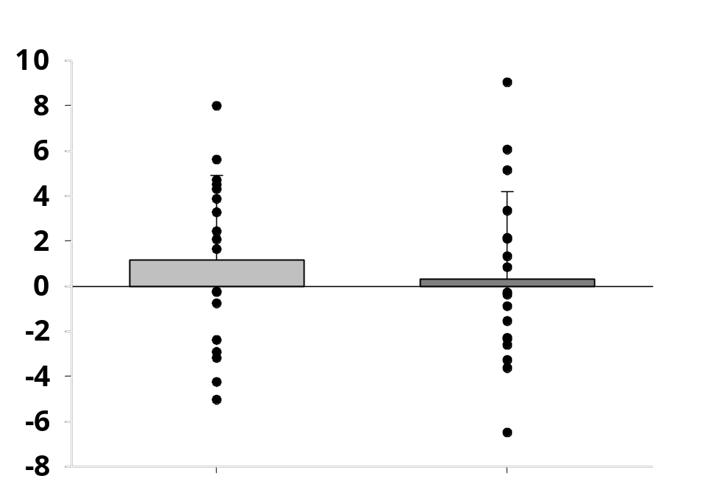

∆MAP (mmHg)

MEL
PLA

Figure 2. Data is displayed as mean ± SD. Shows alterations in mean arterial pressure from baseline to CO₂ rebreathing as a comparison between the placebo treatment and the melatonin treatment (n=18). ∆MAP was calculated as an average value, derived from subtracting an average value of the last 30s of the preceding baseline from each data point during rebreathing. Alpha was set a priori as p < 0.05. No significant difference was seen between treatment groups.
Cerebrovascular Variables
No cerebrovascular variable showed a statistically significant absolute difference between treatment groups during baseline or during the rebreathing trial (Table 3, Table 4). No measured variable showed any statistical differences between treatment groups when comparing the change seen during rebreathing calculated against the last 30s of baseline (Table 3, Table 4). MCAv increased significantly when transitioning from baseline to rebreathing (Figure 3, Table 3, PLA 70.90 ± 11.59 vs. 83.43 ± 13.39 cm/s, p = <0.001, d = -2.14; MEL 72.08 ± 15.77 vs. 83.95 ± 15.68 cm/s, p = <0.001, d = -2.20). CVCi also increased significantly when comparing the transition from baseline to rebreathing (Figure 4, Table 3, PLA 0.67 ± 0.14 vs. 0.78 ± 0.16 cm/s/mmHg, p = <0.001, d = -2.10; MEL 0.68 ± 0.16 vs. 0.79 ± 0.16 cm/s/mmHg, p = <0.001, d = -2.33). TSI increased significantly from baseline to rebreathing (Figure 5, Table 3, PLA 66.57 ± 6.99 vs. 68.12 ± 7.22 %, p = <0.001, r = -0.88; MEL 68.65 ± 5.95 vs. 69.62 ± 6.16 %, p = <0.001, r = -0.87). No particular visual or statistical trend was visible when comparing CVR calculated using MCAv or CVCi absolutely or as a percentage change from rebreathing onset between treatment groups (Figure 6-9, Table 4).

Table 3. Cerebral Vascular Variables (n = 18, 11 males, 7 females; TSI n = 17, 11 males, 6 females)
 | Baseline | p Value, Effect Size | Rebreathing | p Value, Effect Size | ∆ BL-RB | p Value, Effect Size
MCAv (cm/s)
PLA | 70.90 ± 11.59 | p = 0.612 | 83.43 ± 13.39 | p = 0.860 | 13.07 ± 5.74 * | p = 0.818
MEL | 72.08 ± 15.77 | d = -0.118 | 83.95 ± 15.68 | d = -0.042 | 12.68 ± 5.65 * | d = 0.055
CVCi (cm/s/mmHg)
PLA | 0.67 ± 0.14 | p = 0.759 | 0.78 ± 0.16 | p = 0.755 | 0.11 ± 0.05 * | p = 0.926
MEL | 0.68 ± 0.16 | d = -0.072 | 0.79 ± 0.16 | d = -0.075 | 0.12 ± 0.05 * | d = -0.022
TSI (%)
PLA | 66.57 ± 6.99 | p = 0.528 | 68.12 ± 7.22 | p = 0.906 | 1.39 ± 0.92 * | p = 0.106
MEL | 68.65 ± 5.95 | r = -0.149 | 69.62 ± 6.16 | r = -0.029 | 0.99 ± 0.60 * | d = 0.415
Values displayed as mean ± SD. * represents significant differences when comparing the transition from baseline and rebreathing. p Value represents a comparison between PLA and MEL treatments. MCAv: Middle Cerebral Artery Velocity; CVCi: Cerebrovascular Conductance Index. TSI: Total Saturation Index.

Table 4. Rebreathing Cerebrovascular Reactivity (n = 18, 11 males, 7 females)
 | Rebreathing |  |  | p Value,  Effect Size | RB % Change |  | p Value,  Effect Size
CVR_{MCAv} (cm/s/mmHg)
PLA | 1.83 ± 0.81 |  |  | p = 0.949 | 5.37 ± 1.23 |  | p = 0.148
MEL | 1.84 ± 0.72 |  |  | d = -0.015 | 6.01 ± 1.52 |  | d = -0.357
CVR_{CVCi} $(\frac{\frac{cm}{s}}{mmHg}/mmHg)$
PLA | 0.02 ± 0.01 |  |  | p = 0.500 | 4.98 ± 1.77 |  | p = 0.315
MEL | 0.02 ± 0.01 |  |  | r = -0.159 | 5.51 ± 1.89 |  | d = -0.244
Values displayed as mean ± SD. p Value represents a comparison between PLA and MEL conditions. CVR_{MCAv}: Cerebrovascular Reactivity calculated using MCAv; CVR_{CVCi}: Cerebrovascular Reactivity calculated using CVCi.

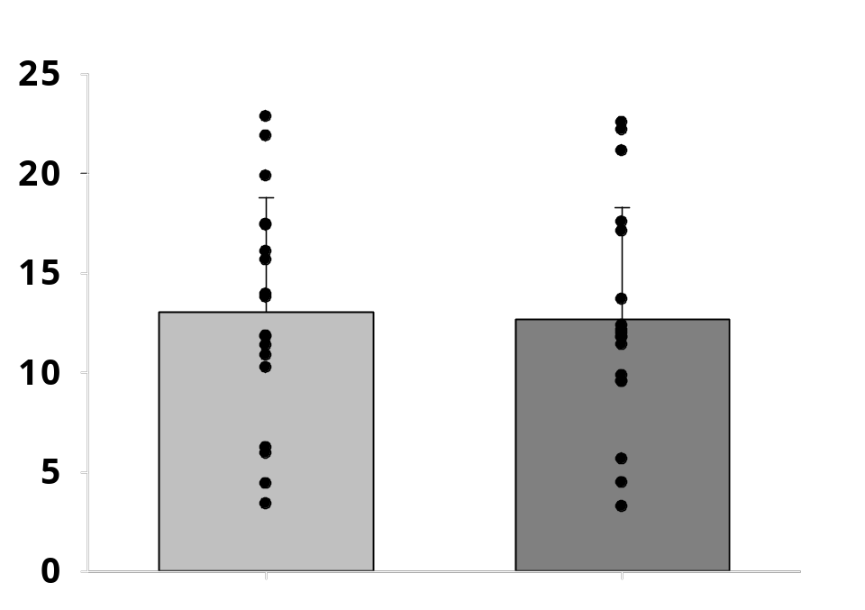

∆MCAv (cm/s)

PLA
MEL

Figure 3. Data is displayed as mean ± SD. Shows alterations in middle cerebral artery velocity from baseline to CO₂ rebreathing as a comparison between the placebo treatment and the melatonin treatment (n=18). ∆MCAv was calculated as an average value, derived from subtracting an average value of the last 30s of the preceding baseline from each data point during rebreathing. Alpha was set a priori as p < 0.05. No significant difference was seen between treatment groups. MCAv significantly increased from baseline to rebreathing in both treatment groups.
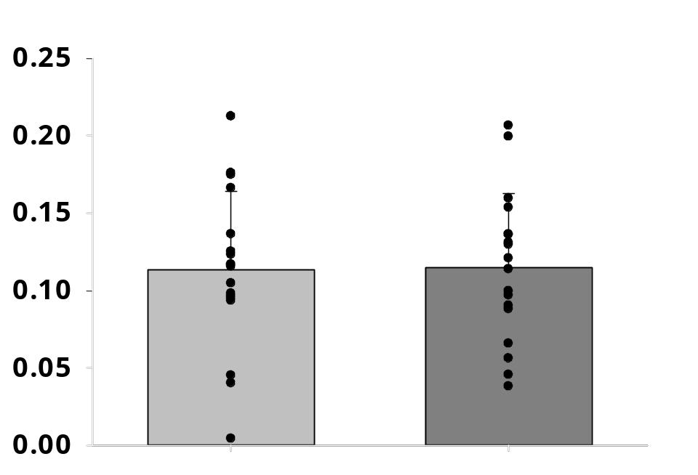

∆CVCi (cm/s/mmHg)

MEL
PLA

Figure 4. Data is displayed as mean ± SD. Shows alterations in the cerebrovascular conductance index from baseline to CO₂ rebreathing as a comparison between the placebo treatment and the melatonin treatment (n=18). ∆CVCi was calculated as an average value, derived from subtracting an average value of the last 30s of the preceding baseline from each data point during rebreathing. Alpha was set a priori as p < 0.05. No significant difference was seen between treatment groups. CVCi significantly increased from baseline to rebreathing in both treatment groups.

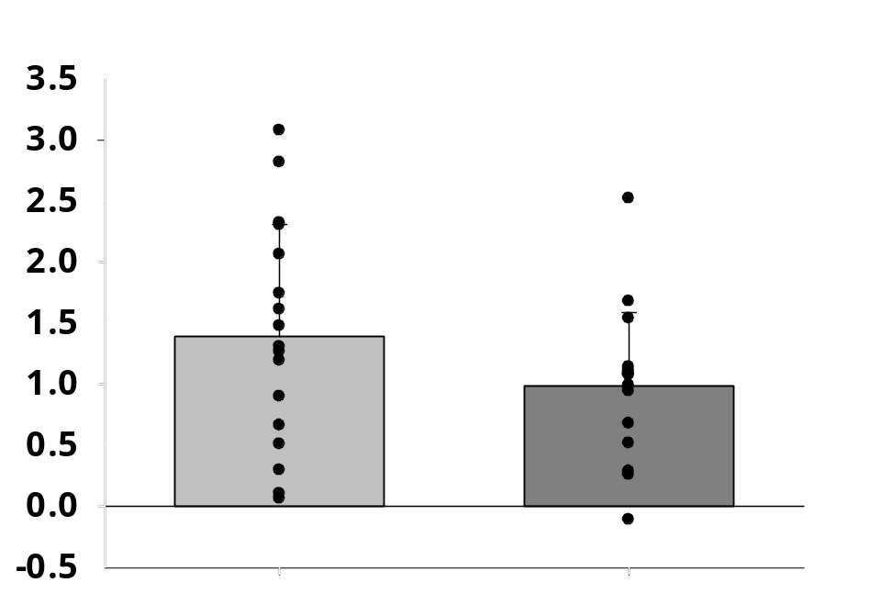

∆TSI (%)
PLA
MEL

Figure 5. Data is displayed as mean ± SD. Shows alterations in the total saturation index from baseline to CO₂ rebreathing as a comparison between the placebo treatment and the melatonin treatment (n=17). ∆Total Saturation Index (TSI) was calculated as an average value, derived from subtracting an average value of the last 30s of the preceding baseline from each data point during rebreathing. Alpha was set a priori as p < 0.05. No significant difference was seen between treatment groups. TSI significantly increased from baseline to rebreathing in both treatment groups.

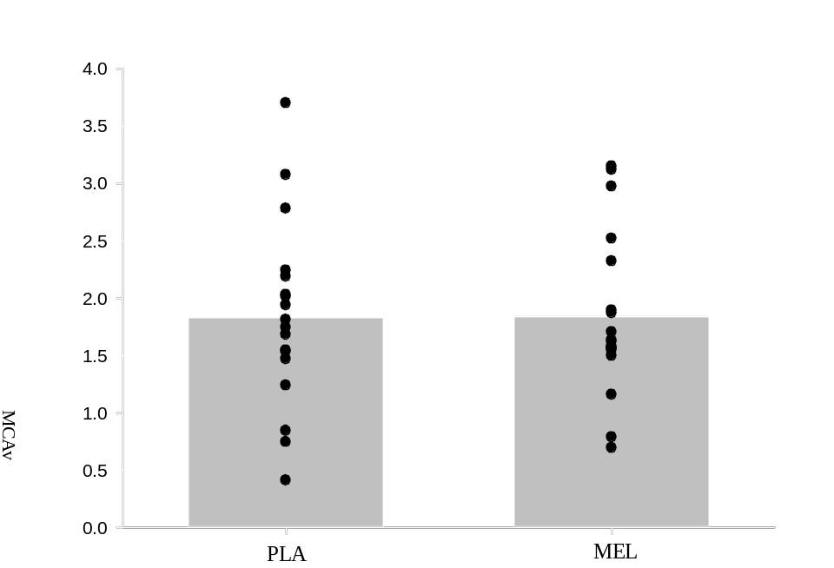

Figure 6. Data is displayed as mean ± SD. Shows alterations in the cerebrovascular reactivity calculated using MCAv from baseline to CO₂ rebreathing as a comparison between the placebo treatment and the melatonin treatment (n=18). CVR_{MCAv} was calculated as an average value, where ∆MCAv was divided by ∆PetCO₂. Alpha was set a priori as p < 0.05. No significant difference was seen between treatment groups.

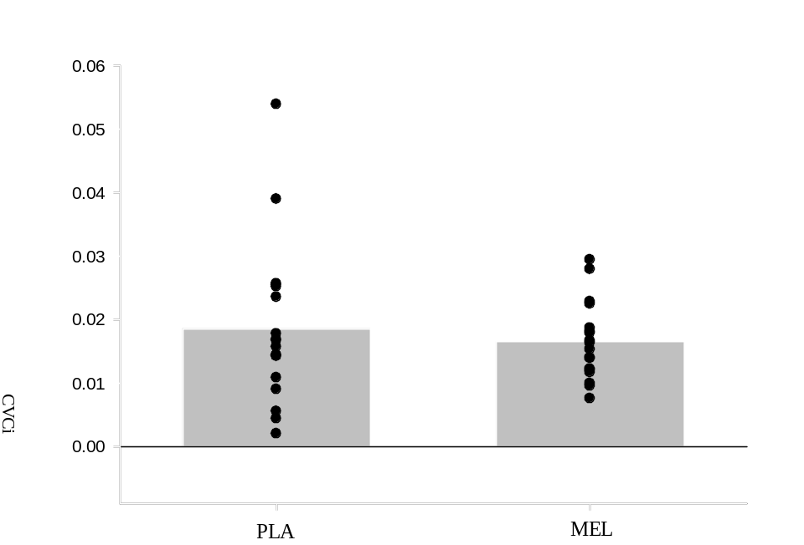

Figure 7. Data is displayed as mean ± SD. Shows alterations in the cerebrovascular reactivity calculated using CVCi from baseline to CO₂ rebreathing as a comparison between the placebo treatment and the melatonin treatment (n=18). CVR_{CVCi} was calculated as an average value, where ∆CVCi was divided by ∆PetCO₂. Alpha was set a priori as p < 0.05. No significant difference was seen between treatment groups.

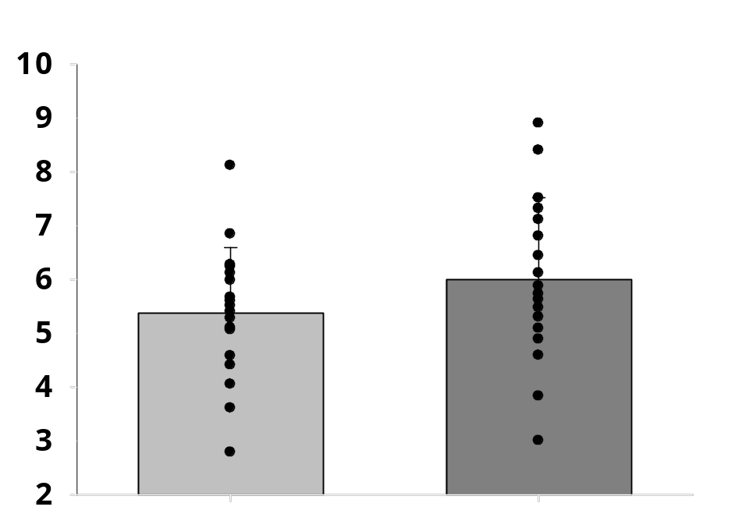

∆CVR_{MCAv} (%)
MEL
PLA

Figure 8. Data is displayed as mean ± SD. Shows alterations in the cerebrovascular reactivity calculated using MCAv from baseline to CO₂ rebreathing as a comparison between the placebo treatment and the melatonin treatment as a percent change (n=18). CVR_{MCAv} was calculated as the percent change in MCAv divided per unit change in end-tidal CO₂. Alpha was set a priori as p < 0.05. No significant difference was seen between treatment groups.
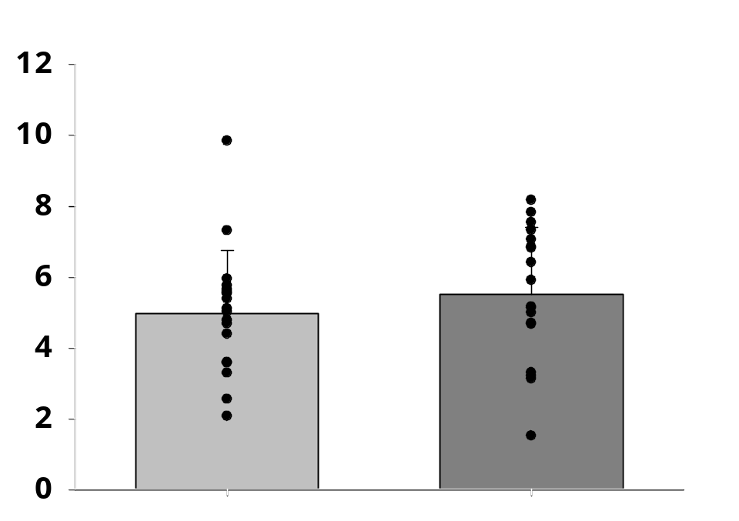

∆CVR_{CVCi} (%)

MEL
PLA

Figure 9. Data is displayed as mean ± SD. Shows alterations in the cerebrovascular reactivity calculated using CVCi from baseline to CO₂ rebreathing as a comparison between the placebo treatment and the melatonin treatment as a percent change (n=18). CVR_{CVCi} was calculated as the percent change in CVCi divided per unit change in end-tidal CO₂. Alpha was set a priori as p < 0.05. No significant difference was seen between treatment groups.

Time to Peak Analysis
The time to peak end-tidal CO₂ was calculated for both the first and second trials of rebreathing. No significant difference in the time to peak was seen comparing between treatment groups (Table 5). The time to peak was significantly shorter during the second trial of rebreathing for both the placebo group and the melatonin group (Table 5, PLA 100.10 ± 17.79 vs. 63.39 ± 24.78 seconds, p = <0.001, d = 1.40; MEL 95.68 ± 18.48 vs. 58.04 ± 21.22 seconds, p = <0.001, d = 2.06).

Table 5. Time to End-tidal CO₂ Peak during RB1 & RB2 (RB1 n = 19, 12 males, 7 females, RB2 n = 18, 11 males, 7 females)
 | RB1 |  | p Value,  Effect Size | RB2 | p Value,  Effect Size | p Value (RB1-RB2)
TTP (seconds)
PLA | 100.10 ± 17.79 |  | p = 0.241 | 63.39 ± 24.78 | p = 0.493 | <0.001
MEL | 95.68 ± 18.48 |  | d = 0.278 | 58.04 ± 21.22 | d = 0.165 | <0.001
Values displayed as mean ± SD. p Value represents a comparison between PLA and MEL conditions. TTP: Time to reach peak End-tidal CO₂ concentrations from the beginning of a rebreathing stage.

Experimental Estimated Flow Analysis
There was no statistically significant difference between treatment groups in terms of the estimated change of flow calculations, despite a visual reduced change in flow in the melatonin group when compared to the placebo group (Figure 10, Table 6, p < 0.05). When comparing the first trial of rebreathing to the second trial within each treatment group, no statistically significant difference was found (Figure 10, Table 6, p < 0.05).

Table 6. Estimated ∆Cerebral Blood Flow (n = 18, 11 males, 7 females)
 | Absolute Change |  |  |  | p Value,  Effect Size |  | CVR Percent Change | p Value,  Effect Size | p Value (RB1-RB2)
Estimated ∆Flow (ml/min)
PLA | 60.73 ± 26.64 |  |  |  | p = 0.787 |  | 6.75 ± 1.19 | p = 0.249 | 0.643
MEL | 58.52 ± 27.26 |  |  |  | d = 0.065 |  | 7.18 ± 1.24 | d = -0.282 | 0.774
Values displayed as mean ± SD. p Value represents a comparison between PLA and MEL conditions. Estimated ∆ Flow: Polynomial-based estimation of a change in cerebral blood flow using previous literature and measured flow velocity values (Verbree et al., 2014); CVR Percent Change: displays a calculation of CVR using estimated flow percentage changes per unit change in end-tidal CO₂. RB1-RB2 displays a comparison between the first trial of rebreathing to the second.

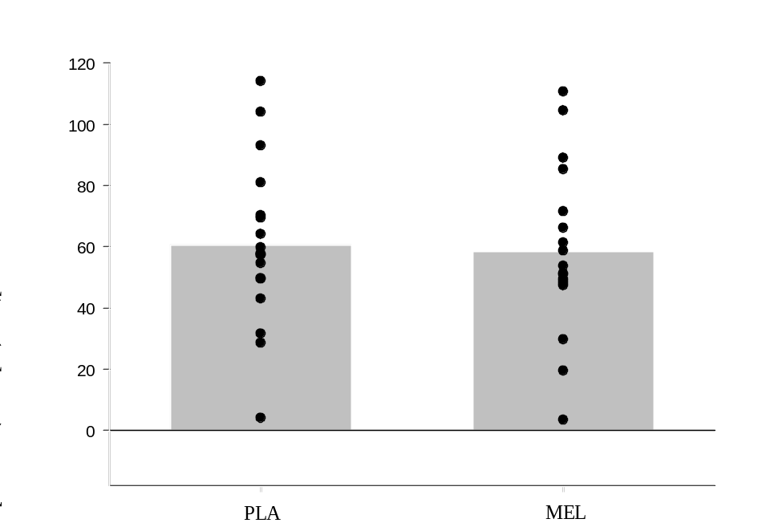

Figure 10. Data is displayed as mean ± SD. Shows alterations in the estimated change of cerebral flow in the middle cerebral artery from baseline to CO₂ rebreathing as a comparison between the placebo treatment and the melatonin treatment (n=18). ∆Flow was calculated as a multiplication of the estimated area derived from a previously described 7-Tesla MRI origin study and our measured MCAv (Verbree et al., 2014). Alpha was set a priori as p < 0.05. No significant difference was seen between treatment groups.
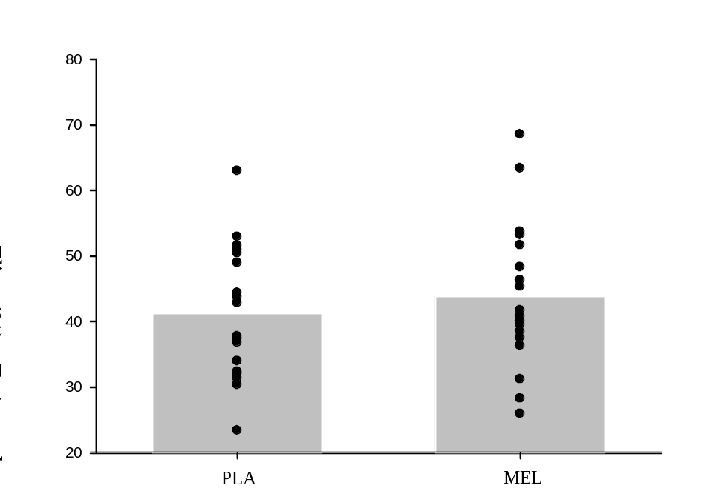

Figure 11. Data is displayed as mean ± SD. Shows alterations in the estimated change of cerebral flow in the middle cerebral artery from baseline to CO₂ rebreathing as a comparison between the placebo treatment and the melatonin treatment as a percent change (n=18). ∆Flow% was calculated using estimated baseline areas (Verbree et al., 2014). Alpha was set a priori as p < 0.05. No significant difference was seen between treatment groups.

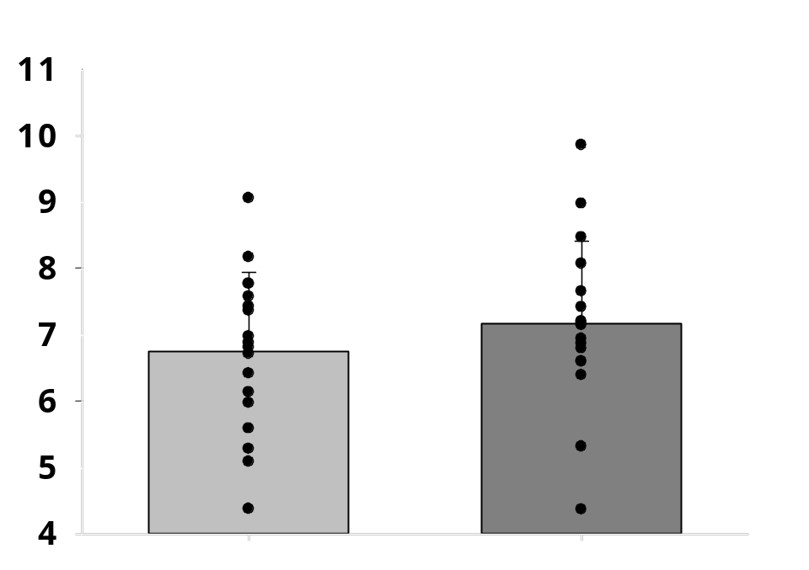

Estimated CVR_{∆Flow} (%)
MEL

PLA

Figure 12. Data is displayed as mean ± SD. Shows alterations in the estimated change of cerebral flow in the middle cerebral artery from baseline to CO₂ rebreathing as a comparison between the placebo treatment and the melatonin treatment as a percent change per unit change of end-tidal CO₂ (n=18). ∆CVR_{Flow%} was calculated using estimated baseline areas (Verbree et al., 2014). Alpha was set a priori as p < 0.05. No significant difference was seen between treatment groups.

IPAQ and PSQI Correlations
IPAQ and PSQI results were analyzed using a correlation test with our outcome CVR values both during individual treatment conditions (placebo or melatonin) and then as a combined group due to the lack of significant differences found between placebo and melatonin treatment conditions. The combined group incorporated both the placebo and melatonin conditions averaged with one another. When compared using individual conditions (placebo or melatonin) or as a combined group, there was no statistically significant correlation (Table 7). Furthermore, there was no large effect size for any of the mentioned comparisons (Table 7).

Table 7. Correlations between IPAQ, PSQI and CVR outcomes (n = 18, 11 males, 7 females)
 | CVR_{MCAv} Combined |  |  |  | CVR_{MCAv} % Combined | CVR_{CVCi} Combined | CVR_{CVCi %} Combined
PSQI
p Value | 0.531 |  |  |  | 0.857 | 0.669 | 0.587
r Coefficient | 0.158 |  |  |  | 0.046 | 0.108 | 0.137
IPAQ
p Value | 0.249 |  |  |  | 0.853 | 0.268 | 0.284
r Coefficient | 0.286 |  |  |  | 0.047 | 0.276 | 0.267
Values displayed as mean ± SD. p Value represents the significance of the Pearson or Spearman correlation. PSQI: Pittsburgh Sleep Quality Index; IPAQ: International Physical Activity Questionnaire; CVR_{MCAv} Combined: the combined CVR values between placebo and melatonin treatments using MCAv; CVR_{MCAv} % Combined: the combined CVR values as a percentage change and per unit change in CO₂ between placebo and melatonin treatments using MCAv; CVR_{CVCi} Combined: the combined CVR values between placebo and melatonin treatments using CVCi; CVR_{CVCi} % Combined: the combined CVR values as a percentage change and per unit change in CO₂ between placebo and melatonin treatments using CVCi.

Chapter V
Discussion
The purpose of the present study was to investigate the effects of melatonin supplementation on cerebrovascular hemodynamics during rest and CO₂ rebreathing in healthy, young adults. Contrary to our first hypothesis, melatonin supplementation did not alter MCA_{v} or estimated cerebrovascular flow during rest or the CO₂ rebreathing trial. Applied to our second hypothesis, melatonin supplementation did not alter cerebrovascular reactivity, did not significantly increase CVCi, and did not significantly decrease MAP. In opposition of our third hypothesis, acute melatonin supplementation did not increase prefrontal cortex oxygenation during either rest or rebreathing.

Melatonin and Cerebral Hemodynamics
The present study found that cerebral hemodynamic variables did not change during acute melatonin supplementation during a resting steady state. Few studies have investigated the effects of melatonin on the cerebrovasculature, but our findings come in contrast to previous literature, where acute melatonin supplementation reduced both circulating catecholamines and blood pressure within 90 minutes (Arangino et al., 1999). There was a visual decrease in blood pressure, with no statistical difference, but our inability to reproduce the blood pressure reduction seen in previous literature may be due to only allowing for 30 minutes to pass from the time of consumption to the beginning of the experimental protocol. Previous literature has primarily used either intravenous melatonin dosing or tablet dosing, which can take up to 60 minutes to reach maximal plasma concentrations (Tordjman et al., 2017). We based our dosing and the time between intake and experiment initiation on previous literature that showed both no significant difference in absorption rate when compared to tablet dosing and a 30 minute time period with which melatonin may reach maximal plasma concentrations when consuming melatonin via a spray (Bartoli et al., 2013). As would be expected during a rebreathing trial, both MCAv and CVCi increased significantly from baseline to rebreathing. Despite this change, no significant difference between the placebo and melatonin treatment groups was found. Furthermore, TSI was also found to increase significantly from baseline to rebreathing, but there was no significant difference between the placebo and melatonin treatment groups.
This is the first time, to our knowledge, that cerebrovascular reactivity was measured under the effect of acute melatonin supplementation during rest and a potent vasodilatory stimulus such as CO₂ rebreathing. The melatonin receptor MT2 has been located in the large vessels of the brain and is known to influence the production of cyclic GMP, a molecule that plays an important role in the process of vasodilation (Petit et al., 1999; Yu et al., 2001). Despite melatonin’s possible effect on cyclic GMP production, melatonin’s ability to blunt sympathetic activity increases seen during lower-body negative pressure, and a lower total release of melatonin at night in patients with multiple cardiovascular diseases related to impaired cerebrovascular function, the promising possibility that melatonin could serve as a useful therapeutic option for those with impaired cerebral vascular reactivity did not display itself in the present study (Petit et al., 1999; Yu et al., 2001; Ray, 2003; Ovsenik et al., 2020). Our results indicated that our participants were within the healthy response range (~3-6%) during both the placebo and melatonin treatments in regards to the percent change in CVR during CO₂ rebreathing (Willie et al., 2014). Despite this, no discernable significant difference that would indicate that melatonin affected cerebrovascular reactivity when compared to the placebo group was found.
Melatonin Central Cardiovascular Effects and CO₂ Rebreathing
The physiological effects of CO₂ rebreathing on the cerebral vasculature are numerous. Supported by plentiful previous research, and because arterial CO₂ concentrations are directly proportional to the total volume of CO₂ production, the arterial concentration of CO₂ can be derived through the measurement of end-tidal CO₂ (Willie et al., 2014; Carr et al., 2021; Manferdelli et al., 2023). Increases in said arterial CO₂ concentration rapidly lead to passive diffusion of CO₂ across the blood-brain barrier. This ultimately alters hydrogen ion concentration via the bicarbonate buffering system in the intracellular and extracellular cerebrospinal and interstitial fluids, finally altering cyclic GMP production and causing a smooth muscle relaxation and vasodilation (Jensen et al., 1988; Willie et al., 2014). While the body displays a clear goal of returning to normal homeostasis following the start of concentrated CO₂ rebreathing by increasing Q, SV, HR, and MAP and clearing out the resulting excess hydrogen, the level to which end-tidal CO₂ was increased in our study was not enough to increase the mentioned central cardiovascular variables. One potential issue with the measurement of CBF during hypercapnia is hypercapnia’s impairment of dynamic cerebral autoregulation, where hypercapnia-induced increases in MAP can “mask” a thorough interpretation of cerebrovascular reactivity (Birch et al., 1995; Zhang et al., 1998; Panerai, 2003; Ainslie et al., 2008; Ainslie & Duffin, 2009). The use of conductance calculated both by itself and as a measure of CVR, because of its incorporation of changes to MAP in the equation itself, also negate the possibility of changes in pressure altering the outcome of our results (Figure 4, 7, 9). Since MAP was not artificially increased during our rebreathing trials, our CVR measurements are more representative than if MAP had increased significantly, further involving autoregulatory responses. Furthermore, increased arterial CO₂ concentrations leads to chemoreceptor activation and stimulation of the respiratory center in the medulla oblongata, which induces an increase in ventilation (Willie et al., 2014; Hoiland et al., 2019). Our data is consistent with this finding, as a statistically significant increase in end-tidal CO₂ concentrations led to a significant increase in breathing frequency.
We found that CO₂ rebreathing induced to a peak change in end-tidal CO₂ of 10 mmHg from the beginning of the trial did not significantly alter any central variables apart from breathing frequency. Furthermore, we found that there was no significant difference between the placebo and melatonin treatment groups in terms of any measured central cardiovascular or cardiopulmonary variable, indicating that 30 minutes post-melatonin spray consumption does not cause a significant difference in central or pulmonary cardiovascular variables during rest or CO₂ rebreathing.

Time to Peak Analysis
The time it took to reach a maximal end-tidal CO₂ concentration measuring from the beginning of each rebreathing stage was investigated in the present study to search for a temporal effect of melatonin on the cerebrovasculature. There was no difference during either the first or second trial of rebreathing between treatment groups. There was, however, a significant decrease in the time to peak for both treatment groups when transitioning from the first rebreathing stage to the second. This can more than likely be attributed to an increased chemoreceptor sensitivity seen in previous literature (Miyamura et al., 1976; Yamashiro et al., 2021). This mechanism is not fully understood but may have to do with central nervous system and carotid body chemoreceptor interactions, where activation of one set is critically dependent on the other, leading to hypersensitivity if circulating concentrations of H⁺ ions in the systemic circulatory system are not fully cleared (Blain et al., 2010).
Another, more probable explanation is that the time given between bouts of CO₂ rebreathing was not enough to reach a true baseline. While absolute values of end-tidal CO₂ did reach resting levels in between bouts of CO₂, we did not take blood samples to confirm circulating H+ ion concentrations. Future studies should investigate the mechanism behind the rapidity change between the first and second bouts of CO₂ rebreathing, as ensuring that baseline is achieved between bouts of CO₂ rebreathing is critical to replicating exactly similar responses between bouts.

Experimental Cerebral Flow Analysis
To our knowledge, this study is the first time that a 7-Tesla MRI-derived polynomial and standardized MCA diameters have been used to estimate changes in cerebral blood flow using only velocity measurements outside of the original description of the technique (Verbree et al., 2014). A previous study that induced hypercapnia through CO₂ rebreathing discovered a change in MCA flow using a 3-Tesla MRI of ~114 ± 68 ml/min, where our study found values of 60.73 ± 26.64 ml/min and 58.52 ± 27.26 in the PLA and MEL groups, respectively. This discrepancy could be due to subject sex distribution, as the mentioned study used a similar 19 subjects, 11 of which were female, where the present study used 18 subjects, 11 of which were male (Coverdale et al., 2014). MCA anatomy as well as responses are highly variable within each individual, but it has been shown that there may be a significant sex difference when measuring cerebral flow changes and comparing males and females (Alwatban et al., 2021). To mitigate this, we did control for menstrual phase, which is a major contributor to the differences in male and female cerebral flow changes, but the sex-based discrepancy may still exist. Furthermore, our estimated percent change CVR values using the estimated changes in flow were higher when compared to our percent change CVR values measured using MCAv or CVCi alone. This would indicate that the consideration of a change in vessel diameter is vital when looking at vascular reactivity during conditions where the vessel diameter may be changing. TCD alone does not consider these vessel diameter changes, so attempting to derive flow during these conditions may be insufficient without using corrective factors such as the one described above. It would be wise to involve MRI flow measurements whenever possible when assessing changes in cerebral flow, particularly under conditions where the MCA is known to change such as CO₂ rebreathing to an increase of 10 or more mmHg end-tidal CO₂ (Coverdale et al., 2014; Verbree et al., 2014).

IPAQ and PSQI Correlations
There did not seem to be any statistical or visible relationship between IPAQ and PSQI scoring and CVR outcomes. This would indicate that sleeping habits, which has a large amount of variable between different individuals, did not show a relationship with their vascular reactivity. Physical activity levels also did not show any indication of acting as a predictive factor of differential CVR outcomes. To investigate further, a study would need to be more thorough with their monitoring and surveying of physical activity levels and sleep habits in subjects in order to solidify that no relationship exists with CVR. More specifically, a more controlled study that closely monitored physical activity levels and provided more comprehensive sleep quality measurements would be more appropriate in determining the relationship between these variables and cerebral vascular reactivity.

Implications of the Present Study
Our results indicate that acute melatonin supplementation does not play a role in MAP, MCAv, CVCi, TSI, cerebral reactivity as calculated using MCAv, or cerebral reactivity as calculated using CVCi during rest or CO₂ rebreathing (Table 2, Table 3, Table 4). Resting results are in accordance with previous literature, but to our knowledge, no other study has examined the effects of acute melatonin supplementation during repeated bouts of CO₂ rebreathing (Mil et al., 2003; Willie et al., 2014).
The time to peak analysis conducted to view the temporal aspect of melatonin’s effect during rebreathing yielded no statistically significant results (Table 5). Repeated bouts of rebreathing became significantly faster when comparing the first and second rebreathing trials, but no difference in speed was shown when comparing the placebo and melatonin treatments, indicating that melatonin had no effect on the overall rapidity of reaching the goal +10 mmHg end-tidal CO₂.
Similar to our results for other cerebral vascular variables, there was no significant difference in our calculated change in cerebral flow between treatment groups (Table 6). While MCAv has been shown to be an accurate conduit of flow in conditions where the diameter of a vessel is not changing, it has been shown that an increase of +10 mmHg end-tidal CO₂ should cause an increase in the diameter of the middle cerebral artery (Serrador et al., 2000; Coverdale et al., 2014; Verbree et al., 2014). Using an area estimation polynomial derived from 7-Tesla MRI data serves as the closest available tool to assess any cerebral flow differences between the placebo and melatonin treatment groups in the event that our CO₂ rebreathing trial did in fact cause a substantial increase in diameter (Verbree et al., 2014). Our results showed lower total increases in absolute flow compared to a study that used a 3-Tesla MRI with a similar protocol and with the same subject count, but an opposite distribution of male and female participants; a factor that would reason, as females tend to have higher global and regional cerebral flow when compared to men (Rodriguez et al., 1988; Gur & Gur, 1990; Coverdale et al., 2014). Furthermore, our calculated change in CVR using the estimated flow was reportedly higher than when using MCAv to calculate CVR, indicating that using corrective tools or estimation techniques may prove extremely interesting during conditions in which a vessel diameter may be changing. MRI is an extremely useful technique, but does not cover nearly as much temporally as the TCD (Aaslid et al., 1989; Anzola et al., 1995; Tiecks et al., 1995). So, a combination of confirmation of a vessel diameter change via MRI use and the temporal change in flow using the corrective factors described here would prove more thorough than either technique alone. Future studies should compare the same experimental analysis with results from the same subjects using an MRI confirmation, as to further assess the validity and accuracy of the described method, which would extend the usefulness of velocity-only TCD measurements towards conditions where vessel diameter is known to actively change (Verbree et al., 2014).

Limitations and Considerations
Multiple limitations may have interfered with the outcome of the present study. First and foremost, the accurate reporting of health status, medicine intake, menstrual phase, pre-study exclusion criteria, and physical activity levels was dependent on the honesty of the participants.
Secondly, we used transcranial doppler ultrasonography to estimate changes in flow, but we did not measure cerebral blood flow itself. Previous literature has demonstrated that the TCD serves as a potent tool for the estimation of changes to cerebral flow (Bishop et al., 1986; Serrador et al., 2000). Despite this, more recent literature has shown that MCA diameter may change during hypercapnic conditions (Coverdale et al., 2014; Verbree et al., 2014). Because of our direct manipulation of end-tidal CO₂ concentrations, within the range where previous research tells us that MCA diameter may significantly change, it is possible that coming to conclusions regarding changes in cerebral flow based on our MCAv data would not be wise (Verbree et al., 2014). To mitigate this, we recorded the gate, depth, and anatomical location of each subject’s MCA in order to as consistently as possible locate the MCA as an insonation angle of 90°. Furthermore, we conducted a further experimental analysis using standardized MCA diameter change values in combination with a polynomial based on end-tidal CO₂ changes in order to derive a potential solution to the TCD’s only provides blood velocity problem (Verbree et al., 2014).
Third, we did not conduct any intravenous procedures to confirm that the level of circulating melatonin changed upon consumption of our mentioned oral spray. Despite this, it has been shown that the large buccal mucosal surface area that a melatonin spray contacts may avoid some of the negative effects of the so-called “first-pass phase” (Bartoli et al., 2013). It has also been stated in previous literature that the total amount of melatonin that reaches the general circulatory system is greater when melatonin is consumed via a spray in comparison to the consumption of a tablet (Bartoli et al., 2013).
Fourth, during the rebreathing stages, we did not directly measure our CO₂ balloon volume. While this could affect the concentration of CO₂ that each participant inhales in the case that there is a mask leakage and rebreathing does not occur properly, particularly towards the end of the stage if the balloon becomes depleted, we did not experience any situation during which the stage had to be stopped early due to a depletion of gas from the balloon.
Fifth, only prefrontal cortex oxygenation was measured, not global brain oxygenation. Despite this, there was a distinct lack of stimuli that would trigger a neurovascular-couple effect and thus an increased neural metabolic demand. Because of the location of the measured cerebral artery, the MCAv located in the prefrontal cortex, any alterations to cerebral oxygenation would more than likely permeate to other locations in the brain.
Sixth, the total amount of light exposure our participants received was not controlled for outside of the experimental protocol. Our protocol also did not consider participants traveling across other time zones, which may change their overall light exposure, as a factor. Because light exposure is the main determining factor of melatonin release, and in order to minimize any potential challenges that a lack of control of light exposure may pose, our study kept the protocol room dark, with only one small flood light to provide operator safety (Pandi-Perumal et al., 2008; Baker & Kimpinski, 2018).
Finally, previous literature has shown that there is a clear and established reduction in cerebrovascular CO₂ reactivity as well as endothelium-dependent vascular reactivity in the morning due to an undiscovered mechanism (Ainslie et al., 2007). Many of our participants chose to complete their experimental visits early in the morning due to our fasting requirement, so this may have directly affected our measured CVR results. In order to attempt to mitigate this and still be able to view changes within each single individual, we attempted to schedule each participant at a similar time of day to their previous visit.

Chapter VI
Conclusion
The purpose of the present study was to investigate the role of acute melatonin supplementation on cerebrovascular reactivity and flow during rest and CO₂ rebreathing in healthy, young adults.

Main Findings of the Current Study
- We reject the first hypothesis that acute melatonin supplementation will increase cerebrovascular flow during rest and CO₂ rebreathing in healthy, young adults.
- We reject the second hypothesis that acute melatonin supplementation will increase cerebrovascular reactivity by means of increasing CVCi, decreasing MAP, and increasing MCAv during rest and CO₂ rebreathing in healthy, young adults.
- We reject the third hypothesis that acute melatonin supplementation will increase prefrontal cortex oxygenation during rest and CO₂ rebreathing in healthy, young adults.

Our results indicate that melatonin does not affect cerebrovascular flow, cerebrovascular reactivity, and does not beneficially affect prefrontal cortex oxygenation in healthy, young adults. Our results remain true whether measuring absolute values or changes between treatment groups in comparison to the previous baseline. Cerebral reactivity was variable individually and did not show any significant difference between treatment groups, despite being within the normal healthy response range for the percent change in CVR in response to CO₂ rebreathing (Willie et al., 2014). In conclusion, acute melatonin supplementation does not improve cerebrovascular function, indicating that melatonin supplementation may display differential responses between the cerebral and peripheral vasculature in humans.

References
Aaslid R, Lindegaard KF, Sorteberg W, Nornes H. Cerebral autoregulation dynamics in humans.
Stroke. 1989 Jan;20(1):45-52. doi: 10.1161/01.str.20.1.45. PMID: 2492126.
Acuña-Castroviejo, D., Escames, G., Venegas, C., Díaz-Casado, M. E., Lima-Cabello, E., López,
L. C., Rosales-Corral, S., Tan, D. X., & Reiter, R. J. (2014). Extrapineal melatonin: sources, regulation, and potential functions. Cellular and molecular life sciences : CMLS, 71(16), 2997–3025. https://doi.org/10.1007/s00018-014-1579-2
Ainslie, P. N., & Duffin, J. (2009). Integration of cerebrovascular CO2 reactivity and
chemoreflex control of breathing: mechanisms of regulation, measurement, and interpretation. American journal of physiology. Regulatory, integrative and comparative physiology, 296(5), R1473–R1495. https://doi.org/10.1152/ajpregu.91008.2008
Ainslie, P. N., & Brassard, P. (2014). Why is the neural control of cerebral autoregulation so controversial? F1000Prime Reports, 6. https://doi.org/10.12703/p6-14
Ainslie, P. N., Murrell, C., Peebles, K., Swart, M., Skinner, M. A., Williams, M. J., & Taylor, R. D. (2007). Early morning impairment in cerebral autoregulation and cerebrovascular co2 reactivity in healthy humans: Relation to endothelial function. Experimental Physiology, 92(4), 769–777. https://doi.org/10.1113/expphysiol.2006.036814
Alpers, B. J., Berry, R. G., & Paddison, R. M. (1959). Anatomical Studies of the Circle of Willis in Normal Brain. A.M.A. Archives of Neurology & Psychiatry, 81(4), 409–418. https://doi.org/10.1001/archneurpsyc.1959.02340160007002
Anzola GP, Gasparotti R, Magoni M, Prandini F. Transcranial Doppler sonography and magnetic resonance angiography in the assessment of collateral hemispheric flow in patients with carotid artery disease. Stroke. 1995 Feb;26(2):214-7. doi: 10.1161/01.str.26.2.214. PMID: 7831690.
Arangino, S., Cagnacci, A., Angiolucci, M., Vacca, A. M., Longu, G., Volpe, A., & Melis, G. B.
(1999). Effects of melatonin on vascular reactivity, catecholamine levels, and blood pressure in healthy men. The American journal of cardiology, 83(9), 1417–1419. https://doi.org/10.1016/s0002-9149(99)00112-5
Baker, J., & Kimpinski, K. (2018). Role of melatonin in blood pressure regulation: An adjunct
anti-hypertensive agent. Clinical and experimental pharmacology & physiology, 45(8), 755–766. https://doi.org/10.1111/1440-1681.12942
Barrie, J. R., Beatty, P. C. R. (1995). Rebreathing – Theoretical aspects of measurement. Current
Anesthesia & Critical Care, 6(3), 180-185. https://doi.org/10.1016/S0953-7112(05)80209-1
Bartoli, A. N., De Gregori, S., Molinaro, M., Broglia, M., Tinelli, C., & Imberti, R.
(2012). Bioavailability of a new oral spray melatonin emulsion compared with a standard oral formulation in healthy volunteers. Journal of Bioequivalence and Bioavailability, 4(7), 96-99. https://doi.org/10.4172/jbb.1000120
Bishop, C. C., Powell, S., Rutt, D., & Browse, N. L. (1986). Transcranial Doppler measurement
of middle cerebral artery blood flow velocity: A validation study. Stroke, 17(5), 913–915. https://doi.org/10.1161/01.STR.17.5.913
Brassard, P., Tymko, M. M., & Ainslie, P. N. (2017). Sympathetic control of the brain circulation: Appreciating the complexities to better understand the controversy. Autonomic Neuroscience, 207, 37–47. https://doi.org/10.1016/j.autneu.2017.05.003
Brugger, P., Marktl, W., & Herold, M. (1995). Impaired nocturnal secretion of melatonin in
coronary heart disease. Lancet (London, England), 345(8962), 1408. https://doi.org/10.1016/s0140-6736(95)92600-3
Cagnacci, A., Arangino, S., Angiolucci, M., Maschio, E., Longu, G., & Melis, G. B. (1997).
Potentially beneficial cardiovascular effects of melatonin administration in women. Journal of pineal research, 22(1), 16–19. https://doi.org/10.1111/j.1600-079x.1997.tb00297.x
Cajochen, C., Kräuchi, K., & Wirz-Justice, A. (2003). Role of melatonin in the regulation of
human circadian rhythms and sleep. Journal of neuroendocrinology, 15(4), 432–437. https://doi.org/10.1046/j.1365-2826.2003.00989.x
Capsoni, S., Viswanathan, M., De Oliveira, A. M., & Saavedra, J. M. (1994). Characterization of
melatonin receptors and signal transduction system in rat arteries forming the circle of Willis. Endocrinology, 135(1), 373–378. https://doi.org/10.1210/endo.135.1.8013371
Capsoni, S., Stankov, B. M., & Fraschini, F. (1995). Reduction of regional cerebral blood flow
by melatonin in young rats. Neuroreport, 6(9), 1346–1348. https://doi.org/10.1097/00001756-199506090-00029
Carr, J. M. J. R., Caldwell, H. G., & Ainslie, P. N. (2021). Cerebral blood flow, cerebrovascular
reactivity and their influence on ventilatory sensitivity. Experimental physiology, 106(7), 1425–1448. https://doi.org/10.1113/EP089446
Chen, J., Liu, J., Xu, W. H., Xu, R., Hou, B., Cui, L. Y., & Gao, S. (2014). Impaired dynamic
cerebral autoregulation and cerebrovascular reactivity in middle cerebral artery stenosis. PloS one, 9(2), e88232. https://doi.org/10.1371/journal.pone.0088232
Chitimus DM, Popescu MR, Voiculescu SE, et al. Melatonin's Impact on Antioxidative and
Anti-Inflammatory Reprogramming in Homeostasis and Disease. Biomolecules. 2020;10(9):1211. Published 2020 Aug 20. doi:10.3390/biom10091211
Claassen, J. A., Thijssen, D. H., Panerai, R. B., & Faraci, F. M. (2021). Regulation of cerebral blood flow in humans: Physiology and clinical implications of Autoregulation. Physiological Reviews, 101(4), 1487–1559. https://doi.org/10.1152/physrev.00022.2020
Coverdale, N. S., Gati, J. S., Opalevych, O., Perrotta, A., & Shoemaker, J. K. (2014). Cerebral
blood flow velocity underestimates cerebral blood flow during modest hypercapnia and hypocapnia. Journal of applied physiology (Bethesda, Md. : 1985), 117(10), 1090–1096. https://doi.org/10.1152/japplphysiol.00285.2014
Cunnane SC, Manku MS, Oka M, Horrobin DF. Enhanced vascular reactivity to various
vasoconstrictor agents following pinealectomy in the rat: role of melatonin. Can J Physiol Pharmacol. 1980;58:287-293
Dagal, A., & Lam, A. M. (2009). Cerebral autoregulation and anesthesia. Current Opinion in Anaesthesiology, 22(5), 547–552. https://doi.org/10.1097/ACO.0b013e32833020be
DeMers, D., & Wachs, D. (2022). Physiology, Mean Arterial Pressure. In StatPearls. StatPearls
Publishing.
Ekmekcioglu, C., Thalhammer, T., Humpeler, S., Mehrabi, M. R., Glogar, H. D., Hölzenbein, T.,
Markovic, O., Leibetseder, V. J., Strauss-Blasche, G., & Marktl, W. (2003). The melatonin receptor subtype MT2 is present in the human cardiovascular system. Journal of pineal research, 35(1), 40–44. https://doi.org/10.1034/j.1600-079x.2003.00051.x
Faul, F., Erdfelder, E., Buchner, A., & Lang, A.-G. (2009). Statistical power analyses using
G*Power 3.1: Tests for correlation and regression analyses. Behavior Research Methods, 41, 1149-1160
Georgiadis, D., Sievert, M., Cencetti, S., Uhlmann, F., Krivokuca, M., Zierz, S., & Werdan, K.
(2000). Cerebrovascular reactivity is impaired in patients with cardiac failure. European heart journal, 21(5), 407–413. https://doi.org/10.1053/euhj.1999.1742
Girouard, H., & de Champlain, J. (2004). Inhibitory effect of melatonin on alpha1-adrenergic-
induced vasoconstriction in mesenteric beds of spontaneously hypertensive rats. American journal of hypertension, 17(4), 339–346. https://doi.org/10.1016/j.amjhyper.2003.12.013
Gunnal, S., Farooqui, M., & Wabale, R. (2019). Study of middle cerebral artery in human Cadaveric Brain. Annals of Indian Academy of Neurology, 0(0), 0. https://doi.org/10.4103/0972-2327.144289
Gur, R. E., & Gur, R. C. (1990). Gender differences in regional cerebral blood flow. Schizophrenia Bulletin, 16(2), 247–254. https://doi.org/10.1093/schbul/16.2.247
Harrell JW, Schrage WG. Cyclooxygenase-derived vasoconstriction restrains hypoxia-mediated cerebral vasodilation in young adults with metabolic syndrome. Am J Physiol-heart C 306: H261–H269, 2014. doi: 10.1152/ajpheart.00709.2013.
Hoiland, R. L., Fisher, J. A., & Ainslie, P. N. (2019). Regulation of the cerebral circulation by arterial carbon dioxide. Comprehensive Physiology, 1101–1154. https://doi.org/10.1002/cphy.c180021
Holmes S, Sugden D. The effect of melatonin on pinealectomy induced hypertension in the rat. Br J Pharmacol. 1976;56:306P-361P
Hu, H. H., Kuo, T. B., Wong, W. J., Luk, Y. O., Chern, C. M., Hsu, L. C., & Sheng, W. Y.
(1999). Transfer function analysis of cerebral hemodynamics in patients with carotid stenosis. Journal of cerebral blood flow and metabolism : official journal of the International Society of Cerebral Blood Flow and Metabolism, 19(4), 460–465. https://doi.org/10.1097/00004647-199904000-00012
Idowu, O. E., Shokunbi, M. T., Malomo, A. O., & Ogunbiyi, J. O. (2002). Size, course, distribution and anomalies of the middle cerebral artery in Adult Nigerians. East African Medical Journal, 79(4). https://doi.org/10.4314/eamj.v79i4.8883
Imenshahidi, M., Karimi, G., & Hosseinzadeh, H. (2020). Effects of melatonin on cardiovascular
risk factors and metabolic syndrome: a comprehensive review. Naunyn-Schmiedeberg's archives of pharmacology, 393(4), 521–536. https://doi.org/10.1007/s00210-020-01822-4
Jeng, J.-S., Yip, P.-K., Huang, S.-J., & Kao, M.-C. (1999). Changes in hemodynamics of the carotid and middle cerebral arteries before and after endoscopic sympathectomy in patients with Palmar hyperhidrosis: Preliminary results. Journal of Neurosurgery, 90(3), 463–467. https://doi.org/10.3171/jns.1999.90.3.0463
Jensen, K. E., Thomsen, C., & Henriksen, O. (1988). In vivo measurement of intracellular pH in
human brain during different tensions of carbon dioxide in arterial blood. A31P-NMR study. Acta PhysiologicaScandinavica,134,295–298.
Katsi V, Karagiorgi I, Makris T, et al. The role of melatonin in hypertension. Cardiovasc
Endocrinol. 2012;1:13-18
King, A., Serena, J., Bornstein, N. M., Markus, H. S., & ACES Investigators (2011). Does
impaired cerebrovascular reactivity predict stroke risk in asymptomatic carotid stenosis? A prospective substudy of the asymptomatic carotid emboli study. Stroke, 42(6), 1550–1555. https://doi.org/10.1161/STROKEAHA.110.609057
Koziróg, M., Poliwczak, A. R., Duchnowicz, P., Koter-Michalak, M., Sikora, J., & Broncel, M.
(2011). Melatonin treatment improves blood pressure, lipid profile, and parameters of oxidative stress in patients with metabolic syndrome. Journal of pineal research, 50(3), 261–266. https://doi.org/10.1111/j.1600-079X.2010.00835.x
K-Laflamme A, Wu L, Foucart S, de Champlain J. Impaired basal sympathetic tone and alpha1-
adrenergic responsiveness in association with the hypotensive effect of melatonin in spontaneously hypertensive rats. Am J Hypertens 1998;11:219-229.
Lynn, Aaron. (2011). The Influence of Osmoreceptors and Baroreceptors on Heat Loss
Responses during a Whole-body Passive Heat Stress.
Manferdelli, G., Narang, B. J., Bourdillon, N., Debevec, T., & Millet, G. P. (2023). End-tidal
carbon dioxide tension is a reliable surrogate of arterial carbon dioxide tension across different oxygen, carbon dioxide and barometric pressures. ERJ open research, 9(2), 00507-2022. https://doi.org/10.1183/23120541.00507-2022
Mannon, E. C., Ray, S. C., Ryan, M. J., & Sullivan, J. C. (2020). Does sex matter?: An update on the implementation of sex as a biological variable in Research. American Journal of Physiology-Renal Physiology, 318(2). https://doi.org/10.1152/ajprenal.00575.2019
Mil, A. H. M. van der H. et al. No Influence of Melatonin on Cerebral Blood Flow in Humans. J Clin Endocrinol Metabolism 88, 5989–5994 (2003).
Nabavi SM, Nabavi SF, Sureda A, et al. Anti-inflammatory effects of Melatonin: A mechanistic
review. Crit Rev Food Sci Nutr. 2019;59(sup1):S4-S16. doi:10.1080/10408398.2018.1487927
Nevo, O., Soustiel, J. F., & Thaler, I. (2007). Cerebral blood flow is increased during controlled ovarian stimulation. American Journal of Physiology-Heart and Circulatory Physiology, 293(6). https://doi.org/10.1152/ajpheart.00633.2007
Ohkura, T., Tejima, Y., Iwasaki, N., & Yaoi, Y. (1994). Poster presentation. Menopause, 1(3), 165. https://doi.org/10.1097/00042192-199400130-00061
Pai, Sb., Varma, R., & Kulkarni, R. (2005). Microsurgical anatomy of the middle cerebral artery. Neurology India, 53(2), 186. https://doi.org/10.4103/0028-3886.16406
Pandi-Perumal SR, Trakht I, Srinivasan V, et al. Physiological effects of melatonin: role of melatonin receptors and signal transduction pathways. Prog Neurobiol. 2008;85:335-353
Papantchev, V., Stoinova, V., Aleksandrov, A., Todorova-Papantcheva, D., Hristov, S., Petkov, D., Nachev, G., & Ovtscharoff, W. (2013). The role of Willis Circle Variations during unilateral selective cerebral perfusion: A study of 500 circles†. European Journal of Cardio-Thoracic Surgery, 44(4), 743–753. https://doi.org/10.1093/ejcts/ezt103
Payne, S. (2016). Cerebral Autoregulation. Springer International Publishing. https://doi.org/10.1007/978-3-319-31784-7
Peltonen, G. L., Harrell, J. W., Aleckson, B. P., LaPlante, K. M., Crain, M. K., & Schrage, W. G. (2016). Cerebral blood flow regulation in women across menstrual phase: Differential contribution of cyclooxygenase to basal, hypoxic, and hypercapnic vascular tone. American Journal of Physiology-Regulatory, Integrative and Comparative Physiology, 311(2). https://doi.org/10.1152/ajpregu.00106.2016
Petit, L., Lacroix, I., de Coppet, P., Strosberg, A. D., & Jockers, R. (1999). Differential signaling
of human Mel1a and Mel1b melatonin receptors through the cyclic guanosine 3'-5'-monophosphate pathway. Biochemical pharmacology, 58(4), 633–639. https://doi.org/10.1016/s0006-2952(99)00134-3
Prado NJ, Ferder L, Manucha W, Diez ER. Anti-Inflammatory Effects of Melatonin in Obesity
and Hypertension. Curr Hypertens Rep. 2018;20(5):45. Published 2018 May 9. doi:10.1007/s11906-018-0842-6
Purkayastha, S., & Sorond, F. (2012). Transcranial Doppler ultrasound: technique and
application. Seminars in neurology, 32(4), 411–420. https://doi.org/10.1055/s-0032-1331812
Ray CA. Melatonin attenuates the sympathetic nerve responses to orthostatic stress in humans. J
Physiol. 2003;551(Pt 3):1043-1048. doi:10.1113/jphysiol.2003.043182
Reisner, A. T., Xu, D., Ryan, K. L., Convertino, V. A., & Mukkamala, R. (2007). Comparison of
cardiac output monitoring methods for detecting central hypovolemia due to lower body negative pressure. Annual International Conference of the IEEE Engineering in Medicine and Biology Society. IEEE Engineering in Medicine and Biology Society. Annual International Conference, 2007, 955–958. https://doi.org/10.1109/IEMBS.2007.4352450
Reisner, A. T., Xu, D., Ryan, K. L., Convertino, V. A., Rickards, C. A., & Mukkamala, R.
(2011). Monitoring non-invasive cardiac output and stroke volume during experimental human hypovolaemia and resuscitation. British journal of anaesthesia, 106(1), 23–30. https://doi.org/10.1093/bja/aeq295
Reiter R. J. (2003). Melatonin: clinical relevance. Best practice & research. Clinical
endocrinology & metabolism, 17(2), 273–285. https://doi.org/10.1016/s1521690x(03)00016-2
Reiter RJ, Mayo JC, Tan DX, Sainz RM, Alatorre-Jimenez M, Qin L. Melatonin as an
antioxidant: under promises but over delivers. J Pineal Res. 2016;61(3):253-278. doi:10.1111/jpi.12360
Resnick, S. M., Maki, P. M., Golski, S., Kraut, M. A., & Zonderman, A. B. (1998). Effects of estrogen replacement therapy on pet cerebral blood flow and neuropsychological performance. Hormones and Behavior, 34(2), 171–182. https://doi.org/10.1006/hbeh.1998.1476
Rodriguez, G., Warkentin, S., Risberg, J., & Rosadini, G. (1988). Sex differences in regional cerebral blood flow. Journal of Cerebral Blood Flow &amp; Metabolism, 8(6), 783–789. https://doi.org/10.1038/jcbfm.1988.133
Sanni, A. A., & McCully, K. K. (2019). Interpretation of Near-Infrared Spectroscopy (NIRS)
Signals in Skeletal Muscle. Journal of functional morphology and kinesiology, 4(2), 28. https://doi.org/10.3390/jfmk4020028
Serrador, J. M., Picot, P. A., Rutt, B. K., Shoemaker, J. K., & Bondar, R. L. (2000). MRI
measures of middle cerebral artery diameter in conscious humans during simulated orthostasis. Stroke, 31(7), 1672–1678. https://doi.org/10.1161/01.str.31.7.1672
Silvestrini, M., Vernieri, F., Pasqualetti, P., Matteis, M., Passarelli, F., Troisi, E., & Caltagirone,
C. (2000). Impaired cerebral vasoreactivity and risk of stroke in patients with asymptomatic carotid artery stenosis. JAMA, 283(16), 2122–2127. https://doi.org/10.1001/jama.283.16.2122
Simko F, Paulis L. Melatonin as a potential antihypertensive treatment. J Pineal Res.
2007;42:319-322
Sleight, E., Stringer, M. S., Marshall, I., Wardlaw, J. M., & Thrippleton, M. J. (2021).
Cerebrovascular Reactivity Measurement Using Magnetic Resonance Imaging: A Systematic Review. Frontiers in physiology, 12, 643468. https://doi.org/10.3389/fphys.2021.643468
Tanriover, N., Kawashima, M., Rhoton, A. L., Ulm, A. J., & Mericle, R. A. (2003). Microsurgical anatomy of the early branches of the middle cerebral artery: Morphometric analysis and classification with angiographic correlation. Journal of Neurosurgery, 98(6), 1277–1290. https://doi.org/10.3171/jns.2003.98.6.1277
Tarumi, T., & Zhang, R. (2018). Cerebral blood flow in normal aging adults: cardiovascular
determinants, clinical implications, and aerobic fitness. Journal of neurochemistry, 144(5), 595–608. https://doi.org/10.1111/jnc.14234
Tiecks, F. P., Lam, A. M., Aaslid, R., & Newell, D. W. (1995). Comparison of static and
dynamic cerebral autoregulation measurements. Stroke, 26(6), 1014–1019. https://doi.org/10.1161/01.str.26.6.1014
Traystman, R. J. (2017). Cerebrovascular anatomy and hemodynamics. Primer on Cerebrovascular Diseases, 5–12. https://doi.org/10.1016/b978-0-12-803058-5.00001-1
Tsao, C. W., Aday, A. W., Almarzooq, Z. I., Alonso, A., Beaton, A. Z., Bittencourt, M. S.,
Boehme, A. K., Buxton, A. E., Carson, A. P., Commodore-Mensah, Y., Elkind, M. S. V., Evenson, K. R., Eze-Nliam, C., Ferguson, J. F., Generoso, G., Ho, J. E., Kalani, R., Khan, S. S., Kissela, B. M., Knutson, K. L., … Martin, S. S. (2022). Heart Disease and Stroke Statistics-2022 Update: A Report From the American Heart Association. Circulation, 145(8), e153–e639. https://doi.org/10.1161/CIR.00000000000010523.
Tobaldini E, Costantino G, Solbiati M, et al. Sleep, sleep deprivation, autonomic nervous system
and cardiovascular diseases. Neurosci Biobehav Rev. 2017;74(Pt B):321-329. doi:10.1016/j.neubiorev.2016.07.004
Tordjman, S., Chokron, S., Delorme, R., Charrier, A., Bellissant, E., Jaafari, N., & Fougerou, C.
(2017). Melatonin: Pharmacology, Functions and Therapeutic Benefits. Current neuropharmacology, 15(3), 434–443. https://doi.org/10.2174/1570159X14666161228122115
Touyz RM. Reactive oxygen species, vascular oxidative stress, and redox signaling in
hypertension: what is the clinical significance?. Hypertension. 2004;44(3):248-252. doi:10.1161/01.HYP.0000138070.47616.9d
Touyz RM, Schiffrin EL. Increased generation of superoxide by angiotensin II in smooth muscle
cells from resistance arteries of hypertensive patients: role of phospholipase D-dependent NAD(P)H oxidase-sensitive pathways. J Hypertens. 2001;19(7):1245-1254. doi:10.1097/00004872-200107000-00009
Valdueza, J. M., Balzer, J. O., Villringer, A., Vogl, T. J., Kutter, R., & Einhäupl, K. M. (1997).
Changes in blood flow velocity and diameter of the middle cerebral artery during hyperventilation: assessment with MR and transcranial Doppler sonography. AJNR. American journal of neuroradiology, 18(10), 1929–1934.
Vavilala, M. S., Lee, L. A., & Lam, A. M. (2002). Cerebral blood flow and vascular physiology. Anesthesiology Clinics of North America, 20(2), 247–264. https://doi.org/10.1016/S0889-8537(01)00012-8
Verbree, J., Bronzwaer, A. S., Ghariq, E., Versluis, M. J., Daemen, M. J., van Buchem, M. A.,
Dahan, A., van Lieshout, J. J., & van Osch, M. J. (2014). Assessment of middle cerebral artery diameter during hypocapnia and hypercapnia in humans using ultra-high-field MRI. Journal of applied physiology (Bethesda, Md. : 1985), 117(10), 1084–1089. https://doi.org/10.1152/japplphysiol.00651.2014
Vernieri, F., Pasqualetti, P., Passarelli, F., Rossini, P. M., & Silvestrini, M. (1999). Outcome of
carotid artery occlusion is predicted by cerebrovascular reactivity. Stroke, 30(3), 593–598. https://doi.org/10.1161/01.str.30.3.593
Virani, S. S., Alonso, A., Benjamin, E. J., Bittencourt, M. S., Callaway, C. W., Carson, A. P.,
Chamberlain, A. M., Chang, A. R., Cheng, S., Delling, F. N., Djousse, L., Elkind, M. S. V., Ferguson, J. F., Fornage, M., Khan, S. S., Kissela, B. M., Knutson, K. L., Kwan, T. W., Lackland, D. T., Lewis, T. T., … American Heart Association Council on Epidemiology and Prevention Statistics Committee and Stroke Statistics Subcommittee (2020). Heart Disease and Stroke Statistics-2020 Update: A Report From the American Heart Association. Circulation, 141(9), e139–e596. https://doi.org/10.1161/CIR.0000000000000757
Viswanathan, M., Laitinen, J. T., & Saavedra, J. M. (1990). Expression of melatonin receptors in
arteries involved in thermoregulation. Proceedings of the National Academy of Sciences of the United States of America, 87(16), 6200–6203. https://doi.org/10.1073/pnas.87.16.6200
Vuillier, F., Medeiros, E., Moulin, T., Cattin, F., Bonneville, J.-F., & Tatu, L. (2008). Main anatomical features of the M1 segment of the middle cerebral artery: A 3D time-of-flight magnetic resonance angiography at 3 T study. Surgical and Radiologic Anatomy, 30(6), 509–514. https://doi.org/10.1007/s00276-008-0360-3
Willie, C. K., Tzeng, Y. C., Fisher, J. A., & Ainslie, P. N. (2014). Integrative regulation of
human brain blood flow. The Journal of physiology, 592(5), 841–859. https://doi.org/10.1113/jphysiol.2013.268953
Xia, C. M., Shao, C. H., Xin, L., Wang, Y. R., Ding, C. N., Wang, J., Shen, L. L., Li, L., Cao, Y.
X., & Zhu, D. N. (2008). Effects of melatonin on blood pressure in stress-induced hypertension in rats. Clinical and experimental pharmacology & physiology, 35(10), 1258–1264. https://doi.org/10.1111/j.1440-1681.2008.05000.x
Xing, C. Y., Tarumi, T., Meijers, R. L., Turner, M., Repshas, J., Xiong, L., Ding, K.,
Vongpatanasin, W., Yuan, L. J., & Zhang, R. (2017). Arterial Pressure, Heart Rate, and Cerebral Hemodynamics Across the Adult Life Span. Hypertension (Dallas, Tex. : 1979), 69(4), 712–720. https://doi.org/10.1161/HYPERTENSIONAHA.116.08986
Yaprak, M., Altun, A., Vardar, A., Aktoz, M., Ciftci, S., & Ozbay, G. (2003). Decreased
nocturnal synthesis of melatonin in patients with coronary artery disease. International journal of cardiology, 89(1), 103–107. https://doi.org/10.1016/s0167-5273(02)00461-8
Yu, M., Sun, C. W., Maier, K. G., Harder, D. R., & Roman, R. J. (2002). Mechanism of cGMP
contribution to the vasodilator response to NO in rat middle cerebral arteries. American journal of physiology. Heart and circulatory physiology, 282(5), H1724–H1731. https://doi.org/10.1152/ajpheart.00699.2001

Supplementary Materials
Interestingly, and while the absolute values still showed no significance, ∆TSI as measured from baseline to the second trial of rebreathing showed that the placebo group increased more than the melatonin group, in direct opposition of our third hypothesis. Because this is the first time that TSI has been measured during acute melatonin supplementation and during a CO₂ rebreathing trial, the inherent large amount of individual anatomical variation and cerebral response variation, the first trial of rebreathing showing no significant difference, and no absolute value differences being found during either trial, it is most likely that individual variation responses contributed to our significant result (Idowu et al., 2002; Tanriover et al., 2003; Pai et al., 2005; Vuiller et al., 2008; Papantchey et al., 2013; Payne, 2016). It is entirely possible that there is another unknown mechanism at play through which melatonin may be affecting the cerebral vasculature and cerebral oxygenation after repeated bouts of CO₂ rebreathing, and this may warrant further investigation.
Melatonin seemingly inhibited a change in oxygenation during the second trial of rebreathing in comparison to the placebo treatment (Table 3). This is likely a result of individual anatomical and cerebral vascular response variation, as absolute values displayed no significant difference during either rebreathing trial when comparing treatments (Table 3). Despite this, an unknown mechanism that is contrary to our third hypothesis may be at play. Future research should focus on the investigation of melatonin’s interaction with MT2 receptors in the cerebral vasculature and how that interaction, and subsequent possible cyclic GMP production alterations, may have an effect either minutely or in cases similar to CO₂ rebreathing; where there is a potent vasodilatory stimulus present.
Table 2. RB1 Central Pulmonary and Cardiovascular Variables (n = 19, 12 males, 7 females)
 | Baseline | Rebreathing 1
Q (L/min)
PLA | 6.07 ± 1.97 | 6.13 ± 2.01
MEL | 5.98 ± 1.51 | 5.98 ± 1.40
SV (mL/beat)
PLA | 94.14 ± 23.35 | 93.99 ± 23.51
MEL | 93.80 ± 19.86 | 93.29 ± 18.68
TPR
PLA | 1.10 ± 0.32 | 0.11 ± 0.31
MEL | 1.13 ± 0.34 | 1.12 ± 0.29
HR (bpm)
PLA | 61.74 ± 8.23 | 63.46 ± 7.49
MEL | 61.13 ± 8.95 | 62.21 ± 9.47
MAP (mmHg)
PLA | 105.76 ± 15.19 | 107.38 ± 14.42
MEL | 106.90 ± 11.56 | 107.23 ± 10.83
P_{ET}CO₂ (mmHg)
PLA | 43.03 ± 1.93 | 49.19 ± 2.10 *
MEL | 44.09 ± 3.49 | 50.19 ± 3.12 *
B_{f} (bpm)
PLA | 14.90 ± 3.15 | 57.87 ± 4.68 *
MEL | 15.35 ± 3.49 | 58.31 ± 3.28 *
Values displayed as mean ± SD. * represents significant differences between baseline and rebreathing. PLA: Placebo Treatment Group; MEL: Melatonin Treatment Group; RB1: The First Trial of Rebreathing until Achieving a Physiological Change of +10 mmHg; Q: Cardiac Output; SV: Stroke Volume; TPR: Total Peripheral Resistance; HR: Heart Rate; MAP: Mean Arterial Pressure; P_{ET}CO₂: End-tidal CO₂; B_{f}: Breathing Frequency.

Table 3. RB2 Central Pulmonary and Cardiovascular Variables (n = 18, 11 males, 7 females)
 | Baseline | Rebreathing 2
Q (L/min)
PLA | 6.40 ± 1.90 | 6.32 ± 1.80
MEL | 6.14 ± 1.43 | 6.11 ± 1.43
SV (mL/beat)
PLA | 97.28 ± 23.19 | 95.87 ± 22.56
MEL | 95.91 ± 19.82 | 95.30 ± 20.00
TPR
PLA | 1.08 ± 0.31 | 1.10 ± 0.31
MEL | 1.09 ± 0.28 | 1.09 ± 0.28
HR (bpm)
PLA | 64.07 ± 8.12 | 64.09 ± 7.67
MEL | 61.89 ± 9.65 | 62.39 ± 8.53
MAP (mmHg)
PLA | 109.99 ± 16.36 | 111.13 ± 16.53
MEL | 107.48 ± 12.42 | 108.19 ± 10.36
P_{ET}CO₂ (mmHg)
PLA | 42.15 ± 2.40 | 49.81 ± 2.73 *
MEL | 43.47 ± 3.03 | 50.76 ± 3.05 *
B_{f} (bpm)
PLA | 15.43 ± 4.30 | 55.09 ± 5.40 *
MEL | 15.26 ± 3.78 | 56.73 ± 5.67 *
Values displayed as mean ± SD. * represents significant differences between baseline and rebreathing. RB2: The Second Trial of Rebreathing until Achieving a Physiological Change of +10 mmHg; Q: Cardiac Output; SV: Stroke Volume; TPR: Total Peripheral Resistance; HR: Heart Rate; MAP: Mean Arterial Pressure; P_{ET}CO₂: End-tidal CO₂.

Table 4. RB1 Cerebral Vascular Variables (n = 19, 12 males, 7 females; TSI n = 18, 12 males, 6 females)
 | Baseline | Rebreathing 1 | ∆ BL-RB
MCAv (cm/s)
PLA | 71.33 ± 12.09 | 83.76 ± 12.97 | 13.34 ± 5.74 *
MEL | 72.22 ± 16.44 | 84.50 ± 15.55 | 13.41 ± 6.44 *
P-Value | 0.702 | 0.803 | 0.962
CVCi (cm/s/mmHg)
PLA | 0.69 ± 0.14 | 0.79 ± 0.15 | 0.12 ± 0.05 *
MEL | 0.69 ± 0.17 | 0.80 ± 0.17 | 0.12 ± 0.06 *
P-Value | 0.947 | 0.931 | 0.653
TSI (%)
PLA | 66.69 ± 6.72 | 67.93 ± 7.07 | 1.24 ± 1.17 *
MEL | 68.40 ± 5.88 | 69.71 ± 5.80 | 1.30 ± 0.74 *
P-Value | 0.616 | 0.616 | 0.846
Values displayed as mean ± SD. * represents significant differences between baseline and rebreathing. P-Value represents a comparison between PLA and MEL treatments. MCAv: Middle Cerebral Artery Velocity; CVCi: Cerebrovascular Conductance Index.

Table 5. RB2 Cerebral Vascular Variables (n = 18, 11 males, 7 females; TSI n = 17, 11 males, 6 females)
 | Baseline | Rebreathing 2 | ∆ BL-RB
MCAv (cm/s)
PLA | 70.47 ± 11.44 | 83.49 ± 14.32 | 13.21 ± 7.83 *
MEL | 71.94 ± 15.58 | 83.63 ± 15.84 | 12.09 ± 7.64 *
P-Value | 0.552 | 0.964 | 0.672
CVCi (cm/s/mmHg)
PLA | 0.66 ± 0.14 | 0.77 ± 0.17 | 0.12 ± 0.07 *
MEL | 0.68 ± 0.15 | 0.78 ± 0.15 | 0.11 ± 0.07 *
P-Value | 0.510 | 0.931 | 0.653
TSI (%)
PLA | 66.45 ± 7.30 | 68.13 ± 7.24 | 1.52 ± 0.88 *
MEL | 68.89 ± 6.08 | 69.51 ± 6.37 | 0.65 ± 0.68 *
P-Value | 0.446 | 0.943 | 0.003 †
Values displayed as mean ± SD. * represents significant differences between baseline and rebreathing. † represents significant differences between treatment groups. P-Value represents a comparison between PLA and MEL treatments. MCAv: Middle Cerebral Artery Velocity; CVCi: Cerebrovascular Conductance Index.

Table 6. Rebreathing Cerebrovascular Reactivity (RB1 n = 19, 12 males, 7 females, RB2 n = 18, 11 males, 7 females)
 | RB1 | RB1 % Change |  | RB2 | RB2 % Change
CVR_{MCAv} (cm/s/mmHg)
PLA | 1.78 ± 0.95 | 0.19 ± 11.49 |  | 1.45 ± 0.97 | -0.70 ± 3.65
MEL | 1.92 ± 0.98 | 2.83 ± 8.67 |  | 1.30 ± 0.93 | -1.15 ± 6.31
P-Value | 0.561 | 0.355 |  | 0.651 | 0.616
CVR_{CVCi}
PLA | 0.02 ± 0.02 | 0.75 ± 4.60 |  | 0.01 ± 0.01 | 1.73 ± 7.66
MEL | 0.02 ± 0.01 | -0.99 ± 2.80 |  | 0.01 ± 0.01 | 0.06 ± 2.42
P-Value | 0.460 | 0.198 |  | 0.867 | 0.845
Values displayed as mean ± SD. P-Value represents a comparison between PLA and MEL conditions. CVR_{MCAv}: Cerebrovascular Reactivity calculated using MCAv; CVR_{CVCi}: Cerebrovascular Reactivity calculated using CVCi.

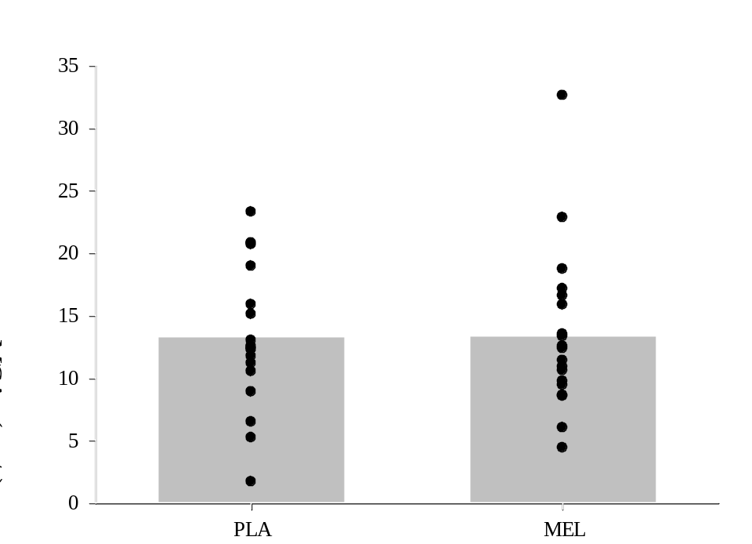

Figure 2. Data is displayed as mean ± SD. Shows alterations in middle cerebral artery velocity from baseline to the first trial of CO₂ rebreathing as a comparison between the placebo treatment and the melatonin treatment (n=19). ∆MCAv was calculated as an average value, derived from subtracting an average value of the last 30s of the preceding baseline from each data point during rebreathing. Alpha was set a priori as P < 0.05. No significant difference was seen between treatment groups. MCAv significantly increased from baseline to rebreathing in both treatment groups.
RB1 dMCAv
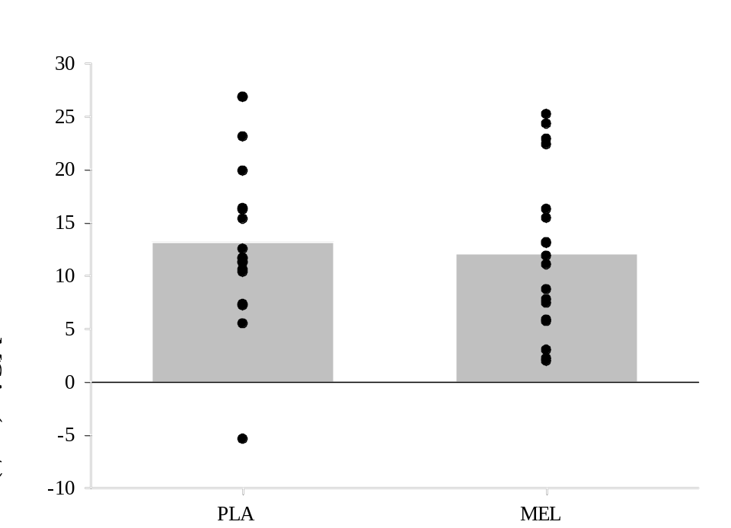

Figure 3. Data is displayed as mean ± SD. Shows alterations in middle cerebral artery velocity from baseline to the second trial of CO₂ rebreathing as a comparison between the placebo treatment and the melatonin treatment (n=18). ∆MCAv was calculated as an average value, derived from subtracting an average value of the last 30s of the preceding baseline from each data point during rebreathing. Alpha was set a priori as P < 0.05. No significant difference was seen between treatment groups. MCAv significantly increased from baseline to rebreathing in both treatment groups.
RB2 dMCAv
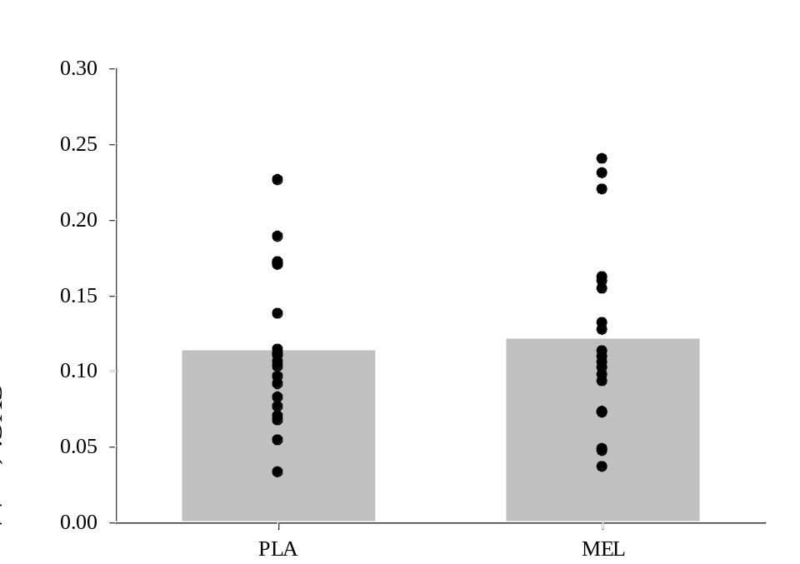

Figure 4. Data is displayed as mean ± SD. Shows alterations in the cerebrovascular conductance index from baseline to the first trial of CO₂ rebreathing as a comparison between the placebo treatment and the melatonin treatment (n=19). ∆CVCi was calculated as an average value, derived from subtracting an average value of the last 30s of the preceding baseline from each data point during rebreathing. Alpha was set a priori as P < 0.05. No significant difference was seen between treatment groups. CVCi significantly increased from baseline to rebreathing in both treatment groups.
RB1 dCVCi
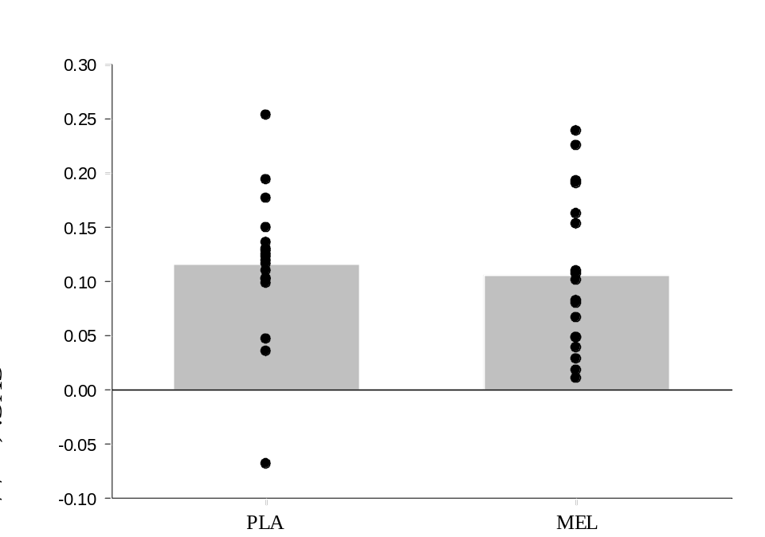

Figure 5. Data is displayed as mean ± SD. Shows alterations in the cerebrovascular conductance index from baseline to the second trial of CO₂ rebreathing as a comparison between the placebo treatment and the melatonin treatment (n=18). ∆CVCi was calculated as an average value, derived from subtracting an average value of the last 30s of the preceding baseline from each data point during rebreathing. Alpha was set a priori as P < 0.05. No significant difference was seen between treatment groups. CVCi significantly increased from baseline to rebreathing in both treatment groups.

RB2 CVCi
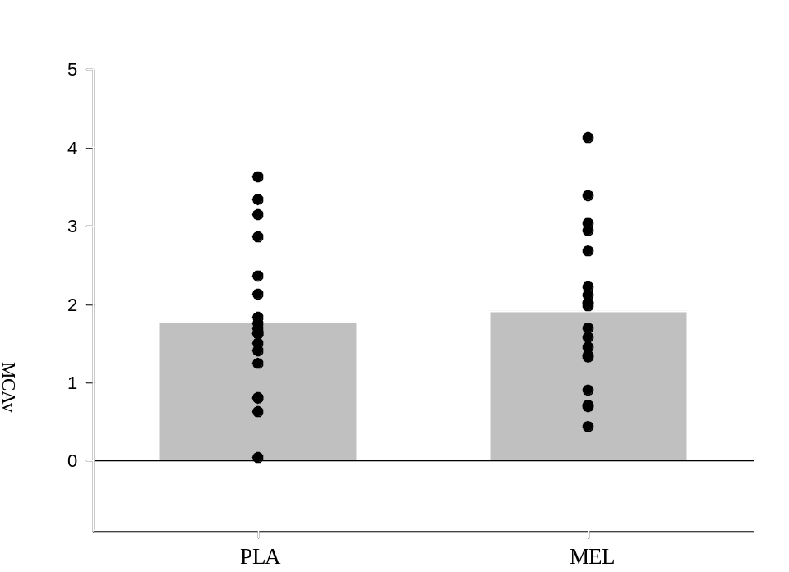

Figure 6. Data is displayed as mean ± SD. Shows alterations in the cerebrovascular reactivity calculated using MCAv from baseline to the first trial of CO₂ rebreathing as a comparison between the placebo treatment and the melatonin treatment (n=19). CVR_{MCAv} was calculated as an average value, where ∆MCAv was divided by ∆PetCO₂. Alpha was set a priori as P < 0.05. No significant difference was seen between treatment groups.

RB1 CVRMCAv
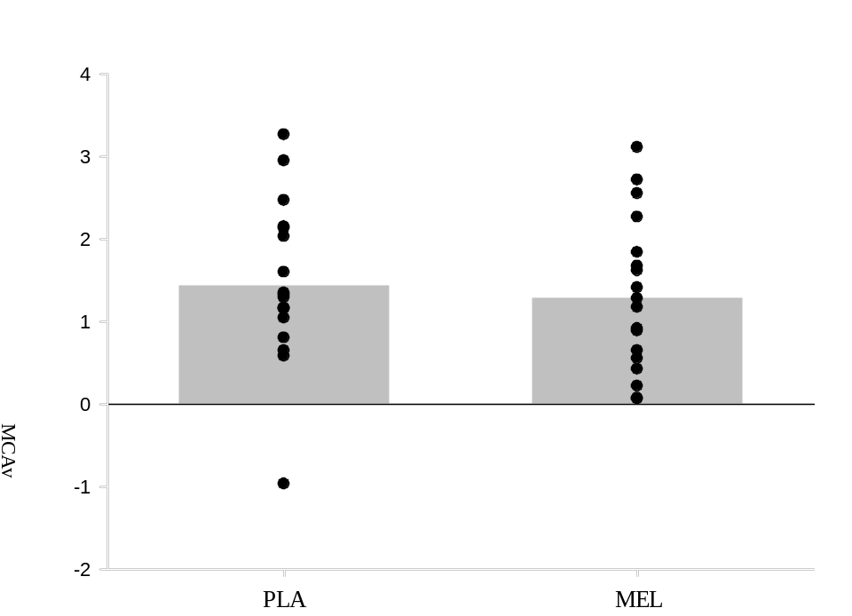

Figure 7. Data is displayed as mean ± SD. Shows alterations in the cerebrovascular reactivity calculated using MCAv from baseline to the second trial of CO₂ rebreathing as a comparison between the placebo treatment and the melatonin treatment (n=18). CVR_{MCAv} was calculated as an average value, where ∆MCAv was divided by ∆PetCO₂. Alpha was set a priori as P < 0.05. No significant difference was seen between treatment groups.
RB2 CVRMCAv
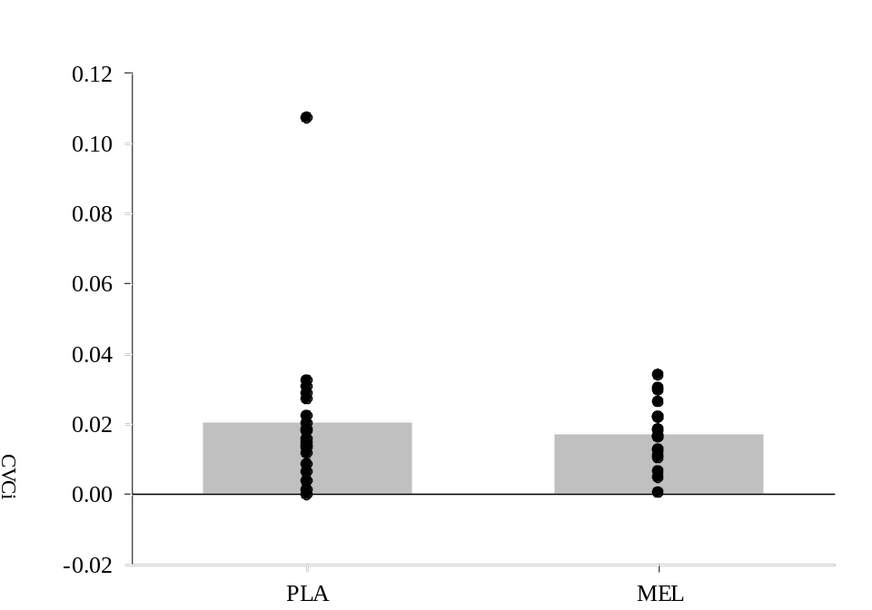

Figure 8. Data is displayed as mean ± SD. Shows alterations in the cerebrovascular reactivity calculated using CVCi from baseline to the first trial of CO₂ rebreathing as a comparison between the placebo treatment and the melatonin treatment (n=19). CVR_{CVCi} was calculated as an average value, where ∆CVCi was divided by ∆PetCO₂. Alpha was set a priori as P < 0.05. No significant difference was seen between treatment groups.
RB1 CVRCVCi
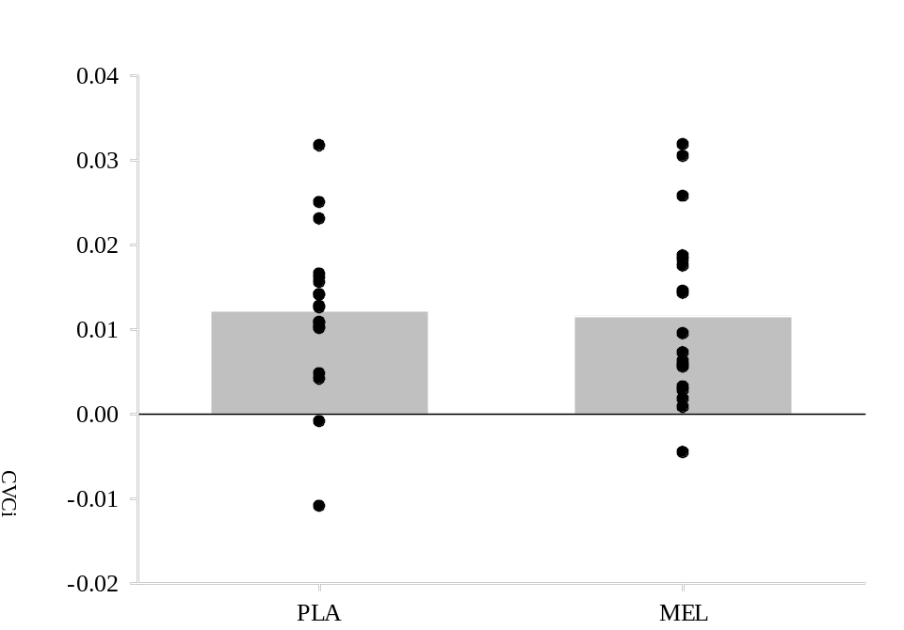

Figure 9. Data is displayed as mean ± SD. Shows alterations in the cerebrovascular reactivity calculated using CVCi from baseline to the second trial of CO₂ rebreathing as a comparison between the placebo treatment and the melatonin treatment (n=18). CVR_{CVCi} was calculated as an average value, where ∆CVCi was divided by ∆PetCO₂. Alpha was set a priori as P < 0.05. No significant difference was seen between treatment groups.
RB2 CVRCVCi

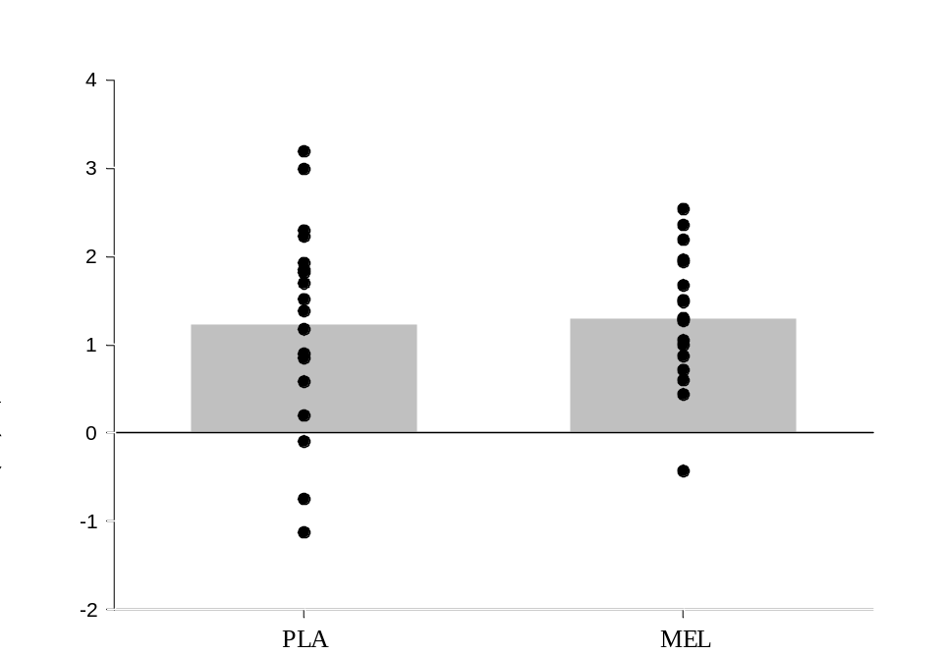

Figure 10. Data is displayed as mean ± SD. Shows alterations in the total saturation index from baseline to the first trial of CO₂ rebreathing as a comparison between the placebo treatment and the melatonin treatment (n=18). ∆TSI was calculated as an average value, derived from subtracting an average value of the last 30s of the preceding baseline from each data point during rebreathing. Alpha was set a priori as P < 0.05. No significant difference was seen between treatment groups. TSI significantly increased from baseline to rebreathing in both treatment groups.
RB1 dTSI

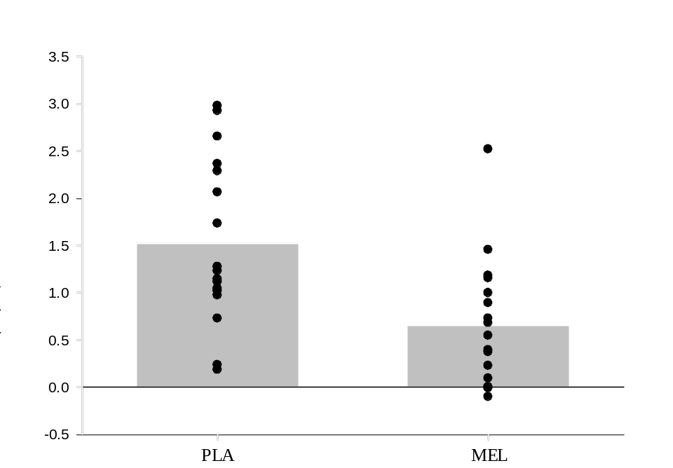
p = 0.003, r = -0.72

Figure 11. Data is displayed as mean ± SD. Shows alterations in the total saturation index from baseline to the second trial of CO₂ rebreathing as a comparison between the placebo treatment and the melatonin treatment (n=17). ∆TSI was calculated as an average value, derived from subtracting an average value of the last 30s of the preceding baseline from each data point during rebreathing. Alpha was set a priori as P < 0.05. The change in TSI was significantly lower during the melatonin treatment when compared with placebo. TSI significantly increased from baseline to rebreathing in both treatment groups.
RB2 dTSI

Table 7. Time to End-tidal CO₂ Peak during RB1 & RB2 (RB1 n = 19, 12 males, 7 females, RB2 n = 18, 11 males, 7 females)
 | RB1 |  | RB2 | P-Value (RB1-RB2)
TTN (seconds)
PLA | 100.10 ± 17.79 |  | 63.39 ± 24.78 | <0.001
MEL | 95.68 ± 18.48 |  | 58.04 ± 21.22 | <0.001
P-Value | 0.241 |  | 0.493
Values displayed as mean ± SD. P-Value represents a comparison between PLA and MEL conditions. TTN: Time to reach peak End-tidal CO₂ concentrations from the beginning of a rebreathing stage.

Table 8. Estimated ∆Cerebral Blood Flow (RB1 n = 19, 12 males, 7 females, RB2 n = 18, 11 males, 7 females)
 | RB1 |  | RB2 | P-Value (RB1-RB2)
Estimated ∆Flow (ml/min)
PLA | 61.28 ± 22.69 |  | 62.47 ± 38.38 | 0.643
MEL | 59.70 ± 30.28 |  | 57.01 ± 38.62 | 0.774
P-Value | 0.837 |  | 0.660
Values displayed as mean ± SD. P-Value represents a comparison between PLA and MEL conditions. Estimated ∆ Flow: Polynomial-based estimation of a change in cerebral blood flow using previous literature and measured flow velocity values (Verbree et al., 2014).

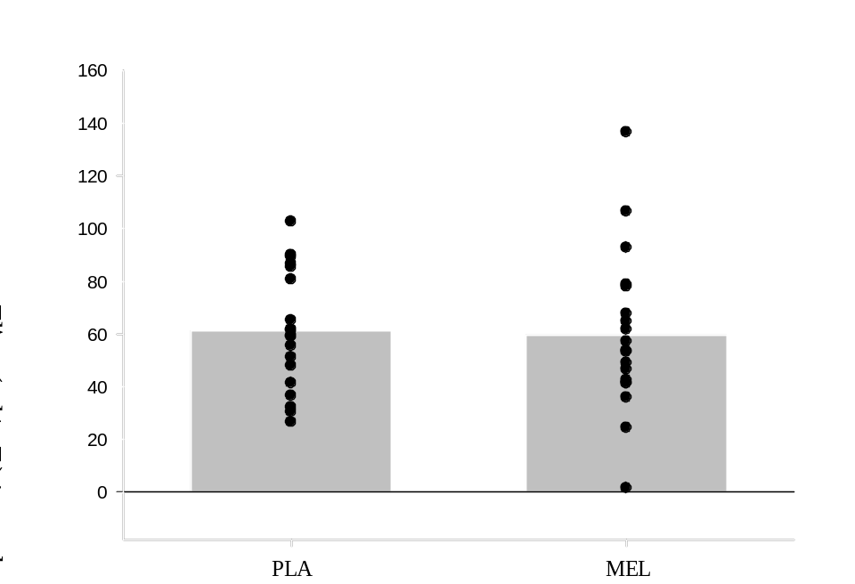

Figure 12. Data is displayed as mean ± SD. Shows alterations in the estimated change of cerebral flow in the middle cerebral artery from baseline to the first trial of CO₂ rebreathing as a comparison between the placebo treatment and the melatonin treatment (n=19). ∆Flow was calculated as a multiplication of the estimated area derived from a previously described 7-Tesla MRI origin study and our measured MCAv (Verbree et al., 2014). Alpha was set a priori as P < 0.05. No significant difference was seen between treatment groups.
RB1 Experimental dFlow

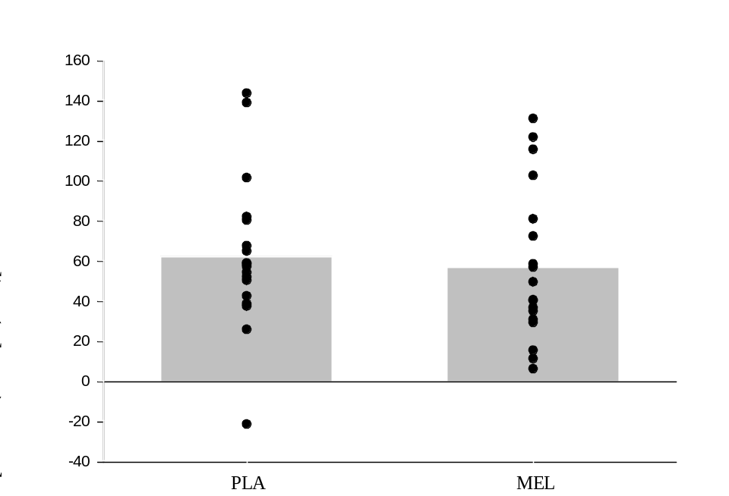

Figure 13. Data is displayed as mean ± SD. Shows alterations in the estimated change of cerebral flow in the middle cerebral artery from baseline to the second trial of CO₂ rebreathing as a comparison between the placebo treatment and the melatonin treatment (n=18). ∆Flow was calculated as a multiplication of the estimated area derived from a previously described 7-Tesla MRI origin study and our measured MCAv (Verbree et al., 2014). Alpha was set a priori as P < 0.05. No significant difference was seen between treatment groups.
RB2 Experimental dFlow

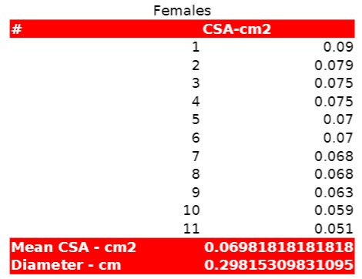
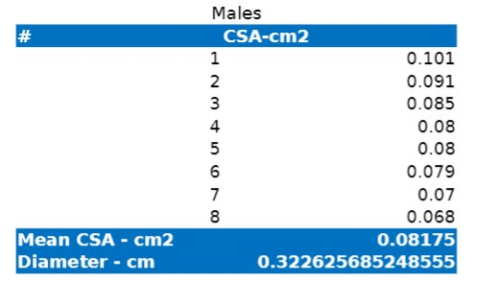
(Verbree et al., 2014).

Appendices
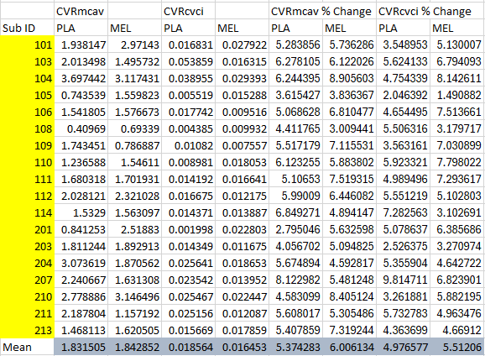
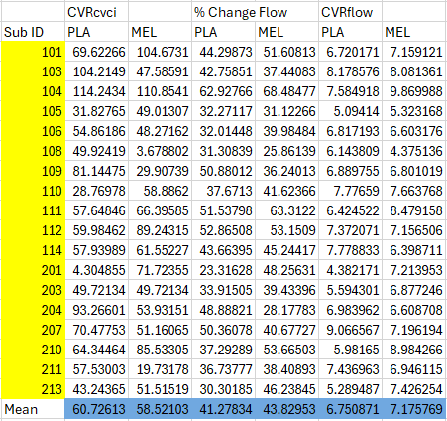

IRB Approved Documents



