University of Oklahoma

Graduate College

Political Consumerism and remote-piloted passenger aircaft

A Dissertation

submitted to the Graduate Faculty

in partial fulfillment of the requirements for the

Degree of

Doctor of Philosophy

By

Andrew keola keahiolalo
Norman, Oklahoma
2018

political consumerism and remote-piloted aircraft

A Dissertation approved for the
Graduate College

By

______________________________
Dr. Lori Snyder, Chair

______________________________
Dr. Kirby Gilliland, Co-Chair

______________________________
Dr. Randa Shehab

______________________________
Dr. Jorge Mendoza

______________________________
Dr. Tim Davidson

© Copyright by ANDREW KEOLA KEAHIOLALO 2018
All Rights Reserved.

Acknowledgements
For all the reasons a student is indebted to a mentor, for sticking with me through the various challenges on either side that we hurdled when, as far as I can see, there was no motivation for you to do so except for the belief that, with guidance, I could succeed, and for being for me the example of how to personally define perseverance, thank you Dr. Gilliland.
I would also like to thank Dr. Susan Sharp, Dr. Lori Anderson-Snyder, Dr. Jorge Mendoza, Dr. Randa Shehab, Dr. Tim Davidson, and Karen Thurston for their collective input in forming this project and for the various times they individually took the time to provide their genuine support.

Table of Contents
Acknowledgements iv
List of Tables viii
List of Figures ix
Abstract xi
Introduction 1
Human Error & Pilot Fatigue 3
Research Problem 10
Review of Relevant Research 12
Timing 13
Parallels in Automobile Automation 16
Automation vs. Remote Piloting. 16
Challenges in Automobile Automation 17
Proactive Navigation and Reactive Response 18
The Legacy Air Traffic Management (ATM) System 19
Radio Detection and Ranging (RADAR) 19
Airways 21
Route Planning 26
Navigation 29
Holding 35
Step-Downs 38
Voice Communication 41
The Next Step Forward 45
Controller to Pilot Data Link Communication (CPDLC) 47
Automatic Dependent Surveillance – Broadcast (ADS-B) 48
Required Navigation Performance (RNP) 51
Trajectory Based Operations (TBO) 53
Flight Time & Crew Rest 57
Dispatchers 58
Flight Attendants 59
Pilots 60
Fatigue, Alcohol, Precision, and Emergencies 65
Political Consumerism 69
Changing Population Attitude 71
Research Questions 75
Research Question One (RQ₁) 76
Research Question Two (RQ₂) 76
Research Question Three (RQ₃) 77
Research Question Four (RQ₄) 77
Method 78
Participants 78
United States Residents 78
Aviophobic Participants 78
Aviation Professionals 79
Sample Size 80
Data Collection Method 81
Non-Random Recruitment 81
Survey Host 83
Storage, Security, & Retrieval 84
Survey Instrument and Procedure 85
Validity Section 85
Treatment Section 86
Conditions Section 90
Results 93
Equalizing Group Sizes 94
Statistical Assumptions 95
Analysis of Variance 96
Multiple Comparisons Tests 96
Effect Size 97
Threats and Limitations 98
Non-Random Recruitment & Parametric Statistics 98
Age Bias 100
Heteroscedasticity & Unequal Group Sizes 100
Discussion 101
Conclusion 104
References 108
Appendix B: Acronyms 140
Appendix C: Task Posting Message 142
Appendix E: Study Survey 145

List of Tables
Table I. Human Factors Analysis & Classification System (HFACS) 4
Table II. Reconfigured Human Factors Classification System Example 6
Table III. ACROSS Project Objectives 14
Table IV. Progressive Reduction of Minimum Flight Crew by Decade 15
Table V Automobile Autonomy Classification Definitions 16
Table VI Minimum Flight Attendants Required by Aircraft Seat Capacity 59
Table VII Descriptive Statistics 96
Table VIII. Mann-Whitney U Test Results 99
Table IX Further Research 106

List of Figures
Figure I. Commercial Airplane Accident Causes 3
Figure II. Remote Piloted Aircraft Fielding 10
Figure III. Study Consumer Focus 11
Figure IV. RADAR Coverage of the U.S. 21
Figure V. Airways over New York. 22
Figure VI. Airways in Operation over the United Kingdom 23
Figure VII. Airway vs. Direct Routing Comparison. 24
Figure VIII. Simplified Example of Triangulation using NAVAIDs 25
Figure IX. Los Angeles to London Straight-Line Route and Geodesic-Line Route Comparison 27
Figure X. Los Angeles, California, USA to London, England Routing Projection Comparison 28
Figure XI. Movement of the Magnetic North Pole 1600-2010 30
Figure XII. United States Magnetic Declination Map. 31
Figure XIII. Global Magnetic Declination Map 33
Figure XIV. Map of Earth's North Poles. 34
Figure XV. London-Heathrow Flight Tracks. 36
Figure XVI. Holding Stacks at London Heathrow. 37
Figure XVII. Frankfurt am Main International Airport Runway Layout 38
Figure XVIII. Step-Down Approach Example 39
Figure XIX. Transmission Range Overlap Diagram 43
Figure XX. Controller to Pilot Data Link 50
Figure XXI. Actual Aircraft Course Related to Desired Course 51
Figure XXII. Figurative Reduction in Flight Separation Tolerance En Route 52
Figure XXIII. Aircraft Design Comparison 53
Figure XXIV. Continuous Descent Approach vs. RADAR Fix Approach Comparison 55
Figure XXV. Example of Trajectory Based Operations 56
Figure XXVI. RADAR vs. Trajectory Based Operations (TBO) 57
Figure XXVII. Pilot Workload by Flight Profile. 67
Figure XXVIII. United States Leaflet Example Distributed in Somalia. 74
Figure XXIX. Study Survey Flow Chart 87
Figure XXX. RPA Support Scale 93
Figure XXXI Group Means by Condition 104

Abstract
The overall purpose of this study was to determine if there exists a receptive market for a new aviation passenger model that by use of emerging technologies may significantly decrease the threat in air safety that is pilot fatigue. In this study, that technology has been termed remote piloted aircraft (RPA). For this technology to be fielded successfully, the following must be available: 1) primary and supporting technologies, 2) corporate investment, 3) professional operators, 4) consumer support, 5) regulatory apparatus. This writing details how currently the aviation industry is secure in the first three. It then describes an experiment performed to determine how the fourth, consumer support for RPA, may be cultivated. The major hypothesis was that by informing consumers of the capabilities of RPA technology, they would be more apt to support it when compared to consumers that were not so informed. An anonymous online survey was distributed to US based aviation consumers. Respondents were divided into three groups: a treatment group that was presented with information about RPA capabilities, a placebo control group that was presented with information about aviation excluding RPA capabilities, and a full control group that was given no information. All respondents were queried regarding their likelihood to travel on a flight using RPA in three different conditions in which RPA might be fielded. By way of one-way ANOVA and appropriate multiple comparisons calculations, it was determined that the treatment group showed a significantly greater level of support for RPA travel than either the placebo control or full control group. This pattern was consistent in all three conditions in which RPA fielding was presented (Cond₁, F_{(2, 213)} = 24.81, p < .001; Cond₂, F_{(2, 213)} = 6.8, p = .01; and Cond₃, F_{(2, 213)} = 4.59, p = .01).

Introduction
This study is an exploration of organizational leadership in passenger aviation. It relates to the development of public perceptions of new technologies and was designed to analyze the feasibility of a new airline operational model. That model’s direct goal: reducing the occurrence of pilot fatigue by utilizing Remote Piloted Aircraft (RPA) for passenger transportation.
As technology has advanced in society, it has allowed for greater productivity and greater margins of safety. Yet even as we progress, or rather because we progress technologically, vocations develop that carry inherent dangers to the physical, physiological, and/or psychological well-being of those employed. The segment of the population with the ability and desire to perform duties at high fidelity in dangerous environments becomes more and more limited as those dangers strengthen. Even considering the most able specimens among us, no one is immune to fatigue. All humans require sleep (Pietrangelo & Krucik, 2014). Among many other negative consequences, sleep deprivation has been shown to have a similar effect on the brain as drinking alcohol by exponentially reducing balance, hand-eye coordination, reaction time, decision making, etc. the longer one is required to stay awake (Pietrangelo, 2014). The effects start to present even with just a few hours of sleep less than optimum (Buxton, 2007). Sleep deprivation is so powerful that it is used as a torture technique in interrogation (Bulkeley, 2014) and in the extreme can result in severe psychosis and death (Mann J. , 2012). Irrespective of their talent or dedication, all pilots will experience declines in performance acuity when fatigued.
Pilot fatigue is the most common cause of pilot-error accidents (Graeber, 2017), which themselves make up 85% of all aviation accidents (Hope, 2015). In a global network comprised of approximately 3.7 billion flights annually (International Aviation Transport Association, 2016), an impact of that magnitude has made pilot fatigue one of the leading safety concerns in commercial aviation.
A leader is responsible for providing a safe working environment for his/her followers (Gilliland, 2011). Ensuring passenger and crew safety by maintaining maximum pilot performance acuity is an important link between the aviation industry and the concepts of organizational leadership (Boyatzis & McKee, 2005; Yukl, 2009). Leadership is expressed in all facets of aviation including engineering, organization expansion, daily aggregate operations, fleet management, flight execution, regulation, and others. However, there are three processes within aviation where leadership is crucial:: 1) the flight crew must exercise good leadership to protect the passengers under their care from harm, 2) corporate airline leadership is responsible for providing the tools for flight crews to do so, and 3 aviation regulators are responsible for building and maintaining a safe environment in which all aviation may safely operate. The purpose of this study was to focus on a major leadership challenge to commercial aviation in these areas. New enhanced technology can actually guide aircraft more safely than human operators, especially when humans are degraded by fatigue. The adoption of new technology in the form of RPA would depend in large measure on public acceptance. However, there is little actual data on whether the flying public would accept RPA (Jacobs, 2009). Thus, effective leadership in the aviation community hinges on an accurate understanding of public perception and acceptance of RPA. This study attempted to look more closely at public acceptance and factors that may affect public acceptance and provide leaders at several levels with empirical evidence regarding the feasibility of implementing RPA.

Human Error & Pilot Fatigue
“Human error has been documented as a primary contributor of more than 70% of commercial airplane hull-loss accidents” (Graeber, 2017; Reason, 1990). This statement is supported by multiple research studies and data meta-analyses (O'Hare, Wiggins, Batt, & Morrison, 1994; Wiegmann & Shappell, 1997; Yacavone, 1993). Pilot fatigue is estimated to cause and/or contribute to between 20 and 30% of human factor accidents in aviation (Akerstedt, Mollard, Samel, Simmons, & Spencer, 2003). These numerical relationships may be visualized in Figure I.

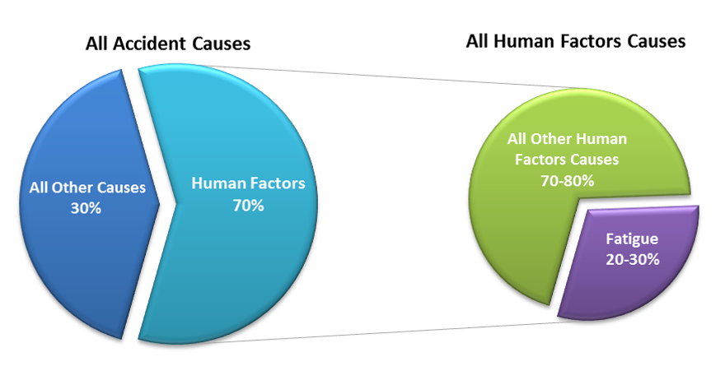
Figure I. Commercial Airplane Accident Causes
Adapted from “Human Factors” by Graeber (2017). Copyright 2017 by the Boeing Company. Also adapted from “The Role of EU-FTL: Legislation in Reducing Cumulative Fatigue in Civil Aviation” by T. Akerstedt, R. Mollard, A. Samel, M. Simmons, & M. Spencer (2003), published by the European Transport Safety Council.

This statistic, while already unnerving, must be understood within the specific context by which it is calculated. Human error accidents in aviation are categorized by the factors found to be present after the investigation of each accident. These factors are organized according to the Human Factors Analysis & Classification System (Wiegmann & Shappell, 1997). These categories and their subcategories are shown in
Table I.

Table I.
Human Factors Analysis & Classification System (HFACS)
Organizational Influences | Unsafe Supervision | Preconditions of Unsafe Acts | Unsafe Acts
Resource Management | Inadequate Supervision | Adverse Mental States | Skill-based Errors
Organizational Climate | Planned Inappropriate Operations | Adverse Physiological States | Decision Errors
Organizational Process | Failure to Correct Known Problem | Physical/Mental Limitations | Perceptual Errors
 | Supervisory Violations | Crew Resource Mismanagement | Violations
 |  | Personal Readiness
Adapted from “A Human Error Analysis of Commercial Aviation Accidents Using the Human Factors analysis and Classification System (HFACS)” by D. Weigmann, and S. Shappell, S. (2001). Published by the U.S. Department of Transportation in Washington, D. C.

Note: All terms are defined in Appendix A: Definitions

Weigmann and Shappell (2001) detail the criteria for each accident classification; however, these classifications represent only end effects. There are always contributing factors to those effects, some of which are neither measured nor ever mentioned officially. Pilot fatigue is especially one of those factors typically glossed over, even though it has the potential to contribute to any aviation accident. For example, a skill-based error represents a breakdown of routine processes that are otherwise inherent to flight and nearly automatic, such as a failure to properly scan aircraft instrumentation (Wiegmann & Shappell, 2001). Decision errors are defined as “goal-intended behavior that proceeds as designed; yet the plan proves inadequate or inappropriate for the situation” (Wiegmann & Shappell, 2001). The category of violations, which are instances of blatant disregard for established rules, could be further sub-categorized with those actions attributed to the deterioration of the quality of decisions from decision fatigue (Tierney, 2011) and/or less inhibited risk tolerance (Vohs, et al., 2008). All three of these types of errors, skill-based error, decision errors, and violations, either present with (Tripp, Yochem, & Uhl, 2007), or are aggravated by (Cabon, Bourgeous-Bougrine, Mollard, Coblentz, & Speyer, 2002) pilot fatigue. In fact, each one of the categories listed in
Table I can be connected directly to fatigue in one way or another. With the understanding that greater accuracy is attainable through targeted academic study, the researcher worked out a simple, preliminary, reconfigured HFACS that more accurately represents the influence of pilot fatigue in Table II.

Table II.
Reconfigured Human Factors Classification System Example
Category | Subcategory | Example of Error | Link to Fatigue*
Organizational Influence | Resource Management | Failure to recognize engine fire and deploy fire extinguishing agent | Reduction in mental acuity
Organizational Influence | Organizational Climate | Not claiming ‘unfit for duty due to fatigue’ to avoid ousting by peers | Informal repercussions for claiming fatigue
Organizational Influence | Organizational Process | Not claiming ‘unfit for duty due to fatigue*’ to avoid reduction in pay & promotion limitations. | Formal repercussions for claiming fatigue
Unsafe Supervision | Inadequate Supervision | Pilot-in-Command sleeping at the controls | Exhaustion
Unsafe Supervision | Planned Inappropriate Operations | Executing the wrong approach sequence | Reduction in mental acuity
Unsafe Supervision | Failed to Correct Known Problem | Slow response to a turbine compressor stall resulting in engine destruction | Reduction in reaction time
Unsafe Supervision | Supervisory Violations | Inappropriate berating other colleagues | Fatigue-induced frustration
Preconditions of Unsafe Acts | Adverse Mental States | Suicide by purposefully crashing the plane | Fatigue-induced depression
Preconditions of Unsafe Acts | Adverse Physiological States | ‘Freezing’ during an emergency | Reduction of autonomic nervous system function
Preconditions of Unsafe Acts | Physical/Mental Limitations | Increased susceptibility sensory illusions | Impaired sense of spatial orientation
Preconditions of Unsafe Acts | Crew-resource Mismanagement | Failure to appropriately delegate | Reduction in ability to communicate
Preconditions of Unsafe Acts | Personal Readiness | Persistent symptoms of illness | Reduction in immune system function
Unsafe Acts | Skill-based Error | Inappropriately aggressive aircraft handling | Reduction in proprioceptive acuity
Unsafe Acts | Decision Errors | Entering an active runway without ATC permission | Reduction of mental acuity
Unsafe Acts | Perceptual Errors | Fixating on altitude and ignoring heading | Reduction in proprioceptive acuity
Unsafe Acts | Violations | Abuse or breach of authority structure | Fatigue-induced frustration
Note: Terms are defined in Appendix A: Definitions.
*These are educated and/or common-sense parallels to fatigue.

Table II is only one relation each human error category has in relation to pilot fatigue. A comprehensive list may be produced by reviewing past accident data and coding them in a manner that specifically focuses on pilot fatigue effects as primary, contributing, or present but non-contributing accident factors. As it stands, pilot fatigue is well underrepresented in accident statistics. The influence of airline corporations on regulators is apparent. For instance, despite over 100 years of aviation progress and decades of collected supporting data in kind, the U.S. Department of Transportation (DOT), under which the Federal Aviation Administration (FAA) falls, would not acknowledge pilot fatigue as a causal factor for an aviation accident/incident until 1993 (Learmount, 2009). This continues today because pilot fatigue statistics are presented in a manner that dissuades attention from it.
By federal regulation, each pilot is responsible for “ensuring [his/her own] adequate rest and fitness of duty” (Federal Aviation Administration, 2012, p. 4). However, crew duty regulations are a convoluted maze of loopholes (see section on Flight Time & Crew Rest, p.57). Unfortunately, even the strictest adherence to those regulations is no guarantee that a refreshed crew will be in command of an aircraft at any given time. An almost tragic example occurred in May of 2016. What is now known as the crash of Egypt Air flight 804 had just disappeared from radar (La Porte, 2016) and all emergency services were being engaged with that priority. Less than four hours later, a Delta Airlines flight traveling from Frankfurt-Hahn International Airport to Kuwait International Airport began to fly off-course and looked intent on violating Greek airspace. The pilots were unresponsive to calls from Italian and Greek air traffic control on all frequencies. Greek authorities, fearing another September 11th-like multi-aircraft terrorist attack on the way to Athens, scrambled two F-16 fighter jets prepared to destroy the Delta aircraft in the air. Instead of finding terrorists in command of the aircraft, however, they came upon both Delta Airlines pilots fast asleep. The passengers noticed the fighter jets and pounded on the cockpit door until the pilots woke up (Mirage News, 2016; Niles, 2016).
It would be easy to vilify the pilots for complacency, and there would be blame to spare in cases like Air France 447 where the pilot and co-pilot spent their rest period partying in Rio de Janeiro in blatant disregard for the tragic consequences that followed (Paris, 2013). However, accidents and incidents involving crew fatigue are far too common to attribute them all to carelessness (George, 2015). The reality is that pilots are required to endure long periods of tedium, sometimes in excess of 20 consecutive hours (Federal Aviation Administration, 2017q), while being required to maintain a sharp eye on flight systems and being prepared to execute any required emergency procedures. For any pilot holding that schedule three days a week, at altitude, crossing time zones, in and out of hotels, and off sleep-rhythm, it would not matter if his/her only daughter was sitting in the cockpit jump-seat, that pilot will, without exception, suffer the progressive symptoms of fatigue.
Pilots’ schedules were originally extended to over 20 hours so the United States could compete in international aviation markets against other regulatory bodies around the world, some with less compunction about crewmember health. These long hours are necessary now because the present airline operations model assumes that the flight crew is required to travel with the plane. It is a concept originally expressed by da Vinci in the 1400s and advanced with technology developed in the late 1890’s with the first attempts at powered flight (Stimson, 2016). Today, that requirement is no longer in place.
The leading concern of airline consumers when debating the purchase of airline tickets is price (Parrella, 2013). From the passenger perspective, most airlines of a particular framework (e.g., hub and spoke, point-to-point, charter, etc.) tend to mirror each other. This is likely due to an environment of heavy regulation that limits airlines’ operational flexibility. Feelings related to safety take a distant third in pre-purchase concerns of passengers (Dow, 2014). They have likely come to trust the arbiters of those regulations in keeping passengers safe. It is commonly communicated that air travel is the safest mode of transportation, statistically speaking (Morris, 2015). However, the everyday airline passenger can neither be expected to be familiar with the frequency and consequences of pilot fatigue episodes, nor how RPA capabilities could mitigate them. Would a shift from current norms of transport aviation, such as with RPA operations, weaken consumers’ supposition of safety as to surpass ticket price in their priority of concerns? Or would consumers’ trust in aviation regulators’ ability to safely extend into new and unfamiliar aeronautical ventures like RPA operations?
This study was a preliminary exploration of consumer support of a new commercial airline operations model where a pilot would be physically separated from the passenger aircraft he/she is controlling. The pilot would operate from a flight control facility on the ground specifically designed for that purpose: in other words, Remote Piloted Aircraft (RPA). The RPA operations model would be akin to the drone-piloted model currently in use in the military. Implementing this model would address one of the major causes of airline accidents—pilot fatigue. This model would allow for the relief of flight crews after a much more reasonable workday by a second or even a third flight crew, fully rested. This is similar to how air traffic controllers change over responsibility of a section of airspace. Passengers and aviation leaders would be assured that a rested flight crew at top performance was in control of the aircraft at all times.

Research Problem
For an operational model using RPA to succeed, the sequential elements of passenger aviation are expressed in Figure II.

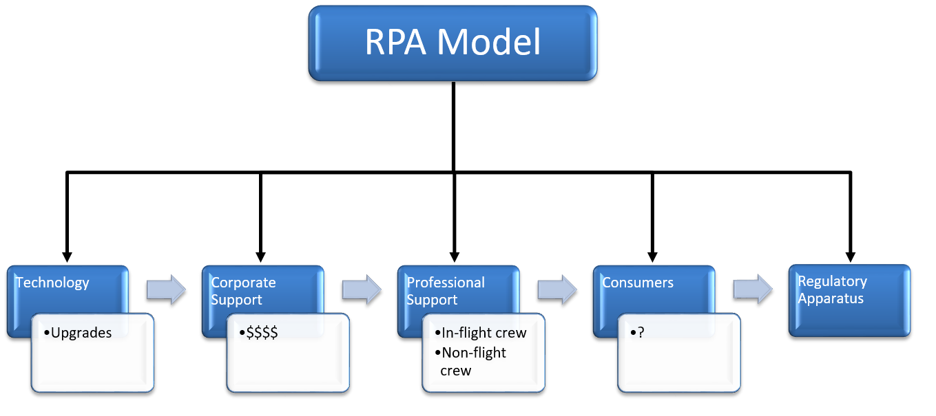
Figure II. Remote Piloted Aircraft Fielding

The technology, corporate support, and professional support are all in place in the aviation industry, as will be detailed below. The only reason remote piloting is not in use for passenger aviation today is because aviation leaders and regulators presume consumers would not be willing to fly on an airplane without a pilot onboard (Patterson, 2015). Therefore, there are yet no aircraft designed for it, no infrastructure to support it, and no regulations to allow for it (Patterson, 2015). “The public like to be assured when flying that there are capable, professional, well-trained pilots in command” (British Broadcasting Corporation, 2012). “The biggest hurdle to the use of any unmanned aircraft [in commercial air travel] is public perception” (Searle, 2013, p. 1). This study analyzed the next step: consumer support. It will focus on consumers’ support of RPA operations, as it is the element where the least amount of hard data exists and where the greatest assumptions are made (Jacobs, 2009).
Since no one has actually asked the RPA question of the flying public, the goal with this study was to fill the gap in that knowledge by exploring an important aspect of leadership in the airline industry: The relationship between understanding consumer perception and its interaction with industry operations. The knowledge gained in this study will further direct aviation stakeholders as to where developmental efforts should be placed.

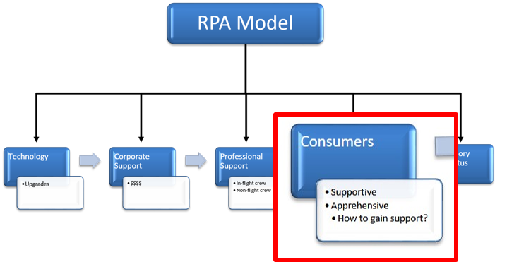
Figure III. Study Focus on Aviation Consumers

Literature has shown that education on a previously unknown or less familiar theme has led to a change in the attitudes towards a more supportive position (Obergefell, et al. Petitioners v. Hodges, Director, Ohio Department of Health, et al., 2015; Probst, 2003; ProCon.org, 2014). In addition, studies show that people are motivated to gather information before making a major decision (Awasthi, 2008). Further still, leadership can effectively guide subordinates (e.g., the DOT leading airline passengers) and receive productive feedback to attain a common acceptable level of risk-tolerance in exploring new ventures (Awasthi, 2008; Hammond, Keeny, & Raiffa, 1999; Probst, 2003). In aviation, the mechanism for the information flow to and from the public, pilots, airline corporate officials, academics, engineers, and regulators already exists, housed nicely in Title 14 of the Code of Federal Regulations-Chapter 1B§11General Rulemaking Procedures (Federal Aviation Administration, 2017v). It requires that anyone wishing to express his/her concerns of a proposed rule be heard by the regulators. Having a hand in a discussion of new regulations will lead to greater understanding of new regulations by those motivated to be involved in their creation. For the rest of the public, education campaigns across all media types will similarly lead to widespread familiarity, then acceptance, and then support (Awasthi, 2008; Hammond, Keeny, & Raiffa, 1999; Probst, 2003).

Review of Relevant Research
This section will begin with a discussion about the timing and debate of RPA. Identifying the differences between automobile automation and the concept of remote piloting will follow. Then will come a review of the current status and operation of the United States Air Traffic Management (ATM) system. Thereafter, the Next Generation (NextGen) of the U.S. ATM will be detailed in relation to the research questions. A discussion of flight crew flight times and crew rest regulations will follow. This chapter will end with a discussion of the power of public perception in political consumerism as well as the changing of that perception by way of targeted education campaigns.

Timing
An important research target influencing the timing this study is the near completion of the Advanced Cockpit for Reduction of Stress and Workload (ACROSS) project, which has been active since January of 2013 (Birgelen, 2014). ACROSS is a European Union (EU) initiative to explore efforts to advance the safety of aviation transport in passenger and air cargo operations by maximizing the efficiency of automation while maintaining the critical element of human judgment. It is very near to release to aircraft manufactures. The ACROSS project began in January of 2013 with validation that started in June of 2016. The ACROSS project is a major step towards remote-piloted passenger aircraft, though that is not the project’s goal (Birgelen, 2014). The project’s objectives are presented in Table III:
Table III.
ACROSS Project Objectives
New Cockpit Solutions for Peak Workload Situations |  | New Cockpit Solutions for Reduced Crew Operations | Identifying Open Issues for Single-Pilot Operations
Assuring Safe Operations Under Peak Workload | Improved Situational Awareness of the Flight Crew | New Cockpit Solutions for Reduced Crew Operations | Identifying Open Issues for Single-Pilot Operations
In High Density Traffic | Increased Automation | Reduced Crew in Long Haul Flights | Identifying Open Issues for Single-Pilot Operations
In Bad Weather | Improved Human/Machine Interaction | Partial Flight Crew Incapacitation | Identifying Open Issues for Single-Pilot Operations
During In-Flight Emergencies | Improved Support in Abnormal Conditions | Total Flight Crew Incapacitation | Identifying Open Issues for Single-Pilot Operations
Note: Adapted from Optics Aviation Research & Innovation: time to take-off! by T. Birgelen (2014) in Advanced Cockpit for Reduction of Stress and Workload Consortium, pp1-24. Published by the European Commission-European Research Area.

The debate surrounding RPA continues to be explored in aviation circles. Lambert Dopping-Hepenstall, the director of the Autonomous Systems Technology Related Airborne Evaluation and Assessment (ASTRAEA), states, “As far as the eye can see, there will always be a pilot in command of an aircraft” (Searle, 2013). The FAA and aircraft manufacturers have assumed the public wants a pilot onboard (Reiner, 2016). Other industry stakeholders are certain, however, that “…one day there will not be any pilots in the aircraft” (Searle, 2013, p. 1).
A pilot in command of an aircraft no longer needs to be situated in it to maintain its control. In fact, without the space and weight limitations inherent in cockpit design, flight control studio designers would be free to situate remote cockpits in the most ergonomic manner and employ the most advanced apparatuses. That would allow a remote-pilot to be better suited to handle the challenges of flight than one in the aircraft. Further research is surely justified in this regard. It can already be said with certainty that remote-pilots will not have to contend with the physiological effects of gravitational (g) forces (Jedick, 2013) or the spatial disorientation that comes with it (Antunano, 2017). This is only one example of how the utility of human judgment may be retained and flexed to greater effect in harmony with aircraft automation. It is the responsibility of aviation stakeholders to explore such safety improvement potential, and it is the duty of aviation regulators to allow for such advances in passenger safety.
Historically, as technology has progressed, so has the number of required flight crew decreased, as shown in Table IV.

Table IV.
Progressive Reduction of Minimum Flight Crew by Decade
Decade | Crew Relieved | Technological Advancement
1950s | Radio Operator | Elimination of telegraphic communication
1970s | Navigator | Introduction of Flight Management Systems (FMS)
1980s | Flight Engineer | Introduction of Engine Indicating Crew Alerting Systems (EICAS)
2010s | Copilot* | Aircraft automation
2020s | Pilot** | Introduction of remote-piloted aircraft in restricted and conflict airspace
Note. Adapted from One Hundred Years of Air Power and Aviation by R. Higham (2003), Copyright 2003 by Texas A&M University Press.
* Single-pilot, high-passenger-seat-capacity operations has been proposed by airline corporate officials and is currently being researched by regulators.
**Remote piloted aircraft operations is the focus of this study.

Airliners are heavily automated as it stands today (Aerotime, 2015a, p. 2; Aerotime, 2015b, p. 1; Markoff, 2015), so much so that the execution of some formerly intensive procedures have been streamlined. When starting an aircraft engine might have involved a lengthy, two-person process of 15 steps or more (Sikorsky Aircraft, 1994), it now takes the single push of a button. Aircraft automation handles the complete starting sequence, except for initiation, while remaining on alert for any contingencies (e.g., turbine gas temperature overheating, fuel leak, engine fire, etc.). Failure in those areas in flight where human control is still required account for 60% of fatal aviation accidents (Birgelen, 2014). It is conceivable that maximizing and mandating automation would lead to a reduction of commercial airplane accidents.

Parallels in Automobile Automation
It may not be apparent, but the concept of remote piloting an aircraft is far less technologically challenging than that of an autonomous ground transportation vehicle. Auto-driving capabilities are becoming more available in new cars today as described by Vincent (2017) in a six-level classification system (level zero to level five) shown here in Table V.

Table V
Automobile Autonomy Classification Definitions
Level 0 | No autonomous functions
Level I | One or more systems that can intervene to break, steer, or accelerate the car
Level II | Coordinated control of speed and staring at the same time without driver input for short periods
Level III | Full autonomous function in all driving conditions with some situations in which autonomous control is not functional
Level IV | Fully autonomous vehicles operating with no intervention from the driver other than entry of the destination
Level V | Entirely autonomous vehicles
Note. Adapted from 9 Cars That Are Almost Self Driving by Vincent (2017) in Car Buying Tips, News and Features, published by U.S. News & World Report.

Automation vs. Remote Piloting.
There are major challenges in automobile automation that are simply not present in remote piloting an aircraft. The goal of automobile automation is complete hands-off, autonomous driving (Paromtchik & Laugier, 1998). Specifically, engineers are attempting to create cars that require only the passenger’s destination and the command to execute before taking control of the vehicle (Ros, Sappa, Ponsa, & Lopez, 2012). Meanwhile, the primary goal of the utilization of RPA is to realize gains in safety and efficiency by maintaining human proactive control of flight systems in concert with the automation of flight subsystems. This is very different from the concept of auto-driving. To begin, there is the difference in the level of human interaction between an auto-drive function and remote piloting an aircraft. In the former, the human is a passive observer, while in the latter, he/she maintains positive control of the aircraft. No changes to altitude, airspeed, or heading are executed without the pilot’s approval. In addition, the abundance and redundancy of collision detection systems, the mandatory surveillance reporting of aircraft, and the centralized calculations of aircraft routes all provide an environment that fundamentally differentiates remote-piloting aircraft from automobile automation. Parallels to RPA may be better drawn from remote control cars, which might provide a social utility. Maybe Über cars might one day show up without drivers. Instead, the drivers would operate vehicles in a coffee shop from their laptops. As of this writing, however, that is not the engineers’ target. Rather automobile engineers are moving directly toward vehicle autonomy (Paromtchik & Laugier, 1998; Ros, Sappa, Ponsa, & Lopez, 2012) .

Challenges in Automobile Automation
The progress of automobile autonomy is rooted more in robotics than in the automobile industry (Montemerlo, et al., 2008). The challenge of creating a digital picture from which an intelligent vehicle may see and navigate has proven quite formidable. Sometimes taken for granted are the amazing ability of the human eye and interpretations of the brain. What most humans can do naturally requires a computer to make heavy calculations refreshed constantly to view, assess, and navigate free space and avoid occupied space, the unconscious abilities of light wavelength interpretation, sensory gating, kinetic depth, etc. notwithstanding. In a digital sense, this translates into processor demands that, at the level of accuracy required to keep passengers safe, at this time are prohibitively expensive or not yet invented (Ros, Sappa, Ponsa, & Lopez, 2012). This technology, however, is steadily making gains towards satisfying those demands (Kitt, Geiger, & Lategahn, 2010).

Proactive Navigation and Reactive Response
Intelligent automobiles must calculate and monitor the route of travel relative to objects stationary and in motion. Any time an object changes velocity and/or vector, the intelligent automobile must react and recalculate. As in the systems described below in The Next Step Forward section (see p.45), route calculation in aviation is conducted at a central hub that coordinates all air traffic through all flight profiles. All flights are sequenced for maximum safety. If that requires a slight airspeed change from one aircraft or another, that command is automatically sent to the pilot for execution. Intentions of any particular aircraft are known and calculated, and all other flights are coordinated considering them. This provides for much greater predictability in aviation than could be managed in automobiles, unless those routes were also centrally calculated. That may be what emerges in the future of driverless cars, but as of this writing, it is not yet being advanced. There would need to be an extended period of careful integration where mixed traffic (driver and driverless automobiles) would co-operate.
The intelligent car must make a workable digital map of its immediate area, separate relevant information from irrelevant, determine what is moving and what is stationary, calculate those movements relative to the vehicle in seven dimensions (height, width, distance, velocity, vector, acceleration, and time-to-intercept), calculate its own path of travel, all while maintaining vigilance for unexpected events (Ros, Sappa, Ponsa, & Lopez, 2012). Then there are the unknowns, as in: Does the auto-drive see heavy rain as an obstacle or would it know to drive through it? Would it recognize the rain at all? Could it correctly assess the rain density and reduce the car’s velocity appropriately to maintain control? These intensive challenges are largely avoided in aviation simply because there are no obstacles at altitude. In addition, all other aircraft in the applicable classes of airspace are required to self-report all dimensional information by radio communication and in a common transponder system actively monitored by air traffic authorities (Federal Aviation Administration, 2017a; Federal Aviation Administration, 2017b; Federal Aviation Administration, 2017c).

The Legacy Air Traffic Management (ATM) System
In this section, a review of the ATM systems in use today is detailed. It focuses on the challenges and inefficiencies inherent in them. Each of the elements in this section has an upgrade in NextGen, the employment of which utilizes advanced aircraft automation and provides an environment where RPA operations may thrive.

Radio Detection and Ranging (RADAR)
The incumbent ATM system is based on Radio Detection and Ranging (RADAR), a 1960’s technology with different “lego-ed” attachments added since (Cook, 2007; National Air Transportation Service, 2016a). It is a cumbersome, finicky, and inaccurate way to track airplanes. It will cost the U.S. economy an estimated $40 billion in lost transactions (Wilson, 2010) if the U.S. ATM system continues to overload the capabilities of RADAR and thus bottleneck the largest aviation market in the world (Jacobs, 2009).
By use of the Doppler effect (Hall, 2015); air traffic RADAR transmits a radio signal radially. Any targets in the area will cause that signal to bounce back to the RADAR source. The time and direction it takes for that signal to arrive back to the source is an indication of the distance and azimuth of that target (Adrian, 1995). Radio Detection and Ranging systems in the United States require a second RADAR to relay transponder information from aircraft to filter out false positives like trucks on the highways or concentrated weather masses (National Air Transportation Service, 2016c). Targets are displayed on a screen for the air traffic controller to observe, coordinate, and de-conflict aircraft routes in flight. This is a truly exceptional responsibility given the number of lives involved. With the constant pressure to keep air traffic flowing efficiently, it becomes clear why air traffic control has such high rates of turnover (Bureau of Labor Statistics, 2015). Figure IV shows the RADAR coverage of the United States.
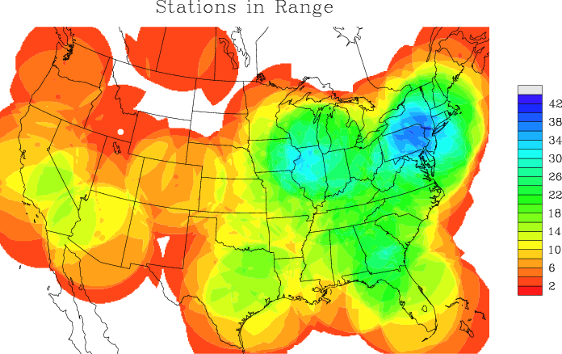
Figure IV. RADAR Coverage of the U.S.
Adapted from “4D Nav is Coming” by Esler (2009), Business & Commercial Aviation, p. 28. Copyright 2009 by the Aviation Week Network.

The excessive redundancy is clear. The New York/Pennsylvania area has an overlap of 42 RADAR stations. Since RADAR is so inaccurate, any converging aircraft must be vertically spaced 1000 feet from each other along a particular airway as a buffer to allow for navigational error (The Boeing Company, 2000). If that buffer were not in place, the worst-case scenario would be two converging aircraft on the same or adjacent airways that are displaced from their intended tracks enough to contact each other. The gap between those aircraft would close quickly and no one, including ATC, would be the wiser until it was too late.

Airways
Airways are another source of inefficiency. Air traffic is bound to these airways, which are like highways in the sky. They are routes that all aircraft dispatchers must use to plan a route from one airport to another. Aircraft dispatchers file a route request that is then approved or altered by ATC. These airways allow for a level of predictability for ATC. Figure V shows the airway structure over New York.

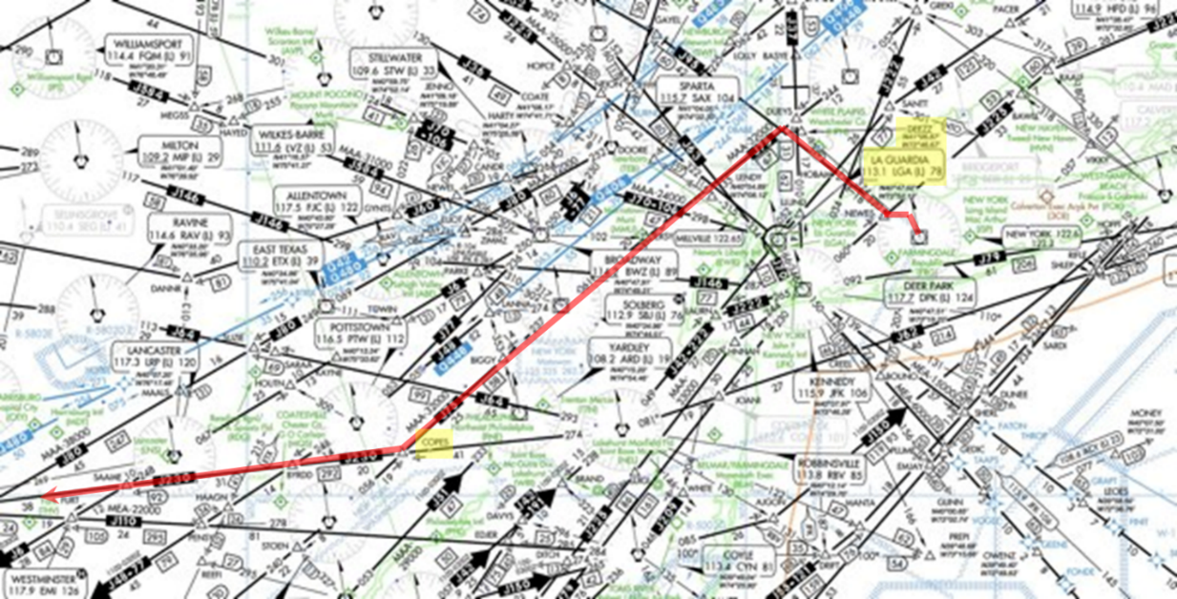
Figure V. Airways over New York.
Adapted from “Chart Supplement – Northeast U.S. (AFDNE)” by the Federal Aviation Administration (2016b). Published by the Department of Transportation.

The black lines indicate airways. The navigational aids and intersections are indicated by the shape corresponding with their type and are individually named (expanded below). A pilot leaving from La Guardia to the West (red highlight) would file a clearance request as follows:
Dep LGA, Newes (entering intersection), J95 (airway), Deetz (exit intersection), J75 (new airway), Coper (exit intersection), J230 (new airway)…
The dispatcher and/or pilot would continue that clearance request all the way to the destination. One challenge with airways is that they force traffic to closer proximities when volumes of open airspace stay unused (Curtis, 2016b). Figure VI is a snapshot of the air traffic over the United Kingdom. Airplanes landing at London-Heathrow Airport must merge onto the applicable airway, and just like an automobile traffic jam when a lane is blocked, aircraft must reduce airspeed down to the fastest possible speed of the slowest aircraft.

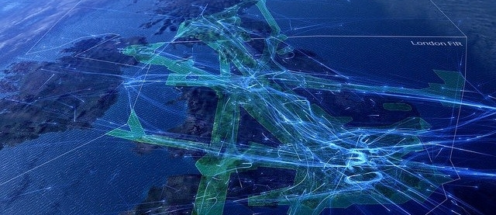
Figure VI. Airways in Operation over the United Kingdom
Adapted from “More need than ever to create an airspace policy for the future” by D. Curtis (2016b). Copyright 2016 by the National Air Transportation Service in London, England.

The same is observed for all other busy airports (e.g., O’Hare, Hartsfield-Jackson, Frankfurt, Washington Dulles, etc.). Efficiency is clearly lost in routing, but also in inhibiting aircraft from flying at their maximum endurance airspeed. Maximum endurance airspeed is the velocity at which an aircraft will stay aloft for the longest time (most fuel-efficient). It is calculated by factoring ambient air pressure, gross weight, altitude, engine properties, and drag profile, so it changes as fuel burns off and as areas of different air pressures are traversed. In some situations, airways can become an aircraft performance limitation issue when the maximum velocity of the slowest aircraft is not high enough to keep larger aircraft airborne.
Figure VII shows an example comparing airway routing with direct routing where each star indicates a required in-flight checkpoint. The lines between the checkpoints represent the route of flight.

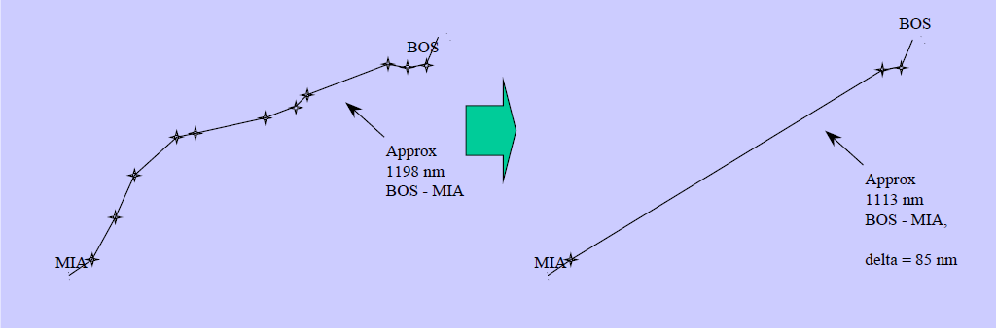
Figure VII. Airway vs. Direct Routing Comparison.
Adapted from “Required Navigation Performance (RNP) and Area Navigation (RNAV)” by The Boeing Company (2000), Copyright 2017 by The Boeing Company.

This comparison shows clearly how airway routing between Boston and Miami adds 85 otherwise unnecessary nautical miles to the flight (The Boeing Company, 2000). Figure VII is just one example of the potential savings in one medium range flight. In aggregate, with thousands of flights launching daily, those savings stack exponentially.
Navigational Aids (NAVAIDS) form the framework of the airway system. They are an assortment of ground-based, radio beacon, Very High Frequency Omni-directional Range (VOR) transmitters and related technologies, Non-Directional Beacons, Distance Measuring Equipment, etc. positioned all over the world. Pilots use the NAVAIDS to navigate along an airway, as ATC checkpoints, and to determine the aircraft position. They produce a means of complex triangulation. Since no VOR technology in use can indicate the distance to or from a particular NAVAID, the pilot must calculate the radial he/she is on relative to one NAVAID, then switch frequencies to a second NAVAID and determine what radial he/she is on relative to that NAVAID. The point at which those two radials cross is where the aircraft was when he/she started this triangulation. It is always an estimation since the aircraft is constantly in motion. Figure VIII shows a simplified example of aeronautical triangulation. This process becomes very complicated around the landing airport where speed and precision are required.

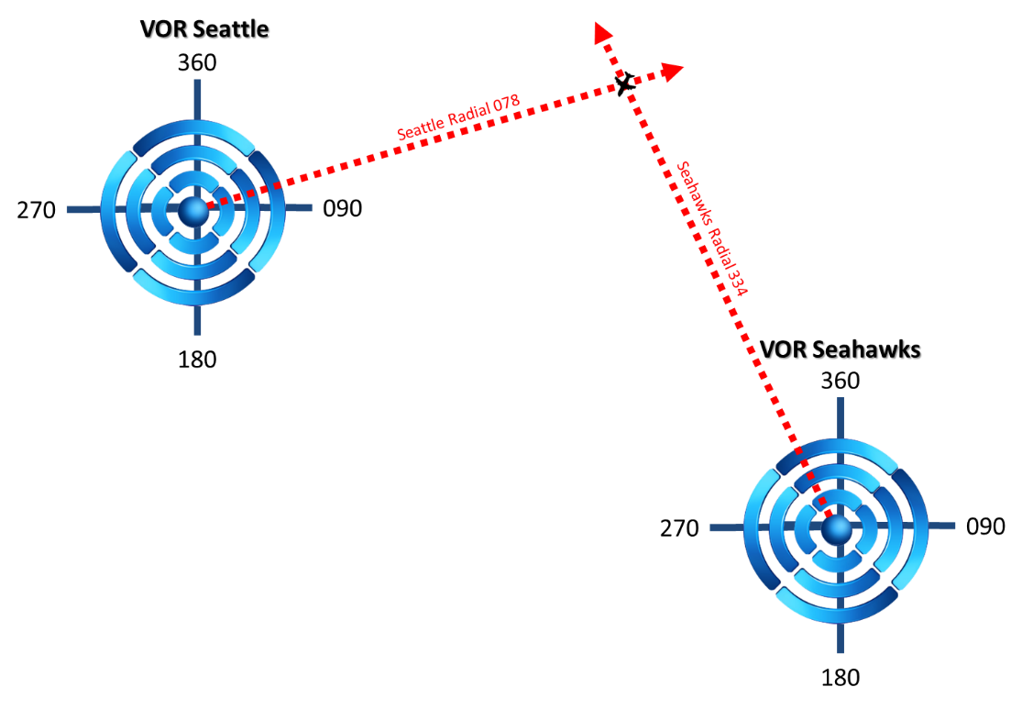
Figure VIII. Simplified Example of Triangulation using NAVAIDs

Very High Frequency Omni-directional Range (VOR) technology is unreliable and inaccurate. Radial indicator jumps of 20° or more and directional indicator diversions of plus or minus 10° are so commonplace that a pilot learns to interpolate his/her actual position based on the quirks of the individual aircraft’s navigation package and/or how well each individual NAVAID functions (Greving, 2000). In addition, interference from ground structures also affect NAVAID accuracy (Greving, 2000).
It is estimated that annually each of the 1,957 stations cost about $3 million when including equipment, land acquisition, installation, and operating costs (Esler, 2009; Federal Aviation Administration, 2017d; James, 2007). That may not sound like very much, but consider this: the technology that will replace these airway uses intangible points in space rather than ground-based beacon facilities, and they have an operating cost of $0.00 (Federal Aviation Administration, 2016d) (see Required Navigation Performance (RNP); p.51).

Route Planning
Since the Earth approximates the shape of a slightly oblate ellipsoid, the optimal routing thereon is best calculated with non-Euclidean geometry by orthodromic distance (Gauss, 1827), resulting in a geodesic-line rather than a straight-line. “Orthodromic” can be cumbersome in use, so it is commonly referred to as “great circle routing.” Figure IX is one example.

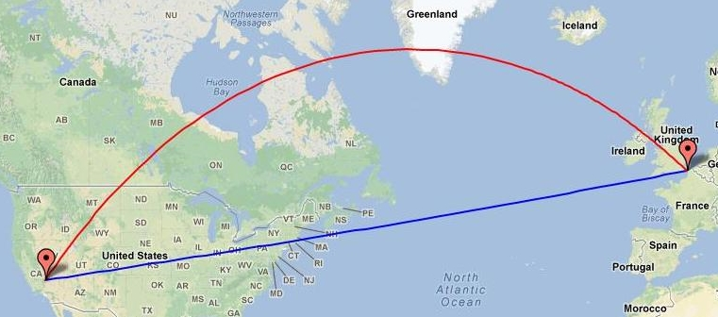
Figure IX. Los Angeles to London Straight-Line Route and Geodesic-Line Route Comparison
Adapted from “Los Angeles to London” by Google Inc. (2017). Copyright 2017 by Google Inc.

In Figure IX, a straight-line route takes the aircraft from Los Angeles right through the Midwest and New England before landing in London; while the great circle routing clears the Northeast entirely and even crosses southern Greenland and Northern Ireland before arriving in London (Google Inc., 2017). On a Mercator map, as used in Figure IX, the great circle route looks considerably longer; but if that same route is depicted on an orthographic or gnomonic projection, it is clear that the great circle route is shorter. The difference in distance-traveled between airway and great circle routing grows in magnitude the further the departure city is from the arrival city. The route from Los Angeles to London route is displayed on different map projections in Figure X.

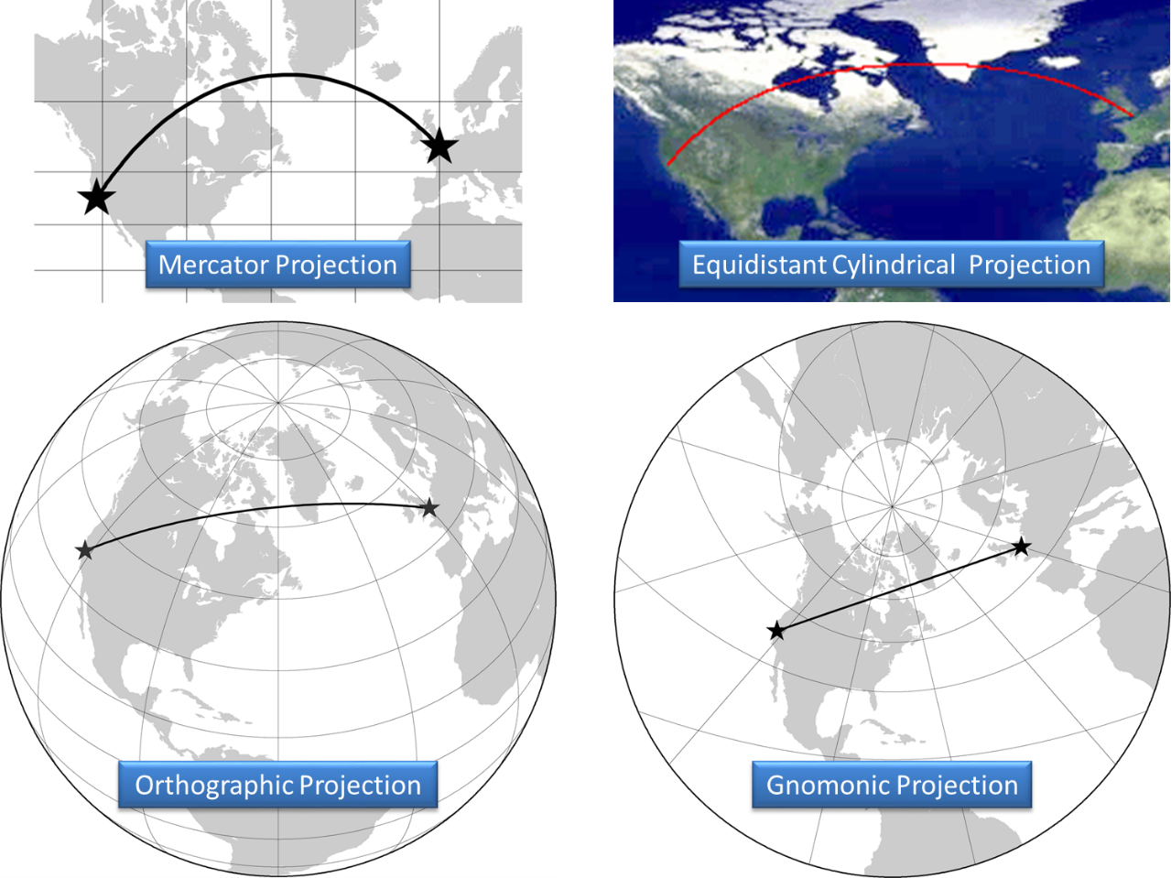
Figure X. Los Angeles, California, USA to London, England Routing Projection Comparison
Adapted from “Plot a Great Circle on a Flat Map” by S. Erle, R. Gibson, & I. Walsh (2013). Copyright 2013 by Flilib.com.

For simplicity, shorter routes are usually depicted in straight-line segments while long haul flights are typically shown as an approximation of great circle routing. The “great circle” concept, however, applies to all flights, no matter how short. The conflict is that the airways all around the world were not designed for great circle flying. They are all straight-line routes, and these deviations from the optimum simply for the sake of staying on an air route burns extra fuel and ultimately costs the consumer unnecessary time and money.

Navigation
Compasses do not point due north. They really point to the little research station of Fort Conger in the Nunavut province of Canada: seasonal population of two to four (George, 2000). The following sections will describe why that is.
Due to the earth’s 11-degree tilt, the Chandler wobble in its rotation, and because magnetic north is a function of its molten core, the indication of magnetic north is subject to fluctuations (Zell, 2015). This is known as the Dynamo Effect (Wilson, 2017). From about 1831 on (National Oceanic and Atmospheric Administration, 2010), magnetic north has been gradually moving away from North America towards Siberia at around 40 kilometers per year (Lovett, 2009). The path of magnetic north over the centuries is shown in Figure XI.
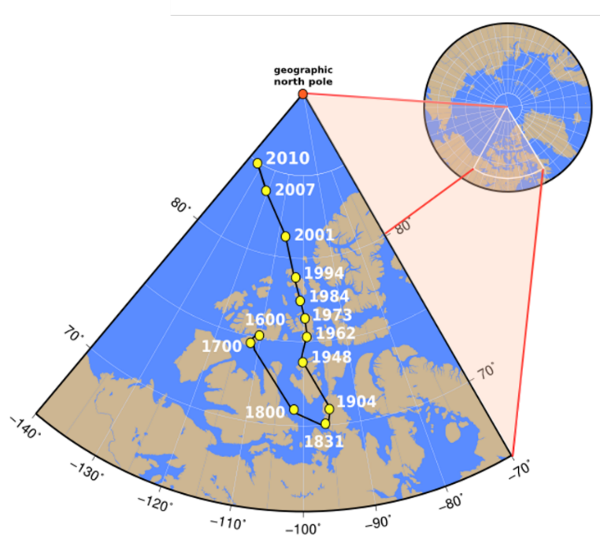
Figure XI. Movement of the Magnetic North Pole 1600-2010
. Adapted from “Movement of the Magnetic North Pole 1600-2010” by The National Oceanic and Atmospheric Administration (2010)

To make azimuth readings on a compass relevant to the North Pole (true north), the user must make the appropriate compass correction. This is applicable to any activity requiring a compass, such as nautical operations or land navigation. The magnitude of the correction depends entirely on where the user happens to be at the time he/she takes measure (United States Geological Survey, 2017). Figure XII shows the corrections necessary to match magnetic north to true north across the U.S. They are called lines of magnetic declination. Whatever the value of the line of magnetic declination is at the point at which one happens to be is equivalent to the number of degrees correction necessary for a compass to indicate true north.

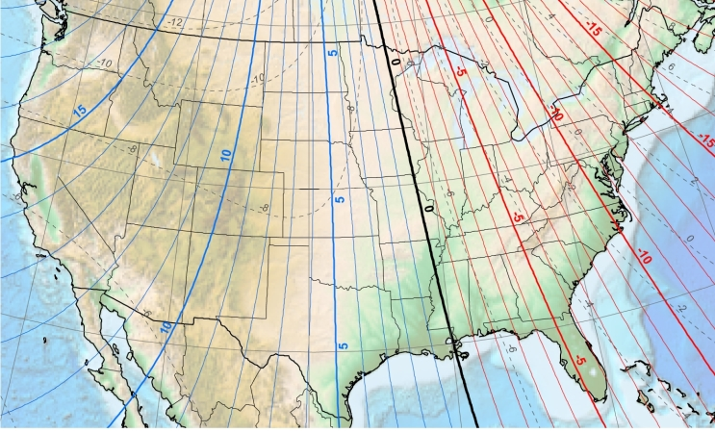
Figure XII. United States Magnetic Declination Map.
Adapted from “How to Use a Compass with a USGS Topographic Map” by the U.S. Geological Survey (2017), U.S. Department of the Interior, Washington D.C.
Note. It will later be helpful to compare this figure with Figure XIII.

These compass corrections are not a challenge in nautical and land navigation, but in aviation, the distances and velocities involved make compass adjustments a constant duty. Figure XII shows that there is a line with no magnetic declination, known as an Agonic Line, in the U.S. approximating the path of the Mississippi River. To compensate for magnetic declination for a flight heading eastbound from the Mississippi River, pilots will progressively adjust their compass backwards (clockwise) to 5° as they cross into Ohio, continuing to 8° as they cross into Pennsylvania, and so forth. The opposite is true for flights heading westward except the pilot will adjust the compass forward (counter clockwise) the appropriate degrees as the flight proceeds. These adjustments are necessary because area navigation is only accurate to the 360° of a circle. The flight safety concerns notwithstanding, without the 15° to 17° correction in Oregon, pilots could miss Portland International Airport (PDX) entirely, and depending on where that flight started, might not even see PDX until they approach the coast and follow it north into Portland. Worse than that, pilots may mistake Vancouver, Washington for Portland, causing chaos for Vancouver air traffic. In this case, 15° off-course is around a 5% tracking error that compounds the longer pilots are off course. There are places where magnetic declination can be as much as 180° (British Geological Survey Natural Environment Research Council, 2015). That is a 50% track error or in other words, the difference between due-north and due-south.
Complicating navigation in the northern hemisphere even further is a large iron deposit on Ellesmere Island in Canada. Earth’s magnetic field is relatively weak, ranging from 0.25 to 0.65 gauss (Finlay, et al., 2010; Savage, 2013). For comparison, the strength of a typical refrigerator magnet is 50 gauss (Smith, 2011). A magnetic resonance imaging machine will create a magnetic field of around 20 kilogauss or 20,000 gauss (Smith, 2011; Savage, 2013); and in searching for the Higgs boson, the Large Hadron Collider produced a magnetic field of 84 kilogauss (84,000 gauss) (Savage, 2013). Since the magnetic field of Earth is so weak, all navigation that is a function of that magnetic field is subject to interference. A large iron deposit in northern Canada is certainly one consideration. Left uncorrected, a compass will point to what is called the “Geomagnetic North Pole.” Figure XIII represents how magnetic interference develops from its various sources around the world.

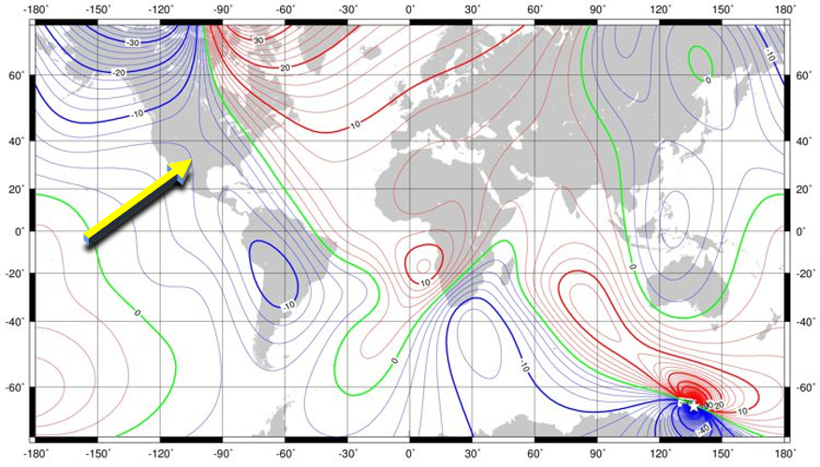
Figure XIII. Global Magnetic Declination Map
Adapted from “World Magnetic Model” by the British Geological Survey Natural Environment Research Council, (2015)

Comparing Figure XII with Figure XIII, the lines of declination in the United States form a gap around the Texas/Oklahoma area. Following this gap south, the source of the push is revealed with an epicenter somewhere in Bolivia. This particular source of magnetic interference is called the “South American Anomaly” (SAA) according to Goguitchaichvili et al. (2015). It is the area above which the Van Allen Radiation Belt dips to its closest proximity to the Earth, about 250 kilometers (National Aeronautics and Space Administration, 2006). The SAA is just one cause of interference. Since magnetic flux lines bend and flex, the manifestation of declination is constantly changing. This illustrates the level of vulnerability a compass has to error from any number of interfering sources, including the aircraft’s own avionics package (Sikorsky Aircraft, 1994).
In all, there are four north poles: the Geographic North Pole, the Magnetic North Pole creeping towards Siberia, the Geomagnetic North Pole at Fort Conger, and the Instantaneous North Pole, which only changes from the perspective outside of the earth’s atmosphere and is thus not relevant in aviation navigation. Figure XIV shows the location of each of the remaining three as of 2016 (excluding the Instantaneous North Pole).

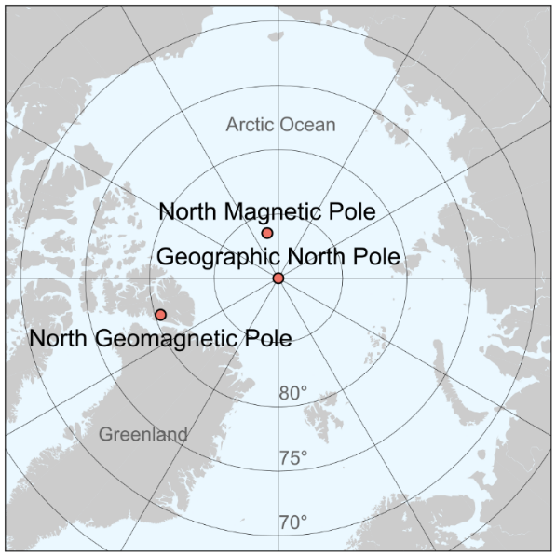
Figure XIV. Map of Earth's North Poles.
Adapted from “Magnetic North, Geomagnetic, and Magnetic Poles” by S.C. Kitashirakawa-Oiwake (2016).

As a final challenge to come, the Earth is overdue to flip magnetic polarities (Gohd, 2018). Once that happens, compasses that previously indicated the direction to the Magnetic North Pole will point to the Magnetic South Pole instead. The last time the Earth’s polarity flipped was about 780,000 years ago (Wilson, 2017). At a historical pattern of 200,000 to 300,000 years, the earth is now nearly 500,000 years late for the next reversal (Gohd, 2018). The location of the Geographic North Pole at any time is measured with respect to the surface of the Earth, and therefore stationary to all earthlings except any astronauts in space. The Geomagnetic North Pole is a function of interference on the Earth’s surface, and so is also stationary to everyone, excluding astronauts in space. However, the Magnetic North Pole, the one that matters, is a function of the Earth’s churning magnetic core. It is independent of the earth’s surface allowing it to wonder at a current pace of 40 kilometers a year and/or to switch polarities. It is not exactly clear how a global polar swap will affect compass navigation except that magnetic forces that are now working generally in tandem will then be opposed to each other.

Holding
If a landing traffic exceeds the airport’s landing capacity, the controller will send aircraft into a holding pattern to wait for sequencing. This is a procedure that requires a pilot to fly making a track in the shape of an oval over a specific area, usually a NAVAID. For a standard holding pattern (with no wind), the pilots will fly to the NAVAID on the specified radial. Once the pilots cross the NAVAID, the pilots will execute a 180° standard-rate turn (three degrees per second) to the right. At a standard-rate, it will take the aircraft one minute to turn 180°. The pilots will then level the wings and continue on the new heading, now flying away from the NAVAID, for one minute. After that minute, the pilots will execute another 180° standard-rate turn to the right. Now inbound to the NAVAID again, the pilot will fly direct to it on the specified radial. The pilot will again make a right turn 180°, and so on. The process is repeated until ATC clears the aircraft out of holding to make an approach to landing.
Figure XV shows the track of each aircraft holding pattern at London-Heathrow Airport. London-Heathrow is a good example because for a being relatively small airport, it takes a full quarter of all transatlantic flights (Curtis, 2016a) making it the busiest airport in Europe (National Air Transportation Service, 2017). That title comes at a cost, however. Scheduled arrivals at London-Heathrow comprise 98% of its landing capacity (Curtis, 2016a). A two percent buffer to absorb non-standard airport operations (e.g., delayed flights, bad weather, etc.) is not enough to maintain a seamless flow of landing aircraft. Pilots can therefore expect to take a few turns in holding any time they fly there.
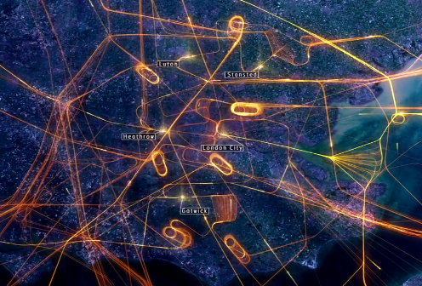
Figure XV. London-Heathrow Flight Tracks.
Adapted from “Is this the end of stack holding?” by D. Curtis (2016a), published by The National Air Traffic Service. London, England.

Air traffic controllers can vertically stack aircraft waiting to land in holding patterns, separated by 1000 feet of altitude. If ATC did not stack aircraft waiting to land, the distances necessary to accommodate such a situation would be so vast that orderly and efficient aircraft sequencing would be unsafe if not impossible. Figure XVI depicts a “stack holding” concept.

Figure XVI. Holding Stacks at London Heathrow.
Adapted from “Is this the end of stack holding?” by D. Curtis (2016a), published by The National Air Traffic Service. London, England.

Pilots in holding will typically assume a minimum drag configuration and maximum efficiency airspeed. Even with those measures, every turn in holding will still burn upwards of 330 kilograms of jet fuel (Airbus, 2004) or $35,300 US (Garvey, Salerno, & McMillin, 2017).

Step-Downs
Step-downs compensate for the inability of air traffic control to dynamically manage aircraft altitudes. Step-downs only work, however, by forfeiting all the potential benefits of being able to climb and descend. A step-down fix is any approach point identified by the FAA after which a descent to a lower altitude may be executed. A step-down fix may be any NAVAID or intersection of NAVAID radials (see Figure VIII, p.25). With step-downs, aircraft are managed as if they were convoys of semitrailers. At a terminal airport, all inbound traffic is lined up in a two-dimensional linear profile. This can be seen clearly at the Frankfurt International Airport (FRA). Along Autobahn 3 (Figure XVII), which happens to split the three FRA landing runways (runways 250 right to the north, 250 center, and 250 left to the south) looking out to the east of the airport, there are usually three lines of landing traffic spaced four to six nautical miles apart lengthwise with each aircraft stepping down in turn. During peak times, this line can be seen from the ground six or seven aircraft deep resembling a truck stop gas station backed up for miles and miles, as shown in Figure XVII.

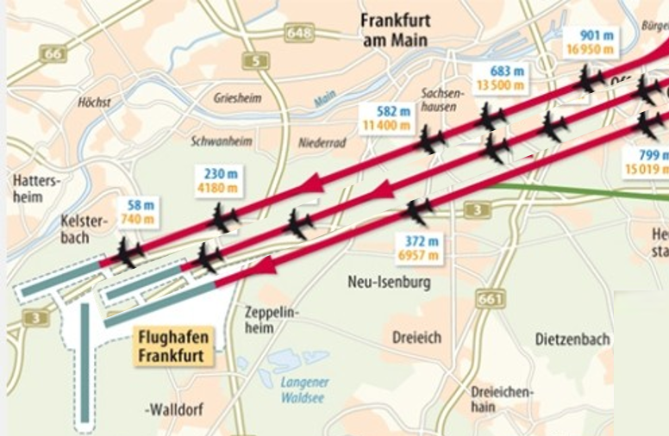
Figure XVII. Frankfurt am Main International Airport Runway Layout.
Adapted from “Vor dem Einflug gibst es kein Entrinnen” by J. Remmert, and H. Schwan (2012) in the Frankfurter Allgemein in Frankfurt Rhein-Main, Germany.

Figure XVIII is a good example of the step-down concept in the approaches for Runway 15 in Baltimore, Maryland.

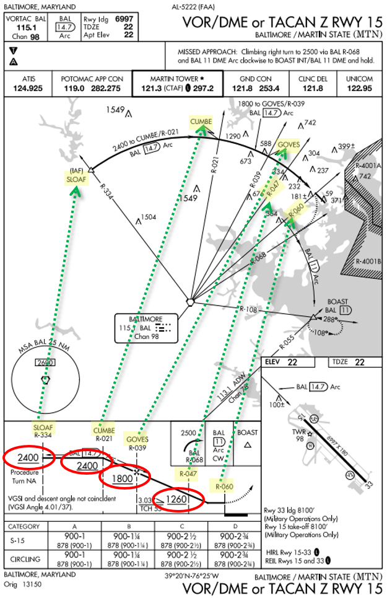
Figure XVIII. Step-Down Approach Example
. Adapted from “Northeast U.S. Terminal Procedures Publication Volume 3 of 4” by the Federal Aviation Administration, (2017x), published by the U.S. Department of Transportation in Washington D.C.

The different altitudes indicate the minimum pilots must maintain, and at which point they may descend further. In this example, pilots may not descend below 2400 feet until crossing Cumbe. Only then may they descend, but not lower than 1800 feet until crossing Goves, and so on until landing. Approaches can be as simple as one step-down, or like at Wiesbaden Army Airfield in Germany, as complicated as five or six step-downs depending on which direction the airport is landing traffic (Zimmerman, 2013).
For a descending plane to arrest its descent at each step-down, the pilot must apply thrust. A byproduct of applying thrust is increased velocity, but in the landing phase of flight, an increase in velocity is not wanted. To mitigate the increase of velocity, the pilot will set the flight controls to create drag. An airplane on approach must arrest its descending momentum at each step-down with the production of lift, while remaining slow enough to land. This creates an oscillation of power demand: Decrease power to descend to the minimum altitude, increase power to arrest the rate of descent at the new altitude, increase drag to maintain velocity, decrease power to maintain altitude, decrease power again at the next fix to descend, increase power to arrest the rate of descent at the new altitude, and so on.
Circling back to airway route planning and flight efficiency, a perfect great circle route is the objective of any commercial route planner. Deviation from that path, be it from airway restrictions, navigation error from false compass readings, extra route length tacked on in holding, or unnecessary ascents and descents, is a point of inefficiency that in aggregate, costs time and money ultimately burdened by the consumer. Fortunately, the NextGen upgrades include two technologies that will allow aviation to break away from magnetic-based navigation. These are Trajectory Based Operations (TBO) and Required Navigation Performance (RNP) Airspace. Both are detailed below.

Voice Communication
If aircraft are the muscle of the ATM system, then voice communication is its heartbeat. A plane does not take off, taxi, or even pull from the gate until permission is given from the controller responsible for movement in that area. The sheer size of the aircraft and the mortal and financial cost of errors require this level of security. En-route and terminal operations inherently have an added emphasis since an aircraft cannot stop in the air. Current voice communication technology has a limited capacity and congested areas are having trouble keeping a steady flow of safe operations because of it (Curtis, 2016b). Before the 1950’s, a whole crew position was dedicated exclusively to radio communication (Higham, 2003).
Prior to doing anything with the aircraft, the pilot must communicate with ATC. This transmission must be understood and acknowledged by ATC with a following transmission of instructions. A third transmission to acknowledge those instructions is made by the pilot by reading back those instructions. ATC must listen to the read back for any errors. If there are none, the communication exchange would then end. If there was an error, the exchange would start all over again. Some typical examples are as follows:
- Pilot call to enter airspace \ ATC response with instructions \ Pilot read-back of instructions (repeated every time the aircraft enters a new ATC area of responsibility)
- Pilot call with request \ ATC acknowledgement \ Pilot communicates request \ ATC acknowledges request \ ATC checks to ensure request is safely possible and advisable \ ATC denies request or issues new instructions to accommodate request \ Pilot read-back of instructions.
- Pilot call to declare emergency \ ATC response (repeated with many back and forth transmissions and the suspension of all other calls).
Certain information is required to be read back to ensure the accuracy of the relay of information. In the United Kingdom, ground taxi, altitude, heading, and airspeed instructions as well as route clearances, approach clearances, runway-in-use, runway actions, transponder operations, altimeter settings, type of RADAR service, and transition altitudes are all required to be read back by the pilot to ensure correct comprehension (Checkflight International, 2008). In the United States, pilots are also required to read back communication frequency instructions. If any transmissions were misheard, misread, or are otherwise wrong, the process must start all over again while everyone else must wait to attempt their own communication exchange.
Very High Frequency (VHF) communication in aviation operates in what is called a “simplex configuration,” meaning the users can either transmit or receive, but they cannot do both simultaneously as with a telephone (Rouse, 2017). In addition, only one party can transmit at a time. If two or more users attempt to transmit at the same time on the same frequency, neither one will be heard. Rather, a garbled mixture of guttural sounds underlying a high-pitch squelch will be heard by everyone on that frequency, except for the two transmitters, ironically enough. This is called being “stepped-on,” and it happens all the time. VHF radios have a finite range. A pilot may be in range to receive the ATC tower transmissions and at the same time unable to receive those of another pilot. The pilot would not hear the other pilot’s transmission to the tower and would therefore disrupt the communication with his/her own. Figure XIX is a simplified diagram that shows how the paradox of disrupting a conversation one cannot hear is possible.

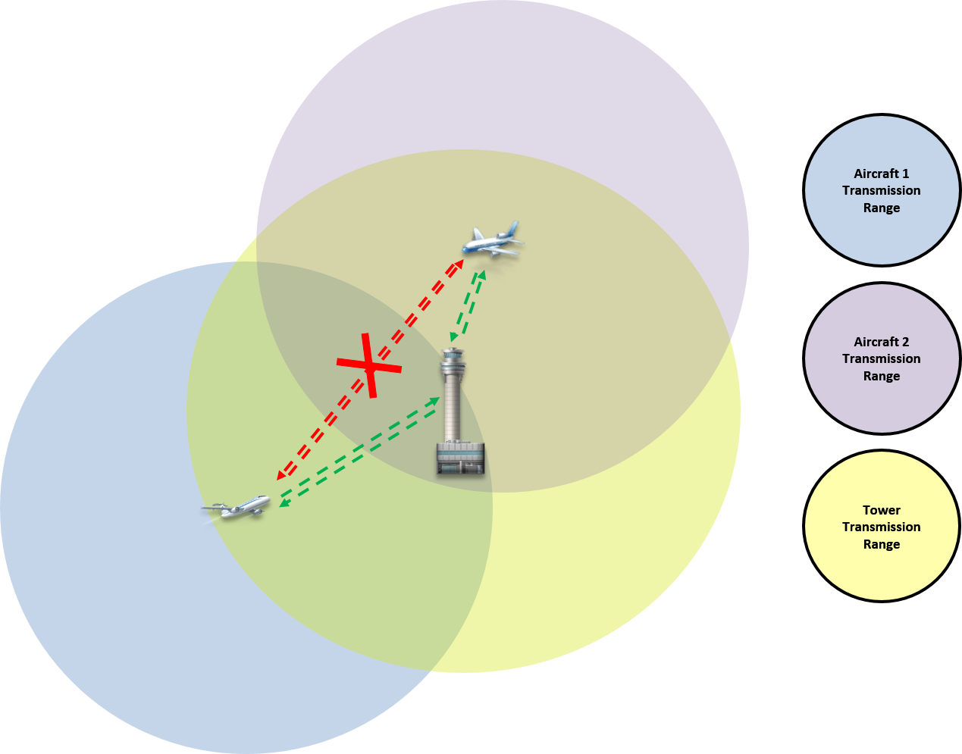
Figure XIX. Transmission Range Overlap Diagram

Air traffic controllers are continually giving instruction, de-conflicting aircraft, and acknowledging new traffic, etc. They are typically at maximum capacity. Controllers simply cannot speak any faster. It is projected that, VHF demand over Europe will eclipse any possible ATC configuration using the incumbent system (Curtis, 2016b; Star Project, 2006). When that happens, growth will be stalled until a more efficient technology or process is adopted (National Air Transportation Service, 2016a).
For obvious reasons, there cannot be more than one controller in charge of an ATC area of responsibility. A solution then, one might say, is to add more controllers and break down the congested area of responsibility. The problem with adding more controllers is, by current protocol, an aircraft would need to be handed off as it left the airspace of one air traffic controller for the airspace of a different controller. That would consist of a set of instructions including change of radio frequency and resulting read back requirement with the controller being left, and an initial radio call to the next controller with resulting acknowledgement and list of information (altimeter settings, wind strength and direction, etc.). In short, adding more controllers increases radio traffic by six transmissions per controller for every aircraft, at best case.
Errors in ATM are serious in that so many lives are at stake. Each mistake, misjudgment, or false assumption could result in tragedy, especially in terminal-area operations where precision is required. ATC supervisors are required to report operational errors (OEs) by mandate of the National Transportation Safety Board (NTSB) (Pape, Weigmann, & Shappell, 2013). In the fiscal year of 2006, United States air traffic controllers tallied 713 OEs (Jackovics, 2008). This figure encompasses some other technical errors that are not the fault of a controller. However, it is at least mirrored if not doubled, by pilot operational errors, which are not reliably tracked. A comprehensive study of OEs in air traffic control sponsored by the FAA was conducted at the end of 2005. It reviewed the 5,011 OE reports filed in America between 1998 and 2002 to categorize them and propose solutions to the reoccurring problems. Of those OEs reviewed, 1,486 were listed as communication error, 1,205 were listed as a failure to comprehend, and 239 were listed as misidentification errors. Of the errors centered on aircraft observation towers only, 721 or one third of the OEs reported involved actual observation of the aircraft (Scarborough, Bailey, & Pounds, 2005).
In practice, voice communication is unreliable, slow, and unclear. One of the main goals of the ATM upgrade to NextGen is to relieve the necessity of voice traffic except in non-standard communication. All routine voice transmissions will move to the Controller-Pilot-Data-Communication system, similar to a text message (Esler, 2009) (see Controller to Pilot Data Link Communication (CPDLC); p.47).
The examples above illustrate how the incumbent ATM system has outlived its usefulness and is functioning beyond its capacity. Consistently operating beyond capacity reduces efficiency, productivity, and creates stagnation. Stagnation and congestion create delay and delay creates waste (Gesell & Dempsey, 2005)

The Next Step Forward
These days in air transport aviation, there has been a lull in the news related to the financial concerns of the passenger. The reports of high baggage charges (Hobica, 2013), fuel surcharges (Muoio, 2016), September 11th security fees, domestic passenger taxes, domestic flight segment taxes, international departure taxes, and passenger facility charges, among others (McGee, 2015) that were commonplace in the news cycle just a few years ago have been replaced with reports on aviation accidents such as Germanwings 9525 in Germany, Egypt Air 804 in the Mediterranean Sea, Korean Air 2708 in Tokyo, etc. and various forms of passenger abuse (Fischer, 2017; Victor & Stevens, 2017). The acceptance of collective travel charges may be attributed to the egregious nature of airplane accidents since new cycles allow for only minimal headlines at a time; or it may be because time and exposure are directly related to a public sense of normalcy (see the section on Changing Population Attitude, p.71).
In terms of speed, there is yet no alternative to air travel. There is a segment of the population that will always travel by air with the expectation that the cost of travel will be absorbed by the value of the business conducted. However, the price elasticity of demand of short-haul, leisure air travel is the highest of all other air travel by a significant margin (Johnston, 2015). The expected 5 to 7% growth rate of aviation demand (International Aviation Transport Association, 2016) notwithstanding, as the incumbent ATM system described in The Legacy Air Traffic Management (ATM) System (p.19) is phased out and those resulting efficiencies are realized, operating costs will decrease leading to a reflective increase in demand (Department of Finance, 2008).
The United States is undergoing a major overhaul in ATM. Nearly every aspect of flight operations is being upgraded (Karp, 2009). This presents an opportunity to incorporate the concept of RPA operations and to design the application of new systems around that idea, rather than to try merging them piecemeal later. The substantive cost reductions and high elasticity of demand of leisure air travel present the possibility to dramatically increase air travel utilization. A natural by-product of increased efficiency in air travel is a reduction of operational costs and environmental consequences. These elements have the potential to move RPA further into the mainstream discussion. In addition, a positive effect on e-commerce and other goods transported by air will manifest to stimulate local and national economies worth an estimated $40 billion (Wilson, 2010). In 2008, implementation by progressive steps of the NextGen of ATM equipment began its 17-year journey to fully-up-and- status (Esler, 2009). The following section will be broken down by the new technologies: Controller to Pilot Data Link Communication (CPDLC), Required Navigational Performance (RNP) airspace, and Trajectory Based Operations (TBO).

Controller to Pilot Data Link Communication (CPDLC)
Supplementing voice communication is Controller to Pilot Data Link Communication (CPDLC), a major element of the NextGen upgrade. It is a technology designed to directly alleviate routine voice communication. Instead, CPDLC will connect aircraft and ATC. The ATC clearances frequencies and other communications will be transmitted to aircraft in the form similar to a text message. It is non-verbal in nature. It begins with a ground computer that will coordinate flights from departure gate, to en-route, to arrival gate (Esler, 2009). The pilot and dispatcher will review the computer-generated route that considers weather forecasts, jet streams, temporarily closed airspace, etc. The pilot and dispatcher will submit that flight plan, which states their preferred routing. This flight plan will either be accepted by ATC or returned with appropriate changes. The pilot and dispatcher will confirm the changes or propose an alternate route. It will be from this flight plan where the ATM system will understand the pilot’s specific intentions throughout the flight. These intentions can be changed along the way should an operational, equipment, or crew change become necessary. The ATM system would then sequence the aircraft into the air traffic with its new route and/or new destination in a way that would create minimal conflict based on the supposition that the earlier a course correction is made, the less intensive that correction must be. There may be cases when a route change would come from ATC. A runway closure may be necessary, another aircraft with an emergency may need priority, or an unexpected weather system may have developed. The routes of all aircraft that would be affected would be updated (Esler, 2009). This is particularly useful to the air traffic controllers as all routine communication regarding the necessary changes in heading, airspeed, or altitude would be passed from ATC to the Flight Management System (FMS) of all other air traffic aloft automatically and in unison (Esler, 2009) instead of the one-at-a-time manner this is done today. Course corrections or alterations can be executed automatically by interactions between the FMS and ATC without pilot to ATC voice communication. Voice communication will always be available for non-routine necessities, but with CPDLC, ATC can defuse periods of intensity by front-loading instructions during low stress times and be assured that pilots will accurately understand and can review those instructions at any time.

Automatic Dependent Surveillance – Broadcast (ADS-B)
In a fully functional Automatic Dependent Surveillance-Broadcast (ADS-B) airspace environment, aircraft will automatically and actively report to the ATM system, rather than being observed by ground-based surveillance. Aircraft will report once every three seconds, as opposed to being seen once every twelve and a half seconds as is the case with legacy RADAR. From the ATC point of view, with a flight plan submitted and approved (with that aircraft reporting every three seconds) at any given time, the ATM system will know where that aircraft is within 0.3 nautical mile accuracy, what its intentions are, and where it will be at any time in the future of the flight with a high degree of accuracy (Koros, Scollenberger, & Della Rocco, 2007). This accuracy leads to a significant advance in predictability. So much so that the new ATM system will change the Estimated Time of Arrival (ETA) to the Controlled or Required Time of Arrival (RTA) at a given initial approach fix. The level of predictability is expected to be so much improved that pilots will be sequenced into arrival before their flight even takes off from a given departure airport. “You might get a Twitter message from the tower on your mobile phone” (Esler, 2009, p. 2). This message could be sent to pilots while they are relaxing in the pilot’s lounge long before their departure. It would tell the exact ground taxi time, thus allowing flight crew and ground crew to back plan accordingly. This utopia of air travel might include a zero- or takeoff-time, and a perfectly sequenced landing direct to their reserved gate at their destination (Esler, 2009). This concept will result in millions of dollars saved in fuel costs and likewise reduced carbon dioxide (CO₂) and nitrogen oxide (NOx) emissions in ground taxi line-up sequencing time alone (Keahiolalo, Walton, & Rosenhammer, 2011).
An added benefit to ADS-B is the air-to-air visibility. Since an aircraft is already broadcasting its position to ATC, other aircraft will also be able to “see” that aircraft on their respective cockpit displays. This is a vast safety improvement in that with this technology, pilots no longer must imagine the air traffic picture around them using only the one-at-a-time transmissions over a frequency modulating (FM) radio (see section on Voice Communication, p.41).
With ADS-B, the air traffic situation will be displayed for each pilot in real time. Further, responsibility for aircraft separation will be handed off, in part, to the aircraft themselves (Esler, 2009). Meaning that more than position, but also intentions will be transmitted between aircraft. If a conflict is foreseen or more accurately fore-calculated, the airplanes in question will be able to communicate with each other and each divert away from the conflict in coordination. This may be a matter of one plane reducing airspeed by a fraction of a knot or mutual 0.1 degree turns 10 nautical miles out instead of 30-degree banks at one nautical mile out. This is a considerable improvement from the “red-on-right-is-wrong” rule. Once an aircraft is determined to be closing, the pilot could never be sure if the other pilot knows the “go–right” rule. This advance will be particularly useful at night when it is difficult if not impossible to determine if an aircraft on the same track and altitude is converging or not. Tragedy has struck before when the converging pilots maneuvered into each other instead of each making right turns. With a constant feed of real-time data, aircraft may maneuver away from potential hazards (e.g., inclement weather, other aircraft, turbulence, etc.) long before those hazards are even seen by the pilot in the aircraft. Figure XX shows the general communication exchange between ATC, aircraft in flight and satellites.

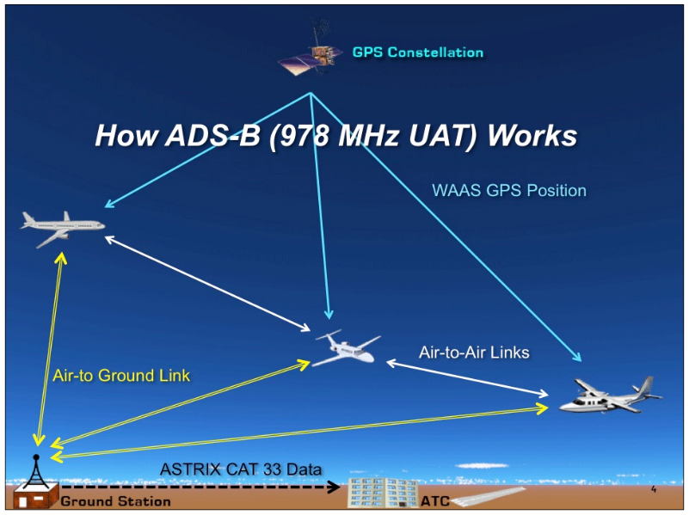
Figure XX. Controller to Pilot Data Link
. Communication Heuristic. Adapted with permission from “How ADS-B (978 MHz UAT) Works” by ADS-B Technologies LLC (2016).

Required Navigation Performance (RNP)
Required Navigation Performance (RNP) airspace is a rating requirement to enter airspace designated for airline air transport. The rating specifies the Total System Error (TSE) by phase of flight (Koros, Scollenberger, & Della Rocco, 2007). For example, RNP-2 requires that an aircraft must be able to navigate no more than two nautical miles deviant from the intended course for 95% of the flight time. Within the United States, the new RNP scheme is as follows: RNP-2 for ATM en-route airspace, RNP-1 for terminal or airport areas, and RNP-0.3 for aircraft on approach. Figure XXI shows a comparison of the en-route error of the RNP and Area Navigation (RNAV) Global Positioning Satellite (GPS) system versus the incumbent RADAR and VOR navigation.

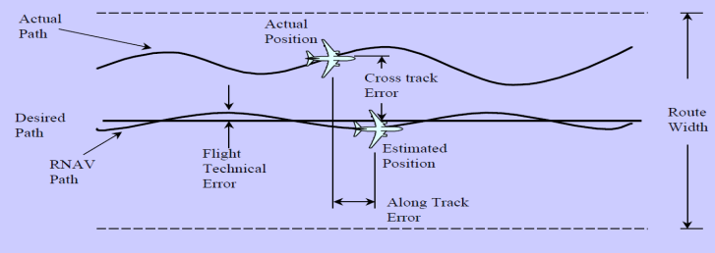
Figure XXI. Actual Aircraft Course Related to Desired Course
. Adapted from “Required Navigation Performance (RNP) and Area Navigation (RNAV)” by the Boeing Company (2000).

By tightening the navigation error of aircraft, more capacity can be drawn from the open skies. Aircraft may confidently fly closer together without fear of collision and utilize that wasted space described in RADAR (p.19) as shown in Figure XXII.
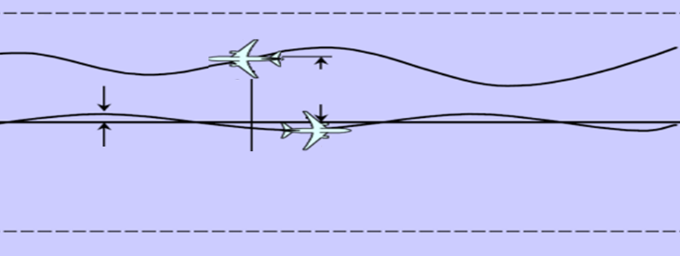
Figure XXII. Figurative Reduction in Flight Separation Tolerance En Route
. Adapted from “Required Navigation Performance (RNP) and Area Navigation (RNAV)” by the Boeing Company (2000).

Another application of the increased accuracy of flights en-route is inclement weather operations. At the San Francisco International Airport (SFO), there are two inbound runways. Under Instrument Flight Rules (IFR), SFO must merge both lines of inbound traffic to one stream. This is due to the margin of error of the landing system at SFO: it cannot comply with the FAA’s standard for Simultaneous Offset Instrument Approaches (SOIA) (Federal Aviation Administration, 2016e). SOIA is a configuration that allows an airport to utilize parallel runways in IFR conditions as long as certain parameters are met (i.e., equipment margin of error, redundancy, etc.). RNP approach minimums at SFO using RNAV tools will allow SFO to move into SOIA configuration with less complication and with equipment already in place (Koros, Scollenberger, & Della Rocco, 2007), effectively doubling SFO’s IFR takeoff and landing capacity. In other words, the inaccuracy of the landing system at SFO will be compensated for by the accuracy of the future aircraft’s own navigation system.

Trajectory Based Operations (TBO)
So far, aviation operations have been addressed in two dimensions in this research paper. However, the beauty of aviation is that third dimension, altitude. With the correct utilization the fourth dimension, time, the maximization of aircraft/airspace operations may be realized in Trajectory Based Operations (TBO). So profound is this improvement that the author of this research investigation is certain it will lead to a drastic redesign of aircraft from the wing-and-hotdog design of aircraft currently in use to some approximation of a delta-wing design. A comparison is shown in Figure XXIII. The concept of TBO will be put to use long before that redesign is fielded because the benefits of TBO can be realized with any airliner.

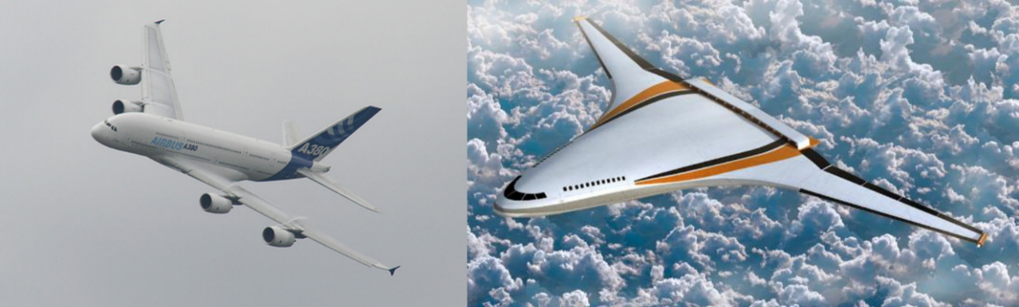
Figure XXIII. Aircraft Design Comparison

Continuous Climb Departure (CCD).
With TBO, aircraft will simply ascend at its most efficient rate of climb to its optimum cruising altitude, called a Continuous Climb Departure (CCD) (Wilson, 2010). The pilot will have the freedom to climb or descend or change any number of flight characteristics that may be desirable (Esler, 2009). There may be head winds, turbulence to avoid, or a jet stream to benefit from. As an aircraft burns fuel, it becomes lighter. It is of considerable benefit for the pilot to climb to a higher or descend to a lower altitude in order to maximize the best air pressure, wind, and drag factors as the flight progresses. Currently, an aircraft is locked into maintaining an altitude unless the pilot requests or is instructed by ATC to change altitude (Esler, 2009). Such a change is required to be made at a 500 foot per minute rate of climb, if the aircraft is able to do so, which may or may not be the most efficient climb rate for a given aircraft.

Continuous Descent Arrival (CDA).
With TBO, a pilot will be free to fly direct to the airport without having to fly the extra miles to line up and descend by step-downs. Upon nearing the terminal area of the desired airport, a pilot will execute a Continuous Descent Approach (CDA) when appropriate. As the name implies, an aircraft will maintain a consistent controlled dive from initial descent to touchdown on the runway (Esler, 2009).
The advantage of the CDA is twofold: Simplicity and cost savings. Less complexity leads to less stress, leads to less mistakes, leads to safer operations. In addition, CDAs burn much less fuel. In Figure XXIV, the white track is a test run comparison of a CDA at SFO. All other red tracks are the standard approach procedures into SFO over a twenty-four-hour period.

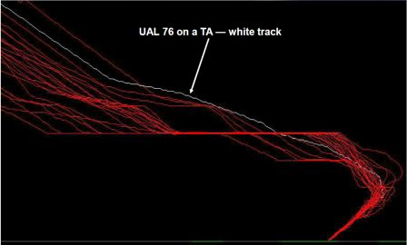
Figure XXIV. Continuous Descent Approach vs. RADAR Fix Approach Comparison
Adapted from “Trajectory Based Operations” by G. Hayman (2009) at the 300+CNS/ATM Conference, published by the Boeing Company.

In a CDA, pilots can bring their engines nearly to idle at altitude, and glide into landing since the only arrest of descent required through the approach is that at touchdown, where the earth is there to assist (Esler, 2009). This is a significant savings of all the fuel that would otherwise be used to step down progressively as described in Step-Downs (p.38)
In a fully implemented CDA airport, the line of six aircraft down the Autobahn 3 in FRA will likely not exist with all aircraft entering the approach course from many different angles and many different altitudes. Figure XXV is a depiction of how TBO will function.

Figure XXV. Example of Trajectory Based Operations
Adapted from “Trajectory Based Operations” by G. Hayman (2009) at the 300+CNS/ATM Conference, Copyright 2009 by the Boeing Company.

TBO vs. RADAR.
TBO is the FAA’s answer to the wasteful mandate of airway navigation (National Air Traffic Systems, 2016b) (see previous section on Airways, p.21) and stepdown approaches (see previous section in Step-Downs, p.38). With TBO, steps ascending and descending are eliminated. Since each ascent requires extra fuel burn and each descent requires still more fuel burn when arresting the rate of descent, TBO will significantly reduce fuel consumption (Wilson, 2010). In addition, TBO will reduce flight times. Shorter flights will result in greater utility of each aircraft and lead to an improvement in expense/revenue ratios. This will then help push down ticket prices for the public (Esler, 2009; Wilson, 2010).
The initial test for Trajectory Based Operations (TBO) was conducted with American Airlines, Delta Airlines, and the U.S. Air Force. Yielding fuel savings of 50 to 135 gallons for each CCD and 100 to 130 gallons for each CDA (Hayman, 2009). That is a staggering jump in efficiency considering that there were 8,727,691 flights from U.S.-based airlines in 2015 (Federal Aviation Administration, 2016a). That is around 1.3 billion gallons of unburned fuel. Other test runs of TBO were conducted under the Asia & South Pacific Initiative to Reduce Emissions (ASPIRE) program. These aircraft flew three routes in TBO profile from cities in Australia to cities in California. They recorded an average of 1,100 gallons, 3,212 gallons, and 1,564 gallons of fuel saved, respectively (Hayman, 2009), by simplifying how altitude is managed. Figure XXVI is a good representation of the difference between RADAR operations and TBO.

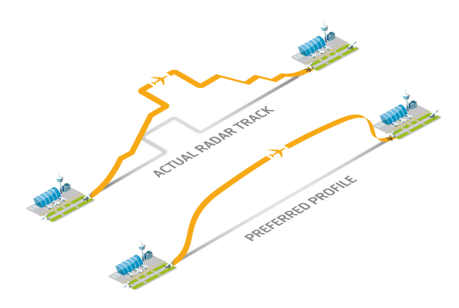
Figure XXVI. RADAR vs. Trajectory Based Operations (TBO)
Adapted from "Managing Real Time Fuel Efficiency" by National Air Traffic Systems (2016b) published by FloSys - Flight Optimization System.

Flight Time & Crew Rest
All flight crewmembers are subject to their individual positions’ duty limitations. Collectively, flight crewmembers are also subjected to flight hour limitations for the specific concern of combating crew fatigue (Federal Aviation Administration, 2017d; Federal Aviation Administration, 2017i). As a baseline, no flight crewmember may be scheduled over 1,000 flight-hours in any calendar year, 100 flight-hours in any calendar month, 30 hours in any seven consecutive days, nor may a crewmember be scheduled less than 8 hours rest between any shift period (Federal Aviation Administration, 2017i).
What follows is a discussion of the FAA’s answer to pilot and crewmember fatigue. That is, the conglomerate of limitations imposed on airlines relative to scheduling their flight crews, how they compare to parallel regulations, and under which stipulations flexibility may be exercised. This section details the current regulations as they pertain to crew rest specific to the different crew positions.

Dispatchers
Dispatchers, although not considered flight crewmembers, are limited by duty day. Dispatchers plan each flight from departure gate to arrival gate. Airlines are required to establish a duty period that includes the time it takes for incoming dispatchers to be thoroughly aware of the situation for which they are about to assume responsibility. This includes the operations in progress, current and forecast weather situations, and anticipated deviations from normal operations. Outgoing dispatches must remain on duty until all aircraft dispatched by them have landed, gone past their jurisdiction, or until they are relieved by another qualified dispatcher (Federal Aviation Administration, 2017y). There is a 10-hour maximum duty day for dispatchers, and they must have at least 24 consecutive hours free from duty every seven days (Federal Aviation Administration, 2017g).

Flight Attendants
Rest regulations get more complicated with flight crewmembers. In general, a flight attendant is limited to 14 hours of duty a day and must be given nine hours break between shifts. Flight attendants’ rest periods can be reduced to eight hours as long as their intervening rest period is extended to 10 hours (Federal Aviation Administration, 2017h). All further flexibility in scheduling flight attendants is based on the minimum flight attendants required for the passenger seating capacity of the aircraft used in the flight. Table VI shows these minima.

Table VI
Minimum Flight Attendants Required by Aircraft Seat Capacity
Aircraft Passenger Capacity | Minimum Flight Attendants Required
Less than 10 | 0 Flight Attendants
10 – 50 passengers | 1 Flight Attendant
51 – 100 passengers | 2 Flight Attendants
More than 100 passengers | 1 Flight Attendant for every 50 seats of passenger capacity
Note. Adapted from 14 Code of Federal Regulations Part § 121.391 and § 1.533 by the Federal Aviation Administration (2017e; 2017f) in the Code of Federal Regulations, published by the U.S. Department of Transportation in Washington D.C.

An airline may schedule a group of flight attendants to a flight requiring more than 14, but no more than 16, hours of duty. In this case, the airline must schedule one additional flight attendant over the minimum required for the flight. The same practice is possible for flights between 16 and 18 hours of required duty except that the airline must then schedule two additional flight attendants to the flight. Likewise, for flights requiring duty between 18 and 20 hours, the airline must schedule three extra flight attendants to the flight, and the flight must have at least one leg with operation outside the 48 contiguous United States and the District of Columbia (Federal Aviation Administration, 2017h). The tradeoff for flight attendants for these extended duties is an intervening rest period of at least 12 hours (Federal Aviation Administration, 2017h). This intervening rest period can be reduced to 10 hours as long as the follow-on rest period is extended to 14 hours. If flight attendants rest periods are reduced, they may not be scheduled for longer than 14 hours after the reduced rest period (Federal Aviation Administration, 2017h). These duty periods must consider commute time during the time the flight crew is away from their home base airport. Flight attendants are required at least one day out of every seven days off duty (Federal Aviation Administration, 2017h).

Pilots
To accommodate flights that exceed duty-day limitations, pilot rest regulations depend on the type of operation conducted for each particular flight. This is determined by the locale of the departure and arrival airports, the seating and/or payload capacity of the aircraft to be used, and its power-plant system. These regulations are reviewed below from least restrictive to most restrictive.

Domestic Operations.
Domestic Operations are those flights that start and end within the United States (except Hawai’i and Alaska) (Holt & Poynor, 2006). Pilots for these flights all fall under the same rest and flight duty limitations. These were mentioned above as 1000 flight-hours maximum per year, 100 per month, 30 per week, and 8 hours required rest between duty periods (Federal Aviation Administration, 2017i). The airline is allowed to schedule a flight crew 8 hours of duty as long as it also allows for 9 consecutive hours of rest. Likewise, an airline can schedule up to 9 flight-hours by granting 10 consecutive hours of rest and over 9 hours by granting 11 hours of rest (Federal Aviation Administration, 2017i). An airline may also reduce a rest period if the time is made up on the subsequent rest period, but it may be no less than the minimum 8 hours of rest. If the crew is scheduled for 9 or more flight-hours, the reduced minimum rest required is 9 hours (Federal Aviation Administration, 2017i).

Flag Operations.
Flag Operations are scheduled flights under any of the following parameters:
- Turbojet-powered airplane
- Nine or more passenger seats
- A payload capacity greater than 75,000 pounds
- Conducted to, from, or between Alaska or Hawai’i or any U.S. Territory
- Conducted to, from, or between any points outside the U.S.
- Conducted from any point outside the U.S. to any other point outside the U.S.
Airline flights under this certificate (Federal Aviation Administration, 2017u), whether flying single-pilot or in a crew of two, are limited to a schedule of eight hours of duty in any 24 consecutive hours without an eight-hour rest period. If an airline schedules a pilot to fly more than eight hours, the airline must:
“…give him [or her] an intervening rest period, at or before the end of eight scheduled hours of flight duty. This rest period must be at least twice the number of hours flown since the preceding rest period, but not less than eight hours.” (Federal Aviation Administration, 2017j).
If pilots have flown more than eight hours in a 24-consecutive hour period, they must be granted 18 hours of rest before their next shift. Weekly flight-hour accrual for flag operation pilots is extended from 30 to 32 hours maximum during any seven days. These pilots must also be given one day off per every seven (Federal Aviation Administration, 2017j).
If the Flag airline is operating aircraft that utilize two pilots and an additional flight crewmember, like a navigator or flight engineer, the regulations change for that flight crew. The flight-hour and rest limitations apply to the additional crewmember as they would the pilots (Federal Aviation Administration, 2017m). For this crew configuration, the limit of duty for any 24 consecutive hours is increased from eight to 12 hours. If pilots accrue more than 20 flight hours in 48 consecutive hours or 24 flight hours in 72, they must be granted a minimum of 18 hours rest before returning to duty (Federal Aviation Administration, 2017m). Monthly flight-hour accrual maximum limits for crews of this nature are 120 flight hours per month and also have the added stipulation of no more than 300 flight hours in any consecutive 90 days (Federal Aviation Administration, 2017k).
When a flight is scheduled with three or more pilots and an additional crewmember for flights requiring more than 12 flight hours in any consecutive 24 hours, the airline must provide adequate sleeping quarters on the aircraft to facilitate rotation of pilots in flight. Upon conclusion of that flight, the pilots must be granted:
“…a rest period that is at least twice the total number of hours he [or she] flew since the last rest period at his [or her] base…If the required rest period is more than seven days, that part of the rest period in excess of seven days may be given at any time before the pilot is again scheduled for flight duty on any route.” (Federal Aviation Administration, 2017l).
Pilots utilized in this configuration may fly up to 350 flight-hours in any consecutive 90 days (Federal Aviation Administration, 2017l).

Supplemental Operations.
Supplemental or Charter Operations are those fitting any of the following parameters.
- Passenger seating capacity of 31 or more
- Payload capacity of 75,000 pounds or greater
- Propeller-powered airplane with between 9 and 31 passenger seats
- Turbojet-powered airplane with between 1 and 31 passenger seats
- Any operations for which the departure time, location, and arrival location are negotiated with the passengers or a passenger representative
- Cargo Operations
Pilots are limited to the standard eight flight hours of duty in any consecutive 24 hours without a rest period. If pilots are scheduled over 8 flight hours, they must be granted 16 hours of rest before taking on a following shift. The pilots also must be granted one day off for every seven consecutive work days. These pilots are also limited to 100 flight hours in any 30 consecutive days, as well as 1,000 hours in a calendar year (Federal Aviation Administration, 2017n).
Supplemental operation pilots may be scheduled up to ten hours of flight time provided the aircraft is pressurized, and the flight crew consists of at least two pilots and a flight engineer. The airline must also have an established dispatch organization, as well as an air-to-ground communication system connecting aircraft and dispatch that is wholly independent of the communications systems operated by U.S. ATM. Both must be approved by the FAA as adequate to serve the points of departure and arrival (Federal Aviation Administration, 2017n)
For two-pilot airplanes, if pilots are scheduled to fly more than eight flight hours in any consecutive 24 hours, they must be granted an intervening rest period that must be at least twice the number of hours flown since the previous rest period but not less than eight hours. No pilot may be scheduled for duty for more than 16 hours in any consecutive 24 (Federal Aviation Administration, 2017o)
For supplemental operations utilizing aircraft with three pilots, flight time is limited to 8 hours in any consecutive 24 hours, or flight aloft for more than 12 hours in any 24 (Federal Aviation Administration, 2017p). Crews of this nature have a maximum duty limit of 18 hours in every 24 (Federal Aviation Administration, 2017p). The same is true for flight crews engaging four pilots except that these crews may fly up to 16 hours and be on duty for a maximum of 20 hours in every 24 (Federal Aviation Administration, 2017q).
A supplemental airline may opt to comply with alternative flight time limitations of Federal Aviation Regulation (FAR) 121.515 and FAR 121.521 through FAR 121.525 if their operation is from the United States (including Alaska, but excluding Hawai’i) and any destination outside the United States (including Hawai’i) and vice versa, or flights from Alaska to Hawai’i (Federal Aviation Administration, 2017r). The alternative regulations as they differ for these flights as designated by crew configuration are listed below.
For two pilots plus one additional crewmember, these alternative regulations increase the monthly cumulative flight hours from 100 to 120 but maintain the quarterly flight-hour limit at 300. They also stipulate that, if air crewmembers have accumulated 20 flight hours in 48 consecutive hours or 24 in 72, they must be given no less than 18 hours rest (Federal Aviation Administration, 2017s). For flights utilizing three or more pilots with an additional crewmember (navigator, flight engineer, etc.), the alternative regulations stipulate that the airline must provide adequate rest periods on the ground away from the crew’s base. The airline shall also provide adequate sleeping quarters on the airplane for flights longer than 12 flight hours in any consecutive 24 hours. An airline cannot schedule a flight crewmember for more than 30 hours of continuous duty.
“If a flight crewmember is on continuous duty for more than 24 hours (whether scheduled or not), he [or she] must be given at least 16 hours for rest on the ground after completing the last flight scheduled for that scheduled duty period before being assigned any further flight duty”. (Federal Aviation Administration, 2017t).
Pilots must also be granted a rest period equal to at least twice the total flight hours since their last rest period at their base. The quarterly accumulation of flight time for these pilots is extended to 350 hours per consecutive 90 days under this regulation (Federal Aviation Administration, 2017t).

Fatigue, Alcohol, Precision, and Emergencies
Blowing completely over the standard nine-to-five work day without a second thought, crew rest regulations start with a base and as flight legs get longer, the regulations are written to require more crewmembers and longer consequential rest periods to mitigate the effects of fatigue. This may increase a measure of safety, with extra pairs of eyes, a reduced share of duty, and an extended recovery time. However, since that intervening recovery time may be spent in different time zones, away from home base, in another country, and/or in the tail of a flying aircraft, actual rest is not guaranteed.
Operating any vehicle while fatigued has been likened to being under the influence of alcohol. At the point one only begins to feel fatigued, studies show subjects experience the same physiological effects of a blood alcohol content level of .01%. Staying awake for 21 hours is equivalent to a blood alcohol content of .1% (Workplace Health and Safety Queensland, 2009). That value is greater than the legal blood alcohol driving limit in Mississippi (Insurance Institute for Highway Safety, 2010), where one can legally drive while drinking (Fink, 2017).
If pilots are not allowed to drink and fly, then it is clearly not desirable for them to fly fatigued. The mix of periods requiring fast-paced multitasking and long monotonous hours in the cockpit, time zone changes, and off-cycle duty is an environment where fatigue will be experienced sooner than would be expected in a standard workplace, notwithstanding the myriad of situations in which pilots may be scheduled beyond eight hours in a day.
Pilots are required to execute tasks of which the quantity and precision required are lodged firmly at the extreme limits of human ability and beyond (Federal Aviation Administration, 2008).

Figure XXVII. Pilot Workload by Flight Profile.
Adapted from Pilot's Handbook of Aeronautical Knowledge by the Federal Aviation Administration (2008), published by the U.S. Department of Transportation.

Figure XXVII indicates the distinct phases of a flight (x-axis) against the task load of the respective phase (y-axis). It is an indication that a standard flight will regularly exceed safe human ability (e.g., in multitasking) to ensure safe operations. It should be emphasized that Figure XXVII is a depiction of a normal flight, the relative ease of which is contingent on all elements both internal (mechanical, crew, etc.) and external (ATC, weather, other aircraft, etc.), working as expected and executing in harmony. These tasks include cognitive assessment of instrument readings, active navigation, aircraft control, and the secondary and tertiary levels of analysis of all of these in aggregate. These activities are standard rudiments of straight and level flight that increase with taking-off and landing. In an emergency, because of an element not working or working falsely, the demands placed on the pilot raise dramatically beyond what Figure XXVII indicates. In those instances, all the aforementioned performance demands on the pilot are flexed to greater intensity to diagnose and address the emergency. In-flight testing and deduction are sometimes required to ensure selection of the correct emergency procedure. The pilot must then lead the crew through the execution of that procedure. As that happens, if necessary, the pilot must choose the most suitable site for an emergency landing and maneuver to it in the time between the instance of the emergency and when the aircraft will contact the earth. One may infer that in these specific emergencies, the pilot’s task requirements only increase and do so to a degree that reaches far beyond the margin of safety depicted in Figure XXVII. If the extreme limit of what may be expected of a human (or pair of humans to negotiate in a given standard of time) is marked by the margin of safety indicated in Figure XXVII, inherently dangerous circumstances may be expected when that time is short. This only compounds the actual emergency regardless of the pilot’s level of experience simply because of the human inability to do more, or to do more accurately. Survivability then depends directly on the pilot’s performance acuity in managing the aircraft and the emergency. Aviation stakeholders must consider any effect leading to the degradation of performance, such as crew fatigue, as a significant flight safety risk.
The intensity of the situations, as the one just described, can be appreciably reduced by the appropriate use of technology available today. An RPA set up would ensure a poised and refreshed crew were in control of the aircraft at the instance of any emergency. In addition, in a flight control facility, ample crew support would be available to assist with emergency-specific duties (e.g., landing site options, announcements to the cabin, communication with ATC, maintenance diagnosis, checking emergency procedures manuals, and many others) that the cockpit crew would otherwise have to handle on their own or go without entirely. An emergency group on stand-by comprised of experienced pilots, maintenance personnel, engineers, and/or scientists could develop, whose only job would be to take over and safely land aircraft in an emergency. They could be trained on this exclusively without having to train on skills not useful otherwise (e.g., ATC regulations, airport operations, etc.). They would become experts on making safe emergency landings. This is only one idea of how one element of an RPA model might develop.

Political Consumerism
Consumers have taken interest in human rights to compel good production practices. Any concern or agenda can be advanced as long as there is enough collective support for it (Micheletti & Follesdal, 2007). Political consumerism has been defined as the deliberate use of a consumer’s “…desire to change objectionable institutional or market environmental, political, ethical practices as reasons for making choices among producers and products” (Micheletti & Follesdal, 2007, p. 168). From chemical disposal to labor conditions to employee conduct are all concerns that can, for the power of the boycott, be advanced.
Globalization has opened up the eyes of the consuming West to the rest of the world. Many benefits come from globalization: maximum utilization of a location’s competitive advantage on the global market, sharing in technological advances, stimulation for the transportation industry, etc. The major challenge is the “difficulty for governments to safeguard production and consumption through legislation and regulatory policy” (Micheletti & Follesdal, 2007, p. 168). This results in minimal protection for the consumers (e.g., poor quality products) along with a minimal protection for the producers (e.g., sweatshops). Micheletti and Follesdal (2007) wrote, Northern hemisphere consumers are “...increasingly seen as an important active holder of responsibility for the global welfare and the human rights of distant others” (p. 168).
As the sole champion of social issues, political consumerism is not without its challenges. The reliability of political consumerism leaves room to be gained as it could be a phenomenon of good times. Consumers, as demanding times come, may quickly lose their resolve. “Government regulatory capacity is necessary – but alas not always sufficient – to shore up weakness and fluctuation in voluntarism” (Micheletti & Follesdal, 2007, p. 173). The term sweatwash has come into the lexicon meaning the superfluous rating systems and codes of conduct companies have adopted to prove to consumers that their principles align. This has, however, led to superficial and counterproductive efforts and practices that lack direction.
“Now that a broader political consumerist movement comes of age, it must face important choices about its future strategies. Will it develop as an outsider protest voice that mobilizes and activates a segment of consumers angry over the growing ramifications of corporate globalization, but which lacks the necessary skills to build a sustainable consumption governance regime? Or will it evolve into a reform movement without the ideological sting of protest and passion – but with skills to use market forces, mainstreaming, and compromises in social movement goals, rhetoric, and style to build partnerships with corporations to reform capitalism?” (Micheletti & Follesdal, 2007, pp. 174-175).
In its most effective use, political consumerism can be used to promote changes in policy and/or production. Micheletti and Follesdal (2007) state that there is the presence of borderless, conscience-driven consumers, rather undefined and looking for direction at present.
Young (2006) challenged the majority philosophical stance that peoples’ obligation to each goes only as far as the political boundaries that govern them. That may have been the case before the internet. Young (2006) proposed the cosmopolitan-utilitarian social model, which holds that “…nation-state membership or any other sort of particularistic relationship among persons is irrelevant to assessing the nature, depth, or scope of obligations they have to one another” (p. 104). He continued stating that a moral obligation exists to minimize the suffering of humans and some non-humans when it occurs until one begins to suffer him-/herself., and that a government body is not necessary to bond a group of willing people. Young (2006) stated:
“The social connections of civil society may well exist without political institutions to govern them. A society consists in connected or mutually influencing institutions and practices through which people enact their projects and seek their happiness, and in doing so affect the conditions under which others act, often profoundly” (2006, p. 105).
Wilkinson (2007) stated that the fair-trade movement in the United States and Europe has taken an institutional assumption. McDonalds and governmental institutions (Micheletti & Follesdal, 2007) along with Starbucks, Newman’s Own, and Dunkin Donuts have acknowledged that fair trade products are one of the fastest growing markets in Europe and America (Wilkinson, 2007). They see the value in actively and publicly supporting fair trade.

Changing Population Attitude
It is well documented that despite initial misgivings, the public historically will come to support a concept with exposure and education on that concept (Probst, 2003). Examples may be drawn from the U.S. Supreme Court as “law is the expression of general will” (Swenson, 2000, p. 163) and changes as public sentiment does. Consider the historical progression of the following landmark cases as awareness of those issues has grown:
- Civil rights for minorities
  - No citizenship (Scott v. Sandford, 1856)
  - Separate but equal (Plessy v. Ferguson, 1896)
  - Repeal of segregation in schools (Brown v. Board of Education, 1954)
  - Hate-crime legislation (Wisconsin v. Mitchell, 1992)
- Women’s right to vote (Leser v. Garnett, 1922)
- Right to an abortion (Roe v. Wade, 1973)
- Same-sex marriage (Obergefell, et al. Petitioners v. Hodges, Director, Ohio Department of Health, et al., 2015)
Less monumental, is the Public Service Announcement concept, where a message is spread by media in the interest of public health at no charge (The Advertising Council, Inc., 2017). These topics range from domestic abuse, to human rights, to drunk driving, to pollution, to seatbelts, and many more. They are effective. The Center for Disease Control (CDC) (2016), claims a more than 24% decrease in teen smoking in 2014 when compared to when the first anti-smoking campaign was launched (Action on Smoking and Health, 2017).
A moral quandary exists as a byproduct of educating en masse because for any public campaign, neither its truthfulness nor its goodness are prerequisites for it. These attributes have come to be known as journalistic integrity. When it is not prioritized, accuracy can, and has been, flippantly disregarded with extraordinary repercussions at times.
King Henry VII understood that history is written by the winners. After his crowning, he promptly had the official narrative of the previous 30 plus years of the Wars of the Roses crafted, most notably in his favor while demonizing King Richard III (Bacon, 1901; Gainsford, 1618; Ford, 1634; Scoones, 2017).
In generations after, William of Orange would later evolve this postulation in an ingenious medieval marketing campaign. He preempted his transition in becoming King William III of England by distributing 60,000 copies of the Declaration of William of Orange (Henry, 1688): his manifesto describing the cause, purpose, and goals in his claim to and advance on England (Journal of the House of Commons, 1802). It worked with resounding and bloodless success despite a 70% illiteracy rate for the period (Mitch, 2004). It allowed him to take his first steps on English land to the cheers of the people rather than their national guard (Chaney & Briggs, 2017; Scoones, 2017). William went so far as to ban his army from using the word invade and even brought a printing press with him as his exclusive weapon of war (Scoones, 2017). Even today, this event is known in England as the Glorious Revolution (Chaney & Briggs, 2017).
In Mein Kampf, Hitler (1941) details the strategy of information manipulation in the campaign of the Nazi party in the 1930’s (Williams, 2011). Passive omission, spin doctoring, alternate facts, and blatant lies to keep the behavior of citizens docile is a practice exercised by many others around the world (British Broadcasting Company, 2005). The United States Department of Defense (DoD) established the U.S. Army Civil Affairs & Psychological Operations Command (PsyOps) in 1985. The U.S. propaganda machine, however, had already been in full operation since World War I as the American Expeditionary Force of Military Intelligence (Gilbert, 2012). Over the years, they have gone to significant effort to win the hearts and minds of citizens of occupied countries, as in Somalia in Operation Restore Hope (Thompson, 2012). Figure XXVIII is an example of one such communiqué to that end and its method of distribution.

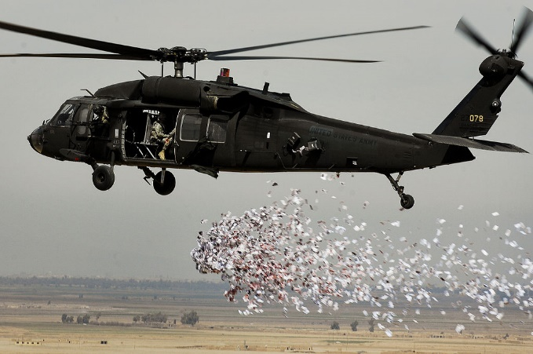
Figure XXVIII. United States Leaflet Example Distributed in Somalia.
Adapted from WHAM (Winning Hearts and Minds), by M. Thompson (2012). Published by Time Magazine.

There are many more recent and more deriding illustrations of manipulation of the populace in a growing collective of unprincipled and intentional misinformation campaigns, advancing in step with the progressing efficiency of mass communication: from parchment to radio to telephone to television to the internet. Disney invented the lemming mass suicide staged in White Wilderness (Disney & Sharpsteen, 1958; Thaler, 2016). It won an Academy Award. The Discovery Channel took part when they aired a faux-documentary on the existence of mermaids (Smithson & Brisley, 2013). The show broke all previous viewership records (Thaler, 2016).
Advertisement, the backbone of the capitalist economy, is an avenue of mass education targeted at consumers via a bank of information about their spending habits. With the phenomena of social media, advertisement has come to be personalized to each consumer. Amazon analyzes a consumer’s spending habits. They will then advertise specifically those items involved in his/her areas of interest on other websites as he/she peruses the internet (Desjardins, 2013). Facebook collects data on the topics on which a person reads and how he/she comments. The news stories posted for him/her are then heavily skewed in that direction (Opsahl, 2010). This is socially concerning and dangerous because with it, people are predominantly exposed to news and topics geared specifically to attract them to click while withholding any other perspective. In another context, this is called selective exposure: the theory that most people will be congenially biased towards concepts that support their standing preconceived beliefs (Hsu, 2009). In social media, however, this selective exposure is executed by the host website without the reader’s permission or awareness. This not only closes off any potential for productive discourse but can also enrage the readers so that their positions on matters lean more and more to the extremes. The practice of gathering data on consumer habits without their approval or knowledge conflicts with Amendment IV (U.S. Constitution, Amendment IV, 1788). That conflict is, as of this writing, being fought out in the Judicial Branch of government and seems destined for the U.S. Supreme Court.
The critical point is that information can sway belief. In this investigation, there is an assumption that providing accurate and responsible factual information to consumers regarding the capability of modern aeronautical piloting systems may be able to assure some of the flying public that they can safely trust these NextGen systems.

Research Questions
Today there are aeronautical technologies available that can provide significant advances in flight safety, yet some consumers might avoid air travel simply because they don’t understand the technology and avoid it due to their possible fear. (e.g., RPA). Despite any initial misgivings, it has been shown that acceptance of a new concept grows in step with its exposure (Obergefell, et al. Petitioners v. Hodges, Director, Ohio Department of Health, et al., 2015; Probst, 2003; ProCon.org, 2014). It is with this supposition that this study was constructed.
The major research hypothesis was that after exposure to information illustrating the capabilities of RPA, the flying public would be more inclined to accept RPA as a viable air travel option, as compared to those who are given general aviation information or no information. The research questions in this study were as follows:

Research Question One (RQ₁)
The first research question was posed to capture any significant difference in the level of RPA support between a group of subjects presented with information specifically about RPA capabilities and a group of subjects given no information at all. The first research question and hypothesis (H₁) were stated as follows:
- RQ₁: Will United States consumers support remote piloted travel to a greater degree if they are educated specifically about remote piloted aircraft capabilities?
  - H₁: United States consumers will support remote piloted travel to a greater degree if they are educated specifically about RPA capabilities compared to consumers that are given no information at all.

Research Question Two (RQ₂)
The second research question was posed to capture any significant difference in the level of RPA support between a group of subjects presented with information specifically about RPA capabilities and a group of subjects given only information about aviation, excluding information on RPA capabilities. The second research question and hypothesis (H₂) were stated as follows:
- RQ₂: Will United States consumers support remote piloted travel to a greater degree if they are educated specifically about RPA capabilities beyond just general information on commercial aviation?
  - H₂: United States consumers will support remote piloted travel to a greater degree if they are educated specifically about RPA capabilities compared to a group of consumers given only general information about commercial aviation.

Research Question Three (RQ₃)
The third research question was posed to capture the effect of the study treatment in a different way the fielding of RPA operations might potentially develop. That is Condition Three (C₃): RPA travel with an onboard distress-pilot. The third research question and hypothesis (H₃) were stated as follows:
- RQ₃: Will the same pattern of consumer support found in RQ₁ and RQ₂ persist even if a distress-pilot is on board all remote piloted flights?
  - H₃: The same pattern of consumer support found in RQ₁ and RQ₂ will persist even if a distress pilot is onboard all remote piloted flights.

Research Question Four (RQ₄)
The fourth research question was posed to capture the effect of the study treatment in another way the fielding of RPA operations might be introduced. That is Condition Four (C₄): RPA travel at half-price fares. The fourth research question and hypothesis (H₄) were stated as follows:
- RQ₄: Will the same pattern of consumer support found in RQ₁ and RQ₂ persist even if those flights were offered at half the standard price?
  - H₄: The same pattern of consumer support found in RQ₁ and RQ₂ will persist even if those flights were offered at half the standard price.

Method

Participants
The target population sample for this study had the following properties, United States residents, 18 years old or older, no flying phobic condition that negatively influences air travel, and no experience in the aviation industry.

United States Residents
The target population for the study was limited to residents of the U.S. Because this study was only interested in those living in the U.S. as part of the aviation global market share, a respondent’s status as a U.S. citizen, foreign student, resident alien, illegal immigrate, etc. were not used as selection criteria.

Aviophobic Participants
An estimated 20 million U.S. citizens suffer from aviophobia (Seaney, 2013). Aviophobics and those that suffer other phobias that interfere with their experience as flight passengers presented confounding variables to the study. Since the nature of phobias in general are not rational (Burnett, 2013), it was presumed that without professional direction, no treatment delivered in the format of this study would have brought these subjects to be more supportive of remote piloted aircraft (RPA). There was also the potential that, for those with extreme aviophobia, completing a survey related to RPA may have inadvertently triggered an acute panic attack episode and/or other related medical condition (Ehlers, Margraf, Davies, & Roth, 1988; Raghunathan, T., & Corfman, 2006). These individuals were filtered out in the survey validity section by way of question V3-Flight Anxiety. This question is a commonly utilized adaptation of the Visual Analogue Scale for Anxiety (VAS-A) (Facco, et al., 2011; Luyk, Beck, & Weaver, 1988) called the Visual Analogue Flight Anxiety Scale (VAFAS) (Nousi, van Gerwen, & Spinhoven, 2008). The VAFAS is a trusted and validated scale in aviation research used to measure passengers’ flight anxiety. It is a self-reporting 11-point assessment of flight angst. It ranges from “0 = ‘No flight anxiety’ to 10 = ‘Terrified’” (Nousi, van Gerwen, & Spinhoven, 2008, p. 307). If a respondent indicated he/she rated an eight or higher on the VAFAS, whatever the reason, it was supposed that a potential risk of harm to the respondent existed by him/her continuing with the survey. Therefore, for their protection, respondents scoring eight, nine, or ten were forwarded to the conclusion page of the study survey. They had neither the opportunity to submit data for the study nor were they exposed to any further parts thereof.

Aviation Professionals
Of the approximately 247,813,910 adults living in the United States (U.S. Census Bureau, 2016), only 590,039 or .24% hold a pilot’s license of any category (e.g., sport, private pilot, commercial pilot, air transport pilot, etc.) (Federal Aviation Administration, 2016c). Similarly, only 728,329 or .29% hold a non-pilot license of any kind (e.g., flight attendant, mechanic, dispatcher, etc.) (Federal Aviation Administration, 2017w). Even with that, an overlap between these licensure figures exists. A general aircraft mechanic will likely also hold an active pilot license of some kind, though it is not required for him/her to perform aviation maintenance duties. It was highly likely that the average support of aviation professionals regarding RPA would not reflect that of the United States general passenger flying public. On one hand, this particular demographic segment is certain to be familiar with the capabilities of aircraft and ATM technologies through repeated exposure and evaluations. They may have had the opportunity to observe or test these functions in action. In some cases, their lives may have been saved and disasters averted by such technologies (Skybrary, 2016). A developed trust of the technologies may have been reflected in the survey responses of aviation personnel. On the other hand, there may have been a disparity between airborne professionals and ground-based aviation professionals. The former may view the concept of remote-piloting aircraft as a threat to their careers or a loss of prestige in the role of a pilot since in the operational model discussed in this study, that role is removed from public view. This only furthers the idea that piloted flight is progressing to obsolescence, which has been a growing concern in aviator circles (Bertorelli, 2014). The latter, however, may have viewed the concept of remote-piloting aircraft as a boon for their own careers as this is the population segment that houses those largely responsible for the technologies that allow for RPA operations to exist at all. In either of these cases, the question of the effect of the study treatment would have been circumvented as there were alternate factors influencing these subjects’ decisions. These individuals were therefore filtered out in the survey validity section by way of question V4-Aviation professionals (p.86)

Sample Size
Because this study used anonymous internet survey technology to collect all study data, there were additional considerations in participant recruitment. An estimated 220,000,000 U.S. residents were potential subjects of this study. However, calculating an estimated group size for the analysis proposed in this study using Cohen’s (1992) procedures provided the prudent limits for participant data collection. Cohen (1992) gave a minimum sample size for each statistical test. For a sample with a medium effect size expected and α = 0.05, these minima began at n = 64 per group for the one-way Analysis of Variance (ANOVA) approach used in this study. The researcher set N = 192 (n = 64 minimum in each group) as the minimum quota for the study sample. Given that the exclusion criteria were limiting, the target sample size was increased by 15% of the minimum to approximately 224 respondents (or approximately 75 for each group) to cover any invalidated respondent surveys.

Data Collection Method
The Amazon Mechanical Turk (Amazon.com, Inc., 2017) website service was used to recruit survey respondents. Respondents received an incentive of $0.25 for completing the study survey. All pre-survey notifications, terms, and conditions requiring respondent acknowledgement were presented clearly on the first page of the study survey. To continue with the study survey, respondents must have indicated their approval on the informed consent page by so clicking at the bottom. Those that did not approve were forwarded to the conclusion page of the survey where they were thanked and their interaction ended.

Non-Random Recruitment
Use of the Amazon Mechanical Turk service is a non-random distribution recruitment method. While the exclusion criteria for this study were minimal, there still may have been bias introduced in the respondent collective. There were, however, elements organic to the study that limited the influence of that bias.
This research project heavily involved technology, its use, understanding, and general acceptance thereof. There are data that show the user’s age is a significant factor when discussing the utilization of technology. For example, Möler (2012) found that nearly 100% of young residents of the United States use the internet while that percentage progressively falls as sample age increases to 74% at ages 50 to 64 and 40% at age 65. Data show that 94.0% of airline passengers are younger than 65 years of age (International Air Transport Association, 2016; International Air Transport Association, 2017). As it happens, 90.4% of households in this same age bracket have some sort of computing device in the home and 78.9% have a subscription to high-speed internet service (File & Ryan, 2014). Participation in airline travel notably decreases for passengers over 65 years of age (International Air Transport Association, 2016), and a similar trend is observed with computing devices in the home and Internet service for this group (File & Ryan, 2014). In addition, 81% of all travel in the United States is researched by the consumer online before purchase, with 74% actually purchased through online means (Kovacs, 2012). Given these similar statistics between internet users and airline passengers and the use of a parallel interface, it is likely that those who submitted surveys for this study largely reflected its target population and effectively minimized the impact of an age bias.
It is likely that the potential subjects first saw the Amazon Mechanical Turk task posting when they were alone and on a private internet device. Therefore, their decision to proceed with the study survey would have been made without foreseeable pressure or undue coercion from anyone else. The researcher had no way to know who proceeded with the survey or who did not. The potential subjects were given that fact clearly prior to consenting to participate. In addition, the researcher was in no position to offer any participant favors for participating outside the standardized compensation.

Survey Host
To determine the most appropriate host for the study survey, seven survey websites were evaluated for their functionality, creation interface, subject interface, and cost. Mysurvey.com, Qualtrics, Surveygizmo.com, Surveymonkey.com, Swagbucks.com, Typeform, and Vindale Research were compared. These survey providers were selected for review for their high marks in “7 Best Survey Tools: Create Awesome Surveys for Free!” by Marrs (2014) and “Our Top 10 Legit Paid Survey Sites Reviewed” by Surveyssay.com (2016). The researcher sampled the functionality of each of the sites listed above and determined that, while most of the websites would provide adequate functionality and analysis, Qualtrics was the best suited for this study survey.
Qualtrics.com, the survey site host, employs a technology that allowed the study survey to be automatically formatted for mobile devices when such a device was used (Qualtrics LLC, 2016a). Since 97% of millennials own a smartphone (The Nielsen Company, 2016), this raised the prospect of respondent submittals from any mobile or tablet device online through mobile data or wireless connection.
The University of Oklahoma holds a license for Qualtrics that allows for unlimited accounts for faculty, staff, and students (Schiller, 2016). It also provides for unlimited survey questions and number of responses, phone and email support, custom universal resource locator (URL)s, and data encryption security measures (Schiller, 2016). During the data collection, the research data was managed exclusively by Qualtrics. The study survey was posted to the survey host website in hypertext markup language (HTML) format using cascading style sheets (CSS) and JavaScript. Qualtrics compiled the research data through its integral software (Qualtrics LLC, 2016c).

Storage, Security, & Retrieval
As part of the University of Oklahoma license package, Qualtrics stored the research data in its only data center with advanced encryption standard (AES)-256 crypto-security (Qualtrics LLC, 2016c; Raleigh, 2016). This encryption prevented the research data from being usable if it were to have been fraudulently accessed in its raw form. The decrypted data was accessed only by the researcher through the online survey portal at https://www.qualtrics.com/login/. Portal access was allowed only by a single correct combination of username and password (Qualtrics LLC, 2016b) through hypertext transfer protocol-secure (HTTPS) encryption. The researcher was and continues to be the only individual that knows either. The processed data was stored on the researcher’s data storage drive, which was and continues to be tri-level user name and password protected [network → computer → drive]. The researcher was and has remained the only individual that knows those combinations.
The study survey was completely anonymous. No identifying data was requested for or collected in the study survey. The internet protocol (IP) addresses of subjects was not recorded. This left only the demographic questions listed in the section on validity questions (p. 85) as having any traceability back to an individual respondent. However, those questions were so general that if fraudulent and/or malicious access to the study data were to have been gained, identification of any one subject would be impossible. As standard policy, Qualtrics does not transfer data and does not disclose any data to third parties (Qualtrics LLC, 2016c). Once the study data were processed from Qualtrics, the researcher destroyed the study data stored on the Qualtrics server. Once deleted, these data were irretrievable by Qualtrics or anyone else (Qualtrics LLC, 2016c).

Survey Instrument and Procedure
The study survey consisted of seven multiple-choice questions. These questions were organized in two survey sections separated by a treatment section: Validity questions, Treatment information, and Conditions questions.

Validity Section
The validity section (V) consisted of four questions to determine if each respondent was a valid member of the target population of the study. Those respondents that were not valid to the study were identified by at least one of the four validity questions. Those subjects that indicated any of the following were forwarded to the conclusion of the survey, skipping past the survey questions designed for data collection:
- They do not consider themselves residents of the United States
- Their age is less than 18 years-old
- They rate their level of flight anxiety at eight or greater on the VAFA
- They have had professional experience in the aviation industry
V₁-United States residents:
- Do you live or work within the borders of the United States, including Hawai’i and/or Alaska, or any United States territories?
  - Yes
  - No
V₂-Age:
- Please indicate your current age.
  - I am {1-130} years old.
V₃-Flight anxiety:
- On the scale below, please indicate the level of any anxiety you typically experience when traveling by air where zero is no anxiety and ten is a total fear of flying.
0 1 2 3 4 5 6 7 8 9 10
V₄-Aviation professionals:
- Have you ever been issued a license, military orders, or otherwise been hired to perform duties in the aviation industry?
  - Yes
  - No

Treatment Section
After the validity section, those subjects that were not disqualified were channeled into one of three groups, each of which received different technical facts and information about aviation: The treatment (T) group, the placebo control (PC) group, or the full control (FC) group. Respondents were assigned to their groups by block-randomization through Qualtrics software (Qualtrics LLC, 2016b). Respondents in each group were presented information specific to their group and did not have access to the information in the other groups. A flow chart describing the different channeling of respondents is shown in Figure XXIX below.

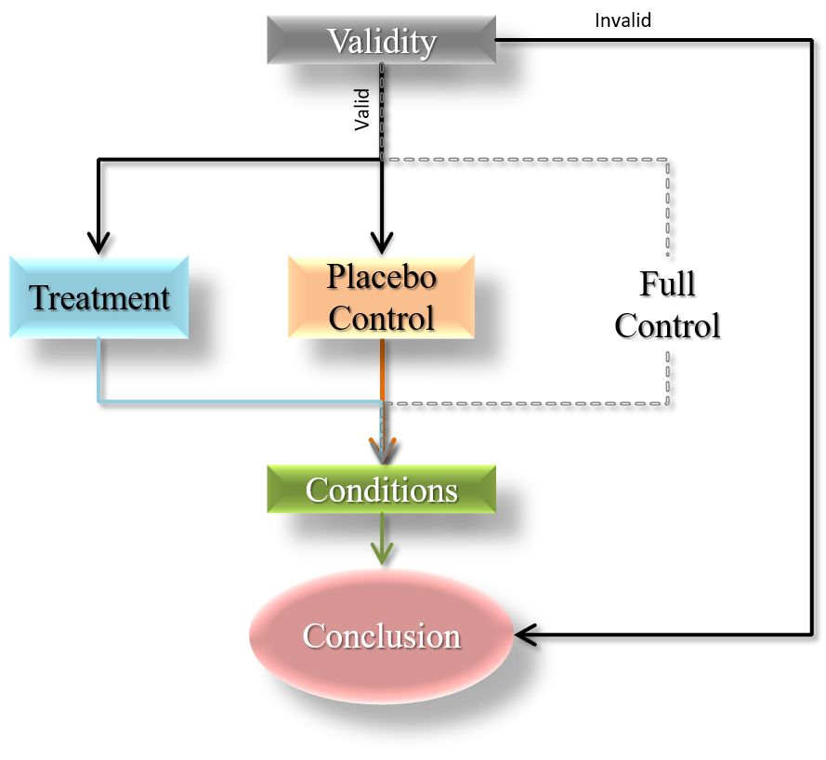
Figure XXIX. Study Survey Flow Chart

Treatment group.
The treatment group was presented with the following information regarding the capabilities now available in aviation related to RPA:
This final section of the survey is about passenger aviation and its impact on society. It includes facts about remote piloted operations and general flight safety. The remaining survey questions will directly follow.
- The technology exists today that allows an aircraft to automatically taxi from the runway to its assigned airport gate and back to the runway without any control input from the pilots.
- The technology exists today that allows for takeoffs and landings to be executed by an automatic aircraft control computer without any control input from the pilots.
- The technology exists today that allows an aircraft in flight to automatically maintain its course to within a 0.3 nautical mile margin of error, whereas old technology required a 2-mile margin of error buffer for safety.
- The technology exists today that allows an aircraft to detect turbulence and automatically ascend or descend to avoid it.
- The technology exists today that allows remote-pilots on the ground to make changes in an aircraft’s heading, altitude, and airspeed in the air whenever necessary.
- Studies show that compared to a remote pilot, a pilot experiencing the G-forces in a flight does not enhance his/her ability to control an aircraft. The G-forces can actually degrade it.
- The technology exists today that allows an aircraft to detect another oncoming aircraft and to take evasive action automatically to avoid contact, all without any pilot input.
- Every cockpit indication or instrumentation reading can immediately be presented and monitored in a remote flight control facility.
- Every control input an on-board pilot could make to an aircraft can also be input by a remote pilot.
- Studies show that remote piloting allows a pilot to fly at his/her maximum ability because he/she is not impeded by G-forces.
- Designing a remote flight control facility on the ground would equip pilots with more and better tools to handle an in-flight emergency because there would be no limits on weight and space as there are in an aircraft.
- Airline pilots are at times required to be on duty for 20 consecutive hours or more.
- Pilot error is the cause of most aviation accidents and incidents today.
- Flight crew fatigue is the most common contributor to pilot error accidents.
- On an average flight, pilots touch controls for under three minutes, a large portion of which is time ground taxiing. The rest of the flight is controlled by aircraft automation.
- Flight crews around the world are apprehensive about claiming they are unfit for duty due to fatigue for fear of professional repercussions.
- Over 50% of pilots have admitted to falling asleep while flying. One third of those stated that when they woke, they discovered that their co-pilot had also fallen asleep.
- Utilizing remote-pilot functions would ensure that a fully rested pilot at full performance was in control of an aircraft at all times.
- If a pilot in a remote piloting installation were to fall ill, that pilot could be replaced in seconds with a fully rested and healthy pilot, avoiding any delays of the departure time.

Placebo control group.
The placebo control (PC) group was presented with the following general information about aviation excluding any information about RPA:
This final section of the survey is about passenger aviation and its impact on society. It includes facts about the aviation industry in the U.S. and around the world. The remaining survey questions will directly follow.
- At any given time, there are 7,000 aircraft in flight.
- There are nearly 24,000 flights every day making 8.7 million flights per year.
- There are nearly 20,000 airports in the United States.
- There is an estimated 5 million square miles of United States airspace.
- Every day, 2 million people travel by air.
- One windshield of a Boeing 747 costs as much as a new BMW automobile.
- The largest plane in the world is the Russian Antonov AN-225 and from nose to tail is nearly as long as a football field.
- Pilots and copilots are required to eat different meals to guard against food poisoning.
- The changing air pressure in an aircraft cabin numbs about a third of a person’s taste buds, which is why tomato juice tastes less acidic in the air.
- The busiest airport in the world is Hartsfield-Jackson Atlanta International Airport, transporting 96 million passengers per year.
- The Boeing 747 is made up of six million parts.
- Singapore Airlines spends $16 million on wine each year.
- As active as commercial aviation is, only 5% of the world's population has ever been on an airplane.
- A Boeing 787 can fly 10,000 miles on one tank of gas.
- Airport control tower windows are angled at precisely 15 degrees to decrease reflections from inside and outside the tower.
- The Boeing 767 intakes enough air to fill the Goodyear blimp every 7 seconds.
- There are more astronauts than pilots that have flown the Concorde supersonic airliner.
- Commercial airport runways are 2 to 4 feet thick with layers of concrete.
- The world's largest passenger airliner is the Airbus A380.
- Globally, the airline industry generates about US$640 Billion

Full control group.
The full control (FG) group was not presented with any information about RPA capabilities or commercial aviation.

Conditions Section
Directly following the treatment section, all participants in all groups were administered the conditions section of the survey. In the conditions section, three scenario-based questions were posed for the participants to consider in how likely they would decide to fly: 1) flying on an RPA, 2) flying on an RPA with a dedicated distress-pilot (an onboard crew member with pilot training who could take control in an emergency), and 3) flying on an RPA with a 50% discount on the airfare. A six-point Likert scale (see note below) was presented to the participants to indicate their answer ranging from absolutely likely to absolutely unlikely. The definition of remote piloted aircraft was presented to the respondent throughout each of the conditions.

C₁-Condition 1: Remote Piloted Aircraft.
For Condition 1 (C₁), the survey question was presented as follows:
A remote piloted aircraft is defined as ‘an airborne vehicle that is controlled by a pilot in a flight control facility on the ground’.
- C₁. With what you know now about aviation operations, how likely is it that you would consider traveling on an airplane that is piloted remotely by a fully licensed and experienced pilot on the ground?
  - Absolutely likely
  - Highly likely
  - Likely
  - Unlikely
  - Highly unlikely
  - Absolutely unlikely

C₂-Condition 2: RPA with Distress-Pilot.
For Condition 2 (C₂), the survey question was presented as follows:
A remote piloted aircraft is defined as ‘an airborne vehicle that is controlled by a pilot in a flight control facility on the ground’.
- C₂. With what you know now about aviation operations, how likely is it that you would consider traveling on an airplane that is piloted remotely by a fully licensed and experienced pilot on the ground if a distress-pilot is onboard and available to take control of the aircraft in the event of an emergency?
  - Absolutely likely
  - Highly likely
  - Likely
  - Unlikely
  - Highly unlikely
  - Absolutely unlikely

C₃-Condition 3: RPA with 50% Discount.
For Condition 3 (C₃), the survey question was presented as follows:
A remote piloted aircraft is defined as ‘an airborne vehicle that is controlled by a pilot in a flight control facility on the ground’.
- C₃. With what you now know about aviation operations, how likely is it that you would consider traveling on an airplane that is piloted remotely by a fully licensed and experienced pilot if the ticket for that flight were offered at half the normal price?
  - Absolutely likely
  - Highly likely
  - Likely
  - Unlikely
  - Highly unlikely
  - Absolutely unlikely
After a participant completed the survey, the website closed. Any incomplete surveys were not considered in the data calculations. All data gained by an uncompleted survey were automatically deleted by Qualtrics software (Qualtrics LLC, 2016c). Once the quota of valid surveys was attained, the survey site was closed for further submittals.
To translate the nominal values of the Likert scale to ordinal values, each response alterative of the scale was assigned to correspond logically to ascending number values. Respondent answers in this section were scored from zero to five using the scale shown in Figure XXX. Obviously, as the value approached five, that group was expressing more support for RPA travel. The opposite was also true.
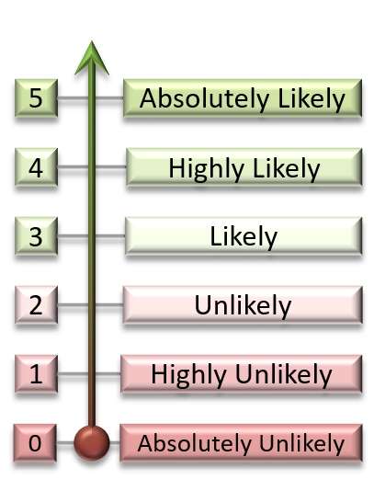
Figure XXX. RPA Support Scale

Results
It was described earlier how, for any new aviation passenger transport model to be successful, the technology and infrastructure must exist for it (see section on The Next Step Forward, p.45), corporations and governments must be willing to invest in it (see section on Timing, p.13), professionals must be available to operate it (see section on Flight Time & Crew Rest, p.57), consumers must support it, and regulators must establish the parameters that allow for it (Airport Technology, 2006).
Of these elements, the behavior of aviation consumers regarding Remote Piloted Aircraft (RPA) operations was absent of hard data (Jacobs, 2009). It has been heretofore assumed by aviation leaders that aviation consumers would be unsupportive of any RPA arrangement (Reiner, 2016). This study was executed on the hypothesis that by bringing consumers to understand the capabilities of RPA and air traffic management available today, their support for it could be fostered. It was also hypothesized that simply priming consumers on aviation, but excluding information on RPA, would not be effective in garnering consumer support for it. To test those hypotheses, respondents were divided into three groups. A treatment group was presented with an information package comprised of little-known facts about RPA capabilities. A placebo control group was presented with an information package comprised of facts about aviation excluding information about RPA. A full control group received no information. Subjects then responded to three questions assessing three different conditions or implementations of RPA. Those conditions were as follows:
- Condition 1 (C₁): Remote piloted aircraft operations
- Condition 2 (C₂): Remote piloted aircraft operations with a distress pilot
- Condition 3 (C₃): Remote piloted aircraft operations with a 50% discounted fare

Equalizing Group Sizes
An unexpected consequence of both building the exclusion criteria into the study survey and of how the Qualtrics random group assignment routine functions resulted in an inequality in the group sizes. Block random assignment to respondent group occurred before each participant proceeded through the validity questions. If a participant was excluded by residency, age, flight anxiety level, or experience in the aviation industry, that respondent was dismissed from the study and one subject for his/her group assignment was lost. When the survey was closed, the treatment group had 72 valid respondents, the placebo control group had 74 valid respondents, and the full control group had 78 valid respondents. To even the group sizes, a randomizer (Urbaniak & Plous, 2018) was utilized to randomly select two respondents from the placebo control group and six from the full control group for elimination. All data calculations were performed with congruent group sizes of 72 respondents.

Statistical Assumptions

Distribution normality.
The Shapiro-Wilk test for distribution normality (Shapiro & Wilk, 1965) was calculated across all groups and conditions. It was determined that the assumption of normality could not be confirmed in any of the conditions C₁ (W₍₂₁₆₎= .933, p < .001); C₂ (W₍₂₁₆₎ = .916, p < .001; C₃ (W₍₂₁₆₎ = .929, p < .001).
The one-way ANOVA test is considered robust against violations of normality (Lund & Lund, 2013). Further, Hayes (1994) states:
“It can be shown that, other things being equal, inferences made about means that are valid for normal populations also are valid even when the forms of the population distributions depart considerably from normal, provided that the n in each sample is relatively large… A common-sense rule is to not worry unduly about the normal assumption and to apply the analysis of variance and F test even with relatively small samples when you must. However, if you feel fairly sure that the population departs considerably from the normal distribution, to be on the safe side you might make an effort to achieve a larger sample size than otherwise” (p. 406).
Each group sample size was 72 respondents, which is larger than the 65 respondents prescribed by Cohen (1992) to be adequate for an experiment with an expected medium effect size, as this one was.

Variance.
Calculation of Levene’s tests for homoscedasticity (Levene, 1960) indicated that the homogeneity of variance could not be assumed in all of the conditions C₁ (F_{(2, 213)} = 3.613, p = .029); C₂ (F_{(2, 213)} = 1.626, p = .199); C₃ (F_{(2, 213)} = 7.227, p = .001). However, “this assumption of homogeneous variances can be violated without serious risk, provided that the number of cases in each sample is the same” (Hays, 1994, pp. 406-407), as was the case in this experiment.

Analysis of Variance
One-way ANOVA calculations were performed across the treatment group, the placebo control group, and the full control group for each of the three fundamental dependent variable questions. A statistically significant difference was found for C₁ (F_{(2, 213)} = 24.81, p < .001), C₂ (F_{(2, 213)} = 6.8, p = .01), and C₃ (F_{(2, 213)} = 4.59, p = .01).

Table VII
Descriptive Statistics
Group | Stat. | C₁ | C₂ | C₃
Treatment | M = | 2.88 | 3.51 | 2.96
Treatment | SD = | 1.006 | 1.256 | 1.204
Placebo Control | M = | 1.83 | 2.83 | 2.28
Placebo Control | SD = | 1.332 | 1.473 | 1.567
Full Control | M = | 1.54 | 2.69 | 2.33
Full Control | SD = | 1.221 | 1.535 | 1.678

Multiple Comparisons Tests
For its power and ability to secure the familywise error rate at α, the Ryan-Einot-Gabriel-Welsch (REGWQ) multiple range test (Welsch, 1977) was calculated to determine which group comparisons had statistically significant differences. These analyses resulted in the following:
- For question C₁, an assessment of support for RPA alone, the level of RPA support of the treatment group was significantly greater than both the placebo control group and the full control group. No significant difference was found between the placebo control group and full control group (crit .470, p < .05).
- For question C₂, an assessment of RPA support with a distress pilot onboard, the level of RPA support of the treatment group was also significantly greater than the placebo control group and the full control group. No significant difference was found between the placebo control group and full control group (crit .561, p < .05).
- For question C₃, and assessment of RPA support with 50% reduction in fare, the level of RPA support in the treatment group was again significantly greater than both the placebo control group and the full control group. No significant difference was found between the placebo control group and full control group (crit .589, p < .05).

Effect Size
A medium effect size of the treatment and lower effect size of the placebo was expected at the onset of this study. Cohen (1992) defined a medium effect size as “an effect likely to be visible to the naked eye of a careful observer” (p. 156). He quantifies effect sizes for each test. In the calculation of Cohen’s D for a one-way ANOVA, small, medium, and large effect sizes were valued by Cohen at d = .10, .25, and .40 respectively (1992, p. 157). Cohen’s D results between the groups and for all conditions showed a mix of effect sizes. Comparisons between the treatment and full control groups showed a large effect size for question C₁ (d = 1.198, r = .514), question C₂ (d = .585, r = .280) and question C₃ (d = .431, r = .211). The comparisons between the treatment and placebo control groups showed a large effect size for question C₁ (d = .890, r = .406) and medium effect sizes for question C₂ (d = .303, r = .150) and question C₃ (d = .359, r = .211). In comparing the placebo control group to the full control group, a medium effect size was observed for question C₁ (d = .227, r = .113) and question C₂ (d = .288, r = .042) and a small effect size for question C₃ (d = .088, r = .0.44).

Threats and Limitations
In the execution of this study, some actions may have presented a threat to the internal validity of the results. In this section, each will be described in its threats, conflict, solution, and/or verification of results.

Non-Random Recruitment & Parametric Statistics
Even though the one-way ANOVA is a parametric statistical test, it was used in part for its conservativeness to Type I errors. It is possible, however, that the non-random method of recruitment could have influenced the results.

Verification of results.
To further verify the study findings, the non-parametric Kruskal-Wallis H test (Kruskal & Wallis, 1952) was calculated at α = .05. Statistical significance was confirmed for question C₁ (H(2) = 45.729, p < .001), question C₂ (H(2) = 12.497, p = .002), and question C₃ (H(2) = 9.595, p = .008).
Comparisons between the groups were calculated using the Mann-Whitney U test (Mann & Whitney, 1947). For question C₁, the treatment group was shown to hold a significantly greater level of RPA support (M = 2.88) than the full control group (M = 1.54) (U = 1054.5, p < .001) and the placebo control group (M = 1.83) (U = 1313.5, p < .001). No significant difference was shown between the placebo control group and the full control group (U = 2296.5, p = .223). For question C₂, the treatment group similarly showed significantly greater support (M = 3.51) than the full control group (M = 2.69) (U = 1798.0, p = .001) and the placebo control group (M = 2.83) (U = 1903.0, p = .005). Again, no significant difference was found between the placebo control and full control groups (U = 2463.5, p = .601). For question C₃ as well, the treatment group showed a significantly greater level of support (M = 2.96) as compared to the full control group (M = 2.33) (U = 1969.0, p = .011) and the placebo control group (M = 2.28) (U = 1898.0, p = .005), while no significant difference was found between the placebo control group and the full control group (U = 2573.0, p = .938). The results are presented in Table VIII.
With these data, the findings in the section titled Multiple Comparisons Tests (p.96) were confirmed.

Table VIII.
Mann-Whitney U Test Results
Group  Comparison | Stat. | C₁ | C₂ | C₃
T vs. FC | x̅_{T} = | 2.88 | 3.51 | 2.96
T vs. FC | x̅_{FC} = | 1.54 | 2.69 | 2.33
T vs. FC | U = | 1054.5 | 1798.0 | 1969.0
T vs. FC | p = | < .001 | .001 | .011
T vs. PC | x̅_{T} = | 2.88 | 3.51 | 2.96
T vs. PC | x̅_{PC} = | 1.83 | 2.83 | 2.28
T vs. PC | U = | 1313.5 | 1903.0 | 1898.0
T vs. PC | p = | < .001 | .005 | .005
PC vs. FC | x̅_{PC} = | 1.83 | 2.83 | 2.28
PC vs. FC | x̅_{FC} = | 1.54 | 2.69 | 2.33
PC vs. FC | U = | 2296.5 | 2463.5 | 2573.0
PC vs. FC | p = | .223 | .601 | .938

Age Bias
The only vehicle used for subject interaction was the internet, to which age is a significant factor in its use (Möler, 2012). This presented a risk of bias that potentially limited older generations in the respondent pool. As it happens, a markedly similar skew is present with United States aviation consumers (File & Ryan, 2014; International Aviation Transport Association, 2016), which was precisely the target population of this study. Engaging the target population with an interface in which its use has similar age properties strengthens the experiment validity despite skewing in the sample ages. By reflecting the target population in the study sample, the impact of an age bias should be minimal (Hays, 1994), yet the possibility of its influence exists (see the section titled Non-Random Recruitment p.81).

Heteroscedasticity & Unequal Group Sizes
Equality of group sizes is one method of reducing Type I errors due to heteroscedasticity (Hays, 1994). The inequality that developed between the groups was corrected (see Equalizing Group Sizes, p.94). To prevent this from reoccurring in future studies, the subject exclusion criteria should be assessed prior to group assignment.

Verification of results.
To minimize the risk of a Type I error, since homogeneity of variance could not be confirmed and since the original group sizes were modified to congruence, Welch’s ANOVA (Welch, 1951) was calculated for being so tolerant. These calculations confirmed all the respective findings in Analysis of Variance (p.96), that a statistically significant difference in RPA support was found in at least one of the groups in C₁ (F_{2, 139.9} = 29.248, p < .001), C₂ (F_{2, 140.9} = 7.542, p = .001), and C₃ (F_{2, 138.8} = 5.582, p = .005).

Discussion
Using a relatively conservative statistical analysis, evidence from this investigation suggests that the research hypotheses should be upheld. Primarily, information about RPA does appear to be an effective tool in cultivating consumer support for RPA travel. The evidence supports accepting H₁ in that, compared to those given no information at all, consumers show a greater level of support for remote piloted travel if they are educated specifically about RPA capabilities. Secondarily, similar efforts that exclude information about RPA will be ineffective in cultivating its support. The evidence supports accepting H₂ in that, compared to those given general information about aviation excluding RPA, consumers will still support remote piloted travel to a greater degree if they are educated specifically about RPA capabilities. Tertiarily, these principles hold true after adding nominal measures for passengers’ perception of safety. The evidence supports accepting H₃ in that the same pattern of support found in H₁ and H₂ will persist even when a distress-pilot is onboard. Quaternarily, those principles continue to hold after adding purchase incentives, including a significant reduction in the heretofore most influential element in air travel consumer decision-making: airfare (Parrella, 2013). The evidence supports accepting H₄ in that the same pattern of support found in H₁ and H₂ will persist even when the fair is offered at half-price.
It is important to note that throughout this experiment, providing respondents with the placebo information had the same relative effect of giving them no information at all. While the selection of the most effective and most appropriate information to gain consumer support is beyond the scope of this study, it is clear that having no RPA-related information would be a wasted effort to that end. A person cannot be expected to support such a shift from incumbent norms to a concept like RPA without specific information about its capabilities. This was exhibited in the placebo control group’s significant difference with the treatment group, and the lack thereof with the full control group.
This study has shown how one’s regard for a previously foreign concept may be shaped when provided with new information about it. Even through other historically influential incentives such as a reduction in airfare, insight into RPA capabilities is significantly more effective in gaining RPA support. Another point to garner regarding consumer support is its very capacity to be cultivated. This may be as much a human aptitude as a function of the zeitgeist. When rocket boosters can safely land themselves after sending a spacecraft into low Earth orbit and regular individuals communicate instantly across the world through satellites, a ride on an aircraft with a dislocated pilot may seem on par for some, especially younger consumers that have never known a time without such technology. It may also be inferred that no prior body of knowledge or expertise is required to participate. Those respondents with professional experience in aviation were eliminated from this study so that the results may determine just that. Thus, the fundamental finding of this study regarding information about RPA and its powerful capability to shape willingness to fly on RPA is exceptionally important for leaders in the aviation industry. Leadership and change often comes through those who will enlighten and lead with new knowledge and technology. This study provides new information for leaders about the dynamics that will change in consumer aviation.
By verifying the researcher’s hypotheses in this experiment, it now appears that aviation consumers in the United States would support RPA travel once they have a general understanding thereof. So strong were the results that there seemed an eagerness from the respondents to participate. This may be from a genuine concern for pilot performance related to fatigue, or more likely because of the novelty that rides the coattails of fielding any new technology. It is clear, in any case, that aviation industry leaders’ confidence and resolution with which they have previously made assumptions regarding consumer resistance to the concept of RPA (Patterson, 2015) are unfounded. Further, these findings open other research questions including the following:
- What are the most effective mediums (e.g., television, radio, journal ads, etc.) for delivering RPA information?
- What kinds of information should be packaged?
- How much information should be packaged?
- How many packages in circulation at a time is optimal?
In analyzing the data from an absolute perspective an interesting and unexpected result was found when comparing the group means across the dependent conditions rather than within the conditions. Using a point at 2.5 on the response scale as the division point between “Likely” and “Unlikely” support for RPA, condition two (the responses for RPA with a distress-pilot onboard) generally stand above the others in relative support. This may be because flying with a pilot on board in case of emergencies is not very far from how passenger air travel is done today. In any case, this is a factor on which further research should focus. Figure XXXI is a depiction of this finding.

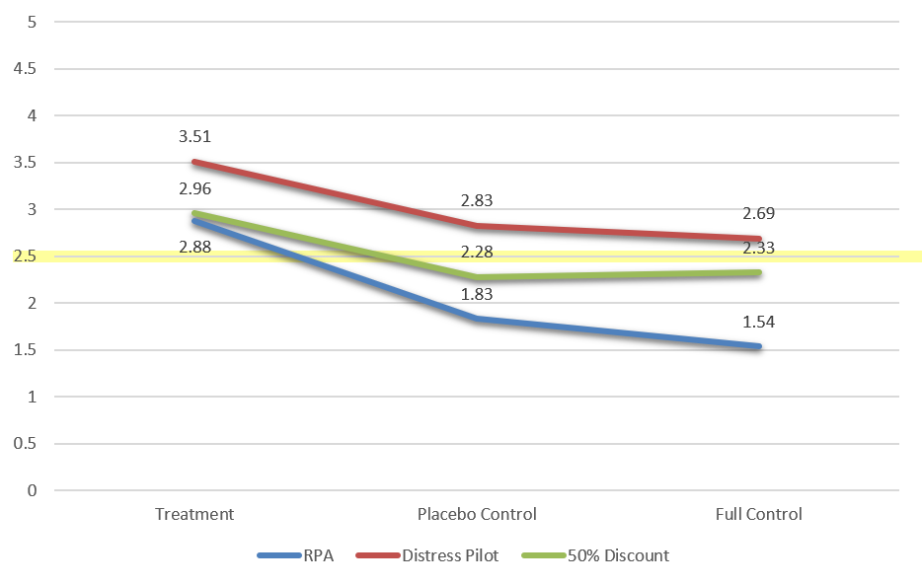
Figure XXXI Group Means by Condition

Conclusion
The larger purpose of this study was to clear a path for the fielding of what may ultimately be technology’s answer to the pilot fatigue question. Without the knowledge of an available market, the resources required in studying the details of an RPA model, building its infrastructure, and establishing the rules for its use would be difficult to come by. In aviation forums, the debate of RPA is bantered back and forth. It is certainly expected that one who has invested a 30-year career in the air may be disturbed at the idea of being replaced by someone they envision behind an Xbox. The discussion of RPA is typically held captive in the exciting arena of emergency landings. A genuine discussion on the boring topic of pilot fatigue is almost never engaged, and because it never develops to the level of day-to-day minutia, the RPA solution to overscheduling is mostly overlooked. The problem with defending the status quo is that the other side continues to get better and better, while the present just stays the same. In this context, the principle is clear: Humans have only a finite endurance. To lengthen performance fidelity, cycle in more humans.
From the findings in this study, an opportunity is presented for industry professionals, marketing professionals, performance artists, and academics to collaborate on a global scale. It is important to note that the time between when the RPA information package was delivered and when the respondent support rating was recorded was negligible. A single-pass with near instant application resulted in the significant effects in this study. It can therefore be inferred that repeated methods of RPA information delivery over a variety of media that are specifically designed to be more engaging than text on a screen will only advance the reception of RPA.
There are many other avenues of productive study that must take place prior to the actual fielding of remote piloted aircraft. They each entail developing a major element of RPA operations and will each certainly lead to further research requirements as they evolve. A few examples are listed on Table IX.

Table IX
Further Research
Studio Design | Ergonomics: What is the best configuration?
Studio Design | Training: What training is necessary and/or helpful?
Scheduling | Flight-hour limitations: What is reasonable?
Scheduling | Transfer of responsibility: When does one pilot stop in the other start?
In-flight Crew | Crew configuration: What should an RPA crew look like?
In-flight Crew | Duties and responsibilities: What should each position be responsible for?
Consumer Outreach | Consumer education: How detailed should the education package be?
Consumer Outreach | Consumer feedback: What was particularly informative for consumers?
Regulations | Safety: Does an RPA operation present any new threats to safety?
Regulations | Security: What measures can be put in place to mitigate those threats?

The conceptual findings in this study mirror those found in platforms across different themes (see the section on Changing Population Attitude, p.71) so relating aviation to the enduring philosophical phenomena that connects presentation to investigation to application to advocation (Schopenhauer, 1818). The topic of RPA falls in line with those other concepts that when first presented to the public were met with skepticism. Yet through continued exposure, formal, and informal discourse, those concepts move closer and closer to a positive recognition.

References
Action on Smoking and Health. (2017). Key Dates in the history of anti-tobacco campaigning. Action on Smoking and Health.
Adrian, E. (1995, June 24). The Doppler Effect. Retrieved October 13, 2009, from University of Illinois: http://archive.ncsa.illinois.edu/Cyberia/Bima/doppler.html
ADS-B Technologies, LLC. (2016). How ADS-B (978 MHz UAT) Works). Retrieved from Next Generation Air Traffic Management Specialists: http://www.ads-b.com/home.htm
Aerotime. (2015a). Airliners may ditch their co-pilots under EU plan. Aerotime, 1.
Aerotime. (2015b). It's about time: greetings to your new robot co-pilot. Aerotime, 1.
Airbus. (2004). Getting to Grips with Fuel Economy. Flight Operations Support & Line Assistance(4).
Airport Technology. (2006). Accommodating the Airbus A380. Airport Technology.
Akerstedt, T., Mollard, R., Samel, A., Simmons, M., & Spencer, M. (2003). Paper prepared for the ETSC "Meeting to discuss the role of EU FTL legislation in reducing cumulative fatigue in civil aviation". Meeting to discuss the role of EU FTL legislation in reducing cumulative fatigue in civil aviation. Brussels, Belgium: European Transport Safety Council.
Antunano, M. (2017). Medical Facts for Pilots. FAA Civil Aerospace Medical Institute.
Awasthi, V. (2008). Managerial Decision-Making on Moral Issues and the Effects of Teaching Ethics. Journal of Business Ethics, 207-223.
Bacon, F. (1901). The History of the Reign of King Henry VII (Stereotyped ed.). Cambridge: University Press.
Bertorelli, P. (2014, October 6). When Will a Drone Take Your Piloting Job? Retrieved July 10, 2016, from avweb.com: http://www.avweb.com/blogs/insider/When-Will-a-Drone-Take-Your-Piloting-Job-222871-1.html
Birgelen, T. (2014, January 1). Optics Aviation Safety Research and Innovation: time to take off! In T. Maret (Ed.), Advanced Cockpit for Reduction of Stress and Workload Consortium (ACROSS) (pp. 1-24). Brussels: European Commission-European Research Area. Retrieved from Introduction to ACROSS Project: http://www.optics-project.eu/wp-content/uploads/2014/12/03_ACROSS-Advanced-Cockpit-for-Reduction-Of-Stress-and-Workload_OPTICS-Diss-Event_181214.pdf
Boyatzis, R., & McKee, A. (2005). Resonant Leadership: Renewing yourself and connecting with others through mindfulness, hope and compassion. Cambridge, Ma: Harvard Business School.
British Broadcasting Company. (2005). U.S. army to produce Mid-East comic. BBC News.
British Broadcasting Corporation. (2012). Trial flights of 'unmanned' aircraft begin in the UK skies. BBC News, 1.
British Geological Survey Natural Environment Research Council. (2015). World Magnetic Model (WMM). Swindon, England: British Geological Survey.
Brown v. Board of Education, 347 US 483 (The Supreme Court May 17, 1954).
Bulkeley, K. (2014). Why Sleep Deprivation is Torture. Psychology Today.
Bureau of Labor Statistics. (2015). Air Traffic Controller. Washington, D.C.: U.S. Bureau of Labor Statistics.
Burnett, D. (2013). Phobias: The rationale behind irrational fears. The Guardian.
Buxton, O. (2007). Sleep and Disease Risk. Healthy Sleep.
Cabon, P., Bourgeous-Bougrine, S., Mollard, R., Coblentz, A., & Speyer, J. J. (2002). Flight and Duty Time Limitations in Civil Aviation and Their Impact on Crew Fatigue: A Comparative Analysis of 26 National Regulations. Human Factors and Aerospace Safety: An International Journal, 2(4), 379-393.
Center for Disease Control and Prevention. (2016). Trends in Current Cigarette Smoking by High School Students and Adults, 1965-2014. Washington, D.C.: U.S. Department of Health & Human Services.
Chaney, W. A., & Briggs, A. (2017). The Revolution of 1688. In J. Jauz, Encyclopedia Britannica. London: Encyclopedia Britannica. Retrieved October 5, 2017, from https://www.britannica.com/place/United-Kingdom/The-Revolution-of-1688
Checkflight International. (2008, March 2). Priority and Readback! Retrieved October 20, 2009, from Check-flight.com: http://www.check-flight.com/index.php?option=com_content&task=view&id=36&Itemid=42
Cohen, J. (1992). A Power Primer. Quantitative Methods in Psychology, 155-159.
Cook, A. (2007). European Air Traffic Management: Principles, Practice, and Research. Ashgate Publishing, Ltd.
Curtis, D. (2016a). Is this the end of stack holding? London: National Air Traffic Service.
Curtis, D. (2016b). More need than ever to create an airspace policy for the future. London: National Air Transportation Service.
Department of Finance. (2008). Air Travel Demand Elasticities, Issues and Measurements. Government of Canada.
Desjardins, L. (2013). How Amazon Uses Marketing Personalization. Nectarom.
Disney, W., Sharpsteen, B. (Producers), Algar, J. (Writer), & Algar, J. (Director). (1958). White Wilderness [Motion Picture]. United States: Buena Vista Distribution.
Dow, R. (2014, June 23). Air Travel Passengers Crave Efficiency Most of All. Rollcall. Retrieved September 26, 2017, from http://www.rollcall.com/news/air_travel_passengers_crave_efficiency_most_of_all_commentary-234145-1.html
Ehlers, A., Margraf, J., Davies, S., & Roth, W. T. (1988). Selective Processing of Threat Cues in Subjects with Panic Attacks. Cognition and Emotion, 2.3, 201-219.
Erle, S.; Gibson, R., Walsh, I. (2013). Plot a Great Circle on a Flat Map. Retrieved May 14, 2017, from flilib.com: http://flylib.com/books/en/2.366.1.61/1/
Esler. (2009, September 1). 4-D Nav Is Coming. Business & Commercial Aviation, p. 28.
Facco, E., Zanette, G., Bacci, C., Sivolella, S., Cavallin, F., & Maanani, G. (2011). Validation of visual analogue scale (VAS-A) for anxiety in dentistry. International Journal of Oral & Maxillofacial Surgery, 40(10), 1058-1058. doi:10.1016/j.ijom.2011.07.111
Federal Aviation Administration. (2008). Pilot's Handbook of Aeronautical Knowledge. Washington, D.C.: Department of Transportation.
Federal Aviation Administration. (2012). Advisory Circular 117-2. Washington, D.C.: U.S. Department of Transportation.
Federal Aviation Administration. (2016a, October 28). Air Traffic By the Numbers. Retrieved May 9, 2017, from FAA.gov: https://www.faa.gov/air_traffic/by_the_numbers/
Federal Aviation Administration. (2016b, April 05). Chart Supplements. Retrieved from faa.gov: https://www.faa.gov/air_traffic/flight_info/aeronav/productcatalog/supplementalcharts/airportdirectory/
Federal Aviation Administration. (2016c). Estimated Active Airmen Certificates Held as of December 31. Washington, D.C.: U.S. Department of Transportation.
Federal Aviation Administration. (2016d, May 5). Navigational Aid (NAVAID) Data. Retrieved from faa.gov: https://www.faa.gov/air_traffic/flight_info/aeronav/Aero_Data/7900.2C-NAVAID/
Federal Aviation Administration. (2016e). United States Standard for Terminal Instrument Procedures (TERPS) Order 8260.3C. Washington, D.C.: Department of Transportation.
Federal Aviation Administration. (2017a). Federal Aviation Regulation 71.1. In Department of Transportation, Code of Federal Regulations. Washington, D.C.: Department of Transportation.
Federal Aviation Administration. (2017b). Federal Aviation Regulation 71.41. In Department of Transportation, Code of Federal Regulations. Washington, D.C.: Department of Transportation.
Federal Aviation Administration. (2017c). Federal Aviation Regulation 71.71. In D. o. Transportation, Code of Federal Regulations. Washington, D.C.: Department of Transportation.
Federal Aviation Administration. (2017d). Federal Aviation Regulation 91.1057 Flight, Duty and Rest Time Requirements: All Crewmembers. In Department of Transportation, Code of Federal Regulations. Washington, D.C.: Department of Transportation. Retrieved May 19, 2010, from risingup.com: http://www.risingup.com/fars/info/part91-1057-FAR.shtml
Federal Aviation Administration. (2017e). Federal Aviation Regulation 91.533 Flight Attendant Requirements. In Department of Transportation, Code of Federal Regulations. Washington, D.C.: Department of Transportation.
Federal Aviation Administration. (2017f). Federal Aviation Regulation 121.391 Flight Attendant Requirements. In Department of Transportation, Code of Federal Regulations. Washington, D.C.: Department of Transportation.
Federal Aviation Administration. (2017g). Federal Aviation Regulation 121.465 Aircraft Dispatcher Duty Time Limitations: Domestic and Flag Operations. In Department of Transportation, Code of Federal Regulation. Washington, D.C.: Department of Transportation. Retrieved May 16, 2010, from www.risingup.com: http://www.risingup.com/fars/info/part121-465-FAR.shtml
Federal Aviation Administration. (2017h). Federal Aviation Regulation 121.467 Flight Attendant Duty Period Limitations and Rest Requirements: Domestic, Flag, and Supplemental Operations. In Department of Transportation, Code of Federal Regulations. Washington, D.C.: Department of Transportation. Retrieved May 16, 2010, from Risingup.com: http://www.risingup.com/fars/info/part121-467-FAR.shtml
Federal Aviation Administration. (2017i). Federal Aviation Regulation 121.471 Flight Time Limitations and Rest Requirements: All Flight Crewmembers. In Department of Transportation, Code of Federal Regulations. Washington, D.C.: Department of Transportation. Retrieved May 16, 2010, from Risingup.com: http://www.risingup.com/fars/info/part121-471-FAR.shtml
Federal Aviation Administration. (2017j). Federal Aviation Regulation 121.481 Flight Time Limitations: One or Two Pilot Crews. In Department of Transportation, Code of Federal Regulations. Washington, D.C.: Department of Transportation. Retrieved May 16, 2010, from risingup.com: http://www.risingup.com/fars/info/part121-481-FAR.shtml
Federal Aviation Administration. (2017k). Federal Aviation Regulation 121.483 Flight Time Limitations: Two Pilots and One Additional Flight Crewmember. In Department of Transportation, Code of Federal Regulations. Washington, D.C.: Department of Transportation. Retrieved May 16, 2010, from risingup.com: http://www.risingup.com/fars/info/part121-483-FAR.shtml
Federal Aviation Administration. (2017l). Federal Aviation Regulation 121.485 Flight Time Limitations: Three or More Pilots and an Additional Flight Crewmember. In Department of Transportation, Code of Federal Regulations. Washington, D.C.: Department of Transportation. Retrieved May 17, 2010, from http://www.risingup.com/fars/info/part121-485-FAR.shtml
Federal Aviation Administration. (2017m). Federal Aviation Regulation 121.493 Flight Time Limitations: Flight Engineers and Flight Navigators. In Department of Transportation, Code of Federal Regulations. Washington, D.C.: Department of Transportation. Retrieved May 17, 2010, from Risingup.com: http://www.risingup.com/fars/info/part121-493-FAR.shtml
Federal Aviation Administration. (2017n). Federal Aviation Regulation 121.503 Flight Time Limitations: Pilots: Airplanes. In Department of Transportation, Code of Federal Regulation. Washington, D.C.: Department of Transportation. Retrieved May 17, 2010, from risingup.com: http://www.risingup.com/fars/info/part121-503-FAR.shtml
Federal Aviation Administration. (2017o). Federal Aviation Regulation 121.505 Flight Time Limitations: Two Pilot Crews: Airplanes. In Department of Transportation, Code of Federal Regulations. Washington, D.C.: Department of Transportation. Retrieved May 17, 2010, from risingup.com: http://www.risingup.com/fars/info/part121-505-FAR.shtml
Federal Aviation Administration. (2017p). Federal Aviation Regulation 121.507 Flight Time Limitations: Three Pilot Crews: Airplanes. In Department of Transportation, Code of Federal Regulations. Washington, D.C.: Department of Transportation. Retrieved May 17, 2010, from risingup.com: http://www.risingup.com/fars/info/part121-507-FAR.shtml
Federal Aviation Administration. (2017q). Federal Aviation Regulation 121.509 Flight Time Limitations: Four Pilot Crews: Airplanes. In Department of Transportation, Code of Federal Regulations. Washington, D.C.: Department of Transportation. Retrieved May 17, 2010, from risingup.com: http://www.risingup.com/fars/info/part121-509-FAR.shtml
Federal Aviation Administration. (2017r). Federal Aviation Regulation 121.513 Flight Time Limitations: Overseas and International Operations: Airplanes. In Department of Transportation, Code of Federal Regulations. Washington, D.C.: Department of Transportation. Retrieved May 17, 2010, from risingup.com: http://www.risingup.com/fars/info/part121-513-FAR.shtml
Federal Aviation Administration. (2017s). Federal Aviation Regulation 121.521 Flight Time Limitations: Crew of Two Pilots and One Additional Airman as Required. In Department of Transportation, Code of Federal Regulations. Washington, D.C.: Department of Transportation. Retrieved May 17, 2010, from risingup.com: http://www.risingup.com/fars/info/part121-521-FAR.shtml
Federal Aviation Administration. (2017t). Federal Aviation Regulation 121.523 Flight Time Limitations: Crew of Three or More plots and Additional airmen as Required. In Department of Transportation, Code of Federal Regulations. Washington, D.C.: Department of Transportation. Retrieved May 17, 2010, from risingup.com: http://www.risingup.com/fars/info/part121-523-FAR.shtml
Federal Aviation Administration. (2017u). Federal Aviation Regulation Airline Certificate Information - Applicable Definitions. In Department of Transportation, Code of Federal Regulations. Washington, D.C.: Department of Transportation. Retrieved May 16, 2010, from av-info.faa.gov: http://av-info.faa.gov/Definitions.asp
Federal Aviation Administration. (2017v). Chapter 1 b, part 11 General Rulemaking Procedures. In Department of Transportation, Code of Federal Redulations. Washington, D.C.: Department of Transportation.
Federal Aviation Administration. (2017w). U.S. Civil Airmen Statistics. Washington, D.C.: Department of Transportation.
Federal Aviation Administration. (2017x). Northeast U.S. Terminal Procedures Publication Volume 3 of 4. Washington, D.C.: Department of Transportation.
Federal Aviation Administration. (2017y). FAR 121.59 Subpart U-Dispatching and Flight Release Rules. In Department of Transportation, 14 Code of Federal Regulations (pp. 215-229). Washington, D.C: Department of Transportation.
File, T., & Ryan, C. (2014). Computer and Internet use in the United States: 2013. Washington, D.C.: U.S. Department of Commerce.
Fink, G. (2017). 11 States That Don't Have Typical 'Open Container' Laws For Vehicles. Huffp 2014ost.
Finlay, C. C., Maus, S., Beggan, C. D., Bondar, T. N., Chambodut, A., Chernova, T. A., . . . Zvereva, T. I. (2010). International Geomagnetic Field: The eleventh generation. Geophysical Journal International, 183(3), 1216-1260. doi:10.1111/j.1365-246X.2010.04804.x
Fischer, C. (2017). Passenger Claims United Airlines Flight Attendant Told Her to "Pee in a cup" During Flight. Houston: American Broadcasting Company.
Ford, J. (1634). The Chronicle History of Perkin Warbeck. London, England.
Gainsford, T. (1618). The True and Wonderful History of Perkin Warbeck. London.
Garvey, W., Salerno, J., & McMillin, M. (2017). Jet-A and Avgas Fuel Prices: April 2017. Business & Commercial Aviation.
Gauss, C. F. (1827). Disquistones Generales circa Superficies Curvas. Göttingen: Typis Dieterichianis.
George. (2000). Fort Conger: Old tales of futility and desperation. Nunatsiaq News.
George. (2015). Preventing Crew Fatigue from A to Zzz. Aviation Week.
Gesell, L., & Dempsey, P. (2005). Air Transportation: Foundations for the 21st Century. Chandler, AZ: Coast Aire Publications.
Gilbert, J. L. (2012). World War I and the Origins of U.S. Military Intelligence. Lanham, Maryland, United States: Scarecrow Press.
Gilliland, K. (2011, January 9). PSY 6433 Interpersonal Dynamics of Leadership. (C. 6, Interviewer)
Goguitchaichvili, A., Morales, J., Schavelzon, D., Vásquez, C., Gogorza, C., Loponte, D., & Raphilini, A. (2015, August). Variation of the Earth's magnetic field strength in South America during the last two millennia: New results from historical buildings of Buenos Aires and re-evaluation of regional data. Phisics of the Earth and Planetary Interiors, 245, 15-25.
Gohd, C. (2018). The Earth's Magnetic Poles are Overdue for a Switch. Futurism.
Google Inc. (2017, May 12). Los Angeles, California. USA to London, England. Retrieved from google.com/maps: http://i.imgur.com/WsVvidL.jpg
Graeber, C. (2017). Human Factors. Retrieved May 11, 2017, from Boeing.com: http://www.boeing.com/commercial/aeromagazine/aero_08/human_textonly.html#top
Greving, G. S. (2000). Problems and Solutions for ILS Category III Airborne and Ground Measurements. Proc. 11th IFIS. Santiago: European and US Views and Perspectives.
Hall, N. (2015). Doppler Effect. Glenn Research Center.
Hammond, J., Keeny, R., & Raiffa, H. (1999). Start Choices: A Practical Guide to Making Better Decisions. Boston, MA: Harvard Business School Press.
Hayman, G. (2009). Trajectory Based Operations. 300+ CNS/ATM Conference. The Boeing Company.
Hays, W. (1994). Statistics (5th ed.). Fort Worth, Texas, USA: Holt, Rinehart and Winston, Inc.
Henry, W. (1688, October 10). Declaration of the Prince of Orange. The Hauge. Retrieved from http://www.british-history.ac.uk/commons-jrnl/vol10/pp1-6
Higham, R. (2003). One Hundred Years of Air Power and Aviation. Texas A&M University Press.
Hitler, A. (1941). Mein Kampf. Berlin: Hougbton Mifflin Company.
Hobica, G. (2013, August 13). Airline Fees, U.S. Carriers, Updated. Retrieved from airfarewatchdog.com: http://www.airfarewatchdog.com/blog/3801089/airline-baggage-fees-chart/#
Holt, M., & Poynor, P. (2006). Air Carrier Operations. Newcastle, WA: Blackwell Publishing.
Hope, S. (2015). 85% of Aviation Accidents are Caused by Pilot Error. Business Aviation Insurance.
Hsu, J. (2009). People Choose News That Fits Their Views. Live Science.
Insurance Institute for Highway Safety. (2010). DUI/DWI Laws. Retrieved May 18, 2010, from iihs.org: http://www.iihs.org/laws/dui.aspx
International Air Transport Association. (2016). Global Passenger Survey. 6th World Passenger Symposium. Dubai, United Arab Emirates: International Air Transport Association.
International Air Transport Association. (2017). Global Passenger Survey. Global Airport & Passenger Symposium. Barcelona, Spain: International Air Transport Association.
International Aviation Transport Association. (2016). Fact Sheet Industry Statistics. Washington, D.C.: International Aviation Transport Association.
Jackovics, T. (2008, April 22). FAA: Air Traffic Controllers Making More Mistakes. The Tampa Tribune.
Jacobs, W. (2009). ASCI 602. Wiesbaden, Germany: Embry-Riddle Aeronautical University.
James, C. (2007, April 04). Multilateration: Radar's Replacement? Retrieved October 13, 2009, from Aviation Today.com: http://www.aviationtoday.com/print/av/issue/cover/9891.html
Jedick, R. (2013). Pulling G's - The Effects of G-Forces on the Human Body. Aerospace Medicine.
Johnston, M. (2015). Elasticity of Demand for Air Travel. Current Issues in Economics. Retrieved from https://econfix.wordpress.com/2015/05/07/elasticity-of-demand-for-air-travel/
Journal of the House of Commons. (1802, December 19). Prince of Orange's declaration: 19 December 1688. Journal of the House of Commons, 10. Retrieved from http://www.british-history.ac.uk/commons-jrnl/vol10/pp1-6
Karp, A. (2009, April 2). Boeing's Carson: FAA's progress on NextGen 'too slow'. Retrieved October 21, 2009, from atwonline.com: http://www.atwonline.com/news/story.html?storyID=16127
Keahiolalo, A. K., Walton, R. O., & Rosenhammer, F. G. (2011). Airlines and the European Union Emissions Trading Scheme: A Marketing Solution. San Diego, CA: Journal of Business and Educational Leadership.
Kitashirakawa-Oiwake, S. C. (2016). Magnetic North, Geomagnetic and Magnetic Poles. Kyoto: Data Analysis Center for Geomagnetism and Space Magnetism, World Data Center.
Kitt, B., Geiger, A., & Lategahn, H. (2010). Visual odometry based on stereo image sequences with RANSAC-based outlier rejection scheme. Procedures IEEE Intelligent Vehicle Symposium.
Koros, A., Scollenberger, R., & Della Rocco, P. (2007). A Human Factors Simulation of Required Navigation Performance Converging Approach Procedures. Springfield, VA: Federal Aviation Administration.
Kovacs, I. (2012). What percentage of plane tickets are sold at airport ticket counters? eMarketer.com.
Kruskal, W., & Wallis, A. (1952). Use of ranks in one-criterion variance analysis. Journal of the American Statistical Association, 47(260), 583-621. doi:10.1080/01621459.1952.10483441
La Porte, A. (2016). Flight 804: Egypt fails to pull data from damaged recorders. Atlanta, Georgia: CNN.
Learmount, D. (2009). Proof that fatigue kills. Flight International. Flightglobal.com.
Leser v. Garnett, 553 (The Supreme Court February 27, 1922).
Levene, H. (1960). Contributions to Probability and Statistics: Essays in Honor of Harold Hotelling. (I. e. Olkin, Ed.) Stanford, CA: Stanford University Press.
Lovett, R. (2009). North Magnetic Pole Moving Due to Core Flux. National Geographic News.
Lund, A., & Lund, M. (2013, March 21). Lund Research Ltd. Retrieved from Laerd Statistics: https://statistics.laerd.com/statistical-guides/one-way-anova-statistical-guide-3.php
Luyk, N. H., Beck, F. M., & Weaver, J. M. (1988). A visual analogue scale in the assessment of dental anxiety. Anesthesia Progress, 35, 121-123.
Mann, H. B., & Whitney, D. R. (1947). On a Test of Whether one of Two Random Variables is Stochastically Larger than the Other. Annals of Mathematical Statistics, 18(1), 50-60.
Mann, J. (2012, October 25). A Brief History of Sleep Deprivation and Torture. Retrieved May 11, 2017, from sleepjunkies.com: https://sleepjunkies.com/features/sleep-deprivation-and-torture-a-brief-history/
Markoff, J. (2015). Planes Without Pilots. NY Times.
Marrs, M. (2014, November 4). 7 Best Survey Tools: Create Awesome Surveys For Free! Retrieved from wordstream.com: http://www.wordstream.com/blog/ws/2014/11/10/best-online-survey-tools
McGee, B. (2015). How much tax do you pay for a plane ticket. USA Today. Retrieved May 12, 2017, from https://www.usatoday.com/story/travel/columnist/mcgee/2015/07/01/airline-fees-taxes/29518427/
Micheletti, M., & Follesdal, A. (2007). Shopping for Human Rights. An Introduction to the Special Issue. Journal of Consumer Policy, 30(3), 167-175.
Mirage News. (2016). Ghost flight: Pilots fall asleep with 140 aboard, F-16s scrambled-VIDEO. Mirage News.
Mitch, D. (2004). Education and Skill of the British Labour Force. In F. Roderick, & P. Johnson, The Cambridge Economic History of Modern Britain, Vol. 1: Industrialization, 1700-1860 (p. 345). Cambridge: Cambridge University Press.
Möler, P. (2012). Technology still a big disconnect for older Americans. US News & World Report.
Montemerlo, M., Becker, J., Bhat, S., Dahlkamp, H., Dolgov, D., Ettinger, S., . . . Penny, I. (2008). Junior: The Stanford entry in the urban challenge. Journal of Field Robotics, 25.
Morris, J. (2015). What is the safest way to travel? One chart which reveals that flying is less dangerous than you may think. City A.M.
Muoio, D. (2016). Airlines are ripping customers off with this one hidden fee. Business Insider. Retrieved from http://www.businessinsider.com/fuel-surcharge-fee-airplane-ticket-prices-2016-8
National Aeronautics and Space Administration. (2006). What is the South Atlantic Anomaly? Houston, Texas: Rice University.
National Air Traffic Systems. (2016b). Managing real time fuel efficiency. Retrieved from FloSys – Flight Optimization System: http://www.nats.aero/services/airspace/flosys-flight-optimisation-system/
National Air Transportation Service. (2016a). Aviation industry warns of future delays without airspace change. London: NATS. doi:http://www.nats.aero/news/aviation-industry-warns-of-future-delays-without-airspace-change/
National Air Transportation Service. (2016c). Radar modification to unlock new wind power. London: NATS. Retrieved from http://www.nats.aero/news/radar-modification-to-unlock-new-wind-power/
National Air Transportation Service. (2017). UK-Irish air traffic controllers collaborate to reduce delays and airline fuel burn. London: NATS. Retrieved from http://www.nats.aero/news/uk-irish-air-traffic-controllers-collaborate-reduce-delays-airline-fuel-burn/
National Oceanic and Atmospheric Administration. (2010). Movement of the Magnetic North Pole 1600-2010. Washington, D.C.: National Centers for Environmental Information.
Niles, R. (2016). Sleeping Pilots Awake to F-16s. AVweb.
Nousi, A., van Gerwen, L. J., & Spinhoven, P. (2008). The Flight Anxiety Situations Questionnaire and the Flight Anxiety Modality Questionnaire: Norms for people with a fear of flying. Travel Medicine and Infectious Disease(6), 305-310.
Obergefell, et al. Petitioners v. Hodges, Director, Ohio Department of Health, et al., 14-556 (The Supreme Court June 26, 2015).
O'Hare, D., Wiggins, M., Batt, R., & Morrison, D. (1994). Cognitive failure analysis for aircraft accident investigation. Ergonomics, 1855-1869.
Opsahl, K. (2010). How to Opt Out of Facebook's Instant Personalization. Electronic Frontier Foundation.
Pape, A. M., Weigmann, D. A., & Shappell, S. (2013, September 25). Human Factors in Aviation Maintenance. Retrieved from FAA.gov: https://www.faa.gov/about/initiatives/maintenance_hf/library/documents/#HumanFactorsMaintenance
Paris, H. (2013). Air France Brazil plane crash pilot 'had only one hour's sleep'. The Telegraph.
Paromtchik, I., & Laugier, C. (1998, May). Automatic Parallel Parking and Returning to Traffic. Video Proceedings of the IEEE International Conference on Robotics and Automation.
Parrella, B. C. (2013). Understanding Airline and Passenger Choice in Multi-Airport Regions. Wenham, MA: Transportation Research Board.
Patterson, T. (2015). Remote-controlled passenger flights 5 years away CEO says. Atlanta, GA: CNN.
Pietrangelo, A. (2014). The Effects of Sleep Deprivation on the Body. Healthline.
Pietrangelo, A., & Krucik, G. (2014, August 19). Healthline. Retrieved May 2, 2017, from The Effects of Sleep Deprivation on the Body: http://www.healthline.com/health/sleep-deprivation/effects-on-body
Plessy v. Ferguson, 163 U.S. 537 (The Supreme Court May 18, 1896).
Probst, T. (2003). Changing Attitudes Over Time: Assessing the Effectiveness of a Workplace Diversity Course. Teaching Psychology, 30(3), 236-239.
ProCon.org. (2014, October 6). Gay Marriage Timeline. Retrieved from ProCon.org: http://gaymarriage.procon.org/view.timeline.php?timelineID=000030
Qualtrics LLC. (2016a). Customer Experience. Retrieved August 19, 2016, from qualtrics.com: https://www.qualtrics.com/customer-experience/
Qualtrics LLC. (2016b). Login. Retrieved November 4, 2016, from qualtrics.com: https://www.qualtrics.com/login/
Qualtrics LLC. (2016c). Qualtrics Security White Paper Lite: Information Security A brief overview of privacy, compliance, and operational policies and procedures. Qualtrics LLC.
Raghunathan, R., T., P. M., & Corfman, K. P. (2006, March). Informational Properties of Anxiety and Sadness, and Displaced Coping. Journal of Consumer Research, 32(4), 596-601. doi:10.1086/500491
Raleigh, S. (2016, November 4). Qualtrics Demo Request. (A. Keahiolalo, Interviewer)
Reason, J. (1990). Human error. New York: Cambridge University Press.
Reiner, A. (2016). Towards the End of Pilots. The Atlantic. Retrieved from https://www.theatlantic.com/technology/archive/2016/03/has-the-self-flying-plane-arrived/472005/
Remmert, J., & Schwan, H. (2012). Vor dem Endanflug gibst es kein Entrinnen. Frankfurter Allgemein.
Roe v. Wade, 410 U.S. 113 (The Supreme Court January 22, 1973).
Ros, G., Sappa, A. D., Ponsa, D., & Lopez, A. (2012). Visual SLAM for Driverless Cars: a Brief Survey. Bellaterra, Spain: Computer Vision Center, Campus UAB.
Rouse, M. (2017). Frequency Modulation (FM. Tech Target.
Savage, N. (2013). The World's Most Powerful MRI Takes Shape. IEEE Spectrum.
Scarborough, A., Bailey, L., & Pounds, J. (2005). Examining ATC Operational Errors Using the Human Factors Analysis and Classification System. Oklahoma City: Federal Aviation Administration.
Schiller, M. (2016, November 4). Qualtrics Demo Request. (A. Keahiolalo, Interviewer)
Schopenhauer, A. (1818). Die Welt als Wille und Vorstellung (Vol. 1). (E. Payne, Trans.) Indian Hills, Colorado: Falcon's Wing Press.
Scoones, E. (Producer), & Scoones, E. (Director). (2017). British History's Biggest Fibs with Lucy Worsley [Motion Picture]. England.
Scott v. Sandford, 60 U.S. (19 How.) 393 (The Supreme Court 1856).
Seaney, R. (2013). Fear of Flying? Some Good Things to Know. ABC News.
Searle, M. (2013, November 30). Single. (Y. Lawler, Interviewer)
Shapiro, S. S., & Wilk, M. B. (1965). An analysis of variance test for normality (complete samples). Biometrika, 52(3-4), 591-611.
Sikorsky Aircraft. (1994). TM 1-1520-237-10 UH-60A Helicopter Technical Manual. Washington, D.C.: Department of the Army.
Skybrary. (2016, May 27). skybrary.aero. Retrieved from Airborne Collision Avoidance Systems (ACAS): http://www.skybrary.aero/index.php/ACAS
Smith. (2011). Magnetic Resonance Imaging. Modalities and Methods: Magnetic Resonance.
Smithson, D., Brisley, T. (Producers), Foley, C., Bhatt, V. (Writers), & Bennett, S. (Director). (2013). Mermaids: The Body Found [Motion Picture]. United States: Discovery Communications Animal Planet.
Star Project. (2006, July 10). STAR (Secure ATM CDMA Software Defined Radio) is a Specific Targeted Research Project of the Sixth Framework Programme. Retrieved October 20, 2009, from Star Project: http://www.ist-star.eu/
Stimson, R. (2016). Attempts to Fly Before the Wrights. Retrieved July 11, 2016, from History of Flight: http://wrightstories.com/attempts-to-fly-before-the-wrights/
Surveyssay.com. (2016, February). Our Top 10 Legit Paid Survey Sites Reviewed. Retrieved from Surveyssay.com: http://www.surveyssay.com/
Swenson, J. (2000). On Jean-Jaqques Rousseau. Stanford, CA: Stanford University Press.
Thaler, A. D. (2016). The Politics of Fake Documentaries: Mermaids: The Body Found and its ilk have done long-term damage. Slate.
The Advertising Council, Inc. (2017). Frequently Asked Questions. Retrieved May 10, 2017, from psacentral.org: https://www.psacentral.org/faq
The Boeing Company. (2000, August). Required Navigation Performance (RNP) and Area Navigation (RNAV). Retrieved October 13, 2009, from Boeing.com: http://www.boeing.com/commercial/caft/reference/documents/RNP082400S.pdf
The Nielsen Company. (2016). Millennials are Top Smartphone Users. New York: The Nielsen Company.
Thompson, M. (2012, August 24). WHAM* (winning hearts and minds). Time.
Tierney, J. (2011, August 17). Do You Suffer From Decision Fatigue? The New York Times Magazine. Retrieved May 11, 2017, from http://www.nytimes.com/2011/08/21/magazine/do-you-suffer-from-decision-fatigue.html
Tripp, B. L., Yochem, E. M., & Uhl, T. L. (2007). Functional fatigue and upper extremity sensorimotor system acuity in baseball athletes. Journal of Athletic Training, 42(1), 90-98.
U.S. Census Bureau. (2016). Quick Facts United States. Washington, D.C.: U.S. Department of Commerce.
U.S. Constitution, Amendment IV. (1788). Amendment IV. In T. Jefferson, & J. A. Madison, The United States Constitution. Philadelphia.
United States Geological Survey. (2017). How to Use a Compass with a USGS Topographic Map. Washington, D.C.: United States Department of the Interior.
Urbaniak, G., & Plous, S. (2018, February 18). Research Randomizer. Retrieved from Research Randomizer: https://www.randomizer.org/
Victor, D., & Stevens, M. (2017). United Airlines Passenger is Dragged From an Overbooked Flight. New York: New York Times.
Vincent, J. M. (2017). 9 Cars That Are Almost Self-Driving. US News World Report.
Vohs, K. D., Baumeister, R. F., Schmeichel, B. J., Twenge, J. M., Nelson, M., N., & Tice, D. M. (2008). Making choices impairs subsequent self-control: A limited resource account of decision-making, self-regulation, and active initiative. Journal of Personality and Social Psychology, 94, 883-898.
Welch, B. L. (1951). On the comparison of several mean values: an alternative approach. Biometrika, 38, 330-336.
Welsch, R. (1977). Stepwise Multiple Comparison Procedures. Journal of the American Statistical Association, 72(359), 556-575.
Wiegmann, D., & Shappell, S. (1997). Human factors analysis of post-accident data: Applying theoretical taxonomies of human error. The international Journal of Aviation Psychology, 67-81.
Wiegmann, D., & Shappell, S. (2001). A Human Error Analysis of Commercial Aviation Accidents Using the Human Factors Analysis and Classification System (HFACS). Washington, D.C.: Department of Transportation.
Wilkinson, J. (2007). Fair Trade: Dynamic and Dilemmas of a Market Oriented Global Social Movement. Journal of Consumer Policy, 219-239.
Williams, J. (2011, March 5). Grey Wolf: The Escape of Adolf Hitler. (Conspicacy, Interviewer)
Wilson. (2010). Plane Sense on Cockpits - NextGen. Av Buyer.
Wilson. (2017). Why does the North Pole move?
Wisconsin v. Mitchell, 505 U.S. 377 (The Supreme Court June 11, 1992).
Workplace Health and Safety Queensland. (2009, September 08). Work Performance. Retrieved May 18, 2010, from Department of Justice and Attorney-General: http://www.deir.qld.gov.au/workplace/subjects/fatigue/effects/performance/index.htm
Yacavone, D. W. (1993). Mishap trends and cause factors in Naval aviation: A review of Naval Safety Center data, 1986-1990. Aviation, Space, and Environmental Medicine, 64, 392-395.
Young, I. (2006). Responsibility and Global Justice: A Social Connection Model. Social Philosophy & Policy Foundation, 102-130.
Yukl, G. A. (2009). Leadership in Organizations. Upper Saddle River, NJ: Prentice-Hall.
Zell, H. (2015). Representation of Earth's Magnetic Field. National Aeronautics and Space Agency.
Zimmerman, J. (2013). 7 Instrument Approaches You Have To See To Believe. Airfacts.

Appendix A
Definitions
Advanced Cockpit for Reduction of Stress and Workload (ACROSS): A European Union (EU) initiative to explore efforts to advance the safety of aviation transport in passenger and air cargo by maximizing the efficiency of automation while maintaining the important element of human judgment.
Adverse Mental State: In this study, a category of the HFACS that describes: "…those mental conditions that adversely affect performance. Principal among these are the loss of situational awareness, mental fatigue, circadian dysrhythmia, and pernicious attitudes such as overconfidence, complacency, and misplaced motivation that negatively impact decisions and contribute to unsafe acts" (Wiegmann & Shappell, 2001, p. 5).
Adverse Physiological State: In this study, a category of the HFACS that describes "an action or incident that would…preclude the safe conduct of flight. Particularly important to aviation are conditions such as spatial disorientation, visual illusions, hypoxia, illness, intoxication, and a whole host of pharmacological and medical abnormalities known to affect performance" (Wiegmann & Shappell, 2001, p. 5).
Agonic Line: In navigation, an area described by a line of longitude with a measurement of zero magnetic declination.
Air France 447: On June 1, 2009 an Airbus A330 flying from–Galeão Airport in Rio de Janeiro, Brazil to Charles de Gaulle Airport in Paris crashed in the Atlantic Ocean. Both pilots had spent their rest period partying in Brazil and showed up to fly 228 passengers and crew on one hour of sleep: all of whom were killed.
Air Traffic Management: The system of rules and procedures used to coordinate safe travel by air.
Aircraft Hull-Loss: An aircraft accident that resulted in damage beyond repair.
Airspace: The sectioning of the areas regarding altitude and distance from an airport in which a nation’s aviation regulators mandate minimum avionics, procedures, and permissions before an aircraft may enter.
Airspeed: The measure of the velocity of an airborne object usually expressed in knots.
Airways: Pre-designated routes for airliners to travel on en-route from departure to destination, like air highways.
Altimeter Setting: The adjustment given by ATC and applied to an aircraft altimeter to correct readings for the local ambient air pressure.
Altimeter: The avionics device that indicates the altitude of the aircraft.
Altitude: The vertical distance an aircraft is from the surface of the earth. In transport aviation, altitude is typically calculated from mean sea level (MSL).
Approach Minimum: In aviation, the regulated level of least visibility and lowest ceiling at which an approach at a particular airport may be attempted.
Approach Procedure: See Instrument Approach
Approach: A descent from altitude with the intention of attempting a landing.
Area Navigation (RNAV): A method of IFR navigation that allows for aircraft to fly without being bound to an airway.
At Altitude: In aviation, (colloquial) at cruise altitude.
Automatic Dependent Surveillance-Broadcast (ADS-B): A navigation technology in which an aircraft determines its position via satellite navigation and reports it, enabling active tracking by ATC and other aircraft.
Aviation Regulator: see Federal Aviation Administration.
Avionics: Any device in operation in an airborne aircraft that produces a means of navigation or communication with ATC or other aircraft in flight.
Aviophobia: The clinical fear of flying.
Baggage Fee: The airline charge for transporting passengers’ luggage.
Cargo Operations: The aerial transportation of living and/or non-living parcels with no passenger associated with that flight.
Ceiling: In aviation, the altitude at which the clouds of an area predominate the sky.
Chandler Wobble: The oscillation of the earth as it rotates.
Charter Operations: See Supplemental Operations
Checkpoint: A specific NAVAID or intersection that denotes an approved outbound or inbound path of flight of a departure procedure or instrument approach.
Clearance: Permission given by ATC to perform an action with an aircraft (e.g., engine start, ground taxi, take off, etc.)
Continuous Climb Departure (CCD): A function of TBO that allows an aircraft to climb at its most efficient configuration throughout the ascent resulting in millions of dollars in fuel savings per year.
Continuous Decent Approach (CDA): A function of TBO that allows an approaching aircraft to bypass all step-down requirements of an approach resulting in millions of dollars of fuel savings per year.
Continuous Duty: “from the time he [or she] reports for duty until the time he [she] is released from duty for a rest period of at least 10 hours on the ground” (Federal Aviation Administration, 2017t).
Contributing Factor: In aviation accident investigation, a reason that enabled or added to the severity of an accident.
Controller to Pilot Data Link Communication (CPDLC): An element of NextGen that allows for communication between ATC and aircraft that allows routine transmissions to be sent via text-type message instead of voice over radio.
Crew Resource Mismanagement: In this study, a category of the HFACS that describes"...the failures of both inter- and intra-cockpit communication, as well as communication with ATC and other ground personnel. This category also includes those instances when crewmembers do not work together as a team, or when individuals directly responsible for the conduct of operations fail to coordinate activities before, during, and after a flight" (Wiegmann & Shappell, 2001, p. 6).
Crew Rest: The time between duty periods for airborne aviation personnel.
Crewmember: see Flight Crewmember.
Cruise Altitude: The altitude of an aircraft after takeoff ascent.
Cruise: The profile of flight after its initial climb to its initial descent.
Decision Error: In this study, a category of the HFACS that describes: "…conscious, goal-intended behavior that proceeds as designed; yet, the plan proves inadequate or inappropriate for the situation. Often referred to as honest mistakes, these unsafe acts typically manifest as poorly executed procedures, improper choices, or simply the misinterpretation or misuse of relevant information" (Wiegmann & Shappell, 2001, p. 4).
Decision Fatigue: The theory that there is a finite level of mental energy available for self-control. This mental energy is taxed with every decision one makes. Similar to physical fatigue, decision fatigue causes a reduction in the quality of the decisions made by the individual as decision fatigue festers (Tierney, 2011).
Declination: See Magnetic Declination.
Department of Transportation (DOT): A federal cabinet department responsible for all transportation. It houses, among others, the FAA.
Direct Routing: A flight with a ground track outside the guidance of airways, typically on course direct to the initial approach fix of the destination airport after takeoff.
Distance Measuring Equipment (DME): A NAVAID technology used on for approach to display the distance an aircraft is from a particular runway.
Distress-Pilot: In this study, regarding an RPA flight, a dedicated pilot onboard that is mission-ready to take over control of the aircraft in the event of an emergency.
Domestic Flight Segment Tax: A $4.00 tax collected for each operation cycle (McGee, 2015).
Domestic Passenger Tax: A 7.5% tax on each ticket collected by the FAA (McGee, 2015).
Doppler Effect: The change in frequency (light, sound) based on its movement (e.g., redshift in astronomy).
Drag: The aerodynamic force that resists forward movement by opposing the thrust force.
Duty Period: Also known as Duty Day, the time between reporting for an assignment involving flight time and release from that assignment by the airline conducting domestic, flag, or supplemental operations. The time is calculated using either Coordinated Universal Time or local time to reflect total elapsed time (Federal Aviation Administration, 2017h).
Egypt Air 804: On May 19, 2016, an Airbus 320 flying from Charles de Gaulle, Paris to Cairo International crashed into the Mediterranean Sea. All passengers and crew are assumed dead and the investigation of the cause of the crash is, as of this writing, not yet complete.
Engine Compressor Stall: A disruption of intake airflow in a gas turbine engine relating to rapid increases demand for thrust, causing unequal air pressures and velocities inside the engine rotors and stators, leading to a rotational imbalance and destruction of the engine if allowed to progress.
Engine Indicating Crew Alerting System (EICAS): an aircraft system for displaying engine parameters and alerting crew to system configuration or faults.
En-Route: Also known as cruise, the flight profile between after takeoff and reaching the Initial Approach Fix.
Euclidean Geometry: The school of geometry in which most laypeople are familiar (e.g., squares, circles, acute angles, etc.).
Failure to Correct Know Problems: “those instances when deficiencies among individuals, equipment, training, or other related safety areas are ‘known’ to the supervisor, yet are allowed to continue uncorrected. For example, the failure to consistently correct or discipline inappropriate behavior certainly fosters an unsafe atmosphere but is not considered a violation if no specific rules or regulations were broken” (Wiegmann & Shappell, 2001, p. 6).
Fatigue: See Flight Crew Fatigue
Federal Aviation Administration (FAA): The governing body of U.S. aerial transportation under the DOT.
Federal Aviation Regulation (FAR): The rules that govern flight in the U.S. that carry the full authority of law.
Fix: See Navigational Aid.
Flag Operations: A flight "conducted by any person operating any turbojet powered airplanes, or airplanes having passenger-seat configuration of more than nine passenger seats, excluding each crewmember seat, or airplanes having a payload capacity of more than 7,500 pounds at the following locations: between any point within the United States or any territory or possessions of the United States respectively, or between any point within the United States and any point outside the United States, or between any point outside the United States and another point outside the United States” (Federal Aviation Administration, 2017u).
Flight Anxiety: The feeling of fear when flying.
Flight Crew Fatigue: The progressive deterioration of an airborne aviator performance acuity due to lack of rest.
Flight Crew: The collection of flight crewmembers assigned to a single flight to perform operational duties in that aircraft while it is in transit. In this study, these refer to the following: Pilots (any class, any rating), Astronauts, Navigators, Flight Engineers, Radio operator, In-flight crew chiefs / air gunner, Flight attendant, Purser Flight medic, Rescue Swimmer, Loadmaster, Bombardier.
Flight Crewmember: A duty position of the flight crew whose primary function involves time in aerial transit (e.g. Pilot in command, co-pilot, flight attendant, flight engineer, navigator, etc.).
Flight Engineer: The flight crew position that is in charge of managing the operation of the aircraft systems and avionics in flight.
Flight Hours: The collective time (in hours) of any of each flight segment (first engine start and last engine shutdown).
Flight level: An indication of an aircraft's height above sea level.
Flight Management System (FMS): Not to be confused with Air Transportation Management system, the airplane-based avionics system that controls the progress of a flight by automatic manipulation of the flight control.
Flight Profile: A description of any of the four airplane configurations in flight segment (e.g., ground taxi, takeoff, en-route, and approach/landing).
Flight Segment: One leg of a flight encompassing one take off until the subsequent landing.
Frequency Modulating (FM): In telecommunications, a method of impressing data onto an alternating-current wave by varying the instantaneous frequency of the wave (Rouse, 2017).
Frequency: In telecommunications – The measurement of cycles per second, or hertz, by which one may wirelessly transmit and receive data. In aviation, the channel that identifies the hertz from which an aircraft is currently able to send or receive data. This may be through voice and/or navigational data.
From Altitude: See At Altitude.
Fuel Surcharge: The airline-imposed charge for the cost of fuel, added after September 11th, 2001 when the cost of oil increased rapidly and is still added to ticket prices today when the price for oil is back to previous levels.
Geodesic Line: A line drawn representing the orthodromic distance between two points on a sphere.
Geomagnetic North: The direction towards the northern end of the magnetic field that surrounds the Earth.
Germanwings 9525: On March 24, 2015, an Airbus 320 flying from Barcelona-El Prat to Düsseldorf Airport was deliberately flown into the ground by the suicidal co-pilot. All 150 passengers and crew were killed.
Go Right Rule: In the instance of converging air traffic, respective right banks from both pilots will keep them clear of each other.
Gravitational (g) Forces: The pressure exerted on an object as a function of gravity. One G is equal to the air pressure at the surface of the earth, 9.8 meters per second.
Great-Circle Routing: The shortest distance between two points on a sphere.
Gross Weight: The total weight of an aircraft inclusive of passengers, fuel, cargo, and external stores.
Ground Taxi: The movement of an aircraft with all wheels on the ground moving under its own power excluding landing and taking off.
Ground Track: The actual path along which an aircraft is flying relative to the surface of the Earth.
Hand-Off: A function of ATC by which the controller instructs a pilot to switch to another communication frequency.
Heading: The cardinal direction of an aircraft’s vector measured by the 360 radials in a circle.
Holding: A contingency used by ATC when the number of inbound aircraft exceed the landing capacity of the airport to land them. It consists of a NAVAID radial for course, then a standard-rate turn, then a return to the NAVAID, then a standard-rate turn out again on that same radial.
Hub & Spoke: In aviation, the operational model that involves feeder routes from multiple cities to a common core city and timing inbound feeder flights with outbound flights back out to other cities thus allowing a passenger to change airplanes as necessary to arrive at a final destination.
Human Error: Not to be confused with Pilot Error - Those mistakes that happen because of a limitation of possible human ability in the given circumstance.
Human Factors Analysis and Classification System (HFACS): An official system of classification describing the primary and contributing factors in aircraft accident investigation. The HFACS is used by the U.S. Navy, U.S. Marine Corps, U.S. Army, Canadian Defense Force, FAA, NASA, and others (Wiegmann & Shappell, 2001)
Human Factors: In aviation, the study of the limitations of human performance under the strain of flight.
Hypothesis One (H1): United States consumers will support remote piloted travel to a greater degree if they are educated specifically about RPA capabilities compared to consumers that are given no information at all.
Hypothesis Two (H2): United States consumers will support remote piloted travel to a greater degree if they are educated specifically about RPA capabilities compared to a group of consumers given only general information about commercial aviation.
Hypothesis Three (H3): The same pattern of consumer support found in RQ1 and RQ2 will persist even if a distress pilot is onboard all remote piloted flights.
Hypothesis Four (H4): The same pattern of consumer support found in RQ1 and RQ2 will persist even if those flights were offered at half the standard price.
Inadequate Supervision: In the HFACS - “…the failures within the supervisory chain of command, which was a direct result of some supervisory action or inaction. That is, at a minimum, supervisors must provide the opportunity for individuals to succeed. It is expected, therefore, that individuals will receive adequate training, professional guidance, oversight, and operational leadership, and that all will be managed appropriately. When this is not the case, aircrews are often isolated, as the risk associated with day-to-day operations invariably will increase (Wiegmann & Shappell, 2001, p. 6).
Inclement Weather: In aviation - Atmospheric conditions of reduced ceiling and visibility that would have an effect the margin of safety of a flight.
Initial Approach Fix (IAF): The NAVAID that begins the approach route for a particular airport.
Initial Descent: In aviation, the reduction of altitude with the intention of landing.
Instantaneous North Pole: The measurement of the North Pole considering the Chandler Wobble.
Instructions: In aviation - The directive given from ATC to a pilot in the route of travel and/or timing thereof, usually in accordance with the pilot’s intentions.
Instrument Approach: A landing attempt using only aircraft instrumentation as guidance.
Instrument Flight Rules (IFR): The set of regulations and equipment requirements necessary to operate an aircraft without visual reference to the Earth (e.g. fly by aircraft instrumentation).
Intentions: In aviation and in reference to flight, the space (ground or airborne) a pilot will move to in the direct future and the path he/she will take to get there.
International Arrival Tax: A $17.70 tax collected by the FAA for each passenger on a flight originating outside of the United States with a destination in the United States (McGee, 2015).
International Departure Tax: A $17.70 tax collected by the FAA for each passenger on a flight originating in the United States and landing in any other country (McGee, 2015).
Intersection: In aviation and in reference to airways - The point at which the radials of two NAVAIDS cross, primarily used as one type of checkpoint.
Kinetic Depth Effect: The brain’s ability to perceive accurately a three-dimensional object in motion without other depth queues.
Korean Air 2708: On May 27, 2016, A Boeing 777 ingested foreign object from the runway at Tokyo Haneda Airport that caused the engine to explode. The takeoff was aborted, and all passengers and crew were evacuated.
Landing Capacity: The maximum number of aircraft an airport can land safely, usually measured in number of aircraft per hour.
Landing Profile: The aircraft configuration describing the time after the aircraft crosses the IAF until its exit from the respective runway, should the aircraft be so capable.
Leisure Air Travel: Travel on an airline for any purpose except for business.
Less supportive: In this study, the group of respondents that scores an RPA support value less than another group.
Light Wavelength: The perception of colors.
Long Haul: A way to describe a flight that crosses an ocean or is similar in distance/flight time, typically flag operations.
Magnetic Declination: The measure of interference of magnetic north present in a given area and used to correct for true north.
Magnetic North Pole: The due North indication on a compass without correcting for magnetic declination.
Magnetic North: The direction to the magnetic north pole as indicated by a compass.
Maximum Endurance: In aviation, the airspeed and aircraft control surface configuration that will allow the aircraft to remain airborne for the longest time.
Mechanical Failure: In aircraft accident investigation, a determination that the failure of a component of the aircraft was the cause of the accident.
Mental Limitations: In the HFACS - "…includes those instances when necessary sensory information is either unavailable, or if available, individuals simply do not have the aptitude, skill, or time to safely deal with it. For aviation, the former often includes not seeing other aircraft or obstacles due to the size and/or contrast of the object in the visual field. However, there are many times when a situation requires such rapid mental processing or reaction time that the time allotted to remedy the problem exceeds human limits (as is often the case during nap-of-the-earth flight (Wiegmann & Shappell, 2001, p. 5).
National Transportation Safety Board (NTSB): A Federal agency charged by Congress with investigating every civil aviation accident the United States and significant accidents in other modes of transportation – railroad, highway, marine and pipeline (National Transpiration Safety Board, 2017).
Navigation Error: The difference between the intended and actual track of an aircraft in flight.
Navigational Aid (NAVAID) Radial: A specific directional bearing to or from a navigational aid expressed in compass headings to indicate or communicate an aircraft’s location.
Navigational Aid (NAVAID): The collection of different technological tools used for aircraft navigation such as, Non-Directional Beacons (NDB), Very High Frequency (VHF) Omnidirectional Radio (VOR), and many others.
Navigator: The position of the flight crew that is responsible for being aware of the aircraft’s position at all times.
Next Generation of ATM (NextGen): The name given to the collective technological upgrades of the incumbent ATM system. These include CPDLC, ADS-B, RNP, TBO, and other technologies.
Non-Directional Beacon (NDB): A specific NAVAID technology that emits a radial signal to aircraft on the appropriate frequency for the purposes of navigation.
Non-Euclidean Geometry: Any geometry that is not Euclidean such as, spherical geometry and hyperbolic geometry.
Non-Standard Airport Operations: Any situation at an airport where a situation exists that is not optimal for aircraft operations (e.g., inclement weather, significant delay, terrorist action, etc.).
Off-Cycle: The interruption of a crewmember’s natural circadian rhythm.
Operation: In aviation, a takeoff or landing.
Operational Error (OE): In aviation, an action that violates ATM policy, safety, or other protocol.
Organizational Climate: In the HFACS - "describes a broad class of organizational variables that influence worker performance and is defined as the “situationally based consistencies in the organization’s treatment of individuals” (Jones, 1988; Wiegmann & Shappell, 2001, p. 7)
Organizational Influence: In the HFACS that describes the “fallible decisions of upper-level management can directly affect supervisory practices, as well as the conditions and actions of operators” (Wiegmann & Shappell, 2001, p. 6).
Organizational Processes: In the HFACS - "…formal processes (operational tempo, time pressures, production quotas, incentive systems, schedules, etc.), procedures (performance standards, objectives, documentation, instructions about procedures, etc.), and oversight within the organization (organizational self-study, risk management, and the establishment and use of safety programs) (Wiegmann & Shappell, 2001, p. 7).
Orthodromic Distance: The shortest distance between two points on a sphere.
Passenger Facility Charge: A $4.50 per flight segment with a maximum of $18.00 total per total trip collected by the airports to fund projects approved by the FAA for expansion, safety, security, reduce noise, increase capacity, and/or increase airline competition.
Passenger Seating Capacity: Not to be confused with Passenger Load – the total number of non-flight crew seats on an aircraft, filled or not, which hold significant influence as to which regulations apply to the flight.
Payload Capacity: In aviation, the difference between the aircraft gross weight and its maximum gross weight (MGW).
Perceptual Error: In the HFACS - "…when sensory input is degraded, or “unusual,” as is often the case when flying at night, in the weather, or in other visually impoverished environments. Faced with acting on imperfect or less information, aircrew run the risk of misjudging distances, altitude, and decent rates, as well as a responding incorrectly to a variety of visual/vestibular illusions" (Wiegmann & Shappell, 2001, p. 5).
Performance Acuity: In this study - A pilot's level of flight fidelity and finesse with regard to reaction time, instrumentation interpretation, aircraft control, flight procedures, and many other aspects of flight.
Performance Limitation: In aviation, the maximum possible ability of a flight parameter (velocity, rate of climb/descent, etc.) of an aircraft based on engine output, gross weight, and environmental factors (air pressure, etc.).
Personal Readiness: In the HFACS - "...instances when rules such as disregarding crew rest requirements, violating alcohol restrictions, or self-medicating, are not adhered to. However, even behaviors that do not necessarily violate existing rules or regulations (e.g., running ten miles before piloting an aircraft or not observing good dietary practices) may reduce the operating capabilities of the individual (Wiegmann & Shappell, 2001, p. 6).
Physical Limitations: In the HFACS - "…includes those instances when necessary sensory information is either unavailable, or if available, individuals simply do not have the aptitude, skill, or time to safely deal with it. For aviation, the former often includes not seeing other aircraft or obstacles due to the size and/or contrast of the object in the visual field. However, there are many times when a situation requires such rapid mental processing or reaction time that the time allotted to remedy the problem exceeds human limits (as is often the case during nap-of-the-earth flight" (Wiegmann & Shappell, 2001, p. 5).
Pilot Error: In aircraft accident investigation, a determination of the cause of an accident indicating the pilot had misused the aircraft in some fashion, had the tools and time to prevent the accident, and that all other factors (maintenance, weather, etc.) were working in order and manageable. It houses the collection of categories of errors in the HFACS that includes Decision Errors, Skill-Based Errors, and Perceptual Errors (Wiegmann & Shappell, 2001).
Pilot Fatigue: See Flight Crew Fatigue.
Pilot in Command: The ultimate decision authority and lead flight crewmember responsible for all matters in aircraft handling and operation.
Planned Inappropriate Operations: In the HFACS - "all aspects of improper or inappropriate crew scheduling and operational planning, which may focus on such issues as crew pairing, crew rest, and managing the risk associated with specific flights" (Wiegmann & Shappell, 2001, p. 6).
Point-to-Point Operations: In aviation, the model that links departure and arrival city pairs in a single line fashion without the use of a hub.
Powerplant system: The elements of an aircraft from which lift and/or thrust may be produced
Preconditions for Unsafe Acts: In the HFACS - The category of contributing factors that includes Substandard Conditions of Flight Crew and Substandard Practices of the Flight Crew (Wiegmann & Shappell, 2001).
Present, but Non-Contributing Factor: In aviation accident investigation, a violation or error that did not enable or add to the severity of an accident.
Pressurized Aircraft: An aircraft in flight that is actively increasing the barometric pressure inside the aircraft to better approximate the barometric pressure on the ground.
Primary Factor: In aviation accident investigation, the major reason the accident occurred.
Propeller Powered: In aviation - An aircraft that uses large, uncased, fan blades to convert rotational energy to thrust for flight.
Radial: See NAVAID Radial.
Radio Detection and Ranging (RADAR): A technology used to detect and track objects by use of the Doppler Effect.
Radio Operator: The flight crewmember responsible for communications with ATC, other facilities on the ground, and other aircraft.
Rate of Climb: The vertical velocity at which an aircraft gains altitude usually measured in feet per minute.
Rate of Descent: The vertical velocity at which an aircraft decreases altitude, usually measured in feet per minute.
Red on Right is Wrong Rule: If the red position light (the other position light is green) is on the right of another aircraft that aircraft is closing. If the red position light is on the left of the other aircraft, it is flying away.
Regulator: See Federal Aviation Administration.
Remote Piloted Aircraft (RPA): In this study - a passenger aircraft operated and controlled by a qualified pilot on the ground in a flight studio.
Remote Piloted Aircraft (RPA) Support: In this study, a group's RPA support value score.
Required Navigation Performance (RNP): The minimum acuity rating of an aircraft avionics package required to fly in a particular area of airspace. The rating specifies the Total System Error (TSE) by flight profile.
Research Question One (RQ1): Will United States consumers support remote piloted travel to a greater degree if they are educated specifically about remote piloted aircraft capabilities?
Research Question Two (RQ2): Will United States consumers support remote piloted travel to a greater degree if they are educated specifically about RPA capabilities beyond just general information on commercial aviation?
Research Question Three (RQ3): Will the same pattern of consumer support found in RQ1 and RQ2 persist even if a distress-pilot is on board all remote piloted flights?
Research Question Four (RQ4): Will the same pattern of consumer support found in RQ1 and RQ2 persist even if those flights were offered at half the standard price?
Resource Management: In the HFACS - "...the management, allocation, and maintenance of organizational resources, including human resource management (selection, training, staffing), monetary safety budgets, and equipment design (ergonomic specifications)" (Wiegmann & Shappell, 2001, p. 6).
Rest Period: The time free of all restraint or duty for an airline conducting domestic, flag, or supplemental operations and free of all responsibility for work or duty should the occasion arise (Federal Aviation Administration, 2017h).
Sensory Gating: A function of the neurological system in which the brain filters out unnecessary or redundant stimuli from the environment.
September 11th Security Fee: A $5.60 charge each way, but not more than $11.20 per trip collected to fund the TSA of the United States (McGee, 2015).
Sequencing: The action of ATC of lining up aircraft to safely takeoff or land.
Short Haul: Opposed to Long Haul – A way to describe a flight with a succinct duration/distance, usually Domestic Operations.
Simultaneous Offset Instrument Approach (SOIA): A terminal ATC configuration in IFR conditions that allow for multiple instrument approaches at the same time and requiring a specific degree of instrumentation accuracy to perform.
Single-Pilot, High Passenger Seat Capacity Operation: A potential flight crew configuration that utilizes only one pilot at a time. At this time, single-pilot operations are allowed for low seat capacity airplanes or general aviation.
Skill-Based Error: In the HAFCS - "…occur with little or no conscious thought. Basic flight skills such as stick and rudder movements and visual scanning often occur without thinking. The difficulty with these highly practiced and seemingly automatic behaviors is that they are particularly susceptible to attention and/or memory failures. As a result, skill-based errors such as the breakdown in visual scan patterns, inadvertent activation/deactivation of switches, forgotten intentions, and omitted items in checklists often appear. Even the manner (or skill) with which one flies an aircraft (aggressive, tentative, or controlled) can affect safety" (Wiegmann & Shappell, 2001, pp. 4-5).
Spatial Disorientation: The loss of one's own positional reference to the surface of the earth.
Stack Holding: An ATC practice that allows an aircraft to remain near the airport while waiting for the opportunity to land by separating waiting aircraft vertically in 500-foot intervals.
Standard Instrument Departure (SID): A predetermined route and procedure for outbound aircraft to follow to leave safely the terminal area.
Standard Rate Turn: A three-degree bank usually held for one minute in holding resulting in a full 180-degree course reversal.
Step-Down Fix: A checkpoint only after which an aircraft may safely descend to a lower designated altitude on approach. There may be multiple step-down fixes on an approach to landing.
Step-Down: The process of landing from altitude by successive descents where an aircraft will maintain an altitude until crossing a step-down fix and then descend to the next lower altitude until the next step-down fix, and so on until landing.
Stepped On: In aviation, when one person transmits over a specific frequency and another person attempts to transmit on the same frequency. The result is that no one on that frequency will understand either transmitter.
Straight-line routing: Routing between a departure and arrival city primarily using the same compass heading.
Supervisory Violation: In the HFACS - "…those instances when existing rules and regulations are willfully disregarded by supervisors when managing assets. For instance, permitting aircrew to operate an aircraft without current qualifications or license is a flagrant violation that invariably sets the stage for the tragic sequence of events that predictably follow" (Wiegmann & Shappell, 2001, p. 5).
Supplemental Operations: Charter or non-scheduled operations where the location and time of departure and arrivals are negotiated between the operator and the customer (Holt & Poynor, 2006).
Terminal Area: The airspace that encompasses an airport, where highest measure of navigation fidelity is necessary because of the density of air traffic.
Thrust: The force that causes an aircraft to move forward.
Total System Error (TSE): The RNP rating of a particular aircraft it a particular phase of flight.
Track: See Ground Track.
Trajectory Based Operations (TBO): The practice of planning and executing an aircraft flight plan to ascend, cruise, and descend using at its most efficient configuration by use of CCD and CDA.
Transition altitude: The vertical distance from sea level at which references to the height of an aircraft switches from altitude (ALT) to flight level (FL).
Transponder: In aviation - A mandatory device of an aircraft avionics package that transmits a code assigned to the aircraft by ATC for identification. As well as other information relative to heading, altitude, and airspeed.
True North: Magnetic north corrected for local magnetic declination.
Turbine Engine: One type of internal combustion engine that provides thrust by the ignition of and acceleration of exhaust gasses.
Turbojet: An encased engine that uses the expulsion of gas through a tightening nozzle as its only source of thrust production.
Unfit for Duty: In this study and in aviation - The status a pilot is supposed to claim in the event he/she feels his/her performance has degraded to an unsafe level for any reason.
Unsafe Acts of Operators: In the HFACS - those behaviors that describes dangerous but deliberate actions of the aircrew. These can be loosely classified into one of two categories: errors and violations (Reason, 1990).
Unsafe Supervision: In the HFACS - "...the overarching category of unsafe supervision was created within which four categories (inadequate supervision, planned inappropriate operations, failed to correct known problems, and supervisory violations) are included" (Wiegmann & Shappell, 2001, p. 6).
US Airways Flight 1549: Upon take off from LaGuardia Airport, the Airbus A320 ingested birds causing the failures of both engines. With low altitude and low speed, the plane did not have the aerodynamic resources to land at an airport. The pilot, to minimize damage and loss of life, performed a water landing on the Hudson River. No fatalities airplane or ground-based.
Vector: Velocity with a specific direction.
Velocity: A measure of speed at which an object is moving.
Very High Frequency (VHF) Omnidirectional RADAR (VOR): A specific NAVAID technology that emits a radial signal to aircraft on the appropriate frequency for the purposes of navigation.
Violations: In this study - “behavior that represents the willful disregard for the rules and regulations” (Wiegmann & Shappell, 2001, p. 5).
Voice Communication: In aviation, the primary means, and currently, most expeditious method by which a pilot may communicate with ATC.

Appendix C:
Task Posting Message

Mr. Andrew Keahiolalo [Date]
C/O Dr. Kirby Gilliland
University of Oklahoma
660 Parrington Oval
Norman, Oklahoma 73019-0390

This tasking will link you to an anonymous survey on passenger airline operations. The survey will take about 5 minutes of your time. An informed consent page detailing the particulars of your participation in this study is presented on the first page of the survey.
Upon the completion of the survey, you will be presented with a unique completion code to obtain your reward of 25 cents.

With Very Kind Regards,

Andrew (Al’i) Keahiolalo
Ph.D. Candidate, University of Oklahoma

Appendix D:
Online Consent to Participate in Research

Would you like to be involved in research at the University of Oklahoma?
I am Andrew Keahiolalo, doctoral degree candidate from the Advanced Programs Organizational Leadership Program; I invite you to participate in my survey research project that explores attitudes related to commercial air travel. This research is being conducted at the University of Oklahoma. You were selected as a possible participant through the Amazon Turk survey tasking operation. You must be at least 18 years of age to participate in this study.
Please read this document and, if you have any questions, contact me with your questions BEFORE agreeing to take part in the research project.
What is the purpose of this research? To explore the prospect of fielding a new airline operations model.
How many participants will be in this research? About 225 people through Amazon Turk. There will be no other recruitment measures
What will I be asked to do? Complete a short and anonymous survey
How long will this take? Approximately 5 minutes
What are the risks and/or benefits if I participate? There are no risks and no benefits involved in participating in this research.
Will I be compensated for participating? A $0.25 payment will be awarded to you upon completion of the survey through the Amazon Turk function.
Who will see my information? It will be impossible to identify you from the questions asked in the survey. Research records will be stored securely and only the researchers and the OU Institutional Review Board will have access to the data.
All data collected for this study will be held secured by the survey host site, Qualtrics.
Feel free to review the details of the Qualtrics Security Protocol. These measures are robust and on par with the latest techniques and technologies in information protection and encryption today. However, since the research, team will not have any control over the security systems of Qualtrics, complete and absolute assurance of data security cannot be guaranteed. Data are collected via an online survey system that has its own privacy and security policies for keeping your information confidential. No assurance can be made as to their use of the data you provide.
Do I have to participate? No. If you do not participate, you will not be penalized or lose benefits or services unrelated to the research. If you decide to participate, you may stop your participation at any time. Any data gathered prior to that point of stopping will be automatically deleted.
Whom do I contact with questions, concerns, or complaints? If you have questions, concerns, or complaints about the research, please contact a member(s) of the research team.
· Andrew (Al’i) Keahiolalo: (904) 705 3996 a.keahiolalo@ou.edu
· Dr. Kirby Gilliland: (405) 325-4552 kirby@ou.edu
If you wish to talk to someone other than the researcher team, or if you cannot reach the researcher team, you may also contact the University of Oklahoma – Norman Campus Institutional Review Board (OU-NC IRB) at 405-325-8110 or irb@ou.edu.
Please print this document for your records.
This research has been approved by the University of Oklahoma, Norman Campus IRB.
IRB Number: 8686 Approval date: November 22, 2017
By providing information to the researcher(s), I am agreeing to participate in this research.

I would like to participate in this study. {link to survey}

I do not wish to participate in this study. {link to conclusion}

Appendix E:
Study Survey
{all respondents}
Validity Questions
V₁. Do you consider yourself a resident of the United States of America?
  - Yes
  - No
V₂. Please indicate your age.
(1 – 130)
V₃. On a scale of 0 to 10, please indicate the level of any anxiety you typically experience when traveling by air.
(0 - 10)
V4. Have you ever been issued a license, issued military orders, or been otherwise hired to perform duties in the aviation industry?
- Yes
- No

{exclusion criteria applied}
{remaining respondent assignment to one of three groups by block randomization}
Group 1 - Treatment Package
A remote piloted aircraft operation is defined as an airborne aircraft that is controlled by a pilot in a flight control facility on the ground.
What follows are facts about remote piloting operations and general flight safety.
- The technology exists today that allows an aircraft to automatically taxi from the runway to its assigned airport gate and back to the runway without any control input from the pilots.
- The technology exists today that allows for takeoffs and landings to be executed by an automatic aircraft control computer without any control input from the pilots.
- The technology exists today that allows an aircraft in flight to automatically maintain its course to within a 0.3 nautical mile margin of error, whereas the previous technology required a 2-mile margin of error buffer for safety.
- The technology exists today that allows an aircraft to detect turbulence and automatically ascend or descend to avoid it.
- The technology exists today that allows remote-pilots on the ground to make changes in an aircraft’s heading, altitude, and airspeed in the air whenever necessary.
- The technology exists today that makes air traffic controllers and pilots aware of present or developing weather hazards, obstacles, and other aircraft along the route of flight in real time.
- The technology exists today that allows an aircraft route computer to calculate an aircraft route and automatically adjust for any airspace conflicts with other aircraft long before the conflicting aircraft is seen by the pilots.
- The technology exists today that allows an aircraft to detect another oncoming aircraft and to automatically take evasive action to avoid contact without pilot input.
- Every cockpit indication or instrumentation reading can likewise be presented to a remote flight control facility with a negligible time difference.
- Every control input an on-board pilot can make to an aircraft can also be input by a remote pilot.
- Designing a remote flight control facility on the ground would equip pilots with more and better tools to handle an in-flight emergency because there would be no limits on weight and space as there are in an aircraft.
- Airline pilots are sometimes required to be on duty for 20 consecutive hours or more.
- Pilot error is the cause of most aviation accidents and incidents today.
- Flight crew fatigue is the most common contributor to pilot error accidents.
- A fatigued flight crew poses an inherent danger to flight safety in reduction of reaction time, decision-making, aircraft control, and other aspects of flight.
- On an average flight, pilots touch controls for under three minutes, a large portion of which is time ground taxiing. The rest of the flight is controlled by aircraft automation.
- Flight crews around the world are apprehensive about claiming they are unfit for duty due to fatigue for fear of professional repercussions.
- Over 50% of pilots have fallen asleep while flying. One third of those stated that when they woke, they discovered that their co-pilot had also fallen asleep.
- Utilizing remote-pilots would ensure that a fully rested pilot at full performance was in control of an aircraft at all times.
- If a pilot in a remote ground installation were to fall ill, that pilot could be replaced in seconds with a fully rested and fully capable pilot, avoiding the flight delay otherwise experienced with in-flight pilots.

Group 2 - Placebo Control Package
This survey is about passenger aviation and its impact on society. The following is some information about the aviation industry in the U.S. and around the world.
- At any given time, there are 7,000 aircraft in flight.
- There are nearly 24,000 flights every day making 8.7 million flights per year.
- There are nearly 20,000 airports in the United States.
- There is an estimated 5 million square miles of United States airspace.
- Every day, 2 million people travel by air.
- One windshield of a Boeing 747 costs as much as a new BMW automobile.
- The largest plane in the world is the Russian Antonov AN-225 and from nose to tail is nearly as long as a football field.
- Pilots and copilots are required to eat different meals to guard against food poisoning.
- The changing air pressure in an aircraft cabin numbs about a third of a person’s taste buds, which is why tomato juice tastes less acidic in the air.
- The busiest airport in the world is Hartsfield-Jackson Atlanta International Airport, transporting 96 million passengers per year.
- The Boeing 747 is made up of six million parts.
- Singapore Airlines spends $16 million on wine each year.
- As active as commercial aviation is, only 5% of the world’s population has ever been on an airplane.
- A Boeing 787 can fly 10,000 miles on one tank of gas.
- Airport control tower windows are angled at precisely 15 degrees to decrease reflections from inside and outside the tower.
- A Boeing 767 intakes enough air to fill the Goodyear blimp every 7 seconds.
- There are more astronauts than pilots that have flown the Concorde supersonic airliner.
- Commercial airport runways are 2 to 4 feet thick with layers of concrete.
- The world’s largest passenger airliner is the Airbus A380.
- Globally, the airline industry generates about US$640 Billion

Group 3 - Full Control Group
{No information package}

{all groups}
Conditions Section
This final section of his survey is about passenger aviation and how it affects you.
A remote piloted aircraft operation is defined as an airborne aircraft that is controlled by a pilot in a flight control facility on the ground.

C₁. Considering the statements above, how likely is it that you would consider traveling on an airplane that is piloted remotely by a fully licensed and experienced pilot on the ground?
- Absolutely likely
- Highly likely
- Likely
- Unlikely
- Highly unlikely
- Absolutely unlikely
C₂. With what you know now about aviation operations, how likely is it that you would consider traveling on an airplane that is piloted remotely by a fully licensed and experienced pilot on the ground if a dedicated pilot is on onboard and available to take control of the aircraft in the event of an emergency?
- Absolutely likely
- Highly likely
- Likely
- Unlikely
- Highly unlikely
- Absolutely unlikely
C₃. With what you know now about aviation operations, how likely is it that you would consider traveling on an airplane that is piloted remotely by a fully licensed and experienced pilot on the ground if the ticket for that flight is offered at half of the normal price?
- Absolutely likely
- Highly likely
- Likely
- Unlikely
- Highly unlikely
- Absolutely unlikely

Conclusion
Thank you very much for your participation in this study.

