University of Oklahoma

Graduate College

Effects of age, gender, and genotype on auditory processing in phelan-mcdermid syndrome

A thesis

submitted to the Graduate Faculty

in partial fulfillment of the requirements for the

Degree of

Master of Science

By

MELODY REESE
Norman, Oklahoma
2019

Effects of age, gender, and genotype on auditory processing in phelan-mcdermid syndrome

A thesis approved for the
Department of Psychology

By

Dr. Lauren Ethridge, Chair

Dr. Michael Wenger

Dr. Robert Terry

© Copyright by MELODY REESE 2019
All Rights Reserved.

Acknowledgements
I would like to acknowledge Dr. Lauren Ethridge for kindly allowing me into her lab on short notice, helping me as I struggled through EEG pre-processing and analysis, and always providing detailed feedback and support despite her busy schedule. I would also like to thank Lisa DeStefano for likewise teaching me the intricacies of EEG pre-processing and analysis and taking time to work with me until I felt confident working on my own. Finally, I am also grateful for Dr. Michael Wenger and Dr. Robert Terry for their continuing support for me in the graduate program, their open-mindedness toward my project ideas, and for their constructive criticism in the making of this thesis.

Table of Contents

Acknowledgements iv
List of Tables viii
List of Figures ix
Abstract x
Chapter 1: Background 1
Phelan-McDermid Syndrome 1
Foundational Research 2
Age 5
Gender 5
Genotype 7
Chapter 2: Overview of the Experiment 8
Purpose 8
Research Objectives 8
Chapter 3: Method 10
Method 10
Participants 10
Procedures 10
Data 11
EEG Analysis 11
Regional Amplitude Analysis 12
Global Amplitude Analysis 14
Chapter 4: Results 16
Regional Results: Between PMS and Controls 16
Gating 16
Amplitude 16
Latency. 17
Regional Results: Within PMS 18
Gating 18
Amplitude 19
Latency 20
Global Results: Between PMS and Controls 23
Gating 23
Amplitude 23
Latency 24
Global Results: Within PMS 24
Gating 24
Amplitude 25
Latency 26
Chapter 5: Discussion 28
Summary 35
Concerns 38
Limitations and Assumptions 40
References 42
Appendix A: Timetable 49
Appendix B: Sample Characteristics and Descriptive Statistics 50
Appendix C: Regional Analysis Results 52
Appendix D: Global Analysis Results 53
Appendix E: Regional ERP Analyses 56
Appendix F: Global ERP Analyses 60
Appendix H: EEG Montage 67

List of Tables
Table 1. Experiment Design 49
Table 2. Sample Characteristics 50
Table 3. Descriptive Statistics 51
Table 4. Regional Results: Between PMS and CON 52
Table 5. Regional Results: Within PMS 53
Table 6. Global Results: Between PMS and CON 54
Table 7. Global Results: Within PMS 55

List of Figures
Figure 1. Regional ERP Analysis of Age (PMS vs. Controls). 56
Figure 2. Regional ERP Analysis of Gender (PMS vs. Controls).. 57
Figure 3. Regional ERP Analysis of Genotype (PMS vs. Controls). 58
Figure 4. Regional ERP Analysis of Genotype (PMS Mutations vs. Deletions). 59
Figure 5. Global ERP Analysis of Age (PMS vs. Controls).. 60
Figure 6. Global ERP Analysis of Gender (PMS vs. Controls).. 61
Figure 7. Global ERP Analysis of Genotype (PMS vs. Controls).. 62
Figure 8. Global ERP Analysis of Genotype (PMS Mutations vs. Deletions).. 63
Figure 9. Regional age by system interaction for N1 latency within PMS. 64
Figure 10. Regional genotype by trial interaction for NN1 latency between PMS and controls. 65
Figure 11. Deletion size by stimulus interaction for global N1 within PMS. 66
Figure 12. BESA 33 Channel EEG Montage. 67

Abstract
Phelan-McDermid Syndrome (PMS) is a rare genetic condition characterized by deletion or mutation of region 22q13.3, which includes the SHANK3 gene. This population is clinically defined as having mildly dysmorphic features, epilepsy, neonatal hypotonia, severely impaired or absent expressive language, developmental delays, and intellectual impairments. Among these characteristics, individuals with PMS notably have autistic-like traits, which include abnormal reactivity to sensory stimuli. However, there are few if any EEG studies done on this population with regard to sensory processing. Therefore, this study focuses on event-related potential (ERP) comparisons between PMS and controls in a standard auditory gating task that measures attenuation of neural activity to repetitive auditory responses. There were 52 participants (27 females), 37 of which have PMS. Specific comparisons of interest include age, gender, and genotype between and within the PMS and control groups. Data analysis included a series of linear models using a region-specific and a global (whole-head) approach to characterize neural activity. The most notable findings between PMS and controls were in genotype, where PMS showed worse gating than controls for the P50 ERP. Within PMS, larger deletion sizes were associated with increased auditory processing abnormalities, especially in younger individuals, suggesting the possibility for developmentally regulated involvement of additional genes in this region. Results suggest that PMS exhibit auditory processing abnormalities that show complex variation by deletion-size, gender, and age, which may provide valuable insight into clinical characterization of sensory and speech behaviors in future studies.

Chapter 1: Background

Phelan-McDermid Syndrome
Phelan-McDermid Syndrome (PMS), also called 22q13.3 Deletion Syndrome, is diagnosed in early childhood and is characterized by a dysfunction in the distal portion of chromosome 22 with a breakpoint at 22q13.3. This dysfunction can be a result of either a point mutation or a widespread deletion of a chromosome that includes SHANK3, a gene that acts as a scaffolding protein in the postsynaptic density of excitatory glutamatergic synapses (Sarasua et al., 2011). Of all potential genes that may be deleted from chromosome 22 such as ACR and RABL2, the haploinsufficiency of SHANK3 is thought to be the primary cause of the neurological and phenotypic features of PMS (Phelan & McDermid, 2011). The clinical features of this SHANK3 deletion or mutation include autistic traits, mildly dysmorphic features such as a bulbous nose, deep-set eyes, long eyelashes, and an elongated skull, epilepsy, neonatal hypotonia, severely impaired or absent expressive language, and other developmental delays and intellectual deficits (Phelan & McDermid, 2011; Sarasua et al., 2011). Multiple organ systems such as cardiac, gastrointestinal, renal, immune, respiratory, and endocrine can also be affected, although these characteristics are less defined (Reierson et al., 2017). An estimated 84% of individuals with PMS also meet the criteria for Autism Spectrum Disorder (ASD), according to a study of 30 patients with PMS. In the same study, 77% of the PMS patients had severe to profound intellectual disability, and only five of the participants used words to communicate (Soorya et al., 2013). There are several differential diagnoses and comorbidities for PMS that make it difficult to know exactly how many individuals are affected by PMS or which symptoms are specific to PMS. Common misdiagnoses are ASD, Fragile-X Syndrome, and Cerebral Palsy for commonalities in behavior, hypotonia, or subtle dysmorphic features (Phelan & McDermid, 2011). In addition, over 30% of individuals with PMS required two or more chromosomal studies before a deletion or mutation was detected in the 22q13.3 region that led to their diagnosis (Phelan, 2008). Overall, PMS is predicted to occur in approximately 2.5 to 10 births per million, although this number may be an underestimate given the hurdles with confirmatory diagnosis (Phelan & Phelan-McDermid Foundation, 2017).
Given its relatively recent discovery and under 2,000 known cases (Phelan-McDermid Syndrome Data Network, 2017), little investigation has been done using electroencephalography (EEG) on individuals with PMS, especially in the realm of sensory reactivity and the potential effects of age, gender, and genotype on PMS development. Therefore, the goal of this paper is to use EEG to identify whether there are differences in sensorimotor processing among individuals with PMS as compared to healthy controls. Here, we focus specifically on ERP differences in auditory processing using a standard auditory gating task. The covariates of interest are age, gender (male or female), genotype (mutation, deletion, or control), EEG system (BioSemi, EGI), deletion size (kilo-bases), and number of trials.

Foundational Research
Auditory gating, and sensory gating in general, is a regulatory mechanism in which neural processing of redundant or unnecessary sensory information is attenuated. Gating is critical for directing the brain’s resources to relevant environmental stimuli and avoiding sensory overload (Davies, Chang, & Gavin, 2009). Gating can be used more generally as a method of measuring the strength of inhibitory pathways in the central nervous system (Hetrick Sandman, Bunney, Jin, Potkin, & White, 1996). A common measure of gating responses is an event-related potential (ERP), which we measure using EEG. An ERP is a scalp recording of electromagnetic activity generated by neurons in accordance with an internal or external event, decision, or response (Luck, 2012).
There are generally three auditory ERP components of interest in basic auditory processing: the P50, N1, and P2. The P50 is a fronto-centrally organized positive ERP component that generally occurs around 50 milliseconds post-stimulus and represents the brain’s initial cortical registration of an auditory event. The P50 is primarily generated by the temporal lobe (Huang et al., 2003; Korzyukov, et al., 2006) and is thought to occur as a mechanism by which we filter out redundant or trivial information to avoid information overload by attenuating the second of two identical auditory stimuli presented in close succession (Sur & Sinha, 2009; Yadon, Bugg, Kisley, & Davalos, 2009). The P50 has an additional frontal lobe generator that is crucial to the gating response; impairments in gating may stem from abnormalities in this fronto-temporal interaction (Korzyukov, et al., 2006).
Following the P50 is the N1, or N100, which is a negative ERP component that generally peaks around 90-200 milliseconds after stimulus onset. Its scalp topography is fronto-centrally organized in adults but temporally organized in children under 8 years old (Bruneau, Roux, Guerin, Barthelemy, & Lelord, 1997). There are 3 subcomponents of the N1 (N1a, N1b, N1c) differentiated by their neural generators, which are the primary auditory cortex, auditory association cortex, and a diffuse central non-specific system (Budd, Barry, Gordon, Rennie, & Michie, 1998). However, the subcomponents are not always distinguishable and often appear to be one N1 peak, as it is in this study. Overall, the N1 is associated with detailed processing of stimulus properties and in the case of auditory gating, may be further used to detect matches or mismatches between consecutive stimuli.
After the N1 is a centrally organized positive deflection called the P2, or P200 ERP, that reaches its peak amplitude around 100-250 milliseconds after stimulus onset (Sur & Sinha, 2009). The P2 reflects the brain’s process of recruiting more resources from the temporal, frontal, and parietal lobes in the case of an auditory stimulus. Two main generators of the P2 ERP are Heschl’s gyrus and the auditory association cortex among other areas (Crowley & Colrain, 2004). At this stage, the brain is registering stimulus quantities and determining if you are sensing an identifiable object. The amplitude and latency of all three ERP components—P50, N1, P2—differ within individuals and more so for the N1 and P2 than the P50, especially with age (Budd et al., 1998; Crowley & Colrain, 2004; Key, Dove, & Maguire, 2005). With a typical gating response, the amplitude and latency of the P50, N1, and P2 are significantly reduced after a second identical auditory stimulus is presented.
In clinical populations with sensory hyperreactivity, such as individuals with Fragile-X Syndrome, there is generally an increase in amplitude of these ERP components alongside a poor gating response, quantified as a reduction in percent attenuation to repeated stimuli, particularly in the N1 component (Ethridge et al., 2018). However, PMS is classified by sensory hyporeactivity rather than hyperreactivity. In this case, we expect PMS patients to have lower amplitude ERPs than healthy controls. From evaluation of preliminary data, we still predict that PMS will show a dissociable deficit in the gating response. Rather than having a hyperresponsive neural response to the auditory stimuli, PMS may have a hyporesponsive neural response, which would still cause poor gating if the hyporesponsivity resulted in similar low amplitude ERPs between the first and second stimulus. That is, PMS would have a lower amplitude than the healthy controls for the first stimulus and an overly positive or negative amplitude for the second stimulus for positive and negative ERP components, respectively. This neurophysiological response would be indicative of poor gating, or a reduced ability to filter out unnecessary sensory information.

Age
For healthy children under age 8, there can be wide variation in auditory gating. Generally, however, children have higher amplitudes and longer latencies of early ERP components than their adolescent and adult counterparts (Brinkman & Stauder, 2007; Freedman, Adler, & Waldo, 1987). It is not until age 8 that auditory gating responses are reliably observed, and adult levels may not be observed until late adolescence (Davies, Chang, & Gavin, 2009). In PMS, by age 5, individuals generally show severely attenuated motor and sensory development, and discrepancies between performances of children with PMS versus their healthy peers become increasingly apparent as both groups age. Therefore, we predict more of a similar pattern for PMS and controls before age 5 as compared to over 5, but with PMS children still falling below amplitudes and having longer latencies than the controls. Some PMS patients even experience sporadic cognitive regression, in which they become worse at cognitive or sensory tasks for at least three months. On average, this occurs around age 6 in PMS, which is much later than regression seen in other neurodevelopmental disorders, such as ASD (Reierson et al., 2017). Since the present study has 17 participants under 8 (96 months), we predict that we will see more variable gating responses than we would from an older sample, with ERP abnormalities potentially correlating with clinical variables indicating behavioral regression.

Gender
PMS is diagnosed in males and females equally, and no known differences exist between males and females in the severity of PMS or symptomology. However, there is a pre-existing difference in ERP responses to an auditory gating task for healthy individuals. Females generally have higher amplitude ERPs but similar latencies as males (Freedman, Adler, & Waldo, 1987). There are a few proposed explanations for this occurrence often revolving around anatomical differences. One possibility is that females have thinner skulls than males, which results in higher amplitude signals penetrating the bone (Cuffin, 1993; Pfefferbaum, 1990; Pfefferbaum & Rosenbloom, 1987). However, one large-scale study found that females have thicker skulls than males in the frontal, parietal, and occipital regions, suggesting that skull thickness contributes less variation in EEG amplitudes than intracranial differences (Li, Ruan, Xie, Wang, & Liu, 2007). Hagemann, Hewig, Walter, and Naumann came to the same conclusion in 2008.
Other possibilities include gender differences in tolerance for loud tones, differences in attention or arousal, and hormones, although reproductive hormones and steroids have been discounted as major contributors to basic sensory ERP amplitudes (Hetrick et al., 1996). According to a study in 2010 that used EEG and NIRS, females also differ from males in resting brain activity, even after controlling for hormonal effects and differences in hemoglobin concentrations. Therefore, females may simply have differences in functional connectivity than males, which result in ERP amplitude differences among the genders (Jausovec & Jausovec, 2010). The precise mechanism underlying the relationship between ERP amplitudes and gender is still unclear at this stage. Despite this, we would expect to see individuals with PMS follow the same pattern as the typically developing population, where females have higher ERPs than males. Theoretically, then, females with PMS would have higher amplitude ERPs than males with PMS, while both genders would have lower gating responses than their healthy counterparts would.

Genotype
Several genotype studies have found a positive correlation between deletion size and the number and severity of behavioral and clinical features of PMS, including developmental delays and absence of speech (De Rubeis et al., 2018; Dhar et al., 2010; Jeffries et al., 2005; Sarasua et al., 2011; Wilson et al., 2003). A deletion is either interstitial or terminal, meaning there is a break either in a middle or end segment of a chromosome (Griffiths, Miller, Suzuki, et al., 2000). For PMS, that break point is in the 22q13.3 region of chromosome 22, which encompasses SHANK3. A small deletion that inactivates a single gene like SHANK3 has phenotypic consequences similar to a point mutation, whereas larger deletions can be multigenic. Larger deletions may include micro-RNA, regulatory elements, and genes like IB2 proximal to SHANK3. There is an additive impact of deletions, meaning that larger deletions affect a greater range of genes and may ultimately lead to variations in type and severity of phenotypes (Sarasua et al., 2011).
Given this information, we are utilizing deletion sizes gathered from genetic testing to determine if there is a pattern between deletion size and auditory gating responses. If so, deletion size may be a mediating factor in the relationship between gating responses of individuals with deletions versus point mutations. In general, a deletion can affect multiple genes, while a point mutation, a change in a single nucleotide base, affects a single gene. Thus, we predict that deletions will show more severe deficits characterized by lower ERPs, longer latencies, and less effective gating than mutations and that this relationship will be stronger for larger deletions. The genetic variation of mutations and deletions as a source of physiological variation may be an important factor to consider in future studies of PMS, particularly given the small sample sizes likely to be available for studies of this rare disorder.
Chapter 2: Overview of the Experiment

Purpose
Since little is known about normal patterns of EEG for PMS, and few if any comparative analyses of their ERPs exist, our data and methods are the first of their kind for this population. Therefore, this study is necessarily exploratory in nature and uses basic, common EEG processing techniques to provide a baseline of information for future studies of PMS.
The overarching goal of this experiment was to look at between and within subject ERP amplitude and latency comparisons based on age, gender, and genotype in PMS and controls for a standard auditory gating task in order to provide basic characterization of variabilities in PMS sensory processing. The outcome of these comparisons, regardless of the findings, will help direct future research and therapeutic development for this understudied population.

Research Objectives
The goals of the study are to assess whether (1) individuals under age 8 with PMS will show similar gating responses to individuals over age 8 with PMS. Do children with PMS hit maximal development in sensory processing between 0-8 years old or regress as they get older? (2) Do we see differences between PMS and controls with respect to age? (3) PMS is known to occur about equally in males and females. Does one gender have more of a developmental delay in terms of an auditory gating response? (4) Do we see differences between PMS and controls with respect to gender? (5) Does the presence of a SHANK3 gene deletion versus mutation determine degree of impairment in terms of an auditory gating response? Is there an effect of deletion size on this relationship? (6) Since the PMS population is clinically defined as having sensory impairment, will individuals with PMS have weaker gating responses than controls? (7) Given the inherent variability in this population, which may also include topographic representation of auditory components, do we see similar results for averaging over relevant auditory electrodes compared to using a whole-head approach?
Our research questions, then, are the following: We hypothesize that (1) individuals 8 or under with PMS will show higher amplitudes and longer latencies than individuals over 8 with PMS but will have similar gating responses due to reduced cortical development in adults. (2) Adults with PMS will have attenuated amplitudes and gating and longer latencies compared to controls. (3) Females will have a significantly higher ERP amplitude overall, consistent with gender effects in typically developing controls, but will not significantly differ in their latencies or auditory gating response compared to males, consistent with disorder-related deficits. (4) Both males and females with PMS will have lower amplitudes, longer latencies, and worse gating responses compared to control males and females, but the PMS and control females will have higher amplitude ERPs overall than the PMS and control males. (5) PMS with deletions will have more impaired auditory gating responses than mutations, and this relationship will be mediated by deletion size. (6) Individuals with PMS will have weaker gating responses than controls. (7) Results from the regional analyses averaging over relevant auditory gating electrodes will have stronger effects than the global analyses averaging over every electrode.

Chapter 3: Method

Method
The participants underwent resting EEG and a standard auditory gating task (see below for task description).

Participants
Fifty-five males and females were recruited for this study, however EEG data from three of the participants were not salvageable (ages 40, 82, and 95 months, 2 females). The remaining 52 participants (age range=46-216 months, 27 females) were recruited from Boston Children’s Hospital, Icahn School of Medicine at Mount Sinai, Rush University Medical Center, and UT Southwestern Medical Center (Table 2). Of the 52, 37 have a diagnosis of PMS. The exclusion criteria for these participants included having a primary language other than English or an age outside of the range 3-21. Healthy controls were judged by the same criteria, but they were also excluded if they had a history of a learning, developmental, psychiatric, or neurological disorder, seizures, or current psychotropic medication use.

Procedures
Prior to the EEG tasks, control participants, or for individuals under 18, their parent or guardian, filled out a consent form, eligibility sheet, and demographic questionnaire including a medication log. Due to intellectual impairment in the PMS group, documentation and consent was completed by a parent or guardian. Participants in the PMS group only would then undergo genetic testing. Both groups would have either a 33-channel BioSemi, 128-channel BioSemi or 128-channel EGI brand EEG net set up for resting brain activity measures depending on data collection site. Importantly, phantom testing of this task prior to study initiation showed comparable data from each system type, given certain pre-processing steps as described below. Regardless, system type was included in all analyses. Resting EEG was recorded for 10 minutes while the participant watched a movie of their choice with the sound muted. Afterward, they would perform an auditory gating task while EEG was recorded. Individuals would hear a 5ms broadband noise burst (75db), with the stimulus onset marking 0ms. Exactly 500ms later, a second identical auditory stimulus was presented. Participants were instructed to listen but not respond to the sounds. Each participant listened to 150 pairs (S1, S2) of these auditory stimuli with an average inter-trial interval of 4,000ms, making the total task duration around 11.25 minutes.

Data
The data is stored in a protected database belonging to the Brain and Biomarker Laboratory at the University of Oklahoma. There are 52 individuals in the dataset (37 have been diagnosed with PMS, 15 are controls with subjects ranging from age 46 to 216 months), 27 are females, and there is no missing data aside from 3 deletion subjects missing deletion size information (see Table 2 for demographics by group). Each individual has data consisting of their ID, genotype (control, deletion, and mutation), age (in months), gender (male, female), amplitudes (μV), and latencies (ms) of responses to stimulus 1 and stimulus 2 for P50, N1, and P2. Subjects with deletions have additional information regarding their deletion size as a continuous variable (kilo-bases).

EEG Analysis
After the EEG data was collected, pre-processing was performed according to previously defined guidelines that utilized a combination of BESA 6.1 (MEGIS Software, Grafelfing, Germany), EEGlab 14.1.1 (Delorme & Makeig, 2004), and Matlab R2017a (The Mathworks, Natick, MA). Data were digitally filtered from 0.5 (12dB/octave slope; zero phase) to 50Hz (24 dB/octave slope; zero-phase) with a 60Hz notch filter and re-referenced to average reference. Bad sensors were interpolated in BESA 6.1 (no more than 5% of total number of sensors). Since some participants had EEG data from 33-channel BioSemi nets, all of the data were re-montaged to a standard 33-channel montage (Figure 12). We then ran an independent component analysis (ICA) using EEGlab 14.1.1 and removed high amplitude components associated with eye movement, muscle movement, heart rate, and other noise from the data. Every participant retained at least 75% of usable trials with a minimum of 65 trials each (PMS M = 116.1, S.D. = 30.4; Control M = 116.2, S.D. = 27.8). Afterward, we resampled all of the data to 500Hz and averaged each file from 250ms before stimulus 1 to 500ms after stimulus 2 (-250 to 1000ms). Before statistical analyses were performed, we looked at the general sample characteristics (Table 2), descriptive statistics (Table 3), regional amplitudes (μV) (Figure 3), and global amplitudes (μV) (Figure 7) for the PMS and control groups to examine overall response patterns in the data. Figures 3 and 7 show a general decrease in amplitude for stimulus 2 as expected with a normal gating response.

Regional Amplitude Analysis
The primary dependent variables for the region-specific set of ERP analyses were mean amplitude (μV) and latency (ms) for the P50, N1, recalculated N1 (as described in the following paragraph), and P2 for stimulus 1 and 2. To measure amplitudes and latencies at stimulus 1 and 2 separately across groups, we defined a time window for each ERP component of interest (P50: [40-130 ms; 540-640 ms]; N1: [100-240 ms; 600-740 ms]; P2: [160-300 ms; 650-800 ms]) post-stimulus 45-75 ms around peak amplitudes from grand averages, with a range dependent on variation in individual topographies. Peak amplitude and latencies in the respective time windows were calculated as the most positive (P1, P2) or negative (N1) deflection occurring within the relevant time windows using Matlab R2017a (The Mathworks, Natick, MA).
Upon visual examination of the scalp topographies at the peaks of interest, we found significant variation between N1 topographies; 22 participants had temporally lateralized N1s, 16 were fronto-centralized, and 14 were widely distributed or unidentifiable. Topographical variations were unsurprising given the age range of our participants and previous literature on typically developing brains (Pang & Taylor, 2000). However, we could not average over as many electrodes as required to accommodate all of the N1-associated activation with a universal set of electrodes. Therefore, we ran two versions of regional analyses for the N1. One version averaged the N1 over the same electrodes as the P50 and P2, which included frontal electrodes FC5, FC6, F3, FC1, F4, FC2, Fz, and the Cz (Figure 12). The second ‘best electrode’ version classified the N1 (henceforth called NN1 for newly calculated N1) according to each individual’s most negative non-occipital electrode 100-240ms and 600-740ms after the first and second stimulus, respectively.
After quantifying the ERP component amplitudes and latencies, there were eight dependent variables for the regional analysis and too few degrees of freedom to include all independent variables, covariates, and interactions as necessary for exploratory analyses. So, we first ran the elastic net protocol in SAS 9.4 (SAS Institute, Cary, NC) using proc glmselect to determine the best configuration of equations for each dependent variable. Elastic net combines ridge regression, where a small bias or shrinkage of highly correlated coefficients is added to predictors to alleviate the influence of multicollinearity (Hoerl & Kennard, 1970), and the least absolute shrinkage and selection operator (lasso) that minimizes the residual sum of squares such that the sum of absolute values of regression coefficients is smaller than a specified constant. This combination includes positive features of the sub-optimal methods like forward selection and optimal methods like ridge regression that are difficult to interpret (Tibshirani, 1996).
The selection criteria included a maximum of 120 steps, where each added variable increases the AIC. Using the equations from elastic net, we ran regression models with proc glm on P50, N1, recalculated NN1, and P2 mean amplitudes and latencies for both stimuli for the PMS and control groups with covariates age, gender, genotype, number of trials, deletion size, EEG system, stimulus, and interaction terms chosen by the elastic net selection process. See tables 4 through 7 for all equations resulting from model selection.

Global Amplitude Analysis
The global averaging method quantifies total amount of scalp activity using the absolute value and mean of all electrode amplitudes for each time point. Similar to the problem with finding an accurate measure of N1, global averaging bypasses the issue of finding a set of electrodes that, when averaged, would encompass all of the participants’ brain activity during the auditory gating task. This is a concern, since we have several children under 8 in the study as well as a population with a rare genetic disorder that may create additional variation in the spatial distribution of their responses. The dependent variables for this analysis included global amplitude values (μV) and latencies (ms) at stimulus 1 and 2 for the P50, N1, and P2. This global approach did not require a recalculated N1, since we found the mean across every electrode. Differences for each component were then measured using the same time windows and code as in the previous analyses, except with global instead of regional mean amplitudes.
To summarize both sets of analyses, we had one region-specific approach with two measures of N1 and one global approach to accommodate topographical variation. With both techniques, we could determine whether the more commonly employed region-specific approach has failed to capture differences in neural activation during the auditory gating task for any participants. With the global analysis completed, we could address the final qualitative hypothesis that results from the regional analysis will be more significant than results from the global analyses.

Chapter 4: Results

Regional Results: Between PMS and Controls
Gating. A main effect of stimulus showed that N1 amplitudes were more negative for stimulus 1 than 2, as expected from gating, F(1, 1) = 5.34, p = .025. For NN1, there was a significant negative interaction of stimulus and gender, where males had shorter latencies than females during stimulus 1 and longer latencies than females for stimulus 2, F(1, 1) = 7.42, p = .009. In other words, males had longer stimulus 2 latencies, and females had somewhat longer and more abnormal stimulus 1 latencies. There was also a significant interaction of stimulus and EEG system for P50 and P2 latency. Latencies were longer for EGI systems during stimulus 2 and similar for both systems at stimulus 1, F(1, 1) = 10.08, p = .002; F(1, 1) = 4.63, p = .035. In general, EGI systems increased in latency over time, while BioSemi slightly decreased.
Of Potential Clinical Interest. P50 latency had a marginally significant main effect of stimulus, where stimulus 1 was more positive than stimulus 2 as expected, F(1, 1) = 3.55, p = .065. N1 latency had a marginal negative interaction of gating and age, where latencies increased across stimuli moreso for older individuals than younger, F(1, 1) = 2.82, p = .099.
Amplitude. A significant main effect of age (range: 97-216 months) indicated that P50 amplitudes were smaller for older participants across both groups, F(1, 1) = 7.73, p = .008. A main effect of genotype shows that controls have more negative N1 and NN1 amplitudes than PMS, implying an impaired N1 response in PMS (F(1, 1) = 5.09, p = .023; F(1, 1) = 4.74, p = .034). A main effect of system for N1 and NN1 showed that EGI nets measured more negative N1 and NN1s than BioSemi caps, F(1, 1) = 6.15, p = .016; F(1, 1) = 4.62, p = .037. P2 had a significant main effect of gender, where males generally had more positive and closer to normal P2 amplitudes than females, F(1, 1) = 6.80, p = .012. P50 and NN1 had a significant interaction of gender and genotype, F(1, 1) = 5.97, p = .018; F(1, 1) = 8.19, p = .006. For P50, the order of amplitude from smallest to largest was PMS females, control females, PMS males, control males. Essentially, PMS males had comparable P50s to controls but PMS females had weaker P50s than any other group. For the NN1, the same trend applied. Control males had the most negative NN1 amplitudes followed by PMS males, control females, and PMS females. P50 also had an interaction of age and system; P50 amplitudes decreased with age for BioSemi systems, which may be driving the odd main effect of age with P50, F(1, 1) = 4.44, p = .040. There was a significant interaction of genotype and trials, where the difference between controls and PMS for N1 and NN1 amplitudes was larger when there were more trials, F(1, 1) = 6.71, p = .012; F(1, 1) = 4.63, p = .036. In other words, the difference between controls and PMS was smaller with fewer trials. N1 and NN1 had a significant interaction of system by trials, where N1 and NN1 become more negative with more trials for BioSemi but less so for EGI, F(1, 1) = 12.25, p = .001; F(1, 1) = 10.02, p = .003.
Of Potential Clinical Interest. For P50 and NN1 amplitude, there was a marginal main effect of gender, where males generally have more positive P50 amplitudes and more negative NN1 amplitudes than females, which is opposite of expected and signifies a smaller amplitude range for females, F(1, 1) = 3.18, p = .081; F(1, 1) = 3.20, p = .080. NN1 had a marginal interaction of gender and system, where males had larger amplitudes with BioSemi and females had larger amplitudes with EGI, (F(1, 1) = 2.96, p = .092). P2 had a marginally significant positive interaction of age and genotype; controls and PMS were similar for P2 amplitudes at the younger end of the spectrum and wildly different at the older end (F(1, 1) = 3.93, p = .053).
Latency. There was an overall significant effect of gender on NN1, in which males had longer latencies than females, F(1, 1) = 5.91, p = .018. However, based on averages in Table 3, this does not appear to be true for controls. NN1 also had a significant interaction of age and gender, where females did not change much across age but males generally decreased in latency (F(1, 1) = 5.27, p = .025).
Of Potential Clinical Interest. N1 latency had a marginal main effect of genotype such that controls had shorter latencies than PMS, F(1, 1) = 3.83, p = .056. P2 had a nearly significant main effect of age, such that older individuals had longer latencies than younger individuals, F(1, 1) = 3.84, p = .054. Lastly, NN1 latency had a marginal interaction of gender and genotype such that females were faster for PMS and males were faster for controls, F(1, 1) = 3.59, p = .063.

Regional Results: Within PMS
Gating. Within PMS, there were no main effects of gating, but there was an interaction of stimulus and system for P50 latency, F(1, 3) = 14.59, p = .0003. EGI latencies were shorter than BioSemi at stimulus 1 and larger at stimulus 2. N1 latency had a deletion size by stimulus interaction. As deletion size increased, an abnormal pattern emerged with an increase in stimulus 1 latencies and decrease in stimulus 2 latencies, F(1, 1) = 7.30, p = .010. N1 latency also had a significant interaction of stimulus and genotype, where stimulus 2 latencies are longer for deletions but shorter for mutations compared to stimulus 1 (F(1, 1) = 7.69, p = .008). Using Table 3, deletions have comparable latencies to controls for stimulus 1 but not 2; mutations have more normal latencies for stimulus 2 but not 1. NN1 latency had an interaction of stimulus with gender, where females had longer latencies at stimulus 1 and shorter latencies at stimulus 2, F(1, 1) = 5.50, p = .022
Of Potential Clinical Interest. P50 latency had a marginally significant main effect of gating, where stimulus 1 had more positive P50s than stimulus 2, F(1, 1) = 3.86, p = .054. NN1 latency had a marginally significant interaction of gating and trials (F(1, 1) = 3.20, p = .078) and gating and system (F(1, 1) = 3.82, p = .055). Stimulus 1 latencies decreased with trials, while stimulus 2 latencies increased. Additionally, stimulus 1 and 2 latencies were similar for EGI but stimulus 2 latencies were much larger for BioSemi.
Amplitude. P50 and both N1 measures had a main effect of genotype, with mutations generally having more positive P50s and more negative N1 and NN1s than deletions, F(1, 1) = 4.81, p = .032; F(1, 1) = 7.77, p = .007; F(1, 1) = 5.27, p = .025. N1 also had main effects of age and trials, where older individuals and those with more trials had more positive N1s (F(1, 1) = 7.28, p = .009; F(1, 1) = 6.55, p = .013). There was a gender by system and genotype by system interaction for P50, F(1, 1) = 8.43, p = .005; F(1, 1) = 6.12, p = .016. For the gender-system interaction, EGI had higher amplitudes for males and BioSemi had higher amplitudes for females. For genotype by system, EGI and Biosemi measured approximately the same P50 amplitude for deletions, and EGI measured approximately the same P50 amplitude for mutations and deletions. However, BioSemi showed much higher amplitudes for mutations. P50 also had a deletion size by gender interaction, where deletion size increases accompany decreases in amplitude faster for males than females, (F(1, 1) = 9.63, p = .003). N1 had a number of interactions, like age by genotype (F(1, 1) = 12.29, p = .0009), age by system (F(1, 1) = 4.10, p = .048), genotype by system (F(1, 1) = 7.61, p = .008), and system by trials (F(1, 1) = 7.86, p = .007). Notably, as age increased, N1 amplitudes were more negative for mutations and were actually more positive for deletions. For system, older participants had more positive N1 amplitudes with BioSemi caps and more negative amplitudes for EGI. The opposite was true when participants were younger. In trial-related interactions, EGI and BioSemi had the most negative amplitudes at 55 and 190 trials, respectively. NN1 did not have the same interactions as N1, meaning that the two measures captured different pieces of information about PMS brain activation. NN1 had interactions between deletion size and gender (F(1, 1) = 14.66, p = .0004) and gender and system (F(1, 1) = 5.31, p = .025). As deletion size increased, males increased in NN1 amplitude faster than females; males with small deletions were more negative than females and males with larger deletions were more positive. In other words, males decreased in amplitude with deletion size, while females did not change. EGI females and BioSemi males had approximately the same amplitude NN1 as one another, and EGI males and BioSemi females were similar and lower amplitude as well. P2 had a deletion size by system interaction (F(1, 1) = 4.41, p = .041) and a gender by genotype interaction (F(1, 1) = 11.71, p = .001). With deletion size increases, P2 amplitudes were smaller with EGI and larger with BioSemi. P2 amplitudes for deletions stayed relatively consistent between genders, but males with mutations had higher amplitude P2s than females with mutations. The high and low values for mutations were also more extreme than deletions.
Of Potential Clinical Interest. P50 had a marginally significant main effect of deletion size and system, in which larger deletion sizes and BioSemi systems were both associated with more P50 amplitude impairment, F(1, 1) = 3.51, p = .066; F(1, 1) = 2.98, p = .089. P2 had a small main effect of trials, F(1, 1) = 2.90, p = .094. N1 had marginally significant interactions for age and gender, in which females had more positive N1s overall and were less negative with age, F(1, 1) = 3.02, p = .088. P2 had a marginal interaction of deletion size and gender with larger amplitudes for males with smaller deletions and females with larger deletions (F(1, 1) = 9.63, p = .003).
Latency. Again, N1 and NN1 have entirely different results. N1 had a main effect of age, where older participants had shorter N1 latencies, F(1, 1) = 4.80, p = .033. NN1 had significant main effects of gender and trials. For gender, males had longer NN1 latencies than females, F(1, 1) = 10.14, p = .002. With trials, latencies increased as trials increased due to an outlier with 186 trials and a latency of 34 ms, F(1, 1) = 4.16, p = .046. For interactions, N1 had an age by gender, age by system, and genotype by trials effect, F(1, 1) = 6.46, p = .014; F(1, 1) = 4.48, p = .040; F(1, 1) = 4.98, p = .030. As age increased, males and females had increasingly different N1 latencies, where males showed much longer latencies than females at younger ages and much shorter latencies for older ages. For age by system, EGI latencies decreased and BioSemi latencies increased with age. Younger participants with EGI had longer latencies than BioSemi but older participants with BioSemi caps had longer latencies than EGI. The PMS age distribution for BioSemi and EGI were similarly shaped, although the average and standard deviation of ages for those measured with BioSemi were smaller than for EGI (BioSemi M = 113.9 months, S.D. = 40.0 months; EGI M = 120.6 months, S.D. = 53.6 months). The age discrepancy between systems may explain differences in N1 latencies, although it is concerning for BioSemi to show increased latencies for older participants. BioSemi (n = 12) also had fewer PMS participants than EGI (n = 25), so an individual’s data could bias the BioSemi average more than for EGI (Figure 9). With trial increases, N1 latencies increased for mutations but not deletions. NN1 had three interactions: gender by genotype (F(1, 1) = 4.07, p = .048), age by system (F(1, 1) = 4.21, p = .044), and gender by system F(1, 1) = 6.97, p = .011. In general, male mutations had the longest latencies and female mutations had the shortest latencies, including latencies of deletions. For interactions involving system, the age by system effects were the same as previously identified, where EGI latencies decreased with age, while BioSemi increased. In regards to gender, EGI latencies are relatively consistent across genders, while BioSemi had much longer latencies for males than females.
Of Potential Clinical Interest. N1 latency had a small effect of deletion size, where latencies increased with deletion size as would be expected, F(1, 1) = 3.48, p = .069. There was also a marginal N1 interaction between deletion size and age, where participants with large deletions stayed relatively consistent in latency across ages, but small deletions had smaller latencies for older participants (F(1, 1) = 3.94, p = .053).

Global Results: Between PMS and Controls
Gating. There was a main effect of stimulus on P50 amplitude, where amplitudes decreased from stimulus 1 to 2 as expected, F(1, 1) = 12.64, p = .0008. P50 had an interaction of stimulus and system; latencies between systems were similar at stimulus 1, but EGI increased and BioSemi decreased by stimulus 2, F(1, 1) = 9.26, p = .004.
Of Potential Clinical Interest. There was a marginally significant interaction between stimulus and genotype for N1 latency (F(1, 1) = 3.11, p = .082) and P2 amplitude (F(1, 1) = 3.77, p = .058), where controls had longer latencies for stimulus 2 as is normal, while PMS had longer latencies for stimulus 1 that were much larger than any latency values for controls. For P2, controls had higher amplitudes than PMS at both time points, and the difference between controls and PMS was larger at stimulus 1 than 2.
Amplitude. For P50, there was a main effect of gender such that males had larger amplitude P50s than females, F(1, 1) = 4.90, p = .031. N1 also had a main effect of gender, where females had lower amplitude N1s than males, F(1, 1) = 4.67, p = .035. N1 and P2 had effects of system, where EGI systems had lower N1 and higher P2 amplitudes than BioSemi (F(1, 1) = 14.83, p = .0003; F(1, 1) = 13.73, p = .0005). N1 had a main effect of age as well (F(1, 1) = 6.74, p = .012); P2 had a main effect of genotype, where PMS had smaller amplitude P2s than controls, (F(1, 1) = 6.89, p = .012). All three components had a significant interaction of gender and genotype (P50: F(1, 1) = 4.40, p = .041); N1: F(1, 1) = 7.44, p = .009; P2: F(1, 1) = 4.62, p = .037). Males had higher amplitude P50s, N1s, and P2s than females with a more exaggerated difference for PMS. N1 had significant interactions of gender-trials, gender-system, and system-trials, in which males had more positive N1 amplitudes than females even between systems and as trials increased, (F(1, 1) = 4.29, p = .043; F(1, 1) = 4.05, p = .049; F(1, 1) = 16.70, p = .0001). P2 amplitude had a significant interaction of genotype-trials and system-trials. PMS had weaker amplitudes than controls, especially as trials increased, and EGI had more positive P2s than BioSemi when there were fewer trials, F(1, 1) = 6.61, p = .013; F(1, 1) = 16.19, p = .0002.
Of Potential Clinical Interest. P50 had a marginally significant interaction between age and gender such that younger males had higher P50 amplitudes than females but older males and females had around the same amplitude P50s, F(1, 1) = 3.05, p = .087. N1 had a marginally significant interaction between genotype and trials, where controls and PMS were similar in N1 amplitude for individuals with fewer trials but increasingly different for people with larger numbers of trials (F(1, 1) = 3.99, p = .051). P2 had a small interaction between age and system such that F(1, 1) = 3.27, p = .077.
Latency. P50 had a main effect of gender, where males have longer latencies than females (F(1, 1) = 10.55, p = .002). P50 also had a significant interaction of gender and trials, where males have longer latencies than females and the difference is greater with more trials, F(1, 1) = 9.81, p = .003.
Of Potential Clinical Interest. There is a marginal main effect for P2 gender (F(1, 1) = 3.00, p = .088). Males have somewhat shorter P2 latencies than females, and controls have somewhat shorter latencies than PMS. P50 also has a marginal interaction between age and genotype, where latency increased with age, and PMS had larger latencies across the entire age range (F(1, 1) = 2.93, p = .093).

Global Results: Within PMS
Gating. There were no main effects of stimulus. N1 amplitude had an interaction of gating and deletion size, F(1, 1) = 4.10, p = .048. When variations in topography were examined using global amplitudes, PMS participants with larger deletion sizes had more negative N1 amplitudes at stimulus 1 than 2. Smaller deletions corresponded to the opposite of gating, where N1 amplitudes were somewhat more negative at stimulus 2 than 1 (Figure 11).
Of Potential Clinical Interest. For EGI, P50 latencies were larger at stimulus 2 than 1, but BioSemi systems had roughly the same latencies at both time points, F(1, 1) = 3.19, p = .079.
Amplitude. Older participants had lower P50 amplitudes than younger participants, F(1, 1) = 6.91, p = .011, possibly due to the excessive neuronal connectivity in children. A P50 and N1 amplitude deletion size main effect showed that, larger deletion sizes had weaker P50 and more negative N1 amplitudes than smaller deletion sizes, F(1, 1) = 8.96, p = .004; F(1, 1) = 18.47, p < .0001. P50 and P2 had main effects of system, where P50 amplitudes were significantly larger and P2 amplitudes significantly smaller for BioSemi than EGI (F(1, 1) = 6.35, p = .015; F(1, 1) = 5.01, p = .029). N1 had a main effect of trials such that an increase in trials led to more negative N1 amplitudes, F(1, 1) = 12.36, p = .0009. All ERP components had a deletion size by gender interaction, F(1, 1) = 38.81, p < .0001; F(1, 1) = 15.01, p = .0003; F(1, 1) = 10.20, p = .002. Females had larger amplitudes with larger deletions sizes, and males had amplitude decreases for all components. P50 had a deletion size by trials interaction, in which P50 amplitudes were smaller with more trials and smallest combined with larger deletions, F(1, 1) = 15.63, p = .0003. P50 had an x-shaped interaction between gender and system, where males had higher amplitudes with BioSemi and females had higher amplitudes with EGI, F(1, 1) = 6.25, p = .015. P50 and P2 had a gender by genotype interaction, F(1, 1) = 5.57, p = .022; F(1, 1) = 7.92, p = .007. Deletions did not have a gender difference for P50 or P2 amplitudes, but mutations had higher amplitudes for males than females. N1 had an age by genotype interaction F(1, 1) = 4.01, p = .050. N1 and P2 also had a genotype by system interaction, where deletions had fairly similar amplitudes with both systems, but mutations had higher global amplitudes with BioSemi caps, F(1, 1) = 4.38, p = .041; F(1, 1) = 7.04, p = .010.
Of Potential Clinical Interest. P50 had two marginal interactions, including genotype by system (F(1, 1) = 3.89, p = .054) and genotype by trials (F(1, 1) = 2.87, p = .096). Deletions and mutations had about the same amplitude at 100 trials, but more trials corresponded with higher amplitudes for mutations and smaller amplitudes for deletions. N1 had one marginal interaction: gender by system, F(1, 1) = 3.40, p = .070.
Latency. P50 had slightly longer latencies for males and older participants, F(1, 1) = 4.30, p = .043; F(1, 1) = 5.59, p = .022. P50 also had a gender by trials, gender by system, and system by trials interaction, F(1, 1) = 7.07, p = .010; F(1, 1) = 7.69, p = .008; F(1, 1) = 5.56, p = .022. For gender, male latencies decreased with more trials, and female latencies increased. Gender by system showed that males were similar for EGI and BioSemi, but females had shorter latencies with BioSemi. For system, EGI had smaller latencies with more trials, whereas BioSemi had longer latencies. P2 had a genotype by system interaction, where EGI’s average P2 latency was similar for deletions and mutations, while BioSemi had significantly larger latencies for mutations (F(1, 1) = 4.44, p = .039). This is likely due to the small number of mutations recorded with BioSemi versus EGI systems (n = 1 versus n = 5).
Of Potential Clinical Interest. There were two marginal main effects for P2: genotype and system, F(1, 1) = 2.85, p = .096; F(1, 1) = 3.65, p = .060. Latencies were longer for mutations and BioSemi systems. An age by genotype interaction for P50 showed that deletions are generally similar across ages but older participants with mutations have longer P50 latencies than younger participants with mutations, F(1, 1) = 3.58, p = .064. Lastly, there was a gender by system interaction, where males with EGI nets and BioSemi females both had shorter P50 latencies than EGI females, F(1, 1) = 7.69, p = .008.

Chapter 5: Discussion
There were a variety of differences in age, gender and genotype between and within PMS and controls in this study. The most notable differences between PMS and controls related to the hypotheses. We expected that (1) children with PMS would have similar gating responses to adults with PMS. As hypothesized, there were no significant differences in gating between PMS children and adults in the regional analysis, but there were differences amplitude and latency for select ERP components. An age by genotype interaction within PMS suggested that older deletions had higher N1 amplitudes than younger individuals, but mutations had smaller amplitudes at older ages, meaning genotype differences may result in different behavioral phenotypes. We predicted that adults would have smaller amplitudes than children, which is consistent with the mutation participants but not deletions for the N1. Since the N1 is related to pattern and detail recognition in auditory gating, individuals with SHANK3 deletions may be worse at identifying sounds in context than mutations. There was a marginal deletion size by age interaction that corroborates this possibility; large deletion sizes had consistent latencies across ages but smaller deletions had shorter N1 latencies among older participants, as expected for less impaired participants. A deletion size by gating interaction for N1 latency also revealed an abnormal pattern in which larger deletion sizes were associated with an increase in stimulus 1 latencies and decrease in stimulus 2 latencies. Deletion size does account for the wide variation in speech and language abilities among PMS patients, which may be the consequence of larger deletions having additional auditory processing impairments (Sarasua et al., 2011; Sarasua et al., 2014).
For the global approach, amplitudes correspond to neural activity across the whole cortex. High amplitudes, or high levels of activity, are expected for stimulus 1 but less for stimulus 2; stimulus 2 bursts should be habituated given that they are identical to stimulus 1 bursts. With this in mind, older PMS participants generally had lower P50 amplitudes—less activity—and marginally longer P50 latencies than younger PMS participants, which is the opposite of what the regional analysis suggested. The inconsistency could be explained by amplitude and latency changes across stimulus points, which are averaged in these findings. If older participants have a drastic decrease in amplitude and increase in latency for stimulus 2, which indicates better gating, averages over both time points could be lower than for younger individuals with potentially weaker gating. However, there were no significant stimulus by age interactions for within comparisons, and scatterplots suggest the same trends for both stimuli. Furthermore, this explanation does not address discrepancies between the regional and global analyses. Rather, it is possible that the global approach is capturing broader impairment that the regional analysis does not.
Even though lower P50 amplitudes for adults were predicted and exemplified by the global analysis, low positive amplitudes do not necessarily indicate better processing or connectivity. For instance, we also predicted PMS to have lower amplitudes than controls, given that impairment—rather than poor functional connectivity—would likely manifest in this way. Therefore, it is possible that older PMS participants are more impaired than younger ones due to global cognitive regression (Phelan & McDermid, 2011). If sensory processing is less affected than other areas of cognition, this may explain why the global analyses demonstrated opposite effects to regional analyses within PMS. However, it could also be that PMS adults have stronger P50 amplitudes for the regional analysis due to a stronger auditory processing response to the stimuli, whereas less global activity may point to more effective auditory processing. One study by Brinkman and Stauder found lower amplitude P50s in typically developing children aged 5-7 compared to adolescents and adults, so higher amplitudes in adults are not unheard of in a typically developing population (2007).
There were no significant age interactions within the global analyses to help parse the unexpected latency finding. Marginal effects suggested that females had a more drastic difference between young and old amplitudes than males, but both had smaller amplitudes on average in the older participant group as expected. PMS children did have more variation in ERP amplitudes and latencies than adults had in the regional analysis but less so for the global analysis (see Table 3). Given the age results, it is unclear whether regression with age is typical in PMS, since both analyses yielded different results. Neither version of analyses undoubtedly points to regression in adults. However, individuals may still have regressed auditory sensory processing; an individual’s data could easily be masked by averages.
(2) Between PMS and controls in the regional analysis, there was an age by gender interaction for NN1 latency. In general, females did not change much across age but males generally decreased in latency. All other age interactions were only marginally significant. Controls and PMS were more similar when younger and quite different when older, with PMS being more impaired. For the global approach, there was only one main effect of age—N1 amplitude—such that older participants had lower global amplitudes and stronger gating than younger participants, where age data was limited to people over 8. Although this was opposite of what was predicted, the results suggest that younger participants have weaker amplitudes in response to the auditory stimuli. This makes sense given previous data on developmental trajectories of auditory gating responses (Davies, Chang, & Gavin, 2009). There were no significant age-genotype interactions between PMS and controls, so changes in amplitude, latency, and gating across ages (over 96 months) were consistent for both groups.
In summary, younger individuals generally had lower amplitude ERPs and longer latencies than older individuals according to the regional analyses, while the global analyses suggested that younger individuals had higher amplitude ERPs, marginally shorter latencies, and less gating than older individuals. The global approach may be capturing global immaturity of neural networks in children, whereas the regional approach captures localized impairment of auditory processing. Impairment here differs from immaturity in that PMS impairment results in hyporesponsiveness (Phelan, 2008), while immature neural networks result in poor inhibition of neuronal signaling due to poor myelination and an overabundance of synapses (Supekar, Musen, Menon, 2009). Thus, the regional approach is better suited for specifically capturing differences in auditory processing but should utilize the best electrode approach to accommodate topographical variation.
(3) Despite PMS occurring equally in males and females, we found a few gender differences. There were significant main effects of gender for both regional and global analyses between PMS and controls. For the regional analysis, males had longer NN1 latencies and larger P2, NN1, and marginally P50 amplitudes than females. Within PMS, females also had shorter latencies than males for the NN1. The global analyses were similar; males had longer P50 latencies and larger P50 and N1 global amplitudes than females. Between and within regional analyses suggested that females had longer NN1 latencies at stimulus 1 than males and shorter latencies at stimulus 2. The difference in latency from stimulus 1 to 2 was larger for females. Thus, females generally had lower amplitude ERPs and shorter latencies than males, both of which were unexpected but consistent across analyses. We expected that females would have higher ERP amplitudes and similar latencies and gating responses compared to males, none of which appears to be true. A gender by genotype interaction further distinguished male from female ERPs, where the order of amplitude from largest to smallest for P50 and NN1 was as follows: control males, PMS males, control females, PMS females. This evidence suggests that females are occasionally lower amplitude than males, even among controls. Deletion sizes also appear to have a greater impact on auditory processing for males than females with P50, N1, and P2 amplitudes. In the global analysis, all three amplitude components showed females having larger global amplitudes with larger deletions sizes, and males having amplitude decreases for all components. Again, this may be related to more extreme global impairment in larger deletions alongside abnormal auditory processing. A global between analysis gender by genotype interaction for all amplitude components showed males with higher amplitudes than females and a more exaggerated difference for PMS than controls. There was no difference for deletions with respect to gender in P50 or P2 amplitudes but mutations had higher amplitudes for males than females. Taken together, it is unclear whether one gender has more of a developmental delay in auditory gating, since both appear more impaired than controls. Males appear to have more impaired gating responses—especially under age 8, but females have consistently more impaired amplitude responses. These may reflect differences in gender impairment, in which males have auditory gating deficits more so than females but females have greater global impairment.
(4) The hypothesis that males and females with PMS had weaker amplitudes, latencies, and gating responses than control males and females does not hold. According to the regional analysis, males had larger P2 amplitudes than females. Similarly, the order of amplitudes from smallest to largest for regional P50 and NN1 was as follows: PMS females, control females, PMS males, control males. In other words, males had larger amplitudes in general and PMS females had the weakest amplitudes of any group. Because of the PMS males, PMS did not always have smaller amplitudes and latencies than controls; gender modified this effect. This may be explained by a gating deficit in males, in which averaging of the stimuli resulted in larger amplitudes from poor gating of stimulus 2. It was also false that females in both groups had higher amplitude ERPs than the males; females with PMS appeared to have the most impaired amplitudes.
(5) The regional analysis within PMS had a main effect of genotype, in which mutations had more positive P50s and more negative N1 and NN1 amplitudes than deletions. There was also a marginal deletion size by gating effect for N1, where larger deletion sizes were associated with longer stimulus 1 latencies and shorter stimulus 2 latencies. Larger deletion sizes had longer latencies for stimulus 1 than 2, while deletions as a whole had shorter latencies at stimulus 1. The change in latencies from stimulus 1 to 2 was greater for smaller deletions, indicating a greater gating effect, and latencies were much higher for stimulus 2 than 1 as expected.
For the global analysis a gating by deletion size interaction indicated that larger deletion sizes had more negative N1 amplitudes than smaller deletions at stimulus 1 and 2, but more so at 1. Deletions and mutations had similar latencies with smaller trial numbers and grew increasingly different as trials increased. In conclusion, the presence of a SHANK3 gene deletion versus mutation corresponded to divergent phenotypes of the auditory gating response, and phenotypes of deletion participants varied by deletion size. Overall, deletions had longer latencies and worse gating than mutations, especially for larger deletions. Mutations often had more extreme amplitude values, possibly because deletions were usually more hyporesponsive to the auditory stimuli (Figures 4 and 8).
(6) Regional analyses between PMS and controls had a main effect of genotype, in which controls had more negative N1 and NN1s than PMS that implied impairment in PMS auditory processing of stimulus properties. In a genotype by trial interaction, as trial numbers increased, N1 and NN1 latencies for both groups decreased but more rapidly for controls. The difference between PMS and controls was larger when there were fewer trials, which is consistent with the idea that individuals with more neurological impairment also have more behavioral impairment that contributes to trial artifact such that trial numbers negatively correlate with impairment.
The global between analyses had a marginal genotype-gating interaction for N1 latency and P2 amplitude. Controls had longer latencies for stimulus 2 as is normal, while PMS had longer latencies for stimulus 1 that were much larger than any latency values for controls. For P2, the difference in amplitude between PMS and controls was larger at stimulus 1. Both analyses had expected findings under the assumption that PMS had worse gating. Global analyses also had a significant effect of genotype for P2 amplitude, where PMS had smaller amplitudes than controls. In general, PMS did have flatter trajectories than controls across all variables. The reduced gating and amplitude and delayed latencies with PMS match well with the clinical aspects of PMS that characterize the population by sensory impairment.
(7) Results from the regional and global analyses were quite different and difficult to compare. Given the inherent variability in the PMS population that may include topographical variation in the representation of auditory components, we do not see similar results for averaging over relevant auditory electrodes compared to using global averaging. Results from the regional analyses with averages over relevant auditory processing electrodes did not necessarily have stronger effects than the global analyses. The global analyses appeared to have a larger number of significant results for P50 amplitude and latency, but regional analyses had more significance for other components, especially for amplitudes. The use of one approach versus the other should be determined by the variation of topographies in a given dataset. If the variations are extreme as in this data, a combined regional and global approach is better than a single approach. However, the optimal method is the best-electrode approach with individualized electrode averaging, since it may bypass issues with using global averaging to make inferences about any specific type of cognitive processing.

Summary
Within PMS, larger deletion sizes were associated with increased auditory processing abnormalities, especially in younger individuals, suggesting the possibility for developmentally regulated involvement of additional genes in this region. Auditory gating deficits are commonly associated with deficits filtering irrelevant sensory information and can lead to difficulty with sensory responsiveness and speech development (Davies, Chang, & Gavin, 2009). The results suggest that PMS auditory processing abnormalities exhibit complex variation by deletion size, gender, and age, which may provide valuable insight into clinical characterization of sensory and speech behaviors in PMS.
The potential implications of the exploratory findings of age, gender, and genotype differences between and within PMS and controls are inherently valuable for directing future research. For instance, PMS children under age 8 generally had higher global amplitudes and longer latencies than PMS adults, and PMS adults had higher regional amplitudes and longer latencies than controls, which suggests slower and less efficient auditory processing in PMS. Given that auditory processing abnormalities were found in PMS children, early childhood is a logical target for sensory development therapies. Researchers have already determined that patients with PMS benefit from early intervention programs along with sport and exercise therapy to strengthen their muscles and regular, intense therapies for improving communication (Phelan, 2008). Auditory gating with amplitude and latency measures may be effective biomarkers for investigating the efficacy of therapies aimed at improving underlying sensory processing abnormalities.
Gender differences were also observed in the current study, making it another important variable to consider in the future. Although PMS previously had no known gender differences in genotype or phenotype, males and females in the current study had differences in auditory processing. Males generally had longer latencies and higher amplitudes than females and were more impacted by deletion size for P50 and NN1 amplitude in the regional analysis. The amplitude and latency findings within PMS imply more of a gating deficit for males than females with PMS, but more overall amplitude impairment in females. However, there were no significant gender-gating interactions aside from NN1 latency.
For genotype differences, PMS had lower ERP amplitudes and abnormal gating as predicted, making the two measurements dissociable and perhaps representing different mechanisms that could benefit understanding of differences between neurodevelopmental disorders with different combinations of these deficits. For instance, there can be different ERP profiles in idiopathic autism, a form of ASD of unspecified cause and for which PMS has high comorbidity (Betancur & Buxbaum, 2013; Yuhas et al., 2011). This dissociation may indicate that poor gating and high or low ERP amplitudes are the result of hyperresponsiveness or hyporesponsiveness to sensory stimuli, respectively, and may help distinguish subtypes of idiopathic autism in terms of sensory processing.
Besides the aforementioned suggestions, future research should emphasize a translational approach for understanding PMS. Animal models of PMS could help piece together the biological pathways and neurophysiological mechanisms underlying PMS, and clinical research can assist development of outcome measures to test the efficacy of treatments. Thus far, animal models of PMS have shown that the loss of SHANK3 is accompanied by reduced AMPA and NMDA receptors, destabilized postsynaptic density receptors, and impaired synaptic transmission contributing to the hyporesponsiveness in PMS (Costales and Kolevzon, 2015; Harony-Nicolas, De Rubeis, Kolevzon, & Buxbaun, 2015). In addition, the exonic region of mutation within the SHANK3 gene alters phenotypic effects in mice, which may explain differences in human phenotype beyond deletion size (Copping et al., 2017). However, it is important to note that SHANK3 mice are point mutations or point deletions that do not necessarily correspond to more extensive deletions (Yang et al., 2012). Mouse models of deletion size would be a logical step for phenotypical investigation as long as there is accurate correspondence between proximal genes deleted in humans and mice. Another beneficial model would combine age, gender, and genotype effects between and within wildtype mice and a murine line mimicking SHANK3 haploinsufficiency that would inform research on the mechanisms driving the interaction and phenotypic effects seen in this study (Harony-Nicolas, De Rubeis, Kolevzon, & Buxbaum, 2015).

Concerns
Instances where one version of analyses implied P50 or P2 amplitudes decreases or N1 or NN1 amplitude increases and other versions implied the opposite were unexpected. One of three things could cause opposite trends. One unlikely possibility is that outliers may have skewed the data in one or more analyses such as the outlier for the regional main effect of trials on NN1 latency within PMS. Second, the relationship differences could be real and with unclear causes—potentially due to variability among the younger participants, less efficient neural networks, or differences in global versus regional processing. Third, the trend may be the product of collapsing across both stimuli, where high P50 and P2 and low N1 and NN1 amplitudes correspond with more effective auditory processing at stimulus 1 and low P50 and P2 and high N1 and NN1 amplitudes generally correspond with better gating at stimulus 2. With hyporesponsiveness for instance, stimulus 1 ERPs are lower amplitude than expected but remain relatively unchanged for stimulus 2. Compared to typical gating, stimulus 1 would be abnormally low amplitude and stimulus 2 would be abnormally high. Averaged out and collapsed across stimuli, both scenarios might have similar amplitudes, effectively covering up the unusual pattern of gating in the hyporesponsive group.
System effects were another concern. It is unclear why the BioSemi caps and EGI nets had opposite effects in certain interactions, such as for P50 and P2, where regional analyses suggested that EGI systems increased in latency over time, while BioSemi slightly decreased. It is unusual for one system to lead to different conclusions than the other. The effects may not be entirely due to the system but rather site effects. Twice as many subjects were recorded using EGI systems than BioSemi. EGI also had twice as many males, females, controls, deletions, and mutations as BioSemi, which could account for the statistical differences between the systems (Table 2). Future research should opt for a single system to minimize the possibility of data discrepancies due to system effects. If multiple systems must be used, they should be matched across important variables. The sites in this study also used different software. EGI sites used E-Prime, while BioSemi used Presentation. E-Prime may have created onset delays for the EGI systems that influenced latency values.
Lastly, instead of having dependent variables for each ERP component across both stimuli, it may be beneficial to separate each component into two variables—one for stimulus 1 and another for stimulus 2. This would eliminate problems associated with interpretation of findings collapsed across the two stimuli. However, doing so would double the number of dependent variables used in the present study and would require additional gating variables. This was the original approach for this data, but the results were unnecessarily complex. The results here help narrow down which variables to consider and whether all three ERP components would be useful to include in future studies. Age, for instance, should undergo careful consideration during data collection. Unless distinct age groups are desired, researchers should be mindful of developmental effects on ERP topographies and select an appropriate age range—either under or over 8 years old (Bruneau et al., 1997). Gender and genotype differences in PMS may also have important consequences for phenotypical characteristics of PMS and should either be controlled for or selected for in sampling and analysis. As for ERP components, all three contributed significant results; however, studies of children may elect to discard the N1 from analyses given its unreliable topography and maturational variability. The N2, or N200, is an additional ERP component to consider. Although this component was not included in the present study, it has been used in previous auditory gating studies with Fragile-X Syndrome (Ethridge, White, Mosconi, Wang, Byerly, & Sweeney, 2016). The N2 is associated with stimulus identification, maintaining auditory memory traces, attentional shifts, and novelty detection (Patel & Azzam, 2005), which upon visual inspection of Figures 1-8, may also be affected in Phelan-McDermid Syndrome.

Limitations and Assumptions
There are several major limitations in this experiment mostly involving small sample sizes. For instance, the data contains five times more deletions than mutations (30 vs. 6), meaning that genotype comparisons had low statistical power. However, since PMS is a rare genetic condition, it can be difficult to acquire a large patient sample. This is especially difficult when further subdividing the patient sample, as we did with comparisons between age, gender, and deletions versus mutations. Yet, this is the largest sample of PMS patients ever collected for an EEG study. If we collected more PMS participants, it would have been unlikely that they had a SHANK3 mutation. Therefore, this particular comparison of deletions and mutations was exploratory in nature and should be used purely as a guide for future targeted studies aimed at recruiting PMS patients with specific genotypes.
Another sample size issue was in the analyses between PMS and controls, where we limited PMS and control comparisons to participants over age 8. There were two main reasons for this restriction. One, there was only one control under 8, and two, participants under 8 (17 PMS) had more topographical variation than adults. With the age restriction in the between-group analyses, we had a sample of 20 PMS participants versus 15 controls. Regardless, there is less cause for concern about exclusions of individuals under 8 in the case-control comparisons, since the auditory gating task has a large literature characterizing typical developmental effects during this age range (Brinkman & Stauder, 2007; Freedman, Adler, & Waldo, 1987). Our within PMS age comparisons of individuals under and over 8 may provide productive exploratory findings when compared to literature-based norms.
Future studies would clearly benefit from larger sample sizes. With a sample size of at least 5% of the population, around 100 for PMS, finite population correction would be an option. This correction reduces the required sample size for a small population and adjusts variance and mean estimates to account only for the proportion of the population absent from the sample (Israel, 1992; Lavrakas, 2008).

References
Betancur, C. and Buxbaum, J.D. (2013). SHANK3 haploinsufficiency: A “common” but underdiagnosed highly penetrant monogenic cause of autism spectrum disorders. Molecular Autism, 4(17). https://doi.org/10.1186/2040-2392-4-17
Brinkman, M.J.R. and Stauder, J.E.A. (2007). Development and gender in the P50 paradigm. Clinical Neurophysiology, 118(7), 1517-1524.
Bruneau, N., Roux, S., Guerin, P., Barthelemy, C., and Lelord, G. (1997). Temporal prominence of auditory evoked potentials (N1 wave) in 4-8-year-old children. Psychophysiology, 34, 32-38.
Budd, T.W., Barry, R.J., Gordon, E., Rennie, C., Michie, P.T. (1998). Decrement of the N1 auditory event-related potential with stimulus repetition: Habituation vs. refractoriness. International Journal of Psychophysiology, 31, 51-68.
Copping, N.A., Berg, E.L., Foley, G.M., Schaffler, M.D., Onaga, B.L., Buscher, N., Silverman, J.L., and Yang, M. (2017). Touchscreen learning deficits and normal social approach behavior in the Shank3B model of Phelan-McDermid Syndrome and autism. Neuroscience, 345(14), 155-165.
Costales, J.L. and Kolevzon, A. (2015). Phelan-McDermid Syndrome and SHANK3: Implications for treatment. Neurotherapeutics, 12(13), 620-630.
Crowley, C.E. and Colrain, I.M. (2004). A review of the evidence for P2 being an independent component process: age, sleep and modality. Clinical Neurophysiology, 115, 732–744.
Cuffin, B. N. (1993). Effects of local variations in skull and scalp thickness on EEG’s
and MEG’s. IEEE Transactions on Biomedical Engineering, 40, 42–48.
Davies, P.L., Chang, W., and Gavin, W.J. (2009). Maturation of sensory gating performance in children with and without sensory processing disorders. International Journal of Psychophysiology, 72(2), 187-197.
Delorme A, Makeig S. EEGLAB: an open source toolbox for analysis of single-trial EEG dynamics including independent component analysis. J Neurosci Methods. 2004;134(1):9–21.
Dhar, S.U., del Gaudio, D., German, J.R., Peters, S.U., Ou, Z., Bader, P.I., Berg, J.S., Blazo, M., Brown, C.W., Graham, B.H., Grebe, T.A., Lalani, S., Irons, M., Sparagana, S., Williams, M., Phillips, J.A. III, Beaudet, A.L., Stankiewicz, P., Patel, A., Cheung, S.W., Sahoo, T. (2010). 22q13.3 deletion syndrome: clinical and molecular analysis using array CGH. Am J Med Genet, 152A, 573-581.
Ethridge, L., Berry-Kravis, E., Thaliath, A., Isenstein, E., Durkin, A., Nelson, C., … Sweeney, J. (2018). Auditory EEG Phenotypes in Single Gene Disorders: Insight into Heterogeneity in Idiopathic Autism. Biological Psychiatry, 83(9) Suppl., S8-S9.
Ethridge, L.E., White, S.P., Mosconi, M.W., Wang, J., Byerly, M.J., and Sweeney, J.A. (2016). Reduced habituation of auditory evoked potentials indicate cortical hyper-excitability in Fragile-X Syndrome. Translational Psychiatry, 6(4), 1-8.
Figura, M. G., Coppola, A., Bottitta, M., Calabrese, G., Grillo, L., Luciano, D., … Elia, M. (2014). Seizures and EEG pattern in the 22q13.3 deletion syndrome: Clinical report of six Italian cases. Seizure, 23(9), 774–779. https://doi.org/10.1016/j.seizure.2014.06.008
Freedman, R., Adler, L.E., and Waldo, M. (1987). Gating of the auditory evoked potential in children and adults. Psychophysiology, 24(2), 223-227.
Griffiths, A.J.F., Miller, J.H., Suzuki, D.T., et al. An Introduction to Genetic Analysis. 7th edition. New York: W. H. Freeman; 2000. Available from: https://www.ncbi.nlm.nih.gov/books/NBK21766/
Hagemann, D., Hewig, J., Walter, C., & Naumann, E. (2008). Skull thickness and
magnitude of EEG alpha activity. Clinical Neurophysiology, 119, 1271–1280.
Harony-Nicolas, H., De Rubeis, S., Kolevzon, A., and Buxbaum, J.D. (2015). Phelan McDermid Syndrome: From genetic discoveries to animal models and treatment. Journal of Child Neurology, 30(14), 1861-1870.
Hetrick, W.P., Sandman, C.A., Bunney, W.E., Jin, Y., Potkin, S.G., and White, M.H. (1996). Gender differences in gating of the auditory evoked potential in normal subjects. Biological Psychiatry, 39, 51-58.
Hocking, R.R. (1976). A biometrics invited paper: The analysis and selection of variables in linear regression. Biometrics, 32(1), 1-49.
Hoerl, A.E. and Kennard, R.W. (1970). Ridge regression: Biased estimation for nonorthogonal problems. Technometrics, 12(1), 55-67.
Huang, M.X., Edgar, J.C., Thoma, R.J., Hanlon, F.M., Moses, S.N., Lee, R.R., Paulson, K.M., Weisend, M.P., Irwin, J.G., Bustillo, J.R., Adler, L.E., Miller, G.A., and Canive, J.M. (2003). Predicting EEG responses using MEG sources in superior temporal gyrus reveals source asynchrony in patients with schizophrenia. Clinical Neurophysiology, 114, 835-850.
Israel, G.D. (1992). Determining sample size. University of Florida Cooperative Extension Service.
Jausovec, N. and Jausovec, K. (2010). Resting brain activity: Differences between genders. Neuropyschologia, 48, 3918-3925.
Jeffries, A.R., Curran, S., Elmslie, F., Sharma, A., Wenger, S., Hummel, M., and Powell, J. (2005). Molecular and phenotypic characterization of ring chromosome 22. Am J Med Genet, 137, 139-147.
Key, A.P.F., Dove, G.O., and Maguire, M.J. (2005). Linking brainwaves to the brain: An ERP primer. Developmental Neuropsychology, 27, 183-215.
Korzyukov, O., Pflieger, M. E., Wagner, M., Bowyer, S. M., Rosburg, T., Sundaresan, K., Elger, C. E., … Boutros, N. N. (2006). Generators of the intracranial P50 response in auditory sensory gating. NeuroImage, 35(2), 814-26.
Lavrakas, P.J. (2008). Finite population correction (FPC) factor. Encyclopedia of survey research methods Thousand Oaks, CA: Sage Publications, Inc. doi: 10.4135/9781412963947
Li, H., Ruan, J., Xie, Z., Wang, H., & Liu, W. (2007). Investigation of the critical geometric
characteristics of living human skulls utilising medical image analysis techniques. International Journal of Vehicle Safety, 2, 345–367.
Luck, S.J. (2012). Event-related potentials. In H. Cooper, P. M. Camic, D. L. Long, A. T. Panter, D. Rindskopf & K. J. Sher (Eds.), APA Handbook of Research Methods in Psychology: Volume 1, Foundations, Planning, Measures, and Psychometrics.
Macedoni-Lukšič, M., Krgović, D., Zagradišnik, B., & Kokalj-Vokač, N. (2013). Deletion of the last exon of SHANK3 gene produces the full Phelan–McDermid phenotype: A case report. Gene, 524(2), 386–389. https://doi.org/10.1016/j.gene.2013.03.141
Pang, E.W. and Taylor, M.J. (2000). Tracking the development of the N1 from age 3 to adulthood: An examination of speech and non-speech stimuli. Clinical Neurophysiology, 111, 388-397.
Patel, S.H. and Azzam, P.N. (2005). Characterization of N200 and P300: Selected studies of the event-related potential. International Journal of Medical Sciences, 2(4), 147-154.
Pfefferbaum,A. (1990). Model estimates of CSF and skull influences on scalprecorded
ERPs. Alcohol, 7, 479–482.
Pfefferbaum, A., & Rosenbloom, M. (1987). Skull thickness influences P3 amplitude.
Psychopharmacological Bulletin, 23, 493–496.
Phelan, K., & McDermid, H.E. (2011). The 22q13.3 Deletion Syndrome (Phelan-McDermid Syndrome). Molecular Syndromology. https://doi.org/10.1159/000334260
Phelan, K., & Phelan McDermid Foundation. (2017). Phelan-McDermid Syndrome. https://rarediseases.org/rare-diseases/phelan-mcdermid-syndrome/
Phelan, M.C. (2008). Deletion 22q13.3 syndrome. Orphanet Journal of Rare Diseases, 3(14). https://doi.org/10.1186/1750-1172-3-14
Reierson, G., Bernstein, J., Froehlich-Santino, W., Urban, A., Purmann, C., Berquist, S., … Hallmayer, J. (2017). Characterizing regression in Phelan McDermid Syndrome (22q13 deletion syndrome). Journal of Psychiatric Research, 91, 139–144. https://doi.org/10.1016/j.jpsychires.2017.03.010
de Rubeis, S., Siper, P. M., Durkin, A., Weissman, J., Muratet, F., Halpern, D., … Kolevzon, A. (2018). Delineation of the genetic and clinical spectrum of Phelan-McDermid syndrome caused by SHANK3 point mutations. Molecular Autism, 9(1). https://doi.org/10.1186/s13229-018-0205-9
Sarasua, S., Dwivedi, A., Boccuto, L., Rollins, J., Chen, C., Rogers, C., Phelan, K., DuPont, B., and Collins, J. (2011). Association between deletion size and important phenotypes expands the genomic region of interest in Phelan-McDermid syndrome (22q13 deletion syndrome). Journal of Medical Genetics, 48(11), 761–766. https://doi.org/10.1136/jmedgenet-2011-100225
Sarasua, S., Dwivedi, A., Boccuto, L., Chen, C., Sharp, J., Rollins, J., Collins, J., Rogers, C., Phelan, K., and DuPont, B. (2014). 22q13.2q13.32 genomic regions associated with severity of speech delay, developmental delay, and physical features in Phelan-McDermid syndrome. Genetics in Medicine, 16(4), 318-328.
SAS Institute Inc. 2015. SAS/IML® 14.1 User’s Guide. Cary, NC: SAS Institute Inc.
Soorya, L., Kolevzon, A., Zweifach, J., Lim, T., Dobry, Y., Schwartz, L., … Parkhomenko, E. (2013). Prospective investigation of autism and genotype-phenotype correlations in 22q13 deletion syndrome and SHANK3 deficiency. Molecular Autism, 4(1), 18.Sur, S. and Sinha, V.K. (2009). Event-related potential: An overview. Industrial Psychiatry
Journal, 18(1), 70-73.
Supekar, K., Musen, M., Menon, V. (2009). Development of large-scale functional brain
networks in children. PLoS Biology, 7(7), 1-15.
Tibshirani, R. (1996). Regression Shrinkage and Selection via the Lasso. Journal of the Royal
Statistical Society. Series B (Methodological), 58(1), 267-288. Retrieved from http://www.jstor.org/stable/2346178
Wilson, H.L., Wong, A.C., Shaw, S.R., Tse, W.Y., Stapleton, G.A., Phelan, M.C., Hu, S., Marshall, J., McDermid, H.E. (2003). Molecular characterisation of the 22q13 deletion syndrome supports the role of haploinsufficiency of SHANK3/PROSAP2 in the major neurological symptoms. J Med Genet, 40, 575-584.
Yadon, C.A., Bugg, J.M., Kisley, M.A., and Davalos, D.B. (2009). P50 sensory gating is related to performance on select tasks of cognitive inhibition. Cognitive and Affective Behavioral Neuroscience, 9(4), 448-458.
Yuhas, J., Cordeiro, L., Tassone, F., Ballinger, E., Schneider, A., Long, J.M., Ornitz, E.M., and Hessl, D. (2011). Brief report: Sensorimotor gating in idiopathic autism and autism associated with Fragile X Syndrome. Journal of Autism and Developmental Disorders, 41(2), 248–253.

Appendix A: Timetable

Table 1. Experiment Design
Tasks | Method of Acquisition | Approximate Length of Time
Informed Consent | Computer | 2 minutes
Eligibility Sheet | Computer | 2 minutes
Demographic Questionnaire | Computer | 2 minutes
Genetic testing – PMS only | Researcher | 15 minutes
Medication log – PMS only | Researcher | 2 minutes
EEG Application | Researcher | 10 minutes
Resting Task | Computer | 10 minutes
Gating Task | Computer | 15 minutes
Remove EEG Net | Researcher | 2 minutes
 | Total Time | ~60 minutes

Note: All tasks were performed in one of four facilities: Boston Children’s Hospital, Icahn School of Medicine at Mount Sinai, Rush University Medical Center, or UT Southwestern Medical Center.

Appendix B: Sample Characteristics and Descriptive Statistics

Table 2. Sample Characteristics
 | Age (months) |  | Gender |  | Genotype |  |  | System
 | 0-8 | 8+ | Male | Female | Control | Deletions | Mutations | EGI | BioSemi
Age (mos.) | 17 people | 35 people | 122(47) | 122(42) | 130(26) | 119(52) | 114(41) | 124(48) | 117(36)
Male | 77(15) | 147(40) |  |  | 8 people | 13 people | 4 people | 17 people | 8 people
Female | 80(17) | 139(37) |  |  | 7 people | 18 people | 2 people | 18 people | 9 people
Control | none | 130(26) | 8 people | 7 people |  |  |  | 10 people | 5 people
Deletions | 78(16) | 158(42) | 13 people | 18 people |  |  |  | 20 people | 11 people
Mutations | 83(16) | 130(42) | 4 people | 2 people |  |  |  | 5 people | 1 person
EGI | 79(17) | 134(42) | 17 people | 18 people | 10 people | 20 people | 5 people
BioSemi | 77(13) | 147(29) | 8 people | 9 people | 5 people | 11 people | 1 person
Trials | 104(35) trials | 122(25) trials | 117(32) trials | 116(28) trials | 116(28) trials | 117(30) trials | 110(34) trials | 110(27) trials | 129(30) trials
Total | 17 people | 35 people | 25 people | 27 people | 15 people | 31 people | 6 people | 35 people | 17 people
Note: Numbers in parentheses are standard deviations, and numbers without units represent age in months.

Table 3. Descriptive Statistics
Group | Component | Amplitude_{R1} | Latency_{R1} | Amplitude_{R2} | Latency_{R2} | Amplitude_{G1} | Latency_{G1} | Amplitude_{G2} | Latency_{G2}
CON | P50 | 2.081 | 19.27 | 1.341 | 26.47 | 1.923 | 22.80 | 1.217 | 27.80
 | N1 | -1.581 | 33.60 | -0.992 | 40.87 | 0.537 | 34.13 | 0.362 | 39.87
 | NN1 | -3.846 | 6.333 | -2.327 | 7.867
 | P2 | 1.744 | 22.27 | 1.029 | 19.27 | 1.746 | 25.20 | 1.159 | 36.33
PMS | P50 | 1.656 | 23.43 | 1.370 | 32.19 | 1.505 | 24.68 | 1.218 | 31.38
 | N1 | -1.037 | 39.73 | -0.830 | 53.38 | 0.490 | 44.59 | 0.397 | 36.11
 | NN1 | -3.155 | 4.081 | -2.616 | 5.703
 | P2 | 1.095 | 24.78 | 0.817 | 30.22 | 1.240 | 24.62 | 1.116 | 40.43
CONmale | P50 | 2.330 | 13.88 | 1.558 | 24.50 | 2.158 | 23.75 | 1.302 | 26.63
 | N1 | -1.647 | 32.75 | -1.036 | 30.75 | 0.560 | 43.50 | 0.337 | 39.38
 | NN1 | -4.250 | 3.625 | -2.392 | 8.500
 | P2 | 2.037 | 21.13 | 1.288 | 17.75 | 1.795 | 9.875 | 1.188 | 32.50
CONfem | P50 | 1.800 | 25.43 | 1.094 | 28.71 | 1.653 | 21.71 | 1.120 | 29.14
 | N1 | -1.504 | 34.57 | -0.941 | 52.43 | 0.512 | 23.43 | 0.391 | 40.43
 | NN1 | -3.383 | 9.429 | -2.253 | 7.143
 | P2 | 1.409 | 23.57 | 0.733 | 21.00 | 1.690 | 42.71 | 1.126 | 40.71
PMSmale | P50 | 1.763 | 23.00 | 1.410 | 33.53 | 1.591 | 25.47 | 1.178 | 32.82
 | N1 | -1.043 | 39.29 | -0.942 | 53.94 | 0.537 | 43.71 | 0.404 | 42.59
 | NN1 | -3.422 | 3.882 | -2.739 | 8.353
 | P2 | 1.337 | 24.41 | 0.939 | 29.47 | 1.338 | 25.94 | 1.124 | 39.06
PMSfem | P50 | 1.565 | 23.80 | 1.340 | 31.05 | 1.431 | 24.00 | 1.252 | 30.15
 | N1 | -1.032 | 40.10 | -0.736 | 52.90 | 0.450 | 45.35 | 0.391 | 30.60
 | NN1 | -2.928 | 4.250 | -2.511 | 3.450
 | P2 | 0.890 | 25.10 | 0.714 | 30.85 | 1.158 | 23.50 | 1.110 | 41.60
Deletions | P50 | 1.522 | 23.55 | 1.360 | 31.06 | 1.437 | 24.16 | 1.223 | 30.52
 | N1 | -0.975 | 37.81 | -0.864 | 55.77 | 0.482 | 43.48 | 0.401 | 37.90
 | NN1 | -3.066 | 3.774 | -2.645 | 5.581
 | P2 | 0.987 | 27.23 | 0.771 | 29.19 | 1.171 | 23.10 | 1.118 | 40.90
Mutations | P50 | 2.349 | 22.83 | 1.410 | 38.00 | 1.856 | 27.33 | 1.193 | 35.83
 | N1 | -1.357 | 49.67 | -0.657 | 41.00 | 0.531 | 50.33 | 0.374 | 26.83
 | NN1 | -3.613 | 5.67 | -2.466 | 6.333
 | P2 | 1.651 | 12.17 | 1.050 | 35.50 | 1.598 | 32.5 | 1.107 | 38.00
PMSchild | P50 | 1.541 | 24.76 | 1.270 | 34.18 | 1.579 | 23.53 | 1.298 | 30.59
 | N1 | -0.907 | 40.71 | -0.935 | 57.06 | 0.575 | 39.18 | 0.493 | 37.00
 | NN1 | -3.314 | 4.294 | -2.891 | 5.882
 | P2 | 1.034 | 30.41 | 0.865 | 36.47 | 1.314 | 28.59 | 1.307 | 35.88
PMSadult | P50 | 1.753 | 22.30 | 1.453 | 30.50 | 1.442 | 25.65 | 1.150 | 32.05
 | N1 | -1.147 | 38.90 | -0.741 | 50.25 | 0.417 | 49.20 | 0.315 | 35.35
 | NN1 | -3.020 | 3.900 | -2.381 | 5.550
 | P2 | 1.147 | 20.00 | 0.776 | 24.90 | 1.178 | 21.25 | 0.954 | 44.30
Note: Table values are means. Amplitudes are measured in μV, and latencies in ms.

Appendix C: Regional Analysis Results
Table 4. Regional Results: Between PMS and CON
Group | P50A (μV) | P50L (ms) | N1A (μV) | N1L (ms) | NN1A (μV) | NN1L (ms) | P2A (μV) | P2L (ms)
Stim 1 | .162(1.29) | 6.27(5.21)~ | -.038(.317)* | 26.7(22.3) | .164(1.80) | 2.05(1.98) | -.652(.894) | 13.7(8.70
Age | -.019(.010)** | -.057(.111) | .001(.008) | -.558(.642) | .002(.012) | -.014(.164) | .006(.024) | .144(.073)~
Gender 0 | 3.63(1.99)~ | 16.2(13.0) | .465(1.52) | 34.2(25.3) | -3.67(2.18)~ | 23.2(7.13)* | .378(.485)*
Genotype 0 | .621(2.81) | 5.26(15.9) | 4.84(2.20)* | 2.82(13.8)~ | 4.32(2.50)* | 15.3(10.0) | -1.91(1.24)
System 0 | -.715(3.24) | -.021(15.9) | -5.75(2.48)* | 31.8(35.7) | -6.97(4.43)* | -.838(2.36) | .751(.391) | 4.79(7.70)
Trials | .008(.014) | .039(.106) | -.015(.010) | -.992(.822) | -.009(.014) | -.032(.212) | .006(.029)
Stim*Age 1 |  |  |  | -.247(.147)~ | .004(.007) |  | .007(.006)
Stim*Gender 10 | -.047(.434) | -5.39(5.29) |  |  | -.517(.476) | -7.99(2.93)** | .161(.393)
Stim*Genotype 10 | .468(.444) |  | -.175(.336) |  | -.822(.498) |  | .419(.402)
Stim*System 10 | -.164(.461) | -17.6(5.55)** | -.566(.350) |  | -.505(.517) |  | -.167(.422) | -23.1(10.7)*
Stim*Trials 1 | .002(.009) |  |  |  | -.007(.010)
Age*Gender 0 | -.012(.008) | -.109(.079) | -.008(.006) | -.232(.158) | .006(.007) | -.099(.043)*
Age*Genotype 0 | -.006(.010) |  | -.004(.008) |  |  |  | .015(.008)~
Age*System 0 | .022(.011)* | .102(.110) | -.0005(.008) |  | -<.0001(.011)
Age*Trials |  |  |  | .005(.005) |  | .0001(.001) | -.0001(.0002)
Gender*Genotype 00 | -1.24(.508)* | -5.00(5.74) | .298(.397) | -11.2(11.9) | 1.57(.547)** | -6.15(3.23)~ | .406(.435)
Gender*System 00 | .651(.529) |  |  | -10.8(13.9) | -.999(.581)~ |  | -.006(.512)
Gender*Trials 0 | -.012(.012) |  | .001(.010)
Genotype*System 00 |  |  | -.675(.526) | -21.4(14.5) | .319(.762) | 1.30(3.85) | -.640(.533)
Genotype*Trials 0 | .008(.016) | -.057(.129) | -.032(.012)* |  | -.037(.017)* | -.108(.071)
System*Trials 0 | -.021(.018) |  | .049(.014)** | -.283(.274) | .060(.019)**
Model p-value | .002 | .004 | .011 | .002 | <.0001 | .008 | .007 | .069
Mean | 1.65 | 24.9 | -1.09 | 41.4 | -2.87 | 5.74 | 1.14 | 21.7
R² | .509 | .374 | .414 | .412 | .620 | .353 | .410 | .124
Note: Table of estimates with standard error in parentheses. ~p < .10, *p < .05, **p < .01, ***p < .001 of the overall effect. Simple effects p<.01 are bolded. Only significant variables chosen by elastic net are presented. A non-significant model means the IVs do not improve model fit; the model has better fit with just the intercept.

Table 5. Regional Results: Within PMS
Group | P50A (μV) | P50L (ms) | N1A (μV) | N1L (ms) | NN1A (μV) | NN1L (ms) | P2A (μV) | P2L (ms)
DeletionSize | -.0001(.0001)~ | .0009(.0008) | <.0001(<.0001) | -.011(.113)~ | -.0005(.0003) |  | <.0001(<.0001)
Stim 1 | .532(.600) | 4.92(4.35)~ | -.385(.558) | -11.5(24.8) | .483(1.27) | 7.18(6.48) | .216(.560)
Age |  | .027(.082) | -.009(.007)** | 1.16(.366)* | -.003(.013) | .043(.033) | -.002(.004)
Gender 0 | -.694(.373) |  | -.404(7.68) | 26.6(32.0) | .081(1.23) | 18.7(4.81)** | .699(.813)
Genotype 0 | -1.31(.691)* | 5.16(10.4) | -1.42(.793)** | -58.9(45.6) | -4.40(2.26)* | 3.16(3.20) | 1.38(1.33)
System 0 | -2.40(.714)~ | 13.2(3.77) | .567(1.10) | 6.70(28.1) | 2.27(1.21) | 9.37(5.40) | -.380(.833)
Trials |  |  | -.006(.005)* | -.292(.4350 | -.002(.018) | .101(.037)* | -.007(.009)~
DS*Age | <.0001(<.0001) |  | <.0001(<.0001) | .0001(<.0001))~
DS*Gender 0 | -.0003(.0001)** |  |  | -<.0001(.003) | .0005(.0001)*** |  | -.0002(<.0001)~
DS*System 0 |  |  |  | .003(.003) | .0001(.0001) |  | -.0002(<.0001)*
DS*Trials |  |  |  |  | <.0001(<.0001)
DS*Stim 1 |  | -.0004(.001) |  | .005(.002)** |  |  | .0001(<.0001)
Stim*Age 1 |  |  | -.003(.003) | -.081(.098) |  |  | .004(.003)
Stim*Gender 10 |  |  | .291(.291) | -7.42(9.51) |  | -6.62(2.82)* | .227(.292)
Stim*Genotype 10 | -.692(.537) |  | .651(.391) | -26.7(12.8)* | .719(.678) |  | -.392(.392)
Stim*System 10 | .494(.423) | -20.2(5.30)*** | -.146(.308) | 14.9(10.3) | -.464(.543) | 5.98(3.06)~ | -.249(.309)
Stim*Trials 1 |  |  |  | .199(.164) | -.011(.008) | -.084(.047)~
Age*Gender 0 |  |  | -.006(.003)~ | -.268(.105)* | -.007(.005)
Age*Genotype 0 |  | -.066(.086) | .018(.005)*** | -.452(.238)~ | .013(.012)
Age*System 0 |  |  | -.009(.004)* | -.307(.145)* |  | -.082(.040)* | .001(.004)
Age*Trials |  |  |  | -.004(.002)
Gender*Genotype 00 |  |  |  | 16.9(19.4) | 1.40(1.04) | -8.36(4.14)* | -1.79(.524)**
Gender*System 00 | 1.30(.448)** |  | -.209(.334) | 2.83(12.3) | -1.35(.588)* | -8.47(3.21)*
Gender*Trials 0 |  |  | .009(.006) | -.087(.190) |  |  | .009(.006)
Genotype*System 00 | 1.75(.708)* |  | -1.46(.531)** | 30.2(24.1) | -1.47(1.23) |  | .662(.708)
Genotype*Trials 0 |  |  |  | .815(.365)* | .024(.019) |  | -.009(.008)
System*Trials 0 |  |  | .018(.006)**
Model p-value | .005 | .0002 | .0009 | .011 | .0002 | .006 | <.0001 | <.0001
Mean | 1.51 | 27.8 | -.934 | 46.6 | -2.89 | 4.89 | .956 | 27.5
R² | .275 | .318 | .479 | .455 | .479 | .345 | .507 | .000
Note: Table of estimates with standard error in parentheses. ~p < .10, *p < .05, **p < .01, ***p < .001 of the overall effect. Simple effects p<.01 are bolded. Only significant variables chosen by elastic net are presented. A non-significant model means the IVs do not improve model fit; the model has better fit with just the intercept. A separate model was used for deletion size and deletion size interactions.

Appendix D: Global Analysis Results
Table 6. Global Results: Between PMS and CON
Group | P50A (μV) | P50L (ms) | N1A (μV) | N1L (ms) | P2A (μV) | P2L (ms)
Stim 1 | .127(.273)*** | 10.3(11.6) | -.062(.169) | 13.9(7.27) | -.272(.742) | -13.7(29.5)
Age | -.009(.006) | .325(.392) | -.001(.0008)* |  | .006(.005)
Gender 0 | 1.51(.714)* | 63.1(20.5)** | .532(.286)* |  | 1.13(.910) | -5.04(8.29)~
Genotype 0 | -2.03(1.36) | 17.6(15.8) | -.159(.447) | 4.52(7.85) | -2.90(1.19)*
System 0 | .369(1.90) | 32.6(38.0) | 1.34(.335)*** |  | 5.32(1.45)***
Trials | .004(.007) | .592(.442) | .004(.002) |  | .011(.006) | -.104(.168)
Stim*Age 1 |  | -.044(.074) | .0007(.001) |  | .003(.003)
Stim*Gender 10 | .242(.263) | 2.26(5.26) | .113(.077) |  | .055(.204) | -10.3(11.7)
Stim*Genotype 10 | .380(.264) | .368(5.52) | .076(.081) | -19.6(11.1)~ | .425(.219)~
Stim*System 10 | .104(.273) | -16.7(5.50)** |  |  | -.023(.217)
Stim*Trials 1 |  |  |  |  | .0005(.004) | .003(.237)
Age*Gender 0 | -.008(.004)~ |  |  |  | -.003(.003)
Age*Genotype 0 | .006(.005) | -.179(.105)~ | -.002(.001) |  | .005(.004)
Age*System 0 | .010(.006) | .088(.138) |  |  | -.009(.005)~
Age*Trials |  | -.003(.003)
Gender*Genotype 00 | -.638(.304)* | -5.97(6.01) | -.235(.086)** |  | -.511(.237)*
Gender*System 00 | .167(.317) | -1.27(6.65) | .185(.092)* |  | .212(.242)
Gender*Trials 0 |  | -.463(.148)** | -.004(.002)* |  | -.003(.006)
Genotype*System 00 | -.006(.381) | 4.52(7.10) | -.181(.118) |  | .122(.313)
Genotype*Trials 0 | .011(.009) |  | .005(.003)~ |  | .019(.007)*
System*Trials 0 | -.015(.011) | -.239(.180 | -.011(.003)*** |  | -.033(.008)***
Model Significance | .0003 | .002 | <.0001 | .183 | <.0001 | .021
Mean | 1.41 | 27.3 | .402 | 40.0 | 1.23 | 31.9
R² | .528 | .506 | .567 | .070 | .603 | .184
Note: Table of estimates with standard error in parentheses. ~ p < .10, *p < .05, **p < .01, ***p < .001. The p-value represents overall effects rather than simple effects. Only significant variables chosen by elastic net model selection are presented. Values are bold if there is a significant (p < .10) simple effect. Any unlisted estimates of variable levels are reference levels (e.g. Stim 2 is a reference level).

Table 7. Global Results: Within PMS
Group | P50A (μV) | P50L (ms) | N1A (μV) | N1L (ms) | P2A (μV) | P2L (ms)
DeletionSize | .0006(.0001)** |  | <.0001(<.0001)*** |  | <.0001(<.0001)
Stim 1 | .218(.621) | 7.08(13.5) | -.012(.181) | 14.8(7.40) | .080(.350) | 9.19(24.1)
Age | -.018(.007)* | .188(.145)* | .001(.002) |  | -.002(.005)
Gender 0 | -.189(.801) | 43.1(18.5)* | .012(.215) | 12.0(7.72) | .473(.632)
Genotype 0 | .547(1.14) | 19.2(16.3) | .251(.252) |  | .844(.910) | -30.9(18.9)~
System 0 | -2.34(.702)* | 37.9(24.4) | -.516(.206) |  | -1.30(.468)* | -39.4(18.6)~
Trials | .009(.010) | .270(.117) | -.003(.001)*** |  | -.003(.008) | .002(.131)
DS*Age |  |  |  |  | -<.0001(<.0001)
DS*Gender 0 | -.0003(.0001)*** |  | -<.0001(.0001)*** |  | -.0002(<.0001)**
DS*System 0 | -<.0001(<.0001)
DS*Trials | -<.0001(<.0001)***
DS*Stim 1 | -<.0001(<.0001) |  | -<.0001(.0001)*
Stim*Age 1 |  |  | .0005(.001) |  | .003(.002)
Stim*Gender 10 | .154(.243) |  | .054(.094) | -13.6(10.9) | .122(.193)
Stim*Genotype 10 | -.383(.328) |  | -.050(.127) |  | -.423(.262) | -11.4(14.8)
Stim*System 10 | .208(.262) | -11.5(6.42)~ | .090(.100)
Stim*Trials 1 | .002(.004) | -.052(.100) |  |  |  | -.133(.181)
Age*Gender 0 | .004(.003) | .092(.070) | .0004(.001)
Age*Genotype 0 | .009(.006) | -.213(.112)~ | -.003(.002)* |  | -.003(.005)
Age*System 0 | .006(.004) | .054(.089)
Age*Trials
Gender*Genotype 00 | -1.17(.498)* |  | -.206(.174) |  | -1.12(.397)**
Gender*System 00 | .713(.285)* | -19.7(7.11)** | .200(.109)~ |  | .206(.227)
Gender*Trials 0 | .003(.005) | -.312(.117)* |  |  | .004(.004)
Genotype*System 00 | 1.20(.610)~ |  | .441(.211)* |  | 1.29(.488)* | 41.0(19.4)*
Genotype*Trials 0 | -.016(.009)~ |  |  |  | -.007(.007)
System*Trials 0 |  | -.310(.131)*
Model Significance | .004 | .013 | .0002 | .190 | <.0001 | .058
Mean | 1.36 | 28.0 | .443 | 40.4 | 1.18 | 32.5
R² | .455 | .388 | .480 | .065 | .525 | .181
Note: Table of estimates with standard error in parentheses. ~p < .10, *p < .05, **p < .01, ***p < .001 of the overall effect. Simple effects p<.01 are bolded. Only significant variables chosen by elastic net are presented. A non-significant model means the IVs do not improve model fit; the model has better fit with just the intercept. A separate model was used for deletion size and deletion size interactions.

Appendix E: Regional ERP Analyses
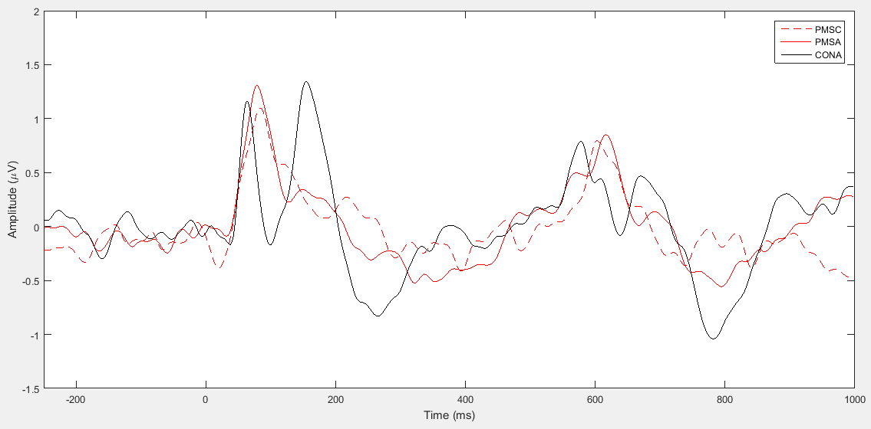
S1
S2

Figure 1. Regional ERP Analysis of Age (PMS vs. Controls). PMSC = PMS children (n = 17), PMSA = PMS adults (n = 20), CONA = Control adults (n = 15).

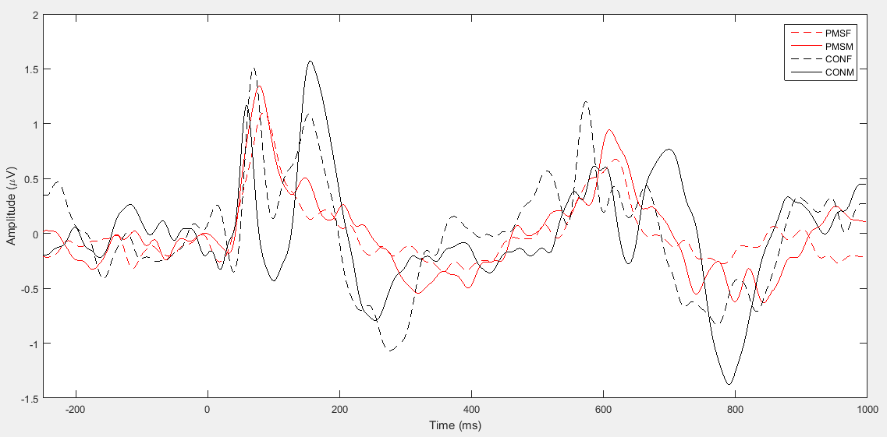
S1
S2

Figure 2. Regional ERP Analysis of Gender (PMS vs. Controls). PMSF = PMS female (n = 20), PMSM = PMS male (n = 17), CONF = control female (n = 7), CONM = control male (n = 8).

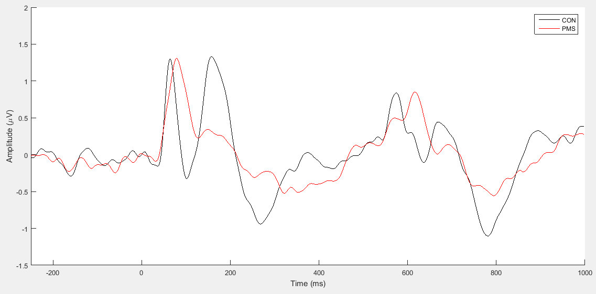
S1
S2

Figure 3. Regional ERP Analysis of Genotype (PMS vs. Controls). CON = control (n = 15), PMS = mutations and deletions (n = 37).

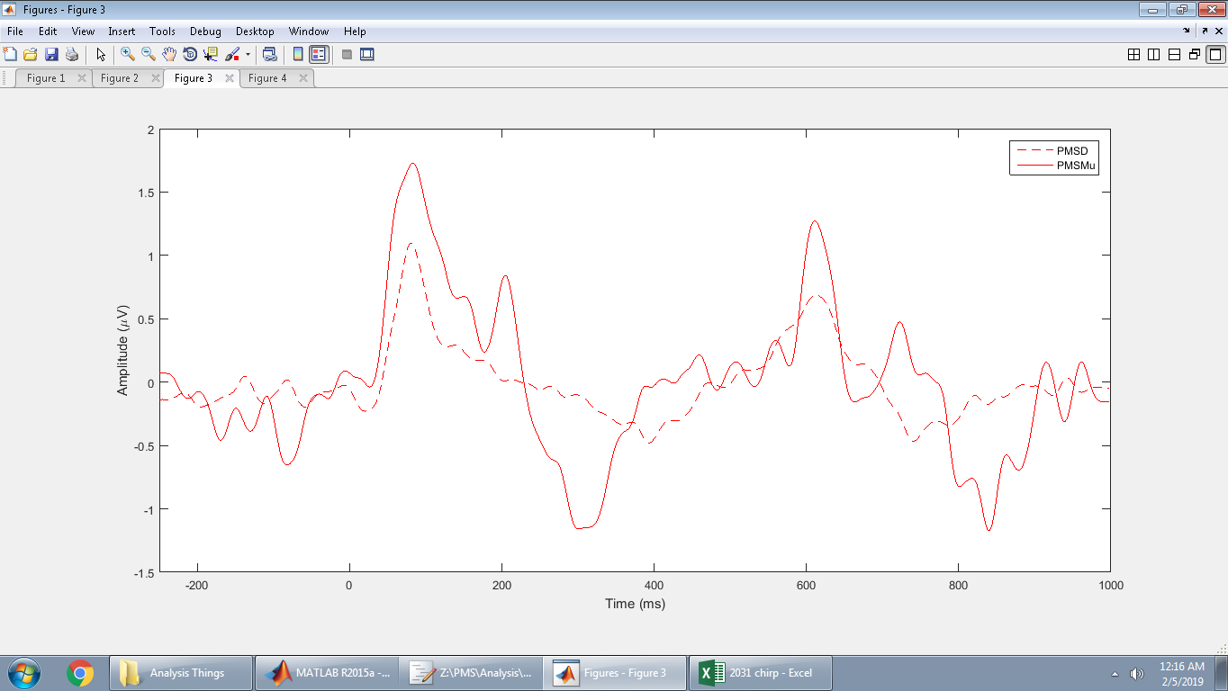
S1
S2

Figure 4. Regional ERP Analysis of Genotype (PMS Mutations vs. Deletions). PMSD = deletions (n = 31), PMSMu = mutations (n = 6).

Appendix F: Global ERP Analyses
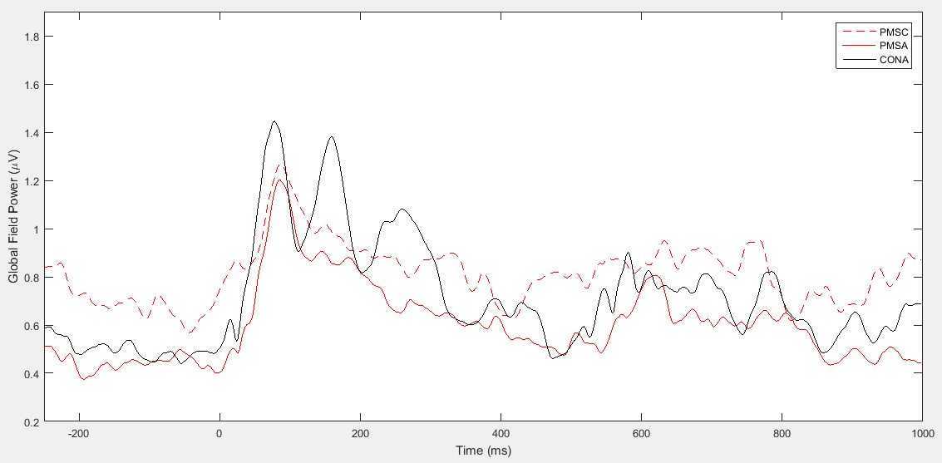
S1
S2

Figure 5. Global ERP Analysis of Age (PMS vs. Controls). PMSC = PMS children (n = 17), PMSA = PMS adults (n = 20), CONA = Control adults (n = 15).

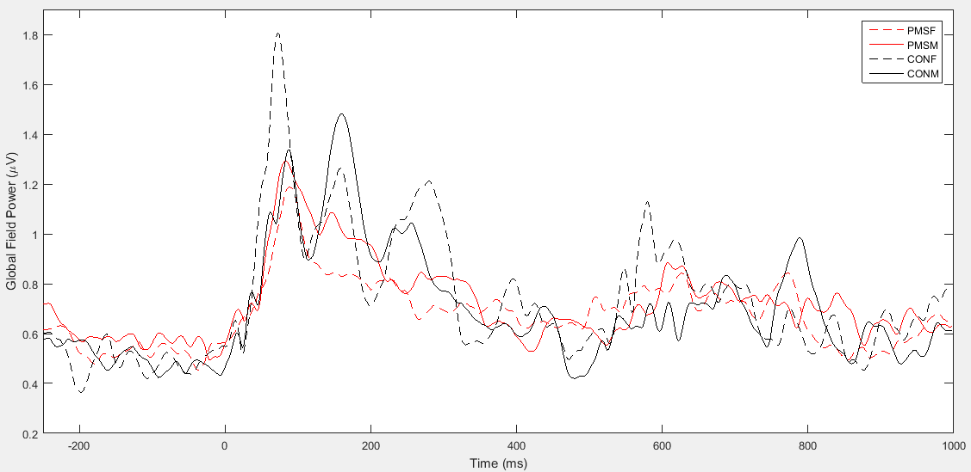
S1
S2

Figure 6. Global ERP Analysis of Gender (PMS vs. Controls). PMSF = PMS female (n = 20), PMSM = PMS male (n = 17), CONF = control female (n = 7), CONM = control male (n = 8).

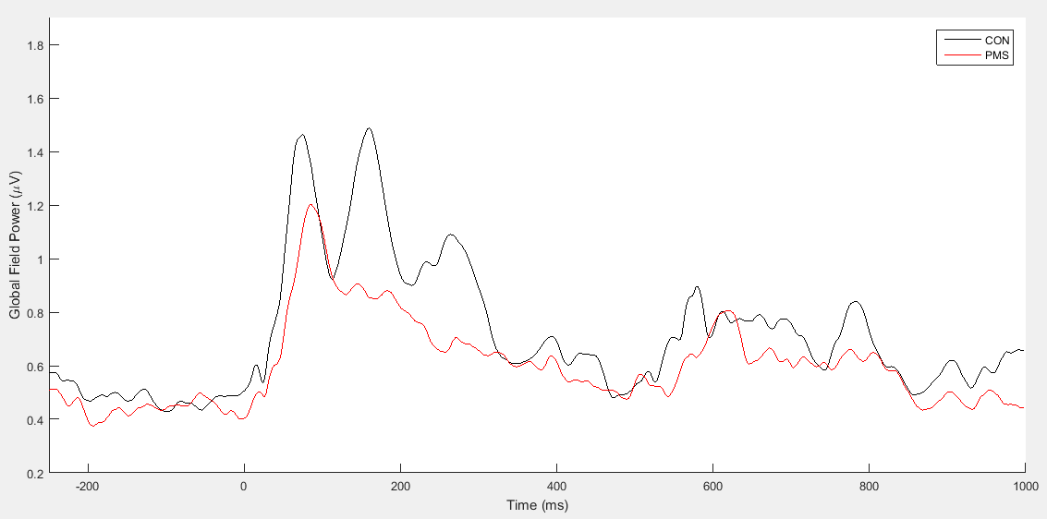
S1
S2

Figure 7. Global ERP Analysis of Genotype (PMS vs. Controls). CON = control (n = 15), PMS = mutations and deletions (n = 37).

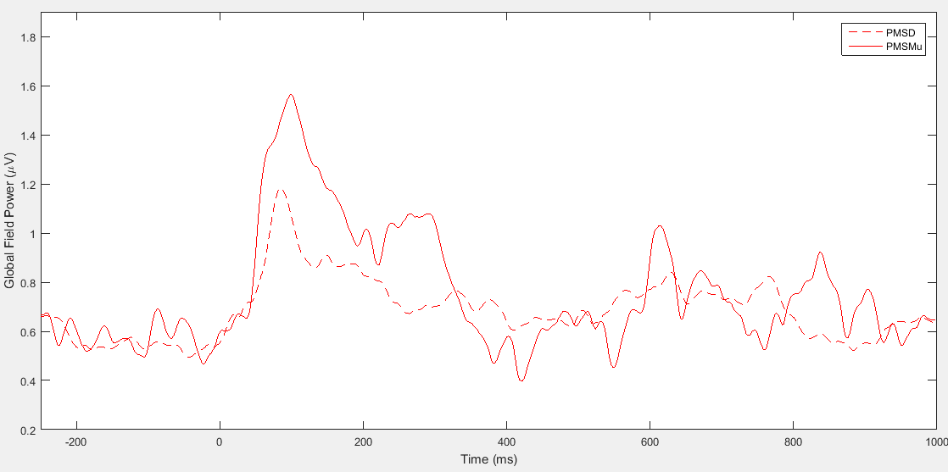
S1
S2

Figure 8. Global ERP Analysis of Genotype (PMS Mutations vs. Deletions). PMSD = deletions (n = 31), PMSMu = mutations (n = 6).

Figure 9. Regional age by system interaction for N1 latency within PMS.

Figure 10. Regional genotype by trial interaction for NN1 latency between PMS and controls.

Figure 11. Deletion size by stimulus interaction for global N1 within PMS.

Appendix H: EEG Montage
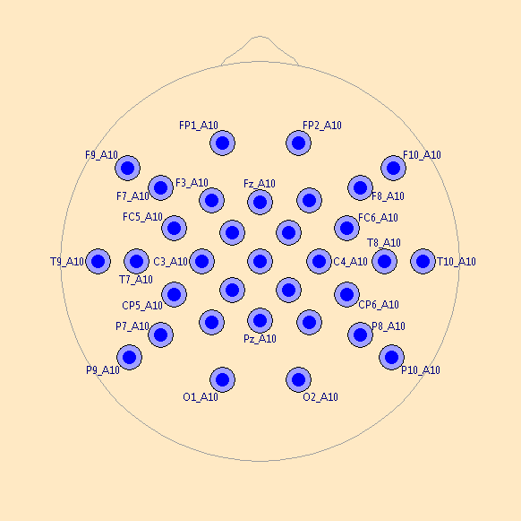

Figure 12. BESA 33 Channel EEG Montage.

