UNIVERSITY OF OKLAHOMA

GRADUATE COLLEGE

THE EFFECT OF FANTASY CONTEXT ON MORAL ACTION AND JUDGMENT

A THESIS

SUBMITTED TO THE GRADUATE FACULTY

in partial fulfillment of the requirements for the

Degree of

MASTER OF SCIENCE

By

BRIAN M. RUEDINGER

Norman, Oklahoma

2019

THE EFFECT OF FANTASY CONTEXT ON MORAL ACTION AND JUDGMENT

A THESIS APPROVED FOR THE
DEPARTMENT OF PSYCHOLOGY

BY THE COMMITTEE CONSISTING OF

Dr. Jennifer Barnes, Chair
Dr. Mauricio Carvallo
Dr. Lara Mayeux

© Copyright by BRIAN M. RUEDINGER 2019
All Rights Reserved

Table of Contents
List of Tables……………………………………………………………………………………...v
Abstract…………………………………………………………………………………………...vi
Introduction………………………………………………………………………………………..1
Experiment 1………………………………………………………………………………………8
Method…………………………………………………………………………………….8
Results…………………………………………………………………………………....10
Discussion………………………………………………………………………………..12
Experiment 2……………………………………………………………………………………..15
Method…………………………………………………………………………………...15
Results……………………………………………………………………………………16
Discussion………………………………………………………………………………..17
Experiment 3……………………………………………………………………………………..20
Method…………………………………………………………………………………...20
Results……………………………………………………………………………………21
Discussion………………………………………………………………………………..23
General Discussion………………………………………………………………………………24
References………………………………………………………………………………………..30
Appendix A: Choose Your Own Adventure Paradigm…………………………………………..40
Appendix B: Transportation……………………………………………………………………..44
Appendix C: Short Dark Triad……………………………………………………….…………..45

List of Tables
Table 1. Wording of items on which male participants were more likely to commit moral violations in the fantasy condition in Study 1. ………………………………………………..…38
Table 2. Means, Adjusted Means, Standard Deviations and Standard Errors for Immorality Ratings in Study 3…………………………………………………………………………...……39

Abstract
Prior research has suggested that individuals import facts from the real world into fictional worlds and that the likelihood of importation depends on both the type of fact and the fictional context (Weisberg & Goodstein, 2009). Here, we extended this work to examine the importation of real-world morality across fictional contexts. Undergraduate participants (Study 1) and MTurk participants (Study 2) were randomly assigned to either a realistic or fantastical interactive narrative focused on competing for a job straight out of college. At seven junctions, participants were required to select how they would proceed with the story, with each crossroad having an option to behave in a Machiavellian manner, committing a moral violation for personal gain. In Study 3, an MTurk sample was asked to render a third-party judgment of the actions of a character who consistently chose the Machiavellian option. For Study 1, a gender by condition interaction was found, with men, but not women, electing more immoral actions in the fantasy condition than in the realistic one. For study 2, where the sample was older and more removed from the circumstances of the story, no such effect was found for first-party action. Nonetheless, in Study 3, participants judged immoral actions taken in the realistic condition as more immoral than those taken in the fantasy context. Across all iterations of the study, greater transportation predicted choosing fewer first-person immoral actions and judging third-person immoral actions more harshly.

Keywords: FANTASY, REALITY, MORALITY, MACHIAVELLIANISM, FICTION

Introduction
Reading is an inherently personal activity. While the words on the page remain consistent, the perspectives and assumptions imported into the narrative belong to the individual reader (Carreiras, Garnham, Oakhill, & Cain, 1996; Gerrig, 1993; Rosenblatt, 1994). Despite these differences, certain “facts” about fictional worlds seem to be held constant across readers. For example, when reading a fictional story, one does not need to be told that humans breathe oxygen or that gravity exists and exerts a force of 9.807 m/s²; unless told otherwise, readers will assume these facts to be true (Gendler, 2011; Ryan, 1980, 1991). But what about the social and moral rules that govern fictional worlds? The purpose of this paper is to examine whether the context of a fictional world—namely, whether or not that context is fantastical—affects the degree to which readers import real-world morality into make-believe worlds.
There is a wealth of evidence and theory supporting the idea that our real world morality affects the way we approach fictional media and that fictional media can affect real world morality (e.g., Anderson & Dill, 2000, Bilandzic, Schnell, & Sukalla, 2019; Ciulla, 1998; Currie, 1995, 2016; Eden, Daalmans, & Johnson, 2017; Eden, Oliver, Tamborini, Limperos, & Woolley, 2015; Grizzard et al., 2017; Krcmar & Curtis, 2003; Lester & Weber, 2016; Schnell & Bilandzic, 2017; Shafer, Janicke, & Siebert, 2016; Tamborini, Weber, Eden, Bowman, & Grizzard, 2010; Walton & Tanner, 1994; Weatherson, 2004). Indeed, Flesch (2007) suggested that a large part of the appeal of fiction is that fictional stories typically offer us the opportunity to see the righteous prevailing while wrongdoers are met with their just desserts. Affective Disposition Theory (ADT; Zillman & Cantor, 1977) states that we generally enjoy seeing liked characters receive good outcomes and disliked characters receive bad outcomes, and the extent to which we like, or dislike characters is derived from our perceptions of the character’s morality (Zillman, 2000). Based on personal conceptualizations of morality, a viewer rejoices when those in line with one’s morality are rewarded and those who violate one’s morality are punished. The viewer is a “moral monitor,” constantly revising the moral correctness of a character’s actions as motivations are revealed and behaviors change. (Zillman, 2000). Thus, morality may explain why various characters (Raney, 2011, 2017) and narratives (Raney, 2004) appeal to their audience.
Strikingly, however, evidence suggests that the enjoyment of characters is not wholly restricted to characters that are traditionally “good.” The enjoyment of morally ambiguous characters, or even villains, has also been explored in detail (Black, Helmy, Robson, & Barnes, 2018; Eden, Grizzard, & Lewis, 2011; Janicke & Raney, 2015; Krakowiak & Oliver, 2012; Krakowiak & Tsay-Vogel, 2013, 2015; Shafer & Raney, 2012; van Ommen, Daalmans, & Weijers, 2014). It is easy to find examples of immoral protagonists in popular media, such as Frank Underwood of House of Cards and Walter White of Breaking Bad (e.g., Salgaro & Tourhout, 2018; Vaage, 2015). Morally ambiguous characters may be more complex than the traditional black-and-white conception of heroes and villains, often displaying both moral and immoral traits (Krakowiak & Oliver, 2012; Eden et al., 2015). Black and colleagues (2018) highlight the mechanisms by which the enjoyment of “dark” fictional characters may arise. The greater complexity of these characters and the relatability of the situations in which they find themselves may lead to greater identification on behalf of the viewer, due to increased similarity (Cohen, 2001; Konijn & Hoorn, 2005). We may also take enjoyment from the dramatic situations and emotional turmoil these characters experience and create (Breithaupt, 2015; Salgaro & Tourhout, 2018). Notably, prior research has shown that feeling empathy for either moral or immoral characters may increase the effects of playing video games on real-world moral behavior (Happ, Melzer, Steffgen, 2015), and it has been suggested that, in the context of fiction, empathy can be separated from morality (Salgaro & Tourhout, 2018). Significantly, identifying with and liking a character may encourage greater forgiveness of immoral actions in order to preserve positive perceptions (Raney, 2004, 2011).
Moral disengagement (Bandura, 1999, 2006), a process by which one avoids moral agency by denying that a harm has been committed or justifying immoral behavior, has been documented as a mechanism that leads to the enjoyment of immoral fictional characters (Janicke & Raney, 2018; Krakowiak & Tsay-Vogel, 2013; Sanders & Tsay-Vogel, 2016). In fiction, no real harms are committed, and there are no real victims; this provides the reader fictional relief, freeing them from considering the consequences of actions unfolding before them (Vaage, 2013) and allowing the audience to focus more on emotion, rather than rational thought in evaluating moral actions (Vaage, 2015). Similarly, moral disengagement may play a key role in engagement with violent video games, where the player is actually acting violently within the game-world themselves (Hartman & Vorderer, 2010).
Thus, prior research and theory suggests both that real-world morality plays a key role in narrative preferences and that audiences may go through a process of moral disengagement in order to enjoy immoral characters; however, less is known about the properties of a narrative that may make it easier for audiences to leave their real-world morality behind. Information derived from fiction can be compartmentalized (Gerrig & Prentice, 1991), but some stories are more obviously fictional than others. To what degree does the context of a narrative—and particularly, realism—play in how we judge the morality of fictional characters or actions? Here, we are interested specifically in fantasy content. Do we hold characters in worlds far removed from our own to the same moral standard as those in realistic stories? The purpose of the current study was to examine whether the extent to which a story world differs from reality affects the degree to which the audience imports real-world morality into the story.
Prior research has investigated the role that distance from reality plays in the importation of mathematical, scientific, contingent (e.g., “Washington, DC is the Capitol of the United States”), and conventional (e.g., “It is rude to pick your nose”) facts. Weisberg & Goodstein (2009) assigned readers to read different versions of the same story, which differed in their distance from reality. Distance, as conceptualized by Weisberg & Goodstein, is the extent to which a fictional world differs from our own, as operationalized by the number of reality violations (e.g., impossible or magical content) the story contains. A realistic novel that seems to take place in our world would be considered close; a fantasy story with magic and potions would be very far. In an experimental study, Weisberg and Goodstein found that both the distance of the story world from the real world and the type of fact affected the likelihood that participants would import facts from the real world to the story world. As distance from reality increased, less of the real world was imported into participants’ construction of fantastical worlds; however, some facts—namely mathematical and scientific facts—were more likely to be imported across worlds than others. Notably, as distance from reality increased, conventional facts—those related to social norms—were less likely to be imported than mathematical or scientific facts. Significantly, however, this study did not investigate whether moral facts would behave similarly to conventional facts, or whether tenets of morality would be treated more on par with scientific and mathematical facts.
This is particularly noteworthy given that moral concerns are a specific type of social convention that some people view as invariant across situations (Turiel, 1983, 2006). Even children are able to recognize this distinction and deliver differential judgment between moral transgressions and conventional transgressions. While conventional transgressions can be forgiven in response to contextual features, transgressions against morality cannot (Killen & Smetana, 2015; Turiel, Smetana, & Killen, 2014). In regard to fictional scenarios, Fast & Van Reet (2018) demonstrate that the acceptability of prosocial behaviors and the unacceptable evaluation of antisocial behaviors remained constant across real and realistic pretend scenarios. Similarly, previous findings suggest that narratives denoted as “true stories” versus narratives denoted as “fictional stories” prompted equal levels of moral disengagement (Krakowiak & Tsay, 2011).
Elsewhere, it has been argued that fiction writers do not have the authority to change morality (Levy, 2005). Whereas an authority figure (writer) can decree that a conventional rule does not apply within a specific fictional context, authorities do not hold such power over concerns of morality. This distinction has been used to explain the phenomenon of imaginative resistance, where people perceive themselves as being unable to imagine worlds in which morality works differently (e.g., Gendler, 2000). To the extent that certain moral “facts” are universal across contexts and even within the imagination, we might expect that, in constructing fictional worlds, we should import moral principles with equal vigor to that which we ascribe to mathematical facts. Yet empirical research on imaginative resistance suggests that some individuals may either not experience it, or be able to overcome it (e.g., Barnes & Black, 2016; Black & Barnes, 2017).
Strikingly, there is also work that suggests that fictionality—that is, knowing that an action or event is make-believe—may affect our moral intuitions in some cases. By reminding oneself that no real harm is committed while playing a violent video game, individuals reduce potential feelings of moral unease (e.g., Hartmann & Vorderer, 2010). Similarly, in a series of studies conducted by Sabo & Giner-Sorolla (2017), support was found for a “fictive pass” in which the evaluation of fictional or imaginary violations does not always mirror the evaluation of equivalent real-world violations. In these studies, participants rated vignettes that were stated to occur in either reality or in the context of imagination (e.g., someone who imagined doing a bad thing, watched a character doing a bad thing in a movie, or did a bad thing while playing a video game). Participants were then asked to rate the moral wrongness of the violations depicted. Results indicated that participants deemed fictional harm violations to be less immoral and less indicative of bad character than real-world harm violations; however, for purity violations, fiction had no mitigating effect. Thus, it seems that fictionality may influence our judgment of some, but not all, moral violations.
Notably, though Sabo & Giner-Sorolla (2017) looked at moral judgment of third parties who committed violations in either reality or imaginary contexts, this experiment did not assess participants’ willingness to commit these violations themselves. Furthermore, the target of the character judgement in the prior study was the person who was viewing the movie or playing the videogame, not the video game or movie characters themselves. Finally, while the fictive pass study adjusted the medium in which the act in question was housed (imagination, movie, or video game), data in the imagination condition were collapsed across these variations. Thus, the study focused on a binary comparison of real-world versus imagination, with all the imaginary contexts being realistic in nature. It is unclear, therefore, what differences in morality might be found between a movie, book, or video game set in a fantasy world and one set within a world that closely resembles our own. Fast and Van Reet (2018) manipulated fictional distance in a study of children’s pretend play and found that, although children import their real-world morality into pretense, they were more forgiving of antisocial behavior when the pretense scenario was fantastical than when it was realistic. In contrast, Hartmann & Vorderer (2010) found that altering the target of a first-person shooter game from human to zombie-like had no effect on moral disengagement.
The purpose of the current studies was to examine whether distance from the real world (i.e. fantasy context) affects the extent to which morality is imported into that world, both in terms of how willing participants are to choose to behave immorally for personal gain (Studies 1 and 2) and in terms of their third-person evaluations of immoral behavior (Study 3). The first study featured an interactive narrative in which participants progressed through a job interview process in either a fantasy or realistic context. Participants were given the option to act in a Machiavellian (behaving immorally to further their own goals) or non-Machiavellian way at each of seven decision points. If morality is imported with equal strength across fictional contexts with varying degrees of fantasy content, there should be no difference in frequency with which participants choose the Machiavellian actions across conditions. If, on the other hand, morality is being imported differently in realistic and fantasy stories, then we would expect the more distanced fictional world to elicit less moral importation. In contrast to theories that argue that morality is invariant across contexts and imaginary worlds (e.g., Levy, 2005), we hypothesized that, like conventional facts (see Weisberg & Goodstein, 2009), real-world morality would be less likely to be imported into fantasy contexts than realistic, yet fictional, ones. Thus, we hypothesized that individuals within a fantasy context would choose more Machiavellian than non-Machiavellian options, consistent with getting ahead, despite consequences for others.

Experiment 1
Method
Participants.
Participants (N =208) were recruited from the psychology department subject pool; all participants completed the current study and then filled out survey measures of television-viewing habits for a second, unrelated study. Participants were excluded if they spent less than 5 minutes (15 participants) or more than one hour (11 participants) on the entire survey (inclusive of both studies). An additional 12 participants were excluded for not finishing the survey and 3 for bad responding on the measure of Transportation, for a final sample of 167 students (68.9% female, 28.1% male, 3% gender non-binary; 79.6% White), with ages ranging between 18 and 23 (M = 19.18, SD = 1.05).
Procedure.
Participants completed the Short Dark Triad (see below) and were then randomly assigned to read and complete either a fantastical or realistic interactive story. The Real-World condition had 89 participants (67.4% female, 30.3% male, 2.2% non-binary) and the Fantasy condition had 78 (70.5% female, 25.6% male, 3.9% non-binary). After completing this experiment, all participants went on to complete an unrelated experiment. Non-binary participants were used in all analyses where gender was not used as a covariate.
Instrumentation.
Interactive narrative. An interactive narrative was created for the purpose of this study. The narrative placed participants in the context of obtaining a desired job and presented various choices along the job acquisition process. The interactive narrative began with the following prompt for the real-world condition, “The end of your final year of college is quickly approaching. You’ve been applying for jobs constantly, but it seems like you never even make it to the interview stage. Your grades are decent, you’ve been involved in leadership positions in extracurricular activities, and you communicate clearly in written and spoken form. Unfortunately, you do not have much prior work experience, and it really seems like that’s holding you back.” Participants then read a description of a possible “dream job” that required 1-3 years of prior work experience and had to decide at the first decision point whether or not to lie on their resume, taking advantage of the fact that there is another student at their school with a highly similar name who has completed the internship programs in question.
In the fantasy condition, participants read the same narrative, with fantasy terms sprinkled in (i.e. “college” became “magic college” and “resume” became “wizarding resume”). After the first decision point, participants were faced with 6 additional choice points where they had to choose between two options: a moral violation to improve their chances of obtaining the job or a morally upstanding behavior that might leave them at a disadvantage. The seven target immoral behaviors included: lying on a resume; endorsing a harmful stereotype to ingratiate yourself to a bigoted interviewer; relaying the interviewer’s prejudiced behavior to an applicant of the target group to dissuade them from continuing their application to the company; sabotaging another applicant’s messages, so that they do not receive communications from the company; stealing another person’s project at an audition, so that it appears they did not turn in any work; revealing sensitive information about your fellow applicants that make them less appealing to employers; and manipulating the significant other of the chosen job applicant in order to encourage them to turn down the job. Presentation order of the Machiavellian and non-Machiavellian choices was randomized. Choices were coded with a 0 for a moral behavior and 1 for an immoral behavior, thus the maximum number of immoral choices was 7. The choice options, as outlined above, were designed to be in line with the Machiavellian subscale of the Short Dark Triad (Jones & Paulhus, 2014) such as “Whatever it takes, you must get the important people on your side.” Regardless of choice, participants progressed in identical ways through the process.
Transportation. Participants’ state transportation into the interactive story was measured with a 12-item scale adapted from Green and Brock’s (2000) 15-item transportation scale. All items were on a seven-point scale (1 = strongly disagree, 7 = strongly agree). (r_{α} = .78).
Short dark triad. The Short Dark Triad (SD3) (Jones & Paulhus, 2014) was used to measure participants’ level of dark triad personality traits. Subscales include Machiavellianism, Narcissism, and Psychopathy. Items are ranked on a 5-point Likert scale from 1 (Strongly disagree) to 5 (Strongly agree). Items include, “ I like to use clever manipulation to get my way” and “Many group activities tend to be dull without me.” Machiavellianism subscale internal consistency was: r_{α} = .75.
Results
Preliminary Analyses
Pearson correlation coefficients were computed to assess the relationship between the number of Machiavellian choices selected and potential covariates. There was a positive correlation between number of Machiavellian choices selected and trait Machiavellianism, (r(167) = .31, p < .001, 95% CI [.17, .47]). There was a negative correlation between number of Machiavellian choices selected and state Transportation into the narrative, (r(167) = -.230, p = .003, 95% CI [-.39, -.08]). There was a positive correlation between number of Machiavellian choices and gender (r(163) = .239, p = .002), with larger number of Machiavellian choices made by men. Thus, trait Machiavellianism, state Transportation, and gender were included in subsequent models.
An independent-samples t-test was conducted to compare Transportation across our two interactive stories to ensure that the two conditions were equally engaging. There was no significant difference in state Transportation for the Realistic condition (M = 4.46, SD = .68) and Fantasy condition (M = 4.29, SD = .93); t(165) = 1.36, p = .176, d = 0.21, 95% CI [-.08, .42]. The unadjusted number of choices selected were: Real World (M = 0.80, SD = 1.25); Fantasy (M = 1.19, SD = 1.49)
Primary Analyses
A negative binomial regression was run to predict the number of Machiavellian choices selected based on condition, participant gender, trait Machiavellianism, and state Transportation into the narrative. The negative binomial regression model was statistically significant Χ²(3) = 16.580, p = .001. A gender by condition interaction was found Χ²(1) = 3.854, p = .050.
To further examine these results, separate negative binomial regressions were calculated to compare the conditions within gender; estimated marginal means were calculated holding trait Machiavellianism and state transportation constant. Men were significantly more likely to commit moral violations in the fantasy condition (M_{adj} = 2.30 , SE =0.45, 95% CI [1.57, 3.37]) than in the realistic condition (M_{adj} = .89 , SE = .26, 95% CI [.50, 1.57]): Χ²(1) = 7.385, p = .007. Females in the fantasy condition (M_{adj} = 0.78, SE = .13, 95% CI [.57, 1.08]) were not significantly more likely to commit a moral violation than in the realistic condition (M_{adj} = 0.72, SE = 0.15, 95% CI [.47, 1.08]): Χ²(1) = .106, p = .744.

Exploratory Analyses.
In order to determine if there were any individual choice points driving the interaction, a post-hoc analysis was performed to compare males in the fantasy condition with males in the real-world condition across each of the seven choice points. A chi-square test of independence was performed for males on each choice point. Males in the fantasy condition were significantly more willing than those in the control to endorse a stereotype to ingratiate themselves to a bigoted interviewer Χ²(1) = 3.833, p = .050, ϕ_{C} = .29; to relay to an applicant of said stereotyped group that such sentiments were expressed in the company Χ²(1) = 3.852, p = .050, ϕ_{C} = .29; and to (psychically) manipulate the significant other of the candidate who received the job offer Χ²(1) = 5.650, p = .026, ϕ_{C} = .35. The exact wording of the choices in the fantasy condition are shown in Table 1.
In order to investigate the role of transportation on moral importation, moderation analyses were conducted using Model 1 of the PROCESS macro (Hayes, 2012) at 10,000 iterations. Condition (Realistic vs. Fantasy) was the predictor variable, transportation was the moderator, and number of Machiavellian choices was the outcome. There was no significant interaction between condition and transportation (β = -.066, SE = .803, p = .934, 95% CI [0.44, 1.06]).
Discussion
The purpose of Study 1 was to examine whether fictional distance from the real world (i.e. fantasy context) affected the degree to which morality was imported into an interactive story world, specifically in terms of how willing participants were to choose to behave immorally for personal gain. Males, but not females, were more likely to choose the immoral options in a fantastical interactive story than in a realistic one. These results are in line with research by Fast & van Reet (2018), which found that children view antisocial behaviors done in fantastical pretend contexts as less immoral than the same actions done in realistic pretend scenarios. These results suggest that, at least for the males in our sample, morality may vary with distance in a manner like conventional facts (e.g., Weisberg & Goodstein, 2009), rather than being held constant across all fictional contexts.
As noted in the preliminary analysis, there was a negative correlation between the number of Machiavellian choices selected and participants’ transportation into the interactive narrative. Individuals who were highly transported, or more psychologically immersed (Green & Brock, 2000), elected to behave in less immoral ways. Given that prior research has shown a relationship between transportation and perceived realism of narratives (Green, 2004), it is possible that, across conditions, the narratives felt more “real” to participants who were highly transported, encouraging them to behave as they would in real life.
An exploratory analysis revealed differences between the realistic and fantasy conditions on choices which featured either a fantastical marginalized group or fantastical action. For example, the second choice point featured an encounter in which the interviewer has some clear prejudice against individuals from either another race (realistic condition) or another magical race (fantasy condition) and to ingratiate themselves to the interviewer, readers have the option to indicate that they agree with such sentiments. Rather than being able to clearly picture a real-world minority group and the types of prejudice that group may regularly face, the use of a magical race is more abstract; the moral norm that it is bad to be racist may not transfer to the more distanced “magical race.” This may have allowed for moral disengagement (e.g., Bandura, 1999, 2002) to occur. Another choice point at which differences were found between the fantasy and realistic conditions was when, after receiving word that they are the backup choice for the job, the participant had the option to manipulate (realistic condition) or psychically manipulate (fantasy condition) the significant other of the chosen applicant, so that the significant other will express disapproval of the effect the job will have on their relationship. The use of a fantastical action may, like the use of a magical race, invoke greater distance within the narrative, as the reader will not have experience in how one would psychically manipulate another. Thus, the difference in Machiavellian behavior in the fantasy and realistic conditions may depend not only on the distance of the story world from the real world, but also on whether or not the specific action was, either in target or behavior, magical in nature.
Strikingly, in the current study, an effect was found for male participants, but not for female participants. This gender effect could have several explanations. Liberman, Trope, & Stephan (2007) notes that distanced situations (in terms of time, space, etcetera) encourage people to think in value terms; as a result, individuals with differing values may differ in planned behaviors in distanced situations. Additionally, increased psychological distance has been shown to minimize the perceived harm of a moral violation (McGraw & Warren, 2010). In comparison to men, women possess higher moral identity and lower moral disengagement (Aquino & Reed, 2002; Clark & Dawson, 1996; Detert, Treviño, & Sweitzer, 2008; Trzebiatowska & Bruce, 2012). Thus, it may be that the distance introduced in the fantastical context encouraged men and women to default to different core values. Specifically, core values that may differ between the emphasis on either agentic (dealing with self-advancement) or communal (dealing with the maintenance of positive relationships) values (e.g., Trappnell & Paulhus, 2012). Similarly, women and men may have made different choices in this task due in part to gender differences in levels of empathizing (vs systemizing) between men and women (Greenberg, Warrier, Allison, & Baron-Cohen, 2018) or in emotional factors associated with moral decision-making, such as shame proneness, guilt, and the expectation of positive emotions from immoral decisions (Ward & King, 2018).
Alternatively, it may be that the gender differences found in this experiment are the result of gender differences in the way that morality is being imported differently across conditions. In other words, it may be that men, but not women, see the immoral behaviors as more acceptable in a fantasy context, and that is why they are more willing to choose the Machiavellian options. Before exploring this possibility, we first wanted to examine whether the gender effect found here was an artifact of the sample used: undergraduate students in an introductory psychology class, which skewed female. Thus, Study 2 was run to examine whether a similar interaction between gender and condition would be found in a second sample, drawn from a different source of participants.
Experiment 2
Method
Participants.
Participants (N = 301) were recruited via Amazon Mechanical Turk (MTurk). MTurk is an online platform where workers complete tasks for compensation. Prior research has demonstrated that participants recruited via MTurk display similar results to and are more representative than convenience samples (Berinsky, Huber, Lenz, 2011); indeed, in a recent study, MTurk participants performed better on an attention check than subject pool participants (Hauser & Schwarz, 2016). Participants were excluded from the final sample for not completing the survey (14 participants) and poor responding on covariates (5 participants). Further, in line with Study 1, participants were excluded if they spent more than one hour on the survey (1 participant) or less than five minutes for total survey duration (3 participants, all of whom were already excluded for poor responding or not finishing) Additionally, to address reviewer concerns about the quality of responding in our MTurk sample, we also applied an exclusion criterion geared toward ensuring that participants spent a sufficient amount of time reading and responding to the interactive narrative specifically, excluding participants who completed the interactive narrative task faster than one standard deviation below the mean (seconds) (M = 223, SD = 165.30) (5 participants). The final sample consisted of 276 individuals (39.1% female; 72.8% White), with ages ranging from 20 to 70 (M = 35.14, SD = 10.42). Time range:15.61 minutes.
Procedure.
Participants were recruited on MTurk and then randomly assigned to either the realistic or fantasy interactive story; the procedure and covariates used were identical to those used in Study 1, Machiavellianism (r_{α} = .838).,transportation (r_{α} = .724).
Results
Preliminary Analyses
Pearson correlation coefficients were computed to assess the relationship between the number of Machiavellian choices selected and potential covariates. As in Study 1, there was a positive correlation between number of Machiavellian choices selected and trait Machiavellianism, (r(276) = .472, p < .001, 95% CI [.37, .58]). There was a negative correlation between number of Machiavellian choices selected and Transportation into the narrative, (r(276) = -.118, p = .049, 95% CI [-.24, 0]). There was a negative correlation between number of Machiavellian choices and age (r(276) = -.2, p < .001, 95% CI [-.40, -.18]). The significant correlations among these variables warranted their inclusion in the subsequent model. An independent-samples t-test was also conducted to compare the levels of transportation into our two interactive stories to ensure that they were equally absorbing. There was no significant difference in Transportation for the Realistic condition (M = 4.88, SD = .79) and Fantasy condition (M = 4.70, SD = .86); t(274) = 1.78, p = .08, d = 0.21, 95% CI [-.02, .37]. Overall, participants in Study 2 reported greater transportation than those in Study 1; t(441) = 5.09, p < . 001. The unadjusted number of choices selected in Study 2 were: Real World (M = 1.66, SD = 1.89); Fantasy (M = 1.70, SD = 1.83). Overall, participants in Study 2 selected more immoral choices than those in Study 1; t(441) = 4.40, p < .001.
Primary Analyses
A negative binomial regression was run to predict the number of Machiavellian choices selected based on condition, participant gender, age, trait Machiavellianism, and Transportation into the narrative. The negative binomial regression model was not statistically significant Χ²(3) = .903, p = .825. There was no significant interaction between gender and condition Χ²(1) = .133, p = .72.
Discussion
The purpose of Study 2 was to examine whether the effect found in our first study—and particularly the gender difference—replicated outside of a college sample. In contrast to Study 1, participants in Study 2 were no more likely to choose immoral, Machiavellian actions in fantasy contexts. A finding that was consistent across Study 1 and Study 2, however, was that increased transportation into the narrative resulted in fewer Machiavellian choices, suggesting that individuals who are more absorbed in a fictional world are more likely to make choices in line with real-world morality.
The differences between Study 1 and Study 2 could be explained by a variety of factors; however, this difference is likely not due to lower quality responding from our MTurk sample. Although we cannot directly compare the time spent on the task in Study 1 and Study 2, due to the fact that Study 1 participants completed additional measures after the completion of this study and time data was only gathered for total survey duration, it is unlikely that our MTurk participants spent less time on the study overall, as the exclusion criteria for Study 2 were slightly stricter than those used in Study 1. Further, participants in Study 2, relative to Study 1, were more transported into the narrative, indicating, if anything, a higher level of engagement with the task. Similarly, the lack of an effect in Study 2 is not due to a general reluctance to choose the Machiavellian option in Study 2, as participants in Study 2 chose a greater number of immoral choices, irrespective of condition.
What, then, can we make of the difference across these studies? One reason that Study 2 participants may have reacted more similarly across our two conditions involves the overall difference found in transportation into the narrative. As noted, participants in Study 2 were more transported into the narrative and, across both studies, transportation was shown to be related to the tendency to import real-world morality into stories. Thus, it may be that there is some kind of transportation threshold, under which there is an effect of fantasy versus reality, yet upon reaching a sufficient level of transportation, fictional distance has no impact, perhaps because the narrative feels more “real” regardless. This is in line with prior research showing that increased transportation is positively related to perceived realism of a story (Green, 2004). Notably, however, moderation analyses in Studies 1 and 2 individually yielded no effects.
Another intriguing explanation for the disparity in our results across Studies 1 and 2 involves the age difference between our samples and the specific content of our story stimuli. The sample for Study 1 was made up of college students who are very close, temporally, to the circumstances depicted in the story, which focused on the job search process. The sample from MTurk was made up of individuals who were older. For this older sample, it is possible that the distance between their own lives and a story focused on going through the interview process for a first job feels significant, regardless of whether the scenario is fantastic in nature. As outlined by Maglio, Trope, Liberman (2013), there is a common underlying construct to psychological distance, such that temporal distance is no greater or less than distance elicited through the hypothetical. Additionally, the extent to which participants were motivated to “achieve the goal” or get the job, may have influenced how they chose to respond; younger individuals may have been more motivated to acquire their “first” post-college job, while older individuals may not have shared this motivation.
In order to set aside issues of motivation, Study 3 examined whether MTurk participants would show evidence of differential moral importation across fantastic and realistic stories with respect to third-party judgment. In addition, switching to third-party judgment allowed us to further probe the gender effect found in Study 1, as it examines whether there are gender differences in moral importation when any gender differences that might exist in willingness to act in an immoral fashion are set aside. If there are gender differences in the way that morality is being imported into fantasy contexts, then we would expect third-party evaluations of immorality to differ across conditions for male, but not female participants. If, on the other hand, both men and women are importing morality differently across fantasy and realistic contexts, then we would expect that both men and women would evaluate the actions of a third party to be less morally wrong in the fantasy context.

Experiment 3
Method
Participants.
Participants (N = 301) were recruited via MTurk with the same specifications as in Study 2, during the same timeframe. Individuals who completed Study 2 were not allowed to participate in Study 3 and vice versa. Participants were excluded for not completing the survey (26 participants), poor responding on covariates (6 participants), and for being under five minutes in total study duration or for completing the evaluation section faster than one standard deviation below the mean (seconds) (M = 234, SD = 188.42) (7 participants), resulting in a final sample of 262 (39.3% female; 59.9% male, .8% non-binary; 73.7% White) with ages ranging from 18 to 70 (M = 34.20, SD = 10.37). The range in completion time was 25.86 minutes.
Procedure.
Participants were recruited on MTurk and then randomly assigned to read either a realistic or fantasy story. The method remained identical to Studies 1 and 2, except that the interactive narrative was adjusted so that rather than choosing actions themselves, participants were evaluating the moral wrongness of the actions taken by a fictional character who chose all the Machiavellian options from the previous studies. In order to avoid specifying the character’s gender, a gender-neutral name (Taylor) was used for the character, and the character was always referred to by name, ensuring that no gendered pronouns were used. Actions at each of the seven choice points outlined in Study 1 were rated on a 7-point Likert scale from 1 (not at all immoral) to 7 (very immoral).
Following this task, participants filled out a measure of state transportation (r_{α} = .74)., Machiavellianism (r_{α} = .88)., and demographics, as in Study 1. Non-binary participants were used in all analyses where gender was not used as a covariate.
Results
Preliminary Analyses
Pearson correlation coefficients were computed to assess the relationship between moral judgment of the third party’s actions and potential covariates. There was a negative correlation between harshness of moral judgment and trait Machiavellianism (r(262) = -.148, p = .016), with those higher in trait Machiavellianism evaluating the character’s Machiavellian actions less harshly. There was a correlation between moral judgement and Transportation (r(262) = .231, p < .001; those who experienced greater transportation delivered harsher evaluations. There was no significant difference in Transportation across the Real-World condition (M = 4.66, SD = .82) and Fantasy condition (M = 4.51, SD = .94); t(260) = 1.31, p = .191, d = .17, 95% CI [-.07, .36] . As in Study 2, participants from Study 3 were more transported into the narrative than participants in Study 1; t(427) = 2.37, p = .018.
Primary Analyses
An ANCOVA was conducted controlling for age, trait Machiavellianism, and state transportation. There was a significant effect of condition on moral judgement, such that actions taken in the realistic condition (M_{adj} = 5.56, SE = 0.78, 95% CI [5.41, 5.72]) were rated as more immoral than actions taken in the fantasy condition (M_{adj} = 5.33, SE = .078, 95% CI [5.17, 5.48]); F(1,253) = 4.46, p = .036, η_{p}² = .02. There was no significant effect of gender on immorality judgment, F(1,253) = 1.802, p = .181, η_{p}² = .01. Trait Machiavellianism was a significant predictor of moral judgement (β = -.141, p = .014, 95% CI [-0.25, -0.03, η_{p}² = .02); those higher in Machiavellianism rated actions as less immoral. Transportation into the narrative was a significant predictor of moral judgment (β = .222, p < .001, 95% CI [.11, .33], η_{p}² = .06); those who were highly transported delivered harsher moral judgments. Unadjusted means and standard deviations can be found in Table 2.
In order to more fully examine the role of transportation, a moderation analysis was conducted using Model 1 of the PROCESS macro (Hayes, 2012) at 10,000 iterations. Condition (Realistic vs Fantasy) was the predictor variable, transportation was the moderator, moral judgment was the outcome. There was no significant interaction between condition and transportation (β = .002, SE = .014, p = .91, 95% CI [-.03, .03]).
Exploratory Analyses.
In order to determine if there were any individual evaluations driving the effect of condition on third-party moral judgment, a post-hoc analysis was performed to compare the real world and fantasy conditions across individual evaluations. An ANCOVA revealed that for the evaluation of the first action only (lying on the resume), there was a statistically significant difference between the realistic (M_{adj} = 5.40, SE = .12, 95% CI [5.15, 5.64]) and fantasy (M_{adj} = 5.0, SE = .12, 95% CI [4.76, 5.26]) conditions, controlling for age, trait Machiavellianism, and state transportation, F(1,255) = 4.78, p = .030, η_{p}² = .02. In order to probe this effect further, we examined whether participants were spending more time on the first choice point, possibly indicating a higher quality of responding. Because the sections of the narrative that participants had to read at each choice point varied in length, we calculated the time spent per word at each of the seven choice points. Participants spent the most time per word on choice points 3 and 7, and the least on choice points 4 and 6; the first choice point fell between these two extremes.

Discussion
The purpose of Study 3 was to extend the findings of Studies 1 and 2, which focused on how participants chose to behave in an interactive story, to third-party judgments of immoral behavior performed within fantastical and realistic contexts. The exploration of third-party judgment strove to eliminate any age-differences in motivation to land one’s first job out of college and to illuminate whether the gender difference from Study 1 is best explained via different moral standards or differences in willingness to select immoral behaviors. Participants who rated the behavior of a third-party, immoral actor judged the actions more harshly in a realistic story than in a fantastical one. There was no effect of gender on the evaluations of immoral behavior. Results of the Study 3 suggests that both men and women imported morality differently into fantasy (versus realistic) contexts, with actions taken within fantasy held to a lesser standard regarding morality. A finding that was consistent across all three studies was that transportation was related to participants’ responding: in Study 3, increased transportation resulted in harsher moral judgments of the choices made by a third party.
In contrast to the null result in Study 2, where participants did not elect to act more immorally in a fantasy context, participants in Study 3 granted more latitude toward Machiavellian behavior in a fantasy context, suggesting an effect of context on moral importation. The results of Study 3 are in line with the suggestion that the null result for first-person action in Study 2 may be related to personal distance from the circumstances of the text and resulting motivational differences. Future research is needed to examine this possibility more thoroughly.
Regarding differential evaluation of individual choice points, we only found a significant effect of condition on the first choice point (lying on a resume), with those in the fantasy condition being less harsh in their moral appraisal than those in the realistic condition. It is unclear what might be causing this effect, though it seems unlikely to be a decrease in the quality of responding as participants proceed through the task. Looking at the time spent per word of narrative, reading time did not systematically decrease as participants worked their way through the experiment. It is worth noting, however, that the first choice point was the longest piece of text and featured the greatest number of magical cues, suggesting that the effect may only occur within text of a specific length or in response to a particular number of cues. Additionally, being the first choice point, participants may have become more transported as the story progressed, thereby reducing the differences between conditions.
Since Study 3 shifted the focus from first-person action to third-person evaluation, it is more akin to prior research dealing with evaluations of or preferences for morally ambiguous or immoral characters (Black, Helmy, Robson, & Barnes, 2018; Eden, Grizzard, & Lewis, 2011; Janicke & Raney, 2015; Krakowiak & Oliver, 2012; Krakowiak & Tsay-Vogel, 2013, 2015; Shafer & Raney, 2012; van Ommen, Daalmans, & Weijers, 2014). The current results suggest that the context of the story (fantasy versus reality) may be one factor to consider in future research on this topic.
General Discussion
Across three studies, we examined the degree to which morality was imported into realistic and fantastical fictional stories. In Study 1 and Study 2, participants completed an interactive story where they had to choose whether or not to behave in an immoral fashion for personal (in-story) gain. In Study 3, participants read a non-interactive version of the story in which a story character repeatedly behaved immorally for personal gain and were asked to rate the morality of those actions. Participants in Study 1 were college undergraduates, for whom the story was initially written to be quite relevant; participants in Studies 2 and 3 were recruited via MTurk and were older and more temporally distanced from the story’s events. The results of these experiments suggest that morality is imported to a different extent across fictional contexts, at least in some cases, and that moral importation increases with greater transportation into a narrative, regardless of whether that narrative is fantastical or realistic.
In the first study, a gender by condition interaction was present, in which males in a first-person fantasy interactive narrative chose to behave more immorally than those who read a more realistic story. Exposing an older population, from MTurk, to the same interactive story, which focused on getting your first job out of college, did not yield this interaction or, indeed, any differences across condition. In contrast, older participants who were tasked with evaluating the actions of character who made the immoral choices at each of the seven decision points from the interactive story revealed an effect of condition, with immoral actions taken in the fantasy context judged less immoral than in the context of a more realistic story. Across studies, those who were more transported into the narrative were more likely to import real-world morality, choosing less immoral actions (interactive story, Studies 1 and 2) and judging a character’s Machiavellian actions as more immoral (Study 3). Looking more closely at the choices/actions that drove the significant effects found in the first study, males in the fantasy condition differed from males in the real world condition on actions that could be considered more distanced in comparison to the rest of the actions, such as gossiping about a fictional group or attempts to psychically manipulate someone. In contrast, third-party judgment in Study 3 revealed an item-level difference on the first judgment, but not on subsequent judgments.
As a whole, this pattern of results is striking for a variety of reasons. First, although prior research has examined the role that fictionality plays in moral judgment (e.g., Sabo & Giner-Sorolla, 2017) and moral disengagement (e.g., Krakowiak & Tsay, 2011), as well as the role that fantasy content plays in how different kinds of facts are imported into fictional worlds (Weisberg & Goodstein, 2009) and the role that fantasy context plays in moral judgment in pretend play (Fast & Van Reet, 2018), the current research is the first that we know of to show that the importation of morality into fictional worlds depends not only on story content, but also on the participant’s degree of transportation into the narrative. Our results suggest that those who are more transported into the narrative are applying the moral standards of the real world to the fictional context to a greater degree. Importantly, the amount of transportation elicited by the realistic and fantasy conditions did not differ significantly. Furthermore, transportation did not moderate the relationship between condition and behaviors/judgments.
Moving forward, trait level transportability should be examined to determine whether individuals who are more easily transported differ in their evaluations of immoral actions, or whether the results found here indicate that the importation of morality into fiction depends on the particular interaction between text and reader. In line with this latter possibility, in Study 3, third-person moral judgment differed significantly across conditions only at the first choice point. Perhaps, as the story progressed, participants experienced greater transportation as aspects of the fictional world unfolded around them. Future research could examine whether parallel effects can be found with leisure-reading (or viewing) of popular fiction: are moral violations encountered near the beginning of a fantastical story judged less harshly than similar violations that occur later on?
Another direction for future research involves the differences found across the interactive story experiments in Study 1 and Study 2. One possible reason that the effect was not replicated within an older population is that our MTurk participants were personally distanced from both the fantasy condition (fictional distance and temporal distance) and the realistic condition (temporal distance). The narrative in question featured the acquisition of a job straight out of college; the intervening years for some of the participants may have elicited distance of a similar magnitude, compared to current college students whose acquisition of a job is a salient concern. Future research is needed to investigate the role that temporal distance—and other forms, such as geographical distance—play in moral judgment.
Another difference found across Study 1 and Study 2 involves the interaction between gender and condition: a significant interaction was found in Study 1, but not in either Study 2 or Study 3. As noted in prior work, women possess higher moral identity and lower moral disengagement (Aquino & Reed, 2002; Clark & Dawson, 1996; Detert, Trevino, & Sweitzer, 2008; Trzebiatowska & Bruce, 2012), yet in Studies 2 and 3, men and women did not differ, either in third-party moral judgment or in choice in an interactive story. It should be noted, however, that a key limitation of our study was the reliance of a single narrative (acquiring a job out of college), with only two options at each choice point. A greater assortment of options and a greater variety of moral dilemmas encountered may prove useful in probing any individual or gender differences that may exist.
For example, instead of offering participants a choice between committing a moral action for personal gain and refraining from committing that action, participants could be offered a third option—behaving morally at personal cost—to examine whether there are gender differences in altruistic behavior and whether a tendency to make altruistic in-story choices depends on the realism of the story context. Similarly, with respect to third-party judgment, it would be interesting to know whether participants differ in their judgment of fictional moral behavior, as well as fictional immoral behavior. If immoral actions committed in a realistic fictional context are seen as worse than those committed in a fantastical context, are moral action committed in realistic contexts likewise seen as more moral than their fantastical counterparts? Future research is needed to explore these questions.
A second limitation of the current studies that needs to be addressed is that the “interactive” story was not, in fact, interactive. Participants were given choices about how to behave in-story, but those choices yielded identical consequences, regardless of how the participants proceeded. It is possible that allowing participants to “succeed” while making the more moral choice decreases any motivation that might exist to behave immorally; thus, future research is needed to examine whether more significant differences may be found in cases where immoral behavior is more clearly incentivized in-story.
Another limitation worth consideration is that, in Study 3, there was only one measure in regard to evaluating the fictional character’s behavior. We focused specifically on moral evaluation; absent was a measure of liking for the character who was committing said behavior, which would have further elaborated on the influence of context on views of characters who behave badly. Future research incorporating the role that fantasy content may play in moral disengagement (e.g., Janicke & Raney, 2018; Krakowiak & Tsay-Vogel, 2013; Sanders & Tsay-Vogel, 2016) and Affective Disposition Theory (e.g., Raney, 2004, 2017; Zillman & Cantor, 1977; Zillman, 2000) could be fruitful. Future studies that incorporate established fictional characters would also be interesting; much has been discussed about characters such as Walter White, Frank Underwood, and Tony Soprano (e.g., Salgaro & Tourhout, 2018; Vaage, 2015), all of whom live in realistic story worlds; however, it would be interesting to see if even more moral latitude is given to characters in fantasy contexts, such as those on Game of Thrones.
Despite these limitations, the results presented here contribute to a growing body of work examining how morality is imported into fictional contexts and suggest that the extent to which a reader is transported influences not only their actions in a story-world, but also their third-party evaluations of fictional violations. Strikingly, the current results may have applications outside the domain of reading. For example, might actions taken in MMORPGs (massive multiplayer online role-playing games) be held to different standards, depending on the player’s immersion in the game? This is an area ripe for future research.
References

Anderson, C. A., & Dill, K. E. (2000). Video games and aggressive thoughts, feelings, and behavior in the laboratory and in life. Journal of personality and social psychology, 78(4), 772.
Aquino, K., & Reed, I. I. (2002). The self-importance of moral identity. Journal of personality and social psychology, 83(6), 1423.
Bandura, A. (1999). Moral disengagement in the perpetration of inhumanities. Personality and social psychology review, 3(3), 193-209.
Bandura, A. (2002). Selective moral disengagement in the exercise of moral agency. Journal of moral education, 31(2), 101-119.
Bandura, A. (2006). Towards a psychology of human agency. Perspectives on Psychological Science, 1, 164–180.
Barnes, J., & Black, J. (2016). Impossible or improbable: The difficulty of imagining morally deviant worlds. Imagination, Cognition and Personality, 36(1), 27-40.
Berinsky, A. J., Huber, G. A., & Lenz, G. S. (2011). Using Mechanical Turk as a subject recruitment tool for experimental research. Submitted for review.
Bilandzic, H., Schnell, C., & Sukalla, F. (2019). The cultivation of idealistic moral expectations: The role of television exposure and narrative engageability. Mass Communication and Society, 1-27.
Black, J. E., & Barnes, J. L. (2017). Measuring the unimaginable: Imaginative resistance to fiction and related constructs. Personality and Individual Differences, 111, 71-79.
Black, J. E., Helmy, Y., Robson, O., & Barnes, J. L. (2018). Who can resist a villain? Morality, Machiavellianism, imaginative resistance and liking for dark fictional characters. Poetics, 74, 101344.
Breithaupt, F. (2015). Empathy for Empathy’s Sake: Aesthetics and Everyday Empathic Sadism.
Carreiras, M., Garnham, A., Oakhill, J., & Cain, K. (1996). The use of stereotypical gender information in constructing a mental model: Evidence from English and Spanish. The Quarterly Journal of Experimental Psychology Section A, 49(3), 639-663.
Ciulla, J. B. (1998). IMAGINATION, FANTASY, WISHFUL THINKING AND TRUTH: Life is translation and we are all lost in it.(Clifford Geertz). Business Ethics Quarterly, 99-107.
Clark, J. W., & Dawson, L. E. (1996). Personal religiousness and ethical judgements: An empirical analysis. Journal of Business Ethics, 15(3), 359-372.
Cohen, J. (2001). Defining identification: A theoretical look at the identification of audiences with media characters. Mass Communication & Society, 4, 245–264.
Currie, G. (1995). The moral psychology of fiction. Australasian Journal of Philosophy, 73(2), 250-259.
Currie, G. (2016). Does Fiction Make Us Less Empathic?. Teorema: Revista Internacional de Filosofía, 47-68.
Detert, J. R., Treviño, L. K., & Sweitzer, V. L. (2008). Moral disengagement in ethical decision making: a study of antecedents and outcomes. Journal of Applied Psychology, 93(2), 374.
Eden, A., Daalmans, S., & Johnson, B. K. (2017). Morality predicts enjoyment but not appreciation of morally ambiguous characters. Media Psychology, 20(3), 349-373.
Eden, A. L., Grizzard, M., & Lewis, R. (2011). Disposition development in drama: The role of moral, immoral, and ambiguously moral characters.
Eden, A., Oliver, M. B., Tamborini, R., Limperos, A., & Woolley, J. (2015). Perceptions of moral violations and personality traits among heroes and villains. Mass Communication and Society, 18(2), 186-208.
Fast, A. A., & Van Reet, J. (2018). Preschool children transfer real-world moral reasoning into pretense. Cognitive development, 45, 40-47.
Flesch, W. (2007). Comeuppance: Costly signaling, altruistic punishment, and other biological components of fiction. Harvard University Press.
Gendler, T. S. (2000). The puzzle of imaginative resistance. The Journal of Philosophy, 97(2), 55-81.
Gendler, T. S. (2011). Is Dumbledore gay?. The Philosophers' Magazine, (52), 94-97.
Gerrig, R. J. (1993). Experiencing narrative worlds: On the psychological activities of reading. Yale University Press, New Haven, CT
Gerrig, R. J., & Prentice, D. A. (1991). The representation of fictional information. Psychological Science, 2(5), 336-340.
Green, M. C. (2004). Transportation into narrative worlds: The role of prior knowledge and perceived realism. Discourse processes, 38(2), 247-266.
Green, M. C., & Brock, T. C. (2000). The role of transportation in the persuasiveness of public narratives. Journal of personality and social psychology, 79(5), 701.
Greenberg, D. M., Warrier, V., Allison, C., & Baron-Cohen, S. (2018). Testing the empathizing–systemizing theory of sex differences and the extreme male brain theory of autism in half a million people. Proceedings of the National Academy of Sciences, 115(48), 12152-12157.
Grizzard, M., Shaw, A. Z., Dolan, E. A., Anderson, K. B., Hahn, L., & Prabhu, S. (2017). Does repeated exposure to popular media strengthen moral intuitions?: Exploratory evidence regarding consistent and conflicted moral content. Media Psychology, 20(4), 557-583.
Happ, C., Melzer, A., & Steffgen, G. (2015). Like the good or bad guy—Empathy in antisocial and prosocial games. Psychology of Popular Media Culture, 4(2), 80.
Hartmann, T., & Vorderer, P. (2010). It's okay to shoot a character: Moral disengagement in violent video games. Journal of Communication, 60(1), 94-119.
Hauser, D. J., & Schwarz, N. (2016). Attentive Turkers: MTurk participants perform better on online attention checks than do subject pool participants. Behavior research methods, 48(1), 400-407.
Janicke, S. H., & Raney, A. A. (2015). Exploring the role of identification and moral disengagement in the enjoyment of an antihero television series.
Janicke, S. H., & Raney, A. A. (2018). Modeling the antihero narrative enjoyment process. Psychology of Popular Media Culture, 533–546.
Jones, D. N., & Paulhus, D. L. (2014). Introducing the short dark triad (SD3) a brief measure of dark personality traits. Assessment, 21(1), 28-41.
Killen, M., & Smetana, J. G. (2015). Origins and development of morality. Handbook of child psychology and developmental science, 1-49.
Konijn, E. A., & Hoorn, J. F. (2005). Some like it bad: Testing a model for perceiving and experiencing fictional characters. Media Psychology, 7, 107–144.
Krakowiak, K. M., & Oliver, M. B. (2012). When good characters do bad things: Examining the effect of moral ambiguity on enjoyment. Journal of Communication, 62(1), 117-135.
Krakowiak, K. M., & Tsay, M. (2011). The role of moral disengagement in the enjoyment of real and fictional characters. International Journal of Arts and Technology, 4(1), 90-101.
Krakowiak, K. M., & Tsay-Vogel, M. (2013). What makes characters’ bad behaviors acceptable? The effects of character motivation and outcome on perceptions,
character liking, and moral disengagement. Mass Communication & Society, 16, 179–199.
Krakowiak, K. M., & Tsay-Vogel, M. (2015). The dual role of morally ambiguous characters: Examining the effect of morality salience on narrative responses. Human Communication Research, 41(3), 390-411.
Krcmar, M., & Curtis, S. (2003). Mental models: Understanding the impact of fantasy violence on children's moral reasoning. Journal of Communication, 53(3), 460-478.
Lester, N., & Weber, R. (2016). Construal level affects intuitive moral responses to narrative content. In CogSci.
Levy, N. (2005). Imaginative resistance and the moral/conventional distinction. Philosophical Psychology, 18(2), 231-241.
Liberman, N., Trope, Y., & Stephan, E. (2007). Psychological distance. In A. W. Kruglanski & E. T. Higgins (Eds.), Social psychology: Handbook of basic principles (2nd ed). New York: Guilford Press.
Maglio, S. J., Trope, Y., & Liberman, N. (2013). The common currency of psychological distance. Current Directions in Psychological Science, 22(4), 278-282.
McGraw, A. P., & Warren, C. (2010). Benign violations: Making immoral behavior funny. Psychological science, 21(8), 1141-1149.
Raney, A. A. (2004). Expanding disposition theory: Reconsidering character liking, moral evaluations, and enjoyment. Communication Theory, 14, 348–369.
Raney, A. A. (2011). The role of morality in emotional reactions to and enjoyment of media entertainment. Journal of Media Psychology: Theories Methods and
Applications, 23, 18–23.
Raney, A. A. (2017). Affective disposition theory. The International Encyclopedia of media effects, 1-11.
Rosenblatt, L. M. (1994). The reader, the text, the poem: The transactional theory of the literary work. SIU Press.
Ryan, M. L. (1980). Fiction, non-factuals, and the principle of minimal departure. Poetics, 9(4), 403-422.
Ryan, M. L. (1991). Possible worlds and accessibility relations: A semantic typology of fiction. Poetics today, 12(3), 553-576.
Sabo, J. S., & Giner-Sorolla, R. (2017). Imagining wrong: Fictitious contexts mitigate condemnation of harm more than impurity. Journal of Experimental Psychology: General, 146(1), 134.
Salgaro, M., & Van Tourhout, B. (2018). Why Does Frank Underwood Look at Us? Contemporary Heroes Suggest the Need of a Turn in the Conceptualization of Fictional Empathy. Journal of Literary Theory, 12(2), 345-368.
Sanders, M. S., & Tsay-Vogel, M. (2016). Beyond heroes and villains: Examining explanatory mechanisms underlying moral disengagement. Mass Communication &
Society, 19(3), 230–252.
Schnell, C., & Bilandzic, H. K. (2017). Television stories and the cultivation of moral reasoning: The role of genre exposure and narrative engageability. Journal of Media Ethics, 32(4), 202-220.
Shafer, D. M., Janicke, S., & Seibert, J. (2016). Judgment and Choice: Moral Judgment, Enjoyment and Meaningfulness in Interactive and Non-Interactive Narratives.
Shafer, D. M., & Raney, A. A. (2012). Exploring how we enjoy antihero narratives. Journal of Communication, 62(6), 1028-1046.
Tamborini, R., Eden, A., Bowman, N. D., Grizzard, M., Weber, R., & Lewis, R. J. (2013). Predicting media appeal from instinctive moral values. Mass Communication and Society, 16(3), 325-346.
Trapnell, P. D., & Paulhus, D. L. (2012). Agentic and communal values: Their scope and measurement. Journal of personality assessment, 94(1), 39-52.
Trzebiatowska, M., & Bruce, S. (2012). Why are women more religious than men?. Oxford University Press.
Turiel, E. (1983). The development of social knowledge: Morality and convention. Cambridge University Press.
Turiel, E. (2006). Thought, emotions, and social interactional processes in moral development. In M. Killen & J. Smetana (Eds.), Handbook of moral development (pp. 7–35). Mahwah NJ: Lawrence Erlbaum Associates.
Turiel, E., Smetana, J. G., & Killen, M. (2014). Social contexts in social cognitive development. Handbook of moral behavior and development, 2, 307-332.
Vaage, M. B. (2013). Fictional reliefs and reality checks. Screen, 54(2), 218-237.
Vaage, M.B. (2015). The antihero in American television. Routledge.
van Ommen, M., Daalmans, S., & Weijers, A. (2014). Who is the doctor in this house? Analyzing the moral evaluations of medical students and physicians of House, MD. AJOB Empirical Bioethics, 5(4), 61-74.
Walton, K. L., & Tanner, M. (1994). Morals in fiction and fictional morality. Proceedings of the Aristotelian Society, Supplementary Volumes, 68, 27-66.
Ward, S. J., & King, L. A. (2018). Gender Differences in Emotion Explain Women’s Lower Immoral Intentions and Harsher Moral Condemnation. Personality and Social Psychology Bulletin, 44(5), 653-669.
Weatherson, B. (2004). Morality, fiction, and possibility. Philosophers’ Imprint, 4(3), 1-27.
Weisberg, D. S., & Goodstein, J. (2009). What belongs in a fictional world. Journal of Cognition and Culture, 9(1-2), 69-78.
Zillmann, D. (2000). Basal morality in drama appreciation. In I. Bondebjerg (Ed.), Moving
images, culture, and the mind (pp. 53–63). Luton: University of Luton.
Zillman, D., & Cantor, J. R. (1977). Affective responses to the emotions of a protagonist. Journal of Experimental Social Psychology, 13(2), 155-165.

Table 1.
Wording of items on which male participants were more likely to commit moral violations in the fantasy condition in Study 1. Fantasy context appears in bold.
Choice Point 2 | Prior to your astral interview, you use your crystal ball to do research on the wizard you are scheduled to be interviewed by and discover it is a person who was hired by the company around this time last year. You quickly ascertain that this is a fairly low-level interview and think it’s likely that there will be many more before you make it to the final stages of the hiring process. But in order to progress to that point, you will first have to receive a positive report from your initial interviewer: Mason Carruthers, a recent graduate from your magic college, who will be interviewing you and passing a report onto his bosses. Your research reveals that he has some pretty obvious prejudices against people from other magical races. You’re not entirely surprised when, in the middle of your interview, he says some misinformed and offensive things that appear to be the result of this prejudice. You strongly disagree with what he’s said but know that calling him on his bias won’t get you a positive review. Do you:
Response Options | Subtly indicate that you agree with his views in order to flatter and appeal to him, developing a good repartee as you pitch yourself as the right person for the job.
Response Options | Bite your tongue and say nothing about his comments, sticking to your talking points and pitching yourself as the right person for the job.
Choice Point 3 | At the mixer, you mingle with the other applicants and meet one individual who’s had extensive background work in the field and seems infinitely more qualified than yourself. Another point of interest is that they belong to the magical race about which Mason Carruthers made offhanded comments about in your interview. Do you:
Response Options | Relay the comments to the applicant to dissuade them from continuing the interview process, mentioning that you admire their fortitude in being willing to work in such an unwelcoming environment.
Response Options | Talk about innocuous topics such as the weather or sports.
Choice Point 7 | Two days later, you receive a raven from the hiring warlock that they have offered the job to another candidate, but letting you know that you are their second choice. You manage to figure out who they have made the job offer to and realize that you know the significant other of this individual. Do you:
Response Options | Attempt to psychically manipulate the significant other of the first choice hire in hopes that they can convince their significant other to turn down the job for the sake of their relationship.
Response Options | Hope the first choice turns the job down but start applying for other jobs in the meantime.
Table 2.
Means, Adjusted Means, Standard Deviations and Standard Errors for Immorality Ratings in Study 3.
Condition | M | (SD) | M_{adj} | (SE)
Realistic
Male | 5.45 | (.82) | 5.46 | (.10)
Female | 5.73 | (.75) | 5.66 | (.12)
Fantasy
Male | 5.26 | (.90) | 5.28 | (.10)
Female | 5.35 | (1.13) | 5.37 | (.12)
Note. Adjusted means controlled for age, transportation, and trait Machiavellianism

Appendix A: Choose Your Own Adventure Paradigm
Control -Left, Fantasy -Right
Choice 1: Lie on a Resume
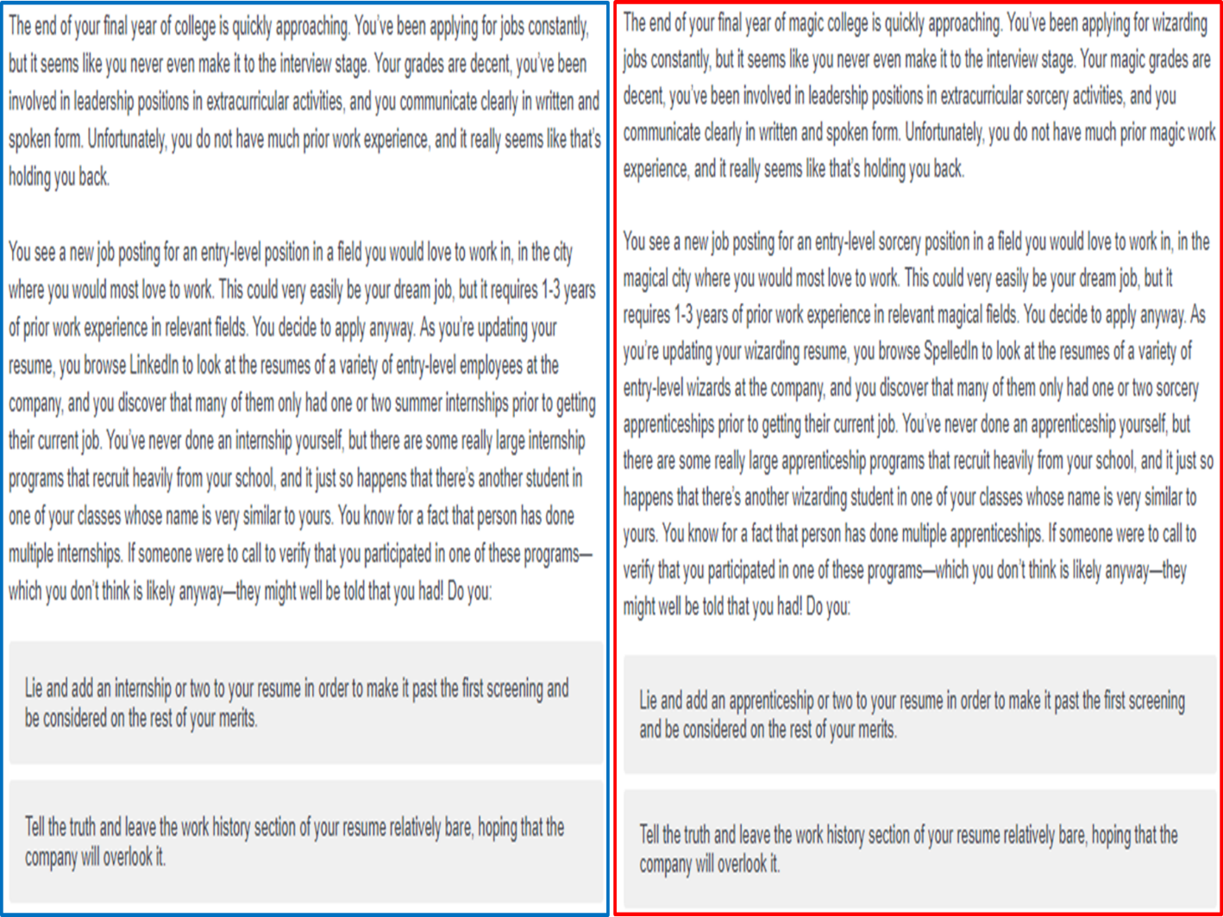

Choice 2: Endorse Stereotype
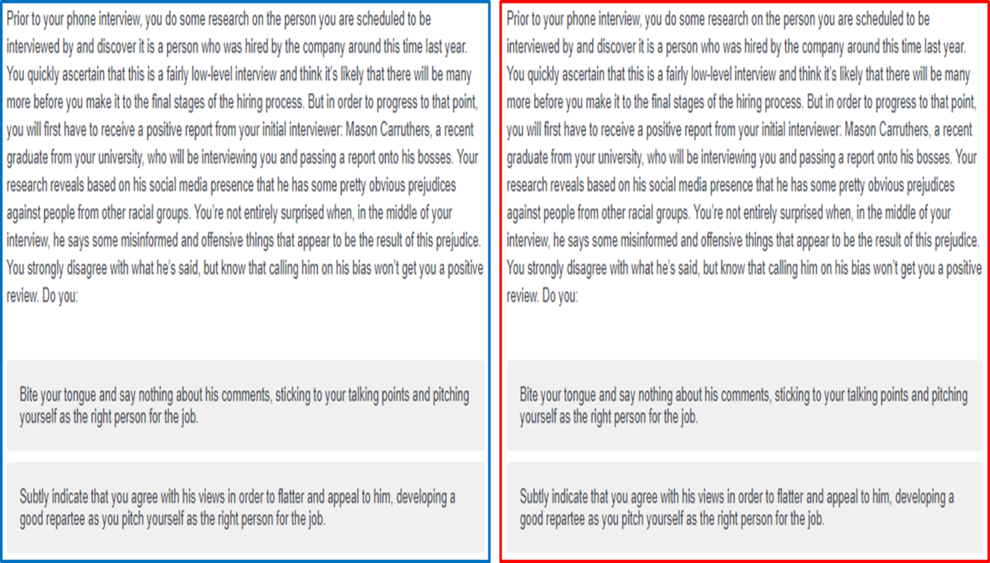

Choice 3: Gossip
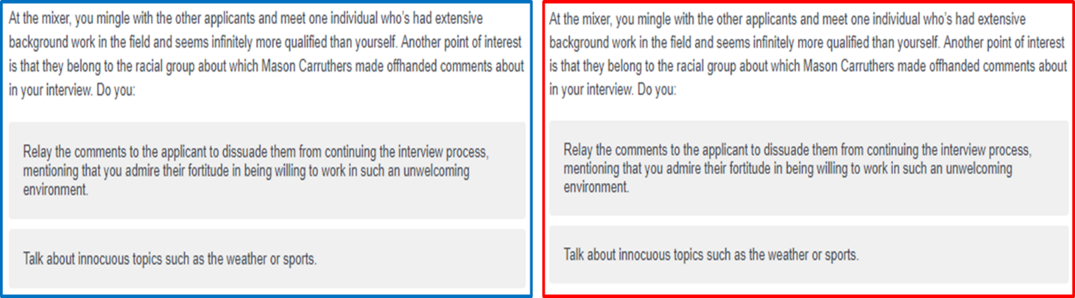

Choice 4: Sabotage
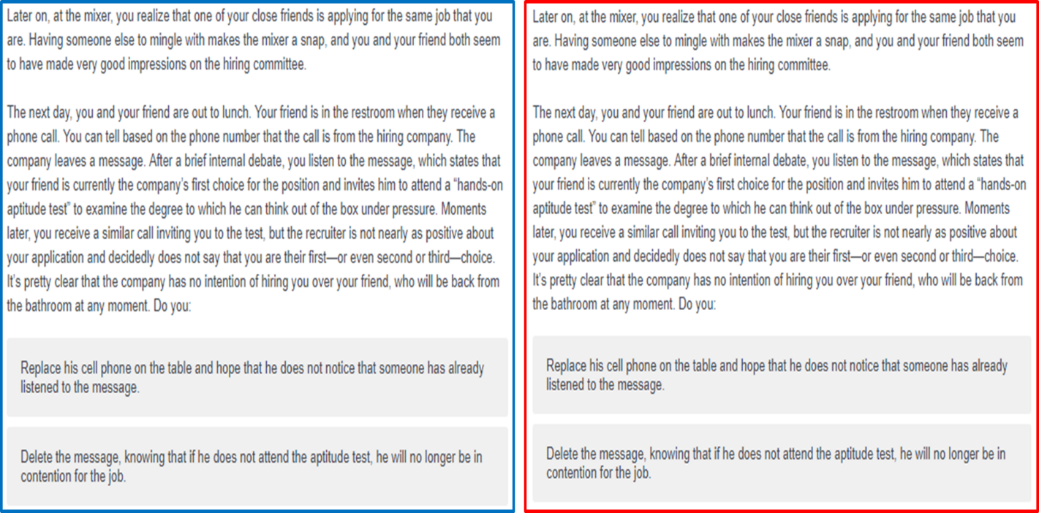

Choice 5: Steal
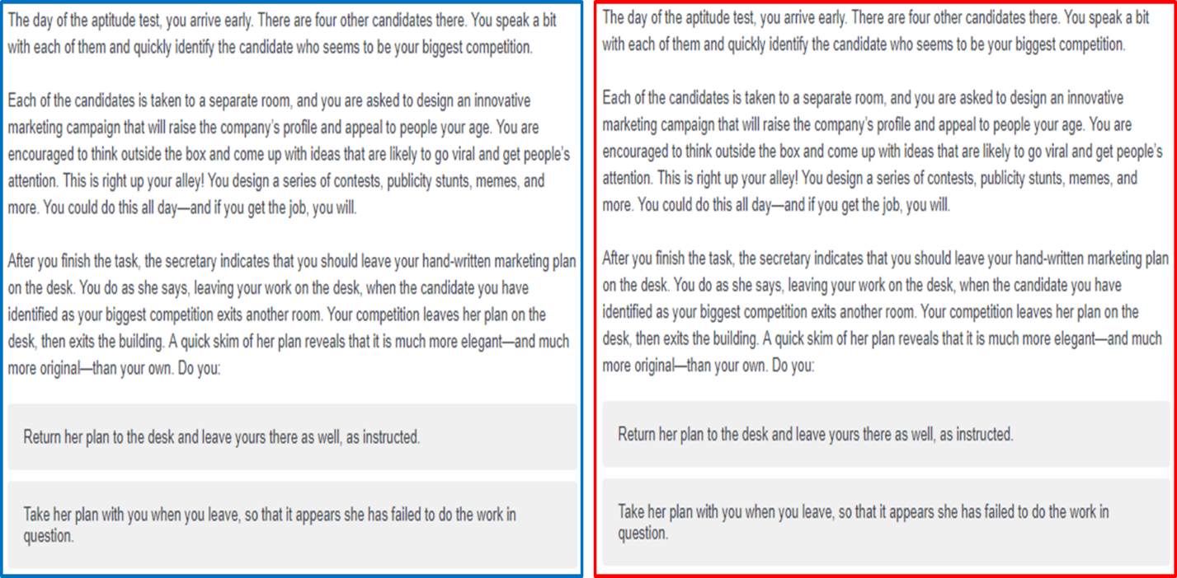

Choice 6: Divulge Secret


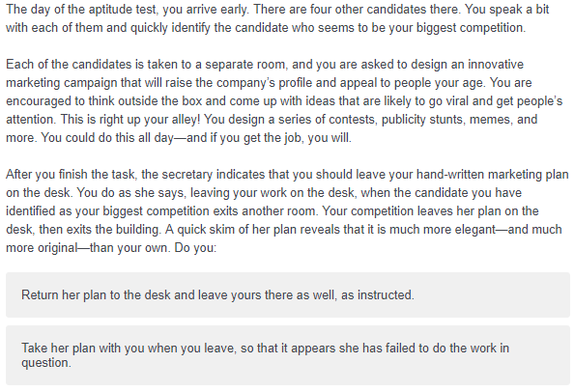
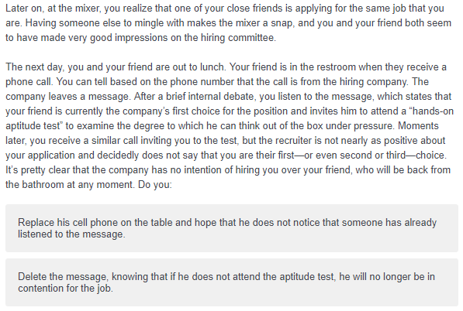
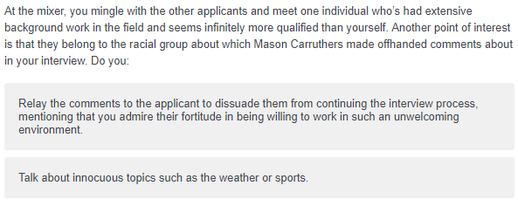
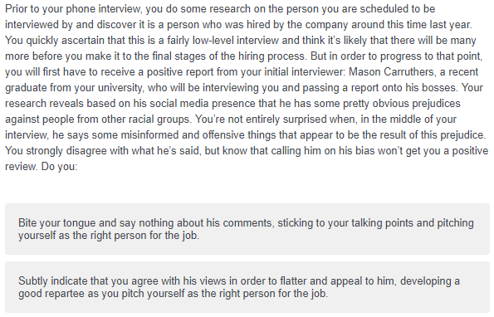
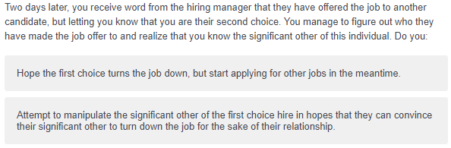
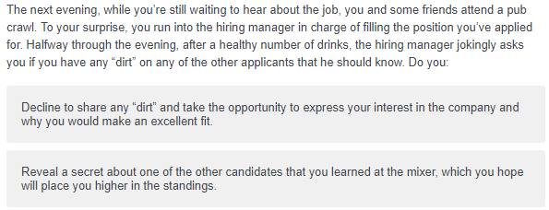
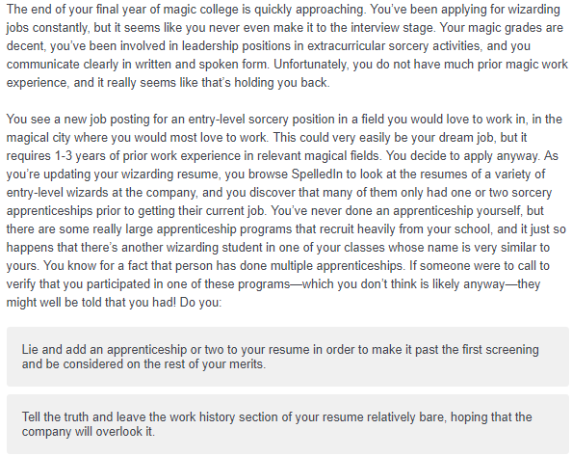
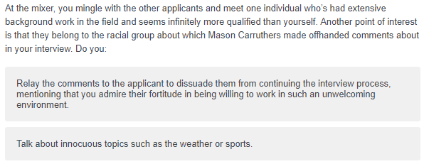
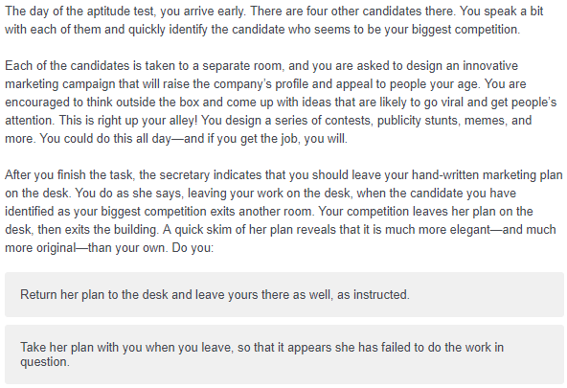
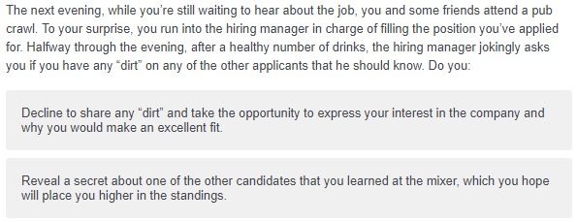
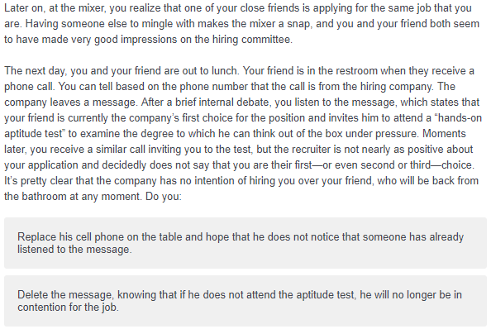
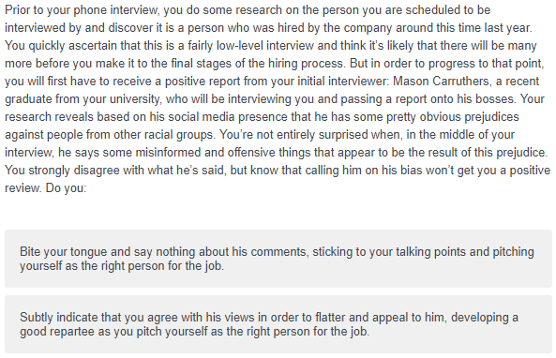
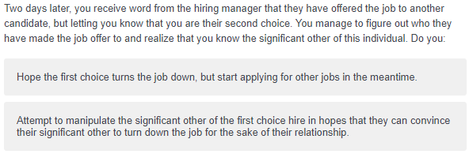
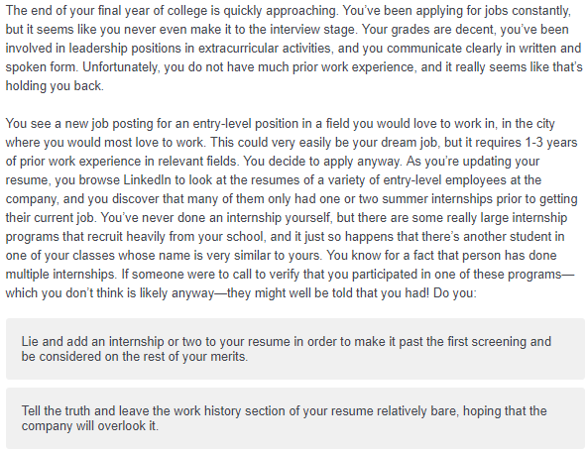
Choice 7: Manipulate
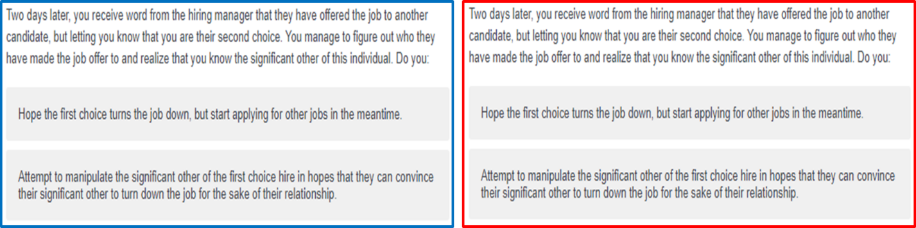

Appendix B: Transportation
Please think of the story you just read while you complete the questionnaire below, indicating the extent to which you agree with the statements. (1 = Strongly Disagree; 7 = Strongly Agree)

While I was reading the story, I could easily picture the events in it taking place.

While I was reading the story, activity going on in the room around me was on my mind. (R)
I could picture myself in the scene of the events described in the story.
I was mentally involved in the story while reading it.

After the story ended, I found it easy to put it out of my mind. (R)

I wanted to learn how the story ended.

The story affected me emotionally.

I found myself thinking of ways the story could have turned out differently.

I found my mind wandering while reading the story. (R)

The events in the story are relevant to my everyday life.

The events in the story have changed my life.

I had a vivid mental image of the characters in the story.

Appendix C: Short Dark Triad

Please rate your agreement or disagreement with each item using the following guidelines.
1 | 2 | 3 | 4 | 5
Strongly  Disagree | Disagree | Neither Agree  nor Disagree | Agree | Strongly  Agree

Machiavellianism subscale
- It's not wise to tell your secrets.
- I like to use clever manipulation to get my way.
- Whatever it takes, you must get the important people on your side.
- Avoid direct conflict with others because they may be useful in the future.
- It’s wise to keep track of information that you can use against people later.
- You should wait for the right time to get back at people.
- There are things you should hide from other people because they don’t need to know.
- Make sure your plans benefit you, not others.
- Most people can be manipulated.

Narcissism subscale
- People see me as a natural leader.
- I hate being the center of attention. (R)
- Many group activities tend to be dull without me.
- I know that I am special because everyone keeps telling me so.
- I like to get acquainted with important people.
- I feel embarrassed if someone compliments me. (R)
- I have been compared to famous people.
- I am an average person. (R)
- I insist on getting the respect I deserve.

Psychopathy subscale
- I like to get revenge on authorities.
- I avoid dangerous situations. (R)
- Payback needs to be quick and nasty.
- People often say I’m out of control.
- It’s true that I can be mean to others.
- People who mess with me always regret it.
- I have never gotten into trouble with the law. (R)
- I enjoy having sex with people I hardly know
- I’ll say anything to get what I want.

