UNIVERSITY OF OKLAHOMA
GRADUATE COLLEGE

EXAMINING WORLD-SYSTEMS AND INCOME INEQUALITY EFFECTS ON INCARCERATION RATES: A CROSS-NATIONAL STUDY

A DISSERTATION
SUBMITTED TO THE GRADUATE FACULTY
in partial fulfillment of the requirements for the
Degree of
DOCTOR OF PHILOSOPHY

By
BURLE G. STEELMAN
Norman, Oklahoma
2016

EXAMINING WORLDS-SYSTEMS AND INCOME INEQUALITY EFFECTS ON INCARCERATION RATES: A CROSS-NATIONAL STUDY

A DISSERTATION APPROVED FOR THE
DEPARTMENT OF SOCIOLOGY

BY

________________________________
Dr. Thomas Burns, Chair

________________________________
Dr. Kelly Damphousse

________________________________
Dr. Susan Sharp

________________________________
Dr. Robert Clark

________________________________
Dr. Susan Laird

© Copyright by BURLE G. STEELMAN 2016
All Rights Reserved.

Table of Contents | iv
List of Tables | v
List of Figures | vi
Abstract | viii
Chapter 1. Introduction | 1
Chapter 2. Data and Methods | 18
Chapter 3. Examining Trends | 53
Chapter 4. World-Systems Position | 71
Chapter 5. Inequality and Incarceration | 81
Chapter 6. Conclusion | 92
References | 99

List of Tables
Table 1. Studies of Income Inequality and Incarceration | 17
Table 2. Attributed World-Systems Position by Study | 25
Table 3. Countries by World-Systems Position | 26
Table 4. Descriptive Statistics | 41
Table 5. Countries by Region | 42
Table 6. Pairwise Correlation Matrix | 44
Table 7. FE Regression for each Explanatory Variable | 48
Table 8. FE Regression for Regional Variables | 49
Table 9. FE Regression for World-Systems Variables | 49
Table 10. RE Regression for each Explanatory Variable | 51
Table 11. RE Regression for Regional Variables | 52
Table 12. RE Regression for each Variable for WSP | 80
Table 13. FE Regression of Incarceration Rates on the Listed Variables | 86
Table 14. RE Regression for each Explanatory Variable | 90

List of Figures
Figure 1. Incarceration Rates per 100,000 | 20
Figure 2. Incarceration Rates per 100,000 (logged) | 21
Figure 3. Inequality Measure, Gini Indices (net) | 22
Figure 4. Gross Domestic Product Per Capita | 27
Figure 5. Gross Domestic Product Per Capita (logged) | 28
Figure 6. Percentage of Population ages 15 through 64 | 30
Figure 7. Percentage of Population Residing in Urban Areas | 31
Figure 8. Percent of Population 15+ Completing Secondary Education | 33
Figure 9. Percent of Population 15+ Completing Secondary Education (log) | 34
Figure 10. Homicide Rates | 35
Figure 11. Homicide Rates (logged) | 36
Figure 12. Histogram of Drug Offense Rates | 38
Figure 13. Histogram of Drug Offense Rates (logged) | 39
Figure 14. Ethnic Fractionalization | 40
Figure 15. Average Incarceration Rates Worldwide | 54
Figure 16. Average Incarceration Rates by Region | 55
Figure 17. Inequality Worldwide | 55
Figure 18. Average Inequality for Regions of the World | 56
Figure 19. GDPPC Worldwide | 57
Figure 20. GDPPC by Region | 58
Figure 21. Democracy Worldwide | 59
Figure 22. Democracy by Regions | 59
Figure 23. Average Percentage of Population between Age 15 and 64 | 60
Figure 24. Average Percentage of Population Between 15 and 64 by Regions | 60
Figure 25. Percent of Population in Urban Areas | 61
Figure 26. Percent of Population in Urban Areas by Region | 62
Figure 27. Physical Integrity Rights Worldwide Average | 63
Figure 28. Physical Integrity Rights Regional Averages | 64
Figure 29. Percent of the Population Completing Secondary Education | 65
Figure 30. Percent Completing Secondary Education by Region | 66
Figure 31. Worldwide Averages for Homicide Rates | 66
Figure 32. Regional Averages for Homicide Rates | 67
Figure 33. Average Drug Offense Rates | 68
Figure 34. Drug Offense Rates by Region | 69
Figure 35. Inequality by World Systems Position | 74
Figure 36. GDPPC by World Systems Position | 75
Figure 37. Democracy by World Systems Position | 76
Figure 38. Average Percentage of Population Between 15 and 64 by WSP | 76
Figure 39. Urbanization by World-Systems Position | 77
Figure 40. Homicide Rates by World-Systems Position | 78

Abstract
Numerous studies find a positive relationship between income inequality and incarceration rates within countries. Other scholars note inequality, as an explanatory variable for differences in incarceration rates, lacks statistical significance. I confirm the positive relationship between increased inequality and increased incarceration rates in initial analyses, but find when tested with additional explanatory variables, income inequality loses its significance as a predictor of incarceration rates. In this study, I examine this relationship to provide additional context for the circumstances under which inequality influences incarceration rates, and when other factors attenuate the effect of inequality. Not only do I control for crime rates, using homicide rates, but include a control for drug offense rates not noted in earlier studies. Given the paucity of research regarding world-systems theory and criminological outcomes, I examine the role of position in the world-system on incarceration rates and other cogent variables. Results indicate no direct relationship between world systems position (WSP) and incarceration rates but indicate strong relationships between WSP and homicide rates and drug offense rates. This cross-national study examines correlates of rates of incarceration for 77 countries from 1994 through 2008. I provide a description of trends in incarceration rates, inequality, wealth, democracy, urbanization, homicide rates, drug offense rates, and other societal measures over the past 15 years. Global trends are broken down comparatively by region.

CHAPTER 1. INTRODUCTION
Although many scholars find a positive relationship between income inequality and incarceration rates, others, often using inequality as a control variable, find a lack of significance in their respective findings. Is inequality an effective predictor of incarceration rates? Using panel data for incarceration rates for 77 countries from 1994 through 2008, I evaluate the relationship between income inequality and incarceration rates within countries, while controlling for country wealth and other factors to provide additional context for the influence of inequality. I also provide a graphic description of trends for many of the variables used in this study. Additionally, I examine the relationship of world-systems position (WSP) and incarceration, inequality, wealth, and other explanatory variables between countries.
Income inequality is a measure used in numerous studies to examine negative social outcomes based on the uneven distribution of wealth and income within societies. Studies find increased inequality associated with lower rates of educational attainment for women (Buchman 1996), lack of maternal care (Shandra, Shandra, and London 2010), reduced food security (Jenkins and Scanlan 2001), and greater human rights violations (Abouharb and Cringranelli 2006), among others. It is often used as a proxy for power and control within countries, or as noted in this alternative version of the Golden Rule, he who has the gold makes the rules. In this case, those with the greatest power define behaviors deemed deviant, define which deviant behaviors are deemed criminal, and the define the appropriate punishments for those criminal acts within those countries.
Scholars note the impact of world-systems position on various social outcomes. Is position in the world system related to incarceration rates, and if so, how? I evaluate the impact of WSP on incarceration rates and note no significant relationship. However, when I evaluate the effect of WSP on homicide rates and drug offense rates, I find significant differences. Specifically, core countries have the lowest homicide rates and the highest drug offense rates than do semiperiphery and periphery countries.
Durkheim (1966) notes that crime and deviance are present in all societies at all time; they function to affirm cultural values and norms, they establish boundaries of acceptable behavior and promote social unity. Deviant behavior is defined differently in different times, different cultures, and different levels of society. Behaviors deemed deviant within families may not be considered deviant within the larger community, and what is deemed deviant within a particular culture may not be considered deviant in other cultures. Crime offends the collective sentiment. As stated by Durkheim (1966):
Imagine a society of saints, a perfect cloister of exemplary individuals. Crimes, properly so called, will there be unknown, but faults which appear venial to the layman will create there the same scandal that the ordinary offense does in ordinary consciousness. If, then, this society has the power to judge and punish, it will define these acts as criminal and will treat them as such. For the same reason, the perfect and upright man judges his smaller failings with a severity that the majority reserve for acts more truly in the nature of an offense. Formerly, acts of violence against persons were more frequent than they are today, because respect for individual dignity was less strong. As this has increased, these crimes have become more rare; and also, many acts violating this sentiment have been introduced into the penal law which were not included there in primitive times (Pp. 68-69).
As crime offends the collective sentiment, punishment confirms for societies the boundaries of acceptable behavior.
Different cultures define deviant and criminal behavior using various standards. They also have diverse standards for determining the type and degree of punishment imposed for criminal behavior. Due to historical, cultural, and political differences, countries vary in their levels of incarceration. This study examines some of the societal differences over the past two decades and how they have changed over that time; how position in the world system impacts incarceration, measures of wealth, democracy, and other variables; and how inequality impacts incarceration rates.
Traditional societies tend to transition to modern societies through a series of steps or stages. Traditional societies have agricultural-based economies while modern societies’ economies are industrial-based. As societies modernize, they move from smaller, close-knit communities to larger, diverse communities with complex divisions of labor. Informal social controls, effective in traditional societies, are replaced by formal controls. Community sanctions move from personal to institutional.
Some posit that countries travel through similar trajectories in the modernization process. According to Rostow (1990), there are five stages common to economic growth, beginning with the traditional society and ending with societies of mass-consumption. The five stages are assumed to be sequential and unidirectional; all countries move toward modernization, not in the reverse. Modernization is a lengthy process by which societies tend to resemble their Western models (So 1990).
Another perspective on modernization is that societies undergo change, and that change results in differences in levels of cohesion. Smaller, close-knit societies are held together by a collective conscience or mechanical solidarity. As societies modernize, they differentiate and become more complex through specialization and the division of labor (Durkheim [1933]1960). With increased specialization, the bonds of social cohesion weaken, and societies develop an interdependence of societal members held together by organic solidarity. Unlike Rostow’s proposition that change occurs incrementally over an extended period, Durkheim acknowledges that change may be more abrupt. Durkheim (1979) posits that when societies undergo rapid change, there is a loss of shared norms, or anomie. As social control diminishes, crime tends to increase.
As societies modernize and move from mechanical to organic solidarity, punishment moves from repressive to restitutive (Durkheim [1933]1960:398). According to Durkheim, as societies progress there are both qualitative and quantitative changes in punishment. Noting the law of quantitative change, Durkheim ([1900]1973) states “[t]he intensity of punishment is the greater the more closely societies approximate to a less developed type . . .” (p. 285). In addition, less severe forms of punishment, like incarceration, would become the “normal means of social control” (Durkheim [1900]1973:294). He also noted the effect of government as an intervening agent in social change, maintaining levels of punishment when we would otherwise expect to see them decline (Durkheim [1900]1973:289). Punishment transitions from informal community-based control to formal society-based control (Tönnies [1957]1963). A commensurate change is a transition from the punishment of the body to the punishment of the mind (Foucault [1977]1995).
Testing Durkheim’s qualitative and quantitative laws, Killias (1986) compresses the two hypotheses into one: that modernization will result in less punishment. On the other hand, Spitzer (1975a) takes exception to the perspective that modernization results in less severe punishment. He notes that “greater punitiveness is associated with higher levels of structural differentiation” (Spitzer 1975a:631).
Examining contemporary ideas regarding modernization and its influence on crime, Shahidullah (2014) notes both internal and external influences on societies as they transform. Within countries, “modernizing elites” (Shahidullah 2014:58) provide leadership during the transitional process. Externally, modernizing countries often employ institutional isomorphism as they seek to emulate more modern countries, which increases legitimacy, resources, stability, and survival prospects (Meyer and Rowan 1977:340). Modernization should result in criminal justice organizations that possess “higher level(s) of legitimacy, adaptability, competence, and performance” (Shahidullah 2014:59). Additionally, modernization may lead to more democratic forms of government with increasingly transparent criminal justice institutions and reductions in crime (Prillaman 2003).
The impact of democratization is not necessarily clear-cut, as noted by Jordan and Arnold (1995). One type of democracy is participatory pluralistic, which protects the rights of minorities with a “capsule of civil and political rights” (Jordan and Arnold 1995:171). Alternatively, democracies may be characterized as populist, or those that fail to provide the protective capsule noted above and mobilize “a coalition of interests against minorities” (Jordan and Arnold 1995:171). The greater impact populist policies have on criminal justice policies, the greater the degree of enforcement and punishment. Expanding on this idea, Jacobs and Kleban (2003) note that when electorates have more direct influence on laws impacting the level of punitiveness, more severe penalties are imposed.
Modernization is a function of socioeconomic development and is characterized by increased urbanization and industrialization, with modernizing countries experiencing similar trajectories (Shelley 1981). Increased complexity in the division of labor results in weakening of societal bonds and control and higher crime rates. Larger urban populations bring together greater numbers of strangers in places lacking social control (Felson and Boba 2010). Modernization tends to increase violent behavior, as rural youth having the “tradition of settling disputes violently” (Neapolitan 1997:69) are brought together in urban areas.
While not addressing directly levels of punitiveness, Shelley (1986) provides insight into the relationship between modernization and crime, and ultimately, punishment. Countries experiencing modernization have similar trajectories with increasing crime rates, noting that “[o]nly political, religious, and economic controls exercised by the society over its members appear sufficiently strong to avert the consequences of modernization” (Shelley 1981:142). However, upon reexamination of the relationship between modernization and crime, Shelley (1986) acknowledges differences in trajectories. Shelley notes that the relationship between modernization and crime is “complex,” and is impacted by “historical, cultural and political traditions” (p. 7) within countries. Regarding the assumption of common trajectories for modernizing countries, Neapolitan (1997) notes rates of change and level of development influence crime rates (p. 69). Noting that punishment is society’s response to criminal behavior, Shelley (1986) calls it a “collective act that reflects the historical, cultural and religious traditions of a society” (p. 17).
World-systems
Wallerstein (1974; 1976) characterizes the world-system as a cyclical, three-tiered capitalistic economic structure, based on a system of unequal exchange. The system consists of “all of the economic, political, social, and cultural relations among the people of the earth” (Chase-Dunn and Grimes 1995:389). An international division of labor exists both between and within these tiers. The dominant position in this tier system is the core, consisting of countries exhibiting capital-intensive industrial activities, using skilled and highly-paid labor (Chase-Dunn 1998:346). At the other end of the spectrum are peripheral countries, characterized by poorly-paid, labor-intensive activities, often in agricultural areas (Chase-Dunn 1998:347). Semiperiphery countries, countries between the core and periphery, exhibit both core and periphery characteristics (Chase-Dunn 1998:347).
Core states enjoy greater economic, political, and military strength. They have greater diversity in trade options with each other, and with semiperiphery and periphery countries. In that regard, core countries use raw materials from countries in the periphery, and more labor-intensive goods and services from the semiperiphery. Those in the semiperiphery are exploited by the core and are exploiters of the periphery. The semiperiphery position acts as a buffer between the core and the periphery. Periphery countries tend to have limited resources to export and find their trade options restricted to the needs of the core and semiperiphery (Wallerstein 1974; Wallerstein 1976). Additionally, periphery countries must rely on core countries for capital investment and manufactured goods (Clark and Beckfield 2009:6).
Over the past several decades, research has validated the existence of a relatively stable, three-tiered world-system. Snyder and Kick (1979) examine network relations; Babones (2005) examines country-level income structures; and Clark and Beckfield (2009), and Clark (2012) examine global trade network densities, in confirming the existence of three tiers. Snyder and Kick’s study examines network connections between nations regarding trade, military interventions, diplomatic connections, and conjoint partnerships in treaties. Their analysis provided strong support for a three-tiered structure for 118 countries in 1965 (Snyder and Kick 1979:1123). Babones (2005) provides graphic evidence of three areas of concentration for national income levels at 5-year intervals from 1975-2000 for 103 countries (pp. 46-48). Clark and Beckfield’s (2009) analysis confirms and updates Snyder and Kick’s orthodox measure. Clark’s (2012) measure presents WSP for countries as recently as the 1990s. Others have noted some variation on the above. In their study, York and Ergas use a ten-block, or ten-tiered, system from research conducted by Kick and others (2011, cited in York and Ergas 2011).
Chase-Dunn (1998) posits that between the poles of the core and periphery, the semiperiphery exists in a continuum of development, rather than an easily identifiable third category (p. 13). Chase-Dunn notes “periods of concentration and dispersion of power and wealth, to experience uneven development” (p. 202), as the core exploits the periphery. Given the differences in position in the international division of labor, it may well be that there are differences in social dynamics demonstrated at the various levels (Burns et al. 1994).
Viewed from this macro level, there is an interrelationship and interdependence within all three tiers of WSP. Inequality is exacerbated in Third World countries, generally those countries in the periphery, by foreign capital penetration from transnational corporations, as noted by Crenshaw (1992). The exploitation of the periphery results in “social disorganization, anomie, urban poverty, income inequality, discrimination, and deprivation – the factors that are strongly correlated with high levels of crime and violence” (Shahidullah 2014:70). Research by Mahutga, Kwon, and Grainger (2011) also indicates that position in the world-system impacts the level of within-country inequality (p. 281). This function occurs when “alliances [are formed] between ruling classes in core and non-core countries” (Mahutga et al. 2011:283). These relationships and the presence of “[d]irect economic penetration and control over the production activities . . . at an artificially low [price]” (Rubinson 1976:642) are mechanisms of core exploitation. Non-core countries also tend to lack effective mechanisms to protect “the capital and organization” present when the demand for raw materials are no longer needed (Rubinson 1976:642).
Scholars find that position in the world-systems hierarchy impacts a variety of ecological and social outcomes. Burns et al. (1994) examine the relationship of world-systems position and deforestation as an environmental outcome. Dyches and Rushing (1996) evaluate world-systems position and its influence on women’s health. Burns, Davis, and Kick (1997) examine the relationship of world-systems position and greenhouse gas emissions. York and Ergas (2011) evaluate the link of world-systems position on gender inequality. Ergas and York (2012) control for world-systems position in their analysis of women’s status and carbon dioxide emissions.
Although not addressing incarceration rates, crime rates grew for almost 30 years, as the world economy grew, according to Shahidullah (2014). Various regions were impacted differently, in part, due to position in the global economy (p. 71). Statistics from the United Nations indicate that “[t]he total reported crime rate . . . increased in the peripheral economies . . . although it declined in the core countries” (Shahidullah 2014:71). There is no observation about the impact within semiperiphery countries.
While other research is extant regarding the influence of WSP on various social outcomes, this study examines the effect of position in the world-system on differences between countries regarding incarceration rates, inequality, wealth, democracy, urbanization, and other variables over the past two decades.
For purposes of this study, I use the distinct three-tier system postulated by Wallerstein and subsequently confirmed by others as noted above. Specifically, I use the most current assessment of world-systems position provide by Clark (2012).
Hypothesis One: Position in the world-system is associated with positive and negative social outcomes. Countries in the core have greater wealth, democracy, urbanization, and educational attainment than semiperipheral and peripheral countries. However, countries in the periphery will have greater incarceration rates, inequality, homicide rates, and drug offense rates.

Inequality
Inequality exists in many forms across the world. Inequality is the unequal distribution of valued resources. The concentration of wealth and income in the hands of a few indicates inequality. Often income inequality results in a concentration of power in those same societies. Examining inequality in the distribution of income within nations, Kuznets (1955) posits inequality increases as traditional societies transition from markets based on agriculture to those based on industrial output. Industrial economies tend to generate higher incomes than agricultural economies. As workers in the agricultural sector move from rural to urban settings to secure higher paying jobs in nonagricultural jobs, inequality within the country increases. Additionally, income inequality is greater within this urban, industrial economy, as those moving into the sector tend to fill lower-income groups within the urban population (Kuznets 1955:17). Income tends to concentrate when industrialization and urbanization increase. For the three countries included in his study, Kuznets (1955) finds a pattern of increasing inequality as countries move into industrialization. As the proportion of native-born urbanites increases, inequality tends to decrease as they are better able to navigate the economic landscape of urban settings (Kuznets 1955:17). The question of Kuznets’ assertion of this curvilinear relationship is not a part of the current study, but provides us with a base from which others have studied the phenomenon.
Scholars have examined the impact of inequality on numerous social outcomes. In many cases as inequality increases, various social issues are negatively affected. There is a lack of maternal medical care associated with increased inequality (Shandra, Shandra, and London 2010). Educational opportunities for women decrease as inequality grows (Buchman 1996). Food security is reduced when there is greater inequality (Jenkins and Scanlan 2001). Human rights violations are higher with increased inequality (Abouharb and Cingranelli 2006). Wilkinson and Pickett (2007) note that in 24 of the world’s richest countries overall educational outcomes decreased with greater inequality. Furthermore, Babones (2008) finds that increased inequality in developed and developing countries is associated with a reduction in life expectancy and an increase in infant mortality.
Inequality is an indicator of the concentration of power. That power manifests itself through social, political, and economic forces, which in turn, influence the definitions of crime and the punishments imposed (Quinney 1969). As Quinney (1969) describes a sociological theory of interests, he notes that society is “characterized by diversity, conflict, coercion, and change” (p. 25). Discussing the differences in power, Quinney (1975) asserts that the definitions of crime are “created by agents of the dominant class” (p. 37). Agents enact laws, and the criminal justice system enforces laws that protect the interests of the dominant class. The “coercive force of the state, embodied in law and legal repression, is the traditional means of maintaining the social and economic order” (Quinney 1980:52). In his examination of the history of vagrancy laws, Chambliss (1964) notes that laws “control the undesirable, the criminal and the ‘nuisance’” (p. 76); generally those lacking social, political, or economic power.
Others note the control exerted by the criminal justice system on some members of society. Spitzer (1975b) notes culture produces those who exist at its margins and are not productive members of society. Spitzer differentiates two categories of marginalized citizens. One referred to as social junk, poses little threat to the social order, like the elderly and infirm. The other group consists of those who are younger and alienated, who have greater volatility and may pose a greater threat. The latter category Spitzer (1975b) refers to as social dynamite, a group more apt to encounter the formal legal process and face imprisonment (p. 643-44).
Inequality also impacts the ability of portions of populations to access valued resources within societies. Strain theorists have long held that the inability to achieve societally accepted goals result in negative responses, including criminal responses (Merton 1938; Agnew 1992). Researchers examining differences in crime between immigrants and native-born people in Sweden note that much of the variation in crime is due to the lack of access to resources for immigrants (Hällsten, Szulkin, and Sarnecki 2013:472). In the United States, researchers note that the increase in the incidence of violent crimes is associated with income inequality (Kawachi, Kennedy, and Wilkinson 1999). Inequality also impacts the level of punishment imposed.
The following provides an overview of research conducted that examines the influence of inequality on incarceration rates among nations. Many of these scholars find statistically significant relationships between inequality and incarceration rates with greater inequality associated with higher incarceration rates (Killias 1986; Wilkins and Pease 1987; Krus and Hoehl 1994; Wilkinson and Pickett 2007; Lappi-Seppälä 2008; DeMichele 2010; Lappi-Seppälä 2010; Miller 2011; Healy, Mulcahy, and O’Donnell 2013). On the other hand, the influence of inequality on incarceration rates is not significant in studies by other scholars (Neapolitan 2001; Jacobs and Kleban 2003; Ruddell 2005).
Scholars finding a positive relationship between inequality and incarceration rates examine a variety of countries, often from the same region of the world. Among those, Killias (1986) uses the Gini index as a measure of power concentration in his study of 55 countries in 1972. In their study of six countries during the mid-1980s, Wilkins and Pease (1987) find a positive correlation between income differential and the length of sentence imposed. Using the ratio of income received by the top 10 percent to that received by the bottom 20 percent of households as a measure of inequality, Krus and Hoehl (1994) conduct regression analysis with a sample of 30 countries from 1989-1991. Examining 24 of the world’s 50 wealthiest countries, Wilkinson and Pickett (2007) find a strong positive correlation between inequality, measured as the ratio of income received by the richest 20 percent to that received by the poorest 20 percent, and incarceration rates. In his 2008 study, Lappi-Seppälä does two things: he examines 25 countries from 1980-2005 and conducts a cross-sectional analysis of 99 countries in 2005. Findings indicate a positive correlation between inequality and incarceration rates, and he notes the strength of the correlation increased from 1987 to 2000. Lappi-Seppälä (2008) also indicates the impact of inequality is influenced by country-specific differences. In a study using a larger sample, Lappi-Seppälä (2010) notes a positive relationship between inequality and imprisonment rates for EU members, but results were not significant when examining non-EU and non-OECD countries. Finding a strong correlation between economic inequality and levels of punitiveness, Van Kesteren (2009) uses 23 Western countries from 1980 to 2000. Van Kesteren (2009) expands his research to 56 countries in four regions and confirms the positive relationship between levels of inequality and the public’s support for increased punishment. Miller (2011) uses Gini coefficients as a measure of marginalization. She finds a strong positive relationship between marginalization and incarceration rates. Another study finding a positive correlation between inequality and incarceration is presented by Healy et al. (2013).
Others find limited support for the positive relationship between inequality and incarceration. Neapolitan (2001) uses single observations for incarceration rates for 148 countries from Walmsley’s 1999 World Prison Population Lists for years 1994-1998, and uses the Gini index for 125 countries from 1986-1996, and finds while inequality produces a positive coefficient, it was not statistically significant. His evaluation finds a positive relationship between homicide rates and incarceration rates. Neapolitan (2001) limits the number of countries in his study due to the limited coverage for his explanatory variables.
Examining the impact of corporatist and federalist policies within progressive democracies, Jacobs and Kleban (2003) use a sample of 13 countries from 1970-1995. In their analysis, Jacobs and Kleban (2003) note inequality does not produce a significant result. Another study in which inequality fails to produce a significant result is Ruddell (2005), in which he examines 100 wealthy countries in the early 2000s.
Many of the above studies use smaller sample sizes due to the availability, or lack thereof, of sufficient data with which to run analyses (Killias 1986; Krus and Hoehl 1994). Alternatively, some researchers examine developed countries (Jacobs and Kleban 2003; Wilkinson and Pickett 2007; Lappi-Seppälä 2008; Van Kesteren 2009; Miller 2011), and regional neighbors (Wilkins and Pease 1987; DeMichele 2013 ) for evaluation, while a few studies use more extensive samples (Neapolitan 2001; Ruddell 2005; Lappi-Seppälä 2008; Lappi-Seppälä 2010). In these larger samples, inequality generally fails to attain significance.
The current study tests the relationship between income inequality and incarceration rates, and controls for homicide rates and drug offense rates for 77 countries from 1994-2008, net of other variables. Controlling for drug offense rates, while reducing the sample size, provides insight into the importance of the allocation of resources for less serious offenses. Additionally, I examine the influence of world-systems position on incarceration rates and the other variables listed as predictor and control variables.
As Neapolitan (2001) notes, the addition of variables in international studies limits the number of countries available for analysis due to the lack of full coverage for all countries of interest for all variables of interest. Specifically, when I add my drug offense variable, I lose many countries for which I have other variables. However, examining the influence of drug offense rates on incarceration rates provides insight into countries’ discretionary prosecutorial patterns.
My sample of 77 countries has at least 4 countries from each of the 6 regions of the world. These 77 countries also consist of 18 countries from the periphery, 19 from the semiperiphery, and 40 from the core.
See Table 1 below for a synopsis of the above-listed research with findings as they relate to the listed study.

Table 1. Studies of Income Inequality and Incarceration.
Author(s) | Sample | Period | Findings
Killias (1986) | 55 countries | 1972-1975 | Unemployment rates and inequality explain a substantial amount of the variation in incarceration. Relationship with crime rates tenuous.
Wilkins & Pease (1987) | 6 European countries | 1970s-1980s | Relative extreme wealth associated with the strongest correlation. Noted that in England and Wales reductions in crime did not result in lower incarceration.
Krus & Hoehl (1994) | 30 countries | 1989-1991 | Unequal distribution of wealth demonstrated the strongest correlation with incarceration rates. Family disintegration produced the next strongest correlation.
Neapolitan (2001) | 148 countries | 1994-1998 | Lack of significance for civilization, inequality, or unemployment as explanatory variables. Significance was demonstrated for homicide rates and street enforcement with the addition of regional dummy variables.
Jacobs & Kleban (2003) | 13 countries  (progressive democracies) | 1970-1995 | Differences in type of democracy (corporatist v. federalist) and internal ethnic threat impact incarceration rates. Homicide rate and percent minority, GDPPC, and percent minority are significant control variables, while inequality is not.
Ruddell (2005) | 100 countries | 2000-2001 | Higher incarceration rates were associated with homicides, common law, retaining capital punishment, and independence.
Wilkinson & Pickett (2007) | 24 of the 50 richest countries | 1992-2002 | Correlation between income inequality and proportion of population incarcerated.
Lappi-Seppälä (2008) | 25 countries  99 countries | 1980-05  2005 | Increased income inequality produces greater incarceration, although the results are not significant in his global sample. Crime rates not strongly correlated with incarceration rates.
Van Kesteren (2009) | 23 developed countries | 1989-2000 | Countries with the greatest inequality have the highest levels of punitiveness. GDPPC and educational attainment unrelated to the level of punitiveness.
DeMichele (2010) | 17 countries | 1960-2002 | Strong positive correlation between inequality and incarceration rates. Does not include inequality in regression analysis.
Lappi-Seppälä (2010) | 218 countries  100 countries  25 countries | Mid-2000s | Inverse relationship between crime and incarceration rates.  Higher correlation between inequality and incarceration rates in EU and OECD states.  Greater spending and greater trust correlated to lower incarceration rates.
Miller (2011) | 52 countries | 2008 | Lack of correlation between crime and incarceration rates.  Greater inequality and higher percentage living below 50 percent of median income correlated with incarceration rates.
Healy, Mulcahy, & O’Donnell (2013) | 26 countries | Mid-2000s | Strong positive correlation between inequality and incarceration rates

Hypothesis Two: Incarceration rates are higher when countries have greater inequality.

CHAPTER 2. DATA AND METHODS
The following provides a description of the variables used in this analysis. In total, the panel data span a 24-year period, from 1990 through 2013.
Dependent Variable
Incarceration rates. I use incarceration rates as a measure of penal severity. “Imprisonment has uncontested prominence as the principal and most severe sanction in European and industrialized Western countries” (Lappi-Seppälä 2008:321). Beginning with the first published World Prison Population List in 1999, Roy Walmsley (1999; 2000; 2002; 2003a; 2003b; 2005; 2007; 2009; 2011; 2013) has prepared and published ten editions of the list, most recently at the end of 2013. Data provided in the first edition dates back to data collected as early as 1993, and the tenth edition contains data collected as recently as October 2013. Although extensive in its coverage, Walmsley (1999) notes limitations regarding differences in techniques and practices in gathering and reporting in different countries. Some countries included incarcerated juveniles and pretrial detainees in their total incarcerations; while others like China, report only those sentenced and not those in administrative detention (Walmsley 2002). In the earlier editions, Walmsley notes that the incarceration rates reported per 100,000 of the population and rounded to the nearest five to avoid the appearance of precision (1999). That practice changed in the fourth edition in 2003, although Walmsley continues to note that the reported populations used for calculations are estimates. I limit the scope of my investigation to those independent countries with populations exceeding 1 million and initially gather information on a maximum of 139 countries.
Walmsley consistently reports incarceration rates for most countries. However, the rates are not updated annually, and Walmsley lists the actual date of the rate reported, which is the date I use in my analysis. I note two entries for Bosnia-Herzegovina (Federation and Republika Srpska) beginning in 1999. According to the Central Intelligence Agency (CIA) World Factbook (N.d.), Republika Srpska and Federation are second-tier governments under the internationally recognized Bosnia-Herzegovina umbrella. I report a pooled figure using both figures reported and divided by the reported populations. Bulgaria and Slovakia had two rates recorded for the year 1998 (in the 1999 and 2000 reports). I used the most recent figures and reported them for the year 1998. For the United Kingdom, I compute the rate based on reported incarcerations for England and Wales and those for Northern Ireland and Scotland and divide by the reported populations for each of the reporting years. The most recent incarceration rate reported for Azerbaijan includes pre-trial detainees not reported in previous computations (Walmsley 2013).
The following countries have only one entry for incarceration rates: Laos, Gabon, Guinea-Bissau, and Timor-Leste. Incarceration rates range from a high of 756 in the United States in 2007 to a low of 25 per 100,000 in Indonesia in 1997 and in Indonesia in 1999 and 2000. The United States has maintained the highest incarceration rates for the group of countries included in this analysis since surpassing the Russian Federation in 1999. I log incarceration rates to correct for skewness. When a dependent variable is logged, the interpretation of regression analysis changes. Rather than unit increases in the independent variable resulting in unit increases in the dependent variable, statistically significant coefficients for independent variables produce percentage increases in the dependent variables. See Figures 1 and 2 for the distribution of incarceration rates and the log of incarceration rates, respectively.
Figure 1. Incarceration Rates per 100,000.

Figure 2. Incarceration Rates per 100,000 (logged).
Independent Variables
Inequality measure. Gini indices are from the Standardized World Income Inequality Database (SWIID) version 4.0 dataset prepared by Solt (2009). The goal of SWIID is to maximize “the comparability of income inequality statistics for the largest possible sample of countries and years” (Solt 2009:232). Starting with the U.N. University’s World Income Inequality Database, Solt uses a missing-data algorithm to standardize the database and provide comparable Gini indices for 153 countries for all available years since 1960. He uses the Luxembourg Income Studies (LIS) as the standard by which he compares the SWIID. SWIID provides both Gini net, reflecting the square root scale of household disposable income, and Gini market, the square root scale of household gross (pre-tax, pretransfer) income. Gini coefficients are computed based on the proportion of income received by percentages of the population, divided by the total area below the line of income equality (Organisation for Economic Co-operation and Development 2006). The Gini index is a measure of inequality that ranges from 0 to 100, with 0 indicating income equality within the population, and 100 indicating that a single person receives all of the income (Solt 2009:234). Assessing the quality of the data set, Solt notes that there are regional differences in the amount and quality of data from which the calculations were performed. Developing countries in Latin America, the Caribbean, and Africa have the largest standard errors due to a lack of data for many countries in those regions (Solt 2009:238).
For purposes of this study, I use SWIID 4.0’s Gini net computation, the square root scale of household disposable income. See Figure 3 below for the distribution of the Gini (net) variable.
Figure 3. Inequality Measure, Gini Indices (net).
For most countries, SWIID 4.0 provides data from 1990 through 2011. The following countries had less than 20 years of coverage for the inequality measure, with the years covered indicated in parentheses: Albania (1996-2008), Algeria (1990-2005), Angola (1995-2008), Azerbaijan (1990-2008), Benin (2003-2006), Bosnia-Herzegovina (1991-2007), Botswana (1990-2005), Burkina Faso (1994-2009), Burundi (1992-2006), Cambodia (1994-2009), Cameroon (1990-2007), Central African Republic (1992-2008), Chad (2002-2005), Republic of the Congo (2005-2006), Cote d’Ivoire (1990-2008), Democratic Republic of Congo (2005-2006), Egypt (1990-2008), Gabon (1990-1992, 2005), Gambia (1992-2003), Ghana (1990-2006), Guatemala (1990-2006), Guinea (1991-2007), Guinea-Bissau (1991-2005), Haiti (1990-2001), India (1990-2009), Iraq (2003-2004), Jamaica (1990-2004), Kenya (1990-2005), Laos (1992-2008), Lebanon (1997-2005), Lesotho (1990-2005), Liberia (2005-2007), Mauritania (1990-2008), Mongolia (1995-2007), Morocco (1990-2007), Mozambique (1996-2007), Namibia (1993-2005), Nicaragua (1992-2009), Niger (1992-2007), Papua New Guinea (1995-2005), Swaziland (1994-2009), Tanzania (1990-2007), Timor-Leste (2001-2007), Togo (2005-2011), Trinidad and Tobago (1990-2005), Turkmenistan (1990-2005), Uzbekistan (1990-2005), Vietnam (1992-2010), Yemen (1992-2005), and Zimbabwe (1990-1995).
World-systems position. World-systems position is from Clark’s (2012) calculations updating Clark and Beckfield’s (2009) three-tiered trade-based measure. According to Clark, core states are those possessing the densest trade and economic ties (2012:372). Core states trade with other core states, semiperipheral states, and peripheral states. Historically, core states have been described as having greater economic, political, and military power (Wallerstein 1974). Peripheral countries, on the other hand, have limited options for trade, they are isolated from one another, and are exploited by both the core and semiperiphery (Clark and Beckfield 2009:12). The mid-level status, the semiperiphery, acts as a buffer between the two poles (Wallerstein 1974), and is exploited by the core, as it exploits the periphery (Clark and Beckfield 2009:12).
Although some movement in position occurs from Clark and Beckfield’s (2009) analysis covering the decade of the 1980s to Clark’s (2012) updated analysis of the 1990s, which is prior to part of the time frame used in this analysis, world-systems position is relatively stable over time. I use the updated data for each country-year.
There are 57 countries in the periphery, 30 countries in the semiperiphery, and 45 countries in the core for a total of 132 of the 139 countries for which I have other data. The following countries do not have world-systems positions for either the decade of the 1980s (Clark and Beckfield 2009) or the 1990s (Clark 2012): Botswana, Hong Kong, Lesotho, Namibia, Swaziland, Taiwan, and Timor-Leste. I use dummy variables for each of the three world-systems positions in my analysis.
I observe the movement of several, although not exhaustive, noteworthy countries relative to their position in the world-system. A group of countries, Brazil, Russia, India, China, and South Africa, referred to collectively as BRICS, are all located in Clark’s (2012) core. However, these countries held positions in the periphery and semiperiphery according to other authors. All of the listed countries demonstrate mobility in the world-system while the United Kingdom and the United States maintain core positions throughout. Interestingly, the BRICS group recently established the New Development Bank, which will provide loans to developing countries for infrastructure and serve as an alternative to the World Bank and International Monetary Fund (Romeo 2015). See Table 2 below for the BRICS countries and the U.S. and U.K. classifications in various studies.
Table 2. Attributed World-Systems Position by Study.
Country | Snyder & Kick (1979) | Arrighi & Drangel (1986) | Terlouw (1993) | Burns, Davis, & Kick (1997) | Clark & Beckfield (2010) | Clark (2012)
Brazil | P | SP | SP | SC | C | C
Russia | SP | SP |  |  | C | C
India | P | P |  | SP | C | C
China | P | P |  | SC | C | C
South Africa | C | SP | SP | SP | P | C
United Kingdom | C | C |  | C | C | C
United States | C | C |  | C | C | C
See Table 3 below for countries by WSP.

Table 3. Countries by World-Systems Position.
Periphery | Semiperiphery | Core
Albania | Algeria | Austria
Armenia | Colombia | Belgium
Bolivia | Costa Rica | Bulgaria
Dominican Republic | Cote d’Ivoire | Canada
El Salvador | Croatia | Chile
Estonia | Ecuador | China
Jamaica | Kazakhstan | Czech Republic
Kyrgyzstan | Kenya | Denmark
Mauritius | Latvia | Finland
Moldova | Lithuania | France
Mongolia | Morocco | Germany
Nepal | Panama | Greece
Nicaragua | Peru | Hungary
Papua New Guinea | Philippines | India
Paraguay | Slovakia | Ireland
Tajikistan | Slovenia | Indonesia
Uganda | Sri Lanka | Israel
Zambia | Uruguay | Italy
 | Venezuela | Japan
 |  | Republic of Korea
 |  | Malaysia
 |  | Mexico
 |  | Netherlands
 |  | New Zealand
 |  | Norway
 |  | Pakistan
 |  | Poland
 |  | Portugal
 |  | Romania
 |  | Russian Federation
 |  | Singapore
 |  | South Africa
 |  | Spain
 |  | Sweden
 |  | Switzerland
 |  | Thailand
 |  | Turkey
 |  | Ukraine
 |  | United Kingdom
 |  | United States of America

Gross domestic product per capita. I use gross domestic product per capita (GDPPC) for each country, based on purchasing power parity, as a measure of economic development (Clark 2011). It stands to reason that at higher levels of development, additional funds are available to use for incarceration costs. These data were collected from World Bank (N.d.a) data. The figures are in constant 2011 international dollars and are indicative of the purchasing power of the U.S. dollar in the United States. The maximum coverage is from 1990 through 2012.
The following countries have notably fewer years reported: Argentina and Taiwan have no GDPPC reported, Timor-Leste’s GDPPC is reported for 1999 through 2013, and Eastern European countries Croatia and Estonia had no GDPPC reported from 1990 through 1994. I log the variable to reduce skew. See Figures 4 and 5 for distribution of GDPPC and GDPPC (logged), respectively.
Figure 4. Gross Domestic Product Per Capita.

Figure 5. Gross Domestic Product Per Capita (logged).
Democracy. Freedom House (2014a) provides two indicators of democracy in their most recent Freedom in the World publication. Measuring political rights and civil liberties on a 1-7 scale, with 1 indicating most free and 7 least free for both indicators. The political rights rating is indicative of the level of self-government and political participation of populations, ranging from having free and fair elections to having severe government oppression. Civil liberties ratings assess freedoms of expression, assembly, association, education, and religion, and the rule of law. The country ratings and status scores for years 1973-2013 are available. I use those from 1990-2013. I average the two scores and invert them indicating that those countries with scores of 7 are most free and those with scores of 1 are least free.
Freedom House (2014b) ratings are not available for Hong Kong; and are missing for some of the covered period for Laos (missing 2009-2012), Serbia (missing 1990-2005), Timor-Leste (missing 1990-2000), and Turkmenistan (missing 2007-2012).
Age cohort. Data for this variable are from the World Bank’s World Development Indicators (N.d.b). They indicate the percentage of the population between the ages of 15 and 64 for each of the countries for each year listed. The greater the proportion of the population between ages 15 and 64, the higher the percentage of the population available for incarceration, and the greater the percentage of the population available for employment. Additionally, there may be an increased demand placed on societal resources as a greater proportion of the population attains reproductive maturity.
I use data covering 1990 through 2012 for all but a few of the countries in my dataset. No data are available for Timor-Leste for the covered years, and data are missing for Turkmenistan for the year 2007 through 2012. Several other countries lack data for 2012 only.
Examining the distribution for this variable indicates a bimodal grouping of percentages between 50 and 55 percent, and between 65 and 68 percent. See Figure 6 below.

Figure 6. Percentage of Population ages 15 through 64.

Urbanization. From the World Bank, World Development Indicators (WDI), I use data for the percentage of the population residing in urban areas by country (World Bank 2015). Data cover all of the years addressed in this analysis.
No data for Taiwan were available. See Figure 7 for the distribution of percentages of populations residing in urban areas.

Figure 7. Percentage of Population Residing in Urban Areas.
Physical integrity rights index. The physical integrity rights index provides a scale indicating the level to which individual governments respect certain human rights. Cingranelli and Richards (1999) examine the incidence of torture, extrajudicial killing, political imprisonment, and disappearance within countries and construct an eight-point scale, combining the scores from each of the listed categories. The indicators are totaled and indicate governmental respect for those rights with 0 indicating no respect for physical integrity rights and 8 meaning full respect for those rights (Cingranelli, Richards, and Clay 2014).
Cingranelli and Richards use the annual human rights reports produced by the U.S. State Department and Amnesty International (Cingranelli and Richards 1999:409). The dataset encompassing the years 1981-2011 for 202 countries is from the CIRI Human Rights Data Project located at humanrightsdata.com. According to the website, “[i]t is designed for use by scholars and students who seek to test theories about the causes and consequences of human rights violations” (Cingranelli et al. 2014). This analysis uses only data from as early as 1990 through 2011, when available, for 138 of the 139 countries chosen for evaluation. Hong Kong has no scores.
Some former Soviet satellites do not have data for the early 1990s. There are no data for Bosnia-Herzegovina before 2001; and Croatia, Estonia, Georgia, Kazakhstan, Kyrgyzstan, Latvia, Lithuania, Macedonia, Moldova, Slovakia, Slovenia, Tajikistan, Turkmenistan, Ukraine, Uzbekistan, and Serbia prior to 1992 and with Serbia also missing data from 2000-2002. The following lack data from some of the years under investigation: The Democratic Republic of Congo from 1992-2000, Lebanon before 2000, Liberia from 1990-1995, Sierra Leone 1997-2000 and 2009, andTimor-Leste 1990-2000 and 2001. Serbia’s scores are from both the Serbia entries and those of Serbia-Montenegro.
Educational attainment. Educational attainment comes from Barro and Lee’s (2013a) updated data for 146 countries from 1950 through 2010 at 5-year intervals. They provide the percentage of the population aged 15 and over that has completed primary, secondary and tertiary education (Barro and Lee 2013b). I choose secondary completion for those aged 15 and over as a proxy for stock of human capital within countries. Using the percentages at each 5-year interval, I average the change over time and impute the change in the intervening years for each of the countries in my sample. I produce a total of 2562 observations based on Barro and Lee’s data.
Due to the positive skew of the distribution, I add one to each of the percentages and log the sum to normalize the distribution. When I test both secondary education attainment and its logged component, both are skewed, as is noted in the following figures. See Figures 8 and 9 for the distribution of percentages and logged percentages, respectively. Since logging the variable fails to correct for skewness, I use the variable in its original form.
The following countries were not covered: Angola, Azerbaijan, Belarus, Bosnia-Herzegovina, Burkina Faso, Chad, Ethiopia, Georgia, Guinea, Guinea-Bissau, Lebanon, Macedonia, Madagascar, Nigeria, Timor-Leste, Turkmenistan, and Uzbekistan.
Figure 8. Percent of Population 15+ Completing Secondary Education.

Figure 9. Percent of Population 15+ Completing Secondary Education (logged).

Homicide rates. The United Nations Office on Drugs and Crime (UNODC) has compiled data on homicide rates. The UNODC collects rates from reports of the World Health Organization, the UN’s Crime Trends Surveys, Interpol, and national police. UNODC defines intentional homicide as unlawful death purposefully inflicted on a person by another person. I use homicide rates from as early as 1990 through 2011 from the UNODC website (UNODC N.d.a; UNODC N.d.b).
I use homicide rates as a proxy for overall crime rates. Homicide is the most consistently and broadly reported offense, and one least susceptible to differences in crime definition from country to country (Bourguignon 2001:173). Those conducting cross-national studies often use homicide rates as a proxy for overall crime rates for the above reasons (c.f. Neapolitan 2001; Jacobs and Kleban 2003; Ruddell 2005; Lappi-Seppälä 2010). Additionally, homicide is deemed wrong in itself, or malum in se (Hill and Hill 2009:261).
As this variable is also skewed, see Figure 10 below, I have added one to each rate and logged the variable to normalize the distribution, seen in Figure 11 below.
Figure 10. Homicide Rates.
Figure 11. Homicide Rates (logged).

Drug offense rates. Unlike the offense of homicide, drug offenses are considered mala prohibita, illegal at certain times based on societies’ definitions, literally, wrong because we deem them to be so (Hill and Hill 2009:261). Although noted as an appropriate indicator of drug problems within countries, drug offenses “are generated by institutional and legal systems that differ across countries, making them even more difficult to compare” (Kilmer, Reuter, and Giommoni 2015:227). The inclusion of this category adds the discretionary component of enforcement and punishment for offenses for which certain groups may be disproportionately targeted.
The United Nations Office on Drugs and Crime at Vienna has also compiled data on drug-related offenses in their Surveys of Crime Trends. For waves 1-10 of the surveys, data are housed with the Inter-university Consortium for Political and Social Research (ICPSR 2010) and covers years 1970-2006, ICPSR data set 26462. In addition, the UNODC website has historical data covering 2003-2008 for drug-related crime rates. The UNODC website notes that surveys are sent out to member countries, but responses are voluntary. Not all countries are covered for all of the noted years, and some countries have no data reported.
Wave 5 of the Surveys of Crime Trends covers years 1990-1994 and provides total drug offenses and country populations for the countries responding to the surveys. I calculate drug offense rates per 100,000 given the data. Wave 6 of the survey covers years 1995-1997 for 83 countries and reports total recorded drug offenses. However, neither country populations, nor drug offense rates per 100,000 are available for those years. In order to calculate drug offense rates, I use country populations for the countries covered during the years 1995-1997 from the World Bank’s World Development Indicators, and use the formula noted above. Data for the United Kingdom are reported separately for Great Britain and Wales, Northern Ireland, and Scotland. I combine the three and compute the rate for the whole.
Covering years 1998-2000, Wave 7 reports total drug offenses per 100,000 and provides 180 observations for the countries included in this study. Wave 8 covers years 2001 and 2002 and provides 82 observations.
For the years 2003 through 2008, I use a combination of data provided in the next two waves of the CTS and the historical documentation available for those years on the UNODC website. Where conflicting data occur, I use the UNODC historical data for consistency for those years.
From the above, the U.S. has data for 1995-1999. Additional information regarding drug rates in the U.S. for other available years was gathered from the Total Annual Arrests by Year and Category table on the DrugWarFacts.org (N.d) web page. Historical FBI data is sourced on the web page and covers the following years: 1990 and 2000 through 2008. Rates are calculated using population totals from World Bank WDI data. See figures 12 and 13 below for histograms of drug offense rates and the logged variable.
Figure 12. Histogram of Drug Offense Rates.
Figure 13. Histogram of Drug Offense Rates (Logged).

Ethnic fractionalization. Fearon (2003) constructs a measure of ethnic fractionalization, “defined as the probability that two individuals selected at random from a country will be different ethnic groups” (p. 208). The formula used by Fearon (2003:208) for calculating fractionalization, for ethnic groups p₁, p_{2,} . . ., p_{n} is:$$F≡1-\sum_{i=1}^{n}{p_{i}^{2}}$$
Each country’s ethnic fractionalization is computed on the number of ethnic groups larger than one percent of that country’s population. Fearon (2003) uses 822 ethnic groups in 160 countries for his calculations for an average of five ethnic groups (p. 204). The resulting fractionalization scores are .953 and 1, respectively. Fractionalization scores range from .004 (Republic of Korea) to 1 and are time invariant in this analysis. I interact ethnic fractionalization with standardized time in my fixed-effect regression to show the impact of ethnic fractionalization on incarceration rates at the mid-point of the analysis.
Papua New Guinea has highly fractionalized ethnic groups that do not meet the one percent of the country population threshold in place for Fearon (2003:205). No ethnic fractionalization scores were available for Hong Kong, Serbia, or Timor-Leste. According to Jacobs and Kleban (2003), perceptions of racial or ethnic threat increased incarceration rates (p. 725). See Figure 14 for the distribution of ethnic fractionalization scores.
Figure 14. Ethnic Fractionalization.

Percentage male. From the World Bank World Development Indicators (N.d.c), I use the percentage of the total population that is female, by country, for 1990-2013 for 138 countries. Data for Taiwan are not available. I then construct the percentage of the population that is male by subtracting percentage female from 100 for each country. The distribution is relatively normal. The larger the percentage male, the greater the incidence of violent crime and incarceration.
As noted, country coverage for many of the listed variables varies and limits the final sample size. When examined for incarceration rates, each listed explanatory/control variable, region of the world, and world-system position, my final sample size consists of 77 countries. See Table 4 below for the descriptive statistics for the variables listed above.
Table 4. Descriptive Statistics.
Variable | Observations | Mean | Std. Dev. | Minimum | Maximum
Incarceration Rates | 325 | 172.0 | 137.14 | 25 | 756
Incarceration Rates (logged) | 325 | 4.9 | .68 | 3.2 | 6.6
Inequality | 325 | 34.6 | 9.60 | 16.2 | 75.3
GDPPC | 325 | 22789.7 | 15062.51 | 1040.2 | 64573.2
GDPPC (log) | 325 | 9.7 | .90 | 6.94 | 11.07
Democracy | 325 | 5.9 | 1.33 | 1 | 7
Percentage Between 15-64 | 325 | 66.1 | 3.77 | 48.3 | 70.7
Percent Urban | 325 | 66.7 | 17.09 | 13.5 | 100
Physical Integrity | 325 | 5.9 | 1.98 | 0 | 8
Percent Completed Sec Ed | 325 | 33.9 | 14.37 | 4.6 | 71.8
Homicide Rate | 325 | 5.6 | 9.85 | .46 | 62.5
Homicide Rate (log) | 325 | 1.4 | .82 | .38 | 4.2
Drug Offense Rates | 325 | 148.5 | 197.76 | .12 | 987.1
Drug Offense Rates (log) | 325 | 4.1 | 1.52 | .11 | 6.9
Ethnic Fractionalization | 325 | .3 | .23 | .004 | 1
Percent Male | 325 | 48.9 | 1.09 | 45.8 | 51.8

Regions. Following Clark (2011; 2012), I construct six regional dummy variables: (1) the West (excluded as the referent category) consisting of 18 countries, (2) East Asia and the Pacific (EAP) consisting of 14 countries, (3) Eastern Europe and Central Asia (EECA) with 20 countries, (4) Latin America (LA) with 15 countries, (5) the Middle East and North Africa (MENA) consisting of 4 countries, and (6) Sub-Saharan Africa (SSA) with 6 countries. See Table 5 below for countries in each of the listed regions.

Table 5. Countries by Region.
West | EAP | EECA | Latin America | MENA | SSA
Austria | China | Albania | Bolivia | Algeria | Cote d'Ivoire
Belgium | India | Armenia | Chile | Israel | Kenya
Canada | Indonesia | Bulgaria | Colombia | Morocco | Mauritius
Denmark | Japan | Croatia | Costa Rica | Turkey | South Africa
Finland | Rep of Korea | Czech Rep | Dom Rep |  | Uganda
France | Malaysia | Estonia | Ecuador |  | Zambia
Germany | Mongolia | Greece | El Salvador
Ireland | Nepal | Hungary | Jamaica
Italy | Pakistan | Kazakhstan | Mexico
Netherlands | PNG | Kyrgyzstan | Nicaragua
New Zealand | Philippines | Latvia | Panama
Norway | Singapore | Lithuania | Paraguay
Portugal | Sri Lanka | Moldova | Peru
Spain | Thailand | Poland | Uruguay
Sweden |  | Romania | Venezuela
Switzerland |  | Russian Federation
UK |  | Slovakia
USA |  | Slovenia
 |  | Tajikistan
 |  | Ukraine
Source: Clark (2011)
Year. My data contain up to 24 consecutive years (1990-2013) for most of my independent variables. To evaluate or control for my time-invariant independent variables in fixed-effects models, I interact the variable with my standardized year (mean = 0). This enables me to assess WSP, and control for ethnic fractionalization, and region using fixed-effects modeling. The main effect of the time-invariant variables refers to the middle of the sample period (cf. Clark 2012:376).
While I begin this data set with as many as 139 countries providing incarceration rates from 1993 through 2013, each time I add variables, the sample size decreases. This limitation is noted by many, but specifically, I note Neapolitan’s (2001) study in which his initial sample decreases due to the lack of coverage by his independent variable. In my final analyses, I use 325 observations for 77 countries. Each of my regions is represented and each world-systems position is represented, as well. Please see table below for the pairwise correlation matrix for all variables included in this study.

Table 6. Pairwise Correlation Matrix. | 13. |  |  |  |  |  |  |  |  |  |  |  |  | 1.00 | -0.02 | -0.09 | 0.06 | -0.02 | 0.11 | -0.02 | -0.07 | 0.04 | 0.05
Table 6. Pairwise Correlation Matrix. | 12. |  |  |  |  |  |  |  |  |  |  |  | 1.00 | -0.05 | -0.25 | 0.01 | -0.05 | 0.18 | 0.05 | 0.39 | -0.31 | 0.20 | 0.19
Table 6. Pairwise Correlation Matrix. | 11. |  |  |  |  |  |  |  |  |  |  | 1.00 | 0.08 | -0.04 | 0.05 | 0.38 | -0.55 | 0.21 | 0.10 | 0.13 | 0.06 | -0.03 | -0.04
Table 6. Pairwise Correlation Matrix. | 10. |  |  |  |  |  |  |  |  |  | 1.00 | -0.19 | -0.03 | 0.03 | 0.59 | -0.36 | -0.18 | -0.20 | -0.04 | -0.03 | 0.32 | -0.13 | -0.28
Table 6. Pairwise Correlation Matrix. | 9. |  |  |  |  |  |  |  |  | 1.00 | -0.22 | -0.08 | 0.51 | -0.13 | -0.44 | -0.05 | 0.10 | 0.47 | -0.09 | 0.30 | -0.47 | 0.24 | 0.36 |  |  | 22. |  |  |  |  |  |  |  |  | 1.00
Table 6. Pairwise Correlation Matrix. | 8. |  |  |  |  |  |  |  | 1.00 | -0.19 | 0.06 | -0.33 | -0.24 | 0.18 | -0.16 | -0.15 | 0.63 | -0.31 | -0.21 | -0.21 | -0.07 | 0.02 | 0.07 |  |  | 21. |  |  |  |  |  |  |  | 1.00 | -0.20
Table 6. Pairwise Correlation Matrix. | 7. |  |  |  |  |  |  | 1.00 | 0.31 | -0.44 | 0.43 | -0.31 | -0.43 | -0.03 | 0.45 | -0.35 | 0.11 | -0.26 | -0.25 | -0.10 | 0.18 | -0.11 | -0.12 |  |  | 20. |  |  |  |  |  |  | 1.00 | -0.66 | -0.61
Table 6. Pairwise Correlation Matrix. | 6. |  |  |  |  |  | 1.00 | 0.38 | 0.05 | -0.28 | 0.38 | -0.13 | -0.28 | 0.04 | 0.43 | -0.19 | -0.27 | 0.11 | 0.03 | -0.29 | 0.47 | -0.17 | -0.43 |  |  | 19. |  |  |  |  |  | 1.00 | -0.16 | -0.01 | 0.22
Table 6. Pairwise Correlation Matrix. | 5. |  |  |  |  | 1.00 | 0.33 | 0.45 | 0.48 | -0.45 | 0.26 | -0.37 | -0.42 | 0.16 | 0.11 | -0.0001 | 0.32 | -0.42 | -0.11 | -0.29 | 0.35 | -0.08 | -0.37 |  |  | 18. |  |  |  |  | 1.00 | -0.04 | -0.04 | 0.12 | -0.08
Table 6. Pairwise Correlation Matrix. | 4. |  |  |  | 1.00 | 0.42 | 0.42 | 0.61 | 0.08 | -0.38 | 0.44 | -0.22 | -0.35 | 0.11 | 0.55 | -0.29 | -0.14 | -0.13 | -0.22 | -0.07 | 0.42 | -0.20 | -0.34 |  |  | 17. |  |  |  | 1.00 | -0.07 | -0.07 | -0.31 | 0.27 | 0.11
Table 6. Pairwise Correlation Matrix. | 3. |  |  | 1.00 | 0.68 | 0.55 | 0.73 | 0.59 | 0.12 | -0.56 | 0.58 | -0.09 | -0.44 | 0.10 | 0.67 | -0.17 | -0.30 | -0.21 | -0.06 | -0.24 | 0.60 | -0.18 | -0.59 |  |  | 16. |  |  | 1.00 | -0.24 | -0.14 | -0.15 | -0.31 | 0.19 | 0.20
Table 6. Pairwise Correlation Matrix. | 2. |  | 1.00 | -0.54 | -0.46 | -0.53 | -0.35 | -0.65 | -0.52 | 0.53 | -0.35 | 0.28 | 0.51 | -0.11 | -0.38 | 0.39 | -0.28 | 0.44 | 0.08 | 0.16 | -0.22 | 0.08 | 0.20 |  |  | 15. |  | 1.00 | -0.28 | -0.13 | -0.08 | -0.08 | 0.09 | -0.09 | -0.02
Table 6. Pairwise Correlation Matrix. | 1. | 1.00 | 0.14 | -0.13 | -0.12 | 0.17 | 0.05 | -0.003 | 0.18 | 0.41 | 0.12 | -0.42 | 0.27 | 0.02 | -0.24 | -0.19 | 0.30 | 0.02 | 0.03 | 0.13 | -0.11 | -0.001 | 0.14 |  |  | 14. | 1.00 | -0.29 | -0.52 | -0.25 | -0.14 | -0.15 | 0.52 | -0.34 | -0.31
Table 6. Pairwise Correlation Matrix. |  |  |  |  |  |  |  |  |  |  |  |  |  |  |  |  |  |  |  |  |  |  |  |  |  |  | 14.West | 15. Ease Asia & the Pacific | 16. East Europe & Cent. Asia | 17. Latin America | 18. Mid East & North Africa | 19. Sub-Saharan Africa | 20. Core | 21. Semiperiphery | 22. Periphery
Table 6. Pairwise Correlation Matrix. |  | 1.Incarceration Ratesª | 2. Inequality | 3. GDPPC ª | 4. Democracy | 5.Age Cohort | 6. Percent Urban | 7. Physical Integrity | 8. Secondary Education | 9. Homicide Ratesª | 10. Drug Offense Ratesª | 11. Percent Male | 12. Ethnic Fractionalization | 13. Time | 14. West | 15. East Asia & the Pacific | 16. East Europe & Cent. Asia | 17. Latin America | 18. Mid East & North Africa | 19. Sub-Saharan Africa | 20. Core | 21. Semiperiphery | 22. Periphery | None: a = logged variable | N = 325 |  | 14.West | 15. East Asia & the Pacific | 16. East Europe & Cent. Asia | 17. Latin America | 18. Mid East & North Africa | 19. Sub-Saharan Africa | 20. Core | 21. Semiperiphery | 22. Periphery

Methods
In each of my analyses, the effect of inequality on incarceration rates, the effect of world-systems position on incarceration rates, and the impact of modernization on incarceration rates, I use fixed-effects (FE) and random effects (RE) regression on my panel data. According to Wooldridge (2009), “FE is widely thought to be a more convincing tool for estimating ceteris paribus effects” (p. 493). Although FE models are not preferred when explanatory variables are constant over time, I address this by interacting the time-invariant term with a standardized time variable. Standardizing the time variable places the mean at 0 with a standard deviation of 1, which provides the impact of the time-invariant terms at the mid-point of the time period. Using RE models assumes a lack of correlation between the unobserved effect with “each explanatory variable in all time periods” (Wooldridge 2009:489).
From Wooldridge (2009:503) the formula for FE and RE models is:
y_{it} = β₁x_{it1} + _{. . . +} β_{k}x_{itk} + α_{i} + u_{it}, t = 1, . . .,T,
where the β are the parameters to estimate, α_{i} is the unobserved effect, and u_{it} is the idiosyncratic error.
For all of my analyses, I use Stata/IC 12.1 for Windows. Stata uses a series of xt commands for panel data sets. “Panel datasets have the form x_{it}, where x_{it} is a vector of observations for unit i and time t” (Stata 2011:3). The xtregar command in Stata allows me to conduct fixed- or random-effects analyses, with an autoregressive process of order one (AR(1)) disturbance. An AR(1) disturbance occurs in “time series models whose current value depends linearly on its most recent value plus an unpredictable disturbance” (Wooldridge 2009:835).
Fixed-effects regressions produce t-values, which test the hypothesis that the mean of the variable is zero. Higher t-scores and resultant indicators of significance allow us to reject that hypothesis, and are reported as a part of the analysis. Likewise, RE regressions produce z-scores, which are also reported in the text of this study. Coefficients and standard errors are reported in associated tables.
Stata reports three values for R² for both models: R² within is the R² computed from the mean-deviated regression; R² between is equal to {corr ($\overline{x}$_{i}$\hat{β}$, $\overline{y}$_{i})}²; and R² overall is equal to {corr (x_{it}$\hat{β}$, y_{i})}² (Stata 2011:493). For all models, I report all three values.
I run an FE model for the log of incarceration rates for each of my primary independent variables and for my control variables. Noting the stability of my chief predictor variables, income inequality and country wealth, I use the value of the dependent variable contemporaneously (c.f. Killias 1986; Neapolitan 2001).
Inequality produces a positive and significant coefficient (t = 13.18, p < .001). Gross domestic product per capita (logged) also produces a positive and significant coefficient (t = 23.01, p < .001). My democracy measure produces a positive, significant coefficient (t = 14.45, p < .001). The following control variables produce positive and significant coefficients: percent of the population between ages 15 and 64 (t = 25.24, p < .001); percent of the population residing in urban areas (t = 25.15, p < .001); countries’ respect for physical integrity rights (t = 3.02, p < .01); percentage of the population that is male (t = 24.51, p < .001); and the percentage of the population over age 15 having completed secondary education (t = 11.22, p < .001). Both the logged variables for homicide rates and drug offense rates produce positive and significant coefficients (t = 3.16, p < .01; t = 5.45, p < .001). I also examine ethnic fractionalization, which I interact with standardized time. The interaction of ethnic fractionalization with time provides the effect at the mid-point of the panel, which is positive and non-significant (t = 1.05, p = .296) and the standardized time variable produces a positive and significant result (t = 4.13, p < .001).
See Table 7 below for FE results for independent and control variables, except regions.
Table 7. FE Regression for each Explanatory Variable. | Model 11 |  |  |  |  |  |  |  |  |  |  | .72  (.68) | 1.17***  (.28) | .002  .32  .001  248  65 | Note: a = variable logged; b = * time (standardized)  +p<.10; *p<.05; **p<.01; ***p<.001.
Table 7. FE Regression for each Explanatory Variable. | Model 10 |  |  |  |  |  |  |  |  |  | .10***  (.004) |  |  | .18  .77  .19  248  65
Table 7. FE Regression for each Explanatory Variable. | Model 9 |  |  |  |  |  |  |  |  | .21***  (.04) |  |  |  | .01  .14  .0030  248  65
Table 7. FE Regression for each Explanatory Variable. | Model 8 |  |  |  |  |  |  |  | .36***  (.11) |  |  |  |  | .24  .05  .26  248  65
Table 7. FE Regression for each Explanatory Variable. | Model 7 |  |  |  |  |  |  | .07***  (.01) |  |  |  |  |  | .02  .41  .02  248  65
Table 7. FE Regression for each Explanatory Variable. | Model 6 |  |  |  |  |  | .06***  (.02) |  |  |  |  |  |  | .01  .05  .02  248  65
Table 7. FE Regression for each Explanatory Variable. | Model 5 |  |  |  |  | .07***  (.003) |  |  |  |  |  |  |  | .001  .78  .001  248  65
Table 7. FE Regression for each Explanatory Variable. | Model 4 |  |  |  | .07***  (.003) |  |  |  |  |  |  |  |  | .03  .78  .04  248  65
Table 7. FE Regression for each Explanatory Variable. | Model 3 |  |  | .49***  (.03) |  |  |  |  |  |  |  |  |  | .04  .53  .04  248  65
Table 7. FE Regression for each Explanatory Variable. | Model 2 |  | .49***  (.02) |  |  |  |  |  |  |  |  |  |  | .04  .74  .04  248  65
Table 7. FE Regression for each Explanatory Variable. | Model 1 | . .09***  (.01) |  |  |  |  |  |  |  |  |  |  |  | .05  .49  .05  248  65
Table 7. FE Regression for each Explanatory Variable. |  | Inequality | GDPPCª | Democracy | Age Cohort | Urban | Physical Integrity | Secondary Education | Homicide Rateª | Drug Offense Rateª | Percentage Male | Ethnic Fractionalization^{b} | Time | R² Overall  R² Within  R² Between  N observations  N groups

When I examine regions and world-systems position, I use each as referent categories in respective analyses. I interact regional variables and world-systems position with standardized time, which provides the effect of the variable at the midpoint of the analysis. As seen in Table 8, only Latin America produces positive and significant coefficients when either the West or Eastern Europe and Central Asia are the referent categories. There are no significant coefficients for any of the world-systems positions noted in Table 9.
Table 8. FE Regression for Regional Variables.
 | Model 1 | Model 2 | Model 3 | Model 4 | Model 5 | Model 6
Time | 1.44***  (.23) | 1.73***  (.41) | .93***  (27) | 2.84***  (.57) | .98  (1.37) | -.25  (1.61)
West |  | -.29  (.47) | .52  (.36) | -1.40*  (.61) | .47  (1.39) | 1.69  (1.63)
East Asia and the Pacific | -.29  (.47) |  | .80  (.49) | -.1.11  (.70) | .75  (1.43) | 1.98  (1.66)
Eastern Europe and Central Asia | -.51  (.36) | -.80  (.49) |  | -1.91**  (.63) | -.05  (1.39) | 1.18  (3.09)
Latin America | 1.40*  (.61) | 1.11  (.70) | 1.91**  (.63) |  | 1.86  (1.48) | 3.09+  (1.70)
Middle East and North Africa | -.47  (1.39) | -.75  (1.43) | .05  (1.39) | -1.86  (1.48) |  | 1.23  (2.11)
Sub-Saharan Africa | -1.69  (1.63) | -1.98  (1.66) | -1.18  (1.63) | -3.09+  (1.48) | -1.23  (.2.11)
R² Overall  R² Within  R² Between  N observations  N groups | .0002  .34  .0009  248  65 | .0002  .34  .0009  248  65 | .0002  .34  .0009  248  65 | .0002  .34  .0009  248  65 | .0002  .34  .0009  248  65 | .0002  .34  .0009  248  65

Table 9. FE Regressions for World-Systems Variables.
 | Model 1 | Model 2 | Model 3
Time | 1.46***  (.17) | .78  (.62) | 1.31*  (.55)
Core |  | .68  (.64) | .15  (.57)
Semiperiphery | -.68  (.64) |  | -.53  (.83)
Periphery | -.15  (.57) | .53  (.83)
R² Overall  R² Within  R² Between  N observations  N groups | .0004  .31  .0001  248  65 | .0004  .31  .0001  248  65 | .0004  .31  .0001  248  65
I run RE models for the log of incarceration rates for each of my primary independent variables and my control variables. Inequality and gross domestic product per capita (logged) both fail to produce a significant coefficient. Democracy produces a positive and significant result (z = 3.52, p < .001). The following control variables produce positive and significant coefficients: percent of population between the ages of 15 and 64 (z = 2.07, p <.05), percentage of the population residing in urban areas (z = 2.97, p < .01), percentage of the population having completed secondary education (z = 2.68, p < .01). Physical integrity rights, homicide rates (logged), and ethnic fractionalization fail to produce significant results. Drug offense rates (logged) produce a positive and significant coefficient (z = 4.89, p < .001) and the percentage of the population that is male produces a negative and significant coefficient (z = -4.23, p < .001).

Table 10. RE Regression for each Explanatory Variable. | Model 11 |  |  |  |  |  |  |  |  |  |  | .20  (.31) |  | .07  .00  .004  325  77 | Note: a = variable logged; b = * time (standardized)  +p<.10; *p<.05; **p<.01; ***p<.001.
Table 10. RE Regression for each Explanatory Variable. | Model 10 |  |  |  |  |  |  |  |  |  | -.19***  (.04) |  |  | .18  .02  .21  325  77
Table 10. RE Regression for each Explanatory Variable. | Model 9 |  |  |  |  |  |  |  |  | ..08***  (.02) |  |  |  | .02  .08  .06  325  77
Table 10. RE Regression for each Explanatory Variable. | Model 8 |  |  |  |  |  |  |  | .02  (.04) |  |  |  |  | .17  .04  .09  325  77
Table 10. RE Regression for each Explanatory Variable. | Model 7 |  |  |  |  |  |  | . .01**  (.003) |  |  |  |  |  | .03  .02  .07  325  77
Table 10. RE Regression for each Explanatory Variable. | Model 6 |  |  |  |  |  | .01  (.01) |  |  |  |  |  |  | .00  .01  .03  325  77
Table 10. RE Regression for each Explanatory Variable. | Model 5 |  |  |  |  | .01**  (.004) |  |  |  |  |  |  |  | .003  .11  .04  325  77
Table 10. RE Regression for each Explanatory Variable. | Model 4 |  |  |  | .02*  (.01) |  |  |  |  |  |  |  |  | .03  .002  .06  325  77
Table 10. RE Regression for each Explanatory Variable. | Model 3 |  |  | .09***  (.03) |  |  |  |  |  |  |  |  |  | .01  .10  .001  325  77
Table 10. RE Regression for each Explanatory Variable. | Model 2 |  | .01  (.06) |  |  |  |  |  |  |  |  |  |  | .02  .0002  .003  325  77
Table 10. RE Regression for each Explanatory Variable. | Model 1 | .0004  (.004) |  |  |  |  |  |  |  |  |  |  |  | .02  .02  .001  325  77
Table 10. RE Regression for each Explanatory Variable. |  | Inequality | GDPPCª | Democracy | Age Cohort | Urban | Physical Integrity | Secondary Education | Homicide Rateª | Drug Offense Rateª | Percentage Male | Ethnic Fractionalization |  | R² Overall  R² Within  R² Between  N observations  N groups

When I examine incarceration rates (logged) for regional and world-systems position dummy variables, I find several dummy variables produce significant results in other regions. When I use the West as the referent category, EECA produces a positive and significant coefficient (z = 2.92, p < .01). In Model 2 below, with EAP as the referent category, EECA produces a positive, significant coefficient (z = 3.49, p < .001) and LA produces a positive and significant coefficient (z = 2.04, p < .05). With EECA as referent category, two regions produce negative, significant results: West (z = -2.92, p < .01) and EAP (z = -3.49, p < .001) indicating incarceration rates are less in these regions than in EECA.
Table 11. RE Regression for Regional Variables.
 | Model 1 | Model 2 | Model 3 | Model 4 | Model 5 | Model 6
West |  | .17  (.22) | -.58**  (.20) | -.30  (.22) | -.39  (.34) | -.41  (.29)
East Asia and the Pacific | -.17  (.22) |  | -.75***  (.22) | -.47*  (.23) | -.56  (.35) | -.58+  (.30)
Eastern Europe and Central Asia | .58**  (.20) | .75***  (.22) |  | .28  (.21) | .20  (.34) | .17  (.29)
Latin America | .30  (.22) | .47*  (.23) | -.28  (.21) |  | -.09  (.35) | -.11  (.30)
Middle East and North Africa | .39  (.34) | .56  (.35) | -.19  (.34) | .09  (.35) |  | -.02  (.40)
Sub-Saharan Africa | .41  (.29) | .58+  (.30) | -.17  (.29) | -.11  (.30) | .02  (.40)
R² Overall  R^{w} Within  R^{w} Between  N observations  N groups | .13  .00  .18  325  77 | .13  .00  .18  325  77 | .13  .00  .18  325  77 | .13  .00  .18  325  77 | .13  .00  .18  325  77 | .13  .00  .18  325  77

When I examine incarceration rates and the influence of world-systems position, no significant differences are noted.
CHAPTER 3. EXAMINING TRENDS
Not only are there differences in many of the variables of interest between countries, but there is variation for many of the variables over time. In this section, I explore trends over the fourteen-year period from 1994-2008 using Tableau Desktop Professional Edition, Version 9.2 for the graphics presentation. Again, I limit the scope of this analysis to the 77 countries used for additional analyses.
To maximize countries available for analysis, I average each of the variables for each country for two time periods, from 1994 through 2002 (the median year in the analysis) and from 2003 through 2008. The resultant average is recorded for the years 2002 and 2008, respectively. Due to the requirement for each country to produce at least one data point for each of the listed time frames, the total number of countries available for investigating trends falls to 49. This includes 18 countries from the West, 7 from East Asia and the Pacific, 17 from East Europe and Central Asia, 5 from Latin America, 3 from the Middle East and North Africa, and 1 from Sub-Saharan Africa. Due to the lack of representation for SSA, I omit it from graphic images in this section. Following a general discussion of the variables, I explore trends by regions and within regions.
An overview of trends for many of the variables for the countries covered in this analysis follows. Incarceration rates and inequality appear steady during this time frame. The average gross domestic product per capita of the nations included in this study reflects growth. Democracy increases from the mid-1990s, coinciding with the dissolution of the Soviet Union. Worldwide, the percentage of the population between the ages of 15 and 64 has grown. On average, the percent of the population residing in urban areas worldwide has increased. Physical integrity rights are lower in the second half of the period. On the other hand, educational attainment is greater in the second half of the period. Homicide rates decline slightly and drug offense rates increase. I discuss this more in-depth with accompanying graphical representations.
Incarceration Rates.
Incarceration rates differ from country to country. The United States and the Russian Federation have recorded the highest incarceration rates for those providing data, while India and Indonesia have much lower incarceration rates.
Looking at the average for incarceration rates across the world during this timeframe shows little change.

Figure 15. Average Incarceration Rates Worldwide.
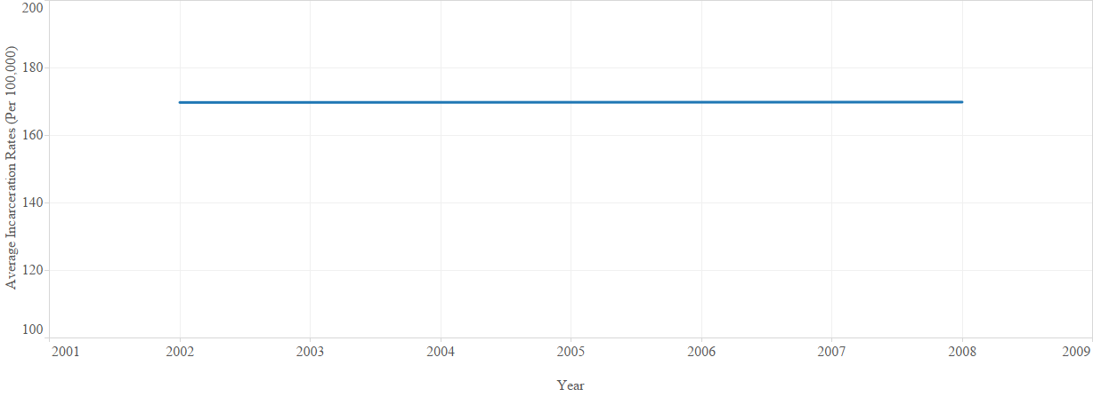
Examining trends in average incarceration rates by regions of the world shows the lowest rates in the West, followed by EAP and LA. In the Middle East and North Africa, incarceration rates increase more than other regions and are greatest at the end of the time period.

Figure 16. Average Incarceration Rates by Region.
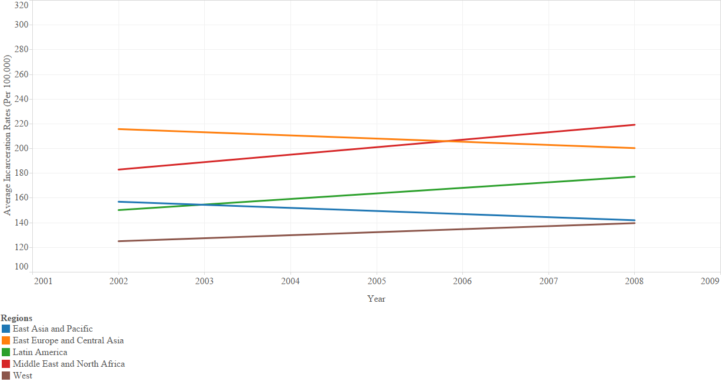
Inequality
Using the Gini score computed as the square root scale of household disposable income from Solt (2009), I look at the average for each of the countries included in this study. Greater inequality indicates more disposable income in the hands of fewer households. For the years covered, inequality ranges from 16.21 in Mauritius to 75.26 in Indonesia.
The worldwide average for inequality is virtually unchanged during this period with a Gini (net) score of just over 35.
Figure 17. Inequality Worldwide.
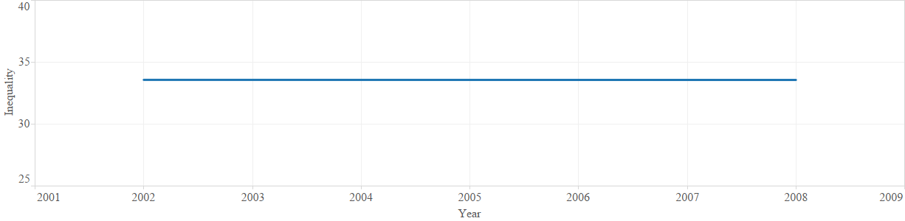
Examining income inequality across regions, I note the level of inequality is greatest in Latin America and East Asia and the Pacific, although a slight decrease in inequality occurs in both regions. The West and EECA have the lowest levels of inequality. Inequality increases most in the MENA.
Figure 18. Average Inequality for Regions of the World.

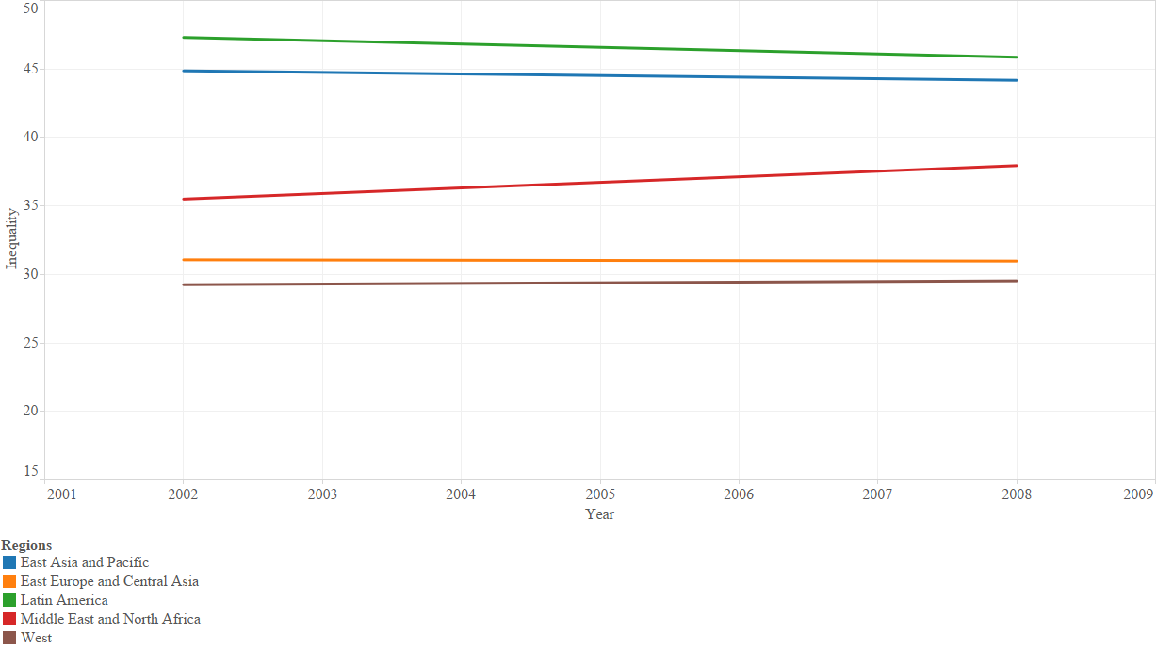
Gross Domestic Product Per Capita
Data for GDPPC are from the World Bank (N.d.a). Coverage for GDPPC is also consistent and extensive for the period covered in this study. Worldwide averages for the years 1994 through 2008 range from $1,040 (Constant 2011 International $) in Tajikistan in 1996 to $64,572 in Norway in 2006.
Examining the longitudinal data on GDPPC, the worldwide average GDPPC is $21,553 during the first half of the observation and increases to $26,141 during the latter half. See Figure 22 for yearly averages for GDPPC.

Figure 19. GDPPC Worldwide.
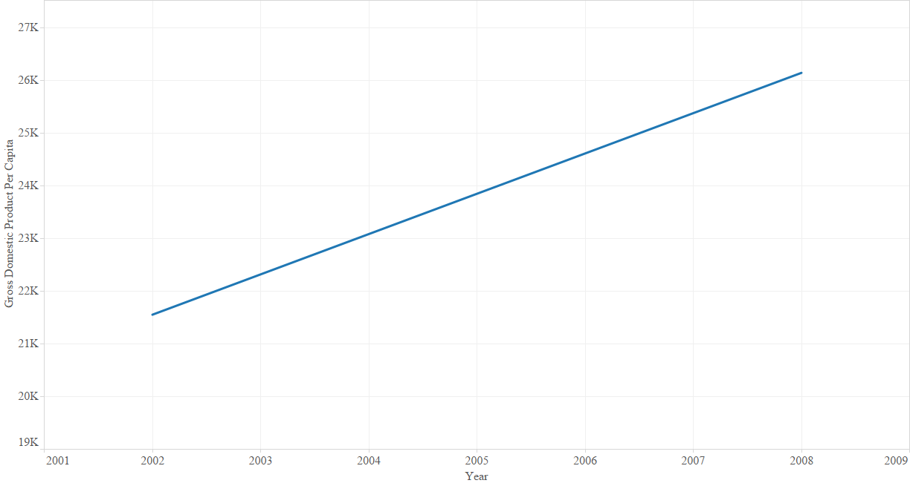

Regional differences in GDPPC are shown in Figure 20. Wealth in the West increases from $37,076 to $43,688. On the other hand, growth in GDPPC in Latin America is the weakest, increasing from $12,518 to $12,949. Growth for the remaining regions is similar, increasing approximately $4,000 between observations.

Figure 20. GDPPC by Region.
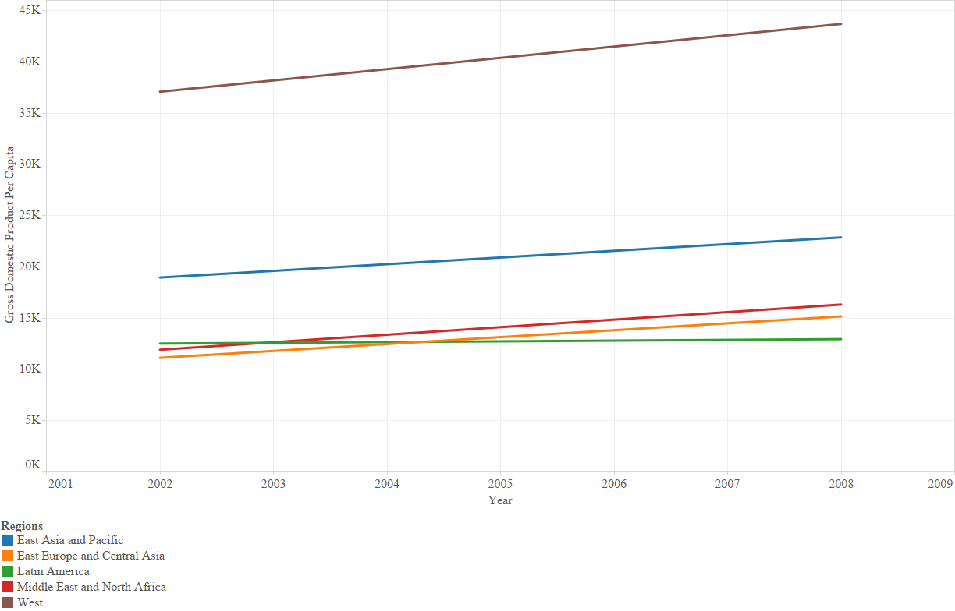
Democracy
My democracy measure from Freedom House (2014a) combines, averages, and recodes political rights and civil liberties indicators. Higher scores indicate more freedom within countries. Figure 21 shows average democracy scores for countries from 1990 through 2012.
Democracy appears to trend upward, as noted by Clark (2012) and remains relatively stable since the mid-2000s. The worldwide average increases from 5.77 to 6.02 during this period. See Figure 21 for annual average global democracy trends.

Figure 21. Democracy Worldwide.
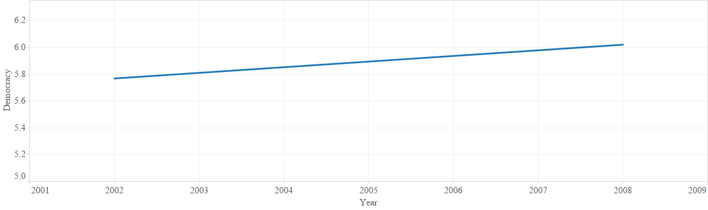
Regionally, differences in democracy are fairly marked. The West scores at or near seven, the maximum score. Latin America has the next highest democracy scores, followed by EECA, EAP, and the MENA, in descending order. Noteworthy is the reduction in civil liberties and political rights only in EAP.
Figure 22. Democracy by Regions.
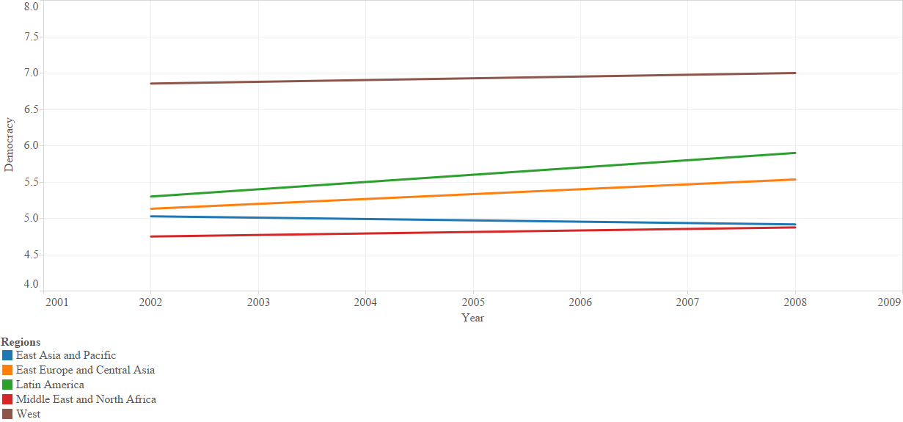
Age Cohort
The percentage of the population between the ages of 15 and 64 rose from 65.62 percent to 66.80 percent. Worldwide a greater percentage of the population is of childbearing, marriage, and working age. Increases in the percentage of the population of reproductive age also increase strain on available natural and societal resources, which are unequally distributed.

Figure 23. Average Percentage of Population between 15 and 64.
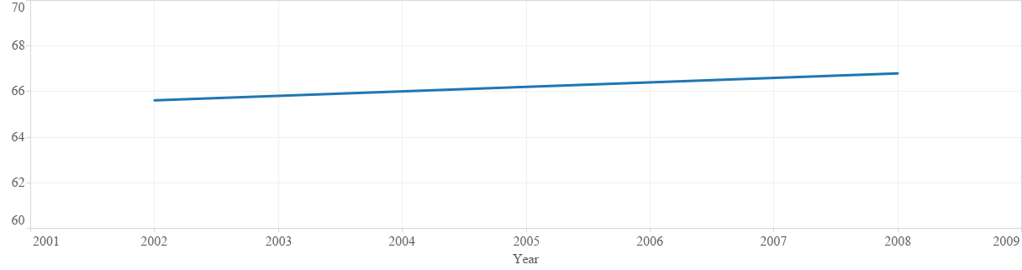

Regionally, the West experiences the least growth in the percentage in this age group during this time frame, moving from the highest percentage during the first half of the period, 66.56, to 66.87, during the second half. All other regions experience larger growth in this category, with EECA, LA, and MENA increasing at similar rates to one another while EAP increases only slightly.
Figure 24. Average Percentage of Population between 15 and 64 by Regions.
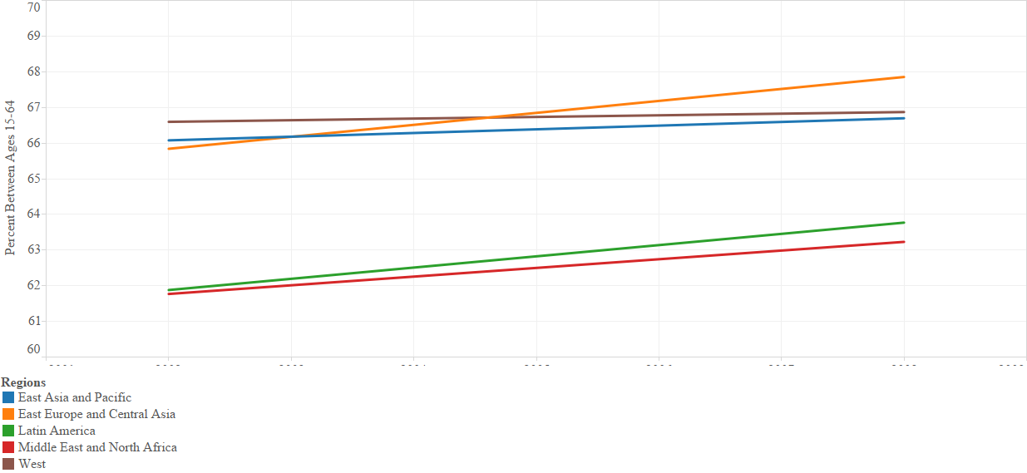

Urbanization
The percentage of a country’s population residing in urban areas is represented in Figure 25 below. Data from the World Bank’s WDI indicate an increase in the percentage of countries’ populations residing in urban areas. As is seen in Figure 25, on average, the world’s population increasingly resides in urban areas. In fact, for the countries included in this study the average percent of the world’s population residing in urban areas increases from 66.66 to 67.80.
Figure 25. Percent of Population in Urban Areas.
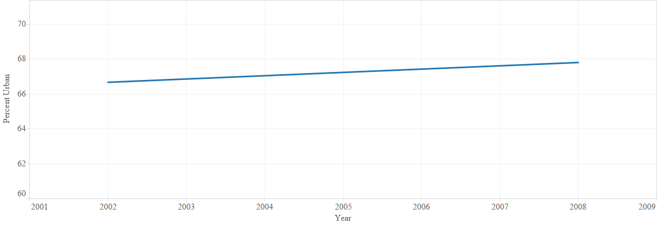
Each of the world’s regions experience increases in urban populations. Latin America has the highest percentage of its populations living in urban areas, increasing from 82.34 to 84.24. Urbanization increases similarly in the West and MENA increasing just over one percent. Urbanization in East Asia and the Pacific increases approximately three percent, while EECA experienced the slowest growth, increasing less than one percent.

Figure 26. Percent of Population in Urban Areas by Region.
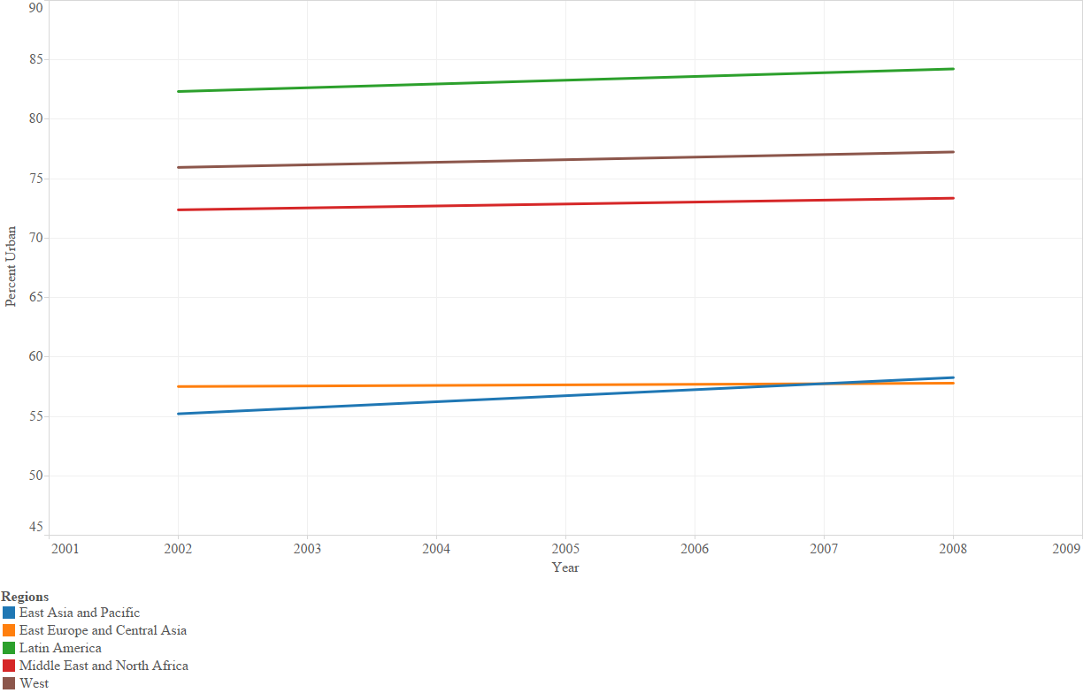
Physical Integrity Rights
Cingranelli and Richards (1999) use an eight-point scale indicating the level at which governments respect the physical integrity rights of the populace. Higher scores indicate greater governmental respect for the lack of torture, extrajudicial killing, political incarceration, and disappearance. There is slight reduction in physical integrity rights worldwide. The global average in the first half of the time period is 5.94, which decreases to 5.65.

Figure 27. Physical Integrity Rights Worldwide Average.
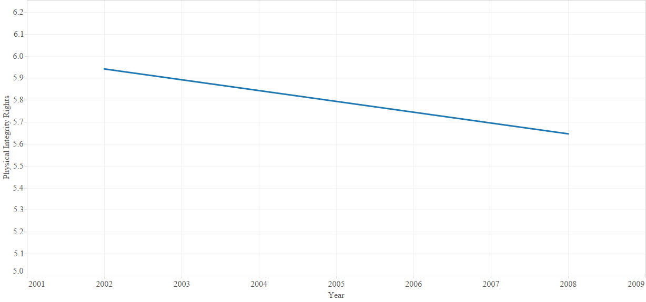

Regional differences in trends in physical integrity rights are shown below. The West has the highest average physical integrity rights for the entire period. However, reductions in physical integrity rights are noted in the following regions: West, EECA, and EAP, while Latin America and the Middle East and North Africa indicate slight increases in the variable. It is noteworthy that the measurement for the first half of the time period ends in 2002, following the terrorist attacks of 9/11. These results may, in part, be the trade-off in security concerns for respect for physical integrity rights following, and influenced by terrorist attacks around the world. Although the increases demonstrated in LA and MENA appear to belie the security concerns explanation.

Figure 28. Physical Integrity Rights Regional Averages.
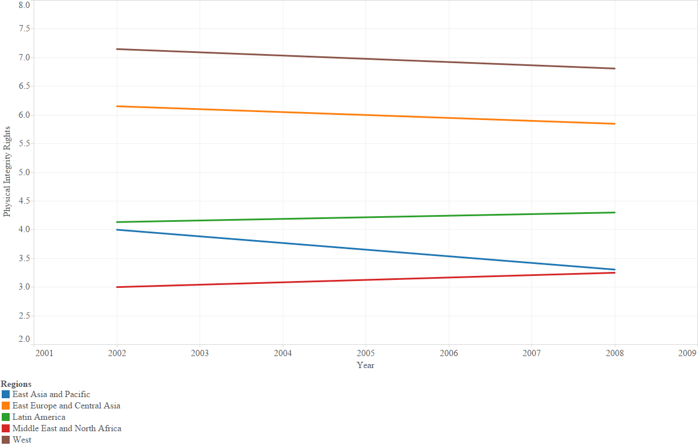

Educational Attainment
My secondary education attainment measure is from Barro and Lee (2013a). I report the percentage of the population aged 15 years and older having completed secondary education. Worldwide averages in these data range from 4.62 in Papua New Guinea to 70.69 in Kazakhstan.
Educational attainment worldwide increases slightly more than four percentage points, from 32.75 percent to 36.80 percent. Although relatively low, it appears that from a global perspective, educational attainment grew during the past two decades. See Figure 29 for trends in educational attainment.

Figure 29. Percent of the Population Completing Secondary Education.
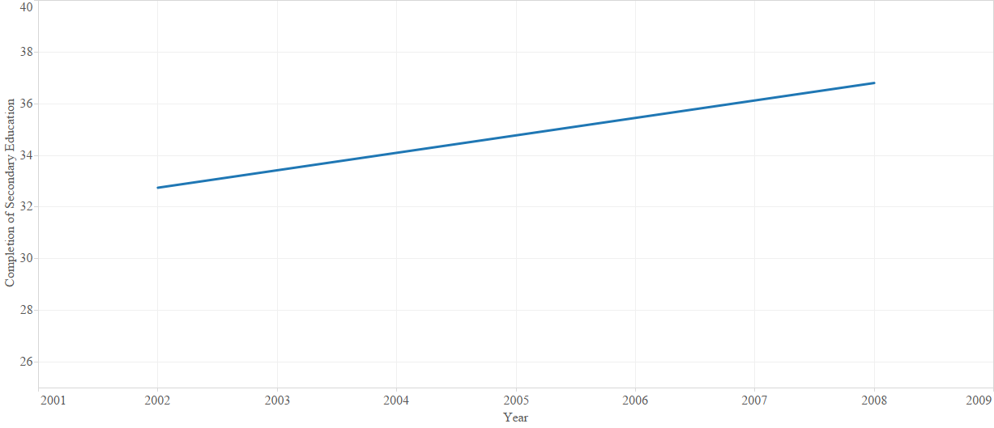
Regional trends for secondary education completion follows. Countries in Eastern Europe and Central Asia report the highest averages during this reporting period. Starting the period with a regional average of 44.61 percent of the population over age 15 completing secondary education, the region shows an increase to 49.65 percent. Educational attainment in the West averages 29.23 for the first half of the observation period and increases to 33.35. Although all regions show some growth in educational attainment, MENA lags all other regions.

Figure 30. Percent Completing Secondary Education by Region.
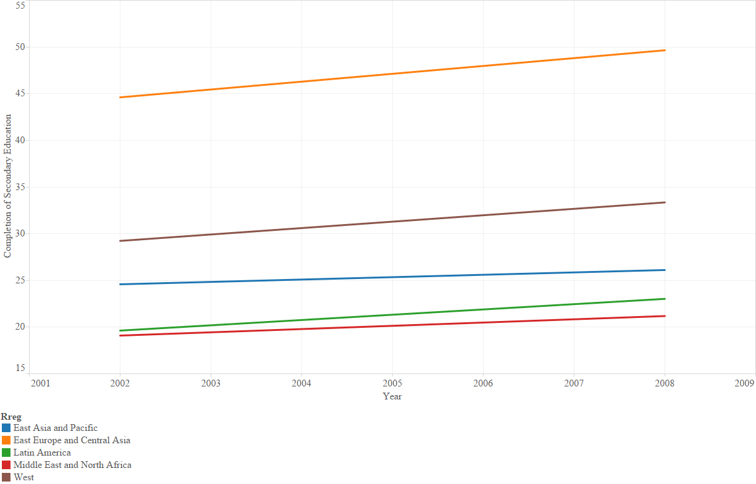

Homicide Rates
The average for homicide rates decreased slightly from the first half of the observation period to the second. At the beginning of the period, the average homicide rate for the countries covered is 4.27, which decreases to 4.00 at the end of the period.
Figure 31. Worldwide Averages for Homicide Rates.
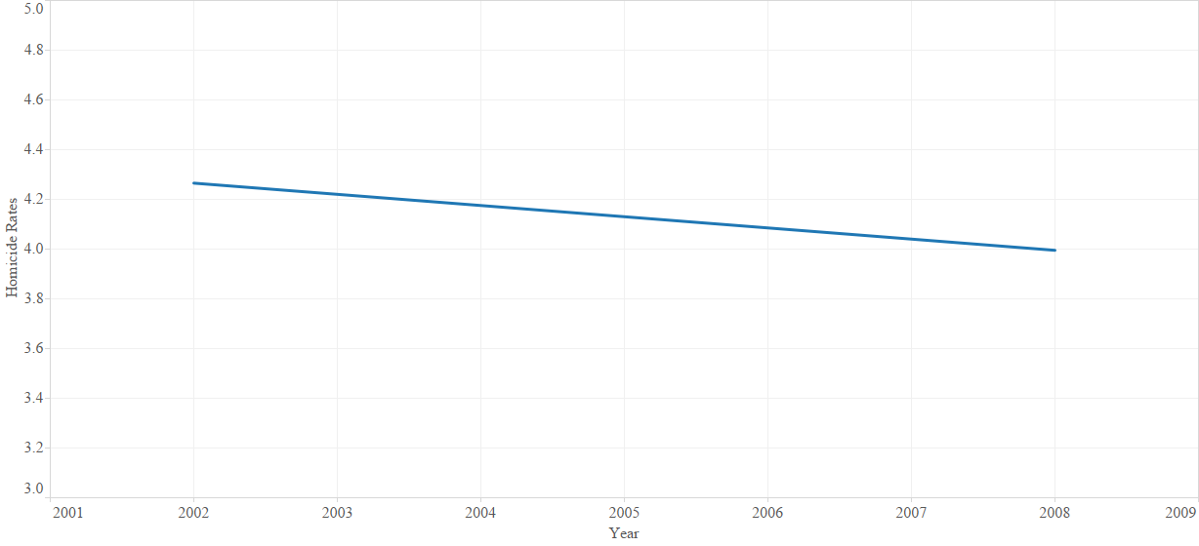
Regionally, homicide rates are greatest in Latin America, increasing from 10.62 per 100,000 to 14.63. Rates decreased the most in EECA while EAP, the West, and MENA all demonstrate smaller reductions. The Middle East and North Africa have the lowest homicide rates, with rates in the West only slightly higher.
Figure 32. Regional Averages for Homicide Rates.
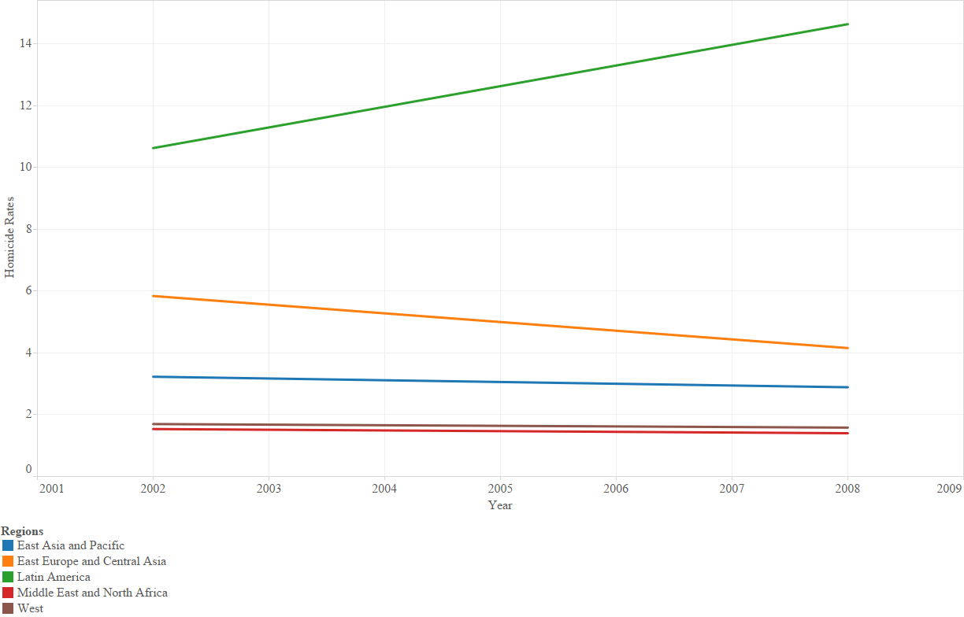
Drug Offense Rates
Unlike the overall reduction in homicide rates, drug offense rates increase during this period. During the first half of the period, average worldwide rates are 146.11 per 100,000, and by the end of the period, rates are 159.32 per 100,000. See Figure 33, below.

Figure 33. Average Drug Offense Rates.
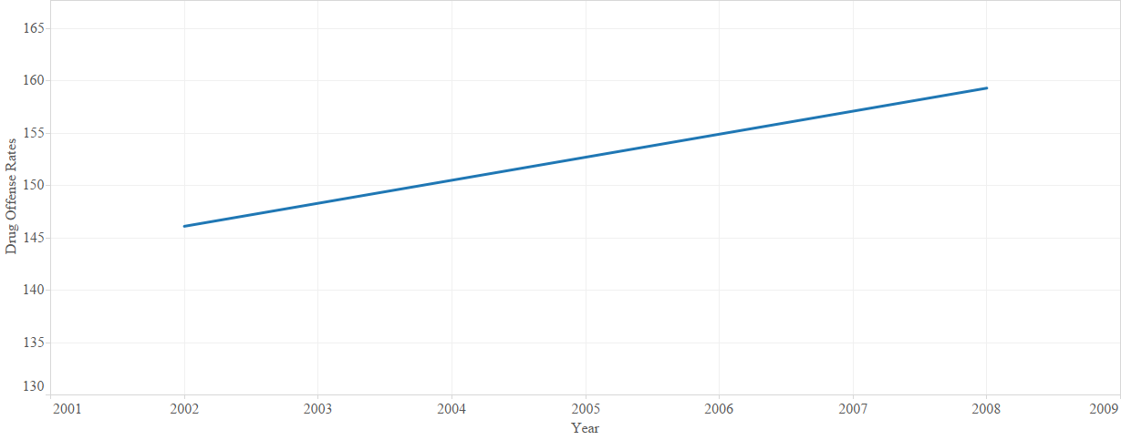
Regional differences in drug offense rates are shown below. The West has the highest drug offense rates, 301.10 per 100,000 the first half of the reporting period and growth between the periods was marginal, only increasing to 316.10 in the second half. On the other hand, drug offense rates in Latin America are lowest among the regions for both reporting periods, 25.20 to 32.10, respectively. The greatest increase occurs in MENA, and the only reduction noted is in East Asia and the Pacific.

Figure 34. Drug Offense Rates by Region.
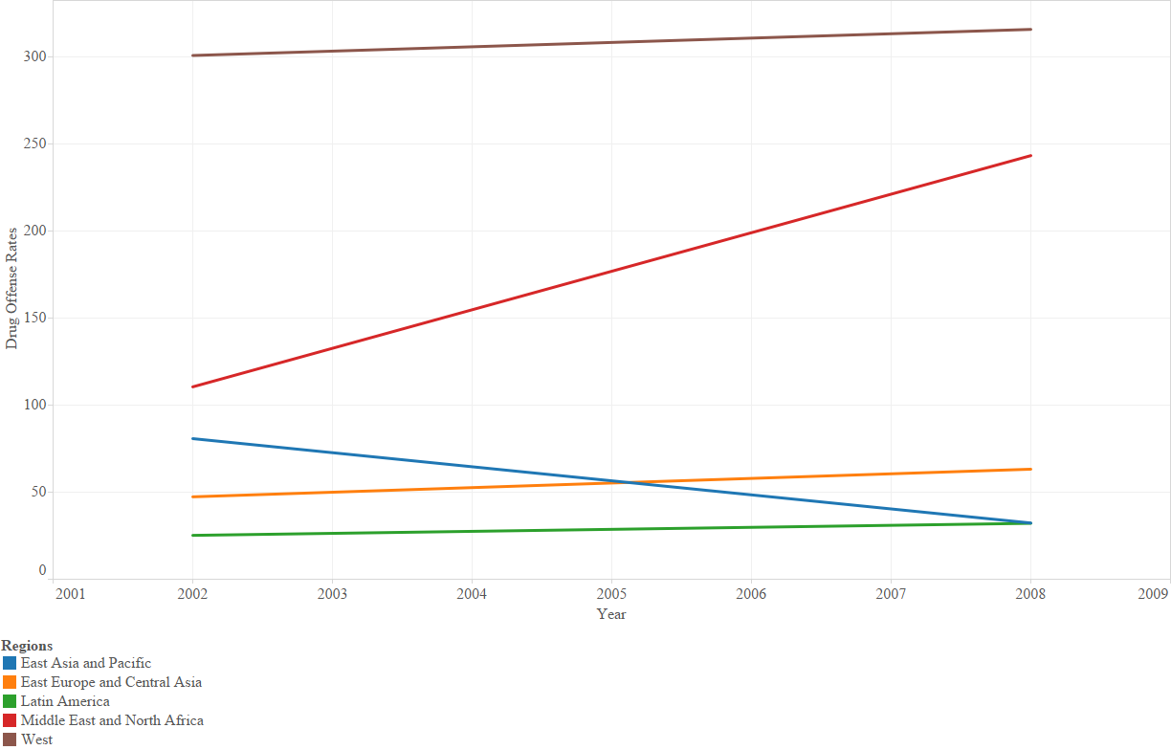

As the preceding graphs depict, the West has the lowest incarceration rates and income inequality and has relatively low homicide rates. On the other hand, the West has the greatest wealth, democracy, governmental respect for physical integrity rights, and drug offense rates; and has a relatively high percentage of the population between ages 15 and 64, urbanization, governmental respect for physical integrity rights, percent of the population completing secondary education. For the most part, these trends are as expected. I note with interest the West has low homicide rates and high drug offense rates. Perhaps as serious offense rates, like homicide, are lower, resources are used to pursue less serious offenses, like drug offenses. Higher drug offense rates may also be associated with greater wealth, with which to purchase illegal substances.
Incarceration rates in East Asia and the Pacific are as low as those in the West at the end of the observation period. Yet, as a region, EAP has high inequality, the second highest GDPPC, and one of the lowest democracy scores of any of the regions. They also report some of the lower homicide rates and drug offense rates.
Eastern Europe and Central Asia has some of the higher incarceration rates, lower inequality, lower wealth, and is mid-range for levels of democracy for the regions. Inequality is greatest in Latin America, although incarceration rates are in the middle of the regions. Latin America has the least wealth but is the region with the next to highest level of democracy. Homicide rates are highest, and drug offense rates are lowest in LA. The Middle East and North Africa has the highest incarceration rates, moving atop EECA during the last reporting period. Compared to other regions, inequality in MENA is in the middle. Regarding wealth, MENA is also in between other regions, but is nearer the poorest regions than the wealthier.
Latin America is in the middle range of regions for incarceration rates, but has the highest level of inequality and the lowest level of wealth. The region, on average, is second in level of democracy and highest in level of urbanization. Homicide rates are greatest in LA and increased during the study period, while drug offense rates were lowest. As a region, Latin America has been the beneficiary, and victim, or foreign domestic investment from transnational corporations. The presence of FDI tends to increase levels of inequality (Rubinson 1976; Mahutga et al. 2011).
The Middle East and North Africa has the highest level of incarceration rates at the end of the period, the lowest level for homicide rates, and has the largest increase in drug offense rates over the period. On average, inequality in MENA is in the middle of the regions.

CHAPTER 4. WORLD-SYSTEMS POSITION
Wallerstein (1976) posits a single capitalistic economic and social system operating in the world. Within that system, there is an international division of labor. The world-systems model is based on a three-tiered structure of economic interactions between countries of the world. Core countries sit atop the system with capital-intensive production, while peripheral countries have labor-intensive agricultural production. Semi-periphery countries exhibit a combination of both capital-intensive and labor-intensive production and act as an economic and political buffer between the core and periphery (Wallerstein 1974; Wallerstein 1976; Chase-Dunn 1998). Exploitation of the semi-periphery and periphery by core countries is a central tenet of world-systems theory. Core countries have greater wealth, and greater political and military power, which leads to increased options in trading with other countries. On the other hand, peripheral countries tend to have limited trading options, both in products to trade and countries with whom they trade.
Empirical work establishing the standard for a three-tiered world-systems position was conducted by Snyder and Kick (1979). For their classification scheme, Snyder and Kick (1979) use “four types of international networks: trade flows, military interventions, diplomatic exchanges, and conjoint treaty memberships” (p. 1105). The four ten-block models indicate the presence or absence of relationships between countries in each of the listed categories. Analyses of the network provide a roughly three-tiered model, although Snyder and Kick (1979:1116) acknowledge the presence of some countries included in their semiperiphery, considered strong or weak semiperiphery states. Similarly, Arrighi and Drangel (1986:65) characterize some countries as perimeter core and perimeter periphery states. Burns et al. (1997) note distinctions within the semiperiphery as well, the stronger states of which they refer to as the “semicore” (p. 439).
The impact of capitalism, via unequal exchange, occurs in interactions between countries. It also occurs within countries. Changes occur within countries as capitalism expands. As noted by Howard, Newman, and Pridemore (2000), “[a]s capitalism expands . . . it disrupts indigenous cultures and traditional means of subsistence, producing exploitation from the outside and new inequalities within” (p. 152). Also, economic growth is accompanied by increased industrialization and urbanization, leading to greater competition for resources and greater inequality (Howard et al. 2000:153). Given the differences in position in the international division of labor, it may well be there are differences in social dynamics demonstrated at the various levels (Terlouw 1993; Burns et al. 1994).
Subsequently, dependency theorists postulate income inequality is exacerbated in Third World countries, generally those countries in the periphery, by foreign capital penetration from transnational corporations, as noted by Crenshaw (1992). In his study, Crenshaw uses dependency or world-systems position as one of his explanatory variables for inequality. However, he finds little support for position in the world economy relative to income inequality (p. 357). He finds support for a curvilinear relationship between development and education and inequality, and a curvilinear relationship between democratic rights and inequality. Finally, he reports agricultural density is negatively related to inequality. Crenshaw (1992) uses the orthodox measure of WSP as produced by Snyder and Kick (1979) for a maximum of 59 countries with data from the 1960s and 1970s.
Clark and Beckfield (2009) confirm and update the three-tiered configuration of world-system position for 144 countries using the international trade network, while addressing the “age, [and] informal construction” (p. 9) of Snyder and Kick’s (1979) model. Their analysis finds the greatest concentration of trade networks among core nations, with significantly lower concentrations for both semi-periphery and periphery countries (p. 14). Clark (2012) extends the above and provides WSP for 161 countries including an expanded core of 47 countries, 38 semiperiphery countries, and 76 periphery countries for the decade from 1990-2000. Although Clark’s (2012) update does not extend into the 2000s, I use Clark’s (2012) updated classification for my analyses.
To investigate the relationship between WSP and explanatory variables, I conduct random effects modeling. Random effects regression are preferred over fixed-effects regression when the explanatory variable is time-invariant. I use the core as my referent category in all analyses.
Results of the regression analysis indicates no relationship between position in the world-system and incarceration rates. Core countries have greater wealth, democracy, urbanization, percentage of the population ages 15-64, and drug offense rates; and lower homicide rates. Semiperiphery and periphery countries have lower levels of democracy, lower percentage of the population age 15-64, less urbanization, and lower drug offense rates. See Table 12.
When I examine the relationship between WSP and inequality in Model 2, I note inequality is greater in the periphery (z = 2.48, p < .05). This analysis is fairly straightforward and does not explore the indirect effects posited by Mahutga et al. (2011). This result also reflects the impact of foreign domestic investment and alliances formed between ruling classes in core and non-core countries (Rubinson 1976; Mahutga et al. 2011). The semiperiphery produces a positive coefficient that fails to achieve significance (z = 1.53). In this analysis, position in the world-system explains approximately 8 percent of the difference in inequality between countries. In Figure 35 below, I show income inequality trends by world-systems position by their averages pre- and post-2002, noting the relative stability of inequality in the core, along with a slight decrease in income inequality in the periphery, with a similarly slight increase in inequality in the semiperiphery.

Figure 35. Inequality by World-Systems Position.
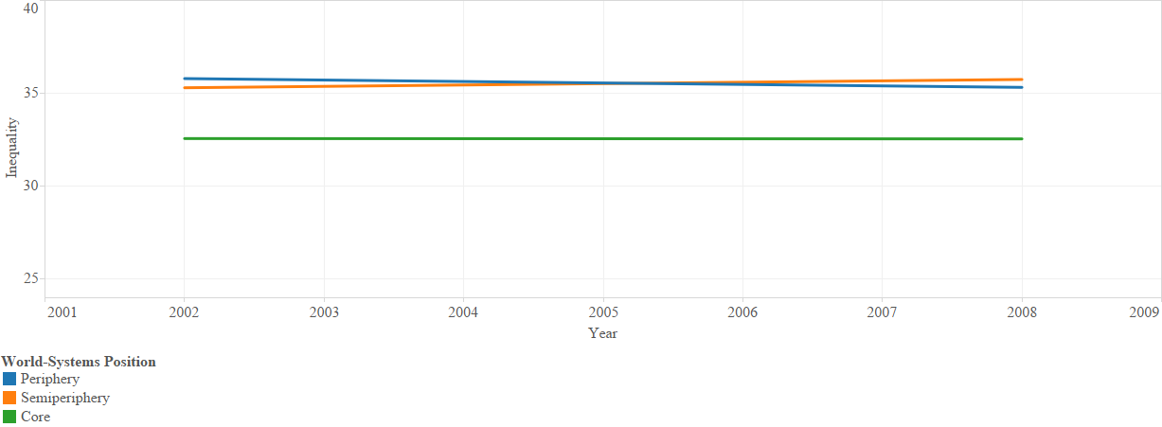
As expected, and by definition, wealth is significantly lower in the semiperiphery (z = -3.91, p < .001) and periphery (z = -7.54, p < .001). The core is made up of countries with greater wealth than either the semiperiphery or the periphery. The direction and magnitude of the results of the regression are indicative of the respective positions. Forty-three percent of the difference in wealth between countries is explained by position in the world-system. A graphic depiction of the differences noted is seen in Figure 36 below.
Figure 36. GDPPC by World-Systems Position.
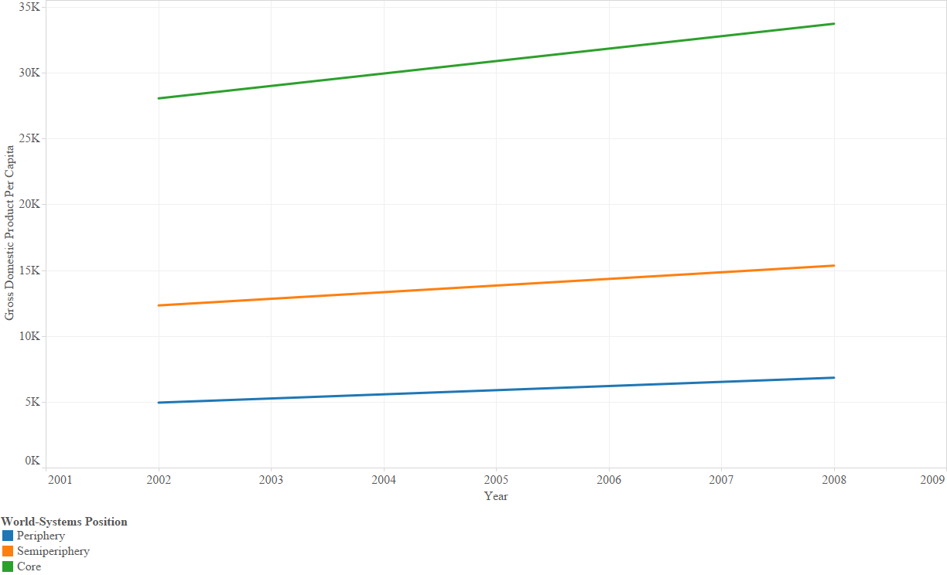
Random effects regression also confirms the relationship between WSP and democracy. Democracy is greatest in the core, with both the semiperiphery (z = -2.32, p < .05) and periphery (z = -3.02, p < .01) producing negative and significant coefficients in Model 3. With the core as the referent category, the results indicate semiperipheral countries have fewer civil liberties and political rights than the core, but more so than peripheral countries. Position in the world-system explains 11percent of the difference in levels of democracy between countries. These results appear similar to Clark’s (2012) findings relative to the relationship between world-systems position and democracy. See Figure 37 below for trends in democracy by position in the world-system.

Figure 37. Democracy by World-Systems Position
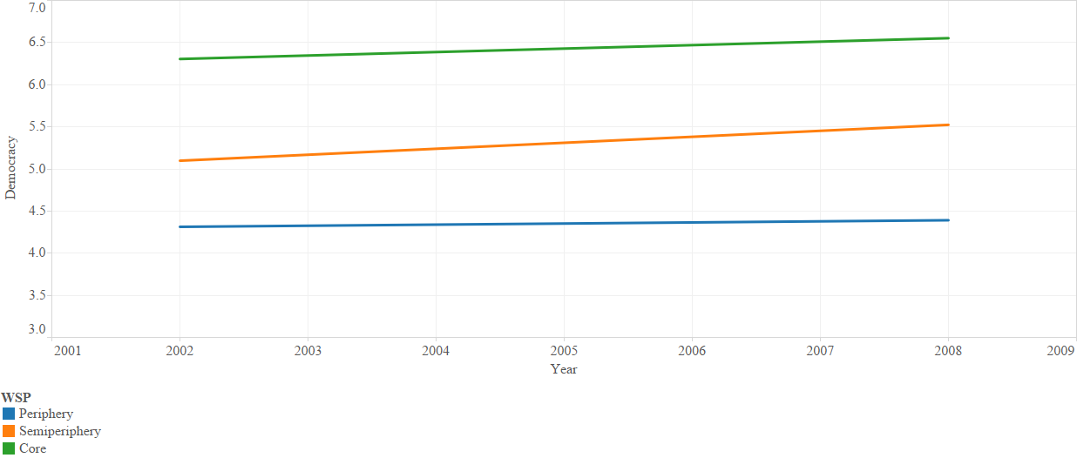

Core countries have a larger percentage of their populations between the ages of 15 and 64. In Model 5, the percentage of the population between ages 15-64 is lower in the semiperiphery (z = -2.45, p < .05) and the periphery (z = -5.37, p < .001).
Figure 38. Percentage of Population between 15-64 by World-Systems Position
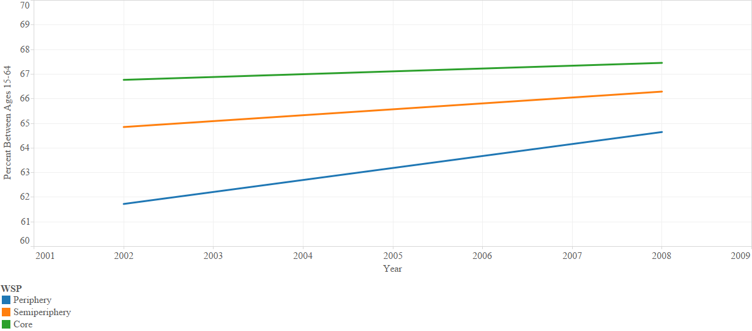

There are greater percentages of populations residing in urban areas in core countries than in the semiperiphery (z = -2.29, p < .05) and periphery (z = -4.78, p < .001).
Figure 39. Urbanization by World-Systems Position.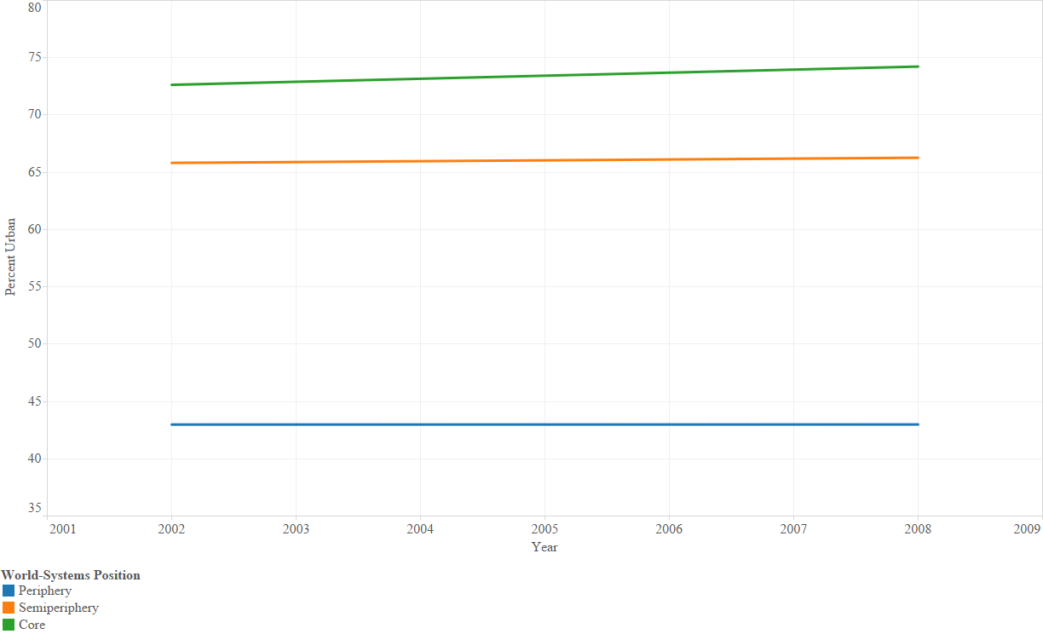

In Model 7, the respect for physical integrity rights is not statistically different among the three tiers, although coefficients for the semiperiphery and periphery were both negative in this analysis. Similarly, the percentage of populations over age 15 having completed secondary education produces negative coefficients for both the semiperiphery and periphery, which fail to achieve statistical significance as seen in Model 8.
Homicide rates (logged) are greater in the semiperiphery (z = 3.97, p < .001) and the periphery (z = 4.94, p < .001), than in the core, as seen in Model 9. Again, the direction and magnitude of the coefficients is consistent with position in the world-system. Position in the world-system explains approximately 27percent of the difference of homicide rates (logged) between countries.

Figure 40. Homicide Rates by World-Systems Position.
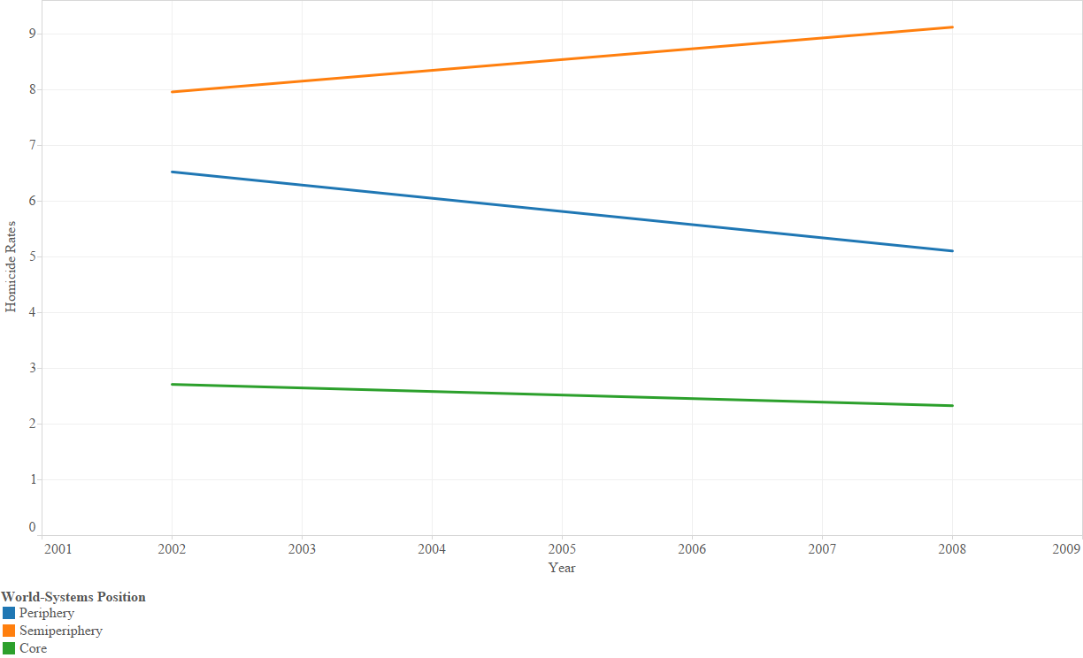

Core countries have higher drug offense rates (logged) than the semiperiphery or the periphery. Drug offense rates are greater in the core than in the semiperiphery (z = -2.03, p < .05) and the periphery (z = -3.72, p < .001), as shown in Model 10. R² for this analysis indicates approximately 15 percent of the variation in drug offense rates (logged) between countries is explained by position in the world-system.
Figure 41. Drug Offense Rates by World-Systems Position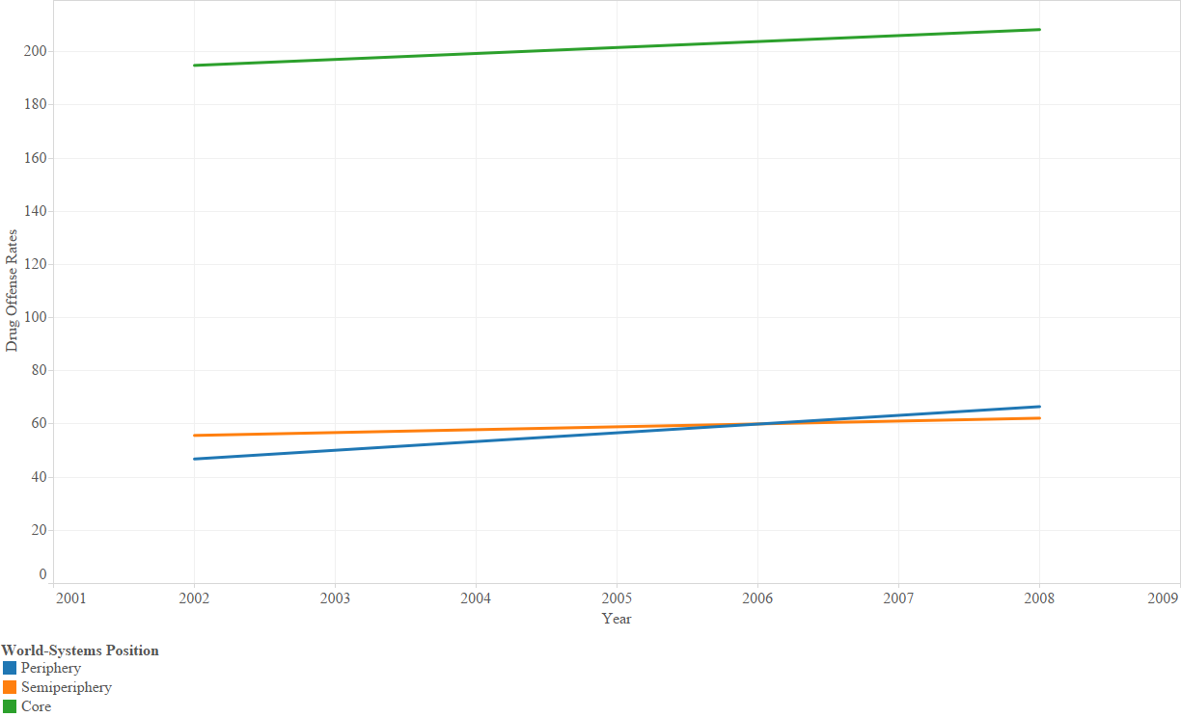

Homicide rates are lower in the core, but drug offense rates are higher in the core. Although beyond the focus of this analysis, the differences in levels of homicide rates and drug offense rates bring to mind the words of Durkheim regarding differences in the definitions of crime and deviance: “Crimes, properly so called, will there be unknown, but faults which appear venial to the layman will create there the same scandal” (1966:68). In the absence of serious offenses, like homicide, it appears that core countries have redefined and criminalized less serious offenses, like drug offenses, to fill the void.

Table 12. RE Regression for each Variable for WSP. | Model 10 | Drug Offense Ratesª | -.81*  (.40) | -1.52***  (.41) | .11  .00  .15  325  77 | Note: a = logged variable.
Table 12. RE Regression for each Variable for WSP. | Model 9 | Homicide Ratesª | .86***  (.22) | 1.10***  (.22) | .23  .00  .27  325  77 | Note: a = logged variable.
Table 12. RE Regression for each Variable for WSP. | Model 8 | Secondary Education | -3.11  (4.11) | -2.53  (4.19) | .004  .00  .01  325  77 | Note: a = logged variable.
Table 12. RE Regression for each Variable for WSP. | Model 7 | Physical Integrity | -.60  (.57) | -.64  (.58) | .03  .00  .02  325  77 | Note: a = logged variable.
Table 12. RE Regression for each Variable for WSP. | Model 6 | Urban | -11.14*  (4.87) | -23.71***  (4.95) | .25  .00  .23  325  77 | Note: a = logged variable.
Table 12. RE Regression for each Variable for WSP. | Model 5 | Age Cohort | -2.81*  (1.15) | -3.28***  (1.17) | .16  .00  .28  325  77 | Note: a = logged variable.
Table 12. RE Regression for each Variable for WSP. | Model 4 | Democracy | -.90*  (.39) | -1.19**  (.39) | .19  .00  .11  325  77 | Note: a = logged variable.
Table 12. RE Regression for each Variable for WSP. | Model 3 | Wealthª | -.81***  (.21) | -1.60***  (.21) | .44  .00  .43  325  77 | Note: a = logged variable.
Table 12. RE Regression for each Variable for WSP. | Model 2 | Inequalityª | 4.34  (2.83) | 7.14*  (1.60) | .05  .00  .08  325  77 | Note: a = logged variable.
Table 12. RE Regression for each Variable for WSP. | Model 1 | Incarceration Ratesª | .09  (.19) | .11  (.19) | .01  .00  .005  325  77 | Note: a = logged variable.
Table 12. RE Regression for each Variable for WSP. |  |  | Semiperiphery | Periphery | R² Overall  R² Within  R² Between  N observations  N groups | Note: a = logged variable.

CHAPTER 5. INEQUALITY AND INCARCERATION
Inequality has long been a subject of interest to researchers. Kuznets (1955) found inequality in the distribution of income within nations increased in developing economies as those economies transitioned from agricultural to industrial bases, with concomitant increases in urban populations. Inequality increases within countries as economies grow but decreases as those economies reach certain levels of growth, demonstrating a curvilinear relationship. His investigation of inequality involves only three nations, the United States, England, and Germany. From this early research on inequality, others have sought to use inequality as an explanatory variable for differences in a variety of social outcomes.
Quinney (1969) posited that social, political, and economic forces impact the social reality of crime. Those in the dominant class impact the definitions of crime and impose those definitions on the powerless. Laws are enacted as a way to “control the undesirable, the criminal and the ‘nuisance’” (Chambliss 1964:76). Some within societies represent a potential threat to the dominant class and may be subject to incarceration as a method of social control. As noted by Spitzer (1975a): “Punishment is an instrumental mechanism for preserving the structure of social life” (p. 632).
In prior research some scholars find a positive correlation between inequality and incarceration rates (Killias 1986; Wilkins and Pease 1987; Krus and Hoehl 1994; Wilkinson and Pickett 2007; Lappi-Seppälä 2008; Van Kesteren 2009; DeMichele 2010; Lappi-Seppälä 2010; Miller 2011; Healy et al. 2013), while others do not (Neapolitan 2001; Jacobs and Kleban 2003; Ruddell 2005). I enhance and expand this research using panel data spanning 20 years, from 1993 to 2013, with incarceration rates from Walmsley’s ten editions of the World Prison Population List, Gini indices from the “Standardizing the World Income Inequality Database 4.0” (SWIID 4.0) by Frederick Solt (2009), and others as noted in the data and methods section. The earliest incarceration rates from Walmsley are in 1993, and the earliest Gini indices I use are from 1990, which allows me to lag my independent variables up to four years. I use Stata/IC 12.1 for Windows for each of my analyses. For panel data, Stata allows me to run fixed- and random-effects models on the data, with a correction for autocorrelation.
In my full model there are 248 observations for 65 countries. I conduct all of the analyses reported in the following table with that subset of my data to maintain consistency in the reported outcomes. When I run the fixed-effect regression incarceration rates on inequality in Model 1, it results in a positive and significant coefficient (t = 13.18, p < .001). According to the analysis, inequality accounts for approximately 49 percent of the variation in incarceration rates within countries. For each unit increase in my inequality measure, there is a percentage increase in incarceration rates. However, when I control for GDPPC in Model 2, inequality produces a positive coefficient that is no longer significant, yet the model explains approximately 75 percent of the variation in incarceration rates with countries. This indicates the influence of inequality on incarceration rates is not significant when the wealth of countries is held constant. As GDPPC is logged, the resultant coefficient indicates percentage increases in GDPPC produce percentage increases in incarceration rates. And as countries’ wealth increases, so do their incarceration rates (t = 13.77, p < .001). In Model 3, I examine the influence of inequality on incarceration rates, this time controlling for my democracy measure. In this analysis both measures produce positive and significant coefficients, although the coefficient for inequality is less than in the first model (t = 6.79, p < .001). The positive and significant results for democracy (t = 7.24, p < .05) indicate in countries with greater civil liberties and political rights, incarceration rates are higher. Noting Jacobs and Kleban’s (2003) findings that decentralized federalist democracies tend to subject local officials to greater pressure from the electorate for greater incarceration, my finding appears to be in line with their conclusions, although my democracy measure does not differentiate types of democracies.
Model 4 controls for the percentage of the population between ages 15-64. Inequality produces a negative coefficient, but is no longer significant. The age cohort variable produces a positive and significant coefficient (t = 15.73, p < .001). As the population between 15 and 64 increases, incarceration rates increase, which may reflect the fact that a larger portion of the population is eligible for incarceration. When I introduce a control for percent of the population living in urban areas, inequality is positive, but not significant (t = 1.19) in Model 5. Urban population also produces a positive and significant coefficient (t = 14.90, p < .001), indicating countries with greater percentages of their populations residing in urban areas also have higher incarceration rates.
Controlling for countries’ respect for physical integrity rights in Model 6 results in a positive and significant coefficient for inequality (t = 13.20, p < .001) and a positive and significant coefficient for physical integrity rights (t = 3.29, p < .001). Countries exercising respect for physical integrity rights are more apt to use incarceration than extrajudicial means.
Although Jacobs and Kleban (2003) note an inverse relationship between education and level of punitiveness found by others (p. 728), I find in Model 7 a positive and significant relationship between percentage of the population aged 15 years and older who have completed secondary education and incarceration (t = 5.80, p < .001). Controlling for educational attainment still produces a positive and significant coefficient for inequality (t = 8.09, p < .001). Controlling for homicide rates produces a positive and significant coefficient for inequality (t = 12.87, p < .001). However, for homicide rates (t = 1.69, p < .10) the coefficient merely approaches significance in Model 8.
In Model 9, I control for the logged variable of drug offense rates. Again, income inequality produces a positive, significant result (t = 12.40, p < .001). Drug offense rates are also positive and significant (t = 3.71, p < .001). Controlling for percent of the population that is male produces a negative, non-significant coefficient for inequality (t = -1.25), and a positive, significant coefficient for percent male (t = 15.16, p < .001) in Model 10. As the percentage of males in the population increases, incarceration rates tend to increase.
I introduce ethnic fractionalization, “the probability that two individuals selected at random from a country will be different ethnic groups” (Fearon 2003:208), as a control variable with inequality in Model 11. While inequality produces a positive and significant coefficient (t = 10.05, p < .001), ethnic fractionalization and its interaction with standardized time (t = -.75) does not. In other words, the influence of ethnic fractionalization, at the middle of the time period, on incarceration rates appears to be minimal. Unnever and Cullen (2010) note ethnic intolerance, while not necessarily indicated in my variable, was a significant predictor of support for the death penalty.
In Model 12, I use all of my variables as controls for inequality in the fixed-effect model. In this model, inequality produces a negative, but non-significant coefficient (t = -1.50). Variables producing positive and significant results include: percentage of the population between age 15-64 (t = 4.18, p < .001), percent of the population residing in urban areas (t = 3.82, p < .001), and drug offense rates (t = 2.67, p < .01). Country wealth produces a negative and significant coefficient (t = -4.57, p < .001). The variables in Model 12 explain over 86 percent of the variation in incarceration rates within countries. Finally, in Model 13 I introduce a regional dummy control with West as my referrent category. The results are similar to those listed in Model 12, with a slight reduction in the t-score for drug offense rates (t = 1.79, p < .10). For the regional variables, none produce significant results. However, the explanatory value of the model explains over 88 percent of the variation in incarceration rates. See Table 13 below.

 | Table 13. FE Regression of Incarceration Rates on the Listed Variables. | Model 10 | -.01  (.01) |  |  |  |  |  |  |  |  | .11***  (.01) |  |  |  |  |  |  |  | .29  .77  .30 |  | Note: a = variable logged; b = * time (standardized); +p<.10; *p<.05; **p<.01; ***p<.001. N=248 for each model.
 |  | Model 9 | .09***  (.01) |  |  |  |  |  |  |  | .11***  (.03) |  |  |  |  |  |  |  |  | .07  .54  .07
 |  | Model 8 | .09***  (.01) |  |  |  |  |  |  | .14+  (.09) |  |  |  |  |  |  |  |  |  | .07  .51  .08
 |  | Model 7 | .06***  (.01) |  |  |  |  |  | .04***  (.01) |  |  |  |  |  |  |  |  |  |  | .13  .57  .14
 |  | Model 6 | .09***  (.01) |  |  |  |  | .05***  (.01) |  |  |  |  |  |  |  |  |  |  |  | .05  .52  .05
 |  | Model 5 | .01  (.01) |  |  |  | .06***  (.004) |  |  |  |  |  |  |  |  |  |  |  |  | .00  .78  .00
 |  | Model 4 | -.01  (.01) |  |  | .08***  (.004) |  |  |  |  |  |  |  |  |  |  |  |  |  | .01  .78  .01
 |  | Model 3 | .05***  (.01) |  | .30***  (.04) |  |  |  |  |  |  |  |  |  |  |  |  |  |  | .01  .63  .01
 |  | Model 2 | .001  (.01) | .48***  (.03) |  |  |  |  |  |  |  |  |  |  |  |  |  |  |  | .04  .74  .04
 |  | Model 1 | .09***  (.01) |  |  |  |  |  |  |  |  |  |  |  |  |  |  |  |  | .05  .49  .05
 |  |  | Inequalityª | GDPPCª | Democracy | Age Cohort | Urban | Physical Integrity | Secondary Education^{a,} | Homicide Rate^{a,} | Drug Offense Ratesª | Percent Maleª |  |  |  |  |  |  |  | R² Overall  R² Within  R² Between
 |  |  |  |  |  |  |  |  |  |  |  |  |  |  |  |  |  |  |  |  |  | Note: a = variable logged; b = * time (standardized); +p<.10; *p<.05; **p<.01; ***p<.001. N=248 for each model.
 | Table 13. FE Regression of Incarceration Rates on Listed Variables (continued)
 |  | Model 13 | -.01  (.01) | -.75***  (.19) | .001  (.04) | .13***  (.03) | .03**  (.01) | .001  (.01) | -.001  (.01) | -.04  (.06) | .04+  (.02) | .03  (.05) | -.36  (.36) | .21  (.18) | -..41  (.25) | -.09  (.17) | .52  (.33) | .92  (.59) | -.64  (.73) |  | .10  .88  .10
 |  | Model 12 | -.01  (.01) | -.84***  (.18) | -.01  (.04) | .14***  (.03) | .04***  (.01) | .0003  (.01) | .001  (.01) | -.03  (.06) | .05**  (.02) | .02  (.05) | -.17  (.36) | .12  (.16) |  |  |  |  |  |  | .09  .87  .10
 |  | Model 11 | .08***  (.01) |  |  |  |  |  |  |  |  |  | -.42  (.56) | .77***  (.23) |  |  |  |  |  |  | .05  .56  .05
 |  |  | Inequality^{a,} | GDPPC^{a,} | Democracy | Age Cohort | Urban | Physical Integrity | Secondary Education | Homicide Rateª | Drug Offense Rates^{a,} | Percent Male | Ethnic Fractionalization^{b} | Time | East Asia & Pacific^{b} | Eastern Europe & Central Asia^{b} | Latin America^{b} | Middle East & North Africa^{b} | Sub-Saharan Africa^{b} |  | R² Overall  R² Within  R² Between

I also conduct random effects (RE) regression on the panel data. In Model 1, income inequality produces a positive coefficient that is not significant. When I control for wealth in Model 2, inequality and wealth product positive coefficients, neither of which is significant. When I introduce level of democracy as a control in Model 3, inequality remains non-significant, while level of democracy produces a positive, significant coefficient (z = 3.53, p < .001). I control for the percentage of the population between ages 15 and 64 in Model 4. Inequality is not significant and my age cohort is positive and significant (z = 4.06, p < .001). The greater the percentage of the population between 15 and 64, the higher the incarceration rates.
In Model 5, I control inequality with percent of the population residing in urban areas. In this model, inequality is non-significant and percent urban is positive and significant (z = 3.07, p < .001). The greater the percentage of the population residing in urban areas, the higher the rates of incarceration. Controlling for physical integrity rights fails to produce a significant coefficient for either variable. In Model 7, controlling for the percentage of the population over age 15 completing secondary education, produces a positive and significant coefficient for education (z = 2.76, p < .01), while inequality is not significant. Inequality is negative and non-significant when I control for homicide rates. Homicide rates also produce a negative, non-significant coefficient. In Model 8, neither inequality nor ethnic fractionalization produce significant coefficients. Model 9 controls for drug offense rates. While inequality continues to fail to produce significant results, drug offense rates (logged) produce a positive and significant coefficient (z = 4.91, p < .001).
I add percentage of the population that is male as a control for inequality in Model 10. Inequality is nonsignificant and percent of population that is male produces a negative, significant result (z = -4.37, p < .001). Model 11 examines inequality, controlling for ethnic fractionalization. Neither variable produces a significant coefficient.
In Model 12, I include all of the listed controls, save regions. In this model, the following variables produce positive and significant coefficients: level of democracy (z = 2.51, p < .05), age cohort (z = 2.84, p < .01), percent urban (z = 4.33, p < .001), educational attainment (z = 1.97, p < .05), drug offense rates (z = 4.36, p < .001), and ethnic fractionalization (z = 2.12, p <.05). Wealth (z = -4.79, p < .001) and percentage of the population that are male (z = -2.32, p < .05) produce a negative and significant coefficients. According to the analysis, the variables in Model 12 explain over 35 percent of the variation in incarceration rates within countries.
In my final model, I include all previously listed explanatory and control variables and include regional dummy variables, with West as the referent category. When I add the regional dummy variables, my results are similar to those in Model 11. Level of democracy (z = 2.40, p <.05), age cohort (z = 2.42, p <.05), percent urban (z = 4.17, p <.001), and drug offense rates (z = 4.54, p <.001), all produce positive, significant coefficients. Country wealth (z = -3.58, p <.001) and percent male (z = -1.94, p <.10), both produce negative coefficients. Using the West as my referent category, all regional variables produce positive coefficients, with EECA, MENA, and SSA attaining significance. R² for Model 13 is .41.

 | Model 13 | .003  (.01) | -.38***  (.11) | .07*  (.11) | .03*  (.01) | .02***  (.004) | .01  (.01) | .005  (.003) | .02  (.05) | .08***  (.02) | -.10+  (.05) | .29  (.28) | .27  (.23) | .44*  (.21) | .34  (.22) | .54*  (.27) | .86**  (.28) | .35  .21  .41
 | Model 12 | .002  (.005) | -.47***  (.10) | .07*  (.03) | .04**  (.01) | .02***  (.004) | .01  (.01) | .01*  (.003) | .03  (.05) | .08***  (.02) | -.10*  (.04) | .57*  (.27) |  |  |  |  |  | .33  .19  .35
Table 14. RE Regression for each Explanatory Variables. | Model 11 | -.001  (.01) |  |  |  |  |  |  |  |  |  | .22  (.33 |  |  |  |  |  | .07  .02  .07 | Note: a = variable logged. +p<.10; *p<.05; **p<.01; ***p<.001. N=325 for each model.
Table 14. RE Regression for each Explanatory Variables. | Model 10 | .003  (.005) |  |  |  |  |  |  |  |  | -.20***  (.04) |  |  |  |  |  |  | .21  .03  .22
Table 14. RE Regression for each Explanatory Variables. | Model 9 | .002  (.005) |  |  |  |  |  |  |  | .08  (.02) |  |  |  |  |  |  |  | .02  .08  .07
Table 14. RE Regression for each Explanatory Variables. | Model 8 | -.0002  (.005) |  |  |  |  |  |  | .02  (.05) |  |  |  |  |  |  |  |  | .17  .04  .10
Table 14. RE Regression for each Explanatory Variables. | Model 7 | .003  (.004) |  |  |  |  |  | .01**  (.003) |  |  |  |  |  |  |  |  |  | .05  .02  .08
Table 14. RE Regression for each Explanatory Variables. | Model 6 | .001  (.005) |  |  |  |  | .01  (.01) |  |  |  |  |  |  |  |  |  |  | .01  .02  .04
Table 14. RE Regression for each Explanatory Variables. | Model 5 | .003  (.005) |  |  |  | .01**  (.003) |  |  |  |  |  |  |  |  |  |  |  | .01  .12  .04
Table 14. RE Regression for each Explanatory Variables. | Model 4 | .003  (.005) |  |  | .02*  (.01) |  |  |  |  |  |  |  |  |  |  |  |  | .06  .0002  .08
Table 14. RE Regression for each Explanatory Variables. | Model 3 | .001  (.004) |  | .09  (.03) |  |  |  |  |  |  |  |  |  |  |  |  |  | .01  .11  .001
Table 14. RE Regression for each Explanatory Variables. | Model 2 | .001  (.01) | .02  (.06) |  |  |  |  |  |  |  |  |  |  |  |  |  |  | .004  .002  .002
Table 14. RE Regression for each Explanatory Variables. | Model 1 | .0004  (.005) |  |  |  |  |  |  |  |  |  |  |  |  |  |  |  | .02  .02  .002
Table 14. RE Regression for each Explanatory Variables. |  | Inequality | GDPPCª | Democracy | Age Cohort | Urban | Physical Integrity | Secondary Education | Homicide Rate^{a,} | Drug Offense Ratesª | Percentage Male | Ethnic Fractionalization | East Asia & the Pacific | Eastern Europe & Central Asia | Latin America | Middle East & North Africa | Sub-Saharan Africa | R² Overall  R² Within  R² Between
The use of this global model over a 15-year period provides additional insight into the influence of inequality on incarceration rates. The fixed-effects model demonstrates while inequality is related to incarceration rates in some ways and to some degree, as demonstrated by others and confirmed in this study. However, the strength of the relationship diminishes when additional factors are taken into consideration. For example, inequality no longer produces a significant coefficient when I control for countries’ wealth. Controlling for differences in the age demographic and level of urbanization also cause inequality to lose significance in the models. In the full model, income inequality is not statistically significant. This study provides additional information regarding some of the factors within countries that provide significant influence on incarceration rates in addition to and perhaps in lieu of inequality. The full model explains approximately 88 percent of the variation in incarceration rates within countries. The random effects models provide less explanatory power.
These results support Hypothesis Two, the positive relationship between inequality and incarceration rates is confirmed, but only in part. As noted above, the impact of inequality is attenuated when additional societal components are held constant.

CHAPTER 6. CONCLUSION
Rates of incarceration vary around the world. Researchers have examined the links between various societal factors and incarceration rates and have come to different conclusions. While some scholars find a positive correlation between inequality and incarceration rates, others do not. In this study, I examine the impact of income inequality on incarceration rates for 77 countries over the past 15 years and provide evidence of factors mitigating the influence of inequality. In this study, I provide additional insight using panel data for a broad cross-section of countries from 1994 through 2008. Using longitudinal data with an autocorrelation correction shows the relative influence of each of the principal independent variables under consideration, along with the attenuating influences of various control variables.
I confirm the positive relationship between inequality and incarceration rates but qualify the finding by noting the influence of countries’ wealth, the percentage of population ages 15-64, percent of the population residing in urban areas, and percent male on the relationship in fixed-effects models. Although inequality is no longer significant, drug offense rates are significant in the full model and approach significance when I include regional controls. Countries with higher percentages of their populations between the ages of 15 and 64, with greater urbanization, and higher drug offense rates tend to have higher incarceration rates. The other significant result in the full models is the negative and significant coefficient for country wealth, indicating at increased levels of wealth, incarceration rates decrease.
When I conduct random effects analysis using similar models for fixed-effects regression, I find no significant relationship between inequality and incarceration rates. While several variables produce significant results in preliminary models, when examined in the full model with regional controls country wealth is negative and significant, while the level of democracy, the percentage of the population between ages 15-64, the percentage of the population residing in urban areas, and homicide rates all produce positive significant results. Regionally, all regions except East Asia and the Pacific and Latin America produce significant positive results, indicating incarceration rates are higher in those regions than in the West.
Increased inequality is one of the correlates of increased incarceration. Other cultural components of societal structure also impact incarceration rates. At the same time, the influence of inequality is attenuated by other layers of cultural structure. My results support, with qualifications, my hypothesis: increased inequality is associated with increased incarceration. These findings also confirm previous findings by Killias (1986), Wilkins and Pease (1987), Krus and Hoehl (1994), Wilkinson and Pickett (2007), Lappi-Seppälä (2008), Van Kesteren (2009), DeMichele (2010), Lappi-Seppälä (2010), Miller (2011), and Healy et al. (2013) that increased inequality is related to increased incarceration rates. However, as noted, when I control for country wealth, the level of democracy, the percentage of the population of reproductive age, and the percentage residing in urban areas the impact of inequality is diminished.
The relationship between homicide rates and incarceration is mixed. Scholars often use homicide rates as a proxy for crime rates, and as correlates of and control variables for analyses regarding incarceration rates. In this study, I also use homicide rates as a proxy for crime rates. In initial FE analyses, homicide rates produce a positive and significant coefficient when regressed on incarceration rates, and are positive and approach significance as a control for inequality. However, in the FE full models homicide rates fail to merely approach significance. In RE models, homicide rates fail to attain significance in any model.
When I evaluate the influence of drug offense rates on incarceration rates, I find positive, significant coefficients in virtually all models. As drug offenses increase within countries, incarceration rates tend to increase. As noted earlier, drug offenses are categorized as mala prohibita offenses, or offenses only because they are deemed to be so by society, not because of their inherent wrongness. Drug offense rates are highest in the West and the core. Wealthier nations tend to have higher drug offense rates and lower homicide rates. When countries experience fewer serious offenses, they may reallocate resources to the prosecution of less severe offenses. Considering Durkheim’s words regarding “a society of saints” (1966:68), perhaps societies lacking sufficient serious offenses opt to turn less severe offenses into punishable crimes.
Knowing countries’ positions in the world-system provide little information about the differences in incarceration rates between countries. However, I confirm inequality is significantly greater in the periphery than in the core, as noted by others (Rubinson 1976; Crenshaw 1992; Howard et al. 2000; Mahutga et al. 2011). Core countries are wealthier, more urbanized countries with greater levels of democracy, as borne out by data used in this study.
The panel data provide an opportunity to observe trends for some the variables in this study. The worldwide average for incarceration rates remains relatively stable over the period. Incarceration rates vary from region to region, with little indication of a general trend. Incarceration is generally lower in the West and EAP and greater in MENA and EECA. Likewise, income inequality has, on average, remained fairly stable, generally lower in the West and EECA and higher in Latin America and EAP.
Wealth, on average, has increased for the people of the world since the mid-1990s. Regionally, the West is by far the wealthiest region. The world’s people, on average, experience greater political rights and civil liberties at the end of the period. The West has the highest level of democracy of the world’s regions.
Although physical integrity rights fail to provide explanatory value for differences in incarceration rates within countries, it seems appropriate to note the reduction in governmental respect for these rights in the second half of the period. Reductions are specifically noted in the West, EECA, and EAP. Governmental respect for physical integrity rights may have been negatively impacted by the terrorist attacks of 9/11.
Limitations
Variation in the type and quality of data used in cross-national analyses is problematic in cross-national studies. Data for this study come from a variety of quality sources. All of the data on incarceration rates come from Walmsley’s compilations over the past 20 years, which provide a measure of consistency. However, as Walmsley notes, there are differences in the measures of incarceration provided by countries. Some countries count only those convicted and incarcerated. Others include those held in custody before conviction and those in administrative detention. Those detained and receiving treatment for mental illness or chemical dependency may not be counted among the incarcerated if they are not under the supervision of prison administrators.
The inequality indices from SWIID 4.0 provide an extensive up-to-date measure computed by Solt. As noted earlier, Solt uses the UN’s World Income Inequality Database and uses the Luxembourg Income Study as the standard for his computations. Solt notes the issue of missing data as a limitation of his dataset. Countries of Latin America, the Caribbean, and of Africa have the largest standard errors in the SWIID database due to lack of data for much of the developing world (Solt 2009:10). However, he imputes missing data using a logarithmic method that takes into account regional and other variations.
Although I choose income inequality as the measure indicating the concentration of power, I acknowledge the existence and importance of other social inequalities. Specifically, I note gender and racial inequalities, which are beyond the scope of this study.
When I use GDPPC as a variable, it provides an average amount of wealth for all of the individuals in a country, which may well overstate the wealth held by the poor and understate that held by the wealthy.
My ethnic fractionalization variable by Fearon (2003) is time-invariant and only demonstrates the effect of ethnic fractionalization at the mid-point of the analysis in FE models. Ideally, the ethnic fractionalization variable, while varying slowly, would reflect ethnic changes experienced due to migration and changing birth rates among minorities.
I note the presence of historical, political, and cultural differences for countries around the world. In attempting to use variables that are consistent across all countries, the nuanced variations within countries may be understated, even within those variables.
Though not exhaustive in the listing of data sources, the above reflects the quality and consistency of data used in this study.
I conduct two types of analyses on the data, fixed- and random-effects modeling. Fixed-effects regression is problematic when using time-invariant variables, and when interacted with standardized time, shows the effect of the variable only at the mid-point of the analysis. Random-effects models examine the influence of time-invariant variables without requiring an interaction term.
Future Research
Whether increased wealth is associated with greater incarceration is similar at all levels of development is an area for further exploration. Additional research into the potential for a curvilinear relationship between wealth and incarceration rates is warranted, noting Lappi-Seppälä’s (2010) findings relative to increased incarceration rates in poorer countries as GDPPC increased, and lower incarceration rates in wealthier countries as GDPPC increased.
Although this study controls for the impact of ethnic fractionalization, additional research on the implications of the growth of ethnic minorities on incarceration rates would shed additional light on cultural reactions to changing demographics. The examination of changing demographic would provide an opportunity to examine the impact of racial inequality on societies. Increasing immigration and the perception of minority threat may lead to increases in the level of social control exercised.
Another are of needed study has to do with the use of private prisons. In numerous countries, the use of private prisons has increased over the past 20 years (Mason 2013). Exploring the relationship between inequality and incarceration rates in countries using private prisons could provide additional insight into within differences in the use of imprisonment. Growth in prison privatization appears to occur mainly in western countries, to date, but increases in the industry and the study of its impact on within country incarceration rates is needed.

References

Abouharb, M. Rodwan, and David L. Cingranelli. 2006. “The Human Rights Effects of World Bank Structural Adjustment, 1981-2000.” International Studies Quarterly 50:233-62.

Agnew, Robert. 1992. “Foundations for a General Strain Theory of Crime and Delinquency.” Criminology 30(1):47-87.

Arrighi, Giovanni, and Jessica Drangel. 1986. “The Stratification of the World-Economy: An Exploration of the Semiperipheral Zone.” Review 10:9-74.

Babones, Salvatore J. 2005. “The Country-Level Income Structure of the World-Economy.” Journal of World-Systems Research 11(1):28-55.

Babones, Salvatore J. 2008. “Income Inequality and Population Health: Correlation and causality.” Social Science and Medicine 66:1614-26.

Barro, Robert J., and Jong Wha Lee. 2013a. “Educational Attainment for Total Population, 1950-2010, v. 2.0.” Database retrieved June 16, 2014 (http://www.barrolee.com/data/yrsch.htm).

Barro, Robert J., and Jong Wha Lee. 2013b. “A New Data Set of Educational Attainment in the World, 1950-2010.” Journal of Development Economics 104:184-98.

Bourguignon, F. 2001. “Crime as a Social Cost of Poverty and Inequality: A Review Focusing on Developing Countries.” Pp. 171-91 in Facts of Globalization: International and Local Dimensions of Development edited by S. Yusuf, S. Evenett, and W. Wu. Washington, D.C.: The World Bank.

Buchman, Claudia. 1996. “The Debt Crisis, Structural Adjustment and Women’s Education: Implications for Status and Social Development.” International Journal of Comparative Sociology 37(1/2):5-30.

Burns, Thomas J., Byron L. Davis, and Edward L. Kick. 1997. “Position in the World-System and National Emission of Greenhouse Gases.” Journal of World-Systems Research 3(3):432-66.

Burns, Thomas J., Edward L. Kick, David A. Murray, and Dixie A. Murray. 1994. “Demography, Development and Deforestation in a World-System Perspective.” International Journal of Comparative Sociology 35:221-39.

Central Intelligence Agency. N.d. The World Factbook. Retrieved March 17, 2014 (https://www.cia.gov/library/publications/the-world-factbook/).

Chambliss, William J. 1964. “Sociological Analysis of the Law of Vagrancy.” Social Problems 12(1):67-77.

Chase-Dunn, Christopher. 1998. Global Formation: Structures of the World-Economy. 2nd ed. Lanham, MD: Rowman and Littlefield Publishers, Inc.

Chase-Dunn, Christopher, and Peter Grimes. 1995. “World-Systems Analysis.” Annual Review of Sociology 21:387-417.

Cingranelli, David L., and David L. Richards. 1999. “Measuring the Level, Pattern, and Sequence of Government Respect for Physical Integrity Rights.” International Studies Quarterly 43:407-17.

Cingranelli, David L., David L. Richards, and K. Chad Clay. 2014. CIRI Human Rights Data Project: Short Variable Descriptions for Indicators in the Cingranelli-Richards (CIRI) Human Rights Dataset. Retrieved August 22, 2014 (http://www.humanrightsdata.com/)

Clark, Rob. 2011. “World Health Inequality: Convergence, Divergence, and Development.” Social Science & Medicine 72:617-24.

Clark, Rob. 2012. “World-system Position and Democracy, 1972-2008.” International Journal of Comparative Sociology 53:367-99.

Clark, Rob, and Jason Beckfield. 2009. “A New Trichotomous Measure of World-system Position Using the International Trade Network.” International Journal of Comparative Sociology 50:5-38.

Copley, Lauren. 2014. “What Does Policy Have to do With It? The Political Economy of Latino Sex Trafficking in the United States.” Crime, Law and Social Change 62:571-84.

Crenshaw, Edward. 1992. “Cross-National Determinants of Income Inequality: A Replication and Extension Using Ecological-Evolutionary Theory.” Social Forces 71(2):339-63.

DeMichele, Matthew. 2010. “Three Worlds of Western Punishment: A Regime Theory of Cross-National Incarceration Rate Variation, 1960-2002.” PhD dissertation, Department of Sociology, University of Kentucky, Lexington.

Drug War Facts. N.d. “Crime, Arrests, and US Law Enforcement.” Retrieved January 11, 2016 (http://www.drugwarfacts.org/cms/Crime#sthash.J8Nuttuu.dpbs)

Durkheim, Emile. [1933] 1960. The Division of Labor in Society. Translated by G. Simpson. Glencoe, IL: The Free Press.

Durkheim, Emile. 1966. The Rules of Sociological Method. 8th ed. Translated by S. A. Solovay and J. H. Mueller. New York: Free Press.

Durkheim, Emile. [1900] 1973. “Two Laws of Penal Evolution.” Translated by T. A. Jones and A. T. Scull. Economy and Society 2(3): 285-308. doi: http://dx.doi.org/10.1080/03085147300000014

Durkheim, Emile. 1979. Suicide: A Study in Sociology. Translated by J. A. Spaulding and G. Simpson. New York: Free Press.

Dyches, Hayne, and Beth Rushing. 1996. “International Stratification and the Health of Women: An Empirical Comparison of Alternative Models of World-System Position.” Social Science and Medicine 43(3):1063-72.

Ergas, Christina, and Richard York. 2012. “Women’s Status and Carbon Dioxide Emission: A Quantitative Cross-national Analysis.” Social Science Research 41:965-76.

Fearon, James D. 2003. “Ethnic and Cultural Diversity by Country.” Journal of Economic Growth 8:195-222.

Felson, Marcus, and Rachel Boba. 2010. Crime and Everyday Life. 4th ed. Thousand Oaks, CA: SAGE Publications.

Foucault, Michel. [1977] 1995. Discipline & Punish: The Birth of the Prison. Translated by A. Sheridan. New York: Random House.

Freedom House. 2014a. Freedom in the World 2014: The Democratic Leadership Gap. Retrieved March 17, 2014 (http://freedomhouse.org/sites/default/files/Freedom%20in%20the%20World%202014%20Booklet.pdf).

Freedom House. 2014b. Freedom in the World: Country Ratings and Status, 1973-2014 (FINAL). Retrieved March 17, 2014 (http://www.freedomhouse.org/report-types/freedom-world#.U3jBVCiooTA).

Hällsten, Martin, Ryszard Szulkin, and Jerzy Sarnecki. 2013. “Crime as a Price of Inequality? The Gap in Registered Crime Between Childhood Immigrants, Children of Immigrants and Children of Native Swedes.” British Journal of Criminology 53:456-81.

Healy, D., A. Mulcahy, and I. O’Donnell. 2013. “Crime, Punishment, and Inequality in Ireland.” Amsterdam Institute for Advanced Labour Studies, GINI Discussion Paper 93. Retrieved August 11, 2014 (http://gini-research.org/system/uploads/591/original/93.pdf?1385131396).

Hill, Gerald N., and Kathleen Thomspon Hill, eds. 2009. Nolo’s Plain-English Law Dictionary. Berkeley, CA: Nolo

Howard, Gregory J., Graeme Newman, and William A. Pridemore. 2000. “Theory, Method, and Data in Comparative Criminology.” Criminal Justice 4:139-211. Retrieved December 22, 2012 (https://www.ncjrs.gov/criminal_justice2000/vol_4/04d.pdf).

Jacobs, David, and Richard Kleban. 2003. “Political Institutions, Minorities, and Punishment: A Pooled Cross-National Analysis of Imprisonment Rates.” Social Forces 80 (2):725-55.

Jenkins, J. Craig, and Stephen J. Scanlan. 2001. “Food Security in Less Developed Countries, 1970 to 1990.” American Sociological Review 66(5):718-44

Jordan, Bill, and Jon Arnold. 1995. “Democracy and Criminal Justice.” Critical Social Policy 15(44-45):170-82. Retrieved June 23, 2015 doi: 10.1177/026101839501504410.

Kawachi, Ichiro, Bruce P. Kennedy, and Richard G. Wilkinson. 1999. “Crime: Social Disorganization and Relative Deprivation.” Social Science & Medicine 48:719-31.

Killias, Martin. 1986. Power Concentration, Legitimation Crisis and Penal Severity: A Comparative Perspective.” International Annals of Criminology 24:181-211.

Kilmer, Beau, Peter Reuter, and Luca Giommoni. 2015. “What Can Be Learned from Cross-National Comparisons of Data on Illegal Drugs?” Crime and Justice 44(1):227-96.

Krus, David J., and Lenore S. Hoehl. 1994. “Issues Associated with International Incarceration Rates.” Psychological Reports 75:1491-95.

Kuznets, Simon. 1955. “Economic Growth and Income Inequality.” The American Economic Review 45(1):1-28.

Lappi-Seppälä, Tapio. 2008. “Trust, Welfare, and Political Culture: Explaining Differences in National Penal Policies.” Crime and Justice 37(1):313-87.

Lappi-Seppälä, Tapio. 2010. “Causes of Prison Overcrowding.” Retrieved August 13, 2013 (http://www.unafei.or.jp/english/pdf/Congress_2010/12Tapio_Lappi-Seppala.pdf).

Mahutga, Matthew C., Roy Kwon, and Garrett Grainger. 2011. “Within-Country Inequality and the Modern World-System: A Theoretical Reprise and Empirical First Step.” Journal of World-Systems Research 17(2):279-307.

Mason, Cody. 2013. “International Growth Trends in Prison Privatization.” The Sentencing Project. Retrieved December 11, 2015 (http://www.sentencingproject.org/publications/international-growth-trends-in-prison-privatization/).

Merton, Robert. 1938. “Social Structure and Anomie.” American Sociological Review 3:672-82.

Meyer, John W., and Brian Rowan. 1977. “Institutionalized Organizations: Formal Structure as Myth and Ceremony.” The American Journal of Sociology 83(2):340-63.

Miller, Leanna. 2011. “Explaining Variation in Incarceration Rates in Industrialized Democracies.” Retrieved April 21, 2014 (https://www.academia.edu/1043465/Explaining_Variation_in_Incarceration _Rates).

Neapolitan, Jerome L. 1997. Cross-National Crime: A Research Review and Sourcebook. Westport, CT: Greenwood Press.

Neapolitan, Jerome L. 2001. “An Examination of Cross-National Variation in Punitiveness.” International Journal of Offender Therapy and Comparative Criminology 45:691-710.

Organisation for Economic Co-operation and Development. 2006. “Glossary of Statistical Terms: Gini Index.” Retrieved October 13, 2014 (http://stats.oecd.org/glossary/detail.asp?ID=4842).

Prillaman, William C. 2003. Crime, Democracy, and Development in Latin America. Policy Papers on the Americas, Volume XIV, Study 6. Washington, D.C.: Center for Strategic and International Studies. Retrieved June 22, 2015 (http://csis.org/files/media/csis/pubs/ppcrime_democracy_
inlatinamerica%5B1%5D.pdf).

Quinney, Richard. 1969. Crime and Justice in Society. Boston, MA: Little, Brown & Co.

Quinney, Richard. 1975. Criminology: Analysis and Critique of Crime in America. Boston, MA: Little, Brown & Co.

Quinney, Richard. 1980. Class, State, & Crime. New York: Longman Inc.

Romeo, Valentina. 2015. "Brics Countries Launch New Development Bank." Money Marketing (Online), July 21, (http://search.proquest.com/docview/1697562834?accountid=12964).

Rostow, W. W. 1990. The Stages of Economic Growth: A Non-Communist Manifesto. 3rd ed. Cambridge, U. K.: Cambridge University Press.

Rubinson, Richard. 1976. “The World-Economy and the Distribution of Income Within States: A Cross-National Study.” American Sociological Review 41(4):638-59.

Ruddell, Rick. 2005. “Social Disruption, State Priorities, and Minority Threat: A Cross-National Study of Imprisonment.” Punishment & Society 7:7-28.

Ruddell, Rick, and Martin G. Urbina. 2004. “Minority Threat and Punishment: A Cross-National Analysis.” Justice Quarterly 21(4):903-31.

Shahidullah, Shahid M. 2014. Comparative Criminal Justice Systems: Global and Local Perspectives. Burlington, MA: Jones & Bartlett Learning.

Shandra, John M., Carrie L. Shandra, and Bruce London. 2010. “Debt, Structural Adjustment, and Non-Governmental Organizations: A Cross-National Analysis of Maternal Mortality.” Journal of World-Systems Research 16(2):217-45.

Shelley, Louise I. 1981. Crime and Modernization: The Impact of Industrialization and Urbanization on Crime. Carbondale, IL: Southern Illinois University Press.

Shelley, Louise I. 1986. “Crime and Modernization Reexamined.” International Annals of Criminology 24(1-2):7-21.

Snyder, David, and Edward L. Kick. 1979. “Structural Position in the World System and Economic Growth, 1955-1970: A Multiple-Network Analysis of Transnational Interactions.” The American Journal of Sociology 84(5):1096-126.

So, Alvin Y. 1990. Social Change and Development: Modernization, Dependency, and World-System Theories. Newbury Park, CA: Sage Publications, Inc.

Solt, Frederick. 2009. “Standardizing the World Income Inequality Database.” Social Science Quarterly 90(2):231-42. Version 4.0, September 2013. Retrieved May 13, 2014 (http://myweb.uiowa.edu/fsolt/swiid/swiid/updates.html).

Spitzer, Steven. 1975a. “Punishment and Social Organization: A Study of Durkheim’s Theory of Penal Evolution.” Law and Society Review 9(4):613-38.

Spitzer, Steven. 1975b. “Toward a Marxian Theory of Deviance.” Social Problems 22(5):638-51.

StataCorp. 2011. Stata: Release 12. Statistical Software. College Station, TX: StataCorp LP.

Sung, Hung-En. 2006. “Democracy and Criminal Justice in Cross-National Perspective: From Crime Control to Due Process.” Annals of the American Academy of Political and Social Science 605:311-37. doi: 10.1177/0002716206287546.

Terlouw, C. P. 1993. “The Elusive Semiperiphery: A Critical Examination of the Concept of Semiperiphery.” International Journal of Comparative Sociology 34:87-102.

Tönnies, Ferdinand. [1957] 1963. Community and Society. Translated by C. P. Loomis. New York: Harper and Row.

United Nations Office of Drugs and Crime. N.d.a. “United Nations Surveys of Crime Trends and Operations of Criminal Justice Systems, Covering the Period 1990-2000.” Retrieved January 24, 2014 (http://www.unodc.org/pdf/crime/seventh_survey/567pc.pdf).

United Nations Office of Drugs and Crime. N.d.b. “Homicide Statistics 2013.” Excel spreadsheet retrieved January 29, 2014 (https://www.unodc.org/unodc/en/data-and-analysis/homicide.html).

United Nations Office of Drugs and Crime. 2011. 2011 Global Study on Homicide: Trends, Contexts, Data. Retrieved January 29, 2014 (https://www.unodc.org/unodc/en/data-and-analysis/statistics/crime/global-study-on-homicide-2011.html).

United Nations Office at Vienna. Crime Prevention and Criminal Justice
Branch. United Nations Surveys of Crime Trends and Operations of
Criminal Justice Systems Series, Waves 1-10, 1970-2006. ICPSR26462-v1. Ann Arbor, MI: Inter-university Consortium for Political and Social Research [distributor], 2010-07-22. Retrieved December 11, 2015 (http://doi.org/10.3886/ICPSR26462.v1)

Unnever, James D., and Francis T. Cullen. 2010. “Racial-Ethnic Intolerance and Support for Capital Punishment: A Cross-National Comparison.” Criminology 48(3):831-64.

Van Kesteren, John. 2009. “Public Attitudes and Sentencing Policies Across the World.” European Journal on Criminal Policy and Research 15:25-46. doi: 10.1007/s10610-009-9098-7.

Walmsley, Roy. 1999. World Prison Population List. Home Office Research, Development and Statistics Directorate, Research Findings No. 88. London, UK: Home Office. Retrieved June 5, 2014 (http://www.apcca.org/uploads/1st_Edition_1999.pdf).

Walmsley, Roy. 2000. World Prison Population List. 2nd ed. Home Office Research, Development and Statistics Directorate, Research Findings No. 116. London, UK: Home Office. Retrieved June 5, 2012 (http://www.prisonpolicy.org/scans/rds/r116.pdf)

Walmsley, Roy. 2002. World Prison Population List. 3rd ed. Home Office Research, Development and Statistics Directorate Findings 166. London, UK: Home Office. Retrieved June 5, 2012 (http://www.prisonpolicy.org/scans/rds/r166.pdf).

Walmsley, Roy. 2003a. World Prison Population List. 4th ed. Home Office Research, Development and Statistics Directorate Findings 188. London, UK: Home Office. Retrieved March 7, 2012 (http://www.prisonpolicy.org/scans/rds/r188.pdf).

Walmsley, Roy. 2003b. World Prison Population List. 5th ed. Home Office Research, Development and Statistics Directorate Finding 234. London, UK: Home Office. Retrieved June 5, 2012 (http://www.prisonpolicy.org/scans/rds/r234.pdf).

Walmsley, Roy. 2005. World Prison Population List. 6th ed. International Centre for Prison Studies, King’s College London. London, UK: King’s College London. Retrieved June 5, 2014 (http://www.prisonstudies.org/sites/prisonstudies.org/files/resources/downloads/world-prison-population-list-2005.pdf)

Walmsley, Roy. 2007. World Prison Population List. 7th ed. International Centre for Prison Studies, King’s College London. London, UK: King’s College London. Retrieved April 24, 2012 (http://www.prisonstudies.org/sites/prisonstudies.org/files/resources/downloads/world-prison-pop-seventh.pdf).

Walmsley, Roy. 2009. World Prison Population List. 8th ed. International Centre for Prison Studies, King’s College London. London, UK: King’s College London. Retrieved April 24, 2012 (http://www.prisonstudies.org/sites/prisonstudies.org/files/resources/downloads/wppl-8th_41.pdf).

Walmsley, Roy. 2011. World Prison Population List. 9th ed. International Centre for Prison Studies, University of Essex. London, UK: International Centre for Prison Studies. Retrieved June 6, 2014 (http://www.prisonstudies.org/sites/prisonstudies.org/files/resources/downloads/wppl_9.pdf).

Walmsley, Roy. 2013. World Prison Population List. 10th ed. International Centre for Prison Studies, University of Essex. London, UK: International Centre for Prison Studies. Retrieved March 9, 2014 (http://www.prisonstudies.org/sites/prisonstudies.org/files/resources/downloads/wppl_10.pdf).

Wallerstein, Immanuel.1974. “The Rise and Future Demise of the World Capitalist System: Concepts for Comparative Analysis.” Comparative Studies in Society and History 16(4):387-415.

Wallerstein, Immanuel.1976. The Modern World-System: Capitalist Agriculture and the Origins of the European World-Economy in the Sixteenth Century. New York: Academic Press.

Wilkins, Leslie T. and Ken Pease. 1987. “Public Demand for Punishment.” International Journal of Sociology and Social Policy 7(3):16-29. Retrieved March 19, 2012 from (http://dx.doi.org/10.1108/eb014252).

Wilkinson, Richard G. and Kate E. Pickett. 2007. “The Problems of Relative Deprivation: Why Some Societies Do Better than Others.” Social Science & Medicine 65:1965-78.

Wooldridge, Jeffrey M. 2009. Introductory Econometrics, 4th ed. Mason, OH: South-Western Cengage Learning.

World Bank. 2015. “Urban population (% of total)” World Development Indicators. World Bank. Retrieved December 7, 2015 (http://data.worldbank.org/indicator/SP.URB.TOTL.IN.Zs?page5).

World Bank. N.d.a. “GDP Per Capita (Constant 2011 International $).” World Development Indicators. World Bank. Retrieved July 5, 2015 (http://databank.worldbank.org/data/reports.aspx?source=World-Development-Indicators#).

World Bank. N.d.b. “Population ages 15-64 (% of total).” World Development Indicators. World Bank. Retrieved May 18, 2014 (http://databank.worldbank.org/data/views/reports/tableview.aspx).

World Bank. N.d.c. “Population, female (% of total).” World Development Indicators. Retrieved July 14, 2015 (http://databank.worldbank.org/data/reports.aspx?source=world-development-indicators&Type=TABLE#).

York, Richard and Christina Ergas. 2011. “Women’s Status and World-System Position: An Exploratory Analysis.” Journal of World-Systems Research 17(1):147-64.

