Cyanobacterial weathering in warming periglacial sediments: implications for nutrient cycling and potential biosignatures
Cansu Demirel-Floyd¹, Gerilyn S. Soreghan¹, and Megan E. Elwood Madden¹
¹ School of Geosciences, University of Oklahoma, 100 E Boyd St., Norman, OK 73019 USA.

*Corresponding author: cansu.demirel@ou.edu

(Co-author) G.S Soreghan: lsoreg@ou.edu

(Co-author) M.E. Elwood Madden: melwood@ou.edu

Conflict of Interest Statement: Authors report no conflict of interest.

Funding Statement: This project is funded by NSF grant #1543344, “Quantifying Surface Area in Muds from the Antarctic Dry Valleys: Implications for Weathering in Glacial Systems”.

Abstract
The cryosphere hosts a widespread microbial community, yet microbial influences on silicate weathering have been historically neglected in cold-arid deserts. Here we investigate bioweathering by a cold-tolerant cyanobacteria (Leptolyngbya glacialis) via laboratory experiments using glaciofluvial drift sediments at 12ºC, analogous to predicted future permafrost surface temperatures. Our results show 3-fold enhanced Si weathering rates in pre-weathered, mixed-lithology Antarctic biotic reactors compared to abiotic controls, indicating significant influence of microbial life on weathering. While biotic and abiotic weathering rates are similar in Icelandic sediments, neo-formed clay and Fe-(oxy)hydroxide minerals observed in association with biofilms in biotic reactors are common on Icelandic mafic minerals, similar to features observed in unprocessed Antarctic drifts. This suggests that microbes enhance weathering in systems where they must scavenge for nutrients that aren’t easily liberated via abiotic pathways; potential biosignatures may form in nutrient-rich systems as well. In both sediment types we also observed up to 4-fold higher bicarbonate concentrations in biotic reactors relative to abiotic reactors, indicating that, as warming occurs, psychrotolerant biota will enhance bicarbonate flux to the oceans, thus stimulating carbonate deposition and providing a negative feedback to rising atmospheric CO₂.
Key words: Biosignature, Cyanobacteria, Mars, Glacial, Silicate weathering, Antarctic Dry Valleys
1. INTRODUCTION
Occupying 10% of the Earth’s land surface and comprising 90% of the cryosphere, the Antarctic continent is a climatically sensitive environment that has major influences on global biogeochemical cycles (Anesio and Laybourn-Parry, 2012; Bockheim, 2015a). This environment is also experiencing some of the most extreme effects of anthropogenic climate change (Ugolini and Bockheim, 2008; Bockheim, 2015b). Increased mean annual temperatures of 3.4°C over the last 50 years resulted in melting ice sheets, unusual flooding events in the McMurdo Dry Valley (MDV) streams and lakes (Nielsen et al., 2012), retreat of alpine glaciers (Fountain et al., 2015), expanding hyporheic zones (Levy et al., 2011), thickening active layer (Guglielmin and Cannone, 2012; Guglielmin et al., 2014), permafrost loss (Bockheim et al., 2013), and similar changes (Bockheim, 2015b). While current mean annual soil temperatures range between -15°C to -40°C, surface temperatures up to +12°C are recorded in the Molodezhynaya station (Dolgikh et al., 2015), and can reach up to 20°C in the Ross Sea region during the austral summer (Balks et al., 2002). Since microbial diversity is linked to soil chemistry (Aislabie et al., 2008), that is in turn influenced by microclimatic conditions (Campbell and Claridge, 2006), dynamically changing permafrost conditions accompanying climate change will likely cause shifts in the cryosphere’s microbial population (Yergeau et al., 2012).
Antarctic soils record signatures of climate change as well as information about the glacial history of the MDVs (Hall and Denton, 2005; Bockheim, 2008; Bockheim, 2015b, Cannone et al., 2021). These hyper-arid soils form through an interplay of cryogenic (fragmentation by glacial retreat, mechanical and chemical weathering) and microclimatic processes (precipitation, katabatic winds, ice sublimation). However, despite the impressive microbial diversity within a range of cryospheric habitats (Cary et al., 2010; Cowan et al, 2010; Annesio and Laybourn-Parry, 2012), the role of psychrotolerant (cold-tolerant) bacteria in silicate weathering has not been deeply investigated, except in organic-rich and relatively humid soils of Eastern Antarctica (Dolgickh et al., 2015).
Although all polar glacial settings exert harsh environmental conditions such as high ultraviolet light (UV) fluxes, extreme cold, nutrient deficiency, high salinity, and aridity (Seckbach and Rampelotto, 2015). As one moves from the coastal regions to inland, the microclimatic zones gradually become hyper arid and colder from mixed xerous in the MDVs (50-200 mm/year precipitation) to ultraxerous (0-50 mm/year precipitation) zones in high-altitude mountain ranges (Bockheim, 1993; Bockheim and Mcleod, 2015), thus potentially decreasing biological diversity and curtailing microbial activity. However, polyextremophilic microbes have evolved multiple survival strategies such as pigment, exopolymeric substance (EPS), cold-adaptive enzymes, and osmo-protectant production that allow them to cope with their extreme environments (Edwards et al., 2004; Margesin and Miteva, 2011; Seckbach and Rampelotto, 2015). Moreover, microbial cells can persist within ice (e.g. Karl et al., 1999; Raymond et al., 2008) and permafrost up to a few million years, and may still be capable of sustaining basic metabolic activities (Bidle et al., 2007; Gilichinsky et al. 2007; Rivkina et al., 2018). Therefore, we hypothesize that as permafrost warms, microbial communities may enhance silicate weathering in polar environments, even in xerous and ultraxerous settings.
Previous studies of Antarctic ephemeral meltwater streams revealed that solute fluxes indicate active chemical weathering of drift sediments, even under kinetically limited extremely cold conditions and short periods of liquid water availability (Gooseff et al., 2002; Stumpf et al., 2012; Marra et al., 2017). Higher-than-expected nutrient concentrations of these streams also show evidence of additional microbial silicate weathering contributing to chemical weathering pathways along these streams (Lyons et al., 2015). In addition, biotically promoted weathering in arid settings of the MDV such as rock crevices and pores occurs as a result of micro-acidic conditions produced within the EPS layer, and mechanical weathering via EPS expansion along with lichen and filament placement (Friedmann and Weed, 1987; Friedmann and Ocampo, 1988; Friedmann, 1982; Johnston and Vestal, 1993; Guglielmin et al., 2005; De Los Rios et al., 2014). MDV soils also have C and N isotopic signatures indicating partial soil formation by microbial life within endolithic environments (Mergelov et al., 2018). Furthermore, cyanobacteria may have formed primordial soils of Early Earth and prospective extraterrestrial soil formation processes on Mars and other bodies may also be tied to bioweathering by polyextremophiles (Mergelov et al, 2018; Rivinka et al., 2018). Traces of such biological surface alteration can be used as inorganic biosignatures, which are defined as the chemical, morphological and mineralogical (biomineral) biproducts of microbe-mineral interactions (Hays et al., 2017; Demirel-Floyd et al., 2020).
Considering the compelling evidence of chemical and potentially biological weathering from previous studies in Antarctica (e.g., De Los Rios et al., 2014; Mergelov et al., 2018) and the role of microbes in accelerating silicate weathering (e.g., Welch and Ullman, 1999; Olsson-Francis et al., 2012, 2017; Montross et al., 2013), we hypothesize that cyanobacterial mats in polar environments have the potential to enhance chemical weathering rates via both elevated pH in the solution and locally generated micro-acidic regions within their EPS on the grains via cell surface attachment. Therefore, we predict that the cyanobacterial mats could cause significant changes in the aquatic chemistry and detectable mineralogical changes in sediments and/or proto soils within glaciated planetary settings. Here we report results from comparative biotic and abiotic silicate weathering experiments at 12°C on mixed felsic-mafic, fine-grained (<63µm), pre-weathered proglacial sediments of the Onyx River (Wright Valley) that derive from MDV drifts. While the focus is on Antarctic bioweathering and links to biogeochemical processes in the permafrost, we include a separate set of experiments on basaltic glacio-volcanic outwash deposits from Iceland to compare bioweathering effects on fresh mafic sources in Arctic regions, and predict potential bioweathering processes on other icy planets such as Mars.
2. METHODS
2.1. Starting material: source, preparation and characterization
To quantify weathering rates of silicate minerals derived from different bedrock compositions in glacial regions we used glacial meltwater sediments collected from Antarctica (mixed felsic-mafic source materials) and Iceland (uniform mafic source), representing glacial drift deposits. Sediments were collected by G.S. Soreghan, M.E. Elwood Madden and previous researchers from slackwater regions of marginal channel bars (Stumpf et al., 2012; Marra et al., 2014; 2015; 2017) and stored at -21°C until this study. We obtained the Antarctic sediments from the Onyx River (n=3; 77° 27.003' S 162° 29.858' E, 77° 27.318' S 162° 28.581' E, 77° 27.787' S 162° 26.567' E, collected in January 2010), a MDV meltwater stream emanating from cold-based Wright Lower Glacier and Clark Glacier in Wright Valley (WV). The Onyx River drains from Lake Brownworth and passes through pre-LGM (Last Glacial Maximum) glacial sediments derived from the Ferrar Dolerite, and plutons composed of diorite, granite, granodiorite and quartz monazite flowing into Lake Vanda (Hall and Denton, 2005; Stumpf et al., 2012). We additionally collected various drift deposits, meltwater stream sediments and soil samples from both Wright and Taylor Valley (TV) to compare their micro-texture and weathering features with the ones to be produced in experimental samples. We obtained the basaltic Iceland sediments from the modern glacial outwash stream of the Eyjafjallajökull volcano (n=3; 63° 40.858' N 19° 38.032' W, 63° 40.976’ N 19° 38.168’ W, 63° 40.178' N 19° 37.504' W; collected in May 2017), to investigate abiotic and biotic weathering of fresh mafic glacio-volcanic deposits, similar to those expected on Mars (Ehlmann et al., 2012).
Before any sample processing, we sputter coated a subsample of the Antarctic sediments with Au/Pb and imaged them using scanning electron microscopy (SEM) with Energy Dispersive X-Ray Spectroscopy (EDS). This imaging enabled observation of the natural state of the samples and examination of any pre-existing weathering features and biofilms (Figure 1).
We merged the three Onyx River sediments together in one batch and three Eyjafjallajökull outwash sediments into another, then wet sieved the two samples through <63μm mesh to obtain the “glacial fine” (Anderson, 2005) mud-sized fraction. We focus on the fine-grained components of the sediments because these have the most abundant surface area for alteration, allowing us to observe solute fluxes in short-term weathering reactors. While weathering also occurs on larger grains, it proceeds more slowly and does not generate significant weathering fluxes (Anderson, 2005; Anderson, 2007). We treated samples with glacial acetic acid (24 hours) and hydrogen peroxide (3 days) to remove secondary carbonate and organic remnants (cell, biofilm and other organic matter) and/or sulfide fractions, respectively (Marra et al., 2017; Demirel-Floyd et al., 2020). These treatments isolated the silicate fraction, thus simplifying the design and allowing us to focus on the aqueous and mineralogical changes resulting solely from silicate weathering and microbial activity.
Following the chemical treatments, we determined the clay and silt fractions within these glacial fines (Table 1) with a Malvern Mastersizer 3000 Laser Particle Size Analyzer (LPSA), after treatment with sodium hexametaphosphate as a dispersant (Blott et al., 2004). We quantified the specific surface area of the glacial fines (Table 1) using the Brunauer-Emmett-Teller (BET) nitrogen adsorption method, with a Quantachrome Nova 2000e gas adsorption analyzer (Brunauer et al., 1938; Demirel et al., 2019), and determined the mineralogy of the glacial fines with X-ray powder diffraction (XRD) using a Rigaku Ultima IV with a Cu radiation source and graphite monochromator (Figure S2, Figure S3). We mounted the sediments in standard glass sample holders and employed the Bragg-Brentano method (2-70º 2Ɵ angle interval). Analyses were run with 0.02º step size and 2 s counting time, using fixed slits. We determined the mineral composition quantitatively (Table 2) with MDI Jade software using the Reitveld refinement method (Bish and Howard, 1988; Demirel et al., 2018), in combination with ClaySIM software using the RockJock method (Eberl, 2003). Finally, we sent our samples to ALS labs (ALS USA Inc., Nevada) for whole rock geochemistry (ICP-MS, Li borate fusion method), and trace element and base metal geochemistry (ICP-AES, acid-digestion methods).
2.2. Culture growth and experimental design
We purchased the polyextremophilic culture, Leptolyngbya glacialis (ULC073) from Belgian Coordinated Collections of Microorganisms (BCCM). This culture is non-axenic (also contains some heterotrophic cells) due to the difficulties in isolating filamentous cyanobacteria (Fernandez-Carazo et al., 2011; Cornet et al., 2018). We grew the culture at 12ºC in 1x BG11 freshwater medium (Sigma-Aldrich #C3061, adjusted pH7 with 1M KOH) in a rotary shaking incubator (Inova 42R with cyanobacterial growth lamp) at 60 rpm for 3 weeks, providing an 8-hour dark/16-hour light cycle (Figure S1B), representing optimal conditions for the strain. Then, we inoculated approximately 25 mg of wet cells to 50 ml sterile glass Erlenmeyer flasks containing 25 ml sterile 0.1x BG11 and 0.25g of UV-sterilized muds, in triplicates to set up biological weathering experiments. We set up abiotic controls containing UV sterilized mud and 25 ml 0.1x BG11. Each separate batch reactor experiment lasted 0-, 1- 2-, 3-, or 4 weeks, representing varying durations of the Antarctic melt season. Additionally, we set up parallel culture growth controls (without adding sediments) to monitor the pH and microbial growth in the absence of nutrient flux from weathering. We monitored the cyanobacterial growth in 0.1x BG11 medium for 6 weeks, to obtain data points at all phases on its growth curve (lag, exponential, stationery and death).
2.3. Sampling and analyses during the experiments
We sampled individual batch reactors (in triplicate) of Icelandic biotic weathering experiments in week-0, -2, -3, and -4. Chlorophyll-a (Chl-a) measurements demonstrate that the culture showed considerable growth in the first week (Demirel-Floyd et al., 2020). Therefore, we added a week-1 sampling time point to the later Antarctic weathering experiments. During each sampling, we filtered supernatants through 0.2 μm syringe-tip filters to remove particulates and cells from the solution and we periodically measured the pH of the filtrates. We sent separate aliquots of the filtrates (untreated) for Ion Chromatography (IC) and acidified (1M HNO₃) aliquots of the filtrates for ICP-AES analyses (The Advanced Water Technology Center and J. Ranville Lab at the Colorado School of Mines) to monitor all released anions and cations. We also monitored the changing alkalinity via bicarbonate and carbonate ion measurements (flow injection method; OSU Soil Labs).
2.4. Weathering rate calculations
Weathering rates were measured based on aqueous silica concentrations observed during both the abiotic and biotic weathering experiments. We calculated Si weathering rates by plotting aqueous Si concentrations (obtained by ICP-AE) normalized to BET surface area of sediments versus time elapsed (Figure 2), then fitting the curve with a polynomial equation. We took the first derivative of the polynomial to determine the rate of biological and abiotic weathering (Rimdstidt, 2014).
2.5. Microbial growth monitoring
We monitored cyanobacterial growth within both the biotic weathering experiments and culture growth controls via Chl-a measurements on microbial mats. We harvested and weighed cell pellets weekly (centrifuging at 12000 x g for 10 minutes in pre-weighed tubes). We extracted Chl-a in 90% methanol at 25ºC in the dark and measured the absorbance of the extract at 663 nm with UV/Vis spectrophotometry (Genesys 6, Thermo Scientific). We also measured the absorbance at 750 nm to correct for interreference, and calculated Chl-a concentrations using Equation 1 (Meeks and Castenholz, 1971; Fiore et al., 2000; Li et al. 2012).
Chl-a (µg/µl) = Absorbance (663nm-750nm) * 12.7 (1)
We also performed the same extractions and spectrophotometric measurements on the sediments of the abiotic experiments to account for remnant Chl-a (if any) or other green pigments coming from the field. Then we corrected absorbance values of biotic experiments by subtracting absorbance values of abiotic experiments This correction allowed us to make sure that our results represent only cyanobacterial growth.
2.6. Imaging microbial mats, weathering features and secondary mineral formation
In order to preserve the biofilm structure for SEM imaging, we fixed sediment-microbe aggregates on pre-sputter coated glass slides immediately upon harvesting using 2.5% Glutaraldehyde + 50 mM Lysine + 0.1 M HEPES buffer (pH 7) mixture. Then we successively applied a secondary fixation (1% OsO4 in 0.1M HEPES), EtOH dehydration (25%, 50%, 75%, 95%, 100%) and finally, chemical drying (HMDS:EtOH ratio 1:2, 1:1 and 2:1) protocols suggested for microbial biofilms (Kyle et al., 2007; Fischer et al., 2012). We sputter coated with Au/Pd (10 nm coating) to create conductive specimens and then imaged biofilms, cells, and potential microbial weathering features (cell-shaped pits, etc.) using SEM. We also coupled EDS measurement with our imaging to determine elemental composition changes on the grains and characterized secondary precipitates, thus identifying and characterizing inorganic biosignatures of surface alteration (Demirel-Floyd et al., 2020). We performed our SEM-EDS studies at OU Samuel Roberts Noble Microscopy Laboratory, using Zeiss NEON 40 EsB field emission SEM with an Oxford Electron Backscattered Diffraction (EBSD) camera and INCA Energy 250 Energy Dispersive X-ray Microanalysis system. We used a combination of Secondary Electron, Backscattered Diffraction and InLens detectors alternating between 5-15 kV, depending on surface charging, organic matter content and scale of the mineral or bacteria to image.
2.7. Statistical analyses
To determine the significance of our results, we performed four multivariate statistical analyses (Till, 1974; Wackernagel, 2003; Ramette, 2007) on abiotic and biotic weathering experiments, separately for Antarctica and Iceland reactors, using GraphPad Prism 9.0.2 software. We performed PCA (Principle Component Analyses; Ramette, 2007) with principal components (PC) with eigenvalues greater than 1.0 (Kaiser rule). Plots of PCs are grouped based on the presence of microbes (biotic or abiotic) and overlapped with loading vectors showing which water chemistry variables (solutes and pH) are driving the most significant differences. We also performed multiple unpaired t-tests using two-stage step-up Benjamini, Krieger, and Yekutieli procedure controlling FDR (false discovery rate; Benjamini et al., 2006), comparing the water chemistry at each time point between abiotic and biotic experiments to identify significant differences. Finally, we plotted r scores from Pearson’s Correlation matrix to make separate heat maps for Antarctica and Iceland experiments to determine which water chemistry changes are significantly correlated with each other in both biotic and abiotic reactors. High positive correlation is indicated by r scores between 0.5 to 1, increasing in degree with higher r scores, while high negative correlation between the two variables is indicated by r scores between -0.5 and -1. Finally, we supplemented these tests with two-way ANOVAs (Analyses of Variance) coupled with Tukey’s multiple comparisons (Till, 1974) on our solute chemistry, using P<0.05 threshold as an indication of significant microbial influence on silicate weathering. Here we also investigated the significance of pH and chlorophyll-a increase between comparable biological weathering and culture growth experiment time points using two-way ANOVAs coupled with Šídák's multiple comparisons.
3. Results
3.1 Weathering features observed in the field
SEM imaging of the untreated field samples show mechanical, biological and abiotic weathering textures in Antarctic drift sediments and soils (Figure 1). Side-by-side comparisons of colonized and uncolonized samples (Figure 1A) illustrate that biofilm cover results in the disintegration of the grain surfaces, whereas, uncolonized grains keep their integrity. Chemical incongruent dissolution features were discernable as smooth pitting and blade-like Ca-rich secondary precipitates, Fe-bearing carbonates and potential Fe-coatings on pit walls (Figure 1B, Table S6). Biofilms and filaments also contribute to mechanical and chemical weathering by separating the grains (Figure 1C, 1D), dissolving them (Figure 1E) and leaving nano-phase secondary precipitates (Figure 1F). Exfoliation structures observed (Figure 1C, 1D) may be artifacts of both mechanical disintegration by the microbial mats and weathering by acidic chemical solutions. SEM coupled with EDS measurements revealed that nano-phase potentially neo-formed precipitates are Fe-(oxy)hydroxide minerals on mafic grains impacted by biofilms (Figure 1F).
3.2 Weathering experiments
3.2.1 Characteristics of the treated starting material
Specific BET surface area values of the Antarctic and Icelandic sediments are 8.2 and 11.5 m²/g, respectively. The bulk SiO₂ and Al₂O₃ contents, as well as grain size (silt/clay) are comparable (Table 1 and Table 2). The primary difference between the Antarctic and Icelandic samples is their contrasting mineralogy. The Antarctic sample contains more felsic primary minerals and clay minerals (largely smectite and illite), while the Iceland sample contains more mafic phases and amorphous material (Table 2, Figure S2, Figure S3).
3.2.2 Silica release rates
Silica release rates in all of the Antarctic mixed-source experiments were significantly slower than the silica release rates observed in the mafic Icelandic experiments, in both the biotic reactors and in the abiotic controls (Table 3, Figure 2). Within the mafic Icelandic sediments, we observed little difference between the bioweathering and abiotic weathering rates. However, in the more felsic, mixed-source Antarctic sediments the bioweathering rates were up to three times faster than the abiotic controls (Table 3, Figure 2).
3.2.3 Aqueous chemistry and chlorophyll production
We observed increasing Si, Al and HCO₃⁻ concentrations in both biotic and abiotic reactors for the Antarctic and Icelandic silicate weathering experiments; however, the final concentrations of Si, Al and HCO₃⁻ were significantly higher in the presence of microbial life (Figure 3, Table S1). Nutrients important for biota (Ca, Fe, Mg, Mn, P, NO₃⁻, SO₄²⁻) decreased significantly in all biotic reactors (Figure 3, Figure 4, Table S1). These solutes changed only slightly or remained constant in all abiotic reactors (Figure 3, Figure 4, Table S1). This trend is also observed in the Fe plots, where Fe was nearly depleted in the solution by the end of week 2 in the biological experiments, then increased, whereas Fe decreased throughout the abiotic experiments.
Solution pH increased from 6.5 to up to 7 in abiotic weathering experiments, and up to 8 in biological weathering experiments and culture growth controls (Figure 5, Table S2). pH increases in the biotic reactors were accompanied by increasing chlorophyll-a (Chl-a) pigmentation (Figure 5, Table 2). Differences in Chl-a between each of the three biotic replicates likely result from sampling both microbial cells and biofilm within the microbial mat. Chl-a concentrations depend on the amount of the active cyanobacterial cells; however, the weight of the biofilm (EPS components, etc.) and the actual cells cannot be differentiated. For example, the highest Chl-a concentrations within the three replicates should correspond to highest weight of cyanobacterial cell density within the sampled microbial mat, even though the total microbial mat (cell + biofilm) weights are almost the same.
3.2.4 Statistical analyses
PCA analyses (Figure S4) revealed that pH, Si, HCO₃⁻, Al and Fe solute concentrations led to the most significant differences in both Iceland and Antarctic experiments, where pH, Si, HCO₃⁻ and Al correlate strongly with biotic pathways, whereas Fe solute concentrations show the most difference in abiotic experiments. Significant differences in water chemistry between biotic and abiotic weathering experiments occur starting with the first and second weeks of the experiments but accentuated in weeks 3 and 4. As expected, no significant differences occur between week 0 samples. Results of the t-tests (Table S3) are in agreement with all PCA results. T-test analyses also show that Ca, Mn, Al, Mg, P, SO₄²⁻ and NO₃⁻ are also significantly different between biotic and abiotic experiments due to significant decreases in aqueous concentrations in biotic experiments (Figure 3, Figure 4, Table S1). Pairwise comparisons indicate that all investigated water chemistry variables, except Fe, are significantly different between biotic and abiotic at the end of 4 weeks. Two-way ANOVA pairwise comparisons of biotic and abiotic solute chemistry (Table S4) are in agreement with PCA and t-test results. In addition, pairwise comparisons of biotic and culture growth comparisons of pH and Chl-a results indicate no significant differences between comparable time points, besides higher mean Chl-a in biotic at week 3 and 4 of Antarctic and Icelandic experiments, respectively (Table S5). Finally, Pearson’s Correlation tests (Figure 6) of both biotic and abiotic experiments showed high positive correlation between Fe-P and Ca-Mg. These results are in strong agreement with agreement with the PCA analyses; Si is highly correlated with pH, HCO₃⁻ and Chl-a in all biotic reactors, with the addition of high correlation to Al in Iceland biotic experiments, indicating high positive correlation of silicate weathering to photosynthesis. In addition, microbially important nutrients (Ca, Mg, Mn, P, SO₄²⁻, NO₃⁻) are highly positively correlated with each other in both Antarctic and Icelandic biotic, whereas similar trends and/or strong correlations are not observed in abiotic experiments. Overall, combined statistical results are all in agreement pointing to significant differences in water chemistry driven by L. glacialis.
3.2.5 SEM observations
While we did not observe any discernable textural changes in the abiotic experiments (Figure 7A), we did observe a few chemically weathered surfaces (Figure 7B), where weathering starts from a corner and regularly moves across the grain surface, leaving a very shallow pitted surface (Figure 7C) that is different from its biogenic counterparts (e.g. figure 7F). We observed several features indicative of biological weathering in the SEM images collected from Icelandic biotic experiments (Figures 7D-F). For example, the cyanobacteria physically trapped grains within a mesh of filaments and were bound to the sediments with their biofilms (Figure 7D). Biofilm and cell attachment also dissolved the grains, leaving filament or coccus-shaped etch pits (Figure 7E, 7F, Figure 8A) on grain surfaces, and potentially aid the formation of secondary Fe-oxy(hydroxide) and flakey clay precipitates on mineral and cell surfaces (Figure 7E, Figure 8B, 8C). Botryoidal etch pits resembling coccus colonies (Figure 7F) were also observed and may potentially reflect heterotrophic communities (potentially Deinococcus sp. in MDV soils; Hirsch et al., 2004) that came with the microbial mat.
4. ENHANCED WEATHERING BY MICROBES IN SEDIMENTS
These results show that L. glacialis enhances Si release rates up to 3-fold relative to abiotic weathering (Table 3, Figure 2) in the mixed-source Onyx River sediments, comparable to Si release rates at 25°C from Leptolyngbya strains collected in temperate glacial environments (Olsson-Francis et al., 2012). Increased weathering rates in biotic reactors relative to abiotic controls likely relate to acidic micro-environments developed beneath microbial biofilms (e.g. De los Rios et al., 2003), forming the cell-shaped etch-pits observed by SEM imaging (Figure 7). Organic acids produced within the EPS also likely facilitated the extremely high Al release observed (Figure 3, Table S1) (Johnston and Vestal, 1993). However, the overall pH increases in biotic experiments (up to ~8) tracks closely with the pH observed in the culture growth controls, accompanied by increasing Chl-a, suggesting that the overall pH is largely controlled by photosynthesis (Figure 5, Figure 6, Table S5). This overall increase in pH in the bioweathering experiments likely contributed to enhanced Si release (Olsson-Francis et al., 2012). Chl-a pigmentation in the microbial mats peaked at weeks 2-3 and was replaced with carotenoid pigments likely as a result of prolonged exposure to UV radiation (Figure S1D and Figure S1E) and NO₃⁻ depletion (Miller et al., 2001; Figure 4). Decreasing Chl-a concentrations after weeks 2-3 also suggests that L. glacialis reached the stationary phase of their life cycle; solute concentrations also either stay constant, or change more slowly (observed by relatively gentle slopes, Figure 3, Figure 4) around the same time, further linking solute release rates to microbial activity.
We observed faster weathering rates in both the biotic and abiotic mafic Icelandic weathering experiments compared to the mixed lithology Antarctic experiments (Table 3), likely attributable to differences in chemistry and mineralogy (Table 2, Figure S2, Figure S3). Icelandic muds contain higher concentrations of fresh reactive mafic minerals (olivine and pyroxene) and volcanic glass, whereas nearly 38% of the Antarctic muds contain clay minerals (Table 2), which are less reactive. Since chemical weathering of the mafic minerals proceeds faster than rates observed for felsic minerals or clays (Goldich, 1938; Rimstidt, 2014), sufficient nutrients may be abiotically delivered to the bacteria in the mafic Iceland experiments, eliminating the need to scavenge nutrients through enhanced chemical weathering, leading to similar weathering rates observed in both the biotic and abiotic weathering experiments. In contrast, we posit that microbes stimulated chemical weathering in the Antarctic sediment experiments due to the lower nutrient release rates from less reactive clays and felsic phases, resulting in nutrient poor-conditions that caused microbes to actively scavenge nutrients through biologically-enhanced mineral dissolution reactions.
The Antarctic sediments have a complex weathering history dating from the Early-Mid Quaternary (Hall et al., 1993), whereas Iceland sediments were freshly supplied by recent volcano-glaciogenic events (Oddsson et al., 2016). Thus, the Antarctic sediments experienced prolonged “pre-weathering” prior to our experiments and thus were less reactive due to aging, in addition to differences in the source lithology. Wild et al. (2018) found a nearly 10-fold increase in abiotic weathering rates from fresh labradorite and olivine minerals compared to artificially acid-aged samples in laboratory experiments.
Our water chemistry results show that nutrients essential for photosystems (i.e. Ca, Fe, Mn, Mg, P) decreased with increasing Chl-a production (Figure 3, Figure 4, Figure 5), consistent with potential secondary mineral precipitation and/or cellular intake by L. glacialis. SEM observations coupled with EDS measurements revealed potential neo-formed flakey secondary clay minerals (Figure 8C) and spherical nano-phase iron oxy/hydroxides (Figure 7E, Figure 8B) associated with EPS and cell surfaces that are similar to the nano-phase minerals observed on biofilm-impacted grains in the field (Figure 1F). Previous studies suggest that such minerals in association with biofilms are potential biosignatures of microbial surface alteration (McKinley et al., 2000; Olsson-Francis et al., 2017; Mergelov et al., 2018; Phillips-Lander et al., 2020). These secondary phases also consume cations from solution, resulting in lower aqueous concentrations, thus lowering apparent weathering rates. Additionally, survival mechanisms observed in polyextremophilic cultures (e.g. EPS and carotenoid production; Figure S1D and Figure S1E) might consume added nutrients.
Increasing Si dissolution (Figure 3) with increasing Chl-a production (Figure 5) indicates that weathering was enhanced by microbial activity in the biotic reactors. Overall, our results and statistical analyses indicate strong impacts of cold-tolerant cyanobacterial mats on silicate weathering, even in cold-arid conditions such as the Antarctic Dry Valleys. Our results also suggest that cyanobacteria likely play an important role in facilitating pedogenesis via silicate weathering in the MDV, as suggested by Mergelov et al. (2018).
5. IMPLICATIONS
5.1 Carbonate production, chemical weathering, and nutrient cycling on Earth
Psychrotolerant polar cyanobacterial mats both enhance silicate weathering, releasing nutrients that promote primary production, and provide refugia for other organisms within their EPS. Cyanobacterial mats also trap and bind mud-sized grains (Frantz et al., 2015), creating an inorganic nutrition bank during prolonged nutrient-limited conditions (Vincent et al., 2000). EPS excreted by psychrophilic cyanobacteria (Figure 7D, Figure 7E) likely helped some eukaryotes like microalgae (e.g. Ye et al., 2015) survive through cold climates and adapt to warmer environments by acting as a physical barrier (Schulze-Makuch et al., 2005). Thus, psychrotolerant polyextremophilic cyanobacteria may have been crucial to sustain terrestrial life during paleoclimatic extremes, including Proterozoic glaciations such as Snowball Earth. Most of the Antarctic cyanobacteria, including those belonging to Leptolyngbya genus, are known for their cold tolerance and functionality across a wide range of temperatures (i.e., 4°C-23°C), making them good candidates for monitoring the effects of global warming (Kleinteich et al., 2012) on soil processes such as weathering fluxes from silicate minerals.
Fresh, fine-grained sediment supplied by glacial milling and/or volcaniclastic processes fertilizes phototrophs (Shoenfelt et al., 2019), stimulating further (bio)weathering and associated nutrient release, and thus further enhancing phototroph activity in a positive-feedback cycle that greatly accelerates CO₂ drawdown. In our experiments, increased photosynthetic activity carried out by the cyanobacteria increased the pH owing to CO₂ consumption, shifting the carbon speciation towards HCO₃⁻ (Andersen, 2002), thus resulting in 4 times higher HCO₃⁻ concentrations compared to the abioticweathering controls (Figure 3). Enhanced bicarbonate concentrations and cations released due to biological weathering of silicates could thus supersaturate oceans and promote precipitation of carbonates, similar to those observed associated with Snowball Earth glaciations (Hoffman and Schrag, 2002).
The results of our experiments provide insights into the effects of future warming of permafrost soils on the global C cycle. While warming temperatures might cause the death of some strictly psychrophilic communities, growth rates of the psychrotolerant cyanobacteria will increase (Kleinteich et al., 2012) in parallel with increasing nutrient fluxes that accompany higher chemical weathering rates. Nutrients resulting from combined abiotic and biotic chemical weathering pathways carried by meltwaters will fertilize the oceans (Lyons et al., 2015) and periglacial soils. In addition, as microbial diversity is closely linked with the chemistry of permafrosts (Aislabie et al., 2008), we posit that soil chemistry and mineralogy will change with intensifying weathering reactions and cause ecological shifts in soil microbial populations within glaciated settings. Based on our observations from untreated MDV sediments and our laboratory experiments, we posit that the Antarctic cyanobacterial mats have the potential to influence soil-forming processes and chemistry via enhanced silicate weathering and nutrient release, resulting in secondary mineral precipitation.
5.2 Weathering and biosignatures on Mars
Microbe-mineral interactions leave biosignatures in the rock record and permafrost soils on Earth, providing clues to interpret similar chemical and mineralogical transformations within planetary soils. In our experiments we observed neo-formed clay and nano-phase Fe-(oxy)hydroxide precipitates (Figure 7E, Figure 8B, Figure 8C) similar to features also observed in unprocessed field samples (see Figure 1F and (McKinley et al., 2000; Olsson-Francis et al., 2017; Mergelov et al., 2018; Phillips-Lander et al., 2020). While secondary Fe and clay precipitates can also be precipitated solely by abiotic pathways, we did not observe them in our abiotic experiments. However, minerals observed on EPS and cell surfaces indicate the role of microbes in precipitating secondary phases through their biofilms. We observed these potential biominerals primarily on mafic minerals in unprocessed Antarctic drifts (Figure 1F) and throughout the bioweathered Icelandic sediments (Figure 7E, Figure 8B, Figure 8C).
Our findings suggest that cyanobacterial mats have the potential to produce putative biosignatures in mafic extraterrestrial terrains, thus providing biosignatures within the soils on other icy planets, especially Mars (Demirel-Floyd et al., 2019; 2020). Even though our experiments are not set up in Mars conditions, our felsic and mafic starting materials are sampled from sites (Antarctica and Iceland) considered to share climatic and mineralogic similarities to the Mars surface (Ehlmann et al., 2012; Cannon et al., 2015; Demirel et al., 2018, 2019; Demirel-Floyd et al., 2020). Finding similar inorganic biosignatures, including spherical nano-phase Fe-(oxy)hydroxide minerals and clays associated with biofilm sheet-like etch surfaces and cell-shaped etch pits from mixed mafic-felsic terrains under SEM imaging (Figure 7E, Figure 8B, Figure 8C) in returned samples from the Perseverance Rover might indicate potential presence of past life on Mars.
6. CONCLUSIONS
Our study demonstrates that psychrotolerant cyanobacterial mats significantly accelerate silicate weathering in mixed source, pre-aged sediments by raising the pH due to photosynthesis and EPS production, under warming polar temperature conditions. Even though the weathering rates are higher in general in mafic, volcanic glass-rich polythermal terrains, chemical and biological weathering are almost of equal importance in terms of nutrient release, as fresh mafic minerals can be easily weathered by abiotic pathways. In terms of the global C cycle, the biotic pathways accelerate atmospheric CO₂ withdrawal and bicarbonate production through weathering and shifting the saturation state towards carbonate via pH increase. As anthropogenic climate change (warming) continues, we posit cyanobacterial mats will contribute increasingly to significant changes in the permafrost in the MDV, altering the soil chemistry through enhancing fluxes of Si, Al, and HCO₃⁻, thus promoting formation of clay and carbonate deposits. Such psychrotolerant polyextremophilic mats would also leave their biosignatures of surface alteration in the form of spherical nano-phase Fe-(oxy)hydroxide minerals on micron-scale biofilm sheet-like etch marks and cell-shaped pits on mafic minerals within mixed mafic-felsic planetary terrains. Therefore, occurrence of such putative biominerals in future sample return missions would be indicative of microbial influences on geochemical cycling within planetary regoliths, and thus the presence of past extraterrestrial life.

ACKNOWLEDGEMENTS

This project is funded by NSF grant #1543344. We thank Kristin Marra, Brenda Hall and Alison Stumpf for sample collection, Nina D.S. Webb for her assistance in sample processing, Preston Larson for his help in SEM imaging, Andy E. Elwood Madden for his help in XRD data analysis and Claire Curry for her help in statistical data analysis. We also thank Amy Callaghan, Boris Wavrick, Bradley S. Stevenson, Paul Lawson and Anne Dunn for allowing access to microbiology lab equipment and facilities.

REFERENCES
Aislabie, J.M., Jordan, S., and Barker, G.M., 2008, Relation between soil classification and bacterial diversity in soils of the Ross Sea region, Antarctica: Geoderma, v. 144, p. 9–20, doi:10.1016/j.geoderma.2007.10.006.
Andersen, C.B., 2002, Understanding Carbonate Equilibria by Measuring Alkalinity in Experimental and Natural Systems: Journal of Geoscience Education, v. 50, p. 389–403, doi:10.5408/1089-9995-50.4.389.
Anderson, S.P., 2005, Glaciers show direct linkage between erosion rate and chemical weathering fluxes: Geomorphology, v. 67, p. 147–157, doi:https://doi.org/10.1016/j.geomorph.2004.07.010.
Anderson, S.P., 2007, Biogeochemistry of Glacial Landscape Systems: Annual Review of Earth and Planetary Sciences, v. 35, p. 375–399, doi:10.1146/annurev.earth.35.031306.140033.
Anesio, A.M., and Laybourn-Parry, J., 2012, Glaciers and ice sheets as a biome: Trends in Ecology and Evolution, v. 27, p. 219–225, doi:10.1016/j.tree.2011.09.012.
Balks, M.R., López-Martinez, J., Goryachkin, S. V, Mergelov, N.S., Schaefer, C.E.G.R., Simas, F.N.B., Almond, P.C., Claridge, G.G.C., Mcleod, M., and Scarrow, J., 2013, Windows on Antarctic soil/landscape relationships: comparison across selected regions of Antarctica: Geological Society, London, Special Publications, v. 381, p. 397–410, doi:10.1144/SP381.9.
Balks, M.R., Paetzold, R.O.N.F., Kimble, J.M., Aislabie, J., And Campbell, I.B., 2002, Effects of hydrocarbon spills on the temperature and moisture regimes of Cryosols in the Ross Sea region: Antarctic Science, v. 14, p. 319–326, doi:10.1017/S0954102002000135.
Benjamini, Y., Krieger, A.M., and Yekutieli, D., 2006, Adaptive linear step-up procedures that control the false discovery rate: Biometrika, v. 93, p. 491–507, doi:10.1093/biomet/93.3.491.
Bidle, K.D., Lee, S.H., Marchant, D.R., and Falkowski, P.G., 2007, Fossil genes and microbes in the oldest ice on Earth: Proceedings of the National Academy of Sciences of the United States of America, v. 104, p. 13455–13460, doi:10.1073/pnas.0702196104.
Bish, D.L., and Howard, S.A., 1988, Quantitative phase analysis using the Rietveld method: Journal of Applied Crystallography, v. 21, p. 86–91, doi:10.1107/S0021889887009415.
Blott, S.J., Croft, D.J., Pye, K., Saye, S.E., and Wilson, H.E., 2004, Particle size analysis by laser diffraction: Geological Society, London, Special Publications, v. 232, p. 63–73, doi:10.1144/GSL.SP.2004.232.01.08.
Bockheim, J.G., 1993, Global change and soil formation in the Antarctic region, in Post-Sem Proc 1st Int Conf Cryopedol, Russian Academy of Science, p. 132–140.
Bockheim, J.G., 2008, Functional diversity of soils along environmental gradients in the Ross Sea region, Antarctica: Geoderma, v. 144, p. 32–42, doi:10.1016/j.geoderma.2007.10.014.
Bockheim, J.G., 2015, Antarctic Soils and Climate Change, in Bockheim, J.G. ed., The Soils of Antarctica, Cham, Springer International Publishing, p. 305–314, doi:10.1007/978-3-319-05497-1_16.
Bockheim, J.G. (Ed.), 2015, The Soils of Antarctica: Cham, Springer International Publishing, World Soils Book Series, doi:10.1007/978-3-319-05497-1.
Bockheim, J.G., and McLeod, M., 2015, Soils of Central Victoria Land, the McMurdo Dry Valleys: 117–148 p., doi:10.1007/978-3-319-05497-1_8.
Bockheim, J., Vieira, G., Ramos, M., López-Martínez, J., Serrano, E., Guglielmin, M., Wilhelm, K., and Nieuwendam, A., 2013, Climate warming and permafrost dynamics in the Antarctic Peninsula region: Global and Planetary Change, v. 100, p. 215–223.
Brunauer, S., Emmett, P.H., and Teller, E., 1938, Adsorption of Gases in Multimolecular Layers: Journal of the American Chemical Society, v. 60, p. 309–319, doi:10.1021/ja01269a023.
Campbell, I.B., and Claridge, G.G.C., 2006, Permafrost Properties, Patterns and Processes in the Transantarctic Mountains Region: Permafrost and Periglacial Processes, v. 17, p. 215–232, doi:10.1002/ppp.
Cannon, K.M., Mustard, J.F., and Salvatore, M.R., 2015, Alteration of immature sedimentary rocks on Earth and Mars: Recording aqueous and surface–atmosphere processes: Earth and Planetary Science Letters, v. 417, p. 78–86, doi:10.1016/j.epsl.2015.02.017.
Cannone, N., Guglielmin, M., Malfasi, F., Hubberten, H.W., and Wagner, D., 2021. Rapid soil and vegetation changes at regional scale in continental Antarctica. Geoderma, 394, 115017. https://doi.org/https://doi.org/10.1016/j.geoderma.2021.115017
Cary, S.C., McDonald, I.R., Barrett, J.E., and Cowan, D.A., 2010, On the rocks: The microbiology of Antarctic Dry Valley soils: Nature Reviews Microbiology, v. 8, p. 129–138, doi:10.1038/nrmicro2281.
Cornet, L., Bertrand, A.R., Hanikenne, M., Javaux, E.J., Wilmotte, A., and Baurain, D., 2018, Metagenomic assembly of new (Sub)polar cyanobacteria and their associated microbiome from non-axenic cultures: Microbial Genomics, v. 4, doi:10.1099/mgen.0.000212.
Cowan, D.A., Khan, N., Pointing, S.B., and Cary, S.C., 2010, Diverse hypolithic refuge communities in the McMurdo Dry Valleys: Antarctic Science, v. 22, p. 714–720, doi:10.1017/S0954102010000507.
De Los Ríos, A., Wierzchos, J., and Ascaso, C., 2014, The lithic microbial ecosystems of Antarctica’s McMurdo Dry Valleys: Antarctic Science, v. 25, p. 459–477, doi:10.1017/S0954102014000194.
De Los Ríos, A., Wierzchos, J., Sancho, L.G., and Ascaso, C., 2003, Acid microenvironments in microbial biofilms of antarctic endolithic microecosystems: Environmental Microbiology, v. 5, p. 231–237, doi:10.1046/j.1462-2920.2003.00417.x.
Demirel, C., Soreghan, G.S., McCollom, N., Elwood Madden, A.S., Marra, K., and Elwood Madden, M.E., 2018, XRD Characterization of Antarctic Glacial Drift Deposits: Implications for Quantifying Weathering Products on Earth and Mars, in 49th Lunar and Planetary Science Conference, Houston, Lunar and Planetary Institute, p. Abstract #1542, http://www.lpi.usra.edu/meetings/lpsc2018/pdf/1542.pdf.
Demirel, C., McCollom, N., Marra, K., Elwood Madden, A.S., Hall, B., Levy, J., Soreghan, G.S., and Elwood Madden, M.E., 2019, Potential Biosignatures of Surface Alteration on Mars Inferred from Terrestrial Analog Regoliths, in Goldschmidt Abstracts, p. 769.
Demirel-Floyd, C., Elwood Madden, A.S., Soreghan, G.S., and Elwood Madden, M.E., 2020, Determination of Inorganic Biosignatures Based on Terrestrial Analogs: Preliminary Results from Glacio-Fluvial Sediments from Iceland, in 51st Lunar and Planetary Science Conference, Houston, Lunar and Planetary Institute, p. Abstract #2238, http://www.lpi.usra.edu/meetings/lpsc2020/pdf/2238.pdf.
Dolgikh, A. V, Mergelov, N.S., Abramov, A.A., Lupachev, A. V, and Goryachkin, S. V, 2015, Soils of Enderby Land, in Bockheim, J.G. ed., The Soils of Antarctica, Cham, Springer International Publishing, p. 45–63, doi:10.1007/978-3-319-05497-1_4.
Eberl, D.D., 2003, User Guide to RockJock - A Program for Determining Quantitative Mineralogy from X-Ray Diffraction Data:, doi:10.3133/ofr200378.
Edwards, H.G.M., de Oliveira, L.F.C., Cockell, C.S., Ellis-Evans, J.C., and Wynn-Williams, D.D., 2004, Raman spectroscopy of senescing snow algae: Pigmentation changes in an Antarctic cold desert extremophile: International Journal of Astrobiology, v. 3, p. 125–129, doi:10.1017/S1473550404002034.
Ehlmann, B.L., Bish, D.L., Ruff, S.W., and Mustard, J.F., 2012, Mineralogy and chemistry of altered Icelandic basalts : Application to clay mineral detection and understanding aqueous environments on Mars: JOURNAL OF GEOPHYSICAL RESEARCH, v. 117, p. E00J16, doi:10.1029/2012JE004156.
Fernandez-Carazo, R., Hodgson, D.A., Convey, P., and Wilmotte, A., 2011, Low cyanobacterial diversity in biotopes of the Transantarctic Mountains and Shackleton Range (80-82°S), Antarctica: FEMS Microbiology Ecology, v. 77, p. 503–517, doi:10.1111/j.1574-6941.2011.01132.x.
Fiore, M.F., Moon, D.H., Tsai, S.M., Lee, H., and Trevors, J.T., 2000, Miniprep DNA isolation from unicellular and filamentous cyanobacteria: Journal of Microbiological Methods, v. 39, p. 159–169, doi:10.1016/S0167-7012(99)00110-4.
Fischer, E.R., Hansen, B.T., Nair, V., Hoyt, F.H., and Dorward, D.W., 2012, Scanning Electron Microscopy: Current Protocols in Microbiology, v. 25, doi:10.1002/9780471729259.mc02b02s25.
Fountain, A.G. et al., 2015, Physical Controls on Ecosystem, v. 49, p. 961–971.
Frantz, C.M., Petryshyn, V.A., and Corsetti, F.A., 2015, Grain trapping by filamentous cyanobacterial and algal mats: Implications for stromatolite microfabrics through time: Geobiology, v. 13, p. 409–423, doi:10.1111/gbi.12145.
Friedmann, E.I., Hua, M., and Ocampo-Freidmann, R., 1988, 3.6 Cryptoendolithic Lichen and Cyanobacterial Communities of the Ross Desert, Antarctica: Polarforschung, v. 58, p. 251–259.
Friedmann, E.J., and Weed, R., 1987, Abiotic Weathering in the Antarctic Cold Desert: Science, v. 236, p. 703–705.
Friedmann, I., 1982, Endolithic Microorganisms in the Antarctic Cold Desert: Science, v. 215, p. 1045–1053.
Gilichinsky, D.A. et al., 2007, Microbial populations in Antarctic permafrost: Biodiversity, stage, age, and implication for astrobiology: Astrobiology, v. 7, p. 275–311, doi:10.1089/ast.2006.0012.
Goldich, S.S., 1938, A Study in Rock-Weathering: The Journal of Geology, v. 46, p. 17–58, http://www.jstor.org/stable/30079586.
Gooseff, M.N., Mcknight, D.M., Lyons, W.B., and Blum, A.E., 2002, Weathering reactions and hyporheic exchange controls on stream water chemistry in a glacial meltwater stream in the McMurdo Dry Valleys: v. 38, doi:10.1029/2001WR000834.
Guglielmin, M., and Cannone, N., 2012, A permafrost warming in a cooling Antarctica ? Climatic Change, v. 111, p. 177–195, doi:10.1007/s10584-011-0137-2.
Guglielmin, M., Cannone, N., Strini, A., and Lewkowicz, A.G., 2005, Biotic and abiotic processes on granite weathering landforms in a cryotic environment, Northern Victoria Land, Antarctica: Permafrost and Periglacial Processes, v. 16, p. 69–85, doi:10.1002/ppp.514.
Guglielmin, M., Fratte, M.D., and Cannone, N., 2014, Permafrost warming and vegetation changes in continental Antarctica: Environ. Res. Lett., v. 9, p. 045001, doi:10.1088/1748-9326/9/4/045001.
Hall, B.L., Denton, G.H., Lux, D.R., and Bockheim, J.G., 2017, Late Tertiary Antarctic Paleoclimate and Ice-Sheet Dynamics Inferred from Surficial Deposits in Wright Valley Author ( s ): Brenda L . Hall , George H . Denton , Daniel R . Lux and James G . Bockheim Source : Geografiska Annaler . Series A , Physical Geog: v. 75.
Hall, B.L., and Denton, G.H., 2005, Surficial geology and geomorphology of eastern and central Wright Valley, Antarctica: Geomorphology, v. 64, p. 25–65, doi:https://doi.org/10.1016/j.geomorph.2004.05.002.
Hays, L. E., Graham, H. v., des Marais, D. J., Hausrath, E. M., Horgan, B., McCollom, T. M., Parenteau, M. N., Potter-McIntyre, S. L., Williams, A. J., & Lynch, K. L. (2017). Biosignature Preservation and Detection in Mars Analog Environments. Astrobiology, 17(4), 363–400. https://doi.org/10.1089/ast.2016.1627
Hoffman, P.F., and Schrag, D.P., 2002, The snowball Earth hypothesis: testing the limits of global change: Terra Nova, v. 14, p. 129–155, doi:https://doi.org/10.1046/j.1365-3121.2002.00408.x.
Johnston, C.G., and Vestal, J.R., 1993, Biogeochemistry of oxalate in the antarctic cryptoendolithic lichen-dominated community: Microbial Ecology, v. 25, p. 305–319, doi:10.1007/BF00171895.
Karl, D.M., Bird, D.F., Björkman, K., Houlihan, T., Shackelford, R., and Tupas, L., 1999, Microorganisms in the accredit ice of Lake Vostok, Antarctica: Science, v. 286, p. 2144–2147, doi:10.1126/science.286.5447.2144.
Kleinteich, J., Wood, S.A., Küpper, F.C., Camacho, A., Quesada, A., Frickey, T., and Dietrich, D.R., 2012, Temperature-related changes in polar cyanobacterial mat diversity and toxin production: Nature Climate Change, v. 2, p. 356–360, doi:10.1038/nclimate1418.
Kyle, J.E., Schroeder, P.A., and Wiegel, J., 2007, Microbial silicification in sinters from two terrestrial hot springs in the Uzon Caldera, Kamchatka, Russia: Geomicrobiology Journal, v. 24, p. 627–641, doi:10.1080/01490450701672158.
Levy, J.S., Fountain, A.G., Gooseff, M.N., Welch, K.A., and Lyons, W.B., 2011, Water tracks and permafrost in Taylor Valley, Antarctica: Extensive and shallow groundwater connectivity in a cold desert ecosystem: Bulletin of the Geological Society of America, v. 123, p. 2295–2311, doi:10.1130/B30436.1.
Li, Y., Scales, N., Blankenship, R.E., Willows, R.D., and Chen, M., 2012, Extinction coefficient for red-shifted chlorophylls: Chlorophyll d and chlorophyll f: Biochimica et Biophysica Acta - Bioenergetics, v. 1817, p. 1292–1298, doi:10.1016/j.bbabio.2012.02.026.
Lyons, W.B., Dailey, K.R., Welch, K.A., Deuerling, K.M., Welch, S.A., and McKnight, D.M., 2015, Antarctic streams as a potential source of iron for the Southern Ocean: Geology, v. 43, p. 1003–1006, doi:10.1130/G36989.1.
Margesin, R., and Miteva, V., 2011, Diversity and ecology of psychrophilic microorganisms.: Research in microbiology, v. 162, p. 346–361, doi:10.1016/j.resmic.2010.12.004.
Marra, K.R., Elwood Madden, M.E., Soreghan, G.S., and Hall, B.L., 2017, Chemical weathering trends in fine-grained ephemeral stream sediments of the McMurdo Dry Valleys, Antarctica: Geomorphology, v. 281, p. 13–30, doi:10.1016/j.geomorph.2016.12.016.
Marra, K.R., Elwood Madden, M.E., Soreghan, G.S., and Hall, B.L., 2015, BET surface area distributions in polar stream sediments: Implications for silicate weathering in a cold-arid environment: Applied Geochemistry, v. 52, p. 31–42, doi:https://doi.org/10.1016/j.apgeochem.2014.11.005.
Marra, K.R., Soreghan, G.S., Elwood Madden, M.E., Keiser, L.J., and Hall, B.L., 2014, Trends in grain size and BET surface area in cold–arid versus warm–semiarid fluvial systems: Geomorphology, v. 206, p. 483–491, doi:https://doi.org/10.1016/j.geomorph.2013.10.018.
McKinley, J.P., Stevens, T.O., and Westall, F., 2000, Microfossils and paleoenvironments in deep subsurface basalt samples: Geomicrobiology Journal, v. 17, p. 43–54, doi:10.1080/014904500270486.
Meeks, J.C., and Castenholz, R.W., 1971, Growth and photosynthesis in an extreme thermophile, Synechococcus lividus (Cyanophyta): Archiv für Mikrobiologie, v. 78, p. 25–41, doi:10.1007/BF00409086.
Mergelov, N. et al., 2018, Alteration of rocks by endolithic organisms is one of the pathways for the beginning of soils on Earth: Scientific Reports, v. 8, p. 1–15, doi:10.1038/s41598-018-21682-6.
Miller, S.R., and Castenholz, R.W., 2001, Ecological Physiology of Synechococcus sp. Strain SH-94-5, a Naturally Occurring Cyanobacterium Deficient in Nitrate Assimilation: Applied and Environmental Microbiology, v. 67, p. 3002–3009, doi:10.1128/AEM.67.7.3002-3009.2001.
Montross, S.N., Skidmore, M., Tranter, M., Kivimäki, A.L., and Parkes, R.J., 2013, A microbial driver of chemical weathering in glaciated systems: Geology, v. 41, p. 215–218, doi:10.1130/G33572.1.
Nielsen, U.N., Wall, D.H., Adams, B.J., Virginia, R.A., Ball, B.A., Gooseff, M.N., and McKnight, D.M., 2012, The ecology of pulse events: insights from an extreme climatic event in a polar desert ecosystem: Ecosphere, v. 3, p. art17, doi:https://doi.org/10.1890/ES11-00325.1.
Oddsson, B., Gudmundsson, M.T., Edwards, B.R., Thordarson, T., Magnússon, E., and Sigurðsson, G., 2016, Subglacial lava propagation, ice melting and heat transfer during emplacement of an intermediate lava flow in the 2010 Eyjafjallajökull eruption: Bulletin of Volcanology, v. 78, p. 48, doi:10.1007/s00445-016-1041-4.
Olsson-Francis, K., Simpson, A.E., Wolff-Boenisch, D., and Cockell, C.S., 2012, The effect of rock composition on cyanobacterial weathering of crystalline basalt and rhyolite: Geobiology, v. 10, p. 434–444, doi:https://doi.org/10.1111/j.1472-4669.2012.00333.x.
Olsson-Francis, K., Pearson, V.K., Steer, E.D., and Schwenzer, S.P., 2017, Determination of Geochemical Bio-Signatures in Mars-Like Basaltic Environments: Frontiers in microbiology, v. 8, p. 1668, doi:10.3389/fmicb.2017.01668.
Phillips-Lander, C.M., Harrold, Z., Hausrath, E.M., Lanzirotti, A., Newville, M., Adcock, C.T., Raymond, J.A., Huang, S., Tschauner, O., and Sanchez, A., 2020, Snow Algae Preferentially Grow on Fe-containing Minerals and Contribute to the Formation of Fe Phases: Geomicrobiology Journal, v. 37, p. 572–581, doi:10.1080/01490451.2020.1739176.
Ramette, A., 2007, Multivariate analyses in microbial ecology: FEMS Microbiol Ecol, v. 62, p. 142–160, doi:10.1111/j.1574-6941.2007.00375.x.
Raymond, J.A., Christner, B.C., and Schuster, S.C., 2008, A bacterial ice-binding protein from the Vostok ice core: Extremophiles, v. 12, p. 713–717, doi:10.1007/s00792-008-0178-2.
Rimstidt, J.D., 2013, Geochemical Rate Models: An Introduction to Geochemical Kinetics: Cambridge University Press, doi:10.1017/CBO9781139342773.
Rivkina, E., Abramov, A., Spirina, E., Petrovskaya, L., Shatilovich, A., Shmakova, L., Scherbakova, V., and Vishnivetskaya, T., 2018, Earth’s perennially frozen environments as a model of cryogenic planet ecosystems: Permafrost and Periglacial Processes, v. 29, p. 246–256, doi:10.1002/ppp.1987.
Schulze-Makuch, D., Irwin, L.N., Lipps, J.H., LeMone, D., Dohm, J.M., and Fairén, A.G., 2005, Scenarios for the evolution of life on Mars: Journal of Geophysical Research E: Planets, v. 110, p. 1–12, doi:10.1029/2005JE002430.
Seckbach, J., and Rampelotto, P.H., 2015, Polyextremophiles, in Wagner, D. and Bakermans, C. eds., DeGruyter.
Shcolnick, S., and Keren, N., 2006, Metal homeostasis in cyanobacteria and chloroplasts. Balancing benefits and risks to the photosynthetic apparatus: Plant Physiology, v. 141, p. 805–810, doi:10.1104/pp.106.079251.
Shoenfelt, E.M., Winckler, G., Annett, A.L., Hendry, K.R., and Bostick, B.C., 2019, Physical Weathering Intensity Controls Bioavailable Primary Iron(II) Silicate Content in Major Global Dust Sources: Geophysical Research Letters, v. 46, p. 10854–10864, doi:10.1029/2019GL084180.
Stumpf, A.R., Elwood Madden, M.E., Soreghan, G.S., Hall, B.L., Keiser, L.J., and Marra, K.R., 2012, Glacier meltwater stream chemistry in Wright and Taylor Valleys, Antarctica: Significant roles of drift, dust and biological processes in chemical weathering in a polar climate: Chemical Geology, v. 322–323, p. 79–90, doi:10.1016/j.chemgeo.2012.06.009.
Till, R., 1974, Statistical Methods for the Earth Scientist: London, Macmillan Education UK, doi:10.1007/978-1-349-15536-1.
Ugolini, F.C., and Bockheim, J.G., 2008, Antarctic soils and soil formation in a changing environment: A review: Geoderma, v. 144, p. 1–8, doi:10.1016/j.geoderma.2007.10.005.
Vincent, W.F., Gibson, J.A.E., Pienitz, R., Villeneuve, V., Broady, P.A., Hamilton, P.B., and Howard-Williams, C., 2000, Ice shelf microbial ecosystems in the high arctic and implications for life on snowball earth: Naturwissenschaften, v. 87, p. 137–141, doi:10.1007/s001140050692.
Wackernagel, H., 2003, Multivariate Geostatistics: Berlin, Heidelberg, Springer Berlin Heidelberg, doi:10.1007/978-3-662-05294-5.
Welch, S.A., and Ullman, W.J., 1999, The effect of microbial glucose metabolism on bytownite feldspar dissolution rates between 5° and 35°C: Geochimica et Cosmochimica Acta, v. 63, p. 3247–3259, doi:https://doi.org/10.1016/S0016-7037(99)00248-3.
Wild, B., Imfeld, G., Guyot, F., and Daval, D., 2018, Early stages of bacterial community adaptation to silicate aging: Geology, v. 46, p. 555–558, doi:10.1130/G40283.1.
Ye, Q., Tong, J., Xiao, S., Zhu, S., An, Z., Tian, L., and Hu, J., 2015, The survival of benthic macroscopic phototrophs on a Neoproterozoic snowball Earth: Geology, v. 43, p. 507–510, doi:10.1130/G36640.1.
Yergeau, E., Bokhorst, S., Kang, S., Zhou, J., Greer, C.W., Aerts, R., and Kowalchuk, G.A., 2012, Shifts in soil microorganisms in response to warming are consistent across a range of Antarctic environments: The ISME Journal, v. 6, p. 692–702, doi:10.1038/ismej.2011.124.

TABLES
Table 1. Physical characteristics of Antarctic and Icelandic sediments
Location | BET (m²/g) | Clay (<4µm) grain size (%) | Silt (4-63 µm) grain size (%)
Antarctica | 8.2 | 3.8 | 96.2
Iceland | 11.5 | 2 | 98
Table 2. Chemical and mineralogical characteristics of Antarctic and Icelandic sediments
Location | SiO₂ (%) | Al₂O₃ (%) | P₂O₅ (%) | Fe₂O₃ (%) | MnO (%) | Mafic minerals (%) | Quartz + K-spar (%) | Plagioclase (%) | Clay minerals (%) | Amorphous phases (%)
Antarctica | 56.4 | 15 | 0.3 | 8.6 | 0.1 | 12.2 | 16.2 | 28.8 | 37.6 | 3.2
Iceland | 52.9 | 15.6 | 0.5 | 11.8 | 0.2 | 25.9 | 0 | 38.7 | 0 | 31.6
Table 3. BET normalized comparative Si release rates (mol/m²s)
Replicate | Antarctica |  |  |  |  | Iceland
Replicate | Biotic | Abiotic | Biotic/Abiotic |  | Biotic |  | Abiotic | Biotic/Abiotic
1 | 7.0 x 10⁻¹⁵ | 4.0 x 10⁻¹⁵ | 1.8 |  | 1.0 x 10⁻¹⁴ |  | 9.0 x 10⁻¹⁵ | 1.1
2 | 1.0 x 10⁻¹⁴ | 3.0 x 10⁻¹⁵ | 3.3 |  | 9.0 x 10⁻¹⁵ |  | 1.0 x 10⁻¹⁴ | 0.9
3 | 9.0 x 10⁻¹⁵ | 2.0 x 10⁻¹⁵ | 4.5 |  | 1.0 x 10⁻¹⁴ |  | 9.0 x 10⁻¹⁵ | 1.1
Average | 8.7 x 10⁻¹⁵ | 3.0 x 10⁻¹⁵ | 3.2 |  | 9.7 x 10⁻¹⁵ |  | 9.0 x 10⁻¹⁵ | 1.0
Standard deviation | 1.3 x 10⁻¹⁵ | 8.2 x 10⁻¹⁶ | 1.1 |  | 4.7 x 10⁻¹⁶ |  | 8.2 x 10⁻¹⁶ | 0.1

FIGURES
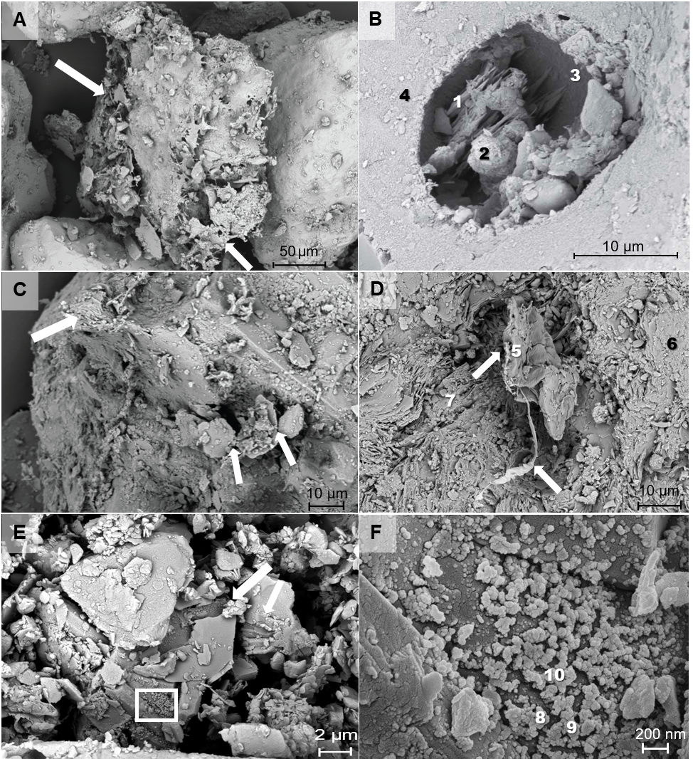

Figure 1. SEM images of untreated Antarctic drift (B: Ross Sea Drift, TV), sediment (A, E, F: Delta Stream, TV; D: Clark Glacier Stream, WV) and soil (C: Upper Onyx River, WV) samples. Numbers indicate EDS measurement locations (Table S6). A: Side-by-side comparison of a biofilm covered (arrow) and uncolonized smooth grain shows that biofilms effectively disintegrate the sediments. B: Incongruent dissolution pits formed via abiotic weathering and secondary blade-like potential Ca-carbonates (EDS #1) and spherical Fe-bearing carbonates (EDS #2) are observed. C: Exfoliation (flaking) of the mineral surface (arrows). D: Exfoliation features are generally associated with biofilms (arrows). E: EPS covering mineral surfaces leave large grooves on mineral surfaces via etching (arrows). F: Close-up of the etched grooves in Fig. 1E (white box) shows nanophase spherical Fe precipitates (putative inorganic biosignatures) nucleating on and within the biofilm layer.
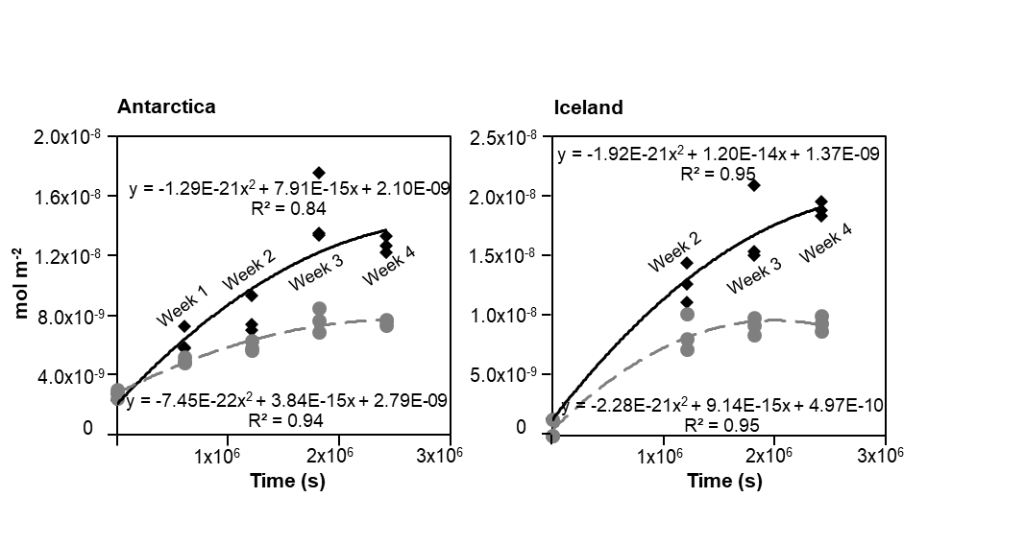
Figure 2. Antarctic and Icelandic silica release normalized to BET surface area (mol/m²). Solid black and dashed gray lines are biotic and abiotic weathering trend lines, respectively. Note the higher biotic weathering rates (diamonds) as compared to abiotic weathering rates (circles).

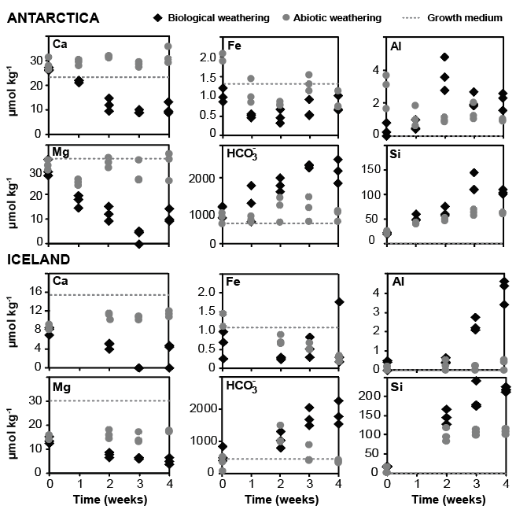Figure 3. Changes in solute chemistry during Antarctic and Icelandic biotic (diamonds) and abiotic (circles) experiments. Dotted lines mark initial concentrations in the growth medium. Note the significant biotic intake of bio-essential nutrients (Ca, Mg, Fe), while HCO₃^{-,} Al and Si increase due to silicate weathering.

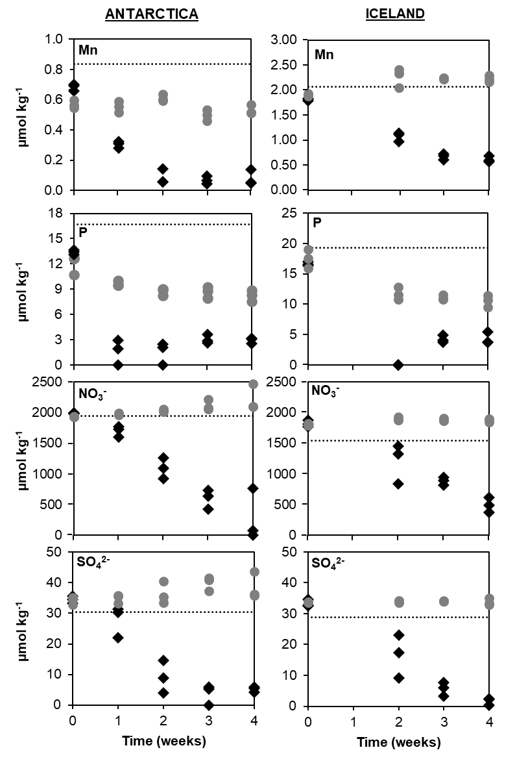
Figure 4. Changes in Mn, P, NO₃⁻, and SO₄²⁻ concentrations during Antarctica and Iceland biotic (diamonds) and abiotic (circles) weathering experiments. Mn, P and NO₃⁻ are consumed by L. glacialis as they are essential for the photosystems. SO₄²⁻ depletion in the biological experiments is likely due to microbial use.
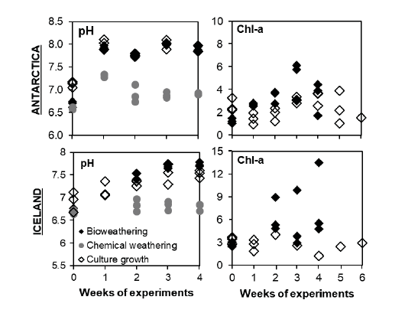
Figure 5. Changes in pH and chlorophyll-a (Chl-a; µg/ml) during Antarctic and Icelandic biotic (solid diamonds) and abiotic (circles) experiments. Hollow diamonds indicate culture growth experiments. Note the increase in pH with Chl-a in bioweathering and culture growth experiments due to photosynthesis, as opposed to nearly constant abiotic pH.

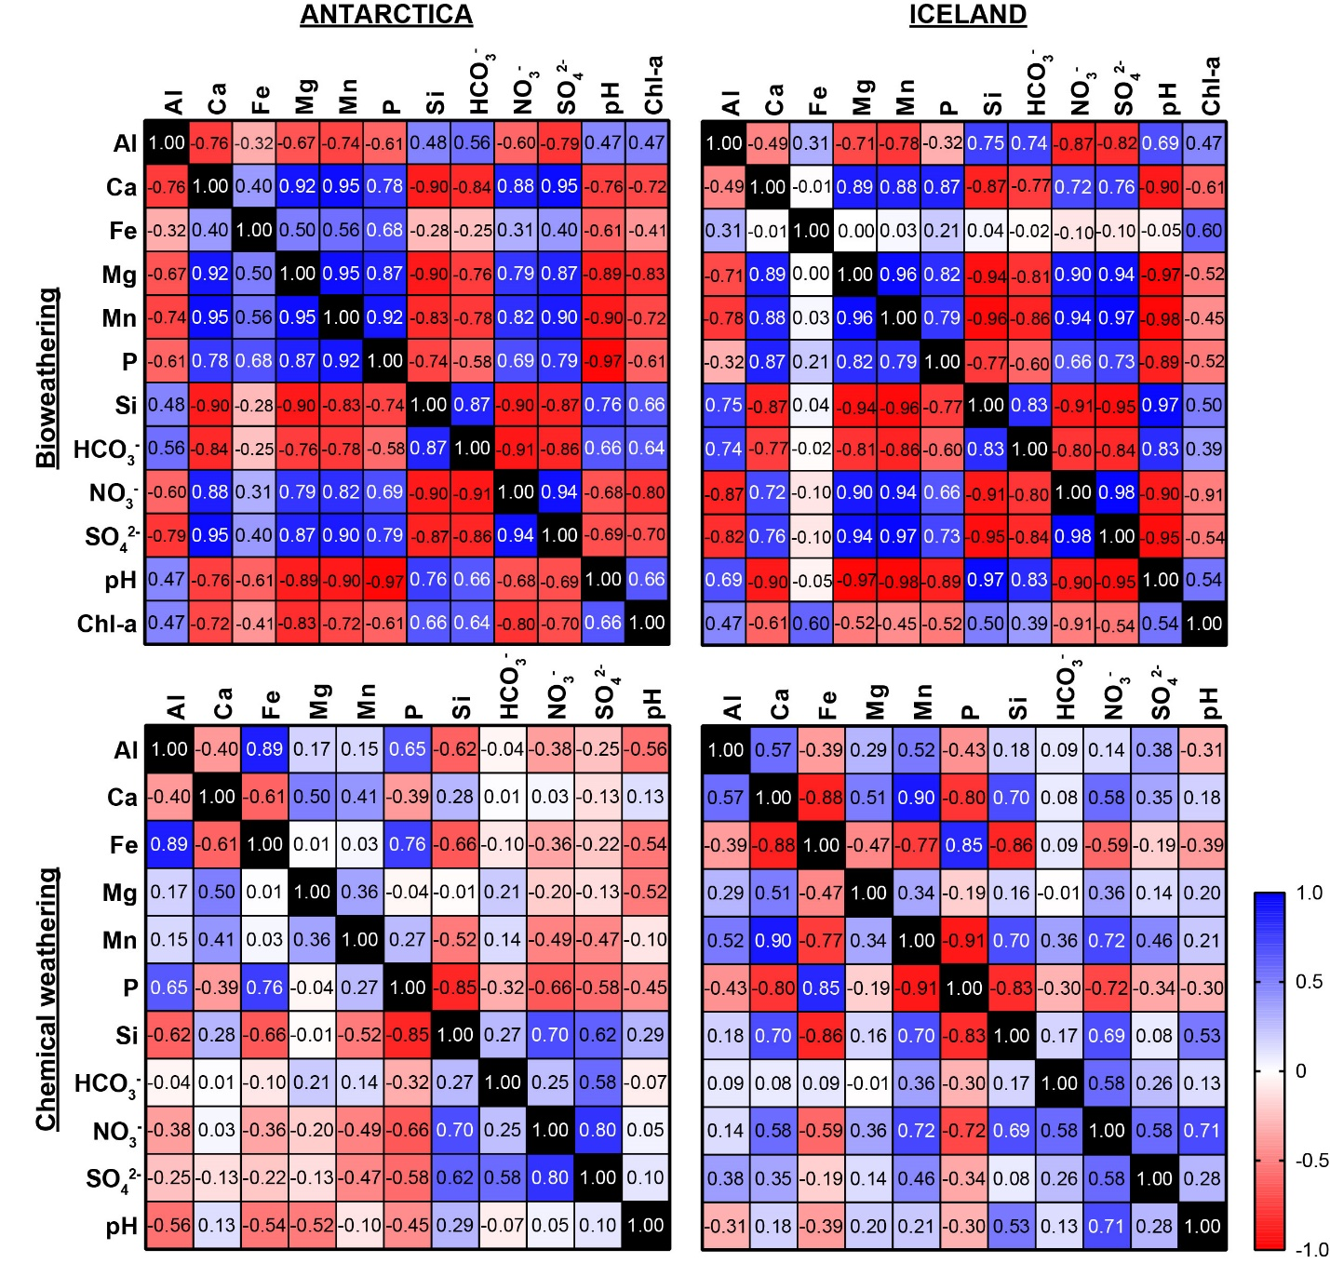Figure 6. Pearson’s Correlation matrices of Antarctic (A), and Icelandic (B) bioweathering and abiotic weathering experiments. Numbers in the cells are calculated r scores, while color transitions from dark to light correspond to their graduation from higher to lower correlation. Red colors (negative values) indicate negative, and blue colors (positive values) indicate positive correlation between the variables.

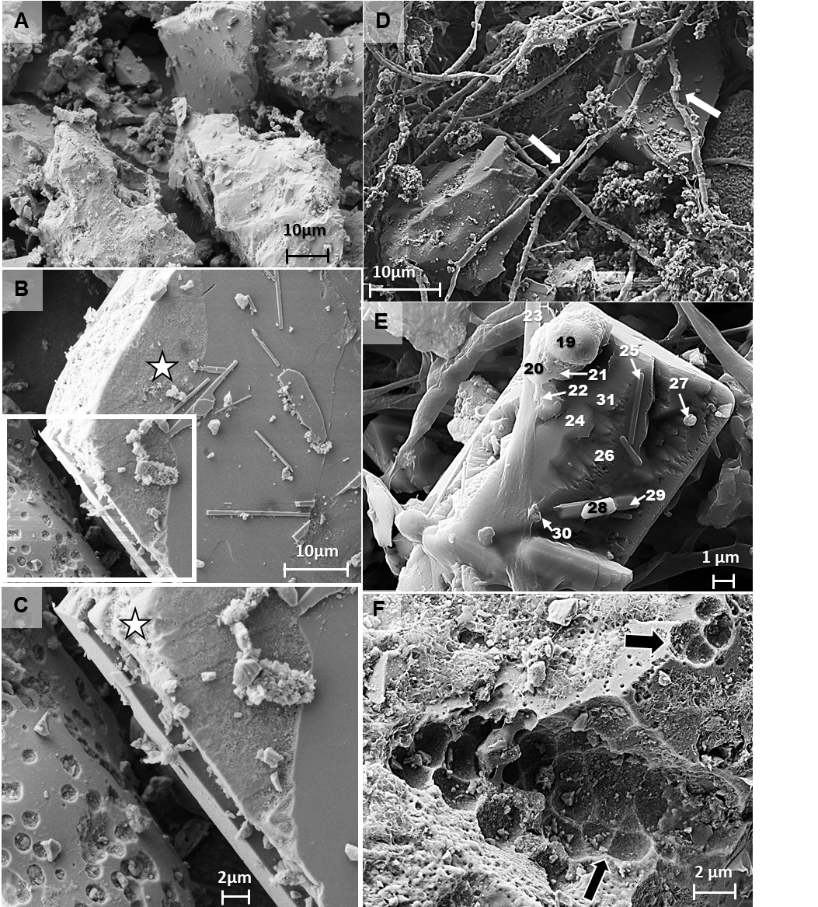Figure 7. SEM images from the fourth week of Icelandic abiotic and biological weathering experiments. Numbers indicate EDS measurement locations (Table S6). A: Illustration of the overall case for abiotic experiments at a magnification of 1.17 kX. Sediments in abiotic experiments illustrate mostly smooth surfaces. B: An etched surface (star) detected on a potential plagioclase grain. C: Close-up look at the boxed area in Figure 7B. As expected, abiotic chemical weathering starts from the corner of the mineral (star) and creates a somewhat smoother surface as opposed to deep-pitted bioweathered minerals (e.g. Figure 7F). Note that the lower left grain with pits is a vesicular basalt, not a weathered grain. D: L. glacialis filaments forms a mesh trapping sediments and binding them with their EPS (arrows). E: A highly weathered Mg- and Fe-rich mineral (potentially olivine; EDS #24, 31) covered with biofilm (EDS #23) and colonized by bacteria (e.g. EDS #25), showing spherical secondary Fe-(hydr)oxide precipitation (EDS #20-21, 27, 30). Note that there are apatite minerals (EDS #28, 29) detected on the surface, which might make the mineral favorable for colonization. F: Etch pits (arrows) left by coccus (tetrad) shaped colonies resembling to Figure 7B, indicating that other microbes in the mat assist weathering. Note that mineral surface around the pits are flakey.

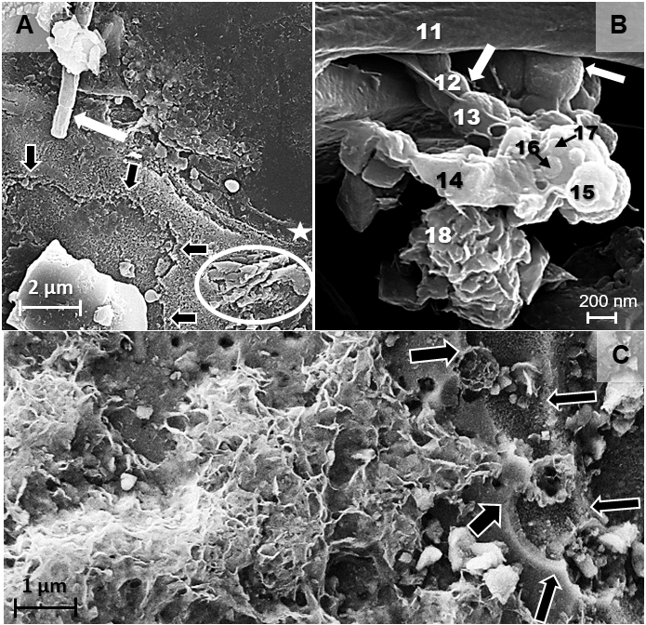
Figure 8. SEM images showing cyanobacteria filament shaped etch pits, biominerals nucleating on cells and flakey surface deposits in Icelandic bioweathering experiments. Numbers indicate EDS measurement locations (Table S6). A: L. glacialis (white arrow), filament shaped etch-pit (star) on a mineral surface. Notice that the mineral surface displays other etching features associated with biofilm attachment (black arrows) and chemical dissolution (circle). B: Secondary nano-phase Fe-(hydr)oxides (EDS #15-17) nucleating on coccus-shaped cell surfaces (white arrows) and a potential clay precipitate associated with biofilms (EDS #18). C: Close-up on a region of flakey surfaces shown in figure Figure 7F. These honeycomb-like features are potentially neo-formed clays produced by bioweathering. Notice the stepwise etching associated with cells and biofilm traced by black arrows.

