UNIVERSITY OF OKLAHOMA
GRADUATE COLLEGE

THE POSITIVE DAD EFFECT: DOES IDENTIFICATION WITH THE FATHERHOOD IDENTITY REDUCE WORK-BASED MASCULINITY THREAT RESPONSES?

Title Page

A THESIS
SUBMITTED TO THE GRADUATE FACULTY
in partial fulfillment of the requirements for the
Degree of
MASTER OF ARTS IN ORGANIZATIONAL DYNAMICS

By
JIL HELLMANN REGOUBY
Norman, Oklahoma
2020

Approval Forms
THE POSITIVE DAD EFFECT: DOES IDENTIFICATION WITH THE FATHERHOOD IDENTITY REDUCE WORK-BASED MASCULINITY THREAT RESPONSES?

A THESIS APPROVED FOR THE
DEPARTMENT OF PSYCHOLOGY

BY TH E COMMITTEE CONSISTING OF

Dr. Jennifer Kisamore, Chair
Dr. Jody Worley
Dr. Brigitte Steinheider

Copyright

© Copyright by Jil Hellmann Regouby 2020
All Rights Reserved.

Table of Contents

Title Page i
Approval Forms ii
Copyright iii
Table of Contents iv
List of Tables v
List of Figures vi
Abstract vii
Introduction 1
The Current Study 2
Masculine Identities and Gender Inequality 2
Traditional Masculinity and Identity Threat 4
Women as Sources of Masculine Identity Threat 6
Manifestations of Masculinity in Organizational Culture 8
Contesting Hegemonic Masculinity 9
Methods 11
Participants 11
Manipulations 13
Measures 14
Procedure 16
Study Design 17
Results 18
Hypothesis 1 18
Hypothesis 2 18
Hypothesis 3 22
Hypothesis 4 22
Hypothesis 5 24
Discussion 26
Summary and Limitations 26
Implications and Future Research 28
References 30
Appendix A: University of Oklahoma IRB Approval Letters 32
Appendix B: Fatherhood Prime 35
Appendix C: Control Prime 38
Appendix D: Masculinity Contest Culture Scale Items 41
Appendix E: Correlation Matrix for All Variables 42

List of Tables
Table |  | Page
1 | Descriptive Statistics for Counteroffers Made by Women and Men in Masculinity Threat Conditions | 20
2 | Descriptive Statistics, Correlations and Reliabilities for Male Participants Only | 23
3 | Descriptive Statistics for Counteroffer Based on Prime and Masculinity Threat Condition | 25

List of Figures
Figure |  | Page
1 | Hypothesized relationship between masculinity threat and threat response with equality masculinity and masculinity contest culture as moderators | 11
2 | Bar chart for counteroffers made by men in threat and no threat conditions | 20
3 | Clustered box plot depicting differences in counteroffers by condition and participant gender | 21
4 | Line graph depicting differences in mean counteroffers by condition and participant gender | 21
5 | Scatterplot for threat response and MCC with trend lines for masculinity threat | 22
6 | Clustered bar chart with error bars for counteroffer by prime and masculinity threat conditions | 24

Abstract
This study investigates whether different masculine identities affect the relationship between masculinity threat and threat response in an organizational context. Specifically, the study seeks to extend the extant literature regarding the threat men often perceive regarding their own masculinity when subordinate to a female, as well as examine how masculinity contest cultures can exacerbate these perceptions while fatherhood primes may alleviate them. Fatherhood is an equality masculinity that promotes egalitarian gender relations and contrasts with the prevalent traditional masculinity which is a hegemonic masculinity is built on feminine subordination. Data trended in the hypothesized direction, which indicated that masculinity threat responses were lower for participants who received the fatherhood prime; due to sampling issues, however, statistical significance was not reached. The general direction of the data, albeit not statistically significant, was also congruent with past findings that female work superiors elicit greater threat responses from men than male superiors do. The general direction of the data was also indicative of a relationship between masculinity contest culture and masculinity threat responses even though the hypothesis was not statistically supported. Overall, the study results indicate replication with a larger sample obtained from an organizational context is warranted.

Keywords: masculinity threat, hegemonic masculinity, equality masculinity, masculinity contest culture, gender dynamics, organizational diversity, patriarchy

The positive dad effect: Does identification with the fatherhood identity reduce work-based masculinity threat responses?
In England during the 1360s women earned an average of 71% of male wages; as of 2006, this amount only increased to an average of 75% (Bennett, 2006). Skeptics might argue that this comparison is coincidental and that modern and medieval times cannot be compared; however, Bennett points out that the gender wage gap in Western Europe has held steady over the past centuries, never exceeding 75% of male wages. This illustrates what an age-old problem organizational gender inequality is and how little has changed. For example, a recent article in The Economist (2019) indicated that in 2018 only 14% of executives at large, mostly American and British companies were female. The share of white women in all senior and executive roles at American companies was only 25%. Women executives who are members of racial minorities were not even listed, presumably because there were so few.
Common approaches to rectifying the gender imbalance in modern organizations place the burden on women. For instance, some leaders expect women to “Lean In,” a phrase coined by Sheryl Sandberg (2013) and made famous by her book of the same title. Sandberg used the term to describe her view that women need to advocate for themselves. Others view bias against women as an accidental occurrence that can be remedied once people are made aware of it (Berdahl, Cooper, Glick, Livingston, & Williams, 2018). This view puts the onus on women to combat organizational gender inequality and generally frames the problem as easily rectifiable.
An alternative view is that hegemonic gender identities entrap men and women in a system of confrontational gender dynamics that are pervasive and nearly impossible to overcome by individual efforts alone. For example, recent work by gender scholars including Berdahl and colleagues, (2018) as well as Ely and Kimmel (2018) have helped shape an emerging perspective that views workplaces as sites of masculinity contests, where conformance with masculine ideals is conflated with actual work performance. In this viewpoint, women and minorities are both held to the same standard as men and are seen as threats to male power given they have traditionally been viewed as subordinate groups in comparison to white males (Kuchynka Bosson, Vandello, & Puryear, 2018; Messerschmidt, 2012). Based on the standpoint that the workplace has a masculinity contest culture, a more systemic approach to improving organizational gender relations is needed. Such an approach needs to address the deeper structures and dynamics that currently exist, and which ultimately render many gender equality initiatives as futile. Indeed, Bennett (2006) argued that the reason for persistent, century-old gender inequality at work, in family relations, political participation and the like, lies within the mechanisms of patriarchal institutions.

The Current Study
The aim of the current study is to investigate the relationship between different types of masculine identities and men’s perceptions of and responses to threat in an organizational context. Specifically, the current study seeks to extend the extant literature on the threat men often perceive regarding their own masculinity when subordinate to a female, as well as examine how masculinity contest cultures can exacerbate these perceptions while fatherhood primes may alleviate them (Berdahl et al., 2018). Thus, the current study extends the field by investigating whether different masculine identities have a moderating effect on gender-based threat perceptions.

Masculine Identities and Gender Inequality
The normative view of masculinity is that it is an external, cultural standard that changes over time and by geographic region and is internalized by individuals as they incorporate the prevailing standard of masculinity into their own belief systems. Once individuals incorporate a standard of masculinity into their personal belief systems, they then behave in ways that reinforce their adopted standard for masculinity (Thompson & Bennett, 2015). Examples of different masculine identities used to describe Scandinavian men’s adaptations to living in a more egalitarian culture include resistant, instrumental and feminized masculinities (Klasson & Ulver, 2015; Ulrich & Tissier-Desbordes, 2018). Mexican men instead are typically described using terms such as traditionalist, adventurer and breadwinner; these labels reflect adaptations of the male identity for Mexicans living within contexts of Northern migration and economic destitution (Broughton, 2008). Many different masculine identities exist, and these identities are continuously shaped by individuals’ actions and the contexts in which they live.
The term traditional masculinity is the masculine identity most commonly described in literature and encountered in mainstream media and Western culture; it has remained unchanged for the past century (Banchefsky & Park, 2016). According to scholars (e.g., Bosson & Vandello, 2011; Glick, Berdahl & Alonso, 2018; Park & Banchefsky 2018; Thompson & Bennett, 2015; Willer, Rogalin, Conlon, & Wojnowicz, 2013), the central characteristics that define traditional masculinity are: physical strength (e.g. assertiveness, aggression), anti-femininity (i.e., disavowal of anything feminine), restrictive emotionality (e.g. rational and stoic appearance), and toughness and status (e.g. dominance, competition, risk-taking).
Messerschmidt (2012) categorized masculinities into hegemonic and equality masculinities. The former category includes masculine identities that legitimize masculine superiority and consequently gender inequality. The latter category includes masculine identities that “legitimate an egalitarian relationship between men and women, between masculinity and femininity, and among men” (Messerschmidt, 2012, p. 73). The current study adopts Messerschmidt’s (2012) categories and is based on the premise that the key to understanding organizational gender inequality lies in examination of linkages between certain masculinities and the perpetuation of patriarchy. For example, traditional masculinity meets the definition of hegemonic masculinity because the traditional masculine ideal is based not only on the notion that there is a continuum of what is masculine and what is feminine—and by definition “un-masculine” (Bosson & Vandello, 2011; Cheryan, Cameron, Katagiri, & Monin,, 2015; Munsch & Gruys, 2018; Park & Banchefsky, 2018; Thompson & Bennett, 2015; Willer et al., 2013) but also the notion that the masculine side of the continuum is superior to the feminine side. Furthermore, traditional masculinity can be considered the dominant masculinity in Western culture because it has been widely incorporated into mainstream culture through numerous mechanisms including but not limited to media and advertising (Ulrich & Tissier-Desbordes, 2018), organizational practices (Ely & Kimmel, 2018), and familial roles and customs (Hochschild & Machung, 2012; Munsch & Gruys, 2018), which serve to legitimize and intensify the gender imbalance. Thus, traditional masculinity can be considered both a hegemonic and dominant form of masculinity in Western countries, which means that individuals residing in Western countries are likely to have incorporated it to some extent into their own belief systems.

Traditional Masculinity and Identity Threat
Traditional masculinity is precarious; it is characterized by a constant struggle to earn and defend one’s masculinity and thus, it is easily threatened (Vandello, Bosson, Cohen, Burnaford, & Weaver, 2008; Willer et al., 2013). While girls are typically viewed as becoming women once they reach a certain age, boys are expected to earn their manhood through stereotypical masculine behavior such as demonstrating courage and physical prowess; even after “earning” their manhood, men are expected to continuously defend their status. Indeed, of the men they studied, Munsch and Gruys (2018) found that most men framed their own masculinity threats in comparison to the masculine identities of other men. As part of the study, men were asked to recall situations in which they felt emasculated; responses indicated men were most likely to feel emasculated when they shied away from risks they perceived other men were willing to take or when they failed to perform well in athletic competitions. These examples illustrate that traditional masculinity, which emphasizes risk-taking and strength, is also inherently hierarchical because the salience, or lack of, masculine traits is measured in reference to the salience of those traits in other men. Thus, maintaining masculinity is largely about overt displays that reflect the masculine ideal of being stronger, tougher and more cool-headed than everyone else.
Threats to a man’s masculine identity are often met with aggression, anger and assertiveness (Kuchynka et al., 2018; Netchaeva, Kouchaki & Sheppard, 2015; Vandello et al., 2008; Willer et al., 2013). In an organizational context, such threats often result in ideological dominance, increased sexual harassment and bullying behaviors (Dahl, Vescio, & Weaver, 2015; Willer et al., 2013). In addition to demonstratively masculine behavior, men who feel threatened often distance themselves from anything that could be seen as un-masculine, such as displaying emotions, performing traditionally feminine duties or voicing preferences for products or activities that could be seen as feminine (Cheryan et al., 2015; Munsch & Gruys, 2018; Ulrich & Tissier-Desbordes, 2018). This traditional male threat response is referred to as masculine overcompensation (Willer et al., 2013); specifically, when threatened in their masculinity, men will try to restore their status through exaggerated masculine behavior and attitudes.
In conclusion, traditional masculinity is a status that is difficult to attain and maintain. It is easily threatened as a result of both its narrow definition and the continual pressure for males to attain and maintain the highest status on the masculine hierarchy (Vandello et al., 2008; Willer et al., 2013). Men who feel their masculinity has been threatened and who define masculinity in terms of traditional masculine traits and behaviors are expected to reclaim their masculinity through excessively stereotypical masculine behavior as well as overt distancing from behaviors, choices, and attitudes that could be seen as feminine.

Women as Sources of Masculine Identity Threat
Men who seek to conform to the standards of traditional masculinity seem to view the world through gendered lenses. For instance, they assign a gender to brands that are viewed as gender-neutral by men who hold less traditional masculine identities (Ulrich & Tissier-Desbordes, 2018). This may be because traditional masculinity is always defined in terms of its contrast to the un-masculine, in other words, the feminine and the non-traditionally masculine. Thus, men who seek to conform to traditional masculine stereotypes tend to focus on identifying and avoiding anything that potentially falls into this category. Moreover, work by scholars including but not limited to Avery (2012) and Ulrich and Tissier-Desbordes (2018) has shown that people and things associated with femininity are likely to be perceived as direct threats to a man’s traditional masculinity. Munsch and Gruys’s (2018) study of affluent, college-educated, mostly white men revealed that 86% of participants framed emasculation in relation to women or femininity. Such situations included those in which women were more intelligent, had more control, or earned more money than the man with whom they were intimately involved. Similarly, Avery (2012) documented that customers of the Porsche car brand, widely viewed as a symbol of traditional masculine status, perceived a potential threat to their masculinity when the company started extending its brand to female customers. This effect was corroborated by Ulrich and Tissier-Desbordes (2018) who found that men who held traditional masculine identities strongly rejected male brands that extended their product lines to women, while men who held more egalitarian masculinity beliefs did not have a negative response to such market extensions.
A growing body of research has examined gender-related masculinity threats within organizations. Work by Kuchynka and colleagues (2018) showed that when men receive information that indicates women are making social status gains, they tend to subsequently reduce their support for gender-inclusive work policies. These results suggest that social out-groups are not only the target of identity threat responses, but also that how one perceives members of out-groups can also lead to identity threats. In fact, numerous studies show that merely working for a woman or being outperformed by one in a traditionally male domain such as leadership frequently causes men to experience public discomfort, anger, and heightened implicit threat perceptions (Dahl et al., 2015; Kuchynka et al., 2018; Netchaeva et al., 2015). Overall, the studies showed that male participants reacted more assertively toward women who held superior roles; in such situations, the men showed signs of increased ideological dominance as measured through increased sexualization of women. Those male participants were also less likely to support gender inclusive policies as a result of zero-sum thinking about female status gains. In sum, many men show signs of identity threat when working for a female superior or when the men perceived they are regarded as displaying feminine characteristics or behaviors. I therefore hypothesize:
Hypothesis 1: Men assigned to a female superior will show significantly higher threat response than men who are assigned to a male superior.
Hypothesis 2: Women’s threat response will be lower than men’s overall threat response and constant regardless of the gender of the superior to which they are assigned (H2a). Gender and threat scenario will interact to determine threat response. Men will exhibit higher threat responses when assigned to a female superior than when assigned to a male superior (H2b).

Manifestations of Masculinity in Organizational Culture
Workplaces have typically been male-dominated and therefore shaped by traditional masculine norms. As a result, workplace norms tend to reflect men’s ambition to dominate others, to suppress emotions, and to disavow any sense of vulnerability (Vandello et al., 2008). For example, traditional masculine behaviors, including but not limited to: working late, putting work before family, and not admitting to insecurities, have been adopted as seemingly neutral standards for good organizational behavior that now apply to everyone (Ely & Kimmel, 2018; Glick et al., 2018). Organizations that operate in accordance with traditionally masculine norms, and that reward individuals essentially based on how closely their behavior conforms to traditional male stereotypes, have been described as having a masculinity contest culture (MCC) (Berdahl et al., 2018; Glick et al., 2018). In organizations that adopt and maintain an MCC, the performance and behaviors of all employees, including women and individuals who do not identify with typical masculine traits, are measured against norms of masculinity and masculine ideals (Ely & Kimmel, 2018).
According to Glick et al. (2018), MCC is characterized only by undesirable traits of masculinity; such an organizational culture can be described as embodying “toxic masculinity” which subsequently hinders organizational diversity and inclusion efforts. Organizations with strong MCCs tend to have high rates of bullying, sexual harassment, cut-throat competition, and zero-sum thinking (Berdahl et al., 2018; Glick et al., 2018; Kuchynka et al., 2018). Such organizations were described by Ely and Kimmel (2018) as “traps” that oblige men to compete if they remain in them. Thus, this type of organizational culture tends to heighten individuals’ awareness of traditional masculinity and, in doing so, increases the likelihood that male employees will experience work-based masculinity threats. Thus, I predict:
Hypothesis 3: Masculinity contest culture (MCC) will be positively correlated to threat responses in men.
Hypothesis 4: Among men, MCC will moderate the relationship between masculinity threat and threat responses, such that the threat response will be stronger when MCC is high as compared to when it is low.

Contesting Hegemonic Masculinity
Challenging hegemonic masculinity is likely to be vital to overcoming organizational gender inequality. Recent work by Park and Banchefsky (2018) sought to determine an alternative to traditional masculinity that men could adopt in order to reduce the detrimental outcomes of masculinity threats and MCCs. Park and Banchefsky (2018) investigated whether the male identity of fatherhood might offer a solution. Their research suggests that when primed with the masculine identity of fatherhood, men respond differently to possible threats to their masculinity. In fact, Banchefsky and Park’s (2016) study was the first to demonstrate that the identity of a specific subgroup of men, in this case fathers, is dynamic, even stereotypically so. They examined parental stereotypes beginning in the 1950s, continuing through the period in which they conducted their study, and extending the stereotype trajectory through 2050. Their examination of the fatherhood stereotype over time suggests that the fatherhood stereotype is becoming increasingly maternal and less paternal both in terms of the perceived behaviors performed by fathers, as well as the traits people ascribe to a typical father. According to Banchefsky and Park (2016), fatherhood increasingly involves being considerate, expressive, and helpful, staying home with sick children, arranging social activities for children, and cleaning the house. While these behaviors have traditionally been associated with motherhood, they are increasingly being associated with behaviors displayed by good fathers.
This ongoing transformation of the fatherhood role might facilitate improvement of workplace gender dynamics. That is, identification with the fatherhood role rather than with traditional masculine ideals may allow men to enact more feminine traits and behaviors (Banchefsky & Park, 2016) without the corresponding social repercussions they would otherwise likely face for violating traditional male norms. In fact, Park and Banchefsky (2018) provide evidence that when faced with a masculine identity threat, men who identified with the social role of dad were less likely to perceive an identity threat than were men who did not receive a fatherhood prime. Also, men primed with the fatherhood role demonstrated greater prosocial behavior than did men who were not primed; the unprimed men conversely showed greater signs of aggression. Specifically, the fatherhood primed men showed significantly greater support for social policies that favor lower status out-groups including members of the LGBTQ community, women, and immigrants than did men who did not receive a masculine role prime. Consequently, fatherhood may fall within the category of what Messerschmidt (2012) considers to be equality masculinity, i.e. one that promoted egalitarian gender relationships. Thus, when men identify with fatherhood rather than traditional masculinity, they will be less likely to perceive they are threatened by a female superior; this is consistent with findings from Ulrich and Tissier-Desbordes’s (2018) study that showed men with a “feminized masculinity” - one that seems to fall within the equality masculinity category - were less opposed to masculine brands that started marketing to women, than men of a traditional masculinity. As such, I hypothesize the following:
Hypothesis 5: Men primed with fatherhood (equality) masculinity will have lower threat responses than men who were not primed (H5a). Fatherhood prime and masculinity threat scenario will interact to determine threat response. Although men not exposed to the fatherhood prime are predicted to exhibit a higher threat responses overall compared to men who did receive the fatherhood prime, the threat responses for unprimed men will be highest in particular when assigned to a female superior (H5b).
To summarize, men facing a gender-based masculinity threat in the workplace are predicted to have a stronger threat response than will either women or men who are not so threatened. Masculinity contest culture (MCC) is expected to moderate the relationship between masculinity threat and men's threat responses such that when assigned a female supervisor and MCC is high, the threat response will be greatest. Lastly, men who are primed with an equality masculinity prime, in this case fatherhood, will have lower threat responses than will men who were not so primed. This model is visualized in Figure 1.
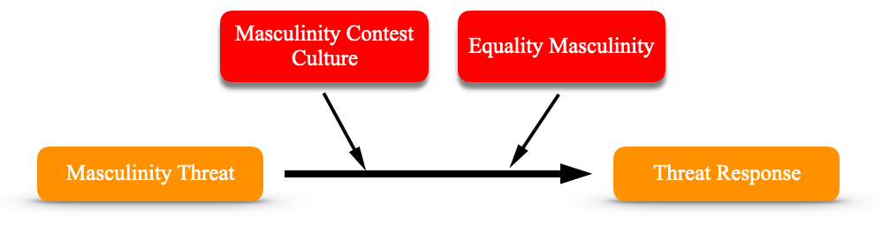
Figure 1. This model shows the hypothesized relationship between masculinity threat and threat response with equality masculinity and masculinity contest culture as moderators.

Methods

Participants
Minimum sample size requirements were computed based on assumption of a medium effect size as found in Netchaeva et al. (2015) and Park and Banchefsky (2018), use of α=0.05 as the criterion for significance, and utilization of a study design involving four groups. Using guidelines set by Cohen (1992), a minimum of 50 participants per group was deemed necessary to achieve adequate levels of power for intended analyses. Approval from the University of Oklahoma’s Institutional Review Board was sought and obtained prior to participant recruitment (see Appendix A).
Participants were recruited using two methods. First, members of the researcher’s professional and social networks were recruited through social media, text messages and email. A total of 190 individuals recruited through network sampling consented to participate in the study. The mortality rate across all scenarios was very high and therefore, only 41 viable responses were collected using this method. Participants were also recruited using Amazon’s mTurk marketplace. Initially, 403 individuals recruited through mTurk attempted the survey but only 320 completed it. Combined, these two recruitment sources yield a total of 361 responses.
Of the 361 participants who completed the survey, 295 passed all three manipulation checks, namely a reading comprehension check to make sure participants had read the priming material, and two multiple choice questions to verify that they had registered their negotiation partner’s gender and superior hierarchical status which in combination, created the masculinity threat; participants who failed any of the manipulation checks were excluded from the analysis. Exploratory analysis of the participants’ counteroffers, which was one of the threat response measures, revealed a significant number of extreme cases, statistically defined as counteroffers greater than $51,900 for the opening offer of $28,500. Theses extreme cases were also excluded from the analysis because it was deemed that they were insincere responses. The resulting effective sample was 196 which represents 33.05% of the total pool of individuals who initially consented to participate in the study. This significant reduction in cases had the consequence that the required number of 50 cases per condition was not always met. The final number of cases for the conditions in Hypothesis 1 ranged between 38 and 96 each, while the number of cases for the conditions in Hypothesis 5 ranged between 22 and 37 each. See tables 1 and 3 for the exact number of cases per condition.
Demographic characteristics are based on the effective sample of 196 participants. At the time of the survey, participants predominantly reported residing in the United States (n=177; 90%). Participants were also asked to indicate the race(s) with which they identified. The majority of respondents (n=156; 79.59%) described themselves as White followed by Asian (n= 21, 10.71%), Black or African American (n=19; 9.69%), Latinx, Hispanic or Spanish (n=12; 6.12%) and America Indian or Alaska Native (n=3; 1.53%). Most respondents were not parents (n=111; 56.63%); 85 respondents (43.36%) indicating being a parent. The majority of respondents (n=120; 61.22%) identified as male followed by 75 (38.27%) who identified as female, and 1 (0.51%) who identified as non-binary. Of the 120 men, 74 (61.7%) were not fathers and 46 (38.30%) were fathers. All but 12 (6.12%) participants were employed at the time of taking the survey with the majority working in management (n=68; 34.69%), sales and office (n=46; 23.47%), and service (n=35; 17.86%) roles. Of those, 100 (51.02%) held non-supervisory positions and the other 96 (48.98%) worked in supervisory, middle management, and top management positions. All participants were between 22 and 73 years old; the median age was 37 years and the mean age was 39.39 years.

Manipulations
The current study used two sets of manipulations, each with two categories. Both manipulations were between-subjects thus participants experienced only one possible combination of the manipulations. Participants were randomly assigned to conditions.
Masculinity threat. Masculinity threat was induced based on the gender of the fictitious superior to which participants were assigned. While all participants were assigned to either a male or female superior, only male participants were expected to experience a masculinity threat and only when assigned to a female superior. This setup replicates previous research by Netchaeva and colleagues (2015) who demonstrated that being assigned to a female superior resulted in a masculinity threat in male participants.
Fatherhood prime. The prime was the same as was used by Park and Banchefsky (2018) and consisted of Pew Research results about the increasing involvement of fathers in caring for their own children. The control group received neutral information about employment statistics, which were also the same as used by Park and Banchefsky (2018). See Appendices B and C for the full primes.

Measures
All measures were self-report and administered online via Qualtrics. Where relevant, reliability statistics were computed prior to the computation of composite scores. Measures were scored such that higher values indicate higher salience of the construct measured.
Masculinity contest culture (MCC) scale. The MCC scale was developed by Glick et al. (2018) to measure the extent to which an organizational culture is characterized by typical masculine competitive behavior; it asks participants to indicate on a 5-point scale the extent to which each statement is true of their work environment. Examples of statements include: “The most respected people don’t show emotions” and “Leadership expects employees to put work first.” Response options ranged from “Not at all true of my work environment” (1) to “Entirely true of my work environment” (5). The scale measures four facets of masculine contest culture which have been labelled Show No Weakness, Put Work First, Strength and Stamina and Dog Eat Dog. In order to shorten the total survey length, only 16 of the original 20 items were used; four items with the strongest loading on each factor were selected. Cronbach’s internal consistency reliability for the entire MCC scale in the current study was .92. Factor analysis showed that the results only supported three independent factors instead of the four predicted by Glick and colleagues (2018). After removing cross-loaded items, Cronbach’s reliability was reduced to .87. Appendix D contains the list of items administered with a notation of those removed due to issues with cross-loading. In the current study, MCC was used as a covariate.
Implicit threat level. Threat response is the outcome of interest in the current study. One measure of threat response is a person's implicit threat level. Netchaeva and colleagues (2015) developed a measure of implicit threat for their study of organization- and gender-based masculinity threat. The measure is comprised of six items; for each item, participants guess, out of a list of four possible responses, the word that flashed on their computer screen for a few milliseconds. Three of the word choices represent threat words such as “risk” or “danger.” The original measure is a Qualtrics program file that was shared by Netchaeva and colleagues (2015) for use in the present study. The program was edited for the current study so that it would work with the current version of Qualtrics. Scores on this measure could range from 0 to 3. Unfortunately, variability on this measure was very low (SD=.847, M=1.27) and Cronbach’s reliability also extremely low (.080). Therefore, the measure was not included in any further analyses.
Assertiveness. A second measure of threat response used in the current study is assertiveness. This is consistent with research that links masculine identity threats to increased assertive behavior (Bosson & Vandello, 2011; Netchaeva et al., 2015; Willer et al., 2013). Following the study design of Netchaeva and colleagues (2015), the monetary counteroffer that participants made during the simulated negotiation was interpreted as an indicator of assertiveness. Higher counteroffers were interpreted to correspond to greater assertiveness thus implying a heightened threat response.
Demographics. Participants were asked several questions in order to understand basic characteristics of the sample including their current country of residence, race, year of birth, parental status, employment status, line of work, and hierarchical rank in their current organization. Participants were also asked to indicate the gender with which they identified to allow for grouping of responses and analyses based on gender.

Procedure
The entire study was administered online via Qualtrics. Individuals who consented to participate were told that they would be participating in a study about workplace communication and culture. There were five sections of the online study. First, participants completed a reading exercise based on whether they were assigned to the fatherhood prime or control condition. Next, participants completed a simulated negotiation exercise to create a work-based gender identity threat. For this part of the study, procedures used by Netchaeva and colleagues (2015) were adopted. The exercise involved deceiving participants about the nature of the research and their managerial ability. Participants were assigned to the role of a recruit based on their performance on a bogus test that they were told measured their managerial ability. The test consisted of several GRE questions. The purpose of the test was to encourage participants to think about workplace hierarchy and status (e.g., manager vs. recruit), and to create the illusion that participants were being assigned their role based on performance on the test. In truth, all participants were told their score resulted in being assigned to the role of “recruit.” Participants were then told that they had accepted a new job and needed to negotiate their starting salary with another randomly assigned participant who had been assigned the role of “recruiting manager.” In reality, the negotiation was simulated. In the threat scenario, participants were assigned to a recruiting manager named Sarah, while in the control scenario participants were assigned to a recruiting manager named David. A starting salary of $28,500 was presented and participants had the ability to either accept the offer or to make a counteroffer.
Third, participants were asked to complete a seemingly unrelated word identification exercise, which was used to assess implicit threat levels and consisted of the implicit threat measure described above. Fourth, participants completed a short survey about the environment of their workplace to assess the masculinity contest culture; the survey contained the shortened version of Glick and colleagues’ (2018) masculinity contest culture scale. In the fifth section, participants completed demographic questions.

Study Design
In the current study, two independent variables, one grouping variable, one covariate and two dependent variables were utilized. The first independent variable was manipulated in that participants were assigned to either a superior of the same or opposite sex as them. For male participants, having a female superior was expected to represent a masculinity threat while having male superior would not. Hereafter, this variable will be referred to as “masculinity threat.” Because women do not have masculine identities, female participants were not expected to perceive masculine identity threats, regardless of whether they were assigned a male or female superior.
The second independent variable dealt with identification with fatherhood. This variable was only presented to male participants. There were two conditions, one in which males were primed to identify with fatherhood in order to invoke a more egalitarian type of masculinity. The second condition was a control condition that involved a reading exercise of similar nature to the priming one but did not include any type of information about masculinity (see Fatherhood Prime above). Due to the pervasiveness of traditional masculine norms in the U.S., the control condition was used to represent traditional, hegemonic masculinity. Hereafter, this variable will be referred to as “fatherhood prime.”
The grouping variable was “gender,” with male and female as the two groups studied. The non-binary respondent was excluded from all analyses. The covariate examined was masculinity contest culture. Hereafter, this variable will be referred to as “MCC”; scores on MCC were continuous.
Due to the lack of variance on the implicit threat measure, only one dependent measure could be used to assess participants’ responses to threat. That measure was the counteroffer amount. This measure was designed to assess assertiveness. Hereafter this dependent variable will be referred to as “counteroffer.”

Results
SPSS 26.0 was used to conduct data analysis. The criterion for significance was set at
α = .05. ANOVA and correlational analyses were used to test hypotheses. Appendix E shows means, standard deviation and correlation coefficients for all variables.

Hypothesis 1
Hypothesis 1 predicted that men assigned to a female superior (masculinity threat) would have a greater threat response, in this case a higher counteroffer, than men assigned to a male superior (no masculinity threat). Results of an independent samples t-test did not support hypothesis H1. Although counteroffers made by men in the threat condition (M=$37,467, SD=$5,406) were higher than those made by men in the no threat condition (M=$35,877, SD=$5,280), the result was not statistically significant t(118)=1.628, p=0.106. On average, counteroffers by men in the threat condition were $1,589 higher than counteroffers by men in the no threat condition, which is depicted in the box plot (Figure 2). A power analysis indicated this test was low in power (power =.257).

Hypothesis 2
Hypothesis 2 was a two-part hypothesis tested using a 2x2 between-subjects ANOVA. Table 1 includes cell and marginal means for the conditions studied. Hypothesis 2a predicted a main effect for gender, specifically that women would make lower counteroffers than men. The results for gender were not significant F(1, 194)=1.719, p=.191, power=.257 but the general direction of the data was as predicted: Counteroffers made by women (M=$35,703, SD=$4,627) were, on average, $983 lower than those made by men (M=$36,686, SD=$5,382).
Hypothesis 2b predicted that masculinity threat would interact with gender such that men in the masculinity threat condition would show an increased threat response, in this case larger counteroffers, than men in the no masculinity threat condition. Counteroffers by women were expected to be roughly equivalent between the two conditions. The masculinity threat X gender interaction term was not significant however, F(1,195)=2.51, p=.115, power=.351. A comparison of the differences in the counteroffers made by men and women shows that the difference was greatest in the threat scenario, with men making on average counteroffers that were $2,151 higher than those made by women (see Table 1). Figure 3 and Figure 4 show that the general direction of the data was as anticipated with men in the threat scenario making the largest counteroffers but that variability was high and the mean difference low.
Overall, results trended in the hypothesized patterns but were not statistically significant for the hypothesized main effects and the interaction term. Power analyses indicated that the sample size was not sufficient to obtain a generally accepted level of power (see Cohen, 1992). Contrary to expectations, however, women's counteroffers were not roughly equivalent. They made higher counteroffers when paired with a male manager (M=$36,100, SD=$4,737) than when paired with a female manager (M=$35,316, SD=$4,548).

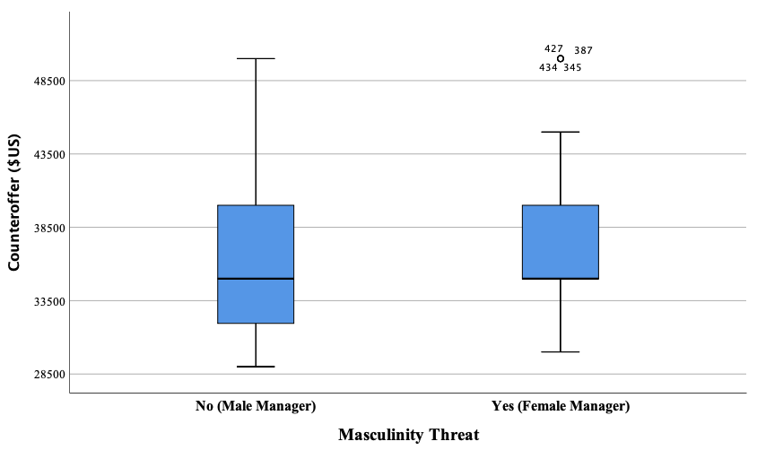
Figure 2. Bar chart for counteroffers made by men in threat and no threat conditions.
Table 1
Descriptive Statistics for Counteroffers Made by Women and Men in Masculinity Threat Conditions.
 |  | Masculinity Threat
Gender | Descriptive Statistics | No  (Male Manager) | Yes  (Female Manager) | Total
 | Mean | $35,878 | $37,467 | $36,686
Male | SD | $5,281 | $5,407 | $5,382
 | N | 59 | 61 | 120
 | Mean | $36,100 | $35,316 | $35,703
Female | SD | $4,737 | $4,548 | $4,627
 | N | 96 | 38 | 75
Mean Difference |  | -$222 | $2,151 | $983
Total Weighted Mean |  | $36,015 | $36,641 | $36,308

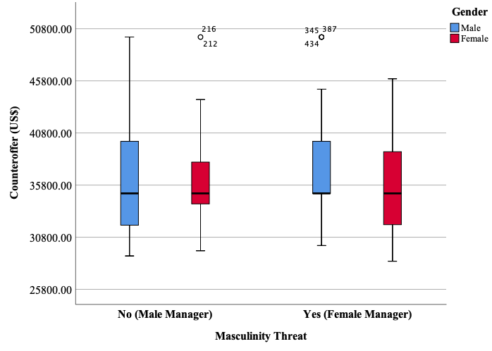
Figure 3. Clustered box plot depicting differences in counteroffers by condition and participant gender.
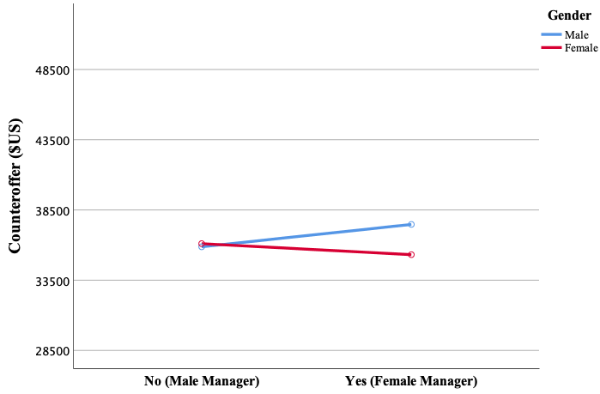
Figure 4. Line graph depicting differences in mean counteroffers by condition and participant gender.

Hypothesis 3
Hypothesis 3 predicted that, among male participants only, MCC scores would be positively correlated with their threat response, in this case, the counteroffer amount. Descriptive statistics, scale reliabilities and bivariate correlation coefficients are shown in Table 2. Results of the correlation analysis did not support Hypothesis 3. There was insufficient evidence to suggest there is a significant positive correlation between MCC scores and counteroffer (threat response) among male participants, r(120)=.025, p=.788.
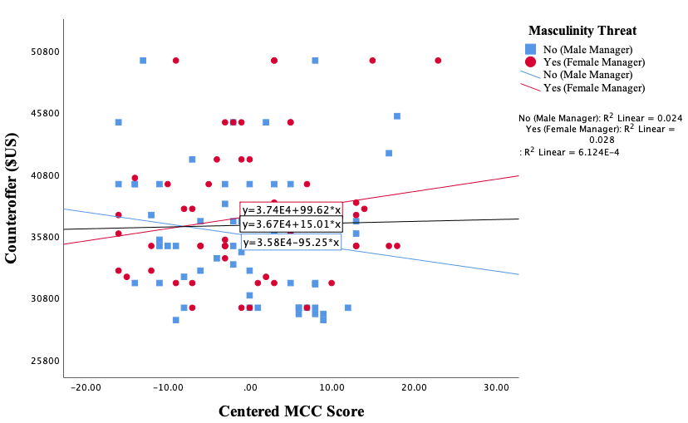
Figure 5. Scatterplot for threat response and MCC with trend lines for masculinity threat.

Hypothesis 4
Hypothesis 4 predicted that, among male participants only, MCC score would moderate the relationship between masculinity threat and threat response, specifically counteroffers. In particular, MCC was expected to exacerbate the threat response for men in the high threat condition. That is, counteroffers were expected to be highest when masculinity threat was present and MCC scores were high. Before regression analyses were conducted, the MCC score and the threat condition were centered to control for bias (Cohen, Cohen, West, & Aiken, 2003). Results of moderated regression analysis did not support hypothesis H2b. The effect was very small and the result not significant R²=.016, p=.169, β=.126. The scatterplot in Figure 5 shows that the general direction of the data was in the hypothesized direction; the regression line for the masculinity threat condition shows a positive relationship between MCC and threat response, specifically counteroffer. The regression line for the no-threat condition pointed toward a negative relationship and the overall regression line was flat.
Table 2
Descriptive Statistics, Correlations and Reliabilities for Male Participants Only.
Variables | N | Mean | SD | 1 | 2 | 3 | 4 | 4 | 6
Counteroffer | 120 | $36,686 | $5,382 | 1
Overall MCC Score | 120 | 2.71 | 0.89 | 0.025 | 1 | (0.87)
MCC: Strength and Stamina | 120 | 2.85 | 1.05 | 0.058 | .859** | 1 | (0.83)
MCC: Show no Weakness | 120 | 2.40 | 1.10 | 0.053 | .743** | .454** | 1 | (0.85)
MCC: Dog Eat Dog | 120 | 2.83 | 1.17 | -0.056 | .804** | .551** | .397** | 1 | (0.88)
*p<.05; **p<.01 (2-tailed).

Hypothesis 5
Hypothesis 5 was a two-part hypothesis tested using a 2 (masculinity threat) X 2 (fatherhood prime) between-subjects ANOVA. Hypothesis 5a predicted a main effect for prime, such that, among male participants only, men who received the fatherhood prime would have a lower threat response, specifically make lower counteroffers, than would men who did not receive the fatherhood prime. Results did not indicate a significant main effect for counteroffer based on the fatherhood prime. Counteroffers made by men who received the fatherhood prime (M=35,897, SD=$4,828) were, on average, $1,661 lower than those made by men who did not receive a the fatherhood prime (M=$37,558, SD=$5,855), but this difference was not statistically significant, F(1, 120)=1.890, p=.172, power=.276.
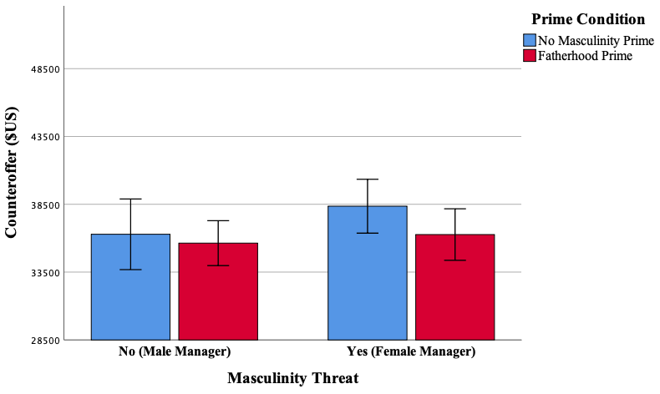
Figure 6. Clustered bar chart with error bars for counteroffer by prime and masculinity threat conditions.
Table 3
Descriptive Statistics for Counteroffer Based on Prime and Masculinity Threat Condition.
 |  | Masculinity Threat
Prime | Descriptive Statistics | No  (Male Manager) | Yes  (Female Manager) | Total
 | Mean | $36,286 | $38,357 | $37f,558
No  (Workforce Statistics) | SD | $5,875 | $5,782 | $5,855
 | N | 22 | 35 | 57
 | Mean | $35,635 | $36,269 | $35,897
Yes  (Fatherhood Prime) | SD | $4,963 | $4,699 | $4,828
 | N | 37 | 26 | 63
Mean Difference |  | $651 | $2,088 | $1,661
Total Weighted Mean |  | $35,878 | $37,467 | $36,686

Hypothesis 5b predicted that, among male participants only, there would be an interaction between masculinity threat and fatherhood prime such that exposure to the fatherhood prime would reduce threat response. That is, counteroffers were expected to be highest for participants that were in the threat condition and who were not exposed to the fatherhood prime. The masculinity threat X fatherhood prime interaction term, however, was not statistically significant, F(1,120)=.520, p=.472, power=.110. Nevertheless, results trended in the hypothesized direction; counteroffers in the masculinity threat condition made by men who did not receive the fatherhood prime were on average $2,088 higher than those made by men who did receive the fatherhood prime (see Table 3 and Figure 6). Power analyses indicated that the sample size was not sufficient to obtain a generally accepted level of power for tests of either Hypotheses 5a or 5b (see Cohen, 1992).

Discussion

Summary and Limitations
This study contributes to the literature on the relationship between masculine identity threat, and organizational gender dynamics. While the results failed to support the hypotheses, the lack of significant results may be the result of low power as several analyses approached significance and power analyses indicated power was below the recommended level of .80 (see Cohen, 1992). In retrospect, a small effect size, as opposed to a medium effect size, should have been anticipated for the fatherhood priming exercise, which would have resulted in the inclusion of a greater number of participants. Overall, the general direction of the data suggests that men who report to female superiors in work situations are likely to perceive a masculinity threat. The general direction of the data also suggests that there was a positive relationship between masculinity contest culture, masculinity threat and threat responses by men, which is consistent with extant literature that found them to be significantly related (Berdahl et al., 2018; Ely & Kimmel, 2018; Glick et al., 2018). Further, the general direction of the data indicates that men’s responses are affected by the masculine identity most salient to them at the time of action. Specifically, men who receive a fatherhood prime, which is interpreted to be an equality masculinity, tend to show lower threat responses than men who are not primed and presumably identify with the prevalent hegemonic traditional masculinity.
The sample was reduced substantially after removing extreme outliers which drastically reduced the number of responses in the sample that were deemed usable. For example, it was estimated that at least 45 responses were needed per condition; for some conditions, however, this threshold was not reached (see Tables 1 and 3 for exact number of cases per condition). Thus, the results lacked statistical power. Furthermore, participants who were recruited through Amazon’s mTurk had an ulterior profit motive and were therefore motivated to finish as fast as possible, rather than responding as accurately as possible. Some of their responses were likely insincere. For instance, it is difficult to imagine that anyone would sincerely counter a job offer for $28,500 with $500,000. Alternatively, extreme counteroffers could reflect masculinity threat responses by male participants to the female academic whose survey they were taking (the consent form revealed her unambiguously female name as well as that of her faculty advisor); so the counteroffer may have been used to show dominance and to knowingly sabotage the survey by making a ridiculously high offer. In either case - lack of sincerity or malintent - the results were warped and it was reasonable to remove them from the analysis. The issue of extreme outliers could be addressed by setting a ceiling limit on the possible size of the counteroffer, asking participants to briefly justify their counteroffer and warning them before the negotiation that unreasonable counteroffers would terminate the negotiation rendering them unsuccess in obtaining the job. Furthermore, participants may have acted more authentically if they had taken the survey simultaneously in the same room because it would have made the simulated negotiation exercise more realistic; this would also be more accurate replication of Netchaeva and colleagues’ (2015) procedure. Given the promising patterns indicated by the data, the study should be repeated with a different sample that is obtained from a more sincere participant pool such as employees of a specific organization.

Implications and Future Research
Work by Ulrich and Tissier-Desbordes (2018) has demonstrated that certain masculinities, such as traditional masculinity, are more easily threatened by women and things perceived to be feminine than are other masculinities such as egalitarian masculinity. This lends weight to Messerschmidt’s (2012) categorization of masculinities into those that are egalitarian (equality masculinities) and those that are built on a foundation of male superiority or patriarchy (hegemonic masculinities). In the Western culture in which this study was conducted, traditional masculinity is the most prevalent form of masculine identity (Banchefsky & Park, 2016) and fits the classification of “hegemonic.” This was demonstrated in the observed pattern that men acted more assertively when negotiating with a female as opposed to a male superior. While the study did not find any significance in the data and thus, the pattern could be a fluke, a growing body of similar research lends weight to the theory that men steeped in hegemonic masculinity are indeed threatened by women (Avery, 2012; Dahl, 2015; Klasson & Ulver, 2015; Kuchynka et al., 2018; Munsch & Gruys, 2018). Future research should replicate the study with samples from different countries to test if the observations hold true in non-Western cultures, which would shed light on the similarity and difference between certain masculinities in each culture. Similarly, it would be interesting to see if there is a difference between different age groups; for example one might reasonably assume that younger men have been raised in different masculinities than older men and that some of these masculinities might be more egalitarian - albeit probably non-dominant.
Masculine identity is continuously constructed between the environment and the individuals who exist within it. Thus, men’s environment shapes their masculinity as much as they shape it themselves (Thompson & Bennett, 2015). The fatherhood priming exercise by Park and Banchfesky (2018) might be an example of how the environment can shape individuals’ masculinities; presenting Western men with equality masculinity stereotypes had an immediate impact on their behavior, which became more egalitarian though not significantly so. Future research should control for participants’ parental status to see if there is an interaction between actual fatherhood and the fatherhood masculinity prime. Also, prolonged exposure to more egalitarian masculine models may have a more pronounced effect on men’s behaviors. Future research is needed to test this assertion. Similarly, Kuchynka et al. (2018) offer evidence that hegemonic masculine environments (such as masculinity contest culture) bring about an increase in male dominating behavior. While the current study did not contribute any significant findings to this theory, the general direction of the data certainly strengthened suspicion sufficiently to merit a replication with improvement to the study design and higher quality sources of potential participants. Future studies should recruit participants from within specific companies who agree to participate in the study so that it is possible to control for organizational culture and to make comparisons between different industries.
At the beginning of this study it was argued that a reason for failing gender equality initiatives might lie deeper than unsuitable work policies and awareness problems. Namely, that the reason such initiative often fail might be contained within the patriarchal gender norms that have shaped Western institutions at local, regional, and global levels for centuries. Future research should repeat this study and investigate how environmental cues like the fatherhood prime can potentially change the dominant norm of traditional masculinity that pitches men against women.

References
Avery, J. (2012). Defending the markers of masculinity: Consumer resistance to brand gender-bending. International Journal of Research in Marketing, 29(4), 322-336.
Banchefsky, S., & Park, B. (2016). The “new father”: Dynamic stereotypes of fathers. Psychology of Men & Masculinity, 17(1), 103–107. DOI 10.1037/a0038945.
Bennett, J. M. (2006). History matters: Patriarchy and the challenge of feminism. University of Pennsylvania Press.
Berdahl, J. L., Cooper, M., Glick, P., Livingston, R. W., & Williams, J. C. (2018). Work as a Masculinity Contest. Journal of Social Issues, 74(3), 422–448. DOI 10.1111/josi.12289
Bosson, J., & Vandello, J. (2011). Precarious manhood and its links to action and aggression. Current Directions in Psychological Science, 20(2), 82-86.
Broughton, C. (2008). Migration as engendered practice: Mexican men, masculinity, and northward migration. Gender & Society, 22, 568-89
Cheryan, S., Cameron, J. S., Katagiri, Z., & Monin, B. (2015). Manning up: Threatened men compensate by disavowing feminine preferences and embracing masculine attributes. Social Psychology, 46(4), 218–227. DOI 10.1027/1864-9335/a000239.
Cohen, J. (1992). A power primer. Psychological Bulletin, 112(1), 155-159.
Cohen, J., Cohen, C., West, S. G., & Aiken, L. S. (2003). Applied multiple regression/correlation analysis for the behavioral sciences (3rd ed.). Mahwah, NJ: Lawrence Erlbaum Associates.
Dahl, J., Vescio, T., & Weaver, K. (2015). How threats to masculinity sequentially cause public discomfort, anger, and ideological dominance over women. Social Psychology, 46(4), 242–254. DOI 10.1027/1864-9335/a000248.
Ely, R. J., & Kimmel, M. (2018). Thoughts on the workplace as a masculinity contest. Journal of Social Issues, 74(3), 628–634. DOI 10.1111/josi.12290.
Glick, P., Berdahl, J. L., & Alonso, N. M. (2018). Development and validation of the Masculinity Montest Culture scale. Journal of Social Issues, 74(3), 449–476. DOI 10.1111/josi.12280.
Hochschild, A. R., & Machung, A. (2012). The second shift: Working families and the revolution at home. New York: Penguin Books.
Klasson, M., & Ulver, S. (2015). Masculinising domesticity: An investigation of men’s domestic foodwork. Journal of Marketing Management, 31(15-16), 1652-1675.
Kuchynka, S. L., Bosson, J. K., Vandello, J. A., & Puryear, C. (2018). Zero-sum thinking and the masculinity contest: Perceived intergroup competition and workplace gender bias. Journal of Social Issues, 74(3), 529–550.
Messerschmidt, J. W. (2012). Engendering gendered knowledge: Assessing the academic appropriation of hegemonic masculinity. Men and Masculinities, 15(1), 56-76.
Munsch, C. L., & Gruys, K. (2018). What threatens, defines: Tracing the symbolic boundaries of contemporary masculinity. Sex Roles, 79(7-8), 375-392.
Netchaeva, E., Kouchaki, M., & Sheppard, L. D. (2015). A man’s (precarious) place: Men’s experienced threat and self-assertive reactions to female superiors. Personality and Social Psychology Bulletin, 41(9), 1247–1259. DOI 10.1177/0146167215593491.
Park, B., & Banchefsky, S. (2018). Leveraging the social role of dad to change gender stereotypes of men. Personality and Social Psychology Bulletin, 44(9), 1380-1394.
Sandberg, S. (2013). Lean in: Women, work, and the will to lead. New York, NY: Random House.
The Economist. (2019, November 7). Diversity memo: How to make your firm more diverse and inclusive. The Economist. Retrieved from https://www.economist.com/business/2019/11/07/how-to-make-your-firm-more-diverse-and-inclusive
Thompson Jr., E. H., & Bennett, K. M. (2015). Measurement of masculinity ideologies: A (critical) review. Psychology of Men & Masculinity, 16(2), 115-134.
Ulrich, I., & Tissier-Desbordes, E. (2018). “A feminine brand? Never!” Brands as gender threats for “resistant” masculinities. Qualitative Market Research: An International Journal, 21(3), 274-295.
Vandello, J. A., Bosson, J. K., Cohen, D., Burnaford, R. M., & Weaver, J. R. (2008). Precarious manhood. Journal of Personality and Social Psychology, 95(6), 1325–1339. DOI 10.1037/a0012453
Willer, R., Rogalin, C. L., Conlon, B., & Wojnowicz, M. T. (2013). Overdoing gender: A test of the Masculine Overcompensation Thesis. American Journal of Sociology, 118(4), 980–1022. DOI 10.1086/668417

Appendix A: University of Oklahoma IRB Approval Letters

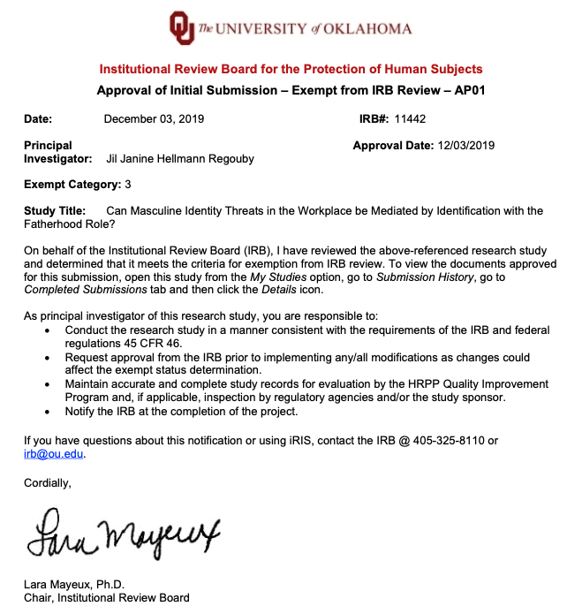

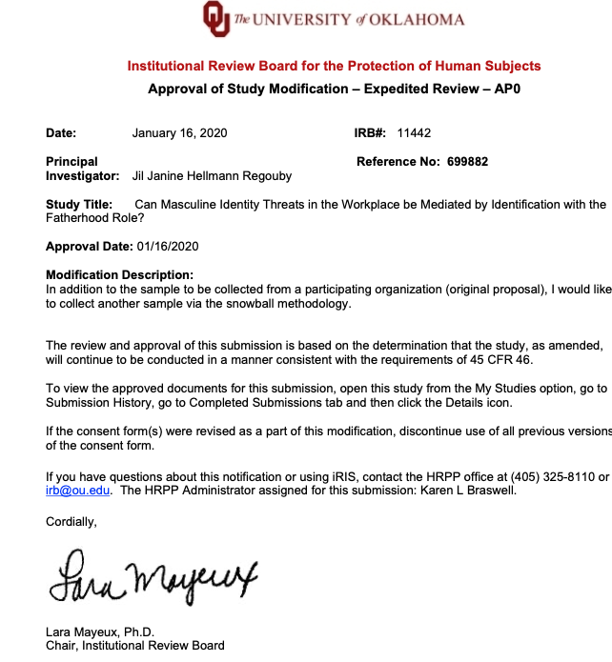
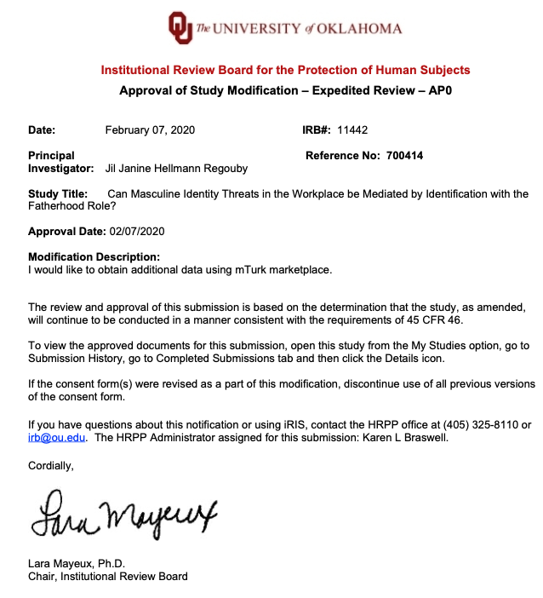

Appendix B: Fatherhood Prime
Instructions: In this part of the study we are looking at reactions to different types of media frequently encountered on the internet. You will read a fact-based article that will present facts about current trends within the United States affecting people's lives. Although a variety of articles will be examined, each respondent will receive just one article. All of the articles were published in 2016. The information will be presented on the following page, showing a total of 6 facts about each trend. You’ll be asked to summarize it based on your comprehension once you’ve finished reading. It may help to increase your screen size (the view size) in order to better see the charts on the following pages. To ensure you have enough time to comprehend the information, the article will appear for a minimum amount of time before the arrows to advance appear.

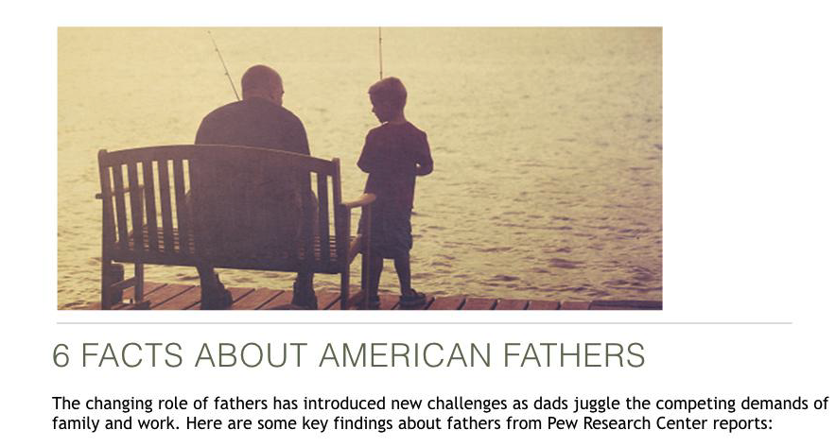
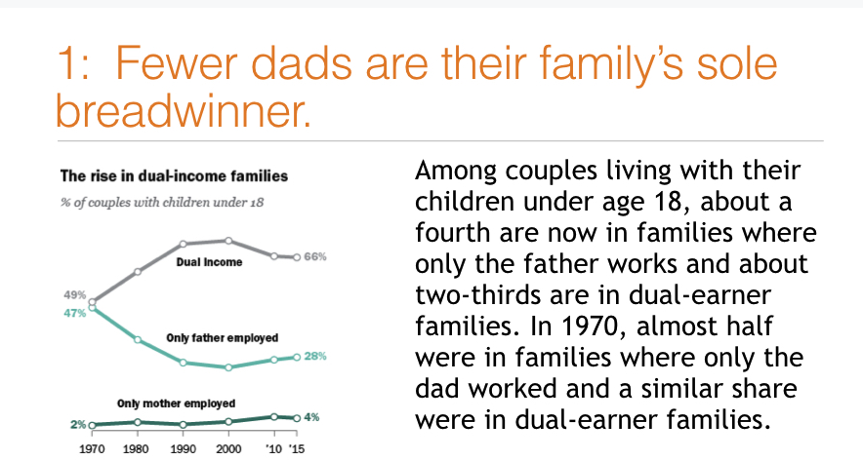
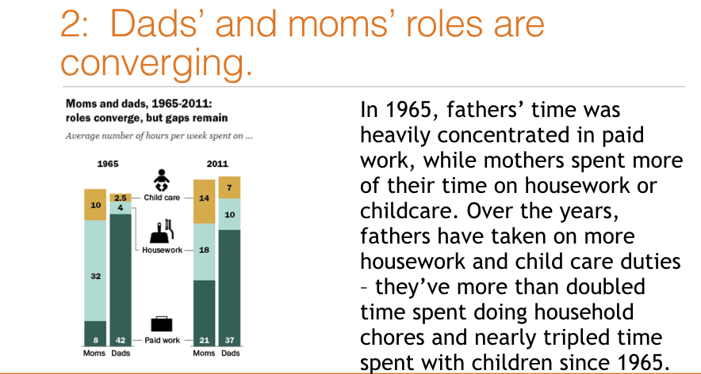
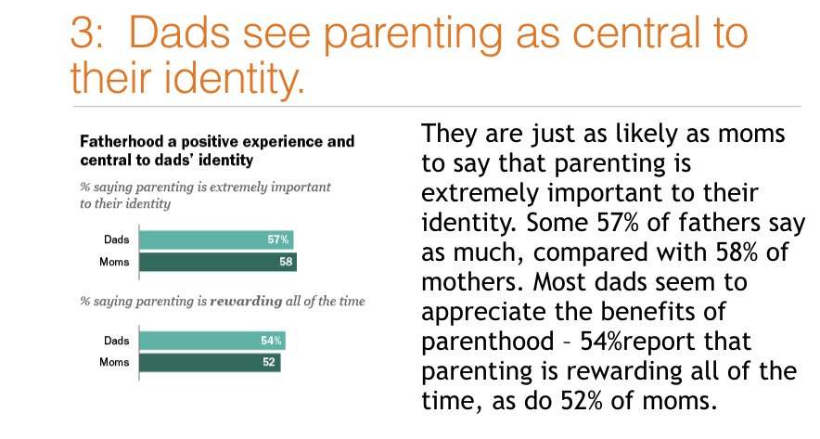
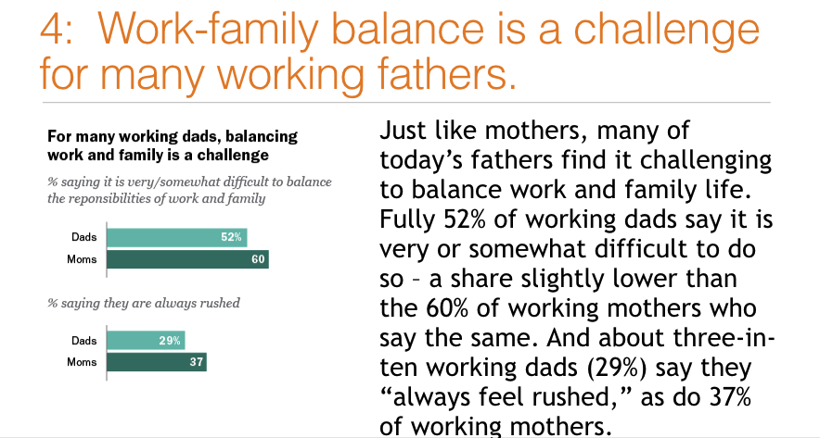
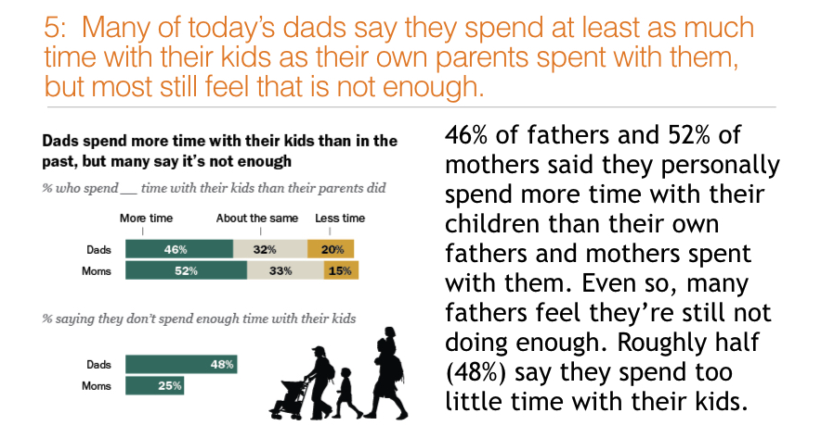
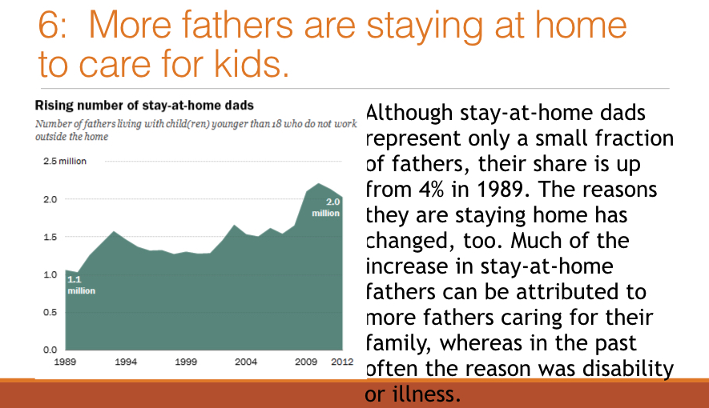

Appendix C: Control Prime
Instructions: In this part of the study we are looking at reactions to different types of media frequently encountered on the internet. You will read a fact-based article that will present facts about current trends within the United States affecting people's lives. Although a variety of articles will be examined, each respondent will receive just one article. All of the articles were published in 2016. The information will be presented on the following page, showing a total of 6 facts about each trend. You’ll be asked to summarize it based on your comprehension once you’ve finished reading. It may help to increase your screen size (the view size) in order to better see the charts on the following pages. To ensure you have enough time to comprehend the information, the article will appear for a minimum amount of time before the arrows to advance appear.
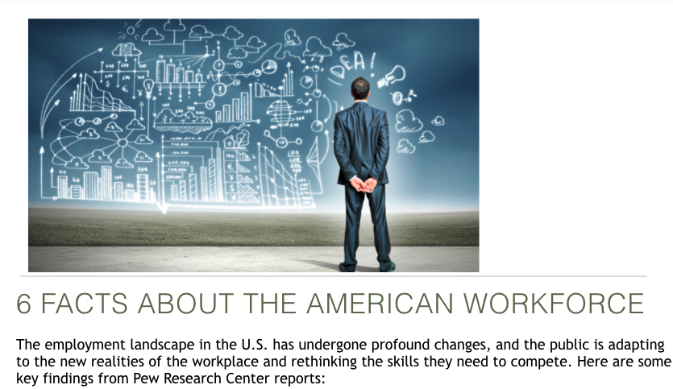
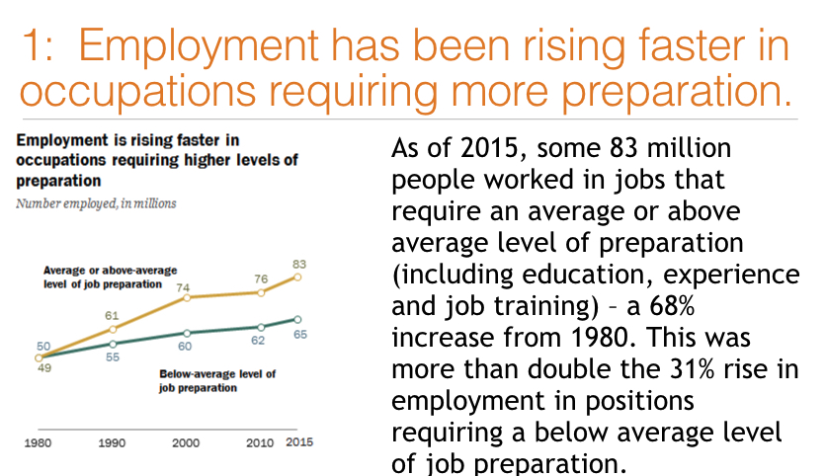
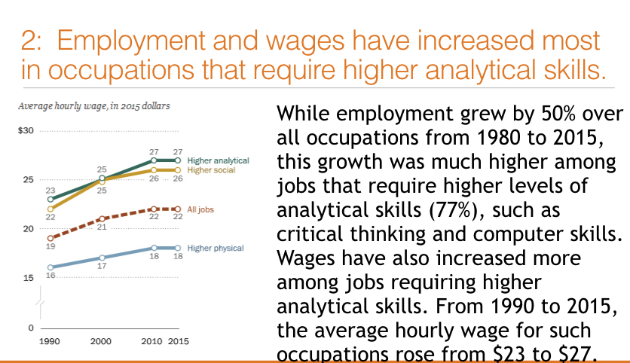
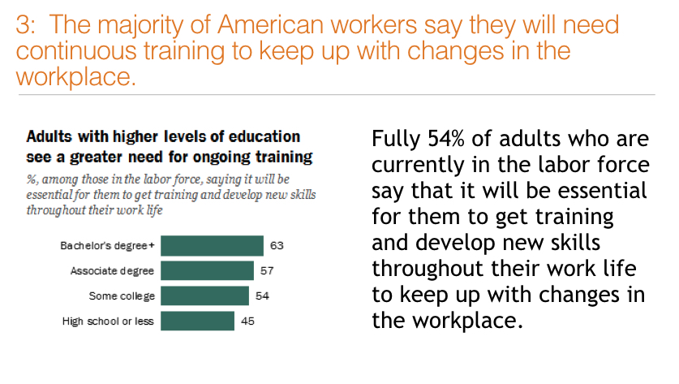
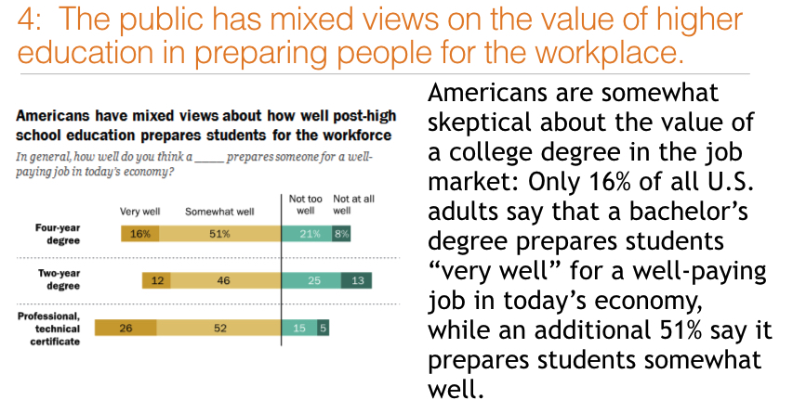
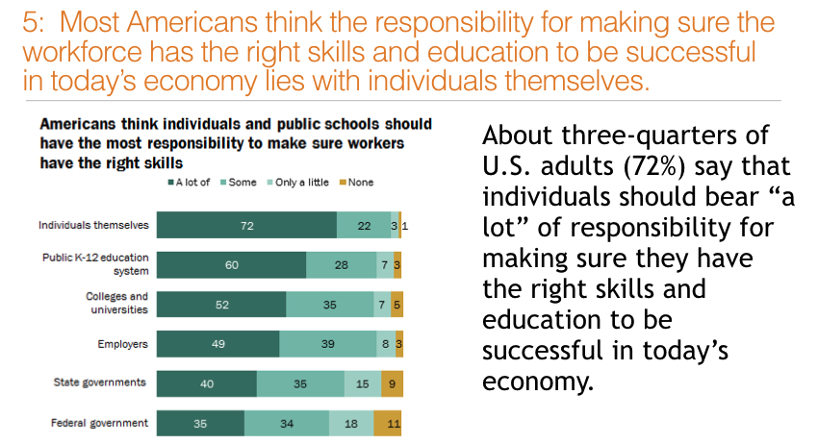
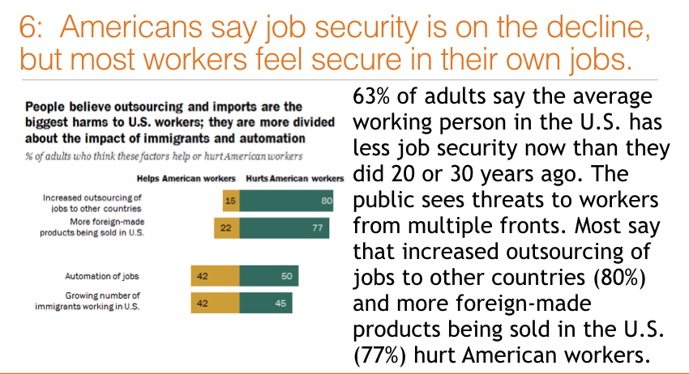

Appendix D: Masculinity Contest Culture Scale Items
Instructions: For each statement below please rate the extent to which it is true of your work environment.
Note: Cross-loaded items were eliminated before computing total MCC score. They have been crossed out in the table below.
 | Item | Not at all true of my work environment |  |  |  | Entirely true of my work environment
1. | Admitting you don’t know the answer looks weak. | 1 | 2 | 3 |  |  | 4 | 5
2. | Expressing any emotion other than anger or pride is seen as weak. | 1 | 2 | 3 |  |  | 4 | 5
3. | Seeking other’s advice is seen as weak. | 1 | 2 | 3 |  |  | 4 | 5
4. | The most respected people don’t show emotions. | 1 | 2 | 3 |  |  | 4 | 5
5. | It’s important to be in good physical shape to be respected. | 1 | 2 | 3 |  |  | 4 | 5
6. | People who are physically smaller have to work harder to get respect. | 1 | 2 | 3 |  |  | 4 | 5
7. | Physical stamina is admired. | 1 | 2 | 3 |  |  | 4 | 5
8. | Athletic people are especially admired. | 1 | 2 | 3 |  |  | 4 | 5
9. | To succeed you can’t let family interfere with work. | 1 | 2 | 3 |  |  | 4 | 5
10. | Taking days off is frowned upon. | 1 | 2 | 3 |  |  | 4 | 5
11. | To get ahead you need to be able to work long hours. | 1 | 2 | 3 |  |  | 4 | 5
12. | Leadership expects employees to put work first. | 1 | 2 | 3 |  |  | 4 | 5
13. | You’re either “in” or you’re “out,” and once you’re out, you’re out. | 1 | 2 | 3 |  |  | 4 | 5
14. | If you don’t stand up for yourself people will step on you. | 1 | 2 | 3 |  |  | 4 | 5
15. | You can’t be too trusting. | 1 | 2 | 3 |  |  | 4 | 5
16. | You’ve got to watch your back. | 1 | 2 | 3 |  |  | 4 | 5

Source: Glick, P., Berdahl, J. L., & Alonso, N. M. (2018). Development and validation of the Masculinity Montest Culture scale. Journal of Social Issues, 74(3), 449–476.

Appendix E: Correlation Matrix for All Variables
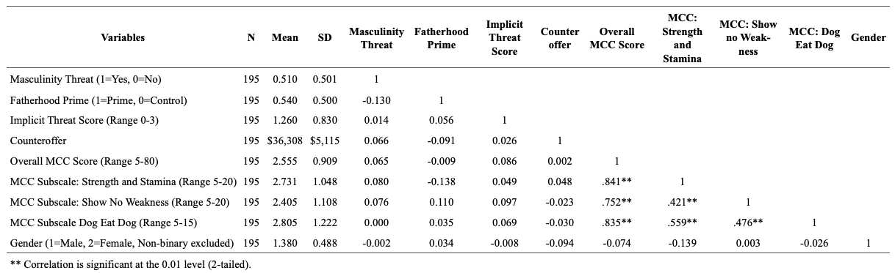

Appendix E:

Correlation Matrix for All Variables

