UNIVERSITY OF OKLAHOMA
GRADUATE COLLEGE

EVALUTATING TRENDS IN BLACKBIRD ABUNDANCE USING WEATHER SURVEILLANCE RADAR

A THESIS
SUBMITTED TO THE GRADUATE FACULTY
In partial fulfillment of the requirements for the
Degree of
MASTER OF SCIENCE

By
Bonne A. Clark
Norman, Oklahoma
2021

EVALUATING TRENDS IN BLACKBIRD ABUNDANCE USING WEATHER SURVEILLANCE RADAR

A THESIS APPROVED FOR THE
DEPARTMENT OF BIOLOGY

BY THE COMMITTEE CONSISTING OF

Dr. Jeffrey F. Kelly, Chair
Dr. Jeremy D. Ross
Dr. Page E. Klug

© Copyright by Bonne A. Clark 2021
All Rights Reserved.

Acknowledgements

Throughout the creation of this Thesis I have received a great deal of support and assistance. First, I would like to thank my advisor, Dr. Jeffrey F. Kelly, whose patient guidance and suggestions were absolutely invaluable to the completion of this research. Your open-ears and constructive ideas helped me immensely throughout this project.
I would like to thank my committee member, Dr. Page E. Klug, whose expertise in the field of blackbird research was vital to understanding the vast amount of information on blackbirds. You’ve given me opportunities to grow as an aspiring biologist seldom afforded to most.
I would also like to thank my committee member, Dr. Jeremy D. Ross, whose expansive knowledge in the field of ornithology allowed for me to form questions and think beyond the scope of this project and broaden my understanding of the field.
I would like to thank Dr. Phil Stepanian, Dr. Elske Tielens, Paula Cimprich, Alisha DiPilla, Christina Kolbmann, Alva Strand, and Mengyuan Zhai, for making our Wednesday morning meetings enjoyable by breaking up the monotony of doing research during a pandemic. The interesting discussions and bad jokes (mine included) made my mornings.
Additionally, I would like to thank Mallory G. White and Allison Shumacher for their constant support doing field research. There isn’t anyone else I’d rather be stuck in the worlds’ smallest RV with 24/7 during the field season than you two.
Finally, I would like to thank my mom, grandmother, and husband for their unyielding emotional support, endless encouragement, and for always being my rock.

Table of Contents
Acknowledgements iv
Abstract vii
1. Using bioenergetics and radar-derived bird abundances to assess the impact of a blackbird roost on seasonal sunflower damage 1
Abstract 2
Introduction 3
Methods 7
Results 13
Discussion 15
Acknowledgements 21
References 22
Appendix S1. 36
2. Atmospheric drivers of blackbird migration from a fall roost 38
Abstract 39
Introduction 41
Methods 46
Results 49
Discussion 51
References 54

List of Tables
Table 1. 30
Table 2 61
Table 3 62
Table 4 62

List of Figures
Figure 1. 30
Figure 2.1 31
Figure 2.2 32
Figure 2.3 32
Figure 2.4 33
Figure 2.5 33
Figure 2.6 34
Figure 2.7 34
Figure 2.8 35
Figure 3 61
Figure 4.1 63
Figure 4.2 63
Figure 4.3 64
Figure 4.4 64
Figure 5.1 65
Figure 5.2 65
Figure 5.3 66

Abstract
Blackbirds damage rice in the southern United States, sunflowers in the Northern Great Plains, and field and sweet corn across the continent. The efficacy of strategies to mitigate damages could be improved by knowing how and when blackbird numbers accumulate throughout the season. Methods aimed at reducing avian damage to agricultural crops are routinely implemented in situations where efficacy can be assessed by quantifying blackbird (Icteridae) abundance relative to environmental variables and extrapolating to ensuring crop damage. Weather surveillance radar (WSR) has been successfully used as a tool to estimate abundances of airborne species such as birds, bats, and insects. Using WSR to estimate numbers of blackbirds at a roost can be inherently useful to inform managers at what point in the season blackbird numbers peak, a period when higher crop damages are expected, and when they depart for migration. Knowing this, producers may be encouraged to plant earlier and harvest their crops before substantial damage occurs. My thesis explores using weather surveillance radar data of a large blackbird roost in North Dakota to evaluate 1) annual crop yield losses to local sunflower, and 2) atmospheric drivers of annual fall blackbird migration.
In chapter one, I evaluated annual damages to local sunflowers from blackbirds at a fall roost in North Dakota, from 2012 to 2019. I used weather surveillance radar (WSR) to derive daily abundance estimates of blackbirds at the roost. I integrated these estimates with previously developed bioenergetics economic models to estimate damages to local sunflower crops. The greatest damages occurred in mid-October, when peak blackbird abundance coincided with the majority of mature but unharvested sunflower fields. Most sunflower fields were harvested later than the peak of blackbird abundance which resulted in large daily damages, suggesting that advancing harvest time should be considered as a strategy for producers to avoid the greatest losses in yield.
In chapter two, I evaluated the effects of atmospheric drivers on blackbirds’ decision to migrate in the fall over a nine-year period (2012 – 2020) at a fall roost in North Dakota. Using weather surveillance radar and local climatological data, I used an AIC model-comparison approach to determine the best weather candidate model to explain blackbird departure from the roost. The best model of departure included Julian date and the daily changes in pressure, v-component of wind strength, and temperature. The integrated model accounted for nearly all the model weight (0.996) in the candidate set. The results show that on average, the final departure of blackbird was on 16 November, when weather conditions were on average at 982 mb (29 in Hg), -7○C, winds were 9 m/sec, and wind was southbound. The null model of Julian date was not a good fit for factors driving blackbird migration, suggesting that other factors were more important than daylight hours. The pressure variable was in all four of the top models, indicating that changes in pressure impact blackbird’s decision to migrate. Blackbirds generally form fall roosts and then depart on fall migration from those roosts as days get shorter, temperatures drop, and weather fronts pass over the roost. I determined that bouts of fall migration (i.e., from peak abundance to final departure from the roost) is seasonally correlated with the combination of Julian date, rise in pressure following low pressure systems, decreasing temperatures, and southbound winds acting as triggers of fall migratory departure at the focal roost.

Using bioenergetics and radar-derived bird abundances to assess the impact of a blackbird roost on seasonal sunflower damage

Published in 2020 at Human-Wildlife Interactions 14(3):427-441

Bonne A. Clark, Page E. Klug, Phillip M. Stepanian, Jeffrey F. Kelly

Department of Biology, University of Oklahoma,
Norman, Oklahoma 73019

Abstract
Methods aimed at reducing avian damage to agricultural crops are routinely implemented in situations where efficacy can be assessed by quantifying blackbird (Icteridae) abundance relative to environmental variables and extrapolating to ensuing crop damage. Concomitantly, Weather Surveillance Radar (WSR) data may have potential to enhance crop damage mitigation through improved monitoring of nuisance wildlife populations. We used WSR to derive daily abundance estimates of blackbirds at a fall roost in North Dakota, USA from 2012 to 2019. We integrated these estimates with previously developed bioenergetics-economic models to estimate local sunflower (Helianthus annuus) damage. The greatest losses usually occurred during a brief period in October, when peak blackbird abundance coincided with large percentages (>50%) of mature but unharvested sunflower fields. Most sunflower fields were harvested later than peak blackbird abundance (360,000–1,120,000 birds) and maximum daily damages ($900–$2,000 USD per day). This seasonal trend suggests advancing harvest time as a strategy to avoid the greatest losses in yield (up to $1,800 in savings at this 1 roost), which may be attainable by earlier planting of early-maturing crop varieties or crop desiccation.

Keywords: aeroecology, autumn migration, blackbirds, crop damage, Helianthus annus, human-wildlife conflict, Icteridae, North Dakota, radar monitoring, roost, sunflowers

Introduction

Background
Blackbirds (Icteridae) damage rice (Oryza sativa) in the southern United States, sunflowers (Helianthus annuus) in the Northern Great Plains, and field and sweet corn (Zea mays) across the continent (Linz et al. 2017). This damage results in national crop yield loss from blackbirds estimated at $100 million USD per year for corn and sunflowers (Linz and Hanzel 1997, Klosterman et al. 2013) and $13.4 million USD for rice (Cummings et al. 2005). National annual damages to corn were estimated to be $25 million USD in 1996 (Wywialowski 1996), while North Dakota, USA experiences a yearly average loss of $1.3 million USD (Klosterman et al. 2013).
Sunflower is a minor crop nationally. However, North Dakota is one of the leading states in the nation’s sunflower production, with an estimated annual crop yield loss due to blackbirds to be $3.5 million USD per year (Klosterman et al. 2013), while total economic losses, including job loss, average $18.7 million USD per year (Ernst et al. 2019). Wildlife damage has deterred sunflower growers from planting in areas with abundant blackbird roosting habitat (i.e., cattail marshes [Typha spp.]; Kleingartner 2003). Although various factors influence whether producers will plant sunflowers, overall sunflower hectarage will likely trend downward without effective management strategies to reduce blackbird damage (National Sunflower Association 2010, Klosterman et al. 2013).
Currently, estimates of blackbird damage to sunflowers are not collected on an annual basis (Klosterman et al. 2013). Surveys of field damage at broad scales are both labor-intensive and difficult to achieve in a timely fashion because data must be collected in the short period between peak damage and harvest. Bird damage to sunflowers takes place over an approximate 8-week period from “seed-set” (i.e., anthesis), usually from mid-August to harvest in mid-October (Cummings et al. 1989). Crop damage is the greatest near roosts, where damage often exceeds 20% yield loss as opposed to ≤2% in fields further from roosts (Klosterman et al. 2013). Significant crop damage is usually found within 8–10 km of a wetland roost (Dolbeer 1990, Linz and Hanzel 1997), corresponding to the daily average foraging distances for premigratory blackbirds (Dolbeer 1990, Homan et al. 2005). Therefore, broad-scale damage surveys may not represent the severity of damage hotspots near roosts where economic impacts to producers are the most extreme.
An inexpensive and reliable method for estimating abundance and seasonal timing of blackbird aggregations would be useful for producers and managers interested in reducing blackbird depredation of agricultural crops (Figure 1). Peer et al. (2003) created a bioenergetics model to estimate regional-scale damages to sunflowers that was based on the North American Breeding Bird Survey June population estimates of blackbirds (Sauer et al. 2017). Although the method developed by Peer et al. (2003) is effective at estimating regional damage estimates, an understanding of the abundance and distribution of blackbirds over the damage period, as influenced by migration and flock aggregations, remains elusive. Currently, the main method to count post-reproductive blackbirds in the fall is field surveys, which have logistical and labor constraints when scaled-up over space and time. In addition to these constraints, field observer roost counts typically lack validation (e.g., replicate independent counts), and ground observer data do not reflect true detectability when expansive roosts are spread across large cattail swaths (Arbib 1972).
The Next-Generation Weather Radar (NEXRAD) system is a potential alternative to field observer counts that could be used to remotely and retroactively estimate blackbird numbers. The NEXRAD is primarily used for forecasting and monitoring weather; however, it has been successfully used to estimate abundances of airborne species such as birds, bats, and insects. Recently developed methods in aeroecology have allowed for biological scatterings of radar to be translated into estimates of numbers of birds (or other airborne species) in an airspace (Gauthreaux et al. 2007, Chilson et al. 2012a, Kelly et al. 2012, Stepanian and Wainwright 2018, Bauer et al. 2019). The NEXRAD has been used to evaluate wildlife conflicts at wind turbine sites (Desholm et al. 2006) and airports (Phillips et al. 2018) but has yet to be used for evaluating bird damage to agriculture. Identifying roosts on radar could allow for estimates of local damages and discovery of trends in bird abundances that managers can use to optimize timing and deployment of management techniques.
Communal roosts can be compromised of a variety of Icteridae species including red-winged blackbirds (Agelaius phoeniceus; RWBL), yellow-headed blackbirds (Xanthocephalus xanthocephalus; YHBL), common grackles (Quiscalus quiscula; COGR), brown-headed cowbirds (Molothrus ater; BHCO), Brewer’s blackbirds (Euphagus cyanocephalus; BRBL), rusty blackbirds (E. carolinus; RUBL), and a species in Sturnidae, European starlings (Sturnus vulgaris; EUST). Although the numbers of many of these blackbird species are declining nationally, RWBL breeding populations are continuing to rise (>1.5% per year) in the PPR (Sauer et al. 2017). The main species that feed on sunflowers in the Northern Great Plains are RWBL, YHBL, and COGR (Sedgwick et al. 1986, Cummings et al. 1989). These species also make up the majority of blackbird flocks roosting in cattails during the autumn in North Dakota (Homan et al. 2005). We examined whether one of these roosts could be monitored using a NEXRAD weather radar.
The NEXRAD data were publicly available with an ~25-year historical record (National Oceanic and Atmospheric Administration [NOAA] 2019) that can be examined to evaluate changes over time. It is the only survey method with an archive that can be used to evaluate historical blackbird populations, is available 24 hours per day, and allows estimation of bird abundance in the nonbreeding season. The network of NEXRAD is comprised of 148 radars across the United States (NOAA 2019). If roosts with known species compositions can be monitored with radar, bird numbers could be calculated and used to estimate the dynamics of blackbird roosts and the potential crop damages in surrounding landscapes. Additionally, radar could be used to gather unbiased blackbird population estimates in multiple years before and after the implementation of management efforts, reducing the need for field observations, at a significant cost savings. Radar cannot detect species composition but can remotely gather unbiased estimates of abundances; thus, cross-referencing with online bird monitoring sites (eBird; Sullivan et al. 2009) or field observations are still needed for explicit species composition.
The main objective of this study was to present a method to estimate potential sunflower damage using radar-derived bird abundances for 1 roost and previously developed bioenergetics models. With sufficient radars distributed across the landscape, migration patterns and seasonal changes to the abundance and distribution of blackbirds could be monitored to inform both their conservation and effective management of human–wildlife conflict across the annual cycle. Our aim is to enable agriculturalists to assess and respond to damage at a landscape scale (i.e., coordinated early planting with neighbors and desiccation) and to improve the seasonal timing of tool deployment (i.e., hazing, evading strategies, habitat management, and chemical repellents) during the autumn damage season (Klug 2017).

Study Area
A blackbird mega roost in the McKenzie Slough in North Dakota was routinely detected on the Bismarck radar (KBIS) from 2012 to 2019. The focal roost at the McKenzie Slough (UTM 388388.58 E, 5188115.17 N, Zone 14T) was approximately 12,000 ha, located ~20 km from Bismarck, North Dakota (Figure 2). This area within the Northern Glaciated Plains of the PPR is a large complex of shallow wetlands with cattail sloughs and open water pocking the landscape (resembling potholes), grassland prairie, and surrounding agricultural crops, including small grains, sunflowers, corn, and soybeans (Glycine max; Johnson et al. 2005).
During the fall, sunflowers in the PPR provide an ideal high caloric food source for pre-migratory blackbirds that need to store energy as fat (Linz 1982). In particular, sunflower seeds provide a key food source for RWBL, YHBL, and COGR (Sedgwick et al. 1986, Cummings et al. 1989), which typically make up the majority of roosting blackbird flocks in cattails (Shaaf 2003, Homan et al. 2005). Other blackbird species found in fall roosts can include EUST, BHCO, BRBL, and RUBL. Although these species generally contribute low percentages to species compositions of roosts, they can still be found in sunflower fields usually taking seeds from the ground (Besser 1978). Thus, the presence of these other species may not greatly bias the damage estimates given that they are usually minor contributors to a roost’s abundance. Field observations in 2019 indicated RWBL comprised the majority of the roost’s blackbird species, though we acknowledge other species were likely to be found at this site from 2012 to 2019.

Methods

Field Observations
Confirmation that biological scatter detected by WSR was blackbird (or other airborne species) required “ground-truthed” observations (Gauthreaux and Belser 1998). We observed blackbirds at the McKenzie Slough during fall 2019 from mid-September to late October. Using the methods described by Meanley (1965) and Arbib (1972), we estimated the number of birds per minute as they departed the roost in flight lines or flocks. Observers worked in pairs and observations began near sunrise when the first flock emerged. One individual focused on counting blackbirds while the other recorded data from the primary observer, taking general note of the dominant blackbird species. During the morning roost exodus, the primary observer counted birds per minute in each flight line in an area with a radius of ~300 m. We counted birds using 5-minute intervals assuming that the number of birds per minute passing a reference point changed throughout the departure period. Counts ended when blackbirds no longer emerged from the roost and lasted between 30 and 90 minutes per morning.

NEXRAD Estimates of Blackbird Abundance
We collected estimates of blackbird abundance at the McKenzie Slough using data from the KBIS WSR, one of the radars comprising the NEXRAD network of 148 WSRs operated by the National Weather Service (NOAA 2019). Data from NEXRAD were publicly available with a historical record of ~25 years as of 2020 (NOAA 2019). The KBIS radar located in Bismarck, North Dakota was the closest radar (~20 km) to the roost (Figure 2). With each sweep of the radar, it sampled the airspace in 720 0.5° azimuths at set elevation angles. Data for each elevation angle and azimuth were collected every 10 minutes or less (NOAA 2019). Each sweep of the radar produced information on the amount of returned signal (radar reflectivity) at each range gate (250-m-distance bins) along each 0.5° azimuth. The returned signal indicated the presence of objects in the airspace, which could be precipitation, birds, insects, and bats (Chilson et al. 2012b). This measure of how much transmitted power is returned to the radar is known as radar reflectivity factor (Z), commonly expressed in log units (dBZ; NOAA 2019). For reference, birds in flight, usually migrating or departing from a roosting site, will be detected with reflectivity factor values of <35 dBZ (Gauthreaux and Belser 1998). Reflectivity >35 dBZ are likely meteorological phenomena. We accessed KBIS radar data from Amazon Web Services and opened it using the Py-ART package (Helmus and Collis 2016).
We downloaded reflectivity data for August 1 through November 30, 2012–2019. For each day, we processed data beginning 1 hour before sunrise and ending 2 hours after sunrise for the area immediately surrounding the roost (575-km² area from ~1200–1500 UTC) to encompass morning roost dispersal (Meanley 1962). Our analysis is limited to reflectivity data from the lowest sweep collected by the radar (0.5°). Manual screening of radar data using NOAA’s Weather and Climate Toolkit indicated that blackbirds did not fly above the area sampled by the 0.5° elevation sweep (i.e., ~90–670 m above ground level). Flight altitude may be a limiting factor in using WSR to detect blackbirds, and distances between WSR and roosts are necessary to consider when monitoring and measuring magnitudes of reflectivity (Kelly et al. 2012). Other known blackbird roosts located farther from the radar (>20 km) were not detected by KBIS. Visual screening of the radar data also confirmed that the focal roost near Bismarck was routinely detected by KBIS from 2012 to 2019.
We censored reflectivity from hydrometeors to focus on values from animals flying in the airspace. We separated meteorological data and non-meteorological data (biological) using the depolarization ratio (DR) described by Kilambi et al. (2018). Prior to 2012, KBIS did not collect the dual-polarized data needed to calculate DR. Therefore, we could not confidently separate reflectivity data from blackbirds and hydrometeors (henceforth, weather) before 2012. Following Kilambi et al. (2018), we censored samples with DR values less than or equal to -12.5 dB as weather and assumed values greater than this cutoff were biological. We are confident reflectivities >35 dBZ were not blackbirds or other biological matter but rather meteorological abnormalities or super-refraction of the radar beam. Occasionally, super-refraction of the radar beam occurs, which will cause a false reflectivity measure of true biological masses in the airspace (van den Broeke 2019). Based on this filtering, we identified 15 total days between 2012 and 2019 with high radar reflectivity values (>35 dBZ) in August and early September that we are confident are not blackbirds. We removed data from these days from our calculations. There were also 20 days between 2012 and 2019 when KBIS was not operating and there were no reflectivity data.
To estimate the abundance of blackbirds at the roost, we summed the total biological radar echoes within the domain surrounding the roost (575 km²). Other animals flying in this area would also be detected by radar. Based on visual observations in 2019, we were confident that most biological scatters were RWBL or other similar-sized blackbirds in this location. Because patterns observed by radar were similar in all years, we assumed all years were primarily RWBLs as observed on the ground in 2019.
Using an equation from Horton et al. (2019), we estimated the radar cross section (RCS) of a RWBL (15.5 cm² North Dakota birds (60 g, assuming 50% males [73.7 g] and 50% females [46.5g]; Linz 1982). The range of values for the average mass of male and female blackbirds will influence the RCS value and ultimately the calculation of the number of detected blackbirds (i.e., larger RCS = fewer blackbirds). In a roost comprised of more males, the average body size of the roost will be larger, resulting in a larger RCS, where the opposite would be the case for a roost comprised of more females. Furthermore, an increase in the number of males increases the percentage of diet comprised of sunflowers and therefore damages while a female-biased sex ratio will result in less damage. In this study, we assumed a 50:50 ratio of males to females (Mayr 1939). We also calculated damages based on 40:60 and 60:40 sex ratios because most wild bird populations will have sex ratios within this range (Mayr 1939).
Determining the best RCS of any species is difficult due to the lack of empirical measurements, among-individual variation in size, and variation in the orientation of the animal relative to the radar. Horton et al. (2019) found a positive relationship between body mass of bird species and measured RCS (cm²) as described by the equation: [(log10 (cross‐section) = 0.670 (log10 (body mass)]. Using this value, we estimated the number of blackbirds in a radar sample by dividing summed reflectivity by the RCS of a single blackbird.

Economic Damage Estimates From Bioenergetics Models
Using bioenergetics calculations from Peer et al. (2003), we converted radar-based estimates of blackbird abundance to annual economic damage estimates for the area surrounding the roost (Table 1). We estimated damage as the sum of field metabolic rate divided by metabolic energy content of sunflowers and then multiplied by diet, moisture, compensation, hull price, and the number of blackbirds derived from radar estimates (Appendix S1). Peer et al. (2003) used a categorical method to account for seasonal change in compensation and metabolic energy content of sunflowers with 2 periods: 14 days following anthesis and 28 days where the crops were at or near maturity (Sedgwick et al. 1986). Anthesis (R6) is defined as the completion of flowering when ray petals are beginning to dry and wilt (Schneiter and Miller 1981). Sunflowers reach maturity (R9) when the sunflower head bracts become yellow and brown (Schneiter and Miller 1981).
During anthesis, the metabolic energy content (MBE) of sunflowers is 15.28 kJ/g (Connor and Hall 1997), which is half the energy content of mature sunflower achenes at 30.56 kJ/g (Park et al. 1997). We have accounted for this difference by incorporating a gradual linear increase of MBE values (15.28–30.56 kJ/g) from the beginning of anthesis to maturity by using the equation [15.28 + (15.28 * % mature sunflower fields)] to reflect the increase in energy content of achenes as they mature. Instead of separating plant growth stages into 2 periods, we modeled a gradual linear change in compensation based on the percent of sunflower fields in their mature stages using the equation [0.85 + (0.15 * % of mature sunflower fields)] to represent decreases in compensation as more fields approach maturity.
Percent of sunflower fields in differing growth stages in North Dakota is reported on a weekly basis by the U.S. Department of Agriculture, National Agricultural Statistical Service (USDANASS). The USDA-NASS (2020) reports sunflower growth stage based on planting date and growing degree days at a statewide level. Regional, county, or local data surrounding the roost were not available. Therefore, our damage estimates assumed that the sunflower growth stages in the area surrounding the roost were typical of the state average. Recorded data on sunflower growth stage was not collected from September 29 to October 20, 2013 because of a U.S. Government shutdown. We accounted for this by calculating an estimated gradual linear change between these dates in percentages of mature sunflower fields.
Using our estimates of blackbird abundances, availability of mature sunflowers, and potential economic losses, we evaluated overlap in bird and crop phenology, compared damage severity at different time periods, and calculated potential cost-saving with alterations in the timing of method implementation. We compared the dates when we detected the maximum number of blackbirds at the roost to dates of peak mature sunflower to determine potential causal relationships. We calculated an annual estimate of damage that could have been avoided if producers had harvested their sunflowers 2 weeks earlier (theoretically by crop desiccation or planting early maturing varieties earlier in the spring). To determine damage potentially avoided with advanced harvest, we shifted the growth stage to reach maturity 2 weeks earlier. Because Cummings et al. (1989) indicated damage is worse in the early stages (i.e., >75% of bird damage in 18 days following anthesis), we wanted to evaluate if early damage was significantly different than late damage. Thus, we compared the accumulated damage each year between the early damage (18 days following anthesis) and late damage (an 18-day period centered on the peak of sunflower maturity) periods. We then calculated the differences between these 2 periods. All damage estimates are reported in USDs.

Results
At the McKenzie Slough roost, blackbird numbers and damage estimates routinely peaked in mid-to-late October, coinciding with the peak of mature yet unharvested sunflowers in all years except 2012. The range of maximum blackbirds was 346,845–1,076,140 (mean = 612,156 ± 87,653 SE) in mid-to-late October or occasionally the first week of November. The year with the largest detected maximum daily abundance was 2016 at 1,076,140 blackbirds in late October. In 2013 and 2019, we found the lowest maximum daily number of detected blackbirds at 346,845 and 451,613 in early November, respectively. The radar counts had a positive correlation (r = 0.7) to our in-field estimates. We identified RWBL as the main species. Other species observed were COGR, YHBL, BRBL, and EUST. However, low-light conditions and estimated large number of blackbirds (>500,000) made quantifying species composition difficult, although we identified that RWBL were the dominant taxa. Daily observations in sunflower fields near the roost consisted largely of RWBL through late October.
We estimated that damage to sunflowers from blackbirds during 2012 to 2019 was greatest in 2015, when potential losses were $41,887 for sunflower fields near this 1 roost (Figure 3). All other years (excluding 2015) had a range of $12,070– $20,948 (mean = $16,839 ± 1,428 SE) for estimated damage. Damage estimates were highest in 2015 due to the large numbers of blackbirds detected early and persisting throughout the fall. We estimated blackbird numbers to be >300,000 birds in early August for both 2015 and 2012, which were on average 19 times higher than other years. Typically, blackbird numbers began to rise during the first week of October and reached maximum abundance by mid-to-late October when damages averaged $189/day (Figure 3). In 2015, the greatest daily average damage was $402/day while in 2018 and 2019 the lowest average daily damage was $116/day and $114/day, respectively.
If the sex ratio was 40:60, the average annual damage estimate (excluding 2015) was $16,007 (±1,358 SE), whereas if the sex ratio was 60:40 the damage was $17,691 (±1,501 SE). Compared to a 50:50 sex ratio, biased sex ratios changed the damage estimate by a about ±5% ($800).
On average, sunflower fields in North Dakota began anthesis (R6) on August 15 and started to become mature (R9) on September 7 from 2012 to 2019. On average, nearly all sunflower fields had reached maturity by October 19 in every year, with average harvest beginning on October 4. Mature fields that were yet to be harvested peaked on average on October 15. The maximum blackbird abundance detected at the McKenzie Slough roost averaged October 27 (disregarding 2012, an outlier, when maximum abundance was August 13). In 2012, sunflower fields exhibited earlier anthesis, maturity, and harvest, in addition to an earlier peak in blackbird abundance compared to other years. Timing of peak maximum blackbird abundance was moderately well explained by timing of peak percent mature sunflower fields (r= 0.557). The peak of sunflower maturity in North Dakota occurred in mid-October, coinciding with maximum blackbird abundance at the roost (Figure 3). Our estimated damages were on average 4 times higher during the 18-day period of peak maturity compared to the 18-day period following anthesis in every year except 2012. In 2012, blackbird numbers peaked during anthesis, where damages were 2 times higher than at maturity. Shifting sunflower growth stages to mature 2 weeks earlier would potentially reduce annual damage in surrounding fields of this single roost by $250– $1,800 (mean = $800 ± 160 SE).

Discussion
Integrating radar-derived blackbird abundance estimates with bioenergetics calculations developed by Peer et al. (2003) allowed us to estimate damages accumulated over the autumn season across multiple years. Our daily damage estimations are for an approximate 10 km radius area around the roost, which is the typical daily movement of blackbirds (Dolbeer et al. 1990, Linz and Hanzel 1997, Homan et al. 2005). We expected that daily economic damage estimated from bioenergetics models would be concentrated near the roost as suggested by Klosterman et al. (2013). Thus, these localized damage estimates may be more relevant to economic losses for producers with sunflower fields near large roosts but could be scaled up with the expansion of radar-based monitoring at broad scales. Although our study is at a single roost in North Dakota, an expanded radar network could be used to monitor bird populations known to damage other crops (e.g., corn and rice) across the continent.
Considering seasonal blackbird abundance and the energy content of sunflowers from anthesis to maturity, the potential economic damages surrounding our study roost were greatest after the peak percentage of sunflower fields reached maturity in North Dakota. The largest numbers of blackbirds (>100,000) overlapped the peaks in the percent of mature sunflower fields in North Dakota, suggesting birds may be aggregating to take advantage of this abundant food resource prior to migration departure. At the time of maximum blackbird abundance at the McKenzie Slough, most sunflower fields statewide remained unharvested; economic damage from blackbirds was likely severe at this time. One caveat of this interpretation is that data used for sunflower growth stages were based on the entire state, while this study focused on localized damage estimates near 1 roost (approximately <10 km). Specificity of damage estimates could be increased if local sunflower growth stage data become available.
Blackbird abundance and thus potential economic damages are severe in the mature stages just before harvest. Approximately $250–$1,800 (mean $800 ± 160 SE) of these damages could have been avoided if local growers harvested 2 weeks earlier and avoided the largest congregations of blackbirds. The strategy of evading damage by altering planting time to offset the synchronization of bird abundance and crop availability has been shown to be successful in reducing blackbird damage to sprouting rice during the spring migration (Wilson et al. 1989, Brugger et al. 1992). Our method of determining how much damage could be avoided if harvest were shifted earlier assumed that blackbirds would not alter their behavior in response to the timing of sunflower maturity. Although, in 2012, when both sunflower maturity and peak blackbirds were early, we saw the greatest savings with advancing sunflower maturity ($1,800).
Future analyses are needed to better understand factors driving changes in blackbird behavior and seasonal trends in abundance. With an expanded network, radar can be a method to understand continental-scale migration movements and aggregations of birds across the annual cycle (Chilson et al. 2012b), especially during spring and fall migrations when data are lacking (Marra et al. 2015). Specifically, how blackbirds respond to shifts in timing of crop growth, weather events, or climate change would be especially informative (Klug 2017). Future research evaluating blackbird behavior on spatially explicit landscapes would strengthen the understanding of how blackbirds disperse across the landscape and use crop fields relative to their roost locations across the damage season. Modelling this behavior could identify thresholds for percent of a landscape that needs to be synchronous in sunflower maturity to garner a benefit from advancing harvest without risking increased damage from attracting more blackbirds.
Our results are consistent with Cummings et al. (1989), who determined that sunflower damages were the most severe when blackbird numbers were the highest. However, the specific timing of this period differed between our study and Cummings et al. (1989). At the time of their study (1979–1982), the majority of bird damage was between August 15 and September 16, when sunflowers were in anthesis and when blackbird numbers were at their peak. We found that blackbird abundance at this roost peaked on average on October 27, coinciding with sunflower maturity in North Dakota and 70 days after the onset of anthesis, except for 2012 where blackbird abundance peaked 8 days after the onset of anthesis and early damage was 2 times late-season damage. The differences in chronology of blackbird abundances and crop damages compared to Cummings et al. (1989) may be accounted for by a combination of regional or landscape differences, improved crop hybrids, climate change impacting crop and bird phenology, and observation methods. These studies took place in different ecoregions with different landscapes (Lake Agassiz Plains vs. the Northern Glaciated Plains), and the composition of crops on the landscape and crop phenology are different today compared to 30 years ago (Johnston 2013, Klug 2017). Additionally, blackbird abundance and distribution may vary with blackbird migration phenology (Travers et al. 2015), which alters the timing of the breeding season, molt, and fall migration departure for each blackbird species.
The chronology of blackbird damages may have changed with changes in breeding and migration timing as a result of climate change. Temperatures in the PPR have increased 3°C in the past 100 years (National Assessment Synthesis Team 2000), with significant increase in regional temperatures since the 1970s (Travers et al. 2015), while precipitation has decreased by 10% in some areas (National Assessment Synthesis Team 2000). Geographically isolated wetlands make up 88% of the wetlands in the PPR and rely on precipitation, and the reduction of wetland areas may impact roost availability for blackbirds (Mitsch and Gosselink 2000, Dahl 2014). The change in climate conditions may consequently influence migration timing and the breeding season length (Van Buskirk et al. 2009). Van Buskirk et al. (2009) reported that RWBL in Pennsylvania, USA increased their intermigratory period (time from spring and fall migration) by >20 days from 1961 to 2006. In Fargo, North Dakota, Travers et al. (2015) found that RWBL (among other migratory birds) are arriving earlier in the spring compared to the 1970s. The shift of migratory timing and climate change in the last few decades suggest that the chronology of peak RWBL flocks could alter timing of blackbird damage locally.
Finally, our study differed from Cummings et al. (1989) in observation methods. During molt, blackbirds fly lower in August and early September (Linz et al. 2017). Thus, their lower flight height may result in reduced detections by radar and therefore radar abundance estimates could undercount numbers of birds near the roost. Populations later in the season (mid-to-late October) are in the hundreds of thousands, indicating that there are large aggregations of migratory and resident birds during this time (Bauer et al. 2019). Late-season aggregations may increase as more fields are harvested prior to migration. Blackbirds may leave smaller roosts and aggregate in a mega roost in the late fall before migrating in large numbers (Meanley 1971). Thus, birds may be more dispersed early in the season and not apparent on radar but still causing early damage. Further research is needed to compare methods and determine whether large numbers of blackbirds remain undetected by radar during molt. Our field observations of the roost in 2019 began in mid-September when the majority of blackbirds had completed molt (Linz et al. 1983, Twedt and Linz 2015, Klug et al. 2019).
Observations of blackbird abundance and flight height may give insight into the proportion of blackbirds detected on radar. This can strengthen our understanding of radar’s utility to detect bird abundances for use in estimating economic damage estimates. The daily fluctuations in the blackbird numbers (based on radar sweeps) may indicate fluctuations in the blackbird population with waves of migration or may be an artifact of how radar samples the airspace and its ability to detect blackbird departure when behaviors such as timing, height, or size of groups vary. Thus, we emphasize the need for comprehensive studies that show the advantages and limitations of using radar to estimate flock abundances.
Radar can greatly reduce the need for infield estimates of species abundance, yet a main caveat is that explicit species composition must be gathered from in-field observations or local knowledge. The YHBL migrates early in the fall season, often leaving the northern Great Plains in September, although they still contribute to crop damage before departing (Twedt and Linz 2015, Dolbeer and Linz 2016). In comparison, RWBL and COGR have later fall migrations (Linz et al. 1983; Klug et al. 2019). We suggest routine weekly observations at roosts of interest to strengthen the understanding of the composition of biological masses detected on radar. Damage estimates with varying blackbird species compositions can be calculated by simply modifying the RCS based on their body size and bioenergetics calculations. In our study, the McKenzie Slough roost had mostly RWBL, but knowing the species composition throughout the season could give more robust estimates of damages.
This study shows the potential future directions in using radar-derived counts of blackbirds to determine damage estimates surrounding roosts. More broadly, radar has the potential to be used for understanding populations of nuisance animals in human–wildlife conflicts. Monitoring wildlife with radar has been evaluated in wildlife collisions where identifying the presence of birds by radar can trigger shutting down wind turbines (Desholm et al. 2006) and diverting aircraft near airports (Phillips et al. 2018). As far as we know, our study is the first to evaluate uses of radar for monitoring agricultural damage from birds. Because radar provides consistent estimates and monitoring of biological masses in the airspace, it allows for more cost-effective assessments of the optimal seasonal timing of agricultural practices and deployment of wildlife damage management tools. With an expanded network of radars across North America, the future could see land managers accessing an application that predicts the real-time risk of bird damage based on the migration movements and aggregations of birds at broad continental scales.
Currently there are only 3 NEXRAD radars in North Dakota (Bismarck, Minot, Grand Forks). Other radars across the United States have the potential to monitor known blackbird roosts where the methods described in this study could be applied to determine damages to sunflowers as well as corn and rice at stopover and overwintering sites. In addition to NEXRAD, mobile research radars provide possibilities for monitoring roosts that are not typically detected by KBIS. This system could allow for localized monitoring of blackbird roost numbers where the methods in this study could be used to gather daily estimates of blackbirds and crop damages. Another option would be to deploy mobile radars to strengthen the understanding of abundance trends of blackbirds at roosts where damage estimates could be useful for evaluating the efficacy of local management methods. On-demand systems could be developed to deploy autonomous tools (e.g., drones; Klug 2017) when radar identifies flocks entering protected areas (Ronconi and St. Clair 2006).

Management Implications
Our analyses suggest that if sunflower producers within 10 km of this single roost had shifted harvest 2 weeks earlier, they may have saved up to $1,800 a year. We emphasize that a coordinated harvest with neighbors is important to avoid having isolated early-maturing or late unharvested fields that are likely to attract large numbers of birds. We found that potential damages are greatest when blackbirds reach their peak abundances, which for most years was during the mature stage of sunflowers. However, 1 year (2012) had more birds during anthesis, and thus potential damages were highest during this time. The variation in flock abundance and phenology at roosts identified on radar can aid managers and producers in testing management tools and methods by monitoring roosts before and after management implementation. Without a historical record of bird populations, it is difficult to ascertain if population responses are a result of management methods or natural variation in population abundance. Further examination of radar as a method for unbiased monitoring of blackbird abundance has the potential to enable more rigorous assessments of a variety of management tools (Linz et al. 2011).

Acknowledgements
We thank A. Schumacher and M. White for assistance with field data collection and observations. The U.S. Department of Agriculture, Animal and Plant Health Inspection Service, Wildlife Services, National Wildlife Research Center (USDA-APHIS-WS NWRC; Cooperative Agreement #AP19WSNWRC00C007), National Science Foundation, Division of Emerging Frontiers (Grant EF-1840230), and the University of Oklahoma funded this project. The USDA-APHIS-WS NWRC approved the manuscript prior to submission and approved all procedures and permits for this study (#QA3102). Any use of trade, firm, or product names is for descriptive purposes only and does not imply endorsement by the U.S. Government. Comments provided by G. Linz, HWI associate editor, and 2 anonymous reviewers greatly improved earlier versions of this manuscript.

References
Arbib, R. 1972. On the art of estimating numbers. American Birds 26:706–716.
Baltezore, J. F., J. A. Leitch, and G. M. Linz. 1994. The economics of cattail management:
assessing the trade-offs. Agricultural Economics Report Number 320, North Dakota State
University, Fargo, North Dakota, USA.
Bauer, S., J. Shamoun-Baranes, C. Nilsson, A. Farnsworth, J. F. Kelly, D. R. Reynolds, A. M.
Dokter, J. F. Krauel, L. B. Petterson, K. G. Horton, and J. W. Chapman. 2019. The grand
challenges of migration ecology that radar aeroecology can help answer. Ecography
42:861–875.
Besser, J. F. 1978. Birds and sunflower. Pages 263–278 in J. F. Carter, editor. Sunflower science
and technology. American Society of Agronomy, Madison, Wisconsin, USA.
Brugger, K. E., R. F. Labisky, and D. E. Daneke. 1992. Blackbird roost dynamics at Millers
Lake, Louisiana: implications for damage control in rice. Journal of Wildlife
Management 56:393–398.
Chilson, P. B., W. F. Frick, J. F. Kelly, K. W. Howard, R. P. Larkin, R. H. Diehl, J. K.
Westbrook, T. A. Kelly, and T. H. Kunz. 2012a. Partly cloudy with a chance of
migration: weather, radars, and aeroecology. Bulletin of the American Meteorological
Society 93:669–686.
Chilson, P. B., W. F. Frick, P. M. Stepanian, J. R. Shipley, T. H. Kunz, and J. F. Kelly. 2012b.
Estimating animal densities in the aerosphere using weather radar: to z or not to z?
Ecosphere 3:72.
Connor, D. J., and A. J. Hall. 1997. Sunflower physiology. Pages 113–182 in A. A. Schneiter,
editor. Sunflower technology and production. Agronomy Monograph 35. American
Society of Agronomy, Madison, Wisconsin, USA.
Cummings, J. L., J. L. Guarino, and C. E. Knittle. 1989. Chronology of blackbird damage to
sunflowers. Wildlife Society Bulletin 17:50–52. Cummings, J. L., S. Shwiff, and S.
Tupper. 2005. Economic impacts of blackbird damage to the rice industry. Eastern
Wildlife Management Conference 11:317–322.
Dahl, T. E. 2014. Status and trends of prairie wetlands of the United States 1997 to 2009. U.S.
Department of the Interior, Fish and Wildlife Service, Ecological Services, Washington,
D.C., USA.
Desholm, M., A. D. Fox, P. D. L. Beasley, and J. Kahlert. 2006. Remote techniques for counting
and estimating the number of bird–wind turbine collisions at sea: a review. Ibis 148:76
89.
Dolbeer, R. A. 1990. Ornithology and integrated pest management: red-winged blackbirds
Agelaius phoeniceus and corn. Ibis 132:309–322.
Dolbeer, R. A., and G. M. Linz. 2016. Blackbirds. Wildlife Damage Management Technical
Series, U.S. Department of Agriculture, Animal and Plant Health Inspection Service,
Wildlife Services, National Wildlife Research Center, Fort Collins, Colorado, USA.
Ernst, K., J. Elser, G. M. Linz, H. Kandel, J. Holderieath, S. DeGroot, S. Shwiff, and S. Shwiff.
2019. The economic impacts of blackbird (Icteridae) damage to sunflower in the United
States. Pest Management Science 75:2910– 2915.
Gauthreaux, S. A., and C. G. Belser. 1998. Displays of bird movements on the WSR-88D:
patterns and quantification. Weather and Forecasting 13:453–464. Gauthreaux, S. A., J.
W. Livingston, and C. G. Belser. 2007. Detection and discrimination of fauna in the
aerosphere using doppler weather surveillance radar. Integrative and Comparative
Biology 48:12–23
Helmus, J. J., and S. M. Collis. 2016. The python ARM radar toolkit (Py-ART), a library for
working with weather radar data in the python programming language. Journal of Open
Research Software 4:e25.
Homan, H. J., A. A. Slowik, and G. M. Linz. 2005. Fall dispersal patterns of red-winged
blackbirds (Agelaius phoeniceus) migrating from the Prairie Pothole Region of North
Dakota. Final report: North Dakota Crop Protection Product Harmonization and
Registration Board (Agreement No. 04-73-38-5502-TF).
Horton, K. G., B. M. Van Doren, F. A. La Sorte, E. B. Cohen, H. L. Clipp, J. J. Buler, D. Fink, J.
F. Kelly, and A. Farnsworth. 2019. Holding steady: little change in intensity or timing of
bird migration over the Gulf of Mexico. Global Change Biology 25:1106–1118.
Johnson, W. C., B. V. Millet, T. Gilmanov, R. A. Voldseth, G. R. Guntenspergen, and D. E.
Naugle. 2005. Vulnerability of northern prairie wetlands to climate change. BioScience
55:863–872.
Johnston, C. A. 2013. Wetland losses due to row crop expansion in the Dakota Prairie Pothole
Region. Wetlands 33:175–182.
Kelly, J. F., J. R. Shipley, P. B. Chilson, K. W. Howard, W. F. Frick, and T. H. Kunz. 2012.
Quantifying animal phenology in the aerosphere at a continental scale using NEXRAD
weather radars. Ecosphere 3:16.
Kilambi, A., F. Fabry, and V. Meunier. 2018. A simple and effective method for separating
meteorological from nonmeteorological targets using dual-polarization data. Journal of
Atmospheric and Oceanic Technology 35:1415–1424.
Kleingartner, L. 2003. Sunflower losses to blackbirds: an economic burden. Pages 13–14 in G.
M. Linz, editor. Management of North American blackbirds. Proceedings of a special
symposium of The Wildlife Society, 9th Annual Conference. U.S. Department of
Agriculture, Animal and Plant Health Inspection Service, Wildlife Services, National
Wildlife Research Center, Bismarck, North Dakota, USA.
Klosterman, M. E., G. M. Linz, A. A. Slowik, and H. J. Homan. 2013. Comparisons between
blackbird damage to corn and sunflower in North Dakota. Crop Protection 53:1–5.
Klug, P. E. 2017. The future of blackbird management research. Pages 217–234 in G. M. Linz,
M. L. Avery, and R. A. Dolbeer, editors. Ecology and management of blackbirds
(Icteridae) in North America. CRC Press, Boca Raton, Florida, USA.
Klug, P. E., H. J. Homan, B. D. Peer, and G. M. Linz. 2019. Flight feather molt in common
grackles (Quiscalus quiscula). Wilson Journal of Ornithology 131:807–816.
Linz, G. M. 1982. Molt, food habits, and brownheaded cowbird parasitism of red-winged
blackbirds in Cass County, North Dakota. Dissertation, North Dakota State University,
Fargo, North Dakota, USA.
Linz, G. M., M. L. Avery, and R. A. Dolbeer. 2017. Ecology and management of blackbirds
(Icteridae) in North America. CRC Press, Boca Raton, Florida, USA.
Linz, G. M., S. B. Bolin, and J. F. Cassel. 1983. Postnuptial and postjuvenal molts of redwinged
blackbirds in Cass County, North Dakota. Auk 100:206–209.
Linz, G. M., and J. J. Hanzel. 1997. Birds and sunflower. Pages 381–394 in A. A. Schneiter,
editor. Sunflower technology and production. Agronomy Monograph 35. American
Society of Agronomy, Madison, Wisconsin USA.
Linz, G. M., H. J. Homan, S. J. Werner, H. M. Hagy, and W. J. Bleier. 2011. Assessment of bird
management strategies to protect sunflowers. BioScience 61:960–970.
Linz, G. M., D. L. Vakoch, J. F. Cassel, and R. B. Carlson. 1984. Food of red-winged blackbirds,
Agelaius phoeniceus, in sunflower fields and corn fields. Canadian Field Naturalist
98:38–44.
Marra P. P., E. B. Cohen, S. R. Loss, J. E. Rutter, and C. M. Tonra. 2015. A call for full annual
cycle research in animal ecology. Biology Letters 11:20150552.
Mayr, E. 1939. The sex ratio in wild birds. American Naturalist 73:156–179.
Meanley, B. 1962. Feeding behavior of the redwinged blackbird in the Dismal Swamp region of
Virginia. Wilson Bulletin 74:91–93.
Meanley, B. 1965. The roosting behavior of the red-winged blackbird in the southern United
States. Wilson Bulletin 77:12.
Meanley, B. 1971. Blackbirds and the southern rice crop. Resource Publication 100, U.S.
Department of the Interior, U.S. Fish and Wildlife Service, Washington, D.C., USA,
<http://pubs.usgs. gov/rp/100/report.pdf>. Accessed July 20, 2020.
Mitsch, W. J., and J. G. Gosselink. 2000. Wetlands. John Wiley and Sons, New York, New
York, USA.
National Assessment Synthesis Team. 2000. Climate change impacts on the United States: the
potential consequences of climate variability and change. Report for the Global Change
Research Program. Cambridge University Press, New York, New York, USA.
National Oceanic and Atmospheric Administration (NOAA). 2019. NOAA Next Generation
Radar [NEXRAD]. National Oceanic and Atmospheric Administration, Washington,
D.C., USA, <https:// data.nodc.noaa.gov/cgi-bin/iso?id=gov.noaa. ncdc:C00345#>.
Accessed March 1, 2020.
National Sunflower Association. 2010. January annual crop production report. National
Sunflower Association, Mandan, North Dakota, USA
<www.sunflowernsa.com/stats/usda-reports/ january-annual-crop-production>. Accessed
August 1, 2020.
Park, C. S., G. D. Marx, Y. S. Moon, Y. Wiesenborn, K. C. Chang, and V. L. Hofman. 1997.
Alternative uses of sunflower. Pages 765–807 in A. A. Schneiter, editor. Sunflower
technology and production. Agronomy Monograph 35. American Society of Agronomy,
Madison, Wisconsin, USA.
Peer, B. D., H. J. Homan, G. M. Linz, and W. J. Bleier. 2003. Impact of blackbird damage to
sunflower: bioenergetic and economic models. Ecological Applications 13:248–256.
Phillips, A. C., S. Majumdar, B. E. Washburn, D. Mayer, R. M. Swearingin, E. E. Herricks, T. L.
Guerrant, S. F. Beckerman, and C. K. Pullins. 2018. Efficacy of avian radar systems for
tracking birds on the airfield of a large international airport. Wildlife Society Bulletin
42:467–477.
Ronconi, R. A., and C. C. St. Clair. 2006. Efficacy of a radar-activated on-demand system for
deterring waterfowl from oil sands tailings ponds. Journal of Applied Ecology 43:111
119.
Sauer, J. R., D. K. Niven, J. E. Hines, D. J. Ziolkowski, Jr., K. L. Pardieck, J. E. Fallon, and W.
A. Link. 2017. The North American breeding bird survey, results and analysis 1966
2015. Version 2.07.2017. U.S. Geological Survey, Patuxent Wildlife Research Center,
Laurel, Maryland, USA, <https://www.mbr-pwrc.usgs.gov/bbs/specl15.html>. Accessed
March 1, 2020.
Schaaf, D. A. 2003. Avian use of ripening sunflower fields in North Dakota. Thesis, North
Dakota State University, Fargo, North Dakota, USA.
Schneiter, A. A., and J. F. Miller. 1981. Description of sunflower growth stages. Crop Science
21:901–903.
Sedgwick, J. A., J. L. Oldemeyer, and E. L. Swenson. 1986. Shrinkage and growth compensation
in common sunflowers: refining estimates of damage. Journal of Wildlife Management
50:513–520.
Stepanian, P. M., and C. E. Wainwright. 2018. Ongoing changes in migration phenology and
winter residency at Bracken Bat Cave. Global Change Biology 24:3266–3275.
Sullivan, B. L., C. L. Wood, M. J. Iliff, R. E. Bonney, D. Fink, and S. Kelling. 2009. eBird: a
citizen-based bird observation network in the biological sciences. Biological
Conservation 142:2282–2292.
Travers, S. E., B. Marquardt, N. J. Zerr, J. B. Finch, M. J. Boche, R. Wilk, and S. C. Burdick.
2015. Climate change and shifting arrival date of migratory birds over a century in the
northern Great Plains. Wilson Journal of Ornithology 127:43–51.
Twedt, D. J., and G. M. Linz. 2015. Flight feather molt in yellow-headed blackbirds
(Xanthocephalus xanthocephalus) in North Dakota. Wilson Journal of Ornithology
127:622–629.
U.S. Department of Agriculture, National Agricultural Statistics Service
(USDA-NASS). 2020. Crop growth data. U.S. Department of Agriculture, National
Agricultural Statistics Service, Washington, D.C., USA,
<https://www.nass.usda.gov/Statistics_by_Subject/index. php?sector=CROPS>.Accessed
August 1, 2020.
Van Buskirk, J., R. S. Mulvihill, and R. C. Leberman. 2009. Variable shifts in spring and autumn
migration phenology in North American songbirds associated with climate change.
Global Change Biology 15:760–771.
Van Den Broeke, M. 2019. Radar quantification, temporal analysis and influence of atmospheric
conditions on a roost of American robins (Turdus migratorius) in Oklahoma. Remote
Sensing in Ecology and Conservation 5:193–204.
Wilson, E. A., E. A. LeBoeuf, K. M. Weaver, and D. J. LeBlanc. 1989. Delayed seeding for
reducing blackbird damage to sprouting rice in southwestern Louisiana. Wildlife Society
Bulletin 17:165–171.
Wywialowski, A. P. 1996. Wildlife damage to field corn in 1993. Wildlife Society Bulletin
24:264–271.

Table 1. Values derived from the equation: [(FMR/MBE) * diet * moisture * compensation * hull * price] developed by Peer et al. (2003). We have given a brief explanation of values, which are further detailed in the supplemental information (Appendix S1).
Component |  | Value | Source
Metabolic energy content of achenes (MBE) |  | 15.28 kJ/g (anthesis) | Connor and Hall 1997
 |  | 30.56 kJ/g (maturity) | Park et al. 1997
Compensation |  | 0.85 | Baltezore et al. 1984
Constants | Field metabolic rate (FMR) | 168 | Peer et al. 2003
Constants | Diet | 0.63 | Linz et al. 1994
Constants | Moisture | 1.225 | Peer et al. 2003
Constants | Hull | 1.25 | Peer et al. 2003

Figure 1. Map of North Dakota, USA with the location of the 3 NEXRAD sites (Bismarck, Minot, and Grand Forks), where we used the Bismarck Weather Surveillance Radar to derive daily abundance estimates of blackbirds (Icteridae) at a fall roost (McKenzie Slough).
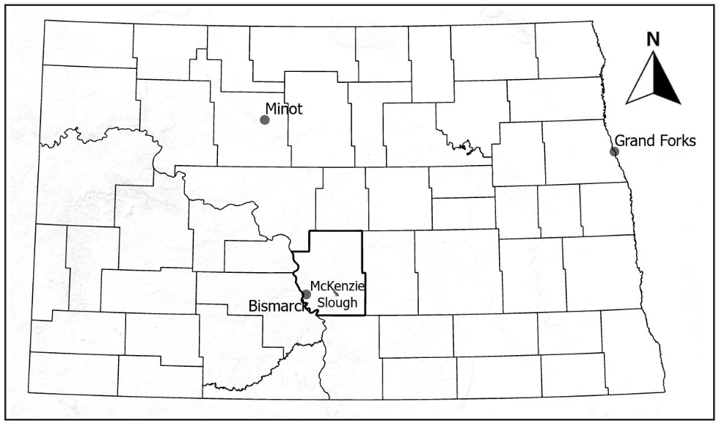
Figure 2. Annual timeseries of estimated daily damage to sunflower (Helianthus annus) yields based on sunflower maturity, radar-derived blackbird (Icteridae) abundance, and bioenergetics calculations near the McKenzie Slough in North Dakota, USA (solid line) from 2012 to 2019. Each figure starts at the beginning of anthesis (R6), and the curve represents the percent of mature (R9) sunflower fields across the state. Mature sunflower fields decreased as fields were harvested, but we disregarded the number of harvested fields in our damage calculation. Dashed lines represent the beginning of sunflower harvest (left) and when 50% of the fields were harvested (right) statewide in North Dakota (except in 2019 when radar indicated migration prior to 50% harvest). The diamond on the solid line represents the maximum blackbird abundance at the focal roost (McKenzie Slough).
Figure 2.1
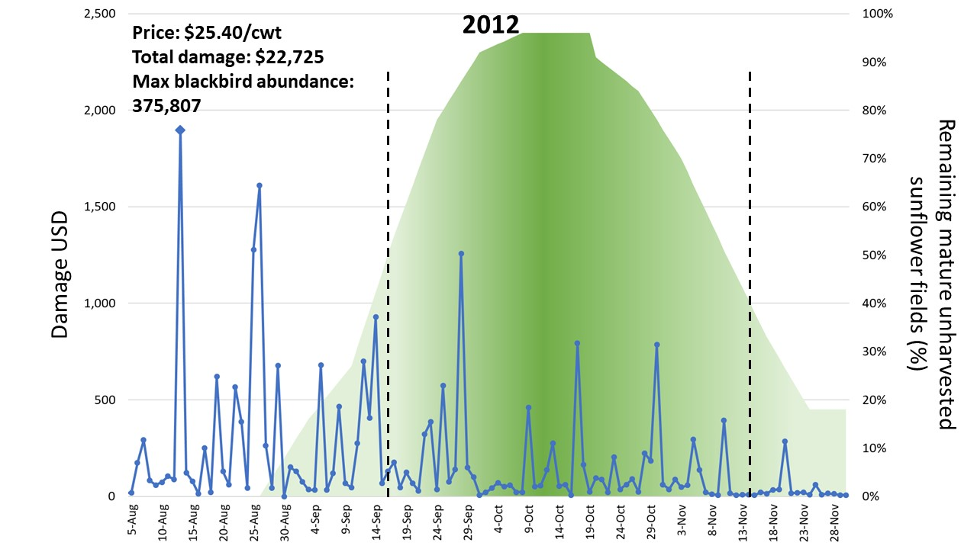

Figure 2.2
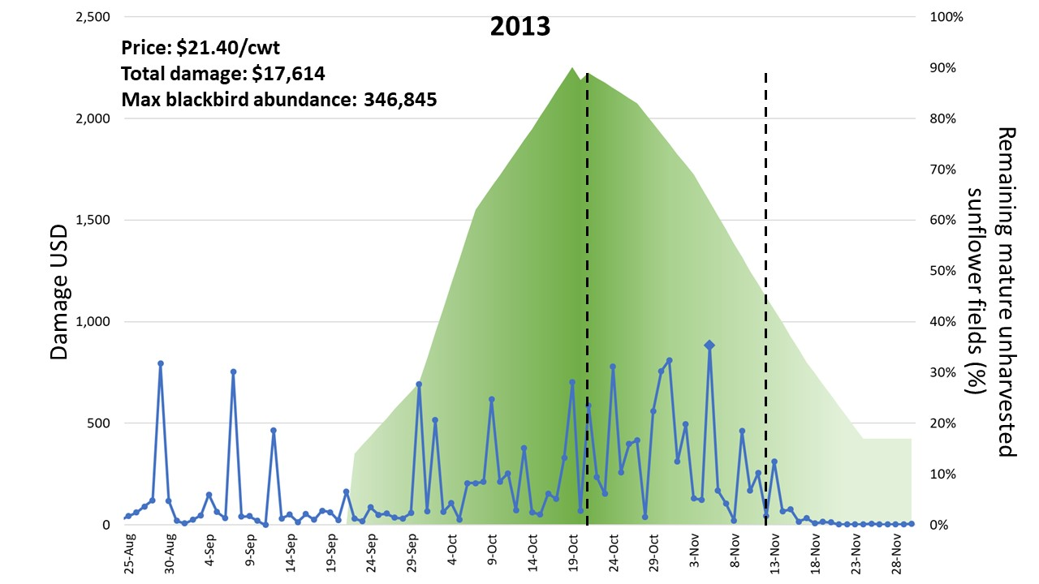
Figure 2.3
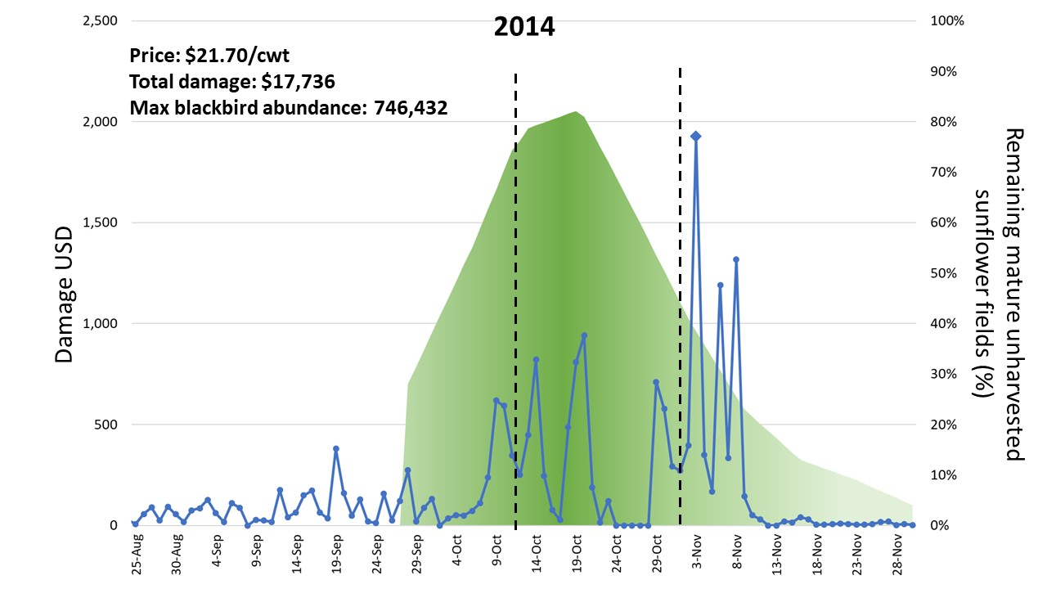

Figure 2.4
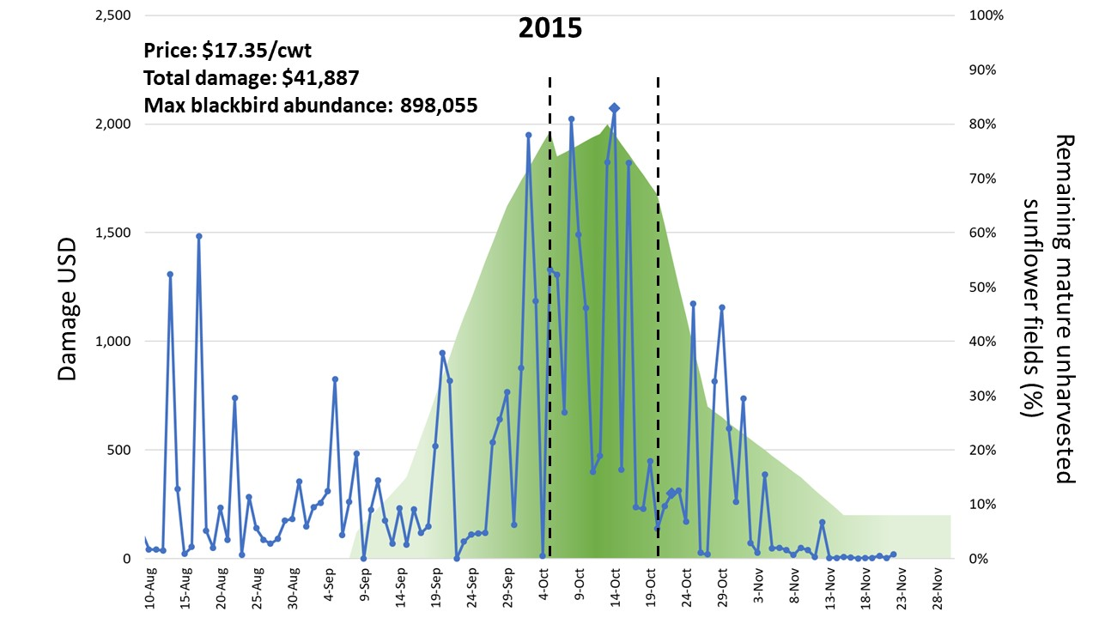
Figure 2.5
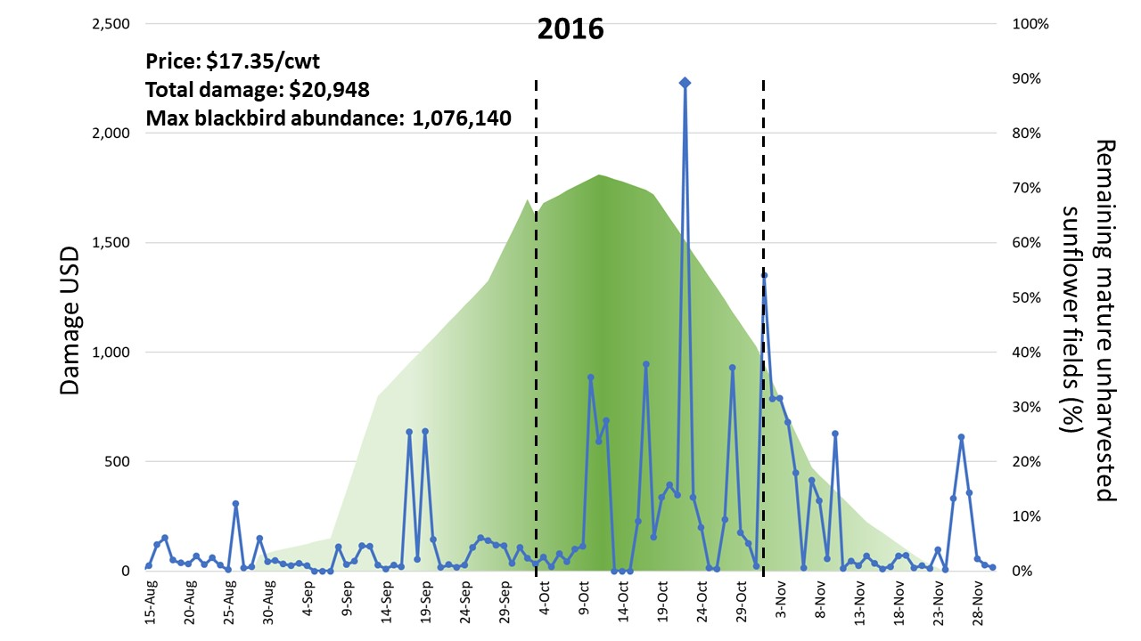

Figure 2.6
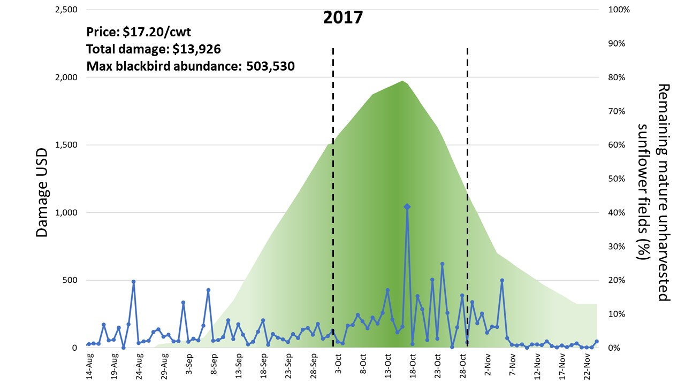
Figure 2.7
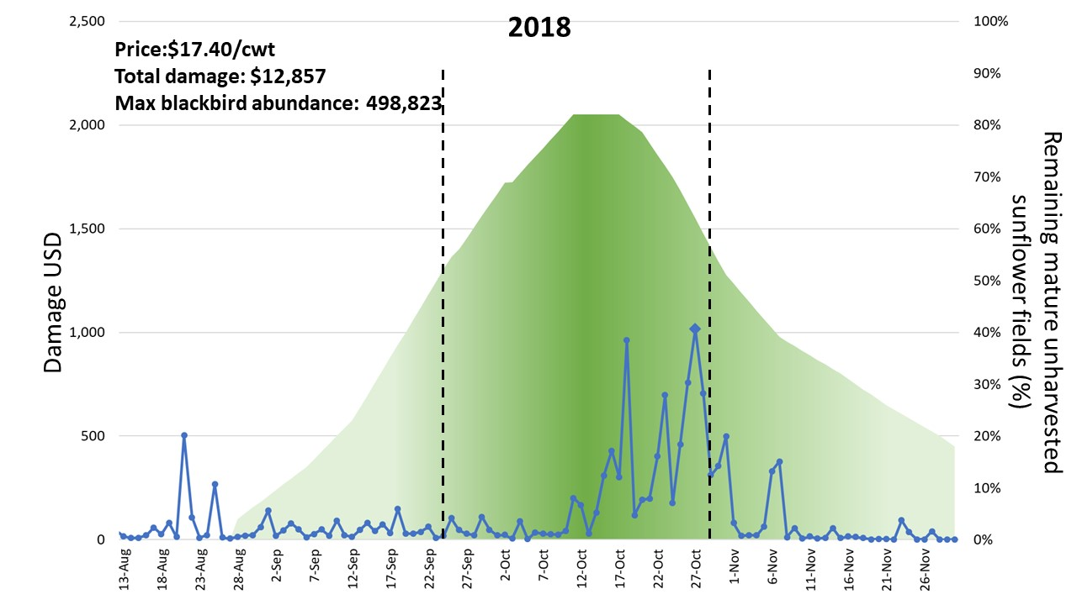

Figure 2.8
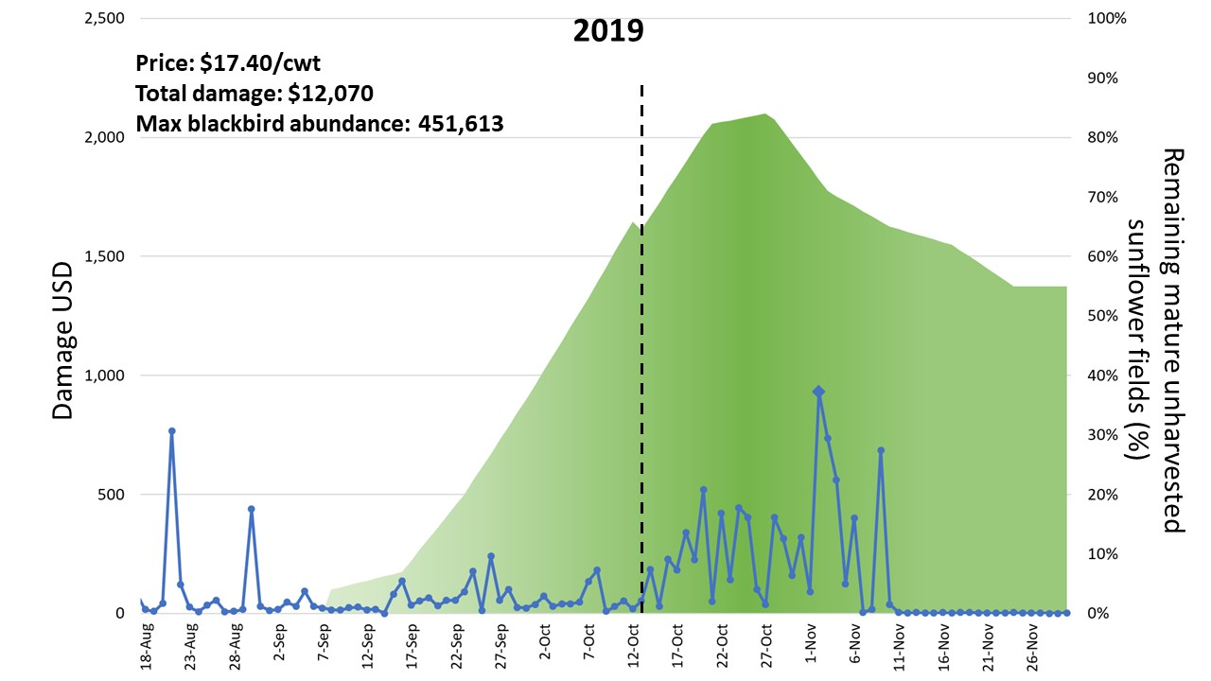

Appendix S1.
Here we give a short explanation of the bioenergetics values, which we have derived directly from Peer et al. (2003), where their full determinations can be found. We took the average field metabolic rate (FMR) of red-winged blackbirds (Agelaius phoeniceus; RWBL), 168 kJ/g, derived from the Peer et al. (2003) determination that male and female red-winged blackbird FMR are 194 and 142 kJ/g, respectively. The metabolizable energy content (MBE) of sunflower achenes depends on their growth stage. From when petals are dry (anthesis), the MBE is 15.28 kJ/g (Connor and Hall 1997). However, as the sunflower approaches maturity, the energy content of sunflower achenes doubles to 30.56 kJ/g. Due to low energy content in the earlier growth stage following anthesis (petal drop), blackbirds would need to consume more to meet their metabolic requirements. In this growth stage, sunflowers can compensate more for losses and focus energy to achenes that are not damaged (Sedgwick et al. 1986, Peer et al. 2003). However, as these crops reach maturity, they are less able to compensate. Thus, Peer et al. (2003) separated the damage period into 2 periods: 14 days following anthesis and the subsequent 28 days where the crops were at or near maturity. Compensation during period 1 is 0.85 whereas in period 2 they removed compensation from the equation. Instead of separating plant growth stages into 2 periods, we have accounted for the change in compensation based on the percentage of sunflower fields in their mature stages using the equation [0.85 + (0.15 * % of mature sunflower fields)] to represent less compensation as more fields approached maturity and were unable to compensate for achene losses.
Constants derived from Peer et al. (2003) concerning the economic damage equation model included the proportion of sunflowers in diet, moisture of the wet mass of the sunflower achene, and the weight of the sunflower hull, which a producer is paid. For diet, we averaged the proportion of sunflowers for both sexes of RWBL diets to be 63%. Red-winged blackbird diets are comprised of 69% and 57% sunflowers for males and females (Linz et al. 1984). The moisture of the wet mass of the achene is 1.225 (Peer et al. 2003). The hull price that producers are paid is 1.25. Price of sunflowers varies annually by year, and the price received by farmers is reported by the USDA-NASS (2020). We gathered market prices from 2012 to 2019, corresponding with the years of collected radar data on bird abundances. The resulting economic loss calculation provides an estimate for damages from an individual bird. We used this estimation and multiplied it by the number of blackbirds derived from radar-based estimates.

Atmospheric drivers of blackbird migration from a fall roost

Bonne A. Clark

Department of Biology, University of Oklahoma,
Norman, Oklahoma 73019

Abstract
Migration timing in relationship to atmospheric conditions is crucial to understanding potential shifts in seasonal movements of species and could be central to future conservation and management efforts. Research has focused on timing of spring migration because it is tied closely to breeding phenology and success, however understanding fall migration is particularly important for evaluating the influence of dynamic seasonal factors such as food availability, social context, and weather. Seasonal fluctuations in wind strength, barometric pressure, and temperature are primary atmospheric cues that migratory birds use to time migration. Further evaluation of the role that weather variables have on departure decisions might enable more informed predication of migration timing for species of interest. During their spring and fall migrations blackbirds are an important agricultural pest to corn, rice, and sunflower. Evaluation of their migration timing in response to atmospheric cues can help land managers make informed decisions about time-sensitive damage management techniques. For example, farmers can shift planting or harvest dates to evade damage by avoiding the largest number of birds. Understanding how weather patterns may impact migration timing will inform the validity of these damage management tools in the context of a changing climate. Using weather surveillance radar (WSR) and local climatological data (LCD), we evaluated atmospheric drivers of blackbird autumn migration over a nine-year period. The best model of departure (i.e., bouts of migration between peak abundance and an empty roost) included Julian date and the daily changes in pressure, v-component of wind strength, and temperature. The integrated model accounted for nearly all the model weight (0.996) in the candidate set. Our results show that on average, the final departure of blackbird was on 16 November, when weather conditions were on average at 982 mb (29 in Hg), -7○C, winds were 9 m/sec, and wind was southbound. Our null model of Julian date was not a good fit for factors driving blackbird migration, suggesting other factors were more important than daylight hours. The pressure variable was in all four top models, suggesting that changes in pressure impact blackbird’s decision to migrate. Blackbirds generally form fall roosts and then depart on fall migration from those roosts as days get shorter, temperatures drop, and weather fronts pass over the roost. We have determined that bouts of fall migration from the roost is seasonally correlated with the combination of Julian date, rises in pressure following low pressure systems, decreasing temperatures, and southbound winds acting as triggers of fall migratory departure from a focal roost.

Keywords: aeroecology, autumn migration, blackbirds, Icteridae, North Dakota, roost, weather radar

Introduction
Timing of bird migration is a flagship indicator of responses to climate and habitat change that could aid in conservation and management plans (Morisette et al. 2009). Analyses of migration timing in relation to weather can provide insight into proximate environmental factors that influence birds’ decisions to migrate. Within this environmental context, future migration phenology can be predicted for species of interest (Marra et al. 2005). Understanding recent
phenological shifts in migration timing related to climate change and weather can be insightful when examining factors that impact a bird’s or flock’s decision to migrate (Richardson 1978). In the spring, timing of migration is directly related to the reproductive success of birds (Berthold 2002). In the autumn, bird migration is more related to food availability, social context, and weather (Alerstam and Hedenström 1998). Evaluating the impact and relationship of external factors on migration timing can provide insight into which factors are important to particular species (O’Neal et al. 2018; Van Doren and Horton 2018). Previous studies on avian migration have found that wind speeds and directions, and changes in temperature and barometric pressure are primary factors that have a strong relationship with the decision to migrate (Richardson 1978). Winds are a particularly influential weather condition in explaining bird departure decisions. Birds can differentiate between favorable and unfavorable wind conditions (Erni et al. 2002). Southbound tailwinds in the fall directly reduce the energetic cost of flying for migratory birds (Richardson 1978). Air temperature has been shown to cue bird migration throughout the season on a large latitudinal distribution (Kelly et al. 2016). Differences in temperature from one day to the next is a potential cue for bird departure (Richardson 1978). Changes in barometric pressure are one of the first signs of a front moving through and is a cue for future weather conditions, which may influence avian departures (Richardson 1978).
There is particular interest in predicting the migration phenology of blackbirds (Icteridae) because they are important agricultural pests in various crops (Linz et al. 2011; Klug 2017). Every autumn, migratory blackbirds join resident breeding populations in the Prairie Pothole Region (PPR), an area rich in sunflower (Helianthus annuus) and corn (Zea mays) used as food resources and abundant cattail (Typha spp.) sloughs used as roosts (Meanley 1965). Sunflowers are high in caloric content and provide a rich food resource as a stopover site for migratory and premigratory blackbirds (Peer et al. 2003). The majority of crop damage from blackbirds occurs prior to autumn migration between mid-August and sunflower harvest in October (Cummings et al. 1989, Clark et al. 2020), when blackbird congregations are at their largest (Werner et al. 2005). Damage to agricultural crops is greatest near blackbird nocturnal roosting sites, which are large cattail marshes in this area of North Dakota (Linz and Hanzel 1997, Werner et al. 2005).
Roosts are also used as stopover locations when birds migrate between their breeding and wintering grounds, where they may form new roosts or join resident populations of blackbirds (Meanley 1965). Many species of blackbirds stopover in North Dakota during their autumn migratory season causing local population increases as migrants of multiple blackbird species integrate with local breeding populations at roost sites (Dolbeer, 1978). Although, species composition at roost sites varies (Meanley 1965), red-winged blackbirds (Agelaius phoeniceus) are one of the main species foraging on sunflower and corn in the autumn season and are the major contributors to crop damage (Dolbeer and Linz 2016). In addition to red-winged blackbirds, some combination of yellow-headed blackbirds (Xanthocephalus xanthocephalus), common grackles (Quiscalus quiscula), brown-headed cowbirds (Molothrus ater), Brewer’s blackbirds (Euphagus cyanocephalus), rusty blackbirds (Euphagus carolinus), and European starlings (Sturnus vulgaris) can be found within the same roosting sites (Meanley 1965). Species may forage separately during the day but return to the communal roost in the evening (Meanley 1965).
Blackbird populations in the PPR increase throughout the fall season due to addition of the season’s fledglings and the influx of migrants from further north. Flocks of blackbirds can number up to 500,000 (Dolbeer et al. 2017), resulting in substantial damage to sunflower crop yields (Klosterman et al. 2013). These significant losses are often near cattail swaths which can be used as roosts (Linz 1997). Roost sites are frequently near available food and favorable habitat, usually marshes with large cattail swaths, which are abundant in the PPR (Meanley 1965, Linz and Hanzel 1997). Regional damages to sunflower crops can be as low as 2% but will often approach >20% locally when there are higher concentrations of blackbirds, particularly near roost sites (Klosterman et al. 2013). This significant crop damage is usually found within 8 km of a wetland roost (Dolbeer et al. 1990). Damages typically occur over an 8-week period in the fall (Cummings et al. 1989). Earlier damages to sunflower are important because blackbirds need to consume more immature sunflower achenes to meet their metabolic energy demands (Cummings et al. 1989, Peer et al. 2003), however later damage is high due to the large number of birds on the landscape damaging mature yet unharvested sunflower fields (Clark et al. 2020). Knowing how and why blackbird numbers aggregate and depart for migration could be useful for producers and land managers when creating management plans.
Timing of blackbird peak abundance and fall migration is crucial for producers to make informed decisions about time-sensitive damage management techniques (Linz et al. 2017). Current methods to mitigate damages from blackbirds include use of hazing, chemical repellents, lethal culls, cattail reduction, crop desiccation, and shifting crop phenology earlier (Linz et al. 2011). Efficacy of some of these strategies could be improved by knowing what atmospheric factors are driving the timing of blackbird roost abundance and migration. Deployment of hazing devices could be targeted to flocks prior to large waves of migrants appearing. Knowing when blackbird numbers are likely to surge in the fall season, producers can prepare to shift planting or harvest dates (i.e. though crop desiccation or planting early-maturing varieties) to evade damage by avoiding the largest number of birds (Clark et al. 2020). Blackbirds generally form fall roosts and then depart on fall migration from those roosts as days get shorter, temperatures drop, and weather fronts pass over the roost. While initiation of fall migration from the roost is seasonally correlated with these factors it is unclear which, if any, act as specific triggers of migratory departure. There is a need for an improved fundamental knowledge of blackbirds’ migratory phenology, which could create opportunities to manage conflicts with agriculture while conserving a native bird species.
It remains largely unknown how environmental variables drive daily fluctuations of blackbird populations throughout the autumn roosting season. Quantifying these factors could provide vital information to land managers about the timing of large congregations of blackbirds accumulating at roosts and their subsequent departure. Recent studies have found that blackbirds have expanded their intermigratory timing by ~20 days (i.e. earlier arrival and later departure) within the last couple of decades, suggesting that climate and atmospheric factors are influencing the timing of migration (Van Buskirk et al. 2009). Weather effects have been hypothesized as a primary factor of autumn migration for migratory birds (Richardson 1990). On a regional scale, weather (i.e. precipitation) was a significant factor in determining blackbird abundance and breeding success in the spring (Forcey et al. 2015), which may consequently impact migration timing (i.e., earlier success in breeding results in earlier molt and migration). Thus, management techniques may be mistimed in relation to the changing timing of blackbird fall migration.
The NEXRAD system in the United States is primarily used for weather forecasting, however NEXRAD has been increasingly used to monitor biological phenomena (Bauer et al. 2019, Bridge et al. 2016, Kelly and Pletschet 2018, Stepanian et al. 2019). The ~145 weather surveillance radars have comprised NEXRAD over the past ~25 years (NOAA 2019). Archived data have allowed researchers to evaluate migration timing of several migratory species (Bauer et al. 2019). However, it has yet to be used to monitor blackbird (Icteridae) migration. There is a long history of studying migration movements of birds by tracking individuals with biologgers and accelerometers in addition to observational data (Thorup et al. 2014, Shamoun-Baranes et al. 2017, Eshleman 2019, Stonefish et al. 2021). However, the network of NEXRAD radars combined with field-observations has enabled the study of migration phenology, and magnitude of flock sizes, in relation to weather over large areas (Bauer et al. 2019, Kelly et al. 2012, 2016, Van Doren and Horton 2018). Radar can pinpoint the magnitude of biological scatterings and provide insight into what atmospheric factors are important to airborne species at those specific times (Van Doren and Horton 2018).
We have identified a large blackbird roost within the PPR in North Dakota that was routinely detected on radar from 2012 to 2020 (Clark et al. 2020). Our objective was to evaluate the relationship between atmospheric conditions and blackbird departure for fall migration at this roost. Specifically, we focused our study on how weather variables influence fall migration timing in a landscape with abundant food resources. Our results could inform agricultural producers and land managers about ideal timing of management techniques to reduce crop damages.

Methods

Radar methods
We downloaded level II reflectivity data from the Bismarck, ND NEXRAD radar, KBIS, which is located ~20 km west of the roost. Radar data was accessed using Amazon Web Services and opened using the Py-ART package (Helmus and Collis 2016). We downloaded data from a 575 km² domain that encompassed the geographic range of morning roost activity. Data from the lowest elevation sweep of the radar (~90-670 m above ground level) were downloaded. Manual screening of the radar data indicated that blackbirds did not fly above this elevation (Clark et al. 2020). Data were downloaded from 01 August to 30 November from 2012 to 2020, a period during which we know the roost was active. We identified 15 days from 2012-2020 that had uncharacteristically high levels of reflectivity from super-refraction of the radar beam, a phenomenon that can occasionally occur with some weather conditions (van den Broeke 2019). We removed these days from our analyses. Additionally, there were 19 days throughout the 9 years when the radar was down, therefore were not included in our analyses. Each morning, we processed data from 1 hour before sunrise to 2 hours after sunrise (~1200-1500 UTC), corresponding with timing of the blackbird morning roost exodus. Using the depolarization ratio (DR) (Kilambi et al. 2018), we censored out meteorological data, and retained data associated with biological scatterers that we visually confirmed to be blackbird flocks dominated by red-winged blackbirds from September to October 2019 (Clark et al. 2020). We estimated the number of blackbirds by dividing the summed reflectivity by the approximate radar cross section (RCS) (15.5 cm²) of a blackbird. This RCS was determined from the average mass of North Dakota red-winged blackbirds (60 g) (Linz 1982) using an equation from Horton et al. (2019). We applied this approach to the radar scan that captured the maximum reflectivity for each day to determine the maximum number of blackbirds for daily population estimates.

Weather data
We accessed local climactic data (LCD) from the National Oceanic and Atmospheric Administration (NOAA) from the Bismarck, ND database (NOAA/NCEI 2020) including the daily temperature, wind speed and direction (v-component), and barometric pressure. Using weather conditions at the time of maximum blackbird abundance for each morning, we calculated daily change in each atmospheric weather variable (Table 2). Weather data was from a ~600 m above ground level. We calculated the v-component using the equation [wind speed * sin(wind direction)], giving a negative value to northerly winds and a positive value to southerly winds, expecting southbound winds to have a positive impact on probability of fall migration. Temperature was derived from dry-bulb temperature or using a thermometer freely exposed to the air but shielded from radiation and moisture. The cue for migration in relation to temperature is more uncertain on a finer (i.e., daily) scale (Bellrose 1973). Temperatures decrease throughout the fall season in North Dakota, indicating a shift towards winter. Therefore, decreasing temperatures are expected to increase the probability of migration. Barometric pressure was considered falling (i.e., wet, stormy weather) or rising (i.e., clearing storm becoming sunny), and we expected the period immediately following low pressure systems to increase the probability of migration. Cold fronts are typically low-pressure systems. Birds are more likely to migrate in the fall immediately following a cold front where the air is dry and cool (Bagg et al. 1950, Richardson 1978).

Departure determination
We considered departure from the focal roost across the seasonal population-level migratory exodus in the late fall. We defined this fall migration window as beginning when blackbirds at the roost reached their seasonal peak abundance and ending when abundance returned to their lowest numbers in the late fall. During this period, migratory blackbirds en route from northern or surrounding roosts may aggregate with the blackbirds at this focal roost (Homan et al. 2004), therefore days with high abundance may be an indication of blackbirds arriving at the roost as a stopover location. We considered these day-to-day variations in blackbird abundance with the weather candidate models. The day-to-day fluctuations of reflectivity (blackbirds) at the roost can be impacted by refraction of the radar beam due to atmospheric conditions (van den Broeke et al. 2019), therefore categorizing these days as departures (or not) may not be accurate. Thus, we also focused on the final departure day from this particular roost and what local weather conditions were present. Through manual screening of the radar and evaluating the time series of blackbird abundance each year, the final migration day was determined for each year. The final migration was determined as a cumulative departure of a threshold exceeding 90% of the peak population. Departure was achieved when blackbird abundance reached their lowest numbers after the peak blackbird abundance, and were followed by several subsequent days of little to no detected blackbirds (<5,000) for the rest of the fall, signaling that the majority of blackbirds have departed from the roost and potentially the surrounding area (Figure 3).

Model development and statistical analyses
Using weather variables previously described, we developed a set of potential candidate weather models to explain timing of migration departure of blackbirds from the fall roost. Our null model was that migration timing depends only on date (Julian date). We also examined more complex models that included combinations of main effects and interaction terms of the three explanatory variables: temperature, barometric pressure, and wind strength (Table 2). The fall migration period is typically less controlled by daylength than spring (Alerstam 1990). However, some studies have shown that seasonality may still have an impact on the probability of migration departure in the fall (Nichols et al. 1983). For this reason and to account for random differences among years, we have included year as a random effect in all models. We modeled blackbird migration departure from the roost using the lme function in the lme4 package in Program R (R Core Team, 2020). Candidate weather models were evaluated using Akaike’s Information Criterion (AIC). Models within ∆AIC <10 were considered competitive (Burnham and Anderson 2002). We report the number of parameters, AIC values, ∆AIC values, model weights, relative likelihoods (evidence ratios), and beta coefficients of each model.

Results

Blackbird roost phenology
The seasonal peak of blackbird abundance was on average on October 27th for every year except 2012, where the peak was much earlier, on August 13th. The largest and final blackbird migration was on average on November 16th, except for in 2020 when the largest migration occurred on November 5th. In 2020, the KBIS was down from November 6-13, which is within the window of primary migration timing for all other years (2012-2019). On 04 November, 460,000 blackbirds were detected at the roost, yet we do not have data following this day. Therefore, it is possible the final migration day in 2020 may have been within this timeframe. Omitting 2020 from the analysis did not result in any significant differences from the main analysis (<2 units change in ∆AIC, no change in model weight or relative likelihood). Omission of 2020 did not skew results; therefore we retained these data in the analyses. The final migration, or the date at which the roost was nearly completely departed, occurred on average 19 (4 ± SE) days after peak blackbird abundance for all years except 2012, when final migration occurred 72 days after maximum bird abundance. Omission of 2012 did not significantly change results of the AIC model analysis.

AIC analysis
The main effects only model with Julian date, wind strength, temperature, and pressure as explanatory variables was the top model for describing departure relative to weather; it captured most of the model weight (0.996) (Table 3). The main effects and interactions model based on temperature and pressure had minimal model weight of 0.002 (∆AIC = 12.26). The main effects model of wind, temperature, and pressure (∆AIC = 14.05) and interaction and main effects model of wind * pressure (∆AIC = 15.35) had little weight (<0.001) in explaining blackbird departure. All other models had ∆AIC >16. The individual main effects models of temperature, wind, and Julian date least explained blackbird departure. The daily change in pressure as a variable (R = 0.005, M = 0.13, SD = 0.27) (Figure 4.4, Figure 5.3) had the most impact on explaining blackbird departure because it was in all four of the top models (Table 3). Daily changes in temperature (R = -0.07, M = 0.12, SD = 6.41) (Figure 4.3, Figure 5.2) was the second-best explanatory variable, being in the top three models (Table 3). Daily changes in wind strength (R = -0.07, M = -0.12, SD = 9.14) (Figure 4.2, Figure 5.1) was the third best explanatory variable being in three of the top four models (Table 3). Temperature and pressure had a moderate negative correlation (R = -0.6). Julian date and temperature had a weak negative correlation (R = -0.5) with temperature and was not well-associated with barometric pressure (R = 0.05) or wind strength (R = -0.002). Wind had minimal influence on barometric pressure (R = 0.09) or temperature (R = 0.001).
Although migration timing was typically within a few days (± 9) of November 16th, our null model of daylength (Julian date) was not a competitive description of migration timing (∆AIC = 58) (Table 3). In the best model, Julian date (β = -312, 95% CI = -2636 – 2012), wind strength (β = -1924, 95% CI = -6064 – 2218 ), pressure (β = -93000, 95% CI = -270,000 – -85000), and temperature (β = -4900, 95% CI = -9900 – 203) negatively affected departure (Table 4). On average, the final autumn migration days for this blackbird roost occurred when pressure was 982 mb (29 in Hg), temperature was -7○C, wind speed was 9 m/sec, wind was southbound, and the Julian date was 320 (16 November).

Discussion
Our main effects model which included Julian date, wind strength, pressure, and temperature was the best model among the other candidate weather models to explain blackbird departure from the fall roost (Table 3). Our null model of daylength (i.e., Julian date) was not a good fit for factors driving blackbird migration, suggesting that other factors were more important than daylight hours. The best single explanatory variable was change in barometric pressure, which was in all of the top four models. Air pressure changes are one of the first local signs of a potential arriving weather front, therefore it is unsurprising that it would be one of the most influential weather effects on bird migration (Richardson 1978, Liechti 2006, Kemp et al. 2013). Bird migrations en masse typically occur immediately following a cold front when the air is cold and dry (low-pressure system) to clearing weather (rising pressure) (Bagg et al. 1950, Richardson 1978). Therefore, we expected an initial rising change in pressure to increase the probability of blackbird departure. Alone, pressure had little weight in explaining blackbird departure (R = 0.005). However, the top model (i.e. main effects of Julian date, wind, temperature, and pressure) indicated that as the change in pressure, temperature, and wind increases, bird abundance decreases (Table 4).
The largest blackbird migration occurred, on average on November 16th, except for in 2020 when blackbird migration occurred on November 5th. Timing of peak blackbird abundance to final migration was on average a 19-day period (SD = 5, CI = 17 – 21) for all years expect 2012, which had a 72-day period between maximum abundance and a final departure. This window of time could be crucial for producers to consider for management plans. During this period, migratory blackbirds en route from northern or surrounding roosts may aggregate with the blackbirds at this focal roost (Homan et al. 2004), therefore days with high abundance may also be an indication of blackbirds arriving at the roost as a stopover location. Flocks of blackbird typically congregate in large roosts before migrating, when migrating blackbirds may join roosting populations of premigratory blackbirds (Meanley 1965, Dolbeer 1978). Waves of migrants move through the landscape in the fall as blackbirds complete molt (Linz et al., Twedt et al. 2015, Klug et al. 2019). Variation of molt patterns in blackbird species may be influenced by environmental factors which could shift migration timing (Klug 2017). For example, increasingly warmer temperatures have been linked to an increase of abundance of common grackles in North Dakota (Forcey et al. 2015). With changing climates, there may be more changes in species compositions, ages and sexes extending their intermigratory time (Van Buskirk et al. 2009), thus contributing to more crop damage. Typically, the first red-winged blackbirds complete molt towards the beginning of September and continue through the end of September (Linz et al. 1983). Therefore, blackbirds in surrounding areas (i.e. northern roosts) may be migrating south and aggregating with the focal roost. Crop damages during this peak abundance and migration time could be severe. Thus, atmospheric indicators of blackbird migration can help predict when roost populations may surge and when they may depart for migration (Forcey et al. 2015, Klug 2017).
Potential future directions in studying abiotic and biotic factors of blackbird departure include other weather and landscape correlates (Blackwell and Dolbeer 2001, Savard et al. 2011). Cloud cover and precipitation have been influential factors in other bird migration studies, which may consequentially impact blackbird migration timing as well (Beason 1978, Richardson 1978). Birds typically migrate in clearer sky conditions with no precipitation, yet some larger bodied birds (e.g. water birds) will attempt to climb above the clouds (Richardson 1978). More study is needed on the impact of weather associations such as cloud cover and precipitation on migrating blackbirds (Forcey and Thogmartin 2017). Evaluation of landscape correlates, such as food and roosting habitat availability, can give more insight to driving factors of blackbird abundance and migration (Forcey et al. 2015). Peak mature unharvested sunflower crop availability on a statewide scale overlaps with blackbird abundance at this roost (Clark et al. 2020). However, there is a need for local landscape data on crop growth stages to understand how crop availability may influence blackbirds’ decision to migrate and stopover durations.
The study of abiotic factors of blackbird abundance and migration could be expanded to other known blackbird roosts and at other points in the annual cycle (e.g., spring migration). This could provide a more in-depth understanding of migration phenology and timing for blackbird species. NEXRAD has ~25 years of archived data, if other known blackbird roosts are identified, we can evaluate trends in migration phenology over time and potential drivers in these changes. NEXRAD can be used as a counting method for blackbirds within ~20 km of a known roost (Clark et al. 2020). However, the difficulty arises with how fine a scale we can evaluate environmental correlates to blackbird behavior on radar. Evaluating effects of the weather at the scale of a single day on blackbird behavior may be limited. Thus, multi-year and time-series patterns are needed to closely tie the association of weather variables to blackbird behaviors that are detectable by radar.
Birds departed from the roost with weather changes that are associated with later dates in the fall. Changes in crop phenology and food availability on the landscape (i.e., unharvested sunflower) are more likely associated with daylight hours (date) and temperature (growing degree-days), as opposed to winds and pressure changes (Qadir and Malik 2007). As temperatures decreased later in the season, blackbirds were more likely to depart from the roost (Figure 5.2). This relationship with temperature suggests that blackbird migration timing could be impacted by climate change, potentially extending the period of elevated risk for localized crop damages in the PPR.

References
Alerstam, T., and A. Hedenström. 1998. The Development of Bird Migration Theory. Journal of Avian Biology, 29(4), 343–369. JSTOR. https://doi.org/10.2307/3677155
Bagg, A. M., W. W. H. Gunn, S. D. Miller., J. T. Nichols, W. Smith, and F. P. Wolfarth.1950. Barometric Pressure-Patterns and Spring Bird Migration. The Wilson Bulletin, 62(1), 5–19.
Bauer, S., J. Shamoun‐Baranes, C. Nilsson, A. Farnsworth, J. F. Kelly, D. R. Reynolds, A. M. Dokter, J. F. Krauel, L. B. Petterson, K. G. Horton, and J. W. Chapman. 2019. The grand challenges of migration ecology that radar aeroecology can help answer. Ecography, 42(5), 861–875. https://doi.org/10.1111/ecog.04083
Beason, R.C. 1978. The influences of weather and topography on water bird migration in the southwestern USA. Oecologia 32:153–70.
Bellrose, F.C. 1973. The effect of short-term weather conditions on the migration of waterfowl. Final report to the United States Bureau of Sport Fisheries and Wildlife. Washington, DC: Department of the Interior.
Blackwell, B. F., and R. A. Dolbeer. 2001. Decline of the red-winged blackbird population in Ohio correlated to changes in agriculture (1965-1996). Journal of Wildlife Management 65:661-667.
Bridge, E. S., S. M. Pletschet, T. Fagin, P. B. Chilson, K. G. Horton, K. R. Broadfoot, and J. F. Kelly. 2016. Persistence and habitat associations of Purple Martin roosts quantified via weather surveillance radar. Landscape Ecology, 31(1), 43–53. https://doi.org/10.1007/s10980-015-0279-0
Burnham, K.P., D. R. Anderson. 2002. Model selection and multimodel inference; a practical information theoretic approach. 2nd ed. New York:Springer-Verlag.
Clark B.A, P.E. Klug, P.M. Stepanian, J.F. Kelly. 2020. Using bioenergetics and radar-derived bird abundance to assess the impact of a blackbird roost on seasonal sunflower damage. Human-Wildlife Interactions. 14(3).
Cummings, J. L., J. L. Guarino, and C. E. Knittle. 1989. Chronology of blackbird damage to sunflowers. Wildlife Society Bulletin 17:50–52.
Dolbeer, R. A. 1978. Movement and Migration Patterns of Red-Winged Blackbirds: A Continental Overview. Bird-Banding, 49(1), 17. https://doi.org/10.2307/4512315
Erni B., F. Liechti, K. G. Underhill, B. Bruderer. 2002. Wind and rain govern intensity of nocturnal bird migration in Central Europe: a log-linear regression analysis. 90:155–66
Eshleman, M. A. 2019. Red-winged Blackbird Migration and its Relationship with Reproduction. North Dakota State University, Fargo, ND, USA.
Forcey, G. M., W. E. Thogmartin, G. M. Linz, P. C. Mckann, and S. M. Crimmins. 2015. Spatially explicit modeling of blackbird abundance in the Prairie Pothole Region: Landscape Models of Blackbirds. The Journal of Wildlife Management, 79(6), 1022–1033. https://doi.org/10.1002/jwmg.912
Forcey, G.M. and W.E. Thogmartin. 2017. Effects of habitat and climate on blackbird populations. Pages 160 - 190 in G. M. Linz, M. L. Avery, and R. A. Dolbeer, editors. Ecology and management of blackbirds (Icteridae) in North America. CRC Press, Boca Raton, Florida, USA.
Helmus, J. J., and S. M. Collis. 2016. The python ARM radar toolkit (Py-ART), a library for working with weather radar data in the python programming language. Journal of Open Research Software 4:e25.
Homan, H., G. M. Linz, R. M. Engeman, and L. Penry. 2004. Spring dispersal patterns of red-winged blackbirds, Agelaius phoeniceus, staging in eastern South Dakota. Canadian Field-Naturalist 118:201-209
Kelly, J. F., K. G. Horton, P. M. Stepanian, K. M. de Beurs, T. Fagin, E. S. Bridge, and P. B. Chilson. 2016. Novel measures of continental-scale avian migration phenology related to proximate environmental cues. Ecosphere, 7(9), e01434. https://doi.org/10.1002/ecs2.1434
Kelly, J. F., and S. M. Pletschet. 2018. Accuracy of swallow roost locations assigned using weather surveillance radar. Remote Sensing in Ecology and Conservation, 4(2), 166–172. https://doi.org/10.1002/rse2.66
Kelly, J. F., J. R. Shipley, P. B. Chilson, K. W. Howard, W. F. Frick, and T. H. Kunz. 2012. Quantifying animal phenology in the aerosphere at a continental scale using NEXRAD weather radars. Ecosphere, 3(2), art16. https://doi.org/10.1890/ES11-00257.1
Kemp, M.U, J. Shamoun-Baranes, A. M. Dokter, E. van Loon, W. Bouten. 2013. The influence of weather on the flight altitude of nocturnal migrants in mid-latitudes. Ibis. 155, 734–749.
Kilambi, A., F. Fabry, and V. Meunier. 2018. A Simple and Effective Method for Separating Meteorological from Nonmeteorological Targets Using Dual-Polarization Data. Journal of Atmospheric and Oceanic Technology, 35(7), 1415–1424. https://doi.org/10.1175/JTECH-D-17-0175.1
Klosterman, M. E., G. M. Linz, A. A. Slowik, and H. J. Homan. 2013. Comparisons between blackbird damage to corn and sunflower in North Dakota. Crop Protection, 53, 1–5. https://doi.org/10.1016/j.cropro.2013.06.004
Klug, P. E. 2017. The future of blackbird management research. Pages 217–234 in G. M. Linz, M. L. Avery, and R. A. Dolbeer, editors. Ecology and management of blackbirds (Icteridae) in North America. CRC Press, Boca Raton, Florida, USA.
Liechti, F. 2006. Birds: blowin’ by the wind? J. Ornithol. 147, 202–211.
Linz, G. M., H. J. Homan, S. J. Werner, H. M. Hagy, and W. J. Bleier. 2011. Assessment of Bird-Management Strategies to Protect Sunflowers. BioScience 61(12):960–70.
Linz, G. M., L. M. Avery, and R. A. Dolbeer. 2017. Ecology and Management of Blackbirds (Icteridae) in North America. CRC Press, Boca Raton, Florida, USA.
Linz, G. M., S. B. Bolin, and J. F. Cassel. 1983. Postnuptial and postjuvenal molts of redwinged blackbirds in Cass County, North Dakota. Auk 100:206–209.
Marra, P. P., C. M. Francis, R. S. Mulvihill, and F. R. Moore. 2005. The influence of climate on the timing and rate of spring bird migration. Oecologia 142:307-315.
Meanley, B. 1965. The Roosting Behavior Of The Red-Winged Blackbird In The Southern United States. The Wilson Bulletin, 77(3), 12.
Morisette, J. T., Richardson, A. D., Knapp, A. K., Fisher, J. I., Graham, E. A., Abatzoglou, J., Wilson, B. E., Breshears, D. D., Henebry, G. M., Hanes, J. M., and Liang, L. 2009. Tracking the rhythm of the seasons in the face of global change: Phenological research in the 21st century. Frontiers in Ecology and the Environment, 7(5), 253–260. https://doi.org/10.1890/070217
NOAA/NCEI, 2020: Local Climatological Dataset from Bismarck Municipal Airport, ND.
Subset used: August 2012–November 2020, accessed 1 December 2020.
<https://www.ncdc.noaa.gov/cdo-web/datatools/lcd>.
O’Neal, B. J., J. D. Stafford, R. P. Larkin, and E. S. Michel. 2018. The effect of weather on the decision to migrate from stopover sites by autumn-migrating ducks. Movement Ecology, 6. https://doi.org/10.1186/s40462-018-0141-5
Qadir, G. and M. A. Malik, 2007. Growing degree days and yield relationship in sunflower (Helianthus annuus L.). International Journal of Agriculture and Biology (Pakistan).
R Core Team. 2020 R: a language and environment for statistical computing. Vienna: R Foundation for statistical computing. https://www.R-project. org/. Accessed 1 Dec 2020.
Richardson, W. J. 1990. Timing of Bird Migration in Relation to Weather: Updated Review. In E. Gwinner (Ed.), Bird Migration (pp. 78–101). Springer. https://doi.org/10.1007/978-3-642-74542-3_6
Richardson, W. J. 1978. Timing and Amount of Bird Migration in Relation to Weather: A Review. Oikos, 30(2), 224–272. https://doi.org/10.2307/3543482
Savard, J. P. L., C. Melanie, and D. Bruno. 2011. Exploratory analysis of correlates of the abundance of rusty blackbirds (Euphagus carolinus) during fall migration. Ecoscience 18: 402– 408.
Shamoun-Baranes, J., F. Liechti, and W. M. G. Vansteelant. 2017. Atmospheric conditions create freeways, detours and tailbacks for migrating birds. Journal of Comparative Physiology. A, Neuroethology, Sensory, Neural, and Behavioral Physiology, 203(6), 509–529. https://doi.org/10.1007/s00359-017-1181-9
Stonefish, D., M. A. Eshleman, G. M. Linz, H. J. Homan, P. E. Klug, T. J. Greives, and E. H. Gillam. 2021. Migration routes and wintering areas of male Red-winged Blackbirds as determined using geolocators. Journal of Field Ornithology (In press).
Stepanian, P. M., C. E. Wainwright, W. F. Frick, and J. F. Kelly. 2019. Weather surveillance radar as an objective tool for monitoring bat phenology and biogeography. The Journal of Engineering, 2019(20), 7062–7064. https://doi.org/10.1049/joe.2019.0595
Thorup, K., F. Korner‐Nievergelt, E. B. Cohen, and S. R. Baillie. 2014. Large-scale spatial analysis of ringing and re-encounter data to infer movement patterns: A review including methodological perspectives. Methods in Ecology and Evolution, 5(12), 1337–1350. https://doi.org/10.1111/2041-210X.12258
Twedt, D. J., and G. M. Linz. 2015. Flight feather molt in yellow-headed blackbirds (Xanthocephalus xanthocephalus) in North Dakota. Wilson Journal of Ornithology 127:622–629.
Van Den Broeke, M. 2019. Radar quantification, temporal analysis and influence of atmospheric conditions on a roost of American robins (Turdus migratorius) in Oklahoma. Remote Sensing in Ecology and Conservation 5:193–204.
Van Doren, B. M., and K. G. Horton. 2018. A continental system for forecasting bird migration. Science, 361(6407), pp.1115-1118.
Werner, S. J., H. J. Homan, M. L. Avery, G. M. Linz, E. A. Tillman, A. A. Slowik, R. W. Byrd,
et al. 2005. Evaluation of Bird Shield ™ as a blackbird repellent in ripening rice and
sunflower fields. Wildlife Society Bulletin 33: 251– 257.

Figure 3. Timeseries of blackbird abundance in 2019 as a model for explaining the determination of blackbird departures from the roost. In 2019 this would have been six data points calculated for each bout of migration. Seasonal variation of the roost abundance displayed here for 2019 is typical for all years except 2012, when maximum blackbird abundance was earlier in the season and departure followed 73 days afterwards. Maximum blackbird abundance is displayed with a red diamond on 2 November (450,000 birds), whereas the final departure date is denoted by a red circle on 10 November, when blackbird abundance dropped significantly to <3,000 birds.
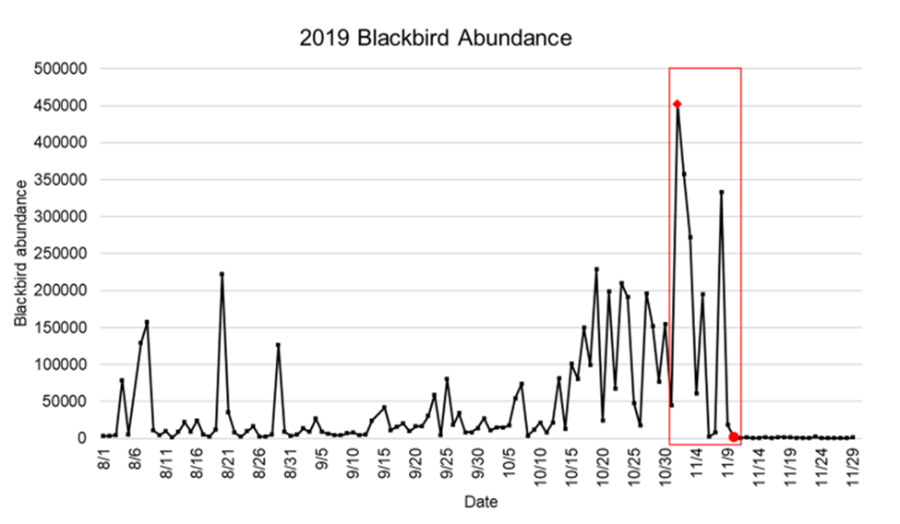
Table 2. Model variables for each hypothesis to explain the probability of blackbird migration (fall departure from roost) from the McKenzie Slough in North Dakota from to 2012-2020.

Variable | Description
Wind strength | Daily change in wind speed (m/sec) and direction (v-component)
Temperature | Daily change in dry-bulb temperature (°C)
Pressure | Daily change in barometric pressure (mb)
Date | Julian date
Combined | Julian date and daily change in wind strength, temperature, pressure

Table 3. Table of candidate models to explain the variation in the timing of blackbird departure from the North Dakota McKenzie Slough roost in the fall ranked by ascending ∆AIC. We included year as a random factor in all the models.

Model | AIC | ∆AIC | RL | w_{i} | K
Date + Wind + Temp + Pressure | 6405.90 | 0.00 | 1.00 | 1.00 | 4
Temp * Pressure | 6418.15 | 12.26 | 0.00 | 0.00 | 2
Wind + Temp+ Pressure | 6419.95 | 14.05 | 0.00 | 0.00 | 3
Wind * Pressure | 6421.25 | 15.35 | 0.00 | 0.00 | 2
Date + Wind + Pressure | 6425.01 | 19.11 | 0.00 | 0.00 | 3
Wind * Temp | 6432.68 | 26.78 | 0.00 | 0.00 | 2
Temp + Pressure | 6435.92 | 30.02 | 0.00 | 0.00 | 2
Wind + Pressure | 6439.06 | 33.17 | 0.00 | 0.00 | 2
Date + Pressure | 6441.37 | 35.48 | 0.00 | 0.00 | 2
Wind + Temp | 6443.68 | 37.78 | 0.00 | 0.00 | 2
Date + Temp | 6445.85 | 39.95 | 0.00 | 0.00 | 2
Date + Wind | 6447.24 | 41.34 | 0.00 | 0.00 | 2
Pressure | 6455.42 | 49.53 | 0.00 | 0.00 | 1
Temp | 6459.92 | 54.02 | 0.00 | 0.00 | 1
Wind | 6461.28 | 55.38 | 0.00 | 0.00 | 1
Date | 6463.57 | 57.67 | 0.00 | 0.00 | 1
* = main effects plus interaction term model
+ = main effect only model
RL = relative likelihood of model to the best model (Date + Wind + Temp + Pressure).
w_{i} = model weight
K = number of parameters

Table 4. Estimated coefficients and 95% confidence intervals for the top model (main effects: date, wind, temperature, barometric pressure) explaining fall departure of migrating blackbirds from the McKenzie Slough roost in North Dakota from 2012 – 2020.
 |  |  | 95% CI
Model | Variable | Coefficient | Lower | Upper | Avg. Coefficient | SE
Date, Wind, Temperature Pressure | Julian date | -311.70 | -2635.62 | 2012.22 | -310.45 | 1341.714
Date, Wind, Temperature Pressure | Wind | -1923.55 | -6064.21 | 2217.11 | -1915.85 | 2390.61
Date, Wind, Temperature Pressure | Temperature | -4880.22 | -9963.05 | 202.62 | -4860.70 | 2934.576
Date, Wind, Temperature Pressure | Pressure | -92528.86 | -271105.65 | 86047.94 | -92158.74 | 103101.40

Figure 4.1 – 4.4. Daily change in bird count at the McKenzie Slough in North Dakota during the fall (17 Sept. to 26 Nov.) as a function of 1) Julian date (17 September to 26 November), 2) daily change in wind strength, 3) daily change in temperature, and 4) daily change in barometric pressure.
Figure 4.1
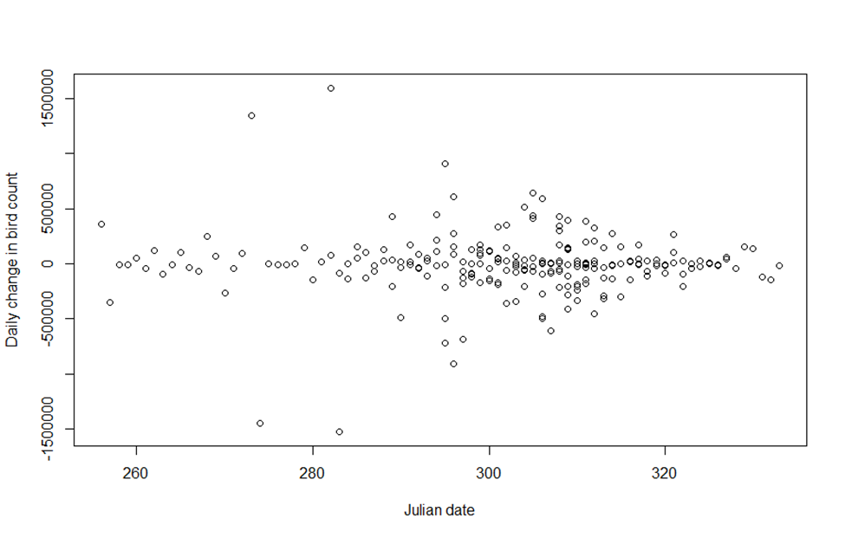
Figure 4.2
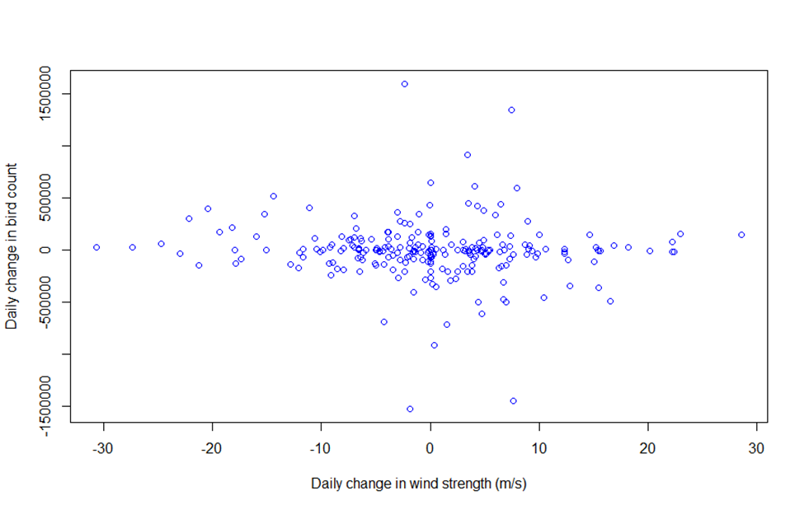
Figure 4.3
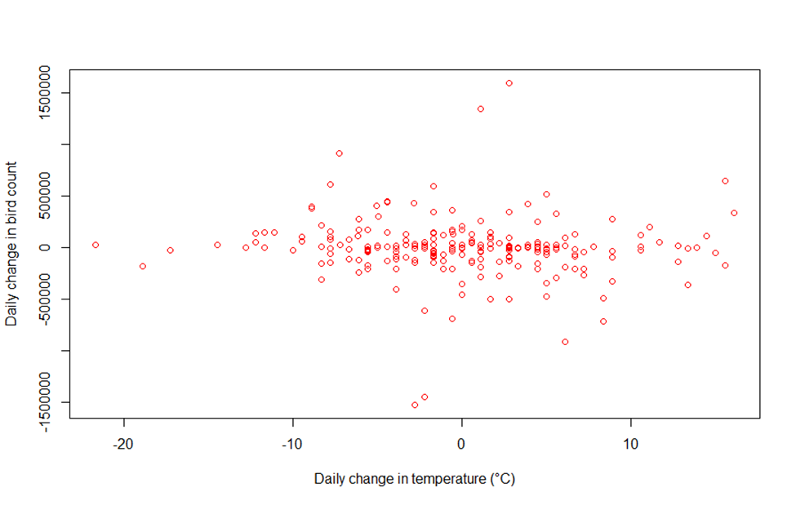
Figure 4.4
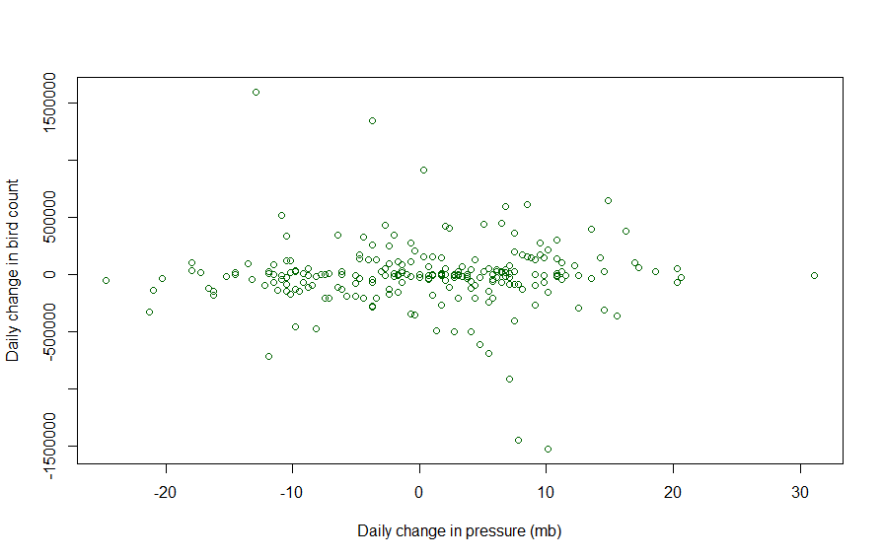

Figure 5.1 – 5.3. Sliding (5-day) average of blackbird abundance for every year (2013-2020) (except the outlier, 2012) at the McKenzie Slough roost in North Dakota during the fall (17 September to 26 November) as a function of 1) average annual wind strength (v-component), 2) average annual temperature, 3) average annual barometric pressure.
Figure 5.1
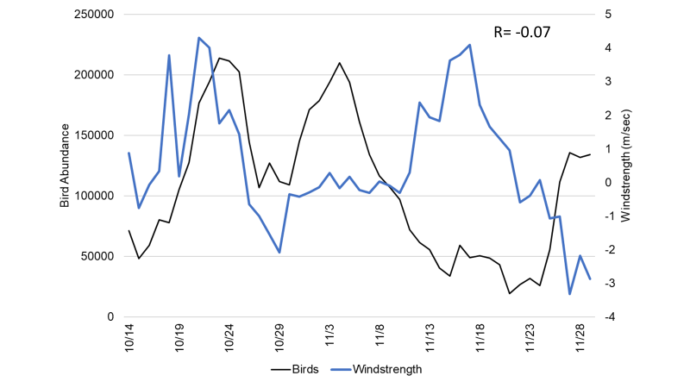
Figure 5.2
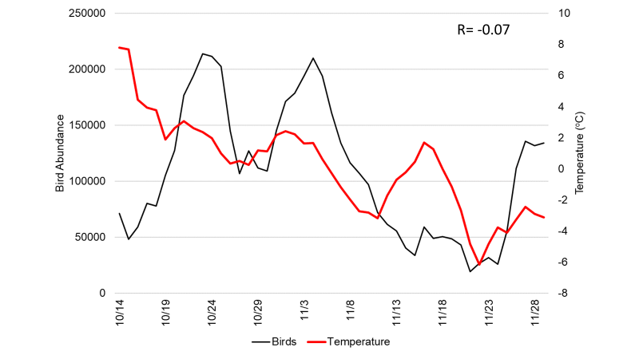

Figure 5.3
