UNIVERSITY OF OKLAHOMA
GRADUATE COLLEGE

CHINA’S PIONEERING COMPOSER: A STYLISTIC AND PEDAGOGICAL ANALYSIS OF SELECTED SOLO PIANO COMPOSITIONS BY DING SHANDE

A DOCUMENT SUBMITTED TO THE
GRADUATE FACULTY
In partial fulfillment of the requirements for the
Degree of
DOCTOR OF MUSICAL ARTS

BY
MIMI X. ZHANG
Norman, Oklahoma
2024

CHINA’S PIONEERING COMPOSER: A STYLISTIC AND PEDAGOGICAL ANALYSIS OF SELECTED SOLO PIANO COMPOSITIONS BY DING SHANDE

A DOCUMENT APPROVED FOR
THE SCHOOL OF MUSIC

BY THE COMMITTEE CONSISTING OF

Dr. Sara M. Ernst, Chair
Dr. Barbara R. Fast, Co-Chair
Dr. Jeongwon Ham
Dr. Sanna Pederson
Dr. Vivian Luong
Dr. Ellen Rubenstein

© Copyright by MIMI X. ZHANG 2024
All Rights Reserved.

Acknowledgements
I would like to extend my sincere gratitude to those who have supported me throughout my studies at the University of Oklahoma. The completion of this degree would not have been possible without the inspiration, encouragement, and motivation of my mentors, family, and friends.
First, I would like to thank my pedagogy advisor and co-chair of my document committee, Dr. Barbara Fast. I am deeply humbled and grateful for your mentorship, enthusiasm, energy, and unyielding support. Thank you for the countless hours you have dedicated to this document and my education.
To the chair of my committee, Dr. Sara Ernst, I am deeply appreciative of your leadership, support, and commitment to my document. Your thoughtful feedback has helped transform my document for the better, thank you so much.
Next, I would like to express my appreciation to my applied piano instructor, Dr. Jeongwon Ham. Thank you for instilling in me the technical knowledge and musical insight to study and appreciate Ding Shande’s music. I will miss our weekly lessons and conversations.
Many thanks to Dr. Sanna Pederson, I am so thankful for your musicological assistance and enthusiasm for my project. To Dr. Vivian Luong, I appreciative your in-depth theoretical analysis of my document, thank you for your caring guidance. To my outside member, Dr. Ellen Rubenstein, thank you for your interest in my project, and support toward to completion of my document. I would also like to extend my appreciation to Dr. John Patrick Murphy, thank you for encouraging me to work on this topic and assisting me with professional development.

There are several others who have played a critical role toward my education. Dr. Matt Stock, thank you for helping me locate and attain the necessary materials for this document, particularly in your help in finding First Lessons in Piano. I would like to especially thank Rachel Mach for traveling to the Chinese University of Hong Kong to locate the hard copy of First Lessons in Piano, thank you so much for going out of your way to find this rare document for me.
To mom and dad, thank you for your unrelenting support toward my education. The sacrifices you both have made for me are immeasurable. Thank you for your assistance with translating text for this document, and for discussing Ding Shande’s music with me. I love you both with all my heart. To Zhangjing and Alice, thank you for helping me connect with publishers and libraries in China. Thank you to my dearest friends Katie, Meldy, and TingTing, your friendship, love and encouragement helped me beyond belief. And to David, thank you for loving me, cheering me on, and helping me achieve my goals.

Table of Contents
Table of Contents vi
List of Figures x
List of Tables xviii
Abstract xx
Chapter One: Introduction 1
Overview 1
Purpose of Study 7
Need for Study 8
Limitations of Study 9
Organization of the Study 10
Literature Review 12
Dissertations and Theses 13
Articles 16
Musical Scores 20
Chapter Two: Biography 28
1911–1928: Childhood 28
1928–1935: Ding Shande’s Education 29
1935–1946: Early Career 33
1947–1949: Paris Conservatoire 36
1966–1976: Cultural Revolution 41
1976–1995: Late Period 43
Ding Shande as Composer and Author 46
Chapter Three: First Lessons in Piano 49
Background information 50
Summary of Contents 51
Ding Shande’s Forward 53
Analysis Overview 55
Section One: Fundamentals 56
Overview 56
Introduction to Keyboard Typography 57
Rhythm Value Introduction: Right Hand (No. 1-16) 59
Rhythm Value Introduction: Left Hand (Nos. 17-23) 67
Reading Approach 70
Asymmetrical Phrase Length 77
Summary of Section One 79
Section Two: Hands Together 80
Overview 80
Sequencing of Hands-Together Playing 81
Development of New Positions 87
New Rhythm Values 92
Summary of Section Two 95
Section Three: New Meters and Keys 96
Overview 96
Development of New Meters 96
Summary of Section Three 103
Section Four: New Meters, Keys, Articulations, and Note Values 104
Overview 104
Development of 6/8 Compound Meter 105
Development of F-Major Key Signature 107
New Rhythm Values 110
Introduction of Articulations 114
Development of Accompaniment Variations 118
Summary 130
Chapter Four: Eight Piano Pieces for Children, op. 28 (1987) 131
No. 1 “Puzzles” 133
No. 2 “Playing Games” 140
No. 3 “Evening Song” 147
No. 4 “Mangluo and Elephant-Foot Drum” 154
No. 5 “Worries” 162
No. 6 “Here Comes the Caravan of Horses” 176
No. 7 “Morning Song” 191
No. 8 “Dragon Dance” 204
Chapter Five: Conclusion and Suggestions for Further Study 223
Bibliography 227
Appendix A – Catalogue of Ding Shande’s Works for Solo Piano 234
Appendix B – Sequential Overview of Exercises and Concepts in First Lessons in Piano 237
Appendix C – Copyright Permission 247
247

List of Figures

Figure 1: Ding Shande Portrait 28
Figure 2: Ding Shande Graduation Recital Program 32
Figure 3: Ding Shande and Pang Jingying Marriage Portrait 33
Figure 4: Ding Shande with Nadia Boulanger 37
Figure 5: Forward to First Lessons in Piano (1957) 54
Figure 6: Translation to Forward (First Lessons in Piano) 54
Figure 7: Introduction of Fundamentals 57
Figure 8: “Chart of Keyboard Notes and Positions on the Grand Staff” 58
Figure 9: First Lessons in Piano, Exercise No. 1: Whole Note 60
Figure 10: First Lessons in Piano, Nos. 2-3: Whole Note Reinforcement 61
Figure 11: First Lessons in Piano, Nos. 7-8: Half Note 63
Figure 12: First Lessons in Piano, No. 9 64
Figure 13: First Lessons in Piano, No. 13: Quarter Note 65
Figure 14: First Lessons in Piano, Nos. 15-16: 4/4 Time Signature 66
Figure 15: First Lessons in Piano, No. 17: Left Hand 68
Figure 16: First Lessons in Piano, Nos. 18-20: Rhythm Values 69
Figure 17: Pitches Introduced in Section One, Exercises No. 1 – 23 70
Figure 18: First Lessons in Piano, No. 1: Reading Approach 71
Figure 19: First Lessons in Piano, No. 4, 6, and 12 72
Figure 20: First Lessons in Piano, No. 5: Reading Approach 72
Figure 21: First Lessons in Piano, No. 9: Reading Approach 73
Figure 22: First Lessons in Piano, No. 7: Reading Approach 74
Figure 23: First Lessons in Piano, No. 13: Reading Approach 74
Figure 24: First Lessons in Piano, No. 17: Reading Approach 75
Figure 25: First Lessons in Piano, No. 18: Reading Approach 75
Figure 26: First Lessons in Piano, No. 22: Reading Approach 76
Figure 27: Middle C Position 76
Figure 28: Pitches Introduced in Section One, Exercises Nos. 1-23 77
Figure 29: First Lessons in Piano, No. 24: Alternating Hands 81
Figure 30: First Lessons in Piano, No. 24 82
Figure 31: First Lessons in Piano, No. 25: Passing Melody Between Hands 82
Figure 32: First Lessons in Piano, No. 26: Call and Response 83
Figure 33: First Lessons in Piano, No. 26: Call and Response, Part 2 84
Figure 34: First Lessons in Piano, No. 30: Hands-Together Playing 85
Figure 35: First Lessons in Piano, No. 31 86
Figure 36: First Lessons in Piano, Nos. 32-33: Increasing Left Hand Independence 87
Figure 37: First Lessons in Piano, No. 27, Right Hand Position Change 89
Figure 38: First Lessons in Piano, No. 28, Left Hand Position Change 90
Figure 39: First Lessons in Piano, No. 30, Excerpt, mm. 1-4, Treble C and Bass C Positions 91
Figure 40: First Lessons in Piano, No. 37, Finger Extension 92
Figure 41: First Lessons in Piano, No. 24-25, Whole and Half Rests 93
Figure 42: First Lessons in Piano, No. 32, Quarter Rest 94
Figure 43: First Lessons in Piano, No. 34-35, Eighth Notes 95
Figure 44: First Lessons in Piano, No. 39, 3/4 meter 98
Figure 45: First Lessons in Piano, No. 41 “Lullaby” 99
Figure 46: First Lessons in Piano, No. 40, Sharp Accidental 100
Figure 47: First Lessons in Piano, No. 41, Left Hand F-Sharp 101
Figure 48: First Lessons in Piano, No. 46, G-Major Key Signature 102
Figure 49: First Lessons in Piano, No. 49, “The Hero's Story” 105
Figure 50: First Lessons in Piano, No. 51 “Tian Ge” 107
Figure 51: First Lessons in Piano, No. 61 “Hunter's Song” 108
Figure 52: First Lessons in Piano, No. 63 “Boat Song” 109
Figure 53: First Lessons in Piano, No. 57 “Waltz” 111
Figure 54: First Lessons in Piano, No. 59 “Lonely Goldfish” 112
Figure 55: First Lessons in Piano, No. 71 “March” 114
Figure 56: First Lessons in Piano, No. 53 “Under the Hillside” 115
Figure 57: "Under the Hillside," Left Hand Position 115
Figure 58: First Lesson in Piano, No. 64 “Pastoral Song” 117
Figure 59: First Lessons in Piano, No. 69 “Luhua Rooster” 118
Figure 60: First Lessons in Piano, No. 50 “Flying Butterfly,” Excerpt, mm. 1-5 120
Figure 61: First Lessons in Piano, No. 64, Drone Accompaniment Example 121
Figure 62: First Lessons in Piano, No. 52, “Little White Horse,” RH Accompaniment 122
Figure 63: First Lessons in Piano, No. 53, RH Accompaniment, Excerpt mm. 1-4 123
Figure 64: First Lessons in Piano, No. 55, “Frog Dance,” Excerpt, mm. 1-5 124
Figure 65: First Lessons in Piano, No. 57 "Waltz," Waltz Accompaniment, Excerpt, mm. 1-6 125
Figure 66: First Lessons in Piano, No. 68 “Worker's Dance,” Waltz Accompaniment 126
Figure 67: First Lessons in Piano, No. 60 “Climbing Mountains,” Imitation 127
Figure 68: First Lessons in Piano, No. 58 “Skipping Rope Song,” Simplified Alberti-bass 128
Figure 69: First Lessons in Piano, No. 56, “Little Sparrow,” March Accompaniment, Excerpt, mm. 1-8 129
Figure 70: First Lessons in Piano, No. 71, March Accompaniment, Excerpt, mm. 1-5 129
Figure 71: “Puzzles,” excerpt mm.1-6 133
Figure 72: “Puzzles,” Harmonic Analysis, mm. 1-6 135
Figure 73: “Puzzles,” Harmonic Analysis, mm. 7-12 136
Figure 74: “Puzzles,” Excerpt mm. 1-6 138
Figure 75: Suggested Fingerings for “Puzzles” ‘ 138
Figure 76: Grace Note Emphasis in “Puzzles,” Excerpt, mm.1-2 139
Figure 77: “Playing Games,” Excerpt, mm. 1-7 141
Figure 78: Pentatonic Scale in Root Position and Four Inversions 141
Figure 79: "Playing Games," B Section, Excerpt, mm. 8-10 142
Figure 80: "Playing Games" A-Prime Section, mm. 15-21 142
Figure 81: “Playing Games,” A-Prime Section Excerpt, mm. 20-21 143
Figure 82: "Playing Games," B Section Pedagogical Suggestions 145
Figure 83: Suggested Fingering and Choreography for "Playing Games,” mm. 1-14 146
Figure 84: "Evening Song," Excerpt, mm. 1-9, Non-Chord Tones 148
Figure 85: "Evening Song," A Section Excerpt, mm. 1-9 149
Figure 86: "Evening Song," B Section 149
Figure 87: “Evening Song” A-prime Section, mm. 19-24 150
Figure 88: Meter changes in “Evening Song,” mm. 1-9 151
Figure 89: Held-Over Tied Notes in “Evening Song” 152
Figure 90: Suggested Fingering and Choreography for “Evening Song” 153
Figure 91: Mangluo Gong 155
Figure 92: Elephant-foot Drum Dance 155
Figure 93: “Mangluo and Elephant-Foot Drum,” Introduction, Excerpt mm. 1-8 157
Figure 94: Opening Chords “Mangluo and Elephant-Foot Drum,” Excerpt mm. 1-8 158
Figure 95: “Mangluo and Elephant-foot Drum,” mm. 1-15 159
Figure 96: Suggested fingering for “Mangluo and Elephant-foot Drum," mm. 1-15 161
Figure 97: “Worries,” A Phrase Excerpt, mm. 1-2 163
Figure 98: “Worries,” A’ Phrase Excerpt, mm. 5-6 163
Figure 99: Comparison of A and A' Phrase Accompaniment 164
Figure 100: “Worries,” A'' phrase, Excerpt mm. 9-10 165
Figure 101: “Worries,” Augmented harmony, M. 1 165
Figure 102: “Worries,” Chromatic Augmented Neighbor, m. 3 166
Figure 103: “Worries,” Augmented Harmony and Modal Mixture, m. 4 166
Figure 104: “Worries,” Augmented Harmony and Modal Mixture, m. 8 167
Figure 105: “Worries,” Augmented Harmony and Modal Mixture, m. 12 167
Figure 106: “Worries,” coda, mm. 13-14 168
Figure 107: “Worries,” m. 14 168
Figure 108: “Worries,” Accompaniment Variation, mm. 1-12 171
Figure 109: “Worries,” A phrase, mm.1-4, Fingering Suggestion 172
Figure 110: “Worries,” A' Phrase Fingering Suggestion 173
Figure 111: “Worries,” A'' Phrase Pedagogical Suggestions 174
Figure 112: “Worries,” coda, mm.13-14 175
Figure 113: “Here Comes the Caravan of Horses,” Introduction, Excerpt mm. 1-5 176
Figure 114: “Here Comes the Caravan of Horses,” Introduction, Excerpt mm. 1-12 177
Figure 115: “Here Comes the Caravan of Horses,” mm. 1-11 178
Figure 116: “Here Comes the Caravan of Horses,” Excerpt, mm. 12-17 178
Figure 117: “Here Comes the Caravan of Horses,” mm. 12-17, zhi diao 179
Figure 118: “Here Comes the Caravan of Horses,” mm. 18-29, yu diao 180
Figure 119: “Here Comes the Caravan of Horses,” B Section Excerpt, mm. 30-32 180
Figure 120: “Here Comes the Caravan of Horses,” mm. 30-43 181
Figure 121: “Here Comes the Caravan of Horses,” Excerpt mm. 30-33, Rising Figures 182
Figure 122: “Here Comes the Caravan of Horses,” mm. 34-36, Rising Figures 182
Figure 123: “Here Comes the Caravan of Horses,” coda, mm. 40-49 183
Figure 124: “Here Comes the Caravan of Horses,” Excerpt mm. 1-5, Syncopations 184
Figure 125: “Here Comes the Caravan of Horses,” mm. 1-11, Chunking Suggestion 186
Figure 126: “Here Comes the Caravan of Horses,” mm. 12-17, Phrasing and Articulation Matching 187
Figure 127: “Here Comes the Caravan of Horses,” mm. 30-36, Left Hand Inner Line 188
Figure 128: “Here Comes the Caravan of Horses,” Excerpt mm. 37-40 189
Figure 129: “Here Comes the Caravan of Horses,” Coda, mm. 41-49, Suggestions 190
Figure 130: “Morning Song,” A phrase, mm.1-8 192
Figure 131: “Morning Song,” A phrase, mm. 1-8, Chord Analysis 193
Figure 132: “Playing Games,” B section, mm. 8-14 194
Figure 133: “Morning Song,” A phrase, Excerpt, mm. 1-4 194
Figure 134: “Morning Song,” A' Phrase, Excerpt, mm. 9-11 195
Figure 135: “Morning Song,” A' Phrase, mm. 9-17 196
Figure 136: “Morning Song,” m. 18, Key Change 197
Figure 137: “Morning Song,” A'' Phrase, Excerpt, mm. 18-19 197
Figure 138: “Morning Song,” A'' Phrase, Excerpt, mm. 18-21 198
Figure 139: “Morning Song,” mm. 1-2, Pedagogical Suggestion 200
Figure 140: “Morning Song,” A' Phrase, mm. 9-10, Pedagogical Suggestion 200
Figure 141: “Morning Song,” A' Phrase, Excerpt, mm. 9-14, Pedagogical Suggestion 201
Figure 142: “Morning Song,” A'' Phrase, Excerpt, mm. 18-19, Pedagogical Suggestion 201
Figure 143: “Morning Song,” A'' Phrase, Excerpt, mm. 18-19, Wrist Rotation and Flexibility 202
Figure 144: “Morning Song,” A'' Phrase, Excerpt, mm. 18-19, Duet 203
Figure 145: “Morning Song,” coda (mm. 26-28) 203
Figure 146: Dragon Dance Example 205
Figure 147: “Dragon Dance,” Excerpt, mm. 1-11 205
Figure 148: “Dragon Dance,” A Section Mediant Relationships, Excerpt, mm. 6-35 207
Figure 149: “Dragon Dance,” Excerpt mm. 9-17 208
Figure 150: “Dragon Dance,” Excerpt, mm. 23-29 208
Figure 151:”Dragon Dance,” B Section, Key Centers 209
Figure 152: “Dragon Dance,” B Section, Excerpt, mm. 75-87, Chromatic Passing Tones 210
Figure 153: “Dragon Dance,” B Section, Excerpt, mm. 76-87, Polychords 211
Figure 154: “Dragon Dance,” C Section, mm. 88-105 212
Figure 155: “Dragon Dance,” Comparison of A Section and A' Section Melody, Diminution 213
Figure 156: “Dragon Dance,” Comparison of Introduction and Coda Material 213
Figure 157: “Dragon Dance,” coda, mm. 119-135 214
Figure 158: “Dragon Dance,” Introduction, mm. 1-8, Pedagogical Suggestions 216
Figure 159: “Dragon Dance,” Excerpt, mm. 6-11, Pedagogical Suggestion 216
Figure 160: “Dragon Dance,” Excerpt, mm. 6-11, Voicing 217
Figure 161: “Dragon Dance,” Excerpt, mm. 6-17, LH Pedagogical Recommendation 218
Figure 162: “Dragon Dance,” B Section, Blocking 219
Figure 163: “Dragon Dance,” C Section, mm. 88-105, Pedagogical Suggestions 220
Figure 164: “Dragon Dance,” A' Section, Excerpt, mm. 111-120, Pedagogical Suggestion 221
Figure 165: “Dragon Dance,” Coda, Pedagogical Suggestion 222

List of Tables

Table 1: Sectional Analysis of First Lessons in Piano (1957) 49
Table 2: Section One Analysis of First Lessons in Piano (1957) 56
Table 3: Rhythm Value Introduction: Right Hand 59
Table 4: Rhythm Value Introduction: Left Hand 67
Table 5: First Lessons in Piano, Asymmetrical Phrase Length 77
Table 6: Section Two Analysis of First Lessons in Piano (1957) 80
Table 7: First Lessons in Piano, Section Two, Development of New Positions 88
Table 8: First Lessons in Piano, Section Two, Rhythm Value Introduction 92
Table 9: First Lessons in Piano, Section Three, Titles 96
Table 10: First Lessons in Piano, Section Three, Meters 97
Table 11: First Lessons in Piano, Section Four Title Translations 104
Table 12: First Lessons in Piano, Section Four New Rhythm Values 110
Table 13: First Lessons in Piano, Section Four Accompaniment Variations 119
Table 14: Formal Outline of “Puzzles” 134
Table 15: Summary of Potential Challenges: “Puzzles” 137
Table 16: Form of “Playing Games” 140
Table 17: Summary of Potential Challenges: “Playing Games” 144
Table 18: Form of “Evening Song” 147
Table 19: Summary of Potential Challenges: “Evening Song” 151
Table 20: Form of “Mangluo and Elephant-Foot Drum” 156
Table 21: Summary of Potential Challenges: “Mangluo and Elephant-Foot Drum” 160
Table 22: Form of “Worries” 162
Table 23: Summary of Potential Challenges: “Worries” 170
Table 24: Form of “Here Comes the Caravan of Horses” 176
Table 25: Summary of Pedagogical Challenges of “Here Comes the Caravan of Horses” 184
Table 26: Form of “Morning Song” 191
Table 27: Summary of Pedagogical Challenges of "Morning Song" 199
Table 28: Form of “Dragon Dance” 204
Table 29: “Dragon Dance,” A Section (mm.1-74) Mediant Relationships 206
Table 30: Summary of Pedagogical Challenges of “Dragon Dance” 215

CHINA’S PIONEERING COMPOSER: A STYLISTIC AND PEDAGOGICAL ANALYSIS OF SELECTED SOLO PIANO COMPOSITIONS BY DING SHANDE

ABSTRACT

Mimi X. Zhang
The University of Oklahoma, 2024
Chair: Dr. Sara M. Ernst
Co-Chair: Dr. Barbara R. Fast

Ding Shande (1911–1995) was a pivotal figure in 20th century China, pioneering the development of Chinese piano pedagogy, music education, and piano performance. This document aims to analyze a selection of pedagogical solo piano works of Chinese composer, Ding Shande: First Lessons in Piano (1957) and Eight Piano Pieces for Children, op. 28 (1987). Through the comprehensive review of these works, this study reveals Ding Shande’s approach to piano teaching, composition, and music education, underscoring his profound influence on the development of Chinese piano pedagogy and music education in the 20th century. Chapter One includes an overview of the topic, the purpose, need, and limitations of the study, and a review of related literature. Chapter Two provides a biographical overview of Ding Shande’s life and works, including a summary of his important contributions to piano pedagogy, composition, research, and performance. Chapters Three features a pedagogical analysis of Ding Shande’s pioneering composition, First Lessons in Piano, the first Chinese piano method composed for elementary pianists. Chapter Four includes a performance and pedagogical analysis of Ding Shande’s late work, Eight Piano Pieces for Children, op. 28. Stylistic, formal, performance, and pedagogical information will be provided for each work in op. 28. Chapter Five features a brief conclusion and includes suggestions for further study.

Chapter One: Introduction

Overview
The Chinese composer, pianist, theorist, and piano pedagogue Ding Shande (丁善德) (1911–1995) was a prolific 20th century composer known best for his solo-piano works, orchestral works, and art songs. Known as China’s first performing and recording pianist, his output includes solo instrumental works, a piano concerto, vocal music, chamber works, symphonies, film music, folk song arrangements, and cantatas. Ding Shande was a key contributor to the development of Chinese piano performance, piano pedagogy, music education, and the modernization of 20th century Chinese musical culture. Throughout his life, Ding composed 36 published opuses, 25 unpublished works, authored over 100 academic articles and a composition treatise, and translated three French theory textbooks into Chinese. His unique compositional style fuses traditional Chinese folk song elements with Western compositional techniques.
At the time of this research, there are 16 solo piano works commercially available, in addition to his children’s piano method and piano concerto. As a lifelong composer and piano pedagogue, Ding composed solo piano repertoire for elementary, intermediate and advanced pianists.
In 1935, 24-year-old Ding Shande completed his undergraduate degree at the Shanghai Conservatory of Music, studying piano with Boris Zakharov (1887–1943), a pupil of Leopold Godowsky (1870–1938). During the time of Ding’s admission to the Conservatory in 1928, Shanghai Conservatory was the only collegiate music institution in the country. Ding became the first graduate in China to receive a bachelor’s degree in piano performance from a higher education institution.
Ding Shande was China’s first solo performing and recording pianist to earn local and international attention. A Russian newspaper reported Ding’s playing as “technically at ease.” According to Ding’s primary biographer, Dai Penghai, Ding Shande was considered in 1935 to be the first professional Chinese pianist in China. In the same year, Ding became the first Chinese pianist in the country to perform a solo piano recital, and the first to record solo Chinese piano music.
In addition to being a sought-after touring concert pianist, Ding Shande was a passionate pedagogue. He served as a piano professor, theorist, composer, and music activist throughout his life, spending the majority of his academic career at the Shanghai Conservatory of Music (1949–1984). Ding mentored the next generation of pianist-composers and pedagogues, including Zhou Guangren, Zhu Gongyi, Chen Mingzhi, and numerous musicians in the country. Over 105 of Ding Shande’s piano students won prizes in national and international competitions.
A pioneering composer, Ding was the first in China to compose for piano a three-movement sonata, toccata, and theme and variations. His compositional style transformed throughout his career and reflected the impact of national political events. In her dissertation entitled “A Survey of Ding Shan-De’s Piano Works,” Liang-Yun You categorized Ding Shande’s compositional output into four periods: early (pre–1947), transitional (1947–49), mature (1949–66), and late (1967–95). Ding’s early, transitional, and mature works fuse the traditions of 19th century romanticism, French impressionism, and Chinese traditional folk song. In particular, Ding was inspired by the works of Debussy and Ravel during his transitional period while studying at the Paris Conservatory between 1947 and 1949. For instance, Ding’s integration of parallel fourths and fifths recalls French Impressionism and highlights the pentatonic structures of traditional Chinese music. His late period (1967–95) works, by contrast, feature modernistic compositional techniques which include chromatic harmony and abstract pentatonic language.
Deeply rooted and inspired by the traditions of Chinese folk music, Ding cultivated an authentic compositional voice that combines Chinese folk tradition and Western styles. In addition to being an accomplished pianist, Ding Shande was an accomplished erhu, dizi, and sanxian player. During the 20th century, China experienced several significant wars and political conflicts, affecting musicians and citizens throughout the country. Ding faced political adversity throughout his career, which has no doubt affected his output and scholarly work. However, despite periods of political unrest, nearly all of Ding’s compositions highlight his unyielding connection to Chinese culture, music, and life. For instance, in his solo piano work, Spring Suite op. 1 (1945), the composer describes that the four movements symbolize the longing for peace during the Second Sino-Japanese War (1937–1945). Secondly, composed during the Chinese Civil War (1946–1949), Three Overtures op. 3 (1948), a solo piano work, references folk melodies from Kunqu Opera and the Northern Shaanxi region. Op. 3 was composed while Ding Shande was studying abroad at the Paris Conservatoire (1947–1949). The composer explained that op. 3 represents his distress and homesickness caused by the separation from his family as a result of the war: “This is a melody that I have known since my childhood from my hometown. The accompaniment contains dissonance, variation, and semitone shifting to represent the tides of my heart rising and falling like waves.”
Setting the stage for Chinese piano pedagogy, Ding Shande composed the first Chinese elementary piano method in 1941, Children’s First Piano Lesson. The title of the method was modified to First Lessons in Piano in the third and final edition, published by Beijing Music Publishing House in 1957. The current document examines two of Ding Shande’s significant pedagogical solo piano collections: First Lessons in Piano (1st ed. 1941, 3rd ed. 1957), composed during his early period (pre-1947); and Eight Piano pieces for Piano, op. 28 (1987), composed in the late period (1967–95). First Lessons in Piano is the only work from his early period (pre–1947) lacking research, and Eight Pieces for Piano, op. 28 is among the several late works missing an in-depth pedagogical study. At the time of research, there is no pedagogical study dedicated to either pedagogical collection.
In the United States, few of Ding Shande’s pedagogical works are represented in published method books, anthologies, and reference texts. For instance, Children’s Suite: Happy Holidays, op. 9: II. “Catching Butterflies” was published in RCM’s Celebration Series (Level 8, 6th Edition) and three early elementary works are included in Level 1 and 2B of Faber’s Piano Adventures Chord Time: “Music from China.” With the exception of the 2022 RCM Syllabus, where Children’s Suite: Happy Holidays, op. 9: II. “Catching Butterflies” is included, Ding Shande’s works are absent from the major reference texts available on piano solo repertoire today, including Jane Magrath’s Piano Literature for Teaching Performance and Maurice Hinson’s Guide to Pianist’s Repertoire.
In China, Ding Shande is widely recognized as an important composer and pioneer of music education. However, despite this towering reputation, the works from his late period (1967–95) are still largely unknown and underperformed in China. Professor of Piano at the Xinghai Conservatory of Music, Li Songwen writes in his 2022 article:
Despite the groundbreaking work Ding Shande contributed to Chinese music, his repertoire is not given the stage presence that it deserves …The ten works written after 1986 (late period solo piano works) are largely unknown.

According to Li Songwen, the compositional language of Ding’s late works can be challenging for students and performers to understand, as his late works feature an increase of modernistic compositional techniques, including dense chromaticism and abstract pentatonicism:
The works of his later years are still unknown. Students who have played them expressed difficulty understanding them, as the mix between French and Chinese styles can be difficult to absorb all at once.

Li is referring to solo piano works of Ding’s late period (1967–1995), which include Eight Piano Pieces for Children, op. 28, (1987), Four Little Preludes and Fugues, op. 29 (1988), 16 Easy Studies for Piano, op. 31 (1988), Sonatina for Piano, op. 32 (1988), Rondo, op. 33 (1988), Six Preludes, op. 34 (1989) Scherzo, op. 35 (1989) and Three Piano Pieces on Chinese Folk Song, op. 36 (1992).
In both China and the United States, Ding’s late works have received less attention than his early, transitional, and mature period works. To address this research gap, the author has chosen to study one of Ding Shande’s substantial late pedagogical works lacking research, titled Eight Pieces for Piano, op. 28. This collection contains eight character pieces suited for middle to late intermediate pianists.
In combination with Eight Pieces for Piano, op. 28, the author will provide an overview and pedagogical analysis of Ding Shande’s elementary piano method, First Lessons in Piano (1957). Despite being the first method book of its kind, there is no current study dedicated to it. Ding Shande’s primary biographer, Dai Penghai states: “First Lessons in Piano, written in 1941, can no longer be found due to [sic] publication…all other works have been collected.” Worldwide, there are two library copies of First Lessons in Piano currently available.
During his education and the majority of his career, Ding Shande lived in the Shanghai, the birthplace of the first piano manufacturing company in China. Originally from London, Sydenham Moutrie established the first piano manufacturing business in China, named S. Moutrie and Co. In the 1870s, S. Moutrie and Co. began importing pianos from Europe, but started manufacturing pianos in Shanghai in the 1890s. S. Moutrie and Co. served as China’s main producer of musical instruments until the 1930s. Piano production in China suffered a decline in the late 1930s due to political unrest and economic decline. In the 1950s, after the establishment of the People’s Republic of China (PRC), the government established four piano factories in China, located in Shanghai, Beijing, the Dongbei region, and Guangzhou. By the mid 20th century, China’s improving economy and rise of the middle class helped fuel the nation’s demand for household pianos. Today, China is the top producer of pianos globally, producing 382,000 pianos in 2014, accounting for 79.6 percent of total pianos produced worldwide.

Purpose of Study
The purpose of this study provides detailed analyses of Eight Pieces for Piano, op. 28, First Lessons in Piano, along with a biographical overview of Ding Shande’s life and career. At the time of this study, there are no comprehensive performance and pedagogical guides for either collection. This study will investigate each work’s interpretive material, technical content, and will explore pedagogical suggestions. The goal of this study is to recognize the historical significance of First Lessons in Piano and provide pianists and teachers a practical guide to Eight Pieces for Piano, op. 28, highlighting Ding Shande’s contributions to piano pedagogy.

Need for Study
Limited comprehensive research has been conducted on Ding Shande’s pedagogical works. While several publications document his overall solo piano output and compositional style, no significant research document has been written on the study of Eight Piano Pieces for Children, op. 28 or First Lessons in Piano. Eight Piano Pieces for Children op.28 represents one of the landmark pedagogical contributions of Ding Shande’s late period (1967–95), while First Lessons in Piano made history as the first Chinese children’s piano method.
Despite the pioneering composition of First Lessons in Piano, Chinese piano instructors have primarily used European pedagogical materials. This trend was rooted from the piano’s historical introduction to China by Italian Missionary Matteo Ricci in the 19th century. Since the first pianists to appear in China were Europeans, the initial piano teaching materials were also predominantly European. As a result, throughout the rise of the piano in China in the early 20th century, piano instructors relied on European teaching methods and materials. According to Guo Xiaojun, the majority of 21st century Chinese piano teachers still utilize traditional European materials:
Despite the introduction of foreign piano methods and newer Chinese methods, traditional piano teaching materials such as John Thompson’s Easiest Piano Course, Ferdinand Beyer’s Elementary Method for the Piano, op. 101 and Carl Czerny’s Etudes still are the mainstream of piano teaching.
In addition to the primary use of European methods in China, the lack of study of First Lessons in Piano is likely linked to its scarcity and inaccessibility, as remaining physical copies may have been destroyed or lost during periods of political unrest and reform.
Although there are publications which focus on areas of his solo piano output, performance career, compositional style, and non-piano related works, none have been devoted to the comprehensive performance and pedagogical analysis of First Lessons in Piano and Eight Pieces for Children, op. 28. This document aims to fill this gap by providing a detailed performance and pedagogical guide to these works, thereby bringing recognition to Ding Shande’s important contribution to piano pedagogy.

Limitations of Study
Eight Pieces for Children, op. 28, represents one of Ding Shande’s 16 published and currently available solo piano works. Chapter Two includes a brief overview of Ding Shande’s solo piano compositions, but an in-depth performance and pedagogical analysis of all of Ding’s solo piano works is beyond the scope of this study. Additionally, the Cultural Revolution (1967–77) may have caused the displacement and/or elimination of Ding’s uncategorized compositions, as many compositions and artistic creations in China were destroyed during this time.
Chapter Three contains the analysis of Ding Shande’s method book for children, First Lessons in Piano, featuring the analysis of a selection of 50 out of 71 exercises. The selection of exercises are based on the introduction and reinforcement of notable pedagogical concepts which demonstrate the pacing and sequencing of the method. This current document does not include a complete pedagogical analysis of all 71 exercises. However, the current author has provided an overview of all 71 exercises located in Appendix B of this document.

Organization of the Study
Chapter One defines the purpose, need, limitations, and organization of the study. It also provides a summary of related literature regarding Ding Shande’s solo piano works. Chapter Two presents a detailed biography of Ding Shande, highlighting his contributions to 20th century Chinese piano performance and pedagogy, and includes an overview of Ding Shande as a composer and author.
Chapter Three provides a review and analysis of Ding’s piano method, First Lessons in Piano. The method contains 71 exercises organized by ascending level of difficulty. The analysis is organized sectionally by the introduction of new concepts, featuring a selection of 50 out of 71 exercises. Pacing, pedagogical aids, and sequencing will be discussed.
Chapter Four provides a comprehensive performance and pedagogical guide to Eight Piano Pieces for Children, op. 28. For each work in this collection, the author will provide historical context as well as a compositional, performance, and pedagogical analysis. Relevant historical context is extracted primarily from the multi-authored semi-autobiography, Memory and Analysis of Ding Shande’s Music Compositions; Ding Shande’s Musical Writings, authored and edited by Ding Shande scholar, Dai Penghai; and Ding Shande and His Musical Works: Proceedings from the Fourth Annual Conference of Modern Music at Shanghai Conservatory of Music, edited by Dai Penghai. Additionally, leveling is provided for each of the Eight Piano Pieces for Children, op. 28, with guidance provided by Jane Magrath’s reference text, Piano Literature for Teaching and Performance.
Chapter Five concludes and summarize the findings of this study, highlighting the significance of Ding Shande’s contributions to 20th century piano pedagogy and performance in China. This document concludes with suggestions for further study.
Appendices A through C include the catalogue of Ding Shande’s solo piano works, an outline of each exercise in First Lessons in Piano, and copyright permission.

Literature Review
In addition to the general articles on Ding Shande in the New Grove Dictionary of Music and Musicians, Wikipedia, and Naxos Music Library, there are two English-language dissertations solely dedicated to the review of Ding’s solo piano music. Also relevant to this study are four doctoral dissertations and one master’s thesis, all of which are partially dedicated to a selection of Ding Shande’s solo piano output.
With varying levels of analysis, the dissertations and journal articles pertaining to Ding Shande’s solo piano works include some level of biographical information and discussion regarding his fusion of Western and Chinese compositional techniques. Throughout this review of related literature, the author has found resources pertaining to Ding’s integration of Eastern and Western compositional techniques, and formal analyses on a selection of solo piano works.

Dissertations and Theses
There are six English-language dissertations and one master’s thesis which are relevant to this research.
One of the most substantial dissertations dedicated to Ding Shande’s solo piano output is written by You Liang-Yun, entitled “A Survey of Ding Shan-De’s Piano Works.” You’s dissertation surveys Ding Shande’s solo piano works and focuses on the evolution of his compositional style through an examination of Ding’s compositional periods. In addition to the examination of Ding’s compositional periods, You features several representative works from each period, including an in-depth historical and formal analysis of featured works. You draws connections between Western and Eastern compositional techniques, including Chinese folk music, Chinese instrumentation, and Eastern harmony. Her document does not include a pedagogical study of Eight Pieces for Piano, op. 28, or First Lessons in Piano, as pedagogical analysis was outside of the scope of You’s dissertation. The current author will be referencing You’s research throughout this document to provide insight to Ding Shande’s contributions to Chinese piano performance and music education, selected theoretical analysis of Ding’s solo piano works, and his compositional style throughout his early, middle, transitional and late periods.
The second dissertation dedicated to Ding Shande’s piano output is Zhou Xu’s dissertation entitled “Shande Ding: An Examination of His Compositional Style and Influences from Western Composers.” Zhou’s dissertation examines the merging of Eastern and Western musical techniques and cultures in Ding Shande’s compositional style. Zhou provides an examination of Ding’s Western and Eastern compositional influences and aesthetics through melody, tonality, harmony, meter, rhythm, form, and texture. In addition to her detailed analysis of Ding’s style through Eastern and Western influences, Chapter Four of Zhou’s document provides a list of brief annotations regarding the technical challenges of Ding’s complete solo piano works. The annotations are limited to short summaries regarding the overall work, and do not include comprehensive analyses on any complete collection, as the detailed performance and pedagogical analysis of Eight Piano Pieces for Piano, op. 28 and First Lessons in Piano was out of the scope of Zhou’s dissertation. However, at the time of this research, Zhou’s fourth chapter represents the only available pedagogical overview of Ding Shande’s solo piano output.
In addition to You and Zhou’s dissertations, Ding’s solo piano works are discussed in four English doctoral dissertations, and one master’s thesis. Li Jingbei’s dissertation entitled “The Preludes in Chinese Style: Three Selected Piano Preludes from Ding Shan-de, Chen Ming-Zhi, and Zhang Shuai to Exemplify the Varieties of Chinese Piano Preludes,” analyzes and compares the characteristics of three Chinese piano preludes composed by their respective composers. Similar to Zhou’s dissertation, Li’s dissertation examines the intersection of Eastern and Western compositional techniques, featuring an analysis of Ding Shande’s transitional period (1947–49) work, Three Overtures, op. 3 (1947). This dissertation designates two compositional periods for Ding Shande’s life, whereas You designates four.
Ding’s mature period (1949–66) work, First Xinjiang Dance, op. 6 (1950) is discussed and analyzed in Ma Zijie’s dissertation entitled “The Presentation and Adaptation of Xinjiang Musical Elements in Chinese Piano Composition: An Analysis of Three Xinjiang Style Piano Works.” Ma’s dissertation studies the traditional folk characteristics of Xinjiang music (northwestern region of China) present in Ding Shande’s First Xinjiang Dance, op. 6, Chu Wanghua’s Xinjiang Capriccio (1978), and Sun Yiqiang’s Spring Dance (1980).
Similar to Ma’s dissertation, Sha Sha’s master’s thesis also compares the Xinjiang folk elements portrayed in Ding Shande’s First Xinjiang Dance, op. 6 and Chu Wanghua’s Xinjiang Capriccio (1978). Sha Sha’s document is titled “Musical and Performance Analysis of the Two Piano Music Works First Dance in Xinjiang and Spring Dance.”
Ding Shande’s mature period (1949–66) work for children, Children’s Suite: Happy Holiday, op. 9 (1953), is analyzed in Yao Lin’s dissertation “East Meets West: Influential Elements of Western Piano Music on Chinese Piano Music.” This document includes formal analysis of each of the five movements of Children’s Suite: Happy Holiday, op. 9.
The second movement of Children’s Suite: Happy Holidays, op. 9 is pedagogically reviewed in Heidi Astle Worsham’s dissertation entitled “A Teacher’s Guide to Diverse Piano Repertoire: An Annotated Bibliography of Intermediate Level Repertoire by Historically Underrepresented Composers through each Historical Period.”
The first movement of Children’s Suite: Happy Holiday, op. 9, fourth movement of Spring Suite, op. 1, and First Xinjiang Dance, op. 6 are discussed and analyzed in Keli Xu’s comprehensive dissertation entitled “Piano Teaching in China During the Twentieth Century.” Although an analysis of Eight Pieces for Piano, op. 28 was not included in Xu’s dissertation, a brief stylistic description of Eight Pieces for Piano, op. 28, Four Little Preludes and Fugues, op. 29, Sonatina, op. 32, and Six Preludes, op. 34, were provided, stating that these works are “based on a combination of traditional modes and scales and atonal elements to create a new sonority and harmonic colors.” Xu’s dissertation surveys Western influence on Chinese piano pedagogy, stating that Ding Shande was among the “first generation of Chinese pianists and piano teachers.”

Articles
There are eight articles written in Chinese and one written in English, that are relevant to this literature review. At the present time of research, there are no articles which focus on the in-depth pedagogical study of either Eight Pieces for Piano, op. 28, or Ding’s method book, First Lessons in Piano. The referenced content from the Chinese articles were translated by the current author.
Most of the relevant articles focus on his creative process, embodiment of national styles, theoretical analysis and/or the fusion of Western and Chinese compositional techniques. For example, Fan Yangjie’s Chinese-language article entitled “Interpretation of the National Characteristics of Ding Shande’s Piano Music Creation,” evaluates Ding Shande’s integration of Chinese folk music and Western harmony in Children’s Suite: Happy Holidays, op. 9, Three Overtures, op. 3, and Piano Sonata in E Major, op. 2 (1946). Here, Fan highlights the Chopin-inspired arpeggiated accompaniment patterns and bel canto singing style in Ding’s early work, Piano Sonata in E Major, op. 2.
Cai Xiao Duan’s Chinese-language article entitled “Ding Shande’s Innovative Practice of Nationalizing Piano Music” analyzes the fusion of French Impressionist harmony and Chinese pentatonic language in Sonata in E Major, op. 2. Additionally, brief theoretical analyses were provided for these works: Three Overtures, op. 3, Children’s Suite: Happy Holidays, op. 9, Toccata, op. 13 (1958), Eight Piano Pieces for Children, op. 28, no. 3 and no. 5, 16 Easy Studies for the Piano, op. 31, no. 11, and Variations on a Chinese Folk Song, op. 4 (1948). Relevant to this current study, Cai references the use of polytonality in number five of Eight Pieces for Children op. 28, titled “Worries.” Additionally, Cai describes the combination of modes in “Evening Song,” number three of op. 28.
Qin Yuan and Jin Yue’s joint Chinese-language article, “The First Xinjiang Dance and Spring Dance,” includes a historical and formal analysis of First Xinjiang Dance, op. 6. In this article, a brief section is dedicated to the technical demands of this work, with several suggestions for successful performance, such as arm mobilization, repeated notes technique, sensitivity of touch, and the imitation of traditional Chinese instruments.
Wang Yi’s Chinese-language article “Research on Ding Shande’s Piano Music Creation” discusses Ding’s embodiment of the Chinese national spirit through his compositions, referencing the use of traditional Chinese opera melodies in Three Overtures, op. 3. Wang provides brief theoretical analyses of no. 4 of 16 Easy Studies, op. 31 and First Xinjiang Dance, op. 6.
Wang Wei’s Chinese-language article “Harmonic Language of Ding Shande’s Piano Works” analyzes the compositional style of several early and middle solo piano pieces. According to Wang, the use of bi-tonal harmony and additive major seconds and minor sevenths were often used to achieve a percussive effect which imitates the sound of traditional Chinese percussion instruments. This occurs, for example, in First Xinjiang Dance, op. 6, in which rapidly repeating major seconds and a sense of rhythmic vitality suggest the qualities of the Chinese percussion ensemble. According to Wang, Ding was deeply inspired by the works of Debussy and Ravel while studying at the Paris Conservatory. There, he integrated characteristics of French Impressionism, such as parallel intervallic movement, with the pentatonic structures of traditional Chinese music. Wang observes this technique in the Second Xinjiang Dance, op. 11 (1955) and Six Preludes, op. 34, no. 6, comparing them to Claude Debussy Preludes for Piano, Book 1, No. 10, L. 117, “Sunken Cathedral.”
While the previous articles largely focus on the theoretical and stylistic analysis of Ding Shande’s compositional style, a Chinese-language article written by Li Wuping features an in-depth pedagogical analysis of the fourth movement of Ding’s solo piano work, Children’s Suite: Happy Holidays, op. 9. For example, Li describes strategies to achieve a light and energetic tone in the A section, lyricism in the B section, and flexibility in rhythm throughout the work.
Published in 2023, one of the most recent articles regarding Ding Shande’s piano output is Danny Zhou’s study of Ding’s performance career and pianism. Danny Zhou’s article provides pedagogical insight through his analysis of Ding Shande’s available recordings and performance styles. An analysis of Ding Shande’s performance style provides context for the genesis of the Chinese school of pianism. After an in-depth analysis of the available recordings of Ding performing his own compositions, Zhou found that the composer-pianist tended to perform with “fast and even tempo, strong emphasis of metric organizations, and articulation of large scale structures through dynamic variation.” Zhou’s analysis provides a clear window into the performance practice of Ding Shande’s music. In regard to works discussed in this document, there is no known recording of Eight Piano Pieces for Children, op. 28.
There are two biographical articles which address Ding Shande’s life, career, and notable achievements. Li Songwen provides an overview of Ding Shande’s life and achievements, and discusses the current lack of exposure to his work outside of China. Additionally, Li states that Ding’s late works are virtually unknown in China. Dai Penghai, one of the foremost Ding Shande scholars, wrote a Chinese biographical article entitled “Musician Mr. Ding Shande’s Career (1911–1995): Contribution to Ding Shande’s Memorial Picture Album.” This article surveys the eras of Ding Shande’s life and accomplishments in chronological order.

Musical Scores

Ding Shande Complete Works Vol. I – VIII (Shanghai Publishing House)
Although currently out of print, Shanghai Publishing House compiled the complete output of Ding Shande’s works into eight volumes published in 2011, entitled Ding Shande Complete Works Vol. I-VIII. The multi-volume publication includes art songs (vol. 1) solo piano (vol. 2), chamber (vol. 3), works for orchestra (vol. 4), symphony (vol. 5), piano concerto (vol. 6), theoretical writings (vol. 7), and books (vol. 8). This current study primarily utilizes the second volume, which contains the complete solo piano works of Ding Shande. Available in both English and Chinese, the full eight-volume collection is only obtainable for loan at Stanford University Libraries, University of Edinburgh Main Library, Monash University Library and University of Melbourne Libraries. Eight Pieces for Piano, op. 28, analyzed in Chapter Four, is also located in the second volume of this collection.

Ding Shande Piano Collection (Shanghai Publishing House)
Published by Shanghai Publishing House in 1997, Ding Shande Piano Collection contains the same solo piano works as Ding Shande Complete Works, Vol.II, including Eight Pieces for Piano, op. 28.

Ding Shande: Short Piano Works (Shanghai Publishing House)
Published by Shanghai Publishing House in 1989, Ding Shande: Short Piano Works features Ding’s late pedagogical works: Eight Pieces for Piano, op. 28, Four Little Preludes and Fugues, op. 29, 16 Easy Studies, op. 31, and Sonatina for Piano, op. 32. The forward of Ding Shande: Short Piano Works includes a statement by the score’s editor, Qiu Chengyu, regarding the pedagogical utility of the selected works:
Short Piano Works is a collection of works written with a special purpose to develop piano education in China by Ding Shande, an eminent composer and pianist of the older generation. Eight Pieces for Children, Four Little Preludes and Fugues, Sonatina, and Sixteen Easy Studies are intimate and lovely music, interesting for their simplicity and originality. They are perfect material for teaching and concert performance.

Chinese Piano Music for Children (Schott)
Published and printed in Germany by Schott, Chinese Piano Music for Children features pedagogical works by a variety of composers, including Ding Shande’s mature period (1949–66) work, Children’s Suite: Happy Holidays, op. 9. In addition to op. 9, this collection includes the following works by other Chinese composers: He Luting’s “Buffalo Boy’s Flute” and “Lullaby” (1934), Shang Tong’s Seven Little Pieces after Folk Songs from Inner Mongolia (1953), and Wang Lisan’s Sonatina.

First Lessons in Piano (Beijing Publishing House)
At present time of research, there are only two available copies of Ding Shande’s piano method, First Lessons in Piano available worldwide. They can be found at Cornell University in New York, United States, and University of Hong Kong in Hong Kong. Through the interlibrary loan at the University of Oklahoma, the author obtained a digital copy of this method, in the format of a PDF on a compact disk. The first edition of First Lessons in Piano was composed in 1941, making it an early period (pre–1947) work. However, the current author utilizes the score from the third and final edition, published by Beijing Publishing House in 1957. Although the third edition was published during Ding’s mature period (1949–66) in 1957, First Lessons in Piano is considered an early period (pre–1947) work due to its initial composition date in 1941. As a result, First Lessons in Piano will henceforth be referred to as an early period (pre–1947) work in this document. Due to the scarcity of the score, the author was unable to locate and obtain the first or second editions of First Lessons in Piano. As a result, verification of changes between editions cannot be provided.

Locating Eight Piano Pieces for Children, op. 28
As previously mentioned, the complete, eight-volume collection of Ding Shande’s output can be found in the following libraries: Stanford University Libraries, University of Edinburgh Main Library, Monash University Library and University of Melbourne Libraries. Eight Piano Pieces for Children, op. 28 is located in volume two of the eight-volume collection, but can also be found at the Library of Congress Stacks, or for purchase at pianorarescores.com. Used editions are still available in Chinese internet bookstores and worldwide secondhand sellers.

Books
Ding Shande’s Musical Writings (Shanghai Conservatory of Music Press)
Ding was an active scholar throughout his life, authoring and publishing more than 100 academic articles, three textbook translations, one composition treatise, and participating in over 30 interviews. A significant portion of his scholarly work, including 60 academic articles, 18 interview transcripts, three textbook translations, and his own composition treatise, were included in Ding Shande’s Musical Writings, a Chinese-language book published by Shanghai Conservatory of Music Press in 2006. The following articles provide a window into Ding Shande’s compositional inspirations, style and core beliefs: “Why Chinese People Accept and Understand Chopin’s Music,” and “Interview Regarding Early Piano Teaching.”
The 12th article in Ding Shande’s Musical Writings is Ding Shande’s article entitled “Why Chinese People Accept and Understand Chopin’s Music.” Published in 1960, Ding explores the formal, stylistic, and expressive qualities of Chopin’s music that resonates with Chinese listeners. Ding attributes this to China’s resistance to foreign invasion and the use of national folk music:
One of the reasons Chinese people can understand and accept Chopin’s music is the spirit of patriotism and resistance of foreign aggression in his music…Additionally, Chopin drew from national folk music, including the polonaise, mazurka, and march…Chinese composers feel the same pride for our national folk tradition.

In addition to the patriotic spirit of Chopin’s music, Ding compares the “bel canto” singing style of Chopin’s melodies to the melodically driven music of the erhu. The erhu is a Chinese bowed instrument made up of two strings. He also suggests that the rubato used in Chopin’s music is comparable to that of the rubato in traditional Chinese opera and erhu repertoire. Other similarities include decorative ornaments, broad melodies, and un-metered introductions and codas. For example, Chopin’s Polonaise-Fantasy, op. 61 contains an ‘unmetered’ introduction, which occurs often in Chinese folk music.
Wei Yange’s interview with Ding Shande, entitled “Interview Regarding Early Piano Teaching” recalls Ding Shande’s role and contribution during the first decades of the rise of pianism in China. Ding reflects on how these experiences shaped him both as a composer and in his views on Chinese musical composition. This interview offers an intimate and personal point of view during the first few decades of pianism in China. Additionally, Wei Yange’s interview “Interview Regarding Early Piano Teaching” highlights how his experiences abroad unified with his Chinese roots to create his own original compositional style. Additionally, Wei gives the reader insight into Ding’s upbringing as a pianist and composer, and highlights some of his thoughts regarding Chinese music creation.
Also included is Chan Yong-chi’s 1983 interview with Ding Shande, entitled “Appreciating Serious Music Requires Understanding of Cultural Climate.” This interview elaborates Ding Shande’s views on modern music performance, composition, and education in China, stating that professional music in China has made great advances since his childhood. Ding concludes by explaining that the growth of Chinese modern music is dependent on high-quality music education, collaboration, and continuing the cultivation of both foreign and Chinese traditions.
A practical and comprehensive text, Dai Penghai’s collection includes articles and interviews pertaining to Ding Shande’s biography, key compositions, philosophy on music, music education, theoretical analysis, and his thoughts on Chinese music. However, missing from the available research in this text is comprehensive performance and pedagogical analyses of Eight Pieces for Piano, op. 28, and First Lessons in Piano. The author seeks to fill this gap by providing an in-depth study of these two works by dedicating Chapter Three to Eight Pieces for Piano, op. 28 and Chapter Four to First Lessons in Piano.
Ding Shande’s Music (Central Conservatory of Music Publishing)
Authored by Dai Penghai, Ding Shande’s Music, a Chinese-language text, is the most significant Chinese biography available of Ding Shande’s life and contributions to Chinese music. Despite its title, Ding Shande’s Music does not include musical analysis, as it serves as a chronological biography of his life. However, it does include a complete list of Ding Shande’s published works, performances, articles, books, and book translations. Ding Shande’s Music was published by The Central Conservatory of Music Publishing (Beijing, China) in 1993 when Ding Shande was 82 years old. This biography provides a comprehensive historical catalog of Ding Shande’s activities throughout his life and career, including a detailed list of completed works, monographs, audio recordings, and articles. Ding Shande’s Music focuses primarily on historical information and does not include musical analysis.

Memory and Analysis of Ding Shande’s Music Composition (Shanghai Music Publishing House)
Written in Chinese, Ding Shande writes about a selection of his compositions in Memory and Analysis of Ding Shande’s Music Composition. Additionally, Qian Yiping, Yang Yuyan, and Chen Mingzi provide commentary on a selection of Ding’s works. Published in 1986 at the Shanghai Publishing House, this semi-autobiographical text features formal musical analysis and reflections on many of Ding Shande’s compositions, including piano, vocal, and chamber works. The chapters are organized chronologically by opus number. Each work is accompanied by corresponding autobiographical information, and a formal analysis by one of the co-authors. Analysis for op. 1 through op. 22 are included, featuring works for solo piano, voice, orchestra, folk song arrangements, and chamber ensemble.
Although there are several relevant articles that provide pedagogical guidance to a selection of other works, there is no significant pedagogical study which focuses on either collection. For example, Li Wuping provides pedagogical instruction for Children’s Suite, op. 9, IV: “Hide and Seek.” Additionally, Qin Yuan Jin Yue’s article offers a pedagogical guide to First Xinjiang Dance, op. 6. Finally, Xu Zhou supplies a table which includes a leveling of Ding Shande’s complete solo piano output, as well as a brief list of technical challenges of each opus. In summary, it is evident that the literature lacks a comprehensive guide to Eight Pieces for Piano, op. 28, and First Lessons in Piano

Chapter Two: Biography
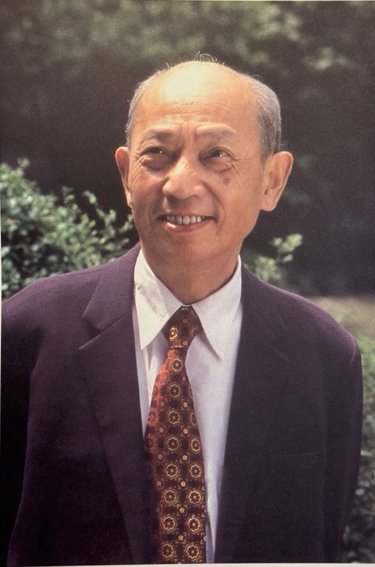
Figure 1: Ding Shande Portrait

1911–1928: Childhood
Ding Shande (see Figure 1) was born on November 12th, 1911, in the town of Kunshan, located in the province of Jiangsu, China. At age six, he was captivated by the robust performances of drumming and folk music at local festivals and celebrations. Developing a deep love for Chinese folk song and instruments, Ding taught himself to play the pipa, dizi, erhu, sanxian, and other Sizhu instruments by the time he turned eight years old.
When Ding was in fourth grade, a small pipe organ was added to his music classroom, which marked his first exposure to Western instruments. Despite being eager to learn the organ, access to the instrument was denied to students. However, Ding stayed past school hours each day to practice the organ in secret:
Although this small organ is simple, it attracted me like a magnet. In addition to playing the organ melodies, I also played Jiangnan Sizhu music, particularly “Three Plum Blossom Variations,” which is well known in our hometown.
When Ding was 16 years old, his high school purchased a set of Jiangnan Sizhu instruments. Since Ding was proficient in the erhu, pipa, sanxian, dizi, and other Sizhu instruments, he served as the Sizhu ensemble’s coach, conductor, and organizer. Renowned erhu player and classmate, Lu Xiutang (1911–1966) was coached by Ding in this ensemble. Recognizing Ding’s aptitude for music, the principal suggested that Ding apply to the Shanghai Conservatory of Music.

1928–1935: Ding Shande’s Education
During the fall of 1928, 17-year-old Ding Shande was admitted to the Shanghai Conservatory, joining a freshman class of 58 students. Ding began his degree as a pipa performance major, in addition to enrolling in secondary piano lessons. Due to quick progress in piano lessons during his first semester, Ding switched his major from pipa to piano in the second semester. Also in the second semester, the Conservatory hired two new faculty, Zi Huang (1904–1938) and Boris Zakharov (1887–1943). Boris Zakharov was the former Professor of Piano at St. Petersburg Conservatory, in St. Petersburg, Russia. During his tenure at the Shanghai Conservatory, Zakharov became one of the most influential and prominent piano pedagogues in China. Ding Shande studied under him at Shanghai Conservatory from 1929 to 1935. When Zakharov first arrived in China, he grew concerned at the lack of advanced pianists enrolled at the conservatory, as the development of professional piano playing in China was in its early stages. When he was offered a piano instructor position at Shanghai Conservatory, he said “What can I teach here?” The president of the conservatory, Xiao Youmei, convinced Zakharov to stay and give the students a chance. Ding credits Zakharov for cultivating the first generation of professional pianists in China:
It was under Zakharov’s strict and formal training that my country’s first generation of formal, professional pianists with international reputation was cultivated… Amongst them, Li Xianmen, Li Cuizhen, and Wu Leyi were all students of Zakharov…Many of them have become famous piano professors. For decades, they have been the backbone of the development of piano performance in our country.

Ding thrived under Zakharov’s instruction, recalling him as a strict and demanding teacher. Ding was determined to rise to Zakharov’s high standards. Colleague Wei Hanzhang recalled Ding’s relentless practice regimen:
Every time I see him in the dormitory, he is always tinkering on the piano and practicing hard…During one summer vacation, he felt that his sight reading was not fast enough, so he found a new piece to read each day. Two days later, I discovered that his face, arms, and legs were covered with red spots. I asked him what kind of skin disease he contracted, but he told me they were mosquito bites he received while practicing the piano.

Although Ding’s main focus was the piano, he continued to perform both as a pianist and pipa soloist. After his first year in Zakharov’s studio, Ding was invited to perform piano at conservatory recitals and community events. On April 3rd, 1930, Ding performed John Field’s Nocturne in A Major, and several pipa works. He was also invited to perform at the Qingxin Girls Middle School in Shanghai in September of 1930, where Ding performed Carl Maria Von Weber’s Invitation to the Dance. At the same event, Ding gave his first presentation on Western Classical music appreciation. By November of 1933, Ding was performing advanced repertoire, including Chopin’s Études, op. 10, no. 9 and 12. In 1934, the 23-year-old Ding performed Chopin Étude, op. 10, no. 3, Ballade op. 47, no. 3, and Liszt’s Hungarian Rhapsody, no. 12 for his jury.
In 1934, Alexander Tcherepnin (1899–1977) and his wife Lee Hsien Ming visited the Shanghai Conservatory. Ding’s piano teacher, Boris Zakharov, invited Ding to perform for Tcherepnin in December of 1935. Ding performed Bach’s Prelude and Fugue in G Major, and two selections from Tcherepnin’s Bagatelles, making him the first Chinese pianist to perform Tcherepnin’s compositions. In 1934, Ding Shande wrote and published his first academic article entitled “Reflections on Chinese Music,” an unusual accomplishment for an undergraduate student.
On May 11, 1935, Ding completed his graduation recital with the following works: Beethoven’s Piano Sonata, op. 27, no. 2, Debussy’s Deux Arabesque, L. 66, no. 2, Weber’s Invitation to Dance, J. 260, op. 65, Grieg’s Piano Concerto in A Minor, op. 16 (1st movement), Chopin’s Étude, op. 10, no. 9, Chopin’s Polonaise-Fantasy, op. 61, Tcherepnin’s Two Piano Pieces, He Luting’s Buffalo Boy’s Flute and Lullaby, and Liszt’s Hungarian Rhapsody, no. 6. The printed recital program (Figure 2) includes information regarding Ding Shande’s professor, the venue, his undergraduate status, and works performed.

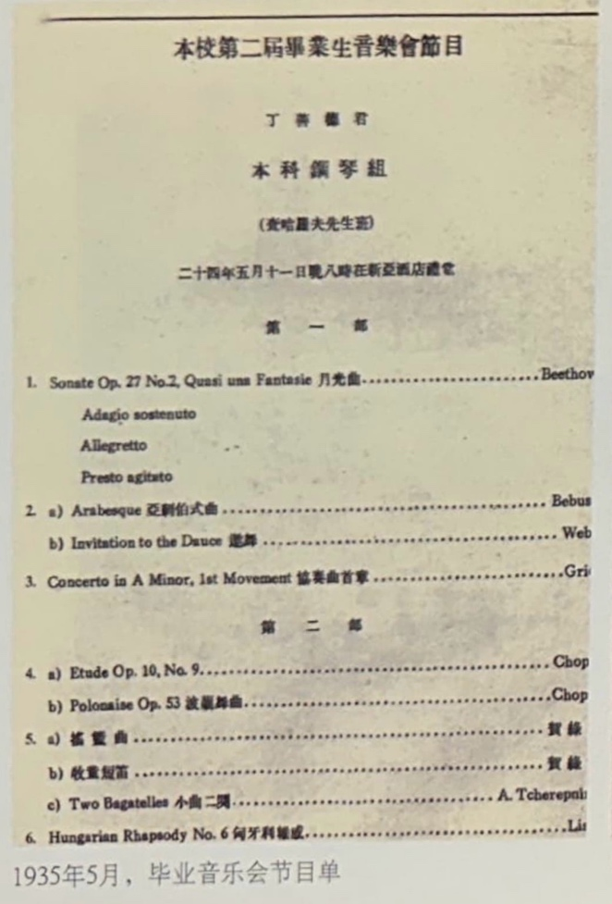
Figure 2: Ding Shande Graduation Recital Program

Ding’s graduation recital was the first solo piano recital performed by a Chinese pianist in China. The recital was a big success and attracted newspaper journalists to the event. In the same year, composer Hu Luting asked Ding Shande to record Buffalo Boy’s Flute and Lullaby with EMI records, which is known as the first recording of Chinese solo piano music recorded in country.

1935–1946: Early Career
After graduation in the spring of 1935, Ding toured for several months, presenting various recitals in Beijing and Tianjin. Later that same year, he was offered an academic teaching position at the Hebei Women’s College in Tianjin, where he taught eight piano students and several pipa students. Ding enjoyed his new position at Hebei Women’s College: “I go to school in the morning and go home to practice in the afternoon, my life is quite comfortable.” In September of 1935, Ding Shande and Pang Jingying were married at the Xinya Hotel in Shanghai, China (see Figure 3).

Figure 3: Ding Shande and Pang Jingying Marriage Portrait
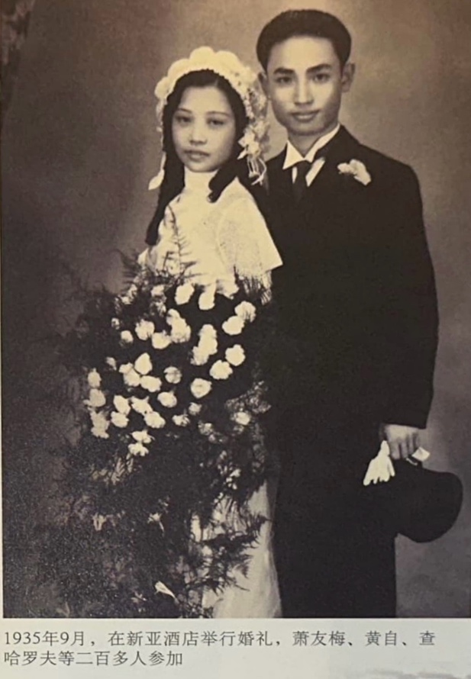
In his second year at Hebei Women’s College, Ding became interested in studying abroad. However, the political instability caused by the Chinese Civil War (1927–1949) created difficulties for Ding. At the time, the university had no allocated funding for studying abroad. Ding reached out to the Deputy Minister of Foreign Affairs, Tang Youren (1894–1935), as Ding was teaching Tang Youren’s daughter at the time. But before this meeting could be arranged, Tang was assassinated by a group associated with the Communist Party, subsequently eliminating any chance of government sponsored funding. Ding recognized that he must look for funding on his own, as it was unsafe to obtain funding elsewhere.
His plans to study abroad were further delayed due to the outbreak of the Second Sino-Japanese War (1937–1945). As a result of the war, Japanese forces bombed Hebei Women’s College in July of 1937, causing a suspension of all university classes. In order to support his wife and a newborn daughter, Ding looked for work in Shanghai. A violent outbreak in Shanghai on August 13th, 1937, known as the “August 13th Incident,” thwarted his plan. After two months of unemployment, in October of 1937, Ding Shande and two former classmates, Lao Jinxian and Chen Youxin, established the Shanghai Music Institute. This institute provided private violin, piano, and voice lessons. In addition to serving as president of the institute, Ding taught piano lessons and theory classes there. After four years, in 1941, the institute reached enrollment of more than one hundred students.
In the fall of 1939, Ding began teaching piano to his three-year-old daughter, Ding Jiannuo (b. 1937). He recalls the lack of pedagogical materials available for his daughter:
She [Ding Jiannuo] was so young, there were no suitable or readily available teaching materials, so I composed some simple etudes and taught them to her…about a year later, I had composed forty or fifty teaching pieces.

These forty to fifty teaching pieces make up Ding Shande’s method book, First Lessons in Piano. Recognizing the lack of pedagogical materials available for young pianists in China, Ding compiled these short pieces into a volume organized progressively by difficulty. The first edition (1941) of First Lessons in Piano was entitled Children’s Piano Learning, published by Shanghai Music Publishing House. To increase its appeal to young learners, Ding commissioned artist Wu Guifang to illustrate artwork for each of the pieces. In 1957, the method book was revised and retitled First Lessons in Piano (1957), published by Beijing Publishing House.
In 1941, in addition to working full time at the Shanghai Music Institute, Ding began taking supplementary composition lessons from Wolfgang Fraenkel (1897–1983), student of Arnold Schoenberg (1874–1951). Fraenkel was residing in Shanghai after fleeing from Germany to seek refuge from the Nazi regime. Ding’s lessons with Fraenkel continued on a weekly basis for five years. He regarded Fraenkel as an effective pedagogue, a knowledgeable resource, and a proficient pianist. In 1947, Fraenkel moved to Los Angeles, California, United States, where he lived until his death in 1983. Ding Shande composed his first two opuses under Fraenkel: Spring Suite, op. 1 (1945) and Piano Sonata in E Major, op. 2 (1946).
Ding Shande’s first work, Spring Suite, op. 1 was completed in May of 1945 and pertains to the historical events occurring at the time. It was composed on the eve of the Japanese surrender during the Second Sino-Japanese War (1937–1945). According to the composer, this suite represents the composer’s inner emotions toward the war and his longing for peace. This longing is symbolized by the anticipation for Spring to arrive. Spring Suite, op. 1 contains four movements: I. “Waiting for Sunrise,” II. “In the Boat,” III. “On the Shore,” and IV. “Breezing in the Morning.”

1947–1949: Paris Conservatoire
In 1947, Ding traveled to France alone to pursue a degree in composition at the Paris Conservatoire. There, he studied with Nadia Boulanger (1887–1979), Noêl Gallon (1891–1966) Arthur Honegger (1892–1955), Wolfgang Fraenkel (1897–1983), Tony Aubin (1907–1981), and Olivier Messiaen (1908–1992). As a new composition student, Ding worked to develop his unique voice by fusing Chinese national folk elements with European compositional techniques, often studying and composing for over thirteen hours daily.
At the Conservatoire, Tony Aubin and Nadia Boulanger both urged him to abandon the rules of traditional harmony, embrace new elements, and avoid foreign influences. Nadia Boulanger encouraged Ding to embrace his Chinese heritage: “We must get rid of foreign influences, be innovative, we must have our own innovative voice; be concise, clean and not cumbersome.” Both solo piano works, Ding composed Three Overtures, op. 3 (1947) under Aubin’s tutelage and Variations on a Chinese Folk Theme, op. 4 (1948) under Boulanger’s. Variations on a Chinese Folk Theme, op. 4 is the first theme and variations composed using a Chinese folk melody. In April of 1949, Variations on a Chinese Folk Theme, op. 4 and Oboe Sonata were both selected to be featured on a Paris radio station. A photo (see Figure 4) of Ding Shande and Nadia Boulanger was taken at the Sixth International Chopin Competition in 1960, where Ding adjudicated, and Nadia Boulanger served as vice chairman of the competition.

Figure 4: Ding Shande with Nadia Boulanger
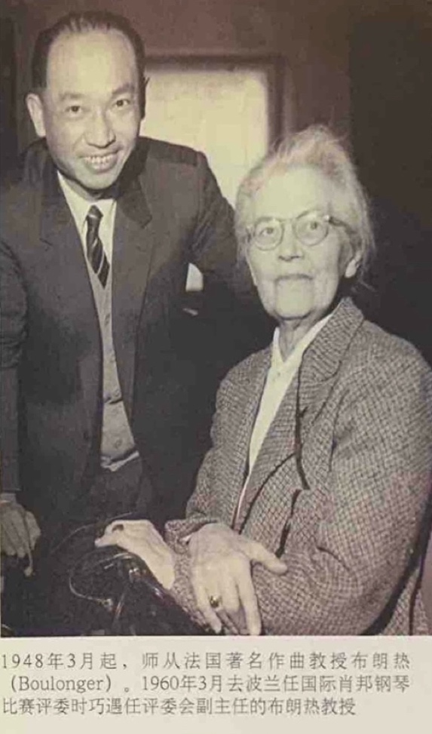
His years spent in France represent his transitional period (1947–49). Works composed during Ding’s transitional period features techniques used by French impressionists, including non-functional harmony, parallel intervals, and pentatonicism. After two years of study at the Paris Conservatoire, Ding Shande graduated in July of 1949, and returned to Shanghai in September of 1949.

1949–1966: Return to China, Pre-Cultural Revolution
After Ding Shande’s return to Shanghai in September of 1949, he continued to search for his own compositional voice, fusing Western compositional techniques with Chinese folk elements. Ding incorporated the techniques he acquired from the Paris Conservatoire and Chinese folk song in his next solo piano compositions: First Xinjiang Dance, op. 6 (1950), Children’s Suite: Happy Holidays, op. 9 (1953), Second Xinjiang Dance, op. 11, (1955), Toccata: Good News, op. 13 (1958). According to Ding, the subject matter of these works reflects Chinese folk music or life in China.
The first work composed after his return was First Xinjiang Dance, op. 6, completed in November of 1950. This single-movement work was inspired by the joyful music and dance found in Xinjiang, China. The Chinese folk song referenced in this work is entitled “The Coachman’s Song.”
During this time in China, foreign influence represented in literature, art, and music, was often resisted by the Chinese public due to a national fear of foreign invasion. Following his return from Paris, Ding stated that he feared that the Chinese public would not accept the new styles and techniques he acquired in France:
After I returned to China, I didn’t compose a single composition at first because I found that society at that time could not accept my style. They preferred works with clear themes that are easily understood by the masses. If it contained many modulations or modeled after impressionistic music, it would be unacceptable.

However, Ding defended and supported the integration of western modern music by stating that the intention and emotional content is the foremost important element of music composition:
The most important thing about music creation is to be able to express human thoughts and emotions…you can use an erhu to perform, or you can you a violin. They are both tools of expression…Many in the past have engaged pointless disputes regarding “local” verses “foreign” singing methods, and whether either one should be avoided or promoted. These are tools to expression, the most important thing is to express genuine emotions. High quality Chinese music should be expressed through both national and international instruments.

The rapid improvement of pianism in China was reflected during the Sixth International Chopin Competition, held in Warsaw, Poland in 1960. Ding Shande served as one of the 37 judges for this competition, among which were Arthur Rubinstein (1887–1982), Nadia Boulanger (1887–1979), and Dmitry Kabalevsky (1904–1987). This competition saw an increase in Chinese competitors. At the competition, Ding recalled a conversation with Henrich Neuhaus (1888–1964) regarding the status of pianism in China. Neuhaus commented “China is so far away from Europe and its playing is so good! Where did you get the tradition? Can you explain? I am very doubtful!” At this competition, Chinese pianist, Li Ming-Qiang, won fourth place.
Although Chinese pianists like Ding Shande and Li Ming-Qiang were gaining international recognition, traveling abroad was often discouraged by the Chinese government. At this time, the Chinese Communist Party believed that exposure to foreign ideologies would contradict the principles of the socialist government and decrease internal nationalism. Bearing this in mind, in 1964, Ding was invited to adjudicate for the Queen Elisabeth International Music Competition, held in Brussels, Belgium.
During his visit to Brussels, several American adjudicators invited Ding to adjudicate for the next Van Cliburn International Piano Competition. They also encouraged Ding to invite Chinese students to compete in the Van Cliburn. However, Ding was ultimately unable to adjudicate for the Van Cliburn. Since the United States and China did not have diplomatic relations at this time, international travel requests needed to be processed through the Chinese Ministry of Culture, a lengthy and potentially dangerous procedure. During Ding’s visit to Brussels, he received an anonymous letter which read “Accompanying Sheng Ying to participate in the competition is a heavy responsibility, so it is best to stay and not return to China.” He quickly reported the letter to officials in Belgium, who provided him security assistance. Still, upon Ding’s return to China in 1964, he was called a ‘traitor’ to the Cultural Revolution.
As the Cultural Revolution (1966–77) crept closer, Ding ceased composing, stating, “from 1963 to the end of 1965, I never wrote anything. When the Cultural Revolution came, my creative activities were completely interrupted.”

1966–1976: Cultural Revolution
The Cultural Revolution began on May 16th, 1966, led by Mao Zedong and the Chinese Communist Party (CCP). This movement affected ordinary people throughout the country, especially impacting educators, intellectuals, and the middle class. Many were prosecuted, imprisoned and/or sent to rural labor camps.
For musicians, all creative activity was prohibited, especially the ownership and performance of foreign works. Chinese schools and universities, including the Shanghai Conservatory, where Ding had taught since 1949, were closed and classes were suspended. Once cherished and revered Chinese musicians were now criticized and publicly shamed. Sadly, many of Ding’s closest colleagues and friends lost their lives during this time.
Although classes at the Shanghai Conservatory were suspended, Ding still came to work each day. His new responsibilities included analyzing documents, reading “big-character” posters, and janitorial labor.
On March 30th, 1966, The Red Guards ransacked and confiscated valuables from Ding’s house, including his music manuscripts:
As soon as they (The Red Guards) arrived, they rummaged through the cabinets and ordered Ding’s wife to hand over all of her gold and silver jewelry; the also confiscated all of Ding’s drawer full of manuscripts (including unpublished works, such as the Sonata for Oboe and Piano composed while in France), they said these possessions were reactionary and useless, and subsequently burned them.

To support his family, Ding sold the majority of his personal academic materials from France, including theory and composition textbooks, and scores by Messiaen, Debussy and Ravel. Soon after, the rebels seized and occupied a large portion of their home. However, they allowed Ding to keep his grand piano.
During the revolution, Ding endured constant scrutiny, criticism, and even physical violence. For instance, in 1968, Ding and several of his colleagues were confined to the basement of the Shanghai Conservatory, where they were interrogated and forced to participate in confessions.
Due to his leadership role at the conservatory, Ding was a vulnerable target for criticism. In July of 1968, the rebels from the conservatory erected large posters with the following text: “Down with the reactionary academic authority Ding Shande.” The rebels claimed that music-related events held at the Shanghai Concert Hall under Ding’s management indicated that he was a counter revolutionary.
Amongst his many charges, Ding’s affiliation with foreigners was denigrated the most. For instance, a photo of Ding with Queen Elisabeth from the 1964 Queen Elisabeth International Music Competition was displayed at a “crime exhibition” at the Shanghai Conservatory as evidence of his traitorship. His punishment included additional labor and public criticism.
Ding’s circumstances started to improve in 1971, when he was given permission to teach an orchestration class at the Shanghai Conservatory. Later in 1973, the government issued refunds to its citizens for the valuables confiscated. Additionally, in June of the same year, enrollment reopened and classes at higher education institutions resumed. Ding was 65 years old when the Cultural Revolution concluded in 1976.

1976–1995: Late Period
During the first year after the collapse of the Cultural Revolution, the Shanghai Conservatory was in the process of restoring the institution and reestablishing admissions. In 1977 alone, the institution received over 5,000 applicants, of which 300 were admitted.
In 1977, at the age of 66, Ding composed his first work post revolution titled In Praise of Premier Zhou, op. 19, no. 1, an art song for tenor and piano. The works composed after the Cultural Revolution include four works for voice, one piano concerto, two orchestral works, one string quartet, one piano trio, one work for voice and cello, one violin sonata, and eight solo piano works. In 1984, Ding composed Piano Trio in C Major, op. 21 as a proposal submission to the Western Art Music Festival held at Wyoming State University. This piece was accepted for this festival and was regarded as “an extremely rare and beautiful trio… the performers were unanimously satisfied and loved it.” According to reports at the time, the trio was one of the first Chinese works performed in the United States. In autumn of the same year, Ding finished composing his first and only piano concerto, Piano Concerto in B-flat Major, op. 23. The complete score of this concerto can be found in Ding Shande Complete Works, Volume VI: Concerto published by Shanghai Music Publishing House. On May 17th, 1986, the concerto premiered during the 12th Annual Shanghai Spring Festival, featuring Li Ming-Qiang as soloist. In the same year, Ding Shande’s most recognized symphony, Long March Symphony op. 16, made record history as one of the top 15 selling records worldwide in the classical genre, together with Beethoven’s Fifth Symphony. Ding resumed a busy schedule of teaching, composing, collaborating, researching, adjudicating, and diplomacy activities.
In 1979, he was appointed Chinese Ambassador to Poland, resulting in a series of diplomatic visits from both Poland and China. In the years following the end of the Cultural Revolution, many festivals, competitions, and conferences resumed, and Ding’s scholarly research also resumed. Additionally, foreign visits and international travel was permitted and encouraged. As a result, international guest performers traveled to China to present their work and research. American pianist, Joseph Banowetz (1934–2022), was the first foreign pianist to be invited by the Chinese Ministry of Culture to perform with the Shanghai Symphony in 1984. Theorists and clinicians presented new works by Western composers, exposing China to contemporary compositional techniques such as the second Viennese school, which Ding embraced.
In 1987, Ding resumed composing short works for the piano. Between the years of 1987 and his death in 1995, Ding Shande composed eight solo piano works. Ding Shande’s late period (1967–1995) compositions combine chromatic language, counterpoint, and pentatonicism. Furthermore, as an advocate for new music, Ding helped establish and presided over the “Modern Music Society of Shanghai Conservatory of Music” in 1987. At the first meeting of the conference, Ding premiered his newly composed works, Ode to Orange, op. 27 (1987), and Eight Piano Pieces for Children, op. 28 (1987). Ding’s final opus was Three Piano Pieces on a Chinese Folk Song, op. 36 (1992).
Ding Shande passed away on December 3, 1995, of a heart attack. His legacy is passed on and represented through his children and grandchildren. Ding Shande’s grandson, Maestro Long Yu, is the present conductor of the Shanghai Symphony Orchestra, in Shanghai, China. In an interview with reporter Chen Nan, Yu recalls:
My grandfather composed many musical works. My favorites are his art songs…I was very lucky to grow up with him and receive musical training from him, which had a profound lifelong influence. He loved writing music and playing with his cat. He was a very kind and caring grandfather.

Honoring his grandfather’s contributions, in January of 2021, Maestro Long Yu conducted a concert featuring a selection of Ding Shande’s art songs and work for solo flute and soprano, Mysterious Flute Sound, op. 5, no. 1.
Ding Shande’s daughter, Ding Jiannuo (b. 1937) has recorded the definitive album of Ding Shande’s solo piano works, available through NAXOS Records. This recording includes the majority of Ding Shande’s solo piano output, with the exception of six works: Eight Piano Pieces for Children, op. 28, 16 Easy Studies for the Piano, op. 31, Sonatina op. 32, Rondo, op. 33, Scherzo, op. 35, and Three Pieces on a Chinese Folk Song, op. 36.

Ding Shande as Composer and Author
Ding Shande’s contributions as a composer, pedagogue, theorist and activist shaped the trajectory of 20th century Chinese music. As a musician, Ding was China’s first performing and recording pianist. A pioneering pedagogue, Ding made history by composing First Lessons in Piano (1957), the first Chinese children’s piano method. Known for his effective teaching, over 105 of his piano students earned prizes at national and international competitions.
As a busy academic, Ding authored and published 111 articles and a composition treatise, translated three French theory textbooks into Chinese, and was interviewed over 30 times. Ding Shande’s composition treatise, Exploration of Composition Techniques, was the first music theory text written in China. Furthermore, Ding exposed Chinese musicians and students to Western musical materials by translating three French theory textbooks taught at the Paris Conservatoire, making them among the first theory materials available in China.
As a composer, his catalogue includes 36 published works and 25 unpublished works across many genres. In China, Ding was the first to compose a three movement sonata, toccata, and piano variations using a Chinese folk theme. During his transitional period (1947–49), he composed the first orchestral suite depicting the victory of the Chinese Civil War (1927–1949), entitled “New China” Symphonic Suite, op. 7 (1949). In addition, Ding composed the first symphony—Long March Symphony, op. 16 (1962)—based on the “Long March,” a 6,000-mile march undertaken during the Chinese Civil War. Finally, Ding composed the first solo piano work describing the lives of children—Children’s Suite: Happy Holidays, op. 9.
Ding Shande’s compositional output can be categorized into four periods: early (pre–1947), transitional (1947–49), mature (1949–66), and late (1967–95). Ding’s early period (pre–1947) combines elements of eastern harmony, namely pentatonicism, and 19th century western functional harmony. Representative solo works of this period include Spring Suite, op. 1, and Sonata in E major, op. 2. Works from the transitional period (1947–49) combine the elements of 19th century Romanticism, French Impressionism, Chinese folk elements, and increased experimentation with chromatic harmony. Representative solo piano works from the transitional (1947–49) period include Three Overtures, op. 3, and Variations on a Chinese Folk Theme, op. 4.
Ding Shande’s mature period (1949–66) is characterized by a strong national voice, use of Chinese folk melodies, and an overall tonal vocabulary. Representative solo piano works of the mature period include:
First Xinjiang Dance, op. 6
Children’s Suite: Happy Holidays, op. 9
Second Xinjiang Dance, op. 11
Toccata, op. 13
Ding’s late period (1967–95) remains one of the most productive writing periods of his career. The works of his final period explore chromatic language, counterpoint, and pentatonicism. Ding composed eight representative solo piano works during the late period:
Eight Piano Pieces for Children, op. 28
Four Little Preludes and Fugues, op. 29
16 Easy Studies for the Piano, op. 31
Sonatina for Piano, op. 32
Rondo, op. 33, Six Preludes, op. 34
Scherzo, op. 35
Three Piano Pieces on a Chinese Folk Song, op. 36.

Summary
Ding Shande’s pioneering work as a composer, theorist, pedagogue, and activist modernized 20th century Chinese music. Ding’s integration of Western music with Chinese folk traditions bridged the gap between East and West, helping to globalize a new era of Chinese music and its musicians. Ding’s compositions continue to resonate with performers and listeners today. Because of his pioneering work as a composer and pedagogue, his pedagogical piano compositions deserve more significant research, particularly his elementary piano method, First Lessons in Piano (1957), and his intermediate piano collection, Eight Piano Pieces for Children, op. 28 (1987). This study aims to bring recognition to these collections, thus highlighting Ding Shande’s contributions to Chinese piano pedagogy.

Chapter Three: First Lessons in Piano
This examination of First Lessons in Piano (1957) provides an analysis of the method’s sequencing, introduction of new concepts, reading and rhythm approach, pedagogical suggestions, and pacing. With a four section organization system (see Table 1), the researcher will demonstrate the content and pacing of First Lessons in Piano through a select analysis of 50 out of 71 exercises. Analyzed exercises were selected to illustrate the introduction and reinforcement of new concepts, pacing, and pedagogical value of the method. Throughout the method, Ding develops students’ keyboard proficiency by incrementally adding complexity to rhythm, hand positions, key and time signatures, harmony, texture, and works with lyrics. New concepts are reinforced through spiral sequencing, the strategic review of previously introduced concepts. Leveling is informed by Jane Magrath’s guide, Piano Literature for Teaching and Performance.

Section | Exercise number range | Overview of contents | Level range | Pacing
Section One | Nos. 1-23 | Fundamentals, simple rhythms, middle C reading, hands separate playing | Level <1-1 | Slow to moderate
Section Two | Nos. 24-37 | Hands-alternating playing and hands together playing, simple meter, simple rhythms | Level 1-2 | Moderate
Section Three | Nos. 38-48 | Pieces with lyrics, introduction of 2/4 and 3/4, frequent position shifts, sharp accidentals | Level 2-3 | Moderate to fast
Section Four | Nos. 49-71 | Introduction of compound time signature (6/8), pentatonic melodies, flat accidentals, dynamics | Level 2-3 | Fast
Table 1: Sectional Analysis of First Lessons in Piano (1957)

First Lessons in Piano (1957), presented in landscape layout, contains 71 exercises tiered progressively by difficulty. A total of 58 pages in length, this method book is designed for an absolute beginner at the keyboard. This analysis is divided into four sections, with its organization based on leveling, content, and pacing (see Table 1).
Section One contains exercises ranging up to a Magrath level one, featuring fundamental concepts, simple rhythms, middle C reading approach, and hands-separate playing. In Section Two, Ding acclimates the student to hands-together playing, beginning with alternating hand playing. Section Two includes level one to two repertoire. Section Three includes works with lyrics, often at a longer length and an increase of pentatonic language. The final section includes the introduction of compound meter, thicker textures and dynamics, and is graded at a Magrath level two to three. Refer to Table 1 for an outline of each section’s content, location, and level.
This chapter begins with background information, a summary of the method’s contents, and Ding Shande’s forward translated by the current author, and continues with information regarding the method’s pacing and comparisons to contemporaneous beginning piano methods.

Background information
Ding composed First Lessons in Piano in 1941 and the Shanghai Publishing House released it the same year. During that time, according to Ding Shande and his biographer, Dai Penghai, elementary-level pedagogical materials suited for beginning pianists were lacking in China. Ding composed First Lessons in Piano (1957) to fill the growing need for elementary pedagogical materials in China. Dai Penghai, Ding’s biographer states:
Many children wanted to learn piano at that time, however there was a lack of available teaching materials…Ding compiled the exercises into a book and named it ‘Children’s Piano Learning.’ He also asked Wu Guifang to create illustrations for each piece… Due to the high quality of print, paper, and illustrations, sales were successful. This was the first publication of the method.

The third and currently utilized edition contains minimal illustrations. Due to the scarcity of the first and second editions of First Lessons in Piano (1957), this author is uncertain whether these editions included more artwork than the third edition. Moreover, the present researcher is unaware of any pedagogical additions and/or changes made between editions.

Summary of Contents
Designed to be a beginner’s first piano method book, First Lessons in Piano (1957) contains 71 exercises arranged in order of increasing difficulty and complexity. Like other methods published in the mid-20th century, such as Thompson (1936), Carr (1967), and Schaum (1973), Ding Shande’s First Lessons in Piano (1957) uses the middle C reading approach. The repertoire in First Lessons in Piano (1957) consists of a combination of technical pedagogical compositions and Chinese folk song arrangements.
Presented in this sequence, First Lessons in Piano includes time signatures 4/4, 3/4, 2/4, and 6/8. Throughout the method, 46 exercises were written in 4/4 or common time, 11 in 3/4, nine in 2/4, and four in 6/8. Key signatures introduced include C major, G major, and F major. First Lessons in Piano (1957) does not contain information on posture, hand position, or proper sitting height, suggesting Ding probably introduced these concepts before starting the method book.
The note values introduced in First Lessons in Piano (1957) are presented in the following order: whole notes, half notes, quarter notes, eighth notes, and sixteenth notes. Contrasting with other popular mid-20th century piano methods, such as John Thompson’s Teaching Little Fingers to Play, David Carr Glover’s Glover Piano Library, and John W. Schaum’s Piano Course, Ding Shande’s First Lessons in Piano (1957) introduces the whole-note value first, whereas Thompson, Glover, and Schaum introduces the quarter note value first. Similar to Ding’s First Lessons in Piano (1957), John Thompson’s Easiest Piano Course: Part One, published in 1955, also introduces the whole note value first.
In addition to time signatures, key signatures, and note values, Ding introduces sharps, flats, tied notes, dynamics, slurs, time signatures, key signatures, and a variety of hand positions. Although the method begins using the middle C reading approach, Ding frequently shifts the hands to different positions throughout the method to acclimate the student to a variety of hand placements.
The pacing of the method is moderate, typically allowing five to six exercises for review and concept reinforcement. However, after exercise number 38, the pacing accelerates, providing on average one to two reinforcement exercises. The final exercise, titled “No. 71: March,” is comparable in difficulty to Bach’s Musette in D Major, BWV Anh.126. First Lessons in Piano (1957) is paced quicker than other contemporaneous primer level methods (Thompson, Glover, and Schaum). Ding Shande’s First Lessons in Piano (1957) is paced similarly to Teaching Little Fingers to Play and John Thompson’s Modern Course for the Piano: The First Grade Book combined. For example, the final exercise in First Lessons in Piano (1957), titled “March,” is comparable to the final piece in John Thompson’s Modern Course for the Piano: The First Grade Book, titled “John Peel.”

Ding Shande’s Forward
Ding Shande’s children’s piano method, First Lessons in Piano (1957) was composed entirely in Chinese, as such, the current author has translated Ding’s titles and pedagogical suggestions into English and labeled them accordingly. Before the method begins, Ding Shande includes a forward for the reader, (see Figure 6) and the translation is in Figure 5.
According to Ding Shande’s forward, the third edition was supplemented with additional exercises, not included in the previous editions. Ding states that the third edition integrates elements from French elementary method books, but the forward provided no further information regarding which specific French method.

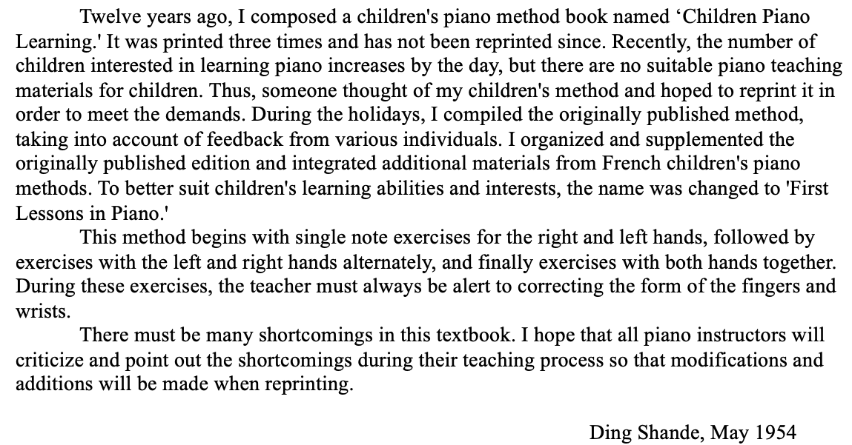
Figure 5: Forward to First Lessons in Piano (1957)

Figure 6: Translation to Forward (First Lessons in Piano)
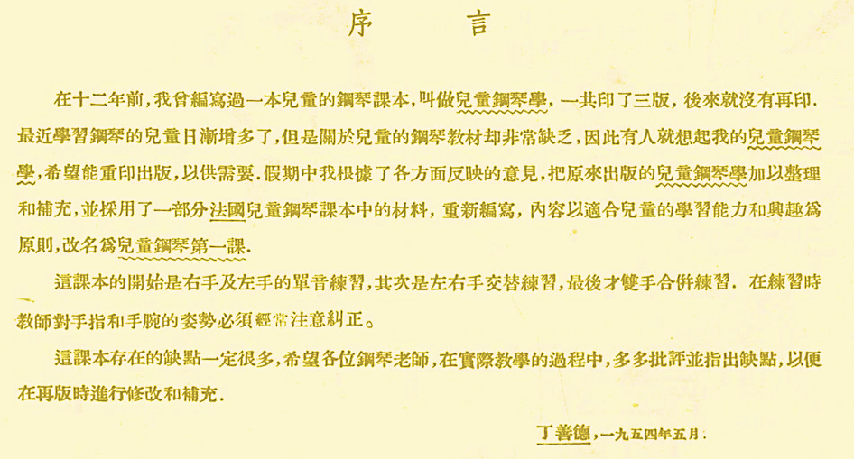

Analysis Overview
The analysis of First Lessons in Piano (1957) is divided into four sections, organized by leveling, content, and pacing (see Table 1). The content and pacing of the method is demonstrated through select analyses of 50 of the 71 exercises. Throughout this analysis, translations of Chinese text are provided in black, while pedagogical suggestions from the current author are indicated in red. A complete annotated overview of all 71 exercises in First Lessons in Piano (1957) can be found in Appendix B.

Section One: Fundamentals

Overview
This analysis of First Lessons in Piano (1957) begins with an examination of the first section, spanning exercises one through 23. This section is divided into four categories: the introduction of keyboard typography, the sequencing and development of rhythm values, note reading approach, and phrase length. Throughout Section One, Ding introduces basic keyboard fundamentals, including the treble and bass clefs, whole notes, half notes, quarter notes, and hands-separate playing. Refer to Table 2 for an overview of concepts and leveling in Section One.

Table 2: Section One Analysis of First Lessons in Piano (1957)
Exercises | Right hand (RH) or left hand (LH) | Overview of contents | Level
Nos. 1-6 | RH only | -Rhythm values: whole notes only  -Hand position: middle C position only  -Treble clef only | Level <1
Nos. 7-12 | RH only | -Rhythm values: half notes and whole notes  -Hand position: middle C position only  -Treble clef only | Level 1
Nos. 13-16 | RH only | -Rhythm values: quarter notes, half notes, and whole notes  -Hand positions: middle C position, finger number 5 on treble-C  -Treble clef only | Level 1
Nos. 17-23 | LH only | -Rhythm values: quarter notes, half notes, and whole notes  -Hand positions: Middle C position, finger number 5 on bass-C  -Bass clef only | Level <1 - 1

Introduction to Keyboard Typography
The first page introduces the pianist to the treble clef, bass clef, grand staff, and middle C (see Figure 7). On this page, Ding provides illustrations for middle C, anticipating the utilization of the middle C reading approach. All English words in the figures have been added by the author, as translations of the Chinese characters. (see Figure 7).

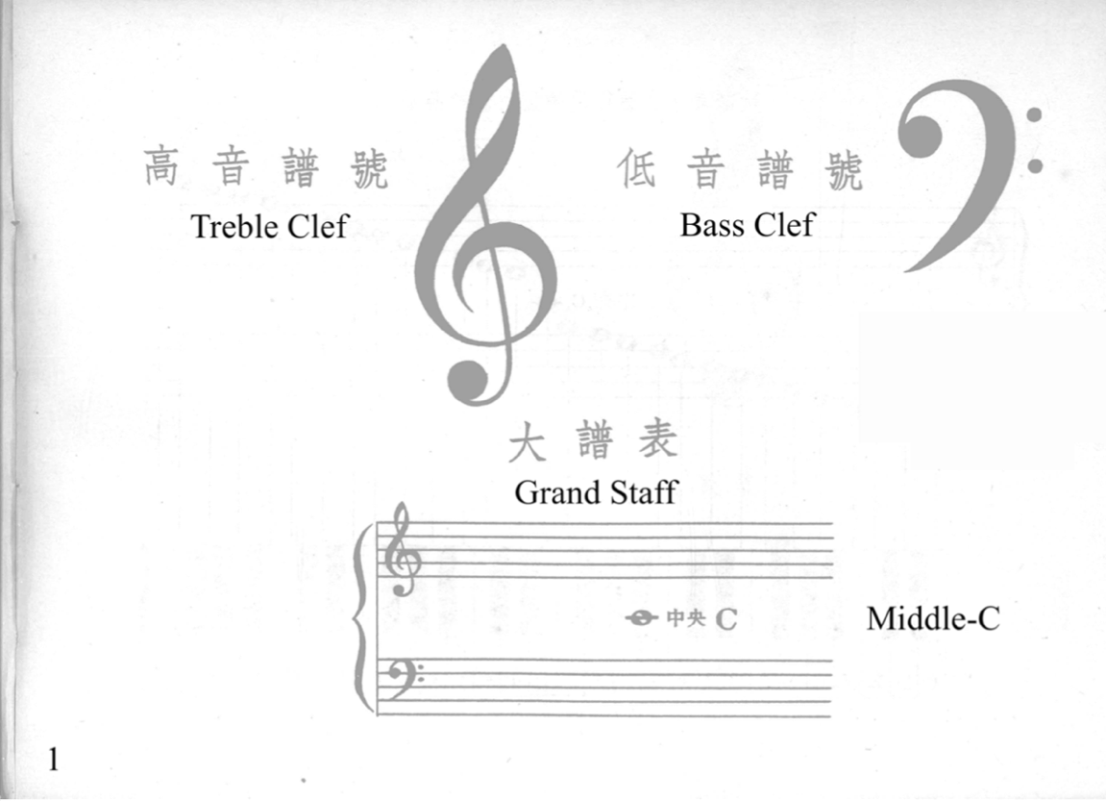
Figure 7: Introduction of Fundamentals

Notes on the grand staff are introduced on page two (Figure 8). The title of this page translates to “Chart of keyboard notes and positions on the grand staff.” This illustration includes notes ranging from C2 to C6. However, Ding did not use this numbering system to label the notes on the keyboard, rather, he utilized superscripts. For example, the letter names in the lowest octave are identified using all-caps (C, D, E, F, G, A, B), boxed in red. The next octave is labeled with lowercase letters (c, d, e, f, g, a, b), boxed in green. Ding labels the following octave using lowercase letters with a superscript one (c¹, d¹, e¹, f¹, g¹, a¹, b¹), boxed in blue. Lastly, the remaining octave is labeled using lowercase letters accompanied by a superscript two (c², d², e², f², g², a², b²), boxed in orange. This suggests that Ding referred to middle C either by its name, “middle C,” or, by “c¹.” Throughout First Lessons in Piano (1957), Ding is consistent with this labeling system.

Figure 8: “Chart of Keyboard Notes and Positions on the Grand Staff”
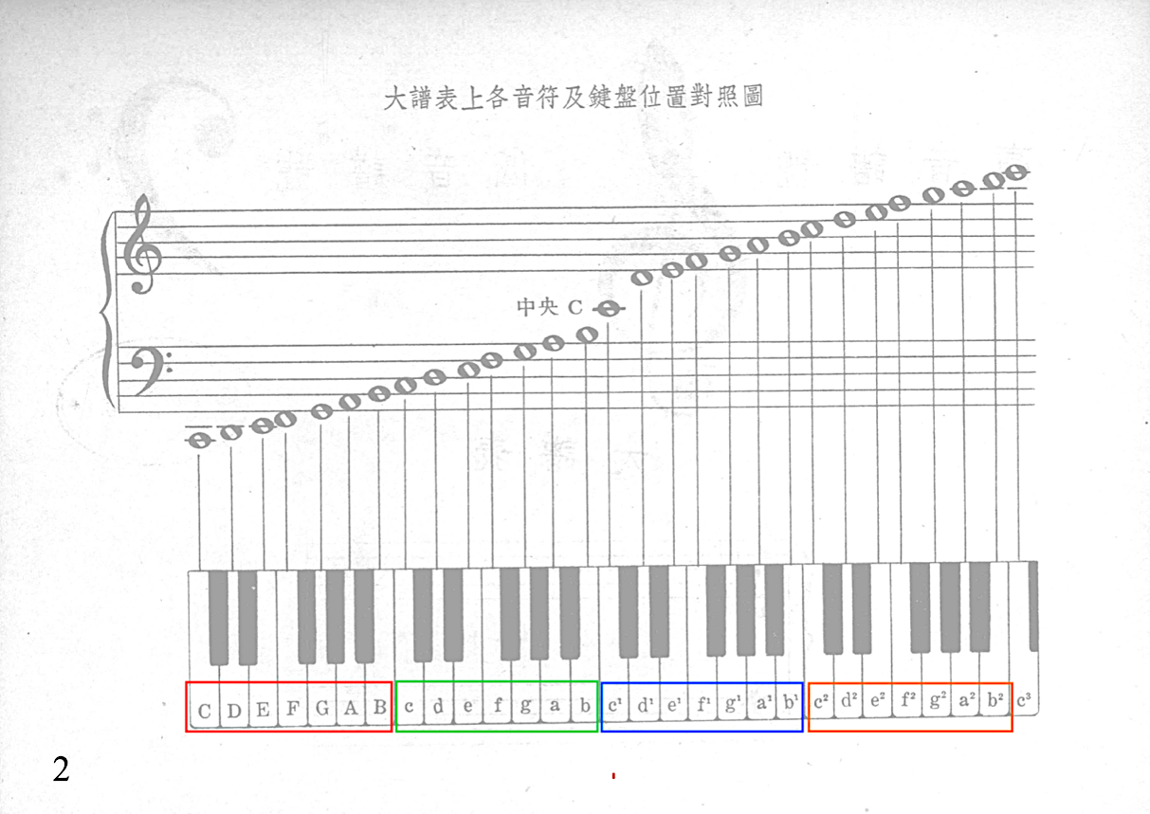

Rhythm Value Introduction: Right Hand (No. 1-16)
Section One of First Lessons in Piano (1957) isolates and develops the hands separately. Exercises one through 16 focus on right hand playing, followed by exercises 17 through 23, which focus on left hand playing (see Table 2). This portion of the analysis examines Ding’s introduction of the whole note, half note and quarter note to the right hand.
Throughout Section One, the right hand introduces whole, half, and quarter note rhythm values (see Table 3). The whole note is introduced in exercise number one and reinforced throughout exercises two through six (see Figure 9). The half note is introduced in exercise number seven, followed by the reinforcement of both whole and half notes in the exercises numbered eight through 12. Lastly, the quarter note is introduced in exercise number 13. Throughout exercise number 14 through 16, Ding reinforces whole, half and quarter notes. Refer to Table 3 for Ding’s sequencing and reinforcement of rhythm values.

Table 3: Rhythm Value Introduction: Right Hand
Exercise number | Rhythm values introduced | Rhythm values reinforced
Number 1 | Whole note
Number 2 – 6 |  | Whole note
Number 7 | Half note
Number 8 – 12 |  | Whole note and half note
Number 13 | Quarter note
Number 14 – 16 |  | Whole note, half note and quarter note

Taking a closer look at Ding’s introduction of rhythm values, exercise number one, located on page three, focuses on developing the student’s understanding of the whole note (see Figure 9).

Figure 9: First Lessons in Piano, Exercise No. 1: Whole Note
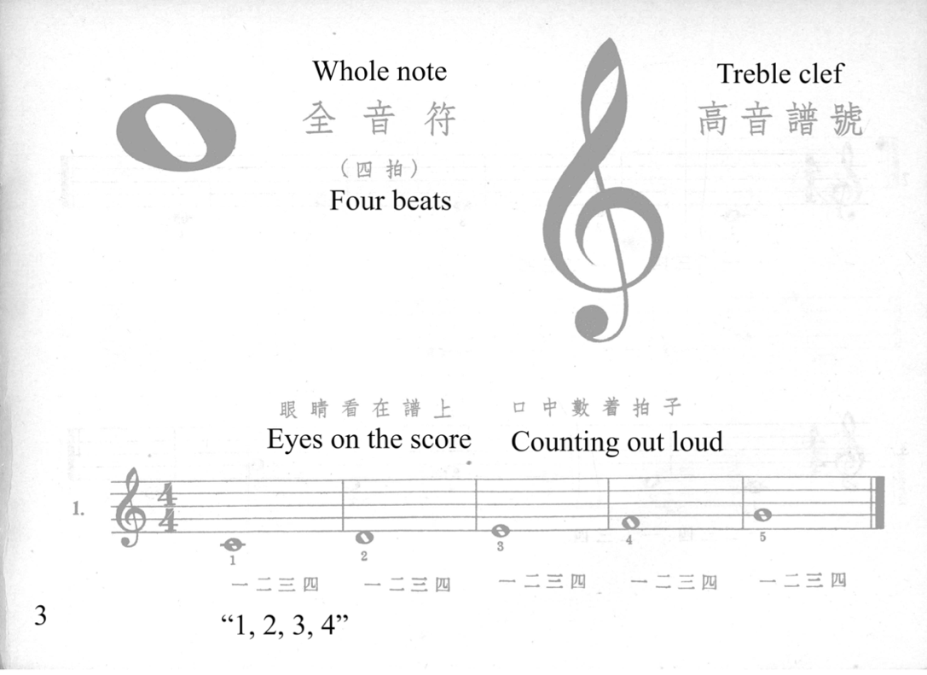

Notated above the treble clef, Ding presents two pedagogical suggestions: eyes on the score, and counting “1, 2, 3, 4” out loud (see Figure 9). To reinforce rhythm, Ding utilizes the metric counting approach, where the number of beats are counted consecutively. In the metric counting approach, each beat is referred to by their location in the measure, for example, beat one will always be counted as ‘one.’ Ding reinforces rhythm by incorporating counting reminders throughout the method (see Figure 10) which appear visually as “一二三四,” translating to “1, 2, 3, 4.” Like John Thompson’s Easiest Piano Course: Part One, Ding’s First Lessons in Piano introduced the whole note value first. The whole note is reinforced throughout exercises two to six (see Table 3).
Although exercises two through six are meant to reinforce the whole note, each exercise is unique and contains some new musical element. For example, while exercise number one utilizes exclusively stepwise motion, beginning in exercise number two, Ding introduces skips into the texture, particularly at the end of the phrase, demonstrating early cadential movement (see Figure 10). Ding continues to provide finger numbers for each pitch, particularly while new concepts are still fresh. Refer to Table 3 on page 58 of this document for an outline of Ding’s sequencing of right hand rhythm values.

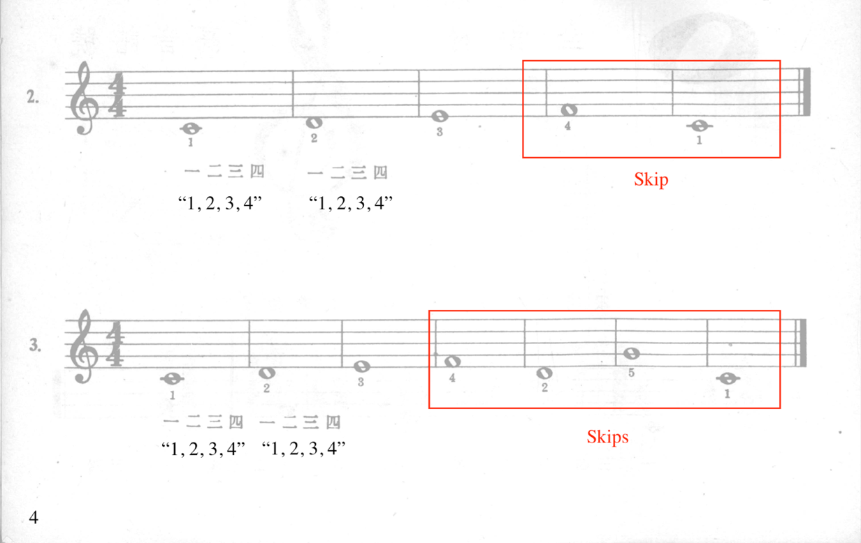
Figure 10: First Lessons in Piano, Nos. 2-3: Whole Note Reinforcement

The half note is introduced in exercise number seven, located on page six (see Figure 11), followed by four exercises which reinforce the half note and whole note (exercise 8 – 11). Ding provides an illustration of the half note, along with its name and number of counts. Under the staff, Ding indicates “一二三四,” a pedagogical reminder to continue counting out loud. Exercise number seven contains mostly stepwise motion but includes a skip leading into the last measure (see Figure 11). Ding provides finger numbers for each pitch, as if to draw the student’s attention to counting, rather than testing their note reading. Additionally, number seven is isolated to mostly half notes, allowing the student to become familiar with half notes.
Following exercise number seven, Ding continues to reinforce the half note, but simultaneously uses spiral sequencing to reintegrate the whole note back into the texture. Spiral sequencing simultaneously reinforces the new concept (half notes), while providing a review and application of the older material (whole notes). Additionally, number eight includes an increased number of skips, adding melodic interest and shifting the pedagogical spotlight back to note reading. Translations are indicated in black, while markings by the current author are indicated in red.

Figure 11: First Lessons in Piano, Nos. 7-8: Half Note
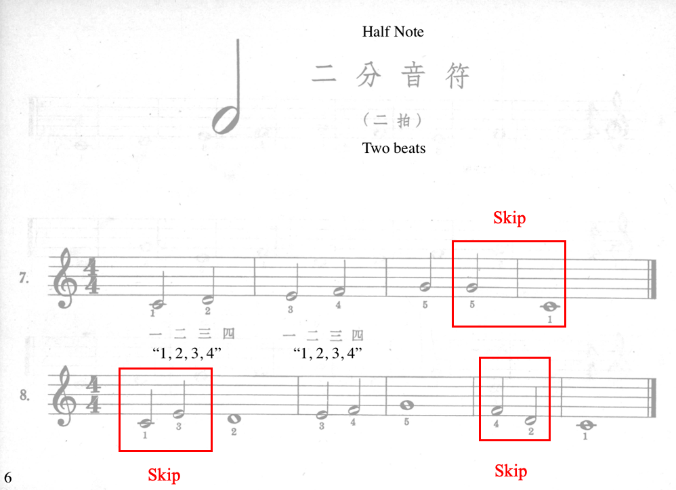

Following exercises numbers seven and eight, Ding proceeds to reinforce the half note and whole note value throughout exercises nine through 12. In addition to reinforcing the half and whole note, Ding introduces a new technique in exercise number nine, the finger crossing (see Figure 12). In this exercise, there are two finger crossings which involve fingers one and three, located in measure two and measures six to seven, outlining an ascending and descending C major scale. To help the student facilitate the finger crossing, finger suggestions are provided.

Figure 12: First Lessons in Piano, No. 9
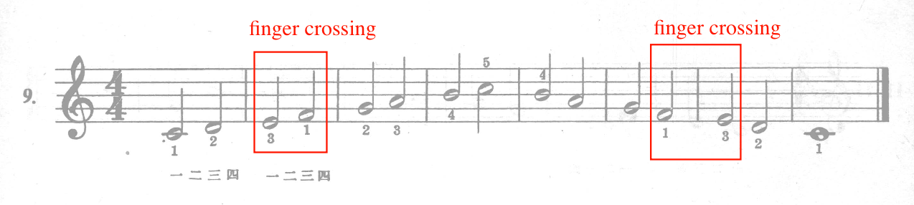

The following exercises (Nos. 10-12, unpictured) prioritize the reinforcement of whole and half note values, as well as finger crossings (one to three, or three to one). In these exercises, Ding reduces fingering suggestions and increases the frequency of skips. Exercises 10, 11, and 12 contain finger crossings, outlining the typography of the C major scale.
Next, the quarter note is introduced in exercise number 13 (see Figure 13) and reinforced throughout exercises 14 through 16. Number 13 consists primarily of stepwise motion, with cadential skips in measures four and five, outlining pitches D, G, and C. This skipping motion was first found in exercise number three, ten and 12. The reoccurrence of this cadential movement strengthens the student’s aural association to cadential structures.

Figure 13: First Lessons in Piano, No. 13: Quarter Note
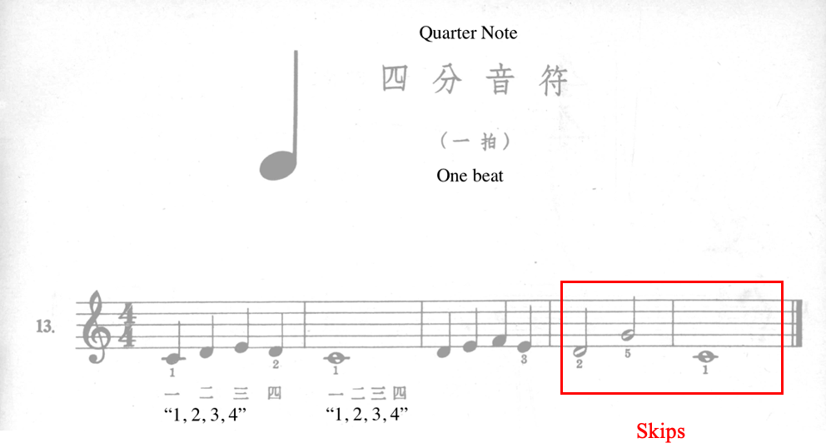

Unlike previous rhythm value introductions, number 13 combines all rhythm values established so far, whereas Ding utilized only the rhythm value being introduced in the whole note and half note exercises. Ding continues to provide counting reminders in exercise number 13 (see Figure 13), prioritizing and promoting a steady beat and a strong internal sense of rhythm.
The final exercises for right hand only, exercises 14 through 16, contain: the reinforcement of whole, half and quarter notes; counting out loud; finger crossings; and the C major scale. While continuing to reinforce whole, half and quarter notes, Ding introduces the 4/4 time signature in exercise number 15 (see Figure 14), located on page 10 of the method. This page contains an illustration of the new time signature, as well as a description of its function:
“four beats per measure,” and “one beat per quarter note.” Translations are provided in black (see Figure 14).

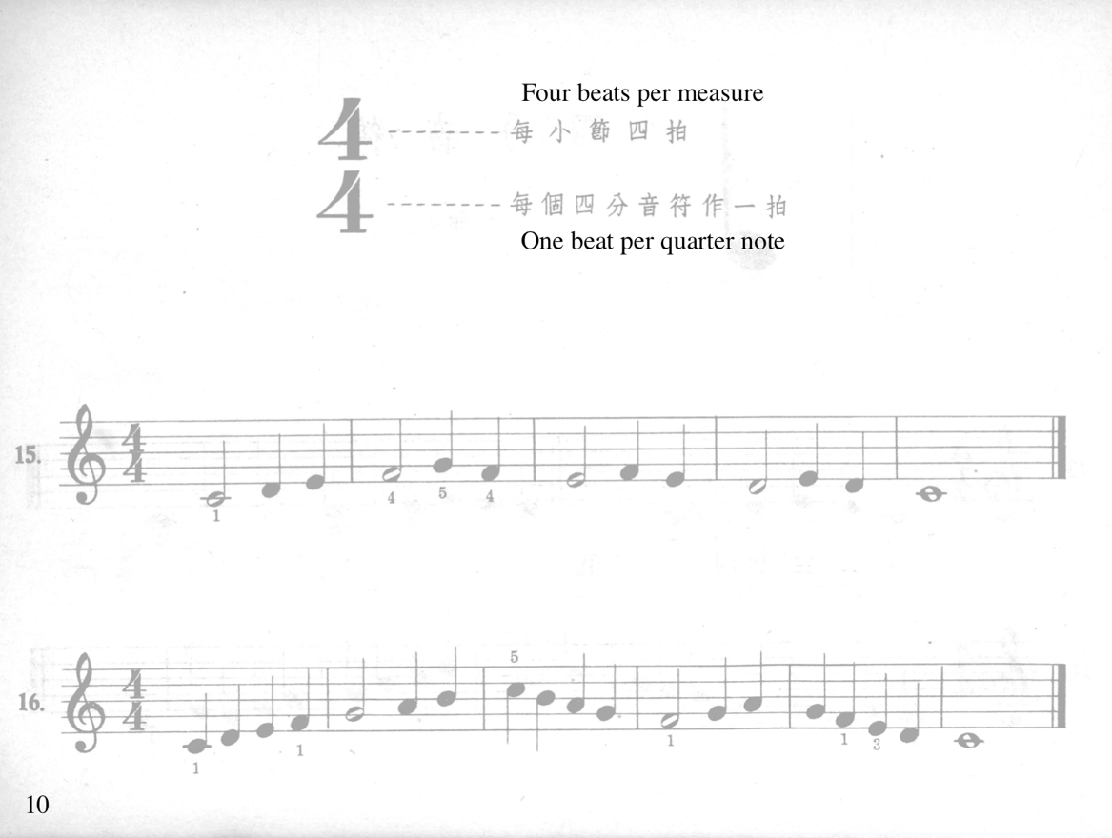
Figure 14: First Lessons in Piano, Nos. 15-16: 4/4 Time Signature

Exercise numbers 15 and 16 represent the final exercises for only the right hand, as number 17 to 23 pertain to the left hand only. In these final two exercises, Ding reduces fingering suggestions and utilizes all rhythm values thus far introduced.
In summary, exercises one through 16 introduce the whole, half and quarter note values to the right hand. Whole note, half note, and quarter notes are introduced in exercises number one, seven, and 13, respectively. The next section pertains to left hand rhythm value sequencing and reinforcement.

Rhythm Value Introduction: Left Hand (Nos. 17-23)
The remainder of Section One consists of exercises 17 through 23, which focus on the development of the left hand. Similar to exercises one through 16 (right hand alone), whole note, half note, and quarter note rhythm values are sequentially reintroduced. Assuming that the student has a conceptual grasp of whole, half and quarter note rhythm values from experiencing them in the right hand, Ding dedicates only seven exercises (Nos. 17-23) to the introduction and reinforcement of these rhythm values in the left hand.
Similar to exercises one through 16 for the right hand, the whole note is the first rhythm value introduced to the left hand, in exercise number 17, followed by the half note in number 19, and finally, the quarter note in number 20. Exercise numbers 17 and 18 consist of whole notes only (see Table 4), followed by number 19, which combine whole notes and half notes. Numbers 20 through 22 combine all rhythm values introduced so far (whole, half and quarter). Lastly, exercise number 23 reviews whole notes and quarter notes (see Table 4). Refer to Table 4 for the sequential introduction of rhythm values for the left hand.

Table 4: Rhythm Value Introduction: Left Hand
Exercise Number | Rhythm values included
Nos. 17-18 | Whole notes only
No. 19 | Whole notes and half notes
Nos. 20-22 | Whole notes, half notes, and quarter notes
No. 23 | Whole notes and quarter notes

Located on page 11 of the method, number 17 is the first exercise written for the left hand (see Figure 15). The purpose of this exercise is to introduce the left hand to whole note rhythm values. Exercise number 17 follows a stepwise structure similar to exercise number one (Figure 9), however, number 17 is nine measures in length, while number one is five measures. Ding reinforces the whole note value by providing a counting reminder, “一二三四,” below the staff. Ding includes an illustration of the left hand, indicating the location of each finger number (see Figure 15).

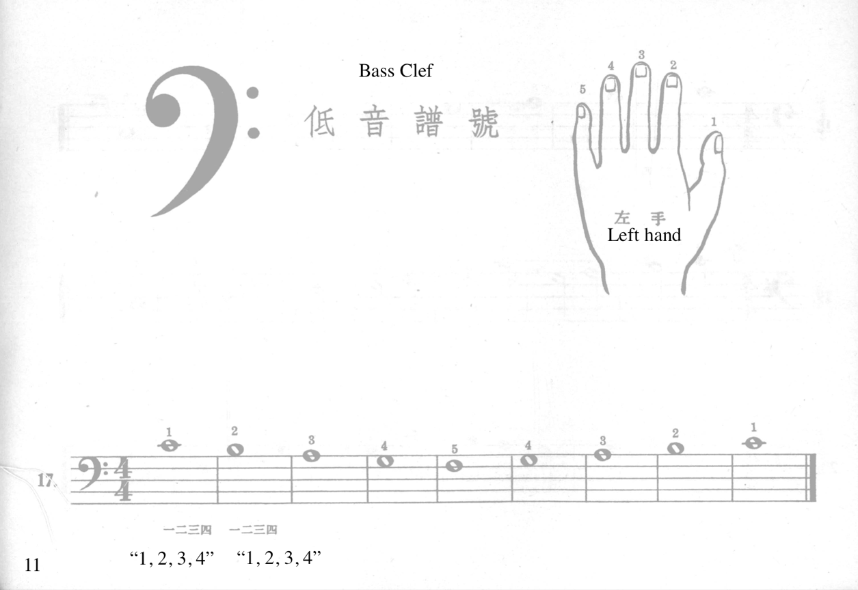
Figure 15: First Lessons in Piano, No. 17: Left Hand

Rhythm values are introduced at a substantially faster rate for the left hand (Nos. 17-23) than compared to the right hand (Nos. 1-16), in fact, sequencing left hand rhythmic values 228% faster than the right hand. This reduces rhythmic reinforcement and allows the adding of new technical concepts at a faster rate. For example, in exercise number 18, Ding reinforces the whole note, but also includes the first instance of the finger crossing technique in the left hand (see Figure 16).

Figure 16: First Lessons in Piano, Nos. 18-20: Rhythm Values
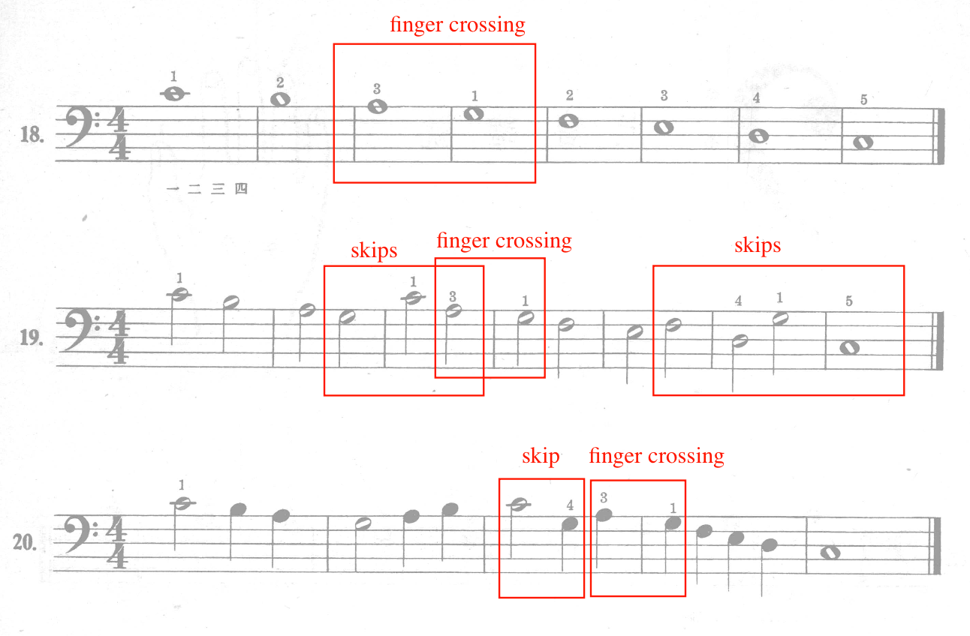

Number 19 continues to reinforce the left hand finger crossing (three to one), but in the context of half note values instead of whole note values (see Figure 16). In this exercise, Ding increases the number of skips and reduces fingering suggestions, promoting reading independence in the left hand.
Exercise number 20 integrates all the rhythm values (whole, half, and quarter) into the texture, including a finger crossing and a skip. Compared to exercise numbers one through 16 (right hand alone), exercises 17 through 23 (left hand alone) progress at a quicker pace, under the assumption that the student is now familiarized with the whole, half and quarter note values.

Reading Approach
In First Lessons in Piano (1957), Ding introduces note reading using the middle C approach, a technique where both thumbs are placed on middle C and pitches surrounding middle C are introduced one by one. Other mid-20th century methods that utilize this reading approach include Thompson (1936), Carr (1967), and Schaum (1973).
Throughout Section One (Nos. 1-23), Ding familiarizes the student with the white key pitches between bass C and treble C (see Figure 17). Although Ding Shande uses superscripts to identify keys on the piano (see Figure 8), the current author will refer to pitches using modern nomenclature throughout this analysis. Ding sequences pitch introduction by beginning in middle C five finger position, then expands a full octave by using finger crossing.

Figure 17: Pitches Introduced in Section One, Exercises No. 1 – 23
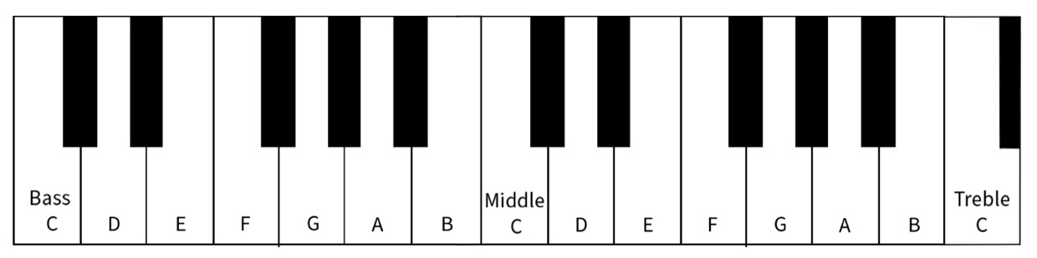

Exercises one through 16 feature only right hand playing, and numbers one through eight all remain within the middle C five finger pattern. Initially, Ding focuses on developing note reading in middle C five finger position. For example, exercise number one introduces the middle C five finger pattern, beginning with finger number one on middle C, walking up to treble G in measure five (see Figure 18).

Figure 18: First Lessons in Piano, No. 1: Reading Approach
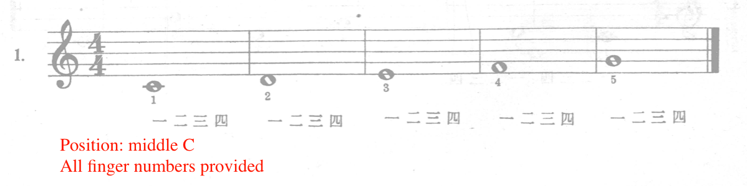

Characteristic of the middle C reading approach, Ding begins most exercises on middle C. All exercises begin (for the right hand only Nos. 1-16) with finger number one on middle C, with the exception of exercises four, six, and 12, which begin on G, E and treble C, respectively (see Figure 19). As the method progresses, Ding incrementally integrates different starting pitches in order to develop independent reading skills.

Figure 19: First Lessons in Piano, No. 4, 6, and 12
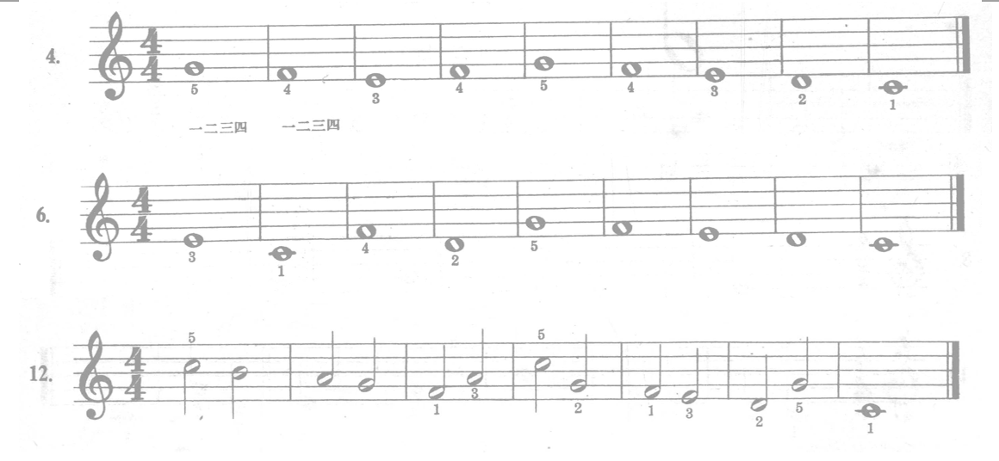
Ding promotes note reading independence by increasing skipping motion, and incrementally removing fingering annotations (see Figure 20). For example, Ding includes finger numbers for each pitch in exercises one through four, but reduces them in exercise five and six.

Figure 20: First Lessons in Piano, No. 5: Reading Approach
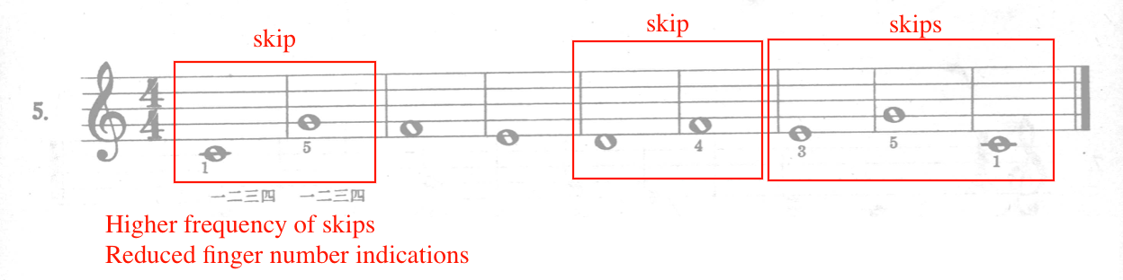

Exercises one through eight remain within the middle C five finger pattern. However, exercise number nine introduces finger crossing, which expands the middle C five pattern into a one octave C major scale (see Figure 21). Since the finger crossing and C major scale are new concepts for the student, Ding includes fingering annotations for most pitches, especially focusing on skips and finger crossings (see Figure 21).

Figure 21: First Lessons in Piano, No. 9: Reading Approach
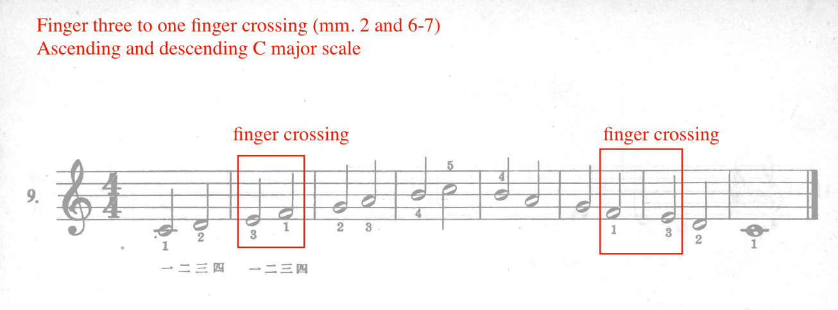

Typically, when introducing new pitch, rhythm or technical concepts, Ding utilizes primarily stepwise motion in combination with fingering annotations to help students adapt to the new concept. For example, the new concept introduced in number nine is the finger crossing (see Figure 21). In this case, Ding provides nearly all fingering indications and omits skipping motion, in order for the student to focus on the new finger crossing technique. Additionally, when introducing half notes in exercise number seven, Ding keeps skipping motion minimal (see Figure 22). Since half notes represent the new concept in exercise number seven, Ding provides finger numbers for each pitch.

Figure 22: First Lessons in Piano, No. 7: Reading Approach
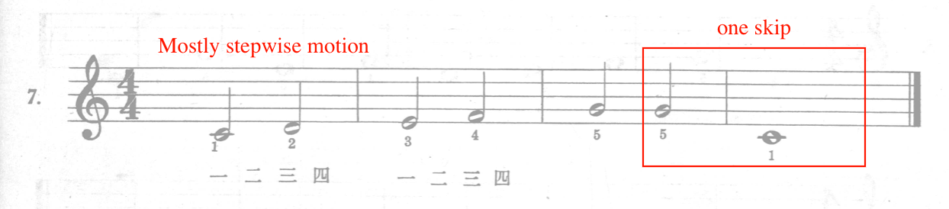

Moreover, when Ding introduces quarter notes in exercise number 13, steps make up the majority of the texture, with the exception of two skips in measures four and five (see Figure 23). By exercise number 13, Ding reduces fingering suggestions, assuming the student has a grasp on reading steps and skips within the middle C five finger position (see Figure 23).

Figure 23: First Lessons in Piano, No. 13: Reading Approach
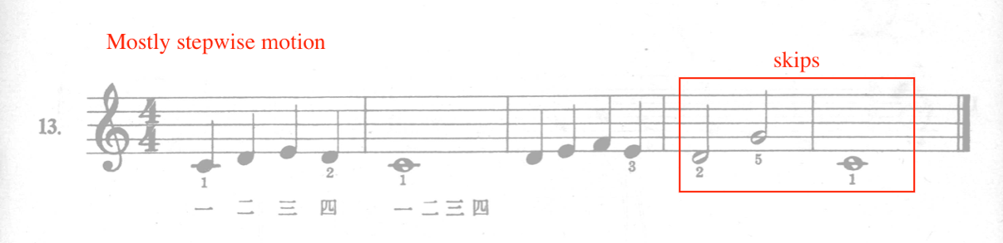

Starting in exercise number 17, Ding develops reading in the left hand. He allocates seven exercises (Nos. 17-23) to left hand reading development, significantly less than the right hand, for which there are 16 exercises (Nos. 1-16). Ding uses the middle C reading approach to introduce middle C and the four notes preceding it.
Ding begins with left hand finger number one on middle C in exercise number 17 (see Figure 24). This exercise is the student’s first experience playing with the left hand. Ding utilizes only whole notes and stepwise motion, and provides finger numbers for each pitch (see Figure 24).

Figure 24: First Lessons in Piano, No. 17: Reading Approach
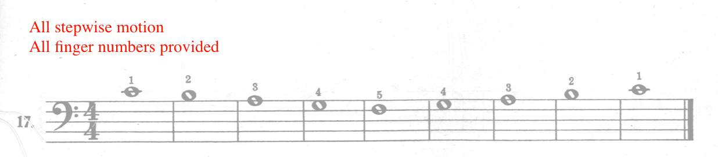

Following exercise number 17, Ding introduces the left hand finger crossing in exercise 18 (see Figure 25), keeping the texture stepwise and supplying all finger numbers. Left hand note reading is sequenced over twice as fast as right hand note reading. For instance, Ding provides eight reading exercises prior to introducing right hand finger crossings, but only writes one left hand exercise before introducing the same concept. This may be due to the assumption that the student has developed an understanding of finger crossings from experiencing them in the right hand first.

Figure 25: First Lessons in Piano, No. 18: Reading Approach
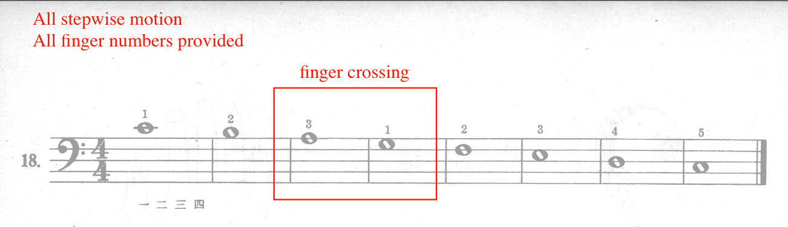

Ding reinforces left hand note reading in numbers 18 through 23, the remaining exercises of Section One. The majority of these reinforcement exercises begin with left hand finger number one on middle C, with the exception of exercise number 22, which begins on bass C (see Figure 26), which occurs unprepared by previous content. Exercises 18 through 23 reinforce note reading in the left hand.

Figure 26: First Lessons in Piano, No. 22: Reading Approach
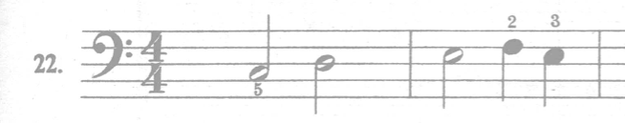

In summary, throughout Section One (Nos. 1-23), Ding develops note reading one hand at a time, first with the right (Nos. 1-16), then left (Nos. 17-23). In both hands, exercises begin with finger number one on middle C, developing the five pitches surrounding middle C (see Figure 27). These pitches include: F, G, A, B, middle C, D, E, F, and G.

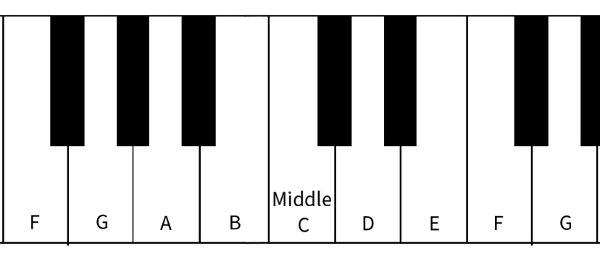
Figure 27: Middle C Position

After the student becomes familiar with the five pitches surrounding middle C, Ding uses finger crossing to introduce additional pitches to the student, expanding the five finger position into a full octave. The following pitches are introduced and reinforced throughout Section One: bass C, D, E, F, G, A, B, middle C, D, E, F, G, A, B, and treble C (see Figure 28).

Figure 28: Pitches Introduced in Section One, Exercises Nos. 1-23
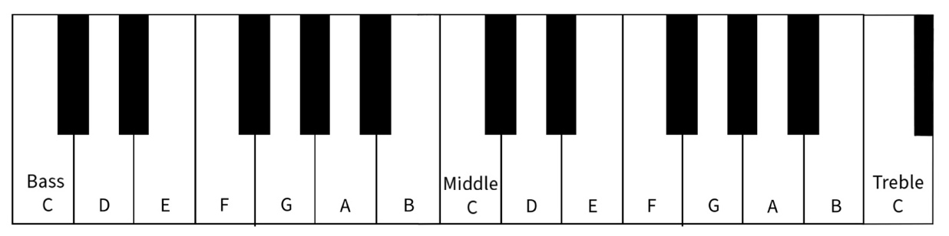

Asymmetrical Phrase Length
Throughout the first section (Nos. 1-23), 17 out of the 23 exercises are asymmetric, or irregular, in length (see Table 5). In contrast, out of the 23 exercises, only six are symmetrical in measure length. Asymmetrical exercises consist of works with an odd number of measures, such as five, seven, or nine, in length. Symmetrical exercises consists of works with an even number of measures, such as four, six, or eight, in length.

Table 5: First Lessons in Piano, Asymmetrical Phrase Length
Exercise number | Total measures | Asymmetric | Symmetric
1 | 5 | X
2 | 5 | X
3 | 7 | X
4 | 9 | X
5 | 9 | X
6 | 9 | X
7 | 4 |  | X
8 | 6 |  | X
9 | 8 |  | X
10 | 7 | X
11 | 7 | X
12 | 7 | X
13 | 5 | X
14 | 6 |  | X
15 | 5 | X
16 | 6 |  | X
17 | 9 | X
18 | 8 |  | X
19 | 7 | X
20 | 5 | X
21 | 5 | X
22 | 5 | X
23 | 7 | X

For example, exercise numbers one and two are five measures in length, and exercise number three is seven measures in length. In fact, 30 out of the 71 exercises in First Lessons in Piano contain asymmetrical, or irregular, phrase lengths. These exercises are either five, seven, nine, 11, 13, 17, or 19 measures in length. This is unusual compared to most contemporaneous method books in the West, which typically are composed in groups of four-bar phrases, resulting in a symmetrical total length. For example, John Thompson’s Teaching Little Fingers to Play, only includes works that are four, eight, 12, 16, or 24 measures in length. This distinctive feature could be connected to or potentially influenced by practices in traditional Chinese folk music. Traditional Chinese music was often asymmetrical in length, as melodies were originally based on spoken poetry, which, when set to music, often resulted in an asymmetrical phrase length.

Summary of Section One
In summary, Section One (Nos. 1-23) introduces and reinforces basic keyboard fundamentals and separate hands playing. The treble and bass clefs are introduced individually. Exercises one through 16 develops the right hand, while exercises 17 through 23 focus on the left hand. Using the middle C reading approach, Section One introduces the pitches within one octave of middle C. Ding introduces the finger crossing technique (three to one or one to three) in exercises nine (right hand) and 18 (left hand), expanding the student’s note reading range from the five finger pattern to a full octave. Sequenced for each hand separately, Ding introduces the whole, half and quarter note, using the metric counting approach and introduces 4/4 meter in exercise number 15. Typically, Ding includes fingering suggestions for newly introduced concepts, and decreases fingering for reinforcement exercises. Instructor guidance is essential throughout this method, as technical suggestions from Ding Shande are minimal.

Section Two: Hands Together

Overview
Section Two of the analysis of First lessons in Piano (1957) features exercises number 24 through 37. The examination of Section Two is divided categorically into three pedagogical goals: the sequencing of hands-together playing, the development of new hand positions, and the introduction and pacing of new rhythm values. Throughout Section Two, Ding carefully sequences the development of hands-together playing, integrates non-middle C positions, and introduces whole/half/quarter rests, and eighth notes. Refer to Table 6 for a summary and leveling of the contents in Section Two.

Table 6: Section Two Analysis of First Lessons in Piano (1957)
Exercises | Alternating-hands or hands-together | Summary of contents | Level
Nos. 24-29 | Alternating-hands | Rhythm: whole, half and quarter notes  Hand position: mostly middle C position  Grand staff | Level 1
Nos. 30-37 | Hands-together | Rhythm: whole, half, quarter, eighth notes  Hand position: shifts between various positions  Grand staff | Level 1-2

Sequencing of Hands-Together Playing
Throughout Section Two, Ding cultivates the development of hands-together playing. Exercises 24 through 29 focus on the alternation of hands, followed by exercises 30 through 37, which develop hands-together coordination.
Exercise 24 introduces hands-alternating playing as well as the half and whole rest (see Figure 29). Exercise number 24 features one hand at time, alternating between right and left hands. On this page, Ding provides an illustration of the whole and half rest, along with descriptions of their values: “rest for one measure,” and “rest for two beats.”

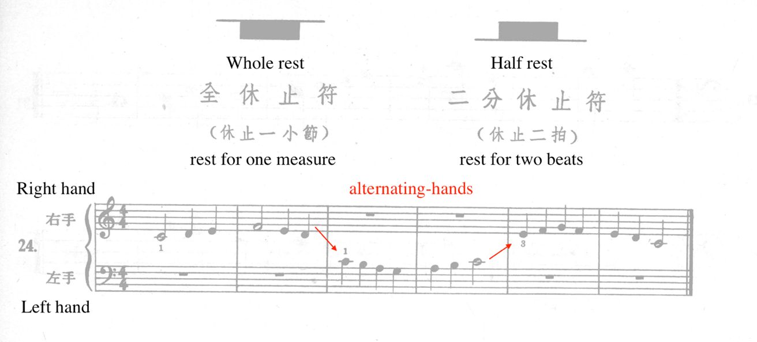
Figure 29: First Lessons in Piano, No. 24: Alternating Hands

New concepts are typically accompanied with fingering suggestions, stepwise motion and static position in both hands, similar to the exercises from Section One (Nos. 1-23). For example, exercise number 24 utilizes stepwise motion and fingering reminders while both hands remain in middle C position (see Figure 30).

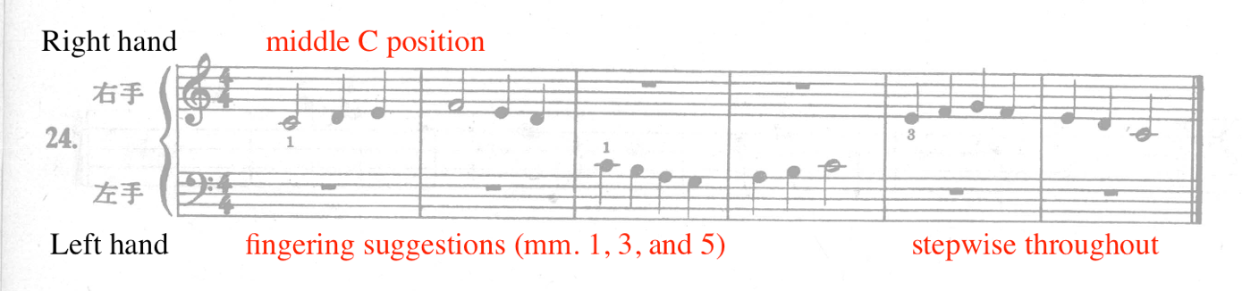
Figure 30: First Lessons in Piano, No. 24

Following exercise number 24, nos. 25 through 29 reinforce hands-alternating playing, typically through trading melodic material between the hands or utilizing a call and response technique. For example, like number 24, exercise 25 passes the melodic material between the hands, remaining in middle C position throughout (see Figure 31).

Figure 31: First Lessons in Piano, No. 25: Passing Melody Between Hands
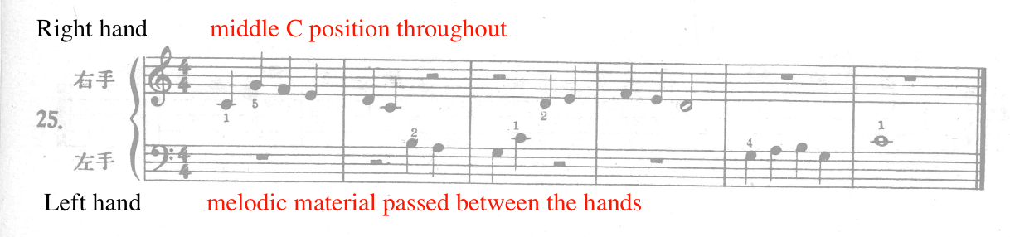

Exercise number 26 features call and response in combination with passing the melodic material between the hands (see Figure 32). For example, a two-measure phrase is presented in the right hand (mm. 1-2), followed by a response in the left hand (mm. 3-4). The final two measures (mm. 5-6) consist of a cadential phrase, passing the melodic material between the hands.

Figure 32: First Lessons in Piano, No. 26: Call and Response
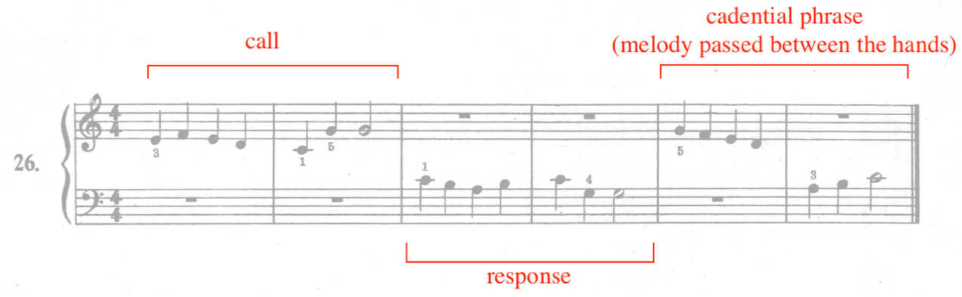

Measures one through four of this exercise (No. 26) are considered call and response due to the repetition of rhythm values as well as the mirroring of melodic contour. For example, measures one through two feature six quarter notes followed by a half note, which is accordingly mirrored in the left hand in measures three to four. Although not completely identical, the contour in the call (RH, mm. 1-2) and response (LH mm. 3-4) feature similar movement, consisting of stepwise motion followed by skips leading to the dominant of C-major (G) (see Figure 33). The integration of call and response helps bring unity to the exercise, in addition to serving as a powerful pedagogical learning tool.

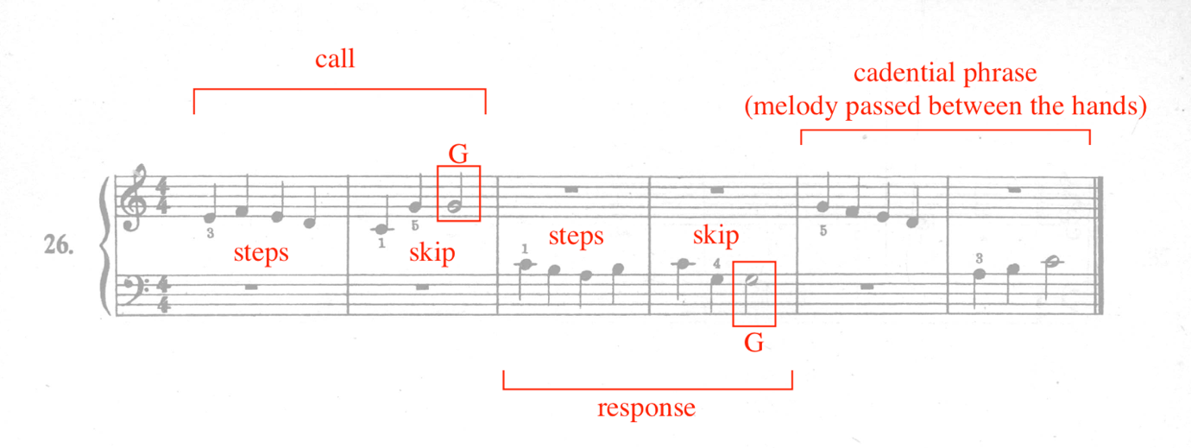
Figure 33: First Lessons in Piano, No. 26: Call and Response, Part 2

While numbers 24 through 29 reinforce hands-alternating playing, exercise number 30 focuses on hands together playing. Number 30 combines the hands while simultaneously adding the introduction of common time, which is equivocated to 4/4 time (see Figure 34). To ease the introduction of hands-together playing, Ding provides generous fingering suggestions and utilizes mostly stepwise motion with both hands remaining in a static position throughout (see Figure 34). Additionally, number 30 is pattern based and repetitive, featuring a parallel period. The right and left hands remain in treble C and bass C positions throughout, respectively. In treble C position, right hand finger number one is placed on treble C, or C5. In Bass C position, left hand finger number five is placed on bass C, or C3. Ding helps the student focus on hands-together playing by simplifying the demands of the one hand. For example, the left hand plays whole notes while the right hand plays half notes in measures three and seven. Additionally, only left hand finger number one (dominant) and five (tonic) are needed in this exercise.

Figure 34: First Lessons in Piano, No. 30: Hands-Together Playing
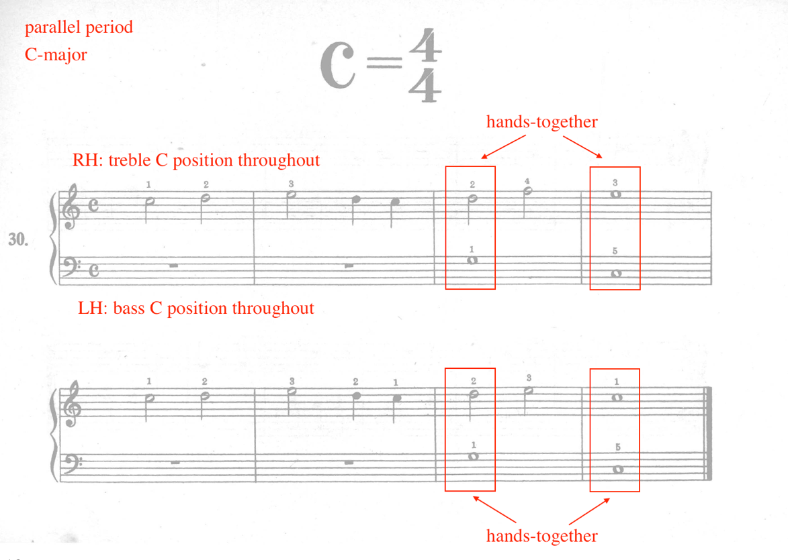
Exercises number 31 through 37 reinforce hands-together playing. Ding continues to aid in the transition from hands-alternating to hands-together playing by keeping certain aspects constant while increasing the difficulty of others. For example, similar to exercise number 30, number 31 also features parallel period phrasing, C-major tonal center, left hand in bass C position (finger number five on bass C, or C3), and whole notes in the left hand (see Figure 35). Number 31 continues to combine slower note values in the left hand with faster ones in the right hand. However, Ding increases the difficulty by incorporating increased skipping motion, more hands-together simultaneities (six simultaneities), and shifting the right hand position to finger number one on A4.

Figure 35: First Lessons in Piano, No. 31
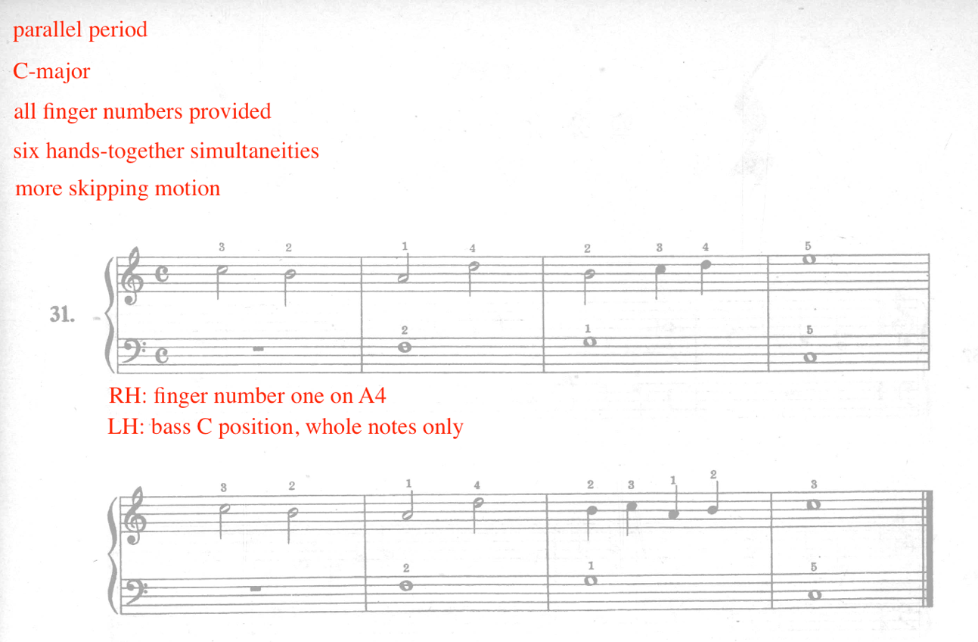

Exercise numbers 32 and 33 establishes left hand independence by using shorter note values (see Figure 36). For example, exercise number 32 utilizes quarter note stepwise imitation to increase left hand independence, while number 33 focuses on repetition. Number 32 introduces a right hand ascending scale in stepwise motion, which is imitated by the left hand in measure two. The same ascending figure is repeated in measures four to five. Number 33 focuses on repetition to promote left hand independence, featuring repeated G’s in measures two and four, eliminating the task of reading different pitches in the left hand. Ding also features spiral sequencing in exercise number 33 by restating the same left hand figure from number 32 in measures six to seven (see Figure 36). Due to the increased activity of the left hand in exercises 32 and 33, Ding grounds both hands in middle C position and provides fingering reminders.

Figure 36: First Lessons in Piano, Nos. 32-33: Increasing Left Hand Independence
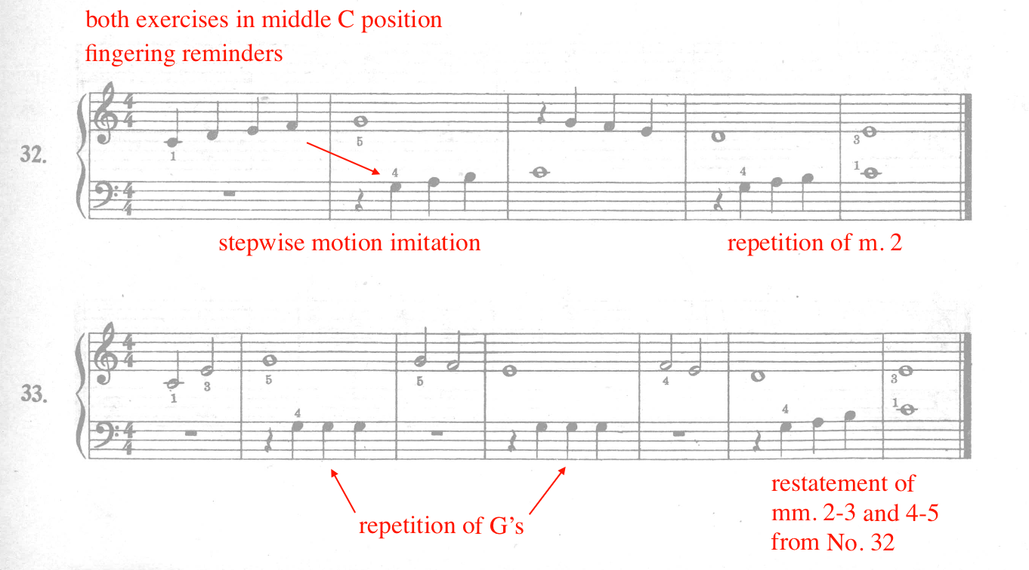

For the remainder of Section Two (nos. 24-37), exercises 34 through 37 focus on hands-together playing while introducing new rhythm values and position shifts, as discussed in the following portion of this section.

Development of New Positions
Throughout Section Two, Ding incrementally expands the student’s keyboard reading range by introducing new (non-middle C) hand positions. However, Ding does not utilize the multi-key approach, an approach where all keys are introduced by learning all chromatic five finger patterns. Instead, new positions are introduced by either starting in the new hand position, shifting to the new position, crossing over/under, or utilizing a finger extension. All exercises after No. 24 are placed on the grand staff. Refer to Table 7 for a list of hand positions throughout Section Two. This table briefly describes the location of the hand position as well as the method of position expansion. Many exercises begin in the new position (non-middle C), while others utilize a finger crossing or finger extension, resulting in a new position. Lastly, several exercises incorporate a direct shift into a new position.

Table 7: First Lessons in Piano, Section Two, Development of New Positions
Exercise No. | Position(s) | Method of position change/new position: finger crossing, shift, finger extension, or starts with new position
No. 24 | RH: middle C  LH: middle C | NA
No. 25 | RH: middle C  LH: middle C | NA
No. 26 | RH: middle C  LH: middle C | NA
No. 27 | RH: middle C, finger 5 on treble C (C5)  LH: middle C | RH: finger crossing (3 to 1) and direct shift  LH: NA
No. 28 | RH: middle C  LH: middle C, finger 5 on bass C (C3) | RH: NA  LH: finger crossing (3 to 1) and direct shift
No. 29 | RH: finger 5 on treble C (C5)  LH: middle C, finger 5 on A3 | RH: starts with finger 5 on treble C (C5)  LH: direct shift
No. 30 | RH: finger 1 on treble C (C5)  LH: finger 5 on bass C (C3) | RH: starts with finger 1 on treble C (C5)  LH: starts with finger 5 on bass C
No. 31 | RH: finger 1 on A4  LH: finger 5 on bass (C3) | RH: starts with finger 1 on A4  LH: starts with finger 5 on bass C (C3)
No. 32 | RH: middle C  LH: middle C | NA
No. 33 | RH: middle C  LH: middle C | NA
No. 34 | RH: middle C, finger 5 on treble C (C5)  LH: middle C, finger 5 on bass C (C3) | RH: shift  LH: finger extension
No. 35 | RH: middle C  LH: finger 5 on bass C (C3) | RH: NA  LH: starts with finger 5 on bass C (C3)
No. 36 | RH: finger 1 on A4, finger 1 on G4  LH: finger 5 on bass C (C3), finger 5 on G2 | RH: shift  LH: finger extension
No. 37 | RH: middle C, finger 5 on treble C (C4)  LH: finger 5 on bass C (C3) | RH: finger extension  LH: starts with finger 5 on bass C (C3)

Throughout Section Two, exercise nos. 24-26 remain in the middle C position, where both thumbs are placed on middle C, or C4. The first exercise to break away from the middle C position is number 27, where Ding uses a finger crossing (mm. 2-3) to expand from middle C position to finger number five on treble C (C5) (See Figure 37). In measures six to seven, the right hand returns to middle C position using a direct shift. The left hand remains in middle C position throughout, helping the student acclimate to position changes in the right hand. Fingering reminders are provided for ease.

Figure 37: First Lessons in Piano, No. 27, Right Hand Position Change
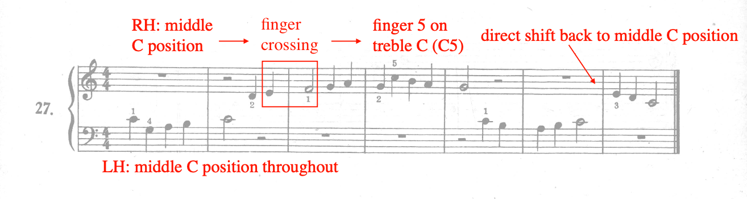

Directly following exercise number 27, exercise 28 features a position change in the left hand, also utilizing a finger crossing and direct shift (see Figure 38). In this exercise (No. 28), both hands begin in middle C position, but the right hand remains in middle C while the left moves away. The left hand uses a finger crossing in measure seven to transition into bass C position, or finger number five on bass C (C3). Fingering reminders are provided throughout, particularly during places where the melody is traded between the hands. Consistent with the concepts introduced throughout Section One, Ding continues to introduce new concepts to the right hand prior to the left hand.

Figure 38: First Lessons in Piano, No. 28, Left Hand Position Change
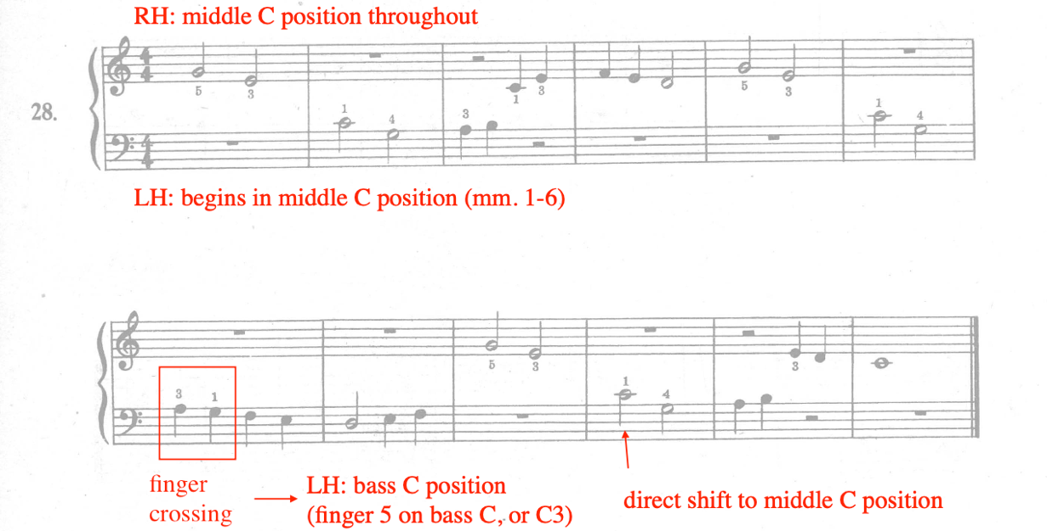

In addition to utilizing finger crossing and direct shift to transition from middle C to new positions, Ding also begins several exercises on non-middle C positions. For example, in exercise number 30, the first exercise containing hands-together playing, both begin on non-middle positions: the right and left hand begin on treble C and bass C positions respectively (see Figure 39).

Figure 39: First Lessons in Piano, No. 30, Excerpt, mm. 1-4, Treble C and Bass C Positions
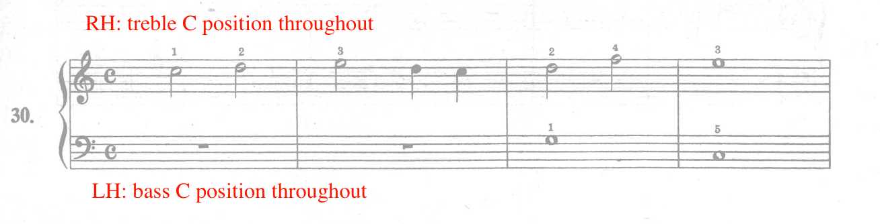

Lastly, Ding utilizes finger extensions to expand the student’s keyboard range. Finger extension refers to the slight extension of the fingers over two or more notes, resulting in the hand moving into a new hand position. For instance, exercise number 37 uses a finger extension in the right hand to transition between middle C position and finger number five on treble C (C5) (see Figure 40). Measures two to three feature a finger extension between finger number one and five, which shifts the hand into a new position for measures three and four. The same finger extension occurs in measures six to seven. Measures four to five feature a five to one finger extension in descending motion, transitioning back to middle C position. Finally, Ding reuses finger crossing in the final measure (m. 8) to transition back to middle C position. Due to the high activity of position shifts in the right hand, the left hand remains in bass C position throughout the entire exercise.
Figure 40: First Lessons in Piano, No. 37, Finger Extension
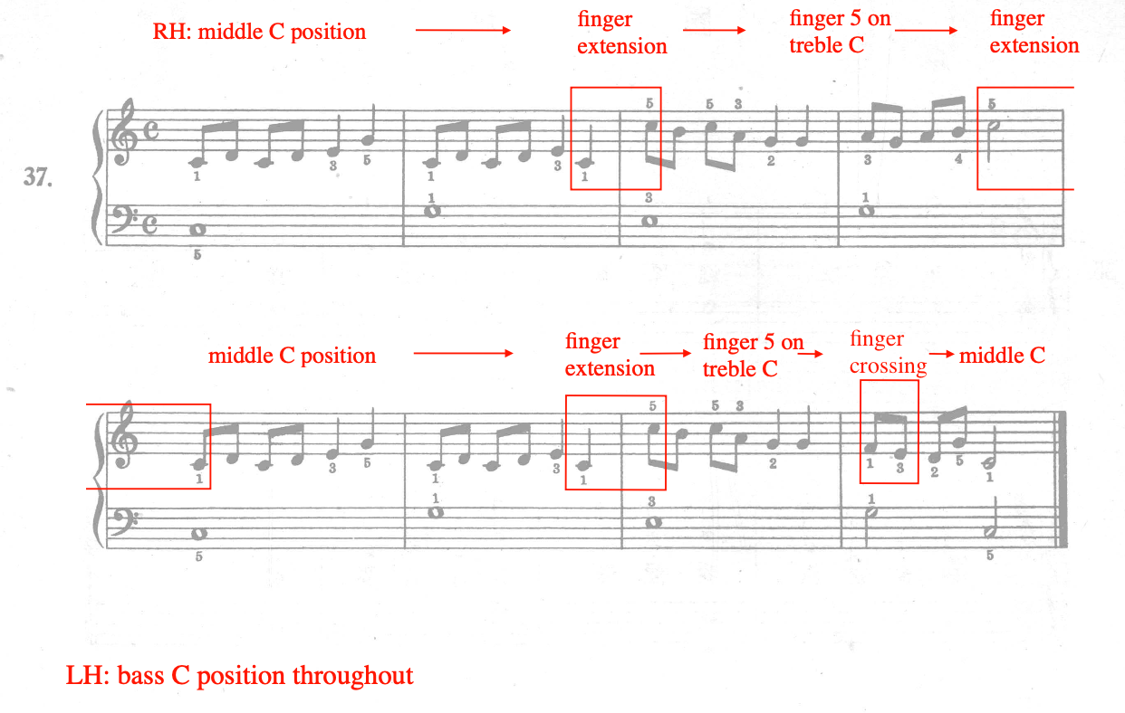

New Rhythm Values
Throughout Section Two (Nos. 24-37), Ding introduces four types of rhythm values: half rests, whole rests, quarter rests, and eighth notes. Refer to Table 8 for an overview of the pacing of rhythm value introductions.

Table 8: First Lessons in Piano, Section Two, Rhythm Value Introduction
Exercise No. | Rhythm value
No. 24 | Whole rest
No. 25 | Half rest
No. 32 | Quarter rest
Nos. 34-35 | Eighth notes

Ding introduces the whole and half rest in exercise number 24 and 25, indicated with the text “rest for one measure,” and “rest for two beats” (see Figure 41). Exercise number 24 includes the whole rest while exercise number 25 includes both whole and half rests. Number 24 and 25 include hand-alternating playing, resting one hand while the other plays.

Figure 41: First Lessons in Piano, No. 24-25, Whole and Half Rests
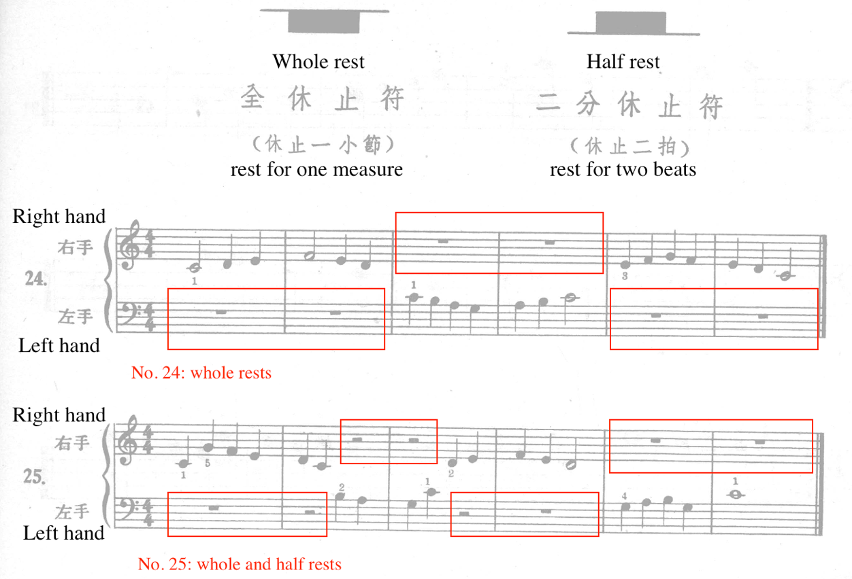

Exercises 26 through 31 reinforce whole and half rests, which are utilized mostly during hand-alternating exercises. Ding introduces the quarter rest in number 32; it occurs in measures two, three and four (see Figure 42). As previously discussed in the first portion of Section Two, exercise number 32 utilizes the call and response technique with the goal of acclimating the student to hands together playing. With the same goal in mind, the quarter rest allows the student to focus on one note at a time, rather than depressing two simultaneous pitches. Both hands are given the opportunity to practice the quarter rest.

Figure 42: First Lessons in Piano, No. 32, Quarter Rest
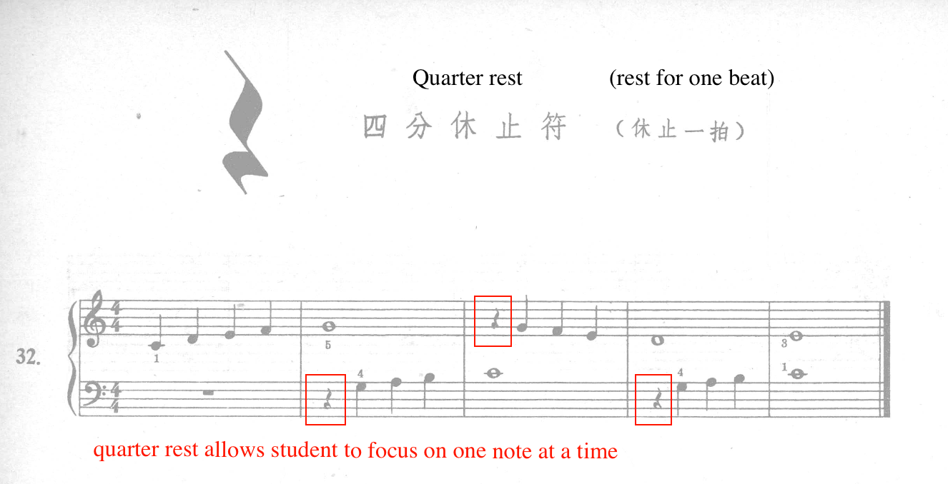

The eighth note is introduced in exercises 34 and 35. An illustration of both single stemmed and beamed eighth notes are provided, with the description “each half of a beat” (see Figure 43). Notably, Ding introduces single stemmed eighths before beamed eighths, likely in an effort to illustrate its value of half of one beat. In exercise 34, Ding also includes counting reminders in measures one and two, specifically notated where the quarter note beats are located. To help the student acclimate to this new rhythm value, measures one and two (no. 34) contain the same rhythm, allowing each hand to practice playing eighth notes. Measure three contains a descending C-major scale, first introduced in exercise number nine during Section One. Exercise number 35 introduces beamed eighth notes. Ding uses repetition in exercise 34 to acclimate the student to reading and playing beamed eighth notes. For instance, the right hand outlines the C-major five finger pattern, which is imitated in the left hand in measure two. Moreover, measure three (RH) contains a similar iteration of the material from measure one. Exercises 36 through 37 both reinforce the introduction of beamed eighth notes, hands-together playing, and new hand positions.

Figure 43: First Lessons in Piano, No. 34-35, Eighth Notes
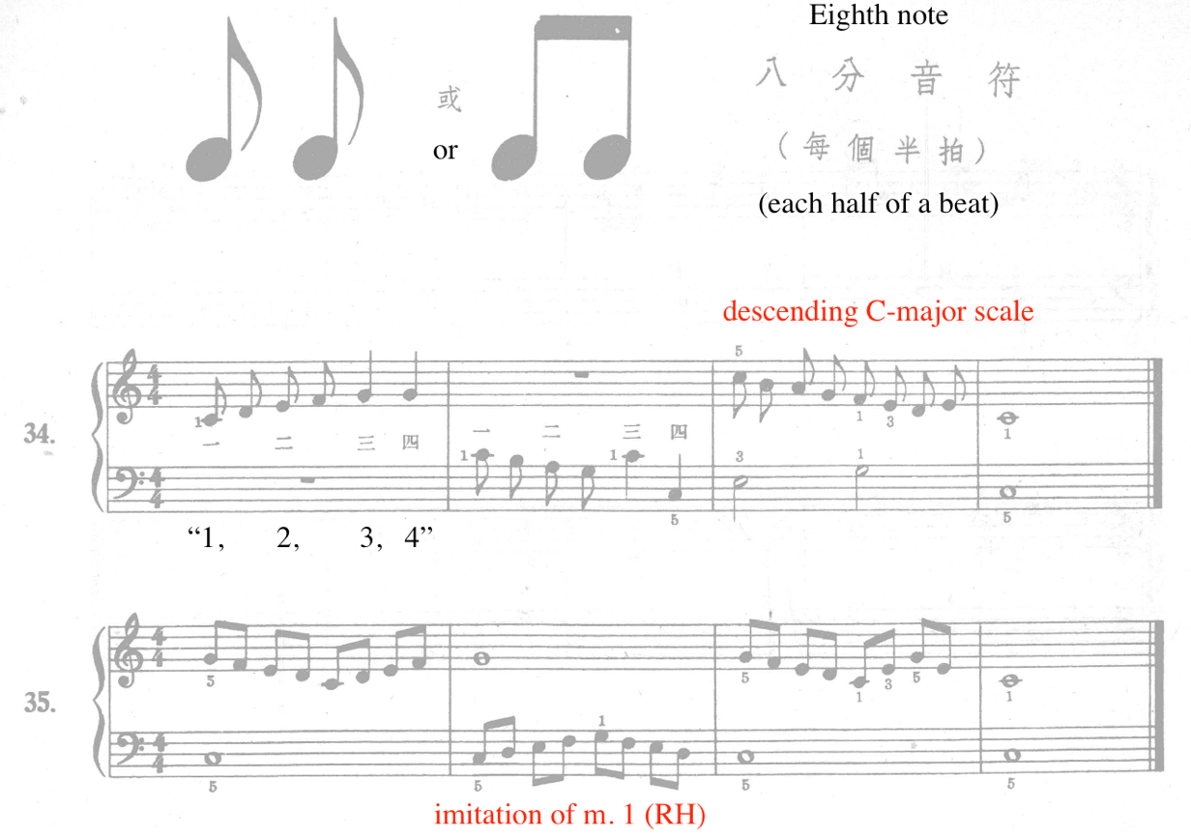

Summary of Section Two
In summary, the analysis of Section Two (nos. 24-37) of First lessons in Piano (1953) focuses on three pedagogical goals: the sequencing of hands-together playing, the development of new hand positions, and the introduction and pacing of new rhythm values. Additionally, all exercises from Section One and Two are composed in the key of C major.

Section Three: New Meters and Keys

Overview
Section Three of First Lessons in Piano ranges from exercises number 38 through 48. For the first time in First Lessons in Piano, Ding adds titles and lyrics to a selection of exercises. All exercises in Section Three are accompanied with titles (see Table 9), but only number 38 includes lyrics. The examination of Section Three focuses on two pedagogical goals: the development of new meters and the G-major key signature.

Table 9: First Lessons in Piano, Section Three, Titles
Exercise No. | Titles (Chinese) | Titles (English)
No. 38 | 國旗 | “National Flag”
No. 39 | 小兵丁 | “Little Soldier”
No. 40 | 兒歌 | “Children’s Song”
No. 41 | 搖籃曲 | “Lullaby”
No. 42 | 鞦韆 | “Swing”
No. 43 | 騎木馬 | “Riding on a Rocking Horse”
No. 44 | 走盪木 | “Walking on a Wooden Log”
No. 45 | 不高興 | “Sad”
No. 46 | 小舞㑹 | “Little Dance”
No. 47 | 木偶舞 | “Puppet Dance”
No. 48 | 短歌 | “Short Piece”

Development of New Meters
Throughout Section One and Section Two, Ding establishes 4/4, or common time meter. Section Three (nos. 38-48) introduces 3/4 and 2/4 meters. Refer to Table 10 for a list of meters used in Section Three.

Table 10: First Lessons in Piano, Section Three, Meters
Exercise No. | Meter
No. 38 | Common time (4/4)
No. 39 | 3/4
No. 40 | 3/4
No. 41 | 2/4
No. 42 | Common time (4/4)
No. 43 | 4/4
No. 44 | 3/4
No. 45 | 3/4
No. 46 | 4/4
No. 47 | 2/4
No. 48 | 2/4

Exercise number 39 features the introduction of 3/4 meter (see Figure 44). Number 39 is titled “Little Soldier,” or “小兵丁.” Ding includes an illustration of the 3/4 meter, as well as a mathematical representation of the dotted half note, marking the first instance of the dotted half note. “Little Soldier” is 11 measures in length, featuring a simple melody and accompaniment, and C-major five finger pattern in both hands. In addition to remaining within the C-major five finger pattern, Ding acclimates the student to the new meter by utilizing many repeated quarter note pitches in either hand (mm. 1, 3, 6, and 8), allowing the student to focus on looking ahead of the music, anticipating new material. In “Soldier Dance,” both hands have the opportunity to play both melodic and accompaniment material. For instance, the first line (mm. 1-5) features the melody in the right hand while the left hand holds dotted half notes, followed by the second line (mm. 6-11), where the opposite occurs. Fingering reminders are included, particularly in locations where skips occur within the measure (mm. 5, 10).

Figure 44: First Lessons in Piano, No. 39, 3/4 meter
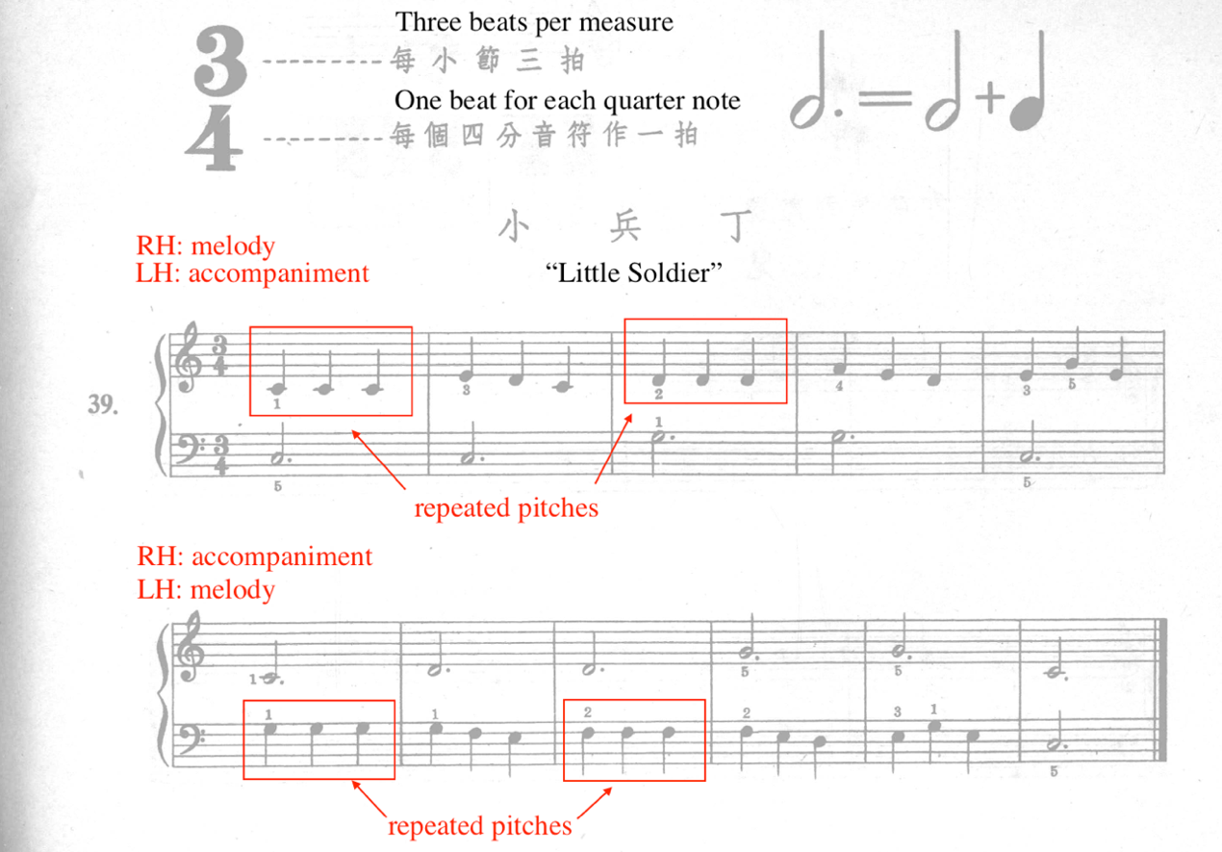

Ding reinforces the 3/4 meter in exercise number 40, titled “Children’s Song.” Following number 40, Ding introduces the 2/4 meter in exercise number 41, titled “Lullaby” (see Figure 45). An illustration of 2/4 meter is provided with the description “two beats per measure,” and “one beat for each quarter note.” “Lullaby” features simple melodic material and accompaniment, both remaining in static hand positions. In order to acclimate the student to the new meter, Ding includes finger numbers on nearly every pitch throughout with the exception of measures two and six in the right hand. Additionally, “Lullaby” is composed in a parallel period structure, resulting in related phrase material between the first (mm. 1-4) and second lines (mm. 5-8).

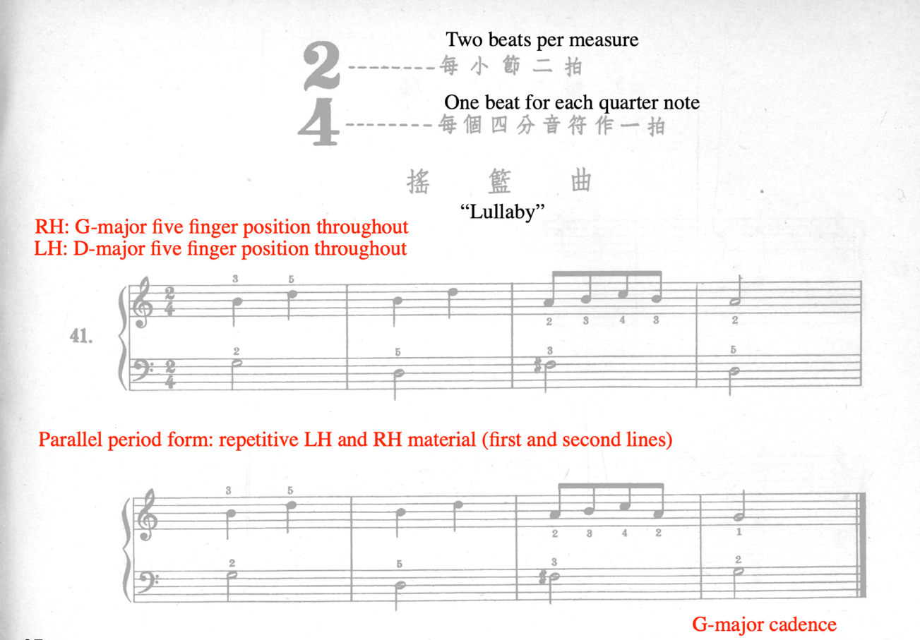
Figure 45: First Lessons in Piano, No. 41 “Lullaby”

Throughout the remainder of Section Three, Ding cycles through 4/4 (or common time), 3/4, and 2/4 meters, reinforcing all time signatures introduced in First Lessons in Piano thus far. In summary, there are four exercises in 4/4 (common time), four in 3/4 meter, and three in 2/4 meter.

Development of G-Major Key Signature
Throughout Section Three, Ding introduces the key of G major. He accomplishes this by first introducing the sharp accidental in exercise number 40, applying the sharp exclusively to F in exercises 40 through 45, foreshadowing the key of G major. Finally, in exercise number 46, Ding officially introduces the key of G-major. Throughout this sequence, the student is aurally familiarized with the key of G-major before learning about the key signature itself. The first step of the sequence occurs in exercise number 40, “Children’s Song,” which introduces the sharp accidental (see Figure 46). An illustration of the accidental is provided and accompanied by the description, “raised semitone sign.” To the right of the sharp sign illustration, a graphic describing the locations of sharp and non-sharp notes in a similar range is provided. “Children’s Song” features one F-sharp, located in measure seven, and arrived at by a finger crossing. In First Lessons in Piano, “Children’s Song” is the first exercise where both hands are rooted in G-major five finger pattern. In consideration of the new concept (sharp accidental) and hand position, Ding provides finger numbers for nearly every pitch, in addition to rooting both hands in G-major five finger pattern (see Figure 46).

Figure 46: First Lessons in Piano, No. 40, Sharp Accidental
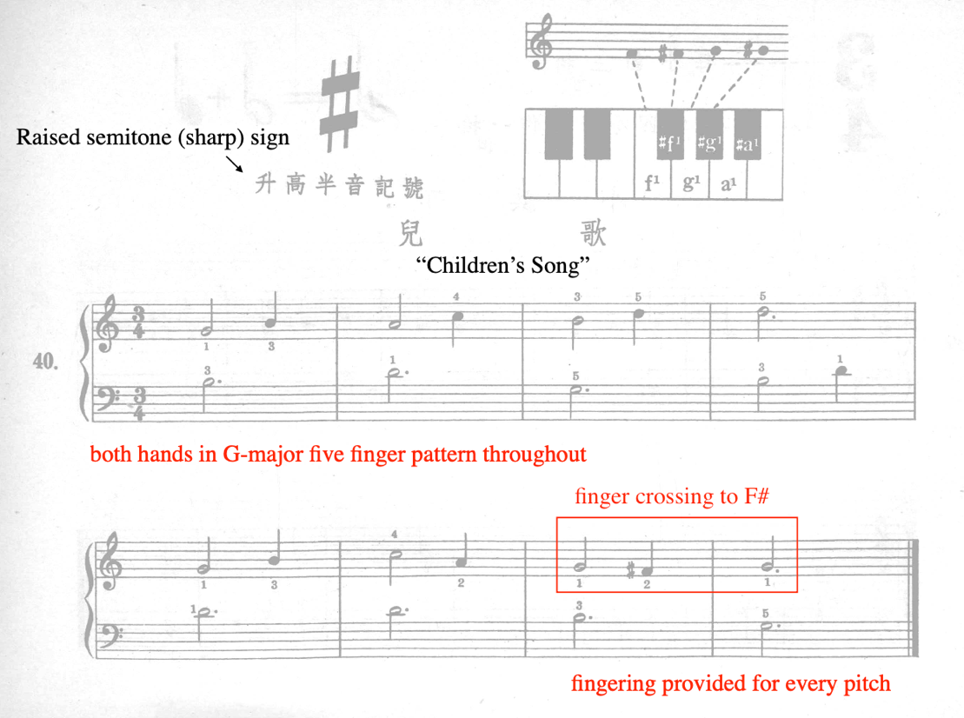
Following number 40, or “Children’s Song,” Ding reinforces and includes the F-sharp accidental in exercises 41 through 45. For example, number 41 focuses on F-sharps in the left hand, while 42, 43, and 44 reinforce F-sharps in the right hand. Exercise number 41, “Lullaby,” includes an F-sharp in the left hand in measures three and seven (see Figure 47). As it is the first time the left hand experiences an accidental, Ding roots both hands in static positions (RH in G-major five finger position, LH in D-major five finger position) throughout the exercise. Ding also provides fingering suggestions for nearly every pitch in “Lullaby.”

Figure 47: First Lessons in Piano, No. 41, Left Hand F-Sharp
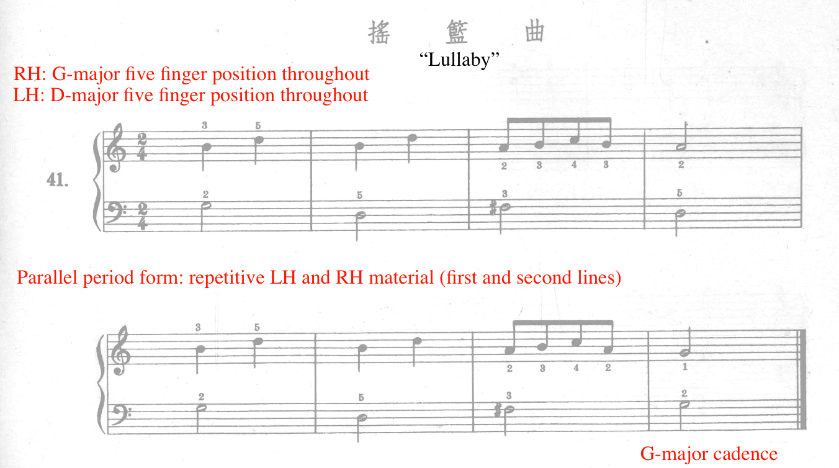

Exercises 42 through 44 reinforce F-sharps in the right hand, followed by exercise number 45, which includes F-sharps in both hands. Thus, exercises 40 through 45 represent exercises composed in the key of G-major, without the signage of the key signature itself. Throughout exercises 40 through 45, the student is aurally and tactilely acclimated to the key of G-major through the experience of playing F-sharps, G-major cadences, and G-major five finger position. Ding officially introduces the G-major key signature in exercise number 46, “Little Dance” (see Figure 48). An illustration and brief explanation of the key is provided. “Little Dance” is the first work in First Lessons in Piano written in a key other than C-major. Eight measures in length, “Little Dance” contains four, two-measure phrases. The exercise begins with the melody (mm. 1-2) in the right hand, outlining a G-major scale while the left hand sustains a G (G2). The left hand takes over the melody in measures three to four, while the right hand sustains a G (G5). The current author suspects that the F-sharp (F#2) on beat three of measure four is likely a printing error, meant to be G (G2) instead. The remainder “Little Dance” consists of left-hand half-note accompaniment and an energetic right-hand melody.

Figure 48: First Lessons in Piano, No. 46, G-Major Key Signature
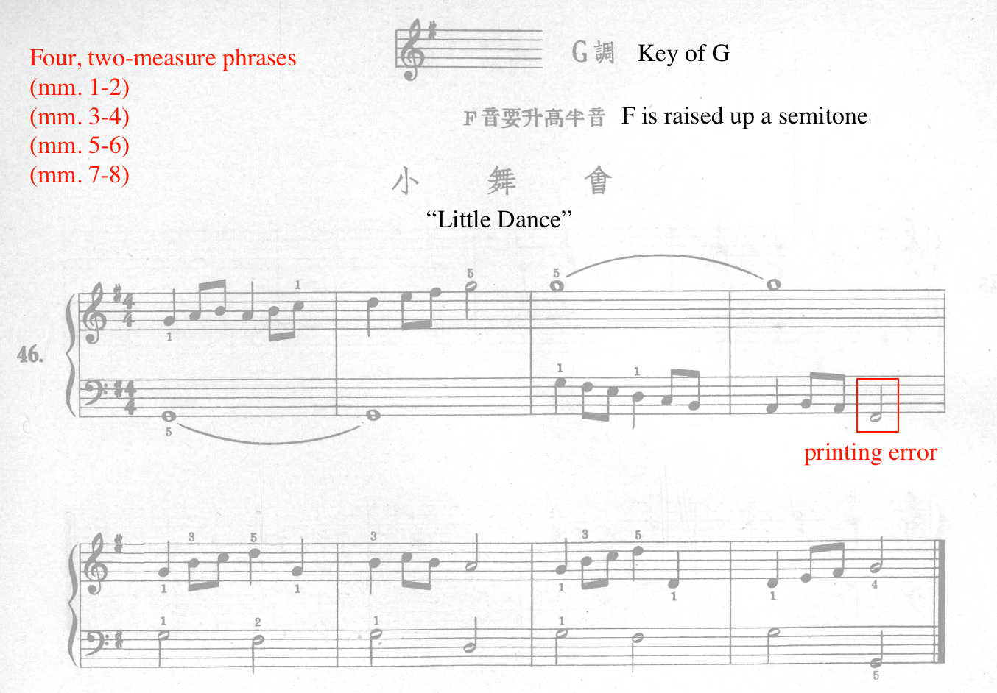

Summary of Section Three
Section Three’s analysis (nos. 38-48) of First Lessons in Piano focuses on the introduction of new meters (3/4 and 2/4), the development of the key of G-major, dotted half notes and the sharp symbol. In addition, the student further reinforces hands-together playing, new and shifting hand positions, and accompaniment patterns. For the first time in First Lessons in Piano, Ding provides descriptive titles for every exercise in Section Three. In fact, titles are provided for all remaining exercises of the method.

Section Four: New Meters, Keys, Articulations, and Note Values

Overview
Section Four encompasses exercise numbers 49 through 71. This section features the introduction of 6/8 meter, staccato and legato articulation, dotted quarter, eighth rests and 16th notes, flat accidentals, repeat signs, new accompaniment figures, and anacrusis. Compared to previous sections, Section Four contains the fastest pacing, featuring a new concept nearly every one to three exercises. This examination of Section Four focuses on a selection of five major developments: 6/8 compound meter, F-major key signature, new rhythm values, articulations, and accompaniment variation. Ding includes titles to each exercise in Section Four. Refer to Table 11 for a list of titles.

Table 11: First Lessons in Piano, Section Four Title Translations
Exercise No | Title | Title
No. 49 | 英雄的故事 | “The Hero’s Story”
No. 50 | 蝴蝶飛 | “Flying Butterfly”
No. 51 | 田歌 | “Tian Ge”
No. 52 | 小白馬 | “Little White Horse”
No. 53 | 山破下 | “Under the Hillside”
No. 54 | 不倒翁 | “Tumbling”
No. 55 | 青蛙跳舞 | “Frog Dance”
No. 56 | 小麻雀 | “Little Sparrow”
No. 57 | 圓舞曲 | “Waltz”
No. 58 | 跳绳舞 | “Rope Skipping Song”
No. 59 | 金魚的寂寞 | “Lonely Goldfish”
No. 60 | 爬山 | “Climbing Mountains”
No. 61 | 獵人的歌 | “Hunter’s Song”
No. 62 | 採𨗨歌 | “Lotus Picking Song”
No. 63 | 船歌 | “Boat Song”
No. 64 | 牧歌 | “Pastoral Song”
No. 65 | 雙人舞 | “Pas de deux”
No. 66 | 爬梯 | “Ladders”
No. 67 | 空軍舞 | “Air Force Dance”
No. 68 | 工人舞 | “Worker’s Dance”
No. 69 | 蘆花公雞 | “Luhua Rooster”
No. 70 | 牧羊歌 | “Shepherd’s Song”
No. 71 | 進行曲 | “March”

Development of 6/8 Compound Meter
Sections One through Three of First Lessons in Piano included the introduction and reinforcement of 4/4 (common time), 3/4, and 2/4 time. At the start of Section Four, Ding introduces the 6/8 meter in exercise number 49, the first compound meter in First Lessons in Piano. Following its initial introduction, numbers 50, 51, 63 provide reinforcement for the new meter. Number 49 is titled “The Hero’s Story,” and features an energetic melody played by both hands in unison (see Figure 49).

Figure 49: First Lessons in Piano, No. 49, “The Hero's Story”
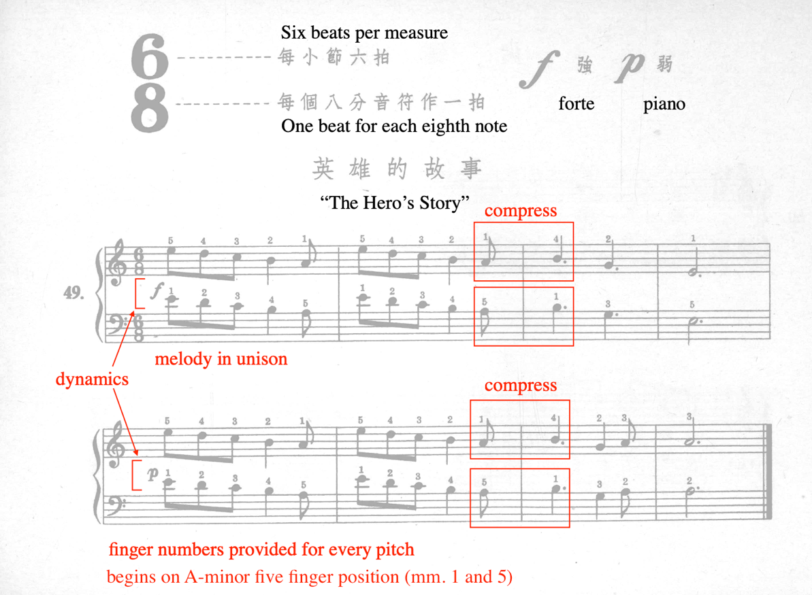
In addition to 6/8 meter, “The Hero’s Story” also introduces forte and piano dynamics. Starting on the A-minor five finger position, Ding composed two phrases of related material, each four measures in length. To acclimate the student to two new concepts (6/8 and dynamics), Ding provides finger numbers for every pitch, as well as repetitive motivic material between the two phrases, measures one through four and five through eight. A potential challenge lies in measures two to three and six to seven, where Ding features a finger compression, resulting in a subsequent position shift to accommodate the pitches following the compression (see Figure 49). For example, measures two to three in the right hand calls for a finger number one to four sequence, which requires the hand and fingers to compress in order to achieve the intended fingering. Recognizing this challenge, Ding provides finger numbers to aid in these transitions.
6/8 meter is reinforced throughout exercises 50, 51 and 63. In particular, number 51, titled “Tian Ge,” features similarities to “The Hero’s Story,” providing appropriate reinforcement in addition to new elements. For example, “Tian Ge” contains two phrases, measures one through four, and measures five through eight (see Figure 50). Similar to “The Hero’s Story,” “Tian Ge” is composed in 6/8, begins on A-minor five finger position, and contains a forte phrase followed by a piano phrase. In addition, Ding inserts C-sharps in the right hand in measures five through seven, creating a shift from A-minor to A-major, known as modal mixture. At measure five, the combination of modal mixture and the new dynamic creates an expressive effect, providing the student an opportunity to explore with tone color. In addition to the reinforcement of 6/8 meter and dynamics (forte and piano), “Tian Ge” is the first exercise in First Lessons in Piano which feature a shift in tonality, expanding the student’s aural palate.

Figure 50: First Lessons in Piano, No. 51 “Tian Ge”
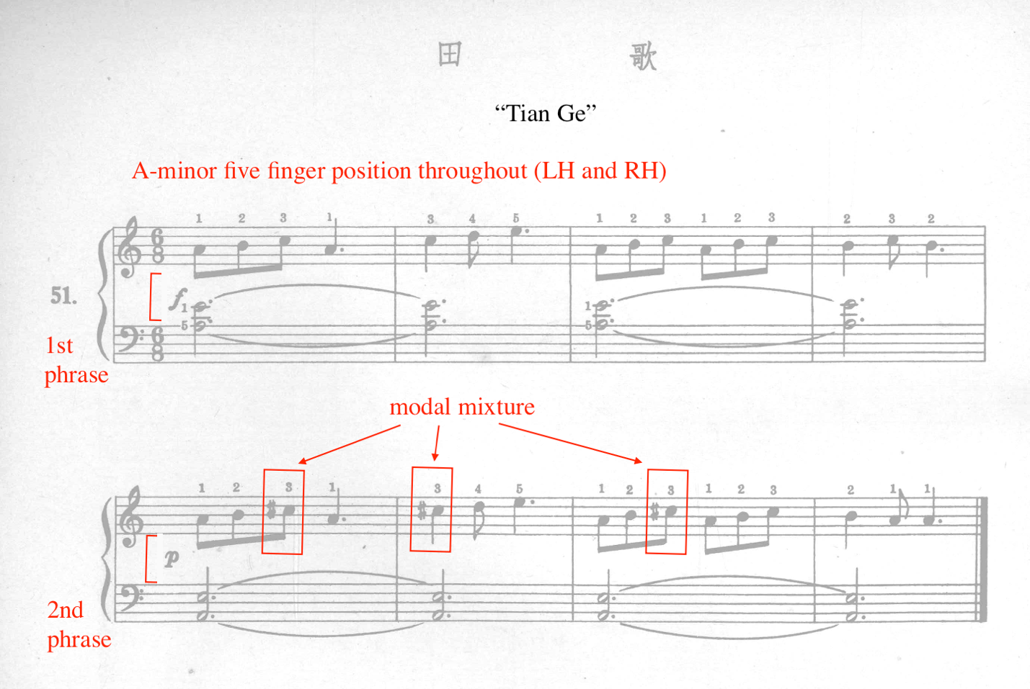

Development of F-Major Key Signature
Ding introduces the F-major key signature in Section Four of First Lessons in Piano. He implements the same sequencing from Section Three’s G-major key signature introduction. To recap, in Section Three, Ding introduced and reinforced the F-sharp accidental prior to the official introduction of the G-major key signature, allowing the student to become aurally acclimated to the tonality of G-major. Using a similar sequence in Section Four, the flat accidental is introduced in exercise number 61, which is exclusively applied to the letter B (see Figure 51). Following number 61, B-flats are reinforced throughout exercise number 62. Ding officially introduces the F-major key signature in exercise 63.
Exercise number 61, “Hunter’s Song,” features the introduction of the flat accidental (see Figure 51). Ding acclimates the student to the F-major key center by placing the right hand in F-major five finger pattern and the left hand in the outline of a first inversion F-major chord (A-C-F) (see Figure 51), presenting a static hand extension. Both hands remain rooted in theses position throughout “Hunter’s Song.” Ding includes an illustration of the flat accidental symbol along with a description and corresponding diagram of the keyboard. Composed in parallel period form, the first phrase (mm. 1-4) ends in a half cadence, followed by an imperfect authentic cadence at the conclusion of the second phrase (mm. 5-8) (see Figure 51). Similar to previous exercises, Ding includes generous fingering suggestions for every pitch in order to acclimate the student to the new concept. “Hunter’s Song” also features terraced dynamics, marked at forte in measures one through four, and piano at measures five through eight.

Figure 51: First Lessons in Piano, No. 61 “Hunter's Song”
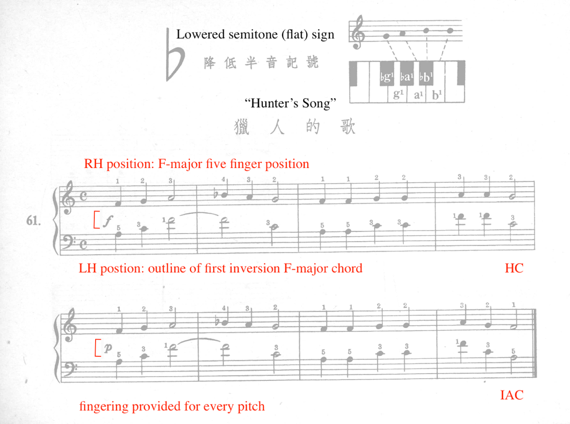
The B-flat is reinforced in exercise number 62, further acclimating the student to the tonal center of F-major. After this reinforcement exercise, Ding introduces the F-major key signature in exercise number 63, titled “Boat Song.” Composed in 6/8 and F-major, “Boat Song” features a repetitive, swaying left hand accompaniment and a lilting right hand melody, mimicking the rocking gestures of the boat. Posing as a potential challenge, “Boat Song” contains finger extensions and compressions in the right hand (mm. 2, 3, 6, and 7) (see Figure 52). In consideration of this challenge, Ding provides finger numbers on every pitch.

Figure 52: First Lessons in Piano, No. 63 “Boat Song”
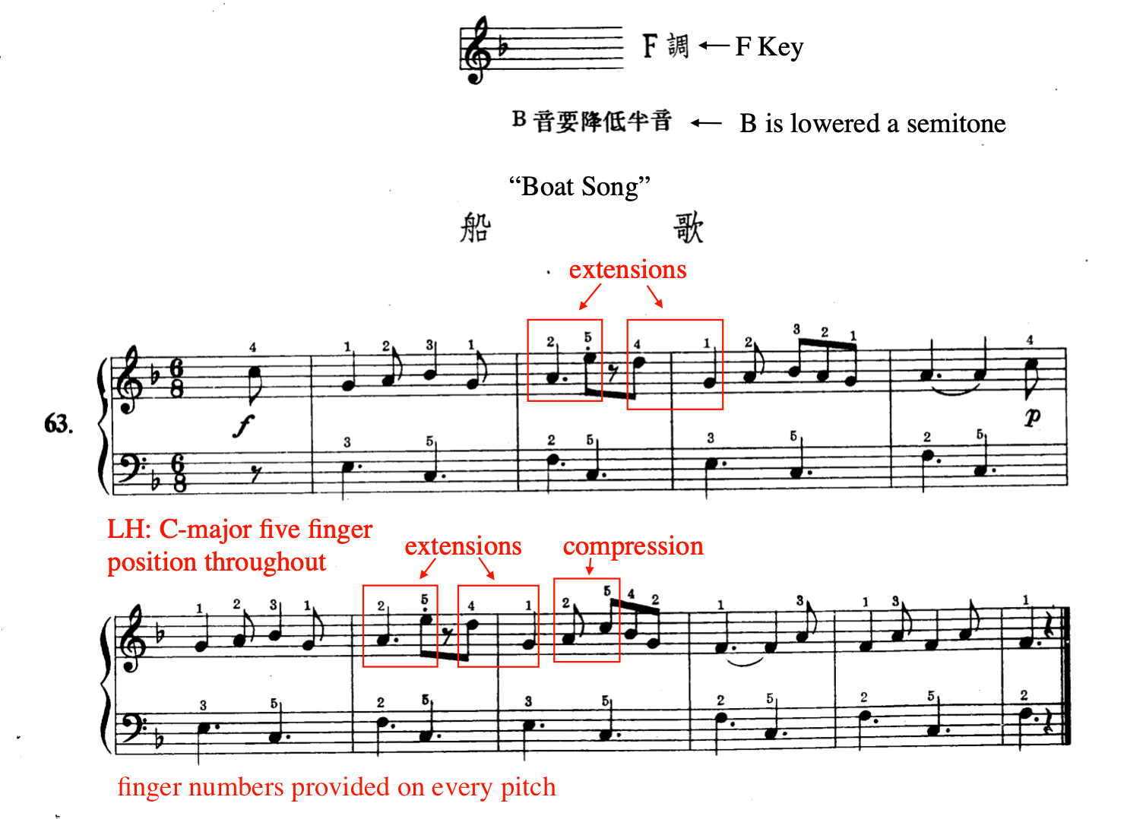

Compared to G-major, the pacing for F-major progresses at a significantly faster rate. For comparison, in Section Three, Ding includes six exercises (Nos. 40, 41, 42, 43, 44, and 45) containing F-sharp accidentals prior to the introduction of the G-major key signature (No. 46). However, in Section Four, Ding provides only two exercises (No. 61, 62) before introducing the F-major key signature in exercise number 63.

New Rhythm Values
Section Four features the introduction of the dotted quarter note, eighth rest, and sixteenth note. Refer to Table 12 for an overview of rhythm value introductions in Section Four.

Table 12: First Lessons in Piano, Section Four New Rhythm Values
Exercise No | Rhythm Value
No. 57 “Waltz” | Dotted quarter note (in the context of 3/4 meter)
No. 59 “Lonely Goldfish” | Eighth rest
No. 71 “March” | Sixteenth notes

Exercise number 57, titled “Waltz” introduces the dotted quarter note. Ding previously introduced the dotted quarter note in the context of 6/8 meter in Exercise No. 49, “The Hero’s Story,” where the mathematical illustration of the dotted quarter note was absent. However, “Waltz” includes an illustration and mathematical breakdown of the dotted quarter note on the upper portion of the page, where the length of a dotted quarter note is equivalent to a quarter and eighth note. “Waltz” is composed in G major, 3/4 meter, and contains 13 total measures. Additionally, a dotted line is illustrated after the dotted quarter (mm. 1, 3), indicating the rhythmic placement of the eighth note (see Figure 53). This pedagogical indication helps students visualize the exact placement of the note proceeding the dotted quarter rhythm, a common obstacle for many students. Recognizing the potential difficulty of dotted quarter note rhythms, Ding provides rhythmic reinforcement throughout “Waltz,” For example, the dotted rhythm introduced in measures one to two throughout “Waltz,” is repeated six times throughout the piece including the first.

Figure 53: First Lessons in Piano, No. 57 “Waltz”
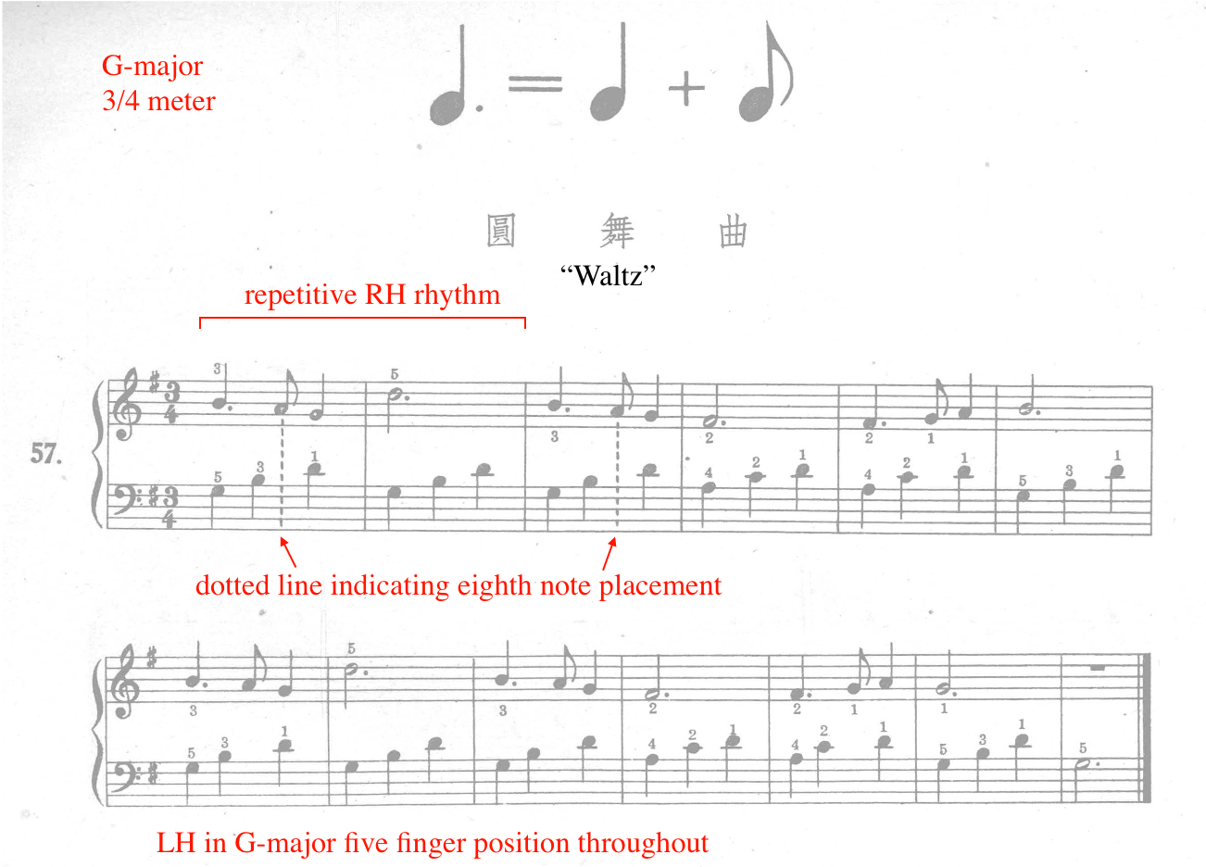

The next rhythm value presented in Section Four is the eighth rest, introduced in exercise number 59, “Lonely Goldfish.” Composed in A-minor and 2/4, “Lonely Goldfish” is eight measures long with an eighth note upbeat. To illustrate the length of the eighth rest, Ding places the rest under the eighth note pickup note (see Figure 54). Potential challenges include ledger, accidentals, finger extensions and substitutions (see Figure 54). A finger substitution occurs when the same pitch is repeated with a different finger number. For example, in measure three, the right hand depresses the A initially with finger number one, shifting to finger number three in order to accommodate the following notes in measures three and four. Ding also includes finger extensions in measures four, six and seven.

Figure 54: First Lessons in Piano, No. 59 “Lonely Goldfish”
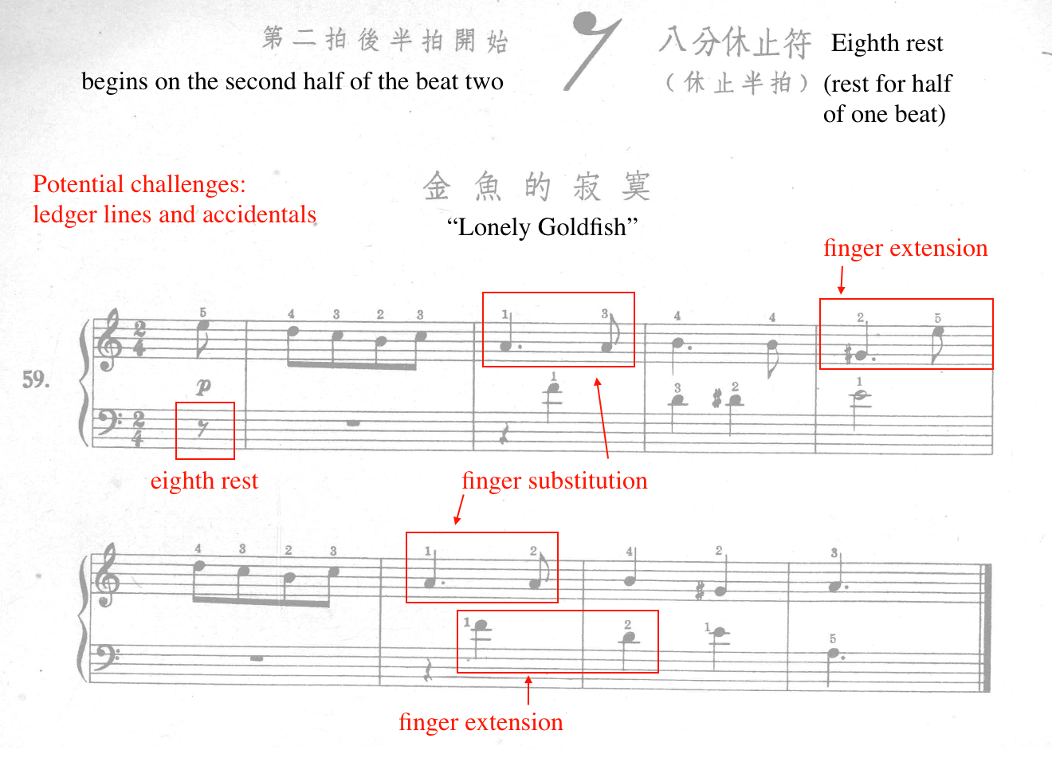

Found in exercise number 71, “March,” the final rhythm value introduced in First Lessons in Piano is the sixteenth note, beamed in groups of two and four. This work is leveled at a Magrath Level three. Composed in F-major and 2/4, “March” is the final work in First Lessons in Piano. An illustration and description of the sixteenth note is provided above the score (see Figure 55). “March” contains alternating leaps in the accompaniment, giving the piece a marching effect.
The melody features repeated sixteenth notes as well as leaps. Due to the lack of specific fingering indications on the repeated pitches in the right hand, exact fingerings for those pitches are unclear. Due to the consistency of fingering suggestions provided by Ding throughout the method, it appears that Ding intended the repeated pitches to be played with the same finger. If not, an alternate fingering would have been indicated by the composer.
Composed in binary form with a repeated B section, “March” contains two contrasting sections, A (mm. 1-8) and B (mm. 9-17). The A section features non-legato left hand accompaniment while the B section contains legato, broken arpeggiated accompaniment (see Figure 55). In the A section, the right hand melody is angular, non-legato, and features rapid repeated sixteenth notes in measures one and three. In contrast, the right hand melody in the B section contains slurs, staccatos, and eighth rests, creating a playful effect throughout the section. A potential challenge, Ding includes both B-natural and B-flat in measure four. Throughout “March,” Ding provides fingering suggestion on almost every pitch.
Figure 55: First Lessons in Piano, No. 71 “March”
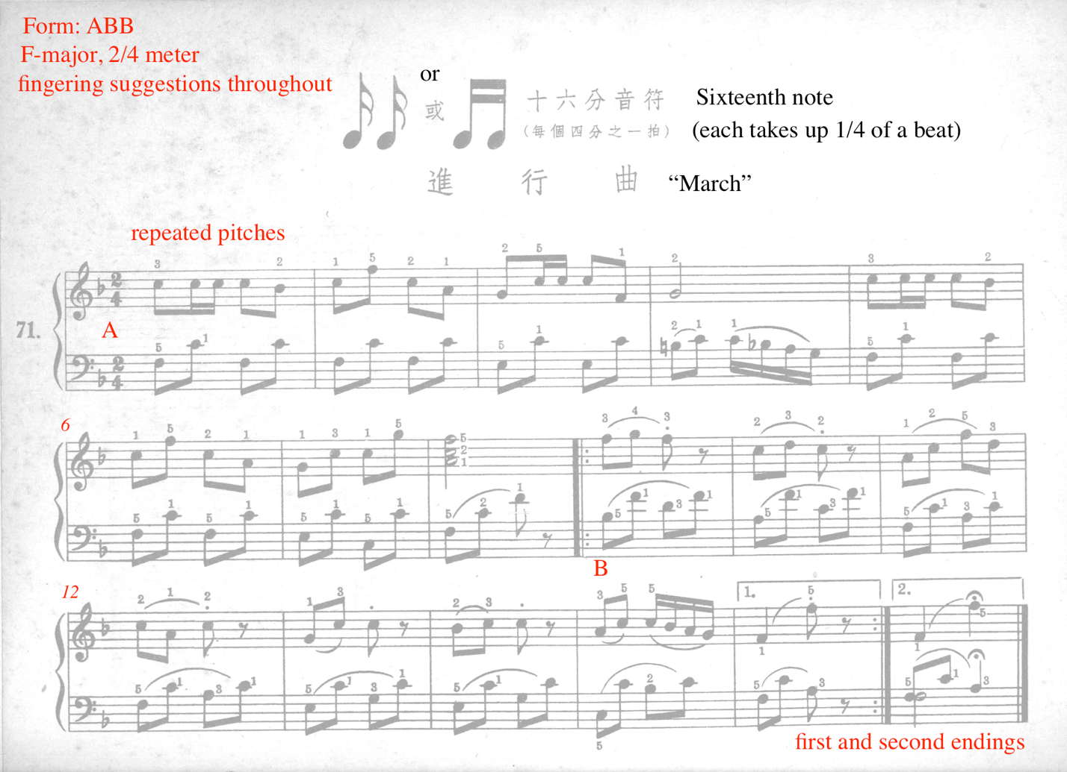

Introduction of Articulations
Section Four includes the first introduction of articulations in the method, presenting staccato in exercise number 53 and legato in 64. Ding introduces the staccato in exercise number 53, titled “Under the Hillside.” In addition to the staccato articulation, “Under the Hillside” also introduces the anacrusis. An illustration of the staccato is provided above the score, in addition to a description of the anacrusis (see Figure 56). As an aid, Ding provides counting reminders in measure one. “Under the Hillside” features a left hand melody and right hand accompaniment, which consists of mainly staccato quarter notes. The right hand only plays G’s, with the exception of the final measure. The simplicity of the right hand accompaniment helps acclimate the student to the staccato articulation. Posing as a potential challenge, the left hand melody contains ledger line pitches as well as an extended hand position (see Figure 57).

Figure 56: First Lessons in Piano, No. 53 “Under the Hillside”
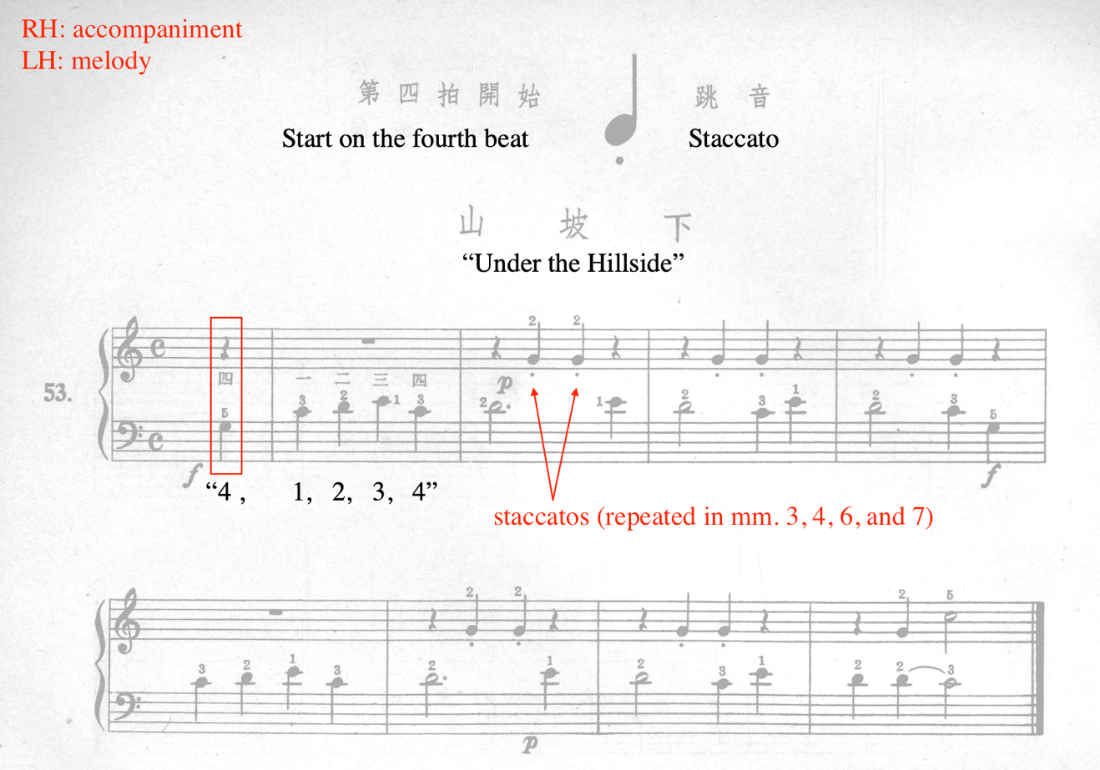

Figure 57: "Under the Hillside," Left Hand Position
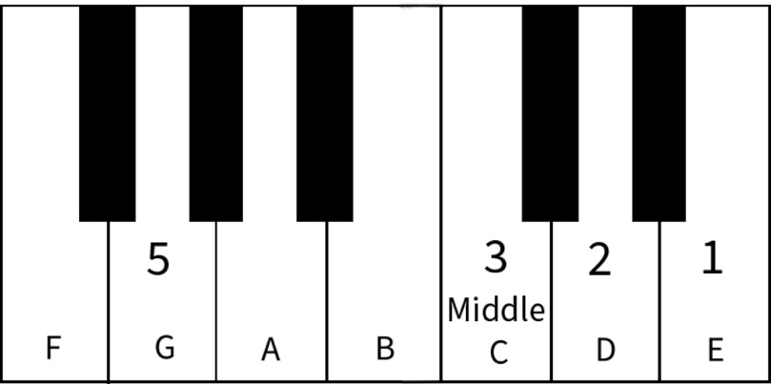

The introduction of the staccato articulation in number 53 is reinforced in exercises 54, 55, 56, 63, 69, and 71. However, exercises number 53, 54, 55, 63 and 71 only reinforce the staccato articulation in the right hand. Numbers 56 and 69 include staccatos in both hands.
Exercise number 64, titled “Pastoral Song” introduces legato articulation (see Figure 58). Ding provides an illustration and description of the slur, indicating that pitches within the slur are meant to be played smoothly. “Pastoral Song” utilizes a sustained drone accompaniment in the left hand, while the right hand focuses on short, legato melodic fragments. The simple left hand texture allows the student to focus on the demands of the right hand, which include legato touch, finger extensions and substitutions, as well as the anacrusis in measure one (see Figure 58). For example, Ding features finger extensions in measures two and six, extending the right hand thumb down to middle C in both instances. In measure seven, a finger substitution occurs between fingers three and two on beats one and two. The legato melodic fragments in the right hand provide an excellent opportunity for the student to experiment with breath in the music, in addition to wrist mobility and flexibility. Ding provides finger numbers on most of the pitches in “Pastoral Song,” allowing the student to focus on legato playing.
Figure 58: First Lesson in Piano, No. 64 “Pastoral Song”
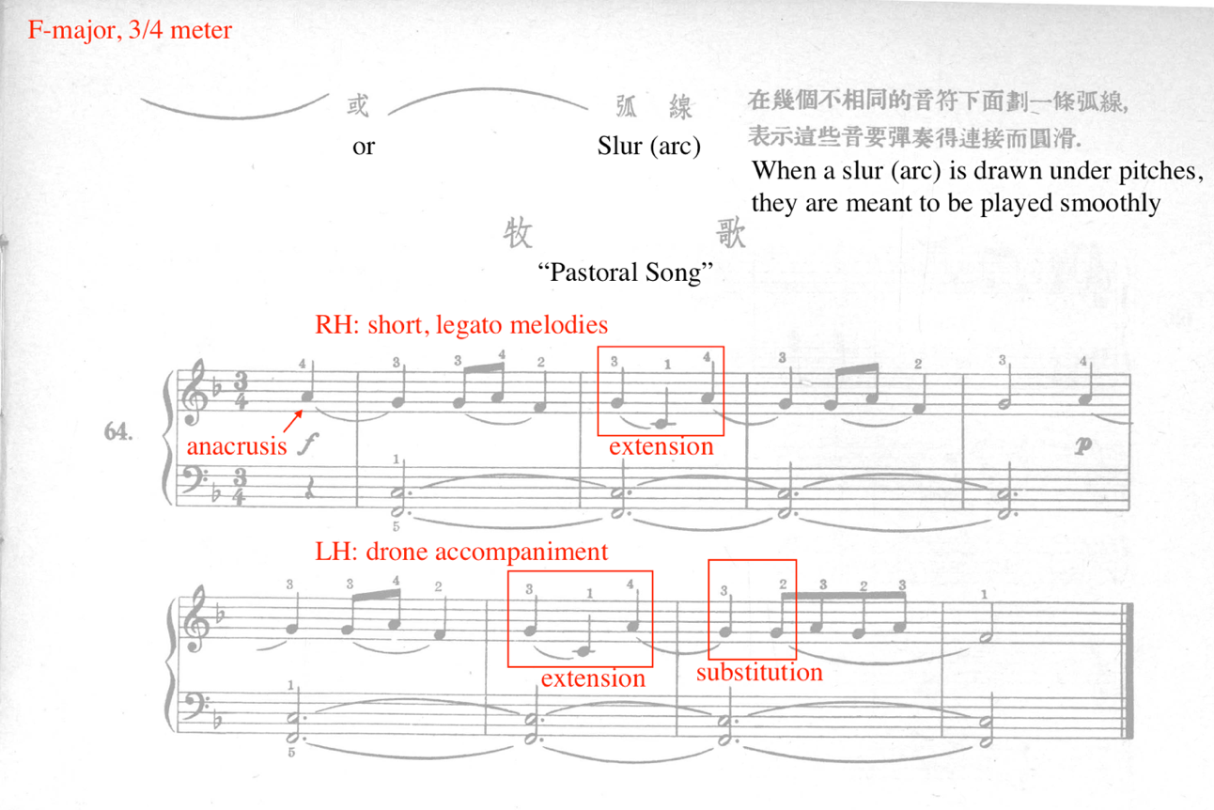

The slur and legato articulation is reinforced in numbers 69, 70, and 71. In these exercises, both left and right hand legato playing is reinforced. Number 69, titled “Luhua Rooster,” contains both legato and staccato articulation in both hands (see Figure 59). This work is featured in Level 2B of Faber’s Piano Adventures Chord Time: “Music from China.” “Luhua Rooster” is composed in 2/4, G-major pentatonic mode, and AA’B form (see Figure 59). The A (mm. 1-4) and A’ (mm. 5-8) phrases reinforce legato articulation in both hands, while the B phrase (mm. 9-13) reinforces staccato articulation, with the exception of the final two measures (mm. 12-13). This charming work contains interpretational potential, as the B phrase (mm. 9-13) mimics the pecking motions and effect of a chicken. Throughout the work, Ding includes finger extensions and substitutions throughout (see Figure 59). The composer provides fingering suggestions.

Figure 59: First Lessons in Piano, No. 69 “Luhua Rooster”
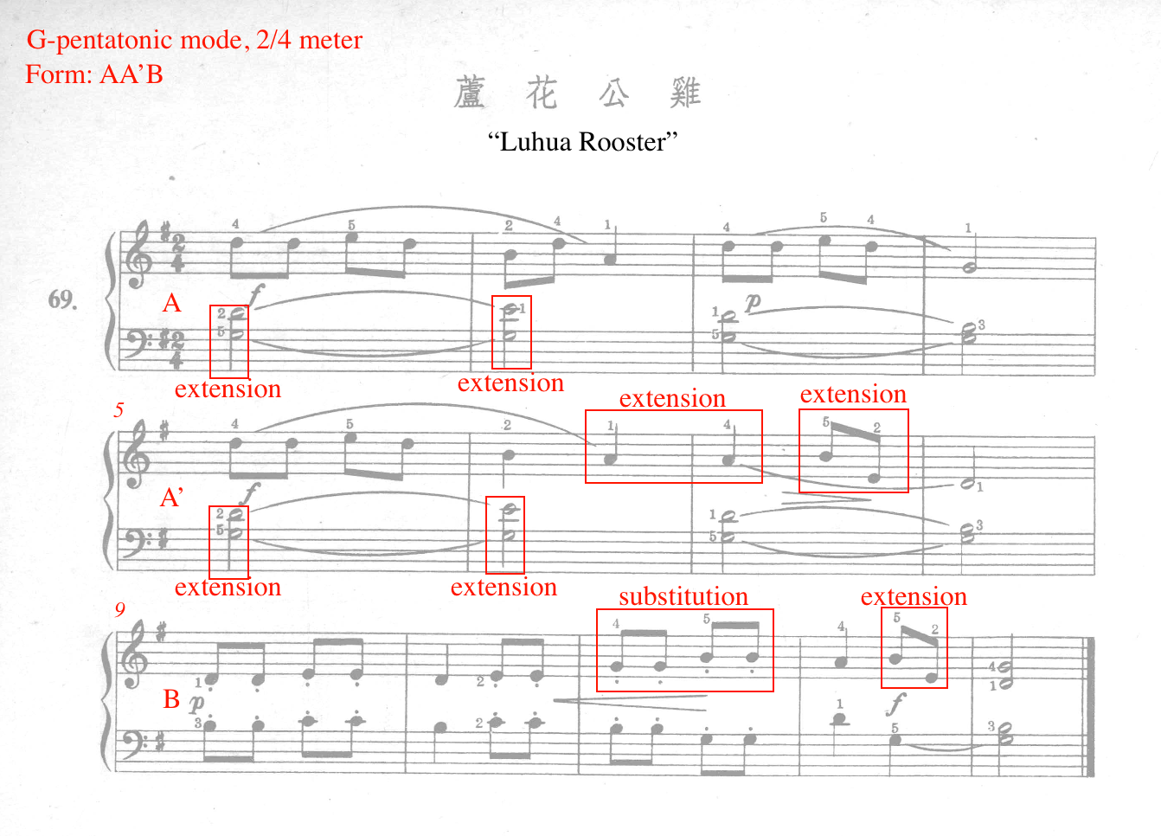

Development of Accompaniment Variations
Section Four (Nos. 49-71) explores the development of accompaniment textures, predominantly represented in the left hand. Ding incorporates and reinforces a variety of patterns, including the barcarolle, drone, right hand accompaniment, waltz, Alberti-bass, imitation, and march. Refer to Table 13 for an outline of accompaniment textures incorporated in Section Four of First Lessons in Piano. Exercises without a distinct accompaniment texture are omitted from the table.

Table 13: First Lessons in Piano, Section Four Accompaniment Variations
Exercise No. | Type of accompaniment texture
No. 50 | Barcarolle
No. 51 | Drone
No. 52 | Right hand accompaniment (Drone)
No. 53 | Right hand accompaniment
No. 55 | Waltz
No. 56 | March
No. 57 | Waltz
No. 58 | Simplified Alberti-bass
No. 60 | Imitative
No. 62 | Waltz
No. 64 | Drone
No. 65 | March-like
No. 67 | Waltz
No. 68 | Waltz
No. 71 | March

The researcher will demonstrate accompaniment variation in Section Four by featuring an example of each of the following accompaniment textures: barcarolle, drone, right hand as accompaniment, waltz, imitation, simplified Alberti-bass, and march.
Ding utilizes the barcarolle style accompaniment pattern in exercise number 50, “Flying Butterfly,” characterized by its gentle eighth note accompaniment in 6/8 meter (see Figure 60). “Flying Butterfly” is the second exercise in Section Four, and one of only two exercises containing lyrics. The lyrics describe the delicate, fluttering wings of a butterfly. Both right and left hands remain in G-major five finger position. The left hand, consisting of root position G-major broken chords, remains constant throughout “Flying Butterfly.” This piece is ten measures in length, spanning two pages in the method. Serving as the student’s first experience of broken chord accompaniment, its repetitive nature helps reinforce the pattern, establish left hand independence, balance, and allows experimentation with wrist flexibility and mobility.

Figure 60: First Lessons in Piano, No. 50 “Flying Butterfly,” Excerpt, mm. 1-5
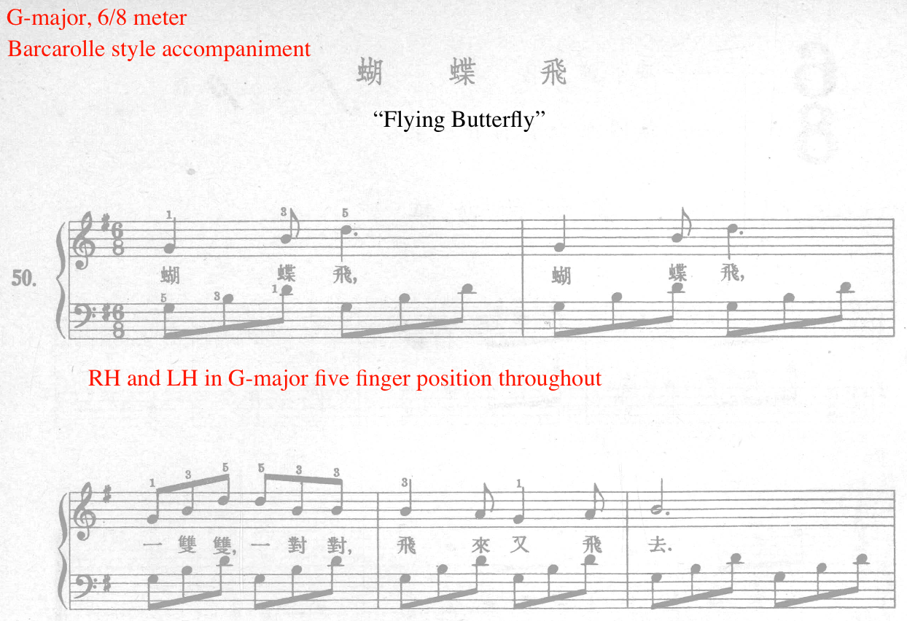

Next, Ding utilizes the drone accompaniment in several exercises throughout Section Four, including exercises 51, 52, and 64. Exercise number 64, titled “Pastoral Song” focuses on the drone accompaniment in the left hand (see Figure 61). In “Pastoral Song,” composed in F-major and 3/4 meter, the slur and legato articulation are introduced. To depict the pastoral setting, Ding features a sustained left hand perfect fifth (F and C), imitating the drone. The simplicity of drone accompaniment texture helps the student focus on legato playing in the right hand. Containing two phrases (mm. 1-4 and 5-8), “Pastoral Song” also reinforces the forte and piano dynamic, indicated in measures one and four. The drone accompaniment is utilized in the left hand in exercise 51, “Tian Ge,” and the right hand in exercise number 52, “Little White Horse.”

Figure 61: First Lessons in Piano, No. 64, Drone Accompaniment Example
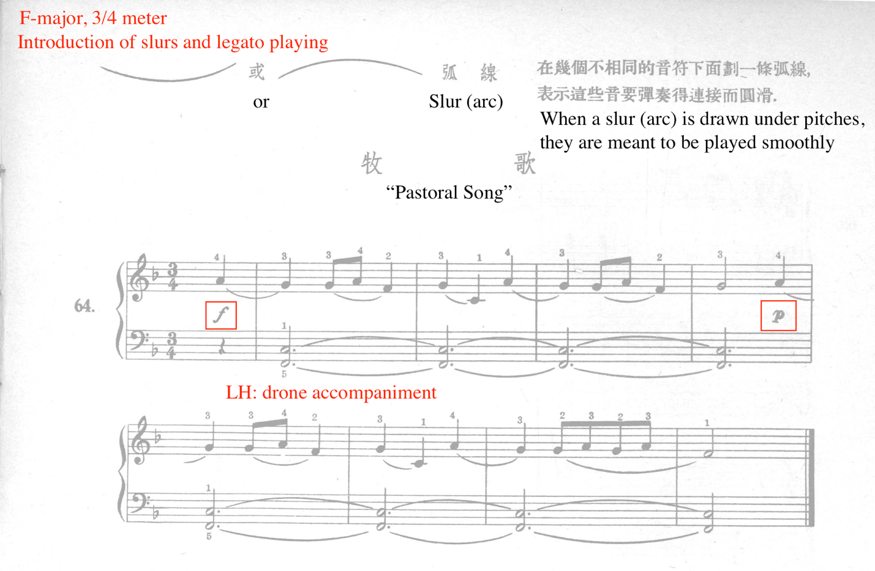

The next accompaniment pattern present in Section Four pertains to right hand accompaniment, utilized in exercises 52 and 53. Exercise number 52, “Little White Horse” features the melody in the left hand, and a single note drone-like accompaniment in the right hand (see Figure 62). The right hand plays only G’s with finger number two throughout “Little White Horse.” This exercise also observes the introduction of the crescendo and decrescendo. Ding indicates fingering suggestions for every pitch, in addition to counting reminders to assist the student with the anacrusis (see Figure 62). The simplicity of the right hand accompaniment allows the student to focus on the melodic material in the left hand, in addition to refining balance between the hands.

Figure 62: First Lessons in Piano, No. 52, “Little White Horse,” RH Accompaniment
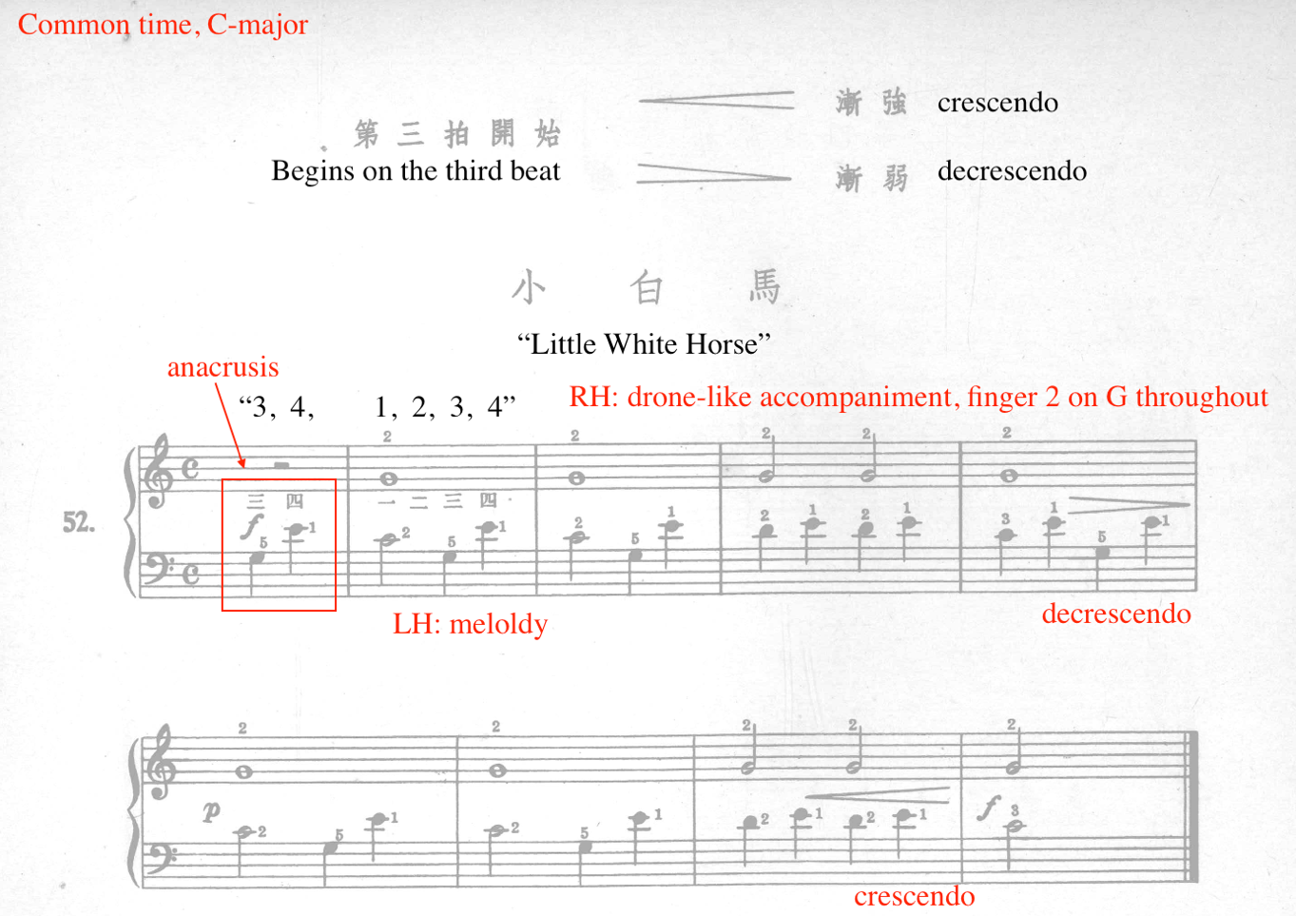

Immediately following exercise number 52, exercise number 53, “Under the Hillside” also features right hand accompaniment (see Figure 63). Previously discussed in Section Four, staccato articulation is introduced in “Under the Hillside.” Similar to exercise number 52, number 53 also utilize G’s in the right hand played by finger number two. The staccato accompaniment on beats two and three, combined with the non-staccato left hand melody adds a charming effect to the music. Additionally, the contrast in articulation between the hands helps the student develop hand independence.

Figure 63: First Lessons in Piano, No. 53, RH Accompaniment, Excerpt mm. 1-4
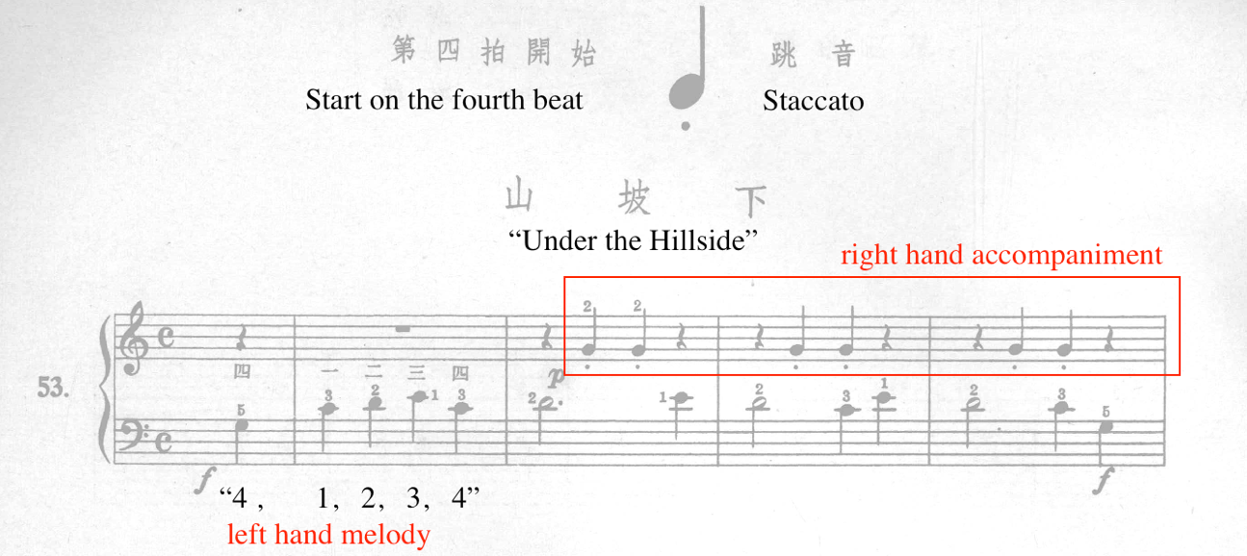

Throughout Section Four, the waltz is the most frequented accompaniment pattern, featured in exercises 55, 57, 62, 67, and 68. This portion will discuss the waltz patterns present in numbers 55, 57, and 68. Ding incrementally increases the complexity of the waltz accompaniment. For example, the first exercise in Section Four containing a waltz accompaniment, number 55, “Frog Dance,” features a simplified version of the waltz, where the accompaniment occurs only on beats two and three (see Figure 64).

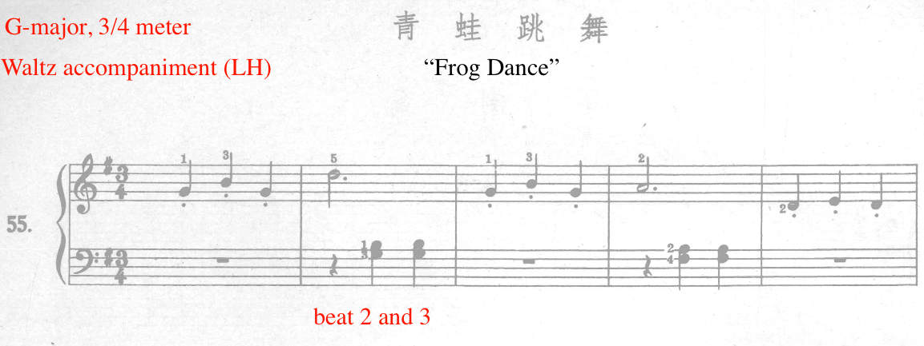
Figure 64: First Lessons in Piano, No. 55, “Frog Dance,” Excerpt, mm. 1-5

Ding incrementally increases the complexity of the waltz pattern in the next exercise, number 57, “Waltz.” “Waltz” features singular notes in the left hand, occurring on beats one, two and three (see Figure 65). Previously discussed, exercise number 57 features the introduction of the quarter note. As such, Ding provides a dotted line to indicate eighth note placement. Acclimating the student to the waltz texture, Ding provides fingering reminders and keeps the left hand rooted in the G-major five finger pattern throughout.
Figure 65: First Lessons in Piano, No. 57 "Waltz," Waltz Accompaniment, Excerpt, mm. 1-6
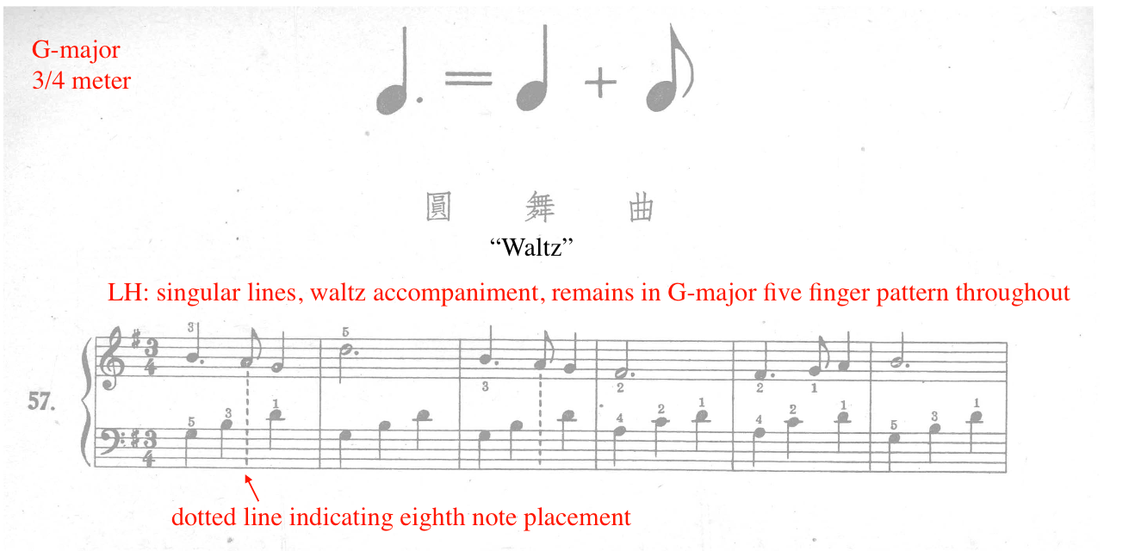

The final exercise showcasing the waltz pattern is “Worker’s Dance,” exercise number 68, made up of largely broken chord textures. Composed in 3/4 and G-major, “Worker’s Dance” features a basic waltz pattern in the left hand, outlining the tonic, and dominant harmonies throughout (see Figure 66). This accompaniment consists of a single bass note on beat one, followed by two dyads on beats two and three. Rooted primarily in the G-major five finger pattern, the accompaniment features root position tonic chords (I), second inversion dominant chords (V43), and a first inversion dominant chord (V65). With the exception of measure eight, the left hand remains entirely within the G-major five finger pattern. Measure eight features a first inversion dominant chord (V65), which requires the left hand finger number five to extend onto the F-sharp (see Figure 66).
Figure 66: First Lessons in Piano, No. 68 “Worker's Dance,” Waltz Accompaniment
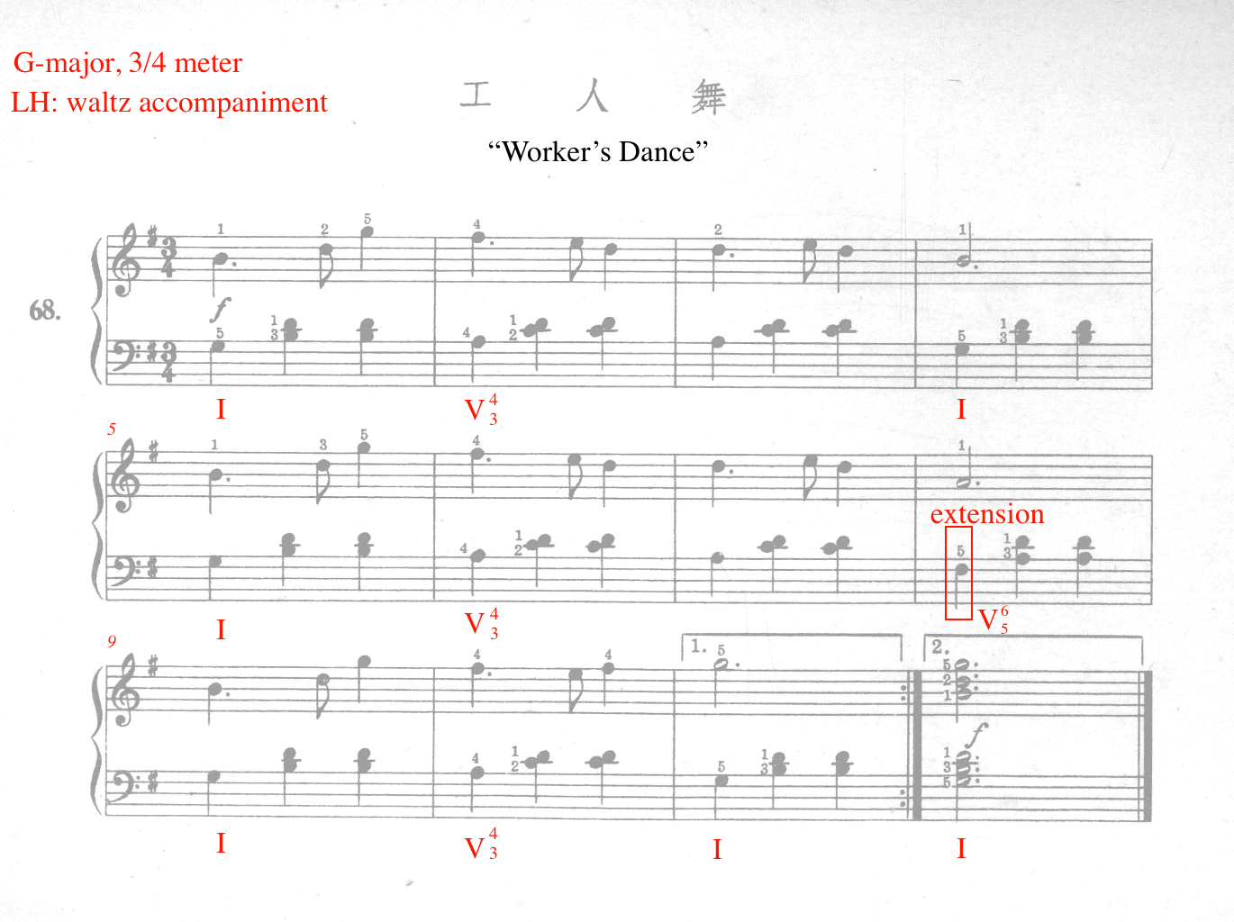

Throughout Section Four, Ding develops the left hand by utilizing imitation in the texture. For example, exercise number 60, “Climbing Mountains” features imitative accompaniment in the left hand (see Figure 67). The melody is stated by the right hand in measures one to two and partially imitated by the left in measures three to four (see Figure 67). Between measures one and six, the left hand imitation occurs two measures after the statement in the right hand. However, in measures seven through 11, the left hand imitation occurs in the measure immediately following the right hand melody, mimicking a stretto effect.

Figure 67: First Lessons in Piano, No. 60 “Climbing Mountains,” Imitation
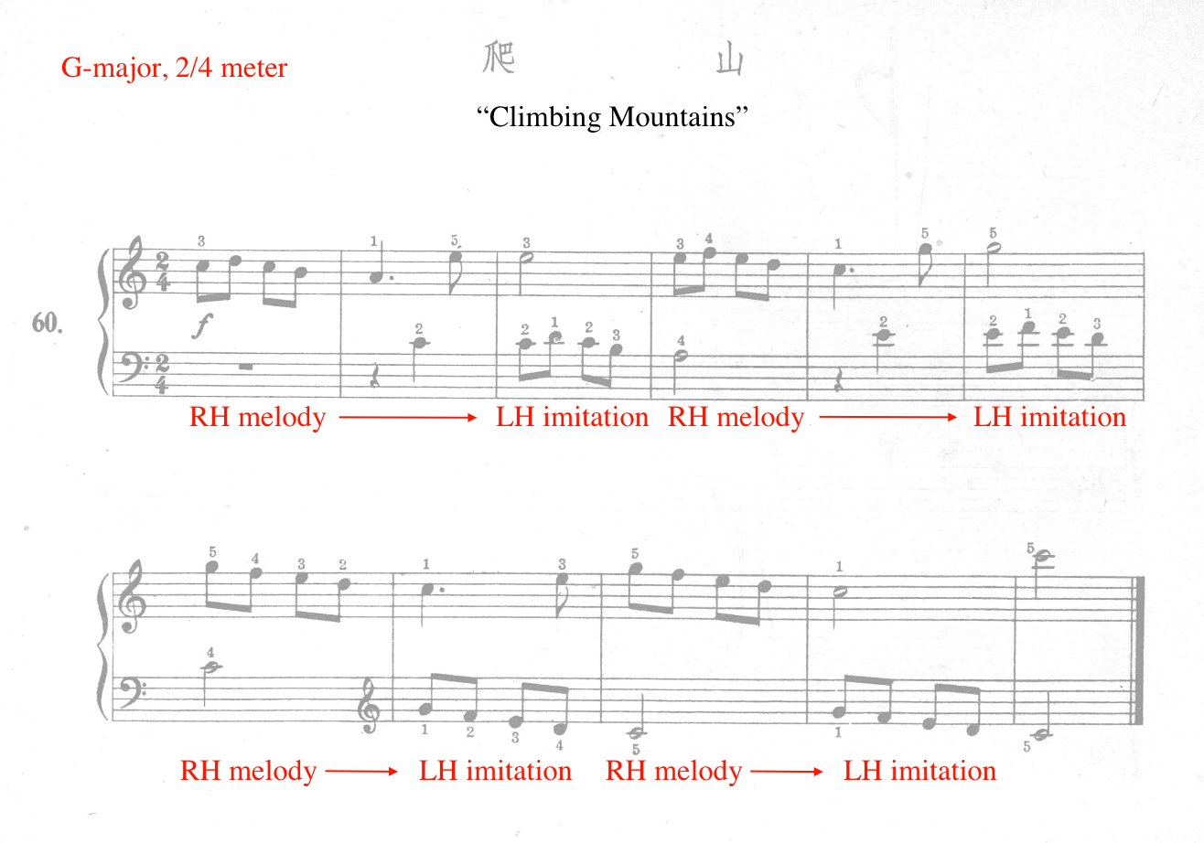

The next accompaniment pattern included in Section Four is the simplified, or truncated Alberti-bass style, present in exercise number 58, “Rope Skipping Song” (see Figure 68). Whereas traditional Alberti-bass accompaniment utilizes three chord tones, “Rope Skipping Song” only features two. For example, the implied harmony in measures one, two, three, and six represent a G-major chord, the tonic of the key signature. However, only the third (B) and fifth (D) of the G-major chord is present. Next, measures five through six indicate the presence of a D-major dominant seventh chord, but, only the root (D) and seventh (C) are present (see Figure 68). This simplified version of the Alberti-bass accompaniment allows the student to focus on steady rhythm, right hand melodic material, and left hand rotation.

Figure 68: First Lessons in Piano, No. 58 “Skipping Rope Song,” Simplified Alberti-bass
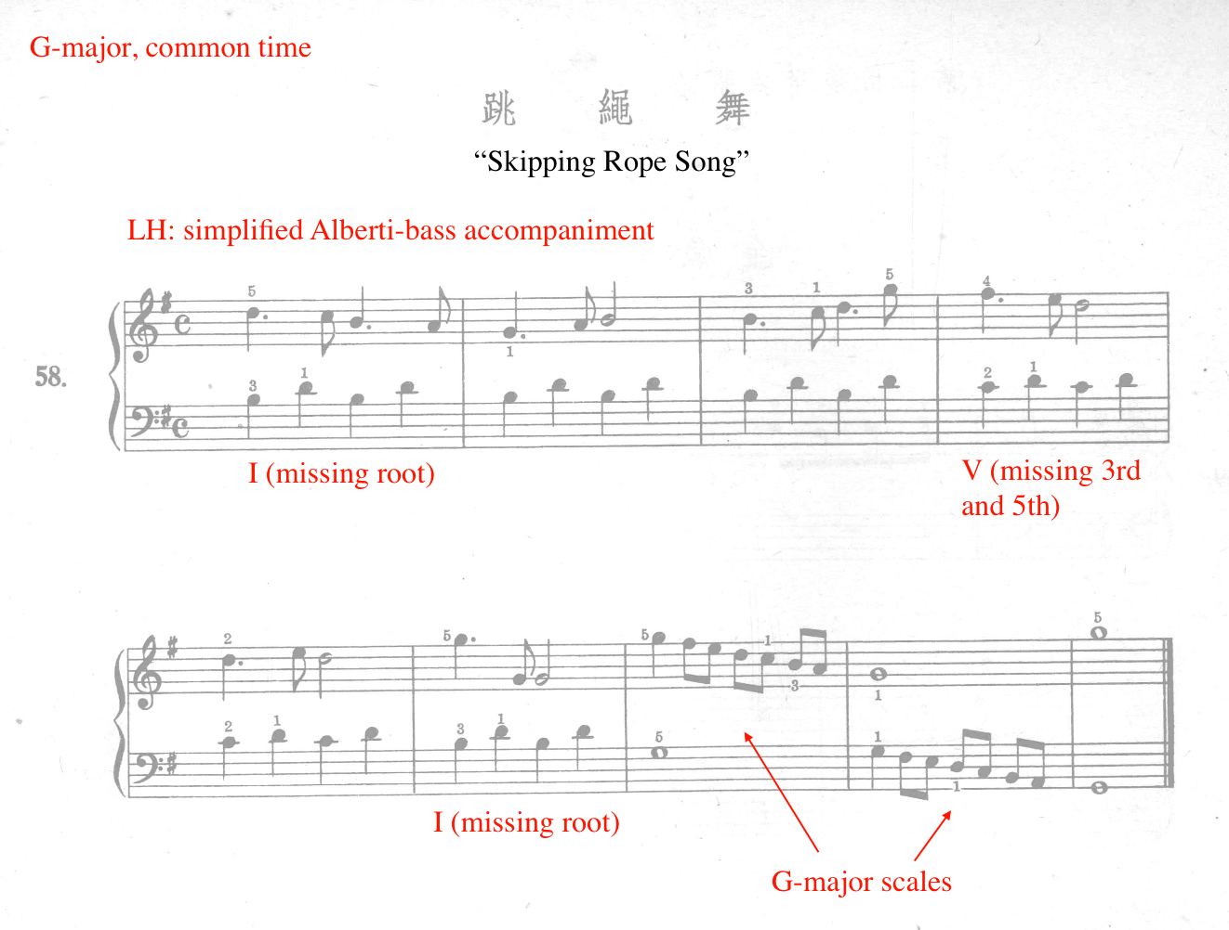

The final accompaniment pattern to examine in Section Four of First Lessons in Piano is the march accompaniment, featured in exercises 56, 65, and 71. This portion features the discussion of exercises 56 and 71. Composed in 2/4 and G-major, number 56, “Little Sparrow,” contains a simple marching texture in the left hand accompaniment, consisting of singular alternating quarter notes (see Figure 69). The left hand accompaniment is enhanced by the staccato articulation, creating a charming buoyancy to the overall texture. To assist with coordination and security, finger number five of the left hand remains on G throughout “Little Sparrow.”

Figure 69: First Lessons in Piano, No. 56, “Little Sparrow,” March Accompaniment, Excerpt, mm. 1-8
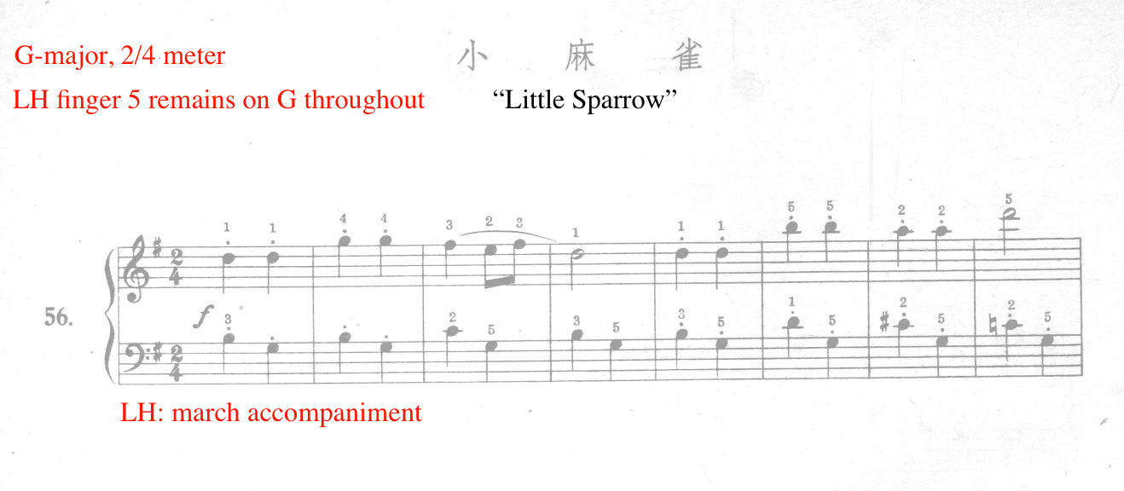

Exercise number 71, “March” is the final exercise of First Lessons in Piano. As the title indicates, number 71 is composed in the march style. Previously discussed, this exercise features the introduction of 16th notes. Composed in F-major and 2/4 meter, “March” leveled at a Magrath Level three. The march characteristic comes from the alternating eighth note rhythms in the left hand. Additionally, the detached repeated 16th notes in the right hand (mm. 1, 3, and 5) enhances the military effect of the march (see Figure 70).

Figure 70: First Lessons in Piano, No. 71, March Accompaniment, Excerpt, mm. 1-5
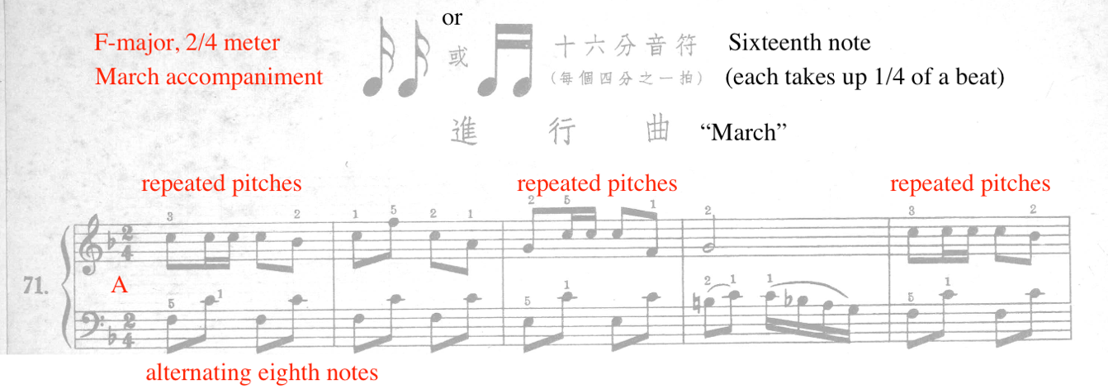

Summary
This analysis of Section Four featured the examination of five selected pedagogical topics: 6/8 compound meter, F-major key signature, new rhythm values, articulations, and accompaniment variation. First Lessons in Piano develops the elementary piano student up to a Magrath level three over the span of 71 exercises. Throughout First Lessons in Piano, Ding introduced various hand positions, rhythm values starting from whole notes to 16th notes, simple and compound time signatures, G and F-major key signatures, accidentals, staccato and legato articulation, dynamics, finger extensions/substitutions/compressions, major, minor and pentatonic melodies, and a variety of accompaniment styles. For an overview of all concepts introduced in First Lesson in Piano, refer to Appendix B of this document.

Chapter Four: Eight Piano Pieces for Children, op. 28 (1987)
Composed during Ding Shande’s late period (1967–95), Eight Piano Pieces for Children, op. 28 (1987) was the first solo piano work he composed after the Cultural Revolution (1966–77). Ding Shande premiered this collection during the inaugural meeting of the “Modern Music Society of Shanghai Conservatory of Music.”
After this 29-year hiatus from the genre, in 1987, Eight Piano Pieces for Children, op. 28 marked Ding’s return to composition for solo piano. In his final era of composition (1977–95), Ding created a new and unique style that combines Chinese folk elements, pentatonicism, and chromatic harmony, known as the ‘floating pentatonic’ technique.
In addition to chromatic harmony and pentatonic techniques, Eight Piano Pieces for Children, op. 28 reflects the traits of traditional Chinese folk music, including 2-3 voice polyphony, pentatonicism, linear melodies, and a lack of thick harmonic structures. According to Zhijie Tu, Eight Piano Pieces for Children, op. 28 contain themes from the Yunnan province. Despite the lack of harmonic verticality, Eight Piano Pieces achieves a chromatically complex palate by combining chromatic harmony with pentatonic pitch collections. These captivating miniatures were composed for the technical development of intermediate pianists, similar to the intention of Béla Bartók’s For Children, Sz. 42.

The eight pieces in the collection are entitled with children’s imagery in mind:
- “Puzzles”
- “Playing Games”
- “Evening Song”
- “Mangluo and Elephant Foot Drum”
- “Worries”
- “Here comes the Caravan of Horses”
- “Morning Song”
- “Dragon Dance”

At present, there is no pedagogical guide available for Eight Piano Pieces for Children, op. 28. This chapter will provide a compositional analysis of each character piece, followed by suggestions for teaching and performance. Leveling and suggestions for comparative literature is informed by Jane Magrath’s guide, Piano Literature for Teaching and Performance.

No. 1 “Puzzles”
Tempo: Lento, quarter = 76
Measures: 12
Pages: 1
Performance Duration: 0:25-0:35
Level: 4

Compositional Analysis:

“Puzzles” is the opening work to Eight Piano Pieces for Children, op. 28. Representative of Ding Shande’s late style (1967–95) of writing, “Puzzles” is a brief work, spanning only 12 measures. Despite its brevity, this miniature is introspective and dense with theoretical complexity. The two-voice texture and chromatic unpredictability of “Puzzles” mimics the strategic scheming of two players in the midst of a difficult game (see Figure 71).

Figure 71: “Puzzles,” excerpt mm.1-6
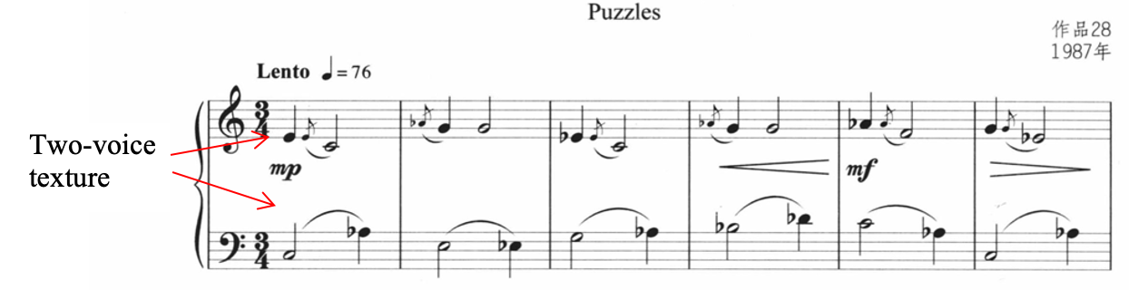

In two-voice counterpoint throughout, “Puzzles” incorporates recurring grace note appoggiatura ornaments reminiscent of those found in traditional Chinese folk melodies. In Chinese folk music, grace note appoggiaturas are known as Yiyin. “Puzzles” is neatly divided into three phrases of four measures each (see Table 14).
Table 14: Formal Outline of “Puzzles”
Phrase 1 | Phrase 2 | Phrase 3
mm. 1-4 | mm. 5-8 | mm. 9-12

Tonally, “Puzzles” revolves largely around the harmony of C-major, but also features the mediant relationship duality between C and A-flat key centers. Ding accomplishes this by creating semitone adjustments to the C-major triad, transforming the harmony throughout the work, one shifting note at a time. For example, beats one and two of measure one features the pitches of the C-major triad. However, on beat three of the same measure, Ding shifts scale degree five (G) up a half step, resulting in A-flat (see). Thus, measure one contains a transformation from the C-major triad (C-E-G) to the A-flat augmented (Ab-C-E) triad, featuring the duality between C-major and A-flat augmented triad. Beat one of measure two features a cross voice relationship, where the A-flat from the previous measure is adopted by the grace note played by the right hand in beat one of measure two (see Figure 72). In measure two, Ding lowers the E in the left hand by a half step, resulting in E-flat on beat three. This transforms the harmony from A-flat augmented (Ab-C-E) triad to A-flat major triad (Ab-C-Eb). However, Ding creates ambiguity in measure two by inserting the pitch G in the right hand, representing the ‘sol’ of C-major, tethering the harmony to both C and A-flat tonal centers. Measure three features the same harmony as measure two, featuring the A-flat major triad with an added G in the left hand. Measure four features G’s in the right hand, representing the dominant of C-major, while the left hand contains a B-flat and D-flat. Together, G, B-flat, and D-flat spell a G-diminished chord. However, Ding creates harmonic ambiguity in measure four by inserting an A-flat in the right hand on beat one, in addition to featuring a ‘fa’ to ‘mi’ movement in the left hand (see Figure 72). Measure five feature pitches belonging in F-minor harmony, representing the submediant, or relative minor of A-flat major, one of the harmonic centers of “Puzzles.” Beat one and two of measure six contain a C-minor harmony. On beat three, Ding introduces an A-flat, transforming the harmony from C-minor to A-flat major, reinforcing the dual relationship between C and A-flat tonal centers.

Figure 72: “Puzzles,” Harmonic Analysis, mm. 1-6
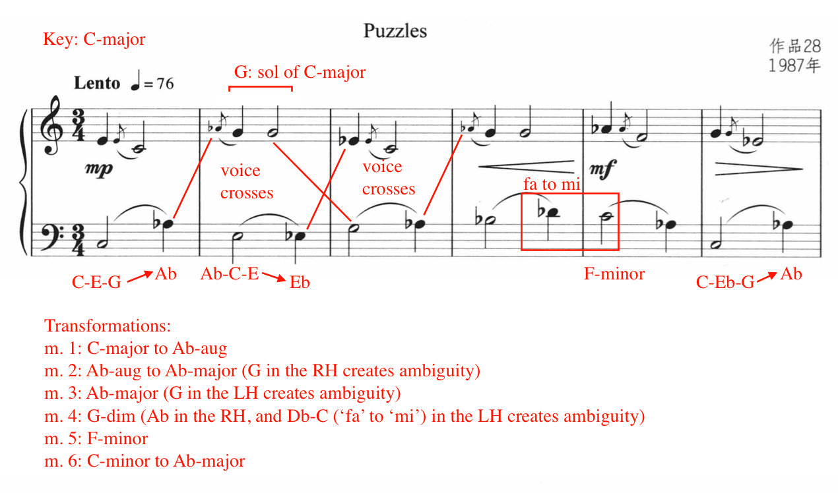

Beat one and two of measure seven include the pitches for a C-major triad: C-E-G. Similar to measure one, beat three contains the semitone shift to A-flat, shifting the harmony from C-major to A-flat augmented triad (see Figure 73). Measures eight and nine are identical to measures four and five. Measure 10 feature a C-minor harmony. Measure 10 feature two voice crossings involving D-flat and F. The F in beat three (LH) shifts to E in beat one of measure 12, representing a ‘fa’ to ‘mi’ cadential movement. The final measure of “Puzzles” concludes on a C-major chord, missing the fifth of the triad.
Figure 73: “Puzzles,” Harmonic Analysis, mm. 7-12
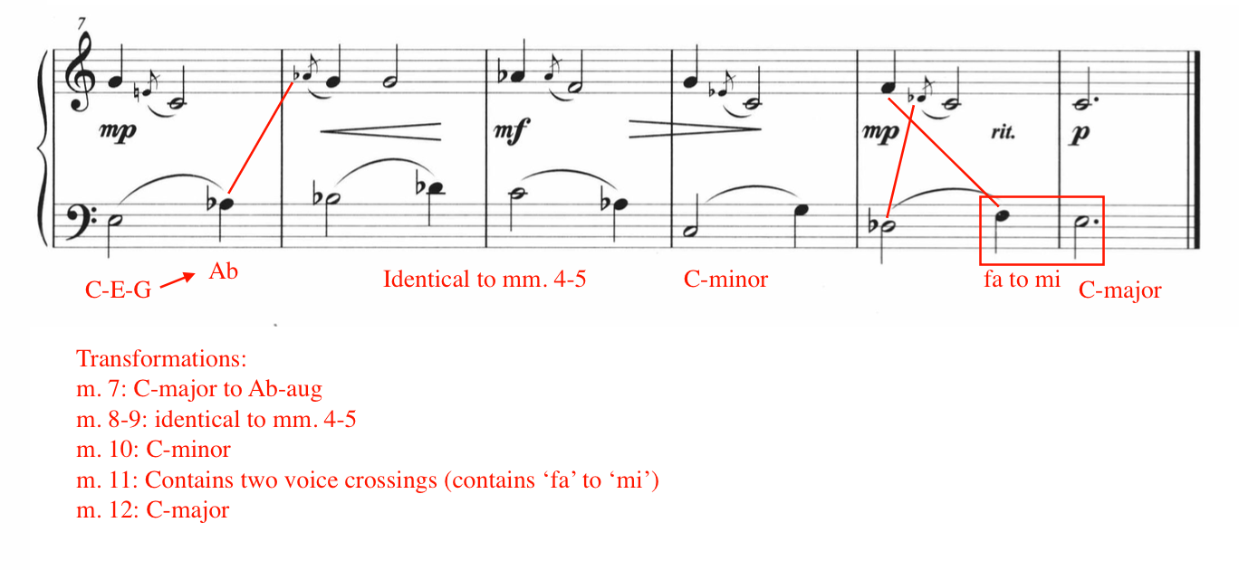

Pedagogical Analysis of “Puzzles”

Table 15: Summary of Potential Challenges: “Puzzles”
Summary of Potential Challenges: “Puzzles”
Chromaticism and accidentals
Leaps greater than a perfect fifth
Frequent hand position shifts
Phrase direction
Slur shaping
Grace note emphasis

Containing three phrases of four measures, “Puzzles” features a consistent and repetitive rhythmic pattern; a quarter followed by a half note in the right hand, and a half note followed by a quarter in the left hand (see Figure 74). “Puzzles” features rhythmic patterns that mimic the deliberate, strategic movements found in a game of chess, while its unpredictable chromatic language infuses each new chess move with excitement and curiosity. For instance, the student can imagine the right and left hands as chess opponents. Throughout the 12 measures of this work, each player attempts to thwart their opponent through unexpected non-chord-tones and chromatic movement. This call and response effect presents the pianist with an excellent opportunity to experiment with rubato, balance, and tone color.

Figure 74: “Puzzles,” Excerpt mm. 1-6
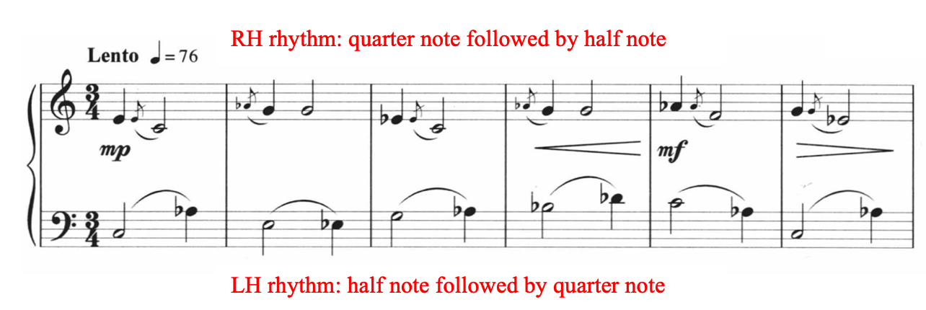

Although “Puzzles” only contains two voices, the chromaticism, leaps larger than a perfect fifth, and frequent position changes present challenges. In order to execute the composer’s phrasing, it is necessary to use consecutively repeated fingers, such as four to four. Leveled at a Magrath level four, its difficulty is comparable to Menuet in G minor Anh. 114 from the Notebook for Anna Magdalena Bach. Suggested fingerings for measures 1 – 6 are provided (see Figure 75), although players should adapt fingerings to suit their individual needs.
Figure 75: Suggested Fingerings for “Puzzles”
‘
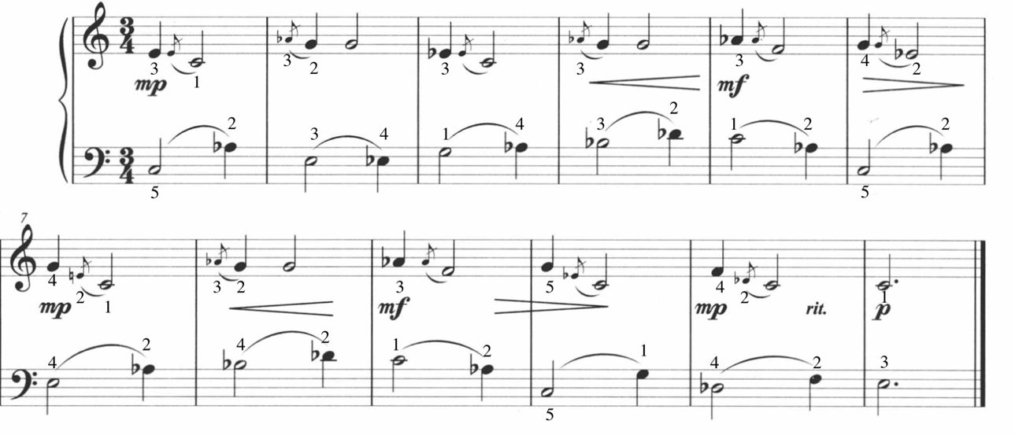
Slurred grace notes appear in each measure throughout “Puzzles” (see Figure 76), Grace note ornamentation, or appoggiaturas, are commonly used in traditional Chinese folk music. According to this study (Liu, 2019) on Chinese folk music performance practice, more stress should be placed on the grace note rather than the note it accompanies. Applying this performance practice to the piano helps elevate the performance and honor its compositional roots.

Figure 76: Grace Note Emphasis in “Puzzles,” Excerpt, mm.1-2
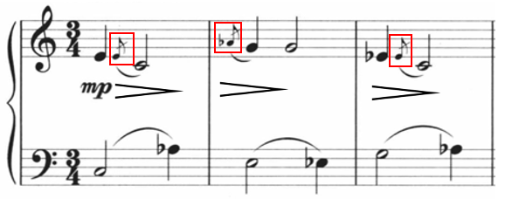
To familiarize the pianist with this technique, practicing grace notes through preparatory exercises is recommended. Ding designates ten dynamic indications in “Puzzles.” These dynamics bring contrast to the piece, direction to the phrase, and encourage flow in the line. “Puzzles” is an excellent work for an adolescent or adult intermediate player.

No. 2 “Playing Games”
Tempo: Allegretto, quarter = 120
Measures: 21
Pages: 1
Performance Duration: 0:40-0:50
Level: 6

Compositional Analysis

The second work in Ding Shande’s collection, Eight Piano Pieces for Children, op. 28 is titled “Playing Games.” “Playing Games” offers a vibrant contrast to “Puzzles,” portraying the boisterous and spirited revelry of children. In D major and 2/4 meter, this work is organized in ternary form, or A-B-A prime. The A and A-prime sections are comprised entirely of accented, energetic parallel fourths, while the B Section features a lyrical melody and chromatic accompaniment. Each phrase is seven measures in length. The form of “Playing Games” is outlined in Table 16.

Table 16: Form of “Playing Games”
A Section (with repeat) | B Section (with repeat) | A-prime Section
mm. 1-7  B minor | mm. 8-14  Pentatonic (right hand)  Chromatic (left hand) | mm. 15-21  F-sharp minor

The A Section (mm. 1 – 7) consists of angular and energetic parallel perfect fourths, set in B minor (see Figure 77). In measure one, the right hand initiates the parallel perfect fourths, followed by a left hand echo of the same rhythmic material in measure two.
The A and A-prime sections are based in B minor and F-sharp minor, respectively. Consequently, Ding employs tonal language in these sections. However, the B Section contains a mixture of pentatonic modes and chromatic language, idiomatic of his late (1966–95) style.

Figure 77: “Playing Games,” Excerpt, mm. 1-7
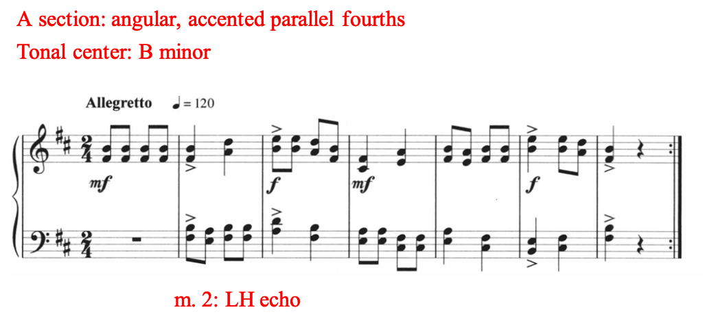
A defining characteristic of Ding Shande’s late (1966–95) style is the synthesis of chromatic language and Chinese pentatonic modes. In traditional Chinese harmony, there are four transpositions/inversions (see Figure 78) of the major pentatonic mode: gong (root), shang (first inversion), jue (second inversion), zhi (third inversion) and yu (fourth inversion).

Figure 78: Pentatonic Scale in Root Position and Four Inversions
Root = gong diao: C D E G A c
First Inversion: shang diao: D E G A c d
Second Inversion: jue diao: E G A c d e
Third Inversion: zhi diao: G A c d e g
Fourth Inversion: yu diao: A c d e g a

In the B Section (mm. 8-14), Ding combines the Yu inversion, or fourth inversion, of the A major pentatonic mode in the right hand with a chromatic broken chord accompaniment containing a C-sharp pedal in the lowest voice (see Figure 79). The pitches of the A-pentatonic mode in Yu inversion include F#-A-B-C#-E. Ding’s combination of pentatonic language and chromatic techniques is representative of his late (1966–95) compositional style.

Figure 79: "Playing Games," B Section, Excerpt, mm. 8-10
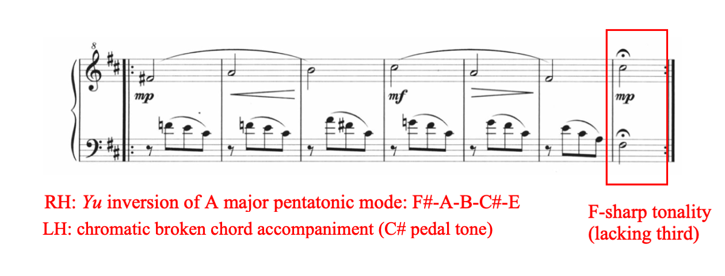
The concluding tonality of the B Section (m. 14) features an F-sharp in the left hand and a C-sharp in the right hand, suggesting an F-sharp chord (see Figure 79). Ding omits the third of the F-sharp chord (m. 14), leaving its major or minor tonality uncertain, although the material leading up to it is minor. This F-sharp chord creates a smooth transition into the following A-prime Section (mm. 15 – 21), which is based in F-sharp minor (see Figure 80).

Figure 80: "Playing Games" A-Prime Section, mm. 15-21
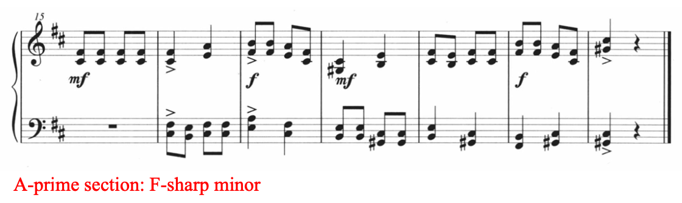
In F-sharp minor, the A-prime Section is the final section of “Playing Games,” spanning measures 15 to 21. This section is a perfect fifth transposition up, or perfect fourth transposition down from the original A Section (mm. 1 – 7) key, previously set in B-minor. The A-prime material features an identical transposition of the A Section material, with the exception of the last two measures, mm. 21 – 22. The final chord of “Playing Games,” a C-sharp harmony in second inversion, does not contain scale degree three. As such, its major/minor tonality is uncertain (see Figure 81), causing the end of the work to feel open ended.

Figure 81: “Playing Games,” A-Prime Section Excerpt, mm. 20-21
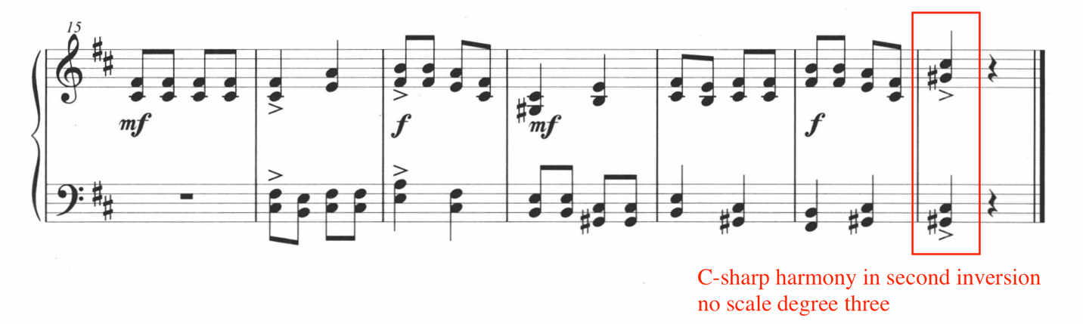

Pedagogical Analysis of “Playing Games”
Table 17: Summary of Potential Challenges: “Playing Games”
Summary of Potential Challenges: “Playing Games”
Parallel perfect fourths
Frequent position shifts
Consecutively repeating finger numbers
Requires a medium to large hand span
Fast tempo

Leveled at a Magrath level six, the second work in Ding Shande’s Eight Piano Pieces for Children, op. 28, “Playing Games” is full of creative potential: the energetic fourths in the A and A-prime sections embody the lively competition amongst children at play, while the B Section is cunning and stealthy in character.
The A and A-prime sections consist exclusively of rapidly shifting parallel perfect fourths, which requires strong fingertips and flexible wrists. These sections also feature consecutively repeated fingers and occasional use of the thumb on black keys. As such, carefully planned choreography is crucial. Due to frequent position changes and leaps in both hands in the A and A-prime sections, the student should rehearse transitioning between positions with a loose wrist and relaxed fingers. Ding also includes eight accents in the A Section and six in the A-prime Section. Strong fingertips are necessary when executing accents in both hands. However, in order to avoid tension buildup, each accent should come from the key, followed by an immediate release. “Playing Games” is not recommended for students with small hands.
While the A and A-prime sections showcase the student’s energetic touch and articulation, the B Section (mm. 8-14) demonstrates lyricism and legato touch. In this section, while full pedaling is advised against, touches of pedal for color is encouraged. The right hand showcases a lyrical melody based in the A major pentatonic scale in fourth inversion, the Yu inversion. The right hand should exercise finger legato in this phrase (see Figure 82). The left hand accompaniment drives the shape of the phrase. For example, the moving notes in the accompaniment is responsible for shaping the crescendo from mezzo-piano to mezzo-forte in measure nine through 11. The author suggests isolating the left hand alone to practice the swells in dynamics.

Figure 82: "Playing Games," B Section Pedagogical Suggestions
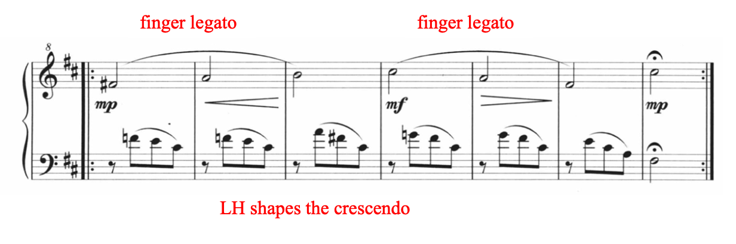

Fingerings and choreography for mm. 1-10 are recommended below (see Figure 83), although pianists should adapt these suggestions to suit their individual needs. A quick lift of the wrist is indicated in red in mm. 2-3 and 4-5, in order to facilitate the repeated use of fingers five and two, and the upcoming accent in measure three. In measure six, the left hand should prepare for beat two by preemptively reaching finger number two over the thumb. The right hand should lift slightly in measure ten to make room for the notes in the left hand. “Playing Games” is appropriate for an energetic intermediate student working on level six repertoire.
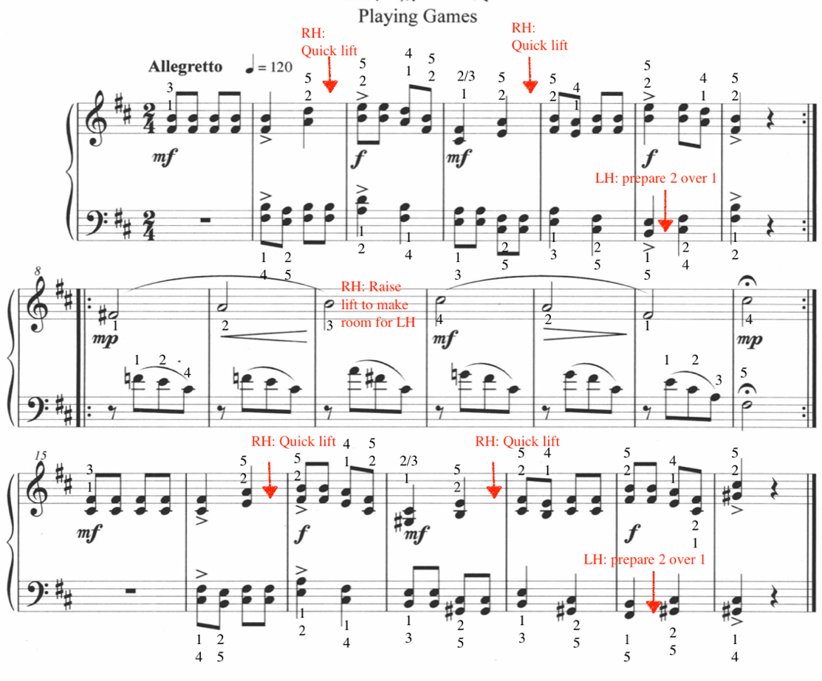
Figure 83: Suggested Fingering and Choreography for "Playing Games,” mm. 1-14

No. 3 “Evening Song”
Tempo: Adagio, quarter = 66
Measures: 24
Pages: 1
Performance Duration: 0:50 – 1:00
Level: 6

Compositional Analysis

“Evening Song” is the most haunting work in this collection and represents Ding’s late (1967-95) style of chromatic composition. A total of 24 measures in length, “Evening Song” follows a loose ternary structure (see Table 18). “Evening Song” is languid, contemplative, and song-like, making it an excellent choice for an intermediate student working on Magrath level six repertoire.

A Section | B Section | A-prime Section
mm. 1-14 | mm. 15-18 | mm. 19-24
Table 18: Form of “Evening Song”

“Evening Song” is set in the key of C minor. However, Ding occasionally disturbs this tonality by inserting non-chord tones and chromaticism (see Figure 84). For instance, measure three features a chromatic lower neighbor non-chord tone in the left hand, and measure eight features an accented lower neighbor non-chord tone in the right hand (see Figure 84). Although Ding incorporates non-chord tones, the A Section is largely tonal, presenting two imperfect authentic cadences in C minor, located in measures five and nine (see Figure 84).

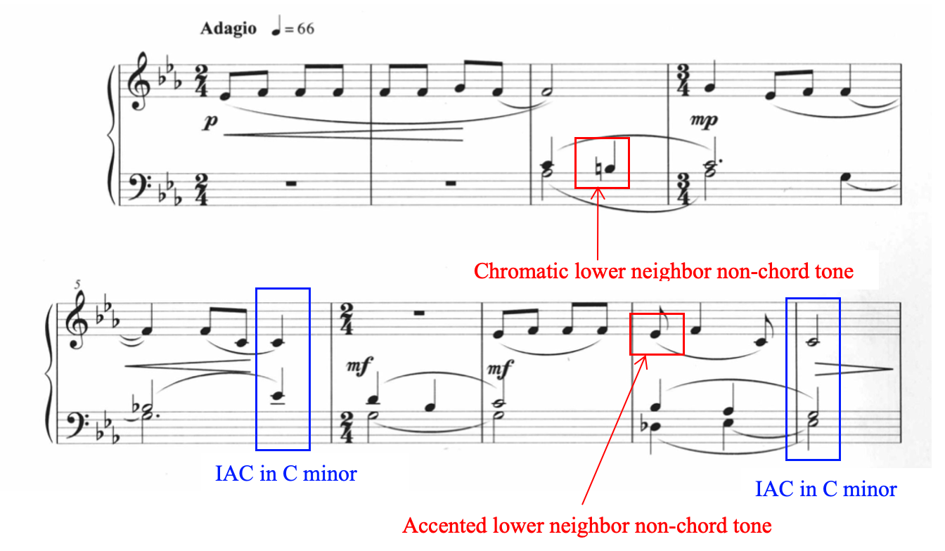
Figure 84: "Evening Song," Excerpt, mm. 1-9, Non-Chord Tones

In the A Section (mm. 1-14), the theme is introduced in C minor by the right hand during measures one through five. A brief fragment of this theme is echoed in measures seven through nine. This theme features mainly stepwise movement and remains within the range of the C minor pentascale (C-D-Eb-F-G). Ding blurs the sense of predictable meter by inserting meter changes at measures four and six. As a result, the melody takes on an improvisatory and unhurried quality.

Figure 85: "Evening Song," A Section Excerpt, mm. 1-9
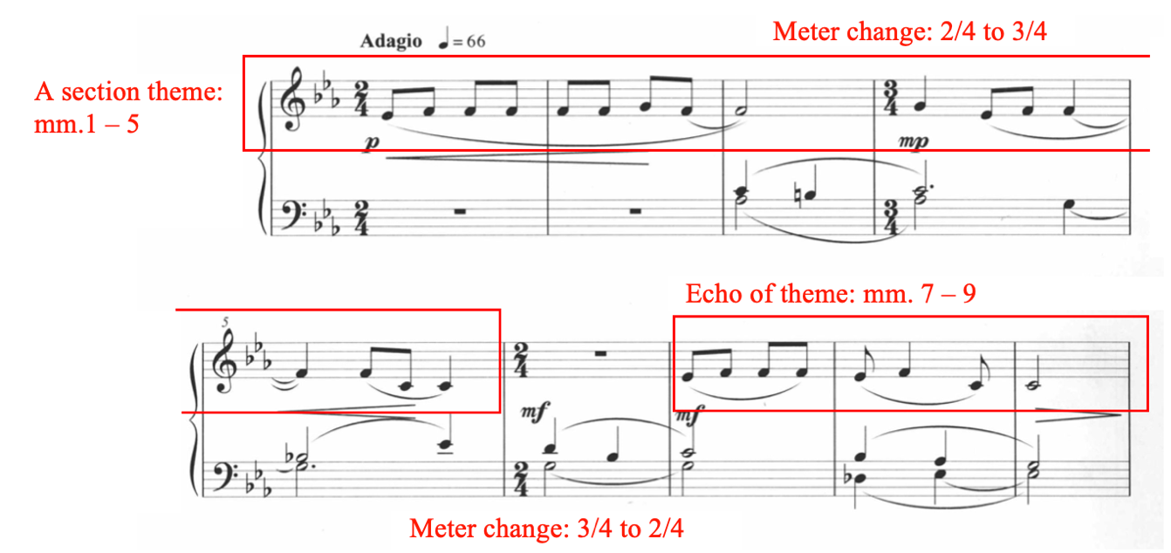

The B Section, mm. 15 – 18 features a modulation from G minor to G major (see Figure 86). The right hand features parallel perfect fourths throughout the B Section, which is accompanied by broken arpeggiated figures in the left hand. This modulation from G minor to G major sets up the return of the A-prime Section, which starts in G major.

Figure 86: "Evening Song," B Section
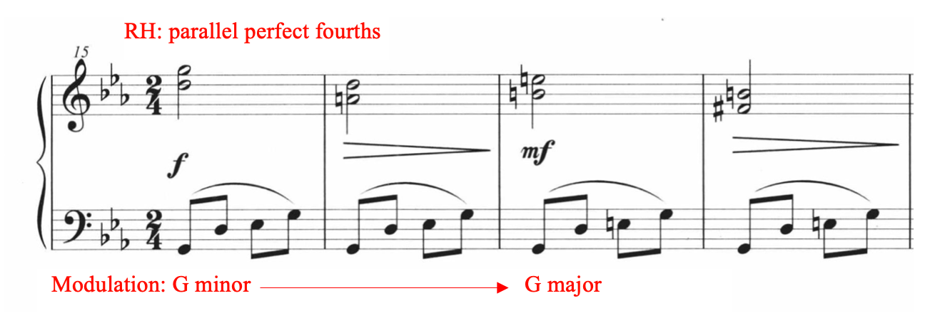
The return of the A-prime Section (mm. 19 – 24) is initially set in G major, however, non-chord tones destabilizes the tonal center (see Figure 87). “Evening Song” concludes with an augmented chord, creating a haunting effect that lingers on until slowly dissipating.

Figure 87: “Evening Song” A-prime Section, mm. 19-24
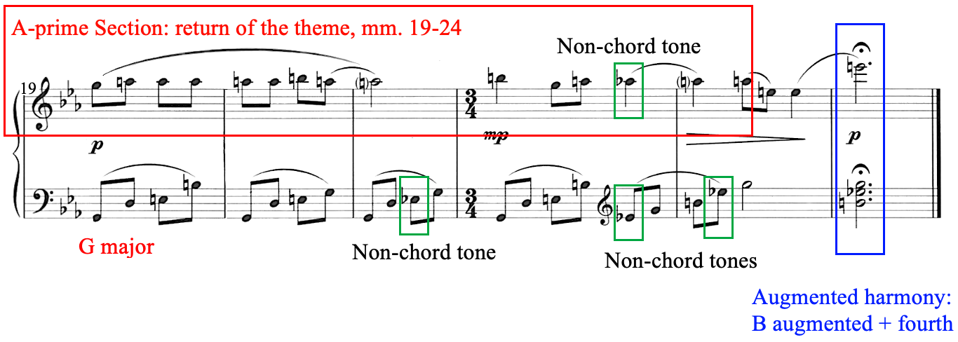

Pedagogical Analysis of “Evening Song”
Table 19: Summary of Potential Challenges: “Evening Song”
Summary of Potential Challenges: “Evening Song”
Legato touch
Sensitive pedaling
Singing tone
Meter changes
Held-over notes
Evenness of tone

Ding Shande’s “Evening Song” is graceful, forlorn, and haunting, presenting an excellent contrast to “Playing Games,” and “Puzzles.” Leveled at a Magrath level six, the primary challenges of “Evening Song” include legato touch, sensitivity to pedaling, and a lyrical tone color. Due to the frequent meter changes, the student should be comfortable switching between simple 2/4 and 3/4 meter (see Figure 88).

Figure 88: Meter changes in “Evening Song,” mm. 1-9
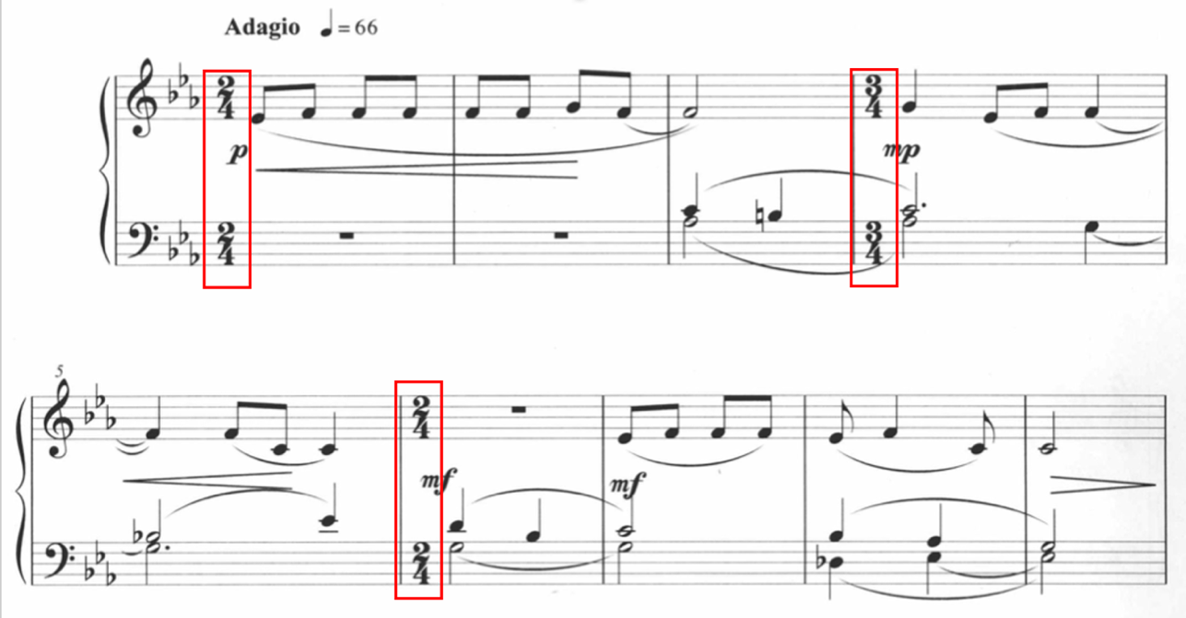
“Evening Song” requires the pianist to hold-over tied notes while independently activating other fingers in the same hand (see Figure 89). This occurs in the left hand, found in mm. 3 – 4, 4 – 5, 6 – 7, and 8 – 9.

Figure 89: Held-Over Tied Notes in “Evening Song”
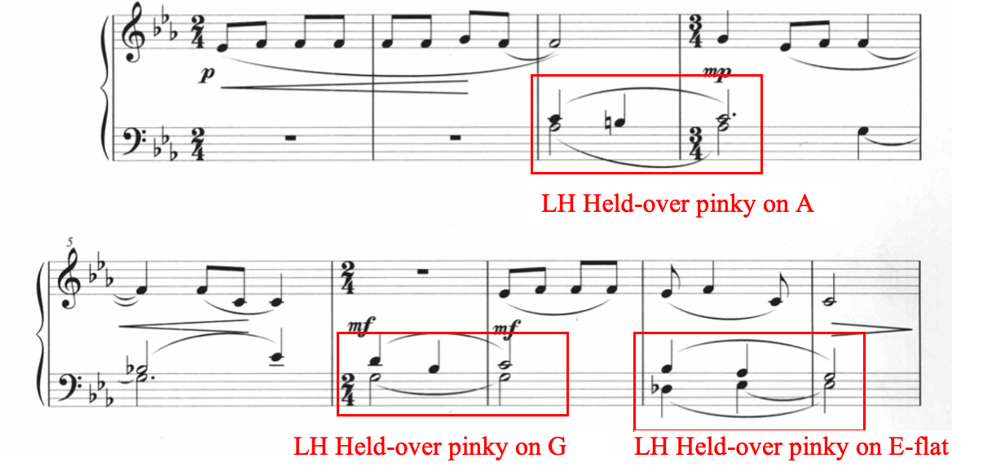

In “Evening Song,” Ding does not indicate pedaling instructions; consequently, sensitivity to pedaling should be encouraged through active listening and adaptation. Syncopated pedaling should be used to enhance the tone color and highlight harmony. To reduce overpedaling, slow practice using legato touch in both hands is recommended. The author suggests the following pedaling and fingering below (see Figure 90). However, fit the adaptations to the technical ability of the student.

Figure 90: Suggested Fingering and Choreography for “Evening Song”
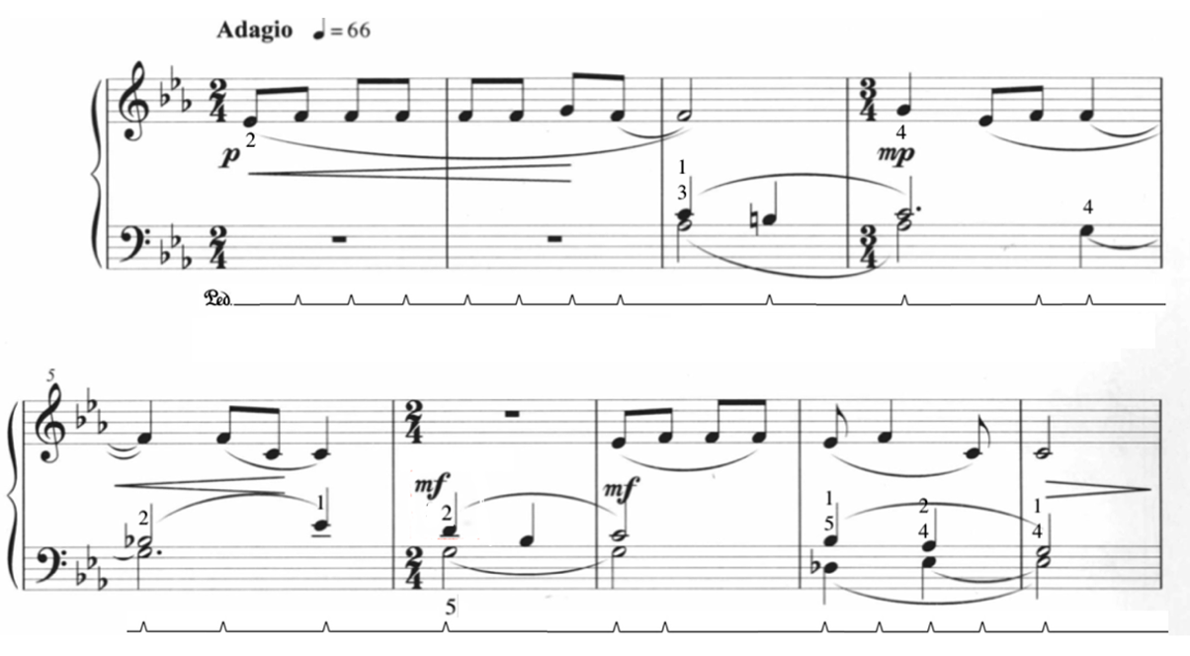

No. 4 “Mangluo and Elephant-Foot Drum”
Tempo: Presto, quarter note = 200
Measures: 45
Pages: 1
Performance Duration: 0:25-0:35
Level: 5-6
Compositional Analysis
The fourth work in Ding Shande’s Eight Piano Pieces for Children, op. 28 is entitled “Mangluo and Elephant-Foot Drum.” “Mangluo and Elephant-Foot Drum” is a festive work, imitating the sounds of the Chinese percussion ensemble. The title describes the pairing of two Chinese percussion instruments, the mangluo (芒锣) and the elephant-foot drum (象脚鼓). A mangluo (see Figure 91) is a type of bronze gong, meant to be struck by a cloth headed mallet, while the elephant-foot drum is a type of resonant hollow drum (see Figure 92). The mangluo gong and elephant-foot drum are typically paired together in performance, as Ding has done in “Mangluo and Elephant-Foot Drum.

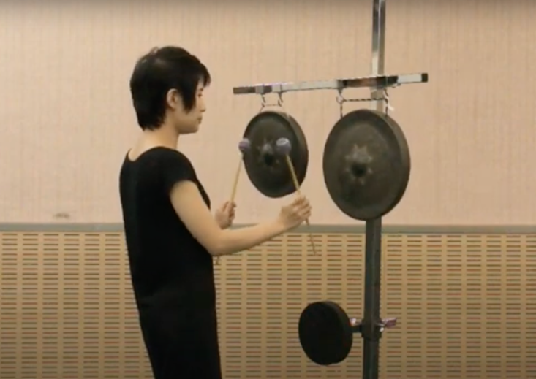
Figure 91: Mangluo Gong
Figure 92: Elephant-foot Drum Dance
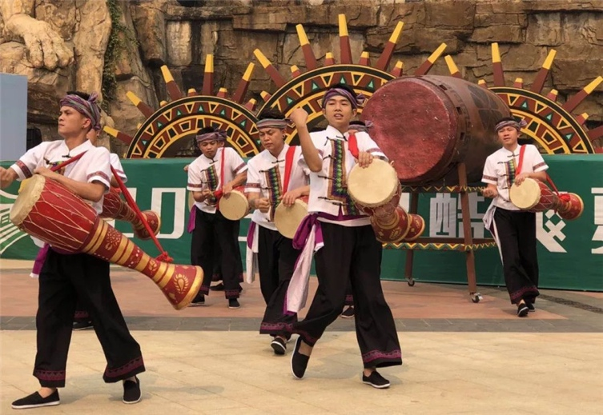

Ding imitates the rhythms and timbre of the mangluo gong and elephant-foot drum ensemble in “Mangluo and Elephant-Foot Drum.” Named after its appearance, the elephant-foot drum (象脚鼓)is a large, bronze colored drum that resembles the shape of an elephant’s foot (see Figure 92). Used primarily during festivals and religious events, the timbre of the elephant-foot drum is deep, resonant, and rich. This drum, used by ethnic groups between southwest China and southeast Asia, typically accompanies vocalists, dancers and operas. These ethnic groups, including the Yue, Bulang, De’ang, Wa, Pu, and Dai people utilize this instrument in a dance called the “Elephant-foot Drum Dance,” where participants dance in a series of circles. The elephant-foot drum is typically accompanied by additional percussion instruments, including gongs and cymbals. However, specific instrumentation varies from region to region.
“Mangluo and Elephant-foot Drum” is composed in a brisk 2/4, and 45 measures in length. In simple binary form, “Mangluo and Elephant-foot Drum” is composed of three sections, an introduction, an A Section, and an A-prime Section (see
Table 20). In this composition, the A-prime Section presents as a transposition of the A material.
Table 20: Form of “Mangluo and Elephant-Foot Drum”
Introduction | A Section | A-prime
mm. 1-12 | mm. 13-28 | mm. 28-45

Imitating the timbre of the mangluo gong and elephant-foot drum, Ding writes alternating left and right hand chords in the introduction section, from mm. 1 – 12 (see Figure 93). The opening chords in mm. 1-8 are meant to imitate the qualities of the mangluo gong and elephant-foot drum (see Figure 94).
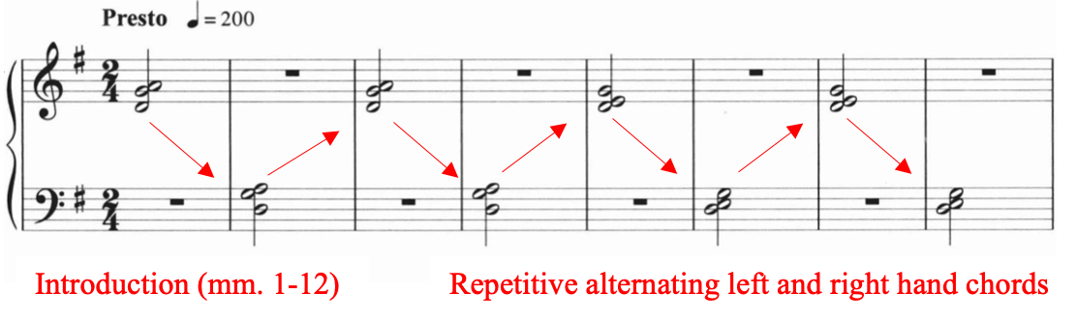
Figure 93: “Mangluo and Elephant-Foot Drum,” Introduction, Excerpt mm. 1-8

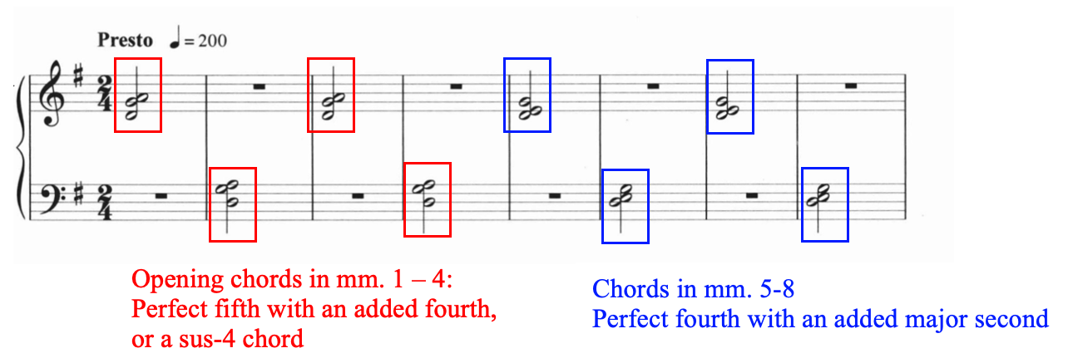
Figure 94: Opening Chords “Mangluo and Elephant-Foot Drum,” Excerpt mm. 1-8

The harmony in mm. 1-4 outlines a perfect fifth with an added fourth, or otherwise known as a sus-4 chord, and m. 5-8 is comprised of a perfect fourth with an added major second (see Figure 94).
Figure 94: Opening Chords “Mangluo and Elephant-Foot Drum,” Excerpt mm. 1-8

Hidden in this sonority in mm. 1- 8 are numerous major seconds. Ding often employed major seconds when imitating the bright and crisp effect created by a Chinese percussion ensemble. This is a recurring interval throughout “Mangluo and Elephant-foot Drum.” In mm. 9, the initial half notes chords (mm. 1 – 8) transform into quarter notes, creating the effect of a ‘written-out’ accelerando.
After the introductory material (mm. 1 – 12), the melodic material is introduced by the right hand in measure 13, marking the entrance of the A Section. Rooted in G major, the A Section spans from measure 13 – 28. Similar to “Evening Song,” Ding incorporates non-chord tones to bring out the brightness and striking effect of the percussion ensemble (see Figure 95).
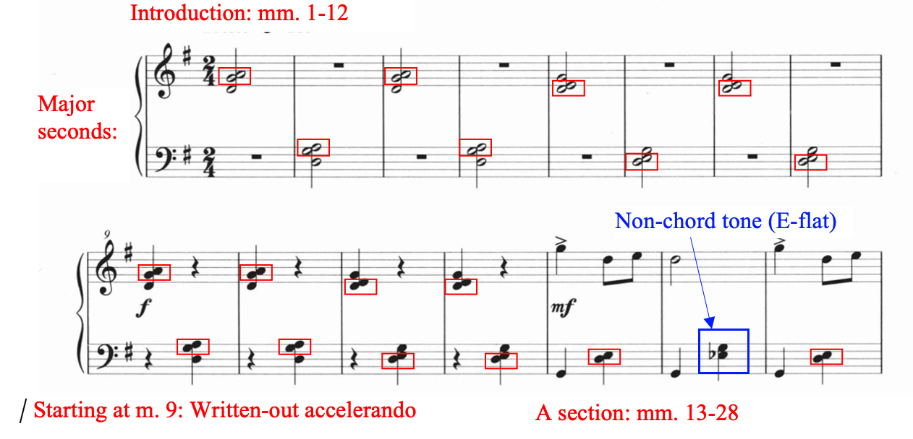
Figure 95: “Mangluo and Elephant-foot Drum,” mm. 1-15

Pedagogical Analysis of “Mangluo and Elephant-Foot Drum”
Table 21: Summary of Potential Challenges: “Mangluo and Elephant-Foot Drum”
Summary of Potential Challenges: “Mangluo and Elephant-Foot Drum”
Fast tempo
Accents
Large left-hand leaps
Little to no pedal
Accidentals

Leveled at a Magrath level six, “Mangluo and Elephant-foot Drum” is an exciting choice for the mid-intermediate pianist due to its cheerful melody, accents, left hand accompaniment pattern, and rhythmic drive. Although the piece models itself after the percussive effects of the mangluo gong and elephant-foot drum, it is important to encourage buoyancy in the fingers and wrists and avoid harsh attacks. In order to achieve a resonant but powerful sound that emulates the timbre of the drums and gongs, strong fingertips, flexible wrists, and adequate follow-though in the arms is recommended.
Before studying Ding Shande’s “Mangluo and Elephant-Foot Drum,” the pianist should be exposed to and educated about the history and cultural roots of the work. For example, the author recommends this video of a traditional Chinese percussion and dance ensemble, which features the mangluo gong and elephant-foot drum. The following figure (see Figure 96) suggests fingerings and choreography, but, adapt fingering and technical suggestions to suit the needs of each individual student.

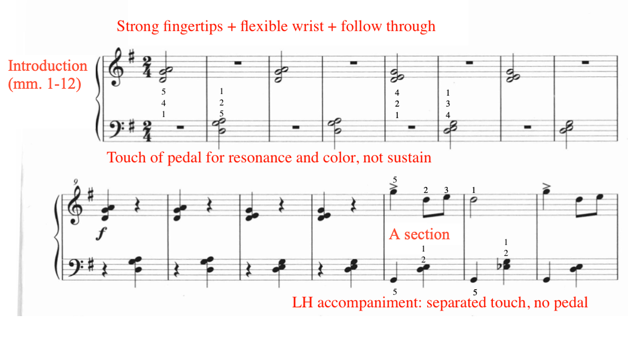
Figure 96: Suggested fingering for “Mangluo and Elephant-foot Drum," mm. 1-15

No. 5 “Worries”
Tempo: Largo, quarter = 58
Measures: 14
Pages: 1
Performance Duration: 1:10 – 1:15
Level: 8

Compositional Analysis

“Worries” is the fifth work in Eight Piano Pieces for Children, op. 28. Ding illustrates an unsettling emotion throughout the work by utilizing rhythmic, harmonic, and textural devices. Ding utilizes the asymmetrical quality of the 5/4 time signature to create an unsettling feeling throughout the work. Augmented harmonies, modal mixture, and evaded cadences help to further illustrate the mood. Lastly, each progressive phrase features an increasingly busy accompaniment texture, contributing to the buildup of unrest.
The work is divided into three phrases, followed by an abbreviated coda (see Table 22). Each phrase spans four measures in length. The A, A’, and A’’ phrases contain the same melodic material, however, the A’’ phrase is transposed up a step. Overall, “Worries” does not possess an overarching key center, instead, several tonalities are visited throughout, including D minor (A and A’ phrase), E minor (A’’ phrase), and F-sharp minor (coda).

Table 22: Form of “Worries”
A phrase | A’ phrase | A’’ phrase | coda
mm. 1-4 | mm. 5-8 | mm. 9-12 | mm.13-14
Melody: D minor | Melody: D minor | Melody: E minor (transposed up a step) | Melody: F-sharp minor
Left hand accompaniment texture: quarter and half notes | Left hand accompaniment texture: eighth notes | Left hand accompaniment texture: eighth note triplets | Accompaniment switches to right hand, melody in left hand

Ding utilizes the texture of the left hand accompaniment to build tension throughout “Worries.” For example, the A phrase (mm. 1-4) features a slow, stately accompaniment using only quarter and half notes (see Figure 97). Set in 5/4 meter, the A phrase accompaniment features legato major and minor parallel thirds.

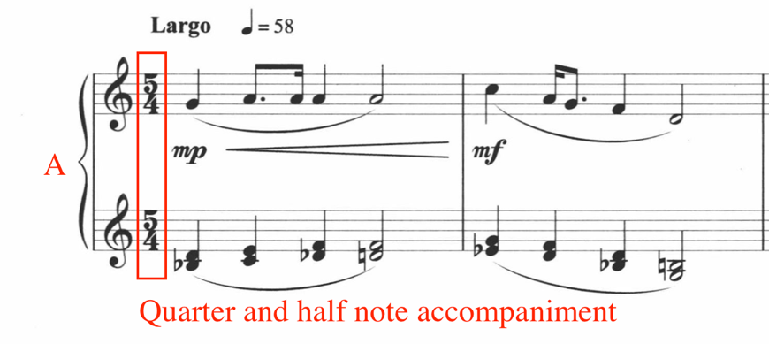
Figure 97: “Worries,” A Phrase Excerpt, mm. 1-2

Ding adds accompaniment variety to illustrate an increasing sensation of anxiety throughout “Worries.” For example, the A’ phrase (mm. 5-8) features moving eighth notes in the left hand accompaniment (see Figure 98), compared to quarter notes in the A phrase (see Figure 97). The right hand melodic material remains the same as the A phrase.

Figure 98: “Worries,” A’ Phrase Excerpt, mm. 5-6
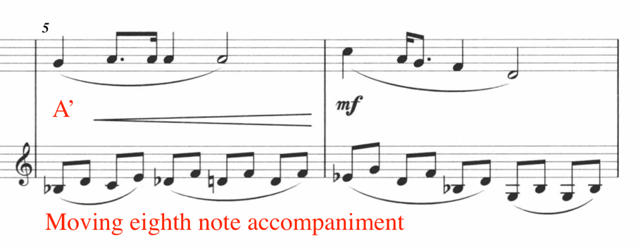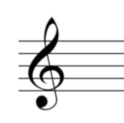
The left hand eighth note accompaniment of the A’ phrase closely mirrors the harmony from the accompaniment in the previous A phrase. For example, the left hand accompaniment in measure five features a broken arpeggiated version of the accompaniment in measure one (see Figure 99). The left hand accompaniment in measure six is harmonically identical to measure two, with the exception of beats four and five, where the A phrase contains a B-natural, while the A’ phrase contains a B-flat (see Figure 99).

Figure 99: Comparison of A and A' Phrase Accompaniment
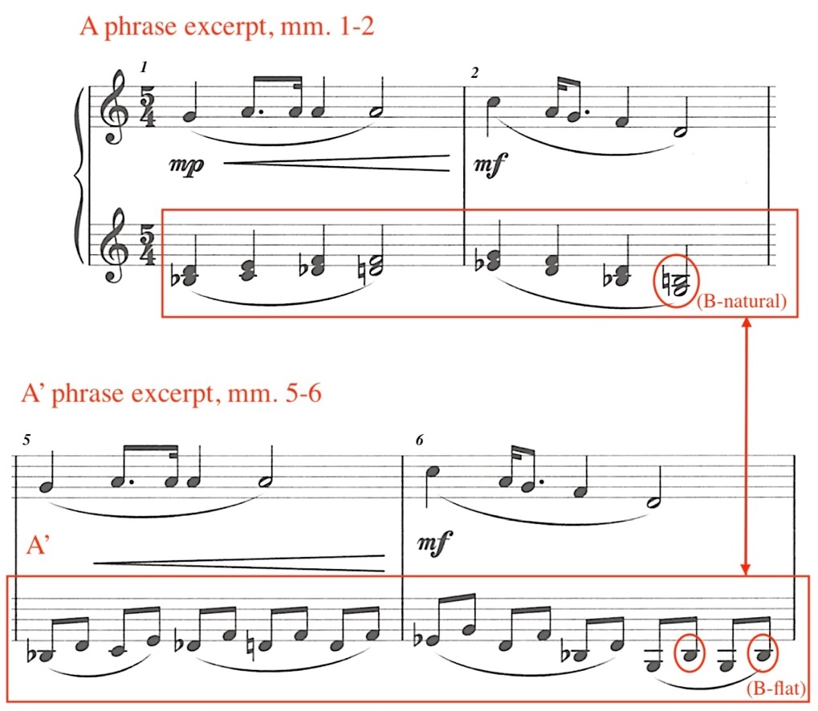

Finally, the last phrase (A’’) utilizes eighth note triplets in the accompaniment, in addition to incorporating large arpeggiations of tenths in the left hand. This faster note value further intensifies the feeling of uneasiness (see Figure 100). Moreover, the A’’ phrase features a transposition of the melodic material found in the previous two phrases (A and A’). For example, the A and A’ melodic material both begin on G, while the A’’ melody begins on A, a whole step transposition upward.

Figure 100: “Worries,” A'' phrase, Excerpt mm. 9-10
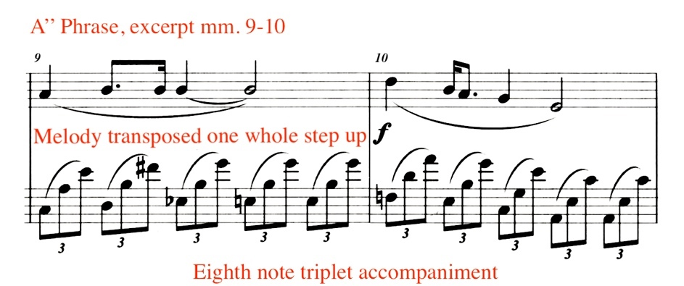
In addition to building tension through increasingly busy left hand accompaniment patterns, Ding infuses tension into the harmony, especially through augmented harmonies and modal mixture. Measure one features a D-flat augmented harmony in the third beat (see Figure 101). The augmented harmony arises out of the A minor chord in the second beat, acting as a chromatic passing harmony, leading to the D minor harmony in the fourth beat. Ding uses the chromatic passing augmented chord to create tension leading into the third beat, which is released on the fourth beat.

Figure 101: “Worries,” Augmented harmony, M. 1
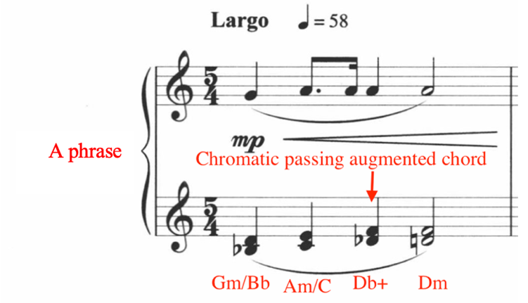
Similarly, in measure three, Ding utilizes a D-flat augmented chord to set up tension and release, resulting in a chromatic neighbor movement: D-Db-D (see Figure 102). The tension and release created from the augmented chord occurs between beats two and three.

Figure 102: “Worries,” Chromatic Augmented Neighbor, m. 3
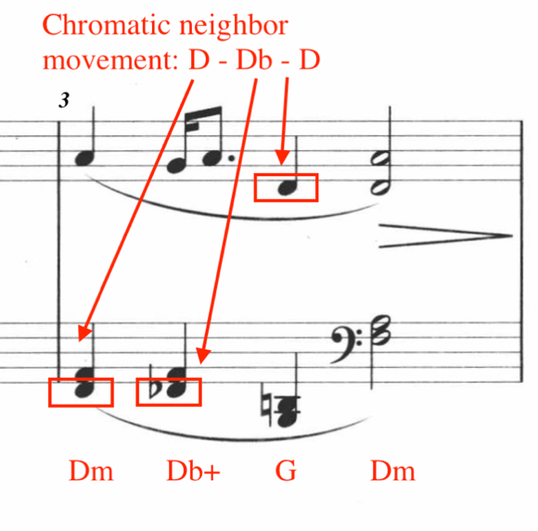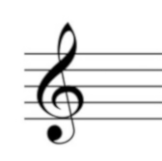

In measure four, the final bar of the first phrase (A phrase), Ding incorporates both augmented harmonies and modal mixture (see Figure 103). Beats one and two contain D-flat augmented chords, while beats three and four feature modal mixture, transitioning from D minor to D major. The modal mixture in beats three and four creates a brief moment of rest, imitating the effect of Picardy third.
Figure 103: “Worries,” Augmented Harmony and Modal Mixture, m. 4
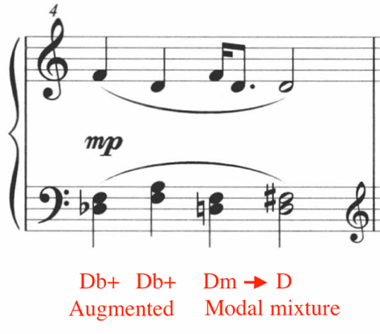
The harmonic progression from measure four returns later in “Worries.” For example, the final measures of the A’ and A’’ phrase extract the same harmonies as the final measure of the A phrase (see Figure 104), as shown in the final measure of the A’ phrase, measure eight, which features an exact harmonic and melodic copy of measure four, with an accompaniment texture variation.

Figure 104: “Worries,” Augmented Harmony and Modal Mixture, m. 8
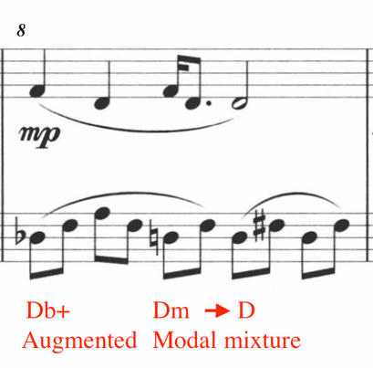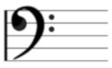

Moreover, the final measure of the A’’ phrase, measure 12 (see Figure 105), also features the same melodic and harmonic material as measures four (see Figure 103) and eight (see Figure 104), except measure 12 is transposed up one whole step, bringing heightened tension into the final phrase.

Figure 105: “Worries,” Augmented Harmony and Modal Mixture, m. 12
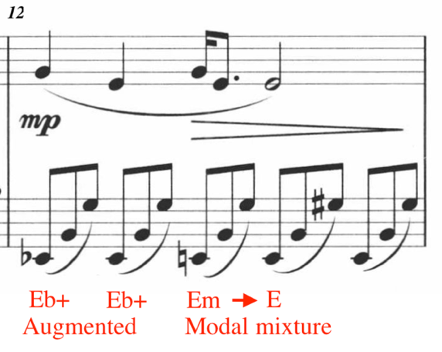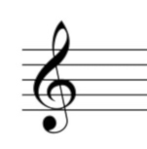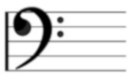
Ding concludes “Worries” with a two measure coda, located in measures 13 and 14 (see Figure 106). The coda features a variation of the melodic material, placed in the left hand, while the right hand provides the accompaniment material. This textural switch provides the coda with a mysterious and atmospheric effect, aided by the evaporating right hand accompaniment.

Figure 106: “Worries,” coda, mm. 13-14

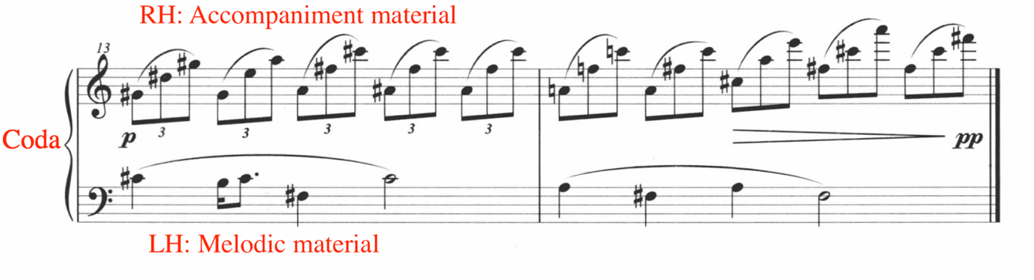

The concluding harmony of “Worries” finishes with an incomplete F-sharp chord, creating a final moment of uneasiness. The final chord on beat five is composed of F# and C#, lacking the third (see Figure 107).

Figure 107: “Worries,” m. 14
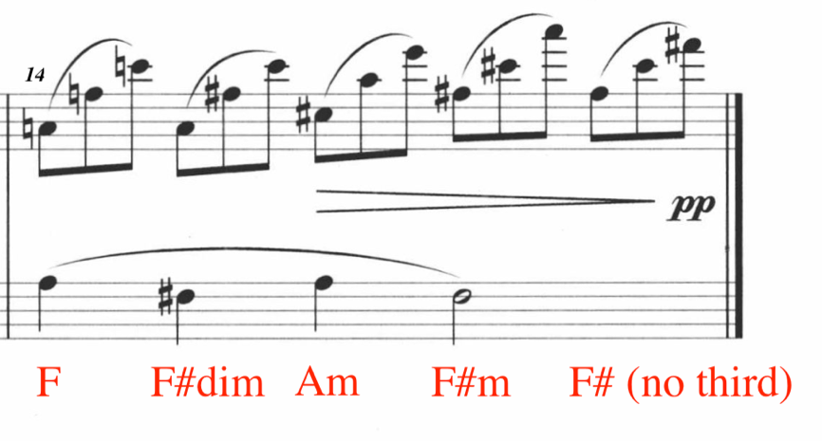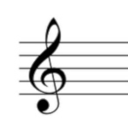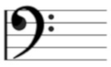
Throughout “Worries,” Ding utilizes rhythmic, textural, and harmonic devices to reflect the work’s title. These devices include using 5/4 meter, transposition, augmented harmonies, modal mixture, and the increasingly busy texture of the accompaniment.

Pedagogical Analysis of “Worries”
Table 23: Summary of Potential Challenges: “Worries”
Summary of Potential Challenges: “Worries”
Legato thirds
5/4 meter
Large left hand arpeggiations
Large right hand arpeggiations
Accidentals
Pedaling

Ding Shande’s “Worries” is unsettling, mysterious, and atmospheric, presenting a contrast to “Mangluo and Elephant-foot Drum.” Leveled at a Magrath level eight, the primary challenges of “Worries” include legato thirds, 5/4 meter, large arpeggiations in both hands, and accidentals. “Worries” presents the student with three varieties of left hand accompaniment textures (see Figure 108). The first phrase (A) consists of legato parallel thirds, followed by broken thirds in the second phrase (A’), and concluding with large tenth arpeggiations in the final phrase (A’’). Although closely related, each phrase’s accompaniment presents its own challenges and pedagogical opportunities.
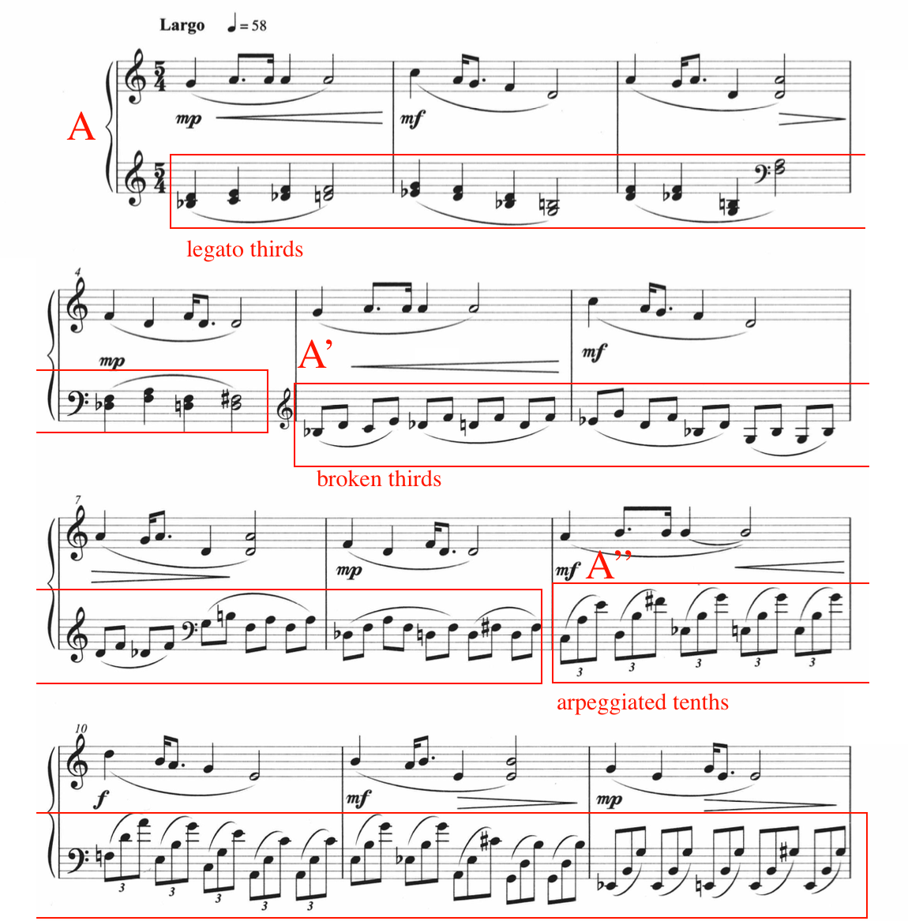
Figure 108: “Worries,” Accompaniment Variation, mm. 1-12

In the first phrase (A phrase: mm. 1-4), careful fingering and overlapping touch facilitate the left hand legato thirds. Use touches of pedal for color, avoiding blurring and prioritizing clarity of harmony. The student should have experience with double thirds prior to learning “Worries.” Keep the wrist flexible and mobile. To demonstrate linearity and evenness in tone, isolate double thirds (mm. 1-4) and split them between the hands, establishing a sound ideal for the final product. After the student has mastered executing the double thirds split between the hands, the student should use the following fingering for the left hand alone (see Figure 109). Adapt fingering and technical suggestions to suit the needs of each individual student.

Figure 109: “Worries,” A phrase, mm.1-4, Fingering Suggestion
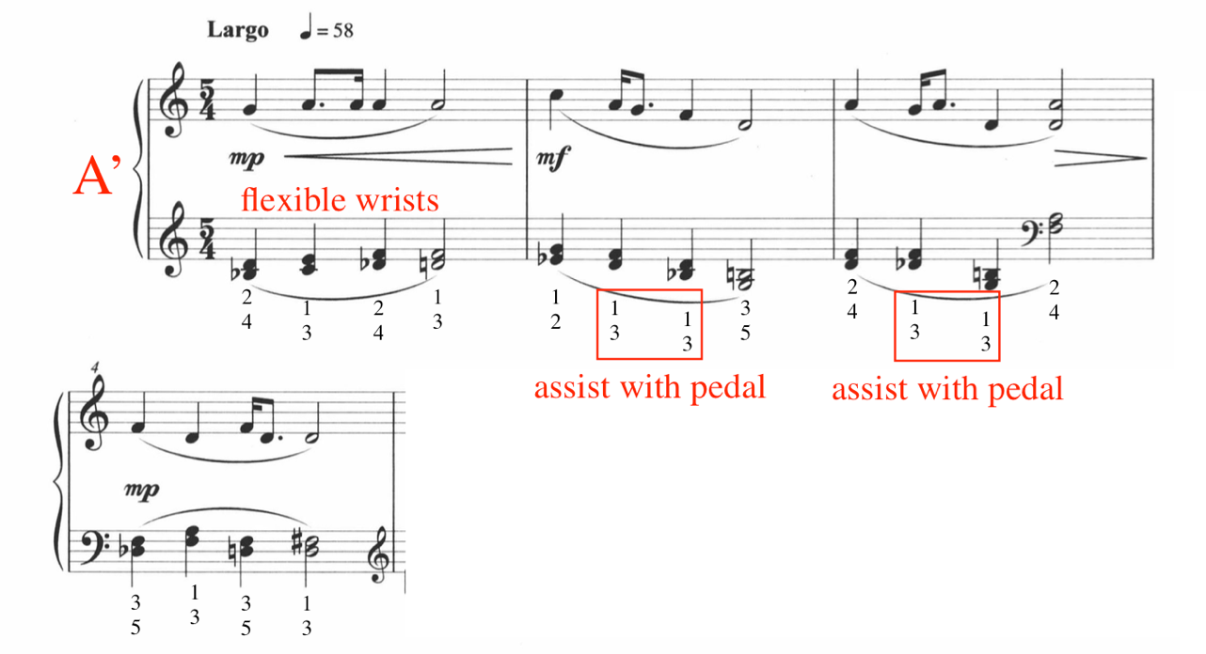

The second phrase (A’ phrase: mm. 5-8) features broken alternating thirds in the left hand, but the same right hand melodic material from measures one through four. Although the harmony of the left broken thirds closely mirrors the parallel thirds introduced in the A phrase (mm. 1-4), alternative fingering will facilitate legato connection. Practice the broken third accompaniment in isolation, carefully implementing overlapping legato touch. Use the following fingering suggestion for the second phrase (A’ phrase: mm. 5-8).

Figure 110: “Worries,” A' Phrase Fingering Suggestion
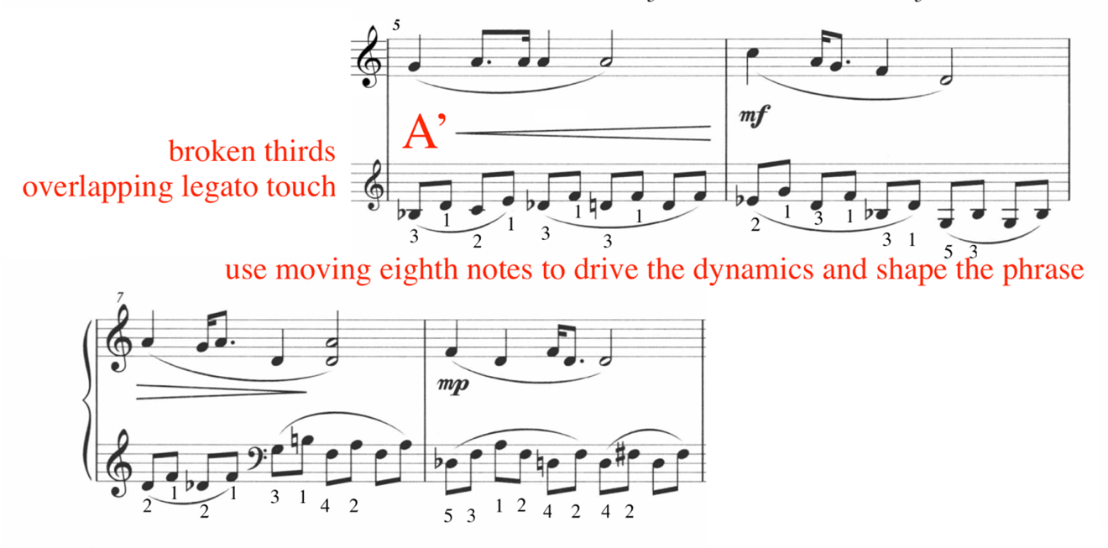
Additionally, the moving eighth notes serve as a driving force to provide shape to the dynamics and drive the direction of the phrase. Illustrating this, the left hand assists the growth of the crescendo in beats four and five in measure five.
The third phrase (A’’: mm. 9-12) features arpeggiated tenths in the left hand. Both right hand and left hand are transposed up one whole step. The A’’ phrase is transposed one whole step up from the A and A’ phrases (see Figure 111). Flexibility in the left hand wrist is crucial for an even tone and legato articulation. The left hand thumb should remain light, avoiding sudden accents. Adjusting for the hand size and comfort of the student, this author recommends either 5-2-1, or 5-3-1 in measures 9-12.

Figure 111: “Worries,” A'' Phrase Pedagogical Suggestions
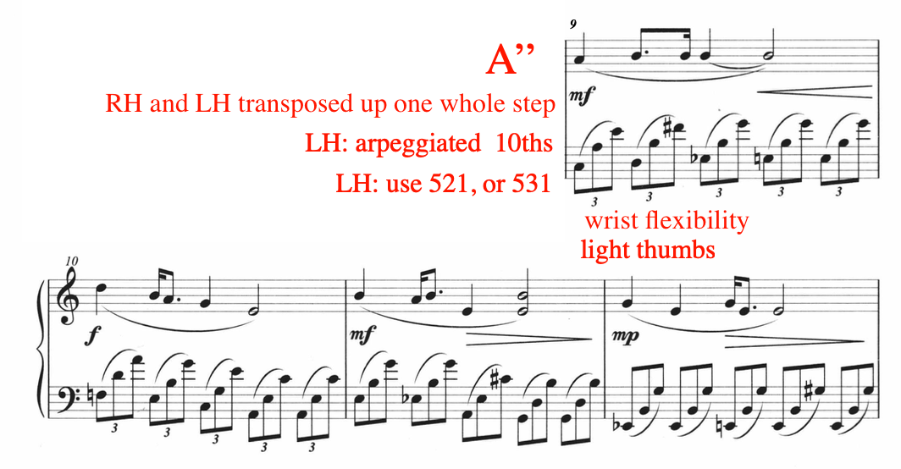

The only forte dynamic in “Worries” appears in measure ten of the A’’ phrase, marking the climax of the work. Ding indicates a crescendo in measure nine, growing into the downbeat of measure ten. The left hand tenth arpeggiations serve as a motor to facilitate the growth of the crescendo. Each arpeggiation in measure nine begins on a higher note, with the exception of beats four to five. This rise in register helps build the effect of the crescendo.
The coda, measures 13 through 14, feature a textural flip of the melody and accompaniment (see Figure 112). The right hand is responsible for the tenth arpeggiations, while the left hand plays the melodic material. Marked at a piano and pianissimo dynamic, the right hand arpeggiations should remain dynamically under the left hand melody. In the coda, the right hand arpeggiations drive the decrescendo in measure 14. To facilitate an evaporating effect in this measure, gradually and gently lift the right hand wrist beginning in beat three, reducing the weight in the keys, but prioritizing evenness (see Figure 112).
Figure 112: “Worries,” coda, mm.13-14
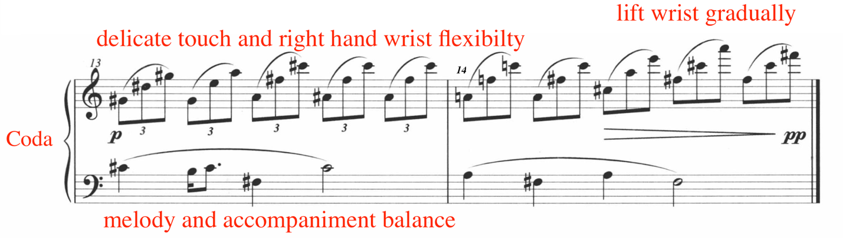
Throughout “Worries,” Ding develops the student’s pianism through a control of melodic and accompaniment balance, dynamic shaping, parallel and broken thirds in the left hand, and tenth arpeggiations in both hands. Moreover, the student will gain familiarity with 5/4 meter, augmented harmonies, modal mixture, and broken tenths. “Worries” from Ding Shande’s Eight Pieces for Piano op. 28, is an accessible choice for a Magrath level eight student.

No. 6 “Here Comes the Caravan of Horses”
Tempo: Allegro molto, quarter = 60
Measures: 49
Pages: 2
Performance Duration: 1:30 – 1:45
Level: 8

Compositional Analysis

“Here Comes the Caravan of Horses” is the sixth work in Ding Shande’s Eight Piano Pieces for Children op. 28. This work features an introduction, two contrasting sections, and a coda (see Table 24). The A Section depicts the sound of trotting horse hooves, while the B Section is dream-like and pastoral, possibly representing the vast plains of grazing horses.

Table 24: Form of “Here Comes the Caravan of Horses”
Introduction | A Section | B Section | coda
mm. 1-12 | mm. 13-30 | mm. 31-40 | mm. 41-49

The introduction, measures one through 13, features alternating minor seconds trading between the hands (see Figure 113). The rhythmic interest in the introduction section comes from the syncopation, seen here in measure one and three.

Figure 113: “Here Comes the Caravan of Horses,” Introduction, Excerpt mm. 1-5
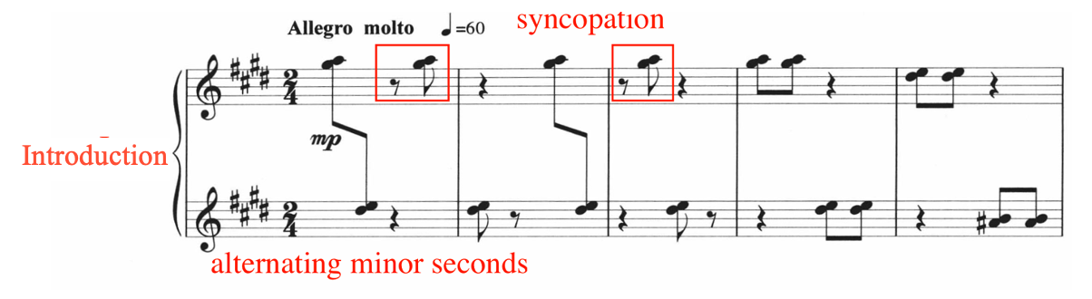
The introduction section begins at mezzo-piano but shifts to a mezzo-forte in measure eight (see Figure 114), imitating the sound of approaching horses. The mezzo-forte dynamic also correlates with textual thickening in measures eight through ten, where the minor seconds become tertiary collections.

Figure 114: “Here Comes the Caravan of Horses,” Introduction, Excerpt mm. 1-12
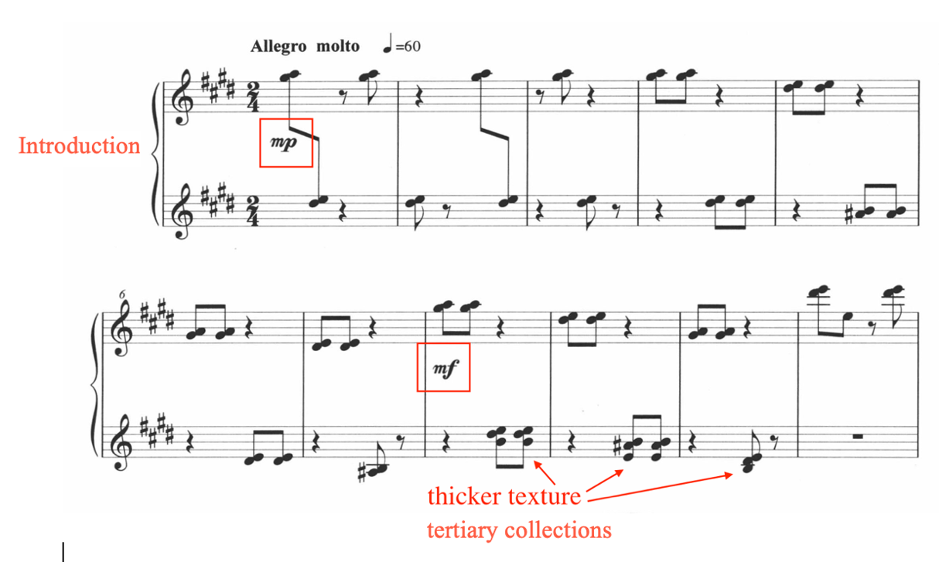

Both the introduction and A sections are composed in the key of E major. However, Ding frequently integrates non-chord tones into the texture. Throughout the introduction and A sections, Ding features the raised fourth, or A-sharp, into the accompaniment. For example, A-sharp non-chord tones are found in measures five, seven, and nine (see Figure 115).

Figure 115: “Here Comes the Caravan of Horses,” mm. 1-11
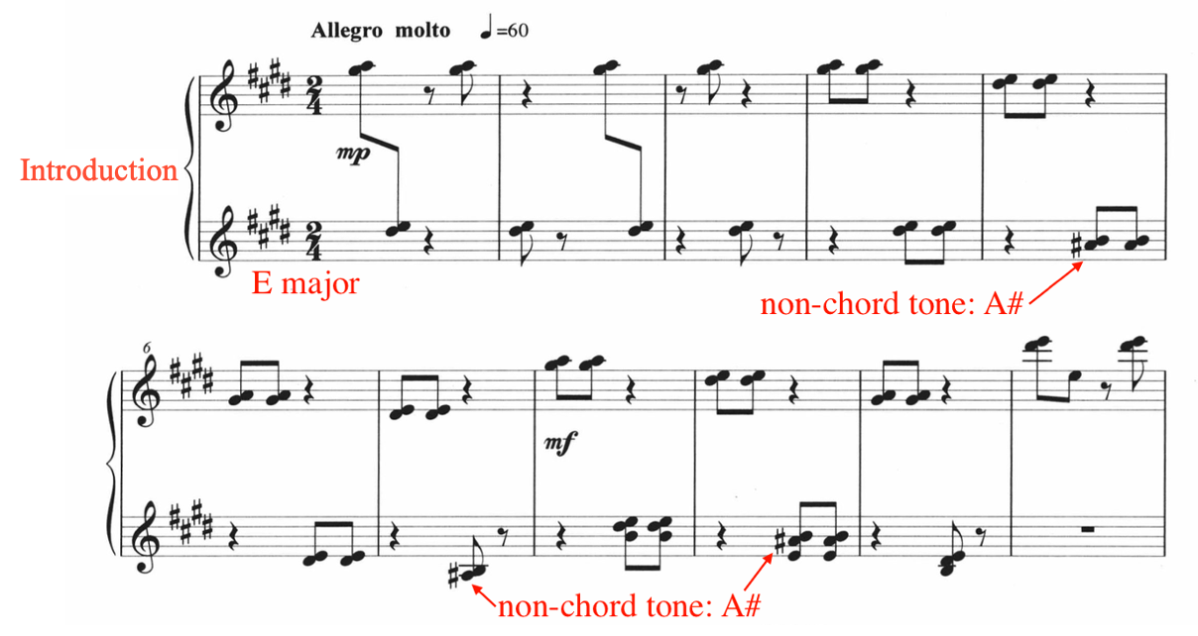
The left hand begins the melody in the A Section (mm. 13-30), followed by an imitation in the right hand (see Figure 116). Fragments of the minor seconds from the introductory material (mm. 1-12) are weaved into the A Section accompaniment, appearing in the form of syncopated minor second dyads in the right hand in measures 12 through 14.

Figure 116: “Here Comes the Caravan of Horses,” Excerpt, mm. 12-17
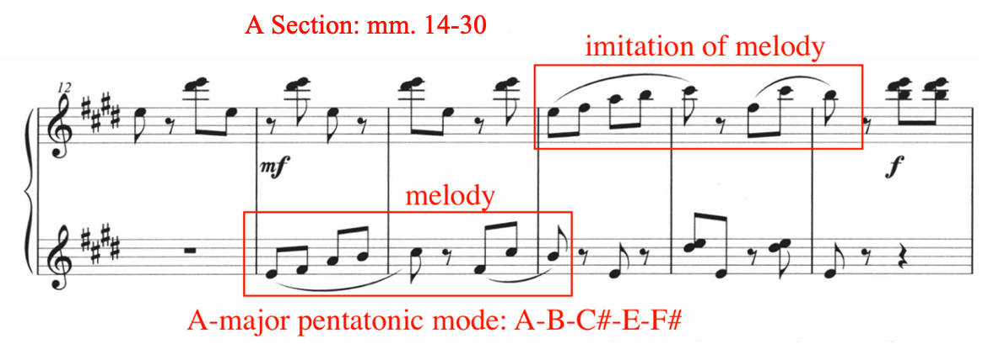
The melody (m. 13) is composed in the A-major pentatonic mode: A-B-C#-E-F#, beginning on E, the third inversion of the mode. In traditional Chinese harmony, the third inversion of the major pentatonic mode is known as the zhi diao (see Figure 117).

Figure 117: “Here Comes the Caravan of Horses,” mm. 12-17, zhi diao
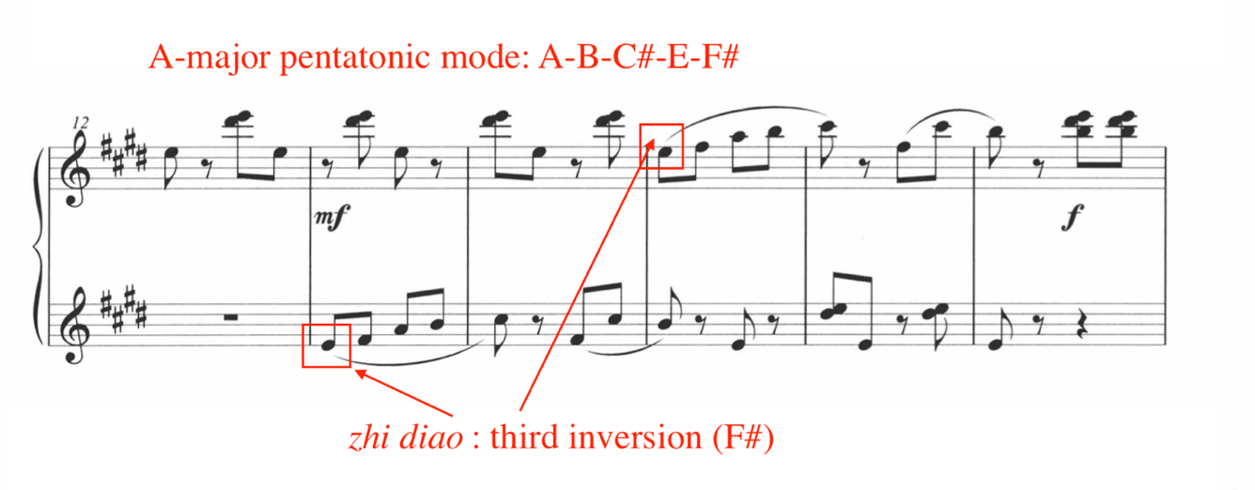

After a brief transition from measure 17 and 22, the melody returns in measure 23, where Ding shifts the starting pitch to F#, the fourth inversion of the A-major pentatonic mode, known as the yu diao (Figure 118). Ding continues to accompany the melodic material with syncopated minor seconds.
Figure 118: “Here Comes the Caravan of Horses,” mm. 18-29, yu diao
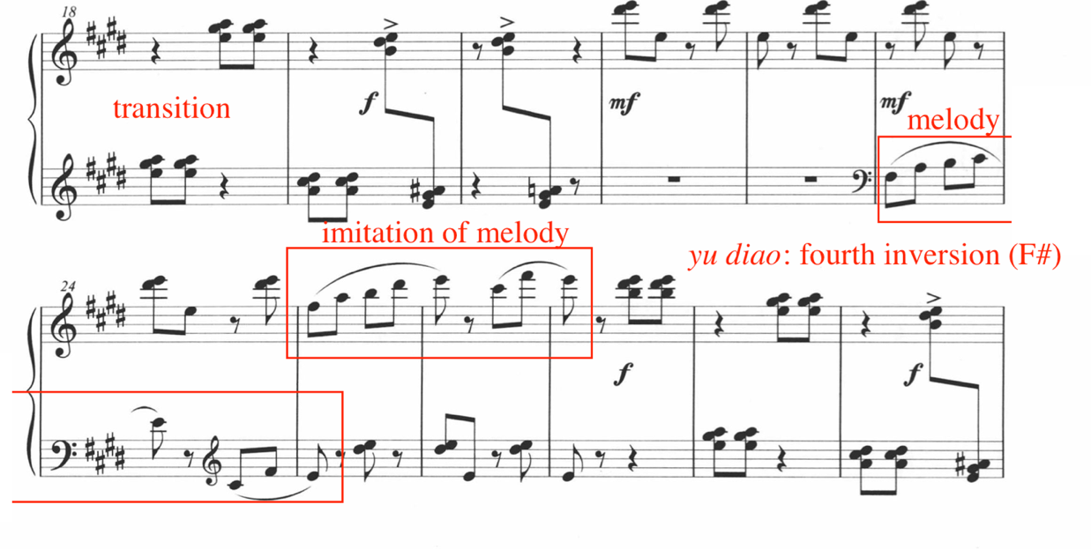

Switching to 5/4 meter and F# major, the B Section (mm. 31-40) is dream-like and pastoral, likely depicting the scenic pastures of grazing horses. The B Section features a repetitive, gently syncopated bassline, which remains constant throughout (see Figure 119).

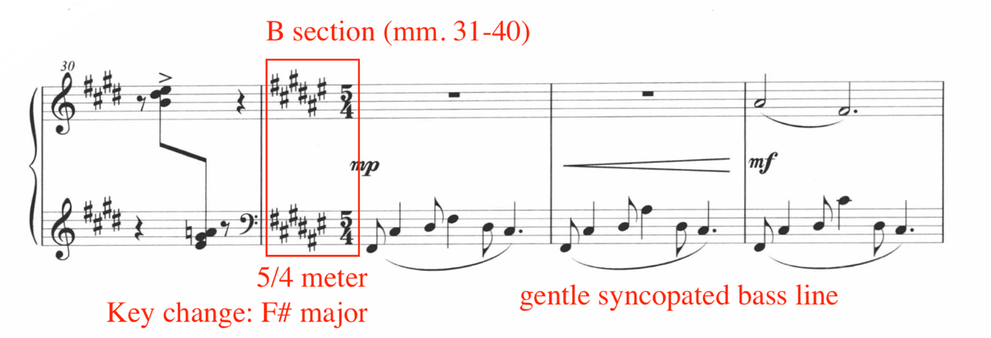
Figure 119: “Here Comes the Caravan of Horses,” B Section Excerpt, mm. 30-32

Beginning in F-sharp major (m. 31), this section cycles through five harmonic sonorities, often employing the use of extended harmonies (see Figure 120). The B Section begins with a two-measure introduction, followed by two four-bar phrases.

Figure 120: “Here Comes the Caravan of Horses,” mm. 30-43
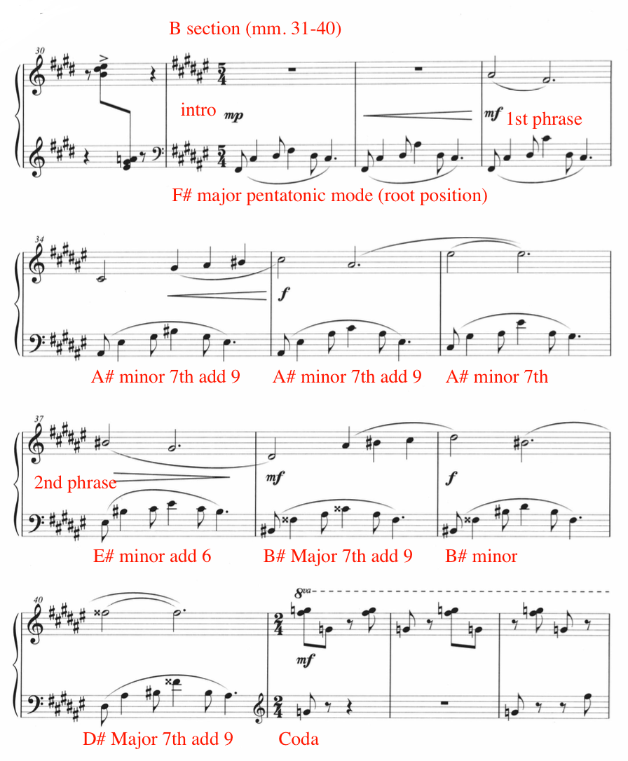

Throughout section B, Ding inserts rising figures into the texture. For example, the left hand bassline in measure 31 throughout 33 features a rising inner line motive outlining the F-sharp major harmony: F-sharp, A-sharp, to C-sharp (see Figure 121).

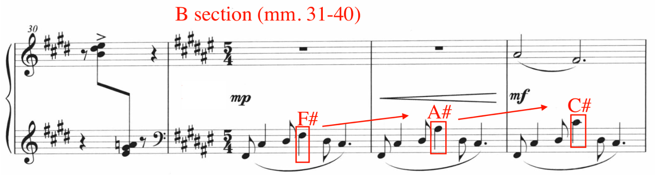
Figure 121: “Here Comes the Caravan of Horses,” Excerpt mm. 30-33, Rising Figures

In addition to rising inner line in the left hand (see Figure 122), the melodic material throughout the B Section also features rising motion. For example, measures 34 through 35 features rising motion in both melody and accompaniment (see Figure 122).

Figure 122: “Here Comes the Caravan of Horses,” mm. 34-36, Rising Figures
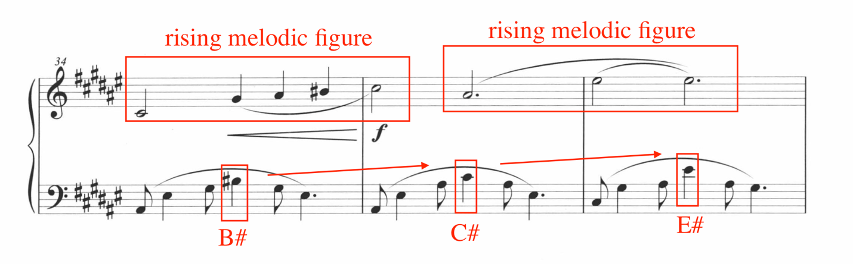
The coda, measures 41 through 49 features a recapitulation of the introductory material from measures one through 12 (see Figure 123). However, the syncopated minor seconds found in the coda remain in a static position, whereas those found in the introduction shift through several positions. Additionally, the minor seconds in the coda are located in a higher register.

Figure 123: “Here Comes the Caravan of Horses,” coda, mm. 40-49
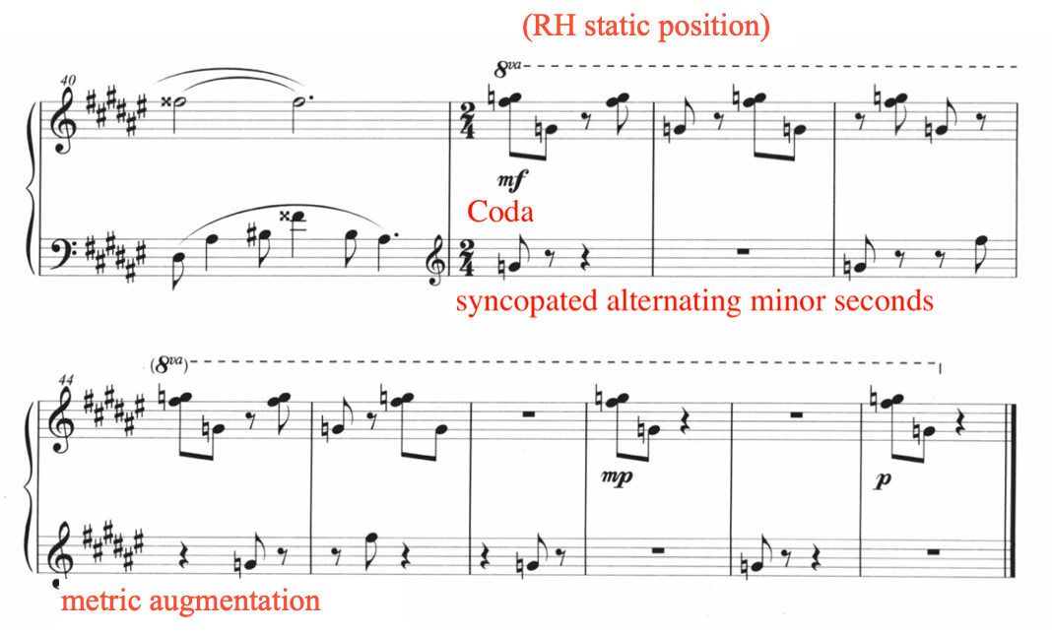

While the introduction (mm. 1-12) imitates the sound of horses approaching, the coda (mm. 41-49) captures the sound of horses disappearing into the distance, achieved by an incremental decrease of dynamics. For example, the coda begins in a mezzo-forte dynamic at measure 41, shifting to mezzo-piano in measure 47, and concludes in measure 49 at a piano dynamic, mimicking the effect of horses disappearing into the distance. Lastly, the final four bars (mm. 46-49) feature metric augmentation, where the minor seconds become more spaced out, thinning out the texture.

Pedagogical Analysis of “Here Comes the Caravan of Horses”
In “Here Comes the Caravan of Horses,” Ding Shande employs compositional tools to depict the sounds and scenes associated with horses. Leveled at a Magrath level eight, the primary challenges of “Here Comes the Caravan of Horses” include frequent leaps, syncopated rhythms, 5/4 meter, accidentals, and rapid transitions (see Table 25).

Table 25: Summary of Pedagogical Challenges of “Here Comes the Caravan of Horses”
Summary of Pedagogical Challenges of “Here Comes the Caravan of Horses”
Frequent leaps
Syncopation
5/4 meter
Position changes
Accidentals in a demanding key signature
Rapid transitions
Voicing and balance

The introduction (mm. 1-12) features a series of syncopated alternating minor seconds. Prior to learning the introduction, practice the rhythms away from the piano. For example, a practice technique is to tap the syncopated rhythms on the piano lid (see Figure 124).

Figure 124: “Here Comes the Caravan of Horses,” Excerpt mm. 1-5, Syncopations
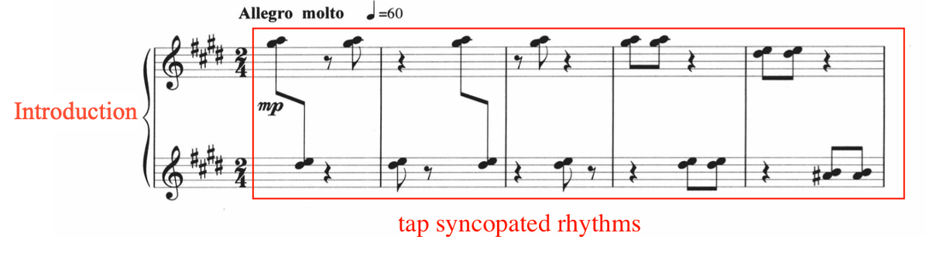
After becoming familiarized with the syncopated rhythms, students should integrate light, upward motions into each tapping motion, prefacing the appropriate articulation needed for this section. The upward motion, when applied to the keyboard, will result in a light and bouncy articulation, mimicking the sound of approaching horse hooves. Similarly, the student should follow this step-by-step approach for the syncopated rhythms in the coda (mm. 41-49).
Ding integrates frequent position changes throughout the introduction (mm. 1-12) section. To rehearse the transitions and rapid position changes, grouping, or ‘chunking’ is an effective practice technique (see Figure 125). For example, measures one through four remain in one position, as such, all pitches of the position should be depressed simultaneously. Next, the hands relocate to the following position, and the same technique applies for the subsequent positions. During the early stages of hands-together coordination, rehearse the transitions between positions in isolation, focusing on moving quickly without tension. For example, the student should ‘chunk,’ or ‘block’ the position at measure four, then, quickly travel to measure five’s position.

Figure 125: “Here Comes the Caravan of Horses,” mm. 1-11, Chunking Suggestion
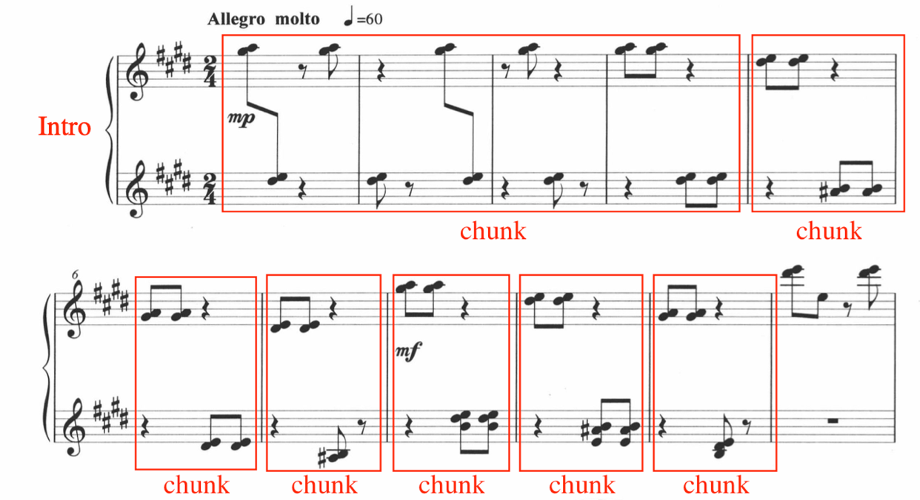

The A Section (mm. 13-30) features an imitative pentatonic melody in A-major pentatonic mode, introduced by the left hand in measure 13, and imitated by the right hand in measure 15 (see Figure 126). In measure 13, the melody is grouped into two phrases, which is followed by an exact imitation of the melody, one octave higher, played by the right hand in measure 15. Practice the melody in isolation from the accompaniment, being sure to imitate the indicated phrasing and articulation in both hands. When the accompaniment is reintegrated into the texture, establish proper balance between melody and accompaniment, in favor of the melody.

Figure 126: “Here Comes the Caravan of Horses,” mm. 12-17, Phrasing and Articulation Matching
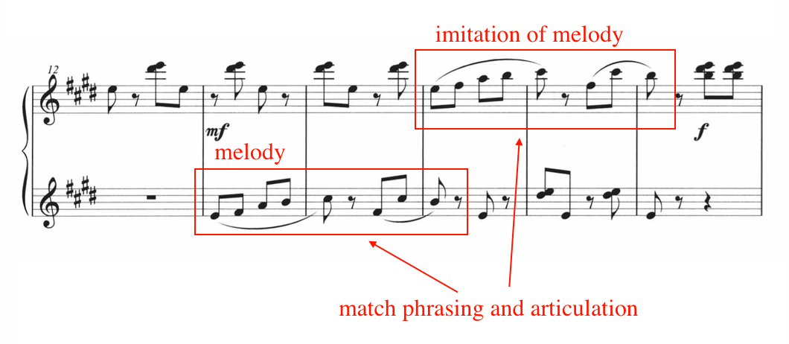
The B Section (mm. 31-40) features a pentatonic melody accompanied by a gently syncopated bass line. Set in the contrasting meter of 5/4 and F# major, the B Section integrates legato touch, complex harmonic changes and accidentals, particularly double sharps. Before combining melody and accompaniment, practice each hand in isolation, focusing on bringing out the left hand rising inner line in measures 31 through 36 (see Figure 127). As the right hand is re-incorporated, establish balance between the voices, bringing prominence to the melody.
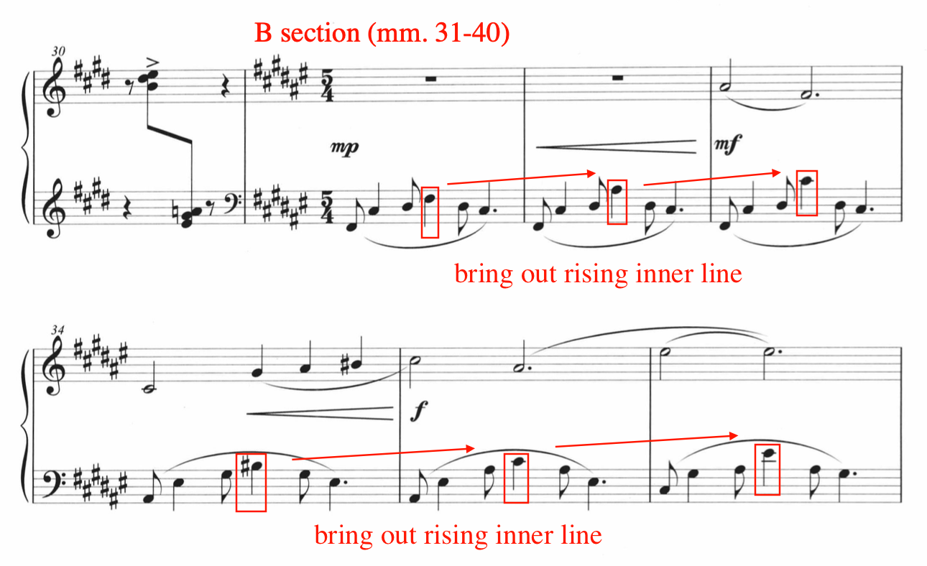
Figure 127: “Here Comes the Caravan of Horses,” mm. 30-36, Left Hand Inner Line

In addition to using the challenging key of F-sharp major, Ding incorporates double sharps in both the accompaniment and melody. Double sharps occur in measures 38 through 40 (see Figure 128). Despite the reading challenges presented in the B Section, the coordination is accessible and both melody and accompaniment fit comfortably in the hands. Practice the right and left hands in isolation to establish reading confidence, particularly focusing on the left hand.
Figure 128: “Here Comes the Caravan of Horses,” Excerpt mm. 37-40
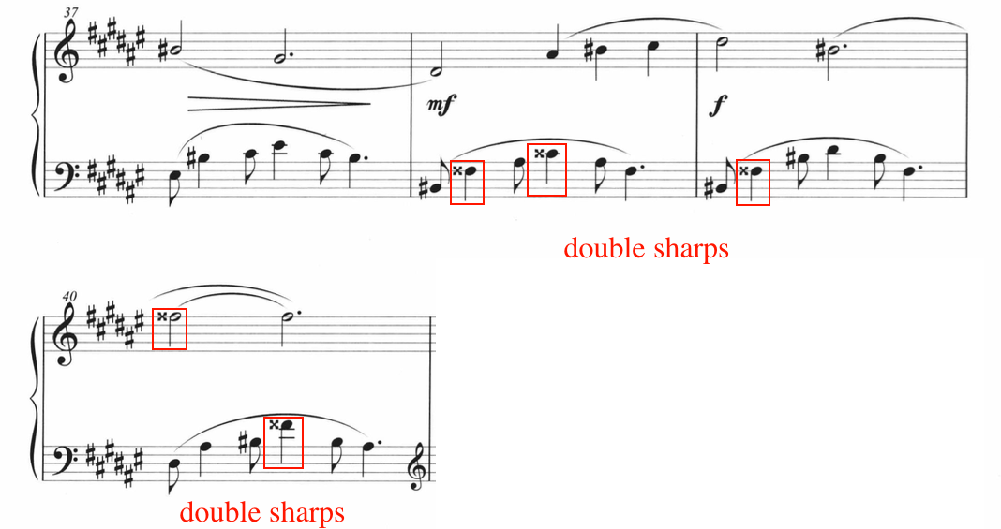

The coda, measures 41 through 49, features the return of the syncopated minor seconds, previously seen in the introduction (mm. 1-12) and A Section (mm. 13-30). Additionally, the meter returns to 2/4, and features an incremental decrease of dynamics. The current author recommends tapping or clapping out the rhythms to build confidence in the syncopations, reflecting the dynamics in the score. After establishing confidence in the rhythm, use the following fingerings in Figure 129.

Figure 129: “Here Comes the Caravan of Horses,” Coda, mm. 41-49, Suggestions
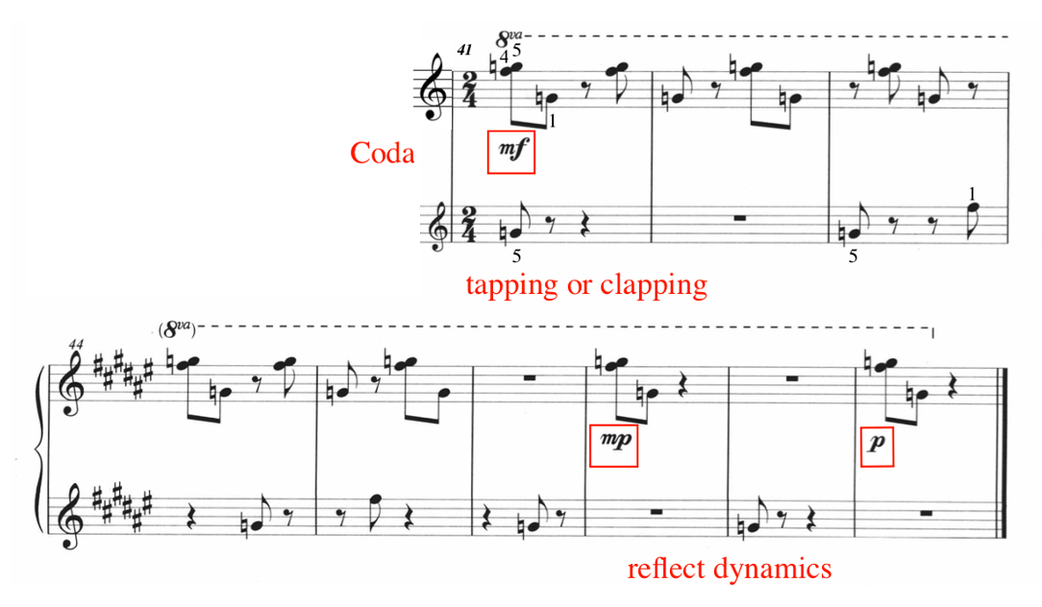

Ding Shande’s “Here Comes the Caravan of Horses” explores a variety of pictorial images, textures, meters, keys, and pedagogical techniques. In the introduction (mm. 1-12) and A section (mm. 13-30), the student will gain experience in syncopated rhythms, imitative counterpoint, and rapid transitions between hand positions. The B Section (mm. 31-40) focuses on legato touch, bringing out hidden lines within the left hand texture, and challenging accidentals. Lastly, the coda (mm. 41-49) features a loose recapitulation of the introduction (mm. 1-12) section. “Here Comes the Caravan of Horses” is an excellent choice for the level eight pianist.

No. 7 “Morning Song”
Tempo: Andante, quarter = 88
Measures: 28
Pages: 2
Performance Duration: 2:45-3:00
Level: 7

Compositional Analysis

“Morning Song” is the seventh work in Eight Piano Pieces for Children, op. 28. Similar to “Worries,” Ding sets this work in a loose variation form, featuring variety through changes in accompaniment. “Morning Song” is composed in 4/4 meter, two contrasting keys, and features three phrases and a coda (see Table 26). Ding creates an ethereal and dream-like atmosphere through his use of modal and tonal harmonies, pentatonic melody, and fluid textures.

Table 26: Form of “Morning Song”
A phrase | A’ phrase | A’’ phrase | coda
mm. 1-8 | mm. 9-17 | mm. 18-25 | mm. 26-28

The theme is introduced in the right hand in measures one through eight, encompassing the A phrase. The first iteration of the theme (A phrase, mm. 1-8) is set in C-major pentatonic mode (C-D-E-G-A) (see Figure 130). The theme consists exclusively of pitches belonging to the C-major pentatonic mode. However, the broken-chord left-hand accompaniment sets the phrase in A-minor, beginning with a A-minor triad in second inversion. Set at quarter note equals 88, the overall atmosphere of “Morning Song” is tranquil, graceful, and in this researcher’s opinion, embodies the imagery of a sunrise. The thematic material (A phrase, mm. 1-8) is linear, unhurried, legato, and consists largely of leaps. Throughout the A phrase, Ding includes one slur per measure, indicating legato touch within each measure, but allowing slight separation between measures.
Figure 130: “Morning Song,” A phrase, mm.1-8
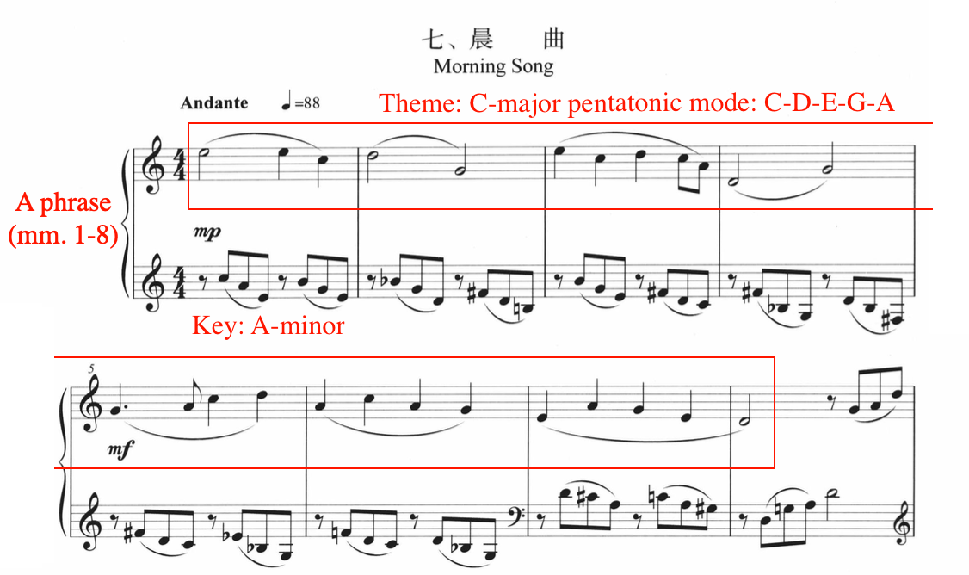

The right hand pentatonic theme is eight measures in length and is accompanied by downward descending broken arpeggios, cycling through a series harmonies (see Figure 131). The A phrase (mm. 1-8) cycles through a series of harmonies, but cadences on the tonal center of D major in measure eight, where the A-minor seventh chord from measure seven shifts into the D chord with an added fourth (see Figure 131). This suggests that the A phrase is set in the first inversion of the C major pentatonic mode, known as the jue diao.

Figure 131: “Morning Song,” A phrase, mm. 1-8, Chord Analysis
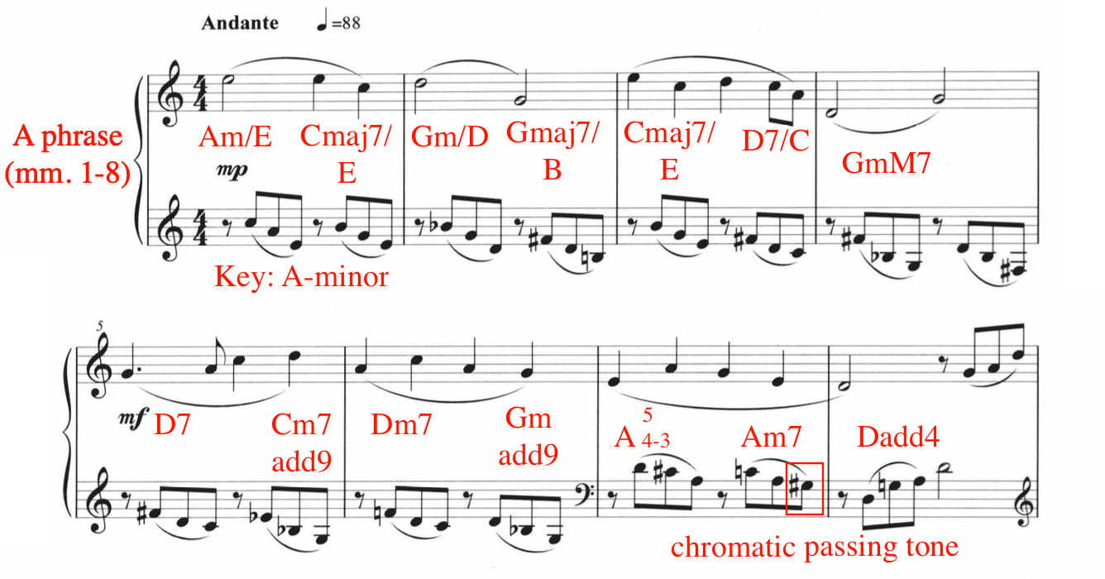

Ding includes several non-chord-tones (NCT) in the A phrase of “Morning Song.” For example, measure five features a retardation from G to A in the right hand (see Figure 131). Beats one and two of measure seven consist of an A major chord with a four to three suspension, resulting in the D to C-sharp movement in the left hand. In measure seven, the G-sharp in the left hand represents a chromatic passing tone, aiding in the movement from the A in measure seven to G natural in measure eight (see Figure 131). The melody and accompaniment of the A phrase (mm. 1-8) evoke textures previously used in Eight Piano Pieces for Children, op. 28, particularly the second work, “Playing Games.” For example, the A phrase of “Morning Song” is reminiscent of the B Section of “Playing Games,” the second piece in Eight Piano Pieces for Children, op. 28 (see Figure 132, Figure 133). Both include a right hand pentatonic melody paired with broken eighth note arpeggiated accompaniment in the left hand, which cycles through shifting harmonies.

Figure 132: “Playing Games,” B section, mm. 8-14
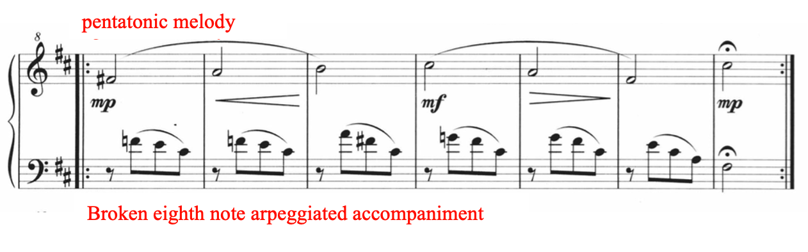

Figure 133: “Morning Song,” A phrase, Excerpt, mm. 1-4
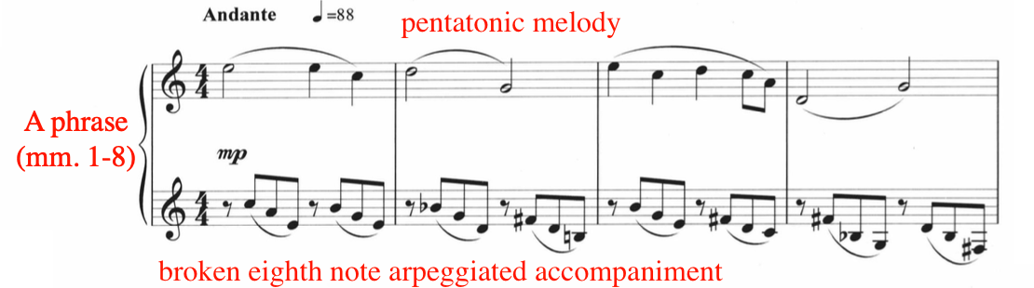

In “Morning Song,” Ding creates variation through changes in the accompaniment material. For example, the A phrase contains arpeggiated eighth note accompaniment in the left hand, while the A’ phrase (mm. 9-17) contains triplet broken arpeggiations (see Figure 134). Similar to the A phrase, the triplet accompaniment material in the A’ phrase contains eighth triplet rests on beats one and three.

Figure 134: “Morning Song,” A' Phrase, Excerpt, mm. 9-11
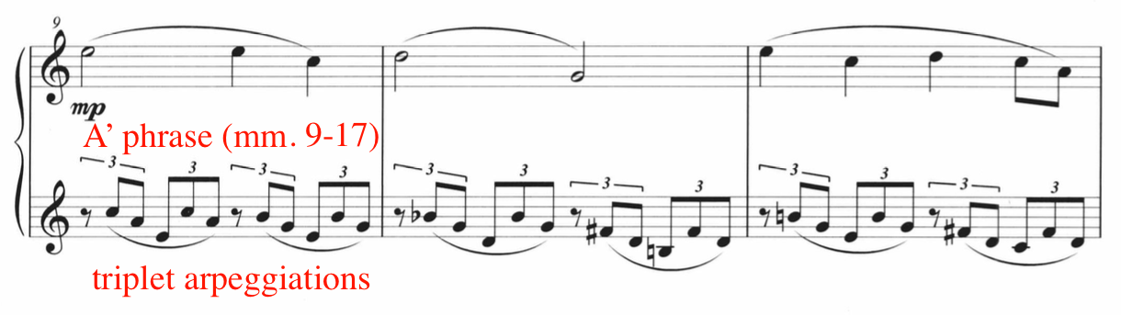

The A and A’ phrases contain eight measures, utilizing the same pitches in both melody and accompaniment, but with variations in the rhythm of the accompaniment. Additionally, the A’ phrase (mm. 9-17) possesses the same cycle of harmonies as those found in the A phrase (see Figure 135), with the exception of beats three and four of measure 16, where a pentatonic arpeggiation rises. During this measure, Ding inserts an E-flat in the arpeggiation in beat four, outlining a C-minor chord, suggesting the harmonic shift in the A’’ phrase (mm. 18-25). Fittingly, Ding introduces a new signature (E-flat major or C-minor) (see Figure 135).

Figure 135: “Morning Song,” A' Phrase, mm. 9-17
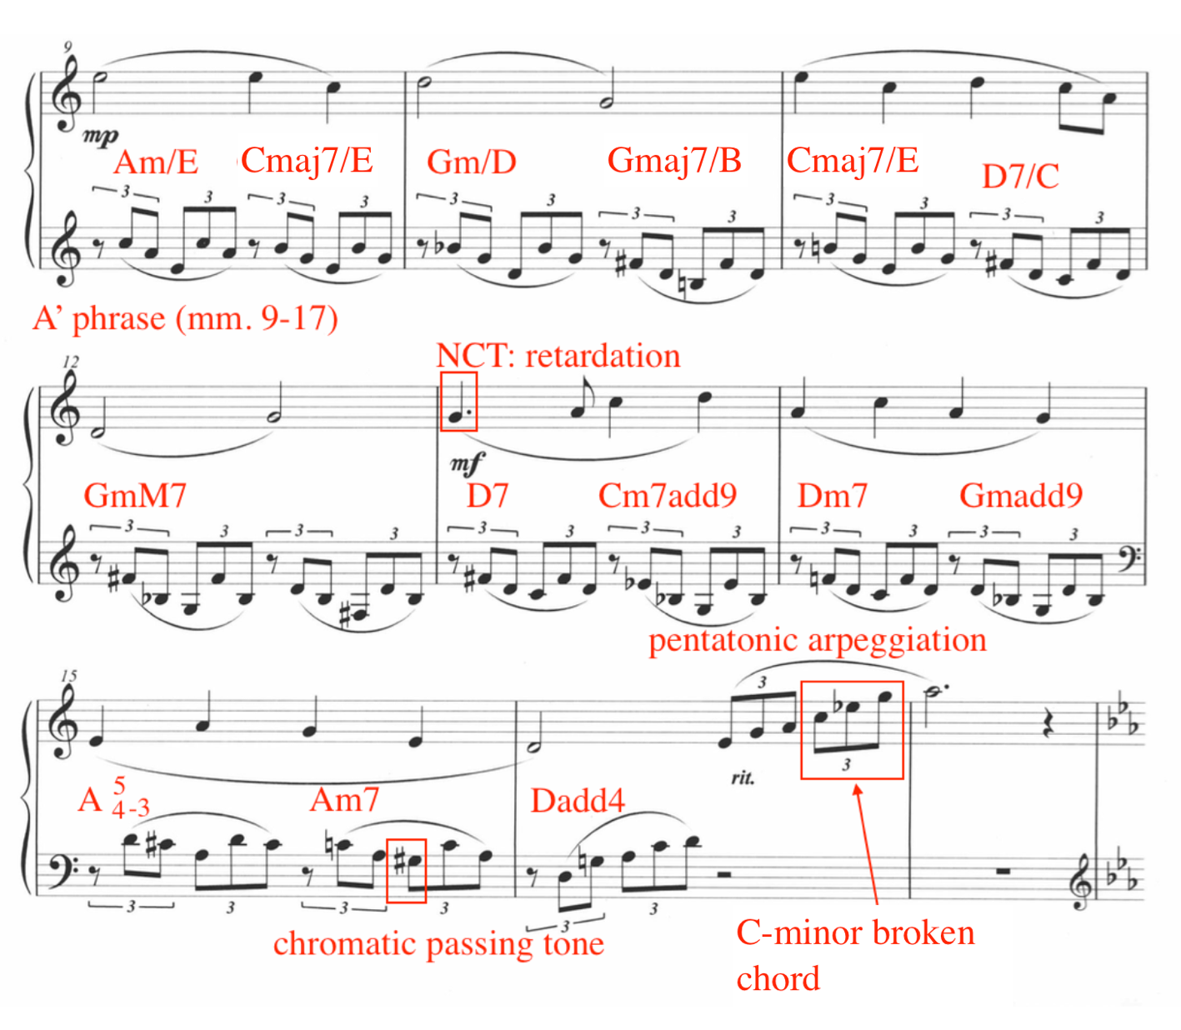

The A’’ phrase (mm. 18-25) features a shift in both key signature and overall texture. For example, while previous phrases (A and A’) operated under the key signature of C-major, the A’’ phrase is composed in E-flat major/C-minor (see Figure 136).

Figure 136: “Morning Song,” m. 18, Key Change
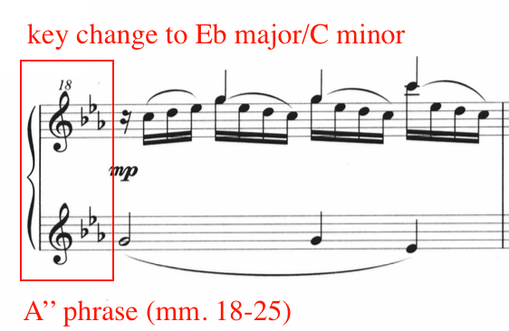

Additionally, the theme in the A’’ phrase shifts over to the left hand, while the right hand takes on the accompaniment (see Figure 137). The right hand accompaniment contains an overarching secondary melody, which soars above the 16th note passage work. This creates a counterpoint between the theme in the left hand, the 16th note accompaniment in the right hand, and the secondary melody weaved within the 16th notes.

Figure 137: “Morning Song,” A'' Phrase, Excerpt, mm. 18-19
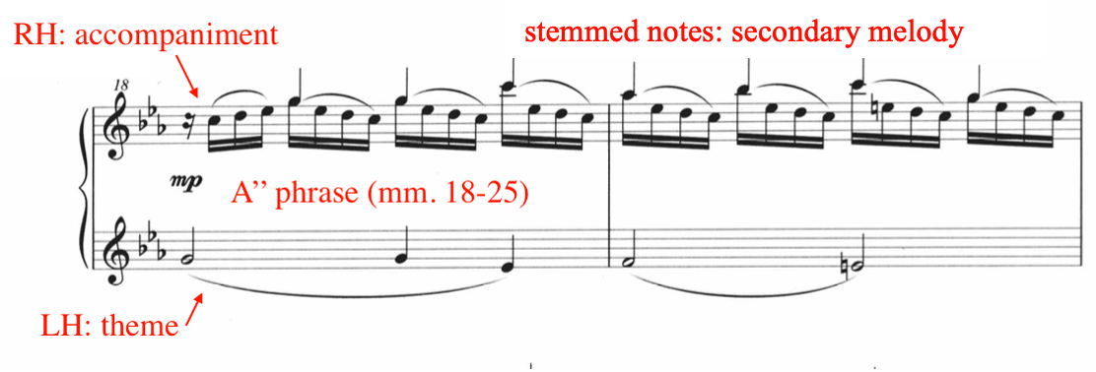

The A’’ phrase is composed in C-minor, the relative minor key of E-flat major. The harmonies and texture of the A’’ phrase convey an unsettling, mysterious atmosphere, caused largely by the minor mode, frequent non-chord-tones, downward figures of the accompaniment, and vague harmonies. The A’’ phrase features loosely functional harmony, containing mostly the C minor (i) F minor (iv), and G minor (v) harmonies (see Figure 138). Contributing to the mysterious atmosphere, Ding includes modal mixture in measure 19, destabilizing the minor mode stablished in measure 18.

Figure 138: “Morning Song,” A'' Phrase, Excerpt, mm. 18-21
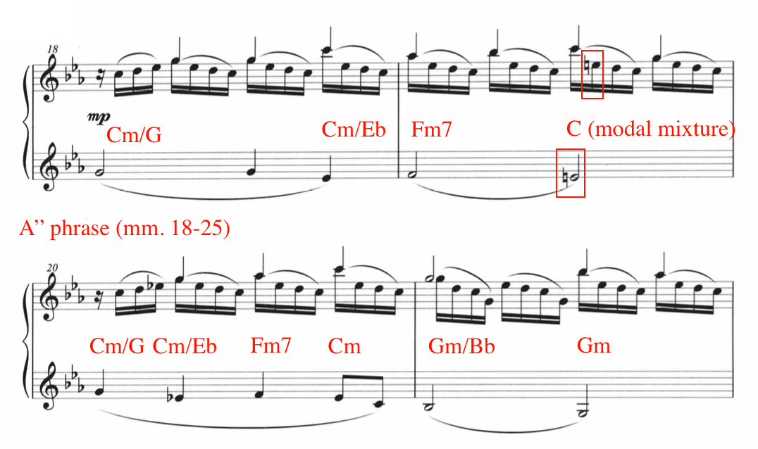

The coda (mm. 26-28) features a brief recapitulated variation of the A phrase (mm. 1-8, featuring the theme in the right hand and accompaniment in the left hand. However, the key signature remains in E-flat major/C-minor, but more specifically, the mode used in the coda is E-flat-major pentatonic mode: Eb-F-G-Bb-C. Ding concludes “Morning Song” on the pitch F, the second note of the E-flat-major pentatonic mode, setting the coda in the first inversion of the mode, the jue diao. Similarly, jue diao was also utilized in the A and A’ phrases.

Pedagogical Analysis of “Morning Song”
Table 27: Summary of Pedagogical Challenges of "Morning Song"
Summary of Pedagogical Challenges of “Morning Song”
Hemiola
Triplet rhythms
Counterpoint
Key change
Finger independence

“Morning Song” is refreshing and introspective, showcasing Ding’s ability to captivate the listener through melody, accompaniment, and texture. The pentatonic melody is presented three times (A, A’, and A’’) throughout “Morning Song,” and is paired with progressively more involved accompaniment patterns with each new phrase. For example, the A phrase features an eighth note broken arpeggiated accompaniment, shifting into broken triplet figures in the A’ phrase, and concluding with a 16th note accompaniment in the right hand. Ding also used progressively more involved accompaniment in “Worries,” the fifth work in his Eight Piano Pieces for Children, op. 28.
Broken into four phrases, “Morning Song” is organized in a loose variation form, featuring an A phrase (mm. 1-8), A’ phrase (mm. 9-17), A’’ phrase (mm. 18-25), and coda (mm. 26-28). The A phrase features a broken eighth note arpeggiated accompaniment in the left hand paired with a singing, pentatonic melody in the right hand. Due to the progressive variation of left hand accompaniment, “Morning Song” is an excellent choice for a student working on left hand independence. To prepare the A phrase, ‘chunk or ‘block the left hand chord shapes in isolation from the right hand melody (see Figure 139). This will improve coordination in both A and A’ phrases, as both sections utilize the same chord shapes (see Figure 140).
Figure 139: “Morning Song,” mm. 1-2, Pedagogical Suggestion
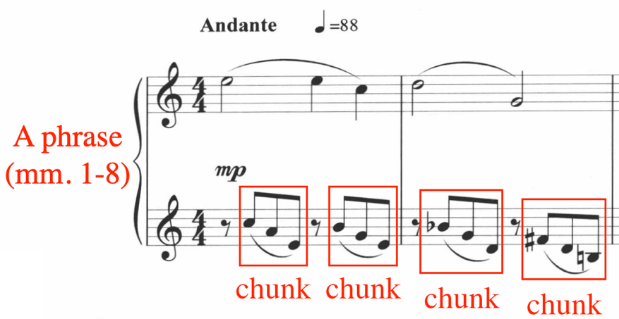

Figure 140: “Morning Song,” A' Phrase, mm. 9-10, Pedagogical Suggestion
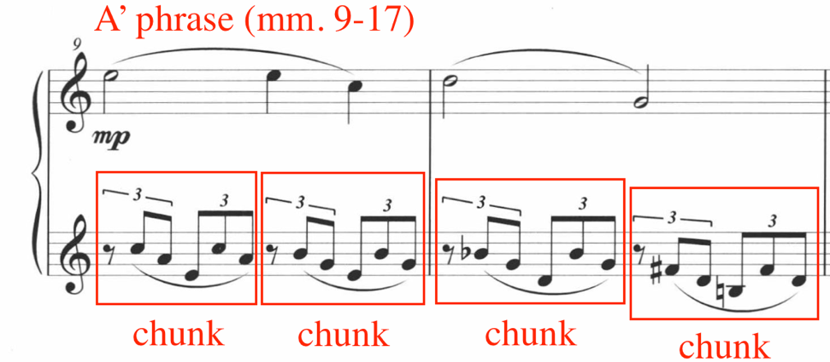

The accompaniment in the A’ phrase (mm. 9-17) features broken triplet figures in the left hand. Introduce several preparatory exercises in triplets prior to assigning “Morning Song.” Additionally, two against three polyrhythm is featured in measures 11 and 13 (see Figure 141). Rehearse the two against three hemiola by tapping or clapping.
Figure 141: “Morning Song,” A' Phrase, Excerpt, mm. 9-14, Pedagogical Suggestion
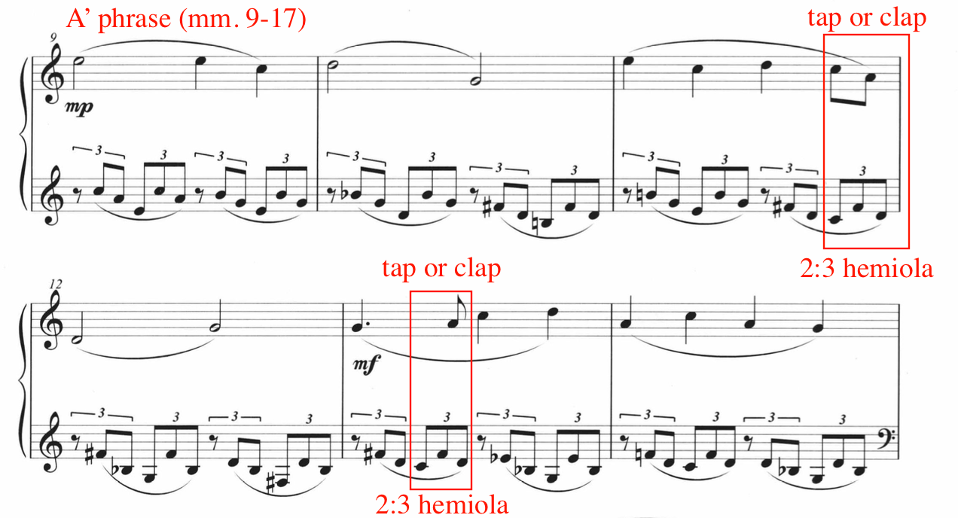
The A’’ phrase presents a new set of pedagogical opportunities. Ding switches the melody from the right hand to the left, and the accompaniment from the left hand to the right. In addition, the right hand has a secondary melody in the top voice. The A’’ phrase allows the student to explore the contrapuntal duality of two continuous themes, in addition to 16th note accompaniment passagework in the inner right hand voice. In preparation, the current author recommends dividing the right hand part into two hands, isolating the stemmed melody from the accompanying 16th note passagework (see Figure 142).

Figure 142: “Morning Song,” A'' Phrase, Excerpt, mm. 18-19, Pedagogical Suggestion
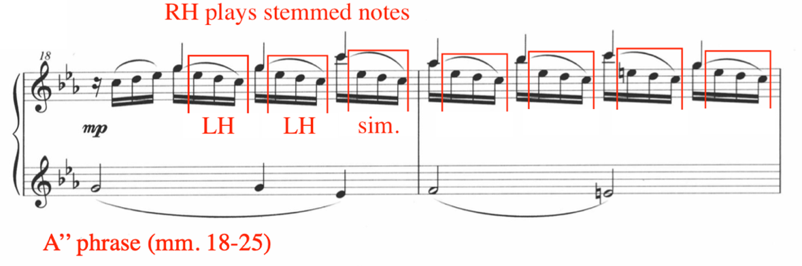
Continuing to divide the 16th note accompaniment between the two hands (see Figure 142
Figure 142), encourage the student to bring out the stemmed notes, while minimizing the flowing 16th note accompaniment. In addition, hum or sing the stemmed notes to reveal a smooth legato melodic line. Once the proper balance has been established in the 16th note accompaniment using both hands, the student should begin incorporating these ideas using right hand only. At this stage, encourage wrist rotation and flexibility, paying close attention to the wide leaps (see Figure 143).

Figure 143: “Morning Song,” A'' Phrase, Excerpt, mm. 18-19, Wrist Rotation and Flexibility
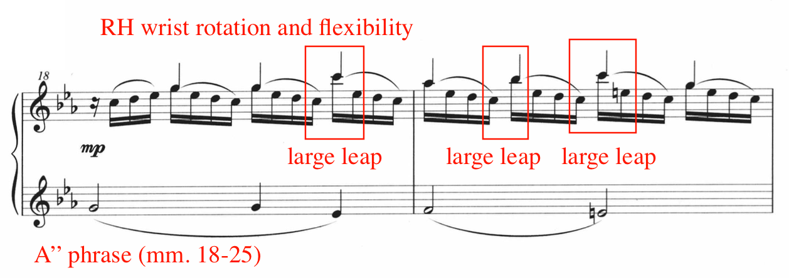

Practice the right hand in isolation. After comfort, balance, and choreography have been established in the right hand, the left hand can be reintegrated into the texture. Before fully combining all parts of the A’’ phrase, the student should isolate and practice the left hand melody combined with the right hand stemmed pitches, listening to the interplay of the two-part duet (see Figure 144). Emphasize legato touch should be emphasized in both hands during this activity, to promote melodic linearity. Finally, all parts can be combined, taking care to bring out the duet, and minimizing the 16th note accompaniment passagework in the right hand inner voice.
Figure 144: “Morning Song,” A'' Phrase, Excerpt, mm. 18-19, Duet
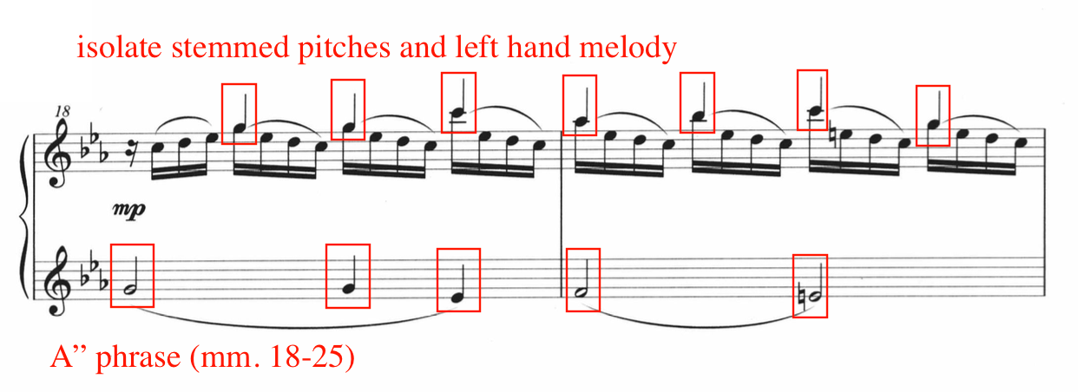

The coda (mm. 26-28) is reminiscent of the A phrase, marked at a slower tempo of quarter note equals 76. The coda begins with a mezzo-piano, shifting into a piano dynamic with a ritardando in the final measure. Use a sensitive touch in this short passage. Despite the key signature of E-flat major/ C-minor, Ding concludes “Morning Song” on an F, the second pitch of the E-flat major pentatonic mode, the jue diao. The imagery created by this conclusion evokes a mysterious and misty atmosphere. “Morning Song” is full of coloristic beauty and presents the level seven students with both technical and expressive potential.

Figure 145: “Morning Song,” coda (mm. 26-28)
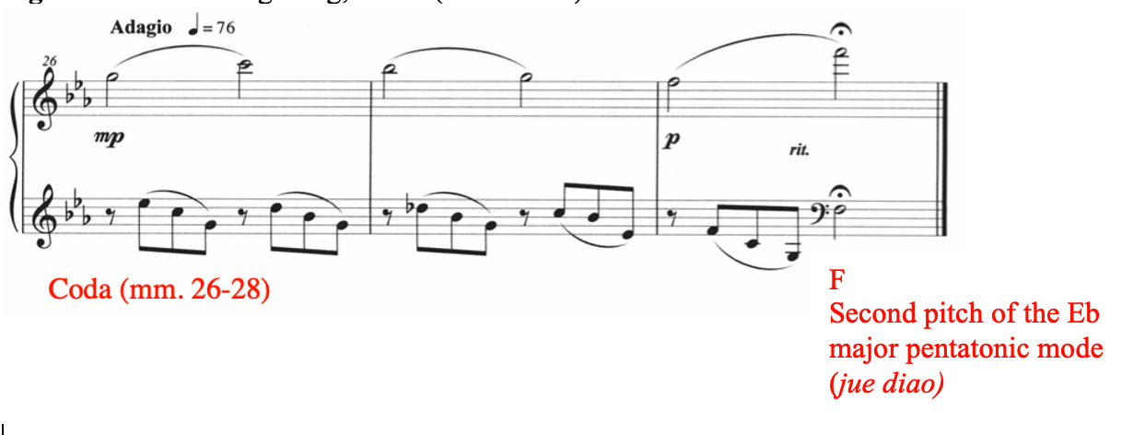

No. 8 “Dragon Dance”
Tempo: Vivace, quarter = 200
Measures: 135
Pages: 4
Performance Duration: 1:25 – 1:45
Level: 9-10

Compositional Analysis

Table 28: Form of “Dragon Dance”
Introduction | A | B | C | A’ | coda
mm. 1-8 | mm. 8-74 | mm. 75-87 | mm. 88-103 | mm. 104-118 | mm. 119-135

“Dragon Dance” is the longest and most difficult work in Ding Shande’s Eight Piano Pieces for Children, op. 28. According to Yu Zhijie, Lecturer of Composition at the Fujian Normal University, “Dragon Dance” pays homage to the robust and joyous musical traditions of the Yunnan province. In Chinese culture, the dragon is a powerful national symbol, representing the elements of weather, particularly rain. For thousands of years, Chinese communities prayed to the dragon for rain, in hopes of a successful harvest during times of drought. Since the Han Dynasty (206 BC-220 AD), this ritual has evolved into a robust dance, celebrated during various festivals, particularly during Chinese Lunar New Year. The dance is operated by a group of men, manipulating a large dragon puppet (see Figure 146).
Figure 146: Dragon Dance Example
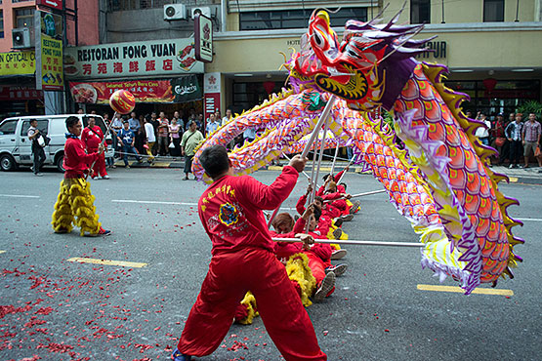

The tempo is notated at quarter note equals 200 (see Figure 147), Ding captures the robust excitement of the dragon dance by incorporating a strong sense of rhythmic pulse throughout, imitating the vigorous sound of beating drums. The work begins (introduction: mm. 1-8) with rapid alternating perfect fourths and fifths, which incrementally rise higher until the texture change at the start of the A Section at measure nine (see Figure 147).
Figure 147: “Dragon Dance,” Excerpt, mm. 1-11
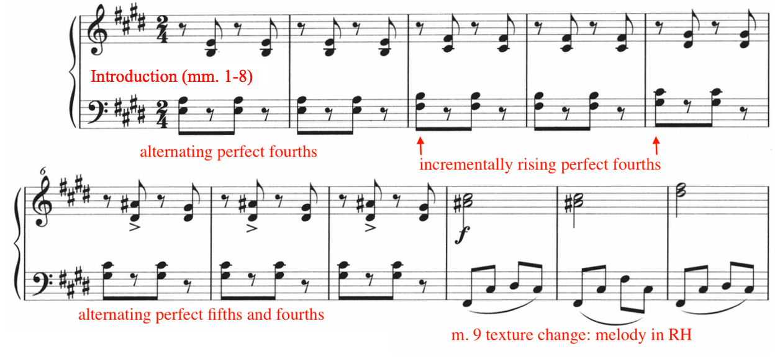
Making up the longest sections in “Dragon Dance,” the A Section (mm. 9-74) includes three total phrases (a, a’, and a’’), set in various tonal centers (see Table 29). Each phrase contains two subphrases of contrasting keys and length. For example, the a-phrase (mm. 9-30) features a subphrase in the F-sharp major pentatonic mode, spanning 14 measures in length, followed a subphrase in the A-sharp phrygian mode, spanning eight measures in length. The subsequent subphrases located in the a’ and a’’-phrases are identical in length, but have contrasting tonal centers (see Table 29).
Ding uses mediant harmonic relationships in the A Section (mm. 9-74) by modulating up a major third in each subphrase (see Table 29).

Table 29: “Dragon Dance,” A Section (mm.1-74) Mediant Relationships
A Section (mm. 1-74) phrase | Tonal center
a-phrase: mm. 9-30 | First subphrase: F-sharp major pentatonic (mm. 9-22)  Second subphrase: A-sharp phrygian (mm. 23-30)
a’-phrase: mm. 31-52 | First subphrase: A major pentatonic (mm. 31-44)  Second subphrase: C-sharp phrygian (mm. 45-52)
a’’-phrase: mm. 53-74 | First subphrase: C harmonic minor (mm. 53-66)  Second subphrase: E phrygian (mm. 76-74)

For example, in the first subphrase of the a-phrase (mm. 9-30), the tonal center shifts from F-sharp major pentatonic mode to A-sharp phrygian mode, featuring the upward modulation of a major third (F-sharp to A-sharp). Moreover, the a’-phrase features a modulation from A major pentatonic mode to C-sharp major phrygian. Finally, the a’’-phrase modulates from C-harmonic minor to E phrygian mode. Refer to Figure 148 for an annotated (excerpt) analysis of mediant relationships present in the A Section.

Figure 148: “Dragon Dance,” A Section Mediant Relationships, Excerpt, mm. 6-35
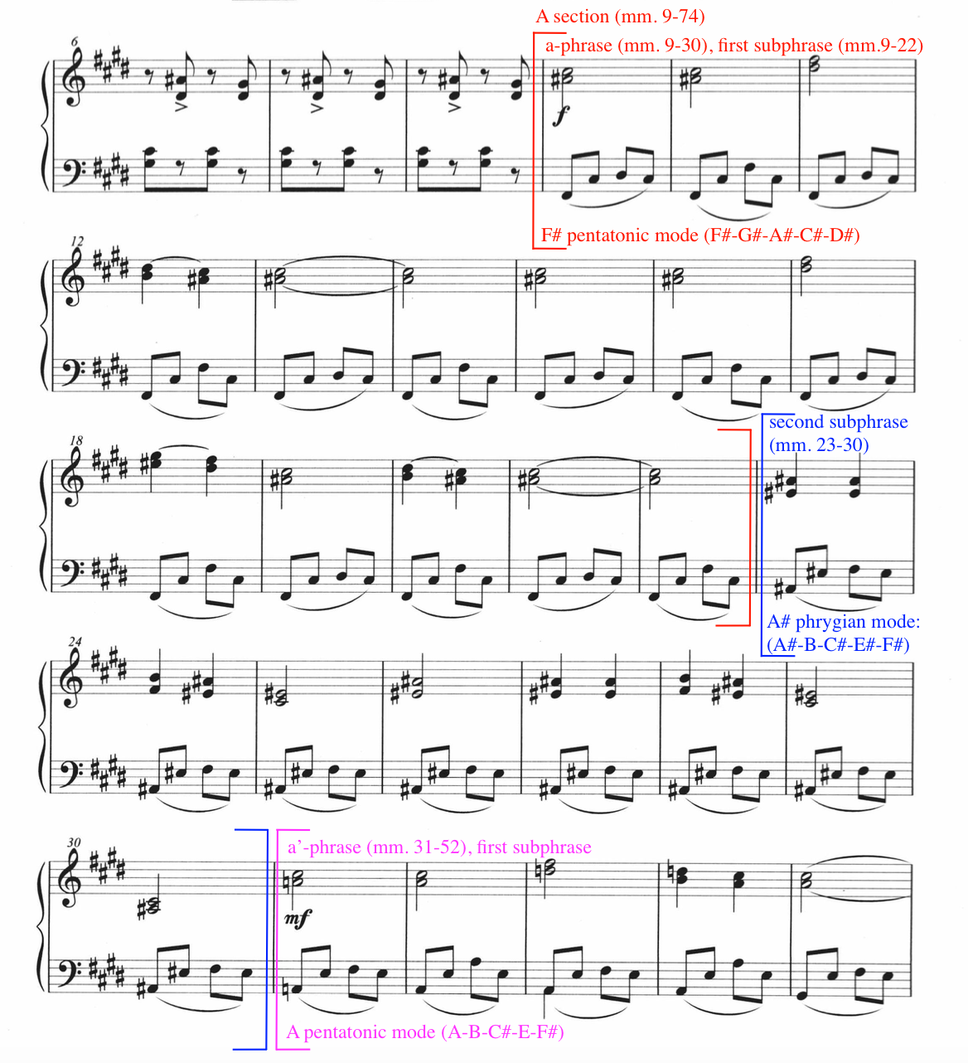

Ding portrays the spontaneity and excitement of the dragon dance by modulating through six harmonic tonal centers across the A Section (see Table 29), where the melodic material remains in the right hand and accompaniment in the left. The first instance of the melody is composed in F-sharp major pentatonic mode (m. 9), consisting of double thirds in the right hand and undulating accompaniment in the left hand (see Figure 149). Set in the F-sharp major pentatonic mode, this phrase (first subphrase of the a-phrase) is festive, energetic, and vibrant.

Figure 149: “Dragon Dance,” Excerpt mm. 9-17
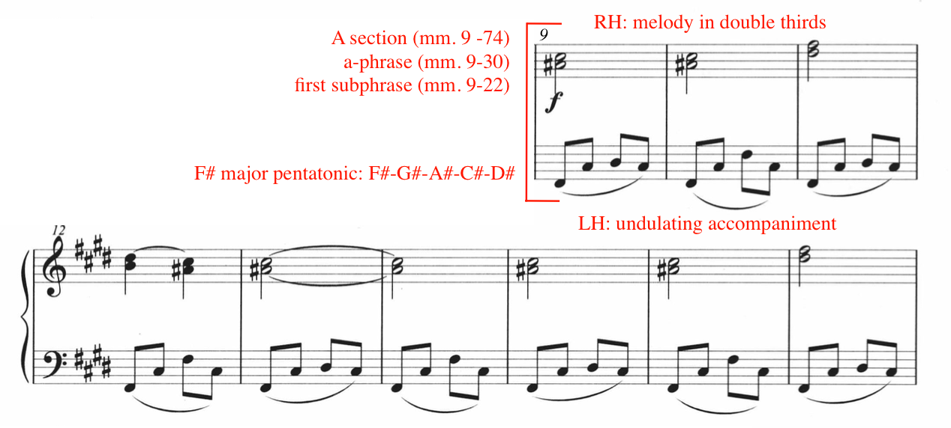
In contrast, the second subphrase (mm. 23-30) of the a-phrase (mm. 9-30) features the melody and accompaniment in the A-sharp phrygian mode (A#-B-C#-E#-F#), which portrays an ominous atmosphere. The melody remains in the right hand, featuring perfect fourths in addition to major thirds (see Figure 150).

Figure 150: “Dragon Dance,” Excerpt, mm. 23-29
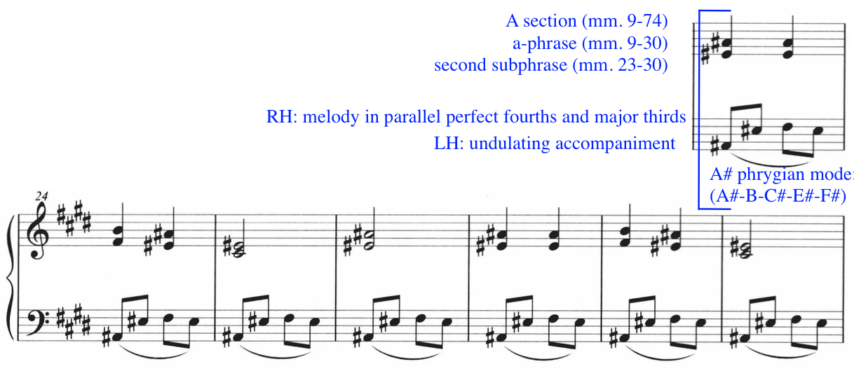
The B Section (mm. 75-88) consists of a series of accented, descending broken arpeggios and blocked chords (see Figure 151), featuring the following harmonies: E-minor, C-major, G-minor, and D-minor. In addition, Ding incorporates poly chords in measure 75 (E-minor and C-major), measure 78 (B-minor and E-minor), and 82 (D-minor and A-major). Measures 83 to 86 feature the alternation between D-minor and A-major (see Figure 151).
Figure 151:” Dragon Dance,” B Section, Key Centers
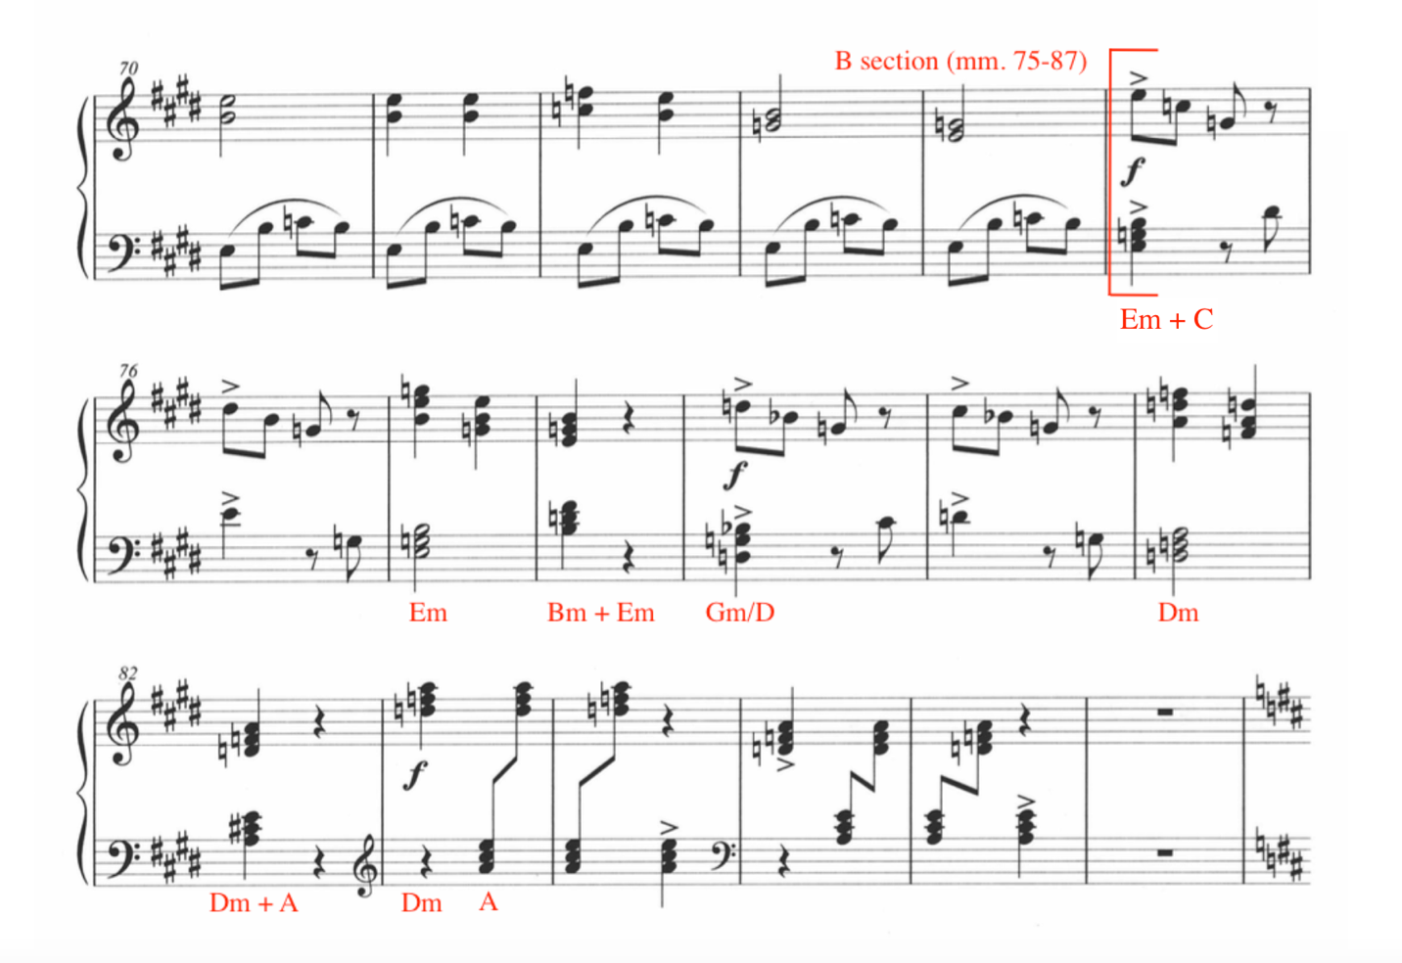
Throughout the B Section (mm. 75-87), Ding incorporates chromatic passing tones, particularly in the broken chord textures (see Figure 152). For example, the D-sharp in the left hand in measure 75 resolves up to an E in measure 76. Similarly, measure 79 to 80 feature chromatic neighbor tones in the left hand, where the C-sharp shifts to D-natural. The current author provides the harmonic analysis in bolded annotations (see Figure 152).
Figure 152: “Dragon Dance,” B Section, Excerpt, mm. 75-87, Chromatic Passing Tones
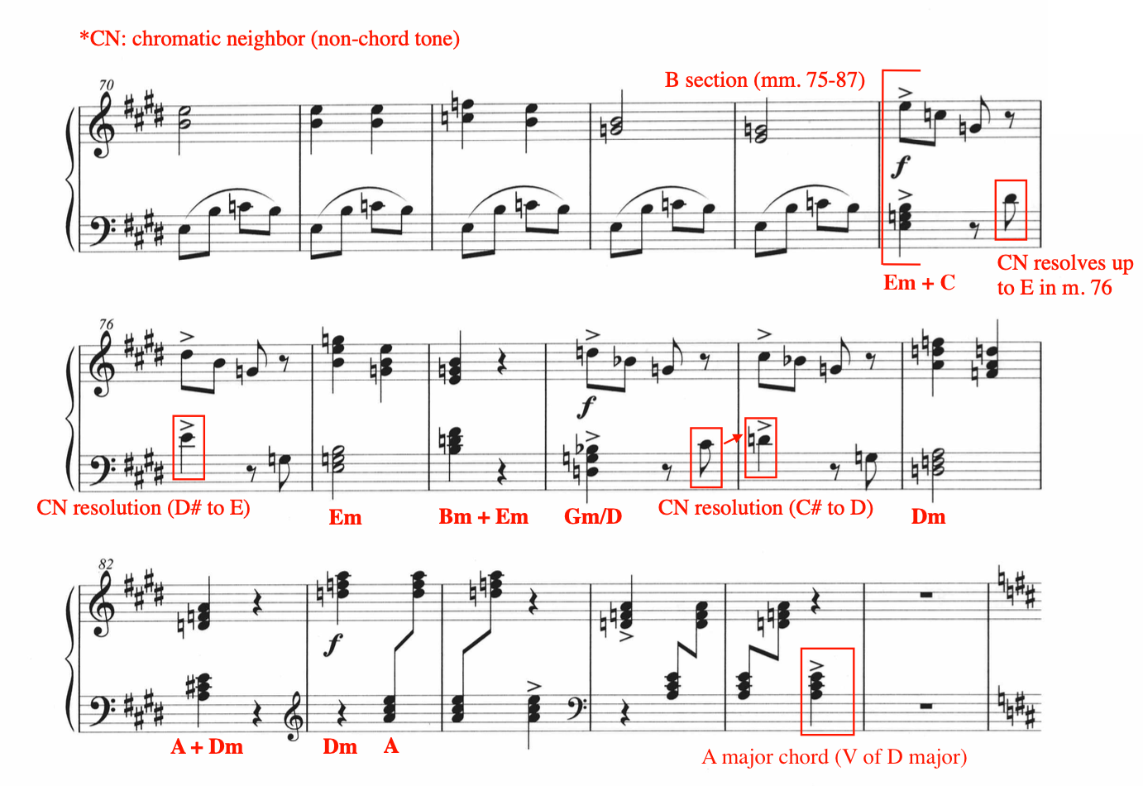

The chromatic neighbor tones add excitement and crunch to the harmonic modulations throughout the B Section. After the series of chromatic neighbor tones in measure 75 and 76, Ding introduces blocked E minor chords in measure 77, gesturing to the upcoming cadence, but evading it by landing on a polychord (B-minor and E-minor) in measure 78 (see Figure 152). Similarly, the same gesture and cadential evasion occurs in measures 81 through 82, where the D-minor blocked chords in measure 81 result in on A-major and D-minor polychord in measure 82. During the final measures of the B Section (mm. 83-87), Ding alternates between D-minor chords in the right hand and A-major chords in the left hand, ending with a final A-major chord in measure 86. The repetitive nature of the alternating D minor and A major chords between measures 83 and 87 mimic that of a prolonged dominant (A-major as dominant), a technique where the composer prolongs the dominant harmony in order to create tension and anticipation. The final A-major chord in measure 86 serves as the dominant harmony to the key of D-major, transitioning smoothly into the C Section (mm. 88-103), set in the key of D-major, indicated by the key signature change in measure 87 (see Figure 153).

Figure 153: “Dragon Dance,” B Section, Excerpt, mm. 76-87, Polychords
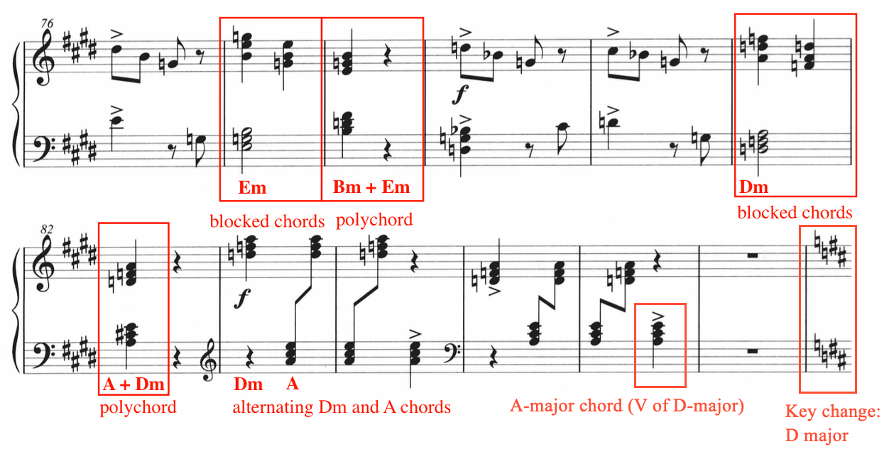

In contrast, the C Section (mm. 88-103) features smooth melodic lyricism and gentle accompaniment (see Figure 154). Ding begins the C Section in the D-major tonality (mm. 88-91), however, cycles through five tonal centers between measures 92 and 103 (see Figure 154), including F-sharp minor, F-major, D-minor, C-sharp minor, and A-minor-major-seventh. Additionally, Ding includes upper neighbors in measures 92 through 99. The combination of the syncopated left hand rhythm and upper neighbor tones create a gentle, lilting effect. The C Section (mm. 88-103) concludes in measure 103 with a marked ritardando, transitioning into the A’ Section (mm. 104-118) in measure 104 (see Figure 154).

Figure 154: “Dragon Dance,” C Section, mm. 88-105
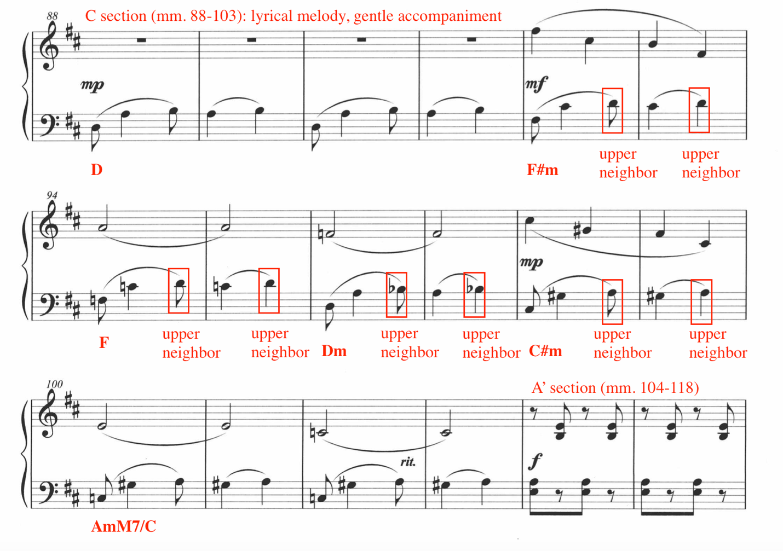

Following the C Section (mm. 88-103), the A’ Section (mm. 104-118) of “Dragon Dance” represents a condensed recapitulation of the original A Section (mm. 8-74). In the A’ Section (mm. 104-118), Ding composes the melody in diminution compared to the A Section (mm. 9-74). For example, the melody is presented in quarter notes in the A’ Section, compared to half notes in the A Section (see Figure 155), heightening the sense of urgency in the A’ Section.

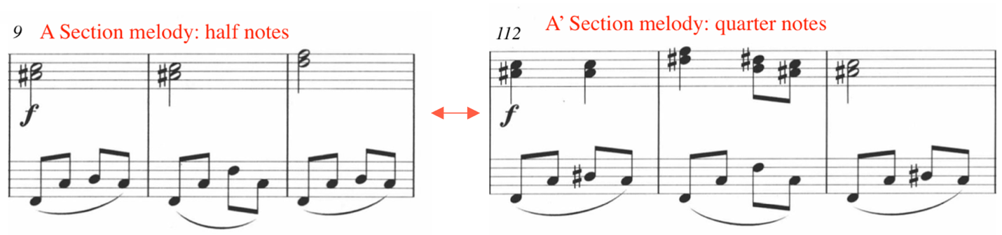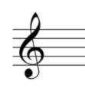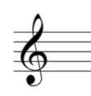
Figure 155: “Dragon Dance,” Comparison of A Section and A' Section Melody, Diminution

Figure 156: “Dragon Dance,” Comparison of Introduction and Coda Material
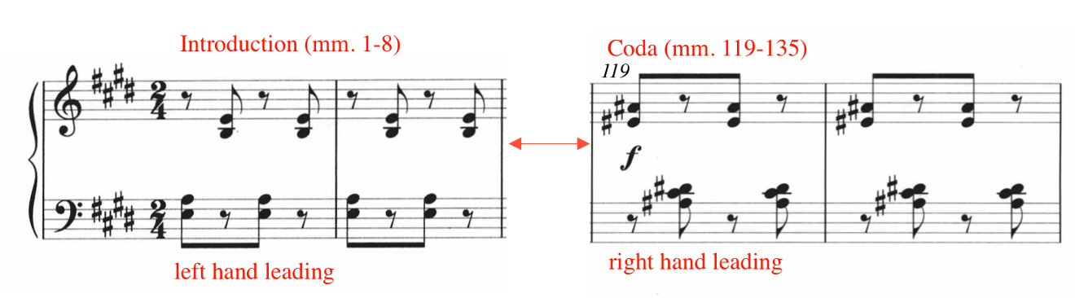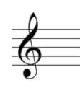

The coda (mm. 119-135) represents the final section of “Dragon Dance,” presenting a loose recapitulation of the introductory material (mm. 1-8). In contrast, the coda begins with the right hand, whereas the introduction leads with the left hand (see Figure 156).
Ding modulates through several harmonies throughout the coda, interspersed with sudden measures of rest (see Figure 157). Harmonies rooted in A-sharp minor occur frequently throughout the coda, evident in measures 119 through 120, 124 through 128, and 132 through 133. Ultimately, Ding concludes the work with an F-sharp major pentatonic (F#-G#-A#-C#-D#) collection in measure 135, establishing overall unity, as the first occurrence of the melody in the A Section was based in the F-sharp major pentatonic mode. Similar to the mediant relationships found in the A Section (mm. 9-74) (see Table 29), Ding echoes the same harmonic writing in the coda, as the A-sharp minor harmonies ultimately resolve to the F-sharp pentatonic collection in measure 135. The final chord in measure 135 is presented as an inversion of the F-sharp pentatonic mode, with C-sharp as the lowest pitch (see Figure 157).

Figure 157: “Dragon Dance,” coda, mm. 119-135
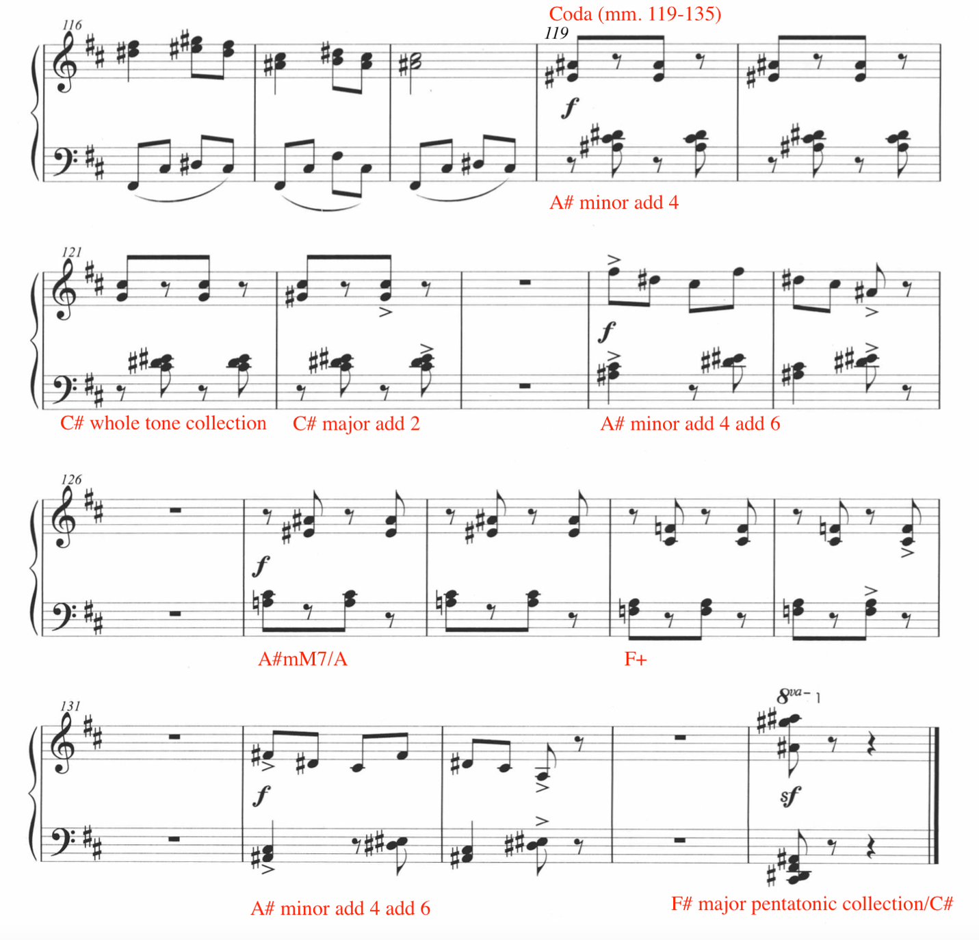
“Dragon Dance” displays the energetic vibrancy of the traditions of the dragon dance, represented through Ding’s sophisticated use of harmonic modulations, energetic accompaniment, pentatonic melodies, and textural variety.

Pedagogical Analysis of “Dragon Dance”
Table 30: Summary of Pedagogical Challenges of “Dragon Dance”
Summary of Pedagogical Challenges of “Dragon Dance”
Fast tempo (quarter note = 200)
Rapid transitions/position changes
Key changes
Accidentals
Right hand double thirds
Left hand endurance
Left hand wrist flexibility and mobility

Ding Shande’s “Dragon Dance” is a vibrant and exciting work for the level 9 student. “Dragon Dance” showcases the excitement of the traditional dragon dance through its creative use of harmony, texture, and form. The primary challenges of “Dragon Dance” include fast tempo, rapid position changes, key changes, accidentals, right hand double thirds, and left hand endurance and flexibility.
The introduction (mm. 1-8) features a series of alternating perfect fourths and fifths shared between the hands. Ding does not indicate dynamics or articulation directions in this section, with the exception of accents in measures six through eight. To capture the anticipation of the approaching dragon, the current author recommends a light but springy touch throughout measures one through eight (see Figure 158). The accents in measures six through eight should be bright and playful, avoiding a harsh attack. In measures six through eight, the upper note of the right hand interval should be voiced, bringing out the melodic interest in the upper line.

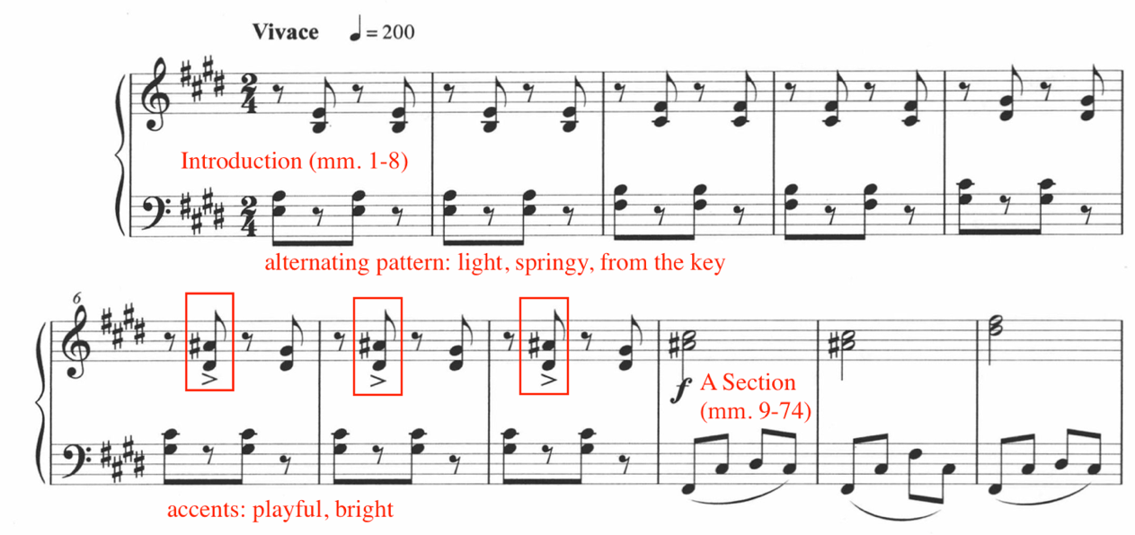
Figure 158: “Dragon Dance,” Introduction, mm. 1-8, Pedagogical Suggestions

The transition (mm. 8-9) into the A Section (mm. 9 -74) requires strategic transitionary rehearsal. The current author suggests blocking the penultimate chord shape in measure eight and moving quickly to the new position, setting the fingers on the keys without depressing them (see Figure 159). Optional fingering suggestions are provided by the current author, indicated in black.

Figure 159: “Dragon Dance,” Excerpt, mm. 6-11, Pedagogical Suggestion
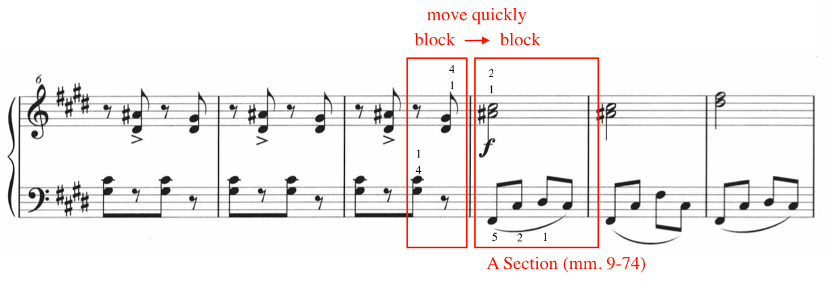

The melody enters at measure nine, consisting of parallel thirds in the right hand and an undulating left hand accompaniment. Ding indicates a forte dynamic at measure nine, potentially portraying the entrance of the dragon. The current author recommends voicing the upper note of the double third, bringing prominence to the melody (see Figure 160).

Figure 160: “Dragon Dance,” Excerpt, mm. 6-11, Voicing
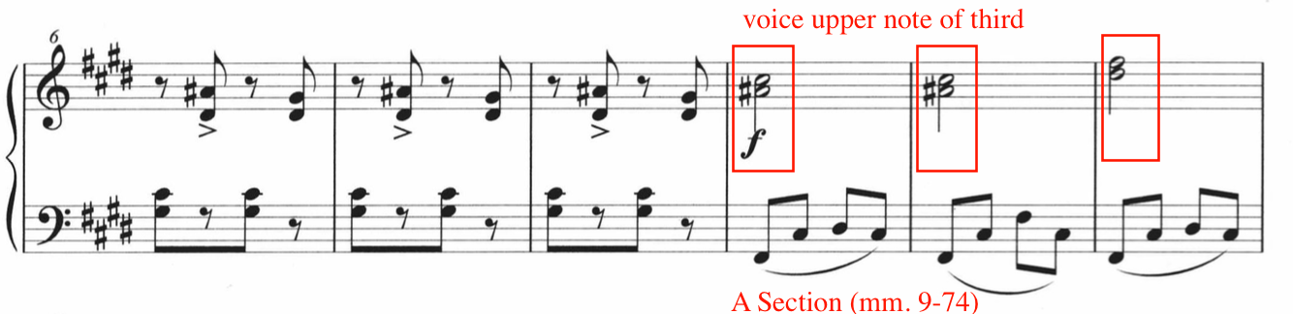

In the A Section (mm. 9 -74), the right hand should employ ample follow-through and support with each double third in order to maintain an orchestral sound and avoid harshness in the tone.
In the accompaniment, the left hand plays undulating arpeggiated figures throughout the entirety of the A Section (mm. 9-74). Take the intermediary step of blocking the left hand chord shapes of each measure, if possible (see Figure 161). Taking in consideration of hand size limitations, Ding includes only intervals within an octave in the A Section (mm. 9-74). Prioritize evenness throughout the left hand arpeggiations.

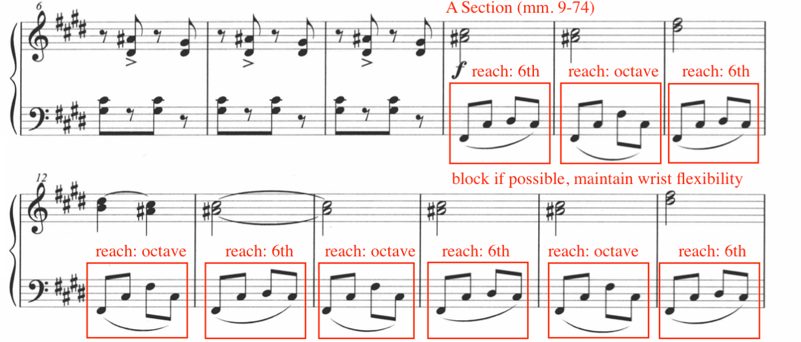
Figure 161: “Dragon Dance,” Excerpt, mm. 6-17, LH Pedagogical Recommendation

Throughout the remainder of the A Section (mm. 9-74), Ding continues to incorporate double thirds (and occasional fourths) in the right hand and arpeggiated accompaniment in the left hand. The current author recommends blocking the left hand positions whenever possible, in addition to rehearsing transitions in isolation. Harmonic pedaling is encouraged, prioritizing clarity and precision.
The B Section (mm. 75-87) features a series of rapid transitions, arpeggiated and blocked chords, accents, and rapidly alternating chords. Blocking is encouraged throughout the B Section, aimed to help increase the speed and accuracy of both its contents and transitions (see Figure 162).
Figure 162: “Dragon Dance,” B Section, Blocking
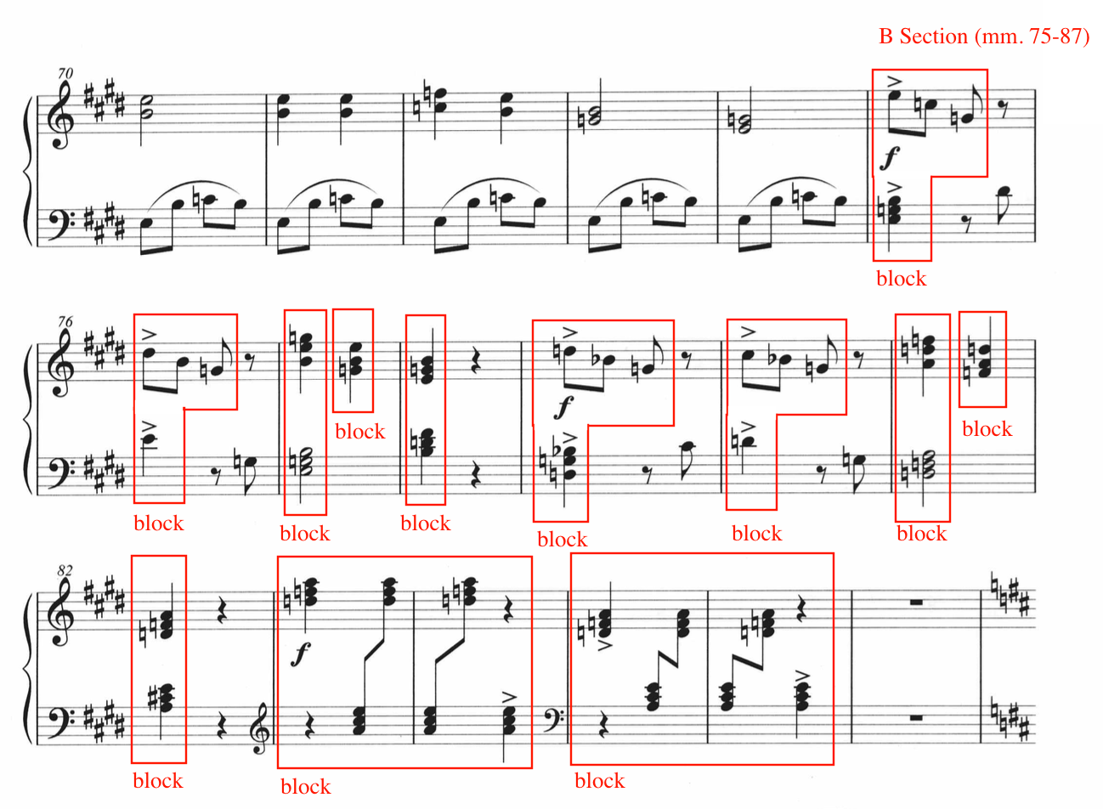

The C Section (mm. 88-103) features a shift of character, exemplifying a calmer, lyrical texture throughout. Utilize touches of pedal in addition to legato touch to achieve a smooth melodic line. Ding indicates a ritardando from measure 102 and 103, setting up the music for a change in measure 104. Although the C Section features a thinner texture, tempo should remain steady and constant (see Figure 163).

Figure 163: “Dragon Dance,” C Section, mm. 88-105, Pedagogical Suggestions
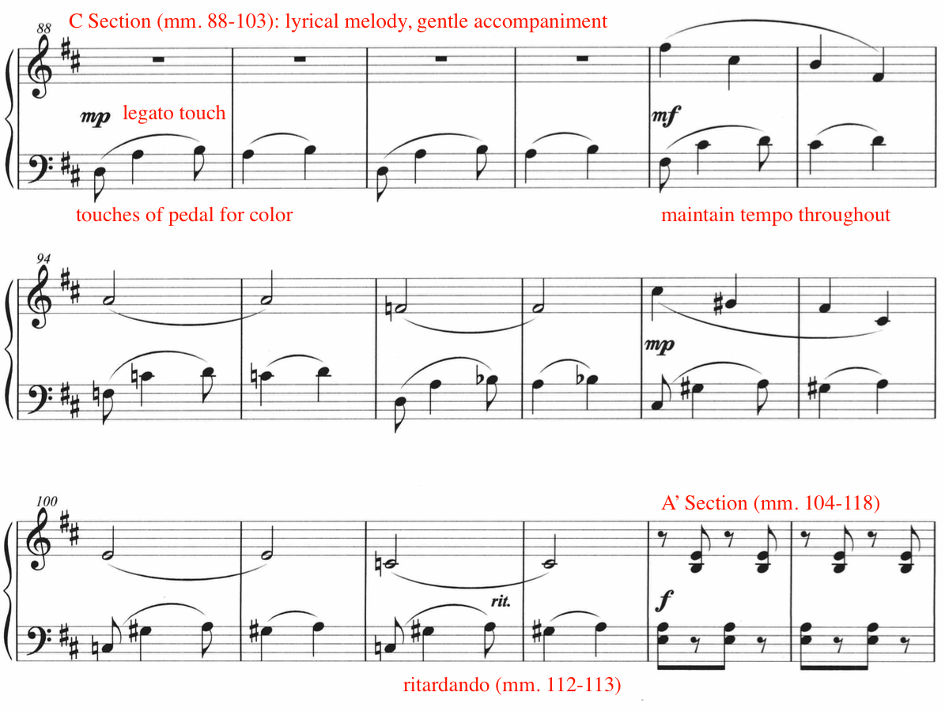

The A’ Section (mm. 104-118) features similar texture and technical demands as the A Section (mm. 9-74). However, due to the diminution of the melody in measure 112 (see Figure 164), the right hand must play double thirds at twice the speed compared to the A Section (mm. 9-74). For this section (mm. 112-118), the current author suggests slow hands-together practice, focusing on wrist flexibility in both hands and smooth transitions between positions. Optional right hand fingering suggestions for measures 112-118 are provided in Figure 164.
Figure 164: “Dragon Dance,” A' Section, Excerpt, mm. 111-120, Pedagogical Suggestion
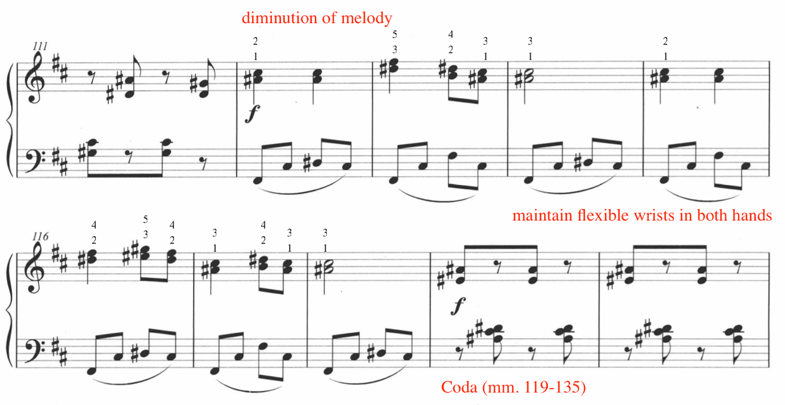

The final section of “Dragon Dance” features a series of fragmented patterns and phrases, separated by sudden measures of rest (see Figure 165). The coda provides an excellent opportunity to discuss how physical choreography enhances a performance, particularly during measures of sudden rest (mm. 123, 126, 131, and 134). During these measures, the student can practice ‘freezing’ briefly to add drama and excitement to their performance. Additionally, Ding includes unexpected accents throughout the coda. The accents (boxed in red) are strategically placed before and after the measures of sudden rest, highlighting the element of surprise (see Figure 165). “Dragon Dance” concludes with a percussive, sforzando chord in measure 135.
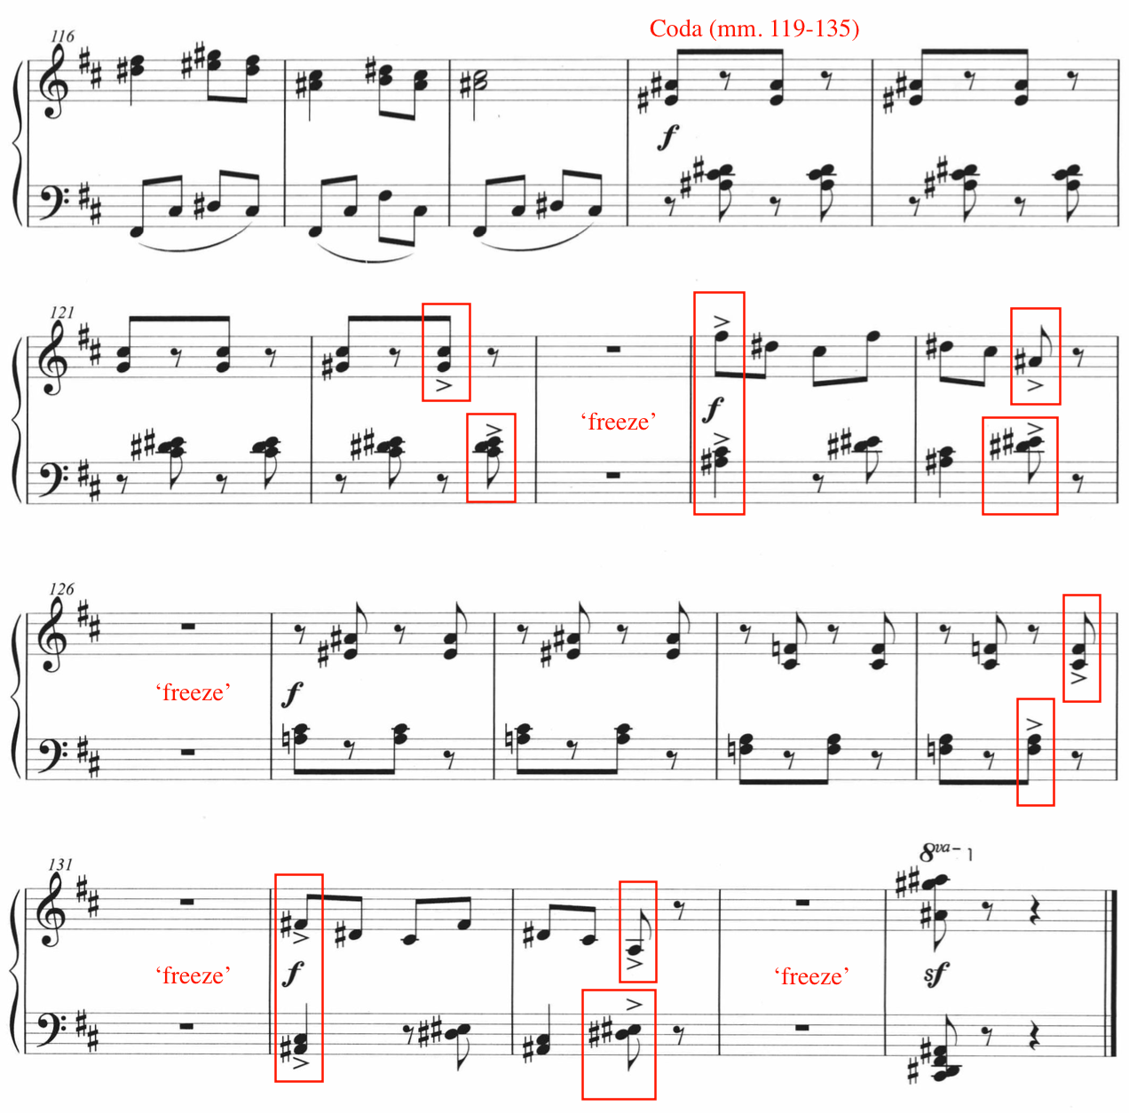
Figure 165: “Dragon Dance,” Coda, Pedagogical Suggestion
Throughout “Dragon Dance,” Ding illustrates the robust soundscapes of the traditional Chinese dragon dance, showcasing its athleticism through tempo, harmony, texture, accompaniment, articulation, contrast, and dramatic pause. “Dragon Dance” is an appropriate choice for an energetic, level nine piano student. Provide both images and video examples of a traditional dragon dance prior to the study of “Dragon Dance.”

Chapter Five: Conclusion and Suggestions for Further Study
Ding Shande’s pioneering contributions as a composer, pedagogue, theorist and activist shaped the trajectory of 20th century Chinese music. A prolific 20th century Chinese composer, Ding Shande (1911–1995) was best known for his solo-piano works, orchestral works, and art songs. He was a leader in the development of piano pedagogy, authoring the first Chinese elementary piano method, First Lessons in Piano. His output for pianists ranged from elementary to advanced (see Appendix A), representing the fusion of Eastern and Western musical styles and traditions. Pioneering the development of pianism in China, Ding was the first Chinese pianist in the country to perform a solo piano recital and first to record Chinese solo piano music.
This study aims to bring recognition to a selection of Ding Shande’s under researched pedagogical contributions: Eight Piano Pieces for Children, op. 28, and First Lessons in Piano (1957). In China, Ding Shande is widely recognized as one of the pioneers of piano performance and pedagogy. However, despite his landmark composition of First Lessons in Piano, there is limited mention and recognition of this historical method within the international pedagogical community. Additionally, Ding Shande’s late pedagogical collection for children, Eight Piano Pieces for Children, does not currently possess a dedicated performance and pedagogical guide. The current author hopes that this document will fill a gap in the available research, encouraging students and teachers to incorporate Ding Shande’s compositions to their studios and performances. There is a considerable amount of research dedicated to Ding Shande’s life and works. The large majority of available academic research revolve around Ding Shande’s symphony, art songs, and solo piano works composed before the cultural revolution. The solo piano works composed after the Cultural Revolution deserve further research, performance, and recognition. At the current time of research, late pedagogical works lacking an in-depth pedagogical analysis include 16 Easy Studies for the Piano, op. 31, and Sonatina for Piano, op. 32. Additionally, there is no known professional recording of Eight Piano Pieces for Children, op. 28, 16 Easy Studies for the Piano, op. 31, Sonatina, op. 32, Rondo, op. 33, Scherzo, op. 35, and Three Pieces on a Chinese Folk Song, op. 36. The professional recording of these listed works is also worthy of exploration. In addition, three editions of First Lessons in Piano exist, however, the current author was only able to obtain the third and final edition. If the lost editions were to be recovered, a comparison of the three editions would be worthy of study.

Summary and Conclusion
Born on November 12th, 1911, in the town of Kunshan, Ding Shande cultivated a strong connection with music from a young age. At 17-years old, he was admitted into the Shanghai Conservatory in 1928 and graduated in 1935. On May 11th, 1935, Ding performed the first solo piano recital given in China. In the same year, Ding was the first to record solo Chinese piano music. In addition to being a sought after touring pianist, he was an active researcher and scholar, publishing his first academic article while he was still enrolled at the Shanghai Conservatory, “Reflections on Chinese Music,” published in 1934. Throughout his life, Ding Shande published 111 articles, authored a composition treatise, translated three French theory textbooks to Chinese, and was interviewed over 30 times.
After touring and giving performances throughout China, Ding accepted an academic teaching position at Hebei Women’s College in 1935. Early in his career, Ding Shande was interested in pursuing composition, however, his pursuit to travel abroad to study composition was thwarted as a result of political tensions due to the Second Sino-Japanese War (1937–1945). However, in 1941, Ding began studying composition with Wolfgang Fraenkel, who was residing in China seeking refuge from the Nazi regime. Fraenkel was a student of Arnold Schoenberg. Ding Shande composed his first works under the tutelage of Fraenkel, Spring Suite op. 1, and Piano Sonata in E major, op. 2.
In 1947, Ding was admitted to the Paris Conservatoire in Paris, France. There, he studied composition with Nadia Boulanger, Noêl Gallon, Arthur Honegger, Wolfgang Fraenkel, Tony Aubin, and Olivier Messiaen. During his studies in Paris, Ding composed two piano works, Three Overtures, op. 3, and Variations on a Chinese Folk Theme, op. 4, the first theme and variations composed using a Chinese folk melody. These works display Ding Shande’s mastery of integrating Chinese folk song with Western techniques. The content of these works were largely motivated by homesickness and longing for his family. Ding returned to Shanghai in 1949, where he accepted an academic position at the Shanghai Conservatory of Music, considered to be one of the most renowned music institutions in the country. Ding spent most of his academic career at the Shanghai Institute, where he taught music theory, counterpoint, composition, and piano.
The Cultural Revolution (1966–1976) placed a halt on all academic, artistic and musical activity in China. All schools and institutions were closed, and many citizens faced prosecution, imprisonment, hazing, and even death. Ding Shande continued to work at the Shanghai Conservatory during the Revolution, but his work was restricted, often involving manual labor and menial tasks. After the Cultural Revolution, Ding resumed artistic activity, and entered a highly productive compositional era. More solo piano works belong to this era than any of his previous eras. Ding composed the majority of his solo pedagogical piano works during the final ten years of his life, including Eight Piano Pieces for Children, op. 28, composed in 1987.
Ding Shande was responsible for mentoring the next generation of Chinese pianists, composers, and pedagogues. Throughout his teaching career, over 105 of Ding Shande’s students have won prizes at national and international competitions. His legacy is passed down through his students, colleagues, and family. Many of Ding’s student become lifelong pedagogues and academic scholars, shaping the next generation of Chinese music, piano performance and piano pedagogy. Despite the large amount of research dedicated to Ding Shande’s life and works, the performance and examination of First Lessons in Piano and late solo piano works deserve greater attention and recognition in the currently available research.

Bibliography
Dissertations and Theses
Guo, Xiaojun. “The Status of Pre-College Piano Teaching in China.” M.M. Thesis., California State University, Northridge, 2019. ProQuest Dissertations & Theses Global.

Kondoh, Akina. “Diversifying Piano Literature: East Asian Music for Piano Study and Performance in the United States.” D.M.A. diss., West Virginia University, 2022. ProQuest Dissertations & Theses Global.

Li, Jingbei. “The Preludes in Chinese Style: Three Selected Piano Preludes from Ding Shan-de, Chen Ming-zhi and Zhang Shuai to Exemplify the Varieties of Chinese Piano Preludes.” D.M.A. diss., The Ohio State University, 2019. ProQuest Dissertations & Theses Global.

Lin, Yao. “East Meets West: Influential Elements of Western Piano Music on Chinese Piano Music.” D.M.A. diss., The University of Maryland, College Park, 2023. ProQuest Dissertations & Theses Global.

Liu, Lang. “An Exploration toward the Enrichment of a Personal Musical Language in Musical Composition.” D.M.A. diss., Royal College of Music, 2019. https://researchonline.rcm.ac.uk/id/eprint/493.

Ma, Zijie. “The Presentation and Adaptation of Xinjiang Musical Elements in Chinese Piano Composition: An Analysis of Three Xinjiang Style Piano Works.” D.M.A. diss., The University of Alabama, 2023. ProQuest Dissertations & Theses Global.

Sha, Sha. “Musical and Performance Analysis of the Two Piano Music Works First Dance in Xinjiang and Spring Dance.” M.M. thesis., Northeast Normal University Global, 2009. ProQuest Dissertations & Theses Global.

Worsham, Heidi Astle. “A Teacher’s Guide to Diverse Piano Repertoire: An Annotated Bibliography of Intermediate Level Repertoire by Historically Underrepresented Composers through each Historical Period.” D.M.A. diss., The University of Iowa, 2022. ProQuest Dissertations & Theses Global.

Xu, Keli. “Piano Teaching in China During the Twentieth Century.” D.M.A. diss., University of Illinois at Urbana-Champaign. 2001. ProQuest Dissertations & Theses Global.

You, Liang-Yun. “A Survey of Ding Shan-De’s Piano Works.” D.M.A. diss., University of Houston, 2004. ProQuest Dissertations & Theses Global.

Zhou, Xu. “Shande Ding: An Examination of His Compositional Style and Influences from Western Composers.” D.M.A. diss., Arizona State University, 2020. ProQuest Dissertations & Theses Global.

Articles
Cai, Xiao Duan. “Ding Shande’s Innovative Practice of Nationalizing Piano Music.” Northern Music, no. 16 (2017):18-20, translated by the author.

Chan, Yong-chi. “Appreciating Serious Music Requires an Understanding of Culture Climate.” Ming Pao Monthly, (1983), translated by the author.

Dai, Penghai. “Musician Mr. Ding Shande’s Career (1911-1995): Contribution to Ding Shande’s Memorial Picture Album.” Art of Music – Journal of the Shanghai Conservatory of Music, no. 4 (2001): 6-17, translated by the author.

Ding, Shande. “Reflections on Chinese Music.” Music Magazine of the Musical Arts and Literature Society, no. 1 (1934), translated by the author.

Ding, Shande. “Why Chinese People Accept and Understand Chopin’s Music.” Music Research, no. 2 (1960), translated by the author.

Fan, Yangjie. “Interpretation of the National Characteristics of Ding Shande’s Piano Music Creation.” Drama House, no. 14 (2018): 278, translated by the author.

Jing, Guo. “Art Characteristics and Teaching of Grace Note in Chinese Instrument Piano Paraphrase.” Proceedings of the 2015 International Conference on Education, Management and Computing Technology, (2015): 460-463.

Li, Songwen. “A Summary of the Academic Symposium on the Commemoration of the 110th Anniversary of Ding Shande’s Birth.” People’s Music Journal 2022, no. 5 (2022): 44-48, translated by the author.

Li, Wuping. “A Brief Analysis of the Teaching of Ding Shande’s Children’s Suite ‘Happy Festival: Hide and Seek.’” Popular Literature and Art, no. 23 (2011): 327, translated by the author.

Qin, Yuan, and Yue Jin. “A Brief Analysis of the Performance Artistic Characteristics of Piano Music Works: The First Xinjiang Dance and Spring Dance.” Journal of Mudanjiang College of Education, no. 3 (2015): 114-115, translated by the author.

Thrasher, Alan R. “The Melodic Structure of Jiangnan Sizhu.” Ethnomusicology 29, no. 2 (1985): 237–63.

Tu, Bo. “Study on the Development of Chinese Piano Music Culture.” Advances in Social Sciences, Education and Humanities Research, no. 310 (2019): 245-250.

Tu, Zhijie. “Like a Poem, Dream, Song, Picture – Commentary on Ding Shande’s “Eight Piano Pieces for Children.”” Fujian Art, (2007), no. 5: 62-63, translated by the author.

Van Khê, Trân. “Chinese Music and Musical Traditions of Eastern Asia.” The World of Music 27, no. 1 (1985): 78–90. http://www.jstor.org/stable/43562680.

Wang, Wei. “Harmonic Language of Ding Shande’s Piano Works.” Journal of Wuhan Conservatory of Music, no. 3 (2000): 92-98, translated by the author.

Wang, Yi. “Research on Ding Shande’s Piano Music Creation.” Music Space and Time, no. 10 (2014): 121-121, translated by the author.

Wei, Yange. “Interview Regarding Early Piano Teaching.” Chinese Music, no. 4 (1982), translated by the author.

Zhang, Qi. “Exploration and Analysis on the Development of Chinese Dragon Dance and the Training System of Dragon Dancing in Universities.” Journal of Humanities, Arts and Social Science, no. 7 (2023): 461-464.

Zhou, Danny. “China’s First Recital and Recording Pianist Ding Shande: A Critical Examination of His Performing Career and Performance Style.” Twentieth Century Music 20, no. 2 (2023): 187-214.

Zhou, Weimin. “The History and Development of Piano Education in China.” Chinese Music, no. 2 (2010): 144-150.

Musical Scores
Burnam Edna-Mae. A Dozen a Day: Preparatory Book. Kentucky: Willis Music, 2005.

Burnam, Edna-Mae. A Dozen a Day: Book 2. Kentucky: Willis Music, 2005.

Ding, Shande. First Lessons in Piano. 3rd ed. Beijing, Beijing Publishing House, 1957.

Ding, Shande. Ding Shande’s Art Song Collection. Shanghai: Shanghai Publishing House, 1984.

Ding, Shande. Ding Shande: Short Piano Works. Shanghai: Shanghai Publishing House, 1989.

Ding, Shande. Chinese Piano Music for Children. Germany: B. Schott Söhne, Mainz, 1990.

Ding, Shande. Ding Shande Piano Collection. Edited by Qian Yiping. Shanghai: Shanghai Publishing House, 1997.

Ding, Shande. Ding Shande Complete Works Vol. I-VIII. Shanghai: Shanghai Publishing House, 2011.

Ding, Shande. Ding Shande Complete Works Vol. II Piano Music. Shanghai: Shanghai Publishing House, 2011.

Ding, Shande. Ding Shande Complete Works Vol.VI Concerto. Shanghai: Shanghai Publishing House, 2011.

Faber, Nancy, and Randall Faber. ChordTime® Piano Music from China – Level 1. Michigan: Faber Piano Adventures, 2020.

Faber, Nancy, and Randall Faber. ChordTime® Piano Music from China – Level 2B. Michigan: Faber Piano Adventures, 2020.

Glover, David Carr, and Louis Garrow. David Carr Glover Piano Library. California: Alfred Music Publishing, 1967.

Ravel, Maurice. Le tombeau de Couperin. Paris: Durand & Cie., 1918.

Schaum, John. W. John W. Schaum Piano Course. Cincinnati: Belwin-Mills Publishing, 1973.

The Royal Conservatory. Piano Repertoire Level 8. Toronto: The Royal Conservatory, 2022.

Thompson, John. John Thompson’s Easiest Piano Course: Part One. Cincinnati: The Willis Music Co, 1955.

Thompson, John. Teaching Little Fingers to Play. Cincinnati: The Willis Music Co, 1936.

Online Newspapers
Chen, Nan. “The Art of Songwriting.” China Daily, November 19, 2021. https://www.chinadailyasia.com/epaper/pubs//chinadaily/2021/11/19/17.pdf

Melvin, Sheila. “How the Piano Became Chinese.” Caixin Global, September 6, 2015. https://www.caixinglobal.com/2015-09-06/how-the-piano-became-chinese-101052942.html

Recordings
Chen, Jie. Chinese Piano Favorites. Naxos Records, 2007.
*Includes Children’s Suite: Happy Holidays, op.9

Ding, Dongnuo. Ding Shande Piano Music Collection. New Era Video, 1990.
*Includes Spring Suite, op.1, Piano Sonata in E Major, op. 2 (II, III), Three Overtures, op. 3, Variations on the Chinese Folks Theme, op. 4, First Xinjiang Dance, op. 6, Children’s Suite: Happy Holidays, op. 9, Second Xinjiang Dance, op. 11, Toccata, op. 13.

Ding, Jiannuo. Ding: Piano Music. Yellow River 82083, 2000.
*Includes Spring Suite, op. 1, Piano Sonata in E Major, op. 2, Three Overtures, op. 3, Variations on the Chinese Folks Theme, op.4, First Xinjiang Dance, op.6, Children’s Suite: Happy Holidays, op. 9, Second Xinjiang Dance, op. 11, Toccata, op. 13, Four Little Preludes and Fugues, op. 29, Six Preludes, op. 34.

Ding, Shande. Children’s Piano Suite. China Recording Group Co., Ltd, 2024.
*Includes Children’s Suite: Happy Holidays, op. 9

Schoenhals, Joel. Chinese Piano Music. Fleur de Son, 2014.
*Includes First Xinjiang Dance, op. 6.

Books
Dai, Penghai. Ding Shande’s Music. Beijing: Central Conservatory of Music Publishing, 1993, translated by the author.

Dai, Penghai, ed., Ding Shande’s Musical Writings. Shanghai: Shanghai Conservatory of Music Press, 2006, translated by the author.

Dai, Penghai. Ding Shande and His Musical Works: Proceedings from the Fourth Annual Conference of Modern Music at Shanghai Conservatory of Music. Shanghai: Shanghai Music Publishing House, 1993, translated by the author.

Ding, Jiannuo. The 100th Anniversary of Ding Shande’s Collection. Shanghai: Shanghai Music Publishing House, 2011, translated by the author.

Ding, Shande. Yiping Qian, Yuyan Yang, and Ming-zhi Chen. Memory and Analysis of Ding Shande’s Compositions. 2nd ed. Shanghai: Shanghai Publishing House, 1986, translated by the author.

Ding, Shande. Exploration of Composition Techniques. Shanghai: Shanghai Music Publishing House, 1990, translated by the author.

Hinson, Maurice. Guide to the Pianist’s Repertoire. 3rd ed. Bloomington: Indiana University Press, 2001.

Magrath, Jane. Piano Literature for Teaching and Performance, 2nd ed. The Frances Clark Center for Keyboard Pedagogy, 2021.

The Royal Conservatory. Piano Syllabus 2022 Edition. Toronto: The Royal Conservatory, 2022. PDF file. https://rcmusickenticocdn.s3.amazonaws.com/rcm/media/main/about%20us/rcm%20publishing/piano-syllabus-2022-edition.pdf
Yuan, Jingfang, ed., Comprehensive Introduction to Chinese Traditional Music. Translated by Boyu Zhang and Lam Ching-Wah. Wien: Hollitzer Verlag, 2023.

Miscellaneous

Catalogue of the Crosby Brown Collection of Musical Instruments: Asia, Gallery 27. 2. The Metropolitan Museum of Art. New York, 1903, vol. II, p. 23.

“Dan Zhaoyi Chinese Piano Educator.” Sin80. Accessed April 29, 2024. https://www.sin80.com/en/artist/dan-zhaoyi

Daxue Consulting. “The Piano Industry in China.” Daxue Consulting. Accessed [May 6, 2024]. https://daxueconsulting.com/the-piano-industry-in-china/

“Demonstration of Chinese Musical Instruments: Percussion Mangluo Gong.” Taipei Chinese Orchestra. August 21, 2021. Video, 00:08, https://youtu.be/wWNxIwpmTaI?si=mxBMc-RyKegehCjr.

“Dr. Alvin Zhu (China)-International Piano Professionals Association.” Accessed April 29, 2024. https://ippa.cc/team/dr-alvin-zhu-china/

“Elephant-foot Drum Dance of Dai Ethnic Minority in Yinjiang County, Dehong.” Yunnan Exploration. Accessed January 19, 2024. https://www.yunnanexploration.com/elephant-foot-drum-dance-of-dai-ethnic-minority-in-yingjiang-county-dehong.html

“Erhu.” Wesleyan University Virtual Instrument Museum 2.0. Accessed January 7, 2024. https://wesomeka.wesleyan.edu/vim2/items/show/69.

Moore, J. Kenneth. “The Pipa.” In Heilbrunn Timeline of Art History. New York: The Metropolitan Museum of Art, 2000-.

Moore, J. Kenneth, Bradley Strauchen-Scherer, Jayson Kerr Dobney. Musical Instruments: Highlights of the Metropolitan Museum of Art. First Printing. New York: The Metropolitan Museum of Art, 2015.

Museum of Chinese in America. “Shaolin Dragon Dancing.” January 23, 2023. https://www.mocanyc.org/2023/01/22/shaolin-dragon-dancing/.

“Dragon Dance Performance in Kuala Lumpur, Malaysia.” Nationsonline.org, 2015. Accessed March 26, 2024, https://www.nationsonline.org/oneworld/Chinese_Customs/dragon_dance.htm#google_vignette.

Shanghai Symphony Orchestra. “SSO in Concert: Long Yu Conducts Ding Shande.” YouTube video, 33:00. Posted May 6, 2022, https://youtu.be/nJG6mrsFcWE?si=a96JwAZQpV6Qds3j.

“The Piano Shop on Nanking Road: A Brief History of S. Moutrie and Co.” Shanghai Sojourns. July 19, 2020. http://shanghaisojourns.net/shanghais-dancing-world/2020/7/19/the-piano-shop-on-nanking-road-a-brief-history-of-s-moutrie-and-co

Xtaaxba. “Elephant-foot Drum Dance One Kind of Dai Minority Dance.” YouTube video, 02:52. Posted January 10, 2010, https://youtu.be/UVmqUzJuZ8c?si=N3Y-9r81z45v2byK.

Zhou, Guangren. “Jury: Zhou Guangren.” Arthur Rubenstein International Music Society. Accessed April 29, 2024. https://arims.org.il/jury/zhou-guangren/

Appendix A – Catalogue of Ding Shande’s Works for Solo Piano
Period | Works | Level | Year completed
Early (pre-1947) | Spring Suite, op. 1  - Waiting for Sunrise  - In the Boat  - On the Shore  - Breezing in the Morning  Piano Sonata in E Major, op. 2  - Allegro moderato  - Larghetto  - Allegretto con vivo | 6-9  10+ | 1945  1946
Transitional (1947-49) | Three Overtures, op. 3  - Andante sostenuto  - Andantino cantabile  - Allegretto con anima  Variations on a Chinese Folk Theme, op. 4 | 6-8  6-10+ | 1948  1948
Mature (1949-66) | First Xinjiang Dance, op. 6  Children’s Suite: Happy Holiday, op. 9  - Outing  - Catching Butterflies  - Skipping  - Hide and Seek  - Holiday’s Dance  Second Xinjiang Dance, op. 11  Toccata, op. 13 | 10+  7-10+  10+  10+ | 1950  1953  1955  1958
Late (1967-95) | Eight Piano Pieces for Children, op. 28  - Puzzles  - Playing Games  - Evening Song  - Mangluo and Elephant-foot Drum  - Worries  - Here Comes the Caravan of Horses  - Morning Song  - Dragon Dance  Four Little Preludes and Fugues, op. 29  - Prelude (Meditation) and Fugue (Delight)  - Prelude (Sorrow) and Fugue (Joy)  - Prelude (Overjoyed) and Fugue (Chasing One Another)  - Prelude (Excited) and Fugue (Festive Dance)  16 Easy Studies for the Piano, op. 31  - Moderato  - Allegro  - Allegro  - Andante  - Allegro  - Moderato  - Maestoso  - Allegro  - Presto  - Allegro  - Vivace  - Vivace  - Moderato  - Allegretto  - Andantino  - Presto  Sonatina for Piano, op. 32  - Allegro grazioso  - Moderato quietissimo  - Animato appassionato  Rondo, op. 33  Six Preludes, op. 34  - Adagietto  - Maestoso  - Animato  - Maestoso  - Vivace  - Allegretto  Scherzo, op. 35  Three Piano Pieces on a Chinese Folk Song, op. 36  - Lan Huahua  - Water in the Stream  - Cotting Song | 4-8  8-10+  4-9  7-10  10+  10+  10+  10+ | 1987  1988  1988  1988  1988  1989  1989  1992

Appendix B – Sequential Overview of Exercises and Concepts in First Lessons in Piano
Exercise | Contents of exercise | New concept | Hand | Measures | Pg
No.1 | Meter: 4/4  Position: Middle C  Sustained whole notes  Stepwise beginning on C  Counting out loud “1,2, 3, 4”  Finger numbers provided for each note | Treble clef  Whole notes  Counting out loud  Right hand | RH only | 5 | 3
No. 2 | Meter: 4/4  Position: Middle C  Sustained whole notes  Mostly stepwise beginning on C  Counting out loud “1, 2, 3, 4”  Finger numbers provided for each note | NA | RH only | 5 | 4
No. 3 | Meter: 4/4  Position: Middle C  Sustained whole notes  Mostly stepwise beginning on C  Counting out loud “1, 2, 3, 4”  Finger numbers provided for each note | NA | RH only | 7 | 4
No. 4 | Meter: 4/4  Position: Middle C  Sustained whole notes  Stepwise beginning on G  Counting out loud “1, 2, 3, 4”  Finger numbers provided for each note | Beginning on treble G | RH only | 9 | 5
No. 5 | Meter: 4/4  Position: Middle C  Sustained whole notes  Mostly steps beginning on C  Counting out loud “1, 2, 3, 4”  Finger numbers provided for some notes | NA | RH only | 9 | 5
No. 6 | Meter: 4/4  Position: Middle C  Sustained whole notes  Skips and steps beginning on E  Counting out loud “1, 2, 3, 4”  Finger numbers provided for some notes | Beginning on treble E | RH only | 9 | 5
No. 7 | Meter: 4/4  Position: Middle C  Mostly half notes  Counting out loud “1, 2, 3, 4”  Finger numbers provided for each note | Half note | RH only | 4 | 6
No. 8 | Meter: 4/4  Position: Middle C  Mixture of half and whole notes  Finger numbers provided for each note | NA | RH only | 6 | 6
No. 9 | Meter: 4/4  Position: Various  C major ascending and descending scale  Mostly half notes  Contains a right hand 3-1 tuck  Counting out loud “1, 2, 3, 4” | Finger crossing (3 to 1) | RH only | 8 | 7
No. 10 | Meter: 4/4  Position: Various  Begins on C, scale based  Mostly half notes  Contains finger crossing | NA | RH only | 7 | 7
No. 11 | Meter: 4/4  Position: Various  Begins on C, scale based  Mixture of half and whole notes  Contains finger crossing  Counting out loud “1, 2, 3, 4” | NA | RH only | 7 | 8
No. 12 | Meter: 4/4  Position: Various  Begins with 5 on treble C  Skips and steps  Contains finger crossing  Mixture of half and whole notes | NA | RH only | 7 | 8
No. 13 | Meter: 4/4  Position: Middle C  Begins on C, followed by steps and skips  Counting out loud, “1, 2, 3, 4”  Contains quarter, half, and whole notes | Quarter note | RH only | 5 | 9
No. 14 | Meter: 4/4  Position: Various  Begins on C, scale based  Contains finger tuck  Contains quarter, half and whole notes | NA | RH only | 6 | 9
No. 15 | Meter: 4/4  Position: Middle C  Begins on C  Contains finger tuck  Contains quarter, half and whole notes | 4/4 meter | RH only | 5 | 10
No. 16 | Meter: 4/4  Position: Various  Begins on C, scale based  Contains quarter, half and whole notes | NA | RH only | 6 | 10
No. 17 | Meter: 4/4  Position: Middle C  Counting out loud “1, 2, 3, 4”  Sustained whole notes only  Finger numbers provided for each note | Bass clef  Left hand | LH only | 9 | 11
No. 18 | Meter: 4/4  Position: NA  Begins with 1 on Middle C  Descending C major scale  Sustained whole notes only  Counting out loud “1, 2, 3, 4”  Contains a finger crossing (3 to 1)  Finger numbers provided for each note | NA | LH only | 8 | 12
No. 19 | Meter: 4/4  Position: Various  Begins with 1 on Middle C  Contains finger crossover (3 to 1)  Mostly half notes  Finger numbers provided for some notes | NA | LH only | 7 | 12
No. 20 | Meter: 4/4  Position: Various  Begins with 1 on Middle C  Contains finger crossing (3 to 1)  Contains quarter, half and whole notes  Finger numbers provided for some notes | NA | LH only | 5 | 12
No. 21 | Meter: 4/4  Position: Various  Begins with 1 on Middle C  Contains finger crossing (3 to 1)  Contains quarter, half and whole notes  Finger numbers provided for some notes | NA | LH only | 5 | 13
No. 22 | Meter: 4/4  Position: Various  Begins with 5 on Bass C  Contains finger crossing (1 to 3)  Counting out loud “1, 2, 3, 4”  Contains quarter, half and whole notes  Finger numbers provided for some notes | NA | LH only | 5 | 13
No. 23 | Meter: 4/4  Position: Middle C  Contains quarter and whole notes  Finger numbers provided for some notes | NA | LH only | 7 | 13
No. 24 | Meter: 4/4  Position: Middle C  Contains quarter and half notes  Contains whole rests  Stepwise  Finger numbers provided for some notes | Whole rest  Half rest  Playing with alternating hands | RH + LH alternating | 6 | 14
No. 25 | Meter: 4/4  Position: Middle C  Contains quarter, half and whole notes  Contains whole and half rests  Skips and steps  Finger numbers provided for some notes | NA | RH + LH alternating | 6 | 14
No. 26 | Meter: 4/4  Position: Middle C  Contains quarter, and half notes  Contains whole and half rests  Skips and steps  Finger numbers provided for some notes | NA | RH + LH alternating | 6 | 15
No. 27 | Meter: 4/4  Position: Various  Contains finger crossing  Contains quarter and half notes  Contains whole and half rests  Skips and steps  Finger numbers provided for some notes | NA | RH + LH alternating | 7 | 15
No. 28 | Meter: 4/4  Position: Various  Contains finger crossing  Contains quarter, half and whole notes  Contains whole and half rests  Skips and steps  Finger numbers provided for some notes | NA | RH + LH  alternating | 12 | 16
No. 29 | Meter: 4/4  Position: Various  Contains ledger line notes  Contains quarter and half notes  Contains whole and half rests  Skips and steps  Finger numbers provided for some notes | Ledger line notes | RH + LH  alternating | 12 | 17
No. 30 | Meter: 4/4  Position: C major  Hands playing simultaneously  Contains quarter, half and whole notes  Contains whole and half rests  Finger numbers provided for most notes | Common time | Hands together | 8 | 18
No. 31 | Meter: 4/4  Position: RH on A minor, LH on C major  Hands playing simultaneously  Contains quarter, half and whole notes  Contains half and whole rests  Finger numbers provided for most notes | NA | Hands together | 8 | 19
No. 32 | Meter: 4/4  Position: Middle C  Hands playing simultaneously  Contains quarter and whole notes  Contains whole, half and quarter rests  Finger numbers provided for some notes | Quarter rest | Hands together | 5 | 20
No. 33 | Meter: 4/4  Position: Middle C  Hands playing simultaneously  Contains quarter, half, and whole notes  Contains whole, half, and quarter rests  Finger numbers provided for some notes | NA | Hands together | 7 | 20
No. 34 | Meter: 4/4  Position: Various  Hands playing simultaneously  Contains eighth, quarter, half, and whole notes  Contains whole rests  Counting out loud “1, 2, 3, 4”  Skips and steps  Finger numbers provided for some notes | Eighth notes | Hands together | 4 | 21
No. 35 | Meter: 4/4  Position: C five finger  Hands playing simultaneously  Contains eighth and whole notes  Mostly steps  Finger numbers provided for some notes | NA | Hands together | 4 | 21
No. 36 | Meter: Common time  Position: various  Hands playing simultaneously  Contains eighth, quarter, half, and whole notes  Mostly skips  Finger numbers provided for each note | NA | Hands together | 8 | 22
No. 37 | Meter: Common time  Position: various  Hands playing simultaneously  Contains eighth, quarter, half, and whole notes  Skips and steps  Finger numbers provided for some notes | NA | Hands together | 8 | 23
No. 38  “National Flag”  國旗 | Meter: Common time  Position: various  Has lyrics  Hands playing simultaneously  Contains eighth, quarter, half and whole notes  Mostly skips  In C-pentatonic mode | First song with lyrics  Leap of a minor 6th | Hands together | 8 | 24
No. 39  “Little Soldier”  小兵丁 | Meter: 3/4  Position: C major five finger  Hands playing simultaneously  Contains quarters and dotted half notes  Mostly steps | 3/4 meter | Hands together | 11 | 25
No. 40  “Children’s Song”  兒歌 | Meter: 3/4  Position: G five finger  RH finger 2 crossing to F-sharp  Hands playing simultaneously  Contains quarter and dotted half notes  Mostly skips | Sharp | Hands together | 8 | 26
No. 41  搖籃曲  “Lullaby” | Meter: 2/4  RH position: G major five finger  LH position: D major five finger  Contains F-sharp  Skips and steps  Contains quarter and half notes | 2/4 meter | Hands together | 8 | 27
No. 42  鞦韆  “Swing” | Meter: Common time  Position: G major five finger  RH finger 2 crossing to F-sharp  Contains F-sharp  Hands playing simultaneously  Steps and skips  Contains quarter, half, and whole notes | NA | Hands together | 8 | 28
No. 43  騎木馬  “Riding on a Rocking Horse” | Meter: 4/4  Position: G major five finger  RH finger 2 crossing to F-sharp  Contains F-sharp  Hands playing simultaneously  Steps and skips  Contains quarter, half, and whole notes | NA | Hands together | 8 | 29
No. 44  走盪木  “Walking on a Wooden Log” | Meter: 3/4  Position: Middle C  Contains F-sharp extension in RH  Hands playing simultaneously  Mostly steps  Finger numbers provided for every note | Tied notes | Hands together | 8 | 30
No. 45  不高興  “Sad” | Meter: 3/4  Position: Various  Contains F-sharp  Contains finger crossing  Hands playing simultaneously  Steps and skips  Contains quarters and dotted half notes  Finger numbers provided for some notes | NA | Hands together | 8 | 31
No. 46  小舞㑹  “Little Dance” | Meter: 4/4  Key: G major  Position: Various  Contains tied notes  Contains finger crossing  Hands playing simultaneously  Steps and skips  Contains eighths, quarters, half  Finger numbers provided for some notes | G major key signature | Hands together | 8 | 32
No. 47  木偶舞  “Puppet Dance” | Meter: 2/4  Key: G major  Position: Various  Hands playing simultaneously  Contains eighth, quarter, and half notes  Steps and skips  Finger numbers provided for some notes | NA | Hands together | 14 | 33
No. 48  短歌  “Short Piece” | Meter: 2/4  Key: C major  Position: Various  Counting out loud “1, 2”  Hands playing simultaneously  Contains eighth, quarter, and half notes  Contains tied notes  Finger numbers provided for every note | NA | Hands together | 17 | 34
No. 49  英雄的故事  “The Hero’s Story” | Meter: 6/8  Key: C major  Position: Various  Hands playing simultaneously  Contains eighth, quarter, dotted quarter, and dotted half notes  Contains forte and piano dynamics  Finger numbers provided for every note | 6/8 time signature  Forte dynamic  Piano dynamic | Hands together | 8 | 35
No. 50  蝴蝶飛  “Flying Butterfly” | Meter: 6/8  Key: G major  Position: G major  Hands playing simultaneously  Contains lyrics  Finger numbers provided for most notes  Contains eighth, quarter, dotted quarter, and dotted half notes | NA | Hands together | 10 | 36-37
No. 51  田歌  “Tian Ge” | Meter: 6/8  Keys: A minor, A major  Positions: A minor and A major five finger  Both hands playing simultaneously  Contains forte and piano dynamics  Contains eighth, quarter, dotted quarter, and dotted half notes  Contains tied notes  Finger numbers provided for most notes | C-sharps | Hands together | 8 | 38
No. 52  小白馬  “Little White Horse” | Meter: Common time  Key: C major  Positions: Various  Counting out loud: “1, 2, 3, 4”  Contains a pickup: starts on beat 3  Contains quarter, half, and whole notes  Contains crescendo and decrescendos  Contains forte and piano dynamics  Finger numbers provided for every note | Crescendo and decrescendo  Pick up: starting on the third beat | Hands together | 9 | 39
No. 53  山破下  “Under the Hillside” | Meter: Common time  Key: C major  Positions: Various  Counting out loud: “1, 2, 3, 4”  Contains pickup: starts on beat 4  Contains staccatos in the right hand  Contains forte and piano dynamics  Contains tied notes  Finger numbers provided for most notes  Contains quarter, half and dotted half notes | Staccato  Pick up: starting on the fourth beat | Hands together | 8 | 40
No. 54  不倒翁  “Tumbling” | Meter: 3/4  Key: C major  RH position: C major five finger  LH position: thumb on middle C  Contains pickup: stars on beat 3  Counting out loud: “1, 2, 3”  Contains eighth, quarter, half, and dotted half notes  Contains staccatos  Finger numbers provided for most notes | NA | Hands together | 8 | 41
No. 55  青蛙跳舞  “Frog Dance” | Meter: 3/4  Key: G major  Position: Various  Contains staccatos  Contains F-sharps in the LH  Finger numbers provided for most notes | NA | Hands together | 10 | 42
No. 56  小麻雀  “Little Sparrow” | Meter: 2/4  Key: G major  Position: Various  Contains staccatos  Contains C-sharps  Contains natural sign  Contains slurs  Contains tied notes  Contains forte dynamic  Finger numbers provided for every note | Natural sign | Hands together | 16 | 43
No. 57  圓舞曲  “Waltz” | Meter: 3/4  Key: G major  Position: G major five finger position  Contains dotted quarter notes  Finger numbers provided for most notes  Contains F-sharp finger crossing in the right hand | Dotted quarter notes (in 3/4 meter) | Hands together | 13 | 44
No. 58  跳绳舞  “Rope Skipping Song” | Meter: Common time  Key: G major  Position: Various  Contains G major scales  Contains dotted quarter notes  Finger numbers provided for some notes | NA | Hands together | 9 | 45
No. 59  金魚的寂寞  “Lonely Goldfish” | Meter: 2/4  Key: A minor  Position: Various  Contains D-sharp and G-sharp  Contains piano dynamic  Contains eighth rests  Contains pickup: start on and of 2  Finger numbers provided for some notes | Eighth rest | Hands together | 8 | 46
No. 60  爬山  “Climbing Mountains” | Meter: 2/4  Key: C major  Position: Various  Contains forte dynamic  Finger numbers provided for most notes | Treble clef in left hand | Hands together | 11 | 47
No. 61  獵人的歌  “Hunter’s Song” | Meter: Common time  Key: F major  Position: F major five finger position  Contains B-flats  Contains tied notes  Contains forte and piano dynamic  Finger numbers provided for every note | Flat accidental | Hands together | 8 | 48
No. 62  採𨗨歌  “Lotus Picking Song” | Meter: 3/4  Key: F major  Position: F major five finger  Contains B-flats  Contains a G-sharp  Finger numbers provided for most notes | NA | Hands together | 15 | 49
No. 63  船歌  “Boat Song” | Meter: 6/8  Key: F major  Position: Various  Contains pickup: start on 6th beat  Contains forte and piano dynamic  Finger numbers provided for each note | F major key signature | Hands together | 10 | 50
No. 64  牧歌  “Pastoral Song” | Meter; 3/4  Key: F major  Position: Various  Contains tied notes  Contains slurs  Contains forte and piano dynamics  Contains pickup: start on beat 3  Finger numbers provided for every note | Slurs | Hands together | 8 | 51
No. 65  雙人舞  “Pas de deux” | Meter: 2/4  Key: F major  Position: Various  Contains B-flats  Finger numbers provided for most notes | NA | Hands together | 18 | 52
No. 66  爬梯  “Ladders” | Meter: 4/4  Key: F major  Position: Various  Contains B-flats  Contains finger crossing in both hands  Finger numbers provided for some notes | NA | Hands together | 10 | 53
No. 67  空軍舞  “Air Force Dance” | Meter: 3/4  Key: F major  Position: Various  Contains B-flats  Contains forte and piano dynamics  Contains first and second endings  Waltz accompaniment  Finger numbers provided for some notes | Repeat sign  First and Second ending | Hands together | 11 | 54
No. 68  工人舞  “Worker’s Dance” | Meter: 3/4  Ley: G major  Position: Various  Contains F-sharps  Contains forte dynamics  Contains first and second ending  Finger numbers provided for some notes  Waltz accompaniment | NA | Hands together | 12 | 55
No. 69  蘆花公雞  “Luhua Rooster” | Meter: 2/4  Key: G major  Position: Various  G-Pentatonic mode  Contains forte and piano dynamic  Contains crescendo and decrescendo  Contains tied notes  Contains slurs  Contains staccatos  Finger numbers provided for some notes | NA | Hands together | 13 | 56
No. 70  牧羊歌  “Shepherd’s Song” | Meter: 4/4  Key: F major  Position: Various  Contains slurs  Contains first and second ending  Finger numbers provided for some notes | NA | Hands together | 9 | 57
No. 71  進行曲  “March” | Meter: 2/4  Key: F major  Position: Various  Contains B-naturals and B-flats  Contains sixteenth notes  Contains first and second ending  Contains staccatos  Contains slurs  Contains fermata  Finger numbers provided for every note | The sixteenth note  Fermata | Hands together | 17 | 58

Appendix C – Copyright Permission

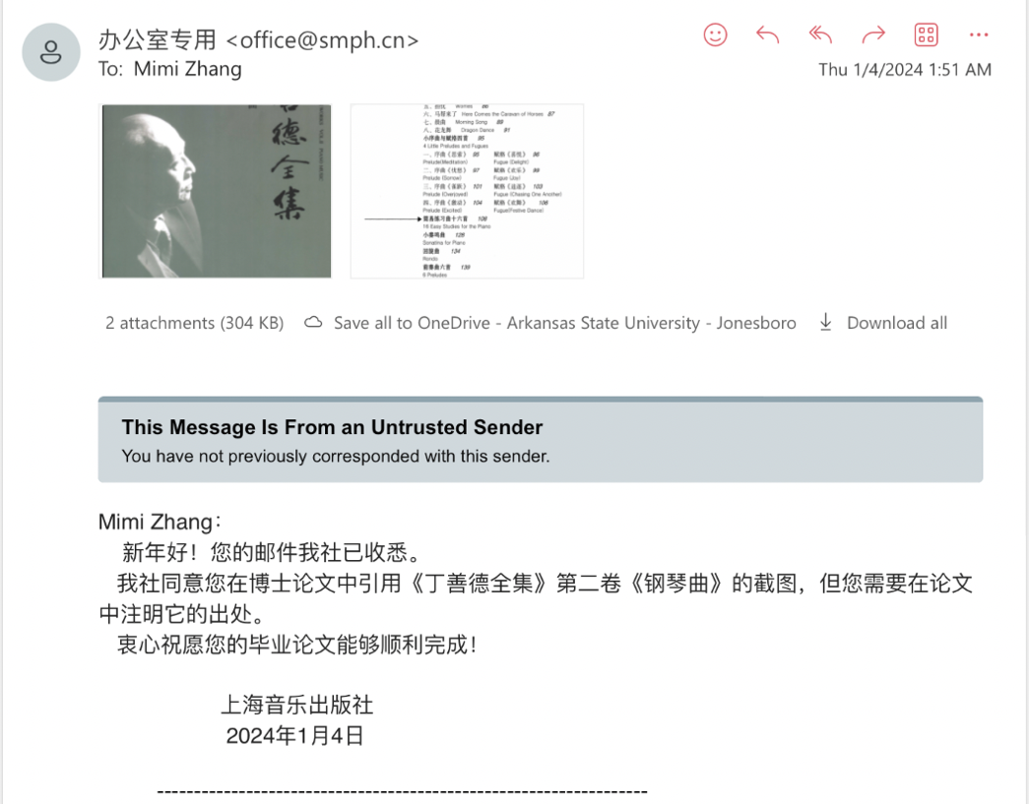
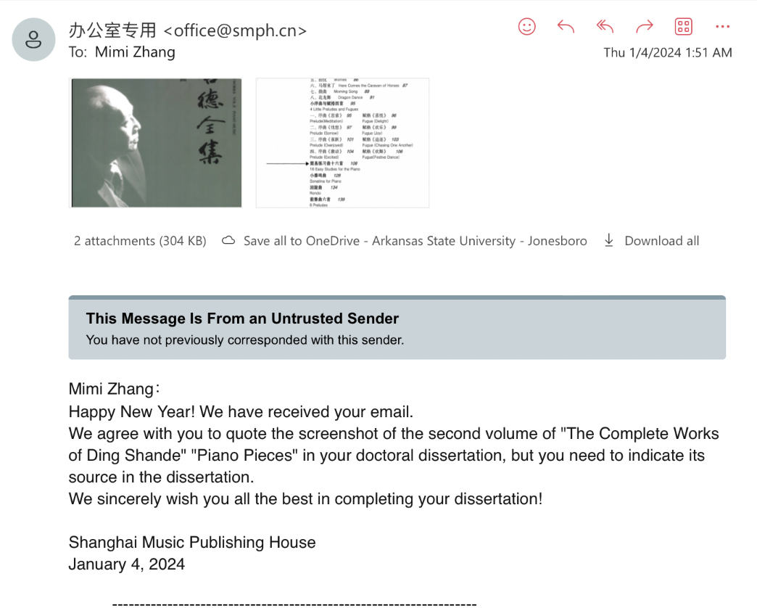

In this document, Chinese composers and authors are referred to by their last names first, following Chinese naming conventions. The majority of the sources used in this document are translated from Chinese text, which all follow this naming convention. Additionally, Liang-Yun You’s dissertation, the most prominent English language dissertation on Ding Shande’s solo piano output, adheres to this naming tradition; Penghai Dai, Ding Shande’s Music (Beijing: Central Conservatory of Music Publishing, 1993), 4, translated by the author; Penghai Dai, Ding Shande’s Musical Writings (Shanghai Conservatory of Music Press, 2006), 3, translated by the author.
Dai, Ding Shande’s Musical Writings, 337.
Xu Zhou, “Shande Ding: An Examination of His Compositional Style and Influences from Western Composers” (D.M.A. diss., Arizona State University, 2020), 3, ProQuest Dissertations & Theses Global.
Ding, Shande, Ding Shande Complete Works Vol. II Piano Music (Shanghai: Shanghai Publishing House, 2011), 1-166.
Penghai Dai, Ding Shande’s Music (Beijing: Central Conservatory of Music Publishing, 1993), 13.
An important figure in Ding Shande’s life was Professor Xiao Youmei (1884-1940), who helped establish Shanghai Conservatory in 1927. Xiao Youmei served as the first president of Shanghai Conservatory of Music.
Danny Zhou, “China’s First Recital and Recording Pianist Ding Shande: A Critical Examination of His Performing Career and Performance Style,” Twentieth Century Music 20, no. 2 (2023): 191.
Dai, Ding Shande’s Musical Writings, 2.
Songwen Li, “A Summary of the Academic Symposium on the Commemoration of the 110th Anniversary of Ding Shande’s Birth,” People’s Music Journal, no. 5 (2022): 46, translated by the author.
Dai, Ding Shande’s Music, 139.
Zhou Guangren (1928-2022) was an influential Chinese pianist, pedagogue and adjudicator. She toured internationally, giving 29 recitals in the USA in 1980. Zhou was the first place winner of the Schumann International Piano Competition in 1956. She has adjudicated for the Van Cliburn International Piano Competition, Gina Bachauer International Piano Competition, Leeds International Piano Competition, and more. Notably, Zhou Guangren was the ‘grand teacher’ of concert pianist, Li Yundi.
Zhu Gongyi (1922-1986) was a Chinese pianist, composer, pedagogue and adjudicator. Zhu was the professor of piano and chair of the piano department (1979) at the Central Conservatory. His grandson, Alvin Zhu, currently serves as the artistic director and professor of piano at the Tianjin Julliard School.
Chen Mingzhi (1925-2009) was a pianist, composer, and educator. Chen served as the director of the composition and conducting department of the Shanghai Conservatory of Music. His output includes orchestral, instrumental, chamber, and solo works. Chen was known for his polyphonic compositions.
Liang-Yun You, “A Survey’s of Ding Shan-de’s Piano Works” (DMA diss., University of Houston, 2004), 9, ProQuest Dissertations & Theses Global; Dai, Ding Shande’s Music, 3.
Dai, Ding Shande’s Musical Writings, 337.
You, “Ding Shan-de’s Piano Works,” 1.
Wang, “Harmonic Language,” 92-98.
Ding Shande was also an organist, violinist, and vocalist.
Shande Ding, Yiping Qian, Yuyan Yang, and Mingzi Chen, Memory and Analysis of Ding Shande’s Music Compositions. 2nd ed. (Shanghai: Shanghai Publishing House, 1986), 13-14, translated by the author.
Ibid., 20.
Ding Shande. First Lessons in Piano, 3rd ed. (Beijing: Beijing Publishing House, 1957), translated by the author.
Though the three editions of this method are now out of print, the third edition, published by Beijing Music Publishing House in 1957, with a forward by the composer, was available for this research through an interlibrary loan from the University of Oklahoma.
The Royal Conservatory, Piano Repertoire Level 8 (Toronto: The Royal Conservatory, 2022).
Nancy Faber and Randall Faber, ChordTime® Piano Music from China – Level 1 (Michigan: Faber Piano Adventures, 2020), 11.
Nancy Faber and Randall Faber, ChordTime® Piano Music from China – Level 2B (Michigan: Faber Piano Adventures, 2020), 20-23.
The Royal Conservatory, Piano Syllabus 2022 Edition (Toronto: The Royal Conservatory, 2022), PDF file, 75, https://rcmusic-kentico-cdn.s3.amazonaws.com/rcm/media/main/about%20us/rcm%20publishing/piano-syllabus-2022-edition.pdf.
Jane Magrath, Piano Literature for Teaching and Performance, (The Frances Clark Center for Keyboard Pedagogy, 2021).
Maurice Hinson, Guide to the Pianist’s Repertoire, Third Edition (Bloomington: Indiana University Press, 2021).
Li, “Symposium on Ding Shande,” 47-48.
Ibid., 48.
Dai, Ding Shande’s Musical Writings, 1.
The two libraries that contain Ding Shande’s piano method, First Lessons in Piano are Cornell University in New York, USA, and University of Hong Kong in Hong Kong.
“The Piano Shop on Nanking Road: A Brief History of S. Moutrie and Co.,” Shanghai Sojourns, July 19, 2020, http://shanghaisojourns.net/shanghais-dancing-world/2020/7/19/the-piano-shop-on-nanking-road-a-brief-history-of-s-moutrie-and-co.
Daxue Consulting, “The Piano Industry in China,” Daxue Consulting. Accessed [May 6, 2024], https://daxueconsulting.com/the-piano-industry-in-china/
Bo Tu, “Study on the Development of Chinese Piano Music Culture,” Advances in Social Science, Education and Humanities Research, no. 310 (2019): 245.
Weimin Zhou, “The History and Development of Chinese Piano Education,” Chinese Music, no. 2 (2010): 145.
Xiaojun Guo, “The Status of Pre-College Piano Teaching in China” (M.M Thesis., California State University, Northridge, 2019), 19, ProQuest Dissertations & Theses Global.
Ding, Qian, Yang, and Chen, Memory and Analysis.
Dai, Ding Shande’s Musical Writings.
Penghai Dai, Ding Shande and His Musical Works: Proceedings from the Fourth Annual Conference of Modern Music at Shanghai Conservatory of Music (Shanghai: Shanghai Music Publishing House, 1993), translated by the author.
Magrath, Piano Literature.
Frank Kouwenhoven, “Ding Shande,” Grove Music Online, January 20, 2001, accessed October 1, 2023, https://doi-org.ezproxy.lib.ou.edu/10.1093/gmo/9781561592630.article.49470
You, “Ding Shan-de’s Piano Works”; Zhou, “Shande Ding: An Examination of His Compositional Style and Influences from Western Composers.”
Zijie Ma, "The Presentation and Adaptation of Xinjiang Musical Elements in Chinese Piano Composition: An Analysis of Three Xinjiang Style Piano Works" (D.M.A. diss., University of Alabama, 2023), ProQuest Dissertations & Theses Global; Yao Lin, “East Meets West: Influential Elements of Western Piano Music on Chinese Piano Music” (D.M.A. diss., University of Maryland, College Park, 2023). ProQuest Dissertations & Theses Global; Heidi Astle Worsham, “A Teacher’s Guide to Diverse Piano Repertoire: An Annotated Bibliography of Intermediate Level Repertoire by Historically Underrepresented Composers through each Historical Period” (D.M.A. diss., The University of Iowa, 2022). ProQuest Dissertations & Theses Global; Jingbei Li, “The Preludes in Chinese Style: Three Selected Piano Preludes from Ding Shan-De, Chen Ming-Zhi and Zhang Shuai to Exemplify the Varieties of Chinese Piano Preludes” (D.M.A. diss., The Ohio State University, 2019), ProQuest Dissertations & Theses Global.
Sha Sha, “Musical and Performance Analysis of the Two Piano Music Works First Dance in Xinjiang and Spring Dance” (Northeast Normal University Global, 2009), ProQuest Dissertations & Theses Global.
You, “Ding Shan-de’s Piano Works”; Zhou, “Shande Ding Compositional Style”; Zijie Ma, "Xinjiang Musical Elements"; Yao Lin, “East Meets West”; Heidi Astle Worsham, “Diverse Piano Repertoire”; Jingbei Li, “Preludes in Chinese Style.”
Sha Sha, “First Dance and Spring Dance.”
The six English-written dissertations are authored by You Liang-Yun, Xu Zhou, Ma Zijie, Lin Yao, Heidi Astle Worsham, and Li Jingbei, and the Chinese master’s thesis is authored by Sha Sha.
You, “Ding Shan-de’s Piano Works.”
Analyzed works in Liang-Yun You’s document include Spring Trip Suite, op. 1, Piano Sonata in E Major, op. 2, Three Overtures, op. 3, Variations on a Chinese Folk Song, op. 4, First Xinjiang Dance, op. 6, Second Xinjiang Dance, op. 11, Children’s Suite: Merry Holiday, op. 9, Toccata, op. 13, and Four Little Preludes and Fugues, op. 29.
Zhou, “Shande Ding Compositional Style”; In this dissertation, Zhou refers to Ding using the American tradition of first name, followed by last name, as done by some English written dissertations on Ding Shande.
Zhou, “Shande Ding Compositional Style,” 47-48.
In Zhou’s dissertation, nine pages were dedicated to providing short pedagogical suggestions for the following works: 16 Easy Etudes, op. 31, no. 2, Six Preludes, op. 34, no. 1 and 2, Piano Sonata in E major, op. 2 first movement, Spring Trip, op. 1, no. 1 and 2, First Xinjiang Dance, op. 6. This brief pedagogical overview was provided for the purpose of showcasing Ding Shande’s representation of Eastern and Western compositional influences.
Three Overtures, op. 3, is also often referred to as Three Preludes, op. 3.
Zhou, “Shande Ding Compositional Style,” 26.
You, “Ding Shan-de’s Piano Works,” 1-4.
Ma, "Xinjiang Musical Elements."
Sha, “First Dance and Spring Dance.”
Lin, “East Meets West.”
Keli Xu, “Piano Teaching in China During the Twentieth Century” (D.M.A. diss., University of Illinois at Urbana-Champaign, 2001). ProQuest Dissertations & Theses Global.
Xu, “Teaching in China,” 118.
In addition to Ding Shande, Xu states that other important first generation pianists include Li Xianmin (Alexander Tcherpnin’s wife), Li Cuizhen, and Wu Leyi, all of whom studied with Boris Zakharov. These musicians were considered the first generation of piano teachers in China, and thus, the leaders of piano pedagogy in China.
Yangjie Fan, “Interpretation of the National Characteristics of Ding Shande’s Piano Music Creation,” Drama House, no.14 (2018), translated by the author; Xiao Duan Cai, “Ding Shande’s Innovative Practice of Nationalizing Piano Music,” Northern Music, no. 16 (2017), translated by the author; Yuan Qin and Yue Jin, “A Brief Analysis of the Performance Artistic Characteristics of Piano Music Works: The First Xinjiang Dance and Spring Dance,” Journal of Mudanjiang College of Education, no. 3 (2015), translated by the author; Yi Wang, “Research on Ding Shande’s Piano Music Creation,” Music Space and Time, no. 10 (2014), translated by the author; Wei Wang, “Harmonic Language of Ding Shande’s Piano Works,” Journal of Wuhan Conservatory of Music, no. 3 (2000), translated by the author; Wuping Li, “A Brief Analysis of the Teaching of Ding Shande’s Children’s Suite: Happy Festival: ‘Hide and Seek,’” Popular Literature and Art, no. 23 (2011), translated by the author; Li, “110th Anniversary”; Penghai Dai, “Musician Mr. Ding Shande’s Career (1911-1995): Contribution to Ding Shande’s Memorial Picture Album,” Art of Music – Journal of the Shanghai Conservatory of Music, Issue 4 (2001), translated by the author.
Danny Zhou, “China’s First Recital and Recording Pianist Ding Shande: A Critical Examination of His Performing Career and Performance Style,” Twentieth Century Music 20, no. 2 (2023).
Yangjie Fan, “National Characteristics,” 81.
Ibid., 81.
Xiao Duan Cai, “Nationalizing Piano Music,” 18.
Ibid., 18-20.
Ibid., 19.
Yuan Qin and Yue Jin, “Dance and Spring Dance,” 114-115.
Ibid., 115.
Yi Wang, “Ding Shande’s Piano Music,” 121.
Ibid., 121.
Wei Wang, “Harmonic Language,” 92-98.
Works discussed: Spring Suite op. 2 IV.” Breezing in the Morning,” First Xinjiang Dance, op. 6, Eight Pieces for Children: VIII. “Dragon Dance,” Toccata, op. 13, Sonata in E Major, op. 2, Second Xinjiang Dance, op. 11, and Six Preludes, op. 34, no. 6, Variations on a Chinese Folk Song, op. 36
Wang, “Harmonic Language,” 92-98.
Wuping Li, “Happy Festival: ‘Hide and Seek,’” 327.
Danny Zhou, “China’s First Recital Pianist,” 187-214.
Danny Zhou, “China’s First Recital Pianist,” 199.
Li, “110th Anniversary”; Penghai Dai, “Musician Ding Shande’s Career.”
Li, “110th Anniversary,” 47-48.
Penghai Dai, “Musician Ding Shande’s Career,” 6-17.
Shande Ding, Ding Shande Complete Works Vol I-VIII (Shanghai: Shanghai Music Publishing House, 2011).
Ding, Ding Shande Complete Works Vol. II Piano Music.
On January 4th, 2024, the author obtained written permission from Shanghai Music House via email to use screenshots from the second volume Ding Shande Complete Works Vol. II Piano Music.
The current author does not have access to the complete eight-volume collection. However, volume two of this collection, containing solo piano works was purchased via secondhand through a secondhand bookstore.
Shande Ding. Ding Shande Piano Collection. Edited by Qian Yiping. (Shanghai: Shanghai Publishing House, 1997).
Ding, Vol. II Piano Music.
Shande Ding, Ding Shande: Short Piano Works. Edited by Qiu Chengyu. (Shanghai: Shanghai Publishing House, 1989).
Ding, Short Piano Works.
Shande Ding, Chinese Piano Music for Children. Edited by Naixiong Liao. Germany: B. Schott Söhne, Mainz, 1990).
Ding, First Lessons in Piano.
Dai, Ding Shande’s Musical Writings.
Ding translated three French theory textbooks used at the Paris Conservatoire into Chinese to use as teaching material at the Shanghai Conservatory: Single Counterpoint, The Outline of Complex Counterpoint, and Outline of Fugue Writing. Completed in 1952, Single Counterpoint was a translation of two textbooks used at the Paris Conservatoire: one written by Marcel Dupré and the latter written by Noel Gallon. Next, completed in 1953, The Outline of Complex Counterpoint was a translation of several counterpoint textbooks written theorists Marcel Dupré, Ebenezer Prout, and Noel Gallon. Lastly, Outline of Fugue Writing was a translation of a counterpoint and polyphonic writing textbook written by André Gedalge, completed by Ding Shande in 1957.
Authored by Ding Shande, this composition treatise is not a translation, but an original theoretical treatise written by Ding Shande, entitled “Exploration of Compositional Techniques,” completed in 1989.
Dai, Ding Shande’s Musical Writings, 1.
Dai, Ding Shande’s Musical Writings, 59.
Ibid., 279.
Shande Ding, “Why Chinese People Accept and Understand Chopin’s Music,” Music Research, no. 2 (1960), translated by the author.
Prior to 1960, China underwent years of political turmoil, namely the Second Sino-Japanese War (1937-1945), which wearied Chinese citizens to be weary of foreign attack. The Second Sino-Japanese War is known as the start of World War II in Asia.
Dai, Ding Shande’s Musical Writings, 60.
Ibid., 62.
Yange Wei, “Interview Regarding Early Piano Teaching,” Chinese Music, no. 4 (1982), translated by the author.
Dai, Ding Shande’s Musical Writings, 279.
Dai, Ding Shande’s Musical Writings, 279-283.
Yong-chi Chan, “Appreciating Serious Music Requires Understanding of Culture Climate,” Ming Pao Monthly (1983), translated by the author.
Dai, Ding Shande’s Musical Writings, 282-283.
Penghai Dai, Ding Shande’s Music. (Beijing: Central Conservatory of Music Publishing, 1993), 7-8.
Ding, Qian, Yang, and Chen, Memory and Analysis.
Li, “Happy Festival,” 327.
Qin and Yuan, “Xinjiang Dance Spring Dance,” 114-115.
Zhou, “Shande Ding Compositional Style.”
Jiannuo Ding, The 100th Anniversary of Ding Shande’s Collection. (Shanghai: Shanghai Music Publishing House, 2011), 1, translated by the author.
“Sizhu” translates to “silk and bamboo.” ‘Silk’ instruments are stringed, while ‘bamboo’ are hollow. For instance, the Erhu is classified as a ‘silk’ instrument, while the Dizi is a classified as a ‘bamboo’ instrument.
Dai, Ding Shande’s Music, 7-8.
Jiangnan is a region in China located at the southern reaches of the Yangtze River.
Dai, Ding Shande’s Music, 9.
Ibid., 11.
Ibid., 11.
Dai, Ding Shande’s Music, 12.
Ibid., 15.
Dai, Ding Shande’s Musical Writings, 279.
Ibid., 280.
Dai, Ding Shande’s Music, 21.
In November of 1929, Ding was invited by the Ministry of Education to perform a concert in Nanjing, amongst other students of the conservatory. This was Ding’s first time traveling outside of the conservatory for a performance. He performed a Pipa solo at this concert.
Dai, Ding Shande’s Music, 21.
Dai, Ding Shande’s Music, 24.
Ibid., 30.
Dai Penghai omitted the BWV to this Prelude and Fugue in G Major. The referenced piece could either be Prelude and Fugue in G Major, BWV 860, or Prelude and Fugue in G Major, BWV 884.
At this performance, Dai Penghai states the Ding performed Tcherepnin’s two bagatelles, omitting the opus number and bagatelle numbers. It is likely that Dai was referring to Tcherepnin’s Bagatelles op. 10.
Dai, Ding Shande’s Music, 32.
Shande Ding, “Reflections on Chinese Music,” Music Magazine of the Musical Arts and Literature Society, no. 1 (1934), translated by the author.
Ding, “Reflections on Chinese Music, 35.
Jiannuo Ding, The 100th Anniversary, 8.
Ding, “Reflections on Chinese Music, 35.
Li, “110th Anniversary of Ding Shande’s Birth,” 46.
Dai, Ding Shande’s Music, 36.
You, “Ding Shan-de’s Piano Works,” 8.
Dai, Ding Shande’s Music, 39.
Ibid., 37; Jiannuo Ding, The 100th Anniversary, 9.
The Chinese Civil War (1927-1949) was fought between the Nationalist Party and the Communist Party. The Nationalist Party was led by Chiang Kai-shek, while the Communist Part was led by Mao Zedong. Both political parties had different ideologies on the unification of China. The Nationalist Party sought out unification and reform through nationalism, democracy through a multi-party governing system, and the eradication of feudalism/imperialism. The Communist Party sought out unification through a peasant-led revolution, guerrilla warfare, and a classless society. However, this war was interrupted by the Second Sino-Japanese War (1937-1945), where both parties united briefly to resist Japanese invasion.
Dai, Ding Shande’s Music, 39.
The state of China’s politics continued to worsen. On July 7th, Japanese troops demanded entry into Wanping, a city near Beijing, after claiming that one of their soldiers went missing in that area. China denied entry and violence escalated, initiating a seven-year war between the Chinese and Japanese known as the Second Sino-Japanese War (1937-1945).
Dai, Ding Shande’s Music, 42.
Dai, Ding Shande’s Music, 42.
You, “Ding Shan-de’s Piano Works,” 8.
Dai, Ding Shande’s Music, 44.
The first edition of First Lessons in Piano was composed in 1941, while the final and third edition was published in 1957. The author utilized the 1957 edition.
Dai, Ding Shande’s Music, 42.
Ibid., 48.
Ding, Qian, Yang, and Chen, Memory and Analysis, 13.
Dai, Ding Shande’s Musical Writings, 281.
Xia Su, “Ding Shande’s Piano Music in His Youth.” In Ding Shande and His Musical Works: Proceedings from the Fourth Annual Conference of Modern Music at Shanghai Conservatory of Music, ed. by Dai Penghai (Shanghai, Shanghai Music Publishing House, 1993), 40, translated by the author.
Dai, Ding Shande’s Musical Writings, 282.
Dai, Ding Shande’s Music, 63.
Jiannuo Ding, The 100th Anniversary, 19.
You, “Ding Shan-de’s Piano Works,” 1.
Dai, Ding Shande’s Music, 65-67.
Ding, Qian, Yang, and Chen, Memory and Analysis, 41-48.
Dai, Ding Shande’s Music, 69-72.
In 1950s China, the aftershocks of the Second Sino-Japanese War (1937-45) caused a nationwide and public fear of invasion.
Dai, Ding Shande’s Musical Writings, 293.
Ibid., 297.
Dai, Ding Shande’s Music, 91.
Dai, Ding Shande’s Musical Writings, 280.
Dai, Ding Shande’s Music, 97-98.
Ibid., 99.
Dai, Ding Shande’s Music, 99.
Ibid.
Ibid., 101.
A ‘foreign work’ refers to any work originating from outside of China.
During the Cultural Revolution, “big-character” posters were used to display public messages, often displaying propaganda or the criticism of individuals.
Dai, Ding Shande’s Music, 103.
Established by the Communist Party, the Red Guards were a civilian-led military group, primarily made up of high school and university-age students. The Red Guards are also referred to as the ‘rebels.’ They sought the downfall of intellectuals, scientists, musicians, artists, educators, institutions, and established authorities.
Dai, Ding Shande’s Music, 104.
Dai, Ding Shande’s Music, 105.
Ibid., 106.
Ibid., 107.
Dai, Ding Shande’s Music, 108.
The death of Mao Zedong (1893-1976) marked the conclusion of the Cultural Revolution. The key figures of the movement, known as the Gang of Four, were subsequently arrested and tried.
Shande Ding, Ding Shande’s Art Song Collection, (Shanghai: Shanghai Music Publishing House, 1984), 45.
These works include op. 19 through op. 36.
Dai, Ding Shande’s Music, 136.
Ibid.
Shande Ding, Ding Shande Complete Works Vol.VI Concerto (Shanghai: Shanghai Music Publishing House, 2011), 7.
Dai, Ding Shande’s Music, 144.
Ibid., 146.
Dai Penghai refers to 1980 as Ding’s year of ‘foreign affairs.’ He established relations with musicians and diplomatic officials from Sweden, Poland, Japan, Canada, Belgium, the Netherlands, United Kingdom, Cambodia, Romania, United States, and Hong Kong. Additionally, in November of 1980, Ding welcomed John Giordano, chairman of the Van Cliburn International Competition to Shanghai for a banquet; Dai, Ding Shande’s Music, 115-117.
Dai, Ding Shande’s Music, 136.
You, “Ding Shan-de’s Piano Works,” 63.
Ding took a 29 gap from composing solo piano works from 1958 to 1987. Prior to 1987, the most recent solo piano work composed was in 1958, entitled Toccata op. 13.
The eight solo piano works composed between 1987 and 1995 include Eight Piano Pieces for Piano, op. 28, Four Little Preludes and Fugues, op. 29, Sixteen Easy Studies for Piano, op. 31, Sonatina, op. 32, Rondo, op. 33, Six Preludes, op. 34, Scherzo, op. 35, and Three Piano Pieces on a Chinese Folk Song, op. 36.
Dai, Ding Shande’s Music, 149.
Nan Chen, “The Art of Songwriting.” China Daily, (2021), 18.
Shanghai Symphony Orchestra, “SSO in Concert, Long Yu Conducts Ding Shande,” YouTube video, 33:00, January 15, 2021, https://youtu.be/nJG6mrsFcWE?si=00x8jQTylNc_mPoh (accessed January 30, 2024).
This concert featured Four Songs, op. 17, no. 2, Poems of Yunnan, op. 22, Five Chinese Folk Songs, op. 12, and Mysterious Flute Sound, op. 5, no. 1.
Jiannuo Ding, Ding: Piano Music. Yellow River 82083, 2000, CD.
Dai, Ding Shande’s Musical Writings, 337.
Ibid., 171-178.
Shande Ding, Exploration of Composition Techniques, (Shanghai Music Publishing House, 1990), translated by the author.
Dai, Ding Shande’s Musical Writings, 335.
Ibid.
Dai, Ding Shande’s Musical Writings, 335.
You, “Ding Shan-de’s Piano Works,” 1.
Including other genres, early period (pre-1947) works include Spring Suite, op. 1 (1945), and Sonata in E Major, op. 2 (1946).
Dai, Ding Shande’s Music, 167; Across all genres, compositions of the transitional (1947-49) period include Three Overtures, op. 3 (1947), Variations on a Chinese Folk Theme, op. 4 (1948), Mysterious Flute Sound, op. 5 (1948), and New China Symphonic Suite, op. 7 (1949).
Dai, Ding Shande’s Music, 167-168; Across all genres, compositions of the mature (1948-66) period include First Xinjiang Dance, op. 6 (1950), Children’s Suite: Happy Holidays, Op. 9 (1953), Four Songs, op. 10 (1955), Second Xinjiang Dance, op. 11 (1955), Five Chinese Folk Songs, op. 12 (1955), Toccata, op. 13 (1958), Cantata: Ode to the Huangpu River, op. 14, Blue Fog, op. 15 (1958), Long March Symphony, op. 16 (1962), Four Songs, op. 17 (1961).
Dai, Ding Shande’s Music, 168-169; Across all genres, compositions of the late period (1967-95) include Two Songs, op. 19 (1977-82), Up the Mountain, Looking at Pingchuan, op. 18 (1978), Symphonic Overture, op. 20 (1983), Piano Trio in C Major, op. 21 (1984), Poetry of Western Yunnan, op. 22 (1984), Piano Concerto in B-flat Major, op. 23 (1984), Symphonic Poem “Spring,” op. 24 (1984), String Quartet in E minor, op. 25 (1985), Three Solo Songs, op. 26 (1986), Ode to Orange, op. 27 (1987), Eight Piano Pieces for Children, op. 28 (1987), Four Little Preludes and Fugues, op. 29 (1988), Sonata for Violin and Piano, op. 30 (1988), 16 Easy Studies for the Piano, op. 31 (1988), Sonatina for Piano, op. 32 (1988), Rondo, op. 33 (1988), Six Preludes, op. 34 (1989), Scherzo, op. 35 (1989), and Three Piano Pieces on a Chinese Folk Song, op. 36 (1992).
Analysis will be provided for nos. 1, 2, 3, 4, 5, 6, 7, 8, 9, 12, 13, 15, 16, 17, 18, 19, 20, 22, 24, 25, 26, 27, 28, 30, 31, 32, 33, 34, 35, 37, 39, 40, 41, 46, 49, 50, 51, 52, 53, 55, 56, 57, 58, 59, 60, 61, 64, 68, 69, and 71.
Magrath, Piano Literature.
The second edition was published sometime in the early 1950s, and the third was published by Beijing Publishing House in 1957.
Dai, Ding Shande’s Music, 49.
John Thompson, Teaching Little Fingers to Play (Cincinnati: The Willis Music Co, 1936).
David Carr Glover and Louis Garrow, David Carr Glover Piano Library (California: Alfred Music Publishing, 1967).
John. W. Schaum, John W. Schaum Piano Course (Cincinnati: Belwin-Mills Publishing, 1973).
John Thompson, Teaching Little Fingers, 5.
David Carr Glover and Louis Garrow, Glover Piano Library, 7.
John. W. Schaum, John W. Schaum Piano Course, 6.
John Thompson’s Teaching Little Fingers to Play, David Carr Glover’s Glover Piano Library, and John W. Schaum’s Piano Course, all introduced the quarter note value first.
John Thompson, John Thompson’s Easiest Piano Course: Part One (Cincinnati: The Willis Music Co, 1955), 8.
Magrath, Piano Literature, 6.
John Thompson, John Thompson Modern Course for the Piano: The First Grade Book (Cincinnati: The Willis Music Co, 1936), 74.
Analysis will be provided for nos. 1, 2, 3, 4, 5, 6, 7, 8, 9, 12, 13, 15, 16, 17, 18, 19, 20, 22, 24, 25, 26, 27, 28, 30, 31, 32, 33, 34, 35, 37, 39, 40, 41, 46, 49, 50, 51, 52, 53, 55, 56, 57, 58, 59, 60, 61, 64, 68, 69, and 71.
Jeanine M. Jacobson, Professional Piano Teaching, Vol. 1 (Alfred Music Publishing, 2016), 35.
The current author annotated the boxes on the score to help the reader locate the referenced octaves.
Jacobson, Professional Piano Teaching, 39.
Contemporaneous primer method books, such as John Thompson’s Teaching Little Fingers to Play, David Carr Glover’s Glover Piano Library, and John W. Schaum’s Piano Course, all introduce the quarter note value first.
Jacobson, Professional Piano Teaching, 35.
Thompson, Teaching Little Fingers.
Glover and Garrow, Glover Piano Library.
Schaum, Piano Course.
In middle C five finger position, thumbs (finger number one) are placed on middle C, and the remaining fingers are placed on adjacent notes.
Thompson, Teaching Little Fingers.
Alan R. Thrasher, “The Melodic Structure of Jiangnan Sizhu,” Ethnomusicology 29, no. 2 (1985): 244.
Jacobson, Professional Piano Teaching, 39.
In exercises 24-29, Ding primarily uses middle C position, but occasionally utilizes finger crossings (3-1 or 1-3) to shift the hands briefly into new positions.
In exercises 30-37, Ding shifts between several positions, including middle C position, right hand one on treble C, left hand five on bass C, right hand three on treble C, right hand A minor five finger position, and right hand G five finger position.
Call and response is a compositional technique that features at least two successive phrases, where the second phrase is composed in response to the first, contributing to a conversational quality. It is an effective tool in music education, both in the classroom and private setting.
In this case, a direct shift is described as the simple movement from one position to another, without the use of a finger crossing or finger extension.
Faber, Music from China – Level 2B, 20-21.
In the Faber method, an introductory description is provided for “Luhua Rooster” on page 20, claiming that the work originates from Ding Shande’s collection for children, Happy Festival. However, the origin claim is inaccurate, as Happy Festival, otherwise known as Children’s Suite: Happy Holiday, op. 9, is a late intermediate work composed in 1953, containing five movements titled, “Outing,” “Catching Butterflies,” “Skipping,” “Hide and Seek,” and “Holiday’s Dance.” “Luhua Rooster” does not originate in or reference material from Happy Festival. Refer to Appendix A for full catalogue and leveling of Ding Shande’s works.
Typically, drones are associated with pastoral themes and topics.
The traditional Alberti-bass pattern features a broken chord accompaniment, where the notes of the chord are arranged in the following order: bottom-top-middle-top. For example, a C-major Alberti-bass pattern would possess the following notes in this order: C-G-E-G.
Dai, Ding Shande’s Music, 148.
“The Modern Music Society of Shanghai Conservatory of Music” was established in commemoration of the 60th anniversary of the Shanghai Conservatory, its first meeting was held at the Shanghai Conservatory in 1987; Dai, Ding Shande’s Music, 149.
Eight Piano Pieces for Children, op. 28 is the first solo piano work composed since Toccata, op. 13 (1958), dated to 1958. Toccata, op. 13 is the final solo piano work of his mature period (1949-66), while Eight Piano Pieces for Children, op. 28 is the first work of his late (1977-95) period. Although Ding took a hiatus from solo piano composition between 1958-1987, he composed works of other genres during that time span.
You, “Ding Shan-de’s Piano Works,” 68.
Zhijie Tu, “Like a Poem, Dream, Song, Picture – Commentary on Ding Shande’s “Eight Piano Pieces for Children.”” Fujian Art, (2007), no. 5, 62-63, translated by the author.
Magrath, Piano Literature for Teaching and Performance.
Jingfang Yuan, ed., Comprehensive Introduction to Chinese Traditional Music, trans. Boyu Zhang and Lam Ching-Wah (Wien: Hollitzer Verlag, 2023), 299.
Lang Liu, “An Exploration Towards the Enrichment of a Personal Musical Language in Musical Composition” (D.M.A. diss., Royal College of Music, 2019), 8-9.
For example, Edna-Mae Burnam’s A Dozen a Day: Preparatory Book, Group II, No.6 “Jumping Like a Frog,” can be assigned to prepare the student for the grace notes in “Puzzles”; Edna-Mae Burnam, A Dozen a Day: Preparatory Book (Willis Music, 2005), 11.
Trân Van Khê, “Chinese Music and Musical Traditions of Eastern Asia,” The World of Music 27, no. 1 (1985): 81.
In this case, ‘small hands’ refers to a thumb to pinky span lesser than an octave.
Van Khê, “Chinese Music,” 81.
Provide preparatory exercises, such as, A Dozen a Day: Book 2, Group II, No. 4 “Chinning Yourself,” to prevent tension buildup., Edna-Mae Burnam, A Dozen a Day: Preparatory Book (Willis Music, 2005), 10.
“Elephant-foot Drum Dance of Dai Ethnic Minority in Yinjiang County, Dehong,” Yunnan Exploration, accessed January 19, 2024, https://www.yunnanexploration.com/elephant-foot-drum-dance-of-dai-ethnic-minority-in-yingjiang-county-dehong.html
“Demonstration of Chinese Musical Instruments: Percussion Mangluo Gong,” Taipei Chinese Orchestra, August 21, 2021, video, 00:08, https://youtu.be/wWNxIwpmTaI?si=mxBMc-RyKegehCjr.
Jingfang Yuan, ed., Chinese Traditional Music, 140.
Jingfang Yuan, ed., Chinese Traditional Music, 139.
Ibid., 139.
Wang, “Harmonic Language,” 92-98.
Xtaaxba. “Elephant-foot Drum Dance One Kind of Dai Minority Dance.” YouTube video, 02:52, posted January 10, 2010, https://youtu.be/UVmqUzJuZ8c?si=N3Y-9r81z45v2byK.
Van Khê, “Chinese Music,” 81.
‘Chunking,’ also known as ‘blocking,’ is a pedagogical practice where all pitches in a hand position are played simultaneously.
Trân Van Khê, “Chinese Music and Musical Traditions of Eastern Asia,” The World of Music 27, no. 1 (1985): 81.
Zhijie Tu, “Like a Poem,” 62-63.
Qi Zhang, “Exploration and Analysis on the Development of Chinese Dragon Dance and the Training System of Dragon Dancing in Universities.” Journal of Humanities, Arts and Social Science, no.7 (2023), 461.
Museum of Chinese in America, “Shaolin Dragon Dancing,” January 23, 2023. https://www.mocanyc.org/2023/01/22/shaolin-dragon-dancing/.
“Dragon Dance Performance in Kuala Lumpur, Malaysia,” Nationsonline.org, 2015, accessed March 26, 2024, https://www.nationsonline.org/oneworld/Chinese_Customs/dragon_dance.htm#googlevignette.
Shande Ding, “Reflections on Chinese Music,” Music Magazine of the Musical Arts and Literature Society, no. 1 (1934).
Dai, Ding Shande’s Musical Writings, 337.

