University of Oklahoma

Graduate College

TOWARD AN INTEGRATED ASSESSMENT OF RISK PERCEPTIONS: DEVELOPMENT AND TESTING OF THE BERLIN RISK PERCEPTION INVENTORY

A DISSERTATION

submitted to the Graduate Faculty

in partial fulfillment of the requirements for the

Degree of

DOCTOR OF PHILOSOPHY

By

Madhuri Ramasubramanian
Norman, Oklahoma
2022
TOWARD AN INTEGRATED ASSESSMENT OF RISK PERCEPTIONS: DEVELOPMENT AND TESTING OF THE BERLIN RISK PERCEPTION INVENTORY

A DISSERTATION APPROVED FOR THE
Department of Psychology

BY The Committee COnsisting of

Dr. Edward T. Cokely, Chair

Dr. Robert Terry

Dr. Adam Feltz

Dr. Hank Jenkins-Smith

© Copyright by Madhuri Ramasubramanian 2022
All Rights Reserved.

Acknowledgements
This dissertation would not have been possible without the mentorship of my advisor, the guidance provided by my professors and the support lent by my friends and family. First, I would like to extend my deepest gratitude to my advisor Dr. Edward T. Cokely. Besides being a constant source of support through the last six years, he has also taught me so much about the value of robust, applied research that can create a positive manifold for various stakeholders. Ed, I know for a fact that I would not be where I am today if you had not invested your time, energy, and effort to help me become a true scholar. Thank you for always believing in me, even when I didn’t believe in myself.
To the other members of my committee, thank you for always encouraging me to explore new ideas and being sources of inspiration. Specifically, Dr. Rocio Garcia-Retamero and Dr. Adam Feltz, thank you for always asking me the big questions, and for encouraging me to be more confident with my research. To Dr. Hank Jenkins-Smith, thank you so much for being an endless source of knowledge and for always being ready to answer any and all questions. I am so grateful that I was able to observe all the different studies and ideas that were being discussed at IPPRA. It taught me so much about conducting exciting and meaningful research studies. Finally, to Dr. Robert Terry, thank you so much for all the after-class discussions about psychometrics and measurement. Those brief talks were especially valuable and empowered me to conduct more informed statistical analyses. I am so grateful that you could be a part of my committee until the very end.
Since a young age, I’d always thought that I was not good at making friends. However, looking back, I am overwhelmed at the community I have managed to build. Starting with some of the women with whom I’ve been best friends for longer than a decade, my machis: Tasneem Mohamed and Shruti Rao. Tasneem, thank you for always being just a phone call away and in the same time zone. I do not know what I would have done those homesick nights if I didn’t have my best friend to call. Shruti, thank you for all the ‘you got this’ motivation texts when I needed it the most. Special thanks to Ishvar Mohan for always making me laugh even through the stressful times, and I am so glad you are done with your dissertation as well!
Coming to Oklahoma was exciting, but also nerve-wracking. As an international student who’d never relocated on my own before, I hoped I would be able to fit in and find friends I could truly trust and share this journey with. Little did I know that I would find a family. To Carol Silva, thank you for being just the coolest person ever, and always being a voice of reason. I’ve enjoyed getting to know you and I hope we can always stay in touch. I’ve said it before, and I will say it again: I want to be you when I grow up. To Kuhika Gupta, thank you so much for your kindness, and all the brunches, lunches, linners and dinners. I was never homesick as long as I got to spend time with you. To Silke Feltz, thank you so much for all the much-needed Jane Austen themed movie nights. I’m so glad that I was able to find a Regency era connection with you, and I look forward to writing you long, poignant, wax sealed letters.
Through my six years at the University of Oklahoma, I came across so many wonderful and amazing people. To Keith Strasbaugh, Samantha Elliot, Marina Mery, Yash Gujar, Divya Patel, Cassidy Krantz, Kenzie Krocak, Brian Ruedinger, Colleen Standish, Jenna Holt, Gwen Hoang, Dana Mahmoud, Jessica Bacerra and Samantha England, thank you for your friendship. To Joe Ripberger, thank you for always finding time to discuss my research and for answering all my questions. To my undergraduate mentees: Chika, Faith, Emily & Madeline, thank you so much for teaching me to be a mentor.
To my core group, who became and always will be my family, words cannot express how much I appreciate and value each and every one of you, but I will do my best to try. Jinan Allan, thank you for picking me up at the airport on my first day. I knew immediately as we started talking about One Tree Hill and having connections to the Middle East that we would become best friends. And we have. Megan Turner, thank you for being such a boss lady, and also for being one of the best roommates I’ve ever had. I could watch trash reality TV for the next 40 years with both of you, anytime. Vincent Ybarra and Grace Williams, thank you for always being a constant source of support and friendship. Vinny, I don’t think I would have made it through graduate school without our movie nights. Wesley Wehde, thank you for always taking the time to listen to me every time I would walk up to your desk, and for all the evenings we spent watching Glee and other bad, good and horror movies. Jinhyo Cho (and Nuri), thank you for all the big and small discussions with me about life and work, for being stable when I got excited, and for comforting me when I got emotional. I’m incredibly grateful for your friendship. Olivia Perrin, thank you for being a pillar of strength over the last year, when I was stressed, overwhelmed or anxious (which was most of the time). Thank you for all the laughs, late night chats and always being ready to get some ice cream with me.
Finally, to my family who have been by my side since the day I was born. I consider myself incredibly fortunate that both my parents and sister support me unconditionally, always. Amma, thank you for showing what strength and perseverance look like. Appa, thank you for always having faith in me, and being proud of every little achievement of mine. Manjari, I don’t want to imagine a life where I do not have you as my sister. Thank you for your support in your own quiet way and thank you for the weekly FaceTime calls. I only hope that one day I will be able to repay your trust, love, and support in some way.
Table of Contents
Acknowledgements iv
List of Tables x
List of Figures xii
Abstract xv
Chapter 1 1
Introduction: The Complex Psychology of Risk Perception 1
Two Distinct Judgment Targets: Societal v. Personal Risk Perceptions 2
A Neglected Continuum: From Specific to General Risk Perceptions 6
Current Studies 10
Chapter 2: Study 1 14
Participants and Procedure 14
Measures 14
Risk Perceptions 15
Results 18
Factor Structure of Original Risks Vs. New Risks. 18
Distilling a Brief Instrument: An Item Response Theory Approach 19
Comparing Short v. Long Forms: A Structural Predictive Modeling Approach 27
Study 1 Discussion 33
Distilling a Brief Measure of General Risk Perceptions 34
Open Questions and Future Directions 35
Chapter 3: Study 2 37
Participants and Procedure 38
Measures 38
Results 40
Comparing Long and Short Form and Other Individual Differences 40
Predicting Societal and Personal Risk Perceptions 43
Structural Evidence of Societal and Personal Risk Perceptions 44
Study 2 Discussion 57
Extension to Personal Risk Perceptions 57
Open Questions and Future Directions 58
Chapter 4: Study 3 60
Participants and Procedure 60
Measures 61
Results 62
Does the Brief Scale Predict COVID-19 Risk Perceptions with Structural Fidelity? 62
Does Domain General Risk Perception Uniquely Predict COVID-19 Risk Perceptions? 63
Do Domain General Risk Perceptions Predict Behavioral Intentions? 65
Study 3 Discussion 66
What Predicts Expert Consensus Knowledge? 67
Decomposing Dread and Unknown Factors 68
Chapter 5: General Discussion 70
A Framework for Analyzing Risk Perceptions: Analyzing Specific, General, and Relative Risk Perceptions 76
Analyzing Specific Sub-Characteristics 79
Conclusions 80
References 83
Appendix A 98
Appendix B 101
Appendix C 102

List of Tables
Table 2. 1 30 Risks Asked in Fischhoff et al., (1978) 15
Table 2. 2 Domain Specific Risks. 16
Table 2. 3 Description of the Nine Dimensions of Risk Asked in the Current Study. 17
Table 2. 4 Criteria for Distilling Representative Dimensions of Unknown and Dread Factors. 22
Table 2. 5 Unconstrained Discrimination Parameters for the Four Risks Across the Dread Factor. 24
Table 2. 6 Unconstrained Discrimination Parameters for the Four Risks Across the Unknown Factor. 24
Table 2. 7 Fit Indices and Explained Variance for Weather Risk Perceptions 29
Table 2. 8 Fit Indices and Explained Variance for Cybersecurity Risk Perceptions 31
Table 2. 9 Fit Indices and Explained Variance for Health and Safety Risk Perceptions 33

Table 3. 1 Correlation Table for Societal Risk Perceptions 42
Table 3. 2 Correlation Table for Societal Risk Perceptions 43
Table 3. 3 Correlation Table for Personal Risk Perceptions 43
Table 3. 4 Regression models predicting Societal Risk Perceptions using the short scale. 45
Table 3. 5 Table 3. 5 Regression models predicting Personal Risk Perceptions using the short scale 46

Table 4. 1 Regression models predicting COVID-19 risk perceptions to society. 64
Table 4. 2 Regression models predicting personal COVID-19 risk perceptions. 65
Table 4. 3 Regression models predicting beliefs and intentions about self-isolation and social distancing during COVID-19. 66
Table 4. 4 Regression models predicting Knowledge 68

List of Figures

Figure 1. 1 Orientations of Risk Perceptions: Personal v. Societal & General v. Specific 2

Figure 2. 1 Test Information Curves for 39 Risks Across Nine Dimensions of Risk Perceptions 23
Figure 2. 2 Four Candidate Risks Across the Dread and Unknown Two Factor Space 24
Figure 2. 3 Four Candidate Risks Across the Dread and Unknown Two Factor Space 25
Figure 2. 4 The Berlin Risk Perception Inventory 26
Figure 2. 5 Structural Equation Model for Weather Risk Perception (Long Form). 28
Figure 2. 6 Structural Equation Model for Weather Risk Perception (Restricted Scale). 29
Figure 2. 7 Structural Equation Model for Weather Risk Perception (Short form). 29
Figure 2. 8 Structural Equation Model for Cybersecurity Risk Perception (Long Form). 30
Figure 2. 9 Structural Equation Model for Cybersecurity Risk Perception (Restricted Scale). 30
Figure 2. 10 Structural Equation Model for Cybersecurity Risk Perception (Short form). 31
Figure 2. 11 Structural Equation Model for Health and Safety Risk Perception (Long Form) 32
Figure 2. 12 Structural Equation Model for Health and Safety Risk Perception (Restricted Scale) 32
Figure 2. 13 Structural Equation Model for Health and Safety Risk Perception (Short Form) 33

Figure 3. 1 Comparison of Models Predicting Societal and Personal Hacking Risk Perceptions using the Long versus Short Form 47
Figure 3. 2 Comparison of Models Predicting Societal and Personal Hurricane Risk Perceptions using the Full versus Short Scale 48
Figure 3. 3 Comparison of Models Predicting Societal and Personal Handgun Risk Perceptions using the Full versus Short Scale 49
Figure 3. 4 Comparison of Models Predicting Societal and Personal Terrorism Risk Perceptions using the Full versus Short Scale 50
Figure 3. 5 Comparison of Models Predicting Societal and Personal Terrorism Risk Perceptions using the Full versus Short Scale 51
Figure 3. 6 Comparison of Models Predicting Societal and Personal Nuclear Power Risk Perceptions using the Full versus Short Scale 52
Figure 3. 7 Comparison of Models Predicting Societal and Personal Smoking Risk Perceptions using the Full versus Short Scale 53
Figure 3. 8 Comparison of Models Predicting Societal and Personal Alcohol Risk Perceptions using the Full versus Short Scale 54
Figure 3. 9 Comparison of Models Predicting Societal and Personal Alcohol Risk Perceptions using the Full versus Short Scale 55
Figure 3. 10 Comparison of Models Predicting Societal and Personal Identity Theft Risk Perceptions using the Full versus Short Scale 56

Figure 4. 1 Structural Equation Model for COVID-19 Societal Risk Perceptions. 62
Figure 4. 2 Structural Equation Model for COVID-19 Personal Risk Perceptions. 62

Figure 5. 1 Composite overall COVID-19 risk perceptions across numeracy while accounting for composite general overall. 77
Figure 5. 2 Composite COVID-19 dread risk perceptions across numeracy while accounting for composite general dread. 78
Figure 5. 3 Standardized differences of overall risk perceptions (COVID-19 – General) across levels of numeracy. 78

Abstract
Research across four decades in psychology has suggested that risk perceptions can often be multi-dimensional, reflecting psychological constructs such as dread (how severe the consequences tend to be) and unknown (knowledge about risks; Fischhoff et al., 1978). However, research has largely neglected the assessment and integration of these dimensions across different orientations of risk perceptions (i.e., general versus specific risk perceptions; societal versus personal risk perceptions; absolute versus relative risk perceptions). As such, the current set of studies aimed to distill a brief psychometric scale to robustly measure diverse, multi-dimensional perceptions of risk to society: The Berlin Risk Perception Inventory (BRPI). Study 1 used Item Response Theory to distill a brief, robust measure of individual differences in societal risk perceptions from previously established standards. Structural analyses revealed that the BRPI explained between 2-3 times more variance in specific risks across emerging domains of weather, cybersecurity and health/safety compared to the original form. Study 2 conducted a successful out of sample replication and validation of the BRPI and demonstrated novel evidence in explaining perceptions of personal risks (i.e., how risky is HIV for me, personally). Study 3 tested the brief scale amidst a truly novel and unprecedented risk: COVID-19. Results revealed that this 3-minute instrument robustly explained both societal and personal perceptions of COVID-19, and downstream consequences (i.e., knowledge and behavioral intentions). General discussion focuses on providing analytic frameworks for measuring general, specific, societal, and personal risk perceptions. Finally, some of the earliest evidence on the measurement of relative risk perceptions of COVID-19 is discussed, with findings suggesting that failure to use the BRPI may result in studies with biased estimates of risk perceptions.
Keywords: Risk Perceptions, Item Response Theory, COVID-19, Base rate neglect

Chapter 1

Introduction: The Complex Psychology of Risk Perception
People’s perceptions of risk (e.g., intuitive risk judgements), which are often meaningfully related to their decisions and behaviors (Fischhoff, 2009; Slovic, 1987, Siegrist & Árvai, 2020), involve complex psychological constructs and diverse considerations (Brown, 2014; Ferrer & Klein, 2015; Fischhoff, 1985; So & Nabi, 2013; Sjoberg, 2003). For example, more than 40 years ago, landmark research indicated that risk perceptions tend to reflect the independent influence of (1) the perceived degree of “dread” associated with a risk (e.g., how severe are the consequences) and (2) the perceived degree to which a risk is judged to be “unknown” (e.g., are the risks understood by science and/or scientists; Fischhoff et al., 1979; Slovic et al., 1982). Moreover, approaches to risk perception measurement typically span a continuum of distinct judgment types (Figure 1), which vary with respect to the potential stakeholders (i.e., personal health risks v. health risks posed to society) and with respect to the specificity of the risks (e.g., the specific risk posed by COVID v. risk posed across technology, medical and financial domains). However, despite many influential research findings and well-established measurement traditions, there are currently no validated instrument for the assessment of diverse responses across these complex risk judgments (e.g., dread v. unknown; societal v. personal; specific v. general). Can a brief psychometric inventory provide an integrated framework for the assessment of individual differences across multiple types and dimensions of risk perceptions?

Figure 1. 1
Orientations of Risk Perceptions: Personal v. Societal & General v. Specific
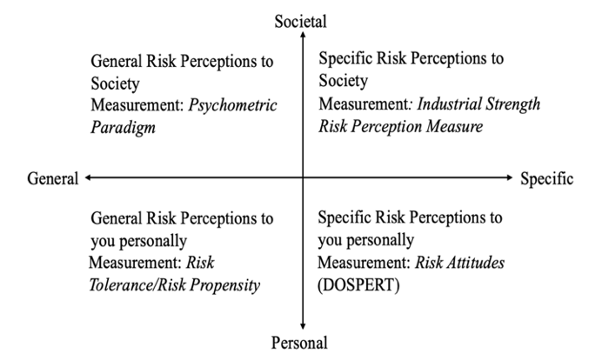

Two Distinct Judgment Targets: Societal v. Personal Risk Perceptions
Societal Risk Perceptions. Over the last four decades, a large body of risk perception research has developed with a primary focus on assessment of attitudes about risks to society (e.g., For health and human welfare, how dangerous is HIV?). Historically, this line of risk perception research began in earnest during the 1960s, when there was opposition to the acceptance of new technologies, particularly nuclear power plants (Sjoberg, 1999; 2001). The now standard approach in this tradition is roughly characterized in Figure 1 by emphasis on the general societal risk perceptions quadrant. This approach was first rooted in an econometrically inspired “revealed preferences” method first established by Starr (1969). Starr conducted a cost-benefit analysis of economic losses and gains using archival data (i.e., revealed preferences) and used this as a method of estimating society’s views towards risks. Despite many advantages of the revealed preferences approach, Fischhoff and colleagues (1978) noted that this approach was critically limited as it did not adequately appreciate non-market valuations of public goods. In order to provide a more representative view of the full range of risk perceptions, leveraging traditions in psychology, Fischhoff and colleagues (1978) developed what is sometimes referred to as the psychometric paradigm for risk perception research. This paradigm specifically focuses on measurement and analyses of “expressed preferences,” (i.e., elicited public opinions of risks and benefits), and has since become a leading standard in modern behavioral and social science research. Specifically, Fischhoff et al. (1978) studied people’s judgments about 30 technologies and activities across nine characteristics, including: severity of consequences, voluntariness, immediacy of effect, knowledge about risk to the exposed and to science, dread risk, control over risk, newness and catastrophic risk. A factor analysis of these nine dimensions then revealed the now classic pattern wherein risk perceptions were well-characterized by the unique influence of two independent factors (i.e., dread, and unknown). Although at the time nuclear power plants were deemed to be a ‘safe technology’ when assessed using revealed preferences, the expressed preferences research by Fischhoff and colleagues revealed that people generally perceived nuclear power to be highly unknown and highly dreaded. In turn, these differences measured via expressed preferences were used to help explain the resistance to siting nuclear waste repositories, and to help inform related public policy and risk communication discussions (e.g., issues with Yucca Mountain).
Today, the original psychometric paradigm continues to be a leading standard for societal risk perception measurement and research (Siegrist & Árvai, 2020), with many subsequent studies replicating the two-factor structure across different risks, countries, cultures, and decades (Fox-Glassman & Weber, 2016; Karpowicz-Lazreg & Mullet 1993; Kleinhesselink & Rosa, 1991; Teigen et al., 1988). Despite its major contributions, concerns about some notable limits of the original methods of the standard psychometric paradigm have emerged. For instance, Sjoberg (1999) noted that the original psychometric paradigm largely neglected variance between respondents because it used aggregated data to explain perceived risks and benefits. Analyses from the same study revealed that when perceived risks were regressed on the dread and unknown factor across respondents, the explained variance dropped from about 80% to 20%. Similarly, Siegrist et al. (2002) conducted a three-way Principal Component Analysis and found that participants were a considerable, neglected source of variance in risk perceptions. Moreover, Marris et al. (1998) analyzed risk perceptions at both the individual and aggregated level and found that individuals varied in risk perceptions for the same risk, and that data at the aggregated level was not consistently related to individual level ratings. Taken together, the growing body of evidence suggests that while the landmark psychometric paradigm is in many respects reliable and useful (e.g., replicating findings to a meaningful extent nearly 40 years later; Fox-Glassman & Weber, 2016), it is also clear there is a lack of standardization across methods (e.g., which risks to measure, what characteristics to assess and how to analyze), which is further complicated by the fact that the paradigm involves substantial time to complete for most participants (e.g., about 1-2 hours to collect risk perceptions on 9 characteristics of around 30 different risks).
Personal Risk Perceptions. In contrast to societal risk perceptions, personal risk perceptions are a distinctly different type of risk perception that primarily focuses on measurement of judgements about the risks to oneself personally (i.e., “How much risk does HIV pose to you personally?”), rather than emphasizing risk to society. Approaches to personal risk perception measurement are quite diverse, with research branching from many fields and leveraging multiple theories and frameworks. As such, across domains and methods, personal risk perceptions have commonly been found to be among the most robust predictors of personal behavioral intentions, decisions, and behaviors (Ajzen, 1985).
One of the earliest frameworks that focused on personal susceptibility or risk severity was the Health Belief Model (HBM). Developed in the 1950s by psychologists in the public health service, this theory attempted to address the low participation rates of the general public in disease prevention and detection programs (Champion & Skinner, 2008; Hochbaum, 1965; Rosenstock, 1974). This theory consisted of four types of risk perceptions that could influence health behavior, namely (i) perceived susceptibility which refers to subjective beliefs about personal susceptibility to a disease, (ii) perceived severity refers to personal judgments of the severity of the disease and the consequences, (iii) perceived benefits reflects whether a particular health behavior can mitigate the health risk, and (iv) perceived barriers refers to the costs of engaging in screening behaviors (Janz & Becker, 1984).
The Health Belief Model helped give rise to other notable theories of risk perceptions, including the Protection Motivation Theory (Rogers, 1983), which suggests that there are two major influencers on health behaviors, (i) threat appraisal and (ii) coping appraisal. In this framework, threat appraisal is (roughly) synonymous with risk perceptions such that they encompass perceived probability of being exposed to the risk, perceived severity of the consequences if the risk comes to pass, and subjective fear, which can influence perceived risk severity. In contrast, coping appraisals were said to involve coping with the threat which included perceived self-efficacy. Beyond the applications to the health domain, the PMT has also been applied to natural hazards such as flooding (Grothmann & Reusswig, 2004). Other more recent influential theories that help explain personal risk perceptions include the risk as feelings hypothesis (Loewenstein et al., 2001) and the tripartite model of risk perceptions (TRIRISK; Ferrer et al., 2016). Both theories suggest that even in the presence of deliberative or cognitive components, affective reactions and responses to risk tend to drive perceptions and decisions (Cokely et al., 2018; Petrova et al, 2022).
Regardless of the specific theoretical approach, it is clear that the relationship between personal and societal risk perceptions is a variable relationship: The two can be related but are not necessarily or even typically related (e.g., a monogamous person can see HIV as high risk to society, yet low risk personally). Accordingly, research demonstrates that personal and societal risk perceptions are often influenced by different factors. For example, consistent with the impersonal impact hypothesis, research suggests that news media often tends to explain societal risk perceptions to a larger degree than personal risk perceptions (Tyler & Cook, 1984). Similar results were also observed in a study by Coleman (1993), where the type of media (e.g., television, newspapers etc.) helped differentially explain societal and personal perceptions of risk. These results highlight the need for studies and assessment standards that carefully avoid confounding the distinct measures of societal and personal risk perceptions, when assessing the factors that influence downstream intentions, decisions, and behaviors.

A Neglected Continuum: From Specific to General Risk Perceptions
Beyond distinctions in measurement of judgments about societal versus personal risks, the assessment of risk perceptions also varies meaningfully by scope (e.g., narrow and specific to broad and general, see Figure 1). For example, some investigations focus on people’s judgments about one specific risk (e.g., tornados, HIV or credit cards), while in other cases researchers have focused on a somewhat broader domain-specific or even overall risks in general (e.g., health, ethical, recreational versus all risks in general). While the different approaches to measuring across the range of specific to general risks have all been investigated to varying degrees, the standards for measurement at each level vary considerably. Moreover, evidence indicates that measurement of judgments about general and domain-specific risks may primarily track differences in personal risk tolerance rather than overall perceptions about all risks in general (e.g., personal risk attitudes versus estimates of overall risk to society).

Measuring Specific Risk Perceptions. Assessment of the perception of specific risks is among the most frequent and most simple type of risk perception measurement that takes place in the scientific literature (Capone et al., 2021; Trumbo et al., 2016). To illustrate, consider one influential stream of research focusing on measurement of specific societal risk perceptions using a basic one item Likert scale for assessment (i.e., “How much risk does XXX pose to human health, safety and prosperity on a 0-7 scale). By focusing on a very brief and simple Industrial Strength Risk Perception measure, researchers have made a number of noteworthy findings, particularly in investigations of factors that shape judgments about politically controversial and polarizing risks (e.g., climate change, gun control, vaccines, (Kahan, 2015a; Kahan 2015b, Kahan, Peters et al., 2017).
Theoretically, the brief Likert scale approach to measuring specific societal risk perceptions is useful because it is simple and efficient (brief, simple, reliable). Moreover, the one-item Likert scale approach has been found to be psychometrically reliable and sensitive to differences in affective attitudes that are related to deeply held values including people’s cultural worldviews and partisan political identities (Kahan Peters et al., 2017). Thus, although the method neglects the potential influence of other dimensions (e.g., dread v. unknown), it is a popular way to collect data on diverse risk perceptions across samples that may be usefully combined with other assessments such as the Domain Specific Risk Taking Scale.
Measuring Domain-Specific Risk Perceptions. The Domain Specific Risk Taking scale or the DOSPERT is by far one of the most extensively validated instruments designed to measure individual differences in risk attitudes related to risky choices and behaviors. Specifically, the DOSPERT measures judgments about personal risk taking in five distinct domains, namely health, social, ethical, financial and recreational risks. Analyses suggest that individual differences in personal risk taking behaviors may tend to be relatively independent across each of the 5 domains, such that risk attitudes about health are not necessarily related to personal risk attitudes about ethics or finance (Weber et al., 2002). That said, recent research has demonstrated that a general factor of risk attitudes may exist within the DOSPERT framework and may even be a robust predictor of risk-taking behavior beyond the specific influence of each of the five factors (Highhouse et al., 2017).
Theoretically, given that the DOSPERT tends to be an outstanding measure of stable traits that can give rise to individual differences in perceived risk attitudes and risky behaviors (i.e., attitudes of risk that are shaped by the perceived riskiness of alternatives), it can be a useful tool when investigating aspects of people’s risk perceptions. Nevertheless, individual differences in attitudes related to personal risk tolerance are not necessarily related to or ideally suited to measuring overall risk societal perceptions. For example, a person can have a high personal tolerance for health risks and yet still think that diseases pose grave risks to society more generally (or vice versa). That is, while this measure provides an extensively validated means of measuring some factors that can be related to risk perceptions, the instrument was not designed to be a direct measure of general societal risk perceptions, nor was it designed to provide an independent estimate of dread and unknown components of risk perceptions.
Measuring General Risk Perceptions. While there is virtually no research on domain general societal risk perceptions beyond that of my colleagues and I (Cho, 2020, in prep; Ramasubramanian, 2020, in prep), there is related research on domain general societal risk perceptions from other social and behavioral science traditions. For example, some aspects of domain general risk perceptions can be related to notions of risk tolerance or risk propensity, as was previously discussed in the section on the DOSPERT. Theoretically, these judgments can be measured by examining how one responds to a risk or hazard, wherein reported risk attitudes will generally reflect an internal scaling of one’s estimated tendency toward risk taking (Nosic & Weber, 2010; Tombu & Mandel, 2015).
In this vein, some general measurement has focused on risk propensity, which refers to how likely one is to engage in risk taking behavior in everyday life, such as choosing between medical treatments or traveling to a risky destination. For example, the Risk Propensity Scale (Meertens & Lion, 2008) was developed to measure risk propensity and contains seven Likert scale items. This scale is correlated with other measures of risk attitudes such as sensation seeking, risk tolerance and risk ambiguity. Results indicated that those who had a higher propensity toward risk taking tended to prefer sensation seeking, had a higher risk tolerance and were generally comfortable with ambiguous risky situations (Harrison et al., 2005).
Interestingly, domain general measures of risk attitudes and risk propensity (across both the societal and personal categories) tend to be used to establish a baseline level of risk perception. Given this baseline, researchers can then more precisely explain specific behaviors or perceptions. For instance, a study by Einav et al. (2012) conducted for the National Bureau of Economic Research found that domain general risk preferences tended to explain differences in observed decisions to purchase health, disability, and dental insurance. Although currently available approaches focus primary on measurement of personal risk attitudes (and personal risk tolerance), theoretically domain general societal risk perceptions could be measured by integrating assessment across multiple risk judgments (e.g., in general how much risk do all technologies and human activities pose to human health and prosperity). For example, one might be able to measure general risk perceptions by taking an average of responses to 30 risks used in the psychometric paradigm, or an ideal subset thereof. In this way, researchers might be able to use a very brief domain general scale, providing both the overall general societal risk perception as well precisely estimating people’s general dread and unknown scores.

Current Studies
Most research focuses two common types of risk perceptions: personal and societal. Personal risk perceptions are judgements of risk about oneself (i.e., how risky is COVID-19 for me, personally?) while societal risk perceptions are judgements about risk to society (e.g., how much risk does COVID-19 pose to society). Additionally, there is usually one more distinction in the risk perception literature: domain specific versus domain general. Domain general risk perceptions tend to measure overall judgements of risk, such as risk propensity and risk tolerance. In contrast, domain specific risk perceptions measure judgements of risk in a particular domain, as seen in studies focusing specifically on health, financial and weather domains (Collins et al., 2021; Nosic & Weber, 2010; Peters et al., 2007; Peters et al., 2011; Ripberger et al., 2018; Shimp & Bearden, 1982; Weinstein et al., 2007). There are some measurement traditions that are associated with these distinctions. The quadrants consisting of Personal General, Personal Specific and Societal Specific risk perceptions are largely measured using validated assessments: Personal General risk perceptions, also referred commonly as risk propensity or risk tolerance are measured using the Risk Propensity Scale (Meertens & Lion, 2008). Personal specific risk perceptions are most often measured with scales such as the DOSPERT (Weber et al., 2006), while societal specific risk perceptions are usually measured with new scales such as Industrial Strength Risk Perception Measure developed by Kahan, (2017). This scale asks participants one question about how much risk an activity poses to human health, welfare, and prosperity. However, there is no validated brief measure of domain general societal risk perceptions. Theoretically, such a measure can be useful to estimate a baseline of general risk perceptions which can subsequently clarify perceptions of emerging risks. Additionally, this measure can also reflect some individual differences (i.e., perceptions of dread versus unknown).
Two primary goals of the current project are:
- Develop a brief, robust, integrated measure of domain general societal risk perceptions in accord with modern psychometric standards and risk perception theory.
- Develop and validate integrated assessment and practical analytic procedures for estimating independent influences of (i) general, (ii) specific and (iii) relative risk perceptions
Theoretically, the development of a valid and efficient measure should include standards consistent with the American Education Research Association, American Psychological Assessment and the National Council on Measurement in Education (AERA, APA & NCME, 1999). These standards tend to align with Messick’s conceptualization of construct validity, including 5 broad classes of criteria as follows:
- Evidence based on test content. This standard aligns with content validity as discussed by Messick (1995). This standard of validity includes content relevance, technical quality and appropriate content representation. I will be using psychometric techniques (i.e., Item Response Theory) to distill a brief measure of risk perceptions from an established risk perception paradigm.
- Evidence based on internal structure. Similar to structural validity posited by Messick (1995), this type of validity refers to the consistency of the underlying dimensionality of the test with the construct being measured. Using analyses such as factor analyses and latent trait modeling, I intend to verify that the dimensionality of the brief scale accords with established dimensionality (i.e., robust estimates of the dread and unknown factor).
- Evidence based on response process. This type of validity implies that there should be observed consistencies in responses, such the underlying thought processes of the individual. Specifically, the test should be able to discern systematic response patterns. This is also referred to as the substantive validity of the test (Messick, 1995). In the current studies I will aim to provide evidence that factors of the brief scale tend to systematically covary with skills (i.e., numeracy).
- Evidence based on relations to other variables. Similar to generalizability and external validity, this standard specifies that the test should be generalizable across populations, occasions and tasks. Additional evidence should show relations with relevant criterion and diverge from irrelevant criteria. Across the studies, I will provide evidence of the convergent, discriminant and predictive validity of the scale.
- Evidence based on consequences of testing. This type of validity accords with consequential validity posited by Messick (1995) which appraises the value implications of the score interpretation as well as social consequences of the test use. This type of validity is often the most difficult to establish, however, I will aim to provide some evidence that the brief scale distilled in these studies can have some important implications (i.e., it will be useful for risk perception researchers to measure individual differences in general risk perceptions).

Accordingly, Study 1 will attempt to replicate and extend the seminal research for assessing societal risk perceptions as developed by Fischhoff et al. (1978), supplementing the factor analytic approach that was used in the original study, thereby obtaining individual differences within the general risk perception framework (dread versus unknown). Additionally, I will employ psychometric techniques such as Item Response Analyses to distill a brief, efficient measure of general risk perceptions that could simulate the longer scale, using comparative analyses (i.e., SEM). Study 2 will conduct an out of sample validation of the analyses in Study 1 using a larger set of emerging risks, extend the scale to predict personal risk perceptions as well as establish longitudinal validity. Study 3 will conduct a practical validity and robustness check of the brief scale to predict perceptions of specific societal and personal risks in a relatively more diverse sample to predict a truly novel and emerging risk: COVID-19, and test if the scale would meaningfully and uniquely explain differences in downstream consequences such as knowledge of expert consensus and behavioral intentions.

Chapter 2: Study 1
Study 1 primarily focused on two objectives. First, I attempted to replicate and extend the seminal research for assessing societal risk perceptions proposed by Fischhoff et al. (1978), using the factor analytic approach that was used in the original study, thereby distilling individual differences within the general risk perception framework (dread versus unknown). Second, I used tests of psychometric robustness (i.e., Item Response Theory) to distill a brief, efficient measure of general risk perceptions that would be representative of the underlying risk perception traits (dread v. unknown). Finally, I conducted several comparative analyses of structural equation models of the underlying relations between individual differences in skills known to be systematically related to risk judgments (i.e., statistical numeracy and risk literacy) and people’s general and specific risk perceptions on both long and short forms.

Participants and Procedure
There were 250 participants in this study. Participants were students at the University of Oklahoma, recruited through SONA. Over half the respondents were female (56%), and the age range of the participants was between 18-22 years old. The data came from an online portion of a larger study that involved data collection online in the laboratory. Participants were asked to first complete numeracy assessments, followed by risk perception measures and ended with demographics. The online survey took about 90 minutes on average to complete, and participants were asked to complete it in one sitting. Participants signed up for the study as part of required course credit. All ethical standards as outlined by the IRB were followed.

Measures
Berlin Numeracy Test. In this study, numeracy was measured using the Berlin Numeracy Test (see RiskLiteracy.org). Following best-practice recommendations, I used the BNT- S form, which includes three items taken from Schwartz et al. (1997), and provides increased sensitivity among less skilled and less educated individuals.

Risk Perceptions
One Item Risk Perception Measure. Developed by Kahan et al. (2017), this measure consists of one item: “How much risk do the following pose for human health, safety and prosperity?”. The scale ranged from 0 (No Risk at All) to 7 (Extremely High Risk). Participants were asked to rate 39 (30 existing and 9 emerging) prevalent risks consisting of technology, activity, weather, health and cybersecurity risks. The risks asked are presented in Tables 2.1 and 2.2 below.

Table 2. 1
30 Risks Asked in Fischhoff et al. (1978)
Risks
Commercial Aviation | Prescription Antibiotics | Skiing
Contraceptives | Railroads | Fire Fighting
Electric Power | Spray Cans | Large Construction
Food Coloring | Vaccinations | Motorcycles
Food Preservatives | X-Rays | Mountain Climbing
High School and College Football | Bicycles | Railroads
Swimming | Smoking | Police Work
Hunting | Alcoholic Beverages | Surgery
Home Appliances | Handguns | Pesticides
General Aviation | Motor Vehicles | Nuclear Power

Table 2. 2
Domain Specific Risks.
Weather | Cybersecurity | Health/Safety
Tornados | Phishing | Heart Attacks
Hurricanes | Identity Theft | HIV
Severe Weather | Hacking | Terrorism

In addition to these 30 risks, nine new and emerging risks were added to the list of 30 risks used by Fischhoff and colleagues (1978) in their original study. These were split into 3 domains: health and safety, weather and cybersecurity (Table 2.2.). These three domains were chosen to represent a larger subset of domain specific risks. For instance, over the last few years, extreme weather events have resulted in tremendous damages both economically (e.g., $4.3 billion on average per flooding event; NOAA, 2019) and socially (100 deaths in the wake of Hurricane Harvey; Blake & Zelinksy, 2018). Similarly, a relatively new substantial threat that individuals face today are risks related to cybersecurity, particularly for those active on social media platforms. As for the health and safety domain, these three risks represent emerging vivid and highly salient threats. Taken together, this sample of new and evolving risks were selected because they are often high priority issues for risk communication researchers.
Nine Dimensions of Risk. In their 1978 study, Fischhoff and colleagues developed nine characteristics of risks that were asked for each risk. These were used in the current study. Table 2.3 below presents the questions and scale labels.

Table 2. 3
Description of the Nine Dimensions of Risk Asked in the Current Study.
Dimensions | Description
Voluntariness of risk | Do people get into these risky situations voluntarily?  (1 = voluntary; 7 = involuntary.)
Immediacy of effect | To what extent is the risk of death immediate-or is death likely to occur at some later time?  (1 = immediate; 7 = delayed.)
Knowledge about risk | To what extent are the risks known precisely by the persons who are exposed to those risks?  (1 = known precisely; 7 = not known.)
Knowledge about risk | To what extent are the risks known to science?  (1 = known precisely; 7 = not known.)
Control over risk | If you are exposed to the risk of each activity or technology, to what extent can you, by personal skill or diligence, avoid death while engaging in the activity?  (1 = uncontrollable; 7 = controllable.)
Newness | Are these risks new, novel ones or old, familiar ones?  (1 =new; 7 = old.)
Chronic-catastrophic | Is this a risk that kills people one at a time (chronic risk) or a risk that kills large numbers of people at once (catastrophic risk)?  (1 =chronic; 7 = catastrophic.)
Common-dread | Is this a risk that people have learned to live with and can think about reasonably calmly, or is it one that people have great dread for-on the level of a gut reaction?  (1 = common; 7 = dread.)
Severity of consequences | When the risk from the activity is realized in the form of a mishap or illness, how likely is it that the consequence will be fatal?  (1 = certain not to be fatal; 7 =certain to be fatal.)

Results

Factor Structure of Original Risks Vs. New Risks.
In the current study, a factor analysis of the original 30 risks as proposed by Fischhoff and colleagues (1978) was conducted. The factor analysis was conducted by calculating an average score for each risk on each characteristic across all the participants, generating a 30x9 matrix. An Exploratory Factor Analysis (EFA) revealed two orthogonal factors: dread and unknown. In this study, the unknown factor consisted of risks known to persons, known to science, new and controllable, and the dread factor consisted of severity of consequences, dread, catastrophic, immediacy and voluntary (see Appendix A; Table 1). The unknown factor explained 38% of the variance, and the dread factor explained 31% of the variance in this analysis. In an effort to plot the risks on a two-dimensional space similar to Fischhoff and colleagues (1978), the current study used z-scores for both the unknown and dread factors (see Appendix A; Figure 1). Additionally, another factor analysis was conducted, this time including the new risks (39x9 matrix). An orthogonal two factor solution was obtained, with similar factor loadings on both the dread and unknown factors. The dread factor explained 42% of the variance and the unknown factor explained 26% (summarized in Appendix A; Table 2). The new risks are designated by red dots. Eight of the nine new risks are in the quadrant that represents high dread and high unknown consistent with the hypothesis that the selected nine risks were suitable indicators of emerging and evolving characteristics of these risks. Taken together, the results suggest that consistent with the original study and the earlier replication (Fox-Glassman & Weber, 2016), the present analyses provide a conceptual replication of the previous findings with appropriate sensitivity.

Distilling a Brief Instrument: An Item Response Theory Approach
While previous research has noted that there tend to be individual differences within domain general societal risk perceptions (e.g., Fischhoff et al., 1978), to my knowledge there is no standardized brief scale that has been validated for the measurement of these differences. As such, I saw an opportunity to be the first to apply Item Response Theory in order to distill a brief, sample independent latent-trait measure of general risk perceptions.
Item Response Theory (IRT) is a psychometric technique that evolved from Classical Test Theory (CTT). CTT includes three concepts to describe a test score (i) a true score, (ii) an observed score, and (iii) an error score. While CTT is valuable to understand the relationship between the test score and true score, a shortcoming of this theory is that it does not sufficiently delve into the relationship of the individual item scores with the true scores. As such, CTT is usually sample dependent (i.e., the properties of the test can be only generalized to the extent that the sample characteristics are similar to the population for which it was created; Hambleton & Jones, 1993).
On the other hand, IRT is a statistical theory based on establishing a unique measurement model for an outcome that specifies the probability of observing that outcome as a function of a latent trait (Lord, 1980; Penfield, 2014). Thus, IRT can be considered sample independent, as the properties of the test can be generalized across samples and populations provided the model accurately estimates the underlying latent trait from the sample data. Furthermore, using IRT can also provide additional insights into the parameters of the responses to individual items (e.g., discriminability, difficulty, guessing), as well as providing information about the test as a whole across the range of the trait (Hambleton, 1989). For these and other reasons, it was logical to use Item Response Theory to identify items that could be included in the brief risk perception measure across the risks themselves.
IRT analyses can be conducted in different ways depending on the types of data and other theoretical considerations (e.g., unidimensional v. multidimensional traits). For instance, with dichotomous data, logistic IRT such as the Rasch, 2PL and 3PL models can be developed on a unidimensional set of items (Samejima, 1999). However, as the risk perception items are measured on a Likert scale, I utilized a graded response model IRT, which involves testing a series of mathematical models that are developed for polytomous data (ltm package in R; Rizupoulous, 2006). The graded response model is widely recommended for modeling Likert scale data when compared to other models such as Nominal Response model (NR) or the Generalized Partial Credit models (GPC; Cole et al., 2019).
To develop and test my IRT model, first, I constructed a graded response IRT model on each dimension of risk to identify the representative risk characteristics of the dread and unknown factors (e.g., catastrophic, known to persons). Characteristics were then selected to be consistent with common Item Response Theory criteria, including: (i) model fit statistics like AIC and BIC, and (ii) the item discrimination parameter of the constrained model for each dimension to estimate a separate general factor for dread and unknown (Krabbe, 2016). The Akaike Information Criterion (AIC) and the Bayesian Information Criterion (BIC) represent fit statistics of the graded response model, and based on prior research, can be interpreted such that smaller values generally indicate better fitting models (Kenny 2015). Similarly, the discrimination (slope) parameter was used because it reflects the strength of the relationship between the items and latent variable being measured (Edelen & Reeve, 2007; Penfield, 2014). With 39 items in each scale, the reduced IRT model with constrained discrimination parameters was considered to be more parsimonious (Toland, 2014). Based on these criteria (summarized in Table 2.4), the most representative characteristics for dread and unknown assessment were selected. With respect to my analysis of the dread factor, although the model fit and constrained discrimination parameter was better for Common – Dread scale than for the Severity of Consequences scale, my selection was also based on theoretical concerns. Specifically, I wanted to also focus on distilling estimators that could be considered objectively quantifiable (e.g., would likely generate high consistency in responses when rated by verifiable risk experts). The Common-Dread scale asked for the rating of dread in a way that emphasizes the gut reaction of a lay person, which is seems qualitatively different that an objective estimate of the true risk (e.g., how many people typically die) and may also be highly variable depending on contextual variables (i.e., how strong should a gut reaction be to perceive a risk as dreaded? For whom, and why?). In contrast, the characteristic Severity of Consequences asked for a rating of how certain one is that the consequences can be fatal (i.e., death), which seems likely to produce more stable judgements across experts. Taken together, the language of the questions pertaining to Catastrophic, and Severity of Consequences were deemed to be most suitable, and the cutoff for the constrained item discrimination was set at 0.80 (see Table 2.4). Similar criteria were used to evaluate the unknown factor. The item response criteria and item language indicated that Known to Persons and Known to Science were the most representative indicators. Test Information Functions (TIF) are displayed in Figure 2.1 for all 39 risks across nine dimensions.

Table 2. 4
Criteria for Distilling Representative Dimensions of Unknown and Dread Factors.
Dimensions of Risk | Characteristics of Risk | Fit Statistics |  | Discrimination Parameter
 |  | AIC | BIC | Constrained
Dread | Dread | 31669.81 | 32497.36 | 1.15
Dread | Catastrophic | 31524.91 | 32352.45 | 0.90
Dread | Severity of Consequences | 31937.61 | 32758.11 | 0.87
Dread | Voluntary | 34002.17 | 34829.72 | 0.77
Dread | Controllability | 35425.50 | 36253.04 | 0.76
Unknown | Known to Science | 30176.66 | 31004.20 | 1.29
Unknown | Known to Persons | 32729.43 | 33556.98 | 1.03
Unknown | Newness | 33833.44 | 34660.98 | 0.95
Unknown | Immediacy | 33837.93 | 34665.47 | 0.77

Figure 2. 1
Test Information Curves for 39 Risks Across Nine Dimensions of Risk Perceptions
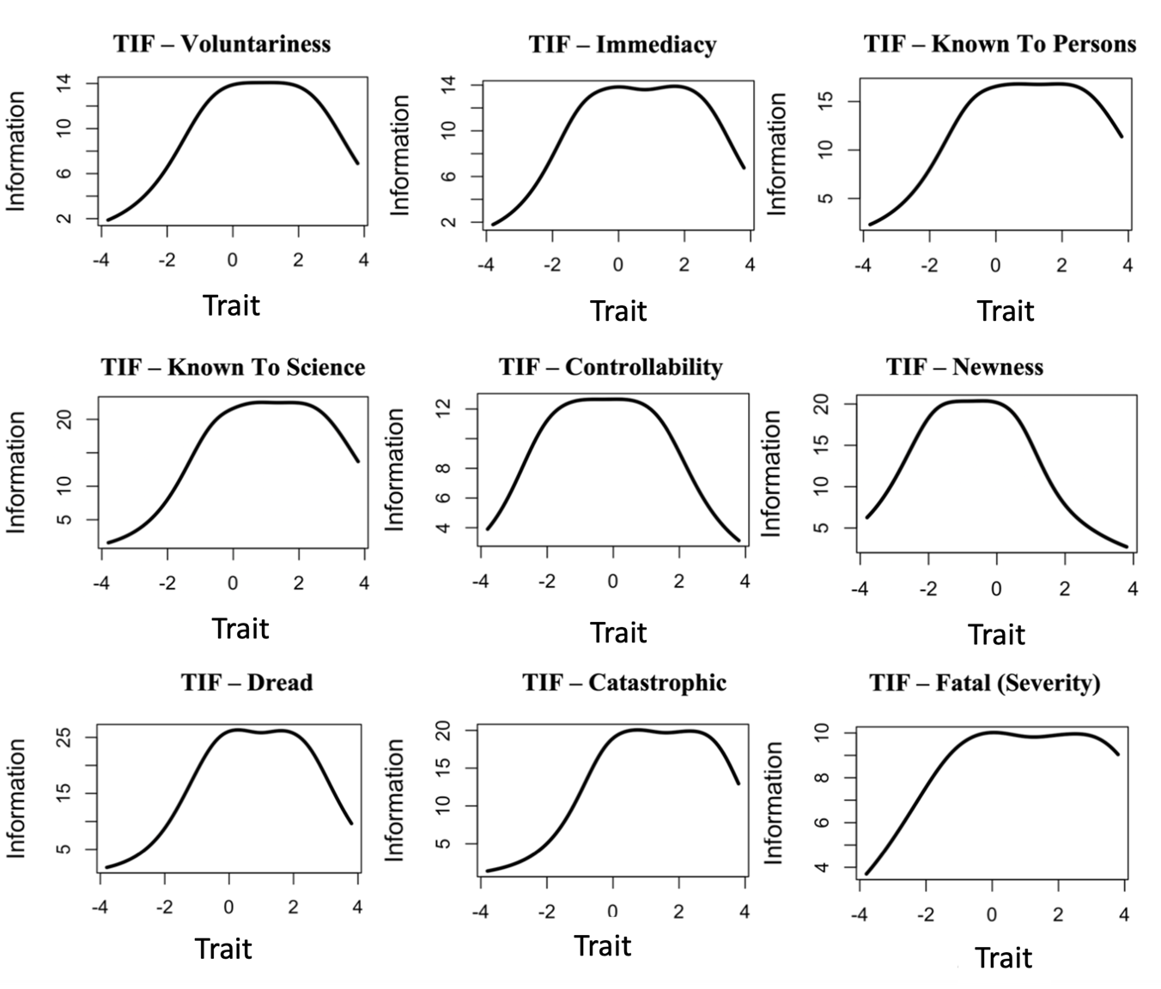

Following this, I distilled a brief set of risks to be included the domain general risk perception scale using the graded response IRT model. In order to appropriately represent the two factor space, I wanted to select a risk from each quadrant (see Figure 2.2). Using polytomous Item Response Theory, with the unconstrained discrimination parameters, I selected four risks. According to Reise and Yu (1990), three levels of item discrimination were identified to cover items of poor (0.44 – 0.75), moderate (0.58 – 0.95) and good quality (0.98 – 1.35). As such, items (risks) corresponding to the cut off for moderate to good quality, and position on the two-factor space were shortlisted from the dread and unknown factors. Finally, items were compared across all nine characteristics of risk. These risks were: Heart Attacks, Motor Vehicles, Alcohol and Skiing. Tables 2.5 and 2.6 show the unconstrained discrimination parameters across the nine dimensions. Figure 2.2 displays the positions of the four risks across the dread-unknown space.

Figure 2. 2
Four Candidate Risks Across the Dread and Unknown Two Factor Space
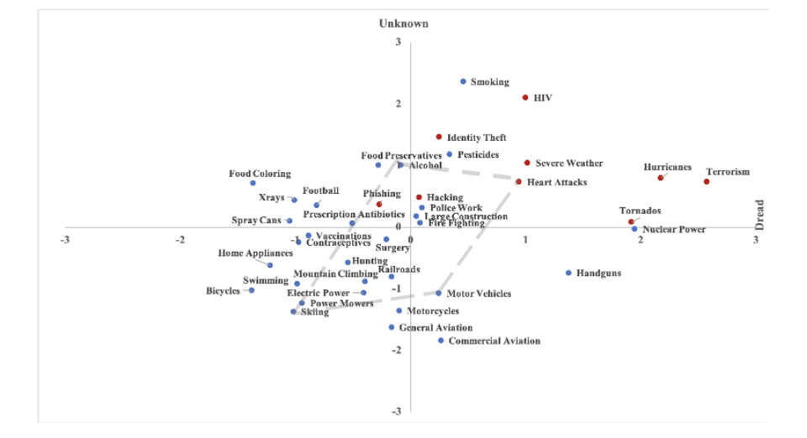

Table 2. 5
Unconstrained Discrimination Parameters for the Four Risks Across the Dread Factor.
 | Unconstrained Discrimination Parameter
Risks | Catastrophic | Severity of Consequences (Fatal) | Dread | Voluntary | Controllability
Alcohol | 1.48 | 0.63 | 1.34 | 1.29 | 0.88
Motor Vehicles | 0.86 | 0.94 | 1.65 | 1.00 | 0.44
Skiing | 2.04 | 1.13 | 1.96 | 1.67 | 0.68
Heart Attacks | 1.48 | 0.42 | 0.50 | -0.32 | -0.42

Table 2. 6
Unconstrained Discrimination Parameters for the Four Risks Across the Unknown Factor.
 | Unconstrained Discrimination Parameter
Risks | Known to Persons | Known to Science | Immediacy | Newness
Alcohol | 1.63 | 1.90 | 0.14 | 1.85
Motor Vehicles | 1.72 | 1.80 | 2.11 | 1.00
Skiing | 1.40 | 1.16 | 1.49 | 1.98
Heart Attacks | 1.28 | 1.60 | 1.27 | 1.34

Finally, I conducted another graded response model for the four risks across four dimensions. Test Information Functions for the brief scale are presented in Figure 2.3, and the final scale is displayed in Figure 2.4.

Figure 2. 3
Four Candidate Risks Across the Dread and Unknown Two Factor Space
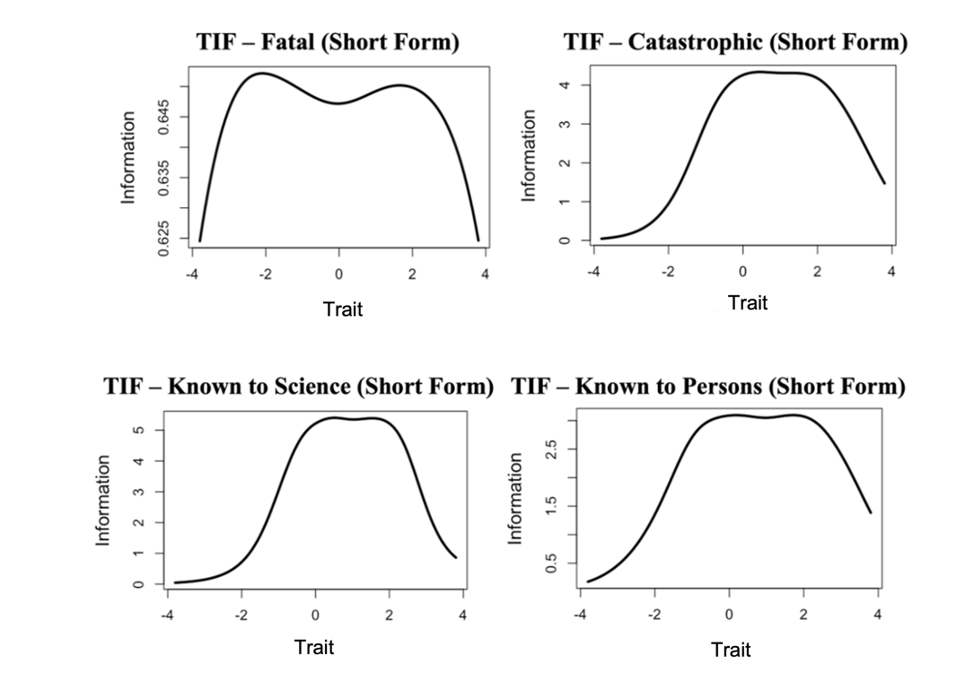

Figure 2. 4
The Berlin Risk Perception Inventory
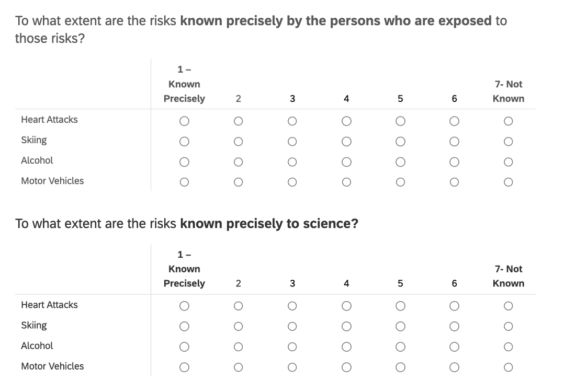
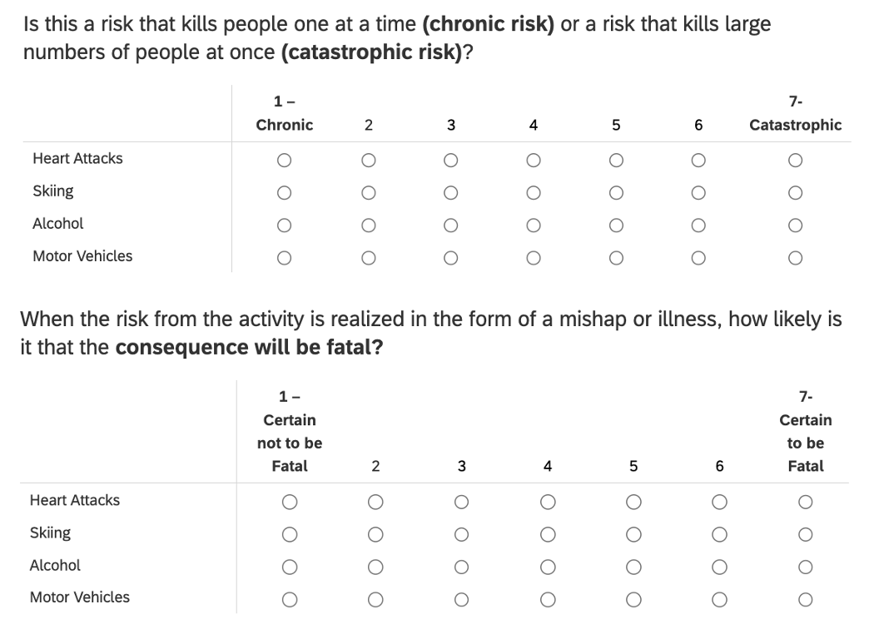

Comparing Short v. Long Forms: A Structural Predictive Modeling Approach
Following my analytical plan, I started by testing a model of the new, specific risk perceptions represented as a latent trait from the three domains (Table 2.2). Structural models were constructed to test whether numeracy was related to each of the latent traits of risk perceptions, controlling for the influence of general risk perceptions. General dread and unknown factors were estimated as follows: based on the factor analysis (Appendix A; Table 2) a composite standardized dread and unknown score was created across the 30 risks from the psychometric paradigm (Fischhoff et al., 1978). The dread score included the characteristics of Severity of Consequences, Chronic-Catastrophic, Common-Dread, Controllability and Voluntariness. Similarly, the composite unknown score included the characteristics of Immediacy, Newness, Known to Persons and Known to Science. These composite scores were then standardized such that each participant had one z-score for the dread and unknown factor respectively.
For each model, at least three candidate structures were tested, based on theory. Results present the models that were above the threshold according to standard fit statistics (Kline, 2015). However, specific relationships between numeracy, general risk perceptions and specific risk perceptions were determined in an iterative process considering three candidate models. For each domain, the first models show the influence of numeracy, dread and unknown factors as estimated by Fischhoff et al., (1978) on specific risk perceptions. The second model was similar to the first, however, the dread and unknown factors were estimated using a restricted approach: to make measurement more similar between the model using 39 risk and the new short form model using only 4 risks, only known to persons and known to science dimensions were used across the 30 risks for the unknown factor, while catastrophic and severity of consequences were used for the dread factor. The restricted models were used as an intermediate between the long and short form of the scale, to examine the robustness of the dread and unknown factors across a wider range of risks. The third model used the brief measure (short form) to estimate dread and unknown factors. The models for the three domains of risk perceptions are presented below, with fit statistics for each model in Tables 2.7 – 2.9. Influences of other relevant variables such as gender were tested on all models, however, none of the relationships were significant.

Comparing Weather Risk Perceptions. Figures 2.5 -2.7 show the structural models predicting weather risk perceptions. With each iteration of the model, the variance explained improved (See Table 2.7), indicating that the brief measure tends to be robust and efficient.

Figure 2. 5
Structural Equation Model for Weather Risk Perception (Long Form).
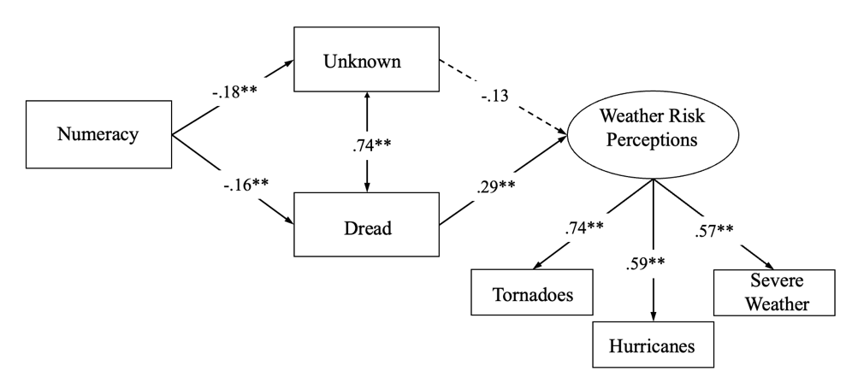

Figure 2. 6
Structural Equation Model for Weather Risk Perception (Restricted Scale).
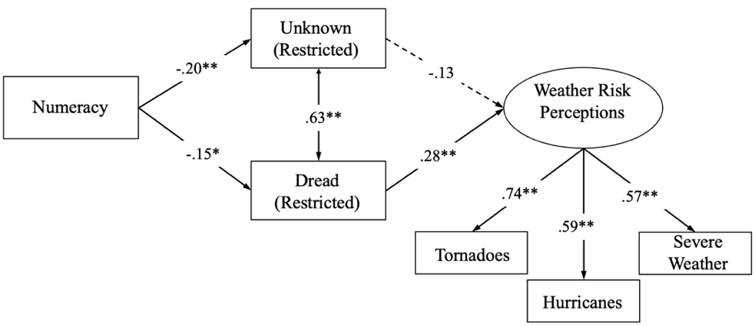
Figure 2. 7
Structural Equation Model for Weather Risk Perception (Short form).
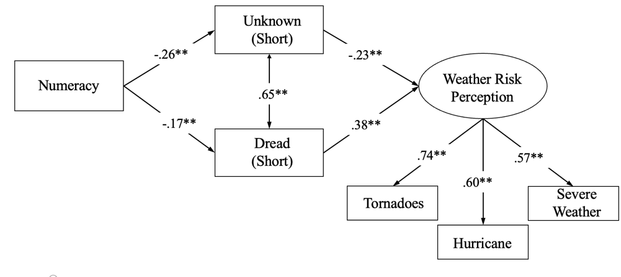
Table 2. 7
Fit Indices and Explained Variance for Weather Risk Perceptions
 | Full Scale  (30 risks) | Restricted Scale (30 risks) | Short Scale
 | Weather Risk Perceptions
χ²(df) | χ²(8) = 22.18 | χ²(8) = 16.70 | χ²(8) = 24.72
CFI | .97 | .96 | .96
TLI | .94 | .92 | .93
RMSEA (90% CI) | .07 (0.03– 0.11) | .07 (0.03– 0.12) | .07 (0.03– 0.11)
SRMR | 0.05 | 0.05 | 0.06
Variance Explained R² | 4.2% | 5% | 8.1%

Cybersecurity. Similar models were specified as seen in Figures 2.8 - 2.10, for the cybersecurity domain.

Figure 2. 8
Structural Equation Model for Cybersecurity Risk Perception (Long Form).
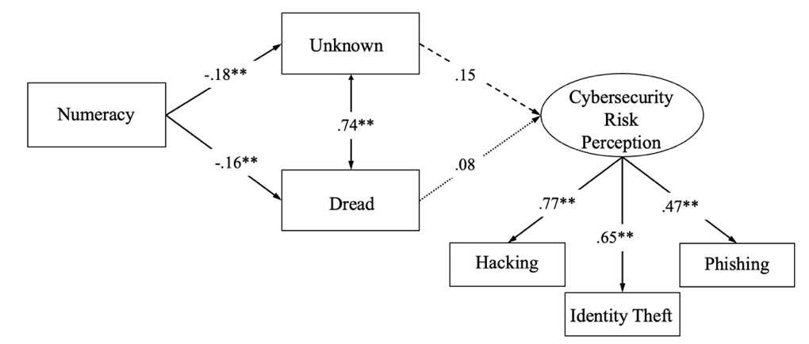

Figure 2. 9
Structural Equation Model for Cybersecurity Risk Perception (Restricted Scale).
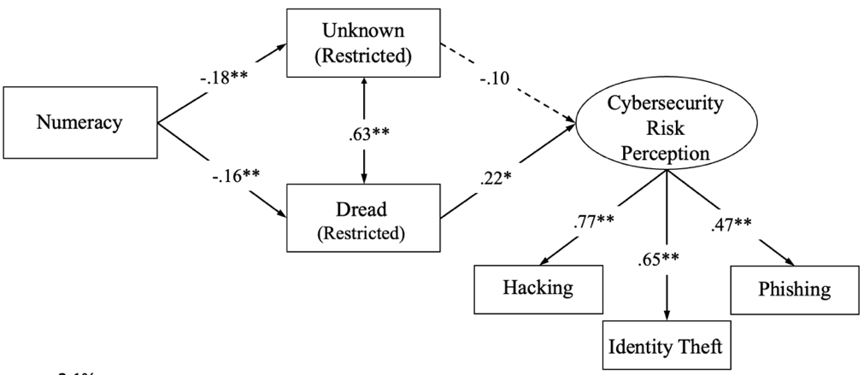

Figure 2. 10
Structural Equation Model for Cybersecurity Risk Perception (Short form).
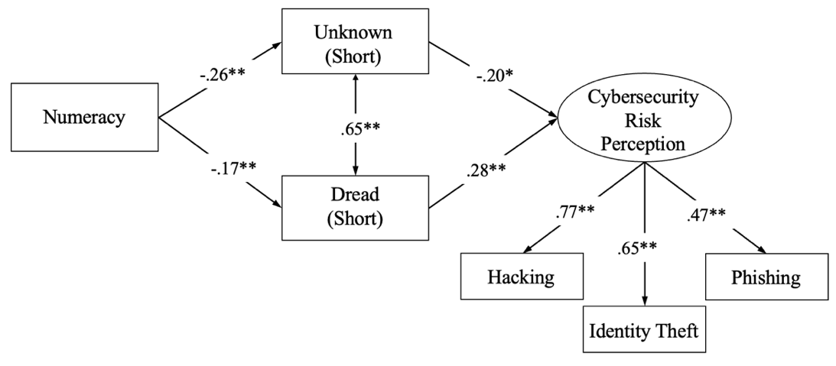

Table 2. 8
Fit Indices and Explained Variance for Cybersecurity Risk Perceptions
 | Full Scale  (30 risks) | Restricted Scale (30 risks) | Short Scale
 | Cybersecurity Risk Perceptions
χ²(df) | χ²(8) = 15.39 | χ²(8) = 12.67 | χ²(8) = 16.72
CFI | 1.00 | .98 | .96
TLI | 1.00 | .95 | .94
RMSEA (90% CI) | .00 (0.00– 0.07) | .06 (0.00– 0.10) | .05 (0.03– 0.11)
SRMR | 0.03 | 0.03 | 0.04
Variance Explained R² | 3% | 5.2% | 11%

Health and Safety. Similar models were specified as seen in Figures 2.11 - 2.13 for the health and safety domain.

Figure 2. 11
Structural Equation Model for Health and Safety Risk Perception (Long Form)
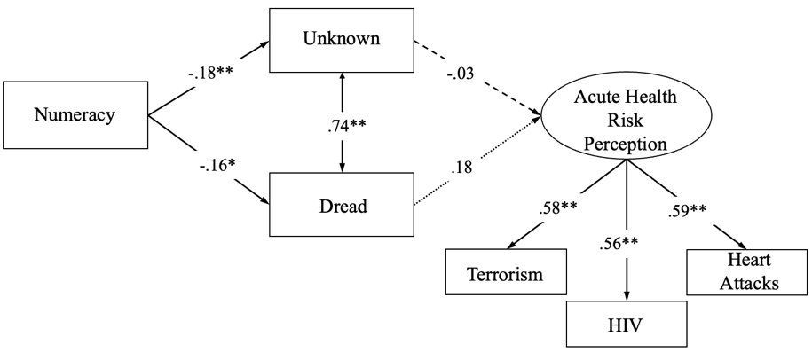

Figure 2. 12
Structural Equation Model for Health and Safety Risk Perception (Restricted Scale)
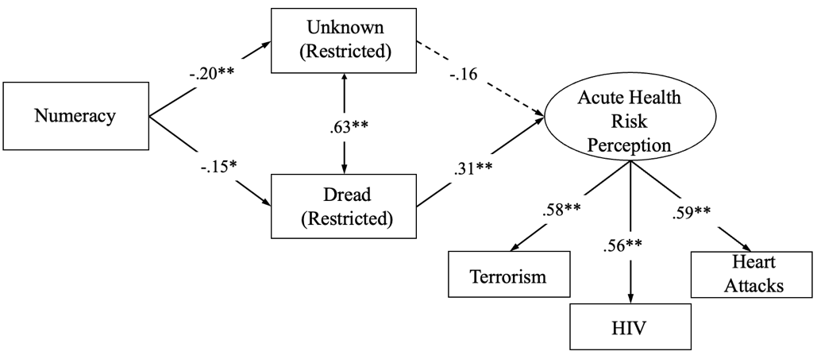

Figure 2. 13
Structural Equation Model for Health and Safety Risk Perception (Short Form)

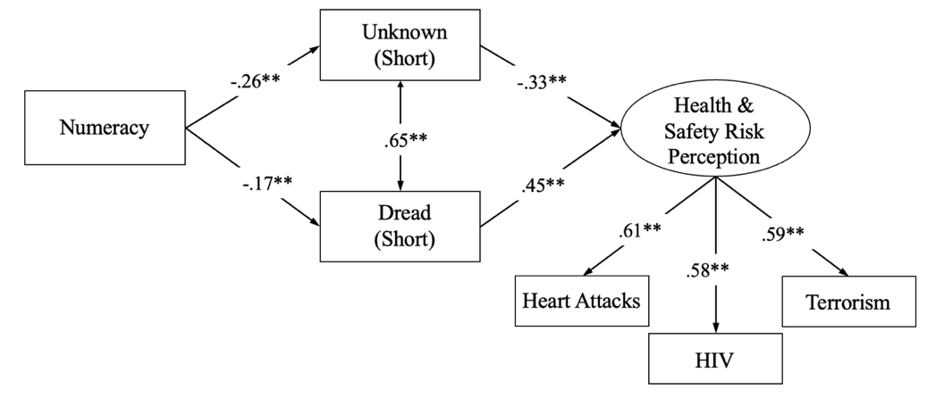

Table 2. 9
Fit Indices and Explained Variance for Health and Safety Risk Perceptions
 | Full Scale  (30 risks) | Restricted Scale (30 risks) | Short Scale
 | Health & Safety Risk Perceptions
χ²(df) | χ²(8) = 16.18 | χ²(8) = 10.87 | χ²(8) = 14.87
CFI | .98 | .98 | .99
TLI | .97 | .97 | .97
RMSEA (90% CI) | .05 (0.00– 0.09) | .04 (0.00– 0.10) | .05 (0.00– 0.10)
SRMR | 0.05 | 0.04 | 0.03
Variance Explained R² | 4.2% | 5.8% | 11.5%

Study 1 Discussion

Study 1 sought to advance measurement efforts in risk perception research. I first started by conducting an extensive replication and extension of the psychometric paradigm developed by Fischhoff et al. (1978) using the original 30 risks and the nine new risks across the nine characteristics. Results revealed that societal risk perceptions are still largely explained by two orthogonal factors: dread and unknown.

Distilling a Brief Measure of General Risk Perceptions
These analyses demonstrate that individual differences in general societal risk perceptions can be reliably measured, they predict specific (novel) risk perceptions, they can help explain relations between skills and risk judgments, and thus may have many implications for theory and application. Study 1 also presents what appears to be the first Item Response Theory model used to estimate individual differences in risk perceptions. In turn, IRT was used to distill a brief, and efficient scale to measure individual differences in general risk perceptions (i.e., measuring four risks by four characteristics; see Figure 2.4) tentatively called the Berlin Risk Perception Inventory (BRPI). Again, I can find no evidence that Graded Response (GR) item response models have been applied to the development or evaluation of measures of general societal risk perceptions, despite the fact that have been extensively used for evaluating measures such as self-efficacy and health-based surveys, and have be used on only a few occasions for assessment of specific risk perception assessment (e.g., HIV, COVID-19 etc.; Napper et al., 2012; Stănculescu, 2022; Toland, 2014). Nevertheless, the analyses conducted using the graded response model in Study 1 are not designed to be extremely fine grained, and as such may not be suitable for testing for local independence (i.e., the assumption that the items measuring the latent trait are not influenced by other items or latent trait such as reading ability; see Toland, 2014). However, since the larger goal of the study was to distill a brief and robust measure that can explain differences in specific risk perceptions, the present analyses demonstrate that the brief measure robustly predicted perceptions of specific risks across emerging risk categories (i.e., weather cybersecurity and health/safety; Figures 2.5-2.13) with similar fidelity as the long form. Furthermore, across all models, domain general risk perceptions mediated the relations between numeracy and specific risk perceptions, such that more numerate folks tend to perceive lower risk in general which in turn predicts perceptions of specific risks. These replicate my previous discovery (Ramasubramanian, 2020) suggesting that higher numeracy skills may be generally associated with lower general risk perceptions, which in turn may reflect differences in their risk literacy and acquired knowledge of all risks in general (Cokely et al., 2018).

Open Questions and Future Directions
Taken together, the findings from Study 1 show that there are unique individual differences in general risk perceptions that have been largely neglected in previous research that may often predict perceptions of many specific risks. Moreover, results suggest that a very brief (about 3-minute) assessment distilled based on Item Response Theory may generally provide robust estimates of both dread and unknown components of general risk perceptions and can closely approximate the long form scale. Beyond the direct implications, there remain several open questions and potential limits that should be addressed. Provided that the instrument tends to predict emerging risks, it would be useful to verify whether the current relations can extend to other specific risks that have not been investigated in the current study (e.g., novel, emerging, and evolving risks). Additionally, the emphasis in this study has been on predicting perceptions of specific risks to society. However, it is possible that the current general risk perception scale may generalize beyond specific societal risk perceptions, to predict (some kinds) of personal risk perceptions (i.e., how much risk does hacking pose to society and how much does it pose to you personally). Theoretically, to the extent that one’s general societal risk perception acts as a reference for other risk judgments, we should expect it help explain some personal risk perceptions to some extent. In other words, if a person sees the world as riskier in general, some of that risk should carry over to at least some of their own personal risks. To address these and other questions Study 2 was conducted, including new validity and robustness checks based on an out of sample replication and extension of Study 1 using a longitudinal, predictive validity design (i.e., predicting specific perceptions 1-2 weeks after measuring general societal risk perceptions).

Chapter 3: Study 2
Results from Study 1 suggested that there were individual differences within domain general risk perceptions (dread and unknown), and that these components can be usefully measured in a brief inventory (e.g., some evidence of validity in each of the five evidence categories: APA, AERA & NCME, 1999). Building on these findings, Study 2 had two primary objectives. First, I wanted to conduct out of sample validation of the analyses in Study 1. Even though the brief scale was distilled using IRT, which is a sample independent analysis, it was only tested on the same sample it was derived from. Therefore, to address potential concerns (e.g., risks of overfitting), Study 2 focused on replicating the comparative analyses structural models (long vs. short form) seen in Study 1 using a different student sample who completed a larger set of emerging risk judgments. While some of the specific risk criteria were modeled in Study 1 (weather, cybersecurity, health and safety), this study also included novel technological risks (nuclear power, handguns) as well as activities (alcohol, smoking) for specific risk judgment criteria. Second, in addition to predicting societal risk perceptions, I wanted to test whether general risk perceptions might also predict some types of personal risk perceptions. Personal risk perceptions are judgements of risk at the individual or personal level (i.e., how much risk does XXX pose for me, personally?). While societal risk perceptions can have broader implications for policy or collective action, personal risk perceptions often have a larger influence on preventative behaviors and behavioral intentions; all of which tend to be prime targets for risk communication efforts (Paek & Hove, 2017). Finally, similar to Study 1, I also wanted to further establish evidence of convergent, discriminant, predictive and consequential validity.
The analytical plan for this study included three primary objectives. First, I started by distilling the short form scale again, with the four risks across four characteristics to compare with the long form scale (30 risks across nine dimensions), thereby providing evidence of convergent and discriminant validity. Second, to test whether structural relations held between numeracy, domain general and domain specific risk perceptions (in accord with Study 1 results), I conducted comparative structural equation modeling to further test and establish cross-validation. Finally, I aimed to extend the evidence of predictive validity for the brief scale to personal risk perceptions, as well as to establish evidence of true predictive validity by testing the longitudinal robustness (e.g., measuring general and specific risk perception 1-2 weeks apart).

Participants and Procedure
There were 308 participants in this study. Participants were students at the University of Oklahoma, recruited through SONA. Over half the respondents were female (70%), and the age range of the participants was between 18-22 years old. Participants completed the study on an online survey software (Qualtrics) in the laboratory. The study was conducted in two sessions and each session took about 90 minutes to complete. In the first session, participants were asked to complete scales relating to general risk perceptions and other individual difference assessments including numeracy, resilience, and personality. The second session of the study was conducted a week later at the same location. In this session, participants completed scales relating to specific risk perceptions and other individual differences such as the DOSPERT, risk propensity, coping and stress, followed by demographics. Participants were asked to complete each session in one sitting; however, they were given breaks throughout the study. Participants signed up for the study as part of required course credit. All ethical standards as outlined by the IRB were followed.

Measures
Berlin Numeracy Test. In this study, numeracy was measured using the Berlin Numeracy Test (see RiskLiteracy.org). Following best-practice recommendations, I used the BNT-S form, which includes three items taken from Schwartz et al. (1997)) andprovides increased sensitivity among less skilled and less educated individuals.
Risk Perceptions
One Item Risk Perception Measure. Participants were asked to rate 10 specific risks in this study, that were both part of the original 30 risks (activities and technologies) asked by Fischhoff et al. (1978), as well some of the new risks in Study 1 pertaining to weather, cybersecurity and health and safety risks. These risks were asked because I wanted to more accurately sample the two dimensional space of dread and unknown (See Figure 2.1).
Two items were asked to measure these specific risk perceptions: one pertaining to societal risk (original one item risk perception measure). Developed by Kahan, Landrum et al. (2017), this measure consists of one item: “How much risk do the following pose for human health, safety and prosperity?”. The scale ranged from 0 (No Risk at All) to 7 (Extremely High Risk).
The other item was asked to measure personal risk perceptions and was modified from the societal item: “How much risk do the following pose for your health, safety and prosperity?”. The scale ranged from 0 (No Risk at All) to 7 (Extremely High Risk).
Nine Dimensions of Risk. As in Study 1, participants were asked to rate the same 39 risks across nine dimensions, following the psychometric paradigm (see Tables 2.1, 2.2 and 2.3).
Brief Risk Perception Scale. Distilled in Study 1, the brief scale was used to predict both societal and personal risks and compare models with the full scale. The scale consisted of four risks (Motor Vehicles, Heart Attacks, Skiing and Alcohol), measured across the unknown (Known to Persons, Known to Science) and dread factors (Severity of Consequences, Catastrophic).

Results

Comparing Long and Short Form and Other Individual Differences
Study 1 presented comparative structural models of the brief versus the long scale to explain perceptions across emerging specific risks (i.e., weather, cybersecurity, health/safety). However, in Study 1 there was virtually no investigation of correlations with other individual differences (e.g., potentially risk relevant traits such as personality variables) that could serve as evidence for convergent and discriminant validity for the brief scale. Therefore, in Study 2, as part of the out of sample replication analyses a correlation matrix was developed to examine first-order relations between the long form, short form, and other individual differences predictors. These variables included other measures of risk attitudes both general (e.g., risk propensity) and specific (e.g., DOSPERT), as well as measures of stress, coping, personality, and cultural theory, along with risk literacy skills (i.e., statistical numeracy) and demographics.
Theoretically, most of the tested correlation coefficients should be similar across the long and short forms of the scale, and should generally be low or unreliable, with few exceptions (e.g., numeracy). However, previous analyses from Study 1 suggest that the scales should correlate with specific risk perceptions, both societal and personal, which would then serve as evidence of convergent validity. Similarly, the scales should systematically covary with numeracy, as seen in Study 1. However, as Studies 1 and 2 attempted to distill a measure of individual differences in general risk perceptions that have been largely neglected in previous literature, I hypothesized that the long and short form scales would not robustly correlate with measures of specific risk attitudes (e.g., DOSPERT) or general attitudes (e.g., risk propensity), as these variables are generally thought to reflect something akin to personal risk tolerance traits rather than one’s estimate of how much risk society faces in general. Further, the scales should be unrelated to relevant trait variables such as personality, coping, and stress. Correlations between the long and short forms of the scale with other variables are presented in Tables 3.1, 3.2 and 3.3. Table 3.1 shows correlations with individual differences and risk measures. Tables 3.2 and 3.3 show correlations with specific societal and personal risks.

Table 3. 1
Correlation Table for Societal Risk Perceptions
 |  | 1 | 2 | 3 | 4 | 5 | 6 | 7 | 8
 | Risk Perceptions
1 | Dread (Long Form)
2 | Dread (Short Form) | .59**
3 | Unknown (Long Form)  m) | .14* | .02
4 | Unknown (Short Form) | .11 | -.07 | .58**
5 | Fatal (Short Form) | .42** | .71** | -.04 | -.17**
6 | Catastrophic (Short Form) | .46** | .79** | .07 | .05 | .13**
7 | Known to Persons (Short) | .05 | -.13* | .43** | .82** | .20** | .02
8 | Known to Science (Short) | .13* | .03 | .51** | .79** | -.08 | .11 | .30**
 | Risk Variables
9 | Risk Propensity | .12 | .09 | .01 | -.03 | .16* | .00 | -.11 | .08
10 | DOSPERT (Medical) | .03 | .07 | .05 | .02 | .00 | .08 | .02 | .02
11 | DOSPERT (Financial) | -.01 | .01 | -.02 | .03 | -.04 | .04 | .08 | -.01
12 | DOSPERT (Recreational) | .02 | .01 | .02 | -.09 | .03 | .06 | .01 | .04
13 | DOSPERT (Ethical) | .00 | .00 | .07 | .05 | .04 | .08 | -.01 | .01
14 | DOSPERT (Social) | .10 | .01 | -.02 | .05 | .14* | -.06 | -.09 | -.04
Individual Differences
15 | Numeracy | -.22** | -.15** | -.24** | -.13* | -.10 | -.12* | -.09 | -.13*
16 | Perceived Stress Scale | -.01 | .00 | .01 | -.02 | .08 | -.06 | -.02 | -.02
17 | Emotional Intelligence | -.10 | -.05 | .01 | .06 | -.06 | -.02 | .05 | .04
18 | Social Intelligence | -.10 | -.03 | .08 | .11 | -.05 | .00 | .07 | .11
19 | Self-Efficacy | -.03 | .02 | -.13 | -.11 | .03 | .00 | -.13 | -.04
20 | Resilience | .04 | .11 | .11 | .04 | .10 | .06 | -.01 | .09
21 | Grit | -.02 | .03 | .02 | .04 | .00 | .04 | .01 | .06
22 | Emotion Coping | -.01 | .00 | .00 | -.04 | .03 | -.01 | -.06 | .01
23 | Task Coping | .06 | .09 | -.10 | -.10 | .05 | .08 | -.09 | -.06
24 | Avoidance Coping | .14* | .16* | .08 | -.04 | .06 | .18** | -.18** | .13
25 | Extraversion | -.01 | .07 | -.03 | .00 | .05 | .06 | -.09 | .10
26 | Agreeable | .00 | .05 | -.01 | .04 | -.03 | .10 | -.03 | .09
27 | Conscientious | .00 | .02 | .05 | -.03 | -.02 | .06 | -.02 | -.03
28 | Emotional Stability | -.04 | .09 | -.09 | -.13* | .01 | .11 | -.15* | -.06
29 | Openness | -.01 | .03 | .07 | .10 | .03 | .01 | .12* | .04
30 | Hierarchical | .01 | .13* | .13* | .09 | .04 | .15** | .08 | .06
31 | Individualism | .01 | .00 | .07 | .03 | -.02 | .01 | .01 | .04
32 | Egalitarianism | .07 | .01 | .08 | .02 | -.02 | .03 | .01 | .01
33 | Fatalism | .03 | .06 | .19** | -.06 | .07 | .14* | .00 | .12*
34 | Gender | .05 | .09 | .13* | -.04 | .19** | -.03 | -.11 | .05

Table 3. 2
Correlation Table for Societal Risk Perceptions
 | 1 | 2 | 3 | 4 | 5 | 6 | 7 | 8
Hacking | .32** | .24** | .06 | .00 | .20** | .16** | .24** | .38**
Hurricanes | .07 | .11 | .04 | -.04 | .23** | -.04 | .48** | .61**
Handguns | .13* | .13* | .10 | -.07 | .22** | .00 | -.08 | -.08
Terrorism | .06 | .08 | .03 | -.06 | .14* | .00 | -.07 | -.07
Tornadoes | .15* | .13* | .09 | -.01 | .22** | .00 | .44** | .00
Nuclear Power | .11 | .02 | .07 | .03 | .15* | -.10 | .00 | .00
Smoking | .14* | .14* | .08 | -.04 | .22** | .01 | -.01 | -.01
Alcohol | .17** | .20** | .08 | .00 | .24** | .06 | -.01 | -.01
Automobiles | .11 | .15* | .01 | -.12* | .24** | .00 | .44** | .41**
Identity Theft | .26** | .23** | .04 | -.08 | .25** | .11 | .32** | .39**

Table 3. 3
Correlation Table for Personal Risk Perceptions
 | 1 | 2 | 3 | 4 | 5 | 6 | 7 | 8
Hacking | .23** | .19** | .02 | -.04 | .21** | .09 | -.01 | -.06
Hurricanes | .15* | .13* | -.06 | -.07 | .13* | .07 | -.08 | -.03
Handguns | .07 | .09 | .04 | -.04 | .19** | -.03 | -.02 | -.04
Terrorism | .07 | .08 | .08 | .01 | .12 | .02 | -.02 | .04
Tornadoes | .17** | .16** | -.04 | -.03 | .25** | .02 | .04 | -.10
Nuclear Power | .10 | .05 | .10 | .08 | .17** | -.07 | .07 | .06
Smoking | .03 | .00 | .00 | .03 | .11 | -.09 | .07 | -.02
Alcohol | .14* | .03 | .00 | -.02 | .11 | -.04 | .00 | .03
Automobiles | .02 | .11 | -.06 | -.17** | .25** | -.06 | -.10 | -.17**
Identity Theft | .17** | .19** | -.05 | -.08 | .28** | .04 | -.08 | -.05

Predicting Societal and Personal Risk Perceptions
To perform an out of sample replication and validation, as well as a novel extension to personal risk perceptions, I conducted stepwise regression models for each of the ten societal and personal risk perceptions. The independent variables included the long and short form of the scale, and all the models controlled for all the individual difference variables in Table 3.1. These models were conducted to test for the influence of general risk perceptions, and to compare the extent to which the long and short form scale performed similarly across the specific societal and personal risk perceptions (see Appendix B; Tables 1 and 2). Results revealed that out of ten stepwise regressions for the societal risk perceptions, six of the models indicated that the dread or unknown factor across both the long and short forms were among the strongest predictors compared to other individual differences (i.e., cultural theory, personality, emotional intelligence). Similar trends were also observed for personal risk perception models.

Structural Evidence of Societal and Personal Risk Perceptions
To further replicate and extend the findings seen in Study 1, similar structural models were again constructed in Study 2 across the long and short form for societal risks. Structural model comparisons were also extended to the personal domain. Figures 3.1 – 3.10 display four models for each risk; (i) long form predicting societal risk perceptions, (ii) short form predicting societal risk perceptions, (iii) long form predicting personal risk perceptions, and (iv) short form predicting personal risk perceptions. In addition to these models, a graphic on the upper right also depicts the position of the particular risk in the two-dimensional dread-unknown phase. For all models, the upper limit of significance was set at p <.20 for illustration purposes and given the moderate sample size. Finally, to present evidence of fidelity between the long and short form, model estimates, confidence intervals and effect sizes (Cohen’s partial f²) were displayed in Tables 3.4 and 3.5. Estimates with confidence intervals covering zero were not included.

Table 3.4.
Regression models predicting Societal Risk Perceptions using the short scale.
Table 3. 4 Regression models predicting Societal Risk Perceptions using the short scale.

 | Numeracy |  |  | Dread |  |  | Unknown
Risks | Estimate | 95% C.I | Effect  Size | Estimate | 95% C.I | Effect  Size | Estimate | 95% C.I | Effect Size
Societal (Long Form)
Hacking |  |  |  | 0.3 | [ 0.18, 0.42] | 0.095
Hurricanes | -0.16 | [-.28, -.03] | 0.024
Handguns | -0.17 | [-0.30, -0.05] | 0.03
Terrorism
Tornados | -0.2 | [-0.32, -0.07] | 0.038
Nuclear Power | -0.22 | [-0.34, -0.10] | 0.048
Smoking | -0.15 | [-0.27, -0.02] | 0.021
Alcohol | -0.15 | [-0.27, -0.03] | 0.022 | 0.13 | [ 0.01, 0.26] | 0.017
Automobiles
Identity Theft | -0.17 | [-0.29, -0.05] | 0.029 | 0.22 | [ 0.10, 0.34] | 0.05
Societal (Short Form)
Hacking | -0.12 | [-0.23, 0.00] | 0.014 | 0.22 | [ 0.10, 0.34] | 0.052
Hurricanes | -0.14 | [-0.26, -0.02] | 0.018
Handguns | -0.17 | [-0.29, -0.05] | 0.03
Terrorism
Tornados | -0.19 | [-0.31, -0.07] | 0.038
Nuclear Power | -0.22 | [-0.34, -0.10] | 0.05
Smoking | -0.14 | [-0.26, -0.02] | 0.02
Alcohol | -0.14 | [-0.26, -0.02] | 0.021 | 0.17 | [ 0.05, 0.29] | 0.031
Automobiles |  |  |  | 0.12 | [ 0.00, 0.24] | 0.014 | -0.13 | [-0.25, -0.01] | 0.016
Identity Theft | -0.18 | [-0.30, -0.06] | 0.034 | 0.2 | [ 0.08, 0.32] | 0.041

 | Numeracy |  |  |  | Dread |  |  | Unknown
Risks | Estimate |  | 95% C.I | Effect Size | Estimate | 95% C.I | Effect Size | Estimate | 95% C.I | Effect Size
Personal (Long Form)
Hacking |  |  |  |  | 0.22 | [ 0.09, 0.34] | 0.047
Hurricanes | -0.14 |  | [-0.26, -0.01] | 0.018
Handguns | -0.16 |  | [-0.28, -0.03] | 0.024
Terrorism
Tornados |  |  |  |  | 0.16 | [ 0.03, 0.28] | 0.024
Nuclear Power | -0.23 |  | [-0.36, -0.11] | 0.055
Smoking
Alcohol
Automobiles
Identity Theft |  |  |  |  | 0.15 | [ 0.03, 0.27] | 0.021
Personal (Short Scale)
Hacking |  |  |  |  | 0.18 | [ 0.06, 0.30] | 0.032
Hurricanes | -0.14 | [-0.26, -0.02] |  | 0.018
Handguns | -0.15 | [-0.27, -0.03] |  | 0.022
Terrorism | -0.2 | [-0.32, -0.08] |  | 0.042
Tornados |  |  |  |  | 0.16 | [ 0.04, 0.28] | 0.024
Nuclear Power | -0.23 | [-0.35, -0.11] |  | 0.054
Smoking
Alcohol
Automobiles |  |  |  |  |  |  |  | -0.18 | [-0.30, -0.05] | 0.031
Identity Theft |  |  |  |  | 0.18 | [ 0.06, 0.30] | 0.033

Table 3.5.
Regression models predicting Personal Risk Perceptions using the short scale.
Table 3. 5 Table 3. 5 Regression models predicting Personal Risk Perceptions using the short scale

Figure 3. 1
Comparison of Models Predicting Societal and Personal Hacking Risk Perceptions using the Long versus Short Form
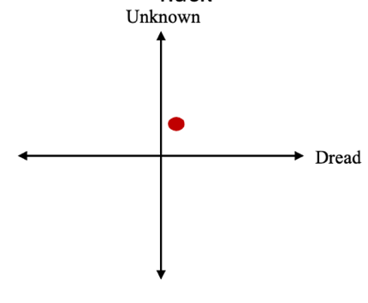

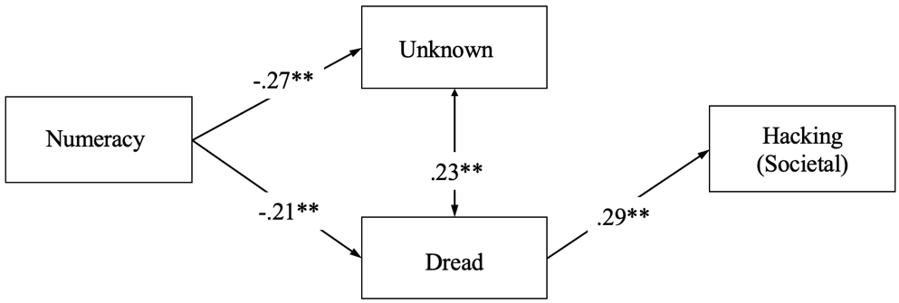 | 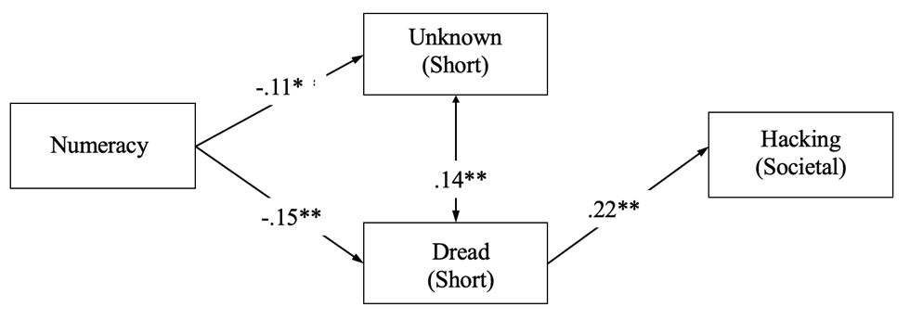
(i) Hacking – Societal Specific with Long Form | (ii) Hacking – Societal Specific with Short Form
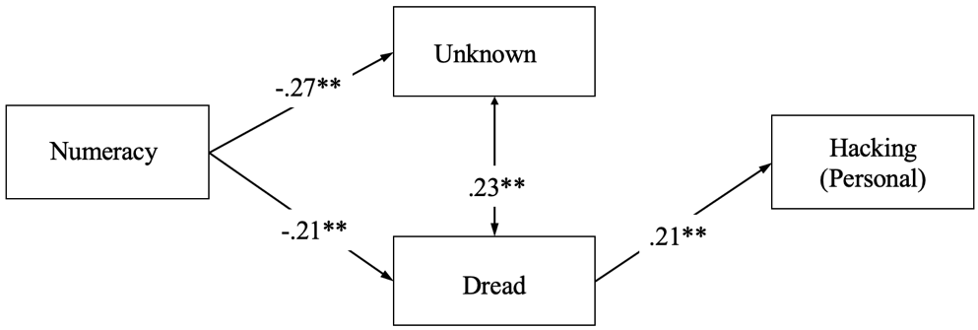 | 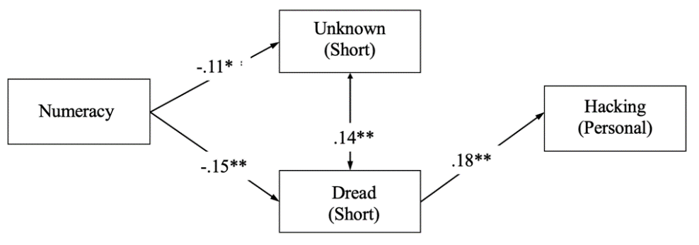
(iii) Hacking – Personal Specific with Long Form | (iv) Hacking - Personal Specific with Short Form

Figure 3. 2
Comparison of Models Predicting Societal and Personal Hurricane Risk Perceptions using the Full versus Short Scale
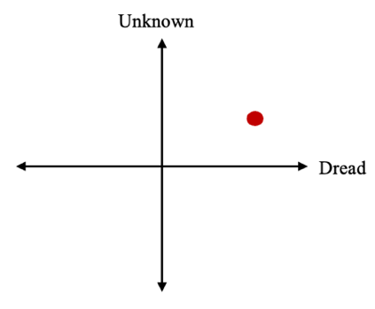
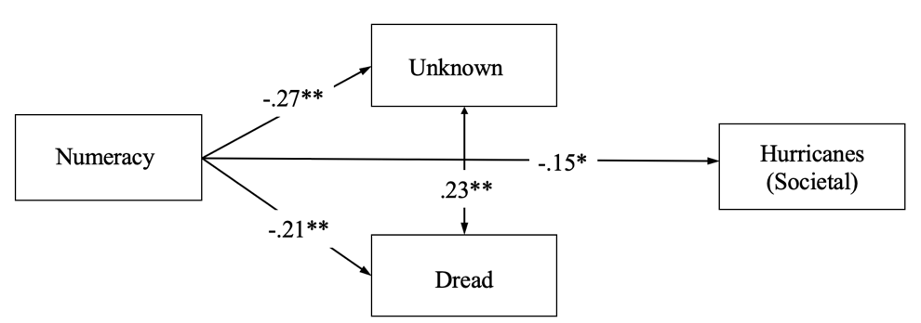 | 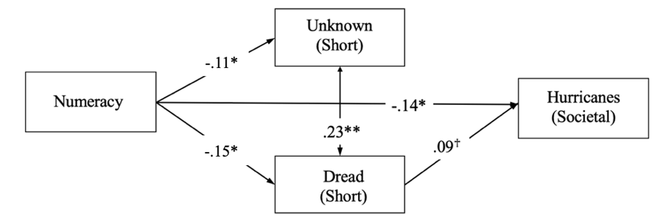
(i) Hurricanes – Societal Specific with Long Form | (ii) Hurricanes – Societal Specific with Short Form
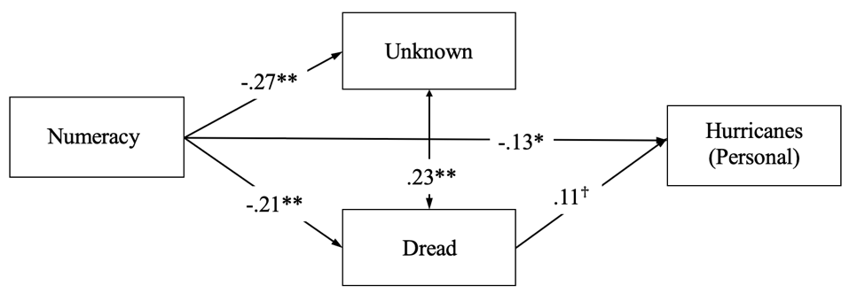 | 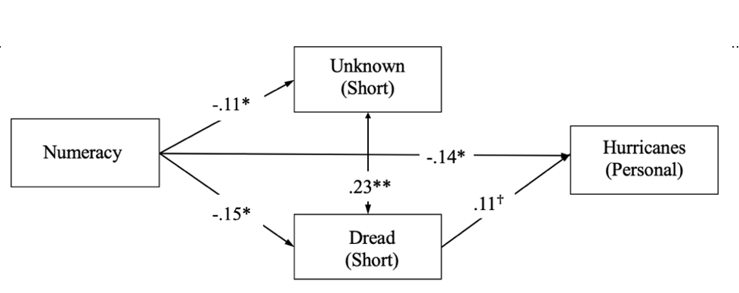
(iii) Hurricanes – Personal Specific with Long Form | (iv) Hurricanes - Personal Specific with Short Form

Figure 3. 3
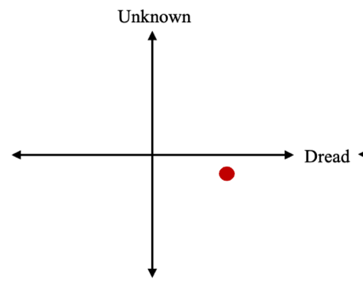
Comparison of Models Predicting Societal and Personal Handgun Risk Perceptions using the Full versus Short Scale

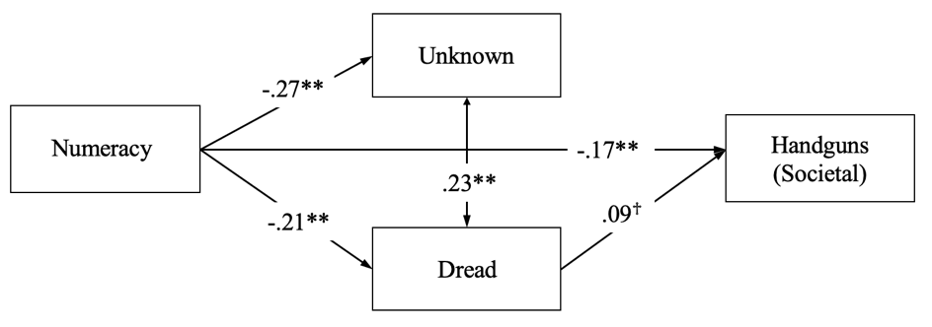 | 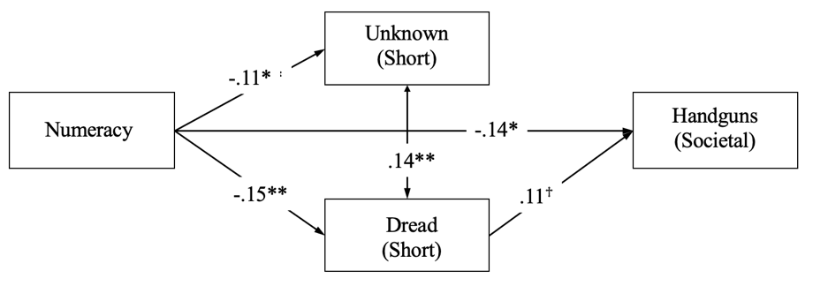
(i) Handguns – Societal Specific with Long Form | (ii) Handguns – Societal Specific with Short Form
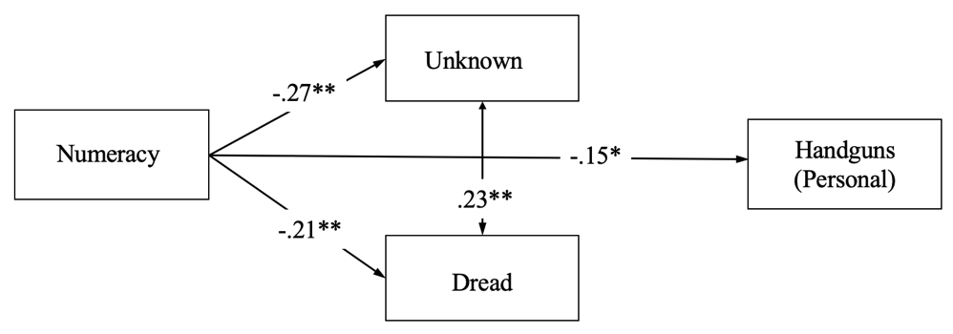 | 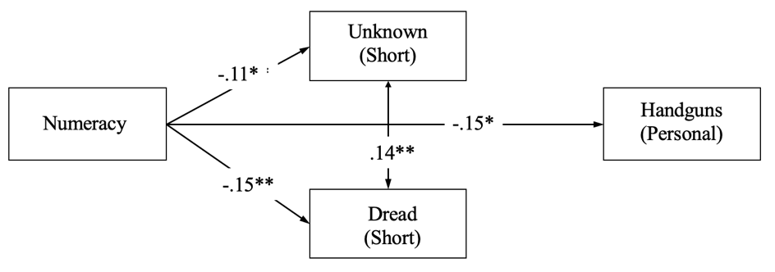
(iii) Handguns – Personal Specific with Long Form | (iv) Handguns - Personal Specific with Short Form

Figure 3. 4
Comparison of Models Predicting Societal and Personal Terrorism Risk Perceptions using the Full versus Short Scale
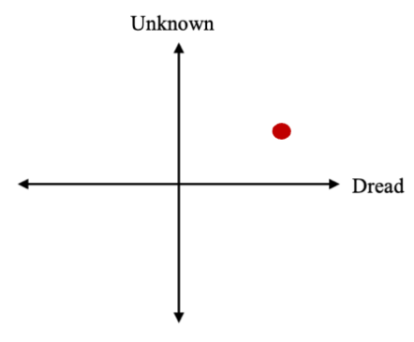

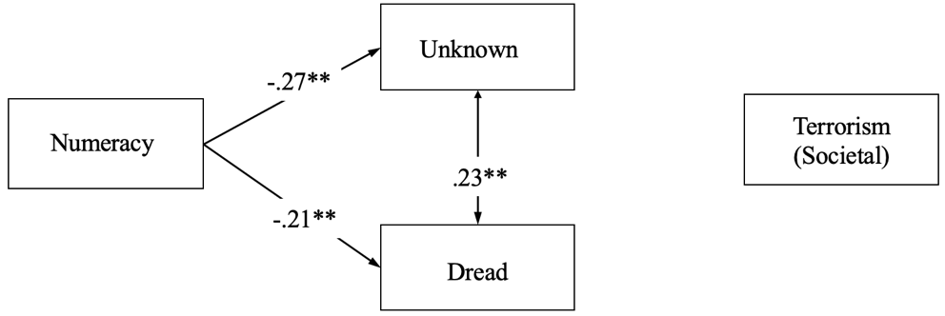 | 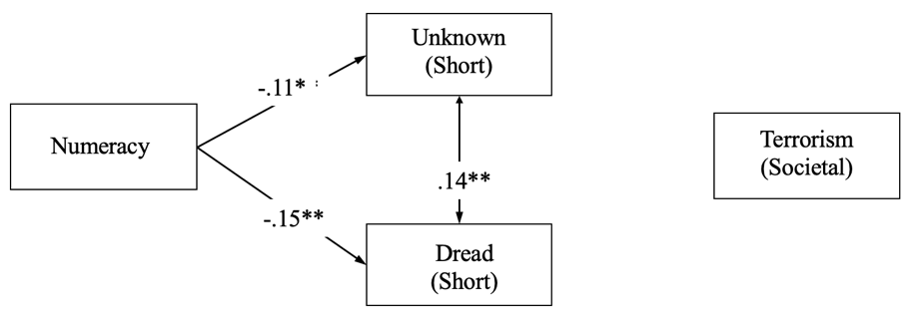
(i) Terrorism – Societal Specific with Long Form | (ii) Terrorism – Societal Specific with Short Form
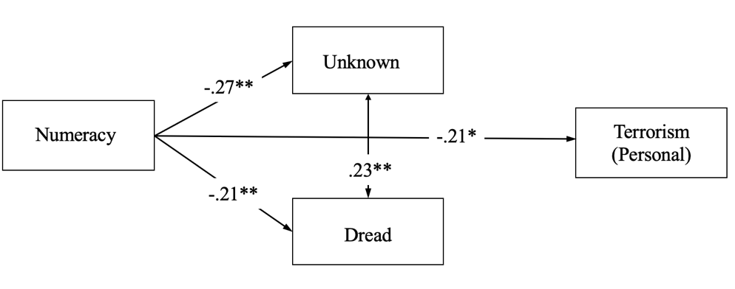 | 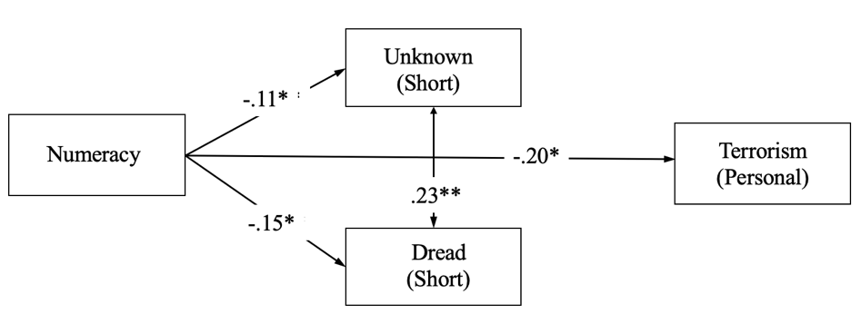
(iii) Terrorism – Personal Specific with Long Form | (iv) Terrorism - Personal Specific with Short Form

Figure 3. 5
Comparison of Models Predicting Societal and Personal Terrorism Risk Perceptions using the Full versus Short Scale
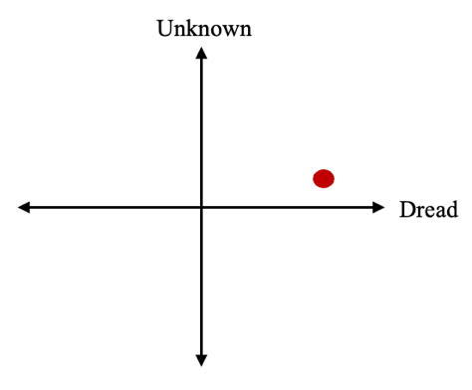
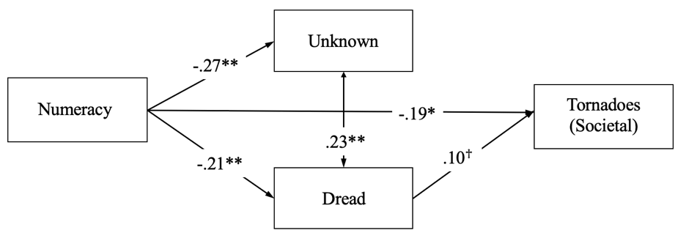 | 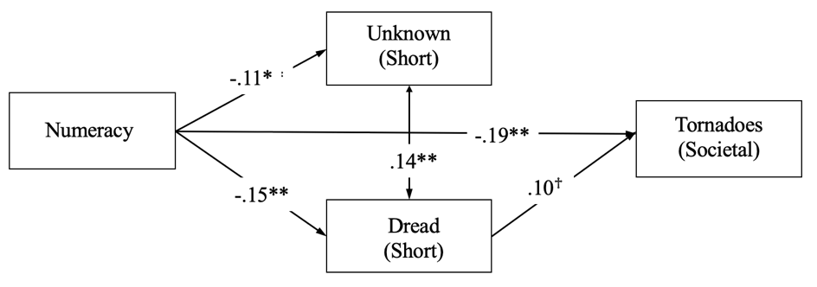
(i) Tornadoes – Societal Specific with Long Form | (ii) Tornadoes – Societal Specific with Short Form
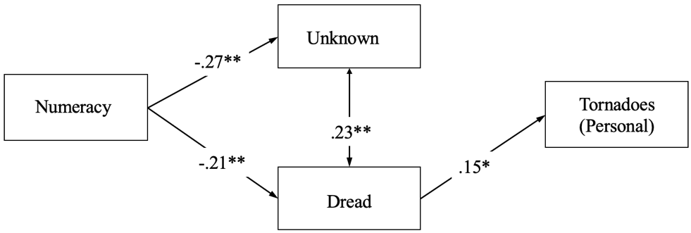 | 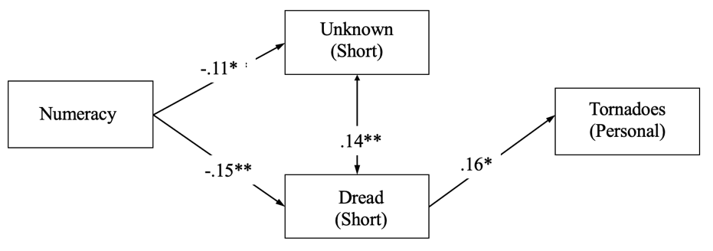
(iii) Tornadoes – Personal Specific with Long Form | (iv) Tornadoes - Personal Specific with Short Form

Figure 3. 6
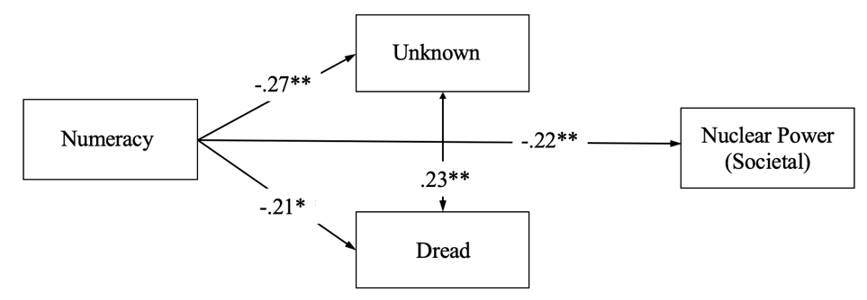 | 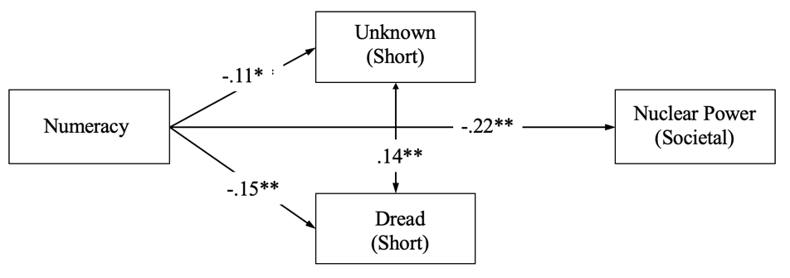
(i) Nuclear Power – Societal Specific with Long Form | (ii) Nuclear Power – Societal Specific with Short Form
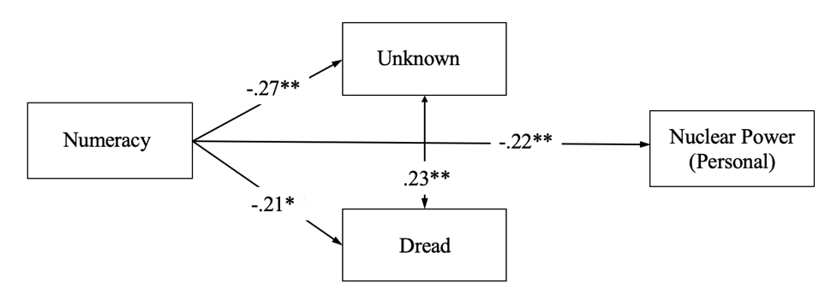 | 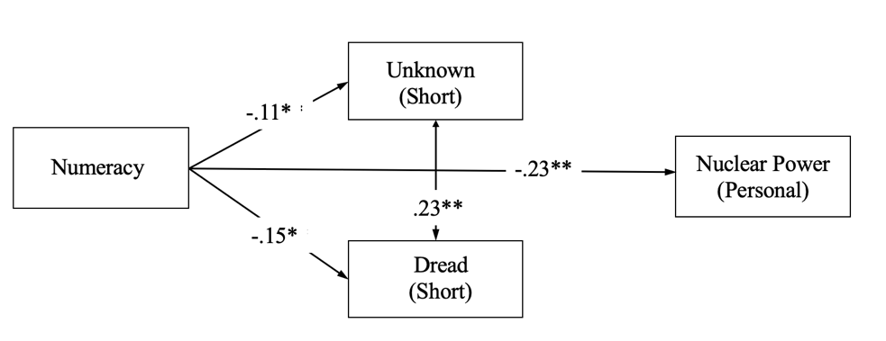
(iii) Nuclear Power – Societal Specific for Long Form | (iv) Nuclear Power – Societal Specific with Short Form
Comparison of Models Predicting Societal and Personal Nuclear Power Risk Perceptions using the Full versus Short Scale
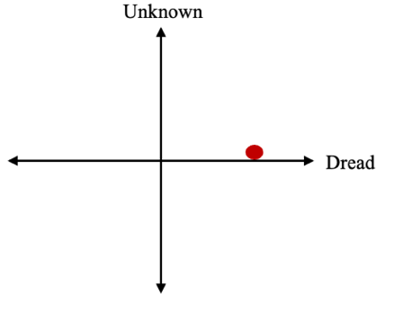

Figure 3. 7
Comparison of Models Predicting Societal and Personal Smoking Risk Perceptions using the Full versus Short Scale
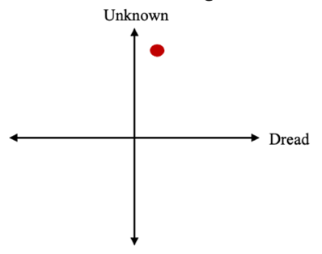

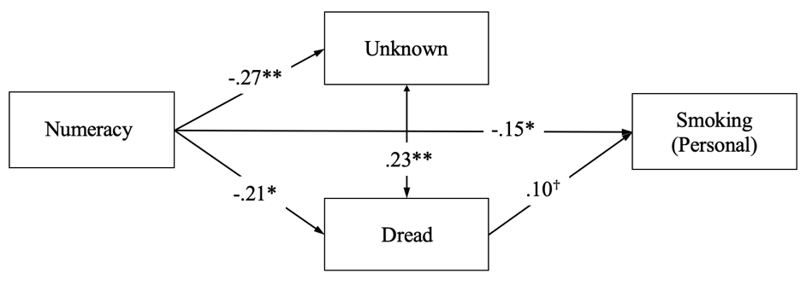 | 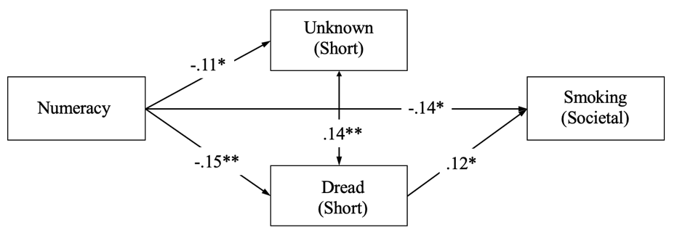
(i) Smoking – Societal Specific with Long Form | (ii) Smoking – Societal Specific with Short Form
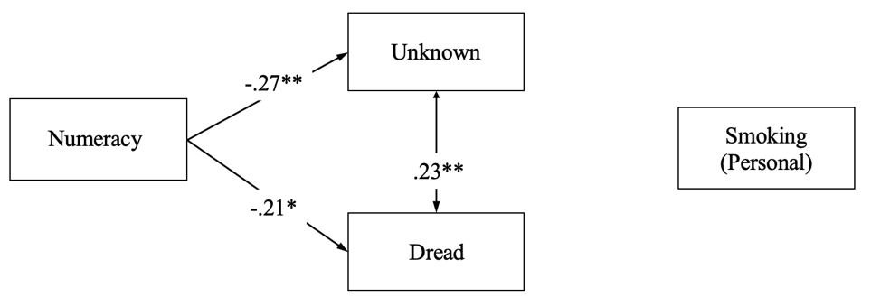 | 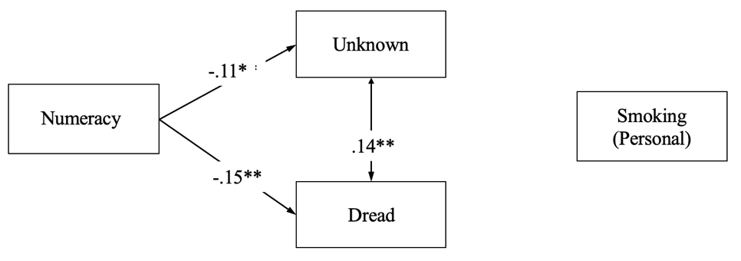
(iii) Smoking – Personal Specific with Long Form | (iv) Smoking -- Personal Specific with Short Form
Figure 3. 8
Comparison of Models Predicting Societal and Personal Alcohol Risk Perceptions using the Full versus Short Scale
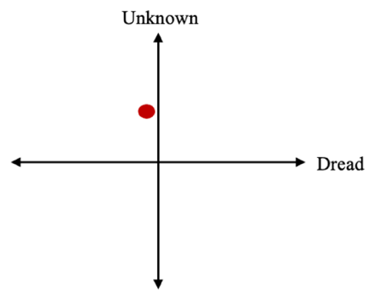

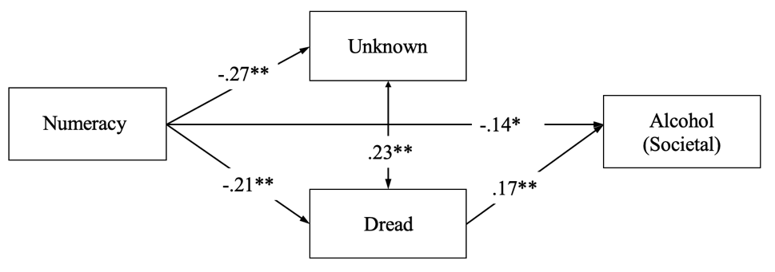 | 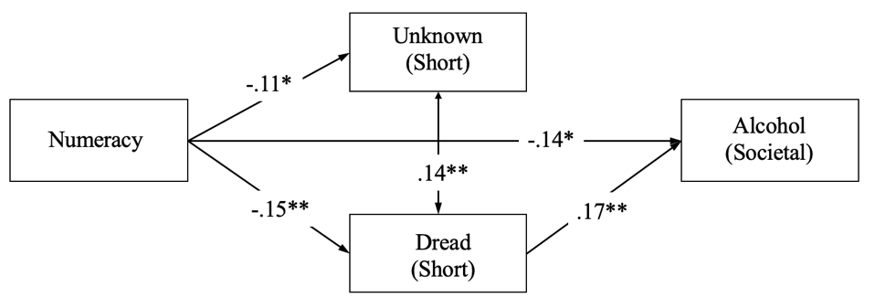
(i) Alcohol – Societal Specific with Long Form | (ii) Alcohol – Societal Specific with Short Form
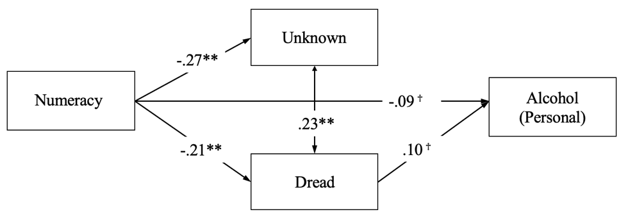 | 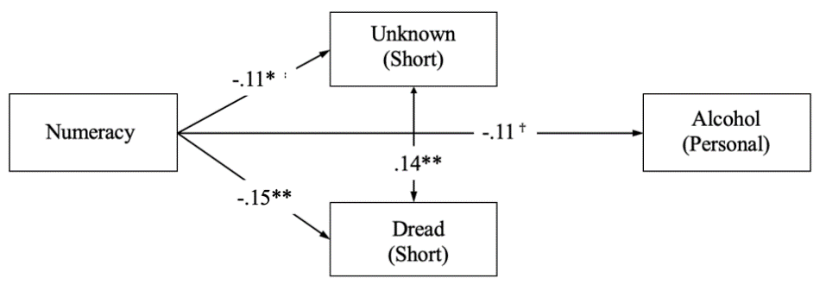
(iii) Alcohol – Personal Specific with Long Form | (iv) Alcohol - Personal Specific with Short Form

Figure 3. 9
Comparison of Models Predicting Societal and Personal Automobile Risk Perceptions using the Full versus Short Scale
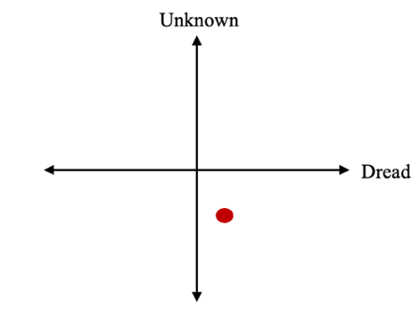

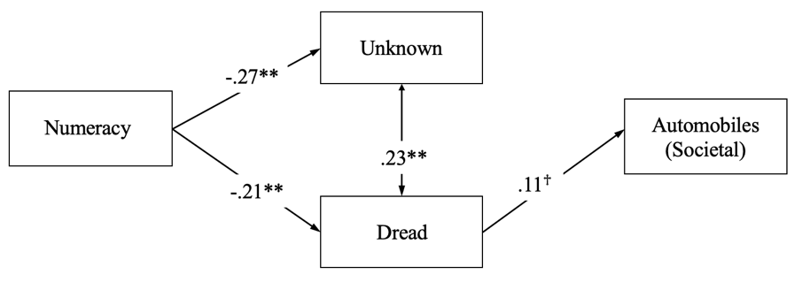 | 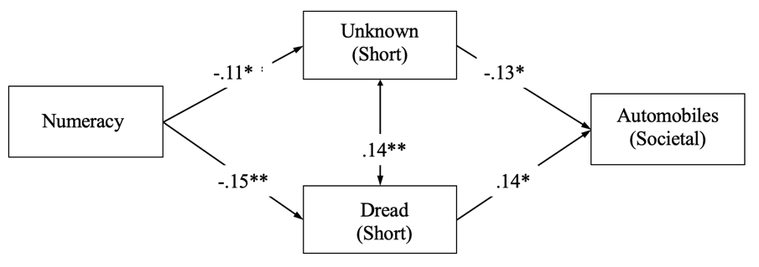
(i) Automobiles – Societal Specific with Long Form | (ii) Automobiles – Societal Specific with Short Form
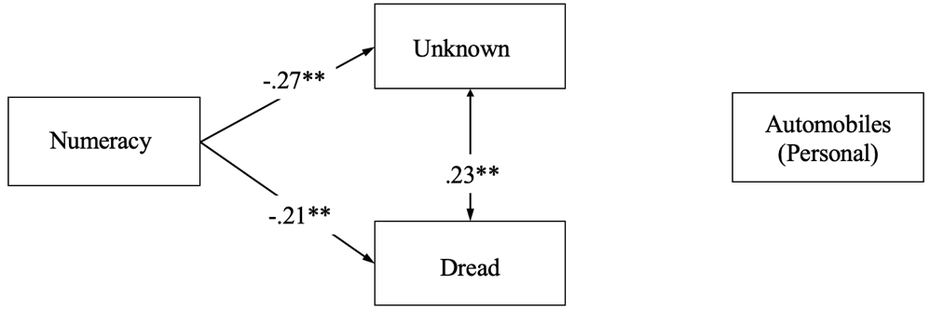 | 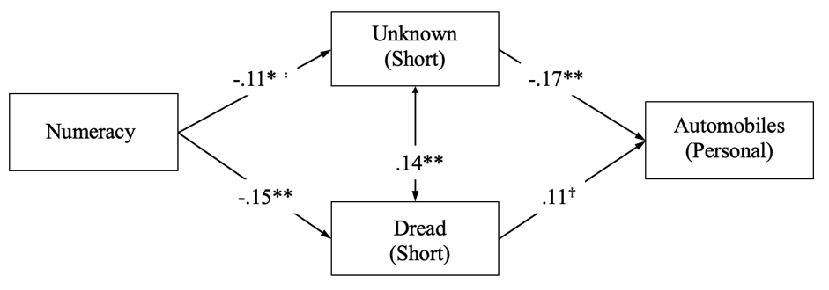
(iii) Automobiles – Personal Specific with Long Form | (iv) Automobiles - Personal Specific with Short Form

Figure 3. 10
Comparison of Models Predicting Societal and Personal Identity Theft Risk Perceptions using the Full versus Short Scale
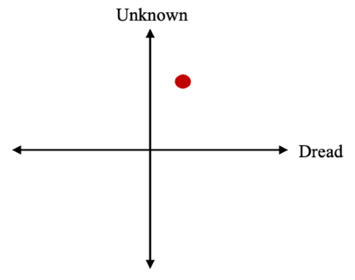

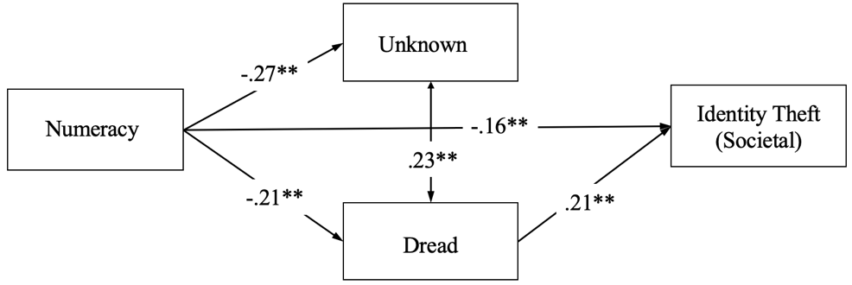 | 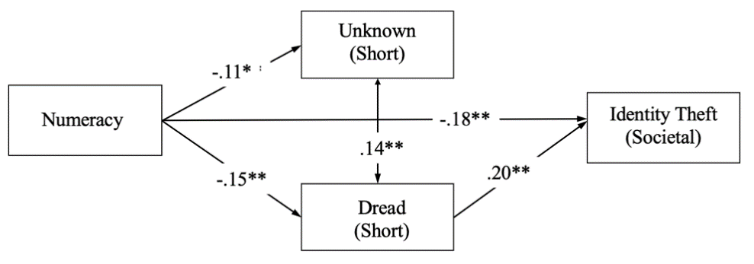
(i) Identity Theft – Societal Specific with Long Form | (ii) Identity Theft – Societal Specific with Short Form
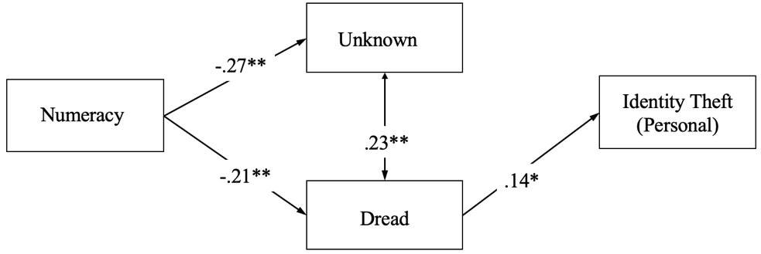 | 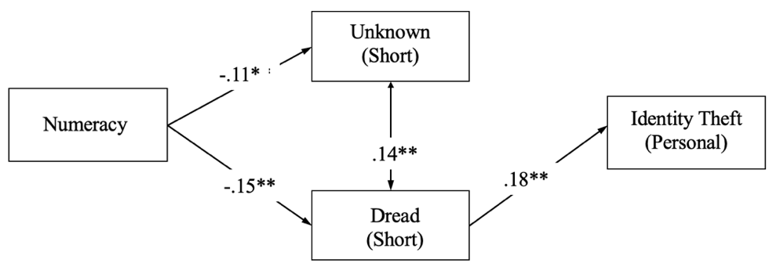
(iii) Identity Theft – Societal Specific with Long Form | (iv) Identity Theft – Societal Specific with Short Form

Study 2 Discussion
Study 1 demonstrated that domain general risk perceptions tended to explain perceptions of most of the emerging societal risks that we considered. Additionally, the brief scale distilled in Study 1 once again approximated the long form with considerable fidelity at the structural level in Study 2. Moreover, results from Study 2 demonstrated that the properties of the brief domain general scale generalized to a new sample of people, novel risks, and to previously untested types of risk perceptions (i.e., personal). First order correlations indicated that the brief scale performed similarly to the long form scale (see Tables 3.1), providing more evidence of convergent and discriminant validity. Both the long and short form scale also correlated with specific societal and personal risk perceptions (Table 3.2 and Table 3.3). Conversely, the long and short form scales did not correlate with nearly any of the other individual difference variables assessed in Study 2. Specifically, the scales did not correlate with other measures of risk attitudes such as the Domain of Specific Risk Taking (DOSPERT; Weber et al., 2006), and the Risk Propensity Scale (Meertens & Lion, 2008). These findings are consistent with the hypothesis that the brief scale could serve as a distinct and unique measure of general societal risk perceptions. Similar to Study 1, comparative structural equation modeling analyses using the long versus short form were conducted to explore perceptions of specific societal risk perceptions (Figures 3.1 – 3.10). Of the ten structural models testing novel risks, six models evidenced a similar structure to the risks tested in Study 1, providing further evidence of predictive validity when general v. specific risk perceptions were assessed at different times (e.g., measured 1-2 weeks apart).

Extension to Personal Risk Perceptions
A novel contribution in this study was the extension of the brief scale to the personal domain. As observed in Figures 3.1- 3.10, the brief scale predicted six out of ten risks in the personal domain (see Figure 3.9). The successful generalization of the brief scale to the personal domain is unique for a few reasons. These results support the notion that this brief 3-minute assessment may provide a useful framework or inventory that can be used for manifold research efforts (i.e., can be used to measure and compare both societal and personal risk perceptions across populations). Finally, as explained in the previous sections, the models display similar structure as seen in Study 1, demonstrating an underlying structure of the two dimensions in relation to both personal and societal specific risk perceptions as well as differences in skill (i.e., numeracy). While the relations between numeracy and specific risk perceptions in Study 1 were fully mediated by general risk perceptions, Study 2 provided novel evidence indicating that in some cases numeracy can robustly predict differences in both societal and personal specific risk perceptions, even after controlling for the domain general scale (e.g., numeracy uniquely and directly predicted differences in handgun risk perceptions).

Open Questions and Future Directions
The structural models from Study 2 indicated that the brief scale did not consistently explain perceptions of risks such as terrorism, nuclear power, handguns, and smoking. One potential explanation for these findings may have to do with the relative distance from dread/unknown predictors in general. Theoretically, perhaps risks that tend to be perceived as somewhat equally dreaded and unknown (e.g., near the theoretical calibration line) are better explained by the brief scale, as opposed to risks that are perceived as either more dreaded or extremely unknown, which is reflected in the position of these 4 risks on the two-dimensional dread-unknown space. Another explanation might be that these risks may be considered particularly salient for the undergraduate sample. For instance, the risk of handguns is evolving at an unprecedented rate, with multiple studies observing firearm related injury to be one of the leading causes of death for teenage/young adults (CDC, 2020). Similarly, nuclear power is still considered highly dreaded but less unknown due to highly publicized and covered accidents at nuclear power plants (e.g., Three Mile Island, Chernobyl; see Slovic, 1987). Smoking may be perceived more as a habit/chronic dependence, especially with the rise in vaping (Dave et al., 2020; Pepper et al., 2019). On the other hand, terrorism can be considered similar to nuclear power, with intensified media coverage of terrorist attacks (Wolff & Larsen, 2014).
These open questions notwithstanding, results from Study 2 present some opportunities to address other potential limitations and novel tests. For instance, it would be useful to test the extent to which the brief scale might robustly explain perceptions of societal and personal risks outside across a more diverse sample (e.g., MTurk sample). Additionally, it would be interesting to assess the extent to which the brief scale might uniquely explain perceptions of truly emerging, evolving, and unprecedented risks (COVID -19), and whether or not the various risk perceptions would indeed help predict downstream behavioral consequences (e.g., acquisition of specific risk knowledge, behavioral intentions).

Chapter 4: Study 3

Similar to Studies 1 and 2, Study 3 had two primary objectives. First, I aimed to conduct a practical validity and robustness test of the brief scale by predicting perceptions of specific societal and personal risks in a more ecological sample of people and tasks (e.g., diverse adults evaluating COVID-19 risks). Accordingly, Study 3 was conducted shortly after widespread stay at home recommendations were offered in United States, early on in the pandemic (March 2020) while total casualties of COVID-19 were <1,000 people. Secondly, while Studies 1 & 2 had primarily tested the brief scale with respect to predictions of specific and personal risk perceptions, Study 3 was designed to test whether the brief scale would meaningfully and uniquely predict differences in downstream behaviors, such as behavioral intentions and accurate knowledge of specific COVID-19 risks.

Participants and Procedure
849 participants were recruited from Amazon’s Mechanical Turk, from a total sample of 1039 adults. Participants were selected for analyses based on coding schemes that included minimum completion time (> 5 minutes), and partial completion of the survey (> 60%). Over half the respondents were female (56%), and the age range of the participants were reported between 19-83 years old, (M =39.36, SD = 13.65). Participants were asked to first complete numeracy assessments, followed by risk perception measures and ended with demographics. The online survey typically took about 10-15 minutes to complete. All ethical standards as outlined by the IRB were followed.

Measures
Numeracy. Numeracy was measured using the Berlin Numeracy Test (see RiskLiteracy.org). Following best-practice recommendations, the BNT-S form was administered., This includes three additional items taken from Schwartz et al. (1997) and provides increased sensitivity among less skilled and less educated individuals (e.g., non-college graduates, older-adults), was administered. An example item is “Imagine we are throwing a five-sided die 50 times... out of 50 throws what proportion will result in an odd number?”
Berlin Risk Perception Inventory. Distilled in Study 1 and preliminarily validated in Study 2, the BRPI was used to measure general societal risk perceptions (see Figure 2.2 for the scale). The integrated framework also included COVID-19 and general risk perceptions measured using the One Item Risk Perception Measure (Kahan, Landrum et al., 2017). Following Study 2, personal risk perceptions were again asked using the same form of the inventory, specifically asking “How risky are the following to you, personally?”
Knowledge of Expert Consensus. Knowledge of expert consensus was assessed using a single item, “According to most experts, how important is it for all individuals to self-isolate and social distance over the next two weeks?” on a scale from 1 (Not Important at All) to 7 (Extremely Important). This item was scored in accord with stay-at-home orders that were in effect in March 2020 (Newsom, 2020).
Intentions about Self Isolation and Social Distancing. Intentions were assessed using a single item, “How important is it for you to self-isolate and social distance over the next two weeks?” on a scale from 1 (Not Important at All) to 7 (Extremely Important) with higher scores indicating more agreement with the statement.

Results
Does the Brief Scale Predict COVID-19 Risk Perceptions with Structural Fidelity?
Following Studies 1 & 2, structural models were constructed to test numeracy’s relation with each of the latent traits of risk perceptions, controlling for the influence of general risk perceptions. The results replicated the structure of the models seen in Studies 1 & 2 and had good fit; see Figures 4.1 and 4.2.

Figure 4. 1
Structural Equation Model for COVID-19 Societal Risk Perceptions.
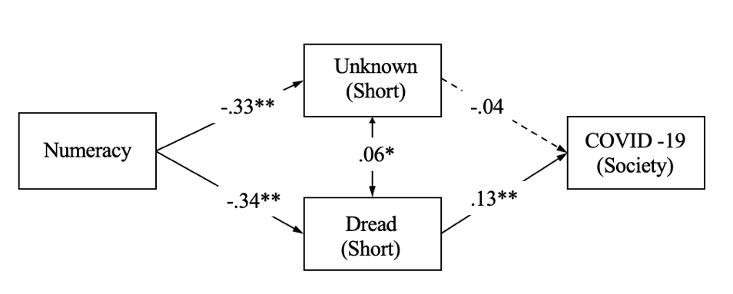

Figure 4. 2
Structural Equation Model for COVID-19 Personal Risk Perceptions.
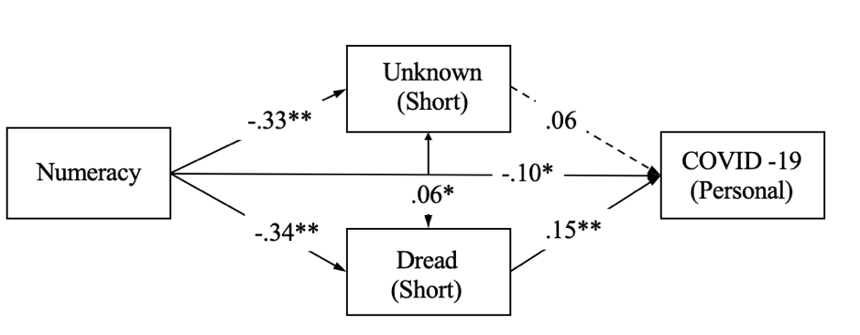

Does Domain General Risk Perception Uniquely Predict COVID-19 Risk Perceptions?
I wanted to examine how useful these brief measures were for explaining specific societal risk perceptions (i.e., how much more variance is explained by the general scale), as well as for predicting downstream consequences like knowledge and beliefs about self-isolation and social distancing. Further, to provide more context and conduct some finer grained analyses, I directly assessed the influence of the sub-characteristics constituting the dread and unknown factors, including: Known to Persons and Known to Science (for unknown) and Severity of Consequences and Catastrophic (for dread). The goal was to have the most precise sense of which component of dread and unknown (if any) was the major driver of risk perceptions of COVID-19 to society, and subsequent outcomes such as knowledge and intentions. Accordingly, regression analyses were conducted to predict risk perceptions of COVID-19 to society with these sub-components (see Table 4.1). Results revealed that Model 2 (Table 4.1) explained twice the variance in societal risk perceptions when compared to Model 1, indicating that the domain general instrument as well as aspects of COVID-19 specific risk perceptions were both meaningful and unique predictors of individual differences in perceptions of COVID-19 risk to society, during the early phases of the U.S. exposure to the pandemic.

Table 4. 1
Regression models predicting COVID-19 risk perceptions to society.
 | Model 1:  COVID-19 Risk Perceptions to Society | Model 2:  COVID-19 Risk Perceptions to Society
Variable (Short Form Assessments) | B (SE) | B (SE)
Known to Science (General) |  | -.06 (.08)
Known to Persons (General) |  | .05 (.07)
Catastrophic (General) |  | .03 (.07)
Severity of Consequences (General) |  | -.13** (.07)
Societal Risk Perceptions (General) |  | .31*** (.06)
Known to Science (COVID-19) |  | .05 (.04)
Known to Persons (COVID-19) |  | .05 (.04)
Catastrophic (COVID-19) |  | .23*** (.03)
Severity of Consequences (COVID-19) |  | .27*** (.04)
Expert Consensus Knowledge | .26*** (.06) | .10** (.06)
Numeracy | -.06 (.03) | .00 (.02)
Individualism | -.05 (.06) | -.04 (.06)
Egalitarianism | .24*** (.05) | .15*** (.04)
Hierarchy | .15*** (.06) | .08* (.05)
Fatalism | .02 (.06) | -.03 (.05)
Age | .03 (.00) | .03 (.00)
Gender | .07* (.11) | .06 (.10)
Explained Variance (%) | 18.07% | 37.16%

Another regression model was constructed to explain perceptions of personal COVID-19 risk perceptions after controlling for cultural values and demographics. Results are presented in Table 4.2. Similar patterns were observed such that the brief scale explained unique variance in personal risk perceptions of COVID-19, replicating findings observed in Study 2. Further, both models shared the same significant components from the brief scale (i.e., general fatal and general societal variables).

Table 4. 2
Regression models predicting personal COVID-19 risk perceptions.
 | Model 1:  COVID-19 Risk Perceptions Personal | Model 2:  COVID-19 Risk Perceptions Personal
Variable (Short Form Assessments) | B (SE) | B (SE)
Known to Science (General) |  | -.06 (.08)
Known to Persons (General) |  | .04 (.07)
Catastrophic (General) |  | .09* (.07)
Severity of Consequences (General) |  | -.14** (.07)
Societal Risk Perceptions (General) |  | .20*** (.06)
Known to Science (COVID-19) |  | .02 (.04)
Known to Persons (COVID-19) |  | -.00 (.04)
Catastrophic (COVID-19) |  | .22*** (.03)
Severity of Consequences (COVID-19) |  | .21*** (.04)
Expert Consensus Knowledge | .15*** (.06) | .04 (.06)
Numeracy | -.15*** (.03) | -.08* (.02)
Individualism | -.06 (.07) | -.07 (.06)
Egalitarianism | .25*** (.06) | .17*** (.04)
Hierarchy | .16*** (.07) | .10* (.05)
Fatalism | .10** (.07) | .05 (.05)
Age | .08* (.00) | .08** (.00)
Gender | -.02 (.11) | -.02 (.10)
Explained Variance (%) | 17.46% | 29.82%

Do Domain General Risk Perceptions Predict Behavioral Intentions?
Following from previous analyses, I conducted a series of regressions to predict behavioral intentions (seen in Table 4.3). While differences in skill (numeracy) and ideology (cultural values) robustly predicted intentions in Model 2, the explained variance more than doubled when the general scale and its sub-components were included, with the general known to science and catastrophic components emerging as the strongest unique predictors. Finally, Model 3 shows that with the addition of expert consensus knowledge, the explained variance further increased, wherein knowledge served as a partial mediator of other observed relations. Despite this partial mediation by knowledge, COVID-19 specific risk perceptions remained direct, unique predictors of behavioral intentions.

Table 4. 3
Regression models predicting beliefs and intentions about self-isolation and social distancing during COVID-19.
 | Model 1: Intentions | Model 2: Intentions | Model 3: Intentions
Variable (Short Form Assessments) | B (SE) | B (SE) | B (SE)
Expert Consensus Knowledge |  |  | .51*** (.04)
Known to Science (General) |  | -.17*** (.05) | -.04 (.05)
Known to Persons (General) |  | .04 (.05) | .04 (.05)
Catastrophic (General) |  | -.10** (.05) | -.00 (.05)
Severity of Consequences (General) |  | -.06 (.05) | -.05 (.05)
Societal Risk Perceptions (General) |  | .00 (.04) | -.06* (.04)
Known to Science (COVID-19) |  | .00 (.02) | -.00 (.02)
Known to Persons (COVID-19) |  | .00 (.02) | -.00 (.02)
Catastrophic (COVID-19) |  | .18*** (.02) | .09*** (.02)
Severity of Consequences (COVID-19) |  | .08* (.03) | .07* (.02)
Societal Risk Perceptions (COVID-19) |  | .30*** (.02) | .24*** (.02)
Numeracy | .20*** (.02) | .12*** (.02) | .03 (.02)
Individualism | .02 (.05) | .05 (.04) | -.01 (.04)
Egalitarianism | .30*** (.03) | .17*** (.03) | .08** (.03)
Hierarchy | .05 (.05) | .04 (.04) | .06 (.03)
Fatalism | -.05 (.04) | -.03 (.04) | -.00 (.03)
Age | .17*** (.00) | .14***(.00) | .09*** (.00)
Gender | .19*** (.07) | .10*** (.08) | .04 (.07)
Explained Variance (%) | 18.24% | 37.07% | 53.75%

Study 3 Discussion
Study 3 aimed to extend the evidence of practical and predictive validity and robustness for the brief measure during the early phases of the COVID-19 pandemic in the United States. Consistent with previous findings, results again provided structural evidence suggesting that the brief scale explained perceptions of COVID-19 risk, both societally and personally, primarily because of the direct influence of the dread factor. However, I also wanted to establish evidence of predictive validity for the brief scale to explain relevant downstream consequences such as behavioral intentions regarding social distancing and self-isolation of COVID-19, as well as accurate knowledge about COVID-19 risk mitigation. Regression models indicated that the brief scale uniquely explained societal and personal risk perceptions of COVID-19, as well behavioral intentions even after controlling for demographics and cultural theory variables.

What Predicts Expert Consensus Knowledge?
Regression analyses similar to those in Tables 4.1 and 4.2 were constructed to identify the strongest predictors of expert knowledge (Table 4.4). Model 1 from Table 4.4 shows that numeracy was the strongest predictor of knowledge. Model 2, which explained about twice the variance as Model 1, indicated that general Known to Science was the strongest single predictor. The finding suggests that how one feels about science and risk in general (e.g., whether most risks are known to science) may also predicts who is more likely to have an accurate understanding of the expert consensus. Similar patterns were also observed for general Catastrophic risk perceptions.

Table 4. 4
Regression models predicting Knowledge
 | Model 1:  Expert Consensus Knowledge | Model 2:  Expert Consensus Knowledge
Variable (Short Form Assessments) | B (SE) | B (SE)
Known to Science (General) |  | -.23*** (.05)
Known to Persons (General) |  | -.00 (.05)
Catastrophic (General) |  | -.18*** (.05)
Severity of Consequences (General) |  | -.02 (.05)
Societal Risk Perceptions (General) |  | .15*** (.04)
Known to Science (COVID-19) |  | .00 (.02)
Known to Persons (COVID-19) |  | .00 (.02)
Catastrophic (COVID-19) |  | .17*** (.02)
Severity of Consequences (COVID-19) |  | .02 (.02)
Societal Risk Perceptions (COVID-19) |  | .10** (.02)
Numeracy | .29*** (.03) | .17*** (.03)
Individualism | .25*** (.06) | .13*** (.03)
Egalitarianism | .09* (.06) | .16*** (.03)
Hierarchy | -.06 (.06) | -.03 (.03)
Fatalism | -.07 (.06) | -.04 (.03)
Age | .13*** (.00) | .09**(.00)
Gender | .20*** (.11) | .11*** (.06)
Explained Variance (%) | 20.64% | 36.17%

Decomposing Dread and Unknown Factors
Study 3 also provided novel evidence for the application of the brief scale and for analyses of its sub-characteristics. That is, the BRPI can be combined to reflect components of general dread and unknown risk perceptions, as observed in the first half of Study 3. However, the specific sub-characteristics of dread and unknown (catastrophic, fatal, known to science, and known to persons) can also be used as individual difference measures that provide reliable information, and may predict domain specific risk perceptions. In all cases, the affect component of domain general risk perceptions (general dread, or individual catastrophic and fatal rating scales) was observed to be the major driver of specific risk perceptions. However, the regression models provided clear evidence indicating an influential role of one of the characteristics of the unknown factor. Additionally, analysis of the internal consistency of the scale suggests that the scale is adequately reliable (.73 < α < .89) to conventional levels, with Known to Science and Catastrophic displaying the highest reliability.

Chapter 5: General Discussion
The current set of studies had two overarching goals: (i) to distill and validate a brief and robust individual differences inventory, integrating multiple types and dimensions of risk perception measurements (e.g., Fischhoff et al., 1978), and (ii) to test applications and develop a methodology and analytic framework for integrated risk perception assessment. Toward these ends, three studies were conducted. Study 1 provided the first Item Response Theory analysis of general societal risk perceptions, based on the methods used in the original psychometric paradigm (Fischhoff et al.). The results from IRT analyses allowed me to distill a brief instrument (3 minute) and to documented psychometric robustness and predictive validity as compared with the full (1-2 hour) assessment (e.g., SEM analyses). Study 2 provided converging evidence of psychometric quality with an out of sample replication and conceptual extension of Study 1 to a wider range of specific risks, controlling for dozens of other potentially risk relevant traits and variables (e.g., DOSPERT, risk propensity, personality, worldviews, demographics). Study 2 also provided the first evidence that general societal risk perceptions can in some cases predict perceptions of one’s own personal risks, even when measured after some delay (e.g., 2 weeks later).
Lastly, Study 3 provided an unanticipated and remarkable opportunity for a robustness check of the brief scale, which resulted in what I believe to be the first study in history to measure both general and specific risk perceptions during the COVID-19 pandemic (i.e., during the early phase of the U.S. experience in March 2020). Specifically, Study 3 provided converging evidence on the robustness of general risk perceptions for predicting specific COVID-19 risk perceptions. Moreover, Study 3 provided some of the very first evidence documenting a relationship between general risk perceptions and downstream behavioral outcomes, such as COVID-19 related behavioral intentions and accurate risk mitigation knowledge. Notably, the study also revealed that the affectively charged dread aspect of risk perceptions was not the only strong predictor of relevant outcomes. In contrast, the “known to science” sub-characteristic of the unknown component of general risk perceptions was found to be the single best predictor of accurate early phase COVID-19 knowledge. In other words, the results suggested that people who rated science as generally more knowledgeable (less unknown) were also more likely to have acquired accurate knowledge of COVID-19 risk mitigation recommendations (e.g., people didn’t pay attention to scientists when the assumed scientists for more unaware of most risks in general). To the extent this finding generalizes, it suggests that many behaviors may be influenced by aspects of risk perceptions beyond the affectively charged influences of the dread component.
Taken altogether, the results from all three studies provide considerable converging evidence indicating that a brief (3 minute) risk perception inventory may often be a useful, and perhaps even necessary, element when the aim is to precisely and accuracy explain individual differences in diverse risk judgements and their consequences. Beyond these findings, the results have major implications for at least two other noteworthy issues. The first concerns the implications for an integrated theory of individual differences in risk perceptions. The second concerns methodological insights, best practices, and avoidable measurement biases that may be addressed via an integrated framework for the assessment of risk perceptions.
Towards a Theory of Individual Differences in Risk Perceptions
Since the development of risk perception measurement in the 1960s, there has been substantial advancement of theories of how individuals and societies perceive, respond to, and understand risk. Today, a large body of research suggests that the insights from risk perception theories and research have many implications for public policies, risk communications, preventative action, and other risk mitigation priorities (Brewer et al., 2004; 2007; Fischhoff & Bostrom, 1993; Plapp & Werner, 2006; Renn, 2004; Slovic et al., 1982; Tagini et al., 2021; Wachinger et al., 2013). Although these theories have uniquely contributed to the risk perception literature, by and large the study of risk perceptions has been somewhat fragmented and has neglected an integrated approach to the measurement of individual differences. Moreover, while the original dimensions of societal general dread and unknown were first identified by Fischhoff et al. (1978) more than four decades ago, psychometric advances in the assessment of individual differences in relevant risk perceptions have lagged behind other advances. As such, most risk perception studies today (and in the past) have focused on only one type or aspect of risk perception (i.e., specific personal, specific societal; see), they have neglected individual differences in dread v. unknown components. For these and other reasons, I suspect the current set of studies is likely to be the first and only to simultaneously assess the influences of domain general, domain specific, societal and personal risk perceptions across dread and unknown dimensions, via a single, simple integrated framework (i.e., a brief psychometric inventory—the Berlin Risk Perception Inventory). The available evidence on the psychometric quality of the new inventory accords with established standards of validity and reliability across all five types of evidence, and can be usefully summarized as follows (AERA, APA & NCME, 1999; Messick, 1998):
- Evidence based on test content. This type of validity commonly refers to systematic item development strategies such as themes, wording, and format of items, usually including expert review. Messick (1998) notes that in addition to item generation and development, the test should also consist of tasks representative of the construct. To this end, I started by replicating the seminal work by Fischhoff et al. (1978). In Study 1, I added nine emerging risks (i.e., weather, cybersecurity and health and safety) to the existing 30 risks (i.e., activities and technologies), and in Study 2 I extended these set of risks to technologies and activities. I used Item Response Theory to distill the brief scale and fulfill both categories of content validity: items were chosen based on placement in the two-dimensional dread-unknown space as well as item difficulty and discrimination parameters, while representative tasks (i.e., individual characteristics of the dread and unknown dimensions) were selected based on Test Information Function (TIF) and constrained discrimination parameters to reduce redundancy.
- Evidence based on internal structure. This type of validity can be defined as the consistency and reliability with which the items measure the underlying construct (e.g., factor structures; Beckman et al., 2005). According to Messick (1998) the internal structure of the assessment should be consistent with the internal structure of the construct. Replication analyses in Study 1 suggest that the underlying factor structure is consistent with Fischhoff et al. (1978). Evidence from all three studies suggests that the brief scale has the same underlying factor structure as the original set of risks and dimensions (i.e., dread and unknown).
- Evidence based on response process. This type of validity refers to the analyses of differences in responses to the test or measure, including scoring and reporting of results. For example, are differences in response patterns a function of theoretical differences in cognitive strategies or knowledge? Analyses demonstrate that differences in response patterns were systematically influenced by skills (i.e., numeracy was inversely related to both dread and unknown risk perceptions), highlighting response consistency (Embretson, 1983; Loevinger, 1957; Messick, 1989). Similarly, structural models from all three studies suggest that the brief scale can closely approximate the long form. In addition to distilling the brief scale, a scoring method to make the responses more interpretable was also developed with single standardized composite score used to estimate the respective dread and unknown dimensions across all three studies.
- Evidence based on relations to other variables. This category of validity refers to the relations between other variables and the construct being measured. Messick (1998) also defines this as external validity, which encompasses subcategories such as convergent, discriminant and predictive validity. Studies 1 and 2 provided evidence of convergent (correlations with societal risks), discriminant (not correlated with variables such as personality, resilience or coping). Study 3 demonstrated evidence of unique predictive validity with components of the brief scale predicting knowledge and behavioral intentions. Additionally, results from the current set of studies suggest that the brief scale shows evidence of generalizability as defined by Messick (1995), across samples, occasions, and time (longitudinal validity).
- Evidence based on consequences of testing. This type of validity refers to the consequences of the test or measure that can have some desired effects (Beckman et al., 2005). As such, value implications of score interpretation can have consequences for how the test is used specifically, but this can also have larger social implications (i.e., justice and fairness; Messick, 1998). Evidence from the current set of studies reveal that using the brief scale to measure domain general risk perceptions can usefully explain differences in perceptions of personal and societal risks, and predict downstream consequences such as expert consensus knowledge, which can have implications for understanding how relevant knowledge may be acquired.
Results from these studies also provide some of the first and earliest evidence that individual differences in risk perceptions can differentially predict perceptions of both societal and personal specific risks. For instance, across all models in the current set of studies, the dread dimension of domain general risk perceptions (general dread factor, or individual catastrophic and fatal rating scales) systematically predicted specific risk perceptions. These findings are consistent with previous research and theory that suggest risk perceptions are often strongly influenced by affect (e.g., feelings of dread, fear, and anxiety; Slovic & Peters, 2006; Slovic et al. 2007; Loewenstein et al. 2001). However, this is not the only dimension that robustly predicted specific risk perceptions. In several cases, general unknown risk perceptions were uniquely and inversely related to specific risk perceptions, suggesting that the more one perceives the world to be unknown or uncertain, the less likely people are to express extreme worries about any specific risk, as seen in personal and societal judgments. While relatively novel, other research has observed similar relations in the health domain, with results from a study by Kraywinkel et al. (2007) revealing that those with increased general health perceptions reported they were relatively less worried about stroke risk. Taken together, results from the current set of studies indicate that there is considerable and compelling evidence that this brief scale is both valid and robust, and as such is likely to be used more generally for investigating a wide range of individual differences in all kinds of risk perception and their implications. As such, insights from these analyses appear to have direct implications for the development of an integrative analysis framework that incorporates both general and specific risk perceptions.

A Framework for Analyzing Risk Perceptions: Analyzing Specific, General, and Relative Risk Perceptions
Based on evidence from the current set of studies, failure to measure and account for general risk perceptions might result in some biased estimates, akin to base rate neglect, which occurs when one does not adequately account for base rates (or overall probabilities) while making a judgement (Tversky & Kahneman, 1973; Lyon & Slovic, 1976). For instance, when asked if someone possessing certain characteristics (i.e., shy, withdrawn, structured and detailed) would be more likely to be a librarian or a salesperson, most respondents tend to choose librarian, even though the base rate or overall probability of someone being a salesperson is greater (Tversky & Kahneman, 1974).
A similar logic can be applied to the study of risk perceptions, more specifically on the relations between numeracy and COVID-19 risk perceptions. Results from Study 3 show that numeracy is inversely related to general dread risk perceptions but is unrelated to COVID-19 specific risk perceptions to society (see Figure 4.1 and Table 4.3). The latter finding is consistent with previous research (Roozenbeek et al., 2020; Pennycook et al., 2020; Sobkow et al., 2020), although respondents with higher numeracy skills tended to be less vulnerable to misinformation related to COVID-19. However, no other study had conducted comparative analyses that included both domain general and domain specific pieces to explain COVID-19 risk perceptions. To illustrate the potential need to analyze specific, general and relative risk perceptions, I wanted to test the relationship between numeracy and COVID-19 risk perceptions after accounting for the “base rate” (i.e., domain general risk perceptions). Specifically, part of the analytic protocol I would recommend is to create a relative score by subtracting the general risk perception score from specific risk perception scores (i.e., COVID-19 – Domain General). One way that would allow for methodologically comparing and unpacking these relative versus absolute risk perceptions is by dichotomizing these difference scores using a median-split (i.e., above the median was scored as 1). Binary logistic regressions were conducted to examine and compare the relationship between numeracy and dichotomized difference scores, allowing for odds ratios between low and high numerate participants. In the current analyses, eight models were tested (see Appendix C; Table 1 for the regression table) and all models controlled for demographics and cultural theory variables. However, for simplicity here I focus on two figures to illustrate the results. Figure 5.1 shows the relationship between numeracy, overall general risk perceptions and overall COVID-19 risk perceptions. These figures indicate that as numeracy increases so does the difference between specific and general risk perceptions (i.e., overall relative risk increases). This relationship also holds for relative dread risk perceptions (see Figure 5.2) such that more numerate folks were about 5 times more likely to be relatively worried about COVID-19 compared to those with lower numeracy. Figure 5.3 shows the standardized difference scores of the overall general and specific risk perceptions across numeracy.

Figure 5. 1
Composite overall COVID-19 risk perceptions across numeracy while accounting for composite general overall.
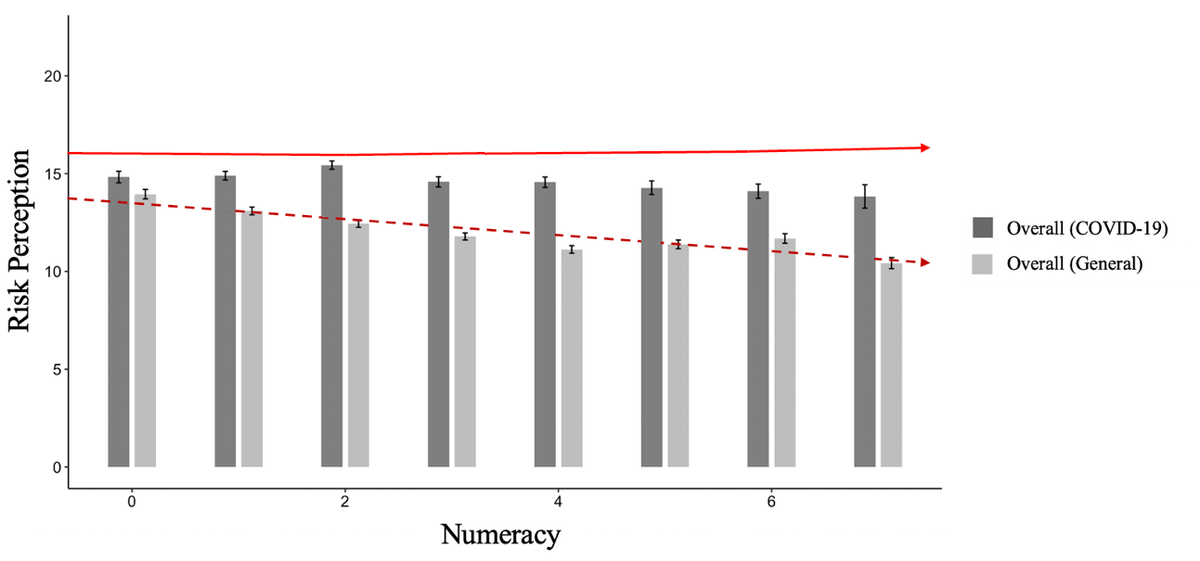
Note. Logistic regression and odds ratio, ß = .90, p <.001; OR [95% CI] = 4.99 [2.77 – 9.09].

Figure 5. 2
Composite COVID-19 dread risk perceptions across numeracy while accounting for composite general dread.
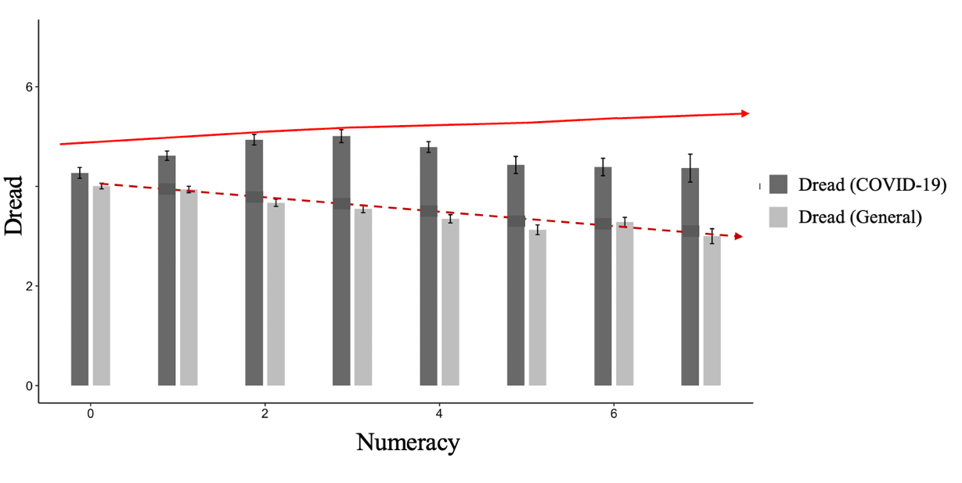
Note. Logistic regression and odds ratio, ß = .93, p <.001; OR [95% CI] = 5.28 [2.90 – 9.51].

Figure 5. 3
Standardized differences of overall risk perceptions (COVID-19 – General) across levels of numeracy.
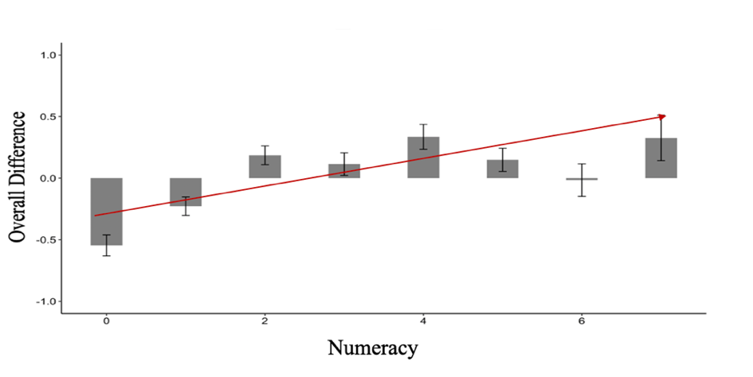

These findings demonstrate that one potential explanation for weak relations between numeracy and risk perception about a specific risk in the existing literature may follow from the previously underrepresented role of domain general risk perceptions. Similar patterns are seen in other domains (i.e., climate change, Cho, 2020; in prep). While more research is necessary to fully unpack these results and test if it extends to other risks, samples as well as longitudinally, the current evidence uniquely explains differences in perceptions of novel risks like COVID-19 across skills, even though it may not be immediately apparent. These findings also caution that failure to measure the same might result in erroneous interpretations about the relations between numeracy and specific risk perceptions.

Analyzing Specific Sub-Characteristics
Beyond measuring specific, general, and relative risk perceptions the Berlin General Risk Perception Inventory framework also allows for a higher fidelity assessment for the influence of specific characteristics (e.g., sub-components of dread and unknown). Unlike Studies 1 and 2, Study 3 used decomposed dread (i.e., catastrophic, fatal) and unknown (i.e., known to persons, known to science) characteristics in order to more fully explain differences in COVID-19 risk perceptions, behavioral intentions and knowledge. Regression models presented in Table 4.4 provided the first evidence that major differences in knowledge of expert consensus were uniquely explained by the Known to Science characteristic, which was also the strongest single predictor in a model that accounted for a large amount of variance. These results imply that those who tend to perceive the world as more unknown to science or scientists in general are more likely to disagree with expert consensus (thereby recommendations) about COVID-19 practices, even after controlling for values and demographics. While more research is needed to replicate this finding in other domains it may in part help explain some of the key issues surrounding science communication. With trust in science declining for both Democrats and Republicans in the United States (Pew Research Center, 2022), these results suggest some timely potential applications that for the Berlin Risk Perception Inventory that may help better predict who will be more likely to disagree with expert consensus on specific risks and why they disagree.

Conclusions
Throughout modern scientific history, innovation in measurement has led to innovation in science and technology in many disciplines, including psychology. For example, measurement advances in psychology have been a catalyst for transformative breakthroughs in mental health care (e.g., Cognitive-Behavioral Therapy), in employee selection and training, and in the development of powerful artificial intelligence applications (e.g., ACT-R intelligent cognitive tutors), to name just a few. More recently in decision psychology, the influence of advances in measurement is also reflected in the influence of statistical numeracy tests. Today, the Berlin Numeracy Test has led to fundamental insights into the nature of human intelligence and decision making skill, with implication for the design of inclusive, effective, and ethical risk communications and training programs (Cokely et al., 2018). Notably, because the Berlin Numeracy Test was designed be brief, robust, and easy-to-use, over the last 10 years researchers from around the world have leveraged this tool for investigations of diverse research topics, producing hundreds of studies involving more than 250,000 diverse people from >150 countries. In short, many advances in science seem to me to be broadly proportional to advances in our ability to accurately and efficiently measure the things that matter deeply to various scientists and diverse stakeholders.
In this dissertation, I conducted three studies to address a largely neglected aspect of judgments about risk, and I have endeavored to develop and validate a new framework and assessment technology—i.e., the Berlin Risk Perception Inventory (BRPI). The BRPI is an integrated assessment inventory for measuring individual differences in general, specific, and relative risk perceptions across multiple dimensions, various risks, and diverse stakeholders. As new and evolving risks take center stage and command the attention of scientists and citizens, or otherwise merit significant investigation, the results from the current set of studies suggest that the BRPI may generally be an efficient and easy to administer assessment that has been extensively validated and “battle tested” during a truly unprecedented global pandemic. Beyond potential theoretical and practical contributions, the Berlin Risk Perception Inventory (BRPI) also offers guidance about some essential measurement procedures (i.e., relative risk perceptions) and the risks that can follow when general risk perceptions are neglected. In other words, failure to use this instrument, or one like it, when measuring specific risk perceptions can result in biased, inaccurate estimates of judgements, attitudes, and implications, a problem that has already been identified in the context of investigations of climate change risk perceptions (Cho, 2020; in prep). From understanding reactions to soil contamination to responses to unforeseen global pandemics, the Berlin Risk Perception Inventory should be a useful tool for assessment of diverse, complex risk perceptions in behavioral decision research for years to come.

References
Ajzen, I. (1985). From intentions to actions: A theory of planned behavior. In Action control (pp. 11-39). Springer, Berlin, Heidelberg.
American Educational Research Association., American Psychological Association., National Council on Measurement in Education. (1999). The Standards for Educational and Psychological Testing. Washington: AERA Publications Sales.
Beckman, T. J., Cook, D. A., & Mandrekar, J. N. (2005). What is the validity evidence for assessments of clinical teaching?. Journal of General Internal Medicine, 20(12), 1159-1164.
Blais, A. R., & Weber, E. U. (2006). A domain-specific risk-taking (DOSPERT) scale for adult populations. Judgment and Decision Making, 1(1).
Blake, E. S., & Zelinsky, D. A. (2018). Hurricane Harvey (AL092017): 17 August–1 September 2017. National Hurricane Center Tropical Cyclone Report, 76.
Brewer, N. T., Chapman, G. B., Gibbons, F. X., Gerrard, M., McCaul, K. D., & Weinstein, N. D. (2007). Meta-analysis of the relationship between risk perception and health behavior: the example of vaccination. Health Psychology, 26(2), 136.
Brewer, N. T., Weinstein, N. D., Cuite, C. L., & Herrington, J. E. (2004). Risk perceptions and their relation to risk behavior. Annals of Behavioral Medicine, 27(2), 125-130.
Brown, V. J. (2014). Risk perception: it’s personal. Environmental Health Perspectives, 122, A276–A279.
Bostrom, A. (1997). Vaccine risk communication: lessons from risk perception, decision making and environmental risk communication research. Risk, 8, 173.
Capone, V., Donizzetti, A. R., & Park, M. S. A. (2021). Validation and psychometric evaluation of the COVID-19 Risk Perception Scale (CoRP): A new brief scale to measure individuals’ risk perception. International Journal of Mental Health and Addiction, 1-14.
Centers for Disease Control and Prevention. (2020). Firearm deaths grow, disparities widen. Retrieved from https://www.cdc.gov/vitalsigns/firearm-deaths/index.html
Champion, V. L., & Skinner, C. S. (2008). The health belief model. Health behavior and health education: Theory, Research, and Practice, 4, 45-65.
Chen, Y., & Yang, Z. J. (2015). Message formats, numeracy, risk perceptions of alcohol-attributable cancer, and intentions for binge drinking among college students. Journal of Drug Education, 45(1), 37-55.
Cho, J.(2020). Numeracy Predicts Accurate Climate Change Knowledge and Beliefs: A Model of Factors That Influence Biases and Polarization [Master’s Thesis, University of Oklahoma]. https://hdl.handle.net/11244/325368.
Cokely, E. T., Feltz, A., Ghazal, S., Allan, J. N., Petrova, D., & Garcia-Retamero, R. (2018). Decision making skill: From intelligence to numeracy and expertise. Cambridge handbook of expertise and expert performance, 476-505.
Cokely, E. T., Galesic, M., Schulz, E., Ghazal, S., & Garcia-Retamero, R. (2012). Measuring risk literacy: The Berlin numeracy test. Judgment and Decision Making.
Cole, K. L., Turner, R. C., & Gitchel, W. D. (2019). A study of polytomous IRT methods and item wording directionality effects on perceived stress items. Personality and Individual Differences, 147, 63-72.
Coleman, C. L. (1993). The influence of mass media and interpersonal communication on societal and personal risk judgments. Communication Research, 20(4), 611-628.
Collins, J., Polen, A., McSweeney, K., Colón-Burgos, D., & Jernigan, I. (2021). Hurricane risk perceptions and evacuation decision-making in the age of COVID-19. Bulletin of the American Meteorological Society, 102(4), E836-E848.
Dave, D., Dench, D., Kenkel, D., Mathios, A., & Wang, H. (2020). News that takes your breath away: risk perceptions during an outbreak of vaping-related lung injuries. Journal of Risk and Uncertainty, 60(3), 281-307.
Edmonds, K. A., Rose, J. P., Aspiras, O. G., & Kumar, M. S. (2021). Absolute and comparative risk assessments: evidence for the utility of incorporating internal comparisons into models of risk perception. Psychology & Health, 1-17.
Edelen, M. O., & Reeve, B. B. (2007). Applying item response theory (IRT) modeling to questionnaire development, evaluation, and refinement. Quality of Life Research, 16(1), 5-18.
Einav, L., Finkelstein, A., Pascu, I., & Cullen, M. R. (2012). How general are risk preferences? Choices under uncertainty in different domains. American Economic Review, 102(6), 2606-38.
Ferrer, R. A., & Klein, W. M. (2015). Risk perceptions and health behavior. Current Opinion in Psychology, 5, 85-89.
Ferrer, R. A., Klein, W. M., Persoskie, A., Avishai-Yitshak, A., & Sheeran, P. (2016). The tripartite model of risk perception (TRIRISK): distinguishing deliberative, affective, and experiential components of perceived risk. Annals of Behavioral Medicine, 50(5), 653-663.
Fischhoff, B. (1985). Managing risk perceptions. Issues in science and technology, 2(1), 83-96.
Fischhoff, B., Slovic, P., Lichtenstein, S., Read, S., & Combs, B. (1978). How safe is safe enough? A psychometric study of attitudes towards technological risks and benefits. Policy Sciences, 9(2), 127-152.
Fischhoff, B., Bostrom, A., & Quadrel, M. J. (1993). Risk perception and communication. Annual Review of Public Health, 14(1), 183-203.
Fox-Glassman, K. T., & Weber, E. U. (2016). What makes risk acceptable? Revisiting the 1978 psychological dimensions of perceptions of technological risks. Journal of Mathematical Psychology, 75, 157-169.
Garcia-Retamero, R., & Galesic, M. (2009). Communicating treatment risk reduction to people with low numeracy skills: a cross-cultural comparison. American Journal of Public Health, 99(12), 2196-2202.
Goebbert, K., Jenkins-Smith, H. C., Klockow, K., Nowlin, M. C., & Silva, C. L. (2012). Weather, climate, and worldviews: The sources and consequences of public perceptions of changes in local weather patterns. Weather, Climate, and Society, 4(2), 132-144.
Grothmann, T., & Reusswig, F. (2004). Coping with floods: risk perception and self-protective behaviour of households and organizations. Natural Hazards, Special Issue “German Research Network Natural Disasters.
Hambleton, R. K. (1989). Principles and selected applications of item response theory. In R. L. Linn (Ed.), Educational measurement (pp. 147–200). Macmillan Publishing Co, Inc; American Council on Education.
Hambleton, R. K., & Jones, R. W. (1993). Comparison of classical test theory and item response theory and their applications to test development. Educational Measurement: Issues and Practice, 12(3), 38-47.
Harrison, G. W., Johnson, E., McInnes, M. M., & Rutström, E. E. (2005). Temporal stability of estimates of risk aversion. Applied Financial Economics Letters, 1(1), 31-35.
Hess, R., Visschers, V. H., Siegrist, M., & Keller, C. (2011). How do people perceive graphical risk communication? The role of subjective numeracy. Journal of Risk Research, 14(1), 47-61.
Highhouse, S., Nye, C. D., Zhang, D. C., & Rada, T. B. (2017). Structure of the Dospert: Is there evidence for a general risk factor?. Journal of Behavioral Decision Making, 30(2), 400-406.
Hochbaum, G. M. (1965). Health agencies and the Tower of Babel. Public Health Reports, 80(4), 331.
Janz, N. K., & Becker, M. H. (1984). The health belief model: A decade later. Health Education Quarterly, 11(1), 1-47.
Kahan, D. M. (2015a). Climate-science communication and the measurement problem. Advances in Political Psychology, 36, 1–43.
Kahan, D. M. (2015b). What is the “science of science communication”? Journal of Science Communication, 14, 1–12.
Kahan, D. M., Landrum, A., Carpenter, K., Helft, L., & Hall Jamieson, K. (2017). Science curiosity and political information processing. Political Psychology, 38, 179-199.
Kahan, D. M., Peters, E., Dawson, E. C., & Slovic, P. (2017). Motivated numeracy and enlightened self-government. Behavioural Public Policy, 1(1), 54-86.
Kahneman, D., & Tversky, A. (1973). On the psychology of prediction. Psychological Review, 80(4), 237-251.
Karpowicz‐Lazreg, C., & Mullet, E. (1993). Societal risk as seen by the French public. Risk Analysis, 13(3), 253-258.
Keller, C., & Siegrist, M. (2009). Effect of risk communication formats on risk perception depending on numeracy. Medical Decision Making, 29(4), 483-490.
Kennedy, B., Tyson, A., & Funk, C. (2022). Americans’ Trust in Scientists, Other Groups Declines. Retrieved from https://www.pewresearch.org/science/2022/02/15/americans-trust-in-scientists-other-groups-declines/
Kenny, D. A. (2015). Measuring model fit. http://davidakenny.net/cm/fit.htm
Kleinhesselink, R. R., & Rosa, E. A. (1991). Cognitive representation of risk perceptions: A comparison of Japan and the United States. Journal of Cross-Cultural Psychology, 22(1), 11-28.
Kline, R. B. (2015). Principles and practice of structural equation modeling. Guilford publications.
Krabbe, P. (2016). The measurement of health and health status: concepts, methods and applications from a multidisciplinary perspective. Academic Press.
Kraywinkel, K., Heidrich, J., Heuschmann, P. U., Wagner, M., & Berger, K. (2007). Stroke risk perception among participants of a stroke awareness campaign. BMC Public Health, 7(1), 1-7.
Lee, T. M., Markowitz, E. M., Howe, P. D., Ko, C. Y., & Leiserowitz, A. A. (2015). Predictors of public climate change awareness and risk perception around the world. Nature Climate Change, 5(11), 1014-1020.
Leiserowitz, A. (2006). Climate change risk perception and policy preferences: The role of affect, imagery, and values. Climatic Change, 77(1), 45-72.
Liao, C., Liu, C. C., & Chen, K. (2011). Examining the impact of privacy, trust and risk perceptions beyond monetary transactions: An integrated model. Electronic Commerce Research and Applications, 10(6), 702-715.
Lichtenstein, S., Slovic, P., Fischhoff, B., Layman, M., & Combs, B. (1978). Judged frequency of lethal events. Journal of Experimental Psychology: Human Learning and Memory, 4(6), 551–578. https://doi.org/10.1037/0278-7393.4.6.551
Loevinger, J. (1957). Objective tests as instruments of psychological theory. Psychological Reports, 3(3), 635-694.
Loewenstein, G. F., Weber, E. U., Hsee, C. K., & Welch, N. (2001). Risk as feelings.
Psychological Bulletin, 127(2), 267.
Lord, F. M. (1980). Applications of item response theory to practical testing problems (pp.
181-223). Hillsdale NJ: Erlbaum.
Lozano, L. M., Megías, A., Catena, A., Perales, J. C., Baltruschat, S., & Cándido, A. (2017). Spanish validation of the domain-specific risk-taking (DOSPERT-30) scale. Psicothema, 29(1), 111-118.
Lyon, D., & Slovic, P. (1976). Dominance of accuracy information and neglect of base rates in probability estimation. Acta Psychologica, 40(4), 287-298.
Malo, T. L. (2011). Numeracy, cancer risk perceptions, and self-protective behaviors among US adults. [Doctoral Dissertation, University of South Florida].
https://digitalcommons.usf.edu/etd/3229.
Marris, C., Langford, I., Saunderson, T., & O'Riordan, T. (1997). Exploring the “psychometric paradigm”: comparisons between aggregate and individual analyses. Risk Analysis, 17(3), 303-312.
Meertens, R. M., & Lion, R. (2008). Measuring an individual's tendency to take risks: the risk propensity scale 1. Journal of Applied Social Psychology, 38(6), 1506-1520.
Messick, S. (1989). Meaning and values in test validation: The science and ethics of assessment. Educational Researcher, 18(2), 5-11.
Messick, S. (1995). Validity of psychological assessment: Validation of inferences from persons' responses and performances as scientific inquiry into score meaning. American Psychologist, 50(9), 741.
Messick, S. (1998). Test validity: A matter of consequence. Social Indicators Research, 45(1), 35-44.
Napper, L. E., Fisher, D. G., & Reynolds, G. L. (2012). Development of the perceived risk of HIV scale. AIDS and Behavior, 16(4), 1075-1083.
National Oceanic and Atmospheric Administration. (2019). Calculating the Cost of Weather and Climate Disasters. National Centers for Environmental Information (NCEI).
Natter, H. M., & Berry, D. C. (2005). Effects of presenting the baseline risk when communicating absolute and relative risk reductions. Psychology, Health & Medicine, 10(4), 326-334.
Nosić, A., & Weber, M. (2010). How riskily do I invest? The role of risk attitudes, risk perceptions, and overconfidence. Decision Analysis, 7(3), 282-301.
O'Connor, R. E., Bard, R. J., & Fisher, A. (1999). Risk perceptions, general environmental beliefs, and willingness to address climate change. Risk Analysis, 19(3), 461-471.
Office of Governor Gavin Newsom. (2020, March 19). Governor Gavin Newsom issues stay at home order [News release]. Retrieved from https://www.gov.ca.gov/2020/03/19/governor-gavin-newsom-issuesstay-at-home-order/
Oltedal, S., Moen, B. E., Klempe, H., & Rundmo, T. (2004). Explaining risk perception: An evaluation of cultural theory. Rotunde, 85(Apr), 1-33.
Peacock, W. G., Brody, S. D., & Highfield, W. (2005). Hurricane risk perceptions among Florida's single family homeowners. Landscape and Urban Planning, 73(2-3), 120-135.
Penfield, R. D. (2014). An NCME instructional module on polytomous item response theory models. Educational Measurement: Issues and Practice, 33(1), 36-48.
Pennycook, G., McPhetres, J., Zhang, Y., Lu, J. G., & Rand, D. G. (2020). Fighting COVID-19 misinformation on social media: Experimental evidence for a scalable accuracy-nudge intervention. Psychological Science, 31(7), 770-780.
Pepper, J. K., Squiers, L. B., Peinado, S. C., Bann, C. M., Dolina, S. D., Lynch, M. M., ... & McCormack, L. A. (2019). Impact of messages about scientific uncertainty on risk perceptions and intentions to use electronic vaping products. Addictive Behaviors, 91, 136-140.
Peters, E., Hart, P. S., & Fraenkel, L. (2011). Informing patients: the influence of numeracy, framing, and format of side effect information on risk perceptions. Medical Decision Making, 31(3), 432-436.
Peters, E., Hibbard, J., Slovic, P., & Dieckmann, N. (2007). Numeracy skill and the communication, comprehension, and use of risk-benefit information. Health Affairs, 26(3), 741-748.
Petrova, D., Cokely, E. T., Sobkow, A., Traczyk, J., Garrido, D., & Garcia‐Retamero, R. (2022). Measuring feelings about choices and risks: The Berlin Emotional Responses to Risk Instrument (BERRI). Risk Analysis, 1-22.
Paek, H. J., & Hove, T. (2017). Risk perceptions and risk characteristics. In Oxford research encyclopedia of communication.
Plapp, T., & Werner, U. (2006). Understanding risk perception from natural hazards: examples from Germany. In RISK21-coping with risks due to natural hazards in the 21st century (pp. 111-118). CRC Press.
Ramasubramanian, M. (2020). Individual Differences and Risk Perception: Numeracy Predicts Differences in General and Specific Risk Perceptions. [Master’s Thesis, University of Oklahoma]. https://hdl.handle.net/11244/324406.
Reise, S. P., & Yu, J. (1990). Parameter recovery in the graded response model using MULTILOG. Journal of educational Measurement, 27(2), 133-144.
Renn, O. (2004). Perception of risks. Toxicology Letters, 149(1-3), 405-413.
Ripberger, J. T., Jenkins‐Smith, H. C., Silva, C. L., Czajkowski, J., Kunreuther, H., & Simmons, K. M. (2018). Tornado damage mitigation: Homeowner support for enhanced building codes in Oklahoma. Risk Analysis, 38(11), 2300-2317.
Rippl, S. (2002). Cultural theory and risk perception: a proposal for a better measurement. Journal of Risk Research, 5(2), 147-165.
Rizopoulos, D. (2007). ltm: An R package for latent variable modeling and item response analysis. Journal of Statistical Software, 17, 1-25.
Rogers, R. W. (1983). Cognitive and psychological processes in fear appeals and attitude change: A revised theory of protection motivation. Social psychophysiology: a sourcebook, 153-176.
Roozenbeek, J., Schneider, C. R., Dryhurst, S., Kerr, J., Freeman, A. L., Recchia, G., ... & Van Der Linden, S. (2020). Susceptibility to misinformation about COVID-19 around the world. Royal Society Open Science, 7(10), 201199.
Rosenstock, I. M. (1974). The health belief model and preventive health behavior. Health education monographs, 2(4), 354-386.
Samejima, F. (1997). Graded response model. In Handbook of modern item response theory (pp. 85-100). Springer, New York, NY.
Savage, L. J. (1954). The foundations of statistics. New York: John Wiley.
Schwartz, L. M., Woloshin, S., Black, W. C., & Welch, H. G. (1997). The role of numeracy in understanding the benefit of screening mammography. Annals of Internal Medicine, 127(11), 966-972.
Shimp, T. A., & Bearden, W. O. (1982). Warranty and other extrinsic cue effects on consumers' risk perceptions. Journal of Consumer Research, 9(1), 38-46.
Siegrist, M., & Árvai, J. (2020). Risk perception: Reflections on 40 years of research. Risk Analysis, 40(S1), 2191-2206.
Siegrist, M., Keller, C., & Kiers, H. A. (2005). A new look at the psychometric paradigm of
perception of hazards. Risk Analysis: An International Journal, 25(1), 211-222.
Sjöberg, L. (1999). Risk perception by the public and by experts: a dilemma in risk management. Human Ecology Review, 1-9.
Sjöberg, L. (2001). Limits of knowledge and the limited importance of trust. Risk analysis, 21(1), 189-198.
Sjöberg, L. (2003). The different dynamics of personal and general risk. Risk Management, 5(3), 19-34.
Sjöberg, L., Peterson, M., Fromm, J., Boholm, Å., & Hanson, S. O. (2005). Neglected and overemphasized risks: the opinions of risk professionals. Journal of Risk Research, 8(7-8), 599-616.
Slovic, P. (1987). Perception of risk. Science, 236(4799), 280-285.
Slovic, P., Fischhoff, B., & Lichtenstein, S. (1982). Why study risk perception? Risk Analysis, 2(2), 83-93.
Slovic, P., Finucane, M. L., Peters, E., & MacGregor, D. G. (2007). The affect heuristic. European Journal of Operational Research, 177(3), 1333-1352.
Slovic, P., & Peters, E. (2006). Risk perception and affect. Current Directions in Psychological Science, 15(6), 322-325.
So, J., & Nabi, R. (2013). Reduction of perceived social distance as an explanation for media's influence on personal risk perceptions: A test of the risk convergence model. Human Communication Research, 39(3), 317-338.
Sobkow, A., Zaleskiewicz, T., Petrova, D., Garcia-Retamero, R., & Traczyk, J. (2020). Worry, risk perception, and controllability predict intentions toward COVID-19 preventive behaviors. Frontiers in Psychology, 3226.
Stănculescu, E. (2022). Fear of COVID-19 in Romania: Validation of the Romanian version of the fear of COVID-19 scale using graded response model analysis. International Journal of Mental Health and Addiction, 20(2), 1094-1109.
Starr, C. (1969). Social benefit versus technological risk: what is our society willing to pay for safety?. Science, 165(3899), 1232-1238.
Tagini, S., Brugnera, A., Ferrucci, R., Mazzocco, K., Pievani, L., Priori, A., ... & Poletti, B. (2021). Attachment, personality and locus of control: psychological determinants of risk perception and preventive behaviors for COVID-19. Frontiers in Psychology, 12.
Teigen, K. H., Brun, W., & Slovic, P. (1988). Societal risks as seen by a Norwegian public. Journal of Behavioral Decision Making, 1(2), 111-130.
Toland, M. D. (2014). Practical guide to conducting an item response theory analysis. The Journal of Early Adolescence, 34(1), 120-151.
Tombu, M., & Mandel, D. R. (2015). When does framing influence preferences, risk perceptions, and risk attitudes? The explicated valence account. Journal of Behavioral Decision Making, 28(5), 464-476.
Trumbo, C. W., Peek, L., Meyer, M. A., Marlatt, H. L., Gruntfest, E., McNoldy, B. D., & Schubert, W. H. (2016). A cognitive‐affective scale for hurricane risk perception. Risk Analysis, 36(12), 2233-2246.
Tversky, A., & Kahneman, D. (1973). Availability: A heuristic for judging frequency and probability. Cognitive Psychology, 5(2), 207-232.
Tversky, A., & Kahneman, D. (1974). Judgment under Uncertainty: Heuristics and Biases. Science, 185(4157), 1124-1131.
Tyler, T. R., & Cook, F. L. (1984). The mass media and judgments of risk: Distinguishing impact on personal and societal level judgments. Journal of Personality and Social Psychology, 47(4), 693.
Vilella-Vila, M., & Costa-Font, J. (2008). Press media reporting effects on risk perceptions and attitudes towards genetically modified (GM) food. The Journal of Socio-Economics, 37(5), 2095-2106.
Vogel, S. E., Keller, C., Koschutnig, K., Reishofer, G., Ebner, F., Dohle, S., ... & Grabner, R. H. (2016). The neural correlates of health risk perception in individuals with low and high numeracy. ZDM, 48(3), 337-350.
Von Neumann, J., & Morgenstern, O. (1944). Theory of games and economic behavior. Princeton University Press.
Wachinger, G., Renn, O., Begg, C., & Kuhlicke, C. (2013). The risk perception paradox—implications for governance and communication of natural hazards. Risk Analysis, 33(6), 1049-1065.
Weber, E. U., Blais, A. R., & Betz, N. E. (2002). A domain‐specific risk‐attitude scale: Measuring risk perceptions and risk behaviors. Journal of Behavioral Decision Making, 15(4), 263-290.
Weinstein, N. D., Kwitel, A., McCaul, K. D., Magnan, R. E., Gerrard, M., & Gibbons, F. X. (2007). Risk perceptions: assessment and relationship to influenza vaccination. Health Psychology, 26(2), 146.
Whitely, S. E. (1983). Construct validity: Construct representation versus nomothetic span. Psychological Bulletin, 93(1), 179.
Wildavsky, A., & Dake, K. (1990). Theories of risk perception: Who fears what and why?. Daedalus, 41-60.
Wolff, K., & Larsen, S. (2014). Can terrorism make us feel safer? Risk perceptions and worries before and after the July 22nd attacks. Annals of Tourism Research, 44, 200-209.
Zajac, L. E., Klein, W. M., & McCaul, K. D. (2006). Absolute and comparative risk perceptions as predictors of cancer worry: Moderating effects of gender and psychological distress. Journal of Health Communication, 11(S1), 37-49.
Zhang, D. C., Foster, G. C., & McKenna, M. G. (2019). Is the DOSPERT gender invariant? A psychometric test of measurement invariance. Journal of Behavioral Decision Making, 32(2), 203-211.

Appendix A
Study 1: Supplementary Analyses

Figure 1. Positions of 30 Risks on the Two Factor Space (Dread v. Unknown)

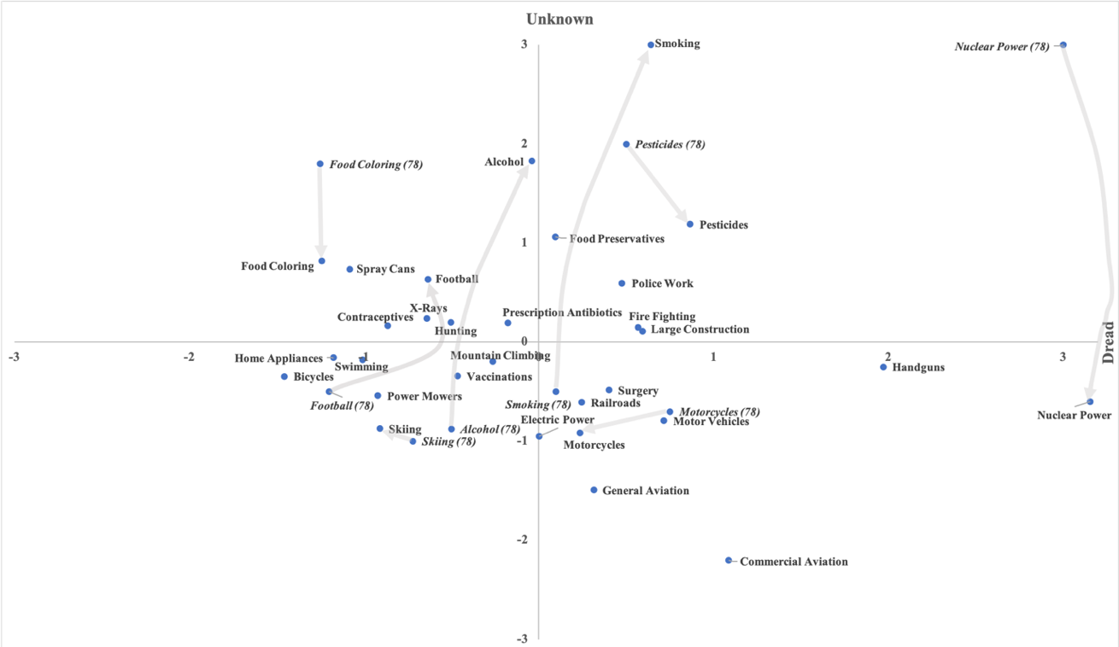

Figure 2. Positions of 39 Risks on the Two Factor Space (Dread v. Unknown)

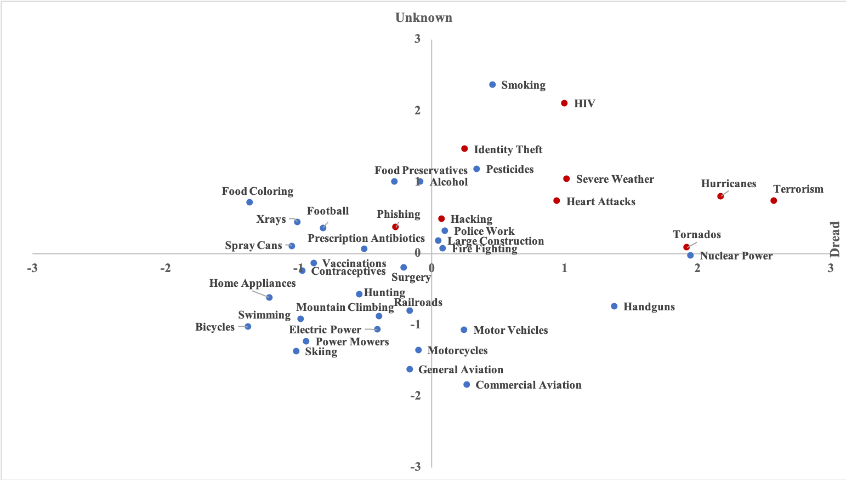

Scale | Voluntary | Immediacy | Known (Exposed) | Known (Science) | Controllable | New | Catastrophic | Dread | Severity |  | Proportion of Variance
Fischhoff et al. (1978)
Unknown | 0.89 | 0.70 | 0.88 | 0.88 | -0.83 | -0.87 | 0.62 | 0.67 | 0.11 | 0.59
Dread | 0.03 | -0.45 | -0.39 | -0.28 | -0.24 | 0.14 | 0.55 | 0.60 | 0.91 | 0.21
Fox-Glassman & Weber (2016)
Unknown | 0.64 | 0.83 | 0.98 | 0.85 | -0.34 | -0.88 | -0.18 | -0.20 | -0.70 | 0.47
Dread | 0.65 | -0.18 | 0.03 | -0.10 | 0.88 | -0.31 | 0.85 | 0.90 | 0.67 | 0.37
Current Study
Unknown | 0.59 | 0.37 | 0.92 | 0.50 | -0.62 | -0.80 | 0.20 | 0.13 | 0.32 | 0.31
Dread | 0.61 | -0.46 |  | 0.46 | -0.35 | 0.28 | 0.85 | 0.92 | 0.94 | 0.38

Table 1. Factor Loadings of the Nine Characteristics with Original 30 Risks

 | Voluntary | Immediacy | Known (Exposed) | Known (Science) | Controllable | New | Catastrophic | Dread | Severity | Proportion of Variance
Unknown | 0.28 | 0.50 | 0.97 | 0.57 | -0.23 | -0.71 |  |  | -0.38 | 0.26
Dread | 0.80 | -0.33 | 0.16 | 0.38 | -0.68 | 0.30 | 0.90 | 0.94 | 0.78 | 0.42

Table 2. Factor Loadings of the Nine Characteristics with 39 Risks

Appendix B
Study 2: Supplementary Analyses

Table 1. Stepwise Regression Models for Societal Risk Perceptions
 | Dread  (Long Form) | Dread  (Short Form) | Unknown  (Long Form) | Unknown  (Short Form)
Hacking | .24* | .34**
Hurricanes | .23*
Handguns |  | .14♱ |  | -.17×
Terrorism
Tornadoes | .14♱
Nuclear Power
Smoking | .15♱ | .15♱
Alcohol | .21× | .24*
Automobiles | .21* | .21* |  | -.14♱
Identity Theft | .21* | .35**

Table 2. Stepwise Regression Models for Personal Risk Perceptions

 | Dread  (Long Form) | Dread  (Short Form) | Unknown  (Long Form) | Unknown  (Short Form)
Hacking | .30** | .30**
Hurricanes |  |  | -.15♱ | -.21*
Handguns | .14♱ | .23*
Terrorism
Tornadoes | .31** | .16♱
Nuclear Power |  |  |  | .21*
Smoking
Alcohol
Automobiles | .23* | .28**
Identity Theft | .16♱ | .27*

Appendix C
Supplementary Analyses: Study 3

Figure 1. Relative COVID-19 risk perceptions across levels of numeracy.
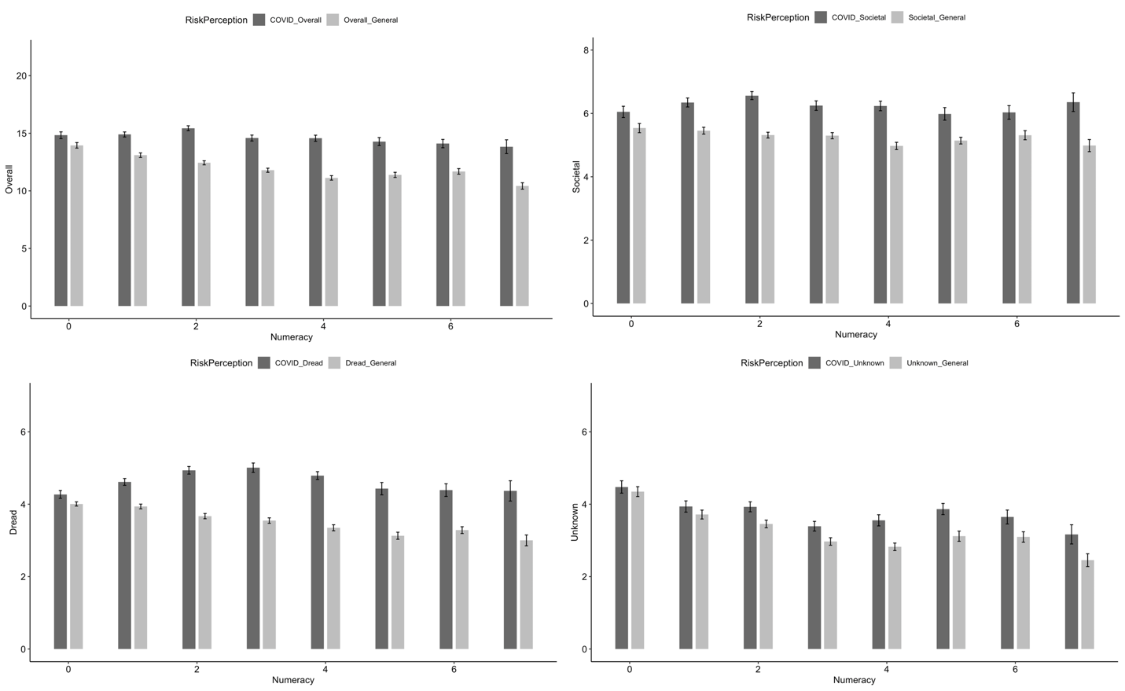
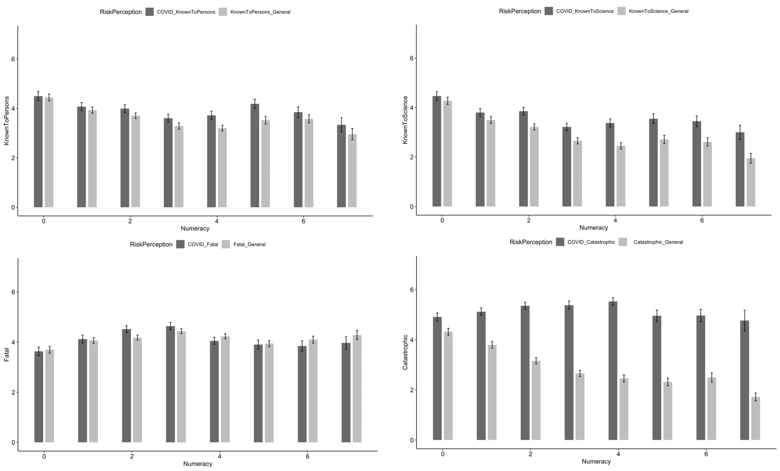
Logistic Regression Models
 | Numeracy (0 vs 7)
Relative Risk Perceptions | B (SE) | OR [95% CI] | OR [95% CI]
Overall | .90*** (.59) | 1.25 [1.15 – 1.37] | 4.99 [2.77 – 9.09]
Societal | .42* (.04) | 1.09 [1.01 – 1.19] | 1.91 [1.08 – 3.39]
Dread | .93*** (.04) | 1.27 [1.16 – 1.38] | 5.28 [2.90 – 9.51]
Unknown | .47** (.04) | 1.12 [1.04 – 1.21] | 2.30 [1.34 – 3.99]
Known to Science | .49** (.04) | 1.13 [1.05 –1.22] | 2.41 [1.40 – 4.18]
Known to Persons | .10 (.04) | 1.02 [0.94 – 1.11] | 1.19 [0.69 – 2.08]
Catastrophic | 1.19***(.05) | 1.35 [1.24 – 1.48] | 8.25 [4.47 – 15.51]
Fatal | -.25 (.55) | 0.93 [0.87 – 1.01] | 0.63 [0.37 – 1.09]
Table 1. Logistic Regression Model for Relative Risk Perceptions

For all models, ♱ p < .20, *p < .05, **p < .01
Overall COVID-19 risk perceptions were a composite sum score of COVID-19 dread, COVID-19 unknown and the COVID-19 one item societal risk perception measure.
Overall general risk perceptions were a composite sum score of general dread, general unknown and the general one item societal risk perception measure.
For all models: × p = ., ♱p <.20, *p <.05, **p <.01

