UNIVERSITY OF OKLAHOMA
GRADUATE COLLEGE

An aeroecological assessment of aircraft bird strike predictability using weather radar and citizen science

A THESIS
SUBMITTED TO THE GRADUATE FACULTY
in partial fulfillment of the requirements for the
Degree of
MASTER OF SCIENCE

By
ALISHA M. DIPILLA
Norman, Oklahoma
2021

An aeroecological assessment of aircraft bird strike predictability using weather radar and citizen science

A THESIS APPROVED FOR THE
DEPARTMENT OF BIOLOGY

BY THE COMMITTEE CONSISTING OF

Dr. Jeff Kelly, Chair
Dr. Mariëlle Hoefnagels
Dr. Larry Weider

© Copyright by ALISHA M. DIPILLA 2021
All Rights Reserved.
Dedication
This thesis is dedicated to Christopher and Natalia DiPilla who have supported me with their time, energy, love, and compassion throughout this entire process.

Acknowledgements
First and foremost, I’d like to thank my advisor, Dr. Jeff Kelly. Over the last few years, you’ve provided me room to think, grow and flourish my path through science. Without your guidance and hands-on approach to research I wouldn’t have developed the confidence that I have today. Your transdisciplinary approach to the biological sciences has transcended me into new perceptions of how scientists from a vast array of fields can cooperate and discover new ways for research. I hope to take the lessons I’ve learned through you to whatever path is in my future.
I would also like to thank my committee members Dr. Larry Weider and Dr. Mariëlle Hoefnagels. Your flexibility and guidance on sometimes unknown territory greatly influenced my willingness to accept change and to think from all angles. Your guidance and generosity with time, feedback and knowledge was invaluable and I hope to be as truly impactful as you both were in my future endeavors.
Finally, I’d like to thank my colleagues and lab mates, Dr. Phil Stepanian, and Alva Strand who played a vital and important role in my completion of this project; your expertise in radar data, coding and computer savviness has saved me time and time again. Also, I’d like to thank Dr. Elske Tielens for advice and guidance on my project, and Paula Cimprich and Bonne Clark for their expert birding knowledge. You all have been great mentors and friends that have truly aided in my ability to complete this degree.

Table of Contents
Acknowledgements………………………………………………………………........….….……v
List of Tables……….……………………………………………………………….……….….viii
List of Figures………………………………………………………………………………….…ix
Abstract……………………………………………………………………………………………x
Introduction………………………………………………………………………………………..1
Background………………………………………………………..………………………1
Motivation………………………………………………………………………………....3
Justification……………………………………………………………………………..…4
Conceptual Approach……………………………………………………………………...6
Methods……………………………………………………………………………........................8
Initial Strike Pattern Analysis……………………………………………………………..8
NEXRAD Radar Collection and Data Sources……………………………………………9
Federal Aviation Administration Data Sampling and Processing……………………….11
eBird Data Estimates and Processing……………………………………………………11
Quantifying Weekly Abundance Differences……………………………………………13
Results……………………………………………………………………………………………14
Seasonal Strike Patterns………………………………………………...………………..14
Birds in the Air Estimates………….………………………………………………...….16
Daily Aviation Trends………………………………………….……………….……….17
eBird Abundance & Occurrences…………………………………….….………………18
Discussion………………………………………………………………………………………..20
References……………………………………………………………………………………..…37

List of Tables
Table 1. Mean bird strike dates from 2015-2019 across all airports…………………………….27
Table 2. Results of Wilcoxon signed ranks test for estimates of number of birds in the air…….28
Table 3. Results of Wilcoxon signed ranks test for the number of daily aircraft operations…….29
Table 4. Results of CI tests for relative ground abundance………………………………….…..30
Table 5. Reported out of county strikes across all airports………………………………………31
Table 6. Reported out of season strikes across all airports………………………………………32

List of Figures
Figure 1. Cumulative monthly strikes (2015-2019)...……………....……………………………33
Figure 2. Bird body size distribution by airport (2019) ...……………………………………….34
Figure 3. Example radar imagery for all airports.………..….…………………………………...35
Figure 4. Example radar imagery for Atlanta across comparator days…………………………..36

Abstract
World-wide air traffic has increased at an average rate of 1.8% per year since the 1980s. With this increase in aviation, there has been a marked intensification of aircraft-wildlife collisions netting an estimate of nearly $1.2 billion * year⁻¹ in damages globally. Airborne wildlife (bats and birds) poses deadly risks to commercial and military aircraft and have resulted in >1,264 bird-aircraft collisions since 1990. These figures emphasize the necessity of computer-based modeling to predict and analyze potential flight risk to mitigate losses of aircraft and human life.
Here, we investigate a method of predicting flight susceptibility to avian wildlife strikes modeled on aerial bird abundance and ground abundance using NEXRAD weather radar and eBird citizen science data reports. These historical datasets were integrated with known aircraft strikes according to the Federal Aviation Administration to evaluate our “air-traffic hypothesis.” We predict that on historical strike days, both aerial and ground abundance is higher than on non-strike days. However, results suggest that while NEXRAD weather radar is applicable in determining current aerial bird abundances, those abundances are not necessarily indicative of inherent strike risk to aircraft. An eBird ground relative abundance index suggests that there is not a strong correlation between this relative abundance index and the probability of strikes occurring.
This data integration demonstrates need for using and developing near-real-time technologies like bird-strike advisory systems, which use computer-based algorithms to both flight plan and track possible wildlife hazards while flights are en-route, instead of relying solely on historical data alone for flight planning and bird-strike avoidance.

Introduction
Background
Since the first commercial flight in 1904, conflict between the aviation industry and wildlife has grown significantly leading to both financial loss and loss of human life (Jeffery and Buschke 2019). In documentation dating back to the International Bird Strike Meeting in 1996, there have been increasing reports of fatal bird strike incidents involving airliners, airplanes, and helicopters. Among these reports, there have been increasing numbers of strikes resulting in damaged and destroyed aircraft; a conservative estimate of the cost of damage and delays to commercial flights is $1.2 billion * y⁻¹ (Allan 2000).
The risk to human life and to aircraft from bird strikes has raised concerns among public and safety professionals alike. Much of the documentation surrounding wildlife strike incidents has come from pilots, and studies indicate that documentation of many wildlife encounters may be incomplete or subconsciously biased (Linnell et al. 1999). As a result, there are gaps in our understanding of strike patterns and trends.
Due to the shared nature of the ‘aerosphere,’ strikes between aircraft and airborne wildlife are inevitable (van Gasteren et al. 2018). Land use surrounding airports is increasingly urbanized due to encroachment of human settlements. Although anthropogenic effects are usually thought of as reducing available habitat for most species, urbanization also provides new niches and new opportunities for synanthropic species, including many birds (Marzluff 2001).
Jeffery and Buschke (2019) proposed a wildlife management approach to reducing the number of bird strikes, where airport operators manage the land-use matrix surrounding airfields by: (1) developing new techniques for deterrence in areas surrounding airports where anthropogenic build-up and land use is high; (2) enabling operator collaboration with landowners near the airfields to manage nuisance bird populations (i.e., brown-headed cowbirds Molothrus ater, European starlings Sturna vulgaris, house sparrows Passer domesticus); (3) use models and predictive habitat indicators to identify new risk management techniques in areas where risk is high. Our study focuses on the third of these objectives.
The emergence of radar technology has increased the operational use of predictive warning systems and has augmented the need for land-use-only based approaches. For example, van Gasteren et al. (2018) noted that early warning systems can aid in preventing bird strikes for en-route military aircraft (en-route strikes are during level and cruise altitudes; Shamoun-Baranes et al. 2005). In addition, studies in the Middle East and Europe have concluded that spatial and temporal distribution of early warning systems are often inconsistent, which limits their efficacy (van Gasteren et al. 2018). In the United States military, the United States Air Force has developed the “Avian Hazard Advisory System,” which uses a Bird Avoidance Modeling (BAM) program that is based on Geographic Information System (GIS) technology. This modeling system uses geospatial bird data as a method to reduce bird strike risk with military aircraft (U.S. Air Force 2015). The use of software such as BAM may be beneficial in conjunction with the use of weather radar systems to reduce the number of collisions between aircraft and airborne wildlife (van Gasteren et al. 2018).
We test both whether historical US weather radar network data could be useful in the prevention of bird strikes, as well as whether a community-science derived measure of relative abundance of birds on the ground are greater during times of historical strike incidences than at times when no strikes are detected.

Motivation
There is mutual concern among ornithologists, air traffic controllers, pilots, and the general public about safety of aircraft, protecting human lives, and protecting native wildlife in urbanized environments like airports. Perhaps the most high-profile instance of bird strikes, the US Airways Flight 1549 striking a flock of Canada Geese on January 15th, 2009 just outside of La Guardia, NY (i.e., the “Miracle-on-the-Hudson”) has inspired many scientists and airline professionals to become highly concerned with strike predictability and prevention (Marra et al. 2009; Jatau and Melnikov 2018).
Many of the most prominent and notorious bird strike incidences in history have occurred at, or around coastal airports (e.g., 9 January 1998 Boeing 727 incident, Houston Intercontinental; 4 September 2003 Fokker 100 incident, La Guardia) (Joyce 2009). These incidences display the need for accurate and timely predictions for strike risk for both commercial and military air operations.
Patterns within bird strike data may be useful in conservation and flight planning alike. Our study explores the feasibility of using historical bird strike data and community science bird observations in conjunction with existing weather radar system as a means of avoiding or mitigating damages to both aircraft and bird populations. With use of the NEXRAD weather radar network, eBird citizen science datasets, and FAA strike data we explore seasonal patterns and assess factors associated with increased risk of bird strikes.
Of the many previous studies involving aircraft strikes, several have focused on environmental and land use effects surrounding airports (Godin 1994; Linnell et al. 2009; Shamoun-Baranes et al. 2008; Gasteren et al. 2018; Jeffery and Buschke 2019). However, these studies did not include indices of abundance of birds on the ground and in the air. Use of NEXRAD in conjunction with FAA strike reporting and eBird-based ground relative abundance indices provide an improved opportunity to explore their ability to predict strikes across coastal environments.
Justification
Research on bird strikes and radar aeroecology has focused on prevention and control of damage caused by wildlife through behavioral ecological approaches (Godin 1994; Soldatini et al. 2010). Studies such as van Gasteren et al. (2018) have provided estimates of effectiveness of migration monitoring systems, including weather radar, in North America, Europe, the Middle East and China (Laursen et al. 2008; Nilsson et al. 2018; Peckford and Taylor 2008; Qiao and Zhang 2019; van Gasteren et al. 2018). Yet, no studies have focused on seasonal patterns in abundance of wildlife as a determining factor in inherent aircraft risk.
Conceptual and methodological bases for quantitatively separating airborne wildlife from weather radar data have grown rapidly over the past decade (Chilson et al. 2012; Jatau and Melnikov 2018; Kelly et al. 2016; Kelly and Horton 2016; Nilsson et al. 2018; Peckford and Taylor 2008; Stepanian et al. 2016). However, the update of the NEXRAD weather radar system in 2013 provided an increase in fidelity due to its dual-polarization methods. This upgrade has permitted meteorologists and biologists alike to use the radar network to distinguish between meteorological and biological radar signals (Stepanian et al. 2016).
Distinguishing between meteorological patterns and biological radar indicators (i.e., birds, bats, and insects), relies on three radar products: 1) radial velocity; 2) differential reflectivity; 3) correlation coefficients (Stepanian et al. 2016). These products have been used to distinguish biological scatter from many radar aeroecology studies (Chilson 2012; Jatau and Melnikov 2018; Nilsson et al. 2018; Stepanian 2016; van Gasteren 2018; Kranstauber et al. 2020; Lin et al. 2019; Westbrook and Eyster 2017; Cui et al. 2020; Farnsworth et al. 2015; Clark et al. 2020). Kelly et al. (2016) indicated that there was a strong “potential” for NEXRAD and eBird count data to be used for phenological purposes; and that potential was evident in a study by Shipley et al. (2018). In our research study, we combine the use of these eBird previously documented eBird findings in conjunction with NEXRAD as a possible predictor for potentially high bird strike days at six US airports.
Peckford and Taylor (2008), as well as Horton et al. (2015) examined the relationship between radar observation and ground counts occurring the day before observed nocturnal passerine migrations. Diurnal ground counts are positively correlated with nocturnal bird counts; however, this correlation may vary geographically, depending on the study region and landforms (Peckford and Taylor 2008). We use this known correlation to analyze the abundance of birds in the air and on-the-ground on the days and weeks of strikes to identify possible patterns associated with high-risk days for bird strikes.
Much of current strike prevention relies on Bird Avoidance Modeling (BAM). BAM uses species distribution modeling in relation to environmental factors or geostatistical models to predict risk (Shamoun-Baranes et al. 2008). Current research into BAM combines both distribution modeling and geostatistical models to provide the most accurate avoidance models. However, limits of BAM include inability to incorporate real-time observations or to incorporate known strikes and routes into risk calculations. For example, BAM is only recommended to be updated approximately every 5 years to account for changes in environment and shifts in either species population size(s), or range(s) (Shamoun-Baranes et al. 2008). Civil aviation agencies have been apprehensive about using BAM as a real-time avoidance system, when compared to its more prominent use by military agencies.
Although much of the military industry has focused on developing higher fidelity BAM, much of the civil aviation industry is focused on real-time bird strike warning radar systems for bird avoidance and route management (Shamoun-Baranes et al. 2008; Lovell and Dolbeer 1999), which underscores the need for more reliable strike management and prevention for the civil aviation industry. Use of the US weather radar system, as well as direct observational data, such as eBird, could possibly serve as valuable additions to current prevention methods.
Conceptual Approach
Previous research has focused on the abundance of birds in the air at the time of strike via radar monitoring systems (and predicting whether there is an inherent risk for strike based on those systems) (van Gasteren et al. 2018; Soldantini 2010). We chose to focus on historical data to see if those patterns were evident when comparing non-strike and strike days. We examined historical bird collisions with aircraft at six major US international airports, comparing daily and seasonal abundances of nocturnal birds within a 15- km radius of airfields based on reflectivity values from NEXRAD weather radars. Using these estimates, we determined the average correlations between birds aloft and seasonal aircraft operations based on comparisons among the abundance of birds on the day of strike and a set of comparator days (i.e., the day before strike, the day after strike and the day of strike in the previous year). To determine whether the number of flights was correlated with increased bird strikes, we also compared the number of flight operations on the day of strike to each of the comparator days.
The Federal Aviation Administration (FAA) produces wildlife strike data that quantifies the reported aircraft strikes by wildlife dating back to 1944. The FAA notes that up to 97% of these strikes occur during landings and takeoffs, with 92% of those strikes occurring at or below 3,500 feet/~1,066 meters AGL (above ground level), and with approximately 37% of strikes occurring between dusk and dawn, thus, indicating that nocturnal strikes are significant (Federal Aviation Administration 2021). Strikes listed in the database present a plethora of information about the wildlife strikes; time of strike (if recorded), species, reporter, damage, and weather conditions. Using NEXRAD in conjunction with historical strike documentation, there offers the possibility of more detailed analyses. We focused on nocturnal aircraft strikes because it simplifies estimating bird abundance from NEXRAD data and minimizes the impact of confounding variables, such as large diurnal insect emergences (Stepanian et al. 2020)
We tested the “air-traffic hypothesis,” that is, bird strikes are a simple function of the number of birds and aircraft in the air. For this study, we determined our independent variables to be a) aerial bird abundance (determined through NEXRAD data processing); b) the amount of daily aircraft operations; and c) the ground relative species abundances (determined by eBird reporting). From these independent variables, our dependent variable is represented by the strikes reported by the FAA.
From our “air-traffic hypothesis,” we predicted that the abundance of flying birds would be highly correlated with the overall strike risk and therefore strikes would occur on days when flying bird abundance was high compared to non-strike days. A secondary prediction of the air-traffic hypothesis was that on-the-ground abundance of birds would be correlated to the airborne abundance of birds such that on-the-ground abundance on strike days would be higher on strike days and would be correlated to overall strike risk compared to non-strike days. It also follows from our hypothesis that there would be no statistically significant differences in bird abundance among the comparator days at the same airport because they would all reflect the same seasonal conditions: breeding, wintering, or migratory periods.
Another prediction was that there would be statistically significant differences between the amounts of aircraft operations on strike days versus non-strike comparator days. We anticipated that more flights would yield an increased propensity for strikes.
Of the chosen airports, five reflected relatively high numbers of daily flights due to their position in large metropolitan areas or on coastlines (San Francisco International Airport (KSFO), Atlanta International Airport (KATL), George Bush Intercontinental Airport (KIAH), Ronald Reagan Washington National Airport (KDCA) and LaGuardia Airport (KLGA). Specifically, Hartsfield-Jackson International Airport in Atlanta is notorious as the world’s busiest airport due to its position as a Delta™ hub for transatlantic flights out of and into the United States. We predicted that due to the strategic location of the coastal airports, we would observe a higher correlation between level of flight activity and bird strikes than at the inland airports.
Methods
Initial Strike Pattern Analysis
We downloaded and analyzed the FAA strike data for 2015-2019 (https://wildlife.faa.gov/home). Mean monthly strike days were calculated by converting the Julian dates to radians to take the circularity of the calendar year into account. We then averaged the mean strike days in radians before converting back to the 365-day calendar year according to methods determined by Marr (2020).
Strike distributions over the 2015–2019 timeframe at each airport were then evaluated for normality using the Shapiro-Wilkes test. In cases where data were significantly non-normal, visual inspection of the data suggested seasonal bimodality (Fig. 1).
NEXRAD Radar Collection and Data Sources
The network of 143 NEXRAD weather radars provides national coverage of dual-polarized radar with datasets beginning in 2013. These radars operate at a frequency of 2.86 GHz with a wavelength of 10.48cm (Crum et al. 1998). Each weather radar has a unique International Civil Aviation Organization site identifier that allows for precise airborne data reaching back to the radar’s inception in 1988 (NOAA 1991). Using Python coding and the PyArt and Pytz packages (Helmus & Collis 2016), radar datasets were downloaded using Amazon Web Services for each strike day.
We initially filtered radar data to reflect dates and times present in the FAA bird strike database to eliminate erroneous data for all six airports. All non-flying wildlife was removed from the data sets, and all diurnal strikes were excluded to prevent confounding data from non-bird and non-bat animal species, such as insect swarms (Tielens et al. 2021). Strikes that listed either an ‘unknown time’ or ‘unknown’ for time-of-strike were also excluded from our analyses. Twenty random strike samples were chosen via a random number generator from each airport to be representative of strikes that occurred in 2019. In some cases, 20 random strike samples were not obtained due to radar file unavailability, where Python was unable to find date/time objects for the listed strikes. In those cases, it is very likely that the radar was down or nonoperational around the time of the strike. When processing KATL, KDCA, and KIAH strikes, one sample from each airport was disregarded due to the radar files being unavailable. KSFO nocturnal data contained 18 nocturnal strikes, two of which were disregarded due to radar inoperability; the remaining 16 were used for the analysis.
Radar data were imported from dates that matched the filtered FAA strike database. Strike dates, strike airport location, and strike time were imported into Python. For each strike incident, we assigned the nearest radar to the airport (KESX- McCarran International Airport; KOKX- LaGuardia Airport; KHGX- George Bush Intercontinental Airport; KLWX- Ronald Reagan Washington National Airport; KMUX- San Francisco International Airport; KFFC- Atlanta International Airport). We defined a 30-km diameter circle around the latitude/longitude of each airport as the radar detection domain to restrict the analyses to locations where planes were at low altitudes and to reduce the amount of weather data that required processing. For each strike incident we analyzed radar files from four days: the day of the strike incident and the three comparator days (i.e., the day before strike, the day after strike and the day of strike in the previous year). The number of birds was determined using the estimated radar cross section (RCS) of a typical bird (11 cm²) (Dokter et al. 2011; Horton et al. 2018). Reflectivity was summed for radar sample on each date and then across each time for each date and divided by the RCS (11 cm²) to calculate the number of birds in the air.
To match radar scans to times of strikes, we used a time window from 30 minutes prior to the aircraft strike to 30 minutes after the aircraft strike. Within this window, we used the closest scan time to the strike. Weather was filtered using the depolarization ratio of -10 dB and a reflectivity threshold of 35 dBZ. Ground scatter was censored by removing all signals under 100 meters AGL. A final CSV file was generated that listed bird abundance(s) for all comparator days across all airports. bathe
Abundance data were tested for normality using the Shapiro-Wilk test, and subsequently the Wilcoxon signed-ranks test were performed on the dataset using SPSS (IBM Corp 2020).

Federal Aviation Administration Data Sampling and Processing
We also tested whether the number of daily aircraft operations was correlated with the probability of strike across the six airports. The same random samples of nocturnal strikes were used as reference days for obtaining FAA aircraft operation data.
Historical flight data were obtained from https://aspm.faa.gov/opsnet/sys/Airport.asp. The following aircraft flight data were subsequently downloaded corresponding with the date of the strike, the daily operations corresponding with the day prior to the strike, daily operations corresponding with the subsequent day of the strike, and the daily operations corresponding with the date of strike in the previous year.
A final CSV file was generated listing all aircraft operations for all tested days for all six airports. To check for normal distribution of flight traffic, the Shapiro-Wilk test was performed. Subsequently, the Wilcoxon signed-ranks test was performed on the dataset using SPSS.
eBird Data Estimates and Processing
eBird is a community science database that has grown exponentially in the number of observations contributed each year (Sullivan et al. 2014). eBird is maintained by the Cornell Lab of Ornithology, where the overall goal is to combine efforts between multidisciplinary scientists and citizen enthusiasts to increase data quantity and control for bias in data collection. eBird data is openly available and can be used as a major source of biodiversity data for scientific studies by increasing understanding of species distributions and conservation (Sullivan et al. 2014). We used these observations to correlate aircraft strike data with an eBird-derived index of “relative species abundance” on strike days. To test if this index of relative ground abundance is indicative of inherent strike risk, both diurnal and nocturnal strikes were analyzed.
We downloaded the county-level eBird relative-abundance data product for each airport from https://ebird.org/data/download/ebd for 1 January 2018 through 31 December 2018. This relative abundance data product is described as “relatively stable year after year” according to Dr. Daniel Fink with the Cornell Lab of Ornithology (personal communication), justifying the comparison of relative abundance data from 2018 with strike data from 2019 (Fink et al. 2018). The counties we included in this download were: Atlanta International Airport, Clayton and Fulton Counties, Georgia; Ronald Reagan Washington National Airport, Arlington County, Virginia; George Bush Intercontinental Airport, Harris County, Texas; McCarran International Airport, Clark County, Nevada; LaGuardia Airport, New York County, New York; and San Francisco International Airport, San Mateo County, California.
We used weekly estimates of relative species abundance from the 2018 eBird Status and Trends products found at https://ebird.org/science/status-and-trends/faq and extracted this product using the R package ebirdst for R version 4.0.1 to estimate the relative abundance of species in the counties where the airports of interest are located. Sampling event data (effort only data) were subsequently downloaded from https://ebird.org/data/download/ebd. This data can be described as the species occurrences in a comparable time and space together with the same sampling effort (Strimas-Mackey et al. 2020).
The county shapefiles for 2018 were obtained from https://www.census.gov/geographies/mapping-files/time-series/geo/tiger-line-file.2018.html. This shapefile indicates all legal county boundaries. These datasets describe the relative abundance of each pixel on the county map. Each pixel represented a 2.96-km² area grid cell overlaid over the county map. eBird defines relative abundance as “the abundance of a certain species if an expert eBirder were to visit each pixel on the county map, starting at the optimal time of day to see a certain species, and to expend the effort necessary to maximize detection of a given species”.
Finally, we used package auk.R (R version 4.0.1) to filter the eBird datasets for date range, county, state, protocol, distance and duration (Strimas-Mackey et al. 2018). eBird data were merged to a county shapefile to generate a relative abundance dataset listing the relative abundance of all species by county for each of the 52 weeks for 2018; we then filtered the species in the eBird CSV file down to just species represented in the FAA strike database for each airport. Referencing the same six airports, FAA strike data for 2019 were obtained from https://wildlife.faa.gov/home. All non-avian wildlife strikes were excluded from all six datasets. In addition, unknown and generalized instances (perching birds, unknown-small bird, etc...) were excluded from the analysis.
To further quantify the ground relative abundances for species involved in bird strikes, we subdivided our airport county level data into size categories to account for any differences between bird size classes.
Quantifying Weekly Abundance Differences
To use the processed eBird abundance data product, strikes obtained from the FAA strike data base were sorted by species at each airport. For each strike incident, the week of the strike was cross-referenced to the eBird abundance CSV file based on species, due to grain of the eBird relative abundance data. Data from eBird relative abundance data product does not have a scale finer than weekly. Comparison weeks were chosen based on the closest subsequent non-strike week for the same species. Comparison week abundances were subtracted from strike week abundances to construct a paired-difference measure. For each airport, we averaged paired differences and calculated the 95% confidence intervals. Confidence intervals that did not include zero and were greater than zero indicated strike week abundance was greater than non-strike week abundance; a confidence interval less than zero indicated strike week abundance was less than non-strike week abundance; confidence intervals that included zero indicated that there was no difference between strike week and non-strike week abundance.
To determine if smaller species had greater relative abundance during strike week versus non-strike weeks, species were categorized by body size/body length (i.e., centimeters). Species size categories were ranked as categories 1-5, correlating to size characteristics, as follows: (1) Extra Large (> 81 cm); (2) Large (40 cm < x <81 cm); (3) Medium (22 cm < x < 40 cm); (4) Small (12 cm < x < 22 cm); (5) Extra Small (< 12 cm). Paired differences for five size categories were calculated and averaged and were subsequently used to calculate confidence intervals as we did for airport specific eBird ground relative abundances. Confidence intervals were determined for all five size categories across all six airports.
Results
Seasonal Strike Patterns
Total strikes between 2015 and 2019 for Atlanta (KATL) ranged between 175 and 241 strikes * yr⁻¹ with an average of 215.2 strikes * yr⁻¹. By far, KATL had the greatest number of strikes of all assessed airports. The largest peak of strike incidences occurred nearly yearly in the months of July (14.5% of total strikes) and October (13.5% of strikes) with an average of 31.2 strikes and 29 strikes * month⁻¹ respectively (Fig. 1). The exception to this pattern was in 2015, where there was not a July peak in strike incidences. Examination of the monthly strike data by Julian dates revealed that the strike distribution was not normally distributed across the calendar year (f=.971, df= 168, p=.001). The average strike day at Atlanta was day 193 (July 12th; Table 1). The mean day for strike across all airports was day 214, August 2nd (Table 1).
Data from Ronald Reagan International (KDCA) data exhibited peak strikes between April and May (27.9% of strikes), as well as in October (16.2% of strikes) (Fig. 1). The total strikes between 2015 and 2019 for KDCA ranged between 76 and 116 strikes * year⁻¹ with an average of 90.4 strikes * year⁻¹. The data were not normally distributed across the calendar year (f=.916, df= 29, p=.024). The overall mean day for strike at KDCA was day 153 (June 12th; Table 1).
The average strike incidences at George Bush Intercontinental Airport (KIAH) were 123.2 strikes * year⁻¹. May had the largest number of strikes on average with 20.2 strikes * month⁻¹ (Fig. 1) (representing 16.4% of strikes for the year). The data were normally distributed across the calendar year (f=.970, df= 35, p=.443). The mean strike day was day 200 (July 19th; Table 1).
For LaGuardia International Airport (KLGA), the overall peak strike incidences occurred in October (19.5% of strikes for the year). The strike average for KLGA was 160.4 strikes * year¹. The data were not normally distributed across the calendar year (f=.956. df= 107, p=.001). The average strike day at LaGuardia was day 236 (August 24th; Table 1).
McCarran International Airport (KLAS) had the smallest number of strikes in the FAA database for the years of 2015-2019 with a total of 219 strikes. The average number of strikes for KLAS was 43.8 strikes * year⁻¹. There was a sharp peak of strike incidences that occurred in October (16% of strikes) (Fig. 1). The data were normally distributed across the calendar year (f=.981, df= 20, p=.948). The mean strike day was day 192 (July 11th; Table 1).
The final tested airport, San Francisco International Airport (KSFO), did not have an obvious mode (Fig. 1). KSFO had an average of 93.8 strikes * year⁻¹. Most strikes occurred in October and November, with each month having 13.9% of strikes for the year. These data were not normally distributed across the calendar year (f=.920, df=49, p=.003). The average strike day at San Francisco was day 214 (September 16th; Table 1).
Across all airports, the median bird strike size was medium (22 cm < x < 40 cm), although the size distribution of birds struck varied among airports, and the distribution of these size ranks was significant, indicating that the number of strikes per size category varied based on airport (f=226.038, df= 4, p<.001) (Fig. 2).
Birds in the Air Estimates
Analyzing the differences between numbers of birds at the time of strikes versus non-strike days yielded non-normal results for the Shapiro-Wilk test. Across all airports and tested days, the air abundance of birds across all airports were not normally distributed. The data were subsequently analyzed using the Wilcoxon signed ranks test (Table 2). Although there are some instances where bird abundance differed significantly between the date of strike, and the previous year, there were many cases where the abundance of birds exhibited no statistically significant differences between strike and comparator days. For visual representation of radar imagery displaying largest number of birds in the air at time of strike across all airports, see figure 3.
At Atlanta (KATL) abundance of birds was not different between time of strike and the previous day (Z=-.402, p=.687, n=19). There was also no significant difference between the abundance of birds in the air on the day following the strike (Z=-.644, p=.520, n=19). However, there was a significant difference between the time of strike, and the previous year (Z=-2.626, p=.008, n=19). To see an example of Atlanta (KATL) strike day and comparator day comparisons, see figure 4. Across all three tested days, the abundance of birds was not significantly different than the time of strike at Ronald Reagan Washington National Airport (KDCA; n=19). At George Bush Intercontinental Airport (KIAH), there was no significant difference in the abundance of birds across comparator days and the time of strike (n=19). Across comparator days at LaGuardia Airport (KLGA), there was no significant difference in the abundance of birds and the time of strike (n=20). At McCarran International Airport (KLAS), there was no significant difference in the abundance of birds between the previous day (Z=-1.045, p=.296, n=20) and the following day (Z=-1.503, p=.133, n=20). However, in the previous year, the data were marginally non-significant (Z=-1.939, p=.053, n=20). Across all tested days, the abundance of birds at the time of strike was not statistically different than the previous day, following day or previous year (Table 2).
Daily Aviation Trends
The number of daily aircraft operations at the six major international airports for the day of strike and comparator days were overwhelmingly non-normally distributed across all airports. The results of the Wilcoxon signed-ranks test showed that there were some instances where the amount of aircraft operations differed significantly between the day of strike and comparator days (Table 3).
At Atlanta (KATL), the amount of aircraft operations occurring on the day of strike versus the day following strike was significantly more on strike days (Z=-2.475, p=.013). For Ronald Reagan Washington National Airport (KDCA), there was a statistically significant difference in the number of aircraft operations between the day of strike versus the previous day (Z=-2.013, p=.044). In contrast, the number of aircraft operations at LaGuardia Airport (KLGA) were not statistically different between strike days and any of the comparator days.
There were statistically significant differences in the number of flights on strike days versus the day following the strike and the year previous at George Bush Intercontinental Airport (KIAH) (following day: Z=2.174, p=.030, previous year: Z=-1.606, p=.033). Further, the day following at San Francisco International Airport (KSFO) was statistically different than the day of strike (Z=-1.965, p=.049). Lastly, the number of flights at Las Vegas (KLAS) differed significantly on the day before strike days and differed significantly than the previous year (Z=-3.584, p<.001; Z=-3.865, p<.001, respectively).
eBird Abundance & Occurrences
When comparing relative abundance of species struck to comparator days, Atlanta International Airport (KATL) and San Francisco International Airport (KSFO) provided the only instances where strike week abundance was greater than non-strike week abundance across all species involved in strike incidences regardless of species size (n=167, CI=.0088, SD=.0583, x̅=.0206; n=49, CI=.0551, SD=.1923, x̅=.1359, respectively). For the other airports, strike week abundance was significantly less than non-strike week abundances across all species involved in strikes (Table 4).
We identified a total of 114 species represented in the strike database across the six tested airports. From these species, we identified 25 species as “out-of-county” and 5 species as “out-of-season.” The out-of-county strike incidences were reported on species that were not found in the target county of interest (representing 6.1% of total strikes; Table 5). The out-of-season strikes were reported as species which had a relative abundance of zero during the week of strike (representing 1.2% of total strikes; Table 6).
At each airport, species were separated via relative size, and their relative abundance on the day of strike and comparator days (Table 4). For large- and medium-sized species at Atlanta International Airport (KATL), strike week abundance was less than non-strike week abundance. For small species, strike week abundance was greater than non-strike week abundance. The sample size was <10 species, and therefore inadequate for analysis for extra-small species. No species fell into the extra-large category.
At Ronald Reagan Washington National Airport (KDCA), all sample sizes were determined to be inadequate for analysis except for small-sized species. For small-sized species, strike week abundance was less than non-strike week abundance (n=10, CI=.761, SD=1.06, x̅=-.681). There were not any extra-small species in the KDCA database.
For George Bush Intercontinental Airport (KIAH), strike week abundance was less than non-strike week abundance for both medium- and small-sized species. For large-sized species, sample size was inadequate for analysis. No species fell into the extra-large and extra-small size categories.
Strike week abundance was less than non-strike week abundance in large-, medium- and small-size species in LaGuardia Airport (KLGA). Sample size was inadequate to analyze extra-large sized species. No extra-small species were struck at KLGA in 2019.
McCarran International Airport (KLAS) had only one size category with enough data for analysis. For medium-sized species, strike week abundance was less than non-strike week abundances. Sample sizes for large and small species were inadequate for analysis. There were no reported strikes at KLAS in 2019 representing extra-large and extra-small sized species.
Finally, San Francisco International Airport (KSFO) strike week abundance for large and small species were less than non-strike week abundance. For medium species, sample size was inadequate to draw any conclusions. Extra-large and extra-small species were not represented in the database for 2019 at KSFO.
Discussion
The results of our study do not provide support for the “air-traffic hypothesis.” Our results indicate that strike risk is not correlated with our measures of bird abundance. In other words, the correlation between abundance of birds in the air at the time of strike and that in the air on paired non-strike days was non-significant. While there was one case where bird abundance did differ significantly between the date and time of strike and the previous year (i.e., Atlanta International Airport), this is the exception and not the norm. We did not detect a distinct pattern or trend across all airports, indicating that the abundance of birds flying at the time of strike within a 15-km radius of the airport is not indicative an inherent strike risk.
Nevertheless, there is evidence that the abundance of birds in the air is highly consistent across consecutive days (comparator days in the same year). Across all airports, there was not a significant difference in the number of birds in the air at the time of strike versus the days surrounding the strike. Night-to-night bird density was expected to be highly correlated between comparator days in the same year due to much of the nighttime aerial biomass being attributed to bird migration during certain times of the year. The expected temporal variation over the course of a few days (in our case, the day before and after strike), is likely correlated. The results indicate no difference in the number of birds between consecutive days.
There was also no clear evidence that increased ground abundance of birds supports the “air-traffic hypothesis.” Although our results indicate that Atlanta and San Francisco International Airports have higher relative ground abundance of birds during strike weeks than non-strike weeks, there is no evidence that this pattern is universal across all regions of the United States. However, at Ronald Reagan Washington National Airport, George Bush Intercontinental Airport, McCarran International Airport and LaGuardia Airport, relative ground abundance across all species was greater on non-strike weeks. This may indicate the Atlanta and San Francisco International Airports are deviations from the normal patterns of strike, at least based on our limited sampling at the six airports in our study.
When breaking down the strike dataset into size subcategories to mitigate possible confounding variables, there was a pattern that ground abundance during strike weeks was lower than abundance during non-strike weeks. This finding contradicts our initial predictions for the “air-traffic hypothesis.” We predicted that on-the-ground abundance of birds would be higher for strike weeks, correlated to overall strike risk when compared to non-strike weeks. The only two cases that supported this prediction, were small-sized species at both Atlanta and San Francisco International Airports. This result, although not entirely consistent with our predictions and overall hypothesis, does lead to an interesting comparison.
In Atlanta, abundance of birds on the ground was greater during strike weeks than non-strike weeks. This pattern was evident for both overall relative ground abundance across all species and two size subsets. Overall, Atlanta remains consistent—that at this location, strike-week abundance is greater than non-strike week abundance. Also, when comparing Atlanta’s aerial bird-abundance at the time of strike to the day of strike in the previous year, there are more birds present at the time of strike. Although this pattern is only present at Atlanta, this consistency among results may indicate that Atlanta, itself, may have a predictability when it comes to strike-risk. The significance at Atlanta may provide additional support that a larger sample size may be required for accurate, clear conclusions regarding our “air-traffic hypothesis” for the remaining airport locations.
Lastly, our “air-traffic hypothesis” was not supported via the number of aircraft flights on strike days. Although there were some days where the number of aircraft flights differed significantly from strike-days, this is likely due to random daily variations in flight schedules, and likely did not influence the probability of strike. Therefore, we cannot state that the sheer number of flights occurring at airports contributes to probability of strike.
When correlating the FAA strike data to the eBird ground abundance estimations, there were several species that were noted as either 1) out-of-season strikes (those species that are found in the county of interest, but not during that temporal time period; see Table 6); or 2) out of county strikes (species that were indicated by the FAA as struck species, but not found in the county of interest; see Table 5). We believe that the likely cause of out-of-season strikes being reported were early or late migrants (grasshopper sparrow Ammodramus savannarum, lesser scaup Aythya affinis, horned lark Eremophila alpestris) which would result in relative ground abundance counts to be close to, if not zero. A. savannarum, a known nocturnal migrant, normally begins autumn migration in September, with peak migrants in early November, traveling from the northern United States to central Florida for overwintering, so it is possible that an early migrant was struck on known east coast migratory routes (Vickery 1996).
In instances where out of county strikes were reported, it is likely that the species was struck outside of county lines, where populations are found (common nighthawk Chordeiles minor, magnolia warbler Setophaga magnolia, Townsend’s solitaire Myadestes townsendi, among others). These out-of-county strikes may have also been struck in other regions during takeoff, or during midflight, and were not reported until arrival at the documented airport. Linnell et al. (1999) indicates that pilots are only likely to report 25% of all bird strikes and were more likely to report strikes that involved certain species, with pilots reporting on species with more gregarious behavior, coloration, activity (diurnal, nocturnal, crepuscular), or due to flight patterns. Due to this inconsistent reporting, it is possible that strike incidences are not recorded until an outside inspector (aircraft maintenance personnel, airport operators, and other pilots) recognizes possible strike residue (Wright and Dolbeer 2005). This could skew the data toward strikes in out-of-range locations.
The struck species could also have been misidentified due to incomplete carcasses, or samples of closely related species, or subspecies, or due to possible time delays in identifying and sampling of struck specimens. For example, Dove et al. (2009) notes\d that strike management programs rely on accurate species identification to ensure prevention. However, they stressed that although there are methods and techniques that allow for accurate species identification, there is not a standardized methodology for collecting and storing bird remains, and recovery of specimens can vary by biologist. Species identification also requires recognizing strikes immediately after occurrence, and proper handling of the incident investigator (Dove et al. 2009). Overall, although there are some inconsistencies within the FAA dataset, we have no reason to believe that the data are unreliable for analysis.
The results of our study provide clarity on which factors may contribute to inherent strike risk to aircraft. Our study indicates that the abundance of birds in the air and on the ground at the time of strike likely does not influence the probability of a strike incident occurring. Also, we note here that the correlation between the numbers of daily aircraft is also an unlikely predictor of strike. Although our study does provide justification for real-time avian hazard radar development, this study has limitations. Here, we analyzed a random subset of nocturnal strikes across six airports to limit the amount of confounding radar indications from other migrating species (insects and/or bats). The use of only nocturnal strikes does provide some evidence that at night, the number of birds in the air likely does not influence strike probability, but we cannot say that this pattern holds true for diurnal strikes.
Another possible limitation is our sample size. In each case, we used 20 random strikes from each airport for our analyses, but in some instances, some samples could not be downloaded due to Python being unable to find date/time objects, likely due to the radar being down for maintenance. This processing issue could have masked trends. Since the Python processing method is largely automated, future studies may benefit from analyzing radar data from multiple years to determine if this lack of pattern is consistent across temporal timescales.
Relating to sample size, some size categories within the eBird relative abundance estimates did not contain enough strike incidences to calculate confidence intervals. Using our current framework, perhaps future analysis could focus on a longer timescale, possibly over five years to match the realignment to BAM calibration, which would allow researchers to obtain a larger sample size for each size subcategory to further validate the conclusions from this study.
We believe that the results from our study provide justification for the civil aviation industry to invest in technologies like bird-strike advisory systems, which use computer-based algorithms to determine strike risks to operational flight plans that can track and provide warning alerts of potential avian hazards in real-time, rather than basing flight planning and routes on historical data alone (Metz et al. 2021). The need for accurate, timely and consistent warning systems should be at the forefront of both civil aviation and military planning alike (Blokpoel and MacKinnon 2001). The impact of wildlife strikes on air transit is astounding. Between 1990 and 2009, the annual cost of US bird strikes was estimated at $400 million, with an estimated $2 billion for the entire globe (El-Sayed 2019).
Since 1912, there have been 55 fatal bird strike incidents, which have destroyed 108 aircraft, and killed 277 people (El-Sayed 2019). These bird strike incidents, in conjunction with bat strikes, account for 1,264 strikes between 1990-2014 in the US alone (El-Sayed 2019). The numbers of strikes have increased dramatically over the last three decades, correlating to increases in air mobility and transit across the globe (yearly increase of 2% * yr⁻¹) (El-Sayed 2019).
Some experts attribute the dramatic rise in wildlife strikes to increases in hazardous bird populations (i.e., Canada goose Branta canadensis, turkey vultures Cathartes aura, American white pelicans Pelecanus erythrohynchos), and encroachment of human settlements and infrastructure of native nesting locations, in migratory flyways, and/or foraging areas (El-Sayed 2019; Dolbeer and Wright 2008; Allan 2000). With the increased probability for human-wildlife conflicts, the aviation industry is in dire need for new measures and predictive models to determine inherent strike risk to aircraft. From this research, we have determined that the number of birds in the air at the time of strike is not correlated to inherent strike risk, nor is the relative ground abundance. Neither result represents a contributing factor to the probability of aircraft strike and therefore drives home the necessity of developing an operational real-time radar-based warning system for the civil aviation industry (Blokpoel and MacKinnon 2001).

Table 1. Mean bird strike dates from 2015-2019 across the six tested airports over the calendar year. The range of average day of strike was day 153-259 between all airports. Overall, mean day of bird strike across all airports was calendar day 214 (August 2nd).
Airport Code | Mean Day | Date | SD | n
KATL | 193 | 12-Jul | 103 | 168
KDCA | 153 | 2-Jun | 77 | 29
KIAH | 200 | 19-Jul | 85 | 35
KLAS | 192 | 11-Jul | 83 | 20
KLGA | 236 | 24-Aug | 82 | 107
KSFO | 259 | 16-Sep | 84 | 49
All Airports | 214 | 2-Aug | 86 | 408
Legend: |  | KATL: Hartsfield-Jackson Atlanta International Airport  KDCA: Ronald Reagan International Airport  KIAH: George Bush Intercontinental Airport  KLGA: LaGuardia International Airport  KSFO: San Francisco International Airport  KLAS: McCarran International Airport

Table 2. Results of Wilcoxon signed ranks test for estimations of number of birds in the air at six airports between the time of strike and three comparator days.
Airport Code | Test statistic | Previous day - Time of strike | Day after - Time of strike | Previous year - Time of strike
KATL  n=19 | Z  P-Value | -.402  .687 | -.644  .520 | -2.656  .008
KDCA  n=19 | Z  P-Value | -.322  .747 | -1.328  .184 | -.563  .573
KIAH  n=19 | Z  P-Value | -.845  .398 | -1.449  .147 | -.282  .778
KLGA  n=20 | Z  P-Value | -.282  .778 | -.563  .573 | -.241  .809
KSFO  n=16 | Z  P-Value | -1.422  .155 | -.776  .438 | -.155  .877
KLAS  n=20 | Z  P-Value | -1.045  .296 | -1.503  .133 | -1.939  .053
Legend: |  | KATL: Hartsfield-Jackson Atlanta International Airport  KDCA: Ronald Reagan International Airport  KIAH: George Bush Intercontinental Airport  KLGA: LaGuardia International Airport  KSFO: San Francisco International Airport  KLAS: McCarran International Airport

Table 3. Results of Wilcoxon signed ranks test for the number of daily aircraft operations at six airports between the day of strike and three comparator days.
Airport Code | Test statistic | Previous day - Day of strike | Day after - Day of strike | Previous year - Day of strike
KATL  n= 19 | Z  P-Value | -.644  .520 | -2.475  .013 | -.926  .355
KDCA  n=19 | Z  P-Value | -2.013  .044 | -1.241  .214 | -1.067  .286
KIAH  n=19 | Z  P-Value | -.846  .398 | -2.174  .030 | -2.133  .033
KLGA  n=20 | Z  P-Value | -.448  .654 | -.821  .411 | -1.606  .108
KSFO  n=16 | Z  P-Value | -.569  .569 | -1.965  .049 | -.931  .352
KLAS  n=20 | Z  P-Value | -3.584  <.001 | -.728  .467 | -3.865  <.001
Legend: |  | KATL: Hartsfield-Jackson Atlanta International Airport  KDCA: Ronald Reagan International Airport  KIAH: George Bush Intercontinental Airport  KLGA: LaGuardia International Airport  KSFO: San Francisco International Airport  KLAS: McCarran International Airport

Table 4. Results of CI analysis for relative ground abundance of a given species by size class, in airport county of interest for strike week compared to non-strike weeks. Mean relative abundance is described the count of individuals of a given species detected by a surveyor at the time of day, while expending the effort necessary to maximize detection of species (Strimas-Mackey et al. 2020). See Table 1 for airport abbreviations. See Methods section for specific body sizes.
KATL | Mean | SD | CI | n
Xlarge | N/A | N/A | N/A | 1
Large | 0.00203 | 0.01901 | 0.00945 | 18
Medium | 0.01144 | 0.04990 | 0.01227 | 66
Small | 0.01880 | 0.04011 | 0.00910 | 77
Xsmall | 0.04692 | 0.07629 | 0.09472 | 5
KDCA | Mean | SD | CI | n
Xlarge | -2.46824 | 2.35630 | 21.17052 | 2
Large | 0.53198 | 1.26920 | 1.33194 | 6
Medium | 0.20429 | 0.22912 | 0.17612 | 9
Small | -0.68149 | 1.06490 | 0.76178 | 10
Xsmall | N/A | N/A | N/A | 0
KIAH | Mean | SD | CI | n
Xlarge | NA | NA | NA | 1
Large | -0.08671 | 0.28966 | 0.46091 | 4
Medium | -0.04918 | 0.25634 | 0.17221 | 11
Small | 0.17318 | 1.02851 | 0.62152 | 13
Xsmall | N/A | N/A | N/A | 1
KLGA | Mean | SD | CI | n
Xlarge | -2.52020 | 3.75541 | 33.74102 | 2
Large | 0.58771 | 5.02352 | 2.67684 | 16
Medium | 2.97622 | 7.07329 | 2.98679 | 24
Small | 0.13741 | 1.11256 | 0.36065 | 39
Xsmall | N/A | N/A | N/A | 1
KLAS | Mean | SD | CI | n
Xlarge | N/A | N/A | N/A | 0
Large | 0.00086 | 0.00043 | 0.00382 | 2
Medium | 0.22891 | 0.79347 | 0.56762 | 10
Small | -0.03174 | 0.06860 | 0.17041 | 3
Xsmall | N/A | N/A | N/A | 1
KSFO | Mean | SD | CI | n
Xlarge | NA | NA | NA | 1
Large | -0.19844 | 0.50051 | 0.19800 | 27
Medium | -0.21361 | 0.36880 | 0.45793 | 5
Small | -0.90710 | 1.94800 | 1.07877 | 15
Xsmall | N/A | N/A | N/A | 1
Table 5. Reported out-of-county strikes across all airports. See Table 1 for airport abbreviations.
Airport Code | Species |  | Day of strike
KLAS | Common nighthawk | Cordeiles minor | 7/10/2019
KLAS | Magnolia warbler | Setophaga magnolia | 10/14/2019
KLAS | Townsend’s solitaire | Myadestes townsendi | 9/24/2019
KLAS | Yellow-headed blackbird | Xanthocephalus xanthocephalus | 5/1/2019
KATL | Bank swallow | Riparia riparia | 5/18/2019
KDCA | Wilson’s snipe | Gallinago delicata | 4/8/2019
KDCA | Horned lark | Eremophila alpestris | 7/13/2019
KIAH | Black-bellied whistling-duck | Dendrocygna autumnalis | 2/7/2019
KIAH | Cattle egret | Bubulcus ibis | 4/6/2019
KIAH | Cave swallow | Petrochelidon fulva | 6/11/2019
KIAH | Chimney swift | Chaetura pelagica | 8/30/2019
KIAH | Eastern meadowlark | Sturnella magna | 11/7/2019
KIAH | Indigo bunting | Passerina cyanea | 10/3/2019
KLGA | American golden plover | Pluvialis dominica | 10/5/2019
KLGA | American oystercatcher | Haematopus palliatus | 5/29/2019
KLGA | American woodcock | Scolopax minor | 11/13/2019
KLGA | Baird’s sandpiper | Calidris bairdii | 8/17/2019
KLGA | Black-bellied plover | Pluvialis squatarola | 9/21/2019
KLGA | Canada warbler | Cardellina candensis | 5/23/2019
KLGA | Chimney swift | Chaetura pelagica | 5/4/2019  6/1/2019  6/12/2019  8/25/2019  8/29/2019
KLGA | Eastern phoebe | Sayornis phoebe | 11/8/2019
KLGA | Eastern wood-pewee | Contopus virens | 9/8/2019
KLGA | Gray catbird | Dumetella carolinensis | 5/10/2019  10/4/2019
KLGA | Laughing gull | Leucophaeus atricilla | 6/4/2019  6/29/2019  7/19/2019  8/21/2019  9/19/2019  9/21/2019  10/12/2019  10/18/2019
KLGA | Yellow-bellied flycatcher | Empidonax flaviventris | 9/8/2019

Table 6. Reported out-of-season strikes across all airports. See Table 1 for airport abbreviations.
Airport Code | Species |  | Day of strike
KATL | Barn owl | Tyto alba | 1/17/2019  3/6/2019  3/21/2019  9/2/2019  10/14/2019  10/27/2019
KATL | Grasshopper sparrow | Ammodramus savannarum | 8/13/2019
KDCA | Lesser scaup | Aythya affinis | 11/12/2019
KLGA | Horned lark | Eremophila alpestris | 9/18/2019
KSFO | Horned lark | Eremophila alpestris | 7/11/2019

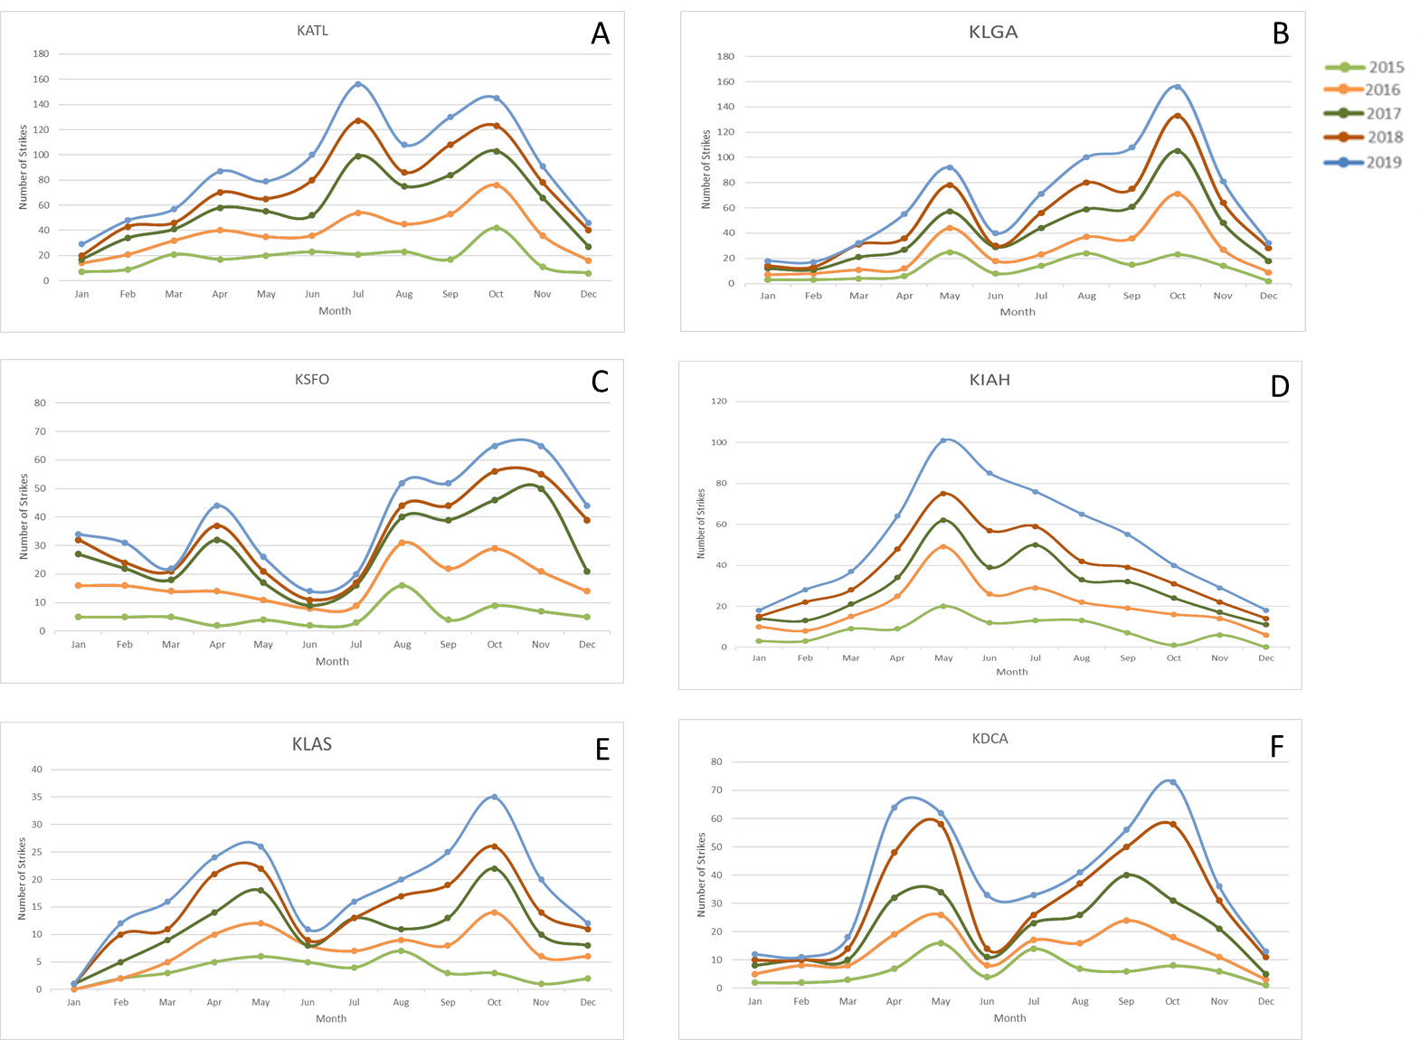
Figure 1 Cumulative monthly strikes from 2015-2019 across six tested airports. At most airports, peak strikes occur around known spring and fall migration months, signifying bimodality in strike seasons.

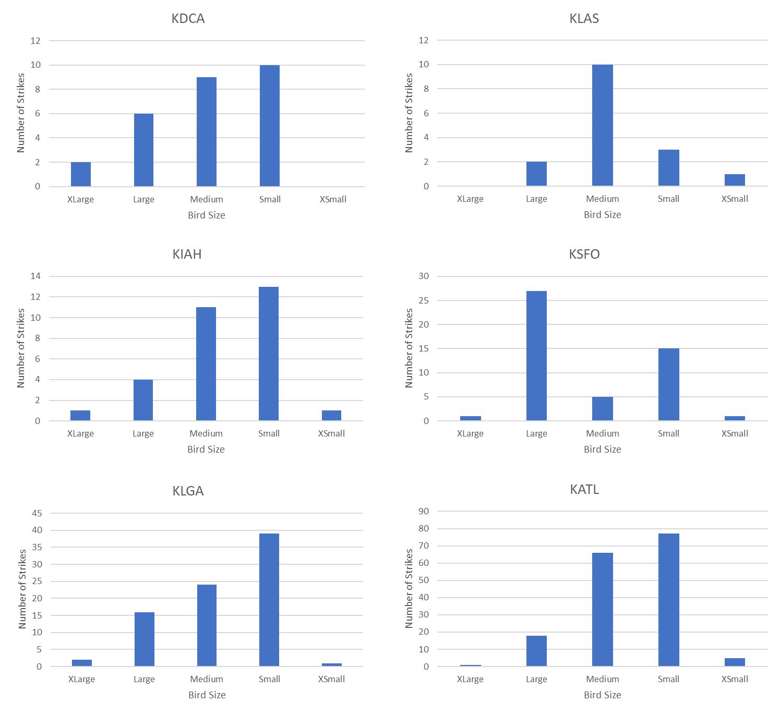
Figure 2 Bird body size distributions for 408 strikes occurring in 2019 across six tested airports. 66% of airports (KLGA, KATL, KDCA and KIAH) reported striking more small-sized birds than any other size, with small sized birds accounting for 41.4% of all strikes in 2019. Medium sized birds accounted for 33.8% of all strikes. Large birds accounted for 20.5% of strikes. Extra-small sized birds and extra-large sized birds account for 2.4% and 1.7%, respectively. The median bird strike size was medium-sized birds across all airports. Size category specifications: Extra Large (> 81 cm); Large (40 cm < x <81 cm); Medium (22 cm < x < 40 cm); Small (12 cm < x < 22 cm); Extra Small (< 12 cm).
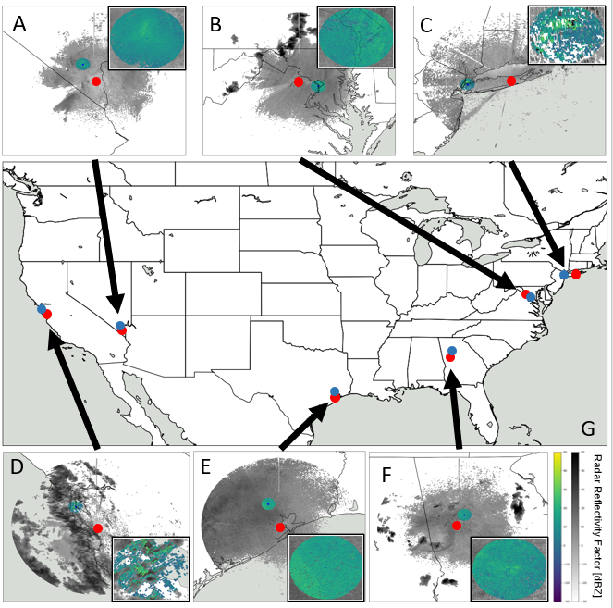
Figure 3 Examples of radar imagery displaying largest number of birds in the air at time of strike across all airports. The radar domain is a representation of 15-km radius surrounding airport latitude/longitude. a) McCarran International Airport (KLAS) on 6/19/19 at approx. 05:52. NEXRAD site: KESX. Estimated number of birds: 8,786; b) Ronald Reagan International Airport (KDCA) on 5/19/19 at approx. 22:21. NEXRAD site: KLWX. Estimated number of birds: 25,246; c) LaGuardia International Airport (KLGA) on 7/5/19 at approx. 01:30. NEXRAD site: KOKX. Estimated number of birds: 39,486; d) San Francisco International Airport (KSFO) on 1/11/19 at approx. 22:00. NEXRAD site: KMUX. Estimated number of birds: 4,274; e) George Bush Intercontinental Airport (KIAH) on 5/15/19 at approximately 04:50. NEXRAD site: KHGX. Estimated number of birds: 59,499; f) Hartsfield-Jackson Atlanta International Airport (KATL) on 8/8/19 at approx. 01:51. NEXRAD site: KFFC. Estimated number of birds: 10,800; g) Location of each airport (blue) and NEXRAD weather radar site (red) across the United States.
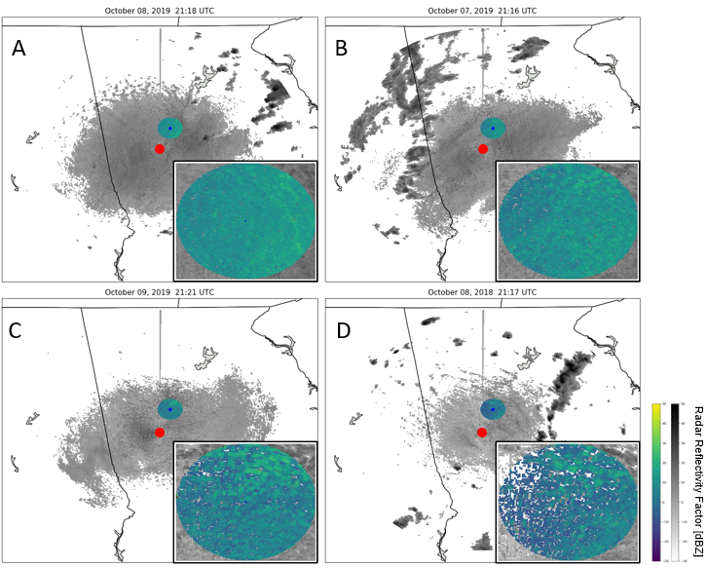
Figure 4 Example of a comparison between the day of strike and all comparator days regarding bird abundance surrounding time of strike at Hartsfield-Jackson Atlanta International Airport (KATL) using radar imagery captured by the KFFC NEXRAD weather radar. The radar domain is a representation of 15-km radius surrounding airport latitude/longitude. a) Day of strike radar image estimated number of birds: 293; b) Day prior to strike radar image, estimated number of birds: 435; c) Day following strike radar image, estimated number of birds: 2,110; d) Day of strike in the previous year (2018) radar image, estimated number of birds: 402.

References
Allan, J.R., 2000. The costs of bird strikes and bird strike prevention. Human Conflicts with Wildlife: Economic Considerations. Retrieved from: https://digitalcommons.unl.edu/nwrchumanconflicts/18/
Blokpoel, H. and MacKinnon, B., 2001. The need for a radar-based, operational warning system for civil aviation. 2001 Bird Strike Committee-USA/Canada, Third Joint Annual Meeting, Calgary, AB. Retrieved from: https://digitalcommons.unl.edu/cgi/viewcontent.cgi?article=1005&context=birdstrike2001
Chilson, P.B., Frick, W.F., Stepanian, P.M., Shipley, J.R., Kunz, T.H. and Kelly, J.F., 2012. Estimating animal densities in the aerosphere using weather radar: To Z or not to Z? Ecosphere, 3(8), pp. 1-19.

Clark, B. A., Klug, P.E., Stepanian, P.M. and Kelly, J.F., (2020). Using bioenergetics and radar-derived bird abundance to assess the impact of a blackbird roost on seasonal sunflower damage. Human-Wildlife Interactions, 14(3).

Crum, T.D., Saffle, R.E. and Wilson, J.W., 1998. An Update on the NEXRAD Program and Future WSR-88D Support to Operations. Weather and Forecasting, 13(2), pp. 253-262.

Cui, K., Hu, C., Wang, R., Sui, Y., Mao, H. and Li, H., 2020. Deep-learning-based extraction of the animal migration patterns from weather radar images. Science China Information Sciences, 63, 140304.
Dokter, A.M., Liechti, F., Stark, H., Delobbe, L., Tabary, P. and Holleman, I., 2011. Bird migration flight altitudes studied by a network of operational weather radars. Journal of the Royal Society Interface, 8(54), pp.30-43.
Dolbeer, R., 1999. Aerodome Bird Hazard Prevention: Case Study at John F. Kennedy International Airport. USDA National Wildlife Research Center - Staff Publications. 1900. http://digitalcommons.unl.edu/icwdm_usdanwrc/1900
Dolbeer, R.A. and Wright, S.E. (2008). Wildlife Strikes to Civil Aircraft in the United States 1990-2007). Federal Aviation Administration National Wildlife Strike Database Serial Report Number 14. https://digitalcommons.unl.edu/cgi/viewcontent.sgi?article=1023&context=birdstrikeother
Dove, C.J., Dahlan, N.F. and Heacker, M., 2009. Forensic bird-strike identification techniques used in an accident investigation at Wiley Post Airport, Oklahoma 2008. Human-Wildlife Conflicts, 3(2), pp. 179-185.
eBird Basic Dataset. Version: ebd_relFeb-2018. Cornell Lab of Ornithology, Ithaca, New York. May 2013.
El-Sayed, A., 2019. Bird Strikes in Aviation: Statistics, Analysis and Management (1st ed.). Wiley.
Farnsworth, A., Van Doren, B.M., Hochachka, W.M., Sheldon, D., Winner, K., Irvine, J., Geevarghese, J. and Kelling, S., 2015. A characterization of autumn nocturnal migration detected by weather surveillance radars in the northeastern USA. Ecological Applications, 26(3), pp. 752-770.
Fink, D., T. Auer, A. Johnston, M. Strimas-Mackey, O. Robinson, S. Ligocki, B. Petersen, C. Wood, I. Davies, B. Sullivan, M. Iliff, S. Kelling. 2020. eBird Status and Trends, Data Version: 2018; Released: Cornell Lab of Ornithology, Ithaca, New York. https://doi.org/10.2173/ebirdst.2018
Godin, A.J, 1994. Birds at Airports. The Handbook: Prevention and Control of Wildlife Damage. Retrieved from: https://digitalcommons.unl.edu/cgi/viewcontent.cgi?article=1054&context=icwdmhandbook
Helmus, J.J. & Collis, S.M., 2016. The Python ARM Radar Toolkit (Py-ART), a Library for Working with Weather Radar Data in the Python Programming Language. Journal of Open Research Software. 4(1), p.e25. DOI: http://doi.org/10.5334/jors.119
Horton, K.G., Shriver, W.G. and Buler, J.J., 2015. A comparison of traffic estimates of nocturnal flying animals using radar, thermal imaging, and acoustic recording. Ecological Applications, 25(2), pp. 390-401.
Horton, K.G., Van Doren, B.M., La Sorte, F.A., Fink, D., Sheldon, D., Farnsworth, A. and Kelly, J.F., 2018. Navigating north: how body mass and winds shape avian flight behaviours across a North American migratory flyway. Ecology letters, 21(7), pp.1055-1064.
IBM Corp. Released 2020. IBM SPSS Statistics for Windows, Version 27.0. Armonk, NY: IBM Corp.
Jeffery, R.F. and Buschke, F.T., 2019. Urbanization Around an Airfield Alters Bird Community Composition, but not the Hazard of Bird-Aircraft Collision. Environmental Conservation, 46(2), pp. 124-131.
Jatau, P. and Melnikov, V., 2018. Bird detection algorithm for the WSR-88D radars. NOAA, 45 pp. Retrieved from: https://www.nssl.noaa.gov/publications/wsr88d_reports/BirdDetectionAlgorithm_2018.pdf
Joyce, C., 2009. FAA: Major Accidents From Bird Strikes Are Rare [Radio broadcast episode]. https://www.npr.org/templates/story/story.php?storyId=99433696
Kranstrauber, B., Bouten, W., Leijnse, H., Wijers, B., Verlinden, L., Shamoun-Baranes, J. and Dokter, A.M., 2020. High-Resolution Spatial Distribution of Bird Movements Estimated from a Weather Radar Network. Remote Sensing, 12(4), pp. 635.
Kelly, J.F., Horton, K.G., Stepanian, P.M., de Beurs, K.M., Fagin, T., Bridge, E.S. and Chilson, P.B., 2016. Novel measures of continental-scale avian migration phenology related to proximate environmental cues. Ecosphere, 7(9), pp. 1-13.
Kelly, J.F. and Horton, K.G., 2016. Toward a predictive macrosystems framework for migration ecology. Global Ecology and Biogeography, 25(10), pp. 1159-1165.
Laursen, K., Frikke, J. and Kahlert, J., 2008. Accuracy of ‘total counts’ of waterbirds from aircraft in coastal waters. Wildlife Biology, 14(2), pp. 165-175.
Lin, T., Winner, K., Bernstein, G., Mittal, A., Dokter, A.M., Horton, K.G., Nilsson, C., Van Doren, B.M., Farnsworth, A., La Sorte, F.A., Maji, S. and Sheldon, D., 2019. MistNet: Measuring historical bird migration in the US using archived weather radar data and convolutional neural networks. Methods in Ecology and Evolution, 10(11), pp. 1908-1922.
Linnell, M.A., Conover, M.R. and Ohashi, T.J., 1999. Biases in Bird Strike Statistics Based on Pilot Reports. The Journal of Wildlife Management, 63(3), pp. 997-1003.
Linnell, M.A., Conover, M.R. and Ohashi, T.J., 2009. Using wedelia as ground cover on tropical airports to reduce bird activity. Human Wildlife Conflicts, 3(2), pp. 226-236.
Lovell, C.D. and Dolbeer, R.A., 1999. Validation of the United States Air Force Bird Avoidance Model. Wildlife Society Bulletin, 27(1), pp. 167-171.
Marr, P.G., 2020. Directional (Circular) Statistics. Shippensburg University. Retrieved from: http://webspace.ship.edu/pgmarr/Geo441/Lectures/Lec%2016%20-%20Directional%20Statistics.pdf
Marra, P.P., Dove, C.J., Dolbeer, R., Dahlan, N.F., Heacker, M., Whatton, J.F., Diggs, N.E., France, C. and Henkes, G.A., 2009. Migratory Canada geese cause crash of US Airways Flight 1549. Frontiers in Ecology and the Environment, 7(6), pp.297-301.
Marzluff, J.M., 2001. Worldwide urbanization and its effects on birds. Avian Ecology and Conservation in an Urbanizing World. In: Marzluff J.M., Bowman R., Donnelly R. (eds) Avian Ecology and Conservation in an Urbanizing World. Springer, Boston, MA. https://doi.org/10.1007/978-1-4615-1531-9_2
Metz, I.C., Ellerbroek, J., Mühlhausen, T., Kügler, D., Kern, S., and Hoekstra, J.M., 2021. The Efficacy of Operational Bird Strike Prevention. Aerospace, 8(1), pp. 17. https://doi.org/10.3390/aerospace8010017
Nilsson, C., Dokter, A.M., Verlinden, L., Shamoun-Baranes, J., Schmid, B., Desmet, P., Bauer, S., Chapman, J., Alves, J.A., Stepanian, P.M., Sapir, N., Wainwright, C., Boos, M., Gorska, A., Menz, M.H.M., Rodrigues, P., Leijnse, H., Zehtindjiev, P., Brabant, R., Haase, G., Weisshaupt, N., Ciach, M. and Liechti, F., 2018. Revealing patterns of nocturnal migration using the European weather radar network. Ecography, 42(5), pp. 876-886.
NOAA National Weather Service (NWS) Radar Operations Center (1991): NOAA Next Generation Radar (NEXRAD). Retrieved from: https://www.ncdc.noaa.gov/data-access/radar-data/nexrad
Peckford, M.L. and Taylor, P.D., 2008. Within night correlations between radar and ground counts of migrating songbirds. Journal of Field Ornithology, 79(2), pp. 207-214.
Qiao, L. and Zhang, L., 2019. Airport Bird Strike Risk Assessment and Research. IOP Conference Series: Material Science and Engineering 612. Retrieved from: https://iopscience.iop.org/article/10.1088/1757-899X/612/5/052071/pdf
Ruhe, W., 2005. Bird Avoidance Model vs. Real Time Birdstrike Warning Systems – a Comparison. International Bird Strike Committee. Retrieved from: https://www.worldbirdstrike.com/images/Resources/IBSC_Documents_Presentations/Athens/IBSC27_WPX-3.pdf
Shamoun-Baranes, J., Sierdsema, H., van Loon, E., van Gasteren, H., Bouten, W. and Sluiter, F., 2005. Linking Horizontal and Vertical Models to Predict 3D + time Distributions of Bird Densities. International Bird Strike Committee. Retrieved from: http://www.int-birdstrike.org/Athens_Papers/IBSC27%20WPIX-3.pdf
Shamoun-Baranes, J., van Loon, E., van Gastere, H., van Belle, J., Bouten, W. and Buurma, L., 2006. A Comparative Analysis of the Influence of Weather on the Flight Altitudes of Birds. Bulletin of American Meteorological Society, 87(1), pp. 47-62.
Shamoun-Baranes, J., Bouten, W., Buurma, L., DeFusco, R., Dekker, A., Sierdsema, H., Sluiter, F., van Belle, J. and van Loon, E., 2008. Avian Information Systems: Developing Web-Based Bird Avoidance Models. Ecology and Society, 13(2).
Shipley, J.R., Kelly, J.F. and Frick, W.F., 2018. Toward integrating citizen science and radar data for migrant bird conservation. Remote Sensing in Ecology and Conservation, 4(2), pp.127-136.
Soldatini, C., Georgalas, V., Torricelli, P. and Albores-Barajas, Y.V., 2010. An ecological approach to birdstrike risk analysis. European Journal of Wildlife Research, 56, pp. 623-632.
Stepanian, P.M., Entrekin, S.A., Wainwright, C.E., Mirkovic, D., Tank, J.L. and Kelly, J.F., 2020. Declines in an abundant aquatic insect, the burrowing mayfly, across major North American waterways. PNAS, 117(6), pp. 2987-2992. doi: doi.org/10.1073/pnas.1913598117
Stepanian, P.M., Horton, K.G., Melnikov, V.M., Zrnić, D.S. and Gauthreaux Jr., S.A., 2016. Dual-polarization radar products for biological applications. Ecosphere, 7(11), pp. 1-27.
Strimas-Mackey, M., W.M. Hochachka, V. Ruiz-Gutierrez, O.J. Robinson, E.T. Miller, T. Auer, S. Kelling, D. Fink, A. Johnston. 2020. Best Practices for Using eBird Data. Version 1.0. https://cornelllabofornithology.github.io/ebird-best-practices/. Cornell Lab of Ornithology, Ithaca, New York. https://doi.org/10.5281/zenodo.3620739
Strimas-Mackey M, Miller E, Hochachka W (2018). auk: eBird Data Extraction and Processing with AWK. R package version 0.3.0, https://cornelllabofornithology.github.io/auk/.
Sullivan, B. L., Aycrigg, J. L., Barry, J. H., Bonney, R. E., Bruns, N., Cooper, C. B., . . . Kelling, S. 2014. The eBird enterprise: An integrated approach to development and application of citizen science. Biological Conservation, 169, 31-40. doi:10.1016/j.biocon.2013.11.003
Tielens, E.K, Cimprich, P.M., Clark, B.A., DiPilla, A.D., Kelly, J.F., Mirkovic, D., Strand, A.I., Zhai, M. and Stepanian, P.M., 2021. Nocturnal city lighting elicits a macroscale response from an insect outbreak population. Biology Letters, 17: 20200808. doi:doi.org/10.1098/rsbl.2020.0808
U.S. Air Force, 2015: Avian Hazard Advisory Stem (AHAS). U.S. Department of Defense. Retrieved from: http://www.usahas.com/
van Gasteren, H., Krijgsveld, K.L., Klauke, N., Leshem, Y., Metz, I.C., Skakuj, M., Sorbi, S., Schekler, I. and Shamoun-Baranes, J., 2018. Aeroecology meets aviation safety: early warning systems in Europe and the Middle East prevent collisions between birds and aircraft. Ecography, 42(5), pp. 899-911.
Vickery, P. D. (1996). Grasshopper Sparrow (Ammodramus savannarum), version 2.0. In The Birds of North America (A. F. Poole and F. B. Gill, Editors). Cornell Lab of Ornithology, Ithaca, NY, USA. https://doi.org/10.2173/bna.239 (https://doi.org/10.2173/bna.239)
Weisshaupt, N., Lehtiniemi, T. and Koistinen, J., 2020, Combining citizen science and weather radar data to study large-scale bird movements. International Journal of Avian Science. Retrieved from: https://onlinelibrary.wiley.com/doi/10.1111/ibi.12906
Westbrook, J.K. and Eyster, R.S., 2017. Doppler weather radar detects emigratory flights of noctuids during a major pest outbreak. Remote Sensing Applications: Society and Environment, 8, pp. 64-70.
Wright, S.E. and Dolbeer, R.A., 2005. Percentage of Wildlife Strikes Reported and Species Identified Under a Voluntary Reporting System. 2005 Bird Strike Committee-USA/Canada 7th Annual Meeting, Vancouver, BC. 11. https://digitalcommons.unl.edu/birdstrike2005/11
Zakrajsek, E.J. and Bissonette, J.A., 2001. Nocturnal Bird-Avoidance Modeling with Mobile-Marine Radar. 2001 Bird Strike Committee-USA/Canada, Third Joint Annual Meeting, Calgary, AB. Retrieved from: https://digitalcommons.unl.edu/cgi/viewcontent.cgi?article=1029&context=birdstrike2001

