UNIVERSITY OF OKLAHOMA
GRADUATE COLLEGE

Temporal and Spatial Variations in Sediment Trace Metal Concentrations in Streams, Rivers, and a Reservoir near a Derelict Lead-Zinc Mining District

A THESIS
SUBMITTED TO THE GRADUATE FACULTY
In partial fulfillment of the requirements for the
Degree of

Master of Environmental Science

By
Carlton Anthony Folz
Norman, Oklahoma
2021
Temporal and Spatial Variations in Sediment Trace Metal Concentrations in Streams, Rivers, and a Reservoir near a Derelict Lead-Zinc Mining District

A THESIS APPROVED FOR THE
SCHOOL OF CIVIL ENGINEERING AND ENVIRONMENTAL SCIENCE

BY THE COMMITTEE CONSISTING OF

Dr. Robert W. Nairn, Chair
Dr. Robert C. Knox
Dr. Kato T. Dee

© Copyright by Carlton Anthony Folz 2021
All Rights Reserved

Acknowledgments
I would first like to thank the Grand River Dam Authority for their financial and intellectual support throughout the entirety of this research project.
I have been truly blessed to work beside and learn from Dr. Nairn, and I cannot thank him enough for the effort and attention to detail he has provided to me and this research. Through this journey, adversity and obstacles were encountered, but his faith in me and the science being completed did not waiver. I would also like to thank my other committee members for their valuable time in helping guide my work and achieve this milestone.
Similarly, this would not have been completed without the endless help from my friends and colleagues of CREW. Specifically, Nick, Brandon, M’Kenzie, and Justine have all been valuable resources in the field and laboratory, as well as keeping me sane. I extend a thank you to all of my previous teachers and professors that have enhanced my love for science and the environment. Thank you, Mrs. Brettingen and Dr. Blumentritt, who introduced, encouraged, and believed in the purist of improving the environment through science and education. I would specifically like to thank the Winona State Geoscience Department for the education of what it means to be a scientist and how to communicate research effectively.
Lastly, I could not have completed this work without the unwavering love and support from my family. Thank you, Mom, Dad, Rachel, Jake, Nick, and Christian, for instilling curiosity into my life and allowing and encouraging me to pursue my goals.

Table of Contents
Acknowledgments iv
List of Tables vi
List of Figures viii
Abstract xiv
1. Project Introduction and General Background 1
1.1 Introduction 1
1.2 Thesis Purpose 4
1.3 Thesis Overview 4
2. Temporal Changes in Trace Metal Concentrations of Tar Creek Sediments 6
2.1 Introduction 6
2.2 Methods and Materials 12
2.2.1 Sediment Collection and Analysis Methods 12
2.2.2 Comparison of Methods 14
2.3 Results and Discussion 15
2.3.1 Sample Collection Limitations 15
2.3.2 Surface Sediment Investigation 16
2.3.3 Passive Treatment Investigation 21
2.3.4 Changes Within the Tar Creek Watershed Land Cover 24
2.3.5 Factors Influencing Observed Changes 26
2.4 Conclusions 30
2.5 Future Work 31
3. Spatial Variations in Sediment Trace Metal Concentrations Downstream of an Abandoned Mining District 33
3.1 Introduction 33
3.2 Methods and Materials 37
3.3 Results and Discussion 40
3.3.1 Spatial Assessment of Trace Metal Concentrations 40
3.3.2 Sediment Contamination Metrics 55
3.3.3 Sediment Quality Guideline Evaluation 59
3.3.4 Discussion of Trace Metal Contamination 64
3.3.5 Limitations and Uncertainties 66
3.4 Conclusions 66
3.5 Future Work 67
4. Bioavailability of Trace Metals in Stream Sediments Impacted by Historic Lead and Zinc Mining 68
4.1 Introduction 68
4.2 Methods and Materials 71
4.3 Results and Discussion 73
4.3.1 Bioavailable Concentrations and Percent of Total for Trace Metals 73
4.3.2 Sediment Organic Carbon, Total Iron, and pH 78
4.3.3 Linear Regression analyses 81
4.3.4 Individual Waterbody Investigation 88
4.3.5 General Discussion 93
4.3.6 Limitations and Uncertainties 96
4.4 Conclusions 96
4.5 Future Work 97
5. Thesis Conclusions 98
5.1 Thesis Conclusions 98
5.2 Implications on the Future 100
Literature Cited 101
Appendix A: Sample information and total metal concentrations for 1988 and 2020 (Chapter 2) 110
Appendix B: Total concentrations and sediment parameters for surface samples (Chapter 3) 113
Appendix C: Contamination Factor and Geoaccumulation Index for Cd, Pb, and Zn for sample locations (Chapter 3) 114
Appendix D: Total and Bioavailable Concentrations at sample locations (Chapter 4) 115
Appendix E: Linear regression figures for total versus bioavailable Cd, Cu, Fe, Mn, Ni, Pb, and Zn (Chapter 4) 116
Appendix F: Organic Carbon, Total Fe, and Sediment pH versus total and bioavailable concentrations of Cd, Cu, Fe, Mn, Ni, Pb, and Zn (Chapter 4) 120

List of Tables
Table 2.1: Results from a 1-tailed Wilcoxon Sign Ranked Test to determine if changes in concentrations throughout the area of study are significant at the 95th confidence interval (p < 0.05) 20
Table 2.2 Results of the Wilcoxon Sign Ranked Test at the 95th confidence interval (p < 0.05) of surface and depth samples collected below the passive treatment systems 24
Table 2.3: pH and trace metal concentrations in Tar Creek near Commerce, OK (Highway 69 bridge crossing) from the early 1980s (USEPA, 1984) compared to the late 2010s (CREW, 2021) 27
Table 3.1: I_{geo} class and description of sample quality for calculated I_{geo} values; modified from Looi et al. (2019) 38
Table 3.2: Consensus-based and TSMD-specific SQGs for trace metals of concern (MacDonald et al., 2000, 2009) 39
Table 3.3: Results from the ANOVA Single Factor test at the 95th confidence interval (p<0.05) to determine if mean concentrations between waterbodies are different 44
Table 3.4: Results from the spatial autocorrelation tests for each of the three trace metals of concern 45
Table 3.5: Resulting p-values from the one-tailed t-test at the 95th confidence interval (p<0.05) for average trace metal concentrations above and below known mining impaired tributaries in Oklahoma 49
Table 3.6: Results from linear regression analysis for distance versus trace metal concentrations in the Spring River (n=15) and the Neosho River, which included Tar Creek samples (n=17) 54
Table 3.7: Median CF values (and standard error) for the three trace metals of concern within each of the waterbodies examined 58
Table 3.8: Mean and median daily streamflow discharge data in cubic feet per second (ft³/sec) for Tar Creek, the Neosho River, and the Spring River over the last 30 years 64
Table 4.1: Summary of linear regression analyses for total concentrations versus bioavailable concentrations for Cd, Cu, Fe, Mn, Ni, Pb, and Zn where significant relationships are indicated by bolding of the element symbol 81
Table 4.2: Summary of linear regression analyses where OC is the independent variable for total and bioavailable concentrations of Cd, Cu, Fe, Mn, Ni, Pb, and Zn 83
Table 4.3: Summary of linear regression analyses where total Fe concentration is the independent variable for total and bioavailable concentrations of Cd, Cu, Fe, Mn, Ni, Pb, and Zn 84
Table 4.4 Summary of linear regression analyses where sediment pH is the independent variable for total and bioavailable concentrations of Cd, Cu, Fe, Mn, Ni, Pb, and Zn 85
Table A.1 Sample number, latitude, longitude, station name, and discrete depth of sample collection for all sample locations included in Chapter 2 110
Table A.2: Site number with corresponding concentrations of Cd, Cu, Fe, and Mn from both 1988 and 2020 sampling efforts 111
Table A.3: Site number with corresponding concentrations of Ni, Pb, S, Zn, and OC content for both the 1988 and 2020 sampling efforts 112
Table B.1: Site name, latitude, and longitude for all sample locations with concentrations of Cd, Pb, and Zn (mg/kg) 113
Table C.1: Site name with corresponding Igeo classification and calculated contamination factor for Cd, Pb, and Zn 114
Table D.1: Site name, sediment pH and organic carbon content (%) and the total and bioavailable concentrations of Cd, Cu, Fe, Mn, Ni, Pb, and Zn (mg/kg) 115

List of Figures
Figure 1.1: Area of study (inset) along with Tar Creek and major rivers (Spring and Neosho Rivers) draining into Grand Lake O’ the Cherokees 2
Figure 1.2: Mine drainage impaired surface water streams underlain by the Picher Mining Field mine workings 3
Figure 2.1: Area of study and sampling locations for surface sediments on and near Tar Creek, surface waters of importance, and mine drainage discharge locations 10
Figure 2.2: Locations of Mayer Ranch and Southeast Commerce Passive Treatment Systems (with mine drainage discharge locations) on the Unnamed Tributary in comparison to sample collection locations downstream of the systems 11
Figure 2.3: Subsamples of surface sediments after oven drying 13
Figure 2.4: Site in Commerce, OK, having undergone substantial land modification preventing evaluation of natural evolution of trace metal changes A) Highlighting Cactus Collapse B) Site construction C) Highlighting Southeast Commerce passive treatment system 15
Figure 2.5: Example box and whisker plot with labeled plot boundaries 16
Figure 2.6: Median a) Cd, b) Cu, d) Mn, e) Ni, f) Pb, and h) Zn, and c) Fe, g) S, and i) OC as % of total weight with standard error of the median for the nine reported analytes for all surface samples. Data from 1988 is presented in solid crimson, while data from 2020 is in hatched blue. 17
Figure 2.7: Percent difference box and whisker plots of the nine constituents where 0 indicates no change, >0 indicates an increase, and <0 indicates a decrease in concentration from 1988 to 2020 in surface sediment samples 18
Figure 2.8: Changes in the landscape and surface hydrology from 1980 to 2015 through aerial imagery investigation with sample locations digitized 21
Figure 2.9: Surface and depth-discrete sample percent differences for the locations below passive treatment systems from 1988 to 2020 where 0 indicates no change, >0 indicates an increase, <0 indicates a decrease in concentrations between sampling events. 23
Figure 2.10: The Tar Creek HUC 12 watershed (left) with aerial imagery and the 2016 NLCD for the Tar Creek watershed (right) 25
Figure 2.11: Changes in major land cover class areas within the Tar Creek watershed from 2001 to 2016 via the NLCD 25
Figure 2.12: Laboratory measured pH box and whisker plot of all surface sediment samples collected in 2020 26
Figure 3.1: The Grand Lake watershed (inset) and the Spring River and Neosho River watersheds within the Grand Lake watershed 34
Figure 3.2: Surface sediment sample locations along Tar Creek, Spring River, Neosho River, and Grand Lake with sample location names 36
Figure 3.3: Sample collection occurring on the bank of the Neosho River in the Fall of 2020 37
Figure 3.4: Cadmium concentrations (mg/kg) shown spatially for each location (left) and the box and whisker plot for the four distinct waterbodies for surface sediments (right) 41
Figure 3.5: Lead concentrations (mg/kg) shown spatially for each location (left) and the box and whisker plot for the four distinct waterbodies for surface sediments (right) 42
Figure 3.6 Lead concentrations (mg/kg) shown spatially for each location (left) and the box and whisker plot for the four distinct waterbodies for surface sediments (right) 43
Figure 3.7: Hotspot analysis results for Cd and Zn showing significant clustering of high or low concentrations 46
Figure 3.8: Mean concentrations of Cd, Pb, and Zn above and below known mining impaired tributaries (a, c, and e above and below Tar Creek, and b, d, and f above and below Beaver Creek) 48
Figure 3.9: Measured Distance from GL0 versus Cd concentrations for the Spring River (squares) and the Neosho River and Tar Creek (circles) with linear regression line shown for each 51
Figure 3.10: Measured Distance from GL0 versus Pb concentrations for the Spring River (squares) and the Neosho River and Tar Creek (circles) with linear regression line shown for each 52
Figure 3.11: Measured Distance from GL0 versus Zn concentrations for the Spring River (squares) and the Neosho River and Tar Creek (circles) with linear regression line shown for each 53
Figure 3.12: Contamination factor for Cd, Pb, and Zn at all sample locations using the OU5 developed background threshold value 56
Figure 3.13: Geoaccumulation index for all sample locations for Cd, Pb, and Zn using OU5 background threshold values for the respective trace metals 57
Figure 3.14: Sediment sample location and results from comparison to consensus based SQGs for Cd, Pb, and Zn 60
Figure 3.15: Sediment sample locations and results from trace metal concentrations compared to TSMD specific SQGs for Cd, Pb, and Zn 61
Figure 3.16: Results for the calculated ƩPEC-Q_{Cd,Pb,Zn} for all surface sediment samples 63
Figure 4.1: Area of study (inset) and locations of sample collection from Grand Lake, the Neosho River, the Spring River, and Tar Creek 70
Figure 4.2: Surface sediments air drying in the CREW laboratory 72
Figure 4.3: Spatial distribution of the bioavailable concentration and percent bioavailable of the total concentration for Cd, Cu, and Fe 75
Figure 4.4 Spatial distribution of the bioavailable concentration and percent bioavailable of the total concentration for Mn, Ni, and Pb 76
Figure 4.5 Spatial distribution of the bioavailable concentration and percent bioavailable of the total concentration for Zn 77
Figure 4.6: Spatial distribution of OC content as % (left) and boxplot of OC content as % (right) for all sample locations 78
Figure 4.7: Spatial distribution of total Fe concentrations (left) and boxplot of total Fe concentrations (right) for all sample locations 79
Figure 4.8: Spatial distribution of sediment pH (left) and boxplot of sediment pH (right) for all sample locations 80
Figure 4.9: Sediment pH plotted against total Zn concentrations (mg/kg) for all sample locations 81
Figure 4.10: Total Zn (mg/kg) plotted against total Cd (mg/kg) with linear regression line and coefficient of determination shown 86
Figure 4.11: Bioavailable Zn (mg/kg) plotted against bioavailable Cd (mg/kg) with linear regression line and coefficient of determination shown. 87
Figure 4.12: Median total recoverable concentrations (with standard error) on a logarithmic vertical axis for Cd, Cu, Fe, Mn, Ni, Pb, and Zn shown for individual waterbodies 89
Figure 4.13: Median bioavailable concentrations (with standard error) on a logarithmic vertical axis for Cd, Cu, Fe, Mn, Ni, Pb, and Zn shown for individual waterbodies 90
Figure 4.14: Median percent bioavailable of the total concentrations (with standard error) for Cd, Cu, Fe, Mn, Ni, Pb, and Zn shown for individual waterbodies 91
Figure 4.15:Median sediment pH (left) and sediment OC content (right) with standard error for individual waterbodies 93
Figure E.1: Total versus bioavailable concentrations of Cd (mg/kg) with linear regression equation and R² for all sample locations 116
Figure E.2: Total versus bioavailable concentrations of Cu (mg/kg) with linear regression equation and R² for all sample locations 116
Figure E.3: Total versus bioavailable concentrations of Fe (mg/kg) with linear regression equation and R² for all sample locations 117
Figure E.4: Total versus bioavailable concentrations of Mn (mg/kg) with linear regression equation and R² for all sample locations 117
Figure E.5: Total versus bioavailable concentrations of Ni (mg/kg) with linear regression equation and R² for all sample locations 118
Figure E.6: Total versus bioavailable concentrations of Pb (mg/kg) with linear regression equation and R² for all sample locations 118
Figure E.7: Total versus bioavailable concentrations of Zn (mg/kg) with linear regression equation and R² for all sample locations 119
Figure F.1: Organic Carbon (%) as the independent variable plotted against total and bioavailable Cd (mg/kg) 120
Figure F.2: Organic Carbon (%) as the independent variable plotted against total and bioavailable Cu (mg/kg) 120
Figure F.3: Organic Carbon (%) as the independent variable plotted against total and bioavailable Fe (mg/kg) 121
Figure F.4: Organic Carbon (%) as the independent variable plotted against total and bioavailable Mn (mg/kg) 121
Figure F.5 Organic Carbon (%) as the independent variable plotted against total and bioavailable Ni (mg/kg) 122
Figure F.6: Organic Carbon (%) as the independent variable plotted against total and bioavailable Pb (mg/kg) 122
Figure F.8: Total Fe (mg/kg) as the independent variable plotted against total and bioavailable Cd (mg/kg) 123
Figure F.7: Organic Carbon (%) as the independent variable plotted against total and bioavailable Zn (mg/kg) 123
Figure F.9: Total Fe (mg/kg) as the independent variable plotted against total and bioavailable Cu (mg/kg) 124
Figure F.10: Total Fe (mg/kg) as the independent variable plotted against total and bioavailable Fe (mg/kg) 124
Figure F.12: Total Fe (mg/kg) as the independent variable plotted against total and bioavailable Ni (mg/kg) 125
Figure F.11: Total Fe (mg/kg) as the independent variable plotted against total and bioavailable Mn (mg/kg) 125
Figure F.14: Total Fe (mg/kg) as the independent variable plotted against total and bioavailable Zn (mg/kg) 126
Figure F.13: Total Fe (mg/kg) as the independent variable plotted against total and bioavailable Pb (mg/kg) 126
Figure F.15: Sediment pH as the independent variable plotted against total and bioavailable Cd (mg/kg) 127
Figure F.16: Sediment pH as the independent variable plotted against total and bioavailable Cu (mg/kg) 127
Figure F.17: Sediment pH as the independent variable plotted against total and bioavailable Fe (mg/kg) 128
Figure F.18: Sediment pH as the independent variable plotted against total and bioavailable Mn (mg/kg) 128
Figure F.19: Sediment pH as the independent variable plotted against total and bioavailable Ni (mg/kg) 129
Figure F.20: Sediment pH as the independent variable plotted against total and bioavailable Pb (mg/kg) 129
Figure F.21: Sediment pH as the independent variable plotted against total and bioavailable Zn (mg/kg) 130

Abstract
Historic lead and zinc mining in the Tri-State Mining District has ceased, but the legacy of trace metal contamination (Cd, Cu, Ni, Pb, and Zn) throughout the region still exists. This thesis focuses on stream sediments in and downstream from contaminated areas. This study evaluated temporal changes of trace metal concentrations over 35-years in Tar Creek sediments. The spatial distribution of trace metal concentrations was subject to analyses between Tar Creek, the Neosho River, the Spring River, and Grand Lake O’ the Cherokees. The last study focused on the bioavailability of trace metals in sediments and what factors may influence it. The watershed of Grand Lake O’ the Cherokees drains multiple National Priority List Superfund sites from mining-related activities. Sources of trace metals entering the surface water systems include artesian flowing mine drainage, mining waste pile leachate, and mine waste in the active channels.
When evaluating temporal changes in Tar Creek sediments, Cd, Mn, Ni, and Zn concentrations and organic carbon content increased. At the same time, Fe, Pb, and S decreased from 1985 to 2020. Spatially, Cd, Pb, and Zn concentrations decreased with increasing distance from mining impaired areas. Lastly, evaluating the impact of sediment pH, sediment organic carbon, and total Fe concentrations resulted in a wide range of responses and variability. The bioavailable concentrations of trace metals were not influenced equally by these factors. Use of statistical evaluations at the 95th confidence interval for the appropriate tests allowed for the determination of significance. Sediment-bound trace metals in freshwater sediments have complex behaviors and are becoming distributed downstream of the mining district. As remediation of sediments in the Superfund sites begins, it is imperative to understand the sources, mobility, and bioavailability of the trace metals to increase the effectiveness and efficiency of remediation while minimizing potential human and environmental risks.

Project Introduction and General Background

1.1 Introduction
The no longer active Tri-State Mining District (TSMD) is located in northeastern Oklahoma, southeastern Kansas, and southwestern Missouri. The Picher Field, on the border of Oklahoma and Kansas within the TSMD, produced over 13 million tons of crude lead (Pb) and zinc (Zn) ore per year in the peak years of the mid-1920s (McKnight and Fischer, 1970). The TSMD contains multiple National Priorities List (NPL) Superfund Sites due to widespread trace metal contamination from mining and ore processing during the 1800s and 1900s (USEPA, 2015). The trace metals of primary concern are Pb, Zn, and cadmium (Cd). However, elevated concentrations of iron (Fe), nickel (Ni), sulfur (S), and other elements exist throughout the TSMD. The predominantly mined ores were sphalerite and galena (ZnS and PbS). Small amounts of chalcopyrite, enargite, marcasite, and pyrite (CuFeS₂, Cu₃AsS₄, orthorhombic FeS₂, and cubic FeS₂) were associated but not targeted during mining (Fowler and Lyden, 1932; McKnight and Fischer, 1970). Sphalerite is also known to have the capacity to include elevated levels of Cd in the sulfide mineral (O’Day et al., 1998; Schwartz, 2000).
Surface waters in the region flow into the multi-use reservoir Grand Lake O’ the Cherokees (Grand Lake), where impacts from legacy mining have been observed both in the surface waters and sediments (Figure 1.1) (McCormick, 1985; Andrews et al., 2009; Juracek and Becker, 2009; Morrison et al., 2019).
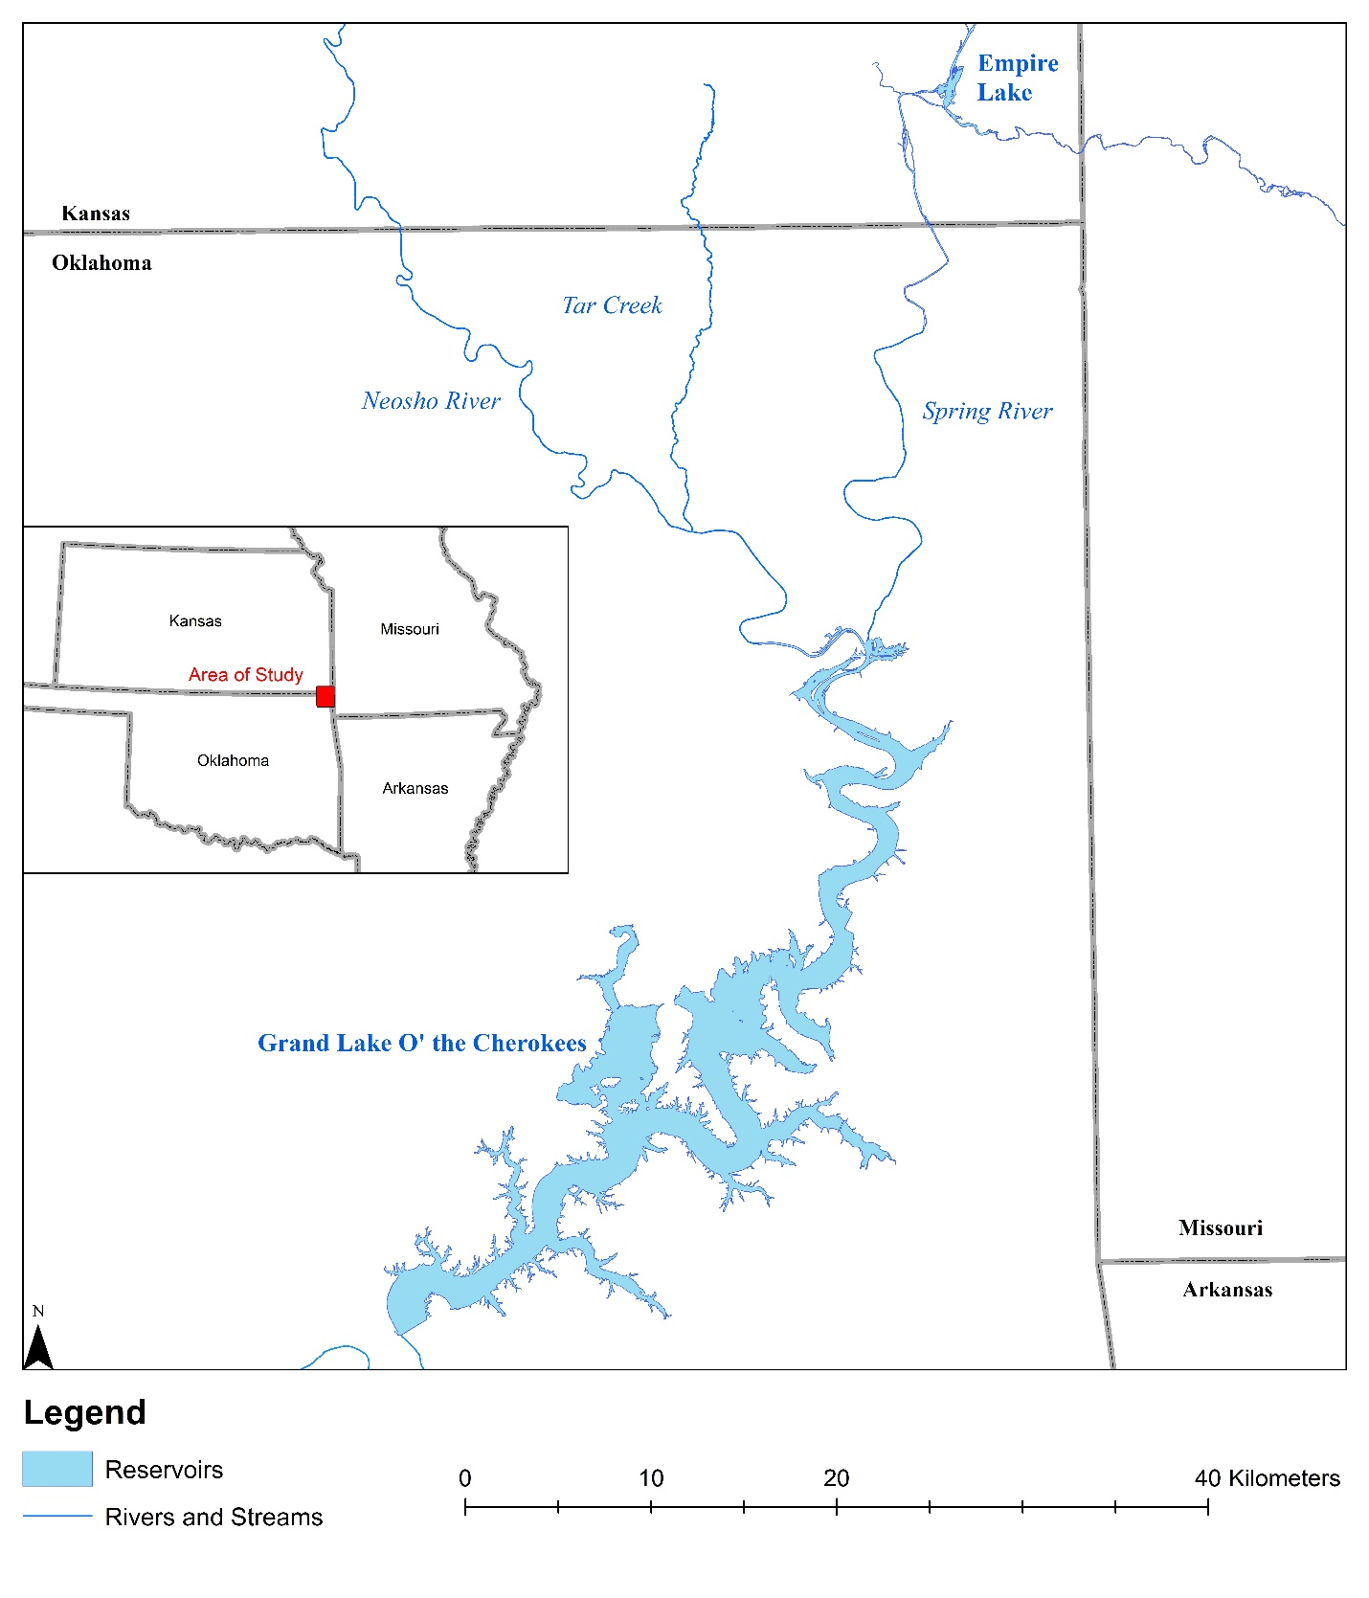
Figure 1.1: Area of study (inset) along with Tar Creek and major rivers (Spring and Neosho Rivers) draining into Grand Lake O’ the Cherokees

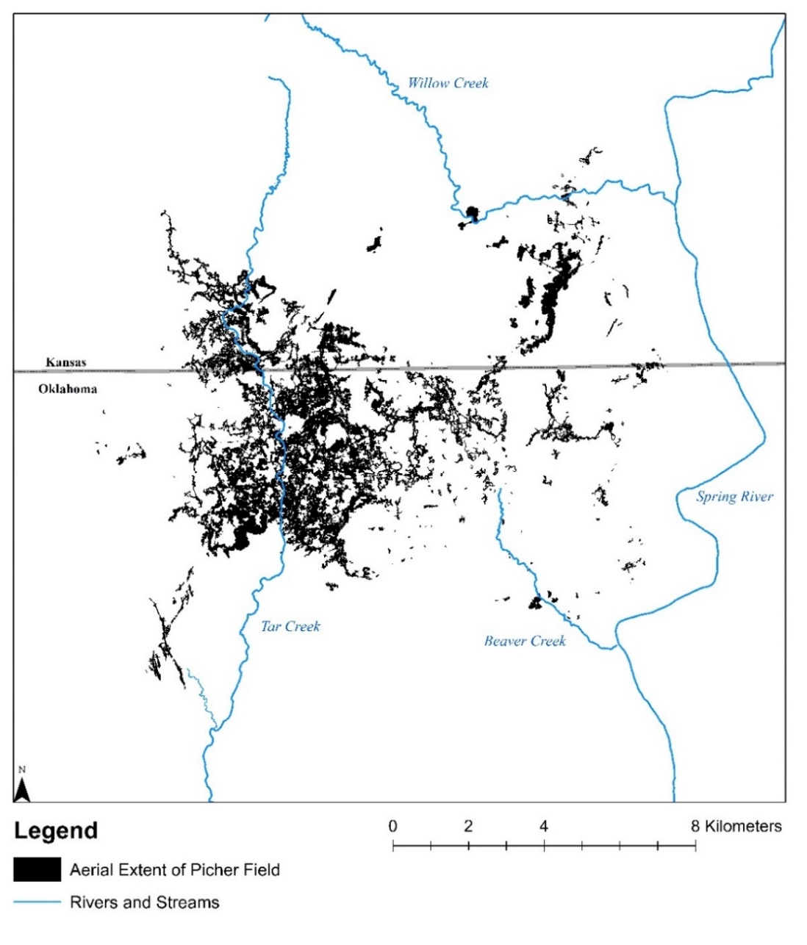
During mining operations, ground water was being pumped from the mine workings to allow continued ore extraction. During this time, the sulfide mineral surfaces became oxidized and, once the mine workings filled with water after mining ceased, the oxidized minerals dissolved mineral concentrations in the mine pool water increased and became mobile. Starting in 1979 and continuing to the present day, numerous surface discharges rich in dissolved trace metals have been flowing continuously into surface streams from mineshafts, boreholes, and air vents. The Picher Field is an extensively mined area that is now the source of much of the contaminated mine drainage in the region, which discharges into several creeks (Figure 1.2).
Figure 1.2: Mine drainage impaired surface water streams underlain by the Picher Mining Field mine workings
Once the trace metal-rich mine drainage reaches the surface, several natural processes occur, promoting the dissolved elements to oxidize, hydrolyze, and precipitate or be sorbed to other constituents. The precipitation of iron oxyhydroxides not only removes that trace metal from the water but can promote co-precipitation, exchange, and sorption of other trace metals from the water, thus incorporating them into the stream sediments (Zwolsman and Van Eck, 1993). The trace metals also become adsorbed onto particles other than iron oxides, including clays and organic matter. In addition to artesian-flowing discharges, another substantial contributor to trace metal contamination and potential environmental risk in the TSMD is the mining waste (chat) piles (USEPA, 1994). The chat piles contain elevated concentrations of trace minerals in their solid form but can become mobilized through numerous processes. In some instances, the stream bed of Tar Creek is predominantly chat, which can act as a source of both dissolved and as particulate, trace metals into the water and which then facilitates transport downstream (Ten Hulscher et al., 1992; Morford and Emerson, 1999; Grybos et al., 2007). These trace metals in stream sediments are of great concern due to the possible adverse effects on humans and the environment. They are evaluated and discussed in further detail in the following chapters.

1.2 Thesis Purpose
The purpose of this thesis is to evaluate both spatial and temporal changes and variability in sediment trace metal concentrations to understand the potential threat to humans and the environment that these trace metals may have in and downstream from the TSMD. Vital aspects of the potential threat to humans and the environment of trace metals is an understanding of the bioavailable fraction and physiochemical factors of influence.

1.3 Thesis Overview
Three unique studies were conducted to evaluate trace metals: 1)temporal distribution, 2)and spatial heterogeneity, and 3) bioavailability in and downstream from the TSMD. The first and last chapters serve as introductory and concluding bookends for the three central chapters. General introductions and an overview of the work is completed in Chapter 1. In order to evaluate the temporal changes in trace metal concentrations, an older dataset was used to compare to the current conditions. A United States Geologic Survey (USGS) report published in 1988 documented the trace metal and organic carbon concentrations in Tar Creek stream sediments (Parkhurst et al., 1988). In 2020, sample collection was repeated at the same locations. The samples were evaluated for the same suite of trace metals to determine changes throughout the site, as well as to investigate the impacts of passive treatment systems (PTS) on trace metals in the sediments (Chapter 2). The spatial variability in trace metal concentrations in surface sediment samples were evaluated along Tar Creek, the Neosho and Spring Rivers, and in Grand Lake O’ the Cherokees (Grand Lake). The concentrations were evaluated through various metrics to determine the magnitude of contamination (Chapter 3). When evaluating the potential threat to humans and the environment, the development of consensus based Sediment Quality Guidelines (SQGs) provided a proxy for sediment toxicity. However, the total concentration of a trace metal is not necessarily indicative of its interactions with its surroundings. Therefore, bioavailable concentrations of trace metals were determined through a laboratory extraction and compared to other sediment parameters to determine factors influencing the behavior of bioavailability (Chapter 4). Lastly, major conclusions for the thesis are presented in Chapter 5.

Temporal Changes in Trace Metal Concentrations of Tar Creek Sediments

2.1 Introduction
The historic TSMD is home to several NPL Superfund sites (USEPA, 1994). The United States Environmental Protection Agency (USEPA) documented that the Tar Creek Superfund site is an approximately 103 km² (40 mi²) area in northeastern Oklahoma and was added to the NPL in the early 1980s and remains listed today. The lead (Pb) and zinc (Zn) mining once produced substantial portions of the Pb and Zn for the United States 20th century war efforts, but substantial mining efforts in the region ceased by 1970 (USEPA, 1994). In 1979, water started flowing via artesian head pressures to the surface from the water-filled abandoned mine workings. These waters were rich in Pb, Zn, iron (Fe), cadmium (Cd), and other trace metals (USEPA, 1984).
The oxidized trace metal-containing minerals release the trace metals into the underground waters to create the mine drainage, and the discharge locations are still flowing with trace metal-rich water to this day (CH2M, 2020). Although the process of dissolving sulfide minerals often results in net acidic water conditions (total acidity greater than total alkalinity), the predominantly limestone and other carbonate-rich parent bedrock created metal-rich waters in net alkaline waters (USEPA, 2000). The oxidation and dissolution of the sulfide minerals galena, sphalerite, and pyrite contribute to elevated sulfate (SO₄²⁻) concentrations in the mine drainage. Two artesian discharge locations currently have constructed passive treatment systems (PTS); however, several discharges remain untreated and flow into surrounding surface waters (Nairn et al., 2011).
Upwelling mine drainage discharges are not the only source of trace metal contamination in the region. The mining waste (chat) piles and tailings ponds containing typically gravel-sized and smaller particles also contain elevated trace metals concentrations. The chat piles have existed since the onset of mining and grew in volume and area as production increased (USEPA, 2008). The chat fines, rich in trace metals, can be transported in their particulate phase via wind and water erosion to make their way into surface waters (Zota et al., 2009; Li and McDonald‐Gillespie, 2020). Numerous locations in the Tar Creek channel are entirely chat as the streambed and banks near the heavily mined areas. The in-stream chat and chat pile runoff contribute to trace metal loadings in Tar Creek (USEPA, 2008).
The trace metals do not remain dissolved when they reach the surface from the abandoned mine workings. When the mine drainage waters reach the surface, the oxygen-rich environment promotes the precipitation of initially amorphous iron oxyhydroxides, which can sorb and co-precipitate other trace metals to their surfaces (von der Heyden and Roychoudhury, 2015). Another interaction that occurs at the surface is the contact of the mine waters with organic matter. Organic matter can be in various forms, including dissolved organic matter, natural organic matter, and potentially other carbon-based compounds. These exist in the water column, stream bed, and riparian areas where the waters may reach during high flow events. A portion of this organic matter is organic carbon (OC), which may be reactive with dissolved and solid trace metals to change their fate and transport in surface water environments (Zwolsman and Van Eck, 1993). Precipitation and sorption processes can lead to the deposition of trace metals into the streambed and along the stream bank. This deposition does not mean the trace metals are then immobile or unreactive indefinitely. Through natural processes such as runoff, erosion, and changes in reduction and oxidation potential, particulate trace metals may be mobilized into the water column or encounter new conditions leading to mobility (van den Berg et al., 2000; Ma and Dong, 2004). Other environmental and anthropogenic conditions in and around Tar Creek may be contributing to the behavior of trace metals, such as water and sediment pH, hydrologic variability, and other environmental phenomena as well as anthropogenic activities like changes in land cover, passive treatment installation, and land reclamation.
The two PTS treating mine drainage discharges before they enter Tar Creek or its tributary are known as Mayer Ranch and Southeast Commerce (MRPTS and SECPTS). Both systems target trace metal removal through a series of specifically designed process units. The water from each system is output into the Unnamed Tributary (UT) before the confluence with Tar Creek near Commerce, Oklahoma. Through the efforts of the University of Oklahoma’s Center for Restoration of Ecosystems and Watersheds (CREW), monitoring of water quality for both systems has been conducted before construction and since they have become operational (MRPTS in2008 and SECPTS in 2017). MRPTS has shown continual retention of over 95% of the targeted trace metal mass. There is a decrease in Zn, Fe, and Cd concentrations in the untreated mine drainage discharge waters at MRPTS, having been observed since monitoring began in 2004 (Nairn et al., 2020). These changes may be occurring throughout the watershed due to the hydrologic connectivity of mine workings which can have a substantial impact on the long-term magnitude of contamination.
Through the continual input of trace metals via mine drainage and chat piles, trace metal-rich sediments and water are being moved in Tar Creek and into the receiving Neosho River before flowing into Grand Lake O’ the Cherokees (Grand Lake). These trace metals have the potential to be toxic in relatively small concentrations (Tchounwou et al., 2012; USEPA, 2015). Therefore, understanding how the trace metals concentrations in sediments change with respect to their environment and time is increasingly important to protect not only humans but the environment.
Parkhurst et al. (1988) documented trace metal concentrations in stream sediments near Picher, OK. This report documented elevated trace metal concentrations in 47 samples (primarily along Tar Creek) that have been impacted by artesian flowing mine drainage and chat piles. Sampling for this study was completed between 1983 and 1985, shortly after the mine drainage started flowing in late 1979. Over 35 years later, while land remediation activities are ongoing, mine drainage is still flowing, and vast amounts of chat remain on the landscape and in the streams.
The purpose of this study is to assess changes in trace metal and OC concentrations in stream sediments from the 1988 report by comparing samples collected in 2020, over 35 years apart. The two hypotheses for this study are i) due to the extended time there has been for, there is an increase in trace metal concentrations, as well as an increase in OC in surface sediments and ii) the construction and operation of the MRPTS and SECPTS have decreased trace metal concentrations in sediments downstream from the systems. To test the hypotheses, first, each original sampling location from the 1988 USGS report was revisited (Figure 2.1), sampled (if feasible), and sediment samples were chemically analyzed for the same suite of trace metals and other constituents. The trace metals evaluated were Cd, copper (Cu), Fe, manganese (Mn), nickel (Ni), Pb, and Zn. Other measured analytes were S and OC. Second, sample locations downstream from the PTS (Figure 2.2) were evaluated for changes using both surface and depth-discrete samples, as well as comparing the changes observed below PTS to all other sampling locations without passive treatment. The USGS report used in this study is far from the only sediment investigation having occurred in the region; however, it does provide a snapshot of the trace metal contamination during the mid-1980s that can be used to compare the snapshot of 2020 trace metal contamination.
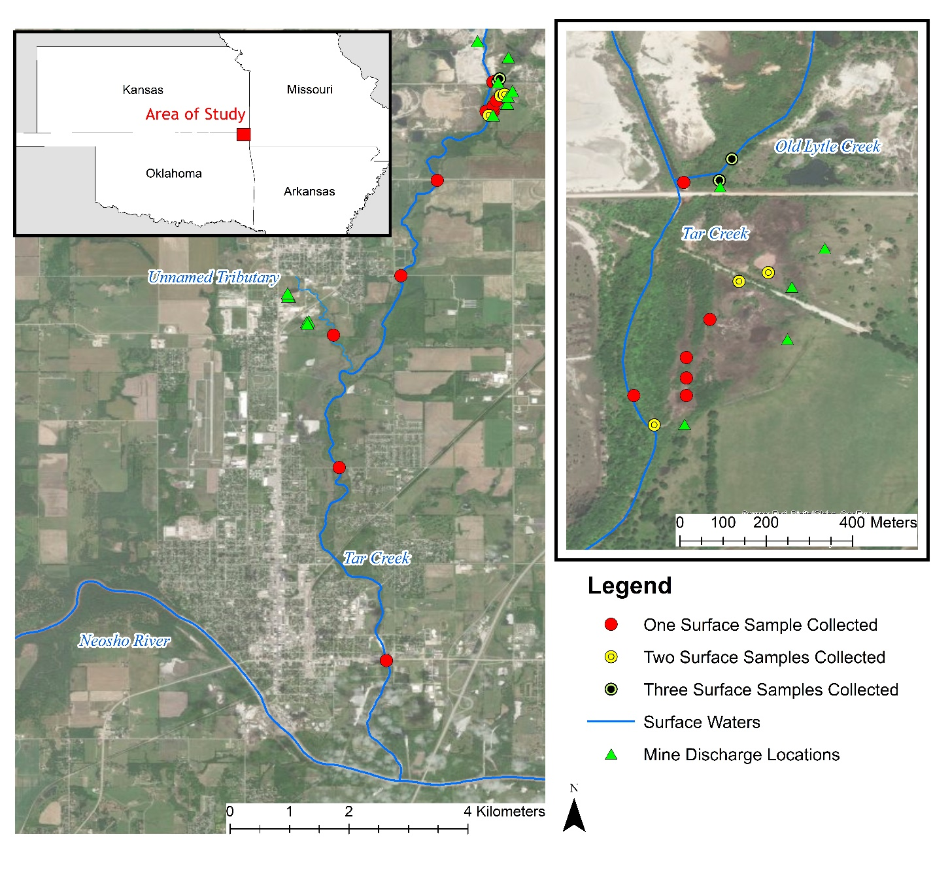
Figure 2.1: Area of study and sampling locations for surface sediments on and near Tar Creek, surface waters of importance, and mine drainage discharge locations

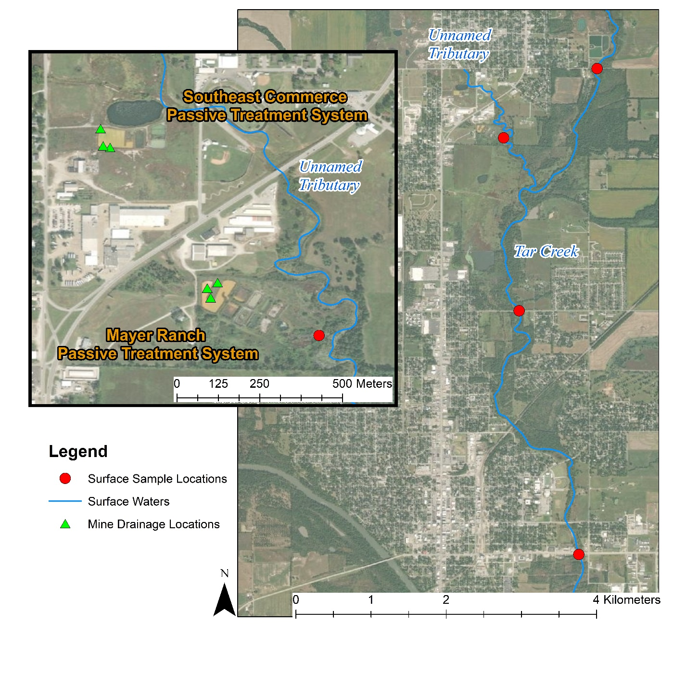
Figure 2.2: Locations of Mayer Ranch and Southeast Commerce Passive Treatment Systems (with mine drainage discharge locations) on the Unnamed Tributary in comparison to sample collection locations downstream of the systems

2.2 Methods and Materials

2.2.1 Sediment Collection and Analysis Methods
To provide the most valid opportunity to compare data, both the sample collection and analysis methods in 2020 were mimicked as closely as possible to those of the 1988 USGS study. Sample locations from the 1988 report were visited in June of 2020 for resampling. In several locations, samples were typically collected at various distances from specific features. For example, when three samples were collected near Old Lytle Creek, the samples were ten, five, and one meter away from a known yet abandoned weir installation location, and the other group was ten, four, and one meter from a known mine discharge location. Sediment samples were collected using a stainless-steel shovel at the corresponding depth designated in the original report. The term surface sample indicates a depth of 0-4 cm. Depth-discrete samples are designated by the depth of the collection. All collected samples were placed in individual 3.8-L resealable inert low-density polyethylene bags, evacuated to remove as much air as possible, and placed in a cooler at 4°C to slow biological processes. Corresponding sample locations (latitude and longitude), depths, and dates were recorded on the bag and in a field notebook. Each location from the 1988 study was visited, however during the 35-years between sampling events, some locations had undergone substantial changes, and it was determined that collecting a sample would not provide representative data, and thus no samples were collected. Of the 47 original sample sites, 15 of them were not recollected due to substantial changes.
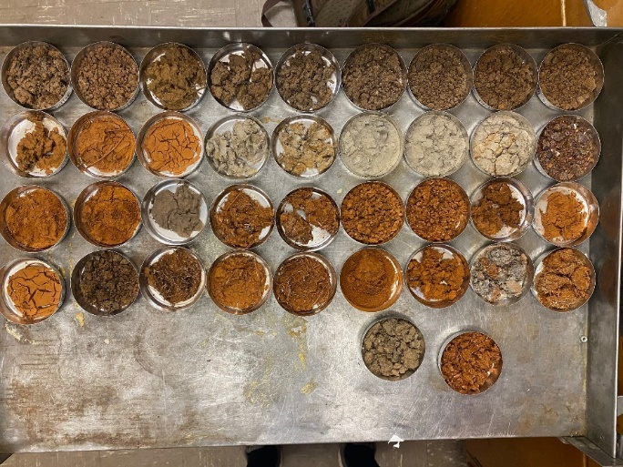
All analyses were completed following University of Oklahoma CREW Standard Operating Procedures (SOPs) based on USEPA methods and following approved Quality Assurance Project Plans (QAPPs) and a Quality Management Plan (QMP). Upon return from the field, the majority of each sample was allowed to air dry. Simultaneously, a small representative sub-sample (Figure 2.3) was taken and dried at 105°C in a drying oven before microwave-assisted total-recoverable digestion (USEPA method 3051A) for trace metals was completed (USEPA, 2007a). Trace metal concentrations were determined using a Varian Vista Pro Inductively Coupled Plasma-Optical Emission Spectrophotometer (ICP-OES) following USEPA Method 6010D (USEPA, 2007b). Reduction of ICP-OES data was completed to calculate concentrations of total-recoverable metal concentrations in milligrams of trace metal per kilogram of sediment (mg/kg). The OC content of dried sediment samples was estimated through loss on ignition (LOI) at 550°C with the assumption that 50% of the organic matter was organic carbon (Nelson and Sommers, 1996). Sediment pH values were not reported in 1988, but due to the fact that trace metal mobility and availability are influenced by pH, the sediment pH was measured in the laboratory following USEPA method 9045D (USEPA, 2004).
Figure 2.3: Subsamples of surface sediments after oven drying
Field duplicate samples were collected at a rate of one duplicate per ten samples and treated the same as other collected samples. During sample digestion, again, one digestion duplicate was completed per ten samples was performed at random. For EPA method 6010D analysis, quality assurance (QA) and quality control (QC) guidelines were followed for laboratory control, duplicate, blank, and matrix-spiked samples in each batch run.
Percent difference was calculated for surface samples collected at the same location to determine a positive or negative change between the sampling events using:
$Percent Difference=\frac{{\left[X\right]}_{2020}-{\left[X\right]}_{1988}}{\left(\frac{{\left[X\right]}_{2020}+{\left[X\right]}_{1988}}{2}\right)}*100$ (2.1)
Where [X]₂₀₂₀ is the concentration or measured amount of the given analyte X from the 2020 sample, and [X]₁₉₈₈ is the concentration or measured amount of given analyte X from the 1988 published report. Positive percent differences indicate an increase in concentrations between the sampling events; negative results indicate a decrease in concentrations from the initial sampling event to the most recent sampling event.
Statistical comparisons of data for all surface sediment locations where samples were collected in 2020 were compared to the initial report concentrations using a Wilcoxon Sign Ranked Test at the 95th confidence interval. This test was selected due to the non-normal distribution of these data. Evaluation of PTS impact was similarly completed using a Wilcoxon Sign Ranked Test at the same confidence interval using both the surface and depth samples downstream of the systems due to the small sample size.
Assessment of changes in land use and land cover in the Tar Creek watershed was done using National Land Cover Database (NLCD) data for the years of 2001, 2004, 2006, 2008, 2011, 2013, and 2016 (Dewitz, 2019). Other assessments of changes in the landscape were completed with the use of available historic aerial imagery.

2.2.2 Comparison of Methods
As previously mentioned, all elemental concentrations in the 2020 sampling were determined via ICP-OES after total-recoverable digestion, and OC was estimated through LOI. In 1988, samples were digested using concentrated perchloric, nitric, and hydrofluoric acid for total-total digestion for trace metals analyses. Cu, Mn, Ni, Pb, and Zn were analyzed using a Graphite Furnace Atomic Absorption (GFAA) spectrophotometer. Fe was determined by ICP-OES. The concentrations of Cd were determined through an ion-exchange separation before analysis via GFAA. Analysis of S was done by a LECO Sulfur Analyzer. No information regarding the OC method was provided in the report (Parkhurst et al., 1988). Previous studies indicate that, for many trace metals, there is not a significant difference in the two digestion methods (Alsaleh et al., 2018). Although detection limits have decreased and accuracy increased, comparisons of concentrations and content of analytes were completed between the two datasets without modification or adjustments.

2.3 Results and Discussion

2.3.1 Sample Collection Limitations
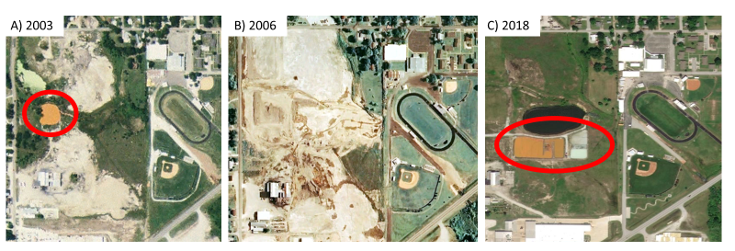
The original USGS Parkhurst et al. (1988) reported data for samples collected over three years, but the report was published in 1988. Therefore, in the following section, the original data are labeled as 1988. The latest of the sample collections was in 1985, resulting in a minimum of 35-years between sampling these exact locations and depths for comparison. Several locations have undergone substantial changes, including infrastructure development, land modification, and natural changes, which prevented valid sample collection. One example of this situation is where two sample locations were originally collected near Cactus Collapse in Commerce, OK. Through historical aerial imagery, in 2006, this site underwent major land reclamation, including the closing of the collapse features. In 2016-17, the SECPTS was constructed (Figure 2.4). Due to that constraint and other similar instances, a total of 36 of the original 47 sample locations were successfully resampled. Of these 36 samples collected, 23 were surface samples, while the remaining 13 were at varying depths at select sample locations. Sediment sampling information and trace metal concentrations used in the statistical comparison for both the 1988 report and recent sampling event are presented in Appendix A.
Figure 2.4: Site in Commerce, OK, having undergone substantial land modification preventing evaluation of natural evolution of trace metal changes A) Highlighting Cactus Collapse B) Site construction C) Highlighting Southeast Commerce passive treatment system

2.3.2 Surface Sediment Investigation
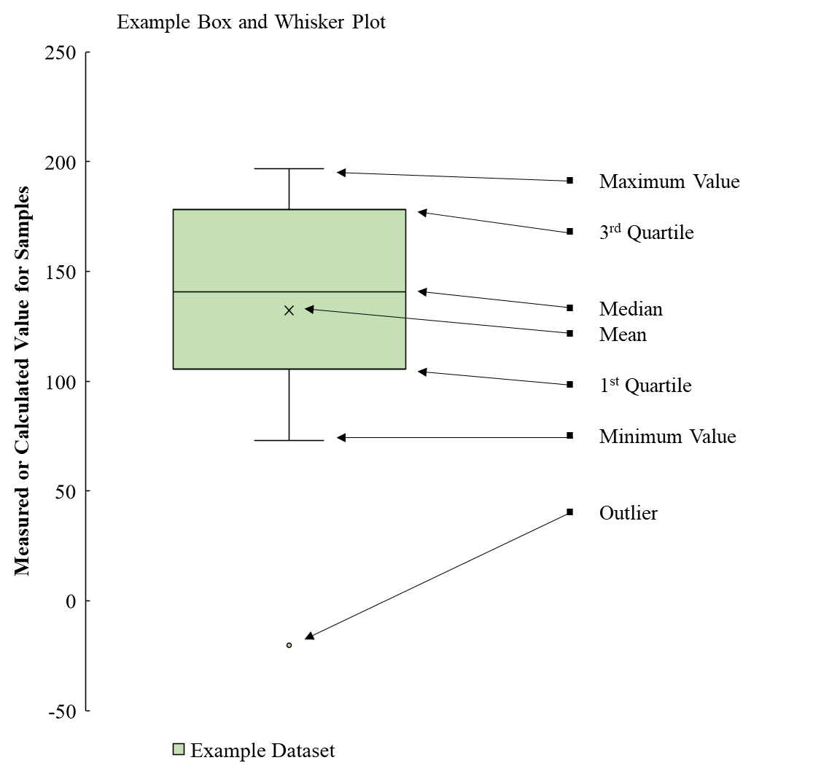
Box and whisker plots were used to show the range and distribution of data; an example box and whisker plot with the corresponding labels is shown in Figure 2.5. Due to the relatively small sample size (n=23), all surface samples were statistically evaluated as a group. The median concentrations were calculated for the surface samples for all nine reported constituents as well as percent differences (Equation 2.1) from 1988 to 2020 (Figures 2.6 and 2.7). Concentrations of Cd, Cu, Mn, Ni, Pb, Zn are presented in mg/kg, while Fe, S, and OC are presented as percent of the total weight of the sediment.
Figure 2.5: Example box and whisker plot with labeled plot boundaries

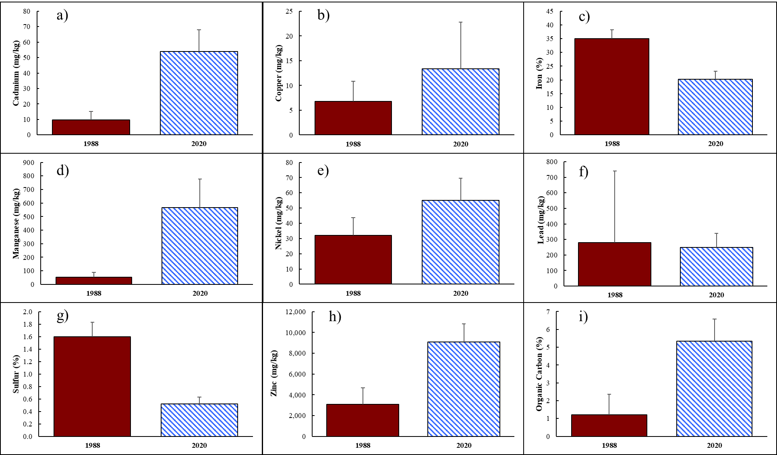
Figure 2.6: Median a) Cd, b) Cu, d) Mn, e) Ni, f) Pb, and h) Zn, and c) Fe, g) S, and i) OC as % of total weight with standard error of the median for the nine reported analytes for all surface samples. Data from 1988 is presented in solid crimson, while data from 2020 is in hatched blue.
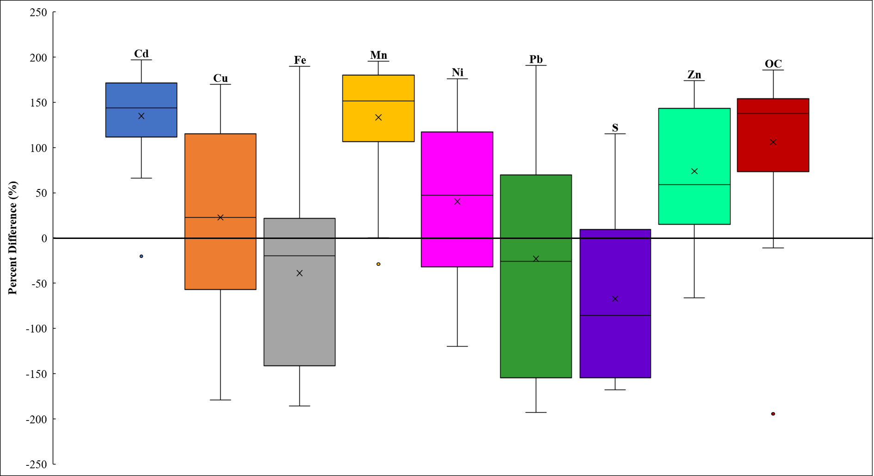
Figure 2.7: Percent difference box and whisker plots of the nine constituents where 0 indicates no change, >0 indicates an increase, and <0 indicates a decrease in concentration from 1988 to 2020 in surface sediment samples
General trends can be observed when median concentrations are plotted side by side. Several analytes increased in concentrations between the sampling events throughout the site, such as Cd, Cu, Mn, Ni, Zn, and OC. The remaining measured elements, Fe, Pb, and S, showed decreases in concentration between the two sampling events. However, the magnitude of change between the two sampling events, as well as the variability of changes throughout the study area, are difficult to determine from a visual comparison. The calculations and display of percent differences show the same general increases and decreases but provide a clearer understanding of the magnitude of change between the sampling events. The Cd and Mn concentrations increased substantially as indicated by the majority of samples resulting in a positive percent difference. Similarly, all locations, except for two, showed increases in OC content. Although not as extreme, the mean and median percent difference of Cu, Ni, and Zn showed increases, while the mean and median percent differences for Fe, Pb, and S decreased. The percent differences for each measured component are also useful in understanding the variability of change observed. In the case of Cu, Fe, and Pb, samples ranged in percent difference from -150% to +150%. This wide range is due to the complex interactions with various sediment parameters occurring currently and changes that have occurred in the region over the last 35 years.
The results of the 1-tailed Wilcoxon Sign Ranked Test showed not only if sample concentrations differed significantly from 1988 to 2020 but also the direction of change (Table 2.1). It was determined that Cu was the only trace metal that showed no change between sampling events. Testing at the 95th confidence interval, Cd, Mn, Ni, Zn, and OC exhibited significant increases while Fe, Pb, and S showed significant decreases.

Table 2.1: Results from a 1-tailed Wilcoxon Sign Ranked Test to determine if changes in concentrations throughout the area of study are significant at the 95th confidence interval (p < 0.05)
All Surface Samples
Analyte | Significant Change | p-value
Cd | Increase | 0.0001
Cu | No Change | 0.4290
Fe | Decrease | 0.0240
Mn | Increase | 0.0005
Ni | Increase | 0.0113
Pb | Decrease | 0.0084
S | Decrease | 0.0020
Zn | Increase | 0.0013
OC | Increase | 0.0006

One substantial change to the landscape and surface hydrology occurred just south of County Road 40 and east of Tar Creek near the former town of Douthat, OK (Figure 2.8). By viewing historical aerial imagery from 1980, there existed a channel in which mine drainage could quickly make its way from artesian discharges to Tar Creek. In 2015 imagery, that area appeared to be and was subsequently confirmed during sampling to be an extensive cattail (Typha spp.) marsh where the water now slowly flows through the marsh before entering Tar Creek. This major change in the landscape and the extended time for organic matter to be sequestered and accumulate is likely contributing to the significant increase in OC. The percent difference of OC shows a positive linear relationship with the percent difference of Cd (R²=0.514), which had the greatest increase of the trace metals in the study. Organic matter (including carbon as well as nutrients), and specifically OC, has considerable cation exchange capacity (CEC), which can result in Cd accumulation in the soil rather than being taken up into the plants (He and Singh, 1993). If organic matter within soils and sediments enters reducing conditions, the release of trace metals into overlying and porewater is possible, therefore, acting as a source of trace metal pollution (Morford and Emerson, 1999; Grybos et al., 2007). Although no plant trace metal data were collected, literature demonstrates the ability of cattails to uptake these contaminants into their roots and aboveground biomass (Sencindiver and Bhumbla, 1988; Brumley, 2004).
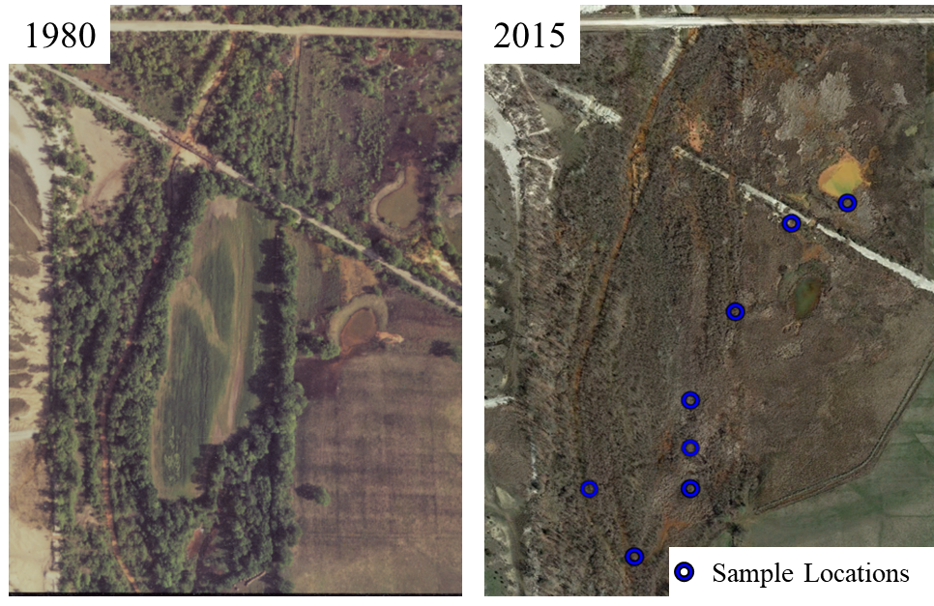
Another possible impact that the development of the cattail marsh may have had on trace metal concentrations is the extended hydrologic residence time allowing for more oxidation and precipitation of Fe from the water. This longer retention time and increased dissolved oxygen in the water may promote the oxidation and precipitation of Fe, and as previously mentioned, co-precipitation of trace metals within the cattail marsh.
Figure 2.8: Changes in the landscape and surface hydrology from 1980 to 2015 through aerial imagery investigation with sample locations digitized

2.3.3 Passive Treatment Investigation
Only three surface sampling locations were downstream of the PTS (one was only downstream of MRPTS, not both PTS). However, with the inclusion of the depth-discrete samples downstream, the sample size was increased to six (three surface and three collected at depth). The percent differences of all samples below the PTS were determined (Figure 2.9). A Wilcoxon Sign Ranked Test requires at least five match pairs, and with increased sample size, statistical power was increased. However, while test completion is feasible, it yielded results of no statistical change for any analyte (Table 2.2).

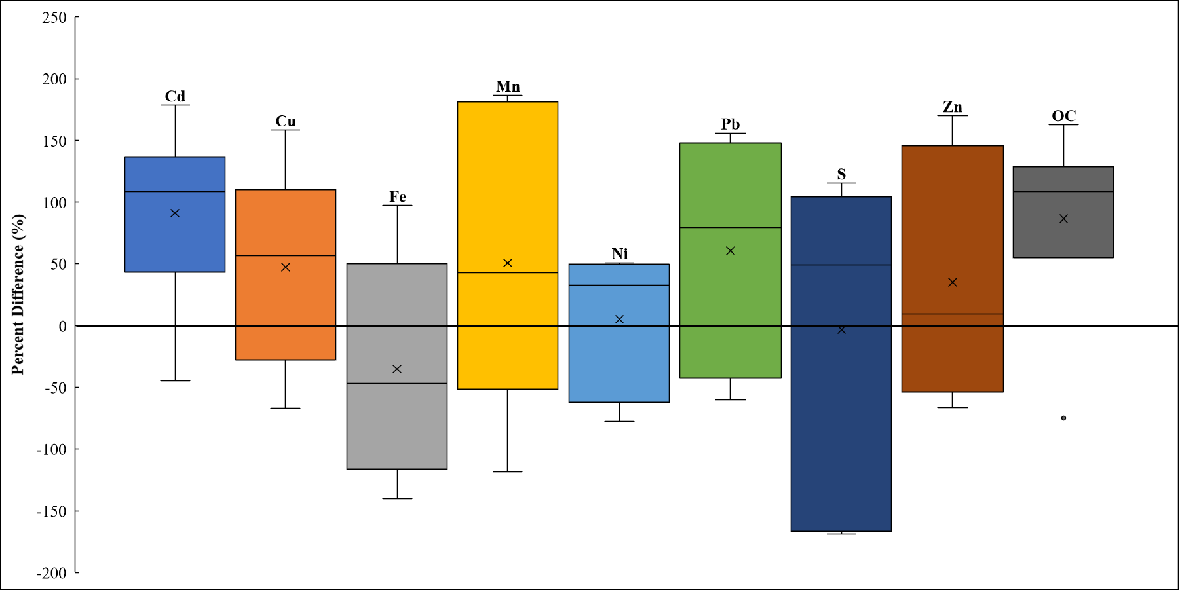
Figure 2.9: Surface and depth-discrete sample percent differences for the locations below passive treatment systems from 1988 to 2020 where 0 indicates no change, >0 indicates an increase, <0 indicates a decrease in concentrations between sampling events.
In the sediment samples downstream of the PTS, Cd, Cu, Mn, Ni, Pb, Zn, and OC showed increases in both median and mean values. S showed a mean decrease but a median increase, suggesting observed changes were not significant. The only element to exhibit a mean and median decrease was Fe.
Table 2.2 Results of the Wilcoxon Sign Ranked Test at the 95th confidence interval (p < 0.05) of surface and depth samples collected below the passive treatment systems
Surface and Depth Downstream of PTSs
Analyte | Change | p-value
Cd | No Change | 0.0580
Cu | No Change | 0.1728
Fe | No Change | 0.1728
Mn | No Change | 0.2318
Ni | No Change | 0.3768
Pb | No Change | 0.1728
S | No Change | 0.4586
Zn | No Change | 0.3768
OC | No Change | 0.1245

2.3.4 Changes Within the Tar Creek Watershed Land Cover
The NLCD uses a 30x30 meter grid size. These data were clipped to the Tar Creek hydrologic unit code (HUC) 12 watershed (136.65 km²) to determine changes through the available temporal information (Figure 2.10). The watershed is predominantly agriculture-based, and with developed land and barren land included, those three groups account for over 75% of the total land use within the watershed. There were no substantial changes in land cover in the watershed through the NLCD datasets between 2001 and 2016 (Figure 2.11). Although minor fluctuations exist, no major land covers increased or decreased to become larger or smaller than any other class during the 15-year period of available data.
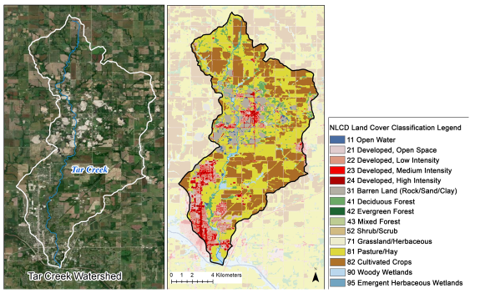

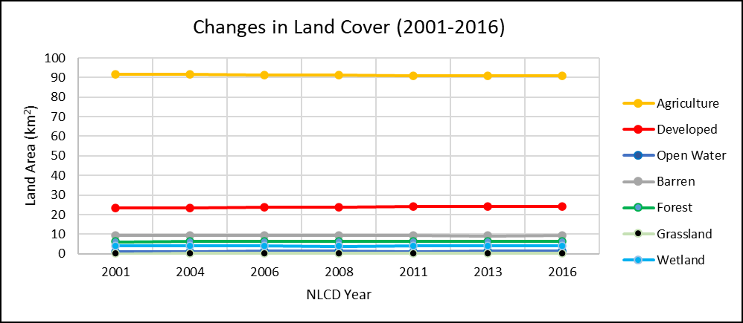
Figure 2.10: The Tar Creek HUC 12 watershed (left) with aerial imagery and the 2016 NLCD for the Tar Creek watershed (right)
Figure 2.11: Changes in major land cover class areas within the Tar Creek watershed from 2001 to 2016 via the NLCD
The coarse grid size (30x30 meters) may mask any small-scale changes on the landscape using the NLCD data. Also, restricting the NLCD does not encompass the time passed between the sampling events. No relations between landcover changes and trace metal contamination in Tar Creek sediments could be determined.

2.3.5 Factors Influencing Observed Changes
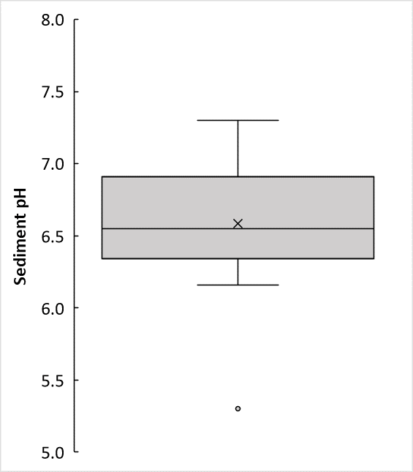
Although sediment pH was not reported by Parkhurst et al. (1988), they were measured for the recently collected samples (Figure 2.12).

Figure 2.12: Laboratory measured pH box and whisker plot of all surface sediment samples collected in 2020

The pH of both overlying water and sediment can greatly influence the mobility and availability of trace metals in the environment (Zhang et al., 2014). Water samples were not collected and analyzed as part of the current study, but sediment pH was determined to understand potential factors influencing trace metals. Zn is most mobile in surface sediment when sediment pH >7 (Tessier et al., 1989; Abdel-Saheb et al., 1994). Only four of the 23 surface samples had pH greater than seven, and thus Zn mobilization is less likely to occur, partially explaining the Zn increase near the more contaminated areas. In water, however, Zn is highly mobile in pH values <5 (Tessier et al., 1989).
Results of initial sampling of water quality, including trace metal concentrations, were reported in the Tar Creek Superfund Site Record of Decision (ROD) in 1984 and are compared to CREW collected data from the same location (Table 2.3).
Table 2.3: pH and trace metal concentrations in Tar Creek near Commerce, OK (Highway 69 bridge crossing) from the early 1980s (USEPA, 1984) compared to the late 2010s (CREW, 2021)
 | 1980-1982 |  | 2017-2019
Parameter | Average | Max (pH Min) | Average | Max (pH Min)
pH | 5.7 | 3.3 | 6.9 | 6.3
Fe (ug/L) | 27,137 | 162,000 | 2,750 | 4,333
Zn (ug/L) | 37,247 | 151,000 | 2,647 | 3,888
Cd (ug/L) | 32.0 | 82 | 2.7 | 5
Pb (ug/L) | 92.0 | 1,090 | 40.2 | 104

This particular sampling location, just outside of Commerce, OK, receives mine drainage-impacted waters originating near Douthat, OK, as well as chat contamination in and around the stream. The initial 1980s water quality data were generated prior to the USGS sampling occurred, and the pH of the water in Tar Creek had reached levels below four. CREW sampling at the same site showed a greater average pH over two years. This increase in pH is generally considered an improvement for the environment, as low pH values can increase solubility and promote the dissolution of trace metals (Carroll et al., 1998). Although the sediment pH partially explained the increase observed in total Zn in the sediments, the low pH of waters shortly after mine drainage started flowing also explains the low initial Zn concentrations in sediments. The low pH water would have been promoting the solubility of Zn in the water and limiting deposition. As the pH changed over time, Zn accumulation in the sediments would have been likely due to the decreased mobility. Similarly, concentrations of the other trace metals of concern (Fe, Cd, and Pb) showed orders of magnitude decreases in water concentrations over this period. Decreases in trace metal concentrations in mine drainage discharges, coupled with ongoing reclamation, are contributing to the decreases of trace metals in the surface waters of Tar Creek.
It was reported that over 99% of the Fe loading in Tar Creek is coming from mine drainage sources, while much of the Zn and Cd come from chat pile influences (Schaider et al., 2014). Schaider et al. (2014) also reported a decrease in Fe concentrations in mine drainage discharge waters when comparing water quality data from the mid-1980s to the early 2000s. The reported decrease in Fe concentrations in mine drainage discharge waters are contributing to the observed decrease in Fe in the Tar Creek sediments. While waters in Tar Creek have improved since the onset of mine drainage discharges, chat pile runoff and chat stream beds are contributing to the continued and prolonged contamination of Tar Creek sediments. Schaider et al. (2014) also noted that concentrations of Cd, Zn, Ni, Mn, and sulfate in chat pile drainage had not changed significantly over a two-decade period. This means there are still trace metals entering Tar Creek, moving downstream, and becoming associated with sediments. The particulate chat fines containing elevated concentrations of trace metals enter the stream through erosion or are already in the stream incorporated in the streambed. These small particles can be transported and deposited downstream in the bedload during channel forming events and have large impacts on sediment analyses and sediment contamination. Trace metals are often incorporated with smaller-sized sediment grains compared to larger grain sizes due to an increased surface area per mass (USEPA, 2001).
One of the important points from the comparison of water quality and sediment quality is that as the aqueous concentrations of trace metals of concern have shown decreases by at last an order of magnitude in the sediments have not shown this trend. Up to 90% of trace metals are associated with either sediments or particles within the water column (Amin et al., 2009; Zhang et al., 2014), thus supporting the capability of surface sediments to act as sinks for trace metals and to retain the metals for extended periods. The surface sediments in Tar Creek will continue to be impaired until actions are taken to remediate the sediments or environmental conditions change and mobilize the trace metals into the water, which could impair downstream water and sediments.
The chemical species of solid Fe was not determined in this study. Fe oxyhydroxides commonly form in the mine drainage waters, and due to their high surface area, they may sorb other trace metals from the water (Estes et al., 2010). The Fe precipitates, while having a considerable affinity to sorb other trace metals, may act as a source of release of the same trace metals if changes in the oxidation and reduction state change. Countless natural processes can change the oxidation and reduction state of sediments, including prolonged high water and bioturbation to add or remove excess oxygen. Future evaluations of Fe oxyhydroxide species would likely prove valuable due to variability of sorption capacity, which may retain or not influence other trace metals in Tar Creek (von der Heyden and Roychoudhury, 2015). For these reasons, sediment contamination may be steady for extended periods, but through natural changes, trace metals could become mobilized and transported downstream.
Targeted trace metal removal by the two PTS in the watershed significantly decreases the trace metal concentrations in the system effluent waters (Nairn et al., 2020). However, it could not be determined that the PTS result in decreased trace metal concentrations in stream sediments in this study. One likely contributor to the lack of change observed is the small sample size limiting statistical power. Of the three sample locations downstream of the PTS, two of the locations receive treated water from PTSs drainage discharges as well as untreated mine drainage from discharges upstream. Only one sample location, directly downstream of MRPTS, receives only passively treated waters. However, MRPTS was constructed in 2008, meaning the location had received nearly 30 years of untreated water, allowing time for trace metal accumulation. Similarly, in that location, differing erosion and deposition changes may be exposing sediments not exposed to treated water. Further study can and should be completed to evaluate how PTS waters affect downstream sediments.
Although remedial efforts on the landscape are ongoing, it is possible that during these clean-up actions, local remobilization of trace metals is occurring. Ongoing chat washing operations are also occurring, which remove the finer (greater trace metal contamination) materials which are then kept on site. The larger (lesser trace metal concentration) particles can and have been used in asphalt construction (USEPA, 1994; Wasiuddin et al., 2010). Although these efforts are decreasing the volume of chat on the landscape, the contamination level may not follow. The current study is not able to determine the direct impact of land reclamation and chat processing on Tar Creek sediments.

2.4 Conclusions
There have been significant increases in Cd, Mn, Ni, Zn, and OC concentrations and significant decreases in Fe, Pb, and S concentrations in the surface sediments along and near Tar Creek from 1988 to 2020 (p<0.05). The only element that showed no difference in concentrations between the sampling events was Cu. The hypothesis that trace metals increased due to an extended time to accumulate cannot be accepted due to the decrease in Fe and Pb. The interactions of different trace metals in this environment are variable and dependent on multiple physiochemical conditions. The increase in OC content, likely from the cattail marsh development from 1988 to 2020, may interact with and sequester Cd and other trace metals in the sediments and resulting in increases in concentrations. Zn is highly influenced by pH, and the circumneutral and slightly acidic sediment pH measurements may be limiting mobility. The low pH in the mine drainage water in the 1980s promoted greater solubilization leading to transport of Zn in the water leading to the observed significant increase in stream sediments.
Tar Creek waters have shown decreases in trace metal concentrations, but sediment trace metal concentrations do not show the same trend. The lack of continuity between the water and sediment trace metal contamination is being influenced by chat pile runoff entering the stream, as well as sections of the stream base being full of wholly chat. The runoff contains elevated levels of Cd, Zn, and other trace metals, continuing the prolonged pollution. Therefore, while improving the water quality is of importance in the region, chat piles near the stream are an ongoing source of trace metals. Similarly, stream sediments will continue to retain the trace metals until acted upon through remedial efforts.
There are no differences in analyte concentrations in samples downstream compared to Tar Creek sediments upstream of the UT and Tar Creek confluence. This lack of difference was limited by the number of sample locations downstream of the PTS and the ability of sediments to retain trace metals for extended periods. Both PTS on the UT are highly effective in removing substantial portions of the trace metals from the mine discharge water before the effluent enters the UT and ultimately Tar Creek; however, stream sediments can hold and release the trace metals back into the water even when the overlying water is of improved quality. Further investigations should be completed to assess trace metal accumulation in sediments immediately downstream of PTS.

2.5 Future Work
Possibilities for future work may include sequential extraction of surface sediments to determine their mobility, availability, and the phase of the different trace metal fractions. Total metal concentrations are often poor predictors of the fraction available to benthic organisms or aquatic biota (Morrison et al., 2019). Investigations into Fe speciation and ability to react with dissolved and particulate trace metals would prove valuable in understanding the complex role Fe plays and what changes may result in a release of trace metals from the stream sediments.
Suggested future work for evaluating trace metal contamination in sediments being influenced by passive treatment should include regular sediment collection and analysis of several locations along the UT to determine changes in conditions. The more frequent sampling events at the same locations should also include laboratory analyses for OC and pH due to their ability to influence sediment trace metal concentrations. One possibility to determine the influence PTS are having on stream sediments would be to insert an apparatus holding sediments that allowed water to flow through both downstream of treated and untreated mine drainages and analyze the trace metal accumulations in the test sediments.

Spatial Variations in Sediment Trace Metal Concentrations Downstream of an Abandoned Mining District

3.1 Introduction
Major mining operations ceased in the Tri-State Mining District (TSMD), in northeastern OK, southeastern KS, and southwestern MO, by the 1970s (Playton et al., 1980; USEPA, 1984). The lead-zinc mining in the region once produced tremendous amounts of crude ore (McKnight and Fischer, 1970). Several artesian flowing mine drainage discharges flow from the abandoned mine workings with water rich in dissolved trace metals (Parkhurst et al., 1988). Although the waters have detectable levels of a suite of trace metals, the primary elements of concern are cadmium, lead, and zinc (Cd, Pb, and Zn) for their known harmful effects (Johansen et al., 2018; Affandi and Ishak, 2019). However, water is not the focus of this study, but rather stream sediments.
Once trace metals enter surface waters (streams and ponds), they encounter numerous physicochemical influences. They can precipitate from the water or sorb onto other particles in the water. They are transported downstream until deposition in the sediments. Trace metal contamination is also coming from mine tailings (chat) piles, which contribute both dissolved and particulate trace metals into surface waters (Schaider et al., 2014). These contamination mechanisms have been continual sources of trace metals for several decades. Although remediation of chat piles and passive treatment of discharges are ongoing, trace metal contamination is still of great concern.
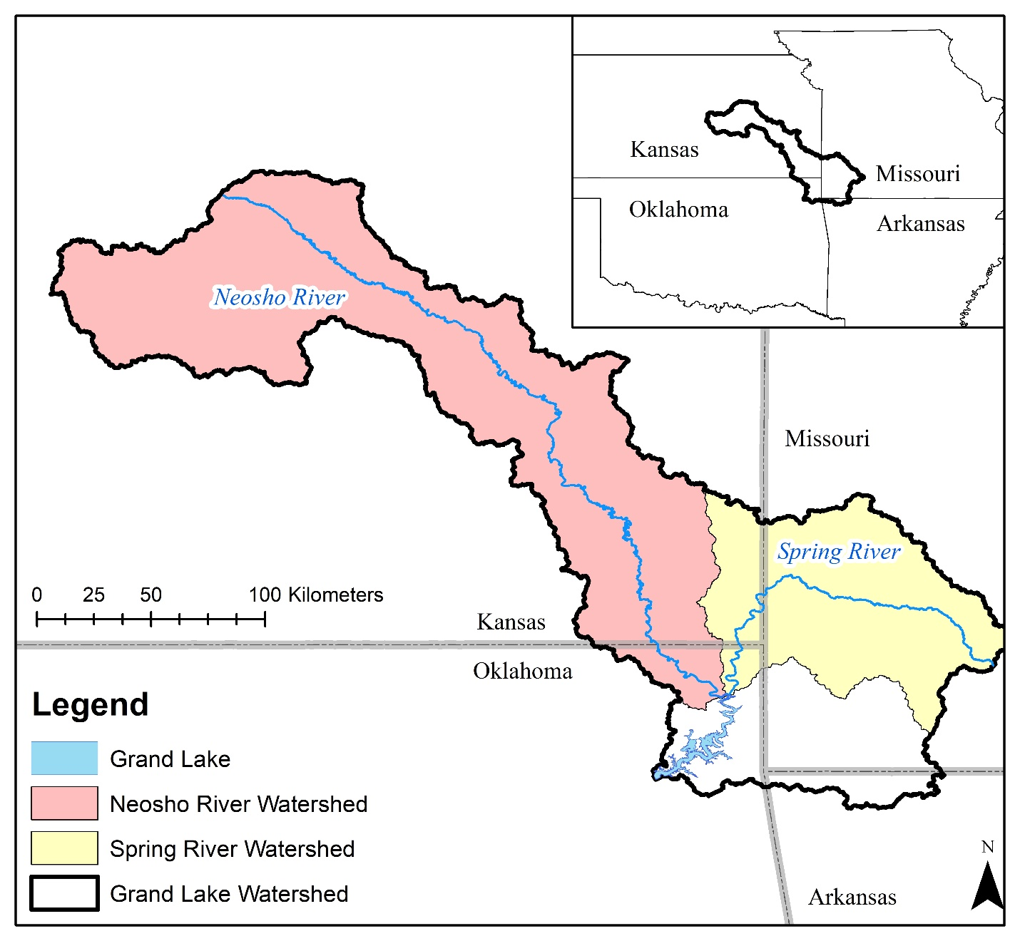
Grand Lake O’ the Cherokees (Grand Lake) forms at the confluence of two major tributaries, the Neosho River and the Spring River (Figure 3.1). Grand Lake is a multi-use reservoir that is one of Oklahoma’s largest tourist attractions in the summer months. There are many tributaries to the lake, but the Spring and Neosho Rivers enter the lake at “Twin Bridges” in the northern section of the lake and drains large regions of the TSMD (Juracek and Becker, 2009). The threat of trace metal contamination in river and reservoir sediments from mining has been previously studied but warrants further investigations. The purpose of this study is to i) evaluate the spatial distribution of the trace metal contamination in both stream and Grand Lake surface sediments with increasing distance from the TSMD and ii) compare trace metal concentrations in surface sediments to predetermined sediment quality guideline (SQG). Sediment samples were collected from Tar Creek, Neosho River, Spring River, and Grand Lake and analyzed for trace metal concentrations (Figure 3.2). Also worth noting within the study area, Empire Lake is a reservoir in KS, which has been the study of previous sediment research (Juracek, 2006).
Figure 3.1: The Grand Lake watershed (inset) and the Spring River and Neosho River watersheds within the Grand Lake watershed
For this study, the hypothesis was that Cd, Pb, and Zn concentrations in sediments would decrease with a greater distance from the TSMD. Comparison of sediment concentrations to background threshold values (BTVs) for sediments allows for the determination of potential risk. Development of BTVs in 2017 was conducted as part of a data gap study investigating trace metal concentrations in watersheds minimally impacted by mining but close to the Tar Creek Superfund site (CH2M, 2020). The two indices of contamination level used in this study are the Contamination Factor (CF) and the Geoaccumulation Index (I_{geo}). These metrics use the trace metal background concentrations to determine the magnitude of contamination for each trace metal at each location.
The consensus based SQG developed by MacDonald et al. (2000) calculated the Threshold Effect Concentration and Probable Effect Concentration (TEC and PEC) for sediments in freshwater ecosystems for many different organic and inorganic contaminants. When concentrations are below the TEC, they are likely to show no adverse effects, while concentrations above the PEC are likely to show negative effects on sediment-dwelling organisms. However, the further site-specific investigation determined TSMD-specific SQGs for Cd, Pb, and Zn (MacDonald et al., 2009). The TSMD SQGs were developed by performing numerous toxicity tests on benthic organisms and calculating the T₁₀ and T₂₀. The T₁₀ and T₂₀ were calculated for Cd, Pb, and Zn and represent the threshold concentration at which a 10% and 20% reduction or survival occur. The current work compares sediment trace metal concentrations to both the general and TSMD specific SQGs.

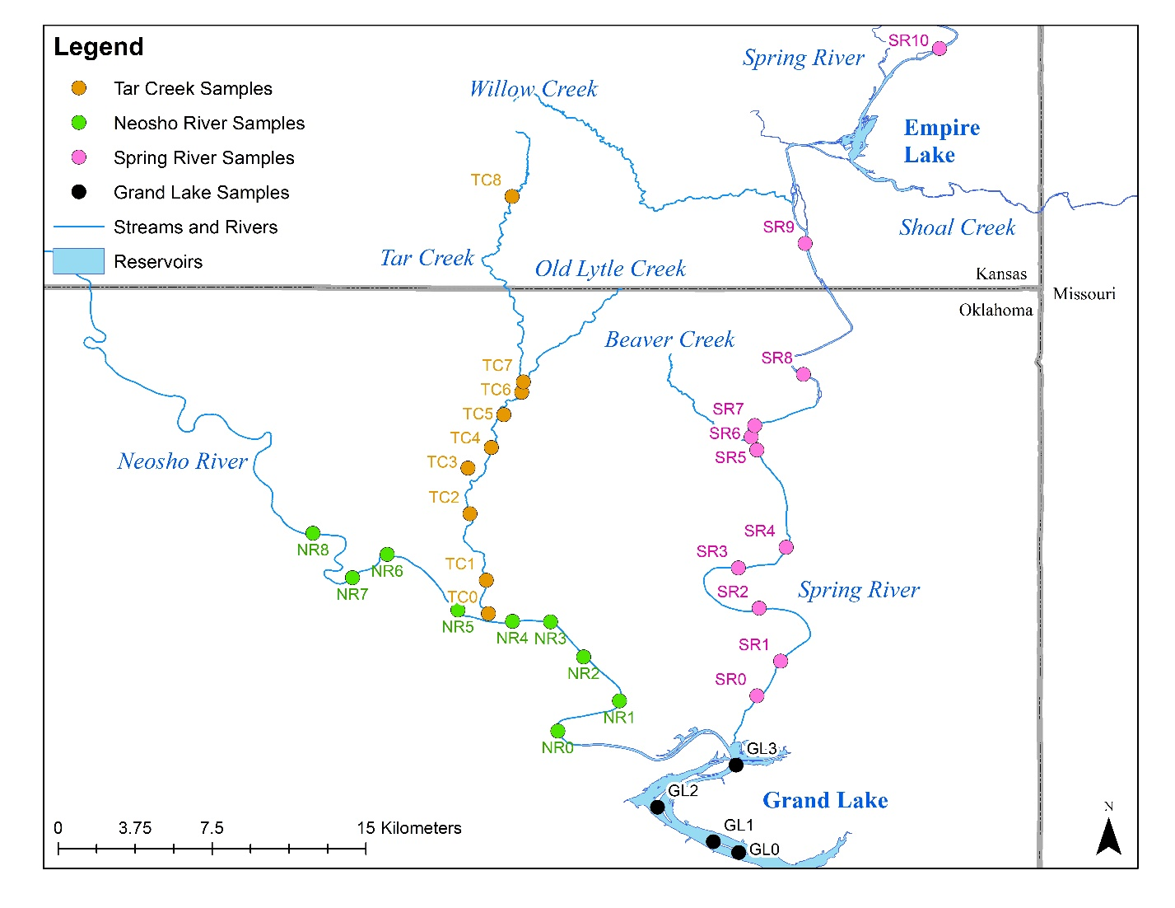
While mining impacts are widespread and numerous tributaries of the Neosho and Spring Rivers have been impacted, Tar Creek (a tributary of the Neosho River) is of great concern due to the magnitude of contamination at the core of the Tar Creek Superfund Site. Another known mine drainage impacted tributary in Oklahoma is Beaver Creek (a tributary of the Spring River). These mining-impacted tributaries enter their respective rivers before entering Grand Lake. Sample collection targeted areas of deposition where trace metals are likely to be elevated.
Figure 3.2: Surface sediment sample locations along Tar Creek, Spring River, Neosho River, and Grand Lake with sample location names

3.2 Methods and Materials
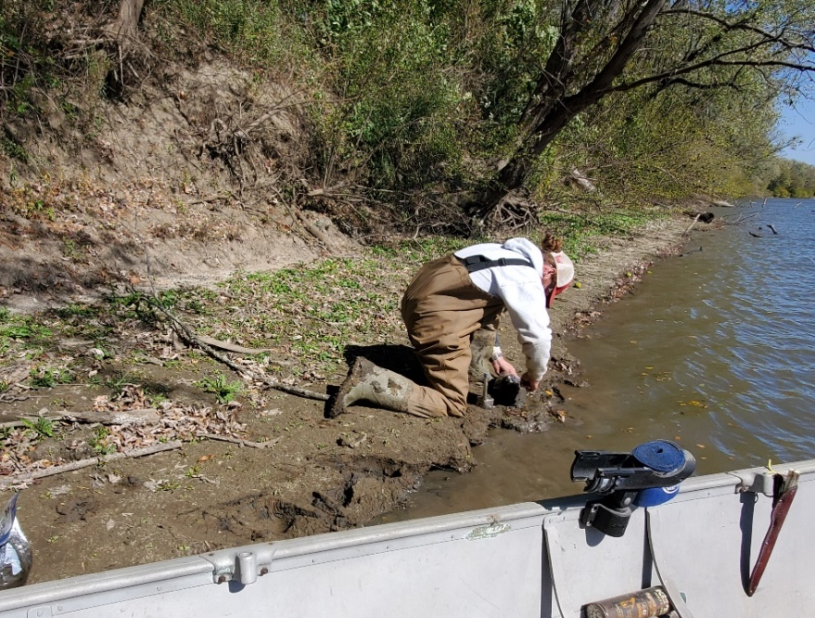
Samples along Tar Creek were collected in June of 2020, while Spring River, Neosho River, and Grand Lake samples were collected in October of 2020. In both cases, samples were collected at depths of 0-4 cm (surface samples) at the water-shore boundary (Figure 3.3). The sample locations were logged using a Garmin handheld Global Positioning System (GPS) and digitized into ArcGIS. All samples were collected using a stainless-steel shovel and placed in low-density polyurethane resealable bags, evacuated of excess air, and stored at 4°C until returned from the field. Pertinent sample information was written on the sample bag and recorded in a field notebook after sampling. Due to differing water access regulations and public access points, limited sample collection took place in Kansas. Distances between sample locations were measured to the nearest 100th of a km on the given waterbodies’ thalwegs using online mapping software. All field and laboratory analyses were conducted in accordance with the University of Oklahoma CREW Standard Operating Procedures (SOPs), which reference USEPA methods and are described in the Quality Assurance Project Plans (QAPP) and Quality Management Plan (QMP).
Sample digestion occurred following USEPA method 3051A, microwave-assisted acid digestion for total-recoverable trace metals (USEPA, 2007b) using representative oven-dried (105°C) subsamples. Samples were analyzed for trace metals using inductively coupled plasma optical emission spectrometry (ICP-OES) following USEPA method 6010D (USEPA, 2007a) after digestion. ICP-OES data reduction included determining the mass of a given element per mass of dried sediment in milligrams per kilogram (mg/kg) and evaluating sample duplicates for quality assurance.
Figure 3.3: Sample collection occurring on the bank of the Neosho River in the Fall of 2020
The CF and I_{geo} metrics compare concentrations for a sample to background concentrations (3.1) and (3.2).
$CF=\frac{C_{n}}{C_{b}}$ (3.1)
$I_{geo}=\log_{2}\left(\frac{C_{n}}{1.5*C_{b}}\right)$ (3.2)
Where C_{n} is the measured concentration of trace metal and C_{b} is the background concentration for the given trace metal. The background concentrations for these comparisons came from the USEPA report (CH2M 2020). The CF results indicate how many times greater than background the concentration is the concentrations for a given element at a given location. The calculated I_{geo} values fall into several classes with corresponding descriptions of sample contamination severity (Table 3.1).
Table 3.1: I_{geo} class and description of sample quality for calculated I_{geo} values; modified from Looi et al. (2019)
I_{geo} Value | I_{geo} Class | Sample Quality
<0 | 0 | Uncontaminated
0-1 | 1 | Uncontaminated to moderately contaminated
1-2 | 2 | Moderately Contaminated
2-3 | 3 | Moderately to strongly contaminated
3-4 | 4 | Strongly contaminated
4-5 | 5 | Strongly to extremely contaminated
5+ | >5 | Extremely contaminated

Two other methods for evaluating the severity of sediment contamination were used to compare trace metal concentrations to consensus-based SQGs and TSMD-specific SQGs. The TSMD SQGs are greater than the consensus based SQGs (Table 3.2). Although the consensus based SQGs area useful tool in identifying potentially toxic sediments, site specific SQGs provide a more accurate potential risk due to the heterogeneity and differing background concentrations across the US. High-risk sediment samples exceed one or more of their respective T₁₀ concentrations and may pose a substantial risk to benthic organisms (MacDonald et al., 2009).
Table 3.2: Consensus-based and TSMD-specific SQGs for trace metals of concern (MacDonald et al., 2000, 2009)
Guideline |  | Cd (mg/kg) | Pb (mg/kg) | Zn (mg/kg)
TEC | Consensus- based | 0.99 | 35.8 | 121
PEC | Consensus- based | 4.98 | 128 | 459
T₁₀ | TSMD-specific | 11.1 | 150 | 2,083
T₂₀ | TSMD-specific | 17.3 | 219 | 2,949

The last sediment comparison completed was also from MacDonald et al. (2009), which uses the PEC values for three trace metals to determine the Sum of the Probable Effect Concentration Quotient for Cd, Pb, and Zn (ƩPEC-Q_{Cd,Pb,Zn}). This method compares the concentrations of the contaminants of concern in the TSMD into a single value using equation (3.3).
ƩPEC-Q_{Cd,Pb,Zn}$=\frac{\left[Cd\right]}{4.98}+\frac{\left[Pb\right]}{128}+\frac{\left[Zn\right]}{459}$ (3.3)
Where [Cd], [Pb], and [Zn] are the concentrations of the respective trace metal in mg/kg for a given sample and the denominators in each fraction are the consensus-based SQGs. If the ƩPEC-Q_{Cd,Pb,Zn} > 7.92, the sample is of high risk to sediment-dwelling organisms (MacDonald et al., 2009). Consequently, when the sum is less than 7.92, the sample is considered low risk. This method allows for sediment evaluation on more than one front as a sample may have lower concentrations of one trace metal, which does not adequately determine overall potential toxicity.
Statistical determination of differences between waterbodies used a one-tailed, two-sample t-test at the 95th confidence level (p<0.05). ANOVA linear regression analyses determined significance, where distance is the independent variable and trace metal concentration is the dependent. Spatial statistics for this dataset were calculated using were completed using ArcGIS. An Average Nearest Neighbor examination determined sample location distribution. A Global Moran’s I (spatial autocorrelation) test determined if the locations and concentrations of trace metals of concern (Cd, Pb, and Zn) were distributed, random, or clustered. This test uses the concentration of the given trace metal compared to its neighboring locations and concentrations. Finally, the Getis-Ord Gi* test (hotspot analysis) was used to determine the location of the highest and lowest (hottest and coldest) clusters of trace metal contamination were located. This test uses the concentrations at the given locations compared to neighboring locations. As the distance from the point increases, the influence on the point of interest decreases. A fixed distance band limited the distance in which neighboring points can influence a given sample location. The distance selected ensured that each sampling location has a least one neighboring location. The hotspot analysis is for clustered data and determines the study area's distribution of concentrations.

3.3 Results and Discussion

3.3.1 Spatial Assessment of Trace Metal Concentrations
Trace metal concentrations exhibited large ranges throughout the study area and between the four major waterbodies (Figures 3.4, 3.5, and 3.6). Waterbody names are abbreviated in figures to decrease legend size. Therefore, GL is Grand Lake, NR is Neosho River, SR, is Spring River, TC is Tar Creek, and BC is Beaver Creek. Sample information and total concentrations of Cd, Pb, and Zn are presented in Appendix B.
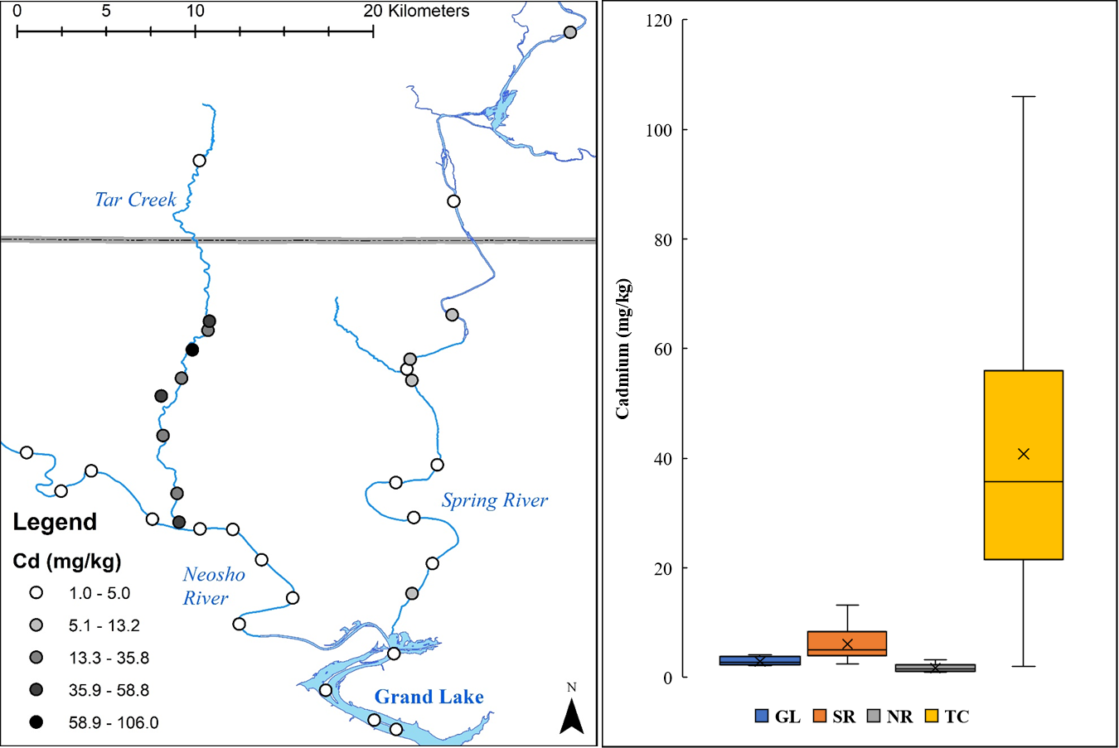
Figure 3.4: Cadmium concentrations (mg/kg) shown spatially for each location (left) and the box and whisker plot for the four distinct waterbodies for surface sediments (right)
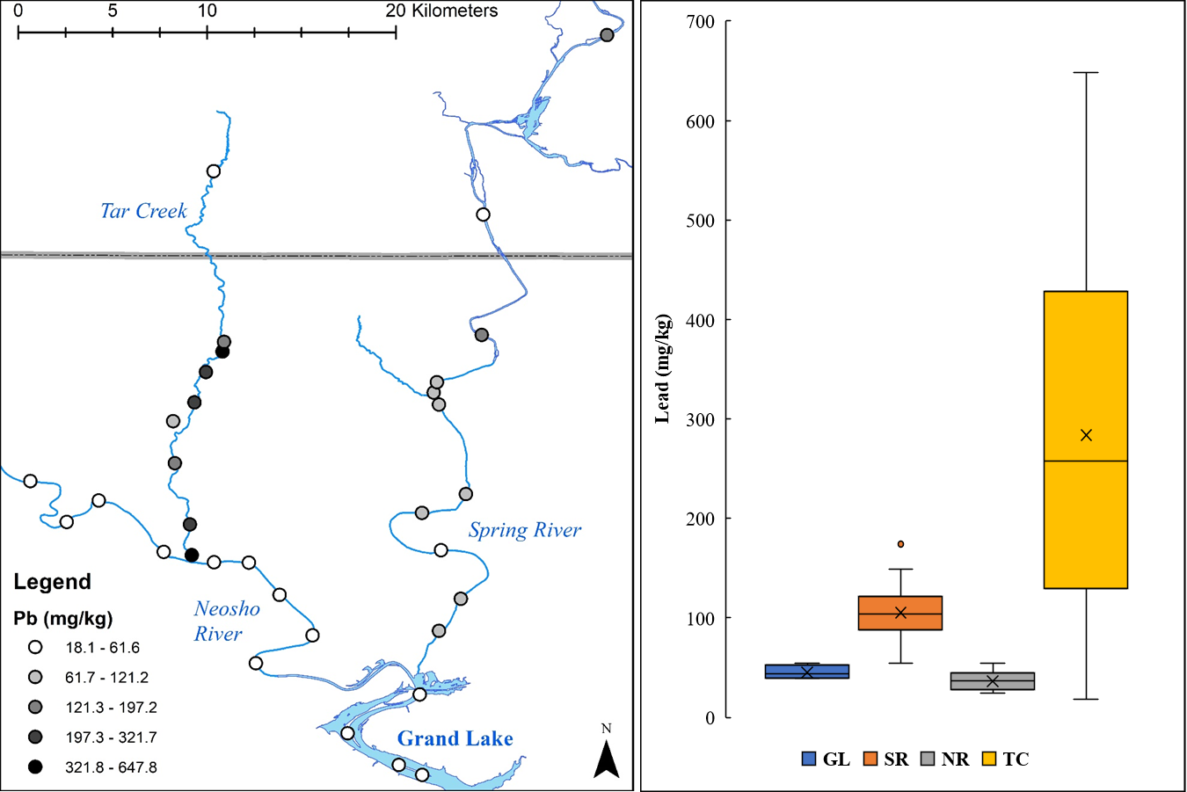
Figure 3.5: Lead concentrations (mg/kg) shown spatially for each location (left) and the box and whisker plot for the four distinct waterbodies for surface sediments (right)
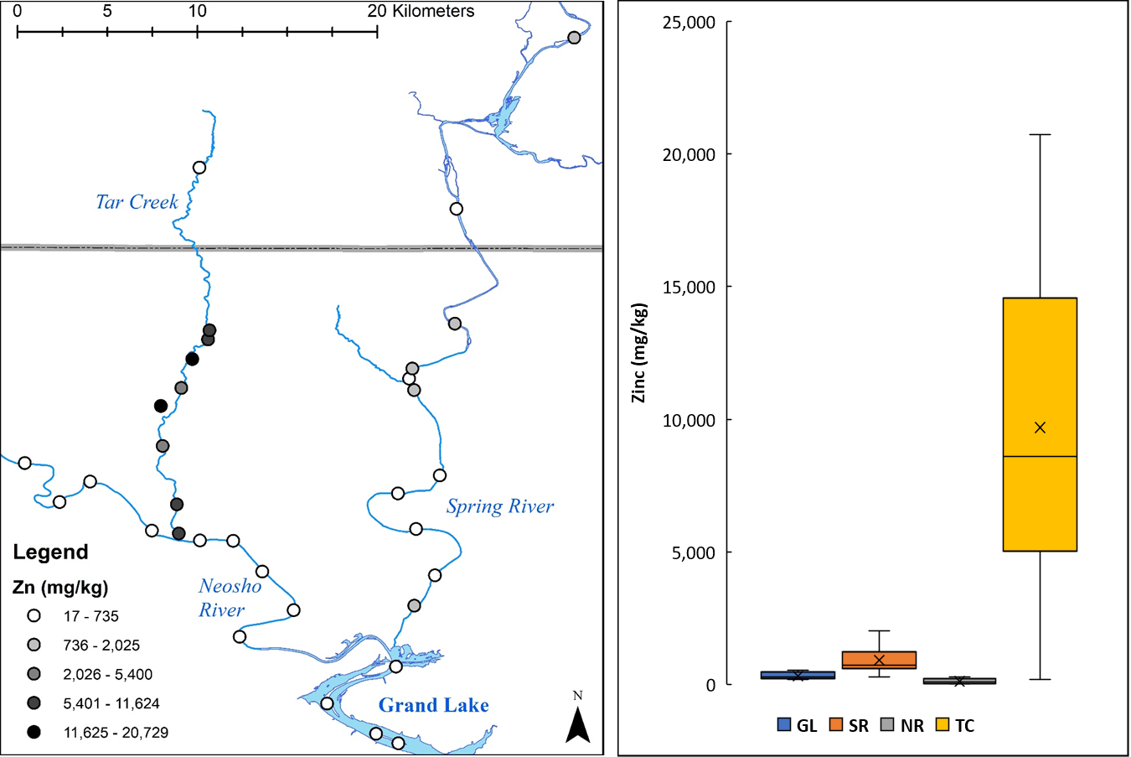
Figure 3.6 Lead concentrations (mg/kg) shown spatially for each location (left) and the box and whisker plot for the four distinct waterbodies for surface sediments (right)

The three trace metals of concern had the greatest concentrations and largest ranges of concentration in the Tar Creek surface sediment samples compared to the other studied waterbodies. The great variability in Tar Creek samples is partially due to the proximity of severely trace metals-contaminated areas, as well as the location TC8, which exists above the mining impact on Tar Creek, in which showed much lesser trace metal concentrations. Generally, the Neosho River and Grand Lake had lesser concentrations of the three trace metals. Some of the Spring River sediments had elevated trace metals concentrations but not as elevated as the Tar Creek samples. Calculation of each trace metal average concentration and standard deviation within each of the four waterbodies allowed input into an ANOVA single factor analysis to determine if the concentration means differed (Table 3.3).
Table 3.3: Results from the ANOVA Single Factor test at the 95th confidence interval (p<0.05) to determine if mean concentrations between waterbodies are different
Trace Metal | Water Body | n |  | Mean Concentration | Standard Deviation |  | p-value | Result
Cd | Grand Lake |  | 4 | 3.0 |  | 0.9 | <0.0001 | A significant difference in concentration averages
Cd | Spring |  | 11 | 6.1 |  | 3.0 | <0.0001
Cd | Neosho |  | 9 | 1.7 |  | 0.8 | <0.0001
Cd | Tar |  | 9 | 40.8 |  | 30.1 | <0.0001
Pb | Grand Lake |  | 4 | 45.1 |  | 6.8 | 0.0001 | A significant difference in concentration averages
Pb | Spring |  | 11 | 105.3 |  | 35.1 | 0.0001
Pb | Neosho |  | 9 | 36.3 |  | 10.6 | 0.0001
Pb | Tar |  | 9 | 283.8 |  | 203.3 | 0.0001
Zn | Grand Lake |  | 4 | 321.2 |  | 142.8 | <0.0001 | A significant difference in concentration averages
Zn | Spring |  | 11 | 909.3 |  | 478.2 | <0.0001
Zn | Neosho |  | 9 | 106.9 |  | 107.3 | <0.0001
Zn | Tar |  | 9 | 9,692.2 |  | 6,400.7 | <0.0001

There was a significant difference (p<0.05) for each trace metal’s mean concentration between waterbodies. Further assessments determined differences spatially to evaluate the concentrations and how they change between waterbodies.
Sample locations were used in an Average Nearest Neighbor assessment in ArcGIS to determine the distribution of data for the study area. The sample locations within the study area were statistically shown to be randomly distributed (p=0.7154). Next, trace metal concentrations and the locations were examined to test for spatial patterns. Spatial autocorrelation was conducted for each trace metal concentration in the study area. The possible results were evenly distributed, randomly distributed, or clustered (Table 3.4).
Table 3.4: Results from the spatial autocorrelation tests for each of the three trace metals of concern
 | Cd | Pb | Zn
Result (CI) | Clustered (99%) | Random (NA) | Clustered (99%)
p-value | 0.0026 | 0.1737 | 0.0001

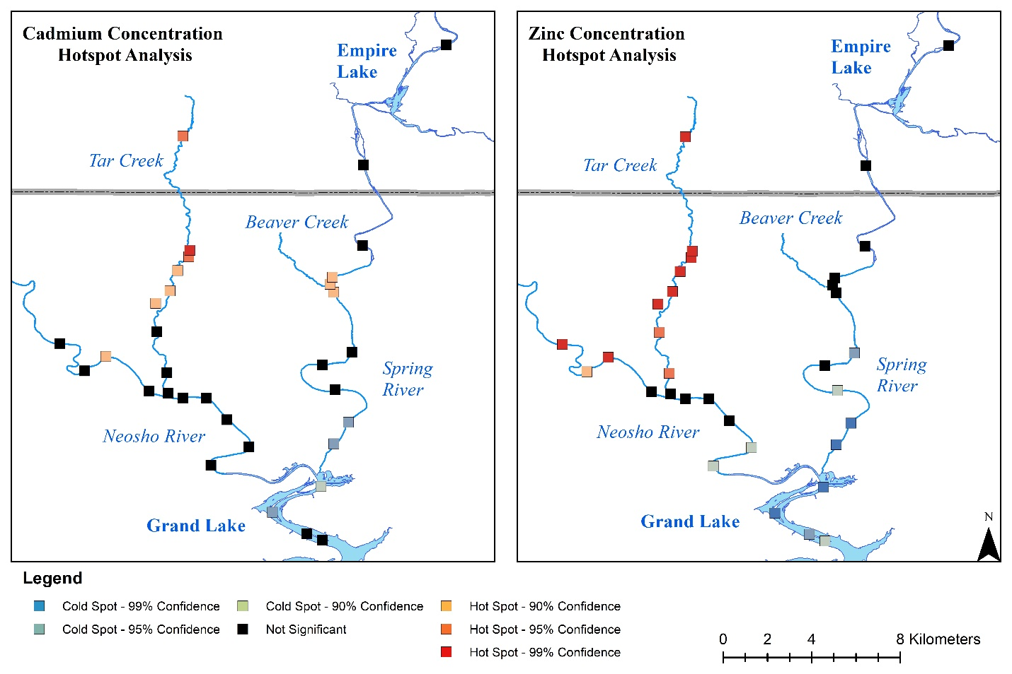
Cd and Zn concentrations were both significantly clustered by location, meaning specific areas of greater and lesser concentrations existed near each other. With the significant clustering of Cd and Zn concentrations throughout the study area, the hotspot analysis was used to determine the specific sample locations that make up the greater and lesser clustering. Hotspot analysis for Pb was not applicable given its random distribution. The hotspot analysis determined the significance of greater and lesser spatial clustering where the significance of each location for Cd and Zn concentrations was determined and fell into one of seven bins: Cold Spot- 99%, 95% or 90% confidence, Not Significant, and Hotspot- 99%, 95%, or 90% confidence (Figure 3.7). While appearing similar to concentration figures, the hot spot analysis does not represent the concentrations of trace metals at the given locations but rather the spatial relationship of greater or lesser concentrations.
One artifact within this analysis comes from the influence of neighboring points. The test uses a Euclidean distance which is a straight line between points. Issues arise in this method due to the meandering of the rivers and the proximity of the locations. For example, locations upstream of the confluence of Tar Creek and the Neosho River have low Zn concentrations, but hotspot analysis indicates a significant hotspot. These locations experienced influence by the proximity of the greater concentration Tar Creek samples. Another possible issue with this test is the large distance between points on the Spring River's upper reaches compared to the proximity of the Tar Creek locations. The hotspot analysis determines significance by comparing neighboring locations and values, and with the larger distance between points, there are fewer neighbors to influence the clustering analysis.
Figure 3.7: Hotspot analysis results for Cd and Zn showing significant clustering of high or low concentrations
While showing the significance of clusters of greater and lesser concentrations, the hotspot analysis does not prove useful in determining the change in trace metal concentrations when moving away from mining-impacted tributaries. Further investigation was needed to determine if known mining-impacted tributaries influence trace metal concentrations in the surface sediments. In attempts to use hotspot analysis for this dataset, the objective of assessing the linear changes in trace metal concentration along a meandering feature proved futile, and other avenues of assessment were deemed to be needed.
Tar Creek has substantial trace metal impairment from mining activities. Evaluation of Cd, Pb, and Zn concentrations in the Neosho River sediments from above and below the Tar Creek tributary determined whether Tar Creek was responsible for substantial trace metal contamination in the Neosho River. Similarly, Beaver Creek has known mine drainage impairment with elevated trace metals leading to impairment in the Beaver Creek watershed. There is known mining impairment above the Beaver Creek confluence with the Spring River, but Beaver Creek is one of Oklahoma's substantial contributors. Similar assessments for evaluating sediment trace metal concentrations above and below the Beaver Creek confluence with the Spring River were conducted. The mean and standard deviations for Cd, Pb, and Zn were used for comparisons between above and below the mining-impacted tributaries' confluences (Figure 3.8).

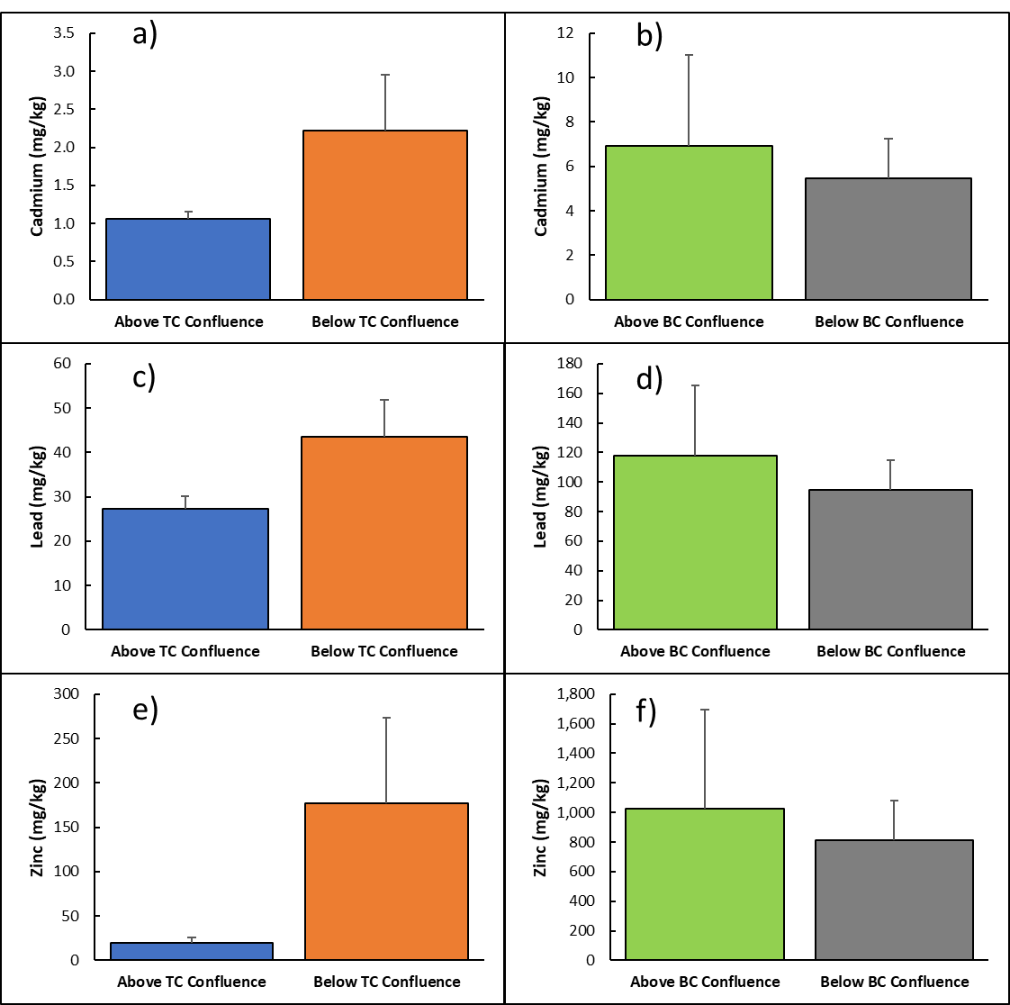
Figure 3.8: Mean concentrations of Cd, Pb, and Zn above and below known mining impaired tributaries (a, c, and e above and below Tar Creek, and b, d, and f above and below Beaver Creek)
Above the Tar Creek confluence, Neosho River sediments had an average lesser concentration than below the confluence for Cd, Pb, and Zn. These results suggest that Tar Creek is responsible for substantial trace metal contamination within the Neosho River sediments. Sample locations NR4 and NR5 bracket above and below the Tar Creek tributary confluence. Thus, NR0 through NR4 are downstream of the Tar Creek confluence while NR5 through NR8 are upstream of the confluence with Tar Creek. No other tributaries other than Tar Creek enter the Neosho River between NR4 and NR5. Conversely, the average trace metals concentrations were lesser below the confluence with Beaver Creek than above, implying that Beaver Creek is not contributing substantial trace metal contamination to the Spring River sediments. A one-tailed t-test was completed for each trace metal to determine if the concentrations above and below the mining-impacted tributaries differed significantly (Table 3.5).
Table 3.5: Resulting p-values from the one-tailed t-test at the 95th confidence interval (p<0.05) for average trace metal concentrations above and below known mining impaired tributaries in Oklahoma
Trace Metal | Tar Creek Confluence p-value | Beaver Creek Confluence p-value
Cd | 0.0129 | 0.2440
Pb | 0.0051 | 0.1814
Zn | 0.0113 | 0.2659

The Cd, Pb, and Zn concentrations increased significantly (p<0.05) in samples downstream of the confluence of Tar Creek with the Neosho River. However, the concentrations of the same trace metals in Spring River sediments from above and below Beaver Creek did not differ significantly.
The measured river distance between sample locations began at GL0, the most downstream location sampled, as it is a common point for both rivers. Linear regression analyses on the Spring River included all sample locations. For the linear regression analysis for the Neosho River, sample locations up the Neosho River and then up Tar Creek were used, with the furthest upstream point being at the confluence of Tar Creek and Old Lytle Creek (TC7). This was selected due to the significant increase in trace metal concentrations in the Neosho River sediments downstream of the Tar Creek confluence. Old Lytle Creek has substantial mining influence from both mine drainage and chat pile influences. Determination of linear relationships were completed between river distance and concentrations of Cd, Pb, and Zn for the Spring River and Neosho River Tar Creek (Figures 3.9, 3.10, and 3.11). The figures, along with linear regression analyses, were completed to evaluate significant trends.

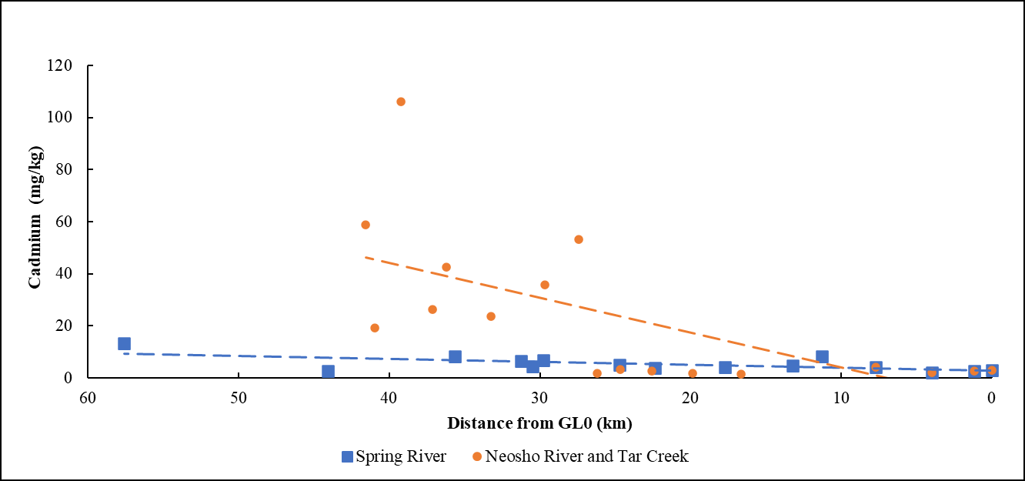
Figure 3.9: Measured Distance from GL0 versus Cd concentrations for the Spring River (squares) and the Neosho River and Tar Creek (circles) with linear regression line shown for each

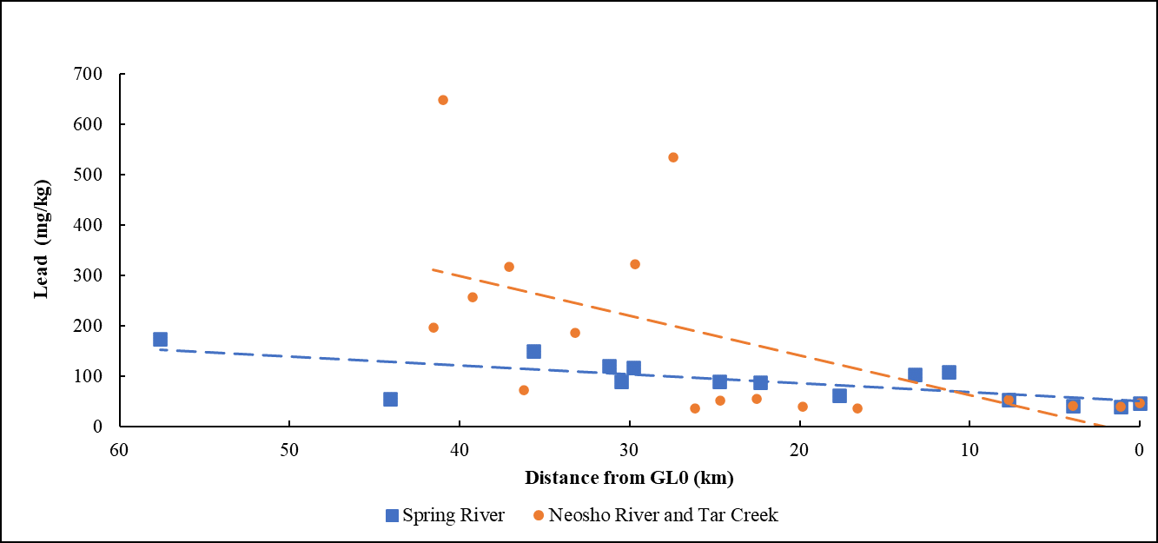
Figure 3.10: Measured Distance from GL0 versus Pb concentrations for the Spring River (squares) and the Neosho River and Tar Creek (circles) with linear regression line shown for each

Figure 3.11: Measured Distance from GL0 versus Zn concentrations for the Spring River (squares) and the Neosho River and Tar Creek (circles) with linear regression line shown for each
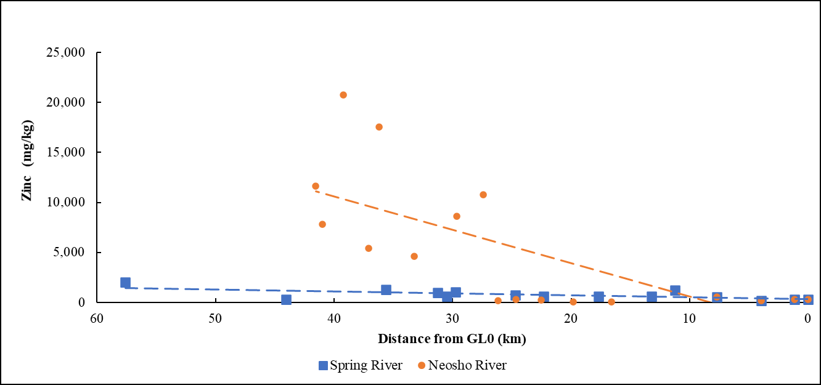

An ANOVA linear regression analysis for the three trace metals for both rivers was completed, where the distance was the independent variable, and trace metal concentrations were the dependent variables. Significant correlations were determined (Table 3.6).
Table 3.6: Results from linear regression analysis for distance versus trace metal concentrations in the Spring River (n=15) and the Neosho River, which included Tar Creek samples (n=17)
 | Neosho River and Tar Creek Distance versus |  |  | Spring River Distance versus
 | Cd | Pb | Zn | Cd | Pb | Zn
Slope | -1.34 | -7.91 | -332.53 | -0.11 | -1.76 | -19.56
y-intercept | 46.3 | 311.3 | 11082.9 | 6.2 | 104.0 | 916.6
R² | 0.417 | 0.344 | 0.489 | 0.405 | 0.513 | 0.435
Slope p-value | 0.005 | 0.013 | 0.002 | 0.011 | 0.003 | 0.007

The coefficient of determination (R²) for these linear relationships moderate, indicating distance is not the only variable influencing the trace metal concentrations. However, the slopes of the linear regression are significant (p<0.05) for all three trace metals in both river systems. These results indicate that when moving downstream (towards Grand Lake and away from the mining-impacted areas), concentrations of these three trace metals of concern decrease. There were no samples collected along the Spring River that were unimpacted by mining activities. However, due to the limited accessibility along the Spring River in Kansas, the point of maximum concentration can not be determined. With several upstream contaminated tributaries to the Spring River, further investigation and targeted sediment sampling may prove vital for determining how far upstream trace metal contamination occurs and developing for more accurate slopes of linear decreases in concentrations.
Similarly, on the Neosho River, a significant decrease of trace metals with distance occurred, moving away from Old Lytle Creek. However, there is only one sampling location above this point, and mining-impacted Tar Creek reaches exist between that location and the Neosho River locations. The concentrations of trace metals decreased significantly with increasing distance from mining-impacted areas. This dataset did not provide ample coverage to determine specific maximum contamination locations in the study area.

3.3.2 Sediment Contamination Metrics
The CF and I_{geo} for Cd, Pb, and Zn compare the concentrations to the BTV concentrations for the Tar Creek Superfund Site (Figures 3.12 and 3.13). All data for the CF and I_{geo} classes for sample locations are in Appendix C.

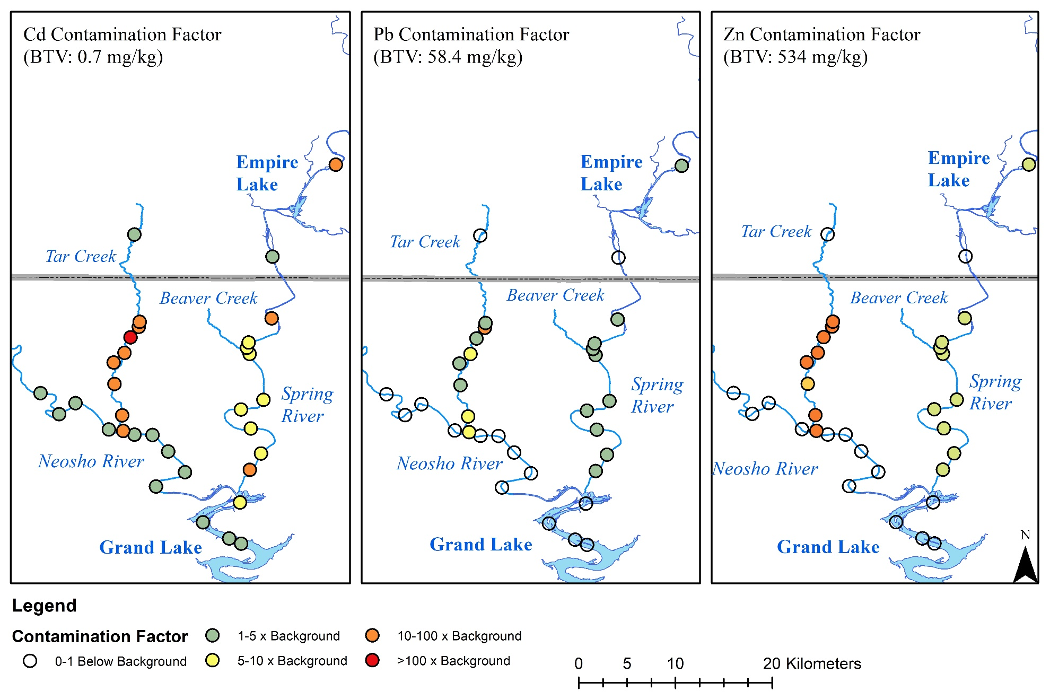
Figure 3.12: Contamination factor for Cd, Pb, and Zn at all sample locations using the OU5 developed background threshold value
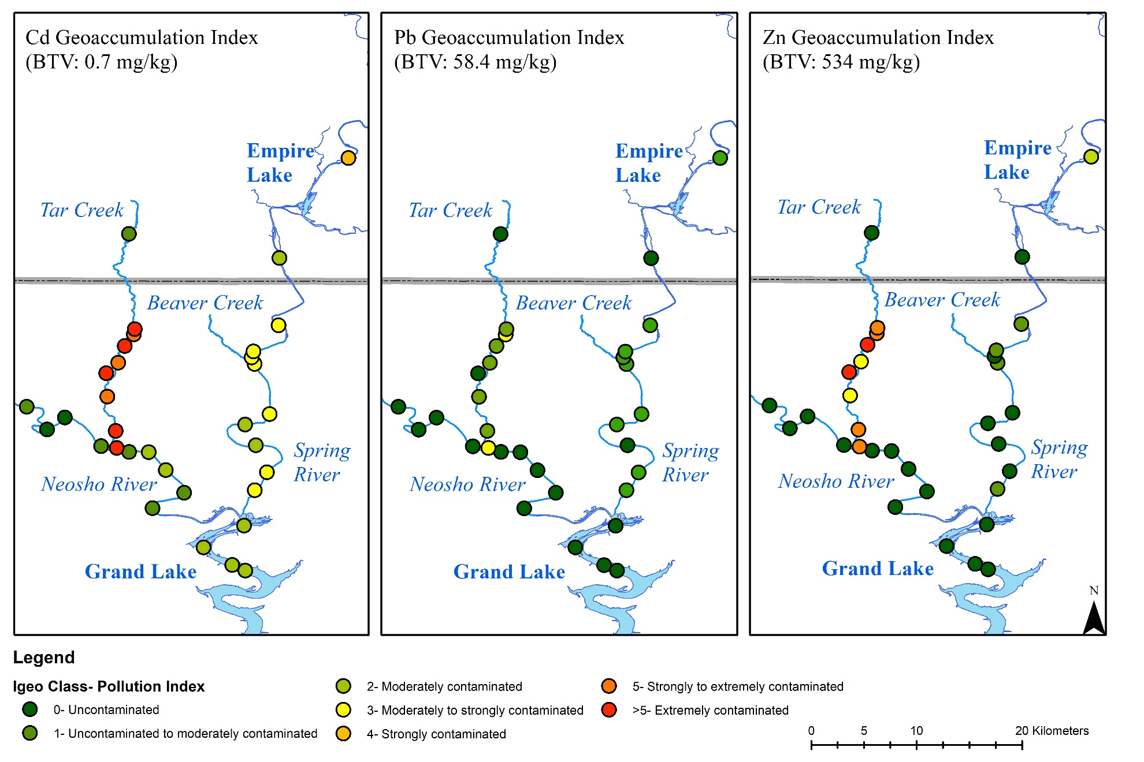
Figure 3.13: Geoaccumulation index for all sample locations for Cd, Pb, and Zn using OU5 background threshold values for the respective trace metals

The CF for Cd showed severe contamination in Tar Creek sediments, with the greatest CF being over 100 times greater than the region's background. The sample locations above the mining impact on Tar Creek had a consistently low CF and I_{geo} for all the three trace metals The CF for Pb and Zn show elevated levels within Tar Creek and lower values throughout the study area. Median CF values for each trace metal in the waterbodies were calculated (Table 3.7). The Neosho River and Grand Lake CF values are lower than those of the Spring River for all trace metals. The median CF for Cd is greater than that of Pb and Zn for each waterbody. These data indicate that Cd contamination in surface sediments is greater than the contamination from Pb and Zn. Unfortunately, Cd is also more toxic than Pb and Zn.
Table 3.7: Median CF values (and standard error) for the three trace metals of concern within each of the waterbodies examined
Median Values ± (Standard error) | Cd CF |  | Pb CF |  | Zn CF
Grand Lake | 3.9 | ± (0.61) | 0.7 | ± (0.06) | 0.5 | ± (0.13)
Spring River | 7.1 | ± (1.28) | 1.8 | ± (0.18) | 1.4 | ± (0.27)
Neosho River | 2.3 | ± (0.38) | 0.6 | ± (0.06) | 0.1 | ± (0.07)
Tar Creek | 51.1 | ± (14.32) | 4.4 | ± (1.16) | 16.1 | ± (3.99)

The upstream sample locations on the Spring River show the CF values 10-100, 1-5, and 1-5 times background concentrations for Cd, Pb, and Zn, respectively. The next sample location downstream shows lower CF values for all three trace metals. The I_{geo} assessment provided similar results throughout the study area. The elevated trace metal contamination above Empire Lake was not surprising as unexpected there are several mining-impacted tributaries in KS and MO. In KS, the Spring River meanders through the Cherokee County Superfund site, and in MO, numerous surface waters drain portions of the Oronogo-Duenweg Mining Belt Superfund site (USEPA, 2002, 2015). Studies of Empire Lake have focused on trace metal contamination within the reservoir’s sediments (Juracek, 2006). Juracek (2006) concluded that trace metal deposition is likely into Empire Lake sediments during low flow conditions and pass sediments through during high flow conditions. Juracek (2006) also concluded that Empire Lake may act as a source of contaminated sediments and suggests that contaminated sediments passing through the lake will become deposited in the lower Spring River and as far downstream as Grand Lake. While I_{geo} was often lower downstream of Empire Lake, the I_{geo} values for multiple Spring River sediment samples are classified as moderately contaminated for each trace metal. Tar Creek is the only waterbody in this study where contamination was considered “strongly to extremely contaminated” or “extremely contaminated” via I_{geo} assessment.

3.3.3 Sediment Quality Guideline Evaluation
The consensus based SQGs and TSMD specific SQGs allow for straightforward comparison of known concentrations to evaluate the potential toxicity of sediment contamination. The consensus based SQGs included information for numerous metal and non-metal contaminants, but the TSMD SQGs focused specifically on Cd, Pb, and Zn. The concentrations of these three trace metals were compared to both of the guidelines for each sample location and placed into one of three categories for the respective guidelines (Figures 3.14 and 3.15).

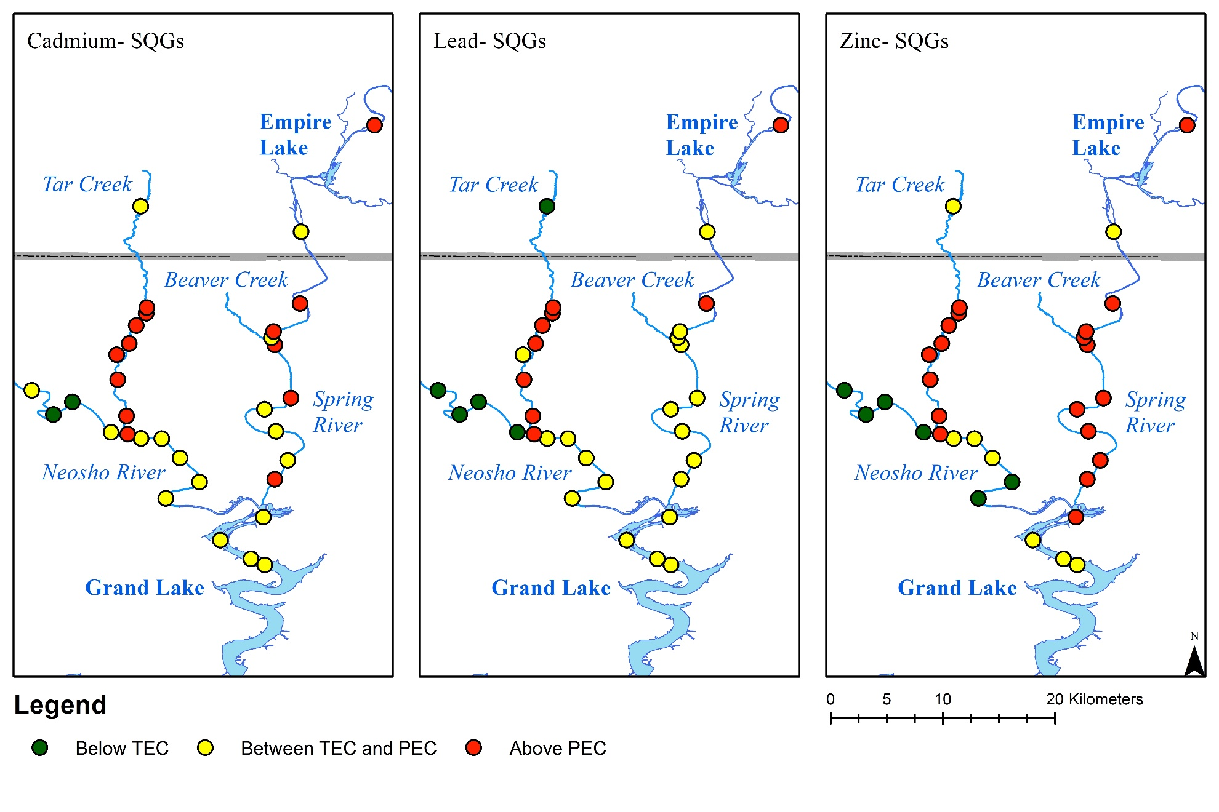Figure 3.14: Sediment sample location and results from comparison to consensus based SQGs for Cd, Pb, and Zn
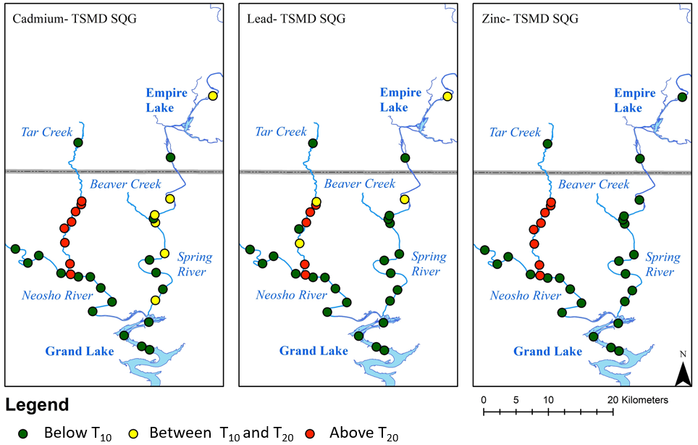
Figure 3.15: Sediment sample locations and results from trace metal concentrations compared to TSMD specific SQGs for Cd, Pb, and Zn

The TEC was exceeded in all samples by at least one trace metal of concern except for two locations. The TEC is the threshold where no adverse effects are likely to be observed below the concentration, while when exceeding the PEC threshold, adverse effects are likely to be observed. Most Tar Creek locations exceeded the PEC for each of the trace metals. The Spring River exceeded the PEC values in order Zn >Cd >Pb, and no Neosho River samples exceeded the PEC for these three trace metals, and only one Grand Lake sample exceeded the Zn PEC. However, Morrison et al. (2019) reported that the T₁₀ values for trace metals in Grand Lake are closer to true toxic approximates for sediment toxicity than the consensus based SQGs.
Samples at several locations did not exceed the T₁₀ or T₂₀ for the trace metals. However, any sample locations exceeding the T₁₀ for any trace metal are classified as high risk. All samples on Tar Creek, except the above mining-impacted location, are considered high risk. Similarly, several locations along the Spring River exceeded the T₁₀ but not the T₂₀ but would still be considered high risk. No sample locations from the Neosho River or Grand Lake exceeded the T₁₀ for any of the three trace metals of concern. Using the TSMD specific guidelines, trace metal contamination posing the greatest to least threat may be characterized as Cd>Pb>Zn.
The determination of the sum of the probable effect concentration quotient for Cd, Pb, and Zn provided a single numeric metric including all three trace metals of concern to determine if the sediments may pose substantial risk. If the calculated values are over the threshold determined by MacDonald et al. (2009), the sediments may be potentially harmful. The ƩPEC-Q_{Cd,Pb,Zn} for the collected sediment samples determined high or low risk when compared to the threshold value are shown in Figure 3.16.

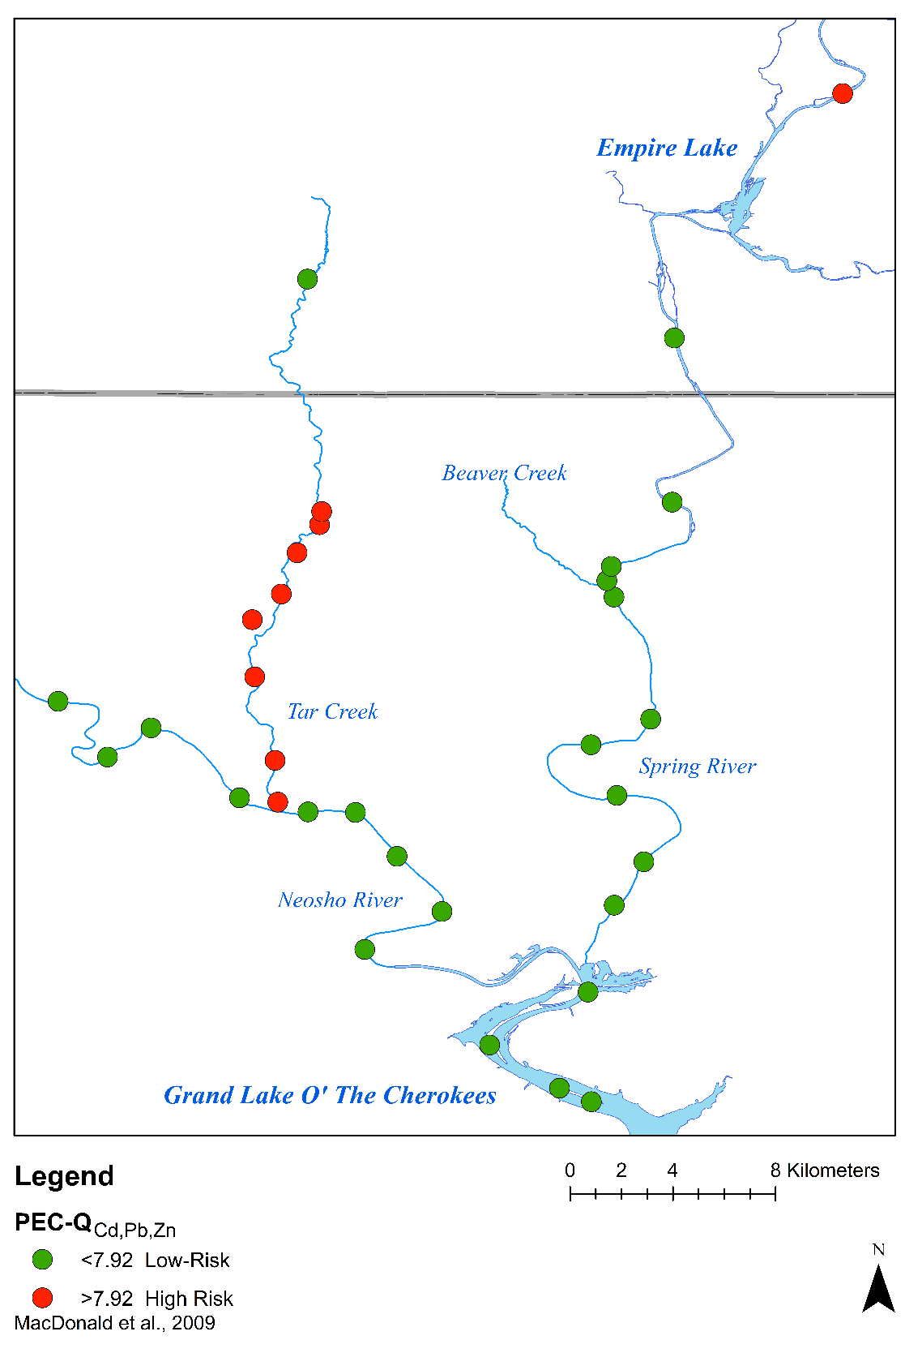
The sum of the probable effect concentration for Cd, Pb, and Zn shows that all samples on Tar Creek, except those above the mining impact area, were considered high risk. Only the sample above Empire Lake is also classified as high risk. This location is downstream of several mining-impacted tributaries. All other samples within the Spring River, Neosho River, and Grand Lake were considered low risk through this study.
Figure 3.16: Results for the calculated ƩPEC-Q_{Cd,Pb,Zn} for all surface sediment samples

3.3.4 Discussion of Trace Metal Contamination
Sediment contamination by trace metals in these large rivers poses a serious threat to the environment and human health. As trace metals continue to enter surface waters through artesian discharges and chat pile runoff, trace metals will continue to accumulate in the sediments. Trace metals will be transported downstream and continue to increase the extent and degree of contamination into Grand Lake.
The concentrations of trace metals in the Neosho River sediments are significantly greater downstream of the Tar Creek confluence than upstream. The concentrations of trace metals in the Neosho River sediments are significantly greater downstream of the Tar Creek confluence than upstream. The mean and median discharge of Tar Creek compared to the Neosho River indicate that Tar Creek is a small fraction of the Neosho River flow (Table 3.8). Given the increase in sediment trace metals concentration downstream of the confluence, it is apparent that mass loading from Tar Creek is of substantial concern and needs further and more detailed evaluation and major remediation efforts.
Table 3.8: Mean and median daily streamflow discharge data in cubic feet per second (ft³/sec) for Tar Creek, the Neosho River, and the Spring River over the last 30 years
Waterbody | Mean Daily Discharge (ft³/sec) | Median Daily Discharge (ft³/sec)
Tar Creek | 61 | 9.22
Neosho River | 2,612 | 973
Spring River | 4,293 | 1,120

Concentrations of trace metals of concern have shown decreases in mine discharges and Tar Creek waters (Schaider et al., 2014; Nairn et al., 2020). However, up to 90% of trace metals in streams are associated with the particulate phase (Amin et al., 2009; Zhang et al., 2014). These sediments will be transported downstream during normal flow regimes through natural transport mechanisms of saltation and suspension with the bedload (Bourg, 1988). This issue worsens during high flow and flooding conditions when higher erosion rates occur, which may distribute trace metal contamination further downstream. Understanding these natural processes and working with them is necessary, rather than attempting to alter them. Trace metals in the sediments can and will continue to be transported downstream into Grand Lake, where deposition in lower flow velocity areas may occur. The deposition and end of transport is not the end all be all, unfortunately. Changes in water and sediment conditions can remobilize and begin further transport of these trace metals further downstream.
Remediation of sediments throughout the TSMD is needed to decrease the adverse effects of legacy mining. As ongoing and planned remediation occurs, a holistic and multidisciplinary approach is needed. When planning sediment remediation, it is vital to consider the sources and behavior of trace metals throughout the TSMD.
While concentrations in Grand Lake do not exceed TSMD-specific thresholds for potentially toxic metals, Cd concentrations above background concentrations indicate impact from mining and show moderate contamination. These impacts are observed downstream in Grand Lake, and further investigation into trace metal contamination in reservoirs downstream of Grand Lake is warranted. As more time passes with inputs of Cd, Pb, and Zn upstream, sediment contamination from these trace metals will only continue into the future. The various metrics for evaluating may indicate the potential toxicity from trace metal concentrations.

3.3.5 Limitations and Uncertainties
Uncertainties originate from the limited sample size used in this study. A single sampling event providing adequate coverage would be a large undertaking given the vast spatial extent of this study area. In the upper reaches of Grand Lake, only four samples were collected and do not adequately represent all of Grand Lake sediments. Similarly, all sediment samples were collected to represent the local area, but not the entirety of the waterbodies.

3.4 Conclusions
There are significant decreases in Cd, Pb, and Zn concentrations with increasing distance downstream from mining impaired areas. Sediments from the Neosho River downstream of Tar Creek have significantly higher Cd, Pb, and Zn concentrations than upstream of the confluence (p=0.0129, 0.0051, and 0.0113 respectively). Surface sediment metal concentrations from the Spring River downstream of Beaver Creek do not differ from those upstream. Spring River sediments upstream of Empire Lake have elevated concentrations of Cd, Pb, and Zn.
By comparing CF, I_{geo,} and SQGs, Tar Creek showed the greatest impairment of sediments due to trace metals compared to the Spring River, Neosho River, and Grand Lake. For Grand Lake, the Spring River, and the Neosho River, the greatest to least contamination for the three trace metals was Cd > Pb > Zn. Tar Creek is Cd > Zn > Pb when compared to BTVs. Most of Tar Creek and several Spring River sediment locations were considered high risk for Cd by exceeding the T₁₀. Tar Creek was considered high risk for Pb and Zn compared to the TSMD SQGs. Use of the sum of the probable effect concentration quotient for Cd, Pb, and Zn indicates that all Tar Creek sediments and SR10 (above Empire Lake) were high-risk.
Evaluation of potential toxicity solely by the total metal concentrations is inadequate due to the complex nature and speciation of trace metals in natural environments. Depending on the selected metric of evaluation, sediment samples can vary in level of risk. Several factors influence the mobility and availability of trace metals. Thus, further investigation on the bioavailable concentrations of trace metals is needed to evaluate potential impacts. (de Vries et al., 2013). This study indicates the widespread contamination by Cd, Pb, and Zn throughout the TSMD and the receiving waterbodies downstream. However, given the large spatial extent of the study area and many source locations for the trace metals, a comprehensive understanding of trace metal behaviors with variable conditions is needed when planning remediation.

3.5 Future Work
Collecting sediments further upstream on the Spring River and above and below tributaries may prove vital in understanding where elevated trace metal concentrations may be entering the river. The point of maximum concentration was not able to be determined with the presented dataset.
Future investigations should target the rate of sediment accumulation of trace metals and the depth of trace metal impairment in Tar Creek and other mining-impacted waterbodies. These efforts will prove useful in the planning of sediment remediation. With an improved understanding of sediment trace metals extent and interactions, remediation of the sediments in the TSMD will be more efficient.

Bioavailability of Trace Metals in Stream Sediments Impacted by Historic Lead and Zinc Mining

4.1 Introduction
The bioavailable fraction of trace metals is the portion of the total concentration that can react and be available for biological action (Doble and Kruthiventi, 2007). Typically, total metal concentrations are poor predictors of the bioavailable fraction (Morrison et al., 2019). The Tri-State Mining District (TSMD) has an abundance of trace metal contamination due to historic lead-zinc mining during the late 19th and 20th centuries. The TSMD encompasses areas of Oklahoma (OK), Kansas (KS), and Missouri (MO). Trace metals are still entering and contaminating surface water systems from mine drainage sources and mining waste (chat) piles (Schaider et al., 2014). The target metals for mining were primarily lead and zinc (Pb and Zn). However, elevated concentrations of iron, cadmium, copper, manganese, and nickel, among others, are also present (Fe, Cd, Cu, Mn, and Ni, respectively) (McKnight and Fischer, 1970). Toxicity from elevated trace metal concentrations poses serious risks to human and environmental health (Beyer et al., 2004; Beattie et al., 2017). Trace metals enter the surface waters in the TSMD both in the dissolved phase and associated with particulate matter. The mine drainage is rich in dissolved trace metals, but much of the trace metal dissolved portions become associated with particles (Salomons, 1998). Evidence of trace metal contamination in the water is present near the mining district, and sediment contamination is also present due to sediments' abilities to retain and accumulate trace metals.
In the current study area, Tar Creek, which is substantially impacted by mine drainage and chat pile influences. It confluences with the Neosho River just south of Miami, OK. There are several mining-impacted tributaries to the Spring River including, Beaver Creek (OK), Willow Creek (KS), Short Creek (KS), Turkey Creek (MO), and Center Creek (MO). The Neosho River and Spring River confluence in the upper reaches of Grand Lake O’ the Cherokees (Grand Lake), which is formed by the Pensacola Dam at Langley, OK. Downstream of Grand Lake, the Grand River flows through a series of reservoirs before contributing to the Arkansas River and ultimately the Mississippi River. The study area for the current work includes Tar Creek, lower reaches of the Neosho River in OK, lower reaches of the Spring River in OK and KS, and Grand Lake's upper reaches (Figure 4.1). Surface sediment samples were collected from these waterbodies, analyzed for a suite of trace metals, and underwent extraction and analysis for bioavailable metals concentrations. Other measured parameters included sediment pH and organic carbon (OC) content.
Trace metals differ from other contaminants in that they will never break down and degrade, thus always persisting in the environment and posing a serious risk (Beattie et al., 2017). Grand Lake is a multi-use reservoir where recreation (boating, fishing, and swimming) is a major tourist attraction, and elevated concentrations of potentially toxic trace metals in sediments are of great concern. The Grand Lake watershed (26,800 km²) drains multiple National Priority List (NPL) Superfund sites in the TSMD. The Tar Creek Superfund site (OK), the Cherokee County Superfund site (KS), the Newton County Mine Tailings Superfund site (MO), and the Oronogo-Duenweg Mining Belt Superfund site (MO) are all included within the Grand Lake watershed. While substantial remedial efforts have been occurring in each of the Superfund sites, there is continuous mine drainage discharges occurring in each of them, as well as chat pile runoff and contaminated soils from ore processing (USEPA, 2015, 2017, 2020).
The bioavailable concentration of trace metals in freshwater sediments is of great concern due to potential uptake, bioaccumulation, and biomagnification into sediment-dwelling organisms. While the total concentrations are often easier to analyze, they are not always accurate predictors of concentrations available to the organisms. Ciszewski et al. (2012) noted that even with elevated Cd, Zn, and Pb concentrations, less than 10% of the concentrations were in an exchangeable form. The factors influencing trace metal behavior in freshwater sediment systems can be complex and varied between locations depending on site-specific conditions (Ghrefat and Yusuf, 2006). Site specific factors include water quality, bedrock geology, climate conditions, land use, and anthropogenic influences.
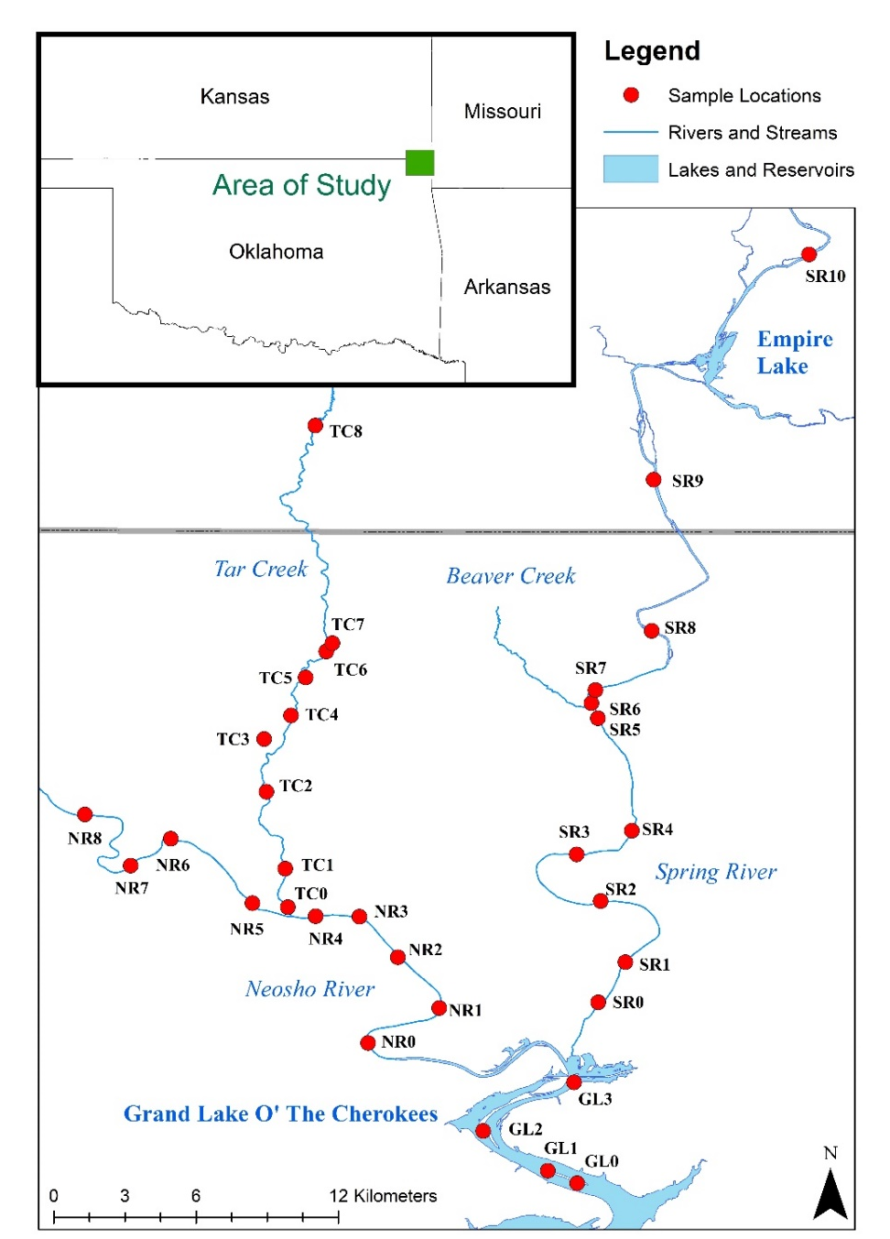
In Grand Lake, Morrison et al. (2019) completed a toxicity study of shallow reservoir sediments to determine trace metal contamination impacts on juvenile amphipods. The sediments showed minimal adverse effects even when trace metal concentrations exceeded sediment quality guidelines. The current study did not include toxicity tests, and sample locations differed from Morrison et al. (2019). Samples were collected from only the upper reaches of Grand Lake and farther upstream in the Spring and Neosho Rivers (Figure 4.1).
Figure 4.1: Area of study (inset) and locations of sample collection from Grand Lake, the Neosho River, the Spring River, and Tar Creek
Often, greater OC content and total Fe concentrations in sediments correlate to elevated concentrations of other trace metals (Rognerud et al., 2000; Goher et al., 2014). Similarly, sediment pH can greatly influence trace metal mobility and availability. At lesser sediment pH values, bonds between trace metals and the particle they are associated with can become weakened, resulting in a greater bioavailability (Belzile et al., 2004; Zhang et al., 2014). The purpose of this study was to evaluate how the sediment OC, total Fe, and pH influence the bioavailability of trace metals downstream from the TSMD. It is hypothesized that: 1) greater concentrations of total Fe and OC in the surface sediment samples will correlate to greater bioavailable concentrations of trace metals, and 2) greater sediment pH will correlate with lower bioavailable concentrations of the same trace metals.

4.2 Methods and Materials
Collection of surface sediment samples (0-4 cm depth) occurred at the land-water interface in Grand Lake, Neosho River, Spring River, and Tar Creek. Samples were collected using a stainless-steel shovel and transported via 3.8-L low-density polyethylene resealable bags at 4°C to slow biologic activity. Use of a small motorized watercraft assisted in sample collection from Grand Lake, the Neosho River, and the Spring River during October of 2020. Tar Creek samples targeted bridge crossings and public access locations, and collection occurred in June of 2020. On rare occasions (3 of 33 sites), wet sieving to 2.5 cm was used to removed cobbles and larger grain sizes. Field duplicate samples were collected at random at a rate of one duplicate per ten sampling locations.
In the laboratory, samples were air dried (Figure 4.2) before analyses. OC content was estimated with the assumption of 50% of the organic matter being OC where the organic matter was determined through loss on ignition (LOI) at 550°C of dried sediments (Nelson and Sommers, 1996). Sediment pH was measured using a glass electrode pH sensor following EPA Method 9045D (USEPA, 2004). The digestion of dried sediments was completed following EPA Method 3051A for total-recoverable concentration (referred to as total concentration throughout) via microwave-assisted digestion using nitric acid (USEPA, 2007b). Elemental analysis for the total concentrations was completed via inductively coupled plasma- optical emission spectrophotometry (ICP-OES) following EPA method 6010C (USEPA, 2007a).
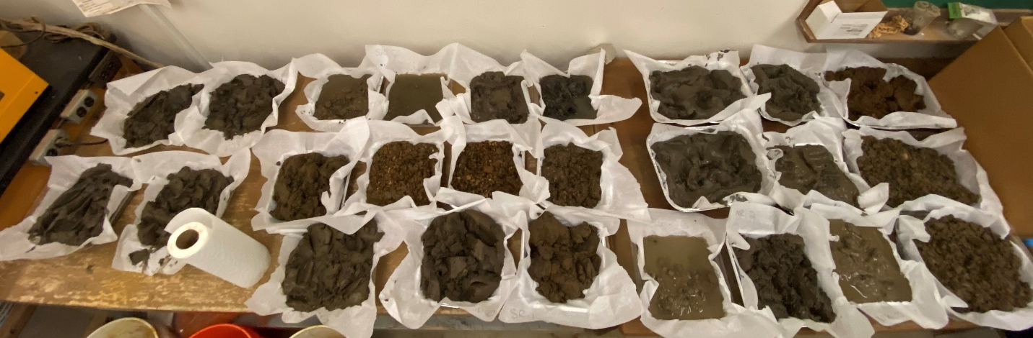
The bioavailable concentrations of Cd, Cu, Fe, Mn, Ni, Pb, and Zn were determined through ammonium bicarbonate diethylenetriaminepentaacetic acid (AB-DTPA) extract (Soltanpour, 1985). Evaluation of relationships between measured parameters and analytes was completed through Analysis of Variance (ANOVA) single factor and linear regression analyses. Air-dried sediment samples were used, as oven drying can alter trace metal bioavailability (Soltanpour, 1991). The bioavailable concentrations of the elements enter the solution when the DTPA, known for chelation properties, forms complexes with the elements in question (Deblonde et al., 2018). The extract was separated from the sediment through filtration by passing through a 0.45 µm filter, and the filtrate was analyzed. A small volume of nitric acid was added before analysis to dissolve the carbonate species in the extract and lower the pH to a suitable ICP-OES analysis level (pH < 2). This acid volume was recorded and included in the dilution factor during data reduction. Due to possible effects from the extract solution interfering with sediment elemental analysis, multiple blank extracts provided details on extract concentrations of elements. If concentrations of elements were detected, the measurement was averaged between the blanks and subtracted from all measured values for the sediment samples to ensure the data presented are only from the sediment extracts.
Figure 4.2: Surface sediments air drying in the CREW laboratory
Laboratory analyses were conducted at the University of Oklahoma Center for Restoration of Ecosystems and Watersheds (CREW) facilities. The field and laboratory methods followed CREW Standard Operating Procedures (SOPs). Throughout the laboratory work, digestion, extraction, and laboratory duplicates and blanks were used included to ensure proper quality assurance.
Statistical analyses for these data were carried out using ANOVA single factor tests to determine significant differences between datasets of the same parameter and ANOVA linear regression analyses to determine significant relationships between two parameters. The 95th confidence level was used in both tests where p < 0.05 is considered significant. Geographic Information Systems (GIS) provided spatial displays for data across the large study area.

4.3 Results and Discussion

4.3.1 Bioavailable Concentrations and Percent of Total for Trace Metals
The bioavailable concentrations of trace metals are of great importance because of uptake and potentially causing adverse effects in organisms. The bioavailable concentrations and the resulting bioavailable percent of the total concentrations for Cd, Cu, Fe, Mn, Ni, Pb, and Zn proved valuable for comparison between waterbodies (Figures 4.3, 4.4, and 4.5). The total and bioavailable concentrations used to calculate the bioavailable percent of the total are included in Appendix D.
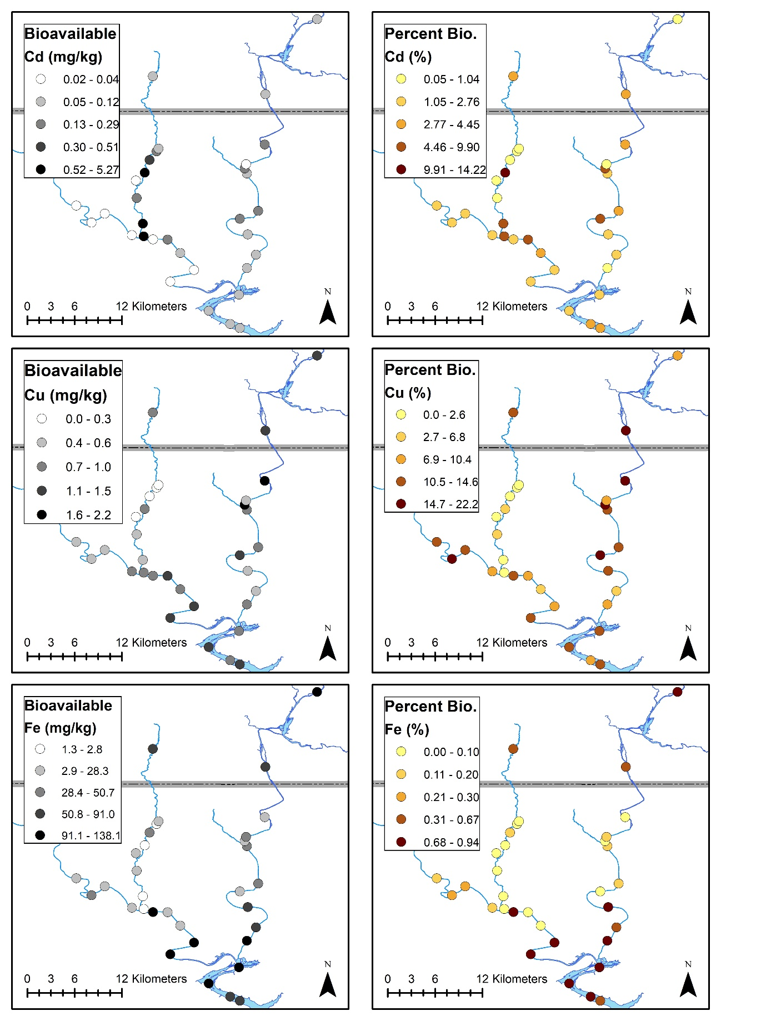
Figure 4.3: Spatial distribution of the bioavailable concentration and percent bioavailable of the total concentration for Cd, Cu, and Fe
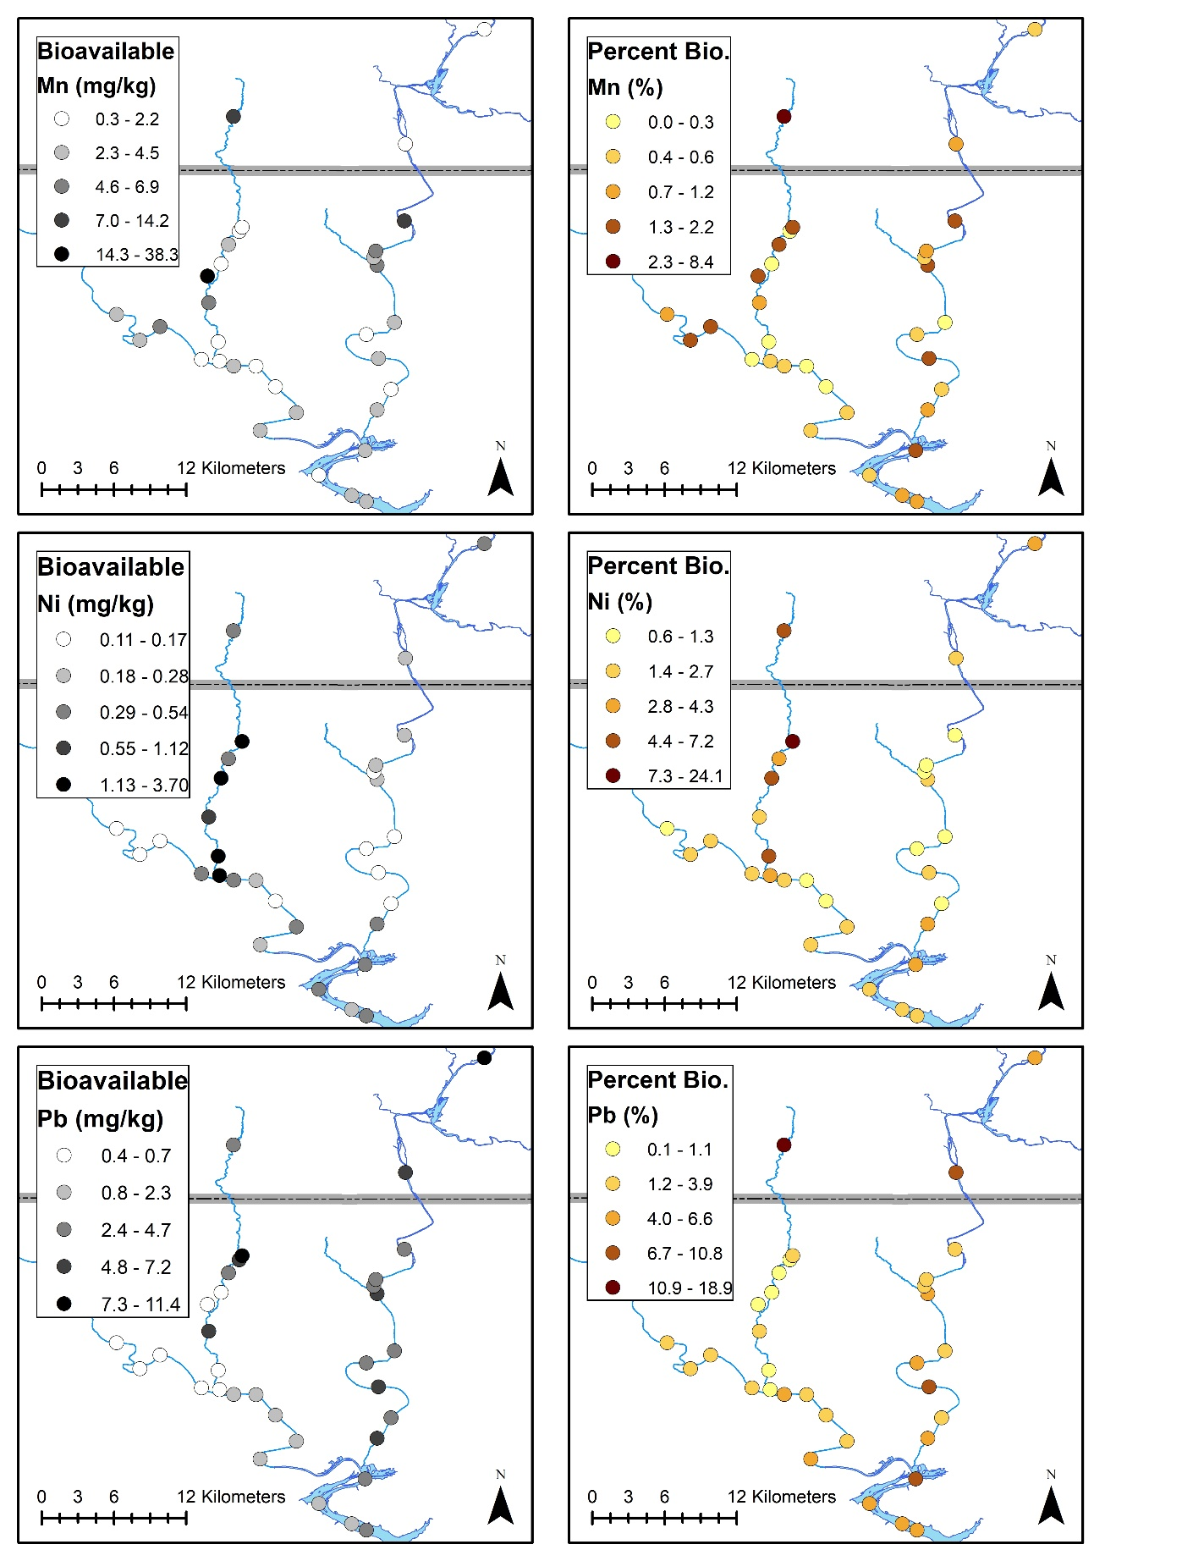
Figure 4.4 Spatial distribution of the bioavailable concentration and percent bioavailable of the total concentration for Mn, Ni, and Pb
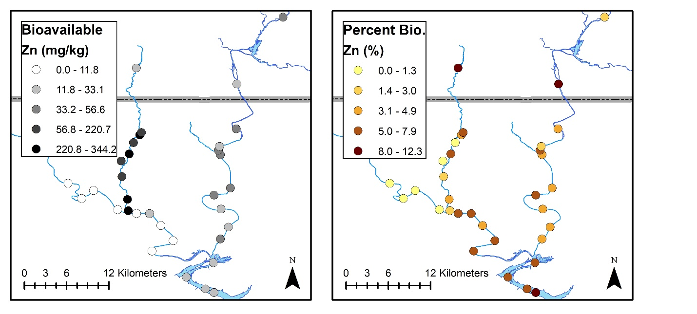
The spatial distribution of bioavailable concentrations throughout the study area was variable, depending not only on elements but also between the primary waterways. While Tar Creek is widely known for trace metal contamination, the greatest bioavailable concentrations occur in other waterbodies in several instances. Determination of the percent bioavailable of the total concentration is beneficial when elevated total concentrations exist and allow for comparison throughout the study area.
Figure 4.5 Spatial distribution of the bioavailable concentration and percent bioavailable of the total concentration for Zn
Zn is an example where Tar Creek samples had elevated bioavailable Zn concentrations but not the greatest percent bioavailable of the total. Evaluation of bioavailable concentrations allows for delineation of determination of the likelihood of areas where trace metal uptake into organisms is likely to occur so they can be studied further, and potential risk understood. Tar Creek has elevated total metal concentrations, but there are elevated concentrations of bioavailable Pb in the Spring River which may pose a risk. Interestingly, for all sample locations, the percent of bioavailable Fe is less than 1%. It is likely due to the extremely elevated total concentrations in Tar Creek as oxyhydroxides which often do not contain elevated concentrations of bioavailable Fe (Hacherl et al., 2001).

4.3.2 Sediment Organic Carbon, Total Iron, and pH
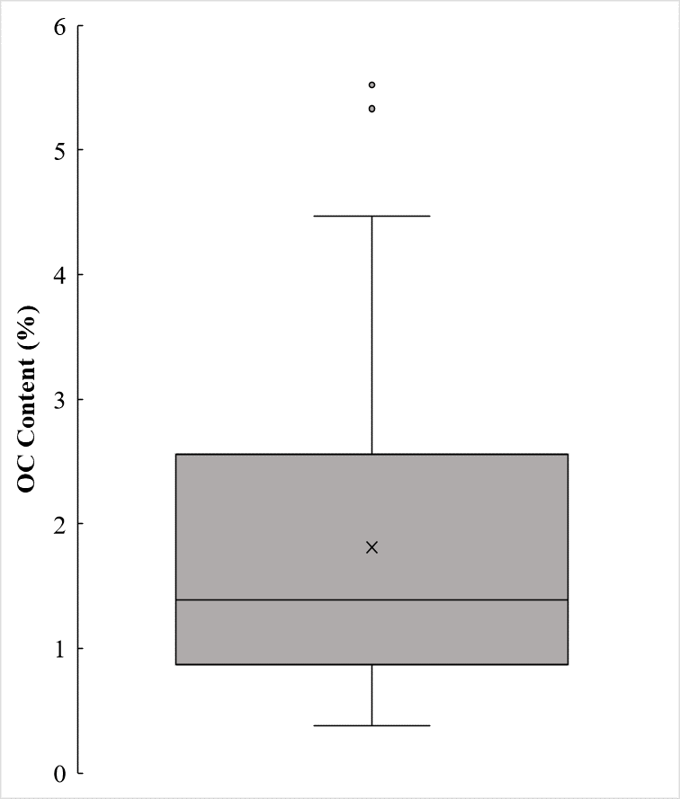
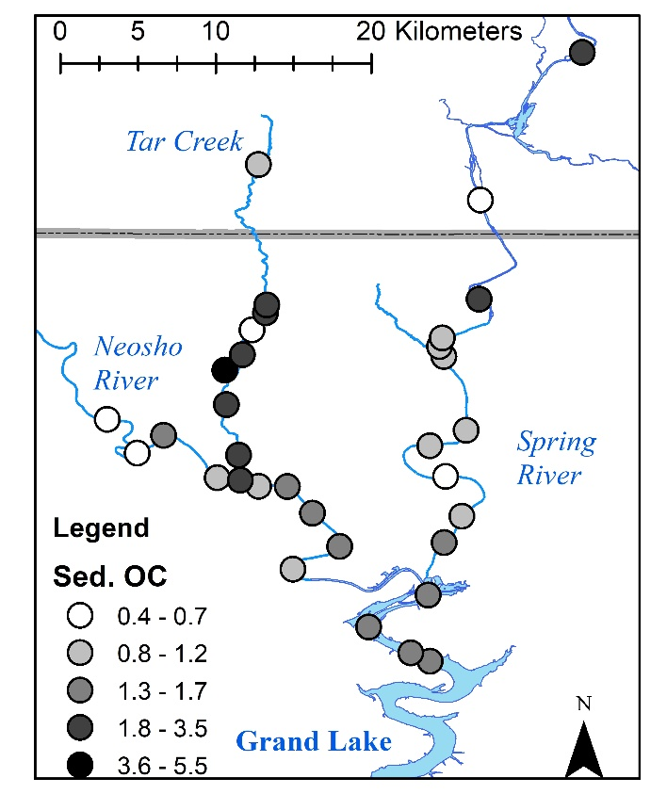
The spatial distribution and boxplots for the OC, total Fe, and sediment pH were constructed (Figures 4.6, 4.7, and 4.8, respectively).
The collected sediment OC content ranges from 0.38 - 5.52 % for all samples, with an average of 1.81 % and a median of 1.39 %. The source of OC within these freshwater sediments is unlikely to be a result of mining. The source of OC in the sediments is likely freshly deposited litter (e.g., plant matter, leaves, and woody debris) as well as further decomposed humic substances (Schumacher, 2002). Humic acids, which are included in humic substances, form ligands with trace metals leading to accumulation in surface sediments. However, upon burial, humic acids may release the trace metals back into the environment in a more mobile state leading to downstream movement (Nriagu and Coker, 1980; Ten Hulscher et al., 1992).
Figure 4.6: Spatial distribution of OC content as % (left) and boxplot of OC content as % (right) for all sample locations
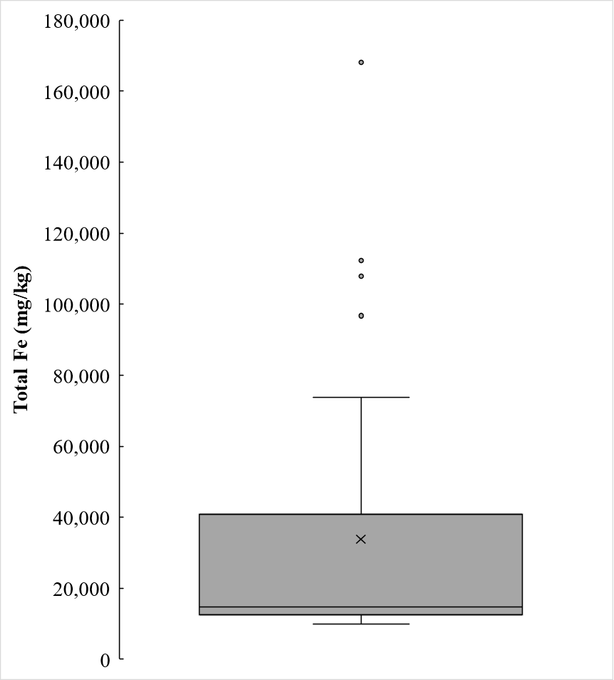
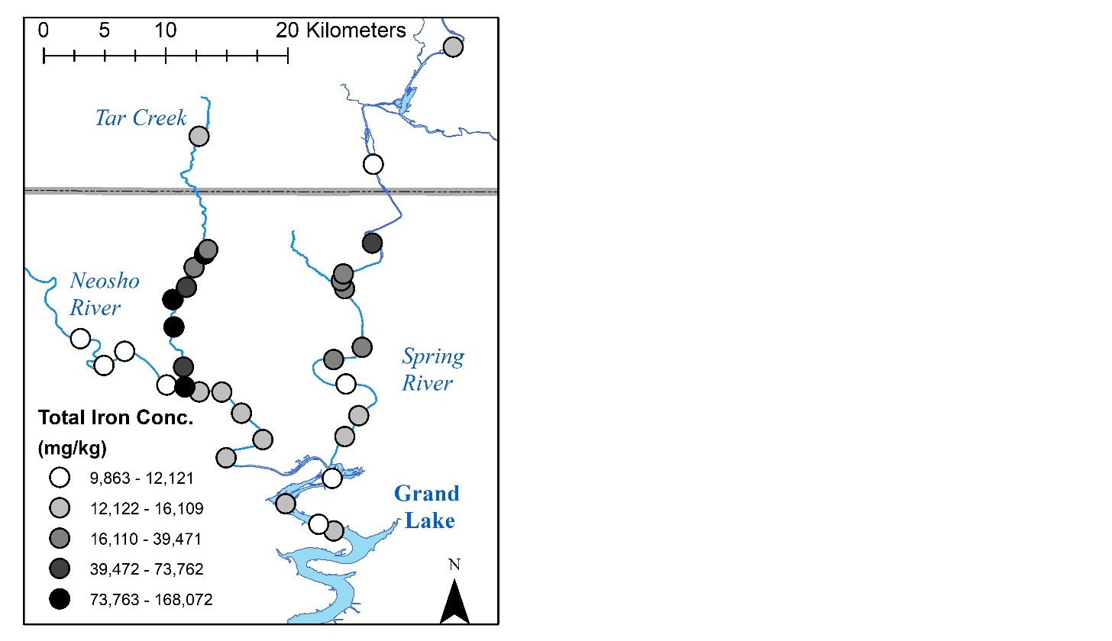
The total Fe concentrations showed wide variability ranging from below 10,000 mg/kg to greater than 168,000 mg/kg. Tar Creek shows elevated concentrations of total Fe compared to other locations in the study area, and further evaluation of differences is found presented in section 4.3.4. Near mine drainage discharges, the total Fe concentrations often represent amorphous Fe oxyhydroxides which precipitate from the Fe-rich discharge waters entering an oxidizing environment. The Fe oxyhydroxides generally have large surface areas and an affinity to sorb other trace metals and nutrients (Tessier et al., 1996; Mendez et al., 2020; Tang and Nairn, 2021). Fe precipitates can also co-precipitate other trace metal ions from solution, leading to elevated concentrations of other metals with Fe (Crawford et al., 1993).
Figure 4.7: Spatial distribution of total Fe concentrations (left) and boxplot of total Fe concentrations (right) for all sample locations
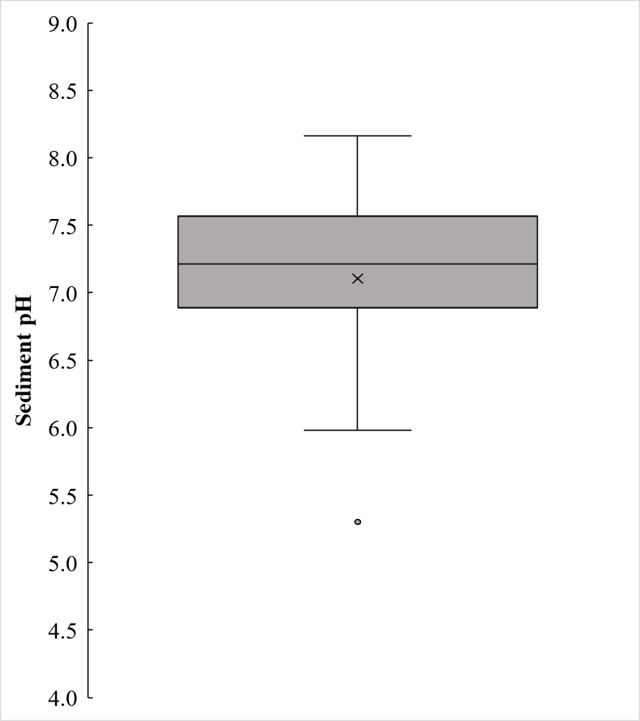
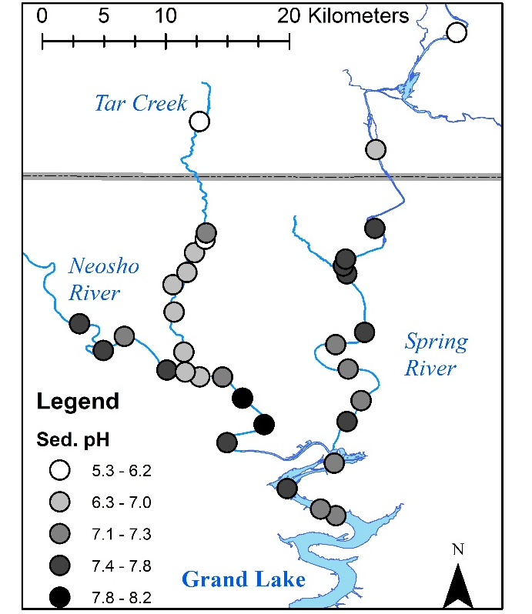
The sediment pH ranges from slightly acidic to slightly basic, with many of the samples being circumneutral. The sediment pH can greatly influence trace metal mobility and availability where at sediment pH values greater than 7, the mobility of Zn increases (Tessier et al., 1989; Zhang et al., 2014). This behavior is observed when total Zn concentrations and sediment pH are plotted together (Figure 4.9). When the sediment pH was greater than seven, zinc concentrations were lower, indicating that increased mobility has allowed Zn transport. Using an ANOVA single factor analysis, total zinc concentrations above and below a pH of seven were evaluated and determined to be significantly different. (p = 0.0002).
Figure 4.8: Spatial distribution of sediment pH (left) and boxplot of sediment pH (right) for all sample locations

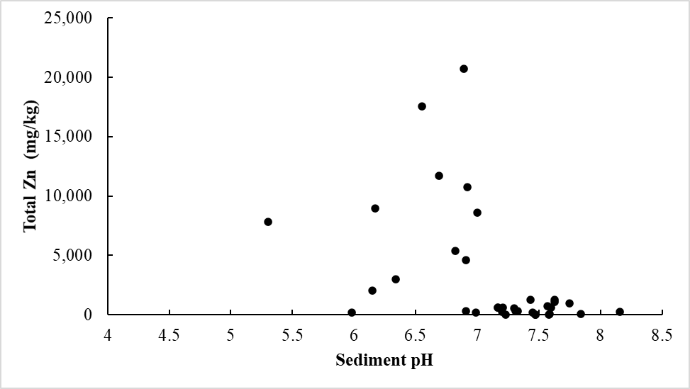
4.3.3 Linear Regression analyses
Figure 4.9: Sediment pH plotted against total Zn concentrations (mg/kg) for all sample locations
Linear regression analyses compared the total and bioavailable concentrations of trace metals for all samples to determine any significant relationships. A summary of the ANOVA analyses for the trace metals included the regression line's slope, the R² value, and the p-value for the slope at the 95th confidence level, where p < 0.05 indicates a significant relationship (Table 4.1). If the line's slope was positive, there was a direct relationship, whereas a negative slope indicated an inverse relationship.
Table 4.1: Summary of linear regression analyses for total concentrations versus bioavailable concentrations for Cd, Cu, Fe, Mn, Ni, Pb, and Zn where significant relationships are indicated by bolding of the element symbol
 | Cd | Cu | Fe | Mn | Ni | Pb | Zn
Slope | 0.0208 | 0.0010 | -0.0003 | 0.0055 | 0.0372 | 0.0016 | 0.0152
Y int | 0.15 | 0.85 | 63.17 | 1.22 | -0.03 | 3.08 | 37.09
R² | 0.18 | <0.01 | 0.22 | 0.18 | 0.44 | 0.03 | 0.49
p-value | 0.01181 | 0.88981 | 0.00502 | 0.01116 | 0.00002 | 0.33538 | <0.0001

There was a significant positive slope (p < 0.05) for the total and bioavailable concentrations of Cd, Zn, Mn, and Ni for the collected samples and a significant inverse linear relationship between the total and bioavailable Fe concentrations. No relationship existed between the concentrations of Pb or Cu. Of the significant results, the R² for all of these relationships failed to exceed 0.5, indicating that while a significant relationship exists, the predictability of the bioavailable concentration from the total concentration was limited. The linear regression figures for the total versus bioavailable concentration are found in Appendix E.
The significant slope indicates that the total concentration of a given trace metal is at least partially responsible for the increase (or decrease) of the bioavailable concentration. However, given the complexity of trace metals in aquatic systems, other factors are likely contributing to the bioavailable concentration.
To further explore these factors, linear regression analyses were completed between the total and bioavailable concentrations of each of the trace metals, and OC content (%), sediment pH, and total Fe concentration as independent variables. All linear regression figures for the three independent variables plotted against total and bioavailable concentrations are found in Appendix F.
Given the large number of tests performed, summary tables of the linear regression tests for OC, total Fe, and sediment pH were created (Tables 4.2, 4.3, and 4.3).

Table 4.2: Summary of linear regression analyses where OC is the independent variable for total and bioavailable concentrations of Cd, Cu, Fe, Mn, Ni, Pb, and Zn
Summary Table for OC | Linear Regression Results
Summary Table for OC | Slope | Y int | R² | p-value
Total Cd | 8.80 | -0.77 | 0.26 | 0.0019
Total Cu | 4.85 | 4.18 | 0.33 | 0.0003
Total Fe | 34,003 | -20,973 | 0.68 | <0.0001
Total Mn | 99.20 | 398 | 0.07 | 0.1292
Total Ni | 30.11 | -21.61 | 0.45 | <0.0001
Total Pb | 152 | -82.55 | 0.48 | <0.0001
Total Zn | 2,400 | -1,155 | 0.37 | 0.0001
Bioavailable Cd | 0.28 | -0.04 | 0.11 | 0.0567
Bioavailable Cu | -0.03 | 0.91 | 0.00 | 0.6885
Bioavailable Fe | -9.06 | 65.57 | 0.09 | 0.0847
Bioavailable Mn | 2.20 | 0.44 | 0.20 | 0.0076
Bioavailable Ni | 0.67 | -0.37 | 0.53 | <0.0001
Bioavailable Pb | 0.19 | 3.05 | 0.01 | 0.6174
Bioavailable Zn | 61.91 | -26.33 | 0.52 | <0.0001

When OC is the dependent variable, there is a significant positive relationship with all total metal concentrations except Mn. This result is probably due to the high surface area of OC and its affinity to attract particles in freshwater systems (Mendez et al., 2020). However, only bioavailable Zn, Mn, and Ni have significant positive relationships with OC. The R² values for each of the trace metal total and bioavailable concentrations were fairly low, with the largest being total Fe (0.68). All significant relationships with the bioavailable concentrations resulted in a positive slope indicating a positive relationship with OC influencing trace metal bioavailability.

Table 4.3: Summary of linear regression analyses where total Fe concentration is the independent variable for total and bioavailable concentrations of Cd, Cu, Fe, Mn, Ni, Pb, and Zn
Summary Table for Total Fe | Linear Regression Results
Summary Table for Total Fe | Slope | Y int | R² | p-value
Total Cd | 2.6x10⁻⁰⁴ | 4.81 | 0.36 | 0.0001
Total Cu | 1.5x10⁻⁰⁴ | 7.05 | 0.51 | <0.0001
Total Fe | - | - | - | -
Total Mn | 2.1x10⁻⁰³ | 492.71 | 0.05 | <0.0001
Total Ni | 7.5x10⁻⁰⁴ | 2.52 | 0.47 | <0.0001
Total Pb | 3.5x10⁻⁰³ | 49.13 | 0.44 | <0.0001
Total Zn | 6.5x10⁻⁰² | 544.44 | 0.46 | <0.0001
Bioavailable Cd | 6.5x10⁻⁰⁶ | 0.20 | 0.10 | 0.0698
Bioavailable Cu | -7.7x10⁻⁰⁷ | 0.90 | 0.01 | 0.6184
Bioavailable Fe | -3.4x10⁻⁰⁴ | 63.17 | 0.22 | 0.0050
Bioavailable Mn | 4.7x10⁻⁰⁵ | 2.54 | 0.15 | 0.0218
Bioavailable Ni | 1.3x10⁻⁰⁵ | 0.31 | 0.34 | <0.0001
Bioavailable Pb | -1.1x10⁻⁰⁶ | 3.43 | 0.00 | 0.9074
Bioavailable Zn | 1.6x10⁻⁰³ | 22.64 | 0.56 | <0.0001

Linear regression analyses using total Fe as the independent variable resulted in low slopes due to the elevated concentrations of total Fe (upwards of 168,000 mg/kg) and the lesser concentrations of total and bioavailable trace metals. Total Fe significantly correlated with all total concentrations except Mn. The bioavailable concentrations of Pb, Fe, and Cu all have negative slopes. However, only bioavailable Fe has a significant negative relationship. Alternatively, there is a significant positive relationship between total Fe and bioavailable Mn, Ni, and Zn. .

Table 4.4 Summary of linear regression analyses where sediment pH is the independent variable for total and bioavailable concentrations of Cd, Cu, Fe, Mn, Ni, Pb, and Zn
Summary Table for Sed pH | Linear Regression Results
Summary Table for Sed pH | Slope | Y int | R² | p-value
Total Cd | -14.87 | 120 | 0.15 | 0.0232
Total Cu | -9.61 | 81.24 | 0.26 | 0.0016
Total Fe | -39,077 | 318,217 | 0.18 | 0.0109
Total Mn | 253 | -1,222 | 0.09 | 0.0807
Total Ni | -34.75 | 279 | 0.12 | 0.0421
Total Pb | -264 | 2,070 | 0.29 | 0.0009
Total Zn | -4,029 | 31,818 | 0.21 | 0.0058
Bioavailable Cd | -0.24 | 2.14 | 0.02 | 0.4827
Bioavailable Cu | 0.27 | -1.03 | 0.11 | 0.0522
Bioavailable Fe | 7.93 | -7.13 | 0.01 | 0.5071
Bioavailable Mn | -1.31 | 13.73 | 0.01 | 0.4986
Bioavailable Ni | -1.00 | 7.90 | 0.22 | 0.0058
Bioavailable Pb | -1.87 | 16.65 | 0.15 | 0.0199
Bioavailable Zn | -106 | 840 | 0.31 | 0.0005

When the sediment pH is the independent variable in linear regression analysis, there is a significant negative slope (p < 0.05) for total Cd, Pb, Zn, Fe, Cu, Ni, and bioavailable Pb, Zn, and Ni. The slope magnitudes reflect the range in concentrations; however, the sign indicates the positive or negative relationship. Each of the significant relationships has negative slopes indicating that elevated sediment pH leads to lower bioavailability of the trace metals. The lower pH of sediment leads to increased metals availability in estuarine sediments (Riba et al., 2003), and the same trend occurs for Pb, Zn, and Ni in freshwater sediments.
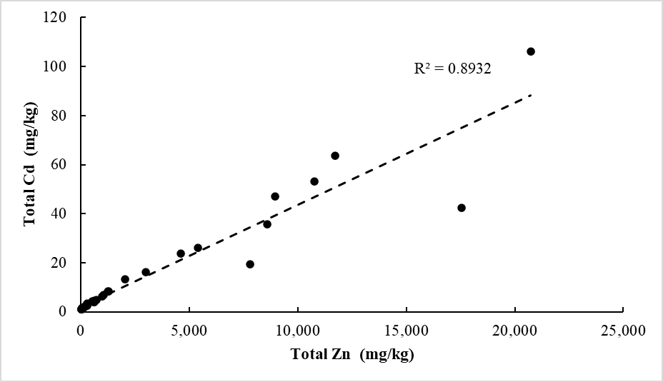
Another important relationship in and around the TSMD is between Zn and Cd, as they can each be toxic when in sufficient excess. In the sediment samples, total Cd and total Zn have a strong relationship (R²= 0.89) for the given dataset (Figure 4.10).
Figure 4.10: Total Zn (mg/kg) plotted against total Cd (mg/kg) with linear regression line and coefficient of determination shown

This relationship between sediment-bound Cd and Zn is due to their similar chemical properties sharing a similar valence state and crystal structure (Beattie et al., 2017). Morrison et al. (2019) determined that this relationship in Grand Lake indicates a dependency on sediment transport and suspension for distribution rather than dissolved metals movement. However, the bioavailable concentrations of Zn and Cd did not have as defined a relationship as the total concentrations (Figure 4.11).
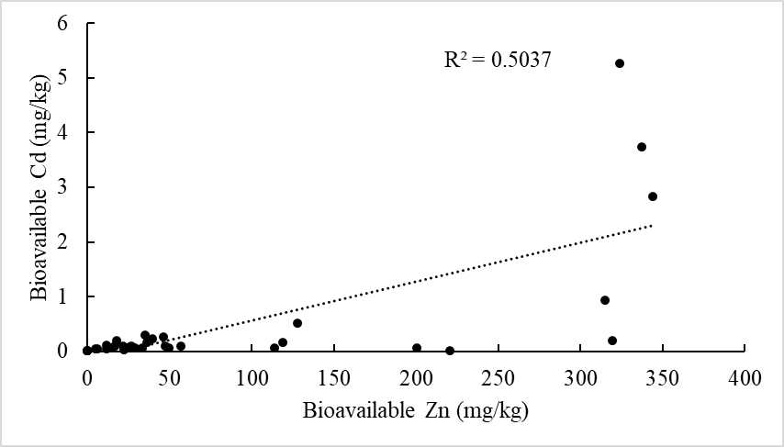
Figure 4.11: Bioavailable Zn (mg/kg) plotted against bioavailable Cd (mg/kg) with linear regression line and coefficient of determination shown.
The relationship between the bioavailable concentrations of Zn and Cd indicates that Zn is more bioavailable than Cd. Although a strong linear relationship exists for the total concentrations, the bioavailable concentrations of Cd remain fairly low at < 1 mg/kg. The only increase in bioavailable Cd concentrations occurs when bioavailable Zn concentrations exceed 300 mg/kg.
The bioavailable Cd correlates significantly in a positive manner to total Cd concentrations. The bioavailable concentration of Fe shows significant negative trends with total Fe and sediment pH. The bioavailable Ni concentration is positively correlated with total Ni, total Fe, and OC while being negatively correlated with sediment pH. The bioavailable Mn showed a positive association with total Mn, total Fe, and OC. Bioavailable Pb only negatively correlated with sediment pH. The bioavailable Zn concentrations in sediments showed positive trend with total Zn, total Fe, and OC, while negatively correlated with sediment pH.
While not one of this study's primary objectives, there were significant positive slopes observed where greater OC content and greater total Fe concentrations correlated with the total concentrations of other assessed trace metals. This result is in line with previous studies where these factors (OC and total Fe concentrations) lead to sorption of other trace metals and leads to elevated concentrations (Mogollón et al., 1990; Tessier et al., 1996; Sipos et al., 2021).

4.3.4 Individual Waterbody Investigation
The sample locations are from four distinct waterbodies (Tar Creek, Neosho River, Spring River, and Grand Lake). Mining efforts have substantially impacted Tar Creek, and while it drains into the Neosho River, it does not contribute substantially to the flow volume. Total and bioavailable concentrations and percent bioavailable of the total concentrations were measured for each waterbody (Figures 4.12, 4.13, and 4.14). Similarly, sediment pH and OC were measured for each waterbody (Figure 4.15). Using ANOVA single factor analyses at the 95th confidence level, the percent bioavailable of each trace metal fraction was compared between water bodies to determine if they differed significantly.
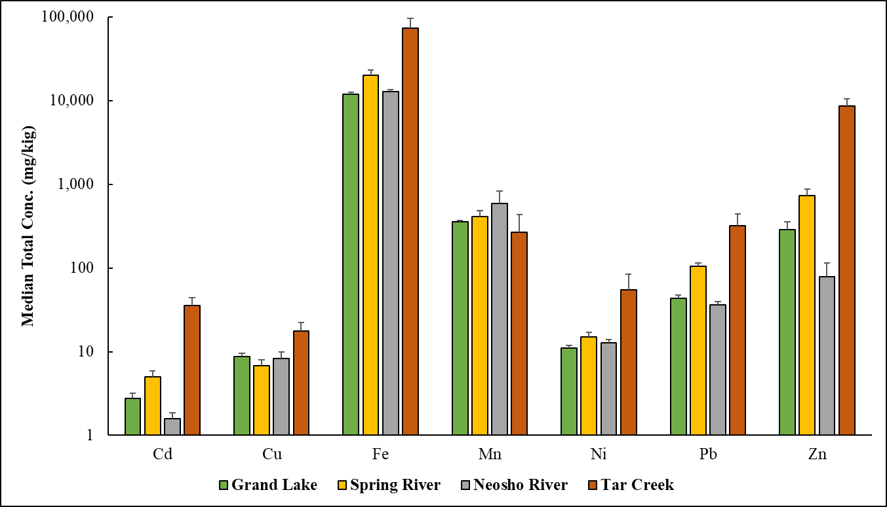
Figure 4.12: Median total recoverable concentrations (with standard error) on a logarithmic vertical axis for Cd, Cu, Fe, Mn, Ni, Pb, and Zn shown for individual waterbodies
Total concentrations of the analytes showed great variability between the waterbodies examined. Tar Creek had the greatest median concentrations for all measured analytes except for Mn. Similarly, the Spring River contained the second greatest median concentrations except for Mn and Cu. Grand Lake and the Neosho River have relatively lesser median concentrations of the primary trace metals of concern (Cd, Pb, and Zn) and Fe and Ni. While Mn can be present in mine drainage discharge waters, Tar Creek had the lowest median concentration in sediments, while the Neosho River had the greatest.
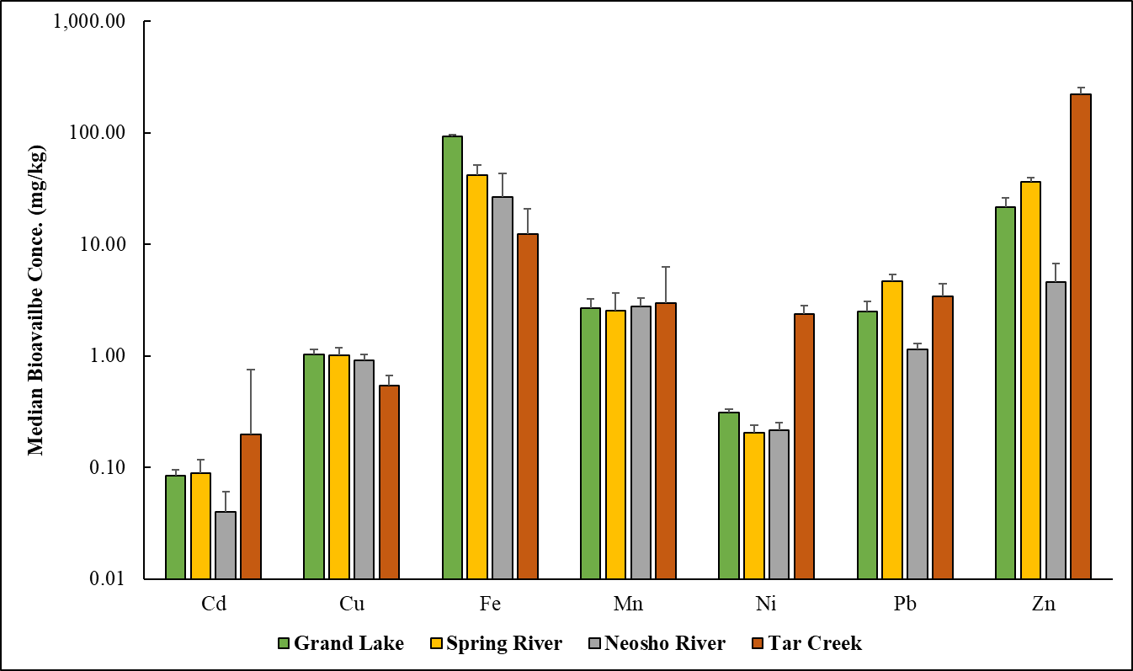
Figure 4.13: Median bioavailable concentrations (with standard error) on a logarithmic vertical axis for Cd, Cu, Fe, Mn, Ni, Pb, and Zn shown for individual waterbodies
Similar to the total concentrations, the bioavailable concentrations varied considerably between waterbodies. Overall, bioavailable concentrations are orders of magnitude lower than the total concentrations. Grand Lake had the greatest median bioavailable Cu and Fe concentrations, while Tar Creek had the greatest median bioavailable concentration of Cd, Mn, Ni, and Zn. Lastly, the Spring River had the greatest median concentration of Pb. The Fe for Grand Lake was unique in that it had the greatest median bioavailable concentration while having the lowest median total concentration. Adversely, Ni, Cd, and Zn show the greatest total and bioavailable concentrations in Tar Creek sediments.
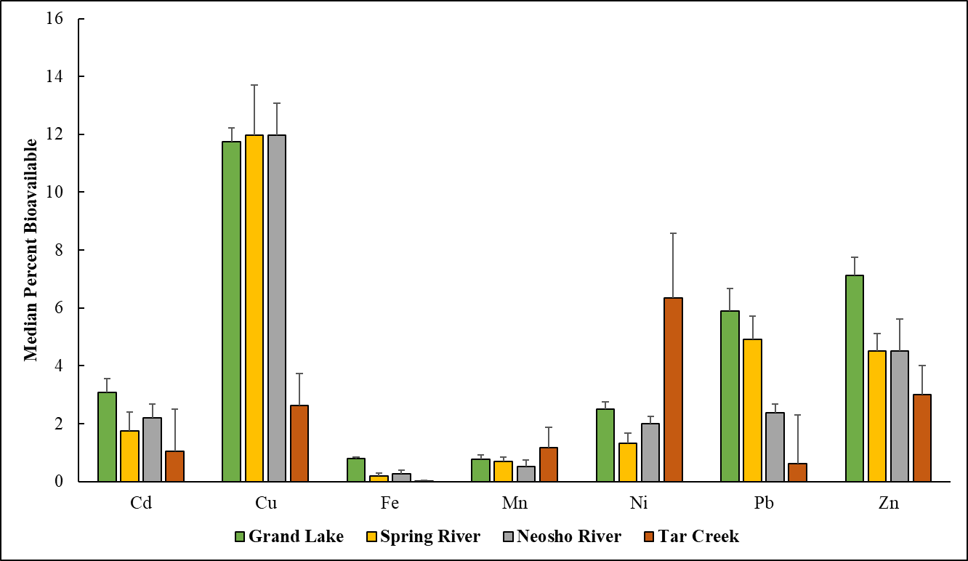
Figure 4.14: Median percent bioavailable of the total concentrations (with standard error) for Cd, Cu, Fe, Mn, Ni, Pb, and Zn shown for individual waterbodies
When comparing the median percent bioavailable trace metals, there is no statistical difference between waterbodies for Cd, Mn, Pb, or Zn. However, the percent bioavailable is significantly different (p<0.05) between waterbodies for Cu, Fe, and Ni. Generally, Cu had the greatest bioavailable percent of the total concentration of the metals evaluated, indicating that conditions are favorable to promote availability. The total Cu in Tar Creek samples had the greatest median concentration (22.8 mg/kg), yet the bioavailable concentrations were the lowest median among waterbodies (0.58 mg/kg). This result leads to a significant difference between the bioavailable percent across the waterbodies. Of the four tested independent variables, the bioavailable Cu did not significantly correlate to any of them. These results indicate that the primary factor(s) controlling the bioavailability for Cu could not be determined. Young (2013) documented a strong affinity for fulvic and humic acids influencing Cu availability.
Interestingly, total Fe has the greatest concentration of elements in this assessment and the lowest average percent bioavailable. The significant negative relationship between total and bioavailable Fe is most apparent in the Tar Creek samples. The low bioavailability where high total concentrations are present in highly contaminated sediments may be a factor in Fe species occurring from the mine drainage sources. While chat influences many trace metals, less Fe is coming from the chat than mine drainage sources. As the dissolved Fe comes to the surface, it will oxidize to form Fe oxyhydroxides near mine drainage discharges. In the formation of goethite, crystal surfaces with fewer impurities result in a decreased bioavailable concentration of Fe (Notini et al., 2019).
For Ni, the average bioavailable concentration in Tar Creek samples is 2.1 mg/kg, while the remaining trace metals are all less than 0.3 mg/kg. Similarly, the median total Ni concentration concentrations in Tar Creek is 74.9 mg/kg, while the remaining waterbodies were all below 16 mg/kg. The total Ni concentration has a significant relationship with bioavailable concentration. Thus, the elevated concentrations due to proximity to severely mining-impacted areas are likely influencing the significant difference between waterbodies.
When no statistical difference in bioavailable percent occurs between the waterbodies for given trace metals, it may indicate that the factors controlling availability for that specific trace metal are consistent throughout the study area leading to similar behavior of the trace metals. There is no single parameter or factor that is completely responsible when there is a significant difference in the bioavailable percent of trace metals between waterbodies. Trace metal behavior is complex, and these data represent a snapshot in time of the sediment quality in terms of total and bioavailable trace metal concentrations. Flooding and other sediment-moving processes will continue resulting in changes. Through burial and erosion, along with the continued inputs of particulate and dissolved trace metals, future decisions for remediation should not be based on one singular data collection event but rather reliable and long-term datasets.
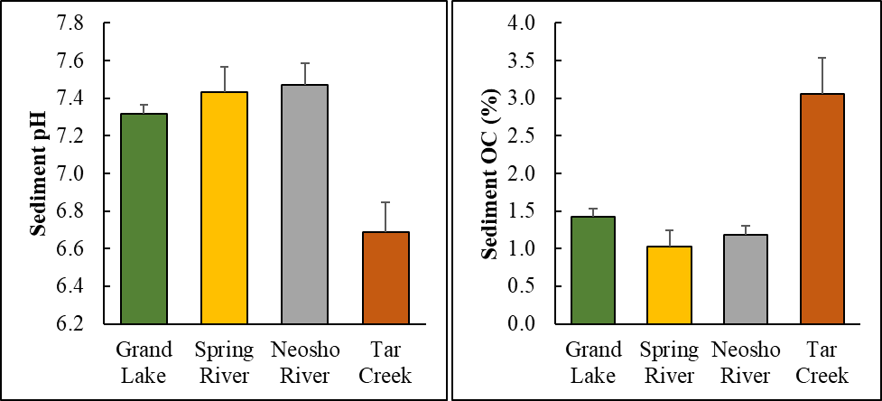
Figure 4.15:Median sediment pH (left) and sediment OC content (right) with standard error for individual waterbodies
The sediment pH and OC differ significantly (p < 0.05) between waterbodies. Tar Creek has the lowest median sediment pH and the highest median OC content. Lower pH values in soils and sediments can lead to greater bioavailability (Rieuwerts, 2007). When OC content is higher, there are likely greater concentrations of trace metals from its ability to sorb with trace metals (Ondrasek and Rengel, 2012). These data indicate a difference in two factors that are known to influence the total and bioavailable concentrations of trace metals.

4.3.5 General Discussion
The Neosho and Spring River, which feed Grand Lake, do not originate from the same environments. The Neosho River is located in the Central Lowlands Province, while the Spring River is part of the Ozark Plateaus Province (Juracek and Becker, 2009). These differences in geologic origin area can be observed with the EPA level II ecoregions, where the Ozark/ Ouachita forest ecoregion mostly encompasses the Spring River watershed. The Neosho River is largely in temperate prairies. The ecoregion classifications include both biotic and abiotic factors (Omernik and Griffith, 2014). The variability in geology, soil, and hydrology are likely influencing the water and sediments from each. The difference in environmental conditions and geology will likely influence the water flowing in the rivers and create differences in sediment composition. In evaluating trace metals, these differences were less pronounced as the mining influence has greatly disturbed the natural environment.
Impacts on the mobility of trace metals are not limited to geochemical changes promoting dissolution back into pore or surface waters. Erosion and transport of sediments either as bedload or suspended particles can also lead to a widespread downstream distribution of the trace metals associated with sediments (Förstner and Müller, 1973; Horowitz, 1985). The erosion process cannot be stopped completely within the Grand Lake watershed, and it is important to consider this factor when moving forward in remediation. Natural disturbances such as flooding or wave action can lead to sediment disturbance. Anthropogenic factors, including dredging and in-stream remediation, can cause disturbances that lead to further downstream contamination (van den Berg et al., 2001).
There is documentation to support the relationship between trace metal concentration and grain size (Lakhan et al., 2003; Beattie et al., 2017). Small grains (clay size particles) in riverine and lacustrine systems will harbor greater trace metals concentrations. This information is vital when planning remediation and when looking at the current study area as a whole. Tar Creek, the Neosho River, and the Spring River all eventually flow into Grand Lake. The Grand River Dam Authority (GRDA) manages Grand Lake water levels. As the flowing waters from the upstream rivers enter Grand Lake, the water velocity slows substantially until eventually leaving Grand Lake through Pensacola Dam. The decrease in velocity allows for smaller particles to become deposited, which is in turn depositing trace metals into Grand Lake. This study only included four sample locations in the upper reaches of Grand Lake, but elevated concentrations of bioavailable trace metals, which pose a serious threat, were detected. The Grand Lake watershed is the drainage basin for multiple Superfund Sites all associated with lead-zinc mining. Nevertheless, each site is being managed differently based on levels and media of contamination. During sediment remediation efforts, communication between managing parties and awareness of potential downstream impacts will prove invaluable.
The results from the linear regression analyses examinations indicated that while the total and bioavailable concentrations vary throughout the study area, numerous factors correlate to some observed changes. The significant relationships where OC and total Fe correlate to greater trace metals concentrations are of vital importance when considering remedial activities. For Cd, Mn, Ni, and Zn, the total concentrations significantly relate to the bioavailable concentration, and thus, by containing and not allowing the total concentration to enter streams, there will be a decrease in the bioavailable concentration. Similarly, the influence of sediment pH on trace metals through these systems will affect the downstream distribution of trace metals and change the availability for organism uptake. The design of a semi-controlled environment allows for a specific pH.
Much of the discussion on OC refers to the ability to sorb other trace metals in the environment, but OC can have variable effects on trace metals in sediment depending on the species and type of OC (Baran et al., 2019). Since the sediment sample collection occurred from the water-land interface with minimal water collection, there is likely little dissolved organic matter (DOM) within the samples. However, the DOM in overlying water may greatly influence behavior and interactions with trace metals (McKnight et al., 2002; Weng et al., 2002; Chakraborty et al., 2014). Further evaluation between sediments, overlying water, and pore water and the exchanges occurring may prove valuable.

4.3.6 Limitations and Uncertainties
One of the limitations of this study resides in the statistical power of the tests used. For Grand Lake, collection and analysis occurred for only four samples from the upper reaches and in no way represent the entirety of the lake. Similarly, due to the heterogeneity of sediments, when concentrations vary between consecutive locations, it cannot be assumed that there is an even and gradual change.
A second limitation in the study is that for each sample location, only one sample was collected. All field sampling protocols were followed to collect a representative sample of the given area, but due to the study's large spatial extent, variability locally and throughout the area is expected. These data provide a snapshot in time as with normal flow and flooding conditions, erosion and deposition will not only result in geomorphic changes in the area but may geochemically bury or expose contaminated sediments.

4.4 Conclusions
The OC content, total Fe concentration, sediment pH, and the total concentration of the given trace metal influenced bioavailable concentrations, but not all trace metals behaved similarly. OC and total Fe concentrations positively correlated with bioavailable Mn, Ni, and Zn concentrations, while total Fe negatively correlated with bioavailable Fe concentrations. Sediment pH negatively correlated with the bioavailable Ni, Pb, and Zn concentrations. Total concentrations significantly correlated with the bioavailable concentration for Cd, Mn, Ni, and Zn. Of the four tested independent variables, there were no significant relations with the bioavailable Cu concentration.
Interactions influencing the bioavailable concentrations happen on small scales and can vary between locations. It is imperative to take a step back and observe these changes throughout the study and determine actions to mitigate trace metal contamination's adverse effects. While sediments can be both sinks and sources of trace metals depending on the surrounding conditions, without ensuring elevated concentrations of trace metals are no longer entering the streams in water or sediments, any downstream efforts to remove or treat sediments are rendered futile by the newly added trace metals. Therefore, it is vital to treat and contain trace metal pollution sources before the needed sediment remediation in Tar Creek, the Neosho River, the Spring River, and Grand Lake. The observed relationships between total concentrations and other stream properties should receive further studies when remediation planning and using the natural processes to aid in the efforts. Lastly, before any large-scale remediation of the sediments, further sample collection and analysis should be conducted to maximize effectiveness.

4.5 Future Work
Future work for the bioavailability of trace metal contamination in the Grand Lake watershed may consider collecting and analyzing samples from higher reaches within the Spring River basin as elevated concentrations occur at the most upstream sampling location in this study. Completing sequential extractions on the sediments will help to understand the trace metals phase and species moving through this freshwater system. Understanding what species trace metals are residing within sediments may help guide efforts to remove the trace metals to safe levels.
Given the numerous factors influencing trace metal availability, the completion of traditional toxicity tests with sediment-dwelling organisms should be accompanied by the determination of bioavailability. The additional information and understanding of the interactions being had within the sediments and how the sediments interact with their surroundings are needed when targeting areas for remediation and the tools used during it.

Thesis Conclusions

5.1 Thesis Conclusions
Extensive lead and zinc mining in the TSMD led to major trace metal contamination in sediments, posing a substantial risk to humans and the environment. The sources of trace metals in sediments primarily come from mine drainage and chat piles. The impact of trace metal contamination in the sediments is of great concern for human and environmental health. However, the USEPA has not filed a Record of Decision for sediments in the Tar Creek Superfund site. Evaluation of trace metal human health risk in different media has been conducted (CH2M, 2021).Ongoing efforts throughout the TSMD are being completed to characterize and assess the degree of contamination (HydroGeoLogic Inc., 2021).
The purpose of this work was to evaluate the temporal changes, spatial trends, and factors that influence trace metal mobility and availability in sediments within and downstream of the TSMD. The temporal evaluation of trace metal concentrations in sediments in Tar Creek was completed by comparing trace metal concentrations in sediments collected in 2020 to a USGS report from 1988 documenting the trace metal concentrations in sediments (Parkhurst et al., 1988). Results indicate that over the 35 years between sampling episodes, the total concentrations of Cd, Mn, Ni, and Zn increased, while the concentrations of Fe, Pb, and S decreased. Increases were attributed to the ability of sediments to accumulate and retain trace metals and the continual input of trace metals from mine drainage and chat pile leachate. The significant decreases in Fe, Pb, and S are related to decreases in their respective concentrations in mine drainage and the relatively low concentrations from chat pile leachates. Temporally, the accumulation of trace metals is expected as sources of trace metal contamination continue to be input into the streams. This initial study demonstrates elevated trace metal concentrations in Tar Creek but did not evaluate the receiving waterbody sediments.
Spatial evaluation of trace metal contamination for Tar Creek, the Neosho River, the Spring River, and the upper reaches of Grand Lake included linear regression analyses and comparison of sample medians. Several mining-impacted tributaries enter the Neosho and Spring Rivers before entering Grand Lake. Tar Creek is significantly impacting sediments in the Neosho River downstream of its confluence. Concentrations of Cd, Pb, and Zn in the Neosho River significantly decrease with increasing distance from known mining-impacted areas. Similarly, there is a significant decrease in concentrations was found with increasing distance from the mining district in the Spring River. Due to the lack of degradation of trace metals in the environment, downstream dispersion of trace metals bound to sediments is expected until source management and remediation of highly contaminated sediments occur.
The OC, total Fe concentration, sediment pH, and the respective total concentration of trace metals were evaluated with regard to the bioavailable concentrations for Cd, Cu, Fe, Mn, Ni, Pb, and Zn. These evaluations indicated that no single factor led to greater bioavailable concentrations for all trace metals. The respective total metal concentrations resulted in significant correlations for bioavailable Cd, Zn, Mn, and Ni. The sediment OC positively correlated with bioavailable Mn, Ni, and Zn. The total Fe concentrations positively correlated with bioavailable concentrations of Mn, Ni, and Zn, while, while inversely correlating with bioavailable Fe. Lastly, sediment pH inversely correlated with bioavailable concentrations of Ni, Pb, and Zn. These data and relationships demonstrate trace metal contamination variability and the different influences on trace metal availability.
As planning for remediation of sediments throughout the Superfund Sites continue to develop, trace metal inputs via chat leachate is imperative. Also worthy of consideration is the ability of contaminated sediments to act as a source of trace metals and lead to downstream contamination.

5.2 Implications on the Future
The current study demonstrated: 1) the ability of sediments to accumulate potentially toxic concentrations of trace metals over time, 2) that sediment-bound trace metals can become distributed downstream of mining impaired areas, and 3) the bioavailable concentrations are not solely dependent on any single variable. Beyond this research, further evaluation of sediments in and downstream of the TSMD is needed before large-scale remediation efforts begin. Currently, a Record of Decision (ROD) for OU5 in the Tar Creek Superfund site has not been filed by the USEPA. Similarly, in the most recent Oronogo-Duenweg Mining Belt Superfund Site Five year review, sediment remediation actions are still to be decided upon (USEPA, 2017). Recommendations include that the sources of trace metal inputs from outside of the active water channels are to be treated. The Newton County Superfund site ROD in 2010 sediment remedial action objectives included the removal and disposal of contaminated sediments in intermittent flowing streams (USEPA, 2010). However, no remedial action objectives were identified for perennially flowing streams or rivers.
Future work should involve continual and consistent sampling of the same areas to better understand short-term temporal changes and potential seasonal fluctuations. Second, completing toxicity tests for both benthic organisms and native fauna accompanied with the determination of bioavailable concentrations will further the understanding of trace metal toxicity in the TSMD. Third, sequential extraction of sediments to determine what species the trace metals are residing in would prove valuable in understanding the pathways by which uptake by organisms may occur. Before large-scale remediation, various small-scale studies should be completed to ensure methods work and allow for the most efficient and effective remediation techniques while minimizing the potential risk to humans and the environment.

Literature Cited
Abdel-Saheb, I., Schwab, A.P., Banks, M.K., and Hetrick, B.A., 1994, Chemical characterization of heavy-metal contaminated soil in southeast Kansas: Water, Air, and Soil Pollution, v. 78, p. 73–82, doi:10.1007/BF00475669.
Affandi, F.A., and Ishak, M.Y., 2019, Impacts of suspended sediment and metal pollution from mining activities on riverine fish population—a review: Environmental Science and Pollution Research, v. 26, p. 16939–16951, doi:10.1007/s11356-019-05137-7.
Alsaleh, K.A.M., Meuser, H., Usman, A.R.A., Al-Wabel, M.I., and Al-Farraj, A.S., 2018, A comparison of two digestion methods for assessing heavy metals level in urban soils influenced by mining and industrial activities: Journal of Environmental Management, v. 206, p. 731–739, doi:10.1016/j.jenvman.2017.11.026.
Amin, B., Ismail, A., Arshad, A., Yap, C.K., and Kamarudin, M.S., 2009, Anthropogenic impacts on heavy metal concentrations in the coastal sediments of Dumai, Indonesia: Environmental Monitoring and Assessment, v. 148, p. 291–305, doi:10.1007/s10661-008-0159-z.
Andrews, W.J., Becker, M.F., Mashburn, S.L., and Smith, J.S., 2009, Selected Metals in Sediments and Streams in the Oklahoma Part of the Tri-State Mining District, 2000–2006: U.S. Geological Survey, Open-File Report USGS Scientific Investigations Report 2009–5032, https://pubs.usgs.gov/sir/2009/5032/pdf/SIR2009-5032-web.pdf.
Baran, A., Mierzwa-Hersztek, M., Gondek, K., Tarnawski, M., Szara, M., Gorczyca, O., and Koniarz, T., 2019, The influence of the quantity and quality of sediment organic matter on the potential mobility and toxicity of trace elements in bottom sediment: Environmental Geochemistry and Health, v. 41, p. 2893–2910, doi:10.1007/s10653-019-00359-7.
Beattie, R.E., Henke, W., Davis, C., Mottaleb, M.A., Campbell, J.H., and McAliley, L.R., 2017, Quantitative analysis of the extent of heavy-metal contamination in soils near Picher, Oklahoma, within the Tar Creek Superfund Site: Chemosphere, v. 172, p. 89–95, doi:10.1016/j.chemosphere.2016.12.141.
Belzile, N., Chen, Y.-W., Gunn, J.M., and Dixit, S.S., 2004, Sediment trace metal profiles in lakes of Killarney Park, Canada: from regional to continental influence: Environmental Pollution, v. 130, p. 239–248, doi:10.1016/j.envpol.2003.12.003.
van den Berg, G.A., Gustav Loch, J.P., van der Heijdt, L.M., and Zwolsman, J.J.G., 2000, Chapter 21 Geochemical behaviour of trace metals in freshwater sediments, in Markert, B. and Friese, K. eds., Trace Metals in the Environment, Elsevier, Trace Elements — Their Distribution and Effects in the Environment, v. 4, p. 517–533, doi:10.1016/S0927-5215(00)80024-7.
van den Berg, G.A., Meijers, G.G., van der Heijdt, L.M., and Zwolsman, J.J., 2001, Dredging-related mobilisation of trace metals: a case study in The Netherlands: Water Research, v. 35, p. 1979–1986, doi:10.1016/s0043-1354(00)00452-8.
Beyer, W.N., Dalgarn, J., Dudding, S., French, J.B., Mateo, R., Miesner, J., Sileo, L., and Spann, J., 2004, Zinc and Lead Poisoning in Wild Birds in the Tri-State Mining District (Oklahoma, Kansas, and Missouri): Archives of Environmental Contamination and Toxicology, v. 48, p. 108–117, doi:10.1007/s00244-004-0010-7.
Bourg, A.C.M., 1988, Metals in Aquatic and Terrestrial Systems: Sorption, Speciation, and Mobilization, in Salomons, W. and Förstner, U. eds., Chemistry and Biology of Solid Waste: Dredged Material and Mine Tailings, Berlin, Heidelberg, Springer, p. 3–32, doi:10.1007/978-3-642-72924-9_1.
Brumley, J.D., 2004, Application of Ecosystem Energetic Indicators for the Valuation of Ecosystem Services and Health [Doctorate of Philosophy]: The University of Oklahoma, 319 p., https://shareok.org/bitstream/handle/11244/8105/Brumley%20Dissertation%202014.pdf?sequence=1&isAllowed=y.
Carroll, S.A., O’Day, P.A., and Piechowski, M., 1998, Rock−Water Interactions Controlling Zinc, Cadmium, and Lead Concentrations in Surface Waters and Sediments, U.S. Tri-State Mining District. 2. Geochemical Interpretation: Environmental Science & Technology, v. 32, p. 956–965, doi:10.1021/es970452k.
CH2M, 2021, Human Health Risk Assessment Tar Creek Superfund Site Operable Unit 5 Ottawa County, Oklahoma: 0079–02017, 2586 p.
CH2M, 2020, Tar Creek Superfund Site Operable Unit 5 Ottawa County, Oklahoma Remedial Investigation Report: CH2M Hill Inc. DCN: 0079-02013.
Chakraborty, P., Sharma, B., Raghunath Babu, P.V., Yao, K.M., and Jaychandran, S., 2014, Impact of total organic carbon (in sediments) and dissolved organic carbon (in overlying water column) on Hg sequestration by coastal sediments from the central east coast of India: Marine Pollution Bulletin, v. 79, p. 342–347, doi:10.1016/j.marpolbul.2013.11.028.
Ciszewski, D., Kubsik, U., and Aleksander-Kwaterczak, U., 2012, Long-term dispersal of heavy metals in a catchment affected by historic lead and zinc mining: Journal of Soils and Sediments, v. 12, p. 1445–1462, doi:10.1007/s11368-012-0558-1.
Crawford, R.J., Harding, I.H., and Mainwaring, D.E., 1993, Adsorption and coprecipitation of multiple heavy metal ions onto the hydrated oxides of iron and chromium: Langmuir, v. 9, p. 3057–3062, doi:10.1021/la00035a052.
Deblonde, G.J.-P., Kelley, M.P., Su, J., Batista, E.R., Yang, P., Booth, C.H., and Abergel, R.J., 2018, Spectroscopic and Computational Characterization of Diethylenetriaminepentaacetic Acid/Transplutonium Chelates: Evidencing Heterogeneity in the Heavy Actinide(III) Series: Angewandte Chemie International Edition, v. 57, p. 4521–4526, doi:https://doi.org/10.1002/anie.201709183.
Dewitz, J., 2019, National Land Cover Dataset (NLCD) 2016 Products:, doi:10.5066/P96HHBIE.
Doble, M., and Kruthiventi, A.K., 2007, CHAPTER 8 - Inherent Safety, in Doble, M. and Kruthiventi, A.K. eds., Green Chemistry and Engineering, Burlington, Academic Press, p. 193–244, doi:10.1016/B978-012372532-5/50009-2.
Estes, E., Schaider, L., Shine, J., and Brabander, D., 2010, Effect of Transport and Aging Processes on Metal Speciation in Iron Oxyhydroxide Aggregates, Tar Creek Superfund Site, Oklahoma: AGU Fall Meeting Abstracts,.
Förstner, U., and Müller, G., 1973, Heavy metal accumulation in river sediments: A response to environmental pollution: Geoforum, v. 4, p. 53–61, doi:10.1016/0016-7185(73)90006-7.
Fowler, G.M., and Lyden, J., 1932, The Ore Deposits of the Tri-state District (Missouri-Kansas-Oklahoma): The American Institute of Mining and Metallurgical Engineers Technical Publication 446.
Ghrefat, H., and Yusuf, N., 2006, Assessing Mn, Fe, Cu, Zn, and Cd pollution in bottom sediments of Wadi Al-Arab Dam, Jordan: Chemosphere, v. 65, p. 2114–2121, doi:10.1016/j.chemosphere.2006.06.043.
Goher, M.E., Farhat, H.I., Abdo, M.H., and Salem, S.G., 2014, Metal pollution assessment in the surface sediment of Lake Nasser, Egypt: The Egyptian Journal of Aquatic Research, v. 40, p. 213–224, doi:10.1016/j.ejar.2014.09.004.
Grybos, M., Davranche, M., Gruau, G., and Petitjean, P., 2007, Is trace metal release in wetland soils controlled by organic matter mobility or Fe-oxyhydroxides reduction? Journal of Colloid and Interface Science, v. 314, p. 490–501, doi:10.1016/j.jcis.2007.04.062.
Hacherl, E.L., Kosson, D.S., Young, L.Y., and Cowan, R.M., 2001, Measurement of Iron(III) Bioavailability in Pure Iron Oxide Minerals and Soils Using Anthraquinone-2,6-disulfonate Oxidation: Environmental Science & Technology, v. 35, p. 4886–4893, doi:10.1021/es010830s.
He, Q.B., and Singh, B.R., 1993, Effect of organic matter on the distribution, extractability and uptake of cadmium in soils: Journal of Soil Science, v. 44, p. 641–650, doi:https://doi.org/10.1111/j.1365-2389.1993.tb02329.x.
von der Heyden, B.P., and Roychoudhury, A.N., 2015, Application, Chemical Interaction and Fate of Iron Minerals in Polluted Sediment and Soils: Current Pollution Reports, v. 1, p. 265–279, doi:10.1007/s40726-015-0020-2.
Horowitz, A.J., 1985, A Primer on Trace Metal Sediment Chemistry: United States Geologic Survey Water-Supply Paper 2277, https://pubs.usgs.gov/wsp/2277/report.pdf.
HydroGeoLogic Inc., 2021, Final Modeling Data Gap Analysis Report: Lower Spring River Basin; Cherokee County Site, OUs 2 and 9; and Tar Creek Site, OU5: Kansas, Missouri, and Oklahoma: Task Order 68HE0720F0127, 172 p.
Johansen, J.L., Rønn, R., and Ekelund, F., 2018, Toxicity of cadmium and zinc to small soil protists: Environmental Pollution, v. 242, p. 1510–1517, doi:10.1016/j.envpol.2018.08.034.
Juracek, K.E., 2006, Sedimentation and Occurrence and Trends of Selected Chemical Constituents in Bottom Sediment, Empire Lake, Cherokee County, Kansas, 1905-2005: Scientific Investigations Report, https://pubs.usgs.gov/sir/2006/5307/pdf/SIR20065307.pdf.
Juracek, K.E., and Becker, M.F., 2009, Occurrence and Trends of Selected Chemical Constituents in Bottom Sediment, Grand Lake O’ the Cherokees, Northeast Oklahoma, 1940–2008: USGS Scientific Investigations Report 2009–5258:, 28 p., https://pubs.usgs.gov/sir/2009/5258/ (accessed March 2020).
Lakhan, V.C., Cabana, K., and LaValle, P.D., 2003, Relationship between Grain Size and Heavy Metals in Sediments from Beaches along the Coast of Guyana: Journal of Coastal Research, v. 19, p. 600–608.
Li, J., and McDonald‐Gillespie, J., 2020, Airborne Lead (Pb) From Abandoned Mine Waste in Northeastern Oklahoma, USA: GeoHealth, v. 4, doi:10.1029/2020GH000273.
Looi, L.J., Aris, A.Z., Yusoff, F.Md., Isa, N.M., and Haris, H., 2019, Application of enrichment factor, geoaccumulation index, and ecological risk index in assessing the elemental pollution status of surface sediments: Environmental Geochemistry and Health, v. 41, p. 27–42, doi:10.1007/s10653-018-0149-1.
Ma, L.Q., and Dong, Y., 2004, Effects of incubation on solubility and mobility of trace metals in two contaminated soils: Environmental Pollution (Barking, Essex: 1987), v. 130, p. 301–307, doi:10.1016/j.envpol.2004.01.007.
MacDonald, D.D., Ingersoll, C.G., and Berger, T.A., 2000, Development and Evaluation of Consensus-Based Sediment Quality Guidelines for Freshwater Ecosystems: Archives of Environmental Contamination and Toxicology, v. 39, p. 20–31, doi:10.1007/s002440010075.
MacDonald, D.D., Smorong, D.E., Ingersoll, C.G., Besser, J.M., Brumbaugh, W.G., Kemble, N., May, T.W., Ivey, C.D., Irving, S., and O’Hare, M., 2009, Development and Evaluation of Sediment and Pore-Water Toxicity Thresholds to Support Sediment Quality Assessments in the Tri-State Mining District (TSMD), Missouri, Oklahoma, and Kansas: , p. 211.
McCormick, C.A., 1985, Water Quality and Sediments of an Area Receiving Acid-Mine Drainage in Northeastern Oklahoma [Masters of Science]: Oklahoma State University.
McKnight, E.T., and Fischer, R.P., 1970, Geology and ore deposits of the Picher field, Oklahoma and Kansas: U.S. Govt. Print. Off., Professional Paper USGS Numbered Series 588, http://pubs.er.usgs.gov/publication/pp588 (accessed February 2020).
McKnight, D.M., Hornberger, G.M., Bencala, K.E., and Boyer, E.W., 2002, In-stream sorption of fulvic acid in an acidic stream: A stream-scale transport experiment: Water Resources Research, v. 38, p. 6-1-6–12, doi:10.1029/2001wr000269.
Mendez, J.C., Hiemstra, T., and Koopmans, G.F., 2020, Assessing the Reactive Surface Area of Soils and the Association of Soil Organic Carbon with Natural Oxide Nanoparticles Using Ferrihydrite as Proxy: Environmental Science & Technology, v. 54, p. 11990–12000, doi:10.1021/acs.est.0c02163.
Mogollón, J.L., Ramirez, A.J., Guillén, R.B., and Bifano, C., 1990, Heavy metals and organic carbon in sediments from the Tuy River basin, Venezuela: Environmental Geochemistry and Health, v. 12, p. 277–287, doi:10.1007/BF01783452.
Morford, J.L., and Emerson, S., 1999, The geochemistry of redox sensitive trace metals in sediments: Geochimica et Cosmochimica Acta, v. 63, p. 1735–1750, doi:10.1016/S0016-7037(99)00126-X.
Morrison, S., Nikolai, S., Townsend, D., and Belden, J., 2019, Distribution and Bioavailability of Trace Metals in Shallow Sediments from Grand Lake, Oklahoma: Archives of Environmental Contamination and Toxicology, v. 76, p. 31–41, doi:10.1007/s00244-018-0559-1.
Nairn, R.W. et al., 2020, Toward Sustainability of Passive Treatment in Legacy Mining Watersheds: Operational Performance and System Maintenance:, https://www.imwa.info/docs/imwa_2020/IMWA2020_Nairn_123.pdf.
Nairn, R., LaBar, J., and Strevett, K.A., 2011, Passive treatment opportunities in a drastically disturbed watershed: Reversing the irreversible? 28th Annual Meeting of the American Society of Mining and Reclamation 2011, v. 2011, p. 450–468, doi:10.21000/JASMR11010450.
Nelson, D.W., and Sommers, L.E., 1996, Total Carbon, Organic Carbon, and Organic Matter, in Methods of Soil Analysis, John Wiley & Sons, Ltd, p. 961–1010, doi:10.2136/sssabookser5.3.c34.
Notini, L., Byrne, J.M., Tomaszewski, E.J., Latta, D.E., Zhou, Z., Scherer, M.M., and Kappler, A., 2019, Mineral Defects Enhance Bioavailability of Goethite toward Microbial Fe(III) Reduction: Environmental Science & Technology, v. 53, p. 8883–8891, doi:10.1021/acs.est.9b03208.
Nriagu, J.O., and Coker, R.D., 1980, Trace metals in humic and fulvic acids from Lake Ontario sediments.: Environmental Science & Technology, v. 14, p. 443–446, doi:10.1021/es60164a001.
O’Day, P.A., Carroll, S.A., and Waychunas, G.A., 1998, Rock−Water Interactions Controlling Zinc, Cadmium, and Lead Concentrations in Surface Waters and Sediments, U.S. Tri-State Mining District. 1. Molecular Identification Using X-ray Absorption Spectroscopy: Environmental Science & Technology, v. 32, p. 943–955, doi:10.1021/es970453c.
Omernik, J.M., and Griffith, G.E., 2014, Ecoregions of the Conterminous United States: Evolution of a Hierarchical Spatial Framework: Environmental Management, v. 54, p. 1249–1266, doi:10.1007/s00267-014-0364-1.
Ondrasek, G., and Rengel, Z., 2012, The Role of Soil Organic Matter in Trace Element Bioavailability and Toxicity, in p. 403–423, doi:10.1007/978-1-4614-0634-1_22.
Parkhurst, D.L., Doughten, M., and Hearn, Jr., P.P., 1988, Chemical analyses of stream sediment in the Tar Creek basin of the Picher mining area, northeast Oklahoma: U.S. Geological Survey, Open-File Report USGS Numbered Series 88–469, http://pubs.er.usgs.gov/publication/ofr88469 (accessed February 2020).
Playton, S.J., Davis, R.E., and McClaflin, R.G., 1980, Chemical quality of water in abandoned zinc mines in northeastern Oklahoma and southeastern Kansas: Oklahoma Geological Survey Circular Other Government Series 82, 53 p., http://pubs.er.usgs.gov/publication/70044398 (accessed March 2021).
Riba, I., García-Luque, E., Blasco, J., and DelValls, T.A., 2003, Bioavailability of heavy metals bound to estuarine sediments as a function of pH and salinity values: Chemical Speciation & Bioavailability, v. 15, p. 101–114, doi:10.3184/095422903782775163.
Rieuwerts, J.S., 2007, The mobility and bioavailability of trace metals in tropical soils: a review: Chemical Speciation & Bioavailability, v. 19, p. 75–85, doi:10.3184/095422907X211918.
Rognerud, S., Hongve, D., Fjeld, E., and Ottesen, R.T., 2000, Trace metal concentrations in lake and overbank sediments in southern Norway: Environmental Geology, v. 39, p. 723–732, doi:10.1007/s002540050486.
Salomons, W., 1998, Biogeodynamics of contaminated sediments and soils: perspectives for future research: Journal of Geochemical Exploration, v. 62, p. 37–40, doi:10.1016/S0375-6742(97)00063-0.
Schaider, L.A., Senn, D.B., Estes, E.R., Brabander, D.J., and Shine, J.P., 2014, Sources and fates of heavy metals in a mining-impacted stream: Temporal variability and the role of iron oxides: Science of The Total Environment, v. 490, p. 456–466, doi:10.1016/j.scitotenv.2014.04.126.
Schumacher, B.A., 2002, Methods for the Determination of Total Organic Carbon (TOC) in Soils and Sediments:
Schwartz, M.O., 2000, Cadmium in Zinc Deposits: Economic Geology of a Polluting Element: International Geology Review, v. 42, p. 445–469, doi:10.1080/00206810009465091.
Sencindiver, J.C., and Bhumbla, D.K., 1988, Effects of Cattails (Typha) on Metal Removal from Mine Drainage, in Pittsburgh, PA, p. 8, doi:10.21000/JASMR88010359.
Sipos, P., Kis, V.K., Balázs, R., Tóth, A., and Németh, T., 2021, Effect of pedogenic iron-oxyhydroxide removal on the metal sorption by soil clay minerals: Journal of Soils and Sediments, doi:10.1007/s11368-021-02899-x.
Soltanpour, P.N., 1991, Determination of Nutrient Availability and Elemental Toxicity by AB-DTPA Soil Test and ICPS, in Stewart, B.A. ed., Advances in Soil Science: Volume 16, New York, NY, Springer, Advances in Soil Science, p. 165–190, doi:10.1007/978-1-4612-3144-8_3.
Soltanpour, P.N., 1985, Use of ammonium bicarbonate DTPA soil test to evaluate elemental availability and toxicity: Communications in Soil Science and Plant Analysis, v. 16, p. 323–338, doi:10.1080/00103628509367607.
Tang, Z., and Nairn, R.W., 2021, Mine Drainage Residual Additions to Lake Sediments Alter Phosphorus and Trace Metal Distributions: Water, Air, & Soil Pollution, v. 232, p. 52, doi:10.1007/s11270-021-05016-3.
Tchounwou, P.B., Yedjou, C.G., Patlolla, A.K., and Sutton, D.J., 2012, Heavy Metals Toxicity and the Environment: EXS, v. 101, p. 133–164, doi:10.1007/978-3-7643-8340-4_6.
Ten Hulscher, Th.E.M., Mol, G.A.J., and Lüers, F., 1992, Release of metals from polluted sediments in a shallow lake: quantifying resuspension: Hydrobiologia, v. 235, p. 97–105, doi:10.1007/BF00026203.
Tessier, A., Carignan, R., Dubreuil, B., and F, R., 1989, Partitioning of zinc between the water column and the oxic sediments in lakes: Geochimica et Cosmochimica Acta, v. 53, p. 1511–1522, doi:10.1016/0016-7037(89)90234-2.
Tessier, A., Fortin, D., Belzile, N., DeVitre, R.R., and Leppard, G.G., 1996, Metal sorption to diagenetic iron and manganese oxyhydroxides and associated organic matter: Narrowing the gap between field and laboratory measurements: Geochimica et Cosmochimica Acta, v. 60, p. 387–404, doi:10.1016/0016-7037(95)00413-0.
USEPA, 2007a, EPA Method 6010C (SW-846): Inductively Coupled Plasma-Atomic Emission Spectrometry:, https://19january2017snapshot.epa.gov/homeland-security-research/epa-method-6010c-sw-846-inductively-coupled-plasma-atomic-emission_.html.
USEPA, 1984, EPA Superfund record of decision: Tar Creek (Ottawa County): United States Environmental Protection Agency Technical Report, https://digitalprairie.ok.gov/digital/collection/stgovpub/id/17794.
USEPA, 2015, Fifth Five-Year Review Report for Cherokee County Superfund Site Cherokee County, Kansas: United States Environmental Protection Agency Region 7 Five-Year Review 30244541, https://www.epa.gov/sites/production/files/2015-09/documents/5th-5year-review-cherokee-county-ks.pdf.
USEPA, 2002, First Five-Year Report for the Oronogo-Duenweg Mining Belt Site: United States Environmental Protection Agency Five-Year Review 40327941, https://semspub.epa.gov/work/07/40327941.pdf.
USEPA, 1994, Five Year Review Tar Creek Superfund Site Ottawa County, Oklahoma:, https://semspub.epa.gov/work/06/1005834.pdf.
USEPA, 2000, Five-Year Review Tar Creek Superfund Site Ottawa County, Oklahoma: United States Environmental Protection Agency Region 6 Five-Year Review 9291408, https://semspub.epa.gov/work/06/9291408.pdf.
USEPA, 2017, Fourth Five-Year Review Report for Oronogo-Duenweg Mining Belt Superfund Site: Five-Year Review 30323583, https://semspub.epa.gov/work/07/30323583.pdf.
USEPA, 2007b, Method 3051A (SW-846): Microwave Assisted Acid Digestion of Sediments, Sludges, and Oils:, https://www.epa.gov/esam/us-epa-method-3051a-microwave-assisted-acid-digestion-sediments-sludges-and-oils.
USEPA, 2001, Methods for Collection, Storage and Manipulation of Sediments for Chemical and Toxicological Analyses: Technical Manual: Washington, DC, United States Environmental Protection Agency: Office of Water.
USEPA, 2010, Record of Decision: Newton County Mine Tailings Superfund Site Newton County Missouri: Record of Decision 30098784, 59 p., https://semspub.epa.gov/work/07/30098784.pdf.
USEPA, 2008, Record of Decision Operable Unit 4 Chat Piles, Other Mine and Mill Waste, and Smelter Waste, Tar Creek Superfund Site:, https://semspub.epa.gov/work/06/825746.pdf.
USEPA, 2020, Sixth Five-Year Report for Tar Creek Superfund Site Ottawa County, Oklahoma: United States Environmental Protection Agency Five-Year Review 100021610, 151 p.
USEPA, 2004, SW-846 Test Method 9045D: Soil and Waste pH:, https://www.epa.gov/hw-sw846/sw-846-test-method-9045d-soil-and-waste-ph (accessed January 2021).
de Vries, W., Groenenberg, J.E., Lofts, S., Tipping, E., and Posch, M., 2013, Critical Loads of Heavy Metals for Soils, in Alloway, B.J. ed., Heavy Metals in Soils: Trace Metals and Metalloids in Soils and their Bioavailability, Dordrecht, Springer Netherlands, Environmental Pollution, p. 211–237, doi:10.1007/978-94-007-4470-7_8.
Wasiuddin, N., Hamid, W., Zaman, M., and Nairn, R., 2010, Use of Raw Chat in Hma Surface-Environmental and Engineering Characterization: The Journal of Solid Waste Technology and Management, v. 36, p. 69–80, doi:10.5276/JSWTM.2010.69.
Weng, L., Temminghoff, E.J.M., Lofts, S., Tipping, E., and Van Riemsdijk, W.H., 2002, Complexation with Dissolved Organic Matter and Solubility Control of Heavy Metals in a Sandy Soil: Environmental Science & Technology, v. 36, p. 4804–4810, doi:10.1021/es0200084.
Young, S.D., 2013, Chemistry of Heavy Metals and Metalloids in Soils, in Alloway, B.J. ed., Heavy Metals in Soils: Trace Metals and Metalloids in Soils and their Bioavailability, Dordrecht, Springer Netherlands, Environmental Pollution, p. 51–95, doi:10.1007/978-94-007-4470-7_3.
Zhang, C., Yu, Z., Zeng, G., Jiang, M., Yang, Z., Cui, F., Zhu, M., Shen, L., and Hu, L., 2014, Effects of sediment geochemical properties on heavy metal bioavailability: Environment International, v. 73, p. 270–281, doi:10.1016/j.envint.2014.08.010.
Zota, A.R., Willis, R., Jim, R., Norris, G.A., Shine, J.P., Duvall, R.M., Schaider, L.A., and Spengler, J.D., 2009, Impact of Mine Waste on Airborne Respirable Particulates in Northeastern Oklahoma, United States: Journal of the Air & Waste Management Association, v. 59, p. 1347–1357, doi:10.3155/1047-3289.59.11.1347.
Zwolsman, J.J.G., and Van Eck, G.T.M., 1993, Dissolved and particulate trace metal geochemistry in the Scheldt estuary, S. W. Netherlands (water column and sediments): Netherland Journal of Aquatic Ecology, v. 27, p. 287–300, doi:10.1007/BF02334792.

Appendix A: Sample information and total metal concentrations for 1988 and 2020 (Chapter 2)

Table A.1 Sample number, latitude, longitude, station name, and discrete depth of sample collection for all sample locations included in Chapter 2
Site # | Latitude | Longitude | Station Name (1988) | Depth (cm)
1 | 36.87091064 | -94.86108398 | Tar C at Central Ave, Miami | Surface
5 | 36.87091064 | -94.86108398 | Tar C at Central Ave, Miami | 10-15
6 | 36.90008545 | -94.8682251 | Tar C at 22nd Ave. Miami | Surface
7 | 36.90008545 | -94.8682251 | Tar C at 22nd Ave. Miami | 5-10
8 | 36.90008545 | -94.8682251 | Tar C at 22nd Ave. Miami | 17-25
9 | 36.92010498 | -94.86907959 | Weir downstream from discharge | Surface
12 | 36.92907715 | -94.85888672 | Tar C near Commerce | Surface
13 | 36.94348145 | -94.85339355 | Tar C at Highway 66 | Surface
15 | 36.95330811 | -94.84558105 | Mine trib at Tar Creek | Surface
16 | 36.95330811 | -94.84558105 | Mine trib at Tar Creek | 5-10
17 | 36.95330811 | -94.84558105 | Mine trib at Tar Creek | 10-15
19 | 36.95330811 | -94.84558105 | Mine trib at Tar Creek | Surface
20 | 36.95330811 | -94.84558105 | Mine trib at Tar Creek | 4-8
21 | 36.95391846 | -94.84490967 | Outflow from mine trib pond | Surface
25 | 36.95428467 | -94.84490967 | Mine trib pond | Surface
26 | 36.95391846 | -94.8460083 | Tailings discharge pond | Surface
27 | 36.95471191 | -94.84490967 | Inflow to mine trib pond | Surface
28 | 36.95471191 | -94.84490967 | Inflow to mine trib pond | 4-8
29 | 36.95550537 | -94.84442139 | Mine trib south of RR culvert | Surface
31 | 36.95550537 | -94.84442139 | Mine trib south of RR culvert | 4-8
33 | 36.95629883 | -94.84381104 | Mine trib N of RR culvert | Surface
34 | 36.95629883 | -94.84381104 | Mine trib N of RR culvert | Surface
35 | 36.95648193 | -94.84320068 | Near RR borehole | Surface
36 | 36.95648193 | -94.84320068 | 5 m from RR borehole | Surface
37 | 36.95648193 | -94.84320068 | 5 m from RR borehole | 4-8
38 | 36.95836163 | -94.84496606 | Mine discharge at Tar Creek | Surface
40 | 36.95840352 | -94.84422329 | 10 m downstream from weir | Surface
41 | 36.95840352 | -94.84422329 | 2 m downstream from weir | Surface
42 | 36.95840352 | -94.84422329 | Near weir | Surface
43 | 36.95885302 | -94.8439627 | 10 m from mine-discharge point | Surface
45 | 36.95885302 | -94.8439627 | 5 m from mine-discharge point | Surface
47 | 36.95885302 | -94.8439627 | Near mine-discharge point | Surface

Table A.2: Site number with corresponding concentrations of Cd, Cu, Fe, and Mn from both 1988 and 2020 sampling efforts
 | Cd (mg/kg) |  | Cu (mg/kg) |  | Fe (%) |  | Mn (mg/kg)
Site # | 1988 | 2020 | 1988 | 2020 | 1988 | 2020 | 1988 | 2020
1 | 12.00 | 35.78 | 3.3 | 28.5 | 41.9 | 7.4 | 47 | 854
5 | 42.00 | 26.61 | 43.0 | 21.4 | 17.1 | 5.1 | 260 | 790
6 | 11.00 | 23.64 | 16.0 | 13.8 | 7.6 | 10.8 | 760 | 567
7 | 4.90 | 20.47 | 7.9 | 13.0 | 2.9 | 8.4 | 460 | 396
8 | 2.70 | 47.62 | 10.0 | 19.4 | 5.2 | 5.6 | 770 | 197
9 | 11.00 | 42.48 | 2.1 | 5.8 | 50.9 | 16.8 | 71 | 2043
12 | 7.90 | 26.24 | 19.0 | 20.9 | 17.7 | 6.0 | 110 | 360
13 | 130.00 | 106.03 | 15.0 | 17.6 | 16.6 | 2.8 | 110 | 269
15 | 0.58 | 9.05 | <2 | 222.4 | 42.8 | 1.6 | 10 | 87
16 | 3.10 | 13.19 | 25.0 | 205.7 | 6.2 | 1.0 | 18 | 72
17 | 15.00 | 12.81 | 190.0 | 167.1 | 1.4 | 0.9 | 100 | 65
19 | 3.80 | 19.27 | 9.4 | 48.4 | 42.5 | 11.2 | 39 | 267
20 | 18.00 | 7.35 | 150.0 | 147.2 | 3.9 | 2.7 | 95 | 66
21 | 4.70 | 60.74 | 10.0 | 12.5 | 15.4 | 39.0 | 56 | 1305
25 | 7.40 | 59.68 | 5.4 | 7.2 | 44.3 | 45.7 | 54 | 976
26 | 18.00 | 63.67 | 86.0 | 48.6 | 0.7 | 26.8 | 180 | 776
27 | 2.00 | 52.14 | 7.5 | 4.2 | 27.3 | 33.9 | 220 | 4263
28 | 4.60 | 41.57 | 16.0 | 9.1 | 3.8 | 28.0 | 120 | 2935
29 | 0.68 | 47.18 | 2.7 | 17.7 | 45.4 | 7.1 | <10 | 245
31 | 15.00 | 58.69 | 21.0 | 18.3 | 18.3 | 7.4 | 110 | 254
33 | 0.51 | 62.44 | 41.0 | 2.2 | 43.6 | 41.4 | <10 | 596
34 | 11.00 | 72.49 | 13.0 | 3.3 | 23.2 | 26.5 | 83 | 566
35 | 8.10 | 16.12 | 3.1 | 11.5 | 35.0 | 3.9 | 24 | 92
36 | 3.70 | 40.97 | 5.9 | 1.9 | 7.8 | 28.9 | 190 | 494
37 | 5.70 | 48.64 | 11.0 | 2.2 | 8.2 | 37.1 | 170 | 612
38 | 9.60 | 58.78 | 6.1 | 14.5 | 45.1 | 6.2 | 26 | 213
40 | 13.00 | 53.98 | 4.4 | 54.0 | 45.3 | 3.0 | 23 | 137
41 | 32.00 | 166.57 | 3.1 | 6.9 | 44.9 | 38.1 | 29 | 2571
42 | 6.60 | 51.96 | 4.4 | 16.7 | 5.5 | 23.9 | 60 | 434
43 | 26.00 | 255.23 | 4.8 | 9.3 | 39.2 | 28.7 | 30 | 1473
45 | 15.00 | 266.09 | 31.0 | 13.3 | 27.4 | 28.7 | 36 | 2311
47 | 14.00 | 58.28 | 24.0 | 7.6 | 24.6 | 20.2 | 24 | 383

Table A.3: Site number with corresponding concentrations of Ni, Pb, S, Zn, and OC content for both the 1988 and 2020 sampling efforts
 | Ni (mg/kg) |  | Pb (mg/kg) |  | S (%) |  | Zn (mg/kg) |  | OC (%)
Site # | 1988 | 2020 | 1988 | 2020 | 1988 | 2020 | 1988 | 2020 | 1988 | 2020
1 | 99.0 | 54.9 | 40 | 322 | 1.50 | 0.14 | 12,000 | 8,589 | 1.10 | 3.45
5 | 110.0 | 48.5 | 460 | 248 | 0.95 | 0.08 | 10,000 | 6,021 | 7.00 | 3.18
6 | 41.0 | 65.3 | 270 | 187 | 0.14 | 0.15 | 2,700 | 4,617 | 0.78 | 2.29
7 | 31.0 | 52.1 | 59 | 179 | 0.05 | 0.13 | 820 | 4,462 | 0.58 | 2.10
8 | 28.0 | 46.2 | 41 | 258 | 0.02 | 0.06 | 490 | 6,038 | 0.73 | 2.79
9 | 280.0 | 342.6 | 40 | 73 | 0.43 | 1.60 | 35,000 | 17,538 | 0.57 | 5.52
12 | 22.0 | 42.3 | 2,800 | 317 | 0.81 | 0.07 | 3,900 | 5,400 | 3.00 | 2.69
13 | 46.0 | 12.7 | 200 | 257 | 0.93 | 1.12 | 14,000 | 20,729 | 27.60 | 0.38
15 | 5.6 | 88.7 | 40 | 1692 | 4.10 | 0.49 | 710 | 7,277 | 0.59 | 1.14
16 | 14.0 | 63.6 | 490 | 2022 | 1.50 | 0.32 | 950 | 6,869 | 0.60 | 1.29
17 | 49.0 | 59.7 | 1,400 | 1828 | 1.90 | 0.32 | 6,300 | 6,354 | 0.49 | 1.15
19 | 17.0 | 118.5 | 130 | 648 | 3.00 | 0.82 | 2,200 | 7,807 | 1.10 | 2.55
20 | 84.0 | 95.3 | 1,400 | 1266 | 0.63 | 0.55 | 6,600 | 6,162 | 1.00 | 2.05
21 | 21.0 | 34.1 | 120 | 248 | 1.40 | 0.56 | 980 | 5,555 | 2.80 | 7.62
25 | 21.0 | 15.2 | 180 | 143 | 3.00 | 0.61 | 3,000 | 2,774 | 1.40 | 10.11
26 | 24.0 | 83.3 | 1,200 | 1056 | 0.30 | 0.32 | 3,200 | 11,733 | 0.20 | 5.33
27 | 20.0 | 76.6 | 11 | 86 | 1.80 | 0.59 | 1,100 | 5,339 | 0.89 | 12.29
28 | 24.0 | 111.3 | 160 | 414 | 0.52 | 0.45 | 1,100 | 5,513 | 1.30 | 13.15
29 | 3.7 | 16.1 | 110 | 1329 | 3.80 | 0.49 | 700 | 8,953 | 0.64 | 4.47
31 | 24.0 | 20.4 | 380 | 245 | 0.62 | 0.53 | 3,700 | 11,021 | 2.00 | 4.35
33 | 9.9 | 49.6 | 280 | 159 | 2.20 | 0.90 | 1,300 | 15,809 | 1.20 | 12.52
34 | 32.0 | 48.5 | 430 | 248 | 1.2 | 1.79 | 3,100 | 27,849 | 1.9 | 10.33
35 | 32.0 | 15.4 | 2,700 | 345 | 1.70 | 0.15 | 2,800 | 3,000 | 1.50 | 3.24
36 | 26.0 | 53.9 | 250 | 266 | 0.39 | 0.48 | 1,500 | 9,081 | 1.3 | 9.72
37 | 29.0 | 39.9 | 260 | 641 | 0.35 | 0.44 | 1,800 | 10,877 | 1.5 | 9.41
38 | 65.0 | 16.3 | 1,200 | 197 | 2.00 | 0.52 | 10,000 | 11,624 | 0.49 | 2.85
40 | 67.0 | 20.8 | 1,300 | 1004 | 2.00 | 0.25 | 11,000 | 5,747 | 0.49 | 0.99
41 | 85.0 | 175.0 | 1,800 | 157 | 2.00 | 0.38 | 12,000 | 22,008 | 1.60 | 6.78
42 | 37.0 | 72.5 | 660 | 216 | -- | 0.35 | 3,200 | 9,701 | 2.50 | 4.01
43 | 67.0 | 82.6 | 1,500 | 111 | 1.80 | 0.86 | 11,000 | 14,799 | 2.50 | 19.30
45 | 48.0 | 67.0 | 8,700 | 171 | 1.00 | 0.65 | 8,800 | 15,148 | 0.91 | 16.89
47 | 17.0 | 97.5 | 6,800 | 120 | 0.76 | 2.05 | 2,600 | 36,990 | 3.50 | 21.35

Appendix B: Total concentrations and sediment parameters for surface samples (Chapter 3)

Table B.1: Site name, latitude, and longitude for all sample locations with concentrations of Cd, Pb, and Zn (mg/kg)
Site Name | Latitude | Longitude | Cd | Pb | Zn
 |  |  | (mg/kg) | (mg/kg) | (mg/kg)
GL0 | 36.75154745 | -94.75038275 | 2.9 | 46.5 | 299.5
GL1 | 36.75629613 | -94.76152113 | 2.6 | 39.0 | 274.1
GL2 | 36.77137867 | -94.78598936 | 2.2 | 40.9 | 188.2
GL3 | 36.78987984 | -94.75153661 | 4.2 | 54.1 | 523.1
SR0 | 36.82024769 | -94.74237625 | 8.4 | 108.7 | 1233.8
SR1 | 36.8354548 | -94.73201982 | 4.6 | 103.9 | 617.2
SR2 | 36.85863895 | -94.74145424 | 4.1 | 61.6 | 606.3
SR3 | 36.87634617 | -94.75052658 | 3.9 | 88.0 | 624.7
SR4 | 36.88532905 | -94.72959537 | 5.0 | 90.3 | 735.3
SR5 | 36.92800522 | -94.7424547 | 6.9 | 117.1 | 1053.8
SR6 | 36.93370487 | -94.74494574 | 4.3 | 89.1 | 588.7
SR7 | 36.93870626 | -94.74338665 | 6.4 | 121.2 | 970.0
SR8 | 36.96115109 | -94.72207147 | 8.3 | 149.3 | 1266.3
SR9 | 37.01856048 | -94.7213183 | 2.5 | 54.6 | 281.7
SR10 | 37.10402961 | -94.66239556 | 13.2 | 174.1 | 2024.9
NR0 | 36.80479503 | -94.82969162 | 1.6 | 36.6 | 82.6
NR1 | 36.81804277 | -94.80266377 | 1.7 | 39.3 | 79.2
NR2 | 36.83733728 | -94.81838003 | 2.7 | 54.1 | 253.5
NR3 | 36.85269937 | -94.83293551 | 3.3 | 51.0 | 291.8
NR4 | 36.85288876 | -94.84955763 | 1.8 | 36.5 | 175.6
NR5 | 36.85781969 | -94.8735389 | 1.2 | 30.0 | 29.4
NR6 | 36.88228247 | -94.90448463 | 1.0 | 25.4 | 16.8
NR7 | 36.87206668 | -94.91974077 | 1.0 | 24.1 | 17.1
NR8 | 36.89153715 | -94.9370813 | 1.1 | 29.5 | 16.7
TC0 | 36.85631923 | -94.86012654 | 53.2 | 534.6 | 10749.6
TC1 | 36.87091064 | -94.86108398 | 35.8 | 321.7 | 8589.2
TC2 | 36.90008545 | -94.8682251 | 23.6 | 186.7 | 4617.4
TC3 | 36.92010498 | -94.86907959 | 42.5 | 72.9 | 17538.1
TC4 | 36.92907715 | -94.85888672 | 26.2 | 317.3 | 5400.5
TC5 | 36.94348145 | -94.85339355 | 106.0 | 257.5 | 20729.5
TC6 | 36.95330811 | -94.84552002 | 19.3 | 647.8 | 7807.2
TC7 | 36.95788574 | -94.8447876 | 58.8 | 197.2 | 11623.7
TC8 | 37.03915 | -94.84975 | 2.0 | 18.2 | 174.9

Appendix C: Contamination Factor and Geoaccumulation Index for Cd, Pb, and Zn for sample locations (Chapter 3)

Table C.1: Site name with corresponding Igeo classification and calculated contamination factor for Cd, Pb, and Zn
Site | Cd Igeo Class | Cd CF | Pb Igeo Class | Pb CF | Zn Igeo Class | Zn CF
GL0 | 2 | 4.19 | 0 | 0.80 | 0 | 0.56
GL1 | 2 | 3.68 | 0 | 0.67 | 0 | 0.51
GL2 | 2 | 3.10 | 0 | 0.70 | 0 | 0.35
GL3 | 2 | 5.97 | 0 | 0.93 | 0 | 0.98
SR0 | 3 | 11.93 | 1 | 1.86 | 1 | 2.31
SR1 | 3 | 6.50 | 1 | 1.78 | 0 | 1.16
SR2 | 2 | 5.79 | 0 | 1.05 | 0 | 1.14
SR3 | 2 | 5.58 | 1 | 1.51 | 0 | 1.17
SR4 | 3 | 7.14 | 1 | 1.55 | 0 | 1.38
SR5 | 3 | 9.81 | 1 | 2.01 | 1 | 1.97
SR6 | 3 | 6.09 | 1 | 1.52 | 0 | 1.10
SR7 | 3 | 9.10 | 1 | 2.08 | 1 | 1.82
SR8 | 3 | 11.87 | 1 | 2.56 | 1 | 2.37
SR9 | 2 | 3.63 | 0 | 0.93 | 0 | 0.53
SR10 | 4 | 18.80 | 1 | 2.98 | 2 | 3.79
NR0 | 1 | 2.26 | 0 | 0.63 | 0 | 0.15
NR1 | 1 | 2.42 | 0 | 0.67 | 0 | 0.15
NR2 | 2 | 3.92 | 0 | 0.93 | 0 | 0.47
NR3 | 2 | 4.66 | 0 | 0.87 | 0 | 0.55
NR4 | 1 | 2.61 | 0 | 0.62 | 0 | 0.33
NR5 | 1 | 1.66 | 0 | 0.51 | 0 | 0.05
NR6 | 0 | 1.42 | 0 | 0.43 | 0 | 0.03
NR7 | 0 | 1.39 | 0 | 0.41 | 0 | 0.03
NR8 | 1 | 1.61 | 0 | 0.51 | 0 | 0.03
TC0 | 6 | 76.06 | 3 | 9.15 | 4 | 20.13
TC1 | 6 | 51.11 | 2 | 5.51 | 4 | 16.08
TC2 | 5 | 33.77 | 2 | 3.20 | 3 | 8.65
TC3 | 6 | 60.68 | 0 | 1.25 | 5 | 32.84
TC4 | 5 | 37.48 | 2 | 5.43 | 3 | 10.11
TC5 | 7 | 151.47 | 2 | 4.41 | 5 | 38.82
TC6 | 5 | 27.53 | 3 | 11.09 | 4 | 14.62
TC7 | 6 | 83.97 | 2 | 3.38 | 4 | 21.77
TC8 | 1 | 2.89 | 0 | 0.31 | 0 | 0.33

Appendix D: Total and Bioavailable Concentrations at sample locations (Chapter 4)
Table D.1: Site name, sediment pH and organic carbon content (%) and the total and bioavailable concentrations of Cd, Cu, Fe, Mn, Ni, Pb, and Zn (mg/kg)

Appendix E: Linear regression figures for total versus bioavailable Cd, Cu, Fe, Mn, Ni, Pb, and Zn (Chapter 4)
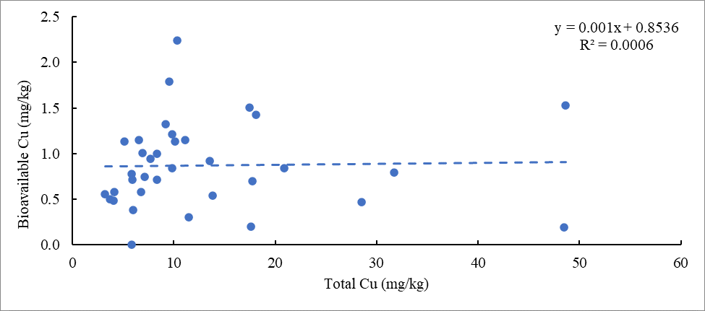
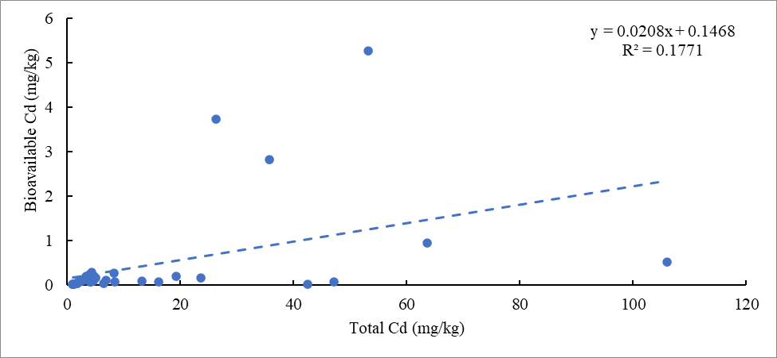
Figure E.1: Total versus bioavailable concentrations of Cd (mg/kg) with linear regression equation and R² for all sample locations
Figure E.2: Total versus bioavailable concentrations of Cu (mg/kg) with linear regression equation and R² for all sample locations

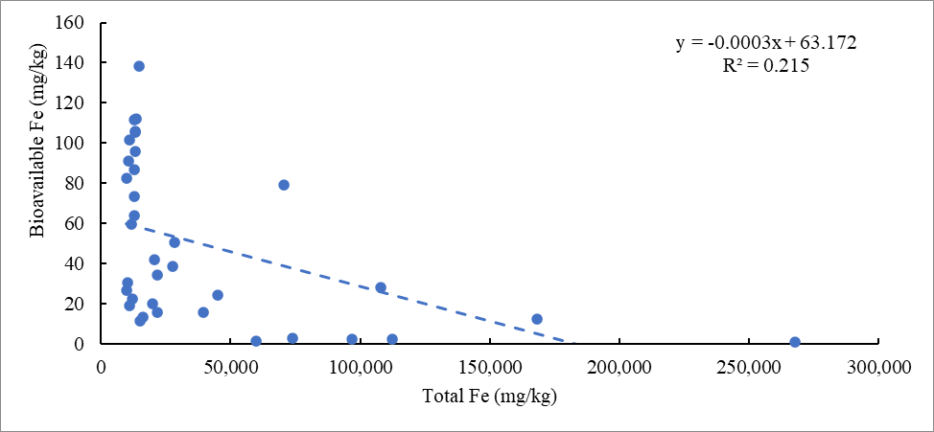
Figure E.3: Total versus bioavailable concentrations of Fe (mg/kg) with linear regression equation and R² for all sample locations
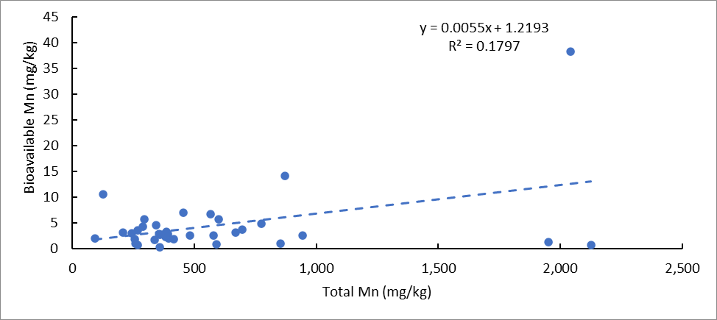
Figure E.4: Total versus bioavailable concentrations of Mn (mg/kg) with linear regression equation and R² for all sample locations

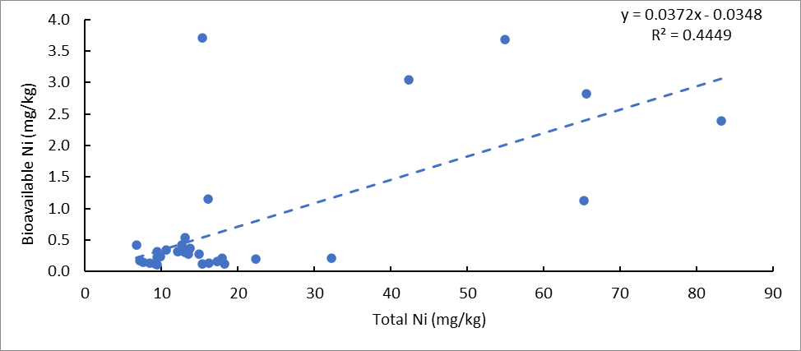
Figure E.5: Total versus bioavailable concentrations of Ni (mg/kg) with linear regression equation and R² for all sample locations
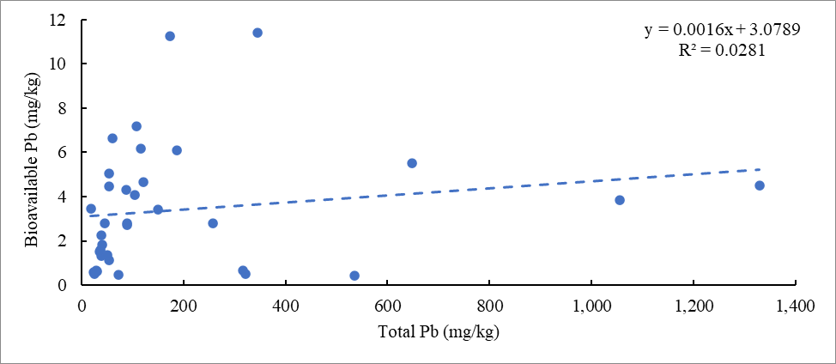
Figure E.6: Total versus bioavailable concentrations of Pb (mg/kg) with linear regression equation and R² for all sample locations

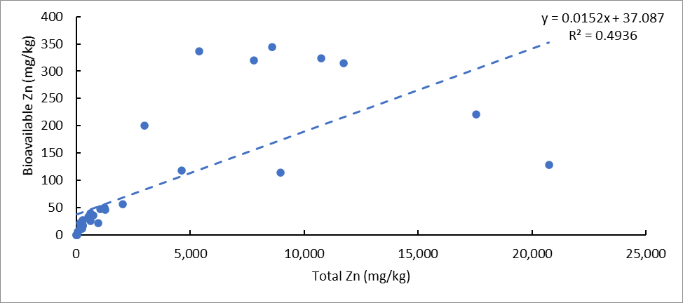
Figure E.7: Total versus bioavailable concentrations of Zn (mg/kg) with linear regression equation and R² for all sample locations

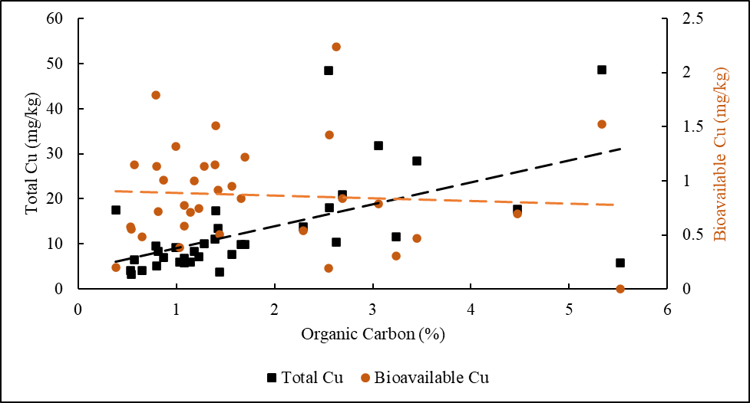
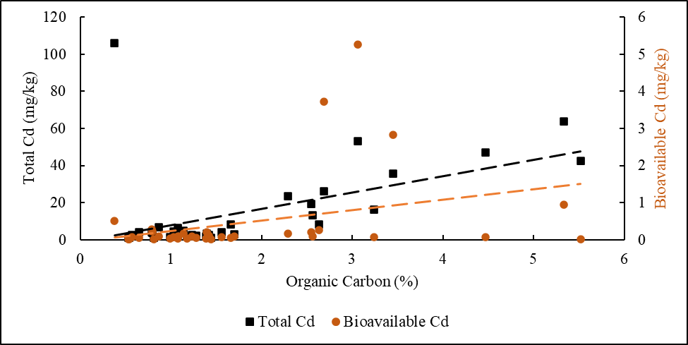
Appendix F: Organic Carbon, Total Fe, and Sediment pH versus total and bioavailable concentrations of Cd, Cu, Fe, Mn, Ni, Pb, and Zn (Chapter 4)
Figure F.1: Organic Carbon (%) as the independent variable plotted against total and bioavailable Cd (mg/kg)
Figure F.2: Organic Carbon (%) as the independent variable plotted against total and bioavailable Cu (mg/kg)
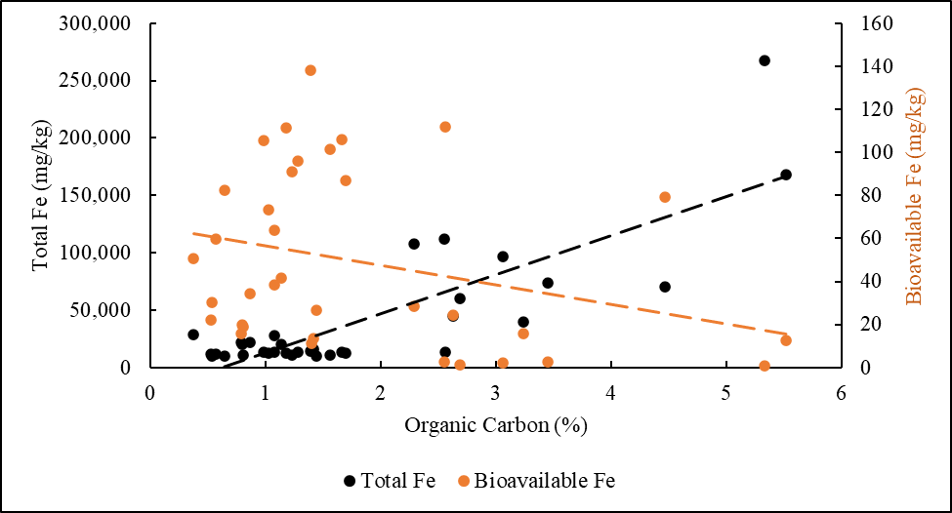
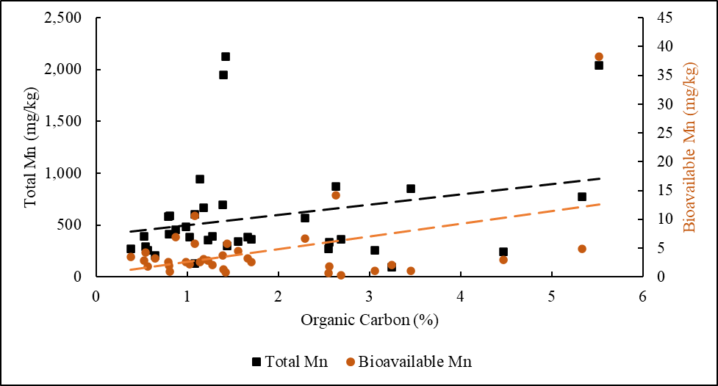
Figure F.3: Organic Carbon (%) as the independent variable plotted against total and bioavailable Fe (mg/kg)
Figure F.4: Organic Carbon (%) as the independent variable plotted against total and bioavailable Mn (mg/kg)

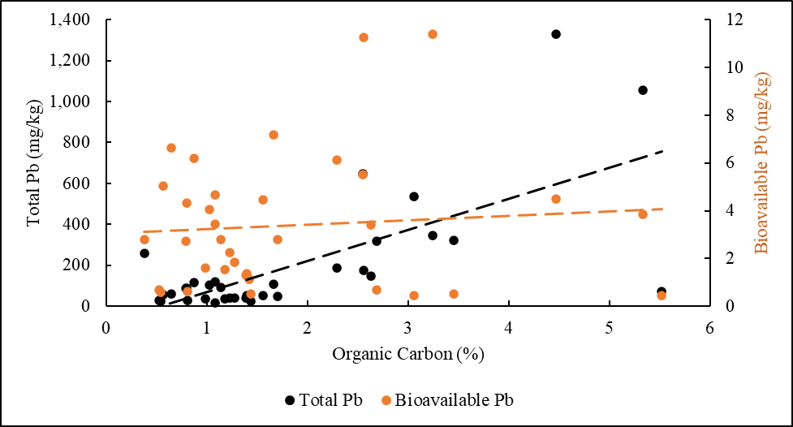
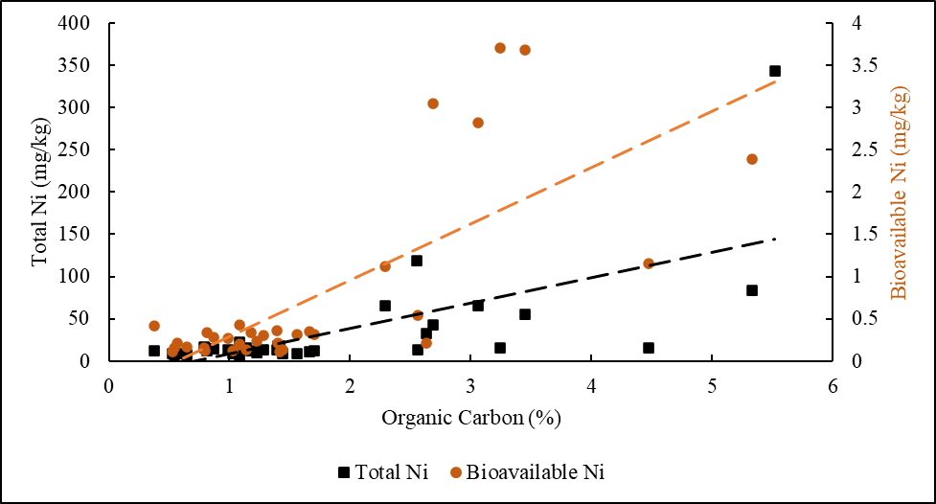
Figure F.5 Organic Carbon (%) as the independent variable plotted against total and bioavailable Ni (mg/kg)
Figure F.6: Organic Carbon (%) as the independent variable plotted against total and bioavailable Pb (mg/kg)

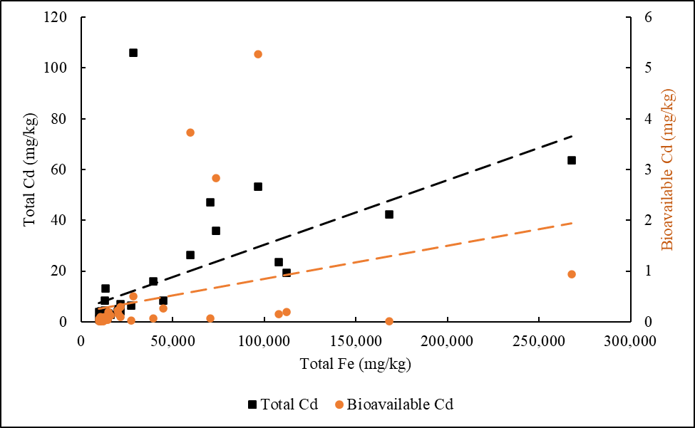
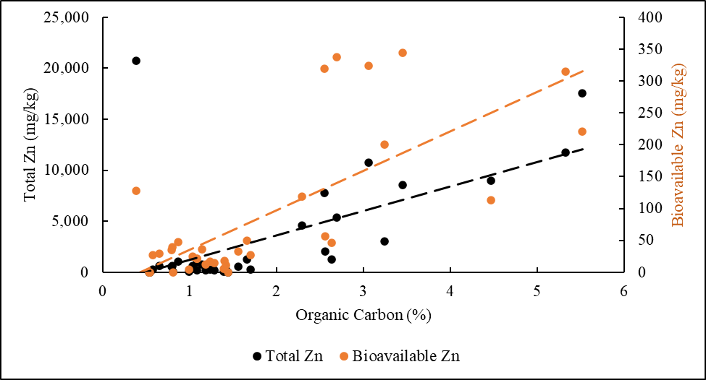
Figure F.8: Total Fe (mg/kg) as the independent variable plotted against total and bioavailable Cd (mg/kg)
Figure F.7: Organic Carbon (%) as the independent variable plotted against total and bioavailable Zn (mg/kg)

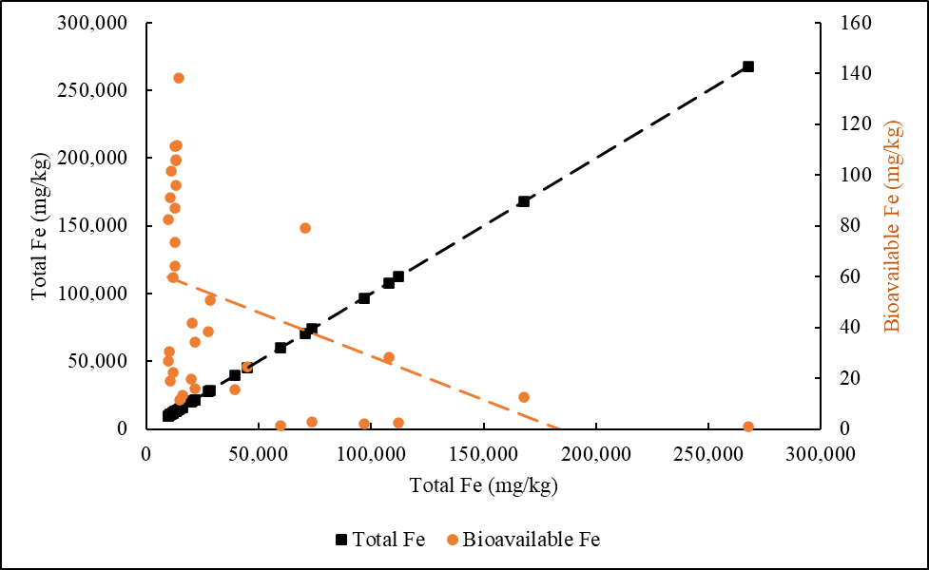
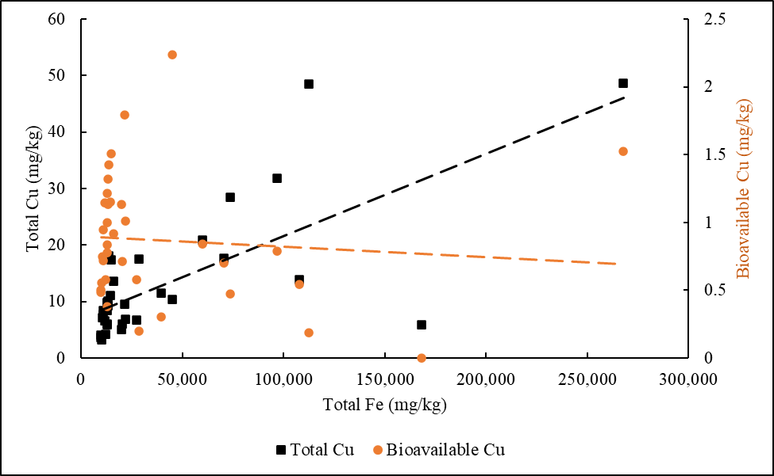
Figure F.10: Total Fe (mg/kg) as the independent variable plotted against total and bioavailable Fe (mg/kg)
Figure F.9: Total Fe (mg/kg) as the independent variable plotted against total and bioavailable Cu (mg/kg)
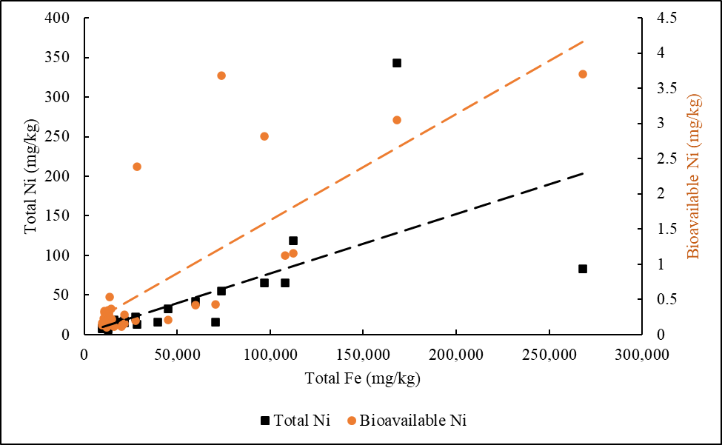
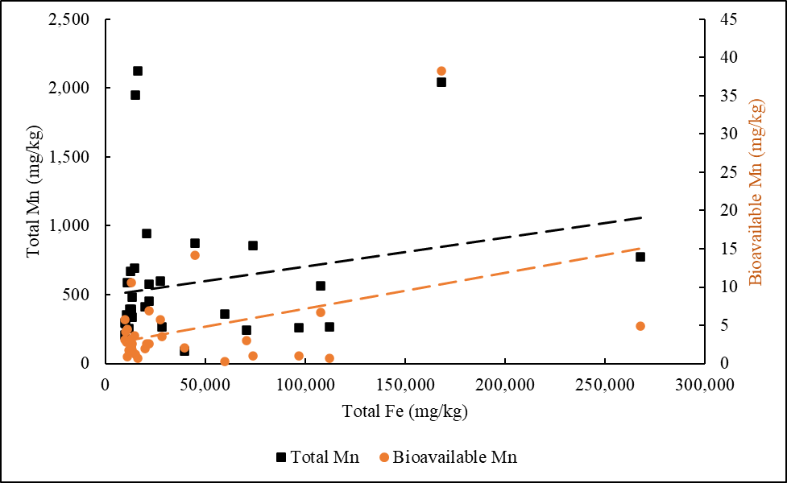
Figure F.12: Total Fe (mg/kg) as the independent variable plotted against total and bioavailable Ni (mg/kg)
Figure F.11: Total Fe (mg/kg) as the independent variable plotted against total and bioavailable Mn (mg/kg)
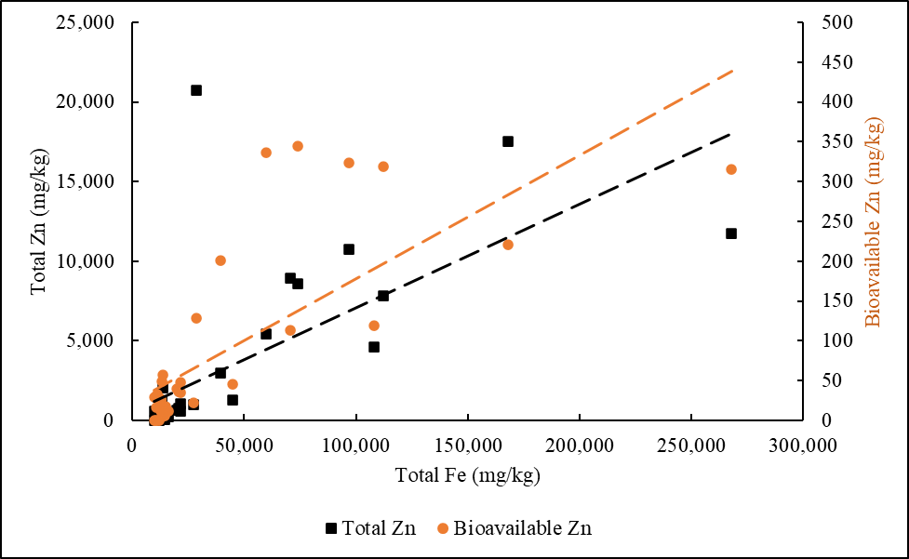
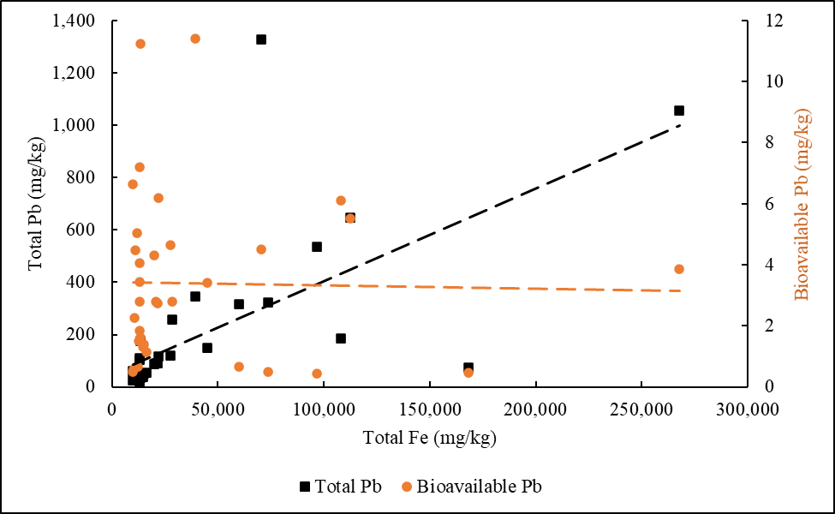
Figure F.14: Total Fe (mg/kg) as the independent variable plotted against total and bioavailable Zn (mg/kg)
Figure F.13: Total Fe (mg/kg) as the independent variable plotted against total and bioavailable Pb (mg/kg)
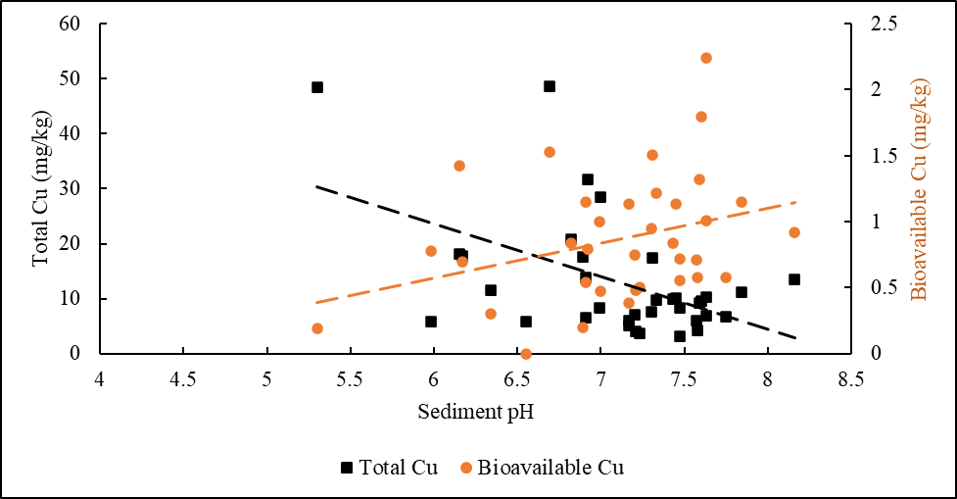
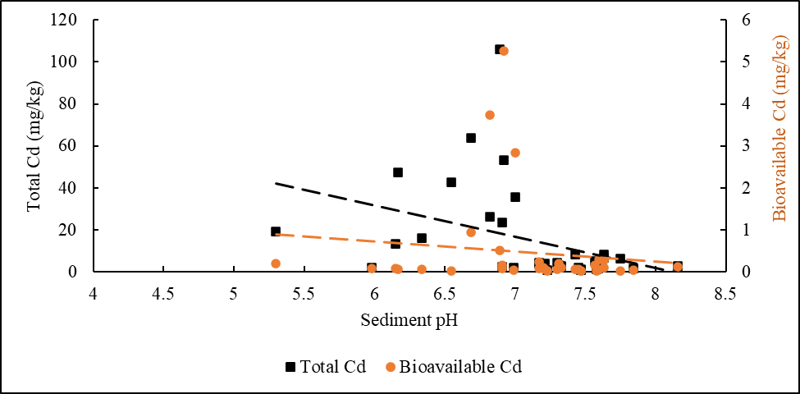
Figure F.15: Sediment pH as the independent variable plotted against total and bioavailable Cd (mg/kg)
Figure F.16: Sediment pH as the independent variable plotted against total and bioavailable Cu (mg/kg)

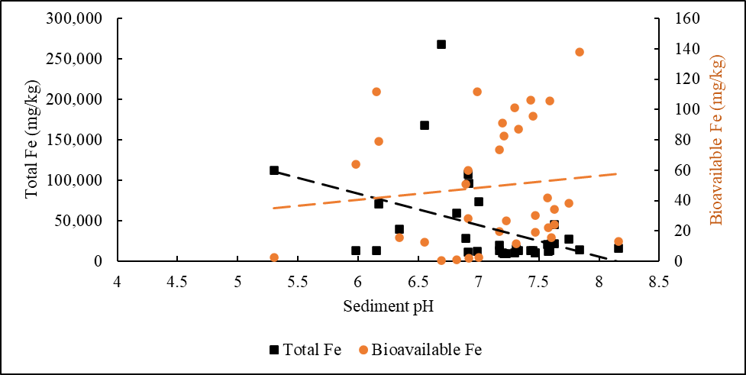
Figure F.17: Sediment pH as the independent variable plotted against total and bioavailable Fe (mg/kg)
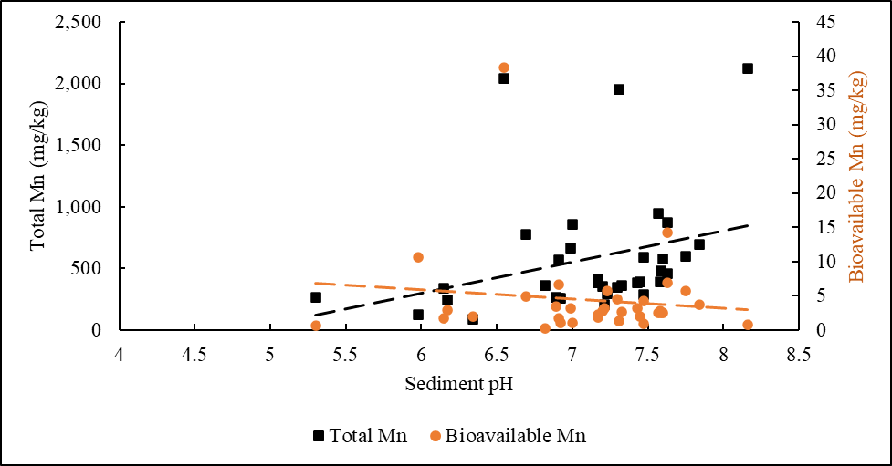
Figure F.18: Sediment pH as the independent variable plotted against total and bioavailable Mn (mg/kg)

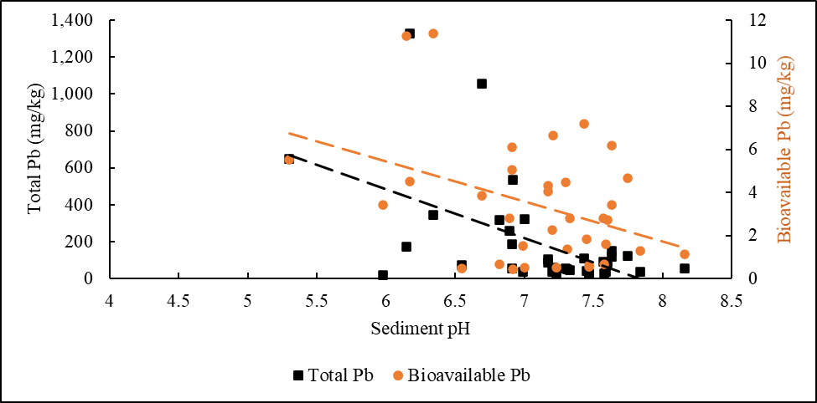
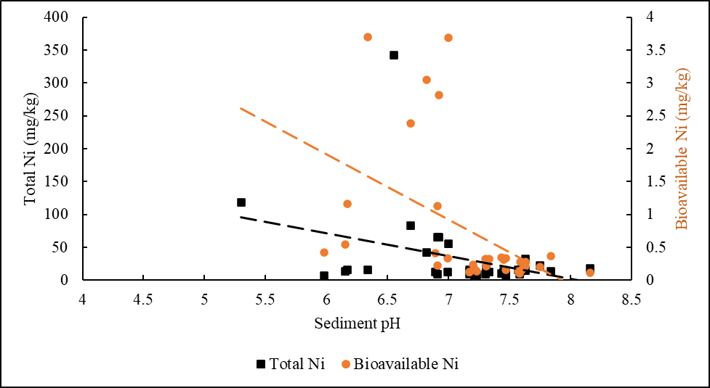
Figure F.19: Sediment pH as the independent variable plotted against total and bioavailable Ni (mg/kg)
Figure F.20: Sediment pH as the independent variable plotted against total and bioavailable Pb (mg/kg)

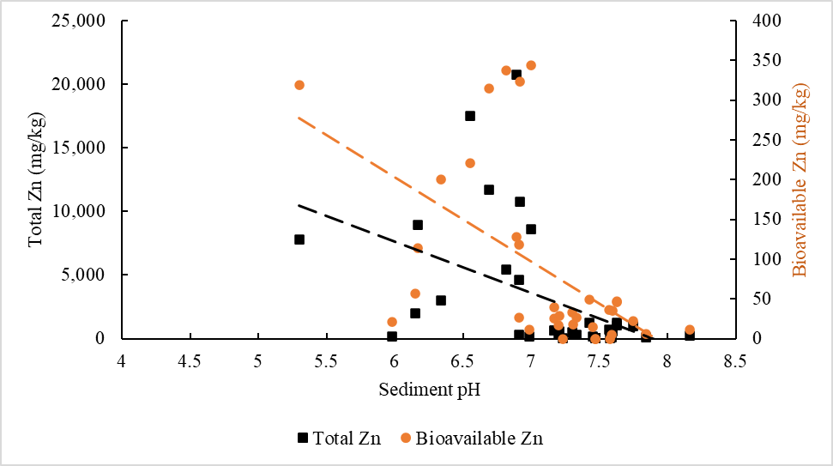
Figure F.21: Sediment pH as the independent variable plotted against total and bioavailable Zn (mg/kg)

