University of Oklahoma

Graduate College

THE INTERSECTION OF WIND ENERGY AND WILDLIFE MANAGEMENT: A CASE STUDY OF PRAIRIE-CHICKENS AND WIND TURBINE SITE SELECTION IN OKLAHOMA

A thesis

submitted to the Graduate Faculty

in partial fulfillment of the requirements for the

Degree of
Master of Science in Environmental Sustainability

By

Ashley nicole ciarlante
Norman, Oklahoma
2018

THE INTERSECTION OF WIND ENERGY AND WILDLIFE MANAGEMENT: A CASE STUDY OF PRAIRIE-CHICKENS AND WIND TURBINE SITE SELECTION IN OKLAHOMA

A thesis approved for the
Department of Geography and Environmental Sustainability

By

Dr. Rebecca Loraamm, Chair

Dr. Travis Gliedt

Dr. Jadwiga Ziolkowska

© Copyright by Ashley nicole ciarlante 2018
All Rights Reserved.

Acknowledgements

I would like to thank my advisor Dr. Rebecca Loraamm, I do not think I would have been able to accomplish this without her guidance. I would also like to thank Dr. Brandi Coyer for allowing me to volunteer in the mammology department of the Sam Noble Museum. This provided me a change of pace and valuable work experience.
I also do not think I would have been able to accomplish this degree without my daily support from my friends. Monica Mustain, my coloring buddy and who helped me with any GIS issues I had. Lora Lapree, my office mate, confidant, and fellow cat lover. Ashley Jorgensen who I shared a summer getting to know and now often have lunch with to discuss graduate school. Daniela Spade, an office mate for a short period of time who I continue to correspond and have lunch with. And finally, my family who have helped me throughout this process.

Table of Contents

Acknowledgments …………………………………………………………………… iv

Table of Contents ……………………………………………………………………. v
List of Tables ………………………………………………………………………… vii
List of Figures ………………………………………………………………………. viii

Abstract ……………………………………………………………………………… ix

Chapter 1: Introduction ………………………………………………………………. 1

Chapter 2: Literature Review ………………………………………………………… 3
2.1 Sustainability Theory ……………………………………………………. 3

2.2 Wind Development in the U.S. …………………………………………... 4

2.2.1 Wind Energy Siting ……………………………………………. 5

2.3 Suitability Analysis ………………………………………………………. 6

2.3.1 Suitability Wildlife Home range………………………………… 8

2.4 Wildlife Management and Habitat Loss ………………………………… 8

2.4.1 Prairie-Chicken Biology and Habitat ………………………… 9

2.4.2 Habitat Loss from Wind Turbine Development ……………… 12

Chapter 3: Research Objectives ……………….…………………………………… 14

Chapter 4: Methods ………………………………………………………………… 15

4.1 Prairie-Chicken Habitat Suitability ……………………………………… 15

4.2 Wind Energy Potential Site Suitability ……………….………………… 20

4.3 Identify Conflict Area …………………………………………………… 24

4.4 Text analysis of Wildlife Management and Wind Energy Policies …… 26

Chapter 5: Results …………………………………………………………………… 30

5.1 Geographic Conflict Site Results…………………………………...…… 30

5.2 Policy Overlap Analysis ……………………………………………….. 34

Chapter 6: Discussion ……………………………………………………………… 43

Chapter 7: Conclusions……………………………………………………………. 49

References ………………………………………………………………………… 52

List of Tables
Table 1……………………………………………………………………………… 16
Table 2……………………………………………………………………………… 18

Table 3……………………………………………………………………………… 21

Table 4……………………………………………………………………………… 23

Table 5……………………………………………………………………………… 31

Table 6……………………………………………………………………………… 32

Table 7……………………………………………………………………………… 34

Table 8……………………………………………………………………………… 36

Table 9……………………………………………………………………………… 37

Table 10……………………………………………………………………………… 39

Table 11……………………………………………………………………………… 41

Table 12……………………………………………………………………………… 42

List of Figures

Figure 1………………………………………………………………………………… 7
Figure 2 ………………………………………………………………………………… 8
Figure 3……………………………………………………………………………… 20
Figure 4 ……………………………………………………………………………… 24
Figure 5……………………………………………………………………………… 26
Figure 6 ……………………………………………………………………………… 31
Figure 7……………………………………………………………………………… 32
Figure 8……………………………………………………………………………… 34

Abstract
The demand for alternatives to fossil fuels has increased over the past couple of years, so it is becoming increasingly important to find alternative energy sources. While wind energy represents one potential alternative energy source, its expansion and development may be problematic for other sustainability efforts such as wildlife management and habitat conservation. One such example is the conflicting relationship between the expansion of wind turbine development in the state of Oklahoma, as it is known to disrupt the management of habitat for the Greater and Lesser prairie-chicken. This thesis explores the conflict between wind energy development and wildlife management by (1) identifying areas of geographic conflict in the state of Oklahoma through a GIS site suitability analysis and (2) conducting a text analysis of existing policies to see if policies mentioned any opposing wind or wildlife policies. The goal of this thesis is to identify areas of intersection between these competing interests in Oklahoma so that wildlife management of species and wind energy development have a way to work together in the future, to ensure the future of wildlife species and wind energy development.
Key words: Greater Prairie-Chickens, Lesser Prairie-Chickens, Wind Energy Turbines, Wildlife Management and Conservation

Chapter 1: Introduction
The intersection of sustainability goals, such as wind energy development and wildlife management, is becoming increasingly important with the increasing demand for renewable energy (Kuvlesky et al. 2007). There have been some studies examining the interactions of wind turbines with the environment, wildlife and humans (Kikuchi 2007, Kuvlesky et al. 2007, Köppel 2014). On one hand, wind energy development is shown to have less environmental impact compared to fossil fuels (Saidur et al. 2011, Jones and Pejchar 2013, Singh et al. 2013), so much so that the United States Department of Energy (DOE) has set a goal of increasing wind power (Jones and Pejchar 2013). There are several federal laws, state laws and regulations on wind energy that need to be considered when building new wind farms. On the other hand, siting of new wind turbines can impact how we manage wildlife that share the same access to this land. In some cases, wildlife managers must sometimes work around these new wind farms to maintain animal populations and work to preserve habitat or food supplies for threatened or endangered species (Oklahoma Department of Wildlife Conservation 2005, Texas Park and Wildlife 2010, The Wildlife Society 2017).
Oklahoma is an excellent example of where these two competing green interests collide. Oklahoma was ranked second nationwide for installed wind capacity and third for total wind generation (AWEA 2013). The Oklahoma Department of Commerce (2009) also notes many currently undeveloped areas have potential for wind development. However, many of those areas potentially overlap with the home range of the Greater and Lesser prairie-chicken, a pair of species listed as “vulnerable” by the IUCN Red List of Threatened Species (BirdLife International 2016). One of the main reasons for this vulnerable listing is that the prairie-chicken home range includes grassland habitats; meaning if the grassland habitats begin to decline from current wind development, so will the prairie-chicken population. It is important for wildlife managers to monitor prairie-chickens in grassland habitats as many other species rely on their conservation. If prairie-chickens are managed and grassland habitats are conserved it will benefit all the other species that rely on grassland habitats.
Prairie-chickens depend on large areas of unfragmented grassland prairie habitat (Fuhlendorf et al. 2002); however, wind development has been shown to fragment grassland landscapes (Drewitt 2006, Braunish et al. 2015). Since both of these efforts constitute sustainability initiatives, there is a need to collaborate to minimize the impact on both alternative energy and conservation initiatives (Kiesecker et al. 2011). Reconciling the efforts of both wildlife conservation professionals and proponents of green energy represents an emerging challenge across Oklahoma’s prairie habitats. Any positive development of sustainable alternatives for this region’s future must effectively consider and anticipate the economic ecological trade-offs associated with policymaking in this delicate situation.
This research will examine the intersection of wind energy development and wildlife species conservation in the state of Oklahoma, specifically looking at the intersection of potential sites for wind turbine development overlapping with prairie-chicken home range in terms of policy and the spatial pattern of development. Specially, this research will first identify current and potential overlap in prairie-chicken habitat and wind turbine development in Oklahoma through a GIS site suitability analysis, then identify potential textual overlap in wind energy development and wildlife management policies. The results will help wildlife managers and wind energy developers reexamine the trade-offs between the two.

Chapter 2: Literature Review
2.1 Sustainability Theory
Sustainability Theory began from the Brundtland Commission in 1987 which defined sustainable development as “development which meets the needs of current generations without compromising the ability of future generations to meet their own needs” (Gibson 2006). Since then, a three pillar approach to sustainability has been established in sustainability literature: society, the economy and the environment (Teodorescu 2012). Teodorescu defines these different relationships in terms of the three pillar approach. An economy-environment relationship puts pressures on the environment of economic activities while an environment-economy relationship represents the economic cost to the environment. The environment-social relationship emphasizes a quality environment and good social standards depending on the pressures it receives from human activities and nature. A social-environment relationship emphasizes that human responsibility that is essential to sustainable efforts. The example I will look at in this research is the environment-economy; where the economic tradeoffs of wind development in the state of Oklahoma versus the environmental impact it carries with respect to prairie-chicken habitat fragmentation will be examined.
Metrics capable of assessing the potential of projects or programs to achieve a sustainable outcome have been developed in literature. Gibson (2006) discusses an eight-point rubric covering basic insights for sustainability assessment. These points consider project factors including the design comprehensiveness, management decision thresholds, policies on corrective action, project considerations for future and secondary outcomes, etc. Sustainability as a project or program pursuit can be captured in a sustainability assessment, often comprised of an audit of four major components. First, decision-makers must give attention to the sustainability requirements by applying decision criteria that meet the core requirements for progress to sustainability. Second, recognizing interdependencies and achieving a benefit for all involved interests is essential. Third, there must be specific sustainability decision criteria and trade-off rules to inform the relevant parties involved. Finally, identifying options for new or continuing tasks, assessing impacts and mitigation possibilities, what should be approved or not, and making adjustments during project implementation.
When it comes to applying sustainability in practice, it is hard to avoid trade-offs and compromises among stakeholders or ecological interests; two approaches used to address trade-offs are rules and processes. Sustainability-based environmental assessments can set general rules and guidelines for decisions on what trade-offs may or may not be acceptable among the interests involved. In developing guidelines, tools such as system analysis, cost-benefit analysis, risk assessment, and others have been developed to examine the trade-offs associated with a management decisions (Gibson 2006).
2.2 Wind Energy Development in the United States
The demand for cleaner and cheaper alternatives to fossil fuels has been driving the need for renewable energy products. The United States Department of Energy has set a goal of increasing wind power to 20% by 2030 (Jones and Pejchar 2013). Wind power plants have less environmental impact compared to fossil fuels (Saidur et al. 2011).
Economic factors must be considered in the development of new wind turbine siting. The United States Department of Energy created a wind energy finance (WEF) application, consisting of an online calculator enabling an economic analysis of wind power projects (National Renewable Energy Laboratory (NREL) 2004). Several economic variables are considered in the inputs for the WEF calculations including the general assumptions of the project, capital cost, operating expenses, financing, tax, economic and financial constraining assumptions (National Renewable Energy Laboratory 2004). This yields the WEF calculation for minimum energy payment to meet financial criteria, leveled cost energy, payback period, net present value, internal rate of return, and a summary of cash flow (National Renewable Energy Laboratory 2004). Oklahoma Wind Power Initiative (OWPI) offers a more localized economic analysis for potential wind development as well (WindIndustry 2014).
Permitting procedures for wind farms also vary among states in the United States. Evaluation of a site’s wind resources permit requirements, cost, and other considerations such as financial structures and plant design are evaluated when determining a wind turbine site along with selecting the optimal wind turbine technology (Anderson and Burns 2013). Federal lands in general require right-of-way or lease permits from the federal land management field office. However, with the site or private lands, regulated permission programs may apply (Jarnevich and Laubhan 2011). Lead agencies vary depending on the project when it comes to typical federal permitting requirements for wind energy projects (AWEA 2008). Depending on the state, some of the agencies in charge of permits might overlap (AWEA 2008). Oklahoma however, as of 2010, is unregulated for permitting authority for wind power projects and no regulation for state environmental review regulations is in place (Anderson et al. 2013).
2.2.1 Wind Energy Siting
Oklahoma has a lot of potential to site new wind energy developments (AWEA 2013). Its wind potential at 80-meter hub height in 2012 was 390,592 MW and the potential at 110-meter hub height in 2012 was 367,984 MW (AWEA 2013). The American Wind Energy Association (2008) created a siting handbook that discusses in detail the siting process of wind turbines. According to this handbook, the first step is to conduct a preliminary site characterization of the possible wind turbine site by analyzing the wind resource to determine the wind speed and reliability within the proposed project site. Then, an initial site visit is conducted to determine any obvious constructability or environmental constraints. Next, establishing the economics, followed by an environmental issue analysis to identify a regulatory framework based on the projected site. Finally, transmission capacity analysis is conducted to determine if the existing system will be able to support the proposed project (AWEA 2008).
Areas with annual average wind speeds around 6.5 meters per second (m/s) and greater at an 80-m height are considered to have a wind resource suitable for wind development (Wind Exchange 2018). It is estimated nineteen states – six Midwestern, six Western, and seven Eastern states have suitable wind resources for wind development (WindExchange 2017). Oklahoma is one of these nineteen states. The wind industry directly and indirectly supported 8,000 to 9,000 jobs in 2016 alone, with a total capital investment of $12.3 billion (AWEA 2013). As of 2016, the total installed wind capacity for Oklahoma is at 7,495 MW, with more potential wind power to be gained. Specifically, the Oklahoma Department of Commerce (2009) has identified Texas/Cimarron counties, Beaver County, Woodward-Buffalo-Alva area, Cheyenne-Arnett area, Weatherford-Hobart area, and Slick Hills as prime areas for wind development. Some of these areas overlap with the home range of the Lesser prairie-chicken. There are at least 250 turbines currently installed in the Lesser prairie-chicken range in Oklahoma; at least 1,300 more turbines have been proposed for the area (Pruett et al. 2009a).
2.3 Suitability analysis
GIS suitability analyses allow for potential candidate sites to be quantified, compared, and ranked. There are binary suitability analyses where results are defined as true or false, meaning that an area can only be suitable or unsuitable, and the area has to be one or the other; any particular location cannot be considered both suitable and unsuitable at the same time or place (Qiu et al 2014). A binary suitability analysis can result in an area being suitable or unsuitable. A binary suitability analysis uses Boolean intersection logical overlays, where all individual suitability criteria are converted to Boolean true “1”/false “0” values of suitability. Figure 1 demonstrates using Boolean-AND overlay analysis for an example where an elevation layer and vegetation layer are inputs. The resulting layer shows what occurs as a results when a Boolean-AND overlay analysis used. For any particular location, if any of the requirements used in a binary analysis are not met, the area is considered unsuitable. The land at any particular location is considered suitable only if all of the requirements are met. If any of the requirements are not met, the area is considered unsuitable. A binary analysis excludes the possibility of capturing between-class overlap in habitat. A binary analysis does not allow for a ranking of sites either. Instead, the results of this method are simple to interpret and implement, which can be appealing to decision makers because the results provide a clear-cut set of boundary results.
Elevation |  |  |  | Vegetation |  |  |  | Results
0 | 1 | 0 |  | 1 | 1 | 0 |  | 0 | 1 | 0
1 | 0 | 1 | AND | 0 | 1 | 1 | = | 0 | 0 | 1
0 | 1 | 0 |  | 0 | 1 | 0 |  | 0 | 1 | 0

Figure 1: Boolean-AND overlay analysis illustrations to demonstrate the results when two layers such as elevation and vegetation are multiplied together on a cell-by-cell bases.
A ranking suitability analysis allows for the ranking of candidate sites based on the criteria selected. The ranking of criteria identifies which areas of land based on criterions are more suitable and which are less suitable (Qiu et al. 2014). This approach converts binary suitability values into a numerical scale to represent relative suitability rankings. The method used to convert the values is called reclassification. Once the input values have been reclassified based on which criteria are suitable or not suitable, the criteria are compared by adding the layers together. Figure 2 shows an example of a ranking overlay, with reclassified input layers of (reclassified based on their relative suitability) including slope and land cover being added and together to provide the result.
0 | 1 | 0 |  | 2 | 1 | 0 |  | 2 | 2 | 0
2 | 1 | 0 | + | 1 | 1 | 2 | = | 3 | 2 | 2
1 | 1 | 2 |  | 2 | 1 | 0 |  | 3 | 2 | 2
Reclassified Slope Reclassified Land Cover Ranking

Figure 2: Adding slope and land cover layers on a cell-by-cell level to obtain the results. The results then will be defined as 0 = unsuitable, 1 = possible suitability, 2 = some suitability, 3 = best suitability.

2.3.1 Suitability Wildlife Home range
Habitat suitability is defined as the habitat’s potential to support a particular species (Kellner et al. 1992). Habitat suitability analysis utilizes Habitat Suitability Indexes (HSI) which range habitat from 0 meaning habitat is unsuitable to 1 for optimal habitat. HSI models are associated with structural features of the habitat. Models identifying habitat areas are identified after suitable habitat is identified (Poor et al. 2012). Habitat suitability models are used in creating species distribution maps, identifying movement pathways, and identifying priority habitat areas for habitat restoration or reintroduction of species.
Different species differ in their home ranges, in terms of habitat requirements and spatial extents (Powell and Mitchell 2012). A home range provides food, avoidance of or protection from predators, and other resources. Habitat selection, territorial overlap, and movement impacts can be studied through analysis of an animal’s home range. Simple calculations of home ranges, such as identifying suitable potential areas, often represent areas of an animal’s potential movement (Downs and Horner 2009).
2.4 Wildlife Management and Habitat Loss
Wildlife management encompasses managing the land for a given species (The Wildlife Society 2017). Specifically, wildlife managers maintain publicly owned lands and provide landowners with wildlife management plans, and help manage private lands as well. A part of wildlife management is habitat control or habitat management. One example in Oklahoma specifically involves wildlife managers preventing habitat loss from occurring within their managed lands by converting invasive plant areas to native prairie habitat, increasing use of prescribed burns on the landscape, promoting erosion control, and removing exotic animal and plant species (Oklahoma Department of Wildlife Conservation 2005). The Oklahoma Department of Wildlife Conservation (ODWC) maintains a detailed and comprehensive wildlife conservation strategy that outlines these conservation efforts for different regions within Oklahoma including the shortgrass prairie, mixed-grass prairie, and tallgrass prairie (2005).
While habitat fragmentation and loss that affect wildlife through changes in habitat quality and composition may occur naturally, humans have a role in manipulating the landscapes as well; many of which have increasingly served as a source of habitat change and some with an overall negative effect on wildlife (The Wildlife Society 2017). Fragmentation and habitat loss often isolate suitable areas of habitat, preventing wildlife from moving back and forth between patches which can lead to inbreeding, limited access to resources, and increased mortality rates for certain species (The Wildlife Society 2017).
2.4.1 Prairie-Chicken Biology and Habitat
Greater prairie-chickens are medium-sized ground birds that are 16 to 18 inches in length and weigh 25 to 42 ounces (Elmore et al. 2017). Their current home range spans from the Flint Hills of Kansas and Oklahoma, northern Kansas, to central areas in Nebraska and South Dakota with scattered populations in the northern Great Plains and northeastern Colorado (Elmore et al. 2017). It is estimated that Greater prairie-chickens occur in ten to 25% of their historic range (McNew et al. 2014). A decrease in available suitable habitat is the leading factor in their declines and isolation. Isolation of this species from other prairie-chicken populations has caused low genetic diversity and has decreased fitness (Westemeier et al. 1998).
Historically, Greater prairie-chickens range in the 1800s expanded north and west, and shifted the distribution to suitable grasslands from as far north as Alberta and westward to northeastern Colorado (Robb and Schroeder 2005a). These animals have been known to occupy grassland habitats from eastern Ontario west toward central Alberta in Canada, North Dakota south toward Texas-Louisiana border and eastern parts of Colorado toward Ohio and west Kentucky of the USA (Ross et al. 2006). In the early 1800s Greater prairie-chickens were uncommon in Kansas, but by 1870 they reached Fort Hays and by 1897 they were reported in Colorado (Robb and Schroeder, 2005a). This shift in geographic distribution is believed to be related to the removal of bison from the grasslands/prairies (Ross et al. 2006). It has been estimated that during the last 30 years’ Greater prairie-chickens have generally declined throughout their geographic distribution. Oklahoma was estimated to have 130,000 Greater prairie-chickens around 1968 and in 1997 the estimate was 1,500 birds (Robb and Schroeder, 2005a). In 2006, their distribution is restricted to 11 US states with only four states containing populations larger than 5,000 breeding birds (Kansas, Nebraska, South Dakota, and Colorado) while the other 7 (North Dakota, Minnesota, Wisconsin, Illinois, Missouri, Iowa, and Oklahoma) are reduced in numbers (Ross et al. 2006).
Greater prairie-chickens occupy mesic prairie habitats which include tall grass prairie compared to the Lesser prairie-chickens which occupy more xeric habitats which include prairies dominated by mixed-grasses, sand sagebrush or sand hennery oak (Winder et al. 2014). Greater prairie-chickens are primarily dependent on grasslands, but can be found in other habitat types throughout the year to meet their seasonal needs. When a small population is isolated from other populations however, the habitat requirements and behavior may differ from one population to the next (Wildlife Habitat Council 2005). Hovick et al. (2015) determined that landscapes with higher elevation consisting of grassland vegetation and low anthropological encroachment are the most suitable habitat for Greater prairie-chickens. As fragmentation increases in this suitable area, Greater prairie-chicken populations have been known to decline (Hovick et al. 2015).
Lesser prairie-chickens are smaller than Greater prairie-chickens and stand 15 to 16 inches in length and weigh 22 to 29 ounces (Elmore et al. 2017). Historically, they occupied the southeast section of Colorado, the southwest parts of Kansas almost to the geographic center, the western third of Oklahoma, northeast to southeast New Mexico, and parts of Texas. The current range of Lesser prairie-chicken, which does not overlap Greater prairie-chickens ranges, is in eastern New Mexico, west Texas, northwestern Oklahoma, western Kansas, and southeastern Colorado (Elmore et al. 2018). Historically, for Oklahoma Lesser prairie-chickens were common throughout the western third of the state and they are found in 12 northwestern Oklahoma counties. It was estimated that during the 1800s the geographic distribution of Lesser prairie-chickens encompassed 358,000 km², by 1969 the area had been reduced to 125,000 km², and 27,300 km² by 1980 (Robb and Schroeder, 2005b). The Lesser prairie-chickens historical home range has decreased by ten percent and their population by five percent (Horton et al. 2010).
Suitable habitat for Lesser Prairie-Chickens includes mixed-grass prairie, tallgrass prairie, sandhills prairie, shortgrass, prairie, sandsage, shiner, and wet meadow (Horton et al. 2010). Lesser prairie-chickens will select a habitat based on the composition of grasses and forbs because these areas provide a limited disturbance level and low risk of predation along with a favorable microclimate (Larsson et al. 2013). As such, land management practices for this species focus on restoration of these specific grasses.
2.4.2 Habitat Loss from Wind Turbine Development
Typically, a clearing of 150 to 250 feet around a wind turbine tower is needed to prepare a site for construction (AWEA 2008). These installations can result in small habitat loss directly by land conversion or indirectly by species, including the prairie-chicken, avoiding the area all together (Gasparatos et al. 2017). Displacement of these species from 100 to 200 meters can occur (Pearce-Higgins et al. 2012). While displacement effects vary by site (Pearce-Higgins et al. 2012), a habitat loss of two to five percent of the total development area with wind turbines is typical (Drewitt and Lanston 2006). Due to collision mortality and collision risk, as well as habitat loss, features associated with traits related to wind farm should be evaluated individually (Drewitt and Lanston 2006).
One way to measure potential habitat loss is through the use of Geographic Information Systems (GIS) habitat suitability analysis. GIS has been used (Stoms et al. 1992, Rickers et al. 1995, Kar and Hodgson 2008) to overcome some of the issues in developing, applying, and evaluating practical habitat models, to gain new and efficient means of assessing habitats, and to examine the development and application of a proximity-based habitat model using GIS (Rickers et al. 1995). These issues include lack of data available to characterize large areas of habitat, complications surrounding species-specific modeling requirements, etc. GIS can be applied to develop new and efficient methods to assess habitat, provide a flexible methods useful under different management scenarios, ways to compile and standardize habitat inventory data, analyze any spatial patterns, and visualize habitat information as maps of habitat (Rickers et al 1995).
Johnson et al. (2006) conducted GIS habitat analyses for Lesser prairie-chicken conservation planning in New Mexico. This study compared suitable Lesser prairie-chicken habitat in New Mexico and identified unsuitable habitat available for oil and gas activities. This study used Landsat Enhanced Thematic Mapper+ (ETM+) and digital orthophoto quadrangles (DOQs), a type of satellite imagery, to create habitat maps. In order to determine suitable areas Johnson et al. (2006) identified areas of suitable habitat by preforming a patch size analysis.
While no literature shows the comparative overlap approach employed in this research has been done before in Oklahoma, a similar GIS multi-criteria approaches have been used to look at the overlap between prairie-chicken habitat and wind energy development. Horton et al. (2010) Spatially-Based Planning Tool Design to Reduce Negative Effects of Development of the Lesser Prairie-Chicken (Tympanuschus pallidicintus) in Oklahoma provides a ranking value of habitat for Lesser prairie-chickens within the historical range of Oklahoma. Horton et al. (2010) shares similarities when examining criteria for prairie-chicken suitability in Oklahoma. Miller and Li (2014) examined GIS-based multi-criteria approaches to identify areas that are best suited to wind energy development in Northeast Nebraska and share similarities with criteria for wind energy site suitability in Oklahoma.

Chapter 3: Research Objectives
Pruett et al. (2009b) discusses how studies of the possible environmental impacts of wind farms on grassland species cannot keep up with the pace of wind turbine development. Wind turbines can often be built in less than six months without formal environmental impact assessments. There is a need to conserve short and mixed-grass prairies and restore habitat between populations of prairie-chicken that are impacted by wind development in prairie-chicken currently and historically occupied areas. The prairie-chicken is being used as an umbrella species to benefit nontarget taxa found in short and mixed-grass prairies of the Great Plains area of the United States. Wind development is a useful step toward addressing the issue of greenhouse gas emissions. The development of wind should be balanced against the potential negative effect on wildlife especially sensitive species like prairie-chickens.
While both wind energy development and wildlife management and conservation are seen as green objectives, their interests do not always align. One can see this competition in the case of Oklahoma with the interaction of wind turbines and prairie-chickens. My research will look at this intersection of wind energy development and wildlife management, with the intent to (1) identify current and potential geographic overlap in wind turbine development and prairie-chicken habitat in Oklahoma through a GIS site suitability analysis, (2) identify potential text overlap in wind energy development and wildlife management policies.

Chapter 4: Methods
To address research objective one, this study conducted binary and ranking GIS suitability analyses (Johnson et al. 2006, Qiu et al 2014, Hovick et al. 2015) to identify where prairie-chicken habitat and potentially suitable areas for wind development overlap. ArcGIS (ESRI 2018), was used, to generate 3 maps: 1) a binary site suitability map for prairie-chicken habitat in Oklahoma, 2) a binary site suitability map for areas suitable for wind energy development in Oklahoma, and 3) a ranking map using the results of the previous two to identify areas with conflict between wind potential and prairie-chicken habitat.
Current literature was consulted to determine suitable criteria for each, then various GIS layers were acquired through several GIS data repositories to match these criteria in Oklahoma. These suitability criteria and GIS data layers are summarized with their corresponding sources. Each data layer was then converted into binary values based on a set of suitability thresholds. Then, through a series of raster math overlays, the suitable area interest was narrowed down in GIS. The resulting layers were used to construct the three maps previously described.
The process used in this research creates a generalized model using key indicators from the literature for each sustainable criterion. This model has not been optimized for Oklahoma, nor does it consider some of the specialized tools created and made available by wind energy development companies or wildlife conservation departments.
4.1 Prairie-chicken Habitat Suitability
A set of 6 criteria were chosen for modeling the suitability of prairie-chicken habitat, including elevation, transmission lines, oil and gas wells, major roads, vegetation type, and wind turbines as represented in Table 1. The criteria selection was based on a comprehensive literature review and is constructed from those criteria deemed relevant and critical to habitat suitability for prairie-chickens in Oklahoma. For this analysis, criteria affecting both Greater and Lesser prairie-chickens were treated as a single set of criteria. All of the data was confined to the study area.
Table 1. Criteria used to model prairie-chicken habitat suitability – the range describes each criteria’s buffer distance used to determine prairie-chicken habitat suitability, along with the criteria source and the GIS dataset type.
Criteria | Range | Source | GIS data
Elevation | The prairie-chicken range was 204 to 1,230 meters | Woodward et al. 2001 and Hovick et al. 2015 | United States Geography Survey (USGS) Digital Elevation Models (DEM)
Transmission lines | Prairie-chicken avoid transmission lines by 100 meters | Pruett et al. 2009a | Homeland Infrastructure Foundation-Level Data (HIFLD)
Oil and gas wells | Prairie-chicken avoids oil and gas wells. A 500 meter buffer is a common distance within which many species are affected by disturbance | McNew et al. 2014 and Jones and Pejchar 2013 | Energy Data Exchange (EDX)
Major roads (highways) | Prairie-chicken avoid roads by 100 meters | Pruett et al. 2009a | TIGER/Line Shapefile
Vegetation type | Prairie-chicken uses prairie and/or grasslands | Horton et al. 2010 and Winder et al. 2014 | Oklahoma Department of Wildlife Conservation
Wind turbines | Wind turbines fragment land and prairie-chicken require unfragmented land | Drewitt and Lanston 2006, Pearce-Higgins et al. 2012, and Hovick et al. 2015 | ESRI

Prairie-chickens are found within a certain range of elevation. Woodward et al (2001) determined that Lesser prairie-chickens are found at the elevation range of 460 to 1,525 meters. Hovick et al. (2015) determined Greater prairie-chickens are found at the elevation range of 204 to 1,230 meters. The elevation where there was an overlapping range was 460 to 1,230 meters between these two findings. However, when examining the northeastern section of Oklahoma, which is part of the Great prairie-chicken current home range, the Digital Elevation Models (DEMs) elevation is not above 460 meters. Thus, if an elevation of 460 meters for the overlap range was used, it would show there were not prairie-chickens present when Greater prairie-chickens had indeed been found in this area. In order to solve this issue, the range selected was set to 204 to 1,230 meters. Any elevation from 204 to 1,230 meters was considered suitable and all other elevation values were considered unsuitable. This data was classified to show elevations within the range of 204 to 1,230 meters as 1, and outside this range as 0.
Transmission lines can cause mortality when animals collide with power lines, possibly cause further fragmentation of landscape, animal avoidance of human-made structures, and potential areas for prey to lay in wait (Pruett et al. 2009a). Pruett et al. (2009a) also showed a similar avoidance of roads by prairie-chickens. Prairie-chickens avoid transmission lines and roads by a margin of 100 meters (m), thus a buffer of 100 m is needed around transmission lines and roads for suitable prairie-chicken habitat. The data was classified within the 100 m buffer as 0 and outside the 100 m buffer as 1.
Oil and gas well sites provide structures that can be used as perches by corvids or raptors who could prey on prairie-chickens (McNew et al. 2014). Prairie-chickens avoid these areas due to them being man-made structures as well as possible sites for predators. No data was found on the margin of avoidance of oil and gas wells by prairie-chickens. Jones and Pejchar (2013) use a 500-meter buffer on their oil and gas well sites analysis because it is a common distance which many species are affected as a result of disturbance. In my analysis, I used a 500-meter buffer on oil and gas well sites based on the Jones and Pejchar (2013) study. This data was classified as within the 500 m buffer as 0 and outside the 500 m buffer as 1.
The vegetation criteria for prairie-chicken habitat that was selected was based on the literature. Greater and Lesser prairie-chickens depend on large areas of unfragmented grassland habitat (Pruett et al. 2009a). Greater Prairie-Chickens occupy mesic prairie habitats which include tall grass prairie (Winder et al. 2015). Lesser Prairie-Chickens occupy in more xeric habitats, including prairies dominated by mixed-grasses, sand sagebrush or sand hennery oak (Winder et al. 2015). Other suitable habitat includes mixed-grass prairie, tallgrass prairie, sandhills prairie, shortgrass prairie, sandsage, shiner, and wet meadow (Horton et al. 2010). This data was classified as any listed vegetation type of prairie and or grasslands as 1 and all other vegetation types as 0.
Wind turbine sites cause land fragmentation and can displace species 100 to 200 meters (Pearce-Higgins et al. 2012) and result in a habitat loss of two to five percent of the total area developed by wind turbines (Drewitt and Lanston 2006). Manville (2004) recommends wind turbines not be placed within 8 km of known leks or breeding sites. Thus, an 8 km buffer was used around wind turbine sites. This data was classified that the area within the 8 km buffer as 0 and the area outside the 8 km buffer as 1.
Criteria | Binary values | Data | Data Source
Elevation | 1 = 460 – 1230 meters  0 = 0 > 460 and > 1230 meters | DEM | USGS DEM
Transmission lines | 1 = > 100-meter  0 = 0 > 100 meter | Line | HIFLD
Oil and gas wells | 1 = > 500-meter  0 = 0 > 500 meter | Point | EDX
Major roads (highways) | 1 = > 100-meter  0 = 0 > 100 meter | Line | TIGER/Line Shapefile
Wind turbines | 1 = > 8-kilometer  0 = 0 > 8 kilometer | Point | ESRI
Vegetation type | 1 = Arbuckle: Prairie/Pasture, Arkansas Valley: Prairie/Pasture, Arkansas Valley: Sandy Prairie/Pasture, Blackland: Pasture/Prairie, Canyon: Grassland, Canyon Gys Grassland, Central Mixedgrass: Prairie/Pasture, Central Mixedgrass: Sandy Prairie/Pasture, Crosstimbers: Pasture/Prairie, Crosstimbers: Sandyland Shrubland and Grassland, Flint Hills: Tallgrass Prairie/Pasture, Grand Prairie: Prairie/Pasture, High Plains: Mesquite Shurbland, High Plains: Sand Prairie, High Plains: Shortgrass Prairie, High Plains: Tallgrass Prairie, Osage Plains: Tallgrass Prairie/Pasture, Ozark-Ouachita: Pasture/Prairie, Post Oak Savanna: Pasture/Grassland, Post Oak Savanna: Sandyland Shurbland and Grassland, West Gulf Coastal Plain: Northern Calcareous Prairie/Pasture  0 = All other vegetation | Polygon | Oklahoma Department of Wildlife Conservation
Table 2. Defined the binary values for each criterion, the data form the original data was in, as well as the data source.

All layers were projected into the Albers Equal Area Conic coordinate system, then clipped to the state of Oklahoma, and converted into raster data structure for analysis. After this analysis data conversion to raster, the criteria layers were then reclassified. Binary values of 1 for suitable and 0 for unsuitable were used in order to support a binary suitability analysis; this is demonstrated in Table 2. The value of 1 represents that the criteria are suitable for prairie-chicken habitat, and 0 represents that the criteria are unsuitable for prairie-chicken habitat.
The binary criteria for the model were combined using the Boolean-AND operation in ArcGIS, where each layer was combined together. Boolean-AND operations return an output value of 1 if both input values are true and if one or both input values are false, then the output is 0 (ESRI 2018). This means that a Boolean-AND operation returns a value of 1 if and only if both input values are 1. So, only those areas found to be suitable for all criteria are considered suitable and will be reflected as “suitable” in the final product. All layers were overlaid and compared using this Boolean-AND logic. The final results characterize suitable prairie-chicken habitat in Oklahoma. Figure 3 shows a flow chart for the approach modeling suitability for prairie-chicken used in this research.

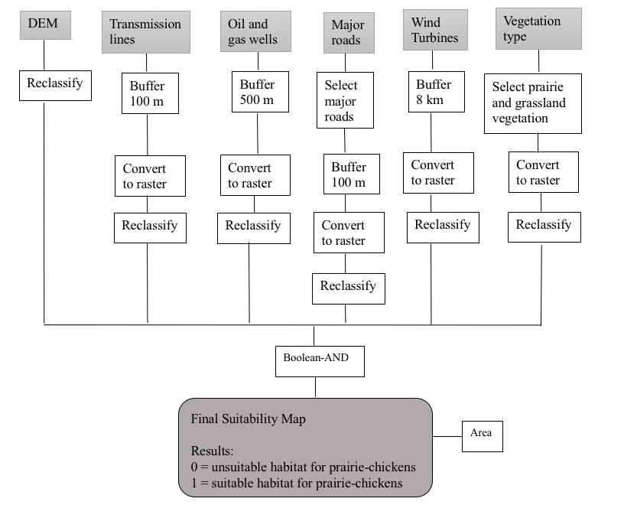
Figure 3. Flowchart for modeling suitability for prairie-chicken habitat. The final suitability map is the state determining if the habitat is suitable or unsuitable in Oklahoma.
4.2 Wind Energy Potential Site Suitability
A set of 7 criteria were chosen for modeling site suitability for wind development, including slope, existing wind turbine, water, land use – urban, wind energy potential, Oklahoma Wind Energy Development Act factors (such as the presence of airports, public schools, and hospitals), and railroads represented in Table 3. The criteria selection was based on a comprehensive literature review and is constructed from those criteria deemed relevant and critical to wind turbine suitability for sites in Oklahoma.

Table 3. Wind turbine site suitability criteria where the range describe the criterion use to determine suitability. Literature sources for the criteria threshold and GIS datasets are shown as well.
Criteria | Range | Source | GIS data
Slope | Wind turbines can only be built on surfaces with less than 20% slope | The Nature Conservancy 2017 | USGS DEM
Wind turbines | Cannot be built within 1.6 km of existing wind turbines | The Nature Conservancy 2017 | ESRI
Water | Cannot be placed in water: river, streams, lakes | The Nature Conservancy 2017 | Oklahoma Water Resource Board
Land Use | Cannot be built in urban or developed areas | The Nature Conservancy 2017 | TIGER/Line  National Land Cover Database (NLCD)
Wind Energy Potential | Categories wind potential 2-7 for suitable wind development. | The Nature Conservancy 2017 | Data.gov
Oklahoma Wind Energy Development Act | The 2015 Oklahoma Development Act mandates wind turbines not be placed within 3 km of airport runways, public schools, and hospitals | The Nature Conservancy 2017 | Airport: Federal Aviation Administration  Schools: okmap.org  Hospitals: HIFLD
Railroads | Cannot be placed on railroads | Miller and Li 2014 | TIGER/Line
Wind turbines can only be built on surfaces with a slope of less than 20% (The Nature
Conservancy 2017). 25 individual DEMs that covered the state of Oklahoma were projected to
Albers Equal Conic coordinate system. The individual DEMs were combined using mosaic to
new raster, and a slope analysis was conducted on the combined DEM.
Wind turbines cannot be built within 1.6 km of existing wind turbines (The Nature Conservancy 2017). A buffer of 1.6 km was applied to all existing wind turbines in Oklahoma. This data was classified that the areas within the 1.6 km buffer were 0 and the areas outside the 1.6 km buffer were 1. The Nature Conservancy (2017) stated wind turbine sites cannot be placed in water, Oklahoma rivers, lakes, and streams were used for this criteria. This data was classified as any data designated as water as 0 and any area not designated as water as 1. Land designated as urban or developed are not considered suitable for wind turbine placement (The Nature Conservancy 2017). Land cover designated as urban or developed was considered unsuitable and the rest of the land was considered suitable.
Areas with annual average wind speeds of less than 6.5 m/s at 80 m height may not be suitable for wind development (The Nature Conservancy 2017). However, data for wind energy potential (wind speeds) at 80-meter height was not publicly available. While wind speed is crucial for estimating turbine performance it is not necessarily the height of the wind turbine (AWEA 2018) that corresponds to a turbine’s available and/or required wind speed for operation. For example, small wind turbines require an annual average wind speed greater than 4 m/s or 9 mph. Average annual wind speed of 6 m/s or 13 mph are required for utility-scale wind turbines. The only publicly available wind potential data found for this research, depicted potential at a 50-meter height and used class categories between 1-7 to group the available values. At the 50-meter heights, the wind speed for category 1 was 5.6 m/s and for category 2 was 6.4 m/s (Anchor Environmental, L.L.C 2004). NREL classified wind potential at 50-meter heights, with class 1 areas was generally not suitable for wind development. Class 2 areas may not be suitable for rural applications and are marginal for utility-scale applications. Class 3 or greater areas suitable for utility-scale wind turbines. For my analysis, I used wind categories 2 – 7 as suitable and category 1 as unsuitable.
The 2015 Oklahoma Development Act mandates wind turbines not be built within 3 km of airport runways, public schools, and hospitals (The Nature Conservancy 2017). For this analysis, buffers of 3 km were placed around airports, public schools, and hospitals. This data was classified as within the 3 km buffer as 0 and outside the 3km buffer as 1. Based on findings in Miller and Li (2014), railroads were buffer at 100 meters as a criterion for wind turbine site selection. Areas within 100 meters of a railroad were considered not suitable (0) for wind turbines, where areas outside the 100-meter buffer were considered suitable for this criteria.
All wind turbine criteria layers were projected into Albers Equal Area Conic, then clipped to the state of Oklahoma, and converted into a raster data structure. After the data conversion to raster, the criteria were then reclassified based on the thresholds discussed here. Binary values of 1 and 0 for each criteria used in the site suitability analysis are listed Table 4. A value of 1 represents that the criteria are suitable for wind turbine sites and a value of 0 represents that the area is unsuitable for wind turbine development.
Table 4. Binary Criteria for wind turbine site suitability
Criteria | Binary values | Data | Data Source
Slope | 1 = 0 > 20% slope  0 = > 20% slope | DEM | US DEM
Wind Turbines | 1 = > 1.6 kilometers  0 = 0 > 1.6 kilometers | Point | ESRI
Water/Wetlands | 1 = not water, rivers, streams  0 = water, rivers, streams | Line | Oklahoma Water Resource Board
Land use | 1 = areas not urban or developed  0 = urban and developed areas | Polygon  Polygon | TIGER/Line  NLCD
Wind Energy Potential | 1 = wind potential categories 2-7  0 = wind potential category 1 | Polygon | Data.gov
Oklahoma Wind Energy Act – airports, public schools, hospitals | 1 = > 3 kilometers  0 = 0 > 3 kilometers | Point | Airport: Federal Aviation Administration  Schools: okmap.org  Hospitals: HIFLD
Railroads | 1 = > 100 meters  0 = 0 > 100 meters | Line | TIGER/Line
The binary criteria for the model were combined using the Boolean-AND operation in
ArcGIS. All layers were examined using this Boolean-AND logic. The final results demonstrate
where wind turbine development potential exist Oklahoma. Figure 4 shows a flow chart for the
steps involved in modeling suitability for wind site potential.
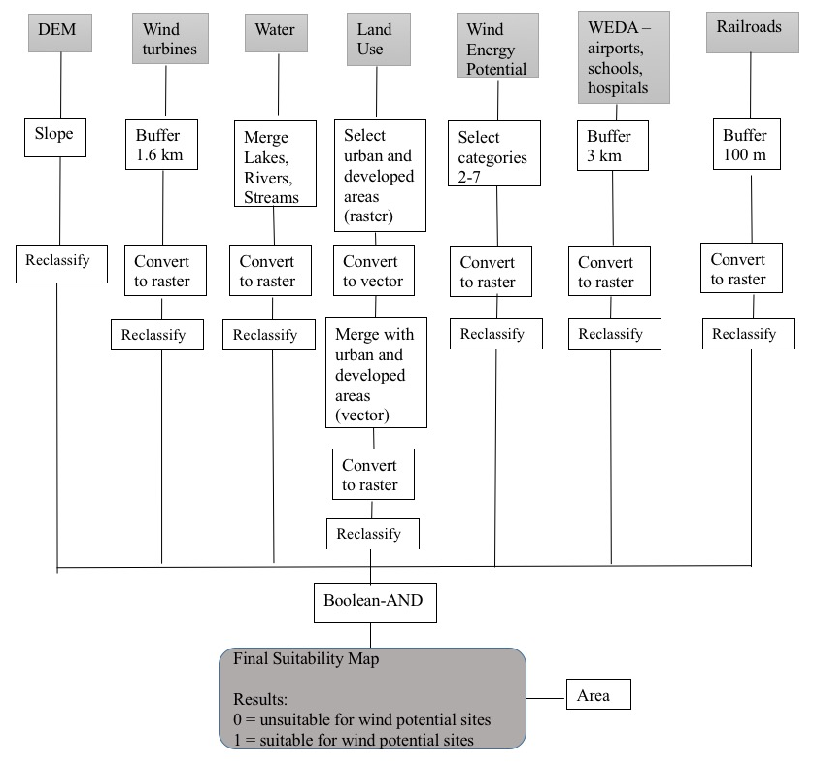
Figure 4. Flowchart for modeling suitability for wind turbine sites. The final suitability is where wind sites are suitable and where wind sites are unsuitable in Oklahoma.
4.3 Identify Conflict Overlap
In order to examine and identify conflict areas between prairie-chicken habitats and potential wind turbine sites, the two binary results layers from the previous suitability analysis were overlaid and reclassified in GIS. In order to identify overlapping conflict zones between wind and habitat, a GIS ranking approach was used. In order to determine which areas would be suitable for prairie-chicken all values of prairie-chicken suitable habitat were reclassified from 1 to 1.1 and unsuitable habitat was left as 0. The values from the Wind Potential Site Suitability result to were also reclassified from 1 to 1.2, to identify which cells were suitable wind potential from our input model and unsuitable habitat was left as 0. So, when overlaying and adding the site suitability values for prairie-chickens (with the new values of 1.1 and 0) with the site suitability for wind turbines (with the new values of 1.2 and 0) the set of possible results would be either 0, 1.1, 1.2, or 2.3. The cells with the value of 0 represent an area that is unsuitable for both wind development and prairie-chicken habitat. A value 1.1 represents the area suitable for prairie-chickens but not suitable for wind development. The value of 1.2 represents areas suitable for wind but not prairie-chickens. A value of 2.3 represents areas that have geographic overlap and therefore potential for conflict; these are suitable for both prairie-chicken habitats and wind energy site potential. Figure 5 shows a flow chart for modeling suitability for prairie-chicken habitats and wind potential interaction.

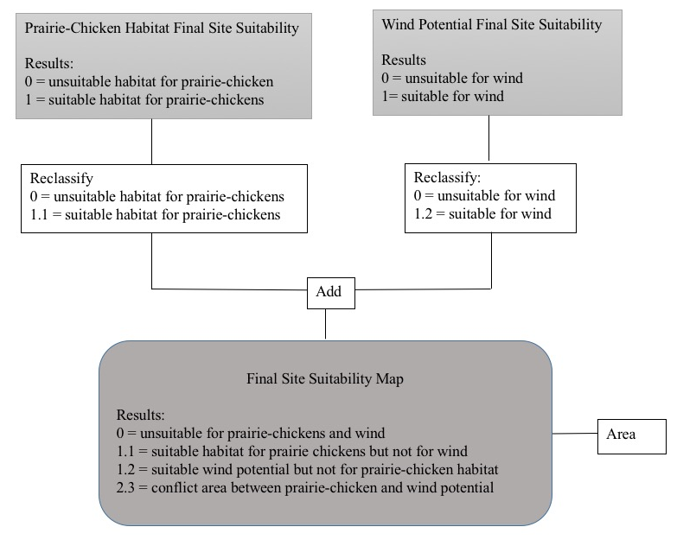
Figure 5. Flow chart of ranking site suitability where the end results are ranked where the final suit abilities had four categories: 0 = unsuitable for prairie-chickens and wind, 1.1 = suitable habitat for prairie-chickens, 1.2 = suitable wind potential but not for prairie-chicken habitat, and 2.3 = conflict area between prairie-chicken habitat and wind energy potential.
In order to determine the area of each criterion, zonal statistics were used. A zone is defined as all cells that have the same value in a value raster dataset (ESRI 2018). For my analysis all the cells whose values were 0 are one zone, all those with a value of 1.1 represent another zone, cells with the value of 1.2 another zone, and 2.3 another zone as well for a total of four separate zones. Zonal statistics is a tool that calculates statistics for each zone; these statistics include but not limited to the area, standard deviation, and mean of the zone (ESRI 2018). These results were mapped for visual comparison and summarized by area.
4.4 Text Analysis of Wildlife Management and Wind Energy Policies
To address research objective two, this study conducted a literature search for web resources describing relevant policy for wildlife management and wind energy development. Federal and State level information was used to evaluate wind energy and wildlife management policies. A generalized search was first conducted to find and determine general federal and state wind energy policies; this search produced the webpage Database of State Incentives for Renewable Efficiency (DSIRE) programs for all of the 50 states including the federal level which was used for wind policies. Wind policies were compiled into federal and state tables.
A generalized search as well as searching on the U.S. Fish and Wildlife Service web search engine was used locate general federal wildlife policies. The Oklahoma Department of Wildlife Conservation site was used to obtain state policies. A second table was created with the wildlife policies for the state and federal level.
The second part of objective two dealt with determining how to analyze the wind and wildlife federal and state policies. Since objective one examined the overlap of potential prairie-chicken habitat and potential wind energy sites in Oklahoma, the same examination of overlap of wildlife management and wind energy needed to be conducted with the policy analysis. The method for examining overlap within the policies was a text analysis of the policies that were selected. The wind and wildlife policies were examined separately and evaluated based on terms presented within the policies. If the policies mentioned any fellow wind or wildlife policies or mentioned any opposing wind or wildlife policies, this was tallied for the analysis. The terms used to evaluate the wind and wildlife policies were: wind / energy/ wind energy, wildlife / species, conservation, habitat, environment / environmental, and sustainable / sustainability. The total number of terms were counted in combination with the name of related policies or name of any opposing policies.
In order to determine if there was overlap within the policies the basic question of did wind energy policies consider wildlife management was asked. This was evaluated by searching for the following terms: wildlife / species, conservation, habitat, environment / environmental, sustainable / sustainability, the name of wind policies, and the name of wildlife policies within Wind Energy Policies. In order to determine if there was overlap within the policies the basic question of did wildlife management policies consider wind energy was asked. This was evaluated by searching for the following terms: wind / energy /wind energy, environment / environmental, sustainable / sustainability, the name of wildlife policies, and the name of wildlife policies. Also, within each analysis the question of do wildlife management and wind energy policies address sustainability was examined by searching for the words sustainable and sustainability throughout all the wind energy and wildlife management policies. Some of the selected terms were grouped while others were single words during the text analysis.
In order for the analysis to be completed, research determining the U.S. Code associated with all the wind and wildlife policies was completed. The United State Code is a compilation of law text organized by subject matter (Office of the Law Revision Council, 2018). The U.S. Code collects the original law along with any subsequent amendments made to each law. The organization of U.S. code is by 50 titles by subject area; then they can be further broken down by chapter and section. Citation for U.S. Codes use the following format: 42 U.S.C. 1382 or 42 § 1382 which, for example, means the law appears in title 42, section 1382 of the Code (Office of the Law Revision Council, 2018).
Once the U.S. Code was determined, each law text or piece of legislation had to be found on the web and downloaded into a pdf format. Each term and policy by name was searched for individually within the policy documents using the find function. After which, each search term or name of policy could be inputted one at a time in the search box and the number of times that word or name was used within each document was displayed. By doing the search terms and policy names manually, one is able to see each instant the term is used whether it be as a reference or part of the policy itself. Text analysis software such as NVIVO were evaluated for this task, however limitations on time to produce this research and the limited complexity of the analysis rendered manual searching a viable option. Two tables, one for wind and one for wildlife policies, were created showing the number of times the selected terms or policy names were recorded within the pdfs. With the search terms that were grouped, the combination of each time all the words were found together were recorded as end results. For example, with a group of terms including wind/ energy/ wind energy, if one document mentioned the term “wind” 5 times, the term “energy” was mentioned 10 times, and “wind energy” was mentioned 15 times the results recorded for that particular document for the category wind/energy/wind energy would be 30.

Chapter 5: Results
5.1 Geographic Conflict Site Results
The resulting binary suitability map for prairie-chicken habitat has two categories of suitability. These are areas considered unsuitable habitat for prairie-chickens and areas considered suitable habitat for prairie-chickens. Potential prairie-chicken habitats are generally found throughout western Oklahoma, mainly prairie areas. However, even in areas of generally suitable prairie-chicken habitats, these areas are mixed between suitable and unsuitable showing fragmentation in the landscape. There are few large, spatially continuous suitable areas for prairie-chicken habitat in Oklahoma. Figure 5 shows the site suitability result for prairie-chicken habitat in Oklahoma.
Total habitat area was calculated, as well as the percentages for unsuitable and suitable habitat, then summarized into Table 5. Approximately 92.05% of Oklahoma is unsuitable for prairie-chicken habitat. The suitable habitat percentage was obtained by dividing by the total habitat area, and multiplying the result by 100. Approximately 7.95% of Oklahoma is suitable for prairie-chicken habitat. Table 5 shows these areas in square kilometers as well as the percentages of the area for unsuitable and suitable habitat for prairie-chickens in Oklahoma.
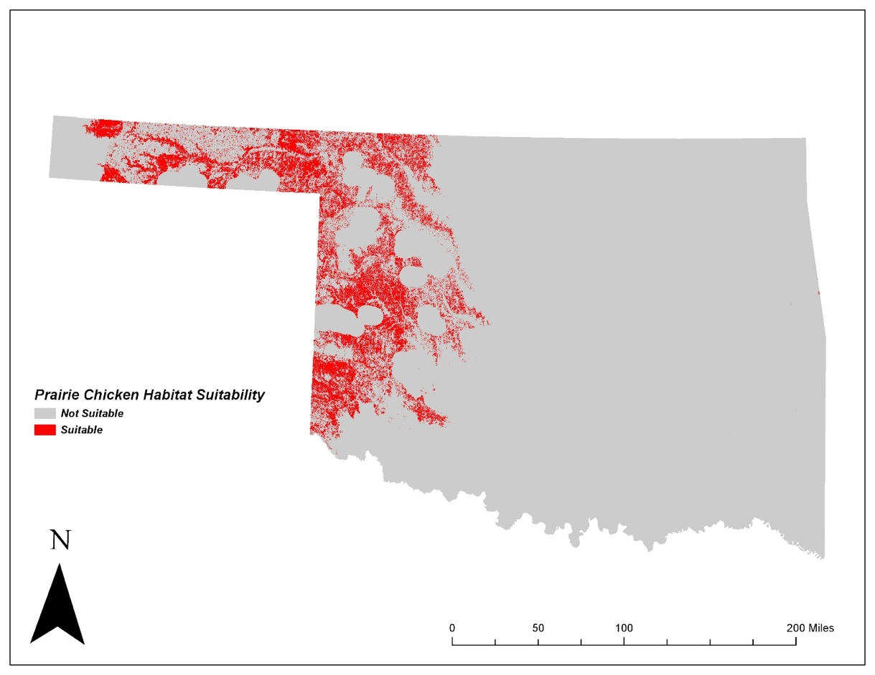
Figure 6. Suitability of habitat areas for prairie-chickens in Oklahoma.
Table 5. Provides the area and percent of unsuitable and suitable habitat for prairie-chickens in Oklahoma.
Prairie-chicken habitat | Area | Percent
Unsuitable habitat | 166,608.97 sq. km | 92.05 %
Suitable habitat | 14,397.45 sq. km | 7.95 %
Total area Oklahoma | 181,006.42 sq. km | 100 %

The binary suitability map for wind energy habitat has two categories: unsuitable and suitable. Potential areas for wind energy development area found primarily throughout western and northern Oklahoma. Unsuitable areas are prevalent in the small areas of the Northeast and much of the Southeast sections of the state. Even where there are potential wind energy sites, there are some unsuitable areas located near and among suitable sites. Figure 6 shows the suitability for wind energy development in Oklahoma.
Percentages for unsuitable and suitable areas of wind energy development were calculated and summarized into Table 6. Approximately 57.72% of Oklahoma is unsuitable for wind energy sites. The suitable area value was divided by the total area and then multiplied by 100 to obtain the percent of total area suitable for wind energy development in Oklahoma. Approximately 42.28 % of Oklahoma has suitable areas for wind energy. Table 6 shows the area in square kilometers as well as the percentage of unsuitable and suitable areas for wind energy development in Oklahoma.
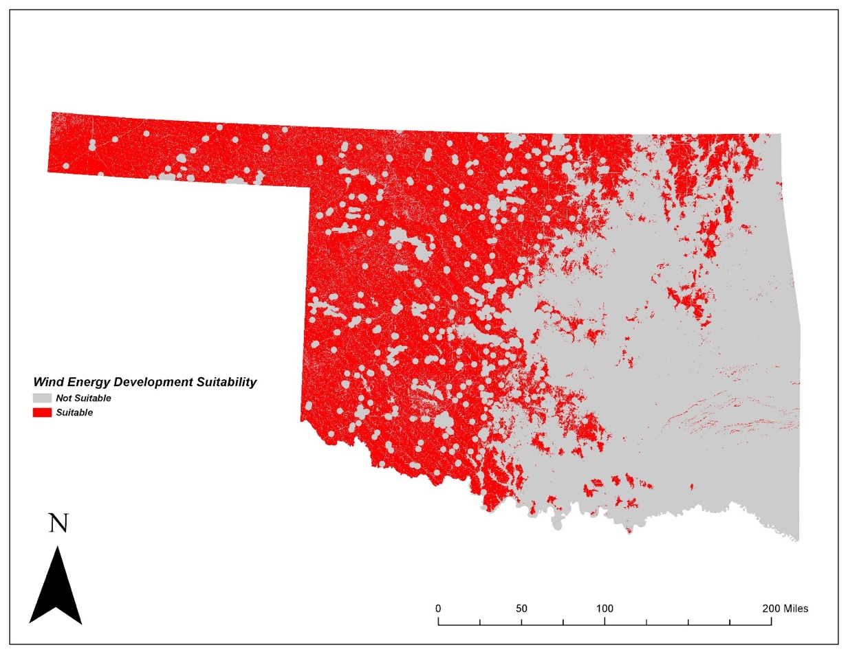
Figure 7. Suitability for wind energy development in Oklahoma.

Table 6. Area and percent for unsuitable and suitable areas for wind turbine development.
Wind turbine site | Area | Percent
Unsuitable sites | 104,468.29 sq. km | 57.72 %
Suitable sites | 76,523.74 sq. km | 42.28 %
Total | 180,992.04 sq. km | 100 %
Since the goal of objective one was to identify areas where these two suitability studies overlap, the intersection of build sites favorable to wind energy and suitable prairie-chicken habitat was rendered as a ranking suitability map. The map has four categories: unsuitable for both wind energy building and habitat for prairie-chickens, suitable sites for wind energy building potential, suitable habitat for prairie-chickens, and conflict areas between wind energy build potential and areas of favorable prairie-chicken habitat.
Per this ranking suitability map, unsuitable areas for both wind and prairie-chickens are generally found in the geographic eastern part of the state of Oklahoma, while suitable sites for wind energy development and suitable prairie-chicken habitat are generally found in the geographic western part of the state of the Oklahoma. The areas of conflict occur in the western part of Oklahoma, as shown in yellow in Figure 7. This map identifies which areas of Oklahoma have geographic conflict between both wind energy development and prairie-chicken habitat. The map also identifies areas that are suitable for wind only and which areas are suitable for prairie-chickens only.
The total areas for each category are summarized in Table 7. Approximately 56.52% of areas represent unsuitable suites for both wind energy development and prairie-chicken habitat. Suitable areas wind energy development area was divided by the total area then multiplied by 100 to get the percent of area suitable for wind development statewide. Approximately 35.52% of Oklahoma is suitable for development as wind energy sites. Total suitable habitat area for prairie-chicken was divided by the total area then multiplied by 100 to get the percent of area suitable for prairie-chicken habitat statewide. Approximately 1.5% of Oklahoma is suitable for prairie-chicken habitat, while 6.76% of Oklahoma is a conflict area between wind energy potential development areas and potential habitat for prairie-chicken habitat.
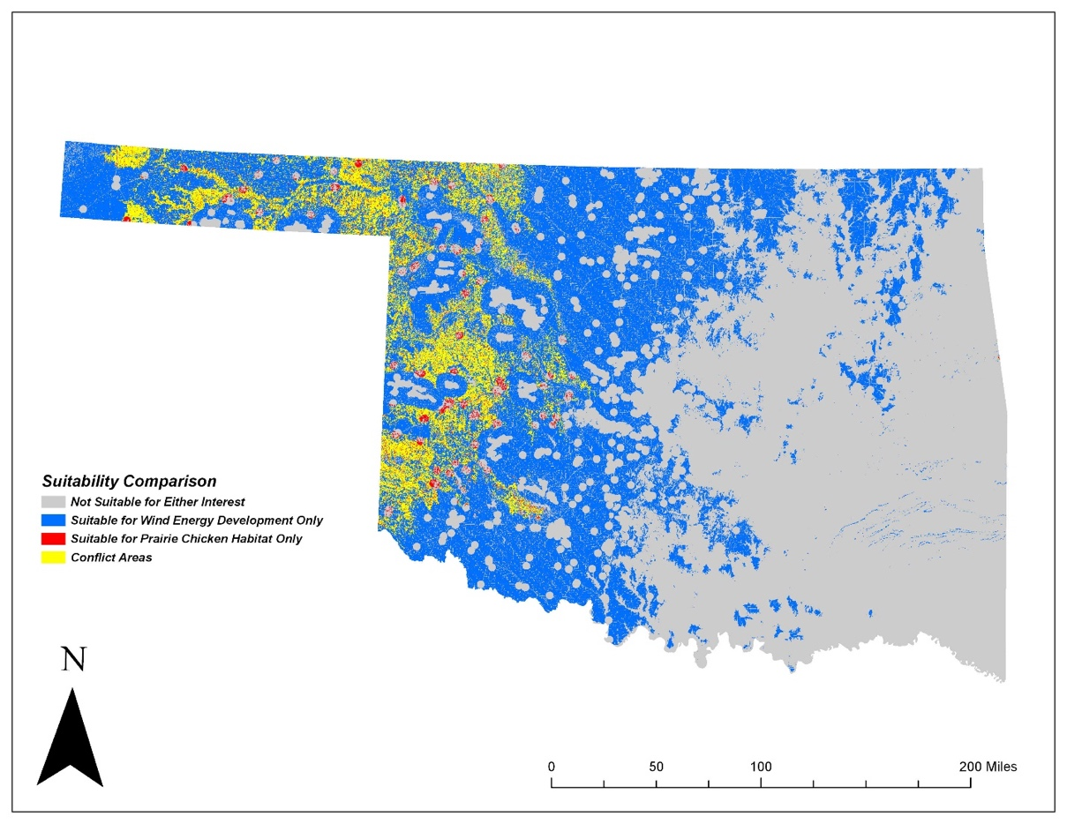
Figure 8. Final site suitability for the intersection of wind energy and prairie-chicken habitat. Current prairie-chicken range is presented here as an illustration to demonstrate the where prairie-chickens are found relative to the findings of this research.
Table 7. Area and percent for prairie-chicken habitat versus wind energy sites. Provides the area and percent for unsuitable habitat, suitable sites for wind energy, suitable habitats for prairie-chicken, and conflict areas between prairie-chickens and wind energy.
Prairie-chickens versus wind habitat | Area | Percent
Unsuitable habitat | 102,289.09 sq. km | 56.52 %
Suitable sites for wind energy | 64,284.48 sq. km | 35.52 %
Suitable habitats for prairie-chickens | 2,159.32 sq. km | 1.5 %
Conflict areas between prairie-chickens and wind energy | 12,235.35 sq. km | 6.76 %
Total | 180,968.25 sq. km | 100 %

5.2 Policy Overlap Analysis
The Database of State Incentives for Renewable & Efficiency (DSIRE) was consulted for a comprehensive list of incentives and policy documents concerning renewable wind energy interest for Oklahoma. I also identified relevant documents detailing federal level recommendations as well. During my examination this list only wind energy documents at the federal level and for the state of Oklahoma were selected for review. A total of 24 individual policies were found, 14 being federal and 10 being State. Out of the 24 selected policies there were 3 that shared an Education element at the Oklahoma state level and 3 different USDA – REAP programs operating at the Federal. Some of these policies and incentives are no longer active but are present in this table to represent past policies concerned with wind energy development. Results for the wind energy policies reviewed are shown in Tables 8 and 9. This tables shows the policy that was examined, a summary of that policy, and the appropriate citation for the Database of State Incentives for Renewable & Efficiency.

Table 8. Summary of Federal wind energy policies.
Name | Summary | Citation
Business Energy Investment Tax Credit (ITC) | Maximum incentives for micro-turbines: $200 per kW. Small wind turbines credit equals to 30% of expenditures in 2018 and 2019, 26% for 2020, 22% for 2021 and 2022, and becomes N/A after that. For large wind, the credit equals 18% of expenditures in 2018, 12% in 2019, and becomes N/A after that. | DSIRE 2018
Clean Renewable Energy Bonds (CREBs) | The Tax Cuts and Jobs Acts of 2017 repealed the Internal Revenue Code which authorized the use of New CREBs. CREBs were used to finance renewable energy projects. Congress limited the participation in the program by limiting the number of bonds. | DSIRE 2018
FHA PowerSaver Loan Program | Small wind power for residential usage. | DSIRE 2018
Green Power Purchasing Goal for Federal Government | The Federal Energy Policy Act of 2005 (EPAct 2005) has been extended and expanded to reduce energy use in existing and new federal buildings. | DSIRE 2018
Interconnection Standards for Small Generators | Include Small Generator Interconnection Procedures (SGIP) and Small Generator Interconnection Agreement (SGIA). Include three standard levels of interconnection: 10-kilowatt inverter process, the fast track process, and study process for all other systems. | DSIRE 2018
Modified Accelerated Cost-Recovery System (MACRS) | Businesses may recover investments through depreciation deductions. A number of renewable technologies are classified as five-year property under MACRS, often known as energy ITC to define eligible property. | DSIRE 2018
Production Tax Credit (PTC) | Wind facilities that start construction by December 31, 2019, and all qualifying facility get a tax credit $ 0.023/kWh and apply to the first 10 years of operations. | DSIRE 2018
Residential Renewable Energy Tax Credit | Small wind-energy: 30% for facilities places in services by 12/31/2019, 26% for facilities in services after 12/31/2019 and before 01/01/2021, 22% for facilities after 12/31/2020 and before 01/01/2022. | DSIRE 2018
U.S. Department of Energy – Loan Guarantee Program | Up to $3 billion is available in a loan for renewable energy, efficient end-use, efficient generation, transmission, and distribution technologies projects. | DSIRE 2018
USDA – High Energy Cost Grant Program | The USDS closed this program on December 14, 2015. It offered an ongoing grant program for improvement of energy generation, transmission, and distribution facilities in rural communities. It offered grants ranging from $50,000 to $3 million were available for qualifying projects. | DSIRE 2018
USDA – REAP:  USDA – Rural Energy for America Program (REAP) Loan Guarantees  USDA – Rural Energy for America Program (REAP) Grants  USDA – Rural Energy for America Program (REAP) Energy Audit and Renewable Energy Development Assistance (EA/REDA) Program | The REAP provides financial assistance to small businesses and agriculture producers for renewable energy projects. These grants are guaranteed to be at least $5,000 and not exceed 75% of the project cost.  These grants are limited to 25% of the cost of the proposed projects and the loan does not exceed $25 million. The combined amount of a grant and loan must be at least $5,000 and cannot exceed 75% of the cost of the project.  The REAP and EA/REDA provide assistance of energy audits and renewable energy technical assistance including wind site assessment to agricultural producers and small businesses owners. About $2 million in grant money is available on an annual basis. | DSIRE 2018
Qualified Energy Conservation Bonds (QECBs) | The Tax and Jobs Act repealed the use of tax credit bonds effective January 1, 2018. QECBs were qualified tax credit bonds similar to new CREBs. QECBs are not subject to U.S. Department of Treasure application and approval process, unlike CREBs. | DSIRE 2018

Table 9 – Summary of States wind energy policies.
Name | Summary | Citation
Education programs:  Community Energy Education Management Program  Energy Loan Fund for Schools  Higher Education Energy Loan Program | Renewable projects for local governments aimed to make energy efficient improvements to government buildings by increasing energy efficiency and reduce energy consumption.  Category one will pay for technical and energy audits, the development of Energy Management Plans and any professional services used to contribute to the planning and design of the energy and reduction systems and measures. Category two funds the acquisitions and installation part of the energy conservation measures. Maximum Loan: $ 200,000 per eligible school district with a 3% interest rate for up to 6 years.  Category one will pay for technical and energy audits, the development of Energy Management Plans and any professional services used to contribute to the planning and design of the energy and reduction systems and measures. Category two funds the acquisitions and installation part of the energy conservation measures. Maximum Loan: $ 300,000. | DSIRE 2018
Energy Standards for State Buildings | In May 2013, the high-performance building certification program ended. The State still requires to adapt and adopt a plan and construct standards for state building to conserve and optimize energy performance of new buildings. Having renewable energy sources are encouraged. | DSIRE 2018
Net Metering | Net metering is available to all customer classes and there is no limit on the amount of net-metered capacity. Utilities and regulated electric cooperatives are not required to purchase monthly net excess generation from customers. The system capacity limits are 100 kW less; 25,000 kWh/year or less. | DSIRE 2018
Oklahoma Wind Energy Development Act | Within one-year of abandonment, the land must be returned to its condition prior to the facility construction, except for roads. After 15 years of operation, wind energy sites must file an estimate of decommissioning cost and evidence to cover the cost of the decommissioning. Wind energy facilities must have general liability insurance. New wind energy must not be constructed with the base of any tower within 1.5 miles of any airport runway, public school, or hospital. | DSIRE 2018
Property Tax Exemption for Wind Generators | Oklahoma offered a 5-year property tax exemption for certain power generators. The exemption ended on January 1, 2017. Countries were eligible if there was a net increase in annualized payroll of at least $250,000 in countries with a population of 75,000 or less or at least $1,000,000 if the facility is located in a county with a population of 75,000 or more. | DSIRE
Renewable Energy Goal | The Oklahoma Energy Security Act established a renewable goal for 15% of total installed generation capacity in Oklahoma to be derived from renewable sources by 2015. | DSRIE 2018
Solar and Wind Access | S.B. 1787 in 2010, states that access to the airspace is tied to the ownership of the land and any wind or solar leasing arrangements associated with the airspace must be made with the landowner that owns the land below the air. The statute does not apply to any property owner utilizing wind or solar for domestic use only. | DSIRE 2018
Zero-Emission Facilities Production Tax Credit | Tax credit of $0.0025/kWh - $0.0050/kWh for 10 years for eligible renewable energy resources. For credits on or after January 1, 2014, the taxpayer can get refunded 85% of the face value of the tax credit at the taxpayer’s request. | DSIRE 2018

The U.S. Fish & Wildlife Service website was used to research and determine federal wildlife policies. The Oklahoma Department of Wildlife Conservation website only appeared to publish policies on hunting and fishing regulations in the state. No other available documentation was found for policies at the state level concerning wildlife. Two different recommendations were found however: (1) a set of land-based wind energy siting guidelines and (2) a suggested 5-mile buffer around known prairie-chickens leks for the construction of wind turbines. A total of 10 policies including 7 federal, 1 states, and 2 agency recommendations are reflected and are found in Table 10. This table shows the policy that was examined, a summary of that policy, whether it was federal or state level, and the appropriate citation for where the summary came from depending on if it was state or federal.

Table 10. Federal and State wildlife policies.
Name | Summary | Federal/State | Citation
5-Mile Buffer from Leks with Wind Turbines | The U.S. Fish and Wildlife Service recommends a 5 mile (8 km) barrier with wind turbines of known prairie-chicken leks (communal pair formation grounds/ breeding grounds). | Recommendations | Manville 2004
Bald and Gold Eagle Protection Act of 1940 (BGEPA) | Protects Bald and Gold Eagles “take, possess, sell, purchase, barter, offer to sell, purchase or barter, transport, export or import, at any time or any manner, any bald eagle … [or any golden eagle], alive or dead, or any part, nest, or egg thereof” | Federal | U.S. Fish & Wildlife Service 2018
Endangered Species Act of 1973 (ESA) | Its purpose is to protect and recover imperiled species and the ecosystems which the species depend. Species that are covered under this act are listed as “Endangered” or “Threatened.” The designation of “critical habit” is essential, critical habitat is the geographic areas that contain the physical and/or biological feature. | Federal | U.S. Fish & Wildlife Service 2018
Federal Land Policy and Management Act of 1976 (FLPMA) | Federal land should remain under federal ownership and establish a regulatory system for the U.S. Bureau of Land Management (BLM) to manage federal lands. Management of the land would include timber and mineral production, wildlife and fish protection, oil and gas production and more. | Federal | U.S. Bureau of Land Management
Fish and Wildlife Act of 1956 | Establishes a national fish and wildlife resources policy that emphasizes on the commercial fishing industry but has regard to the inherent right that every citizen and resident has to fish for pleasure and betterment and to maintain and increase public opportunities for recreational use of fish and wildlife resources. | Federal | U.S. Fish & Wildlife Service 2018
Hunting and Fishing Regulation | Oklahoma Department of Wildlife Conservation has the 2018/2019 laws and regulations for Hunting and fishing available on their website. | Oklahoma | Oklahoma Department of Wildlife Conservation 2018
Migratory Bird Treaty Act of 1918 (MBTA) | Protection of migratory birds  “hunting, taking, capture, killing, possession, sale, purchase, shipment, transportation, carriage, or export of any . . .bird, or any part, nest or egg” of any protected migratory birds. | Federal | U.S. Fish & Wildlife Service 2018
National Environmental Policy Act of 1969 (NEPA) | Uses environmental assessments (EAs) and environmental impact statement (EIS) to protect, restore and enhance our environment. NEPA established the Council on Environmental Quality (CEQ) to ensure Federal agencies meet their obligations under NEPA. | Federal | U.S. Fish & Wildlife Service 2018
The National Wildlife Refuge System Administration Act (NWRSAA) of 1966 | Administers lands through FWS into a single National Wildlife Refuge System. Establishes a unifying mission, compatible uses of refuges, and preparing comprehensive conservation plans whose focus is on wildlife conservation. | Federal | U.S. Fish & Wildlife Service 2018
U.S. Fish and Wildlife Land-Based Wind Energy Guidelines | The guideline is set up in a 5 Tier system. Tier 1: Preliminary site evaluation where the landscape is assessed in terms of habit for species of concern. Tier 2: Site Characterization assesses potential presence of species of concern and species of habitat fragment concern as well as plant communities that provide habitat for species of concern. Tier 3: Field studies and impact prediction where the risk is evaluated to species of concern from project construction and operation and identify ways to mitigate potential direct and indirect impacts of building and operating the project. Tier 4: Post-construction studies where studies are conducted to access the habitat-related impacts. Tier 5: Other post-construction studies and research where studies are conducted as needed and potential mitigation strategies are used to reduce the impact of the buildings. | Recommendations | U.S. Fish & Wildlife 2012

The policy names are the laws or regulations common names, however, when publishing laws by the U.S. House of Representatives the U.S. Code (U.S.C.). These names are used to organize and publish United States laws. The portions of the U.S.C. evaluated include a set of 20 wind policies, with 2 group policies each composed of 3 similar component policies. These materials were obtained through a web search and recorded. The terms “wildlife” and “species” total count was 3, “conservation” had a total count of 60, “habitat” total count was 4, the total count for “environment” and “environmental” was 82, and “sustainability” and “sustainable” total count was 2, throughout the 20 wind policies.
When examining the names of wind of policies there was a total count of 11 wind policies. Concerning these wind policies mentioned: QECBs were mentioned 5 times, Net Metering was mentioned 3 times, PTC was mentioned one time, and CREBs was mentioned 3 times. 16.67% different policies names were mentioned in the wind policies determined from the total 24 wind policies discovered. Wildlife Policies by name had a total count of 3 through the document examined. NEPA was the only wildlife policies to be mentioned and for two of those counts was mentioned only in the citations. The total count for wildlife terms, wind policies by name, and wildlife policies by name for wind energy policies was 165 within the 20 wind energy policies. Table 11 shows the results from the wildlife and wind select terms, wind policies, and wildlife policies mentioned.

Table 11. Wind policy name, U.S. Code, select terms, other wind policies mentioned, and wildlife policies.
Policy Name | U.S. Code | Wildlife / Species | Conservation | Habitat | Environment / Environmental | Sustainable/  Sustainability | Wind Policies | Wildlife Policies
ITC | 26 § 48 | 0 | 0 | 0 | 0 | 0 | 0 | 0
CREBs | 26 § 54, 26 § 54A, 26 § 54C | 0 | 35 | 1 | 0 | 0 | 5 | 0
Education programs | OK §74-5003.10 | 0 | 0 | 0 | 0 | 0 | 0 | 0
Energy Standards for State Buildings | OK 61 § 213 | 0 | 0 | 0 | 4 | 0 | 0 | 0
FHA PowerSaver Loan Program | 12 §1703,  24 CFR 201 | 0 | 0 | 0 | 0 | 0 | 0 | 0
Green Power Purchasing Goal for Federal Government | 42 § 15852 | 0 | 0 | 0 | 3 | 0 | 0 | 0
Interconnection Standards for Small Generators | 18 CFR Part 35 | 0 | 2 | 0 | 28 | 2 | 2 | 2
MACRS | 26 § 168 | 0 | 5 | 0 | 7 | 0 | 1 | 0
Net Metering | O.A.C. § 165:  40-9-1, S.B. 1456 | 0 | 0 | 0 | 0 | 0 | 0 | 0
OK Wind Energy Development Act | §17-160.11 -  §17-160.22 | 0 | 0 | 0 | 1 | 0 | 0 | 0
PTC | 26 § 45 | 1 | 1 | 0 | 3 | 0 | 0 | 0
Property Tax Exemption for Wind Generators | OK SB498, OK Stat §68-2902 | 0 | 0 | 0 | 0 | 0 | 0 | 0
Renewable Energy Goal | OK 17 § 801 | 0 | 2 | 0 | 0 | 0 | 0 | 0
Residential Renewable Energy Tax Credit | 26 § 25D | 0 | 0 | 0 | 0 | 0 | 0 | 0
Solar and Wind Access | S.B. 1787, 60 O.S. § 820.1 | 0 | 0 | 0 | 0 | 0 | 0 | 0
U.S. Department of Energy – Loan Guarantee Program | 42 § 16511, 10 CFR 609 | 0 | 0 | 0 | 13 | 0 | 0 | 1
USDA – High Energy Cost Grant Program | 7 CFR 1709 | 0 | 3 | 0 | 18 | 2 | 0 | 0
USDA – REAPs | 7 § 8107, H.R. 8 | 1 | 0 | 3 | 4 | 0 | 1 | 0
QECBs | 26 § 54D,  26 § 6431 | 1 | 12 | 0 | 0 | 0 | 2 | 0
Zero-Emission Facilities Production Tax Credit | OK §68-2357.32A | 0 | 0 | 0 | 1 | 0 | 0 | 0
TOTAL |  | 3 | 60 | 4 | 82 | 2 | 11 | 3

The 7 wildlife policies appearing in the U.S.C. considered in this research were obtained through a web search. There were 3 instances where the U.S.C. was not used including (1) the 5-Mile Buffer Prairie-Chicken Lek Recommendations, (2), Oklahoma’s 2018/2019 Hunting and Fishing Regulations, and (3) U.S. Fish and Wildlife Land-Base Wind Energy Guideline Recommendations. With respect to wildlife policies reviewed, the terms “wind/ energy/ wind energy,” had a total count of 570. The total count for the terms “environment/environmental” was 187. The terms “sustainable” and sustainability” total count was 3 among the 10 documents.
The total count for names of wildlife policies mentioned was 35 times within the 10 documents evaluated. The ESA was mentioned 14 times, the Fish and Wildlife Act was mentioned 3 times, NEPA was mentioned 8 times, buffer zones were mentioned 5 times, and MBTA was mentioned 5 times. There were zero wind policies mentioned within wildlife policies. The total count for number of wind energy terms, wildlife policy by name, and wind policy by name was 795 within the 10 wildlife policies. Table 12 show the results from the wildlife policy analysis.

Table 12. Wildlife policy name, U.S. Code, select terms, other wildlife policies mentioned, and wind policies mentioned.
Policy Name | U.S. Code | Wind / Energy / Wind Energy | Environment / Environmental | Sustainable/  Sustainability | Wildlife  Policies | Wind Policies
5-Mile Buffer from Leks with Wind Turbines | N/A – Recommendation | 54 | 3 | 0 | 4 | 0
BGEPA | 16 § 668 | 2 | 0 | 0 | 0 | 0
ESA | 16 U.S.C. 35 | 2 | 10 | 0 | 5 | 0
Fish and Wildlife Act of 1956 | 43 U.S.C. §1701-1785 | 22 | 60 | 2 | 2 | 0
FLPMA | 16 U.S.C. 742a-742j, not including 742 d-l; 70 Stat. 1119 | 0 | 0 | 0 | 0 | 0
Hunting and Fishing Regulation | 2018/2019 Oklahoma Hunting and Fishing Regulations | 0 | 3 | 0 | 0 | 0
MBTA | 16 U.S.C. 703-712 | 1 | 8 | 0 | 1 | 0
NEPA | 42 U.S.C. § 4321-4347 | 0 | 47 | 0 | 0 | 0
NWRSAA | 16 U.S. Code § 668dd | 21 | 16 | 0 | 4 | 0
U.S. Fish and Wildlife Land-Based Wind Energy Guidelines | N/A – Recommendation | 468 | 40 | 1 | 20 | 0
TOTAL |  | 570 | 187 | 3 | 35 | 0

Chapter 6: Discussion
This study investigated the relationship between wildlife management and wind energy development in Oklahoma, identifying where respective goals may overlap or conflict. This was achieved using a case study of management for prairie-chicken habitat versus potential wind energy development. My study investigated the geographic and policy overlap of wildlife management and wind energy development in Oklahoma. This investigation used prairie-chickens and wind energy development in Oklahoma as a case study in respectively “green” interests, which may conflict in their respective goals toward sustainability in general. Results yielded by this research may provide a useful tool for evaluating trade-offs between potential wind energy development and the management of suitable prairie-chicken habitat. Current literature shows only limited studies that deal with these trade-offs.
Before identifying the potential conflict area in Oklahoma, two binary models where conducted to identify potential habitat for prairie-chicken and potential suitable sites for wind energy development in Oklahoma. These GIS models provided results characterizing unsuitable and suitable habitat for prairie-chickens and potential wind energy sites in Oklahoma. Ranking habitat potential or expressing varying degrees of habitat quality or wind energy development sites were not developed as part of this research. By developing binary instead of ranking models, all the criteria from Table 1 had to be met for areas to register as potential prairie-chicken habitat in Oklahoma. All criteria from Table 3 had to be met for areas to register as potential wind energy sites in Oklahoma. The benefit of using binary suitability models for this analysis centers on ease of interpretation, and comparability between resulting suitability layers. A binary suitability result can be easily compared or overlaid with another binary suitability result, without any necessary normalization or rescaling steps applied to the respective input layers. In short, all binary suitability results subscribe to the same scale of measure measurement; a simple true or false relationship.
For the first part of this study I conducted a GIS analysis to identify and quantify where prairie-chicken habitats and suitable wind development areas geographically overlapped in Oklahoma. One component consistent in the literature on prairie-chicken habitat selection is the animals’ avoidance of human-made structures. This is similar to what was found in the GIS analysis, where human development, in this case wind turbine development, reduces the total potential area of prairie-chickens in Oklahoma from 7.95% of the state to 1.5% of the state if wind turbines are allowed to utilize this space. These results demonstrate how detrimental human development can be in these areas, as loss of habitat for vulnerable species such as the prairie-chickens may not represent an equal trade given the benefits of increasing renewable energy initiatives in the area. Further, decrease in population and habitat will lead to prairie-chickens becoming listed as Threatened or Endangered under the IUCN Red List. If prairie-chickens become listed as Threatened or Endangered, then the U.S. Endangered Species Act (ESA) will enter into force with respect to prairie-chickens and their management. Any building or structures such as wind energy developments would have to follow the rules and regulations under the ESA when developing within areas listed as hosting prairie-chickens.
With the results showing that potential prairie-chicken habitat decreases from 7.95% to 1.5%, we note this results captures the potential habitat-only areas for prairie-chickens in Oklahoma. The 1.5% is a measure of areas suitable for prairie-chicken which are not suitable for wind energy development. Additional habitat site suitability analyses would need to be conducted through the prairie-chickens’ range to determine how their habitat as a whole is being affected by wind energy development; the decrease of 7.95% to 1.5% conflict-free habitat is an Oklahoma-only measure. Another analysis would be need to quantify the size of each patch determined to be suitable within this analysis and compare with the prairie-chicken home range to determine if individual patches are even large enough to support prairie-chicken survival.
Conversely, there is still potential for wind energy to development in the state where avoiding conflict area with the prairie-chicken altogether would yield 35% of the state suitable for wind development. While the results of the study demonstrate that prairie-chicken home range management should be a priority overall, the results show a considerable amount of wind potential in areas that do not conflict with existing prairie-chicken habitat. The results of this study show that wind energy development is still a possibility in western Oklahoma without conflict with prairie-chicken habitat. Given that prairie-chickens only find less than 8% of the of the state suitable, wind energy development sites could try to allocate more land toward prairie-chicken conservation by building outside of these areas, or enacting additional conservation or reclamation measures at their peripheries. While this study did not identify how much potential KW of electricity can be generated, only the areas suitable, wind energy developers can look to the table provided here and calculate that value based on the available land.
Another detail highlighted by the GIS analysis is the that the prime area for both wind and prairie-chicken habit occur in western part of the state where prairie habitat is most prevalent. Since the literature identifies renewable energy development as a goal for sustainable future, this geographic overlap found in the results of this study highlights the need for communication between these two green efforts. This is especially true in Oklahoma where the potential for renewable energy jobs is also high (Jones and Pejchar 2013).
The results of Objective 1 demonstrate the geographic overlap and potential conflict between wind energy development and prairie-chicken management; it also demonstrates a need to prioritize between each. One way each manages is through their policies. Objective 2 of this research looked at policy to identify any potential conflict or overlap and to determine if each industry communicated with or considered the other in policymaking. Since human pressures are likely to continue on the current prairie-chicken home range, it is important that current and future policies consider these factors. A positive future for policy at the intersection of prairie-chicken management and wind energy development will require the two interests to work together, mitigating and compromising through any issues that arise during the conservation and wind energy development processes.
In the analysis for Objective 2, the total number of wind policies was greater than the number of wildlife policies, and the number of federal policies was greater than the state, at least for the state of Oklahoma. Future studies involving wind energy development and wildlife policy can now refer to the tables presented in this research to see if the interest considers the other. However, the results at this time show there is very limited overlap or similarity between the two subjects when comparing just the amount of times a policy text lists a term from the other initiative. When comparing between the two however, wildlife polices ten to mention wind development or related terms (795 times in all of the documents) more often than wind policies mentioning wildlife (only 165 times). This is likely due to the wildlife literature directly examined recommending how to mitigate the effects of wind turbines for wildlife and for prairie-chickens. The two recommendations examined specifically in this study determine how to mitigate the effects of wind turbines on wildlife. While some overlap in the text did occur, this demonstrates how important it is for policies to incorporate concepts or need from the other interest. Since wind development in Oklahoma will increase in the coming years, it is worthwhile to further examine these wind policies for way to incorporate wildlife conservation and management concerns.
Lastly, the results of this study show quantitatively that there is an intersection between these two competing green interests more broadly. In order for wind energy development to become completely sustainable it must examine the interactions of economic sustainability, environmental sustainability, and social sustainability. If wind energy development policy and practice are unable incorporate, consider, mitigate all aspects of sustainability, wind energy development might not become a truly sustainable replacement for fossil fuels. My research examines the environmental aspects of sustainability, it is important however examine this overlap of wind energy development and wildlife management from the social and economic perspectives as well. The economic aspect could be examined by conducting a cost benefit analysis and economic analysis of the WEF calculations, and the social aspect could be examined by conducting stakeholder surveys within and outside the conflict area and comparing the results. Adding an economic and social aspect to this research will help examine the sustainability interactions of this system at a larger scale, gaining insight towards what trade-offs might be occurring along with the net gain of the relationship. While competition for space with wildlife management concerns are inevitable, the methods shown here are a first pass toward methods themselves that can be used to identify what areas are likely to be most affected. This stresses the importance of the two interests needing to work together toward a sustainable future, especially in strategic wind energy siting.
Future research needs to examine, study, and expand this area of research investigating the intersection between wildlife conservation and wind energy development. Thus, any energy development projects or study being conducted or constructed should include an examination of how wind turbines would affect the wildlife management of that area. A majority of the literature that does examine the efforts of wind energy development and wildlife does so on a species level. Such future research will need to incorporate a section of examining the ‘bigger picture’ of wildlife management of the species, wildlife management of any other species of concerns, and the relationship to wind energy.

Chapter 7: Conclusions
Further examination of the economic component of the relationship between wildlife management and wind energy development is possible and recommended. Conducting a cost benefit analysis could add to the value of this study overall. Table 6: Area and percent for unsuitable and suitable areas for wind turbine development provides the unsuitable and suitable wind energy development areas for Oklahoma. Those values are noted per km, and could be converted to values expressing potential MW. Then, a cost analysis could be conducted for the areas developable versus how much money would be gained by potential MW generated. Another, economic evaluation that could be examined could be evaluating and providing an examples using the United States Department of Energy wind energy finance (WEF) application and the Oklahoma Wind Power Initiative (OWPI) available from the WindIndustry websites. This data would provide a more detailed look at the economics behind wind energy and provide an estimate of how much it would cost to develop the area identified in this research, along with income projections wind farms over the next 10 to 20 years.
The policy analysis performed in this research was basic and textual. For the policy analysis only the federal and state wind and wildlife management aspects were examined. Research was not conducted to see if the policies could be examined at a case level or perhaps species-level. Future research, or extensions to this research, could examine wildlife management at a species level and any relationship this policy scope may have to wind energy policy. This type of study would look at how wind energy as well as wildlife management policies affect the management of a selected species. This study could also examine how policies are written and if they are written in general terms of wind energy and wildlife management or specifically detail wind energy or wildlife policy concerns.
The policy analysis portion of this research, could be conducted along a timeline, such as a 5-year period, to provide for longitudinal comparison of results. Yearly results could be compared to determine if the intersection of the two industries is increasing, decreasing, or staying the same in terms of policy. Additionally, this approach could compare and contrast a neighboring state to Oklahoma to see if there is any suggestion for the state of Oklahoma. In my research, I counted the terms and names of policies even they were used as a reference. Another change could be to only include terms and the names of policies within the actual policy texts.
A future part of this study examining the social aspects of the overlap of wildlife management and wind energy in Oklahoma would be conducting surveys. One such survey could determine the relationship between the people of Oklahoma and their opinions surrounding wildlife management, wind energy development, and the interaction between the two. The survey would ask specific questions aimed to reveal if people have a negative or positive view of wildlife as well a negative or positive view of wind energy development. Additionally, surveying could determine if the public is able to tell whether these interests interact – strongly or weakly – between wildlife management and wind energy development. This survey should be conducted within the current prairie-chicken range, the area identified in this study of potential suitable habitat for prairie-chickens, and the conflict area of Oklahoma. After which, the survey should be conducted within the area identified as potential wind energy sites. Then the surveys could be examined to determine if people in Oklahoma are able to identify the overlapping relationship of wind energy and wildlife management in their state.
The GIS analysis presents some limitations including the need for better (more detailed; more recent) GIS layers as well as examining more variables in general. A more sophisticated GIS analysis could target certain populations of prairie-chickens specially, or directly wind development site selection toward particular build scenarios for wind turbine arrays.
This thesis examines the relationship of wildlife management and wind energy development by looking at a case study of potential overlap with wind energy development and prairie-chicken habitat in Oklahoma. The methodology presented here provides away to examine other wind energy and wildlife management relationships elsewhere in the United States. It also encompasses the field of environmental sustainability and methods to address the economic and social aspects of sustainability. This thesis also presents suggestions to examine more economic aspects by conducting a cost benefit analyses, evaluating and providing data from the WEF applications, and to explore social aspects by conducting surveys in order to address all the major themes of sustainability practice.
Both wildlife managers and wind energy development professionals can benefit from this research. It provides wind energy development possible areas to develop without causing conflict to a species that is listed as vulnerable under the IUCN Red List. It needs to be emphasized that it is within wind energy’s best interest to develop areas identified as potential wind energy sites and not develop in areas identified as conflict areas or potential prairie-chicken habitat. The main reason for this is, if prairie-chickens become listed as Threatened or Endangered wind energy might lose some of the land identified as potential sites due to overlap with newly endangered prairie-chicken habitat. Wildlife managers benefit from this research because it is identifies what areas need to be conserved for prairie-chicken habitat. It also allows wildlife managers to examine the conflict areas, that are now identified, more closely and make better management decisions about the land.

References
- Anchor Environmental, L.L.C., 2004. Appendix A: Wind Energy Resource Assessment. Retrieved from https://www.klickitatcounty.org/283/Index-to-Final-Energy-Overlay-Zone-EIS-F.
- Anderson, A., Burns, 2013. THE (LOST) ART of wind technology turbine selection. Power Engineering, 117(3), 22-24,26-27. Retrieved from https://search-proquest com.ezproxy.lib.ou.edu/docview/132780637c?accountid=12964.
- AWEA, Retrieved August 2018. The most frequently asked questions about wind energy (circa 2001 – 2004). Retrieved from http://www.culturechange.
org/wind.htm.
- AWEA, 2013. Wind in Oklahoma. Retrieved from http://awea.files.cmsplus.
com/FileDownloads/pdfs/Oklahoma.pdf.
- AWEA, Prepared by: Tetra Tech EC, Inc. & Nixon Peabody LLP, 2008. Wind Energy Siting Handbook, Retrieved from http://awea.files.cms-plus.com/AWEA
_Siting_Handbook_Feb2008.pdf.
- BirdLife International, 2016. Tympanuchus cupido. The IUCN Red List of Threatened Species 2016:e.T22679514A92817099. Retrieved from http://dx.doi.org/10.2305/
IUCN.UK.2016-3.RLTS.T22679514A92817099.en.
- BirdLife International 2016. Tympanuchus pallidicinctus. The IUCN Red List of Threatened Species 2018: e.T22679519A131795740.
- Braunisch, V., Coppes, J., Bachle, S., and Schant R., 2015. Underpinning the precautionary principle with evidence: A spatial concept for guiding wind power development in endangered species’ habitat, Journal for Nature Conservation, 24, 31-40. DOI: 10.1016/j.jnc.2015.01.003.
- Data.gov – Wind Energy Potential, 2017. Retrieved from https://catalog.data.gov/
dataset/oklahoma-high-resolution-wind-resource.
- Database of State Incentives for Renewable Efficiency (DSIRE), 2018. Retrieved from http://programs.dsireusa.org/system/program.
- Downs, J.A. & Horner, M.W. 2009. A Characteristic-Hull Based Method for Home Range Estimation: A Characteristic-Hull Based Method for Home Range Estimation. Transactions in GIS, 13 (5-6), 527-537. Retrieved from https://doi.org/10.1111/ j.1467-9671.2009.01177.x.
- Drewitt, A. and Lanston, R., 2006. Assessing the impact of wind farms on bird, Ibis, 148(1), 29-42. DOI: 10.1111/j.1523-1739.2009.01254.x.
- EDX, Retrieved 2018. Retrieved from https://edx.netl.doe.gov/dataset/oklahoma-well-locations-and-operators?sort=metadata_modified%20asc.
- Elmore, D., Thacker, R., Smith, L., and Dahlgren, D., Retrieved September 2017. Distinguishing Between Greater and Lesser Prairie-Chicken, (Oklahoma Cooperative Extension Service, Division of Agricultural Science and Natural Resources, Oklahoma State University), retrieved from http://pods.dasnr.okstate.edu/docushare/
dsweb/Get/Document-8624/L-421.pdf.
- ESRI, Retrieved 2018. Retrieved from https://www.esri.com/en-us/home.
- ESRI, Retrieved 2018. Retrieved from http://www.arcgis.com/home/item.html?
id=5ec977e941434f08b40f92a1d238da46.
- Federal Aviation Administration, 2018. Retrieved from http://ais-faa.opendata.
arcgis.com/datasets/e747ab91a11045e8b3f8a3efd093d3b5_0.
- Fuhlendorf, S.D., Woodward, A.J., Leslie, D.M., Schackford J.S., 2002. Multi-scale effects of habitat loss and fragmentation on lesser prairie-chicken populations of the US Southern Great Plains, Landscape Ecology, 17(7), 617-628, DOI:10.1023/A:102159
2817039.
- Gasparatos, A., Doll, C., Esteban, M., Ahmed, A., and Olang, T., 2017. Renewable energy and biodiversity: Implications for transitioning to a Green Economy. Renewable and Sustainable Energy Review, 70, 161-184, DOI: 10.1016/j.rser.2016.08.030.
- Gibson, R., 2006. Beyond the Pillars: Sustainability Assessment as Framework for Effective Integration of Social, Economic and Ecological Considerations in Significant Decision-Making, in Journal of Environmental Assessment Policy and Management, vol. 8(3), 259-280. Retrieved from https://edisciplinas.usp.br/pluginfile.php/223053/mod_
resource/content/1/526_sa_gibson.pdf.
- Jarnevich, C.S. anE Laubhan, M.K. 2011. Balancing Energy Development Conservation: A method Utilizing Species Distribution Models, Environmental Management, 47: 926. doi:10.1007/s00267-011-9651-2.
- Johnson, K., Neville, T., and Neville, P., 2006. GIS habitat analysis for lesser prairie-chickens in southeastern New Mexico, BMCEcology, 6(18), DOI:10.1186/1472-6785-6-18.
- Jones, F. and Pejchar, L., 2013. Comparing the Ecological Impacts of Wind and Oil and Gas Development: A Landscape Scale Assessment, PLoS One, 8(11), DOI: 10.1371/journal.pone.0081391.
- Kar, B. and Hodgson, M., 2008. A GIS-Based Model to Determine Site Suitability of Emergency Evacuation Shelters, Transactions in GIS, 12:2, 227-248, DOI: 10.1111/j.1467-9671.2008.01097.x.
- Kellner, C., Brawn, J., and Karr, J., 1992. What is habitat suitability and how should it be measured? in Wildlife 2001: Populations, 476 – 488, DOI: 10.1007/978-94-011-2868-1_36.
- Kiesecker, J., Evans, J., Fargione, J. Doherty, K. Foresman, K., Kunz, T., Nibbelink, N., and Niemuth, N., 2011. Win-Win for Wind and Wildlife: A Vision to Facilitate Sustainable Development, PLoS One 6(4): e17566. DOI: 10.1371/journal.pone.0017566.
- Kikuchi, R., 2008. Adverse impacts of wind power generation on collision behaviour of birds and anti-predator behaviour of squirrels, Journal for Nature Conservation, 16: 44-55. DOI: 10.1016/j.jnc.2007.11.001.
- Köppel, J., Dahmen, M., Helfrich, J. Schuster, E., and Bulling, L., 2014. Cautious but Committed: Moving Toward Adaptive Planning and Operation Strategies for Renewable Energy’s Wildlife Implications, Environmental Management 54: 744-755. DOI: 10.1007/s00267-014-0333-8.
- Kulvesky, W. Jr., Brennan, L., Morrison, M., Boydston, K., Ballard, B., and Bryant, F., 2007. Wind Energy Development and Wildlife Conservation: Challenges and Opportunities, Journal of Wildlife Management, 71(8): 2487-2498. DOI: 10.2193/2007-248.
- Homeland Infrastructure Foundation-Level Data (HIFLD), 2018. Retrieved from https://hifld-geoplatform.opendata.arcgis.com/datasets/electric-power-transmission-lines.
- Homeland Infrastructure Foundation-Level Data (HIFLD), 2018. Retrieved from https://hifld-geoplatform.opendata.arcgis.com/datasets/a2817bf9632a43f5ad1c6b
0c153b0fab_0.
- Horton, R., L. Bell, C. M. O‟Meilia, M. McLachlan, C. Hise, D. Wolfe, D. Elmore and J.D. Strong., 2010. A Spatially-Based Planning Tool Designed to Reduce Negative Effects of Development on the Lesser Prairie-Chicken (Tympanuchus pallidicinctus) in Oklahoma: A Multi-Entity Collaboration to Promote Lesser Prairie-Chicken Voluntary Habitat Conservation and Prioritized Management Actions. Oklahoma Department of Wildlife Conservation. Oklahoma City, Oklahoma. 79 pp. http://www.wildlifedepart
ment.com/lepcdevelopmentplanning.htm.
- Hovick, R. Dahlgren, D. Pages, M., Elmore R., Pitmans, J., 2015. Predicting Greater Prairie-Chicken Lek Site Suitability to Inform Conservation Actions, PLoS One, 10(8), DOI: 10.1371/journal.pone.0137021.
- Johnson, K., Neville, T., and Neville, P., 2006. GIS habitat analysis for lesser prairie-chickens in southeastern New Mexico, BMCEcology, 6(18), DOI:10.1186/1472-6785-6-18.
- Jones, F. and Pejchar, L., 2013. Comparing the Ecological Impacts of Wind and Oil and Gas Development: A Landscape Scale Assessment, PLoS One, 8(11), DOI: 10.1371/journal.pone.0081391.
- Larsson, L. Pruett, C., Wolfe, A., and Patten, M., 2013. Fine-scale selection of habitat by the Lesser prairie-chicken, The Southwestern naturalist, 58(2), 135-149. DOI: 10.1894/0038-4909-58.2.135.
- Manville, A.M., 2004. Prairie grouse leks and wind turbines: U.S. Fish and Wildlife Service justification for a 5-mile buffer from leks; additional grassland songbird recommendations. Retrieved from https://www.fws.gov/southwest/es/oklahoma/
documents/te_species/wind%20power.
- Miller, A. and Li, R., 2014. A Geospatial Approach for Prioritizing Wind Farm Development in Northeast Nebraska, USA, ISPRS International Journal of Geo-Information, 3: 968-979. DOI: 10.3390/ijgi3030968.
- McNew, L., Hunt, L., Gregory, A., Wisely, S., and Sandercock, B., 2014. Effects of Wind Energy Development on Nesting Ecology of Greater Prairie-Chickens in Fragmented Grassland, Conservation Biology, 28(4), 1089–1099. DOI: 10.1111/cobi.12258.
- National Land Cover Database (NLCD), 2011. Retrieved from https://www.mrlc.gov/
nlcd11_data.php.
- National Renewable Energy Laboratory, 2004. Wind Energy Finance (WEF): An Outline Calculator for Economic Analysis of Wind Projects, Prepared for U.S. Department of Energy, DOE/GO-102004-1846, DOE/GO-102004-1846, https://www.nrel.gov/docs/
fy04osti/33638.pdf.
- Office of the Law Revision Counsel, Accessed September 2018. United States Code. Retrieved from http://uscode.house.gov/browse.xhtml.
- Oklahoma Department of Wildlife Conservation, 2005. Oklahoma Comprehensive Wildlife Conservation Strategy: Planning for the Future for Oklahoma’s Wildlife. Retrieved from http://climatechange.lta.org/wp-content/uploads/cct/2015/03/Oklahoma-Wildlife-Action-Plan.pdf.
- Oklahoma Department of Commerce, 2009. Economic Development Guide for Wind Energy in Oklahoma, Retrieved from http://okiswindenergy.com.
- Oklahoma Department of Wildlife Conservation, Retrieved from 2018. Retrieved from http://www.wildlifedepartment.com/facts_maps/ecoregions.htm.
- Oklahoma Department of Wildlife Conservation, 2018. 2018/2019 Oklahoma Fishing Regulations, Retrieved from https://www.wildlifedepartment.com/sites/default/
files/18OKAB-Fishing-PP4_RE_0.pdf.
- Oklahoma Department of Wildlife Conservation, 2018. 2018/2019 Oklahoma Hunting Regulations, Retrieved from https://www.wildlifedepartment.com/sites/default/
files/18OKAB-Hunting-PP4-RE_0.pdf.
- Okmap.org, Retrieved August 2018. https://koordinates.com/search/global/north-america/united-states/oklahoma/?q=schools.
- Oklahoma Water Recourse Board, Retrieved 2018. Retrieved from http://www.owrb.
ok.gov/maps/PMG/owrbdata_SW.html.
- Pearce-Higgins, P., Stephen, L., Douse, A., and Lansgston, R., 2012. Greater impacts of wind farms on bird populations during construction than subsequent operation: results of a multi-site and multi-species analysis, Journal of Applied Ecology, 49(2), 386–394, DOI: 10.1111/j.1365-2664.2012.02110.x.
- Poor, E., Loucks, C., Jakes, A., and Urban, D., 2012. Comparing Habitat Suitability and Connectivity Modeling Methods for Conserving Pronghorn Migrations, in PLos ONE, 7(11): e49390, doi:10.1371/journal.pone.0049390.
- Powell, R. and Mitchell, M., 2012. What is a home range? in Jounral of Mammalogy, 93(4): 948 – 958, DOI: 10.1644/11-MAMM-S-177.1.
- Pruett, C., Patten, M., and Wolfe, D., 2009a. Avoidance behavior by Prairie Grouse: Implications for Development of Wind Energy, Conservation Biology, 23(5), 1253-1259, DOI: 10.1111/j.1523-1739.2009.01254.x.
- Pruett,C., Patten, M. and Wolfe, D., 2009b. It’s Not Easy Being Green: Wind Energy and a Declining Grassland Bird, BioScience, 59(3), 257-262. DOI: 10.1525/bio.2009.59.3.10.
- Qui, F., Chastain, B., Zhou, Y., Zhang, C., and Sridharan, H., 2014. Modeling land suitability/capability using fuzzy evaluation, in GeoJournal, 79: 167 – 182, DOI: 10.1007/s10708-013-9503-0.
- Rickers, J., Queen, L., and Arthaud, G., 1995. A proximity-based approach to assessing habitat, Landscape Ecology, 10:5, 309-321, Retrieved from: https://link-springer-com.ezproxy.lib.ou.edu/content/pdf/10.1007%2FBF00128997.pdf.
- Robb, L and Schroeder, M., 2005a. Greater Prairie-Chicken (Tympanuchus cupido): A technical conservation assessment. Prepared for the USDA Forest Service, Rocky Mountain Region, Species Conservation Project, https://www.fs.usda.gov/Internet/
FSE_DOCUMENTS/stelprdb5295645.pdf.
- Robb, L and Schroeder, M., 2005b. Lesser Prairie-Chicken (Tympanuchus pallidinctus): A Technical Conservation Assessment, Prepared for the USDA Forest Service, Rocky Mountain Region, Species Conservation Project, Retrieved from https://www.fs.usda.gov/Internet/FSE_DOCUMENTS/stelprdb5182045.pdf.
- Ross, J., Arndt, A., Smith, R., Johnson, J. Bouzat, J., 2006. Re-examination of the historical range of the greater prairie chicken using provenance data and DNA analysis of museum collections, Conservation Genetics, 7(5): 735 – 751.
- Saidur, R., Rahim, N.A., Islam, M.R., Solangi, K.H., 2011. Environmental impact of wind energy, Renewable and Sustainable Energy Review, 15, 2423-2430, DOI: 10.1016/j.rser.2011.02.024.
- Smith, J., Whalen, C., Brown, M., and Powell, L., 2016. Indirect Effects of an Existing Wind Energy Facility on Lekking Behavior of Greater Prairie-Chickens, Ethology; International journal of behavioural biology, 122, 419-429. DOI: 10.1111/eth.12489.
- Singh, A., Pant, D., and Olsen, S., 2013. Life Cycle Assessment of Renewable Energy Sources (Springer; London, Heidelberg, New York, Dordrecht). 195. DOI 10.1007/978-1-4471-5364-1.
- Snyder, B. and Kaiser, M., 2009. Ecological and economic cost-benefit analysis of offshore wind energy, Renewable Energy, 34(6), 1567-1578, DOI: 10.1016/j.renene.2008.11.015.
- Stoms, D., Davis, F. and Cogan, C., 1992. Sensitivity of Wildlife Habitat Models to Uncertainties in GIS Data, Photogrammetric Engineering & Remote Sensing, 58:6, 843-850, Retrieved from: https://www.asprs.org/wp-content/uploads/pers/1992journal/
jun/1992_jun_843-850.pdf.
- Teodorescu, A., 2011. Links Between the Pillars of Sustainable Development, Annals of University of Craiova – Economic Science Series, University of Craiova, Faculty of Economic and Business Administration, vol. 1(40), 168-173. Retrieved from http://feaa.ucv.ro/AUCSSE/0040v1-026.pdf.
- Texas Parks and Wildlife, 2010. Comprehensive Wildlife Management Planning Guideline for the Edwards Plateau and Cross Timbers & Prairies Ecological Regions, Retrieved from https://tpwd.texas.gov/publications/pwdpubs/
media/pwd_bk_w7000_0788.pdf.
- TIGER/Line – Roads, 2017. Retrieved from https://www.census.gov/cgi-bin/geo/shapefiles/index.php?year=2017&layergroup=Roads.
- TIGER/Line – Urban Areas, 2017. Retrieved from https://www.census.gov/cgi-bin/geo/shapefiles/index.php?year=2017&layergroup=Urban+Areas.
- TIGER/Line – Railroads, 2017. Retrieved from https://www.census.gov/cgi-bin/geo/shapefiles/index.php?year=2017&layergroup=Rails.
- The Nature Conservancy (TNC), 2017. Low-risk wind energy development areas in the Central Great Plains. Central Great Plains Grasslands Initiative project office, Tulsa, Oklahoma, USA. Retrieved from http://www.nature.org/sitewindright.
- The Wildlife Society, 2017. Habitat Loss and Fragmentation, Retrieved from http://wildlife.org/wp-content/uploads/2017/05/FactSheet-Fragmentation_FINAL.pdf.
- USGS DEM, Retrieved 2018. Retrieved from https://viewer.nationalmap.gov/basic/
?basemap=b1&category=ned,nedsrc&title=3DEP%20View.
- U.S. Department of the Interior, Bureau of Land Management and Office of the Solicitor (editors), 2001. The Federal Land Policy and Management Act, as amended. Retrieved from https://www.blm.gov/or/regulations/files/FLPMA.pdf.
- U.S. Fish and Wildlife Service, 2018. Digest of Federal Resource Laws, Retrieved from https://www.fws.gov/laws/lawsdigest/Resourcelaws.html.
- U.S. Fish and Wildlife Service, 2012. U.S. Fish and Wildlife Service Land-Base Wind Energy Guidelines, Retrieved from https://www.fws.gov/ecological-services/es-library/pdfs/WEG_final.pdf.
- Westemeier, R., Brawn, J., Simpson, S., Esker, T., Jansen, R., Walk, J. Kershner, E., Bouzat, J., and Paige, K., 1998. Tracking the Long-Term Decline and Recovery of an Isolated Population. Science, 282(5394), 1695-1689. DOI: 10.1126/science.282.5394.1695.
- Wildlife Habitat Council, 2005. Greater Prairie-Chicken (Tympanuchus cupido), Fish and Wildlife Habitat Management Leaflet, Retrieved from https://www.nrcs.usda.gov/
Internet/FSE_DOCUMENTS/nrcs143_010041.pdf.
- WindExchange, Retrieved February 2017. WindExchange is a resource of the U.S. Department of Energy’s Wind Technologies Office. Retrieved from https://wind
exchange.energy.gov/maps-data?height=80m.
- Winder, V., McNew, L., Gregory, A., Hunt, L., Wisely, S., and Sandercock, B., 2014. Effects of wind energy development on survival of female prairie-chickens, Journal of Applied Ecology, 51, 395-405. DOI: 10.1111/1365-2664.12184.|
- WindIndustry. 2014. WindIndustry Project Calculator. Retrieved from: http://www.
windustry.org/resources/node/728/wind-project-calculator/.
- Woodward, A., Fuhlendorf, S., Leslier, D., 2001. Influence of Landscape Composition and Change on Lesser Prairie-Chicken (Tympanuchus Pallidicinctus) Populations in The American Midland Naturalist, 145, (2), Retrieved from https://www.jstor.org/stable/
3083105.

